Date of First Round CER: 7 October 2011 (Amended 4 November 2011)
Date of Second Round CER: 1 March 2012

AusPAR Attachment 2

Extract from the Clinical Evaluation Report for Prednisone-modified release formulation
  - Proprietary Product Name: Lodotra TR
  - Sponsor: Mundipharma Pty Ltd

About the Therapeutic Goods Administration (TGA)
- The Therapeutic Goods Administration (TGA) is part of the Australian Government Department of Health and Ageing, and is responsible for regulating medicines and medical devices.
- The TGA administers the Therapeutic Goods Act 1989 (the Act), applying a risk management approach designed to ensure therapeutic goods supplied in Australia meet acceptable standards of quality, safety and efficacy (performance), when necessary.
- The work of the TGA is based on applying scientific and clinical expertise to decision-making, to ensure that the benefits to consumers outweigh any risks associated with the use of medicines and medical devices.
- The TGA relies on the public, healthcare professionals and industry to report problems with medicines or medical devices. TGA investigates reports received by it to determine any necessary regulatory action.
- To report a problem with a medicine or medical device, please see the information on the TGA website <http://www.tga.gov.au>.
About the Extract from the Clinical Evaluation Report
- This document provides a more detailed evaluation of the clinical findings, extracted from the Clinical Evaluation Report (CER) prepared by the TGA. This extract does not include sections from the CER regarding product documentation or post market activities.
- The words [Information redacted], where they appear in this document, indicate that confidential information has been deleted.
- For the most recent Product Information (PI), please refer to the TGA website <http://www.tga.gov.au/hp/information-medicines-pi.htm>.
Copyright
© Commonwealth of Australia 2013
This work is copyright. You may reproduce the whole or part of this work in unaltered form for your own personal use or, if you are part of an organisation, for internal use within your organisation, but only if you or your organisation do not use the reproduction for any commercial purpose and retain this copyright notice and all disclaimer notices as part of that reproduction. Apart from rights to use as permitted by the Copyright Act 1968 or allowed by this copyright notice, all other rights are reserved and you are not allowed to reproduce the whole or any part of this work in any way (electronic or otherwise) without first being given specific written permission from the Commonwealth to do so. Requests and inquiries concerning reproduction and rights are to be sent to the TGA Copyright Officer, Therapeutic Goods Administration, PO Box 100, Woden ACT 2606 or emailed to <tga.copyright@tga.gov.au>.

Contents
List of abbreviations 4
1. Clinical rationale 5
2. Contents of the clinical dossier 6
2.1. Scope of the clinical dossier 6
2.2. Paediatric data 7
2.3. Good clinical practice 7
3. Pharmacokinetics 7
3.1. Studies providing pharmacokinetic data 7
3.2. Summary of pharmacokinetics 8
3.3. Evaluator’s overall conclusions on pharmacokinetics 15
4. Pharmacodynamics 15
4.1. Studies providing Pharmacodynamic data 15
4.2. Summary of Pharmacodynamics 16
4.3. Evaluator’s overall conclusions on Pharmacodynamics 18
5. Dosage selection for the pivotal studies 18
6. Clinical efficacy 18
6.1. Efficacy studies relevant to the indication sought 18
6.2. Analyses performed across trials (pooled analyses and meta-analyses) 40
6.3. Evaluator’s conclusions on clinical efficacy for the indication sought 40
7. Clinical safety 41
7.1. Studies providing evaluable safety data 41
7.2. Pivotal studies that assessed safety as a primary outcome 42
7.3. Patient exposure 42
7.4. Adverse events 44
7.5. Laboratory tests 51
7.6. Postmarketing experience 53
7.7. Safety issues with the potential for major regulatory impact 54
7.8. Other safety issues 54
7.9. Evaluator’s overall conclusions on clinical safety 55
8. First round benefit-risk assessment 56
8.1. First round assessment of benefits 56
8.2. First round assessment of risks 56
8.3. First round assessment of benefit-risk balance 56
9. First round recommendation regarding authorisation 56
10. Clinical questions 56
11. Second round evaluation of clinical data submitted in response to questions 57
11.1. Second round benefit-risk assessment 57
12. Second round recommendation regarding authorisation 58
13. References 58

List of abbreviations
Abbreviation | Meaning
AE | Adverse Event
ACR | American College of Rheumatology
AUC | Area Under the Curve
ATC | Anatomical Therapeutic Classification (WHO drug classification)
BMI | Body Mass Index
CI | Confidence intervals
Cmax | Peak (or maximum) concentration
CrCl | Creatinine clearance
CRP | C-Reactive Protein
CTX I | C-Terminal Telopeptide Type I Collagen
DMARD | Disease Modifying Anti-Rheumatic Drug
EULAR | European League Against Rheumatism
ICH GCP | International Conference on Harmonisation and Good Clinical Practice
GMT | Geometric Mean Titre
HPA | Hypothalamic Pituitary Axis
IL | Interleukin
IM | Intramuscular
IR | Immediate Release
Ig | Immunoglobulin
LLOQ | Lower Limit of Quantification
LOCF | Last Observation Carried Forward
LS | Least Square
MCID | Minimal Clinically Important Difference
MR | Modified Release
NSAID | Non-Steroidal Anti-Inflammatory Drug
PD | Pharmacodynamic
PK | Pharmacokinetic
PP | Per Protocol
QOL | Quality of Life
SAE | Serious adverse event
SE | Standard Error
SF-36 | Short Form-36 Questionnaire
TEAE | Treatment Emergent Adverse Event
TNF | Tissue Necrosis Factor
T-lag | Absorption Lag Time
Tmax | Time to peak (maximum) concentration
TR | Timed Release
VAS | Visual Analogue Scale

Clinical rationale
Rheumatoid arthritis is a chronic autoimmune disorder which affects approximately 1% of the population. Glucocorticoids have been used since 1955 to manage the condition and remain an important therapy in contemporary practice as an adjuvant treatment with disease modifying anti-rheumatic drugs (Da Silva et al 2006; Bijlsma and Jacobs 2008). Glucocorticoids have a broad spectrum of anti-inflammatory and immunosuppressive effects. They inhibit leucocyte trafficking; modify the functions of leucocytes, fibroblasts and endothelial cells; and suppress the synthesis and actions of pro-inflammatory cytokines such as Interleukin (IL)-6 (Buttgerit et al 2005). In addition to controlling symptoms of active RA such as morning stiffness, there is increasing evidence that low dose glucocorticoid treatment (equal to or less than 10 mg/day of prednisone or equivalent) may have disease modifying effects (Kirwan et al 2007). Some of the main symptoms of RA, such as joint pain and morning stiffness are typically most prominent in the morning upon awakening. It is known that the mechanism underpinning this observation relates to circadian rhythms involving both the hypothalamic-pituitary-adrenal axis as well as endogenous inflammatory mediators such as IL-1, IL-6 and TNF (Tumour Necrosis Factor). The levels of these pro-inflammatory cytokines in patients with RA are known to exhibit a circadian rhythm with peak concentrations observed between 2 am and 6 am. Furthermore, the serum concentration of IL-6 has been observed to correlate with morning stiffness and other clinical symptoms (Straub and Cutolo 2007; Perry et al 2009).
Lodotra is a modified (delayed or “timed”) release formulation of prednisone. The active drug sits within a core surrounded by inactive shell which delays the release of prednisone until approximately 2 am, when the drug is ingested at about 10 pm. The maximal concentration of prednisone is achieved at approximately 4 am. Drug release is triggered by penetration of water and is mostly independent of the gastrointestinal tract environment. The overnight timed release of prednisone is proposed to be an efficient manner in which to counter-act the circadian rhythm of pro-inflammatory cytokines such as IL-6 and thus reduce the symptoms of RA associated with these phenomena. Although administration of immediate release (IR) prednisone at low dose (5 or 7.5 mg/day) taken at 2 am versus 7.30 am has been shown in a single study involving 26 RA subjects treated for 4 days to improve morning stiffness and joint pain, such a regimen in the long term would be inconvenient and likely to result in disturbed sleep with reduced drug adherence (Arvidson et al 1997). Lodotra was developed as modified release formulation of prednisone which could be taken prior to bedtime (at around 10 pm) but achieve the same drug exposure and profile after a 4 hour delayed release as compared to a standard IR prednisone tablet ingested at 2 am.

Contents of the clinical dossier

Scope of the clinical dossier
The submission contained the following clinical information:
- Module 5 (68 volumes; 57,132 pages)
  - 9 biopharmaceutical studies, including 3 that provided data about the selection and development of the commercial formulation (Studies EMR 62215-001, -002 and -005), 1 study (NP01-006) that examined the effect of food on bioavailability, 1 study (NP01-008) that assessed dose proportionality, 2 bioavailability studies to support the product specification (NP01-009 and -010), 1 study (NP01-014) evaluating bioequivalence for tablets produced by 2 different manufacturers, and 1 comparative bioavailability study (NP01-013) of Lodotra with a commonly used immediate release formulation of prednisone (Decortin®) in humans under therapeutic dosing conditions.
  - 2 pivotal efficacy/safety studies (EMR 62215-003 and NP01-007). Both of the phase 3 studies were of 12 weeks duration and designed as superiority trials for the main efficacy outcome.
  - Study EMR 62215-003 also had a 9-month, open-label follow-up phase which provided supportive evidence in relation to the maintenance of efficacy and safety.
- Module 1 (1 volume; 318 pages)
  - Application letter, application form, draft Australian PI and CMI, European Summary of Product Characteristics (Netherlands, Sweden and Britain) and proposed Risk Management Plan for Australia (version 1: March 2011).
- Module 2 (1 volume; 385 pages)
  - Clinical Overview, Summary of Clinical Efficacy, Summary of Clinical Safety and literature references.

Paediatric data
The submission did not include any paediatric data and there is no current intention to develop such a program.

Good clinical practice
ll studies in the Lodotra clinical development program were conducted in accordance with the principles of Good Clinical Practice (GCP) and compliance with ethical requirements were met. However, major protocol deviations potentially affecting the robustness of the efficacy analysis involved at least 20% of subjects in the 2 pivotal phase 3 trials. Protocol deviations were clearly articulated and similarly distributed among the active and control treatment groups.

Pharmacokinetics

Studies providing pharmacokinetic data
The pharmacokinetic (PK) studies supporting the current application for the licensing of Lodotra in Australia consist of 9 phase 1 trials which can be summarized as: -
- Studies EMR 62215-001, -002 and -005 were primarily conducted to investigate the bioavailability and PK characteristics of various experimental MR formulations with the aim to select a MR tablet formulation with the appropriate PK profile for evening ingestion,
- Study NP01-006 mainly evaluated the effect of food on bioavailability,
- Study NP01-008 assessed the dose proportionality of 1, 2 and 5 mg tablets of Lodotra,
- Studies NP01-009 and -010 evaluated the bioavailability of batches with different in vitro lag times under fasted and fed conditions,
- Study NP01-013 (performed as a post-approval commitment to the initial licensing in Germany) compared the relative bioavailability of 5 mg Lodotra tablets (given at 10 pm after a light evening meal) to a commonly used IR prednisone formulation in Europe (Decortin, 5 mg and taken at 8 am in a fed state after breakfast), and
- Study NP01-014 which evaluated the bioequivalence of single oral doses of Lodotra 5 mg produced by 2 different manufacturing sites.
All the PK studies have been conducted in healthy subjects (male and female) between the ages of 18 and 45 years, who were predominately of Caucasian ethnicity. No multi-dose PK studies have been performed and the sponsor justifies this approach on the basis that the likelihood of accumulation of prednisone or prednisolone is negligible due to the short elimination half-lives of the active components (< 3 hours) and the recommended dosage regimen is once daily.

Summary of pharmacokinetics
The information outlined below is a summary of data derived from the 8 single dose PK studies conducted as part of the Lodotra clinical development program, all of which recruited healthy volunteers. No PK studies involving patients with RA have specifically been performed.

Physicochemical characteristics of the active substance
Lodotra tablets are a MR formulation of prednisone which contains in the core either 1, 2 or 5 mg of prednisone as the active ingredient together with various excipients commonly used in the manufacture of tablets such as lactose monohydrate, sodium croscarmellose and povidone. The active core is protected from gastrointestinal fluids by an inert shell that delays dissolution by approximately 4 hours. Prednisone release from the core is triggered by the penetration of gastrointestinal liquids into the shell. Dissolution occurs rapidly thereafter and is independent of the medium pH.

Pharmacokinetics in healthy subjects

Absorption
In general, the PK characteristics of prednisone are clearly delineated. Prednisone is rapidly and almost completely absorbed from the gastrointestinal tract.

Bioavailability

Bioavailability analysis supporting the Lodotra specification
Two open label, randomized, 4-period crossover, single dose studies (NP01-009 and -010) were conducted to investigate the bioavailability of 5 mg Lodotra tablets with different in-vitro lag times of prednisone. Both studies had a similar design and enrolled 28 healthy male volunteers. The key differentiating feature between the 2 studies was that NP01-009 was conducted under standard fasted conditions and NP01-010 was performed with the drug administered at 10 pm (0.5 hours after dinner). The aim of both studies was to justify the setting of the in-vitro drug release specification for Lodotra with a mean lag time of 4 hours. To achieve this objective, 4 batches of Lodotra tablets were manufactured with the mean in-vitro lag times in hours being 3.5 (T1), 4.0 (R), 4.5 (T2) and 5.0 (T3). The sample size calculation was based on the results of Cmax variability in Study EMR 62215-005.
A total of 28 healthy, non-smoking, Caucasian, male subjects aged 18-45 years were recruited into Study NP01-009, and 27 completed follow-up. There was a minimum wash-out period of 3 days between each of the 4 single oral doses of 5 mg prednisone. In Study NP01-009 (fasted conditions), the 4 batches were comparable for Cmax, AUC∞ and AUC-t. This indicates that the in-vitro lag times had no effect upon the rate and extent of prednisone absorption. However, the relative bioavailability of all these batches was low with the maximum geometric mean concentrations (Cmax) in the range of 5.37-5.98 ng/mL and systemic exposure as expressed by AUC∞ being 32.91-36.6 ng.h/mL. Furthermore, there was significant inter-individual variability (geometric mean CV %) for Cmax and AUC∞ ranging 61-76%. This observation was primarily attributed to the 10 hour fasting conditions of the trial and was consistent with the results of Study NP01-006, which was also performed under fasting conditions. In contrast, Study EMR 62215-005 which was conducted under fed and semi-fed conditions showed reduced in-vivo lag times (Tmax). Hence, the effect of food taken at or near Lodotra ingestion is an important determining PK characteristic.
Study NP01-010 was performed using the same 4 batches of Lodotra 5 mg tablets but taken under fed conditions (10 pm, 0.5 hours after dinner) because of the low bioavailability and high variability of Lodotra when tested after an overnight fast in Study NP01-009. A total of 28 healthy, non-smoking, Caucasian, male subjects aged 18-45 years were recruited into the study, and 26 completed follow-up. There was a minimum wash-out period of 3 days between each of the 4 single oral doses of 5 mg prednisone. For this trial, Cmax, AUC∞ and AUC-t were similar for prednisone and prednisolone regardless of the in-vitro lag time of the 4 batches. The maximum geometric mean concentrations (Cmax) in ng/mL were 13.56 for tablet R, 21.39 for T1, 16.33 for T2 and 17.44 for T3. Systemic exposure (AUC∞) was 85.75 ng.h/mL for R, 121.15 for T1, 110.54 for T2 and 106.17 for T3. Across all treatment groups, 7.4% (8/108) of results demonstrated a low exposure to prednisone and prednisolone. These outliers deviated significantly from the group mean and were randomly distributed between subjects and treatment groups (n=4, 0, 2 and 1 for groups R, T1, T2 and T3 respectively). All batches showed acceptable bioavailability but the high rate of outliers in the reference group R caused a higher inter-subject variability and slightly lower Cmax and AUC for this particular group. Hence, the 3 formulations (T1, T2 and T3) did not meet the regulatory definition of bioequivalence to the R formulation (i.e. the 90% CI of the test/reference to fall within 80-125%). The sponsor indicates that the high inter-subject variability with the R formulation may be due to physiological conditions in the gut rather than lag time dynamics. The standard dinner served in this trial consisted of pasta with spaghetti sauce (high calorie, but not high fat) to be commenced 1 hour pre-dose. It is hypothesized that meal digestion may have occurred more rapidly in some individuals allowing the stomach to empty its contents early. To support this hypothesis the sponsor performed an additional post-hoc PK analysis whereby the outlier results were excluded. Bioequivalence criteria were met on the post-hoc analysis, thereby suggesting that the in vitro lag time in the selected range of 3.2 (T1) to 4.9 (T3) hours does not affect Cmax and AUC, and that the high variability is not dependent on the in vitro lag times but rather on physiological factors involving the gut.
The in-vitro lag time was linearly related to the in-vivo Tmax and T-lag. The median in-vivo lag time (in hours) for prednisone after T1 was 4.5, 5.0 for R, 5.5 for T2 and 6.0 for T3 (corresponding in-vitro lag times of 3.2, 3.9, 4.4 and 4.9 hours). Therefore, for all batches Tmax was observed 2-3 hours after the onset of absorption which is comparable for the Tmax of IR prednisone (Decortin 5 mg tablets) which is approximately 3 hours. Hence, oral bioavailability is unchanged for batches with longer in-vitro lag time and the selected range of 3.2-4.9 hours is appropriate for justifying the Lodotra specification.

Bioequivalence to relevant registered products
The TGA raised concerns about the validity of applying results using an overseas IR prednisone reference formulation (Decortin) as a comparator for the PK studies to the Australian context. Decortin is the innovator brand of IR prednisone marketed by Merck in Germany and is the most commonly utilised formulation of prednisone in Europe. The Australian products, Sone and Panafcort, are qualitatively similar to Decortin (e.g. similar excipients and physiochemical properties) and exhibit comparable dissolution profiles. I concur with the sponsor opinion that a direct comparison between Lodotra and the commonly used formulations of IR prednisone in Australia is not required. Extrapolation of the data for the comparison between Lodotra and Decortin is of sufficient rigour to meet bioequivalence standards.
As a post-approval commitment of the European regulatory process (at the BfArM request) an additional PK study (NP01-013) investigating the bioavailability of Lodotra and IR prednisone when administered in accordance to their respective SmPC conditions. Study NP01-013 was an open label, randomized, 2-way crossover trial which examined the relative bioavailability of a single 5 mg oral dose of Lodotra and a commonly used formulation of IR prednisone in Europe (Decortin). The study involved 28 healthy subjects (male and female). Lodotra was taken after dinner at 10 pm and Decortin was administered in the morning after breakfast. The bioavailability of both prednisone formulations was comparable as evaluated by a mixed ANOVA model with AUC 0-∞ and Cmax as the primary parameters. The estimated difference between Lodotra and Decortin for T-lag was 4.5 hours and Tmax was 3.5 hours. The shape of the prednisone and prednisolone concentration-time profiles (see Figure 1) were comparable between the 2 formulations although the Lodotra concentration-time profile was shifted by approximately 4 hours to the right compared to Decortin.

Figure 1. Mean plasma levels of prednisone and prednisolone after single administration of Lodotra 5 mg or IR prednisone (NP01-013)
Prednisone Prednisolone
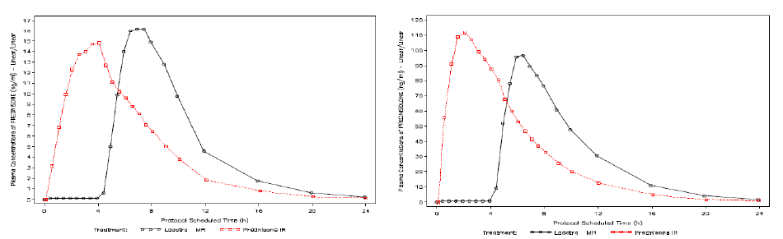
Table 1 displays the key PK parameters calculated from prednisone and prednisolone plasma concentrations. The difference in T-lag and Tmax between Lodotra and Decortin reflected the delayed release of prednisone from the Lodotra tablet compared to IR prednisone.
Table 1. Plasma PK parameters of prednisone and prednisolone (NP01-013)
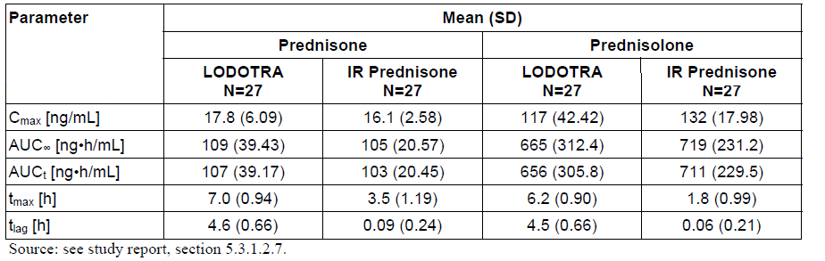
In Study NP01-013, 3 (11.1% of 27) subjects had significantly lower plasma concentrations of prednisone and prednisolone after receiving Lodotra compared to the ingestion of IR prednisone in the same subjects. The proposed Australian PI and European Summary of product characteristics state “lower prednisone plasma concentrations have been observed in 6-7% of cases” receiving Lodotra.
Study NP01-014 had a randomized, open-label, 2-sequence, 2-period crossover design. The primary objective of the trial was to evaluate the bioequivalence of single oral doses of 5 mg of prednisone MR manufactured by Bayer Schering Pharma AG (Leverkusen, Germany) and Skye Pharma Production SAS (St-Quentin-Fallavier, France). In addition, the study assessed T-lag and Tmax of prednisone and prednisolone after ingestion of each formulation. All subjects received both treatments separated by a wash-out period of at least 3 days. The 24 hour PK profile of prednisone and prednisolone was obtained from blood samples collected pre-dose, every 30 minutes from 1-9 hours, then also at 9, 10, 12, 16, 20 and 24 hours post-dose. Study drug administrations occurred at 8 am after a high fat breakfast which had to commence 30 minutes prior to tablet intake and be completed within 5 minutes before drug ingestion. In total, 52 healthy subjects (26 male, 26 female) were recruited into the study and 51 (98.1%) were included in the bioequivalence analysis. One male subject withdrew his consent for personal reasons on day 3 of the first treatment period and data for this individual was only available for the Bayer formulation. The enrolled subjects had a mean age of 30.4 years (range 18-45 years), mean BMI of 23.4 kg/m² (range 18.4-28.9 kg/m²) and all but 1 subject was Caucasian. Bioequivalence was demonstrated for all PK parameters. In particular, Cmax (21.4 ng/mL) and AUC∞ (136 hr.ng/mL) were identical between the formulations. The T-lag and Tmax of both products were also similar. For prednisone, the mean T-lag was 4.13 hours (SD 0.55 hours) for the Bayer tablet and 4.09 hours (SD 0.40 hours) for the Skye formulation. The mean Tmax was 6.77 hours (SD 1.38 hours) for the Bayer tablet and 6.51 hours (SD 0.87 hours) for the Skye formulation. The T_{1/2} was 2.8 hours (SD 0.60) for the Bayer preparation and 2.7 hours (SD 0.47) for the Skye produced tablet. The mean plasma concentration-time curves for prednisolone showed a similar profile to the prednisone plots for both formulations. The Hodges-Lehman estimates for all PK parameters showed a relatively narrow 90% CI supporting the claim of PK similarity between the 2 formulations. The majority of individual subject PK data was within the 90% CI limits of the 80-125% bioequivalence criteria. However, 2 subjects displayed significantly lower plasma concentrations of prednisone and prednisolone after receiving the Bayer preparation compared with the Skye formulation. One of those subjects was only able to achieve a Cmax for prednisone after the Bayer tablet approximately 25% of the Skye formulation value. The other outlier subject also showed a very different concentration-time plot for prednisone with the Bayer tablet having a Tmax of 10 hours and the Cmax was about 50% of that achieved with the Skye formulation. For the Australian market, the sponsor proposes to source MR prednisone from 2 additional potential manufacturers (Sanofi Chimie in France, and Tianjin Tianyao Pharmaceuticals in China). The submission contained TGA GMP clearance letters for all 4 manufacturing sites. The sponsor indicates that the results of Study NP01-014 demonstrate that a consistent tablet quality in terms of PK characteristics can be sourced from different manufacturers.

Influence of food
Two phase 1 studies have primarily investigated to effect of food on the PK and bioavailability of Lodotra. In Study EMR 62215-005, 5 mg of Lodotra given at 8 pm under semi-fed conditions (2.5 hours after a light meal at 5.30 pm – treatment B) or in the fed state (0.5 hours after a normal dinner at 7.30 pm – treatment C) was compared to the reference IR prednisone formulation of Decortin administered at 2 am after a light meal taken at 5.30 pm (treatment A).
Figure 2 shows that the mean plasma concentrations of prednisone and prednisolone in 26 healthy, young-middle aged, male subjects increased rapidly after receiving Decortin with quantifiable levels measured after 0.5 hours and Tmax of 2 hours. The concentration-time profiles observed for Lodotra in the semi-fed and fed state were comparable to the reference formulation but the lag time until plasma concentrations were achieved (first detectable and Tmax) were delayed by approximately 4 hours. The Tmax after Lodotra administration was 2.5 hours after the onset of absorption.

Figure 2. Mean plasma concentration of prednisone after a single dose of 5 mg prednisone as IR formulation (A) or Lodotra in the semifed (B) or fed state (C) (Study EMR 62215-005, n=26).
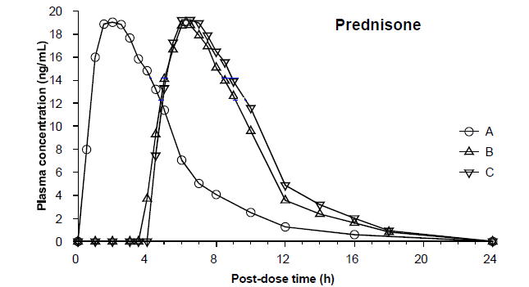
Table 2 summarizes the key PK parameters derived from a non-compartmental analysis for prednisone and prednisolone in Study EMR 62215-005. Total exposure to prednisone and prednisolone were similar for both Lodotra treatments and the IR prednisone comparator. The inter-individual variability was higher with both Lodotra administration conditions, but particularly evident under semi-fed conditions.
Table 2. PK parameters for prednisone and prednisolone after single administration of 5 mg prednisone as IR formulation or Lodotra (EMR 62215-005, n=26)
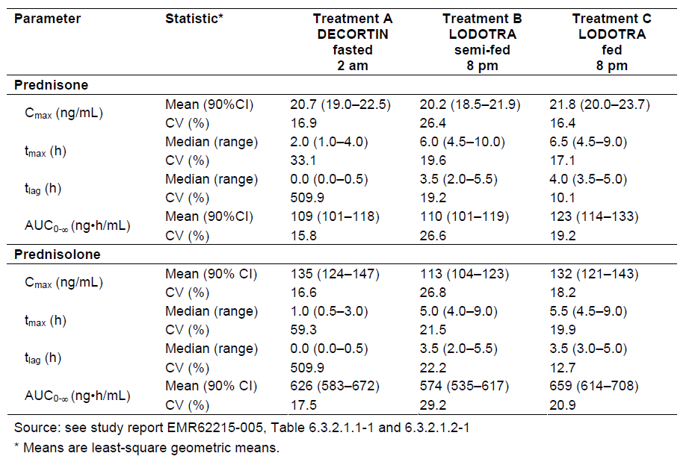
*Means are least squares geometric means
Study NP01-006 was an additional, phase 1, single centre, open label, randomized trial with a 2-period crossover design that was requested by USA regulatory authorities to fulfil the effect of food on PK parameters. The study recruited 24 healthy young male (n=12) and female (n=12) volunteers who were administered 5 mg of Lodotra at approximately 8 am after an overnight (10 hour) fast versus after intake of a high fat breakfast. As demonstrated in Table 3, exposure to prednisone and prednisolone increased 3-4 fold when Lodotra was taken under fed conditions versus fasting. Furthermore, the median T-lag and Tmax for both prednisone and prednisolone were 1 -1.5 hours longer in the fasted state.
Table 3. Effect of food on PK parameters of prednisone and prednisolone in Study NP01-006
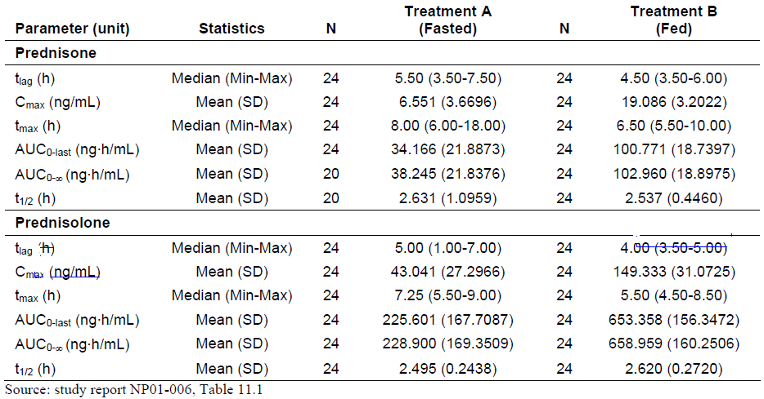
The results of both studies indicate that Lodotra should not be ingested under fasting conditions if desired PK profiling is to be achieved. The amount of food does not seem to significantly affect bioavailability (Study EMR 62215-005) as treatments B and C appeared equivalent in that trial. In the pivotal phase 3 studies, patients were advised to take Lodotra with or up to 2 .5 hours after dinner.

Dose proportionality
The dose proportionality of orally administered Lodotra (3 strengths – 1, 2 and 5 mg tablets) was examined in Study NP01-008. This was a single centre, phase 1, open label, randomized, balanced, 3-way crossover study involving 18 healthy, non-smoking, male volunteers aged between 18 and 45 years. There was a 3 day washout period between dosing regimens. The study was conducted under fasting conditions in accordance with the relevant regulatory guideline. At the time of its conduct, the pronounced effect of food on the bioavailability of Lodotra was not evident. Dose proportionality for the 3 doses was assessed for the log transformed variables of Cmax, AUC∞ and AUC-t for prednisone and prednisolone using a mixed model with fixed effects for sequence and period, and a random effect for subject within sequence, while log dose served as a covariate. Table 4 summarizes the results of this study and indicates dose proportionality for the limited dose range of Lodotra that has been evaluated. The estimated slopes for all parameters were close to 1 (with the 90% CI overlapping 1) indicating dose proportionality for the 3 tested dose levels (1, 2 and 5 mg).
Table 4 Study NP01-008. Analysis of dose-proportionality for prednisone and prednisolone
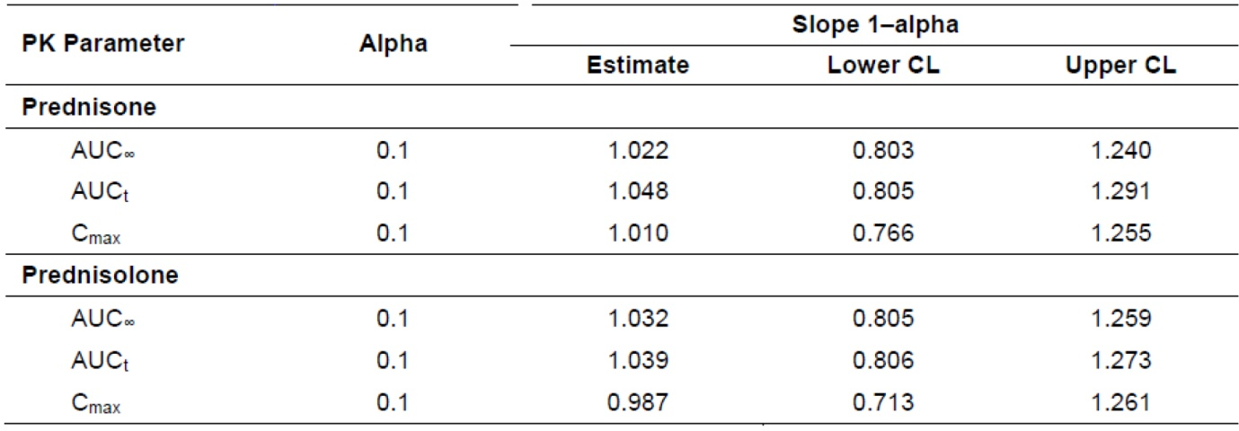

Bioavailability during multiple-dosing
This has not been assessed for Lodotra. In addition, the TGA has raised concerns about the fact that no studies with Lodotra have been conducted at steady state. The requirement for steady state bioavailability trials for Lodotra was waived by the FDA, for which I concur is a justifiable decision. The estimated half-lives of prednisone and prednisolone are 2-4 hours. Because Lodotra is given once daily, the wash-out period is up to 24 hours which correlates with at least 6 half-lives. Therefore, no drug accumulation would be expected for Lodotra if taken according to dosing instructions.

Distribution
Peak serum concentrations of prednisone are reached approximately 6 hours after ingestion of Lodotra. Both prednisone and prednisolone reversibly bind to plasma proteins with a high affinity for transcortin (or corticosteroid binding globulin, CBG) and low affinity for plasma albumin. In the low dose range (up to 5 mg), approximately 6% of prednisolone is free. When the prednisone dose exceeds 10 mg, the binding capacity of transcortin is utilised and the free proportion of prednisolone may increase.

Metabolism
During first pass liver metabolism, 80-100% of prednisone is rapidly converted to the active metabolite prednisolone by reduction of the 11-oxo group. The pre-conversion half-life of prednisone is approximately 60 minutes. Prednisone and prednisolone are metabolically reversible with equilibrium favouring formation of the active metabolite in a ratio of 1:6 to 1:10.

Excretion
Prednisolone is mainly eliminated by hepatic metabolism – approximately 70% by glucuronidation and 30% by sulphation. The metabolites of prednisolone have no pharmacological activity and are mainly eliminated via the kidneys. Negligible amounts of prednisone and prednisolone are found unchanged in the urine.

Pharmacokinetics in the target population
No PK studies involving patients with RA have been performed.

Pharmacokinetics in other special populations
This has not been assessed for Lodotra.

Pharmacokinetic interactions
No specific studies examining drug interactions with Lodotra have been performed. The draft PI has proposed an extensive list of potential drug interactions based on the known potential drug interactions of prednisone with other therapies (i.e. a historical literature review).

Evaluator’s overall conclusions on pharmacokinetics
In total, 9 phase 1 PK studies involving healthy volunteers (mainly, young males) have been conducted as part of the clinical development program and 6 of these trials used Lodotra tablet formulations identical to the commercially proposed product. Study EMR 62215-005 evaluated the PK behaviour of the final Lodotra formulation (5 mg) with an in-vitro lag time of 3.5 hours to the reference IR prednisone product of Decortin and demonstrated similar PK characteristics with the exception of an in-vivo lag time of 3.5-4 hours.
Dose proportionality for a limited range of Lodotra dosing (1, 2 and 5 mg) was shown in Study NP01-008. Studies NP01-009 and -010 demonstrated that batches of Lodotra with different in-vitro lag times showed comparable and acceptable bioavailability.
A consistent finding from the studies (in particular, EMR 62215-005 and NP01-006) is that fasting conditions significantly alter the PK of Lodotra with increased in-vivo lag time and Tmax with fasting versus fed state, and Cmax and AUC considerably lower with fasting. In addition, inter-individual variability of Cmax and AUC is significantly higher under fasting administration.
Study NP01-013 which was conducted under SmPC conditions revealed comparable PK profiles for Lodotra and Decortin in terms of Cmax and AUC. This trial also confirmed the expected MR formulation behaviour with the estimated differences between Lodotra and Decortin being 4.5 hours for T-lag and 3.5 hours for Tmax.

Pharmacodynamics

Studies providing Pharmacodynamic data
None of the early phase studies evaluated PD data. However, the 2 phase 3 trials (including the OLE phase of the CAPRA-1 Study) collected PD endpoints as part of their analysis. The endpoints included serum inflammatory markers (ESR and CRP) for both phase 3 trials, serum cytokines (IL-6 in both studies; and also TNF in the CAPRA-2 Study) and bone turnover markers (serum osteocalcin values in the CAPRA-1 Study, and urine CTX I levels in the CAPRA-2 trial). The production of CRP by the liver is significantly influenced by IL-6. Differences between the treatment groups for morning IL-6 levels were considered to be a pivotal PD result supporting the hypothesis that the release of Lodotra has advantages over comparator treatment for influencing the clinical endpoint of morning stiffness.
For the CAPRA-1 Study, ESR (mm/hour) and CRP (mg/L) were collected at baseline, 2, 6 and 12 weeks during the double-blind phase, as well as every 3 months during the OLE period. Interleukin-6 and osteocalcin levels were collected at baseline, visit 5 (12 weeks) and visit 8 (end of OLE). For the CAPRA-2 Study, ESR and CRP were collected at baseline (visit 1) and visits 2-4. Interleukin-6, TNF levels and urine CTX I values were collected at screening (visit 0) and visit 4 only. For both studies, PD markers (except urine CTX I) were based on results of blood analysis with samples collected before 10 am.

CAPRA-1 study results
No significant median changes from baseline in CRP or ESR were seen for either treatment group (MR or IR prednisone) at any assessment visit (weeks 2, 6, and 12 in the double blind phase; and at visit 6, 7, and 8 in the OLE period).
Median baseline IL-6 concentrations were higher in the IR prednisone group at baseline (1110 IU/L) compared to the MR prednisone arm (860 IU/L). When re-assessed at 12 weeks, IL-6 values decreased in the MR prednisone group (median visit 5 value of 470 IU/L; relative change from baseline -28.6%; n=135). The IR prednisone group showed no change from baseline to 12 weeks. However, the variability in IL-6 results was high in both groups with individual values ranging from 200-22,700 IU/L. At visit 8 in the OLE follow-up of the CAPRA-1 Study, patients originally treated with Lodotra maintained the same reduction in IL-6 concentrations at 9 months. Subjects who switched from the IR prednisone group to Lodotra at 3 months (end of double blind phase) showed a decrease in IL-6 concentrations during the OLE (visit 5 value of 1050 IU/L ; visit 8 value of 515 IU/L; relative change of -40.14%). The decrease in IL-6 for this treatment switch group was similar to the decrease seen in the original Lodotra treatment population.
There was no change from baseline to 12 weeks and visit 8 for mean osteocalcin (ng/mL) values.

CAPRA-2 study results
Serum inflammatory marker concentrations (ESR and CRP) were highly variable between and within subjects, and showed no clear decreasing trend over the course of the study in either treatment group (Lodotra or placebo tablets + background DMARD).
More than 50% of subjects had IL-6 levels less than the LLOQ (<5 pg/mL) at screening. The mean IL-6 concentration was higher in the Lodotra compared to placebo group (24.1 versus 11.0 pg/mL, respectively) because of several individuals with markedly increased results in the Lodotra arm. At visit 4, the mean absolute decrease from baseline in Il-6 concentration was numerically higher in the Lodotra group (-15.7 pg/mL) versus the placebo arm (-2.5 pg/mL). This difference was considered statistically significant when a log transformation calculation was applied to the non-normally distributed data (GMT ratio of 0.8 [95% CI 0.7, 0.9] with p=0.008).
The median TNF concentrations at screening and visit 4 (12 weeks) were below the LLOQ (<5 pg/mL), highly variable and not normally distributed so meaningful interpretation of the results is not possible. There was no change from baseline to 12 weeks for urine CTX I values in either treatment group.

Summary of Pharmacodynamics

Mechanism of action
The PD effects of corticosteroids are produced by binding to specific intracellular glucocorticoid receptors which reside mainly in the cell cytoplasm. The receptor itself is bound to stabilizing proteins, including heat shock proteins. Binding of corticosteroid to the receptor causes it to change its properties, and allow for dissociation of the receptor from heat shock proteins. The receptor-hormone complex then transfers to the cell nucleus and initiates the transcription of genes which trigger the synthesis of messenger RNA. This in turn leads to the synthesis of specific proteins and enzymes that are responsible for the actions of glucocorticoids. The glucocorticoid receptor complex also binds to the negative glucocorticoid responsive element (nGRE), which subsequently inhibits the synthesis of IL-2, IL-6 and TNF.

Pharmacodynamic effects

Primary Pharmacodynamic effects
Prednisone and prednisolone are synthetic glucocorticoid hormones with a broad anti-inflammatory action. In addition, glucocorticoids also have metabolic effects, particularly involving carbohydrate metabolism. Prednisone is rapidly converted to prednisolone in vivo. Prednisone is a pro-drug with little pharmacological activity until the 11-oxo group is metabolically reduced in the liver to form the active moiety, prednisolone.

Secondary Pharmacodynamic effects
This was not included in the submission.

Time course of Pharmacodynamic effects
The genomic effects of the glucocorticoid receptor complex (as described in 5.2.1) are delayed in onset by several hours and can last for up to several days. Typically, the action of 1 dose lasts from 1-1.5 days. However, some of the other effects of glucocorticoids occur very quickly (e.g. suppression of endogenous cortisol secretion and changes in the peripheral white blood cell count) to suggest a non-genomic mechanism of action. These latter PD effects correlate well with glucocorticoid plasma concentrations.

Relationship between drug concentration and Pharmacodynamic effects
The timing of prednisone administration may influence some of the symptoms of RA (especially morning stiffness and joint pain) as well as the serum levels of pro-inflammatory cytokines, such as IL-6 and TNF. As illustrated in Figure 3, several of the key pro-inflammatory cytokines involved in the pathogenesis of RA exhibit a circadian rhythm with concentration peaks in the early morning (2-6 am). Due to the short half-life of prednisone (~2 hours), administration of IR prednisone between 6-8 am may not be the optimal time to dose for RA symptomatic relief. In comparison to healthy individuals, patients with RA often have higher serum concentrations of IL-6 and TNF, and they exhibit a more pronounced circadian rhythm. To complicate the pathogenesis considerations, IL-6 is a potent activator of the HPA axis and stimulates the release of cortisol from the adrenal cortex to counteract inflammation. However, in RA patients the responsiveness of the permanently stimulated HPA axis is significantly blunted and inadequate (Cutolo et al 2003). Furthermore, there is evidence to suggest that the peak concentration of IL-6 between 2-6 am is causally related to the peak in morning stiffness (Buttgerit et al 2008; Straub and Cutolo 2007).
Figure 3 - Circadian Rhythm of Inflammatory Cytokines in Rheumatoid Arthritis
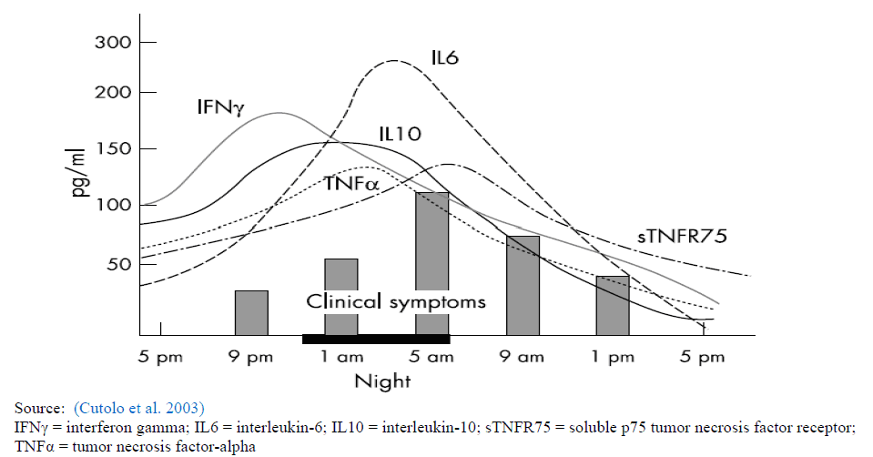

Genetic-, gender- and age-related differences in Pharmacodynamic response
Not contained within the submission.

Pharmacodynamic interactions
No PD drug interaction studies have been specifically conducted with Lodotra. The sponsor justifies this approach based on the extensive published evidence available within the IR prednisone database.

Evaluator’s overall conclusions on Pharmacodynamics
The PD properties for Lodotra were only assessed from data collected in the 2 pivotal phase 3 clinical trials involving samples from 600 adult patients with RA (354 of whom had received Lodotra, 132 had been given IR prednisone and 114 had received placebo tablets). Most subjects were middle-aged Caucasian females. The sponsor had nominated changes in IL-6 levels with treatment as the pivotal PD marker to support the biological plausibility for the benefits of MR prednisone in improving symptomatic control of RA, particularly morning stiffness. Other supportive PD markers were serum inflammatory markers (especially CRP as it has a link with IL-6 production), other cytokines (TNF) and bone turnover markers.
In both of the phase 3 studies, the median or mean baseline levels of IL-6 showed statistically significant improvements following treatment with Lodotra compared to IR prednisone (in the CAPRA-1 Study) and placebo (in the CAPRA-2 Study). However, the clinical relevance of these changes is unclear, and the result was additionally clouded by large inter-individual variability in IL-6 values. Furthermore, none of the supportive PD markers (in particular CRP) were significantly different between any of the treatment groups (MR or IR prednisone, and placebo) in either of the phase 3 studies.

Dosage selection for the pivotal studies
Both pivotal phase 3 studies investigated prednisone doses at the low end of the dose range (3-10 mg daily in Study EMR 62215-003 and a fixed 5 mg/day in Study NP01-007) in patients receiving concurrent DMARD therapy. Low dose concurrent prednisone therapy (< 10 mg/day) is frequently prescribed for adult patients with RA, and its efficacy in controlling symptoms and having disease modifying characteristics is reported in the literature (ACR guideline 2002, Conn 2001, Hoes et al 2007, and Saag et al 1997).
With ingestion of the modified release formulation of prednisone at approximately 2200 hours (+/- 30 minutes), the dosage regimen chosen in the 2 pivotal phase 3 studies allowed for the release of the active drug to achieve optimal concentration prior to the early morning circadian rise of various cytokines (in particular, IL-6) which is thought to trigger the characteristic morning symptoms of stiffness and pain associated with active RA.

Clinical efficacy

Efficacy studies relevant to the indication sought
The sponsor is seeking a single indication - “for the treatment of moderate to severe, active rheumatoid arthritis in adults, particularly when accompanied by morning stiffness.”
The efficacy data pertaining to the indication sought by the sponsor was evaluated in 2 pivotal, phase 3 studies (EMR 62215-003 and NP01-07) of 12 weeks duration. As the study populations and outcome measures were different, the trials will be considered individually. Furthermore, no integrated efficacy analysis was provided in the submission. Supportive efficacy data was provided by the 9 month, open-label extension (OLE) phase of Study EMR 62215-003, although this trial predominately aimed to collect longer-term safety information. None of the earlier phase clinical studies provided efficacy data to the sought indication.

Pivotal efficacy studies

Study EMR 62215-003 (CAPRA-1)

Study design, objectives, locations and dates
The primary objective of this study was to evaluate if 12 weeks of treatment with MR prednisone (Lodotra formulation) administered in the evening was superior to standard morning administration of IR prednisone in reducing the duration of morning stiffness. The secondary objectives were to compare the effect of the 2 prednisone formulations on standard RA efficacy parameters.
The trial was a randomized, double-blind, active-controlled, double-dummy, parallel-group study of 12 weeks duration (plus a 1-2 week screening period) with an option for 9 months of open label follow-up in adult patients with active RA. During the 12 week controlled study phase, assessments were performed at weeks 2, 6 and 12. Eligible patients had to have received a daily dose of 2.5-10 mg prednis(ol)one for at least 3 months prior to entry, with a stable dose for at least 1 month prior to screening. They also had to have taken DMARD treatment for RA for at least 3 months (unless DMARDs were not tolerated, in which case prednis(ol)one only was allowed). At the start of the 3-month, double-blind phase of the study, patients were randomized to treatment with prednisone as Lodotra or the IR reference product (Decortin®), prepared as double-dummy study medication for evening and morning intake. The prednisone dose was to correspond to the individual patient’s pre-study dose (3-10 mg/day). Lodotra (or matching placebo tablet) was to be taken at 10 pm (±30 min) in the evening. The reference product of IR prednisone (or placebo) was taken between 6 am and 8 am in the morning. The double-blind phase was followed by a 9-month open follow-up phase, in which all patients regardless of previous treatment group could receive Lodotra.
The 12 week, double-blind treatment phase of Study EMR 62215-003 commenced on 4 August 2004 and was completed on 6 April 2006. The additional 9 month, open-label extension phase of Study EMR 62215-003 was completed in October 2007. The study was performed at 17 centres in Germany and 12 centres in Poland, although 3 centres screened but did not randomize any patients. Patient recruitment by treatment centre ranged from 1 patient (5 centres) to more than 30 subjects (1 centre with 32 and another with 33 subjects).

Inclusion and exclusion criteria
Male or female patients between the ages of 18 and 80 years with a documented history of RA (seropositive or seronegative) according to the ACR diagnostic criteria were eligible for this study if they were symptomatic as defined as: -
- average daily duration of morning stiffness of ≥ 45 minutes in the preceding 7 days,
- average daily maximum pain intensity score as per 100 mm VAS of ≥ 30 mm (last 7 days),
- ≥ 3 joints with pain (tenderness to palpation) and ≥ 1 swollen joint, and
- evidence of systemic inflammation (i.e. ESR ≥ 28 mm and or CRP ≥ 1.5 times above the normal age and sex related range).
Prior to the study, patients had to receive glucocorticoid medication for at least 3 months, and a stable low dose (2.5 to 10 mg/day) of prednis(ol)one for at least 1 month prior screening. They also had to receive DMARD treatment for RA for at least 3 months (unless DMARDs were not tolerated, in which case prednis(ol)one only was allowed). Biological DMARDs were not allowed for 4 months prior to inclusion, or during the study. Patients were to be excluded if they had significant renal (serum creatinine > 150 μmol/L) or hepatic impairment (investigator’s opinion), other diseases requiring glucocorticoid treatment (e.g. asthma), presence of a contraindication to corticosteroids (e.g. established osteoporotic fractures, history of herpetic infections or overt GIT ulceration in the previous 2 months), or pregnancy/lactation.

Study treatments
The study treatment involved a total daily dose of 3-10 mg prednisone, which was individualized to the subject’s pre-study stable dose level. Lodotra tablets were supplied in the 1 and 5 mg dose strengths. The reference product was a common commercial formulation of IR prednisone used in Europe – Decortin (1 and 5 mg strengths). All tablets (both prednisone formulations and placebo tablets) were identical in size, shape and colour. No tablets were to be broken during the study so patients were receiving a pre-study dose of prednisone of either 2.5 or 7.5 mg, these were rounded to 3 and 7 mg, respectively. The selection of dose range examined in the study (prednisone 3-10 mg/day) is appropriate to clinical practice guidelines for the continuous low dose prednisone for RA management in selected patients. Doses below 2.5 mg/day would be unlikely to show a significant difference in treatment effect by prednisone formulation although the availability of the 1 mg dose strength makes this a possible design feature. Furthermore, the clinical pharmacology data supports the timing of administration for the dose formulations used in this study.
Compliance with study medication was high in both treatment groups with only 9 patients (6.3% of 144) in Lodotra group and 5 (3.5% of 144) subjects in the IR prednisone group not complying with more than 80% of their study medication.

Efficacy variables and outcomes
The primary efficacy outcome was the duration of morning stiffness after 3 months of treatment expressed as the relative mean change from baseline. The result was calculated based on entries made by the patient in their study diary. Each morning, patients were to asked to document their wake-up time, whether or not they had joint stiffness, and the time of its resolution (if present). Baseline measurements were defined as the average daily value during the last week of the screening period prior to randomization (i.e. days -7 to -1 before visit 2). The last observation was defined as the average daily duration of morning stiffness recorded in the last week prior to the conclusion of the double blind treatment period.
Many secondary efficacy outcomes were assessed and they were derived from 2 sources.
- Daily patient diary entries
The following variables were derived from the patient diary entries and were independent of the study visits. For these measurements, a week was defined as each subsequent 7-day period starting with day 1 at visit 2 and ending with the last day of week 12.
Variables related to stiffness. In addition to the relative change in duration of morning stiffness, the following stiffness-related variables were assessed:
- Mean daily duration [minutes] of morning stiffness in each week of the study as observed and as relative changes from baseline
- Number of patients with recurrence of stiffness during the day for each week of this study (number of patients with at least one event within the respective week)
Pain intensity: Patients were to record their maximum pain intensity during the day on a 100 mm VAS with the endpoints 0 = “not active at all” and 100 = “extremely active”. The following variables were used to evaluate pain:
- Relative change in patient’s assessment of intensity of pain from baseline at individual study end in the double-blind treatment phase, and
- Mean daily VAS pain score [mm] during each week of the study as observed and as relative changes from baseline
Quality of sleep: Patients were to record their quality of sleep on a 100 mm VAS with the endpoints 0 = very good and 100= very bad. The following variable was calculated:
- Mean daily VAS values [mm] during each week of the study as observed and as relative changes from baseline
Use of analgesics: The daily yes/no entries in the patient diary were used to derive the number of days between baseline and endpoint measurements where analgesics were used.
- Secondary efficacy variables obtained from assessments made at scheduled study visits
Changes from baseline to relevant visits were analysed for the following variables:
- DAS28 at visits 3, 4, and 5 (weeks 2, 6, and 12), and also at visits 6, 7 and 8 (every 3 months) in the open-label extension phase.
  - The DAS28 is derived from:
    - Number of tender joints assessed using 28-joint counts.
    - Number of swollen joints assessed using 28-joint counts.
    - ESR [mm/hour], and
    - Patient’s global assessment of disease activity using a 100 mm VAS with the endpoints 0 = “not active at all” and 100 = “extremely active”
- Physician’s global assessment of disease activity at visits 3, 4, and 5 (weeks 2, 6 and 12), and also at visits 6, 7, and 8 (every 3 months) in the open-label extension.
The physician’s global assessment was measured by a 5-point scale (1 = symptomatic, 2 = mild, 3 = moderate, 4 = severe, 5 = very severe).
- Functional: HAQ-DI at visit 5 (week 12), and at visits 6, 7, and 8 (every 3 months),
- Quality of life: SF-36 scores at visit 5 (week 12) and 8 (end of 12 month follow- up),
- ACR20 response at visit 5 (week 12) and 8 (end of follow-up)
Patients were classified as responders according to the ACR20 response criterion if they showed at least:
- 20% reduction in the tender joint count (0-28),
- 20% reduction in the swollen joint count (0-28), and
- 20% reduction in at least 3 of 5 additional measures:
  - Patient assessment of pain (VAS in patient diary),
  - Patient global assessment of disease activity (VAS),
  - Physician global assessment of disease activity (scale of 1-5),
  - Disability index of the HAQ (HAQ-DI), and
  - ESR as the acute-phase reactant.

Randomisation and blinding methods
Treatments were randomized within centres using a computer program (PMX) operating at a central site in Germany by Merck. Each subject was allocated their study medication at visit 2 in a consecutive manner, i.e. in the order of their enrolment into the double-blind treatment phase they received the next available medication number. A double-blind, double-dummy technique was utilised to maintain the treatment blind.

Analysis populations
There were 3 analysis populations – the safety dataset (all randomized subjects who received any study medication), Intention-to-Treat population (all randomized patients) and the Per-Protocol cohort (all randomized who received treatment in accordance with the protocol). The safety and ITT populations were identical in this study with each treatment group comprising 144 subjects. As detailed in section 7.1.1.1.10, the PP cohort was significantly smaller in evaluable subject number - 53.1% [153/288] for the 2 treatment groups combined [47.9% (69/144) for MR prednisone and 58.3% (84/144) for IR prednisone].

Sample size
The sample size calculation was based on the primary efficacy variable. Assuming a standard deviation of 64% in the relative change from baseline to week 12 in the duration of morning stiffness, 120 subjects were required in each of the groups if the treatment difference between MR and IR prednisone was 27%. This calculation was based on a probability of 90% at α=2.5% significance level (1-sided, 2 sample problem, normal distribution). Furthermore, it was estimated that 15% of recruited subjects may not evaluable in the primary analysis, so approximately 140 patients had to be randomized per treatment group.
However, because there was uncertainty about the variation for the primary efficacy outcome, the sample size was reviewed in the study’s mid-progress (i.e. when at least 120 subjects in total [~50% of the total cohort] had completed the double-blind treatment phase). The appropriateness of the sample size was confirmed without unblinding. In December 2005, when 123 patients had completed their double-blind treatment phase, the observed standard deviation was 75.61% (using the LOCF method of imputation), which resulted in the adjusted standard deviation being 70.96%. Since the difference between the a priori and calculated standard deviations was small, no adjustments to the sample size calculation were required mid-study.

Statistical methods
The primary analysis of the relative change from baseline of morning stiffness was performed on the ITT population. To support the robustness of the ITT evaluation, analysis using the per-protocol population was additionally performed. The relative change from baselines of morning stiffness was analysed by ANOVA with the main factors in the model being treatment group and centre. According to the one-sided objective, statistical tests were performed 2-sided at a significance level of 5% and reported according to the 1-sided objective significance level of 2.5%.
The analysis of the secondary efficacy variables was also performed with the ITT population. Continuous variables were summarised by the number of observations (n), mean, standard deviation (SD), minimum, median, and maximum. Categorical variable were presented by the number of observations (n), absolute and relative (%) frequency, and missing data. For continuous data, the same model was used to compare treatment groups as planned for the primary analysis. To provide estimates for the differences between medication groups, the 95% CI were calculated.
The relative change from baselines of intensity of pain was analysed using the same ANOVA model as for the primary target variable. The control of analgesics is important when analysing the secondary outcome pain. Hence, the number of days between baselines and endpoint measurements where analgesics were used incorporated as covariate in the analysis for intensity of pain. The parameters of the HAQ, SF-36, and DAS28 were scored and summarised according to standard algorithms.

Participant flow
Table 5 summarizes the disposition of subjects in the CAPRA-1 Study. A total of 375 patients were enrolled but 87 failed the screening process. The most common reason for screen failure was failure to meet the inclusion/exclusion criterion (61 subjects). Other screen failure reasons included withdrawal of consent (7 patients), missing patient information (12 subjects) and various other reasons including 1 subject who experienced an AE.
Of the 288 subjects randomized, 251 (87.2%) completed the double-blind treatment phase - 121 (84.0% of 144) in the MR prednisone group and 130 (90.3% of 144) in the IR prednisone arm.
Table 5 – Disposition of Subjects in CAPRA-1 Study
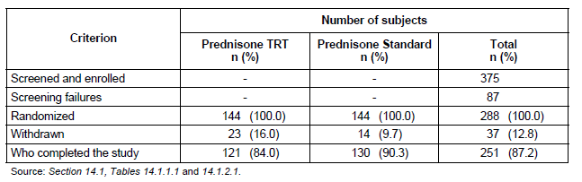

Major protocol violations/deviations
Subjects with major protocol deviations (defined as likely to affect the validity of the data for the duration of morning stiffness) were excluded from the PP analysis. A total of 135 subjects (46.9% of 288) showed major protocol deviations – 75 patients (52.1% of 144) in the prednisone MR group and 60 patients (41.7% of 144) in the prednisone IR arm. The 3 most common reasons for exclusion from the PP analysis on the basis of protocol deviation were duration of therapy “out of range” (32.6% [47/144] for MR and 27.8% [40/144] for IR prednisone), baseline morning stiffness of <45 minute duration (16.0% [23/144] for MR and 12.5% [18/144] for IR prednisone) and timing of evening medication “out of range” (14.6% [21/144] for MR and 10.4% [15/144] for IR prednisone). Evening medication was required to be given between 2100 and 2300 hours. The “out of range” treatment duration was defined as those who did not have their final assessment at 84 +/- 3 days, and includes 37 early study drop-out subjects (23 in the MR, and 14 in the IR prednisone groups).

Baseline data
Baseline demographic data between the 2 treatment groups was similar and outlined in Table 6. The age and gender distribution of the subjects were typical of RA populations with most being female (85.8%, 247/288) and middle-aged (45-65 years of age) with a mean age of 55.0 years (SD 11.2 years; range 20-79 years). All but 1 patient was Caucasian. The mean patient weight was 70.6 kg (range 43-115 kg).
Table 5 – Disposition of Subjects in CAPRA-1 Study
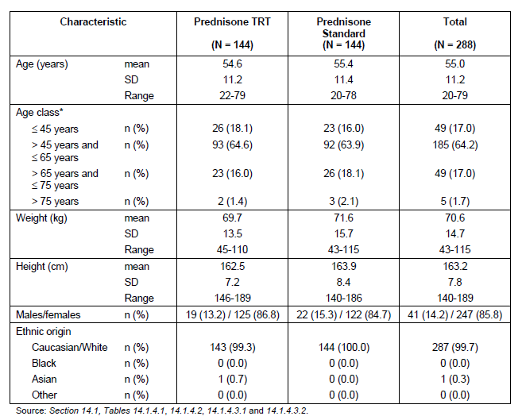
The baseline disease characteristics are summarized in Table 7. No major differences were observed between the treatment groups. The mean duration of RA was 115.3 months (9.6 years) and nearly 40% of subjects had RA for more than 10 years. Patients had evidence of high disease activity at baseline with mean DAS28 score being 5.9. The other RA measures of disease activity (such as the mean HAQ-DI score of 1.5) are consistent with severely active disease at baseline.
Table 7 – Disease Characteristics at baseline in CAPRA-1 Study
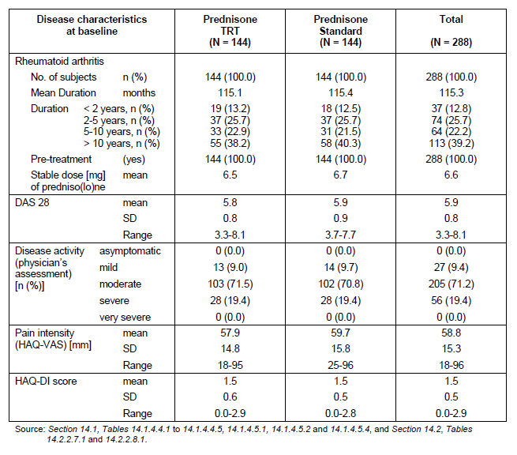
Additional baseline data not included in Table 7 are: -
- Mean tender joint count was 11.9 for Lodotra and 12.5 for IR prednisone,
- Mean swollen joint was 7.3 for Lodotra and 7.2 for the IR prednisone group,
- Mean CRP was 9.9 mg/L for Lodotra and 12.2 mg/L for IR prednisone and
- Median ESR of 30 mm/hour for Lodotra and 34 mm/hour for the IR prednisone group.
Co-morbidities at baseline were similar between the 2 treatment groups and included hypertension (37.8%, 109/288), osteoporosis (18.4%, 53/288), obesity (10.1%, 29/288) and hypercholesteraemia (9.4%, 27/288). Furthermore, 10 patients (6 in the Lodotra group and 4 in the IR prednisone arm) had non-insulin dependant diabetes mellitus, 7 subjects (3 and 4 per group) had insulin requiring diabetes mellitus and another 8 subjects (2 in the Lodotra group and 6 in the control population) had a history of impaired glucose intolerance.
All 288 recruited subjects had taken prior corticosteroids for at least 3 months for RA. Many patients continued to take concurrent NSAID (81.3%, 234/288) and DMARD therapy (94.4%, 272/288) during the study. The most common DMARD treatments were methotrexate (66.3% of patients, 191/288), leflunomide (13.9%, 40/288 subjects) and sulfasalazine (8.7%, 25/288).

Results for the primary efficacy outcome
The relative mean change (in percentage terms) in the duration of morning stiffness after 12 weeks of treatment was -22.7% (baseline of 164 minutes to final value of 121 minutes) for Lodotra and -0.4% (baseline of 182.5 minutes to final value of 157.4 minutes) for IR prednisone – refer to Table 8.
Table 8 – Duration of Morning Stiffness after 12 weeks in CAPRA-1 Study (Intention-to-Treat)
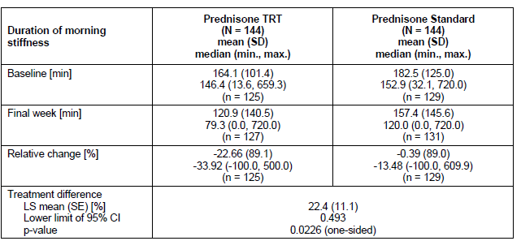
LS=least square; SE-standard error
Using an analysis of variance accounting for treatment and centre effects, the treatment difference was shown to be superior for Lodotra compared to IR prednisone in the ITT population (treatment difference being 22.4% [standard error 11.1%]; lower limit of 95% CI was 0.49%. This difference was statistically significant with p = 0.0226 (1-sided test). Using the same model applied to the PP cohort, the treatment difference in the relative change in duration of morning stiffness was calculated to be 21.2% (standard error 15.2%). The treatment difference in this analysis was not statistically significant (p=0.0822) and may be biased by the lower number of evaluable subjects in the PP population (153 subjects versus 288 patients in the ITT dataset). No consistent treatment by centre or country effect was observed on further sensitivity analyses.
Subgroup analyses evaluated by descriptive statistics were performed on the primary efficacy variable using the ITT population. The subgroups examined were gender (male/female), age group (<65 years/equal to > 65 years), concomitant NSAID (yes/no) and disease duration (<5 years/5-10 years/>10 years). There no significant baseline differences between the subgroups for the duration of morning stiffness although some subgroups (such as male subjects [n=19], those > 65 years of age [n=28] and no concurrent NSAID [n=21] in the group who received Lodotra) were too small in number to make meaningful conclusions. For the Lodotra treatment group, patients with RA of < 5 years duration showed a smaller improvement in morning stiffness from baseline (-12%, n=50) compared to those with established disease (-31% for RA of 5-10 years duration [n=30] and -29% for RA > 10 years duration [n=45]). This finding was not observed in subjects randomized to the IR prednisone arm and the true validity of the observation is unclear.

Results for other efficacy outcomes

Other stiffness variables
The mean daily duration of morning stiffness was also assessed on a per week basis during the 12 weeks of the trial. Table 9 summarizes the week-by-week change in this variable whereas the primary efficacy outcome examined changes at discrete time points (2, 6 and 12 weeks with a +/- 3 day window for the subjects’ convenience). Improvements for the Lodotra group were seen as early as 2 weeks and continued to improve to week 9, but thereafter plateauing to week 12. For the IR prednisone group there was no clear trend for change over the 12-week study period.
Table 9 – Mean daily duration of morning stiffness per week in CAPRA-1 Study (ITT analysis)
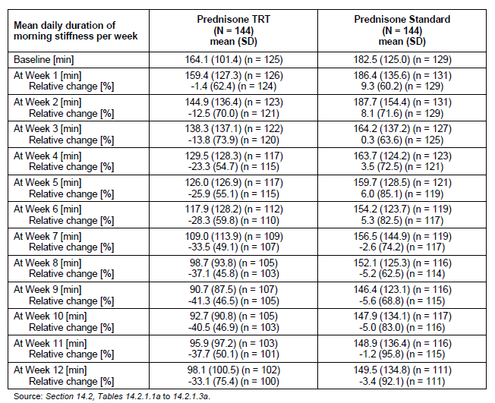
The number of patients with recurrence of stiffness during the day decreased during the 12- week treatment period in both groups with no notable differences between the 2 treatment groups at any assigned visits (weeks 2, 6 and 12). The baseline number of subjects who experienced recurrence of stiffness was 58.3% (84/144) for Lodotra and 57.6% (83/144) for IR prednisone. At 12 weeks of follow-up, the rates of recurrence of stiffness during the day were 47.1% (56/119) for Lodotra and 43.3% (55/127) for IR prednisone.

Other secondary efficacy variables
No statistically significant differences between the 2 treatment groups were observed for any other secondary efficacy variables: pain intensity (both mean daily, and change from baseline after 12 weeks of treatment), quality of sleep, analgesic use, mean change from baseline in DAS28 score, physician’s and patient’s global assessment of disease activity, mean change from baseline in HAQ-DI score, mean change in tender and swollen joint count, Quality of Life (SF-36) scores, or the ACR20 response rate.

Study NP01-007 (CAPRA-2)

Study design, objectives, locations and dates
The CAPRA-2 Study was a randomized, double blind, parallel-group, placebo-controlled trial conducted in 62 centres in 6 countries in Europe (Poland, Germany, Hungary and UK) and North America (USA and Canada). Patients with a history of RA who were on DMARD treatment for at least 6 months (with a stable dose of DMARD therapy for at least 6 weeks prior to the screening visit), and who had a duration of morning stiffness of at least 45 minutes were eligible for inclusion. Treatment with glucocorticoids other than the study medication was prohibited during the study.
The study design involved a 1 week, single-blind screening phase and a 12-week double-blind treatment phase. During the screening phase all patients received placebo in addition of their standard medication for RA. The screening phase included daily recording of the duration of stiffness in diaries prior to Visit 1 (randomization visit) to establish a baseline value for this variable. The double-blind treatment phase of the study started with Visit 1 (baseline; Week 0), whereby eligible patients were randomized to receive either Lodotra (5 mg) tablets or placebo tablets at a fixed dose for 12 weeks. The double-blind treatment phase included 4 visits (Visits 1-4 corresponding with weeks 0, 2, 6 and 12). The total duration of the study for each patient was a maximum of 13 weeks (including the screening period).
The primary objective of the CAPRA-2 Study was to evaluate if 12 weeks of treatment with 5 mg of modified release prednisone (Lodotra formulation) administered in the evening was superior to placebo in terms of the ACR20 responder rate.
The trial commenced subject recruitment on 31 March 2008 and the last patient completed follow-up on 16 April 2010. Although the study was initiated in 62 centres, only 50 sites successfully recruited subjects - 30 centres in the USA, 12 in Poland, 10 in Hungary, 4 in Germany and 3 each in the UK and Canada. Highest patient recruitment occurred in Poland (41.4% [145/350] of all subjects) followed by Hungary (29.1%, 102/350) and the USA (21.4%, 75/350).

Inclusion and exclusion criteria
The study included patients aged 18-80 years with a documented history of RA who had been receiving DMARD treatment for at least 6 months (at a stable dose for at least 6 weeks prior to screening visit). Patients were required to have duration of morning stiffness of at least 45 minutes, and both a swollen and tender joint count of at least 4 (of 28 joint counts). Patients with significant renal (serum creatinine > 150 μmol/L) or hepatic impairment (investigators opinion) or taking corticosteroids (oral, intra-articular or topical) within the last 4-6 weeks were excluded. Biological DMARD therapy at any time was an exclusion medication.

Study treatments
This trial compared a fixed daily dose of 5 mg Lodotra tablets to matching placebo tablets. Patients continued their background RA therapy at the same dose for the duration of the study. New NSAID or DMARD treatment could not be initiated after screening. The overall compliance with study medication was high and comparable between the 2 treatment groups with only 4 patients (3 in Lodotra group and 1 who received placebo) out of 350 subjects not complying with more than 80% of their study medication. Approximately 88% (308/350) of subjects took their study medication correctly more than 95% of the time during the trial.

Efficacy variables and outcomes
The primary efficacy outcome for Study NP01-007 was the ACR20 response rate between the 2 treatment groups at 12 weeks of treatment.
The key secondary efficacy variable was the relative change from baseline (in percentage terms) in the duration of morning stiffness at week 12.
Other secondary efficacy outcomes included:
- ACR20, 50 and 70 response rates at week 2 (visit 2), week 6 (visit 3) and week 12 (visit 4),
- Time to response based on the achievement of an ACR20 response,
- Change from baseline in the DAS28 score at each visit,
- Rate of obtaining EULAR response criteria,
- Change from baseline in each of the 7 variables comprising the ACR response criteria (such as tender and swollen joint counts, Physician and Patient Global Assessment of disease activity, Patient’s assessment of pain, HAQ-DI score, and serum inflammatory markers [ESR or CRP]),
- Change from baseline in the severity of morning stiffness, and the reoccurrence of stiffness during the day,
- Use of additional analgesics, and
- Change from baseline in QOL measures such as SF-36 and FACIT-Fatigue questionnaire.

Randomisation and blinding methods
At randomisation, patients were distributed from a central call centre in a 2:1 ratio to receive either 5 mg Lodotra or placebo tablets. All study medications were packaged identically and the tablets themselves had an identical appearance. Investigators, sponsors and subjects were blinded to trial treatments and the randomization schedule.

Analysis populations
There were 3 analysis populations – the safety dataset (all randomized subjects who received any study medication), Intention-to-Treat population (all randomized patients) and the Per-Protocol cohort (all randomized who received treatment in accordance with the protocol). The safety and ITT populations were identical in this study with 231 patients in the Lodotra group and 119 subjects in the control arm. As detailed in section 7.1.1.2.10, the PP cohort was smaller in evaluable subject numbers - 79.7% [279/350] for the 2 treatment groups combined [80.1% (185/231) for MR prednisone and 79.0% (94/119) for placebo].

Sample size
The sample size calculation was based on the comparison of 2 proportions using the χ2 test and a randomization ratio of 1:2 for placebo: Lodotra. Superiority for Lodotra compared with control therapy was defined as an ACR20 response rate at least 20% higher (e.g. 45% versus 25%). The published literature indicates a typical placebo ACR20 response rate of between 25-30%. For this study, if the assumed ACR20 response rate was 25% in the control group, a total of 294 subjects (98 placebo, 196 Lodotra) were required to provide 90% power to detect an ACR20 response rate of 45% in the Lodotra group at a significance level of α=0.05. It was estimated that a minimum of 350 patients would have to be enrolled in the study to obtain 294 evaluable subjects.
With an assumed standard deviation of 89% for the key secondary efficacy variable of relative change in duration of morning stiffness, the calculated sample size of 294 patients (98 placebo, 196 Lodotra) would have 78% power to detect a difference of 30% between control and Lodotra, and 89% power to detect a difference of 35%.

Statistical methods
The main efficacy endpoint of the ACR20 response after 12 weeks of treatment was primarily analysed using the safety population with a logistic regression model incorporating treatment and geographic area, age category and gender as factors with a 2-sided significance level of 0.05. Missing values were imputed as non-responders (worse case imputation). In addition, the observed case, last observation carried forward (LOCF) and withdrawal imputations were analysed. The logistic regression analysis was repeated in 2 processes. Firstly, with treatment as a factor and sites pooled as a nested effect of geographic region (i.e. treatment-by-the nested effect interaction was included in the model). Secondly, with treatment and geographic region as factors and a treatment-by-region interaction term included in the model (where region was defined as US/Canada versus Europe). The primary efficacy analysis was repeated for the ITT and PP populations as sensitivity analyses.
The key secondary endpoint of relative change in duration of morning stiffness between baseline and week 12 was analysed using the Hodges Lehmann method for the safety population (primary analysis population). This secondary endpoint was also analysed for the ITT and PP populations (with observed case and LOCF imputations as sensitivity analyses). This analysis was also repeated for US/Canada and Europe.
The other secondary efficacy variables were analysed as follows: -
- Percentage of patients fulfilling ACR20, ACR50, ACR70 and EULAR criteria was analysed using a logistic regression model with treatment as a factor.
- Change from baseline at each visit in duration of morning stiffness was analysed using the Hodges Lehmann method. This analysis was repeated for the regions of US/Canada and Europe.
- Change from the baseline by visit for DAS28 was analysed using a mixed model. The model was repeated for the mean absolute and relative changes from baseline.
- Change from baseline in the SF-36 QOL, HAQ-DI and the FACIT-Fatigue questionnaire were analysed using an ANCOVA with treatment and geographic region as factors.
- The time between baseline and patient’s first response to the ACR20 criteria was analysed using Kaplan-Meier methodology and treatments were compared using a Cox model stratified by geographic region. Hazard ratio using a Cox model stratified by region was also presented.
- The number of days of analgesic use was analysed using the Wilcoxon rank sum test.

Participant flow
Figure 4 summarizes the disposition of subjects in the CAPRA-2 Study. A total of 389 patients were consented and 39 failed the screening process. The most common reason for screen failure was failure to meet the inclusion/exclusion criterion (24 subjects, 6.2%). Other screen failure reasons including withdrawal of consent (12 patients, 3.1%) and 3 subjects (0.8%) experienced an AE.
Of the 350 subjects randomized, 323 (92.3%) completed the double-blind treatment phase - 217 (93.9% of 231) in the MR prednisone group and 106 (89.1% of 119) in the placebo arm.

Figure 4 – Patient Disposition in CAPRA-2 Study
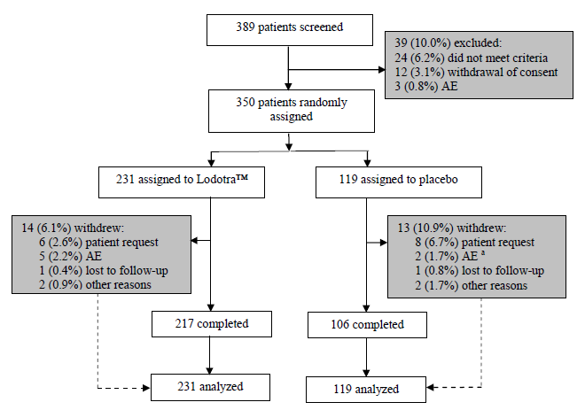

Major protocol violations/deviations
Subjects with major protocol deviations (defined as likely to affect the validity of the data for the ACR20 and/or the duration of morning stiffness calculation) were excluded from the PP analysis. A total of 71 subjects (20.3% of 350) showed major protocol deviations – 46 patients (19.9% of 231) in the Lodotra group and 25 patients (21.0% of 119) in the placebo arm. The 4 most common reasons for exclusion from the PP analysis on the basis of protocol deviation were receipt of prohibited medications (10.4% [24/123] for Lodotra and 14.3% [17/119] for placebo), adherence failure to study medications (6.1% [14/231] for Lodotra and 3.4% [4/119] for placebo), mis-randomization (2.2% [5/231] for Lodotra and 4.2% [5/119] for placebo) and failure to meet inclusion, exclusion or randomization criteria (3.5% [8/231] for Lodotra and 0.8% [1/119] for placebo). The taking of prohibited medication was commonly explained by those taking NSAIDs which involved 38 patients overall (10.9% of 350) – 23 in the Lodotra group (10.0%) and 15 in the placebo arm (12.6%). Another 2 subjects (1 in each treatment group) were receiving additional corticosteroids, and 1 patient in the placebo group was receiving biologic DMARD.

Baseline data
Baseline demographic data between the 2 treatment groups was similar and outlined in Table 10. The age and gender distribution of the subjects were typical of RA populations with most being female (84.0%, 294/350) and middle-aged (45-65 years of age) with a mean age of 57.2 years (SD 9.76 years). Almost all patients were white (98.3%, 344/350).
Table 10 – Demographic Characteristics of Subjects in CAPRA-2 Study
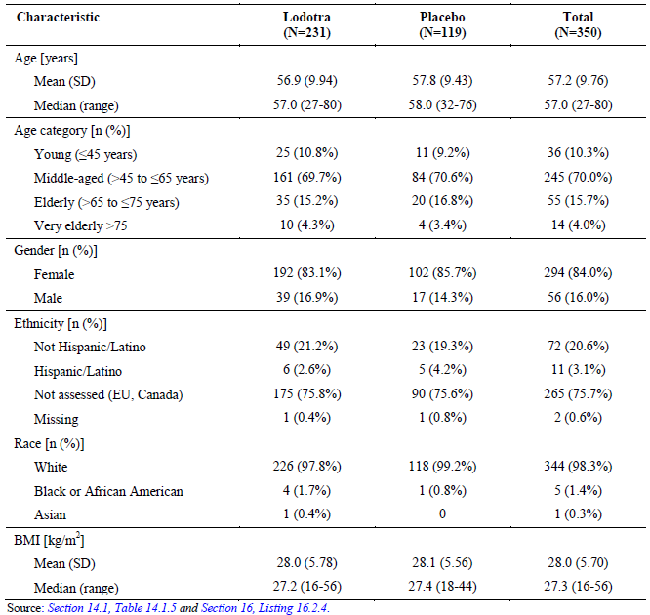
The baseline disease characteristics are summarized in Table 11. No major differences were observed between the treatment groups. The mean duration of RA was 8.0 years. Patients had evidence of high disease activity at baseline with mean DAS28 score being 5.2. The other RA measures of disease activity are also consistent with moderately-severely active disease at baseline.
Table 11 – RA Characteristics for Subjects in CAPRA-2 Study
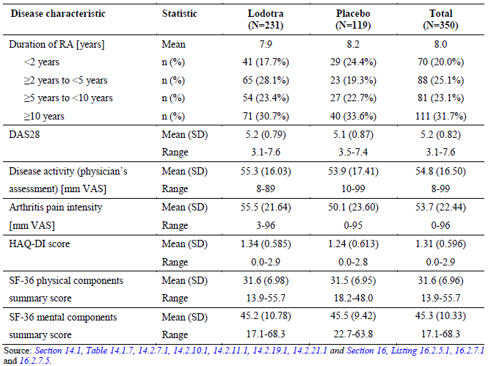
Additional baseline data not included in Table 11 are: -
- Mean tender joint count was 12.6 for both groups,
- Mean swollen joint was 8.4 for Lodotra and 8.6 for the placebo group,
- Mean CRP was 5.0 mg/L for Lodotra and 5.4 mg/L for placebo arm and
- Mean ESR of 33 mm/hour for both groups.
Co-morbidities at baseline were similar between the 2 treatment groups and included hypertension (43.1%, 151/350), osteoporosis (14.9%, 52/350), hypercholesteraemia (10.9%, 38/350) and gastroesophageal reflux disease (10.0%, 35/350). In general, this reflects a patient population with RA with restricted additional medical problems (e.g. no established heart disease or diabetes).
All 350 recruited subjects had taken conventional DMARDs for RA and most had been tried on NSAIDs (72.6%, 254/350). The most common DMARD treatments were methotrexate (74.6% of patients, 261/350), anti-malarial drugs (12.0%, 42/350) and leflunomide (11.4%, 40/350 subjects). Twenty-five patients (16 for Lodotra [6.9%] and 9 for placebo [7.6%]) had taken prior corticosteroid treatment for a variety of medical conditions (RA, asthma, skin conditions). The corticosteroids were discontinued as per study protocol in all but 2 patients (1 in each group) – both suffered from refractory rhinosinusitis. In addition, 7 subjects (4 in Lodotra group and 3 receiving placebo) were administered additional corticosteroids during the study, usually for intercurrent illness, AEs or infections. Two patients (1 in each treatment group) had received prior biological DMARD, which was an exclusion criterion.

Results for the primary efficacy outcome
The primary efficacy endpoint was achieved as Lodotra 5 mg/daily (46.8%, 108/231) demonstrated a statistically significant higher ACR20 responder rate after 12 weeks of treatment compared to placebo (29.4% [35/119] using the ITT population) – refer to Table 12. The treatment difference was 17.3% (95% CI 6.37, 26.91) with an odds ratio of 2.16 (95% CI 1.34, 3.48). The observed difference was significant using different imputation methodologies for missing values and was confirmed by analyses of the safety and PP populations, demonstrating robustness of the data. In addition, consistency of the results across different study sites was confirmed.
Table 12 – ACR20 Response rate at Visit 4 in CAPRA-2 Study (different imputation methods)
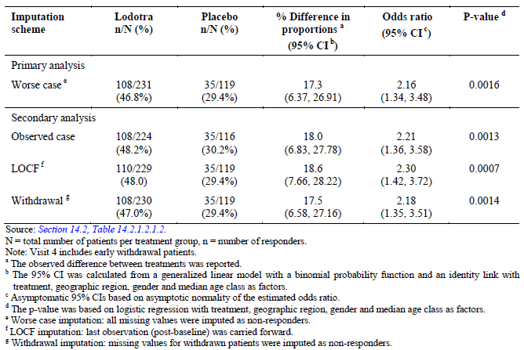

Results for other efficacy outcomes

ACR20 response rates by visit and time to response
Using the observed patient assessments, the difference between the 2 treatment groups became statistically evident at the first post-treatment assessment (visit 2), which was 2 weeks after randomization (23.8% [53/223] for Lodotra versus 11.4% [13/114] for control; p = 0.0049). By visit 3 results at week 6 of therapy, the majority of the treatment difference was evident with the ACR20 response rates being 43.7% (94/215) for Lodotra and 27.1% (29/107) for placebo (p=0.0037).
The median time to the first occasion of meeting an ACR20 response, which was analysed only in patients who were responders at any time (188 patients in total - 138 receiving Lodotra and 50 in the control arm), was approximately twice as long for the control group when compared to the Lodotra arm (84 days versus 45 days).

ACR50 and ACR70 response rates
The ACR50 and ACR70 response rates at visit 2 (2 weeks of treatment) were expectedly low and similar between the 2 treatment groups – ACR50 rate of 3.6% (8/224) for Lodotra and 2.6% (3/114) for placebo [p=0.6465] and the corresponding ACR70 response rates were 0.9% (2/224) for Lodotra and 1.8% (2/114) for control [p=0.4967].
However, a numerically higher response rate was seen at visit 4 (12 weeks) for the Lodotra group compared to placebo when measured using the ACR50 (22.5% [52/231] versus 9.2% [11/119]) and ACR70 (6.9% [16/231] versus 2.5% [3/116]) criteria but this only achieved statistical significance for ACR50 response (p=0.0026 for the 12 week ACR50 evaluation and p=0.0964 for the ACR70 comparison).
Similarly, the treatment difference at visit 3 (6 weeks) was statistically significant for the ACR50 assessment but not the rates of ACR70 response.

Duration of morning stiffness
The relative percentage change from baseline to visit 4 (week 12) in the duration of morning stiffness was considered by the sponsor to be a key secondary variable, which I concur has relevance to the proposed indication wording for Lodotra in Australia. A summary of the results in the CAPRA-2 Study are provided in Table 13. The median baseline duration of morning stiffness was comparable between the 2 groups – 128.6 minutes for Lodotra and 138.6 minutes for placebo. At visit 4 (12 weeks), the median duration of morning stiffness was 45.2 minutes in the Lodotra group and 85.0 minutes in the placebo group which corresponds to a median percentage decrease from baseline of 56.5% for Lodotra and 33.3% for placebo (p=0.0008). Sensitivity analyses using different imputation methods and specified populations (ITT and PP cohorts) confirmed the same result. In addition, analysis by geographic regions (North America and Europe) demonstrated consistency in this parameter.
Table 13 – Change in duration of morning stiffness between baseline and visit 4
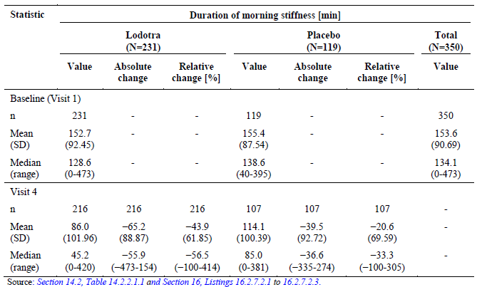

Change in DAS28 score
The mean baseline DAS28 was comparable between the 2 treatment groups being 5.2 for Lodotra and 5.1 for placebo. The mean absolute change from baseline for the DAS28 score showed a greater decrease in the Lodotra group than in the placebo group at each visit, and reached values of -1.2 and -0.7 respectively at visit 4 (week 12). A change of -1.2 (i.e. 2 times the measurement error of the calculation) in the DAS28 score is considered to indicate significant change.

EULAR response
EULAR response criteria incorporate some amount of change from baseline for the individual, as well as a certain level of attained disease activity. The EULAR response criteria classify patients as either good, moderate or non-responders. To be classified as a “good responder” the patient must achieve at least a -1.2 change from baseline as well as an overall DAS28 score of no greater than 2.6. “Non-responders” have a change in score from baseline that is less than -0.6 and the overall score is greater than 3.7. All other changes are regarded as a “moderate” EULAR responder.
According to EULAR criteria, no patients in the CAPRA-2 Study achieved a good response at any visit. However, the number of patients with a moderate response was greater in the Lodotra group than the placebo arm at each treatment visit. In particular, the rate of moderate EULAR response at visit 4 (12 weeks) was 56.7% (131/231) for Lodotra compared with 40.3% (48/119) for the control group.

Individual ACR response variables
The mean tender (12.6 joints) joint count at baseline was the same for both treatment groups, and the mean swollen joint count was similar (8.4 for Lodotra and 8.6 for control group). Over the 12 weeks of the study, the mean tender and swollen joint counts decreased in both groups but were numerically higher in the Lodotra group compared to the placebo group (-4.8 tender joints for Lodotra versus -2.8 tender joints for placebo; and -3.6 swollen joints for Lodotra versus -2.7 swollen joints for placebo).
In the patient’s assessment of pain, the mean score decreased at each visit for the Lodotra group (-11.4 mm at visit 2), whereas for the placebo group, the mean score did not decrease until visit 3. At 12 weeks, the absolute mean of the change from baseline in the Lodotra group was -22.4 mm VAS (baseline 55.5 mm) which was double that observed in the placebo group (-10.8 mm VAS; baseline 50.1 mm) and this reached MCID for this variable (-11.9 mm change in the 100 mm VAS).
In the global assessment of disease activity, the patient’s and physician’s assessment were comparable and both in favour of Lodotra, with the mean changes from baseline to visit 4 being -21.4 mm for Lodotra (baseline 57.6 mm) and -7.2 mm for the placebo group (baseline 50.5 mm) in the patient’s assessment, and -23.6 mm for Lodotra (baseline 55.3 mm) and -12.9 mm for placebo (baseline 53.9 mm) in the physician’s assessment.
The mean baseline HAQ-DI scores were 1.34 in the Lodotra group and 1.24 for the placebo arm. The HAQ-DI score has a range of 0-3 with a higher score indicating more functional impairment. The mean change in the HAQ-DI score between baseline and visit 4 was numerically higher in the Lodotra group (-0.22) compared to the placebo group (-0.05). The difference in HAQ-DI score between baseline and visit 4 just meets the MCID for the change in HAQ-DI (-0.22).
Changes in serum inflammatory markers (ESR and CRP) were considered as part of the PD analysis.

Change in severity and reoccurrence of morning stiffness
The mean baseline severity of morning stiffness was slightly higher in the Lodotra group (54.8 mm versus 50.3 mm for placebo on a 100 mm VAS). Over the 12 weeks of the study, the patient’s assessment of morning stiffness decreased (i.e. improved) in both treatment groups, but with a greater mean change from baseline to visit 4 for the Lodotra group (-28.7 mm) than for the placebo group (-19.1 mm).
At baseline, the mean reoccurrence of morning stiffness was comparable in the Lodotra (69.1% of days) and control groups (70.6% of days). Over the course of the trial, the mean reoccurrence of morning stiffness of morning stiffness decreased in both treatment groups with a greater mean change from baseline for those in the Lodotra group (-22.3% of days) versus the control arm (-10.7% of days).

Change in analgesic use
The mean number of days with additional analgesic use during the 12-week study period was comparable in both treatment groups (14.7 days [SD 26.44] for Lodotra and 14.3 days [SD 23.46] for placebo).

Quality of life measures
At visit 4 (12 weeks) the SF-36 measurement showed a greater improvement in the Physical component Summary (PCS) score for the Lodotra group (mean improvement of 3.5 from a baseline value of 31.6) compare to the control group (mean improvement of 1.1 from a baseline of 31.5). The difference is of modest clinical magnitude given that minimal clinically important change (MCID) in the PCS is variably considered to be between 2.5 and 5. No relevant improvement in the Mental Component Summary (MCS) score was observed over 12 weeks of follow-up with the mean improvement for Lodotra being 1.5 (baseline mean of 45.2) and for control treatment the mean improvement was 0.4 (baseline mean of 45.5).
The FACIT-F fatigue score ranges from 0-52 with a higher score indicating better QOL. The mean baseline FACIT-F score was comparable in the 2 treatment groups (28.8 for Lodotra and 28.7 for placebo). At visit 4 (week 12) a greater mean increase in the FACIT-F score (i.e. reduction of fatigue) was in the Lodotra group (mean improvement of 3.7) compared to the placebo group (mean improvement of 1.6). This difference is of modest clinical relevance for Lodotra with the MCID for this parameter considered 3-4.

Other efficacy studies

Openlabel extension phase of CAPRA-1 study (EMR 62215-003)

Design and objectives
This was 9 month OLE phase of the CAPRA-1 Study which had the primary objective of evaluating the longer-term safety of MR prednisone (Lodotra formulation). However, the study also assessed the maintenance of efficacy in those who received Lodotra in the forerunner double blind trial as well as the response by individuals who received IR prednisone in the preceding controlled study. All subjects who completed the double blind study phase of CAPRA-1 were eligible to either continue Lodotra (n=120) or to start receiving Lodotra (n=129) as a substitute corticosteroid treatment for IR prednisone. The OLE phase of the CAPRA-1 study commenced immediately at the end of the double blind study period (visit 5- week 12) reflecting a seamless design. During the OLE study phase, there were 3 discrete assessment time points - visit 6 [3 months], visit 7 [6 months] and visit 8 [9 months].
The first subject started in the OLE on 3 November 2004 and the last patient completed follow-up on 5 January 2007. The OLE study was conducted at 13 centres in Germany and 12 sites in Poland.

Study treatments
Patients were given Lodotra in 2 dose strengths (1 and 5 mg) with tablets not to be broken, chewed or dissolved so as to maintain the integrity of delayed release shell. Lodotra was to be taken in the evening (2200 hours +/- 30 minutes) either with or after a light meal. During the OLE phase, patients were allowed to reduce their DMARD and prednisone dose at the discretion of the patient or investigator. Upon entering the OLE phase, the same doses of these medicines were maintained according to the doses at the final (visit 5) assessment in the double blind period. Biological DMARD therapy was excluded in the OLE. Compliance with study medication during the trial was high with only 6 subjects (2.4%) taking their treatment <80% correctly (i.e. incorrect dose and timing).

Statistics and efficacy variables
The study analysis population consisted of all subjects for whom it was reasonable to assume intake of study medication on at least 1 occasion after visit 5. All efficacy parameters were evaluated by descriptive statistics.
The primary efficacy variable for the OLE was the duration of morning stiffness (absolute and relative change) at the scheduled study visits, but particularly the change between visits 5 and 8.
The secondary parameters for efficacy included: -
- Subject’s assessment of pain intensity at each visit (absolute and relative change from visit 5),
- Number of subjects with recurrence of stiffness during the day,
- Mean changes in the DAS28 score (absolute and relative),
- Physician’s Global Assessment of disease activity at each visit (visits 5-8),
- Mean changes in the HAQ-DI and SF-36 scores from visit 5,
- ACR20 response rates at visit 8 compared to the start of the double blind period (visit 2) and start of the OLE (visit 5), and
- Dose changes for MR prednisone and DMARD over the OLE study period.

Study population
A total of 249 of a potentially eligible 251 patients (120 from the original Lodotra group and 129 from the IR prednisone arm) entered the OLE study phase and 219 patients (88.0%) completed the 9 months of follow-up. The reasons for OLE study withdrawal in the 30 patients were adverse events (12, 4.8%), withdrawal of consent (10, 4.0%), insufficient efficacy (5, 2.0%), protocol violations (2, 0.8%) and 1 subject (0.4%) for “other reasons”.
The patient population included 216 (86.7%) female subjects with a mean age of 55 years (range 20-78 years) and a mean weight of 71 kg (range 44-114 kg). All but 1 subject was of Caucasian ethnicity. At visit 5, the mean DAS28 score was 5.15 (range 2.18-8.03), mean HAQ-DI score was 1.43 (range 0-2.63), mean pain intensity was 43.8 mm VAS and 60.6% (151/249) of subjects had a “moderate” score on the Physician Global Assessment of disease activity (8.4% [21/249] were rated severe and 30.5% [76/249] were rated mild). Overall, these baseline disease characteristics for the OLE phase indicate patients with persistent, moderately-severely active RA.

Efficacy results
For patients who initially received treatment with MR prednisone, the mean reduction in the duration of morning stiffness was greater at 3 months, and then was maintained over the extended treatment period (to 12 months) with no weaning of effect observed – refer to Table 14. The relative mean change in the duration of morning stiffness with Lodotra was 55% after 12 months compared to baseline (absolute reduction from 156 minutes to 74 minutes). The former IR prednisone group showed a notable reduction in the duration of morning stiffness after 3 months of Lodotra (relative change of 46%; absolute change from 150 to 85 minutes), which is similar in magnitude to the change seen with the Lodotra group in the double-blind phase. The treatment effect in this switch treatment patient group remained stable thereafter to 9 months of follow-up.
Table 14 – Duration of morning stiffness after commencing MR prednisone in CAPRA-1 Study
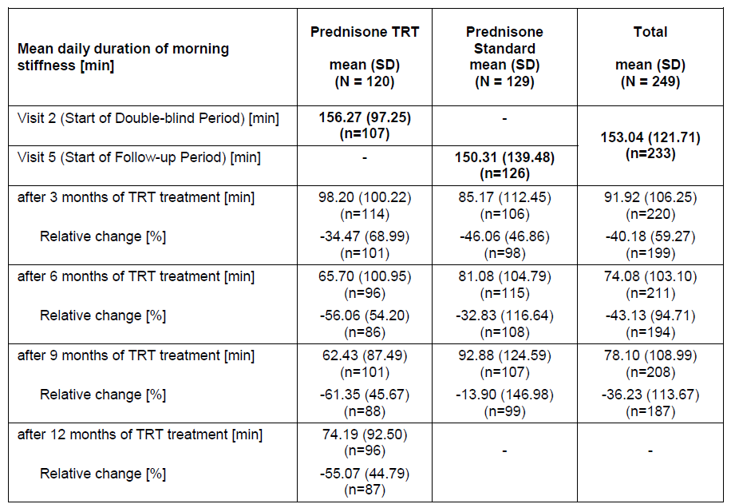
The number of patients with recurrence of stiffness during the day remained stable over the OLE for those previously treated with Lodotra in the double blind period (51.7% [62/120] at visit 5 and 51.5% [53/103] at visit 8). For patients in the previous IR prednisone group, the rate of daytime stiffness recurrence initially decreased after the initial 3 months of Lodotra treatment (50.4% [65/129] at visit 5 and 40.2% [49/122] at visit 6) but then returned to their baseline incidence (50.0% [60/120] at visit 7 and 47.3% [52/110] at visit 8).
As reported in the double-blind period of CAPRA-1, no clear treatment effect in terms of the change in the patient’s assessment of pain intensity (according to VAS scores) was found when comparing the 2 different prednisone formulations. The same pattern of no clear and consistent effect upon reduction of pain intensity was seen in either group (original Lodotra or the treatment switch group) during the OLE phase.
During the open follow-up phase, the mean DAS28 decreased from 5.15 (visit 5) to 4.84 (visit 8), while at baseline (visit 2) the mean DAS28 score was 5.88. The change observed between visit 5 and 8 is not of a clinically significant magnitude. An analysis of the components comprising the DAS28 score (tender and swollen joint counts, as well as serum inflammatory markers) supported the non-significant composite outcome result and followed the same trend.
The number of patients whose disease activity was assessed by the physician as “mild” increased over the OLE from 30.5% (76/249) at visit 5 to 40.2% (88/219) at visit 8. This change in trend was mainly explained by a shift of physician rated disease activity from “moderate” (60.6% [151/249] at visit 5 to 51.6% [113/219] at visit 8).
The percentage of patients reaching an ACR20 response after 9-12 months of treatment was 37.4% (82/249). The incidence of achieving an ACR20 response at 9-12 months of treatment compared to visit 2 was similar in both pre-treatment groups (original Lodotra and IR prednisone). In the 3-month, double blind phase no noticeable treatment effect by prednisone formulation was seen (14.6% for Lodotra and 17.4% for IR prednisone).
No notable differences were observed between visits 5 and 8 for the secondary efficacy parameters of mean change in HAQ-DI and Quality of Life (SF-36) scores.
During the OLE, 22 subjects (8.8% of 249) required an increase in their baseline prednisone dose and 23 patients (9.2%) were able to achieve a dose reduction. The calculated mean daily dose of prednisone remained unchanged over the OLE at 6.79 mg (median 6.37 mg). The rate of concomitant DMARD use remained unaltered over the OLE at 96.8% of subjects (241/249).

Analyses performed across trials (pooled analyses and meta-analyses)
Not applicable

Evaluator’s conclusions on clinical efficacy for the indication sought
Evaluator’s conclusions on clinical efficacy “for the treatment of moderate to severe, active rheumatoid arthritis in adults, particularly when accompanied by morning stiffness:”
The sponsor has provided the efficacy data from 2 pivotal, randomized, multicentre, double blind trials to support the efficacy of Lodotra in treating adult patients with active RA, particularly when morning stiffness is a prominent symptom. Supportive evidence of efficacy is provided by the 9-month open label extension phase of 1 of the phase 3 studies (CAPRA-1). In general, the trials were of adequate design to evaluate the proposed indication, and they both had a clear and appropriate plan of analysis. The biological rationale for the use of modified release prednisone in RA is plausible and the low dose used in both of the pivotal studies (3-10 mg/day) is appropriate to the literature, including international treatment guidelines. In both phase 3 studies, patients continued on their background DMARD, as well as NSAID for most subjects.
In the CAPRA-1 study, 2 treatment groups (each consisting of 144 subjects) were randomized to receive either Lodotra 3-10 mg/day or a common formulation of immediate release prednisone (Decortin) used in Europe. In the CAPRA-2 Study, patients were randomized to receive either a fixed 5 mg/day dose of Lodotra (n=231) or placebo tablets (n=119) while continuing their background treatment for RA at stable doses (DMARD, and often concurrent NSAID). The majority of patients (at least 84%) in all treatment groups completed the 12 weeks of follow-up in both pivotal studies. However, there was high number of protocol violations in the CAPRA-1 Study affecting both treatment groups (52% for MR and 42% for IR prednisone) which may have potentially affected the validity of the efficacy analysis. In the CAPRA-2 Study, protocol violations affected 20-21% of subjects in each of the 2 treatment groups.
The populations examined in the phase 3 studies are partly similar in demographics to patients that would be treated in Australian clinical practice. The trials were conducted mainly in Germany and Poland, and mostly recruited middle-aged Caucasian women. The background treatments for RA are consistent with Australian treated patients but the incidence of co-morbid illness was less than expected. The baseline disease characteristics of the study cohorts are consistent with a group of patients with moderately to severely active RA, which is congruent with the proposed indication wording. However, the generalizability of the study results to a broader RA population in Australia has limitations. As stated in the Lodotra RMP for Australia, the background incidence of co-morbid disease in the RA population include cardiovascular disease (12-22%), depression (19%), diabetes (5-7%), peptic ulcer disease (3-9%) and renal disease (3%). In the study populations, most of these conditions were usually under-represented (e.g. a history of peptic ulcer was an exclusion in the CAPRA-1 Study).
The primary efficacy outcome in the CAPRA-1 Study was the duration of morning stiffness and main efficacy endpoint in the CAPRA-2 Study was the ACR20 responder rate at 12 weeks. The CAPRA-2 trial also had the change in the duration of morning stiffness as a key secondary parameter. In addition, there were several other secondary efficacy endpoints in both studies, some of which were dependent on subjective assessments done by either the subject or physician (e.g. stiffness variables and pain intensity). Nonetheless, the efficacy endpoints were appropriate for evaluating the proposed indication for Lodotra.
In the controlled period of both phase 3 studies the primary efficacy measure was achieved in favour of Lodotra over comparator treatment. In the CAPRA-1 Study, the relative improvement from baseline to week 12 in the duration of morning stiffness for Lodotra compared to IR prednisone was 22.7%, which although statistically significant represents a modest clinically relevant difference. In the CAPRA-2 Study, the ACR20 responder rate after 12 weeks of treatment was higher in the Lodotra group (47.2%) compared to placebo (28.6%). This outcome in favour of Lodotra was supported by a higher proportion of Lodotra treated subjects (22.5%) achieving an ACR50 response at 12 weeks compared to placebo (9.2%; p=0.0026). Furthermore, the mean decrease in morning stiffness from baseline to 12 weeks was -56.5% for Lodotra and -33.3% for placebo. Overall, the primary efficacy results of the 2 pivotal studies indicate a treatment effect with Lodotra in active RA beyond placebo (and of moderate clinical relevance), and modestly better than standard IR prednisone.
The results for the secondary efficacy endpoints were inconsistently achieved. In the CAPRA-1 Study, none of the secondary efficacy outcomes demonstrated a treatment difference between MR or IR prednisone except when the primary variable (duration of morning stiffness) was assessed on a per week basis instead of a change from baseline to 12 weeks (as for the primary analysis). In particular, the objective endpoints of clinical relevance such as DAS28 and HAQ-DI score showed no difference in treatment effect (MR or IR prednisone). In the CAPRA-2 Study when Lodotra 5 mg/day was compared to placebo + background DMARD, some but not all of the secondary efficacy endpoints were met. These results confirm that the addition of low dose prednisone to standard care for patients with active RA has a clinical benefit of moderate magnitude.
The CAPRA-1 Study also had an open label extension phase for participants to either continue receiving Lodotra (as per the double blind period) or be switched to Lodotra from IR prednisone. The treatment switch patients achieved an improvement in the duration of morning stiffness similar to those initially treated with Lodotra, while the continuing Lodotra maintained their response to MR prednisone. However, for many of the secondary endpoints of clinical relevance such as those subjects able to alter their baseline dose of prednisone, no result in favour of Lodotra was observed.
In summary, the data in this submission appears to support the efficacy of Lodotra in treating adult patients with active RA, particularly with respect to improving the duration of morning stiffness. The 2 pivotal studies are appropriately different in design to understand the relative effect of Lodotra in comparison to alternative management approaches such as IR prednisone or placebo + background DMARD. The open label experience provides limited information on the durability of response up to 12 months of treatment.

Clinical safety

Studies providing evaluable safety data
The following studies provided evaluable safety data:

Pivotal efficacy studies
In the pivotal efficacy studies (CAPRA-1 and -2), the following safety data was collected:
- Adverse events (AEs) were assessed and recorded as per the MedDRA coding system (version 4.0).
- No specific AEs of particular interest were pre-specified by sponsor but certain AEs such as risk of infection, hyperglycaemia and suppression of the hypothalamic-pituitary adrenal (HPA) axis could be assessed by the evaluator from the dataset.
- Laboratory tests including haematology, biochemistry and urine analysis variables were performed at screening (visit 1), baseline (visit 2), 2 weeks (visit 3), 6 weeks (visit 4) and 12 weeks (visit 5).
- Adrenocortical function tests were planned to be assessed in a subset of 32 subjects in the CAPRA-1 Study.
- Vital signs (blood pressure, heart rate and body weight) were measures at visit 1 or 2 for baseline, and at visit 5.

Pivotal studies that assessed safety as a primary outcome
Not applicable to this submission.

Dose-response and non-pivotal efficacy studies
The dose-response and non-pivotal efficacy studies provided safety data as follows:
- The 9-month OLE phase of the CAPRA-1 Study provided data on the longer term incidence of treatment emergent AEs, adrenocortical function (in a small subset), laboratory variables and vital signs; and
- Study NP01-008 (which assessed dose proportionality) also provided safety data.

Other studies evaluable for safety data
Eight additional clinical pharmacology studies (EMR 62215-001, -002 and -005; NP01-006, -009, -010, -013 and -014) also contributed safety assessments.

Pivotal studies that assessed safety as a primary outcome
Not applicable.

Patient exposure
During the double blind phase of Study EMR 62215-003, all randomized patients were either exposed to either Lodotra (n=144) or IR prednisone (n=144) at a daily dose of 3-10 mg (according to individual patient requirements). The mean, median and range for the duration of exposure were similar between the 2 treatment groups as was the mean daily dosage of 6.4-6.8 mg/day (as per Table 15). When entering the OLE of Study EMR 62215-003, all patients from the IR prednisone group were switched to Lodotra. Table 15 also displays the duration of exposure and the mean daily dose (6.79 mg) for the combined dataset (double blind and open label, follow up phases).
Table 15 – Extent of exposure to prednisone in CAPRA-1 Study
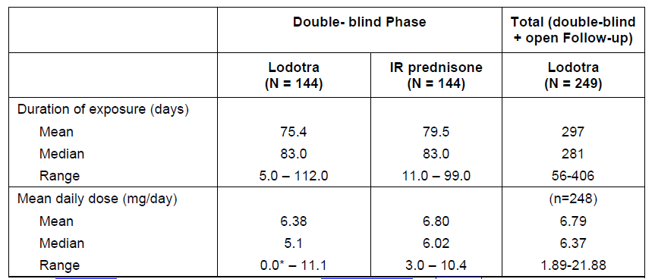
Table 16 summarizes the number of patients exposed to Lodotra for specific time periods (incremental 3 month periods to 12 months).
Table 16 – Treatment duration with Lodotra in CAPRA-1 Study
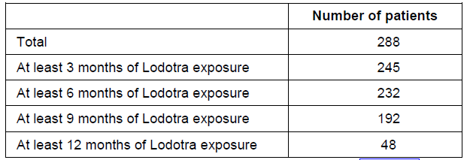
Table 17 summarizes the overall exposure to Lodotra in the second pivotal phase 3 study (NP01-007). In this trial, all subjects receiving Lodotra were given it at a fixed 5 mg/day dose and the median duration of exposure was 84 days. However, 70.6% (163/231) of subjects took the therapy for at least 84 days.
Table 17 – Exposure to Lodotra in Study NP01-007
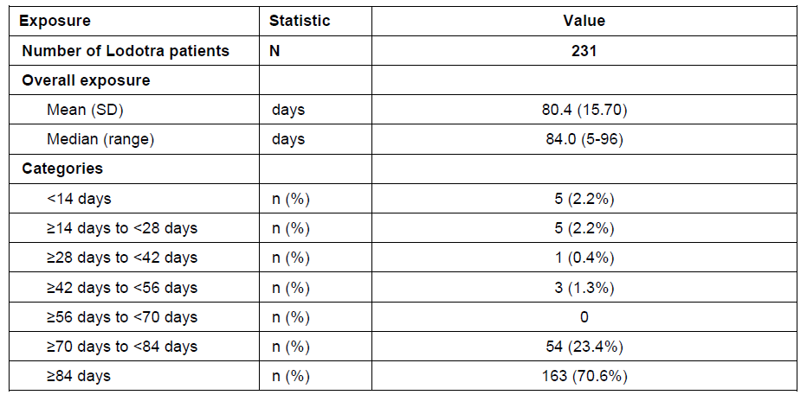
Table 18 provides a summary of the total exposure to prednisone (including test and reference formulations) for 8 of the earlier phase clinical studies. Study NP01-014 is not represented in Table 18. It involved 52 subjects receiving up to 2 single oral doses of 5 mg of prednisone. In total, 247 subjects were exposed to study treatment in the 9 early phase trials. All of these studies were single dose only in design. The dose of prednisone varied from 2-20 mg but the most commonly examined doses were 5 and 10 mg.
Table 18 – Summary of prednisone exposure in Phase 1 Studies (NP01-014 not shown)
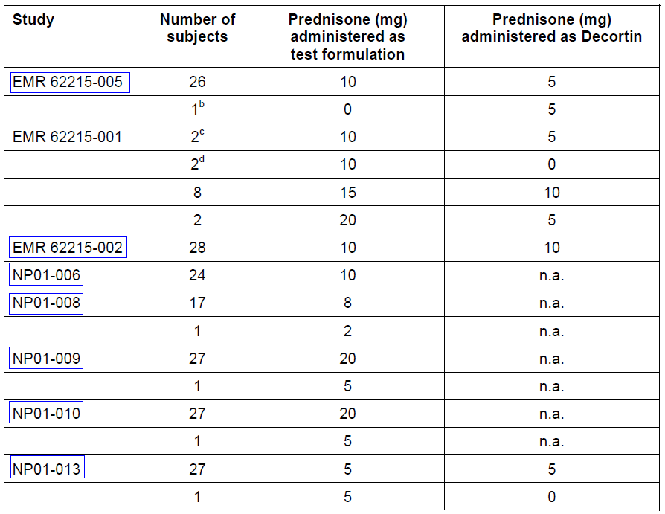

Adverse events

All adverse events (irrespective of relationship to study treatment)
Because of heterogeneity in the study populations (healthy individuals versus patients with RA), design and the use of different test formulations and regimens, the sponsor analysed and presented the safety data for each study individually rather than by pooling data across the trials. A combined analysis of AEs that were reported during the double blind periods of the 2 phase 3 studies was the only integrated dataset assessment.

Pivotal studies

CAPRA-1 study
For each treatment group, AEs were reported in 59 subjects (41.0% of 144) and there were no differences between the 2 treatment groups with regard to types of AEs observed. Approximately two thirds of reported AEs in each group were considered to be unrelated to the study medication (Lodotra or IR prednisone). Severe AEs were reported in 5 subjects (3.5% of 144) treated with Lodotra and 4 patients (2.8%) receiving IR prednisone. The most frequently reported AEs (by MedDRA Preferred Term) were worsening of RA (24 patients, 8.3% of 288), upper abdominal pain (13 patients, 4.5% of 288) and nasopharyngitis (12 patients, 4.2% of 288). The incidences of these AEs were similar in both treatment groups.
During the OLE period, 127 patients (51.0%) experienced at least 1 AE irrespective of its relationship to MR prednisone, but for 27 patients (10.8%) those AEs were considered by the investigator to be related to Lodotra. Treatment-emergent AEs causing discontinuation of Lodotra were experienced by 13 patients (5.2%). Thirteen subjects (5.2%) were reported to have experienced severe AEs and 98 patients (39.4%) who recorded to have experienced significant AEs. The individual types of AEs recorded in the OLE period was comparable to that seen in the double blind phase, and often at a lower incidence apart from exacerbation of RA (14.5%, 36/249). However, some individual types of AEs were only recorded in the OLE phase such as increased weight (7 subjects, 2.8% of 249), back pain (7 patients, 2.8%), gastritis (4 subjects, 1.6%), depression (4 patients, 1.6%) and sleep disorder (3 subjects, 1.2%).

CAPRA-2 study
Overall, 157 patients (44.9% of 350) experienced at least 1 AE with a slightly lower proportion of patients in the Lodotra group (42.9%, 99/231) compared to the placebo group (48.7%, 58/119). The AEs were considered to be treatment related in 28 patients overall (8.0% of 350) with a similar incidence of treatment related AEs in both groups (7.8% [18/231] for MR prednisone versus 8.4% [10/119] for placebo). One patient treated with Lodotra and 2 patients treated with placebo suffered SAEs, all of which were considered to be unrelated to study treatment. In total, 6 patients experienced AEs leading to withdrawal (5 in the Lodotra group and 1 in the placebo group). These AEs were considered to be related to study treatment in 5 patients (4 in the Lodotra group and 1 in the placebo group). The most commonly reported AEs by preferred term were arthralgia (13.7%, 48/350), aggravated RA (7.4%, 26/350), nasopharyngitis (4.3%, 15/350) and headache (4.0%, 14/350). The proportion of patients experiencing arthralgia in the placebo group was double that in the Lodotra group (20.2% [24/119] versus 10.4% [24/231]) and more patients in the placebo group reported aggravation of RA (9.2% [11/119] versus 6.5% [15/231] for Lodotra).

Combined analysis of phase 3 studies
An integrated summary of safety for the CAPRA-1 and -2 studies was performed and showed that the safety profile was comparable across both phase 3 studies. The overall incidence of AEs across the 2 phase 3 studies was slightly higher in the placebo group (48.7%, 58/119) compared to Lodotra (41.9%, 157/375) or standard IR prednisone (39.6%, 57/144) – refer to Table 19. Drug-related AEs occurred more frequently for IR prednisone (30.6%, 44/144) than Lodotra (16.8%, 63/375) and placebo (8.4%, 10/119). Drug-related AEs leading to withdrawal were most frequently reported for IR prednisone (4.2%, 6/144), followed by Lodotra (2.9%, 11/375) and placebo (0.8%, 1/119). The incidence of SAEs and drug-related SAEs was low and comparable for all 3 treatments. There was correlation between prednisone dose (above or below 5 mg/day) and the incidence of AEs for either prednisone formulation (MR or IR).
Table 19 – Overview of Adverse Events across the CAPRA-1 and -2 Studies (3 month, double blind periods only – safety population)
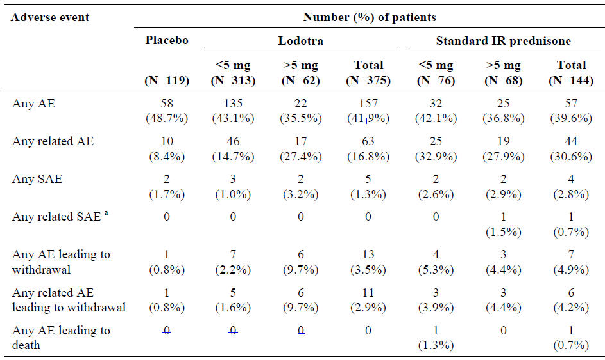
ªincludes events assessed as possibly related. SAE=serious adverse event. IR=immediate release; N=number of patients
The most commonly reported AEs (occurring in >2% of patients in any treatment group) did not reveal any statistically significant differences between Lodotra and placebo, or Lodotra and IR prednisone, except for RA flare being more frequently reported for placebo than for either formulation of prednisone (26.1% [31/119] for placebo versus 12.8% [48/375] for MR and 9.7% [14/144] for IR; p<0.05 for both pairwise comparisons); and a statistically significant difference in the incidence of diarrhoea, which was reported for a higher proportion of patients receiving IR prednisone than Lodotra (2.8% [4/144] versus 1.1% [4/375]; p = 0.0444), although there were very low numbers of patients with diarrhoea in both groups.

Other studies
In total, 20 and 26 AEs were reported in studies EMR 62215-001 and EMR 62215-002, respectively. The most frequent AE in both studies was headache (8 cases in study EMR 62215-001 and 7 cases in study EMR 62215-002) followed by various AE terms relating to gastrointestinal disorders (9 cases in study EMR 62215-001 and 12 cases in study EMR 62215-002). All AEs were mild to moderate in severity with the exception of 1 AE were considered by the investigator to be not related to the MR prednisone.
In Study EMR 62215-005, 23 AEs occurred after administration of study medication - 6 AEs in 4 subjects after taking Decortin in the fasted state, 4 AEs in 4 subjects after receiving Lodotra in the fed stare, and 13 AEs in 10 subjects after being given Lodotra in the semi-fasted state. All of the events were of mild intensity and the investigator considered all as unlikely or not related to the study drug. The most frequent types of AEs (affecting at least 2 cases) were abdominal pain (5 cases), headache (3 cases), pharyngitis (3 cases), and hematoma (2 cases). Other AEs reported as single cases were: arthralgia, skeletal pain, dizziness, taste perversion, diarrhoea, hypertension, phlebitis, sinusitis, hot flushes, and upper respiratory tract infection. With the exception of skeletal pain and diarrhoea, all of these AEs occurring as single cases were observed after intake of Lodotra. In the semi-fasted state, more AEs were observed with Lodotra than with the IR reference product. This difference is not considered to be clinically relevant because all of the events were mild and considered to be either unlikely or not related to the study drug. The number of subjects with AEs observed after Lodotra in the fed state was the same as after the IR reference product in the fasted state.
Overall, 7 AEs were recorded in 5 subjects participating in Study NP01-006 – 2 AEs in 2 subjects given 5 mg of Lodotra in the fasted state (n=24) and 5 AEs in 3 subjects given 5 mg of Lodotra in the fed state (n-24). Diarrhoea was the only AE reported on more than a single occasion and occurred in 2 subjects given Lodotra under fed conditions. The other AEs were palpitations, insomnia, gastroenteritis, headache and epicondylitis.
During Study NP01-008, 4 AEs of mild intensity were observed in 3 of the 18 subjects (16.8%). No serious or severe AEs occurred, and none of the AEs required medical treatment. Three of the 4 AEs in were judged to be possibly related to Lodotra.
In Studies NP01-009 and -010, each subject received the same dose (5 mg) of Lodotra, but from 4 different batches. Therefore, AEs are not compared between different treatments but assessed together. In Study NP01-009, a total of 14 AEs were observed in 8 of the 28 subjects (28.6%), all of mild or moderate intensity. No SAEs occurred and there were no withdrawals due to AEs. The frequency of AEs was similar across the batches. During Study NP01-009, 9 AEs occurred in 6 subjects that were considered as possibly related to Lodotra. In Study NP01-010, a total of 15 AEs (of mild or moderate severity) were observed in 8 subjects. No SAEs occurred. One subject who experienced gastroenteritis stopped after this AE. All AEs were assessed as being unrelated to Lodotra intake.
During Study NP01-013, 5 of the 28 subjects (17.9%) experienced 7 AEs that were all assessed by the investigator as not being related to the study medication. All AEs were mild (2 AEs: headache and oropharyngeal pain) or moderate (5 AEs: periodontitis, gastroenteritis, urinary tract infection, headache and dysmenorrhea) in severity. For subjects who received Lodotra, 4 AEs of moderate intensity were observed in 3 of 28 subjects (10.7%). For those who were given IR prednisone, 3 AEs of mild or moderate intensity were observed in 3 out of 27 subjects.
Overall, 24 AEs were recorded in 14 of 52 (26.9%) subjects participating in Study NP01-014 – 12 AEs in 9 subjects (17.3% of 52) given 5 mg of the Bayer preparation and 12 AEs in 8 subjects (15.7% of 51) who received the Skye Pharma formulation. The most commonly reported AE was headache affecting 4 subjects in the Bayer drug group (7.7% of 52) and 6 volunteers in the Skye tablet arm (11.8% of 51). Other types of AEs reported on more than a single occasion included nausea (n=4; 2 subjects in each group), diarrhoea (n=3; 2 in the Bayer group and 1 in the Skye tablet arm), epistaxis (n=3; 1 in the Bayer group and 2 with the Skye tablet) and vomiting (2 subjects given the Bayer formulation). All but 3 of the AEs were considered mild, and all AEs resolved by the study conclusion. The 3 moderate intensity AEs were singular reports of headache, nausea and vomiting (all with the Bayer tablet preparation).

Treatment-related adverse events

Pivotal studies

CAPRA-1 study
Overall, drug-related AEs were reported in 35 of 288 patients (12.2%) - 19 (13.2% of 144) subjects in the Lodotra group and 16 (11.1% of 144) patients in the IR prednisone arm. During OLE treatment, 27 patients (10.8% of 249) were recorded to have suffered a drug related AE. Table 20 displays the most frequent drug-related AEs that occurred in >1.0% of treated patients. The most frequently reported drug-related AEs were gastrointestinal complaints (MedDRA Preferred Term “abdominal pain upper” and “gastritis”), “nausea” and “headache” (overall, 6 patients [2.1% of 288] for each of the last 2 AE types in the double blind phase). The incidences of drug-related AEs were similar in both prednisone treatment groups, which are expected because of the study design. Furthermore, all patients had received prednisone before the study for at least 3 months and in light of the RA disease duration (mean 10 years) it can be assumed that the majority of patients had probably received prednisone for a long time.
With longer treatment duration, weight increases were observed in 6 cases (2.4% of 249) in the OLE phase. Otherwise, no significant or clinically relevant changes in the AE profile were observed under open label treatment. Although the duration of the open label follow-up was considerably longer (up to 3-fold) than the duration of the double-blind phase, the incidence of most AEs was lower which may be contributed to by under-reporting because of the longer visit intervals.
Table 20 – Drug Related Adverse Events (>1.0% frequency) in CAPRA-1 Study
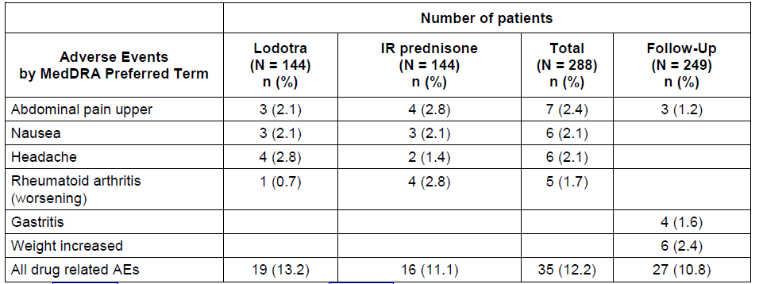

CAPRA-2 study
In total, 28 patients (8.0% of 350) reported AEs that were considered to be related to study treatment - 18 (7.8% of 231) in the Lodotra group and 10 (8.4% of 119) in the placebo group. Table 21 shows the most frequent drug-related AEs that occurred in > 0.5% of treated patients. The most commonly reported treatment-related AE by preferred term was headache (4 patients overall, 1.1% of 350). All treatment-related AEs were mild or moderate in severity with the exception of 1 AE (severe headache in a patient receiving placebo who withdrew because of the AE).
Table 21 – Drug Related Adverse Events (>0.5% frequency) in CAPRA-2 Study
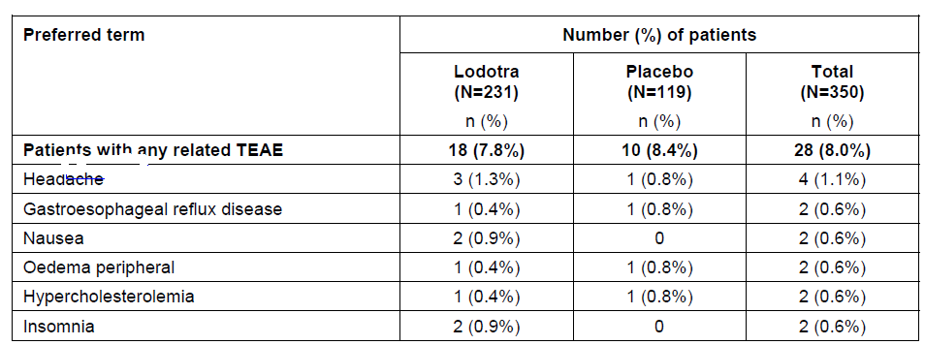

Other studies
In Study EMR 62215-002, 1 subject had increased hepatic enzymes (ALT and SGPT) at discharge (which was 1 day after treatment with the MR formulation in the fed state). This AE was rated as mild in severity and assessed as possibly related to study medication. The subject’s SGPT level was still elevated 1 week after discharge but had returned to the normal range upon re-elevation 1 month after discharge.
In Study NP01-006, 5 of the 7 reported AEs were considered to be related to Lodotra. There were 2 cases of diarrhoea (occurring in subjects given the drug in the fed state), and 1 case each of insomnia (fasted administration), gastroenteritis (fed state) and headache (fed state ingestion).
Three of the 4 AEs in Study NP01-008 were judged to be possibly related to Lodotra: “headache” in 1 subject after the 1 mg dose of Lodotra; and “swollen lymph nodes” and “skin irritation” in 1 subject following 2 mg of Lodotra. The observed immunoreactions occurred in period 1 and the subject had no known allergy. Both reactions fully resolved before the next administration of Lodotra and did not recur with the higher dose of 5 mg.
During Study NP01-009, 9 AEs occurred in 6 subjects that were considered as possibly related to Lodotra. These comprised 2 reports of headache in 2 subjects (7.1%), 3 infection related AEs in 3 patients (10.7%; common cold, herpes labialis and rhinitis). Another subject reported dizziness and sweating (both of moderate intensity) accompanied by pale skin. Additionally, 1 subject complained of moderate nausea, which was assessed as being treatment related. Except for the case of herpes labialis, which was treated topically with acyclovir, all AEs had resolved by the end of study without requiring medication.
Eleven AEs occurring in 9 subjects (17.3% of 52) during Study NP01-014 were considered by the investigator to be related to prednisone. None of the AEs were unknown or unexpected with prednisone treatment. The AEs included headache in 6 subjects (11.5%), diarrhoea in 2 subjects (3.8%), and singular reports of nausea, vomiting and fatigue (1.9% each). Headache occurred in 3 subjects given each MR prednisone formulation. Diarrhoea was experienced only after receiving the Bayer tablet formulation, vomiting and fatigue following ingestion of the Bayer preparation, and nausea occurred with the Skye Pharma formulation.

Deaths and other serious adverse events

Pivotal studies
No subject died while receiving study treatment in any of the trials. However, 1 patient (a 64 year old female with treated RA for 14 years) involved in the CAPRA-1 Study suddenly died 18 days after receiving her last dose of IR prednisone. The death was assumed to be due to myocardial infarction and the patient had a significant past history of coronary artery disease. The death was judged to be unrelated to prednisone.
In addition to the death, 11 SAEs were reported in 7 patients (2.4%) in the CAPRA-1 Study – 6 SAEs in 4 patients (2.8%) receiving Lodotra and 5 SAEs in 3 subjects (2.1%) given IR prednisone. All patients with SAEs recovered from their events but 2 patients had sequelae (OA-related thumb surgery for a patient receiving Lodotra and a shoulder tendon rupture for a subject administered IR prednisone).
One patient (47 year old male) receiving IR prednisone experienced an SAE (depressed level of consciousness) judged to be possibly related to prednisone but this appears to be unlikely. Trial medication was discontinued due to the SAE and the patient recovered within days. The SAE was thought to be either possibly related to a recent influenza vaccination or the new onset of psychiatric illness. Other noteworthy types of SAEs were 2 cases of chest pain/coronary artery disease in each of the treatment groups (i.e. 4 in total), but none were considered related to study treatment, and 1 patient had an excision of squamous cell carcinoma from the cheek (deemed unrelated to Lodotra and occurring on study day 71).
Most patients (249 of 251) who completed the double-blind phase of the CAPRA-1 study entered the OLE period and all subjects received Lodotra then. Of these, 34 patients experienced 52 SAEs. The development of an SAE led to treatment delay for 2 patients and treatment discontinuation for 14 other patients. One SAE (tendon rupture) was still present at the conclusion of the OLE follow-up but all other SAEs were reported to be either recovered, recovered with sequelae or recovering. Only 2 of the SAEs that occurred during the 12 months of treatment were assessed as possibly related to Lodotra: gastric ulcer perforation in 1 patient and gastrointestinal haemorrhage in another subject. In both of these patients, concomitant medications (NSAID –diclofenac and ketoprofen) may have contributed to the events. Other single SAE events of interest and possibly related to corticosteroid treatment included sepsis (study day 59), pyelonephritis (study day 337), moderate leucopenia (study day 362) and delirium (study day 31). All other SAEs could be explained by the patients’ underlying disease (RA or concurrent OA).
During the CAPRA-2 Study, 4 SAEs were reported for 3 patients - 1 patient [0.4%] in the Lodotra group and 2 patients [1.7%] in the placebo group. The patient in the Lodotra group experienced 2 SAEs (palpitations and chest discomfort). In the placebo group, 1 patient experienced an SAE of ischemic heart disease and the other had abnormal cervical cytology reported. None of the SAEs were considered to be related to study medication.

Other studies
No deaths or SAEs were reported in the early phase trials.

Discontinuation due to adverse events

Pivotal studies
During the double-blind treatment phase of the CAPRA-1 Study, a total of 22 patients (7.6% of 288) experienced 34 AEs leading to the discontinuation of prednisone. Ten patients received IR prednisone (6.9% of 144) and 12 patients received Lodotra (8.3% of 144). During the 9 OLE months of CAPRA-1, an additional 14 patients (5.6% of 249) treated with Lodotra withdrew due to AEs.
The most common AEs leading to discontinuation of prednisone were worsening of RA (16 patients in total - 10 in the controlled period and 6 in the OLE) followed by upper abdominal pain, nausea, and insomnia (each AE type reported in 2 patients). During the controlled period of CAPRA-1, the incidences of most common AEs leading to discontinuation of prednisone were similar in both treatment groups (MR and IR prednisone). Two women became pregnant during the OLE phase of CAPRA-1 and withdrew from the study. Two patients experienced gastric ulcers (1 with perforation) that resulted in discontinuation of Lodotra (both taking 3-5 mg/day) in the OLE period. Another 3 patients also discontinued Lodotra (all taking 5-10 mg/day) in the OLE phase because of insomnia. Over 12 months of follow-up, 3 patients developed infections that led to discontinuation of Lodotra – 1 case each of sepsis (onset on study day 59), pneumonia (study day 220) and tuberculosis (exact date unknown). The latter 2 patients were taking a daily dose of Lodotra of 3-5 mg and the sepsis case was taking 7-10 mg. All of the infectious related withdrawals, and all but 1 of the insomnia cases were rated as either unlikely or not related to Lodotra, which appears to be an unconvincing causality appraisal to this evaluator.
In the CAPRA-2 Study, 6 patients developed AEs leading to withdrawal – 5 subjects (2.2% of 231) treated with Lodotra and 1 person (0.8% of 119) in the placebo group. Four of the Lodotra withdrawal patients had their AE attributed to study medication. The events included single patients experiencing hypertension (with associated headache and anxiety), glaucoma exacerbation, vomiting and headache. The patient in the IR prednisone who withdrew did so because of headache.

Other studies
Not relevant to the single dose, early phase studies; or observed in those with a crossover design.

Laboratory tests

Liver function

Pivotal studies
Most patients in the pivotal studies were taking concurrent DMARD treatment for their RA (especially methotrexate and leflunomide), as well as NSAID therapy. These concurrent treatments (alone or in combination) are associated with abnormalities of liver function tests, particularly raised serum transaminases. In both of the phase 3 studies, the incidence of developing new increases of serum transaminases (from normal baseline values) with Lodotra was 2.6-6.3%, which is comparable to those given IR prednisone in the CAPRA-1 Study (incidence 3.5-4.9%) and placebo in CAPRA-2 (frequency 5.0-7.6%). A couple of patients in each of the above treatment groups (MR and IR prednisone, and placebo) across both pivotal trials developed mild transient increases in serum bilirubin that resolved without specific intervention.

Other studies
Three subjects in the early phase studies (1 in Study EMR 62215-002 and 2 in Study NP01-009) developed new onset, mild (up to x 2 ULN) transient increases in serum transaminases after receiving prednisone. Events lasted for a maximum of 4 weeks, and fully resolved without specific intervention or sequelae. Another subject in Study NP01-008 developed a transient 2-fold rise in serum bilirubin (asymptomatic).

Kidney function

Pivotal studies
The pivotal studies showed no consistent trend to increased blood urea or creatinine levels between any of the study treatments (MR versus IR prednisone in CAPRA-1, and MR prednisone versus placebo in the CAPRA-2 Study).

Other studies
No abnormalities of kidney function were observed in the early phase trials.

Other clinical chemistry

Pivotal studies
Corticosteroid treatment has the potential for precipitating impaired glycaemic control. During the double blind phase of the CAPRA-1 Study, 2 cases of clinically relevant, abnormally increased blood glucose concentrations were reported in each of the prednisone treatment groups (1.4% of 144 for each group). During the OLE phase of CAPRA-1, 4 cases of significantly raised blood glucose levels were reported (1.6% of 249). During the CAPRA-2 Study, 1 patient treated with Lodotra recorded significantly increased blood glucose. This was a known, long-standing diabetic subject who had not yet administered her regular morning dose of insulin prior to the study blood tests being taken.
Prednisone therapy has also been associated with serum lipid abnormalities. The incidence of raised total cholesterol levels (from a normal baseline value) with Lodotra was 12.5% (18/144) in the CAPRA-1 and 15.6% (36/231) in the CAPRA-2 Study compared with 10.4% (15/144) for IR prednisone in CAPRA-1 and 7.6% (9/119) for placebo in the CAPRA-2 trial. However, the incidence of newly elevated serum triglyceride levels was similar (4.8-6.7%) in the 2 pivotal studies regardless of study treatment (MR or IR prednisone, and placebo).
There were no significant trends for changes in serum chemistry (such as sodium and potassium) across the treatment groups (MR or IR prednisone, and placebo). Five patients (4 received IR prednisone and 1 was given Lodotra) in the CAPRA-1 Study developed abnormalities on urine testing – microscopic haematuria in 3 patients; and glycosuria and proteinuria in 2 subjects. These abnormalities did not appear to be related to prednisone.

Other studies
Two patients (1 subject in Study NP01-009 and another involved in NP01-013) developed new high serum creatinine phosphokinase levels (up to 2263 U/L; normal < 192 U/L) after receiving Lodotra. In both cases, the transient, abnormally high result was attributed to excessive physical activity and not drug treatment. No clinically significant abnormalities on urine analysis were identified.

Haematology

Pivotal studies
Consistent with the known effects of prednisone, the CAPRA-2 Study demonstrated a significant difference in 2 haematological variables (baseline to visit 4) when Lodotra was compared to placebo. The incidence of subjects developing baseline normal to high neutrophil counts with Lodotra was 17.7% (41/231) versus 8.4% (10/119) for placebo. The incidence of patients developing baseline normal to low monocyte counts was 10.0% (23/231) for Lodotra compared with 6.7% (8/119) for placebo. Nonetheless, the CAPRA-1 Study showed no significant difference between MR and IR prednisone for the incidence of newly abnormal or the mean change in any haematology parameter.

Other studies
No individuals developed significantly abnormal haematology results during the early phase studies. In Study N01-008, mean haematology values were evaluated and not significantly altered across any of the treatment sequence groups.

Effect on adrenocortical function
The effect of long-term, low dose treatment with Lodotra compared with IR prednisone on the hypothalamic-pituitary axis was investigated in a sub-study of EMR 62215-003 using a corticotrophin-releasing hormone (CRH) test. The intention was to recruit 32 subjects (in the screening phase) that were already enrolled in the pivotal phase 3 trial. Initially patients were required to be receiving a stable 5 mg daily dose of prednisone. However, because of recruitment difficulties, the 5 mg dose restriction was waived allowing dosages up to 10 mg/day. The sub-study was conducted at 6 centres in Germany. In total, 28 patients were involved in the CRH sub-study - 22 during the controlled phase (8 receiving Lodotra and 14 given IR prednisone) and an additional 6 subjects were recruited in the OLE period. Patients were to have a CRH test at screening, end of double blind period (12 weeks) and end of OLE phase (9-12 months). Cortisol measurements were taken at -15, 0, 60 and 90 minutes after injection. The changes in cortisol concentrations were compared to the individual’s efficacy and safety data. CRH test results were interpreted as “normal” if the change in cortisol concentration was at least 5 μg/dL, “suppressed” if the change was 0-5 μg/dL, and “no response” if no there was no increase in cortisol concentration.
Each of the 28 patients had at least 1 CRH test performed, including the 6 subjects who performed only the 1 test at the end of the OLE phase. In total, 64 tests were conducted (32 with each of the prednisone formulations – MR and IR). However, 2 of tests performed on subjects receiving Lodotra had to be discarded because of incorrect dosing intervals before the CRH test (i.e. 62 CRH tests were analyzed). The prednisone dose before the CRH tests was 5 mg/day in 54 of the 64 tests with mean daily dose being 5.3 mg for IR prednisone and 5.6 mg for Lodotra.
Pre-injection cortisol concentrations were similar between the 2 treatment groups and only 6 patients had low pre-injection cortisol concentrations (<10 μg/dL). This included 5 patients receiving IR prednisone and the result was recorded at baseline (screening) and 1 patient on Lodotra (test 2 –week 12; and with no test 1 value for comparison). Three of the 6 subjects with low pre-injection cortisol concentrations subsequently were observed to increment their baseline cortisol concentration by more than 10 μg/dL after receiving treatment with Lodotra. In test period 3 (at the end of OLE) only 1 patient had a low pre-test cortisol concentration, which was also present at screening.
The changes between cortisol concentrations from pre- to post-injection of CRH were similar regardless of the formulation of prednisone being received – refer to Table 22. The mean increase in plasma cortisol concentration after CRH was 5.5 μg/dL for IR prednisone and 5.3 μg/dL for Lodotra. These results indicate that no new additional HPA axis suppression developed with Lodotra therapy. In terms of clinical outcomes, no discernible pattern of AEs or lack of efficacy was correlated with the CRH test results. However, 24 of the 28 subjects did report flushing with at least 1 of the administered tests.
Table 22. Change in plasma cortisol concentration after stimulation with corticorelin (CRH-test substudy of Study EMR 62215-003)
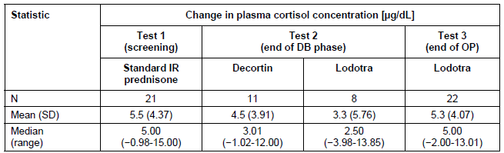
DB=double blind; IR=immediate release; N=number of tests; OP=open phase; SD=standard deviation

Electrocardiograph
ECG recordings were made at screening and at discharge in all of the human studies. Review of the results did not reveal any clinically significant ECG changes. In Studies EMR 62215-002 and -005, the post-baseline corrected QT interval was formally calculated (only trials in the program) and was <450 milliseconds for all subjects.

Vital signs
Physical examination including vital signs assessment was conducted at screening and end of study in the 2 phase 3 trials, as well as the biopharmaceutical studies. The vital signs evaluated were blood pressure, height and weight. No significant change with treatment (Lodotra and IR prednisone) in any of the vital signs was observed in any of the studies.

Postmarketing experience
Lodotra is marketed in 7 European countries (Austria, Denmark, Finland, Germany, Norway, Poland and the United Kingdom). The tablet is available in strengths of 1, 2 and 5 mg. A total of 17, 213, 400 mg of prednisone has been distributed as of the data lock date of 17 October 2010. Based on the sponsor’s assumption that an adult patient takes a daily dose 10 mg (which seems higher than the trial data information), the patient exposure is estimated to be approximately 4716 patient-years since the initial marketing authorization of Lodotra in the EU. This exposure includes the subjects enrolled in the Lodotra Non-Intervention Studies (NIS). The NIS program is being conducted by Merck Pharma GmbH, Germany to assess the change in activity status and quality of life for RA patients, as well as the safety and tolerability of Lodotra. Enrolment into the program was ceased in late 2009 upon obtaining the desired recruitment numbers of approximately 3000 RA patients. A study report for the NIS is not included with the current submission but the sponsor states it should be available in the second quarter of 2011.
The submission contained 4 Periodic Safety Update Reports in module 5 (volume 52). No new safety concerns have been identified in the adverse drug reports (serious and non-serious) obtained from spontaneous reporting sources and the scientific literature for Lodotra as well as the active substance, prednisone.

Safety issues with the potential for major regulatory impact

Withdrawal and rebound
Rapid dose reduction or cessation after long term corticosteroid treatment may lead to reactivation of inflammation (flare of RA) or insufficiency of endogenous cortisol secretion. Because of these considerations, the dose of Lodotra should be tapered slowly in patients discontinuing treatment. Patients who stopped study medication in EMR 62215-003 were advised to return to their pre-study treatment (including the same dose of IR prednisone) or were switched to 5 mg/day of IR prednisone and then tapered in Study NP01-007. The draft PI for Lodotra outlines a suggested regimen for drug withdrawal and warns of the potential risks associated with abrupt discontinuation. Furthermore, the effect of low dose Lodotra upon adrenocortical function was assessed in small number of patients as a sub-study of EMR 62215-003.

Potential long term toxicity issues
The current dataset for Lodotra has an exposure limited to 12 months of therapy. Some of the important side effects of prednisone therapy (even in low dose) are only associated with long term use (many years of treatment). In particular, assessments regarding the potential impact of Lodotra on the incidence of osteoporosis, cardiovascular safety and certain ophthalmic conditions (primarily cataracts and glaucoma) can not be made from the current drug exposure dataset.

Other safety issues

Safety in special populations
Pregnancy was an exclusion criterion in the clinical studies. However, 2 women became pregnant while taking Lodotra in the OLE of the CAPRA-1 Study. Both subjects withdrew from the trial for non-medical reasons and delivered healthy children without complications.
Safety analyses on special population subgroups were performed on the data obtained in the double bind period of Study EMR 62215-003. The 6 subgroup analyses were based on gender (male/female), age (< 65 years/ equal to > 65 years), disease duration (<5 years/5-10 years/>10 years), concomitant diabetes (yes/no), concurrent impaired kidney function (yes/no) and concomitant liver disease (yes/no). Some of the subgroups were too small in subject numbers to make meaningful interpretations but numerically the number of common and treatment emergent AEs, and AEs leading to discontinuation were similar. In particular, few patients were recorded as having liver disease according to the investigator (n=7/144 [4.9%] for Lodotra and n=4/144 [2.8%] for IR prednisone), renal impairment of any degree but better than a baseline serum creatinine of 150 μmol/L (n=7/144 [4.9%] for Lodotra and n=4/144 [2.8%] for IR prednisone) and concurrent diabetes (n=11/144 [7.6%] for Lodotra and n=13/144 [9.0%] for IR prednisone). The majority of patients in both treatment groups were younger than 65 years (78.5% [113/144] versus 21.5% [31/144] in each of the treatment groups). The frequencies of AEs and AEs leading to discontinuation were similar in the older versus younger age group definition. No different pattern of AE types was also observed. Patients with RA of > 10 years duration had a higher incidence of AEs (45.5%, 25/55) compared to those with shorter disease duration (37.4-39.4%). The same pattern of increased AE incidence in subjects with long established RA was also observed in the IR prednisone group.

Safety related to drug-drug interactions
No specific studies examining Lodotra drug interactions have been performed. However, the draft PI has proposed an extensive list of potential drug interactions based on the known potential drug interactions of prednisone with other therapies.

Evaluator’s overall conclusions on clinical safety
The data presented in this submission concerning the safety profile of Lodotra in adult subjects is of sufficient volume for assessment of the short to medium term risks. In total, 375 patients with RA have received at least 1 dose of Lodotra (3-10 mg) in the pivotal phase 3 trials. Regarding the extent of exposure, 192 of these subjects received Lodotra for at least 9 months. Collectively, the safety data in the phase 1 studies involved 247 healthy men and women, who were mostly given single doses of Lodotra ranging from 2-20 mg.
Key safety conclusions identified by the clinical development program include: -
- During the 12 week, double blind periods of the phase 3 studies, Lodotra was generally well tolerated with the overall incidence and most types of common AEs being similar in patients receiving comparator treatment (either IR prednisone or placebo with background DMARD for RA);
- Overall SAEs occurred at a low and similar frequency in the prednisone treatment groups, as well as the comparison between Lodotra and placebo;
- Discontinuations due to AEs were similar in incidence and type between MR and IR prednisone (CAPRA-1 Study) but numerically higher for Lodotra compared with placebo (CAPRA-2 Study);
- The 9-month, open label extension phase of the CAPRA-1 Study demonstrated that although the overall incidence of AEs remained within expectations, AEs of special interest for longer-term follow-up became evident (such as gastrointestinal ulcers/gastritis, weight gain, mood and sleep disorders, hypertension and glaucoma);
- Collectively, there were 7 cases of significantly impaired glycaemic control with Lodotra in the phase 3 trials, and the incidence of elevated total cholesterol levels was higher for those receiving Lodotra (12.5-15.6%) compared to both IR prednisone (10.4%) and placebo (7.6%);
- The effect of extended treatment with Lodotra compared with IR prednisone (both in low dose) on the hypothalamic-pituitary axis was investigated in a sub-study of EMR 62215-003 using a CRH test, and showed no significant difference in HPA axis suppression between the 2 prednisone formulations; and
- The AE profile observed in the phase I studies was characteristic of early phase trial reporting with most of the observed AEs judged as unrelated or consistent with the known side effect profile of prednisone (primarily headache and gastrointestinal disorders).
In summary, the safety data indicates that the administration of Lodotra to subjects with RA (mainly middle-aged women) is generally safe and well tolerated, and has a comparable short to medium term safety profile as standard immediate release formulations of prednisone as well as placebo tablets in patients receiving background DMARD treatment for RA. However, some significant potential safety concerns will require on-going pharmacovigilance. These risks include osteoporosis, cardiovascular safety (hypertension and an increased risk of atherosclerosis), ophthalmic conditions (cataracts and glaucoma), gastrointestinal ulcers and metabolic consequences (weight gain and HPA suppression).

First round benefit-risk assessment

First round assessment of benefits
The main benefits of Lodotra in the proposed usage pertaining to the requested indication are:
- Improvements in the duration of morning stiffness for adult patients with moderately to severely active RA over 12 weeks compared to IR prednisone (relative mean change of 22.7%), or placebo + background standard of care (relative mean change of 23.2%).
- Improvements in the ACR20 (46.8% versus 29.4%) and ACR50 response rates (22.5% versus 9.2%) at 12 weeks compared to placebo + background DMARD treatment.
Maintenance of improvements in the duration of morning stiffness with treatment for up to 12 months.

First round assessment of risks
The risks of Lodotra in the proposed usage are:
- Discontinuations to AEs are numerically higher for Lodotra (2.2%) versus placebo (0.8%), but similar in incidence and type between MR and IR prednisone (8.3% versus 6.9%, respectively).
- In total, 7 cases of significantly impaired glycaemic control were observed with Lodotra in the phase 3 trials.
- The incidence of elevated total cholesterol levels was higher for those given Lodotra (12.5-15.6%) compared to both IR prednisone (10.4%) and placebo (7.6%).
AEs of special interest became evident in the longer term follow-up study with cases of gastrointestinal ulcers, gastritis, weight gain, mood and sleep disorders, hypertension and glaucoma being reported.

First round assessment of benefit-risk balance
The benefit-risk balance of Lodotra for the proposed indication and dosing regimen is favourable.

First round recommendation regarding authorisation
The evaluator recommended acceptance of the sponsor’s proposed indication for Lodotra subject to amendments of the PI, provision of data for the Non-Intervention Study and regular periodic safety update reports.

Clinical questions
The evaluator only submitted questions regarding the PI and Consumer Medicine Information which are beyond the scope of this AusPAR.

Second round evaluation of clinical data submitted in response to questions
The sponsor has submitted a response dated 25 January, 2012 to the TGA consolidated Section 31 request for information. From the clinical evaluation perspective, the response included an update to module 1 in relation to prescribing information for Australia. This comprised a 1500 word (5 volumes) response to questions relating to module 1 of the submission. Module 3 responses were also included but were not specifically considered as part of the second round clinical evaluation.

Second round benefit-risk assessment

Second round assessment of benefits
No new clinical information was submitted in response to efficacy. Accordingly, the benefits of Lodotra® in the proposed usage are unchanged from those identified in Section 7.1.

Second round assessment of risks
As requested, the sponsor has provided a safety report (dated 6 July 2011) for the Non-Intervention Study (NIS) which was an uncontrolled, multicentre study undertaken in Germany involving adult patients with RA. After consideration of the new clinical information, the risks of Lodotra® in the proposed usage are unchanged from those identified in Section 7.2.
The NIS was conducted in 461 centres between April 2009 and October 2010. The safety population included 2676 patients who had at least 1 on-study assessment. The trial was prematurely terminated so that the results could be made available by the end of 2010 as a post-approval commitment to the European reference member state regulatory authority (BfArM, Germany). Patients were eligible for inclusion if they had active RA with accompanying morning stiffness, and were either already receiving or about to commence low dose oral corticosteroids. All patients were commenced on Lodotra at a starting dose of 5 mg/day. At 9 months of follow-up, the mean dose of Lodotra was 4.1 mg/day. The study population was consistent with expectations – predominately female (72.0%) and middle-aged (median of 60 years; range 18-97 years). The mean duration of RA was 7.9 years. In total, 158 patients (5.9%) experienced 218 AEs leading to withdrawal. The most common types of AEs by SOC resulting in cessation were gastrointestinal disorders (54 cases, 2.02%), psychiatric (29 subjects, 1.08%) and nervous system problems (17 patients, 0.64%). The most frequent individual types of AEs leading to withdrawal were nausea (n=22), upper abdominal pain (n=18), sleep disorders (n=16), headache (n=9), dizziness (n=6) and impaired glucose metabolism (n=6).
A total of 22 patients (0.82%) experienced 35 SAEs. Half (11 subjects, 0.41%) of the SAE patients had events that were considered to be treatment related. These included 8 gastrointestinal SAEs (in particular, various types of GIT bleeding and symptoms relating to gastritis); and singular reports of sleep disturbance, tachyarrhythmia and ruptured Achilles tendon. Four deaths occurred during the observation period and none were considered to be treatment related. Two of the deaths were for unclear reasons (69 and 82 year old women), one patient died following a fall (75 year old female) and another subject (81 year old female) suffered a fatal myocardial infarct.
In summary, the incidence and type of adverse events observed in the NIS are consistent with the expected safety profile of continued low dose corticosteroid treatment.

Second round assessment of benefit-risk balance
The benefit-risk balance of Lodotra® for the proposed indication and dosing regimen is favourable.

Second round recommendation regarding authorisation
The evaluator recommended acceptance of the sponsor’s proposed indication for Lodotra subject to regular periodic safety update reports.

References
ACR Subcommittee on Rheumatoid Arthritis Guidelines. Guidelines for the management of rheumatoid arthritis: 2002 Update. Arthritis and Rheum 2002; 46(2): 328-346.
Arvidson NG, Gudbjornsson B, Larsson A and Hallgren R. The timing of glucocorticoid administration in rheumatoid arthritis. Ann Rheum Dis 1997; 56(1): 27-31.
Bijlsma JWJ and Jacobs JWG. Glucocorticoid chronotherapy in rheumatoid arthritis. Lancet 2008; 371(9608): 183-184.
Buttgerit F, Burmester GR and Lipworth BJ. Optimised glucocorticoid therapy: the sharpening of an old spear. Lancet 2005; 365(9461): 801-803.
Conn DL. Low dose prednisone is indicated as a standard treatment in patients with rheumatoid arthritis. Arthritis and Rheum 2001; 45(5): 462-467.
Cutolo M, Seriolo B, Craviotto C, Pizzorni C and Sulli A. Circadian rhythms in RA. Ann Rheum Dis 2003; 62(7): 593-596.
Da Silva JAP, Jacobs JWG, Kirwan JR, Boers M, Saag KG, Ines LBS, et al. Safety of low dose glucocorticoid treatment in rheumatoid arthritis: published evidence and prospective trial data. Ann Rheum Dis 2006; 65(3): 285-293.
Hoes JN, Jacobs JWG, Boers M, Boumpas D, et al. EULAR evidence based recommendations on the management of systemic glucocorticoid therapy in rheumatic diseases. Ann Rheum Dis 2007; 66(12): 1560-1567.
Kirwan JR, Bijlsma JWJ, Boers M and Shea BJ. Effects of glucocorticoids on radiological progression in rheumatoid arthritis. Cochrane Database of Systematic Reviews (online; published 2007): number 1 CD006356.
Perry MG, Kirwan JR, Jessop DS and Hunt LP. Overnight variations in cortisol, Interleukin-6, tumour necrosis factor alpha and other cytokines in people with rheumatoid arthritis. Ann Rheum Dis 2009; 68(1): 63-68.
Saag KG. Low dose corticosteroid therapy in rheumatoid arthritis: balancing the evidence. Amer J Med 1997; 103(6): 31S-39S.
Straub RH and Cutolo M. Circadian rhythms in rheumatoid arthritis: implications for pathophysiology and therapeutic management. Arthritis and Rheum 2007; 56(2): 399-408.

