Date of CER: November 2013

AusPAR Attachment 2

Extract from the Clinical Evaluation Report for pomalidomide
  - Proprietary Product Name: Pomalyst
  - Sponsor: Celgene Australia Pty Ltd
About the Therapeutic Goods Administration (TGA)
- The Therapeutic Goods Administration (TGA) is part of the Australian Government Department of Health, and is responsible for regulating medicines and medical devices.
- The TGA administers the Therapeutic Goods Act 1989 (the Act), applying a risk management approach designed to ensure therapeutic goods supplied in Australia meet acceptable standards of quality, safety and efficacy (performance), when necessary.
- The work of the TGA is based on applying scientific and clinical expertise to decision-making, to ensure that the benefits to consumers outweigh any risks associated with the use of medicines and medical devices.
- The TGA relies on the public, healthcare professionals and industry to report problems with medicines or medical devices. TGA investigates reports received by it to determine any necessary regulatory action.
- To report a problem with a medicine or medical device, please see the information on the TGA website <http://www.tga.gov.au>.
About the Extract from the Clinical Evaluation Report
- This document provides a more detailed evaluation of the clinical findings, extracted from the Clinical Evaluation Report (CER) prepared by the TGA. This extract does not include sections from the CER regarding product documentation or post market activities.
- The words [Information redacted] indicate confidential information has been deleted.
- For the most recent Product Information (PI), please refer to the TGA website <http://www.tga.gov.au/hp/information-medicines-pi.htm>.
Copyright
© Commonwealth of Australia 2014
This work is copyright. You may reproduce the whole or part of this work in unaltered form for your own personal use or, if you are part of an organisation, for internal use within your organisation, but only if you or your organisation do not use the reproduction for any commercial purpose and retain this copyright notice and all disclaimer notices as part of that reproduction. Apart from rights to use as permitted by the Copyright Act 1968 or allowed by this copyright notice, all other rights are reserved and you are not allowed to reproduce the whole or any part of this work in any way (electronic or otherwise) without first being given specific written permission from the Commonwealth to do so. Requests and inquiries concerning reproduction and rights are to be sent to the TGA Copyright Officer, Therapeutic Goods Administration, PO Box 100, Woden ACT 2606 or emailed to <tga.copyright@tga.gov.au>.

Contents
List of abbreviations 5
1. Clinical rationale 8
1.1. Multiple myeloma 8
1.2. Product background 9
1.3. Rationale for use of pomalidomide with dexamethasone 10
2. Contents of the clinical dossier 11
2.1. Scope of the clinical dossier 11
2.2. Paediatric data 11
2.3. Good clinical practice 12
3. Pharmacokinetics 12
3.1. Studies providing pharmacokinetic data 12
3.2. Summary of pharmacokinetics 14
3.3. Evaluator’s conclusions on pharmacokinetics 26
4. Pharmacodynamics 27
4.1. Studies providing pharmacodynamic data 27
4.2. Summary of pharmacodynamics 28
4.3. Evaluator’s conclusions on pharmacodynamics 30
5. Dosage selection for the pivotal studies 30
6. Clinical efficacy 31
6.1. Pivotal efficacy study 31
6.2. Other efficacy studies 47
6.3. Comparison of efficacy results of pivotal and supportive trials 48
6.4. Evaluator’s conclusions on efficacy 50
7. Clinical safety 50
7.1. Studies providing safety data 50
7.2. Patient exposure 52
7.3. Adverse events 54
7.4. Laboratory tests 64
7.5. Post-marketing experience 68
7.6. Safety issues with the potential for major regulatory impact 68
7.7. Other safety issues 68
7.8. Evaluator’s conclusions on safety 69
8. First round benefit-risk assessment 70
8.1. First round assessment of benefits 70
8.2. First round assessment of risks 71
8.3. First round assessment of benefit-risk balance 72
9. First round recommendation regarding authorisation 72
10. Clinical questions 72

List of abbreviations
Abbreviation | Meaning
AE | Adverse event
Ae | Amount of drug excreted in urine on Days 1 and 29
ALT (SGPT) | Alanine aminotransaminase (serum glutamate pyruvic transaminase)
ANC | Absolute neutrophil count
ASCT | Autologous stem cell transplantation
AST (SGOT) | Asparate transaminase (serum glutamic oxaloacetic transaminase)
AUC0-t | Area under the concentration-time curve from time 0 to the last measurable time point
AUC(0-τ) | Area under the plasma concentration-time curve over a dosing interval on Days 1 and 29
AUC(0-tz) | Area under the plasma concentration-time curve from time zero up to the last quantifiable concentration on Day 1
AUC(0-∞) | Area under the plasma concentration-time curve from time zero to infinity on Day 1
CL/F | Apparent total plasma clearance on Days 1 and 29
CLR | Renal clearance on Days 1 and 29
Cmax | Maximum observed plasma concentration on Days 1 and 29
Ctrough | Plasma concentration at the end of the dosing interval on Days 1 and 29
CR | Complete response
CRF | Case report form
CTCAE | Common terminology criteria for adverse events
DMC | Data Monitoring Committee
DOR | Duration of response
DVT | Deep vein thrombosis
EBMT | European Group for Blood and Marrow Transplantation
ECG | Electrocardiogram
eCRF | Electronic case report form
ECOG | Eastern Cooperative Oncology Group
EMA | European Medicines Agency
FCBP | Female of child bearing potential
fe | Percentage of dose excreted in urine on Days 1 and 29
λz | Apparent plasma terminal elimination rate constant on Days 1 and 29
λeff | Predicted and actual effective rate constant of accumulation
GCP | Good Clinical Practice
GCSF | Granulocyte stimulating factor
HIV | Human Immunodeficiency Virus
ICH | International Conference on Harmonization
IEC | Independent Ethics Committee
IgG | Immunoglobulin G
IgM | Immunoglobulin M
IMiD | Immunomodulatory drug
IMWG | International Myeloma Working Group
IRAC | Independent Response Adjudication Committee
IRB | Institutional Review Board
ITT | Intent to treat
IVRS | Interactive Voice Response System
LDH | Lactate dehydrogenase
LLN | Lower limit of normal
MedDRA | Medical Dictionary for Regulatory Activities
mIU/ml | Milli-international units per milliliter
MM | Multiple Myeloma
MR | Maximum response
MRT | Mean residence time on Days 1 and 29
NCI | National Cancer Institute
ORR | Overall response rate
OS | Overall survival
PD | Progressive disease
PFS | Progression free survival
PK | Pharmacokinetic(s)
PO | Orally
PR | Partial response
RA1 | Accumulation ratio based on AUC(0-τ)
RA2 | Accumulation ratio based on Cmax
RL | Linearity ratio
RBC | Red blood cell
SAE | Serious adverse event
SAP | Statistical Analysis Plan
SCT | Stem cell transplantation
SD | Standard deviation
SGOT/AST | Serum glutamic oxaloacetic transaminase/Aspartate transaminase
SGPT/ALT | Serum glutamic pyruvic transaminase/Alanine aminotransferase
SOP | Standard Operating Procedure
tmax | Time of maximum plasma concentration
TNM | Tumor, lymph nodes, metastasis staging system
TTF | Time to treatment failure
TTP | Time to progression
ULN | Upper limit of normal
VAD | Vincristine, adriamycin, dexamethasone
VGPR | Very good partial response
VTE | Venous thromboembolism
Vz/F | Apparent volume of distribution following oral dosing
WHO | World Health Organization

Clinical rationale

Multiple myeloma

Disease background
MM is an incurable disease that is characterised by the accumulation of clonal plasma cells in the bone marrow and accounts for 10% of all haematological malignancies. The disease follows a relapsing course in the majority of patients, regardless of treatment regimen or initial response to treatment. While relapsed and/or refractory MM (RRMM) patients may achieve responses to subsequent anti myeloma therapies, the duration of response typically decreases with successive relapses until resistant disease develops reflecting changes in disease biology, with more tumour cells expressing a more aggressive phenotype, higher rates of proliferation, and lower rates of apoptosis.
The clinical features of MM are varied and can arise from the effects of the tumour itself, the toxicity of the tumour products, or the host's own response. The most common criteria used in diagnosis of symptomatic MM are the presence of neoplastic plasma cells comprising greater than 10% of bone marrow cells or presence of a plasmacytoma, paraprotein (M protein) in the serum and/or urine, and evidence of related organ or tissue impairment due to plasma cell disorder. Symptomatic MM, signalling the necessity for treatment, is typically manifested by hypercalcaemia, renal insufficiency, anaemia, and bone lesions (CRAB), which are clinical features of malignant disease associated with active MM. This deterioration leads to progressive morbidity and eventual mortality by lowering resistance to infection and causing significant skeletal destruction, and less commonly, neurological complications and hyperviscosity.
The prognosis of patients with MM depends on a variety of factors including a patient’s age and stage of MM at time of diagnosis. These factors are typically described by the International Staging System and Durie Salmon staging system. Poor prognostic factors include stage III disease (β2-microglobulin level ≥ 5.5 mg/L), hypodiploidy, deletion of 17p, translocation of chromosomes 4 and 14 (t[4:14]), translocation of chromosomes 14 and 16 (t[14;16]); and light chain and Immunoglobulin A (IgA) disease.

Treatment
All patients with MM eventually relapse and may benefit from certain salvage therapies. Various definitions for relapsed and refractory disease exist; however, new definitions have recently appeared in the literature, primarily by the International Myeloma Working Group. This guidance was used to develop definitions for the pivotal Study CC-4047-MM-003.

Current definition of relapsed disease
Relapsed myeloma is defined as previously treated myeloma, which after a period of being off-therapy, requires salvage therapy but does not meet criteria for "primary refractory" or "relapsed and refractory" categories, as outlined below.

Definition of refractory disease
Refractory myeloma is defined as disease that is non responsive while on therapy or progresses within 60 days of last therapy.
- Relapsed and refractory myeloma is defined as relapse of disease in patients who achieve MR or better, and then either become non responsive while on salvage therapy, or progress within 60 days of last therapy.
- Primary refractory myeloma refers to refractory disease in patients who have never achieved an MR with any therapy, and includes 2 subcategories:
- Patients who never achieve MR or better in whom there is no significant change in M protein and no evidence of clinical progression.
- Primary refractory PD.

Treatment options upon relapse
There is no single standard treatment for patients with relapsed myeloma. Determining which treatment to use should be individualised and depends for example on prior therapy, including the patient’s duration of remission since the initial therapy, as well as current physical status, and the presence or risk of side effects. The choice of agent to use at relapse not only depends on availability in a given region of the world, but also on individual preference and, importantly, co-morbidities.
At first relapse, the first choice might be to use a new class of drug or a drug combination different from that used for induction, unless the first remission was long enough to merit consideration of retreatment with the same or a similar regimen, with the possibility of adding another agent. Additionally, the presence or risk of side effects may require a change from the first line treatment.
At second or subsequent relapse treatment options have historically comprised combination therapies with corticosteroids and cytotoxic chemotherapeutic agents.
The approvals of bortezomib and lenalidomide based regimens, plus thalidomide in certain countries, for the treatment of previously treated MM have provided effective therapeutic options that give patients with relapsed or refractory MM the prospect for a longer progression free survival (PFS) and OS. These agents are generally used in combination with corticosteroids (pulsed or weekly dexamethasone), and sometimes with an alkylator (either melphalan or most commonly, in certain countries, cyclophosphamide), or with an anthracycline (adriamycin or liposomal pegylated adriamycin), with selected patients undergoing autologous stem cell transplantation (ASCT). The various regimens can be used in different combination or sequences. No best sequence has been identified. Of note, it is recommended to use steroids in combination with all products with a few exceptions. Miscellaneous antineoplastic agents including a number of investigational drugs may be used.

Product background
The mechanism of action of pomalidomide includes a variety of immunomodulatory effects such as induction of immune responses, enhancement of activity of immune cells, alteration and modulation of the induction of pro and anti inflammatory cytokines, and inhibition of inflammation. These compounds also have tumoricidal and anti angiogenic activities that contribute to their anti tumour activities.
The multiple pharmacological properties of pomalidomide suggest a potential therapeutic benefit in patients with MM. While it is structurally similar to both thalidomide and lenalidomide and shares a number of potentially therapeutic pharmacological properties, pomalidomide has a distinctly different activity and potency profile making it a unique compound in the immunomodulatory class in both the nonclinical and clinical settings. Pomalidomide exhibits greater potency than thalidomide with regard to immune modulation, anti inflammatory and anti proliferative activity, and has greater potency than lenalidomide at anti proliferative effects in MM cell lines, augmentation of CD4+ and CD8+ T cell proliferation, Th1 cytokine production, and NK T cell activation. These differences allow the administration of pomalidomide at lower relative doses compared to thalidomide or lenalidomide.
Initial treatment of MM with dexamethasone effectively induces MM cell apoptosis; however prolonged drug exposures result in the development of chemoresistance, which is associated with defective apoptotic signalling in response to drugs, over expression of anti-apoptotic proteins such as Bcl-2 or inhibitors of apoptosis protein, expression of multidrug resistance gene, the presence of growth promoting cytokines within the bone marrow microenvironment such as IL-6 and insulin growth factor-1 (IGF-1).
Pomalidomide inhibits the proliferation of MM cell lines in vitro including the dexamethasone resistant MM1R cell line. Nonclinical studies have shown that the observed activity of the combination of pomalidomide and dexamethasone is greater than that of single agent pomalidomide or dexamethasone. Moreover, the combination of pomalidomide and dexamethasone is synergistic at inhibiting cell proliferation and inducing apoptosis in both lenalidomide sensitive and lenalidomide resistant H929 cell lines, suggesting that it may similarly be effective in MM patients who have become refractory or resistant to lenalidomide. The exact mechanism of pomalidomide + dexamethasone synergy is not known at present although the combination of pomalidomide + dexamethasone was shown to reduce pRB1 phosphorylation, the expression of Survivin, IRF-4, Bcl-2, and to increase the expression of p27 and BIM when compared to either agent alone.
These data show that pomalidomide is active in dexamethasone resistant cells, and that lenalidomide refractory MM cells are responsive to pomalidomide monotherapy, and the combination of pomalidomide + dexamethasone induces strong synergistic and tumoricidal effects, suggesting that pomalidomide and dexamethasone together have potential therapeutic benefit in the treatment of lenalidomide refractory patients, although the synergy between pomalidomide and dexamethasone is likely cell line dependent. In parallel, preliminary in vivo studies have also shown that pomalidomide + dexamethasone may overcome resistance to lenalidomide + dexamethasone.
These findings support the conclusions from clinical studies that showed pomalidomide + dexamethasone is active in RRMM patients who have previously been treated with lenalidomide + dexamethasone.

Rationale for use of pomalidomide with dexamethasone
The combination of pomalidomide + LD dexamethasone has been proposed based on the following clinical considerations.

Combination of immunomodulatory drugs with dexamethasone
Synergistic anti myeloma effects have been reported in animal models and in clinical data. Lenalidomide and thalidomide are now used extensively in combination with dexamethasone and are either approved by regulatory authorities and /or recommended in the literature in combination by experts in many countries. Also the combination of lenalidomide plus standard pulsed high dose (HD) dexamethasone has been shown in the relapsed setting to be more effective than either drug taken alone. Initial studies of pomalidomide, when dexamethasone was added in 9 subjects with PD and 2 subjects with stable disease (SD), some activity was shown.

Use of LD dexamethasone
Effective regimens containing HD dexamethasone are associated with significant toxicity. In the pivotal lenalidomide Phase III studies, patients receiving combination therapy (lenalidomide + 40 mg dexamethasone) who had their dexamethasone dose reduced owing to a toxicity had a significantly higher overall response rate (ORR), including a higher complete response (CR), compared with those who persisted with standard dexamethasone dose. This was possibly due to reduced complications and improved tolerance, which led to better compliance and a longer duration on therapy. Moreover, it has been described in the literature that HD dexamethasone was not well tolerated in elderly patients.
In a study of 445 patients, as initial therapy for newly diagnosed MM, lenalidomide plus HD dexamethasone was associated with better response (79% versus 68%, p = 0.008), although toxicity was higher (deep vein thrombosis [DVT] 26% versus 12%, infections including pneumonia 16% versus 9%, and fatigue 15% versus 9%). Short term OS was better with lenalidomide + LD dexamethasone (96% versus 87% at 1 year, p = 0.002).
The nonclinical and clinical experience with lenalidomide in combination with dexamethasone provided an additional rationale for the evaluation of the combination of pomalidomide and dexamethasone. LD dexamethasone at 40 mg weekly was proposed to be used in combination with pomalidomide, which had already been shown to be effective in early clinical studies.
Comment: The rationale for the clinical study of pomalidomide and LD dexamethasone in patients with relapsed or refractory MM is acceptable although the contribution of LD dexamethasone compared to pomalidomide alone is unknown and was not the object of the pivotal Phase III study.

Contents of the clinical dossier

Scope of the clinical dossier
- Eight (8) clinical pharmacology studies, including 5 on healthy subjects and 3 on patients with MM provided pharmacokinetic data. Two of the 5 were bioequivalence studies, 2 determined pharmacokinetic properties, and 1 ADME. Three studies included pharmacodynamic assessments of the effect of pomalidomide on CD4 and CD8 cells, cytokine production, serum paraprotein concentration, and neutrophil numbers. Efficacy outcomes reflect the pharmacodynamic properties of pomalidomide in its effects on the myeloma disease process, while safety issues reflected its pharmacodynamic effects on the body’s normal tissues such as bone marrow and the production of normal blood cells. These will be assessed from data in the relevant clinical trials
- Preliminary pharmacokinetic data was obtained in the pivotal Phase III trial but a definitive analysis of population pharmacokinetic is to be completed later
- Two of the 3 pharmacokinetic studies in patients with MM were ascending dose studies to determine the maximum tolerated dose (MTD)
- Two studies of efficacy and safety were Phase II studies (CC-4047-002 and IFM 2009-02) and one was pivotal Phase III trial (CC-4047-MM003). Two additional Phase I studies (CC-4047-MM-001 and CC-4047-MM-002) were also submitted, mainly for safety assessment.

Paediatric data
The submission did not include paediatric data. The Paediatric Development Plan stated that the EU had given a waiver for paediatric data. The FDA did not require such data because of the orphan designation of pomalidomide.

Good clinical practice

Ethical conduct of the study
The pivotal Phase III study, CC-4047-MM-003 was conducted in accordance with the sponsor’s standard operating procedures (SOPs) and working procedures (WPs), which were designed to ensure adherence to Good Clinical Practice (GCP), as defined in the ICH requirements for GCP and in accordance with the ethical principles outlined in the Declaration of Helsinki.

Patient information and consent
An informed consent form (ICF) explaining the procedures of the study, including the potential hazards, was reviewed and approved by the IRB and IEC prior to its use. Prior to entering the study, the ICF was read by and explained to all subjects or their legally authorised representative. Each subject had ample opportunity to ask questions and was assured of the right to withdraw from the study at any time without any disadvantage and without having to provide a reason for this decision.
Each subject was required to sign an ICF to participate in the study. If the subject was not capable of providing a signature, an oral statement of consent could have been given in the presence of a witness. Each subject or representative received a signed and dated copy of the ICF.
A sample ICF and the written information given to the subject were provided.

Independent Ethics Committee (IEC) or Institutional Review Board (IRB)
The protocol (and its amendments) were reviewed and approved by each study site’s Institutional Review Board (IRB) or Independent Ethics Committee (IEC) prior to the start of the study.

Evaluation of compliance with Good Clinical Practice
The Celgene Clinical Research Physician, in conjunction with other study team members, was responsible for assessing the overall compliance of the study with GCP guidelines. During the course of the study, compliance with GCP was reviewed by the study monitors on an ongoing basis and investigators were notified when issues were identified. Actions taken to ensure compliance with GCP included follow up with sites to ensure that any departures were corrected in a timely manner, and when necessary, investigators and other site personnel were re-trained on protocol defined procedures. A listing of identified issues was provided. None of the issues had an impact on interpretation of the data or subject safety.

Pharmacokinetics

Studies providing pharmacokinetic data
Submitted pharmacokinetic studies are shown in Table 1.

Table 1: Submitted pharmacokinetic studies.
PK topic | Subtopic | Study ID | *
PK in healthy adults | General PK - Single dose | 1398/132
PK in healthy adults |  | CC-4047-CP-004
PK in healthy adults | Multi-dose | CC-4047-CP-006
PK in healthy adults | Bioequivalence† - Single dose | CC-4047-CP-005
PK in healthy adults | Multi-dose | CC-4047-CP-007
PK in healthy adults | Food effect | CC-4047-CP-005
PK in special populations | Target population § - Single dose
PK in special populations | Multi-dose | CC-4047-MM-001-PK
PK in special populations | Multi-dose | CC-4047-MM-002
PK in special populations | Multi-dose | CC-4047-MM-003
PK in special populations | Hepatic impairment | NA
PK in special populations | Renal impairment | NA
PK in special populations | Neonates/infants/children/adolescents | NA
PK in special populations | Elderly | NA
Genetic/gender-related PK | Males versus females | NA
PK inter-actions | NA
Population PK analyses | Healthy subjects | NA
Population PK analyses | Target population | NA
Population PK analyses | Other | NA
* Indicates the primary aim of the study. † Bioequivalence of different formulations. § Subjects who would be eligible to receive the drug if approved for the proposed indication.
None of the pharmacokinetic studies had deficiencies that excluded their results from consideration.

Summary of pharmacokinetics
The information in the following summary is derived from conventional pharmacokinetic studies unless otherwise stated.

Pharmacokinetics in healthy subjects
The PK profiles of single and multiple doses of pomalidomide from 0.5 mg to 50 mg, and 0.5 mg to 5 mg, respectively, have been evaluated. Overall mean and median values across studies in this section are based on data from solid dosage form studies, except the Absorption, Metabolism, Excretion (AME) study CC-4047-CP-004. The Summary of Clinical Pharmacology (SCP) stated that in general, the PK results were similar between healthy and MM subjects.

Absorption

Sites and mechanisms of absorption
The SPC stated that pomalidomide was absorbed in healthy subjects under fasting conditions at single orally administered doses around the clinical range (0.5 to 10 mg) with a Cmax at a median Tmax of approximately 3 hours postdose. In the human AME study, at least 73% of the dose was absorbed, indicating good oral absorption. In-vitro, pomalidomide has been shown to be a substrate of P-gp. The clinical significance of this has not been investigated, as the AME data suggest intestinal absorption does not appear to be limited by this.
Comment: The report of study 1398/132 (study p53) concluded the Tmax showed an overall increase with dose, because the value was a median of 3hr for the 1 mg dose and 6 hr for the 50mg dose, reflecting “a more prolonged period of absorption”. However at doses lower than 50mg, median values of Tmax for the 1, 5, 10, and 25 mg doses were 3.00, 2.5, 3.25, and 3.25 hr respectively, in agreement with the above conclusion in the SPC. A mean value of 3hr was also found for Tmax in Study CC-4047-CP-004 for each enantiomers, and for total pomalidomide.
The systemic exposure of single dose pomalidomide as determined from the AUC increased in an approximately dose-proportional manner, suggesting relative bioavailability is constant over this dose range (Figure 1). The Cmax increased in a less than dose proportional manner over the 1 mg to 50 mg dose range (see ditto), though this is most evident at doses >5 mg. Over a range more clinically relevant (0.5 to 5 mg), Cmax appears to increase in an approximately dose proportional manner (see CC-4047-CP-006). Based on limited available data and exploratory analysis, a dose-associated decrease in absorption rate from 10 mg to 50 mg was observed (Figure 2), with the absorption rate of higher doses (>10 mg) being slower than that associated with the lower doses. The absorption rate constants were summarized from an exploratory compartment modelling. This finding is consistent with the low solubility of pomalidomide and may help explain the less than dose proportional increase in Cmax at higher dose levels. The Tmax was increased at a dose >25 mg compared with the clinical dose range. Multiple dose exposure over the 0.5 mg to 2 mg dose range was approximately dose proportional, with pomalidomide reaching steady-state by Day 3.
Figure 1: Exploratory ANOVA Test on the Dose Normalized AUCinf and Cmax in Healthy Subjects.
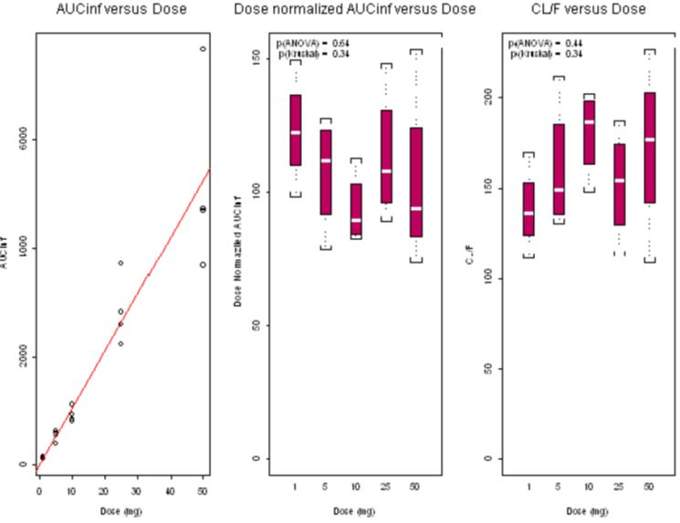
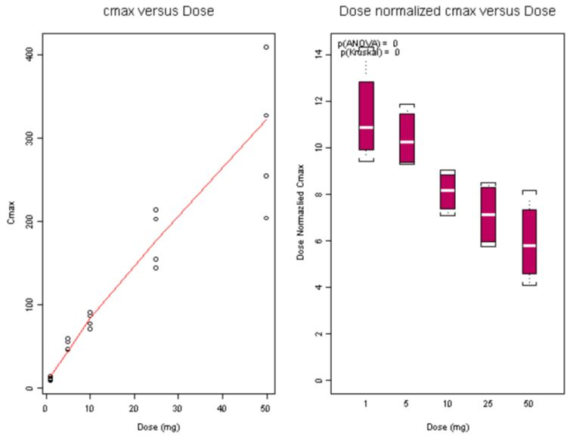
(top and bottom right panels: white line = median; box = 25% and 75% quartiles; brackets = 1.5*interquartile range)
Figure 2: Absorption Rate versus Dose in Healthy Male Subjects.
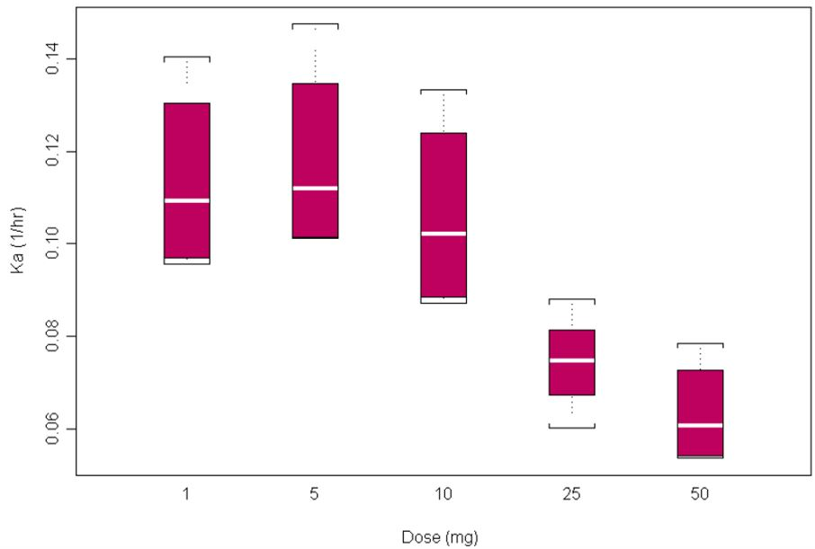
(top and bottom right panels: white line = median; box = 25% and 75% quartiles; brackets = 1.5*interquartile range)
Comment: In preclinical studies, after separate administration of the individual enantiomers to monkeys, considerable interconversion between enantiomers was observed (18% to 32% based on AUC ratios). In this study, pomalidomide and its enantiomers exhibited low clearance (<1/6th of hepatic blood flow), moderate volume of distribution (< 2-times total body water) and quantitative bioavailability.

Bioavailability

Absolute bioavailability
The TGA guidance document “Transitional mandatory requirements for an effective submission” for Prescription Medicines states that all submissions to register a new chemical entity must be supported by an absolute bioavailability study.
The current application does not include an absolute bioavailability study. The justification provided by the sponsor was as follows:
- Celgene does not intend to develop either an intravenous (IV) or oral solution formulation for commercial purposes.
- An oral suspension has been assessed during the clinical development program in the 14C-pomalidomide AME clinical study CC-4047-CP-004.
- Pomalidomide is not a suitable candidate for an oral solution or IV formulation because of the instability of pomalidomide in solution at neutral pH and its limited solubility (13 µg/mL at pH 6.8). In addition, the human AME study demonstrated that at least 73% of the drug is absorbed from the gastrointestinal tract, so an absolute bioavailability study would offer little additional information regarding the absorption of pomalidomide.
Comment: The justification is acceptable.

Bioequivalence of different dosage formulations and strengths used in the clinical trials and of those proposed for marketing
One bioavailability/food effect study (CC-4047-CP-005) was conducted comparing Formula 3 and Formula 4. The two formulations were not bioequivalent and the 2 mg test formulation (Formula 4) has not been developed any further. The geometric mean ratio estimates for test formulation Cmax and AUC0-t were 72.8% and 96.2% respectively compared with the reference formulation. The confidence intervals for AUC were within the generally accepted 80% to 125% range required for bioequivalence, but the confidence interval for Cmax was outside this range.
The second study was a BE study which demonstrated bioequivalence of the 4 mg capsule with two 2 mg capsules, and the 3 mg capsule with a dose of one 1 mg capsule + one 2 mg capsule (both Formula 3). The Phase 2 trial CC-4047-MM-002 was conducted with the 1 mg and 2 mg capsules only and the Phase 3 registration trial CC-4047-MM-003 was conducted with the 1 mg, 2 mg, 3 mg and 4 mg capsules. This BE study supports registration of all four dosage strengths.

Influence of food
The food effect evaluation was conducted in study CC-4047-CP-005 with the test formulation (Formula 4) of pomalidomide, not the clinical and commercial formulation (Formula 3). However, while the test formulation had a lower Cmax compared with the commercial formulation, the plasma concentration profiles for the two formulations in the fasted state were essentially superimposable after ~6 hours postdose. This implies that the modest rate differences in the absorption profile between the formulations, in the absence of formulation-dependent changes in mean clearance [%CV] (7.5 [22.4] vs 7.16 [21.9] L/hr), are unlikely to meaningfully impact the interpretability of the food effect study.
Additionally, the food effect was assessed through Geometric Mean Ratios to evaluate relative change; therefore, factors such as formulation are held constant across comparisons.
As data from CC-4047-CP-005 were not available at the time of conduct of the pivotal CC-4047-MM-003 registration trial, that protocol instructed that pomalidomide should be taken 2 hours before or 2 hours after eating.
In summary, a high fat meal decreased the rate of absorption but had minimal effect on overall extent of absorption; therefore pomalidomide can be administered without regard to food intake.
Comment: The conclusion is acceptable.

Dose proportionality
Data on dose proportionality were available from a Phase 1, single-blind, placebo-controlled ascending single oral dose, safety and pharmacokinetic study in healthy subjects. Pomalidomide or placebo was administered orally in capsule form at 1, 5, 10, 25, and 50 mg to 30 male subjects. Following each dose level, pomalidomide was absorbed with a Cmax occurring at a median Tmax of 2.5 to 6 hours postdose. The systemic exposure of pomalidomide determined from the AUC increased in an approximately dose-proportional manner, whereas Cmax increased in a less than dose proportional manner. The geometric t1/2 ranged from 8.2 to 10.8 hours, with no apparent dose-related trend. Total clearance (CL/F) also appeared dose independent (for CL/F in L/hr).
At steady state on day 5 in healthy subjects (CC-4047-CP-006) at three daily dose levels (0.5, 1.0 and 2.0mg), accumulation of pomalidomide was minimal as shown by the accumulation ratio of AUC 0-24 (1.13, 1.08 and 1.04 respectively) and Cmax values (1.14, 1.04 and 1.08 respectively) on day 5 and day 1.
Comment: Note that the figures from the SPC (Figure 1 this evaluation) showing Cmax and AUC relationship to dose were not in the report of study 1398/132. The conclusions in that report about the dose-relationship of Cmax and AUC are confusing. On p37 the report states “The number of subjects studied at each dose level was not sufficient to perform a statistical analysis of the AUC and Cmax data to determine dose proportionality.” However on p56, the report states “The mean data for AUC(0-tz) and AUC(0-∞) showed these parameters to increase in an approximately dose-proportional manner”. The difference presumably is that “approximately” is based on inspection (Figure 1) but not on statistical analysis. At the single dose of 50mg, the high value outlier would influence the mean and bring it into a proportional relationship to dose. Dose-proportionality for AUC is more convincingly shown in that Figure up to a dose of 25 mg, but not at 50mg. As well, the CV for the mean is very high at 30.4% compared to 17.7% for the 1 mg dose. Since the 50mg dose is outside the intended therapeutic range, it can be accepted that the AUC increases in a dose-proportional manner up to a 25 mg dose. The data for the dose-normalised values of AUC are variable and unhelpful.

Distribution

Volume of distribution
Mean (%CV) Vz/F apparent volume of distribution of pomalidomide in healthy subjects after a single dose ranged from 102 L (22%) to 140 L (32-51%) across a dose range of 1 mg to 50 mg.

Plasma protein binding
The extent of plasma protein binding in pooled male and female plasma (CC-4047-DMPK-015) was 15.8% for the R-enantiomer and 42.2% for the S-enantiomer. Since the in vitro data indicated that pomalidomide had low to moderate protein binding, clinical plasma samples were not evaluated for plasma protein binding. Additionally, since there were no unique or disproportionate human metabolites, and no metabolites have been identified as having pharmacological activity, the plasma protein binding of the pomalidomide metabolites has not been evaluated.

Erythrocyte distribution
In the human AME study (CC-4047-CP-004), blood to plasma ratios for radioactivity ranged from 0.749 ± 0.0357 at 0.5 hours post dose to 0.904 ± 0.0444 at 24 hours post dose, suggesting that radioactivity distributed readily into red blood cells.

Tissue distribution
Tissue concentrations of pomalidomide and its metabolites have not been evaluated in the clinic. Pomalidomide distributes into semen. Semen collected in the 2 mg QD cohort in CC-4047-CP-006 showed that pomalidomide recovered in semen at 4 hours postdose on Day 4 ranged from 10.5 to 113 ng with a geometric mean concentration of 16.4 ng/mL, which was approximately 67% of pomalidomide plasma concentration observed at the same time point on Day 5 (i.e., 24.5 ng/mL).

Distribution in preclinical studies
Following a single oral administration [14C]pomalidomide to male rats, pomalidomide-derived radioactivity was widely distributed to tissues. Radioactivity concentrations were slightly higher in blood than in plasma, indicating that [14C]pomalidomide-related radioactivity freely distributed into blood cells. Concentrations of radioactivity in blood, plasma and most tissues were highest at 3 hours postdose and were undetectable by 12 hours postdose, suggesting rapid distribution and elimination of radioactivity from the tissues. These data suggest that accumulation of pomalidomide-related material in any particular tissue is unlikely. The highest radioactivity concentrations occurred in organs of the gastrointestinal tract (stomach, cecum, and small intestine), organs involved in excretion (renal cortex, renal medulla), as well as in the urinary bladder and bile. The presence of radioactivity in the bile and urinary bladder contents suggest that both the liver and kidney are involved in the excretion of pomalidomide and/or its metabolites. Moderate radioactivity concentrations were found in most tissues, including the liver, endocrine glands (adrenal, pituitary, and thyroid), secretory glands (Harderian, pancreas, salivary), reproductive organs, lymphatic system, muscle, and the respiratory tract. Moderate levels of radioactivity were also observed in melanin containing tissues (pigmented skin and uveal tract) and radioactivity concentrations in these tissues were below the limit of detection by 24 hours postdose, indicating minimal melanin binding. Pomalidomide-derived radioactivity was observed in the spinal cord and brain, with tissue to blood ratios between 0.27 and 0.43 at 3 hours postdose. An additional study showed that the brain to blood AUC ratio for unbound pomalidomide was 0.39 ± 0.03. These data indicate penetration of pomalidomide into the central nervous system in rodents.

Metabolism

Interconversion between enantiomers
In Study CC-4047-CP-004 in healthy human volunteers, plasma concentrations of the pomalidomide enantiomers CC-5083 and CC-6016 were measured using a LC/MS method, and plasma pomalidomide concentrations were calculated by adding the plasma CC-5083 and CC-6016 concentrations. The mean Cmax and AUC0-t values for CC-6016 were approximately 49% and 50%, respectively, and for CC-5083 were approximately 52% and 49%, respectively, of those observed for pomalidomide in plasma. These results indicate that the R- and S-enantiomers were present in approximately equal amounts.
In pre-clinical studies, after IV or oral administration of the individual enantiomers discretely to monkeys, considerable interconversion between enantiomers was observed (18% to 32% based on AUC ratios). In this study, pomalidomide and its enantiomers exhibited low clearance (<1/6th of hepatic blood flow), moderate volume of distribution (< 2-times total body water) and quantitative bioavailability.

Sites of metabolism and mechanisms / enzyme systems involved
In-vitro, pomalidomide was metabolized to a limited extent in human hepatocytes, and the principal routes of metabolism were hydroxylation followed by glucuronidation, and hydrolysis, with multiple products also formed due to non-enzymatic hydrolysis of the glutarimide and phthalidmide rings (CC-4047-DMPK-004).
Following oral administration of a single 2 mg [14C]-pomalidomide dose to healthy male subjects (CC-4047-CP-004), pomalidomide was the predominant circulating radioactive component, accounting for approximately 70% of the circulating radioactivity, and no metabolites were present at >10% relative to parent or total radioactivity. The metabolites observed were formed primarily via hydroxylation with subsequent glucuronidation, or hydrolysis of the parent compound.

Non-renal clearance
Pomalidomide is mainly metabolized at extra-renal sites and the metabolites are eliminated predominantly through renal excretion (72.8% of the administered dose). Less than 5% of the pomalidomide dose was excreted as unchanged drug in the urine. Faecal excretion of radioactivity accounted for 15.5% of the administered dose, with unchanged pomalidomide accounting for 7.7% of the dose.

Metabolites identified in humans
The proposed metabolic pathways of pomalidomide in vivo and in-vitro are shown in Figure 3. In-vitro studies incubating pomalidomide with various CYP isozymes showed that CYP3A4 and CYP1A2 were the primary isozymes responsible for the CYP450-mediated metabolism of pomalidomide, with minor contributions from CYP2C19 and CYP2D6.
Figure 3: Proposed Metabolic Pathways of Pomalidomide in vivo in Rats, Monkeys, and Humans and in-vitro in Hepatocytes from Rabbits and Humans.
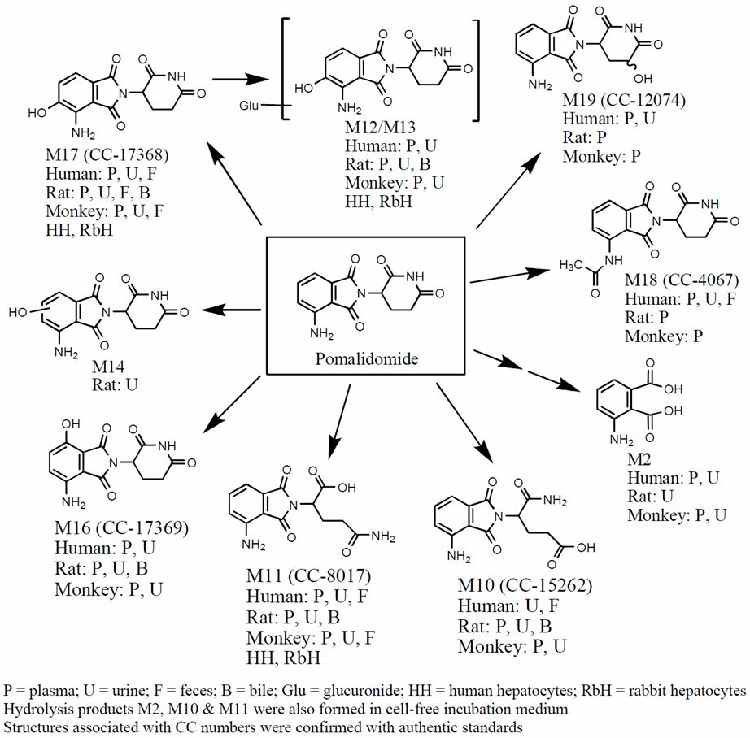
Non-clinical testing has suggested that the parent compound is the predominant moiety responsible for the pharmacological response associated with pomalidomide administration. In cell proliferation assays using MM cell lines, all pomalidomide metabolites and hydrolysis products tested had little or no activity, with IC50 values >1 µM. By comparison, pomalidomide inhibited proliferation of the MM cell lines with IC50s in the 0.028 to 0.038 µM range, indicating that the metabolites and hydrolysis products are at least 26-fold less potent than pomalidomide for direct inhibition of MM cell proliferation. Immunomodulatory activity (elevation of T cell IL-2 production and inhibition of peripheral blood mononuclear cell TNF-α production) of the metabolites was at least 32-fold less potent than pomalidomide.

Pharmacokinetics of metabolites
A Phase 1 study (CC-4047-CP-004) examined the absorption, metabolism, and excretion of pomalidomide following a single 2 mg oral dose of pomalidomide containing approximately 100µCi [14C]-pomalidomide in healthy male subjects. The secondary objectives were to characterize the PK of total radioactivity in plasma and whole blood, and the PK of pomalidomide and its enantiomers and metabolites in plasma.
Pomalidomide is a racemic mixture of R- and S- enantiomers, CC-6016 and CC-5083, respectively. The mean Cmax and AUC0-t values for CC-6016 were approximately 49% and 50%, respectively, and for CC-5083 were approximately 52% and 49%, respectively, of those observed for pomalidomide in plasma. These results indicate that the R- and S-enantiomers were present in approximately equal amounts.
Pomalidomide and 8 metabolites were detected in human plasma. Based on exposure (AUC0-t), unchanged pomalidomide accounted for approximately 70% (range 61.9% to 75.2%) of circulating total radioactivity (TRA) exposure. Six metabolites were detected by radiochromatography, with exposure to each metabolite <10% of the plasma TRA or pomalidomide. Other trace metabolites (M18 and M19) were detected only by mass spectrometry and could not be quantified.
Urinary excretion of radioactivity accounted for an average of 72.8% of the administered dose, with unchanged pomalidomide in the urine accounting for a mean of 2.2% of the dose. The predominant metabolites in urine were M11, M12 and M13, accounting for 23.3%, 17.1%, and 12.4%, respectively, of the dose over the 72-hour postdose period.

Routes and mechanisms of excretion
In the human AME study, CYP dependent metabolites accounted for approximately 43% of the excreted radioactivity, while non-CYP dependent hydrolytic metabolites accounted for 25%, and excretion of unchanged pomalidomide accounted for 10%.

Mass balance studies
Recovery of total [14C]-radioactivity was approximately 88% of the administered dose, with 72.83% and 15.46% recovered in urine and feces, respectively.

Renal clearance
Urine was the primary route of elimination for radioactivity, containing 72.8% of the dose. However, unchanged drug in urine accounted for <3% of the dose, indicating extensive metabolism prior to excretion. The radioactivity in feces (15.5% of the dose) contained parent compound (approximately 8% of the dose) and several metabolites. The metabolites in excreta were formed via similar pathways as those observed in plasma. Based on the in vivo rat, monkey and human metabolism data, there were no unique or disproportionate metabolites observed in humans. The predominant metabolites in urine were M11, M12 and M13, accounting for 23.3%, 17.1%, and 12.4%, respectively, of the dose in the urine over the 72-hour postdose period.
The mean t1/2 of pomalidomide was approximately 7.5 hours, and CL/F generally ranged from 6.5 to 10.8 L/hr. Both CL/F and t1/2 in plasma appeared to be independent of dose and dosing duration. Steady-state was reached by Day 3 in healthy subjects.
Mean eGFR based on data from the single dose bioequivalence study CC-4047-CP-007 (4 mg) and CC-4047-CP-005 (2 mg) was approximately 98 mL/min/1.73m². Mean CLR at a dose of 5 mg (1398/132) was 6.7 mL/min.

Pharmacokinetics in the target population
The SPC summaries the PK in MM patients as follows. The pharmacokinetic parameters of single dose pomalidomide in subjects with MM appear similar to those in healthy subjects over the comparable dose range. In subjects with MM (CC-4047-MM-001, and CC-4047-MM-002 Phase 2) administered pomalidomide at doses of 1, 2, 4, 5, or 10 mg once daily or 5 mg every other day, pomalidomide was absorbed with a median Tmax ranging from 1.5 to 4.0 hours postdose. Systemic exposure of single dose pomalidomide based on AUC was approximately dose proportional, while Cmax increased in a less than dose proportional manner up to 5 mg after single dose (Day 1). There was a dose related increase in exposure of pomalidomide in plasma upon multiple once-daily dosing in MM subjects, with greater changes from Day 1 to Day 29 at 1 and 2 mg dose levels compared with 4 and 5 mg dose levels.
Comment: In study CC-4047-MM-001, the report states on p26 that AUC(0-τ) and Cmax appeared to increase in a sub-proportional manner over the once daily dose range of 1 to 10 mg, which was more pronounced on Week 4 compared to Day 1. At the 5 mg daily dose, the closest to that proposed, the increase in AUC at week 4 compared to the 1 mg dose was only 2-fold, rather than the 5 fold to be expected. The above conclusions are therefore incorrect. As well accumulation of pomalidomide was seen in this study at the 1 mg and 2mg doses, but not at the 5 mg dose.
Mean Vz/F (%CV) in MM subjects was similar to that in healthy subjects ranging from 65 L (39%) to 97 L (23%) after a single dose across the same dose range.
Similar levels of parent drug in urine were found in MM subjects (CC-4047-MM-001) as were reported in healthy subjects. The fraction of the dose excreted in the urine as unchanged drug was low for all dosing regimens (1, 2, 5, and 10 mg daily, and 5 mg every other day), with a maximum of 4.5% being eliminated up to 24 hours after dosing on Day 1 and at Week 4 for individual subjects.
Accumulation appeared minimal in both healthy and MM subjects. In CC-4047-MM-001, the PK parameters for pomalidomide in MM subjects showed increased exposure with once daily multiple dosing at 1 and 2 mg compared to 4 mg and 5 mg. The observations at 1 and 2 mg were difficult to interpret due to relatively high inter-subject variability and limited subject numbers, and since a preliminary exploratory analysis suggested that accumulation is similar and minor in both healthy and MM subjects.
Comment: The two PK studies in the MM patients are difficult to interpret, giving conflicting results at different dose levels. In study CC-4047-MM-001, patient numbers were small, the between-patient variability high (CV up to 123% 50mg qod week 4), and no statistical analysis was possible, while the PK component of Study CC-4047-MM-002, Phase 2 (PK), was only an exploratory objective. The important question is whether the anomalies and issues in the two PK studies have any clinical significance. These issues include drug exposure (AUC and Cmax) and dose-proportionality, drug-accumulation, and anomalous PK results at a drug dose of 5 mg daily, which was the closest dose to the recommended dose of 4mg a daily for 21 out of 28 days. This question cannto be answered from PK data alone, and will be assessed on the basis of the safety of the 4mg dose in the clinical studies. Other comments on this issue follow each of the trial summaries and lead to the following conclusions:
- The AUC and Cmax of pomalidomide administered daily increased in a sub-proportional manner with dose in MM patients;
- Drug accumulation was demonstrated at 4 weeks at the lower doses of 1 and 2mg daily, but not at the 5 mg dose in study CC-4047-MM-001; smaller accumulation (AUC up to 33% and Cmax up to 19%) was demonstrated at day 8 of study CC-4047-MM-002, Phase 2).
PK Results in the Pivotal Study CC-4047-MM-003: The limited PK data obtained are to be combined with PK data from other trials for an analysis of population pharmacokinetics.

Pharmacokinetics in other special populations
The Summary of Clinical Pharmacology states that the impact of major intrinsic factors on exposure to pomalidomide is not yet fully understood, as the exposure data are limited at this time and not sufficient to conduct a rigorous population PK covariate analysis. These analyses will be conducted when data from on-going and future trials are available. Preliminary analyses on exposure in some special populations were conducted with the following results.

Pharmacokinetics in subjects with impaired hepatic function
A dedicated Phase I study with hepatic impaired subjects has not been completed, and subjects with high (>3 ULN) liver transaminases were excluded from the Phase II trials CC-4047-MM-002 and IFM-2009-02. Therefore no exposure data are available from hepatic impaired patients. Liver transaminase concentrations were measured and monitored in CC-4047-MM-002 and no remarkable trends or issues were noted.

Pharmacokinetics in subjects with impaired renal function
A dedicated study in MM subjects with different degrees of renal impairment is in progress (CC-4047-MM-008). This study is a Phase I, dose escalation PK and safety study of pomalidomide in combination with low dose dexamethasone in relapsed or refractory MM subjects with impaired renal function. Since pomalidomide is highly metabolized (<5% is eliminated as parent drug), it is hypothesized that renal impairment will not affect exposure to pomalidomide in a clinically relevant manner.

Pharmacokinetics according to age, body weight and gender
Single and multiple dose exposure data were combined from four studies in healthy adult males administered pomalidomide capsules (1398/132, CC-4047-CP-005, CC-4047-CP-006 and CC-4047-CP-007). Exploratory covariate analysis showed that there is no notable trend between age or body weight and the pomalidomide apparent total body clearance (CL/F) in healthy subjects (n=148) by visual assessment (Figure 4). In addition, within the range of 75.4 to 195.5 mL/min creatinine clearance calculated for individual healthy subjects, there is no notable correlation between creatinine clearance and pomalidomide CL/F (Figure 4). A renal impairment study in MM patients is currently in progress to determine the effect of renal function on pomalidomide exposure (CC-4047-MM-008).
Figure 4: Effect of Age and Body Weight on Pomalidomide Exposure in Healthy Subjects.
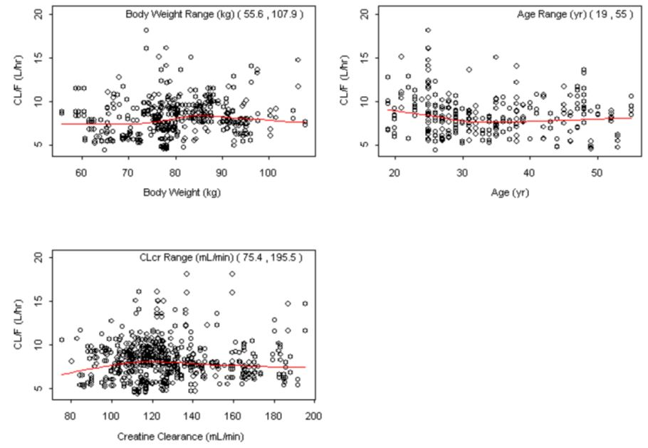
Exposure data are available from two MM patient studies (CC-4047-MM-001, CC-4047-MM-002 Phase 2). The data are primarily from subjects administered pomalidomide alone, except from 7 subjects who received pomalidomide plus dexamethasone. Exploratory covariates analysis using these data showed that there is no notable trend between age (range: 48-81 years, median: 65 years; Figure 5), or body weight (range: 48-94.5 kg, median: 67.7 kg; Figure 6), and pomalidomide exposure. In addition, it is unlikely that there is sex difference for pomalidomide exposure in MM subjects (p=0.89) (Figure 7).
Figure 5: Effect of Age on Pomalidomide Exposure in MM Subjects.
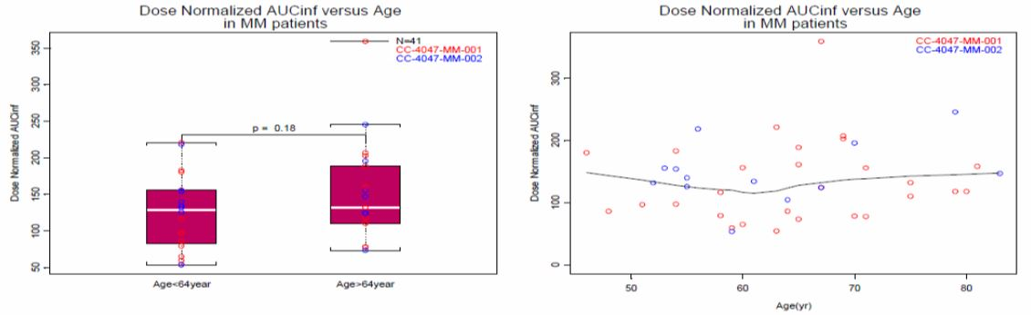
Figure 6: Effect of Body Weight on Pomalidomide Exposure in MM Subjects.
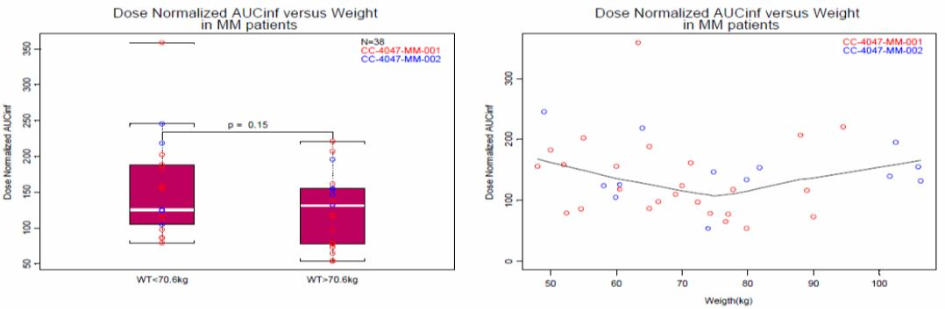
Figure 7: Effect of Sex on Pomalidomide Exposure in MM Subjects.
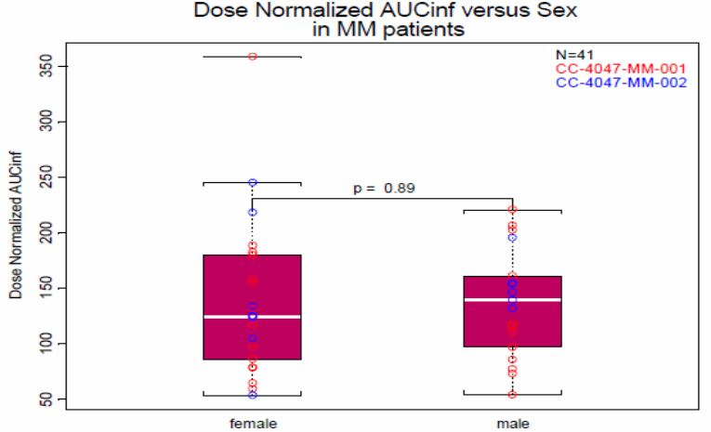

Pharmacokinetics {in other special population / according to other population characteristic}
Treatment outcomes (response rates) were assessed with variable patient characteristics such as disease severity, and ethnicity, but not pharmacokinetics.

Pharmacokinetic interactions

Pharmacokinetic interactions demonstrated in human studies
Co-administration with dexamethasone (a weak to moderate inducer of several CYP enzymes including CYP3A) did not affect the PK profile of pomalidomide in MM patients. A Phase I clinical trial evaluating potential drug-drug interactions when pomalidomide is co-administered with strong CYP3A and/or CYP1A2 inhibitors or a CYP3A inducer or a P-gp inhibitor is clinically complete and data analysis is in progress (CC-4047-CP-008).
Concomitant medications in clinical trial CC-4047-MM-002: In addition to dexamethasone, patients were likely to receive anti-thrombotic therapy. In the Phase II CC-4047-MM-002 study, all subjects received aspirin 81 mg to 100 mg daily as prophylactic anti-thrombotic treatment unless contraindicated, in which case subjects received another form of anti-thrombotic therapy according to hospital guidelines or physician preference. The most common co-medications (>25% of subjects) in the Phase II portion of CC-4047-MM-002 were presented in the SCP. None of these co-medications were inhibitors/inducers of CYP isozymes. As well, since pomalidomide is metabolized by several pathways, pomalidomide is unlikely to be affected by or cause a drug-drug interaction.

Clinical implications of in vitro findings
Pomalidomide Effect on Other Drugs: In human liver microsomes, pomalidomide produced no direct inhibition of CYP1A2, CYP2A6, CYP2B6, CYP2C8, CYP2C9, CYP2C19, CYP2D6, CYP2E1, and CYP3A4/5, with IC50 values >30 µM, and little to no time-dependent inhibition of CYP1A2, CYP2C9, CYP2C19, CYP2D6 or CYP3A4/5 was observed at concentrations up to 30 µM (CC-4047-DMPK-024). Treatment of cultured human hepatocytes with pomalidomide had little inductive effect on the enzymatic activities of CYP1A2, CYP2B6, CYP2C9, CYP2C19, and CYP3A4/5 (CC-4047-DMPK-023). In MDCK cells, pomalidomide (up to 10 µM) did not inhibit P-glycoprotein (CC-4047-DMPK-037). In transporter expressing cells, pomalidomide (at 2 and 20 µM) had little to no inhibitory effect on BCRP, OATP1B1, OATP1B3, OCT2, OAT1 and OAT3 and OCT2 (CC-4047-DMPK-043). Pomalidomide has not been evaluated as a potential inducer of any drug transporters.
In conclusion, pomalidomide is not anticipated to cause clinically relevant pharmacokinetic drug-drug interactions at therapeutic doses when co-administered with CYP substrates or substrates of the evaluated transporters, and clinical drug-drug interaction studies have not been conducted.
Effect of Other Drugs on Pomalidomide: As a substrate, since pomalidomide is eliminated in humans via multiple pathways (CYP mediated metabolism, enzymatic and non-enzymatic hydrolysis, and excretion of unchanged drug), and several CYP enzymes are capable of metabolizing pomalidomide, namely CYP1A2, CYP3A4, and to a minor extent CYP2C19 and CYP2D6 (CC-4047-DMPK-022), it is not anticipated that co-administration of an inhibitor or inducer of any one of these CYPs will have a significant impact on pomalidomide pharmacokinetics.
Furthermore, since pomalidomide plus metabolites M2, M11, M12, M13, M16 and M17, formed via hydrolysis, hydroxylation and/or glucuronidation, account for >94% of the total radioactivity in human plasma collected over the 0-24 hour postdose period (CC-4047-CP-004), it is unlikely that there are other metabolic pathways that are important to the overall PK or metabolism of pomalidomide.
In MDCK cells, pomalidomide is a substrate of P-gp (CC-4047-DMPK-037), although intestinal absorption did not appear to be limited by this. In the human AME study, at least 70% of the dose was absorbed, indicating good oral absorption. Additionally, parent drug is the major circulating entity and any effect of P-gp inhibition on the minor metabolites is unlikely to have any clinical impact. Therefore the potential for clinically relevant drug-drug interactions when pomalidomide is co-administered with inhibitors of P-gp is low. Pomalidomide has not been evaluated as a substrate for drug transporters other than P-gp. In the human AME study (CC-4047-CP-004) elimination of unchanged pomalidomide in urine and feces represented approximately 10% of the dose. This suggests that transporter mediated elimination of pomalidomide into bile and urine plays a relatively minor role in its overall disposition.

Evaluator’s conclusions on pharmacokinetics
The following conclusions are based on those of the Summary of Clinical Pharmacology, except where the evaluator disagrees with those conclusions as indicated.
- Following single dose administration in the fasted state, pomalidomide was at least 73% absorbed with a median Tmax of ~3 h.
- Steady state was reached by Day 3 in healthy subjects. No drug accumulation was seen in these subjects after 5 days, but in MM subjects receiving 1 mg or 2 mg daily doses for 28 days, drug accumulation was shown by a 73% to 98% higher value for AUC0-τ on Day 28 compared to that predicted from Day 1 findings. Drug accumulation was not seen at 5 mg daily dose in MM patients. The difference is unexplained. (The Summary of Product Characteristics has a different interpretation.)
- Systemic exposure increased after single doses of differing strengths of pomalidomide in both healthy subjects and MM patients. In healthy subjects, the Cmax increase was sub proportional, while the AUC values were approximately proportional. In MM patients, both AUC and Cmax were not dose proportional.
- Food decreased the rate of absorption but had minimal effect on overall extent of absorption (~8% decrease in AUC). Pomalidomide can be administered without regard to food intake.
- Mean (%CV) apparent volume of distribution during terminal phase after non IV administration (Vz/F) of pomalidomide after a single dose ranged from 65 to 138 L.
- Pomalidomide distributed into semen, with the semen concentration at plasma Tmax approximately 67% of plasma concentration.
- Pomalidomide protein binding in human plasma was low to moderate (15.8% and 42.2% for R- and S-enantiomers, respectively).
- Pomalidomide is metabolized in humans via multiple pathways (CYP mediated, enzymatic and non-enzymatic hydrolysis). The metabolites observed were formed primarily via hydroxylation with subsequent glucuronidation, or hydrolysis of the parent compound.
- Pomalidomide was the predominant circulating radioactive component, accounting for approximately 70% of the circulating radioactivity, and no metabolites were present at >10% relative to parent or total radioactivity. There were no unique or disproportionate human metabolites.
- CYP dependent metabolites accounted for approximately 43% of the excreted radioactivity, while non-CYP dependent hydrolytic metabolites accounted for 25%, and excretion of unchanged pomalidomide accounted for 10%.
- Pomalidomide metabolites did not show significant pharmacological activity in-vitro.
- The mean half-life of pomalidomide is approximately 7.5 h, and CL/F generally ranged from 6.5 to 10.8 L/hr. CL/F and half-life in plasma appear to be independent of dose and dosing duration.
- Urine was the primary route of elimination for radioactivity, containing approximately 72% of the dose. Unchanged drug in urine accounted for <3% of the dose, indicating extensive metabolism prior to excretion. The radioactivity in faeces (15.3% of the dose) contained parent compound (~8% of the dose) and several metabolites.
- The pharmacokinetic parameters of single dose pomalidomide in subjects with MM appear similar to those in healthy subjects over the comparable dose range, except for the 1 and 2 mg doses in MM patients (see above). (The Summary of Product Characteristics has a different interpretation.)
- Pomalidomide is not an inhibitor or inducer of CYP isozymes, and did not inhibit P-glycoprotein or other studied transporters in vitro. Pomalidomide is not anticipated to cause clinically relevant pharmacokinetic drug-drug interactions at therapeutic doses when co-administered with CYP substrates or substrates of the evaluated transporters and therefore has not been studied in a clinical trial.
- Pomalidomide is partially metabolized by CYP1A2 and CYP3A4, and to a minor extent CYP2C19 and CYP2D6. Pomalidomide is a substrate of P-glycoprotein in vitro but well absorbed in humans. Pomalidomide is unlikely to be a significant substrate of other enzymes or transporters. The potential for clinically relevant drug-drug interactions when pomalidomide is co-administered with other drugs is low. A clinical trial evaluating potential drug-drug interactions is clinically complete and data analysis is in progress (CC-4047-CP-008).
- Clinical trials evaluating pharmacokinetics in MM patients with renal insufficiency and in otherwise healthy subjects with hepatic impairment are in progress (CC-4047-MM-008 and CC-4047-CP-009, respectively).

Pharmacodynamics

Studies providing pharmacodynamic data
Studies providing pharmacodynamic data are shown in Table 2.
Table 2: Submitted pharmacodynamic studies.
PD Topic | Subtopic | Study ID
Primary Pharmacology | Effect on CD4 and CD8 count | 1398/132 (in part)
Primary Pharmacology | Effect on serum M protein concentration, cytokine production and neutrophils. | CC-4047-00-002 (in part)
Secondary Pharmacology | NA
Gender other genetic and Age-Related Differences in PD Response | Effect of gender NA
PD Interactions | NA
Population PD and PK-PD analyses | NA
NA=Not available
Note: The pharmacodynamic evaluations from Study CC-4047-CC-006 were reported separately, and were not found in this application.

Summary of pharmacodynamics
The information in the following summary is derived from conventional pharmacodynamic studies in humans unless otherwise stated.

Pharmacodynamic effects
Preclinical Studies: The PD properties demonstrated in animal studies were presented in the Pre-Clinical section of the application. In summary these included pleiotropic activities of pomalidomide on a range of cell types including MM cells and immune effector cells, potent inhibition of the proliferation of MM cell lines in vitro, activity in in vivo tumor models, potent anti-inflammatory activity in vitro, and multiple effects on the immune system. Preclinical data revealed no evidence for potential QTc prolongation.
The PD results presented in the clinical section of this application were those in Study 1398/132 reporting the effects of increasing doses of pomalidomide on the CD4 and CD8 counts, Study CDC-4047-00-001, the effect on paraprotein concentration, and the Phase I study, CC-4047-MM-002.
Effect on CD4 and CD8 counts: Single doses of 5 and 25 mg pomalidomide reduced the CD4 count most at 48hr post-dose while the reduction after the 1 mg and 10mg doses were the same as placebo. The CD8 count was reduced at 1, 2 and 4 days at all doses but were no different from placebo.
Effect on concentration of serum paraprotein: A mean decrease from base line values was seen at doses of 2, 5 and 10mg. Among the 23 Cohort I subjects evaluable for response as reflected in a reduction in serum paraprotein levels of at least 25%, nine (39%) subjects treated with pomalidomide in the everyday schedule demonstrated this extent of M-protein reduction after 4 weeks of treatment. In two of the subjects, the paraprotein reduction was ≥ 75% of pretreatment levels. Similarly, seven (37%) of 19 evaluable subjects in Cohort II showed a reduction in serum paraprotein levels of at least 25%.
Effect on neutrophils: Of 24patients with MM who received daily oral doses of 1, 2, 5, and 10 mg of pomalidomide, 6 (15.8%) had Grade 4 neutropenia, and 1 (2.6%) Grade 3 neutropenia. The nadir occurred in all cases on day 22, and lasted for 6 to 8 days.
Comment: The time of the nadir was that seen in other studies of safety in this application.

Relationship between drug concentration and pharmacodynamic effects
The SCP notes that there are not sufficient PK data currently available to assess robustly exposure-response relationships, although a preliminary analysis was presented on exposure and relation to M-protein, and exposure and relation to nadir neutrophils and nadir platelets, based on data from CC-4047-MM-002 (PK available for 14 subjects).
Efficacy: An exploratory analysis of exposure-response relationship in CC-4047-MM-002 was performed on Cycle 1 Day 8 AUC0-t and Cmax versus M-protein (Cycle 2 Day 28). Graphically, the M-protein concentrations measured on Cycle 2 Day 28 appeared to decrease with increasing pomalidomide AUC and Cmax, except for 1 subject. However, due to the limited number of subjects with PK data in this study, the potential trend could not be confirmed with the full rigor of statistical significance.
Safety: An exploratory analysis of exposure-response relationship in CC-4047-MM-002 was performed on Cycle 1 Day 8 AUC0-t and Cmax versus nadir neutrophils and nadir platelets (across all cycles). Graphically, no relationship between exposure (AUC0-t and Cmax) and nadir neutrophils and nadir platelets were noted in either arms.

Genetic-, gender- and age-related differences in pharmacodynamic response
The main pharmacodynamic response to pomalidomide in patients with MM can be taken to be the response of MM to treatment.
Gender: The response rates of 119 male patients and 102 female patients in study CC-4047-MM-002 were not different on visual comparison.
Age: Pomalidomide has been administered to subjects up to 88 years of age in MM clinical trials. The impact of age was assessed by subjects ≤ 65 years and >65 years in the total ITT subjects population. The cut-off of 65 years was based on a common definition of elderly. Of the 221 MM subjects (ITT population) who received study treatment in Study CC-4047-MM-002, 90 were over 65 years of age (Table 3). There was no major difference in the percentage of subjects over 65 years of age between the pomalidomide + dexamethasone and pomalidomide alone groups. Visual assessment of clinical response by age does not show any strong trend indicating a difference in efficacy between the two subpopulations.
Table 3: Summary of Myeloma Response Rates by IRAC (Based on Best Response Assessment Using EBMT Criteria – Age) in CC-4047-MM-002.
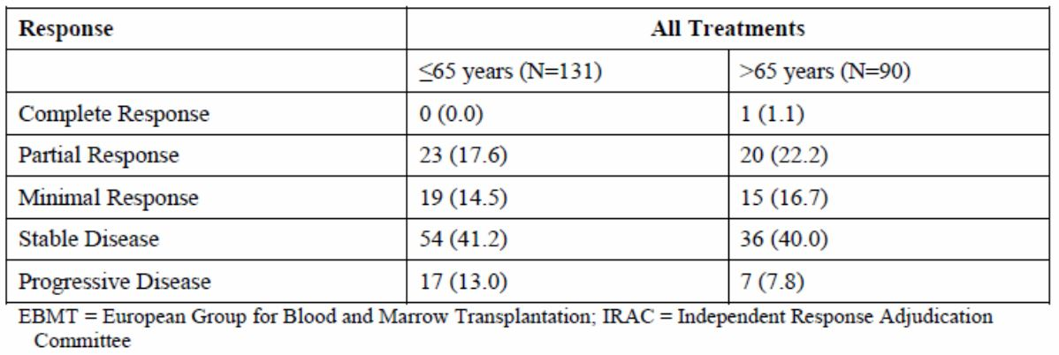
Safety and effectiveness in pediatric patients below the age of 18 have not been established. A pediatric study with pomalidomide is not required as MM is an orphan indication. In addition, MM rarely occurs in patients below the age of 40 years.
Of the 84 MM subjects who received study treatment in study IFM-2009-2, 26 were ≥ 65 years of age. Overall response rate for subjects < 65 years of age was 38% and for subjects ≥ 65 years of age was 27%.

Pharmacodynamic interactions
A number of drugs was co-administered with pomalidomide in cell lines and animal models. The following interactions were reported in the Summary of Pre-Clinical Pharmacology and may act as signals if such combinations were used in humans.
Bortezomib and Dexamethasone: In cell lines and a MM xenograft mouse model, as single agents, pomalidomide and Dex inhibited tumor growth approximately 43% and 38% (Day 8) - 87% and 65% (Day 25), respectively compared with the control. The combination of pomalidomide with bortezomib, Dex, or Dex and bortezomib further increased the tumor suppression to approximately 93%, 93%, and 96%, respectively on Day 25.
Rituximab: Pomalidomide alone and in combination with rituximab (an anti-CD20 monoclonal antibody/antitumor agent), was evaluated in vivo in a human Burkitt’s lymphoma tumor model in SCID mice. SCID mice treated with both pomalidomide and rituximab experienced a significant, near doubling of median survival compared to SCID mice treated with rituximab alone. At the end of the follow-up period, a higher survival rate was observed in the pomalidomide/rituximab group (30%), compared with rituximab alone (5.3%).
Hydroxyurea and Butyrate and Fetal Hemoglobin Expression: Pomalidomide was a more potent inducer of HbF expression in healthy donor erythrocytes than both HU and butyrate: compounds known to increase HbF levels. In the healthy donor erythrocytes tested, pomalidomide increased HbF with an EC50 of 0.08 μM compared with 30 µM and 150 µM for HU and butyrate, respectively. In all healthy donor samples, pomalidomide dose-dependently increased the percentage of cells expressing HbF but unlike HU and butyrate, did not affect cell viability. Furthermore, pomalidomide (1 and 10 µM) acted synergistically with HU (10 µM) in increasing HbF expression during erythroid differentiation and additively at lower (0.1 µM) concentrations of pomalidomide.
Histone Deacetylase (HDAC) Inhibitors: Pomalidomide was found to enhance the expansion of CD34+ and CD133+ cells from various sources: bone marrow, cord blood, and both steady-state and mobilized peripheral blood. This activity was observed in serum-free conditions in the presence of various growth factors. The expansion potential of pomalidomide was maximal in the presence of stem cell factor (SCF). Positive effects were observed at concentrations as low as 0.1 and 1µM; no toxicity was observed at the maximum concentration used (50 µM). In combination with the histone deacetylase (HDAC) inhibitors valproic acid (VPA) and TSA, a synergistic effect was observed in the expansion of CD34+ and CD133+ cells.

Evaluator’s conclusions on pharmacodynamics
- Pharmacological properties of pomalidomide from pre-clinical studies are summarised
- Effects of pomalidomide on the CD4 and CD8 counts in Study 1398/132 in healthy subjects were inconclusive
- A reduction in serum paraprotein concentration of at least 25% was seen in 39% of patients treated with pomalidomide (Study CDC-4047-00-001)
- Grade 3 and 4 neutropenia were seen in MM patients treated with pomalidomide
- Efficacy and safety were not shown to be related to PK data on pomalidomide because of insufficient data.

Dosage selection for the pivotal studies
The proposed clinical starting dose for pomalidomide is 4 mg daily (given as 2 x 2 mg capsules) on Days 1 to 21 of repeated 28 day cycles, in combination with 40 mg dexamethasone on Days 1, 8, 15 and 22 of each 28 day cycle. In the Phase II section of study CC-4047-MM-002, the results from the 14 patients who provided pharmacokinetic data showed a steady state mean exposure (AUC0-t) to pomalidomide in the range of 381-411 ng.hr/mL (CV 28-55%).
The therapeutic dose is consistent with data from the Phase I portion of CC-4047-MM-002, in which the MTD of pomalidomide when administered as single agent once per day orally on Days 1 to 21 of each 28 day cycle (cyclic regimen schedule) was determined to be 4 mg based on the occurrence of dose limiting toxicities (DLTs) of grade 4 neutropenia in the 5 mg dose cohort. Subjects in the 4 mg cohort had fewer dose reductions than those in the 5 mg cohort and the proportion of subjects who completed ≥ 40 weeks on study was higher in the 4 mg (and 5 mg) cohort compared with the 2 mg and 3 mg cohorts. This implies a balance between tolerability and efficacy. This result is consistent with Study CC-4047-MM-001, which determined an MTD of 2 mg once daily (QD) or 5 mg every other day (QOD), but did not explore a dose between this range. The MTD of 4 mg was used as the recommended starting dose for the Phase II open label randomised segment of the study to determine the efficacy and safety of pomalidomide alone and in combination with LD dexamethasone in the RRMM population.
The proposed usage of pomalidomide is in combination with dexamethasone. However, pomalidomide is active when administered alone, with an overall response rate of 9% (intent to treat [ITT population]), and a response rate of 15.4% in subjects > 65 years old and 23.1% in subjects >75 years old based on an Independent Response Adjudication Committee (IRAC), in the heavily pre-treated subjects in the Phase II Study CC-4047-MM-002. The rationale for the combination of pomalidomide plus LD dexamethasone was based on in vitro data that show that pomalidomide inhibits the proliferation of lenalidomide resistant MM cell lines and synergises with dexamethasone in both lenalidomide sensitive and lenalidomide resistant cell lines to induce tumour cell apoptosis. These data were supported by the overall response rate of 30.1% (ITT population) in subjects treated with the combination of pomalidomide and LD dexamethasone versus 9.3% in subjects treated with pomalidomide alone in Phase II Study CC-4047-MM-002. In addition, lenalidomide (of which pomalidomide is an analogue) demonstrated increased antimyeloma activity when used in combination with dexamethasone compared to treatment with lenalidomide alone. The use of LD dexamethasone as well as a cyclic regimen schedule is also supported by studies using lenalidomide.
A cyclic regimen of pomalidomide 21 of 28 days versus 28 of 28 days was compared in IFM-2009-02. There was no difference in response rate, or any secondary endpoint, between the two different treatment regimens, both of which contained the same dose/schedule of dexamethasone. Since both regimens were well tolerated, and overall treatment duration was longer with the 21 day versus the 28 day regimen, use of the 21 day regimen appears favourable.
Therefore, the available data support a 21 of 28 day cyclic regimen of pomalidomide 4 mg in combination with LD dexamethasone to be the optimal regimen. There were not sufficient PK data currently available to determine an exposure-response relationship.
Comment: The reasons for the dose selections are acceptable.

Clinical efficacy

Pivotal efficacy study

Study CC-4407-MM-03

Study design, objectives, locations and dates
Study Design: Study CC-4047-MM-003 followed a randomized, open-label design to compare PFS as a primary endpoint between Pom + LD-dex and HD-dex. In addition, the study was also powered to show an advantage in OS. The control arm was HD-dex, a treatment widely used as a comparator to test novel agents in relapsed/refractory MM. For subjects in the HD-dex arm who had confirmed disease progression, the option to enrol into an ongoing companion study (CC-4047-MM-003C) to receive pomalidomide alone was available.
The study was conducted in five consecutive phases as shown below: screening, randomization, treatment, follow-up to assess PFS (for subjects who discontinued treatment without disease progression), and long-term follow-up. Within 28 days of randomization, subjects were screened for eligibility. Thereafter, eligible subjects were randomized in a 2:1 ratio to 1 of 2 treatment arms.
Figure 8: Effect of Sex on Pomalidomide Exposure in MM Subjects.
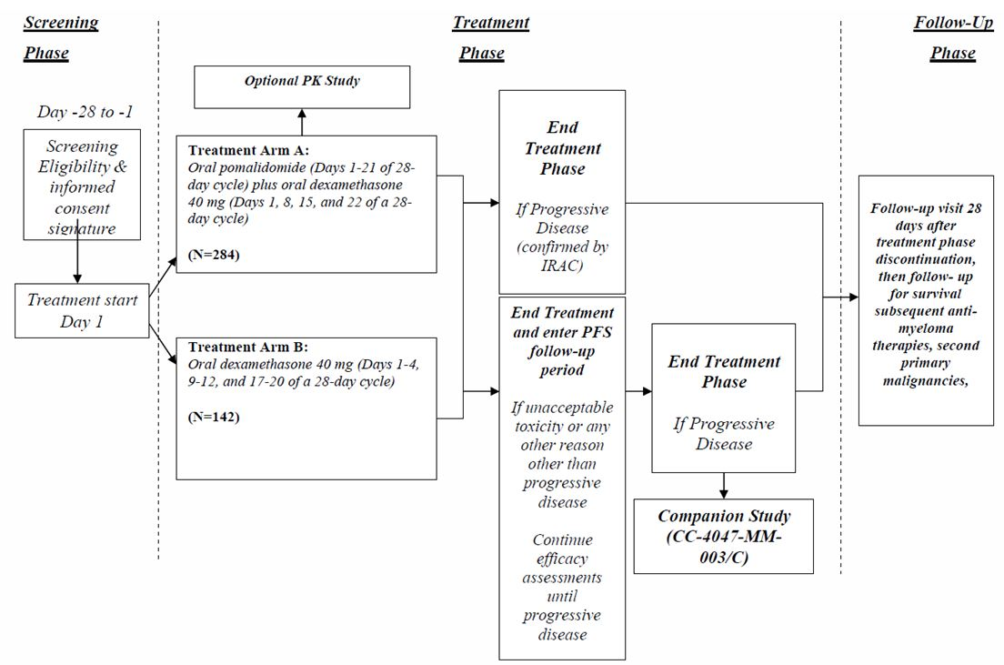
Primary Objective: The primary objective of the study was to compare the efficacy of Pom + LD-dex with that of HD-dex in subjects with refractory MM or relapsed and refractory MM.
Secondary Objectives: The secondary objective of the study was to compare the safety of Pom + LD-dex with that of HD-dex in subjects with refractory MM or relapsed and refractory MM.
Exploratory Objectives: The exploratory objectives of the study were to explore the relationship between MM response and cytogenetic abnormalities; to determine the population pharmacokinetics of pomalidomide when administered along with low- dose dexamethasone in subjects with refractory MM or relapsed and refractory MM; to explore the pomalidomide exposure and response relationship, and to explore the mechanism of action of pomalidomide.
Locations and Monitoring: The study was conducted at 93 sites: 58 sites in Europe, 10 sites in Australia, 10 sites in the United Kingdom, 10 sites in Canada, 4 sites in Russia, and 1 site in the United States (US). Before the study was initiated at a site visit or at an investigator meeting, all aspects of the study were reviewed with the investigator(s) and the staff. Celgene’s Clinical Quality Assurance (CQA) unit conducted audits of clinical research activities in accordance with Celgene SOPs and Working Procedures (WPs) to evaluate compliance with GCP guidelines and regulations. The number of patients entered ranged from 1 (Frankston, Victoria) to about 30 (Athens, Greece). A copy of the audit certificates for 9 sites audited was provided.
Comment: One site audited, site 407 (Pierre Bénite, France), is not shown as entering any patients (Listing 16.1.07).
Dates: The first subject was enrolled on 18 Mar 2011, and the first data cutoff was on 07 Sep 2012. After this time, a pre-planned interim analysis was completed when approximately 121 subjects across both arms had progressed or died during the study. This is the primary analysis of the study with the endpoints final Progression Free Survival (PFS) and interim Overall Survival (OS).
An updated OS analysis was performed (data cut-off 01 March 2013) when the originally specified number of OS events was reached for the final analysis, even though the interim OS analysis had crossed the O’Brien-Fleming superiority boundary. PFS analysis was also updated using the adjudicated response data with the 01 Mar 2013 cut-off date. These updated data were provided, but the sponsor asked that the interim analysis be taken as the primary analysis.

Inclusion and exclusion criteria
Inclusion Criteria: Those peculiar to this study were that subjects were to have documented and measurable MM (serum M-protein ≥ 0.5 g/dL or urine M-protein ≥ 200 mg/24 hours), to have undergone prior treatment with 2 or more regimens that included lenalidomide and bortezomib, either alone or in combination, to have received adequate prior alkylator therapy, and to have had either refractory or relapsed and refractory disease defined as documented disease progression during or within 60 days of completing their last myeloma therapy.
Also eligible were those subjects who had not had a ≥ Minimal Response (MR) response and had developed intolerance/toxicity after a minimum of two cycles of a bortezomib-containing regimen.
Females of childbearing potential (FCBP) must have agreed to utilize two reliable forms of contraception simultaneously or practiced complete abstinence from heterosexual contact for at least 28 days before starting study drug, while participating in the study (including dose interruptions), and for at least 28 days after study treatment discontinuation and must have agreed to regular pregnancy testing during this timeframe.
Exclusion Criteria: Important exclusions were subjects with any of the following laboratory abnormalities:
- Absolute neutrophil count (ANC) < 1,000/µL
- Platelet count < 75,000/µL for subjects in whom < 50% of bone marrow nucleated cells were plasma cells; or a platelet count < 30,000/ µL for subjects in whom ≥ 50% of bone marrow nucleated cells were plasma cells
- Creatinine Clearance < 45 mL/min according to Cockcroft-Gault formula . If creatinine clearance calculated from the 24-hour urine sample was ≥45 ml/min, subject qualified for the trial
- Corrected serum calcium > 14 mg/dL (> 3.5 mmol/L)
- Hemoglobin < 8 g/dL (< 4.9 mmol/L; prior RBC transfusion or recombinant human erythropoietin use was permitted)
- Serum SGOT/AST or SGPT/ALT > 3.0 x upper limit of normal (ULN)
- Serum total bilirubin > 2.0 mg/dL (34.2 µmol/L); or > 3.0 x ULN for subjects with hereditary benign hyperbilirubinaemia
Also excluded were subjects who were resistant to high-dose dexamethasone used in the last line of therapy, defined as disease progression on or within 60 days of receiving the last dose of high-dose dexamethasone used in the last line of therapy, either as single agent or in combination.
Subjects who progressed on low-dose dexamethasone qualified for the trial.
Those subjects were excluded who received an allogeneic bone marrow or allogeneic peripheral blood stem cell transplant less than 12 months prior to initiation of study treatment and who had not discontinued immunosuppressive treatment for at least 4 weeks prior to initiation of study treatment and were currently dependent on such treatment.

Study treatments
Eligible subjects were randomized in a 2:1 ratio to 1 of 2 treatment arms:
- Treatment Arm A - Pom + LD-dex: Pomalidomide (4 mg PO) was administered on Days 1-21 of each 28-day treatment cycle. Low-Dose Dexamethasone (40 mg PO) was administered once per day on Days 1, 8, 15, and 22 of a 28-day cycle (Subjects >75 years of age received dexamethasone 20mg)
- Treatment Arm B – HD-dex: High Dose dexamethasone (40 mg on Days 1 through 4, 9 through 12, and 17 through 20 of a 28-day cycle. (Subjects > 75 years of age received dexamethasone 20 mg)
Pomalidomide dose modification: The starting dose was 4mg. Dose level 1 was 3mg, dose level 2, 2mg and dose level 3, 1 mg. Dose levels were reduced based on haematological toxicity ( Grade 4 neutropenia and thrombocytopenia) and non-haematological toxicity (Grade 3 or more rash, constipation, venous thromboembolism, peripheral neuropathy, any other Grade 3 or more AE due to pomalidomide; Grade 2 or more hypo- or hyperthyroidism).
Low-dose dexamethasone dose modification: The starting dose was 40mg, level 1 was 30mg, level 2, 20mg and level 3, 10mg for subjects under 75, and 20mg, 12mg, and 8mg respectively for those over 75. Doses were reduced for the following dexamethasone related toxicities – dyspepsia Grades 1-3; oedema Grade 3 or 4; confusion or mood alteration Grade 2 or more; muscle weakness Grade 2 or more; hyperglycaemia Grade 3 or more; acute pancreatitis (discontinue treatment); any other Grade 3 or more AE due to dexamethasone.
High-dose dexamethasone dose modification: The starting dose 40 mg on Days 1-4, 9-12, 17-20 of 28-day cycle; level 1 was 40 mg on Days 1-4, 9-12 of 28-day cycle; and level 2 40 mg on Days 1-4 of 28-day cycle for subjects under 75 ( if level 2 was to be lowered, dexamethasone was to be discontinued. For subjects over 75, the dose at each level was 20mg. The toxicities leading to dose reduction were the same as for low-dose dexamethasone.
Rationale for use of HD-dex as comparator: High-dose dexamethasone was chosen as the control arm for this study as it was widely used as a comparator for testing the novel agents prior to their approval in the relapsed/refractory setting in MM. High dose dexamethasone has shown activity in patients with relapsed myeloma with response rates ranging from 18% to 27%. Because dexamethasone is not cytotoxic, it still has a role in the management of subjects with myeloma, especially those with cytopenias and renal impairment. Studies have shown that the high-dose steroid component of the vincristine, adriamycin, dexamethasone (VAD) regimen contributed to about 85% of its effectiveness (5 refs in CSR). Currently, there are no clinical studies that report the response rate of low-dose dexamethasone in relapsed and refractory MM patients. However, in the newly diagnosed setting, a statistically higher response rate was observed with lenalidomide plus high-dose dexamethasone compared to lenalidomide plus low-dose dexamethasone, suggesting high-dose dexamethasone has greater activity than low-dose dexamethasone for inducing responses in patients receiving this combination.
Comment: The rationale is acceptable.

Efficacy variables and endpoints
Response (efficacy) assessments were conducted at the same time points for all subjects during their participation in this study in order to accurately compare PFS between the treatment arms.
A central laboratory performed laboratory efficacy assessments. Efficacy assessments for Treatment Arms A and B were to be performed at the start of each new cycle.
The efficacy variables were: bone marrow aspiration and/or biopsy (at screening and to confirm CR, and if clinically indicated PD); ECOG PS (at screening and on day 1 of each cycle); laboratory assessments of serum Beta 2-microglobin (at screening only) and myeloma paraprotein (M-Proteins) protein electrophoresis and immunofixation on serum and urine, serum immunoglobulin assessment, and serum free light chain assay (all at screening and on day 1 of every cycle and every 28 days during PFS follow-up, at treatment discontinuation and treatment phase discontinuation visits, and to confirm complete response.); skeleteal survey (at screening or within 60 days prior to start of cycle 1 then only if indicated); assessment of extramedullary plasmacytomas (clinically if accessible otherwise by CT/MRI).
Main efficacy variables were assessment of response and overall survival -
- Assessment of response: Overall best response was assessed using the International Myeloma Working Group (IMWG) and European Group for Blood and Marrow Transplantation (EBMT) criteria at every cycle on Day 1 starting at Cycle 2 and at the treatment discontinuation visit, every 28 days during the PFS follow-up period and treatment phase discontinuation visit. Overall response rates utilizing both criteria were reported in the clinical study report. For all Investigator-assessed PDs, confirmation of PD by at least one member of the IRAC was required for all subjects. If the IRAC determined that PD was confirmed, then subjects in either Treatment Arm were discontinued from the treatment phase
- Overall survival and subsequent anti-MM therapies: All subjects were followed for survival until death or until 5 years from randomization, whichever occurred first. Subjects were assessed 4 times a year (every 84 days following the 28 days after treatment phase discontinuation visit) to determine survival status. All subsequent therapies given for MM and response to each therapy were collected and entered into the eCRF. The date of progression and reason for progression based on the IMWG uniform response criteria, if available, was also collected during long-term follow-up for subjects who did not have PD during the study treatment phase.
The primary efficacy endpoint was the PFS by International Myeloma Working Group (IMWG) criteria.
Secondary efficacy endpoints included: Overall survival (OS); Overall Response (using the new IMWG response criteria per IRAC); Objective Response (using EBMT criteria per Investigators); Time to progression (TTP); Time to response; Duration of response; Clinical benefit responses (Time to increased hemoglobin value, time to improvement of bone pain, time to improvement of renal function, time to improvement of ECOG performance status) and the European Organization for Research and Treatment of Cancer QoL Questionnaire for Patients with Multiple Myeloma (EORTC QLQ-MY20) Module, the Cancer QoL Questionnaire for Patients with Cancer (EORTC QLQ-C30) Module, and the descriptive system of the EQ-5D.

Randomisation and blinding methods
Randomization was accomplished by a validated interactive voice/web response system (IVRS/IWRS), using the method of randomly permuted block within strata, stratified by:
- Age (≤ 75 years old versus > 75 years old)
- Disease population (refractory subjects who had progressed on or within 60 days of both lenalidomide and bortezomib-based treatments versus relapsed and refractory subjects who achieved at least PR and progressed within 6 months after stopping treatment with lenalidomide and/or bortezomib versus refractory/intolerant subjects who had developed intolerance/toxicity after a minimum of 2 cycles of bortezomib)
- The number of prior anti-MM therapies (2 prior anti-MM therapies versus > 2 prior anti-MM therapies).
The study was open-label. The sponsor stated the study team remained blinded to the study treatment code prior to the final analysis of PFS. The Independent Response Adjudication Committee (IRAC) reviewed the response data in a blinded manner (and also independent of investigator-reported response) and determined the response to therapy and the time of disease progression for each subject. Study results were not summarized by treatment arm prior to the final analysis of the primary endpoint (PFS). Independent Data Monitoring Committee (IDMC) reviewed unblinded study results prepared by independent statistician before the study unblinding.

Analysis populations
Three populations were formed for the purpose of analysis:
- Intent-to-treat (ITT) population, defined as all randomized subjects
- Safety population, defined as all randomized subjects who took at least one dose of study medication
- Efficacy Evaluable (EE) population, defined as all ITT subjects who took at least one dose of study treatment and who had baseline disease measurement and at least one postbaseline efficacy assessment or PFS event.
Subgroup Analyses: In addition to analyses that include the ITT population, certain efficacy analyses (PFS based on IRAC assessment using IMWG criteria, OS, Myeloma response rate based on IRAC assessment using IMWG criteria, and response duration based on IRAC assessment using IMWG criteria) were performed for subgroups to compare treatments within stratification factors of age (≤ 75years old versus > 75 years old), disease population (refractory to both lenalidomide and bortezomib versus relapsed and refractory to lenalidomide and/or bortezomib versus refractory/intolerant to lenalidomide and/or bortezomib), and prior anti-MM therapies (2 prior anti-MM therapies versus > 2 prior anti-MM therapies).
Subgroup analyses was to be performed on other important demographic and baseline characteristics such as gender (male versus female), race (white versus all other non-missing races, for subject with available data), baseline ECOG performance status (0 versus >0), baseline cytogenetic categories (high risk versus non-high risk (defined in the protocol and CSR), and whether subjects had prior exposure or were refractory to selected prior anti-MM drugs and combination of drugs.
Due to the short follow-up time for subjects who were randomized shortly before the data cutoff date (Sept.7, 2012), subgroup analyses (PFS, overall response rate, and response duration) were to be performed for subjects who were randomized at least 6 months prior to the cutoff date to allow for sufficient time for response after study treatment for those subjects.

Sample size
A total of 426 subjects (284 in Treatment Arm A, 142 in Treatment Arm B) were planned to be enrolled in this study. Primary analysis for PFS was performed after 242 subjects progressed or died during the study (PFS events), with 85% power to detect a hazard ratio of 1.5 (HD-DEX versus POM+LD-DEX) for PFS between the two treatment arms (5 to 7.5 months) at the 2-sided significance level of 0.05 (equivalent to a 1-sided alpha of 0.025). An interim analysis for PFS using a group sequential procedure was also planned, for futility only, at 50% of the events (after about 121 subjects have developed disease progression or died on study). The Independent Data Monitoring Committee could consider stopping the trial for futility at the interim analysis, if the futility boundary was crossed.
The OS analyses (interim and final) was to be performed if the final PFS results were statistically significant, thus the overall alpha for OS comparisons is maintained at 0.05 (2-sided). The final analysis for OS was to be performed after 212 subjects have died, with approximately 81% power to detect a hazard ratio of 1.5 (HD-DEX versus POM+LD-DEX) for OS between the two treatment arms at the 2-sided overall significance of 0.05 (equivalent to a 1-sided alpha of 0.025). An interim analysis for OS using a group sequential procedure was also planned, either at the same time of the final PFS analysis, or at 50% information (106 deaths), whichever was later, and the O’Brien-Fleming boundary for superiority used for the OS interim analysis. The actual superiority boundary for the interim OS analysis was calculated based on the number of events (deaths) observed at that time, and the alpha level for the final OS analysis adjusted accordingly. The study could be stopped without further follow-up on OS, if the IDMC determined both the final PFS results are statistically significant and the interim analysis of OS crossed the superiority boundary. (Considering the β spending for the PFS interim and final analyses, actual overall power for OS will be slightly less than 81%.) Assuming that 50% subjects would have died at the time of the final OS analysis, 426 subjects needed to be randomized.

Statistical methods

Analysis of primary efficacy endpoint
The Kaplan-Meier product limit methods was used to estimate the survivorship functions for PFS. A log-rank test stratified by the 3 stratification factors used in randomization was used as the primary analytic method to compare survivorship functions between the treatment arms. In terms of the survivorship functions for each treatment arm, the hypotheses of interest are:
H0: SA(t) = SB(t) for all t
versus
H1: SB(t) ≠ SA(t) for all t,
where SB is the survivorship function for the HD-DEX arm (treatment B, high-dose dexamethasone), and SA is the survivorship function for the POM+LD-DEX arm (treatment A, pomalidomide plus low-dose dexamethasone).
Two-sided 95% confidence intervals for the median time-to-event in each treatment arm, the event-free rate at specific time-points, and the hazard rate (risk) ratio (based on Cox proportional hazards model comparing treatment groups using the stratification factors as prognostic variables) were computed.
An unstratified log-rank test was performed in addition to the stratified analysis described above.
The Cox proportional hazards model was used in exploratory analyses to determine which demographic and prognostic variables most affect treatment outcome and to adjust the treatment comparisons for these variables. Only those variables that differed at the 0.10 level for a preliminary univariate Cox regression analysis will be included in the multivariate model. A forward selection stepwise procedure was used with an entry level of 0.20 to identify the subset of relevant factors. After a final model has been determined, treatment was added to assess its effect on the model.
As secondary analyses, PFS based on IRAC assessed response using the EBMT criteria, and PFS based on the investigator assessed response (IMWG criteria only) were analyzed similarly.

Analysis of secondary efficacy endpoints
Overall survival: Overall survival was calculated as the time from randomization to death from any cause. OS was censored at the last date that the subject was known to be alive for subjects who were alive at the time of analysis and for subjects who were lost to follow-up before death was documented. OS analysis was based on the ITT population. Final analysis for OS was performed after at least 212 subjects across both treatment arms died during the study. Interim analysis for OS was to be performed either at the same time of the final PFS analysis, or at the 50% information of OS events (i.e., 106 deaths), whichever is later. OS analyses used the same methods as those for PFS, with unstratified Cox model and log-rank test. The effect of subjects who received a treatment other than their assigned study treatment on the comparison of OS could be assessed using exploratory time-dependent covariate modeling. In particular, the cross-over and other anti-myeloma treatments given during the long-term follow-up phase was to be adjusted in the exploratory Cox model analysis.
Myeloma Response (IMWG criteria) and Objective Response (EMBT criteria: Myeloma response, including progressive disease (PD), was assessed by both the investigators and the IRAC, according to the new International Myeloma Working Group Uniform Response criteria. The overall confirmed myeloma response rate (ORR) [at least a partial response (PR)] together with the relative proportions in each response category was to be examined, for investigators‟ assessments as well as for the IRAC assessments. Responses from subjects after they receive other anti-myeloma treatments was counted for the new treatments they received instead of the original study assigned treatments.
Exact test procedures were used to compare response rates. Analyses were performed both to compare the distribution of responses over all response categories (CR, VGPR, PR, SD, PD) resulting in a 2 x 5 table, and to compare the proportions showing at least a confirmed PR (PR + VGPR + CR) resulting in a 2 x 2 table. The percentage together with 95% confidence intervals will be provided for myeloma response data.
The Cochran–Mantel–Haenszel (CMH) test to compare response rates (at least PR) between the two treatment arms, using the stratification factors as prognostic variables, was also be carried out.

Participant flow
The number of patients screened could not be found in the documents submitted. A total of 455 subjects were randomized in the study: 302 in the Pom + LD-dex arm and 153 in the HD-dex arm. As of the data cutoff date of 07 Sep 2012, 136 (45.0%) subjects in the Pom + LD-dex arm and 38 (24.8%) subjects in the HD-dex arm are still on treatment.
As of the data cutoff date, the most common reason for discontinuation was disease progression, which was reported for 107 (35.4%) subjects in the Pom + LD-dex arm and 75 (49.0%) subjects in the HD-dex arm.
Subject disposition is shown graphically in Figure 9.
Figure 9: Disposition of subjects.
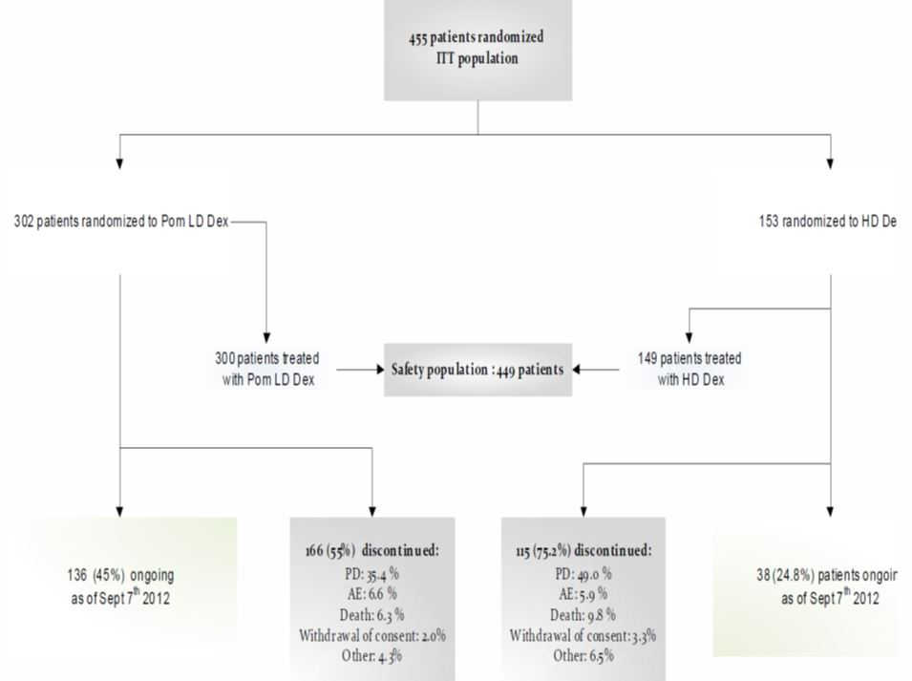
Additional details are shown in Table 4.
Table 4: Disposition of subjects.
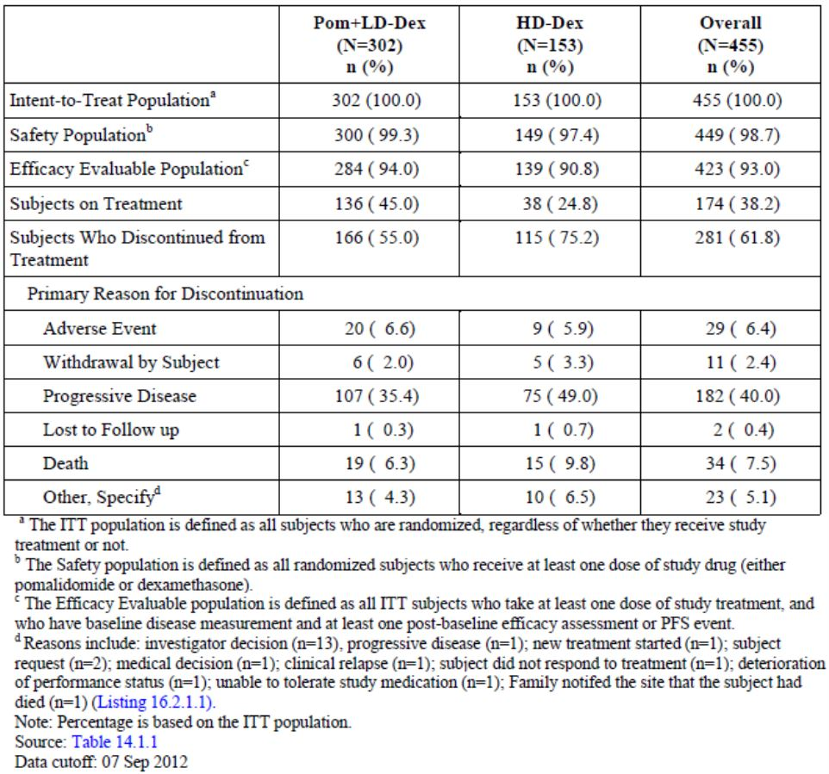
Comment: Because the number of patients screened was not given (found), no comparison can be made with the number proceeding to randomisation. The sponsor should provide this information in the first round responses. The number of patients on treatment at data cut-off was smaller (24.8%) in the HD-dex arm compared to the Pom +LD-dex arm (45%), due mainly to the higher numbers of PD and death in the former arm. Other reasons for discontinuation were of approximately equal frequency in each arm.

Major protocol violations/deviations
Protocol violations were noted for a total of 22 subjects. The majority were baseline skeletal surveys that were missing or not performed in 12 subjects. Three subjects in the Pom + LD-dex arm had anti-thrombotic medication administered without medical justification and 3 subjects in the HD-dex arm were incorrectly stratified at study entry. Single deviations were reported for 3 additional subjects. All protocol deviations were presented by subject in the CSR.

Baseline data
The majority of subjects were male (58.9%) and White (78.5%); the median age for the overall population was 64 years (min, max: 35, 87 years). Approximately 92% of subjects in both treatment arms were ≤ 75 years of age and approximately 8% of subjects in both treatment arms were > 75 years. Over 80% of subjects (based on stratification factor for disease population 1) in each treatment arm were refractory and had progressed on or within 60 days of both lenalidomide and bortezomib-based treatments and over 94% of subjects had > 2 prior anti-MM therapies.
The median number of prior antimyeloma regimens was 5 in both treatment arms. Approximately 59% of subjects in the Pom +LD-dex arm and 67% of subjects in the HD-dex arm had Stage III MM. The majority of subjects in both treatment arms were diagnosed with IgG type MM and the median time since diagnosis was 5.3 years and 6.1 years, respectively, in the Pom + LD-dex and HD-dex arms. Light chain disease was detected in 11.6% of subjects in the Pom + LD-dex arm and 18.3 % subjects in the HD-dex arm.
The CSR states “The characteristics of this study population closely represent the general population of refractory or relapsed and relapsed and refractory MM patients.”
Comment: The demographic and disease characteristics were balanced in the two arms with the following exceptions that favoured the Pom+LD-dex arm - fewer patients with Stage III disease, a shorter median time since diagnosis, a lower incidence of light chain disease, and more subjects with ECOG PS 0 (36.4% cf 23.5%). On the other hand there were more high risk + modified high risk subjects based on cytogenetics in the Pom+ ld-dex arm (43%+25.5%) than in the HD-dex arm (37.3%+ 22.9%). How these imbalances affect treatment outcomes is unknown.
Prior anti-MM therapy with proteosome inhibitors was mainly with Bortezomib (99.8% of total patient population) with only 7 of the total 455 patients treated with Carfilzomib.

Results for the primary efficacy outcome
As of the 07 Sep 2012 data cutoff, in the ITT population, PFS by IRAC review based on IMWG criteria was significantly longer with Pom + LD-dex arm compared with the HD-dex arm (median 15.7 vs 8.0 weeks; 267 total events; HR 0.45; p < 0.001) as shown in Table 5 and Figure 10.
Table 5: Progression Free Survival Time by IRAC Review based on IMWG Criteria (Stratified Log Rank Test) ITT Population.
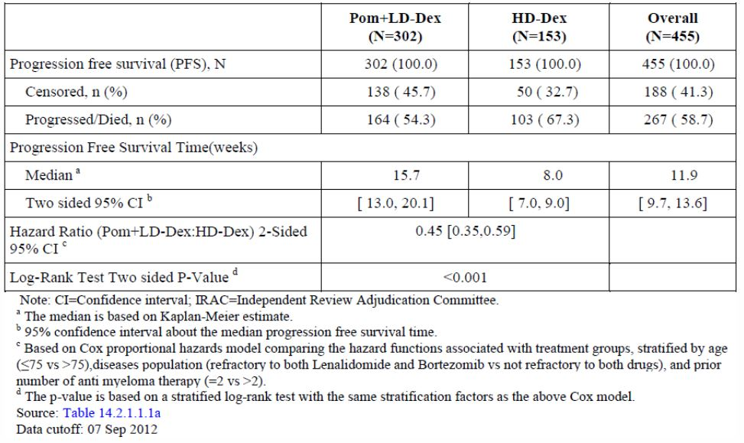
Figure 10: Progression Free Survival based on IRAC Review of Response by IMWG Criteria (Stratified Log Rank Test) ITT Population.
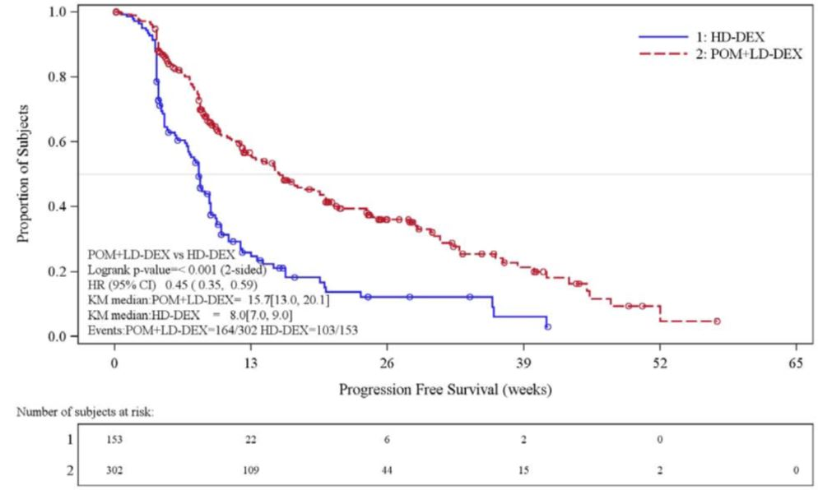
Identical results were obtained by IRAC review based on EBMT criteria. Results from the analysis of the EE population based on IMWG criteria, as well as EBMT criteria, were consistent with those observed in the ITT population. The PFS in the two arms of the EE population were very similar, and PFS by investigator assessment based on IMWG criteria were also similar (median PFS 16.9 weeks [14.0-20.6weeks] and 8.1 weeks [8.1-8.9 weeks] in the respective arms).
The median (min, max) PFS follow up for all subjects was 8.9 weeks (0.1, 57.4) in the Pom + LD-dex arm and 5.1 weeks (0.1, 41.3) in the HD-dex arm.
Updated PFS Analysis: The PFS by IRAC review based on IMWG criteria was updated using the adjudicated response data with the 01 Mar 2013 cutoff date, and is provided here for information as the sponsor intends the results of the interim analysis to be the primary endpoint. These results of the updated analysis are very similar to those of the interim analysis. The median values of the PFS were 16 weeks (13-19.6 weeks) for the test arm and 8.1weeks (7.1-9.4 weeks) for the control arm with a HR of 0.49 (0.39-0.61), and a p value <0.001.
Comment: As stated, the results for the updated PFS are unchanged in contrast to those for OS (see below).
Sensitivity Analyses: All sensitivity analyses supported the results of the analysis of the primary endpoint. These included the TTP (median for the Pom+LD-dex arm 20.1 weeks, and 8.3 weeks for the HD-dex arm); TTP for the overall ITT population by investigator assessment; and analyses using an alternative censoring rule to assess the robustness of the primary analysis using both IMWG and EBMT criteria for the ITT and efficacy evaluable populations.
An additional sensitivity analysis was that of time to treatment failure (TTF). TTF was defined as a composite endpoint (i.e., PD based on IRAC assessed response using IMWG criteria, study discontinuation for any reason, death, or start of another antimyeloma therapy) measuring time from randomization to treatment failure events. In the Pom + LD-dex arm, median TTF was 15.3 weeks (95% CI: 12.1, 18.1). In the HD-dex arm, median TTF was 8.0 weeks (95% CI: 4.9, 8.1). The HR was 0.441 (95% CI: 0.349, 0.557, p < 0.001).

Analysis of PFS in subgroups
- Hazard Ratios -The hazard ratios were consistently favorable for PFS for Pom + LD-dex across 30 subgroups except for the following: patients with relapsed and refractory disease who achieved at least a PR, and progressed within six months after stopping lenalidomide and/or Bortezomib (2 of 8 in Arm 1 and 4 of 5 in Arm 2 with PD); patients with 2 prior anti-myeloma therapies (2 of 8 and 4 of 5); and patients with low creatinine clearance <45 ml/min (23 of 30 and 14 of 18).
- Duration of PFS in Subgroups- the PFS in males and females and in white subject was the same as in the total ITT population. The numbers of other ethnicities were too small for reliable conclusions. In subjects with baseline ECOG performance status of 0, median PFS time for the ITT population based on IMWG criteria was longer than that observed in the overall ITT population for the Pom + LD-dex arm (19.6 weeks [95% CI: 13.1, 28.1]; PFS in the HD-dex arm was similar to that observed in the overall ITT population (7.6 weeks [95% CI: 4.7, 12.1]). In subjects with baseline ECOG performance status of > 0, median PFS time for the ITT population was consistent with the overall ITT population in both treatment arms.

Stratification factors
Age - In subjects ≤ 75 years, median PFS time for the ITT population consistent with that observed in the overall ITT population in both treatment arms, but the numbers of subjects over 75 was too small for reliable conclusions. An additional analysis was performed for subjects ≤ 65 years versus > 65 years. Median PFS times for the ITT population based on IMWG criteria for subjects in subjects ≥ 65 years and subjects > 65 years were consistent with those observed in the ITT population. There were no differences in median PFS times observed between the two age groups.

Disease population
- In refractory subjects who had progressed on or within 60 days of completing treatment with both lenalidomide- and bortezomib-containing regimens, median PFS time was consistent with that observed in the overall ITT population for both treatment groups.
- The numbers of relapsed and refractory subjects who achieved at least PR and then progressed within 6 months after stopping treatment with lenalidomide and/or bortezomib were too small for reliable conclusions.
- In refractory/intolerant subjects who had developed intolerance/toxicity after a minimum of 2 cycles of lenalidomide and/or bortezomib, median PFS time for the ITT population based on IMWG criteria in the Pom + LD-dex arm was consistent with the overall ITT population and longer in the HD-dex arm than that observed in the overall ITT population (10.9 weeks [95% CI:8.0, 14.1]).
Number of Prior Anti-Myeloma Therapies (2 versus > 2) - In subjects with 2 prior anti-myeloma therapies, median PFS time for the ITT population based on IMWG criteria has not been reached in the Pom + LD-dex arm. Median PFS time in the HD-dex arm was 10.9 weeks (95% CI: 4.7, 36.0). The number of subjects in this subgroup was small in both treatment arms: 17 in the Pom + LD-dex arm and 8 in the HD-dex arm. In subjects with > 2 prior anti-myeloma therapies, median PFS time for the ITT population based on IMWG criteria was consistent with that observed in the overall ITT population for both treatment groups.

PFS and other possible prognostic factors
Beta 2-microglobulin- In subjects with baseline beta-2 microglobulin levels < 3.5 mg/L, median PFS time for the ITT population based on IMWG criteria was 25.1 weeks (95% CI: 15.3, 41.1) in the Pom + LD-dex arm and 8.1 weeks (95% CI: 7.6, 13.0) in the HD-dex arm. In subjects with baseline beta-2 microglobulin levels 3.5 to < 5.5 mg/L, median PFS time for the ITT population based on IMWG criteria was 17.0 weeks (95% CI: 13.1, 21.4) in the Pom +LD-dex arm and 8.1 weeks (95% CI: 5.9, 10.1) in the HD-dex arm. In subjects with baseline beta-2 microglobulin levels ≥ 5.5 mg/L, median PFS time for the ITT population based on IMWG criteria was 10.7 weeks (95% CI: 8.4, 15.1) in the Pom + LD-dex arm and 5.7 weeks (95% CI: 4.6, 8.6) in the HD-dex arm.
Albumen- In this subgroup based on baseline albumin levels, median PFS times differed from those observed for the overall ITT population for each treatment group. In subjects with baseline albumin levels ≥ 3.5 g/L, median PFS time for the ITT population based on IMWG criteria was 20.1 weeks (95% CI: 15.3, 28.7) in the Pom + LD-dex arm and 9.0 weeks (95% CI: 8.0, 10.1) in the HD-dex arm. In subjects with baseline albumin levels < 3.5 g/L, median PFS time for the ITT population based on IMWG criteria was 12.3 weeks (95% CI: 8.9, 16.0) in the Pom + LD-dex arm and 4.7 weeks (95% CI: 4.1, 8.0) in the HD-dex arm.
Cytogenetic Risk- In subjects who were in the high risk category (defined as any cytogenetic abnormality in 13q14,17p13, 4p16/14q32 or 14q32/16q23), median PFS time was consistent with that observed in the overall ITT population and slightly shorter in the HD-dex arm than the overall ITT population (7.0 weeks [95% CI: 4.6, 8.1]).
In subjects who were non-high risk, median PFS time was 17.0 weeks (95% CI: 13.1, 30.1) in the Pom + LD-Dex arm (n=91) and 10.1 weeks (95% CI: 8.1, 12.1) in the HD-dex arm (n=47).
In subjects who were in the modified high risk category (defined as any cytogenetic abnormality in 17p13 or 4p16/14q32), median PFS time was 13.4 weeks (95% CI: 10.0, 20.1) in the Pom + LD-Dex arm (n=77) and 5.1 weeks (95% CI: 4.1, 8.0) in the HD-dex arm (n=35).
Comment: Conclusions are difficult as all the CI values overlap the mean PFS values for the total ITT population, 15.7 weeks and 8.0 weeks in the two arms.
Baseline Renal Impairment: In subgroups of subjects who had creatinine clearance (last assessment prior to the first dose) ≥ 60 mL/min and ≥ 45 to < 60 mL/min, median PFS time for the ITT population based on IMWG criteria was consistent with that observed for the overall ITT population in both treatment groups.
In subjects who had creatinine clearance (last assessment prior to the first dose) < 45 mL/min, median PFS time for the ITT population based on IMWG criteria was 8.6 weeks (95% CI: 6.6, 18.1) in the Pom + LD-Dex arm and 5.7 weeks (95% CI: 4.3, 8.6) in the HD-dex arm. The HR was 0.61 (95% CI: 0.31, 1.22) and the p value 0.155. This subgroup comprised 48 subjects (30 in the Pom + LD-dex arm and 18 in the HD-dex arm).
Comment: Patients with renal impairment: Patients with creatinine clearance of <45mL/min at screening were to be excluded from the trial (Exclusion criterion 1, dot point 3, of the original protocol). The test was performed using the Cockcroft-Gault method. Amendment 3 to the protocol (4 Nov 2011) required such subjects to have an evaluation of creatinine clearance using the 24-hour urine sample from the urine M-Protein collection. It is not stated whether the 66 patients in this subgroup had creatinine clearance values above 45ml/min when the amendment was followed. My random check of protocol violations in the CSR did not shown any violations due to treating patients with creatinine clearance <45ml/min.
The results for the PFS in this sub-group show overlapping CIs for both treatment groups and a non-significant difference in the Hazard Ratio for which the CI includes unity. The CSR added that “the majority of subjects in both treatment arms had low albumin levels (< 3.5 g/dL) and high beta-2 microglobulin levels(> 3.5 mg/L), which are factors indicative of a poor prognosis.” However while a high incidence in these subjects of low albumen levels and high beta-2 microglobulin levels could explain shorter PFS in both groups, it does not explain the failure to show a difference in PFS, unless the incidence of adverse factors was unbalanced. Data showing the increased incidence of the two poor prognostic factors in this subgroup were not given. Instead reference was made to a listing of the results of all subjects’ chemistries for the whole trial (20,324 pages). The conclusion remains that in this group of subjects with impaired renal function, superiority of Pom+LD-dex over HD-dex with respect to PFS was not demonstrated.

PFS based on the type of anti-Myeloma Therapy used in prior therapy
For 8 different combinations (included was 1 therapy with thalidomide alone), the PFS time for the ITT population based on IMWG criteria in each subgroup was consistent with the overall ITT population. Median PFS in the Pom + LD-dex arm across these subgroups was approximately 14 to 17 weeks and approximately 8 weeks in the HD-dex arm. The difference between treatments was statistically significant for each subgroup.

PFS based on refractoriness to selected prior anti-myeloma therapy
Median PFS time for the ITT population based on IMWG criteria was assessed by refractoriness to lenalidomide; bortezomib; lenalidomide and bortezomib; lenalidomide and thalidomide; and lenalidomide, bortezomib, and thalidomide. PFS time for the ITT population based on IMWG criteria in each subgroup was consistent with the overall ITT population. Median PFS in the Pom + LD-dex arm across these subgroups was approximately 14 to 16 weeks and approximately 8 weeks in the HD-dex arm. The difference between treatments was statistically significant for each subgroup.
Comment: PFS results - The median (min, max) PFS follow up times of 8.9 weeks (0.1, 57.4) in the Pom + LD-dex arm and 5.1 weeks (0.1, 41.3) in the HD-dex arm were short and consequently the number of subjects censored was high (45.7% and 32.7% respectively). The majority (39.4% and 19.6%) were subjects continuing treatment, that is, without disease progression. However the number of PFS events was achieved to allow the analysis of PFS to be considered as the final endpoint. At the same time, an interim analysis of OS was done to ensure the futility boundary was not crossed. This was not the case. In spite of the short follow-up time, the efficacy results for PFS show convincingly the superiority of the Pom+LD-dex combination over HD-dex.
Sub-group analyses - Hazard ratios: the CSR suggested that the three exceptions described above were due to low numbers of subjects in these sub-groups. While this is true for the first two, the numbers in the subgroup with reduced creatinine clearance were reasonably high. The lack of significant risk (Hazard Ratio) in this case was supported by the failure to show a statistically significant difference in the median PFS for this subgroup in each of the treatment arms.

Results for other efficacy outcomes
Overall Survival: A total of 226 (74.8%) of the Pom + LD-dex subjects and 95 (62.1%) of the HD-dex subjects were alive as of the cutoff date. Median OS time from Kaplan-Meier estimates has not been reached for the Pom + LD-dex, but would be expected to be at least 48 weeks, the lower boundary of the 95% CI. Median OS time for the HD-dex arm was 34 weeks (95% CI: 23.4, 39.9); however, approximately 29% of subjects in this treatment arm received pomalidomide after progression on HD-dex. The 1-year event free rate was 52.6% (± 5.72%) for the Pom + LD-dex arm and 28.4% (± 7.51%) for the HD-dex arm. The difference in OS between the two treatment arms was statistically significant (HR 0.53 [95% CI: 0.37, 0.74], p < 0.001).
Results for the efficacy evaluable population are consistent with those observed in the ITT population for this subgroup. The median (min, max) OS follow up was 19.2 weeks (1.4, 70.0) in the Pom + LD-dex arm and 16.3 weeks (0.3, 60.6) in the HD-dex arm.
Overall survival is summarized in Table 6 and the Kaplan-Meier curve for OS for the ITT population is provided in Figure 11. As shown in the figure, separation between the groups was observed early in the treatment period and was maintained through the data cutoff.
Table 6: Overall Survival: ITT Population.
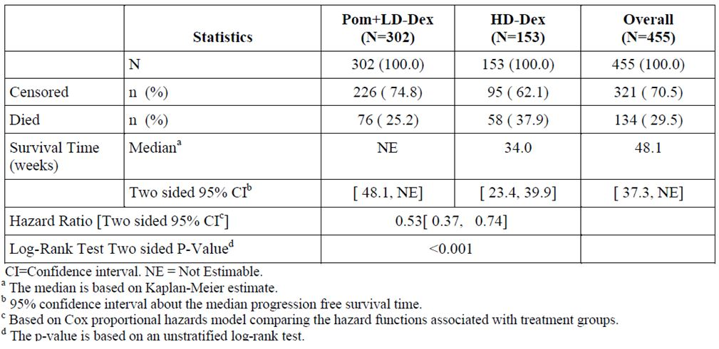
Figure 11: Kaplan-Meier Curve of Overall Survival ITT Population.
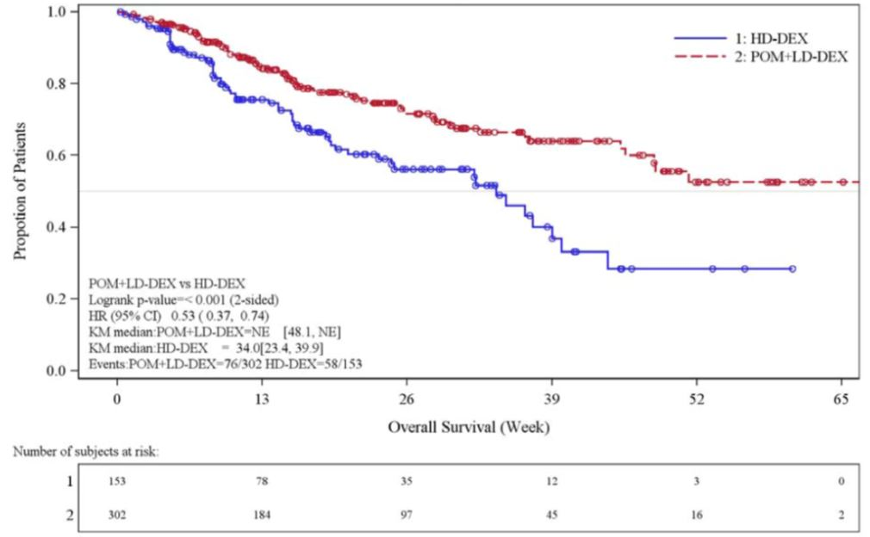
Comment: The high percent of censored subjects were due to the number of patients continuing treatment. Normally this and the relatively short follow-up times for survival would make the results premature, but the update of the OS (see next section) supports the results of this analysis. Note however that the Hazard Ratio was changed from 0.53 [95% CI: 0.37, 0.74] to 0.74 [0.56-0.97], that is the probability (risk) of death for those survivors on HD-dex was reduced in this update.
Updated OS Analysis: An updated OS analysis was performed when the number of originally specified OS events was reached for the final analysis, even though the interim OS analysis had crossed the O’Brien-Fleming superiority boundary. As of the 01 Mar 2013 cutoff date, 227 patients (49.9% of the total population, with 48% in the Pom+LD-dex arm and 53.6% in the HD=dex arm) died; median OS was 55.4 weeks (95% CI 45.3, 67.3 weeks) for Pom + LD-dex and 35.1 weeks (95% CI 29.9, 47.1 weeks) for HD-dex (HR = 0.74 [0.56-0.97], log-rank p = 0.028), significantly favoring Pom + LD-dex . Of note, half (49.7%) of the HD-dex subjects had received pomalidomide at this analysis with a median follow-up of 43.4 weeks.
Comment: see comment above.
Analysis of OS in Sub-Groups: Overall survival for relevant subgroups was analyzed in the same manner as for the overall ITT population. The relative hazard ratios of Pom + LD-dex and HD-dex for OS by IRAC review based on IMWG criteria in subgroups mainly matched the results of the primary analysis for PFS for the subgroups based on the ITT population, except that in addition to the three groups with no significant difference in hazard ratios for PFS in the two arms, 6 other subgroups showed no significant difference in the hazard ratios for OS in the two arms, that is a total of 9 out of 30 subgroups.
Analysis of OS in Other Sub-Groups including those with different Prognostic Factors:
SubGroups with unchanged OS: The results of these analyses are presented in summary as this was an exploratory secondary objective. In all subgroups shown above for PFS, except for those shown below, the OS was either unchanged or the mean OS time has not been reached. The results are compared to the OS determined for the total ITT population in the interim analysis, that is, at least 48 weeks in the POM+LD-dex arm and 34 weeks in the HD-dex arm.
Sub-Groups with reduced OS: Subjects with baseline beta-2 microglobulin levels ≥ 5.5 mg/dL, had a median OS time from Kaplan-Meier estimates of 28.4 weeks (95% CI: 21.1, NE) in the Pom + LD-dex arm, and 19.0 weeks (95% CI: 14.4, 37.3) in the HD-dex arm, shorter in both treatment arms than that observed for the overall ITT population.
Subjects with baseline albumin < 3.5 g/dL, had a median OS time from Kaplan-Meier estimates of 28.6 weeks (95% CI: 20.1, 51.3) in the Pom + LD-dex arm, and 17.3 weeks (95% CI: 14.4, NE) in the HD-dex arm, shorter in both treatment arms than that observed for the overall ITT population.
Subjects with creatinine clearance < 45 mL/min had a median OS time from Kaplan-Meier estimates of 29.9 weeks (95% CI: 12.6, NE) in the Pom + LD-dex arm, shorter that in that arm for the overall ITT population. In the HD-dex arm, the median OS time was 37.3 weeks (95% CI: 15.7, NE) comparable to that in the overall ITT population.
Comment: These three prognostic factors are recognized as risk factors, reducing survival in MM. The level of beta-2 microglobin is used to stage the disease in the IMWG’s staging system, in which a beta-2 microglobin level ≥5.5 mg/L is Stage III disease. Of interest is that high risk defined by cytogenetics was not shown to reduce OS in this group of patients. The reduction in OS of subjects with worst renal function in the Pom+LD-dex arm is probably significant, but in the absence of an upper limit of the CI interval, remains uncertain.
Response Rate: As of the 07 Sep 2012 data cutoff, CR was observed in one subject in the Pom+LD-dex arm. Objective responses (SCR + CR + VGPR +PR) were observed in 16.6% of subjects in Pom + LD-dex arm and 3.9% of subjects in the HD-dex arm. Partial responses were observed in 14.9% of subjects in the Pom + LD-dex arm and in 3.3% of subjects in the HD-dex arm. Consistent results were observed in response rates by IRAC review based on EBMT criteria. Based on a later assessment by the IRAC using a data cutoff of 09 Nov 2012, the ORR based on IMWG criteria in the ITT population was 21.2% (64/302) for subjects in the Pom + LD-dex arm and 2.6% (4/153) for subjects in the HD-dex arm.
Duration of Response: Based on IMWG criteria, median duration of response was 32.0 weeks (95% CI: 24.1, NE) in the Pom + LD-dex arm and 28.6 weeks (95% CI: 20.1, 37.1) in the HD-dex arm. Results based on IRAC review based on EBMT criteria are consistent with those observed using IMWG criteria.
Other Efficacy Outcomes: The assessment of other disease parameters (shifts from baseline in hemoglobin, creatinine clearance, ECOG performance status and bone pain) demonstrated that, in both treatment arms, the majority of subjects either remained at baseline levels or had improvements at some time during the study.

Other efficacy studies

Study CC-4047-MM-002 (Phase 2)
In the Phase 2 part, a total of 221 subjects were randomized: 113 subjects in the Pom + Dex arm and 108 subjects in the pomalidomide arm. Subjects received oral pomalidomide at a dose of 4mg a day on days 1-21 of a 28 day cycle, and oral dexamethasone 40 mg once per day on days 1, 8, 15 and 22 of each 28-day cycle for subjects who were ≤ 75 years of age and 20mg once a day for those >75. Subjects with PD on the pomalidomide arm could choose to have dexamethasone added to their treatment. Subjects had to have a documented diagnosis of multiple myeloma, to have received at least two prior therapies, to have relapsed after having achieved at least stable disease for at least one cycle of treatment to at least one prior regimen, and to have had documented evidence of PD during or within 60 days. The primary study endpoint was progression free survival (PFS) and secondary efficacy endpoints objective response (EBMT), time to response, duration of response, overall survival, response (International Myeloma Working Group Uniform Response [IMWG] criteria). The majority of subjects were male (53.8%) and white (80.5%); the median age for the overall population was 63 years (min, max: 34, 88 years). The majority (87.8%) of subjects were 75 years or younger and had an ECOG status score of 1 (62.9%) at baseline. Subjects received a median of 5 prior anti-myeloma regimens that included lenalidomide and bortezomib per protocol, and the majority (67%) had prior exposure to thalidomide.
Median PFS times: The pre-planned analysis (1 April 2011) of PFS found a median PFS time of 12 weeks (CI 8.4-16.1 weeks) for single-agent pomalidomide (prior to the addition of dexamethasone), and a median PFS time in the Pom+Dex arm of 16.6 weeks(14.1-21.1 weeks). At this time 86 (76%) of subjects in the Pom+Dex arm had progressed or died, and 81 (75%) in the Pomalidomide overall, and 75(69.4%) in the pomalidomide arm prior to dexamethasone.
Comment: Although the difference in PFS is stated in the CSR to be significant, the CI intervals overlap, and the upper limit of the HR is 0.99 [0.54-0.99]. The p value was shown as 0.019 in Table 20 of CSR and 0.037 in Figure 2, CSR. The statistical analysis plan (SAP) for the study (16.1.09) based the sample size on an expected value of 10 months PFS in the Pom+Dex arm and 6 months in the Pom arm. The time difference of 4 weeks found in the study is of doubtful clinical significance. At the time of this analysis, the number of events, 167, (progression and death) had exceeded the requirement of the SAP (139 events).
Median OS times at the planned analysis time (data cut-off 1 April 2011) from Kaplan-Meier estimates were 62.6 (CI 53.6-NE)weeks and 59.3 (41.6-NE) weeks for the Pom + Dex and pomalidomide arms, respectively, and the HR 0.85 [ 0.57, 1.29]. At this time 44 and 47 patients had died in the respective arms. The difference in OS between the two treatment arms was not statistically significant (p values 0.449 [log-rank]; 0.397[Wilcoxon]). For information, OS data to 16 September 2011 was analysed. A total of 59 (52.2%) of the Pom + Dex-treated subjects and 62(57.4%) of the pomalidomide-treated subjects were dead. Median OS time from Kaplan- Meier estimates was 71.7 weeks (95% CI: 53.7, NE) for the Pom + Dex arm, and 59.3 weeks (95% CI: 41.6, 75.0) for the pomalidomide arm. The HR was 0.83 (0.58-1.19) and the p values 0.309 (log rank) and 0.361 (Wilcoxon).
Comment: The total number of deaths in the pre-planned analysis (1 April 2011) was 91, whereas the SAP required 139 deaths for analysis. In the later analysis (16 Sep 2011), the number of deaths were 59 and 62, a total of 121.
Response Rates: As of the 01 April 2011 data cutoff, PRs were observed in 29% of subjects in the Pom + Dex arm and in 9% of subjects in the pomalidomide arm. Complete response by IRAC was observed in one subject in the Pom + Dex arm as of the data cutoff. Objective responses (CR + PR) were observed in 30% of subjects in Pom + Dex arm and 9% of subjects in the pomalidomide arm. Addition of dexamethasone to pomalidomide (for subjects in the pomalidomide arm) did not change the overall best response rate for subjects in this treatment arm.
Comment and Conclusions: The statistical comparison was made between the sum of CR,PR,and SD in each arm and the p value was <0.001(Wilcoxon rank sum). The frequency of SD was 35% and 46% in the Pom+Dex and Pom arms respectively.
The study showed that pomalidomide was effective in treating relapsed and refractory MM. The addition of LD-dex increased the PFS compared to Pom alone, but the increase was of marginal clinical significance. Although the response rate to the combination was greater than with pomalidomide alone, added dexamethasone did not increase OS.

Study IFM-2009-02
This French, multicente, randomized, open label, Phase II study compared two schedules of pomalidomide and dexamethasone treatment in multiple myeloma patients who had relapsed and who had refractory disease which was progressive, and who had achieved at least a partial response to Bortezomib and Lenalidomide. The study assessed the efficacy of daily pomalidomide for 21 days compared to 28 days, each with dexamethasone.
The study period was from 07 Jan 2009 to 28 Jun 2010 (last patient randomized). 72 evaluable patients were planned and 84 were analysed in the ITT population. Patients were randomized (1:1) to receive either 4 mg/day pomalidomide on Days 1 to 21, plus dexamethasone 40 mg on Days 1, 8, 15, and 22 of each 28-day cycle (Arm A) OR 4 mg/day pomalidomide on Days 1 to 28 plus dexamethasone 40 mg on Days 1, 8, 15, and 22 of each 28-day cycle (Arm B). The primary endpoint was the response rate (PR+CR) to pomalidomide and dexamethasone using International Myeloma Working Group (IMWG) response criteria. Secondary endpoints included PFS and OS. The study was non-comparative and the response rate assessed separately for reach arm.
The median age of the ITT population was 60 (range 42-83), with more male patients (68%) than female patients (32%). ECOG PS values of 0 / 1 / 2 / 3 were reported in 39% / 41% / 19% / 1% of patients, overall. Patients had received a median of 5 prior lines of treatment, with 23% of patients having received more than 6 prior lines. All patients had received prior treatment with bortezomib and with lenalidomide.
Response rate: Based on assessment by the IRC, the overall response rate (CR, VGPR, PR) in the ITT population was 35% (95% CI: 25% - 46%); no significant difference was observed between response rates in Arm A and Arm B (p=0.943). Differences in response determination were observed between assessments by the IRC and investigators for 28 patients (33%), with an overall response rate of 42% (95% CI: 31% - 53%) according to investigator assessment.
Progression free survival: There were 29 events in 43 subjects in Arm A and 32 of 41 in Arm B with median values (CI) of 25.14 (16.3-41.7) weeks, and 25.14 (13.3-36.0) weeks respectively, and a p value of 0.516 for the difference.
Overall Survival: There were 19 events in of 43 subjects and 18 in 41 subjects in Arms A and B respectively, with median times (CI) of 58.43(38.7-60.6) weeks and 66.43(39.9-NE) weeks, and a P value of 0.744 for the difference.
Comment and Conclusion: The width of the CI for all endpoints indicates high patient variability in response. The study would be underpowered to show differences in the regimes and was not designed to be comparative. The conclusion is that pomalidomide with dexamethasone is active in producing responses in this group of heavily pre-treated patients.

Comparison of efficacy results of pivotal and supportive trials
The efficacy results of the three trials are shown in Table 7.
Table 7: Summary of Key Efficacy Endpoints (based on Best Response Assessment using EBMT/IMWG Criteria.
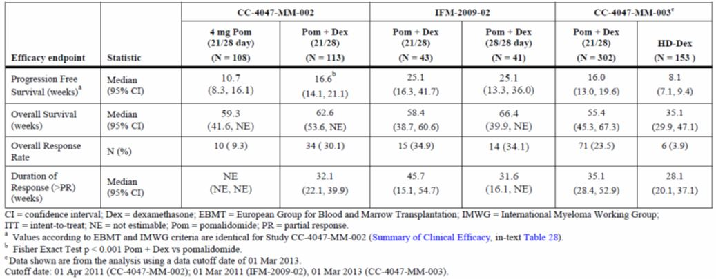
PFS: Based on the later data cutoff of 01 Mar 2013, PFS in the Pom + LD-Dex arm of Study CC-4047-MM-003 was 16.0 weeks, which is similar to that of the Pom + LD-Dex arm in study CC-4047-MM-002 (16.6 weeks) (Table 7). PFS was longer in Arm A of study IFM-2009-02 (25.1 weeks) although the study population was smaller and differed from those in studies CC-4047-MM-002 and CC-4047-MM-003 in terms of baseline disease characteristics. Note that the PFS given in the above table for the former study was for patients treated in the pom arm who had had pom alone and those who had added dexamethasone on request. The PFS for those who had pomalidomide alone was a median of 12 weeks (CI 8.4-16.1). Interestingly the CIs for both groups were the same.
Comment: The comment from the Clinical Overview, CO, (page 31) that the baseline disease characteristics of subjects in IFM-2009-02 differed from those in the pivotal trial CC-4407-MM-003 is correct. However the differences were such that they favoured a worse clinical outcome rather than the better outcome shown by the longer PFS and higher response rates found in the trial. Two disease characteristics shown in the pivotal trial to have a worse prognosis were a high beta-2 microglobin concentration and a low albumin concentration. In the IFM trial and the pivotal trial, the percentage of patients with high (≥5.5 mg/L) concentrations of beta-2 microglobulin were 50% and 33% respectively, and with low albumin (<3.5g/L) 50% and 36%. For this reason, the outcomes for the IFM trial would be expected to be worst that in pivotal trial. Those for PFS and RR were better whereas the OS was similar. The results of the study are therefore difficult to interpret.
To assess the effect of adding dexamethasone to pomalidomide treatment, the figures to compare are 12 weeks and 16.6 weeks. From these figures the clinical benefit to the patient of 4.6 weeks is small. The p value of 0.019 was calculated from a comparison of 10.7 and 16.6 weeks, not 12 and 16.6 weeks, so the statistical significance applies to the two treatments used in the study, both with dexamethasone, and not to the effect of adding dexamethasone to pomalidomide treatment.
OS: In study CC-4047-MM-003, the OS as of the later data cutoff of 01 Mar 2013 for the Pom + LD-Dex arm was 55.4 weeks (95% CI: 45.3, 67.3) (Table 7). In the HD-Dex arm, OS was 35.1 weeks (95% CI: 29.9, 47.1). By comparison, OS in the Pom + LD-Dex arm was 62.6 weeks (95% CI: 53.6, NE) in Study CC-4047-MM-002 and 58.4 (95% CI: 38.7, 60.6) weeks in Study IFM 2009-02.
Response Rate (RR): With the 01 Mar 2013 cutoff date now at 6 months after the last subject enrolled in Study CC-4047-MM-003, response rate in the Pom + LD-Dex arm was 23.5%, which is lower than that of study CC-4047-MM-002 and IFM-2009-02, although response rate was still significantly higher than that of the HD-dex arm (3.9%) (Table 7).
Comment: In Study CC-4047-MM-002, the marked difference in RR (30% cf 9%) in the two arms was associated with only a small increase in PFS although statistically significant, with no increase in OS. This is unexpected. Note that the results for the pivotal study in Table 7 were based on the updated data (1 Mar 2013) and not the primary analysis in the application (7 Sep 2012).

Evaluator’s conclusions on efficacy
- In the pivotal trial Study CC-4407-MM-03, the combination of pomalidomide + LD dexamethasone was effective in the treatment of patients with MM who had failed at least two prior therapies including lenalidomide and bortezomib.
Comment: The study was not designed to show effectiveness against any other proteasome inhibitor than bortezomib, and only 7 of 455 patients in the trial had received another proteasome inhibitor, carfilzomib. It may be argued that because of their similar anti MM action, resistance to all proteasome inhibitors is the same as for bortezomib. However, lenalidomide and pomalidomide are also structurally and functionally similar, but resistance to lenalidomide still allows response to pomalidomide as shown in the pivotal trial. It is therefore unsafe to extrapolate responses in this disease based on similarities in the agents involved.
- The combination of pomalidomide + LD dexamethasone resulted in a clinically significant improvement of 7.7 weeks in PFS, of more than 12 weeks in OS (20 weeks in the updated analysis), and of 12.7% in response rate. The positive effects were shown in most subgroups, with three exceptions.
- If the two subgroups with very small numbers of patients were excluded, one subgroup with an adequate number of subject with poor renal function (creatinine clearance <45 ml/min) showed no significant difference in endpoints in the two treatment arms.
- The contribution of LD dexamethasone to the combination of pomalidomide + LD dexamethasone remains uncertain in this population of patients. The supporting trials confirmed the activity of pomalidomide in this group of patients, as shown by the response rates achieved with the pomalidomide treatments. The one trial of pomalidomide + LD dexamethasone and pomalidomide alone (CC-4047-MM-002) showed a small clinical benefit of the added dexamethasone with an increase of 4.6 weeks in the PFS in the pomalidomide + dexamethasone arm (16.6 weeks) compared to the pomalidomide arm (12 weeks) before dexamethasone was added to Arm B, and 6.6 weeks after the addition (16.6 weeks compared with 10 weeks PFS). However, the OS was the same in each arm and the addition of dexamethasone to the pomalidomide treatment in the pomalidomide alone arm did not increase the response rate.

Clinical safety

Studies providing safety data
The following studies provided evaluable safety data:

Pivotal efficacy Study CC-4047-MM-003
In the pivotal efficacy study, the following safety data were collected:
- General adverse events (AEs) were assessed by safety analyses performed on the safety population. AEs were classified using the MedDRA classification system (Version 14.0). The severity of the toxicities was graded according to the National Cancer Institute Common Terminology Criteria for Adverse Events (NCI CTCAE) version 3.0 whenever possible. The frequency of treatment emergent adverse events (TEAEs) was tabulated by MedDRA system organ class, preferred term, and dose cohort/treatment arm. In the by subject analysis, a subject having the same event more than once was counted only once. AEs were summarised by CTCAE version 3.0 grade. AE leading to discontinuation from treatment, events classified as CTCAE version 4.0 grade 3 or higher, study drug related events, and serious adverse events (SAEs) were tabulated and listed separately. By subject listings of all AEs, SAEs, and their attributes were provided. All AEs were assessed starting after the subject signed the informed consent and until 28 days after study drug discontinuation. AEs that lead to study discontinuation were followed until resolution or stabilisation. For subjects who entered the PFS follow up period of the study treatment phase, any study related AEs occurring beyond 28 days after treatment discontinuation were recorded. SAEs, regardless of relationship to the investigational product, that occurred during the study (from the time the subject signed informed consent to at least 28 days after treatment discontinuation) or until the last study visit, whichever period was longer, and those made known to the Investigator at any time thereafter that were suspected of being related to IP must have been reported to Celgene Drug Safety within 24 h of the Investigator’s knowledge of the event.
- TEAEs of particular interest, including analyses, were presented with tabulations for CTCAE Grade 3 or 4 TEAEs of interest, TEAEs of interest related to study medication, serious TEAEs of interest and TEAEs of interest leading to study medication discontinuation, by the following AE of interest categories and preferred terms:
  - TEAEs associated with pomalidomide: neutropenia, febrile neutropenia, infection, thrombocytopenia, haemorrhage and bleeding, neuropathy, DVT, pulmonary embolism (PE); secondary malignancies.
  - TEAEs associated with dexamethasone: muscular weakness, glucose intolerance, mood alteration, cataract, cardiovascular events/dysrhythmia, fluid retention/oedema.
- Laboratory tests, including clinical laboratory data (including TSH, T3 and T4 levels) were summarised by dose regimen/treatment arm. Laboratory data were graded according to CTCAE version 4.0 criteria wherever possible. The frequencies of the worst severity grade observed during treatment were displayed in cross tabulations by baseline status for each dose regimen. In addition, clinically notable laboratory values were summarised by cycle. For vital signs and electrocardiogram (ECG) data, cross tabulations showing the number of subjects with values below, within and above the normal ranges pre versus post study drug initiation were summarised. For weight, means, medians, standard deviations, minimum and maximum were provided by cycle. Tests for haematology and pregnancy and venous thrombotic events (VTEs) were performed weekly; serum chemistry, ECGs, urinalysis and creatinine clearance were on Day 1 of each 28 day cycle.

Pivotal studies that assessed safety as a primary outcome
Not applicable.

Dose response and non pivotal efficacy studies
The dose response and non pivotal efficacy studies provided safety data as follows:
- Study CC-4047-MM-002 Phase II: The Phase II section of this multicentre, randomised, open label, dose escalation study was designed to determine the MTD, safety, and efficacy of pomalidomide alone and in combination with LD dexamethasone, and provided safety data on 107 subjects and 112 subjects respectively in the two treatment arms.
- Study IFM-2009-02: This Phase II, multicentre, randomised, open label study evaluated the safety and efficacy of oral pomalidomide in combination with two regimens of LD dexamethasone provided data on 43 and 41 subjects in each of the two arms.
- Study CC-4047-MM-001(CDC-407-00-001): This Phase I, single centre, open label study evaluated safety and efficacy of dose escalation of pomalidomide in subjects with relapsed or refractory MM, and provided safety data on 24 subjects on daily dosing and 21 on second daily dosing.
- Study CC-4047-MM-002, Phase I: The Phase I section of this trial (see above) determined the MTD of pomalidomide administered daily and provided safety data on 38 subjects.

Other studies evaluable for safety only
As of 7 September 2012, the safety of pomalidomide had been evaluated in subjects with RRMM, myeloproliferative neoplasm (MPN) associated myelofibrosis (MF), small cell lung cancer (SCLC), metastatic prostate cancer, and advanced soft tissue sarcomas (STSs), as well as in healthy male subjects. The clinical development program included a total of 14 studies, 9 of which were completed and 5 of which included subjects who are still being followed for disease progression and survival status. These 14 studies included 5 studies in MM (one primary Phase III study [CC-4047-MM-003]; two supportive Phase II studies [CC-4047-MM-002 Phase 2 and IFM 2009-02], and two supportive Phase I studies [CC-4047-MM-002 Phase 1 and CC-4047-MM-001] [see above]); four studies in subjects with other tumor types; and five Phase I studies in healthy subjects. The latter two groups were presented in an appendix; three additional ongoing studies are evaluating pomalidomide containing regimens in RRMM (CC-4047-MM-003/C), MPN associated MF (CC-4047-MF-002), and sickle cell disease (CC-4047-SCD-001).
Comment: The studies additional to the 5 above will be checked but not included in this evaluation unless their safety results differ significantly from the pivotal and supportive studies in the application.

Patient exposure
The total numbers of subjects exposed to pomalidomide in the MM studies providing safety data in this review are shown in Table 8 by pomalidomide dose.
Table 8: Number of Subjects Exposed in Multiple Myeloma Studies by Pomalidomide Starting Dose (Safety Population).
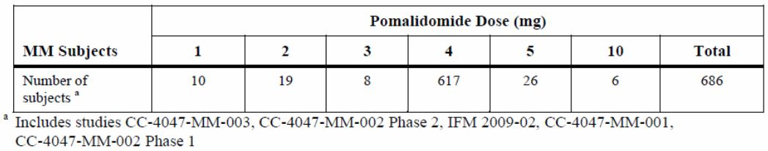
Pivotal Study CC-4047-MM-003: Duration of Treatment - The median duration of treatment in the Pom + LD-dex arm (12.4 weeks) was longer than that in the HD-dex arm (8.0 weeks). The distribution of treatment duration in the Pom + LD-dex arm differed from that in the HD-dex arm, with 56.6% of Pom + LD-dex subjects receiving treatment for 12 weeks or longer compared with 28.2% of HD-dex subjects. The median number of treatment cycles was 3.0 in the Pom + LD-dex arm (minimum [min], maximum [max]: 1, 16 cycles) and 2.0 in the HD-dex arm (min, max: 1, 12 cycles). These data reflect the lower rate of discontinuation from treatment seen in the Pom + LD-dex arm.
Dosing and dose reductions and interruptions for pomalidomide - Subjects in the Pom + LD-dex arm were exposed to pomalidomide for a median (min, max) of 63 (2, 327) days at a median daily dose of 4.0 mg. The median relative dose intensity (ie, observed dose intensity [in mg/day] divided by planned dose intensity [in mg/day]) was 0.90.
Depending on the type of treatment-emergent adverse event (TEAE), the dose of pomalidomide was first interrupted and then reduced, or was reduced. In the Pom + LD-dex arm, 24% of subjects had at least 1 pomalidomide dose reduction, among whom the median number of reductions per subject was 1 and the median time to the first dose reduction was 30 days (min, max: 10 to 232 days). In the Pom + LD-dex arm, 58% of subjects had at least 1 pomalidomide dose interruption. Among subjects with at least 1 dose interruptions, the median number of dose interruptions per subject was 2 (min, max: 1 to 14) and the median time to the first interruption was 29 days (min, max: 2 to 253 days). There were more pomalidomide dose interruptions than dose reductions as a result of the occurrence of neutropenia in 45.3% of Pom + LD-dex subjects; neutropenia was one of the TEAEs that required dose interruption before dose reduction.
Dosing and dose reductions and interruptions for dexamethasone - Subjects in the Pom + LD-dex arm were exposed to dexamethasone for a median of 12 days at a median daily dose of 40 mg. Subjects in the HD-dex arm were exposed to dexamethasone for a median of 20 days at a median daily dose of 40 mg. The difference in dexamethasone exposure (in days) reflects the difference in planned dexamethasone dose regimens used in the 2 treatment arms. The median relative dose intensity (ie, observed dose intensity [in mg/day] divided by planned dose intensity [in mg/day]) for dexamethasone was similar (0.9 in the Pom + LD-dex arm and 1.0 in the HD-dex arm).
The percentage of subjects with at least 1 dexamethasone dose reduction was lower in the Pom + LD-dex arm (16.7%) than in the HD-dex arm (26.2%). Among subjects with at least 1 dose reduction, the median number of dose reductions per subject in each treatment arm was 1. The median time to the first dexamethasone dose reduction was longer in the Pom + LD-dex arm (57 days [min, max: 8 to 312 days]) than in the HD-dex arm (33 days [min, max: 28 to 309 days). The percentage of subjects with at least 1 dexamethasone dose interruption was higher in the Pom + LD-dex arm (37.0%) than in the HD-dex arm (22.1%). Among subjects with at least 1 dose reduction, the median number of dexamethasone dose interruptions was 2 in the Pom + LD-dex arm and 1 in the HD-dex arm. The median time to the first dexamethasone interruption was longer in the Pom + LD-dex arm (29 days; min, max: 8 to 261 days) than in the HD-dex arm (17 days; min, max: 9 to 81 days).
Study CC-4047-002 Phase 2: Subjects were randomized 1:1 to treatment arm A or B.
Arm A: Subjects received oral pomalidomide at a dose of 4mg a day on days 1-21 of a 28 day cycle, and oral dexamethasone 40 mg once per day on days 1, 8, 15 and 22 of each 28-day cycle for subjects who were ≤ 75 years of age and 20mg once a day for those >75.
Arm B: Subjects received oral pomalidomide at a dose of 4mg a day on days 1-21 of a 28 day cycle. Subjects who had confirmed progressive disease (PD) at any time had the option to receive a starting dose of dexamethasone was 40 mg once per day on Days 1, 8, 15 and 22 of each 28-day cycle for subjects who were ≤ 75 years of age in addition to pomalidomide. For subjects who were > 75 years of age, the starting dose of dexamethasone was 20 mg once per day on Days 1, 8, 15 and 22 of each 28-day cycle.
Overall, as the data cutoff date, subjects were exposed to pomalidomide for a mean of 121 days with an average daily dose of 3.8 mg/day. Mean treatment duration was approximately 173 days. Twenty-six of the 112 subjects in the Pom + Dex arm and 34 of the 107 subjects in the pomalidomide arm had at least one pomalidomide dose reduction (27.4% of subjects in the overall safety population).
Study IFM-2009-02: Patients were randomized (1:1) to receive in Arm A: 4 mg/day pomalidomide on Days 1 to 21, plus commercial dexamethasone 40 mg on Days 1, 8, 15, and 22 of each 28-day cycle or in Arm B: 4 mg/day pomalidomide on Days 1 to 28 plus commercial dexamethasone 40 mg on Days 1, 8, 15, and 22 of each 28-day cycle.
Patients remained on treatment for an average of 6 treatment cycles overall. The average number of cycles received was higher amongst patients in Arm A (median: 8) than in Arm B (median: 6). More patients underwent dose reduction in Arm A (19 patients, 44%) than Arm B (14 patients, 34%), but there was no difference between treatment arms in terms of relative dose intensity (88% in each arm).

Adverse events

All adverse events (irrespective of relationship to study treatment)

Pivotal studies

Overview of treatment emergent adverse events
In summary, almost all of the subjects in each treatment arm had at least one Treatment Emergent Adverse Event (TEAE), and approximately three quarters of the subjects in each treatment arm had at least one Grade 3 or 4 TEAE. Discontinuations of treatment due to any TEAE occurred more frequently in the Pom + LD-dex arm than in the HD-dex arm (9.7% cf 5.4%); however, these discontinuations occurred infrequently (< 10% of subjects in each arm). The frequencies of dexamethasone-related TEAEs, dexamethasone-related Grade 3/4 TEAEs, and dexamethasone-related SAEs were lower in the Pom + LD-dex arm than in the HD-dex arm. Dose interruptions were more frequent than dose reductions in both treatment arms. Reductions of dexamethasone dose were more frequent in the HD-dex arm than in the Pom + LD-dex arm.
Comment: More subjects had discontinuations (see above), dose reductions and dose interruptions in the Pom+LD-dex arm (23.7% and 61.3%) compared to those in the HD-dex arm (16% and 50.3%).

Treatment emergent adverse events by SOC and preferred term
Blood and lymphatic disorders, particularly neutropenia, occurred more frequently in the Pom + LD-dex arm. General disorders and infections occurred more frequently in the Pom + LD-dex arm. Upper respiratory tract infections occurred more frequently in the Pom + LD-dex arm; however, pneumonia, the most frequently occurring TEAE in this SOC, occurred in similar proportions of subjects in the 2 treatment arms. Constipation, dyspnea, and cough also occurred more frequently in the Pom + LD-dex arm, as did pruritus and rash. Musculoskeletal disorders, particularly muscular weakness and myopathy, occurred more frequently in the HD-dex arm. Metabolism and nutrition disorders, including hypercalcemia, hyperglycemia, and hypocalcemia, occurred more frequently in the HD-dex arm. Insomnia occurred more frequently in the HD-dex arm.
TEAEs tended to occur shortly after treatment initiation (ie, within the first 2 cycles) and new occurrences of these TEAEs decreased in frequency thereafter in both treatment arms.
Severe TEAEs (Grades 3 and 4): Severe TEAEs occurring in ≥2% of subjects in either treatment arm were summarized for the safety population. Similar percentages of subjects in each treatment arm had at least 1 Grade 3/4 TEAE (78.0% of Pom + LD-dex subjects and 75.8% of HD-dex subjects). Many of these events, including anemia and thrombocytopenia (the most frequently occurring Grade 3/4 events), occurred in similar proportions of subjects in the 2 treatment arms.
Events that occurred notably more frequently in the Pom + LD-dex arm than in the HD-dex arm included Grade 3/4 neutropenia (41.7% vs 14.8%); Grade 3/4 febrile neutropenia (6.7% vs 0%); Grade 3/4 bone pain (6.3% vs 2.7%); and neutrophil count decreased (4.0% vs 0.7%).
Events that occurred notably more frequently in the HD-dex arm than in the Pom + LD-dex arm included hyperglycemia (6.7% vs 3.0%), asthenia (6.0% vs 3.3%) and myopathy (3.4% vs 0.0%).

Adverse events of special interest
Treatment-emergent AEs of special interest included events of relevance to the disease state, events selected based upon the known mechanism of action of pomalidomide and class effects of similar immunomodulatory agents (eg, thalidomide and lenalidomide), and events selected based on the known safety profile of dexamethasone. The TEAEs of special interest included:
TEAEs potentially associated with pomalidomide: neutropenia and febrile neutropenia; infection; thrombocytopenia; hemorrhage and bleeding; peripheral neuropathy; thromboembolic events; cardiovascular events/dysrhythmia; SPMs; acute renal failure; cataract;
TEAEs associated with dexamethasone: glucose intolerance; fluid retention/edema; muscular weakness; mood alteration.
Comment: These TEAEs have been considered elsewhere in the safety analysis. The following summaries are included where they provided additional information.
Neutropenia: Neutropenia occurred in higher proportions of Pom + LD-dex subjects than HD-dex subjects. A large majority of neutropenias were Grade 3/4 events; however, few were serious and no subject in either treatment arm was discontinued due to neutropenia. Among subjects with Grade 3/4 neutropenia, the majority of subjects in each treatment arm had no concurrent infection.
Febrile neutropenia occurred only in Pom + LD-dex subjects (6.7%).
Infection: The proportion of subjects with at least 1 treatment-emergent infection was higher in the Pom + LD-dex arm, 55% cf 48.3%; however, proportions of subjects with at least one Grade 3/4 infection and at least 1 serious infection were similar in the 2 treatment arms, 24% and 22.8%. The proportions of subjects who discontinued treatment due to infections were low (approximately 2%) in both treatment arms. Deaths due to infections occurred more frequently in the HD-dex arm (7.4%) than in the Pom+LD-dex arm (2.7%), largely due to higher frequencies of death due to septic shock and sepsis in this arm. Among subjects with Grade 3+ infections, the majority of subjects in each treatment arm had no concurrent neutropenia.
Thrombocytopenia: Thrombocytopenia occurred in approximately 30% of subjects in each treatment arm. Most of these events were Grade 3/4 events; however, few were serious and few resulted in treatment discontinuation in either arm. In the Pom +LD-dex group, of the 69 of 300 subjects with Grade 3 or higher thrombocytopenia (23%), 18(26.1%) had concurrent bleeding, and in the HD-dex group, of the 38 of 149 subjects (25.5%), 10 (26.3%) had concurrent bleeding.
Comment: See next paragraph. Two subjects, one in each treatment group, died of hemorrhage and concurrent thrombocytopenia. The latter event is not attributable to treatment but was more likely due of the disease process.
Hemorrhage and Bleeding: Hemorrhage occurred in 16.3% of Pom + LD-dex subjects and 21.5% of HD-dex subjects. Epistaxis and hematoma were the most frequently occurring types of hemorrhage, and these events occurred in similar proportions of subjects in each treatment arm.
Among subjects with hemorrhage, 21 of 49 (42.9%) Pom + LD-dex subjects and 10 of 32 (31.3%) HD-dex subjects had thrombocytopenia concurrently with the hemorrhage. Serious hemorrhage occurred in 2.7% of Pom + LD-dex subjects and 2.7% of HD-dex subjects. Hemorrhage was the cause of death in 2 Pom + LD-dex subjects (1 subarachnoid hemorrhage with no concurrent thrombocytopenia ; and 1 subdural hematoma with concurrent thrombocytopenia); and 1 HD-dex subject (gastrointestinal hemorrhage with concurrent thrombocytopenia).
Peripheral Neuropathy: Peripheral neuropathy occurred in similar proportions of subjects in the 2 treatment arms, 12.3% and 10.7%. Few occurrences in either arm were Grade 3/4. Among Pom + LD-dex subjects. The data suggested that subjects with a neuropathy TEAE were more likely to have had neuropathy reported at baseline than subjects without a neuropathy TEAE.
Thromboembolic Events: All subjects in the Pom + LD-dex arm as well as subjects in the HD-dex arm who had a prior history of deep vein thrombosis (DVT) or PE were to receive VTE prophylaxis.
Serious VTEs occurred in 1.7% of Pom + LD-dex subjects and in no HD-dex subjects. No VTE led to the discontinuation of treatment in either treatment arm No subject died as a result of a VTE. Arterial thrombotic events occurred in 1.0% of Pom + LD-dex subjects and 0.7% HD-dex subjects. In the Pom + LD-dex arm, these events included: embolism, ischemic cerebral infarction, and myocardial infarction each occurring in 1 subject. In the HD-dex arm, 1 subject (0.7%) had a transient ischemic attack. No subject died as a result of an ATE.
Glucose intolerance, hyperglycemia and new onset diabetes: TEAEs related to glucose intolerance, hyperglycemia and new onset diabetes occurred in 16.0% of subjects in the Pom + LD-dex arm and in 22.1% of subjects in the HD-dex arm. The most frequently occurring of these events included hyperglycemia (5.0% in the Pom + LD-dex arm and 8.1% in the HD-dex arm). Grade 3/4 hyperglycemia and new onset diabetes mellitus occurred in 5.3% of Pom + LD-dex subjects and 8.1% of HD-dex subjects.
Muscular Weakness: Muscular weakness occurred more frequently in the HD-dex arm (10.7%) than in the Pom + LD-dex arm (2.7%). Grade 3/4 muscular weakness also occurred more frequently in the HD-dex arm (2.7%) than in the Pom + LD-dex arm. No subject in the Pom + LD-dex arm and 2 subjects in the HD-dex arm (1.3%) had TEAEs of muscular weakness that were serious.
Acute renal failure: Acute renal failure occurred with similar frequency in the 2 treatment arms (13.0% in the Pom + LD-dex arm and 13.4% in the HD-dex arm). The most frequently occurring of these events included blood creatinine increased, renal failure, acute renal failure, and renal impairment, all of which occurred in < 5% of subjects in each arm. Grade 3/4 acute renal failure occurred in 7.0% of Pom + LD-dex subjects and 5.4% of HD-dex subjects. Serious acute renal failure occurred in 6.7% of subjects in each treatment arm. Renal failure and acute renal failure were the cause of death in 1.0% of Pom + LD-dex subjects and in no HD-dex subjects.

Other studies
For the two supporting studies, each TEAE reported is not reviewed here. Instead, treatment-related TEAEs are presented later in this section.

Treatment-related adverse events (adverse drug reactions)

Pivotal studies
Treatment-emergent AEs considered by the investigator to be related to pomalidomide treatment that occurred in ≥ 5% of subjects in the Pom + LD-dex arm are presented in Table 9. A total of 230 of the 300 subjects (76.7%) in the Pom + LD-dex arm had at least 1 TEAE considered by the investigator to be related to pomalidomide. The most frequently occurring TEAEs considered by the investigator to be related to pomalidomide included neutropenia (38.7%), anemia (22.7%), thrombocytopenia (18.7%), and fatigue (17.7%).
Table 9: TEAEs Considered Related to Pomalidomide by the Investigator in at least 5% of Subjects by SOC and Preferred Term (Safety Population).
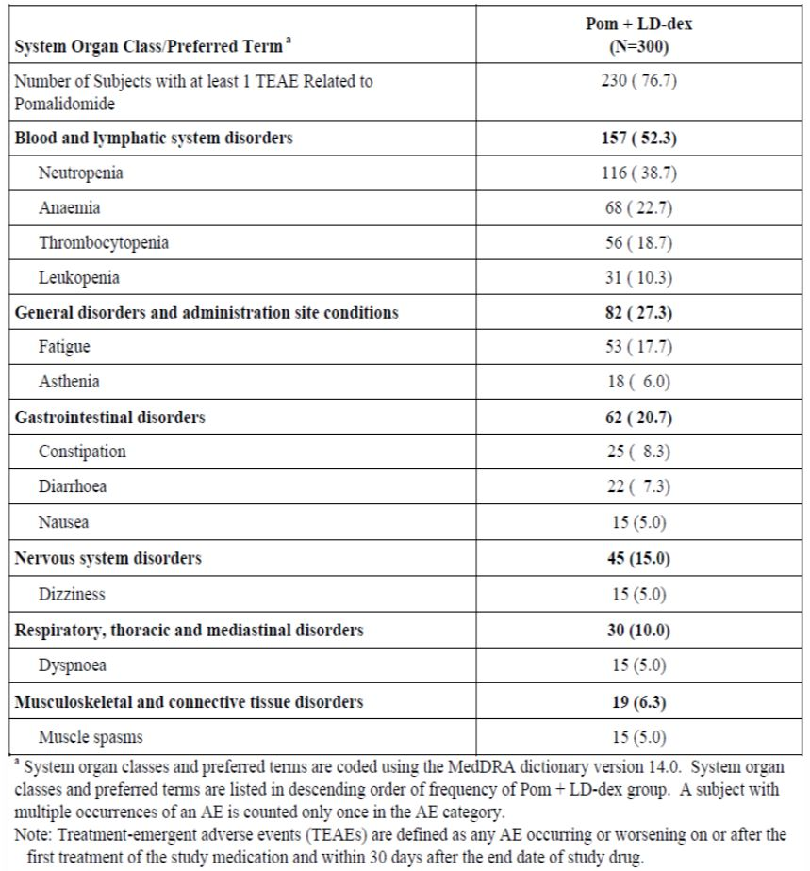
TEAEs considered by the investigator to be related to dexamethasone that occurred in ≥ 5% of subjects in either treatment arm are summarized in Table 10. The proportion of subjects with at least 1 TEAE considered by the investigator to be related to dexamethasone was higher in the HD-dex arm (71.8%) than in the Pom + LD-dex arm (56.7%). These events tended to occur more frequently in the HD-dex arm than in the Pom + LD-dex arm, particularly insomnia (17.4% in the HD-dex arm and 3.3% in the Pom + LD-dex arm), myopathy (7.4% in the HD-dex arm and 0.3% in the Pom + LD-dex arm), and muscular weakness (7.4% in the HD-dex arm and 1.7% in the Pom + LD-dex arm).
Table 10: TEAEs Considered Related to Dexamethasone by the Investigator in at least 5% of Subjects by SOC and Preferred Term (Safety Term).
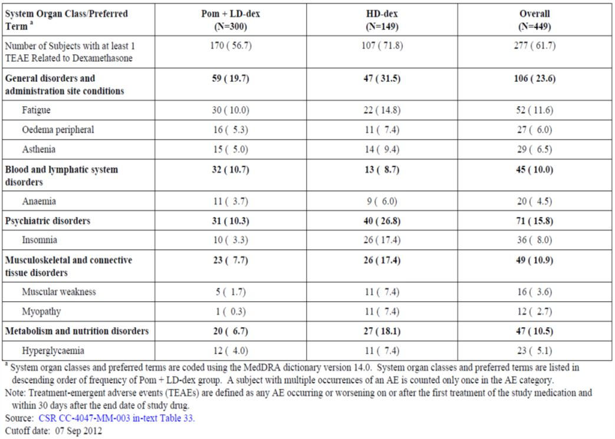
Severe TEAEs considered to be treatment-related: TEAEs of Grade 3/4 that were considered by the investigator to be related to pomalidomide and that occurred in ≥ 2% of Pom + LD-dex subjects are summarized in Table 11. A total of 170 of the 300 subjects (56.7%) in the Pom + LD-dex arm had at least one Grade 3/4 TEAE considered by the investigator to be related to pomalidomide. The most frequently occurring of these TEAEs included neutropenia (35.7%), thrombocytopenia (13.7%), and anemia (13.0%).
Table 11: TEAEs with CTCAE Grade 3 or 4 Considered by the Investigator Related to Pomalidomide in at least 2% of Subjects by SOC and Preferred Term (Safety Population).
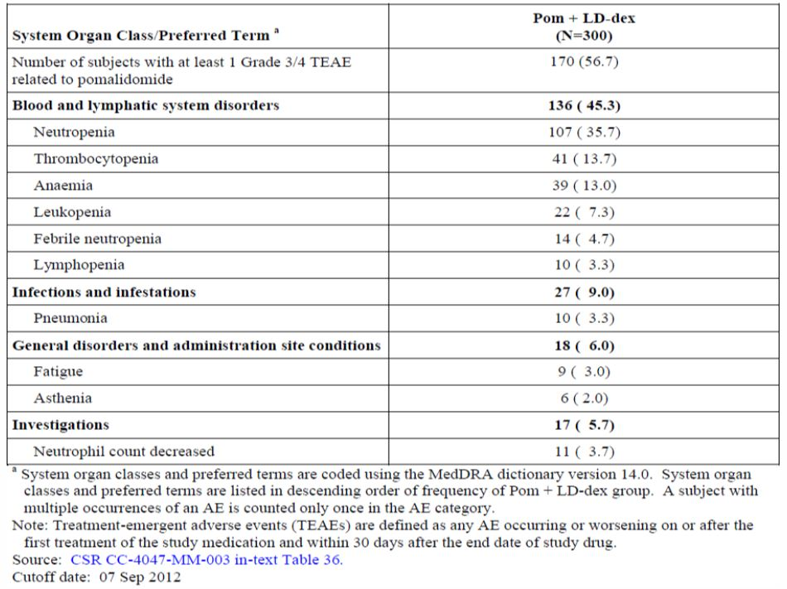
Grade 3/4 TEAEs considered by the investigator to be related to dexamethasone are summarized by treatment arm in Table 12. A higher proportion of subjects in the HD-dex arm (43.0%) than in the Pom + LD-dex arm (28.0%) had at least one Grade 3/4 TEAE considered by the investigator to be related to dexamethasone. With the exception of hyperglycemia in the HD-dex arm, no particular dexamethasone-related Grade 3/4 TEAE occurred in more than 5% of subjects in either treatment arm. Grade 3/4 dexamethasone-related hyperglycemia occurred more frequently in the HD-dex arm (6.7%) than in the Pom + LD-dex arm (3.0%) as did asthenia (4.7% in the HD-dex arm and 0.7% in the Pom + LD-dex arm) and myopathy, as expected (2.7% in the HD-dex arm and none in the Pom + LD-Dex arm. Other Grade 3/4 TEAEs considered by the investigator to be related to dexamethasone occurred in similar proportions of subjects in the 2 treatment arms.
Table 12: TEAEs with CTCAE Grades 3 or 4 considered related to Dexamethasone by the Investigator in at least 2% of subjects by SOC and Preferred Term.
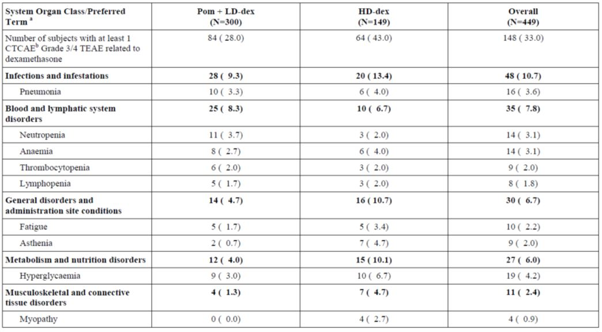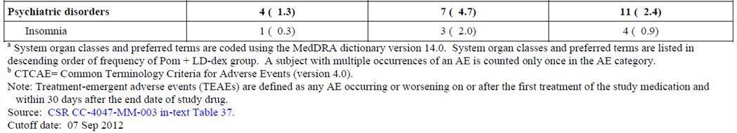

Other studies

Study CC-4047-MM-02. Phase 2
Pomalidomide related adverse events: A total of 195 (89.0%) of the 219 subjects in the safety population, 89.3% of subjects in the Pom + Dex arm and 88.8% of subjects in the pomalidomide arm had at least one drug-related TEAE. The most commonly occurring in ≥10% of subjects in the Pom+dex and the Pom (before addition of dex) that were related to pomalidomide were neutropenia (45.5% and 45.8%), fatigue (38.4% and 29.9%), anaemia (25% and 16.8%), thrombocytopenia (20.5% and 18.7%), and Infections and Infestations (SOC) (23.2% and 12.1%).
Severe (Grade 3 and 4) drug-related TEAEs: The frequency for all patients was 93.6%. The most commonly occurring in the Pom +dex and the Pom (in this case this referred to the overall Pom population including that after the addition of dex to Pom only treatment) arms were neutropenia (37.5% and 43%), thrombocytopenia (17% and 17.8%), anemia (10.7% and 9.3%), Infections and Infestations (SOC) (10.7% and 11.2% including pneumonia 7.1% and 6.5%, respectively), and fatigue (5% and 6.5%).

Study IFM-2009-02
Treatment related adverse events: Relationship to study drug was presented without distinction between pomalidomide and dexamethasone in the CSR of study IFM 2009-02, this information was available in the database and was extracted and presented in the SCS.
The majority of patients (79, 94%) experienced at least one TEAE that was considered to be related to study treatment. The most common TEAEs related to pomalidomide were neutropenia (62.8% and 62.1%), thrombocytpoenia (32.6% and 29.3%), and anemia (30.2% and 34.1%). Two cases of acute renal failure were reported in the 21/28 day arm and one case of renal failure in the 28/28, all related to pomalidomide.
The most common TEAE considered by the investigators to be related to dexamethasone was asthenia. Dexamethasone-related asthenia was more frequently reported in subjects treated with pomalidomide in combination with dexamethasone for 21 days of each 28-day cycle, compared with those treated for 28 days of each 28-day cycle (27.9% vs 12.2%).
Severe (Grade 3 and 4) drug-related TEAEs: The most common pomalidomide related TEAEs in the 21/28 and 28/28 day groups were neutropenia (60.5% and 56.1% respectively), thrombocytopenia ( 25.6% and 26.8%), anemia ( 20.9% and 24.4%) and pneumonia (14% and 9.8%). One case (2.3%) of drug-related acute renal failure occurred in the 21/28 day group. Although renal failure was reported in 16 patients (19%), these were primarily considered to be unrelated to study treatment.
Comment: The frequency of neutropenia related to pomalidomide was higher in this study (62.8%) than in patients treated similarly (21/28) in Study CC-4047-MM-02 (45.5%) and in the pivotal trial (38.7%). This was attributed to the longer period of treatment (6 months) with pomalidomide in the former study compared to a median treatment periods of 4 months and 3 months in Studies CC-4047-MM-002 and the pivotal study CC-4047-MM-003 respectively.

Deaths and other serious adverse events

Pivotal studies

Deaths
Eighteen subjects in study CC-4047-MM-003 died after they were screened but before they were randomized, and, therefore, were not included in the Safety Population. As expected, most of these subjects died due to MM or infections. Three additional subjects (1 Pom + LD-dex and 2 HD-dex) died due to MM after randomization but before receiving their first dose of study medication, and therefore were not included in the Safety Population. Deaths among all subjects are displayed in Figure 12.
Figure 12: Deaths among all subjects (Safety Population). Pivotal Study.
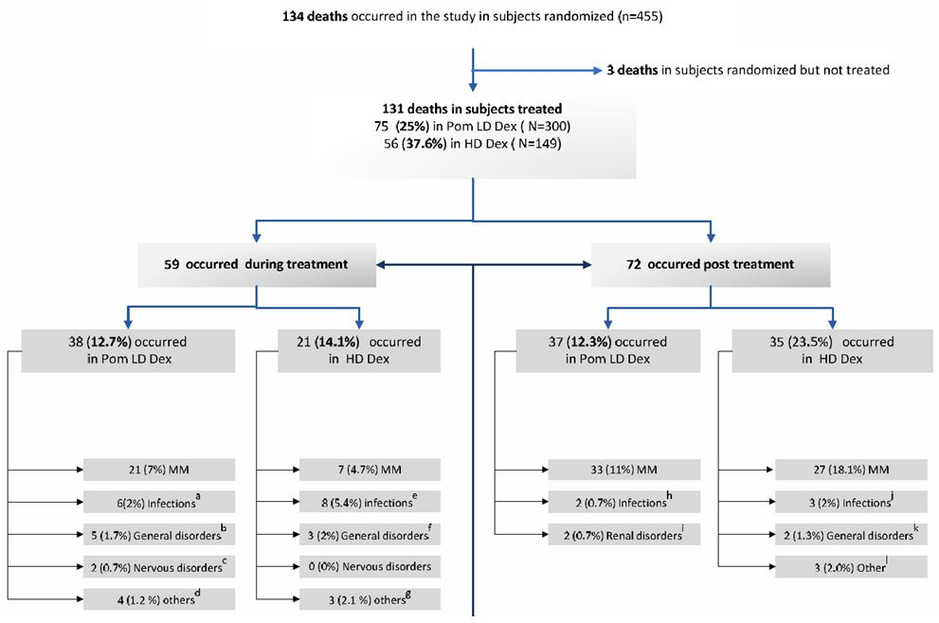
As of 07 Sep 2012, the proportion of subjects in the Pom + LD-dex arm who had died (75 of 300 subjects [25.0%]) was lower than that in the HD-dex arm (56 of 149 subjects [37.6%]). As expected, the most common cause of death in both treatment arms was MM: 54 subjects (18.0%) in the Pom + LD-dex arm and 34 subjects (22.8%) in the HD-dex arm.
Grade 5 Adverse Events (death related to an AE): The occurrence of at least one Grade 5 TEAE was similar in the 2 treatment arms: 37 subjects (12.3%) in the Pom + LD-dex arm and 22 subjects (14.8%) in the HD-dex arm. General physical health deterioration was the most frequently occurring Grade 5 TEAE in both treatment arms (5.3% of Pom + LD-dex subjects and 4.0% of HD-dex subjects). One additional subject in the HD-dex arm died due to “general health deterioration”. Grade 5 infections occurred more frequently in the HD-dex arm (7.4%) than in the Pom + LD-dex arm (2.3%). Most of this difference is due to the more frequent occurrence of septic shock in the HD-dex arm (3.4%) than in the Pom + LD-dex arm (0.3%). Three subjects in the Pom + LD-dex arm (1%) and no subjects in the HD-dex arm had Grade 5 acute renal failure. Two of these 3 subjects had disease progression and one did not. The 2 subjects with disease progression had baseline creatinine clearance values between 30 and 45 mL/min, while baseline creatinine clearance for the subject without disease progression was between 45 and 60 mL/min.
All other Grade 5 TEAEs occurred in 1 or 2 subjects in each treatment arm.

Other serious adverse events
Treatment-emergent SAEs that occurred in 2% or more subjects in either treatment arm were summarized. The proportions of subjects with at least 1 SAE were similar in the 2 treatment arms: 153 subjects (51.0%) in the Pom + LD-dex arm and 75 subjects (50.3%) in the HD-dex arm. The most frequently occurring SAEs in both treatment arms were pneumonia (9.3% in the Pom + LD-dex arm and 8.7% in the HD-dex arm) and general physical health deterioration (7.3% in the Pom + LD-dex arm and 7.4% in the HD-dex arm). The majority of SAEs occurred in similar proportions of subjects in the 2 treatment arms. Exceptions include septic shock, which occurred more frequently in HD-dex subjects (4.0%) than Pom + LD-dex subjects (1.0%), and febrile neutropenia, which occurred more frequently in Pom + LD-dex subjects (4.0%) than in HD-dex subjects (none).

Other studies

Study CC-4047-MM-002 Phase 2
Deaths: As of the data cutoff date, 41/219 (18.7%) subjects died during the study: 20 (17.9%) of the 112 Pom + Dex-treated subjects and 21 (19.6%) of the 107 pomalidomide-treated subjects. The most common cause of death (in a total of 23 (10.5%) of 219 subjects) was progression of MM (cause of death listed as “multiple myeloma” in 17 [7.8%] subjects and as “disease progression” in 6 [2.7%] of subjects). In the two arms, the two causes combined were 10.7% (Pom+dex) and 13.1% (Pom). In the follow-up period to data cut-off, 20.5% and 24.3% died in the Pom+dex and the Pom arms respectively. In the combined periods, 20+23 of 112 subjects (41%) in the Pom+dex arm and 21+26 of 107 subjects (44%) in the Pom arm had died by the data cut-off data.
Grade 5 Adverse Events: In the Pom+dex arm, 16 subjects (14.3%) and in the Pom arm 16 subjects (15.0%) of the patient population had an AE associated with death. Of all deaths, 16 of 43 (37%) and 16 of 47 (34%) were associated with an adverse effect. Seven of these (8% of total deaths) were suspected to be related to pomalidomide. These include staphylococcal sepsis, 3 cases of pneumonia, MM progression, respiratory failure, and sepsis.
Comment: The inclusion of MM progression is unexplained.
Other Serious Adverse Events (SAEs): The number of subjects with at least one SAE was higher in the Pom + Dex arm (61.6%) than in the pomalidomide alone arm before dex (46.7%). This difference was due to the incidence of pneumonia, which occurred at approximately twice the frequency in the Pom + Dex arm (18.8%) than in the pomalidomide alone arm (9.3%). Pyrexia and dyspnoea also had a higher incidence in the Pom+dex arm, probably related to the higher incidence of pneumonia in that arm. Acute renal failure was of similar incidence (5.4% and 4.7%), as was febrile neutropenia with one and two cases in each arm. Pneumonia and neutropenia were the most common SAEs that were suspected by the investigator to be related to pomalidomide occurring in a total of 14 (6.4%) and 3 (1.4%) subjects, respectively.
Comment: Of interest is that 61 subjects of the 107 in the Pom arm had dexamethasone added to their treatment. The incidence of pneumonia after addition was 9.8% compared to 9.3% before, whereas in the Pom+dex with dexamethasone administered with pomalidomide from the start of treatment, the incidence of pneumonia was 18.8%. The difference is unexplained.

Study IFM-2009-02
Deaths: A total of 37 patients in the present study died before the cut-off date of 01 Mar 2011. A total of 16 patients (43%) died whilst on-study, with the remaining 21 deaths (57%) reported more than 30 days after the patients’ last received study treatment. For 35 patients (95%), death was considered to be a result of the patients’ multiple myeloma.
Grade 5 Adverse events: Two patients had Grade 5 TEAEs, one with respiratory disease that was considered treatment related, and the second with pneumonia and neutropenia, not considered drug related.
Comment: The clinical histories of the patients who died were provided. In the latter case above, the patient was admitted on 6 Dec 2010 with left pneumonia and a neutrophil count of 1.9 x 10⁹/L. The patient died on 23 Dec 2010, 16 days after trial treatments were stopped. At the time of death her neutrophil count was 0.64 x 10⁹/L. The contribution of her neutropenia to the patient’s pneumonia and death and the relation of trial treatment to the neutropenia are of concern but remain unclear.

Discontinuation due to adverse events

Pivotal studies
Twenty-four subjects (8.0%) in the Pom + LD-dex arm had 1 or more TEAEs that led to the discontinuation of pomalidomide. Most common were infections (2%) and renal disorders (1.3%). No single TEAE resulted in the discontinuation of pomalidomide in more than 2 subjects.
The percentages of subjects with 1 or more TEAEs leading to discontinuation of dexamethasone were 8.3% in the Pom + LD-dex arm and 5.4% in the HD-dex arm. In the Pom + LD-dex arm, no single TEAE other than pneumonia led to the discontinuation of dexamethasone in more than 2 subjects. Pneumonia led to the discontinuation of dexamethasone in 3 Pom + LD-dex subjects (1.0%) and no HD-dex subjects. In the HD-dex arm, no single TEAE led to the discontinuation of dexamethasone in more than 1 subject.

Other studies

Study CC-4047-MM-002
Discontinuation of pomalidomide: A total of 22 (10.0%) of 219 subjects experienced AEs that led to permanent withdrawal of pomalidomide. These include 9 (8.0%) of the 112 subjects who received Pom + Dex and 13 (12.1%) of the 107 subjects who received pomalidomide alone. The most common AEs that led to withdrawal of pomalidomide were renal failure acute in a total of 3 (1.4%) subjects (1 subject in the Pom + Dex arm and 2 subjects in the pomalidomide arm), thrombocytopenia, and fatigue, each in 2 (0.9%) subjects overall (each in 2 subjects who took pomalidomide alone) and increased blood creatinine in 2 (0.9%) subjects overall (1 subject in each of the treatment arm).
Discontinuation of dexamethasone: A total of 10 (5.8%) of 173 subjects who received dexamethasone in the study experienced at least one AE that led to permanent withdrawal of dexamethasone. These include 8 (7.1%) of the 112 subjects in the Pom + Dex arm and 2 (3.3%) of the 61 subjects in the pomalidomide alone arm (after the addition of dexamethasone). All AEs that led to permanent withdrawal of dexamethasone occurred in 1 subject each in either treatment arm and overall.

Study IFM-2009-02
Overall, 27 patients (32%) experienced a total of 34 TEAEs reported as leading to discontinuation of at least one study treatment (pomalidomide, dexamethasone or both), with no imbalance between treatment groups (Arm A: 14 patients, 33%; Arm B: 13 patients, 32%). Three patients experienced a treatment-related AE that led to discontinuation of treatment. This included two patients for whom treatment-related adverse events were the primary reason for study termination, and one who discontinued treatment with dexamethasone only. Patient 001-07 (Arm B) was discontinued from the study during Cycle 4, due to treatment-related neutropenia and respiratory distress
- Patient [information redacted] (Arm B) was discontinued from the study during Cycle 11 due to treatment-related pneumonia; this patient had immunoallergic pneumopathy in the absence of neutropenia
- Patient [information redacted] (Arm B) discontinued treatment with dexamethasone (but continued to receive pomalidomide) having experienced a treatment related pneumonia.
For the remaining 24 patients, adverse events reported as leading to withdrawal were not considered to be related to study treatment.

Phase 1 Studies CC-4047-MM-001 and CC-4047-MM-02 Phase 1
The safety assessments of the Phase I studies did not show any adverse events not seen in the larger Phase 2 and 3 studies.

Laboratory tests

Liver function
Clinically significant laboratory abnormalities were reported as AEs and are described in that section above.

Pivotal study CC-4047-MM-003
In the Pom+LD-dex group, the concentrations of alanine aminotransferase, alkaline phosphatase, gamma glutamyl transferase and bilirubin at baseline were normal in 87.6%, 93.1%, 98.5% and 68.7% respectively of the patient population. During the study the percentage of subjects whose measurements worsened to a Grade 3 abnormality were 1.2%, 1.2%, 0.8% and 2.8% of patients, with one (0.4%) Grade 4 abnormality of GGT. In the HD arm, the baseline normal figures were 90.8%, 94.6%, 100% and 71.7% with 6.7% Grade 3 and 0.8%Grade 4 for GGT reported post-baseline.
Comment: The difference in the incidence of Grade 3 and 4 abnormalities of GGT measurements between the two arms was >4.0% (3.2% in the Pom+LD-dex arm and 7.5% in the HD arm).

Other studies

Study CC-4047-MM-002 Phase 2
No shifts in the parameters of liver function from normal at baseline to Grade 3 or 4 post-baseline were reported.

Study CC-IFM-2009-002
Demonstration of serum levels of total bilirubin <2.0 mg/dL, and AST and ALT values <3 x the upper limit of normal were required for eligibility in this study. Four patients (5%) did not have bilirubin <2.0 mg/dL at baseline, and were considered as having minor protocol violations, while 3 patients (4%) entered the study with AST values >3 x ULN and 3 patients (4%) with ALT values >3 x the ULN Overall, the number of patients with normal levels of bilirubin, AST and ALT remained constant throughout the study, at 93-100% overall.

Kidney function

Pivotal studies
The percentage of subjects with normal baseline values for creatinine concentration in the Pom+LD-dex arm was 65% and in the HD arm 60.8%. During the study, worsening to Grade 3 abnormalities occurred in 0.8% (2 of 300) and in 1.7% (2 of 149) of subjects in the respective arms, and Grade 4 abnormalities in 0.4% and 1.7%, respectively.
Creatinine clearance measurements were normal at baseline in 60.2% and 53.3% of subjects in the respective arms, while worsening to Grade 3 abnormalities was reported in 4.2% and 5.8% and Grade 4 in 0.4% and 5.8%.

Other studies

Study CC-4047-MM-002
Shifts to a Grade 3 serum creatinine abnormality occurred in 4 of197 subjects [2.0%] from grade 1 and 5 of 197 [2.5%] from grade 2.

Study CC-IFM-2029-002
The majority of patients had normal serum creatinine levels at baseline (61 patients, 73%). In Arm A, the number of patients with normal creatinine levels, and the number with abnormal high and low levels remained unchanged throughout the study; in contrast, in Arm B, the percentage of patients with low serum creatinine increased from Cycle 2 onwards. Overall, a total of 26 patients (32%) experienced abnormal creatinine levels during the course of the study including 4 patients (5%, 2 patients per arm) with grade 3-4 elevated serum creatinine.
Comment: The clinical significance of the higher incidence of lower serum creatinine concentrations in Arm B (28/28) compared to Arm A (21/28) is unclear.

Other clinical chemistry

Pivotal studies
Tests with the largest differences (ie, difference > 4.0% between the Pom + LD-dex and HD-dex treatment arms) were protein urine (36 subjects [13.4%] versus 27 subjects [21.6%]), and urate (72 subjects [30.2%] versus 40 subjects [34.8%]), for which each had a greater percentage of Grade 3 or 4 reports in the HD-dex treatment arm.
Two subjects in the Pom + LD-dex arm were reported with Grade 4 glucose at baseline. One shifted to normal post-baseline, and the other had additional Grade 4 readings post-baseline. One subject in the HD-dex treatment arm had a report of Grade 4 glucose at baseline but withdrew before any other scheduled readings were performed.
The only serum electrolytes reported with post-baseline Grade 3 or 4 values for subjects in either treatment arm (Pom + LD-dex versus HD-dex) were calcium (corrected) (6 subjects [2.4%] versus 4 subjects [3.3%]), potassium (16 subjects [6.2%] versus 3 subjects [2.5%]), and sodium (7 subjects [2.7%] versus 7 subjects [5.8%]. For potassium and sodium, most of these subjects shifted from normal at baseline.

Other studies

Study CC-4047-MM-002
More subjects in the pomalidomide arm than in the Pom + Dex arm had shifts from normal, grade 1 or grade 2 to grade 3 or 4 post-baseline in calcium (4/95 [4.2%] versus 2/102 [2.0%]), serum glucose (7/95 [7.4%] versus 4/102 [3.9%]), and serum uric acid (12/95 [12.6%] versus 8/102 [7.8%]).
More subjects in Pom + Dex arm than in the pomalidomide arm had shifts from normal, grade 1 or grade 2 to grade 3 or 4 post-baseline in phosphorous (10/102 [9.8%] versus 0).
A similar proportion of subjects in the pomalidomide arm had shifts in uric acid before and after addition of dexamethasone, whereas the proportion of subjects who had shifts in calcium and serum glucose increased after the addition of dexamethasone.

Study CC-2029-002
Laboratory analyses conducted at each cycle included assessment of thyroid function, by measurement of TSH, T4 and T3. Elevated baseline levels of TSH, T4 and T3 were observed in 6 patients (8%), 1 patient (1%) and 2 patients (3%), respectively. The incidence of patients with normal TSH remained unchanged at approximately 100% throughout the study, although one patient in Arm B had a persistent elevation of TSH, which appeared to increase the incidence (as a percentage) of abnormal TSH values as the number of patients in the arm decreased. The number of patients with elevated T4 and T3 did not exceed 2 at any point during the study.
Nine patients (11%) entered the study with serum calcium levels higher than normal. The incidence of elevated remained calcium remained below 10% throughout the rest of the study.

Haematology

Pivotal studies
The numbers of subjects in the Safety Population with hematology tests by CTCAE grade at baseline and at worst post-baseline grade were provided in the CSR for both treatment arms.
Hemoglobin, leukocytes, lymphocytes, neutrophils, and platelets were recorded with a postbaseline Grade of 3 or 4. The percentages of subjects with Grade 3 or 4 hemoglobin, lymphocyte, and platelet values were similar in the Pom + LD-dex and HD-dex treatment arms. Substantially higher percentages of subjects in the Pom + LD-dex arm than in the HD-dex arm experienced Grade 3 or 4 leukocyte (44.6% versus 12.4%) and neutrophil (55.1% versus 16.3%) values. No other hematology parameter had any non-normal CTCAE value at any time during the study.
Neutropenia was reported as a TEAE in 136 (49.7%) subjects in the Pom + LD-dex arm and 29 (19.5%) subjects in the HD-dex arm. Neutropenia was a TEAE of interest and is discussed in the AE section above.

Other studies

Study CC-4047-MM-02
In the Pom+Dex arm, shifts from normal, Grade 1 or 2 neutrophil counts at baseline to Grade 3 occurred in 40.5% of subjects and to Grade 4 in 7.2%. In the Pom arm, the figures were 33.7% and 17.8%. In the case of platelets, the figures were 14.8% Grade 3, 1.8% Grade4 in the Pom+Dex arm and 12.0% and 3.0% in the Pom arm.
The median time for occurrence of the first Grade 3 or 4 neutrophil count was 22 days for both treatments, and for the first Grade 3 or 4 platelet count, 15 days. Recovery time to normal, Grades 1 or 2 neutrophil counts was a median of 8 days in the Pom + Dex arm and 15 days in the Pom arm. For platelets, the median times were 15 days and 20 days in the respective arms.
Comment: In the rationale for the combination of dexamethasone with pomalidomide was the suggestion in laboratory studies of possible synergy in their anti MM actions. This raised the possibility that the two drugs may act synergistically in increasing side effects such as neutropenia and thrombocytopenia. The above results suggest that the neutropenia was less severe in the Pom+Dex arm than in the Pom arm but thrombocytopenia remained similar. Recovery from both neutropenia and thrombocytopenia were both shorter in the Pom+Dex arm. However the conclusions are complicated by the addition of dexamethasone to pomalidomide on disease progression in patients in the Pom group.

Study CC-IFM-2009-002
The majority of patients had normal neutrophil levels at baseline, with 33 patients (81%) in Arm A and 32 patients (82%) in Arm B having neutrophil counts within the normal range at study entry. During the study, however, most patients experienced grade 2-4 neutropenia at some point; grade 2-4 neutropenia was reported in 37 patients (90%) in Arm A, and 32 patients (82%) in Arm B. A significant number of these patients (19 patients [46%] in Arm A, 23 patients [59%] in Arm B) experienced severe neutropenia (Grades 3 and 4).
Abnormal platelet levels were reported in 31 patients (72%) in Arm A and 31 patients (78%) in Arm B. There was no difference between treatment groups with regards the incidence of grade 3-4 events; grade 3-4 thrombocytopenia was observed in 9 patients in Arm A (21%) and 10 patients (25%) in Arm B. Abnormal platelet levels were reported at baseline for 20 patients in each arm, including one patient in Arm B who entered the study with grade 3 thrombocytopenia at baseline.
Comment: The higher incidence of Grade 3 and 4 neutropenia in Arm B is consistent with an effect of longer treatment (28 days) with pomalidomide compared to 21 days of treatment in Arm A.

Electrocardiograph

Pivotal study CC-4047-MM-003
In general, mean values for ECG parameters were similar in the 2 treatment arms at baseline, and mean changes in these parameters were similar in the 2 treatment arms at endpoint. Mean and median changes from baseline in QT intervals (corrected) were all under 30 msec.
Two subjects in the Pom + LD-dex arm (0.7%) and no subject in the HD-dex arm had a TEAE of QT prolonged. One event was Grade 2 and one was Grade 3, both events resolved, and neither recurred despite continued treatment. One subject in the Pom + LD-dex arm (0.3%) and no subject in the HD-dex arm had a TEAE of ST segment depression. No other ECG-related TEAEs were reported.

Vital signs

Pivotal study CC-4047-MM-003
Mean (± SD) systolic blood pressure at baseline was 125.70 (± 15.85) mmHg in the Pom + LD-dex arm and 125.01 (± 16.31) mmHg in the HD-dex arm. The mean changes from baseline at endpoint were -0.97 (± 16.80) mmHg for the Pom + LD-dex arm and 1.82 (± 14.34) mmHg for the HD-dex arm.
Mean (± SD) body weight at baseline was 74.80 (± 15.28) kg in the Pom + LD-dex arm and 72.62 (± 15.61) kg in the HD-dex arm. The mean change from baseline at endpoint was -1.02 (± 2.57) kg for the Pom + LD-dex arm and -1.25 (± 2.53) kg for HD-dex.
There were no notable changes or trends observed in the vital signs data in either treatment arm.

Post-marketing experience
There are no post-marketing data available as approval of pomalidomide (8 February 2013) by the Food and Drug Administration in the United States was recent.

Safety issues with the potential for major regulatory impact

Haematological toxicity
The addition of pomalidomide to dexamethasone was associated with an increase in hematological AEs, specifically neutropenia and febrile neutropenia. Approximately 24% of subjects in the Pom + LD-dex arm in the pivotal study had pomalidomide dose reductions, most of which were due to neutropenia (7.7%), thrombocytopenia (6.3%), and febrile neutropenia (1.3%). Pomalidomide dose interruptions were more frequent (61.3%) and were due to neutropenia (21.0%); thrombocytopenia (8%).
The management of hematological toxicity therefore is an important part of responsible use of Pom+LD-dex treatment in this population of MM patients.

Other safety issues

Safety in special populations
In general, the safety profile of Pom + LD-dex remained essentially unchanged regardless of age (> 65 or ≤ 65 years old), gender, ECOG performance status, disease population, or baseline renal function. Some analyses (such as those based on race and number of prior anti-myeloma therapies) resulted in subgroups of small sizes, precluding any conclusions about safety in these subgroups.

Safety related to drug-drug interactions and other interactions
Pomalidomide is not an inhibitor or inducer of cytochrome P-450 (CYP) isoenzymes, and did not inhibit P-glycoprotein (P-gp) or other studied transporters in vitro. Pomalidomide is not anticipated to cause clinically relevant pharmacokinetic drug-drug interactions at therapeutic doses when co-administered with CYP substrates or substrates of the evaluated transporters. Pomalidomide is partially metabolized by CYP1A2 and CYP3A4, and to a minor extent CYP2C19 and CYP2D6. Pomalidomide is a substrate of P-gp in vitro but is well absorbed in humans. Pomalidomide is unlikely to be a significant substrate of other enzymes or transporters and the potential for clinically relevant drug-drug interactions when pomalidomide is co-administered with other drugs is low.

Use in pregnancy and lactation
Pomalidomide is a thalidomide analogue. Thalidomide is a known human teratogen that causes severe life-threatening birth defects. Pomalidomide was found to be teratogenic in a developmental study in rats and rabbits. Pomalidomide therefore is considered as having the potential to cause teratogenic effects in humans. Celgene therefore has mandated the fetal exposure risk management program in all pomalidomide studies.
It is not known if pomalidomide is excreted in human milk. Pomalidomide was detected in the milk of lactating rats following administration to the mother. Because of the potential for adverse reactions in nursing infants from pomalidomide, a decision should be made whether to discontinue nursing or to discontinue the drug, taking into account the importance of the drug to the mother.
Appropriate warnings based on the above are important in the Product Information and CMI documents.

Second Primary Malignancies (SPMs)
A summary of SPMs that have been reported across all pomalidomide studies in all contexts was presented, including all SPMs reported in all subjects receiving pomalidomide across all studies, including investigator-initiated studies, compassionate use, and all ongoing Celgene-sponsored studies as of 31 Dec 2012.
Thirty two (32) subjects have experienced a total of 40 SPMs across all programs. This represents a current reporting rate of approximately 1% among the approximately 3000 subjects exposed to pomalidomide in all contexts. For individuals 65 years and older, as commonly seen in the demographics of subjects enrolled in cancer treatment studies, the overall incidence of a new diagnosis of invasive cancer (excluding in situ cancer and non-melanoma skin cancer) is approximately 2.1 per 100 person-years (reference given in SCS). Calculation of an overall SPM incidence rate was not possible due to incomplete data on duration of exposure outside of the Celgene-sponsored studies.
No cases of AML have been reported in any MM studies. As of 31 December 2012, 18 cases of AML (blastic/leukemic transformation) have been reported in subjects receiving pomalidomide, and all have occurred in studies investigating pomalidomide as a treatment for myelofibrosis, also called MPN-associated MF. Transformation to blastic phase under these conditions is not considered SPM but disease progression. These subjects are therefore not included in the above figures.

Evaluator’s conclusions on safety
The following conclusions are largely from the pivotal Study CC-4047-MM-002 in which the treatment dose and patient population were closest to those in the requested indication.
- TEAEs related to pomalidomide were significantly more frequent (76.7%) than those related to LD dexamethasone (56.7%) in the proposed pomalidomide + LD dexamethasone combination.
- The most frequently occurring TEAEs related to pomalidomide included neutropenia (38.7%), anaemia (22.7%), thrombocytopenia (18.7%), and fatigue (17.7%). The majority of the first three TEAEs were severe (see below).
- Those related to LD dexamethasone included fatigue (10%), asthenia (5%), peripheral oedema (5.3%) and hyperglycaemia (4%).
- Severe TEAEs (Grade 3 and 4) related to pomalidomide occurring in at least one subject were significantly more frequent (56.7%) than those related to LD dexamethasone (28%).
- The most frequently occurring severe TEAEs related to pomalidomide included neutropenia (35.7%), thrombocytopenia (13.7%), and anaemia (13.0%). Febrile neutropenia occurred in 4.7% of subjects.
- The most frequently occurring severe TEAEs related to LD dexamethasone included pneumonia (3.3%), hyperglycemia (3%), and fatigue combined with asthenia (2.4%).
(Note: Investigators classified 3.7% and 2% of subjects with neutropenia and thrombocytopenia as related to dexamethasone respectively. However, since this association would be difficult to make in the presence of a pomalidomide effect on these counts, and since these figures were not increased in the HD dexamethasone arm, the evaluator does not consider they were caused by the LD dexamethasone administered.)
- The proportion of subjects in the pomalidomide + LD dexamethasone arm who had died at the data cut-off date was 25%, 18% of whom died of MM and 12.3% of a TEAE. Of the latter, most (5.3%) were due to “physical health deterioration”, while 3 subjects (1%) died of acute renal failure.
- A total of 24 subjects (8.0%) in the pomalidomide + LD dexamethasone arm had 1 or more TEAEs that led to the discontinuation of pomalidomide. Most common were infections (2%) and renal disorders (1.3%). No single TEAE resulted in the discontinuation of pomalidomide in more than 2 subjects.
- The percentages of subjects with 1 or more TEAEs leading to discontinuation of dexamethasone were 8.3% in the pomalidomide + LD dexamethasone arm. No single TEAE other than pneumonia led to the discontinuation of dexamethasone in more than 2 subjects. Pneumonia led to the discontinuation of dexamethasone in 3 subjects (1.0%).
- No unexpected laboratory abnormalities were reported. Neutropenia was significant and also reported as a TEAE (see above), which was severe in most cases.
- As pomalidomide is a thalidomide analogue that is teratogenic in animal models, care was taken in the pomalidomide trials to warn about and monitor possible exposure to female subjects. Strong warnings have been included in the proposed PI and CMI.
- Renal abnormalities (both TEAEs and severe TEAEs) were less frequent in the Pom+LD-dex group of subjects than in those receiving HD dexamethasone.
- A total of 32 subjects receiving pomalidomide have reported 40 second primary malignancies (SPMs) from ~3000 patients receiving the drug.
- The safety of pomalidomide + LD dexamethasone compared to pomalidomide alone could not be assessed in the pivotal trial but was assessable in the Phase II trial, CC-4047-MM-002, although complicated by the addition of dexamethasone treatment to the pomalidomide only arm on disease progression. The question is important, given that synergy of the two drugs was shown in laboratory and animal studies. In the trial, the incidence of TEAEs related to pomalidomide was the same (89%) in pomalidomide + dexamethasone and the pomalidomide only arms, and that of severe (Grade 3 and 4) TEAEs similar in both arms for the most frequent events. Grade 5 adverse events were also of similar frequency (12.3% and 14.8%). Pomalidomide was discontinued in 8% of subjects in the pomalidomide + LD dexamethasone and 12% in the pomalidomide only arm. These results show that adverse events were not increased by the addition of dexamethasone to pomalidomide.
Overall, it can be concluded that treatment of this heavily pretreated population of patients with pomalidomide and dexamethasone is associated with frequent and severe neutropenia that was manageable as shown by the relatively low discontinuation rate and Grade 5 events due to neutropenia.

First round benefit-risk assessment

First round assessment of benefits
The benefits of pomalidomide and LD dexamethasone in the proposed usage are:
- a clinically significant improvement of 7.7 weeks in PFS
- a clinically significant improvement of more than 12 weeks in OS (20 weeks in the updated analysis)
- a clinically significant improvement of 12.7% in response rate
- The positive effects were shown in most subgroups, with one possibly significant exception.
Note that these benefits are from comparison with HD dexamethasone treatment, and not to pomalidomide alone. That comparison in the Phase II Study CC-4047-MM-002 showed a smaller clinical benefit in PFS and no benefit in OS or response rates when dexamethasone was added to pomalidomide on disease progression.

First round assessment of risks
The main risks of pomalidomide and LD dexamethasone in the proposed usage are:
- The high frequency (56.7%) of Grade 3 and 4 neutropenia with the associated risks of infection.
Comment: Although of high frequency, severe neutropenia was manageable, and is acceptable for this population of heavily pre-treated patients with advanced disease, provided the treatment is administered and managed by experienced physicians.
- VTEs and arterial thrombotic events (ATEs): These events were infrequent. In the pomalidomide + LD dexamethasone arm, 3.3% of subjects had at least 1 VTE. In the HD dexamethasone arm, 2.0% of subjects had at least 1 VTE. At least one Grade 3/4 VTE occurred in 1.3% of pomalidomide + LD dexamethasone subjects and in no HD dexamethasone subjects. Serious VTEs occurred in 1.7% of pomalidomide + LD dexamethasone subjects and in no HD dexamethasone subjects. No VTE led to the discontinuation of treatment in either treatment arm. No subject died as a result of a VTE. DVT and venous thrombosis occurred in similar proportions of subjects in the 2 treatment arms. Pulmonary embolism occurred in 1.0% of pomalidomide + LD dexamethasone subjects and in no HD dexamethasone subjects. Arterial thrombotic events occurred in 1.0% of pomalidomide + LD dexamethasone subjects and 0.7% HD dexamethasone subjects. In the pomalidomide + LD dexamethasone arm, these events included: embolism, ischemic cerebral infarction, and myocardial infarction each occurring in 1 subject. In the HD dexamethasone arm, 1 subject (0.2%) had a transient ischemic attack. With the exception of the embolism in the pomalidomide + LD dexamethasone arm, these ATEs were Grade 3/4 events and were serious. None of these ATEs resulted in the discontinuation of treatment in either treatment arm. No subject died as a result of an ATE.
Comment: The data show that the risk of these AEs is low and manageable. It is noted that all subjects in the pivotal trial were required to take prophylactic medication for thrombosis and this recommendation is included in the PI.
- Peripheral neuropathy: The frequency of peripheral neuropathy was significant in both arms of the pivotal trial. In the pomalidomide + LD dexamethasone arm, 12.3% of subjects had at least one occurrence of peripheral neuropathy, and in the HD dexamethasone arm, 10.7%. There were few occurrences of severe neuropathy in either arm.
- Second primary malignancies: the occurrence of a second primary malignancy exists in patients receiving pomalidomide.
Comment: This risk has to be considered against the seriousness of the disease being treated, and the risk that exists with MM in the absence of pomalidomide treatment. An appropriate warning is included in the PI.
- Teratogenic effects: The risks associated with the teratogenic effects of pomalidomide are addressed by the restricted access program and the TGA approved compulsory i-access program, which also apply to thalidomide and lenalidomide.
Comment: Combined with the related warnings and advice in the PI of Pomalyst, this risk is acceptable.
- The possibility that dexamethasone contributes significantly to toxicity but not to efficacy compared to pomalidomide alone:
Comment: Although the addition of dexamethasone to treatment with pomalidomide did not increase OS, the small increase in PFS seen and the lack of any synergistic toxicity provide reasons for accepting its use, while noting that its contribution to the efficacy of the combination was not addressed in the pivotal study.
- Whether similar outcomes of both efficacy and safety would be observed with a patient population refractory or resistant to proteasome inhibitors other than bortezomib.

First round assessment of benefit-risk balance
The benefit-risk balance of pomalidomide with dexamethasone remains unfavourable given the proposed usage, but would become favourable if the recommended changes are adopted. The reason is that broadening the patient population to include those who are resistant or refractory to any proteasome inhibitor (including those not yet in clinical trial) introduce a risk of loss of efficacy, because structurally similar drugs, for example, lenalidomide and pomalidomide have different patterns of drug resistance in this patient population. The results can therefore only be applied with safety to patients who have had exposure to the designated proteasome inhibitor, bortezomib.

First round recommendation regarding authorisation
The evaluator recommends that the requested indication be approved if the wording were changed to the following:
Pomalyst in combination with dexamethasone is indicated for the treatment of patients with multiple myeloma who have failed at least two prior therapies including lenalidomide and bortezomib
provided the wording of the PI and Consumer Medicine Information (CMI) be changed as recommended.

Clinical questions
None.

European Medicines Agency, “ICH Topic E 6 (R1) Guideline for Good Clinical Practice, Step 5: Note for Guidance on Good Clinical Practice (CPMP/ICH/135/95)”, July 2002.

