April 2018

Australian Public Assessment Report for Phleum pratense (extract)
  - Proprietary Product Name: Grazax
  - Sponsor: Seqirus Pty Ltd

About the Therapeutic Goods Administration (TGA)
- The Therapeutic Goods Administration (TGA) is part of the Australian Government Department of Health and is responsible for regulating medicines and medical devices.
- The TGA administers the Therapeutic Goods Act 1989 (the Act), applying a risk management approach designed to ensure therapeutic goods supplied in Australia meet acceptable standards of quality, safety and efficacy (performance) when necessary.
- The work of the TGA is based on applying scientific and clinical expertise to decision-making, to ensure that the benefits to consumers outweigh any risks associated with the use of medicines and medical devices.
- The TGA relies on the public, healthcare professionals and industry to report problems with medicines or medical devices. TGA investigates reports received by it to determine any necessary regulatory action.
- To report a problem with a medicine or medical device, please see the information on the TGA website <https://www.tga.gov.au>.
About AusPARs
- An Australian Public Assessment Report (AusPAR) provides information about the evaluation of a prescription medicine and the considerations that led the TGA to approve or not approve a prescription medicine submission.
- AusPARs are prepared and published by the TGA.
- An AusPAR is prepared for submissions that relate to new chemical entities, generic medicines, major variations and extensions of indications.
- An AusPAR is a static document; it provides information that relates to a submission at a particular point in time.
- A new AusPAR will be developed to reflect changes to indications and/or major variations to a prescription medicine subject to evaluation by the TGA.
Copyright
© Commonwealth of Australia 2018
This work is copyright. You may reproduce the whole or part of this work in unaltered form for your own personal use or, if you are part of an organisation, for internal use within your organisation, but only if you or your organisation do not use the reproduction for any commercial purpose and retain this copyright notice and all disclaimer notices as part of that reproduction. Apart from rights to use as permitted by the Copyright Act 1968 or allowed by this copyright notice, all other rights are reserved and you are not allowed to reproduce the whole or any part of this work in any way (electronic or otherwise) without first being given specific written permission from the Commonwealth to do so. Requests and inquiries concerning reproduction and rights are to be sent to the TGA Copyright Officer, Therapeutic Goods Administration, PO Box 100, Woden ACT 2606 or emailed to < tga.copyright@tga.gov.au>.

Contents
Common abbreviations 5
I. Introduction to product submission 9
Submission details 9
Product background 9
Regulatory status 10
Product Information 11
II Registration timeline 12
III. Quality findings 12
Drug substance (active ingredient) 12
Drug product 13
Biopharmaceutics 13
Quality summary and conclusions 14
IV. Nonclinical findings 14
Introduction 14
Pharmacology 16
Pharmacokinetics 21
Toxicity 21
Nonclinical summary and conclusions 31
V. Clinical findings 34
Introduction 34
Pharmacokinetics 37
Pharmacodynamics 37
Dosage selection for the pivotal studies 38
Efficacy 39
Safety 42
First Round Benefit-Risk Assessment 45
First Round Recommendation Regarding Authorisation 46
VI. Pharmacovigilance findings 46
Risk management plan 46
Safety Concerns and Risk Minimisation 46
New and outstanding recommendations - Round 2 48
Wording for conditions of registration 48
VII. Overall conclusion and risk/benefit assessment 49
Background 49
Quality 49
Nonclinical 50
Clinical 51
Evaluation of Risk Management Plan (RMP) 65
Discussion 65
Outcome 82
Attachment 1. Product Information 83
Attachment 2. Extract from the Clinical Evaluation Report 83

Common abbreviations
Abbreviation | Meaning
AE | Adverse event
AIT | Allergy immunotherapy
ALK | ALK-Abelló A/S
ARIA | Allergic Rhinitis and its Impact on Asthma
AVH | Australian Virtual Herbarium
BAL | bronchoalveolar lavage
BAU | Bioequivalent Allergy Units
CER | Clinical evaluation report
CSR | Clinical study report
DMS | Daily medication score
DSS | Daily symptom score
FAS | Full analysis set
FcγRIIB | The low-affinity IgG receptor
GINA | Global Initiative for Asthma
GPS | Grass pollen season
Grazax | Grazax 75,000 SQ-T oral lyophilisate, also called ALK grass tablet 75,000 SQ-T, also called SCH697243 (Timothy grass allergy immunotherapy tablet [2800 BAU Phleum pratense grass extract (equivalent to 75,000 SQ-T)]
ICAM-1 | Intercellular adhesion molecule 1
ICH | International Conference on Harmonisation
IL-4 | Interleukin 4
IL-5 | Interleukin 5
IL-10 | Interleukin 10
IL-12 | Interleukin 12
IL-13 | Interleukin 13
IFNγ | Interferon Gamma
IgA | Immunoglobulin A
IgA₂ | Immunoglobulin A2
IgE | Immunoglobulin E
IgE blocking factor | Redefinition of the IgX term, calculated as: 1 – IgX; the IgE-blocking factor is thus a dimensionless number which varies theoretically from 0 (no presence of IgE-blocking components) to 1 (all IgE blocked from binding to allergen)
IgG | Immunoglobulin G
IgG₄ | Immunoglobulin G4
IgX | IgE-blocking antibodies/factor; IgX is the ratio between [allergen binding IgE-activity in serum measured in the presence of other serum components] and [allergen binding IgE- activity in serum measured in the absence of other serum components]. If no IgE-blocking factor is induced the IgX value is close to 1, whereas the presence of IgE-blocking factor will result in reduced IgX values. The assay is termed IgX since the isotype specificity of the competing components is not determined.
IgX assay | Assay designed to measure the inhibitory capacity of serum components competing with IgE for allergen binding. Assay read out is S/T. The assay is termed IgX since the isotype specificity of the competing components is not determined.
IM | intramuscular
IMP | Investigational medical product
IV | intravenous
MMAD | Mass median aerodynamic diameter
MOA | modes of action
MRHD | Maximum recommended human dose
NAL | nasal lavage
Ph. Eur. | European Pharmacopoeia
PI | Product Information
PO | Per oral
Phl p1 | A major allergen of Phleum pratense grass pollen
Phl p5 | A major allergen of Phleum pratense grass pollen
Phl p6 | A major allergen of Phleum pratense grass pollen
prn | As needed
PSUR | Periodic safety update report
RID | radial immunodiffusion
RLU | Relative light unit
SCH 697243 | Grazax was trialled and sold by MSD, called Grastek in the USA
SCIT | Subcutaneous immunotherapy
SLIT | Sublingual immunotherapy
SmPC | Summary of product characteristics
SPT | Skin prick test
SQ | Standardised quality
SQ-T | Standardised quality units (tablet); the SQ-T and SQ-U units express the same biological activity. SQ-U was originally introduced for products for subcutaneous administration. The SQ-U has for Grazax been substituted by the unit SQ-T to distinguish between the 2 pharmaceutical forms (that is subcutaneous versus oromucosal use).
SQ-U | Standardised quality units, see SQ-T above
S/T | S (simultaneous) and T (2 step) describes how the analysis is performed.  S: The IgE is present in the assay simultaneously with competing allergen specific antibodies  T: No competing allergen specific antibodies are present in the assay. The readout from the assay that is S/T is a measure of the inhibitory capacity of serum components competing with IgE for allergen binding. Thus, a decrease in S/T signifies an increase in competing antibodies
TACA | Total Allergen Centaur Assay
TGF-β | Transforming growth factor β
Th1 | T-helper cells type 1
Th2 | T-helper cells type 2
Treg | Regulatory T cells
VAS | Visual analogue scale, Visual Analogy Scale
WHO | World Health Organisation

I. Introduction to product submission

Submission details
Type of submission: | New biological entity
Decision: | Approved
Date of decision: | 24 February 2017
Date of entry onto ARTG | 7 March 2017
Active ingredient: | Phleum pratense
Product name: | Grazax
Sponsor’s name and address: | Seqirus Pty Ltd  63 Poplar Rd  Parkville Vic 3052
Dose form: | Tablet, orally disintegrating
Strength: | 75,000 SQ-T
Container: | Blister pack
Pack sizes: | 10, 30, 90 and 100 tablets
Approved therapeutic use: | Grazax is indicated for disease modifying treatment of grass pollen (Phleum pratense or allergens cross reacting with P. pratense) induced allergic rhinitis with or without conjunctivitis in adults, adolescents and children above the age 5 years.
Route of administration: | Oral
Dosage: | One tablet once daily
ARTG number: | 267955

Product background
This AusPAR describes the application by Seqirus Pty Ltd (the sponsor) to register Grazax standardised allergen extract of grass pollen from Timothy grass (Phleum pratense) 75,000 SQ-T oral lyophilisate tablets for the following indication:
Grazax is allergy immunotherapy indicated for the treatment of grass pollen-induced allergic rhinitis with or without conjunctivitis.
Grazax is indicated for disease-modifying treatment of grass pollen induced rhinitis and conjunctivitis.
Grazax is approved for use in persons aged 5 years or older.’
Allergy to grass pollen is one of the most common inhalant allergies in the western world. Allergy immunotherapy (AIT) is a treatment option for allergy that is complementary to pharmacotherapy and with a distinct mechanism of action. AIT is performed by repeated sublingual or subcutaneous administration of specific allergens to an allergic person in order to gradually induce immunological tolerance towards the allergens. The objective of AIT is thus to treat the underlying allergic disease resulting in clinical effect on all manifestations of the disease. AIT modulates the basic immunologic mechanism of the allergic disease and is the only known treatment option with the potential to provide long term, post-treatment benefits and alter the natural course of allergic disease.
Grazax allergen extract is a complex biological mixture derived from the pollen of Timothy grass (Phleum pratense). Timothy grass (Phleum pratense) is a member of the pooideae family, closely related to ryegrass and other common allergenic grasses known as the temperate grasses. It is not closely related to the subtropical and tropical grasses. It is immunologically standardised on the basis of two of the major Timothy grass pollen allergens and the “standard quality” units [SQ-T]) is ultimately standardised on human clinical desensitisation efficacy.
Grazax is presented as an oral lyophilisate tablet for once daily use.

Regulatory status
The product received initial registration on the Australian Register of Therapeutic Goods (ARTG) on 7 March 2017.
There are several other products on the market in Australia which include extracts from Phleum pratense, including subcutaneous injection (Pollen allergen liquid extract timothy grass ARTG 32623) and sublingual tablets (Oralair, sublingual treatment (allergen pollen extract of 5 grasses) ARTG 167565 and 167566).
Grazax is the approved trade name in the European Union (EU). In the US, the approved trade name is Grastek. With the exception of trade name, both products are identical.
The product was approved in many European countries in 2006/2007. The product was registered in 2006/2007 but withdrawn from the market in 2013 for commercial reasons in the following countries: Bulgaria, Estonia, Hungary, Latvia, Lithuania, Malta, Cyprus, and Romania. A submission was made in Russia in May 2014 and is still pending. No submission has been filed in Singapore.
The indications approved in the European Union, the USA, and Canada are presented in Table 1.
Table 1: Approved indications for Grazax/Grastek in EU, USA and Canada
Country/ Region | Submission date | Indications
European  Union (EU)  Mutual Recognition Procedure (MRP) | 07 Apr 2006 | (Approved 25 September 2006)  Disease-modifying treatment of grass pollen induced rhinitis and conjunctivitis in adults and children (5 years or older), with clinically relevant symptoms and diagnosed with a positive skin prick test and/or specific IgE test to grass pollen.  Children should be carefully selected for treatment.
USA | 25 Jan 2013 | (Approved 11 Apr 2014)  Grastek is an allergen extract indicated as immunotherapy for the treatment of grass pollen-induced allergic rhinitis with or without conjunctivitis confirmed by positive skin test or in vitro testing for pollen-specific IgE antibodies for Timothy grass or cross-reactive grass pollens. Grastek is approved for use in persons 5 through 65 years of age.
Canada | 30 Jun 2011 | (Approved 12 Dec 2013)  Grastek (sublingual tablet of grass pollen extract) is indicated for reducing the signs and symptoms of moderate to severe seasonal Timothy and related grass pollen induced allergic rhinitis (with or without conjunctivitis) in adults and children 5 years of age and older confirmed by clinically relevant symptoms for at least two pollen seasons and a positive skin prick test and/or a positive titre to Phleum pratense specific IgE; and who have responded inadequately, or are intolerant to conventional pharmacotherapy Treatment with Grastek should only be prescribed and initiated by physicians with adequate training and experience in the treatment of respiratory allergic diseases. For pediatric patients, physicians should have the corresponding training and experience with children.  Pediatrics (< 5 years of age): Safety and efficacy in pediatric patients below 5 years of age have not been established.  Geriatrics (> 65 years of age): There is limited experience with Grastek in patients greater than 65 years of age (See WARNINGS AND PRECAUTIONS / Geriatrics).

Product Information
The Product Information (PI) approved with the submission which is described in this AusPAR can be found as Attachment 1. For the most recent PI, please refer to the TGA website at < https://www.tga.gov.au/product-information-pi>.

II Registration timeline
Table 2 Registration timeline
Description | Date
Submission dossier accepted and 1st round evaluation commenced | 29 January 2016
1st round evaluation completed | 8 July 2016
Sponsor provides responses on questions raised in 1st round evaluation | 31 August 2016
2nd round evaluation completed | 13 October 2016
Delegate’s overall risk-benefit assessment and request for Advisory Committee advice | 1 November 2016
Sponsor’s pre-Advisory Committee meeting response | 14 November 2016
Advisory Committee meeting | 2 December 2016
Registration decision | 24 February 2017
Entry onto ARTG | 7 March 2017
Number of TGA working days from submission dossier acceptance to registration decision * | 231
* Statutory timeframe 255 working days

III. Quality findings

Drug substance (active ingredient)

Structure
The drug substance is a complex mixture of proteins and other biologically derived substances extracted from grass pollen that is partially purified. The drug substance contains two of the major Timothy grass pollen allergens, Phl p 5and Phl p 6, as measured by radial immunodiffusion (RID). The extract also contains other Timothy grass pollen allergens.

Physical and Chemical Properties
The drug substance is a frozen aqueous allergenic extract solution derived from grass pollen of Timothy grass (Phleum pratense) containing purified water.The allergen extract normally contains at least 10% protein and 90% non-protein material such as lipids, carbohydrates or other substances based on dry matter content. The protein content of the dry matter is estimated by BCA (bicichoninic acid) method.
The drug substance is light to dark yellow/brown non-adhesive frozen droplets that are soluble in a range of buffers and water. The drug substance frozen droplets are non-sterile and bioburden is monitored by microbial limits.
All manufacturing steps are validated.

Drug substance manufacturing process
The source material used for the production of the drug substance is grass pollen from Timothy grass (Phleum pratense) cultivated and collected from grasses grown under natural but controlled conditions in the USA.
The process consists of a series of unit operations including extraction of the source pollen.

Specification Issues

After consultation with the nonclinical evaluator
It is the view of the TGA nonclinical evaluator that ergot alkaloids and other potential mycotoxins should be monitored in the drug substance.
Assuming the ultrafiltration steps are effective, ergot and other mycotoxins should be low. However, Seqirus should monitor the levels of the key mycotoxins in the drug substance since the area where the source material is grown (USA) is known to have ergot (and probably other mycotoxins) problems from time to time.
The risk is likely low, but Seqirus should not take any chances. Ergot and other mycotoxins should be routinely monitored as part of their QA/QC; this is not difficult to do, the assays are readily available and are routine in food safety labs around the world and are relatively inexpensive.

Sponsor Response
The licensor ALK-Abelló A/S (ALK) has advised when considering the lifecycle of ergot compared to pollen collection combined with the processes and controls in place, there is little to no risk of ergot being present in the pollen. The actual risk is even lower considering the source material process and drug substance process ensuring the capability to reduce any ergot toxins present in the pollen. Finally, all worst case scenarios have been considered. Only in the case where all of the dry matter in the drug substance consists of ergot, does the theoretical concentration near the acute reference dose and exceed the tolerable daily limit. Thus, it is not considered necessary to measure ergot during the manufacturing of the grass tablet.
This issue is considered resolved.
All analytical procedures are validated.

Drug product

Stability
The proposed shelf life for the drug product is 4 years (48 months) at 25°C from the date of manufacture.
Stability data have been generated under stressed and real time conditions to characterise the stability profile of the product. Photostability data: the product is photostable.
Stability studies have been conducted in accordance with relevant International Conference on Harmonisation (ICH) guidelines.

Potency
This is determined by a competitive immunoassay.

Biopharmaceutics
NA

Quality summary and conclusions
With respect to quality matters, the PI, CMI and labels are acceptable. There were no QC changes to PI/CMI.
Conditions of registration
The quality evaluator recommended to the Delegate the following conditions of registration:
- S14 exemption
It is requested that the approval letter contain an S14 exemption from TGO 69 for the blister pack as follows:
Exemptions from compliance with the Therapeutic Goods Order No. 69 (TGO 69) clauses 3(2)(b) “the name(s) of all active ingredients in the goods” and 3(13)(a).
The reason for this is as follows:
- The proposed EU blister foil for the 75,000 SQ-T tablet does not:
  - Include the name of the active ingredient (Phleum pratense)
  - Include the Seqirus name or trademark.
- Batch Release Testing and Compliance with Certified Product Details (CPD)
- It is a condition of registration that all batches of Grazax [(standardised allergen extract from Timothy grass, (Phleum pratense)], sublingual immunotherapy tablet, 75,000 SQ-T imported into Australia must comply with the product details and specifications approved during evaluation and detailed in the Certified Product Details (CPD).
- It is a condition of registration that each batch of Grazax [(standardised allergen extract from Timothy grass, (Phleum pratense)], sublingual immunotherapy tablet, 75,000 SQ-T imported into Australia is not released for sale until samples and/or the manufacturer’s release data have been assessed and endorsed for release by the TGA Laboratories Branch.

IV. Nonclinical findings

Introduction
As an overall comment, the submitted set of nonclinical studies is neither ICH M3 (R2) compliant (allergen preparations fall under the scope of this general guidance, nor is it fully compliant with other relevant ICH guidelines. However, the major focus of ICH M3 (R2) and other relevant ICH guidelines is predominantly traditional, highly purified, small molecule pharmaceuticals and not relatively crude, protein dominated complex plant extract mixtures. There is no specific internationally accepted guidance on the nonclinical aspects of these types of pharmaceuticals. Due to the substantial limitations of the nonclinical data package the safety properties of the product must be assessed based on human clinical data.
There is no clear correlation between the measured nonclinical endpoints and human clinical efficacy (that is no definitive animal biomarker that is closely correlated with human clinical outcomes). There is also no clear relationship between the doses used in the nonclinical studies (measured as SQ units that are ultimately defined on human clinical efficacy) that used normal healthy animals (that is not deliberately immunologically primed before Phl p allergen extract treatment), the proposed clinical dose for patients (who are previously immunologically hypersensitised to Timothy grass pollen allergens) and the safety properties of Grazax in human patients. There is no clear nonclinical justification of the proposed clinical dose. Most of the nonclinical data set is suggestive of the possible situation in humans, rather than being directly and clearly indicative.
The Grazax drug substance (Phleum pratense allergen extract) is a solvent defatted, freeze-dried complex biological mixture derived from the pollen of Timothy grass (Phleum pratense) grown in the USA., It is immunologically standardised on the basis of two of the major Timothy grass pollen allergens(Phl p 5 and Phl p 6). The human dosimetry (that is “standard quality” units [SQ-T]) is ultimately standardised on human clinical desensitisation efficacy., The actual mass of Phl p allergen extract (that is mg of Phl p allergen extract per SQ-U) that constitutes 1 SQ-U is variable (dependent on composition, biological/immunological properties and clinical desensitisation performance of each batch).[Information redacted]. Similar information is published in Malling et al, 2006 in which the dose unit was defined on the basis of the amount of P pratense major allergen 5 (Phl p 5) in the allergen extract, with 100,000 SQ-T corresponding to 20 µg Phl p 5.
The sponsor has also claimed, without Grazax-specific data, that once swallowed, the drug substance is completely inactivated in the gastrointestinal tract. This is a reasonable assumption for the protein fraction of the Grazax drug substance; the most likely source of clinically relevant undesirable effects. Notably, the published reference supplied by the sponsor to support this claim used a highly purified major, radiolabelled allergen (Parietaria judaica allergen [Par j 1]) that is not equivalent to the Grazax Phl p allergen extract drug substance. However, this assumption may not be correct for the non-protein sub-fraction of the drug substance.
An important source of nonclinical uncertainty is that normal, healthy animals (exposure to non-test article sources of timothy grass allergens was intentionally prevented in all animal studies; animals were likely immunologically naïve at the start of the study dosing phases) were intentionally used in the toxicology program. Phl p allergen extract administration to timothy grass allergen immunologically primed animals would be more representative of the proposed human clinical situation. However, the use of immunologically primed animals in the toxicology program may have created technical challenges with the conduct of the studies. This situation is representative of the overall limitations of current nonclinical test methods in relation to allergen extracts such as Grazax.
The immunological responses in immunologically primed versus normal healthy animals were demonstrably different. In normal healthy mice, high doses (approximately 1522 X the clinical dose/d PO for 15 weeks) administered over relatively long periods of time (≥ 15 weeks in mice) were required to produce an immunological response in approximately ⅔ of animals. However, in Phl p allergen extract immunologically primed (greater human relevance) mice pharmacologically-relevant immune responses were reliably achieved at much lower dose levels (approximately 76 x clinical dose).
The maximum doses used in most of the toxicology program were the claimed highest practical experimental doses (500,000 SQ-U/animal/d PO, roughly 0.68 mg Phl p dry matter/animal/d, approximately 1522 x clinical dose in mice and approximately 20 x clinical dose in dogs; 1,000,000 SQ-U, roughly 1.36 mg/animal, approximately 3045 x clinical dose was the maximum dose in the mouse acute toxicology studies).
Consistent with the likely human clinical situation, the dosing volumes used in the mouse studies (5 or 10 µL of the Phl p allergen extract dissolved in distilled water) resulted in essentially the entire test article dose reaching the stomach (that is the administered material was not just confined to the oral cavity), even when the animals were restrained for 20 sec in an attempt to try and prevent, as far as practical, them from swallowing the dosed material (based on ALK-Abelló A/S’s published data).,, The intent of the 20 sec of restraint was to try and ensure adequate oral mucosal contact with the test articles (no kinetic data demonstrating the effectiveness of this was supplied. Notably no differences were observed with 40 sec of restraint vs 20 sec of restraint). A mannitol + fish gelatine + lyphosilate of Phl p allergen extract tablet formulation (similar to the proposed Grazax clinical formulation) was used in the dog studies (the mouth of the animal was held shut for approximately 10 seconds to allow dissolution, mucosal contact and absorption of the tablet test articles).
In summary, while there are notable uncertainties regarding extrapolating from the nonclinical program to the proposed human clinical use of Grazax, rough quantitative comparisons regarding non-immunological safety properties can be made. Given the toxicologically negligible levels of exposure to the non-protein components in the Phl p allergen extract, the major potential sources of undesirable effects will likely be the various immune system responses to its protein components. Animal models are unreliable predictors of human risk for some of these immunological endpoints (for example anaphylaxis, anaphylactoid reactions).

Pharmacology

Primary pharmacology
The primary pharmacology of SLIT is incompletely understood. There is little Grazax-specific data, it is assumed that it behaves like other SLIT products,, and the sponsor’s proposed major modes of action (MOA) are: (a) production of allergen specific IgG and IgG₄ blocking antibodies which interfere with major allergen Immunoglobulin E (IgE) interactions; and (b) induction of regulatory T cells (Treg) mediated inhibition of Th2 cell pro-allergic responses. Total serum allergen specific IgG and IgG₄ levels are often used as indirect surrogate biomarkers markers for the development of blocking antibodies and monitoring of SLIT desensitisation. However, the predictive relationships between these biomarkers and clinical outcomes of SLIT are poor. In general, serum anti-allergen IgG and IgG₄ levels are regarded as being uncertain parameters for evaluating the clinical outcome of SLIT treatment.
Figure 1: Mechanisms of allergic versus healthy immune responses
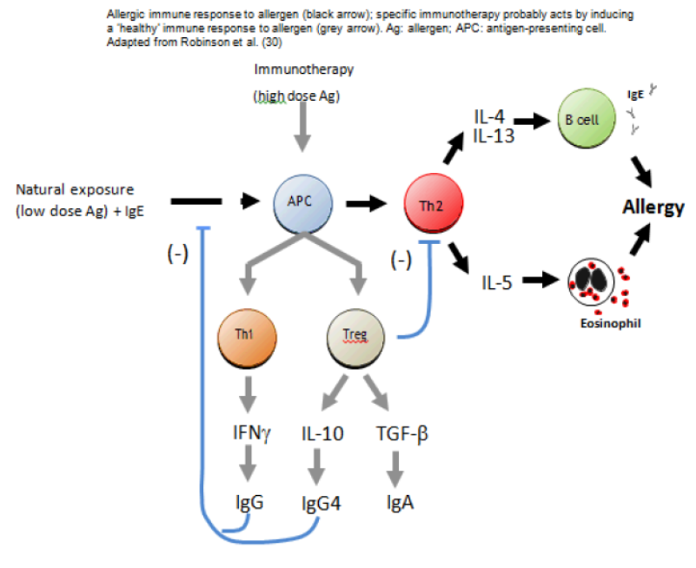
The sponsor claims the available animal models of SLIT only partially replicate the human clinical phenomenon and that none of the currently known modes/mechanisms of action are able to explain all the observed human clinical and immunological effects. However, SLITs for grass pollen allergies are currently used in a variety of veterinary species and the interspecies differences are being progressively explored. Relevant pharmacology and pharmacodynamic studies are technically feasible in various animal models and are potentially important. The sponsor has not fully explored these possibilities in the submitted nonclinical dossier.
Some important general features of the SLIT Mechanisms of actions, which may apply to Grazax, are as follows:
- As an overall generalisation SLIT acts, at least in part, as an immune system modifier by inducing blocking antibodies that competitively inhibit allergen IgE interactions, altering the regulation of IgE and IgG synthesis, inducing a shift from a Th2 to Th1/Treg cell dominated immune/cytokine responses, inhibiting T-cell antigen presentation and T-cell activation, altering mast cell and eosinophil homing, and reducing the number of effector cells (mast cells, eosinophils, basophils, and others) and level of inflammation at reaction sites.
- SLIT reputedly induces switching from a Th2 (that is pro-allergy) to a Th1/Treg dominated immune response. This results in Interleukin 12 (IL-12) and Interferon Gamma (IFNγ) production which, in turn, inhibits Th2 cells and the associated Interleukin 4 (IL-4), Interleukin 5 (IL-5) and Interleukin 13 (IL-13) dependent, pro-allergy pathways. Induction of allergen specific Treg cells (CD4⁺ CD25⁺ forkhead box P3 [Foxp3⁺]) that secrete Interleukin 10 (IL-10) (induces T cell anergy) and Transforming growth factor β (TGF-β) (which inhibits co-activation during Th2-mediated B-lymphocyte activation) also occurs. The net overall effect of these changes is to reduce pro-inflammatory cytokine production and downstream inflammatory responses.
- Allergen specific immunotherapy also induces allergen specific IgG₄ and allergen specific Immunoglobulin A2 (IgA₂). The role of IgG₄ production remains controversial; it has been hypothesised that anti-allergen IgG₄ prevents allergen mast cell sIgE binding and subsequent mast cell activation. Alternatively (or concurrently), the IgG₄ allergen complex engages the B isoform of the low-affinity IgG receptor (FcγRIIB) on mast cells (and basophils) which may act as a deactivation signal. However, the level of allergen specific IgG (total IgG or IgG₄) neither predicts nor correlates with clinical responses. Allergen specific IgG₄ level is still used as a biomarker of immunotherapy responses.
- The oral cavity is reputedly a naturally immunologically tolerogenic environment due to TGF-β and IL-10 production by local monocytes and Langerhans cells. SLIT reputedly takes advantage of this “tolerance biased” environment in order to reduce allergic responsiveness, to avoid new sensitisation and to induce long-lasting remission. This is one of the hypothesised mechanisms for SLIT “rush” (tachyphylaxis like) down regulation of mast cells.
- For long-lasting effects, Treg activation seems to be involved: allergen specific Treg cells reputedly differentiate from naïve T-cells after application of soluble antigens to the oral mucosa and exert a suppressive effect on Th1, Th2 and downstream inflammatory and cytokine responses. Allergen specific Treg cells are also involved in IgG₄ and/or IgA induction and tissue remodeling.
Critically, none of the known mechanisms of actions of SLIT explain all the observable clinical effects and immunological phenomena.
The sponsor’s primary pharmacology/efficacy study in the immunologically primed mouse Phl p allergen extract rhinitis model (dose range: 25,000 SQ-U/animal 1 to3 X/week, 58,000 SQ-U/animal 3 X/week, 175,000 SQ-U/animal 1 X/week; duration of exposure 2 to 9 weeks) demonstrated the following:
- PO Phl p allergen extract treatment (25,000 SQ-U/animal/day for 6 weeks) in previously Phl p allergen extract sensitised (IP route) mice induced significant (p < 0.05) increase in mean serum Phl p allergen extract-specific Ig (maximum of approximately 2 X relative light unit (RLU) ↑ for IgE, approximately 5 X RLU ↑ for IgA, approximately 2 X RLU ↑ for IgG_{2a}, no change for IgG₁ relative to negative control treatment). The response was dominated by antigen-specific serum IgA production.
- Based on serum IgA responses, the optimal dosing regime was 25,000 SQ-U/animal/day, 7days per week (IgA ↑ approximately 5 X RLU compared with negative control treatment). Dosing at least OID for 3 days/week was required to induce a significant (p < 0.05) serum IgA response.
- A post-dosing restraint time (presumed to be approximately oral mucosal contact time) of 40 seconds was not more efficacious than a restraint time of 20 seconds.
- Six weeks of PO dosing at 25,000 SQ-U/animal/d resulted in a 100% incidence of animals with ↑ anti-Phl p5 serum IgA, but only a 60% incidence of animals with ↑ anti-Phl p6 serum IgA. Lower incidences of serum IgA responses occurred to other major allergen antigens (Phl p1, Phl p2/3). The largest increases in serum IgA responses to Phl p major antigens occurred for Phl p5 and Phl p6 (approximately 5 to 6 X RLU ↑) that is the serum antibody response was dominated by IgA responses to Phl p5 and Phl p6.
- In general, bronchoalveolar lavage (BAL) and nasal lavage (NAL) IgA (sIgA) responses (↑ 5 to 130 X RLU following Phl p allergen extract PO dosing [5,000, 25,000, 125,000 SQ-U/d PO for 2, 4 or 6 weeks] compared with control) reflected the serum IgA response. The responses were treatment duration proportional but only partly dose proportional.
- Pooled high allergen specific sIgA BAL fluid from Phl p treated mice reduced the binding of IgE to a biotinylated Phl p extract in vitro, whereas pooled low allergen specific sIgA BAL fluid could not.
- In the mouse rhinitis model, daily Phl p allergen extract PO dosing (125,000 SQ-U/animal/day) for 6 to 9 weeks reduced rhinitis associated clinical signs (≤ approximately 0.5 X ↓post- challenge sneezing compared with control), airway hypersensitivity following methacholine challenge (↓ ≤ approximately 3 X compared with control), NAL fluid eosinophil count (↓ ≤ approximately 3 X compared with control), NAL anti-Phl p IgE and IgG₁ (↓ ≤ approximately 2 X compared with control), splenocyte antigen specific proliferation (↓ ≤ approximately 0.5 X compared with control), cervical lymph node antigen specific proliferation (↓ ≤ approximately 0.3 X) and cervical lymph node cell antigen-specific pro-Th2 cytokine (IL-10, IL-5, IL-4) and IFN-γ production in vitro (effects were dose and treatment duration responsive).
- PO Phl p allergen extract treatment (125,000 SQ-U/animal/day for 9 weeks) was associated with an approx. doubling of Phl p allergen extract-specific serum IgE levels. However, subsequent IP allergen challenge did not result in additional increases in allergen specific IgE. This implies some degree of desensitisation to downstream IgE mediated responses (consistent with SLIT treatment expectations).
The evaluator notes that several primary pharmacokinetic/pharmacodynamics studies have been published in relation to SLIT in animal models. These studies have demonstrated the critical importance of allergen retention in the oral cavity, allergen trafficking in the immune system, the importance of interactions with oral antigen presenting cells and bone marrow-derived dendritic cells etcetera.³⁷ ³⁸ ³⁹ These areas have not been explored in the Grazax nonclinical package.
Overall, the biological pattern associated with Phl p SLIT treatment in the mouse rhinitis model was reduction of clinical signs combined with a shift away from a Th2-dominated immune response. This provides limited, basic “proof of concept” for Phl p SLIT treatment of Timothy grass pollen induced allergic rhinitis in humans.

Secondary pharmacodynamics
No specific studies were supplied. As previously discussed, the very low level of exposure to Phl p allergen extract (both protein and non-protein components) at the clinical dose also implies that undesirable secondary pharmacodynamics effects are most likely to stem from adverse immune system reactions to the Phl p allergen extract protein sub-fraction. The available animal models for some of these effects (for example anaphylaxis and anaphylactoid reactions) are often poorly predictive of human risk. These types of effects are best assessed using human data.

Safety pharmacology
Limited safety pharmacology evaluations were performed as part of the repeat dose toxicology program (limited electrocardiography and blood pressure monitoring in the 52 week dog study). This data, plus the data from the toxicology studies adequately covers the key safety pharmacology systems (that is cardiovascular system, gastrointestinal system). The available data set demonstrated no abnormalities.

Pharmacokinetics
Traditional small molecule pharmacokinetics studies are not feasible or of value for products such as Grazax.
The sponsor provided the following waiving argument for the lack of nonclinical pharmacokinetic studies:
“In accordance with the EMA Guideline on the clinical development of products for specific immunotherapy for the treatment of allergic diseases (CHMP/EWP/18504/2006; November 2008), traditional pharmacokinetic studies are not possible for products of allergy immunotherapy. Due to the nature of the product (proteins which will rapidly catabolised to peptides and amino acids), plasma levels of the active substance are not measurable. The dossier for Grazax thus does not include pharmacokinetic studies. Rather, it contains literature references regarding the sublingual dose form.”
CHMP/EWP/18504/2006; November 2008 (not adopted by TGA) is a human clinical guidance document. The additional text of the section of the document that was partially quoted by the sponsor is as follows:
“However, to show the effect of specific immunotherapy on the immune system immunological changes (for example changes in allergen specific IgG levels, T-cell responses, and/or cytokine production) and/or modifications of the end organ specific response (for example provocation tests) should be measured. These parameters can be followed in other studies on specific immunotherapy.”
The immune system immunological changes and end organ specific responses relevant to CHMP/EWP/18504/2006 have been partially shown in the mouse primary pharmacology study and in the repeat dose toxicology studies.

Toxicity
Critically, all the in vivo toxicology studies were performed in normal healthy animals (that is not deliberately immunologically primed with Phl p allergen extract before test article treatment; likely immunologically naïve at the start of the studies). These studies may not accurately replicate the proposed clinical use of Grazax in previously hypersensitised humans. However, the use of hypersensitised animals in longer duration repeat dose toxicology studies also presents significant technical challenges. These circumstances again support the proposition that some of the safety and immunological properties of Grazax are best assessed using the human clinical data.

Test article composition
Notably, the test articles used in the in vivo toxicology program were made with a different manufacturing process (initial DS process) than the process used to produce the ultimate marketed drug substance and product (optimised frozen droplet DS process). The sponsor has claimed, on the basis of data within dossier modules2.3.S.2.2, 2.3.S.2.3, 3.2.P.2.2 and 3.2.P.2.3 that the two different manufacturing processes resulted in comparable drug products. Liquid (aqueous) dosing solutions were used in the mouse toxicity studies whereas the tablet lyophilisate dose form was used in the canine toxicity studies. Given the compositional issues discussed above (in the introduction), small compositional differences in the Phl p allergen extract dry matter is likely to have negligible safety property ramifications.

Relative exposure to total Phl p allergen extract (on a dry matter basis)
Relative exposures based on AUC were not possible in the absence of pharmacokinetic/toxicokinetic data, thus relative exposures have been estimated on the basis of dose per body surface area. It should be noted that the relative immunological potency of the product in animals compared with humans is unknown. It is also unknown if immunological properties/effects scale between species on the basis of body surface area. Serological analysis showed induction of specific IgG in mice, but responses were variable in dogs.
The animal:human BSA ratios (see Table 3 below) were calculated by the nonclinical evaluator and based on the Phl dry matter (mg/kg/day) dose given to each species, in each study and at each dose level. The calculated ‘dry matter doses’ have not been included in Table 3 as they were considered commercial in confidence material by the sponsor.
Table 3: Relative exposure to Phl p
Study Type  Species  Route | Dose  SQ-U per animal per d PO | Phl p dry matter mg/kg/d†* | Phl p dry matter mg/m²/ d | Human clinical dose/d  SQ-T per d | Human  Phl p dry matter mg/kg/d‡ | Human  Phl p dry matter mg/m²/d | Animal:  Human BSA Ratio
Acute toxicity  Mouse IV and PO | 750,000 |  |  | 75,000 |  |  | approx. 2284
Acute toxicity  Mouse IV and PO | 1,000,000 |  |  | 75,000 |  |  | approx. 3045
Repeat dose toxicity  (all studies including reproduction studies)  Mouse  PO | 25,000 |  |  | 75,000 |  |  | approx. 76
 | 75,000 |  |  | 75,000 |  |  | approx. 228
 | 500,000 |  |  | 75,000 |  |  | approx. 1522
Repeat dose toxicity  (all studies)  Dog  PO | 25,000 |  |  | 75,000 |  |  | approx. 1
Repeat dose toxicity  (all studies)  Dog  PO | 75,000 |  |  | 75,000 |  |  | approx. 3
Repeat dose toxicity  (all studies)  Dog  PO | 500,000 |  |  | 75,000 |  |  | approx. 20
* Mouse body weight = 20g = 20/1000 = 0.02 kg; dog body weight= 10 kg K_{m} mice = 3, K_{m} dog = 20, K_{m} human 50 kg = 33; K_{m} is the factor for converting mg/kg dose to mg/m² dose ‡ Based on a 50 kg person

Acute toxicity
Phl p allergen extract (≤ approximately 2,284 to 3,045 X clinical dose), has a very low propensity for acute intravenous (IV) and PO toxicity. The only test article associated adverse effect was significantly (p < 0.5) reduced mean bodyweight gain (correlated with ↓ food consumption) in females dosed at approximately 3,045 X clinical dose IV. Marginally lower weight gain (correlated with ↓ food consumption) was also present in the males IV dosed with ≥ approximately 2,284 X clinical dose IV. No local gastric toxicity noted. Phl p allergen extract single PO doses up to 3,045 X clinical dose PO were toxicologically innocuous.

Repeat-dose toxicity

Non-immunological endpoints.

Sub-acute PO exposure
Daily PO administration of Phl p allergen extract (liquid dose form) to normal healthy mice at doses ≤ approximately 1,522 X maximum recommended human dose (MRHD) for 4 weeks was toxicologically innocuous. Daily PO administration of Phl p allergen extract (tablet dose form) to non-primed dogs at doses ≤ approximately 20 X clinical dose for 28 days was also toxicologically innocuous.

Studies of longer duration
Repeated daily PO dosing (liquid [aqueous] formulation) of mice at ≤ approximately 1,522 X clinical dose for 15 weeks was not associated with mortality, adverse clinical signs, gross anatomic pathology lesions or immunotoxicity (as evaluated by measuring natural killer cell function and spleen lymphocyte subset populations). Statistically significant (p < 0.05) lower group mean bodyweight gain (approximately 8% reduction compared with controls) was evident in females dosed at 1,522 x clinical dose. After a 4 wk “drug holiday”, an approximately 9% reduction was still apparent in this group and a approximate 12% reduction was still apparent following a subsequent week of recrudescent drug treatment (that is no compensatory growth). Over the dosing + drug holiday phase (EW0-20) mean body weight gain in the approximately 1,522 X clinical dose females was approximately 65% that of the control animals (adverse effect). This was correlated with statistically significant (p < 0.05) reductions in weekly food intake over EW0-20. Feed conversion efficiency in females treated with approximately 1,522 X clinical dose was approximately 80% of that of the negative control animals that is the effects on body weight were, at least in part, due to lower caloric utilisation for growth rather than solely due to reduced feed intake. These findings are suggestive of either an anti-nutritive effect or systemic toxicity. A dose related, partially reversible, reduction in heart weight (by approximately 17%; without anatomic pathology correlates) in animals killed at experimental week 20 (that is after 15 weeks of drug treatment, the 4 week drug holiday and 1 week of recrudescent drug treatment) which reached statistical significance (p < 0.01) in the approximately 1,522 X clinical dose females was present. Given that this effect was not replicated in any of the other repeat dose toxicology studies, the biological relevance of this finding is uncertain (most likely secondary to reduced body weight). Significantly reduced (p < 0.05) spleen weight (by approximately 23%) was also present in the approximately 1,522 X clinical dose females and this was associated with ↓ splenic haematopoiesis. Again the biological relevance of this finding is uncertain and it was most likely associated with reduced growth.
Repeated daily PO Phl p allergen extract dosing (liquid [aqueous] formulation) of male mice with approximately 1,522 x clinical dose for 26 weeks was associated with an approximately 20% reduction (p < 0.05) in body weight. Although not statistically significant (p > 0.05), an approximately 11% reduction in body weight (exceeded MTD parameters) was present in females at this dose level. The effect in males was correlated with effects on feed consumption but not feed conversion efficiency In females, weight loss occurred despite the animals having a significantly (p < 0.05) higher mean food consumption relative to controls (that is anti-nutritive effect and/or reduced caloric utilisation for growth).
Repeated daily PO Phl p allergen extract dosing (lyophilisate + mannitol + fish gelatine tablet dose form; similar to the proposed Grazax clinical product) of dogs with approximately 1 to 20X clinical dose for 52 weeks did not induce human relevant adverse effects. In male dogs receiving approximately 20 X clinical dose, an increased degree and incidence of arteritis/periarteritis was seen in one or more tissues (for example lung, thymus, heart and optic nerve). These effects were due to Beagle pain syndrome (beagle canine idiopathic polyarteritis; not human relevant).

Overall conclusions
Repeated oral daily dosing with Phl p allergen extract in mice and dogs is toxicologically innocuous except at extreme doses in mice (approximately 1,522 X clinical dose). Some overt systemic toxicity, manifesting as reductions in body weight and body weight gain without complete pos -exposure compensatory growth was apparent following PO dosing of mice at approximately 1,522 X clinical dose for ≥ 15 weeks.

Immunological endpoints
Critically, serum and mucosal surface IgA levels (the major primary pharmacological effect and major class of blocking antibodies in the Phl p allergen extract primed mouse rhinitis model) were not determined in any of the toxicity studies. Systematic and detailed evaluations of the effects of repeated PO exposure to Phl p allergen extract on the immune system were not performed; however routine histopathology, basic serology, basic splenocyte phenotyping and basic measures of NK-cell function are available.

Subacute repeat PO exposure
Only 8.3% of normal healthy mice dosed with Phl p allergen extract at approximately 76 to 228 X clinical dose developed Phl p allergen extract specific serum IgG, although a higher rate of response (66.7%) was observed at approximately 5,22 X clinical dose. Overall, most of the Phl p allergen extract treated animals in this study did not seroconvert (based on serum IgG responses), even following high PO doses compared with the proposed clinical dose. Notably, the incidence of normal healthy mice developing an IgG response was much lower compared with Phl p allergen extract primed mice (that is mouse rhinitis model primary pharmacology study), even though substantially higher PO doses were used. No overt hypersensitivities or histological evidence of immunotoxicity were observed in this study.
Following daily PO administration of Phl p allergen extract (lyophilisate + mannitol + fish gelatine tablet dose form; similar to the proposed Grazax clinical product) to normal healthy dogs at doses ≤ approximately 20 X clinical dose for 28 days, detectable serum Phl p allergen extract specific IgG responses (9 out of 10 animals) only occurred at the highest dose level. No overt hypersensitivities or histological evidence of immunotoxicity were observed in this study.

Studies of longer duration
Repeated daily PO dosing of mice with Phl p allergen extract at doses ≤ approximately 1,522 X clinical dose for 15 weeks was not associated with overt immunotoxicity (as evaluated by measuring natural killer cell function and splenocyte T cell subset phenotyping) or hypersensitivity. In contrast with other repeat dose studies, PO Phl p allergen extract dosing reliably induced serum Phl p allergen specific IgG antibodies (approximately 84 to 97% of animals dosed at approximately 76 to 1,522 X clinical dose had a positive response after 15 weeks of treatment; response was not dose related). However, repeated daily PO dosing (Phl p allergen extract lyophilisate + mannitol + fish gelatine tablet dose form; similar to the final Grazax product form) of dogs with approximately 1 to 20 X clinical dose for 52 weeks did not induce serum allergen specific IgG responses. This result illustrates the lack of immunological reliability of the dosing technique in normal healthy dogs. No overt hypersensitivities were observed in this study

Overall conclusions
In terms of efficacy at induction of antigen-specific serum IgG antibody responses to Phl p allergens, PO treatment of normal healthy mice and dogs is relatively inefficient and unreliable compared with the results observed in the Phl p allergen extract primed mouse rhinitis model. As a generalisation, very high PO doses (relative to the clinical dose) and long durations of exposure unreliably resulted in a modest incidence of serum anti-allergen IgG responses in mice. The results in dogs were less predictable.
Critically, as stated above, the predictive relationship between allergen specific serum IgG responses as a biomarker of SLIT efficacy is generally poor.¹⁸ Serum IgG and IgG₄ levels are regarded as being suitable parameters for evaluating the clinical outcome of SLIT treatment by some investigators.⁵³
In normal healthy mice and dogs, repeated daily PO Phl-P allergen extract treatment is not overtly immunotoxic and does not induce overt hypersensitivities, based on basic screening techniques.
Overall, the results demonstrate the general inadequacy of the normal healthy mouse and dog models (that is likely not immunologically primed for assessing the immunological/immunotoxicological safety properties of Phl p allergen extract). These aspects of safety assessment will be largely assessed on the basis of human clinical data.

Genotoxicity
Technically, the submitted genotoxicity package is not compliant with ICH S2 (R1) (lacks an in vivo screening study). The sponsor’s waiving arguments for this are:
- “The Phleum pratense allergen extract has for decades been used by subcutaneous application to induce tolerance induction, without any recognised genotoxic implications however to ascertain that impurities or related substances are without mutagenic properties an Ames’ test was performed. Furthermore, genotoxicity was studied using mouse lymphoma cells.”
- The protein components of the Phl p allergen extract will be degraded and digested in the GI that is the bulk of the drug substance will not be bioavailable.
The evaluator concurs that the protein fraction of the Phl p allergen extract will be largely not systemically bioavailable. However, this does not eliminate any potential local effects in the oral cavity and gastrointestinal tract. The sponsor has supplied two acceptable (validity confirmed by the use of positive and negative controls) negative bacterial reverse mutation studies (treat and plate method) and an acceptable negative mammalian cell forward mutation study all of which utilised Phl p allergen extracts as the test articles. Furthermore, the risk of proteins acting directly DNA interacting mutagens is negligible and there is no in vitro evidence of Phl p allergen extract mediated mutagenicity.
The sponsor’s waiving arguments do not account for the non-protein fraction in Phl p allergen extracts and in Grazax. Notably, the test articles used in the negative in vitro genotoxicity program contained 23 to 26% of the non-protein fraction.This is lower than the maximum level in the drug substance (≤ 40%). In terms of the risk of systemic genotoxicity, the human clinical dose exposure to the Phl p allergen extract non-protein fraction is ≤ approximately 41 µg/day. Given that the non-protein sub-fraction of the Phl p drug substance can essentially be regarded as multiple impurities, it should be noted that the relevant ICH M7 TTC-based acceptable intake (ADI) for multiple DNA reactive genotoxic impurities (that is the unlikely worst case scenario for the non-protein sub-fraction of the Phl p drug substance) over the 3 year maximum Grazax treatment period is 30 µg/day and for individual impurities in the non-protein sub-fraction of the Phl p drug substance it is 10 µg/day. Furthermore, it is entirely possible for the non-protein fraction to have a potential for local site of contact genotoxicity (that is in the sublingual area in the mouth).
An in vivo screening study should have been performed in order to account for any possible effects of the Phl p allergen extract non-protein fraction. Ideally, one of the transgenic mouse assay methods (to allow for assessment of local mutagenesis in the oral mucosa) should have been used.
Overall, since Phl p does not induce reverse mutations in bacteria or forward mutations in mammalian cells in vitro and no in vivo data is available (although such studies are technically feasible and likely more reliable than the in vitro studies that were used).

Carcinogenicity
The proposed duration and pattern of use for Grazax indicates that carcinogenesis studies are required to meet ICH S1A. The sponsor has provided the following waiving arguments (module 2.6) to support this decision (with the evaluator’s responses):
- Sponsor’s waiving argument 1: “Histopathological examination in the repeated dose toxicity studies showed no neoplastic changes at doses up to 500,000 SQ-T/day in mice (approximately 10,000 fold higher than the maximum human therapeutic dose for a 50 kg person) and dogs (approximately 33 fold higher than the maximum human therapeutic dose for a 50 kg person).”
  - Evaluator’s response 1: None of the repeat dose toxicity studies were long enough nor of sufficient statistical power to evaluate carcinogenic effects. The longest study, a 52 week study in dogs, is not equivalent to a near life-time study. The n of 4/sex/dose used in this study is statistically inadequate for evaluation of carcinogenic endpoints (minimum requirement is 50/sex/dose with at least 20/sex/dose surviving a near life-time exposure to the test article). The longest mouse study was 26 weeks. Again, this is not equivalent to a near life-time study. An n of 10/sex/dose is statistically inadequate. Furthermore, the animal models used are not equivalent to the available transgenic models of carcinogenesis where a shorter duration of exposure can be justified.
- Sponsor’s waiving argument 2: “In vitro and in vivo nonclinical genotoxicity data concludes that the relatively low exposure to allergy immunotherapeutic product prepared from the Phleum pratense allergen extract does not pose any genotoxic risk for human patients.”
  - Evaluator’s response 2: There was also no specific in vivo nonclinical genotoxicity data submitted. The sponsor’s argument does not account for non-genotoxic carcinogenic modes of action; particularly at sites of contact with the concentrated material for example the oral mucosa.
- Sponsor’s waiving argument 3: “The absence of any adverse genotoxic or carcinogenic effect(s) is supported by approximately 30 years of clinical experience with products containing Phleum pratense allergen extracts.”
  - Evaluators response 3: The sponsor’s comment relies upon three well-known scientific fallacies: (a) the formal anecdotal fallacy that is anecdotal information is not equivalent to scientific evidence; (b) the formal appeal to probability fallacy that is the appeal that takes something for granted because it might be the case is not equivalent to scientific evidence; and (c) the informal argumentum ad ignorantiam fallacy that is an assumption that a claim is true because it has not been (that is there is no definitive data) or cannot be proven false is not equivalent to scientific evidence. However, on the other hand, there is also no clear and conclusive evidence which demonstrates that Phleum pratense allergen extracts are carcinogenic. The current scientific situation is akin to that of “not even wrong” that is there is insufficient data to reach a definitive scientific conclusion.
- Sponsor’s waiving argument 4: For sublingually administered allergy immunotherapy products, studies have shown that only limited absorption of the allergen through the oral mucosa occurs. Therefore, no systemic absorption of sublingually applied allergen is expected to any significant extent.”
  - Evaluator’s response 4: The sponsor’s waiving argument does not account for potential local effects in the mouth (an important consideration for materials that are held within the mouth for an extended period). Furthermore, epitopes from the drug substance must be transported by dendritic cells and other antigen presenting cells to the regional lymph node in order for the primary pharmacological actions to occur that is exposure to components of the drug substance at sites beyond the oral mucosa. Finally, the sponsor’s waiving argument does not account for the non-protein sub-fraction of the Phl p allergen extract drug substance (which may account for up to 40% of the drug substance), components of which may be absorbed across the gastrointestinal barrier.
- Sponsor’s waiving argument 5: The inherent properties of the product (naturally occurring proteins) makes it very unlikely that any interaction with intra-cellular DNA should occur.
  - Evaluator’s response 5: This sponsor’s argument is likely correct for the protein sub-fraction of the Phl p allergen extract. However, it does not account for the non-protein sub-fraction (which may account for up to 40% of the drug substance). Furthermore, the sponsor’s comment does not account for any potential non-genotoxic carcinogenic mode of action.
- Sponsor’s waiving argument 6: “Although many naturally occurring materials have the potential for genotoxicity and/or carcinogenicity, despite a large proportion of the world's population being exposed to Phleum pratense allergens on a daily basis throughout their lives, there is no recorded evidence of any adverse health conditions related to genotoxic and/or carcinogenic potential.”
  - Evaluator’s response 6: The evaluator could not locate any definitive epidemiological data to support the sponsor’s evaluation. Furthermore gastrointestinal exposure to concentrated Timothy grass pollen is not the norm for the human population and intact Timothy grass pollen is not the same substance as a concentrated solvent-defatted pollen extract. The major route of background exposure to Timothy grass pollen is via inhalation and the major site of deposition of Timothy grass pollen within the respiratory tract is the tracheobronchial region (Timothy grass pollen antigens are predominantly associated with air particulates with a mass median aerodynamic diameter (MMAD) of ≥ 7.2 µm). This is not toxicologically equivalent to sublingual application of Timothy grass pollen extracts, although some laryngopharyngeal/oesophageal exposure to inhaled intact pollen could be expected due to tracheobronchial mucociliary clearance.
Overall, there is no definitive data. The supplied data is insufficient (statistically and experimental design wise) for the assessment of pre-neoplastic and neoplastic lesions in animals. The lack of a carcinogenesis studies represents a limitation of the available data set. The sponsor has claimed that there is no indication of carcinogenic risk in post-market pharmacovigilance data (data not supplied or evaluated).

Reproductive toxicity
The dossier section is non ICH S5 (R2) compliant (lack of a non-rodent embryo-fetal development study). The sponsor has also not performed studies in the ICH S5 (R2) preferred rodent species (rats). The sponsor has provided the following waiving arguments to support this decision (module 2.6) (with the evaluator’s responses):
- Sponsor’s waiving argument 1: “ALK has extensive experience in developing therapeutic goods for commercialisation using the mouse as an appropriate model for reproductive toxicity testing (for example Grastek approved in the EU, Canada and US in 2006, 2013 and 2014 respectively). The use of mice as a single species for nonclinical development has previously, and on multiple occasions, been discussed with and agreed to by the Paul-Ehrlich-Institut (PEI), the German competent authority for allergen products. The most recent discussions with the PEI on the use of mice as a single species for reproductive toxicity took place in 2014.”
  - Evaluator’s response 1: This is not a waiving argument. The statement specifically does not address the issues of a lack of a non-rodent teratology study and the use of mice, rather than the ICH S5 (R2) preferred rodent species (rats).
- Sponsor’s waiving argument 2: “It is widely recognised that the species chosen for nonclinical development should reflect the relevant pharmacodynamic disease model for use of the medicinal product in humans. Bearing in mind the fact that prior nonclinical testing of allergen extracts in other animal species is limited, it is difficult to draw conclusions from data in other species and the data may not be predictive of use in humans.”
  - Evaluator’s response 2: A PubMed search (27-06-2016) demonstrated 6 published studies that utilised the rat as the animal model. Furthermore, SLITs for grass pollen allergies are currently used in a variety of veterinary species and the interspecies differences are being progressively explored.²⁵ ²⁶ ²⁷ ²⁸ ²⁹ ³³ ³⁵. The sponsor’s claims that the mouse is the only available model are not correct. Critically, the results of the only available mouse primary pharmacology study demonstrate substantial differences between this animal model and the sponsor’s claimed effects in humans for example the dosimetric relationships appear to be considerably different; and the major humoral immune response in the mouse model was the development of serum and surface IgA blocking antibodies whereas the sponsor claims that the key blocking antibody class in humans is IgG, specifically IgG₄. The sponsor has already “drawn conclusions from data in other species” whose responses “may not be predictive of use in humans.”
- Sponsor’s waiving argument 3: “Thus, through extensive in-house testing, and in accordance with ICH S6 (R1), ALK has identified mouse as the only established pharmacologically relevant species and the model of choice for testing of sublingual immunotherapy (SLIT).”
  - Evaluators response 3: Allergen extracts are not ICH S6(R1) biotechnology products:
“This document does not cover antibiotics, allergenic extracts, heparin, vitamins, cellular blood components, conventional bacterial or viral vaccines, DNA vaccines, or cellular and gene therapies.” (1.3 [page 1] ICH S6 (R1).
Waiving arguments premised on ICH S6 (R1) are therefore inappropriate. The remainder of the sponsor’s statement is dealt with above (Evaluator’s response 2).
- Sponsor’s waiving argument 4: “Of note, the nonclinical development program for Grazax, including the use of mice as a single test species for reproductive toxicity testing, has previously been discussed with MPA, Sweden. Furthermore, Grazax is currently approved in the European Union, Switzerland, Turkey, Canada and the United States and no questions regarding the use of a single species have been raised.”
  - Evaluator’s response 4: : This is exactly the same argument used in sponsor’s waiving argument 1 (above). Again, the statement specifically does not address the issues of a lack of a non-rodent teratology study and the use of mice, rather than the ICH S5 (R2) preferred rodent species (rats).
In the mouse combined fertility and embryonic development study, there was a clustering of a small number of litters (4/23 litters compared with negative control 1/43 litters) containing a single dead fetus at 1,522 X clinical dose (on a dry matter and BSA basis) without any effect on the mean number of late resorptions per litter. The test article relevance of this is uncertain. There was also an apparent decrease in the 1,522 X clinical dose group in the proportion of fetuses with a skull nasofrontal ossification centre (17% compared with 40% in the control group) and with incomplete hyoid apparatus ossification (30% compared with 18% in the control group). The incidence of nasofrontal ossification centres is well within the normal range (0 to 94% with a mean of 32%) in the 1,522 X clinical dose and negative control groups. The incidence of incomplete hyoid apparatus ossification (30%) in the 1,522 X clinical dose group is approximately 2 X the upper range of the normal historical control incidence for this finding (0 to 15%). Thus, the effect on the hyoid apparatus appears to be a minor test article related developmental variant. In this study all Phl p treated groups showed a slight overall reduction in the general degree of ossification compared with control (sites implicated: cranial centres and sternebrae; all dose levels; 76 to 1,522 X clinical dose). These effects and the effects on the hyoid bone were not secondary to overt maternotoxicity, although the study authors claim that there was a “slight transient impairment of maternal bodyweight gain at the start of treatment at 500,000 SQ-U/day (1,522 X clinical dose), which was not considered to represent an adverse effect.” The evaluator concurs with the study report regarding the lack of maternotoxicity and does not regard the observed non-significant (p > 0.05; difference ≤ approximately 2.6% at all time points from GD0-10 for the 1,522 X clinical dose) reduced mean maternal weight in the high dose group as a plausible explanation for the skeletal findings. The skeletal findings are likely a developmental variation rather than being developmentally adverse. The findings are potentially indicative of developmental delay. These effects were not detected in the in the preliminary study (used a different test article batch) at the same doses. No effects on fertility and pre-postnatal development were noted at exposures ≤ approximately 1,522 X clinical dose.
Notably the available, but limited, histopathology data set from the repeat dose toxicology studies demonstrates a lack of evidence of adverse effects on reproductive organs and tissues and there is no evidence of any hormonal mode of action.
Overall the lack of reproductive data from a second, non-rodent species is a limitation of the available dataset.

Pregnancy classification
The sponsor has proposed Pregnancy Category B2. The evaluator concurs with this category.
It should be noted that antigen preparations for desensitisation are exempt from pregnancy categorisation. However, since the sponsor has requested a pregnancy category, it should be retained in the product information.

Local tolerance
Specific local tolerance studies have not been submitted. Local tolerance following repeated intra-buccal exposure of non-immunologically primed mice and repeated “sublingual” exposure of non-immunologically primed dogs in the toxicology program was acceptable.

Immunotoxicity
The presence of fish gelatines in Grazax is a potential cause of rare, but severe hypersensitivity reactions, including anaphylaxis, in humans. Because of the inadequacy of the available animal models, these issues are largely a human clinical concern.

Impurities
The proposed impurity limits in the Phl p allergen extract drug substance are acceptable.

Paediatric use
Approval for Grazax in children < 5 years of age has not been requested by the sponsor. However, Grazax is intended for use in people ≥ 5 years of age. In the pre-/postnatal development study in mice, in which only the maternal animals were treated, no maternal or offspring adverse effects were noted at doses up to approximately 1,522 X clinical dose. No specific studies in juveniles have been supplied.

Comments on the Nonclinical Safety Specification of the Risk Management Plan
Overall, the RMP should be largely derived from the human clinical data and not the nonclinical program. The exposure margins in the nonclinical sections of the RMP should be updated to reflect BSA comparisons and it should be noted that findings in non-immunologically primed animals may not fully reflect the risk of undesirable effects associated with Grazax use in immunologically primed humans (the proposed human clinical situation associated with Grazax use). The lack of juvenile animal data should be taken into account in the RMP.

Nonclinical summary and conclusions
- The limitations of the submitted data set are: the lack of carcinogenesis studies, the use of only 1 rodent (non-preferred) species in the reproductive toxicology studies, the lack of studies in juvenile animals, the lack of a clear correlation between the measured nonclinical endpoints and human clinical efficacy (no definitive nonclinical biomarker[s] of efficacy), the lack of a clear relationship between the effects induced by doses used in the nonclinical studies and human clinical efficacy (1 SQ-U/SQ-T in humans is not equivalent to 1 SQ-U/SQ-T in animals in terms of claimed primary pharmacological effects), the lack of a clear nonclinical justification of the proposed human clinical dose, the use of normal healthy animals (that is not deliberately immunologically primed) in the toxicology program (proposed clinical use is in patients with existing hypersensitivity to Timothy grass pollen), the lack of studies on allergic conjunctivitis, and the unreliability of current animal models in terms of predicting human immunological safety (anaphylactic and anaphylactoid reactions) risk. Notably, the dose ratios in this evaluation are only rough approximations.
- The complete primary pharmacological mode of action (MOA) of Grazax is unknown. No Grazax-specific MOA studies were supplied. In an observational study using the Phl p allergen extract primed mouse rhinitis model, repeated Phl P allergen extract PO dosing (animals restrained to maximise contact with the oral mucosa for 20 sec; whole dose swallowed) triggered ↑ anti-allergen serum and bronchoalveolar (BAL)/nasal (NAL) surface antibodies (particularly IgA) that inhibited IgE-allergen binding in vitro (treatment duration related effect; only partly dose responsive; approximately 76 X clinical dose for 6 weeks was effective). Consistent with known SLIT modes of action, repeated Phl p allergen extract PO dosing also ↓ clinical signs of rhinitis and ↓ pro-allergy Th2 responses (↓ rhinitis-associated sneezing, ↓ airway hypersensitivity, ↓ eosinophil counts in nasal lavage fluid, ↓ anti-Phl p IgE and IgG, ↓ splenocyte/lymph node cell antigen-specific proliferation , ↓ pro-Th2 cytokine [IL-10, IL-5, IL-4] production ex vivo). Critically, the sponsor has claimed that a major MOA of Grazax treatment in humans is IgG and IgG₄-mediated inhibition of allergen IgE binding (see Figure 1, the human clinical overview and associated text).This is not consistent with the findings in the Phl p allergen extract primed mouse rhinitis model where IgA is the major blocking antibody class. Notably, PO Phl p allergen extract treatment (125,000 SQ-U/animal/d for 9 weeks) in the Phl p allergen extract primed mouse rhinitis model was associated with an approx. doubling of Phl p allergen extract-specific serum IgE levels. However, subsequent IP allergen challenge did not result in additional increases in allergen specific IgE. This implies some degree of desensitisation to downstream IgE mediated responses (consistent with SLIT treatment expectations) despite ↑ serum IgE levels.
- No secondary pharmacodynamics data was supplied.
- Limited safety pharmacology endpoints (ECG, QT_{c}, blood pressure) following supratherapeutic Phl p allergen extract PO dosing were measured in some of the canine nonclinical toxicology studies. No adverse effects were noted at doses ≤ approximately 20 X the clinical dose.
- No Grazax-specific pharmacokinetic data was supplied.
- Phl p allergen extract (at ≤ approximately 2,284 to 3,045 X clinical dose PO and IV), was not acutely toxic (transient effects on body weight and food consumption occurred at doses ≥ approximately 2,284 X clinical dose PO) in normal healthy animals.
- Non-immunological effects in repeat dose toxicology studies using normal healthy animals: High levels of exposure (> 1,000 X for Phl p allergen extract and its protein and non-protein sub-fractions; BSA comparisons) were achieved in the studies. Phl p allergen extract was mostly toxicologically innocuous in mice and dogs even at extreme doses relative to the clinical dose. Mild adverse effects in mice included ↓ body weight, ↓ body weight gain, ↓ food consumption and ↓ feed conversion efficiency in mice (mostly at approximately 1,522 X clinical dose administered for ≥ 15 weeks). This did not occur in dogs. The results of the studies are consistent with the likely digestive breakdown of the Phl p allergen extract protein sub-fraction in the gut. Any undesirable effects of Grazax are most likely to be due to adverse immune system reactions to the Phl p protein sub-fraction. Such effects are best evaluated using human data.
- Immunological and immunotoxicological effects in repeat dose toxicology studies using normal healthy animals. Serological responses in normal, healthy animals (not immunologically primed before Phl p allergen extract treatment) differed from those in the Phl p allergen extract primed mouse rhinitis model. Four weeks of repeated daily PO dosing of mice at approximately 1,522 X clinical dose induced serum anti-Phl p IgG responses in approximately ⅔ of animals (approximately 8% response at approximately 76 to 228 X clinical dose). Sub-acute repeated daily PO dosing of dogs at approximately 20X clinical dose induced Phl p specific serum IgG responses in 90% of animals (0% response at approximately 1 to 3 X clinical dose). Fifteen weeks of repeated daily PO dosing of mice at approximately 1,522 X clinical dose induced serum anti-Phl p IgG in approximately 84 to 97% mice (not dose responsive). However, 52 weeks of repeated daily PO dosing of dogs at ≤ approximately 20 X clinical dose did not induce a serum anti-allergen specific IgG response. Critically, serum and mucosal IgA levels were not measured in the toxicology studies. Specific evaluations of allergen blocking antibodies were either not performed or not reported. Repeated daily supratherapeutic oral exposure for up to 26 weeks in mice and 52 weeks in dogs was not associated with local or systemic hypersensitivity responses. However, the healthy, normal animal models used are unreliable predictors of the human risk of some forms anaphylactic/anaphylactoid/pseudoallergic reactions. Anti-Phl p allergen extract IgE serum/mucosal surface antibody levels were either not evaluated or not reported in the repeat dose toxicology studies.
- There is no in vivo genotoxicity data. Phl p allergen extract (74 to 77% protein; 13 to 16% non-protein) did not induce reverse mutations in bacteria or forward mutations in mammalian cells in vitro.
- No carcinogenesis data was supplied.
- Reproductive and developmental data are only available for one species. PO dosing with Phl p allergen extract at ≤ approximately 1,522 X clinical dose did not adversely affect fertility, embryofetal development and pre-postnatal development in normal healthy mice. There is no direct information regarding lactation (no adverse effects noted in the pre-postnatal study). Grazax is proposed for use in patients’ ≥ 5 years of age. However, no specific studies in juvenile animals (apart from the pre-postnatal study) have been supplied.
- While no specific studies were performed, Phl p had adequate local tolerance in the general toxicity studies in normal healthy mice and dogs.
- Proposed limits of pesticide residues and metals (lead) in the Grazax drug substance are acceptable.
- Grazax contains fish gelatines (13.5 mg per tablet), a cause of rare, but sometimes severe, hypersensitivity reactions and anaphylaxis in fish sensitised humans. The PI contains a relevant warning statement.

Conclusions and recommendation
- Overall, there are no nonclinical objections to the registration of Grazax with the following caveats:
  - The primary pharmacology section of the nonclinical dossier is limited in scope. Relevant primary pharmacology and pharmacodynamic studies are technically feasible in various animal models and are potentially important. The sponsor has not fully explored these possibilities. Issues pertaining to efficacy are likely to be best assessed using human data.
  - There is no clear correlation between nonclinical endpoints, nonclinical doses and human clinical efficacy. There is no clear nonclinical justification of the human clinical dose selection. Critically, there is no specific, reliable and reproducible way of directly measuring the desired treatment effects (that is clinically detectable desensitisation) except by using human clinical data.
  - The major risks associated with human use of the product are most likely to arise from adverse immune-mediated responses to the protein sub-fraction of the Phl p allergen extract used in Grazax. These risks are best assessed using human data.
  - Assessment of safety properties in immunologically hypersensitised human patients will largely depend on human clinical data since all the nonclinical in vivo toxicology was performed in normal, healthy animals (that is not deliberately immunologically primed before Phl p allergen extract treatment).
  - The animal models used are unreliable predictors of the risk of anaphylactic, anaphylactoid and pseudoallergic reactions in humans. These aspects of safety assessment are best assessed on the basis of human clinical data.
  - No specific studies in juveniles have been performed. Safety assessment for this patient subpopulation will be entirely dependent on human clinical data.
  - Safety assessment in relation to the fish gelatine content of Grazax will largely depend on human clinical data.
- Major data limitations are present in the nonclinical dossier that is embryofetal development only examined in one (non-preferred) species, weak justification for not using the ICH preferred species (rats) in the embyrofetal development study, no in vivo genotoxicity studies, no carcinogenicity studies, and no studies in juvenile animals.
The nonclinical evaluator also made recommendations regarding the draft PI and the Risk Management Plan(RMP) but presentation of these is beyond the scope of the AusPAR.

V. Clinical findings
A summary of the clinical findings is presented in this section. Further details of these clinical findings can be found in Attachment 2.

Introduction

Clinical rationale
The prevalence of allergic disease is increasing in most countries in the world and respiratory allergy is estimated to affect up to 50% of the population in some countries with an estimated 500 million sufferers in the world. Allergy to grass pollen is one of the most common inhalant allergies in the western world.
Allergic diseases are chronic conditions which account for a significant proportion of the overall health care costs in the industrialised countries. The expenses comprise both direct expenditures in the health care system and indirect costs associated with loss of productivity and impaired quality of life.
The treatment of allergic diseases is based on allergen avoidance, pharmaco-therapeutic symptom relief and specific immunotherapy:
Allergen avoidance has the purpose of creating a low allergen environment, for example in the subject’s home, but for patients allergic to grass pollen this approach is not feasible
Symptom relief by conventional pharmacotherapy, for example antihistamines and topical and/or systemic steroid preparations, is available depending on the severity of the allergic disease. Despite the more recent introduction of the long acting, non-sedative antihistamines and the ready availability of steroid nasal sprays, such treatment often fails to produce sufficient symptomatic relief in up to 60% of subjects.
Specific immunotherapy with allergen products is the repeated administration of allergens to allergic individuals in order to activate immunomodulatory mechanisms and provide sustained relief of symptoms and need for medications, and improvement in quality of life during subsequent natural allergen exposure.
Seasonal allergic rhinoconjunctivitis to grass pollen may be considered a rather uncomplicated disease but it significantly influences and hampers a person’s daily life and activities during the pollen season. Concomitant asthma is estimated to occur in 20 to 50% of patients with allergic rhinoconjunctivitis (Yawn et al. 1999), and concomitant rhinoconjunctivitis is estimated to occur in more than 80% of asthmatic patients. Thus, allergic rhinitis and allergic asthma is considered different stages of the same allergic disease, consistent with the “one airway, one disease” theory ⁶², of allergy manifesting itself in different target organs (eyes, nose and lungs).
Long term strategies such as preventive measures and immunomodulatory treatment play an important role besides symptomatic treatment based on pharmacotherapy. Specific immunotherapy is the only treatment that affects the basic pathophysiological mechanism of the allergic disease and therefore the only available treatment that potentially has long-term efficacy and disease modifying effect. , In this context, the EU Guideline has defined disease modifying effect of specific immunotherapy in allergic rhinitis/rhinoconjunctivitis as sustained significant and clinically relevant efficacy in post treatment years.
Allergy immunotherapy (AIT) is a treatment option for allergy that is complementary to pharmacotherapy and with a distinct mechanism of action. AIT is performed by repeated sublingual (SLIT) or subcutaneous (SCIT, not the subject of this application) administration of specific allergens to an allergic person in order to gradually induce immunological tolerance towards the allergens. The objective of AIT is thus to treat the underlying allergic disease resulting in clinical effect on all manifestations of the disease. AIT modulates the basic immunologic mechanism of the allergic disease and is the only known treatment option with the potential to provide long term, post-treatment benefits and alter the natural course of allergic disease.
Comment: At the pre-submission meeting the TGA questioned the relevance of this product to Australia given that the product only contains Phleum pratense (Timothy grass) which is mainly found in the highlands of southern (temperate) Australia (parts of Tasmania and Victoria) and is considered a noxious weed.
To address this, the sponsor has provided additional information on Phleum pratense and a letter from Dr [Information redacted], Specialist in Clinical Immunology and Allergy and [information redacted].
The sponsor provides a statement that the Australian Virtual Herbarium (AVH) indicates the presence of Timothy grass in Victoria, NSW, Tasmania, South Australia and Western Australia. The reference to this is a website called AusGrass 2 ("Simon, B.K. and Alfonso, Y. 2011. AusGrass2, http://ausgrass2.myspecies.info/ accessed on 10 February 2016." The date of the reference to the AVH is 2011. When the AVH (AVH 2016. Australia’s Virtual Herbarium, Council of Heads of Australasian Herbaria, < http://avh.chah.org.au> , accessed 10 February 2016) was accessed directly it includes only NSW, ACT and WA as sites of presence.
Dr [Information redacted] provided the following comments:
“Timothy grass (Phleum pratense) is a member of the pooideae family, closely related to ryegrass and other common allergenic grasses known as the temperate grasses. Pooideae is a subfamily of poaceae which also includes subtropical grasses such as Bermuda grass (couch), bahia grass (paspalum) and sorghum. Timothy grass is itself not common or widely distributed in Australia although it does occur in cooler parts such as some parts of Victoria, Tasmania and the ACT. Ryegrass is probably the most widespread and common of the temperate allergic grasses. However it is known that Timothy grass contains almost all the relevant allergenic epitopes contained in ryegrass and other common temperate grasses. Therefore Grazax should be a suitable therapeutic product to treat allergy to Australian temperate grasses…Many sufferers of pollen allergy are sensitised to both temperate and subtropical grass pollens. In northern parts of Australia, it is thought that the primary (initiating) sensitising pollens are subtropical, and in the southern parts, temperate. It is thought that optimal immunotherapy should target the primary sensitising allergen and generally should cover all the major pollens to which the patients is sensitised.
Therefore, it is unlikely that Grazax will be the optimal agent for pollen allergy sufferers in the northern parts of Australia, and in the southern parts where there is sensitisation to both temperate and subtropical grass pollens. However, it is likely to be a suitable agent for those with exclusive or predominant sensitisation to temperate grass pollens in the southern and central parts of Australia which constitute a significant subgroup.”

Guidance
CHMP/EWP/18504/2006 Guideline on the clinical development of products for specific immunotherapy for the treatment of allergic diseases” (EMEA 2008).

Contents of the clinical dossier
This clinical evaluation report presented the data provided in the submission as follows:
- 2 x clinical pharmacology study that provided pharmacodynamic data (GT-16, GT-18). (PD data was also provided in many of the efficacy and safety studies.)
- 2 x dose finding studies (GT-01, GT-02)
- 2 x dose escalation studies (GT-03, GT-04)
- 2 x pivotal efficacy/safety studies in adults (GT-08, GT-14) – considered pivotal based on same primary endpoints and same formulation
- 2 x supporting efficacy studies in adults (GT-07, P05238)
- 1 x pivotal efficacy/safety studies in children (GT-12)
- 1 x supporting efficacy studies in children (P05239)
- 3 x other studies : efficacy/safety studies in adults (GT-10, GT-17, GT-19,)
- 2 x other efficacy/safety studies in children (GT-11 and GT-09)
- 2 x Periodic safety update reports (PSURs)
The submission also included a Clinical Overview, Summary of Clinical Pharmacology, Summary of Clinical Efficacy, Summary of Clinical Safety and literature references.

Paediatric data
The submission included paediatric efficacy and safety data.

Good clinical practice
The clinical study reports state that the studies were conducted in accordance with the Declaration of Helsinki, the ICH guidelines on Good Clinical Practice and the applicable local regulatory requirements. Consent was obtained in writing prior to any trial-related activities.

Pharmacokinetics

Studies providing pharmacokinetic data
In accordance with the EMA Guideline,⁷⁰ traditional pharmacokinetic studies were not done as it is not possible for products of allergy immunotherapy. Due to the nature of the product (proteins which will be rapidly catabolised to peptides and amino acids), plasma levels of the active substance are not measurable.

Evaluator’s conclusions on pharmacokinetics
The drug substance in Grazax is a partly purified allergen extract of grass pollen from Phleum pratense (Timothy) which contains the relevant allergens. The drug substance is a mixture of molecules and the drug substance is standardised with respect to the content of major allergens. The biological activity is controlled by measuring the total allergenic activity and is expressed in the arbitrary Standardised Quality Tablet unit: SQ-T. However, the SQ-U unit is applied in protocols and reports because this unit has been used during development. The change from SQ-U to SQ-T is based on a wish from the applicant to make a differentiation between the subcutaneous treatment products (SQ-U) and the tablets (SQ-T).
The sponsor has not provided any clinical trials investigating the PK of the allergens in line with the EU guideline.

Pharmacodynamics

Studies providing pharmacodynamic data
Summaries of the pharmacodynamic studies were provided. Table 4 shows the studies relating to each pharmacodynamic topic.
Table 4: Pharmacodynamic studies
PD Topic | Subtopic | Study ID | Primary Aim
Primary Pharmacology | Effect on immunological parameters | GT-01 | Dose finding
Primary Pharmacology | Adults | GT-02 | Dose finding
Primary Pharmacology |  | GT-03 | Dose escalation
Primary Pharmacology |  | GT-08 | Efficacy and safety
Primary Pharmacology |  | GT-14 | Efficacy and safety
Primary Pharmacology |  | GT-16 | PD
Primary Pharmacology |  | GT-18 | PD
Primary Pharmacology |  | P05238 | Efficacy and safety
Primary Pharmacology | Children | GT-09 | Safety
Primary Pharmacology |  | GT-11 | Efficacy and safety
Primary Pharmacology |  | GT-12 | Efficacy and safety
Primary Pharmacology |  | P05239 | Efficacy and safety
None of the pharmacodynamic studies had deficiencies that excluded their results from consideration.
For the full evaluation of pharmacodynamics please see Attachment 2.

Evaluator’s conclusions on pharmacodynamics
In the studies that measured immunological parameters changes in allergen specific serum antibodies were observed, although not quite as consistently as the sponsor claims.
IgE-blocking antibodies (IgX) have been suggested a possible marker for clinical efficacy of specific immunotherapy. The median ratio of Phleum pratense specific IgX showed a decrease in the median value of the active treatment group after 4 weeks of treatment. Thus, the treatment led to higher activity of IgE-blocking antibodies.
Overall, a time and dose dependent response was shown for the IgG and IgE antibodies analysed in blood, indicating that the treatment had an effect on the immune system.

Dosage selection for the pivotal studies
Two dose finding and two dose escalation studies were conducted to establish the safety and optimal dose of the allergens for the pivotal studies.
Study GT-01 was a randomised double blind placebo controlled safety trial with an 8 week dose escalation phase, followed by an optional 15 week parallel treatment group phase. Forty-four subjects completed the initial phase of the trial, and 28 subjects completed the parallel treatment group phase. Three different dose groups were included in the parallel treatment group phase (2,500 SQ-T, 25,000 SQ-T, 75,000 SQ-T). Subjects were between 18 and 65 years of age and had seasonal allergic rhinoconjunctivitis with confirmed sensitivity to Phleum pratense. The results indicated that the doses 2,500 SQ-T, 25,000 SQ-T and 75,000 SQ-T were considered safe for further investigation in future clinical trials.
The primary objective of the GT-02 trial was to evaluate the efficacy of specific immunotherapy with 3 doses of Grazax, 2,500, 25,000 and 75,000 SQ-T, compared to placebo, in adult subjects with grass pollen induced allergic rhinoconjunctivitis receiving active rescue medications as needed. The results indicated that the 75,000 SQ-T dose was the only dose demonstrating a clinical effect and statistically significant differences compared to placebo.
Study GT-03 was a randomised, double blind placebo controlled multiple dose, dose escalation Phase I safety trial with a 28 days treatment period in 84 subjects. Eight dose groups received treatment with Grazax (25,000, 75,000, 150,000, 300,000, 500,000, 750,000 or 1,000,000 SQ-T) or placebo, daily for 28 days. Due to an error in the conduct of the trial, no blood samples were taken at the end of the trial and consequently evaluation of treatment induced response was not possible. Blood samples were taken 6 to 12 months after treatment. The long-term effect on the levels of antibodies (Phleum pratense specific IgE, IgE-blocking antibodies, and total IgE) measured one year after a short treatment period (28 days) with different doses of Grazax was evaluated however, no significant long-term treatment effect was observed. A clear dose dependent increase in the overall rate of treatment related adverse events (AEs) and in the incidence of 'gastrointestinal symptoms' (including most oral sensations) was observed. The increase for treatment related AEs as well as 'gastrointestinal symptoms' started at 75,000 SQ-T.
Study GT-04 was a double blind, parallel group, placebo controlled trial to evaluate the safety of Grazax in the dose groups 75,000, 150,000, 300,000 and 500,000 SQ-T in 43 subjects. The incidence of AEs appeared to be dose related but the relation was not pronounced, however the number of AEs reported in the 75,000 SQ-T groups was distinctly lower compared with the higher dose levels.
In children, the tolerability of 75,000 SQ-T was investigated in two Phase I trials (GT-09 and GT-11). No indications of any significant differences between the adult and the paediatric population were observed and this was in agreement with the well-established clinical practice of using the same dosage of immunotherapy in adults and children.
In conclusion, as safety is of utmost importance for a product intended for home treatment, an efficacy size markedly above what has already been seen in the GT-07, GT-08 and GT-12 trials probably is unrealistic for the first year with any immunotherapy treatment; the 75,000 SQ-T dose was recommended. An increased dose could lead to more AEs and thereby potentially compromise the benefit-risk profile. In addition, reduced subject compliance to the treatment due to tolerance problems at the application site could undermine the treatment regimen. In conclusion, the 75,000 SQ-T dose compared to other doses was considered having an optimal benefit-risk profile.

Efficacy

Indication 1 (Adults), Treatment of allergic rhinitis with or without conjunctivitis in adults

Studies providing efficacy data

Pivotal efficacy studies
- Study GT-08
- Study GT-14

Other efficacy studies
- Study GT-07
- Study P05238
- Other studies Study GT-10 and GT-17 which evaluated treatment compliance were summarised (but no detailed evaluation was presented)

Indication 2: Treatment of allergic rhinitis with or without conjunctivitis in children (≥ 5 years)

Studies providing efficacy data

Pivotal efficacy study
- Study GT-12

Other efficacy studies
- Study P05239
For the full detail of the evaluation of the studies please see Attachment 2.

Evaluator’s conclusions on efficacy
In the summary of clinical efficacy the sponsor identified 18 studies conducted with Grazax, of which 17 were included in the submission (Study PO8067 was not included). They identified 7 trials as supporting clinical efficacy; GT-02, GT-07, GT-08, GT-12, GT-14, P05238, and P05239. Of these studies GT-02, GT-07, GT-08, GT-14, P05238 were conducted in adults and GT-12, P05239 are in children. The sponsor does not identify any of the studies as pivotal and appears to give equal weight to all the studies and also makes little distinction between adults and children.
This evaluation has identified the adult studies GT-08 and GT-14 as pivotal studies based on having the same primary outcomes and the same formulation. The studies GT-07 and P05238 are considered supporting trials and GT-02 was primarily a dose finding study and therefore it was included (in this report). In children, Study GT-12 was considered pivotal as it had the same primary outcomes as the adult trials and P05239 was considered a supporting trial.
The trials had many varied outcome parameters and it is noted that most of the studies were conducted prior to the adoption of the EU Guidelines for treatment of allergic conditions but it is reasonable to consider the guidelines in reviewing the data submitted as the studies generally comply to the guidelines and the sponsor makes reference to them at different times in the summaries.
In terms of the primary outcomes of the trials the EU guideline states:
Primary endpoint: The use of rescue medication has an impact on symptom severity. Therefore, the primary endpoint has to reflect both, symptom severity as well as the intake of rescue medication. ……. One approach is to combine both scores by a weighted sum of the symptom and medication score respectively. In such a situation the choice of the weights has to be justified.
All of the trials have done this in some way but it differs in each trial; usually by using the co-primary endpoints of daily symptom score (DSS) and daily medication score (DMS) or a combined endpoint (with no weighting) and then DSS and DMS as secondary endpoints.
The pivotal studies, GT-08 and GT-14 used DSS and DMS as the primary endpointand then GT-08 added new secondary endpoints at each of the 4 subsequent years of the trial so that by the end of Year 5 there were 67 secondary outcomes. The EU guideline makes the point that:
“……..the applicant should provide a definition of a clinically meaningful effect in the primary efficacy endpoint and the basis for choosing this value. A merely statistical significant effect might not be sufficient.” (EU Guideline on Treatment of Allergic Rhinoconjunctivitis)
While this guideline is not intended to apply to specific immunotherapy and refers to the primary endpoint, the point is a good one and there is danger that using so many secondary endpoints raises concern regarding selective selection of the data.
Looking at the primary (or key secondary) outcomes in the efficacy studies, that sponsor claims consistent efficacy but provides very little critical discussion of the results either in the individual study reports or in the summaries. The results of the efficacy studies for the entire GPS are as shown in Table 5.
Table 5: Summary results of the efficacy studies for the entire GPS
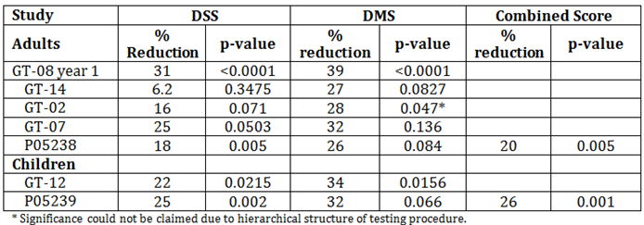
When viewing the results in this way the studies do not show a consistent benefit as claimed by the sponsor. For adults only 2 of 5 studies show statistically significant benefit for rhinoconjunctivitis symptoms and only 1 of 5 show statistically significant benefit for DMS.
The sponsor argues that the reasons the primary analysis in studies GT-02 and GT-14 did not show a statistically significant difference compared to placebo was due, in Study GT-02, to the fact that not all subjects were able to comply with the 8 week pre-seasonal treatment period and in Study GT-14 to the subjects’ pre-seasonal symptom score, overlapping pollen seasons/allergies and/or geographical regions/pollen areas. These may be valid reasons for these studies but also reflect the real world use of the product.
The question is then how much efficacy is required to register the product? Normally efficacy in 2 independent trials or 1 study with significant and clinically relevant results are considered sufficient for acceptance of a product’s efficacy. Grazax meets these criteria and therefore is recommended for approval for the indication of treatment of allergic rhinitis with or without conjunctivitis.
The sponsor is also seeking an indication of disease modifying. It is noted that this was granted in the EU but not in the USA. The EU guideline does not provide much guidance as what evidence is required for a disease modifying claim, the only guidance is that for long-term efficacy and disease modifying effect a “sustained significant and clinically relevant efficacy in post treatment years” is required (EU guideline on Treatment of allergic diseases).
Only 1 study investigated the long term effect of Grazax, so the disease modifying claim rests with Study GT-08 that treated patients for 3 years and then followed them for 2 years. A sustained significant and clinically relevant effect was seen for the first year but not the second (the rhinoconjunctivitis medication score was not statistically significant). The sponsor argues that the second year (2009) GPS was significantly milder than the previous seasons and due to the confirmed influence of grass pollen exposure on the symptom and medication scores, this was inevitably influencing the size of the efficacy measurements. However, whatever the reason, the sustained benefit was not present in the second year of follow up. This aspect, together with the variability seen in the other trials, are not sufficient enough for a claim of disease modifying.
It is noted that the wording of the requested indication is for “grass pollen” allergy without specifying Phleum pratense. This should be included in the indication to reflect the studies submitted.
It is recommended that the product be approved but for the amended indication:
Grazax is indicated for treatment of Timothy grass (Phleum pratense) pollen allergic rhinitis with or without conjunctivitis in adults, adolescents and children (above the age of 5) with clinically relevant symptoms, confirmed by a positive cutaneous test and/or a positive titre of the specific IgE to Phleum pratense.

Safety

Studies providing safety data
The following studies provided evaluable safety data:
Pivotal efficacy studies; GT-08, GT-14 and GT-12
In the pivotal efficacy studies, the following safety data were collected:
- General AEs were assessed by recording all AEs reported by the subjects and also which were not spontaneously reported by the subject, but were elicited by asking a non-leading question such as “How are you feeling?”
- AEs of particular interest were not identified Laboratory tests, including routine haematology, blood chemistry and urinalysis were performed at baseline and at end of treatment (approximately 1 week after end of GPS) and any unscheduled visits
- Vital signs (blood pressure and heart rate) and physical examination including the standard questioning and tests (general appearance, head (oral inspection, ears, eyes, nose and throat), respiratory [auscultation/stethoscopy examination of the lungs], heart [auscultation/stethoscopy of the heart], lymph nodes and skin) was performed at baseline and at end of treatment (approximately 1 week after end of GPS) and any unscheduled visits
- FEV1 was performed at baseline and at end of treatment (approximately 1 week after end of GPS) and any unscheduled visits

Patient exposure
Table 6: Patient exposure by dose
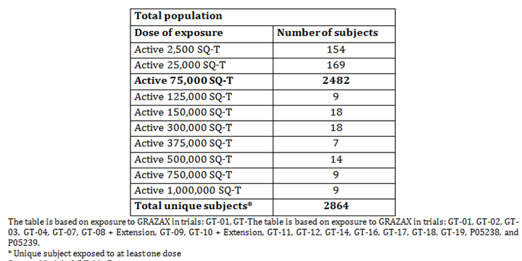
Table 7: Extent of exposure to Grazax by duration
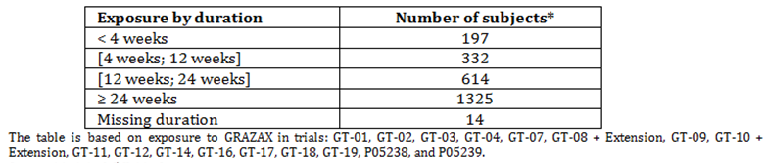
Table 8: Exposure to 75,000 SQ-T by age group and gender
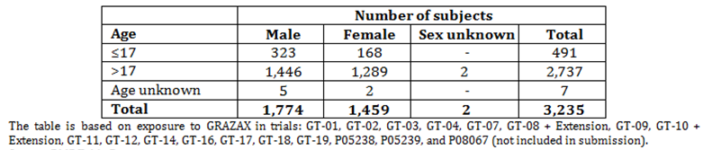
Table 9: Exposure to 75,000 SQ-T by ethnic or racial origin
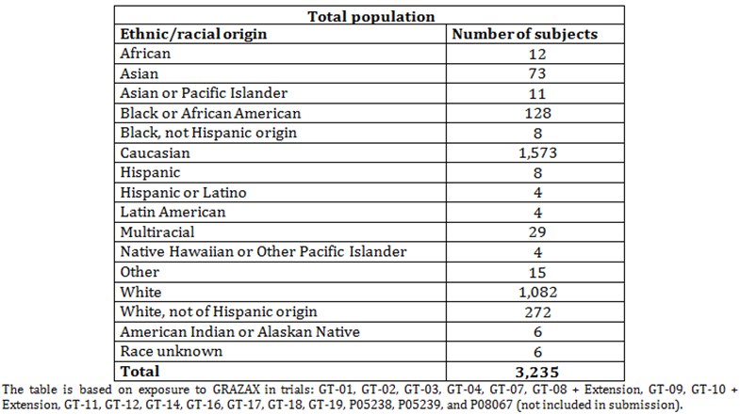

Safety issues with the potential for major regulatory impact

Systemic allergic reactions
Systemic allergic reactions are well known in relation to immunotherapy. Systemic reaction may occur in 2 forms; non life threatening systemic allergic reaction (also called anaphylactic reactions) and the more severe condition anaphylactic shock. The definition of the 2 types of systemic reactions is different in various publications and guideline documents. Experience with sublingual immunotherapy has suggested a more favourable safety profile compared to subcutaneous immunotherapy. Sublingual immunotherapy is characterised by frequent but mild local reactions (located in the mouth and throat), and rare systemic reactions.
Delayed systemic reactions (most frequently urticaria and mild asthma and/or rhinoconjunctivitis) may develop after several hours or within the first day or 2 have also been reported during the use of sublingual immunotherapy, but they are not common and some of these delayed reactions may be symptoms of a subject’s underlying allergic disorder.
In the clinical trials with Grazax, systemic allergic reactions as such were not reported; however some symptoms consistent with systemic reactions were reported.
One case of urticaria led to withdrawal in Study GT-02 and would usually be considered a significant systemic reaction. However, the number of subjects reporting urticaria during the trial was similar between treatment groups including placebo. The same pattern was observed in Study GT-08 (1st year), where similar numbers of subjects (approximately 1%) with urticaria were observed between treatment groups. None of the events led to withdrawal. In Study GT-10 approximately 1% of subjects reported urticaria. Only 1 of these events (mild localised urticaria in mouth) led to withdrawal.
During the GT-14 trial in the US, 3 non serious significant AEs occurred (all in the Grazax group, all assessed as related to treatment) which were treated with adrenaline although none of the events included signs of hypotension. All subjects recovered from the events.
One subject experienced a moderate (investigator’s assessment) systemic allergic reaction about 5 minutes after first intake (swelling of lips, itchy mouth, tongue and throat and dysphagia, but no abnormalities in the oral examination). Ten minutes after first symptom onset the subject was treated with 0.2 ml adrenaline SC. and 10 mg cetirizine PO.
One subject experienced itchy throat, itchy mouth, dry cough and one hive on left side of lower lip immediately after first intake. Furthermore, uvula was reported as being red. 20 mg of loratadine and 0.3 mg adrenaline intramuscular (IM) was administered.
One subject experienced a systemic allergic reaction 6 minutes after first intake, described as mild by investigator. Symptoms included itching under the tongue, throat, ears and nose, sneezing, rhinorrhoea, throat irritation. The subject was treated with 0.3 mg adrenaline SC and 20 mg loratadine PO. The next day the subject experienced another episode of anaphylactic reaction. No treatment was instigated due to the second event and the subject continued in the trial.
During Study P05238 2 subjects were treated with 0.3 mg adrenaline. One of the administrations was due to an adverse reaction to the investigational medical product (IMP) (dysphagia, uvular oedema and pharyngeal oedema) that occurred following the first administration of the tablet under the care of the investigator (Grazax group). The event was categorised as mild in severity by the investigator. The other administration was given inappropriately for an anxiety event unrelated to IMP (placebo group).
During Study P05239, 3 subjects received adrenaline at Day 1, Day 23, and Day 137. On Day 1 the administrations was given in response to an adverse reaction to the IMP (Grazax group). The subject developed lip angioedema, slight dysphagia due to the sensation of a lump in the throat, and intermittent cough within minutes following the first IMP administration. The symptoms resolved within minutes after adrenaline administration (0.3 mg IM). The investigator graded this event as moderate in severity. The other administration (0.3 mg IM) was received for viral pharyngitis in an emergency department on Day 23, where adrenaline administration was not indicated (or medically appropriate) (Grazax group). The third adrenaline administration (0.15 mg IM) on Day 137 was in response to wheezing and suprasternal notch chest retraction (placebo group). The investigator graded the event as moderate in severity and unrelated to IMP.
Eight of 43 subjects (19%) in Study GT-04 reported a total of 16 treatment related AEs that could indicate changes in asthma symptoms and in Study GT-07, 26 of 114 subjects (23%) reported a total of 36 AEs related to asthma. All subjects included in the 2 trials suffered from mild to moderate grass pollen induced asthma andthere were no obvious differences between treatment groups in numbers or frequency of AEs and no indications of asthma aggravation in actively treated subjects compared to placebo.

Post marketing data
Grazax was first approved on 14 March 2006 in Sweden. Subsequently, approval was granted for the 32 countries including most of Europe and the USA. The manufacturer (ALK) has withdrawn the marketing authorisation in 8 countries: Bulgaria, Cyprus, Estonia, Hungary, Latvia, Lithuania, Malta and Romania due to commercial reasons.
The cumulative patient exposure from post-marketing to 24 June 2015 is estimated to be 211,119 treatment years. The sponsor has submitted 13 PSURs in Europe but only 2 were included in the submission in Australia (covering time frame 25 June 2014 to June 2015).
The sponsor states that overall, the experience gained from post-marketing use of Grazax is in general similar to what has been identified in completed clinical trials and/or what is expected for sublingual immunotherapy. The following adverse drug reactions have been added to the current EU approved summary of product characteristics (SmPC) from spontaneous reports post-marketing:
- 19 January 2009: Events of 'Palpitations' and 'Hypotension' added based on reports received post marketing
- 25 June 2015: Events of 'Eosinophilic oesophagitis' added based on reports received post marketing
- 30 July 2015: 'Systemic allergic reactions' changed to 'Anaphylactic reactions' based on a single case of anaphylactic shock reported post marketing.
No safety issues have been identified post-marketing which is considered to impact the overall benefit-risk profile of Grazax.

Evaluator’s conclusions on safety
The total number of subjects exposed to Grazax in the clinical development program was 2,482. Overall, 72% of subjects receiving Grazax reported treatment related AEs. These AEs were primarily reported during the first 3 months of treatment (56% reported AEs within the first 3 months of treatment).
Oral pruritus was the most frequently reported related AE, experienced by 30% of the subjects treated with Grazax. Throat irritation, mouth oedema and ear pruritus were also frequently reported (by 8 to 16% of the subjects treated with Grazax). These side effects may be sufficiently bothersome to lead to discontinuation of therapy.
In Study GT-19 which used antihistamines in addition to Grazax there was no statistically significant difference in the number of subjects reporting local allergic reactions when treated with antihistamine or placebo antihistamine.
Systemic allergic reactions were uncommon but did occur during the studies. No anaphylactic shock was reported in any of the clinical studies but has been reported as a spontaneous post marketing event.

First Round Benefit-Risk Assessment

First round assessment of benefits
The benefits of Grazax in the proposed usage are:
- Effectiveness in relieving symptoms of rhinoconjunctivitis symptoms and to lesser extent use of rescue medication was shown in 2 studies in adults and 2 studies in children with clinically relevant symptoms and diagnosed with a positive skin prick test and specific IgE test to Timothy grass pollen.
- In most of the studies where immunological endpoints were included, the immunological changes of Grazax immunotherapy have been consistent and statistically significant although the exact clinical significance of the findings remains to be elucidated.

First round assessment of risks
The risks of Grazax in the proposed usage are:
- Anaphylactic reactions including anaphylactic shock have been observed with Grazax during post-marketing surveillance. The risk of systemic allergic reactions with Grazax is small and most likely to occur at the first does and may be manageable with appropriate supervision of the initial doing.
- Local allergic reactions of varying severity are common particularly oral pruritus, throat irritation, mouth oedema and ear pruritus.
- Acute asthma may occur.
- Use in children below 5 years of age and in elderly above 65 years of age as well as use in pregnant and lactating women was excluded from the trials and so is unknown. Use in children < 5 is not requested and is unlikely but efficacy and safety in the elderly is unknown.

First round assessment of benefit-risk balance
The benefit-risk balance of Grazax, given the proposed usage, is favourable.

First Round Recommendation Regarding Authorisation
Based on the clinical data submitted it is recommended that Grazax be approved for the following indication:
Grazax is indicated for treatment of Timothy grass (Phleum pratense) pollen allergic rhinitis with our without conjunctivitis in adults, adolescents and children (above the age of 5) with clinically relevant symptoms, confirmed by a positive cutaneous test and/or a positive titre of the specific IgE to Phleum pratense.

VI. Pharmacovigilance findings

Risk management plan
Seqirus Pty Ltd has submitted EU-RMP version 8 (10 March 2015; DLP 24 June 2013) and Australian Specific Annex (ASA) version 1 (10 November 2015) in support of this application. The sponsor submitted ASA version 2 (23 August 2016) with the response to issues raised in the first round evaluation.

Safety Concerns and Risk Minimisation
The proposed summary of safety concerns and their associated risk monitoring and mitigation strategies are summarised in Table 10.
Table 10: Summary of safety concerns and risk minimisation activities
Summary of safety concerns |  | Pharmacovigilance |  | Risk Minimisation
 |  | Routine | Additional | Routine | Additional
Important identified risks | Anaphylactic reaction including anaphylactic shock |  | – |  | –
Important identified risks | Progression of oral reaction into the throat |  | – |  | –
Important identified risks | Acute asthma |  | – |  | –
Important potential risks | None identified
Missing information | Use in children below 5 years of age |  | – |  | –
Missing information | Use in elderly above 65 years of age |  | – |  | –
Missing information | Use in pregnant and lactating women |  | – |  | –
Missing information | Inflammatory condition in the oral cavity# |  | – |  | –
Missing information | Forced expiratory volume in 1 second (FEV1) < 70% of predicted value (adults)# |  | – |  | –
Missing information | Severe asthma (children)# |  | – |  | –
Missing information | Malignancy or systemic diseases affecting the immune system (for example autoimmune diseases, immune complex diseases or immune deficiency diseases)# |  | – |  | –
Missing information | Children with symptoms of, or treatment for, upper respiratory tract infection, acute sinusitis, acute otitis media or other relevant infectious process at randomisation have been excluded from clinical trials as inter-current infections are a concern at initiation of treatment before the patient has developed tolerance.# |  | – |  | –
Missing information | Simultaneous immunotherapy with other allergens# |  | – |  | –
# indicates safety concerns that were recommended for inclusion by the RMP evaluator, and which the sponsor has committed to including at the next revision of the EU-RMP and ASA. Adequate risk minimisation statements are included in the current version of the PI.

New and outstanding recommendations - Round 2
The sponsor has adequately addressed the recommendations made in the first round RMP evaluation. The sponsor has committed to update the Summary of Safety Concerns in accordance with the recommendations of the RMP evaluator. Specifically, it is noted that the sponsor has committed to add the following safety concerns as missing information:
- inflammatory condition in the oral cavity
- Forced expiratory volume in 1 second (FEV1) < 70% of predicted value (adults)
- severe asthma (children)
- Malignancy or systemic diseases affecting the immune system (for example autoimmune diseases, immune complex diseases or immune deficiency diseases)
- Children with symptoms of, or treatment for, upper respiratory tract infection, acute sinusitis, acute otitis media or other relevant infectious process at randomisation have been excluded from clinical trials as inter-current infections are a concern at initiation of treatment before the patient has developed tolerance.
- simultaneous immunotherapy with other allergens
The revised EU-RMP and ASA should also document the pharmacovigilance and risk minimisation activities for these items of missing information, noting that the current version of the PI includes adequate risk minimisation measures.
The PI and the CMI have been revised incorporating recommendations made by the RMP evaluator and the ASA has been updated with the corresponding PI changes. However, the RMP evaluator notes that there are outstanding recommendations including changes to the PI and CMI that were raised in the first round clinical evaluation report.

Wording for conditions of registration
Any changes to which the sponsor has agreed should be included in a revised RMP and ASA. However, irrespective of whether or not they are included in the currently available version of the RMP document, the agreed changes become part of the risk management system.
The suggested wording is: Implement EU-RMP (version 8; 10 March 2015; DLP 24 June 2013) with Australian Specific Annex (version 2; date 23 August 2016), submitted with application PM-2015-03979-1-2, and any future updates as a condition of registration.

VII. Overall conclusion and risk/benefit assessment
The submission was summarised in the following Delegate’s overview and recommendations:

Background
This submission seeks the registration of a new biological substance, Grazax. Grazax is an allergen extract of grass pollen from Timothy grass (Phleum pratense). The proposed indications are:
Grazax is indicated for treatment and disease-modification of diagnosed grass pollen allergic rhinitis with or without conjunctivitis. Grazax is approved for use in persons aged 5 years or older.
The submission proposes registration of the following dosage form and strength:
Allergenic extract of standardised grass pollen extract, Timothy grass (Phleum pratense) 75,000 SQ-T in pack sizes of 10, 30, 90 and 100 tablets.
The proposed Dosage and Administration in the Product Information (PI):
Treatment with Grazax should be initiated by a clinician with experience in treatment of allergies. Patients should have a confirmed clinical history and a positive test of grass pollen sensitisation (skin prick test and/or specific IgE) prior to treatment.
The recommended dose is one oral lyophilisate (75,000 SQ-T) daily.
It is recommended that the first oral lyophilisate is taken under medical supervision and that the patient is monitored for half an hour, to enable discussion and possible treatment of any immediate side effects.
The oral lyophilisate should be taken with dry fingers from the blister unit immediately after opening the blister and placed under the tongue, where it will disperse. Swallowing should be avoided for approximately 1 minute. Food and beverage should not be consumed for the following 5 minutes.
For seasonal treatment, treatment should be initiated at least 16 weeks before the GPS and continue daily until the end of the GPS. If treatment is initiated 2-3 months before the GPS some efficacy may also be obtained.
For sustained effect and disease modification treatment should be continued daily for 3 consecutive years. See also clinical trials.
Efficacy data is available for 3 years of treatment and 2 years of follow-up in adults (see clinical trials). If no improvement is observed during the first year of treatment with Grazax there is no indication for continuing treatment.
Grazax is not recommended for use in patients below 5 years of age due to insufficient data on safety and efficacy in this population (see precautions).

Quality
There are no objections on quality grounds to the approval of Grazax [(standardised allergen extract from Timothy grass, (Phleum pratense)], sublingual immunotherapy tablet, 75,000 SQ-T.
Proposed conditions of registration
- Condition(s) of Registration resulting from primary evaluation:
It is requested that the approval letter contain an S14 exemption from TGO 69 for the blister pack as follows:
Exemptions from compliance with the Therapeutic Goods Order No. 69 (TGO 69) clauses 3(2)(b) “the name(s) of all active ingredients in the goods” and 3(13)(a).
The reason for this is as follows:
- The proposed EU blister foil for the 75,000 SQ-T tablet does not:
  - Include the name of the active ingredient (Phleum pratense)
  - Include the Seqirus name or trademark.
- Batch release testing and compliance with certified product details.

Nonclinical
There is no nonclinical objection to the registration of Grazax with the following caveats:
- The primary pharmacology section of the nonclinical dossier is limited in scope. Relevant primary pharmacology and pharmacodynamic studies are technically feasible in various animal models and are potentially important. The sponsor has not fully explored these possibilities. Issues pertaining to efficacy are likely to be best assessed using human data.
- There is no clear correlation between nonclinical endpoints, nonclinical doses and human clinical efficacy. There is no clear nonclinical justification of the human clinical dose selection. Critically, there is no specific, reliable and reproducible way of directly measuring the desired treatment effects (that is clinically detectable desensitisation) except by using human clinical data.
- The major risks associated with human use of the product are most likely to arise from adverse immune mediated responses to the protein sub-fraction of the Phl p allergen extract used in Grazax. These risks are best assessed using human data.
- Assessment of safety properties in immunologically hypersensitised human patients will largely depend on human clinical data since all the nonclinical in vivo toxicology was performed in normal, healthy animals.
- The animal models used are unreliable predictors of the risk of anaphylactic, anaphylactoid and pseudoallergic reactions in humans. These aspects of safety assessment are best assessed on the basis of human clinical data.
- No specific studies in juveniles have been performed. Safety assessment for this patient subpopulation will be entirely dependent on human clinical data.
- Safety assessment in relation to the fish gelatine content of Grazax will largely depend on human clinical data.
- Major data limitations are present in the nonclinical dossier that is embryofetal development only examined in one (non-preferred) species, weak justification for not using the ICH preferred species (rats) in the embryofetal development study, no in vivo genotoxicity studies, no carcinogenicity studies, and no studies in juvenile animals.
- The nonclinical evaluator also made recommendations with regard to the draft Product Information but these are beyond the scope of the AusPAR.

Clinical
The clinical dossier included the following clinical studies:
- 2 clinical pharmacology studies that provided pharmacodynamic (PD) data (GT-16, GT-18). (PD data was also provided in many of the efficacy and safety studies)
- 2 dose finding studies (GT-01, GT-02)
- 2 dose escalation studies (GT-03, GT-04)
- 2 pivotal efficacy/safety studies in adults (GT-08, GT-14) – considered pivotal based on same primary endpoints and same formulation
- 2 supporting efficacy studies in adults (GT-07, P05238)
- 1 pivotal efficacy/safety studies in children (GT-12)
- 1 supporting efficacy studies in children (P05239)
- 3 other studies : efficacy/safety studies in adults (GT-10, GT-17, GT-19)
- 2 other efficacy/safety studies in children (GT-11 and GT-09)
- 2 PSURs

Pharmacokinetic (PK) data
In accordance with the EMA Guideline,⁷⁰ traditional PK studies were not done as it is not possible for products of allergy immunotherapy. Due to the nature of the product, plasma levels of the active substance are not measurable. The submitted PK information is derived from literature references.

Pharmacodynamics (PD) data
The sponsor makes the statement that “the immunological effect of specific immunotherapy is equivalent to a PD effect”. In the studies that measured immunological parameters, changes in allergen specific serum antibodies were observed. Overall, a time and dose dependent response was shown for the IgG and IgE antibodies, this may indicate that the treatment had an effect on the immune system.

Dose finding studies
A number of dose finding studies (Study GT-01, GT-02, GT-03, and GT-04) were conducted to explore the safety and optimal dose of the allergens for the pivotal studies. These studies were discussed in the clinical evaluation report (see Attachment 2). The dose of 75,000 SQ-T was considered having an optimal benefit-risk profile.

Clinical efficacy
The clinical evaluator has identified the adult studies GT-08 and GT-14 as pivotal studies. The studies GT-07 and P05238 are considered supporting trials and GT-02 was primarily a dose finding study. In children, Study GT-12 was considered pivotal as it had the same primary outcomes as the adult trials and P05239 was considered a supporting trial.

Study GT-08 (adults)
This was a randomised, parallel group, double blind, placebo controlled studied conducted in Europe. The primary objectives were to evaluate the efficacy of the 75,000 SQ-T Grazax (ALK grass tablet) compared to placebo in subjects with grass pollen induced rhinoconjunctivitis, based on the rhinoconjunctivitis symptom score as well as the rhinoconjunctivitis medication score during the GPS 2005 (Year 1) and in subsequent years 2006 to 2009 (extension study).
The trial was initiated in the autumn 2004 and subjects received Grazax or placebo 4 to 8 months prior to the GPS and during the season in 2005. At the end of the initial study the participants were offered continued treatment for an additional 2 years (2006 and 2007) with an additional 2 years of follow up ( 2008 and 2009).
Figure 2: Study GT-08: Overall trial design
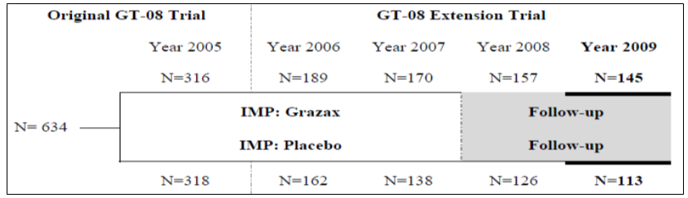
The study enrolled healthy subjects (18 to 65 years) with a history of grass pollen induced allergic rhinoconjunctivitis of 2 years or more requiring treatment; a history of severe rhinoconjunctivitis symptoms, which remain troublesome despite treatment with anti-allergic drugs; a positive skin prick test (SPT) response to Phleum pratense and positive specific IgE against Phleum pratense and FEV1 ≥ 70% of predicted value. See the clinical evaluation report (Attachment 2) for exclusion criteria.
During the treatment Year 2005 the subjects were randomised to double blind Grazax or placebo once daily. The tablet was placed under the tongue and swallowing to be avoided for 1 minute. First dose was taken at the clinic and the subject stayed at the clinic for 60 minutes for observation. Following doses were taken at home. Treatment was for total of 3 years.
Rescue medication for rhinoconjunctivitis was provided in the following steps:
- Step 1: Desloratadine 5 mg tablets. Dosing: 1 tablet daily as needed (prn).
- Step 2: Budesonide nasal spray 32 µg micronised budesonide per actuation. Dosing: Up to 2 actuations per nostril twice daily, prn.
- Step 3: Prednisone 5 mg tablets. Dosing: Up to 50 mg daily for 3 days.
The co-primary efficacy endpoints were the average rhinoconjunctivitis DSS and the average rhinoconjunctivitis DMS. Other efficacy outcomes include rhinoconjunctivitis symptoms scored on Visual Analogy Scale (VAS), Number of well days, global evaluation of rhinoconjunctivitis symptoms, immunological markers, Quality of Life Assessments; determined using the Juniper’s Rhinoconjunctivitis Quality of Life (RQLQ). See clinical evaluation report (CER) (Attachment 2) for definition of Full Analysis Set (FAS) and Per-Protocol Set (PP). Summary of subject disposition in Year 1 are presented in the CER. The trial population comprised slightly more males (59%) than females (41%). The subjects had moderate (44%) or severe (56%) allergy to grass pollen and had a mean duration of grass pollen allergy of 16 years.

Results for Year 1 (2005)
The analysis of average rhinoconjunctivitis DSS showed that Grazax provided a reduction of the symptoms of 31% when compared to placebo (p < 0.0001). The analysis of DMS showed that Grazax reduced the use of rescue medication by 39% when compared to placebo (p < 0.0001).
Table 11: Study GT-08. Analysis of average symptom and medication score during the pollen season (FAS)
Treatment Group | Adjusted Mean  75,000 SQ-T | Adjusted Mean Placebo | Difference Adjusted Mean (%) | 95% CL Diff. Adjusted Mean | p value
Rhinoconjunctivitis Symptom Score:
Number of Subjects | 282 | 286
Treatment Effect | 2.85 | 4.14 | -1.29(-31%) | [-1.68 ; -0.90] | < 0.0001
Rhinoconjunctivitis Medication Score:
Number of Subjects | 282 | 286
Treatment Effect | 1.65 | 2.68 | -1.03(-39%) | [-1.44 ; -0.63] | < 0.0001
CL = confidence limits % = Percent reduction in the 75,000 SQ-T group compared to placebo.
Table 12: Study GT-08. Summary of primary and secondary outcomes; Year 1
Endpoint (FAS) | 75,000 SQ-T  (mean) | Placebo  (mean) | p value | Reduction*
Rhinoconjunctivitis symptom score | 2.85 | 4.14 | < 0.0001 | 31%
Rhinoconjunctivitis symptom score (peak pollen season) | 3.81 | 5.27 | < 0.0001 | 28%
Rhinoconjunctivitis medication score | 1.65 | 2.68 | < 0.0001 | 39%
Rhinoconjunctivitis medication score (peak pollen season) | 2.12 | 3.46 | < 0.0001 | 39%
Percentage well days | 45% | 33% | < 0.0001 | 38%
Percentage well days (peak pollen season) | 33% | 22% | < 0.0001 | 46%
Rhinoconjunctivitis symptom VAS score | 15 | 21 | < 0.0001 | 31%
Rhinoconjunctivitis symptom VAS score (peak pollen season) | 19 | 28 | < 0.0001 | 31%
RQLQ score (that is rhinoconjunctivitis quality of life) | 1.03 | 1.40 | < 0.0001 | 26%
Global evaluation of rhinoconjunctivitis symptoms | 7.09 | 8.95 | < 0.0001 | 21%
Global improvement of rhinoconjunctivitis symptoms | 0.82 | 0.55 | < 0.0001 | 49%
Excellent rhinoconjunctivitis control | 0.401 | 0.241 | < 0.0001 | 66%
FAS=full analysis set, VAS=visual analogue scale, RQLQ=rhinoconjunctivitis quality of life questionnaire; *Reduction = (Active –Placebo) ÷ Placebo x 100

Results for Treatment Year 2 (2006)
The trial was amended to extend the treatment to 3 years with 2 years of follow-up to assess long-term and sustained efficacy and safety of Grazax.
All individual nose and eye symptoms showed statistically significant improvements in the Grazax group relative to placebo of 32%-51% (all p values ≤ 0.001) during the entire GPS. Similar results were found for peak GPS (differences: 30 to 50%; all p values ≤ 0.002).
The comparison to the symptom scores and medication use reported by the same subjects in the GPS 2005 showed that the difference in treatment effect between the two GPSs was not statistically significant (p = 0.95 and p = 0.27 respectively).
Table 13: Study GT-08. Average symptom and medication score during the entire 2006 season (FAS) and comparison to 2005 (extension cohort)
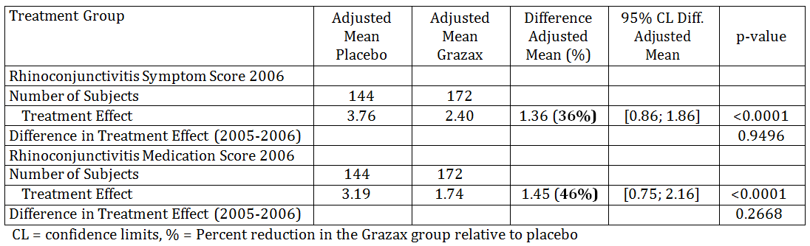
Table 14: Study GT-08. Overview of Efficacy Results in Year 1 (2005) and Year 2 (2006) (FAS)
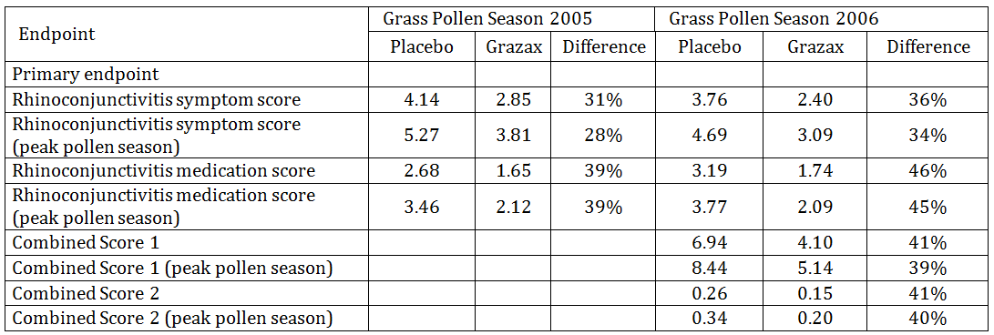

Results for treatment Year 3 (2007)
The average symptom and medication scores were calculated for each subject as the average of the observed total daily scores throughout the entire GPS 2007. Compared to Placebo, Grazax treated subjects had a 29% reduction in average daily symptom score with a reduction in both nose symptoms and eye symptoms over the entire GPS 2007.
Table 15: Study GT-08. Average daily symptom and medication scores entire GPS 2007
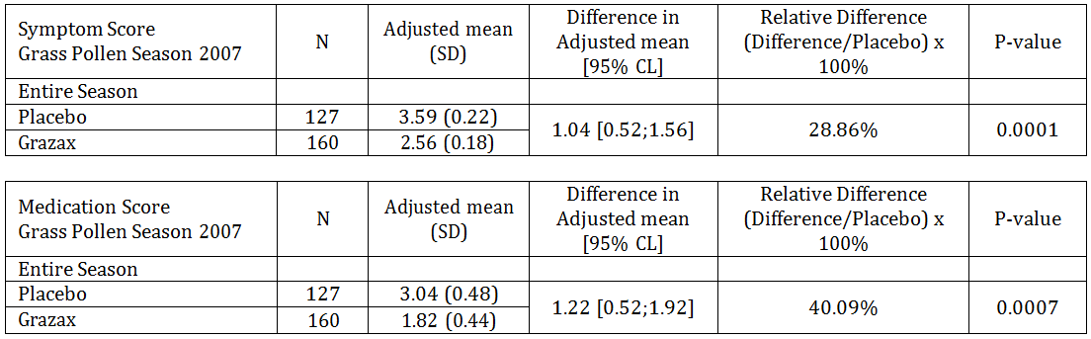
Table 16: Study GT-08. Efficacy overview of endpoint analysis results 3rd year of treatment (2007)
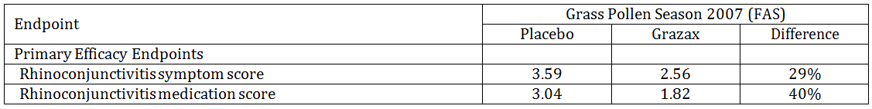

Results for Year 4 (2008, 1st year follow up after 3 years treatment)
A clinically relevant effect in terms of reduced average daily symptom and medication scores during entire GPS was seen for the first follow up year (Year 2008)
Table 17: Study GT-08. Average daily symptom and medication scores entire GPS 2008 (Year 4)
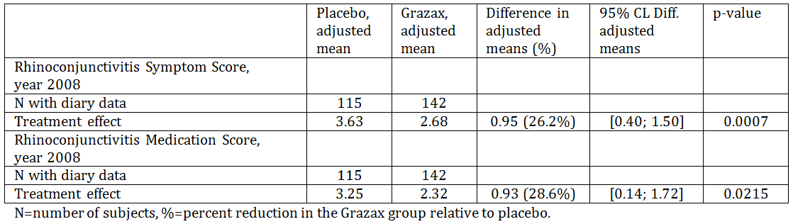
Table 18: Study GT-08. Overview of Efficacy Results from the Grass Pollen Season 2008 (Year 4)
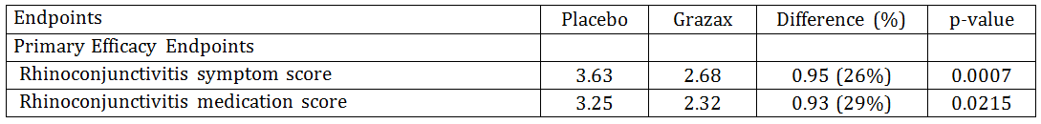

Results for Year 5 (2009, second year follow up after 3 years treatment)
The analysis of average symptom scores showed that 2 years after completion of 3 years of treatment, the Grazax group had a reduction of the symptom score of 25% during the entire GPS when compared to placebo. This difference was statistically significant (p = 0.0037).
The analysis of medication score showed that, 2 years after the end of 3 years of treatment, the Grazax group had a slightly reduced use of rhinoconjunctivitis symptomatic medications of 20% during the entire GPS when compared to placebo. However, this difference was not statistically significant (p = 0.1136).
Table 19: Study GT-08. Average daily symptom and medication scores entire GPS 2009 (Year 5)
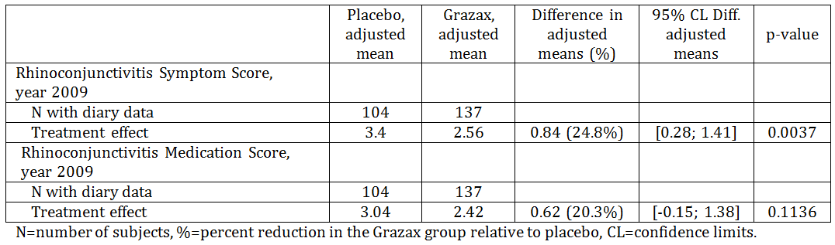
Table 20: Study GT-08. Overview of efficacy results, GPS 2009 (Year 5)
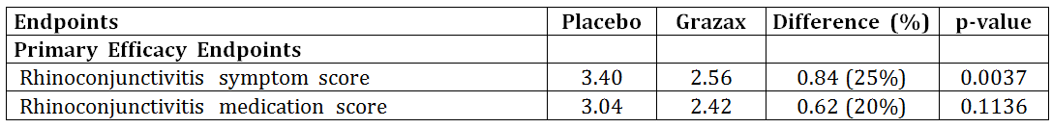

Study GT-14
This was a Phase III, randomised, double blind, parallel group, placebo controlled trial. The trial was conducted in the USA. The primary objective was to assess the efficacy of Grazax versus placebo during the entire GPS based on the rhinoconjunctivitis symptom score. Treatment duration was at least 8 to 16 weeks pre-seasonal treatment and continuous treatment throughout the GPS 2007.
Healthy subjects (18 to 65 years) with a history of grass pollen induced allergic rhinoconjunctivitis of at least 2 years requiring treatment during the GPS; with a history of significant rhinoconjunctivitis symptoms, which remain troublesome despite treatment with anti-allergic drugs during the GPS; with positive skin prick test (SPT) to Phleum pratense and with positive specific IgE against Phleum pratense (≥ IgE class 2). Subjects were randomised to Grazax or placebo. The rescue medication was provided to subjects as predefined, open labelled medication in a step wise fashion (see CER (Attachment 2) for details). No major differences between treatment groups were observed.
The primary efficacy endpoint was the average rhinoconjunctivitis symptom score during the entire GPS calculated for each subject as the sum of the individual daily rhinoconjunctivitis symptom scores during the entire GPS, divided by the number of rhinoconjunctivitis symptoms dairy recordings during the entire GPS.

Results of the Primary Efficacy Endpoints
Average rhinoconjunctivitis symptom scores: the analysis showed there was no statistically significant differences between Grazax and placebo (p = 0.3475).
Table 21: Study GT-14. Average symptom score during the entire GPS (FAS)
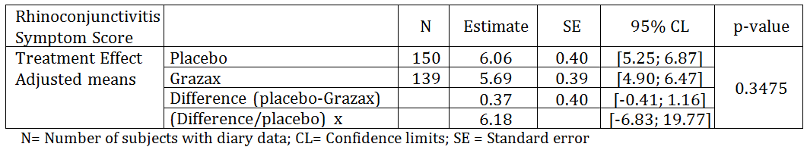
Average rescue medication score: the analysis showed there was no statistically significant differences between Grazax and placebo (p = 0.0827). The non-parametric test of the average rhinoconjunctivitis medication score showed no differences between treatments (p = 0.2141).
Table 22: Study GT-14. Average rescue medication score during the entire GPS (FAS)
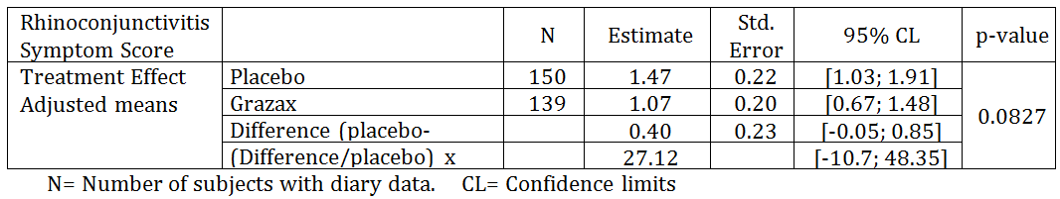

Study GT-07
This was a randomised, parallel group, double blind; placebo controlled Phase II study conducted in Denmark and Sweden in 2004. It is noted that the formulation used was not the final formulation. The primary objective of the study was to evaluate the safety of the ALK Grass tablet as compared to placebo in subjects diagnosed with mild to moderate grass pollen induced asthma as well as grass pollen induced rhinoconjunctivitis.
Adult subjects (18 to 65 years) with a history of significant grass pollen induced allergic rhinoconjunctivitis and mild to moderate grass pollen induced asthma of 2 years or more, a positive skin prick test and specific IgE to Phleum pratense and a history of mild to moderate grass pollen induced asthma during the last 2 seasons controlled by appropriate medications. Subjects were randomised to ALK grass tablet or placebo for 12 weeks. Stepwise rescue medication for rhinoconjunctivitis was detailed in the CER. Efficacy was a secondary objective. The efficacy endpoint was average daily rhinoconjunctivitis symptom score as well as average rhinoconjunctivitis medication score for the GPS. No formal statistical sample size and power calculations were made. Outcome measures are described by treatment group displaying number of subjects, mean, SD, median, 5%-quantile, 95%- quantile, minimum and maximum. A total of 114 subjects were included with 40 subjects in the placebo group and 74 in the active group. The demography and baseline characteristics were comparable for the 2 groups. All had suffered from grass pollen induced asthma for 2 to 45 years, and grass pollen induced allergy for 2 to 51 years.
The efficacy analysis showed that both symptom and medication score were lower for subjects in the active treatment group compared to that in the placebo group (ITT population) in the GPS (average symptom score 2.27 versus 3.04 and average medication score 2.60 versus 3.81). Results were similar for the PP population. Post hoc it was decided to test the observed differences in the efficacy endpoints. Neither the rhinoconjunctivitis score nor the medication score were statistically significant for the full analysis set. No immunological testing was done in this study.

Study P05238
This is a multicentre, double blind, randomised, placebo-controlled study. The study evaluated the sublingual tablet (SCH 697243 (Grazax)) in adult subjects with a history of grass pollen induced rhinoconjunctivitis with or without asthma. The formulation of SCH 697243 is the same as Grazax. The study consisted of observational period in 2008 where no investigational product was given. Open-label rescue medications for the rhinoconjunctivitis and asthma symptoms were provided. In 2009 (the treatment period), the subjects were treated with either SCH 697243 or placebo for about 16 weeks prior to and during the GPS. The primary objective was to evaluate the efficacy of SCH 697243 for grass pollen induced rhinoconjunctivitis based on the total combined (sum of) rhinoconjunctivitis daily symptom score and rhinoconjunctivitis daily medication score averaged over the entire GPS. The treatment duration was for 24 weeks.
Healthy adults (aged 18 to 65) with a history of significant allergic rhinoconjunctivitis to grass and with a positive skin prick test (average wheal ≥ 5 mm) and positive for specific IgE against Phleum pratense (≥ IgE Class 2) and FEV1 ≥ 70% predicted. Subjects were randomised 1:1 to receive either SCH697243 or placebo. The 2 groups were well balanced regarding the baseline characteristics.
The primary efficacy endpoint was the total combined score (TCS) based upon the combined (sum of) rhinoconjunctivitis DSS and DMS averaged over the entire GPS. A total of 438 subjects were treated with 213 in the active group and 225 in the placebo group. The results of the TCS analysis showed a lower adjusted mean TCS for the active group (5.08) when compared to the placebo group (6.39) [difference = -1.31]. The difference in mean TCS was statistically significant (p = 0.005), and the active treatment provided a 20% improvement over the placebo during the GPS. Similar results were seen with the PP population.
Table 23: Study P05238 Results of primary efficacy endpoint: TCS during the entire GPS (FAS)
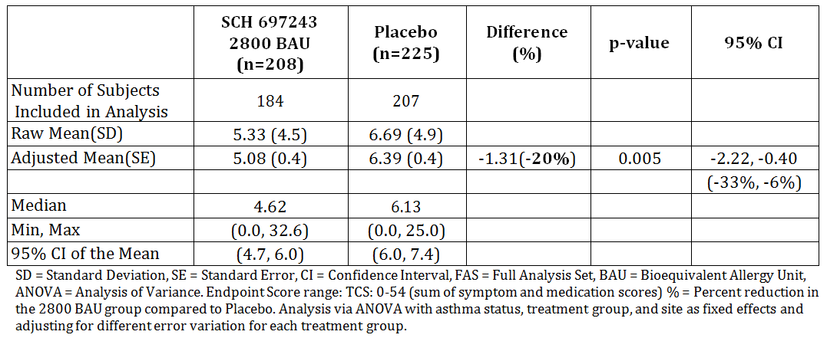

Results for other efficacy outcomes
Rhinoconjunctivitis daily symptom score (DSS) during GPS: in the pre-seasonal period, subjects in both groups had low levels of symptoms (3.14 in the active group and 3.45 in placebo group; p = 0.340). As the GPS began, the rhinoconjunctivitis DSS increased in both groups, but to a lesser extent for the group on SCH 697243. Analysis of the rhinoconjunctivitis DSS results during the GPS showed a lower adjusted mean DSS for the active group (3.83) compared to the placebo group (4.69). Treatment with SCH 697243 provided statistically significantly lower rhinoconjunctivitis symptoms (18%; difference = -0.86; p = 0.015, adjusted for multiplicity) compared with placebo.
Average rhinoconjunctivitis DMS during GPS: the use of rescue medication was limited during the treatment period, most probably related to the weak 2009 GPS. The mean DMS for SCH 697243 was not significantly different from that of placebo (difference = -0.45; p = 0.084).
Average Weekly Quality of Life Total Score during GPS: the analysis of the average weekly RQLQ(S) total score during the GPS showed a statistically significantly lower total score for subjects treated with SCH 697243 compared to placebo (mean total scores of 1.30 and 1.57, respectively; p = 0.022, adjusted for multiplicity). Subjects treated with SCH 697243 demonstrated a 17% lower total score compared to placebo.
The change from baseline to the average total score during the GPS in RQLQ(S) was found to be statistically significantly different between treatment groups (p = 0.020); treatment with SCH 697243 provided 34% less impairment from baseline in quality of life domain symptoms compared to the placebo group (0.41 versus 0.62, respectively)

Other studies
Study GT-10 and GT-17 which evaluated treatment compliance are summarised in CER (Attachment 2).

Study GT-12 (children ≥ 5 years)
This is a Phase III randomised, parallel group, double blind, placebo controlled study conducted in in children aged 5 to 16 years with grass pollen induced rhinoconjunctivitis with or without asthma. The study was done in Germany (November 2006 to September 2007). The primary objective was to evaluate the efficacy of Grazax in children (5 to 16 years) with grass pollen induced rhinoconjunctivitis.
Healthy children (5 to 16 years) with a history of grass pollen induced allergic rhinoconjunctivitis (with or without asthma) having received treatment during the previous GPS; with positive SPT response (wheal diameter > 3 mm) to Phleum pratense and positive specific IgE against Phleum pratense (≥ IgE class 2). Subjects were randomised to receive either Grazax 75,000 SQ-T or placebo once daily. Treatment was for 16 weeks prior to and then during the entire GPS of 2007 (26 weeks). Rescue medication was provided to subjects as pre-defined, open-label medication in a step wise fashion depending on the severity, persistency and type of symptoms.
The primary efficacy outcomes were the average daily rhinoconjunctivitis symptom and medication scores. These two average scores were calculated as the sum of the individual daily scores for each subject during the entire GPS 2007 divided by the number of subject diary recordings of that score during the entire GPS.
Detailed statistical approach is discussed in the CER (Attachment 2). The full analysis set included 126 subjects in Grazax group and 127 in the placebo group. The per-protocol group included 91 subjects in the Grazax group and 100 subjects in the placebo group.

Results for the primary efficacy outcome

Average daily symptom (DSS) score
The parametric analysis of the average symptom score showed a statistically significant difference in favour of the Grazax group (p = 0.0215). The difference relative to placebo between the back transformed, adjusted means for the 2 groups was 22%. In addition, a non-parametric analysis for the FAS of the symptom score over the entire GPS confirmed the observed treatment effect, with a difference relative to placebo between the medians of the two treatment groups of 24%. The results were similar for the PP analysis.
Table 24: Study GT-12. Analysis of average symptom score, entire GPS (FAS)
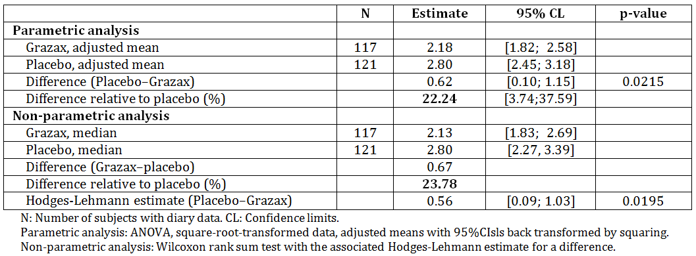

Rhinoconjunctivitis rescue medication score (DMS)
Subjects treated with Grazax had an overall lower medication intake than subjects treated with placebo, mainly due to a reduction in the use of loratadine tablets. The results were similar for the PP analysis.
Table 25: Study GT-12. Average medication score, entire GPS (FAS)
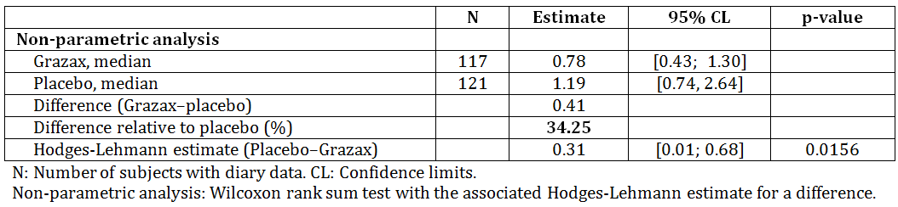
An amendment to the clinical study report (CSR) was submitted in which the results of the medication score were further analysed. This was due to the finding of a configuration deficiency in the programming of the electronic log pads used for assessment of symptoms and medication use. This deficiency resulted in 42 diary records with inconsistent responses to 2 questions regarding the use of rescue medication. The amendment provided a sensitivity analysis for the impact of this deficiency on the statistical analysis of the medication score. The result of the sensitivity analysis was that the medians for the medication score was slightly lower for both groups in the sensitivity analysis compared to the original analysis. This led to a slightly lower absolute difference between the 2 groups, giving a relative difference of 33% in the sensitivity analysis instead of 34%. For both analysis, the difference between the 2 treatment groups is highly statistically significant (p = 0.0156 compared with p = 0.0175), indicating only very small difference for the 2 analytical approaches.
The results for other efficacy outcomes are presented in the CER (Attachment 2).

Study P05239 (children)
This was a double blind, randomised, placebo-controlled, parallel group study conducted in children (5 to < 18 years) with a history of grass pollen induced rhinoconjunctivitis with or without asthma. The study was done in USA and Canada from January 2008 to September 2009. The primary objective was to evaluate the efficacy of the sublingual tablet (SCH 697243) versus placebo in the treatment of grass pollen induced rhinoconjunctivitis based on the total combined (sum of) rhinoconjunctivitis DSS and rhinoconjunctivitis DMS averaged over the GPS. Please see the CER for the list of the secondary objectives.
This was an approximately 19 month study including an observational period during 2008 GPS with no administration of investigational medicinal product (IMP), and a treatment period during 2009 GPS, with randomisation to either SCH 697243 or placebo. Healthy subjects aged 5 to < 18 years, with a history of significant allergic rhinoconjunctivitis to grass and having received treatment during the previous GPS and with a positive SPT (average wheal ≥ 5 mm) and positive Phleum pratense specific IgE (≥ IgE Class 2) and FEV1 ≥ 70%.
At the start of the treatment the subjects were randomised 1:1 to SCH697243 or placebo. Study drugs were taken for approximately 16 weeks prior to and during the GPS. Rescue medication was provided and given to the subjects as predefined, open label medication taken in a step wise fashion depending on the magnitude, severity, and type of symptoms.
Primary efficacy outcome was the total combined (sum of) DSS and the DMS averaged over the entire GPS. A total of 344 subjects were randomised into the treatment and received study drug. The two groups were well balanced regarding the baseline characteristics.
The results of the primary endpoint of Total Combined Score (TCS) of the DSS and the DMS averaged over the GPS are as follows:
Total Combined Score (TCS): the TCS analysis showed a lower adjusted mean TCS for the SCH 697243 group (4.62) when compared with the placebo group (6.25) [difference = -1.63]. The difference in mean TCS was statistically significant (p = 0.001), and treatment with SCH 697243 provided a 26% improvement over treatment with placebo during the GPS.
Table 26: Study P05239. Analysis of the Total Combined Score (TCS) during the Entire GPS (FAS)
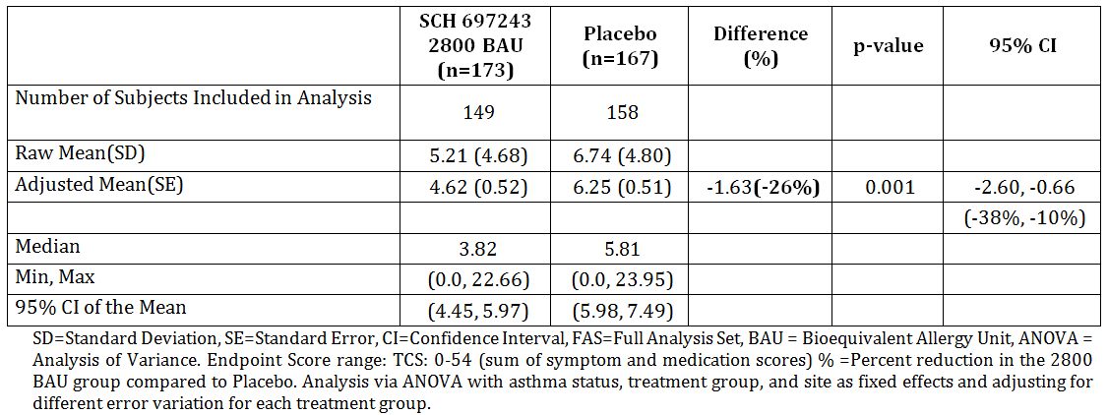
The SCH 697243 group had a statistically significantly lower mean TCS value compared to the placebo group during the preseason (defined as the last 14 days prior to GPS) (3.13 versus 4.52, respectively; p < 0.001). Similar results were seen with the PP population.
Rhinoconjunctivitis Daily Symptom Score (DSS): the analysis of the rhinoconjunctivitis DSS results during the entire GPS showed a lower adjusted mean DSS for the SCH 697243 group (3.71) compared to the placebo group (4.91). Treatment with SCH 697243 provided statistically significantly lower rhinoconjunctivitis symptoms (-25%; difference = -1.20; p = 0.005, adjusted for multiplicity) compared with placebo.
Table 27: Study P05239 Summary and Analysis of the DSS during the Entire GPS (FAS)
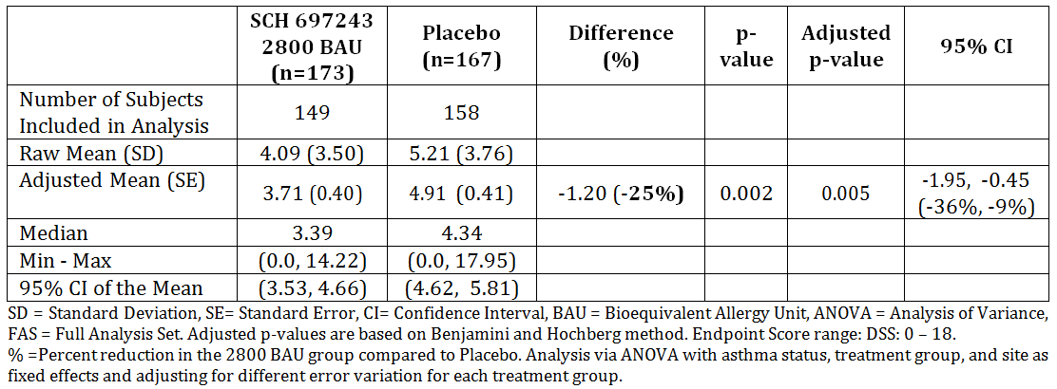
Average Rhinoconjunctivitis DMS during GPS: Analysis of the rhinoconjunctivitis DMS results showed a lower adjusted mean DMS for the SCH 697243 group (0.91) compared to the placebo group (1.33); indicating the active drug group used less rescue medication for allergic rhinoconjunctivitis symptoms. Although the difference in medication score was 32% in favour of SCH 697243, the mean DMS for SCH 697243 was not significantly different from that of placebo (difference = -0.42; p = 0.066).
Table 28: Study P05239. Analysis of the DMS during the Entire GPS (FAS)
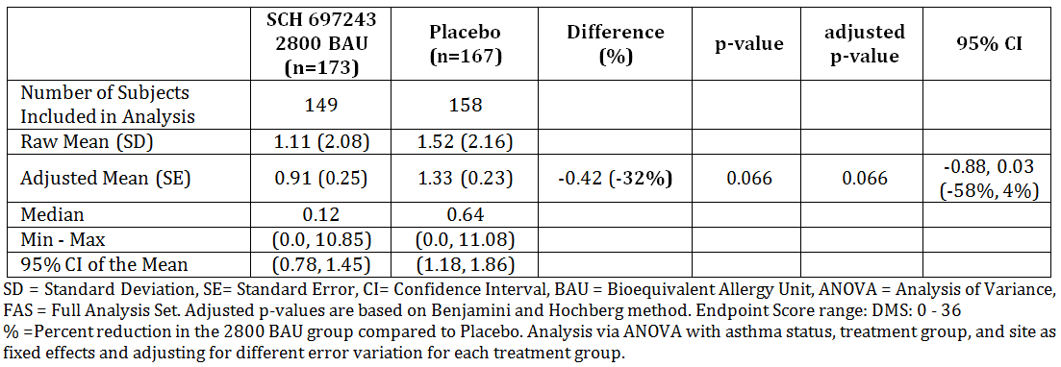
The result was different in the PP subset analysis. In the PP subset, the SCH 697243 group had a lower adjusted mean rhinoconjunctivitis DMS (0.99) compared to the placebo group (1.50), a 34% reduction, and this difference was statistically significant (difference = -0.51; p = 0.044).
The results for other and additional efficacy outcomes are presented in the CER (Attachment 2).

Analyses performed across trials
No pooled analysis was submitted by the sponsor, with the exception of a discussion of the length of time pre GPS was optimal for treatment. The reduction in symptom and medication score for patients receiving Grazax compared to placebo was estimated for 1, 2, 3,…, 24 weeks of pre-treatment (thus treatment effect at both 8 and 16 weeks of pre-treatment was estimated). In the Figure 3 below the p value for treatment difference (right y axis) and the estimated reduction in rhinoconjunctivitis symptom and medication score compared to placebo (left y axis) is shown.
From the figure it is evident that a statistically significant reduction in the average daily symptom and medication score in the GPS for patients treated with Grazax versus patients treated with placebo was obtained with approximately 8 weeks of pre-treatment (p < 0.05). Further, it can also be derived that the symptom as well as the medication score was reduced by 17% to 23% after 8 weeks, which is considered to be clinically relevant. The reduction in the average daily symptom and medication score increases with longer period of pre-treatment, which is reflected in the p value approaching null.
Figure 3: Effect of Grazax pre-treatment duration on reduction in rhinoconjunctivitis symptom and medication score (GT-02, GT-07 and GT-08 1st GPS Combined)
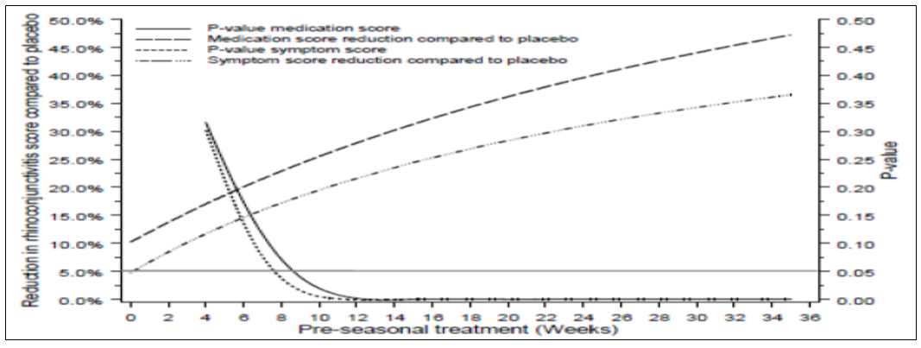

Clinical Safety
Please refer to the CER (Attachment 2) for detailed patients’ exposure and safety evaluation. Safety issues with the potential for major regulatory impact are discussed below.

Systemic allergic reactions
Systemic allergic reactions are well known in relation to immunotherapy. Systemic allergic reaction may occur in 2 forms; non life threatening systemic allergic reaction (also called anaphylactic reactions) and the more severe condition anaphylactic shock. Experience with sublingual immunotherapy has suggested a more favourable safety profile compared to subcutaneous immunotherapy. Sublingual immunotherapy is characterised by frequent but mild local reactions (located in the mouth and throat), and rare systemic reactions. Delayed systemic reactions (most frequently urticaria and mild asthma and/or rhinoconjunctivitis) that may develop after several hours or within the first day or 2 have also been reported during the use of sublingual immunotherapy, but they are not common and some of these delayed reactions may be symptoms of a subject’s underlying allergic disorder.
In the clinical trials with Grazax, systemic allergic reactions were not reported; however some symptoms consistent with systemic reactions were reported.
One case of urticaria led to withdrawal in Study GT-02 and would usually be considered a significant systemic reaction. However, the number of subjects reporting urticaria during the trial was similar between treatment groups including placebo. The same pattern was observed in Study GT-08 (1st year), where similar numbers of subjects (approximately 1%) with urticaria were observed between treatment groups. None of the events led to withdrawal. In Study GT-10 approximately 1% of subjects reported urticaria. Only one of these events (mild localised urticaria in mouth) led to withdrawal.
During the GT-14 trial in the US, 3 non serious significant AEs occurred (all in the Grazax group, all assessed as related to treatment) which were treated with adrenaline although none of the events included signs of hypotension. All subjects recovered from the events.
During Study P05238, two subjects were treated with 0.3 mg adrenaline. One of the administrations was due to an adverse reaction to IMP (dysphagia, uvular oedema and pharyngeal oedema) that occurred following the first administration of the tablet under the care of the investigator (Grazax group). The event was categorised as mild in severity by the investigator. The other administration was given inappropriately for an anxiety event unrelated to IMP (placebo group).
During Study P05239, 3 subjects received adrenaline at Day 1, Day 23, and Day 137. On Day 1 the administrations was given in response to an adverse reaction to the IMP (Grazax group). The subject developed lip angioedema, slight dysphagia due to the sensation of a lump in the throat, and intermittent cough within minutes following the first IMP administration. The symptoms resolved within minutes after adrenaline administration (0.3 mg IM). The investigator graded this event as moderate in severity. The other administration (0.3 mg IM) was received for viral pharyngitis in an emergency department on Day 23, where adrenaline administration was not indicated (or medically appropriate) (Grazax group). The third adrenaline administration (0.15 mg IM) on Day 137 was in response to wheezing and suprasternal notch chest retraction (placebo group). The investigator graded the event as moderate in severity and unrelated to IMP.
Eight of 43 subjects (19%) in Study GT-04 reported a total of 16 treatment related AEs that could indicate changes in asthma symptoms and in Study GT-07, 26 of 114 subjects (23%) reported a total of 36 AEs related to asthma. All subjects included in the two trials suffered from mild to moderate grass pollen induced asthma and. There were no obvious differences between treatment groups in numbers or frequency of AEs and no indications of asthma aggravation in actively treated subjects compared to placebo.

Safety related to drug-drug interactions and other interactions
Drug interactions were not studied. No drugs have been contraindicated in the proposed PI due to drug interaction.

Post-marketing experience
Grazax was first approved on 14 March 2006 in Sweden. Subsequently, approval was granted for the 32 countries including most of Europe and the USA. The manufacturer (ALK) has withdrawn the marketing authorisation in 8 countries: Bulgaria, Cyprus, Estonia, Hungary, Latvia, Lithuania, Malta and Romania due to commercial reasons. The cumulative patient exposure from post-marketing to 24 June 2015 is estimated to be 211,119 treatment years. The sponsor has submitted 13 PSURs in Europe but only 2 were included in the submission in Australia (covering 25 June 2014 to June 2015).
The sponsor states that overall, the experience gained from post-marketing use of Grazax is similar to what has been identified in completed clinical trials and/or what is expected for sublingual immunotherapy. The following adverse drug reactions have been added to the current EU approved SmPC from spontaneous reports post-marketing: palpitations, hypotension, eosinophilic oesophagitis, and anaphylactic reactions. No safety issues have been identified post-marketing which is considered to impact the overall benefit-risk profile of Grazax.

Overall conclusions on clinical safety
The total number of subjects exposed to Grazax in the clinical development program was 2,482. Overall, 72% of subjects receiving Grazax reported treatment related AEs. These AEs were primarily reported during the first 3 months of treatment (56% reported AEs within the first 3 months of treatment).
Oral pruritus was the most frequently reported related AE, experienced by 30% of the subjects treated with Grazax. Throat irritation, mouth oedema and ear pruritus were also frequently reported (by 8 to 16% of the subjects treated with Grazax). These side effects may be sufficiently bothersome to lead to discontinuation of therapy.
In Study GT-19 which used antihistamines in addition to Grazax there was no statistically significant difference in the number of subjects reporting local allergic reactions when treated with antihistamine or placebo antihistamine.
In Phase I trial GT-09 and GT-11, the tolerability of 75,000 SQ-T was assessed in children. No indications of any significant differences between the adult and the paediatric population were observed and this was in agreement with the well-established clinical practice of using the same dosage of immunotherapy in adults and children.
Systemic allergic reactions were uncommon but did occur during the studies. No anaphylaxis was reported in any of the clinical studies but has been reported as a spontaneous post marketing event.

Evaluation of Risk Management Plan (RMP)
The second round RMP evaluation was included for ACPM information. The sponsor has addressed the recommendations made in the first round RMP evaluation, and is committed to update the summary safety concerns in accordance with the recommendations of the evaluator.
Any changes to which the sponsor has agreed should be included in a revised RMP and ASA. However, irrespective of whether or not they are included in the currently available version of the RMP document, the agreed changes become part of the risk management system.
Condition of registration should include the following:
Implement EU-RMP (version 8; 10 March 2015; DLP 24 June 2013) with Australian Specific Annex (version 2; date 23 August 2016), submitted with application PM-2015-03979-1-2, and any future updates as a condition of registration.

Discussion
A number of dose finding, pivotal, and supportive clinical studies are provided to demonstrate the efficacy and safety of Grazax for the proposed indication. Studies GT-08 and GT-14 were considered as pivotal and GT-07 and P05238 as supportive for adult studies. Study GT-12 was considered as pivotal and P05239 as a supporting study for children.
Different efficacy endpoints were used in these studies. Most of these studies were conducted prior to the adoption of the EU Guidelines for treatment of allergic conditions.⁷⁰ In terms of the primary endpoints of the trials, the EU guideline states:
Primary endpoint: The use of rescue medication has an impact on symptom severity. Therefore, the primary endpoint has to reflect both, symptom severity as well as the intake of rescue medication. ……. One approach is to combine both scores by a weighted sum of the symptom and medication score respectively. In such a situation the choice of the weights has to be justified.
All of the studies have done this in some way but it differs in each trial; usually by using the co-primary endpoints of DSS and DMS or a combined endpoint (with no weighting) and then DSS and DMS as secondary endpoints. The pivotal studies, GT-08 and GT-14 used DSS and DMS as the co-primary endpoint, and GT-08 added new secondary endpoints at each of the 4 subsequent years.
The efficacy results of these key studies are summarised in Table 5 above.
The clinical evaluator commented that the submitted studies do not appear to show a consistent benefit as claimed by the sponsor. For the studies in adults, only 2 of 5 studies show statistically significant benefit for rhinoconjunctivitis symptoms and only 1 of 5 show statistically significant benefit for DMS.
The sponsor argues that the reasons the primary analysis in Studies GT-02 and GT-14 did not show a statistically significant difference compared to placebo was due, in Study GT-02, to the fact that not all subjects were able to comply with the 8 week pre-seasonal treatment period and in Study GT-14 to the subjects’ pre-seasonal symptom score, overlapping pollen seasons/allergies and/or geographical regions/pollen areas. These may be valid reasons for outcomes of these studies but also reflect the real world use of the product.
Normally efficacy demonstrated in two independent studies or in single pivotal study with significant and clinically relevant results is considered sufficient for acceptance of a product’s efficacy. Grazax meets this criterion and the clinical evaluator accepts that the efficacy of the product in treating allergic rhinitis with or without conjunctivitis has been demonstrated.
The sponsor is also seeking an indication of disease modifying effect. It is noted that this was granted in the EU but not in the USA. The EU guideline does not provide much guidance as to what evidence is required for a disease modifying claim, the only guidance is that for long-term efficacy and disease modifying effect a “sustained significant and clinically relevant efficacy in post treatment years” is required.⁷⁰
The long term effect of Grazax was assessed in Study GT-08, and the disease modifying claim rests with this study that treated patients for 3 years and then followed them for 2 years. A sustained significant and clinically relevant effect was seen for the first follow up year (Year 2008) but not the second (the rhinoconjunctivitis medication score was not statistically significant). The sponsor argues that the second year (2009) GPS was significantly milder than the previous seasons and due to the influence of grass pollen exposure on the symptom and medication scores, this was inevitably influencing the size of the efficacy measurements. However, whatever the reason, the sustained benefit was not present in the second year of follow up. In view of this and the variability seen in the other trials, the evaluator considers that the evidence is not sufficient to support the claim of disease modifying effect. It cannot be established if the decrease in grass pollen exposure is the sole explanation for the trend towards a gradual decrease in treatment effect.
The sponsor does not agree to the revised indication or to the inclusion of the need for confirmation of cutaneous testing or positive titre in the indications section. They cite recent decisions for Acarizax and Actair in which the need for confirmatory tests was included in the dosage and administration section of the PI. However, given the marked difference in the prevalence of Timothy grass allergy and house dust mite allergy, the evaluator considers it is important that only those patients with specific Timothy grass allergy receive Grazax and therefore the indication should reinforce this requirement by including this in the indication.
The TGA toxicology evaluator questioned the relevance of this product to Australia given that the product only contains Phleum pratense (Timothy grass) which is mainly found in the highlands of southern (temperate) Australia (parts of Tasmania and Victoria) and is considered a noxious weed. To address this, the sponsor has provided additional information on Phleum pratense and a letter from Dr [information redacted], a specialist in clinical immunology and allergy and [information redacted] of the Australian Society of Clinical Immunology and Allergy.
The sponsor states that the Australian Virtual Herbarium (AVH) indicates the presence of Timothy grass in Victoria, NSW, Tasmania, South Australia and Western Australia. The reference to this is a website called AusGrass 2 The date of the reference to the AVH is 2011. When the AVH (AVH 2016. Australia’s Virtual Herbarium, Council of Heads of Australasian Herbaria) was accessed directly it includes only NSW, ACT and WA as sites of presence (of Timothy grass).
The following comments were provided by Dr [information redacted]:
“Timothy grass (Phleum pratense) is a member of the pooideae family, closely related to ryegrass and other common allergenic grasses known as the temperate grasses. Pooideae is a subfamily of poaceae which also includes subtropical grasses such as Bermuda grass (couch), bahia grass (paspalum) and sorghum. Timothy grass is itself not common or widely distributed in Australia although it does occur in cooler parts such as some parts of Victoria, Tasmania and the ACT. Ryegrass is probably the most widespread and common of the temperate allergic grasses. However it is known that Timothy grass contains almost all the relevant allergenic epitopes contained in ryegrass and other common temperate grasses. Therefore Grazax should be a suitable therapeutic product to treat allergy to Australian temperate grasses. Many sufferers of pollen allergy are sensitised to both temperate and subtropical grass pollens. In northern parts of Australia, it is thought that the primary (initiating) sensitising pollens are subtropical, and in the southern parts, temperate. It is thought that optimal immunotherapy should target the primary sensitising allergen and generally should cover all the major pollens to which the patients is sensitised.
Therefore, it is unlikely that Grazax will be the optimal agent for pollen allergy sufferers in the northern parts of Australia, and in the southern parts where there is sensitisation to both temperate and subtropical grass pollens. However, it is likely to be a suitable agent for those with exclusive or predominant sensitisation to temperate grass pollens in the southern and central parts of Australia which constitute a significant subgroup.”
In view of the above comments, the Delegate recommends that Australia PI should include the information about Australia geographical distribution of Timothy grass given that the product only contains allergen extract of grass pollen from Timothy grass.

The preliminary action proposed by the Delegate
Overall, the effectiveness of Grazax in relieving symptoms of rhinoconjunctivitis symptoms and to lesser extent use of rescue medication was shown in two studies in adults and two studies in children with clinically relevant symptoms, confirmed by a positive cutaneous test and/or a positive titre of the specific IgE to Phleum pratense. In most of the studies where immunological endpoints were included, the immunological changes of Grazax immunotherapy have been consistent and statistically significant, although the clinical significance of these findings has not been established.
There is a possible risk of anaphylactic reactions associated with the use of Grazax, including anaphylactic shock. The risk of systemic allergic reactions is most likely to occur at the first dose. Local allergic reactions of varying severity are common particularly oral pruritus, throat irritation, mouth oedema and ear pruritus. Acute asthma may occur with the use of Grazax.
There remain questions as to the adequacy of evidence in supporting the disease-modifying effect. The product Information should include the information with regards to the geographical distribution of Timothy grass in Australia given that the product only contains allergen extract of grass pollen from Timothy grass pollen (Phleum pratense).
The overall benefit-risk balance of Grazax, given the proposed usage, is considered favourable. It is noted that the wording of the requested indication is for “grass pollen” allergy without specifying Phleum pratense. Phleum pratense should be included in the indication to reflect the studies submitted. Based on the submitted data, the Delegate recommends that Grazax be approved for the indication below:
Grazax is indicated for treatment of Timothy grass (Phleum pratense) pollen allergic rhinitis with or without conjunctivitis in adults, adolescents and children above the age of 5 with clinically relevant symptoms, confirmed by a positive cutaneous test and/or a positive titre of the specific IgE to Phleum pratense.

Summary of issues
A number of dose finding, pivotal, and supportive clinical studies are provided to demonstrate the efficacy and safety of Grazax for the proposed indication. The effectiveness of Grazax in relieving symptoms of rhinoconjunctivitis symptoms and to lesser extent use of rescue medication was shown in 2 studies in adults and 2 studies in children. In most of the studies where immunological endpoints were included, the immunological changes have been consistent and statistically significant, however clinical significance of the findings remains to be elucidated.
The relevance of this product to Australia has been questioned, given that the product only contains allergen extract of grass pollen from Timothy grass.
There is a risk of anaphylactic reactions associated with the use of Grazax, including anaphylactic shock. There is a risk of systemic allergic reactions which is most likely to occur at the first dose. Local allergic reactions of varying severity are common particularly oral pruritus, throat irritation, mouth oedema and ear pruritus. Acute asthma may occur with the use of Grazax.
There remain questions as to the adequacy of evidence in supporting the disease modifying effect of Grazax.

Proposed action
The Delegate had no reason to say, that the application should not be approved for the treatment of Timothy grass (Phleum pratense) pollen allergic rhinitis with or without conjunctivitis in adults, adolescents and children above the age of 5 with clinically relevant symptoms, confirmed by a positive cutaneous test and/or a positive titre of the specific IgE to Phleum pratense.
The conditions of registration should include the following:
Any changes to which the sponsor has agreed should be included in a revised RMP and ASA. However, irrespective of whether or not they are included in the currently available version of the RMP document, the agreed changes become part of the risk management system.
Implement EU-RMP (version 8; 10 March 2015; DLP 24 June 2013) with Australian Specific Annex (version 2; date 23 August 2016), submitted with application PM-2015-03979-1-2, and any future updates as a condition of registration.
The final approval is subject to satisfactory resolutions of any issues relating to the Product Information (PI) and the Risk Management Plan (RMP/ASA).

Request for ACPM advice
The committee is requested to provide advice on the following specific issues:
- Could ACPM please comment on the relevance of this product to Australia, given that the product only contains allergen extract of grass pollen from Timothy grass (Phleum pratense)? Should the product Information include the information about the geographical distribution of Timothy grass in Australia?
- Does ACPM consider the submitted data support the disease modifying effect of Grazax for the treatment of grass pollen induced rhinitis and conjunctivitis?
- Does the ACPM consider there is a need for a more prominent warning in the PI regarding the possibility of serious anaphylactic reactions?
- Does ACPM support the following indication proposed by the evaluator?
- Grazax is indicated for treatment of Timothy grass (Phleum pratense) pollen allergic rhinitis with or without conjunctivitis in adults, adolescents and children above the age of 5 with clinically relevant symptoms, confirmed by a positive cutaneous test and/or a positive titre of the specific IgE to Phleum pratense.
The committee is (also) requested to provide advice on any other issues that it thinks may be relevant to a decision on whether or not to approve this application

Response from sponsor
Following review of the Delegate’s overview Seqirus seeks to comment on the items for which the Delegate is seeking ACPM advice and to address the Delegate’s recommendations regarding the proposed PI.

Product overview
Grazax is a once daily, sublingual immunotherapy (SLIT), oral lyophilisate tablet. It contains 75,000 SQT standardised allergen extract of grass pollen from Timothy grass (P. pratense). It has been developed as a convenient AIT product for at home treatment of grass related respiratory allergic disease, specifically allergic rhinoconjunctivitis. Grazax is currently approved in 21 European (EU) countries and the US (the International Birth Date is March 2006). As noted by the Delegate, the approved Indication for Grazax varies globally. This is not unexpected - as for many products, these differences are reflective of differing regional clinical practice and also commercial strategy(s).
There is extensive IgG₄ and IgE cross reactivity between P. pratense allergen extract and those of other grasses within the Pooideae (that is temperate grasses) subfamily to which it belongs (for example Poa sp, Dactylis sp, Lolium sp (that is rye grass) and Anthoxanthum sp). This is due to the high degree of homology (> 90%) of the amino acid sequences of the molecular surface. From a clinical perspective, this means patients will experience symptoms when exposed to pollen from any of the Pooideae grasses and as the immune system does not appear to distinguish between the different species, the literature concludes that treatment with pollen extract of just one species may affect the allergic response caused by any of the temperate grasses in the Pooideae subfamily. Additionally, the EU Guideline⁷⁰ states that within a ‘homologous group’, it is sufficient to prove efficacy with one representative allergen species. Grazax could therefore offer an advantage over other grass allergen SLIT products which include allergen extracts from multiple species of the Pooideae subfamily (temperate grasses).

Efficacy
The Delegate notes that demonstration of efficacy in a single pivotal study with significant and clinically relevant results is considered sufficient for acceptance of efficacy. As per the information provided during Seqirus’ April 2015 pre-submission meeting and the 29 October 2015 Pre Submission Planning Form (PPF), the Grazax clinical development program includes two pivotal Phase III studies, therefore Seqirus contend the adequacy of the clinical data provided.
GT-08 investigated the safety and efficacy in adults with grass pollen induced rhinoconjunctivitis. Initially planned as a 1 year trial, the trial was extended with 2 more years of treatment and 2 years of follow-up. The co-primary endpoints for this trial were average daily rhinoconjunctivitis symptom score and average daily rhinoconjunctivitis medication score for the entire GPS each year. Both co-primary endpoints were met for Grazax recipients; there was a statistically significant improvement in rhinoconjunctivitis symptom score at all time points for Years 1 to 5 (difference relative to placebo ranged from 25% to 36%; p < 0.004), and a statistically significant reduction in rhinoconjunctivitis medication score at Years 1 to 4 (difference relative to placebo ranged from 29% to 46%; p < 0.03) (Table 29). Although not statistically significant at Year 5, the 20% reduction in use of rhinoconjunctivitis medications relative to placebo is considered clinically relevant in accordance with the minimal relevant magnitude of efficacy proposed by the World Allergy Organisation. It is also relevant from a quality of life perspective. Additionally, the treatment effect for the TCS was statistically in favour of Grazax treatment in each of the 5 years with a relative reduction of 23 to 41% (p ≤ 0.01) compared to placebo. Importantly, in accordance with EMA guideline⁷⁰) sustained and clinically relevant efficacy for > 3 years supports a claim for a disease modifying effect.
Study GT-12 investigated the safety and efficacy in children aged 5 to 16 years with grass pollen induced rhinoconjunctivitis with/without asthma. The co-primary endpoints for this trial were the same as per Study GT-08. Grazax recipients again demonstrated a statistically significant improvement in rhinoconjunctivitis symptom score (22%; p = 0.0215) and a reduction in rhinoconjunctivitis medication score (34%; p = 0.0156) compared to placebo.
Table 29: Results for co-primary endpoints for Phase III trial GT-08
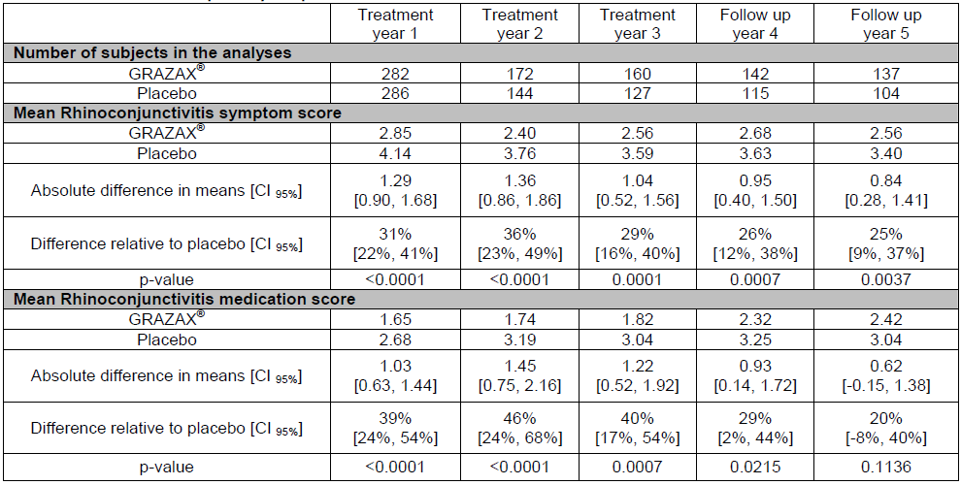

Safety
The safety of Grazax has been demonstrated during the clinical development program in which 3,944 patients received the proposed 75,000 SQ-T dose, as well as through approximately 10 years of global post-marketing experience. To date > 100,000,000 units of Grazax have been marketed globally, equivalent to 274,621 treatment years. The most common treatment emergent AEs (TEAEs) reported for Grazax during the clinical development program include oral pruritus, throat irritation, nasopharyngitis and ear pruritus. This is reflected in post-marketing experience.
The Delegate comments that whilst systemic allergic reactions were not reported in the Grazax clinical trials, they are well known in relation to AIT and hence conclude that there is a risk of anaphylactic reaction/shock associated with Grazax, recommending inclusion of a statement to this effect in the PI. This is already addressed in the proposed PI, where it states such AEs are considered a class effect. Moreover, systemic allergic reactions are not unexpected considering the patient population to whom AIT is administered. The wording in the proposed PI is aligned with the current TGA approved PIs for Oralair (AUST R 167565 & 167566), Acarizax (AUST R 250392) and Actair (AUST R 233470 & 233471).
The Delegate also refers to 3 US clinical trials in which adrenaline was administered to 5 subjects in relation to Grazax related AEs and also comments on the black box warning in the FDA approved PI regarding severe allergic reactions. In relation to the clinical trials, it is important to note that for all 5 subjects, the AE was reported as non serious or mild-moderate in severity rather than serious or life threatening. It is important to note that the information in the FDA approved PI for Grastek reflects the design of the US-specific clinical trials as conducted in consultation with the FDA. By way of background, prior to FDA approval of Grastek and other like SLIT products (eg Oralair and Ragwitek), the FDA only had experience with subcutaneous immunotherapy (SCIT) products. By their very nature (that is SC injection), SCIT products are always administered in a clinician’s office in the presence of adrenaline. The information in the US PI therefore reflects the design of the US-specific clinical trials in which the FDA requested co-prescription with adrenaline due to their lack of familiarity/comfort with SLIT products. Of note, the same information is in the US PI for Oralair. In contrast, SLIT products in the form of SLIT-drops had been used as at-home treatment for years in parts of the EU at the time of conducting the clinical trials for Grazax/Grastek. The EU authorities being very familiar with at-home use of AIT products and with the safety profile of such products therefore this information is not included in the EU SmPC. As of 24 Jun 2016, estimated cumulative post-marketing data for Grazax, comprising 274,621 treatment years, has not lead to a change in the risk-benefit assessment in relation to a potential need for co-prescription of adrenaline. Other SLIT products are currently registered in Australia (AU) with no requirement for co-prescription of adrenaline (eg Oralair, Acarizax or Actair).
Body of request for ACPM advice
The Delegate questions whether the submitted data supports the disease modifying effect of Grazax for the treatment of grass pollen induced rhinitis and conjunctivitis. The pivotal Phase III clinical trial GT-08 included 3 years of Grazax treatment then 2 years follow-up. As mentioned in Efficacy above, subjects administered Grazax demonstrated statistically significant improvement in rhinoconjunctivitis symptom score at all timepoints for Years 1 to 5, and statistically significant reduction in rhinoconjunctivitis medication score at Years 1 to 4 (Table 29). Although not statistically significant at Year 5, as mentioned previously, the reduction in use of rhinoconjunctivitis medications relative to placebo (that is 20%) is considered relevant. The TCS was also statistically in favour of Grazax compared to placebo in each of the 5 years with a relative reduction of 23-41% (p ≤ 0.01).
As per the TGA adopted EU guideline CHMP/EWP/18504/2006., maintenance of significant and clinically relevant efficacy during 2 to 3 years of treatment allows a claim for sustained clinical effect, whereas sustained significant and clinically relevant efficacy in post-treatment years allows a claim for disease modification. Importantly, the EMA guideline does not specify the duration (that is years of follow up) needed for a claim for disease modification. Moreover, the international treatment guidelines for allergic rhinitis refer to a treatment period of 3 years for allergy immunotherapy to achieve disease modification. Seqirus thus contends that the statistically and clinically relevant effect seen in Year 4 of GT-08 (that is first year of follow up) for both mean rhinoconjunctivitis symptom score (difference relative to placebo 26%; p = 0.0007) and mean rhinoconjunctivitis medication score (difference relative to placebo 29%; p = 0.0215) supports the claim for disease modification. Further, Seqirus contends that the statistically and clinically relevant effect seen in Year 5 of GT-08 (that is second year of follow up) for both the mean rhinoconjunctivitis symptom score (1st ranked 1° endpoint, p = 0.0037, difference relative to placebo 25%) and the mean combined symptom and medication scores (p < 0.05 for all 5 combined scores constructed, differences relative to placebo 23-27%), as well as the statistically significant TCS in each of the 5 years provides additional support for the claim for disease modification.
The Delegate questions whether a prominent warning regarding the risk of serious anaphylactic reactions should be added to PI . As acknowledged in the Delegate’s Overview, although systemic allergic reactions are well known in relation to AIT, they have not been reported in the Grazax clinical trials see p2. The current proposed PI already include a statement in the Adverse Effects section advising that cases of serious anaphylactic reactions including anaphylactic shock have been reported for Grazax during post-marketing experience and are considered a class effect. Additionally, the Precautions section of the PI also contains various information for clinicians regarding systemic allergic reactions/anaphylactic shock. This is consistent with other TGA approved PIs for SLIT products (eg Oralair, Acarizax or Actair).
The Delegate’s Overview questions the relevance of this product to AU, given that the product only contains allergen extract of grass pollen from Timothy grass and also whether the PI should include information about the geographical distribution of Timothy grass in AU. As part of the pre-submission discussion for Grazax on 16 April 2015 , the TGA questioned the clinical relevance of Grazax to Australia (AU) given it contains only P. pratense (Timothy grass). Seqirus subsequently included justification regarding clinical relevance in Module 1.0.1 of the dossier.
Seqirus contend that it is inappropriate to include the geographical distribution of Timothy grass (P. pratense) into the PI for the following reasons:
- The reported geographical distribution of Timothy grass varies depending on the reference consulted. This is not unexpected given that, although considered a weed in some areas, it is also used as a fodder plant or soil stabiliser in other areas. For example, and as noted by the Delegate, the distribution as cited by the AU Virtual Herbarium (AVH) has changed since 2011 (Vic, NSW, Tas, SA & WA) compared to 2016 (NSW, ACT and WA). Additionally, ASCIA12 recognises Timothy grass as a common allergenic pollen in the ACT, Vic, Tas and QLD. As it is extremely likely that this will continue to change over time, the inclusion of this information in the PI could result in potential misinformation to clinicians.
- Grasses rely on the wind to spread their pollen. These pollen are produced in vast quantities, blow long distances and cause allergies in people living a long way from the source.
- A large proportion of Australians travel domestically and internationally for work, leisure or personal reasons. Notwithstanding the points above, inclusion of this information in the PI may result in clinicians believing that Grazax it is not appropriate for their patients if they do not live in one of the above listed states.
- As noted by Dr William Smith of ASCIA (see p21 of the Overview), Timothy grass is closely related to ryegrass and other common allergenic grasses known as the temperate grasses. Whilst Timothy grass itself may have variable distribution in AU, ryegrass is widespread and the most common of the temperate allergenic grasses. It is known that Timothy grass allergens are closely homologous to ryegrass allergens and Timothy grass contains almost all of the relevant allergenic epitopes contained in ryegrass and other common temperate grasses. Grazax should therefore be a suitable therapeutic product to treat allergy to temperate grasses.
The Delegate questions the adequacy of evidence in supporting the disease-modifying effect and proposes that Grazax is indicated for the treatment of Timothy grass (P. pratense) pollen allergic rhinitis with or without conjunctivitis in adults, adolescents and children above the age of 5 with clinically relevant symptoms, confirmed by a positive cutaneous test and/or a positive titre of the specific IgE to P. pratense.
As mentioned previously, Seqirus contends that in accordance with the TGA adopted EMA guideline14, the data from the pivotal Phase III clinical Study (GT-08) support the proposed Indication for disease modification. Regarding the inclusion of a reference to the skin prick test/IgE in the Indication, the Delegate’s Overview comments that given the marked difference in the prevalence of Timothy grass allergy and house dust mite allergy, the evaluator considers it is important that only those patients with specific Timothy grass allergy receive Grazax and therefore the indication should reinforce this requirement by including this in the indication. Seqirus maintains that regardless of the prevalence of an allergen, prior to treatment, all patients administered any AIT should have a confirmed history and positive test for sensitisation to that allergen prior to treatment. This information is already included in the Dosage and Administration section of the PI (§1). Moreover, the Indication also includes ‘diagnosed’ which is in alignment with the recently approved PIs for Acarizax and Actair. The proposed Indication is: Grazax is indicated for treatment and disease modification of diagnosed grass pollen allergic rhinitis with or without conjunctivitis. Grazax is approved for use in persons aged 5 years or older.

Advisory Committee Considerations
The Advisory Committee on Prescription Medicines (ACPM), having considered the evaluations and the Delegate’s overview, as well as the sponsor’s response to these documents, advised the following:
The ACPM resolved to recommend to the TGA Delegate of the Secretary that:
The ACPM, taking into account the submitted evidence of efficacy, safety and quality, agreed with the Delegate and considered Grazax tablet containing 75,000 SQ‐T of allergenic extract of standardised grass pollen extract - Phleum pratense (Timothy grass) to have an overall positive benefit–risk profile for the amended indication;
Grazax for the treatment of Timothy grass (Phleum pratense) pollen allergic rhinitis with or without conjunctivitis in adults, adolescents and children above the age of 5 with clinically relevant symptoms, confirmed by a positive skin prick or serological testing to be sensitive to Phleum pratense or cross reacting allergens.
Note to indication: studies have not shown any benefit for allergy to sub-tropical grasses prevalent in Australia, such as paspalum (Paspalum grasses).

Proposed conditions of registration
The ACPM agreed with the Delegate on the proposed conditions of registration.
- Subject to satisfactory implementation of the Risk Management Plan most recently negotiated by the TGA,
  - Any changes to which the sponsor has agreed should be included in a revised RMP and ASA and the agreed changes become part of the risk management system.
- Negotiation of Product Information and Consumer Medicines Information to the satisfaction of the TGA.

Proposed Product Information (PI)/Consumer Medicine Information (CMI) amendments
The ACPM agreed with the Delegate to the proposed amendments to the Product Information (PI) and Consumer Medicine Information (CMI), particularly over the anaphylaxis PRECAUTION and the listing of adverse events by importance.
Specific advice
The ACPM advised the following in response to the Delegate’s specific questions on this submission:
- Does ACPM consider the submitted data support the disease‐modifying effect of Grazax for the treatment of grass pollen induced rhinitis and conjunctivitis?
The ACPM advised that it did not consider the submitted data supported the disease‐modifying claim; in the trials there was an approximately 30% reduction in symptoms and medication use but good evidence for sustained long term benefit after cessation of treatment is lacking.
- Does ACPM consider that a prominent warning regarding the risk of serious anaphylactic reactions should be added to Product Information?
The risk, if it exists, is extremely small and is almost exclusively associated with the first dose; since it is standard practice, and specified in the PI, for the first dose to be administered under supervision and with a subsequent observation period the warning does not appear to be necessary.
- Could ACPM please comment on the relevance of this product to Australia, given that the product only contains allergen extract of grass pollen from Timothy grass? Should Product Information (PI) include the information about the geographical distribution of Timothy grass in Australia?
The ACPM advised the product will be unsuitable for many Australian patients with allergic rhinoconjunctivitis due to grass pollen allergy; while it is not necessary for the PI to describe Timothy distribution in Australia it should make it clear that Bahia, which does not cross react with Timothy, is widespread.
- Does ACPM support the following indication proposed by the evaluator?
Grazax is indicated for treatment of Timothy grass (Phleum pratense) pollen allergic rhinitis with or without conjunctivitis in adults, adolescents and children above the age of 5 with clinically relevant symptoms, confirmed by a positive cutaneous test and/or a positive titre of the specific IgE to Phleum pratense.
The ACPM advised the product appears to be suitable for patients with grass pollen allergy caused by species which cross react with Timothy, which includes the common allergen, rye grass. Thus the committee was of the view that “or cross reacting allergens” should be added to the indication.
However, it is unsuitable, as monotherapy, for the considerable percentage of the Australian population who are also sensitised to sub-tropical grasses without consideration being given to these other grass allergens.
Positivity to Timothy allergens appears to be a necessary but insufficient requirement for patients to gain substantial relief from grass pollen allergic rhinitis with or without conjunctivitis in much of Australia. This needs to be clearly explained to both prescribers and patients, before treatment commences.
The ACPM advised that implementation by the sponsor of the recommendations outlined above to the satisfaction of the TGA, in addition to the evidence of efficacy and safety provided would support the safe and effective use of this product.

Post ACPM Response from sponsor
In response to the ratified minutes of the ACM the sponsor provided a response to the TGA which is presented below.
The ACPM minutes propose several recommendations in relation to the proposed PI for Grazax including the Indication, distribution of Timothy grass in Australia, and the need for discussion between the prescriber and patient before treatment commences.
Seqirus’ comments in relation to these items are provided below. Copies of the proposed amended Product Information (PI) (clean and annotated) are provided in Attachment 1 and Attachment 2.
The ACPM advised that it did not consider the submitted data supported the disease‐modifying claim as good evidence for sustained long term benefit after cessation of treatment is lacking.
Seqirus maintains the submitted pivotal Phase III trial GT-08 supports the disease modification claim. The claim for disease modification is supported by the results of the primary co-end points as well as the total combined (symptom and medication) score (TCS), number of ‘well days’, and changes to in vitro immunological parameters, all of which are also widely recognised as important indicators of efficacy for allergy immunotherapy (AIT) products,⁸², , , Please see below for further details. The clinical relevance and statistical significance of the results support long term efficacy and disease modifying effect (that is a sustained significant and clinically relevant effect for at least 2 posttreatment years following 3 years of treatment) and provide support for a claim for disease modification.
Co-primary endpoints
GT-08 investigated the safety and efficacy in adults with grass pollen induced rhinoconjunctivitis. Initially planned as a 1 year trial, the trial was extended to include 2 more years of treatment and 2 years of follow-up. The co-primary endpoints for this trial were average daily rhinoconjunctivitis symptom score and average daily rhinoconjunctivitis medication score for the entire GPS each year.
The results of GT-08 met both co-primary endpoints; there was a statistically significant improvement in rhinoconjunctivitis symptom score at all-time points for Years 1 to 5 (difference relative to placebo ranged from 25% to 36%; p < 0.004), and a statistically significant reduction in rhinoconjunctivitis medication score at Years 1 to 4 (difference relative to placebo ranged from 29% to 46%; p < 0.03) (refer to proposed PI, Table 1). The result for medication score at Year 5 was 20% (p = 0.1136). Although the medication score was not statistically significant at Year 5, this is attributable to the low pollen count. As per Durham et al, in seasonal allergy trials with grass SLIT tablet, the observed treatment effect is highly dependent on pollen exposure with the magnitude being higher with higher pollen exposure. That is, low pollen counts result in low symptom scores which in turn results in the need for less medication and hence lower medication scores. Subsequently, the dependency of treatment effect on pollen exposure is an important relationship that must be considered when interpreting trial results.⁸⁹ This effect is observed in the Year 5 results of GT-08. Indeed the results for GT-08 showed a significant correlation between TCS and the cumulative grass pollen counts (correlation co-efficient 0.98) thus highlighting the significant dependency. The median grass pollen exposure in the second follow-up season (Year 5) of GT-08 was 38% lower than the 1st treatment season (Year 1) and 30% lower than the 1st follow-up season (Year 4). The variation in pollen loads caused significant variations in the level of symptoms and use of symptomatic medications. Importantly, despite the low pollen count in Year 5, from a clinician and patient perspective, the 20% decrease in medication score seen in patients administered Grazax, is considered clinically relevant.
Total Combined Score
Whilst AIT trials typically assess symptom and medication scores independently, treatment reduces both. Severity and frequency of symptoms and use of medication are interdependent. Evaluation of TCS addresses this. As per the literature, a difference of > 20% to placebo is considered clinically relevant. ⁸⁹ ⁹¹
The TCS for the entire GPS for GT-08 Years 1 to 5 are presented below in Table 30. Bearing in mind the widely recognised clinical relevance threshold of > 20%,, ⁸⁹, ⁹¹, ⁹⁵ the difference relative to placebo ranged from 23% to 41%. The results were statistically significant for all years (p ≤ 0.0128). Figure 4 also demonstrates that the treatment difference relative to placebo for the TCS was in favour of Grazax.
As mentioned previously, the dependency of treatment effect on pollen exposure is an important relationship that must be considered when interpreting trial results.⁹² The TCS for Grazax in relation to daily grass pollen count for Years 1 to 5 is presented in Figure 5. The results demonstrate:
- the TCS for both active and placebo are dependent on the pollen count (that is at increased pollen counts, the TCS score increases). Of note, the same relationship was found for the separate symptom and medication scores (not shown).
- the magnitude of treatment effect (that is the difference between active and placebo, based on TCS) increases with higher pollen counts.
The clinical relevance and statistical significance of the TCS for Grazax thus demonstrate the long term efficacy and disease modifying effect (that is a sustained significant and clinically relevant effect for at least 2 post treatment years following 3 years of treatment) and support the claim for disease modification.
The proposed PI has been amended to include the TCS results
Table 30: Results for Phase III trial GT-08 total combined score (TCS) Years 1 to 5
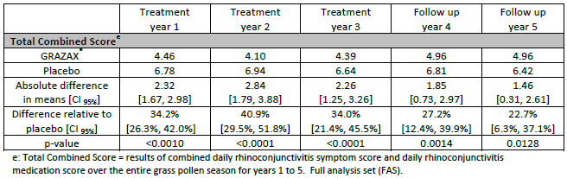
Figure 4: Forrest plot of GT-08 total combined scores (TCS) Years 1 to 5
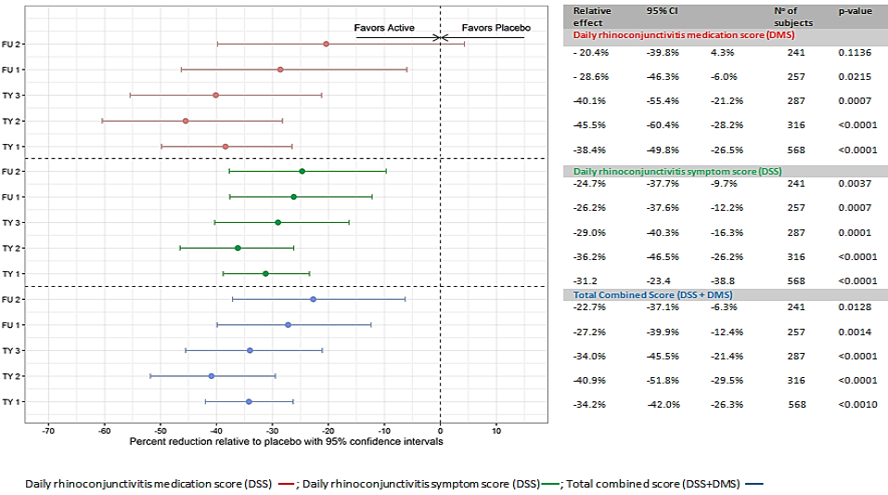
Figure 5: TCS for Grazax versus placebo (Years 1-5) in relation to daily grass pollen count
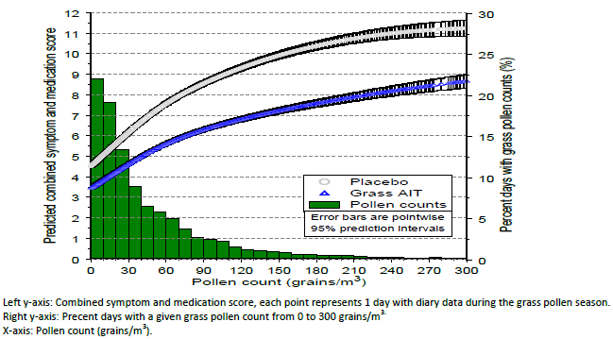
Well days
The number of ‘well days’ evaluates the number of days with symptom control (that is days without intake of rescue medication and a symptom score below a pre-defined and clinically relevant threshold). This is an important measure of quality of life for both the patient and the clinician and is recognised as an important indicator of efficacy for AIT., ⁹⁶ In GT-08, well days were defined as a measurement that combines the medication and symptom score for rhinoconjunctivitis without any intake of symptomatic medications and a total daily rhinoconjunctivitis symptom score no larger than 2 (from a maximum score of 18).
Analysis of well days for the entire GPS for each of Years 1 to 5 of GT-08 are presented in Table 31. The increase in well days for patients administered Grazax compared to placebo ranged from 24% to 48% for the entire pollen season over Years 1 to 5 (p ≤ 0.0203). The difference in median number of well days for patients administered Grazax compared to placebo was 6 to 9 days. Bearing in mind the definition of well days comprises improvement in symptom score without use of medication, the difference in median number of well days for Grazax compared to placebo (that is difference of 6 to 9 days over Years 1 to 5) is considered clinically relevant for both patients and clinicians. The clinical relevance and statistical significance of these results support the long term efficacy and disease modifying effect of Grazax (that is a sustained significant and clinically relevant effect for at least 2 post treatment years following 3 years of treatment) and provide additional support for the claim for disease modification.
Table 31: Analysis of Well Days for the Entire GPS for each of Years 1 to 5 of GT-08 (FAS) , , , ,
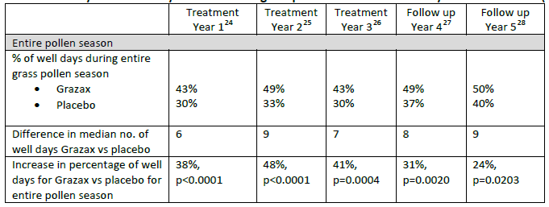
Changes to in vitro immunological parameters
In accordance with EMA ⁹⁴ and the World Allergy Organisation (WAO), ⁹⁶ changes in immunological parameters should be explored to assess the efficacy for allergy immunotherapy. Thus, immunological parameters were assessed for Grazax GT-08 (Years 1 to 5).
Specifically,
- IgE (for which the role in allergy is well established)
- IgG₄ (serological trials of specific immunotherapy have established that successful AIT is accompanied by an increase in allergen specific IgG, predominantly IgG₄ which is reported to inhibit the binding of IgE to the allergen in a competitive manner) and
- IgE-blocking factor (a term used by ALK to account for all treatment-induced blocking components (that is IgG isotypes, IgA and other less defined components).
The Year 5 results for IgE, IgG₄ and IgE-blocking factor support the long term efficacy and disease modifying effect of Grazax (that is a sustained significant and clinically relevant effect for at least 2 post treatment years following 3 years of treatment) and provide additional support for the claim for disease modification.
In GT-08, an initial increase in allergen specific IgE was seen followed by a plateau/slow decline (Figure 6). During the treatment years (Years 1 to 3), a blunting effect on seasonal specific IgE for Grazax compared to placebo was observed. In accordance with the literature, this is expected due to the down regulation of the allergic response. , , Yearly increases are also seen in both groups; this is due to environmental grass exposure during the yearly GPSs. At the end of the second follow-up year (Year 5), the difference between the Grazax and placebo groups was statistically significant (p = 0.0389).
Figure 6: Change from baseline in logarithm of Grazax specific IgE (GT-08 Years 1 to 5; FAS)
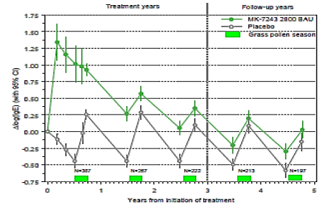
A significant increase in IgG₄ was observed within 2 months of treatment with Grazax compared to placebo. This effect persisted through all treatment years and also post-treatment years (Figure 7) and was statistically significant at the end of the second follow-up year (Year 5) (p < 0.0001).
Figure 7: Change from baseline in logarithm of Grazax specific IgG₄ (GT-08 Years 1 to 5; FAS)
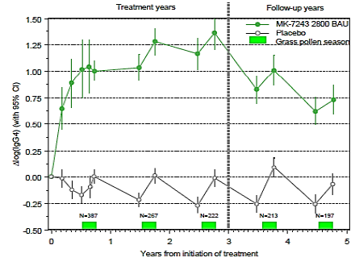
For IgE-blocking factor, an increase was observed within 2 months of treatment with Grazax compared to placebo and also persisted through all treatment years and also post-treatment years (Figure 8). The difference compared to placebo was statistically significant at the end of the second follow-up year (Year 5) (p < 0.0001).
Figure 8: Change from baseline in logarithm of Grazax specific IgE-blocking factor (GT-08 Years 1-5; FAS)
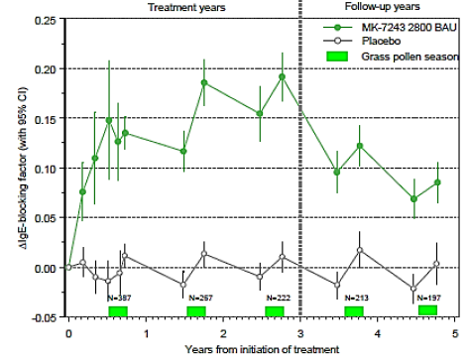
The ACPM comments that Grazax appears to be suitable for patients with grass pollen allergy caused by species which cross react with Timothy and recommend the addition of “or cross reacting allergens” to the Indication. They have also proposed a note to the Indication advising that studies have not shown any benefit for allergy to sub-tropical grasses.
As per the ACPM minutes, due to high degree of homology in temperate grasses, there is extensive IgG₄ and IgE cross reactivity between Phleum pratense allergen extract and those of other grasses within the Pooideae subfamily to which it belongs. As noted by the ACPM, Grazax is not intended for treatment of allergies to sub-tropical grasses. Subsequently, Seqirus proposes the inclusion of ‘temperate grasses’ to the indication and also to the dosage and administration and description sections of the proposed PI.
The ACPM comments that positive skin prick or serological testing to be included in the indications.
The dosage and administration section of the PI already states that patients should have a confirmed clinical history and a positive test of grass pollen sensitisation (skin prick test and/or specific IgE) prior to treatment. Additionally, the current proposed indication also states that Grazax is for patients diagnosed with grass pollen allergic rhinitis with or without conjunctivitis. Subsequently, Seqirus maintains that there is no need for inclusion of this text in the indication.
The ACPM comment that positivity to Timothy allergens appears to be a necessary but insufficient requirement for patients to gain substantial relief from grass pollen allergic rhinitis with or without conjunctivitis in much of Australia and that this needs to be explained to both prescribers and patients before treatment commences.
In line with the ACPM comment, the dosage and administration section of the PI has been amended to add a statement that management of specific allergy symptoms should be discussed prior to initiation of treatment.

Delegate’s post ACPM review of sponsor’s response
The Delegate reviewed the sponsor’s post-ACPM response. Amendment of the indication and the wording of the ‘precautions’ and ‘dosage and administration’ sections of the PI and CMI was subsequently negotiated with the sponsor.

Outcome
Based on a review of quality, safety and efficacy, TGA approved the registration of Grazax standardised allergen extract of grass pollen from Phleum pratense 75,000 SQ-T oral lyophilisate tablets, indicated for:
Grazax is indicated for disease modifying treatment of grass pollen (Phleum pratense or allergens cross reacting with P.pratense) induced allergic rhinitis with or without conjunctivitis in adults, adolescents and children above the age of 5 years.

Specific conditions of registration applying to these goods
- The Grazax [standardised allergen extract of grass pollen from Timothy grass (Phleum pratense)], Risk Management Plan (RMP): EU-RMP (version 8; 10 March 2015; DLP 24 June 2013) with Australian Specific Annex (version 2; date 23 August 2016), submitted with application PM-2015-03979-1-2, and any subsequent revisions, as agreed with the TGA will be implemented in Australia.
- It is a condition of registration that all batches of Grazax [(standardised allergen extract from Timothy grass, (Phleum pratense)], sublingual immunotherapy tablet, 75,000 SQ-T imported into Australia must comply with the product details and specifications approved during evaluation and detailed in the Certified Product Details (CPD).
- It is a condition of registration that each batch of Grazax [(standardised allergen extract from Timothy grass, (Phleum pratense)], sublingual immunotherapy tablet, 75,000 SQ-T imported into Australia is not released for sale until samples and/or the manufacturer’s release data have been assessed and endorsed for release by the TGA Laboratories Branch.

Attachment 1. Product Information
The PI for Grazax approved with the submission which is described in this AusPAR is at Attachment 1. For the most recent PI, please refer to the TGA website at <https://www.tga.gov.au/product-information-pi>.

Attachment 2. Extract from the Clinical Evaluation Report

Therapeutic Goods Administration
PO Box 100 Woden ACT 2606 Australia
Email: info@tga.gov.au Phone: 1800 020 653 Fax: 02 6232 8605
https://www.tga.gov.au

Standardised quality units (tablet); the SQ-T and SQ-U units express the same biological activity. SQ-U was originally introduced for products for subcutaneous administration. The SQ-U has for Grazax been substituted by the unit SQ-T to distinguish between the 2 pharmaceutical forms (that is subcutaneous versus oromucosal use).
ICH M3 (R2) Nonclinical Safety Studies for the Conduct of Human Clinical Trials and Marketing Authorisation for Pharmaceuticals
Dossier 3.2.S.2.2
Table 3, Dossier 3.2.S.2.3
Dossier 3.2.S.3.1
“The biological activity of the tablet is expressed in SQ-T. SQ-T is an arbitrary unit defined by ALK-Abelló A/S.” dossier 3.2.P.1. pp 1.
The calculated ‘dry matter doses’ have not been included as they were considered commercial in confidence material by the sponsor.
HJ Malling, et al, Safety and Immunological Changes During Sublingual Immunotherapy With Standardised Quality Grass Allergen Tablets. J Investig Allergol Clin Immunol 2006; Vol. 16(3): 162-168
2.4.1 in Module 2.4 Nonclinical overview.
Bagnasco M, et al. Absorption and distribution kinetics of the major Parietaria judaica allergen (Par j 1) administered by noninjectable routes in healthy human beings J Allergy Clin Immunol 1997; 100: 122-129.
Dose comparisons are on a BSA and Phl p dry matter basis.
Brimnes J, et al. Sublingual immunotherapy reduces allergic symptoms in a mouse model of rhinitis Clin Exp Allergy. 2007; 37: 488-497
This is in contrast to the claims in the Module 2 nonclinical overview that the dose volumes “could be administered without the dissipation being unacceptably large” (that is would not distribute beyond the mouth).
Study No. LEA-004-023818 pp 11: “The animal was restrained for a further 15-20 seconds after dosing to avoid, as far as possible, the animal swallowing the dosing formulation.” Study No. LEA-008-033623 pp 14: “Each animal was then restrained for a further 15-20 seconds (to avoid, as far as possible, swallowing of the test material) before being returned to its home cage.” Study No. LEA-010-042144 pp 16: “Each animal was then restrained for a further 15-20 seconds (to avoid, as far as possible, swallowing of the test material) before being returned to its home cage.”
Scaparrotta A, et al. Critical appraisal of Timothy grass pollen extract GRAZAX in the management of allergic rhinitis. Drug Des Devel Ther. 2015; 9: 5897-5909.
Krishna MT, et al. 2011. Clinical immunology review series: an approach to desensitization. Clin Exp Immunol. 2011; 163: 131–146.
Prevent the binding of allergen–IgE complexes on the low affinity receptor for IgE at the surface of B cells, thus decreasing the capacity of B cells to present the allergen to specific T cells.
Canonica GW, et al. Sublingual immunotherapy: World Allergy Organization position paper 2013 update. World Allergy Organ J. 2014; 7: 6; Senna G, et al. Safety and tolerability of sublingual immunotherapy in clinical trials and real life. Curr Opin Allergy Clin Immunol. 2011; 11: 375-380.
Pfaar O, et al. Allergen-Specific Immunotherapy: Which Outcome Measures are Useful in Monitoring Clinical Trials? Immunol Allergy Clin North Am. 2011; 31:289-309
Figure 1 in dossier §2.5.3
Roussel AJ, et al. Characterisation of dog sensitisation to grass pollen in western France from 1999 to 2010. Vet Rec. 2013; 172: 686;
Schiessl B, et al. Importance of early allergen contact for the development of a sustained immunoglobulin E response in a dog model. Int Arch Allergy Immunol. 2003; 130:125-134
Masuda K, et al. Positive reactions to common allergens in 42 atopic dogs in Japan. Vet Immunol Immunopathol. 2000; 73: 193-204
Patterson R, et al. Rush immunotherapy in a dog with severe ragweed and grass pollen allergy. Ann Allergy Asthma Immunol. 1999; 83: 213-216
Wheeler AW. Grass pollen specific antibody in the plasma of normal dogs. Lab Anim. 1993; 27: 73-76;
Stoecklinger A, et al. T cell epitopes of the timothy grass pollen allergen Phl p 5 of mice and men and the detection of allergen-specific T cells using Class II Ultimers. Int Arch Allergy Immunol. 2012; 158: 326-334
Olivry T et al. Treatment of canine atopic dermatitis: 2015 updated guidelines from the International Committee on Allergic Diseases of Animals (ICADA) BMC Vet Res. 2015; 11: 210
https://www.heska.com/Documents/Allergy/UPDATED-SUBLINGUAL_IMMUNOTHERAPY_FOR_PETS-001-pdf.aspx; http://veterinarymedicine.dvm360.com/sublingual-immunotherapy-new-option-allergy-patients?id=&sk=&date=&pageID=2; https://www.acttallergy.com/about-actt/
Jensen-Jarolim E et al. Pollen Allergies in Humans and their Dogs, Cats and Horses: Differences and Similarities. Clin Transl Allergy. 2015; 5: 15;
Favrot C et al. A prospective study on the clinical features of chronic canine atopic dermatitis and its diagnosis. Vet Dermatol. 2010;21:23–31;
Masuda K, et al. Seasonal rhinitis in a cat sensitized to Japanese cedar (Cryptomeria japonica) pollen. J Vet Med Sci. 2001; 63: 79–81.
Akdis M, et al. Mechanisms of allergen-specific immunotherapy J Allergy Clin Immunol. 2007; 119: 780–791;
Nagai Y, et al. Transportation of sublingual antigens across sublingual ductal epithelial cells to the ductal antigen-presenting cells in mice. Clin ExpAllergy. 2015; 45: 677-686
Frati F, et al. Mucosal immunization application to allergic disease: sublingual immunotherapy. Allergy Asthma Proc. 2007; 28: 35-39
Saint-Lu N, et al. Targeting the allergen to oral dendritic cells with mucoadhesive chitosan particles enhances tolerance induction. Allergy. 2009; 64:1003-1013
Ozdemir C, et al. Mechanisms of Aeroallergen Immunotherapy: Subcutaneous Immunotherapy and Sublingual Immunotherapy. Immunol Allergy Clin North Am. 2016; 36: 71-86
Pfaar O, et al. Guideline on allergen-specific immunotherapy in IgE-mediated allergic diseases: S2k Guideline of the German Society for Allergology and Clinical Immunology (DGAKI), the Society for Pediatric Allergy and Environmental Medicine (GPA), the Medical Association of German Allergologists (AeDA), the Austrian Society for Allergy and Immunology (ÖGAI), the Swiss Society for Allergy and Immunology (SGAI), the German Society of Dermatology (DDG), the German Society of Oto- Rhino-Laryngology, Head and Neck Surgery (DGHNO-KHC), the German Society of Pediatrics and Adolescent Medicine (DGKJ), the Society for Pediatric Pneumology (GPP), the German Respiratory Society (DGP), the German Association of ENT Surgeons (BV-HNO), the Professional Federation of Paediatricians and Youth Doctors (BVKJ), the Federal Association of Pulmonologists (BDP) and the German Dermatologists Association (BVDD). Allergo J Int. 2014; 23: 282-319;
Hagen A et al. Specific immunotherapy (SIT) in the treatment of allergic rhinitis. GMS Health Technol Assess. 2010
Incorvaia C et al. Sublingual immunotherapy for allergic rhinitis: where are we now? Immunotherapy. 2015; 7: 1105-1110
Pleskovic N, et al. The Future of Sublingual Immunotherapy in the United States. Curr Allergy Asthma Rep. 2015; 15: 44
Vitaliti G, Mucosal immunity and sublingual immunotherapy in respiratory disorders. J Biol Regul Homeost Agents. 2012; 26: S85-93
Moingeon P, et al. Induction of tolerance via the sublingual route: mechanisms and applications. Clin Dev Immunol. 2012; 2012: 623474;
Kawauchi H, et al. Short review on sublingual immunotherapy for patients with allergic rhinitis: from bench to bedside. Adv Otorhinolaryngol. 2011; 72: 103-106;
Ozdemir C. An immunological overview of allergen specific immunotherapy -subcutaneous and sublingual routes. Ther Adv Respir Dis. 2009; 3: 253-262;
Scadding G, et al. Mechanisms of sublingual immunotherapy. J Asthma. 2009; 46: 322-334
Garcia-Marcos L, et al. Sublingual specific immunotherapy: state of the art. Inflamm Allergy Drug Targets. 2007; 6: 117-126;
Frati F, et al. Mucosal immunization application to allergic disease: sublingual immunotherapy. Allergy Asthma Proc. 2007; 28: 35-39;
Details of the chemiluminescent assay methodology and relevant titration curves were not supplied but it is assumed that the assays were performed using the “Magic Light assay” as described in Brimnes J, et al. Sublingual immunotherapy reduces allergic symptoms in a mouse model of rhinitis Clin Exp Allergy. 2007; 37: 488-497. That is, actual change in Titre or Ig level cannot be calculated based on the data provided. However, comparatively small changes in RLU (2 to 5X) actually represent relatively large changes in antigen-specific antibody titres.
Akdis M, et al. Mechanisms of allergen-specific immunotherapy J Allergy Clin Immunol. 2007; 119: 780–791
All dose comparisons are on a BSA and Phl p dry matter basis.
Clemo FA, et al. Differentiating spontaneous from drug-induced vascular injury in the dog. Toxicol Pathol. 2003; 31: 25-31.
http://www.ich.org/fileadmin/Public_Web_Site/ICH_Products/Guidelines/Safety/S2_R1/Step4/S2R1_Step4.pdf
Dossier Module 2.6.6.4
ICH Harmonised Tripartite Guideline On The Need For Carcinogenicity Studies Of Pharmaceuticals S1a Step 4. http://www.ich.org/fileadmin/Public_Web_Site/ICH_Products/Guidelines/Safety/S1A/Step4/S1A_Guideline.pdf
Schäppi GF, et al. Concentrations of major grass group 5 allergens in pollen grains and atmospheric particles: implications for hay fever and allergic asthma sufferers sensitized to grass pollen allergens. Clin Exp Allergy. 1999; 29: 633-641.
Historical control data mouse – CD-1(Crl:CD1[ICR]), 2003-Jun 2013, Charles River Laboratories Preclinical Services; Data for Frontal bone(s): incomplete ossification.
Historical control data mouse – CD-1(Crl:CD1[ICR]), 2003-Jun 2013, Charles River Laboratories Preclinical Services; Data for combined incidence of hyoid bone – incomplete ossification and hyoid bone - unossified.
Pregnancy Category B2 is defined as Drugs which have been taken by only a limited number of pregnant women and women of childbearing age, without an increase in the frequency of malformation or other direct or indirect harmful effects on the human fetus having been observed. Studies in animals are inadequate or may be lacking, but available data show no evidence of an increased occurrence of fetal damage.
https://www.tga.gov.au/therapeutic-goods-exempted-pregnancy-categorisation
All comparisons on a BSA Phl p allergen extract dry matter basis
FDA. Guidance for Industry. Immunotoxicology Evaluation of Investigational New Drugs. October 2002; The guidance states that serum Ig E levels and cutaneous and or systemic anaphylaxis assays can be used to identify allergenic potential of proteins. However, negative results in such assays “should not be interpreted to indicate that an experimental drug cannot produce anaphylactic reactions.”
Bousquet et al. 2008 Allergic Rhinitis and its Impact on Asthma (ARIA) Allergy 2008: 63 (Suppl. 86): 8–160.
Haahtela T and Laitinen L 1996, Asthma program in Finland 1994-2004. Clinical and Experimental Allergy 1996; 26: i-iii and 1-24.
White P et al. 1998 Symptom control in patients with hay fever in UK general practice: how well are we doing and is there a need for allergen immunotherapy? Clinical and Experimental Allergy 1998; 28: 266–270
Yawn BP et al 1999 Allergic rhinitis in Rochester, Minnesota residents with asthma: Frequency and impact on health care charges. J. Allergy Clin. Immunol. 1999; 103: 54-59
Corren J 1998 The impact of allergic rhinitis on bronchial asthma. J. Allergy Clin Immunol 1998; 101: S352-356
Grossman J 1997 One airway, one disease. CHEST 1997; 111:11S-16S
Bousquet Jet al. 1998 WHO Position paper. Allergen immunotherapy: therapeutic vaccines for allergic diseases Geneva: January 27-29 1997.
Durham SR et al. 2012 SQ-standardised sublingual grass immunotherapy: Confirmation of disease modification 2 years after 3 years of treatment in a randomized trial. J Allergy and Clin Immunology 2012; 129 ; 717-725
CHMP/EWP/18504/2006 Guideline on the clinical development of products for specific immunotherapy for the treatment of allergic diseases” (EMEA 2008)
IgE-blocking antibodies/factor; IgX is the ratio between [allergen binding IgE-activity in serum measured in the presence of other serum components] and [allergen binding IgE- activity in serum measured in the absence of other serum components]. If no IgE-blocking factor is induced the IgX value is close to 1, whereas the presence of IgE-blocking factor will result in reduced IgX values. The assay is termed IgX since the isotype specificity of the competing components is not determined.
Routine risk minimisation activities may be limited to ensuring that suitable warnings are included in the product information or by careful use of labelling and packaging.
Routine pharmacovigilance practices involve the following activities: - All suspected adverse reactions that are reported to the personnel of the company are collected and collated in an accessible manner; - Reporting to regulatory authorities; - Continuous monitoring of the safety profiles of approved products including signal detection and updating of labeling; - Submission of PSURs; - Meeting other local regulatory agency requirements.
Clarification: The Sponsor indicated that copies of all PSURs are available upon request; however copies have not been requested.
Simon, B.K. & Alfonso, Y. 2011. AusGrass2, http://ausgrass2.myspecies.info/ accessed on 10 February 2016.
The FDA approved tradename for this product is Grastek. The EU approved name is Grazax. Both products are the same.
Lorenz AR et al. The principle of homologous groups in regulatory affairs of allergen products--a proposal. Int Arch Allergy Immunol. 2009; 148: 1-17.
Johansen N, et al. Extensive IgE Cross-Reactivity towards the Pooideae Grasses Substantiated for a Large Number of Grass-Pollen-Sensitized Subjects. Int Arch Allergy Immunol 2009; 150: 325–334.
Hejl C, et al. Phleum pratense alone is sufficient for allergen specific immunotherapy against allergy to Pooideae grass pollen. Clin Exp Allergy 2009; 39: 752–759.
Bousquet PJ, et al. Sublingual immunotherapy: World allergy organization position paper 2009. Allergy 2009; 64 :1-59.
http://www.fda.gov/downloads/AdvisoryCommittees/CommitteesMeetingMaterials/BloodVaccinesandOtherBiologics/AllergenicProductsAdvisoryCommittee/UCM37 8093.pdf, Table 13, p65
Bousquet PJ, Cox LS, Durham SR, Nelson HS, Passalacqua G, Ryan DP, et al. Sublingual immunotherapy: World allergy organization position paper 2009. Allergy 2009;64(Suppl 91):1-59.
CHMP/EWP/18504/2006; The Clinical Development Of Products For Specific Immunotherapy For The Treatment Of Allergic Disease (effective Jun 2009)
Bousquet,J., et al. 2008. Allergic Rhinitis and its Impact on Asthma (ARIA) 2008 update (in collaboration with the World Health Organization, GA2LEN and AllerGen). Allergy, 63 Suppl 86, 8-160
See Module 5.3.5.1 , CSR Trial GT-08 Year 5-Final Report, Section 9.2, Panel 9-5, p79 and Section 9.4.1, Panel 9-11, p83
http://keyserver.lucidcentral.org/weeds/data/03030800-0b07-490a-8d04-0605030c0f01/media/Html/Phleum_pratense.htm
The Australefficacy Society of Clinical Immunology and Allergy (ASCIA), the peak professional medical organisation for allergy and clinical immunology in AU and NZ
http://www.allergy.org.au/patients/allergic-rhinitis-hay-fever-and-sinusitis/guide-to-common-allergenic-pollen/273-timothy-grass
Canonica GW, et al. Recommendations for standardization of clinical trials with Allergen Specific Immunotherapy for respiratory allergy. A Statement of a World Allergy Organization (WAO) taskforce. Allergy 2007;62:317–324, p322
Clark J, Schall R. Assessment of combined symptom and medication scores for rhinoconjuncitivits immunotherapy clinical trials, Allergy 2007: 62: 1023-1028, p1023
Mailing HJ, Sublingual immunotherapy: efficacy – methodology and outcome of clinical trials, Allergy 2006: 61: 24-28, p24
Durham SR, et al Magnitude of efficacy measurements in grass allergy immunotherapy trials is highly dependent on pollen exposure. Allergy 2014; DOI: 10.1111/all.12373, p1,6
Grazax dossier, Module 2.5, section 2.5.4.4.3, p32
European Medicines Agency, Committee for Medicinal Products for Human Use (CHMP). Guideline on the clinical development of products for specific immunotherapy for the treatment of allergic diseases EMEA/CHMP/EWP/18504/2006, Nov-2008 (effective Jun 2009), p9
Canonica GW et al., Sublingual immunotherapy: World Allergy Organization position paper 2013 update. World Allergy Organization Journal 2014, p31
Bousquet PJ, et al. Sublingual immunotherapy: World allergy organization position paper 2009. Allergy 2009; 64: 1-59, p54
http://www.fda.gov/downloads/AdvisoryCommittees/CommitteesMeetingMaterials/BloodVaccinesandOtherBiologics/AllergenicProductsAdvisoryCommittee/UCM378093.pdf, p55
Durham SR, et al. Magnitude of efficacy measurements in grass allergy immunotherapy trials is highly dependent on pollen exposure. Allergy 2014; DOI: 10.1111/all.12373
European Medicines Agency, Committee for Medicinal Products for Human Use (CHMP). Guideline on the clinical development of products for specific immunotherapy for the treatment of allergic diseases EMEA/CHMP/EWP/18504/2006, Nov-2008 (effective Jun 2009), p9
Grazax dossier, Module 5 – section 5.3.5.1, GT-08 year 1 study report, p65/919
Grazax dossier, Module 5 – section 5.3.5.1, GT-08 year 5 study report, p36/206
Grazax dossier, Module 5 – section 5.3.5.1, GT-08 year 1 study report amendment, p10/107
Grazax dossier, Module 5 – section 5.3.5.1, GT-08 year 2 study report, p72,73/781
Grazax dossier, Module 5 – section 5.3.5.1, GT-08 year 3 study report, p86,778/1014
Grazax dossier, Module 5 – section 5.3.5.1, GT-08 year 4 study report, p74,75/925
Grazax dossier, Module 5 – section 5.3.5.1, GT-08 year 5 study report, p86,87/6373
Cooke R, et al Serological evidence on immunity with co-existing sensitization in a type of human allergy; hay fever. J Exp Med 1935; 62 :733
Lichtenstein LM, et al. A quantitative in vitro study of the chromatographic distribution and immunoglobulin characteristics of human blocking antibody. J Immunol 1968; 101: 317-324
Nouri-Aria KT, et al. Grass pollen immunotherapy induces mucosal and peripheral IL-10 responses and blocking IgG activity. J Immunol 2004; 172: 3252-3259
Lima MT, et al. Grass pollen sublingual immunotherapy for seasonal rhinoconjunctivitis: a randomized controlled trial. Clin Exp Allergy 2002;32: 507-514
Lichtenstein LM, et al. IgE Antibody measurements in ragweed hay fever: Relationship to clinical severity and the results of immunotherapy. J Clin Invest 1973; 53: 472-482
Grazax dossier, Module 5 – section 5.3.5.1, GT-08 year 5 study report, p1326/6373
http://www.fda.gov/AdvisoryCommittees/CommitteesMeetingMaterials/BloodVaccinesandOtherBiologics/AllergenicProductsAdvisory Committee/ucm367268.htm,p32
Grazax dossier, Module 5 – section 5.3.5.1, GT-08 year 5 study report, p1326/6373
Ref:http://www.fda.gov/AdvisoryCommittees/CommitteesMeetingMaterials/BloodVaccinesandOtherBiologics/AllergenicProductsAdvisory Committee/ucm367268.htm,p33
Grazax dossier, Module 5 – section 5.3.5.1, GT-08 year 5 study report, p1326/6373
Ref:http://www.fda.gov/AdvisoryCommittees/CommitteesMeetingMaterials/BloodVaccinesandOtherBiologics/AllergenicProductsAdvisory Committee/ucm367268.htm,p34
Lorenz AR et al. The principle of homologous groups in regulatory affairs of allergen products-a proposal. Int Arch Allergy Immunol. 2009;148(1):1-17

