Date of first round report: 29 October 2015
Date of second round report: 27 January 2016

AusPAR Attachment 2

Extract from the Clinical Evaluation Report for Pertuzumab
  - Proprietary Product Name: Perjeta
  - Sponsor: Roche Products Pty Ltd

About the Therapeutic Goods Administration (TGA)
- The Therapeutic Goods Administration (TGA) is part of the Australian Government Department of Health, and is responsible for regulating medicines and medical devices.
- The TGA administers the Therapeutic Goods Act 1989 (the Act), applying a risk management approach designed to ensure therapeutic goods supplied in Australia meet acceptable standards of quality, safety and efficacy (performance), when necessary.
- The work of the TGA is based on applying scientific and clinical expertise to decision-making, to ensure that the benefits to consumers outweigh any risks associated with the use of medicines and medical devices.
- The TGA relies on the public, healthcare professionals and industry to report problems with medicines or medical devices. TGA investigates reports received by it to determine any necessary regulatory action.
- To report a problem with a medicine or medical device, please see the information on the TGA website <https://www.tga.gov.au>.
About the Extract from the Clinical Evaluation Report
- This document provides a more detailed evaluation of the clinical findings, extracted from the Clinical Evaluation Report (CER) prepared by the TGA. This extract does not include sections from the CER regarding product documentation or post market activities.
- The words [Information redacted], where they appear in this document, indicate that confidential information has been deleted.
- For the most recent Product Information (PI), please refer to the TGA website <https://www.tga.gov.au/product-information-pi>.
Copyright
© Commonwealth of Australia 2016
This work is copyright. You may reproduce the whole or part of this work in unaltered form for your own personal use or, if you are part of an organisation, for internal use within your organisation, but only if you or your organisation do not use the reproduction for any commercial purpose and retain this copyright notice and all disclaimer notices as part of that reproduction. Apart from rights to use as permitted by the Copyright Act 1968 or allowed by this copyright notice, all other rights are reserved and you are not allowed to reproduce the whole or any part of this work in any way (electronic or otherwise) without first being given specific written permission from the Commonwealth to do so. Requests and inquiries concerning reproduction and rights are to be sent to the TGA Copyright Officer, Therapeutic Goods Administration, PO Box 100, Woden ACT 2606 or emailed to <tga.copyright@tga.gov.au>.

Contents
Common abbreviations 5
1. Introduction 9
1.1. Drug class and therapeutic indication 9
1.2. Dosage forms and strengths 9
1.3. Dosage and administration 9
2. Clinical rationale 10
2.1. Pathological complete response (pCR) 11
2.2. NOAH and GeparQUATTRO studies 12
3. Contents of the clinical dossier 16
3.1. Scope of the clinical dossier 16
3.2. Paediatric data 17
3.3. Good clinical practice 17
4. Pharmacokinetics 17
4.1. Studies providing pharmacokinetic data 17
4.2. Summary of pharmacokinetics 18
4.3. Evaluator’s overall conclusions on pharmacokinetics 21
5. Pharmacodynamics 22
5.1. Studies providing pharmacodynamic data 22
5.2. Summary of pharmacodynamics 22
5.3. Evaluator’s overall conclusions on pharmacodynamics 23
6. Dosage selection for the pivotal studies 23
6.1. NEOSPHERE (WO20697) 23
6.2. TRYPHAENA (BO22280) 24
7. Clinical efficacy 25
7.1. Neoadjuvant treatment of operable, locally advanced or inflammatory HER2-positive breast cancer 25
1.1.2. Other efficacy studies 58
1.1.3. Analyses performed across trials (pooled analyses and meta-analyses) 65
1.1.4. Evaluator’s conclusions on clinical efficacy 65
8. Clinical safety 68
8.1. Studies providing evaluable safety data 68
8.2. Patient exposure 73
8.3. Adverse events 78
8.4. Laboratory tests 92
1.1.5. Vital signs 103
1.1.6. Other safety issues 104
8.5. Other safety issues 109
8.6. Safety related to drug-drug interactions and other interactions 111
8.7. Post-marketing experience (29) 112
8.8. Safety issues with the potential for major regulatory impact 113
8.9. Evaluator’s overall conclusions on clinical safety 113
9. First round benefit-risk assessment 113
9.1. First round assessment of benefits 113
9.2. First round assessment of risks 114
9.3. First round assessment of benefit-risk balance 114
10. First round recommendation regarding authorisation 114
11. Clinical questions 116
11.1. Pharmacokinetics 116
11.2. Pharmacodynamics 116
11.3. Efficacy 116
11.4. Safety 116
12. Second round evaluation of clinical data submitted in response to questions 117
12.1. Question 1 117
12.2. Question 2 117
12.3. Question 3 118
12.4. Question 4 118
12.5. Question 5 121
12.6. Question 6 123
12.7. Question 7 123
13. Second round benefit-risk assessment 124
13.1. Second round assessment of benefits 124
13.2. Second round assessment of risks 124
13.3. Second round assessment of benefit-risk balance 124
14. Second round recommendation regarding authorisation 124
15. References 125

Common abbreviations
Abbreviation | Meaning
ADCC | Antibody-dependent cellular cytotoxicity
AE | Adverse event
AEGT | Adverse event grouped term
ALT | Alanine aminotransferase
ANC | Absolute neutrophil count
ARTG | Australian Register of Therapeutic Goods
AST | Aspartate aminotransferase
ATA | Anti-therapeutic antibodies
BCS | Breast-conserving surgery
bpCR | Pathological complete response in the breast
CBE | Clinical breast examination
CHF | Congestive heart failure
CISH | Chromogenic in situ hybridisation
CL | Clearance
CMI | Consumer medicine information
CrCl | Creatinine clearance
CSR | Clinical study report
D | Docetaxel
DFS | Disease-free survival
EBC | Early breast cancer
ECD | Extracellular domain
ECOG | Eastern Co-operative Oncology Group
eCRF | Electronic case report form
EEA | European economic area
EGFR | Epidermal growth factor receptor 1
ER | Oestrogen receptor
EU | European union
FEC | 5-fluorouracil, epirubicin, and cyclophosphamide
FFPE | Formalin-fixed paraffin embedded
FISH | Fluorescence in situ hybridisation
FU | Follow-up
GBG pCR | GBG definition of pcr (ypt0 ypn0).
GCP | Good clinical practice
HER | Human epidermal growth factor receptor
HBV | Hepatitis B virus
HCV | Hepatitis C virus
HIV | Human immunodeficiency virus
HR | Hazard ratio
IBC | Inflammatory breast cancer
ICH | International Conference on Harmonization
Ig | Immunoglobulin
IHC | Immunohistochemistry
ILD | Interstitial lung disease
ITT | Intention –to-treat
IV | Intravenous
KM | Kaplan-Meier
LABC | Locally advanced breast cancer
LVEF | Left ventricular ejection fraction
LVSD | Left ventricular systolic dysfunction
MBC | Metastatic breast cancer
MedDRA | Medical Dictionary for Regulatory Activities
NCI CTCAE | National Cancer Institute Common Terminology Criteria for Adverse Events
NYHA | New York Heart Association
OS | Overall survival
pCR | Pathological complete response
PFS | Progression-free survival
Ptz | Pertuzumab
PD | Pharmacodynamics
PgR | Progesterone receptor
PI | Product information
PK | Pharmacokinetics
popPK | Population pharmacokinetics
PP | Per protocol
q3w | Every third week
SAE | Serious adverse event
SmPC | Summary of product characteristics
SMQ | Standardized meddra query
SOC | System organ class
SOP | Standard operating procedure
T_{1/2} | Half-life
TCH | Docetaxel, carboplatin and trastuzumab
TGA | Therapeutic Goods Administration
TNM | Tumour Nodes Metastases classification
tpCR | Pathological complete response in the breast and axillary nodes
T | Trastuzumab
ULN | Upper limit of normal
USA | United States of America
Vc | Volume of distribution (central)
Vp | Volume of distribution (peripheral)
Ypt0/Tis | The absence of invasive cancer in the breast
Ypt0/Tis ypn0 | The absence of invasive cancer in the breast and axillary nodes
Ypt0 ypn0 | The absence of invasive and in situ cancer in the breast and axillary nodes

Introduction
This is a submission to extend the indications for use of pertuzumab.

Drug class and therapeutic indication
Pertuzumab is a recombinant humanized monoclonal antibody that binds to the extracellular dimerization domain (Subdomain II) of the human epidermal growth factor receptor 2 protein (HER2) and thereby blocks ligand-dependent heterodimerisation of HER2 with other HER family members, including EGFR, HER3 and HER4.
Approved indication: In combination with trastuzumab and docetaxel for patients with HER2-positive metastatic breast cancer who have not received prior anti-HER2 therapy or chemotherapy for their metastatic disease.
Proposed indication: For use in combination with trastuzumab and docetaxel for the neoadjuvant treatment of patients with HER2-positive , locally advanced, inflammatory, or early stage breast cancer (> 2 cm in diameter) as part of a fluorouracil, epirubicin and cyclophosphamide (FEC) or carboplatin containing treatment regimen.

Dosage forms and strengths
Pertuzumab is supplied as a single use vial containing 14 mL of preservative free concentrate solution. Each vial contains 420 mg of pertuzumab (30 mg/mL) with the following excipients; sucrose, polysorbate 20, histidine and acetic acid, glacial. No new dosage forms or strengths are proposed.

Dosage and administration
Current indication: In the metastatic setting pertuzumab is used in combination with trastuzumab and docetaxel. The recommended initial dose of pertuzumab is 840 mg, administered as a 60 min IV infusion, followed by, every 3 weeks, a 420 mg dose administered over 30-60 min. When trastuzumab is administered with pertuzumab, the recommendation is to follow a 3- weekly schedule, administered as an IV infusion, with an initial trastuzumab dose of 8 mg/kg followed by every 3 weeks, a dose of 6 mg/kg. When docetaxel is administered with pertuzumab, the recommended initial docetaxel dose is 75 mg/m². The dose of docetaxel may be escalated to 100 mg/m² if the initial dose is well tolerated. The medicinal products should be administered sequentially. Pertuzumab and trastuzumab can be given in any order. When the patient is receiving docetaxel, the docetaxel should be administered after pertuzumab and trastuzumab. An observation period of 30-60 minutes is recommended after each pertuzumab infusion and before commencement of any subsequent infusion of trastuzumab or docetaxel. It is recommended that patients are treated with pertuzumab until disease progression or unmanageable toxicity.
Proposed extended indication: The proposed schedule of administration of pertuzumab is for neoadjuvant treatment of patients with HER2-positive, locally advanced, inflammatory or early stage breast cancer (either greater than 2 cm in diameter or node positive) in combination with trastuzumab and docetaxel, as part of a FEC-containing regimen, or as part of a carboplatin-containing regimen. Examples of suggested regimens are as follows:
- Four pre-operative cycles of pertuzumab in combination with trastuzumab and docetaxel followed by 3 post-operative cycles of FEC (as per the NEOSPHERE/WO20697 study)
- Three pre-operative cycles of FEC alone followed by 3 preoperative cycles of pertuzumab in combination with docetaxel and trastuzumab (as per the TRYPHAENA/BO22280 study)
- Six pre-operative cycles of pertuzumab in combination with docetaxel, carboplatin and trastuzumab (TCH) (as per the TRYPHAENA/BO22280 study)
The recommended initial dose of pertuzumab is 840 mg, administered as a 60 min IV infusion, followed by, every 3 weeks, a 420 mg dose administered over 30-60 min. When trastuzumab is administered with pertuzumab, the recommendation is to follow a 3- weekly schedule, administered as an IV infusion, with an initial trastuzumab dose of 8 mg/kg followed by every 3 weeks, a dose of 6 mg/kg. When docetaxel is administered with pertuzumab, the recommended initial docetaxel dose is 75 mg/m². The dose of docetaxel may be escalated to 100 mg/m² if the initial dose is well tolerated. In the carboplatin-containing regimen, dose escalation above 75 mg/m² is not recommended.
The drugs should be administered sequentially. Pertuzumab and trastuzumab can be given in any order. When the patient is receiving docetaxel, the docetaxel should be administered after pertuzumab and trastuzumab. An observation period of 30-60 minutes is recommended after each pertuzumab infusion and before commencement of any subsequent infusion of trastuzumab or docetaxel.
Comment: While locally advanced (inoperable/borderline operable) breast cancer and inflammatory breast cancers are frequently offered up-front chemotherapy, it is notable that neoadjuvant therapy for operable-breast cancer has a low level of use in Australia at less than 3% (1). Nevertheless, in cases where it is employed, commonly used regimens would include the FEC-DT/DT-FEC and TCH regimens proposed in the extended indication. In the case of the FEC regimen the number of cycles of FEC is limited to 3. There are several varieties of ‘FEC’, including FEC100, in which 5-Fluorouracil is given at 500 mg/m², epirubicin is given at 100 mg/m² and cyclophosphamide is given at 500 mg /m², and FEC90 as used in the GEICAM 9906 study in which 5-Fluorouracil is given at 600 mg/m², epirubicin is given at 90 mg/m² and cyclophosphamide is given at 600 mg/m². Regimens such as these are commonly used in Australian practice although it should be noted that in the GEICAM 9906 adjuvant study 4 cycles of FEC was given rather than 3 (2, 3).
It is important to note that the practice of giving trastuzumab concurrently with anthracycline-based chemotherapy as described in the adjuvant phase of this study would be inconsistent with current Australian practice due to concerns over cardiac toxicity (4). The evaluator notes that approval for this adjuvant combination is not sought in the current application.
It is also noteworthy that in a non HER2-positive population (n=2091) that addition of fluorouracil to a sequential adjuvant EC-Paclitaxel regimen was not associated with an improved disease-free survival outcome in patients with early breast cancer (5). Thus it is likely that a significant number of Australian oncologists will wish to reduce the amount of FEC administered in favour of the less toxic EC regimen.
The proposed indications for use of pertuzumab do not represent an increase in the maximum dose or duration of treatment compared to the approved regimens.

Clinical rationale
HER2-positive breast cancer remains a significant health problem, estimated to account for around 60,000 to 90,000 deaths per year globally. A significant proportion of these deaths occur in patients previously treated for non-metastatic disease with clinical trials of neoadjuvant or adjuvant trastuzumab plus chemotherapy reporting 5-year relapse rates ranging from approximately17% to 40% depending on stage of disease and tumour characteristics of the patients enrolled. Thus there remains a need to improve outcomes for women with HER2-positive breast cancer treated in the adjuvant and neoadjuvant settings. Historically, decisions relating to which therapies warrant testing (and approval) in the adjuvant and neoadjuvant settings have relied on the demonstration of efficacy in the metastatic setting.
In the CLEOPATRA (WO20698) study, the addition of pertuzumab to trastuzumab plus docetaxel (Ptz + T+D) treatment resulted in a substantial prolongation of both progression free- and overall survival (PFS and OS) in patients with metastatic HER2-positive breast cancer (MBC) in comparison to trastuzumab plus docetaxel (Pla + T + D). The median survival estimates were 56.5 months with Ptz+T+D versus 40.8 months with Pla+T+D (HR = 0.68; 95% CI, 0.56 − 0.84; p = 0.0002). The median PFS (investigator-assessed) was 18.7 months in the pertuzumab-containing arm and 12.4 months in the placebo arm (HR = 0.68; 95% CI, 0.58 − 0.80; p < 0.0001). (Update CSR WO20698).
Two neoadjuvant studies, NEOSPHERE (WO20697) and TRYPHAENA (BO22280) have addressed the role of pertuzumab in the neoadjuvant setting using pathological complete response (pCR) as a surrogate end-point. There is a further ongoing neoadjuvant study BERENICE (WO29217), which is a non-randomised, open-label, phase II study evaluating pertuzumab in combination with trastuzumab and two different neoadjuvant anthracycline-based chemotherapy regimens in patients with HER2-positive, locally advanced, inflammatory or early-stage breast cancer. Data from this study are expected at around the end of 2017. Importantly, there is an adjuvant APHINITY (BO25126) study expected to be analysed in 2016 with reporting in 2017. This study is a randomised phase III study of adjuvant trastuzumab +/- pertuzumab after adjuvant chemotherapy (either anthracycline or non-anthracycline based as per investigator). 4805 patients are enrolled onto this study, which is expected to provide important data relating to DFS, OS, long-term cardiac safety, quality-of-life and pharmacokinetic parameters.

Pathological complete response (pCR)
There are several definitions of pCR in use with varying degrees of stringency.
- ypT0/Tis – Breast pathological complete response (bpCR) = the absence of invasive cancer in the breast
- ypT0/Tis ypN0 – Total pathological complete response (tpCR) = the absence of invasive cancer in the breast and axillary nodes
- ypT0 ypN0 – German Breast Group pathologic complete response (GBG pCR) = the absence of invasive and in situ cancer in the breast and axillary nodes
In the Cortazar analysis of 2012 (9,10) in which data from nearly 13,000 patients was analysed, nodal involvement following neoadjuvant therapy was associated with an increased risk of recurrence and death, but residual ductal carcinoma in situ was not prognostic. Therefore the FDA recognizes both ypT0/Tis ypN0 and ypT0 ypN0 as reasonable definitions. In contrast, the smaller (n=6377) German Breast Group/Arbeitsgemeinschaft Gynakologische Onkologie- Breast Group (GBG) meta-analysis determined that there was an improved DFS in patients with ypT0 ypN0 responses in comparison to those with residual in situ disease (ypTis ypN0) with a trend to better OS. Hence the GBG definition of a true pCR is ypT0 ypN0 (11). However, for regulatory purposes the following definition is recommended by the EMA: absence of any residual invasive cancer on haematoxylin and eosin evaluation of the resected breast specimen and all sampled ipsilateral lymph nodes following completion of the neoadjuvant systemic therapy (ypT0/is ypN0) (12, 13).
In should be noted that in the pivotal NEOSPHERE (WO20697) and TRYPHAENA (BO22280) studies, pathological complete response (for the purposes of the main analyses) was confined to the assessment of the response in the breast (bpCR; ypT0/is), that is, a less stringent end-point than that recommended for use by regulators elsewhere. However, data were collected in both studies to enable pCR assessment by tpCR and GBG pCR for the purposes of exploratory analyses.
The sponsor has provided data pertaining to the use of pCR as a surrogate endpoint for DFS through analyses of the NOAH and GeparQUATTRO studies as presented below.

NOAH and GeparQUATTRO studies
The following section outlines the key features of the NOAH and GeparQUATTRO studies upon which the use of pathological complete response rate is based (14). Discussion will therefore be limited to the data as it pertains to this question.

NOAH

Design
The study was an international, open-label, Phase III trial in women with newly diagnosed locally advanced or inflammatory breast cancer. Patients we with HER2-positive disease were randomly assigned to receive neoadjuvant trastuzumab plus chemotherapy followed by adjuvant trastuzumab, or neoadjuvant chemotherapy alone. However, after positive results of adjuvant trastuzumab trials became available, HER2-positive patients allocated to chemotherapy alone were offered 1 year of adjuvant trastuzumab post-surgery. Because prospective data comparing treatment outcomes of HER2-positive patients with those of patients with HER2-negative disease were scarce, a parallel observational cohort was prospectively included, in which women with HER2-negative disease were selected with the same criteria as were those with HER2-positive disease, and received the same chemotherapy as did the HER2-positive group, but without trastuzumab.

Objectives

Primary objective
- To compare event-free survival, defined as time from randomisation to disease recurrence or progression (local, regional, distant, or contralateral) or death from any cause, inpatients with HER2-positive disease treated with and without trastuzumab.

Secondary objectives: to assess
- pathological complete response in breast tissue
- total pathological complete response (in breast and axilla)
- overall clinical response rates
- cardiac safety
- survival in all three groups of patients
- event-free survival (measured from study registration) in patients with HER2-negative disease.

Centres and countries
Patients were recruited from 25 centers in 6 countries (Russia, Spain, Italy, Germany, Austria, and Portugal) with each center recruiting between 1 and 90 patients.

Sample size
The primary endpoint of EFS was used to determine the sample size for NOAH. A total of 333 patients were enrolled: 234 patients with HER2-positive disease (116 randomised to the HER2 + TC group and 118 to the HER2 + C group), and 99 patients with HER2-negative disease (HER2-C group). The number of patients screened but not enrolled was not collected. The sample size for the exploratory assessment of surrogacy of pCR was based on patients who were HER2-positive in the ITT population or full analysis set (FAS), namely 115 patients in the HER2 + TC group and 116 patients in the HER2 + C group. Patients who had unknown pCR status were treated as non-pCR patients in the assessment. The data used in the pCR exploratory analysis used the same clinical cut-off date (that is, 30 March 2009) as that used for the Roche CSR, however differs from that used in the earlier analysis by Gianni et al. (2010) for the NOAH results.

Analysis of pCR
- pCR of the primary tumour (breast pCR [bpCR]) was defined as the absence of any invasive cancer cell of the primary tumour at major surgery after neoadjuvant chemotherapy ± trastuzumab. This corresponds to the definition’ypT0/is’. For patients whose response could not be assessed (such as patients not undergoing surgery or withdrawing from the study prior to surgery as well as patients with missing information on breast tumour remnants), the pCR of the primary tumour was set to ‘not evaluable.’
- pCR of the primary tumour and axillary lymph nodes (total pCR [tpCR]): ypCR was associated with the presence or absence of positive axillary nodes at pathology. Clinical assessment of ipsilateral supraclavicular lymph nodes could also be 0. This corresponds to definition ‘ypT0/is, ypN0’. For patients whose response could not be assessed (such as patients not undergoing surgery or withdrawing from the study prior to surgery as well as patients with missing information on breast tumour remnants or the number of positive axillary nodes), the pCR of the primary tumour was set to ‘not evaluable.’
The focus of the analyses of NOAH data was on tpCR, but analyses were also repeated for bpCR.

Results
- tpCR rates in HER2 + TC group were 40% (46 of 115 patients) and in HER2 + C group were 20.7% (24 of 116 patients), resulting in a difference in tpCR of 19.3%. The data for bpCR were 44.3% (51of 115 patients) and 26.7% (31 of 116 patients), respectively.
- 22% (50 of 231 patients) of the patients in the full analysis set were unevaluable for bpCR. The corresponding figure for tpCR was 21% (49 of 231 patients). In the assessment of surrogacy, these unevaluable patients were treated as non-responders.
- The percentage of patients with EFS events was 40% (46/115) and 50.9% (59/116) in the HER2 + TC and HER2 + C groups, respectively.

GeparQUATTRO

Design
Patients with large operable or locally advanced tumours, with hormone receptor negative tumours, or with receptor positive tumours but also clinically node positive disease were recruited to receive preoperatively four cycles of epirubicin plus cyclophosphamide (EC; epirubicin 90 mg/m² and cyclophosphamide 600 mg/m²). Patients were then randomly assigned to four cycles of docetaxel (100 mg/m²), four cycles of docetaxel capecitabine (TX; docetaxel 75 mg/m² plus capecitabine 1,800 mg/m²), or four cycles of docetaxel (75 mg/m²) followed by four cycles of capecitabine (1,800 mg/m²; T-X). Patients with human epidermal growth factor receptor 2 (HER-2) –positive tumours received trastuzumab concomitantly with all cycles.

Objectives

Primary objectives
- to assess the effect of docetaxel by comparing EC plus docetaxel versus EC plus TX
- to assess the effect of duration by comparing EC plus TX versus EC plus T-X on pathologic complete response (pCR, without invasive/non-invasive breast tumour, regardless of nodal status) at surgery, irrespective of trastuzumab treatment.
Only the data from the HER2-positive patients (who also received trastuzumab) were made available by GBG.

Centres and countries
All were recruited from Germany.

Sample size
Only the data from the 444 HER2-positive patients (who also received trastuzumab) were made available by GBG to the sponsor for this analysis. Of these, 425 were randomised to one of the 3 treatment groups (146 to EC-DOC, 136 to EC-DOC-X, and 143 to EC-DOCX).

Analysis of pCR
For GeparQuattro, only data corresponding to the pCR definition ‘ypT0’ were available.

Results
The pCR (ypT0) results from the HER2-positive patients show comparable rates across all 3 treatment groups with pCR rates as follows - EC-DOC 48/146 (32.9%), EC-DOCX 47/136 (34.6%) and EC-DOC-X 45/143 (31.5%). DFS analysis was conducted with log-rank testing showed no difference (p=0.637).

Analyses of NOAH and GeparQUATTRO regarding pCR as a surrogate for DFS
Exploratory analyses were conducted using statistical simulations as the sponsor argued that the Prentice criteria for surrogacy cannot be applied to the NOAH study by virtue of the study design. By using a multivariate Cox regression on NOAH data, they show that attaining tpCR is an important independent indicator of longer EFS compared with those not attaining tpCR
Meta-analysis regression and simulation approaches on clinical trial data from 656 HER2-positive patients in NOAH and GeparQuattro, indicate there is reasonable correlation between pCR and EFS/DFS and may suggest that changes in pCR can predict changes in EFS/DFS. The sponsor suggests that a difference in pCR of 15 to 20% may lead to a meaningful difference in EFS, at least for a HER2-targeted therapy.
Comment: See section Pathological complete response (pCR).

Pathological complete response in context
This submission is unique in that it posits that pathological complete response (pCR) is a sufficient end-point upon which to base extension of indications. The rationale for this submission is that the addition of a short course (up to 6 cycles) of pertuzumab to a trastuzumab/taxane neoadjuvant regimen will lead to increased pCR rates and by inference, improved long-term outcomes.
However, pCR has not been definitively established as a surrogate marker for long-term outcome by standard statistical criteria (that is, Prentice criteria). Both the NOAH and GeparQUATTRO studies were not designed to specifically address the question of whether pCR (by various measures) can be used as a surrogate for long-term benefit. The analyses of the NOAH and GeparQUATTRO studies used statistical simulations due to the inability to apply Prentice criteria. It is also noted that the NOAH and GeparQUATTRO studies used different definitions of pCR for the surrogate marker analyses, which may affect applicability.
Note is made of the sponsor’s responses given to the ‘Request for supplementary information’ from the EMA in which several neoadjuvant studies of various agents were referenced. in which pCR rates of approximately15% were linked to the survival benefits seen with the same agents, however in different studies. The sponsor acknowledges that the pCR benefit seen with the addition of lapatinib in the Neo ALTTO study did not translate to a significant long-term benefit in the ALTTO study (15). While the data from CLEOPATRA (WO20698) show convincing benefit in the metastatic setting, the data from the adjuvant APHINITY (BO25126) study are clearly critical in the evaluation of the use of pertuzumab in non-metastatic disease.
Breast cancer is a heterogeneous entity, even within molecular subtypes such as HER2-positive breast cancer. Notably, endocrine receptor expression (ER&/or PR) is associated with lower levels of pCR despite superior long-term outlook (10) making the generalisability of pCR as a surrogate marker an open question.

International guidance on pCR
It is noted that both the European and US regulatory authorities have developed guidance documents in relation to the use of pCR as a surrogate end-point.
EMA draft guidance document in relation to the use of pCR states that approval based on pCR may be acceptable in patients with aggressive (high-risk) early stage breast cancer as add-on to an established (neo) adjuvant regimen, if there is a well characterised mechanism of action and provided the results show major increase in pCR with only minor changes in toxicity. Such results may lead to an approval with agreed conditions for confirmatory study data in terms of DFS/OS (The role of the pathological Complete Response as an endpoint in neoadjuvant breast cancer studies EMA/CHMP/151858/2014; date 20 March 2014).
Similarly the FDA has released a draft guidance document ‘Guidance for Industry Pathological Complete Response in Neoadjuvant Treatment of High-Risk Early-Stage Breast Cancer: Use as an Endpoint to Support Accelerated Approval (U.S. Department of Health and Human Services Food and Drug Administration Center for Drug Evaluation and Research (CDER), October 2014 , Clinical/Medical (website: www.fda.gov). This guidance document states that the FDA may grant accelerated approval ‘..upon a determination that the product has an effect on a surrogate endpoint that is reasonably likely to predict clinical benefit, or on a clinical endpoint that can be measured earlier than an effect on irreversible morbidity or mortality, that is reasonably likely to predict an effect on irreversible morbidity or mortality or other clinical benefit, taking into account the severity, rarity, or prevalence of the condition and the availability or lack of alternative treatments.’ However ‘Approval under this section will be subject to the requirement that the applicant study the drug further, to verify and describe its clinical benefit, where there is uncertainty as to the relation of the surrogate endpoint to clinical benefit, or of the observed clinical benefit to ultimate outcome.’ This document also referenced a 2013 Public workshop with the FDA and ASCO that concluded ‘that a large improvement in pCR rate based upon analysis of a full intent-to-treat population was reasonably likely to predict clinical benefit, and that the potential advantages of granting accelerated approval based upon pCR from a neoadjuvant randomised controlled trial generally outweighed concerns. The panel emphasised that such trials should be limited to high-risk patients, and that a confirmatory trial should be ongoing at the time of accelerated approval’. The evaluator notes that the numerical value corresponding to a ‘large’ improvement in pCR rate remains unknown, and that there is no mechanism for conditional approval in the Australian regulatory environment.

Guidance
- EMA/CHMP/703715/2012 Appendix to the guidance on the guideline on the evaluation of anticancer medicinal products in man Condition Specific Guidance Supersedes EMA/CHMP/EWP/520088/2008, Appendix 2 (Adopted by TGA 17 December 2010) Effective: 1 April 2014.
- EMA/CHMP/151853/2014 Committee for Medicinal Products for Human Use (CHMP) Draft guideline on the role of the pathological Complete Response as an endpoint in neoadjuvant breast cancer studies, First published 28/04/2014, Last updated 28/04/2014
- ‘Guidance for Industry - Pathological Complete Response in Neoadjuvant Treatment of High-Risk Early-Stage Breast Cancer: Use as an Endpoint to Support Accelerated Approval (U.S. Department of Health and Human Services Food and Drug Administration Center for Drug Evaluation and Research (CDER), October 2014 , Clinical/Medical)

Contents of the clinical dossier

Scope of the clinical dossier
The clinical dossier initially provided, documented pivotal and other clinical trials related to the proposed extension of indications, and included updated clinical trial information from the clinical trial underpinning the existing indication for metastatic breast cancer.
The submission contained the following clinical information:
- 1 clinical pharmacology study, including 1 that provided pharmacokinetic data and 1 that provided pharmacodynamic data.
- 2 population pharmacokinetic analyses.
- 1 human pharmacodynamics data report.
- 1 pivotal efficacy/safety study.
- 0 dose-finding studies.
- 2 other efficacy/safety studies.
- 1 other report of pCR analyses from more than 1 study.
Additional data were provided later:
- Final Clinical Study Report – WO20697 Research Report 1062325/February 2015
- CHMP Assessment Report 25 June 2015
- CHMP Opinion
- EMA Request for Supplemental Information (RSI)
- Response to first RSI
- EMA second RSI
- Response to second RSI
- SAG-O Meeting Minutes
- SAG-O Roche Written Response
- Primary CSR from Study WO20697; CSR for an updated analysis from Study WO20697
- Primary and Addendum CSRs from 20698.

Paediatric data
The submission did not include paediatric data. The evaluator does not believe that pertuzumab is likely to be of any clinical relevance for this indication in a paediatric population.

Good clinical practice
This studies reviewed for this submission were conducted in full conformance with the principles of the ‘Declaration of Helsinki’ (and its subsequent amendments) or with the local laws and regulations of the country in which the research was conducted; whichever provided greater protection to the individual. In countries in which good clinical practice (GCP) guidelines exist, the sponsor and the investigators strictly adhered to the stated provisions in these guidelines. This was documented by the Investigator’s signature on the protocol agreeing to carry out all of its terms in accordance with applicable regulations and law and to follow International Conference on Harmonization (ICH) guidelines for GCP. All investigators were trained according to company standard operating procedures (SOPs).

Pharmacokinetics

Studies providing pharmacokinetic data
There is one new study examining pharmacokinetic parameters of pertuzumab for consideration, that pertaining to the NEOSPHERE (WO20697 study). The study design is detailed in Figure 1. The pertuzumab PK results in NEOSPHERE (W020697) were consistent with the previous popPK model predictions, suggesting similarity in pertuzumab PK between the EBC population in NEOSPHERE (W020697) and other historical patient types including the first-line MBC population and others included in the popPK model. The majority of patients (130 out of 133) in the pertuzumab-containing arms of NEOSPHERE (W020697) had an observed pertuzumab trough serum concentration > 20 μg/mL (the target efficacious exposure based on nonclinical efficacy models) at Cycle 2. This target serum concentration is achieved in >90% of neoadjuvant breast cancer patients receiving a 840 mg loading dose of pertuzumab followed by a 420 mg maintenance dose q3w (16). The trastuzumab PK results were similar across the three arms in NEOSPHERE (W020697).

Table 1: Submitted pharmacokinetic studies
PK topic | Subtopic | Study ID
PK in healthy adults | General PK - Single dose | Nil new
PK in healthy adults | - Multi-dose | “
PK in healthy adults | Bioequivalence† - Single dose | Nil new
PK in healthy adults | - Multi-dose | “
PK in healthy adults | Food effect | Nil new
PK in special populations | Target population § Single dose | NEOSPHERE (WO20697)
PK in special populations | - Multi-dose
PK in special populations | Hepatic impairment | N/A
PK in special populations | Renal impairment | N/A
PK in special populations | Neonates/infants/children/adolescents | N/A
PK in special populations | Elderly | N/A
Genetic/gender-related PK | Males versus females | N/A
PK interactions | Trastuzumab | NEOSPHERE (WO20697)
PK interactions | Docetaxel | NEOSPHERE (WO20697)
Population PK analyses | Healthy subjects | Nil new
Population PK analyses | Target population | Nil new
Population PK analyses | Other | HANNAH (BO22227) †^
† Bioequivalence of different formulations. ^ Included as a comparator for trastuzumab pharmacokinetics
None of the pharmacokinetic studies had deficiencies that excluded their results from consideration.

Summary of pharmacokinetics
The information in the following summary is derived from conventional pharmacokinetic studies unless otherwise stated.

Physicochemical characteristics of the active substance
Nil new data submitted.

Pharmacokinetics in healthy subjects
Nil new data submitted.

Absorption

Sites and mechanisms of absorption
Pertuzumab is administered as an intravenous (IV) infusion. There have been no studied performed with other routes of administration.

Pharmacokinetics in the target population

Absorption
Pertuzumab is administered as an intravenous (IV) infusion. There have been no studies performed with other routes of administration.

Distribution
As per previous pharmacokinetic popPK modelling, with a loading dose of 840 mg, followed by maintenance doses of 420 mg IV 3 weekly, the steady-state concentrations of pertuzumab were reached after the first maintenance dose. Pertuzumab demonstrates linear pharmacokinetics at a dose range of 2-25 mg/kg.
Following IV administration, the volume of distribution of the central compartment (3.07L) approximates serum volume. The central compartment volume and steady state volume values indicate distribution is restricted to the serum compartment. Across all clinical studies, the volume of distribution of the central and peripheral compartment in the typical patient was 3.11L and 2.46 L respectively.
Comment: A change in the PI is proposed based on this information, and is satisfactory.

Metabolism
The metabolism of pertuzumab has not been directly studied. Antibodies are cleared principally by catabolism.

Excretion
Across multiple clinical trials, in various indications, there was no change in the clearance of pertuzumab at doses of 2-25 mg/kg. Based on a population PK analysis that included 444 patients the median clearance of pertuzumab was 0.239L/day and the median half-life was 17.2 days.

Immunogenicity
The immunogenicity of pertuzumab has been investigated in 11 Phase I/II studies (TOC2297g, BO16934, BO17004, BO17931, JO17076, TOC2572g, TOC2664g, TOC2682g, TOC2689g, TOC3258g and WO20024) and in the pivotal Phase III study, CLEOPATRA (WO20698). The incidence of anti-therapeutic antibodies (ATA) to pertuzumab was low. Overall, two out of 366 (0.5%) and 13 out of 389 (3.3%) pertuzumab treated patients (with post-treatment samples available for ATA analysis) tested positive for ATA to pertuzumab in the eleven Phase I/II and one Phase III pertuzumab clinical trials (at the time of the latest cut-off), respectively. Both patients testing positive for ATA in the Phase I/II trials experienced Grade 3 hypersensitivity reactions, possibly due to ATA, that precluded further administration of pertuzumab. However, none of the 13 pertuzumab-treated patients in CLEOPATRA (WO20698) testing positive for ATA experienced anaphylactic/hypersensitivity reactions clearly related to ATA development.
In the CLEOPATRA (WO20698) study 6.7% of patients in the Pla + T + D arm developed ATAs versus 3.3 % in the Ptz + T + D arm. In those patients where a post-baseline ATA titre was detected, this often occurred at the C3 assessment (approximately Day 61-65). There was no clear association with anti-therapeutic antibodies to pertuzumab and hypersensitivity/anaphylactic reactions. Most hypersensitivity/anaphylactic reactions occurring on the day of a placebo/pertuzumab infusion were reported in the first two cycles of therapy, although events were reported as late as Cycle 30. Most reactions occurring on the day of a placebo/pertuzumab infusion, especially in the Pla+T+D arm, were Grade 1 - 2 in severity. More patients in the Ptz+T+D arm experienced Grade 3 hypersensitivity/anaphylactic reactions. Overall the proportion of patients experiencing anaphylaxis/hypersensitivity was balanced between the two treatment arms (9.1% of patients in the Pla+T+D arm versus 11.0% of patients in the Ptz+T+D arm with one additional event of hypersensitivity reported in the Ptz+T+D arm (versus none in the Pla+T+D arm) after the primary clinical cut-off (17, 18). Anti-therapeutic antibodies (ATA) were not collected in either of the two neoadjuvant studies.
The ORR was lower in patients who tested positive for ATA compared with ORR in the ITT population and in comparison with patients who tested negative for ATA (Table 2). In patients with ATA positive samples receiving Pla+T+D, ORR was 45.0% (95% CI = 23; 69), and for patients with ATA positive samples in the Ptz+T+D arm, the ORR was 45.5% (95% CI = 17; 77). The number of patients testing positive for ATA with a response in each arm (9 patients in the Pla+T+D arm, 5 patients in the Ptz+T+D arm) was low, and the CIs are wide, and therefore it is difficult to draw firm conclusions as to the implications of ATAs on efficacy.

Table 2: Summary of efficacy by ATA status CLEOPATRA (WO20698) (17)
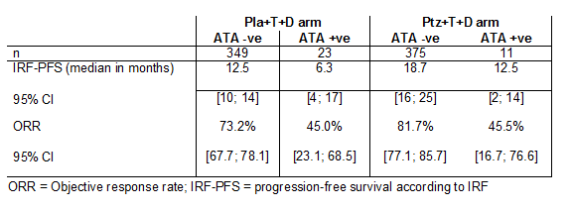
Comment: Further analysis of the implications for ATAs on efficacy should be sought from ongoing studies.

Pharmacokinetics in other special populations

Pharmacokinetics in subjects with impaired hepatic function
The safety and efficacy of pertuzumab have not been studied in patients with hepatic impairment.

Pharmacokinetics in subjects with impaired renal function
No formal pharmacokinetic study has been conducted in patients with renal impairment. Based on the population PK analysis, renal impairment is not expected to influence pertuzumab exposure, as in the population PK analysis Mild/moderate renal impairment had no effect on the PK of pertuzumab relative to patients with normal renal status (19).

Pharmacokinetics according to age
No dedicated pertuzumab studies have been conducted in elderly patients. In a population PK analysis, age was not found to significantly affect PK of pertuzumab. In the population PK analysis, 32.5% (n=143) patients were ≥ 65 years of age and 9.1% (n=40) patients were ≥ 75 years of age.

Pharmacokinetics related to genetic factors
Specific genetic studies have not been conducted however population PK analysis suggests no differences in pharmacokinetics based on ethnicity.

Pharmacokinetics

Low body weight and albumin (19)
Low body weight and albumin were identified as statistically significant covariates on pertuzumab PK. Pertuzumab CL decreased with increasing albumin. Extremes in albumin translate to ± 40% variability in PK parameters and Cmin,ss. However, sensitivity analyses indicated the Cmin,ss values from patients at the lower end of the albumin range are well above the desired target concentration of 20 μg/mL. Notably in the 2013-07-03 NEOSPHERE-PKPD-V2-final analysis (16), serum concentrations >20 μg/mL did not result in increased pCR rates.

Pharmacokinetic interactions

Pharmacokinetic interactions demonstrated in human studies
In the NEOSPHERE (WO20697) study, optional biomarker sample repository blood samples were collected from consented patients on Cycles 2 and 4 on Days 14 to 21 post-dose. Trastuzumab and docetaxel did not appear to cause any drug-drug interactions with pertuzumab (16). There are other data mentioned in the dossier relating to the BO17021, WO20024, TOC3258g and CLEOPATRA (WO20698) studies indicating that pertuzumab does not significantly alter the PK of gemcitabine, capecitabine, or erlotinib, however the interaction if any, with carboplatin is unknown.
Although the trastuzumab concentrations were similar across the three arms of the NEOSPHERE (WO20697) study, the observed serum concentrations were lower than the predictions from the previous popPK model derived from the HANNAH (BO22227) study (19). Lower serum trastuzumab concentrations were also observed in the BP27836 study of advanced gastric cancer (20). The variation was not explained by the identified covariates and according to the sponsor was being evaluated further. The evaluator notes that there was a change in the ELISA assay used between studies to reduce cross-reactivity, however analyses described in Study ba-met-hh2015-cvr (21) indicate that the results from the two trastuzumab assays are comparable.

Clinical implications of in vitro findings
At the recommended dosing schedule, the vast majority of patients achieve pertuzumab serum levels in the target therapeutic range. In the NEOPSHERE (WO20697) study the pCR rate was higher in patients treated with Ptz+T+D compared with those treated with T+D. An exposure-response relationship was not observed for pertuzumab in the Ptz+T+D group, and thus pertuzumab serum concentrations >20 μg/mL did not result in increased pCR rates.
It is unclear what the lower trastuzumab concentrations observed in the NEOSPHERE (WO20697) study imply for treatment efficacy. During previous trastuzumab PK studies of IV versus SC delivery, the target trastuzumab concentration was > 20 μg/mL. In the NEOSPHERE (WO20697) study, the mean observed cycle 2 trough serum concentration was 34 μg/mL, and only 64% of patients analysed (83/129) had a trough serum concentration >20 μg/mL (16).
Comment: Further explanation for the effect on trastuzumab serum levels will be sought from the sponsor (Clinical questions).

Evaluator’s overall conclusions on pharmacokinetics
After correcting for baseline differences in body weight and serum albumin concentration between the prior popPK modelling and the data from the NEOPSHERE study, the pertuzumab pharmacokinetics are similar between the neoadjuvant population and those observed in the metastatic setting. In addition, the lack of variation in pertuzumab PK between the arms of the NEOSPHERE (WO20697) study indicates that it is not influenced by co-administered trastuzumab or docetaxel. Drug-drug interactions have not been observed with several other chemotherapeutic agents however needs to be formally evaluated for co-administered carboplatin.
The measured trastuzumab level was lower in the NEOSPHERE (WO20697) study, with around a third of patients analysed having suboptimal serum trough levels of trastuzumab. The sponsor is requested to provide updated data as to the explanation for this, and analyses as to the efficacy of trastuzumab at these lower doses.

Pharmacodynamics

Studies providing pharmacodynamic data
New pharmacodynamic data are submitted to supplement this application from the NEOSPHERE (WO20697) study only.

Summary of pharmacodynamics
The information in the following summary is derived from conventional pharmacodynamic studies in humans unless otherwise stated.

Mechanism of action
Pertuzumab (rhuMAb 2C4) is a recombinant, humanized immunoglobulin (Ig) G1κ monoclonal antibody, which targets the human epidermal growth factor receptor-2 (HER2, also known as c-erbB-2), a transmembrane glycoprotein with intrinsic tyrosine kinase activity. Pertuzumab is the first in a new class of targeted cancer treatments called HER2 dimerization inhibitors. By binding to the subdomain 2 of HER2, it prevents heterodimerisation of HER2 with other members of the HER family (HER1, HER3 and HER4). As a result, ligand-activated downstream signaling is blocked by pertuzumab. Pertuzumab is also capable of activating antibody-dependent cell-mediated cytotoxicity (ADCC).

Pharmacodynamic effects

Primary pharmacodynamic effects
No direct drug-molecular target interactions were measured in the study however concurrent pertuzumab increased the breast pCR rate (bpCR) in patients treated with trastuzumab and docetaxel. As discussed in Section Pathological complete response (pCR) this is not the standard measure for registration purposes. Twenty-five of 49 (51%) patients treated with pertuzumab + trastuzumab + docetaxel (who also provided PK samples) had a pCR after Cycle 4 compared with 9 of 41 (22%) patients treated with trastuzumab + docetaxel only (who also provided PK samples). Similarly, concurrent trastuzumab increased the bpCR rate of patients treated with pertuzumab and docetaxel. The bpCR rate in patients treated with pertuzumab + trastuzumab + docetaxel (51%) was higher than in patients treated with pertuzumab + docetaxel only (20%). These findings are consistent with in vivo data from human xenograft tumour models showing a strongly enhanced anti-tumour effect of the pertuzumab and trastuzumab combination. There was no significant impact on the probability of pCR response with an increase in the trough serum pertuzumab concentration within the range 3.4-103.2 g/ml (16).
In the NEOSPHERE (WO20697) study, biomarker analyses were conducted to explore whether there was an association between biomarker expression levels and pCR. A significant association with the treatment benefit seen in the Ptz+T+D arm compared to the T+D arm was observed only for HER2 membrane protein levels, as assessed by IHC (odds ratio=3.91; p = 0.0236). However 17 significance tests were performed at the alpha=0.2 level, with no adjustment for multiplicity. Furthermore, as patients needed to have high HER2 expression to be study-eligible, the range of HER2 expression under study is narrow, and thus the differences observed and may not be biologically significant (22).

Secondary pharmacodynamic effects
Not applicable.

Time course of pharmacodynamic effects
Not applicable.

Relationship between drug concentration and pharmacodynamic effects
In the NEOSPHERE (WO20697) study, target pertuzumab serum concentrations of 20 μg/mL were achieved by the great majority of patients (> 90%) receiving the 840 mg loading dose of pertuzumab followed by a 420 mg maintenance dose q3w. For patients treated with pertuzumab + trastuzumab + docetaxel, there was no apparent relationship between the estimated probability of achieving a bpCR and the pertuzumab serum concentrations, within the range observed in the study. These observations were consistent with the dose-response studies in xenograft tumour models, which showed that a maximum suppression of tumour growth was achieved when the steady-state trough serum concentrations of single agent pertuzumab were in the range of 5 to 25 μg/mL. The analysis support the selection of 20 μg/mL as a rational target trough exposure level for the treatment of patients with pertuzumab.
Comment: The dosing schedule of pertuzumab is satisfactory.

Genetic-, gender- and age-related differences in pharmacodynamic response
Not applicable.

Pharmacodynamic interactions
Not applicable.

Evaluator’s overall conclusions on pharmacodynamics
At the proposed dosing schedule, it is likely that clinically relevant drug concentrations will be achieved in the majority of patients. Tumour responses are unlikely to be significantly influenced by the degree of variability in drug levels achieved using this dosing strategy. There are no robust biomarkers of response identified from the NEOSPHERE (WO20697) study.
Although the addition of pertuzumab to trastuzumab and docetaxel was associated with a higher rate of pCR in the breast, this end-point is not the standard for registration proposed by international regulators.

Dosage selection for the pivotal studies

NEOSPHERE (WO20697)
Rationale for the dosage selection of trastuzumab and pertuzumab:
- Based on pharmacokinetic data and positive clinical data, fixed, non-weight-based dosing with a dosing interval of three weeks is recommended. In Phase II studies, a loading dose of 840 mg pertuzumab (followed by 420 mg, every 3 weeks (q3w)) was capable of attaining steady-state trough and peak concentrations by the second cycle.
- A three-weekly schedule of trastuzumab was also used. Although the registered schedule for trastuzumab administration at the time of protocol preparation was a weekly dose of 2 mg/kg after a loading dose of 4 mg/kg, it is known now that the half-life of trastuzumab using this schedule is approximately 4 weeks. PK and clinical studies support the 3- weekly administration of trastuzumab (8 mg/kg IV loading dose and 6 mg/kg given IV q3w) as a suitable alternative schedule.
Rationale of dosage selection for docetaxel:
- Docetaxel is an established agent in the therapy of breast cancer and is registered for use in this indication. Docetaxel at a dose of 100 mg/m² in combination with trastuzumab has been associated with positive risk and benefit in patients with HER2 overexpressing metastatic breast cancer compared to docetaxel alone (100 mg/m² given q3w) and is registered for use with trastuzumab at this dose. The risks and benefits associated with different docetaxel doses (single agent) have been established in a randomised study. Based on the Phase Ib study (BO17021), the maximum tolerated dose of docetaxel in combination with pertuzumab is 75 mg/m². The starting dose of docetaxel used in this study was therefore 75 mg/m², with escalation according to individual tolerability.
Rationale for post-surgery adjuvant therapy:
- Following surgery, patients received the standard combination FEC as adjuvant chemotherapy. There is evidence that in patients selected for having good cardiac function, the combination of cardio-toxic anthracyclines (such as epirubicin) with trastuzumab may be associated with acceptable cardiac tolerability. Due to uncertainty in relation to the effect of additional pertuzumab on cardiac parameters, the dosing of FEC was separated from the dosing of pertuzumab by a minimum of 5 weeks.

TRYPHAENA (BO22280)
Based on pharmacokinetic and clinical data, an IV dosing interval of three weeks was determined for pertuzumab (half-life of approximately 17 days). A loading dose of 840 mg (followed by 420 mg q3w) was capable of attaining steady-state trough and peak concentrations by the second cycle.
The half-life of trastuzumab is approximately 28.5 days, which supports a dosing of every three weeks.
The intravenous chemotherapy regimens used for docetaxel. FEC, and carboplatin, are based on published data and routine clinical usage. Intravenous docetaxel was used at the starting dose of 75 mg/m² and was escalated up to 100 mg/m² according to individual tolerability. Higher doses of epirubicin were shown to be superior to lower doses of epirubicin (60 mg/m²) in the treatment of breast cancer, and so the dose of epirubicin used in this study was 100 mg/m². The use of 5- fluorouracil (500 mg/m² IV) in combination with an anthracycline (epirubicin in this protocol) and cyclophosphamide is considered a standard regimen. Data supporting the use of six cycles of therapy, both as neoadjuvant therapy and as adjuvant therapy are available.
Comment: The dosing schedules described are appropriate for current Australian practice, including the separation between HER2-directed therapy and anthracyclines, and the dosing schedule for docetaxel. As discussed above, the choice of FEC and docetaxel regimen is consistent with Australian practice.

Clinical efficacy

Neoadjuvant treatment of operable, locally advanced or inflammatory HER2-positive breast cancer

Pivotal efficacy studies

Study - NEOSPHERE (WO20697)

Study design, objectives, locations and dates

Design
NEOSPHERE (WO20697) is a Phase II, open-label, randomised, multi-centre trial to evaluate the efficacy and safety of neoadjuvant treatment in chemotherapy-naïve patients, with HER2-positive locally advanced, inflammatory or early stage breast cancer.

Objectives
Primary Objective: The primary objective was to make a preliminary assessment of the efficacy of neoadjuvant treatment of trastuzumab plus docetaxel, as compared to trastuzumab, pertuzumab plus docetaxel, or to trastuzumab plus pertuzumab, and to compare pertuzumab plus docetaxel with trastuzumab, pertuzumab plus docetaxel, in patients with T2-4d HER2-positive breast cancer, based on complete pathological response rate (defined as breast pCR).
Secondary Objectives: Secondary objectives are the following:
- To evaluate the safety profiles of each treatment regimen, including pre-operative (neoadjuvant) and post-operative (adjuvant) treatment
- To determine the time to clinical response, time to response, disease-free survival, and progression-free survival for each treatment arm.
- To evaluate the biomarkers that may be associated with primary and secondary efficacy endpoints in accordance with each treatment (expression of HER-family receptors or related receptor tyrosine kinases, HER2 ligands, markers/components of the HER signal transduction or alternative signaling pathways; pAKT, PTEN, c-myc gene amplification, PIK3CA mutational status).
- To evaluate the rate of breast conserving surgery for all patients with T2-3 tumours for whom mastectomy was planned at diagnosis.
- To make a preliminary assessment of the efficacy of neoadjuvant treatment of pertuzumab and docetaxel.
The primary objective was evaluated after all patients had received neoadjuvant treatment and had either undergone primary surgery or withdrawn from the study.

Centres and countries
Patients were recruited across 59 centers in 16 countries (Australia, Austria, Brazil, Canada, Italy, Mexico, Peru, Poland, Republic of Korea, Russian Federation, Spain, Sweden, Switzerland, Taiwan, Thailand, and United Kingdom).

Period of trial
Recruitment occurred between 17 December 2007 (first patient enrolled) and 22 December 2009. All enrolled patients had completed treatment and were either in follow-up or had withdrawn from the study as of 15 February 2011. The last patient/last visit occurred 22 September 2014 (end of study). Four main clinical data cut-offs have been performed for this study: the first was performed for the primary analysis (22 December 2009), while the second (09 March 2012) and the third (12 July 2013) were performed for safety updates. The final clinical cut-off occurred on 20 October 2014 and the final clinical study report was produced in February 2015.

Inclusion and exclusion criteria

Disease specific inclusion criteria:
- Female patients with locally advanced, inflammatory or early stage, unilateral and histologically confirmed invasive breast cancer.
- Primary tumour > 2cm in diameter
- HER2-positive breast cancer confirmed by a central laboratory. Tumours must be HER2+++ by IHC (immunohistochemistry) or FISH/CISH (fluorescence/chromogenic-in situ hybridisation__ + (FISH/CISH mandatory for HER2 ++ tumours).
- Availability of FFPE (formalin-fixed paraffin embedded) tissue for central confirmation of HER2 eligibility (FFPE tumour tissue will subsequently be used for assessing status of biomarkers).

General inclusion criteria:
- Age ≥ 18 years.
- Baseline LVEF ≥ 55% (measured by echocardiography or MUGA).
- Performance status ECOG ≤ 1.
- At least 4 weeks since major unrelated surgery, with full recovery.
- A negative pregnancy test must be available for pre-menopausal women and for women less than 2 years after the onset of menopause.
- Signed informed consent.

Cancer related exclusion criteria
- Metastatic disease (Stage IV) or bilateral breast cancer.
- Previous anticancer therapy or radiotherapy for any malignancy.
- Other malignancy, except for carcinoma in situ of the cervix or basal cell carcinoma.
- Haematological, biochemical and organ function:
- Inadequate bone marrow function (for example, Absolute Neutrophil Count (ANC) < 1.5 x 109/L, Platelet count < 100 x 10⁹/L and Hb < 9 g/dL).
- Impaired liver function: (for example, serum [total] bilirubin > 1.25 x ULN (with the exception of Gilbert’s syndrome), AST, ALT > 1.25 x ULN, albumin < 25 g/L
- Inadequate renal function, serum creatinine > 1.5 x ULN.
- Uncontrolled hypertension (systolic > 150 and/or diastolic > 100), unstable angina, CHF of any NYHA classification, serious cardiac arrhythmia requiring treatment (exception, atrial fibrillation, paroxysmal supraventricular tachycardia), history of myocardial infarction within 6 months of enrollment, or LVEF < 55%.
- Dyspnea at rest or other diseases that require continuous oxygen therapy.

Other study drug related exclusion criteria
- Severe uncontrolled systemic disease (for example, hypertension, clinically significant cardiovascular, pulmonary, metabolic, wound-healing, ulcer, or bone fracture).
- Subjects with insulin-dependent diabetes.
- Pregnant and/or lactating women.
- Subjects with reproductive potential not willing to use highly effective non-hormonal method of contraception or two effective forms of non-hormonal contraception. Contraception use must continue for the duration of study treatment and for at least 6 months post discontinuation of study treatment.
- Received any investigational treatment within 4 weeks of study start.
- Subjects with known infection with HIV, HBV, HCV.
- Known hypersensitivity to any of the study drugs or excipients.
- Subjects assessed by the investigator to be unable or unwilling to comply with the requirements of the protocol.

Study treatments

Study design
Patients were randomised in a 1:1 ratio to one of the four treatment arms (Figure 1):
Figure 1: NEOSPHERE (WO20697) Study schema (22)
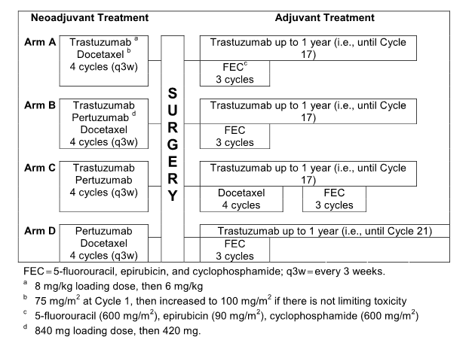

Pre-operative treatment:
For all study arms treatment was administered every 3 weeks for 4 cycles. Study treatments were given consecutively on the same day, in the following order (where applicable): trastuzumab, followed by pertuzumab, followed by docetaxel.
Arm A: trastuzumab plus docetaxel (T + D)
- A loading dose of 8 mg/kg of trastuzumab was given on Cycle 1, Day 1, with a maintenance dose of 6 mg/kg given thereafter. The starting dose of docetaxel was 75 mg/m² for cycle 1, then 100 mg/m² for cycles 2-4, if no dose limiting toxicities occurred.
Arm B: pertuzumab, trastuzumab plus docetaxel (Ptz + T +D)
- A loading dose of 8 mg/kg of trastuzumab and 840 mg of pertuzumab was given on Cycle 1, Day 1; thereafter maintenance doses of 6 mg/kg of trastuzumab and 420 mg of pertuzumab were given from Cycle 2 onwards. The starting dose of docetaxel was 75 mg/m² for cycle 1, then 100 mg/m² for cycles 2-4, if no dose limiting toxicities occurred.
Arm C: pertuzumab plus trastuzumab (Ptz + T)
- A loading dose of 8 mg/kg of trastuzumab and 840 mg of pertuzumab was given on Cycle 1, Day 1; thereafter maintenance doses of 6 mg/kg of trastuzumab and 420 mg of pertuzumab were given from Cycle 2 onwards.
Arm D: pertuzumab plus docetaxel (Ptz + D)
- A loading dose of 840 mg of pertuzumab was given on Cycle 1, Day 1; thereafter maintenance 420 mg of pertuzumab was given from Cycle 2 onwards. The starting dose of docetaxel was 75 mg/m² for cycle 1, then 100 mg/m² for cycles 2-4, if no dose limiting toxicities occurred.

Post-operative treatment
At the end of four cycles, the patients underwent physical examination, mammogram (and ultrasound if required by local practice) prior to breast surgery (allowing comparison with the baseline assessments). Post-surgery, patients were treated in the following fashion:
Arm A: trastuzumab plus docetaxel (T + D)
- Patients received trastuzumab 6mg/kg followed FEC (5-fluorouracil 600 mg/m² IV, epirubicin 90 mg/m² IV and cyclophosphamide 600 mg/m² IV) on day 1, and every 3 weeks thereafter for 3 cycles (cycles 5-7). Trastuzumab 6 mg/kg was given every 3 weeks from cycle 8 until cycle 17.
Arm B: pertuzumab, trastuzumab plus docetaxel (Ptz + T +D)
- Patients received trastuzumab 6mg/kg followed FEC (5-fluorouracil 600 mg/m² IV, epirubicin 90 mg/m² IV and cyclophosphamide 600 mg/m² IV) on day 1, and every 3 weeks thereafter for 3 cycles (cycles 5-7). Trastuzumab 6 mg/kg was given every 3 weeks from cycle 8 until cycle 17.
Arm C: pertuzumab plus trastuzumab (Ptz + T)
- Patients received trastuzumab at 6 mg/kg followed by docetaxel at a starting dose of docetaxel was 75 mg/m² for cycle 5, then 100 mg/m² for a further 3 cycles (cycles 6-8), if no dose limiting toxicities occurred. For cycles 9-11, patients received trastuzumab 6mg/kg followed FEC (5-fluorouracil 600 mg/m² IV, epirubicin 90 mg/m² IV and cyclophosphamide 600 mg/m² IV) every 3 weeks. In cycles 12 through to cycle 17, trastuzumab 6 mg/kg IV every 3 weeks was continued.
Arm D: pertuzumab plus docetaxel (Ptz + D)
- Patients received trastuzumab 6mg/kg followed FEC (5-fluorouracil 600 mg/m² IV, epirubicin 90 mg/m² IV and cyclophosphamide 600 mg/m² IV, q3w) on day 1, and every 3 weeks thereafter for 3 cycles (cycles 5-7). Trastuzumab 6 mg/kg was given every 3 weeks from cycle 8 until cycle 21.
All patients received trastuzumab, 3-weekly, for one year in total. No pertuzumab was administered during the adjuvant period.
Hormone therapy (in hormone receptor-positive patients) and/or radiotherapy could also be given during adjuvant treatment, according to local guidelines. Notably rates of endocrine therapy use were similar across the arms - 28% in Arm A (T + D), 28% in Arm B (Ptz + T + D), 25% in Arm C (Ptz +T) and 30% in Arm D (Ptz + D) (24).
The mean total docetaxel dose received was as up to 29.6 mg different between arms (the highest exposure in Arm A, in which no pertuzumab was given, and the lowest in Arm D, where no neoadjuvant trastuzumab was given). This difference in exposure when expressed as a percentage of the total dose received is < 5%, and unlikely to be of significance. Overall, 95.7% of patients completed the neoadjuvant phase of treatment (24).
Comment: The use of endocrine therapy was as per local guidelines, and was generally well balanced across the arms. The use of non-standardized endocrine therapy throughout the study should not influence the pCR data (as it was given in the adjuvant setting) however should be borne in mind when viewing the DFS and OS data, which may be influenced by variations in the use and type of endocrine therapies between arms, especially as endocrine-receptor positive patients appear to be less sensitive to neoadjuvant cytotoxic/anti-HER2 therapies.

Efficacy variables and outcomes (22, 25)
Primary endpoint: The primary endpoint was post-surgery pCR rate.
The primary endpoint was pCR in the breast (bpCR; ypT0/is), that is, the definition does not take into account the regional lymph nodes, nor does it require absence of residual in situ disease. This was evaluated after patients had received 4 cycles of neoadjuvant treatment and undergone surgery or had withdrawn from the study, whichever occurred first. pCR in the breast was defined as the absence of invasive neoplastic cells on microscopic examination of the surgical specimen following primary systemic therapy (residual in situ disease was allowed). The bpCR rate is the proportion of the intent-to-treat (ITT) population that achieved a bpCR.
The purposes of this study were to identify:
- Whether Arm B (Ptz+T+D) and/or Arm C (Ptz+T) demonstrated a clinically significant improvement in bpCR rate over Arm A (T+D).
- Whether Arm D (Ptz+D) demonstrated a clinically significant bpCR rate over Arm B.
In addition to the assessment of bpCR (the primary endpoint in this study), data were also collected prospectively on the rates of tpCR (ypT0/is ypN0) and GBG pCR (ypT0 ypN0) in order to conduct exploratory analyses of pCR according to other definitions. In particular, total pCR (tpCR) is the preferred definition of some health authorities and is included in draft guidelines on pCR from the United States Food and Drug Administration (US FDA) and European Medicines Agency (EMA).
Processing and assessment of tumour specimens was performed by the local pathologist, according to institutional standards/local practice, with no centralized review of specimens.

Secondary efficacy outcomes included
- Clinical response rate: Clinical response rate was defined as complete response (CR, partial response (PR), stable disease (SD) and progressive disease (PD), and clinical response rate was defined as the proportion of patients who achieved a clinical response (CR or PR) during cycles 1-4 (prior to surgery). Clinical response was assessed at each cycle between Days 15-21 of each cycle or on Day 1 of the next cycle.
- Progression-free survival (PFS): This is defined as the time from the date of randomisation to the first documentation of PD or death. All patients, from their randomisation date until their first documentation of a PD, recurrence or death were included in the analysis. Patients who withdrew from the study without documented progression and for whom there was eCRF evidence that disease evaluations were made were censored at the date of the last assessment when the patient was known to be free from PD. Patients without post-baseline assessments but known to be alive were censored at the time of randomisation.
- Disease-free survival (DFS): This was defined as the time from the first date of no disease (that is, the date of surgery) to the first documentation of PD or death. Patients who underwent surgery, until their first documentation of a PD or death are included in this analysis. Patients who had surgery but did not achieve a pCR were censored at the date of surgery. Patients who withdrew from the study without documented progression and for whom there was eCRF evidence that disease evaluations were made were censored at the date of the last assessment when the patient was known to be disease-free.
- After completion of the study treatment, patients were to be followed up for progression free survival (PFS) until disease progression or until five years after randomisation of the last patient, whichever is earlier. Survival status was also collected when available. Overall survival was not a protocol-defined secondary efficacy endpoint and, therefore, survival status was not systematically reported beyond PD, disease recurrence or withdrawal.
Comment: For the DFS end-point the idea of censoring the patients with a non-pCR outcome after neoadjuvant therapy is noted and the evaluator has concerns regarding this as it suggests those who respond less well to the neoadjuvant therapy will not be analysed further after that surgery (as they are censored from the analysis, despite being rendered ‘disease free’ by surgery). Given this statistical decision it is important to reiterate that the survival end-points in this study are descriptive only.

Other secondary objectives
- To evaluate the safety profiles of each treatment regimen, including pre-operative (neoadjuvant) and post-operative (adjuvant) treatment.
- To evaluate the biomarkers that may be associated with primary and secondary efficacy endpoints in accordance with each treatment arm:
  - expression of HER-family receptors or related receptor tyrosine-kinases for example,/IGF1-R, EGFR, HER2, HER3 (assessed by qRT-PCR and/or IHC)
  - HER ligands (amphiregulin and betacellulin) assessed by qRT-PCR
  - Components of the HER signal transduction or alternative signalling pathways (pAKT and PTEN expression assessed by IHC; c-myc gene amplification as assessed by FISH, mutational status of PIK3CA assessed by a PCR-based assay)
- To evaluate the rate of breast conservative surgery for all patients with T2-3 tumours for whom mastectomy was planned at diagnosis.

Randomisation and blinding methods (22)
Eligible patients were randomised via interactive voice response system and assigned a unique randomisation number. Patients were randomly assigned, by a central randomisation center using dynamic allocation in the order in which they were enrolled, to Arm A, B, C or D and stratified by operable (T2-3, N0-1, M0), locally advanced (T2-3, N2 or N3, M0; T4a-c, any N, M0) and inflammatory (T4d, any N, M0) breast cancer and estrogen and/or progesterone positivity.
A Patient Enrollment and Identification Code List was maintained by the investigator. The password-protected and/or encrypted electronic Master Randomisation List was kept in a central repository by the Biometrics and Drug Safety Departments. This was an open-label trial (that is, not blinded).
Comment: Although this was an open-label trial and therefore at risk of bias, the primary end-point was bpCR, a determination made by a pathologist generally unaware of treatment assessment. Therefore the risk of bias is likely to be low. The evaluator notes the responses to queries from the European regulators in relation to the question of blinding and bias (26).

Analysis populations methods (22, 25)
Intention to treat (ITT) population: The ITT population includes all randomised patients, regardless of whether they received any study medication. In analyses using the ITT population, patients are grouped according to their randomised treatment arm. All efficacy outputs were produced for the ITT population.
Per Protocol Population: The per protocol (PP) population, is a subset of the ITT population. It excludes patients who were deemed to have any major protocol violations prior to the adjuvant phase of the study. In analyses using the PP population, patients are grouped according to their randomised treatment arm. The PP population excludes patients who received less than 3 cycles of their randomised study medication in the neoadjuvant setting.
Safety population: The safety population includes patients who received at least one dose of study medication and at least one safety assessment performed at baseline. Patients were assigned to treatment groups according to treatment actually received.
As shown in the Table 3, some 107, 107, 107, and 96 patients were randomised to Arms A, B, C, and D, respectively, and were therefore included in the ITT population; however, 3 patients did not receive the correct treatment, to which they were randomised, and 1 additional patient (in Arm A) did not receive any treatment. The numbers of patients in the safety population, therefore, were 107 in Arm A, 107 in Arm B, 108 in Arm C, and 94 in Arm D. 3 patients in the pertuzumab + docetaxel arm were erroneously reported as not having FFPE tissue for central confirmation of HER2. Therefore the correct number of patients excluded from the PP population for this arm is 5.

Table 3: Summary of analysis populations by trial treatment NEOSPHERE (WO20697) (22)
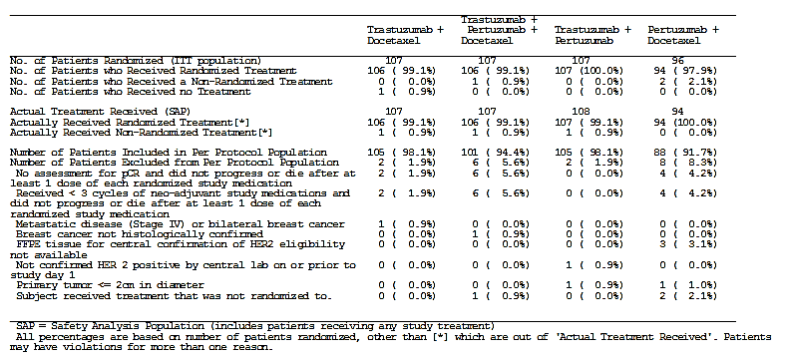

Sample size (22)
There were 400 patients eligible for randomisation onto the study. With 400 patients and an overall alpha level of 0.2, the study would have 80% power to detect an absolute percentage increase of 15% between each of the three primary comparisons.

Statistical methods (22)
Pathological complete response rate in the breast (bpCR; ypT0/is) was the primary endpoint for the study. Notably this definition differs from that of the EMA and FDA guidelines (although both are drafts) raising concerns re the validity of this endpoint for the purposes of extension of indications.
A pCR rate of 25%was anticipated in Arm A (T + D) and Arm D (Ptz + D). A pCR rate of 40% in Arm B (Ptz +T +D) or Arm C (Ptz + T) was considered to be of clinical interest.
The following three individual hypotheses were tested using a two-sided Cochrane Mantel-Haenszel test at an alpha level of 0.2. (The choice of a two-sided test is appropriate given uncertainty as to the direction in which any differences would lie for all comparisons).
Arm A versus Arm B
- Null hypothesis: pCR A rate = pCR B rate
- Alternative hypothesis: pCR A rate not = pCR B rate
Arm A versus Arm C
- Null hypothesis: pCR A rate = pCR C rate
- Alternative hypothesis: pCR A rate not = pCR C rate
Arm D versus Arm B
- Null hypothesis: pCR D rate = pCR B rate
- Alternative hypothesis: pCR D rate not= pCR B rate
As there were three individual comparisons, a Simes multiplicity adjustment was applied to the individual p-values obtained at the end of the study to maintain the overall false positive risk at 0.2. With 400 patients and an overall alpha level of 0.2, the study would have 80% power to detect an absolute percentage increase of 15% between each of the three primary comparisons.
Comment: The use of the Simes adjustment is an appropriate, albeit conservative adjustment for multiple comparisons. The greater issue here is that in this randomised phase II study, the pre-specified type 1 error rate is high at 0.2. Nevertheless, review of the data pertaining to pCR does show quite significant p values despite the adjustments, and thus despite the caveats above the differences between arms are well beyond those expected by chance. A difference in pCR rate of 15% between the T+D arm and Ptz+T+D arm was considered to be of clinical significance, however it is unknown to what degree an increase in pCR rate will (or will not) translate into a change in disease-free survival.

Participant flow
Figure 2: Patient disposition flowchart for NEOSPHERE (WO20697) (27)
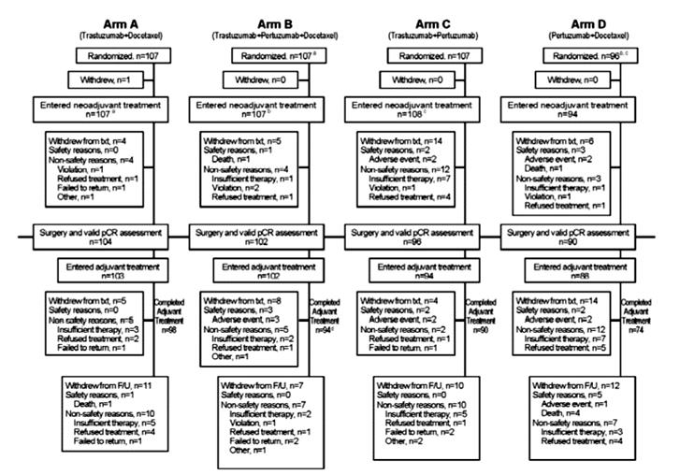
Patients withdrawing from study treatment could still undergo primary surgery and could still be ongoing in the post-treatment follow-up period. Withdrawal at any time up to the first adjuvant trial treatment was regarded as withdrawal from the neoadjuvant phase.

Major protocol violations/deviations (22, 25, 27)

Protocol deviations/violations
The majority of protocol deviations reported were minor and did not exclude patients from the PP population. Across the treatment arms between 7.5-10.3% per arm reported at least one inclusion criteria violation, (mostly due to a positive or missing baseline pregnancy test result). Between 6.5-13.1% reported at least one exclusion criteria violation, the most common of which was missing data for, or impaired liver function. 4.7-10.3% recorded a protocol deviation whilst on study (see Table 4).

Table 4: Summary of protocol deviations by trial treatment NEOSPHERE (WO20697) (22, 25, 27)
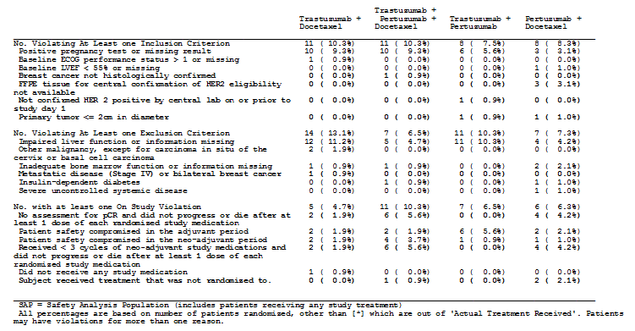
One patient had a pulmonary lesion that was confirmed as a metastasis, which violated exclusion criteria. A violation form was signed, and the patient was withdrawn from the study after receiving 2 cycles of treatment. Two patients had missing screening values and thus were reported as having a violation of primary tumour measuring less than 2 cm. However, both patients had cycle 1 tumour measurement values >2cm and therefore were not actually protocol violators.
Comment: The 10.3% rate of protocol violations on study (relating to pCR assessment) in the Ptz+T+D was over 50% higher than in the Ptz+T and Ptz+D arms and more than double that in the T+D arm. Nevertheless the overall rate is small and the nature of the violations is unlikely to influence outcome.

Protocol amendments (22)
First amendment: Version B (dated 4 December, 2007) introduced the following changes:
- Addition of a fourth treatment arm (arm D), in order to evaluate the efficacy of pertuzumab, in the absence of trastuzumab, in the neoadjuvant setting, with corresponding update of schedule of assessment and dosing information. There were a total of 29 patients who had been recruited on the original protocol prior to introduction of this arm.
- Increase in the number of patients participating in the study from 180 to 400, and corresponding increase in the number of centres, from 45-55 to 100.
- Amendment of efficacy endpoints, hypothesis testing and analyses to reflect addition of arm D and increased patient numbers.
- Addition of an exclusion criterion, to exclude patients with insulin-dependent diabetes from the study.
- Clarification of the off-set dosing schedule.
Second Amendment: Version C (Dated 11 December 2008) made the following change:
- Correction of the tumour-node-metastasis (TNM) classes used to classify patients’ disease for the stratification groups operable, locally advanced, or inflammatory cancer for this study.
Third Amendment: Version D (Dated 27 June 2009) made the following significant changes:
- Updates to: the definition of post-menopausal women, the contraceptive requirements for women of child bearing potential as recommended by the MHRA in accordance with the ICH M3 guideline, and the pregnancy testing scheduling.
- Clarification of clinical response definition.

Baseline data
A total of 417 female patients were included in the study as previously described, with 107, 107, 107 and 96 patients randomised to arms A, B, C and D respectively. These patients were included in the ITT population. Note that there were slightly less (approximately10% less) patients in Arm D due to the late addition of this arm to the study. Randomisation was stratified by primary diagnosis of operable (T2-3, N0-1, M0), locally advanced (T2-3, N2/3, M0; T4a-c, any N, M0) or inflammatory (T4d, any N, M0) breast cancer, and oestrogen and or progesterone receptor positivity.
The baseline demographics were generally well balanced across the arms of the study (Table 5):
- Median age was 49-50 years across all groups
- Median weight was 62.3 – 67 kg across all groups
- Median height was 159 -161 cm across all groups
- Race was Caucasian in 63.5 – 74.8% across all groups; note in Arm D (Ptz + D) there were 26% Oriental patients and 3.1% Black patients, slightly higher rates than the other arms
- Post-menopausal status was 41.7 – 46.7% across all groups
- ECOG 0 status was 83.3-94.3% across all groups

Table 5: Summary of demographic data by trial treatment (ITT population) NEOSPHERE (WO20697) (22)
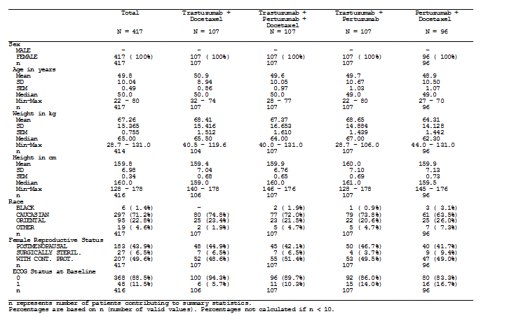
The tumour characteristics were distributed relatively evenly across the groups. In particular:
- ER positivity ranged from 43 to 45.8%
- PR positivity ranged from 29.9% to 39.3%
- ER and/or PR positivity ranged from 46.7 to 48.1%
- HER2 FISH positivity ranged from 95 to 100%
- Operability at baseline ranged from 59.8 to 62.5%
- Inflammatory breast cancers accounted for 5.2 to 9.3% of cases
- Locally advanced breast cancers accounted for 29.9 to 33.6% of cases
The population of patients enrolled in the NEOSPHERE (WO20607) study was typical of patients with HER2-positive locally advanced, inflammatory and EBC that would be deemed suitable for neoadjuvant systemic therapy (Tables 6, 7 and 8).

Table 6: Summary of History of breast cancer and HER2 status by treatment (ITT population) NEOSPHERE (WO20697) (22)
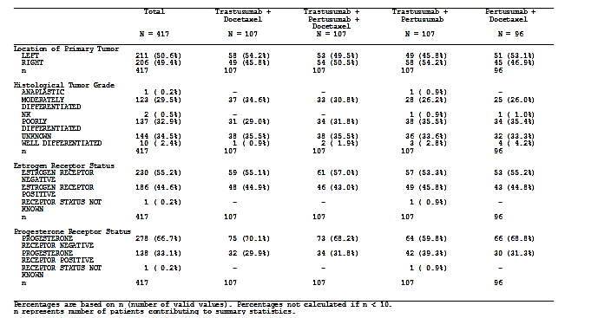

Table 7: Summary of History of breast cancer and HER2 status by treatment (ITT population) NEOSPHERE (WO20697) (22)
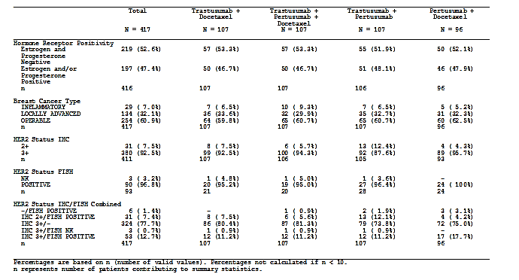

Table 8: Summary of TNM classifications by treatment and breast cancer type NEOSPHERE (WO20697) (22)
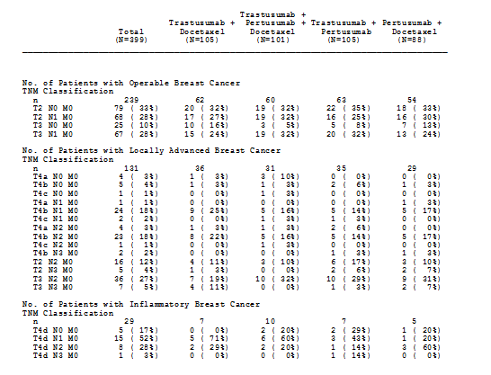
Comment: Prior to treatment, lymph nodes were assessed by institutional practice which is potentially quite variable, and did not include lymph node sampling. Thus it is unclear how comparable the baseline nodal status was between the groups.

Results for the primary efficacy outcome

Table 9: Summary of availability of pCR assessments NEOSPHERE (WO20697) (22)
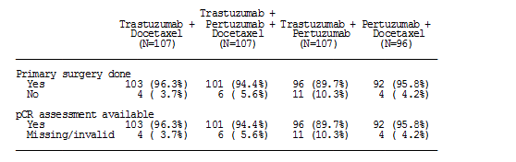

Table 10: Pathological complete response outcomes in the NEOSPHERE (WO20697) study (22)
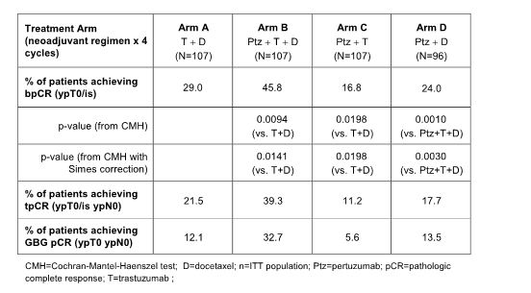

Pathological complete response (See Tables 9 and 10):
The majority of patients were assessable for pCR, although in the Ptz + T arm were lower than the other arms at 89.7% compared to over 94% in all the other groups. It is unlikely that this would have contributed significantly to the results. Patients receiving Ptz + T + D (n=107) had significantly higher bpCR rates than patients receiving T + D (n= 107) (45.8%, compared to 29.0%: difference in bpCR rates = 16.8%: 95% CI = 3.5, 30.1, p= 0.0141; odds ratio 2.07, 95% CI [1.18, 3.64]). This result is statistically significant at the pre-specified 0.2 alpha-level and would also be statistically significant had an alpha-level of 0.05 been specified in the protocol. Patients receiving Ptz + D (n = 96) had similar bpCR rates to patients receiving T + D (bpCR rate = 24.0%), however, this was significantly lower than for patients receiving Ptz + T + D (p = 0.0030). The Ptz + T arm (n = 107) was also active (bpCR rate = 16.8%), but the bpCR rate was significantly lower than for T + D (p = 0.0198).
The more stringent tpCR and GBG pCR rates, across treatment arms, were lower those observed for bpCR rates, although for each pCR definition the rates of pCR remained numerically higher in the group treated with Ptz + T +D. Notably, the group in which Ptz +T + D arm was given had the highest rate of pCR in the breast + negative nodes at surgery at 39.3% compared to T + D at 21.5%, with the other 2 schedules having rates under 20% (Table 11). This definition is equivalent to that recommended for use by international regulators, but was not a pre-specified primary end-point.
Comment: There was no standardised manner for assessing baseline nodal status and therefore it is difficult to interpret the tpCR and GBG pCR data.

Table 11: Summary of lymph node status at surgery by trial treatment for patients who achieved pathological complete response NEOSPHERE (WO20697) (22)
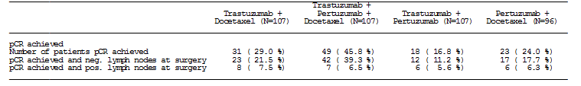
Among tumour subgroups (Table 12) bpCR rate was highest in the Ptz+T+D arm and Ptz+D arm in patients with inflammatory breast cancer, although the numbers of patients in this analysis are too few to draw firm conclusions. For patients with locally advanced cancer, patients in the T+D arm and Ptz+T+D arm had a similar bpCR rate (41.7% and 43.8%, respectively), and treatment in these arms performed notably better than the Ptz+T and Ptz+D arms (bpCR rate = 14.3% and 16.1%, respectively). These results are congruent with those observed in the ITT population.

Table 12: Summary of pathological complete response rate by trial treatment and breast cancer type strata NEOSPHERE (WO20697) (22)
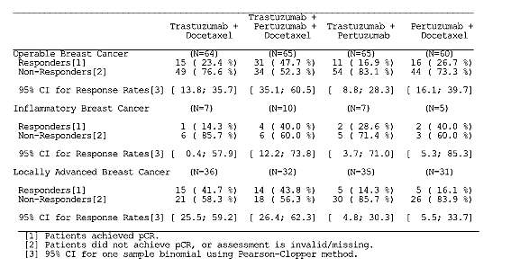
The effect of hormone-receptor expression on bpCR was also reported (Table 13). Notably the treatment benefit of Ptz + T + D over T + D was mainly seen in hormone receptor-negative patients, with limited benefit in hormone receptor-positive patients. In all cases, bpCR rates were higher in patients whose tumours were estrogen and progesterone negative. bpCR rate was notably low in hormone receptor-positive patients in the Ptz + T arm.

Table 13: Summary of pathological complete response rate by trial treatment and hormone receptors strata NEOSPHERE (WO20697) (22)
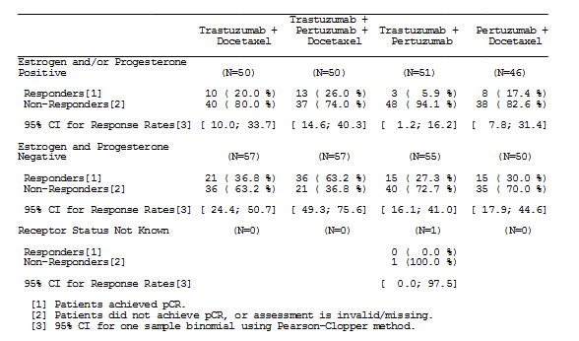

Results for other efficacy outcomes

Clinical response rate
Patients were assessed by a mixture of clinical breast examination (CBE) at each neoadjuvant cycle, and x-ray/mammography at baseline and after cycle 4. Response rates were as follows (Table 14 and 15):

Table 14: Summary of best tumour response during neoadjuvant treatment (ITT population) NEOSPHERE (WO20697) (22)
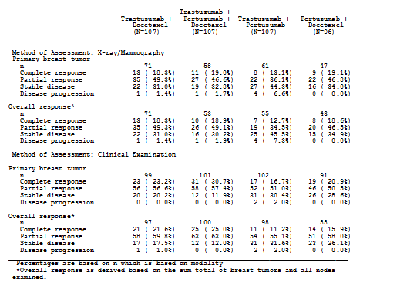
These data are summarised in Table 14 and 15 and indicate that by CBE assessment of the primary tumour (the modality applied to a greater number of the patients, and utilised at each cycle) that the highest rate was observed in with Ptz + T + D (88.1%), followed by T + D (79.8%), then Ptz + D (71.4%) and Ptz + T (67.6%). A similar pattern was observed when overall response was assessed (that is, sum of total breast tumours and all nodes examined). In practice, clinical assessment is a key determinant of surgical decision-making (that is, the decision to proceed to breast conservation), although BCS rates were not greatly improved (see below).
By x-ray and mammography, a different pattern was observed, with the highest rate of primary tumour response observed with T + D (67.9%), followed by Ptz + D (66%), then Ptz + T + D (65.5%) and Ptz + T (49.2%). Evaluating overall response by this assessment modality the results for the Ptz + T + D and T + D arms were almost identical (67.9% and 67.6% respectively), followed by Ptz + D (65%) and Ptz + T (47.3%). As significantly fewer patients were assessed using radiology these data are difficult to interpret.

Table 15: Summary of clinical response during neoadjuvant treatment (ITT population) NEOSPHERE (WO20697) (22)
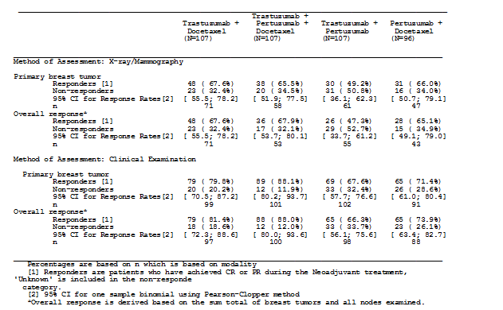

Time to clinical response
The median time to clinical response, based on clinical breast examination assessing for the primary breast tumour alone, was similar across all 4 arms, with a trend to earlier response in the T + D and Ptz + T + D arms, compared to Ptz + T and Ptz + D (Table 16).

Table 16: Summary of time to first clinical response [weeks] based on primary breast lesion during neoadjuvant treatment NEOSPHERE (WO20697) (16)
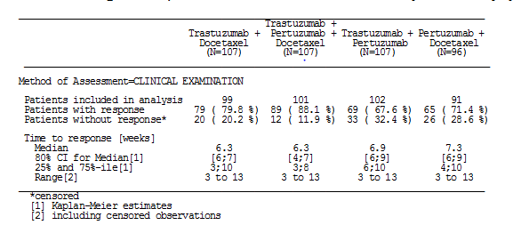

Breast conserving surgery
Just over half of the patients in this study were originally planned for mastectomy as the definitive surgical management of their breast cancer. Despite the fact that over 2/3 of the patients in each group responded by clinical assessment (see ‘Clinical Response Rate’ above) only 18 – 31.7% of patients actually underwent breast conservation. The highest rate of breast conservation amongst those previously planned for mastectomy was 31.7% in the Ptz + D arm, and the lowest was in the Ptz + T arm at 18.0% (Table 17). Notably the Ptz + T + D group were not the group in which there was the highest rate of conversion to breast conservation despite the pCR data presented in section Results for the primary efficacy outcome.

Table 17: Summary of patients achieving breast conserving surgery (BCS), for whom mastectomy was planned NEOSPHERE (WO20697) (22)
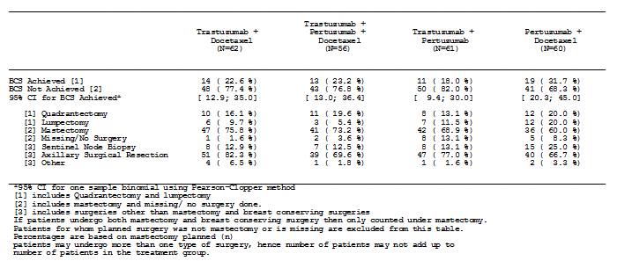

Evaluation of biomarkers
Baseline biomarker levels were assesses for the overall study population and also per study arm (Table 18). Baseline biomarker levels were well-balanced across study arms although there was some variability in the number of samples analysed across the various biomarkers due to various reasons including tissue availability and technical reasons - 65.9% -99.8% of patients had samples assessed across the various biomarkers.
- PIK3CA – PIK3CA mutation status was assessed in 65.5% of study patients, and of those assessed, 32% of samples were found to carry a PIK3CA mutation, well-balanced across the treatment arms
- Betacellulin and amphiregulin – the signal strength for the mRNA of these markers was too weak to allow any exploration
- Fc gamma receptor polymorphisms – samples from 399 patients were evaluated for Fc gamma receptor polymorphisms, with well-balanced distribution across of polymorphisms of interest across the treatment arms. Overall numbers of polymorphisms was too low for meaningful analysis.
- HER2 ECD – the median levels of ECD across the arms were close to the commercial assay’s defined cut of 15 mg/mL to determine possibility; the sponsor urges interpretation of these results with caution.
A treatment interaction test using logistic regression was carried out to investigate whether there was a relationship between biomarker levels and pCR rate. Using this test, a significant association with the treatment benefit seen in the Ptz + T + D arm compared to T + D was observed for HER2 membrane protein levels as per IHC assessment (OR = 3.91; p=0.0236). 17 significance tests were performed at the alpha =0.2 level, although with no adjustment for multiplicity, and in view of the fact that the relationship was not seen in the other trastuzumab/pertuzumab containing arm, and the range of values over which the HER2 was assessed was narrow, was thought not to be biologically significant.

Table 18: Summary of treatment (Ptz + T + D versus T + D) and biomarker (Median Cut Point) interaction, by assay method NEOSPHERE (WO20697) (22)
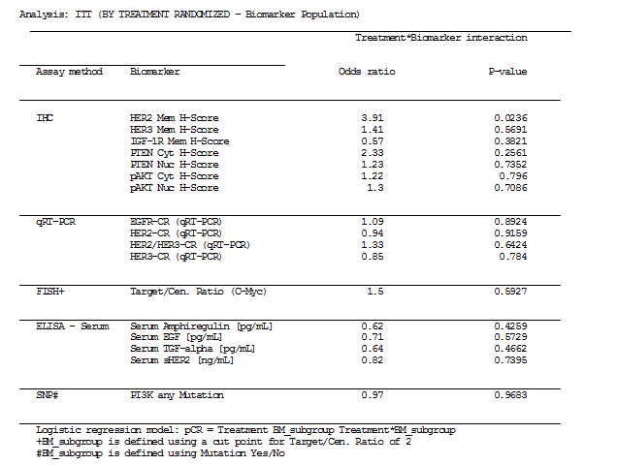

Disease-free survival and progression-free survival
The initial (and final) results for disease-free and progression-free survival are tabulated below (Table 19). This sponsor’s report argues that the PFS and DFS results (hazard ratios of 0.69 and 0.60, respectively) are supportive of the benefit shown from the addition of pertuzumab to trastuzumab plus docetaxel in the primary analysis of pCR (Section Results for the primary efficacy outcome).
Comment: Nevertheless, the confidence intervals are wide, and as the PFS and DFS analyses were not designed or powered to test formal hypotheses, are for descriptive purposes only, should be viewed with caution, and are included for completeness only.

Table 19: Overview of secondary efficacy results NEOSPHERE (WO20697) (25)
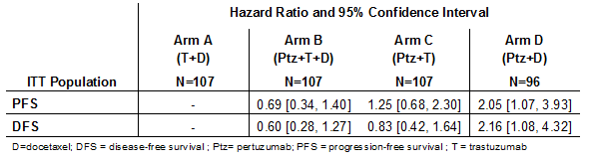
The hazard ratio for treatment Arms B and C is with respect to Arm A while the hazard ratio for Arm D is with respect to Arm B.

Progression-free survival
Progression-free survival (PFS) was defined as the time from the date of randomisation to the first documentation of progressive disease (PD) or death. This is equivalent to the definition of Event-Free Survival (EFS). The number of PFS events in the overall analysis and subsequent subgroup analyses (Hormone Receptor Status and pCR status) are low, are for descriptive purposes only.
At the time of the final clinical cut-off date (20 October 2014), a total of 87 patients (19 [17.8%] in the T + D arm, 17 [15.9%] in the Ptz + T + D arm, 27 [25.2%] in the Ptz + T arm and 24 [25.0%] in the Ptz + D arm had a PFS event. The hazard ratio for the Ptz + T + D arm with respect to the T + D arm was 0.69 (95% CI [0.34; 1.40]). The hazard ratio for the Ptz + T arm with respect to the T + D arm was 1.25 (95% CI [0.68; 2.30]), and the hazard ratio for the Ptz + D arm with respect to treatment Ptz + T + D was 2.05 (95% CI [1.07;3.93]).
The Kaplan Meier survival estimates are not reliable at the later survival time points, most notably beyond 60 months. The number of patients at risk in the analysis is very low at the tails of the curves, with late events occurring at these time points.
An exploratory landmark analysis for PFS has been conducted. Landmark survival estimates at three years from randomisation (Kaplan-Meier estimates), indicate a higher percentage of patients surviving in the Ptz + T + D arm compared to other treatment arms (T + D: 86%, Ptz + T + D: 90%, Ptz + T: 81% and Ptz + D: 82%).
Exploratory analyses for PFS were also performed in the following subgroups:
- hormone receptor status (negative/positive disease) Table 20
- tpCR status (achieved versus not achieved) – included as it features in draft guidelines on pCR from the US FDA and EMA, and is the preferred definition for some regulatory authorities.
Comment: In the absence of a consistent method of assessing lymph nodes up front, comparison of tpCR status between subgroups should be interpreted with caution.
PFS in Patients with Hormone Receptor Negative Disease: A total of 219 patients had hormone receptor negative disease, spread equally across the treatment arms. Of these, 50 patients in total had a PFS event: 13 (22.8%] in the T + D arm, 9 (15.8%) in Ptz + T + D arm, 13 (23.6%) in the Ptz + T arm and 15 (30.0%) in the Ptz + D arm. The hazard ratio for the Ptz +T + D arm with respect to the T + D arm was 0.60 (95% CI [0.24; 1.48]).
PFS in Patients with Hormone Receptor Positive Disease: A total of 197 patients had hormone receptor positive disease, spread reasonably equally across the arms. Of these, 36 patients in total had a PFS event: 6 (12.0%) in the T + D arm, 8 (16.0%) in the Ptz + T + D arm, 13 (25.5%) in the Ptz + T arm and 9 (19.6%) in the Ptz + D arm. The hazard ratio for the Ptz +T + D arm with respect to the T + D arm was 0.86 (95% CI [0.27; 2.75]). One patient in the Ptz + T arm did not have a hormone receptor status recorded and was therefore not included in either of the hormone receptor analyses for PFS.

Table 20: Overview of PFS analyses by hormone receptor status NEOSPHERE (WO20697) (25)
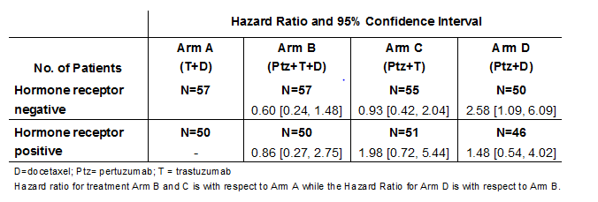
PFS Analyses by tpCR Status (Achieved versus. Not Achieved): In total, 417 patients were included in this analysis: Of the 323 patients who did not achieve tpCR, 73 (22.6%) had a PFS event, and of the 94 patients who achieved tpCR 14 patients (14.9%) had a PFS event. The hazard ratio for patients who achieved tpCR in relation to patients who did not achieve tpCR was 0.54 (95% CI [0.29; 1.00]) (Table 21).

Table 21: Overview of PFS Analyses by tpCR Status NEOSPHERE (WO20697) (25)
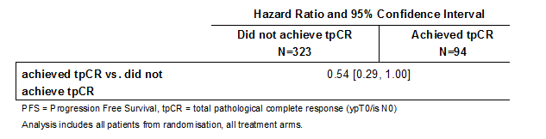

Disease-free survival:
DFS was defined as the time from the first date of no disease (that is, date of surgery) to the first documentation of PD or death. Contralateral in-situ disease was not considered as PD in this definition. The number of DFS events in the overall analysis and subsequent subgroup analyses (Hormone Receptor Status and pCR status) was limited. As for the PFS analyses, data are included for descriptive purposes only.
At the time of the final clinical cut-off date (20 October 2014), a total of 74 patients (18 [17.5 %] in the T + D arm, 15 [14.9 %] in the Ptz + T + D arm, 19 [19.8 %] in the Ptz + T arm, and 22 [23.9 %] in the Ptz + D arm) had a DFS event. The hazard ratio for the Ptz + T + D arm with respect to the T + D arm was 0.60 (95% CI [0.281.27]. The hazard ratio for the Ptz + T arm with respect to the T + D arm was 0.83 (95% CI [0.42; 1.64]). The hazard ratio for the Ptz + D arm with respect to the Ptz + T + D arm was 2.16 (95% CI [1.084.32]).
As for PFS, the number of patients at risk in the analysis is very low at the tails of the curves, with late events occurring at these time points. The Kaplan Meier survival estimates are not reliable at the later survival time points. An exploratory landmark analysis for DFS has been conducted. Landmark survival estimates at three years from surgery (Kaplan-Meier estimates), indicate a higher percentage of patients surviving in the Ptz + T + D arm compared to other treatment arms (T + D: 85%, Ptz + T + D: 92%, Ptz + T: 88% and Ptz + D: 84%).
Exploratory analyses for DFS were also performed in the following subgroups:
- hormone receptor status (negative/positive disease) Table 22
- tpCR status (achieved versus not achieved); Table 23 included as it features in draft guidelines on pCR from the US FDA and EMA, and is the preferred definition for some regulatory authorities.

Table 22: Overview of DFS analyses by hormone receptor status NEOSPHERE (WO20697) (25). Hazard ratio and 95% confidence interval
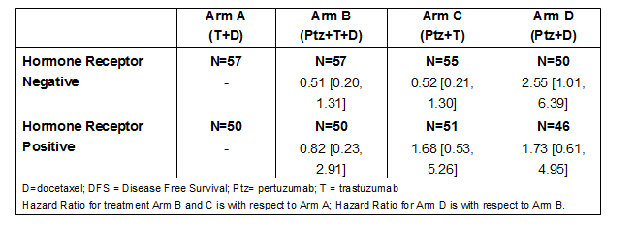
DFS in Patients with Hormone Receptor Negative Disease: A total of 42 patients (13 [23.2%] in the T + D arm, 8 [14.8%] in the Ptz + T + D arm, 8 [16.3%] in the Ptz + T arm and 13 [27.7%] in the Ptz + D arm) with hormone receptor negative disease had a DFS event. The hazard ratio for the Ptz + T + D arm with respect to the T + D arm was 0.51 (95% CI [0.20; 1.31]).
DFS in Patients with Hormone Receptor Positive Disease: A total of 31 patients (5 [10.6%] in the T + D arm, 7 [14.9%] in the Ptz + T + D arm, 10 [21.7%] in the Ptz + T arm and 9 [20.0%] in the Ptz + D arm) with hormone receptor positive disease had a DFS event. The hazard ratio for the Ptz + T + D arm with respect to the Ptz + D arm was 0.82 (95% CI [0.23; 2.91]).

Table 23: Overview of DFS analyses by tpCR status NEOSPHERE (WO20697) (25)
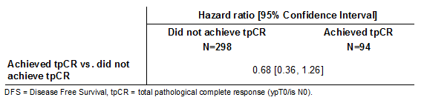
DFS Analyses by tpCR Status (Achieved versus. Not Achieved): In total, 392 patients were included in this analysis: Of the 298 patients who did not achieve tpCR, 60 (20.1%) had a DFS event, and of the 94 patients who achieved tpCR, 14 patients (14.9%) had a DFS event. The hazard ratio for patients who achieved tpCR in relation to patients who did not achieve tpCR was 0.68 (95% CI [0.36; 1.26]).
DFS in Patients Who Achieved pCR: A total of 14 patients who achieved a tpCR (4 [17.4 %] in the T + D arm, 6 [14.3 %] in the Ptz + T + D arm, 1 [8.3 %] in the Ptz + T arm, and 3 [17.6 %] in the Ptz + D arm) had a DFS event. The hazard ratio for the Ptz + T + D arm with respect to the T + D arm was 0.62 (95% CI [0.15; 2.50]).
DFS in Patients Who Did Not Achieve pCR: A total of 60 patients (14 [17.5 %] in the T + D arm, 9 [15.3 %] in Ptz + T + D arm, 18 [21.4%] in the Ptz + T arm and 19 [25.3 %] in the Ptz + D arm) had a DFS event. The hazard ratio (HR) for treatment the Ptz + T + D arm with respect to the T + D arm was 0.52 (95% CI [0.19; 1.43]).

Study - TRYPHAENA (BO22280)

Study design, objectives, locations and dates (23, 28)

Design
TRYPHAENA (BO22280) is a Phase II, open-label, randomised, multinational, multi-center trial designed to evaluate the tolerability and activity, particularly with respect to cardiac function, associated with trastuzumab and pertuzumab when used in combination with anthracycline-based or carboplatin-based chemotherapy regimens as neoadjuvant therapy, in patients with HER2-positive locally advanced, inflammatory or early stage breast cancer (> 2 cm in diameter).

Objectives
- The primary objective of TRYPHAENA (BO22280) was to evaluate the tolerability (especially in relation to cardiac function) of the 3 neoadjuvant treatment regimens. The following safety endpoints were of primary importance for the evaluation of the primary objective:
  - Incidence of symptomatic cardiac events as assessed by the Investigator (Grade 3, 4 or 5 symptomatic LVSD)
  - Clinically significant LVEF declines over the course of the neoadjuvant period (LVEF decline of ≥10% from baseline and to a value of <50%)
The primary endpoint was assessed using the safety population.
- The secondary objectives were:
  - To make a preliminary assessment of the activity associated with each regimen as indicated by the rate of pathological complete response (pCR; defined as the absence of invasive neoplastic cells at microscopic examination of the tumour remnants after surgery, following primary systemic therapy) in the breast. (Note: pCR by this definition is a less stringent definition than that preferred by the FDA and EMA, that is, ypT0/Tis ypN0)
  - To evaluate the safety profiles of each treatment regimen, including pre-operative (neoadjuvant) and post-operative (adjuvant) treatment (that is, trastuzumab) as indicated by the following endpoints:
    - Incidence of symptomatic cardiac events and asymptomatic LVEF events
    - LVEF measures over the course of the study
    - Incidence and severity of AEs and SAEs
    - Laboratory test abnormalities.
  - To investigate the overall survival (OS), the time to clinical response (CR), time-to-response, disease-free survival (DFS) and progression-free survival (PFS) for each treatment arm.
  - To investigate the biomarkers that may be associated with primary and secondary efficacy endpoints in accordance with each treatment arm.
  - To investigate the rate of breast conserving surgery for all patients with T2 3 tumours for whom mastectomy was planned at diagnosis.
  - The neoadjuvant and the adjuvant phases of the TRYPHAENA (BO22280) study are complete. The efficacy endpoints were secondary objectives in this study.

Centres and countries
Patients were recruited at 44 centers across 19 countries (Bahamas, Bosnia and Herzegovina, Brazil, Canada, Croatia, Germany, Great Britain, Italy, Mexico, New Zealand, Portugal, Republic of China, Republic of Korea, Republic of Serbia, Romania, South Africa, Spain, Sweden, and Switzerland).

Period of trial
Three main clinical data cut-offs have been performed for this study: the first was performed for the primary analysis (21 June 2011), while the second (04 July 2012) and the latest (22 July 2013) were performed for safety updates. The study is still ongoing; the end of the study will be five years after randomisation of the last patient (that is, 2016), or when all patients have progressed, or when the trial is terminated by the study sponsor whichever is earliest.

Inclusion and exclusion criteria (23)

Inclusion criteria
- Female patients with locally advanced, inflammatory or early stage, unilateral and histologically confirmed invasive breast cancer. The initial breast cancer assessment had to be performed by a physician with experience in surgery for breast cancer. Patients with inflammatory breast cancer must have had a core needle biopsy.
- Primary tumour > 2 cm in diameter.
- HER2-positive breast cancer confirmed by a central laboratory. Tumours had to be HER2 3+ by immunohistochemistry (IHC) or fluorescent in situ hybridization (FISH)/ chromogenic in situ hybridization (CISH positive). FISH/CISH positivity mandatory for HER2 2+ tumours.
- Availability of formalin-fixed paraffin-embedded (FFPE) tissue (buffered formalin method of fixation was accepted) for central confirmation of HER2 eligibility (FFPE tumour tissue was subsequently used for assessing status of biomarkers).
- Female patients, age ≥ 18 years.
- Baseline LVEF ≥ 55% (measured by echocardiography [ECHO] or multiple-gated acquisition [MUGA]).
- Eastern Cooperative Oncology Group (ECOG) Performance Status ≤ 1
- At least four weeks since major unrelated surgery, with full recovery.
- A negative pregnancy test must have been available for pre-menopausal women and for women less than 12 months after the onset of menopause.
- For women of childbearing potential, agreement to use a ‘highly-effective’, non- hormonal form of contraception or two ‘effective’ forms of non-hormonal contraception by the patient and/or partner. Contraception had to be continued for the duration of study treatment and for at least six months after the last dose of study treatment
- Signed informed consent.

Exclusion criteria:
- Metastatic disease (Stage IV) or bilateral breast cancer.
- Previous anticancer therapy or radiotherapy for any malignancy.
- Other malignancy, except for carcinoma in situ of the cervix, basal cell carcinoma or squamous cell carcinoma of the skin.
- Inadequate bone marrow function (egg, absolute neutrophil count (ANC) < 1.5 x 109/L, platelet count < 100 x 10⁹/L and Hb < 9 g/dL).
- Impaired liver function: (egg, serum [total] bilirubin > 1.25 x upper limit of normal (ULN) (with the exception of Gilbert’s syndrome), ASAT, ALAT > 1.25 x ULN, albumin < 25 g/L.
- Inadequate renal function, serum creatinine > 1.5 x ULN.
- Uncontrolled hypertension (systolic > 150 and/or diastolic > 100), unstable angina, congestive heart failure (CHF) of any New York Heart Association (NYHA) classification, serious cardiac arrhythmia requiring treatment (exceptions: atrial fibrillation, paroxysmal supraventricular tachycardia), history of myocardial infarction within six months of enrollment, or LVEF < 55%.
- Dyspnea at rest or other diseases that required continuous oxygen therapy.
- Severe uncontrolled systemic disease (egg, hypertension, clinically significant cardiovascular, pulmonary, metabolic, wound-healing, ulcer, or bone fracture).
- Patients with insulin-dependent diabetes.
- Pregnant and/or lactating women.
- Patients with reproductive potential not willing to use a ‘highly effective’ method of contraception or two ‘effective’ methods of contraception.
- Received any investigational treatment within four weeks of study start.
- Patients with known infection with HIV, HBV, HCV.
- Current chronic daily treatment with corticosteroids (dose of >10 mg methylprednisolone, or equivalent [excluding inhaled steroids])
- Known hypersensitivity to any of the study drugs or excipients.
- Patients, assessed by the Investigator who were unable or unwilling to comply with the requirements of the protocol.

Study treatments (23)
Eligible patients were randomised in a 1:1 ratio to one of three treatment arms (Figure 3):
- Arm A: pertuzumab and trastuzumab plus FEC, q3w, for three cycles, followed by pertuzumab, trastuzumab and docetaxel, q3w, for three cycles (Ptz+T+FEC/Ptz+T+D)
- Arm B: FEC, q3w, for three cycles, followed by pertuzumab, trastuzumab and docetaxel, q3w, for three cycles (FEC/Ptz+T+D)
- Arm C: pertuzumab and TCH (docetaxel), carboplatin and trastuzumab), q3w, for six cycles (Ptz+TCH).
Figure 3: TRYPHAENA (BO22280) study schema (29)
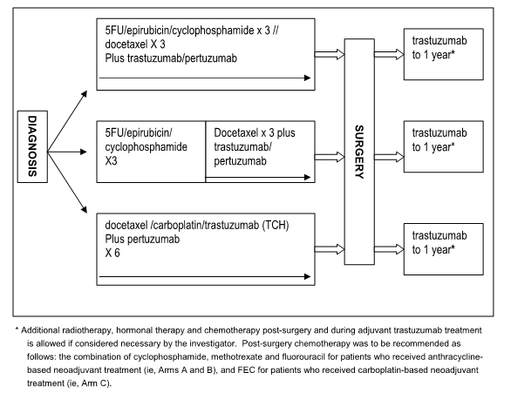
Study treatments were given consecutively on the same day, in the following order (where applicable): trastuzumab, followed by pertuzumab, followed by FEC, docetaxel or carboplatin. For patients in Arm C carboplatin was always given before docetaxel. Pertuzumab was given IV on Day 1 of each three-week-cycle, using an initial loading dose of 840 mg, followed by a maintenance dose of 420 mg, q3w, for the subsequent cycles. Pertuzumab was administered on Day 1 of Cycle 1 for Arm A (Ptz+T+FEC/Ptz+T+D) and C (Ptz+TCH) patients, and on Day 1 of Cycle 4 for Arm B (FEC/Ptz+T+D) patients. Neoadjuvant trastuzumab was given IV on Day 1 of each three-week-cycle using an initial loading dose of 8mg/kg, followed by a maintenance dose of 6mg/kg, q3w, for the subsequent cycles. FEC was administered as an IV bolus or as an infusion on Day 1 in the FEC-containing treatment arms. FEC was given q3w for three cycles, as follows:
- 5-FU was given as a dose of at 500 mg/m², with dose capping at 1200 mg
- Epirubicin was given as a dose of 100 mg/ m²
- Cyclophosphamide was administered at 600 mg/ m², with dose capping at 1200 mg.
Note: The proposed PI does not stipulate the precise FEC schedule, and there is some variability between the 5-FU and epirubicin doses used in the TRYPHAENA (WO22280) and NEOPSHERE (WO20697) studies. The study proposed PI refers back to the clinical trial schedules, and therefore may need to be more explicit in guiding the precise schedule, and avoidance of combined HER2-blockade and anthracyclines.
Docetaxel was administered at 75 mg/m² IV after the trastuzumab and/or pertuzumab infusion on Day 1, and in the Ptz+T+FEC/Ptz+T+D and FEC/Ptz+T+D arms, was escalated up to100 mg/ m2 in the subsequent cycles if no dose limiting toxicity was experienced. Docetaxel dose escalation was not allowed in the Ptz+TCH arm, consistent with routine clinical practice. Carboplatin (with a target AUC of 6) was given q3w for six cycles to patients in the Ptz+TCH arm. The Calvert formula was used to calculate the absolute dose (given in mg, not mg/ m2) of carboplatin. Following completion of six cycles of neoadjuvant treatment, patients underwent physical examination, and had a mammogram (and ultrasound if required by local practice) prior to breast surgery.
Comment: It should be noted that interval assessment would usually be performed after 2 cycles in an Australian setting (1).
Post-surgery, all patients received adjuvant trastuzumab (6 mg/kg IV, q3w) from Cycle 7 onwards. This was continued for a maximum of one year in total (that is, until Cycle 17 for patients in the Ptz+T+FEC/Ptz+T+D and Ptz+TCH arms and until Cycle 20 for patients in the FEC/Ptz+T+D arm). Hormone therapy (in hormone receptor-positive patients) and/or radiotherapy could also be given during adjuvant treatment, according to local guidelines. No pertuzumab was administered during the adjuvant period.
Comment: The use of adjuvant endocrine therapy was as per local guidelines. This should not influence the data from the neoadjuvant setting, but should be considered in any evaluation of long-term outcome for example, DFS and OS.

Efficacy variables and outcomes (23, 28, 29)
This study was primarily a safety study. However, the main efficacy variables were:
- Pathological complete response in the breast (bpCR, ypT0/is) was the key efficacy endpoint.
Other efficacy outcomes included:
- Clinical response rate,
- Time to clinical response
- BCS rate were also evaluated during the neoadjuvant phase and these data were mature at the time of the primary analysis.
- DFS, PFS and OS have not yet been evaluated.

Randomisation and blinding methods (23)
This was a randomised, open-label Phase II study. Patients who were candidates for enrollment were evaluated for eligibility by the Investigator. Eligible patients were randomised via interactive voice response system (IVRS) at a central randomisation center, which assigned a unique randomisation number to each patient. Patients were randomly assigned using dynamic allocation to each of the arms, and stratified by:
- Breast cancer type: operable (T2-3, N0-1, M0), locally advanced (T2-3, N2 or N3, M0; T4a-c, any N, M0) and inflammatory (T4d, any N, M0) breast cancer
- Hormonal receptor status: hormone receptor positive (ER+ and/ or PR+) versus negative (ER- and PR-). Treatment was started within five working days after randomisation.

Analysis populations (29)
Intent to Treat (ITT) Population: All patients randomised, regardless of whether they received any study medication, were included in in the ITT population. Patients were assigned to treatment groups as randomised for analysis purposes. A total of 73, 75, and 77 patients were randomised to the Ptz+T+FEC/Ptz+T+D, FEC/Ptz+T+D and Ptz +TCH arms respectively, and were therefore included in the intent-to-treat (ITT) population. All efficacy outputs were produced for the ITT population. Two patients (one in the Ptz+T+FEC/Ptz+T+D arm and one in the Ptz+TCH arm) withdrew before receiving any treatment. All other patients received the treatment according to how they were randomised.
Safety Population: The safety population included patients who received any amount of study medication. Patients were assigned to treatment groups as treated. The number of patients included in the safety analysis population was therefore 72, 75 and 76 in the Ptz+T+FEC/Ptz+T+D, FEC/Ptz+T+D and Ptz +TCH arms respectively. The safety analysis population of patients who entered the adjuvant period comprised 68, 65 and 67 patients in the Ptz+T+FEC/Ptz+T+D, FEC/Ptz+T+D and Ptz +TCH arms respectively. Once the treatment periods were over, or if patients withdrew from treatment, patients could enter the post-treatment follow-up period, which comprised 70, 75 and 74 patients in the Ptz+T+FEC/Ptz+T+D, FEC/Ptz+T+D and Ptz +TCH arms respectively.

Sample size (23)
A total of 300 patients with early stage HER2-positive breast cancer were screened, of whom 225 were randomised, 223 entered the neoadjuvant phase, 200 entered the adjuvant phase, and 219 entered the post-treatment follow-up period.

Statistical methods (23)
The primary objective of the study was to describe the tolerability of the treatment regimens in the Ptz+T+FEC/Ptz+T+D, FEC/Ptz+T+D and Ptz +TCH arms during neoadjuvant treatment. The primary endpoint of this study therefore relates to safety rather than efficacy. The sample size was based on the primary (safety) endpoint. Approximately 75 patients per arm were planned to be recruited into the study (225 in all).
Formal hypothesis testing was not planned and the study was not powered to detect differences in pCR. However, for pCR (the main efficacy endpoint) the approximate expected pCR rates were: Ptz+T+FEC/Ptz+T+D: 50%, FEC/Ptz+T+D: 45% and Ptz+TCH: 40%. With this planned sample size, if these response rates were observed, the minimum true efficacy (lower bound of exact 95% confidence interval) of the estimates would be approximately Ptz+T+FEC/Ptz+T+D:38.9%, FEC/Ptz+T+D: 33.8%, Ptz +TCH: 28.9%. For the assessment of incidence of symptomatic left ventricular systolic dysfunction (LVSD), if the true underlying incidence was 3%, the probability of observing more than five such events in a treatment arm was 0.025.

Participant flow
Figure 4: TRYPHAENA (BO28880) study participant flow (29)
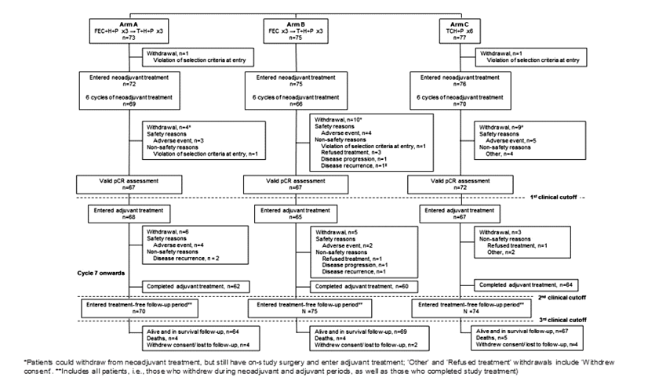

Major protocol violations/deviations (23, 28) (Tables 24 and 25)
At the time of the second clinical cut-off date, between 36% and 49% of patients (ITT population) reported at least one protocol violation, across all three arms. Major violations were related to safety criteria and no per protocol population was defined.
Major Violations: More patients in the Ptz+T+FEC/Ptz+T+D, arm were reported with an inclusion criteria violation (14%, versus 4% in the FEC/Ptz+T+D arm and 7% in the Ptz+TCH arm), all of which were designated as major violations. The most commonly reported inclusion criteria violation was a missing pregnancy test result (there were no positive pregnancy test results), which did not change since the primary analysis. Other inclusion violations occurred for a variety of reasons, with no notable difference across arms for any individual reason. Three patients in the Ptz+T+FEC/Ptz+T+D, arm entered the study with a primary tumour < 2cm in diameter. One patient in the Ptz+T+FEC/Ptz+T+D, arm entered the study and received the first cycle of treatment, despite not having confirmed HER2-positive breast cancer - this patient’s tumour was IHC 0/1+, and HER2-positivity was not determined by FISH. The patient (who remained in the study at the investigator’s discretion, until surgery was complete) was subsequently withdrawn on Study Day 191, for this reason. In addition, one patient in the Ptz+TCH arm did not have the eCRF page filled in for FFPE tissue availability, and so was reported as not having tissue available for HER2 testing; however, this patient was tested and was found to be IHC 3+ and HER2-positive by FISH. One patient in the FEC/Ptz+T+D arm and two patients in the Ptz+TCH arm entered the study with a baseline LVEF reading of < 55%. One patient in the FEC/Ptz+T+D arm violated the criterion excluding patients with metastatic disease or bilateral breast cancer, since they were determined to have inflammatory metastatic breast cancer, and had presented with lung metastasis during screening. This patient was withdrawn on Study Day 24 for this reason.
Approximately 30% of patients in each treatment arm reported at least one on-study protocol violation. The most common on-study violation was ‘patient safety compromised’. This category included patients for whom tumour assessments/CBE, LVEF measurement, or hematology evaluations were omitted for at least one scheduled assessment, as well as patients who received an incorrect dose of study treatment. Three patients in the Ptz+T+FEC/Ptz+T+D, arm, and one in the FEC/Ptz+T+D, arm entered the study with a primary tumour of less than 2 cm in diameter. However, one of these individuals no longer appears as a protocol violator because, after the primary analysis, the tumour measurements at the screening visits were updated by the Investigator as being larger than 2 cm.
Minor violations: More patients in the Ptz+T+FEC/Ptz+T+D, arm reported an exclusion criteria violation (12%, versus 5% in the FEC/Ptz+T+D, arm and 8% in the Ptz+TCH arm): all but the above noted cases of metastatic disease were minor violations. The majority of these were due to impaired liver function, as indicated by laboratory assessments.
Comment: Although in total, there were a substantial number of violations across the study, the nature of these (predominantly the potential for compromise of patient safety for example, missing pregnancy tests) is unlikely to significantly affect the data.

Table 24: Protocol violations TRYPAHENA (BO22280) (28)
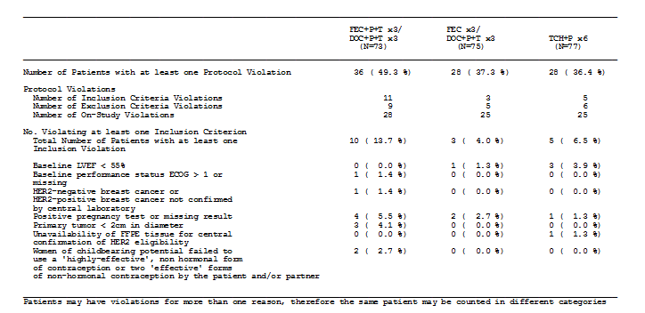

Table 25: Protocol violations TRYPHAENA (BO22280) (28)
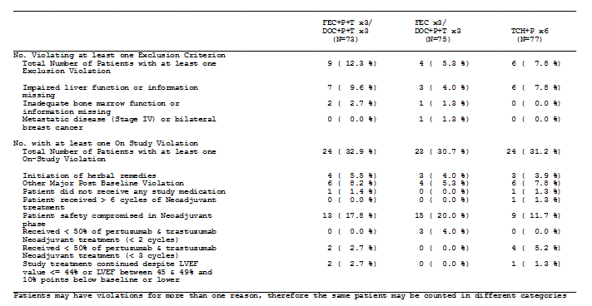

Baseline data (23)

For the safety population (Table 26)
- The three treatment arms were generally balanced with respect to the baseline demography (age, weight, height, ECOG status, race and smoking status).
- Nearly all patients in the study were Caucasian (77%) or Oriental (18%).
- Patients had a median age of 49-50 years, and a median weight of 63-67 kg.
- The majority of patients (89%) had an ECOG status of zero.
- The proportion of Caucasian patients was highest in the Ptz+TCH arm (84%, versus 76% in the Ptz+T+FEC/Ptz+T+D arm and 69% in the FEC/Ptz+T+D arm). The Ptz+TCH arm therefore had fewest Oriental patients (13% versus, 17% in the Ptz+T+FEC/Ptz+T+D arm and 24% in the FEC/Ptz+T+D arm).
- The percentage of post-menopausal women was highest in the Ptz+TCH arm (49%; versus 33% in the Ptz+T+FEC/Ptz+T+D arm and 41% in the FEC/Ptz+T+D arm).

For the ITT population (Table 27)
- closely matched those in the safety population
- the majority of patients presented with operable cancer, the proportion of which was lower in the Ptz+TCH arm (64%), than in the Ptz+T+FEC/Ptz+T+D arm (73%) and the FEC/Ptz+T+D arm (72%). Correspondingly, there were more patients in the Ptz+TCH arm with locally advanced breast cancer (31%, versus 21% in the Ptz+T+FEC/Ptz+T+D arm and 23% in the FEC/Ptz+T+D arm). Few patients in any arm (5%- 7%) had inflammatory disease
- The treatment arms were balanced with respect to differentiation status of the primary tumours
- Approximately half of the patients had hormone receptor-negative disease and this was comparable between arms
- The majority of patients had HER2 IHC 3+ and FISH-positive tumours (87.7%- 92.2% across arms). Three patients’ tumours were FISH negative; however, all three were HER 3+ by IHC. A single patient in the Ptz+T+FEC/Ptz+T+D arm did not have confirmed HER2-positive disease (the tumour was IHC 0/1+ and FISH positivity not determined), and was consequently withdrawn
- TNM classification was broadly balanced across the arms for patients with operable breast cancer, although there were fewer patients in the Ptz+T+FEC/Ptz+T+D arm with classification T2 N0 M0 (17%) than in the FEC/Ptz+T+D arm and the Ptz+TCH arm (37%-39%), and correspondingly most patients in the Ptz+T+FEC/Ptz+T+D arm with classification T3 N1 M0 (38% versus 26% and 14% in the Ptz+T+FEC/Ptz+T+D and Ptz+TCH arms respectively)
- The proportion of patients with locally advanced breast cancer was highest in the Ptz+TCH arm. There was a wide spread in classifications for patients with locally advanced breast cancer, however, the number of patients per classification subgroup was small. T4b N1 M0 was the most common classification in the Ptz+TCH arm; whereas T3 N2 M0 was the most common in the Ptz+T+FEC/Ptz+T+D and FEC/Ptz+T+D arms; however patient numbers in any one category were low. Few patients (4-5 across the arms) had inflammatory breast cancer
- All patients had their primary tumour assessed at baseline, and for the majority this was by CBE (77% – 88%). Other common assessments methods included mammography (48%) and ultrasound (32%). Primary tumour size, assessed by CBE was balanced across the treatment arms (between 49 mm and 53 mm)
- Concordance between the IVRS and the clinical database on the two baseline stratification factors (Hormone receptor status and Disease type [breast cancer strata]) was less than 100%. Hormone receptor status was 98% concordant between IVRS and the clinical database (four patients were misclassified). For the disease stage stratification there was approximately25% discordance (56 patients were misclassified) between the clinical data entry and IVRS entry, at baseline. This was likely due to a degree of subjectivity in the staging process that could result in a patient’s staging being altered after IVRS data entry. However, all statistical analyses were based on the information in the clinical database, which were verified against the source documents.

Table 26: Demographic data and baseline characteristics in safety cohort; analysis by treatment received TRYPAHENA (BO22280) (23)
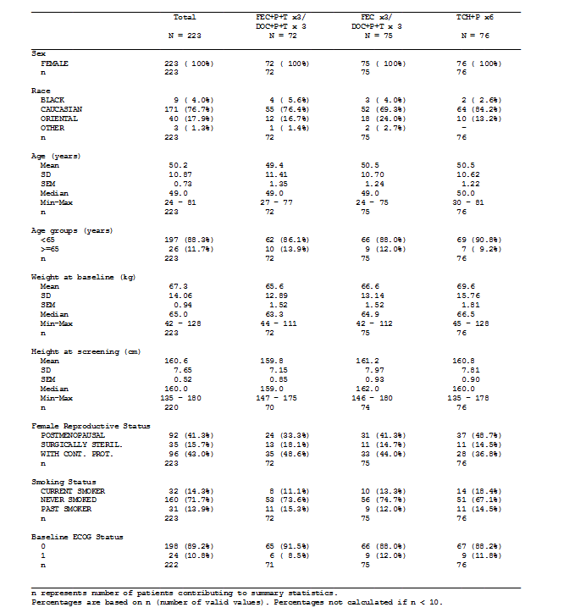

Table 27: History of breast cancer and HER2 status (by ITT) TRYPAHENA (BO22280) (23)
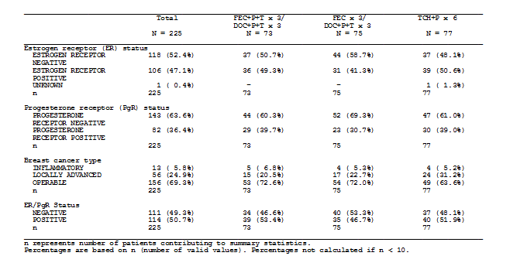

Results for the primary efficacy outcome (23)
As discussed earlier, this study was primarily a safety study. Safety results are presented in the section on clinical safety. A total of 73, 75 and 77 patients were randomised to the Ptz+T+FEC/Ptz+T+D, FEC/Ptz+T+D and Ptz+TCH respectively, and were included in the ITT population. Two patients withdrew before receiving any treatment. All other patients received treatment according to which arm they were allocated by randomisation. The number of patients included in the safety analysis population was therefore 72, 75 and 76 in arms Ptz+T+FEC/Ptz+T+D, FEC/Ptz+T+D and Ptz+TCH respectively.

Pathological complete response rate (Key secondary endpoint):
Most patients who entered the study had primary surgery on study and had a valid pCR assessment available (however, this was using the bpCR definition, not that recommended by regulators). Nevertheless, the pCR rates were comparable, in fact higher than those observed in the Ptz+T+D arm of NEOPSHERE (WO20697). These data are supportive of those seen in NEOSPHERE, bearing in mind that the non-taxane chemotherapy was brought forward to the neoadjuvant setting in TRYPHAENA (BO22280) and this likely account for the higher pCR rate in this study. There were four, eight and six patients in Ptz+T+FEC/Ptz+T+D, FEC/Ptz+T+D and Ptz+TCH arms respectively, who did not have surgery (these patients had previously withdrawn from the neoadjuvant period). One further patient in the Ptz+T+FEC/Ptz+T+D arm had an invalid pCR assessment. All three treatment regimens were active, with the majority of patients achieving a pCR in the breast (bpCR). bpCR rates were similar across the arms (61.6%, 57.3% and 66.2% in Ptz+T+FEC/Ptz+T+D, FEC/Ptz+T+D and Ptz+TCH arms respectively) (Table 28).

Table 28: Pathological complete response rate by ITT (bpCR; ypT0/is) TRYPHAENA (BO22280) (23)
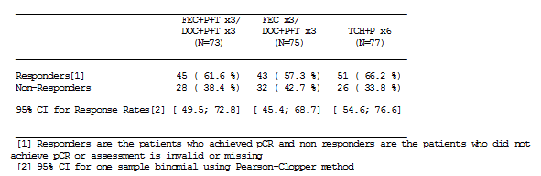
A similar pattern of response was observed when more stringent definitions of pCR were used. The tpCR (ypT0/is ypNO) rates were as follows: 56.2%, 54.7% and 63.6% in arms Ptz+T+FEC/Ptz+T+D, FEC/Ptz+T+D and Ptz+TCH respectively. The GBG pCR (ypT0 ypN0) rates were as follows: 50.7%, 45.3% and 51.9% in arms Ptz+T+FEC/Ptz+T+D, FEC/Ptz+T+D and Ptz+TCH respectively.

Results for other efficacy outcomes (23)

Clinical response rate
Nearly all patients achieved a response (CR or PR) as their best overall response during the neoadjuvant period. The number of patients with CR was highest in the Ptz+T+FEC/Ptz+T+D arm (50.7%), followed by the Ptz+TCH arm (40.3%) and was lowest in the FEC/Ptz+T+D arm (28.0%). One patient in the Ptz+T+FEC/Ptz+T+D arm had PD as their best overall response. The overall best tumour response, closely matched the tumour response evaluation at the end of the neoadjuvant period. The pattern of best overall responses within the subgroup of patients with operable breast cancer, or in the subgroup of patients with locally advanced disease was generally comparable with that of the overall ITT population (Table 29).

Table 29: Best overall response: Clinical response rate (best overall response) during the neoadjuvant period (ITT) TRYPHAENA (BO22280) (23)
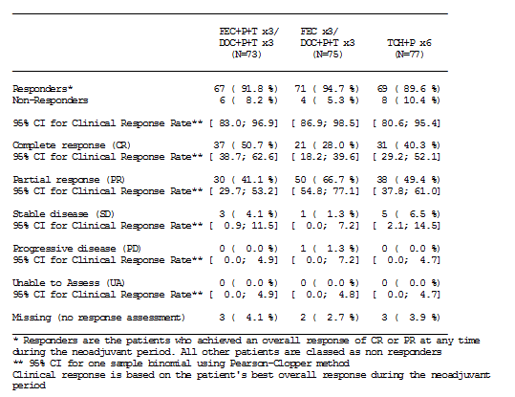

Time to clinical response
The median time to clinical response was 3.6 weeks in the Ptz+T+FEC/Ptz+T+D arm, 6.9 weeks in the FEC/Ptz+T+D arm and 4.9 weeks in the Ptz+TCH arm. The range in time was wide (between 1 and 18-20 weeks across arms).

Breast conservation rate
Within the ITT population, the proportion of patients who were able to have BCS within the subgroup of 119 patients with T2-T3 tumours initially planned for mastectomy was 10/46 (21.7%) in the Ptz+T+FEC/Ptz+T+D arm, 6/36 (16.7%) in the FEC/Ptz+T+D arm and 10/37 (27.0%) in the Ptz+TCH arm. Improvement in BCS was not a goal of the study, and these data do not distinguish patients who chose to undergo mastectomy from those who chose BCS.

Disease-free, progression-free and overall survival
Preliminary DFS data for patients who had surgery were presented in the second update CSR. Data for PFS and OS were not mature at the time of the third clinical cut-off date, and, therefore, have not been analysed by the sponsor. The results will be reported at the end of the study, that is, five years after randomisation of the last patient, or when all patients have progressed, or when the trial is terminated by the sponsor, whichever is earliest.

Table 30: Disease-free survival in patients who underwent surgery (ITT) TRYPHAENA (BO22280) (29)
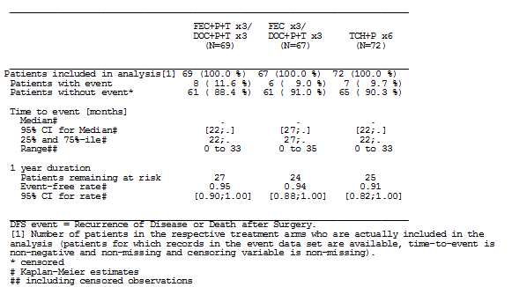

Other efficacy studies

CLEOPATRA (WO20698) STUDY (8, 17, 18)
Note: this study has been reviewed previously for the metastatic breast cancer indication. Data are included here to update that from previous analyses.

Design, objectives, locations, dates and baseline characteristics

Design
Phase III, randomised, double-blind, placebo-controlled clinical trial

Objectives
- The primary objective of this study was to compare PFS, between patients in the two treatment arms (the placebo plus trastuzumab plus docetaxel [Pla+T+D] arm versus the pertuzumab plus trastuzumab plus docetaxel [Ptz+T+D] arm) based on assessments by an independent review facility.
- A key secondary objective of this study was to compare overall survival (OS) between the two treatment arms.
- Other secondary objectives of this study were as follows:
  - To compare PFS between the two treatment arms based on Investigator assessment of progression.
  - To compare the overall objective response rate between the two treatment arms.
  - To compare the duration of objective response between the two treatment arms.
  - To compare the safety profile between the two treatment arms.
  - To compare the time to symptom progression between the two treatment arms, as assessed by the Functional Assessment of Cancer Therapy (FACT) Trial Outcome Index—Physical/Functional/Breast (TOI-PFB).
  - To evaluate if biomarkers from tumour tissues or blood samples (for example, HER3 expression, Fcγ-Receptor polymorphisms, and serum ECD/HER2 and/or HER ligand concentrations) correlate with clinical outcomes. A sub study of this protocol was also designed to evaluate corrected QT (QTc) interval, pharmacokinetics (PK) and drug-drug interactions (DDI).
Locations: Brazil, Canada, China, Costa Rica, Croatia, Ecuador, France, Finland, Germany, Great Britain, Guatemala, Italy, Japan, Latvia, Macedonia, Mexico, Poland, Republic of Argentina, Republic of Korea, Republic of the Philippines, Russia, Singapore, Spain, Thailand, USA.

Dates:
12 February 2008 to 11 February 2014

Baseline characteristic:
- 808 patients were randomised.
- The treatment groups were generally comparable with respect to demographic characteristics and patients’ baseline characteristics, and the stratification variables of region and prior treatment status were well balanced between treatment arms.
- Most patients were female (99.8%)
- Median age was 54 years.
- approximately50% was hormone receptor- positive.
- >97% of patients had metastatic disease at study entry
- 78% of patients had visceral metastases
- approximately50% patients had received prior adjuvant or neoadjuvant therapy.
- 40.4% of patients in the placebo, trastuzumab plus docetaxel arm versus 37.3% of patients in the pertuzumab, trastuzumab plus docetaxel arm had previously received an anthracycline
- approximately 11% of patients had received prior trastuzumab in the adjuvant/neoadjuvant setting.
- slightly fewer patients in the placebo, trastuzumab plus docetaxel arm had an ECOG status of 0 (248 patients [61.1%] versus 274 patients [68.2%]) indicating a slightly worse performance status in patients in the placebo, trastuzumab plus docetaxel arm compared with the pertuzumab, trastuzumab plus docetaxel arm. Only four patients in the whole study had an ECOG performance status worse than 0 or 1 at baseline.

Inclusion and exclusion criteria
The study population for this trial comprised patients aged ≥ 18 years with previously untreated (in the metastatic setting), HER2-positive, metastatic or locally recurrent, unresectable breast cancer. This population included patients who had not been treated previously with chemotherapy and/or biologic therapy (including approved or investigational tyrosine kinase/ HER inhibitors or vaccines) for their metastatic disease. Patients were allowed prior adjuvant hormonal therapy and one line of hormonal therapy for metastatic disease. Patients with stage IV disease at initial disease presentation or PD occurring ≥ 12 months after neoadjuvant or adjuvant therapy were included. Trastuzumab and/or taxanes were acceptable neoadjuvant or adjuvant treatments.

Disease-specific inclusion criteria
- Histologically or cytologically confirmed adenocarcinoma of the breast with locally recurrent or metastatic disease, and candidate for chemotherapy.
- Patients with measurable and/or non-measurable disease were eligible.
- Patients with bone only metastases were eligible provided they had some bone metastases that had not been previously irradiated and had tumour tissue samples from the primary tumour available for central HER2 testing and subsequent biomarkers analysis.
- Locally recurrent disease must not have been amenable to resection with curative intent.
- Patients with de-novo Stage IV disease were eligible.
- HER2-positive (defined as 3+ IHC or FISH amplification ratio ≥ 2.0) metastatic breast cancer confirmed by a Sponsor-designated central laboratory.

General inclusion criteria
- Age ≥ 18 years.
- LVEF ≥ 50% at baseline (within 42 days of randomisation) as determined by either ECHO or MUGA (ECHO being the preferred method.
- Eastern Cooperative Oncology Group (ECOG) performance status (PS) of 0 or 1.
- For women of childbearing potential and men with partners of childbearing potential, agreement to use a highly effective, non-hormonal form of contraception or two effective forms of non-hormonal contraception by the patient and/or partner. Contraception use was to continue for the duration of study treatment and for at least 6 months after the last dose of study treatment. Male patients whose partners were pregnant were advised to use condoms for the duration of the pregnancy.
- Signed, written informed consent (approved by the Institutional Review Board or Independent Ethics Committee) obtained prior to any study procedure.

Cancer-related exclusion criteria
- History of anti-cancer therapy for MBC (with the exception of one prior hormonal regimen for MBC, which had to be stopped prior to randomisation).
- History of approved or investigative tyrosine kinase/HER inhibitors for breast cancer in any treatment setting, except trastuzumab used in the neoadjuvant or adjuvant setting.
- History of systemic breast cancer treatment in the neoadjuvant or adjuvant setting with a disease-free interval from completion of the systemic treatment (excluding hormonal therapy) to metastatic diagnosis of < 12 months.
- History of persistent NCI-CTCAE, Version 3.0 Grade ≥ 2 hematologic toxicity resulting from previous adjuvant therapy.
- Current peripheral neuropathy of Grade ≥ 3 at randomisation.
- History of other malignancy within the last 5 years, except for carcinoma in situ of the cervix, basal cell carcinoma or squamous cell carcinoma of the skin that was previously treated with curative intent.
- Current clinical or radiographic evidence of central nervous system (CNS) metastases. CT or MRI scan of the brain was mandatory (within 28 days of randomisation) in cases of clinical suspicion of brain metastases.
- History of exposure to the following cumulative doses of anthracyclines:
  - doxorubicin or liposomal doxorubicin > 360 mg/m²
  - epirubicin > 720 mg/m²
  - mitoxantrone > 120 mg/m² and idarubicin > 90 mg/m²
  - other (that is, liposomal doxorubicin or other anthracycline > the equivalent of 360 mg/m² of doxorubicin)
  - if more than one anthracycline was used, then the cumulative dose must not exceed the equivalent of 360 mg/m² of doxorubicin.

Exclusion criteria related to hematological, biochemical, and organ function parameters
- Current uncontrolled hypertension (systolic > 150 mmHg and/or diastolic > 100 mmHg) or unstable angina.
- History of congestive heart failure (CHF) of any New York Heart Association (NYHA) criteria, or serious cardiac arrhythmia requiring treatment (exception: atrial fibrillation, paroxysmal supraventricular tachycardia).
- History of myocardial infarction within 6 months of randomisation.
- History of LVEF decline to below 50% during or after prior trastuzumab neoadjuvant or adjuvant therapy.
- Current dyspnea at rest due to complications of advanced malignancy, or other diseases requiring continuous oxygen therapy.

General exclusion criteria
- Inadequate organ function, evidenced by the following laboratory results within 28 days of randomisation:
  - Absolute neutrophil count (ANC ) < 1,500 cells/mm3
  - Platelet count < 100,000 cells/mm3
  - Hemoglobin < 9 g/dL
  - Total bilirubin > upper limit of normal (ULN) (unless the patient had documented Gilbert’s syndrome)
  - AST (SGOT) or ALT (SGPT) > 2.5 × ULN
  - AST (SGOT) or ALT (SGPT) > 1.5 × ULN with concurrent serum alkaline phosphatase > 2.5 × ULN. Serum alkaline phosphatase may have been > 2.5 × ULN only if bone metastases were present and AST (SGOT) and ALT (SGPT) < 1.5 × ULN
  - Serum creatinine > 2.0 mg/dL or 177μmol/L
  - International normalized ratio (INR) and activated partial thromboplastin time or partial thromboplastin time (aPTT or PTT) > 1.5 × ULN (unless on therapeutic coagulation).
- Current severe, uncontrolled systemic disease (for example, clinically significant cardiovascular, pulmonary, or metabolic disease; wound healing disorders; ulcers; or bone fractures).
- Major surgical procedure or significant traumatic injury within 28 days of study treatment start or anticipation of the need for major surgery during the course of study treatment.
- Pregnant or lactating women.
- History of receiving any investigational treatment within 28 days of randomisation.
- Current known infection with HIV, HBV, or HCV.
- Receipt of IV antibiotics for infection within 14 days of randomisation.
- Current chronic daily treatment with corticosteroids (dose of > 10 mg/day methylprednisolone equivalent) (excluding inhaled steroids).
- Known hypersensitivity to any of the study drugs.
- Assessed by the investigator as unable or unwilling to comply with the requirements of the protocol.
- Participation in concurrent interventional or non-interventional studies was not permitted.

Study treatments
Figure 5: Study design CLEOPATRA (WO20698) (8)
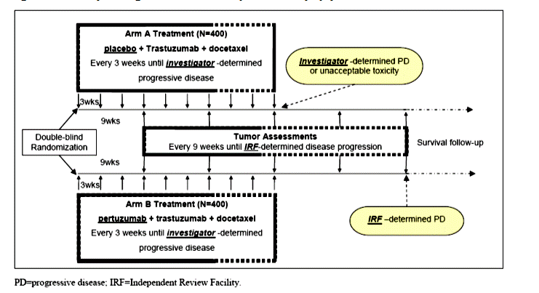
A total of 800 patients were planned for the study, randomised in a 1:1 ratio to one of two treatment arms to receive (Figure 5):
Arm A (Pla+T+D)
- Pertuzumab placebo: IV infusion every 3 weeks (q3w)
- Trastuzumab: loading dose of 8 mg/kg IV, followed by 6 mg/kg IV q3w
- Docetaxel dose of 75 mg/m² IV q3w for at least six cycles
Arm B (Ptz+T+D)
- Pertuzumab: loading dose of 840 mg/kg IV, followed by 420 mg/kg IV q3w
- Trastuzumab: loading dose of 8 mg/kg IV, followed by 6 mg/kg IV q3w
- Docetaxel dose of 75 mg/m² IV q3w for at least six cycles
On, or prior to Cycle 6, docetaxel could be discontinued only for progressive disease (PD) or unacceptable toxicity. After Cycle 6, continuation of docetaxel treatment was at the discretion of the patient and the treating physician. If pertuzumab/placebo and/or trastuzumab had to be permanently discontinued or withheld for more than two cycles, the patient was taken off the study treatment. However, if docetaxel had to be permanently discontinued for reasons related to toxicity, the patient could continue with pertuzumab/placebo and trastuzumab. At the discretion of the treating physician, the docetaxel dose could be increased to 100 mg/m² for patients who tolerated at least one cycle without any of the following toxicities: febrile neutropenia, Grade 4 neutropenia for > 5 days or absolute neutrophil count (ANC) < 100/μL for > 1 day, or other Grade > 2 non-hematologic toxicities.

Randomisation and blinding methods (8)
Eligible patients were be randomised in a 1:1 ratio to one of two treatment arms by central randomisation using an Interactive Voice Response System (IVRS). Unblinding of treatment assignment will not be permitted during the study except for safety issues that may arise during study conduct. An approval from the sponsor’s medical monitor(s) must be obtained prior to any unblinding of treatment code.
A complete block randomisation scheme was used to achieve balance in treatment assignment within each of the eight strata, as defined by the following stratification factors:
- prior treatment status (de novo , adjuvant or neo-adjuvant therapy (includes chemotherapy and/or trastuzumab in the adjuvant or neo-adjuvant setting)
- region (Asia, Europe, North America, South America)

Analysis populations (8)
The following analysis populations were defined:
- Intent-to-treat (ITT) population: All randomised patients were included in the ITT population. The ITT population comprised all 808 randomised patients (406 patients randomised to Pla+T+D; 402 patients randomised to Ptz+T+D). The ITT population was the basis for the efficacy analyses.
- Safety analysis population: Patients who received any amount of any component of study treatment were included in the safety analysis population. The safety analysis population comprised 396 patients in the Pla+T+D arm and 408 patients in the Ptz+T+D arm. Crossover patients were included in the Pla+T+D arm of the safety analysis population up to the day prior to the date of their first dose of crossover pertuzumab.

Sample size (8)
A total of approximately 800 patients (approximately 400 per arm) were planned to be enrolled. 808 were actually randomised.

Statistical Methods (8, 17)
The primary analysis of PFS was planned for when approximately 381 IRF-assessed PFS events had occurred. It was estimated that a total of 381 IRF-assessed PFS events would provide approximately 80% power to detect a 33% improvement in median PFS (hazard ratio [HR] of 0.75 with a two-sided significance level of 5%). Since both PFS and OS analyses are event-driven, and to avoid prolonged waiting period after final PFS analysis for OS data to reach the required number of events, the trial was designed to enroll sufficient number of patients such that approximately 50% of the required deaths will have been observed at the time of the final PFS analysis.
The primary endpoint was IRF-assessed PFS. The log-rank test, stratified by prior treatment status and region was used to compare PFS between the two treatment arms. The Kaplan-Meier approach was used to estimate median PFS for each treatment arm and the Cox proportional hazard model, stratified by prior treatment status and region was used to estimate the HR between the two treatment arms (that is, the magnitude of treatment effect) and its 95% confidence interval (CI). Analysis methods for OS were the same as for PFS.
Note: At the second interim analysis of overall survival, the predefined stopping boundary was crossed, the analysis was considered statistically significant and patients were permitted to cross-over.
Comment: Statistical analyses are appropriate

Participant flow (8)
A total of 1196 patients were screened for the study, and a total of 808 patients were randomised to one of two treatment arms: 406 patients to the Pla+T+D arm and 402 patients to the Ptz+T+D arm. Due to the statistically significant overall survival benefit with Ptz+T+D compared with Pla+T+D reached at the clinical data cut-off of 14 May 2012, patients still alive and on study treatment in the placebo arm (that is, patients whose disease had not progressed) were offered crossover from placebo to pertuzumab. Forty- eight of 406 patients (11.8%) randomised to the placebo arm crossed over to pertuzumab between July 2012 and November 2012. Based on the ITT population and therefore including crossover patients in the placebo arm, a total of 389 patients (221 patients [54.4%] in the placebo arm and 168 patients [41.8%] in the pertuzumab arm) had died by the time of data cut-off on 11 February 2014; 37 patients (9.1%) randomised to Pla+T+D and 67 patients (16.7%) randomised to Ptz+ T + D were still alive and on study treatment. In the Pla+T +D arm, 105 patients (25.9%) were alive and in survival follow-up compared with 125 patients (31.1%) in the Ptz+T+D arm. Of the 48 patients who crossed over from placebo to pertuzumab, 1 patient had died, 31 patients were still alive and on crossover treatment, and 15 patients were alive and in survival follow-up.

Protocol violations/deviations (17)
The most common protocol violations were on-study violations of LVEF and tumour assessments being performed outside the schedule of every 9 weeks +/-7 days. At the time of the primary analysis approximately 60% of patients in each treatment arm had at least one protocol violation reported, the majority of which were minor and of no risk to individual patient safety. Only three patients, one in the Pla+T+D arm and two in the Ptz+T+D arm, withdrew from study treatment due to protocol violations. Approximately 1% of patients in each arm violated one of the inclusion criteria defined for the study. However, approximately 12% of patients in each treatment arm overall were categorised as having violated an inclusion criterion because baseline tumour assessments were outside the 28-day screening window.
Comment: Protocol violations/deviations were evenly distributed between arms, mostly minor and unlikely to have influenced the results of the study.

Efficacy results (8) table 31
At the time of primary analysis, the study met its primary endpoint of PFS, demonstrating that the pertuzumab, trastuzumab plus docetaxel regimen was superior to placebo, trastuzumab plus docetaxel. At the more recent clinical cut-off date of 11 February 2014, 320/406 patients (78.8%) randomised to Pla+T+D and 284/402 patients (70.6%) randomised to Ptz+T+D were reported to have had a PFS event according to investigator assessment. The HR was 0.68 (95% CI, 0.58 − 0.80) and the medians for PFS (12.4 months in the placebo arm and 18.7 months in the pertuzumab arm).
At the analysis of 14 May 2012, the predefined stopping boundary for statistical significance was crossed (p ≤ 0.0138), demonstrating that treatment with pertuzumab, trastuzumab plus docetaxel significantly improved OS when compared with placebo, trastuzumab plus docetaxel. (HR = 0.66; 95% CI: 0.52, 0.84; p = 0.0008). Thereafter cross-over was permitted.
Thus the final analysis of overall survival was event-driven and defined to take place after 385 deaths had occurred (due to late reporting it was actually 389 deaths). The data cut-off occurred when 385 deaths had been reported on 11 February 2014. The data cut-off occurred approximately 43 months after the last patient had been enrolled into the study. The median duration of follow-up was 50.6 months (range: 0 − 69) in the placebo arm and 49.5months (range: 0−70) in the pertuzumab arm). At the time of data cut-off, 320/406 patients (78.8%) in the Pla+T+D arm and 284/402 patients (70.6%) in the Ptz+T+D arm had experienced a PFS event according to the investigator. The treatment benefit of Ptz+T+D compared with Pla+T+D was maintained in the updated analysis of investigator-assessed PFS (HR = 0.68; 95% CI, 0.58 − 0.80; p < 0.0001). The median PFS durations of 12.4 months in the placebo arm and of 18.7 months in the pertuzumab arm were consistent with results from the previous analyses.
In the placebo arm, 221/406 patients (54.4%) had died compared with 168/402 patients (41.8%) in the pertuzumab arm at the data cut-off date. There was a substantial difference in overall survival between the two treatment arms: HR = 0.68; 95% CI, 0.56 − 0.84; p = 0.0002. The median survival estimates were 40.8 months with Pla+T+D and 56.5 months with Ptz+T+D, that is, treatment with Ptz+T+D prolonged median overall survival by 15.7 months compared with Pla+T+D. This improvement is despite the crossover of 48 patients from placebo to pertuzumab.

Table 31: CLEOPATRA (WO20698) study: overall survival results from three analyses (8)

Conclusions
The PFS and the OS results were statistically significant and clinically meaningful with a dramatic increase in PFS of some 6 months, and OS of nearly 16 months and provided confirmation of the positive benefit−risk ratio of treatment with pertuzumab and trastuzumab combined with docetaxel, in patients with HER2-positive metastatic or locally recurrent, unresectable breast cancer. These data have therefore provided the basis for the current listing of pertuzumab in the metastatic setting.

Analyses performed across trials (pooled analyses and meta-analyses)
Not applicable.

Evaluator’s conclusions on clinical efficacy
for neoadjuvant treatment of patients with HER2-positive, locally advanced, inflammatory or early stage breast cancer (either greater than 2 cm in diameter or node positive)
The sponsor has provided data from two open-label randomised phase II studies, NEOSPHERE (WO20697) and TRYPHAENA (BO22280), with supporting data from the previously reviewed CLEOPATRA (WO20698) study.
In the two neoadjuvant studies, the target population were female patients with HER2-positive non-metastatic breast cancer where the primary tumour is > 2 cm in size. The choice of study population was appropriate as HER2-positive breast cancer is a molecular breast cancer subtype that is highly responsive to neoadjuvant therapy. It is noted that in both studies, approximately half of the patients were endocrine-receptor positive, a subgroup for which neoadjuvant therapy may be less effective (9, 10).
The sponsor is applying to add pertuzumab to a neoadjuvant chemotherapy backbone that involves a taxane (docetaxel) and trastuzumab. Concurrent treatment with anthracycline is not intended in the application although was a component of the adjuvant component of the 4 arms of the NEOSPHERE (WO20697) and the neoadjuvant Arm A (Ptz+T+FEC/Ptz+T+D) of TRYPHAENA (BO22280). The current standard of care in Australia is to avoid concurrent administration of trastuzumab due to the risks of cardiotoxicity, and it is critical that the sponsor provides some guidance in the PI as to the appropriate adjuvant regimen to use post-surgery, as a recapitulation of the regimens described in the NEOSPHERE (WO20697) study is not congruent with current Australian practice. As discussed in the review of safety, there were 2.8% and 5.9% rates of significant LVEF impairment in the Ptz+T+D arm of the NEOSPHERE (WO20697) study during the neoadjuvant and adjuvant phases of the study, higher than the comparator arms. This is of potential concern as this carry over to the adjuvant setting is likely to lead to reduced exposure to adjuvant trastuzumab which does have a proven impact on survival outcomes. Nevertheless, with the concurrent anthracycline component of the regimens omitted, the schedules are reflective of current clinical practice in the neoadjuvant setting. As noted previously, a recent study by Del Mastro et al (5) in an adjuvant breast cancer population showed that the addition of 5-fluorouracil to epirubicin/cyclophosphamide (followed by paclitaxel) was not associated with improved DFS. Therefore it is possible that in some patients for example, those with comorbidities, and older patients, oncologists will use a different chemotherapy in the adjuvant setting (for example, EC or AC).
The evaluator notes that there was slight variability in the FEC regimens used in the NEOSPHERE (WO20697) and TRYPHAENA (BO22280) studies. In the former the schedule was 5-fluorouracil administered at 600 mg/m², epirubicin 90 mg/m², and cyclophosphamide 600 mg/m², while in the latter the schedule was 5-fluorouracil administered at 500 mg/m², epirubicin 100 mg/m², and cyclophosphamide 600 mg/m². In the pivotal efficacy study, NEOPSHERE (WO20697) the FEC was given in the adjuvant setting and of less relevance to the pCR endpoint of the study. As stated in the detailed review of NEOSPHERE (WO20697), the study was not powered to assess DFS and OS, end-points for which the subtleties of the adjuvant therapy dosing may/may not have influence. In contrast the TRYPAHENA (BO22280) study administered the FEC upfront however there was no control arm in this study and it was primarily designed to look at cardiac toxicity. Again this study was not powered to address DFS and OS. The precise FEC schedule may or may not influence long-term outcomes however does not influence decision-making in relation to the use of the surrogate end-point of pCR (in the case of the NEOSPHERE (WO20697) and TRYPHAENA (BO22280) studies as measured using bpCR). Likewise, the use of adjuvant endocrine therapy was as per local guidelines, with the potential to influence long-term outcome but not pCR.
The pCR rates were higher in the TRYPHAENA (BO22280) study, likely as a result of combining polychemotherapy with the anti-HER2 therapies in the neoadjuvant setting. However the influence of these treatments as a neoadjuvant rather than adjuvant therapy with respect to long-term outcome remains unknown.
The evaluator notes that the NEOPSHERE (WO20697) and TRYPHAENA (BO22280) studies were Phase II, open-label studies and therefore potentially subject to bias (especially in relation to the clinical assessment of response). However, given that the primary endpoint of the NEOSPHERE (WO20697) study was pCR, assessed by pathologists who were in large part oblivious to the treatment allocation, the risk of bias in this application, which is based on the use of pCR as a surrogate end-point should be low.
From the CLEOPATRA (WO20698) study, pertuzumab added to trastuzumab and docetaxel has high efficacy in the setting of metastatic setting with a response rate of approximately 80%, and a meaningful prolongation in both PFS and OS - this provides a strong argument to study this triplet combination in an early breast cancer population. To this end, the APHINITY (BO25126) study has been conducted with results awaited in 2016. Certainly the data from CLEOPATRA (WO20698) are compelling however the duration of treatment with pertuzumab is significantly longer than that used in the NEOSPHERE (WO20697) and TRYPAHENA (BO22280) studies, as it the duration of cytotoxic chemotherapy. It is therefore unclear whether a short course of neoadjuvant treatment will translate into meaningful long-term outcomes as has been so dramatically demonstrated in the metastatic setting.
While the adjuvant pertuzumab study (APHINITY BO25126) has yet to report, both NEOPSHERE (WO20697) and TRYPHAENA (BO22280) show, in very similar populations of patients that the addition of pertuzumab to a combination of trastuzumab and a taxane results in pCR rates by the least stringent definition of ypT0/is of between 46% to over 66%. This least stringent definition is not that which is recommended by the FDA and EMA for registration purposes. The sponsor provides data as to the taper and GBGpCR rates however, in the absence of standardised pre-treatment nodal assessment it is difficult to assess the rates of nodal control by the neoadjuvant strategies used in the various treatment arms of the two neoadjuvant studies. Furthermore the NEOSPHERE (WO20697) study was designed with an alpha level of 0.2, which is not particularly statistically stringent.
From a clinical surgical decision-making perspective, these aggregate data suggest that a neoadjuvant pertuzumab + trastuzumab + taxane triplet results in clinical response rates (that is, that assessed by standard clinical assessment by clinical examination and imaging with mammography and/or ultrasound of around 90%). Nevertheless, breast conservation rates remain low, and relatively uninfluenced by the addition of pertuzumab, with around a quarter to one third of patients study undergoing BCS. The evaluator notes that the NEOSPHERE (WO20697) and TRYPHAENA (BO22280) studies were not designed to show a difference in BCS, and as the numerous factors influencing surgical decision making were not controlled for, it is difficult to draw definitive conclusions.
The current application is predicated on the assumption that pCR after a limited course of pertuzumab + trastuzumab + taxane will result in long-term benefits in DFS and OS. The data for this assumption remain controversial. In particular, current data do not allow for the prediction of the magnitude of the DFS/OS effect from a certain pCR effect. In the absence of the awaited APHINITY (BO25126) data it is unclear if patients with operable HER2 + breast cancer may in fact be better served by a prolonged adjuvant treatment course. The evaluator notes that the striking benefits seen in the metastatic setting occurred with a substantially greater exposure to both chemotherapy and pertuzumab.
The endocrine receptor status of the tumours in these studies did predict pCR, with lower rates observed in the hormone-receptor positive subgroup compared to the hormone-receptor negative subgroup. This is in line with data from the Cortazar meta-analysis (9, 10). This meta-analysis also showed that patients who achieve pCR have better long-term outcomes regardless of endocrine-receptor status, and indeed in the CLEOPATRA (WO20698) study there was still a clinically meaningful benefit from pertuzumab in the endocrine-receptor positive group. Nevertheless, in the neoadjuvant setting, the likelihood of pCR is lower in this group comprising about 50% of patients in the NEOSPHERE (WO20697) and TRYPHAENA (BO22280) studies. Thus guidelines that suggest a ‘large’ change in pCR is required to assume that there might be a clinically meaningful change in DFS/OS down the track become increasingly difficult to interpret. Certainly, for a significant proportion of HER2 + patients a pCR benefit (by whatever definition is used) is likely to be ‘less large’.
In summary, the addition of pertuzumab to trastuzumab and docetaxel leads to a higher rate of bpCR (in the breast) in patients with HER2+ early breast cancer. This pCR end-point is not that which is recommended for registration purposes, and the statistical test used in the NEOPSHERE (WO20697) study used an alpha of 0.2. While to sponsor provides data as to the tpCR and GBGpCR rates, the assessment of the axilla at baseline is not robust and uniform (that is, the true state of nodal involvement pre-treatment is difficult to assess) and therefore these tpCR and GBGpCR data are viewed with some caution. The DFS/OS data have been provided by the sponsor to supplement the pCR data – these end-points are likely to be influenced by numerous other factors in the adjuvant setting for example, variability in chemotherapy schedules and endocrine therapies, and while interesting, are underpowered and exploratory only.
Thus, while the NEOSPHERE (WO20697) and TRYPHAENA (BO22280) studies show promising results from the perspective of pCR, it is unclear whether this will translate into meaningful long-term benefit. It is the evaluator’s view that adding pertuzumab increases the likelihood of a pCR in the breast (and is associated with tumour shrinkage in about 90% of patients) – the main benefit of a short course of pertuzumab may in fact be to render patients of borderline operability, surgically amenable. The CLEOPATRA data provide a compelling rationale for the adjuvant APHINITY (BO25126) study that will provide further data as to the benefit of pertuzumab in the early setting. The evaluator notes that both the American and European approvals for neoadjuvant pertuzumab are conditional upon the provision of further data such as that anticipated in the APHINITY (BO25126) study. Such conditional registration does not exist in Australia at present.

Clinical safety

Studies providing evaluable safety data
The following studies provided evaluable safety data:
NEOSPHERE (WO20697)
TRYPHAENA (BO22280) – primarily a safety study
CLEOPATRA (WO20698)

Pivotal efficacy studies
The pivotal efficacy studies were:
- NEOSPHERE (WO20607)

Pivotal studies that assessed safety as a primary outcome
The TRYPHAENA (BO22280 study) assessed safety as a primary outcome. The study design has been discussed earlier.

Supporting studies:
- CLEOPATRA (WO20698)

Efficacy, safety and supporting studies
The pivotal efficacy study NEOSPHERE (WO20697), and the two other studies, TRYPHAENA (BO22280) and CLEOPATRA (WO20698) contributed to this safety assessment. For ease of comparison and discussion, all 3 studies are grouped together.
- All three studies required adverse events (AEs) (regardless of grade or causality) and serious adverse events (SAEs) to be reported.
- All three studies required regular collection of data on:
  - physical examination
  - vital signs
  - Eastern Cooperative Oncology Group performance status (ECOG PS)
  - full blood count with platelets and differential counts,
  - serum chemistries and electrolytes
  - 12-Lead electrocardiograms (ECGs) and assessment of left ventricular ejection fraction (LVEF) by echocardiogram (ECHO) or multigated acquisition (MUGA) scan.
- In the NEOSPHERE (WO20697) and TRYPHAENA (BO22280) studies, liver function/coagulation parameters (International Normalized Ratio, activated partial thromboplastin time) were collected during the study for all patients, but in the CLEOPATRA (WO20698) study, these were only required for patients receiving anticoagulants.
Anti-therapeutic antibodies (ATA) were not collected in either of the two neoadjuvant studies. However, pertuzumab immunogenicity was extensively characterized in the CLEOPATRA (WO20698) study in which 6.7% of patients in the Pla + T + D arm developed ATAs versus 3.3% in the Ptz + T + D arm. In the CLEOPATRA (WO20698) study, in those patients where a post-baseline ATA titre was detected, this often occurred at the C3 assessment (approximately Day 61-65). There was no clear association with anti-therapeutic antibodies to pertuzumab and hypersensitivity/ anaphylactic reactions. Most hypersensitivity/anaphylactic reactions occurring on the day of a placebo/pertuzumab infusion were reported in the first two cycles of therapy, although events were reported as late as Cycle 30. Most reactions occurring on the day of a placebo/pertuzumab infusion, especially in the Pla+T+D arm, were Grade 1 - 2 in severity. More patients in the Ptz+T+D arm experienced Grade 3 hypersensitivity/anaphylactic reactions. Overall the proportion of patients experiencing anaphylaxis/hypersensitivity was balanced between the two treatment arms (9.1% of patients in the Pla+T+D arm versus. 11.0% of patients in the Ptz+T+D arm with one additional event of hypersensitivity was reported in the Ptz+T+D arm (versus. none in the Pla+T+D arm) after the primary clinical cut-off (17, 18).
- All patients who received at least one dose of treatment and underwent at least one post-baseline safety assessment were included in the safety evaluation for the three studies. The treatment arms for the safety analyses were defined according to the study treatment actually received.
- General adverse events (AEs) were collected as per standard protocols and severity of AEs was graded according to the National Cancer Institute Common Terminology Criteria for Adverse Events (NCI-CTCAE) version 3.0 on a five-point scale (Grade 1 to 5) and reported in detail on the eCRF.
- The causality relationship of study drug to the AE was assessed by the Investigator as either ‘yes’ or ‘no’. For non-serious AEs, the Investigator could only specify relationship to ‘study medication’; for SAEs, the Investigator could specify a relationship to one component of study medication
- Cardiac events were monitored as Adverse Events to Monitor (Table 32).

Table 32: Cardiac safety data for the NEOSPHERE (WO20697), TRYPHAENA (BO22280) and CLEOPATRA (WO20698) studies - (30 – components reconciled against CSRs for the 3 studies)
Parameter | NEOSPHERE (WO2067) | TRYPHAENA (BO22280) | CLEOPATRA (WO20698)
Asymptomatic LVEF decline | Reportable as AEs if they met the following criteria:  - Asymptomatic decline in LVEF of > 10%-points from baseline to a value of <50% (reportable as an AE)  - Asymptomatic decline in LVEF requiring treatment or leading to discontinuation of study treatment  - these had to reported as Non-Serious Adverse Events of Special Interest on both SAE and AE forms  - these events were to be reported as ‘left ventricular systolic dysfunction’ (LVSD) and graded according to NCI-CTCAE | As for NEOSPHERE | As for NEOSPHERE. I addition, all cardiac AEs occurring during the study and up to 12 months after the last medication of study medications were reportable regardless of causality and seriousness.
Symptomatic LVSD (that is, Grade 3 or greater LVD) | Reportable as a SAE, using the term congestive heart failure (CHF) | Reportable as a SAE using the term ‘left ventricular systolic dysfunction’ (LVSD) | As for TRYPHAENA
Symptomatic LVSD (that is, Grade 3 or greater LVD) | Reportable as a single diagnosis rather than symptoms or signs and graded according to NCI-CTCAE and NYHA classification | As for NEOSPHERE | As for NEOSPHERE
Symptomatic LVSD (that is, Grade 3 or greater LVD) | CHF occurring during the study and up to 24 months after the last dose of study medications was to be reported regardless of causality graded according to NCI-CTCAE and NYHA classification | As for NEOSPHERE (except using the term symptomatic LVSD rather than CHF) | Symptomatic LVSD occurring during study and up to 36 months after last dose of study medications was to be reported , regardless of causality, and graded according to NCI-CTCAE and NYHA classification
Symptomatic LVSD (that is, Grade 3 or greater LVD) | Specific signs and symptoms of LVSD were entered into the comments section of the AE eForm | A cardiac questionnaire was completed by investigators prior to each treatment cycle. Cardiac symptom and physical findings of symptomatic LVSD were entered into the cardiac questionnaire eForm | Cardiac symptoms and signs were reported on a ‘Symptomatic LVSD’ eCRF page for patients with LVSD
LVEF schedule of assessments | Between days 15 and 21 of cycles 2, 4, 8, 11 and 15, and after surgery, and < 7 days prior to cycle 5, and after cycle 17 and 21 (Ptz + D arm only) (that is, every 6 weeks during neoadjuvant and adjuvant therapy). Subsequent LVEF assessments every 6 months for 2 years | Between days 15 and 21 of Cycles 2, 4 and 6, after surgery and < 7 days prior to cycle 7, and between days 15 and 21 of cycles 10, 12 and 15 and 18 (FEC/Ptz + T + D arm only) (that is, every 6 weeks during the neoadjuvant period and every 6-9 weeks during the adjuvant period), at the post-treatment visit, then every 6 months for 2 years, then annually for 2 years | Every 9 weeks during study treatment, at the treatment discontinuation visit, then every 6 months for the first year, then annually for up to 3 years after the treatment discontinuation visit
Central review of cardiac data | Safety data (in general) reviewed by steering committee | Copies of MUGA and ECHO recordings were sent to a central laboratory for independent assessment | An independent Cardiac Review Committee (CRC) reviewed data for all potential cardiac events
CHF= congestive heart failure; LVEF = left ventricular ejection fraction; LVSD = left ventricular systolic dysfunction; NCI-CTCAE= National Cancer Institute Common Terminology Criteria for Adverse Events; NYHA = New York Heart Association
Comment: There was some variability in the terminology used to describe significant cardiac dysfunction, with symptomatic left ventricular systolic dysfunction (Grade 3 and above) being used in the TRYPHAENA (BO22280) and CLEOPATRA (WO20698) studies and symptomatic LVSD being classified as congestive heart failure in the NEOSPHERE (WO20697) study. This is considered in reviewing the aggregate data across the studies.
Several other parameters were specifically followed as per Table 33.

Table 33: Other events to monitor in the NEOSPHERE (WO20697), TRYPHAENA (BO22280) and CLEOPATRA (WO20698) studies (17, 22, 23)
Adverse events to monitor | Safety analysis strategy
Diarrhoea | PT ‘Diarrhoea’
Rash | Roche standard AEGT ‘EGFR-associated rash’
Leucopoenia, neutropenia | SMQ (narrow) ‘Haematopoietic leucopoenia’
Febrile neutropenia | PT ‘Febrile neutropenia’ – ‘subgroup of the search for ‘leucopoenia’
Leucopenic infection  Febrile neutropenic infection | Events from the ‘Infections and infestations’ SOC with a start date of a grade > 3event of SMQ (narrow) ‘Haematopoietic leucopenia’ and for infections following PT ‘Febrile neutropenia’ – subgroup of the search for ‘Leucopenic infection’
Interstitial lung disease | SMQ (narrow) ‘Interstitial lung disease’
Hypersensitivity/anaphylaxis | Roche standard AEGT ‘Anaphylaxis and hypersensitivity’, containing the MedDRA SMQ (narrow) ‘Anaphylactic reaction’ plus all MedDRA PTs containing ‘Hypersensitivity’
Mucositis | Roche Standard AEGT ‘Mucositis of gastrointestinal tract’
Cardiac dysfunction/SAEs suggestive of CHF | Serious events from the SMQ (wide) ‘Cardiac failure’ (see also preceding table)
QT prolongation | SMQ (wide) ‘Torsade de pointes/QT prolongation’
Venous thromboembolic events | Roche standard AEGT ‘Thromboembolic events-venous’
Hepatic related AEs (for TRYPHAENA and CLEOPATRA) | SMQ (wide) 'Drug Related Hepatic Disorders - comprehensive search'
AEGT=adverse events group terms; CHF =congestive heart failure; EGFR=epidermal growth factor receptor; PT=preferred term; SMQ=standard MedDRA queries; SOC=system organ class

Pivotal studies that assessed safety as a primary outcome
The TRYPHAENA (BO22280) study was a pivotal study that assessed safety as a primary outcome. The study is previously described in Section Efficacy. Safety outcomes are described together with those for NEOSPHERE (WO20697) and CLEOPATRA (WO20698).

Dose-response and non-pivotal efficacy studies
No new data.

Other studies evaluable for safety only
No new data.

Patient exposure
The number of patients exposed to pertuzumab in the three studies evaluated is as follows:
NEOSPHERE (WO20697) – 309
- 107 patients exposed to the combination of pertuzumab, trastuzumab and docetaxel
- 108 patients exposed to the combination of pertuzumab and trastuzumab
- 94 patients exposed to pertuzumab and docetaxel
TRYPHAENA (BO22280) – 223
- 72 patients exposed to pertuzumab in combination with trastuzumab, docetaxel and FEC
- 75 patients exposed to pertuzumab in combination with trastuzumab and docetaxel subsequent to FEC
- 76 patients exposed to pertuzumab in combination with trastuzumab, docetaxel and carboplatin
CLEOPATRA (WO20698) - 408
- 408 patients on this study received pertuzumab in combination with trastuzumab and docetaxel.
A further 696 patients have been exposed to pertuzumab in earlier studies submitted previously for regulatory review (BO17931, BO17929, BO16934, TOC2689g, TOC2572g, BO17004, TOC2682g, TOC2297g, BO17003, BO17021, WO20024, TOC3258g), and not re-reviewed here.
Importantly, the patients on the CLEOPATRA study did receive substantially more pertuzumab than those treated in the neoadjuvant studies, receiving a median of 8 cycles of pertuzumab + trastuzumab + docetaxel, and a median of 24 cycles of pertuzumab + trastuzumab, with sufficient follow-up (of greater than 2 years) to allow for the identification of delayed toxicity.

NEOSPHERE (WO20697) study (22) tables 34, 35, 36
Pertuzumab was only administered during the neoadjuvant period of this study (Cycles 1−4). A total of 416 patients started at least one cycle of study treatment (107 in the T+D arm, 107 in the Ptz+T+D arm, 108 in the Ptz+T arm, and 94 in the Ptz+D arm), and most patients (93%−95%) in the Ptz+T+D, Ptz+T, and Ptz+D arms completed all 4 cycles of neoadjuvant treatment with pertuzumab. Nearly all of the planned doses were received (of the planned total dose of 2100 mg, the mean total dose received was 2048−2060 mg).
Nearly all cycles of pertuzumab were administered without the need for delay, slowing down, interruption, modification, or discontinuation (90%−93% of all cycles across the Ptz+T+D, Ptz+T, and Ptz+D arms). Of those cycles with a delay to pertuzumab, the delay was no more than 14 days for any cycle, with the exception of 2 patients in the Ptz+T+D arm who experienced a delay of more than 24 days due to of asymptomatic decline in LVEF values < 50%. Overall, the number of pertuzumab cycles delayed, slowed down, interrupted, or discontinued was low, with the highest percentage occurring in the Ptz+T+D arm (3.1%) followed by the Ptz+T arm (2.9%) and Ptz+D arm (0.5%). Delays that were not due to AEs primarily occurred for administrative reasons.

Table 34: Summary of Total dose of pertuzumab received in NEOSPHERE (WO20697) (22)
Comment: In the pertuzumab-containing arms, exposure was close to maximal and there were few toxicities necessitating delay, slowing, down, interruption or modification. Exposure was well balanced across groups.

Table 35: Summary of total dose of neoadjuvant trastuzumab received NEOPSHERE (WO20697) (22)

Table 36: Summary of total dose of docetaxel received overall NEOPSHERE (WO20697) (22)
Comment: The total doses of docetaxel received across the arms were reasonably equally spread, as were the trastuzumab doses. Importantly, in the neoadjuvant setting the mean doses of both docetaxel and trastuzumab received in the Ptz+T+D arm was within 5% of those given in the T+D arm, suggesting that the effect of the addition of pertuzumab in the Ptz+T+D arm was not offset or augmented by large changes in the doses of the docetaxel or trastuzumab.

TRYPHAENA (BO22280) Study (23)
Pertuzumab was administered only during the neoadjuvant period of this study (Cycles 1−6). For patients in the Ptz+T+FEC/Ptz+T+D and Ptz+TCH arms, 6 cycles of pertuzumab were scheduled, whereas for patients in the FEC/Ptz+T+D arm, only 3 cycles of pertuzumab were scheduled. The majority of patients (88%−96%) in the three arms completed all 6 cycles of neoadjuvant treatment.
Patients in the Ptz+T+FEC/Ptz+T+D and Ptz+TCH arm received a median of 6 cycles (range 1−6), and patients in the FEC/Ptz+T+D arm received a median of 3 cycles (range 1−3) of pertuzumab as per study design. In the Ptz+T+FEC/Ptz+T+D and Ptz+TCH arms, 91.7% and 92.1% of patients, respectively, completed all 6 planned cycles of pertuzumab, and in the FEC/Ptz+T+D arm, 88% of patients completed all 3 planned cycles of pertuzumab. 5 patients in the FEC/Ptz+T+D arm withdrew from neoadjuvant treatment during the 3 cycles of FEC treatment and so did not receive any pertuzumab treatment (Table 37).

Table 37: Total dose of neoadjuvant pertuzumab received in the TRYPHAENA (BO22280) (23)
The majority of pertuzumab infusions were given without dose modification (including delay or interruption) or discontinuation. More cycles of pertuzumab were delayed, modified, or discontinued in the Ptz+TCH arm (17.7%) than in the Ptz+T+FEC/Ptz+T+D (9.3%) or the FEC/Ptz+T+D arm (8%). The majority of these dose modifications were due to an AE (5.7% in the Ptz+T+FEC/Ptz+T+D arm, 4.9% in the FEC/Ptz+T+D arm, and 14.2% in the Ptz+TCH arm), although not necessarily attributed to pertuzumab. Of the patients who experienced some form of dose modification, the vast majority did so for only one cycle of treatment. With the exception of 3 patients (all in the Ptz+TCH arm), dose delays lasted ≤ 14 days.
Two patients (both in the Ptz+TCH arm) had at least one cycle of pertuzumab discontinued. One patient experienced a second occurrence of PT infusion-related reaction at Cycle 6, but continued to receive all 17 cycles of trastuzumab. The other patient had an SAE of drug hypersensitivity (Grade 4) at Cycle 1, did not receive the entire pertuzumab infusion, and permanently discontinued study treatment. Four patients (3 in the Ptz+T+FEC/Ptz+T+D arm and 1 in the Ptz+TCH arm) missed one pertuzumab dose, but received at least one other component of their planned treatment for that cycle.
Comment: Exposure was less in the FEC/Ptz+T+D arm, and furthermore was less than planned due to the withdrawal of 5 patients after the FEC component of therapy. This arm had the lowest pCR rate of the three TRYPHAENA (BO22280) arms.

CLEOPATRA (WO20698) Study (18)
In the CLEOPATRA (WO20698) study, patients received study medication (Pla+T+D or Ptz+T+D) every 3 weeks until disease progression (PD), unacceptable toxicity, or withdrawal of consent. It was recommended that docetaxel be given for at least 6 cycles. Patients could continue pertuzumab/placebo plus trastuzumab if docetaxel was discontinued due to unacceptable toxicity. However, if pertuzumab/placebo and/or trastuzumab were withheld for more than two cycles or discontinued for toxicity, all three study medications (including docetaxel) had to be stopped and the patient was withdrawn from the treatment phase of the study.

Table 38: Number of Number of Placebo/Pertuzumab and Trastuzumab Cycles Administered in the CLEOPATRA study (WO20698) (18)

Table 39: Pertuzumab/placebo infusions administered, slowed down, interrupted, or discontinued (18)
Patients in the CLEOPATRA (WO20698) study received more pertuzumab than patients in the NEOSPHERE (WO20697) or TRYPHAENA (BO22280) studies (because of the recommendation to continue until progressive disease). As of the latest clinical cut-off date (14 May 2012), the median number of placebo/pertuzumab cycles was 15 in the Pla+T+D arm and 24 in the Ptz+T+D arm. Almost twice as many patients in the Ptz+T+D arm completed at least 30 cycles of treatment compared to those in the Pla+T+D arm (42.2% versus 24.2%, respectively). The difference between treatment arms was due to a greater number of withdrawals from treatment at the time of data cut-off (primarily due to PD), in the Pla+T+D arm. The median total dose of pertuzumab/placebo received by patients in the Pla+T+D arm was 6720 mg compared with 10500 mg in the Ptz+T+D arm (Table 38).
Most of the pertuzumab/placebo infusions were administered without the need for delaying, slowing down, interrupting, or discontinuing the infusion (Table 39). Overall, the number of cycles delayed, slowed down, interrupted, or discontinued was balanced between treatment arms (6.9% in the Pla+T+D arm versus 6.7% in the Ptz+T+D arm); of these, 3.0% and 2.4%, respectively, were delayed, slowed down, interrupted, or discontinued because of AEs. Delays that were not due to AEs primarily occurred for administrative reasons. The number of cycles requiring a delay only (defined as more than 24 days between cycles based on the protocol-defined window) was also balanced between the treatment arms (6.0% in the Pla+T+D arm versus 5.7% in the Ptz+T+D arm). Delays were typically less than 14 days in both treatment arms (where 1 day of delay was defined as 25 days between cycles). Although the proportion of patients with an infusion interruption was less in the Pla+T+D arm than in the Ptz+T+D arm (1.8% versus. 4.9%, respectively), most of these interruptions occurred for one cycle only. The proportion of patients with an infusion slowed down in at least one cycle was greater in the Pla+T+D arm (10.9%) than in the Ptz+T+D arm (8.3%).
Comment: Exposure to significantly more pertuzumab was observed in the CLEOPATRA (WO20698) study in comparison to the NEOSPHERE (WO20697) and TRYPHAENA (BO22280) studies. This extended exposure and adequate follow-up of patients on the CLEOPATRA (WO20698) study is therefore likely to provide an indication of the potential medium-term side effects of pertuzumab given in combination with trastuzumab and docetaxel.

Adverse events

Table 40: Key safety data for the NEOSPHERE (WO20697), TRYPHAENA (BO22280) and CLEOPATRA (WO20698) Studies. Data have been reconciled with that found in Module 5
Safety Para-meter | Patients experiencing event
Safety Para-meter |  | Neoadjuvant setting |  |  |  |  | MBC setting
Safety Para-meter | NEOSPHERE (WO20697) Neoadjuvant treatment period |  |  | TRYPHAENA (BO22280) Neoadjuvant treatment period |  |  | CLEOPATRA (WO20698) Overall treatment period
Safety Para-meter | T+D  N=  107  Arm A | Ptz + T+D  N=107  Arm B | Ptz + T  N=108  Arm C | Ptz + D  N=94  Arm D | Ptz + T + FEC/Ptz + T+D  N=72  Arm A | FEC/Ptz +T+D  N=75  Arm B | Ptz +TCH  N=76  Arm C | Pla +T + D  N=396 | Ptz + T + D  N=408
Any AE | 98.1% | 97.2% | 70.4% | 98.9% | 100.0% | 96.0% | 100% | 98.7% | 100.0%
Grade > 3 | 74.8% | 60.7% | 11.1% | 71.3% | 69.4% | 60.0% | 73.7% | 73.5% | 76.2%
Related AE | 97.2% | 95.3% | 66.7% | 97.9% | 100.0% | 94.7% | 100.0% | 96.2% | 97.3%
AE disc | 0 | 1.9% | 2.8% | 2.1% | 5.6% | 6.7% | 7.9% | 28.8% | 30.6%
AE i/m | 34.6% | 32.7% | 14.8% | 43.6% | 36.1% | 29.3% | 50.0% | 54.3% | 61.8%
SAE | 16.8% | 11.2% | 3.7% | 17.0% | 27.8% | 20.0% | 35.5% | 29.0% | 36.3%
AE death | 0 | 0.9% | 0 | 0 | 0 | 0 | 0 | 3.0% | 2.0%
Death, PD | 0 | 0 | 0 | 0 | 0 | 0 | 0 | 34.3% | 24.5%
Death, other | 0 | 0.9% | 0 | 0 | 0 | 0 | 0 | 4.0% | 3.2%
AE disc =any AE leading to discontinuation of one or more study drugs; AE i/m= any AE leading to interruption or modification; SAE=any SAE; AEdeath=AE with outcome of death (that is, Grade 5); Death, PD=death due to progressive disease; Death, other=death due to causes other than progressive disease

All adverse events (irrespective of relationship to study treatment)

Pivotal studies

NEOSPHERE (WO20697) (22, 25)

During the neoadjuvant phase
- The tolerability of Ptz+T+D was similar with that of T+D in terms of the incidence and severity of AEs and related AEs, discontinuations due to AEs, dose interruptions or modifications due to AEs, and frequency of AEs requiring treatment or leading to death (see Table 40, 41).

Table 41: Summary of number of pertuzumab infusions administered, delayed, slowed down, interrupted, or discontinued NEOSPHERE (WO20697) (22)
- Notably the incidence of Grade ≥ 3AEs (74.8% in the T+D arm versus 60.7% in the Ptz+T+D arm), SAEs (16.8% in the T+D arm versus 11.2% in the Ptz+T+D arm), were higher in the T+D arm than in the Ptz+T+D arm in this study
- The AE profile of Ptz+D was generally similar to that of T+D, although there were more AEs leading to dose interruptions/modifications in the Ptz+D arm than in the T+D arm (43.6% versus 34.6% respectively) and slightly more AEs leading to discontinuation of study medication in the Ptz+D arm than in the T+D arm (2.1% versus 0% respectively).

Table 42: Summary of adverse events by body system – neoadjuvant period NEOSPHERE (WO20697) (22)
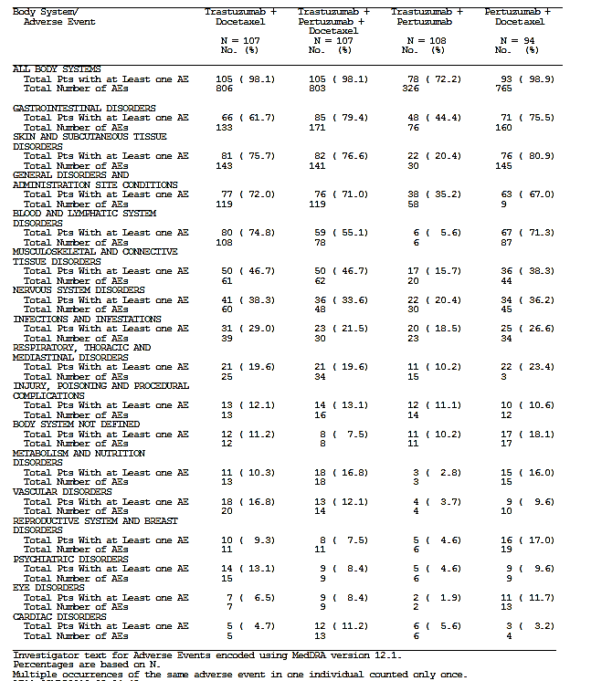
- In the Ptz+T arm of the study, in which pertuzumab and trastuzumab were given without docetaxel, the incidence of AEs (70.4%), Grade >3 AEs (11.1%), and SAEs (3.7%), was markedly lower than in the other three arms. AEs by body system are tabulated in Table 42.
- The incidence of diarrhoea was higher (> 5% difference) in the Ptz+T+D arm (45.8% of patients) compared with the T+D arm (33.6% of patients); the incidence of rash was 29.0% of patients in the T+D arm versus 40.2% of patients in the Ptz+T+D arm, and mucositis was 33.6% in the T+D arm versus 45.8% in the Ptz+T+D arm.
- There was a higher incidence of cardiac disorders in the Ptz + T + D arm (11% versus 5%, 6% and 3% for the other arms, however the numbers affected are low. A total of 5 patients (1 in the T+D arm, 3 in the Ptz+T+D arm and 1 in the Ptz+D arm) experienced asymptomatic LVD AEs associated with declines in LVEF of > 10%- points from baseline to < 50%; in all patients, the LVEF improved (to >50%) by Cycle 4. In the Ptz+T arm, one additional patient experienced CHF (symptomatic LVD) associated with a decline in LVEF of >10-points from baseline to < 50%. The patient’s LVEF subsequently recovered to > 50%.
Comment: The triplet regimen was associated with higher rates of diarrhoea, rash and mucositis, and asymptomatic cardiac dysfunction in comparison to T+D. However toxicities of Grade 3 or higher were less common, and the rate of toxicity leading to discontinuation was low. The AE rate was strikingly lower in the Ptz + T arm due to the omission of the docetaxel in the neoadjuvant period.
During the adjuvant phase: (when all patients received adjuvant trastuzumab plus FEC for 3 cycles, followed by trastuzumab alone):
- The following AEs were notably more frequent in the adjuvant treatment period in the Ptz+T arm compared with the T+D arm (that is, incidence > 10% higher in the Ptz+T arm); all are known side effects of docetaxel: Diarrhoea, Alopecia, Myalgia, Stomatitis, Cough, Peripheral oedema, Peripheral sensory neuropathy.
- Eleven patients experienced LVD during the adjuvant period (1 in the T+D arm, 5 in the Ptz+T+D arm, 0 in the Ptz+T arm and 5 in the Ptz+D arm). All events were asymptomatic declines in LVEF of >10%-points from baseline to < 50%. The LVEF subsequently improved (to > 50%) in all cases. No patient experienced CHF.
- The incidence of AEs in the Ptz+T+D and the Ptz+D arms was very similar to that in the T+D arm. During the adjuvant phase, patients in these three treatment arms all received the same therapy (adjuvant trastuzumab plus FEC for 3 cycles, followed by trastuzumab alone). The incidence of AEs typically associated with pertuzumab when co-administered with trastuzumab + chemotherapy was very similar in these 3 treatment arms:
  - Diarrhoea: 16.5% T+D; 15.7% Ptz+T+D; 18.2% Ptz+D
  - Mucosal inflammation: 9.7% T+D; 15.7% Ptz+T+D; 12.5% Ptz+D
  - Stomatitis: 4.9% T+D; 9.8% Ptz+T+D; 4.5% Ptz+D
  - Rash: 5.8% T+D; 8.8% Ptz+T+D; 3.4% Ptz+D.
  - Vomiting was the only event > 10% more frequent in either the Ptz+T+D arm or Ptz+D arm compared with the T+D arm (20.4% of patients in the T+D arm, 30.4% of patients in the Ptz+T+D arm and 31.8% of patients in the Ptz+D arm).
Comment: Adverse events were more frequent in the Ptz+T arm than in the other treatment arms, due to the administration of three cycles of docetaxel (as well as 3 cycles of FEC) during the adjuvant period in this treatment arm, as patients in all other treatment arms received docetaxel in the neoadjuvant period only. The incidence of non-cardiac AEs was similar in the Ptz+T+D, Ptz+D and T+D arms during the adjuvant treatment period. The rate of cardiac toxicity was low, and ranged from 0 to 5 patients in the Ptz-containing arms.
During the Post-Treatment Follow-Up Period: At the time of the final clinical cut-off date (20 October 2014), of the 378 patients who entered the post-treatment follow-up period, 7 patients (6.5%) in the T + D arm, 11 patients (10.3%) in the Ptz+T + D arm, 8 patients (7.4%) in the Ptz + T arm, and 7 patients (7.4%) in the Ptz + D arm experienced AEs in this study period. The majority of these AEs occurred in < 1.1% of patients (that is, 1 patient only) with the exception of:
- Musculoskeletal events: 4.7% T +D; 2.8% Ptz+T+D
- Cardiac toxicity: 2.8% Ptz + T+ D; 1.9% Ptz + T; 2.1 % Ptz + D
- GIT toxicity: 1.9% Ptz + T + D
- Psychiatric events: 1.9% Ptz + T
Comment: These AE event rates are low and reasonably evenly spread across the arms.

TRYPHAENA (BO22280) Study
The safety population for the neoadjuvant and overall study periods includes all patients who received any study treatment (N=223 [99% of ITT population]; 72 patients in Arm A (Ptz+T+FEC/Ptz +T+D), 75 in Arm B (FEC/Ptz+T+D) and 76 in Arm C (Ptz +TCH)). The safety population for the adjuvant period was smaller as not all patients entered the adjuvant phase of the study (N=200 [90% of the safety population]; 68 patients in the Ptz+T+FEC/Ptz +T+D arm, 65 in the FEC/Ptz+T+D arm and 67 in the Ptz +TCH arm). The safety data from the adjuvant period were based on patients treated with adjuvant trastuzumab. Throughout the entire study treatment period the incidence of most AEs was generally similar across the treatment arms, the most common being diarrhoea.

During the neoadjuvant phase: (23)
- The vast majority of patients experienced at least one AE during the neoadjuvant period (96-100% across arms)

Table 43: Overview of adverse events during the neoadjuvant period TRYPHAENA (BO22280) (23)
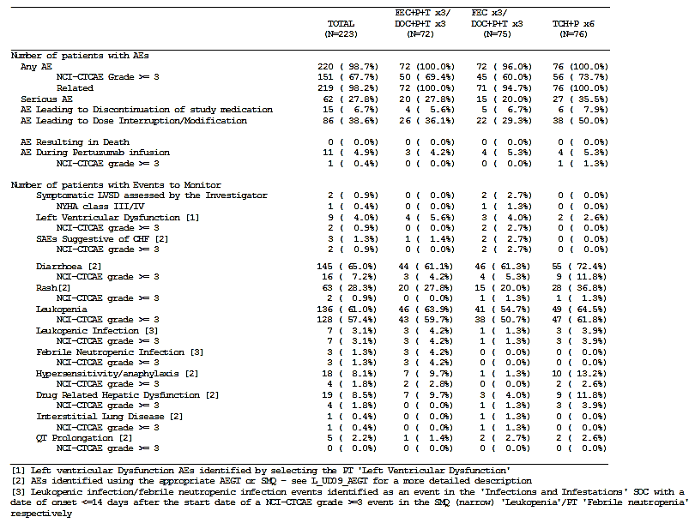
- The most common AE in the neoadjuvant period was diarrhoea, which occurred in 61% - 72% of patients, across treatment arms.
- The tolerability of the three neoadjuvant regimens (Ptz+T+FEC/Ptz+T+D, FEC/Ptz+T+D and Ptz+TCH) was similar. However,
  - Diarrhoea, anemia, dygeusia, insomnia and thrombocytopenia were reported more frequently in the Ptz+TCH arm (that is, occurred in at least 10% more patients in the Ptz+TCH arm than in either of the other two arms).
  - Dyspepsia, decreased appetite and rash were reported less frequently in the FEC/Ptz+T+D arm (that is, occurred in at least 10% fewer patients than in at least one of the other two arms). The incidence of these AEs was broadly comparable in the Ptz+T+FEC/Ptz+T+D and the Ptz+TCH arms.
  - The incidence of Grade ≥ 3AEs, SAEs and AEs resulting in treatment interruption or dose modification was also highest in the Ptz+TCH arm and lowest in the FEC/Ptz+T+D arm. Cardiac safety of the 3 regimens was similar. Notably, two of the treatment arms included an anthracycline and in one of the treatment arms (Ptz+T+FEC/Ptz+T+D), pertuzumab was given concurrently with trastuzumab and epirubicin.
Comment: The toxicities experienced are well-balanced across the arms, however note is made of the high rate of diarrhoea occurring across the arms, particularly in association with nearly 60% Grade 3 (or higher) leucopenia in Arm C (Ptz + TCH) and nearly 51% Grade 3 (or higher) leucopenia in Arm B (FEC/ Ptz+D+T). Both of these regimens are suggested as potential neoadjuvant schedules in the proposed PI, and may be associated with a potential risk of Gram negative sepsis. The evaluator notes that G-CSF was permitted as prophylaxis against leucopenia in the TRYPHAENA (BO22280) studies which may account for the low rates of febrile neutropenia (0.0%). Colony-stimulating factors (primarily filgrastim) were used as follows: 36% in the Ptz+T+FEC/Ptz+T+D arm, 27% in the FEC/Ptz+T+D arm, and 43% in the Ptz + TCH arm (23).

During the adjuvant phase (when all patients received trastuzumab without any scheduled chemotherapy):
- The most common AE was radiation skin injury that occurred in 16.2% of patients in the Ptz+T+FEC/Ptz+T+D arm, 21.5% of patients in the FEC/Ptz+T+D arm and 10.4% of patients in the Ptz+TCH arm.
- Other AEs occurring in at least 10% of patients in any arm were arthralgia, hot flush, diarrhoea, headache, myalgia and upper respiratory tract infection.
- AE incidences were broadly similar across the arms, with the exception of myalgia, which did not occur in any patients in the Ptz+TCH arm, but was reported in 15% of patients in the FEC/Ptz+T+D arm and in 4% of patients in the Ptz+T+FEC/Ptz+T+D arm.
During the post-treatment follow-up period and up to the third clinical cut-off date: 20 patients (6 in the Ptz+T+FEC/Ptz+T+D arm, 9 in the FEC/Ptz+T+D arm, and 5 in the Ptz+TCH arm) experienced at least one AE. During the post-treatment follow-up period, symptomatic LVSD was observed in 1 patient in the Ptz+T+FEC/Ptz+T+D arm (with no events observed in the other arms). LVEF declines of at least 10%-points from baseline to below 50% were observed in 9 patients (2 in the Ptz+T+FEC/Ptz+T+D arm, 5 in the FEC/Ptz+T+D arm, and 2 in the Ptz+TCH arm); all recovered to 50% or greater apart from the one symptomatic LVSD patient who subsequently improved. During the post-treatment follow-up period, there were 12 deaths (3, 4, and 5 in the Ptz+T+FEC/Ptz+T+D, FEC/Ptz+T+D and Ptz+TCH arms respectively), all of which were caused by disease progression. During the post-treatment follow-up period, SAEs occurred in 2 patients in the FEC/Ptz+T+D arm (one event of LVD and one neutropenic infection) (Table 44).
Comment: There is no suggestion of any significant late or cumulative toxicity in any of the three treatment arms of the study.

Table 44: Overview of adverse events in TRYPAHENA (BO22280) (post-treatment follow-up period) (28)
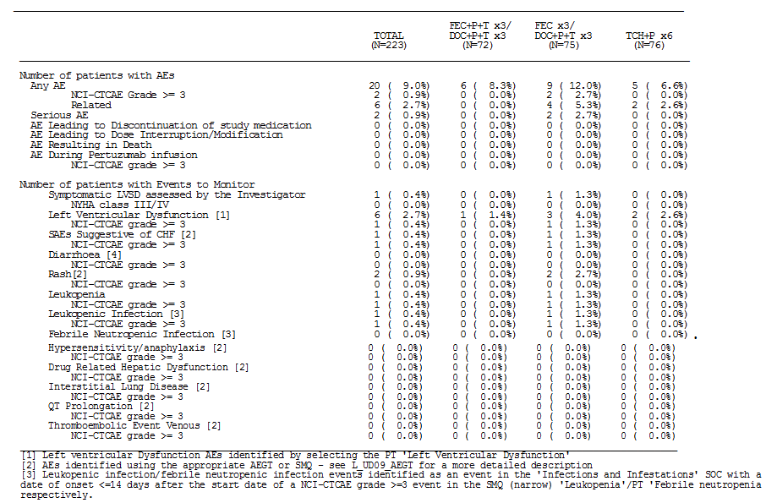

Other studies

CLEOPATRA (WO20698) Study (8, 17,18)

Table 45: Duration of patient time on study CLEOPATRA (WO20698) (8)
- Overall, the tolerability of Ptz+T+D was comparable to that of Pla+T+D in terms of the incidence and severity of AEs, discontinuations due to AEs and AEs leading to death (Table 46).
- The most common AEs in both arms were alopecia, diarrhoea, neutropenia, nausea and fatigue. The incidence of diarrhoea, rash, mucosal inflammation, febrile neutropenia, dry skin and pruritus was higher (> 5% difference) in the Ptz+T+D arm than in the Pla+T+D arm. However, peripheral edema and constipation were more common in the Pla+T+D arm.
- At the latest analysis there were 54.8% deaths in the Pla+T+D arm and 41.4% deaths in the Ptz+T+D arm.
- Although most AEs were Grade 1 or 2 in severity, the majority of patients experienced at least one Grade ≥ 3AE (73.5% of patients in the Pla+T+D arm and 77.2% of patients in the Ptz+T+D arm). Grade ≥ 3AEs of leukopenia (53.3% Pla+T+D versus 58.3% Ptz+T+D), and diarrhoea (5.1% Pla+T+D versus 9.3% Ptz+T+D) were more frequent in the Ptz+T+D arm.
- The incidence of SAEs was higher in the Ptz+T+D arm (36.5%) than in the Pla+T+D arm (29.3%). Febrile neutropenic infection occurred in 0.8% and 3.4% of patients in the Pla+T+D arm and Ptz+T+D arm respectively.
- 13 patients in the Pla+T+D arm (3.0%) and 8 patients in the Ptz+T+D arm (2.0%) died of AEs.
- AEs were reported less frequently after discontinuation of docetaxel treatment. In particular, no AEs of febrile neutropenia were reported after discontinuation of docetaxel.

Table 46: Overview of adverse events during the total study period CLEOPATRA (WO20698) (8)
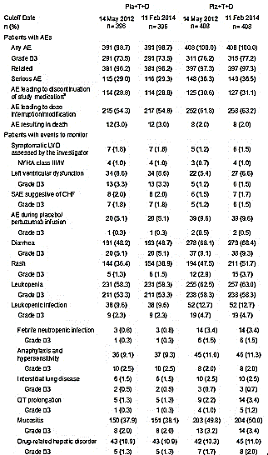
Comment: The summary data from CLEOPATRA (WO20698) are likely to provide a good sense of the toxicity of the Ptz + T + D combination. Importantly here do not appear to be overly concerning increases in toxicity. There was a small increase in febrile neutropenia, and Grade ≥ 3 leucopenic infections. The evaluator notes that the sponsor has tried to off-set the extra toxicity seen with Ptz +T+D by performing an adjustment for the time on treatment (as the Ptz+D+T arm was treated longer than the Pla+T+D arm) reporting that as at 14 May 2012, the rate of AEs reported per patient-year during the treatment period was slightly higher in the Pla+T+D arm (18.72 events per patient-year) compared with the Ptz+T+D arm (16.88 events per patient-year). Although this may be acceptable in the setting of a protracted treatment course as seen in metastatic breast cancer, it may not be appropriate in the neoadjuvant setting. In the CLEOPATRA (WO20698) study the mean and median number of cycles of docetaxel were much shorter than the overall treatment period at 9 and 8 (Pla +T+D) and 9.2 and 8 (Ptz +T+D). Correcting for the lengthier docetaxel-free period experienced in the Ptz+T+D group should not be taken into consideration in the case of a neoadjuvant schedule in which docetaxel (a major contributor to neutropenic sepsis) is a requirement.

Treatment-related adverse events (adverse drug reactions)

Pivotal studies and other studies

NEOSPHERE (WO20697) Study (22, 30)
As of the analysis of 12 July 2013, the proportion of patients with treatment-related AEs during the overall treatment period were as follows: 99.1% of patients in the T+D arm, 98.1% in the Ptz +T+D arm, 91.7% in the Ptz + T arm, and 98.9% in Ptz +D arm experienced AEs that were considered to be possibly related to study treatment. One further AE of LVD (in the Ptz + D arm), which was considered possibly related to study treatment, was reported in the post-treatment follow-up period since the third cut-off. Patients in the Ptz + T arm had the fewest treatment-related adverse events during both the overall treatment period and the neoadjuvant period, but had the highest number of treatment-related adverse events during the adjuvant period, when they had the chemotherapy with both docetaxel and FEC together with trastuzumab.

TRYPHAENA (BO22280) Study (23, 27, 28)
The incidence of AEs was, in general, balanced across treatment arms. At the clinical cut-off date of 21 June 2011 analysing the neoadjuvant period of the study almost all patients (98.7%) experienced at least one AE; in the Ptz+FEC+ T/Ptz+D+T and Ptz+TCH arms 100% of patients had a treatment-related AE, while in the FEC/Ptz+D+T arm 96% of patients had a treatment-related AE. Across the study almost all patients (98.2%) experienced AEs considered related to neoadjuvant study treatment. At the time of the 4 July 2012 analysis covering the neoadjuvant and adjuvant periods 100% of patients in the Ptz+FEC+ T/Ptz+D+T and Ptz+TCH arms, and 96% of patients in the FEC/Ptz+D+T arms had experienced a treatment-related AE.

CLEOPATRA (WO20698) Study (8)
The majority of patients in both treatment arms experienced at least one AE considered by the Investigator to have a reasonable suspected causal relationship to study treatment (96.2% of patients in the Pla+T+D arm and 97.3% of patients in the Ptz+T+D arm). The proportion of patients who experienced Grade ≥ 3 AEs that were considered related to study treatment was 65.2% (258/396) in the placebo arm and 68.4% (279/408) in the pertuzumab arm. The most commonly reported AEs that were considered related to study treatment by the Investigator were alopecia, diarrhoea, nausea, neutropenia, fatigue, rash, asthenia, mucosal inflammation, decreased appetite, nail disorder and myalgia.

Deaths and other serious adverse events

Pivotal studies

NEOSPHERE (WO20697) Study (24)
Overall, 31 deaths have been reported in the study (6 patients [5.6%] in the T+D arm, 8 patients [7.5%] in the Ptz+T+D arm, 9 patients [8.3%] in the Ptz+T arm, and 8 patients [8.5%] in the Ptz + D arm). One death occurred during the neoadjuvant period, and no deaths occurred during the adjuvant period. As of final clinical cut-off date (20 October 2014), 30 deaths occurred during the post-treatment follow up period. Twenty-three of the 31 deaths were due to disease progression/breast cancer; 4 had no cause of death reported, 2 were due to colon/colorectal carcinoma, 1 was due to fulminant hepatitis and 1 was due to a cerebrovascular accident.
Neoadjuvant: One patient (in the Ptz+T+D arm) died during the neoadjuvant period. This death was due to fulminant hepatitis, 2 days after administration of Cycle 4. The event was accompanied by elevations in the transaminases and total bilirubin. This patient had a background of obesity, diabetes mellitus and hypertension, and was receiving ipratropium bromide, isosorbide and enalapril. There were signals suggestive of cardio- circulatory overload due to her obesity. The Investigator assessed the fulminant hepatitis as related to study medication (including docetaxel) and to concomitant medication (isosorbide, enalapril and ipratropium bromide), although there was no hepatitis serology performed, nor liver biopsy or autopsy.
Comment: Given that there was no excess in abnormal LFTs in the much larger CLEOPATRA (WO20698) study, in which exposure to both docetaxel and pertuzumab was far greater than that in the NEOSPHERE (WO20697) study, this single instance of fulminant hepatitis does not raise any new concerns over and above that which would be expected when making decisions in relation to ‘fitness for cytotoxic chemotherapy’ with a docetaxel-containing agent in routine clinical practice. Furthermore, in the absence of a basic hepatitis work-up including hepatitis serology, other important causes of hepatitis have not been excluded. A liver biopsy may have added some clarity, but in the setting of a critically ill and increasingly coagulopathic patient may not have been safe.
Adjuvant Period: No patients died during the adjuvant period.
Post-Treatment Follow-up Period: As of the latest clinical cut-off date (20 October 2014), 30 deaths (6 patients [5.6%] in the T+D arm, 7 patients [6.5%] in the Ptz+T+D arm, 9 patients [8.3%] in the Ptz+T arm, and 8 patients [8.5%] in the Ptz+D arm) had occurred during the post-treatment follow-up period. 23 of the 30 deaths were due to disease progression/breast cancer; four had no cause of death reported, and two were due to colon/colorectal carcinoma. One patient had a CVA. All non-PD deaths were not considered related to study treatment although for 4, the relationship was not known.

Table 47: Deaths NEOSPHERE (WO20697) (25)
Comment: Over 10% of patients deaths in the post-treatment period did not have an appropriate attribution as to aetiology. This is of concern when considering the long-term ramifications of a neoadjuvant approach, although 3 of these unattributed deaths were in the Ptz + T arm, and the other was in the T+D arm, and therefore the absence of these data is unlikely to be of concern for assessing the safety of the triplet Ptz+T+D regimen.

TRYPHAENA (BO22280) Study (23, 27, 28)
Neoadjuvant Period: No patients died during the neoadjuvant period.
Adjuvant Period: One patient in the Ptz+T+FEC/Ptz+T+D arm died as a result of an AE, ‘metastatic neoplasm,’ after presenting with spinal cord compression. Disease recurrence in the lung and bone was subsequently confirmed before the patient died.
Post-Treatment Follow-up Period: At the time of the clinical cut-off date 22 July 2013, 12 patients had died in the post-treatment follow-up period (3 in the Ptz+T+FEC/Ptz+T+D arm, 4 in the FEC/Ptz+T+D arm and 5 in the Ptz+TCH arm). These deaths were all due to disease recurrence/progression.

CLEOPATRA (WO20698) Study (8)
At the clinical cut-off date 11 February 2014 a total of 217 patients (54.8%) in the Pla+T+D arm and 169 patients (41.4%) in the Ptz+T+D arm had died (Table 48). The most frequent cause of death in both treatment arms was PD. In the placebo arm, 12/396 patients (3.0%) died as a result of an AE compared with 8/408 patients (2.0%) in the pertuzumab arm.

Table 48: Deaths CLEOPATRA (WO20698) Study (8)
Comment: The non-PD deaths are uncommon and well balanced between the two groups and do not raise any concerns.

Discontinuation due to adverse events

Pivotal studies

NEOSPHERE (WO20697) Study (24)

Neoadjuvant and adjuvant period
As of the second clinical cut-off date, 17 patients discontinued at least one study treatment (that is, pertuzumab, trastuzumab, or chemotherapy) because of adverse events: 0 patients in the T+D arm, 5 patients (4.7%) in the Ptz+T+D arm, 8 (7.4%) in the Ptz+T arm, 4 (4.3%) in the Ptz+D arm (Table 49). Six patients discontinued a study treatment because of cardiac disorders: 5 (3 in the Ptz+T+D arm and 2 in the Ptz+D arm) because of left ventricular dysfunction and 1 (Ptz+T arm) because of congestive heart failure. Four patients (1 in the Ptz+T+D arm and 3 in Ptz+T) discontinued a study treatment because of drug hypersensitivity; all other adverse events leading to discontinuation from a study treatment were reported in only 1 patient and included abdominal strangulated hernia, ulcerative colitis, asthenia, chest discomfort, neutropenia, septic shock, and pregnancy. In addition, 1 extra patient in the Ptz+D arm discontinued treatment during the neoadjuvant period because of biliary cirrhosis; however, because of a data error, the event was reported as taking place during the post-treatment follow-up period, and 1 patient in the Ptz+T+D arm experienced a serious adverse event of LVD (Grade 2, asymptomatic), which was reported as an interruption in adjuvant trastuzumab treatment however was actually a discontinuation. Both of these 2 events are not reflected in the Table 49 below derived from Update CSR1 WO20697 (24).

Table 49: Adverse events leading to discontinuation of study medication Overall treatment period (Safety population) WO20697 (24)
Comment: The rate of adverse events leading to discontinuation is low across the study and does not raise any new safety concerns especially for the Ptz+T+D arm. Nevertheless, the sponsor has provided these data in a confusing manner that made it difficult to reconcile the data from the sponsor’s Summary and that which is presented in the clinical module. It would be helpful if the discontinuations could be tabulated for all 19 (not 17) patients with distinction made between the adjuvant and neoadjuvant phases.

TRYPHAENA (BO22280) Study (23)
Neoadjuvant Period: The number of patients discontinuing any study medication was low across all arms (4 patients [5.6%], 5 patients [6.7%] and 6 patients [7.9%] in the Ptz+T+FEC/Ptz+T+D, FEC/Ptz+T+D and Ptz+TCH arms, respectively). In the FEC/Ptz+T+D arm, all 5 discontinuations (for LVD in 2 patients and for hepatotoxicity, dehydration and pneumonitis in the other 3 patients) occurred prior to initiation of Ptz+T+D. In the majority of cases, all study treatments were discontinued simultaneously. AEs leading to discontinuation in more than one patient were left ventricular dysfunction, drug hypersensitivity and neutropenia.

Table 50: Adverse events leading to discontinuation of study medication by body system - Neoadjuvant period TRYPAHENA (BO22280) (23)
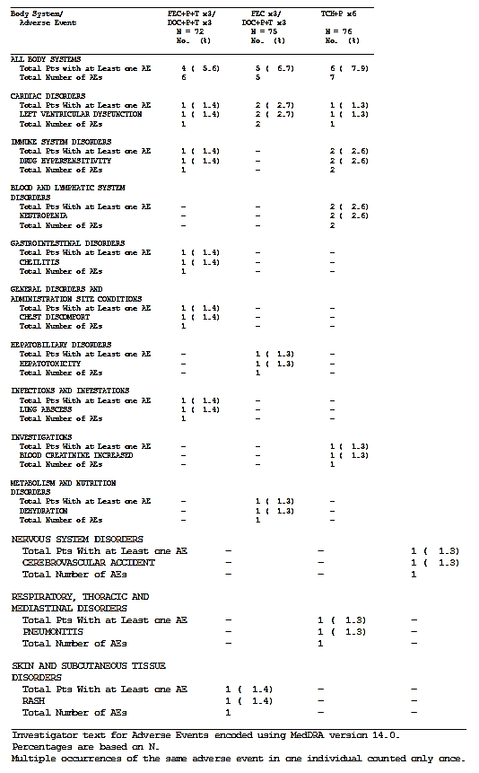
Adjuvant Period: During the adjuvant period, a total of 5 patients experienced an AE that led to discontinuation of study treatment. This included 2 patients in the Ptz+T+FEC/Ptz+T+D arm with LVD, 2 patients in the FEC/Ptz+T+D arm with LVD, and one patient in the Ptz+T+FEC/Ptz+T+D arm with erythema.
Comment: The rate of adverse events leading to treatment discontinuation was low across the arms. There are no new concerns raised by these data.

CLEOPATRA (WO20698) Study (8)
According to the protocol, patients could continue treatment with pertuzumab/placebo plus trastuzumab if docetaxel was discontinued because of unacceptable toxicity. However, if pertuzumab/placebo and/or trastuzumab were discontinued for toxicity or withheld for more than two cycles, all three study medications (including docetaxel) were stopped and the patient was withdrawn from the treatment phase of the study.
A similar proportion of patients in the two arms experienced AEs that led to discontinuation of all study treatments (excluding events leading to discontinuation of docetaxel only): 24 patients (6.1%) in the Pla+T+D arm and 35 patients (8.6%) in the Ptz+T+D arm. The most frequently reported AE that led to discontinuation of all study treatments was LVD, which occurred in 8 patients (2.0%) in the Pla+T+D arm and 10 patients (2.5%) in the Ptz+T+D arm.
AEs that led to discontinuation of docetaxel were reported more frequently than events leading to discontinuation of all three study medications and the frequency of such events was similar in the two arms (23.5% of patients in the Pla+T+D arm versus 23.8% of patients in the Ptz+T+D arm). The most common AEs leading to discontinuation of docetaxel alone were in the SOCs, General Disorders and Administration Site Conditions (in particular, edema) and Nervous System Disorders (in particular, peripheral neuropathy). Seven patients in each treatment arm discontinued docetaxel as a result of neutropenia, and 4 patients in the Ptz+T+D arm discontinued docetaxel because of febrile neutropenia. Five patients discontinued docetaxel because of diarrhoea (1 patient in the Pla+T+D arm and 4 patients in the Ptz+T+D arm); 4 patients because of hypersensitivity (all in the Pla+T+D arm); 2 patients because of toxic hepatitis (both in the Ptz+T+D arm); and 1 patient because of atrial fibrillation (in the Pla+T+D arm).
Comment: Given that this is a metastatic population, the rates of discontinuation of all three study treatments were low and relatively equal between the groups. Note is made of the high-rate of docetaxel discontinuation (around a quarter of patients in both arms), although the median number of docetaxel cycles given was 8 in both groups, and the mean was 9.0 and 9.2 cycles in the Pla+T+D and Ptz+T+D arms respectively suggesting a reasonable and equal length of docetaxel exposure.

Laboratory tests

Hepatic and renal function

Pivotal and other studies

NEOSPHERE (WO20697) Study (29, 22, 24, 25, 30)
Significant biochemical abnormalities were uncommon, with most abnormalities detected being low grade. In the neoadjuvant period, 5.6% of patients in the T+D arm, 3.7% in the Ptz+T+D arm and 3.2% in the Ptz+D arm experienced hepatic disorder AEs, while no patients experienced 'Drug Related Hepatic Disorders’ in the Ptz+T arm during the neoadjuvant period (Table 51). Of these, 2.8%, 2.8% 1.1% and 0.0% respectively, were of Grade 3 severity or higher. There was one pertuzumab-treated patient who met the biochemical criteria for Hy’s law who died from fulminant hepatitis in the neoadjuvant period of the NEOSPHERE (WO20697) study however, the case did not fully satisfy Hy’s law criteria since the patient had at least one alternative cause for hepatic failure (treatment with a known hepatotoxic drug - docetaxel), as well as confounding clinical conditions.

Table 51: Summary of hepatic disorders NEOSPHERE (WO20697) Study, Neoadjuvant period (30)
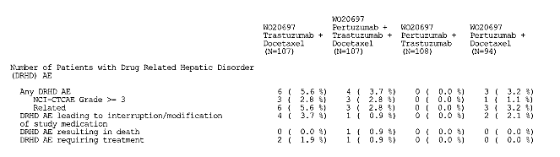

TRYPHAENA (BO22280) Study (23, 27, 28)
At the time of the Update CSR1 of the BO22280 study, drug-related hepatic dysfunction covering both the neoadjuvant and adjuvant periods was the similar to that reported in the initial analysis of the neoadjuvant period only. In the FEC+Ptz+T/D+Ptz +T arm the rate of hepatic dysfunction was 9.7% (0.0% were ≥ Grade 3), in the FEC/D+Ptz +T arm the rate of hepatic dysfunction was 5.3% (1.3 % were > Grade 3), and in the TCH + Ptz arm the rate was 11.8% (3.9% were > Grade 3). The most common abnormality was an elevated an elevated alanine aminotransferase (at 3.9% in the TCH+Ptz arm, equating to 3 patients in total). No significant hepatic events were reported in the follow-up period.

CLEOPATRA (WO20698) Study (8)
In the CLEOPATRA (WO20698) study, the proportion of patients with hepatic disorders was similar in the two treatment arms (10.9% of patients in the Pla+T+D arm versus 11.0% of patients in the Ptz+T+D arm (Table 52). Grade ≥3 events accounted for 1.3% and 2.0% of cases respectively. No patients in either arm of the study completely met Hy’s law for drug-induced liver injury.

Table 52: Hepatic disorders CLEOPATRA (WO20698) (8)
Comment: Low-level abnormalities in LFTs were reported in all three studies. There was no clear relationship with pertuzumab treatment. The fact that there were no reports of hepatic disorders in the neoadjuvant period in the Ptz+T arm of the NEOSPHERE (WO20697) study, although LFT derangement was observed in the docetaxel-containing arms of all 3 studies suggests that the small rate of LFT abnormalities detected is likely to be attributable to chemotherapy. The one case of fulminant hepatitis in the NEOSPHERE (WO20697) study, while not fully subjected to analysis with liver biopsy is thought to be unrelated to pertuzumab therapy. Overall, these data do not suggest that pertuzumab is hepatotoxic.

Haematology

Pivotal and other studies

NEOSPHERE (WO20697) Study (22, 24)
As of the cut-off date 20 October 2014 (assessing the overall treatment period), ‘haematopoietic leukopenia’ was experienced by the majority of patients during the overall treatment period (82.2% in the T+D arm, 69.2% in the Ptz+T+D arm, 50.0% in the Ptz+T arm, and 79.8% in the Ptz +D). Most events of leucopenia were Grade ≥ 3 in severity (76.6%, 61.7%, 43.5%, and 70.2% respectively). Despite the high leucopenia rates, leucopenic infection events were as follows (3.7%, 2.8%, 0.9%, and 2.1% in the T+D, Ptz+T+D, Ptz+T and Ptz+D arms respectively). All events of leucopenic infection were Grade ≥ 3 in severity. As of the second clinical cut-off date, febrile neutropenia events were as follows (9.3%, 11.2%, 4.6%, and 16.0% in the T+D, Ptz+T+D, Ptz+T and Ptz+D arms respectively). All events of febrile neutropenia were Grade ≥ 3 in severity. Grade ≥ 3anaemia was infrequent across all arms at 2.8% in the T+D arm, 0.9% in the Ptz+T+D arm, 2.8% in the Ptz+T arm, and 4.3% in the Ptz+D arm across the entire duration of the study.
A break-down of haematological toxicity by phase of the study is shown in Tables 53, 54 and 55.

Table 53: Haematological toxicity during neoadjuvant period NEOSPHERE (WO20697) (30)

Table 54: Haematological toxicity during adjuvant period NEOSPHERE (WO20697) (30)

Table 55: Haematological toxicity during overall period NEOSPHERE (WO20697) (25)

TRYPHAENA (BO22280) Study (23, 27)
In the TRYPHAENA (BO28880) study the majority of patients developed neutropenia in all treatment arms. During the neoadjuvant period the rates were as tabulated follows:

Table 56: Leucopenia adverse events neoadjuvant period (TRYPHAENA) (23)
The majority of patients had at least one leukopenia AE in the neoadjuvant period (Table 56). The most common leukopenia AE was neutropenia (46.7%-51.4% of patients), followed by leukopenia (16%-22.2%), then febrile neutropenia, which was less frequent in the FEC/Ptz+T+D arm (18.1% in the Ptz+T+FEC/Ptz+T+D arm, 9.3% in the FEC/Ptz+T+D arm and 17.1% in the Ptz+TCH arm).

Table 57: Haematological toxicity overall TRYPHAENA (BO22280) (27)
The incidence of leukopenic AEs was very similar in the overall treatment period (Table 57) to the neoadjuvant period, since relatively few patients experienced leukopenic AEs during the adjuvant period when no chemotherapy was scheduled (10.3% of patients in the Ptz+T+FEC/Ptz+T+D arm, 7.7% of patients in the FEC/Ptz+T+D arm and 1.5% of patients in the Ptz+TCH arm). No leukopenic infection events occurred in the adjuvant period.
At the time of the update CSR (clinical cut-off 4 July 2012) the overall haematological toxicity was as tabulated above. The rate of anaemia was 17.1% in the TCH+Ptz arm versus 1.4% in the FEC+Ptz+T/Ptz+D+T arm and 4.0% in the FEC/Ptz+D+T arm. The rates of thrombocytopenia were 11.8%, 0.0% and 0.0% respectively.
Comment: The data pertaining to the rate of febrile neutropenia in the TRYPHAENA (BO22280) study are confusing, with data from the primary CSR indicating a febrile neutropenia rate of up to 18.1% in the FEC+Ptz+T/Ptz+D+T arm, 9.3% in the FEC/Ptz+D+T arm and 17.1% in the TCH+Ptz arm in the neoadjuvant period alone, with quite different and lower numbers quoted in the tables from the Update 1 CSR covering the same period (in addition to the adjuvant period). Some clarification would assist as to the rates of clinically significant haematological toxicity (for example, febrile neutropenia) in the different treatment phases of the study.
Nevertheless, using the rates quoted for the neoadjuvant period in the TRYPHAENA (BO22280) study the febrile neutropenia rates in the FEC/Ptz+D+T arm are similar to the rate observed in the neoadjuvant + adjuvant period of the NEOSPHERE (WO20697)study which covered the Ptz+T+D (followed by FEC) arm. The TCH+Ptz arm appears to result in nearly double the rate of febrile neutropenia than the FEC/Ptz+D+T arm.

CLEOPATRA (WO20698) Study

Table 58: Leukopenia events CLEOPATRA (WO20698) (8)
At the clinical cut-off date of the 11 February 2014, there was a higher rate of leukopenic events in the Ptz+T+D arm in comparison to the Pla+T+D arm, and notably febrile neutropenia rates of 13.7% and 7.6% respectively (Table 58). This febrile neutropenia rate is similar to that observed in the Ptz+T+D arm of the NEOSPHERE study despite treatment being substantially longer in duration.

Table 59: Haematological toxicity CLEOPATRA (WO20698) (8)
Other toxicities as of the 11 February 2014 analysis are tabulated above and are well matched between the study arms. In particular grade > 3 anaemia was 4.4% in the Ptz+T+D arm versus 5.1% in the Pla+T+D arm, Grade ≥ 3thrombocytopenia was 1% in the Ptz+T+D arm versus 0.5% in the Pla+T+D arm, and Grade ≥ 3lymphopenia was 30.1% in the Ptz+T_D arm versus 30.6% in the Pla+T+D arm (Table 59).

Cardiac dysfunction

Pivotal and other studies

NEOSPHERE (WO20697) Study (22)
Cardiac risk factors were well balanced at baseline and therefore unlikely to account for any differences in outcome.

Table 60: Summary of cardiac dysfunction events NEOSPHERE (WO20697) (22)
During the neoadjuvant and adjuvant phases of the NEOSPHERE (WO20697) study there were an excess of cases of left ventricular dysfunction in the Ptz+T+D arm (Table 60). Four patients (1 in the T+D arm and 3 in the Ptz+T+D arm) reported LVEF declines of 10-15% from baseline to below 50% during the neoadjuvant period. One patient in the Ptz+T arm and one in the Ptz +D arm recorded decreases of 15% or over from baseline to below 50%. Of these 6 patients, all had improved to greater than 50% and less than a 10% decrease by cycle 4, with the exception of 1 patient in the Ptz+T arm, who discontinued treatment due to CHF (Tables 61 - 62).

Table 61: Overview of LVEF Decline >= 10%-points from Baseline to below 50% during the neoadjuvant, adjuvant and post-treatment follow-up period of the NEOPSPHERE (WO20697) study (25)

Table 62A: Overview of LVEF Decline ≥ 10% points from baseline to below 50% during the neoadjuvant, adjuvant and treatment-free follow-up period based on single LVEF assessments and on two consecutive LVEF Assessments NEOSPHERE (WO20697) (25)

Table 62B: Overview of cardiac events during the neoadjuvant, adjuvant and post-treatment follow-up periods of the NEOSPHERE (WO20697) study (25)
Comment: Although the absolute numbers are small, especially for symptomatic LVSD, there was an excess of cardiac toxicity in the Ptz+T+D arm, followed by the other regimen in which pertuzumab was given concurrently with docetaxel (Ptz +D). As of the second clinical cut-off date, 2 patients (1 in the T+D arm and 1 in the Ptz+D arm) had experienced QT prolongation adverse events during the neoadjuvant period assessed as unrelated to study medication. There have been no further QT prolongation events since then. Review of episodes of palpitations/tachycardia/sinus tachycardia/supraventricular arrhythmia/AV block during the neoadjuvant period indicates rates of 3.7%, 6.4%, 4.6% and 3.3% in the T+D, Ptz+T+D, Ptz+T and Ptz+D arms respectively (Table 63).

Table 63: Cardiac adverse events, neoadjuvant period NEOSPHERE (WO20697) (22)

TRYPHAENA (BO22280) study

Table 64: Adverse events by body system Overall treatment period TRYPHAENA (BO22280) (27)

Table 65: Cardiac AEs TRYPHAENA (BO22280) Neoadjuvant period (23)

Table 66: Cardiac Disorders TRYPHAENA (BO22280) Adjuvant period (27)

Table 67: Cardiac Disorders TRYPHAENA (BO22280) Follow-up period (28)

Table 68: Overview of adverse events of left ventricular dysfunction (preferred term, all grades including symptomatic LVSD) in TRYPHAENA (29, 23, 27, 28)

Table 69: Overview of symptomatic (NCI-CTCAE Grade ≥ 3) LVSD in TRYPHAENA (BO22280) (neoadjuvant, adjuvant and post-treatment follow- up periods) (29, 23, 27, 28) Patient identifiers have been redacted from the table description.
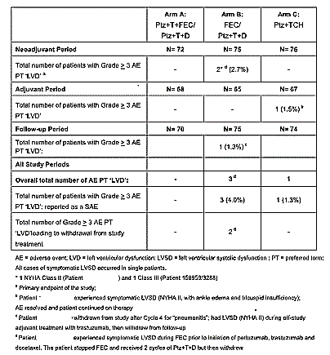

Table 70: Overview of LVEF Decline ≥ 10%-points from baseline to below 50% during the neoadjuvant, adjuvant and post-treatment follow-up period, based on single LVEF assessments and confirmatory LVEF assessments TYRPHAENA (BO22280) (28)
Comments: The primary end-points of the TRYPHAENA (BO22280) study were: (Tables 64-70)
    - incidence of symptomatic cardiac events as assessed by the investigator (Grade 3, 4 or 5 symptomatic LVSD)
    - clinically significant LVEF declines over the course of the neoadjuvant period (LVEF decline of > 10% from baseline and to a value of < 50%)
    - Over the time of the entire TRYPHAENA (BO22280) study the rate of LV dysfunction ranged from 6.6-8.3% across the three arms of the study. This was most prominent during the adjuvant phase of the study. Palpitations were experienced in between 1.3 and 5.3% of patients, and tachycardia was observed in 1.3-2.8%. Across the entire study, the highest rate of symptomatic LV dysfunction was observed in the FEC/Ptz+T+D arm (4%/3 patients), followed by the Ptz+TCH arm (1.3%/1 patient).
    - In the FEC/Ptz+T+D arm, the rate of confirmed LVEF decline >10%-points to below 50% was more than double that observed in the other two arms. The reason for this is unclear, especially in comparison to the FEC+Ptz+T/Ptz+D+T arm in which anthracycline was given concurrently with pertuzumab and trastuzumab. The small numbers in the study may make it difficult to draw conclusions.

CLEOPATRA (WO20698) Study (8)
At the time of the clinical cut-off at 11 February 2014, the proportion of patients who had experienced cardiac disorders was similar between treatment arms (17.4% of patients [69/396] in the Pla+T+D arm versus. 16.9% of patients [69/408] in the Ptz+T+D arm). LVD was the most common cardiac AE (Table 71).

Table 71: Cardiac-related AEs CLEOPATRA (WO20698) (8)
The proportion of patients who experienced SAEs in the SOC Cardiac Disorders was 3.5% (14/396 patients) in the Pla+T+D arm and 2.0% (8/408 patients) in the Ptz+T+D arm. Of the 23 SAEs of Cardiac Disorders in both arms combined, 18 were assessed by the investigator to be related to study treatment. At the time of clinical cut-off, 8 patients (2.0%) in the Pla+T+D arm and 7 patients (1.7%) in the Ptz+T+D arm had experienced SAEs suggestive of CHF, most commonly LVD. In the Pla+T+D arm, 7 patients (1.8%) experienced symptomatic LVD versus. 6 patients (1.5%) in the Ptz+T+D arm (Table 72).

Table 72: Symptomatic LVSD events as assessed by the Investigator CLEOPATRA (WO20698) (8)
The overall incidence of significant declines in LVEF (a decline of ≥ 10 percentage points from baseline to an absolute value < 50%) was similar between arms (Pla+T+D: 28/378 patients [7.4%]; Ptz+T+D: 24/394 patients [6.1%]). Six patients in the Pla+T+D arm and 3 patients in the Ptz+T+D arm had an LVEF decline to below 40%.

Table 73: QT prolongation events CLEOPATRA (WO20698) (8)
Adverse events suggestive of a QT prolongation were evaluated by the SMQ ‘Torsade de pointes/QT prolongation’. In the Pla+T+D arm, 1.3% of patients experienced AEs suggestive of QT prolongation versus 3.4% of patients in the Ptz+T+D arm (Table 73). The difference in the incidence of AEs suggestive of QT prolongation between treatment arms may be due to the longer time on study treatment of patients in the Ptz+T+D arm compared with patients in the Pla+T+D arm. Non-specific events of syncope were reported for 4 patients in the Pla+T+D arm and for 7 patients in the Ptz+T+D arm. QT prolongation on ECG was reported for 1 patient in the Pla+T+D arm and for 4 patients in the Ptz+T+D arm.
Comment: The rates of clinically significant LV dysfunction and arrhythmia are low and reasonably well matched in the two arms of the CLEOPATRA (WO20698) study. Clinically significant LVD (that is, Grade >3) was seen in ≤ 2% in both arms despite the prolonged period of treatment (as compared to the neoadjuvant studies). In the small TRYPHAENA (BO22280) study the rate of Grade >3 LVD was maximal in the FEC/Ptz+T+D arm at 2.7%, during the neoadjuvant period. Importantly, in the NEOSPHERE (WO20697) study, the rate of clinically significant LVD (that is, Grade ≥3) was <1% in all arms of the study. Events concerning for arrhythmia/ QT prolongation were uncommon.

Vital signs

Pivotal and other studies

NEOSPHERE (WO20697) Study (22)
During the neoadjuvant treatment period, there were no noteworthy changes in temperature, respiratory rate, diastolic or systolic blood pressure or pulse rate. No clinically meaningful differences between the treatment arms were apparent for any of the vital signs.

TRYPHAENA (BO22280) Study (23)
There were no major changes in median or mean blood pressure, body temperature, respiratory rate or pulse rate over time, throughout the study. No clinically meaningful differences between the treatment arms were apparent for any of the vital signs.

CLEOPATRA (WO20698) Study (17)
There were no major changes in mean or median temperature, blood pressure or pulse rate during the study, and no clinically meaningful differences between the treatment arms was apparent for any of the vital signs. Pertuzumab infusions were also not associated with an increase in blood pressure when pre- and post-infusion measurements were compared.
Comment: there are no concerning data relating to vital signs

Other safety issues

Interstitial lung disease

Pivotal and other studies

NEOSPHERE (WO20697) Study (25)
As of the latest clinical cut-off date, 1 patient in the Ptz+D arm had developed Grade 2 lung infiltration, which was considered possibly related to study treatment. This event began on Study Day 8, lasted 156 days, required treatment, and resolved without sequelae. The patient had a history of systemic lupus erythematosus, Raynaud’s phenomenon and scleroderma. There were no other cases of note.

TRYPHAENA (BO22280) Study (23)
In the neoadjuvant period, one patient experienced an interstitial lung disease AE. The patient in the FEC/Ptz+T+D arm developed Grade 3 pneumonitis (reported as an SAE), which led to discontinuation of pertuzumab, trastuzumab, and docetaxel. The patient also reported dyspnea, starting two days prior to pneumonitis. The Investigator assessed the dyspnea as being caused by a pneumonitis, which was considered secondary to docetaxel toxicity. The pneumonitis was treated and resolved after 11 days, with no sequelae. In the adjuvant period, one patient in the Ptz+TCH arm developed radiation pneumonitis.

CLEOPATRA (WO20698) Study (8)
In this study, the incidence of interstitial lung disease AEs was similar in the two treatment arms (6 patients [1.5%] in the Pla+T+D arm versus 10 patients [2.5%] in the Ptz+T+D arm. Grade ≥ 3events were observed in 0.5% and 0.7% of cases respectively.

Table 74: Interstitial lung disease CLEOPATRA (WO20698) study (8)
Comment: The incidence of pneumonitis is low across the studies, and in most cases likely related to the docetaxel. There does not appear to be an increased risk with the addition of pertuzumab.

Mucositis

Pivotal and other studies

NEOSPHERE (WO20697) Study (22, 24)
The proportion of patients experiencing mucositis during the neoadjuvant period was 33.6% in the T+D arm, 45.8% in the Ptz+T+D arm, 9.3% in the Ptz+T arm and 43.6% in the Ptz+D arm. Stomatitis was more frequently reported in the Ptz+T+D arm (18% of patients, compared with 8%, 5% and 10% of patients in the T+D, Ptz+T and Ptz+D arms, respectively). Mucositis was also common during the adjuvant treatment period (24.3% of patients in the T+D arm, 30.4% in the Ptz+T+D arm, 39.4% in the Ptz+T arm and 25.0% in the Ptz+D arm). Only 2 patients experienced Grade> 3 mucositis (1 in the Ptz+T+D arm and 1 in the Ptz+D arm. Overall, 46.7% of patients in the T+D arm, 54.2% in the Ptz+T+D arm, 38.9% in the Ptz+T arm and 50.0% in the Ptz+D arm experienced mucositis, but only 4 patients experienced Grade ≥ 3mucositis at any time (3 in the Ptz+T+D arm and 1 in the Ptz+D arm).

TRYPHAENA (BO22280) Study (23)
During the neoadjuvant period, 45.8% of patients in the Ptz+T+FEC/Ptz+T+D arm, 41.3% of patients in the FEC/Ptz+T+D arm and 34.2% of patients in the Ptz+TCH arm experienced mucositis. Most of these were Grade 1/2 in severity. Only 1, 2 and 1 patient experienced a Grade 3 mucositis event in the Ptz+T+FEC/Ptz+T+D, FEC/Ptz+T+D and Ptz+TCH arms, respectively.

CLEOPATRA (WO20698) Study (8)
The incidence of mucositis events was higher in the Ptz+T+D arm (50.0%) than in the Pla+T+D arm (38.1%). Grade ≥ 3events accounted for 3.4% and 2.0% respectively.
Comment: In the absence of chemotherapy, there is a low rate of mucositis (9.3% in the Ptz+T arm of the NEOSPHERE (WO20697) study in the neoadjuvant setting). Although the rate of mucositis does appear to increase with the addition of pertuzumab as per the CLEOPATRA (WO20698) study, the rates of grade > 3 toxicity are low.

Venous thromboembolic events

Pivotal and other studies

NEOSPHERE (WO20697) Study (24)
As of the clinical cut-off date 12 July 2013, 4 patients (1.0%) experienced VTEs during the study overall: 2 in the Ptz+T+D arm (1.9% of patients) and 2 in the Ptz+D arm (2.1% of patients), one of which was Grade > 3. Two of these events were reported in the neoadjuvant period and 2 in the adjuvant period. There were no VTEs in the T+D arm. All 4 events were deemed unrelated to study treatment by the Investigators. There were no pulmonary emboli reported.

TRYPHAENA (BO22280) Study (27)
4 patients (1.8%) experienced VTEs in this study; 3 patients in the neoadjuvant period (2 patients in the Ptz+T+FEC/Ptz+T+D arm and 1 patient in the Ptz+TCH arm) and 1 patient in the adjuvant period (in the FEC/Ptz+T+D). The 3 events in the neoadjuvant period were considered to be possibly-related to study treatment by the Investigators and the adjuvant event was considered unrelated. One of the events in the neoadjuvant setting was a pulmonary embolism.

CLEOPATRA (WO20698) Study (8)
As of the clinical cut-off date 11 Feb 2014, in the Pla+T+D arm, 1.5% of patients experienced venous thromboembolic events (VTEs) compared with 3.7% of patients in the Ptz+T+D arm. Expressed as events per patient-year, the rate of VTEs was 1.2 per 100 patient-years in the Pla+T+D arm (80% CI, 0.6 − 2.1; 90% CI, 0.5 − 2.3) compared with 2.3 events per 100 patient-years in the Ptz+T+D arm (80% CI, 1.7−3.2; 90% CI, 1.5−3.5). Notably 7 patients (1.7%) in the Ptz+T+D arm developed pulmonary emboli compared to 1 in the control arm (0.3%). Refer to Table 75.

Table 75: Venous thromboembolic events CLEOPATRA (WO20698) (8)
Comment: The VTE rate was low at around 2% in most treatment arms studied across all 3 studies. The only exception was that 3.7% of patients in the Ptz+T+D arm had VTEs, of which just under half were pulmonary emboli. Although it is likely that the hypercoagulable state associated with the metastatic setting contributed to this, data from the adjuvant APHINITY (BO25126) study would be helpful to examine the issue of VTE risk in a curative (non-metastatic) setting.

Leukopenia and leukopenic infection events (see above)

Rash

Pivotal and other studies

NEOSPHERE (WO20697) Study (22, 24)
During the neoadjuvant period, the incidence of rash was lowest in the Ptz+T arm (18.5%) and highest in the Ptz+T+D and Ptz+D arms (40.2% and 40.4% of patients, respectively). Fewest total episodes of rash-related AEs were reported during the neoadjuvant period in the Ptz+T arm (23, versus 46, 70 and 60 in the T+D, Ptz+T+D and Ptz+D arms, respectively) suggesting that the docetaxel treatment was a likely contributor. There were no Grade 4 AEs reported and few Grade 3 events. The incidence of rash AEs declined over time, with the majority occurring in the first 2 treatment cycles.
Rash was also common during the adjuvant treatment period: 11.7% of patients in the T+D arm, 20.6% of patients in the Ptz+T+D arm, 26.6% of patients in the Ptz+T arm and 14.8% of patients in the Ptz+D arm. One patient in each arm experienced a Grade ≥ 3rash during the adjuvant period. The higher frequency of rash in both the Ptz+T+D and Ptz+D arms compared with the T+D arm of the study during the adjuvant period, suggests there may have been a ‘carry-over effect’ of neoadjuvant pertuzumab into the adjuvant period resulting in an increased incidence of rash in patients in these treatment two arms compared with the control, T+D arm.
Overall, combining the neoadjuvant and adjuvant periods, the lowest incidence of rash was in the Ptz+T arm (35.5% in the T+D arm, 44.9% in the Ptz+T+D arm, 33.3% in the Ptz+T arm, and 44.7% in the Ptz+D arm). The incidence of Grade ≥ 3rash was low in all treatment arms (2.8%, 2.8%, 0.9% and 2.1% in the T+D, Ptz+T+D, Ptz+T and Ptz+D arms, respectively).

TRYPHAENA (BO22280) Study (23, 27, 28)
More patients in the Ptz+TCH arm experienced a rash (36.8%, versus 27.8% in the Ptz+T+FEC/Ptz+T+D arm and 20.0% in the FEC/Ptz+T+D arm) in the neoadjuvant period. However, the total number of AEs in each arm was broadly similar. All but two of the rashes were Grades 1/2 in severity.
The incidence of rash was lower in the adjuvant period (when patients were receiving trastuzumab alone) than during the neoadjuvant period. The incidence was 14.7% in the Ptz+T+FEC/Ptz+T+D arm, 10.8% in the FEC/Ptz+T+D arm and 16.4% in the Ptz+TCH arm. Only two patients (both in the Ptz+T+FEC/Ptz+T+D arm) experienced Grade ≥ 3events.
At the data cut-off of 4 July 2012 covering both the neoadjuvant and adjuvant periods, the incidence of rash was 37.5%, 25.3% and 46.1% and the incidence of Grade ≥ 3rash was 2.8%, 1.3% and 1.3% in the Ptz+T+FEC/Ptz+T+D , FEC/Ptz+T+D and Ptz+TCH arms respectively.

CLEOPATRA (WO20698) Study (8)
In the CLEOPATRA (WO20968) study, the incidence of rashes (was higher in the Ptz+T+D arm (47.5%) than in the Pla+T+D arm (36.4%).
AEs of rash occurred mostly during the first two cycles and decreased in frequency with subsequent cycles. By Cycle 10, < 2% of patients in either treatment arm experienced any form of rash. The majority of AEs were Grade 1/2 in severity; 6 events (1.5% incidence) in the Pla+T+D arm and 15 events (3.7% incidence) in the Ptz+T+D arm were Grade 3.
Comment: Overall, the incidence of high-grade rash was low, although it was lowest in the regimens in which pertuzumab was not given concurrently with docetaxel.

Diarrhoea

Pivotal and other studies
Overall, diarrhoea was reported frequently in the three studies. Diarrhoea was reported more frequently in the Ptz+T+D arm compared with the T+D arm in the NEOSPHERE (WO20697) study and in the Ptz+T+D arm compared with the Pla+T+D arm in the CLEOPATRA (WO20698) study; in the TRYPHAENA (BO22280) study, the highest incidence was in the Ptz+TCH arm compared with the other two arms. The lowest incidence of diarrhoea was in the Ptz+T arm of the NEOSPHERE (WO20697) study. The incidence of Grade ≥ 3diarrhoea and discontinuations due to diarrhoea was low in all treatment subsets.

NEOSPHERE (WO20697) Study (22, 24)
In the neoadjuvant period, the incidence of diarrhoea was higher in the Ptz+T+D arm(45.8%) and the Ptz+D arm (54.3%) than in the T+D and Ptz+T arms (33.6%) and 30 patients (27.8%), respectively. The majority of episodes occurred in the first 2 treatment cycles. No Grade 4 cases were reported throughout the neoadjuvant period. Amongst the patients who experienced diarrhoea, the median number of episodes per patient was 1, and the median time to first episode was between 4.5 and 7 days.
In the overall treatment period, diarrhoea was common, with the lowest incidence in the T+D arm (38.3% of patients in the T+D arm, 51.4% of patients in the Ptz+T+D arm, 42.6% of patients in the Ptz+T arm and 56.4% of patients in the Ptz+D arm). The incidence of Grade ≥ 3 diarrhoea was low (3.7%, 6.5%, 2.8% and 5.3% in the T+D, Ptz+T+D, Ptz+T and Ptz+D arms, respectively).

TRYPHAENA (BO22280) Study (27)
Diarrhoea was the most common AE in the neoadjuvant period (reported in 63.9% of patients in the Ptz+T+FEC/Ptz+T+D arm, 62.7% of those in the FEC/Ptz+T+D arm, and 72.4% of patients in the Ptz+TCH arm) In all three arms, diarrhoea was most common during the first cycle of pertuzumab and trastuzumab treatment, and incidence progressively declined thereafter. The majority of AEs were Grade 1-2 in severity. Grade 3 AEs were experienced by 4.2%, 5.3% and 11.8% of patients in the Ptz+T+FEC/Ptz+T+D arm, FEC/Ptz+T+D arm and Ptz+TCH arm, respectively. Of the patients receiving adjuvant therapy, 10.3% (7/68) in the Ptz+T+FEC/Ptz+T+D arm, 7.7% (5/65) in FEC/Ptz+T+D arm and 9% (6/67) in the Ptz+TCH arm experienced diarrhoea, with none of their events being Grade 3 in severity. Loperamide was the treatment most commonly given to those patients requiring treatment for diarrhoea.

CLEOPATRA (WO20698) Study (8)
The incidence of diarrhoea was higher in the Ptz+T+D arm (279 patients [68.4%]) than in the Pla+T+D arm (193 patients [48.7%]) of this study. Patients in the Ptz+T+D arm also experienced more episodes of diarrhoea (436 episodes of diarrhoea in the Pla+T+D arm versus 965 episodes of diarrhoea in the Ptz+T+D arm). The majority of episodes occurred in the first three cycles of treatment. There was nearly double the amount of Grade ≥ 3 diarrhoea in the Ptz+T+D arm (9.3%) versus the Pla+T+D arm (5.1%).
Comment: Diarrhoea is a common side effect of pertuzumab-containing regimens, although Grade ≥ 3 diarrhoea is generally sub-10%. Although the diarrhoea is easily managed with loperamide, the occurrence of concurrent neutropenia is of concern.

Infusion reactions/hypersensitivity (22, 23, 8)
Overall, the incidence and severity of IRRs in the neoadjuvant studies was similar to that in the CLEOPATRA (WO 20698) study. However, IRRs were more frequent in the neoadjuvant studies in the first cycle, likely as a consequence of the fact that patients received all their study medication on the same day, and thereafter the incidence and severity of IRRs in the second cycle was very similar in all three studies.
The most frequently reported AEs (affecting at least 1% of patients in any of the studies) on the day of placebo/pertuzumab infusion in Cycle 1 were myalgia, fatigue, insomnia, pyrexia, chills, headaches, asthenia, hypersensitivity/drug hypersensitivity, vomiting, infusion-related reaction, dysgeusia, dyspnea, hypotension, abdominal pain, arthralgia, urticarial, dizziness, palpitations and edema.
Data pertaining to the three studies are summarised below. Notably the incidence of anaphylaxis/ hypersensitivity reactions in the Ptz+T+D arm of the NEOSPHERE (WO20697) study compares favourably with the Ptz+T+D arm of the CLEOPATRA (WO20698) study.

Table 76: Anaphylactic/hypersensitivity reactions in the NEOSPHERE (WO20967), TRYPHAENA (BO22280) and CLEOPATRA (WO20968) studies: (22, 23, 8)
Safety para-meter (%) | Patients experiencing event
Safety para-meter (%) | NEOSPHERE  (neoadjuvant period) |  |  |  | TRYPHAENA  (neoadjuvant period) |  |  |  | CLEOPATRA
Safety para-meter (%) | T+D  N=  107 | Ptz+T+D  N=  107 | Ptz+T  N=  108 | Ptz+D  N=  94 | Ptz+T+FEC/  Ptz+T+D  N=  72 | FEC/  Ptz+T+D  N=75 | Ptz+TCH  N=  76 |  | Pla+T+D  N=  396 | Ptz+T+D  N=  408
Anaphylaxis/  Hypersensiti-vity  All grades | 1.9 | 5.6 | 5.6 | 6.4 | 9.7 | 1.3 | 13.2 | 9.3 |  | 11.3
Anaphylaxis/  Hypersensiti-vity  Grade > 3 | 0 | 0.9 | 1.9 | 0 | 2.8 | 0 | 2.6 | 2.5 |  | 2.0
Comment: The sponsor’s summary appears to have a typographical error in the Ptz + D column that reads 7.4%, where is actually should read 6.4%.

Other safety issues

Safety in special population (Data reviewed reconciled with clinical module)

Safety in older patients

NEOSPHERE (WO20697) Study
The majority of patients (n=384) were less than 65 years of age and only 32 patients were > 65 years of age. Because only 2 patients were >75 years of age, no analysis of safety was conducted for patients using the 75 year cut-off. Although patient numbers in the > 65-year age group were small, there was no apparent difference in incidence of AEs between the older and younger patients. In particular, older patients did not appear to be at increased risk of cardiac toxicity or any other AE of special interest.

TRYPHAENA (BO28880) Study
The majority of patients (n=197) were less than 65 years of age and only 26 patients were > 65 years of age. Only 4 patients were > 75 years of age; therefore, no analysis of safety was conducted using the 75-year cut-off. Although patient numbers in the > 65-year age group were small, there was no apparent difference in incidence of AEs between the older and younger patients. In particular, older patients did not appear to be at increased risk of cardiac toxicity or any other of the events to monitor. However, patients in the older age group appeared more likely to discontinue medication as a result of an AE (23.1% overall) compared with patients in the younger age group (4.6% overall).

CLEOPATRA (WO20698) Study
Across both treatment arms, the proportion of patients with at least one AE was comparable between the age groups, with almost all patients (99%–100%) experiencing an event, regardless of age. There was a slightly higher rate of Grade ≥ 3AEs in older patients in the Ptz+T+D arm (80.6%) than in younger patients (75.4%) or patients > 65 in the Pla+T+D arm (75.0%), but otherwise there were no notable differences between the two age groups. Overall, older patients did not appear to be at increased risk of cardiac toxicity or any other event to monitor compared with younger patients. Overall, there were 19 patients aged > 75 years. Patients in this age group had a similar safety profile to that of younger patients. However, patients > 75 years old were more likely to discontinue study medication for an AE (42.1% of patients) than younger patients (29.4%).

Safety profile by race

NEOSPHERE (WO20697) Study
The majority of patients receiving neoadjuvant treatment were White (296 patients) and Asian (96 patients). The number of patients in racial groups Black and Other was too low (6 and 18 patients, respectively) to draw any firm conclusions on safety in these subgroups. The overall safety profile was similar in White and Asian patients. The majority of patients in each treatment arm experienced at least one AE (60.8%-100%), and a similar pattern of events was seen across racial groups. However, the incidences of Grade ≥ 3 AEs, SAEs, AEs leading to dose interruption/modification, leukopenia, diarrhoea, rash and mucositis were generally higher in Asian patients than in White patients (regardless of treatment arm).

TRYPHAENA (BO28880) Study
The majority of patients (n=171) receiving neoadjuvant treatment in the TRYPHAENA study were White (52-64 patients across treatment arms). There were 40 Asian patients (10-18 patients across treatment arms) but the number of patients in racial groups Black (9 patients) and Other (3 patients) was too low to draw any conclusions about safety in these subgroups. The overall safety profile was similar in White and Asian patients. The majority of patients in each treatment arm experienced at least one AE (63.3%-100%), and a similar pattern of events was seen across racial groups. However, the incidence Grade ≥ 3 AEs, SAEs, leukopenia, diarrhoea and rash were generally higher in Asian patients than in White patients (regardless of treatment arm). The difference between White and Asian patients was particularly marked for leukopenia which was reported in 87.5% of Asian patients versus 54.4% of White patients.

CLEOPATRA (WO20698) Study
The majority of patients were White (57.1% in the Pla+T+D arm and 61.3% in the Ptz+T+D arm) and Asian (33.6% in the Pla+T+D arm and 31.4% in the Ptz+T+D arm). The numbers of patients in the racial groups Black (5.1% in the Pla+T+D arm and 2.5% in the Ptz+T+D arm) and Other (4.3% in the Pla+T+D arm and 4.9% in the Ptz+T+D arm) were small; therefore, any differences observed when comparing data in these two groups with data from White and Asian patients should be interpreted with care.
The majority of patients experienced at least one AE (94%-100%). A similar pattern of events was seen across racial subgroups, as with the overall patient population. A few exceptions included the following:
- The incidence of SAEs was highest in Asian (47.7%) and Other (50.0%) patients in the Ptz+T+D arms and in Black patients (60.0%) in the Pla+T+D arm compared with the rest of the treatment arms across racial groups (range: 20%-40%).
- The number of AEs leading to discontinuation of any study medication was highest in Asian patients (44.4% in the Pla+T+D arm and 42.2% in the Ptz+T+D arm) and in Black patients in the Pla+T+D arm (40.0%) compared with the other treatment arms across racial groups (range: 18%-30%).
- Asian patients in the Ptz+T+D arm had a higher rate of Grade 3 AEs than Asian patients in the Pla+T+D arm (83.6% versus 73.7%) mainly driven by leukopenia (69.5% versus 57.1%), leukopenic infections (7.0% versus 1.5%), and febrile leukopenic infections (3.1% versus 0%).
- The incidence of LVD and SAEs suggestive of CHF was highest in Black patients in the Pla+T+D arm compared with the other treatment arms across racial groups.
- The incidence of AEs during pertuzumab/placebo infusion was highest in White (11.2%) and Other (15.0%) patients in the Ptz+T+D arm compared with other racial groups.
- As seen in the neoadjuvant studies, the incidence of diarrhoea, rash, leukopenia and mucositis was generally higher in Asian patients than in White patients.
Comment: Although numbers are small, the higher rates of toxicity in Asian/Oriental patients are seen across the studies and should be mentioned in the PI.

Safety related to drug-drug interactions and other interactions

Drug interactions
Since pertuzumab and trastuzumab levels are much lower than levels of circulating endogenous immunoglobulins, a drug-drug interaction (DDI) between these two agents due to competition for non-specific elimination pathways was not expected. In addition, since they bind to distinct epitopes on the HER2 receptor without competing with each other, a DDI at the target level was not expected. Since pertuzumab is not cleared via the kidney nor is it eliminated via cytochrome P450 (CYP450) isoenzymes, a DDI between pertuzumab and docetaxel was also not expected. The possibility of drug interactions between pertuzumab, trastuzumab and docetaxel was investigated in a separate sub study of the pivotal study CLEOPATRA (WO20698). In addition to non-compartmental analysis of pharmacokinetic (PK) data, a population PK (popPK) sensitivity analysis was conducted to compare the PK of pertuzumab in CLEOPATRA (WO20698) to that in other studies. No evidence of DDI was observed between docetaxel, pertuzumab and trastuzumab. The lack of DDI between pertuzumab and trastuzumab and between pertuzumab and docetaxel was further confirmed by PK data from NEOSPHERE (WO20697). In addition, PK data from a previous Phase Ib study of pertuzumab given in combination with docetaxel (Study BO17021) provided further support for the lack of DDI between docetaxel and pertuzumab.
During development, pertuzumab was tested in combination with several other anticancer agents. Results from Phase Ib and Phase II studies of pertuzumab co-administered with gemcitabine (Study TOC3258g), capecitabine (Study BO17003), or erlotinib (Study WO20024) indicate that pertuzumab does not alter the PK of these agents. In these studies, the PK of pertuzumab was similar to that observed in single-agent pertuzumab studies.
Comment: There are no new concerns re drug interactions.

Post-marketing experience (29)

Table 77: Cumulative pertuzumab exposure from marketing experience (29)
In the interval between 11 September 2001 and 7 December 2013, an estimated total of 11,346 patients have received commercial pertuzumab. A cumulative summary of serious adverse events from post-marketing sources between 08 June 2012 and 07 December 2013 is presented below.

Table 78: Cumulative summary tabulations of serious adverse reactions from post-marketing sources*
Comment: No new concerns above those raised in the studies are noted.

Safety issues with the potential for major regulatory impact
No additional noted.

Evaluator’s overall conclusions on clinical safety
The safety profile for pertuzumab, as shown in the NEOSPHERE (WO20697), TRYPHAENA (BO22280) and CLEOPATRA (WO20698) studies, is consistent with other monoclonal antibodies and agents targeting the HER1 and HER2 receptors and with previous data for pertuzumab in patients with advanced malignancies.
- Administration of pertuzumab in combination with trastuzumab and chemotherapy in the neoadjuvant setting did not reveal any new or unexpected safety findings, with the exception of the following:
  - Slightly higher rates of cardiac toxicity with the combination of pertuzumab + trastuzumab + docetaxel. However, the rates of symptomatic LVSD were low. In all treatment groups, LVSD tended to be asymptomatic reversible declines in LVEF.
  - Rates of both neutropenia and diarrhoea are reasonably high – these two toxicities in combination are concerning due to the risk of Gram-ve neutropenic sepsis, and will possibly lead to a requirement to co-administer G-CSF. This concern was not reflected in study outcomes.
- Overall, the addition of pertuzumab to a docetaxel/trastuzumab backbone does not appear to increase toxicity markedly and was consistent with the data from the CLEOPATRA (WO20698) study in patients with MBC. In both studies, the addition of pertuzumab to trastuzumab and docetaxel did not result in a major increase in toxicity compared with trastuzumab and docetaxel (T+D).
- Across the studies, the addition of pertuzumab to the regimen appeared to be well tolerated with few discontinuations.
- Across the three studies, the most frequently reported AEs were those typically associated with chemotherapy – alopecia, neutropenia, diarrhoea, nausea, vomiting, fatigue and rash. The incidence of diarrhoea, rash, hypersensitivity/anaphylaxis and mucositis was higher in the Ptz+T+D arm compared with the T+D arm of the NEOSPHERE (WO20697) study, although few events were Grade > 3. These findings are consistent with those seen in the CLEOPATRA (WO20698) study, apart from hypersensitivity/anaphylaxis that was not more frequent in the Ptz+T+D arm of the CLEOPATRA (WO20698) study.
- Pertuzumab infusions were generally well tolerated and most infusion-associated events were Grade 1 or 2 in severity. No fatal events were reported.
- Toxicities appeared to be generally worse in Asian patients, an important caveat for the Australian patient group, and should be addressed in the Product information.

First round benefit-risk assessment

First round assessment of benefits
The NEOSPHERE (WO20697) study demonstrated a statistically significant improvement in pCR in the breast through the addition of pertuzumab to a neoadjuvant schedule of trastuzumab and docetaxel (45.8% versus 29% in the comparator). This is a surrogate end-point using a definition of pCR that is not the optimal measure recommended by international regulators in the US and Europe. The high rate of pCR with the addition of pertuzumab was reinforced by the high pCR rates observed in all arms of the TRYPHAENA (BO22280) study. pCR remains a controversial surrogate end-point for long-term outcome from breast cancer, however the impressive results from the CLEOPATRA (WO20698) study in metastatic breast cancer provide significant optimism that the pCR changes observed in the NEOSPHERE (WO20697) and TRYPHAENA (BO22280) studies will translate into improved survival.
Nevertheless, in Australia, neoadjuvant therapy for breast cancer is utilised in a small fraction of cases (<3%), a fraction on which will be HER2-positive. Of those approximately 50% will be endocrine-receptor positive, and less likely to achieve pCR using a neoadjuvant strategy. Importantly, the results of the APHINITY (BO25126) study are anticipated to show a benefit for a more substantial period of 1 year of pertuzumab/trastuzumab therapy in the adjuvant setting. If this is the case, then the benefit of 3 – 6 doses of neoadjuvant pertuzumab may be debatable. The possible exception to this are patients for whom a high likelihood of tumour response will determine the difference between operability and inoperability, as surgical management of breast cancer remains a pillar of breast cancer management especially with regard to local control.

First round assessment of risks
In general, there are slightly higher rates of toxicity with the addition of pertuzumab to a neoadjuvant trastuzumab/chemotherapy backbone, and are comparable to those observed in the CLEOPATRA (WO20697) study. In particular, although there are slight increases in cardiac toxicity observed in the pertuzumab-containing arms, episodes of LV dysfunction were often asymptomatic, and frequently reversible. In particular the rates of ≥ Grade 3 toxicity are < 5% across the three studies reviewed.
There does however appear to be a high rate of both diarrhoea and neutropenia, a combination of particular concern for medical oncologists due to the risk of Gram negative sepsis and consequently co-administration of G-CSF is advisable. Asian patients appear to be more susceptible to toxicity.

First round assessment of benefit-risk balance
The benefit-risk balance of the proposed extension of indications, acknowledging that Conditional Registration is not available in Australia, is unfavourable given the proposed usage. At the present time, the use of neoadjuvant pertuzumab can be said to increase pCR, but survival end-points are essentially speculative. This may change in the light of forthcoming adjuvant data.

First round recommendation regarding authorisation
Increasingly, neoadjuvant chemotherapy has become a reasonable choice of initial treatment of breast cancer, aimed at improving the resectability of disease that is locally advanced, of large tumour size and of inflammatory subtype. The theoretical benefits of a neoadjuvant strategy also include increasing breast conservation as opposed to mastectomy (that is, a cosmetic outcome), and the opportunity to discontinue ineffective systemic therapy in those patients whose cancers fail to respond to treatment. The meta-analysis of Mauri et al (31) reassured clinicians that neoadjuvant chemotherapy did not lead to inferior systemic outcome outcomes, and there are now meta-analyses that show a consistent association between the development of a pathological complete response (pCR) following neoadjuvant therapy and disease-free (DFS) and overall survival (OS) (10, 11).
Although Australian regulators do not yet supply guidance in relation to the use of pCR as a surrogate end-point, the FDA in conjunction with the American Society of Clinical Oncology has developed a guidance document that concluded that ‘a large improvement in pCR rate based upon analysis of a full intent-to-treat population was reasonably likely to predict clinical benefit, and that the potential advantages of granting accelerated approval based upon pCR from a neoadjuvant randomised controlled trial generally outweighed concerns’. However the precise magnitude of the pCR improvement remains unknown.
It is not known is whether an increase in a certain pCR rate, will translate into an increased event-free survival (EFS), DFS or OS. The NEOSPHERE (WO20697) study showed that the addition of pertuzumab to docetaxel + trastuzumab increased the bpCR rate (in the breast) about 1.5 fold, the tpCR rate 1.8 fold and the GBG pCR rate 2.7 fold. It is unclear whether this magnitude of change in pCR rate is sufficient to translate into meaningful long-term benefit, and no statistically significant changes in long-term outcome were presented although the rates of disease recurrence/progression and death were numerically lower in the arm receiving triple therapy. The evaluator notes the document m53531 v000092 ‘Pathologic Complete Response Analyses in Early Breast Cancer’ in which meta-analysis regression and simulation approaches on clinical trial data from 656 HER2-positive patients in NOAH and GeparQuattro, were conducted. These analyses suggested that a difference in pCR of 15 to 20% may lead to a meaningful difference in EFS, at least for a HER2-targeted therapy, although concluded that ‘the findings from these exploratory analyses need to be confirmed by data from further studies’. It should be noted that the Prentice criteria were not met, and statistical simulations were used to justify the argument that pCR is a surrogate for long-term outcome.
In addition, there is clear heterogeneity in the utility of pCR as an indicator of outcome in patients with breast cancer, even within the HER2+ group. The findings of the German Breast Group meta-analysis, the NeoALTTO study and the CTNeo BC meta-analysis show that pCR does not predict DFS/OS in HER2+ER/PR+ tumours (10, 11, 15). In addition, both the NEOSPHERE (WO20697) and TRYPHAENA (BO22280) studies showed lower pCR rates in the hormone receptor positive group, questioning the utility of a neoadjuvant strategy in such patients (particularly those who are be clearly operable at baseline).
Finally, although proponents of neoadjuvant therapy for breast cancer cite increased breast conservation rate as a potential benefit, this was not observed in the pivotal NEOSPHERE (WO20697) study.
Thus, the conclusion of the evaluator is that there are insufficient data to recommend the extension of indications in their entirety. The evaluator considers that a consideration should be given to extending the indications to those patients in whom tumour response is critical to allow definitive surgery with a view to optimizing local control, with the wording as follows:
Additional indication: for use in combination with trastuzumab and docetaxel for the neoadjuvant treatment of patients with HER2-positive, borderline-operable locally advanced breast cancer as part of an anthracycline- or carboplatin-containing treatment regimen. The term ‘borderline-operable’ pertains to tumours that are inoperable on surgical assessment, in which tumour shrinkage would facilitate definitive surgery with curative intent.
Further extension of indications will require assessment of data from the ongoing adjuvant pertuzumab studies.

Clinical questions

Pharmacokinetics
- Further explanation for the effect on trastuzumab serum levels should be sought from the sponsor. The measured trastuzumab level was lower in the NEOSPHERE (WO20697) study, with around a third of patients analysed having suboptimal serum trough levels of trastuzumab. The sponsor is requested to provide updated data as to the explanation for this, and analyses as to the efficacy of trastuzumab at these lower doses.

Pharmacodynamics
Nil.

Efficacy
- Further analysis of the implications for ATAs on efficacy should be sought from ongoing studies. The sponsor is requested to provide further data in relation to this question.
- For the DFS end-point the idea of censoring the patients with a non-pCR outcome after neoadjuvant therapy is noted and the evaluator has concerns regarding this as it suggests those who respond less well to the neoadjuvant therapy will not be analysed further after that surgery (as they are censored from the analysis, despite being rendered ‘disease free’ by surgery). Given this statistical decision it is important to reiterate that the survival end-points in this study are descriptive only. The sponsor is requested to provide revised DFS estimates without this censoring.
- Prior to treatment, lymph nodes were assessed by institutional practice which is potentially quite variable, and did not include lymph node sampling. Thus it is unclear how comparable the baseline nodal status was between the groups. The sponsor is requested to clarify if they have any data in relation to baseline nodal assessment.

Safety
- Some clarification would assist as to the rates of clinically significant haematological toxicity (for example, febrile neutropenia) in the different treatment phases of the study.
- The VTE rate was low at around 2% in most treatment arms studied across all 3 studies. The only exception was that 3.7% of patients in the Ptz+T+D arm had VTEs, of which just under half were pulmonary emboli. Although it is likely that the hypercoagulable state associated with the metastatic setting contributed to this, data from the adjuvant APHINITY (BO25126) study would be helpful to examine the issue of VTE risk in a curative (non-metastatic) setting. The sponsor is requested to provide any further data relating to this question if available.
- The sponsor’s Summary appears to have a typographical error in the Ptz + D column that reads 7.4%, where is actually should read 6.4%. The sponsor is requested to clarify.

Second round evaluation of clinical data submitted in response to questions

Question 1

Sponsor response
The first generation trastuzumab pharmacokinetic (PK) ELISA was developed to measure trastuzumab in monotherapy settings and used recombinant HER2, the target of both trastuzumab and pertuzumab, as a capture reagent. With both drugs present in samples, pertuzumab interfered in the quantitation of trastuzumab using the first generation PK assay. Therefore, to support trastuzumab/pertuzumab combination studies, a second generation PK ELISA was developed and validated for measuring trastuzumab. The trastuzumab concentrations reported in the NEOSPHERE study were determined using this validated second generation PK ELISA. In the second generation assay, the capture reagent was a monoclonal anti-idiotype antibody against trastuzumab that does not cross-react with pertuzumab, thereby eliminating pertuzumab interference. Similarly, a monoclonal anti-pertuzumab capture reagent was used in the pertuzumab PK ELISA.
Due to the change in the assay, as well as the lower than expected trough trastuzumab levels observed in the NEOSPHERE study, assay cross-validation studies were performed. The initial assay cross-validation studies found the two assays to be statistically equivalent under the conditions of the analyses. Please refer to BA.MET.HH2.015.CVR.MBC_0 (effective date: 02May2013) and BA.MET.HH2.015.CVR.GC_0 (effective date: 13 June 2013) Cross-Validation Reports for more details. Results of the third (and final) assay cross-validation study, which was conducted using incurred (study) trough samples, demonstrated that the second generation assay measured trastuzumab levels approximately 34% lower than the original assay. Please refer to BA.MET.HH2.015.CVR.EBC_0 (effective date: 23 November 2015) Cross-Validation Report for more details. Due to the outcome of the final assay cross-validation study, the second generation assay is currently undergoing a root cause investigation.
Taking into account the approximate 34% lower measurements of trastuzumab with the second generation assay, the observed trough levels of trastuzumab in the NEOSPHERE study are within the expected range and comparable to the trastuzumab trough concentrations in historical trials.

Evaluator’s comment
The response is considered acceptable.

Question 2

Sponsor response
Further analysis of the implications of ATAs on efficacy will be sought from the following ongoing studies:
- WO20698 (CLEOPATRA): A Phase III, randomised, double-blind, placebo-controlled clinical trial to evaluate the efficacy and safety of pertuzumab + trastuzumab + docetaxel versus placebo + trastuzumab + docetaxel in previously untreated HER2-positive metastatic breast cancer. Additional immunogenicity data will be provided when this study is closed out.
- BO25114 (JACOB): A double-blind, placebo-controlled, randomised, multi-centre Phase III study evaluating the efficacy and safety of pertuzumab in combination with trastuzumab and chemotherapy in patients with HER2-positive metastatic gastroesophageal junction and gastric cancer
- M028113 (PENELOPE): A two-part, randomised Phase III, double-blind, multi-centre trial assessing the efficacy and safety of pertuzumab in combination with standard chemotherapy versus. placebo plus standard chemotherapy in women with recurrent platinum resistant epithelial ovarian cancer and low HER3 mRNA expression
- WO29217 (BERENICE): A multi-centre, multinational, Phase II study to evaluate pertuzumab in combination with trastuzumab and standard neoadjuvant anthracycline-based chemotherapy in patients with HER2-positive, locally advanced, inflammatory, or early-stage breast cancer
- The immunogenicity data will be presented in the clinical study reports for the above trials.

Evaluator’s comment
The response is considered acceptable.

Question 3

Sponsor response
The sponsor can confirm that patients who underwent surgery but did not achieve a pCR after neoadjuvant therapy were not censored at the time of surgery in the DFS analysis. All patients who underwent surgery were included in the analysis of DFS, which was defined as the time from the first date of no disease (that is, the date of surgery) to the first documentation of PD or death. Patients without documented progression were censored at the last assessment when the patient was known to be disease-free. Patients with no assessments post-surgery were censored one day after the date of surgery. In practice, only one patient was censored immediately after surgery: Patient [information redacted] (Ptz+T), who achieved a pCR but withdrew from the study after surgery, with no further assessments performed.
The statement about censoring patients who did not achieve a pCR was included in error in the statistical analysis section of the original protocol, and was subsequently removed in Protocol Version D. The erroneous text also appeared in the Final CSR, having been taken from the original protocol. Consequently, the sponsor believes revised DFS estimates are not required.

Evaluator’s comment
The response is considered acceptable

Question 4

Sponsor response
The response to this comment is provided in three parts:
- Clinical assessment of the lymph nodes at baseline
- Pathological assessment of the lymph nodes at baseline
- Summary/conclusions

1. Clinical assessment of the lymph nodes at baseline
Consistent with current practice at the time, all patients in NEOSPHERE and TRYPHAENA underwent clinical assessment of nodal status at baseline and throughout the neoadjuvant phase of the study. According to the protocols, the baseline breast tumour had to be > 2 cm and measured by mammogram and clinical breast examination (CBE). CBE in both studies included physical examination of locoregional lymph nodes, as well as the primary breast tumour. Additional methods, such as ultrasound, CT scan, X-rays, or MRI, could also be used to evaluate disease at baseline according to routine clinical practice. In both studies, measurements of tumour and lymph nodes at baseline were collected for all modalities used.
In the NEOSPHERE study 19.2% of patients had a baseline assessment of the primary tumour and 5.7% of patients had a baseline assessment of locoregional lymph nodes by ultrasound; 12.5% had a baseline assessment of the primary tumour and 2.6% had a baseline assessment of locoregional lymph nodes by MRI; and 0.5% had a baseline assessment of locoregional lymph nodes by CT scan (derived from t_ftr_bt_i , l_bor1_bt_arnd and t_rrcre_cr_i). In comparison, in the TRYPHAENA study, 32.0% of patients had a baseline assessment of the primary tumour by ultrasound, 12.4% by MRI, 1.7% by PET-CT scan and 0.4% by CT scan or ‘other’ method (photograph) (t_utumbase_i). Summaries of baseline lymph node measurement by assessment modality were not part of the planned data outputs for this study. However, extrapolating from the NEOSPHERE study, it is likely that locoregional lymph nodes were assessed using the same additional modalities used to assess the primary tumour in a minority of patients.
Although there may have been differences between investigative sites in the use of additional modalities (ultrasound, MRI, CT or PET-CT scan) to assess the lymph nodes at baseline, the overall number of patients who underwent nodal assessment by additional modalities appears to have been small and there is no reason to suppose that there would have been any difference in use of these assessment methods between treatment arms since patients were randomised to treatment arm after completion of staging investigations. Accordingly, the frequency of different nodal stages at baseline was balanced across treatment groups, as summarised in Tables 79 and 80.

Table 79: NEOSPHERE Nodal stage at baseline
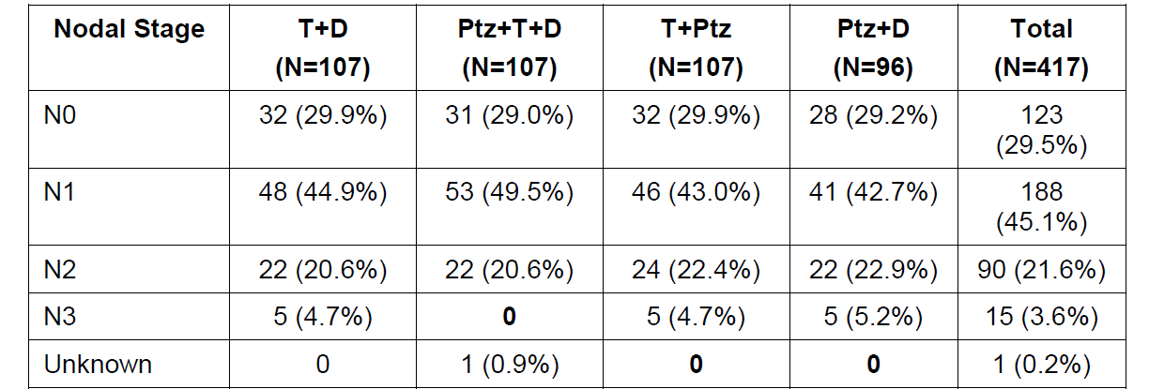

Table 80: TRYPHENA Nodal stage a baseline
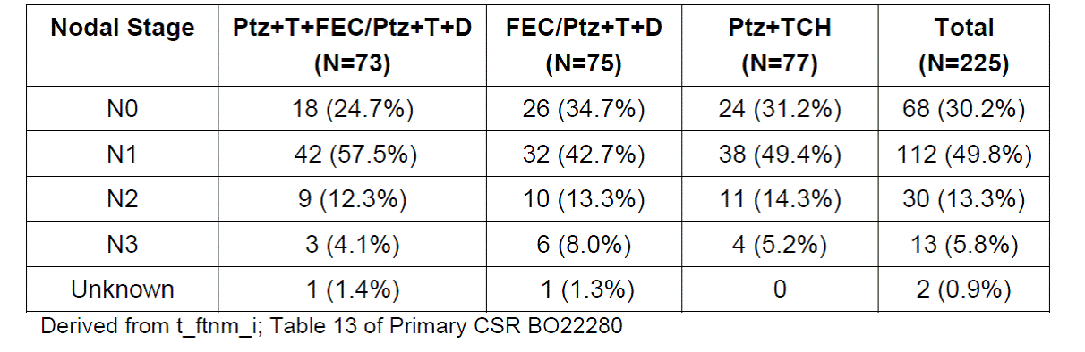

2. Pathological assessment of the lymph nodes at baseline
Pathological assessment of the lymph nodes was not required by the NEOSPHERE and TRYPHAENA protocols so data were not collected on methods or results of baseline pathological nodal assessment. Accordingly it is not known for sure how many patients underwent a pathological procedure such as sentinel lymph node (SLN) biopsy or axillary fine needle aspirate (FNA) prior to the commencement of neoadjuvant therapy. However, based on guidelines, clinical practice and data available at the time the studies were designed and conducted, the rate of pathological assessment of the lymph nodes prior to neoadjuvant therapy is expected to have been low.

2.1 NEOSPHERE
Following a manual review of the NEOSPHERE study data, five patients were identified who underwent SLN biopsy prior to neoadjuvant therapy (data captured in the ‘Additional Observations’ field of the eCRF). These five patients came from four different investigative sites. They were also fairly evenly distributed across treatment arms: one patient was in Arm A (T+D), one was in Arm C (Ptz+T), and three were in Arm D (Ptz+D). No patient was identified who had a SLN biopsy before starting neoadjuvant treatment in Arm B (Ptz+T+D). Of the five patients who had a SLN biopsy before starting neoadjuvant treatment, two were SLN-positive (one in Arm C [Ptz+T] and one in Arm D [Ptz+D]), and the remaining three patients (one in Arm A [T+D] and two in Arm D) were SLN-negative.
In addition, axillary FNA was reported for one patient prior to starting neoadjuvant treatment. This was reported on the ‘Surgical Procedures Related to Breast Cancer’ electronic case report form (eCRF) page but results were not provided.

2.2 TRYPHAENA
A manual review of TRYPHAENA study data identified 10 patients who underwent SLN biopsy prior to neoadjuvant chemotherapy. Six of these patients came from one investigative site ([information redacted] in Germany). The rest of the patients known to have undergone SLN biopsy came from four different investigative sites. Two of the patients who underwent SLN biopsy were in Arm A (Ptz+T+FEC/ Ptz+T+D), three were in Arm B (FEC/Ptz+T+D) and five were in Arm C (Ptz + TCH).
The findings of the SLN biopsy were not routinely documented in the ‘Additional Observations’ eCRF. However, based on the TNM stage at initial diagnosis, which was collected on the ‘History of Breast Cancer’ eCRF page, all 10 patients who had a SLN biopsy at study entry were node-negative.

3. Summary/conclusions
All patients in the NEOSPHERE and TRYPHAENA studies were scheduled to undergo baseline assessment of disease using CBE and mammography. A small minority of patients appear to have undergone additional baseline staging investigations of locoregional lymph nodes (probably < 10% of patients). Pathological assessment of lymph nodes at baseline appears to have been infrequent in both studies (probably < 2% of patients). Although it is possible that different assessment methods were used in different investigative sites, staging investigations had to be completed before randomisation so baseline lymph node status was balanced across treatment arms.
Differences in baseline lymph node assessment methods are unlikely to have affected clinical response rates reported from the NEOSPHERE study at least, since response rates were calculated separately for each different assessment modality in this study. Response rate according to CBE is generally quoted and given most weight since all patients had to undergo CBE, and disease was assessed by CBE at every neoadjuvant treatment cycle.

Evaluator’s comment
The response is considered acceptable.

Question 5

Sponsor response
The response to this comment is provided in two parts:
- Explanation for apparent discrepancy in figures
- Rates of clinically significant haematological toxicity in different phases of the study

1. Explanation for apparent discrepancy in figures
The sponsor believes that confusion may have arisen between ‘febrile neutropenia’ events (where febrile neutropenia is the preferred term) and ‘febrile neutropenic infection’ events, which are defined as follows:
- Events coded to a preferred term in the SOC ‘Infections and Infestations’ with a date of onset < 14 days after the start of a Grade ≥ 3event with the preferred term ‘febrile neutropenia’.
Analysis of ‘febrile neutropenic infection’ events is intended to pick up additional events that might be the consequence of febrile neutropenia. For example, a patient with febrile neutropenia might subsequently develop pneumonia or cerebral abscesses as a result of overwhelming sepsis accompanying the neutropenia. Of note, the index event of ‘febrile neutropenia’ is not included in the ‘febrile neutropenic infection’ category. So a patient who developed febrile neutropenia and then experienced pneumonia within 14 days would be counted as having a ‘febrile neutropenic infection’ event (pneumonia), whereas a patient who developed febrile neutropenia with no subsequent infection would not be counted as having a ‘febrile neutropenic infection.’ Both patients would be counted as having febrile neutropenia. Since many patients who develop febrile neutropenia do not go on to experience another infection within 14 days (because they are treated appropriately for febrile neutropenia), the rates of ‘febrile neutropenic infection’ events are lower than the rates of ‘febrile neutropenia’.
Similarly, analysis of ‘leukopenic infection’ events (see Section TRYPHAENA CSR Update 1 for example) is intended to pick up additional events that might be the consequence of leukopenia. These were defined as an event coded to a preferred term in the SOC 'Infections and Infestations' with a date of onset ≤ 14 days after the start date of a NCICTCAE Grade ≥ 3 event coded to a PT in the SMQ (narrow) 'Haematopoietic Leukopenia'. Importantly, both leukopenic infection events and febrile neutropenic infection events include Grade 1 and 2 infections occurring within 14 days of the index Grade ≥ 3event. Thus, a patient who experienced a Grade 1 event, such as an upper respiratory infection, 13 days after experiencing Grade 3 febrile neutropenia would be counted as experiencing a ‘febrile neutropenic infection’ event and a ‘leucopenic infection’ event.
The rates of febrile neutropenia quoted by the Assessor for the neoadjuvant period (up to 18.1% in the FEC+Ptz+T/Ptz+D+T arm, 9.3% in the FEC/Ptz+D+T arm and 17.1% in the TCH+Ptz arm) are correct. These appear for example in Table 56 in the TGA assessment report (which corresponds to Table 79 from the Summary of Clinical Safety). The same figures appear in many places in the TRYPHAENA Primary CSR (CSR 1046609 dated May 2012; clinical cut-off date, 21 June 2011) (for example, Table 23, 24 and 34) and in the Summary of Clinical Safety (SCS) (for example, Table 29).
Febrile neutropenic infection events are summarised in tables which include events summarised by SMQ and AEGT and do not appear in tables summarising events by preferred term only. The incidence of febrile neutropenic infection events is provided in Table 81 below, which corresponds to part of Table 7 from the TRYPHAENA Update CSR 1 (CSR 1052838, dated December 2012; clinical cut-off date 04 July 2012). This table indicates that 4.2% of patients in Arm A of the TRYPHAENA study experienced febrile neutropenic infections during the neoadjuvant and adjuvant periods combined (versus none in Arm B or Arm C). Febrile neutropenia (by preferred term) is not included in this table so, at a glance, the figures for febrile neutropenic infection might be interpreted as the figures for febrile neutropenia. Of note, data for leukopenia included in this table are based on the SMQ (narrow) ‘Haematopoietic leukopenia’, which includes events other than leukopenia (preferred term). Accordingly, figures for leukopenia in Table 81 are higher than for leukopenia in Table 56.

Table 81: Overview of AEs during neoadjuvant and adjuvant period combined (derived from Table 7 in TRYPHENA updated CSR 1)5
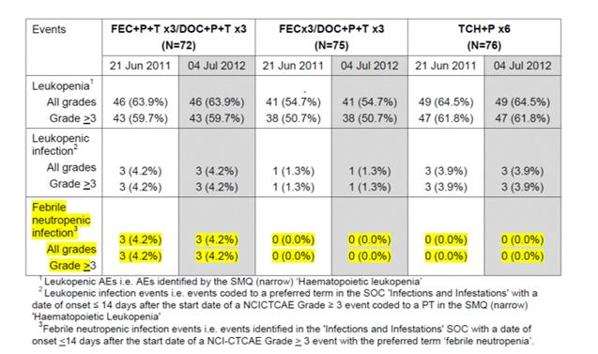

2. Rates of clinically significant haematological toxicity in different phases of the study
Although the data analysis plans for TRYPHAENA included analyses of febrile neutropenic infection events and leucopenic infection events, these categories do not represent laboratory data or adverse events as reported by investigators, and their meaning is not immediately apparent to the reader. Therefore, Table 82 simply summarises AEs by preferred term for the neoadjuvant and adjuvant periods of the TRYPHAENA study. All grade and Grade >3 events (that is, clinically significant events) are provided. In the TRYPHAENA study, all chemotherapy was given in the neoadjuvant period (unlike the NEOSPHERE study) and, in the adjuvant period, only trastuzumab was give. As a result, in the TRYPHAENA study, most haematological toxicity occurred in the neoadjuvant period (shaded in Table 82).

Table 82: Incidence of key haematological AEs in TRYPHENA study by treatment phase
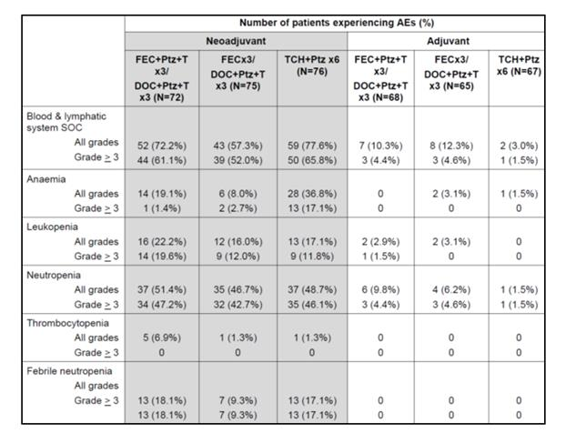

Evaluator’s comment
The response is considered acceptable.

Question 6

Sponsor response
The MAH will provide the VTE rates from the adjuvant APHINITY trial once the data becomes available.

Evaluator’s comment
The response is considered acceptable.

Question 7

Sponsor response
The sponsor can confirm that the percentage of patients with a hypersensitivity/anaphylaxis adverse event during the neoadjuvant period in the Ptz+D arm of NEOSPHERE was 7.4%. The discrepancy is due to a few changes to the neoadjuvant data after the clinical cut-off for the primary CSR. The rate of 6.4% is taken from the summary of anaphylaxis/hypersensitivity adverse events produced at the time of the primary analysis (clinical cut-off date 22 December 2009), as shown in Table 48 [not in this Attachment 2] of the Primary NEOSPHERE CSR.
Although all patients had completed neoadjuvant treatment at the time of the clinical cut-off date for the primary analysis, the database was kept open because adverse events continued to evolve over the study. Consequently some changes to neoadjuvant data did occur after the database lock for the primary analysis. At the time of the clinical cut-off for the NEOSPHERE CSR Update (9 March 2012), changes in the neoadjuvant data were evaluated but the conclusions stated in the primary CSR were unaltered. This is documented in the NEOSPHERE CSR Update 1. The overview of safety summary and the summary of Grade ≥ 3 adverse events during the neoadjuvant period were based on this later clinical cut-off. The rate of 7.4% is taken from the updated overview of safety (clinical cut-off 9 March 2012).
The difference in incidence (7.4% versus 6.4%) is due to one patient [information redacted], who experienced a Grade 2, non-serious AE of anaphylactic reaction during the neoadjuvant period. The investigator noted that docetaxel was interrupted and restarted with a longer infusion time as a result of this AE.

Evaluator’s comment
The response is considered acceptable.

Second round benefit-risk assessment

Second round assessment of benefits
After consideration of the responses to clinical questions, the benefits of pertuzumab in the proposed usage are unchanged from those identified in the first round evaluation. The evaluator notes the comprehensive review of the data pertaining to pCR rate across breast cancers of differing disease extent (operable, locally advanced and inflammatory) provided by the sponsor in addition to the responses to the clinical questions. These data do indicate higher pCR rates, regardless of pCR definition used, with pertuzumab-containing neoadjuvant regimens. These data do not and cannot address the issues related to the use of pCR as a surrogate end-point as detailed in earlier in this report. Nevertheless, the survival data for pertuzumab in metastatic disease are compelling and thus it is very likely that use of neoadjuvant pertuzumab in will ultimately result in survival benefit in this setting also. This expectation is congruent with the tenor of discussions around this area among Australian thought leaders. Furthermore, the evaluator recognises that pertuzumab has been approved for the neoadjuvant indication by regulators in Europe and in the United States.

Second round assessment of risks
After consideration of the responses to clinical questions, the benefits of pertuzumab in the proposed usage are unchanged from those identified in the first round evaluation.

Second round assessment of benefit-risk balance
The benefit-risk balance of pertuzumab, given the proposed usage, is favourable.

Second round recommendation regarding authorisation
After consideration of the data presented in the clinical submission and the responses to the clinical questions, the evaluator recommends the following indication statement:
Additional indication: Perjeta is indicated in combination with trastuzumab and chemotherapy for the neoadjuvant treatment of patients with HER2-positive, locally advanced, inflammatory or early stage breast cancer (> 2 cm in diameter) as part of a complete treatment regimen for early breast cancer.
This indication must have appended to it, the following ‘Note to the Indication’:
The approval is based upon a surrogate endpoint and improvement in disease free, progression free or overall survival has not been demonstrated.
This ‘Note to the Indication’ must be included in any marketing material as a condition of registration. Once confirmatory data are available demonstrating survival benefit, the ‘Note to the Indication’ can be removed.

References
- Read RL, Flitcroft K, Snook KL, Boyle FM and Spillane. ANZ J Surg. 2015;85(5):315-20.
- Roche H, Fumoleau, Speilman M et al. Sequential adjuvant epirubicin-based and docetaxel chemotherapy for node-positive breast cancer patients: the FNCLCC PACS01 trial. J Clin Oncol 2006; 24 (36): 5664-5671.
- Martin M, Rodriguez-Lescure A, Ruiz A et al. Randomised phase 3 trial of fluorouracil, epirubicin and cyclophosphamide alone or followed by paclitaxel for early breast cancer. J Natl Cancer Inst 2008; 100: 805-814.
- https://www.eviq.org.au/AdditionalClinicalInformation/tabid/64/id/60/Default.aspx
- Del Mastro et al Lancet. 2015; 385(9980):1863-72.
- PERJETA - Proposed PI Annotated (version 141016; CDS 4.0.) (Module1)
- PERJETA - Proposed CMI Annotated (version 140317) (Module 1)
- Update Clinical Study Report 2 – WO20698/TOC4129g – A Phase III, Randomised, Double-Blind, Placebo-Controlled Clinical Trial to Evaluate the Efficacy and Safety of Pertuzumab + Trastuzumab + Docetaxel versus. Placebo + Trastuzumab + Docetaxel in Previously Untreated HER2-Positive Metastatic Breast Cancer – Report No. 1059844, July 2014. (Module 5)
- Cortazar P, et al. Meta-analysis Results from the Collaborative Trials in Neoadjuvant Breast Cancer (CTNeoBC) [abstract]. Cancer Res 2012; 72 (24 Suppl.) 93s, S1-11.
- Cortazar P, al. Pathological complete response and long- term clinical benefit in breast cancer: the CTNeoBC pooled analysis. Lancet. 2014 Feb 13. pii: S0140-6736(13)62422-8. doi: 10.1016/S0140-6736(13)62422-8. [Epub ahead of print]
- von Minckwitz G, et al. Definition and impact of pathologic complete response on prognosis after neoadjuvant chemotherapy in various intrinsic breast cancer subtypes. J Clin Oncol 2012; 30:1796-1804.
- EMA/CHMP/151853/2014 Committee for Medicinal Products for Human Use (CHMP) Draft guideline on the role of the pathological Complete Response as an endpoint in neoadjuvant breast cancer studies, First published 28/04/2014, Last updated 28/04/2014
- Guidance for Industry - Pathological Complete Response in Neoadjuvant Treatment of High-Risk Early-Stage Breast Cancer: Use as an Endpoint to Support Accelerated Approval (U.S. Department of Health and Human Services Food and Drug Administration Center for Drug Evaluation and Research (CDER), October 2014 , Clinical/Medical)
- Pathologic Complete Response Analyses in Early Breast Cancer [NOAH and GeparQUATTRO] (Module 5)
- Piccart-Gebhart MJ, et al. The association between event-free survival and pathological complete response to neoadjuvant lapatanib, trastuzumab or their combination in HER2-positive breast cancer. Survival follow-up analysis of the NeoALTTO Study (BIG 1-06). Cancer Res 2013: Abstract S1-01.
- Pharmacokinetic analysis and exposure-response of pertuzumab in combination with trastuzumab and docetaxel in the neoadjuvant setting (2013 07 03 NEOSPHERE PKPD v2 Final). (Module 5)
- Clinical Study Report –WO20698C/TOC4129g - A Phase III, Randomised, Double-Blind, Placebo-Controlled Clinical Trial to Evaluate the Efficacy and Safety of Pertuzumab + Trastuzumab + Docetaxel versus. Placebo + Trastuzumab + Docetaxel in Previously Untreated HER2-Positive Metastatic Breast Cancer – Report No. 1046288, October 2011. (Module 5)
- Update Clinical Study Report – WO20698/TOC4129g - A Phase III, Randomised, Double-Blind, Placebo-Controlled Clinical Trial to Evaluate the Efficacy and Safety of Pertuzumab + Trastuzumab + Docetaxel versus. Placebo + Trastuzumab + Docetaxel in Previously Untreated HER2-Positive Metastatic Breast Cancer – Report No. 1053649, December 2012. (Module 5)
- Population PK Study reports (Module 5 of submission)
- An open-label, randomised, multicenter, phase IIA study evaluataing pertuzumab in combination with trastuzumab and chemotherapy in patients with HER2-positive advanced gastric cancer (Study dm-bp27836-20121010). (Module 5)
- Cross-Validation of Trastuzumab PK ELISA Methods BA.MET.HH2.013 and BA.MET.HH2.015 Using Incurred Samples (Study ba-met-hh2015-cvr). (Module 5)
- Primary CSR WO20697 - Clinical Study Report – A randomised, multicenter, multinational Phase II study on trastuzumab plus docetaxel versus trastuzumab plus docetaxel plus pertuzumab versus trastuzumab plus pertuzumab versus pertuzumab and docetaxel in patients with locally advanced, inflammatory or early stage HER2-positive breast cancer. Report No. 1032196.Version 1: September 2010; Version 2: December 2010 (to include investigators’ CVs); Version 3: June 2011 (to correct one patient’s primary endpoint data and add biomarker results). (Module 5)
- Clinical Study Report – BO22280 - A randomised, multicentre, multinational Phase II study to evaluate pertuzumab in combination with trastuzumab, given either concomitantly or sequentially with standard anthracycline-based chemotherapy or concomitantly with a non-anthracycline-based chemotherapy regimen, as neoadjuvant therapy for patients with locally advanced, inflammatory or early stage HER2-positive breast cancer. Report No: 1046609; May 2012. (Module 5)
- Update Clinical Study Report – WO20697 − A randomised, multicenter, multinational Phase II study on trastuzumab plus docetaxel versus trastuzumab plus docetaxel plus pertuzumab versus trastuzumab plus pertuzumab versus pertuzumab and docetaxel in patients with locally advanced, inflammatory or early stage HER2-positive breast cancer. Report No. 1053542; March 2013. (Module 5)
- Final Clinical Study Report - WO20697 - A randomised, multicenter, multinational Phase II study on trastuzumab plus docetaxel versus trastuzumab plus docetaxel plus pertuzumab versus trastuzumab plus pertuzumab versus pertuzumab and docetaxel in patients with locally advanced, inflammatory or early stage HER2-positive breast cancer Report No. 1062325/February 2015. (Module 5)
- CHMP 1st RSI RtQ-01 – EMA responses. (Module 1)
- Update Clinical Study Report – BO22280 - A randomised, multicentre, multinational Phase II study to evaluate pertuzumab in combination with trastuzumab, given either concomitantly or sequentially with standard anthracycline-based chemotherapy or concomitantly with a non-anthracycline-based chemotherapy regimen, as neoadjuvant therapy for patients with locally advanced, inflammatory or early stage HER2-positive breast cancer. Report No: 1052838; December 2012. (Module 5)
- Second Update Clinical Study Report – BO22280 - A randomised, multicentre, multinational Phase II study to evaluate pertuzumab in combination with trastuzumab, given either concomitantly or sequentially with standard anthracycline-based chemotherapy or concomitantly with a non-anthracycline-based chemotherapy regimen, as neoadjuvant therapy for patients with locally advanced, inflammatory or early stage HER2-positive breast cancer. Report No: 1058102. (Module 5)
- Sponsor’s Summary of clinical safety (Module 2)
- WO20697 − A randomised, multicenter, multinational Phase II study on trastuzumab plus docetaxel versus trastuzumab plus docetaxel plus pertuzumab versus trastuzumab plus pertuzumab versus pertuzumab and docetaxel in patients with locally advanced, inflammatory or early stage HER2-positive breast cancer. Report No. 1057938. February 2014. (Module 5)
- Mauri D, et al. Neoadjuvant versus adjuvant systemic treatment in breast cancer: a meta-analysis. J Natl Cancer Inst. 2005; 97:188-194.
- Risk Management Plan for Australia (Module1)

Therapeutic Goods Administration
PO Box 100 Woden ACT 2606 Australia
Email: info@tga.gov.au Phone: 1800 020 653 Fax: 02 6232 8605
https://www.tga.gov.au

Bear HD et al, Sequential Preoperative or Postoperative Docetaxel Added to Preoperative Doxorubicin Plus Cyclophosphamide for Operable Breast Cancer: National Surgical Adjuvant Breast and Bowel Project Protocol B-27. Journal of Clinical Oncology, Vol 24, No 13 (May 1), 2006: pp. 2019-2027 Rastogi P et al. Preoperative Chemotherapy: Updates of National Surgical Adjuvant Breast and Bowel Project Protocols B-18 and B-27 Journal of Clinical Oncology 2008:26:778-785; Gianni L et al. Follow up results of NOAH, a randomized phase III trial evaluating neoadjuvant chemotherapy with trastuzumab (CT+H) followed by adjuvant H versus CT alone, in patients with HER2- positive locally advanced breast cancer. ASCO 2013; JCO 31 (suppl; abs 503). [10808].
Bear HD et al, Sequential Preoperative or Postoperative Docetaxel Added to Preoperative Doxorubicin Plus Cyclophosphamide for Operable Breast Cancer: National Surgical Adjuvant Breast and Bowel Project Protocol B-27. Journal of Clinical Oncology, Vol 24, No 13 (May 1), 2006: pp. 2019-2027; Fisher B et al. Effect of preoperative chemotherapy on local-regional disease in women with operable breast cancer: findings from NSABP Study B-18. Journal of Clinical Oncology. 1997; 15:2483-2493; Kelly AM et al. Sentinel node identification and classification after neoadjuvant chemotherapy – systematic review and meta analysis. Academic Radiology,2009, Vol 16:551-563; Rastogi P et al. Preoperative Chemotherapy: Updates of National Surgical Adjuvant Breast and Bowel Project Protocols B-18 and B-27 Journal of Clinical Oncology 2008:26:778-785.

