March 2020

Australian Public Assessment Report for Pertussis vaccine - acellular combined with diphtheria and tetanus toxoids (adsorbed)
  - Proprietary Product Name: Adacel
  - Sponsor: Sanofi-Aventis Australia Pty Ltd

About the Therapeutic Goods Administration (TGA)
- The Therapeutic Goods Administration (TGA) is part of the Australian Government Department of Health and is responsible for regulating medicines and medical devices.
- The TGA administers the Therapeutic Goods Act 1989 (the Act), applying a risk management approach designed to ensure therapeutic goods supplied in Australia meet acceptable standards of quality, safety and efficacy (performance) when necessary.
- The work of the TGA is based on applying scientific and clinical expertise to decision-making, to ensure that the benefits to consumers outweigh any risks associated with the use of medicines and medical devices.
- The TGA relies on the public, healthcare professionals and industry to report problems with medicines or medical devices. TGA investigates reports received by it to determine any necessary regulatory action.
- To report a problem with a medicine or medical device, please see the information on the TGA website <https://www.tga.gov.au>.

About AusPARs
- An Australian Public Assessment Report (AusPAR) provides information about the evaluation of a prescription medicine and the considerations that led the TGA to approve or not approve a prescription medicine submission.
- AusPARs are prepared and published by the TGA.
- An AusPAR is prepared for submissions that relate to new chemical entities, generic medicines, major variations and extensions of indications.
- An AusPAR is a static document; it provides information that relates to a submission at a particular point in time.
- A new AusPAR will be developed to reflect changes to indications and/or major variations to a prescription medicine subject to evaluation by the TGA.

Copyright
© Commonwealth of Australia 2020
This work is copyright. You may reproduce the whole or part of this work in unaltered form for your own personal use or, if you are part of an organisation, for internal use within your organisation, but only if you or your organisation do not use the reproduction for any commercial purpose and retain this copyright notice and all disclaimer notices as part of that reproduction. Apart from rights to use as permitted by the Copyright Act 1968 or allowed by this copyright notice, all other rights are reserved and you are not allowed to reproduce the whole or any part of this work in any way (electronic or otherwise) without first being given specific written permission from the Commonwealth to do so. Requests and inquiries concerning reproduction and rights are to be sent to the TGA Copyright Officer, Therapeutic Goods Administration, PO Box 100, Woden ACT 2606 or emailed to <tga.copyright@tga.gov.au>.

Contents
Common abbreviations 4
I. Introduction to product submission 6
Submission details 6
Product background 7
Regulatory status 9
Product Information 10
II. Registration timeline 10
III. Submission overview and risk/benefit assessment 11
Quality 11
Nonclinical 11
Clinical 11
Risk management plan 26
Risk-benefit analysis 27
Outcome 31
Attachment 1. Product Information 32

Common abbreviations
Abbreviation | Meaning
ACV | Advisory Committee on Vaccines
ASA | Australian specific Annex
ATAGI | Australian Technical Advisory Group on Immunisation
CDC | Centers for Disease Control and Prevention (US)
CI | Confidence interval
CMI | Consumer Medicines Information
DLP | Data lock point
DTP | Diphtheria, tetanus, and whole cell pertussis (vaccine)
DTPa | Diphtheria, tetanus, and acellular pertussis (vaccine;paediatric formulation containing substantially greater amount of diphtheria toxoid and pertussis antigens compared with adult (dTpa) formulations)
dTpa | Diphtheria, tetanus, and acellular pertussis (vaccine; formulation used in adolescents and adults containing substantially lesser amounts of diphtheria toxoid and pertussis antigens (compared with paediatric (DTPa) formulations)
ELISA | Enzyme-linked immunosorbent assay
EU | European Union
EU-RMP | European Union-Risk Management Plan
FDA | Food and Drug Administration (US)
FHA | Filamentous haemagglutinin
FIM 2-3 | Fimbriae types 2 and 3
Hib | Haemophilus influenza type b
HPV4 vaccine | Human papillomavirus vaccine that contains 4 serotypes
IPV | Inactivated poliomyelitis vaccine
IU | International unit
KPNC | Kaiser Permanente Northern California
LBS | Literature based submission
PRN | Pertactin
PT | Pertussis toxin
RMP | Risk management plan
Td | Tetanus, reduced diphtheria (vaccine)
TDaP | Tetanus toxoid, diphtheria toxoid and acellular pertussis (vaccine); also known as DTPa (see above)
Tdap | Tetanus toxoid, reduced diphtheria toxoid and acellular pertussis (vaccine); also known as dTpa (see above)
UK | United Kingdom
US | United States
VAERS | Vaccine Adverse Event Report System
VE | Vaccine effectiveness
WHO | World Health Organization

I. Introduction to product submission

Submission details
Type of submission: | Extension of indications
Decision: | Approved
Date of decision: | 14 May 2019
Date of entry onto ARTG: | 20 May 2019
ARTG numbers: | 106554; 297685
Black Triangle Scheme | No
Active ingredients: | Pertussis vaccine-acellular combined with diphtheria and tetanus toxoids (adsorbed)
Product name: | Adacel
Sponsor’s name and address: | Sanofi-Aventis Australia Pty Ltd  Talavera Corporate Centre, Building D  12-24 Talavera Rd  Macquarie Park NSW 2113
Dose form: | Suspension for injection
Strength: | Each 0.5 mL dose of Adacel contains:  - Diphtheria toxoid: ≥ 2 IU (2 Lf);  - Tetanus toxoid: ≥ 20 IU (5 Lf);*  - Pertussis toxoid: 2.5 micrograms;  - Pertussis filamentous haemagglutinin: 5 micrograms;  - Pertactin: 3 micrograms;  - Pertussis fimbriae types 2 and 3: 5 micrograms.  *The formulated content of 5 Lf of tetanus toxoid per 0.5mL dose is the same as the related product Tripacel
Containers: | Vial; pre-filled syringe
Pack sizes: | Vial: 1 or 5,  Prefilled syringe: 1 or 10 with or without separate needles.
Approved therapeutic use: | Adacel may be administered during pregnancy for prevention of pertussis in young infants via transplacental antibody transfer from the pregnant woman to the fetus.
Route of administration: | Intramuscular injection
Dosage: | Adacel (0.5 mL) should be administered by intramuscular route.  Booster doses of Adacel should be given according to the official national recommendations as per the current Immunisation Handbook.  Administration to a pregnant woman should be done according to official national recommendations for pertussis vaccination of a pregnant woman.  For further information, refer to the Product Information (PI) and current Immunisation Handbook.

Product background
This AusPAR describes the application by Sanofi-Aventis Australia Pty Ltd (the sponsor) to register Adacel pertussis vaccine-acellular combined with diphtheria and tetanus toxoids (adsorbed) 0.5 mL suspension for injection, vial and pre-filled needle-free syringe for the following proposed extension of indications:
Adacel may be administered during pregnancy for prevention of pertussis in young infants.
Pertussis is an important cause of morbidity in all age groups and of mortality in infants. The disease burden remains high compared to that of other vaccine-preventable diseases. Worldwide, in children younger than 5 years, there were an estimated 24.1 million cases of pertussis and an estimated 160,700 deaths from pertussis in 2014 according to a recent publication modelling these data. Of these, an estimated 5.1 million cases and an estimated 85,900 deaths occurred in infants younger than 1 year of age. In Australia, during a pertussis outbreak (2008 to 2012) the rate of pertussis peaked in the overall population in 2011 (173.5 cases per 100,000) with 333.8 cases per 100,000 in children less than 4 years of age. Between 2006 and 2012, infants aged < 6 months accounted for 42% (1,832 of 4,408) of pertussis-related hospitalisations. During this period there were 11 deaths attributed to pertussis; 10 of these deaths were in infants < 6 months of age. Rates of pertussis were lower overall in 2013 and 2014 (approximately 50 cases per 100,000) with 95.4 and 72.4 cases, respectively, per 100,000 in children less than 4 years of age.2 During 2014, there were 39 reported cases of pertussis in infants less than 6 weeks of age, and 98 reported cases in those 6 weeks to less than 4 months of age. In 2015 and 2016, the number of pertussis cases increased overall (94.5 and 83.1 cases per 100,000), mostly due to increased reporting in several states/territories, with 186.1 and 185.5 cases, respectively, in children less than 4 years of age.
Even though there is antibiotic treatment for pertussis, it has its highest mortality in children under 6 months of age; hence, prevention is very important in this age group. Acellular pertussis-containing vaccines for the prevention of pertussis have been used for both primary and booster vaccination of children in Australia since 1999 and the primary vaccination series commences at 2 months of age in Australia. The acronym DTPa, using capital letters, signifies child formulations of diphtheria, tetanus and acellular pertussis-containing vaccines. The acronym dTpa is used for formulations that contain substantially lesser amounts of diphtheria toxoid and pertussis antigens and are usually used in adolescents and adults.,
Vaccination of pregnant women with dTpa has been shown to be effective in preventing pertussis disease in newborn infants via the transfer of maternal antibodies in utero and this strategy has been widely used for over a decade in many countries (including Australia), particularly during pertussis outbreaks. Vaccination of mothers at least 7 days before delivery reduced pertussis disease by 91% in infants < 3 months of age.
The World Health Organization (WHO) position paper on pertussis vaccines (2015) recommends that national programs consider vaccination of pregnant women with one dose of dTpa in the second or third trimester and preferably at least 15 days before the end of the pregnancy. The routine primary infant immunisation during the first year of life with DTPa should remain unchanged.
In Australia, the ‘cocoon’ strategy (vaccinating those who will be in close contact with infants, in order to reduce exposure to pertussis) has been recommended in the Australian Immunisation Handbook since 2003 and this has been funded by state and territory governments as an outbreak response measure since 2008 to various populations at various times. In 2013, the Australian Immunisation Handbook pertussis vaccine recommendations were extended to include the option of vaccinating pregnant women in the third trimester of pregnancy, and in March 2015 this recommendation was updated to support a preference for pertussis vaccination during each pregnancy (optimally between 28 and 32 weeks), rather than postpartum.
Adacel is an adult/adolescent formulation of diphtheria, tetanus and acellular pertussis with reduced content (dTpa) of diphtheria toxoid, pertussis toxoid and filamentous haemagglutinin compared to paediatric formulations of DTPa. At the time the submission described in this AusPAR was under consideration, Adacel was not recommended for use in pregnancy in Australia. Its comparison with Boostrix, which is another registered dTpa formulation, is as follows in Table 1, below. In Australia, Boostrix is approved as booster from age 4 years onwards, has pregnancy classification Category B1; and is allowed use in pregnancy for prevention of pertussis in young infants.
Table 1: Comparison of antigen composition of Adacel and Boostrix dTpa vaccines
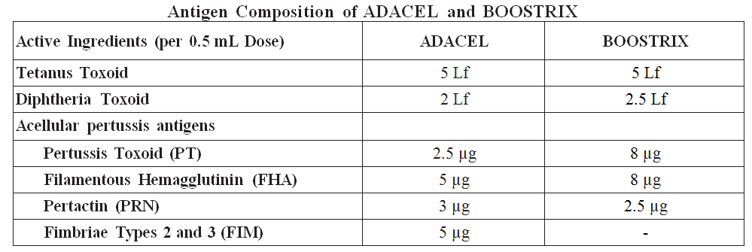
In addition to the proposed extension of indications for use of Adacel in pregnancy, this submission also sought the following changes:
- To update the Product Information (PI) regarding use of Adacel for repeat vaccination in accordance with the current recommendations as per the Australian Immunisation Handbook.6
- Change in Adacel Pregnancy classification from Category B2; to Category A.
- Other changes/updates to the PI including interaction with other vaccines (tetravalent meningococcal vaccine Menactra).
This submission was a literature based submission (LBS), as agreed with the TGA.

Regulatory status
Adacel received initial registration on the Australian Register of Therapeutic Goods (ARTG) on 21 November 2005 for the following indication:
‘active immunisation against tetanus, diphtheria and pertussis in persons aged 10 years and over as a booster following primary immunisation’.
At the time the TGA considered this application, Adacel was currently registered in 67 countries including the United States (US), United Kingdom (UK), Canada, Singapore and the countries in the European Union (EU).
Table 2 below outlines the countries where the dossier for use of Adacel during pregnancy has been submitted or was under evaluation, as of the time the submission was under consideration in Australia.
Table 2: International regulatory status as of March 2019
Country or region | Submission date | Approval status | Approved indication
EU | Variation submission: 11 June 2018 | Approved: 20 February 2019 | Covaxis is indicated for:  Active immunization against tetanus, diphtheria and pertussis in persons from 4 years of age as a booster following primary immunization.  Passive protection against pertussis in early infancy following maternal immunization during pregnancy (see sections 4.2, 4.4, 4.6 and 5.1).  Covaxis should be used in accordance with official recommendations.
Canada | Supplemental New Drug Submission: 18 September 2018 | Under consideration | Under consideration

Product Information
The Product Information (PI) approved with the submission which is described in this AusPAR can be found as Attachment 1. For the most recent PI, please refer to the TGA website at <https://www.tga.gov.au/product-information-pi>.

II. Registration timeline
The following table captures the key steps and dates for this application and which are detailed and discussed in this AusPAR.
Table 3: Timeline for Submission PM-2018-01989-1-2
Description | Date
Submission dossier accepted and first round evaluation commenced | 2 July 2018
First round evaluation completed | 30 November 2018
Sponsor provides responses on questions raised in first round evaluation | 2 January 2019
Second round evaluation completed | 15 February 2019
Delegate’s Overall benefit-risk assessment and request for Advisory Committee advice | 1 March 2019
Sponsor’s pre-Advisory Committee response | 18 March 2019
Advisory Committee meeting | 3 April 2019
Registration decision (Outcome) | 14 May 2019
Completion of administrative activities and registration on the ARTG | 20 May 2019
Number of working days from submission dossier acceptance to registration decision* | 197
*Statutory timeframe for standard applications is 255 working days

III. Submission overview and risk/benefit assessment
The submission was summarised in the following Delegate’s overview and recommendations.

Quality
There was no requirement for a quality evaluation in a submission of this type.

Nonclinical
There was no requirement for a nonclinical evaluation in a submission of this type.

Clinical
To support the efficacy and safety of maternal pertussis vaccination a LBS has been submitted after discussion with the TGA (and the search strategy approved). [Information redacted]. A total of 13 published immunogenicity and 4 vaccine effectiveness (VE) studies that support use of dTpa vaccine during pregnancy were identified in the literature search. A total of 22 published studies provide safety data that support use of dTpa vaccine during pregnancy were identified in the literature search.
To support repeat vaccination, two pivotal immunogenicity studies are submitted and 3 supportive studies present antibody persistence data from Studies TC9704-LT, Td9707-LT and Td9805-LT.
The main results of some selected papers are discussed in this section.

Details of the studies

Immunogenicity and vaccine effectiveness
- Four randomised clinical studies provide immunogenicity data in pregnant women and their infants through the infant series or booster dose of DTPa vaccines:
  - Munoz et al.;
  - Villarreal Perez et al.;
  - Halperin et al.; and
  - Hoang et al.
- Four cohort or observational studies provide immunogenicity data in pregnant women and their infants at birth:
  - Healy et al.;
  - Vilajeliu et al.;
  - Gall et al.; and
  - Fallo et al.
  - In addition, one further study provided evidence through the booster dose of DTPa vaccine: Hardy-Fairbanks et al.
- One randomised clinical study reported by Maertens et al.; provides immunogenicity data in infants after the booster dose of DTPa vaccine.
- Three cohort, case, or observational studies provide immunogenicity data in infants:
  - Vilajeliu et al.;
  - Ladhani et al.; and
  - Kent et al.

Vaccine effectiveness
- Four case-coverage/control and cohort studies that support VE from the use of dTpa vaccine during pregnancy:
  - 2 studies reported by Amirthalingam et al.;,
  - Baxter et al.; and
  - Dabrera et al.

Safety
- The four randomised clinical studies mentioned above also collected safety data:
  - Munoz et al.;12
  - Villarreal Perez et al.;13
  - Halperin et al.;14 and
  - Hoang et al.15
- Twelve cohort or observational studies reported by:
  - Kharbanda et al.;
  - Morgan et al.;
  - DeSilva et al.;
  - Zheteyeva et al.;
  - Donegan et al.;
  - Sukumaran et al.;,
  - Regan et al.;
  - Moro et al.;
  - Perry et al.; and
  - Talbot et al.
- Six cohort or observational studies reported by:
  - Shakib et al.;
  - Berenson et al.;
  - Layton et al.;
  - Zerbo et al.;
  - Datwani et al.; and
  - Moro et al.

Data supporting repeat vaccination (2 pivotal and 3 supportive studies)

Pivotal studies
- Study Td518: Safety and immunogenicity in adolescents and adults following revaccination with Adacel 4 to 5 years after a previous dose of Adacel. A Phase IV, descriptive, open-label, multicentre study in Canada and the US.
- Study Td526: Safety and immunogenicity in adults following revaccination with Adacel approximately 10 years after a previous dose of Adacel or Adacel Polio vaccine. Phase IV, open-label, multicentre study in Canada.

Supportive studies
- Study TC9704-LT Long-term immunogenicity: 1, 3, 5, 8, and 10 year follow up.
- Study Td9707-LT Long-term immunogenicity: 6 month, 1, 3, 5, and 10 year follow up.
- Study Td9805-LT Long-term immunogenicity: 1, 3, 5, and 10 year follow up.
These 3 studies were included in the original (new entity) application (Submission No. 2004-1199-2) submitted in 2004 in support of Adacel registration in Australia and the data in this submission is the long-term (LT) follow-up immunogenicity studies in adolescents and adults.

Other documents
A clinical overview and summaries for both parts of the submission were included as were the draft new copies of the Australian PI and Consumer Medicines Information (CMI), planning for submission and search strategy, risk management and pharmacovigilance system, and overseas regulatory status.

Efficacy

Immunogenicity (randomised controlled trials)

Munoz et al., (2014)
Table 4 provides an overview of the study by Munoz et al., (2014).¹²
Table 4: Munoz et al., (2014) study overview
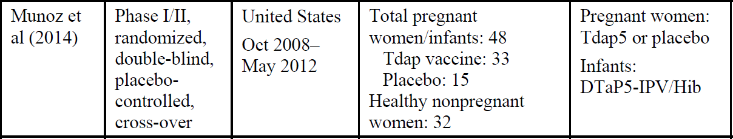
The dTpa vaccine (Adacel) or placebo was given at 30 to 32 weeks gestation. The results were as follows in Table 5.
Table 5: Munoz et al., (2014) study results
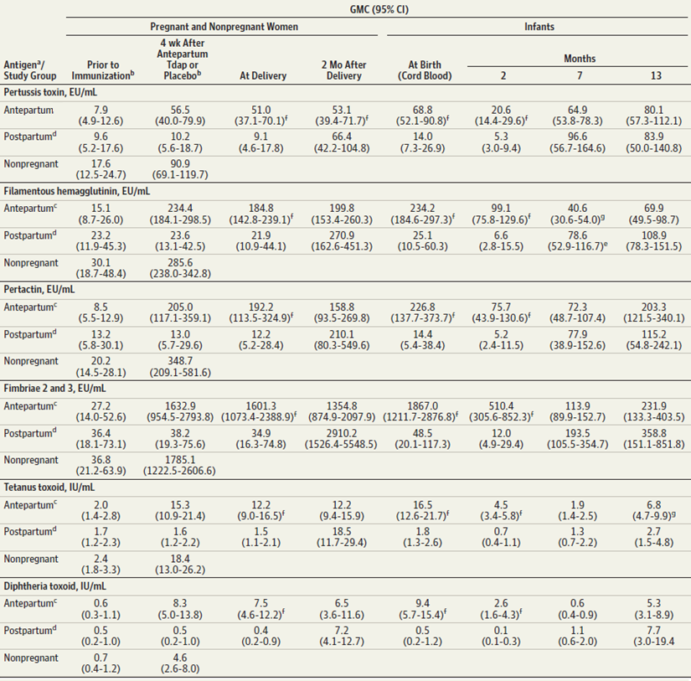
Immune response to antepartum dTpa results in high concentrations of antibodies against all pertussis antigens (pertussis toxin (PT), filamentous haemagglutinin (FHA), pertactin (PRN), fimbriae types 2 and 3 (FIM 2-3)) at delivery in women with comparable levels in cord blood. These levels were still persisting in mothers at 2 months after delivery. In the infant at age 2 months, the levels were roughly a third to a half of the cord blood levels. The immune response to DTPa in infant for FHA and FIM was relatively lower at age 7 months after completion of 3 priming doses of DTPa in infants. At 13 months, one month after fourth booster dose of DTPa, the responses were similar for all pertussis antigens. In infants born to women who were given dTpa postpartum, cord levels and Month 2 levels were low as expected but response measured at 7 and 13 months was unaffected.

Villarreal Perez et al., (2017)
Table 6 provides an overview of the study by Villarreal Perez et al., (2007).¹³
Table 6: Villarreal Perez et al., (2017) study overview
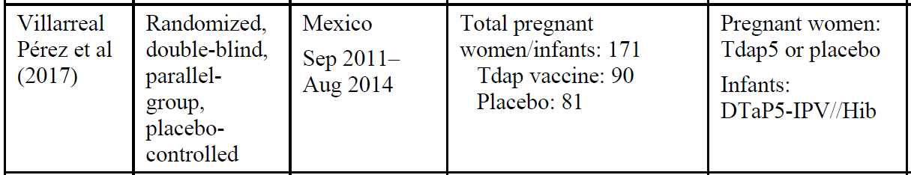
The dTpa vaccine (brand not specified) or placebo was given at 30 to 32 weeks gestation. The anti-PT response was slower and lower compared to the anti-PRN response in the mother (placebo response shown in dotted line). The PT response to DTPa in infants was subdued at age 2 and 4 months but robust at age 6 months. There was no PRN response to DTPa in infants in this study.
Figure 1: Perez et al., (2017) study results
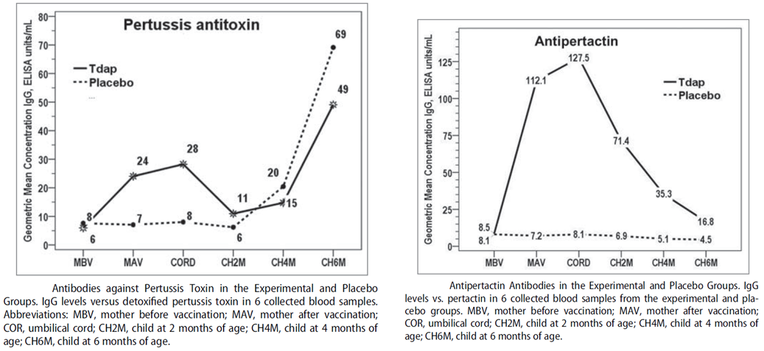

Hoang et al., (2016) and Maertens et al., (2016)
The following tables provide an overview of studies by Hoang et al., (2016)15 and Maertens et al., (2016).²¹
Table 7: Hoang et al., (2016) study overview
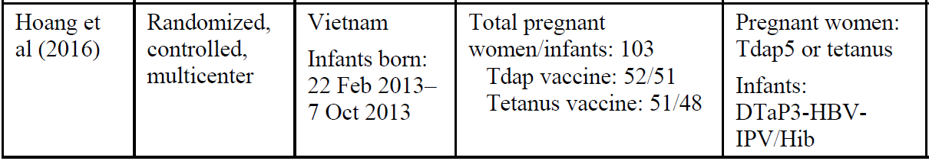
Table 8: Maertens et al., (2016) study overview
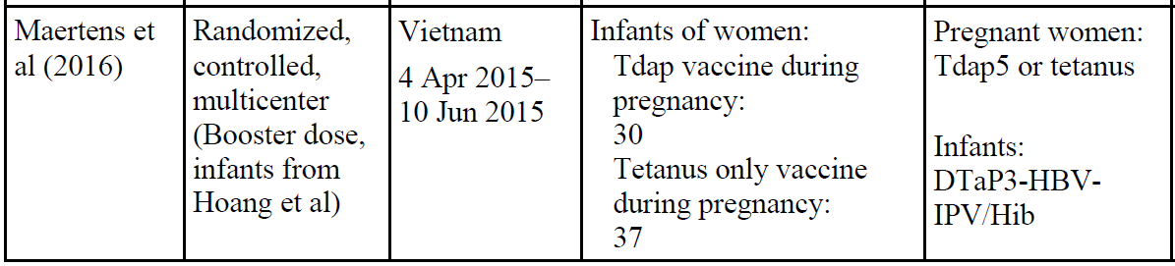
The dTpa vaccine (Adacel) or tetanus vaccine was given at 18 to 36 weeks gestation. Prior to the start of dTPa primary series in infants, there were persisting, moderate levels of antibodies against pertussis antigens in infants of dTpa maternal vaccination group compared to unprotected levels in infants whose mothers received antepartum TT.
Table 9: Hoang et al., (2016) study and Maertens et al., (2016) study results
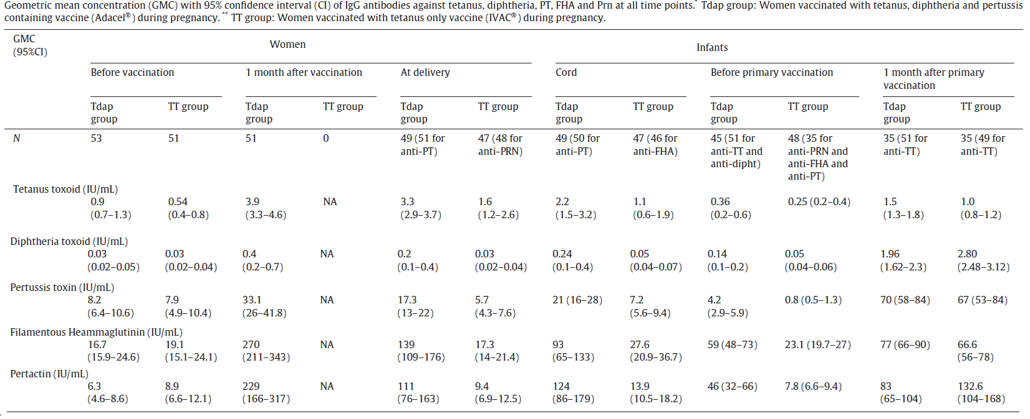
The results at one month after booster (fourth) dose of dTPa were separately reported by Maertens et al (2016) as follows.
Table 10: Maertens et al., (2016) study results (one month after booster (fourth) dose)
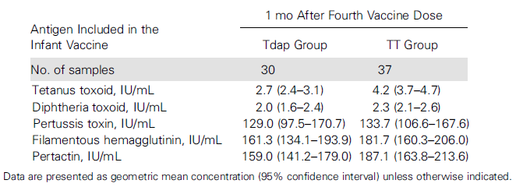
The immune response to fourth dose of dTPa was indicative of similarly robust reaction in the vaccinated and the control group.

Halperin et al., (2018)
Table 11 provides an overview of the study by Halperin et al., (2018).¹⁴
Table 11: Halperin et al (2018) study overview
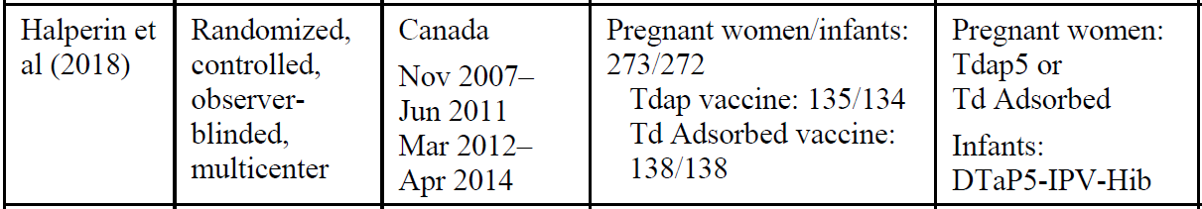
This is the most recently reported clinical trial in which dTPa (Adacel) or tetanus diphtheria (Td) vaccine were given in third trimester of pregnancy (range 33.3 to 35.7 weeks gestation). The infant results were as follows in Table 12.
Table 12: Halperin et al., (2018) study results, geometric mean antibody concentration (95 % confidence interval)
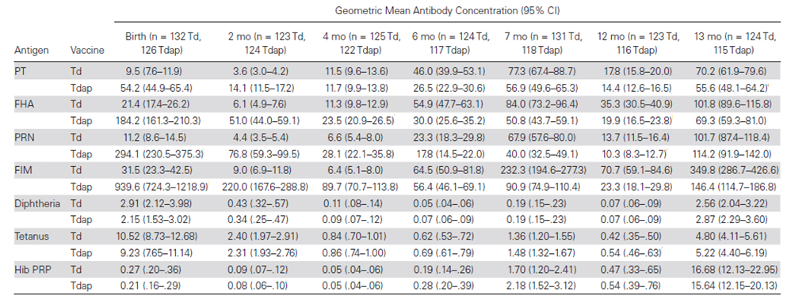
This is considered pivotal comparative data (antepartum dTPa versus Td) based on sufficient numbers in each group and administration of dTPa/Td is a standardised narrow time period between 33 and 36 weeks of gestation. It confirms the pattern of relatively subdued response to dTPa at all timepoints in the presence of antepartum maternal pertussis vaccination compared to antepartum Td control. The responses to diphtheria, tetanus and haemophilus influenza type b (Hib) antigens in infants were not affected.
Figure 2: Halperin et al., (2018) study results (responses to antigens in infants)
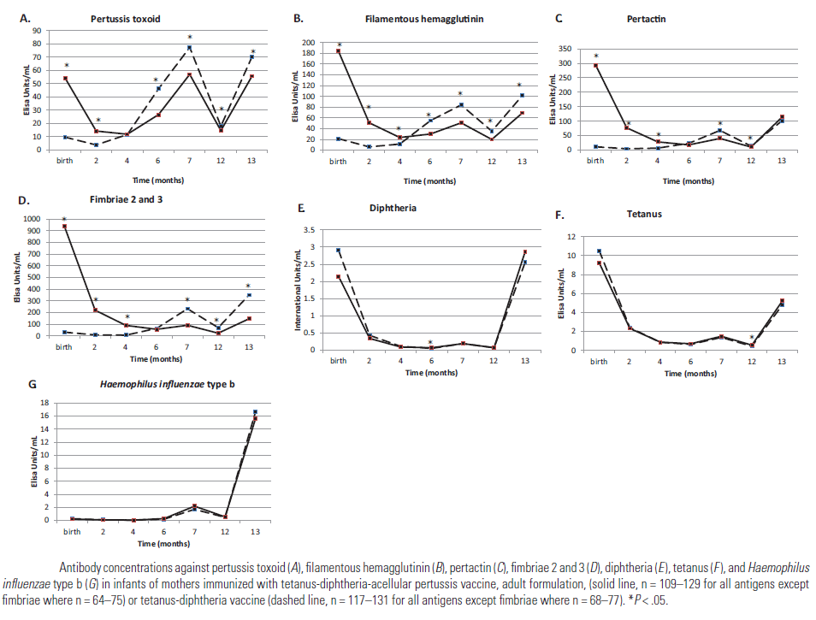

Vaccine effectiveness studies
Estimates of VE of maternal pertussis vaccination, from 4 observational studies, were available and are briefly presented below.

Amirthalingam et al., (2014 and 2016)
The Amirthalingam el al., (2014) report was based on 82 cases and 26,684 live births with maternal coverage from 1 October 2012 to 30 September2014.²⁵ It was followed by publication of Amirthalingam el al (2016) with extended coverage and a larger dataset.²⁶
Table 13: Amirthalingam et al., (2016) overview
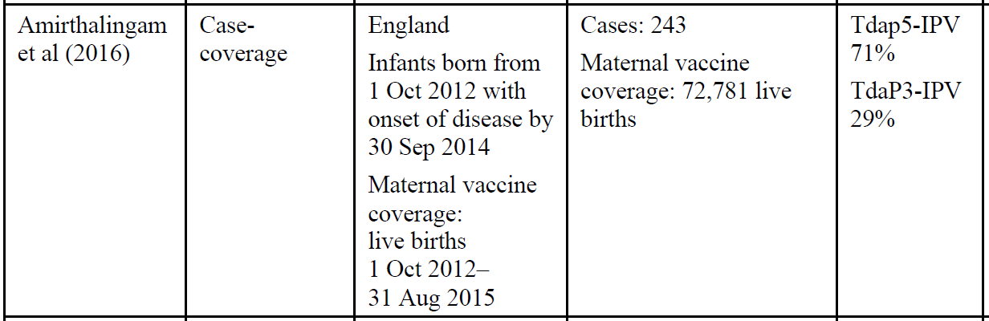
VE calculated (screening or case coverage method) as 1 minus odds of maternal vaccination in cases/odds of vaccination in matched population as reported as follows.
Table 14: Amirthalingam et al. (2016), results for maternal vaccinations at least 1 week before delivery
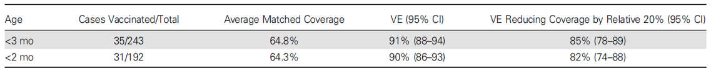
Estimates of VE by timing of maternal pertussis vaccination were as follows indicative of significant drop in VE if dTPa was given within one week of delivery or postpartum.
Table 15: Amirthalingam et al. (2016), results, vaccine effectiveness by timing of maternal vaccination
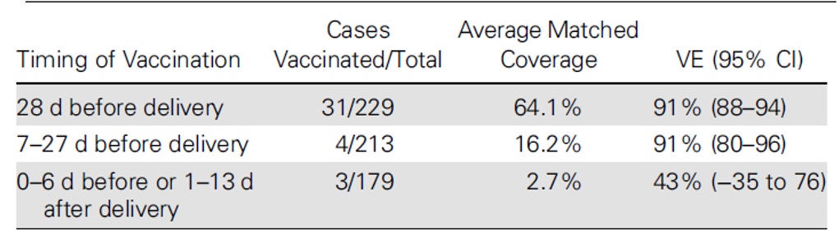
Estimates of VE by dTPa dose were as follows, indicative of declining vaccine efficacy despite the priming dTPa series; that is, clinical data consistent with the immunogenicity data seen earlier.
Table 16: Amirthalingam et al. (2016) results, vaccine effectiveness by number of doses
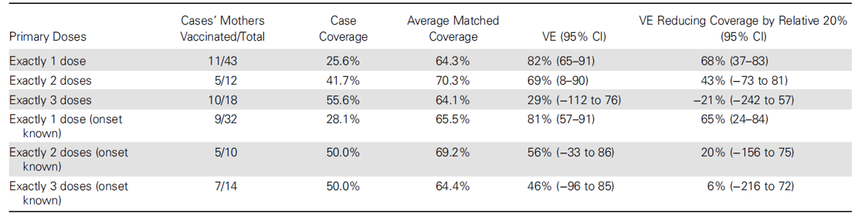

Dabrera et al., (2015)
Dabrera et al., (2015) was a case control study as follows in Table 17.²⁸
Table 17: Dabrera et al., (2015) overview
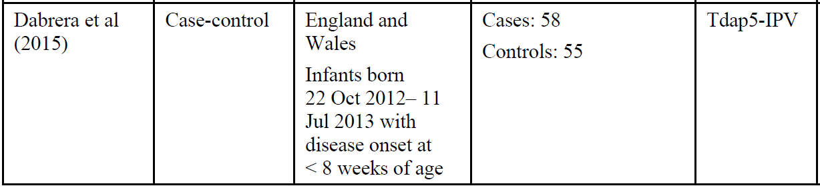
The median gestation at the time of dTPa vaccination was 31.5 weeks (range, 28 to 38 weeks) for cases and 33 weeks (range, 26 to 38 weeks) for controls. The estimate of VE was as follows in Table 18, consistent with the estimate seen in Amirthalingam et al., (2016) above (Table 15).
Table 18: Dabrera et al., (2015) results, vaccine effectiveness
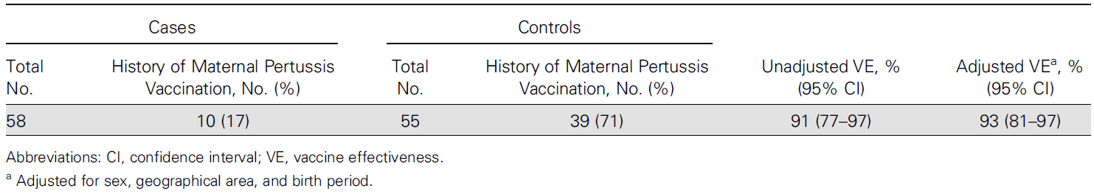

Baxter et al., (2017)
Baxter et al., (2017) was a retrospective cohort study based on larger dataset.²⁷
Table 19: Baxter et al. (2017) overview
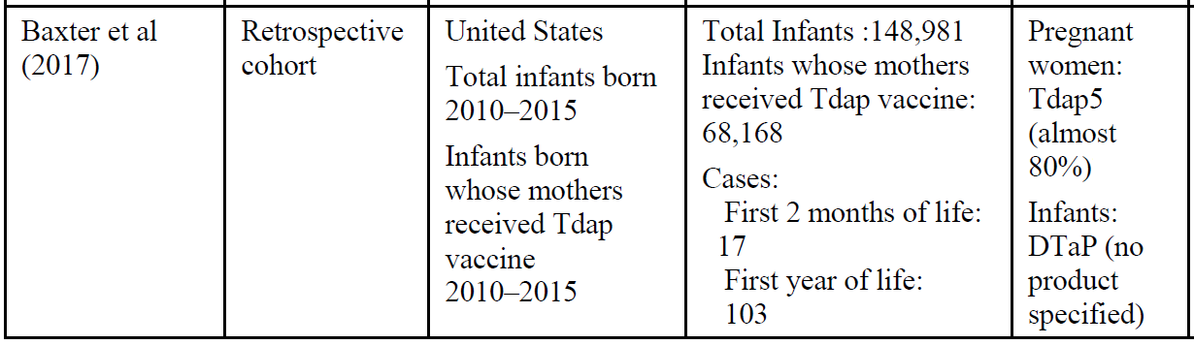
The database was Kaiser Permanente of Northern California (KPNC), which is a medical care organisation providing integrated medical services to nearly 3.7 million members. The estimates of VE can be expected to be more reliable with this larger dataset. The study had 2 overlapping (retrospective) follow-up periods from birth to 2 months of age and from birth to 1 year of age.
The VE of maternal pertussis vaccination during pregnancy was 91.4% (95% confidence interval (CI) 19.5%, 99.1%) for prevention of pertussis during 2 months follow up in infants after birth and was 69.0% (95% CI 43.6%, 82.9%) during first year of life (during which dTPa primary series was also carried out).
Table 20: Baxter et al., (2017) results, vaccine effectiveness in maternal dTpa and DTPa vaccination in preventing pertussis in 148, 981 infants following from birth until 2 and 12 months of age
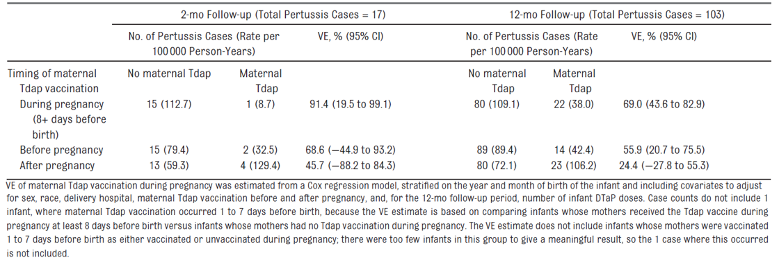
The VE was 87.9% (95% CI: 41.4%, 97.5%) before infants had any DTPa vaccine dose, 81.4% (95% CI: 42.5%, 94.0%) between Doses 1 and 2, 6.4% (95% CI: -165.1%, 66.9%) between Doses 2 and 3, and 65.9% (95% CI: 4.5%, 87.8%) after infants had 3 DTPa doses.
Table 21: Baxter et al., (2017) results, protection against pertussis from maternal dTpa vaccination during pregnancy before and after infant DTPa vaccination in 148,981 infants following from birth until 12 months of age
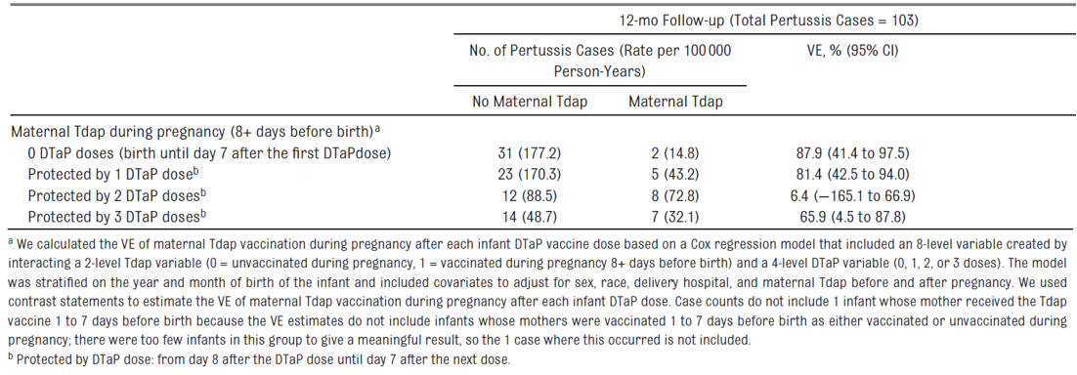

Published papers supporting proposed changes to repeat vaccination
The following studies were submitted:
- Pivotal studies
  - Study Td518
- Long-term follow up studies
  - Study TC9704-LT
  - Study Td9805-LT
  - Study Td526
  - Study Td9707-LT
The data is supportive of the update. The recommended text is same as that proposed initially at the time of submission, that is:
‘Adacel can be used for repeat vaccination, after a previous dose of dTpa or dTpa-IPV to boost immunity to diphtheria, tetanus and pertussis. Repeat vaccination should be performed according to official national recommendations.’

Clinical safety
A small risk of chorioamnionitis was noted with the use of maternal dTpa, particularly in third trimester, in a number of large observational studies. However, an association with adverse maternal, foetal, perinatal or neonatal outcomes was not found in these datasets.
Kharbanda et al., (2016);29 was a large retrospective cohort study (dTpa exposed = 53,885; unexposed = 109,253) in which risks for acute adverse events (0 to 3 and 0 to 42 days following maternal dTpa) were reported. The reporting rates were similar for the exposed and unexposed. An earlier, retrospective cohort study by Kharbanda et al., (2014); also reported birth outcomes (dTpa exposed pregnant women 26,229; unexposed 97,265) as follows in Table 22.
Table 22: Kharbanda et al., (2014) study results, rates of adverse gestational and birth outcomes and relative risks associated with receipt of dTpa during pregnancy
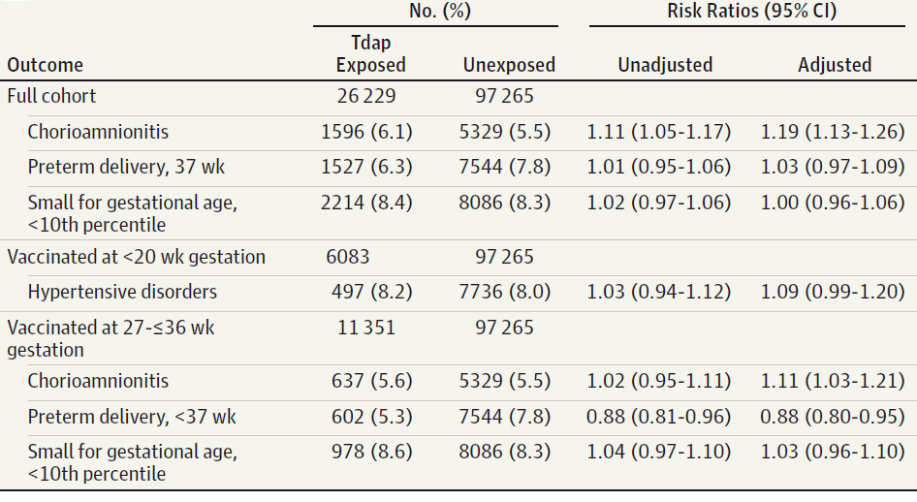
DeSilva et al., (2017);³¹ was a follow on study from the above Kharbanda et al., (2014)46 dataset. The reported adverse outcomes were as follows and the finding of chorioamnionitis was consistent with the previous data.
Table 23: DeSilva et al., (2017) study results, incidence rates, rate differences, and rate ratios of infant outcomes associated with receipt of dTpa during pregnancy at 7 Vaccine Safety Datalink sites, 2010 to 2013, (n = 197,564), by time period during pregnancy in which dTpa was administered and limiting results to infants born < 34 weeks gestation
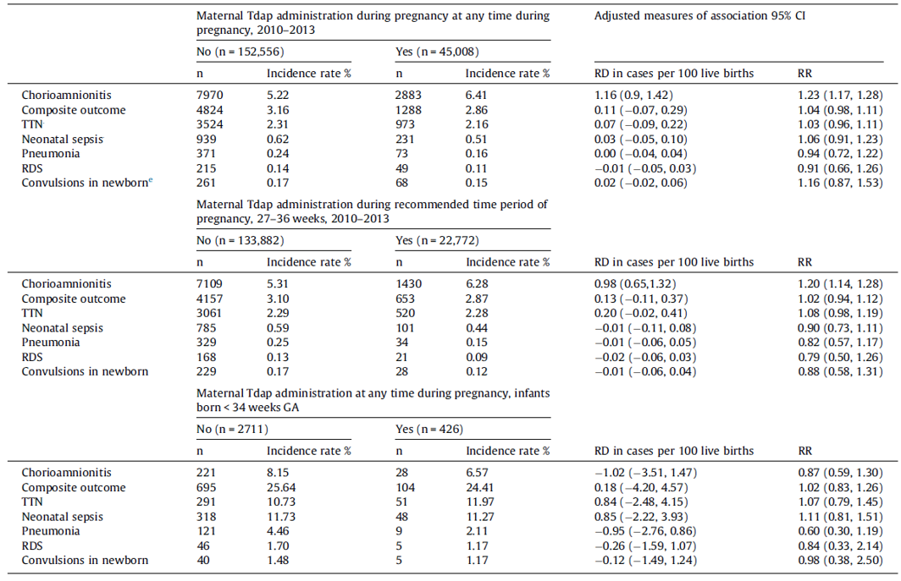
Berenson et al., (2016)41 was a small retrospective review which reported maternal and infant outcomes as shown in the following table.
Table 24: Berenson et al., (2016) study results, maternal and infant outcomes by dTpa vaccination status (n = 1,759)
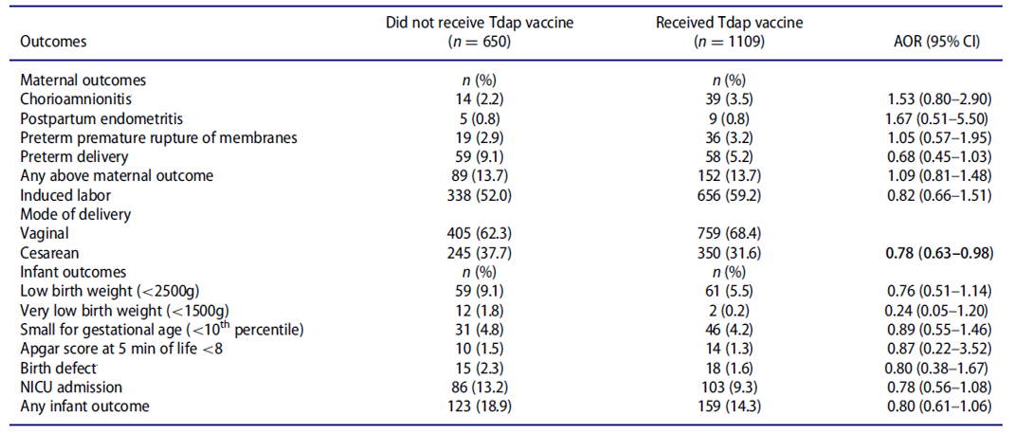
Layton et al., (2017) was a large cohort study with reported safety outcomes as follows in Table 25.⁴²
Table 25: Layton et al., (2017) study results, birth and newborn outcomes by immunisation status
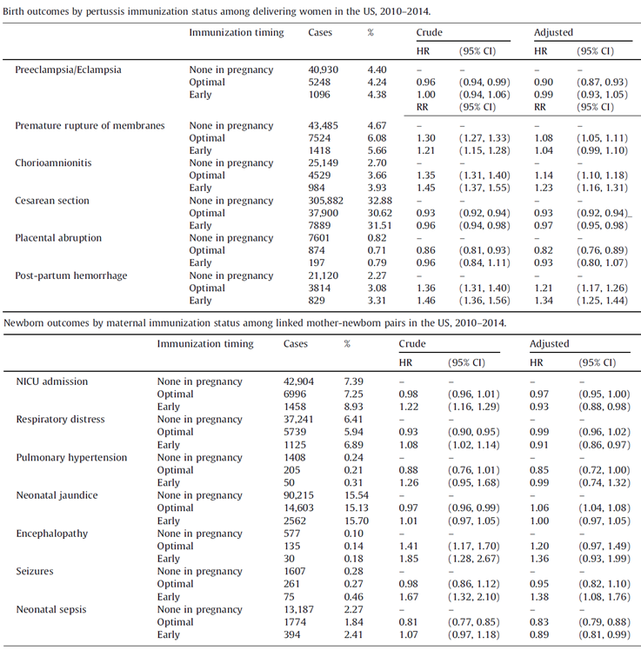
Thus chorioamnionitis appears to show up consistently in all datasets with relatively higher occurrence in dTpa exposed groups compared to dTpa unexposed controls. The related perinatal or natal outcomes are variable, uncertain due to low reporting or not affected.
Datwani et al., (2015)44 was a retrospective review of Vaccine Adverse Event Report System (VAERS) database to study any association of maternal vaccinations in pregnancy and chorioamnionitis. VAERS is a spontaneous (passive) reporting system managed by Centers for Disease Control and Prevention (CDC) and the Food and Drug Administration (FDA). A total of 31 reports of chorioamnionitis were received out of 3389 pregnancy reports in 24 years (1990 to 2014). These were evenly distributed amongst recipients of 2009 H1N1 inactivated flu vaccine, human papillomavirus vaccine that contains 4 serotypes (HPV4 vaccine), dTpa and seasonal trivalent flu vaccine. Chorioamnionitis was identified in 3 reports of spontaneous abortion and 6 stillbirths, 6 reports of pre-term birth (two of whom died) and 16 reports of term birth. Maternal outcomes included 2 reports of postpartum haemorrhage and one report of admission to the intensive care unit. A formal data mining analysis to assess disproportionate reporting or calculate crude reporting rates was not done.
Donegan et al., (2014)33 was a cohort study after a large pertussis outbreak in the UK, followed by high uptake of dTpa in third trimester of pregnancy. Predefined safety outcomes were as follows in Table 26 and did not indicate any untoward signal with the use of maternal dTpa.
Table 26: Donegan et al (2014) study results, matched cohort analysis, overall risk of predefined potential adverse events in vaccinated women and all women eligible for vaccination versus historical unvaccinated controls
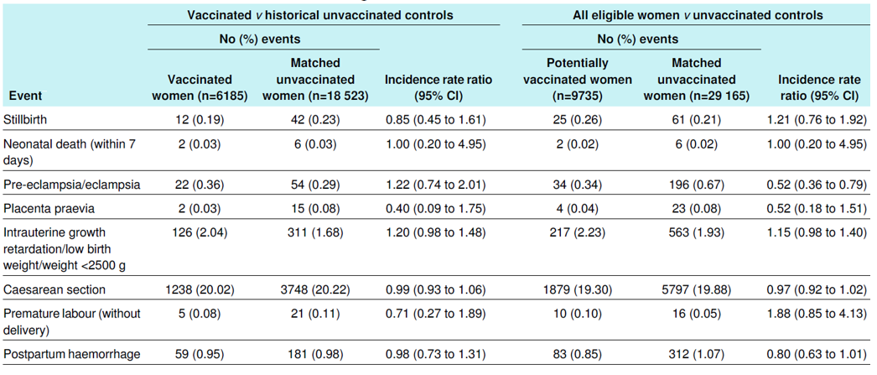
A more recent publication based on VAERS database was Moro et al., (2017)45 which sought to assess major birth defects following vaccination during pregnancy (1990 to 2014). The reported results were as follows in Table 27 and demonstrate the issue of underreporting in spontaneous safety datasets.
Table 27: Moro et al (2017) study results
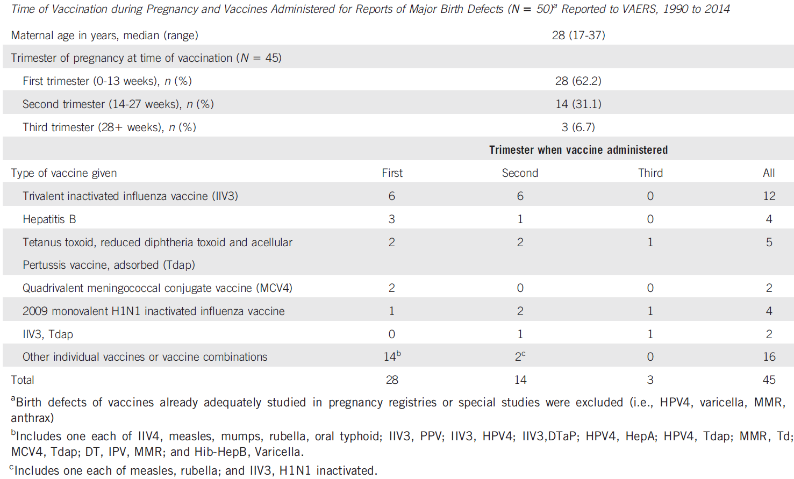

Risk management plan
The sponsor submitted European Union-Risk Management Plan (EU-RMP) version 4.0 (dated 15 May 2018; data lock point (DLP) 16 March 2017) and Australian specific Annex (ASA) version 1.0 (dated 31 May 2018) in support of this application. Adacel has been in the ARTG since 2005. The TGA has not evaluated a risk management plan (RMP) for this product previously.
The proposed summary of safety concerns and their associated risk monitoring and mitigation strategies for Australia are summarised in the Table 28.
Table 28: Summary of safety concerns
Summary of safety concerns |  | Pharmacovigilance |  | Risk Minimisation
 |  | Routine | Additional | Routine | Additional
Important identified risks | Convulsion |  | – |  | –
Important identified risks | Extensive limb swelling |  | – |  | –
Important identified risks | Hypersensitivity reactions |  | – |  | –
Important identified risks | Syncope |  | – |  | –
Important potential risks | Facial (Bell’s) palsy |  | – |  | –
Important potential risks | Guillain-Barré syndrome |  | – |  | –
Important potential risks | Brachial neuritis |  | – |  | –
Important potential risks | Myelitis |  | – |  | –
Missing information | Limited information on use in pregnant women during first trimester of pregnancy |  | * |  | –
Missing information | Limited information on use in breastfeeding women |  | * |  | –
Missing information | Duration of protection with pertussis antigens |  | – |  | –
Missing information | Immuno-compromised patients |  | – |  | –
Missing information | Patients with other relevant co-morbidities |  | – |  | –
Missing information | Sub-populations carrying known and relevant polymorphisms |  | – | – | –
*Pregnancy registry
A pregnancy registry was established by the sponsor in 2005 at request of the US FDA. Data from Australian patients is included in this registry. The TGA considers this to be acceptable as an additional pharmacovigilance activity.
Routine pharmacovigilance measures are proposed for all safety concerns. This is also considered acceptable by the TGA. There are no outstanding issues.

Risk-benefit analysis

Delegate’s considerations

Summary
- Antepartum maternal vaccination with dTpa in second or third trimester of pregnancy, for prevention of pertussis in early infant period (0 to 3 months of age), is current policy and established clinical practice in Australia as well as numerous jurisdictions around the world.
- Adacel is a 5 (toxoid and subunit) component, reduced-content, formulation (dTpa) currently approved for use as a booster from age 10 years where primary immunisation in childhood has been completed in the past.
- The diverse amount of published data evaluated in this submission show that immune responses (immunoglobulin G; IgG) to the dTpa vaccine antigens in pregnant women are similar to the immune responses in non-pregnant women. High levels are found in cord blood and efficiently transmitted across placenta.
- Passive immunity is conferred with the passage of maternal antibodies to pertussis antigens to the fetus/infant which persist up to the time of start of 3 dose priming series of DTPa at the age of 2, 3 or 4 months, providing beneficial protective effect in this uncovered period.
- The response to the primary DTPa series in infants of mothers exposed to dTpa during pregnancy is somewhat subdued compared to infants born to mothers who did not received dTpa during pregnancy. The immune responses become comparable following the fourth dose of DTPa at 12 months in infants born to dTpa exposed or unexposed mothers.
- Serological correlates of protection for pertussis have not been established. Long standing data, from a vaccine efficacy trial conducted in Sweden, were suggestive that anti-FHA levels did not correlate with clinical protection; low (< 5 IgG enzyme-linked immunosorbent assay (ELISA) units/mL) anti-PRN, high (≥ 5 ELISA units/mL) anti-PT, and low anti-FIM levels correlated with efficacy of 46.1% (95%CI: 13.9%, 66.4%); low anti-PRN combined with high anti-PT and high anti-FIM levels correlated with efficacy of 72.2% (95%CI: 22.4%, 90.1%); and high anti-PRN levels combined with high anti-PT and high anti-FIM levels correlated with an efficacy of 84.9% (95%CI: 65.0%, 93.5%).
- The mean antibody titres to DTPa in infants of dTpa exposed mothers reported in the datasets in this submission were high but only tended to be relatively lower than in infants born to controls (dTpa unexposed mothers).
- However, the VE data from observational studies in this submission, does point to a drop in VE in infants during the primary series of DTPa born to mothers who received dTpa during pregnancy compared to controls. The protection conferred until 3 months of age is unmistakable.
- Safety data are indicative of a small risk of chorioamnionitis in pregnant women following vaccination with dTpa during pregnancy. This was not associated with adverse maternal, perinatal or natal outcomes. The effect (chorioamnionitis) does not seem to be specific to dTpa vaccines and was also noted with other vaccines used in pregnancy such as inactivated influenza vaccines.

Delegate’s conclusions
- The use of Adacel in pregnancy is supported. However, this does not require update as an addition to the therapeutic indication. The indication as currently approved is up to date and specific to the use of a dTpa vaccine as booster formulation.
The recommendation that Adacel may be used in pregnancy for prevention of pertussis in infant should be placed in the dosage section following on from directions for use as a booster and preceding the recommendation to use it in pregnancy according to the national guidelines. A note here that routine DTPa, in children whose mothers received dTpa in pregnancy, according to national guidelines is also recommended.
The timing of administration of maternal dTpa in pregnancy is noted only under the proposed text in Use in Pregnancy, where it refers to the availability of most data in secondand third trimesters. This is considered acceptable.
- Change from Pregnancy Category B2;10 to B1;8 is supported. The proposed change to Category A;11 is not supported as most data relate to the use of dTpa in second and third trimester of pregnancy (data on use in first trimester is neither required nor available) and there is the finding of a small risk of chorioamnionitis of uncertain clinical significance.
- In addition, the use of dTpa vaccines in pregnancy and Category A classification is more suitable for consideration as a policy matter, along the lines of unadjuvanted, inactivated subunit influenza vaccines, by advisory bodies such as Australian Technical Advisory Group on Immunisation (ATAGI) or the Advisory Committee on Vaccines (ACV) with subsequent action by TGA if required.
- The updated recommendation for repeat (booster) vaccination (where a dTpa or dTpa-IPV has previously been given) is supported by data. The recommended text, originally submitted by the sponsor, has been noted above.
- The proposed text on interaction with the meningococcal vaccine Menactra is consistent with the findings in the previously supplied study report of Study MTA21 and is also supported.

Summary of issues
The proposed addition to the currently approved indication and the change to Pregnancy Category A are not supported.

Proposed action
The Delegate had no reason to say, at this time, that the application for Adacel should not be approved for registration, incorporating the changes recommended by the Delegate and any advice and comments from the ACV.

Request for ACV advice
The Advisory Committee on Vaccines (ACV) is requested to provide advice on the following specific issues:
- The Delegate supports the use of Adacel in pregnancy and recommends addition of recommendation to the Dosage section and Use in Pregnancy sections. Advice is requested from the ACV.
- The Delegate supports change in Adacel Pregnancy Category from B2 to B1. Advice is requested from the ACV.

Advisory Committee Considerations
The ACV, taking into account the submitted evidence of efficacy and safety, considered the vaccine Adacel, a dTpa combination vaccine formulated for adults and adolescents to have an overall positive benefit-risk profile for the extended indication [as italicised, with an addition recommended by the committee in bold].
Adacel may be administered during pregnancy for prevention of pertussis in young infants via antibody transfer from the mother.
In making this recommendation the ACV:
- noted the range of published immunogenicity studies, VE studies and clinical safety studies submitted in support of the application;
- considered the indication should be clarified to highlight that the protection for the infant is via passive prevention;
- had no objection to the proposals to update the dosage information to include a repeat (booster) vaccination after a previous dose of a dTpa containing vaccine, to boost immunity to diphtheria, tetanus and pertussis at 5 to 10 year intervals
- had no objection to the proposal to update the PI on interaction with the meningococcal A C W135 Y vaccine Menactra (also sponsored by the same sponsor).

Proposed Product Information/Consumer Medicine Information amendments
The committee recommended:
- references to the ‘Immunisation Handbook’ should be corrected to ‘current Australian Immunisation Handbook’
- the PI should state that the adverse effects profile in pregnant women does not appear different to the safety profile in non-pregnant women
- the PI should mention the large number of randomised clinical trials and observational studies undertaken in pregnant women
- minor changes for clarity in the use in pregnancy section of the PI, as italicised:
- ‘Pertussis antibody responses following vaccination with Adacel are robust in most pregnant women, are amplified when measured in newborn cord blood, persist for 2 to 4 months in the infant, but appear to blunt (reduce) the infant’s antibody responses to her or his own pertussis vaccinations later in infancy. There is no evidence to suggest that this blunting is clinically relevant in protection against pertussis’.
- ‘Several analyses have shown Adacel and Adacel Polio to be > 90% effective when given to women during pregnancy in preventing pertussis disease and hospitalisation in their among infants younger than 3 months of age.’
- mention of chorioamnionitis, including the lack of association with adverse outcomes.
The committee commented favourably on the context provided in the opening paragraph after the post-marketing experience subheading in the adverse effects section.

Specific advice
The ACV advised the following in response to the Delegate’s specific questions on the submission.
- The use of Adacel in pregnancy and the addition of recommendations to the Dosage section and Use in pregnancy section (Indications section)
The ACV advised that it is appropriate to include in the indication section of the PI the use of the vaccine during pregnancy for prevention of pertussis in young infants.
The currently approved indication refers to ‘active immunisation’. The intent of vaccination during pregnancy is not to improve the mother’s resistance to pertussis. Protection of the infant is via passive prevention in the first few months of life.
The ACV advised that it would be useful to add ‘via antibody transfer from the mother’ at the end of the indication, for clarity and to support appropriate statements in the CMI. Mention of antibody transfer in the CMI should assist in education of a pregnant woman of the need for re-vaccination during a subsequent pregnancy and that the protection of the infant is not via protection of the infant’s environment (that is, vaccine protection of the persons surrounding the infant). The term ‘passive prevention’ is technically correct but less informative than ‘antibody transfer from the mother’ for patients.
- The appropriate category under the Australian categorisation system for prescribing medicines in pregnancy
The committee noted that the sponsor sought to change the use in pregnancy categorisation from Category B2;10 to A;11 while the Delegate’s position was to change from B2 to B1 category.8
The ACV advised that Category A is more appropriate than Category B1, based on evidence of safety and benefit risk profile. Data show that the vaccine has been administered to ‘a large number’ (as per Category A) and not ‘a limited number’ (as per Category B1 and B2) of pregnant women without evidence of harm.
The ACV noted that safety data suggested a small risk of chorioamnionitis in pregnant women following vaccination with dTpa during pregnancy. This was not associated with adverse maternal, perinatal or natal outcomes. The observations on chorioamnionitis, including the lack of association with adverse outcomes, should be mentioned in the PI.

Other advice
The ACV recommended that consideration should be given to emerging literature on closely spaced repeat vaccination in women vaccinated in consecutive pregnancies; possible risks include increase in injection site reactions.
At this time there is a disconnection between the presented data on revaccination responses after 5 to 10 years in non-pregnant adults and real-world use where pregnancy is the usual basis for revaccination. Women recommended to receive the vaccine during each pregnancy will often receive several closely spaced doses of dTpa.

Outcome
Based on a review of quality, safety and efficacy, TGA approved the following extension of indications for Adacel containing pertussis vaccine-acellular combined with diphtheria and tetanus toxoids (adsorbed) 0.5mL suspension for injection vial and pre-filled needle-free syringe:
Adacel may be administered during pregnancy for prevention of pertussis in young infants via transplacental antibody transfer from the pregnant woman to the fetus.
The full indications at this time were thus:
Adacel is indicated for active immunisation against tetanus, diphtheria and pertussis in persons aged 10 years and over as a booster following primary immunisation.
Adacel may be administered during pregnancy for prevention of pertussis in young infants via transplacental antibody transfer from the pregnant woman to the fetus.
In addition, the Australian Pregnancy Category for Adacel was changed to Category A.10

Specific conditions of registration applying to these goods
- The Adacel EU-RMP (version 4.0, dated 15 May 2018; DLP 16 March 2017)), with ASA (version 1.0, dated 31 May 2018), included with submission PM-2018-01989-1-2, and any subsequent revisions, as agreed with the TGA will be implemented in Australia.
An obligatory component of risk management plans is routine pharmacovigilance. Routine pharmacovigilance includes the submission of periodic safety update reports (PSURs).
Unless agreed separately between the supplier who is the recipient of the approval and the TGA, the first report must be submitted to TGA no later than 15 calendar months after the date of this approval letter. The subsequent reports must be submitted no less frequently than annually from the date of the first submitted report until the period covered by such reports is not less than three years from the date of this approval letter. The annual submission may be made up of two PSURs each covering six months. If the sponsor wishes, the six monthly reports may be submitted separately as they become available.
- For all injectable products the Product Information must be included with the product as a package insert.

Attachment 1. Product Information
The PI for Adacel approved with the submission which is described in this AusPAR is at Attachment 1. For the most recent PI, please refer to the TGA website at <https://www.tga.gov.au/product-information-pi>.

Therapeutic Goods Administration
PO Box 100 Woden ACT 2606 Australia
Email: info@tga.gov.au Phone: 1800 020 653 Fax: 02 6232 8605
https://www.tga.gov.au

Yeung, K. et al. (2017). An update of the global burden of pertussis in children younger than 5 years: A modelling study. Lancet Infect Dis. 2017; 17: 974-980.
National Notifiable Diseases Surveillance System. Australian Government Department of Health Web site. http://www.health.gov.au/cda/source/cda-index.cfm. Accessed October 23, 2017.
Pillsbury, A., Quinn, H. and McIntyre, P. (2014). Australian vaccine preventable disease epidemiological review series: Pertussis, 2006-2012. Commun Dis Intell. 2014; 38: E179-194.
The acronym DTPa, using capital letters, signifies child formulations of diphtheria, tetanus and acellular pertussis-containing vaccines. The acronym dTpa is used for formulations that contain substantially lesser amounts of diphtheria toxoid and pertussis antigens and are usually used in adolescents and adults.
Note, the acronyms DTPa and dTpa are used throughout this document; however, in some tables and figures, the acronym TDaP and Tdap are used. TDaP is synonymous with DTPa, and Tdap is synonymous with dTpa.
World Health Organization (2015), Pertussis vaccines: WHO position paper - September 2015. Wkly Epidemiol, 2015; 90: 433-458.
Australian Technical Advisory Group on Immunisation (ATAGI). The Australian immunisation handbook 10th ed (2017 update). Canberra: Australian Government Department of Health, 2017.
Pregnancy Category B1: Drugs which have been taken by only a limited number of pregnant women and women of childbearing age, without an increase in the frequency of malformation or other direct or indirect harmful effects on the human fetus having been observed. Studies in animals have not shown evidence of an increased occurrence of fetal damage.
Note this submission does not apply to Adacel-Polio, which is approved in Australia (AUST R 106565 and 106576) for boosting from age 4 years and above and similarly has B2 classification.
Pregnancy Category B2: Drugs which have been taken by only a limited number of pregnant women and women of childbearing age, without an increase in the frequency of malformation or other direct or indirect harmful effects on the human fetus having been observed. Studies in animals are inadequate or may be lacking, but available data show no evidence of an increased occurrence of fetal damage.
Pregnancy Category A: Drugs which have been taken by a large number of pregnant women and women of childbearing age without any proven increase in the frequency of malformations or other direct or indirect harmful effects on the fetus having been observed.
Munoz, F. et al. (2014). Safety and immunogenicity of tetanus diphtheria and acellular pertussis (Tdap) immunisation during pregnancy in mothers and infants: a randomised clinical trial. JAMA, 2014; 311:1760‐1769.
Villarreal Perez, J. Z. et al. (2017). Randomised clinical trial of the safety and immunogenicity of the Tdap vaccine in pregnant Mexican women. Human Vaccines & Immunotherapeutics. 2017; 13: 128–135.
Halperin S et al. (2018). A Randomised Controlled Trial of the Safety and Immunogenicity of Tetanus, Diphtheria, and Acellular Pertussis Vaccine Immunisation During Pregnancy and Subsequent Infant Immune Response, Clin Infect Dis. 2018; 67 :1063-1071.
Hoang H et al. (2016). Pertussis vaccination during pregnancy in Vietnam: results of a randomised controlled trial Pertussis vaccination during pregnancy. Vaccine, 2016; 34: 151-159.
Healy C et al. (2013). Importance of timing of maternal combined tetanus, diphtheria, and acellular pertussis (Tdap) immunisation and protection of young infants. Clin Infect Dis. 2013; 56: 539-544.
Vilajeliu A et al. (2015). PERTU Working Group. Combined tetanus-diphtheria and pertussis vaccine during pregnancy: transfer of maternal pertussis antibodies to the newborn. Vaccine. 2015; 33: 1056-1062.
Gall S et al. (2011). Maternal immunisation with tetanus-diphtheria-pertussis vaccine: effect on maternal and neonatal serum antibody levels. Amer J Obstet Gynecol. 2011; 204: 334.e1-5.
Fallo A et al. (2016). Prevalence of pertussis antibodies in maternal blood, cord serum, and infants from mothers with and those without tdap booster vaccination during pregnancy in Argentina. J Pediatric Infect Dis Soc. 2016; 00: 1-7.
Hardy-Fairbanks A et al. (2013). Immune responses in infants whose mothers received Tdap vaccine during pregnancy. Pediatr Infect Dis J. 2013; 32: 1257-1260.
Maertens K et al. (2016). The effect of maternal pertussis immunisation on infant vaccine responses to a booster pertussis-containing vaccine in Vietnam. Clin Infect Dis. 2016; 63: s197-s204.
Vilajeliu A et al. (2016). The PERTU Working Group. Pertussis vaccination during pregnancy: antibody persistence in infants. Vaccine. 2016; 34: 3719-3722.
Ladhani S et al. (2015). Antibody responses after primary immunisation in infants born to women receiving a pertussis-containing vaccine during pregnancy: single arm observational study with a historical comparator. Clin Infect Dis. 2015; 61: 1637-1644.
Kent A et al. (2016). Pertussis antibody concentrations in infants born prematurely to mothers vaccinated in pregnancy. Pediatrics. 2016; 138: e20153854
Amirthalingam G et al. (2014). Effectiveness of maternal pertussis vaccination in England: an observational study. Lancet. 2014; 384: 1521-1528.
Amirthalingam G et al. (2016). Sustained effectiveness of the Maternal Pertussis Immunisation Program in England 3 years following introduction. Clin Infect Dis. 2016; 63: s236-243.
Baxter R et al. (2017). Effectiveness of vaccination during pregnancy to prevent infant pertussis. Pediatrics. 2017; 139: e20164091.
Dabrera G et al.(2015). A case-control study to estimate the effectiveness of maternal pertussis vaccination in protecting newborn infants in England and Wales, 2012-2013. Clin Infect Dis. 2015; 60:333-337.
Kharbanda, E. et al. (2016). Maternal Tdap vaccination: Coverage and acute safety outcomes in the vaccine safety datalink, 2007-2013. Vaccine. 2016; 34: 968-973.
Morgan, J. et al. (2015). Pregnancy outcomes after antepartum tetanus, diphtheria, and acellular pertussis vaccination. Obstet Gynecol. 2015; 125: 1433-1438.
DeSilva, M. et al. (2017). Maternal Tdap vaccination and risk of infant morbidity. Vaccine. 2017; 35: 3655-3660.
Zheteyeva Y et al. (2012). Adverse event reports after tetanus toxoid, reduced diphtheria toxoid, and acellular pertussis vaccines in pregnant women. Am J Obstet Gynecol. 2012; 207: 59.e1-7.
Donegan K, et al. (2014). Safety of pertussis vaccination in pregnant women in UK: observational study. BMJ. 2014; 349: g4219.
Sukumaran L, et al. (2015). Safety of tetanus toxoid, reduced diphtheria toxoid, and acellular pertussis and influenza vaccinations in pregnancy. Obstet Gynecol. 2015; 126: 1069-1074.
Sukumaran L et al. (2015). Association of Tdap vaccination with acute events and adverse birth outcomes among pregnant women with prior tetanus containing immunisations, JAMA. 2015; 314:1581-1587.
Regan A et al. (2016). A prospective cohort study assessing the reactogenicity of pertussis and influenza vaccines administered during pregnancy. Vaccine. 2016;34: 2299-2304.
Moro P et al. (2016). Enhanced surveillance of tetanus toxoid, reduced diphtheria toxoid, and acellular pertussis (Tdap) vaccines in pregnancy in the Vaccine Adverse Event Reporting System (VAERS), 2011-2015. Vaccine. 2016; 34: 2349-2353.
Perry J et al.; (2017). Patient reaction to Tdap vaccination in pregnancy. Vaccine. 2017; 35:3064-3066.
Talbot E et al. (2010). The safety of immunizing with tetanus-diphtheria-acellular pertussis vaccine (Tdap) less than 2 years following previous tetanus vaccination: experience during a mass vaccination campaign of healthcare personnel during a respiratory illness outbreak. Vaccine. 2010; 28: 8001-8007.
Shakib J et al. (2013). Tetanus, diphtheria, acellular pertussis vaccine during pregnancy: pregnancy and infant health outcomes. J Pediatr. 2013; 163: 1422-1426.
Berenson A et al. (2016). Maternal and infant outcomes among women vaccinated against pertussis during pregnancy. Hum Vaccines Immunother. 2016; 12: 1965-1971.
Layton et al. (2017). Prenatal Tdap immunisation and risk of maternal and newborn adverse events. Vaccine. 2017; 35: 4072-4078.
Zerbo, et al. (2016). Kaiser Permanente Northern California pregnancy database: Description and proof of concept study. Vaccine. 2016; 34: 5519-5523.
Datwani et al.. (2015). Chorioamnionitis following vaccination in the Vaccine Adverse Event Reporting System. Vaccine. 2015; 33: 3110-3113.
Moro P et al. (2017). Brief report: major birth defects after vaccination reported to the Vaccine Adverse Event Reporting System (VAERS), 1990 to 2014. Birth Defects Res. 2017; 109: 1057-1062.
Kharbanda, E. O. et al (2014). Evaluation of the Association of Maternal Pertussis Vaccination With Obstetric Events and Birth Outcomes, JAMA. 2014; 312: 1897–1904.
Routine risk minimisation activities may be limited to ensuring that suitable warnings are included in the product information or by careful use of labelling and packaging. Routine pharmacovigilance practices involve the following activities: - All suspected adverse reactions that are reported to the personnel of the company are collected and collated in an accessible manner; - Reporting to regulatory authorities; - Continuous monitoring of the safety profiles of approved products including signal detection and updating of labelling; - Submission of PSURs; - Meeting other local regulatory agency requirements.
Gustafsson et al. (1995). Efficacy trial of acellular pertussis vaccine. Technical report trial 1. Stockholm, Sweden: Swedish Institute for Infectious Disease Control; 31 August 1995.
Storsaeter et al. (1998). Levels of anti-pertussis antibodies related to protection after household exposure to Bordetella pertussis. Vaccine. 1998;16: 1907-1916.
The Advisory Committee on Vaccine (ACV) provides independent medical and scientific advice to the Minister for Health and the Therapeutic Goods Administration (TGA) on issues relating to the safety, quality and efficacy of vaccines supplied in Australia including issues relating to pre-market assessment, post-market monitoring and safe use in national immunisation programs. The Committee is established under Regulation 39F of the Therapeutic Goods Regulations 1990 and the members are appointed by the Minister for Health. The ACV was established in January 2017, following consolidation of previous functions of the Advisory Committee on the Safety of Vaccines (ACSOV) and the pre-market functions for vaccines of the Advisory Committee on Prescription Medicines (ACPM). Membership comprises professionals with expertise in specific scientific, medical or clinical fields, or consumer health issues.

