April 2021

Australian Public Assessment Report for Perampanel hemisesquihydrate
  - Proprietary Product Name: Fycompa
  - Sponsor: Eisai Australia Pty Ltd

About the Therapeutic Goods Administration (TGA)
- The Therapeutic Goods Administration (TGA) is part of the Australian Government Department of Health and is responsible for regulating medicines and medical devices.
- The TGA administers the Therapeutic Goods Act 1989 (the Act), applying a risk management approach designed to ensure therapeutic goods supplied in Australia meet acceptable standards of quality, safety and efficacy (performance) when necessary.
- The work of the TGA is based on applying scientific and clinical expertise to decision-making, to ensure that the benefits to consumers outweigh any risks associated with the use of medicines and medical devices.
- The TGA relies on the public, healthcare professionals and industry to report problems with medicines or medical devices. TGA investigates reports received by it to determine any necessary regulatory action.
- To report a problem with a medicine or medical device, please see the information on the TGA website <https://www.tga.gov.au>.

About AusPARs
- An Australian Public Assessment Report (AusPAR) provides information about the evaluation of a prescription medicine and the considerations that led the TGA to approve or not approve a prescription medicine submission.
- AusPARs are prepared and published by the TGA.
- An AusPAR is prepared for submissions that relate to new chemical entities, generic medicines, major variations and extensions of indications.
- An AusPAR is a static document; it provides information that relates to a submission at a particular point in time.
- A new AusPAR will be developed to reflect changes to indications and/or major variations to a prescription medicine subject to evaluation by the TGA.

Copyright
© Commonwealth of Australia 2021
This work is copyright. You may reproduce the whole or part of this work in unaltered form for your own personal use or, if you are part of an organisation, for internal use within your organisation, but only if you or your organisation do not use the reproduction for any commercial purpose and retain this copyright notice and all disclaimer notices as part of that reproduction. Apart from rights to use as permitted by the Copyright Act 1968 or allowed by this copyright notice, all other rights are reserved and you are not allowed to reproduce the whole or any part of this work in any way (electronic or otherwise) without first being given specific written permission from the Commonwealth to do so. Requests and inquiries concerning reproduction and rights are to be sent to the TGA Copyright Officer, Therapeutic Goods Administration, PO Box 100, Woden ACT 2606 or emailed to <tga.copyright@tga.gov.au>.

Contents
List of abbreviations 4
I. Introduction to product submission 6
Submission details 6
Product background 8
Regulatory status 10
Product Information 11
II. Registration timeline 12
III. Submission overview and risk/benefit assessment 12
Quality 12
Nonclinical 13
Clinical 13
Risk management plan 51
Risk-benefit analysis 52
Outcome 63
Attachment 1. Product Information 64

List of abbreviations
Abbreviation | Meaning
ABNAS | Aldenkamp-Baker Neuropsychological Assessment Schedule
ACM | Advisory Committee on Medicines
AE | Adverse event
AED | Antiepileptic drug
AMPA | α-amino-3-hydroxy-5-methyl-4-isoxazolepropionic acid
ARTG | Australian Register of Therapeutic Goods
ASA | Australian specific Annex
AUC | Area under the concentration-time curve
CGI | Clinical Global Impression
CGI-C | Clinical Global Impression of Change
CHMP | Committee for Medicinal Products for Human Use (European Medicines Agency)
CI | Confidence interval
CL/F | Apparent clearance
C_{max} | Maximum plasma concentration
CV | Coefficient of variation
CYP3A | Cytochrome P450, family 3, subfamily A
DDI | Drug-drug interaction
DLP | Data lock point
EAP | Extended access program
EEG | Electroencephalogram
EIAED | Enzyme-inducing antiepileptic drug
EMA | European Medicines Agency (European Union)
EU | European Union
FDA | Food and Drug Administration (United States of America)
GTCS | Generalised tonic clonic seizure
GVP | Good Pharmacovigilance Practices
IGE | Idiopathic generalised epilepsy
IGF | Insulin-like growth factor
IGF-1 | Insulin-like growth factor-1
LOCF | Last observation carried forward
MedDRA | Medical Dictionary for Regulatory Activities
PD | Pharmacodynamic(s)
PGTC | Primary generalised tonic-clonic
PGTCS | Primary generalised tonic-clonic seizure
PI | Product Information
PIP | Paediatric Investigation Plan
PK | Pharmacokinetic(s)
Pop PK | Population PK
POS | Partial-onset seizure
PSUR | Periodic safety update report
RMP | Risk management plan
SAE | Serious adverse event
SCAR | Severe cutaneous adverse reaction
SD | Standard deviation
SGTC | Secondarily generalised tonic-clonic
SGTCS | Secondarily generalised tonic-clonic seizure
t_{½} | Elimination half-life
TEAE | Treatment emergent adverse event
US(A) | United States (of America)

I. Introduction to product submission

Submission details
Type of submission: | Extension of indications  New formulation
Product name: | Fycompa
Active ingredient: | Perampanel hemisesquihydrate
Decision: | Approved
Date of decision: | 11 February 2021
Date of entry onto ARTG: | 16 February 2021
ARTG numbers: | 207690, 207689, 207688, 207687, 207692, 207691, 332505
Black Triangle Scheme: | Yes  This product will remain in the scheme for 5 years, starting on the date the new indication was approved

Sponsor’s name and address: | Eisai Australia Pty Ltd  Level 2, 437 St Kilda Road  Melbourne, VIC, 3004
Dose forms: | Film coated tablets, oral suspension
Strengths: | 2 mg, 4 mg, 6 mg, 8 mg, 10 mg, and 12 mg film-coated tablets  2 mg/4 mL oral suspension
Containers: | Blister pack, bottle
Pack sizes: | 2 mg film-coated tablets: blisters of 7 tablets  4 mg, 6 mg, 8 mg, 10 mg and 12 mg film-coated tablets: blisters of 28 tablets  Oral suspension: one bottle
Approved therapeutic use: | Fycompa is indicated for the adjunctive treatment of:  - Partial-onset seizures (POS) with or without secondarily generalised seizures in patients from 4 years of age with epilepsy.  - Primary generalised tonic-clonic seizures (PGTCS) in patients from 7 years of age with idiopathic generalised epilepsy.
Route of administration: | Oral
Dosage: | Fycompa must be titrated, according to individual patient response, in order to optimise the balance between efficacy and tolerability. Fycompa should be taken orally once daily at bedtime.  The physician should prescribe the most appropriate formulation and strength according to weight and dose. Alternate formulations of perampanel are available, including an oral suspension.  For further information regarding dosage, refer to the Product Information.
Pregnancy category: | B3  Drugs which have been taken by only a limited number of pregnant women and women of childbearing age, without an increase in the frequency of malformation or other direct or indirect harmful effects on the human fetus having been observed.  Studies in animals have shown evidence of an increased occurrence of fetal damage, the significance of which is considered uncertain in humans.  The use of any medicine during pregnancy requires careful consideration of both risks and benefits by the treating health professional. This must not be used as the sole basis of decision making in the use of medicines during pregnancy. The TGA does not provide advice on the use of medicines in pregnancy for specific cases. More information is available from obstetric drug information services in your State or Territory.

Product background
This AusPAR describes the application by Eisai Australia Pty Ltd (the sponsor) to register Fycompa (perampanel hemisesquihydrate) 2 mg, 4 mg, 6 mg, 8 mg, 10 mg, and 12 mg film-coated tablets for the following proposed extension of indications in the paediatric population:
Partial onset (focal) seizures with or without secondary generalisation
- Fycompa is indicated for adjunctive treatment in paediatric patients from 2 to 11 years of age with epilepsy.
Primary generalised tonic clonic seizures
- Fycompa is indicated for adjunctive treatment in paediatric patients from 2 to 11 years of age with idiopathic generalised epilepsy
The sponsor also sought to register a new oral suspension dosage form (2 mg/4 mL oral suspension) for the following indications (identical to the full proposed indications for the film coated tablet dosage form):
Partial onset (focal) seizures with or without secondary generalisation
- Fycompa is indicated for adjunctive treatment in adult and adolescent patients from 12 years of age with epilepsy.
- Fycompa is indicated for adjunctive treatment in paediatric patients from 2 to 11 years of age with epilepsy.
Primary generalised tonic clonic seizures
- Fycompa is indicated for adjunctive treatment in adult and adolescent patients from 12 years of age with idiopathic generalised epilepsy.
- Fycompa is indicated for adjunctive treatment in paediatric patients from 2 to 11 years of age with idiopathic generalised epilepsy
Epilepsy is a common neurological disease that affects approximately 50 million people worldwide. Multiple antiepileptic drugs (AEDs) have been developed in an effort to control seizures in patients with epilepsy (including sodium or calcium channels blockers); however, 20 to 30% of patients are still refractory to currently available drug treatments. This is the rationale behind development of adjuvant therapies to patients who are refractory to their current AEDs.
Epilepsy is broadly classified into partial onset epilepsy, in which seizures begin in an epileptogenic focus and spread to other parts of the brain, or primary generalised epilepsy, in which the whole brain network enters a seizure at the same time. In most seizures, the involved neurons fire frequently and excessively for the duration of the seizure. In some forms of primary generalised epilepsy, such as absence epilepsy, neural activity is abnormally synchronised at the network level rather than excessive at the level of individual neurons. A classic major convulsive seizure, known as a generalised tonic-clonic seizure (GTCS) usually consists of full-body stiffening (termed the tonic phase) followed by jerking of all four limbs (termed the clonic phase), with loss of awareness either at or near the start of the seizure. In a primary generalised tonic-clonic seizure (PGTCS), the whole brain network enters the seizure at the same time, and the subject does not usually remember the onset of the seizure. A partial onset seizure (POS) that begins in one region of the brain may spread to involve the whole brain, leading to a secondarily generalised tonic-clonic seizure (SGTCS). In such cases, the subject may often remember the focal phase of the seizure, because some parts of the brain were still working during the focal phase, but often the focal phase is too rapid to be clinically noticeable.
Children with epilepsy, particularly infants, differ from adults not only in the manner that their seizures present clinically, but also due to the unique aetiologies, presence of unique aetiologies, electroencephalogram (EEG) patterns, and their response to anti-seizure medications. The immature brain, particularly in the neonate and young infant, differs from the adult brain in the basic mechanisms of epileptogenesis and propagation of seizures.
Seizures in younger children differ significantly from those in older children and adults. Children older than six years tend to have seizures that are quite similar to those of adults, whereas younger children and infants have less complex behaviours, particularly with focal seizures with impairment of awareness. Moreover, there are age-specific changes in the types of seizures. It is hypothesised that these changes might be the result of the differences in the connectivity and functionality of different brain regions. Determination of an alteration of awareness is difficult in infants and young children. In addition, their behaviours during a seizure tend to be less complicated and more fragmented than those in older children. Typical generalised tonic-clonic and absence seizures are extremely uncommon in the first two years of life and never occur in the newborn.
Perampanel is a selective, non-competitive, orally active antagonist of the AMPA receptor. AMPA receptors mediate fast-excitatory synaptic transmission (see Figure 1, below), generating and spreading epileptic activity. Perampanel has already shown efficacy in adults and adolescents, when used as adjunctive (add-on) therapy for both PGTCS and POS, including secondarily generalised tonic-clonic (SGTC) seizures. In the submission described in this AusPAR, the sponsor applied to extend the indications of Fycompa film-coated tablets to include the paediatric population, and to register a new oral suspension formulation as a bioequivalent and interchangeable alternative to the currently approved tablet formulation.
Figure 1: Schematic representation of the synaptic junction and the brain targets common to the neurobiology and pharmacology of epilepsy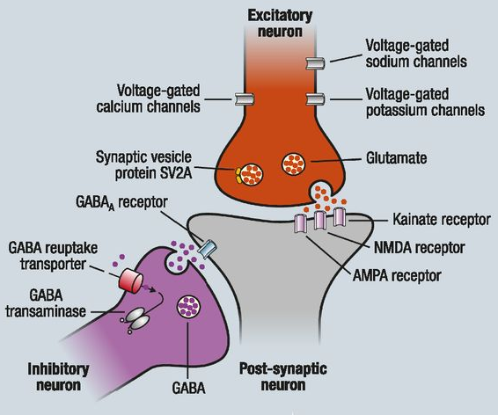
Example of a prototypical excitatory (glutamate)/inhibitory (GABA) synapse modulating the activity of a forebrain postsynaptic neuron. Postsynaptic targets include glutamate (NMDA, AMPA, and kainite receptors) and GABA_{A} receptors. SV2A is a membrane glycoprotein that regulates neurotransmitter release from secretory vesicles. Voltage-gated K+, Na+, and Ca2+ channels modulate the action potential and resting membrane potential thus controlling neuronal firing activity. GABA transaminase catabolises GABA into succinic semialdehyde.
GABA = gamma-aminobutyric acid; GABA_{A} = gamma-aminobutyric acid A receptor; NMDA = N-methyl-D-aspartate; SV2A = synaptic vesicle protein 2A.
Source: Brodie et al. 2016.

Regulatory status
The film coated tablet products received initial registration on the Australian Register of Therapeutic Goods (ARTG) on 23 May 2014 for the following indication:
Fycompa is indicated for the adjunctive treatment of partial-onset seizures with or without secondary generalised seizures in patients with epilepsy aged 12 years and older.
The following extension of indications for the film coated tablets was registered on 13 May 2016:
Fycompa is indicated for the adjunctive treatment of primary generalised tonic-clonic seizures in adult and adolescent patients from 12 years of age with idiopathic generalised epilepsy.
At the time the TGA considered this application, similar applications had been approved in the European Union (EU), the United States of America (USA) and in Canada (as shown in Table 1, below).
Table 1: International regulatory status of paediatric extension of indications as of November 2020, select regions only
Region | Submission date | Status | Approved indications
EU | 28 August 2019 | Approved on 10 November 2020 | Fycompa (perampanel) is indicated for the adjunctive treatment of:  - • partial-onset seizures (POS) with or without secondarily generalised seizures in patients from 4 years of age and older.  - • primary generalised tonic-clonic (PGTC) seizures in patients from 7 years of age and older with idiopathic generalised epilepsy (IGE).
USA | 28 March 2018 | Approved on 27 September 2018 | Treatment of POS with or without secondarily generalized seizures in patients with epilepsy 4 years of age and older
Canada | 13 March 2019 | Approved on 25 February 2020 | Fycompa (perampanel) tablets and oral suspension are indicated as:  • adjunctive therapy in the management of partial-onset seizures in patients 7 years of age and older, who are not satisfactorily controlled with conventional therapy  - • adjunctive therapy in the management of primary generalized tonic-clonic (PGTC) seizures in patients 12 years of age and older with epilepsy, who are not satisfactorily controlled with conventional therapy.
The sponsor has stated that an original application to extend perampanel to include paediatric use was withdrawn in the EU in April 2019. The sponsor is requested to clarify the reason for withdrawal (see ‘Questions for the sponsor’ section, below).
The oral suspension formulation has been approved in the EU (approved on 19 September 2016), in the USA (approved on 29 April 2016), in Canada (approved on 21 December 2016) and in Switzerland (approved on 16 April 2020).

Product Information
The Product Information (PI) approved with the submission which is described in this AusPAR can be found as Attachment 1. For the most recent PI, please refer to the TGA website at <https://www.tga.gov.au/product-information-pi>.

II. Registration timeline
The following table captures the key steps and dates for this application and which are detailed and discussed in this AusPAR.
Table 2: Timeline for Submission PM-2019-05359-1-1
Description | Date
Submission dossier accepted and first round evaluation commenced | 2 January 2020
First round evaluation completed | 9 June 2020
Sponsor provides responses on questions raised in first round evaluation | 3 August 2020
Second round evaluation completed | 15 October 2020
Delegate’s Overall benefit-risk assessment and request for Advisory Committee advice | 3 November 2020
Sponsor’s pre-Advisory Committee response | 16 November 2020
Advisory Committee meeting | 3 and 4 December 2020
Registration decision (Outcome) | 11 February 2021
Completion of administrative activities and registration on the ARTG | 16 February 2021
Number of working days from submission dossier acceptance to registration decision* | 197
*Statutory timeframe for standard applications is 255 working days

III. Submission overview and risk/benefit assessment
The submission was summarised in the following Delegate’s overview and recommendations.

Quality
The extension of indications for Fycompa (perampanel) film-coated tablets for use in paediatric patients (2 to 11 years) was not evaluated by the quality evaluator as there is no change to any quality aspect of these products.
In regard to the new oral suspension formulation, the quality evaluator summarised the following points:
- The new formulation (oral suspension) has been chosen due to the low aqueous solubility of perampanel.
- Study 048 was included to demonstrate bioequivalence between the 12 mg tablet and 12 mg dose of oral formulation under fasted and fed conditions in healthy subjects.
- The oral suspension was concluded to be bioequivalent to the 12 mg tablet under fasted conditions. The oral suspension was not bioequivalent to the 12 mg tablet under fed conditions. The 90% confidence interval (CI) for the maximum plasma concentration (C_{max}) (72.6 to 82.7%) was on the lower side and outside the acceptance criteria of 80 to 125% to conclude bioequivalence. However, given that the 90% CI for the area under the concentration-time curve (AUC) (94.8 to 102.8%) was still within the criteria under fed condition; the method of administration in the PI ‘It may be taken with or without food’ was still considered supported.
Approval is recommended for registration of the proposed oral suspension product from a quality perspective.

Nonclinical
There was no requirement for a nonclinical evaluation in a submission of this type.

Clinical
The clinical information submitted by the sponsor included the following:
- One open-label pharmacokinetics (PK)/tolerability study (Study 232) that also assessed efficacy as a minor endpoint.
- One safety/PK study (Study 311) that also assessed efficacy as a minor endpoint.
- One comparative bioavailability study (Study 048) that compared the proposed oral suspension formulation with tablets.
- A brief description of Study 028, which was said to be a pilot bioavailability; the actual study report for this study was not submitted.
- A population PK (Pop PK) analysis of Study 311 in conjunction with previously evaluated studies in adults and adolescents.
- A Pop PK/pharmacodynamics (PD) analysis of Study 311 in conjunction with previously evaluated studies in adults and adolescents.
- A ‘meta-analysis’ of previously published studies of other anticonvulsant drugs used to treat primary generalised epilepsy, seeking to show that efficacy in adults and children is similar across different drugs and different studies.
- Literature references, including two papers (Pellock et al 2012; and Pellock et al, 2017) that included a ‘meta-analysis’ of previously published POS efficacy studies and argued that extrapolation of adult efficacy data was appropriate for POS.
- A few days prior to the clinical evaluator completing the clinical evaluation report, the sponsor submitted the European extension of indication variation assessment report, which summarised a number of concerns that the European Medicines Agency (EMA) had about the proposed extension of indications. This report arrived too late for a comprehensive evaluation, but the key conclusions were listed within the clinical evaluation report.
- After completion of the first round clinical evaluation report and second round clinical evaluation report, the sponsor submitted two new studies, in support of the sponsor’s response to TGA’s clinical questions. Study 235 was performed in adolescents. It was classified as a PD study but it was primarily evaluable for safety. Study 311 (Extension A) was a long term open-label extension of the main, open-label efficacy study assessing perampanel in children. Both of these studies are described in the ‘Safety’ section of this AusPAR.

Pharmacology

Pharmacokinetics
The following is a summary of known PK parameters of perampanel in adults:
- Perampanel absorption is rapid and essentially complete (with approximately 100% bioavailability), with negligible first-pass metabolism.
- Perampanel is 95% bound to plasma proteins.
- The volume of distribution in healthy volunteers averages 77 L.
- Perampanel is extensively metabolised via primary oxidation and sequential glucuronidation, with the metabolism primarily mediated by cytochrome P450 3A (CYP3A).
- The average elimination half-life (t_{1/2}) of perampanel is 105 hours, in subjects not receiving enzyme-inducing agents.
- When perampanel is administered in combination with the strong inducer carbamazepine, the average t_{1/2} is 25 hours.
- Perampanel exhibits dose linearity between 2 to 12 mg.
- Perampanel has a wide therapeutic window.

Population pharmacokinetics
The Pop PK data was referred to the TGA Pharmacometrics Working Group for expert advice. Based on the modified Pop PK model and the dosing approach, the working group has concluded that the systemic exposure of perampanel in children 4 to < 12 years of age is comparable to adolescents and adults.
Demographics: there were four subjects younger than 4 years of age included in the PK model (see Table 3). Fifty-nine children were in the 4 to < 7 year age group. 135 children in the 7 to < 12 years age group and 226 adolescents were included in the model. The model was dominated by adults (n = 1912). Around half of the subjects were on enzyme-inducing agents such as carbamazepine. The majority of subjects had a diagnosis of POS.
Table 3: Demographics and covariates in the population pharmacokinetic analysis of perampanel
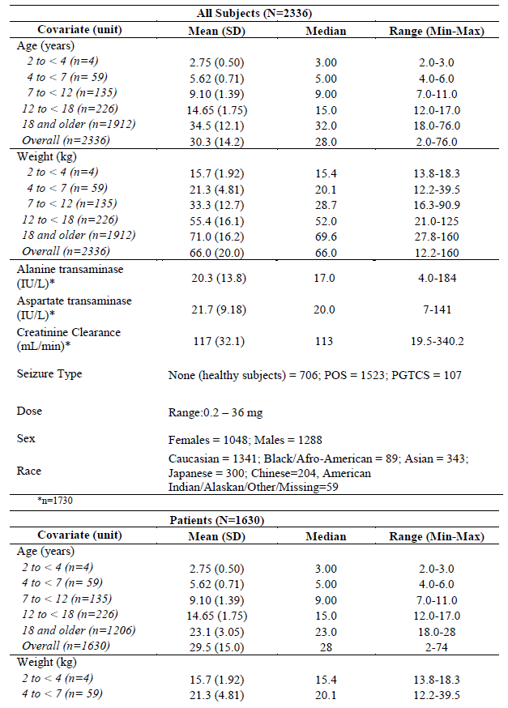
Max = maximum; Min = minimum; SD = standard deviation.
The proposed extension of indications is heavily dependent on the extrapolation principles based on Pop PK data. During the EMA evaluation, the evaluator highlighted critical issues with the initial PopPK model that the sponsor had submitted. The sponsor stated that the weight of the subjects had no effect on apparent clearance (CL/F). Dosage based on that model would have resulted in a higher exposure to perampanel in children, compared to adults.
The sponsor's initial Pop PK model had the following issues:
- The model was not based on allometric scaling for body weight effect on PK parameters such as CL/F and volume of distribution.
- Simulations were not performed based on weight based dosing.
- Very low number of subjects in the < 4 years age group.
- Children from 4 to < 7 years of age with epilepsy had a dose normalised AUC that was 1.76 fold greater, compared to patients of 18 years and above (independent of association with inducers).
- The PK parameters in subjects in the < 12 years age group had the most impact from this approach. There was a reduction in the ETA CL/F in subjects < 40 kg and also < 12 years of age (see Figure 2).
Figure 2: No allometric scaling for apparent clearance
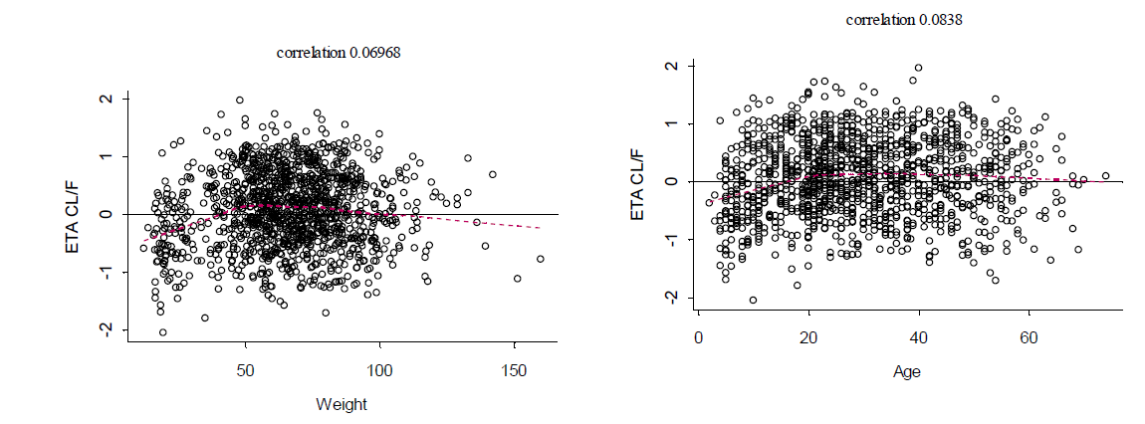
The sponsor resubmitted a PopPK model to the EMA, and also to the TGA, that included allometric (fixed) scaling for body weight effect with a factor of 0.75 for inter-compartment clearance and 1 for central and peripheral volumes of distribution for all subjects. The implementation of scaling on all subjects has altered the correlation between weight, age and the CL/F (see Figure 3). The issue with the revised model presented was that the allometry was performed upon weight without consideration of CL/F maturation with age.
Figure 3: Apparent clearance scaling applied to all subjects
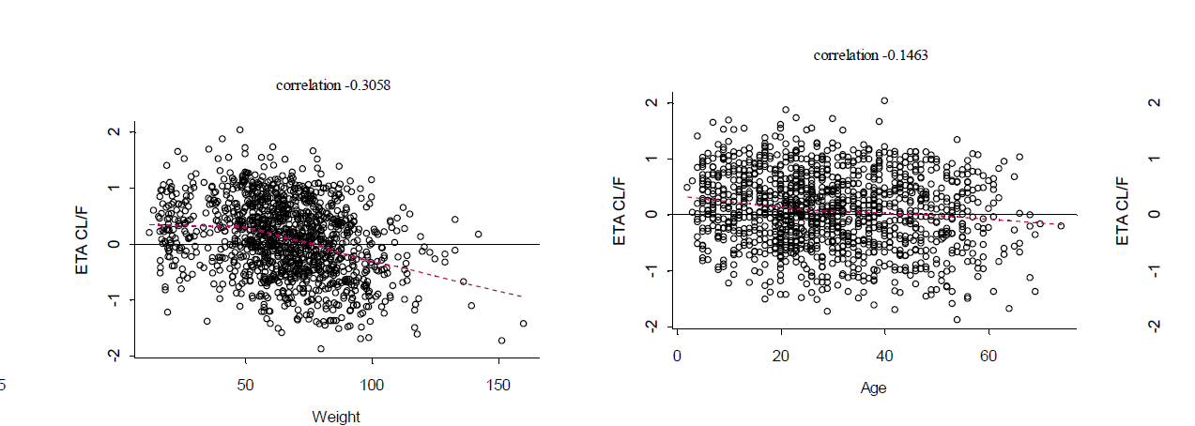
The Pharmacometric Working Group recommended to develop a model that includes a maturation component and allometric weigh effect.
In response to the Working Committee's recommendation, the sponsor submitted the explanation that the CYP3A activity matures by around 2 years of age and hence a maturation component is not required to be included in the model. The Committee considered that the CYP3A activity is not the sole factor that determines clearance of perampanel. Rather, it is determined by total hepatic activity which is affected by the liver weight, blood flow, total microsomal content, liver blood flow and protein binding. These factors does not reach adult levels until late teens.
The sponsor's approach to remove allometric scaling at 18 years of age (when body weight stabilises) had limitations. However, it was considered by the Committee as an empirical approach. The sponsor has adopted a weight-based dosing and modified the indication by limiting the age group from 4 to < 12 years, rather than the initial proposal of from 2 to < 12 years of age. The Committee considered this approach as acceptable.
Figure 4: Apparent clearance scaling for subjects < 18 years only
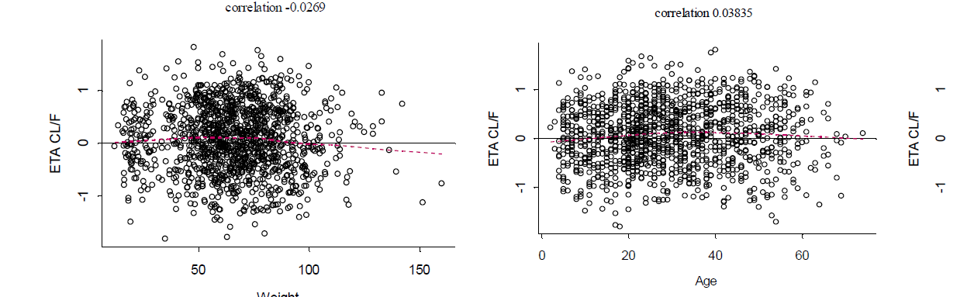
The mean AUC for perampanel in Figure 5 and Table 4 in the 7 to < 12 years age group are comparable with adolescents and adults. However, the mean AUC for children in the 4 to < 7 years of age group was considerably higher than the adolescents and adults (see Table 4). The Pharmacometric Working Group has noted that the maximum value for AUC for children in the 4 to < 7 years of age group was comparable to adolescents and adults and there was a considerable overlap between the 95% CI of the perampanel AUCs in children, adolescents and adults (see Figure 5). Based on these observations, the Working Group concluded that the systemic exposure of perampanel in children 4 to < 7 years of age is comparable to adolescents and adults. The magnitude of effect of inducers on the PK of perampanel was comparable across children and adults.
Figure 5: Predicted perampanel area under the concentration time curve at steady state versus weight (kg) /dose (mg), non induced N = 100
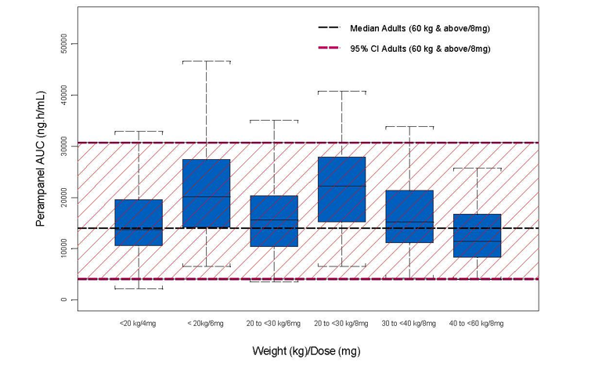
AUC = area under the concentration time curve; CI = confidence interval.
Table 4: Summary of individual dose normalised area under the concentration time curve across age groups and concomitant antiepileptic drugs
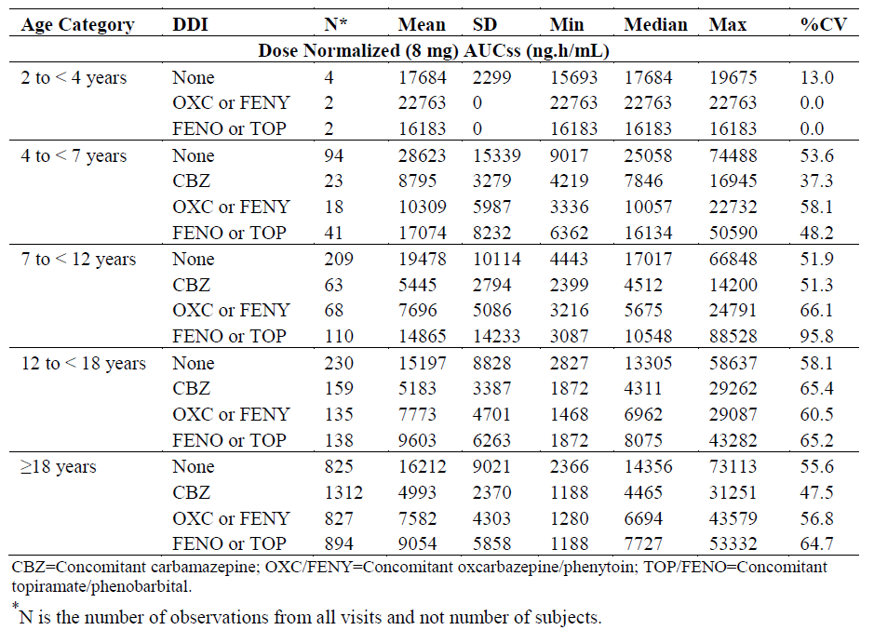
CV = coefficient of variation; DDI = drug-drug interaction; SD = standard deviation.

Effect of food on oral suspension
The evaluator has concluded that the minor 10 to 13% reduction in AUC with food is unlikely to be of clinical significance, and the 22% reduction in C_{max} would be expected to reduce peak-dose tolerability issues without compromising efficacy. The Delegate agrees with this conclusion. This information is included in the proposed PI.

Pharmacodynamics
The sponsor has pooled the efficacy data from these studies and combined the data from PK and efficacy studies in adolescents and adults to produce a model to describe the PK/PD relationship for perampanel in subjects of all ages, for both POS and PGTCS. The evaluator considered the paediatric data as sub-optimal, since the efficacy data was based on uncontrolled studies. In addition, the sponsor had pooled the data based on an assumption that the efficacy is comparable across age groups. However, there was no evidence to support this assumption. Based on these aspects, the evaluator concluded that PK/PD models did not serve the purpose of extrapolating the efficacy of perampanel from adults to children. The Delegate agrees with this conclusion.

Efficacy
The sponsor's approach was to use the Pop PK model to extrapolate efficacy of perampanel that has been demonstrated in adults and adolescents to children < 12 years of age. No studies that evaluated efficacy as a primary outcome were included in this submission. Studies 232 and 311 were primarily designed to examine the safety of perampanel in the targeted patient population. The sponsor also included meta-analyses of studies in children with POS and PGTCS.

Meta-analysis of studies in children with partial-onset seizures
A meta-analysis by Pellock et al., (2012)7 was referred to by the sponsor for a comparison of data between POS studies in adults and children. In these studies, efficacy was expressed using standard measures of placebo-subtracted changes in seizure frequency and response rates. Thirty studies were included in this analysis. Placebo-subtracted median percent seizure reduction between Baseline and treatment periods ranged from 7.0% to 58.6% in adults and from 10.5% to 31.2% in children. The ≥ 50% responder rate ranged from 2.0% to 43.0% in adults and from 3.0% to 26.0% in children. In children < 2 years of age, an insufficient number of trials were eligible for analysis. The overall efficacy data suggest a comparable treatment benefit for adults and children, for the anti-epileptics that were included in the studies. The wide range of treatment response for perampanel was noted.
The limitations of this meta-analysis were:
- Perampanel was not used in any of these studies. Moreover, the AEDs used in these studies did not have comparable mechanism of action to perampanel (gabapentin, lamotrigine, levatiracetam, oxcarbazepine and topiramate).
- The pathophysiological differences in epilepsy across the age groups of children (2 to 17 years of age) included in the studies:
  - The EEGs from very young children (2 to 4 years of age) are very distinct from those of 17 years old children and adults. This is attributed to the difference in background rhythms in very young children, compared to adolescents and adults.

Sponsor's meta-analysis of primary generalised tonic-clonic seizure studies
In response to the EMA's request, the sponsor conducted a meta-analysis for PGTCS studies. Seven studies were included in this analysis. The meta-analysis did not have the criteria to include studies with AEDs that has been assessed in both adults and children.
The following limitations were noted, and most of them were conceded by the sponsor:
- Low number of children in the 4 to 16 years age group.
- None of the studies involved treatment with perampanel in both children and adults.
- ‘Adults’ were defined as subjects > 12 years of age in most studies and > 16 years in one study, resulting in an inconsistent overlap of age groups.
- The AEDs used in these studies and perampanel did not have a comparable mechanism of action.
- The sponsor used an estimated standard deviation (SD) from one study (French et al., 2015) and applied it across all studies. This approach could introduce an unknown error in the estimates.
- A standard difference was used to compare treatment difference across studies in adults and children. The standard difference was the difference in medians between drug treated patients and placebo treated patients divided by the SD. The evaluator considered that this approach to normalise the efficacy might have created a unit-less measure of efficacy (based on reduction in seizure frequency from Baseline, for the primary analysis).
It was noted that the ‘standard difference’ between active treatment and placebo was about 0.53 in the double-blind stage of adult/adolescent studies, and about 0.59 in the double-blind stage of child/adolescent studies.
In summary, the evaluator concluded that the methodological limitations outweigh the findings from these meta-analyses.
The Delegate agrees with the evaluator's conclusions regarding these meta-analyses and hence the data was not considered as providing supportive evidence for the proposed indication.

Study 311
Study design: open label, multicentre, uncontrolled, single arm study.
Patient population: children 4 to < 12 years of age with inadequately controlled POS or PGTCS. Safety and efficacy of perampanel oral suspension was assessed as an adjunctive therapy to ongoing treatment with 1 to 3 AEDs.
Study period: November 2016 to July 2018.
The study primarily consisted of a Core study period and an Extension Phase A. For subjects enrolled in Japan and in countries where an extended access program (EAP) could not be implemented, subjects could also enter an Extension Phase B after completion of Extension Phase A. Subjects were stratified by age into two groups (4 to < 7 years, ≥ 7 to < 12 years) at randomisation.
The screening period lasted for up to 4 weeks ± 3 days. The treatment phase consisted of 3 periods: a titration period (up to 11 weeks), a maintenance period (up to 12 weeks), and a follow-up period (lasting up to 4 weeks ± 7 days, but only for those subjects who did not roll over into Extension A).
Table 5: Study 311 design
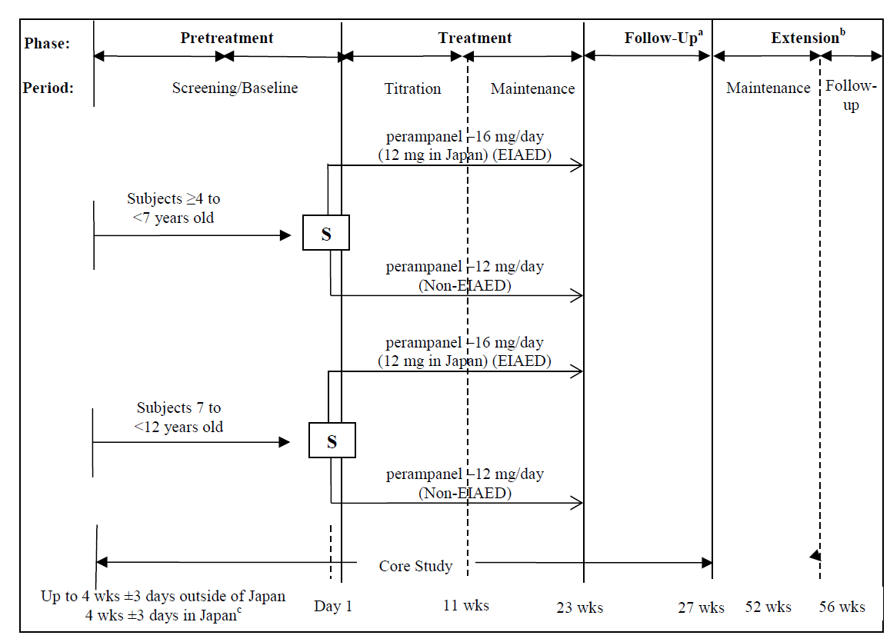
Follow-up may have occurred during the core study (if the subject discontinued during the core study), or during the extension A or extension B, after the termination of study treatment.
EIAED = enzyme-inducing antiepileptic drug, S = stratified, wks = weeks.
a: Subjects had a follow-up visit 4 weeks (± 7 days) after the end of the treatment and a final assessment completed if they did not roll over into Extension A; b: Subjects who were enrolled in Japan and in countries where an EAP could not be implemented, and completed the Extension A were eligible to enrol in Extension B; c: Subjects in Japan were required to complete 4 full weeks ± 3 days of the screening/baseline period.
The primary objective of the study was to evaluate safety and tolerability of perampanel oral suspension in children aged 4 to 12 years of age with inadequately controlled POS or PGTC seizures.
Key secondary objectives were:
- To characterise the PK of perampanel and the relationship between perampanel plasma concentrations, efficacy, and safety using population PK/PD modelling.
- To evaluate the efficacy of perampanel as measured by the median percent change per 28 days in seizure frequency, by the proportion of responders (≥ 25%, ≥ 50%, and ≥ 75%), and by the proportion of subjects who were seizure-free for POS, PGTC, and generalised tonic-clonic seizures.
- To assess the effects of perampanel on the Clinical Global Impression rating scales (CGI), as measured by the Clinical Global Impression of Change (CGI-C).

Key inclusion criteria
The key inclusion criteria were:
- Children 4 to< 12 years of age.
- Minimum weight of 16 kg.
- Diagnosis of epilepsy with POS (with or without SGTC or PGTC seizures).
- The diagnosis of POS or PGTC should have been established at least 6 months prior to screening by clinical history and be associated with an EEG that was consistent with the diagnosis; normal interictal EEGs were allowed, provided that the subject met the other diagnosis criteria.
- Brain imaging scan prior to Visit 1 that ruled out a progressive cause of epilepsy.
- One or more POS or PGTC seizures during the 12 weeks ± 3 days prior to entry into the treatment phase (Visit 2).
- Maintained on stable doses of one to a maximum of three AEDs for at least 4 weeks prior to Visit 1 (or at least 8 weeks when a new AED regimen had been initiated).
- Only one enzyme-inducing antiepileptic drug (EIAED), such as carbamazepine, phenytoin, oxcarbazepine, or eslicarbazepine, was allowed out of the maximum of three AEDs.

Key exclusion criteria
The key exclusion criteria were:
- History of status epilepticus that required hospitalisation during the 6 months before Visit 1.
- Current or history of pseudo-seizures (psychogenic, non-epileptic seizures) within approximately 5 years before Visit 1.

Study treatments
All subjects received open label perampanel oral suspension. During the titration period, subjects were stratified by the presence or absence of concomitant EIAEDs. Perampanel was commenced at a dose of 2 mg/day for subjects not on EIAEDs and at a dose of 4 mg/day for those on EIAEDs. The perampanel dose was then titrated no more frequently than at weekly intervals based on individual clinical response and tolerability. The initial target of perampanel dose was 8 mg/day for non-EIAED subjects and 12 mg/day for EIAED subjects. The maximum individual doses were up to 12 mg/day and up to 16 mg/day for subjects without and with EIAEDs for treatment of epilepsy respectively. Regardless of EIAED status, subjects enrolled in Japan could not receive doses higher than 12 mg/day.

Efficacy endpoints
The key efficacy endpoint was the percentage reduction in seizure frequency compared to the Baseline period. Other efficacy endpoints were the proportion of treatment responders and the proportion of subjects who were seizure-free during maintenance and long-term treatment period (52 weeks).
A responder was defined as a subject achieving at least 50% reduction in seizure frequency (assessed separately for total seizures and for individual seizure types), compared to Baseline.

Statistical methods
No formal hypothesis testing was performed. Descriptive statistics was used to report efficacy results. The evaluator has highlighted the potential impact of the uncontrolled and unblinded design of the study on the interpretation of the efficacy outcomes. The issues are largely due to the potential effect of regression-to-mean and natural variability in the background seizure pattern of children enrolled in this study.
For the purpose of registration in Japan, the sponsor was asked to compare the efficacy results of Study 311 to the placebo arm of a previously conducted study in adults using perampanel (Study 335). The Study 311 findings were considered positive if the upper bound of the 95% confidence interval of reduction in seizure frequency was greater (more negative) than 10.5%.

Sample size
A sample size of 160 subjects was considered as adequate for safety evaluation in children < 12 years of age. This assumption was based on previously conducted Phase III studies in adolescents that supported the registration of perampanel for the treatment of POS and PGTC seizures in that patient population.

Participant flow
180 subjects were treated with perampanel. Around 81% of the subjects completed the study. 7.8% of subjects discontinued due to adverse events (AEs). The Safety Analysis Set consisted of 180 subjects who received at least one dose of the study treatment.
Overall, 9.4% of subjects had major protocol deviations, with 6% and 25.8% of subjects in the POS and PGTS cohorts respectively. Most of the protocol deviations were inclusion of subjects who did not meet the inclusion criteria. Five of the six subjects who did not meet the entry criteria of the study were in the PGTC cohort. These subjects had other generalized seizure types (myoclonic, clonic, and tonic), but not the tonic-clonic or POS that were required for eligibility.

Baseline characteristics
The mean age was around 8 years, with the youngest subject at 4 years of age and the oldest at 11 years of age. Around 50% of the subjects were males. The mean weight was 28 kg. The lowest weight recorded was 16 kg and the highest was 64.7 kg. There appears to be a considerable overlap in terms of the seizure patterns across POS and PGTCS. Seven subjects in PGTS cohort were detected with ‘localisation of epileptogenic region’, which is not in line with their PGTS diagnosis (see Table 6). Around 6% of subjects listed as having PGTCS in fact had POS with SGTCS. Similarly, nine subjects in POS cohort were having absence seizures, which are a type of generalised seizures, by definition.
Table 6: Study 311 Epilepsy-specific medical history by disease cohort, Safety Analysis Set
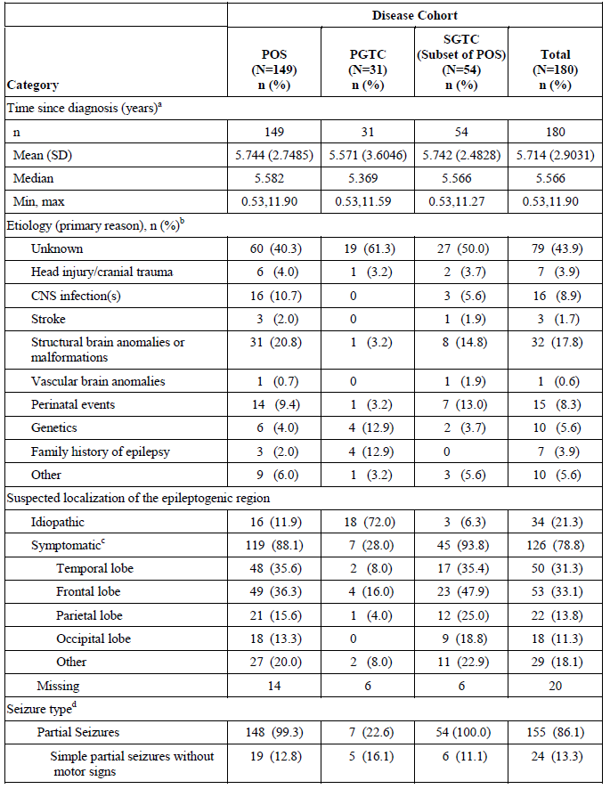
Table 6 (continued): Study 311 Epilepsy-specific medical history by disease cohort, Safety Analysis Set
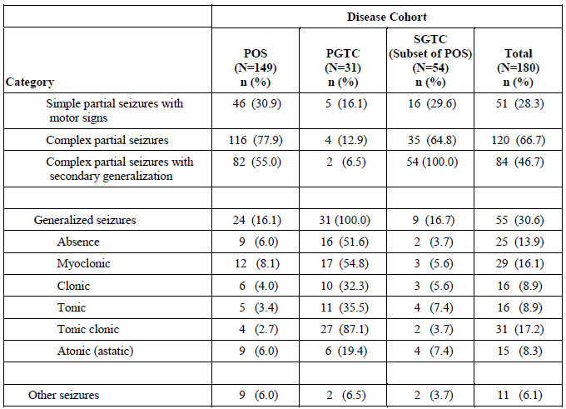
Subjects were assigned as POS or PGTC by the investigator. SGTC was the subset of POS subjects who recorded secondarily generalised seizures during the Baseline period. Percentages were based on the total number of subjects with non-missing values in relevant treatment group.
CNS = central nervous system; PGTC = primary generalised tonic-clonic; POS = partial-onset seizure; SD = standard deviation; SGTC = secondarily generalised tonic-clonic.
a: (Screening date – date of diagnosis)/365.25. If the day or month of diagnosis was missing, the day was imputed to be the first of the month and the month was imputed to be January. If imputed date was before the birth date, the birth date was used in place of time from diagnosis; b: Only a subject’s primary reason was listed; c: Multiple suspected localizations of the epileptogenic region may have been recorded; d: Multiple seizure types may have been recorded.

Results

Seizure frequency
At 23 weeks of treatment period, the median percent change in seizure frequency per 28 days, from Baseline, was -40.1% (95% CI, -52.6%, –31.4%) for total POS seizures and -69.2% (95% CI, –100.0%, –17.7%) for PGTC seizures (see Table 7). The median change in seizure frequency was -58.7% for SGTCS.
In the POS cohort, there were 40 children in the 4 to < 7 years age group and 109 children in 7 to < 12 years age group. There was an overall reduction in the seizure frequency across age groups.
In PGTCS cohort, there were three children in the 4 to <7 years and 19 children in the 7 to < 12 years age group.
The Delegate commented that the very low number of children in the PGTS cohort has limited the ability to make any conclusions regarding the treatment benefit of perampanel, in terms of reduction in seizure frequency. The upper bound of confidence interval of up to 1217 (for the percent change in seizure frequency indicates the impact of low number of subjects on the outcomes).
Table 7: Study 311 Seizure frequency per 28 days and percent change during treatment summary for age cohort by each disease cohort, Full Analysis Set
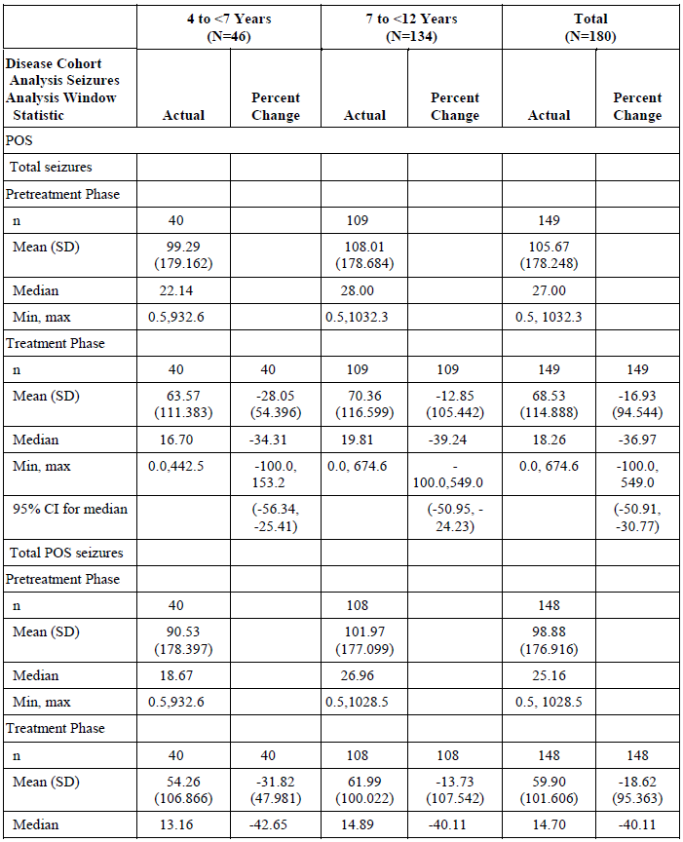
Table 7 (continued): Study 311 Seizure frequency per 28 days and percent change during treatment summary for age cohort by each disease cohort, Full Analysis Set
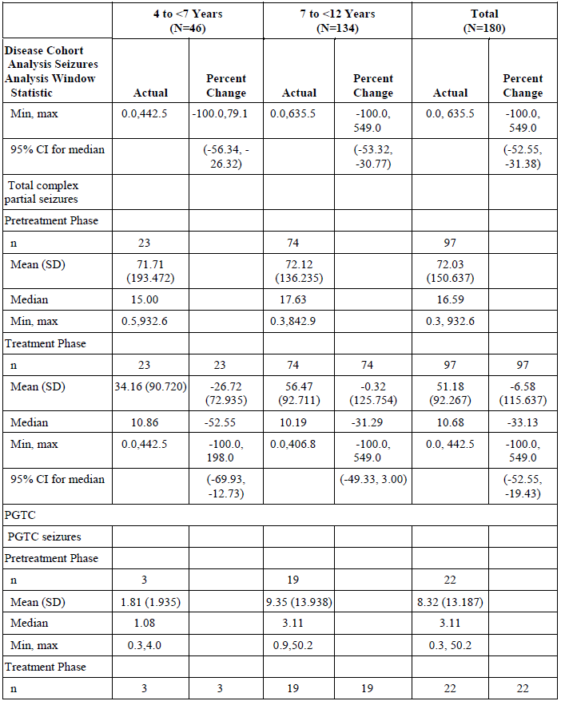
Table 7 (continued): Study 311 Seizure frequency per 28 days and percent change during treatment summary for age cohort by each disease cohort, Full Analysis Set
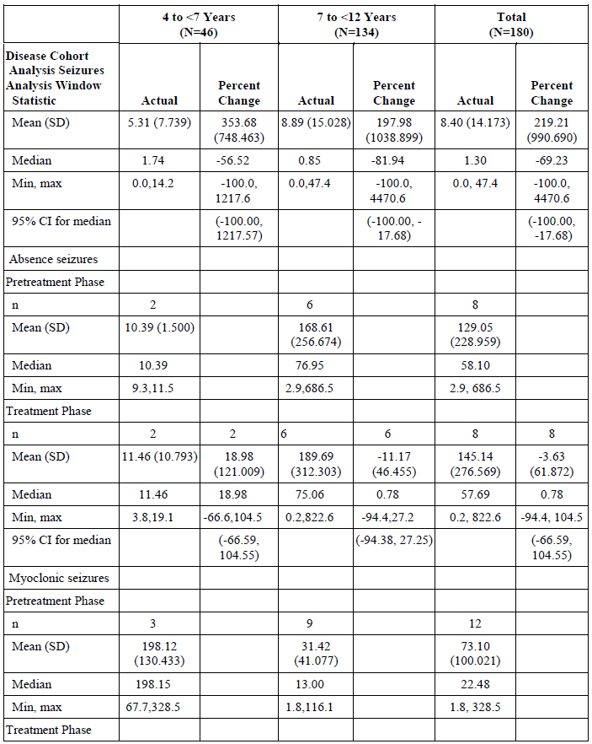
Table 7 (continued): Study 311 Seizure frequency per 28 days and percent change during treatment summary for age cohort by each disease cohort, Full Analysis Set
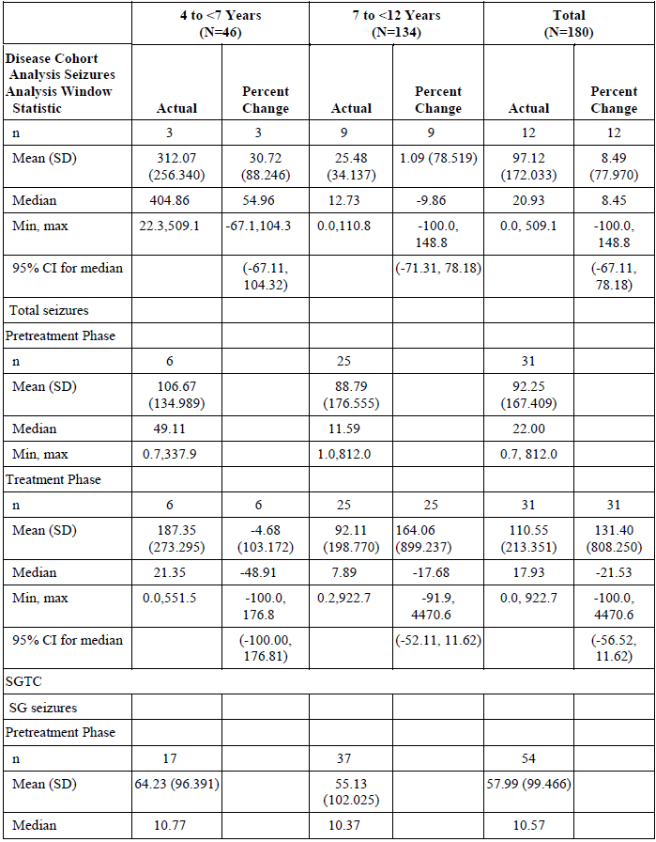
Table 7 (continued): Study 311 Seizure frequency per 28 days and percent change during treatment summary for age cohort by each disease cohort, Full Analysis Set
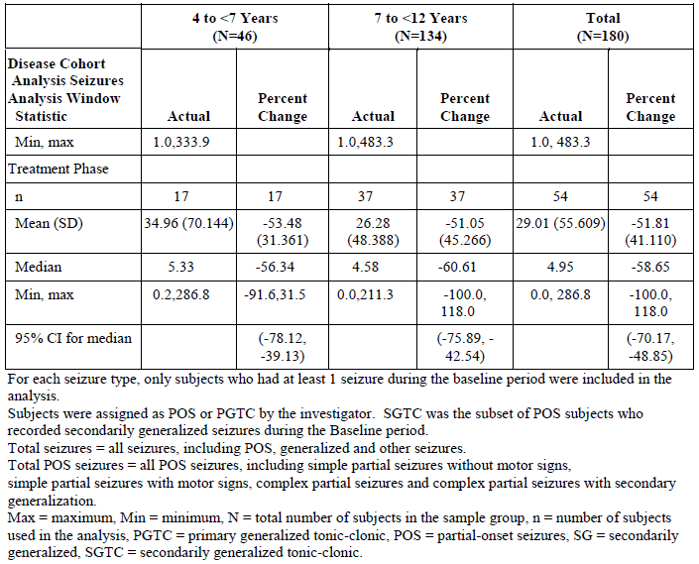
The median reduction in total POS seizure frequency in the POS cohort was -34.0% (95% CI, -59.5%, 9.0%) in subjects with concomitant EIAEDs and -42.2% (95% CI, -53.8%, -32.1%) in subjects without concomitant EIAEDs.
The median reduction in PGTC seizure frequency in the PGTC cohort was -69.2% (95% CI, -100.0%, -17.7%) in subjects without EIAEDs. There were no subjects with PGTCS who were on concomitant EIAEDs at Baseline.
The analysis of the Japanese cohort was broadly consistent with the results obtained in the full cohort. In Japanese subjects, the median percent change in seizure frequency in the POS cohort, compared to Baseline, was -37.0 (95% CI, -52.6%, -25.5%). The pre-specified criterion of having the upper limit of the 95% CI for the change in frequency below -10.5% was met (that is, the magnitude of the change was greater than 10.5%).

Response rates
A reduction in seizure frequency of ≥ 50% or greater was achieved in 69 (46.6%) subjects for total POS seizures in the POS cohort and in 14 (63.6%) subjects for PGTC seizures in the PGTC cohort. The proportion of subjects with reductions of ≥ 50% in seizure frequency was comparable across the age ranges of 4 to < 7 years and ≥ 7 to < 12 years of children in both POS and PGTC cohorts.
Across the EIAED cohorts, seizure reductions of ≥ 50% for total POS seizures in the POS cohort were 21 (45.7%) and 48 (47.1%) in subjects with or without concomitant EIAEDs, respectively. A reduction of ≥ 50% was achieved in 14 (63.6%) subjects without concomitant EIAEDs in the PGTC cohort. There were no PGTC subjects in the inducer cohort.
Seizure-free status in the Maintenance Period was achieved in 17 (11.5%) subjects in the POS cohort and 12 (54.5%) in the PGTC cohort. The seizure-free rates in subjects aged 4 to < 7 years and ≥ 7 to < 12 years were 3 (7.5%) and 14 (13.0%) in POS cohort. The results were numerically better in the PGTC cohort, but they are based on low patient numbers, with 2 (66.7%) and 10 (52.6%) subjects in the 4 to < 7 years and ≥ 7 to < 12 years of age cohorts achieving seizure free status.
None of the subjects were seizure free at 53 to 65 weeks. This observation indicates the natural variability of the condition.

Clinical Global Impression of Change
At Baseline, 58.9% of subjects responded as either normal (not at all ill), or borderline or mildly ill, 18.3% of subjects were moderately ill, and 22.8% of subjects were either markedly ill, severely ill, or extremely ill.
At Week 23, 145 subjects had CGI-C observations recorded. 52 (42.6%) subjects in the POS cohort and 8 (34.8%) subjects in the PGTC rated CGIC as ‘Very much improved’ or ‘Much improved’ compared to Baseline. 18 (14.8%) subjects in the POS cohort and 6 (26.1%) subjects in the PGTC cohort rated CGIC as ‘No change’ compared to Baseline.

Study 232
Study design: open label pilot study to generate preliminary safety, tolerability and efficacy data for perampanel oral suspension in children from 2 to 12 years of age with epilepsy.
Subjects were stratified based on age at enrolment: Cohort 1 consisted of subjects 7 to 12 years of age and cohort 2 consisted of subjects from 2 to 7 years of age.
Core study consisted of 2 phases. The pre-treatment phase for up to 2 weeks and treatment phase that consisted of a titration period (7 weeks), maintenance period (4 weeks) and follow up period (4 weeks), if not rolling over to the extension phase.
The primary objective of the study was to evaluate PK of perampanel in children.
The secondary objectives were to evaluate short and long term safety, tolerability and efficacy of perampanel. The long term effect of perampanel on growth in children was also evaluated.

Key inclusion criteria
The key inclusion criteria were:
- Children 2 to 12 years of age.
- Diagnosis of epilepsy with any types of seizures at least 6 months prior to Visit 1 (clinical history and EEG).
- At least one seizure during the 4 weeks prior to Visit 1.
- Brain computed tomography or magnetic resonance imaging to rule out a progressive cause of epilepsy.
- Treated with one to three concurrent AEDs prior to Visit 1 and throughout the study duration. Subjects needed to have been on their current concomitant AED regimen for 2 months or more, with a stable dose for at least 4 weeks prior to Visit 1.
- Only one of the three AEDs could be an enzyme-inducing AED (such as carbamazepine, oxcarbazepine, or phenytoin).

Key exclusion criteria
The exclusion criteria were identical to Study 311.

Study treatments
Perampanel 0.5 mg/mL oral suspension was administered once daily at bedtime.
Subjects were started with a daily dose of 0.015 mg/kg of perampanel once daily during titration period and the doses were up-titrated at 1 week intervals to a maximum daily dose of 0.18 mg/kg or until the maximum tolerability dose was reached. The maximum dose was then continued during the 4 week maintenance period and the 4 week follow up period.
The efficacy endpoints were identical to Study 311. The seizure-free status was defined based on absence of any seizure during the 4 weeks follow-up period. The evaluator has highlighted this period as very short to conclude a subject as seizure free, due to the natural variability in the pattern of occurrence of seizures. The short time period for the maintenance phase of the study was also noted.
No formal statistical tests were conducted. Summary statistics was used to display efficacy parameters. PK and preliminary safety data were evaluated and described.
A sample size of 24 was considered adequate for the initial exploration of PK profile of perampanel.

Baseline characteristics
Mean and median ages in the younger cohort were 4.5 years and 5 years, respectively. The number of subjects aged ≤ 3 was low: there were two 2 year olds, and three 3 year olds. 68% of the subjects were males.
Across Cohort 1 (2 to 7years of age) and Cohort 2 (7 to 12 years), 84% of subjects had focal seizures.
Table 8: Study 232 Baseline characteristics
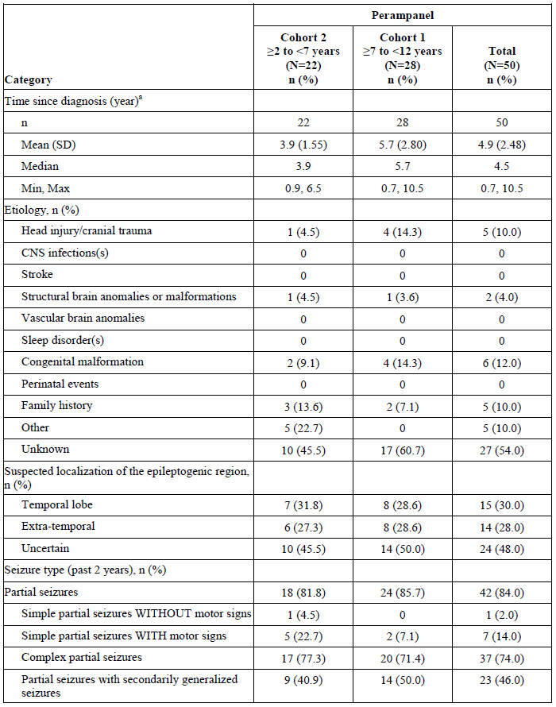
Table 8 (continued): Study 232 Baseline characteristics
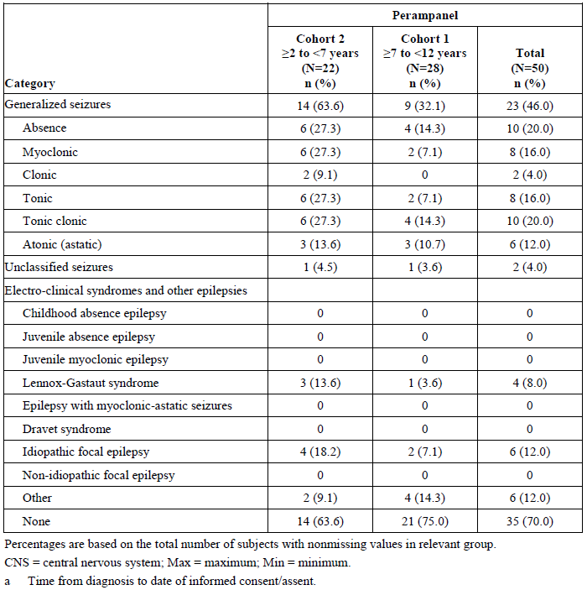

Results

Seizure frequency
There was a reduction in the median number of seizure events in the POS group across Cohorts 1 and 2. The magnitude of reduction was comparable to Study 311.
The PGTCS group in Cohort 1 experienced a reduction in seizure frequency, while there was an increased incidence of seizure events in Cohort 2.
The evaluator has highlighted that the short study period, low number of participants and the unblinded study design limits the ability to make any conclusion regarding efficacy of perampanel.
Table 9: Change in seizure frequency, partial-onset seizure cohort
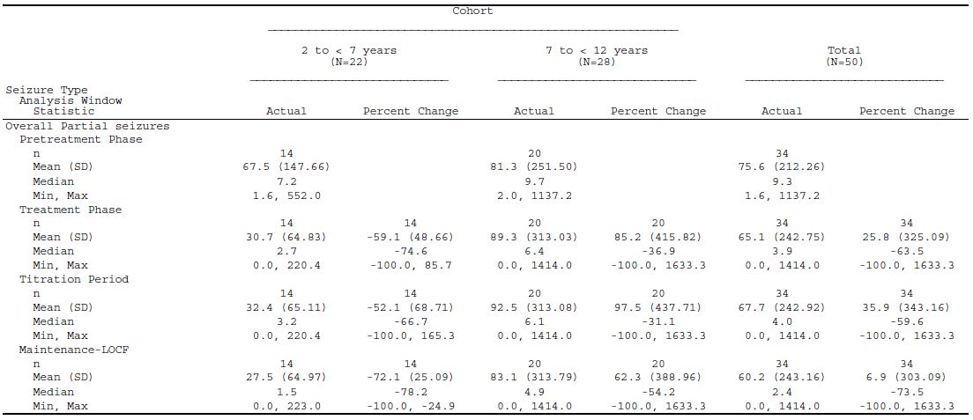
LOCF = last observation carried forward; Max = maximum; Min = minimum; SD = standard deviation.
Table 10: Change in seizure frequency, primary generalised tonic-clonic seizure cohort
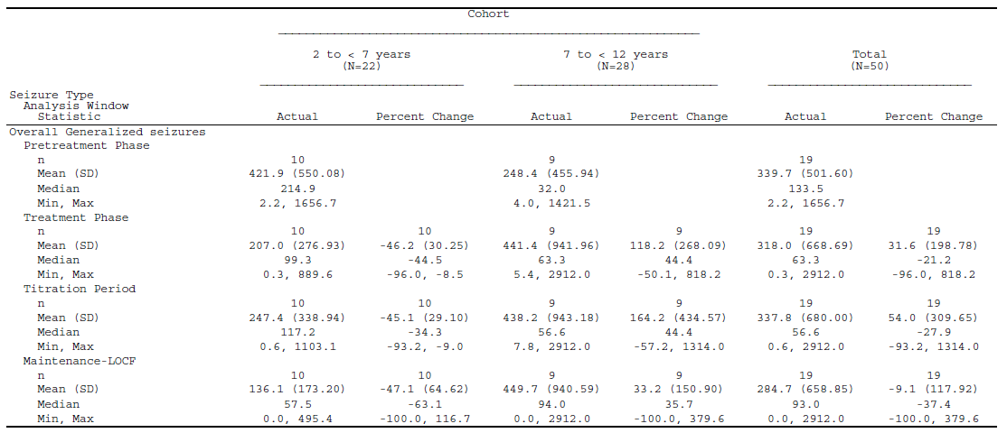
LOCF = last observation carried forward; Max = maximum; Min = minimum; SD = standard deviation.

Response rate
The response rates were 59.1% in the total population, 76.2% in the younger cohort, and 43.5% in the older cohort.

Seizure-free rate
Around 21% of subjects were seizure free after 11 weeks of the treatment period.

Clinical Global Impression of Change score
At Baseline, 36.0% of subjects responded as either normal (not at all ill) or mildly ill and 42.9% of subjects were moderately ill, and 20.0% of subjects were either markedly ill or severely ill. After 11 weeks of treatment, around 60% of subjects reported ‘much improved’, compared to Baseline.

Study 311 (Extension Phase A)
The extension phase was primarily designed to monitor safety events (demographic details and baseline characteristics are described in the Safety: ‘Study 311 (Extension A)’ section, below). The very low number of subjects in PGTCS cohort limits the ability to make any conclusions regarding long-term efficacy. The efficacy outcomes were described over a time period of eight weeks (for example, Week 40 to 52), which is different to the reported outcomes at Week 23 in the core Study 311. Hence, the Delegate is unable to compare the efficacy outcomes between the Extension Phase and the core study. The sponsor is requested to provide analysis consistent with the core Study 311 (see ‘Questions for the sponsor’ section, below).

Safety
Assessment of perampanel's safety for use in children with POS and PGTCS was based on the data from Studies 311 and 232. Both studies had extension phases that provided long-term safety data. Study 311 had two extension phases; Phases A and B. Extension Phase A continued following up of subjects after the study period. Extension B was in countries (Japan) where an EAP was not able to be implemented.

Exposure

Study 311
The mean exposure was around 20 weeks. Approximately 71% and 58% of subjects in the POS and PGTC cohorts, respectively, had a > 22 weeks exposure (see Table 11). However, only 7.2% and 2.2% completed the follow-up period in POS and PGTCS cohorts, respectively. The sponsor is requested to clarify any possible reasons for this observation (see ‘Questions for the sponsor’ section, below).
Table 11: Study 311 Cumulative extent of exposure, Safety Analysis Set
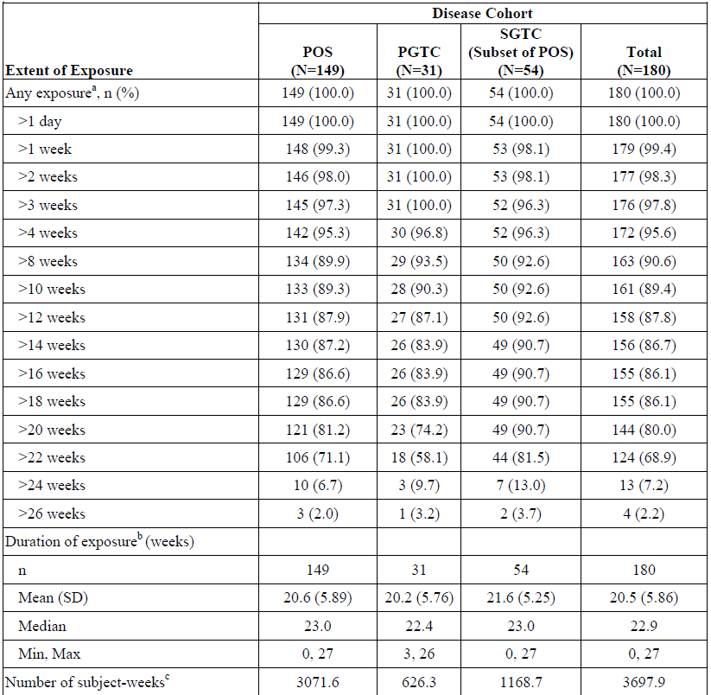
Subjects were assigned as POS or PGTC by the investigator. SGTC was the subset of POS subjects who recorded secondarily generalised seizures during the Baseline period.
PGTC = primary generalised tonic-clonic; POS = partial-onset seizure; SD = standard deviation; SGTC = secondarily generalised tonic-clonic.
a: Subjects were counted in each applicable exposure category; b: Duration of exposure = (date of last dose of study drug – date of 1st dose of study drug + 1)/7; c: Number of subject-weeks = summation over all subject’s exposure durations in weeks.
The extent of exposure for the core study phase is extended to over 23 weeks for a few patients who still continued to receive dose adjustments after the core study completion date and did not enter the extension phase. The reason that few patients have extended duration to over 26 weeks is due to data issues.
180 subjects entered the Extension Phase, with 149 subjects in POS and 31 subjects in PGTCS cohorts. Around 11% of subjects completed the 52 weeks extension study period, with 17 subjects in POS, 11 subjects in SGTCS and 4 subjects in PGTCS cohorts.
Table 12: Study 311 Cumulative extent of exposure during the Extension Phase
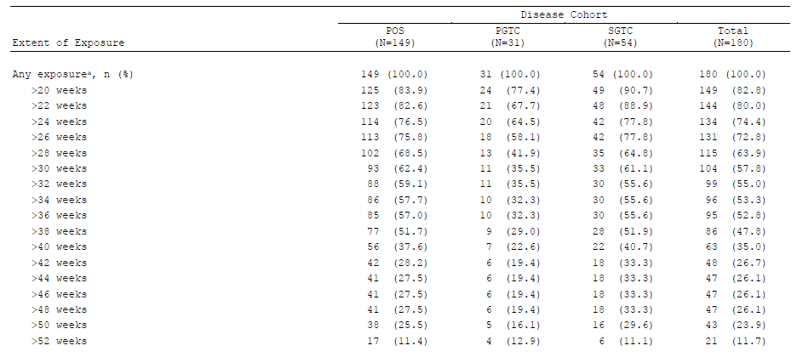
PGTC = primary generalised tonic-clonic; POS = partial-onset seizure; SD = standard deviation; SGTC = secondarily generalised tonic-clonic.

Study 232
The mean exposure was 11 weeks and was comparable across age groups.
Table 13: Study 232 Extent of exposure
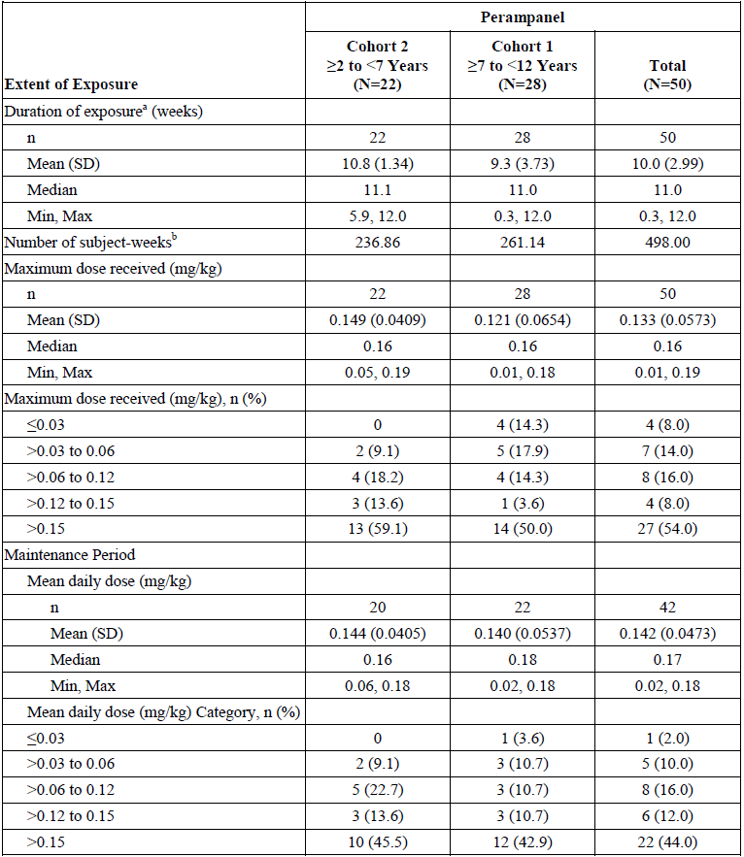
Max = maximum; Min = minimum; SD = standard deviation.
a: Duration of exposure = data of last dose of study drug – date of first dose of study drug +1; b: Number of subject-weeks = summation over all subjects’ exposure durations.

Exposure by dose and age
In Study 311, the mean daily dose of perampanel was 8.3 mg/day and was comparable across POS, SGTCS and PGTCS cohorts. The mean maximum dose was slightly higher in older paediatric subjects: 7.9 mg/day in the 4 to < 7 year cohort and 9.0 mg/day in the ≥ 7 to < 12 year cohort. 11 (8.5%) subjects (all in the POS cohort, including 2 in the SGTC subset) were exposed to perampanel at doses greater than 12 mg during the treatment period.
Dosing for Study 232 was reported in mg/kg. In the Core Phase of Study 232, the mean daily dose of perampanel was 0.142 mg/kg during the maintenance period.

Adverse events

Study 311
Overall, most subjects (88.9%) had at least one treatment emergent adverse event (TEAE) and majority of them (66.7%) were treatment related events. 7.8% of the subjects experienced severe TEAEs. Around 10% subjects experienced a TEAE that required withdrawal of study treatment. Around 40% of subjects required dose reduction of perampanel due to a TEAE.
The PGTCS cohort experienced a greater incidence of treatment-related TEAEs (around 15% more) and severe TEAEs (twice as many), compared to the POS cohort during the core study period. A similar trend was also noted during the extension phase. TEAEs that led to treatment discontinuation and dose reduction were comparable across disease cohorts.
Table 14: Study 311 core study period, treatment emergent adverse events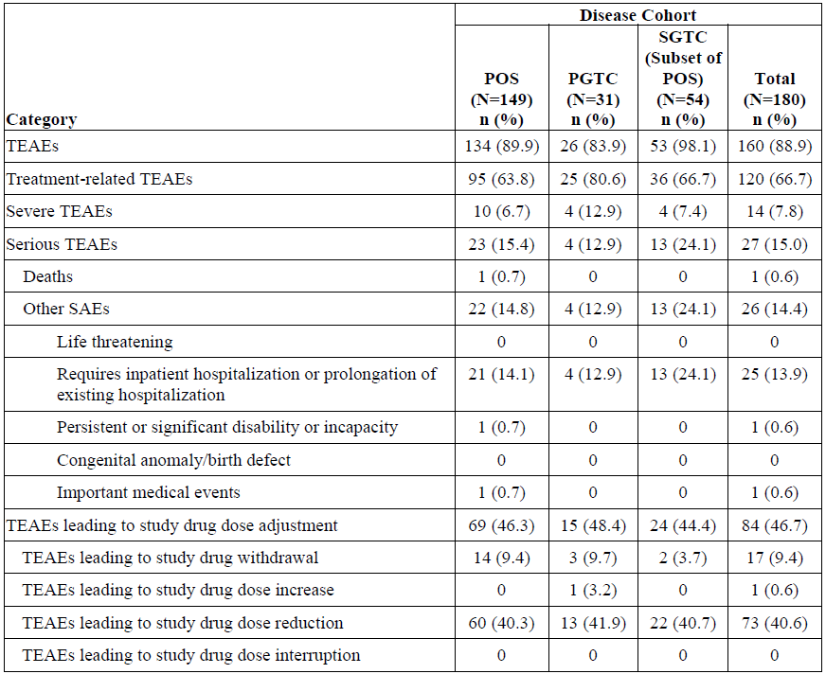
PGTC = primary generalised tonic-clonic; POS = partial-onset seizure; SD = standard deviation; SAE = serious adverse event; SGTC = secondarily generalised tonic-clonic; TEAE = treatment emergent adverse event.
Overall, the rate of incidence of these events during the extension phase was comparable to the core study period.

Study 232
In Study 232, 98% of subjects experienced a TEAE, with majority of them being related to treatment with perampanel. Severe TEAEs occurred in 12% of subjects in the Core Phase and 31.7% in the Extension Phase. AEs leading to discontinuation of treatment were reported in 6% of subjects during the core phase and 12.2% in the Extension Phase.
Table 15: Study 232 core study period, treatment emergent adverse events
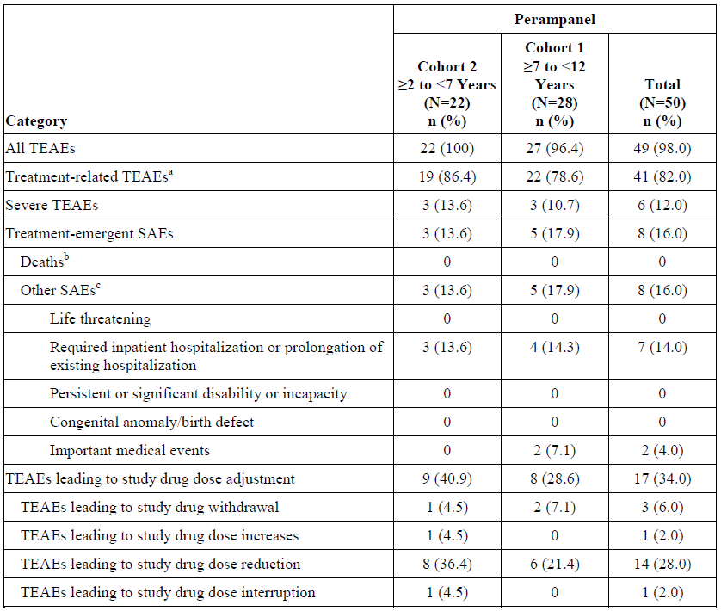
MedDRA Version 16.1.
A TEAE was defined as an adverse event with an onset date, or a worsening in severity from Baseline (pre-treatment), on or after the first dose of study drug up to 30 days following study drug discontinuation. For each row category, a subject with two or more TEAEs in that category was counted only once.
MedDRA = Medical Dictionary for Regulatory Activities; SAE = serious adverse event; TEAE = treatment emergent adverse event.
a: Includes TEAEs considered by the investigator to be possibly or probably related to study drug or TEAEs with missing causality; b: Includes all subjects with an SAE resulting in death; c: Includes subjects with nonfatal SAEs only. If a subject had both fatal and nonfatal SAEs, the subject is counted in the previous row and is not counted in this row.

Treatment emergent adverse events (Studies 311 and 232)
Somnolence and nasopharyngitis occurred in around 20% of subjects, followed by vomiting, dizziness and irritability in around 12% of subjects (see Table 16).
Table 16: Core Study 311 treatment emergent adverse events
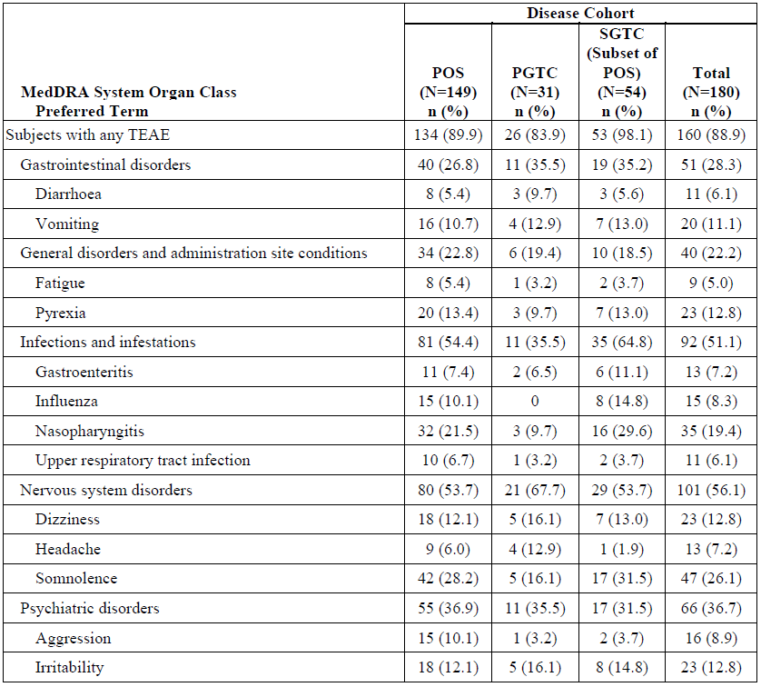
MedDRA = Medical Dictionary for Regulatory Activities; PGTC = primary generalised tonic-clonic; POS = partial-onset seizure; PT = Preferred Term; SGTC = secondarily generalised tonic-clonic; SOC = System Organ Class; TEAE = treatment emergent adverse event.
Study 232 also reported an overall greater incidence of somnolence, irritability and fatigue (see Table 17).
Table 17: Core Study 232 treatment emergent adverse events
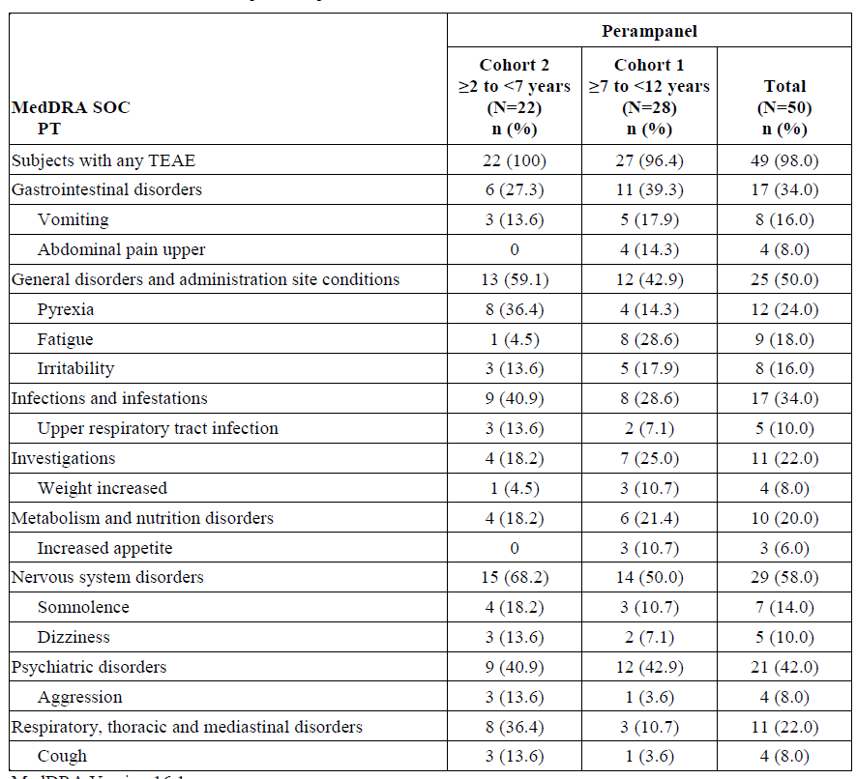
MedDRA = Medical Dictionary for Regulatory Activities; PT = Preferred Term; SOC = System Organ Class; TEAE = treatment emergent adverse event.

Treatment-related adverse events (Studies 311 and 232)
The most common treatment-related AEs were somnolence, dizziness, irritability, aggression, and fatigue. Treatment-related AEs occurred in 38 (82.6%) subjects in the 4 to < 7 years age group, compared to 82 (61.2%) subjects in the ≥ 7 to < 12 years age group. The PGTC cohort experienced a higher incidence of treatment-related TEAEs (80.6%), compared to POS cohort (63.8%). A slightly higher incidence of TEAEs was reported in subjects who were on concomitant EIAEDs (68.9%), compared to those without EIAEDs (60.4%).
TEAEs that mostly led to treatment discontinuation were psychiatric disorders such as aggression, and irritability (around 1.7%), followed by balance disorder (1.1%).

Serious adverse events (Studies 311 and 232)

Study 311
‘Nervous system disorders’ were the most commonly reported SAEs, with an incidence in around 7% of subjects, followed by infections and infestations in 6.7% of subjects. The PGTCS cohort had a higher incidence (12.9%) of these events, compared to the POS cohort (6%).

Study 232
‘Respiratory infections’ were the most common (in 8% of subjects), followed by ‘psychiatric disorders’ (in 4% of subjects).

Treatment emergent adverse events that led to discontinuation of the treatment and reduction of dose

Study 311 and Study 232
Around 10% of subjects across POS and PGTCS cohorts experienced TEAES that led to discontinuation of treatment in Study 311. ‘Psychiatric disorders’ presented the leading cause, with an incidence in 5.6% subjects in Study 311 and 4% subjects in Study 232, followed by nervous system disorder in 3.9% subjects in Study 311 and 4% subjects in Study 232.
The TEAEs most commonly resulting in dose reduction of study drug dose were somnolence (13.3% subjects), dizziness (5.6% subjects), aggression (4.4% subjects), and irritability (4.4% subjects) in Study 311 and fatigue (8% subjects) and irritability (6% subjects) in Study 232.

Death
One death (4 year old male subject in the POS cohort in Study 311) due to viral myocarditis was reported. The cause of death was not determined as related to perampanel.

Safety issues with possible regulatory impact
Liver function and liver toxicity: no subjects met the criteria for drug-induced liver injury (Hy’s Law) in the Core Study. There were subjects with elevated gamma-glutamyl transferase, alanine aminotransferase and aspartate transaminase during the study period. None of these events led to treatment discontinuation.
Haematological toxicity: in Study 311, markedly low neutrophils were reported in around 5% of subjects receiving perampanel.

Adverse events of special interest

Cognition, behaviour and co-ordination

Study 311
Around 40% of subjects experienced TEAEs that were related to alertness and cognition.
26.1% of subjects reported somnolence and 8.9% subjects reported aggression. In five subjects, these events led to discontinuation.
The sponsor used the Aldenkamp-Baker Neuropsychological Assessment Schedule (ABNAS) method to assess the treatment-related effect on fatigue, slowing, memory, concentration, motor-coordination and language. The following are the findings: overall, the mean (SD) total ABNAS score at Baseline was 19.6 (19.72) (N = 170), and the mean (SD) change from Baseline was -0.5 (12.78) at Week 23 (N = 126) and –3.3 (16.58) at Week 52 (N = 112).
The Delegate commented that the high SD was noted and indicates the large variability of this measure in children 4 to < 12 years of age.

Study 232
25% of subjects in the 7 to < 12 years age group and 40.9% of subjects in the 2 to 7 years age group experienced TEAEs that were related to alertness and cognition.
In Study 311, the Child Behaviour Checklist was used to assess behavioural and emotional problems in children, as reported by the primary caregiver. There were no major changes from the mean baseline values.
The evaluator has highlighted the increased incidence of aggressive behaviour among the study population across Studies 311 and 232. Also, the lack of control arm limits the ability to make any conclusions in this regard.
The Lafayette Grooved Pegboard Test was used to assess the potential effects of perampanel on co-ordination. No major changes from mean baseline values were reported.

Treatment emergent adverse events related to hostility or aggression
Overall, in Study 311, aggression-related TEAEs were reported in 32.2% subjects, including 30.9% subjects in the POS cohort and 38.7% subjects the PGTC cohort.
In Study 232, including its extension phase, TEAEs related to hostility or aggression were reported in 47.4% subjects in Cohort 2 and 36.4% subjects in Cohort 1.

Treatment emergent adverse events related to psychosis and psychiatric disorders
Around 4% subjects in Study 311 and 12% subjects in Study 232 were reported with TEAEs related to psychosis.

Treatment emergent adverse events related to suicidal ideation and behaviour
In the Core Phase of Study 311, a total of 23 TEAEs were reported in 19 subjects related to suicidal ideation or suicidal behaviour. All of the TEAEs were mild or moderate, and there were no suicidality-related SAEs, but one subject with TEAE of ‘altered mood’ was discontinued from the study. During the Extension Phase, there were four additional TEAEs reported by four subjects. All of these TEAEs were mild or moderate.
In Study 232, one subject in the older cohort had a TEAE related to suicidal ideation and behaviour in the Core Study. The events were not classified as SAEs and did not result in treatment discontinuation. Two additional TEAEs related to suicidal ideation/ behaviour were reported in the Extension Phase of Study 232.

Comparison of the incidence of treatment emergent adverse events between children, adolescents and adults
In response to evaluator's question, the sponsor provided a comparison of AEs across studies with perampanel in children, adolescents and adults. The sponsor compared safety data from Studies 304, 305, 306, 332 and 235 with the core study of the current submission, Study 311. The combined pool included a total of 1384 subjects (1008 adults, 196 adolescents, and 180 children aged 4 to < 12 years) treated with perampanel, compared to 572 subjects (470 adults, and 102 adolescents) treated with placebo.
The overall incidence of TEAEs was higher in children. TEAEs were seen in 79.0% of all subjects treated with perampanel: 88.9% in children, 75.5% in adolescents, and 78.0% in adults. Many individual TEAEs were substantially more common in children, particularly somnolence, irritability and aggression, and some TEAEs related to mood and behaviour (irritability, aggression and agitation) were more likely to lead to dose reduction or withdrawal (details below):
- Somnolence (26.1% children, 14.8% adolescents, 14.2% adults).
- Dizziness (12.8% children, 24.0% adolescents, 29.5% adults).
- Irritability (12.8% children, 6.6% adolescents, 7.4% adults).
- Aggression (8.9% children, 7.7% adolescents, 1.0% adults).
- Agitation (4.4% children, 0.5% adolescents, 0.4% adults).
TEAEs leading to dose reduction were observed in 40.6% of children, compared to 17.9% of adolescents and 15.2% of adults. Across all age groups, common TEAEs (> 4%) leading to dose reduction included dizziness (7.7%) and somnolence (4.6%). Psychiatric and nervous system related TEAEs leading to dose reduction in children were also reported as TEAEs leading to dose reduction in adolescents and adults, as follows:
- Somnolence (13.3% children, 6.1% adolescents, 2.8% adults).
- Dizziness (5.6% children, 6.1% adolescents, 8.3% adults).
- Irritability (4.4% children, 1.5% adolescents, 0.9% adults).
- Aggression (4.4% children, 2.6% adolescents, 0.3% adults).
TEAEs leading to withdrawal were seen in 9.4% of children, compared to 3.1% of adolescents and 10.0% of adults.
In children, TEAES (> 1%) leading to withdrawal included:
- Aggression (1.7% children, 0.5% adolescents, 0.4% adults).
- Irritability (1.7% children, 1.0% in adolescents, 0.3% adults).

Growth and development
The sponsor utilised measures such as height, weight, insulin-like growth factor-1 (IGF-1) and thyroid hormones to assess growth and development.
The Delegate commented that even though there were no major change in the mean and median values for these measures from baseline, following were the limitations:
- The wide standard deviation indicates the high variability in these measures.
- There were high negative values for measures such as insulin-like growth factor (IGF) and thyroid hormones, indicative of potential reduction in the levels of these hormones.
- Lack of control arm limits the ability to make any conclusions regarding the potential impact of perampanel on growth and development.
Table 18: Study 311 Measures of growth and development
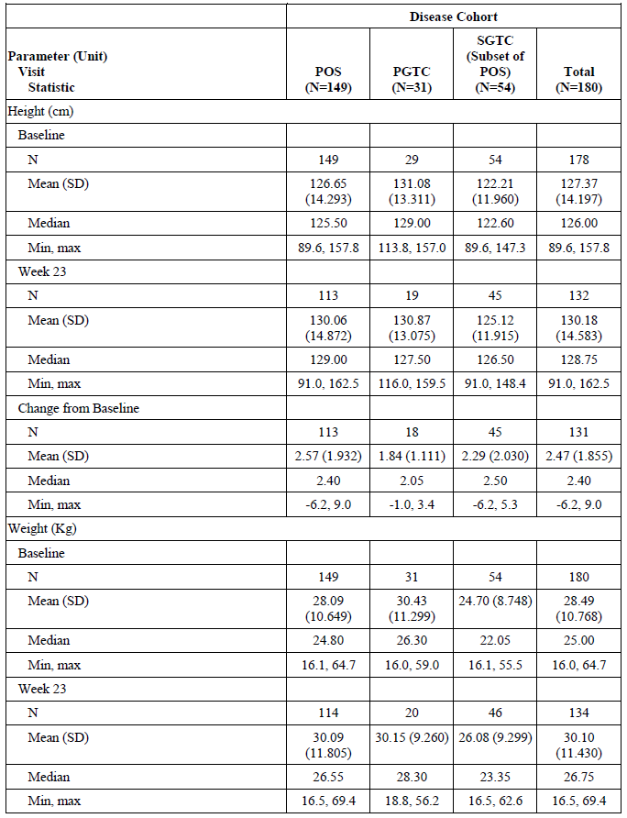
Table 18 (continued): Study 311 Measures of growth and development
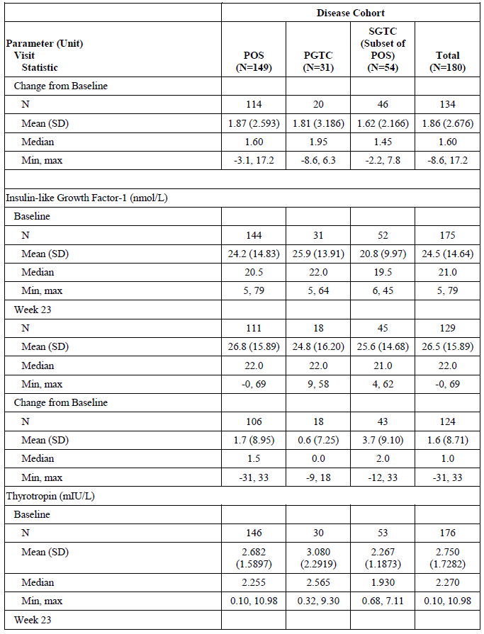
Table 18 (continued): Study 311 Measures of growth and development
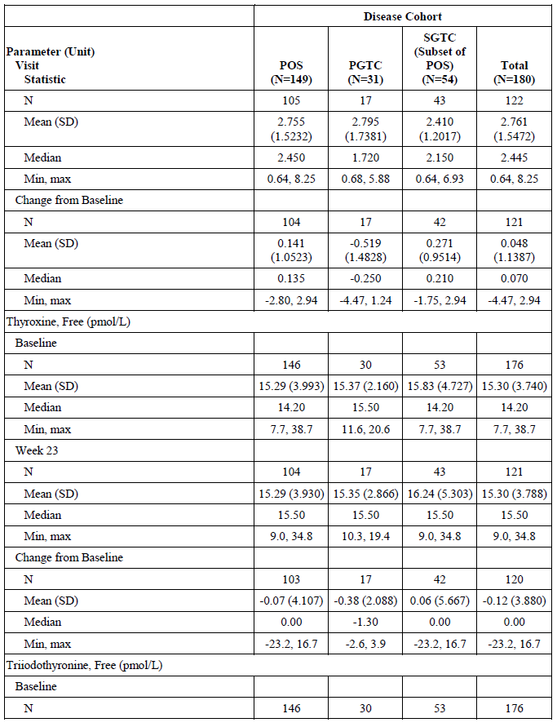
Table 18 (continued): Study 311 Measures of growth and development
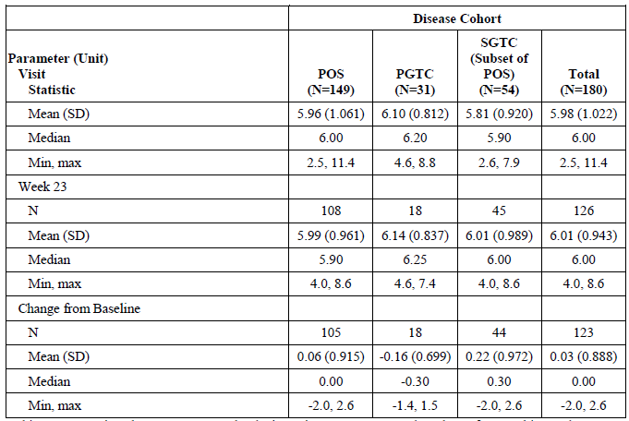
Max = maximum; Min = minimum; PGTC = primary generalised tonic-clonic; POS = partial-onset seizure; SD = standard deviation; SGTC = secondarily generalised tonic-clonic.

Study 235
Study design: A double blind randomised controlled trial with an open label extension phase.
This study was conducted in adolescents (12 to < 18 years of age) with POS to evaluate the effect of perampanel on growth, cognition, safety, tolerability and PK, when administered as an adjuvant therapy. Perampanel has already been approved by TGA for use in this patient population (see ‘Regulatory status’ section, above). The findings of this study were not considered to contribute evidence to support the current proposed indication in children in the 2 to < 12 years age group. However, from a safety perspective, the findings of this study on perampanel's effects on cognitive functions are important.

Results
The evaluator has summarised the study findings as: a nominally significant advantage for perampanel relative to placebo for the domain of ‘Quality of Episodic Secondary Memory’ was reported. There were statistically significant disadvantages for perampanel relative to placebo for the domains of ‘Continuity of Attention’ and ‘Speed of Memory’. The clinical significance of these results remains unclear.
About a quarter of subjects (25.9%) receiving perampanel had TEAEs categorised under psychiatric disorders compared to only 10.4% of placebo recipients (and this category did not include irritability). Individual PTs for irritability and aggression were 3 to 4 times more commonly reported on perampanel than on placebo (aggression 8.2% versus 2.1%; irritability 7.1% versus 2.1%).
The Delegate agrees with the evaluator's conclusions. The higher incidence of psychiatric disorders, irritability and aggression in the perampanel arm was noted. Studies 311 and 232 were not designed to assess the potential effects of perampanel on cognitive functions of children.

Study 311 (Extension A)
Extension A was the long-term open label follow-up phase of Study 311. Subjects eligible to participate in Extension A were those who had completed the 23 week treatment phase of the Core Study. Extension A consisted of a second maintenance period (up to 29 weeks). Data from subjects who completed the Extension A study period contributed to the 52 weeks safety and efficacy data.
A follow-up assessment was conducted 4 weeks ± 7 days after the last dose of perampanel, unless subjects entered Extension B (an open-label treatment option provided to subjects enrolled in Japan and in countries where an EAP could not be implemented, after having completed Extension A).
The objective of Extension A was to assess the long term safety, tolerability and efficacy of perampanel in children (4 to < 12 years of age) with POS and PGTCS.
The subjects continued to receive the same dose of perampanel that they were receiving at the completion of core study, except if, they were experiencing AEs or if a higher dose was considered as beneficial.
Across the Core study and Extension A phases, the average (SD) of the mean daily dose of perampanel was 7.4 (2.86) mg/day across disease cohorts.
Out of the 146 subjects who completed the core study, 136 subjects entered into Extension A.
36 subjects (32 subjects with POS, and 4 subjects with PGTC) were in the 4 to < 7 year age group, and 100 subjects (84 subjects with POS, and 16 subjects with PGTC seizures) in the ≥ 7 to < 12 year age group.
A total of 122 subjects completed Extension A, including 31 subjects in 4 to < 7 year age group and 91 subjects in the ≥ 7 to < 12 year age group. 17 subjects in PGTC cohort and 105 subjects in POS cohort completed Extension A phase.
Table 19: Study 311 Extension A subject disposition
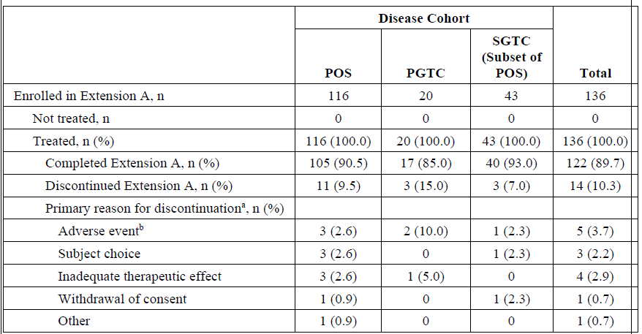
Subjects were assigned as POS or PGTC by the Investigator. SGTC is the subset of POS subjects who recorded secondarily generalized seizures during the Baseline Period. Percentages are based on the number of enrolled and treated subjects.
CRF = case report form, N = total number of subjects in the sample group, n = number of subjects, PGTC = primary generalized tonic-clonic seizures, POS = partial-onset seizures, SGTC = secondarily generalised tonic-clonic seizures.
a: As reported on the Subject Disposition CRF; b: Corresponding adverse event(s) leading to withdrawal from study/study drug are listed in [a table in the clinical study report, not included in this AusPAR].

Results

Treatment emergent adverse events
Most TEAEs were mild or moderate in severity. 21 (11.7%) subjects had severe TEAEs. 12.2% subjects experienced TEAE that required cessation of treatment with perampanel.
Somnolence, dizziness, irritability and aggression were the most common treatment-related TEAEs.

Serious adverse events
20.0% subjects experienced treatment-emergent SAEs across the core study and Extension A. The most common SAEs were seizure in 2.8% subjects and pneumonia in 2.2% subjects.

Treatment emergent adverse events that led to dose adjustment
Dizziness (6.7%), somnolence (13.9%), aggression (5%) and irritability (4.4%) were the common causes of dose adjustment. In total, 18.3% of subjects required a dose reduction because of psychiatric TEAEs.

Risk management plan
In support of the extended indications, the sponsor has submitted EU-risk management plan (RMP) version 4.3 (dated 16 January 2019, data lock point (DLP) 22 July 2018) and Australian specific Annex (ASA) version 4 (DLP 22 November 2019). The most recently evaluated EU-RMP was version 3.3 (dated 21 May 2015, DLP 18 May 2015) and ASA Version 3 (dated November 2015). At the second round of evaluation, the sponsor provided an updated EU-RMP version 4.4 (date 13 May 2020; DLP 22 July 2019) and ASA version 4.1 dated 20 July 2020. At the third round of evaluation, the sponsor provided an updated ASA version 4.2 dated 26 October 2020 incorporating all the recommendations made at the second round of evaluation.
At the second round of this evaluation, the sponsor changed the proposed indication, raising the minimum age of the proposed paediatric patient population for both partial onset seizures and primary generalised tonic-clonic seizures from 2 years to 4 years.
The summary of safety concerns and their associated risk monitoring and mitigation strategies are summarised in Table 20.
Table 20: Summary of safety concerns
Summary of safety concerns |  | Pharmacovigilance |  | Risk minimisation
 |  | Routine | Additional | Routine | Additional
Important identified risks | Aggression* |  | – |  | –
Important identified risks | Interaction with levonorgestrel-containing contraceptives, and unintended pregnancy exposures |  | – |  | –
Important identified risks | Suicidality* |  | – |  | –
Important identified risks | Psychiatric Reaction*† |  | –
Important potential risks | Hepatic disorders (excluding hepatic disorders induced by severe cutaneous adverse reactions (SCARs)) |  | – |  | –
Important potential risks | Psychiatric reaction*† |  | – | – | –
Important potential risks | Homicidal ideation*† |  | – |  | –
Missing information | Use in human pregnancy and lactation¶ |  |  |  | –
Missing information | Impact on cognition and growth in the paediatric population |  | – |  | –
Missing information | Long-term safety in children < 12 years of age† |  | – |  | –
*Follow-up questionnaires, † Australian specific safety concerns, ¶ Pregnancy registry
There are no outstanding issue that are related to the RMP.
The RMP evaluator has recommended Fycompa be included in the Black Triangle scheme.
The Delegate has noted that routine pharmacovigilance has been planned to monitor the long-term safety in children < 12 years of age. The Delegate has requested the Advisory Committee comment on the adequacy of this approach (see ‘Advisory Committee considerations’ section, below). The Committee's recommendation in terms of having registries as an additional pharmacovigilance activity is also requested.

Risk-benefit analysis

Delegate’s considerations
The sponsor's approach to extrapolate efficacy of perampanel from adults to children of 4 to < 12 years of age based on Pop PK modelling principles is in accordance with the EMA's concept paper on extrapolation of efficacy and safety in medicine development, the draft reflection paper on extrapolation of efficacy and safety in paediatric medicine development, and the US Food and Drug Administration’s (FDA’s) guidance for extrapolation of efficacy of medicines to treat POS from adults to paediatric patients 2 years of age and older. However, there were critical limitations with the Pop PK model, such as the very low number of children in the 2 to 4 year age group;20 and not including the maturation factors in the model.,, Following the advice of the Pharmacometrics Working Group, the sponsor has modified the model by raising the lower limit of the age group in their initially proposed indication from 2 to 4 years. The sponsor has also adopted a weight based dose regimen. This approach appears to have resulted in exposures for perampanel in children that are comparable to adults. Hence, it has satisfied the criteria for extrapolation of efficacy data, as stipulated by the EMA guideline.20 From a safety perspective, it is reassuring that for children weighing < 30 kg, the maximum dose as per the proposed dose regimen will be lower than that used in the pivotal study. However, from a clinical perspective, the efficacy of the proposed dosage regimen is unknown. The overall number of children who have completed 52 weeks of exposure to perampanel (n = 122) has satisfied the criteria stipulated by the EMA guideline for long-term safety data (a minimum number of 100 children to be exposed to treatment for a duration of 52 weeks). However, a very low number of children (n = 17) with PGTCS were exposed to perampanel for a 52 week duration.
It was noted that the median value for the dose-normalised AUC of perampanel for children 4 to < 7 years of age was almost twice higher than the corresponding value for adolescents and adults. From an efficacy perspective, the Delegate has considered the Pharmacometric Working Group's views on this issue. From a safety perspective, considering the increased incidence of TEAEs in children, the Delegate has requested the Advisory Committee comment on the potential implications of this finding (see ‘Advisory Committee considerations’ section, below).
Study 311 provided descriptive data to support efficacy of perampanel in children. The study design was in line with the relevant EMA guideline.25 The limitations of unblinded, uncontrolled studies, such as regression to the mean, the inability to account for the natural variability of the condition and the placebo effect, were considered. These limitations were even worse in Study 232, with its short duration of study period.
In Study 311, for children with POS (total n = 148), around 40% reduction in seizure frequency per 28 days was reported across age groups 4 to < 7 years (n = 108) and 7 to < 12 years (n = 40). With due consideration of the limitations of cross-study comparisons, the magnitude of treatment response and the proportion of responders are largely comparable to previously conducted controlled studies with perampanel in adolescents and adults. Around 11% of subjects achieved seizure free status. Subjects in the SGTC subset of POS cohort also achieved a similar treatment benefit.
The magnitude of treatment benefit, in terms of seizure reductions per 28 days for children (4 to < 12 years, total n = 22) with PGTCS (-76.5%) is comparable to previous studies in subjects > 12 years of age. However, the data from Study 311 is limited by the very low number of children across age groups (age 4 to <7 years; n = 3, and age 7 to < 12 years; n = 19) with PGTCS. In addition, the patient population included in the PGTCS cohort were not well characterised. Around 25% of children in the PGTCS cohort had protocol violations that were mainly attributed to not having the eligibility as per the inclusion criteria. Moreover, unlike POS, there is no accepted regulatory recommendation to extrapolate efficacy from adult data to children with PGTCS. This position is based on the understanding that the mechanisms for PGTCS and other generalised seizures are likely to be different in adults and children.4 The drugs needed to treat the age-related epilepsy syndromes in children may also be different to those that have shown efficacy in adults.
In terms of safety, in addition to the uncontrolled study design of Study 311, the data from very low number of subjects in PGTCS cohort (n = 17) completing the 52-week study period (Extension Phase A) is inadequate to evaluate long-term safety of perampanel in children (4 to < 12 years of age). In Core Study 311, an approximate 20% increase in the incidence of treatment-related AEs was reported in the PGTCS cohort, compared to the POS cohort. Similarly, a considerably higher number of children in the PGTCS cohort (12.9%) experienced severe AEs, compared to the POS cohort (6.7%). The exact mechanism of this observation is unclear. However, these findings highlight the need for long-term safety data for the use of perampanel in children, particularly with PGTCS.
The submitted studies raised no new concerns in terms of the types of TEAEs. However, there was an increased rate of incidence of TEAEs in children, compared to adults and adolescents. In addition, for any observed TEAE, due to the lack of placebo arm, it is unclear what the background rate of that TEAE would be in this population. This is particularly important for the psychiatric and nervous system disorders that were commonly reported, compared to TEAEs in other categories. The psychiatric and nervous system related events are known AEs of perampanel when used in subjects ≥ 12 years of age. However, there was an increased incidence of these events in children, compared to adolescents and adults. Somnolence (26.1% of subjects), dizziness (12.8%) and irritability (12.8%) appear very likely to have a causal relationship with perampanel. The sponsor's conclusion of perampanel's lack of effect on cognition was based on the ABNAS assessment. The Delegate has noted the wide standard deviation that indicates the high variability of this measure and considers that it reflects the unreliability of this patient-perceived measure of cognition in children < 12 years of age with epilepsy. The rationale to use ABNAS instead of Cognitive Drug Research (CDR) System Global Cognition Score is unclear. The evaluator has highlighted that it is completely unknown whether the long-term glutamate antagonism could have detrimental effects in learning and maturation. The potential long-term effects of perampanel on neurodevelopment, motor development, cognition, behaviour, growth, endocrine functions and puberty are unknown. The EMA has requested the sponsor to provide data related to these long-term issues and to consider the implementation of a prospective disease based registry to gather relevant long-term safety data. The sponsor is requested to update whether children in Australia will be included in the registry (see ‘Questions for the sponsor’ section, below). Also, to confirm whether the registry will be part of the proposed RMP.
The clinical evaluator has highlighted the limitations of the available data that are mostly related to the uncontrolled efficacy and safety data that were included to support the proposed indication, and also the higher incidence of TEAEs in children, compared to adolescents and adults with epilepsy. The evaluator has taken in to consideration the ease of administration of the liquid formulation, the once daily dosing, perampanel's comparable PK data in children and the regulatory recommendation to support extrapolation of efficacy for POS and recommended approval of perampanel for the treatment of children (4 to < 12 years of age) with POS and not for the use of perampanel in children (4 to < 12 years of age) with PGCTS.
In summary, the Pop PK modelling indicates comparable systemic exposure for perampanel in children with epilepsy and hence satisfies the principles of extrapolation of efficacy data for POS, as recommended by EMA and FDA.21 Based on uncontrolled open label descriptive data, the efficacy of perampanel for the treatment of children with POS appears largely to be comparable to adolescents and adults. The efficacy and long term safety data of children with PGTCS are compromised by the very low number of children in this cohort, the unavailability of regulatory guideline to extrapolate data due to the difference in the pathophysiology of the condition across age groups, the poor characterisation of subject's seizure profile and the increased number of treatment related AEs and SAEs. The long-term effects of perampanel on cognition, growth and development in children of 4 to < 12 years of age with epilepsy are not well-defined. The greater incidence of psychiatric and nervous system related TEAEs and the lack of controlled data on cognition, growth and development highlights the need for long-term safety data in children treated with perampanel.

Proposed action
The Delegate has no reason to say, at this time, that the application for perampanel should not be approved for the treatment of children (4 to < 12 years) with POS, with or without secondary generalisation.
There is inadequate evidence to support the use of perampanel in children (4 to < 12 years) with PGTCS.

Questions for the sponsor
The sponsor provided the following response to questions from the Delegate.
- The sponsor states that an original application to extend perampanel to include paediatric use was withdrawn in the EU in April 2019. Please clarify the reason for this withdrawal.
The sponsor referred the Delegate to a specific section of the dossier, which outlined the following:
- The variation was previously submitted on 12 February 2019, procedure number EMEA/H/C/2434/II/0044. During the validation phase it was identified that certain aspects of the Paediatric Investigation Plan (PIP) required modification and a subsequent compliance check. The sponsor elected to withdraw that submission on 18 April 2019.
- The perampanel PIP has subsequently been modified (EMEA-000467-PIP01-08-M11, P/0217/2019, dated 12 June 2019) and a positive partial PIP compliance check (C6-000467-PIP01-08-M11) was finalised on 23 August 2019 by the EMA Paediatric Committee.
- The application was resubmitted on 28 August 2019. There were no changes to the submission dossier apart from minor updates to Module 1 documents to reflect the PIP modifications.
- Please clarify whether there were any differences between the data set that was submitted to FDA and TGA.
The sponsor referred the Delegate to a specific section of the dossier, which outlined the following:
- The dossier supporting the oral suspension is essentially similar to the US submission. In the USA, the supply chain is slightly different and so the registered manufacturing sites are different. However, the product registered is the same and therefore manufacturing information, ingredients and testing are the same.
- The paediatric indication was registered in the US based on an interim analysis of the pivotal study report Study 311. This application then used the interim analysis to extrapolate efficacy. In Australia and the EU, the submission is based on the final analysis of Study 311.
- As a result, the submission in the USA was submitted approximately one year earlier with less mature data.
The sponsor then summarised the following in their response to the Delegate’s question:
- The US submission was based on an interim analysis of Study 311.
- The sponsor provided additional data at the Day 120 submission during the FDA analysis.
- Please clarify how many children were 2, 3 and 4 years of age in Studies 232, 311, and in the Pop PK model.
The number of children who were 2, 3, and 4 years of age (as of the date of a subject’s signed informed consent) in Study 232, Study 311, and in the Pop PK model (excluding Study 232) are tabulated below in Table 21.
Table 21: Number of children of 2, 3 and 4 years of age in Studies 232, 211 and the population pharmacokinetics model
Age | Study 232 | Study 311 | Pop PK model^{b}
2 years | 2 | --ª | -
3 years | 3 | --ª | -
4 years | 5 | 5 | 5
Total | 10 | 5 | 5
a: Study 311 was designed to enrol patients aged 4 to < 12 years; b: Only subjects with PK data were included in the Pop PK analysis.
- Please provide dose normalised mean (SD) and median (min, max) values for C_{max} of perampanel across children (4 to < 7 and 7 to < 12 years of age), adolescents and adults.
Descriptive statistics for dose-normalised (to 8 mg) C_{max} without concomitant use of enzyme inducing anti-epileptic drugs (namely, carbamazepine, oxcarbazepine, and phenytoin) are provided in Table 22.
Table 22: Dose normalised (to 8 mg) maximum plasma concentration
Age category | N* | Mean | SD | Min | Median | Max | %CV
4 to < 7 years | 90 | 1707 | 607 | 964 | 1562 | 3732 | 35.6
7 to < 12 years | 232 | 1218 | 482 | 492 | 1146 | 3960 | 39.6
12 to < 18 years | 239 | 793 | 342 | 331 | 712 | 2569 | 43.2
≥ 18 years | 943 | 763 | 329 | 204 | 683 | 3033 | 43.1
*N is the number of observations from all visits, but not the number of subjects.
CV = coefficient of variation; Max = maximum; Min = minimum; SD = standard deviation.
- The efficacy outcomes of Extension Phase A were described over a time period of eight weeks (for example, Week 40 to 52), which is different to the reported outcomes at Week 23 in the core Study 311. Hence, it is unable to compare the efficacy outcomes between the Extension Phase and the core study. Please provide analysis consistent with the core Study 311.
Tables providing the information requested by the Delegate are provided below.
Table 23: Seizure frequency per 28 days and percent change during treatment summary for age cohort by each disease cohort, Full Analysis Set
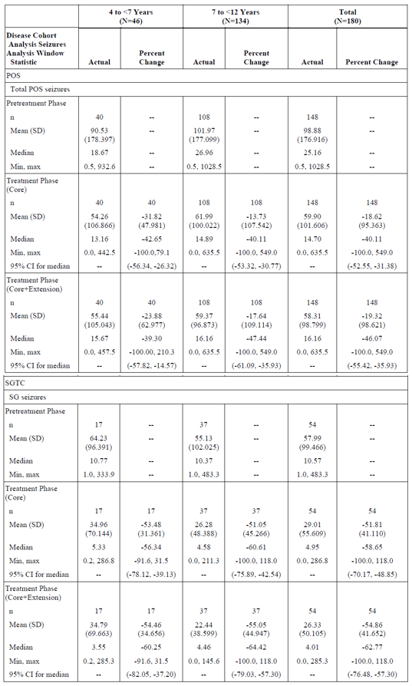
Table 23 (continued): Seizure frequency per 28 days and percent change during treatment summary for age cohort by each disease cohort, Full Analysis Set
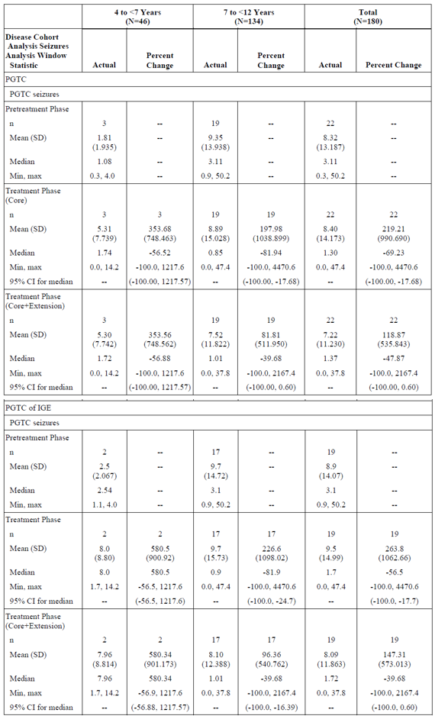
Total POS seizures = all POS seizures, including simple partial seizures without motor signs, simple partial seizures with motor signs, complex partial seizures and complex partial seizures with secondary generalisation.
CI = confidence interval; Max = maximum; Min = minimum; PGTC = primary generalised tonic-clonic; POS = partial-onset seizure; SD = standard deviation; SGTC = secondarily generalised tonic-clonic.
Table 24: 50% responder rate during maintenance-last observation carried forward for age cohort by each disease cohort, Full Analysis Set
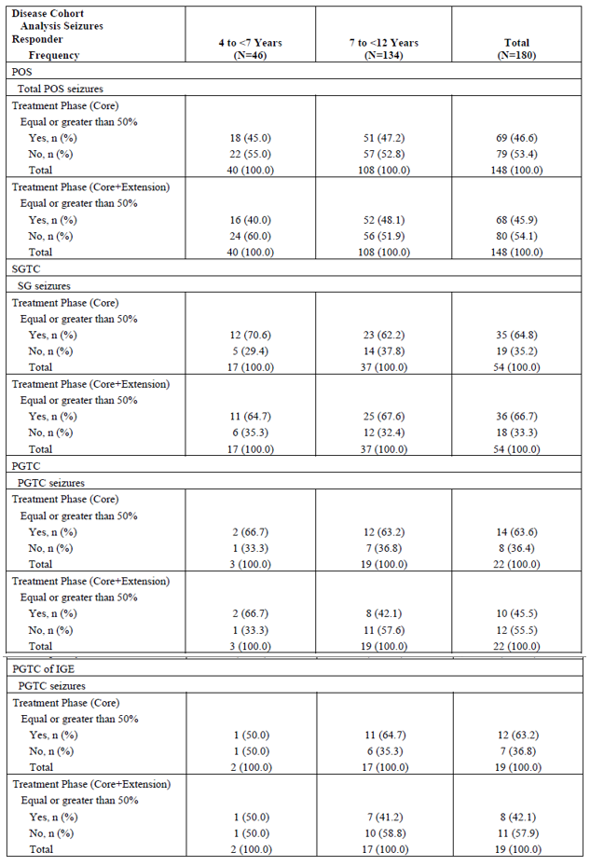
Table 25: Seizure free rate during maintenance for age cohort by each disease cohort, Full Analysis Set
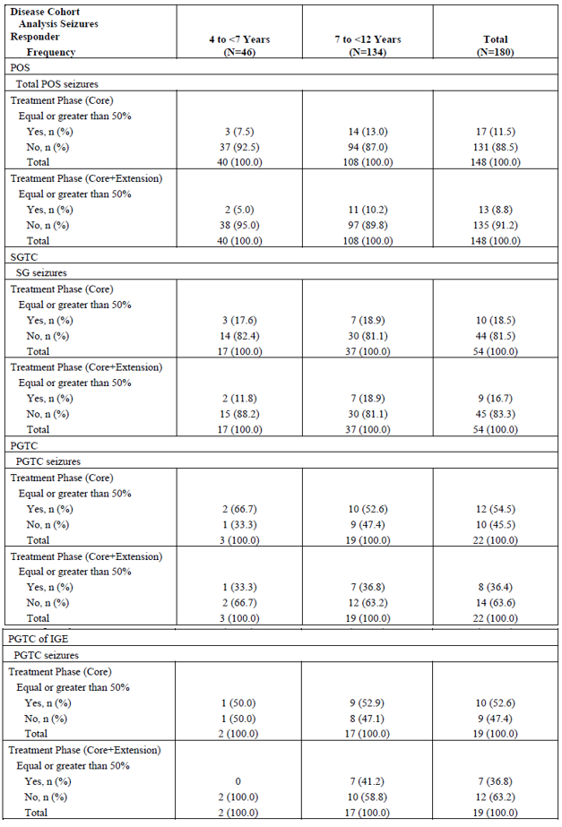
IGE = idiopathic generalised epilepsy ; PGTC = primary generalised tonic-clonic; POS = partial-onset seizure; SD = standard deviation; SGTC = secondarily generalised tonic-clonic.
- The Delegate has noted that the Cognitive Drug Research (CDR) System Global Cognition Score was used in studies with perampanel in adolescents that assessed the treatment-related effects on cognition. Please clarify why this measure was not used in the patient population in Study 311, instead of the ABNAS scores.
The original concept of Study 311 design included a proposal to use CDR for the assessment of perampanel treatment effect on cognition. However, it was identified that CDR is validated for subjects 6 years old and above only, and thus cannot be used for children younger than 6 years of age. Therefore, the Vineland Adaptive Behaviour Scale (VABS; validated for birth to 90 years of age) was initially selected to replace CDR. However, as the VABS is about 30 pages long with multiple data points, it has poor acceptance by the patient, caregiver, and site staff owing to the administrative complexity of the scale. The logistics and burden of administering the scale was an important consideration in the study given the nature of the disease and the age of study population. The ABNAS assessment was subsequently selected as the preferred method due to its reduced burden on patients and caregivers, as well as the perceived advantage of ease of administration. It was anticipated that this would result in greater compliance during data collection during the study.
- Please state which studies the sponsor is referring to for the changes in the PI: adults with Parkinson’s disease, adults with diabetic neuropathy, adults with multiple sclerosis, and where it has been included in the dossier.
The studies mentioned in Section 5.2 of the PI were conducted in the past when perampanel was investigated as a potential treatment option for neurological conditions including Parkinson’s disease, diabetic neuropathy, and multiple sclerosis. However, those investigational programs were terminated and no marketing authorisation applications were sought. As a result, those study data have not been submitted to the TGA. The wording was updated in the [response to TGA questions] to align with the Summary of Product Characteristics for consistency; however, if the TGA would prefer this information not to be included and the existing approved wording for this section to be retained, this proposed change will be reverted.
- Please update on the registry that has been recommended by the EMA and also please clarify whether it has been included in the EU RMP.
The sponsor notes the comment of the Delegate where they state ‘EMA has requested the sponsor to provide data related to these long-term issues and to consider the implementation of a prospective disease based registry to gather relevant long-term safety data.30 The sponsor is requested to update whether children in Australia will be included in the registry. Also, to confirm whether the registry will be part of the proposed RMP.’
The sponsor advises the TGA that at the conclusion of the evaluation of the application in the EU, no registry or additional clinical study was required by the EMA.
[The sponsor referred the Delegate to relevant sections of the EMA evaluation report – information redacted].
The EMA conclusion was that a further study was not warranted, but safety should be monitored in the ongoing Study 236 and 238 and in future PSURs.9

Advisory Committee considerations
The Advisory Committee on Medicines (ACM), having considered the evaluations and the Delegate’s overview, as well as the sponsor’s response to these documents, advised the following.

Specific advice to the Delegate
- Please comment on the potential implications of the higher systemic exposure for perampanel in children 4 to < 7 years (not on inducers) of age, compared to adolescents and adults.
The ACM agreed that there is a higher systemic exposure in the 4 to 7 year age group, however, noted that there is no obvious safety signals reported in this age group in the clinical studies. However, the ACM advised this information to be included in the PI. The ACM advised that overall, the systemic exposure is similar to that of the other age ranges.
- Please comment on the potential implications of the proposed dosage regimen, which is different (lower) to the dose of perampanel that was used in Studies 311 and 232.
The ACM advised to start low and go slow, they noted that Study 311 and 232 are not optimally designed. However, awareness for prescribers to start on a low dose and increase dose adjustment intervals is crucial and needs to be highlighted in the PI.
- What are the committee's views on the level of evidence provided to support the efficacy of perampanel in children (4 to < 12 years of age) with focal and generalised epilepsy.
The ACM advised that the level of evidence is below the gold standard, however acceptable and the efficacy and safety in this group is almost comparable as for over 12 year olds.
- What are the committee's view on the safety data and whether that has been adequately addressed in the PI, including perampanel's effects on cognition, growth and development of children with epilepsy and irritability, somnolence and aggressive behaviour?
The ACM agreed that the concerns of possible effects on cognition, growth and development in particular irritability, somnolence and aggressive behaviour are well documented in the PI. They are known adverse effects of perampanel, when used in adolescents and adults.
- Please comment on the adequacy of the proposed long-term safety monitoring of perampanel in children as a routine pharmacovigilance activity and the Delegate's recommendation that a registry be established as part of the RMP.
The ACM agreed that a registry of adverse events would be useful and should be a gold standard in any new medicine used in children. The ACM also noted the challenges associated with this risk management action. It was further noted that there should be an obligation to collect this type of data when the number of patients is limited in a cohort of children and the long-term effects are unknown.

Conclusion
The ACM considered this product to have an overall positive benefit-risk profile for the indication:
Partial onset (focal) seizures with or without secondary generalisation
- Fycompa is indicated for adjunctive treatment in adult and adolescent patients from 12 years of age with epilepsy.
- Fycompa is indicated for adjunctive treatment in paediatric patients from 4 to 11 years of age with epilepsy.
Primary generalised tonic clonic seizures
- Fycompa is indicated for adjunctive treatment in adult and adolescent patients from 12 years of age with idiopathic generalised epilepsy.
- Fycompa is indicated for adjunctive treatment in paediatric patients from 7 to 11 years of age with idiopathic generalised epilepsy.

Outcome
Based on a review of quality, safety and efficacy, the TGA approved the registration of Fycompa (perampanel hemisesquihydrate) 2, 4, 6, 8, 10 and 12 mg film coated tablets, for the following extension of indications in paediatric patients, and the new 2 mg/4 mL oral suspension product for the following indications:
Fycompa is indicated for the adjunctive treatment of:
- Partial-onset seizures (POS) with or without secondarily generalised seizures in patients from 4 years of age with epilepsy.
- Primary generalised tonic-clonic seizures (PGTCS) in patients from 7 years of age with idiopathic generalised epilepsy.
As such, these were the full indications at this time for both the film coated tablet presentations and the oral suspension presentation.

Specific conditions of registration applying to these goods
- Fycompa (perampanel) is to be included in the Black Triangle Scheme as it is subject to additional monitoring in Australia due to approval of an extension of indications. The PI and Consumer Medicines Information for Fycompa must include the black triangle symbol and mandatory accompanying text for five years, which starts from the date the new indication is registered.
- The Fycompa EU-RMP (version 4.5, dated 13 May 2020, DLP 22 July 2019), with ASA (version 4.2, dated 26 October 2020), included with submission PM-2019-05359-1-1, and any subsequent revisions, as agreed with the TGA will be implemented in Australia.
An obligatory component of risk management plans is routine pharmacovigilance. Routine pharmacovigilance includes the submission of periodic safety update reports (PSURs).
Unless agreed separately between the supplier who is the recipient of the approval and the TGA, the first report must be submitted to TGA no later than 15 calendar months after the date of the approval letter. The subsequent reports must be submitted no less frequently than annually from the date of the first submitted report until the period covered by such reports is not less than three years from the date of the approval letter. The annual submission may be made up of two PSURs each covering six months. If the sponsor wishes, the six monthly reports may be submitted separately as they become available.
If the product is approved in the EU during the three years period, reports can be provided in line with the published list of EU reference dates no less frequently than annually from the date of the first submitted report until the period covered by such reports is not less than three years from the date of the approval letter.
The reports are to at least meet the requirements for PSURs as described in the European Medicines Agency’s Guideline on Good Pharmacovigilance Practices (GVP) Module VII-periodic safety update report (Rev 1), Part VII.B Structures and processes. Note that submission of a PSUR does not constitute an application to vary the registration. Each report must have been prepared within ninety calendar days of the data lock point for that report.

Attachment 1. Product Information
The PI for Fycompa approved with the submission which is described in this AusPAR is at Attachment 1. For the most recent PI, please refer to the TGA website at <https://www.tga.gov.au/product-information-pi>.

Therapeutic Goods Administration
PO Box 100 Woden ACT 2606 Australia
Email: info@tga.gov.au Phone: 1800 020 653 Fax: 02 6232 8605
https://www.tga.gov.au

The Black Triangle Scheme provides a simple means for practitioners and patients to identify certain types of new prescription medicines, including those being used in new ways and to encourage the reporting of adverse events associated with their use. The Black Triangle does not denote that there are known safety problems, just that the TGA is encouraging adverse event reporting to help us build up the full picture of a medicine's safety profile.
World Health Organization, Epilepsy: Key Facts. Updated 20 June 2019, accessed 26 March 2021. Available from the WHO website.
Dalic L, Cook MJ. Managing drug-resistant epilepsy: challenges and solutions. Neuropsychiatr Dis Treat. 2016; 12: 2605-2616.
Wilfong, A, Seizures and epilepsy in children: Classification, etiology, and clinical features, In: UpToDate, Waltham, MA (Accessed 2019).
AMPA receptors are ligand gated ion channel (or ionotropic) glutamate receptors. metabotropic). The naming of AMPA receptors is derived from the ability of these receptors to be activated by the artificial glutamate analogue α-amino-3-hydroxy-5-methyl-4-isoxazolepropionic acid (AMPA).
Brodie, M.J. et al, Epilepsy, Antiepileptic Drugs, and Aggression: An Evidence-Based Review, Pharmacological Reviews, 2016; 68 (3) 563-602.
Pellock, J.M. et al. Efficacy of antiepileptic drugs in adults predicts efficacy in children: a systematic review. Neurology. 2012; 79(14): 1482-1489.
Pellock, J.M. et al. Extrapolating evidence of antiepileptic drug efficacy in adults to children ≥ 2 years of age with focal seizures: The case for disease similarity. Epilepsia. 2017; 58(10): 1686-1696.
EMA, European Public Assessment Report (EPAR), Fycompa (perampanel), EMA/695418/2020, 17 September 2020. Available from the EMA website.
Cytochrome P450 (CYP) enzymes: CYPs are the major enzymes involved in drug metabolism, accounting for large part of the total metabolism. Most drugs undergo deactivation by CYPs, either directly or by facilitated excretion from the body. Also, many substances are bioactivated by CYPs to form their active compounds. Many drugs may increase or decrease the activity of various CYP isozymes either by inducing the biosynthesis of an isozyme (enzyme induction) or by directly inhibiting the activity of the CYP (enzyme inhibition). This is a major source of adverse drug interactions, since changes in CYP enzyme activity may affect the metabolism and clearance of various drugs. Such drug interactions are especially important to take into account when using drugs of vital importance to the patient, drugs with important side-effects and drugs with small therapeutic windows, but any drug may be subject to an altered plasma concentration due to altered drug metabolism.
ETA = empirical Bayes estimate of the interindividual random effect.
French, J.A. et al. Perampanel for tonic-clonic seizures in idiopathic generalized epilepsy A randomized trial. Neurology. 2015; 85(11): 950-957.
Clinical Global Impression is a 7-point rating scale that provides a clinician-determined summary of the severity of a patient’s illness before and after commencing treatment, comprising two components: a) the severity of psychopathology, and b) the change from the initiation of treatment.
Definitions of status epilepticus vary, but status epilepticus is typically a single seizure lasting more than five minutes or two or more seizures within a five-minute period without the person regaining consciousness between seizures.
The Aldenkamp-Baker Neuropsychological Assessment Schedule (ABNAS) is a patient reported outcome that is used to assess perceived side effects of antiepileptic medicines.
The Child Behaviour Checklist (CBCL) is a checklist completed by the parent or primary caregiver that is used to detect behavioural and emotional issues in children and adolescents.
The Lafayette Grooved Pegboard Test (LGPT) is a test of manipulative dexterity, consisting of 25 holes with randomly positioned slots. The pegs, which have a key along one side, must be rotated to insert into the hole.
Routine risk minimisation activities may be limited to ensuring that suitable warnings are included in the product information or by careful use of labelling and packaging. Routine pharmacovigilance practices involve the following activities: - All suspected adverse reactions that are reported to the personnel of the company are collected and collated in an accessible manner; - Reporting to regulatory authorities; - Continuous monitoring of the safety profiles of approved products including signal detection and updating of labelling; - Submission of PSURs; - Meeting other local regulatory agency requirements.
EMA, Human Medicines Development and Evaluation, Concept paper on extrapolation of efficacy and safety in medicine development, EMA/129698/2012, 19 March 2013.
EMA, Draft reflection paper on extrapolation of efficacy and safety in paediatric medicine development, EMA/199678/2016, 1 April 2016.
FDA, Center for Drug Evaluation and Research, Drugs for Treatment of Partial Onset Seizures: Full Extrapolation of Efficacy from Adults to Pediatric Patients 2 Years of Age and Older Guidance for Industry, FDA-2018-D-0178, September 2019.
Mahmood, I., Allometric issues in drug development. J Pharm Sci, 1999; 88(11): 1101-1106.
Huang, Q. and Riviere,J.E., The application of allometric scaling principles to predict pharmacokinetic parameters across species. Expert Opin Drug Metab Toxicol, 2014; 10(9): 1241-1253.
Mahmood, I., Application of allometric principles for the prediction of pharmacokinetics in human and veterinary drug development. Adv Drug Deliv Rev, 2007; 59(11): 1177-1192.
EMA, Committee for medicinal products for human use (CHMP), Guideline on clinical investigation of medicinal products in the treatment of epileptic disorders, CHMP/EWP/566/98 Rev.2/Corr, 22 July 2010.
Steinhoff, B.J., et al., Efficacy and safety of adjunctive perampanel for the treatment of refractory partial seizures: a pooled analysis of three phase III studies. Epilepsia, 2013; 54(8): 1481-1489.
Goldenberg, M.M., Overview of drugs used for epilepsy and seizures: etiology, diagnosis, and treatment. P T, 2010; 35(7): 392-415.
Aldenkamp, A.P., et al., The A-B neuropsychological assessment schedule (ABNAS): the relationship between patient-perceived drug related cognitive impairment and results of neuropsychological tests. Seizure, 2002; 11(4): 231-237.
Meador, K.J., et al., Cognitive effects of adjunctive perampanel for partial-onset seizures: A randomized trial. Epilepsia, 2016; 57(2): 243-251.
EMA, Committee for Proprietary Medicinal Products (CPMP), Note for Guidance on Clinical Investigation of medicinal Products in children, CPMP/EWP/462/95.
The ACM provides independent medical and scientific advice to the Minister for Health and the Therapeutic Goods Administration (TGA) on issues relating to the safety, quality and efficacy of medicines supplied in Australia including issues relating to pre-market and post-market functions for medicines. The Committee is established under Regulation 35 of the Therapeutic Goods Regulations 1990. Members are appointed by the Minister. The ACM was established in January 2017 replacing Advisory Committee on Prescription Medicines (ACPM) which was formed in January 2010. ACM encompass pre and post-market advice for medicines, following the consolidation of the previous functions of the Advisory Committee on Prescription Medicines (ACPM), the Advisory Committee on the Safety of Medicines (ACSOM) and the Advisory Committee on Non-Prescription Medicines (ACNM). Membership comprises of professionals with specific scientific, medical or clinical expertise, as well as appropriate consumer health issues relating to medicines.

