First round evaluation: 13 June 2013
Second round evaluation: 15 November 2013

AusPAR Attachment 2

Extract from the Clinical Evaluation Report for Perampanel
  - Proprietary Product Name: Fycompa
  - Sponsor: Eisai Australia Pty Ltd

About the Therapeutic Goods Administration (TGA)
- The Therapeutic Goods Administration (TGA) is part of the Australian Government Department of Health, and is responsible for regulating medicines and medical devices.
- The TGA administers the Therapeutic Goods Act 1989 (the Act), applying a risk management approach designed to ensure therapeutic goods supplied in Australia meet acceptable standards of quality, safety and efficacy (performance), when necessary.
- The work of the TGA is based on applying scientific and clinical expertise to decision-making, to ensure that the benefits to consumers outweigh any risks associated with the use of medicines and medical devices.
- The TGA relies on the public, healthcare professionals and industry to report problems with medicines or medical devices. TGA investigates reports received by it to determine any necessary regulatory action.
- To report a problem with a medicine or medical device, please see the information on the TGA website <http://www.tga.gov.au>.
About the Extract from the Clinical Evaluation Report
- This document provides a more detailed evaluation of the clinical findings, extracted from the Clinical Evaluation Report (CER) prepared by the TGA. This extract does not include sections from the CER regarding product documentation or post market activities.
- The words [Information redacted], where they appear in this document, indicate that confidential information has been deleted.
- For the most recent Product Information (PI), please refer to the TGA website <http://www.tga.gov.au/hp/information-medicines-pi.htm>.
Copyright
© Commonwealth of Australia 2013
This work is copyright. You may reproduce the whole or part of this work in unaltered form for your own personal use or, if you are part of an organisation, for internal use within your organisation, but only if you or your organisation do not use the reproduction for any commercial purpose and retain this copyright notice and all disclaimer notices as part of that reproduction. Apart from rights to use as permitted by the Copyright Act 1968 or allowed by this copyright notice, all other rights are reserved and you are not allowed to reproduce the whole or any part of this work in any way (electronic or otherwise) without first being given specific written permission from the Commonwealth to do so. Requests and inquiries concerning reproduction and rights are to be sent to the TGA Copyright Officer, Therapeutic Goods Administration, PO Box 100, Woden ACT 2606 or emailed to <tga.copyright@tga.gov.au>.

Contents
List of abbreviations 5
1. Clinical rationale 6
2. Contents of the clinical dossier 7
2.1. Scope of the clinical dossier 7
2.2. Paediatric data 7
2.3. Good clinical practice 7
3. Pharmacokinetics 7
3.1. Studies providing pharmacokinetic data 7
3.2. Summary of pharmacokinetics 9
3.3. Pharmacokinetics in healthy subjects 9
3.4. Pharmacokinetics in the target population 18
3.5. Pharmacokinetics in other special populations 21
3.6. Pharmacokinetic interactions 23
3.7. Evaluator’s overall conclusions on pharmacokinetics 26
4. Pharmacodynamics 27
4.1. Studies providing pharmacodynamic data 27
4.2. Summary of pharmacodynamics 27
4.3. Mechanism of action 28
4.4. Pharmacodynamic effects 28
4.5. Time course of pharmacodynamic effects 29
4.6. Relationship between drug concentration and pharmacodynamic effects 29
4.7. Gender- and age-related differences in pharmacodynamic response 30
4.8. Pharmacodynamic interactions 30
4.9. Population analyses 32
4.10. Evaluator’s overall conclusions on pharmacodynamics 33
5. Dosage selection for the pivotal studies 34
6. Clinical efficacy 34
6.1. For the adjunctive treatment of partial-onset seizures with or without secondarily generalised seizures in patients with epilepsy aged 12 years and older 34
6.2. Pivotal efficacy studies 35
6.3. Extension efficacy studies 75
6.4. Analyses performed across trials (pooled analyses and meta-analyses) 93
6.5. Evaluator’s conclusions on clinical efficacy 103
7. Clinical safety 104
7.1. Studies providing evaluable safety data 104
7.2. Studies that assessed safety as a primary outcome 105
7.3. Patient exposure 112
7.4. Adverse events 113
7.5. Ongoing studies 131
7.6. Safety issues with the potential for major regulatory impact 131
7.7. Other safety issues 137
7.8. Safety in special populations –Adolescent 140
7.9. Safety related to drug-drug interactions and other interactions 146
7.10. Events related to alertness or cognition 148
7.11. Psychiatric disorders (including aggression) 150
7.12. Suicidality 154
7.13. Status epilepticus/convulsion 154
7.14. Abuse potential 156
7.15. Falls 156
7.16. Overdose 157
7.17. Evaluator’s conclusions on clinical safety 157
8. First round benefit-risk assessment 158
8.1. First round assessment of benefits 158
8.2. First round assessment of risks 158
8.3. First round assessment of benefit-risk balance 159
9. First round recommendation regarding authorisation 159
10. Clinical questions 159
10.1. Pharmacokinetics 159
10.2. Pharmacodynamics 160
10.3. Efficacy 160
10.4. Safety 160
11. Second round evaluation of clinical data submitted in response to questions 160
11.1. Sponsor responses to questions 160
12. Secound round benefit-risk assessment 162

List of abbreviations
Abbreviation | Meaning
A_{e} | amount of drug excreted in the urine
AED | antiepileptic drug
AMPA | alpha-amino-3-hydroxy-5-methyl-4-isoxazolepropionic acid
AMS | accelerator mass spectrometry
BCRP | breast cancer resistance protein
CBZ | carbamazepine
CRT | Choice Reaction Test
CTT | Continuous Tracking Test
DB | double blind
df | degrees of freedom
E2007 | perampanel
FBM | fat body mass
hERG | human ether-a-go-go related gene
HSA | human serum albumin
IC₅₀ | concentration of half-maximal inhibition
IEC | Independent Ethics Committee
IIV | inter-individual variability
ΔIIV | change in IIV
IOV | inter-occasion variability
IRB | Institutional Review Board
IVRS | interactive voice recognition system
KSS | Karolinska Sleepiness Scale
MTD | maximum tolerated dose
NRU | neutral red uptake
OATP | organic anion transporting polypeptides
OFV | objective function value
ΔOFV | change in OFV
OL | open label
OLE | Open-label Extension
PI | phototoxic index or prediction interval
PSV | peak saccadic velocity
PTF | peak-trough fluctuations
R_{ac} | accumulation ratio
STM | Sternberg Short Term Memory Scanning Task
V_{d}/F | apparent volume of distribution
VAMS | Bond and Lader Visual Analog Mood Scale

Clinical rationale
Partial epilepsies (focal or localization-related) account for more than 60% of epilepsies, and they include most of the difficult-to-treat subjects. Partial epilepsies include simple partial seizures (without impairment of consciousness), complex partial seizures (with impairment of consciousness and often more disabling), and secondarily generalized tonic-clonic seizures.
The goals of treatment for adults with epilepsy are the best quality of life achievable, with no seizures, and the fewest possible adverse effects from treatment.
‘Approximately 30% of patients continue to experience inadequate seizure control with current treatments. Data from studies investigating the efficacy of new AEDs as adjunctive therapy in patients refractory to standard therapies showed that the highest doses of the most efficacious of these adjunctive AEDs (topiramate, oxcarbazepine, levetiracetam, and pregabalin) resulted in a 50% or greater reduction in seizure frequency in only about one-third of patients, after accounting for the placebo response. Furthermore, seizure control in many patients comes at the price of troublesome or serious side effects. Up to 25% of patients initially exposed to an AED have an adverse event (AE) severe enough to require drug withdrawal, and many more experience chronic AEs that negatively impact their quality of life. Thus, there clearly remains a significant unmet need for new AEDs with improved efficacy and tolerability profiles, as well as for greater mechanistic diversity.
AMPA receptors play a key role in mediating cortical glutamatergic transmission. AMPA antagonists could potentially reduce excessive excitatory activity and excitotoxicity, and thus exhibit anticonvulsant and potentially anti-epileptogenic effects. Perampanel has shown anticonvulsant activity in seizure models in rodents, suggesting that perampanel could be effective in the treatment of partial-onset seizures, with or without secondary generalization.’
Comment: In the section on Analysis of Anti-Epileptic Drugs’ Mechanism of Action it is suggested that the median Responder Rates and Reduction in Seizure Frequency are greater with perampanel than placebo regardless of concomitant AED’s mechanism of Action on the sodium channel; however the number of subjects on concomitant non-sodium channel mechanism of action AEDs are small.

Contents of the clinical dossier

Scope of the clinical dossier
The submission contained the following clinical information:
- 27 Phase I and two Phase II clinical pharmacology studies, and 4 that provided pharmacodynamic data.
- In addition PK data obtained in Phase II studies 206 and 208 and the pivotal Phase III studies 304, 305, and 306 were utilized in the population PK, PD, or PK/PD analyses.
- 3 pivotal efficacy studies (304, 305, and 306) [studies 206 and 208 also contained efficacy secondary variables].
- 3 ongoing, open-label extension studies 207 [of Studies 206 and 208], 307 [of Studies 304, 305, and 306], 233 [of Study 231]).
- Dose-finding Study 206.
  - Incomplete Study 235 for deaths and serious adverse events only.

Paediatric data
The submission did not include paediatric data.

Good clinical practice
All studies in the perampanel clinical development program were conducted in compliance with Good Clinical Practice guidelines.

Pharmacokinetics

Studies providing pharmacokinetic data
No PK study had deficiencies that excluded their results from consideration. Table 1 shows the studies relating to each PK topic.
Table 1. Submitted pharmacokinetic studies
PK topic | Subtopic | Study ID | *
PK in healthy adults | General PK- Single dose | E2007-E044-001  E2007-J081-010 | *
PK in healthy adults | General PK - Multi-dose | E2007-E044-002  E2007-E044-009  E2007-J081-026 | *  *  *
PK in healthy adults | Bioequivalence - Single dose | E2007-A001-008  E2007-E044-016  E2007-E044-037  E2007-A001-039  E2007-A001-040 | *  *  *  *  *
PK in healthy adults | Bioequivalence - Multi-dose | n/a
PK in healthy adults | Bioavailability - Single dose | E2007-E044-017  E2007-E044-028 | *  *
PK in healthy adults | Food effect – Single dose | E2007-E044-003  E2007-E044-009 | *  *
PK in special populations | Target population  - Single dose | n/a
PK in special populations | - Multi-dose | E2007-E049-203  E2007-J081-231 | §
PK in special populations | Hepatic impairment | E2007-E044-015 | *
PK in special populations | Renal impairment | n/a
PK in special populations | Paediatrics and adolescents | n/a
PK in special populations | Elderly  – Single dose | E2007-E044-007  E2007-E044-004 | *
PK in special populations | Poly-substance users | E2007-A001-023  E2007-A001-024 | *  *
Gender-related PK | Males versus females | E2007-E044-003 | *
PK interactions | Ketoconazole | E2007-E044-005 | *
PK interactions | Carbamazepine | E2007-E044-006 | *
PK interactions | Midazolam | E2007-A001-014 | *
PK interactions | Oral contraceptives | E2007-E044-019  E2007-E044-029 | *  *
 | Levodopa | E2007-E044-025 | *
Population PK analyses | Healthy subjects | CPMS-E2007-2011-002ª | *
Population PK analyses | Target population  - Adults (Phase II)  - Adults (Phase III)  - Adolescents (Phase III) | EMFFR2008/06/00^{b}  CPMS-E2007-2011-003^{c}  CPMS-E2007-2011-004^{d} | §  §  §
* Indicates the primary aim of the study. § Subjects who would be eligible to receive the drug if approved for the proposed indication. ª Studies included in this analysis were 001, 002, 003, 004, 005, 006, 008, 009, 010, 013, 015, 016, 023, 024, 026, 028, 029, 030 and 037. ^{b} Two Phase II studies (206 and 208) were included in the analysis.

Summary of pharmacokinetics
The information in the following summary is derived from conventional PK studies unless otherwise stated.

Physicochemical characteristics of the active substance
The following information is derived from the sponsor’s summaries in Module 2.7.1.1:
‘Perampanel is a white to yellowish white powder that is freely soluble in N-methylpyrrolidone, sparingly soluble in acetonitrile and acetone, slightly soluble in methanol, dehydrated ethanol and ethyl acetate, very slightly soluble in 1-octanol and diethyl ether and practically insoluble in heptane and water. The hydrate has a molecular weight of 362.90. Perampanel is achiral with no optical centres.’

Pharmacokinetics in healthy subjects

Absorption

Sites and mechanisms of absorption
Perampanel is absorbed from the gut, but details of the precise sites and mechanisms involved are lacking. Following rapid absorption, C_{max} was generally reached within 0.5 to 2.0 hours. Figure 1 summarises the mean plasma perampanel concentration-time profiles for 0.2 mg to 8 mg (inclusive).
In the single-dose study in healthy Japanese adult males, E2007-J081-010 (Study 010), similar concentration-time profiles were observed (for 0-24h and 0-336h post-dose) except the 6 mg and 8 mg regimen profiles were almost superimposable in the first 24-48h compared with the results in Study 001 (Figures 1 and 2). The differences may, in part, be explained by differences in race and BMI that is, Study 001 had primarily Caucasian subjects with higher BMI than Japanese subjects in Study 010.
Comment: Multiple disposition phases make discrimination between phases difficult and causes difficulties in the estimation of ke and associated parameters (terminal t_{1/2} and V_{d}/F) as well as difficulties in PK modelling (addressed to some extent with Pop-PK analysis).
Figure 1. Mean plasma perampanel concentration-time profiles (0-48h) for 0.2 to 8 mg as a single dose in healthy adult males [linear scale]
The decline in plasma concentrations after C_{max} appeared to be tri-exponential, with a long apparent terminal disposition phase (Figure 2).
Figure 2. Mean plasma perampanel concentration-time profiles (0-168h) for 0.2 to 8 mg as a single dose in healthy adult males [semi-logarithmic scale]

Bioavailability

Absolute bioavailability
Bioavailability was approximately 45%, 50% and 75%, in rats, dogs and monkeys, respectively (non-clinical overview, Module 2.4).
Traditional human absolute bioavailability studies are conducted using a two-way crossover design where an IV administration is followed by an oral administration, after an appropriate washout period. Plasma drug concentrations are measured, typically by liquid chromatography with tandem mass spectrometry detection (LC/MS/MS), and the AUC profile obtained by the two routes of administration compared, to derive the absolute bioavailability of the drug. However, perampanel is highly insoluble, and a conventional IV formulation was not practically possible according to the sponsor. Consequently, Study E2007-E044-017 (Study 017) was conducted using an IV micro dose of ¹⁴C-perampanel and measurement of the radiolabel using AMS methodology.
The absolute bioavailability of perampanel was investigated in ten healthy male adult subjects in Study 017. Subjects received single oral 8 mg perampanel (2x4 mg) followed by single 10 µg IV micro dose of ¹⁴C-perampanel labelled with 200 nCi radioactivity. ¹⁴C-perampanel was administered as a 15 minute infusion starting 45 minutes after oral perampanel, to coincide with T_{max} of the oral dose.
The mean absolute bioavailability for perampanel was 116% (range: 105% to 129%) based on data from 5 of 10 (50%) subjects, as quality control samples for the fractionated AMS assay failed the acceptance criteria and reliable plasma concentrations of ¹⁴C-perampanel could not be provided.
For the five subjects who had measurable concentrations of total ¹⁴C and ¹⁴C-perampanel, at each time point, mean total ¹⁴C plasma concentration for these five subjects was higher than the mean ¹⁴C-perampanel concentration (C_{max} 456pg/mL for ¹⁴C-Perampanel versus 550pg/mL for Total ¹⁴C). Furthermore, at most time points this difference was at least 20%. This result was unexpected as none of the metabolite profiling and identification data from this study suggested the presence of metabolites (especially as this difference occurred immediately after infusion).
Comments: While the sponsor has provided an explanation why it deviated from the traditional route for a determination of absolute bioavailability (high insolubility of perampanel not suitable for an IV formulation and long half-life of perampanel does not make a crossover study practical), the loss of 50% of the evaluable plasma concentration data and the high variability in PK parameters (for example half-life ranged from 29.7 to 285 hours) does not instil confidence in the final determination oral perampanel has 116% absolute bioavailability. Given the mass balance finding in Study 007 that only 3% of radioactivity was observed in faeces in the first 48 hours post dose, this suggests most of a perampanel oral dose is bioavailable but certainly not greater than 100%. This value is much greater than reported for monkeys (75%) and other animal species.

Bioavailability relative to an oral solution
Study 028 compared the bioavailability of 4 mg film-coated immediate release tablet and a 4 mg oral suspension. While C_{max} for the oral suspension was not equivalent to the tablet (0.67 ratio of perampanel oral suspension relative to perampanel tablet), there was good agreement between the ratios of perampanel oral suspension relative to perampanel tablet for AUC_{0–72} and AUC_{last} (0.97 and 0.95, respectively). Hence, the oral suspension and film-coated tablet are considered equivalent in terms of bioavailability.

Bioequivalence of clinical trial and market formulations
Four tablet formulations have been used in perampanel clinical trials (A, B, C and D). Formulation C and D tablets are proposed for commercial use. Formulation C (2 and 4 mg tablets), were used in the Phase III program. The major difference between Formulation B tablets and Formulation C tablets is a colour change from yellow to orange for the 2 mg tablet, respectively and a different colour and size of tablet for the 4 mg strength. Formulation D (6, 8, 10 and 12 mg tablets) was developed to permit convenient dose escalation. Compared with Formulation C, the amount of low-substituted hydroxypropyl cellulose in the tablet core of Formulation D was reduced and microcrystalline cellulose was added.
Study 008 evaluated the bioequivalence of a new perampanel formulation [B] in 34 healthy adults. Cornstarch was removed from the test tablet (Formulation A; as water absorption identified over time). All other excipients remained unchanged. The point estimates for the reference (with cornstarch) and test (without cornstarch) formulations were contained within 90% CI for the geometric LS means for C_{max} [103.9%; CI: 98.8; 109.3] and AUC_{o-inf} [104.1%; CI: 95.4; 113.4]. T_{max}, half-life, in-subject variability and incidence of treatment-emergent adverse events were also similar between the reference and test formulations.
Comments: The TGA-adopted criteria for bioequivalence were demonstrated between Formulation A and Formulation B. Hence, the formulation change from A to B should not have any negative impact on the PK results for Studies 003, 002, 004, 005 and 006, which solely used Formulation A.
While Formulation B was solely used in trials 007, 010, 009, 203 and 015, no bioequivalence comparisons were made against the proposed market formulation, Formulation C, used in Phase III clinical trials. As Formulation B and C for the 2 mg tablet only differ in colouring agent used, no major impact on bioequivalence would be expected as a result of this change and therefore no demonstration of bioequivalence is required between these formulations.

Bioequivalence of different dosage forms and strengths
Studies 037, 039 and 040 evaluated the bioequivalence of Formulation C versus D (2 mg tablets versus 6 mg or 12 mg tablets) dosed in healthy adult subjects, while Study 016 compared two doses of Formulation C (2 mg versus 4 mg). Studies 016 and 039 demonstrated bioequivalence. However, while comparison of the ratio of geometric means for AUC_{0–t} satisfied bioequivalence criteria in Study 037, the lower limit for C_{max} did not (90% CI: 0.784; 0.953) and so bioequivalence could not be concluded. Study 040 effectively repeated Study 037 with a larger population (54 versus 28 subjects) that had fewer Caucasians, a lower mean BMI, fewer males and a lower mean age of subjects and changes to its power calculations (for example ‘true ratio’ estimate of 0.9 in this study, 1.0 in Study 037). In that study, bioequivalence criteria were satisfied for AUC_{0–t} and C_{max}. In addition, Study 039 also used a ‘true ratio’ estimate of 0.9 instead of 1.0.
Comments: Based on the data presented, the 2 mg, 4 mg, 6 mg and 12 mg film-coated tablets have satisfied the TGA-adopted criteria for bioequivalence. It would therefore seem reasonable bioequivalence for 8 mg and 10 mg tablets are inferred from the data presented. While the AUC indices consistently approximated a geometric least squares means ratio of 1.0 across dosages the results for C_{max} were less consistent. Indeed, C_{max} tended to decline proportionately with increasing dose (geometric least squares means ratio 0.98 for 4 mg tablet versus 0.923 for 6 mg tablet versus 0.864 to 0.907 for 12 mg tablet). In part, the reduction in C_{max} (and generally concurrently prolonged T_{max} in studies 037 and 039) may be explained by the differences in surface area of the tablets that is, slower absorption as tablet size increases. This is supported by a right-sided displacement of the dissolution curves for the higher strength that is, larger, tablets [6-12 mg].
The effect of changing the true ratio in Studies 039 and 040 to 0.9 instead of 1.0 (that forms a primary assumption of bioequivalence) is unclear.

Bioequivalence to relevant registered products
Not relevant in this application.

Influence of food
In the specific food study, Study 003, a high fat breakfast lowered C_{max} of a 1mg perampanel dose approximately 40% and increased median t_{max} by two hours compared with after a 10h overnight fast. There was no apparent change in AUC_{0-t}, AUC_{0-inf} or t_{½}.
In Part 1 of Study 009, in 32 healthy adults, presence of a fatty meal reduced peak concentration (C_{max}) by 28% and delayed peak absorption (median t_{max}) by 3 hours (fasting 1h versus fed 4h; p = 0.0008), but did not reduce overall drug exposure (AUC₀₋₂₄). Perampanel given to fasting healthy male subjects, demonstrated peak to trough ratios (C_{min}/C_{max} x 100%) from 57% to 82% over 1 to 6 mg/day (Study 002). In healthy Japanese male volunteers (Study 026), peak to trough ratios ranged from 67% to 74% for 2 mg and 4 mg/day doses, respectively. In Study 009, perampanel with food reduced peak to trough fluctuations (PTF) over 6 to 10 mg/day, with mean PTF ratio 38- 22%.
Despite a longer t_{max}, in the Pop-PK analysis of 135 subjects who received perampanel with food, there was no statistically significant effect of food on perampanel exposure based on AUC estimates.
Comments: Administration of perampanel with food consistently slowed drug absorption but did not change the extent of absorption. Gender differences observed in AUC and t_{½} may be due to either a larger volume of distribution (greater lipid distribution) and/or lower clearance in females compared with males. The relationship between BMI, volume of distribution and clearance remains unclear given volume of distribution was assumed 129L in the Pop-PK analyses (although clearance shown to decrease with increasing body mass). A longer half-life probably gave rise to greater exposure in females. Food affected the rate of perampanel absorption to a similar extent in males and females. No dose adjustment is warranted in relation to food or gender.

Dose proportionality
Dose proportionality has been demonstrated in healthy adults in a number of single or multiple oral ascending-dose studies with parallel group designs, from 0.2 to 8 mg perampanel per day. In two single dose studies (Studies 001 and 010), linearity was demonstrated in the range 0.2 to 8 mg/day perampanel using linear regression (all CIs around the exponential term included 1.0). Absorption of perampanel was rapid (t_{max} approximately1h) and elimination appeared unaffected by dose, typically with a t_{½} between 52.5 and 94.8 hours. Multiple dose studies in healthy adults (Studies 002 and 004) also demonstrated linearity in the dose range 1-4 mg/day and 1-2 mg/day, respectively. T_{max} and t_{½} were similar to those found in single oral-dose PK studies.
Although no formal statistical analysis was performed, the results of Studies 009, 026 and 013, which collectively evaluated single and multiple perampanel dosing from 2 to 12 mg, did not reveal evidence of significant nonlinearities. These results are supportive of dose proportionality.
In healthy adult poly-drug users (Studies 023 and 024), there was a tendency towards dose-proportionality from 8 to 36 mg/day perampanel in AUC indices, but not C_{max}. The possibility of significant drug-drug interactions affecting perampanel PK cannot be ruled out in these study populations, as well as the lower absorption observed with higher strength perampanel tablets (Studies 037 and 040, for instance) as a contributory factor towards nonlinearity in C_{max}.
In the Phase II studies (203 and 231), in the target population, there was some supportive evidence of dose-proportionality. However, the concomitant use of AEDs with inducing properties complicates the picture.
Pop-PK analysis of data from pivotal Phase III studies (Study CPMS-E2007-2011-003) approximated dose-proportional increases between the observed perampanel concentrations with increasing dose from 2 mg to 12 mg/day.
Comment: While there is good evidence perampanel produces a dose-proportional PK profile over the therapeutic range 4 mg to 8 mg, the results above 8 mg/day are generally supportive in the Phase I and II trials submitted. However, the Pop-PK analysis of sparse PK data in Phase III studies did provide good evidence of dose-proportionality from 2 to 12 mg/day (inclusive). While deviations in linearity appeared to occur at supra-therapeutic perampanel doses, this may have resulted from slower absorption of perampanel as seen by higher t_{max} values. Furthermore, presence of some AEDs with liver enzyme inducing potential for example CBZ, appeared to affect perampanel PK linearity.

Bioavailability during multiple-dosing
No formal studies were undertaken as part of this application.

Effect of administration timing
Part 2 of Study 009 assessed the impact of timing on perampanel PK. Subjects were randomised to receive perampanel once daily immediately before breakfast or immediately before dinner (12h separation). Dosage was escalated every seven days by 2 mg increments starting at 6 mg with a maximum 10 mg once daily. Most PK parameters were not calculated for the perampanel evening group and there were no formal statistical comparisons between groups. Mean C_{trough} concentrations were similar among perampanel morning and evening dosing groups. Peak to trough fluctuations (PTF) were small (PTF ratio = 38% – 22% across the dose range tested).
Comment: Perampanel exposure after repeated dosing appeared unaffected by the time of drug dosing.

Distribution

Volume of distribution
The volume of distribution at steady state for rats, dogs, and monkeys was 1560.0, 4423.5 and 1813.27mL/kg, respectively.
In Study 001, the mean volume of distribution (V_{d}/F) of single dose perampanel in the range 0.2 mg to 8 mg ranged from: 51.2L for 0.2 mg to 96.7L for 6 mg. In healthy Japanese adults (Study 010), in the same dose range and study design, mean V_{d}/F ranged from 65.9L for 4 mg to 83.2L for 2 mg. In Study 004, single oral perampanel doses (1mg or 2 mg) in elderly subjects recorded arithmetic mean V_{d}/F of 86.5L and 92.5L, respectively.
From the PK analysis of the total population (including the adolescent subgroup) the apparent volume of distribution could not be estimated and was therefore fixed as 129 L, a population estimate from an analysis from Study 306. In humans, the apparent volume of distribution at steady state is higher than body volume, which suggests distribution occurs beyond the intravascular compartment. Pop-PK analysis noted apparent volume of distribution varied directly with BMI. For instance, a subject with a BMI of 26kg/m² estimated V_{d}/F is 89.6L.
Comments: Apparent volume of distribution at steady state was not assessed in this submission as sampling was not undertaken following evening perampanel dosing. The long half-life and the effect of BMI (and FBM that is, a measure of distribution into adipose tissue) were also likely to have contributed to the variability in this parameter. Exposure in the Pop-PK analyses relied solely on apparent clearance (CL/F), rather than a combination of clearance and volume of distribution. This may affect the internal validity of study results.

Plasma protein binding
Pre-clinical studies (B00033 and B02010) determined plasma protein binding of perampanel was moderate, at clinically relevant concentrations, for mice (94.1% – 94.6%), rats (86.8% – 87.5%), dogs (88.8% – 90.1%), monkeys (90.1% – 90.6%) and humans (95.3% – 95.8%). Perampanel was primarily bound to human serum albumin and α1-acid glycoprotein, and partially bound to γ-globulin. The binding of α1-acid glycoprotein was saturable (Study AE-4737-G). Study E2007-E044-017 reported 95.9% plasma protein binding 1 hour post dose, which is consistent with the non-clinical results.

Erythrocyte distribution
Distribution of perampanel to red blood cells in rats, dogs, monkeys and humans appeared to be limited, based on blood to plasma concentration ratios (0.55 − 0.94; Study B06013). In Study 017, whole-blood-to-plasma radioactivity ratios were 0.60 1 hour post dose and 1.04 at 312 hours post dose, which suggests slow equilibration into red blood cells. This finding is supported by the results from Study 007, which found concentrations of radioactivity in whole blood were approximately 80% of those in plasma up to 96 hours post dose. The clinical results are therefore consistent with the pre-clinical findings.

4.2.23.4 Tissue distribution
From the non-clinical summary (Module 2.4):
Following a single oral administration of [¹⁴C] perampanel (1mg/kg) to rats, drug-derived radioactivity was widely distributed in various tissues. The highest tissue concentrations of radioactivity were found in the liver, adipose tissue and adrenal gland.
Specific details about where perampanel is distributed in humans are lacking.
In Study 002, steady state was achieved after Day 14.

Metabolism

Metabolic pathways involved in perampanel elimination
In vitro metabolism studies showed perampanel is metabolised in animal and human liver microsomes and in human cryopreserved hepatocytes. The metabolites formed were hydroxylated metabolites and their glucuronides, metabolites with a rearranged pyridine ring, dihydrodiol metabolites, and dihydroxylated metabolites. In vitro and in vivo studies demonstrated CYP3A4 is the primary enzyme of oxidative metabolism.
Based on the metabolic profiling results of two clinical studies using radiolabelled perampanel (Studies 007 and 017), the in vivo metabolic profile of perampanel is summarised in Figure 3. M34 and M35 are not included: M34 has two –OH (hydroxyl) groups on the benzene ring and M35 has one. M6 was not analysed in Studies 007 and 017. However, it was detected in human urine samples. M19 (shown in parentheses) has not been detected in human samples obtained from clinical studies.
From Figure 3, the main metabolic pathway of perampanel is primary oxidation at the pyridine, benzene, or benzonitrile ring, and sequential glucuronide conjugation. Perampanel is metabolised slowly.

Non-renal clearance
The hepatic metabolism of perampanel is described in Figure 3. Following metabolic conversion to glucuronides, subsequent clearance is rapid and predominantly faecal (approximately70%) with a smaller proportion of an administered radioactive drug recoverable from urine (approximately30%), although the mean total recovery of radioactivity from excreta was only 70% (Study 007).

Metabolites identified in humans

Active metabolites
It is unclear from this submission whether any identified metabolite had pharmacological activity. Generally glucuronide conjugates have low pharmacological activity and would not be expected to contribute to the overall safety or activity profile of perampanel. However, the sponsor has not commented or appeared to test this assertion.

Other metabolites
Plasma: Following oral administration of perampanel and radioactive perampanel administered IV 45 minutes later (Study 017), quantitative and specific assays for known perampanel metabolites (M1, M2, M3, M4, M5 and M7, and their glucuronides) showed only trace amounts of M4 (hydroxylated) and M7 (dihydrodiol) in plasma samples (in one subject each) after the addition of β-glucuronidase. In the analysis of ¹⁴C-content in the pooled plasma sample using AMS, peaks corresponding to M3 (hydroxylated), M5 (hydroxylated), and M7 were detected. M4 was also detected by LC/MS/MS analysis, although it was present at very low levels. There were no other distinctive peaks, suggesting the absence of unknown metabolites.
Urine: Of recovered drug in urine, 63% of excreted radioactivity is explained by a mixture of M7 and two glucuronides (M14 and M13). M1 + M4 and M2 account for 18% and 8% of drug recovery in urine, respectively. M3, M5, M15, M34 and unchanged perampanel were also detected in urine in trace amounts.
Faeces: M1 + M4 accounted for 43% of recovered radioactivity, and M7 and unchanged perampanel accounted for 15% and 10% of radioactivity, respectively. The remaining radioactivity in faeces consisted of M2, M3, M5, M15 and M35. In contrast to the urine excretion profiles, glucuronides were not detected in faeces. This finding was expected because it is unlikely glucuronides exist in the intestinal flora of the faecal environment. Of note, the extraction efficiencies of faeces samples were very low (less than 20%), making quantitative interpretation of metabolite excretion in faeces difficult and likely to be inaccurate.
Figure 3. Metabolic Pathways of Perampanel in Humans (In Vivo Data)

Pharmacokinetics of metabolites
It is unclear from this submission whether the sponsor undertook any PK on any identified metabolite. No circulating metabolites were detected in plasma at t_{max} (Study 007).

Consequences of genetic polymorphism
No study results for genetic polymorphism were provided. This is reasonable given perampanel is predominantly a CYP3A4 metabolised agent.

Excretion
From the non-clinical summary (Module 2.4):
Biliary excretion of radioactivity following oral administration of [¹⁴C] perampanel was 92.3% of administered dose in the bile-duct cannulated rats, indicating the faecal excretion was mediated by biliary excretion in rats.

Routes and mechanisms of excretion
Metabolic clearance is the primary pathway of perampanel elimination. Following oral administration of ¹⁴C-perampanel (Study 007), 70.1% of radioactivity was recovered, with 22.3% and 47.8% recovered in urine and faeces, respectively.
Comment: Although untested, faecal excretion in humans is probably mediated via biliary excretion.

Mass balance studies
The plasma concentration versus time profile for radiolabelled perampanel from Study 007 is displayed in Figure 4.
Figure 4. Mean Plasma Pharmacokinetic and Radiokinetic Profiles Following Oral Administration of a Single 2 mg (200 nCi) Perampanel Dose (Study 007)
In general, the PK profile of ¹⁴⁻C was similar to the parent compound: radiolabelled and unlabeled perampanel were rapidly absorbed, with t_{max} achieved within the first hour after drug administration.
Apparent half-life was 203h for radiolabel versus 136h for unlabelled perampanel, reflecting differences in terminal elimination phase profiles (radiokinetic profile had an additional minor phase). While differences in assay sensitivity between the two methods may explain this finding, one or more circulating metabolites that are eliminated more slowly than the parent compound could explain this difference. Comparison of AUC parameters indicated total exposure was 20–25% higher for ¹⁴C-radioactivity than for unlabelled perampanel, which suggests such metabolite(s) could make up a substantial component of systemic exposure to drug-related material. This was supported by metabolic profiling of faecal samples from a later time-point (144-168h), which demonstrated unchanged perampanel was only a minor component of the drug-related material excreted into the faeces.

Renal clearance
Perampanel and its metabolites are mainly eliminated through the faecal route with approximately 30% of radiolabelled dose recovered in urine (Study 007). The rate of renal excretion of unchanged perampanel was low compared with metabolic clearance. Estimates of renal clearance were similarly low (< 0.03mL/min) after single dose and repeated dosing that is, between 0.12% and 0.18% of dose was eliminated unchanged in urine, irrespective of dose, in Studies 001 and 002, respectively.

Intra- and inter-individual variability of pharmacokinetics
Interindividual variability, as assessed in the PK studies, was moderate at recommended doses. For instance, in a multi-dose study of 32 healthy adult male volunteers (Study 002), in the dose range 1 to 6 mg/day, the variability (%CV) in C_{max}, AUC and accumulation ratio was generally between 20-30% irrespective of dose and dosing schedule (that is, single dosing on Day 1 versus multiple dosing on Day 14). Although the variability for the accumulation ratio for the 4 mg regimen was 105.6%, the geometric mean of 6.10 was consistent with the other dosage regimens. Similarly half-life of the 4 mg regimen had an approximate nine-fold range (48.5h versus 423.2h) but the median value of 71.4h was consistent with the other treatments.
Interindividual variability was also assessed in the Pop-PK analysis. In the final PK model, variability expressed by percent coefficient of variation (%CV) was moderate for most parameters (range: 30.6% for variability in V1/F to 51.5% for variability in Q), but quite marked (>100%) for the absorption rate constant (K_{a}), as shown in Table 2.
In the Pop-PK analysis, except for half-life and V_{d}/F, PK parameters (both dose-dependent for example C_{max} and AUC, and dose-independent for example CL/F) were consistent across studies for the same dose level.
Within-subject variability does not appear to have been directly addressed by any PK study within this submission.
Comment: Given perampanel does not have a narrow therapeutic index and the main AE in relation to C_{max} appears to be sedation, the variability in C_{max} is not of particular concern. However, the wide variability in elimination half-life may have negative consequences in the treatment of perampanel overdose or cessation of perampanel treatment secondary to serious or severe TEAEs.

Pharmacokinetics in the target population

Adolescents
No Phase I or Phase II PK studies were undertaken in adolescents with epilepsy. The PK adolescent population (n = 74) in the Pop-PK analysis, CPMS-E2007-2011-004, was derived from three Phase III clinical trials data: Studies 304, 305 and 306. The PK population had similar demographic and baseline characteristics to the PK/PD population (Study CPMS-E2007-2011-004). Perampanel plasma concentrations showed approximate dose-proportional increases in the dose range 2 to 12 mg perampanel/day. CL/F was not significantly affected by baseline seizure frequency, time during the study, dose, sex, body size, age, race, renal or liver function, or co-administered AEDs other than CBZ or oxcarbazepine.

Adults

Phase II data
In Study 203, perampanel PK were characterised by rapid absorption (t_{max} 0.5-1.0h) followed by multiphasic disposition. Exposure was much higher after 14 days post dose (steady-state) than after a single dose. Perampanel exposure after repeated dosing tended to be lower among patients also taking cytochrome P450 inducers for example CBZ. The effect of concomitant AEDs with CYP3A4 induction activity (inducers) on perampanel PK could not be ascertained in Japanese Study 231, as there was only one evaluable non-inducer in the maintenance period. However, CBZ decreased perampanel plasma concentration compared with phenytoin and phenobarbital, although no breakdown by AED dose was provided. Perampanel administration had no apparent effect on plasma concentration of the other AEDs, but was not formally tested.
The two Phase II Studies (206 and 208) included in the Pop-PK analysis (Study EMFFR2008/06/00) provided sparse PK data for 176 subjects across the range 1 to 12 mg/day perampanel. Using NONMEM, a one-compartment disposition model with first-order absorption and elimination adequately described the PK data. Perampanel CL/F decreased with time, female gender and with age across the population. CBZ increased perampanel CL/F by 68% with a resultant decrease in exposure.

Phase III data
Study CPMS-E2007-2011-003 was a PK analysis of pooled data obtained from three Phase III studies conducted in patients with epilepsy (Studies 304, 305 and 306) in the proposed dose range 2 to 12 mg/day. The PK population for perampanel included 770 patients (including 74 adolescents). Using NONMEM, a one-compartment disposition model with first-order elimination adequately described the perampanel PK data. The PK population had a similar distribution of demographic data and other covariates.
At steady state, there was an approximate dose-proportional increase in observed plasma perampanel concentrations with dose from 2 mg to 12 mg (inclusive). The apparent volume of distribution could not be estimated (fixed at 129L from Study 306). Perampanel CL/F was not significantly affected by baseline seizure frequency, age, race, or renal or hepatic function. Statistically significant increases in perampanel CL/F were found for co-administration of CBZ (3-fold), oxcarbazepine (2-fold), phenytoin (2-fold) and a lesser increase in topiramate. Perampanel CL/F was slightly lower in female patients than males, but this difference was not considered clinically meaningful. The PK model showed no clinically relevant effect of perampanel on the PK of CBZ, lamotrigine, clobazam, clonazepam, levetiracetam, phenobarbital, phenytoin, topiramate, valproic acid or zonisamide.
Table 2. Final Population Pharmacokinetic Parameters for Perampanel (Study CPMS-E2007-2011-002)
Comments: Generally, PK parameters were similar across healthy adult populations and adults with partial-seizures, particularly in regards to rate and extent of absorption and dose-proportionality across the proposed dose range 2 to 12 mg/day, inclusive. While adolescents with partial seizures appeared to have a similar PK profile to adults with partial seizures, no direct comparison between healthy adolescents and adolescents with partial seizures could be made, in the absence of submitted data in the latter group. Across the Phase I and Phase II studies, CBZ consistently reduced perampanel clearance (up to three-fold). On this basis, dose adjustment of perampanel is warranted when prescribing perampanel concomitantly with AEDs with cytochrome P450 enzyme inducing activity.

Pharmacokinetics in other special populations

Pharmacokinetics in subjects with impaired hepatic function
In the single-dose (1mg) PK hepatic impairment trial (Study 015), subjects with mild (Child-Pugh A) and moderate (Child-Pugh B) degrees of hepatic impairment had increased fractions of unbound perampanel by 27.3% and 73.5%, respectively, compared to their demographically matched ‘normal controls’. Child-Pugh A and B subjects had a longer half-life (> two-fold), increased AUC_{0-inf} (bound and unbound [1.8 fold and 3.3 fold, respectively]), reduced clearance (bound and unbound) and increased unbound (and total) volume of distribution.
Comments: Based on these results, dose adjustment is recommended in mild and moderate hepatic impairment. In particular, dose titration should proceed slower than subjects with normal hepatic function as steady-state is expected to take longer to achieve. The sponsor’s recommendation to increase dose every two weeks in this population is reasonable in the first instance.
No information was provided for subjects with severe hepatic impairment (Child-Pugh C). It is reasonable to assume administration of perampanel in severe hepatic impairment would lead to greater exposure and reduced clearance of drug, with concomitant potential to cause more severe TEAEs.

Pharmacokinetics in subjects with impaired renal function
No specific studies in renal impairment were undertaken as part of this submission.
The Phase III Pop-PK analysis (Study CPMS-E2007-2011-003) did not reveal an effect of renal function of perampanel clearance. However, the median creatinine clearance (118.8mL/min; range 47.3 to 160.0mL/min) of subjects in this analysis is indicative of normal renal function.
Comment: While any effect of renal impairment on perampanel PK is expected to be minimal, this remains untested.

Pharmacokinetics according to age

Elderly
Two clinical studies were conducted in elderly subjects: Study 007 was a mass balance study and Study 004 specifically characterised the PK of perampanel (1mg and 2 mg) in an elderly population. In Study 004, Perampanel PK were characterised by rapid absorption followed by a multiphasic disposition in which an initial rapid drop from C_{max} followed by a much slower subsequent decline. Total and peak exposure increased in a dose-proportional manner (dose-adjusted ratio: AUC_{0-inf}: 1.00, 90% CIs; 0.73, 1.36; C_{max}: 1.00, 90% CIs: 0.80, 1.25) while other PK parameters (t_{max}, t_{1/2}, CL/F, and V_{d}/F) appeared constant across the doses tested.
Study 007 assessed the PK of perampanel in healthy elderly males and females (65-80 years, inclusive) in a single oral-dose of 2 mg perampanel containing a micro dose of radio chemically pure ¹⁴C-perampanel. In general, the PK profile of ¹⁴C was similar to the parent compound: both radiolabelled and unlabeled perampanel were rapidly absorbed, with t_{max} achieved within 1h post dose. Thereafter, plasma concentrations decreased in a multi-phasic manner, characterised by an initial rapid drop from C_{max}, followed by a much slower decline with additional minor peaks in plasma concentration versus time profile that suggest occurrence of perampanel recycling. The apparent mean half-life was considerably longer for the radiolabel than unlabelled perampanel (203 versus 136h), reflecting differences in the terminal elimination phase of the two profiles (an additional minor phase within the radiokinetic profile). While it is possible this simply reflects differences in the sensitivity of the two assay methods, it could alternatively indicate the existence of one or more circulating metabolites that are eliminated more slowly than the parent compound. In addition, total exposure (AUC) was also greater for the radiolabelled perampanel. The parent drug and radioactivity measurements were made with separate analytical techniques. Thus, the observed differences in PK profiles between parent drug and total radioactivity could be explained by differences in assay accuracy, particularly at low concentrations.
Comments: The findings between Studies 004 and 007 are inconsistent with each other and the Pop-PK analysis (CPMS-E2007-2011-003; age range 12 to 74 years) failed to demonstrate a correlation between age and exposure. The individual study differences might be accounted for by assay differences and the small numbers of subjects studied. Given the predominant hepatic clearance of perampanel, we would not expect age to have a significant effect. On this basis, the Pop-PK results seem reasonable and therefore no age adjustment is required in the elderly.

Pharmacokinetics in adolescents
No formal PK studies were undertaken in this application. PK data for adolescents, in Study CPMS-E2007-2011-004, were derived from a subgroup PK and PK/PD analysis of pooled data for adolescents (age range: 12 to <18 years) included in the CPMS-E2007-2011-003 database. The latter contained pooled data from three Phase III, DB, placebo-controlled, dose-escalation, parallel-group studies of perampanel as adjunctive therapy for treatment of epileptic patients with partial-onset seizures (Studies 304, 305 and 306).
Comment: Refer to Pharmacokinetics in target population, Adolescents above for detailed PK in adolescents in epilepsy.

Pharmacokinetics related to genetic factors
No relevant genetic information was provided in this submission and there are no genetic groups expected to have significantly altered PK for perampanel.

Pharmacokinetics according to gender
Part 2 of Study 009 assessed the impact of gender on perampanel PK. Perampanel exposure appeared similar among men and women. Although no formal statistical comparisons were undertaken, PK parameters were not appreciably different between sexes. In Study 004 (elderly population), there were no noteworthy gender differences in the PK of perampanel. In Study 007, the concentration versus time plasma profiles were similar in males and females. However elderly women tended to have higher total exposure to perampanel (both parent compound and 14C-perampanel, 39% and 28%, respectively) and 50% longer elimination half-life. The latter results are consistent with Study 003, in young healthy male and female volunteers, administered 1mg perampanel that is, females tended to have longer t_{½} and higher AUC than men. In Study 007, there were no apparent differences in routes of metabolism or routes or rates of excretion of radio-labelled material between men and women.
In a Pop-PK analysis, the effect of gender was modest. CL/F was estimated to be 24% lower in female subjects compared to male subjects.
Comment: The lower clearance in females identified in the Pop-PK analysis is consistent with the longer elimination half-life and greater systemic exposure to perampanel in females, especially elderly female subjects. The differences between females and males are modest. The sponsor does not recommend dosage adjustment is made on the basis of gender. This seems reasonable given the submitted data.

Pharmacokinetics according to body size
Based on the Pop-PK analysis of Phase I studies (in adolescents and total population), perampanel CL/F was not significantly affected by baseline body size (including body weight and BMI). The sponsor does not recommend dosage adjustment is made on the basis of body size. This seems reasonable given the submitted data.

Pharmacokinetics according to race
The PK population consisted of 606 subjects, including 479 Caucasians. Based on the two-compartment model used in the Pop-PK analysis of Phase I studies (CPMS-E2007-2011-002) perampanel CL/F was not significantly affected by baseline race. Dose adjustment is not warranted.

Pharmacokinetics in polysubstance users
Two studies were conducted to investigate the effects of perampanel in recreational poly-drug users. An exploratory study, Study 023, provided a basis for selection of doses for the definitive abuse liability study (Study 024). In Study 023, median t_{max} values were 1 to 2 hours at most dose levels, but increased in some subjects to 4h from 16 mg to 36 mg/day perampanel, indicative of slower absorption. Perampanel plasma concentrations declined in an apparent biphasic manner, and were still detectable in plasma at 72h post dose for all doses. Overall, C_{max} increased with increasing perampanel dose up to 28 mg and AUC_{0-t} increased with increasing perampanel dose up to 36 mg. Dose-proportionality was not demonstrated in this study based on C_{max} and AUC_{0-t} results. The latter finding was also demonstrated in Study 024, as well as longer t_{max} values for the 24 mg and 36 mg doses compared with the 8 mg regimen (again suggesting perampanel absorption was slower at higher doses).
Comment: C_{max} for 8 mg perampanel in Study 023 was approximately 27% lower for the corresponding value in Study 001 (healthy adults) and AUC_{0-t} was 39% lower, respectively. Dose adjustment on the basis of recreational poly-drug usage is not warranted, although drug-drug interactions that may significantly affect perampanel systemic exposure cannot be excluded.

Pharmacokinetic interactions

Pharmacokinetic interactions demonstrated in human studies

Effects of perampanel on the PK of other drugs

Ketoconazole
In Study 005, 26 healthy adult male volunteers received a single 1mg perampanel dose with or without a 10 day course of ketoconazole 400 mg (a CYP3A4 inhibitor). Ketoconazole increased the AUC_{0-inf} of perampanel by 20%. The 90% CI for the geometric means ratio with and without concomitant ketoconazole fell outside the standard 80% to 125% bioequivalence limits [111.3-128.5%]. Geometric mean t_{½} was 52.4h after perampanel alone and 60.2h after perampanel plus ketoconazole (p < 0.001), but fell within the bioequivalence limits. T_{max} was unaffected by ketoconazole co-administration and C_{max} of perampanel fell within the standard range (80.8-101.2%). Overall, the results are consistent with ketoconazole inhibiting perampanel breakdown by CYP3A4, resulting in higher perampanel plasma levels. These results are consistent with in vitro studies that showed CYP3A4 plays a role in perampanel clearance.

Carbamazepine
In Study 006, 20 healthy adult male volunteers received a single 2 mg perampanel dose with or without steady-state carbamazepine 300 mg bid. (a CYP3A4 inducer). In combination, perampanel plasma concentration declined in a multiphasic manner, with a 56% shorter apparent terminal phase compared to perampanel alone (see Figure 5).
Treatment with carbamazepine also increased apparent oral clearance of perampanel 3-fold with a corresponding decrease in C_{max} and AUC_{o-inf} by 26% and 67%, respectively. These differences were all statistically significant. Median t_{max} was approximately 1h with or without CBZ in combination with perampanel (p = 0.385). The ratio of 6-β-hydroxycortisol/cortisol increased with time, indicating induction of metabolism.
The Phase III Pop-PK analysis (Study CPMS-E2007-2011-003) also showed carbamazepine significantly increased perampanel clearance.
Comment: Given these results, higher (and more frequent) dosing of perampanel may be required when given in combination with carbamazepine.
Figure 5. Plasma concentration time curve for perampanel alone and in combination with steady-state carbamazepine (Study 006)

Combined oral contraceptive
In Study 029, 24 healthy adult female volunteers received a single 6 mg perampanel dose with or without Microgynon 30 tablets once-daily (containing ethinylestradiol 30mcg and levonorgestrel 150mcg at steady-state).
No subject had acceptable %AUC extrapolated values < 20%, for estimation for AUC_{o-inf} therefore, t_{½} and AUC_{o-inf} were not calculated. AUC₀₋₇₂ was approximately 5% lower in combination treatment compared with perampanel alone; C_{max} was approximately 9% lower in combination and t_{max} 18% lower. The geometric mean ratios of treatment for C_{max} and AUC₀₋₇₂ fell entirely within the standard bioequivalence limits. Microgynon 30 tablets at steady state did not significantly affect PK of a single 6 mg dose of perampanel.
Comment: The proposed maximum dose of perampanel is 12 mg/day, so the findings of this study should be extrapolated to higher perampanel dosage regimens with caution.

Population PK analysis
The Pop-PK analysis used data from Phase III studies that evaluated the effect of commonly co-administered AEDs on perampanel PK (Study CPMS-E2007-2011-003). Three CYP3A4-inducer AEDs increased perampanel CL/F: Carbamazepine increased perampanel CL/F approximately 3-fold; Oxcarbazepine or phenytoin (at a median phenytoin concentration of 16.2 µg/mL) increased perampanel CL/F approximately 2-fold; co-administration of perampanel with topiramate increased perampanel CL/F by 23% to 29%. No other concomitantly administered AED had an effect on perampanel clearance.

Effects of other drugs on perampanel PK

Midazolam
In Study 014, 35 healthy adult volunteers received a single 4 mg midazolam dose (a CYP3A4 substrate) with or without steady-state perampanel dosed at 6 mg/day. The arithmetric LS mean ratios of midazolam plus perampanel to midazolam alone showed 90% CI for AUC_{0-inf} fell entirely within the standard bioequivalence limits, while the lower limit of the 90% CI for C_{max} was outside (0.78). C_{max} for midazolam decreased by 15% when administered with perampanel and this is not likely to be clinically significant. Furthermore, mean urinary 6-β-hydroxycortisol/cortisol ratio increased by 37.4% on midazolam alone on Day 1 versus combination treatment on Day 22. This suggests some degree of metabolism occurred during this period.
Comments: No dose adjustment for concomitant midazolam is warranted based on the results presented. The sponsor provided oral midazolam PK endpoint comparisons in terms of arithmetic means rather than geometric means (as used in the other drug interaction studies). Visual inspection of the geometric means for AUC_{0-inf} and C_{max} revealed lower point estimates (0.85 and 0.83, respectively) and so the lower 90% CIs for these parameters would be expected to be lower too, although unlikely to be clinically significant based on the known metabolism of perampanel.

Levodopa
In Study 025, 60 healthy adult volunteers received a single 100 mg levodopa dose with or without steady-state perampanel dosed at 4 mg/day. The geometric LS means ratios of levodopa plus perampanel to levodopa alone showed 90% CIs for AUC_{0-inf} and C_{max} fell entirely within the standard bioequivalence limits. Hence, perampanel did not alter the PK of levodopa to a clinically significant effect, the dosages used in this study were sub-maximal for both levodopa and perampanel.

Combined oral contraceptive
In Study 019, 24 healthy adult female volunteers received steady-state 4 mg perampanel with or without Microgynon 30 ED tablets once-daily (containing ethinylestradiol 30mcg and levonorgestrel 150mcg at steady-state). For both ethinylestradiol and levonorgestrel components, the comparisons between AUC_{0–τ} and C_{max} for the OC pill alone (Day 21) and the OC pill in combination with perampanel (Day 49) fell within standard bioequivalence limits that is, 4 mg perampanel did not alter the PK of the components of Microgynon 30 ED tablets. However, the 4 mg perampanel regimen used in this study is only one-third of the proposed maximum daily dose of 12 mg. Hence, higher dosages regimens were assessed in Study 029 below.
In Study 029, 28 healthy adult female volunteers received steady-state perampanel (up to 12 mg/day) with or without Microgynon 30 tablets once-daily (containing ethinylestradiol 30mcg and levonorgestrel 150mcg at steady-state). Twenty (20) of 28 randomised subjects completed the study as per protocol (although only 8 completed 12 mg/day perampanel dosing regimen because of poor tolerance to perampanel). Only two of 48 calculated values had acceptable %AUC extrapolated values < 20%. Hence, t_{½} and AUC_{0-inf} were not reported. AUC and C_{max} displayed a dose-response reduction compared with OC alone (9% versus 40% reduction for AUC for 8 mg and 12 mg perampanel, respectively and 5% versus 42% reduction for C_{max} for 8 mg and 12 mg perampanel, respectively) that is, steady-state concentrations of perampanel following multiple doses of 8 mg perampanel had no clinically or statistically significant effect on PK of combined OC, whereas absorption and systemic exposure were significantly reduced with steady-state 12 mg/day perampanel. Analysis by OC component revealed perampanel had a much greater effect on levonorgestrol than ethinylestradiol that is, 12 mg perampanel induced a decrease of C_{max} and AUC (0-24h) of levonorgestrel to 42% and 40% compared with OC alone. In comparison, for ethinylestradiol, C_{max} was approximately 6% and 18% lower for the 8 mg and 12 mg perampanel, respectively, with no appreciable effect on AUC at either dose.
Comment: The combined effects of perampanel on ethinylestradiol and levonorgestrel suggest 12 mg/day of perampanel induced the metabolism of levonorgestrel. This may implications for prescribing progesterone only contraceptives with perampanel, particularly at higher perampanel doses.

Population PK analysis
The Phase III Pop-PK analysis (Study CPMS-E2007-2011-003) evaluated the effect of perampanel on the PK of carbamazepine, clobazam, clonazepam, lamotrigine, valproic acid, levetiracetam, phenytoin, phenobarbital, oxcarbazepine, topiramate and zonisamide. Perampanel had a statistically significantly effect on clearance of carbamazepine, clobazam, lamotrigine and valproic acid, but the magnitude of these effects were < 10% at the highest perampanel dose evaluated (12 mg/day) and therefore not considered clinically relevant. The analysis of oxcarbazepine concentrations showed a 26% decrease in clearance in the presence of perampanel, but the significance of this finding is unclear.

Clinical implications of in vitro findings
From the non-clinical summary (Module 2.4):
The primary oxidative metabolism of perampanel was mediated by human CYP3A4 and/or CYP3A5. In human liver microsomes, perampanel at high concentration (30 µmol/L) inhibited CYP2C8 and UGT1A9 among major hepatic CYPs (9 CYP isoforms) and UGTs (5 UGT isoforms). In cultured human hepatocytes, perampanel induced CYP2B6 and CYP3A4/5. However, induction potencies were weak compared to corresponding positive controls. Perampanel is not a substrate, but a weak inhibitor of OATPs, OATs, OCTs, and the efflux transporters P-gp and BCRP. Overall, the data indicate a weak potential for drug-drug interactions at the maximum recommended human dose.
Furthermore, perampanel PK in rats, dogs and monkeys was characterised by low-moderate clearance, moderate-large volume of distribution, no accumulation after repeated dosing, less than dose-proportional systemic exposure after repeated-dosing at high doses and a terminal half-life between 1.4 and 6.9 hours.
Comments: While the metabolism profile in humans appears to be similar to rodent (rat) and primate (monkey) species, there are marked differences in PK between the animal species examined and humans. In particular, the at least ten-fold shorter half-life in animal species compared with humans probably accounts for the lack of accumulation seen in animal species, whereas accumulation ratios in excess of eight have been reported in human PK studies (for example Study 002). Clearance appears much lower in humans, which contributes to accumulation/greater systemic exposure compared with the animal species.

Evaluator’s overall conclusions on pharmacokinetics
The pharmacokinetics of perampanel are not well characterised in terms of distribution, bioavailability and elimination. Apparent volume of distribution could not be accurately determined in the Population Pharmacokinetics (Pop-PK) analysis and the multi-phasic and long elimination phase/s make elimination half life (and elimination rate constant) very difficult to determine for perampanel. An absolute bioavailability of 116% is nonsensical and is explained, in part, by deviation from the standard methods utilised in the determination of absolute bioavailability, as well as the use of different assays to measure the relative AUC indices. In terms of bioavailability among clinical trial and proposed marketing formulations, it was evident the higher strength that is, larger tablets (6 mg and 12 mg) did not achieve the equivalent C_{max} compared with 2 mg perampanel tablets. This is reflected in the sponsor’s sample size calculations in Studies 039 and 040 that used a ‘true ratio estimate’ of 0.9 instead of 1.0, which is what is expected for true bioequivalence.
The determination of elimination half-life was not clear from this submission. The wash-out period of 2 weeks in many drug-drug interaction studies undertaken with perampanel assumed the half-life occurred in the range 70 to 100 hours (that is, steady-state at 14 days). However, this 2 week period was insufficient in most instances. The drug-drug interaction studies deviated from standard practice by not employing a true cross-over design but instead used a fixed sequence design on the basis of the long elimination half-life making study duration impractical. Using a fixed sequence design has the potential to introduce period effects as well as carryover effects that may impact on the validity of the results. Several studies reported quantifiable plasma perampanel at pre-dose, some with C_{max} > 5%, which suggests the wash-out period was insufficient as well as a longer elimination half-life than predicted. Some studies had quantifiable plasma perampanel concentrations after a 6 week washout, which again suggests a longer half-life than the sponsor proposes in its PI (105h). The long elimination half-life may be potentially problematic in dose changes for some individuals (especially those with any degree of liver impairment) and in the treatment of overdose.
Dose-proportionality was generally satisfactory over the proposed range (2 to 12 mg/day, inclusive). Metabolic clearance was the primary mechanism of elimination of parent perampanel. The faecal route was the primary route of elimination (then renal). No active metabolites of perampanel were identified.
The sponsor proposes to register perampanel for use in adolescents and adults (including elderly patients) for partial seizures, yet the PK data for adolescents at least is limited to sparse PK data in subjects with partial seizures. There are no specific PK studies in healthy adolescents and the sponsor does not appear to have analysed the 74 adolescent subjects by age-group (12-14, 15-17 years), so it is unclear whether younger adolescent subjects have different PK profiles compared with their older peers. The results in the elderly populations studied (albeit small in numbers) are inconclusive. Study 007 suggested exposure and half-life of perampanel could be two fold greater than an adult population but these results were not supported by Study 004. On this basis dosing in the elderly should proceed more cautiously than in the general adult population.
Food affects the rate of absorption but not the extent of exposure so dose adjustment is not required. While females tended to have 24% lower apparent clearance than males, this is unlikely to be clinically significant. Race and body size did not appear to markedly affect clearance, although there is a suggestion from the evidence provided that clearance may be reduced in adipose tissue, which may have implications for dose adjustment in subjects with high body mass index (BMI). Timing of dosing did not greatly affect PK parameters but given the association of C_{max} with sedation, evening dosing is appropriate.
Drug-drug interaction studies revealed a very significant interaction with CYP3A4 inducers, particularly carbamazepine (more rapid clearance, reduced exposure) as well as the progesterone component of the combined oral contraceptive and possibly clinically significant interactions with ketoconazole and midazolam at higher doses of perampanel. No drug-drug interaction was observed with levodopa.

Pharmacodynamics

Studies providing pharmacodynamic data
Table 3 shows the studies relating to each PD topic. No PD study had deficiencies that excluded their results from consideration.

Summary of pharmacodynamics
No clinical studies were submitted that explored the primary pharmacology of perampanel. The information in the following summary is derived from conventional PD studies in humans unless otherwise stated.
Table 3. Submitted pharmacodynamic studies
PD Topic | Subtopic | Study ID | *
Primary Pharmacology | n/a | n/a
Secondary Pharmacology | Effect on Sedation | 001, 002, 003, 004, 009, 010, 026, 030, 203  CPMS-E2007-2011-003 | *
Gender other genetic and Age-Related Differences in PD Response | Effect of gender | n/a – see subgroup analyses of efficacy studies
 | Effect of age | n/a – see subgroup analyses of efficacy studies
PD Interactions | Alcohol | 030 | *
PD Interactions | Sedation, psychomotor, postural stability, EEG, cognitive function | 001, 002, 009, 030
PD Interactions | Phototoxicity | 020 | *
PD Interactions | Carbamazepine | 006 | §
 | Abuse liability | 023, 024 | *
 | Thorough QT study | 013 | *
Population PD and PK-PD analyses | Healthy subjects | CPMS-E2007-2011-002
Population PD and PK-PD analyses | Target population  Adults  Adolescents | CPMS-E2007-2011-003  EMFFR2008/06/00  SCPMS-E2007-2011-004 | §
* Indicates the primary aim of the study. § Subjects who would be eligible to receive the drug if approved for the proposed indication.

Mechanism of action
Perampanel is an AMPA-type glutamate receptor antagonist. In an in vitro binding assay, perampanel did not show any binding affinity to the AMPA binding site, suggesting perampanel is not a competitive AMPA antagonist (Study T/O 00-6870). In cultured rat cortical neurons, perampanel inhibited the AMPA-induced increase in intracellular free Ca²⁺ concentration with a 50% inhibitory concentration (IC₅₀) value of 0.093 µmol/L (0.032 µg/mL; Study M00025). These data indicate perampanel is a non-competitive AMPA antagonist.

Pharmacodynamic effects

Primary pharmacodynamic effects
No relevant data were submitted.

Secondary pharmacodynamic effects
PD studies were restricted to exploring safety-related secondary PD effects (Table 3).

Sedation
Measures of sedation and sedation side effects were the principal AEs observed in animal studies with perampanel and reported in clinical studies with other AMPA antagonists. Hence, PD evaluations in the clinical studies included measures of sedation, as assessed primarily by the effect of perampanel on saccadic eye movement or patient-reported subjective mood scores. Eye movement was measured using an electro-oculogram. Outcome measures included peak saccadic velocity (PSV) and percentage failed saccades. In some studies, the maximum effect on baseline-adjusted PSV (E_{max}) and area under the baseline-adjusted PSV effect versus time curve (AUEC_{0-t}) were also calculated. The 16-item Bond and Lader Visual Analogue Mood Scale (VAMS) were completed by study subjects. Subscores for anxiety, dysphoria and sedation were calculated. PSV and the sedation sub-score of the BandL VAS mood scales have been extensively used in clinical studies to assess the sedative effects of CNS-active compounds. Both parameters have been shown to be sensitive and reproducible PD measures of perampanel-induced sedation.

Saccadic eye movement
PSV was reduced in a dose-related manner for perampanel doses 2 mg and higher under fasting conditions. Maximal effects were apparent at C_{max} (Studies 001, 002, 009, 010 and 026). In Study 009, dose-related maximum changes from baseline in PSV and area under the baseline-adjusted PSV effect versus time curve were observed in both perampanel morning and perampanel evening dosing groups, but effects at each dose were smaller in the perampanel evening dosing group (E_{max} difference = 51.8; 95% CI = 25.2 to 78.5). There was no difference in the minimum (trough) sedative effects between morning and evening dosing.
Population PK/PD analysis of the Phase III studies, found an increase in the frequency of somnolence with increasing perampanel exposure (Study CPMS-E2007-2011-003).

Subjective mood scores
The effects of perampanel on patient-reported sedation scores were similar to the effects on saccadic eye movement. Perampanel administered while fasted caused some sedation with maximal effects at times corresponding to C_{max} (Studies 001, 002 and 203). The sedative effects of higher perampanel doses were accompanied by anxiety reduction but no effect on dysphoria was observed (Studies 001, 002 and 004). In Study 009, although a decrease in the VAMS sedation subscore was observed in the morning group compared with the evening group, it was not statistically significant.

Other sedation-related assessments
In Study 030, steady-state perampanel treatment (at 12 mg once daily) was associated with increased daytime sleepiness and reduced alertness.

Time course of pharmacodynamic effects
In Study 002, the effects of a particular dose were similar on Days 1, 7 and 14 of dosing despite markedly higher perampanel plasma concentrations after repeated dosing. This may indicate tolerance to the (sedative) effect of perampanel may occur over time. Similar trends were seen in the VAMS sedation sub-score.
In Study 030 (alcohol study), psychomotor performance returned to normal within two weeks of perampanel withdrawal but, though effects were relatively small, alertness levels were reduced up to four weeks after treatment cessation.

Relationship between drug concentration and pharmacodynamic effects
In Studies 001, 002, 009, 010 and 026, PSV (see Figure 6) and sedation scores were reduced in a dose-related manner, with maximal effects apparent a times corresponding to maximum plasma concentrations (that is, at C_{max}).
Figure 6. Mean Perampanel Plasma Concentration-Time and PSV-Time Plots (Study 001)

Gender- and age-related differences in pharmacodynamic response
There were no differences in the perampanel plasma concentration-response relationship with sex or age (or race, study region or co-administration of AEDs).

Pharmacodynamic interactions

Sedation
In Study 006, measures of sedation showed a PD interaction between perampanel and carbamazepine. Reductions in PSV and increases in VAMS sedation subscores were observed after administration of either a single 2 mg dose of perampanel or repeated dosing with carbamazepine 300 mg bid. These effects were greater when perampanel was co-administered with carbamazepine compared with either treatment alone.
In Study 030, the increased daytime sleepiness and reduced alertness associated with (steady-state) perampanel 12 mg/day were greater when perampanel was administered with a single dose of alcohol calculated to achieve a blood alcohol level of 80 to 100 mg/100mL.

Psychomotor performance
In Study 030, perampanel 8 mg and 12 mg (but not 4 mg) impaired psychomotor performance in a dose-related manner. Car-handling ability was impaired with 12 mg/day perampanel administered to steady state, but there was no evidence of increased risk taking or unusual driving behaviour. The psychomotor impairment effects of perampanel likely reflect the sedative effects of the drug. When administered in combination with alcohol, perampanel consistently impaired simple and complex psychomotor performance, including driving ability. In many cases the effects of alcohol were additive to those of perampanel. However, in some cases the combination of effects was supra-additive. Psychomotor performance returned to normal within 2 weeks of cessation of perampanel administration. However, alertness levels were reduced up to 4 weeks after treatment cessation. Perampanel 12 mg was associated with small but statistically significant changes in mood with increased tension and anger, increased feelings of depression and confusion, reduced vigour and increased fatigue.

Cognitive function
In Study 030, single doses of 4, 8 or 12 mg perampanel were associated with impairment of the motor components, but not the cognitive components of psychomotor tests. Multiple doses of perampanel 12 mg were associated with impairment of short-term memory when administered with and without alcohol. Cognitive function returned to normal within 2 weeks of treatment cessation.
In Study 009, there appeared to be no evidence of a difference between evening and morning dosing groups with the exception of Speed of Memory in which there appeared to be evidence of an improvement in Speed of Memory in the evening group compared with the morning group.

EEG effects
The effects of perampanel on brain electrical activity were assessed in two Phase I studies in healthy volunteers (Studies 002 and 009). EEG findings indicated a global increase in delta and theta activity following perampanel administration, in a dose-dependent manner. Perampanel-related changes were similar after a single dose and after repeated dosing, suggesting the development of tolerance to perampanel effects over time. Overall, the EEG results are in line with the sedative effects associated with perampanel administration.

Postural stability
In Study 001, single perampanel doses up to 8 mg had little apparent effect on body sway. In Study 030, a single dose of perampanel increased body sway area with increasing doses ranging from 4 to 8 mg, particularly with the eyes closed. A single dose of perampanel administered with alcohol impaired postural stability, particularly at the highest perampanel dose (12 mg). Multiple dosing with perampanel 12 mg once daily did not significantly affect postural stability/balance, but there was evidence of significant balance impairment when perampanel was administered with alcohol.

Phototoxic potential
The results from the in vitro 3-day transfer (3T3) neutral red uptake (NRU) assay indicated perampanel has potential to cause phototoxicity (Study F-06-003). Because U.S. and European regulatory guidelines on photo-safety testing advise an in vivo experimental follow-up to a positive result on the in vitro 3T3 NRU phototoxicity test (Guidance for Industry, U.S. FDA, May 2003; CPMP/SWP/398/01, 27 June 2002), Study 020 was undertaken. In Study 020, there was no evidence to suggest 6 mg perampanel induces immediate or delayed skin phototoxicity to ultraviolet or visible light in healthy volunteers. This finding was supported by the results of a Phase III questionnaire administered to epileptic patients.

Potential for drug abuse and drug dependency
Due to the activity of perampanel on glutamatergic neurotransmission, it was necessary to rule out potential subjective effects of the NMDA-antagonist type. In a study in rats, perampanel was shown to have the potential to produce physical dependence, as indicated by withdrawal signs (for example hyper-reactivity to handling, muscle rigidity, decreased food consumption, and body weight losses) that were observed during the first week after cessation of perampanel administration (Study ES06156). In a study in rhesus monkeys (Study ES06157), perampanel was concluded to have reinforcing effects with IV self administration, although the potential was relatively low.
To address the issues of drug abuse and dependency, two clinical studies were conducted in recreational poly-drug users. The exploratory study, Study 023, provided a basis for selection of doses for the definitive abuse liability study (Study 024). Because sedative effects (for example, somnolence, fatigue, etc.) have been observed in clinical trials with perampanel, alprazolam was selected as the primary comparator. In addition, because perampanel inhibits glutamatergic neurotransmission and potential ketamine-like effects were observed in Study 023 and in previous clinical trials at higher doses (for example visual disturbances, paraesthesias and euphoric mood), it was considered appropriate to include ketamine as a second positive control to assess the potential for perceptual effects.
Study 024 was valid as demonstrated by the statistically significant effects of alprazolam and ketamine compared with placebo on relevant abuse potential measures. This study demonstrated dose-related elevations in several measures of drug liking relative to placebo, indicating perampanel does have some level of abuse potential. However, this abuse potential appears to be lower than observed for ketamine. Specifically, perampanel produced elevations in scores indicative of positive subjective effects that were lower than ketamine, had a slower onset of effect and produced negative effects that were persistent, up to 48h post dose in some cases (especially with higher doses: 28 to 36 mg). Perampanel did produce positive effects comparable with alprazolam, both in magnitude of effect, onset of action and duration of effect. Perampanel also produced negative effects greater than alprazolam, and which lasted longer.
Perampanel was associated with statistically significant differences compared with placebo on most primary and secondary measures, especially at the two highest or ‘supra-therapeutic’ doses (24 mg and 36 mg). Whereas perampanel 8 mg (‘therapeutic’ dose) showed statistically lower effects compared with alprazolam and ketamine on most measures. The abuse potential profile of perampanel at the 24 mg and 36 mg doses was not statistically different from alprazolam on the primary measures or most secondary measures.

QT interval
In vitro studies indicated perampanel blocks human ether-a-go-go-related gene (hERG) K⁺ channel with an IC₅₀ of 15.8 µmol/L (no effect at 3 µmol/L). For comparison, the highest perampanel concentration observed in a healthy subject is 1196 ng/mL (3.42 µmol/L; Study 024), the C_{max} following a single dose of 36 mg. This value corresponds to a free drug concentration of approximately 60 ng/mL (approximately 170 nmol/L) when adjusted for protein binding (95% based on Studies B00033 and 017).
Two clinical studies evaluated the effect of perampanel on QT interval duration. Study 009 was conducted, in part, to identify a dose regimen suitable for use in a definitive QT prolongation study (013). At perampanel doses up to 10 mg/day, there were no apparent relationships between perampanel dose and mean changes from baseline in QT interval duration indices or perampanel plasma concentrations and changes in QT interval duration. In the definitive (or thorough) active- (moxifloxacin) and placebo-controlled QT study (013), administration of 6 mg and 12 mg doses of perampanel for seven days did not show effects on cardiac repolarisation in healthy subjects. At all time points, the upper one-sided 95% confidence limit of ΔΔQTcF (time-matched, baseline-adjusted, placebo-corrected QTcF) and ΔΔQTc values for the perampanel 6 mg and perampanel 12 mg treatment groups were less than 10ms. The PK/PD analyses evaluating the effect of perampanel concentrations on QT interval duration demonstrated perampanel did not have any effect on heart rate or any QTc intervals.
The results of the QT interval studies are consistent with ECG findings from perampanel clinical studies, in particular the low incidence of abnormal ECG findings reported in pivotal Phase III studies conducted in patients with epilepsy.

Population analyses

Seizure frequency
In Study EMFFR2008/06/00 (population analysis of Phase II studies in epileptic patients), seizure frequency decreased when the average steady-state concentration of perampanel increased. This decrease in seizure frequency was greater in patients who received carbamazepine. In a typical patient with a baseline seizure frequency of nine seizures per 28 days, exposed to 92 ng/mL perampanel and 8.6 µg/mL carbamazepine, seizure frequency decreased to 5.3 seizures per 28 days after 84 days of perampanel treatment. This was an improvement relative to a typical patient from the placebo group, whose seizure frequency would decrease from a baseline value of nine to 7.1 seizures per 28 days (See Safety). The probability of response (50% reduction in seizure frequency from baseline) significantly increased as a function of average steady-state perampanel concentration. No significant covariates were found to affect this relationship. In particular, there was no effect of carbamazepine noted for this parameter.
The PK/PD analysis of seizure frequency in patients with epilepsy, in Studies CPMS-E2007-2011-003 and CPMS-E2007-2011-004, found a statistically significant relationship between perampanel plasma concentration and therapeutic effect, but as this relationship does not explain the high residual variability, perampanel plasma concentration of an individual patient was concluded not to be a good predictor of therapeutic outcome. A summary of estimates of treatment differences (of percent change from baseline) to placebo for the 8 and 12 mg dose groups found a statistically significant decrease in response related to co-administration of carbamazepine and oxcarbazepine. No significant effect was found for co-administration of phenytoin (Study CPMS-E2007-2011-003). In the adolescent subgroup, the effect of perampanel concentration was decreased with co-administration of phenytoin but unaffected by any other concomitant AED, age, sex, race, study, or region (Study CPMS-E2007-2011-004).
In both the total population and adolescent subgroup, the probability of an individual being a responder was significantly affected by perampanel concentration. For the total population, the probability decreased when subjects were co-administered clobazam, but there was no interaction between clobazam co-administration and the effect of perampanel concentrations.

Other CNS effects
The exploratory data analysis of the exposure-adverse event relationships showed occurrence of dizziness and the class of CNS adverse events (defined as dizziness, somnolence, gait disturbance and balance disorders) increased with perampanel exposure. The result for the class of CNS adverse events was confirmed by logistic regression (EMFFR2008/06/00).
PK/PD exposure-adverse event modelling for all patients showed the occurrence of fatigue, somnolence, gait disturbances, dizziness, weight increase, irritability, dysarthria and euphoric mood increased when perampanel exposure increased, and occurrence of headache and increased or decreased appetite were unaffected by perampanel exposure (Study CPMS-E2007-2011-003).
For the adolescent subpopulation, exposure-adverse event modelling analysis showed no influence of perampanel exposure on the probability of occurrence of somnolence, dizziness, fatigue, headache, decreased appetite or irritability (Study CPMS-E2007-2011- 004).

Withdrawal effects
In the Phase III studies, patients were asked to complete a questionnaire regarding potential withdrawal effects they experienced following perampanel discontinuation. As only 37 patients in the total population provided non-missing questionnaire data, the usefulness of the questionnaire findings are limited. The results suggest perampanel exposure was greater in patients who reported higher severity grades of post-treatment events (that is, panic, irritability, mood changes, sleep disturbances, fatigue/lethargy/asthenia, muscle pain or stiffness, gastrointestinal symptoms, or changes in weight or appetite), with the exception of the craving or drug-seeking item (that is, any desire to continue taking the drug for any reason; Study CPMS-E2007-2011-003).

Evaluator’s overall conclusions on pharmacodynamics
No primary pharmacodynamic studies were undertaken. The anticonvulsant effects of perampanel are inferred from the seizure frequency observed in efficacy studies.
Dose-related sedation and effects on psychomotor performance were demonstrated in this submission, with maximal effects generally evident at C_{max}. This lends support to an evening once-daily dosing of perampanel. Higher doses of perampanel appeared to affect body sway/postural stability, which may become an issue in elderly patients prone to falls. However, the Pop-PK analysis in 74 adolescent subjects did not demonstrate any perampanel exposure-adverse event (AE) relationships. Lack of association with somnolence for example is probably due to the small numbers of adolescent subjects. Furthermore, no analysis by adolescent sub-group (for example 12 to 14 years, 15 to 17 years) was undertaken to determine if there were differences in younger versus older adolescents (in terms of PD as well as PK).
There were significant pharmacodynamic interactions with carbamazepine and alcohol (and presumably even greater effects with all three agents together). Patients co-prescribed carbamazepine and perampanel or consuming alcohol while taking perampanel (especially in combination with carbamazepine) should be made aware of the apparent ‘synergistic effects’ on sedation and cognitive function, as they may affect an individual’s ability to drive or operate machinery.
From the data presented in this application, perampanel appears to have low arrhythmogenic potential (minimal effect on QT interval), no apparent effect on inducing an immediate or delayed skin phototoxicity reaction and low potential for drug abuse (perampanel considered equivalent to a benzodiazepine). There is some evidence to suggest withdrawal effects in subjects who received high perampanel doses but its significance is unclear.

Dosage selection for the pivotal studies
From Study 304 Report:
The results of the PK/PD analysis of Studies 206 and 208 were used to select the doses to evaluate in the Phase III studies (no effect = 2 mg, minimum effective dose = 4 mg, mid range effective dose = 8 mg and high effective dose = 12 mg).
Study 206 demonstrated: 1) a trend in therapeutic effect (31% with perampanel versus 22% with placebo, P = 0.19, for the primary analysis of responder rate), 2) this effect size is within the range of other AEDs when studied in their lower dose range, 3) perampanel at a 4 mg dose was well tolerated with an AE rate similar to that with placebo. The rate of subject discontinuation was 6% in both treatment arms.
Study 208 demonstrated greater treatment effects with acceptable tolerability at doses up to and including 12 mg/d. Results of the PK/PD analysis of these two studies were used to select the doses to evaluate in the Phase III studies. All three studies include titration periods when the doses are adjusted upward to the randomly assigned dose and dose adjustments were permitted subsequently based on the occurrence and resolution of intolerable AEs.

Clinical efficacy

For the adjunctive treatment of partial-onset seizures with or without secondarily generalised seizures in patients with epilepsy aged 12 years and older
The sponsor uses medians for reporting results:
Due to an expected irregular distribution of seizure frequency, median was the primary statistic of interest for the percent change in seizure frequency (as well as for all other seizure frequency-based continuous variables). The Hodges−Lehmann estimator and its 95% CI were displayed for treatment differences. This is consistent with Scientific Advice received from the EMA
After discussion with the Delegate, this evaluator quotes means wherever possible in this report.

Pivotal efficacy studies

Study E2007-G000-304

Study design, objectives, locations and dates
A double-blind, placebo-controlled, dose-escalation, parallel-group study to evaluate the efficacy and safety of perampanel given as adjunctive therapy in subjects with refractory partial seizures.
In the 6-week Pre-randomization Phase, subjects began recording seizures in a daily diary. Those who experienced the required minimum number of seizures despite receiving antiepileptic drugs (AEDs) then entered the Double-blind Phase and were randomly assigned to one of three treatment groups (placebo or 8, 12 mg perampanel). The Double-blind Phase included a 6-week Titration Period followed by a 13-week Maintenance Period, during which the subjects continued to receive the doses they achieved at the end of the Titration Period. From 30 April 2008 to 11 November 2010 in 77 centres in Argentina, Canada, Chile, Mexico, and the United States.
Figure 7. Study Diagram
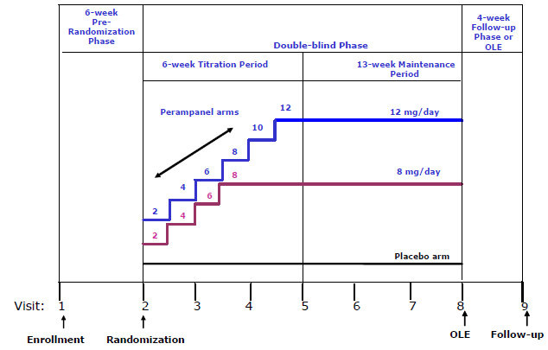
OLE = open-label extension

Primary objectives
To evaluate the efficacy of two doses of perampanel (8 and 12 mg) in comparison to placebo given as an adjunctive therapy in subjects with refractory partial seizures.

Secondary objectives
To evaluate the safety and tolerability of perampanel vs. placebo in subjects with refractory partial seizures.

Exploratory objectives
- To explore potential withdrawal symptoms of perampanel vs. placebo in subjects with refractory partial seizures.
- To explore potential photosensitivity of perampanel vs. placebo in subjects with refractory partial seizures.
- To explore the relationship of DNA sequence variability to exposure, development of AEs, or response to perampanel in subjects with refractory partial seizures.
- To explore the effects of perampanel on partial seizure frequency (in 25% increments), on the frequency of complex partial seizures with secondary generalization, and on Clinical and Patient Global Impressions of Change.

Protocol amendments
Amendment 01; 20 March 2009 after 109 subjects had been enrolled. Included:
- Added safety parameters to be evaluated.
- Defined end of the study as the date of database lock to ensure that all data were collected, verified, and cleaned thoroughly following the last subject visit.
- Specified that the investigator should review the subject diary with the subject at Visits 1 and 2 to ensure correct seizure classification.

Inclusion criteria
- A diagnosis of epilepsy with partial seizures with or without secondarily generalized seizures. Diagnosis was established by clinical history and an EEG that was consistent with localization-related epilepsy; normal interictal EEGs were allowed provided that the subject met the other diagnosis criterion (that is,, clinical history).
- A computed tomography or magnetic resonance imaging within the last 10 years that ruled out a progressive cause of epilepsy.
- Uncontrolled partial seizures despite having been treated with at least two different AEDs within approximately the last 2 years.
- During the 6-week Pre-randomization Phase, subjects must have had five or more partial seizures (with two or more partial seizures per each 3-week period) and no 25-day seizure-free period in the 6-week period, as documented via a valid seizure diary. Only simple partial seizures with motor signs, complex partial seizures, and complex partial seizures with secondary generalization were counted toward this inclusion.
- Currently being treated with stable doses of one, two or a maximum of three approved AEDs. Only one inducer AED (defined as carbamazepine, phenytoin, phenobarbital, or primidone) out of the maximum of three AEDs was allowed.
- On a stable dose of the same concomitant AED(s) for 1 month (or no less than 21 days) prior to Visit 1; in the case where a new AED regime was initiated for a subject, the dose must have been stable for 2 months (or no less than 49 days) prior to Visit 1.
- If on a stable dose (other than intermittent rescue use) of benzodiazepines for epilepsy (or for anxiety or sleep disorders), the prescribed dose was stable for 1 month (or no less than 21 days) prior to Visit 1. When used in these cases (epilepsy, anxiety or sleep disorders), benzodiazepines were counted as one AED; therefore, only one or a maximum of two additional approved AEDs were allowed.

Exclusion criteria
- Presence of non-motor simple partial seizures only.
- Presence of primary generalized epilepsies or seizures, such as absences and or myoclonic epilepsies.
- Presence or previous history of Lennox-Gastaut syndrome.
- A history of status epilepticus within approximately 12 months prior to Visit 1 with seizure clusters where individual seizures could not be counted.
- A history of psychogenic seizures.
- Scheduled and/or confirmed to have epilepsy surgery within 6 months after Visit 1; however those with previously documented “failed” epilepsy surgery were allowed.
- Suffering from psychotic disorder(s) and/or unstable recurrent affective disorder(s) evident by use of antipsychotics or who had a suicide attempt(s) within approximately the last 2 years.
- Presence of a progressive central nervous system (CNS) disease, including degenerative CNS diseases and progressive tumours.
- A history of drug or alcohol dependency or abuse within approximately the last 2 years
- If felbamate was used as a concomitant AED, subjects were on felbamate for at least 2 years, with a stable dose for 2 months (or no less than 49 days) prior to Visit 1. They must not have had a history of WBC count of ≤ 2500/mcL, platelets below 100,000/mm³, liver function tests above 3 times the ULN, or other indication of hepatic or bone marrow dysfunction while receiving felbamate. If subjects received felbamate in the past, it must have been discontinued 2 months (or no less than 49 days) prior to Visit 1.
- Concomitant use of vigabatrin. Subjects who took vigabatrin in the past were off vigabatrin for approximately 5 months prior to Visit 1 and had documentation showing no evidence of a vigabatrin-associated clinically significant abnormality in a visual perimetry test.
- Concomitant use of barbiturates (except for seizure control indication) within 1 month (or no less than 21 days) prior to Visit 1.
- Use of intermittent rescue benzodiazepines (that is,, one or two doses over a 24-hour period considered one-time rescue) two or more times in a 1-month period prior to Visit 1.

Study treatments
Subjects were randomized in 1:1:1 ratio to receive placebo or 8 or 12 mg/day of perampanel. The subjects continued to take their baseline AED medication regimen throughout the Double-blind Phase.
During the Titration Period,
- initially all subjects took six tablets either
  - six tablets of placebo [placebo group]
  - one tablet of 2 mg perampanel plus five tablets of placebo [perampanel groups].
- For the perampanel groups, the dose was increased (by replacing placebo tablets with perampanel tablets) at weekly intervals in increments of 2 mg up to the appropriate randomized dose level.
- Subjects experiencing intolerable AEs could remain on the same dose or have their dose reduced to the previously tolerated dose.
During the Maintenance Period, subjects continued once daily with placebo or the perampanel dose achieved during the Titration Period, taking the study drug. Subjects experiencing intolerable AEs could have their dose down-titrated.

Efficacy variables and outcomes
The primary end point and key secondary endpoint varied between EMEA and non EMEA submissions. In this submission:
The primary endpoint was the percent change in seizure frequency per 28 days during treatment relative to baseline in the ITT Population (LOCF).
The key secondary endpoint was:
- The 50% responder rate.
The other secondary endpoint was the percent change in complex partial plus secondarily generalized seizure frequency per 28 days during treatment relative to baseline.
There were multiple exploratory efficacy endpoints.

Randomisation and blinding methods
Randomization was performed centrally by an Interactive Voice Response System vendor that generated a randomization list with a pseudorandom number generator.

Analysis populations
- The ITT Analysis Set was the group of subjects who were randomized to study drug, received study drug, and had at least 2 weeks of seizure frequency data from the Pre-randomization Phase (baseline) and at least 2 weeks of seizure frequency data from the Double-blind Phase.
- The Full Intent-to-Treat (ITT) Analysis Set was the group of subjects who were randomized to study drug, received study drug, and had any seizure frequency data during the Double-blind Phase.
- The ITT Analysis Set for Responder Rate was the group of subjects who were randomized to study drug, received study drug, and entered the Maintenance Period (that is, took at least one dose of study drug during the Maintenance Period and had any seizure frequency data during the Maintenance Period).
- The Per Protocol (PP) Analysis Set was the subset of subjects in the ITT Analysis Set who did not have any major protocol deviations, were at least 80% compliant with the study treatment during the Double-blind Phase, and had diary compliance of more than 50% during the Pre-randomization and Double-blind Phases.
- The Modified PP Analysis Set was the subset of subjects in the ITT Analysis Set who did not have major protocol deviations expected to have a substantial impact on efficacy evaluations, were at least 80% compliant with the study treatment during the Double-blind Phase, and had diary compliance more than 50% during the Pre-randomization and Double-blind Phases. Thus, the protocol deviations considered “major” were more limited for the Modified PP Analysis Set than for the PP Analysis Set, leading to fewer excluded subjects.
- The Completer Analysis Set is the group of subjects who were randomized to study drug, received study drug, and completed the study.

Sample size
Based on Phase II studies in subjects with epilepsy, it was assumed that the percent change in seizure frequency per 28 days in the Maintenance Period relative to the Pre-randomization Phase would be 10% in the placebo group and 32% in the 8 mg group in the ITT Analysis Set. Therefore, a sample size of 120 subjects in each treatment group in the ITT Analysis Set would have 83% power to detect a treatment difference of 22% in seizure frequency (assuming a common SD of 56%) between placebo and each perampanel group based on the Wilcoxon rank-sum test with a 0.05 two-sided significance level. To account for subjects who might be randomized but not be included in the ITT Analysis Set, the number of subjects randomized was to be approximately 125 per treatment group.
Based on a proposed sample size of 120 subjects per treatment group, the study had 90% power to detect a treatment difference of 16% in responder rate proportions (10% with placebo and 26% with perampanel) with a 0.05 two-sided significance level using a 2-group chi-square test.

Statistical methods
The primary comparison is the 8 mg dose compared with placebo.
If there were countries with < 12 subjects then the countries were pooled.
For the primary efficacy endpoint, Percent change in seizure frequency, a closed testing procedure was to be employed to control family wise type-I error rate. First, the 8 mg treatment group was to be compared with the placebo at the 0.05 two-sided alpha level. If this comparison demonstrated superiority then the 12 mg treatment group was to be compared to the placebo at the 0.05 two-sided alpha level to claim superiority of the 12 mg treatment groups over placebo.
Both the Pre-randomization Phase seizure frequencies per 28 days as well as percent change from Maintenance Period per 28 days were to be rank transformed separately. The ANCOVA was then to be conducted on this rank transformed data with treatment, and pooled countries as factors, and the ranked Pre-randomization Phase seizure frequency per 28 days as a covariate. P-values were to be computed using contrasts between active and placebo treatment groups.
Responder rate: An analysis of subjects who experience a 50% or greater reduction in seizure frequency in the Maintenance Period of the Double-blind Phase relative to the Pre-randomization Phase was to be conducted based on Cochran-Mantel-Haenszel test adjusting for pooled countries.
Percent change in seizure frequency in complex partial seizure plus complex partial with secondary generalization seizures per 28 days in the Maintenance Period relative to the Pre-randomization Phase was to be analysed using rank ANCOVA with treatment, and pooled countries as factors, and the ranked Pre-randomization complex partial seizure plus complex partial with secondary generalization seizures frequency per 28 days as a covariate.

Participant flow
Figure 8. Subject Disposition
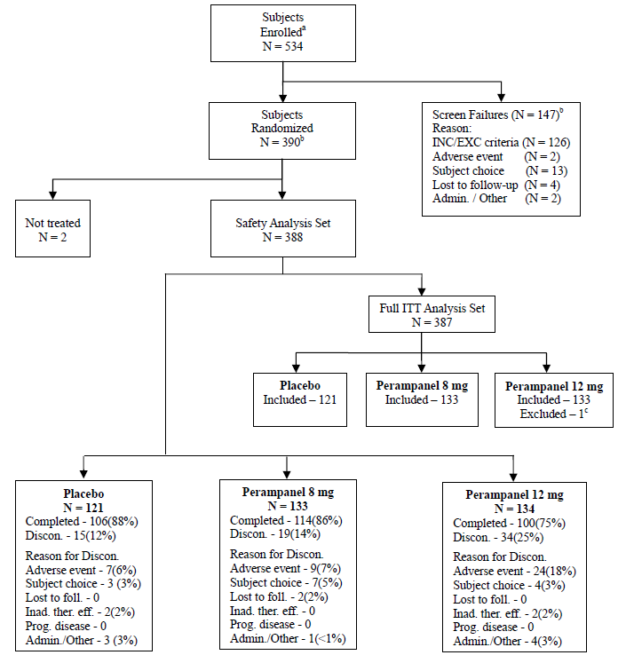
Admin. = administrative, Discon. = discontinued/discontinuation, Foll. = follow-up, Inad. ther. eff. = inadequate therapeutic effect, INC/EXC = inclusion/exclusion, Prog. disease = progressive disease. ª Subjects who signed informed consent forms. ^{b} Includes three subjects who were screen failures and were inappropriately randomized to a treatment group. ^{c} Subject [information redacted] was treated for 1 day and did not complete a seizure diary that day.

Major protocol violations/deviations
Table 4. Summary of Reasons for Exclusion from Per-Protocol Analysis - Intent-to-Treat Analysis Set Study 304
 | Placebo (N=119) | Perampanel
 | Placebo (N=119) | 8 mg (N=132) | 12 mg (N=130)
< 80% Compliant with Study Drug | 1 (<1) | 3 (2.3) | 0
Mis-randomized (screen failure) | 0 | 1 (<1) | 0
Not enough seizures during Pre-randomization | 3 (2.5) | 7 (5.3) | 4 (3.1)
Not treated with stable doses of 1-3 AEDs with max 1 inducer | 3 (2.5) | 7 (5.3) | 4 (3.1)
Intermittent use of benzodiazepines | 0 | 0 | 1 (<1)
Good Clinical Practices Violations | 1 (<1) | 2 (1.5) | 2 (1.5)
If a subject met 2 or more criteria for exclusion, the subject is counted in each exclusion criterion met.

Baseline data
Overall, 15.5% of the subjects were taking one AED, 55.7% were taking two AEDs, and 28.9% were taking three AEDs. There was variability between the groups in the percentage of subjects taking one AED (12.4% in the placebo group, 19.5% in the 8 mg group, 14.2% in the 12 mg group), two AEDs (52.9%, 52.6%, and 61.2%, respectively), or three AEDs (34.7%, 27.8%, and 24.6%, respectively).
Table 5. Summary of Demography, Baseline: Safety Analysis Set Study 304
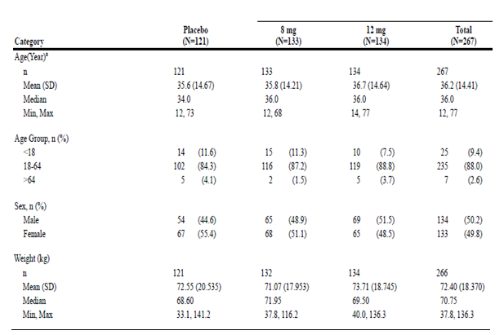
Percentages are based on the total number of subjects in relevant treatment group.
ª: Age at Informed Consent.
^{b}: BMI represents subject's Body Mass Index (kg/m^2). The units used are kg/m^2.
Table 6. Summary of Epilepsy-Specific Medical History: Safety Analysis Set Study 304
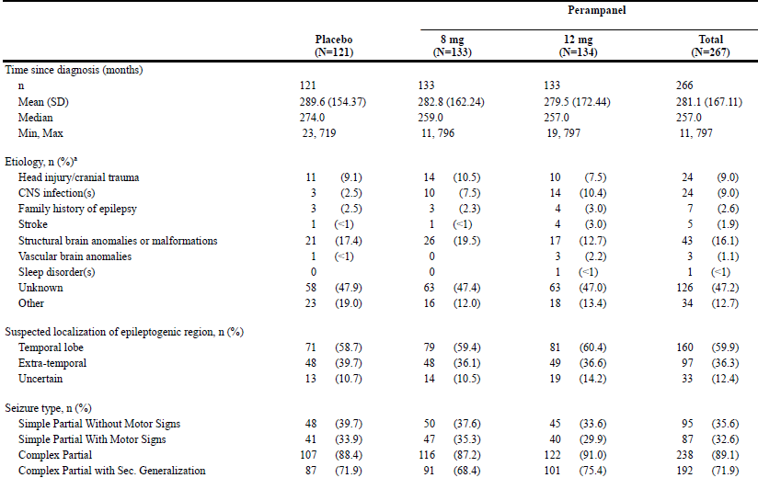
Sec = secondary ª: Aetiology: Only a subject’s primary reason is listed.
Table 7. Anti-Epileptic Drugs at Baseline - Safety Analysis Set Study 304
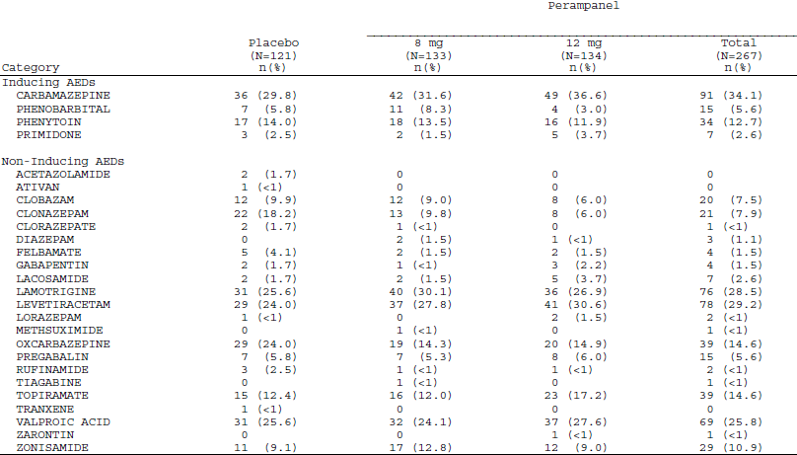
Percentages are based on the total number of subjects in relevant treatment group Inducer AEDs include Carbamazepine, Phenobarbital, Phenytoin, and Primidone. Non-inducer AEDs include all other AEDs.

Results for the primary efficacy outcome
For the percent change in seizure frequency per 28 days during the Double-blind Phase relative to baseline for the Full ITT Analysis Set; mean (SD) change was -5.10 (65.417)% in the placebo group; -24.12 (50.081)% on 8 mg and -17.60 (83.195)% on 12 mg perampanel; median change was -20.95% in the placebo group, -26.34% in the 8 mg group, and -34.49% in the 12 mg group.
Model Estimated Percent Changes from Pre-randomization (95% CI) were placebo -21.29 (-32.04,-9.23); perampanel 8 mg -39.38 (-47.62,-30.20); 12 mg -36.47 (-45.17,-26.76) that is, some overlap of CIs.
The P values for the difference from placebo were 0.0261 for 8 mg and 0.0158 for 12 mg based on the rank ANCOVA and 0.0044 and 0.0184, respectively, based on the log transformation-based ANCOVA.

Table 8. Percent Change from Pre-randomization in Seizure Frequency per 28 Days - Full Intent-to-Treat Analysis Set Study 304
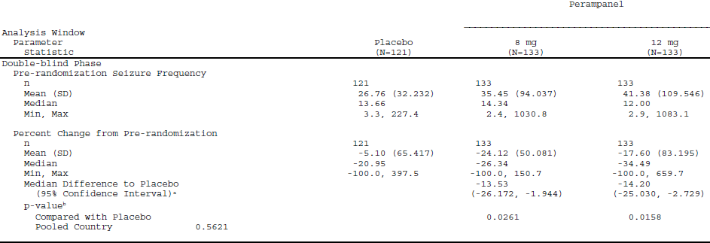
ª: The Median Difference to placebo and the 95% confidence interval are based on the Hodges-Lehmann method. ^{b}: For analysis windows, the p-value is based on rank ANCOVA for percent change from Pre-randomization of seizure frequency per 28 days with treatment and pooled country as factors, and Pre-randomization seizure frequency per 28 days as covariate. The Pre- randomization and post randomization efficacy measurements are rank transformed separately. ^{c}: The linear trend test is based on the contrast with coefficients of -5, 2, and 3 for the Placebo, 8 mg, and 12 mg groups, respectively, from the above rank ANCOVA.
Table 9. Analysis of Percent Change from Pre-randomization in Seizure Frequency per 28 Days Using Log Transformation - Full Intent-to-Treat Analysis Set Study 304
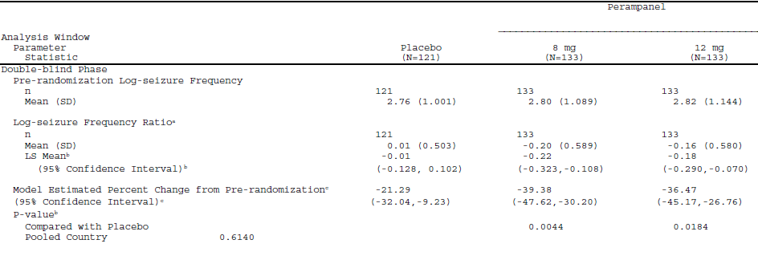
ª: Log seizure frequency ratio is equal to log(post-randomization seizure frequency per 28 days/pre-randomization seizure frequency factors per 28 days+0.2), where the constant 0.2 is added to avoid the log transformation of zero values. ^{b}: The LS means, 95% confidence intervals, and p-values are obtained from an analysis of covariance (ANCOVA) model. The model has log-seizure frequency ratio as the response with treatment and pooled country as factors and centralized pre-randomization log-transformed seizure frequency per 28 days as covariate. The linear trend test is based on the contrast with coefficients of -5, 2, and 3 for the Placebo, 8 mg, and 12 mg groups, respectively. ^{c}: The percentage change from pre-randomization and the associated 95% confidence interval are obtained by back transformation of the least squares mean and the associated 95% confidence interval from the above ANCOVA model.

For Central and South America, the change in seizure frequency per 28 days for geographic subsets (ITT Analysis Set) showed a much higher response in the placebo group compared with the responses seen in the placebo groups for North America and for the United States. This resulted in a significant treatment-by-region interaction (P = 0.0035).
To further understand the results from Latin America, additional sensitivity analyses were performed by seizure type for each study site in this region with at least one perampanel- and one placebo-treated subject with the seizure type at baseline. For simple partial seizures, moderate improvement in seizure frequency relative to placebo was seen at 8 of 14 sites (median differences from placebo of -14.69% to -237.40%), whereas the two sites with the highest number of subjects (one site in Chile and one in Argentina) showed a greater effect for placebo (median differences of 35.07% and 15.26%. respectively). For complex partial seizures, improvement relative to placebo was seen at 6 of 16 sites (median difference from placebo -14.64% to -112.37%); again, the two sites with the greatest number of subjects showed a greater effect for placebo (median differences of 4.50% for the site in Chile and 38.97% for the site in Argentina). For secondarily generalized seizures, improvement in seizure frequency relative to placebo was seen at 10 of 14 sites (median differences from placebo of -14.54% to -234.29%), including the two sites with the largest numbers of subjects (median differences of -19.20% for the site in Chile and -25.84% for the site in Argentina).
Table 10. Study 304 Percent Change in Seizure Frequency per 28 Days During the Double-blind Phase Relative to Baseline for the Full ITT Analysis Set: Results by Region Study 304
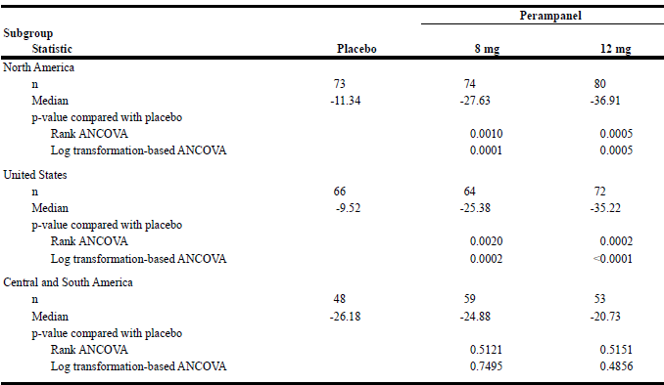

Results for other efficacy outcomes
Table 11. 50% Responder Rate Analysis: Full ITT Analysis Set Study 304
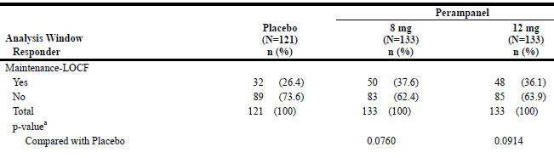
ª: The p-value is based on non-missing values and is from the Cochran-Mantel-Haenszel (CMH) test adjusted for pooled country. Responders were defined as subjects who experienced a 50% or greater reduction in seizure frequency per 28 days in the Maintenance Period relative to the Pre-randomization Phase.
Table 12. Percent Change in Frequency per 28 days of Complex Partial Plus Secondarily Generalized Seizures: Full ITT Analysis Set Study 304
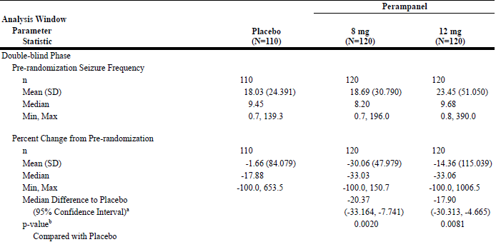
This table summarizes the percent change in the frequency of complex partial seizures combined with the frequency of complex partial seizures that secondarily generalized. ª: The Median Difference to placebo and the 95% confidence interval are based on the Hodges-Lehmann method. ^{b}: The p-value is based on rank ANCOVA for percent change from Pre-randomization of seizure frequency per 28 days with treatment and pooled country as factors, and Pre-randomization seizure frequency per 28 days as covariate. The Pre-randomization and post randomization efficacy measurements are rank transformed separately.
Table 13. Responder Analysis - Secondarily Generalized Seizures - Intent-to-Treat Analysis Set with Secondarily Generalized Seizures at Pre-randomization Study 304
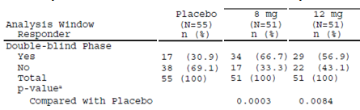
^{a:} The p-value is based on non-missing values and is from the Cochran-Mantel-Haenszel (CMH) test adjusted for pooled country. A responder is a subject who experienced a 50% or greater reduction in seizure frequency per 28 days from the Pre-randomization Phase.

Table 14. Percent Change from Pre-randomization in Seizure Frequency per 28 Days - Secondarily Generalized Seizures -Full Intent-to-Treat Analysis Set with Secondarily Generalized Seizures at Pre-randomization Study 304
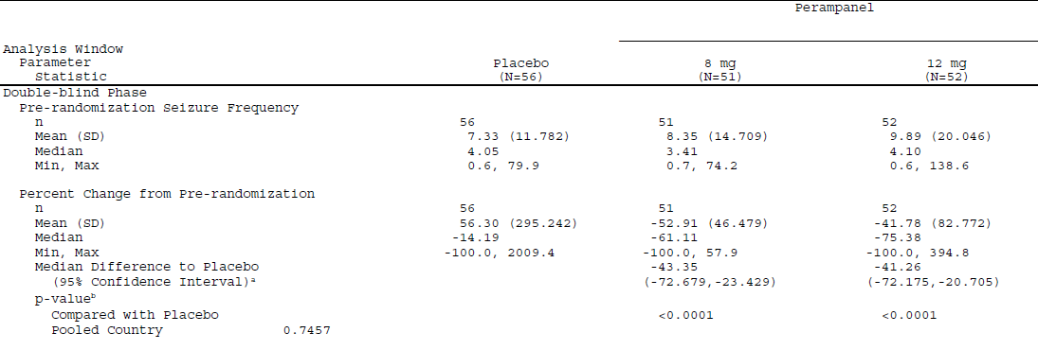
ª: The Median Difference to placebo and the 95% confidence interval are based on the Hodges-Lehmann method.^{b}: For analysis windows, the p-value is based on rank ANCOVA for percent change from Pre-randomization of seizure frequency per 28 days with treatment and pooled country as factors, and Pre-randomization seizure frequency per 28 days as covariate. The Pre-randomization and post randomization efficacy measurements are rank transformed separately. ^{c:} The linear trend test is based on the contrast with coefficients of -5, 2, and 3 for the Placebo, 8 mg, and 12 mg groups, respectively, from the above rank ANCOVA.

Study E2007-G000-305

Study design, objectives, locations and dates
Similar to study E2007-G000-304 except did not include exploratory DNA sequencing.
Conducted from 20 May 2008 to 14 Jan 2011 in 84 centres in Australia, Austria, Belgium, Finland, France, Germany, Greece, India, Israel, Italy, Netherlands, Russian Federation, South Africa, Sweden, United Kingdom, and the United States.

Efficacy variables and outcomes
Similar to study E2007-G000-304. The primary end point and key secondary endpoint varied between EMEA and non EMEA submissions. In this submission:
The primary endpoint was the percent change in seizure frequency per 28 days during treatment relative to baseline in the ITT Population (LOCF).
The key secondary endpoint was:
- the 50% responder rate.
The other secondary endpoint was the percent change in complex partial plus secondarily generalized seizure frequency per 28 days during treatment relative to baseline.
There were multiple exploratory efficacy endpoints.

Major protocol violations/deviations
Table 15. Summary of Reasons for Exclusion from PP Analysis - ITT Analysis Set Study 305
 | Placebo (N=136) | Perampanel
 | Placebo (N=136) | 8 mg (N=129) | 12 mg (N=121)
< 80% Compliant with Study Drug | 2 (1.5) | 2 (1.6) | 1 (<1)
Mis-randomized (screen failure) | 3 (2.2) | 3 (2.3) | 1 (<1)
Not enough seizures during Pre-randomization | 3 (1.5) | 3 (2.3) | 2 (1.7)
Not treated with stable doses of 1-3 AEDs with max 1 inducer | 5 (3.7) | 3 (2.3) | 2 (1.7)
Received unblinded drug kit at Visit 7 | 2 (1.5) | 3 (2.3) | 2 (1.7)
If a subject met 2 or more criteria for exclusion, the subject is counted in each exclusion criterion met.

Participant flow
Figure 9. Subject Disposition Study 305
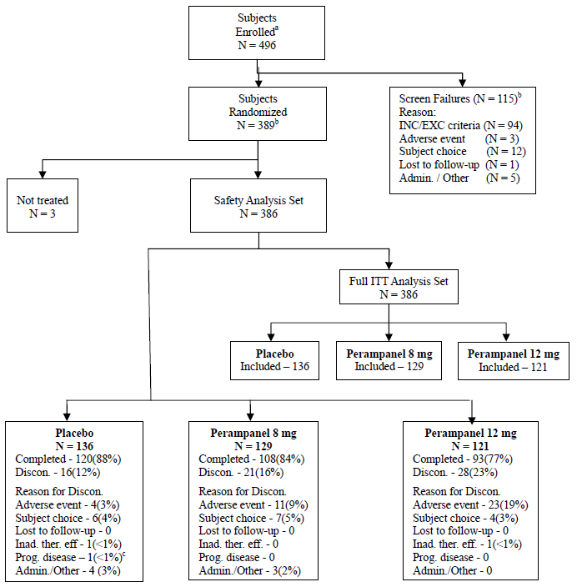
Admin. = administrative, Discon. = discontinued/discontinuation, Inad. ther. eff. = inadequate therapeutic effect, INC/EXC = inclusion/exclusion, ITT = intent-to-treat, Prog. disease = progressive disease. ª: Subjects who signed informed consent forms. ^{b}: Includes eight subjects who were screen failures yet inappropriately randomized to a treatment group. ^{c:} Subject [information redcated] was mistakenly indicated as having progression of disease instead of progression of seizures;

Baseline data
Table 16. Summary of Demography, Baseline: Safety Analysis Set Study 305
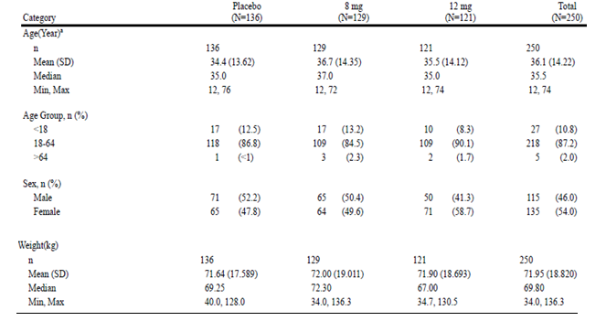
Percentages are based on the total number of subjects in relevant treatment group. a: Age at Informed Consent
Table 17. Summary of Epilepsy-Specific Medical History: Safety Analysis Set Study 305
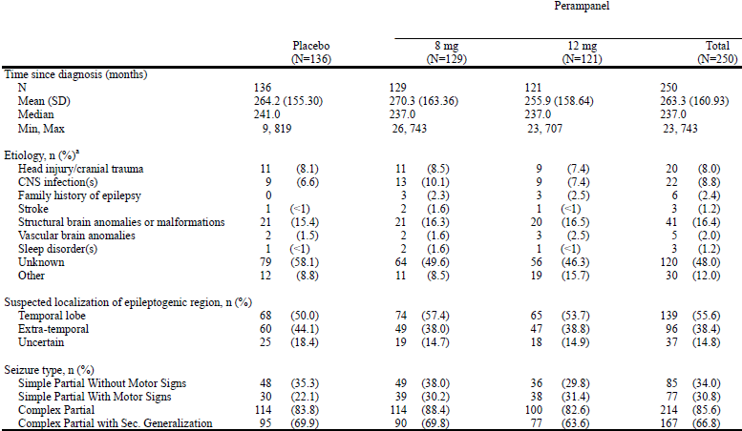
ª: Aetiology: Only a subject’s primary reason is listed.
Table 18. Anti-Epileptic Drugs at Baseline - Safety Analysis Set Study 305
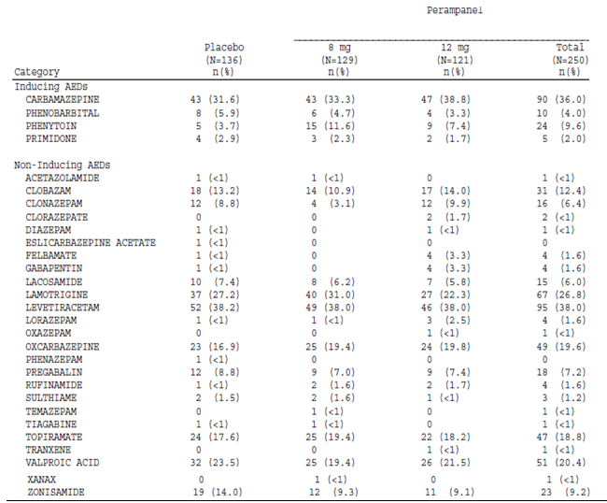
Percentages are based on the total number of subjects in relevant treatment group. Inducer AEDs include Carbamazepine, Phenobarbital, Phenytoin, and Primidone. Non-inducer AEDs include all other AEDs.
Overall, 10.9% of the subjects were taking one AED, 50.5% were taking two AEDs, and 38.6% were taking three AEDs. There was variability between the groups in the percentage of subjects taking one AED (12.5% in the placebo group, 12.4% in the 8 mg group, 7.4% in the 12 mg group), two AEDs (47.1%, 52.7%, and 52.1%, respectively), or three AEDs (40.4%, 34.9%, and 40.5%, respectively).

Results for the primary efficacy outcome
The percent change in seizure frequency per 28 days during the Double-blind Phase relative to baseline for the Full ITT Analysis Set. Mean (SD) change was 1.01 (66.587)% in the placebo group; -21.43 (48.258)% on 8 mg and 1.08 (129.422)% on 12 mg perampanel. The median change was -9.72% in the placebo group, -30.52% in the 8 mg group, and -17.57% in the 12 mg group.
Model Estimated Percent Changes from Pre-randomization (95% CI) were placebo -8.77 (-18.84,2.30); perampanel 8 mg -29.71 (-37.99,-20.59); 12 mg -23.96 (-33.07,-13.90) that is, some overlap of CIs.
The P values for the difference from placebo were 0.0008 for 8 mg and 0.0105 for 12 mg based on the rank ANCOVA and 0.0013 and 0.0253, respectively, based on the log transformation-based ANCOVA.

Table 19. Percent Change from Pre-randomization in Seizure Frequency per 28 Days - Full Intent-to-Treat Analysis Set Study 305
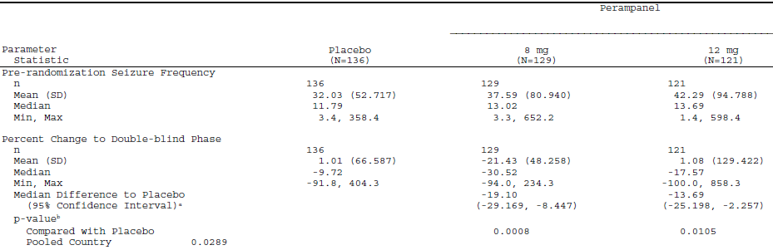
ª: The Median Difference to placebo and the 95% confidence interval are based on the Hodges-Lehmann method. ^{b}: For analysis windows, the p-value is based on rank ANCOVA for percent change from Pre-randomization of seizure frequency per 28 days with treatment and pooled country as factors, and Pre-randomization seizure frequency per 28 days as covariate. The Pre- randomization and post randomization efficacy measurements are rank transformed separately. ^{c}: The linear trend test is based on the contrast with coefficients of -5, 2, and 3 for the Placebo, 8 mg, and 12 mg groups, respectively, from the above rank ANCOVA.
Table 20. Analysis of Percent Change from Pre-randomization in Seizure Frequency per 28 Days Using Log Transformation - Full Intent-to-Treat Analysis Set Study 305
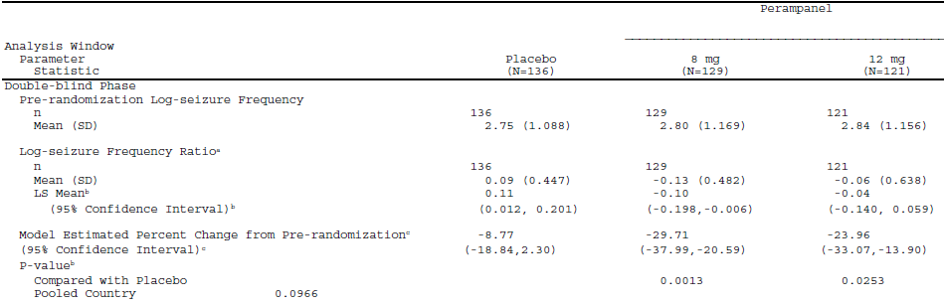
ª: Log seizure frequency ratio is equal to log(post-randomization seizure frequency per 28 days/pre-randomization seizure frequency factors per 28 days+0.2), where the constant 0.2 is added to avoid the log transformation of zero values. ^{b}: The LS means, 95% confidence intervals, and p-values are obtained from an analysis of covariance (ANCOVA) model. The model has log-seizure frequency ratio as the response with treatment and pooled country as factors and centralized pre-randomization log-transformed seizure frequency per 28 days as covariate. The linear trend test is based on the contrast with coefficients of -5, 2, and 3 for the Placebo, 8 mg, and 12 mg groups, respectively.
^{c}: The percentage change from pre-randomization and the associated 95% confidence interval are obtained by back transformation of the least squares mean and the associated 95% confidence interval from the above ANCOVA model. Although the treatment-by-baseline interaction was statistically significant (P = 0.0163), the rank ANCOVA model with the treatment-by-baseline interaction effect still yielded statistically significant differences between the 8 mg and 12 mg groups vs. placebo (P = 0.0009 and 0.0091, respectively).
The two perampanel dose groups tend to have greater seizure percentage reductions with lower seizure rates at baseline, while the placebo group had more seizure percentage reductions with higher baseline seizure rate. This observation is consistent with the covariate estimates for the rank ANCOVA with the treatment-by-baseline interaction, where the active groups had positive covariate slopes while the placebo group had a negative slope.

Results for other efficacy outcomes
Table 21. 50% Responder Rate Analysis: Full ITT Analysis Set Study 305
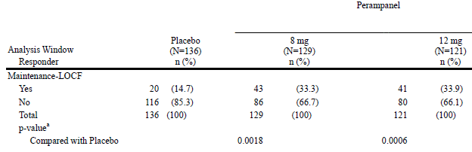
ª: The p-value is based on non-missing values and is from the Cochran-Mantel-Haenszel (CMH) test adjusted for pooled country. A responder is a subject who experienced a 50% or greater reduction in seizure frequency per 28 days from the Pre-randomization Phase.
Table 22. Percent Change in Frequency per 28 days of Complex Partial Plus Secondarily Generalized Seizures: Full ITT Analysis Set Study 305
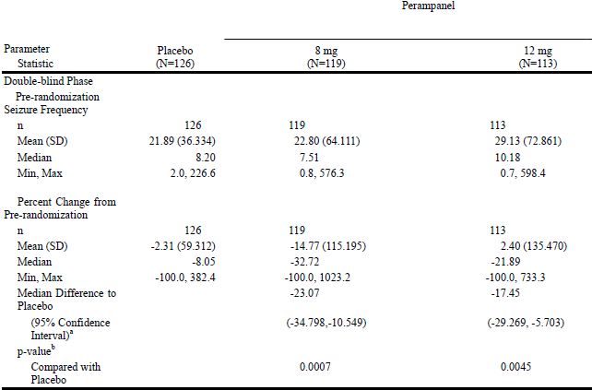
This table summarizes the percent change in the frequency of complex partial seizures combined with the frequency of complex partial seizures that secondarily generalized. ª: The Median Difference to placebo and the 95% confidence interval are based on the Hodges-Lehmann method. ^{b}: The p-value is based on rank ANCOVA for percent change from Pre-randomization of seizure frequency per 28 days with treatment and pooled country as factors, and Pre-randomization seizure frequency per 28 days as covariate. The Pre-randomization and post randomization efficacy measurements are rank transformed separately.

Table 23. Percent Change from Pre-randomization in Seizure Frequency per 28 Days - Secondarily Generalized Seizures - Full Intent-to-Treat Analysis Set with Secondarily Generalized Seizures at Pre-randomization Study 305
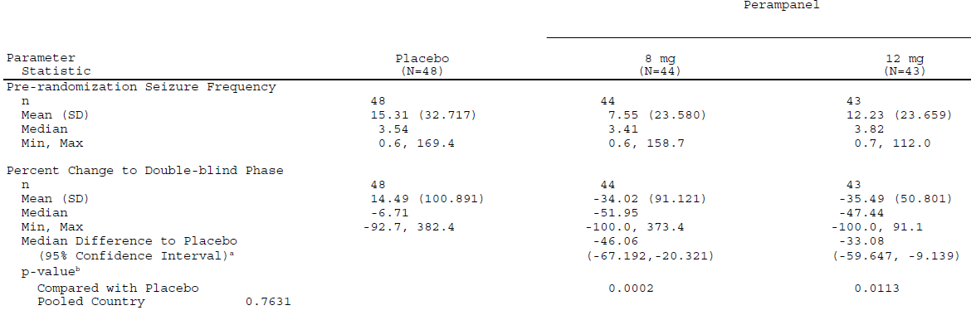
ª: The Median Difference to placebo and the 95% confidence interval are based on the Hodges-Lehmann method. ^{b}: For analysis windows, the p-value is based on rank ANCOVA for percent change from Pre-randomization of seizure frequency per 28 days with treatment and pooled country as factors, and Pre-randomization seizure frequency per 28 days as covariate. The Pre-randomization and post randomization efficacy measurements are rank transformed separately. ^{c:} The linear trend test is based on the contrast with coefficients of -5, 2, and 3 for the Placebo, 8 mg, and 12 mg groups, respectively, from the above rank ANCOVA.

Table 24. Responder Analysis - Secondarily Generalized Seizures - ITT Analysis Set for Responder Rate with Secondarily Generalized Seizures at Pre-randomization Study 305
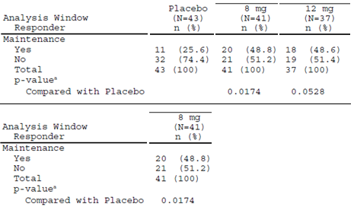
^{a:} The p-value is based on non-missing values and is from the Cochran-Mantel-Haenszel (CMH) test adjusted for pooled country. A responder is a subject who experienced a 50% or greater reduction in seizure frequency per 28 days from the Pre-randomization Phase.

Study E2007-G000-306

Study design, objectives, locations and dates
Similar to study E2007-G000-304 except 3 doses of perampanel (2, 4 and 8 mg) were used in comparison to placebo.
4 Aug 2008 to 21 Jul 2010 in 116 centres in Australia, Bulgaria, China, Czech Republic, Estonia, Germany, Hong Kong, Hungary, India, Italy, Republic of Korea, Latvia, Lithuania, Malaysia, Philippines, Poland, Portugal, Romania, Russian Federation, Serbia and Montenegro, Spain, Thailand, Taiwan, United States and Ukraine.
Primary Objectives
To evaluate the efficacy of three doses of perampanel (2, 4 and 8 mg) in comparison to placebo given as an adjunctive therapy in subjects with refractory partial seizures.
Secondary and exploratory objectives were similar to study E2007-G000-304.

Protocol amendments
Similar to study E2007-G000-304.

Inclusion and Exclusion criteria
Similar to study E2007-G000-304.

Study treatments
Similar to study E2007-G000-304 except:
Subjects were randomized in 1:1:1:1 ratio to receive placebo or 2, 4 or 8 mg/day of perampanel. The subjects continued to take their baseline AED medication regimen throughout the Double-blind Phase.
During the Titration Period,
- Initially all subjects took six tablets either
  - six tablets of placebo [placebo group]
  - one tablet of 2 mg perampanel plus five tablets of placebo [perampanel groups].
- For the perampanel groups, the dose was increased (by replacing placebo tablets with perampanel tablets) at weekly intervals in increments of 2 mg up to the appropriate randomized dose level.
- Subjects experiencing intolerable AEs could remain on the same dose or have their dose reduced to the previously tolerated dose.
During the Maintenance Period, subjects continued once daily with placebo or the perampanel dose achieved during the Titration Period, taking the study drug. Subjects experiencing intolerable AEs could have their dose down-titrated.

Efficacy variables and outcomes
Similar to study E2007-G000-304:
The primary end point and key secondary endpoint varied between EMEA and non EMEA submissions.
The primary endpoint was the percent change in seizure frequency per 28 days during treatment relative to baseline in the ITT Population (LOCF).
The key secondary endpoint was:
- The 50% responder rate.
The other secondary endpoint was the percent change in complex partial plus secondarily generalized seizure frequency per 28 days during treatment relative to baseline.
There were multiple exploratory efficacy endpoints.

Analysis populations
Similar to study E2007-G000-304.

Sample size
Based on Phase II studies in subjects with epilepsy, it was assumed that the percent change in seizure frequency per 28 days in the Maintenance Period relative to the Pre-randomization Phase would be 10% in the placebo group, 32% in the 8 mg group and 26% in the 4 mg group in the ITT Analysis Set. Therefore, a sample size of 162 subjects in each treatment group in the ITT Analysis Set would have 92% power to detect a treatment difference of 22% in seizure frequency (assuming a common SD of 56%) between placebo and each perampanel group based on the Wilcoxon rank-sum test with a 0.05 two-sided significance level. To account for subjects who might be randomized but not be included in the ITT Analysis Set, the number of subjects randomized was to be approximately 170 per treatment group.
Based on a proposed sample size of 162 subjects per treatment group, the study had 96% power to detect a treatment difference of 16% in responder rate proportions (10% with placebo and 26% with 8 mg perampanel) with a 0.05 two-sided significance level using a 2-group chi-square test.

Statistical methods
The primary comparison is the 8 mg dose compared with placebo.
If there were countries with < 12 subjects then the countries were pooled.
For the primary efficacy endpoint, Percent change in seizure frequency, a closed testing procedure was to be employed to control family wise type-I error rate.
First, the 8 mg treatment group was compared with placebo at the 0.05 two-sided alpha level. If this comparison demonstrated superiority, then the 8 mg treatment group was declared efficacious. The 4 mg treatment group was then compared with placebo at the 0.05 two-sided alpha level to claim superiority of the 4 mg treatment groups over placebo. If both the 8 and 4 mg treatment groups were statistically superior to placebo at the 0.05 two-sided alpha level, the 2 mg treatment group was then compared with placebo at the 0.05 two-sided alpha level to test for superiority of the 2 mg treatment group over placebo.
Both the Pre-randomization Phase seizure frequencies per 28 days as well as percent change from Maintenance Period per 28 days were to be rank transformed separately. The ANCOVA was then to be conducted on this rank transformed data with treatment, and pooled countries as factors, and the ranked Pre-randomization Phase seizure frequency per 28 days as a covariate. P-values were to be computed using contrasts between active and placebo treatment groups.
Responder rate: An analysis of subjects who experience a 50% or greater reduction in seizure frequency in the Maintenance Period of the Double-blind Phase relative to the Pre-randomization Phase was to be conducted based on Cochran-Mantel-Haenszel test adjusting for pooled countries.
Percent change in seizure frequency in complex partial seizure plus complex partial with secondary generalization seizures per 28 days in the Maintenance Period relative to the Pre-randomization Phase was to be analysed using rank ANCOVA with treatment, and pooled countries as factors, and the ranked Pre-randomization complex partial seizure plus complex partial with secondary generalization seizures frequency per 28 days as a covariate.

Participant flow
Figure 10. Subject Disposition Study 306
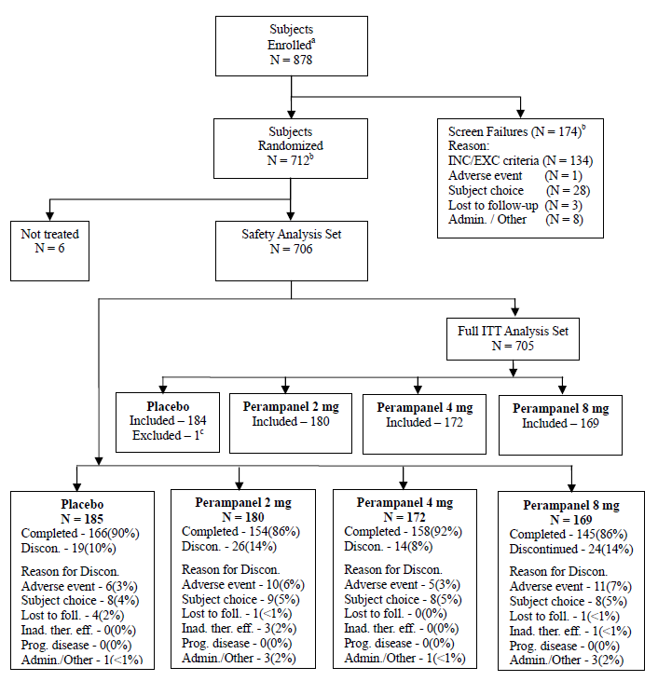
Admin. = administrative, Discon. = discontinued/discontinuation, Foll. = follow-up, Inad. ther. eff. = inadequate therapeutic effect, INC/EXC = inclusion/exclusion, ITT = intent-to-treat, Prog. disease = progressive disease. ª: Subjects who signed informed consent forms ^{b}: Includes eight subjects who were screen failures and were inappropriately randomized to a treatment group ^{c}: Subject 43056003 was treated for 1 day and did not complete a seizure diary that day.

Major protocol violations/deviations
Table 25. Summary of Reasons for Exclusion from PP Analysis - ITT Analysis Set Study 306
 | Placebo (N=182) | Perampanel
 | Placebo (N=182) | 2 mg (N=177) | 4 mg (N=168) | 8 mg (N=166)
< 75% Compliant with Study Drug | 2 (1.1) | 0 | 1 (<1) | 2 (1.2)
≤ 50% Diary Compliant | 1 (<1) | 0 | 1 (<1) | 0
Pre-randomization Phase | 0 | 0 | 1 (<1) | 0
Double-blind Phase | 1 (<1) | 0 | 0 | 0
Mis-randomized (screen failure) | 1 (<1) | 1 (<1) | 0 | 0
Not enough seizures during Pre-randomization | 3 (1.6) | 5(2.8) | 1 (<1) | 8 (4.8)
Not treated with stable doses of 1-3 AEDs | 6(3.3) | 2 (1.1) | 3 (1.8) | 3 (1.8)
Did not receive randomized drug | 2 (1.1) | 1 (<1) | 2 (1.2) | 1 (<1)
If a subject met 2 or more criteria for exclusion, the subject is counted in each exclusion criterion met.

Baseline data
Table 26. Summary of Demography, Baseline Safety Analysis Set Study 306
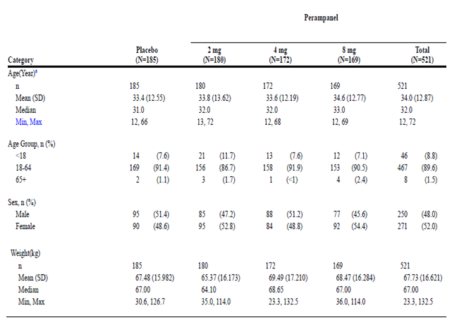
Percentages are based on the total number of subjects in relevant treatment group. ª: Age at Informed Consent.
Table 27. Summary of Epilepsy-Specific Medical History: Safety Analysis Set Study 306
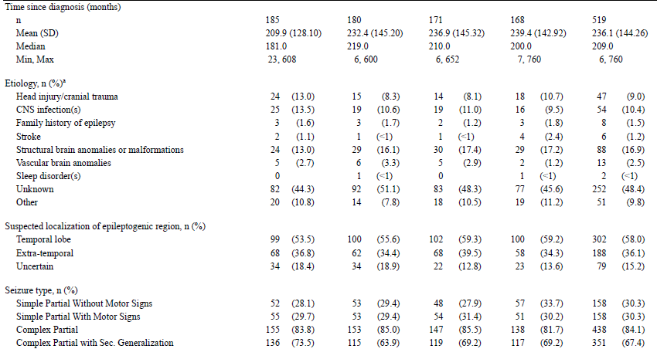
Sec = secondary ª: Aetiology: Only a subject’s primary reason is listed.
Overall, 14.7% of the subjects were taking one AED, 48.2% were taking two AEDs, and 37.1% were taking three AEDs. There was variability between the groups in the percentage of subjects taking one AED (15.1% in the placebo group, 16.7% in the 2 mg group, 11.0% in the 4 mg group, 16.0% in the 8 mg group), two AEDs (48.6%, 44.4%, 51.2% and 48.5%, respectively), or three AEDs (36.2%, 38.9%, 37.8% and 35.5%, respectively).
Table 28. Anti-Epileptic Drugs at Baseline - Safety Analysis Set Study 306
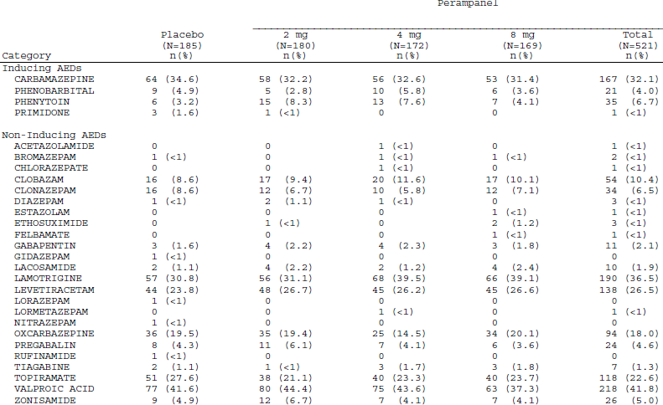
Percentages are based on the total number of subjects in relevant treatment group. Inducer AEDs include Carbamazepine, Phenobarbital, Phenytoin, and Primidone. Non-inducer AEDs include all other AEDs.

Results for the primary efficacy outcome
For the percent change in seizure frequency per 28 days during the Double-blind Phase relative to baseline for the Full ITT Analysis Set; mean (SD) change was 0.82 (67.438)% in the placebo group; --7.25 (58.392) % on 2 mg, -14.33 (66.977)% on 4 mg and -20.86 (60.937)% on 8 mg perampanel; median change was -10.69% in the placebo group, -13.63% in the 2 mg group, -23.33% in the 4 mg group, and -30.80% in the 8 mg group.
Model Estimated Percent Changes from Pre-randomization (95% CI) were placebo -17.56 (-25.90,-8.47)%; perampanel 2 mg -22.56 (-30.62,-13.78)%; 4 mg -31.84 (-39.31,-23.68)%; 8 mg -38.36 (-45.30,-30.77)% that is, some overlap of CIs.
The P values for the difference from placebo were 0.4197 for 2 mg, 0.0026 for 4 mg, and < 0.0001 for 8 mg based on the rank ANCOVA and 0.2542, 0.0037, and < 0.0001, respectively, based on the log transformation-based ANCOVA.
From the ranked ANCOVA model the effect of the ranked pre-randomization (baseline) seizure frequency did not reach statistical significance (P = 0.0550) while the effect for pooled country was statistically significant (P = 0.0002). Treatment by pooled country interaction and by baseline interaction were not statistically significant (P = 0.6910 and 0.8027 respectively).

Table 29. Percent Change from Pre-randomization in Seizure Frequency per 28 Days - Full Intent-to-Treat Analysis Set Study 306
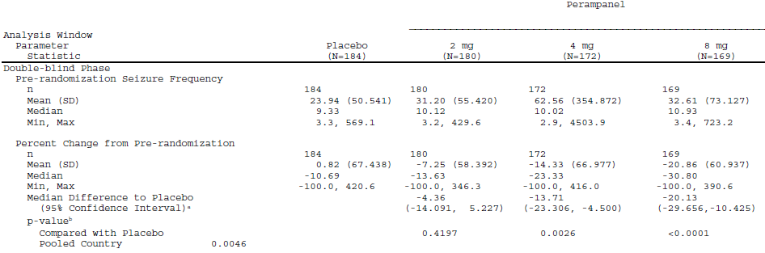
ª: The Median Difference to placebo and the 95% confidence interval are based on the Hodges-Lehmann method. ^{b}: For analysis windows, the p-value is based on rank ANCOVA for percent change from Pre-randomization of seizure frequency per 28 days with treatment and pooled country as factors, and Pre-randomization seizure frequency per 28 days as covariate. The Pre- randomization and post randomization efficacy measurements are rank transformed separately. ^{c}: The linear trend test is based on the contrast with coefficients of -5, 2, and 3 for the Placebo, 8 mg, and 12 mg groups, respectively, from the above rank ANCOVA.
Table 30. Analysis of Percent Change from Pre-randomization in Seizure Frequency per 28 Days Using Log Transformation -Full Intent-to-Treat Analysis Study 306
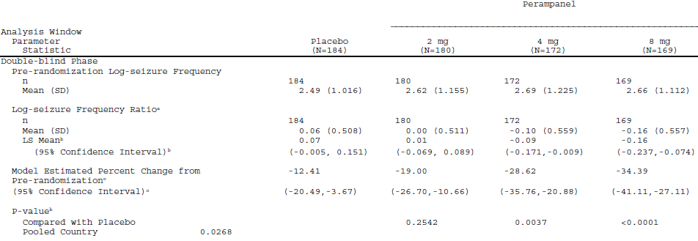
ª: Log seizure frequency ratio is equal to log(post-randomization seizure frequency per 28 days/pre-randomization seizure frequency factors per 28 days+0.2), where the constant 0.2 is added to avoid the log transformation of zero values. ^{b}: The LS means, 95% confidence intervals, and p-values are obtained from an analysis of covariance (ANCOVA) model. The model has log-seizure frequency ratio as the response with treatment and pooled country as factors and centralized pre-randomization log-transformed seizure frequency per 28 days as covariate. The linear trend test is based on the contrast with coefficients of -5, 2, and 3 for the Placebo, 8 mg, and 12 mg groups, respectively. ^{c}: The percentage change from pre-randomization and the associated 95% confidence interval are obtained by back transformation of the least squares mean and the associated 95% confidence interval from the above ANCOVA model.

Results for other efficacy outcomes
Table 31. 50% Responder Rate Analysis: Full ITT Analysis Set Study 306
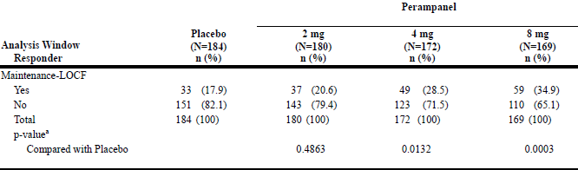
ª: The p-value is based on non-missing values and is from the Cochran-Mantel-Haenszel (CMH) test adjusted for pooled country. A responder is a subject who experienced a 50% or greater reduction in seizure frequency per 28 days from the Pre-randomization Phase.
Table 32. Percent Change in Frequency per 28 days of Complex Partial Plus Secondarily Generalized Seizures: Full ITT Analysis Set Study 306
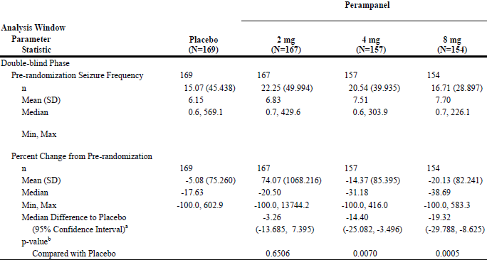
This table summarizes the percent change in the frequency of complex partial seizures combined with the frequency of complex partial seizures that secondarily generalized. ª: The Median Difference to placebo and the 95% confidence interval are based on the Hodges-Lehmann method. ^{b}: The p-value is based on rank ANCOVA for percent change from Pre-randomization of seizure frequency per 28 days with treatment and pooled country as factors, and Pre-randomization seizure frequency per 28 days as covariate. The Pre-randomization and post randomization efficacy measurements are rank transformed separately.

Table 33. Percent Change from Pre-randomization in Seizure Frequency per 28 Days - Secondarily Generalized Seizures - Intent-to-Treat Analysis Set with Secondarily Generalized Seizures at Pre-randomization Study 306
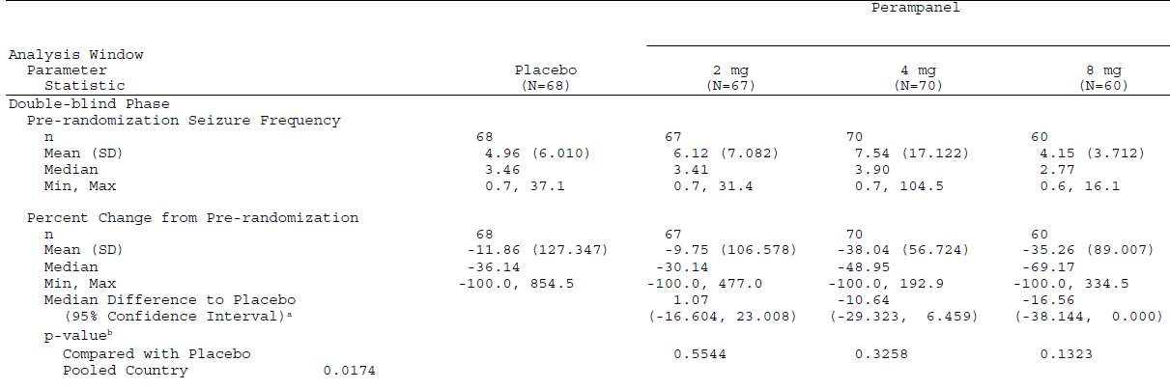
ª: The Median Difference to placebo and the 95% confidence interval are based on the Hodges-Lehmann method. ^{b}: For analysis windows, the p-value is based on rank ANCOVA for percent change from Pre-randomization of seizure frequency per 28 days with treatment and pooled country as factors, and Pre-randomization seizure frequency per 28 days as covariate. The Pre-randomization and post randomization efficacy measurements are rank transformed separately. ^{c:} The linear trend test is based on the contrast with coefficients of -5, 2, and 3 for the Placebo, 8 mg, and 12 mg groups, respectively, from the above rank ANCOVA.

Table 34. Responder Analysis - Secondarily Generalized Seizures - Intent-to-Treat Analysis Set with Secondarily Generalized Seizures at Pre-randomization Study 306
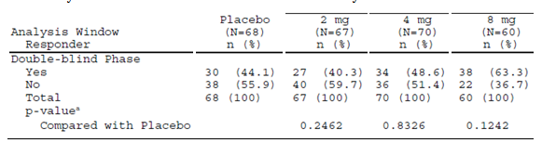
^{a:} The p-value is based on non-missing values and is from the Cochran-Mantel-Haenszel (CMH) test adjusted for pooled country. A responder is a subject who experienced a 50% or greater reduction in seizure frequency per 28 days from the Pre-randomization Phase.

Other efficacy studies
These studies all had a maintenance period of only 4 weeks so cannot be considered pivotal.

Study E2007-J081-231
A Phase II, ascending high-dose, add-on study of perampanel in patients with refractory partial seizures uncontrolled with other antiepileptic drugs; conducted in 9 centres in Japan, from 13 Mar 2009 to 11 Nov 2009.
The study objectives were to explore the safety and tolerability of perampanel of up to 12 mg co-administered with other AEDs.
32 subjects enrolled, 30 treated and 23 completed.
Inclusion/exclusion criteria were similar to Study 304.
The dose started from 2 mg and up-titrated weekly in 2 mg increments up to the maximum 12 mg.
Total duration of treatment was 10 weeks from the initial dose.
When up-titration was judged inappropriate, the dose was not increased but was maintained with the same dose or 1 step down-titration (only allowed once).
Titration period: 6 weeks, maintenance period: 4 weeks.
Efficacy assessment was Seizure frequency in subject diary card, Clinical Global Impression of Change (CGIC), Patient Global Impression of Change (PGIC).
Required population size was not statistically assessed.
The median (minimum, maximum) of percent change in total seizure frequency in maintenance period was −35.00 (−100.0, 312.8)% for LOCF and −42.20 (−100.0, 312.8)% for OC. The responder rate of total seizure frequency in maintenance period was 37.0% (10/27 subjects) for LOCF and 45.5% (10/22 subjects) for OC.
Table 35. Total Seizure Frequency and Percent Change in Total Seizure Frequency [Efficacy Analysis Set] Study 306
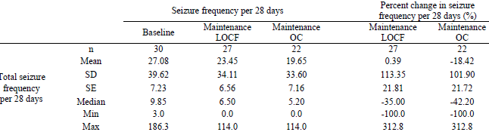
OC: Observed Case
Table 36. Responder Rate of Total Seizure Frequency [Efficacy Analysis Set] Study 306
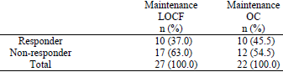
OC: Observed Case

Study E2007-A001-206
A double-blind, placebo-controlled, dose-escalation, parallel-group study of perampanel given as adjunctive therapy in patients with refractory partial seizures; conducted at 22 US sites, 17 in Europe, and 4 sites in Australia from 08 March 2005 to 06 February 2007.
Secondary Objectives included:
To evaluate the efficacy of perampanel for the control of partial-onset seizures by the proportion of subjects experiencing a >50% reduction in partial seizure frequency from Baseline to the Maintenance Phase (total and per dose group).
Subjects were randomized in a 1:1:1 ratio to the placebo-treated, BID dosing or QD dosing treatment arms.
Figure 11. Study Design Study 206
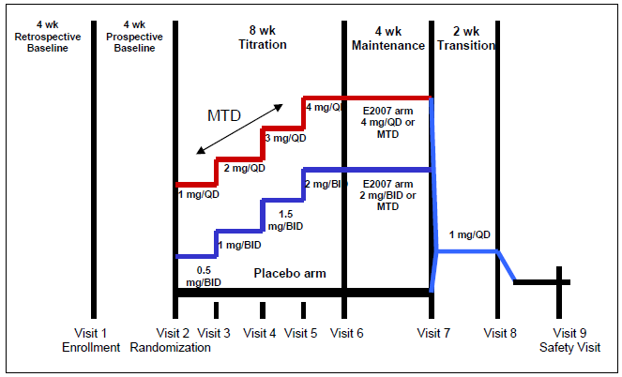
MTD = maximum tolerated dose
In the Titration Phase (up to 8 weeks): Subjects were titrated to maximum tolerated dose. Subjects on drug arms were started at 1mg/day (0.5mg BID or 1mg QD), with dosage increased every 2 weeks up to 4 mg per day or the maximum tolerated dose. Subjects suffering intolerable AEs were to have the dose reduced 1 step (by 1mg/day). Once reduced, the same dose was to be continued until the end of the Maintenance Phase. Subjects unable to tolerate the lower dose were discontinued from the study.
A total of 144 subjects (48 treated BID and 48 treated QD, for a total of 96 on drug; and 48 on placebo) were planned.
Inclusion criteria were similar to Study 304 except:
- Had uncontrolled partial seizures despite having been treated with at least 3 different AEDs (given concurrently or sequentially) for at least 2 years.
- Must have averaged at least 4 partial seizures per month, with no 21-day seizure-free period during the 2 months preceding randomization. To be randomized, the subject must have had at least 3 seizures during the prospective Baseline Phase (28 days), with no 21-day seizure free period.
- Exclusion criteria also differed but not greatly.
Protocol amendments after the study commenced altered some of the Inclusion/exclusion criteria.
The “primary” efficacy endpoint was the proportion of responders in the ITT-LOCF Population during the Maintenance Phase. A subject was considered to be a responder if they experienced a 50% or greater reduction in seizure frequency from the Baseline Phase.
There were 12 other secondary efficacy endpoints.
A Fisher’s exact test with a 0.05 two-sided significance level provided 80% power to detect 20% difference among the treatment groups when the sample sizes were 80 and 40 in the study drug and placebo treatment groups, respectively.
Table 37. Summary of Subject Disposition Study 206
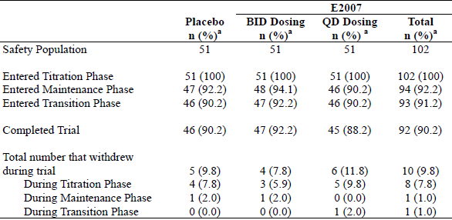
ª: Percent was calculated using the number of subjects in the Safety Population as the denominator.
Protocol deviations that led to exclusion from the Fully Evaluable Population were noted for 5 of 102 subjects in the perampanel group (4.9%) and 2 of 51 subjects in the placebo group (3.9% subjects).
Table 38. Summary of Demographics and Baseline Characteristics Study 206
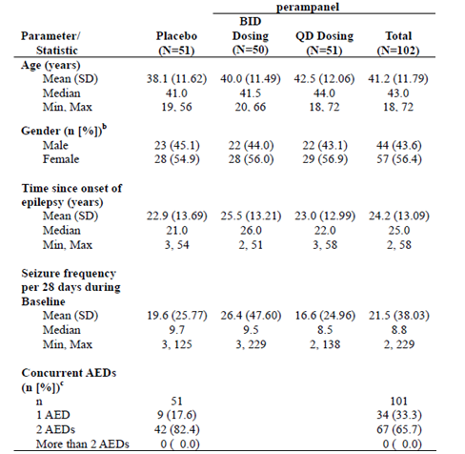
^{b}: Percent was calculated by using the number of subjects in the ITT Population as the denominator. ^{c}: Percent was calculated by using the number of subjects in the Safety Population as the denominator.
Table 39. Concomitant Antiepileptic Drugs: Safety Population Study 206
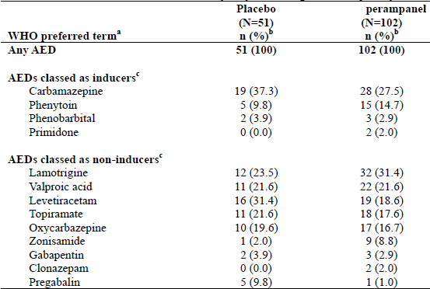
ª: WHO Drug Dictionary version 2Q2005. ^{b}: Percent was calculated using the number of subjects in the Safety Population as the denominator. ^{c}: Inducer and non-inducer AEDs are listed in decreasing order of incidence for the perampanel-treated group.
Table 40. Summary of Number (%) of Responders: ITT Population Study 206
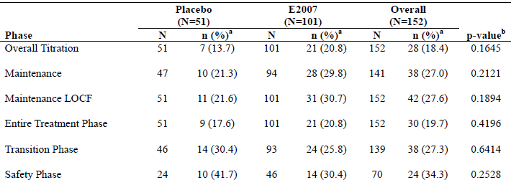
ª: Percent was calculated using the number of ITT Population subjects at each phase as the denominator. ^{b}: P-values were obtained from a Cochran-Mantel-Haenszel test adjusting the pooled sites.

Study E2007-G000-208
A randomized, double-blind, placebo-controlled, parallel group study to explore the safety and tolerability of doses of perampanel up to a maximum of 12 mg in patients with refractory partial seizures. Conducted in 16 centres in Europe and 1 in Australia from13 Mar 2007 to15 Jan 2008.
Secondary Objectives included:
Investigate the efficacy of perampanel for the treatment of partial seizures.
The “primary” efficacy variable was the proportion of responders during the Maintenance Phase. There were 6 other secondary efficacy endpoints, plus 3 added.
Figure 12. Study Design Study 208
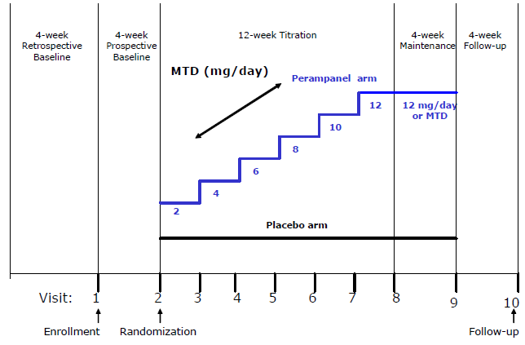
In the Titration Phase (12 weeks, Days 1 to 84): in the perampanel group dosing was to be started at 2 mg daily and titrated up to 12 mg, at 2-week intervals on the basis of individual tolerability and in 2-mg incremental steps. Subjects who did not tolerate perampanel could remain on the same dose or have their dose reduced to their previously tolerated dose (subjects receiving placebo were to have a sham down-titration). Only 1 dose reduction was to be allowed.
Subjects were initially to be stratified (inducers vs. non-inducers of the cytochrome P450 3A4 isoenzyme) according to their concomitant AEDs, with the aim to recruit approximately 24 subjects to each stratum. Following stratification, subjects were then to be randomized to 1 of 2 double-blind treatment groups in a 3:1 ratio (perampanel to placebo) such that, within each stratum, approximately 18 subjects would receive perampanel and approximately 6 subjects would receive placebo.
Inclusion/exclusion criteria were similar to Study 206 except:
- Had an average of at least 3 partial seizures per month, with no 21-day seizure-free period during the 2 months preceding randomization.
It was expected that approximately two-thirds of the subjects in the active group were likely to complete the study and that approximately 45% of those subjects (inducers and non-inducers) at the study maximum tolerated dose would be responders.
Based on those assumptions, and under normal approximation, the given sample size would allow a 90% two-sided confidence interval for a single proportion that would not deviate by more than 17% from the observed proportion. In other words, if a 45% responder rate was observed, then the actual responder rate would be between 28% and 62% with 90% confidence.
Table 41. Summary of Subject Disposition Study 208
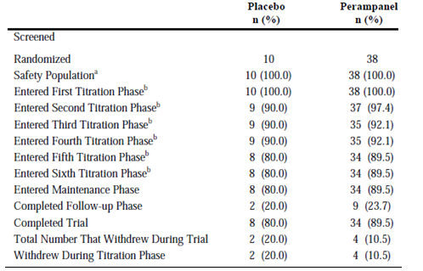
ª: The Safety Population included all randomized subjects who took at least 1 dose of double-blind study drug. ^{b}: This subject disposition summary does not reflect the dose of study medication administered in the titration phases, only whether a subject entered a titration phase. For example, a subject who tolerated all dose levels of perampanel would have received 2 mg, 4 mg, 6 mg, 8 mg, 10 mg, and 12 mg during the first, second, third, fourth, fifth, and sixth titration steps, respectively. However, that did not happen in every case, as some subjects entered a subsequent titration phase without increasing their dose of study medication.
Two protocol violations occurred that resulted in 1 subject from each treatment group, being discontinued from the study.
Table 42. Demographics and Baseline Characteristics (Safety Population) Study 208
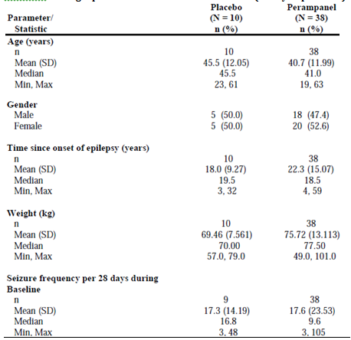
BP = blood pressure; resp = respirations.
Table 43. Anti-Epileptics Drugs at Baseline (Safety Population) Study 208
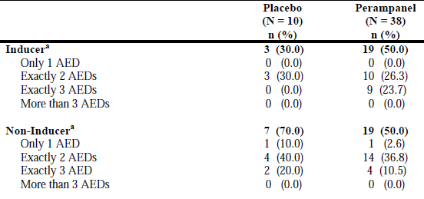
Subjects reporting duplicate AEDs are counted only once. AED = anti-epileptic drug. ª: A subject is classified as an inducer if she/he took at least 1 inducing concomitant medication at baseline. A non-inducer subject took only non-inducing concomitant medications. For both groups (inducer and non-inducer) the subjects are classified by the number of AEDs used at baseline.
Table 44. Number (%) of Responders Intent-to-Treat Population Study 208
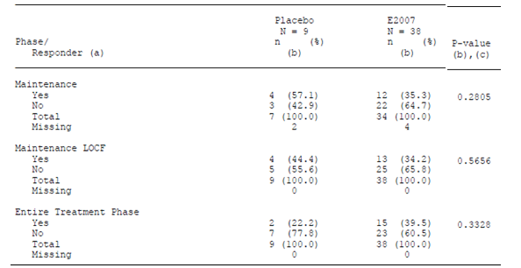
Percent is calculated by using the number of intent-to-treat population patients in the Total row within each phase as the denominator. (a) A patient is a responder if she/he experiences a 50% or greater reduction in seizure frequency from the baseline phase. (b) The missing values were not included in the 100% nor in the calculation of the p-values. (c) The P-value was based on the Chi-square test.

Extension efficacy studies

Study E2007-G000-307 [Extension of Studies 304, 305, and 306]
An open-label extension phase of the double-blind, placebo-controlled, dose-escalation, parallel-group studies to evaluate the efficacy and safety of perampanel given as adjunctive therapy in subjects with refractory partial seizures; conducted in 283 centres in 41 countries from 17 Oct 2008 to 01 December 2010 (interim data cut-off date).
The primary objective was to evaluate the safety and tolerability of perampanel (up to12 mg/day) given as adjunctive treatment in subjects with refractory partial seizures.
The secondary objective was to evaluate the maintenance of effect of perampanel for the control of refractory partial seizures.
The study was to continue for approximately 5 years, until the marketing of perampanel, or until perampanel development is terminated.
The study included:
- A Conversion Period [16 weeks in duration] during which subjects continued taking tablets as they were instructed during the double-blind study. Subjects previously on placebo began receiving perampanel 2 mg/day and were to be titrated on the basis of individual tolerance in 2 mg increments in a blinded fashion. Subjects previously assigned to the 2 mg, 4 mg, 8 mg, and 12 mg perampanel arms were to continue taking the study drug in a blinded fashion. Subjects who achieved 12 mg/day during the double-blind study required no titration and their dose was to be stably maintained during this period. Subjects who achieved perampanel doses below 12 mg (for example, 8 mg, 4 mg or 2 mg), were to be up-titrated in 2 mg increments (for example, beginning at 2 mg, 4 mg, or 8 mg and up-titrate to a maximum of 12 mg of perampanel) in a blinded fashion until an optimal dose was found.
- A Maintenance Period [256 weeks in duration]) during which subjects were to be treated with the perampanel dose that provided the best combination of individual efficacy and tolerability.
There was Amendment 01 (17 October 2008), Amendment 02 (20 March 2009), and Amendment 03 (28 September 2009). As a result the fixed interval (of 2 weeks) between up titrations was removed.
Inclusion and Exclusion criteria
- Have completed Visit 8 of study E2007-G000-304, E2007-G000-305 study, or E2007- G000-306 and shown compliance with the inclusion and exclusion criteria for that study (excluding criteria that are related to seizure occurrences).
- Continue to be treated with a stable dose of 1 or a maximum of 3 approved AEDs.
- Those who, for any reason, discontinued early from the preceding double-blind study were excluded.

Primary efficacy endpoints
- Percent change in seizure frequency per 28 days.
- Proportion of patient who experience a 50% or greater reduction in seizure frequency per 28 days (responder rate analysis).
- Percent change in seizure frequency per 28 days per seizure type.
For subjects on perampanel during the preceding studies, these variables were to be analysed over the Double-blind Phase of the initial study plus the Conversion Period + Maintenance Period of this study relative to Pre-randomization Phase of the initial study.
For subjects on placebo in the initial studies, these variables were to be analysed over the Conversion Period + Maintenance Period relative to Pre-randomization Phase of the initial study:

Secondary efficacy endpoint(s)
To evaluate delayed treatment effect, summaries of the previous endpoints were to be constructed over the Conversion Period + Maintenance Period relative to Pre-randomization Phase of the initial study by treatment groups assigned in the double-blind phase.
Evaluation was based on the Full ITT Analysis Set –subjects who received at least one dose of perampanel in this open label extension study, and had valid seizure data during the perampanel treatment duration.
1218 subjects were enrolled in Study 307, including 311/320 subjects from Study 304 (105 placebo, 206 perampanel), 312/322 subjects from Study 305 (118 placebo, 194 perampanel), and 595/623 subjects from Study 306 (157 placebo, 438 perampanel) that is, between 96% and 97% of subjects who completed the initial studies.
Table 45. Subject Disposition and Primary Reason for Discontinuation (Safety Analysis Set) Study 307
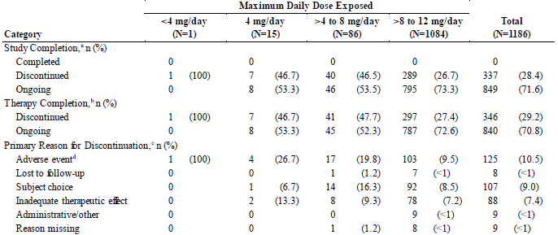
Percentages based on the total number of subjects in the relevant treatment group.ª: As reported for „study completion‟ on the End of Study (Subject Disposition) case report form. ^{b}: As reported for r “ therapy completion” on the End of Study (Subject Disposition) case report form. Discontinued subjects also include those who discontinued therapy, but had not filled out an End of Study form. ^{c}: Only one primary reason is recorded. Subjects with a missing reason had not had a final visit to fill out an End of Study (Subject Disposition) case report form. ^{d}: Corresponding AE(s) leading to withdrawal from therapy were reported on the AE case report form as applicable.
The percentage of subjects who discontinued perampanel treatment in this extension study was similar for subjects who had received prior treatment with placebo (105/380, 27.6%) or perampanel (234/838, 27.9%).
Table 46. Demographic and Baseline Characteristics (Safety Analysis Set) Study 307
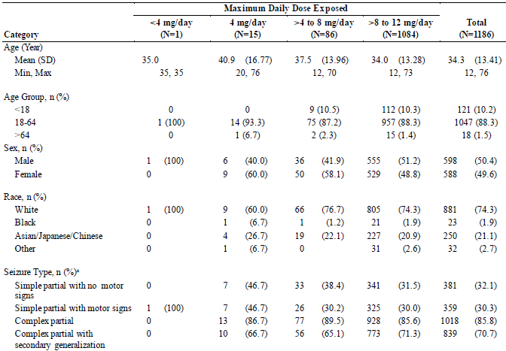
n = number of subjects with characteristics. Percentages are based on the total number of subjects in the relevant treatment group. ª: The seizure type at baseline in the previous double-blind study. Age at Informed Consent to the previous DB study.

Results
The mean (SD) Percent Change from Pre-perampanel in Seizure Frequency per 28 Days at weeks 4- 26 was -27.33 (69.963)%, from Weeks 27-39 it was -31.08 (75.984)% and Weeks 40-52 it was -32.89 (72.367)%. The Responder Rate at Weeks 14-26 was 41.4%, from Weeks 27-39 it was 45.3% and Weeks 40-52 it was 46.9%.
Table 47. Summary of Percent Change from Pre-perampanel in Seizure Frequency per 28 Days During Perampanel Treatment Duration - Full Intent-to-Treat Set Study 307
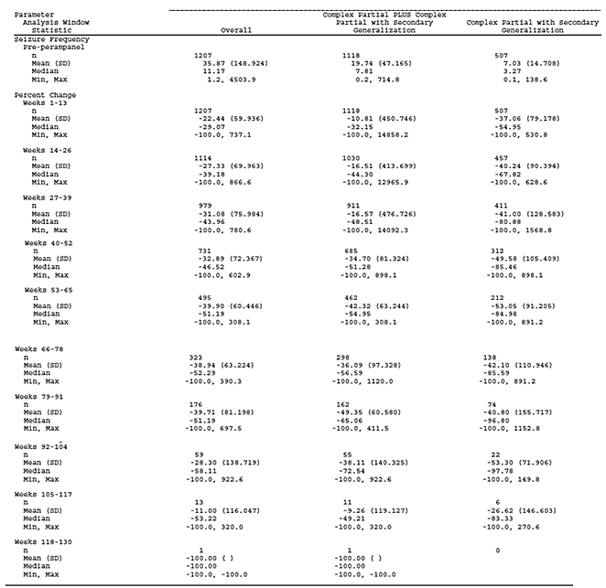
N = total number of subjects; n = number of subjects with event. Week 1 begins on the date of the first dose of perampanel treatment duration. The perampanel treatment duration starts from the first perampanel dose in the double-blind or open-label study to the last perampanel dose in the open-label study, except for subjects with a gap in perampanel exposure from the double-blind to the open-label study of > 14 days where the perampanel treatment duration is the open label exposure.
Table 48. Responder Analysis Summary During the Perampanel Treatment Duration - Full Intent-to-Treat Set Study 307
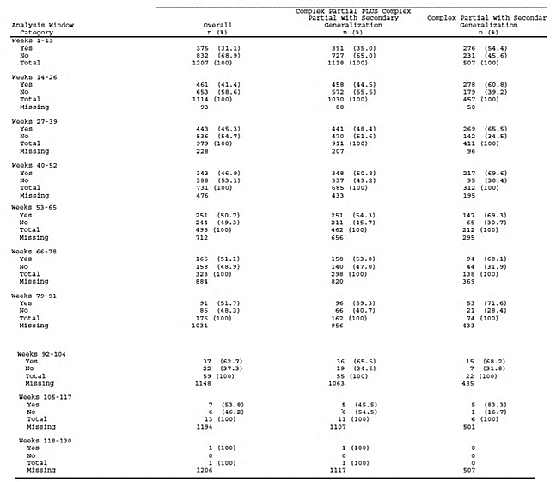
N = total number of subjects; n = number of subjects with event. Week 1 begins on the date of the first dose of perampanel treatment duration. The perampanel treatment duration starts from the first perampanel dose in the double-blind or open-label study to the last perampanel dose in the open-label study, except for subjects with a gap in perampanel exposure from the double-blind to the open-label study of > 14 days where the perampanel treatment duration is the open label exposure.

Adolescents in study E2007-G000-307 [Extension of 304, 305, and 306]
Table 49. Summary of Demography and Baseline Characteristics by Maximum Daily Dose Exposed - Adolescent Safety Analysis Set Study 307
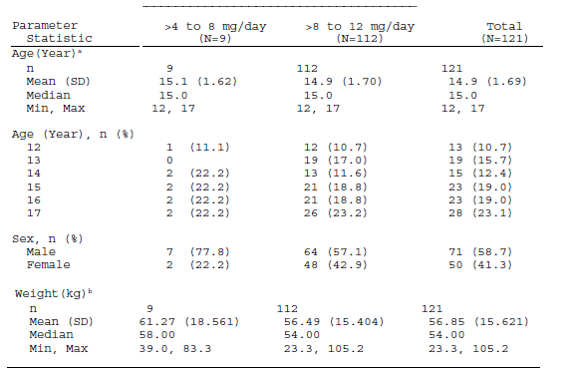
Percentages are based on the total number of subjects in relevant treatment group. ª: Age at Informed Consent to the previous double-blind study. ^{b}: Weight, height, and BMI are at baseline in the preceding double-blind study.
Table 50. Seizure type at baseline - Adolescent Safety Analysis Set Study 307
Seizure type, n (%)b | >4 to 8 mg/day  (N=9) | >8 to 12 mg/day  (N=112) | Total  (N=121)
Simple Partial Without Motor Signs | 3 (33.3) | 24 (21.4) | 27 (22.3)
Simple Partial With Motor Signs | 4 (44.4) | 51 (45.5) | 55 (45.5)
Complex Partial | 8 (88.9) | 100 (89.3) | 108 (89.3)
Complex Partial with Secondary Generalization | 7 (77.8) | 71 (63.4) | 78 (64.5)
^{b}: Seizure type are at baseline in the preceding double-blind study.
Table 51. Number of Anti-Epileptic Drugs at Double-blind Baseline by Maximum Daily Dose Exposed - Adolescent Safety Analysis Set Study 307
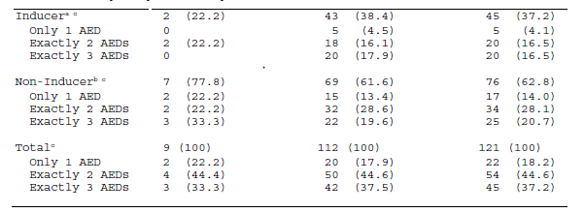
Percentages are based on the total number of subjects in relevant treatment group. Subjects reporting the same Anti-Epileptic Drug (AED) more than once are counted only once. Inducer AEDs include Carbamazepine, Phenobarbital, Phenytoin, and Primidone. Non-inducer AEDs include all other AEDs. ª: An inducer subject took at least one inducing anti-epileptic drug at double-blind baseline. ^{b}: A non-inducer subject took only non-inducing anti-epileptic drugs at double-blind baseline. ^{c}: The subjects are classified by the number of anti-epileptic drugs used at double-blind baseline.
Table 52. Anti-Epileptic Drugs at Double-blind Baseline by Maximum Daily Dose Exposed - Adolescent Safety Analysis Set Study 307
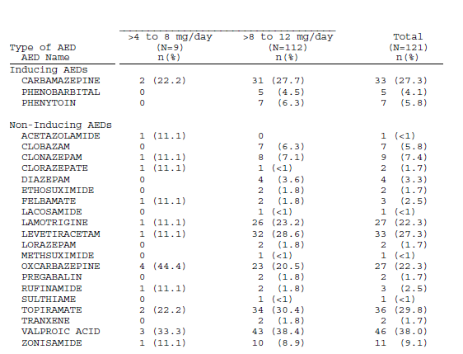
Baseline is Double-Blind Baseline. Percentages are based on the total number of subjects in relevant treatment group. Subjects reporting the same Anti-Epileptic Drug (AED) more than once are counted only once. Inducer AEDs include Carbamazepine, Phenobarbital, Phenytoin, and Primidone. Non-inducer AEDs include all other AEDs.
Table 53. Summary of Percent Change from Pre-perampanel of Seizure Frequency per 28 Days During the Perampanel Treatment Duration - Adolescent Full ITT Set Study 307
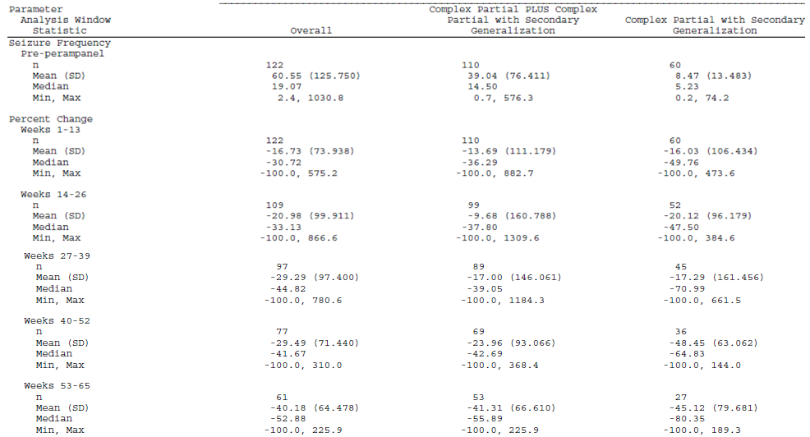
Week 1 begins on the date of the first dose of perampanel treatment duration. The perampanel treatment duration starts from the first perampanel dose in the double-blind or open-label study to the last perampanel dose in the open-label study, except for subjects with a gap in perampanel exposure from the double-blind to the open-label study of > 14 days where the perampanel treatment duration is the open label exposure.
Table 54. Responder Analysis Summary During the Perampanel Treatment Duration - Adolescent Full Intent-to-Treat Set Study 307
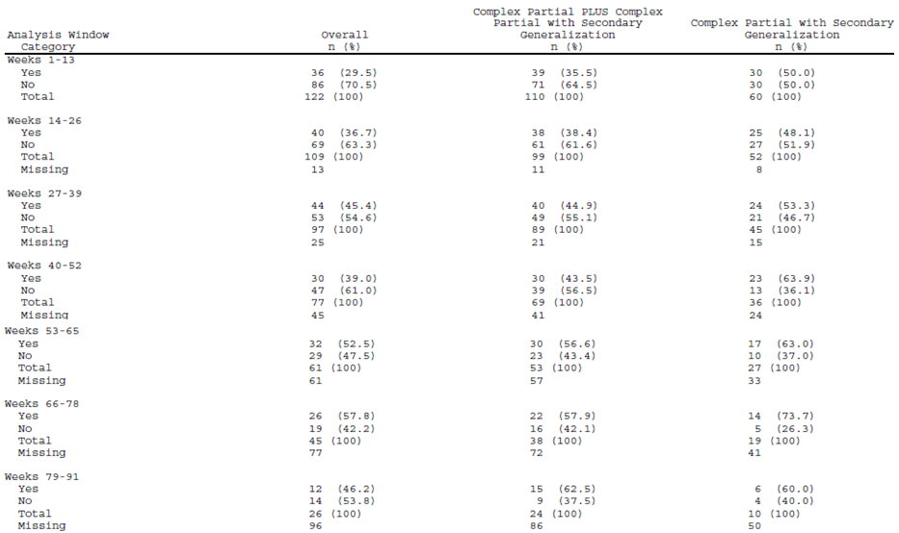
Week 1 begins on the date of the first dose of perampanel treatment duration. The perampanel treatment duration starts from the first perampanel dose in the double-blind or open-label study to the last perampanel dose in the open-label study, except for subjects with a gap in perampanel exposure from the double-blind to the open-label study of > 14 days where the perampanel treatment duration is the open label exposure.

Study E2007-J081-233 [Extension of study 231]
A multicenter, open-label, long-term extension study of perampanel in patients with refractory partial seizures uncontrolled with other anti-epileptic drugs; extended administration was conducted at the maintenance dose of Study E2007-J081-231. However, 1-step down-titration from the viewpoint of safety and up-titration to the maintenance dose of Study E2007-J081-231 was allowed. From 17 June 2009 to 01 December 2010. Enrolled in treatment period; 21 subjects, 17 continued at cut-off date (52 weeks). The administration period was initially to be 52 weeks, it was extended to 112 weeks.
Objectives were to investigate the safety, tolerability, and secondary efficacy of perampanel by long-term administration (112 weeks) in patients with refractory partial seizure who completed Week 10 of Study E2007-J081-231.
Inclusion/exclusion criteria included patients who completed the evaluation period of Study E2007-J081-231 (Week 10), but excluded patients engaged in driving vehicles or other potentially dangerous machine operations.
Efficacy endpoints included Seizure frequency in subject diary, Clinical Global Impression of Change and Patient Global Impression of Change. The number of responders was obtained and its percentage (responder rate).

Table 55. Percent Change in Seizure Frequency per 28 Days[Efficacy Analysis Set] Study 233
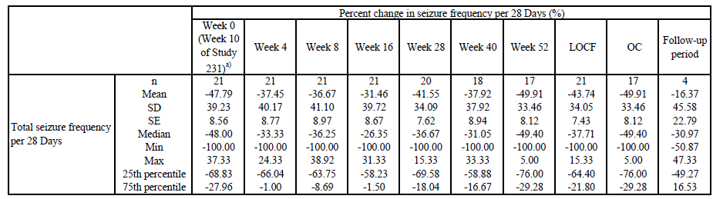
Table 56 Number (%) of Responders [Efficacy Analysis Set] Study 233
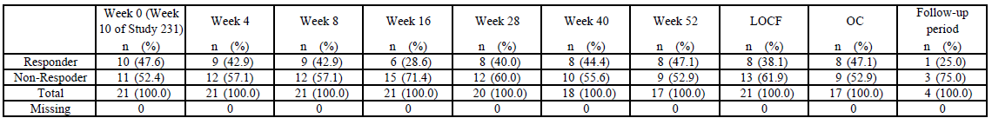
a) Week 0 is at the time of Enrolment in Treatment

Study E2007-A001-207 [Extension of studies 206 and 208]
A 14-month open-label extension phase of double-blind, placebo-controlled, dose-escalation, parallel-group study of perampanel in patients with refractory partial seizures. Conducted in 48 centres in Australia, Belgium, Czech Republic, Estonia, Finland, France, Germany, Latvia, Lithuania, The Netherlands, Spain, Sweden, United Kingdom, and United States, from 10 Oct 2006 to the cut-off date of 01 Dec 2010.
The primary objective was to evaluate the safety and tolerability of perampanel given as adjunctive, long-term treatment in subjects with refractory partial seizures with or without secondary generalization that completed the E2007-A001-206 or E2007-G000-208 study.
The secondary objective was to evaluate the long-term maintenance of perampanel efficacy for the control of partial-onset seizures by the change in partial seizure frequency from Pre-perampanel Baseline in Studies 206 or 208 to the last efficacy collecting visit of the E2007- A001-207 study.
There were 7 protocol amendments.
The study consists of the following phases:
Titration Phase (12 weeks) made in 2 mg o.d. increments at 2 week intervals, on the basis of individual tolerance to 12 mg o.d.
Maintenance Phase (424 weeks)
During the study, for intolerance, a dose reduction to the previous dose level could be made.
Inclusion Criteria included:
- Have completed all scheduled visits up to and including Visit 8 in the E2007- A001-206 study or Visit 9 of the E2007-G000-208 study (revised per Amendments 04 and A).
- Currently being treated with a stable dose of 1, or a maximum of 3, marketed and approved AEDs and are known to take their medication(s) as directed (revised per Amendments 04 and A).
The Intent-to-Treat Population was all patients who complete the Week 0 visit, receive at least 1 dose of open-label study medication, and have some open-label post baseline treatment information.
The Fully Evaluable Population was all patients who complete the entire open-label treatment period, have a medication compliance of ≥ 80% at the final visit, and have no other significant protocol violations.
The Safety Population was all patients who complete the Week 0 visit and who receive at least 1 dose of open-label study medication.
Enrolled and treated in study: 138 subjects - 101 subjects from Study 206 (35 placebo, 66 perampanel) and 37 subjects from Study 208 (8 placebo, 29 perampanel). As of the interim data cut-off, one (0.7%) subject completed the study, 84 (60.9%) subjects had discontinued the study, and 53 (38.4%) subjects were ongoing.
Among the 84 subjects who discontinued the study, withdrawal of consent (n = 32, 23.2%) and “other” (n = 28, 20.3%) were the most common reasons for premature withdrawal.
Results: Some patients had been on perampanel for 12 or 16 weeks prior to entering this study, while for others their first dose of perampanel was in this study; for both groups Week 1 began on the date of first dose of the open-label study drug in this study.
The overall mean (SD) Percent Change from Pre-perampanel in Seizure Frequency per 28 Days at week 26 was - 17.6 (66.47)%, at Week 52 it was -24.2 (61.30)% and at Week 104 it was -24.3 (59.71)%. The Responders (Rate) at Week 26 was 43(34.1%), at Week 52 it was 44(43.1%) and at Week 104 it was 35(47.3%).
Table 57. Demographics and Epilepsy-specific Medical History by Maximum Daily Dose of Perampanel -Safety Analysis Set Study 207
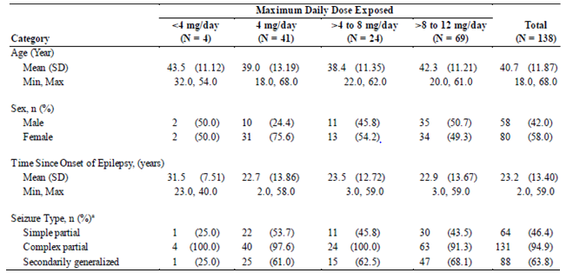
ª: Subjects may check all that apply. Percent is calculated by using the number of subjects in relevant group. Age at Informed Consent to the previous DB study.
Table 58. Subject Discontinuation by Maximum Daily Dose Exposed Safety Analysis Set Study 207
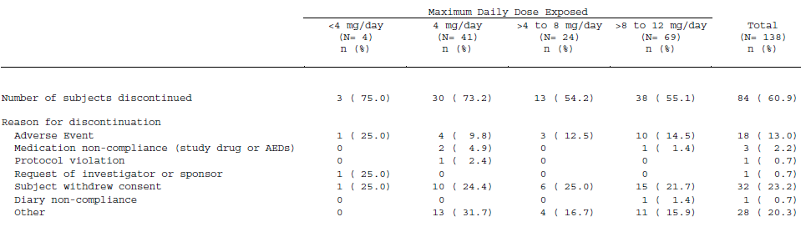
Table 59, Number of Anti-Epileptics Drug at Double-Blind Baseline by Maximum Daily Dose Exposed Safety Analysis Set Study 207
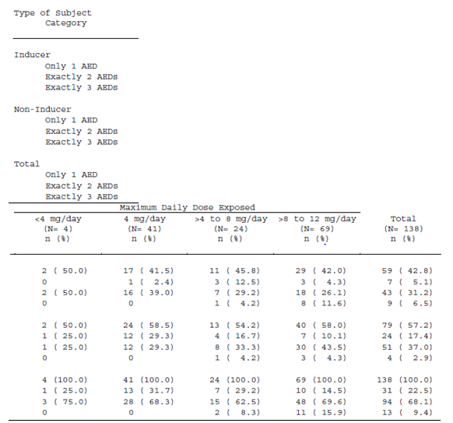
Subjects reporting the same Anti-Epileptic Drug (AED) more than once are counted only once. Inducer AEDs include Carbamazepine, Phenobarbital, Phenytoin, and Primidone. Non-inducer AEDs are all others. An inducer subject took at least one inducing anti-epileptic drug at double-blind baseline. A non-inducer subject took only non inducing anti-epileptic drugs at double-blind baseline. The subjects are classified by the number of anti-epileptic drugs used at double-blind baseline.
Table 60. Anti-Epileptics Drug at Double-Blind Baseline by Maximum Daily Dose Exposed Safety Analysis Set Study 233
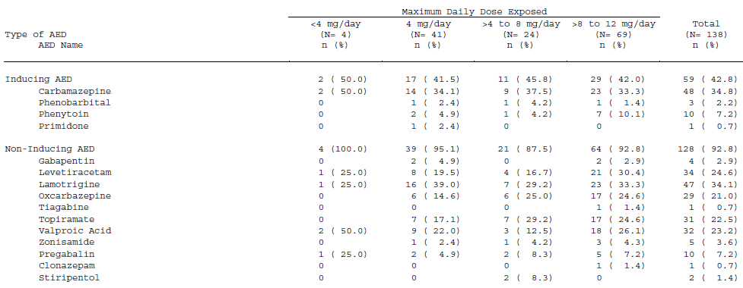
Percentages are based on the number of subjects in relevant group. Subjects reporting the same Anti-Epileptic Drug (AED) more than once are counted only once. Inducer AEDs include Carbamazepine, Phenobarbital, Phenytoin, and Primidone. Non-inducer AEDs include all other AEDs
Table 61. Percent Change from Pre-perampanel in Total Seizure Frequency per 28 Days During Open-Label Study Full ITT Analysis Set Study 233. Table continued across two pages.
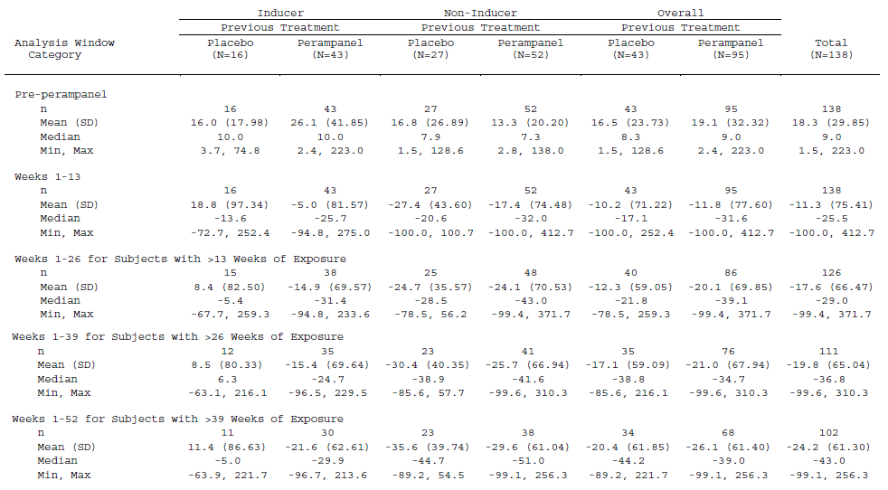
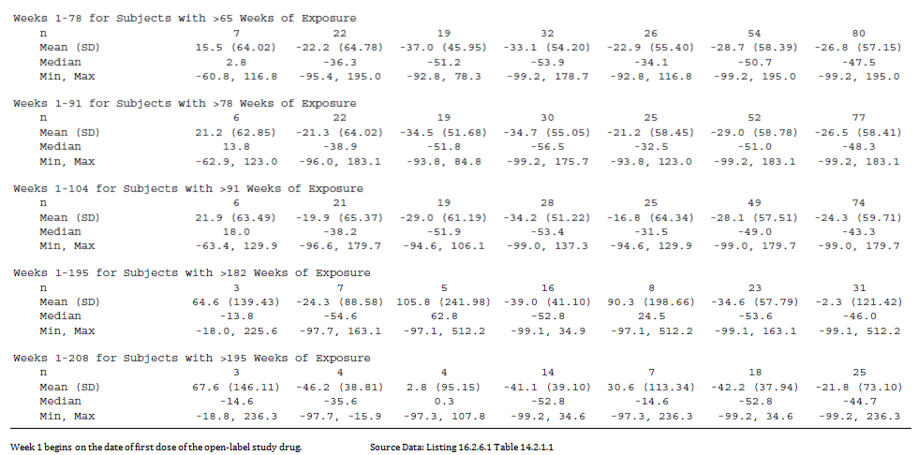
Week 1 begins on the date of first dose of the open-label study drug.
Table 62. Number (%) of Responders During Open-Label Study Full ITT Analysis Set Study 233. Table continued across two pages.
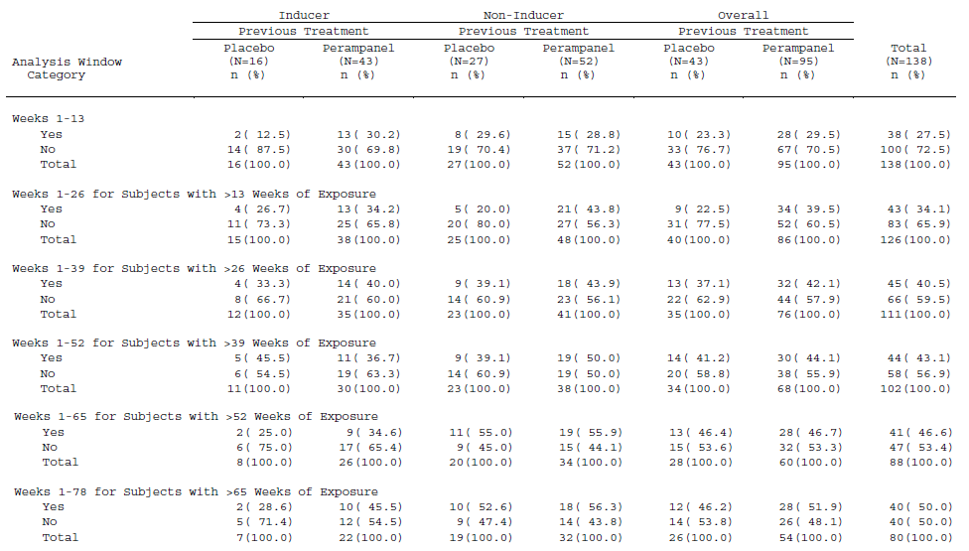
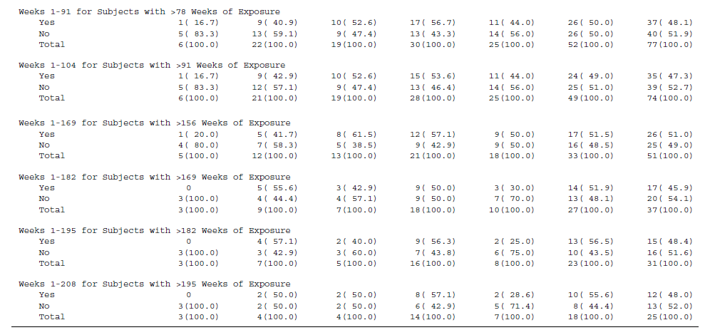
Percentages are based on the number of subjects in the total row in relevant group. Week 1 begins on the date of first dose of the open-label study drug.

Analyses performed across trials (pooled analyses and meta-analyses)
The 3 Phase III double-blind epilepsy studies (E2007-G000-305, 306 and 307) were to be pooled – all 3 studies being similar in design; the only differences are the dose given with 8 mg being common to all. Some data from E2007-G000-307, the Phase III open-label extension study, was also used. No pooling was done for other perampanel studies.
The most common reasons for discontinuation for all treatment groups were AEs (higher on 12 mg) and subject choice. In each study, ≤ 1% of all subjects in each study discontinued due to a lack of therapeutic effect.
Due to an expected irregular distribution of seizure frequency, the median was to be the primary statistic of interest for all seizure frequency based continuous endpoints.
The cross study analysis of efficacy was set up to show a dose/effect relationship, to show onset of effect and subgroup analyses. The endpoints used to assess these effects were the primary endpoint that is, change in seizure frequency and the key secondary endpoint – the responder rate. In relation to change in seizure frequency the SAP says:
Descriptive summary statistics (median, mean, standard deviation, minimum, maximum, and number of subjects with non-missing data) will be displayed for the subgroups.
The Hodges-Lehmann estimator and its 95% confidence interval will also be displayed for understanding the treatment effect size.
for Responder Rate the SAP says
This endpoint will be summarized (number of subjects and percent) for the subgroups.
Thus it would appear not set up to do a statistical analysis of responder rate, while the analysis of effects on change in seizure frequency in the combined population is proposed as a dose response assessment.
However:
For Dose Response the percent change at Maintenance Period was analysed (using LOCF all randomized doses population using both randomised dose and actual dose) using a rank ANCOVA. This was done for both the partial-onset seizures with or without secondarily generalised seizures and also the complex partial seizure plus secondary generalization seizures populations. The ANCOVA model had the covariates of ranked Pre-randomization Phase seizure frequency per 28 days and randomized treatment (which was to be used to assess a dose response).
Additional statistical analyses in the SAP were:
Adolescents-The SAP refers to using summary statistics and the Hodges-Lehmann estimator and its 95% CIs for Percent change in seizure frequency, Responder rate and Percent change in complex partial plus secondary generalization seizures.
For the Onset of the Treatment Effect rank ANCOVA was planned which included treatment (perampanel, placebo) as a factor and the rank of the pre-randomization phase seizure frequency per 28 days as a covariate will be used to analyse the percent change from pre-randomization during the first 2 weeks in the Titration Phase. The Hodges-Lehmann estimator and the associated 95% confidence interval were also to be calculated.
For all other combined assessments summaries only were planned in the SAP.
Responder rate other than as summaries in the combined populations was only to be statistically in individual studies using a new population (Discontinuations during Titration as Non-responder).
Dose-response: The 2 mg of perampanel dose did not provide any benefit in terms of improved seizure control compared with placebo. Perampanel (randomized) doses of 8 mg and 12 mg produced greater reductions in seizure frequency and improved responder rates compared with the once daily dose of 4 mg. However for the seizure frequency the 95% CIs for each dose overlapped its neighbouring doses and after 8 mg no greater improvement in seizure control was seen with the 12 mg dose. (Indeed the mean difference actually fell, see Table 66, Table 67). In the results for those 209 subjects who had dose increases from 8 mg (in the double-blind studies) to 12 mg (in the blinded Conversion Period) at the time of data cut-off for analysis: median seizure frequency decreased further from −32.42% at the double-blind Maintenance Period to −43.27% at the blinded Conversion Period, and the 50% responder rate rose from 37.8% on a dose of 8 mg in the double-blind Maintenance Period to 43.5% in the same subjects on a dose of 12 mg in the blinded Conversion Period.
The analysis using actual (last) dose was similar.
Age: overall 143 were < 18y (including 45 on placebo), 98/1037 or 9.5% of all those on perampanel were < 18y; while only 28 (1.9%) were ≥ 65y with 20/1037 (1.9%) being on perampanel that is, the numbers were very low for ≥ 65y.
Among adolescents, the median percent change in total seizure frequency per 28 days relative to the Pre-perampanel Baseline (median seizure frequency, 19.07) was -30.72% during Weeks 1 to 13 (n = 122), -33.13% during Weeks 14 to 26 (n = 109), -44.82% during Weeks 27 to 39 (n = 97), and -41.67% during Weeks 40 to 52 (n = 77). The responder rates (all partial seizures) during these same intervals for the Adolescent Full ITT Analysis Set were 29.5%, 36.7%, 45.4%, and 39.0%, respectively. Statistical analyses were not in the submission.
Sex: The mean time since diagnosis was approximately 20y for males and females (244.9 and 260.1 months, respectively), and approximately 85% of subjects in both subgroups (83.2% and 87.7%, respectively) had complex partial with or without secondarily generalized seizures. Approximately one-third of males and female subjects were receiving background therapy with three AEDs (36.4% and 34.4%, respectively).
Race: Most of the 1478 subjects were White (n=1114, 75.4%). Of the remaining subjects 19.6% (n=289) were Asian and 2.1% (n=31) Pacific Islander.
Comment: In the section on Analysis of Anti-Epileptic Drugs’ Mechanism of Action it is suggested that the median Responder Rates and Reduction in Seizure Frequency are greater with perampanel than placebo regardless of concomitant AED’s mechanism of Action on the sodium channel, however the numbers of concomitant non-sodium channel MOAs are small.

Table 63. Demographic and Baseline Characteristics Full Intent-to-Treat Analysis Set Pooled
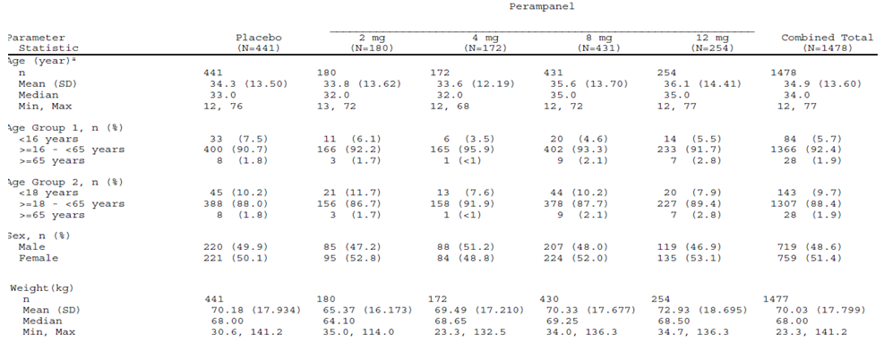
ª: Age at Informed Consent. Percentages are based on the total number of subjects in relevant treatment group.
Table 64. Demography and Baseline Characteristics Double-blind Adjunctive Therapy Phase III Studies in Adolescents (< 18 years old) with Refractory Partial Seizures (Full ITT Analysis Set)
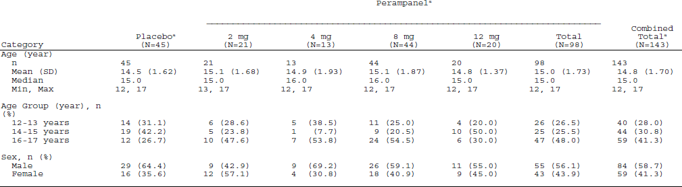
ª: Subjects treated during the double-blind study. Dose groups are based on the actual treatment groups.
Table 65. Number of Anti-Epileptic Drugs at Baseline Full Intent-to-Treat Analysis Set Pooled
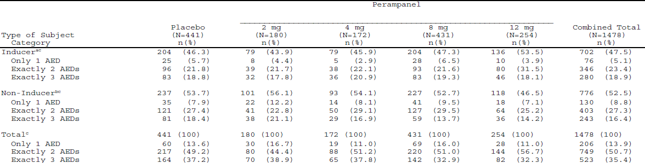
Percentages are based on the total number of subjects in relevant treatment group. Subjects reporting the same Anti-Epileptic Drug (AED) more than once are counted only once. Inducer AEDs include Carbamazepine, Phenobarbital, Phenytoin, and Primidone. Non-inducer AEDs are all other AEDs. ª: An inducer subject took at least one inducing anti-epileptic drug at baseline. ^{b}: A non-inducer subject took only non-inducing anti-epileptic drugs at baseline. ^{c}: The subjects are classified by the number of anti-epileptic drugs used at baseline.
Table 66. Summary Statistics and Linear Trend Percent Change from Pre-randomization for Seizure Frequency per 28 Days by Dose Group Full ITT Set Pooled
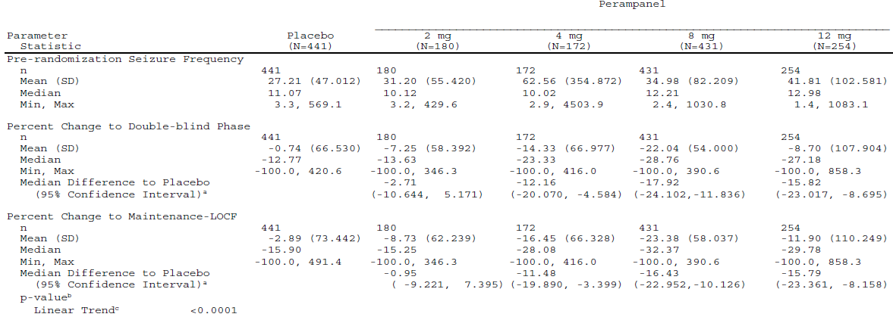
ª: The median difference to placebo and the 95% confidence interval are based on the Hodges-Lehmann method. ^{b}: The linear trend test is based on the p-value for the covariate of treatment from a rank ANCOVA for percent change from pre-randomization of seizure frequency per 28 days with treatment and pre-randomization seizure frequency per 28 days as covariates. The Pre-randomization and post randomization efficacy measurements are rank transformed separately.
Table 67. Summary Statistics Responder Rate by Dose Group Full ITT Set Pooled
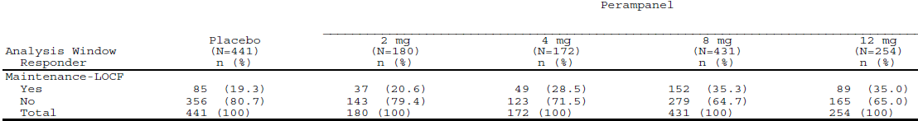
A responder is defined as a subject who experienced a 50% or greater reduction in seizure frequency per 28 days from the Pre-randomization Phase.
Table 68. Summary Statistics and Linear Trend Percent Change from Pre-randomization for Seizure Frequency per 28 Days - Complex Partial plus Secondary Generalization by Dose Group Full ITT Set with Complex Partial plus Secondary Generalization at Pre-randomization Pooled
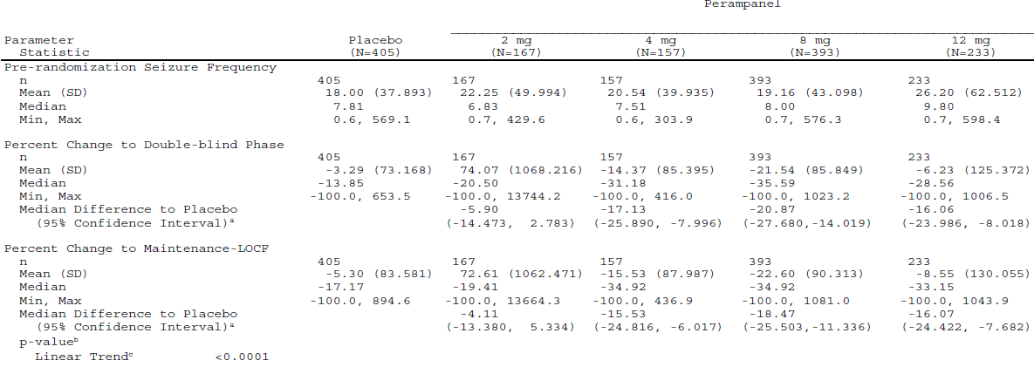
ª: The median difference to placebo and the 95% confidence interval are based on the Hodges-Lehmann method. ^{b}: The linear trend test is based on the p-value for the covariate of treatment from a rank ANCOVA for percent change from pre-randomization of seizure frequency per 28 days with treatment and pre-randomization seizure frequency per 28 days as covariates.The Pre-randomization and post randomization efficacy measurements are rank transformed separately.
Table 69. Seizure-free Status During the Maintenance Period: Studies -306, -305, -304, ITT Analysis Set (306 and 304), ITT for Responder Rate Analysis Set (305)
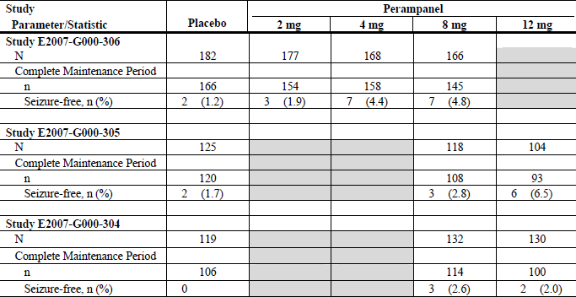
Shaded area indicates perampanel dose was not evaluated in a particular study. A subject achieved seizure-free status during the complete maintenance phase if the subject completed the maintenance phase with no seizures based on “valid” diary days
Table 70. Summary Statistics Primary and Secondary Endpoints by Age, Integrated Phase III Full ITT Analysis Set
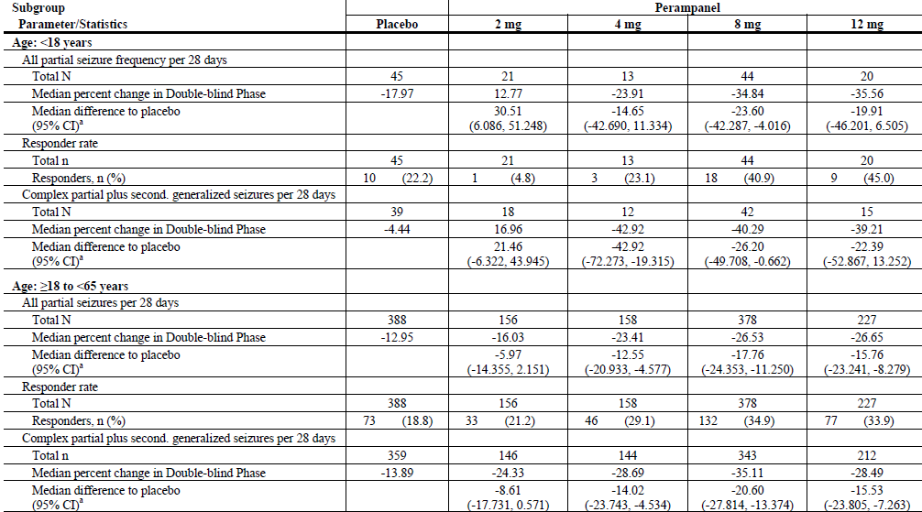
second. = secondarily. ª: The median difference to placebo and the 95% CI are based on the Hodges-Lehmann method.
Table 71. Summary Statistics Median Percent Change in Seizure Frequency and Responder Rate During Maintenance Period by Last (Actual) Dose and Baseline Co-administered AED, Completer Analysis Set for Studies -305 and -304, Excluding Central and South American Sites
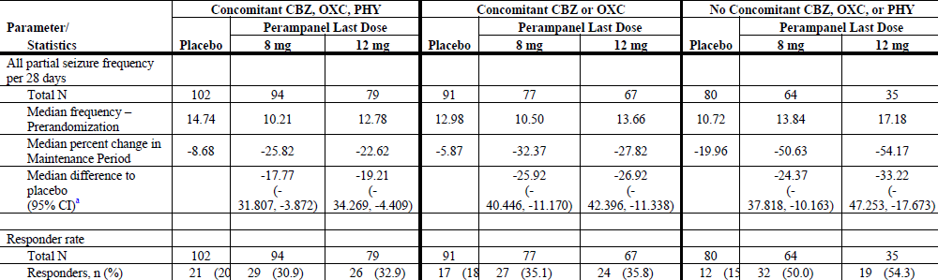
ª: The median difference to placebo and the 95% CI are based on the Hodges-Lehmann method. AED = antiepileptic drug; CBZ = carbamazepine; OXC = oxcarbazepine; PHY = phenytoin. Subjects who were completers and with actual last dose equal to perampanel 8 or 12 mg were included in the analysis.
Table 72. Summary Statistics Median Percent Change in Seizure Frequency and Responder Rate During Maintenance Period by Last (Actual) Dose and Baseline Co-administered AED, Completer Analysis Set for Study 306
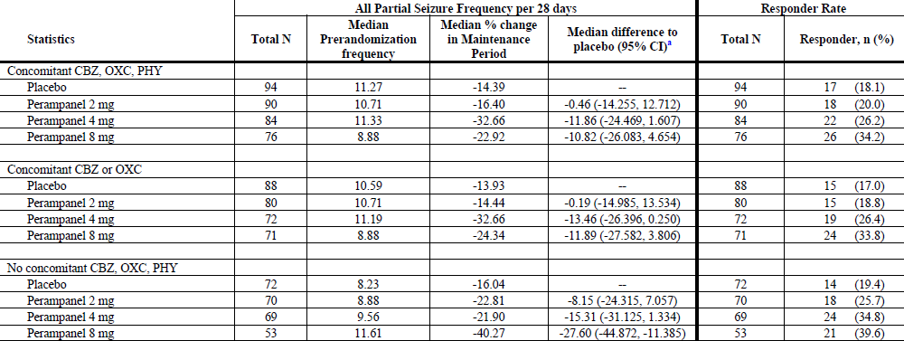
ª: The median difference to placebo and the 95% CI are based on the Hodges-Lehmann method AED = antiepileptic drug; CBZ = carbamazepine; OXC = oxcarbazepine; PHY = phenytoin. Subjects who were completers and with actual last dose equal to perampanel 8 or 12 mg were included in the analysis.

The median treatment difference vs. placebo in the percent change in seizure frequency per 28 days in the Maintenance Period among subjects in the perampanel non inducer AED subgroup was similar to that for subjects receiving concomitant therapy with carbamazepine or oxcarbazepine at the 8 mg perampanel dose, higher in subjects receiving the 12 mg dose, and higher than that for subjects receiving carbamazepine, oxcarbazepine or phenytoin. Higher responder rates during the Maintenance Period for perampanel 8 mg and 12 mg compared with placebo were seen regardless of perampanel AED inducer use. However, the response rate during the Maintenance Period was higher for subjects on adjunctive perampanel 8 mg or 12 mg therapy in the perampanel non inducer AED subgroup compared to subjects in either of the two perampanel AED inducer subgroups. These results suggest that the induction effects of carbamazepine and oxcarbazepine on perampanel clearance have a small effect on perampanel response at these higher doses.
In Study 306 the median percent reductions in seizure frequency per 28 days in the Maintenance Period were larger, and the responder rates were higher, for perampanel doses of 4 and 8 mg compared with placebo or perampanel 2 mg for subjects receiving concomitant therapy with perampanel AED inducers and those not on a co-administered a perampanel AED inducer.
Time to Onset of Activity for perampanel relative to placebo was explored by analyses of the percent change in seizure frequency during the first 2 weeks of the Titration Period when all perampanel subjects received 2 mg once a day (OD) during Week 1 and subjects in the perampanel 4 mg, 8 mg, or 12 mg groups received a daily 4 mg OD during Week 2.
The median difference relative to placebo was -6.51% for Week 1 and -14.11% for Week 2 (P = 0.0138 and P < 0.0001, respectively).
The sponsors argue that:
- Since the treatment effect for Week 2 (-14.11% on 4 mg) was comparable to the median difference (-13.71%) seen for the 4 mg dose group in the Double-blind Phase of Study 306.
- And since the sponsors felt they had established 4 mg was the minimally effective dose for perampanel in Study 306.
It follows in their argument that the onset of clinically meaningful seizure improvement with perampanel is apparent as early as the second week of treatment if the subject is titrated at a rate increase of 2 mg/week.

Evaluator’s conclusions on clinical efficacy
for the Adjunctive Treatment of Partial-Onset Seizures With or Without Secondarily Generalised Seizures in Patients with Epilepsy aged 12 years and older
In the pivotal trials patients had to be on stable doses of 1, 2 or 3 anti-epileptic drugs (AEDs) for ≥ 21 days or for a new AED regime ≥ 49 days and despite this treatment have had five or more partial seizures (with two or more partial seizures per each 3 week period) and no 25 day seizure free period in the 6 week period Pre-randomization Phase.
The commission has determined that Class I superiority studies be designed to detect a >20% absolute (rather than relative) difference in the primary outcome (that is, efficacy/ effectiveness) between study treatment and comparator using an intent-to-treat analysis.
While this recommendation is in relation to monotherapy, it is consistent with the basis of the sample size calculations in the pivotal studies.
It was assumed that the percent change in seizure frequency per 28 days in the Maintenance Period relative to the Pre randomization Phase would be 10% in the placebo group and 32% in the 8 mg group in the Intent-to-Treat (ITT) Analysis Set. Therefore, a sample size of 120 subjects in each treatment group in the ITT Analysis Set would have 83% power to detect a treatment difference of 22% in seizure frequency.
Not all the median or mean results for ≥ 4 mg OD treatment groups in the pivotal studies achieved the 20% separation in percent change in seizure frequency per 28 days, however there was consistent statistically significant difference shown by the p-values.
With the responder rate, Study 304 failed to show any statistically significance from placebo for either 8 or 12 mg while Study 305 did with differences from placebo approaching 20%; Study 306 showed for 4 and 8 mg groups statistically significant differences from placebo approaching 20% for the 8 mg group.
The sponsor’s explanation for the results in Study 304 related them to a higher placebo response in 2 South American centres.
The effect of sex and race do not appear to be significant.
There are insufficient elderly patients for comment.
Efficacy needs to be evaluated for all focal seizures and secondary generalised seizures separately.
Studies 304 and 305 showed statistically significant differences > 20 % from placebo in both percent change in seizure frequency per 28 days and responder rate for patients with secondarily generalised seizures while Study 306 could show no significant difference.
There were 124 adolescents enrolled in the trials with descriptive summary results only; a study in adolescents was ongoing at the time of submission. In the Phase III Double-blind Studies 58 adolescents were on ≥ 4 mg/day of perampanel.
The pivotal studies were of sufficient length for showing efficacy and long term sustainment of effect was seen in the extension studies with 588 subjects at 1 year.

Clinical safety

Studies providing evaluable safety data
Comment: Multiple references in the sponsor’s Summary of Clinical Safety could not be found in the submitted data. These were found in additional data submitted.
The following studies provided evaluable safety data:

Pivotal efficacy studies
In the pivotal efficacy Studies 304, 305 and 306, the following safety data were collected:
- General adverse events (AEs).
- AEs of particular interest, including potential withdrawal symptoms photosensitivity and the relationship of DNA sequence variability to exposure, development of adverse events or response to perampanel
- Laboratory tests.

Studies that assessed safety as a primary outcome
Included:
- Study E2007-G000-307 [Extension of Studies 304, 305, and 306],
- Study E2007-A001-207 [Extension of Studies 206 and 208],
- Study E2007-J081-233 [Extension of Study 231],
- Study E2007-G000-208, Study E2007-A001-206 Study E2007-J081-231.
These studies are described below.
Study E2007-E049-203 a PK study in patients.

Other studies evaluable for safety only
Incomplete Study 235 for deaths and serious adverse events only.

Clinical pharmacology studies
- 27 Phase I clinical pharmacology studies.

Studies that assessed safety as a primary outcome

Study E2007-G000-307 [Extension of studies 304, 305, and 306]
10 subjects had a gap of > 14 days between the initial study and this extension study, only the longer duration was counted.
Most subjects in the Safety Analysis Set (n = 1089, 91.8%) received more than 16 weeks (approximately4 months) of treatment with perampanel, 580 (48.9%) subjects received more than 52 weeks (1 year) of perampanel treatment, and 250 (21.1%) subjects received more than 76 weeks (approximately1.5 years) of perampanel treatment. The mean (SD) cumulative duration of exposure to perampanel for the Safety Analysis Set was 52.52 (25.583) weeks (range: 1.1, 128.1 weeks). The total exposure to perampanel was 62291 subject-weeks (approximately1198 subject-years).
The mean ± SD dose of perampanel across the entire Open-label Extension Treatment Phase, when the dose of perampanel was titrated to maximum individual subject efficacy and tolerability, was 10.05 ± 2.276 mg (range: 1.9, 12.0) for the Safety Analysis Set.
For the 121 subjects in the Adolescent Safety Analysis Set, the mean (± SD) cumulative duration of exposure to perampanel was 55.22 (± 28.841) weeks (range: 2.7, 111.9 weeks) The mean dose of perampanel across the entire Open-label Extension Treatment Phase among adolescent subjects of 10.24 ± 2.274 mg (range: 2.7, 12.0).
Of 3 deaths: one was in a motor vehicle accident (MVA); a 53-year-old male, died on Study Day 309 (Study Day 176 of Open-label Extension study) as a result of a cerebral haemorrhage. The subject had experienced severe headache, nausea, vomiting, and loss of consciousness, and had malignant hypertension (arterial blood pressure of 220/110 mmHg) preceding the haemorrhage; and a 54-year-old male receiving background therapy with topiramate and oxcarbazepine, died on Study Day 56 of Open-label Extension study (subject received placebo in initial study); the cause of death in this subject was not specified and was classified as a sudden unexplained death in epilepsy (SUDEP).
Table 73, Adverse Event Summary - Safety Analysis Set Study 307
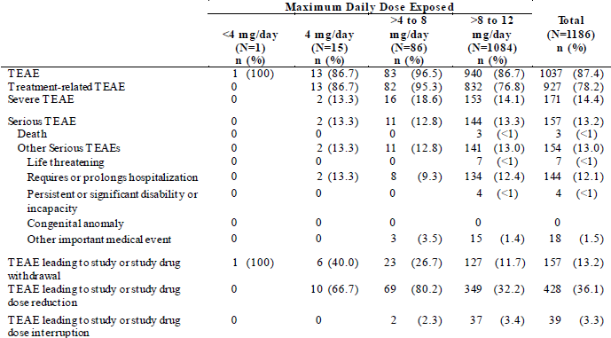
An AE is treatment emergent if the AE started on or after the date of first perampanel dose and prior to or on the day of (Date of Last Dose + 30 days) of open-label treatment. Percentages are based on the total number of subjects in relevant treatment group. For each row category, a subject with two or more AEs in that category is counted only once. Adverse events were summarized across the entire perampanel exposure. For subjects who received perampanel in the preceding double-blind study, the perampanel exposure consisted of the double-blind plus the open-label treatment duration. For subjects who received placebo in the preceding double-blind study, the perampanel exposure consisted of the open-label treatment duration.
The most SAEs were those related to epilepsy (convulsion [n =2 4, 2.0%], status epilepticus [n = 9, <1%], epilepsy [n = 4, < 1%], grand mal convulsion [n = 4, < 1%], partial seizures with secondary generalization [n = 2, < 1%], drug withdrawal convulsions [n = 1]). Other SAEs reported in six (0.5%) or more subjects were aggression (n = 10), psychotic disorder (n = 6), and suicidal ideation (n = 6). All non-fatal SAEs had resolved or were resolving as of the interim cut-off date except for five (somnolence, spinal compression fracture, anger, epilepsy, aggression [unknown outcome]). SAEs led to withdrawal of perampanel in 33 (2.8%) subjects.
157 (13.2%) subjects had AEs that resulted in discontinuation. Dizziness (n = 36, 3.0%) irritability (n = 14, 1.2%), and aggression (n = 13, 1.1%) were the only AEs that resulted in the discontinuation of 1% or more of subjects; other AEs that resulted in the discontinuation of six (0.5%) or more subjects were fatigue (n = 11), ataxia (n = 9), somnolence (n = 8), abnormal behaviour (n = 8), headache (n = 7), vertigo (n = 7), suicidal ideation (n = 6), weight increased (n = 6), and diplopia (n = 6).
449 (37.9%) of subjects in the Open-label Extension Safety Analysis Set had an AE that resulted in interruption of perampanel or dose adjustment (that is, reduction). The most common of these AEs (≥ 2.0% incidence) were dizziness (20.7%), somnolence (7.3%), ataxia (3.3%), fatigue (2.9%), headache (2.3%), and gait disturbance (2.0%). For most subjects, these TEAEs resolved without sequelae and the subject remained on treatment.
Fourteen (1.2%) subjects in the Open-label Extension Safety Analysis Set had an AE related to suicidality.
Table 74. AEs: Most Common (≥ 5% in Total Safety Population) - Safety Analysis Set and Adolescent Safety Analysis Set Study 307
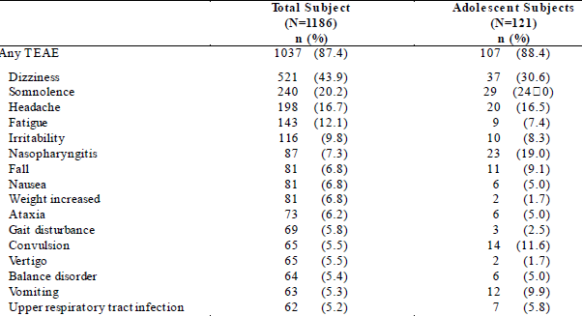
An AE is treatment emergent if the AE started on or after the date of first perampanel dose and prior to or on the day of (Date of Last Dose + 30 days) of open-label treatment. Percentages are based on the total number of subjects in relevant treatment group. For each row category, a subject with two or more AEs in that category is counted only once. Adverse events were summarised across the entire perampanel exposure. For subjects who received perampanel in the preceding double-blind study, the perampanel exposure consisted of the double-blind plus the open-label treatment duration. For subjects who received placebo in the preceding double-blind study, the perampanel exposure consisted of the open-label treatment duration.

Study E2007-J081-233 [Extension of study 231]
The primary objective was to evaluate the safety and tolerability of perampanel (up to12 mg/day) given as adjunctive treatment.
4 (19.0%) subjects had discontinued the Open-label Extension study (none due to AEs), and 17 (81.0%) subjects were ongoing.
Table 75. Extent of Exposure [Safety Analysis Set] Study 233
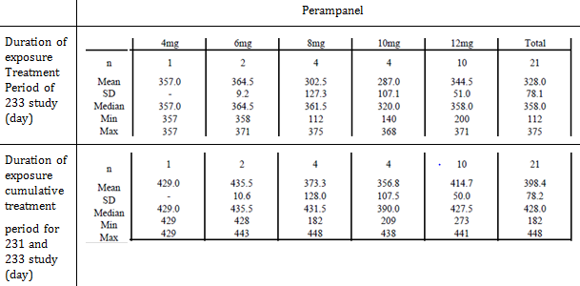
Table 76. Overall Incidence of Adverse Events [Safety Analysis Set] Study 233
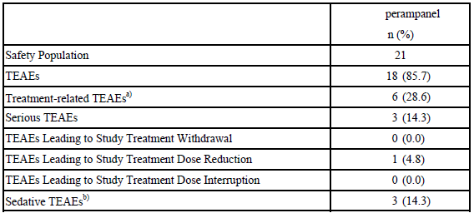
Percentages are based on the total number of subjects ^{a)} Treatment-related includes the causality categories: Possibly Related, Probably Related. ^{b)} Sedative TEAEs include following PT terms: Somnolence, Dizziness, and Dizziness postural.

Study E2007-A001-207 [Extension of studies 206 and 208]
The primary objective was to evaluate the safety and tolerability of perampanel given as adjunctive, long-term treatment.
138 subjects were enrolled in Study 207, 18 subjects (13.0%) were discontinued prematurely due to AE(s).
21 (15.2%) subjects had an SAE, the only SAEs that occurred in more than one subject were those related to epilepsy (that is,, convulsion [n = 4], epilepsy [n = 3], status epilepticus [n = 3]), and pneumonia (n = 2). Three of the epilepsy-related SAEs resulted in discontinuation.
AEs that resulted in discontinuation occurred in 17 (12.3%) subjects.
The AEs that resulted in discontinuation of more than one subject were dizziness (n = 3), vertigo (n = 2), abdominal pain upper (n = 2), fatigue (n = 2), headache (n = 2), and status epilepticus (n = 2).

Table 77. Extent of Exposure to Perampanel Treatment Safety Analysis Set Study 207
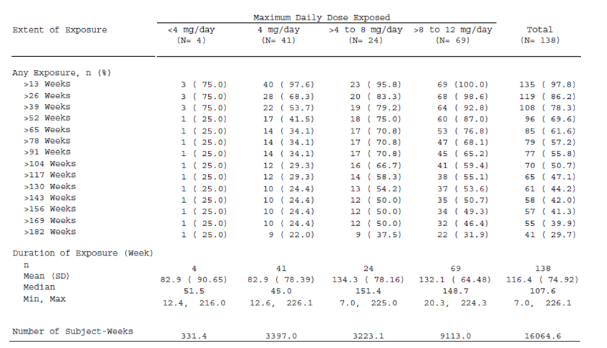

Table 78. Treatment-emergent Adverse Events: Most Common (≥ 5% in Total Safety Population) - Safety Analysis Set Study 207
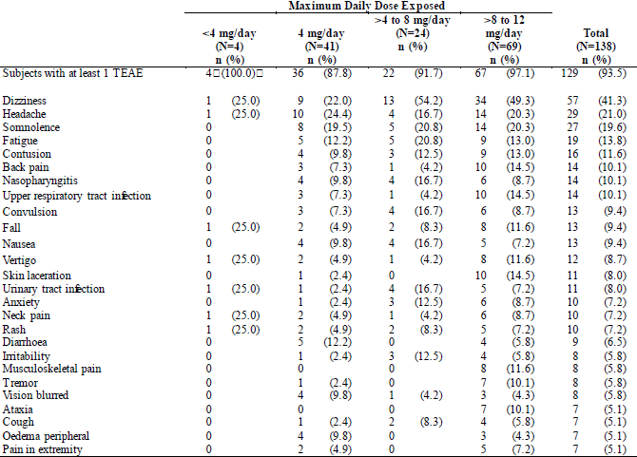
An adverse event is treatment-emergent if the adverse event either started on or after the date of first dose of perampanel and up to 30 days after the last dose of perampanel or started before the date of first perampanel dose and increased in severity during the treatment of perampanel. Percentages are based on the total number of subjects in relevant treatment group. A subject with two or more adverse events in the same preferred term is counted only once for that preferred term. Adverse events were summarised across the entire perampanel exposure. For subjects who received perampanel in the preceding double-blind study, the perampanel exposure consisted of the Double-blind plus the Open-label Treatment Phases. For subjects who received placebo in Study 206, the perampanel exposure consisted of the Transition Phase (Double-blind Phase) plus the Open-label Treatment Phase. For subjects who received placebo in Study 208, the perampanel exposure consisted of the Open-label Treatment Phase. For each row category, a subject with two or more adverse events in that category is counted only once.

Study E2007-G000-208
The primary objective was to determine the safety and tolerability of doses up to a maximum of 12 mg per day of perampanel in subjects with refractory partial seizures who were taking inducing and non-inducing AEDs.
Table 79. Extent of Exposure to Study Medication Entire Treatment Phase (Titration + Maintenance Phases) Safety Population Study 208
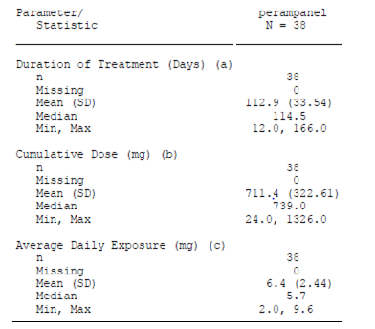
(a) The duration of treatment is calculated as the difference between the first and last dose dates of a phase. (b) The cumulative dose during the treatment period is the sum of all daily doses during the treatment period. (c) The average daily exposure is equal to the cumulative dose during the treatment period divided by the number of days during which a patient is treated during the treatment period.
Compared to placebo, a higher percentage of subjects on perampanel had AEs that were possibly related to treatment (55.3% vs.40.0%), or probably related to treatment (47.4% vs. 0%).
1 subject in each group had an SAE (1/10 (10.0%) in the placebo group and1/38 (2.6%) in the perampanel group). 5/38 (13.2%) in the perampanel group and 0/10 in the placebo group had severe AEs.
One subject (1/10, 10.0%) in the placebo group and 2 subjects (2/38, 5.3%) in the perampanel group had AEs leading to discontinuation from the study.
Subjects on perampanel most frequently reported the AE of dizziness (22/38, 57.9% vs. Placebo 1/10, 10%), followed by somnolence (12/38, 31.6% vs. 0), headache (7/38, 18.4% vs. 1/10, 10%), fatigue (4/38, 10.5% vs. 2/10, 20%), and diarrhoea (4/38, 10.5% vs. 1/10, 10%).

Study E2007-A001-206
The primary objective was to determine the maximal tolerated dose of perampanel when added to concomitant AEDs in subjects with refractory partial onset seizures (including secondarily generalized seizures).
5 SAEs, all connected with seizures; all were considered possibly related to study treatment.
5.9% (6/102 subjects) of subjects in the perampanel treatment group and 3.9% (2/51 subjects) of subjects in the placebo treatment group discontinued due to AEs.
2 were in the placebo group with AEs that were both considered treatment-related and both seizures.
Of the 6 subjects in the perampanel group with AEs that led to withdrawal, 1 subject had =status epilepticus; 3 had a moderate rash that was considered treatment-related for 2 of them. Of the others 1 had severe somnolence (considered treatment-related) and 1 had multiple treatment-emergent AEs (gait disturbance, balance disorder, and tremor), not considered treatment-related and mild to moderate in severity.
Table 80. Summary of Adverse Events: Safety Population Study 206
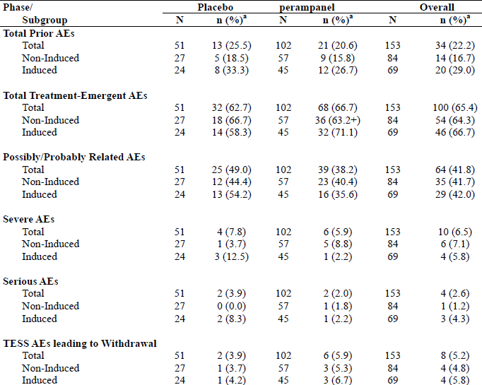
ª: Percent was calculated using the number of subjects in the Safety Population or relevant subgroup as the denominator.

Study E2007-J081-231
The study objectives were to explore the safety and tolerability of perampanel of up to 12 mg co-administered with other AEDs.
The Maximum tolerated dose was judged to be 12 mg in 33.3% (10/30 subjects), 10 mg or higher in 50.0% (15/30 subjects), and 8 mg or higher in 70.0% (21/30 subjects).
Among subjects with concomitant use of antiepileptic drug having CYP3A4 induction activity (inducer subgroup), the Maximum tolerated dose was judged to be 12 mg in 33.3% (9/27 subjects), 10 mg or higher in 51.9% (14/27 subjects), and 8 mg or higher in 74.1% (20/27 subjects).
27/30 subjects (90.0%) had AEs and 26/30 subjects (86.7%).had adverse drug reactions (adverse events with causal relationship other than unrelated).
Frequent (incidence ≥ 10%) AEs were dizziness 53.3% (16/30 subjects), somnolence 46.7% (14/30 subjects), nasopharyngitis 16.7% (5/30 subjects), contusion 13.3% (4/30 subjects), and headache, upper respiratory tract inflammation, and irritability 10.0% (3/30 subjects each). Frequently observed (incidence ≥ 10%) adverse drug reactions were dizziness 53.3% (16/30 subjects), somnolence 46.7% (14/30 subjects), and headache and irritability at 10.0% (3/30 subjects each).

Patient exposure
As of the cut-off date for this submission (1 December 2010), 1639 subjects with epilepsy had received perampanel in double-blind Phase II and 3 studies and open-label extensions (OLEs). The total exposure to perampanel in the epilepsy studies was 82,629.0 subject-weeks. A total of 1147 subjects had received perampanel for > 6 months, 703 subjects had received perampanel for > 1 year and 95 subjects had received perampanel for > 2 years. For the 102 subjects who were 12 to < 17 years old, the overall exposure to perampanel was 5095.4 subjects-weeks and perampanel had been taken for > 6 months, > 1 year, and > 2 years by 72, 49, and 4 subjects, respectively.
An additional 2717 subjects with non-epilepsy indications received perampanel in double-blind Phase II and 3 studies and OLEs. The overall exposure to perampanel in these studies was 86,176.1 subject-weeks. A total of 1251 subjects received perampanel for > 6 months, 556 subjects received perampanel for > 1 year and 66 subjects received perampanel for > 2 years.
In Phase I single-dose studies, 573 healthy subjects received 922 single doses of perampanel. In Phase I multiple-dose studies, 343 healthy subjects had an overall exposure to perampanel of 917.9 subject-weeks.

Adverse events
The data from the studies in subjects with epilepsy were combined into three pools:
- Double-blind adjunctive therapy Phase III studies (Studies 304, 305, and 306) or epilepsy Phase III double-blind pool.
- Double-blind adjunctive therapy Phase II studies (Studies 203, 206, and 208) or epilepsy Phase II double-blind pool.
- All treated subjects with partial-onset seizures; includes all above and four open-label studies (Studies 207, 231, 233, and 307) or the epilepsy all treated pool.

Healthy subjects
Table 81. Overview of Treatment-emergent Adverse Events – Phase I Multiple-Dose Study Pool (Safety Analysis Set)
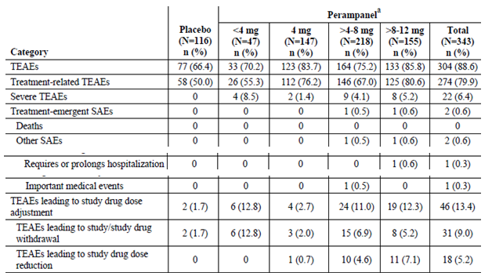
A TEAE is generally defined as an adverse event that begins within 30 days after dosing with perampanel/placebo or an ongoing event that increases in severity after dosing with perampanel/placebo. Full details are given in the Statistical Analysis Plan. For each row category, a dose administration with two or more adverse events in the category is counted only once. N = Number of subjects receiving the dose at any time during the study ^{a:} Actual dose at onset of the first occurrence of the TEAE within each dose group.
Of the 1083 subjects who received at least one dose of study drug in those studies, 989 (91.3%) completed the study. Reasons for discontinuation were AEs (4.5%), protocol violation (0.5%), withdrawal of consent (1.8%), and other (1.8%).
The reasons for 4 (0.4%) discontinuations in the single dose total perampanel group were blood CPK increased, ECG QT prolonged, haemoglobin decreased, and WBC count increased, each of which occurred in 1 subject. AEs leading to discontinuation occurred in two (1.7%) subjects in the placebo group and 31 (9.0%) subjects in the multi-dose total perampanel group.
AEs that occurred in ≥ 10% of the healthy subjects were dizziness, somnolence, headache, fatigue, and nausea. Euphoric mood (single-dose studies) and positive rhombergism (multiple-dose studies) were reported at much higher incidences with doses > 12 mg/d group.
Dizziness occurred in 7 (6.0%) healthy volunteers on placebo, 7 (14.9) on < 4 mg/day, 63 (42.9) on 4 mg /day, 81 (37.2) on > 4-8 mg /day and 62 (40.0) on > 8-12 mg /day.
Nausea showed a dose related increase (Placebo 4 (3.4), < 4 mg/day 2 (4.3)4 mg /day 8 (5.4), > 4-8 mg /day 19 (8.7), > 8-12 mg /day 28 (18.1)).
Dysarthria occurred in 1 (0.9) on placebo, 1 (0.7) on 4 mg /day, 10 (4.6) on > 4-8 mg /day and 32 (20.6) on > 8-12 mg /day.
Ataxia occurred in 2 (1.7) on placebo, 5 (2.3) on > 4-8 mg /day and 17 (11.0) on > 8-12 mg/day.
Balance disorder showed a dose related increase (Placebo 1 (0.9), < 4 mg /day 0, 4 mg/day 1 (0.7), > 4-8 mg /day 8 (3.7) and > 8-12 mg /day 11 (7.1)).
Cerebellar ataxia was reported only in 5 (3.2) on >8-12 mg /day.
Agitation occurred in 1 (0.5) on > 4-8 mg /day and 6 (3.9) on > 8-12 mg /day.
Severe AEs were reported for 2 (1.4%) subjects on placebo and 3 (0.3%) on perampanel in the single-dose pool. They were diarrhoea and upper abdominal pain in the placebo group, and limb injury, somnolence, and headache in the perampanel group. There were no severe AEs on placebo and in 22 (6.4%) subjects on perampanel in the multiple-dose pool. The severe events were somnolence (n = 7), fall (n = 6), dizziness (n = 4), positive Rhombergism and ataxia (n = 3 each), vertigo and headache (n=2 each), and asthenia, gait disturbance, poisoning, concussion, ALT increased, anxiety, and thinking abnormal (n = 1 each).
Two subjects, both in the multidose trials perampanel group, had SAEs one was concussion associated with fall and head injury, and one subject had anxiety, paranoia, and balance disorder.
AEs related to alertness and cognition for the Phase I single-dose study pool occurred in eight (5.5%) of the subjects on placebo and 191 (20.7%) of those in the perampanel group. The most common AE was somnolence 7 (4.8%) of the subjects in the placebo group and 178 (19.3%) of those in the total perampanel group.
And AEs related to alertness and cognition in the multiple-dose study pool occurred in 10 (8.6%) of the subjects on placebo and 122 (35.6%) of those in on perampanel. The most common AE was somnolence, in seven (6.0%) and 84 (24.5%) of the subjects, respectively. All other AEs in this category occurred in ≤ 5.5% of the subjects in the placebo or total perampanel group.
In subjects on perampanel somnolence led to discontinuation in 8 (2.3%) and sedation led to 2 (0.6%). Amnesia, judgment impaired, loss of consciousness, and memory impairment each led to treatment discontinuation in one (0.3%) perampanel-treated subject.
Feeling drunk was reported by none on placebo or < 4 mg by 9 (6.1) on 4 mg /day, by 16 (7.3) on > 4-8 mg /day and by 15 (9.7) on > 8-12 mg/day.
The psychiatric AEs that occurred in the healthy pools but not in the epilepsy pools were daydreaming, dissociation, psychiatric symptom, flat affect, thinking abnormal, delusional perception, disturbance in sexual arousal, dysphoria, illusion, inappropriate affect and staring, each of which occurred in ≤ 0.6% of the perampanel-treated subjects.
AEs suggestive of abuse potential occurred in 2.9% of the subjects in the total perampanel group in the Phase I multiple-dose study pool; the most common being feeling drunk and slow slurred speech (0.9% of the subjects in the total perampanel group). All other such AEs occurred in ≤ 0.6% of the subjects in the total perampanel group.
Falls occurred in one (0.1%) subject in the Phase I single-dose study pool (in the perampanel >12 mg/d group)). In the Phase I multiple dose study pool, AEs of fall occurred in two (1.7%) subjects in the placebo group and 18 (5.2%) subjects in the total perampanel group (four (1.8%) in the > 4-8 mg/d group and 14 (9%) in the > 8-12 mg/d group).
Positive Rhombergism occurred in 8 (6.9%) of placebo volunteers in 6 (2.8%) on > 4-8 mg /day and 37 (23.9%)on > 8-12 mg /day.
AEs related to rash occurred in 7 (0.8%) of the subjects in the single dose total perampanel group; and 1 (0.9%) of the subjects in the placebo group and 21 (6.1%) of those in the multi-dose total perampanel group.
Cardiac disorders and ECG-related AEs occurred in 1 (0.7%) of the subjects in the placebo group and four (0.4%) of those in the single dose total perampanel group; while they occurred in 11 (3.2%) of those in the multi-dose total perampanel group. The only such AEs that occurred > 1 subject were palpitations (n = 4) and cyanosis, heart rate increased, and tachycardia (n = 2 each).
Orthostatic changes occurred in 1 (0.1%) of those in the single dose total perampanel group; while they occurred in 3 (2.6%) of the subjects in the placebo group and 10 (2.9%) of those in the multi dose total perampanel group.
In the single-dose studies, no subject had a maximum QTcB or QTcF value > 500msec. A maximum QTcF value > 450msec occurred in three (3.4%) and four (2.4%) subjects, respectively. One subject (perampanel group) had a change from baseline in QTcB of > 60msec, whereas no subject had changes from baseline in QTcF of that magnitude. In the multiple-dose studies, a maximum QTcB or QTcF value > 500msec occurred in no subject in either the placebo group or total perampanel group. Changes from baseline in QTcB of > 60msec occurred in one (3.8%) and one (0.9%) subject, respectively; changes from baseline in QTcF of > 60msec occurred in zero and one (0.9%) subjects, respectively.
In the single-dose studies with ECG data, no subject had sinus tachycardia (heart rate >100bpm). Sinus bradycardia (heart rate <60bpm) was detected in 64 (71.9%) of 89 ECGs in the placebo group and 168 (87.5%) of 192 ECGs in the total perampanel-group. First-degree atrioventricular block (PR interval >200msec) was detected on eight (9.0%) and 19 (9.9%) ECGs, respectively. Intraventricular block (QRS duration >120msec) was detected on zero and two (1.0%) ECGs, respectively. In the multiple-dose studies, sinus tachycardia was detected in zero of 26 ECGs in the placebo group and four (3.4%) of 117 ECGs in the total perampanel group. Sinus bradycardia was detected in 21 (80.8%) and 87 (74.4%) ECGs, respectively. First degree atrioventricular block was detected in two (7.7%) and 12 (10.3%) ECGs, respectively. Intraventricular block was detected on zero and four (3.4%) ECGs, respectively. There were no dose-related trends across the perampanel groups for any parameter.
AEs related to laboratory abnormalities occurred in 8 (0.9%) of those in the single dose total perampanel group. The only event that occurred in > 1 subject was blood CPK increased, which occurred in 3 subjects (2 in the < 4 mg/d group and 1 in the > 12 mg/d group).
AEs related to laboratory abnormalities occurred in two (1.7%) subjects in the placebo group and eight (2.3%) subjects in the multi-dose total perampanel group. The AEs that occurred in > 1 perampanel-treated subject were ALT increased (4 subjects in the total perampanel group) and AST increased (2 subjects, perampanel).
In both the single-dose and multiple-dose pools, no subject in either the placebo group or the total perampanel group had markedly abnormal laboratory values at any time for most safety parameters. When markedly abnormal values were measured, they occurred in ≤ 2.0% of the subjects in either group, and showed no dose-related trends across the perampanel groups.
In the Phase I single-dose study pool, 2 (0.4%) perampanel-treated subjects had values for AST that were > 5x ULN, and 1 (0.2%) perampanel-treated subjects had values for ALT that were > 5x ULN.
In the Phase I multiple-dose study pool, Creatine kinase values > 5x ULN occurred in 5 (4.9%) placebo-treated subjects and 4 (1.3%) perampanel-treated subjects. No placebo-treated subjects and 1 (0.3%) perampanel-treated subject had values for ALT that were > 5x ULN. The perampanel-treated subject also had elevated AST values (not > 5x ULN); 4 (1.2%) perampanel-treated subjects and 1 (0.9%) placebo-treated subject had values for bilirubin that were > 2x ULN.

Double blind and all treated epilepsy patients

All adverse events (irrespective of relationship to study treatment)
Table 82. Overview of Adverse Events by Randomized Treatment – Epilepsy Phase III Double-blind Pool (Safety Analysis Set)
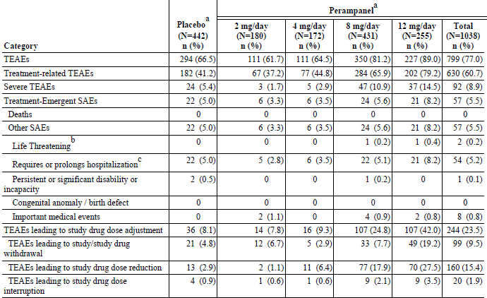
A TEAE is defined as an adverse event that either begins on or after the first dose date and up to 30 days after the last dose date of study drug; or begins before the first dose date and increases in severity during the treatment period. For each row category, a subject with two or more adverse events in that category is counted only once. ª: Subjects treated during the double-blind study.
Table 83. Adverse Events That Were Very Common* or Common# by Randomized Treatment – Epilepsy Phase III Double-blind Pool (Safety Analysis Set)
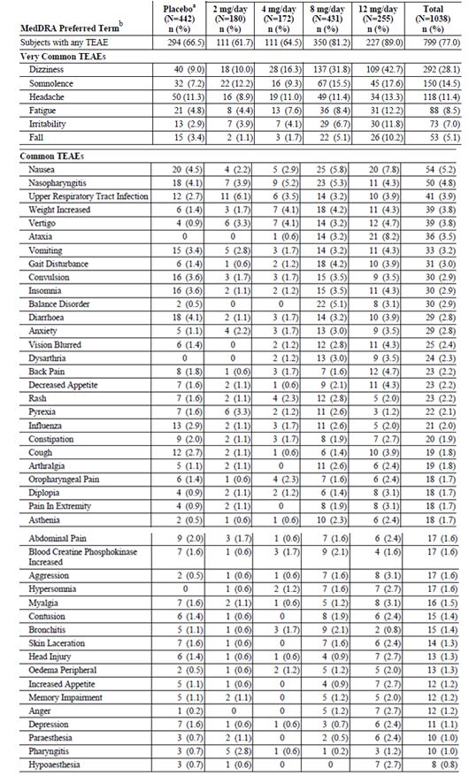
A TEAE is defined as an adverse event that either begins on or after the first dose date and up to 30 days after the last dose date of study drug; or begins before the first dose date and increases in severity during the treatment period. Subject with two or more adverse events with the same preferred term is counted only once for that preferred term. ^{b}: MedDRA preferred terms are sorted in descending order of frequency in the total perampanel column. * ≥ 10% of Subjects in Any Treatment Group # ≥ 2% to < 10% of the Subjects in Any Treatment Group

Table 84. AEs by Decreasing Frequency (≥ 5%) and Maximum Daily Dose of Perampanel- All Treated Subjects with Partial Seizures (Safety Analysis Set)
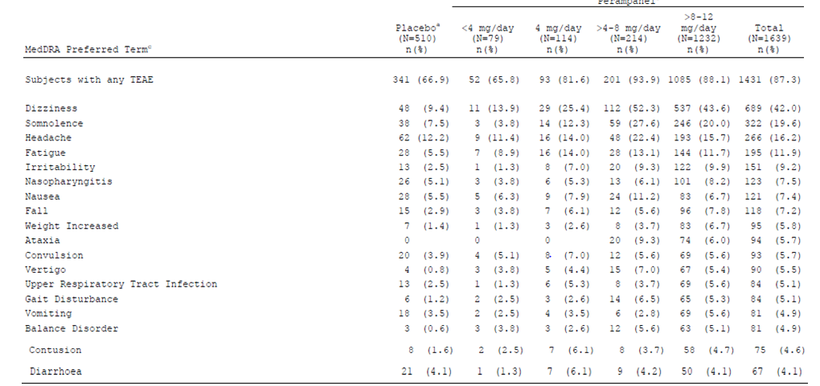
A TEAE is defined as an adverse event that either begins on or after the first dose date and up to 30 days after the last dose date of study drug; or begins before the first dose date and increases in severity during the treatment period. Subject with two or more adverse events in the same system organ class (or with the same preferred term) is counted only once for that system organ class (or preferred term).
ª: Subjects treated with placebo during the double-blind study.
^{b}: Subjects treated with perampanel in any study. Dose is the maximum daily dose received.
^{c}: MedDRA preferred terms are sorted in descending order of frequency in the total column.

Treatment-related adverse events (adverse drug reactions)
In the Epilepsy All Treated Pool most events in all treatment groups were considered possibly or probably related to treatment.
The following ADRs (shown in order of decreasing frequency in the total perampanel group) resulted from the clinical evaluation of the epilepsy studies: dizziness, somnolence, fatigue, irritability, fall, nausea, ataxia, weight increased, vertigo, balance disorder, gait disturbance, anxiety, vision blurred, dysarthria, back pain, decreased appetite, aggression, diplopia, anger, and increased appetite. Confusional state occurred in 0.9% of the subjects in the total perampanel group and 0.5% of those in the placebo group in the epilepsy Phase III double-blind pool (based on the clinical evaluation of the non-epilepsy studies, confusional state was added to the list of ADRs).
Table 85. Adverse Drug Reactions – Epilepsy Phase III Double-blind Pool (Safety Analysis Set
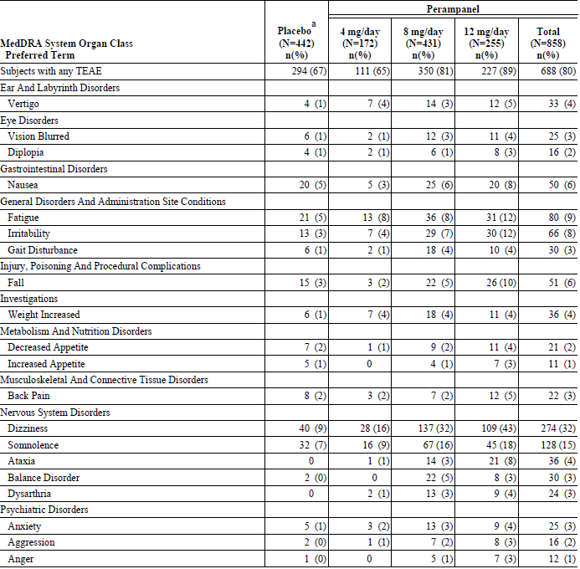

Pivotal studies
Table 86. Very Common (≥ 10% of Subjects in Any Treatment Group) AEs by Preferred Term, Relationship to Study Drug, and Randomized Treatment – Epilepsy Phase III Double-blind Pool (Safety Analysis Set)
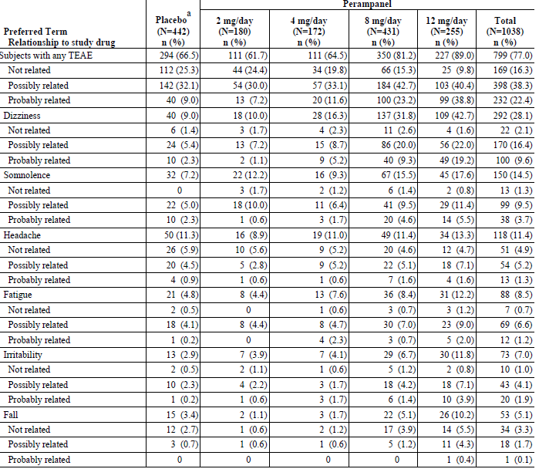
A TEAE is defined as an adverse event that either begins on or after the first dose date and up to 30 days after the last dose date of study drug; or begins before the first dose date and increases in severity during the treatment period. If a subject had a single incident of an AE (Preferred Term) with a missing relationship, the subject will be counted in the ‘Missing’ category for that Preferred Term. If a subject had two or more adverse events in the same system organ class (or with the same preferred term) with different relationships to study drug, then the event with the closest relationship was used for that subject. Subjects with missing relationship to study drug for an AE are counted under “Missing" category unless the subject already has another AE classified as Probably Related, in which case the subject is counted under "Probably Related" category. Relationship to study drug reflects Investigator’s opinion. ^{a:} Subjects treated with placebo during the double-blind study.

Deaths and other serious adverse events
Four deaths occurred in subjects who were receiving perampanel in an Open Label Extension study: One death was a sudden unexpected death in epilepsy. None of the deaths were considered related to perampanel.

Discontinuation due to adverse events
Discontinuation due to AEs occurred in 4.8% of the subjects in the placebo group and 6.7%, 2.9%, 7.7%, and 19.2% of the subjects, respectively, in the 2, 4, 8, and 12 mg/d groups. Percentages of subjects discontinuing due to Dizziness were in the placebo (0.9%), 2 mg/d (0.6%), 4 mg/d (0.6%) 8 mg/d (2.1%) and 12 mg/d (4.3%) groups. Convulsion led to discontinuation in similar percentages of subjects in all treatment groups. There were much higher discontinuations due to AEs in the US on ≥ 4 mg/day perampanel (16 – 26%) than on placebo (8.4%). Europe was similar.
Table 87. AEs Leading to Discontinuation of Study Drug in ≥ 1% of the Subjects in Any Treatment Group by Randomized Treatment – Epilepsy Phase III Double-blind Pool (Safety Analysis Set)
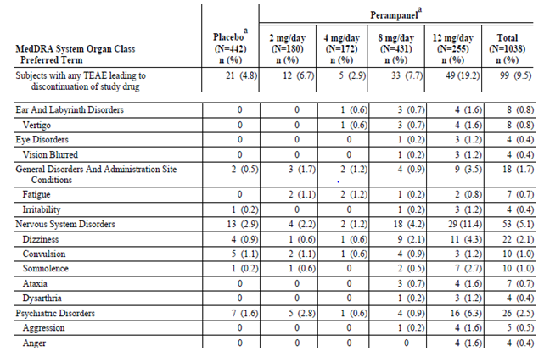
A TEAE is defined as an adverse event that either begins on or after the first dose date and up to 30 days after the last dose date of study drug; or begins before the first dose date and increases in severity during the treatment period. Subject with two or more events in the same system organ class (or with the same preferred term) is counted only once for that system organ class (or preferred term). ª: Subjects treated during the double-blind study.
Table 88. AEs Leading to Study or Study Drug Discontinuation in ≥ 1% of Subjects in Any Treatment Group by Decreasing Frequency and Last Daily Dose of Perampanel - All Treated Subjects with Partial Seizures (Safety Analysis Set)
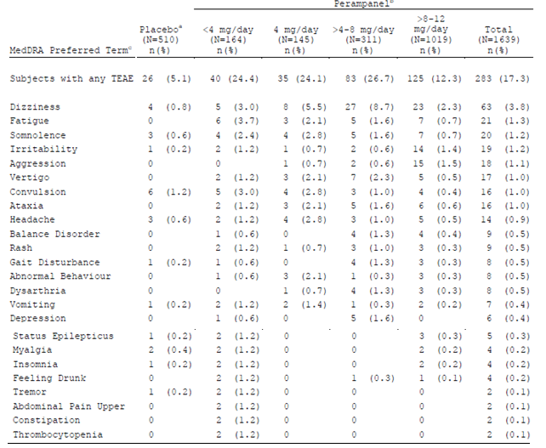
A TEAE is defined as an adverse event that either begins on or after the first dose date and up to 30 days after the last dose date of study drug; or begins before the first dose date and increases in severity during the treatment period. Subject with two or more adverse events with the same preferred term is counted only once for that preferred term. ª: Subjects treated with placebo during the double-blind study. ^{b}: Subjects treated with perampanel in any study. Dose is the last daily dose received. ^{c}: MedDRA preferred terms are sorted in descending order of frequency in the total column.

Laboratory tests
In the epilepsy Phase II double-blind pool AEs related to laboratory abnormalities occurred in 6 (8.8%) subjects in the placebo group and 13 (8.6%) subjects in the total perampanel group, including 8.3%, 9.9%, and 5.3% of the subjects in the < 4, 4, and > 8-12 mg/d groups, respectively.
Haematology-related AEs occurred in 1.5% of the subjects in the placebo group and 4.6% of those in the total perampanel group. The most common preferred term was activated PTT prolonged, which occurred in 1 (1.5%) placebo-treated subject and 4 (2.6%) perampanel-treated subjects (all in the 4 mg/d group). Anaemia occurred in 1 (0.7%) perampanel-treated subject.
Of the 14 subjects (including 12 females, all ≤51 years old) with markedly abnormal results for haemoglobin 12 had abnormal baseline values and four of these 12 subjects had histories of anaemia. Of the 12 subjects with abnormal baseline values (all with NCI Grade 1), all had an increased from baseline of one NCI grade. Eight subjects concomitantly took valproic acid, phenytoin, or both.
In the double-blind studies the only SAE was thrombocytopenia in 1 placebo subject. The only discontinuation was due to thrombocytopenia in 1 perampanel subject.
In the epilepsy all treated pool the only SAE was anaemia in 1 subject. The discontinuations were due to: neutropenia (2 subjects) and thrombocytopenia (2 subjects).
In the Epilepsy All Treated Pool Haematology-related AEs occurred in 3.2% of the subjects including: anaemia (1.1%). Neutropenia and leucopoenia occurred in 0.6% and 0.5%, respectively, of the perampanel-treated subjects thrombocytopenia.WBC count decreased, activated PTT prolonged, haemoglobin decreased, haemoglobin increased, mean cell haemoglobin concentration increased, haematocrit decreased, RBC count decreased, platelet count decreased) occurred in . 0.4% of the subjects in the total perampanel group.
Table 89. Treatment-Emergent Markedly Abnormal Laboratory Results for Haematology Parameters and Differentials by Randomized Treatment – Epilepsy Phase III Double-blind Pool (Safety Analysis Set)
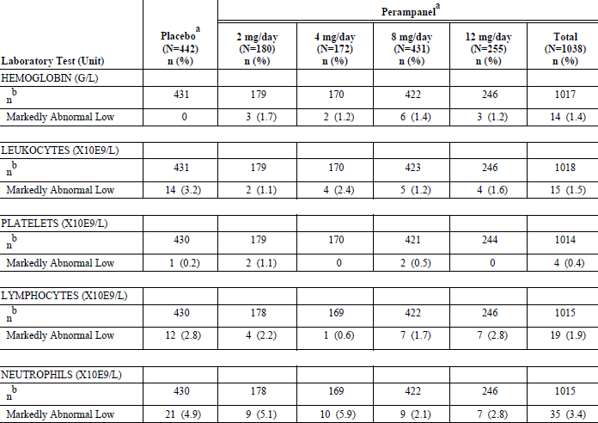
An increase in NCI grade to Grade 2 or higher from baseline constitutes a markedly abnormal result. Subjects are counted only once for each row. ª: Subjects treated during the double-blind study. ^{b}: Indicates the number of subjects with observed data during the treatment period and is used for calculating the percent.

Table 90. Treatment-Emergent Markedly Abnormal Laboratory Results for Haematology Parameters and Differentials by Modal Dose of Perampanel – Epilepsy All Treated Pool (Safety Analysis Set)
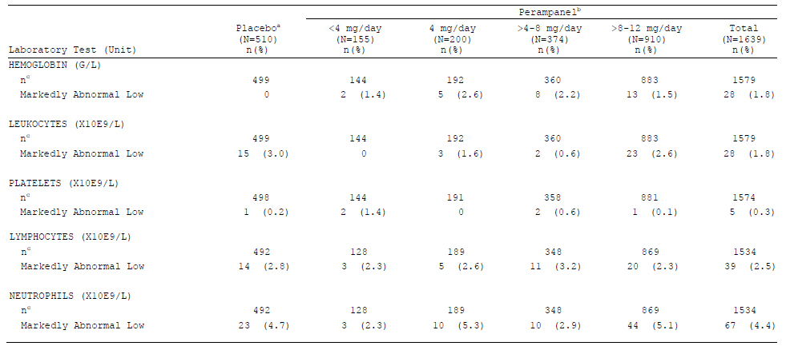
Subjects are counted only once for each row. a: Subjects treated with placebo during the double-blind study. b: Subjects treated with perampanel in any study. Dose is the modal dose received. c Indicates the number of subjects with observed data during the treatment period and is used for calculating the percent.

Subjects in the placebo and total perampanel groups had AEs related to renal parameters (0% and 0.7%, respectively), hepatic parameters (2.9% and 1.3%), electrolytes (2.9% and 1.3%), metabolic parameters (1.5% and 1.3%), and other (1.5% and 2.6%).
In the Epilepsy All Treated Pool AEs related to laboratory abnormalities occurred in 163 (9.9%) subjects in the total perampanel group. Except for Blood Creatine phosphokinase increased (2.0%), individual AEs occurred in ≤ 1.1% of all perampanel treated subjects in the epilepsy all treated pool.
AEs related to hepatic parameters occurred in 1.7% of the subjects. They were cholelithiasis (4 [0.2%] subjects) and hepatic function abnormal (2 [0.1%)] subjects). AEs related to metabolic parameters occurred in 2.9% of the subjects; however, no individual event occurred in more than 0.9% of the subjects.

Electrocardiograph
Study 013 was a parallel-group study of the effect of perampanel on QT interval in healthy subjects.
Sinus bradycardia occurred in 472 (32.0%) subjects, and sinus tachycardia occurred in 32 (2.2%) subjects. First degree atrioventricular block occurred in 71 (4.8%) subjects, and intraventricular block occurred in 16 (1.1%) subjects. Abnormalities related to ischemia and infarction occurred in 41 (2.6%) subjects.

Table 91. Summary of Abnormal QTcB and QTcF Results During Treatment Period by Randomized Treatment - Epilepsy Phase III Double-blind Pool (Safety Analysis Set)
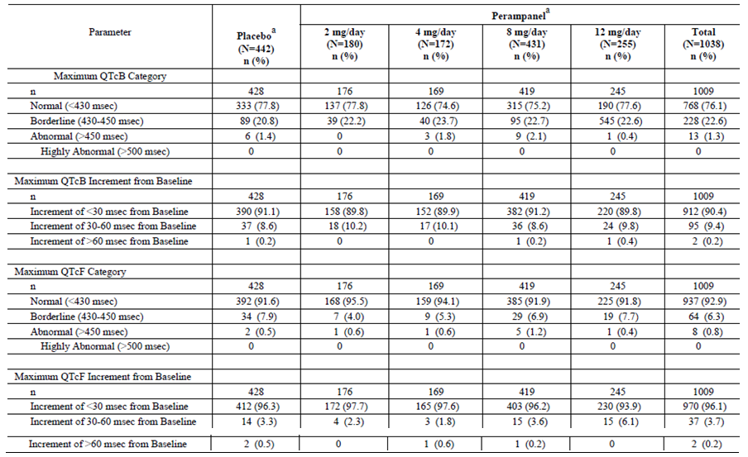
Subjects are counted in each applicable category. Percentages are based on the number of subjects in the Safety Analysis Set per treatment group with data during the treatment period. a: Subjects treated during the double-blind study.
Table 92. Summary of Abnormal QTcB and QTcF Results During Treatment Period – Epilepsy All Treated Pool (Safety Analysis Set)
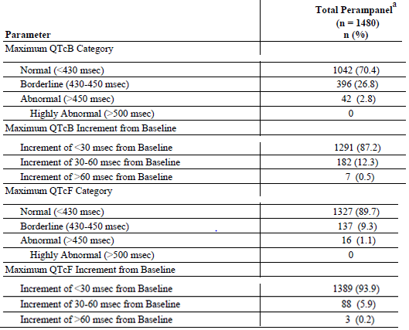
ª: Subjects treated with perampanel in any study. Subjects are counted in each applicable category. Percentages are based on the number of subjects in the Safety Analysis Set per treatment group with data during the treatment period.

Vital signs
Orthostatic hypotension (systolic and diastolic change ≥ 20mmHg) appeared to show some dose relationship; the numbers were small for grater changes.
Table 93. Abnormal Vital Signs During The Treatment Period – Orthostatic changes - Double-blind Adjunctive Therapy Phase II Studies in Subjects with Refractory Partial Seizures (Safety Analysis Set)
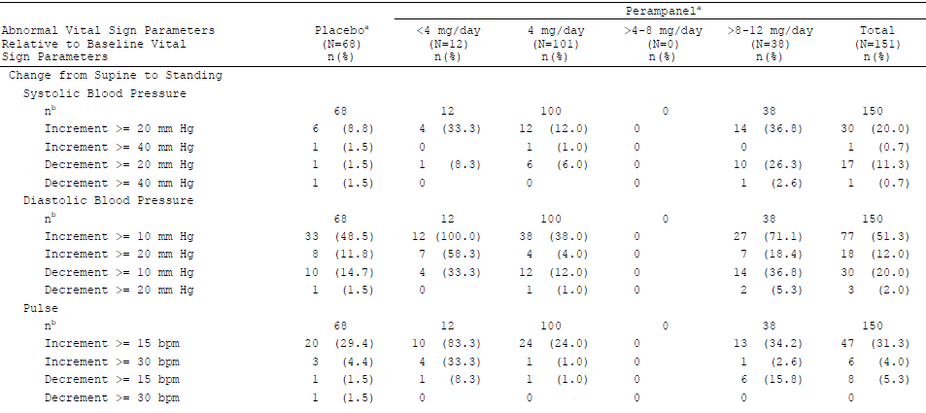
Subjects are counted only once for each row. ª: Subjects treated during the double-blind study. Dose groups are based on the actual treatment groups. ^{b}: Indicates number of subjects with observed data during the treatment period and is used to calculate percentages within each test.

Table 94. Clinically Notable Changes in Supine Vital Signs and Weight by Randomized Treatment - Epilepsy Phase III Double-blind Pool (Safety Analysis Set)
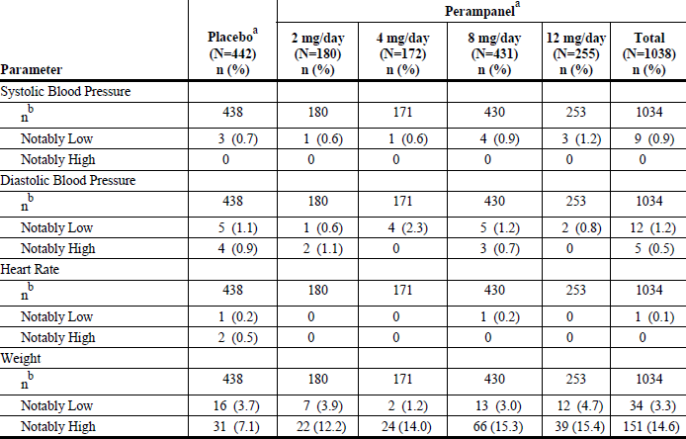
^{b}: Indicates number of subjects with observed data during the treatment period and is used to calculate percentages within each test. Only subjects with non-missing data at both baseline and the end of treatment are included in the summary statistics.
Table 95. Clinically Notable Changes in Supine Vital Signs and Weight – Epilepsy All Treated Pool (Safety Analysis Set)
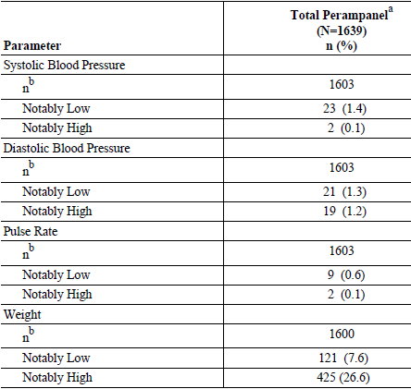
Subjects are counted only once for each row. ª: Subjects treated with perampanel in any study. ^{b}: Indicates number of subjects with observed data during the treatment period and is used to calculate percentages within each test.
The incidence of metabolic syndrome however the dose was analysed (mean, modal, etc.) tended to increase with increased dose.
Table 96. Incidence of Risk Factors Associated with Metabolic Syndrome– Epilepsy Phase III Double-blind Pool (Safety Analysis Set)
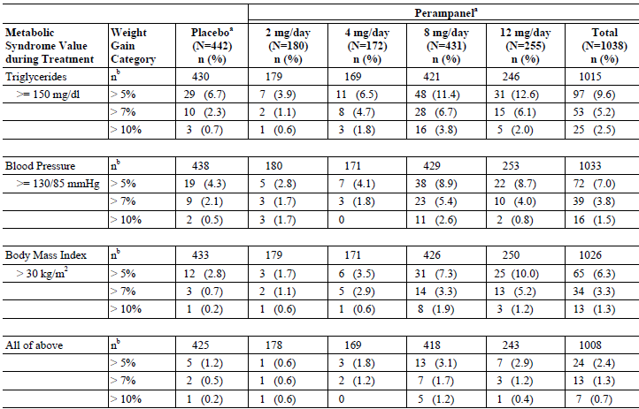
ª: Subjects treated during the double-blind study. ^{b}: Indicates the number of subjects with observed data during the treatment period and is used for calculating the percent.
Table 97. Incidence of Metabolic Syndrome by Modal Dose of Perampanel - All Treated Subjects with Partial Seizures (Safety Analysis Set)
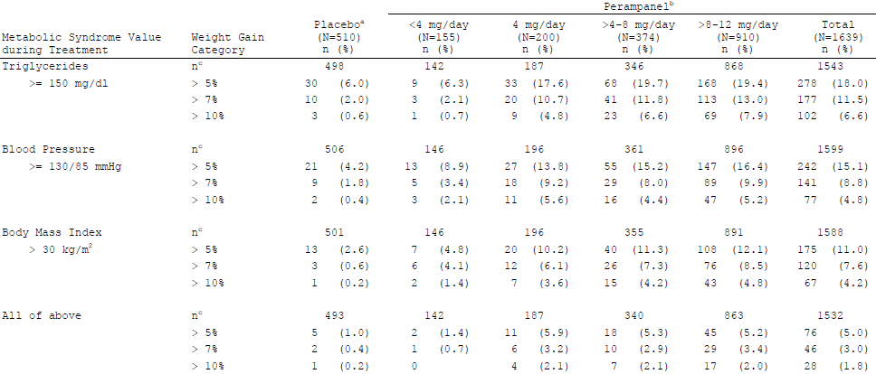
ª: Subjects treated with placebo during the double-blind study. ^{b}: Subjects treated with perampanel in any study. Dose is the modal dose received. ^{c}: Indicates the number of subjects with observed data during the treatment period and is used for calculating the percent.

Photosensitivity
A photo-irritation study (Study 020) in which healthy subjects received perampanel 6 mg/d for 10 days was negative. A photosensitivity questionnaire was added to the double-blind, Phase III epilepsy studies, the proportion with positive responses (skin rash/reaction/change in pigmentation/skin complaint) was higher in the 8 and 12 mg/d groups: 1.2% (3/242) in the placebo group, 0% (0/75) in the 2 mg/d group, 1.4% (1/74) in the 4 mg/d group, 2.4% (5/212) in the 8 mg/d group, and 3.2% (5/158) in the 12 mg/d group. Of the subjects with positive responses, one in the placebo group and five in the perampanel group also had a positive response to the question about skin reacting to sunlight more than expected. All three subjects in the placebo group and five of the 11 subjects in the perampanel group had histories of dermatitis or skin complaints.

Ongoing studies
Includes Studies 307, 207, and 233 between the data cut-off date for this submission (01 Dec 2010) and 01 Jul 2011 and in ongoing Study 235 as of 01 Jul 2011.
There was one death in ongoing Study 307, a 28 year-old female she fell (not reported as serious) and, despite medical assistance, died. The subject had been seizure free since June 2010 and had not experienced a seizure on the day of the fall. No autopsy was performed. The investigator classified the death as not related to treatment and indicated the subject had suspected long QT syndrome, although she had no history of that at baseline.
No SAEs occurred in Study 233. In Study 235 of 4 SAEs, 1 was Aggressive behaviour in a 15y/F. Among the 50 additional SAEs in Study 307 were:
- Heart rate irregular Coronary artery stenosis Fatigue Fall Shortness of breath and Angina pectoris; Cardiovascular insufficiency Pneumonia;
- Grand mal seizure; 2 with Seizures; 3 with Status epilepticus; Intractable epilepsy; 2 with Epilepsy; Generalized convulsion 14/F; Partial seizures, complex;
- Aggressive behaviour 13/M;
- Suicide attempt (carbamazepine overdose) Overdose intentional (carbamazepine overdose);
- Dizziness aggravated Overdose (perampanel, 12 mg instead of 4 mg);
- Hyponaetraemia (suspect medication, oxcarbazepine); Drug toxicity (lamotrigine) Ataxia.
Among the 3 additional SAEs in Study 207 were: Psychotic disorder; Epileptic seizure.

Safety issues with the potential for major regulatory impact

Liver toxicity
Study 015 was a study of the effect of impaired hepatic function on the PKs of a single 1mg dose of perampanel. 1/6 subjects with moderate hepatic impairment had a mild AE (headache), considered possibly related, while 3/12 normal subjects each had 1 AE (nausea, fatigue, and headache); all possibly related to study drug.
Markedly abnormal results occurred in ≤ 3.1% of the subjects in any treatment group. When the analysis was limited to subjects whose baseline values were within the normal range markedly abnormal results occurred in ≤ 1.1% of the subjects in any treatment group.
Comment: Based on this statement, patients with abnormal liver function are approximately twice as likely to have deterioration in hepatic markers.
In the double-blind studies, none of the AEs related to hepatobiliary parameters were SAEs and none caused discontinuation. ALT increased and AST increased each led to discontinuation of treatment in 1 placebo subject.
Markedly abnormal high cholesterol values occurred in one (0.2%) subject in the placebo group and 20 (2.0%) subjects in the total perampanel group. Fifteen of the latter 20 subjects did not have markedly abnormal values for cholesterol at two consecutive visits. Of the five subjects with markedly abnormal values at two or more consecutive visits, all had baseline values for cholesterol that were above the normal range, and none had a change from baseline of more than one NCI grade.
In the epilepsy all treated pool, none of the AEs related to hepatobiliary parameters occurred were SAEs and no subject discontinued treatment due to such AEs.
Table 98. Treatment-Emergent Markedly Abnormal Laboratory Results for Hepatobiliary Parameters by Randomized Treatment – Epilepsy Phase III Double-blind Pool (Safety Analysis Set)
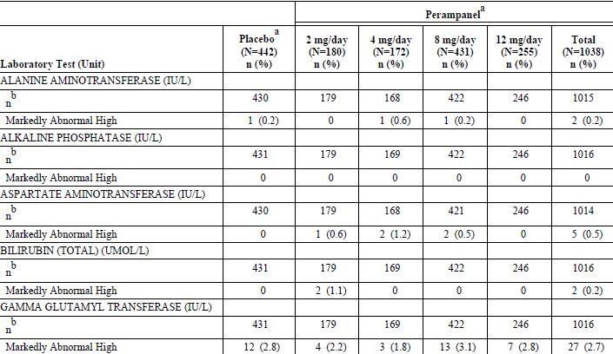
An increase in NCI grade to Grade 2 or higher from baseline constitutes a markedly abnormal result. Subjects are counted only once for each row. ª: Subjects treated during the double-blind study. ^{b}: Indicates the number of subjects with observed data during the treatment period and is used for calculating the percent.
Table 99. Treatment-Emergent Markedly Abnormal Laboratory Results for Hepatobiliary Parameters – Epilepsy All Treated Pool (Safety Analysis Set)
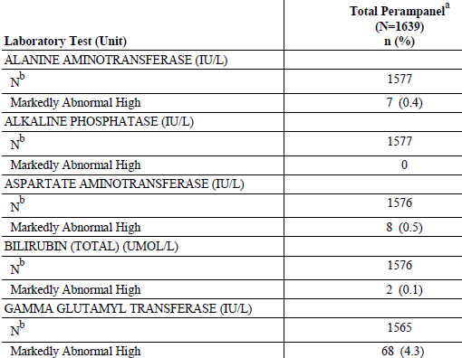
An increase in NCI grade to Grade 2 or higher from baseline constitutes a markedly abnormal result. Subjects are counted only once for each row. ^{a:} Subjects treated with perampanel in any study. ^{b:} Indicates the number of subjects with observed data during the treatment period and is used for calculating the percent.

Renal
In the Epilepsy Phase III Double-blind Pool the mean changes from baseline to the end of treatment were small; there were no notable differences between the treatment groups (including placebo) and no dose-related trends. Markedly abnormal high values for creatinine occurred in 1 (0.2%) placebo subject and 2 (0.2%) perampanel subjects. When the analysis was limited to subjects whose baseline values were within the normal range, markedly abnormal values for creatinine occurred in 1 (0.2%) and 1 (0.1%) subjects, respectively.
In the double-blind studies, none of the AEs related to renal parameters were SAEs, and none led to discontinuation of treatment.
In the Epilepsy All Treated Pool markedly abnormal high values for creatinine were seen in 9 (0.6%) subjects in the total perampanel group (2 of these had abnormal values at baseline).
Of the 13 abnormal creatinine assessments that occurred in the total perampanel group, 3 (0.2%) occurred with doses of < 4 mg/d, 3 (0.2%) occurred with doses of 4 mg/d, and 7 (0.2%) occurred with doses of > 8-12 mg/d.
In the epilepsy all treated pool, AEs related to renal parameters occurred in < 0.3% of the subjects, none were SAEs. There was a related AE (blood creatinine increased) that led to discontinuation of treatment in one subject.

Rash
In the epilepsy Phase III double-blind pool, there were no deaths or SAEs related to rash. 5 (0.5%) perampanel subjects discontinued due to AEs related to rash. The doses at the onset of these events were 2 mg/d (1 rash erythematous), 6 mg/d (1 rash), 8 mg/d (2 subjects with rash), and 12 mg/d (1 rash). There were no SAEs related to rash.
In the epilepsy all treated pool, rash occurred in 1.8% of placebo subjects and 3.3% of total perampanel subjects in the combined double-blind studies. The exposure-corrected rates were 0.004 and 0.003 subjects with rash per subject-month, respectively. 10 (0.6%) subjects in the total perampanel group discontinued treatment due to AEs related to rash.
Table 100. Adverse Events (for Rash) by Decreasing Frequency and Randomized Treatment – Epilepsy Phase III Double-blind Pool (Safety Analysis Set)
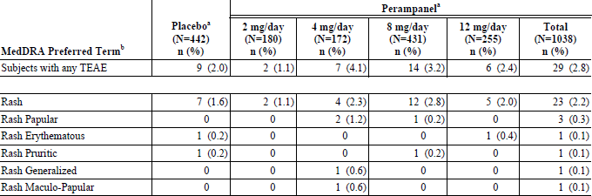
A TEAE is defined as an adverse event that either begins on or after the first dose date and up to 30 days after the last dose date of study drug; or begins before the first dose date and increases in severity during the treatment period. Subject with two or more adverse events with the same preferred term is counted only once for that preferred term. ª: Subjects treated during the double-blind study. ^{b}: MedDRA preferred terms are sorted in descending order of frequency in the total perampanel column.
Table 101. Adverse Events (Selected Preferred Terms for Rash) by Decreasing Frequency – Epilepsy All Treated Pool (Safety Analysis Set)
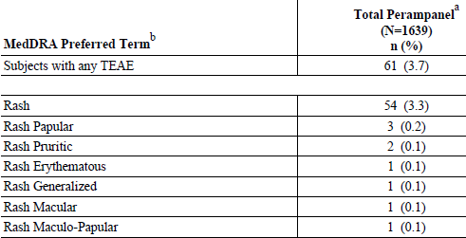
A TEAE is defined as an adverse event that either begins on or after the first dose date and up to 30 days after the last dose date of study drug; or begins before the first dose date and increases in severity during the treatment period. Subject with two or more adverse events with the same preferred term is counted only once for that preferred term. ^{a:} Subjects treated with perampanel in any study. ^{b}: MedDRA preferred terms are sorted in descending order of frequency in the total column.

Cardiovascular safety
In the epilepsy Phase III double-blind pool there were no cardiac- or ECG-related deaths or SAEs. There were 3 discontinuations; 1 in the placebo group due to palpitations, 1 in the 2 mg/d group due to tachycardia and 1 in the 8 mg/d group due to ECG QT prolonged.
In the epilepsy all treated pool there was 1 cardiac related death. SAEs each in a single perampanel subject were : bradycardia and sick sinus syndrome, angina pectoris, atrial fibrillation and atrial flutter, acute coronary syndrome, angina unstable, atrioventricular dissociation and hypertrophic cardiomyopathy, coronary artery stenosis and heart rate irregular, myocardial infarction.
Discontinuations due to AE each in a single perampanel subject were: atrioventricular block first degree, bradycardia, sinus bradycardia, tachycardia, ECG QT prolonged, blood pressure increased.
Table 102. Adverse Events (Selected Preferred Terms for Cardiac and ECG AEs) by Decreasing Frequency and Randomized Treatment – Epilepsy Phase III Double-blind Pool (Safety Analysis Set)
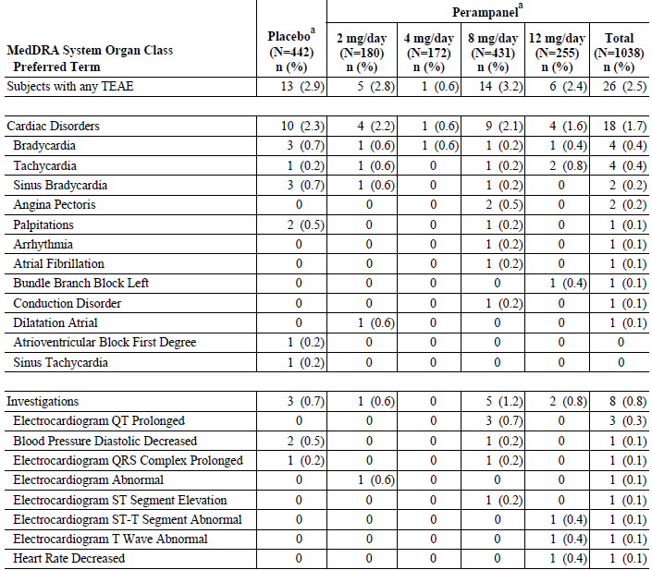
A TEAE is defined as an adverse event that either begins on or after the first dose date and up to 30 days after the last dose date of study drug; or begins before the first dose date and increases in severity during the treatment period. Subject with two or more adverse events with the same preferred term is counted only once for that preferred term. ª: Subjects treated during the double-blind study.
Table 103. Adverse Events (Cardiac and ECG AEs) by Decreasing Frequency – Epilepsy All Treated Pool (Safety Analysis Set)
MedDRA System Organ Class Preferred Term | Total Perampanelª N=1639  n (%) | MedDRA System Organ Class Preferred Term | Total Perampanelª N=1639  n (%)
Subjects with any AE | 67 (4.1) | Hypertrophic Cardiomyopathy | 1 (0.1)
Cardiac Disorders | 50 (3.1) | Left Ventricular Hypertrophy | 1 (0.1)
Bradycardia | 10 (0.6) | Myocardial Infarction | 1 (0.1)
Sinus Bradycardia | 7 (0.4) | Myocardial Ischaemia | 1 (0.1)
Palpitations | 5 (0.3) | Sick Sinus Syndrome | 1 (0.1)
Angina Pectoris | 5 (0.3) | Supraventricular Tachycardia | 1 (0.1)
Tachycardia | 4 (0.2) | Tachycardia Paroxysmal | 1 (0.1)
Atrioventricular Block First Degree | 4 (0.2) | Ventricular Arrhythmia | 1 (0.1)
Atrial Fibrillation | 3 (0.2) | Investigations | 20 (1.2)
Conduction Disorder | 2 (0.1) | ECG Abnormal | 4 (0.2)
Acute Coronary Syndrome | 1 (0.1) | ECG QT Prolonged | 4 (0.2)
Angina Unstable | 1 (0.1) | Blood Pressure Diastolic Decreased | 3 (0.2)
Arrhythmia | 1 (0.1) | ECG T Wave Abnormal | 2 (0.1)
Atrial Flutter | 1 (0.1) | Heart Rate Decreased | 2 (0.1)
Atrioventricular Dissociation | 1 (0.1) | ECG QRS Complex Prolonged | 1 (0.1)
Bradyarrhythmia | 1 (0.1) | ECG Normal | 1 (0.1)
Bundle Branch Block Left | 1 (0.1) | ECG QT Shortened | 1 (0.1)
Cardiac Arrest | 1 (0.1) | ECG ST Segment Elevation | 1 (0.1)
Cardiac Hypertrophy | 1 (0.1) | ECG ST-T Segment Abnormal | 1 (0.1)
Coronary Artery Disease | 1 (0.1) | Heart Rate Increased | 1 (0.1)
Coronary Artery Stenosis | 1 (0.1) | Heart Rate Irregular | 1 (0.1)
Dilatation Atrial | 1 (0.1)
A TEAE is defined as an adverse event that either begins on or after the first dose date and up to 30 days after the last dose date of study drug; or begins before the first dose date and increases in severity during the treatment period. Subject with two or more adverse events with the same preferred term is counted only once for that preferred term. ª: Subjects treated with perampanel in any study.

Electrolytes
Markedly abnormally low sodium values occurred in 12 (2.8%) subjects in the placebo group and 25 (2.5%) subjects in the total perampanel group. Across the perampanel dose groups, the values ranged from 1.1% to 4.9%, with the highest value in the 12 mg/d group. All of these subjects were taking at least one concomitant AED known to cause decreases in sodium, that is, carbamazepine, oxcarbazepine, or valproic acid. When the analysis was limited to subjects with normal baseline values for sodium, markedly abnormal low values during treatment occurred in nine (2.2%) of the subjects in the placebo group and 15 (1.5%) of those in the total perampanel group.
Markedly abnormally high values occurred in 2 (0.5%) subjects in the placebo group and 10 (1.0%) subjects in the total perampanel group. Across the perampanel dose groups, the values ranged from 0% to 2.8%, with the highest value in the 4 mg/d group.
None were SAEs. Discontinuations were due to: blood bicarbonate decreased, blood creatine phosphokinase increased, blood potassium decreased, and blood sodium decreased (1 subject each in the perampanel group).
In the epilepsy all treated pool, AEs related to electrolytes or other chemistry parameters each occurred in ≤ 2.6% of the subjects. There were 3 SAEs: hyponaetraemia in 2 subjects and hypochloremia in 1 subject. The only discontinuations were blood bicarbonate decreased, blood creatine phosphokinase increased, blood potassium decreased, and blood sodium decreased (one subject each).

Other safety issues

Safety in special populations –Elderly
In the Epilepsy Phase III Double-blind Pool Although higher percentages of perampanel treated subjects who were ≥ 65 years old had any TEAE, dizziness, fatigue, and fall; only 20 subjects were included in that subgroup.
Likewise there were only 31 of 1639 subjects in the Epilepsy All Treated Pool(of whom 26 received ≥ 8 mg/day and 14 who had > 8 mg/day as their last dose) but there were 96.8% of > 65y who had any AE vs. 87.0% of < 65y.
Table 104. Demography and Baseline Characteristics by Modal Dose of Perampanel and >65y Age Group - All Treated Subjects with Partial Seizures (Safety Analysis Set)
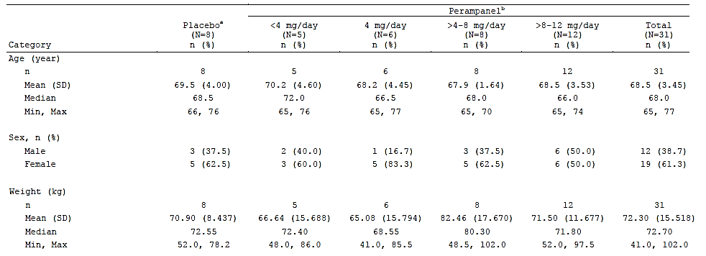
ª: Subjects treated with placebo during the double-blind study. ^{b}: Subjects treated with perampanel in any study. Dose is the modal dose received. ^{c}: Not collected in all studies.
Table 105. Subject Disposition and Primary Reason for Discontinuation by Last Daily Dose of Perampanel and >65y Age Group - All Treated Subjects with Partial Seizures (Safety Analysis Set)
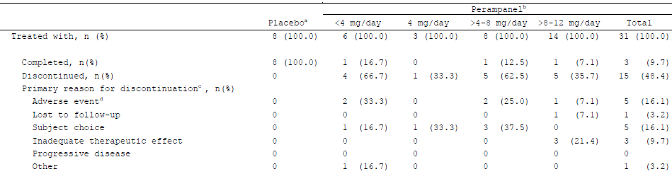
This table is based on the subject last disposition status under the treatment group ª: Subjects treated with placebo during the double-blind study. ^{b}: Subjects treated with perampanel in any study. Dose is the last daily dose received. ^{c}: Discontinuation means discontinuation from the therapy (from the study). ^{d}: Corresponding adverse event(s) leading to withdrawal from the study / study drug were reported on the Adverse Event CRF.

Table 106. Percentage of Subjects with Very Common AEs by Subgroup (Age) and Randomized Treatment - Epilepsy Phase III Double-blind Pool (Safety Analysis Set)
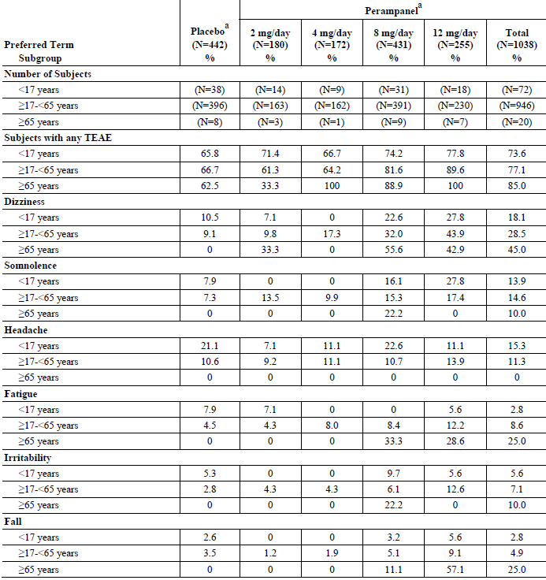
Very common TEAEs are those that occurred in 10% or more of the subjects in any treatment group in the entire epilepsy Phase III double-blind pool. A TEAE is defined as an adverse event that either begins on or after the first dose date and up to 30 days after the last dose date of study drug; or begins before the first dose date and increases in severity during the treatment period. Subject with two or more adverse events in the same system organ class (or with the same preferred term) is counted only once for that system organ class (or preferred term). 0% indicates that no subject in that group had an event. ª: Subjects treated during the double-blind study.

Safety in special populations –Adolescent
Among All Treated Subjects with Partial Seizures (Safety Analysis Set) < 18y, 128 subjects received > 4 to 12 mg/day compared with 45 on placebo.
In the Epilepsy Phase III Double-blind Studies 72/77 (93.5%) adolescents on perampanel completed compared with 37/45 (82.2) on placebo, with 2 (2.0%) and 3 (6.7%) respectively discontinuing due to an AE.
Except for headache the incidence of overall very common AEs was slightly less in adolescents on perampanel than in adults ≥ 17 to < 65 y. In adolescents on perampanel Aggression 8 (8.2%), Anxiety and Insomnia (both 4.1%) were more common than on placebo 0 (0).
Table 107. Demography and Baseline Characteristics by Modal Dose of Perampanel and < 18y Age Group - All Treated Subjects with Partial Seizures (Safety Analysis Set)
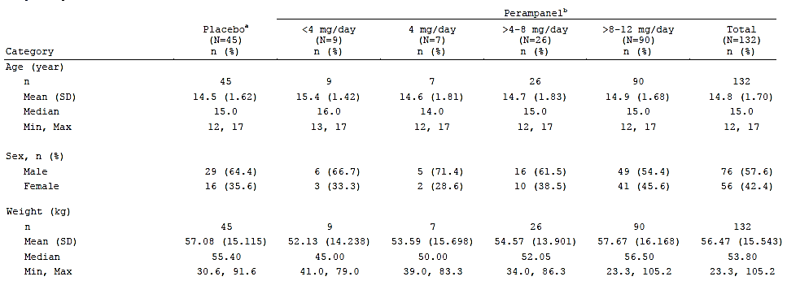
ª: Subjects treated with placebo during the double-blind study. ^{b}: Subjects treated with perampanel in any study. Dose is the modal dose received. ^{c}: Not collected in all studies.
Table 108. Subject Disposition and Primary Reason for Discontinuation by Last Daily Dose of Perampanel and <18y Age Group - All Treated Subjects with Partial Seizures (Safety Analysis Set)
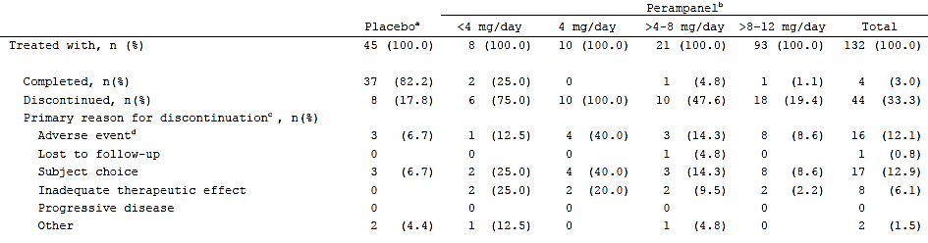
This table is based on the subject last disposition status under the treatment group ª: Subjects treated with placebo during the double-blind study. ^{b}: Subjects treated with perampanel in any study. Dose is the last daily dose received. ^{c}: Discontinuation means discontinuation from the therapy (from the study). ^{d}: Corresponding adverse event(s) leading to withdrawal from the study / study drug were reported on the Adverse Event CRF.
Table 109. Overview of Adverse Events - Double-blind Adjunctive Therapy Phase III Studies in Adolescents (< 18 years old) with Refractory Partial Seizures Safety Analysis Set
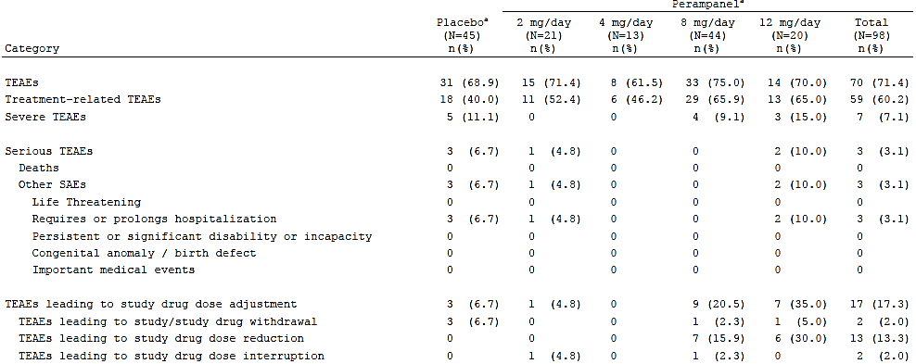
A TEAE is defined as an adverse event that either begins on or after the first dose date and up to 30 days after the last dose date of study drug; or begins before the first dose date and increases in severity during the treatment period.For each row category, a subject with two or more adverse events in that category is counted only once. ª: Subjects treated during the double-blind study. Dose groups are based on the actual treatment groups.
Table 110. AEs by Decreasing Frequency - Double-blind Adjunctive Therapy Phase III Studies in Adolescents (< 18 years old) with Refractory Partial Seizures Safety Analysis Set. Table continued across two pages.
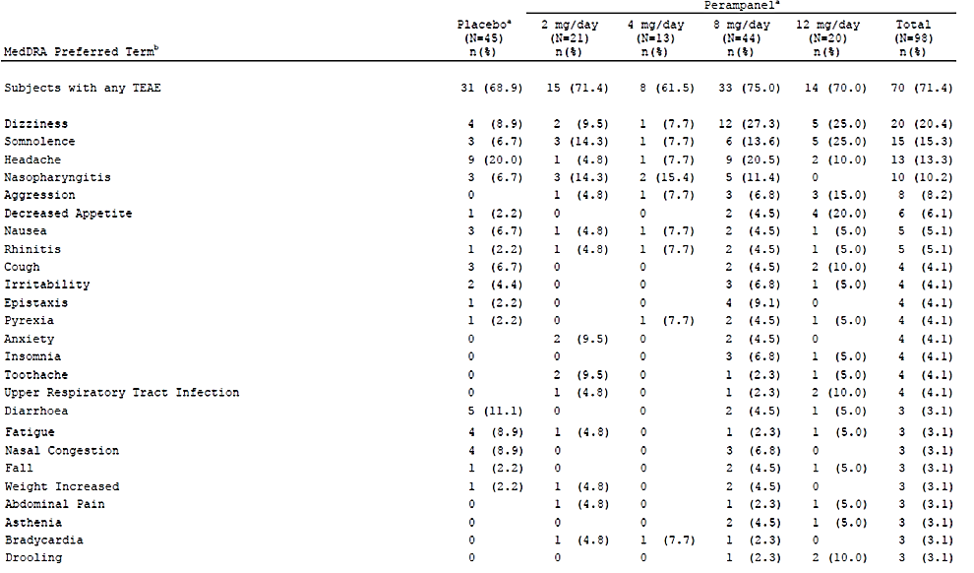
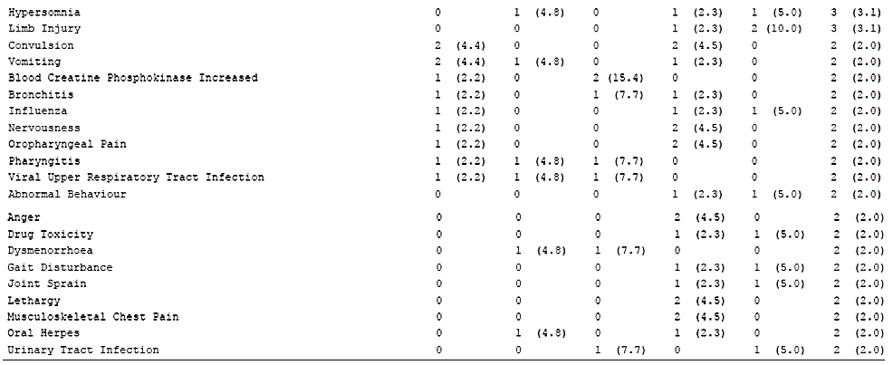
A TEAE is defined as an adverse event that either begins on or after the first dose date and up to 30 days after the last dose date of study drug; or begins before the first dose date and increases in severity during the treatment period. Subject with two or more adverse events with the same preferred term is counted only once for that preferred term. ^{a:} Subjects treated during the double-blind study. Dose groups are based on the actual treatment groups. ^{b}: MedDRA preferred terms are sorted in descending order of frequency in the total perampanel column.

Safety related to drug-drug interactions and other interactions
The proportion of subjects who completed the double-blind Phase III study was comparable when examined as a function of co-administered AED using integrated data for all randomized and treated subjects in Studies 306, 305, and 304. The overall percentage of subjects in the combined perampanel treatment group who completed the double-blind study was comparable among those whose background AED therapy included carbamazepine (428/491, 87.2%), oxcarbazepine (233/270, 86.3%), lamotrigine (397/458, 86.7%), levetiracetam (369/435, 84.8%), topiramate (254/294, 86.4%), or valproic acid (419/478, 87.7%).
Table 111. Percentage of Subjects with Very Common TEAEs by Subgroup (Concomitant AED) and Randomized Treatment - Epilepsy Phase III Double-blind Pool (Safety Analysis Set). Table continued across two pages.
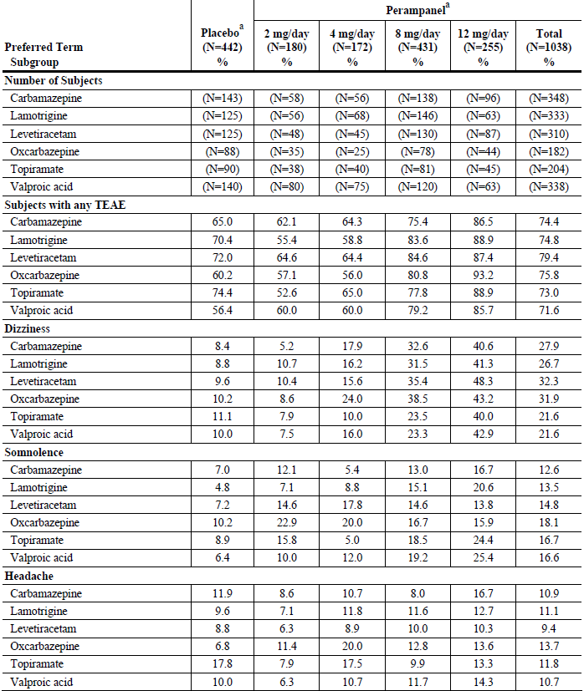
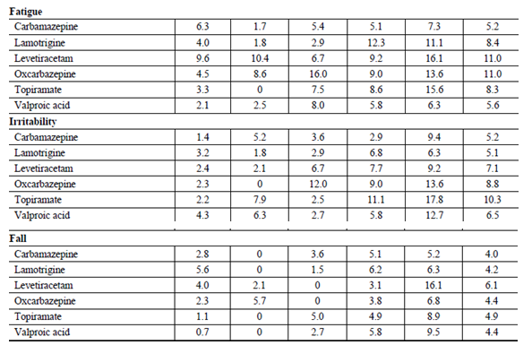
Very common TEAEs are those that occurred in 10% or more of the subjects in any treatment group in the entire epilepsy Phase III double-blind pool. 0% indicates that no subject in that group had an event. AEDs received at baseline by 15% or more of the subjects in any treatment group were included in this analysis. A TEAE is defined as an adverse event that either begins on or after the first dose date and up to 30 days after the last dose date of study drug; or begins before the first dose date and increases in severity during the treatment period. Subject with two or more adverse events in the same system organ class (or with the same preferred term) is counted only once for that system organ class (or preferred term). N = total number of subjects in each dose group in this pool, ª: Subjects treated during the double-blind study.

Events related to alertness or cognition
Table 112.Treatment-emergent Adverse Events for Cognitive Disorders by Decreasing Frequency Multiple Dose Studies in Healthy Subjects
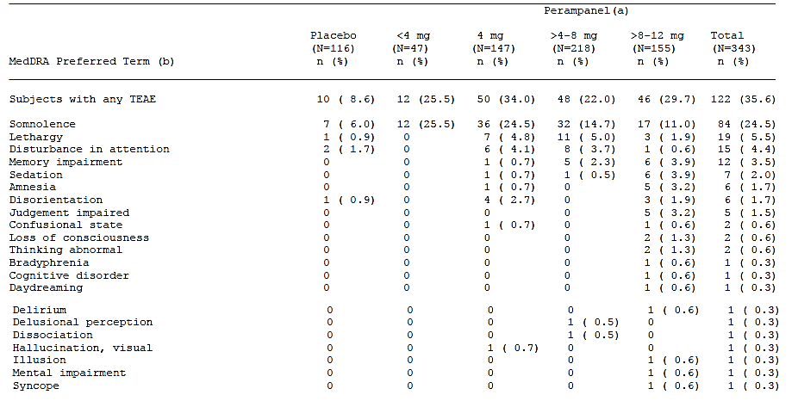
N = number of subjects receiving the dose at anytime in the study A TEAE is generally defined as an adverse event that begins within 30 days after dosing with perampanel/placebo or an ongoing event that increases in severity after dosing with perampanel/placebo. Full details are given in the SAP. For each row category, a subject with two or more adverse events in the category is counted only once. (a) Actual dose at onset of the first occurrence of the TEAE within each dose group. (b) MedDRA preferred terms are sorted in descending order of frequency in the total column.

Table 113. Adverse Events (Related to Alertness or Cognition) by Decreasing Frequency and Randomized Treatment – Epilepsy Phase III Double-blind Pool (Safety Analysis Set)
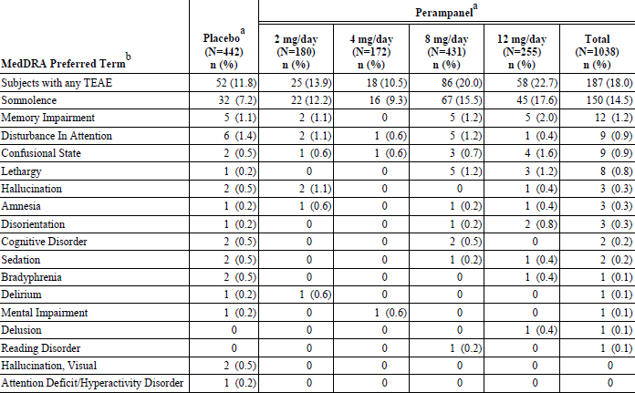
ª: Subjects treated during the double-blind study. ^{b}: MedDRA preferred terms are sorted in descending order of frequency in the total perampanel column. A TEAE is defined as an adverse event that either begins on or after the first dose date and up to 30 days after the last dose date of study drug; or begins before the first dose date and increases in severity during the treatment period. Subject with two or more adverse events with the same preferred term is counted only once for that preferred term.
In the Epilepsy Phase III Double-blind Pool there appears to be a dose-related increase in somnolence with the randomized perampanel doses. Somnolence led to treatment discontinuation in one (0.2%) placebo-treated subject and 10 (1.0%) perampanel-treated subjects (one, two, and seven subjects in the 2, 8, and 12 mg/d groups, respectively) and led to dose interruption or reduction in two (0.5%) placebo-treated subjects and 30 (2.9%) perampanel-treated subjects (17 subjects in the 8 mg/d group and 13 subjects in the 12 mg/d group).
Table 114. Adverse Events (Related to Alertness or Cognition) by Decreasing Frequency and Actual Dose at Onset - Epilepsy All Treated Pool (Safety Analysis Set)
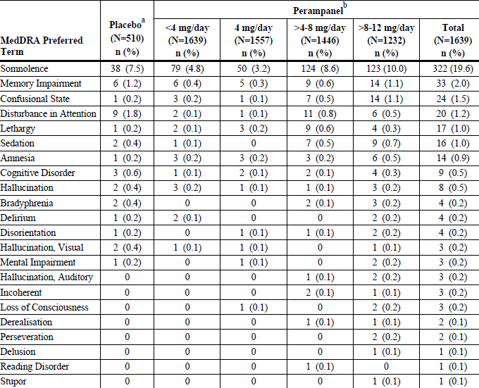
A TEAE is defined as an adverse event that either begins on or after the first dose date and up to 30 days after the last dose date of study drug; or begins before the first dose date and increases in severity during the treatment period. Subjects are counted in the denominator of the dose group(s) they are exposed to. Subjects with two or more TEAEs in the same system organ class (or with the same preferred term) are counted only once for that system organ class (or preferred term) within each dose group in the numerator. ª: Subjects treated with placebo during the double-blind study. ^{b}: Subjects treated with perampanel in any study. Dose is the actual dose received.

Psychiatric disorders (including aggression)
Three (0.3%) subjects in the total perampanel group (1 in the 2 mg/d group and 2 in the 12 mg/d group) had an SAE of aggression. Five (0.5%) subjects in the total perampanel group (one in the 8 mg/d group and four in the 12 mg/d group) had treatment discontinued due to aggression. Seven (0.7%) subjects in the total perampanel group (one, four, and two subjects in the 2, 8, and 12 mg/d groups, respectively) had dose interruption or reduction due to aggression.
Aggression occurred in a larger percentage of perampanel-treated adolescents (7.8%) than perampanel-treated adults (1.3%).
Four (0.4%) subjects in the total perampanel group (all in the 12 mg/d group) had treatment discontinued due to anger. Two (0.2%) subjects in the total perampanel group (one each in the 8 and 12 mg/d groups) had dose interruption or reduction due to anger.
In the All Treated Subjects with Partial Seizures (Safety Analysis Set) there were 2 (0.4%) subjects with aggression AEs while there were 41 (4.0%) on >8 – 12 mg/day perampanel.
Table 115. Adverse Events (Preferred Terms for Psychiatric Disorders That Occurred in Two or More Subjects in Any Treatment Group) by Decreasing Frequency and Randomized Treatment – Epilepsy Phase III Double-blind Pool (Safety Analysis Set)
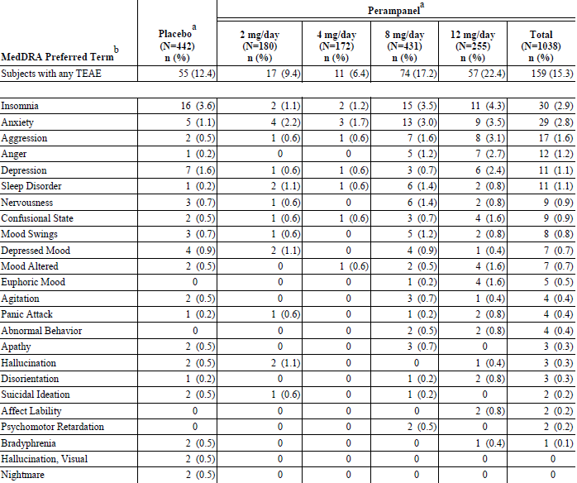
A TEAE is defined as an adverse event that either begins on or after the first dose date and up to 30 days after the last dose date of study drug; or begins before the first dose date and increases in severity during the treatment period. Subject with two or more adverse events with the same preferred term is counted only once for that preferred term. ^{a:} Subjects treated during the double-blind study. ^{b:} MedDRA preferred terms are sorted in descending order of frequency in the total perampanel column.

Table 116. AEs for Psychiatric Disorders by Decreasing Frequency Multiple Dose Studies in Healthy Subjects
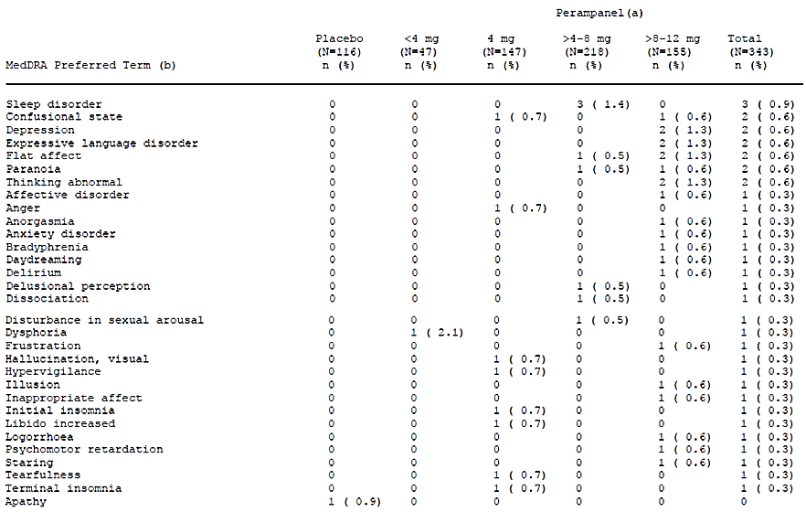
A TEAE is generally defined as an adverse event that begins within 30 days after dosing with perampanel/placebo or an ongoing event that increases in severity after dosing with perampanel/placebo. Full details are given in the SAP. For each row category, a subject with two or more adverse events in the category is counted only once. N=number of subjects receiving the dose at anytime in the study (a) Actual dose at onset of the first occurrence of the TEAE within each dose group. (b) MedDRA preferred terms are sorted in descending order of frequency in the total column.
Table 117. Adverse Events (Preferred Terms for Psychiatric Disorders That Occurred in Two or More Subjects) by Decreasing Frequency – Epilepsy All Treated Pool (Safety Analysis Set)
MedDRA Preferred Term^{b} | Total Perampanelª (N=1639) n (%) | MedDRA Preferred Term^{b} | Total Perampanelª (N=1639) n (%)
Subjects with any TEAE | 399 (24.3) | Stress | 5 (0.3)
Insomnia | 68 (4.1) | Bradyphrenia | 4 (0.2)
Anxiety | 64 (3.9) | Delirium | 4 (0.2)
Aggression | 61 (3.7) | Disorientation 4 (0.2)
Depression | 53 (3.2) | Psychomotor Retardation | 4 (0.2)
Mood Swings | 26 (1.6) | Hallucination, Visual | 3 (0.2)
Anger | 24 (1.5) | Libido Decreased | 3 (0.2)
Confusional State | 24 (1.5) | Emotional Disorder | 3 (0.2)
Nervousness | 20 (1.2) | Restlessness | 3 (0.2)
Abnormal Behaviour | 19 (1.2) | Affect Lability | 3 (0.2)
Mood Altered 1 | 6 (1.0) | Hallucination, Auditory | 3 (0.2)
Agitation | 15 (0.9) | Paranoia | 3 (0.2)
Sleep Disorder | 15 (0.9) | Suicide Attempt | 3 (0.2)
Depressed Mood | 14 (0.9) | Tearfulness | 3 (0.2)
Suicidal Ideation | 12 (0.7) | Abnormal Dreams | 2 (0.1)
Euphoric Mood | 10 (0.6) | Acute Psychosis | 2 (0.1)
Hallucination | 8 (0.5) | Derealisation | 2 (0.1)
Psychotic Disorder | 8 (0.5) | Hypomania | 2 (0.1)
Affective Disorder | 7 (0.4) | Libido Increased | 2 (0.1)
Apathy | 5 (0.3) | Perseveration | 2 (0.1)
Panic Attack | 5 (0.3) | Withdrawal Syndrome | 2 (0.1)
A TEAE is defined as an adverse event that either begins on or after the first dose date and up to 30 days after the last dose date of study drug; or begins before the first dose date and increases in severity during the treatment period. Subject with two or more adverse events with the same preferred term is counted only once for that preferred term. adverse event ª: Subjects treated with perampanel in any study. ^{b}: MedDRA preferred terms are sorted in descending order of frequency in the total column.

Suicidality
In the epilepsy Phase III double-blind pool, 2 (0.5%) subjects in the placebo group, 1 (0.6%) subject in the 2 mg/d group, 1 (0.2%)subject in the 8 mg/d group, and 1 (0.4%) subject in the 12 mg/d group had AEs related to suicidality. The 2 placebo and 2 of the perampanel subjects had suicidal ideation, and the fifth subject had multiple drug overdose intentional (overdose of oxycodone and cyclobenzaprine). No subject died. Suicidal ideation in the 8 mg/d group and multiple drug overdose intentional in the 12 mg/d group were SAEs. All 3 AEs in the perampanel subjects, led to treatment discontinuation.
In the epilepsy all treated pool 17 (1.0%) subjects had AEs related to suicidality. The exposure-adjusted rate was 0.001 subjects per subject-month, the same as the exposure-adjusted rate of AEs related to suicidality for the placebo group of the pooled double-blind studies.

Status epilepticus/convulsion
In the epilepsy Phase III double-blind pool, Convulsion was an SAE in 3 (0.7%) placebo subjects and 6 (0.6%) subjects in the total perampanel group (1, 3 and 2 subjects in the 4, 8, and 12 mg/d groups, respectively),led to discontinuation in 5 (1.1%) placebo subjects and 10 (1.0%) perampanel subjects (1, 1, 4, and 3 subjects in the 2, 4, 8, and 12 mg/d groups, respectively), and led to dose interruption or reduction in 2 placebo subjects (0.5%) and 2 (0.2%) perampanel subjects (1 each in the 2 and 12 mg/d groups).
For the epilepsy all treated pool. Status epilepticus occurred in 15 (0.9%) subjects in the total perampanel group, compared with 2 (0.4%) placebo subjects in the pooled double-blind studies. The exposure-adjusted rates were 0.0008 and 0.001 subjects per subject-month, respectively. In the analysis by actual dose at onset this event occurred in 3 (0.2%) subjects at doses of < 4 mg/d, 2 (0.1%) subjects at doses of > 4-8 mg/d, and 10 (0.8%) subjects at doses of > 8-12 mg/d. One death was a sudden unexpected death in epilepsy.
Table 118. Adverse Events (for Status Epilepticus/Convulsions) by Decreasing Frequency and Randomized Treatment – Epilepsy Phase III Double-blind Pool (Safety Analysis Set)
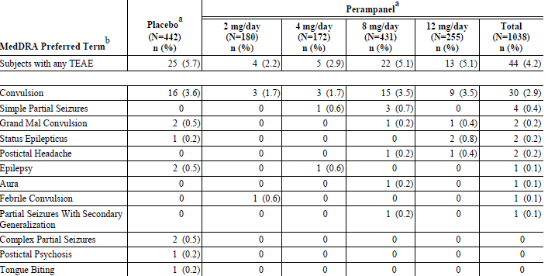
A TEAE is defined as an adverse event that either begins on or after the first dose date and up to 30 days after the last dose date of study drug; or begins before the first dose date and increases in severity during the treatment period. Subject with two or more adverse events with the same preferred term is counted only once for that preferred term. ª: Subjects treated during the double-blind study. ^{b}: MedDRA preferred terms are sorted in descending order of frequency in the total perampanel column.

Table 119. Adverse Events (for Status Epilepticus/Convulsions) by Decreasing Frequency and Mean Daily. Dose of Perampanel– All Treated Subjects with Partial Seizures (Safety Analysis Set) by Decreasing Frequency and - (Safety Analysis Set)*
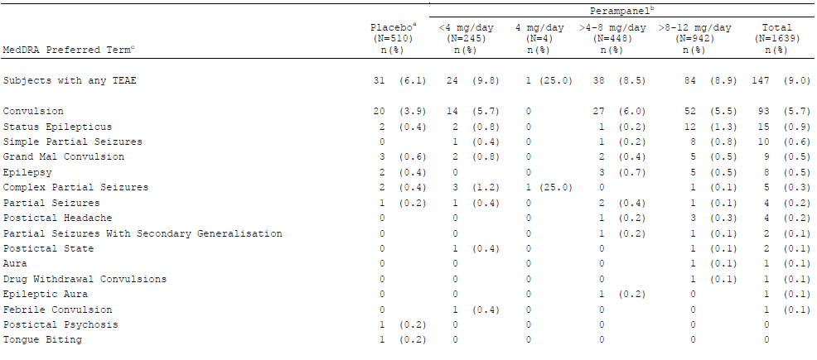
A TEAE is defined as an adverse event that either begins on or after the first dose date and up to 30 days after the last dose date of study drug; or begins before the first dose date and increases in severity during the treatment period. Subject with two or more adverse events with the same preferred term is counted only once for that preferred term. ª: Subjects treated with placebo during the double-blind study. ^{b}: Subjects treated with perampanel in any study. Dose is the mean daily dose received. ^{c}: MedDRA preferred terms are sorted in descending order of frequency in the total column.

Abuse potential
There were no reports of abuse of perampanel in any of the clinical studies.
In the Epilepsy All Treated Pool AEs suggestive of abuse potential event occurred in 26.2% of the subjects in the total perampanel group. The most commonly occurring AEs were those within the category of mood disorders and disturbances. The most common event within that category was irritability, which occurred in 9.2% of those in the total perampanel group. The analysis of AEs by actual dose at onset showed a dose-related increase in the incidence of irritability.

Falls
In the epilepsy Phase III double-blind pool, AEs of falls led to study drug interruption or dose reduction in 1 (0.2%) subject in the 8 mg/d group and 2 (0.8%) subjects in the 12 mg/d group.
The rate of falls for placebo patients was 0.0047 falls per subject-month vs. 0.0175 falls per subject-month for perampanel subjects.
In an analysis based on number of events rather than number of subjects, the number of AEs of fall/subject-year of exposure was 0.113 in the placebo group and 0.033, 0.050, 0.248, and 0.392 in the 2, 4, 8, and 12 mg/d groups (0.210 in the total perampanel group) for the epilepsy Phase III double-blind pool. Of the 16 falls that occurred in the placebo group during double-blind treatment, 12 (75.0%) occurred in association with seizures. Of the 73 falls that occurred in the total perampanel group during double-blind treatment, 44 (60.3%) occurred in association with seizures, that is,, either occurred on the same day as a seizure or were noted as seizure-associated by the investigator.
In the entire epilepsy all treated pool, there were 118 subjects with 186 falls (treatment-emergent and non-treatment-emergent AEs) during 19,439 subject-months of exposure, or 0.0096 falls per subject-month.
5 subjects in the epilepsy all treated pool had falls reported as treatment emergent SAEs.
Comment: Possibly of relevance was the 45.2% incidence of dizziness on >8 – 12 mg/day vs. 6.9% on placebo in healthy volunteers.
Table 120. Number of Subjects With AEs of Falls by Actual Dose at Onset and Study Phase/Period of Onset - Epilepsy Phase III Double-blind Pool (Safety Analysis Set)
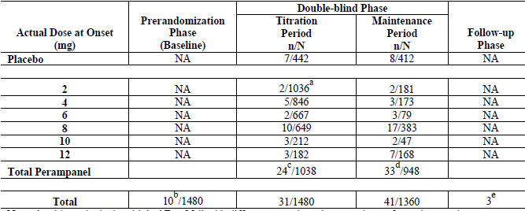
A subject who had multiple AEs of fall with different onset doses is counted once for each onset dose. NA = not applicable, n/N = number of subjects with fall divided by number of subjects exposed to that actual dose during the relevant phase or period. ª: Two subjects in Study 306 did not receive 2 mg doses during the titration period. ^{b}: Subjects who experienced adverse events of falls before receiving study drug. ^{c}: Subject (Study 305) had two falls during the titration period, one while receiving 6 mg and one while receiving 8 mg. ^{d}: Subject (Study 305) had two falls during the maintenance period, one while receiving 6 mg and one while receiving 8 mg. ^{e}: Subjects were no longer receiving study drug during the Follow-up Phase. All 3 subjects (were from Study 304, and all had received double-blind perampanel.
Table 121. Exposure-adjusted Rates for AEs of Fall – Studies 304, 305, 306, and 307 (Safety Analysis Set)
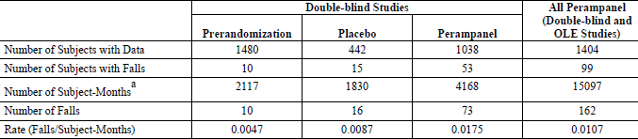
OLE = open-label extension. ª: 1 month = 30 days

Overdose
Perampanel 2 mg none; perampanel 4 mg - 3 accidental overdose; perampanel 8 mg - 6 accidental overdose; perampanel 12 mg - 6 accidental overdose, 3 intentional overdose.

Evaluator’s conclusions on clinical safety
Many Summary tables referred to in the sponsor’s Summary of Clinical Safety were not connected to the links and apparently not submitted. Without such substantiation this evaluator cannot make final conclusions. The submission of additional data enabled this.
The risks common in the Healthy subjects (dizziness, somnolence, headache, fatigue, and nausea) were also common in the epilepsy subjects.
AEs related to alertness and cognition occurred in 10 (8.6%) of the subjects on placebo and 122 (35.6%) of those in on perampanel.
Cardiac disorders and electrocardiogram (ECG) related AEs occurred in 11 (3.2%) of those in the multi-dose total perampanel group but not placebo.
Falls occurred in two (1.7%) subjects in the placebo group and 18 (5.2%) subjects in the total perampanel group (four in the > 4-8 mg/d group and 14 in the > 8-12 mg/d group).
In the Epilepsy Phase III Double-blind Pool very common AEs (dizziness, somnolence, fatigue, irritability and fall) were at least twice as common with perampanel 8 mg/day than placebo (the exception was headache with similar incidence) and the incidence increased with 12 mg/day.
On 8 mg/day perampanel among the common AEs nausea, weight increased, vertigo, ataxia, gait disturbance and balance disorder were at least twice as common as with placebo.
In relation to the Elderly (> 65) there were only 31 of 1639 subjects in the Epilepsy All Treated Pool and only 20 in the Epilepsy Phase III Double-blind Pool (of whom 26 received ≥ 8 mg/day). Not only was there a higher incidence of any AEs in the elderly, but some of concern were much higher for example dizziness and fall. The sponsor claims a much more extensive population exposed in non epilepsy trials, however, of elderly patients in one group of trials there were only 39 who received >4 – 8 mg/day and of elderly in another group of trials while there were 133 receiving the >4-8 mg/day, none of the elderly in either trial indication group received >8 mg/day.

Adolescents
In the Epilepsy Phase III Double-blind Studies 72/77 (93.5%) adolescents on perampanel completed compared with 37/45 (82.2) on placebo, with 2 (2.0%) and 3 (6.7%) discontinued respectively due to an AE. On the data provided there appeared to be some differences in the nature of the more common AEs compared with adults.

First round benefit-risk assessment

First round assessment of benefits
The benefits of perampanel in the proposed all partial-onset seizures with or without secondarily generalised seizures are:
- A novel type of anticonvulsant.
- Not all the median or mean results for ≥ 4 mg OD treatment groups in the pivotal studies achieved the 20% separation in percent change in seizure frequency per 28 days, however there was consistent statistically significant difference shown by the p-values.
- With the responder rate – Study 304 failed to show any statistically significance from placebo for either 8 or 12 mg while Study 305 did with differences from placebo approaching 20%; Study 306 showed for 4 and 8 mg groups statistically significant differences from placebo approaching 20% for the 8 mg group.
- Studies 304 and 305 showed, for patients with secondarily generalised seizures, statistically significant differences > 20 % from placebo in both percent change in seizure frequency per 28 days and responder rate, while Study 306 could show no significant difference in either.
- There are relatively few discontinuations in the long term studies in the group on a maximum of > 8 to 12 mg/day (73.3%) with most discontinuations due to AEs (103/297 34.7%).
- The mean Percent Change from Pre-perampanel in Seizure Frequency per 28 Days and the Responder Rate was maintained among those continuing on the drug.
- Subjects who completed the double-blind studies at a dose of 8 mg and then increased their dose to 12 mg in the Open label extension Maintenance Phase showed that the 50% responder rate rose from 38.5% on a dose of 8 mg to 48.3% in the same subjects on a dose of 12 mg. However overall the results for the 12 mg group were less than the 8 mg group.

First round assessment of risks
The risks of perampanel in the proposed usage are:
- In the Phase III Double-blind Studies only 58 adolescents were on ≥ 4 mg/day of perampanel. There were 124 adolescents enrolled in the trials with descriptive summary results only – a study in adolescents was ongoing at the time of submission. There were thus relatively few adolescents on the proposed dosage and the AE profile has some differences with a greater incidence of somnolence and aggression.
- There were only 31 Elderly (> 65) of 1639 subjects in the Epilepsy All Treated Pool and only 20 in the Epilepsy Phase III Double blind Pool (of whom 26 received ≥ 8 mg/day). The sponsor argues that since 1324 Elderly (> 65y) were treated in non epilepsy trials that safety data is adequate, however what data there is for > 65y old epilepsy patients suggests a higher incidence of AEs than in other adults, and in actuality only 169 elderly in non epilepsy trials received > 4-8 mg/day and none received >8 mg/day.

First round assessment of benefit-risk balance
So many summary Tables were referred to but not submitted that some sections of the Summary of Clinical Safety had virtually no data. An assessment of risk/benefit could not be made. This was rectified by the submission of extra data.
The risk benefit balance for the proposed Indication is considered unfavourable by this evaluator.
The risk benefit balance could be considered favourable if the Indication is modified as recommended below.

First round recommendation regarding authorisation
Many of the summary tables referred to in the 2.7.3 Summary of Clinical Efficacy and 2.7.4 Summary of Clinical Safety were not included in the submission. The sponsor was asked to submit all referenced supporting Tables. These confirmed the very small numbers involved in elderly and adolescent patients treated for the disease at the recommended dosage.
It is recommended that Fycompa not be approved for the Indication requested.
It is recommended that Fycompa be registered for:
For the adjunctive treatment of partial-onset seizures with or without secondarily generalised seizures in adult patients with epilepsy aged < 65years.

Clinical questions

Pharmacokinetics

Question 1
In the company study report of Study E2007-A001-040, the sponsor stated: “The percentage of AUC_{0–inf} obtained by extrapolation was greater than 20% in 77 of 99 profiles in total”.
‘Total’ in this context refers to the combined percentage of AUC_{0–inf} for the a) 12 mg perampanel tablet and b) the 6x2 mg perampanel tablets. AUC_{0–t} should cover at least 80% of AUC_{0–inf} (EMA adopted guideline”CPMP/EWP/QWP/1401/98 Rev.1/Corr 20 January 2010).
What proportion of AUC_{0–inf} was covered by AUC_{0–t} for the a) 12 mg perampanel tablet and b) the 6x2 mg perampanel tablets?

Question 2
Where in the study report for drug interaction (ketoconazole) study, E2007-E044-005, are the results for the determination of any cross-over effects between Treatment Periods 1 and 2?

Question 3
In the calculation of primary and secondary PK parameters in Study E2007-A001-014, and the subsequent log ratios between midazolam alone and midazolam in combination of perampanel at steady-state, the sponsor used arithmetic means in Table 9 CSR instead of geometric means. Geometric LS means ratios and their 90% confidence intervals were calculated in the other drug-drug interaction studies submitted in this application.
What are the geometric LS means ratios and their 90% confidence intervals for the primary PK endpoints in Study E2007-A001-014?

Question 4
In Study E2007-E044-025, urine was collected for 24 hours after the last dose of perampanel (Day 20) for metabolite identification purposes.
Where in this report are the results of this urinalysis and were any metabolites identified?

Question 5
Where in the clinical study report for the abuse potential study, E2007-A001-024, are the results for the determination of any cross-over effects between treatment sequences for each investigational product?

Pharmacodynamics
Nil.

Efficacy
Nil.

Safety
Nil.

Second round evaluation of clinical data submitted in response to questions

Sponsor responses to questions
Question 1 Response acceptable.
Question 2 Comment on response In Study E2007-E044-005, in group B no cross-over effect would be expected as the subjects received ketoconazole only in the second period. In group A it has been assumed the washout was long enough for ketoconazole to be excreted and the effect on CYP3A4 to have ceased.
However from the number of samples analysed no pre dose analysis of ketoconazole occurred in period 2 for Group A, nor is an indication given of the expected duration of the effect of ketoconazole on CYP3A4.
The 90% confidence interval for the ratio test: reference was calculated for each dose separately for C_{max} AUC_{0 - tn} and AUC_{0 - α}, from analysis of variance (ANOVA), of the logarithmically transformed data. The ANOVA contained factors for Subject nested within Sequence, Sequence (K∅ or ∅K), Period (Period 1 or 2) and Treatment (with K, No K). The results for Sequence can be seen in the following table.
Table 122. Analyses of Variance for LC_{max}, LAUC_{0 - tn}, LAUC_{0 - inf}, using Adjusted ss for Tests
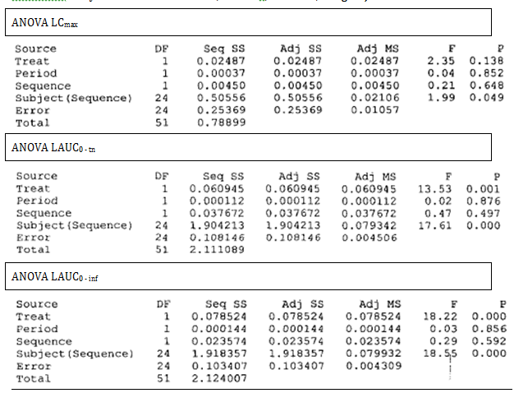
Question 3 Response acceptable.
Question 4 Response acceptable.
Question 5 Response acceptable.
Comment 6. There was no analysis of PKs that included Sequence effect though the possibility was acknowledged. Although a few subjects in the previous E2007-A001-023 study had detectable perampanel levels predose following a 14-day washout, the levels represented a relatively small fraction and were not expected to interfere with the pharmacodynamic assessments or result in safety issues in this study. In the Study design the washout interval between each perampanel dose and the subsequent treatment was at least 14 days. This represents a washout interval of approximately 3.5- to 5-times the half-life of perampanel and was determined to be adequate to minimize the risk of carryover effects or interactions.
Further minimisation was undertaken by removing randomisation sequences that could have led to 3 perampanel doses in a row.
In reporting the PD results Least squares means were estimated from a mixed-effect model having treatment, period, and sequence as fixed effects and subject nested within sequence as a random effect. For most results the sponsor stated first-order carryover effect was found to be non-significant at the 25% level and was dropped from the model. Overall Drug Liking VAS E_{min} was an exception.

Secound round benefit-risk assessment
The sponsor’s response has not altered the risk benefit decision.

Therapeutic Goods Administration
PO Box 100 Woden ACT 2606 Australia
Email: info@tga.gov.au Phone: 1800 020 653 Fax: 02 6232 8605
http://www.tga.gov.au

2.5 Clinical Overview Page 7
2.7.3.3.5 Summary of Clinical Efficacy page 110
A Phase II, double-blind, placebo-controlled, dose-escalation (to a maximum of 4 mg/d), parallel-group study of perampanel given as adjunctive therapy in subjects with refractory partial seizures
A second, Phase II, escalating-dose trial
Sponsor’s Summary of Clinical Efficacy
Seizure frequency refers to the frequency of all partial seizures
Seizure frequency per 28 days was derived from the information recorded in the subject diaries
Responders were defined as subjects who experienced a 50% or greater reduction in seizure frequency per 28 days in the Maintenance Period relative to the Pre-randomization Phase.
This refers to the frequency of complex partial seizures combined with the frequency of complex partial seizures that secondarily generalized
Study Report page 71, Statistical Analysis Report Page 36
Latin America Analyses Report, Section 7.2.2.2 and 304 Sensitivity Tables 14.2.7.1.1 to 14.2.7.1.3
Seizure frequency refers to the frequency of all partial seizures
Seizure frequency per 28 days was derived from the information recorded in the subject diaries
Responders were defined as subjects who experienced a 50% or greater reduction in seizure frequency per 28 days in the Maintenance Period relative to the Pre-randomization Phase.
This refers to the frequency of complex partial seizures combined with the frequency of complex partial seizures that secondarily generalized
Section 6.5 Statistical Analysis Report Page 40
Seizure frequency refers to the frequency of all partial seizures
Seizure frequency per 28 days was derived from the information recorded in the subject diaries
Responders were defined as subjects who experienced a 50% or greater reduction in seizure frequency per 28 days in the Maintenance Period relative to the Pre-randomization Phase.
This refers to the frequency of complex partial seizures combined with the frequency of complex partial seizures that secondarily generalized
The maintenance period should last at least 12 weeks in order to establish that efficacy is not short lasting. CHMP/EWP/566/98 Rev. 2/Corr Guideline on Clinical Investigation of Medicinal Products in the Treatment of Epileptic Disorders
Seizure frequency was based on the number of seizures per 28 days, calculated as the number of seizures over the entire time interval divided by the number of days in the interval and multiplied by 28
Maintenance began from the end of week 16
Maintenance began from the end of week 13 in this study.
1. Age group: <16 years, <18 years, ≥16 to <65 years, ≥18 to <65 years, ≥65 years 2. Race: White, Black or African American, Asian or Pacific Islander, Other 3. Sex: male, female 4. United States 5. Region (North America, Central and South America, Europe, Asia-Pacific).
percent change in the seizure frequency per 28 days in the Double-blind Phase relative to the Pre-randomization Phase in the Full ITT Analysis Set
Confounded by subjects who did not achieve and maintain the randomized dose and by the higher discontinuation rate due to adverse events in the 12mg group.
defined as the last dose. All of these analyses also excluded the Central and South American sites due to the unusually high observed placebo response.
By referring to a previous section rather than specifying directly
As did the mean
2.7.3.3.5 Summary of Clinical Efficacy page 110
Relative to the Pre-randomization Phase
For the Full ITT Analysis Set based on integrated data from Studies 306, 305, and 304
749 (50.7%) were on 2 AEDs, and 523 (35.4%) were on 3 AEDS
Updated ILAE evidence review of antiepileptic drug efficacy and effectiveness as initial monotherapy for epileptic seizures and syndromes *T Glauser et al, Epilepsia, 54(3):551–563, 2013
Approximately 60% of newly diagnosed patients are seizure-free on a single AED (monotherapy). An additional 10%-20% achieve freedom of seizure with polytherapy. It follows that about 30% of patients are not satisfactorily controlled. In addition many patients suffer from significant adverse effects. CHMP/EWP/566/98 Rev. 2/Corr Guideline on Clinical Investigation of Medicinal Products in the Treatment of Epileptic Disorders Replaces: CPMP/EWP/566/98 Rev 1 (adopted by TGA 19 April 2001) page 3
CHMP/EWP/566/98 Rev. 2/Corr Guideline on Clinical Investigation of Medicinal Products in the Treatment of Epileptic Disorders Replaces: CPMP/EWP/566/98 Rev 1 (adopted by TGA 19 April 2001) page 7
Table 20.1-5.5
National Cancer Institute
2.7.4 Summary of Clinical Safety Page 360
2.7.4 Summary of Clinical Safety Page 157
Table 22.4-7
Page 865 study report
Study report page 27

