May 2020

Australian Public Assessment Report for Pembrolizumab (rch)
  - Proprietary Product Name: Keytruda
  - Sponsor: Merck Sharp & Dohme (Australia) Pty Limited

About the Therapeutic Goods Administration (TGA)
- The Therapeutic Goods Administration (TGA) is part of the Australian Government Department of Health and is responsible for regulating medicines and medical devices.
- The TGA administers the Therapeutic Goods Act 1989 (the Act), applying a risk management approach designed to ensure therapeutic goods supplied in Australia meet acceptable standards of quality, safety and efficacy (performance) when necessary.
- The work of the TGA is based on applying scientific and clinical expertise to decision-making, to ensure that the benefits to consumers outweigh any risks associated with the use of medicines and medical devices.
- The TGA relies on the public, healthcare professionals and industry to report problems with medicines or medical devices. TGA investigates reports received by it to determine any necessary regulatory action.
- To report a problem with a medicine or medical device, please see the information on the TGA website <https://www.tga.gov.au>.

About AusPARs
- An Australian Public Assessment Report (AusPAR) provides information about the evaluation of a prescription medicine and the considerations that led the TGA to approve or not approve a prescription medicine submission.
- AusPARs are prepared and published by the TGA.
- An AusPAR is prepared for submissions that relate to new chemical entities, generic medicines, major variations and extensions of indications.
- An AusPAR is a static document; it provides information that relates to a submission at a particular point in time.
- A new AusPAR will be developed to reflect changes to indications and/or major variations to a prescription medicine subject to evaluation by the TGA.

Copyright
© Commonwealth of Australia 2020
This work is copyright. You may reproduce the whole or part of this work in unaltered form for your own personal use or, if you are part of an organisation, for internal use within your organisation, but only if you or your organisation do not use the reproduction for any commercial purpose and retain this copyright notice and all disclaimer notices as part of that reproduction. Apart from rights to use as permitted by the Copyright Act 1968 or allowed by this copyright notice, all other rights are reserved and you are not allowed to reproduce the whole or any part of this work in any way (electronic or otherwise) without first being given specific written permission from the Commonwealth to do so. Requests and inquiries concerning reproduction and rights are to be sent to the TGA Copyright Officer, Therapeutic Goods Administration, PO Box 100, Woden ACT 2606 or emailed to <tga.copyright@tga.gov.au>.

Contents
Common abbreviations 4
I. Introduction to product submission 7
Submission details 7
Product background 8
Regulatory status 10
Product Information 12
II. Registration timeline 12
III. Submission overview and risk/benefit assessment 12
Quality 12
Nonclinical 13
Clinical 13
Risk management plan 33
Risk-benefit analysis 34
Outcome 36
Attachment 1. Product Information 37

Common abbreviations
Abbreviation | Meaning
2L+ | Second line treatment setting or higher
AE | Adverse event
ARTG | Australian Register of Therapeutic Goods
ASA | Australian specific Annex
AUC | Area under the plasma concentration time curve
BICR | Blinded independent central review
BMI | Body mass index
BP | Blood pressure
cHL | Classical Hodgkin lymphoma
CI | Confidence interval
CMI | Consumer Medicines Information
CR | Complete response
CSR | Clinical study report
CTCAE | Common Terminology Criteria for Adverse Events
DCO | Data cut off
DLP | Data lock point
DLT | Dose-limiting toxicity
dMMR | Mismatch repair deficient
DOR | Duration of response
DTC | Differentiated thyroid cancer
EC | Endometrial carcinoma
ECG | Electrocardiogram
EU-RMP | European Union-Risk Management Plan
FDA | Food and Drug Administration (US)
FIGO | International Federation of Gynecology and Obstetrics (Fédération Internationale de Gynécologie et d'Obstétrique
GVHD | Graft versus host disease
GVP | Good Pharmacovigilance Practice
HC | Health Canada
HCC | Hepatocellular carcinoma
HIV | Human immunodeficiency virus
HNSCC | Head and neck squamous cell cancer
IHC | Immunohistochemistry
IIR | Independent imaging review
IRR | Independent radiological review
irRECIST | Immune-related Response Evaluation Criteria in Solid Tumors
IV | Intravenous
IVD | In vitro diagnostic
LVEF | Left ventricular ejection fraction
MedDRA | Medical Dictionary for Regulatory Activities
MMR | Mismatch repair
MSI | Microsatellite instability
MSI-H | Microsatellite instability-high
MTD | Maximum tolerated dose
NCI | National Cancer Institute (US)
NSCLC | Non-small cell lung cancer
OCE | Oncology Center of Excellence (FDA, US)
ORR | Objective response rate
OS | Overall survival
PCR | Polymerase chain reaction
PD-L1 | Programmed cell death ligand-1
PFS | Progression free survival
PI | Product Information
PMBCL | Primary mediastinal B-Cell Lymphoma
PO | By mouth, Latin: per os
PR | Partial response
PRES | Posterior reversible encephalopathy syndrome
PSUR | Periodic safety update report
PT | Preferred Term
Q2W | Every 2 weeks
Q3W | Every 3 weeks
QD | Once daily, Latin: quaque die
RCC | Renal cell carcinoma
RECIST 1.1 | Response Evaluation Criteria in Solid Tumors, version 1.1
RMP | Risk management plan
RP2D | Recommended Phase II dose
RSD | Reference safety dataset
SAE | Serious adverse event
SCT | Stem cell transplantation
TEAE | Treatment emergent adverse event
TL | Target lesion
UC | Urothelial carcinoma
US(A) | United States (of America)
UTI | Urinary tract infection

I. Introduction to product submission

Submission details
Type of submission: | Extension of indications
Decision: | Approved for provisional registration
Date of decision: | 17 September 2019
Date of entry onto ARTG: | 17 September 2019
ARTG numbers: | 226597, 263932
Black Triangle Scheme | Yes  As a provisionally registered product, this medicine will remain in the Black Triangle Scheme for the duration of its provisional registration
Active ingredient: | Pembrolizumab (rch)
Product name: | Keytruda
Sponsor’s name and address: | Merck Sharp & Dohme (Australia) Pty Limited  Locked Bag 2234  North Ryde NSW 1670
Dose forms: | Powder for injection, concentrated injection
Strengths: | 50 mg, 100 mg/4 mL
Container: | Vial
Pack size: | One
Approved therapeutic use: | Endometrial carcinoma  Keytruda (pembrolizumab), in combination with lenvatinib, is indicated for the treatment of patients with advanced endometrial carcinoma that is not MSI-H or dMMR, who have disease progression following prior systemic therapy and are not candidates for curative surgery or radiation. This indication was approved via the provisional approval pathway, based on objective response rate and duration of response in a single-arm trial. Full registration for this indication depends on verification and description of clinical benefit in confirmatory trials.
Route of administration: | Intravenous infusion
Dosage: | Treatment must be initiated and supervised by specialised healthcare professionals experienced in the treatment of cancer.  Recommended dosing  The recommended dose of Keytruda in adults is 200 mg administered as an intravenous infusion over 30 minutes every 3 weeks.  The recommended dose of Keytruda in paediatric patients is 2 mg/kg (up to a maximum of 200 mg) for PMBCL or MSI-H/dMMR cancers.  When administering Keytruda as part of a combination with chemotherapy, Keytruda should be administered first. See also the Product Information for the chemotherapy agents administered in combination.  Patients should be treated with Keytruda until disease progression or unacceptable toxicity. Patients with urothelial carcinoma, NSCLC, PMBCL or MSI-H/dMMR cancers without disease progression can be treated for up to 24 months or 35 cycles [see Section 5.1 PHARMACODYNAMIC PROPERTIES, Clinical Trials]. Atypical responses (i.e., an initial transient increase in tumour size or small new lesions within the first few months followed by tumour shrinkage) have been observed. Clinically stable patients with initial evidence of disease progression can under some circumstances remain on treatment until disease progression is confirmed (see Section 5.1 PHARMACODYNAMIC PROPERTIES, Clinical Trials for a description of the circumstances where such continued treatment was allowed in the pivotal studies).  For the adjuvant treatment of melanoma, Keytruda should be administered for up to one year or until disease recurrence or unacceptable toxicity.  For the treatment of endometrial carcinoma that is not MSI-H or dMMR, Keytruda should be administered as above in combination with lenvatinib 20 mg orally once daily until disease progression, unacceptable toxicity, or for Keytruda, up to 24 months in patients without disease progression. Refer to the lenvatinib Product Information for recommended dosing information.  For further information regarding dosing, refer to the Product Information.

Product background
This AusPAR describes the application by Merck Sharp & Dohme (Australia) Pty Limited (the sponsor) to register Keytruda pembrolizumab (rch) 50 mg powder for injection and 100 mg/ 4 mL concentrated injection for the following extension of indications:
Keytruda (pembrolizumab), in combination with lenvatinib, is indicated for the treatment of patients with endometrial carcinoma that has progressed following prior systemic therapy and that is not microsatellite instability high (MSI-H) or mismatch repair deficient (dMMR).
Endometrial carcinoma (EC) is the most common gynaecological malignancy in the developed world. Malignant neoplasms of the uterus are estimated to have an age standardised incidence of 20 cases per 100,000 females in Australia; the fifth most common type of cancer diagnosis amongst females and the most common gynaecological malignancy. The 2019 age standardised mortality rate is estimated to be between 3 and 4 deaths per 100,000 females. In absolute terms this translates to around 3200 new cases and 600 deaths in Australia each year. Based on data from 2010 to 2014, 5 year relative survival at diagnosis is estimated to be 83%: most patients present with early stage disease, for which curative surgical therapy is usually possible. Mortality appears stable (in Australia the annual rate has been between 2.5 and 3.5 per 100,000 women since 1986), however, incidence is increasing, likely due to increasing obesity which is an independent risk factor for EC.
For patients with advanced disease, a surgical cure is not possible and palliative systemic therapy is indicated. There is no standard second-line therapy for advanced EC that progresses despite first line standard of care (platinum-based chemotherapy) treatment. In the single-arm KEYNOTE-016 trial in patients with microsatellite instability-high (MSI-H) or mismatch repair deficient (dMMR) solid tumours, pembrolizumab monotherapy has shown activity against EC that is MSI-H/dMMR, with a response rate of 36%. Other therapies when studied in the second line treatment of advanced EC (agnostic of microsatellite instability (MSI)/mismatch repair (MMR) status) have shown response rates around 15%.
This submission was evaluated concurrently with submission PM-2019-02448-1-4 (Eisai Australia Pty Limited), to use Keytruda (pembrolizumab), in combination with Lenvima (lenvatinib), for the treatment of patients with EC that has progressed following prior systemic therapy and that is not MSl-H or dMMR.
This was the first evaluation facilitated through Project Orbis; an initiative of the United States (US) Food and Drug Administration (FDA) Oncology Center of Excellence (OCE). Under this project, the FDA, Health Canada (HC) and the TGA collaboratively reviewed the application. This innovative evaluation process provided a framework for process alignment and management of evaluation issues in real-time across jurisdictions. Each regulatory agency has maintained its regulatory process to make an independent decision regarding approval (market authorisation) of the new indication.

Regulatory status
Keytruda (pembrolizumab (rch)) 50 mg powder for injection vial received initial registration on the Australian Register of Therapeutic Goods (ARTG) on 16 April 2015 (AUST R 226597).
Keytruda (pembrolizumab (rch)) 100 mg/4 mL concentrated injection received initial registration on the ARTG on 8 March 2016 (AUST R 263932).
At the time the submission was under consideration, there were multiple indications for which pembrolizumab was registered in Australia, included those as listed in Table 1.
Table 1: Current indications for pembrolizumab in Australia, as of September 2019
Tumour type | Indication wording
Melanoma | Keytruda (pembrolizumab) is indicated as monotherapy for the treatment of unresectable or metastatic melanoma in adults.  Keytruda (pembrolizumab) is indicated as monotherapy for the adjuvant treatment of patients with melanoma with lymph node involvement who have undergone complete resection.
NSCLC | Keytruda (pembrolizumab), in combination with pemetrexed and platinum chemotherapy, is indicated for the first-line treatment of patients with metastatic non-squamous NSCLC, with no EGFR or ALK genomic tumour aberrations.  Keytruda (pembrolizumab), in combination with carboplatin and either paclitaxel or nab-paclitaxel, is indicated for the first-line treatment of patients with metastatic squamous NSCLC.  Keytruda (pembrolizumab) is indicated as monotherapy for the first-line treatment of patients with NSCLC expressing PD-L1 [tumour proportion score (TPS) ≥ 1%] as determined by a validated test, with no EGFR or ALK genomic tumour aberrations, and is  - stage III where patients are not candidates for surgical resection or definitive chemoradiation, or  - metastatic.  Keytruda (pembrolizumab) is indicated as monotherapy for the treatment of patients with advanced NSCLC whose tumours express PD-L1 with a ≥1% TPS as determined by a validated test and who have received platinum-containing chemotherapy. Patients with EGFR or ALK genomic tumour aberrations should have received prior therapy for these aberrations prior to receiving Keytruda.
Head and Neck Squamous Cell Cancer (HNSCC) | Keytruda (pembrolizumab) is indicated as monotherapy for the treatment of patients with recurrent or metastatic head and neck squamous cell carcinoma (HNSCC) with disease progression on or after platinum-containing chemotherapy. This indication is approved based on overall response rate and duration of response. Improvements in overall survival, progression-free survival or health-related quality of life have not been established.
Classical Hodgkin Lymphoma (cHL) | Keytruda (pembrolizumab) is indicated as monotherapy for the treatment of adult patients with relapsed or refractory classical Hodgkin Lymphoma (cHL):  - following autologous stem cell transplant (ASCT) or  - following at least two prior therapies when ASCT or multi-agent chemotherapy is not a treatment option.  The approval of this indication is on the basis of objective response rate (ORR). See Section 5.1 PHARMACODYNAMIC PROPERTIES, Clinical Trials.
Primary mediastinal B-Cell Lymphoma (PMBCL) | Keytruda (pembrolizumab) is indicated for the treatment of adult and paediatric patients with refractory primary mediastinal B-cell lymphoma (PMBCL), or who have relapsed after 2 or more prior lines of therapy. The approval of this indication is on the basis of objective response rate (ORR) and duration of response from non-randomised studies. See Section 5.1 PHARMACODYNAMIC PROPERTIES, Clinical Trials.
Urothelial carcinoma | Keytruda (pembrolizumab) is indicated as monotherapy for the treatment of patients with locally advanced or metastatic urothelial carcinoma who are not eligible for cisplatin-containing therapy and whose tumours express PD-L1 [Combined Positive Score (CPS) ≥ 10] as determined by a validated test, or in patients who are not eligible for any platinum-containing chemotherapy regardless of PD-L1 status. This indication is approved based on overall response rate and duration of response in a single-arm study. Improvements in overall survival, progression-free survival, or health-related quality of life have not been established.  Keytruda (pembrolizumab) is indicated as monotherapy for the treatment of patients with locally advanced or metastatic urothelial carcinoma who have received platinum-containing chemotherapy.
MSI-H cancer | Colorectal  Keytruda (pembrolizumab) is indicated in adult and paediatric patients for the treatment of unresectable or metastatic, microsatellite instability-high (MSI-H) or mismatch repair deficient (dMMR) colorectal cancer that has progressed following treatment with a fluoropyrimidine, oxaliplatin, and irinotecan. This indication was approved via the provisional-approval pathway, based on objective response rate and response duration in single-arm trials. Continued approval for this indication depends on verification and description of clinical benefit in the confirmatory trials.  Non-colorectal  Keytruda (pembrolizumab) is indicated in adult and paediatric patients for the treatment of unresectable or metastatic, microsatellite instability-high (MSI-H) or mismatch repair deficient (dMMR) tumours that have progressed following prior treatment and when there are no satisfactory alternative treatment options. This indication was approved via the provisional-approval pathway, based on the pooling of data on objective response rate and response duration across multiple different tissue types in a single-arm trial. Sample sizes for individual tissue types were too small to provide data on clinical utility of the MSI-H/dMMR tests for each of the tissue types, individually. The assumption that MSI-H/dMMR-status is predictive of the treatment effect of Keytruda for every tissue type has not been verified. Continued approval for this indication depends on verification and description of clinical benefit in the confirmatory trials.  The safety and effectiveness of Keytruda in paediatric patients with MSI-H central nervous system cancers have not been established.
At the time the TGA considered this application, a similar application had not been approved in any jurisdiction.

Product Information
The Product Information (PI) approved with the submission which is described in this AusPAR can be found as Attachment 1. For the most recent PI, please refer to the TGA website at <https://www.tga.gov.au/product-information-pi>.

II. Registration timeline
The following table captures the key steps and dates for this application and which are detailed and discussed in this AusPAR.
Table 2: Timeline for Submission PM-2019-02526-1-4
Description | Date
Designation (Provisional) | 5 June 2019
Submission dossier accepted and first round evaluation commenced | 4 July 2019
Evaluation completed | 9 September 2019
Delegate’s Overall benefit-risk assessment | 13 September 2019
Sponsor’s pre-Advisory Committee response | Not applicable
Advisory Committee meeting | Not applicable
Registration decision (Outcome) | 17 September 2019
Completion of administrative activities and registration on the ARTG | 17 September 2019
Number of working days from submission dossier acceptance to registration decision* | 54
*Target timeframe for priority applications is 150 working days from acceptance for evaluation to the decision.

III. Submission overview and risk/benefit assessment
The submission was summarised in the following Delegate’s overview and recommendations.
This section is a TGA summary of wording used in the TGA Delegate’s Overview, which discussed numerous aspects of overseas evaluation reports and included some information that was commercial-in-confidence.

Quality
There was no requirement for a quality evaluation in a submission of this type.

Nonclinical
There was no requirement for a nonclinical evaluation in a submission of this type.

Clinical

Scope of clinical data
The evidence for clinical benefit of the combination therapy with lenvatinib plus pembrolizumab is derived from the pivotal efficacy study: Study 111, also known as the KEYNOTE 146 trial.
Evidence that the efficacy of the combination is greater than either of these drugs as a monotherapy relies on cross trial comparison between the four submitted single-arm clinical studies (Table 3, see Table 5, below, for consideration of key population and design differences between these studies). Study 204 (lenvatinib monotherapy) has been completed. The KEYNOTE-158 and KEYNOTE-028 trials are ongoing, and data from interim analyses of these studies have been submitted.
Table 3: Overview of the four submitted clinical studies in which lenvatinib plus pembrolizumab, or one of these drugs as a monotherapy, were investigated in the treatment of advanced endometrial carcinoma that is not MSI-H/dMMR
Trial | Study treatment | Endpoints | Patients enrolled and DCO | Study population | Centres and locations
Study 111/ KEYNOTE 146 (pivotal) | Lenvatinib 20 mg PO daily, plus pembrolizumab 200 mg IV Q3W | ORR and DOR based on RECIST 1.1 by IRR | Phase II:  Total: 124 subjects with EC*  DCO date: 10 January 2019 | Subjects with EC who received 0 to 2 lines of previous therapies | US (15 sites) and Spain (5 sites)
Study 204 | Lenvatinib 24 mg PO daily | ORR based on RECIST 1.1 by IIR | 133  DCO date: 21 May 2012 | Advanced EC following first line platinum based chemotherapy | US and Europe (20 sites each), Russia (10 sites)
KEYNOTE-158 | Pembrolizumab 200 mg IV Q3W | ORR based on RECIST 1.1** as determined by IIR | Cohort D: 107 Cohort K (EC): 38  Not MSI-H/ dMMR: 90  DCO date: 06 Dec 2018 | Advanced EC after progression of standard of care | 49 centers in various countries
KEYNOTE-028 | Pembrolizumab 10 mg/kg IV Q2W | ORR based on RECIST 1.1** as determined by IRR | Total: 24  Not MSI-H/ dMMR: 18  DCO date: 6 December 2018 | PD-L1 positive, advanced EC following 1 or more prior lines of therapy | US (7 sites), France (2 sites), Canada, Republic of Korea, Spain, UK (1 site each)
*108 subjects who received the combination of lenvatinib plus pembrolizumab in the second line or higher (2L+) setting who had sufficient follow up to provide a median follow up of at least 12 months; 94 were not MSI-H/dMMR. ** In both these studies, although RECIST 1.1 references a maximum of 5 target lesions in total and 2 per organ, the sponsor allowed a maximum of 10 target lesions in total and 5 per organ: ‘if clinically relevant to enable a broader sampling of tumor burden’ (KEYNOTE-158) and ‘to accommodate for tumor response patterns seen with pembrolizumab treatment (for example, tumor flare), if needed’ (KEYNOTE-028). These criteria have not been abbreviated to ‘mRECIST’ in this document, as that abbreviation is used in the literature to refer to a specific set of modified RECIST criteria used to account for embolisation-related imaging issues in hepatocellular carcinoma. DCO = data cut off, dMMR = mismatch repair deficient, DOR = duration of response, EC = endometrial carcinoma, IIR= independent imaging review, IRR = independent radiological review, IV = intravenous, MSI-H = microsatellite instability-high, ORR = objective response rate, PD-L1 = programmed cell death ligand-1, PO = by mouth, Q2W = every 2 weeks, Q3W = every 3 weeks, RECIST 1.1 = Response Evaluation Criteria in Solid Tumors, version 1.1.

Pharmacology
No new pharmacology data have been submitted as part of this dossier. No drug interactions are expected between pembrolizumab and lenvatinib based on their differing metabolic pathways.

Efficacy

Pivotal study: Study 111 (E7080-A001-111)/KEYNOTE-146 trial

Study summary
Study 111/KEYNOTE 146 trial is an ongoing, open label, multi cohort trial being conducted in multiple tumour types, entitled ‘A multicenter, open-label Phase Ib/II trial of lenvatinib (e7080) plus pembrolizumab in subjects with selected solid tumors.’
The design of Study 111/KEYNOTE 146 trial is described in Table 4.
Table 4: Study design of Study 111/KEYNOTE-146 trial
 | Study details
Population | Inclusion criteria (abridged):  Consenting, willing and able adults (at least 18 years of age) with confirmed metastatic solid tumour, one of: EC, renal cell carcinoma (RCC), non-small cell lung cancer (NSCLC), urothelial carcinoma (UC) or melanoma  Progression on approved therapies or no standard effective therapy available  Measurable disease (per immune-related Response Evaluation Criteria in Solid Tumors (irRECIST) by investigator assessment)  ECOG 0 or 1, adequately controlled blood pressure, adequate bone marrow and organ function, life expectancy > 12 weeks  Exclusion criteria (abridged):  Recent (within 6 months) significant cardiac impairment  Noninfectious pneumonitis requiring steroids  Organ allograft, human immunodeficiency virus (HIV), hepatitis B or hepatitis C  Brain metastases unless primary therapy complete, clinically steroid and steroids discontinued at least 28 days prior to study treatment start  Prior lenvatinib  Prior pembrolizumab (with exceptions in non-relevant arms)  Prior to study treatment start:  anticancer treatment within 28 days (or 5 half-lives, whichever shorter)  any investigational agent within 30 days  Proteinuria more than 1 g in 24 hours, QT prolongation > 480 msec  Active infection requiring systemic treatment  Applicable only to Phase II:  More than 2 prior lines of systemic therapy  Tumour assessments  All efficacy endpoints, other than overall survival (OS), were based on the tumour assessments performed by the investigators using both irRECIST and mRECIST 1.1. Response assessments and treatment decisions were determined by the investigator based on irRECIST. Tumour assessment scans for the EC cohort were also assessed by IIR using irRECIST, mRECIST 1.1, and standard RECIST 1.1.  MSI/MMR status testing  MSI testing (Promega polymerase chain reaction (PCR) MSI Analysis System) and MMR testing (Ventana MMR immunohistochemistry (IHC) assay) were not required for study enrolment, but were conducted centrally on available samples. Local test results for both MSI and MMR status were also collected if available. Where conflicts between results were present, preference was given to central over local testing and to IHC over PCR (that is, MMR over MSI status).  Location: 38 sites, across 3 countries (USA, Spain and Norway): EC subjects were enrolled across 15 sites in the USA and 5 sites in Spain.  Dates: commenced 21 July 2015. Data cut-off for primary analysis 10 January 2019.
Intervention Phase Ib (n = 13) Phase II (n = 273) | Phase Ib: dose finding, using a 3 + 3 design  Phase II: lenvatinib 20 mg once daily (QD) orally plus pembrolizumab 200 mg IV Q3W  Dose modifications for toxicity followed pre-specified instructions for each agent. Dose reductions of pembrolizumab were not permitted.
Comparator | None
Endpoints | Phase Ib:  To choose a recommended Phase II dose (RP2D) for lenvatinib to be used in combination with pembrolizumab in Phase 2, by identifying the maximum tolerated dose (MTD) based on dose-limiting toxicities (DLTs) during the first 21 days of treatment.  Phase II:  Primary per protocol  Investigator-assessed ORR at Week 24 per irRECIST (per-protocol)  According to the clinical study report (CSR), this was ‘considered primary only for the purpose of determining whether the EC cohort should be expanded in the Phase II portion of this study.’  Primary per CSR  IIR-assessed ORR per RECIST 1.1 (unmodified/original)  IIR-assessed DOR  Secondary: (all per investigator-assessed irRECIST)  ORR  Progression free survival (PFS)  OS  Disease control rate  Clinical benefit rate  DOR  Exploratory:  Tumour response endpoints by investigator-assessed mRECIST 1.1  Tumour response endpoints for the subjects in the EC set by IIR assessment using irRECIST, mRECIST 1.1, and RECIST 1.1  Safety:  Adverse events (AEs), laboratory abnormalities (graded using CTCAE version 4.03), vital signs, electrocardiogram (ECG), and left ventricular ejection fraction (LVEF).  Statistical analysis:  As this is a single-arm study, no statistical inference can be made and results are descriptive.

Baseline characteristics
The submitted clinical study report (CSR) presents descriptive efficacy for the EC second-line or greater analysis set (EC 2L+ Set), comprised of patients who received 20 mg lenvatinib PO daily and 200 mg pembrolizumab IV Q3W and who had previously received at least one systemic anticancer therapy for their advanced EC, with a minimum of 6 months follow up for responders and at least 12 months median follow up for the entire set (n = 108).
Of the 108 patients in the EC 2L+ Set, central testing of MSI/MMR status was available for 97 patients (7 samples didn’t meet testing criteria, and no tumour sample was available for 4 subjects). Of the 11 patients for whom central results were not available, 8 had local results which were used for MSI/MMR status instead. For three subjects, status was not evaluable as neither central nor local results were available.
Of the 105 patients in the EC 2L+ Set who were evaluable for MSI-H/dMMR status, 11 patients had an MSI-H or dMMR result. For the purposes of this submission, the relevant subgroup of the EC 2L+ set is the Indication Efficacy Set, comprised of the remaining 94 patients whose tumours were not MSI-H or dMMR (‘not MSI-H/dMMR’, n = 94).
Baseline demographic and disease characteristics of the Indication Efficacy Set are outlined in Table 5. As expected for a population with advanced disease, this group was enriched for non-endometrioid histology compared to what would be seen for an EC population with earlier stage disease.
Table 5: Baseline demographic and disease characteristics for the Indication Efficacy Set in Study 111/KEYNOTE-146 trial (the not MSI-H/dMMR subgroup of the EC 2L+ Set)
 | Group | Indication Efficacy Set (n = 94) n (%)
Age (median 66 years) | < 65 | 36 (38.3)
Age (median 66 years) | ≥ 65 | 58 (61.7)
Race | White | 81 (86.1)
Race | Non-White | 13 (13.8)
BMI (median: 30.65) | Minimum | 14.0
BMI (median: 30.65) | Maximum | 58.6
Geographic region | US | 81 (86.1)
Geographic region | Non-US | 13 (13.8)
ECOG PS at Baseline | 0 | 49 (52.1)
ECOG PS at Baseline | 1 | 45 (47.9)
ECOG PS at Baseline | 2 | N/A
PD-L1 status | Positive | 46 (48.9)
PD-L1 status | Negative | 39 (41.5)
PD-L1 status | Not Available | 9 (9.6)
Number of prior anti-cancer regimens | 1 | 48 (51.1)
Number of prior anti-cancer regimens | 2 | 36 (38.3)
Number of prior anti-cancer regimens | 3+ | 10 (10.6)
Histology | Endometrioid | 46 (48.9)
Histology | Serous | 33 (35.1)
Histology | Clear cell | 5 (5.3)
Histology | Other | 10 (10.6)
FIGO grade | Grade 1/2 | 25 (26.6)
FIGO grade | Grade 3/4 | 69 (73.4)
FIGO grade | Not Available | 0
Any lymph node TL at baseline | Yes | 34 (35.1)
Any lymph node TL at baseline | No | 60 (63.8)
Any non-lymph node TL at Baseline | Yes | 82 (87.2)
Any non-lymph node TL at Baseline | No | 12 (12.8)
Any non-target lesions at baseline | Yes | 86 (91.5)
Any non-target lesions at baseline | No | 8 (8.5)
BMI = body mass index, FIGO = International Federation of Gynecology and Obstetrics (Fédération Internationale de Gynécologie et d'Obstétrique), TL = target lesion.

Results

Phase Ib (dose finding)
Of three patients with solid tumours who received 24 mg lenvatinib PO daily in combination with 200 mg pembrolizumab IV Q3W, two experienced DLTs (Grade 3 arthralgia and Grade 3 fatigue) at this dose. Ten patients received 20 mg lenvatinib PO daily in combination with 200 mg pembrolizumab IV Q3W and no DLTs were observed. Therefore, this latter dose (lenvatinib at 20 mg) was declared the MTD and chosen as the RP2D.

Phase II
In the EC 2L+ Set, MSI/MMR status was high/deficient in 11 patients (all per central test results), not high/proficient in 94 patients (86 per central testing, 8 per local testing) and not evaluable for 3 patients. For those who had both central and local testing available, concordance was around 95%.
Key efficacy results in the Indication Efficacy Set (non MSI-H/dMMR, n = 94) may be summarised as follows:
- ORR: 38.3% (95% confidence interval (CI): 28.5%, 48.9%);
- Complete responses (CR): 10.6% (10 patients);
- Partial responses (PR): 27.7% (26 patients);
- DOR:
  - 25 patients (69% of responders) had a response of > 6 months’ duration;
  - 8 patients (22% of responders) had a response of > 12 months’ duration;
  - Median DOR was not estimable (median follow up was 18.7 months).
Time to event endpoints were described in the CSR but have not contributed to the benefit risk uncertainty assessment for this submission, as they cannot be interpreted in the single arm setting.

Cross trial efficacy comparison
Due to the single-arm nature of Study 111/KEYNOTE-146 trial, it is not possible to isolate the contribution of lenvatinib or pembrolizumab to the combination of lenvatinib plus pembrolizumab. Ideally, monotherapy effects should be considered earlier in the development of a combination treatment (that is, through a randomised Phase II design that included monotherapy arms). Given the results that have now been obtained with the combination in Study 111, however, it is no longer feasible nor ethical to randomise patients to one of the combination partners as a monotherapy.
To assess whether both drugs probably contributed to the treatment effect seen with the combination therapy must therefore rely on descriptive assessment of data from the other submitted trials, in which pembrolizumab or lenvatinib were investigated as a monotherapy in a similar patient population (these trials are summarised in Table 3, above). Table 6 contains a summary of key results in Study 111/KEYNOTE-146 trial alongside results from the other submitted monotherapy trials.
Table 6: Descriptive summary of responses and response durations in the pivotal trial (Study 111/KEYNOTE-146 trial) compared to those in the other submitted studies
 | STUDY 111/ KEYNOTE-146: Indication Efficacy Set EC 2L+ and not MSI-H/dMMR | Study 204 | KEYNOTE-158 Not MSI-H/dMMR | KEYNOTE-028 Not MSI-H/dMMR
Treatment | L+P | L | P | P
Number of patients | N = 94 | N = 133 | N = 90 | N = 18*
ORR, n (%) | 36 (38.3) | 19 (14.3) | 7 (7.8) | 2 (11.1)
- 95% CI of ORR | (28.5, 48.9) | (8.8, 21.4) | (3.2, 15.4) | (1.4, 34.7)
- CR | 10 (10.6) | 1 (0.8) | 0 | 1 (5.6)
- PR | 26 (27.7) | 18 (13.5) | 7 (7.8) | 1 (5.6)
- Stable disease (SD) | 38 (40.4) | 62 (46.6) | 24 (26.7) | 3 (16.7)
- PD | 12 (12.8) | 24 (18.0) | 49 (54.4) | 9 (50.0)
- Not evaluable | 8 (8.5) | 4 (3.0) | 2 (2.2) | 1 (5.6)
- Unknown | 0 | 24 (18.0) | 8 (8.9) | 3 (16.7)
DOR (months)
- Median (95% CI) | NE (6.3, NE) | 7.2 (4.5, NE) | Not reached | Not reached
- Range (min, max) | (1.2+, 33.1+) | (1.02+, 9.76+) | (8.4+, 27.6+) | (49.8+, 51.0+)
- ≥ 6 months, n (%) | 25 (69) | 5 (26) | 7 (100) | 2 (100)
- ≥ 12 months, n (%) | 8 (22) | 0 | 5 (71) | 2 (100)
L = lenvatinib, NE = not evaluable P = pembrolizumab. * Of 18 EC patients that were not-MSI-H or dMMR in this study at the DCO of 23 January 2019, two were not evaluable for response. If the denominator were reduced to include only the 16 evaluable patients, the ORR would be 12.5% (1.6, 38.3).
Based on this descriptive comparison, the combination is associated with a nominally higher response rate than either of the drugs as a monotherapy, and responses appear durable.
Cross trial comparison is subject to uncertainty due to known and unknown baseline differences between trials. Key population and design differences between the studies included in this submission, based on clinical assessment of the possible prognostic relevance of known differences, are summarised in Table 7.
Table 7: Key population and design differences between the trials included in this submission
 | STUDY 111/ KEYNOTE-146; Indication Efficacy Set  EC 2L+ and not MSI-H/dMMR | Study 204 | KEYNOTE-158  Not MSI-H/dMMR | KEYNOTE-028  Not MSI-H/dMMR
Treatment | L+P | L | P | P
Number of patients | N = 94 | N = 133 | N = 90 | N = 18
Study period | 21 July 2015 to DCO 10 January 2019 (ongoing) | 3 March 2010 to 21 May 2012 (completed) | 15 January 2016 to DCO 6 December 2018 (ongoing) | 3 December 2013 to DCO 23 January 2019 (ongoing)
Prior lines of therapy allowed per protocol | Up to 2, unless discussed with the sponsor | At least 1 | At least 1 | At least 1 where a standard therapy exists
ECOG performance status | 0 to 1 | 0 to 2 | 0 to 1 | 0 to 1
Age of enrolled population (median) | 66 years | 62 years | 63 years | 66.5 years
% enrolled in the USA | 86% | 44% | 30% | 56%
PD-L1 status | 49% positive | not collected | 62% positive | 100% positive
MSI status | not MSI-H/dMMR | not collected | not MSI-H/dMMR | not MSI-H/dMMR
Dose studied | lenvatinib 20 mg PO daily, plus pembrolizumab 200 mg IV Q3W | lenvatinib 24 mg PO daily | pembrolizumab 200 mg IV Q3W | pembrolizumab 10 mg/kg IV Q2W

Exploratory propensity score analysis
To evaluate the likelihood that the nominally higher response rate seen with use of the combination in Study 111/KEYNOTE-146 trial was attributable to baseline differences between the trials, an exploratory propensity score matching analysis was conducted for the regulatory clinical review. It should be noted that, unlike randomisation, propensity score matching is unable to account for differences between studies that are not included in the analysis, or are unmeasured or unknown. The results of this exploratory analysis should therefore be interpreted with caution.
Due to the small sample size and different dose schedule of pembrolizumab investigated in the KEYNOTE-028 trial, this study was not included in the analysis.
In brief, the analysis followed the following methodology:
- Propensity score:
  - Estimated used logistic regression modelling for the combination (lenvatinib + pembrolizumab in Study 111/KEYNOTE-146 EC 2L+, not MSI-H/dMMR subgroup) versus each monotherapy (lenvatinib in Study 204, or pembrolizumab in KEYNOTE-158), with treatment group as the dependent variable.
  - Adjusted for selected baseline covariates:
    - Lenvatinib + pembrolizumab versus lenvatinib: age, race, region, ECOG score, histology, FIGO Grade; and lesions at baseline;
    - Lenvatinib + pembrolizumab versus pembrolizumab: age, race, region, ECOG score, PD-L1 status, number of prior lines of therapy and histology.
- Balance on the propensity score:
  - Matching algorithm: 1:1 greedy nearest neighbourhood match, caliper = 0.2;
  - Weighting approaches: stabilised inverse probability of treatment weight (sIPTW), average treatment effect in the treated (ATT), average treatment effect on the control (ATC), average treatment effect in the overlap (ATO).
- Check the balance of propensity score and covariates.
- Estimate treatment effect.
Using this approach, it was demonstrated that the differences in response rates (between the combination therapy compared to each of the monotherapies in Study 204 and the KEYNOTE-158 trial) were larger after adjustment for included covariates (Table 8). This supports that the difference in ORR between studies was not attributable to the included covariates.
Table 8: Differences between response rates with combination and monotherapy lenvatinib and pembrolizumab, before and after adjusting for clinically selected covariates
Difference in ORR | Combination (Indication Efficacy Set) versus lenvatinib monotherapy (Study 204) | Combination (Indication Efficacy Set) versus pembrolizumab monotherapy (KEYNOTE-158 trial)
Unadjusted | 24.0 (12.5, 35.5) | 30.5 (19.2, 41.8)
Adjusted by matching | 27.7 (13.1, 42.3) | 32.3 (13.1, 51.5)
Adjusted by weighting: sIPTW | 25.6 (13.8, 37.4) | 33.4 (21.8, 45.1)
Sensitivity analysis: excluding all 12 ECOG PS = 2 patients from Study 204 | 26 (11, 34) | (n/a)
MSI/MMR status was not determined in Eisai Study 204 (lenvatinib monotherapy), and this was therefore not able to be included as a covariate in the analysis for lenvatinib + pembrolizumab versus lenvatinib. Based on a provided meta-analysis, prevalence of MSI-H/dMMR status in EC has been estimated to be around a quarter. Unlike the checkpoint inhibitors, tumour mutational status or DNA repair deficiency is not expected to predict efficacy of lenvatinib, as lenvatinib’s mechanism of action involves different cellular functional pathways (multi-vascular endothelial growth factor (VEGF) receptor inhibition and associated anti-angiogenesis). There is limited and conflicting data in the literature to date on MSI/MMR status in EC as a prognostic marker or as a predictive marker for chemotherapy, and there is no published data for MSI/MMR status as a predictive marker for anti-angiogenic treatments. As there is no mechanistic reason that lenvatinib efficacy should differ based on MSI or MMR status, the lack of data for these subgroups in Study 204 is not considered to significantly impact the cross-study comparison of efficacy between Study 111 and Study 204.
Other differences between studies that were not accounted for in the propensity score analysis include:
- Differences in the study period between Study 111/KEYNOTE-146 trial and Study 204 (characteristics of study populations and patient management may have changed during this time).
- The dose of lenvatinib in Study 111 was lower (20 mg) than in Study 204 (24 mg).

Efficacy related conclusions
In a single arm clinical study, patients with advanced EC that had been previously treated with at least one systemic line of therapy received lenvatinib 20 mg PO daily plus pembrolizumab 200 mg IV Q3W. In a subgroup of 94 of these patients whose tumours were not MSI-H/dMMR (the Indication Efficacy Set), the treatment was associated with a response rate of 38% (95%CI 29, 49; including 11% CR rate). Median DOR is not yet estimable with a median follow up of 18.7 months.
Exploratory propensity score analysis demonstrated that, for the included covariates, the differences between trial populations would be predicted to underestimate the efficacy of the combination (as measured by ORR) versus external comparator groups treated with lenvatinib or pembrolizumab as monotherapy. This analysis is not able to account for differences between populations and trials that were unmeasured or not included in the analysis as covariates.

Safety
The safety review for this submission consisted of descriptive analysis of safety data from Study 111/KEYNOTE-146 trial. Cross study comparison of safety data between the other submitted study reports and analysis of adverse events trends was also conducted, noting that these are subject to the same uncertainty as the cross-trial efficacy comparisons. The sponsor provided additional comparisons of safety data between the pivotal study and larger monotherapy sets (pooled from studies of lenvatinib or pembrolizumab as a monotherapy across all indications). These comparisons did not generate additional safety signals, and are not presented below.
Both lenvatinib and pembrolizumab are registered in Australia for other indications, have a history of usage in Australia and overseas, and have reasonably well described safety profiles.

Safety analysis plan and populations
The safety analysis submitted in the dossier provided descriptive analysis of safety data in three populations from the pivotal study (Study 111/KEYNOTE-146 trial):
- The Indication Safety Set (n = 94);
  - ‘…subjects with EC that is not MSI-H/dMMR and has progressed following prior systemic therapy, who received at least 1 dose each of lenvatinib plus pembrolizumab as of the data cut-off date of 10 January 2019, and who met the pre-specified follow up criteria.’
  - These were the same 94 subjects in the Indication Efficacy Set.
- All EC Safety Set (n = 124): defined as all patients with EC.
- Non-EC Safety Set (n = 159): subjects with non-EC tumours.
In addition to the CSR for Study 111/KEYNOTE-146 trial, a 90 day safety update with a DCO of 10 April 2019 was submitted by the sponsors, and contributed to the safety evaluation.
Pooled safety data from the lenvatinib monotherapy clinical program and the ‘reference safety dataset’ (RSD) for pembrolizumab monotherapy were submitted as supporting safety data.
Additional data analysis was performed for the collaborative regulatory authority evaluation, including:
- Evaluation of trial datasets to ensure consistency with the information reported in the CSR (no obvious discrepancies were identified);
- Review of data categorisation and coding methods (found to be appropriate);
- Random audit (10%) of case report forms for completeness and accuracy of raw adverse event datasets (no concerns identified);
- Pooling of adverse event Preferred Terms (PTs, per Medical Dictionary for Regulatory Activities (MedDRA) version 21.1 and National Cancer Institute (NCI) Common Terminology Criteria for Adverse Events (CTCAE) version 4.03) into clinically meaningful groups (to avoid underestimation of adverse effects, for example, grouping ‘depression’, ‘depressed mood’ and ‘adjustment disorder with depressed mood’); and descriptive analysis of pivotal study safety data using these pooled preferred terms;
- Additional analysis of safety data in patients with EC who had received at least one prior systemic therapy (the same 108 patients as the EC 2L+ Set), to assess consistency of the safety profile outside the not MSI-H/dMMR subgroup;
- Cross-trial comparison with submitted safety data from the lenvatinib monotherapy trial (Study 204) and the pembrolizumab monotherapy trials (KEYNOTE-158 and KEYNOTE-028 trials) to assess trends of adverse events and infer the likely contribution of each drug to the safety profile of the combination.
All of the above analyses, as well as the analyses submitted by the sponsor, were considered by the Delegate. Selected analyses are presented in the following sections to provide a brief overview of the safety data.

Exposure
Durations of treatment with lenvatinib and pembrolizumab in the pivotal study in the Indication Safety Set and the EC 2L+ Set are summarised in Table 9.
Table 9: Exposure to lenvatinib and pembrolizumab in Study 111/KEYNOTE-146 trial (data cut-off 10 January 2019)
Exposure | Indication Safety Set EC 2L+, not MSI-H/dMMR N = 94 | EC 2L+ Set  EC 2L+  N = 108
Mean (SD) duration of treatment, months:
with the combination* | 8.36 (7.869) | 8.73 (8.350)
with lenvatinib | 8.21 (7.928) | 8.50 (8.352)
with pembrolizumab | 7.21 (6.112) | 7.50 (6.360)
* Defined as the duration between the earliest first dose start date of either medication and the latest end date of either medication.

Overview of adverse events
An overview of adverse events (AEs) in the pivotal study in the Indication Safety Set and the EC 2L+ Set per the regulators’ analysis of trial datasets is presented in Table 10.
Table 10: Overview of treatment emergent adverse events in Study 111/ KEYNOTE-146 trial (data cut-off 10 January 2019)
Adverse event overview | Indication Safety Set  EC 2L+, not MSI-H/dMMR  N = 94 | EC 2L+ Set  EC 2L+  N = 108
Number (%) of patients with:
Any AE | 94 (100) | 108 (100)
Grade 3 to 4 AEs | 69 (73.4) | 79 (73.1)
Grade 3 | 62 (66) | 71 (65.7)
Grade 4 | 7 (7.4) | 8 (7.4)
Grade 5 (includes deaths due to disease progression) | 12 (12.8) | 14 (13.0)
Serious adverse events (SAEs) | 50 (53.2) | 57 (52.8)
Any treatment discontinuation (lenvatinib or pembrolizumab or both) due to AEs | 25 (26.6) | 29 (26.9)
Any dose interruption (lenvatinib or pembrolizumab or both) due to AEs | 74 (78.7) | 86 (79.6)

Common adverse events
Adverse events that occurred in at least 10% of patients in the Indication Safety Set in the pivotal trial are summarised in Table 11 alongside corresponding rates of events in monotherapy-treated patients in Study 204, and the KEYNOTE-158 and KEYNOTE-028 trials.
Although this analysis is subject to the usual uncertainties inherent in cross-trial comparison, review of baseline demographics and disease characteristics indicated no major differences between the four populations that would preclude cross-trial comparison. Differences that were noted were consistent with the expected characteristics of a population with advanced EC, including female sex, older age and high BMI. Characteristics of the Indication Safety Set were consistent with the EC 2L+ Set, and were representative of the external advanced EC population. Importantly, all the populations included in the cross-trial comparison comprised patients with EC who had received at least one prior therapy.
Table 11: Adverse events (by Preferred Term, including pooled Preferred Terms) that occurred in ≥ 10% of patients in the Indication Safety Set in the pivotal trial (90 day safety update data: data cut-off 10 April 2019) with cross-study comparison
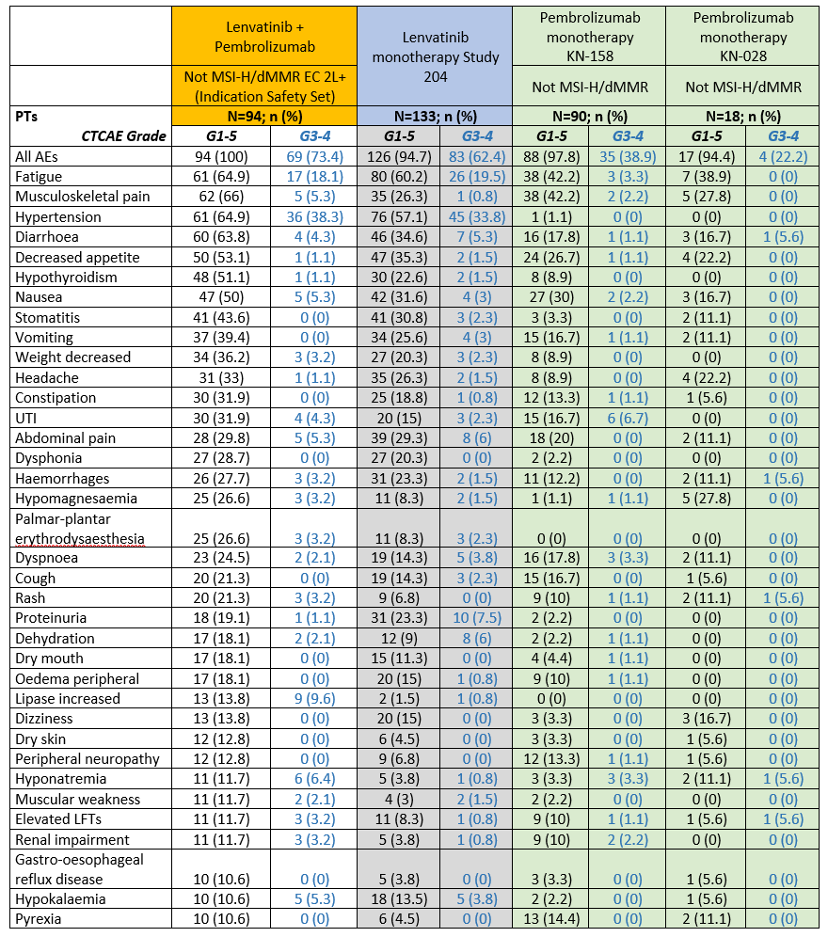
This safety table was generated by the FDA using their grouped terms.

Serious adverse events
Serious adverse events are shown in Table 12.
Table 12: Serious adverse events (by pooled Preferred Term) that occurred in at least 3% of patients in the Indication Safety Set in the pivotal trial (90 day safety update data: data cut-off 10 April 2019) with cross-study comparison
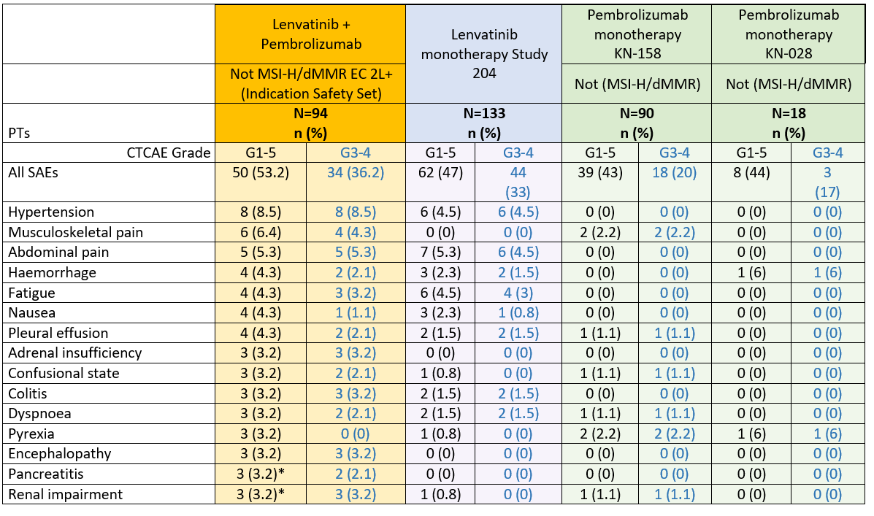
* Compared to the dataset with DCO 10 Jan 2019, the 90-day safety update resulted in two additional serious AEs reaching the threshold for inclusion in this table (3%): pancreatitis and renal impairment (previously 2%). L = lenvima, P = pembrolizumab. This safety table was generated by the FDA using their grouped terms.

Deaths
In total, there were 14 adverse events leading to deaths in the EC 2L+ set in Study 111/KEYNOTE-146 trial. Ten of these cases were attributable to disease progression. The remaining four deaths were due to AEs of:
- Intracranial haemorrhage (1 case):
  - Assessed by the clinical evaluator to be likely related to study drugs. The patient did not have any predisposing factors, including prior haemorrhage or brain metastases.
- E. coli sepsis (1 case):
  - Assessed by the clinical evaluator to have unclear causality. Temporal association was present but no predisposing factors including preceding neutropenia were reported. ‘Abdominal cavity drainage’ was reported subsequent to the sepsis, implying abdominal disease progression contributed.
- Gastrointestinal perforation related to disease progression (1 case):
  - Assessed by the clinical evaluator to be most likely due to ischemic small bowel and disease progression based on the case narrative.
- Intraventricular haemorrhage and posterior reversible encephalopathy syndrome (PRES):
  - Assessed by the clinical evaluator to be likely related to study drugs:
    - Day 10: hospitalised for seizure. Blood pressure (BP) 217/107 mmHg and Grade 3 headache. Both pembrolizumab and lenvatinib interrupted.
    - Day 20: lenvatinib monotherapy resumed, at a lower dose.
    - Day 36: hospitalised for BP of 190/100 mmHg.
    - Day 37: Grade 3 intraventricular haemorrhage on CT scan.
    - Day 38: Grade 3 PRES considered, and lenvatinib interrupted.
    - Day 40: withdrew from the study.
    - Day 48: died (intraventricular hemorrhage and PRES did not recover).
Another 35 patients in the EC 2L+ set died during survival follow-up. Causes of death were not collected for deaths that occurred in this period.
In the non-EC cohort of Study 111/KEYNOTE-146 trials (n = 159), there were 12 adverse events that led to death. The causes of death in these cases were:
- Myocardial infarction;
- Aspiration;
- Pulmonary haemorrhage;
- Sepsis;
- Pneumonia aspiration;
- Pneumonia aspiration;
- Pneumonia;
- Gastrointestinal haemorrhage;
- Portal vein thrombosis;
- Pneumothorax;
- Pneumonia aspiration;
- Urosepsis.
Known risks of lenvatinib use (see lenvatinib Australian PI: Warnings and Precautions section) include haemorrhage, PRES, arterial thromboembolic events and cardiac dysfunction. Fatal cases of pneumonia and sepsis have been seen in previous studies of pembrolizumab and are described in the pembrolizumab Australian PI. Additional possible aetiologies for these deaths include underlying disease, hospitalisation and immobility in terms of risk factors for procoagulability, pneumonia and sepsis.

Discontinuations and dose modifications
Discontinuations from study treatments and the treatment emergent adverse events (TEAEs) leading to discontinuation are summarised in Table 13 and Table 14. No common aetiology was evident in the TEAEs leading to discontinuation of one or both drugs.
Table 13: Overview of discontinuations in Study 111/KEYNOTE-146 trial
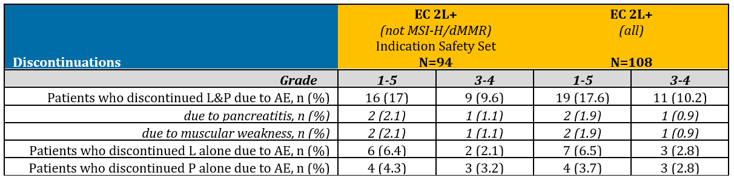
AE = adverse event, L = lenvatinib, P = pembrolizumab.
Table 14: Treatment emergent adverse events leading to discontinuation of lenvatinib only, pembrolizumab only or both drugs in Study 111/KEYNOTE-146 trial
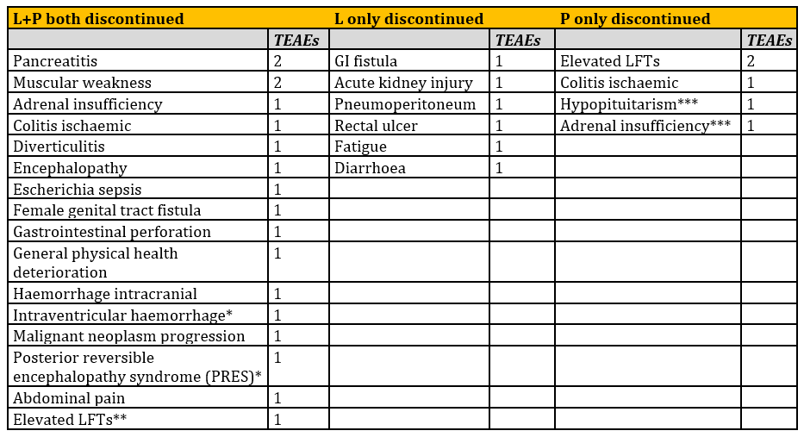
* Intraventricular haemorrhage and PRES occurred in the same patient leading to withdrawal of both drugs. ** This case was not identified in the sponsor’s analysis. *** Hypopituitarism and adrenal insufficiency occurred in the same patient leading to withdrawal of pembrolizumab. L = lenvima, LFT = liver function test, P = pembrolizumab. This safety table was generated by the FDA using their grouped terms.
The discontinuation rate from lenvatinib monotherapy in Study 204 (29%) was comparable to the discontinuation rate from lenvatinib (regardless of action taken with pembrolizumab) in the Indication Safety Set of Study 111/KEYNOTE-146 trial (25%). Median time to discontinuation was also comparable (1.2 months and 2.5 months, respectively).
The discontinuation rate from pembrolizumab monotherapy in the KEYNOTE-158 trial (22%) was comparable to the discontinuation rate from pembrolizumab (regardless of action taken with lenvatinib) in the not MSI-H/dMMR subgroup of the EC 2L+ set of Study 111/KEYNOTE-146 trial (21%). Median time to discontinuation was also comparable (2 months and 2.4 months, respectively).
Dose modifications are summarised in Table 15. Dose modification of lenvatinib due to AEs was required more frequently in Study 111/KEYNOTE-146 trial than Study 204, despite the lower daily dose of lenvatinib (20 mg versus 24 mg, respectively). Median time to dose interruption or reduction due to TEAE was comparable between studies: approximately 1 to 2 months for lenvatinib and approximately 2 to 3 months for pembrolizumab.
Table 15: Overview of dose modifications in Study 111/KEYNOTE-146 trial (data cut-off 10 January 2019)
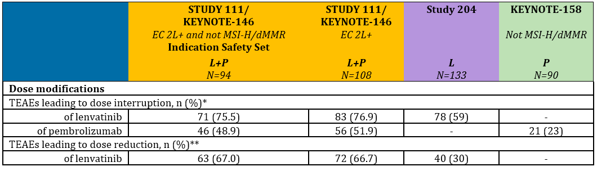
* Regardless of the action taken with the other drug. ** Pembrolizumab dose reduction was not permitted per protocol.

Post-market data
Post-market data specific to the combination of lenvatinib plus pembrolizumab is not available as this combination has not previously received marketing approval in any jurisdiction.

Dosing in severe renal and hepatic impairment
In the TGA submission through which lenvatinib was first registered in Australia (for differentiated thyroid cancer (DTC)), data was submitted that demonstrated increased exposure in severe hepatic and renal impairment. Based on the existing recommendations for other approved indications (DTC and RCC), a reduced starting dose of 10 mg daily of lenvatinib has been proposed for EC patients with severe renal or hepatic impairment. The dose reduction scheme in the Australian PI was also supported by clinical safety data, and the rate of dose reductions and discontinuations in the EC population appears comparable to those for RCC and DTC. The proposed dosing for severe renal or hepatic impairment in EC patients is therefore accepted.

Safety-related conclusions
The size of the population and duration of exposure in the pivotal trial is considered sufficient to characterise the safety of lenvatinib plus pembrolizumab for the proposed provisional approval of usage in second line or later EC. The monotherapy datasets provided comprehensive individual safety profiles for each of the two drugs across tumour types, as well as sufficient EC 2L+ data for comparison to the pivotal trial safety data and inference of contribution to the safety profile of the combination.
The possibility of immune-related toxicities with delayed onset beyond the available follow-up is recognised, but expected to be scarce, based on onset times for the majority of such observed delayed AEs with pembrolizumab in other tumour types.9
AE trends across the four submitted studies (Study 111/KEYNOTE-146, Study 204, and the KEYNOTE-158 and KEYNOTE-028 trials) were evaluated by pooling of Preferred Terms. The following summary of AEs refers to the analysis using these pooled terms.
The incidence of any-grade AEs, higher grade (Grades 3 to 4) AEs and SAEs were higher with the combination of lenvatinib plus pembrolizumab than with either monotherapy, however, the types of AEs seen with the combination were consistent with the known safety profiles of lenvatinib and pembrolizumab in other indications. Fatigue, musculoskeletal disorders, hypertension, diarrhoea, decreased appetite, hypothyroidism and nausea were the most common events, and occurred in at least 50% of patients.
The most common Grade 3 to 4 AEs with the combination were hypertension, fatigue and lipase increase. The most common Grade 3 to 4 AEs with lenvatinib in Study 204 were hypertension, fatigue, proteinuria, dehydration and abdominal pain (noting the higher dose of lenvatinib compared to Study 111/KEYNOTE-146 trial: 24 mg versus 20 mg daily). The most common Grade 3 to 4 AEs with pembrolizumab in the KEYNOTE-158 trial were urinary tract infection (UTI), dyspnoea and hyponatraemia.
SAEs with the combination included hypertension, musculoskeletal pain, abdominal pain, haemorrhage, fatigue, nausea, pleural effusion, adrenal insufficiency, confusional state, colitis, dyspnoea, pyrexia, encephalopathy, pancreatitis and renal impairment. Two deaths were assessed by the regulatory authorities to be likely drug-related: involving haemorrhagic and PRES events. Of note, hypertension, haemorrhage and PRES are known to occur with VEGF inhibitors and are specific warnings/precautions for lenvatinib.8
Discontinuation of one or both drugs due to AEs occurred in around a quarter of patients in Study 111/KEYNOTE-146 trial, and two thirds of patients required dose reduction of lenvatinib due to an AE.

Confirmatory data
The provision of confirmatory data is a requirement for provisional approval. The required confirmatory data for this indication consists of:
- Data regarding the efficacy and safety of the combination in second line treatment of EC as measured by PFS and OS (from Study 309/KEYNOTE-775 trial)
- Data to support validation of two in vitro diagnostic (IVD) devices:
  - an IHC-based device to identify patients with EC who are not dMMR, and
  - a nucleic acid-based device to identify patients with EC who are not MSI-H).
The data to support validation of the IVD devices, both dMMR and MSI-H, are being collected as part of the regulatory requirements (in a number of countries including Australia) related to the tissue-agnostic approval of pembrolizumab for use in MSI-H/dMMR solid tumours. Data collection is ongoing, and for the IHC-based device the target date for submission to TGA is January 2024. The nucleic-acid based device validation data is expected to be collected slightly later, with the target date for submission to TGA is January 2025.
Another clinical trial is ongoing in the first line setting (Study 313/LEAP-001 trial) and should provide additional important safety follow up data. Submission to TGA of results of interim and final analysis from the LEAP-001 trial should be a separate condition of registration.
Key features of Study 309/KEYNOTE-775 trial and Study 313/LEAP-001 trial are summarised in Table 16.
Per the requirements for provisional registration, the confirmatory data should be included in the clinical study plan specified in the Australian specific Annex (ASA) to the RMP, and therefore specified in a condition of registration that requires submission of findings from the clinical study plan to TGA.
Table 16: Summary of key features of Study 309/KEYNOTE-775 trial and Study 313/LEAP-001 trial, two ongoing studies of lenvatinib plus pembrolizumab in the treatment of advanced endometrial carcinoma
 | Study 309/KEYNOTE-775 | Study 313/LEAP-001
Setting | Second line advanced EC | First line advanced EC
Investigative drug | lenvatinib 20 mg PO daily plus pembrolizumab 200 mg IV Q3W | lenvatinib 20 mg PO daily plus pembrolizumab 200 mg IV Q3W
Comparator | physician’s choice: one of paclitaxel 80 mg/m² IV weekly for 3 weeks then 1 week off (28 day cycle)  or  doxorubicin 60 mg/m² IV Q3W | paclitaxel 175 mg/m² IV Q3W plus carboplatin 10 mg/mL IV area under the plasma concentration time curve (AUC) = 6 (Calvert's formula) Q3W
Follow up | PFS: approximately 24 months, OS: approximately 27 months | PFS: approximately 31 months, OS: approximately 45 months
Endpoints | co-primary PFS and OS  RECIST 1.1 by blinded independent central review (BICR) | co-primary PFS and OS  RECIST 1.1 by BICR
Recruitment status | actual enrolment = 471 as of 15 July 2019 (planned n = 780) | actual enrolment = 18 as of 5 July 2019 (planned n = 720)
Estimated completion | January 2023 | April 2023
Estimated submission to TGA | January 2024 | April 2024

Risk management plan
The sponsor has submitted the updated European Union-Risk Managmenent Plan (EU-RMP) version 25.0; (dated 12 July 2019, data lock point (DLP) 24 August 2018) with ASA version 17 (dated 11 August 2019).
The summary of safety concerns for pembrolizumab and their associated risk monitoring and mitigation strategies are summarised in Table 17.
Table 17: Summary of safety concerns from the risk management plan evaluation for pembrolizumab
Summary of safety concerns |  | Pharmacovigilance |  | Risk Minimisation
 |  | Routine | Additional | Routine | Additional
Important identified risks | Immune mediated adverse reactions:  - Immune-mediated pneumonitis  - Immune-mediated colitis  - Immune-mediated hepatitis  - Immune-mediated nephritis  - Immune-mediated endocrinopathies |  | ¹ |  | ^{3, 4}
Important potential risks | For haematological malignancies: increased risk of severe complications of allogenic stem cell transplantation (SCT) in patients who have previously received pembrolizumab |  | ¹ |  | ^{3, 4}
Important potential risks | Graft versus host disease (GVHD) after pembrolizumab administration in patients with a history of allogeneic SCT |  | ^{1, 2} |  | ^{3, 4}
Missing information | Long-term safety |  | ¹ | – | –
1 Clinical trial. 2 Cumulative review of cases. 3 Patient education. 4 Patient alert card.
TGA policy requires inclusion in the black triangle scheme for all provisionally approved medicines.

Risk-benefit analysis

Delegate’s considerations

Benefits and uncertainties
The evidence in support of efficacy of the proposed indication consists of data from the single arm Phase Ib/II Study 111/KEYNOTE-146 trial. In a subgroup of 94 patients (the Indication Set) with advanced endometrial carcinoma that was not MSI-H or dMMR, who had received previous systemic therapy for their disease, lenvatinib (20 mg PO daily) plus pembrolizumab (200 mg IV Q3W) was associated with an ORR of 38% (95% CI 29, 49), including ten CRs (11%). Responses appear to be durable, with median DOR not yet reached and a median duration of follow up of 18.7 months.
By comparison to existing therapeutic options, noting the limitations involved in making external comparisons, this represents a magnitude of benefit that is likely to be clinically meaningful. This data is also likely to correlate to improvement in time-to-event endpoints (PFS and OS) in pending Phase III clinical studies.
The contribution of each combination partner to the efficacy of the combination is not possible to truly isolate from the available data. Nonetheless, requiring a randomised study to isolate the contribution of each drug to the efficacy of the combination is not considered viable or ethical, as equipoise is lost. Characterisation of single agent activity in separate clinical trials by exploratory propensity score analysis, although limited, provides reassurance that the treatment effect of the combination is not derived from either of the component single agents alone.

Harms and uncertainties
The combination of lenvatinib plus pembrolizumab is associated with significant toxicity. Two deaths in the pivotal trial Indication Set (n = 94) were likely drug-related: one due to intracranial haemorrhage and the other due to intraventricular haemorrhage and PRES. Discontinuation of one or both drugs due to AEs occurred in around a quarter of patients in the Indication Set, and two thirds of patients required dose reduction of lenvatinib due to an AE: a rate more than double that seen in a separate trial of lenvatinib monotherapy at a 17% lower dose. AEs of all grades, higher grade AEs (Grade 3 to 4) and SAEs appear to be more frequent with the combination than with either monotherapy, by cross-trial comparison. The types of events seen with the combination in the pivotal trial were consistent with those known to be associated with each of the component drugs. Fatigue, musculoskeletal disorders, hypertension, diarrhoea, decreased appetite, hypothyroidism and nausea occurred in at least half of patients in the Indication Set. High-grade and serious hypertension events appear more frequent with the combination than with lenvatinib alone, and this AE will require specific review with the availability of confirmatory data.

Benefit-risk balance
For patients with advanced EC that is not MSI-H/dMMR whose disease has progressed despite first-line systemic therapy, there are no TGA registered therapies, there is no standard therapy, and the currently available therapies have response rates in the order of 10%. Despite significant uncertainty (evidence of efficacy relies on ORR and DOR in a single-arm study) and toxicity, in this setting, the benefit-risk balance of provisional registration of the non-fixed dose combination of lenvatinib plus pembrolizumab for the proposed usage is considered favourable.

Independent expert clinical advice
Impartial Australian experts provided TGA with Australia-specific clinical context. They did not identify any additional areas of clinical uncertainty.

Confirmatory studies
The required confirmatory data are:
Results from Study 309/KEYNOTE 775 trial.
Validation data for the companion diagnostics.
These studies should be included in the Clinical Study Plan of the ASA to the RMP, and thus submission of results from these studies will be a condition of the provisional registration. The study referred to as the LEAP-001 trial is also considered important follow-up for safety reasons, and results from the LEAP-001 trial should be submitted to TGA as a separate condition of registration.

Proposed action
The benefit-risk balance of provisional registration of the non-fixed dose combination of lenvatinib plus pembrolizumab for the proposed usage is considered favourable.

Advisory Committee Considerations
The Delegate did not refer this application to the Advisory Committee on Medicines (ACM) for advice.

Outcome
Based on a review of quality, safety and efficacy, TGA approved the provisional registration of Keytruda pembrolizumab (rch) 50 mg powder for injection and 100 mg/ 4 mL concentrated injection for the following extension of indications:
Endometrial carcinoma
Keytruda (pembrolizumab), in combination with lenvatinib, is indicated for the treatment of patients with advanced endometrial carcinoma that is not MSI-H or dMMR, who have disease progression following prior systemic therapy and are not candidates for curative surgery or radiation. This indication was approved via the provisional approval pathway, based on objective response rate and duration of response in a single-arm trial. Full registration for this indication depends on verification and description of clinical benefit in confirmatory trials.

Specific conditions of registration applying to these goods
- Keytruda pembrolizumab (rch) is to be included in the Black Triangle Scheme. The PI and CMI for Keytruda must include the black triangle symbol and mandatory accompanying text for the products entire period of provisional registration.
- Confirmatory trial data (as identified in the sponsor’s plan to submit comprehensive clinical data on the safety and efficacy of the medicine before the end of the 6 years that would start on the day that registration would commence) must be provided. Specifically the sponsor must conduct studies as described in the clinical study plan in version 18, dated 11 September 2019 of the Australia-specific Annex. Interim and final clinical study reports (CSRs) for the following studies should be submitted to TGA.
  - KEYNOTE-775 (Study E7080-G000-309), submission of final CSR expected
  - January 2024
  - Validation studies of an IHC-based companion diagnostic device for the identification of MMR status, submission expected: January 2024
  - Validation studies for a nucleic acid-based companion diagnostic device for the identification of MSI status, submission expected: January 2025
Further guidance for sponsors is available on the TGA website.
- Interim and final clinical study reports for the LEAP-001 (MK-7902-001/ENGOT-en9) clinical trial should be submitted to TGA. Submission of interim CSR expected April 2024 unless unavailable due to negative interim analysis result. Submission of final CSR expected April 2025.
- The Keytruda EU-Risk Management Plan (RMP) (version 25.0, dated 12 July 2019, data lock point 24 August 2018), with Australian Specific Annex (version 18, dated 11 September 2019), included with submission PM-2019-02526-1-4, and any subsequent revisions, as agreed with the TGA, will be implemented in Australia.
An obligatory component of risk management plans is routine pharmacovigilance. Routine pharmacovigilance includes the submission of periodic safety update reports (PSURs).
Reports are to be provided in line with the current published list of EU reference dates and frequency of submission of PSURs until the period covered by such reports is not less than three years from the date of this approval letter.
The reports are to at least meet the requirements for PSURs as described in the European Medicines Agency’s Guideline on Good Pharmacovigilance Practices (GVP) Module VII-periodic safety update report (Rev 1), Part VII.B Structures and processes. Note that submission of a PSUR does not constitute an application to vary the registration.
- For all injectable products the Product Information must be included with the product as a package insert.

Attachment 1. Product Information
The PI for Keytruda approved with the submission which is described in this AusPAR is at Attachment 1. For the most recent PI, please refer to the TGA website at <https://www.tga.gov.au/product-information-pi>.

Therapeutic Goods Administration
PO Box 100 Woden ACT 2606 Australia
Email: info@tga.gov.au Phone: 1800 020 653 Fax: 02 6232 8605
https://www.tga.gov.au

Chen, L.M. and Berek, J.S. Endometrial carcinoma: Epidemiology and risk factors. Last updated 26 August 2019. Accessed from the UpToDate website.
Cancer Australia, National Cancer Control Indicators website – uterine cancer statistics. Accessed at on 26 July 2019.
Evans, T. et al. (2011). Differential trends in the rising incidence of endometrial cancer by type: data from a UK population-based registry from 1994 to 2006. Br J Cancer. 2011; 104: 1505–1510.
For more information on the concurrent submission, refer to the AusPAR for Lenvima (lenvatinib as mesilate), Eisai Australia Pty Limited, PM-2019-02448-1-4.
Project Orbis seeks to increase collaboration among international regulators, which may in turn allow patients with cancer to receive earlier access to products in other countries where there may be significant delays in regulatory submissions, regardless of whether the product has received approval. Pivotal clinical trials in oncology are commonly conducted internationally and these global trials are increasingly important for investigating the safety and effectiveness of cancer drugs for approval across jurisdictions. Future drug development may benefit by establishing a greater uniformity of new global standards of treatment, leading to the optimal design of these important trials. For further information visit: https://www.fda.gov/about-fda/oncology-center-excellence/project-orbis
Henze, J., Maintz, D and Persigehl, T. (2016). RECIST 1.1, irRECIST 1.1, and mRECIST: How to Do, Curr Radiol Rep (2016) 4: 48.
Freeman, S.F. et al. (2012). The Revised FIGO Staging System for Uterine Malignancies: Implications for MR Imaging. RadioGraphics. 2012; 32: 1805-1827.
Lorenzi, M et al. (2018). Structured literature review and meta-analyses of the prevalence of microsatellite instability high (MSI-H) and deficient mismatch repair (dMMR) in endometrial and ovarian cancers [abstract]. Abstract presented at: Society for Immunotherapy of Cancer (SITC) Annual Meeting. 2018 Nov 7-11; Washington DC. Abstract No. P585.
The sponsors were given opportunity to review and comment on the pooled terms.
Australian Product Information document for lenvatinib. Version 3.1 dated 15 Jan 2019. Accessed from the TGA website.
Australian Product Information document for pembrolizumab. Version dated 5 Aug 2019. Accessed from the TGA website.
Routine risk minimisation activities may be limited to ensuring that suitable warnings are included in the product information or by careful use of labelling and packaging. Routine pharmacovigilance practices involve the following activities: - All suspected adverse reactions that are reported to the personnel of the company are collected and collated in an accessible manner; - Reporting to regulatory authorities; - Continuous monitoring of the safety profiles of approved products including signal detection and updating of labelling; - Submission of PSURs; - Meeting other local regulatory agency requirements.
The ACM provides independent medical and scientific advice to the Minister for Health and the Therapeutic Goods Administration (TGA) on issues relating to the safety, quality and efficacy of medicines supplied in Australia including issues relating to pre-market and post-market functions for medicines. The Committee is established under Regulation 35 of the Therapeutic Goods Regulations 1990. Members are appointed by the Minister. The ACM was established in January 2017 replacing Advisory Committee on Prescription Medicines (ACPM) which was formed in January 2010. ACM encompass pre and post-market advice for medicines, following the consolidation of the previous functions of the Advisory Committee on Prescription Medicines (ACPM), the Advisory Committee on the Safety of Medicines (ACSOM) and the Advisory Committee on Non-Prescription Medicines (ACNM). Membership comprises of professionals with specific scientific, medical or clinical expertise, as well as appropriate consumer health issues relating to medicines.

