October 2016

Australian Public Assessment Report for Pembrolizumab (rch)
  - Proprietary Product Name: Keytruda
  - Sponsor: Merck Sharp & Dohme (Australia) Pty Ltd

About the Therapeutic Goods Administration (TGA)
- The Therapeutic Goods Administration (TGA) is part of the Australian Government Department of Health and is responsible for regulating medicines and medical devices.
- The TGA administers the Therapeutic Goods Act 1989 (the Act), applying a risk management approach designed to ensure therapeutic goods supplied in Australia meet acceptable standards of quality, safety and efficacy (performance) when necessary.
- The work of the TGA is based on applying scientific and clinical expertise to decision-making, to ensure that the benefits to consumers outweigh any risks associated with the use of medicines and medical devices.
- The TGA relies on the public, healthcare professionals and industry to report problems with medicines or medical devices. TGA investigates reports received by it to determine any necessary regulatory action.
- To report a problem with a medicine or medical device, please see the information on the TGA website <https://www.tga.gov.au>.
About AusPARs
- An Australian Public Assessment Report (AusPAR) provides information about the evaluation of a prescription medicine and the considerations that led the TGA to approve or not approve a prescription medicine submission.
- AusPARs are prepared and published by the TGA.
- An AusPAR is prepared for submissions that relate to new chemical entities, generic medicines, major variations and extensions of indications.
- An AusPAR is a static document; it provides information that relates to a submission at a particular point in time.
- A new AusPAR will be developed to reflect changes to indications and/or major variations to a prescription medicine subject to evaluation by the TGA.
Copyright
© Commonwealth of Australia 2016
This work is copyright. You may reproduce the whole or part of this work in unaltered form for your own personal use or, if you are part of an organisation, for internal use within your organisation, but only if you or your organisation do not use the reproduction for any commercial purpose and retain this copyright notice and all disclaimer notices as part of that reproduction. Apart from rights to use as permitted by the Copyright Act 1968 or allowed by this copyright notice, all other rights are reserved and you are not allowed to reproduce the whole or any part of this work in any way (electronic or otherwise) without first being given specific written permission from the Commonwealth to do so. Requests and inquiries concerning reproduction and rights are to be sent to the TGA Copyright Officer, Therapeutic Goods Administration, PO Box 100, Woden ACT 2606 or emailed to <tga.copyright@tga.gov.au>.

Contents
Common abbreviations 5
I. Introduction to product submission 9
Submission details 9
Product background 9
Regulatory status 10
Product information 12
II. Quality findings 12
Structure 12
Drug substance (active ingredient) 12
Drug product 13
Advisory committee considerations 14
Quality summary and conclusions 15
III. Nonclinical findings 15
Introduction 15
Pharmacology 15
Pharmacokinetics 16
Toxicology 16
Nonclinical summary and conclusions 19
IV. Clinical findings 20
Introduction 20
Pharmacokinetics 23
Population Pharmacokinetics 23
Pharmacodynamics 25
Dosage selection for the pivotal studies 25
Efficacy 26
Safety 29
First round benefit-risk assessment 31
First round recommendation regarding authorisation 32
Clinical questions 33
Second round evaluation of clinical data submitted in response to questions 33
V. Pharmacovigilance findings 33
Risk management plan 33
VI. Overall conclusion and risk/benefit assessment 47
Introduction 47
Quality 62
Nonclinical 62
Clinical 62
Risk management plan 115
Risk-benefit analysis 116
Outcome 128
Attachment 1. Product Information 128
Attachment 2. Extract from the Clinical Evaluation Report 128

Common abbreviations
Abbreviation | Meaning
ACPM | Advisory Committee for Prescription Medicines
ACSOM | Advisory Committee for the Safety of Medicines
ADA | anti-drug antibodies
AE | Adverse Event
AEOSI | Adverse event of special interest
ALT | Alanine Transaminase
APaT | All patients as treated
ARTG | Australian Register of Therapeutic Goods
ASA | Australian Specific Annex (of the RMP)
AST | Aspartate Transaminase
AUC | Area under the curve
AUS_{ss} | Area under the curve at steady state
BTLA | B and T lymphocyte attenuator
C1q | the first subcomponent of the C1 complex of the classical pathway of complement activation
CI | Confidence interval
C_{max} | Maximum concentration
CMI | Consumer Medicines Information
CNS | Central nervous system
CR | Complete Response
CSR | Clinical Study Report
CT | X-Ray Computed Tomography
CTLA-4 | CTLA4 or CTLA-4, also known as CD152, is a protein receptor that, functioning as an immune checkpoint, down regulates immune responses. CTLA4 is constitutively expressed in Tregs but only up regulated in conventional T cells after activation
DoR | Duration of Response
ECOG | Eastern Cooperative Oncology Group (performance status)
EMA | European Medicines Agency
FAQ | Frequently asked questions
FAS | Full analysis set
FDA | Food and Drug Administration (USA)
GLP | good laboratory practice
HBV | hepatitis B virus
HCV | hepatitis C virus
ICH | International Conference on Harmonisation
ICOS | Inducible costimulatory molecule
IFNγ | Gamma interferon
IgG | Immunoglobulin G
IgG4 | Subclass 4 of IgG
IHC | Immunohistochemistry
IL-2 | Interleukin 2
ILD | interstitial lung disease
IPI | Ipilimumab
irAE | Immune related adverse event
irRC | Immune related response criteria
IRO | independent radiology and oncology review
IV | Intravenous
Kd | Dissociation contsant
L | Litre(s)
LDH | lactate dehydrogenase
mAbs | Monoclonal antibodies
MHC | Major histocompatibility complex
MRI | Magnetic Resonance Imaging
MSD | Merck Sharp and Dohme
NCCN | National Comprehensive Cancer Network
NOAEL | no observable adverse effect level
NSCLC | Non-Small Cell Lung Cancer
ORR | objective response rate
ODAC | oncologic drugs advisory committee
OS | Overall Survival
PASS | Post Authorisation Safety Study
PBS | Pharmaceutical Benefits Scheme
PD | Pharmacodynamics
PD-1 | Programmed cell death receptor -1
PD-L1 | Programmed death ligand 1 (also known as B7-H1 and CD274)
PD-L2 | Programmed death ligand 2 (also known as B7-DC)
PFS | Progression free survival
PI | Product Information
PK | Pharmacokinetics
Pop PK | population pharmacokinetics
PR | Partial Response
PSC | Pharmaceutical Sub Committee (of ACPM)
PSUR | Periodic Safety Update Reports
Q2W | Once every 2 weeks
Q3W | Once every 3 weeks
QoL | although quality of life
RECIST | Response evaluation criteria in solid tumours
RPSFT | rank preserving structural failure time
SAE | serious adverse event
SJS | Stevens-Johnson syndrome
TDZ | temozolomide
TEN | toxic epidermal necrolysis
TFH | T follicular helper
TFR | T follicular regulatory
TGA | Therapeutic Goods Administration
T_{max} | Time of maximum concentration
TTP | Time to Progression
Vc | Central volume of distribution
Vp | Peripheral volume of distribution
VPC | Visual predictive check
Vss | Volume of distribution at steady state

I. Introduction to product submission

Submission details
Type of submission: | New biological chemical entity
Decision: | Approved
Date of decision: | 15 April 2015
Date of entry onto ARTG | 16 April 2016
Active ingredient: | pembrolizumab (rch)
Product name: | Keytruda
Sponsor’s name and address: | Merck Sharp and Dohme (Australia ) Pty Ltd  North Ryde Business Centre  Locked Bag 2234  North Ryde BC NSW 1670
Dose form: | Powder for injection
Strength: | 50 mg
Container: | vial
Pack size: | 1
Approved therapeutic use: | Keytruda is indicated as monotherapy for the treatment of unresectable or metastatic melanoma in adults
Route(s) of administration: | Intravenous infusion
Dosage: | 2 mg/kg administered intravenously over 30 minutes every 3 weeks (‘Q3W’). Infusion requires a sterile, non-pyrogenic, low protein binding 0.2 to 5 µm in-line or add-on filter.
ARTG number: | 226597

Product background
This AusPAR describes the application by Merck Sharp and Dohme (Australia) Pty Ltd (the sponsor) to register Keytruda pembrolizumab (rch) 50mg powder for injection vial for the following indication;
Keytruda pembrolizumab (rch) is indicated for the treatment of unresectable or metastatic melanoma in adults.
Pembrolizumab (rch) is a humanised monoclonal antibody against the programmed cell death receptor -1 (PD-1). Pembrolizumab inhibits PD-1 to (programmed death ligand) PD-L signalling. PD-1’s role is to limit the activity of T cells in tissues at the time of an inflammatory response to infection and to limit autoimmunity.
The PD-1 pathway, normally involved in promoting peripheral tolerance, may be usurped in tumours to overcome active T cell immune surveillance. As an antibody directed against PD-1, pembrolizumab is designed to block the interaction between the PD-1 receptor and its ligands, PD-L1 and programmed death ligand-2 (PD-L2). PD-L1 has been found to be abundantly expressed by human melanomas and other cancers, with high expression correlated with poor prognosis and survival. Blockade of the PD-1 pathway by pembrolizumab is envisaged to enhance the functional activity of tumour infiltrating lymphocytes to induce tumour regression. In melanoma this is to allow the immune system to engage with and ‘reject’ the melanoma. A recent synopsis has been published.
Treatment of advanced melanoma has changed with recent availability of ipilimumab (anti-CTLA-4 antibody), vemurafenib (BRAF inhibitor), dabrafenib (BRAF inhibitor) and trametinib (MEK inhibitor). In the USA, pembrolizumab and nivolumab (PD-1 inhibitors) became available in 2014.
The sponsor has applied for an indication in unresectable or metastatic melanoma.

Regulatory status
The product received initial registration on the Australian Register of Therapeutic Goods (ARTG) on 16 April 2015.
At the time the TGA considered this application, a similar application had been approved in USA (approved 4 September 2014) was under consideration in; EU/EMEA Centralised procedure (submitted June 2014) and Canada (submitted June 2014).

Overseas status

USA; Food and Drug Administration
The product was approved by the Food and Drug Administration (FDA) on 9 April 2014 with the following indication:
Keytruda (pembrolizumab) is indicated for the treatment of patients with unresectable or metastatic melanoma and disease progression following ipilimumab and, if BRAF V600 mutation positive, a BRAF inhibitor.
This indication is approved under accelerated approval based on tumour response rate and durability of response. An improvement in survival or disease-related symptoms has not yet been established. Continued approval for this indication may be contingent upon verification and description of clinical benefit in the confirmatory trials.
MSD sought an indication in patients previously treated with ipilimumab; but the FDA required; in addition disease progression following BRAF inhibition in patients with BRAF mutant tumours. The FDA had access to a dataset with an efficacy cut-off date 13 October 2013, but did not have access to sub-group analysis by PD-L1 status.
The application was approved under accelerated approval regulations, as emphasised within the US indication, so that ‘further adequate and well controlled studies /clinical trials to verify and describe clinical benefit’ are required. The following requirement was included in the approval letter.
2770-1 (trial completion March 2016; report submission January 2017)
Conduct and submit the results of a multicentre, randomised trial or trials establishing the superiority of pembrolizumab over standard therapy in adult patients with unresectable or metastatic melanoma who are refractory to ipilimumab or who have not been previously treated with ipilimumab.
Studies P002 and P006 are such trials.
No Risk Evaluation and Mitigation Strategy (REMS) was required by the FDA. There is a REMS in place for ipilimumab.
The application was not considered by the relevant FDA advisory committee (oncologic drugs advisory committee (ODAC)) for the following reasons (given in the approval letter):
…the safety profile is acceptable for the treatment of patients with unresectable or metastatic melanoma whose disease has progressed following treatment with ipilimumab, and, if BRAF V600 mutation positive, received treatment with a BRAF inhibitor. The application did not raise significant public health questions on the role of Keytruda for this indication and outside expertise was not necessary as there were no controversial issues that would benefit from an advisory committee discussion.
Since FDA approval, one safety issue has emerged, namely ‘reports of fatal outcome of adverse events related to interstitial lung disease (ILD) that may be possibly related to pembrolizumab treatment.’

EU; European Medicines Agency (EMA)
An application has been received by the EMA for marketing authorisation. The sought indication is:
Keytruda is indicated for the treatment of unresectable or metastatic melanoma in adults.
Pembrolizumab was not approved for any use by the EMA as of 22 January 2015.

Other
Nivolumab, another anti-PD-1 mAb, has been approved by PMDA in Japan for use in melanoma, and in the USA with an indication identical to that of pembrolizumab.

Product information
The Product Information (PI) approved with the submission which is described in this AusPAR can be found as Attachment 1. For the most recent PI, please refer to the TGA website at <https://www.tga.gov.au/product-information-pi>.

II. Quality findings

Structure
Pembrolizumab (rch) is a humanised Immunoglobulin G (IgG) IgG4/kappa monoclonal antibody with specificity for PD-1. The Fc domain has a single mutation of Ser228Pro engineered into the molecule to increase hinge region stability. Other aspects of the molecule are typical for an IgG4 antibody. The description of the structure is ‘Anti-(human protein PDCD1 (programmed cell death 1)) immunoglobulin G4 (human-Mus musculus monoclonal heavy chain) disulfide with human-Mus musculus monoclonal light chain, dimer’.

Drug substance (active ingredient)
This substance is manufactured by recombinant Chinese hamster ovary (CHO) cells in a fermentation process utilising typical cell expansion processes to reach the production volume. Purification of the drug substance uses steps including chromatography, filtration and viral inactivation.
This process consists of steps typical for monoclonal antibody biopharmaceutical and is in line with other registered antibody products. The process has a range of control processes and testing points. This process in combination with the drug substance release testing make up an appropriate control strategy for manufacturing product comparable to that used in the clinical studies. The manufacturing process has been transferred and comparability of material throughout the process development has been demonstrated through batch analysis testing.
Cell banking processes have been fully described and characterised in line with adopted International Conference on Harmonisation (ICH) guidance.
Adventitious agent issues have been addressed. Other than the cell line, there are no animal or human derived raw materials used in the manufacturing process. Any animal derived material used during early development process was considered to be of appropriate quality with respect to adventitious agents.

Physical and chemical properties
The characterisation has confirmed the expected primary, secondary and tertiary structure of the IgG4/kappa with hinge modification (S228P). Molecular weights were within the expected range for a glycosylated IgG molecule. The post-translational modifications seen include:
- heavy-chain amino-terminal cyclization (heavy chain: Gln 1 → pyroglutamic acid)
- carboxy-terminal processing (heavy chain:des-Lys449)
- glycosylation (heavy chain: Asn297)
- oxidation (heavy chain: Met105, Met252, Met358 and Met428)
- deamidation (heavy chain: Asn55, Asn384, Asn389).
Most of these modifications are common to other therapeutic monoclonal antibodies. Of note are the modifications to residues contained with the CDR domain of the molecule responsible for ligands binding.
The biological properties of MK3475 were determined using 2 in vitro surrogate cell based assays to demonstrate blocking of PD1 and an ELISA based binding assay. The kinetics of binding of MK-3475 to PD-1 has also been determined using surface Plasmon resonance
The Fc binding properties of MK-3475 to various Fc receptors (C1q and Fcγ) was also characterised using surface plasmon resonance. The results were as expected for an IgG4 molecule with binding lower affinity than for the control IgG1 molecule. As the mechanism of action for MK-3475 is independent of the recruitment of other molecules through the Fc domain the characteristics and control of this domain is not critical to the efficacy of the product.

Specifications
The proposed specifications, which measure identity, content, potency, purity and other biological and physical properties of the drug substance. These specifications form a critical part of the drug substances control strategy. The potency assay for the product is based on binding to the target PD-1 only and does not include any other interaction of the molecule. This has been considered acceptable given the mode of action of the product and justified in the validation data supporting the analytical methods.
Appropriate validation data have been submitted in support of the test procedures.

Drug product
Pembrolizumab is lyophilised powder for single use that is reconstituted with sterile water for injection and further diluted with normal saline (0.9% sodium chloride injection) or 5% dextrose prior to intravenous (IV) administration. A single strength is proposed in a single pack size.

Manufacture
The drug product manufacturing method utilises processes similar to many registered biological medicines. The product is fully formulated at the drug substance stage and undergoes, sterile filtration, filling, lyophilisation, capping and storage. The control strategy for the drug product has addressed ongoing control of critical quality attributes. Validation of the process has demonstrated consistency in manufacture.

Stability
An initial shelf life of 12 months at 2 to 8 °C is proposed. Additional real-time stability data of the primary batches provided during the submission supports a shelf life of 18 months. The stability data also supports the instructions that the reconstituted drug product solutions may be stored at room temperature for a cumulative time of up to 8 hours
The container closure assessment has determined the impact of all leachable and extractable materials to be minimal.

Advisory committee considerations
The Pharmaceutical Sub Committee (of ACPM) (PSC) considered the referral for advice from the TGA in relation to the submission from Merck Sharp & Dohme Australia Pty Ltd to enter on the ARTG the product:
The Delegate requested advice on the following issues:
- Whether PSC agrees with the conclusions of the evaluation of the population pharmacokinetic (Pop PK) study (for the conclusions of the Pop PK evaluator please see below in Section IV; pharmacokinetics)
- Whether the results of the evaluation of the Pop PK study demand any modifications to the draft PI or Consumer Medicines Information (CMI)?
The PSC reviewed the documentation provided and advised the following:

Population pharmacokinetics
The PSC noted the Pop PK evaluator’s overall conclusions as follows:
- Overall, both the sponsor’s modelling study and the external validation process are in agreement with the information on pharmacokinetics provided in the sponsor’s PI document
- The evaluator does not have any questions for the sponsor in regard to the Pop PK data.

Specific advice
The Delegate requested advice on the following issues:
- Whether PSC agrees with the conclusions of the evaluation of the Pop PK study.
The PSC noted that the external evaluator had rebuilt the model and was satisfied that the model was in agreement with the external validation process.
The PSC questioned whether the model supported the statement in the PI that the clearance of pembrolizumab increased with increasing age, as this was hard to explain physiologically. The PSC noted the model was highly statistical but the statement did not have biological plausibility.
The PSC also noted that there were 411 patients, a sample of the population. The PSC noted that using a sample of patients was not the usual standard approach to ascertain a uniform distribution of patients.
The PSC resolved to recommend to the Advisory Committee for Prescription Medicines (ACPM) and the TGA that:
The PSC considered the application submitted from Merck Sharp & Dohme Australia Pty Ltd to register Keytruda, powder for injection vial containing 50 mg of a new chemical entity, pembrolizumab.
The PSC advised that clarity should be sought on whether clearance of pembrolizumab is affected by age.
The PI should be amended to reflect the recommendations of the PSC.

Quality summary and conclusions
The quality evaluator concluded that there are no objections on quality grounds to the registration of Keytruda pembrolizumab (rch).

III. Nonclinical findings

Introduction
Pembrolizumab (rch) (Keytruda) is a new biological entity for the treatment of unresectable or metastatic melanoma in adults. The proposed dosing regimen involves IV administration at 2 mg/kg every 3 weeks until disease progression or unacceptable toxicity.
The nonclinical dossier was of high quality and comprised studies on primary pharmacology, pharmacokinetics, general repeat dose toxicity and on tissue cross reactivity. The scope of studies was consistent with relevant TGA adopted guidelines for biotechnology derived pharmaceuticals and anticancer pharmaceuticals. All of the toxicity studies were performed according to good laboratory practice (GLP).

Pharmacology

Primary pharmacology
The PD-1 pathway, normally involved in promoting peripheral tolerance, may be usurped in tumours to overcome active T cell immune surveillance. As an antibody directed against PD-1, pembrolizumab is designed to block the interaction between the PD-1 receptor and its ligands, PD-L1 and PD-L2. PD-L1 has been found to be abundantly expressed by human melanomas and other cancers, with high expression correlated with poor prognosis and survival. Blockade of the PD-1 pathway by pembrolizumab is envisaged to enhance the functional activity of tumour infiltrating lymphocytes to induce tumour regression.
In vitro studies demonstrated that pembrolizumab binds to human PD-1 with high affinity (Kd, 29 pM) and acts to inhibit the binding of the PD-L1 and PD-L2 ligands to the PD-1 receptor. Comparable affinity for human and Cynomolgus monkey PD-1 was shown, consistent with the high degree of homology between human and monkey PD-1 (96% identical amino acid sequence), while pembrolizumab did not recognise mouse, rat of dog PD-1 (which display 62 to 72% identity with the human form). Pembrolizumab was shown to enhance T cell immune responses, measured as production of Interleukin 2 (IL-2) and other cytokines following activation by Staphylococcus enterotoxin B in cultured blood cells from healthy human donors, cancer patients and Cynomolgus monkeys, and as gamma interferon (IFNγ) production from pre-existing memory T cells in the peripheral blood of healthy human donors following stimulation with tetanus toxoid. Pembrolizumab was demonstrated to not spontaneously activate T cells in the absence of concurrent T cell receptor signalling. In vivo studies, conducted in mice bearing syngeneic tumours (colon adenocarcinoma), revealed significant anti-tumour activity for an anti PD-1 antibody (mouse specific surrogate), including instances of complete tumour regression and substantially prolonged animal survival. Combination treatment with either gemcitabine or 5-fluorouracil enhanced the antitumor activity of the anti PD-1 antibody in a synergistic fashion.

Secondary pharmacodynamics
Pembrolizumab contains an IgG4 Fc portion. The drug showed limited potential for effector function, consistent with expectations for the isotype, based on the results of assays for C1q, CD64 (FcγRI) and CD16a (FcγRIIIa) binding affinity.
Immunohistochemical cross reactivity studies with pembrolizumab, conducted against a panel of normal human and Cynomolgus monkey tissues, demonstrated positive staining of mononuclear leukocyte membranes in both species, consistent with known PD-1 expression. Off target binding was observed, but was principally cytoplasmic in nature (of dubious relevance given that the cytoplasm is not expected to be accessible to the drug in vivo) and was not associated with toxicity (see repeat dose toxicity).

Safety pharmacology
No specialised safety pharmacology studies were conducted, in accordance with the guidelines.^{9, 10} Both of the general repeat dose toxicity studies conducted in monkeys included ECG examinations, and blood pressure was measured in one study. There were no treatment related effects on these parameters, and no other general observations made in the studies that would indicate adverse effects of pembrolizumab on cardiovascular, respiratory, renal or nervous system function. The peak serum concentration of pembrolizumab achieved in animals at the high-dose level (200 mg/kg IV) in these studies is more than two orders of magnitude higher than that expected in patients at the recommended clinical dose (2 mg/kg IV).

Pharmacokinetics
Exposure to pembrolizumab after IV administration was dose proportional or slightly greater than dose proportional in Cynomolgus monkeys (studied over 0.3 to 200 mg/kg) and dose proportional in humans (studied over the range 2 to 10 mg/kg). Terminal half-life was long in both species (approximately 22 days in monkeys and approximately 26 days in humans) and volume of distribution was low (as expected for an antibody).
No distribution, traditional metabolism, excretion or pharmacokinetic interaction studies were submitted (in accordance with the guideline⁹). Pembrolizumab was shown not to engage in Fab-arm (half molecule) exchange with other IgG4 antibody; a structural rearrangement that results in bi-specific antibodies; either in vitro (in phosphate buffered saline or human serum) or in vivo (in mice) by virtue of a mutation (serine to proline at position 228) engineered into the hinge region of the molecule. Pembrolizumab will be eliminated by normal protein degradation pathways for IgG molecules, and, as a protein, is not expected to cause or be subject to pharmacokinetic drug-drug interactions.

Toxicology

Single-dose toxicity
No single dose toxicity studies were submitted. This is acceptable, with relevant information on acute toxicity obtainable from other studies. A low order of acute toxicity was apparent for pembrolizumab in Cynomolgus monkeys.

Repeat dose toxicity
The repeat dose toxicity of pembrolizumab was investigated in studies in Cynomolgus monkeys of 1 and 6 months duration. Administration was by the clinical route (IV), with dosing more frequent than proposed for humans (once weekly in the 1 month study and once every two weeks in the pivotal 6 month study compared with once every three weeks for patients under the recommended regimen). Animals of both sexes were used; group sizes and the duration of the pivotal study were appropriate. The use of a single species is acceptable given the absence of a pharmacodynamically responsive rodent species. Both studies included recovery groups (allowed a subsequent 4 month treatment free period) to examine reversibility/potential delayed toxicity.

Relative exposure
Exposure ratios have been calculated in the table below based on animal: human serum area under the curve (AUC) values for pembrolizumab following adjustment to reflect the higher dosing frequency in animals. The human reference AUC value is for the maximum recommended clinical dose (2 mg/kg every 3 weeks) at steady state, obtained in population PK modelling (clinical Study 03TLC8). AUC values for animals are calculated after exclusion of serum concentrations measured in animals positive for anti-drug antibodies. Very high exposure multiples were achieved in animals at the upper dose levels used in the studies.
Table 1. Relative exposure in repeat dose toxicity studies
Species | Study | Frequency | Dose (mg/kg); IV | AUC_{0–t}(µg∙day/mL) |  | Exposure ratio#
Monkey; Cynomolgus | 1 month | Once weekly | 6 | 1,790 | t = 1 wk | 7.6
Monkey; Cynomolgus | 1 month | Once weekly | 40 | 24,100 | t = 1 wk | 103
Monkey; Cynomolgus | 1 month | Once weekly | 200 | 170,000 | t = 1 wk | 724
Monkey; Cynomolgus | 6 months | once every 2 weeks | 6 | 2,463 | t = 2 wks | 5.2
Monkey; Cynomolgus | 6 months | once every 2 weeks | 40 | 13,417 | t = 2 wks | 29
Monkey; Cynomolgus | 6 months | once every 2 weeks | 200 | 67,500 | t = 2 wks | 144
Human (melanoma patients) | Population PK modelling | once every 3 weeks | 2 | 704 | t = 3 wks | –
# = animal: human serum AUC x animal: human dosing frequency; wk(s) = week(s)

Major findings
Treatment with pembrolizumab was well tolerated in monkeys, with no deaths or treatment related histopathological findings observed. Notable treatment related findings were limited to an increased incidence of inguinal swelling and increased spleen weight in male monkeys treated at 200 mg/kg/week in the 1 month study. These findings were not apparent in female animals, and were without histopathological correlate. Reversibility of the increase in spleen weight after withdrawal of treatment was demonstrated. There were no treatment related findings in the pivotal 6 month study, and a no observable adverse effect level (NOAEL) of 200 mg/kg every 2 weeks is established (yielding 144 times the serum exposure expected in patients treated at the maximum recommended clinical dose of 2 mg/kg once every 3 weeks). Anti pembrolizumab antibodies developed in some low dose animals during the treatment period in both studies. This led to a marked reduction in exposure in the affected animals, although a full pharmacodynamic effect was maintained in almost all cases. The development of anti-drug antibodies did not affect the validity of the studies.

Genotoxicity
No genotoxicity studies have been conducted, in accordance with the guideline.⁹ As a high molecular weight protein, pembrolizumab is not expected to interact directly with DNA or other chromosomal material.

Carcinogenicity
No carcinogenicity studies have been conducted, in accordance with TGA adopted guidelines for biotechnology derived products⁹ and for therapeutics intended to treat patients with advanced cancer.¹⁰

Reproductive and developmental toxicity
No reproductive or developmental toxicity studies have been conducted for pembrolizumab. The sponsor has considered the potential for adverse effects on embryofetal development with the drug based on published literature regarding the PD-1 pathway; this is acceptable according to the guideline.¹⁰ The absence of studies on fertility and early embryonic development and on pre-/postnatal development is also consistent with that guideline. With regard to potential effects on fertility, although no actual functional studies have been performed, it can be noted that male and female reproductive tissues were not identified as targets for pembrolizumab toxicity in the general repeat dose toxicity studies in monkeys.
Numerous literature publications identify the PD-1 pathway as having a fundamental role in maintaining immune tolerance to the fetal allograft. The PD-L1 molecule is expressed at the uteroplacental interface and protects the conception from maternal T cell mediated immunity. Blockade of PD-L1 signalling in mice has been shown to abrogate foetomaternal tolerance, resulting in increased fetal resorbtion and abortion.¹², In a murine model of allogeneic pregnancy (CBA x B6 strains mated), maternal treatment with an anti PD-L1 antibody (doses administered from shortly after implantation up to approximately halfway through the period of organogenesis) increased the incidence of fetal resorbtion from a spontaneous rate of 18% to 86%.¹² In further experiments involving pregnant B cell deficient mice (conducted to confirm the role of T cells in mediating these effects), blockade of the PD-1 pathway by an anti-PD-L1 antibody caused fetal rejection in 100% of animals. Accordingly, pembrolizumab can be reasonably expected to cause embryofoetal lethality in pregnant patients.

Pregnancy category
The sponsor has proposed Pregnancy Category C. Although they are pharmacologically mediated, given the extreme nature of the adverse effects predicted (that is, embryofoetal lethality), the proposed pregnancy category is considered inappropriate. The product should be assigned Pregnancy Category D instead.

Local tolerance
Local tolerance was investigated as part of the general repeat dose toxicity studies in monkeys, based on observations of clinical signs and on gross and microscopic examination of injection sites. There were no treatment related injection site findings. The animals were administered pembrolizumab at strength of 25 mg/mL, 2.5 times higher than the maximum strength recommended for administration to patients in the draft PI. The excipient profile of the formulation tested in animals was as for Keytruda.

Impurities
No specialised impurity studies in animals were conducted. The repeat dose toxicity studies in monkeys did not identify any toxicity attributable to the presence of impurities, but these used a drug lot containing levels of impurities lower than the maximum levels proposed in the drug substance and drug product specifications so that potential maximum human exposure was not achieved. The acceptability of the impurity specification will need to be based on quality and/or clinical assessment.

Paediatric use
Keytruda is not proposed for paediatric use. No studies in juvenile animals were submitted.

Comments on the safety specification of the risk management plan
Results and conclusions drawn from the nonclinical program for pembrolizumab detailed in the sponsor’s draft Risk Management Plan (RMP) are in general concordance with those of the nonclinical evaluator. Of note, animal: human exposure comparisons made in the RMP differ to those reported here. The sponsor cites a lower margin, reflecting a comparison made to a reference human dose of 10 mg/kg every 2 weeks (as the highest dose employed in clinical trials) rather than the maximum recommended dose specified in the PI (2 mg/kg every 3 weeks), and the absence of adjustment to account for more frequent dosing in animals (every 2 weeks in the pivotal 6 month monkey study) compared to patients treated according to the recommended dosing regimen.

Nonclinical summary and conclusions
- The nonclinical dossier contained an adequate set of studies investigating pharmacology, pharmacokinetics and toxicity. The scope of nonclinical studies was in accordance with TGA adopted ICH guidelines applicable to biotechnology derived pharmaceuticals and to anticancer pharmaceuticals. All of the toxicity studies were GLP compliant.
- In vitro studies established that pembrolizumab binds to human PD-1 with picomolar affinity, is able to block the binding of the PD-1 receptor’s endogenous ligands (PD-L1 and PD-L2), and enhances T cell immune responses. The antibody binds to Cynomolgus monkey PD-1 with comparable affinity compared to the human form, but does not recognise PD-1 from other common laboratory animal species tested (mouse, rat and dog). In vivo studies, conducted in mice with a surrogate anti PD-1 antibody, showed significant anti-tumour activity (evident as instances of complete tumour regression and substantially prolonged animal survival) for the drug, which was synergistically enhanced when combined with conventional anticancer agents (gemcitabine or 5-fluoruracil). Coupled with evidence of the PD-1 pathway being usurped by melanomas (to overcome active T cell immune surveillance), the submitted pharmacology studies offer support for efficacy in the proposed patient population.
- Investigations pertaining to antibody specificity, effector function and on safety pharmacology endpoints identified no relevant concerns.
- Pharmacokinetic studies revealed similarly long serum half-life and low volume of distribution in Cynomolgus monkeys (the animal species used in toxicity studies) and humans. Pembrolizumab has been engineered to not engage in Fab-arm (half molecule exchange) with other IgG4 antibodies.
- Repeat dose toxicity studies of up to 6 months duration were conducted with pembrolizumab in Cynomolgus monkeys, and showed that the drug was very well tolerated (both systemically and locally). Supporting safety, systemic exposure in animals at the NOAEL established in the pivotal study (200 mg/kg IV every 2 weeks) is a very high multiple of the serum AUC achieved in patients at the recommended clinical dose (that is, 144 times).
- Consistent with relevant ICH guidelines, no genotoxicity, carcinogenicity or reproductive/ developmental toxicity studies were conducted with pembrolizumab. Published literature identifies a critical role for the PD-1 pathway in maternofoetal tolerance, and the drug can be reasonably expected to cause embryofoetal lethality in pregnant patients.
- There are no nonclinical objections to the registration of Keytruda for the proposed indication.
- The nonclinical evaluator has recommended the assignment of Pregnancy Category D (rather than C as the sponsor has proposed).
The nonclinical evaluator made recommendations regarding the PI but these are beyond the scope of the AusPAR.

IV. Clinical findings
A summary of the clinical findings is presented in this section. Further details of these clinical findings can be found in Attachment 2.

Introduction
Pembrolizumab (rch) is a monoclonal antibody, which targets the PD-1 receptor on activated T-lymphocytes. There are currently no agents in this class registered in Australia.
The proposed indication is:
for the treatment of unresectable or metastatic melanoma in adults.
The submission proposes registration of the drug as a powder for injection, in vials containing 50 mg. The powder is to be reconstituted with sterile water for injection (2.3 mL) and then added to normal saline or 5% dextrose prior to infusion.
The proposed dosage regimen is 2 mg/kg by IV infusion (over 30 minutes) once every 3 weeks (Q3W). Treatment is continued until progressive disease or unacceptable toxicity occurs.

Clinical rationale
According to Cancer Council Australia, there were 11,405 new cases of melanoma diagnosed in Australia in 2010, and 1,544 people died from the disease in 2011.
Until recently there were limited options available for the treatment of subjects who developed unresectable or metastatic disease. The cytotoxic agent dacarbazine was the most commonly used agent for many years. Other cytotoxic agents registered in Australia for advanced melanoma are temozolomide and fotemustine. Despite use of these agents the prognosis was poor, with median overall survival typically being 6 to 9 months.
In recent years a number of new agents have been registered for the treatment of advanced melanoma. These agents include the BRAF inhibitors vemurafenib and dabrafenib, which are effective in subjects with melanoma positive for a BRAF V600 mutation. The MEK inhibitor trametinib has also been registered for use in combination with dabrafenib, or as monotherapy in BRAF mutation positive subjects in whom BRAF inhibitors cannot be used.
Another monoclonal antibody, ipilimumab (IPI), has also been registered as second-line therapy. This agent blocks the CTLA-4 receptor on activated T lymphocytes. Stimulation of the CTLA-4 receptor produces an inhibitory signal to the lymphocyte, and therefore blockage by ipilimumab results in enhanced T cell mediated anti-tumour effects.
Pembrolizumab is a monoclonal antibody that inhibits the PD-1 receptor (also known as CD279), which is expressed on activated T-lymphocytes. Similar to the CTLA-4 receptor, stimulation of PD-1 results in an inhibitory effect on T cell function. The normal function of the PD-1 receptor is to limit or ‘check’ overstimulation of immune responses. There are two known normal ligands for PD-1: PD-L1 (also known as CD274 or B7-H1) and PD-L2 (also known as CD273 or B7-DC). Multiple normal tissues express PD-L1, whereas PD-L2 is expressed primarily on haematopoietic cells.., ,
Several different tumours, including melanoma, express PD-L1.²⁰ Tumour expression of PD-L1 may result in inhibition of T cell mediated antitumor effects. The clinical rationale for PD-1 receptor blockade with pembrolizumab is to remove such inhibition.
Various inhibitors of PD-1 or PD-L1 are currently under development. One of these, nivolumab, has been approved for the treatment of unresectable melanoma in Japan.

Guidance
The following EMA guidelines, which have been adopted by the TGA, are considered relevant to the current submission:
- Guideline on the evaluation of anticancer medicinal products.
- Guideline on the investigation of pharmacokinetics of therapeutic proteins.
Compliance with these guidelines is considered in the relevant sections of this report.
The clinical data in the submission came from a single clinical trial (P001) and the TGA has adopted an EMA guideline on submissions that are based on a single pivotal study. However this guideline is not considered applicable to the current application. Study P001 commenced as a conventional Phase I trial but was subsequently amended on multiple occasions by the addition of Phase II type cohorts. The study currently includes four separate cohorts of melanoma subjects (Cohorts B1, B2, B3 and D).

Contents of the clinical dossier
The submission contained the following clinical information:
- A study report for a single clinical trial (P001), which examined pharmacokinetics (PK), pharmacodynamics (PD), efficacy and safety, primarily in subjects with melanoma and non-small cell lung cancer (NSCLC). The study included multiple separate cohorts of patients as follows:
  - Cohorts A, A1 and A2: Subjects with various advanced solid tumours
  - Cohorts B1, B2, B3 and D: Subjects with advance melanoma
  - Cohorts C and F: Subjects with advanced NSCLC
- The various cohorts are described further below in the clinical efficacy section
- 1 population pharmacokinetic (Pop PK) analysis
- A series of other analyses which examined relationships between pembrolizumab PK and various PD, efficacy and safety parameters
- Literature references.
The submission also contained a clinical overview, summary of biopharmaceutic studies, summary of clinical pharmacology, summary of clinical efficacy and summary of clinical safety.

Paediatric data
The submission did not include any paediatric data. From documents included in the submission it appears that the sponsor has obtained a waiver from the FDA from the need for paediatric studies on the grounds that the drug is an orphan drug in the USA. In Europe, it appears that a waiver has been granted for subjects under the age of 6 months, but that a study is being planned for subjects aged 6 months to 18 years. The study is not due to be completed until 2019.

Good clinical practice
The report for study P001 included an assurance that the trial ‘was conducted in conformance with Good Clinical Practice standards and applicable country and/or local statutes and regulations regarding ethical committee review, informed consent, and the protection of human patients participating in biomedical research’.

Pharmacokinetics

Studies providing pharmacokinetic data
Table 2 shows the studies relating to each pharmacokinetic topic.
PK sampling was included for all cohorts in Study P001. In Cohorts A, A1 and A2, intensive sampling was conducted after the first 1 or 2 doses. In the remaining cohorts sparse sampling (at peak and trough) was performed. Most of the information on the PK of pembrolizumab comes from a population PK analysis (Report 03TLC8) performed with PK data from all cohorts.
Table 2. Submitted pharmacokinetic studies
PK topic | Subtopic | Study ID
PK in special populations | Subjects with advanced cancer  - Single and multiple dose  - Single and multiple dose  - Single and multiple dose  Subjects with advanced melanoma §  - Single and multiple dose  - Single and multiple dose | Cohorts A and A1  Cohort A2  Cohort C  Cohorts B1 and B2  Cohort D
Population PK analyses | Population PK in subjects with advanced cancer/melanoma | 03TLC8
§ Subjects who would be eligible to receive the drug if approved for the proposed indication.
None of the pharmacokinetic studies had deficiencies that excluded their results from consideration. An early population PK analysis (based on PK data from cohorts A and A2 only) is not reviewed in this report, as it was superseded by Report 03TLC8.

Evaluator’s conclusions on pharmacokinetics
The PK profile of pembrolizumab has been adequately investigated. It has similar PK to other monoclonal antibodies, with a small volume of distribution, slow clearance and a half-life of approximately 26 days.

Population Pharmacokinetics
A separate Pop PK report was prepared for the assessment of this submission and an extract from it is presented in this section.

Table 3. Studies providing PK and PK/PD data
Population PKPD Study | Studies contributing Data | Study Population | Number of Subjects
Modelling and Simulation Report of Population PK of MK-3475 | Study P001V01 | Subjects with progressive locally advanced or metastatic melanoma, or non-small cell lung cancer | 476

Study P001V01

Objective of the analysis
- To develop a population PK model that characterizes the MK-3475 serum concentration profile over time
- To generate exposure predictions to support exposure-response analysis for clinical efficacy and safety
- To investigate the effects of potential covariates on pertinent PK parameters
- To evaluate the impact of selected covariates on exposure to support dose recommendations in special populations as required.

Population pharmacokinetics evaluator’s conclusions on the pop PK analysis
The modelling process was conducted and reported in accordance with the guideline.
The approach taken by the sponsor was hypothesis testing, rather than exploratory. The sponsor scaled the parameters for the effects of weight in the base model (rather than exploring these effects) and then tested for the effects of renal function and hepatic function. In the opinion of the evaluator, this approach is justified because the effects of interest to clinicians (that is effects of hepatic impairment or renal impairment) are the ones tested by the models.
The base structural model and error model were developed using appropriate criteria and were confirmed by the external validation. The goodness of fit plots was acceptable. The covariate model was developed using all the available covariate data. The covariate model building process was rigorous. The final model was supported by the goodness of fit plots and the visual predictive check (VPC).
Simulations of alternative dosing regimens were not performed in the Pop PK study but the model is suitable for performing such simulations within the dose ranges included in the data.
The modelling and simulation process supports the proposed dosing regimen.
There were sufficient subjects with moderate and mild renal impairment to explore these effects, but insufficient subjects with severe renal impairment. There were sufficient subjects with mild hepatic impairment to explore this effect, but insufficient subjects with severe or moderate hepatic impairment.
The sampling strategy was not suitable for estimating the parameters for a multi-compartmental model. Despite this, the sponsor’s model has produced plausible estimates for the PK parameters of a two compartment model. The sponsor has provided overall volume of distribution information in the PI document rather than information for central distribution (Vc) and peripheral distribution (Vp) separately, and the evaluator considers this to be appropriate.
Overall, both the sponsor’s modelling study and the external validation process are in agreement with the information on pharmacokinetics provided in the sponsor’s PI document.
The Pop PK evaluator has no objection to the authorisation of pembrolizumab for the proposed indication based on the analysis of the Pop PK data.

Pharmacodynamics

Studies providing pharmacodynamic data
Summaries of the PD studies were provided. Table 4 shows the studies relating to each PD topic.

Table 4. Submitted pharmacodynamic studies
PD Topic | Subtopic | Study ID
Primary Pharmacology | Effect on interleukin-2 secretion (Population PK/PD analysis) | 03TLC9
Secondary Pharmacology | Effect on QT interval | 03TLCF
For details of the evaluation of the PD data please see Attachment 2.

Evaluator’s conclusions on pharmacodynamics
Only limited clinical PD data were included in the submission. The submitted studies were acceptable.

Dosage selection for the pivotal studies
The lowest dose chosen for testing in advanced melanoma subjects was 2 mg/kg every 3 weeks (Q3W). This dose was chosen on the basis of:
- Pop PK/PD data (levels of IL-2 secretion) which suggested that maximum PD-1 receptor saturation was likely to occur at doses of ≥ 0.8 mg/kg; and
- PK/PD modelling which suggested that the dose of 2 mg/kg Q3W gave a high probability of achieving a partial response (Figure 1).
Figure 1. Estimated MK-3475 dose-response for probability of anti-tumour efficacy using translational PK-PD indicates near maximal (> 90% probability of partial and major) responses starting at dose regimens of 1 or 2 mg/kg Q3W
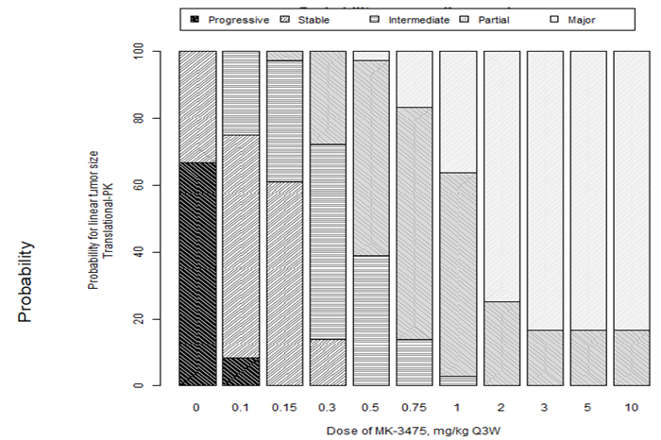
Probability predictions were derived under various scenarios for plausible human melanoma growth (fast, slow and intermediate) and tumour kill rate scaling (according to growth rate or blood flow), and took into account model parameter uncertainty for the fitted model components. The boundaries between different probability categories are defined as: Progressive: > 20% increase tumour size; Stable: between 20% increase and 10% decrease; Intermediate: 10% to 30% tumour size reduction; Partial: 30% to 50% tumour size reduction; Major: > 50% tumour size reduction.
Comment: The rationale for the higher doses tested in the melanoma cohorts (10 mg/kg Q3W or once every 2 weeks (Q2W)), was not discussed in the study report.

Efficacy

Studies providing efficacy data

Pivotal efficacy study - Study P001
Study P001 is an open label, Phase I trial with multiple parts and cohorts, as follows:
- Part A was conducted in subjects with solid tumours and consisted of three cohorts:
  - Cohort A was a dose escalation study using a conventional 3 + 3 design. Sequential groups of patients received doses of 1, 3 and 10 mg/kg every 2 weeks
  - Cohort A1 was a dose confirmation study in which all subjects received the maximum dose tolerated in Cohort A (which was 10 mg/kg Q2W). Cohort A1 commenced after completion of Cohort A
  - Cohort A2 explored the use of a 3 weekly dosage interval. Subjects in Cohort A2 were randomised to one of three cohorts, and received the dosage regimens summarised in Table 5. In this cohort, doses below 1 mg/kg were used during the first cycle to explore the relationship between pembrolizumab PK and PD
  - Enrolment in Cohort A2 commenced following completion of enrolment in Cohort A1.

Table 5. Study P001 Part A Cohort A2; dosage regimens
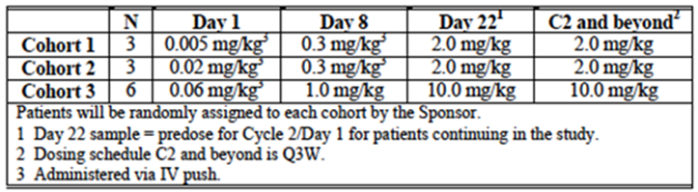
- Part B is being conducted in subjects with advanced melanoma and also consisted of three cohorts:
  - Cohort B1 enrolled subjects who were either ipilimumab (IPI)-naïve or IPI treated. Subjects were enrolled in one of three dosage cohorts: 10 mg/kg Q2W, 2 mg/kg Q3W or 10 mg/kg Q3W. Enrolment in these cohorts was in a sequential, non-randomised fashion
  - Cohort B2 enrolled subjects who were IPI refractory. They were randomised to receive treatment with either 2 mg/kg Q3W or 10 mg/kg Q3W
  - Cohort B3 enrolled subjects who were IPI naïve, IPI treated or IPI refractory. Subjects were randomised to receive 10 mg/kg Q2W or 10 mg/kg Q3W. The results for this cohort were not included in the study report as the data were premature, and hence no further review of this cohort will be included in this evaluation.
- Part C is being conducted in subjects with advanced NSCLC. All subjects were treated with 10 mg/kg Q3W.
- Part D is being conducted in subjects with advanced melanoma who were IPI naïve. Subjects were randomised to receive either 2 mg/kg Q3W or 10 mg/kg Q3W.
- Part F is being conducted in subjects with NSCLC and consisted of two cohorts. The results from this Part were not included in the study report, and hence no further review of this Part will be included in this evaluation.
  - Cohort F1 enrolled subjects with previously untreated disease, whose tumours expressed PD-L1. Subjects were randomised to receive 10 mg/kg Q2W or 10 mg/kg Q3W.
  - Cohort F2 enrolled subjects with previously treated disease, with or without PD-L1 expression. Subjects were randomised to receive 10 mg/kg Q2W or 10 mg/kg Q3W.
A summary of the various parts of the study is shown in Table 6.

Table 6. Summary of study parts. Study P001
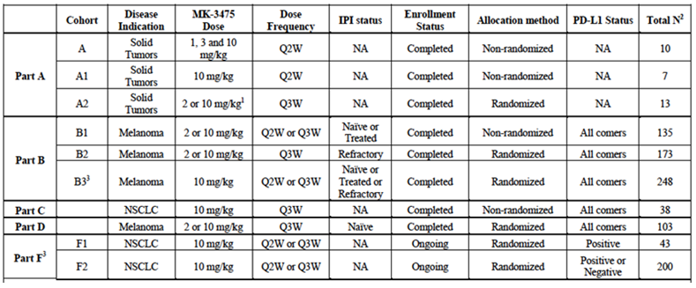
1 A2; three cohorts with separate Cycle 1 dose titration, followed by either 2 or 10 mg/kg Q3W starting with Cycle 2; 2 Total N as of 18 Oct 2013; 3 Not included in this interim Clinical Study Report (CSR); IPI = ipilimumab; NSCLC = non-small cell lung cancer; Q2W = every 2 weeks; Q3W = every 3 weeks; NA = not applicable
Comment: In terms of establishing the efficacy of pembrolizumab for the proposed indication of advanced melanoma, the relevant Parts of the study are Part B (Cohorts B1 and B2) and Part D. In these Parts, at least a proportion of the subjects received the proposed dosage regimen of 2 mg/kg Q3W. Review of efficacy data in this report will focus on these study Parts.
At one stage the study also included a Part E, to be conducted in NSCLC patients. This Part was subsequently removed from the protocol, apparently without any patients having been enrolled.
For a full description and evaluation of the study please see Attachment 2.

Evaluator’s conclusions on efficacy
The results of study P001 indicate that pembrolizumab produces objective responses in a substantial proportion of patients with advanced melanoma (approximately 33% overall). Meaningful response rates were also observed in the subgroup of subjects who had received 2 or more prior systemic therapies. These responses appear to be long lasting.
Median progression free survival (PFS) was 23.7 weeks (approximately 5.5 months). Overall survival data were not mature. No quality of life data were collected in the study.
The efficacy results observed compare favourably with those obtained with other agents registered for the treatment of advanced melanoma. For example, in the pivotal study that led to the approval of ipilimumab, the observed response rate was 10.9% (95% confidence interval (CI): 6.3 to 17.4) and median PFS was only 2.86 months (95%CI: 2.76 to 3.02).
Doses greater than 2 mg/kg Q3W were not associated with improved efficacy.
The data are limited in that pembrolizumab has not been compared with a registered agent in a randomised controlled trial. Its place in the therapy of advanced melanoma is therefore uncertain. However the data clearly indicate that the drug has clinically significant activity in this disease.
Efficacy is clearly superior in subjects with PD-L1 positive disease. Responses are achieved in only a small percentage of subjects with PD-L1 negative disease and data on the durability of such responses are limited.

Safety

Studies providing safety data
The main safety data included in the submission were those generated in study P001.
Cohorts A, A1 and A2 enrolled small numbers of patients with various malignancies. The safety data from these cohorts has been reviewed briefly (see Attachment 2).
Cohorts B1, B2 and D enrolled subjects with advanced melanoma (n = 411). These subjects are considered to be the main population of interest and will be the focus of the following review of safety.
Cohort C enrolled a population of subjects with NSCLC (n = 38). Data from these subjects will be presented separately.
The submission also included limited data on serious adverse events (SAEs) from other ongoing studies.

Patient exposure
Exposure to pembrolizumab in the pooled melanoma cohorts is summarised in Table 7. For all dosage regimens combined, the mean number of days on therapy was 238.9 (34 weeks). The median number of administrations was 10.0. Of the 411 subjects, 212 had received at least 6 months treatment and 115 had received at least 12 months treatment.

Table 7. Pooled melanoma cohorts (B1+B2+D); summary of drug exposure
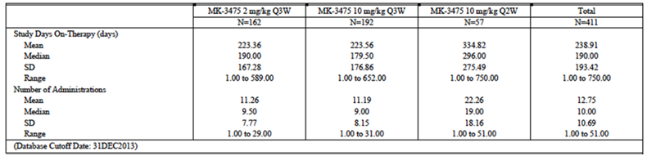

Safety issues with the potential for major regulatory impact

Liver toxicity
There were no cases suggestive of a potential for pembrolizumab to cause severe drug-induced liver injury.

Haematological toxicity
One case of pancytopaenia (grade 3) was reported in study P001. It resolved after treatment with steroids.

Serious skin reactions
No cases of Stevens-Johnson syndrome (SJS) or toxic epidermal necrolysis (TEN) were reported in study P001. However one case of SJS was reported in another ongoing study (Study 002). The investigator considered the case to be related to pembrolizumab.

Cardiovascular safety
Cardiovascular adverse events were not a prominent feature in the pooled melanoma cohorts. As of the October cut off, 39 out of 411 subjects (9.5%) had experience at least one cardiac adverse event (AE), and 67 out of 411 subjects (16.3%) had experienced at least one vascular AE. The AEs reported were provided.
The incidence of the more significant cardiovascular AEs was low:
- Grade 3 to 5 AEs 2.4% (cardiac) and 2.4% (vascular)
- Serious AEs 2.9% (cardiac) and 2.2% (vascular)
- Discontinuations due to AEs 0.2% (cardiac) and 0% (vascular).

Unwanted immunological events
Autoimmune type events were a notable feature of pembrolizumab.

Immunogenicity
The submission included a report on immunogenicity testing conducted during study P001 (Report No 03VXM4). Subjects enrolled in the trial had pre and post baseline serum samples collected for measurement of anti-drug antibodies (ADA). A total of 449 subjects had a baseline and at least one post-baseline sample available. The presence of circulating pembrolizumab can interfere in the analytical detection of ADA. For 129 out of the 449 patients (29%), pembrolizumab concentrations were sufficiently low in the last post-dose sample to confirm a negative immunogenicity status.
Two subjects tested positive for ADA (after both screening and confirmatory assays). One of these subjects was found to have a positive test on the baseline sample. Therefore only one subject was classified as having a treatment emergent positive test. This subject had negative testing at baseline and Day 22, a positive test at Day 83, and inconclusive testing on Days 169 and 254. Therefore the overall positivity rate was 1 out of (129 + 1) = 0.77%.
The PK of pembrolizumab in the two patients who had positive tests was similar to the PK of other subjects. The patient who developed a treatment emergent test achieved stable disease as a best response and had no evidence of hypersensitivity.

Safety data from other ongoing studies
The submission included tabulations of ‘notable’ SAEs that had occurred in other ongoing cohorts of P001 (Cohorts B3 and F) and other ongoing studies (P002, P006, P010 and P012). Many were consistent with an immune aetiology (pneumonitis, colitis/diarrhoea, hyperthyroidism, thrombocytopenia etcetera). There was one additional fatal AE.

Late breaking safety information
In October 2014 the sponsor distributed a ‘Dear Physician’ letter to doctors prescribing pembrolizumab in clinical trials or under the Special Access Scheme. The letter concerned pneumonitis/interstitial lung disease (ILD), and the fact that fatal cases had now been reported. A sponsor review of reported ILD events apparently indicated an incidence of 2.8% overall, 1.3% for grade 3 to 5 events and 0.15% for fatal events. A copy of the review was not provided. The letter emphasised the importance or early treatment with steroids.
For further detail of evaluation of safety please see Attachment 2.

Evaluator’s conclusions on safety
All subjects enrolled in P001 received pembrolizumab. The absence of any control arm makes interpretation of the safety data difficult, in that many of the reported AEs may have been due to the disease under study rather than the drug. Patients with advanced melanoma would be expected to experience a variety of AEs as a result of their disease.
Given the mechanism of action of pembrolizumab, autoimmune type toxicity might be expected. Such effects are a feature of ipilimumab, a drug with a similar mode of action to that of pembrolizumab. A variety of such effects were observed in study P001 (and the other ongoing trials). The overall incidence of events that met the criteria for adverse event of special interest (AEOSI) was 12.4%. About half of these events were rated as serious AEs or grade 3 to 5 in severity. The sponsor’s recent safety warning indicates that fatal events of pneumonitis/ILD have occurred. Other events observed included colitis, thyroid disorders, autoimmune hepatitis, hypophysitis and uveitis.
Common AEs in melanoma subjects included fatigue, arthralgia, gastrointestinal AEs and skin disorders. However, most of these events were grade 1 to 2 in severity and not considered serious.
The overall incidence of serious AEs was fairly high at approximately 34.8%. However, SAEs that were assessed as drug related occurred in only 8.8% of subjects. Similarly, grade 3 to 5 events occurred in 39.7% of subjects, but drug related grade 3 to 5 events occurred in only 12.7%. Apart from fatal cases of pneumonitis reported recently by the sponsor, there was no clear evidence that pembrolizumab caused fatal AEs.
Approximately 9% of subjects had to discontinue pembrolizumab due to AEs. According to the investigators, only 3.9% of subjects discontinued due to AEs that were related to pembrolizumab. This suggests that pembrolizumab toxicity is manageable with the dose delays used in P001.
In general, toxicity did not appear to be related to dose, over the 2 to 10 mg/kg range when the drug was given at 3 weekly intervals. The incidence of AEs appeared to be increased in the subgroup of patients who received 10 mg/kg Q2W. However, this may have been due to a longer period of follow-up in this group. If this is so, the incidence of AEs in the 2 mg/kg Q3W would be expected to increase with further follow-up and the data in the study report might underestimate the long-term toxicity of the proposed 2 mg/kg Q3W regimen.
Pembrolizumab is intended for subjects with a serious life threatening disease and a limited life expectancy. The safety profile of pembrolizumab described above should not preclude its use in such a population. The drug is therefore considered to have acceptable safety given the intended patient population.

First round benefit-risk assessment

First round assessment of benefits
The benefits of pembrolizumab in the proposed usage are:
- Significant reduction in tumour size in a substantial proportion of patients (approximately 33%). The early data suggest that such effects are durable.

First round assessment of risks
The risks of pembrolizumab in the proposed usage are:
- Autoimmune phenomena such as pneumonitis, colitis, etcetera
- A variety of other adverse effects including fatigue, arthralgia, gastrointestinal and skin events. However, most of these are mild or moderate in severity (that is, grade 1 or 2).

First round assessment of benefit-risk balance
Overall, it is considered that the benefits of pembrolizumab outweigh its risks. However, the data submitted with this application are early. Specific limitations of the data include the following:
- Data on the duration of tumour responses was not mature
- There were no randomised comparisons of pembrolizumab against other agents registered for use in the proposed patient population, for example:
  - ipilimumab which is registered for patients who have failed prior therapy
  - BRAF inhibitors (for example vemurafenib and dabrafenib), which are registered for the treatment of BRAF mutation positive disease.
Both of these therapies have been demonstrated to produce benefits in terms of overall survival or progression free survival. In the absence of any randomised controlled trials, it cannot be concluded that pembrolizumab produces similar benefits.
Regulatory approval of new anticancer agents usually requires a favourable risk-benefit ratio demonstrated in a Phase III study using time-to-event endpoints such as overall survival or progression free survival. However, in situations where the indication is a life threatening condition and there are no other established therapies available, approvals have been granted based on non-comparative Phase II studies which used response rate as an endpoint.
The indication proposed by the sponsor is:
‘for the treatment of unresectable or metastatic melanoma in adults’.
This is a broad indication, which would include patients eligible for treatment with ipilimumab or BRAF inhibitors, even though comparable efficacy has not been demonstrated. The sponsor is currently conducting randomised controlled trials in melanoma comparing pembrolizumab with chemotherapy (Study P002) and ipilimumab (Study P006).
It is therefore recommended that pembrolizumab be approved for registration, but with a more restricted indication than the one proposed by the sponsor. The indication currently approved in the USA would be appropriate:
‘for the treatment of patients with unresectable or metastatic melanoma and disease progression following ipilimumab and, if BRAF V600 mutation positive, a BRAF inhibitor.’
The risk-benefit balance is less favourable in subjects with PD-L1 negative disease, due to limited efficacy. It may be appropriate to further limit the indication to subjects with PD-L1 positive tumours. However this would require the availability of appropriate testing. The sponsor should be asked to comment on this issue.

First round recommendation regarding authorisation
It is recommended that the application be approved, but with the restricted indication outlined above.

Clinical questions

Efficacy

Question 1
The sponsor was asked to provide a short summary of any updated/new efficacy data relating to the following:
- Duration of response in the melanoma cohorts (B1, B2 and D) of Study P001. Any updated data on duration of response in subjects with PD-L1 negative disease should also be provided
- Overall survival in the melanoma cohorts (B1, B2 and D) of Study P001
- The relationship between biomarkers (other than PD-L1) and efficacy outcomes in melanoma in study P001
- Results from Cohort B3 in Study P001
- Results from the Phase III melanoma studies P002 and P006.

Question 2
The sponsor was asked to comment on the availability in Australia of IHC testing for tumour expression of PD-L1. Are there any plans for the assay used in Study P001 to be made commercially available?

Second round evaluation of clinical data submitted in response to questions
The evaluation of the response to the clinical questions has been addressed in the Delegate’s review of the submission.

V. Pharmacovigilance findings

Risk management plan
The sponsor submitted a Risk Management Plan EU-RMP, version 1.0, dated 20 May 2014 and Australian Specific Annex (ASA), dated August 2014 which was reviewed by the RMP evaluator.

Safety specification
The sponsor provided a summary of ongoing safety concerns which are shown at Table 8.
Table 8. Summary of ongoing safety concerns
Ongoing safety concerns
Important identified risks | Thyroid Disorder (hypothyroidism, hyperthyroidism)  Colitis  Hepatitis  Pneumonitis
Important potential risks | Other endocrine disorders (hypopituitarism, hypophysistis)  Uveitis  Myositis  Nephritis
Missing Information | Safety in patients with moderate of severe hepatic impairment  Safety in patients with moderate or severe renal impairment  Safety in patients with autoimmune disease  Safety in patients with HIV or Hepatitis B or Hepatitis C  Paediatric patients  Reproductive and lactation data  Long term safety  Safety in various ethnic groups  Potential pharmacodynamics interaction with systemic immunosuppressant’s

Pharmacovigilance plan
The sponsor proposes to conduct only routine pharmacovigilance activities for all ongoing safety concerns.
The following clinical studies enrolling melanoma patients are ongoing at the time of evaluation, and include Australian patients:
- Study P001
- Study P002
- Study P006
The Study P010 is an ongoing clinical study enrolling non-melanoma patients (small cell lung cancer) as part of the company’s ongoing clinical development program, and includes Australian patients:
The following clinical studies are ongoing enrolling patients with different cancer types, as part of the company’s ongoing clinical development program, and do not include Australian patients: Study P012, Study P013, Study P016, Study P021 and Study P028.

Risk minimisation activities
The sponsor concludes that routine risk minimisation activities are sufficient to mitigate any safety concerns associated with use of the product.

OPR reviewer comment:
Although Keytruda would be the first product on the market targeting the PD-1 pathway, a product targeting the CLTA-4 pathway, which exerts its effect through the same mechanism of action, is registered in Australia. Based on its mechanism of action, it appears that the side effect profile of Keytruda is similar to that of Yervoy and therefore, it would be appropriate that the same risk-minimisation activities are carried out for Keytruda that are implemented for Yervoy. Moreover, due to the currently limited knowledge about the safety profile of the product, it is considered appropriate that the sponsor implements additional risk minimisation activities, to educate prescribers and patients about the safety related product characteristics.
It is recommended that the sponsor considers implementing additional risk minimisation activities, including a Healthcare Professional frequently asked questions (FAQ) Brochure and Patient Information Brochures including Alert Cards. The information to be provided in these documents should have a similar content as documents used as additional risk minimisation activity tools for Yervoy (ipilimumab) in Australia. Please refer to the EMA website using Yervoy as search term, and refer to the following document ‘Conditions or restrictions with regard to the safe and effective use of the medicinal product to be implemented by the member states’.
Implementation of such additional risk minimisation activities will ensure that physicians are comprehensively informed about possible side effects and their management. Moreover, it will ensure that patients understand the side effects of the drug and how to identify possible complications at an early stage, and are able to communicate these to HCPs involved in their care. These additional activities should remain in place until there is sufficient market experience with Keytruda to justify cessation of these activities.

Reconciliation of issues outlined in the RMP report
Table 9 summarises the first round evaluation of the RMP, the sponsor’s responses to issues raised the RMP evaluator’s evaluation of the sponsor’s responses.
Table 9. Reconciliation of issues outlined in the RMP report
Recommendation in RMP evaluation report | Sponsor’s response | OPR evaluator’s comment
It is recommended that the table of ongoing safety concerns be amended as follows: The following identified risks should be added to the table of ongoing safety concerns: A.) Renal adverse events (including. Nephritis, renal failure), B.) Respiratory disorders (including. Pneumonitis), C.) Skin disorders, D.) Gastrointestinal disorders, E.) Abnormal laboratory values.  The following potential risks should be added to the table of ongoing safety concerns: F.) Immunogenicity / Hypersensitivity, G.) Other immune related adverse events;  The following missing information should be added to the table of ongoing safety concerns: H.) Safety in patients with an active infection, I.) Interaction with contraceptives. | Please note the information provided below is a short summary of the sponsor’s response.  A.) The sponsor describes that ‘nephritis’ has been reclassified from an important potential risk to an important identified risk. Furthermore, the sponsor describes that ‘renal failure’ was reviewed, but at this time there was no sufficient clinical details to support a causal relationship with pembrolizumab.  B and D.) The sponsor states in their response: Some of the general categories of events that were reviewed included respiratory disorders, acute renal failure, and gastrointestinal disorders. At this time, only those specific diagnoses of pneumonitis, nephritis and colitis in the respective general categories were found to have sufficient clinical details to support a possible causal relationship with pembrolizumab and warrant inclusion in the EU RMP.  C.) The sponsor states that reviews of the Merck Adverse Event Reporting and Review System (MARRS) database, as of 31 August 2014, led to the addition of the potential risk of ‘severe skin reactions’. No detailed data was provided for assessment.  E.) Abnormal laboratory values. The sponsor states in their response: The sponsor’s opinion is that there is no evidence to add ‘Abnormal laboratory values’ to the updated EU RMP as a risk at this time. The sponsor continues to monitor laboratory abnormalities in the clinical trial and post marketing settings for pembrolizumab.  F) Immunogenicity/ Hypersensitivity. The sponsor is closely monitoring anti-MK-3475 antibodies during the melanoma clinical development and during the development in multiple other indications. No safety risk has been identified. Therefore, ‘immunogenicity’ is not being added to the updated EU RMP as a risk at this time. If it is shown that anti-drug antibodies are associated with efficacy or safety concerns, the sponsor will update product labelling and the RMP as appropriate.  G.) Other immune related adverse events. The sponsor states in their response: A general category of ‘other immune related adverse events’ is not being added to the EU RMP as a risk at this time. However, in the updated EU RMP v1.1 the risks will be categorised and grouped more clearly as immune-mediated within both the identified and potential risks where applicable. In addition, the sponsor is sensitive to the potential for PD1 inhibitors to cause immune-mediated adverse reactions and therefore, SAEs and AEOSIs across the clinical program that may be immune mediated are routinely reviewed to determine if there is sufficient evidence to add the event as a risk in the EU RMP.  H.) The sponsor disagrees to add this missing information, based on limited evidence of efficacy and safety of patients treated for infection while on pembrolizumab.  I.) The sponsor has provided a rationale as to why no interaction with the efficacy of contraceptives is expected. | A.) This is considered acceptable. However, further pharmacovigilance activities to comprehensively characterise the safety profile of pembrolizumab are recommended.  B and D.) This is considered acceptable. However, further pharmacovigilance activities to comprehensively characterise the safety profile of pembrolizumab are recommended.  C.) The sponsor should provide justification as to why this adverse event was added as potential risk rather than an identified risk.  E.) Abnormal laboratory values. This is considered acceptable. However, further pharmacovigilance activities to comprehensively characterise the safety profile of pembrolizumab are recommended.  F.) Immunogenicity/ Hypersensitivity. This is considered acceptable. However, further pharmacovigilance activities to comprehensively characterise the safety profile of pembrolizumab are recommended.  G) Other immune related adverse events. This is considered acceptable. However, further pharmacovigilance activities to comprehensively characterise the safety profile of pembrolizumab are recommended.  H.) This is considered not acceptable as there is only limited safety data available for this patient group, as stated by the sponsor. This recommendation remains and is supported by Advisory Committee for the Safety of Medicines (ACSOM).  I) This is considered acceptable
The sponsor should provide an attachment to the ASA setting out all the forthcoming studies and the anticipated dates for their submission in Australia | As the study progress of the on-going clinical trials outlined in the EU-RMP are dynamic in nature, an anticipated date for submission in Australia for the forthcoming studies would be difficult to predict, so MSD does not agree to include these studies in the ASA. The safety profile of Keytruda is constantly being evaluated on an integrated basis during these trials. For the purpose of providing safety updates from on-going clinical trials to the TGA, the sponsor confirms that Periodic Safety Update Reports (PSUR), as outlined in the EMA ‘Guideline will be provided on a 6 monthly basis. The PSURs will contain all safety data collected by the sponsor, including data from clinical trials and in-market use in territories where Keytruda is approved. Changes to the safety profile of Keytruda will be communicated via changes in labelling, individual case reporting and the periodic PSURs. | This is considered acceptable
It appears that safety related data which will be collected during ongoing clinical studies will address some of the ongoing safety concerns. Consequently, it is recommended that the sponsor amends table 46 of the EU-RMP (Overview of Pharmacovigilance Actions), and any other table as appropriate, to assign safety concerns to the ongoing clinical studies. | The sponsor agrees to update Table 46 ‘Overview of Pharmacovigilance Actions’ in the current EU RMP v1.1 to reflect generally the current on-going clinical trials as they will contribute important safety data to the overall understanding of ongoing safety concerns | The sponsor’s response cannot be verified because no updated RMP was provided with the response.  It is recommended that the sponsor provides the updated RMP for review prior to approval.
The study protocols for the PIP have not been attached to the RMP, and it is recommended that the sponsor provides these as annex to the EU-RMP. Furthermore, these studies should be assigned to the ongoing safety concerns of safety in paediatrics in the pharmacovigilance plan of the RMP. | Section SIV.3 ‘Limitations in Respect to Populations Typically Under-represented in Clinical Trial Development Programmes’ and Table 49 ‘Overview of Pharmacovigilance Actions’ of the EU RMP v.1.1 have been updated to include the PIP study as a pharmacovigilance activity to address the missing information of ‘Safety in use in paediatric patients’.  Furthermore, the sponsor agrees to include the available study protocol for the PIP in an annex to the EU RMP v1.1, and future PIP study protocols will be added when available. | The sponsor’s response cannot be verified because no updated RMP was provided with the response.  It is recommended that the sponsor provides the updated RMP for review prior to approval.
As the safety data base is relatively small, it is recommended that the sponsor implements further pharmacovigilance activities, to ensure the safe use of the product, should it be approved. This includes, but is not limited to: A.) Implementation of follow-up forms for all identified and potential risks, in order to collect comprehensive information about the causality and outcome of adverse events. B.) Implementation of a Post Authorisation Safety Study (PASS) to collect detailed information about the safety profile of the product. | The sponsor requests follow up information on spontaneous adverse event reports received for pembrolizumab utilizing Standard Operating Procedures. In addition, the sponsor agrees to utilise an additional follow-up form to collect important information on the identified and potential risks, immune related events and infusion related reactions, reported with pembrolizumab as part of routine pharmacovigilance activities.  Although the initial cohort for which safety assessments have been the basis of the RMP is generally small, the sponsor believes that a PASS is not necessary at this time given the number of on-going clinical trials with pembrolizumab and the planned studies across all indications from which valuable safety information will be obtained. Specifically, the number of patients exposed to pembrolizumab as of August 2014 from protocols 001, 002, 006, 010, 012, 013, 025 and 028 (patients receiving at least one dose of pembrolizumab) is 3,251 across the following tumour types: melanoma, lung, hematologic malignancies; and multiple solid tumour types. In addition, 1,787 patients were exposed to pembrolizumab in the melanoma Expanded Access Program (EAP 030). Therefore, the overall exposure to pembrolizumab as of August 2014, including all studies and the EAP, is 5,038 patients. All of these on-going and planned clinical trials will provide valuable data sets and help to inform the sponsor regarding ongoing safety concerns and to identify future safety signals. In addition, there has been no specific safety concerns identified for which a specific study would be required to address. The ongoing clinical trial program will provide adequate information to characterise the safety profile of pembrolizumab. | A.) The sponsor’s commitment to implement additional follow-up forms to collect important information on the identified and potential risks, immune related events and infusion related reactions, reported with pembrolizumab has been noted. It is recommended that these additional follow-up forms are included in the pharmacovigilance plan of the RMP, and are attached to an updated RMP as an annex.  B.) The recommendation to implement additional pharmacovigilance activities remains and is supported by ACSOM.
It is recommended that the sponsor considers implementing additional risk-minimisation activities; including a Healthcare Professional FAQ Brochure and Patient Information Brochures including alert cards. | The sponsor is committed to provide comprehensive information, based on the PI to prescribers in Australia. The sponsor considers routine risk minimization (the PI) adequate for the pembrolizumab RMP. Based on the current benefit: risk profile for pembrolizumab, there is no evidence that additional risk minimization activities beyond those planned by the sponsor are warranted. The PI comprehensively communicates risks for pembrolizumab and provides clear guidance for identification, treatment of the risks associated with pembrolizumab, and recommendations for discontinuation or temporary interruption of therapy accordingly to the severity by observed risk. The sponsor will be providing educational materials to prescribers and patient information that will enhance the product labelling awareness for pembrolizumab. The sponsor also considers that the oncology community is now familiar with immunotherapy for melanoma. Adoption of appropriate patient management for a new oncology product into treatment practices will be adequately supported by labelling with product specific educational materials provided by the sponsor to support product launch. | A.) The sponsor’s response is unclear and further clarification is sought to address this recommendation. The sponsor stated in their response: The sponsor considers routine risk minimization (the PI) adequate for the pembrolizumab RMP. In contrast the sponsor also states: The sponsor will be providing educational materials to prescribers and patient information that will enhance the product labelling awareness for pembrolizumab.  The sponsor should clarify if educational materials for physicians and patients will form part of the RMP, and if so, this activity should be incorporated in the risk-minimisation plan of the RMP and these documents attached to the updated RMP as an annex.  B.) Pending the clarification by the sponsor, the recommendation to implement additional risk-minimisation activities remains and is supported by ACSOM.
It is recommended that the sponsor amends table 65 of the EU-RMP (Summary of Safety Concerns and Risk Minimization Activities) to describe only risk-minimisation activities but not pharmacovigilance activities. | Part V ‘Risk Minimization Measures’, V.3 ‘Summary Table of Risk Minimization Measures’, Table 73 ‘Summary of Safety Concerns and Risk Minimization Activities’ of the EU-RMP has been modified and includes the routine risk minimization activities for each listed safety concern. | The sponsor’s response cannot be verified because no updated RMP was provided with the response.  It is recommended that the sponsor provides the updated RMP for review prior to approval.
A table comparing the wording in the Australian-PI with the EU-SmPC should be provided as annex to the ASA. | A table comparing the proposed EU SmPC, US monograph and the proposed Australian PI is provided as an attachment to the ASA. The documents are generally consistent, and any differences between the relevant sections are typically due to the different layouts of the documents. | The table has been provided by the sponsor. This is considered acceptable.
It is recommended that the sponsor outlines the wording, by which important safety concerns are addressed in the US monograph compared to the proposed Australian PI, and material differences in the Australian PI should be justified. | A table comparing the US monograph, the proposed Australian PI and the proposed EU SmPC is provided as an attachment to the Australian-Specific Annex. The documents are generally consistent, and any differences between the relevant sections are typically due to the different layouts of the documents. | The sponsor’s response has been noted.
The following is brought to the delegate’s attention. The following statement is included in the Australian PI in section ‘dosage and administration’: The recommended dose of Keytruda is 2 mg/kg administered intravenously over 30 minutes every 3 weeks. Patients should be treated with Keytruda until disease progression or unacceptable toxicity. Atypical responses (that is, an initial transient increase in tumour size or small new lesions within the first few months followed by tumour shrinkage) have been observed. Clinical stable patients with initial evidence of disease progression should remain on treatment until disease progression is confirmed. The RMP evaluator raises the following issues: A.) It may be appropriate for the sponsor to provide further clarification about how disease progression should be defined, in order to justify cessation of treatment with Keytruda, B.) The underlined writing is not included in the US monograph, where the product is registered since September 2014. | Merck proposes to inform prescribers that atypical responses can occur to Keytruda, and that prescribers should confirm progression in patients who are clinically stable so that they do not prematurely discontinue treatment. In P001, patients were allowed to remain on study treatment after an initial disease assessment of progression until a second disease assessment at least 4 weeks later was performed. If disease progression is confirmed, then patients should discontinue Keytruda; if disease progression is not confirmed, then patients may continue Keytruda.  In the U.S. prescribing information, the above language was included in the initial labelling information proposed to FDA. After FDA review, language on patient management in P001 was relocated to the clinical studies section, and reworded as follows:  ‘Patients were randomised to receive 2 mg/kg (n = 89) or 10 mg/kg (n = 84) of Keytruda Q3W until unacceptable toxicity or disease progression that was symptomatic, was rapidly progressive, required urgent intervention, occurred with a decline in performance status, or was confirmed at 4 to 6 weeks with repeat imaging.’ | It appears that the writing in bold was initially included in the US prescribing information, but was subsequently removed, and more detailed information was included in the clinical trial section. This is in line with the recommendations made by the RMP evaluator to more clearly define disease progression, and to consider the acceptability of the underlined statement in the proposed form.  It is recommended to the Delegate that additional wording, as it is included in the US prescribing information, be included in the Australian PI. This will provide a clearer description as to how disease progression was determined during the clinical development program, and will provide guidance to physicians as to how disease progression should be defined in the context of treatment with pembrolizumab.
Amendments to the PI and CMI as follows: In regard to the proposed routine risk minimisation activities, it is recommended to the Delegate that the draft PI be revised as follows:  A.) The sponsor should add a statement in the PI describing that the product has been derived using mammalian cells of Hamster origin. B.) The sponsor should add a statement informing health care professionals that patients with active infections should be appropriately treated prior to commencement of therapy with Keytruda. C.) The sponsor should amend the PI to include a statement describing that only experienced oncologists should administer the product.  In regard to the proposed routine risk minimisation activities, it is recommended to the Delegate that the draft CMI document be revised as follows:  D.) The sponsor should add a statement in the CMI informing patients with a known allergy to Hamster protein to be more cautious when receiving Keytruda. | The amended PI is provided. | A.) The sponsor has added a statement as recommended.  Pending the Delegate’s approval, this is considered acceptable.  B.) The sponsor has not included a statement as recommended. Of relevance the sponsor states in their response: it was recommended that the patient’s active infection be treated prior to the start of therapy with pembrolizumab in study P001.  As such a recommendation was made during the clinical development program, and there is no safety data available for patients being treated with an active infection, this recommendation to the Delegate remains.  C.) The sponsor has added the following statement: Treatment must be initiated and supervised by healthcare professionals experienced in the treatment of cancer.  It is recommended to the Delegate that this statement be amended to: Treatment must be initiated and supervised by specialist physicians experienced in the treatment of cancer.  D.) The sponsor has not included a statement as recommended.  This recommendation remains.

Summary of recommendations

Outstanding issues

RMP related issues remaining from the round 1 RMP report
- The sponsor should provide justification as to why ‘Skin disorders’ was added as potential risk rather than an identified risk to the table of ongoing safety concerns.
- It is recommended that ‘Safety in patients with an active infection’ be added as missing information to the table of ongoing safety concerns.
- As the safety data base is relatively small, it is recommended that the sponsor implements further pharmacovigilance activities in Australia, to ensure the safe use of the product, should it be approved. This includes, but is not limited to: 1.) Implementation of a Post Authorisation Safety Study (PASS) to collect detailed information about the safety profile of the product.
- It is recommended that the sponsor implements additional risk-minimisation activities in Australia; including a Healthcare Professional FAQ Brochure and Patient Information Brochures including alert cards.

New issues arising following the evaluation of the sponsor’s response
- It is recommended that the sponsor provides the updated RMP for review prior to approval.
- It is recommended that additional follow-up forms are included in the pharmacovigilance plan of the RMP, and that these forms are attached to an updated RMP as an annex.
- It is recommended that the sponsor clarifies if educational materials for physicians and patients will form part of the RMP, and if so, this activity should be incorporated in the risk-minimisation plan of the RMP, and these documents attached to the updated RMP as an annex.

Recommendations to the delegate in relation to the PI/CMI
- It is recommended to the delegate that a clearer description as to how disease progression was defined in the context of treatment with pembrolizumab during the clinical development program is provided in the PI.
- The sponsor should add a PI statement informing health care professionals that patient’s with active infections should be appropriately treated prior to commencement of therapy with Keytruda.
- The sponsor should amend the PI to include a statement describing that only specialist physicians should administer the product.
- The sponsor should add a statement in the CMI informing patients with a known allergy to Hamster protein to be more cautious when receiving Keytruda.

Additional recommendations regarding the PI/CMI made by ACSOM
- Hypophysitis was a serious Potential Risk that needs to be highlighted in information to prescribers, as it can be fatal if unrecognised.
- A number of the exclusion criteria for the clinical trials do not appear in the PI as contraindications. The committee advised this should also be done as the safety of this medicine in these patient groups was certainly not established.
- The committee advised that the CMI appeared bland and needed to highlight that the medicine was novel, its approval was based on limited safety information, and positive and negative events related to the medicine may occur after treatment had ceased. The committee considered that such caveats could also appear in the PI.

Key changes to the updated RMP
In their response to the TGA requests for information the sponsor states that the following changes will be made to an updated version of the RMP (version 1.1). However, the updated RMP has not been provided for assessment.
- Elevation of some important potential risks to important identified risks in the EU RMP that were considered immune-mediated adverse reactions, including hypophysitis, hypopituitarism, including secondary adrenal insufficiency; nephritis; and uveitis.
- Two new important identified risks were recently added to the safety risk profile, an immune mediated adverse reaction of Type 1 Diabetes Mellitus (T1DM) and an adverse reaction of infusion related reactions.
- One new important potential risk was added, severe skin reactions, which is considered an immune mediated adverse event.
- The missing information section of the EU RMP is also being updated to include: Safety in patients with previous hypersensitivity to another monoclonal antibody; and, Safety in patients with intolerance to ipilimumab or with ongoing ipilimumab related AEs.

Suggested wording for conditions of registration

RMP
Due to various outstanding RMP issues, and because the updated EU-RMP version 1.1 cited by the sponsor, has not been reviewed by the TGA, no specific wording can be provided at this time.

VI. Overall conclusion and risk/benefit assessment
The submission was summarised in the following Delegate’s overview and recommendations.

Introduction

Clinical development programme
Pembrolizumab is a monoclonal antibody against PD-1. The current application is for use in unresectable or metastatic melanoma, but pembrolizumab is also being tested in patients with NSCLC, triple negative breast cancer, urothelial cancer, head and neck cancer, gastric cancer and hematologic malignancies. Table 10 summarises pembrolizumab studies across these cancer types; clinicaltrials.gov suggests even broader testing.

Table 10. Pembrolizumab clinical development programme
Study | Description, Phase | Design | Number of patients | Duration of follow up | Estimated / Actual completion | Updated description (data cut off 31 July 2014)
Melanoma
P001 Parts B and D | Phase I Study of Single Agent MK-3475 in Patients with Progressive Locally Advanced or Metastatic Carcinoma, Melanoma, and Non- Small Cell Lung Carcinoma; Phase I | Open-Label | Target: 1246 pts  Actual: 1191 pts  (for all P001) | 24 m¹ | December 2016 | KEYNOTE001 was the initial phase I study that was expanded to include cohorts of melanoma and NSCLC patients. Cohort B and D include 656 melanoma patients including ipilimumab-treated and ipilimumab-naïve patients.
P002 | Randomised, Phase II Study of MK-3475 versus Chemotherapy in Patients with Advanced Melanoma; Phase II | Open label (MK dose is blinded) | Target: 510 pts;  Actual: 540 pts | 24 m | June 2016 | KEYNOTE002 is an ongoing clinical trial comparing two doses of pembrolizumab (2 mg/kg Q3W or 10 mg/kg Q3W) versus investigator’s choice of standard of care chemotherapy in patients who have failed prior ipilimumab treatment. These data include 449 patients who received pembrolizumab including 91 patients who crossed over to pembrolizumab after progressing on the comparator.
P006 | A Multicentre, Randomised, Controlled, Three-Arm, Phase III Study to Evaluate the Safety and Efficacy of Two Dosing Schedules of MK-3475 Compared to Ipilimumab in Patients with Advanced Melanoma; Phase III | Open-label | Target: 645 pts;  Actual: 831 pts | 36 m | July 2016 | KEYNOTE006 is an ongoing study of two doses of pembrolizumab (10 mg/kg Q2W or 10 mg/kg Q3W) versus ipilimumab. Of note, cross over to pembrolizumab is not permitted in this study compared to KEYNOTE002 above. A total of 556 patients have been treated with pembrolizumab in KEYNOTE006.
NSCLC
P001 Parts C and F | Phase I Study of Single Agent MK-3475 in Patients with Progressive Locally Advanced or Metastatic Carcinoma, Melanoma, and Non- Small Cell Lung Carcinoma; Phase I | Open-Label | Target: 1246 pts  Actual: 1191 pts  (for all P001) | 24 m | December 2016 | KEYNOTE001 is the phase I study that included two cohorts with NSCLC patients. Cohort C was the preliminary NSCLC 3rd line cohort. Cohort F includes NSCLC patients with various lines of therapy including patients without prior chemotherapy. A total of 549 NSCLC patients have been treated in KEYNOTE001 (39 in C, 510 in F).
P010 | A Phase II/III Randomised Trial of Two Doses of MK-3475 (SCH900475) versus Docetaxel in Previously Treated Subjects with Squamous Histology Non-Small Cell Lung Cancer; Phase II/III | Open-Label for study therapy; PDL1 expression level = blinded | Target: 920 pts;  Actual: 170 pts | 30 days and survival follow-up | September 2015 | KEYNOTE010 is an ongoing randomised trial of pembrolizumab two doses (2 mg/kg Q3W or 10 mg/kg Q3W) versus docetaxel 75 mg/m2. Patients were required to have had progression on or after prior platinum-based chemotherapy. Cases are included for patients who had at least one dose of pembrolizumab. Approximately 323 NSCLC patients had been treated in KEYNOTE010.
P011/025 |  |  |  |  |  | KEYNOTE011/025 are ongoing NSCLC studies in Japan using a range of doses. A total of 40 patients have been enrolled to date.
P021 | A Phase I/II Study of MK-3475 (SCH900475) in Combination with Chemotherapy or Immunotherapy in Patients with Locally Advanced or Metastatic NSCLC; Phase I/II | Open Label | Target: 320 pts;  Actual: 1 pts | Survival follow-up | May 2016
Other
P001 Part A | Phase I Study of Single Agent MK-3475 in Patients with Progressive Locally Advanced or Metastatic Carcinoma, Melanoma, and Non- Small Cell Lung Carcinoma; Phase I | Open-Label | Target: 1246 pts Actual: 1191 pts (for all P001) | 24 m | December 2016 | KEYNOTE001 Cohort A included 30 patients with different solid tumour types for dose ranging. A total of 30 patients received pembrolizumab in this cohort.
P012 | A Phase Ib Multi-Cohort Study of MK-3475 in Subjects with Advanced Solid Tumours; Phase I | Nonrandomised, open label study | Target: 114 pts Actual: 160 pts | Survival follow up every 12 weeks until death or end of study | May 2015 | KEYNOTE012 is a phase II study of pembrolizumab in patients with triple negative breast cancer, head and neck cancer, urothelial cancer, or gastric cancer. A total of 225 patients have been treated with pembrolizumab.
P013 | A Phase Ib Multi-Cohort Study of MK-3475 in Subjects with Hematologic Malignancies; Phase I | Open-Label | Target: 106 pts; Actual: 36 pts | 12 weeks | April 2016 | KEYNOTE013 is a phase II study in patients with hematologic malignancies. A total of 69 patients have been enrolled in this trial.
P016 | Phase 2 Study of MK-3475 in Patients with Microsatellite Unstable (MSI) Tumours;  Phase I | Open-Label | Target: 71 pts; Actual: 10 pts | 3 m | September 2017
P028 | Phase IB Study of MK- 3475 in Subjects with Select Advanced Solid Tumours; Phase Ib | Nonrandomised, open label study | Target: 320 pts; Actual: 10 pts | Survival follow up every 12 weeks until death or end of study | October 2015 | KEYNOTE028 is a phase II study of 20 different tumour types that are PDL1+. A total of 353 patients have been enrolled.
¹ m = months

Unresectable or metastatic melanoma
The sponsor has applied for an indication in unresectable or metastatic melanoma. By metastatic melanoma, this is taken to mean distant metastatic melanoma (Stage IV), as opposed to regional and distant metastasis (Stages III and IV). This aligns with a key inclusion criterion in P002 (‘…unresectable stage III or metastatic melanoma not amenable to local therapy’). Figure 2 shows melanoma staging.
Figure 2. NCCN guidelines version 1.2015 staging melanoma part 1
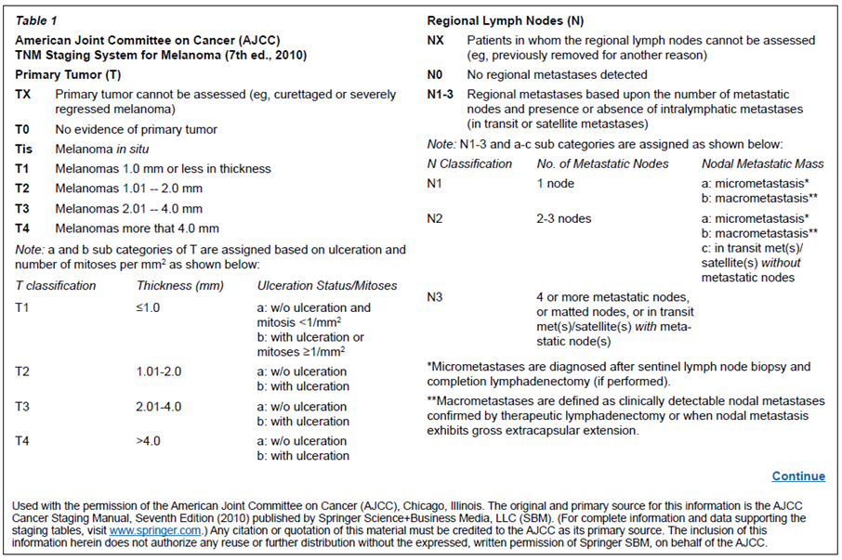
Figure 2(cont) NCCN guidelines version 1.2015 staging melanoma
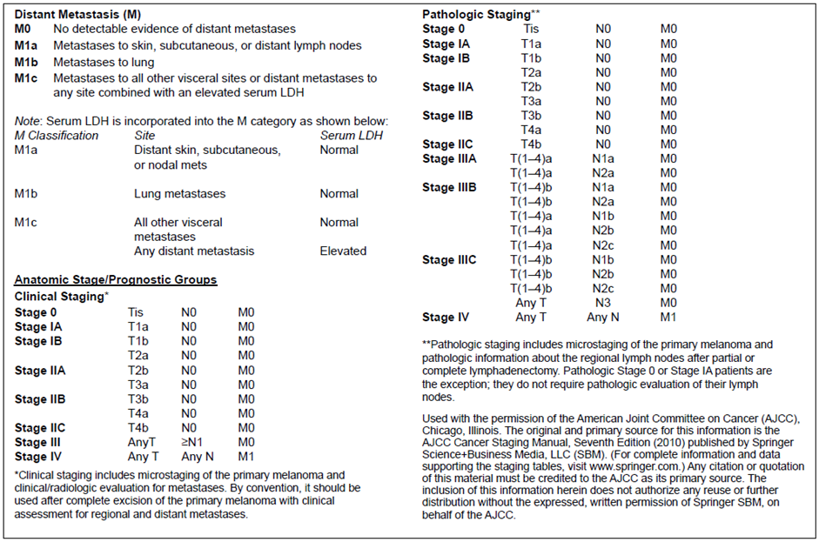
Some prognostic factors in cutaneous melanoma are listed below (from Up-to-date 7618.27).
- Stage of disease (integrating: primary tumour thickness, ulceration and mitotic rate; regional lymph node status; presence of distant metastases; lactate dehydrogenase LDH level)
- Age (advancing age is associated with worse prognosis)
- Gender (male gender is associated with worse prognosis)
- Anatomic location.
The prognostic value of interactions between melanoma and the immune system has also been studied. Lo and Fisher noted in a recent review of melanoma:
The importance of immune responses in melanoma has long been appreciated, with reports of spontaneous melanoma regressions published more than 50 years ago. The cancer immune surveillance hypothesis, which posits that adaptive immunity can prevent cancer development and progression, was supported by observation of higher melanoma incidence in immunosuppressed patients. Early discovery of immune infiltrates and tumour specific antibodies as positive prognostic factors provided additional evidence of immune interactions with melanoma.
Absence of a lymphocytic infiltrate is associated with worse prognosis.
In 81 patients, Breslow thickness and PD-L1 membrane positivity were independent risk factors for melanoma specific death. Using a 5% cut off for PD-L1 positivity (at which threshold, 30 out of 81 patients [37%] were considered to have PD-L1 positive tumours), the hazard ratio for melanoma specific death was 3.9. The authors suggested PD-L1+ melanomas are more aggressive, based on study of PD-L1+ and PD-L1- cell lines. 40% of metastatic but 14% of primary melanoma samples were PD-L1+; in 17 out of 22 patients the metastatic site was positive but the primary tumour was negative. The interpretation was that PD-L1 is expressed during disease progression.
The sponsor states that ‘literature data are divided on the prognostic significance of PD-L1 expression in melanoma’.

Targets and mechanism of action
Pembrolizumab is a humanised monoclonal antibody (IgG4/kappa isotype) against the cell surface receptor PD-1. Pembrolizumab inhibits PD-1 – PD-L signalling.
The role of PD-1 to PD-L signalling in human biology is summarised below in the ‘overview of PD-1 to PD-L signalling in human biology’. PD-1’s role is to limit the activity of T cells in tissues at the time of an inflammatory response to infection and to limit autoimmunity.
There are two PD-1 ligands, PD-L1 and PD-L2, so pembrolizumab is described by the sponsor as producing ‘dual ligand blockade’ (versus the ‘single ligand blockade’ that might be expected with PD-L1 or PD-L2 mAbs).
The proposed mechanism by which pembrolizumab acts in melanoma is to allow the immune system to engage with and ‘reject’ the melanoma, as outlined below. There is a recent synopsis by Wolchok and Chan.⁵
Multiple mechanisms undermine an adaptive immune response to cancer. An adaptive immune response is regulated by ‘immune checkpoints’ that allow negative feedback, dampening the response. This regulation is protective in important scenarios, for example in the context of infection, constraining immune responses to limit tissue damage; or in the context of self-antigen, preventing autoimmunity. However, immune checkpoints may also subvert an effective anti-tumour response.
A component of one immune checkpoint is induction of PD-1 expression on T cells after antigen exposure. Subsequent binding by PD-L1 or -L2 will inhibit T cell function. It has been argued that T cells in the tumour microenvironment could up-regulate PD-1 due to persistence of tumour antigen. However, for a negative signal to be delivered via PD-1’s intracellular domain, engagement with PD-L1 or -L2 is required.
Overexpression of PD-L1 has been reported in tumours, including melanoma (PD-L1 can be constitutively expressed, or induced by interferon-producing T cells; IFN-γ is reported to up regulate its expression on tumour cell lines). PD-L1 may also be found on immune cells that infiltrate the tumour.
PD-1 -PD-L signalling between T lymphocytes and tumour cells (or other immune cells in the tumour microenvironment) may attenuate anti-tumour responses, via inhibitory signalling to the T cell (an intrinsic effect on the T cell) and / or promotion of regulatory T cells (an extrinsic mechanism that suppresses T cell function).
Blockade of PD-1 -PD-L signalling therefore encourages adaptive tumour immunity, in that it relieves this inhibitory signalling.

Overview of PD-1 –PD-L signalling in human biology

Background
The two-signal hypothesis of T cell activation holds that:
- specificity is from interaction between the peptide - major histocompatibility complex (MHC) (on the antigen-presenting cell) and the T cell receptor / CD3 complex, and
- sensitivity of cells to activation is modulated by integration of co-stimulatory and co-inhibitory signals (second signals, constituting ‘immune checkpoints’).
Costimulatory (and coinhibitory) interactions have been distinguished from the influence of cytokines.
A depiction of this below is in Figure 3.
Figure 3. A depiction of PD-1 PD-L1 signalling (from Okaziaki et al³⁶)
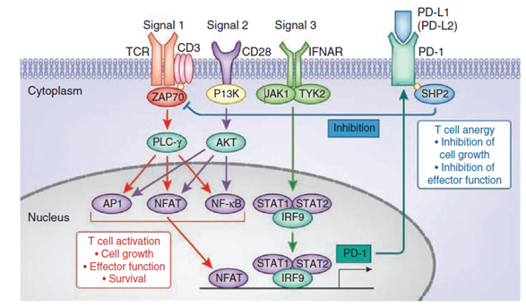
PD-1 induces T cell tolerance. PD-1 inhibits the TCR signalling pathway through SHP-2. T cells are activated by signal 1 (antigen stimulation), signal 2 (costimulation) and signal 3 (inflammatory cytokines). In naïve T cells, TCR mediated calcium influx initiates Pdcd1 transcription by activating NFATc1. In chronically activated (‘exhausted’) T cells, interferon α (IFNα) causes prolonged Pdcd1transcription through the binding of transcription factor IRF9 to the Pdcd1 promoter. When it’s the physiological ligand (PD-L1 or PD-L2) binds, PD-1 suppresses the activation and function of T cells through the recruitment of SHP-2, which dephosphorylates and inactivates Zap70, a major integrator of TCR mediated signalling. CD3, coreceptor; PI(3)K, Jak1 and Tyk2, kinases; PCL-γ, phospholipase C-γ; Akt, kinase; NF-κB, transcription factor. From Okazaki et al (2013)

PD-1 and its ligands
PD-1 (CD279) is a negative (that is inhibitory) co-receptor induced on antigen stimulated CD4+ and CD8+ T cells, NK cells, B cells and myeloid cells. It is also expressed in the thymus on CD4- CD8- T cells.
Ligands for the PD-1 receptor are PD-L1 (CD274) and PD-L2 (CD273).
- PD-L1 expression is constitutive and / or inducible on many haematopoietic and other cells; PD-L1 is expressed on some tumour cells and non-neoplastic elements in the tumour micro-environment.
  - PD-L1 is highly expressed on placental syncytiotrophoblasts, the cells at the mother fetus interface, suggesting a role in immune suppression by the fetus
  - There is expression of PD-L1 on endothelial cells and, at lower levels, on cardiomyocytes.
- PD-L2 expression is inducible on a narrower range of cells (antigen presenting cells, for example germinal centre B cells; dendritic cells).
PD-1 is a member of the CD28 family, along with CD28 and inducible costimulatory molecule (ICOS) (co-stimulatory), and CTLA-4 and B and T lymphocyte attenuator (BTLA) (co-inhibitory). It is a cell surface monomer, encoded by PDCD1. Signal transduction is via a cytoplasmic tail that recruits SHP-2, a phosphatase that dephosphorylates effector molecules activated by the TCR or BCR (for example, Zap70 in T cells; Syk in B cells). Inhibitory signalling via PD-1 / PD-L1 may be overcome by IL-2.. Splice variants of PD-1 have been reported, in the case of PD-1Δex3 resulting in a soluble molecule.
PD-1 signalling is summarised in the cartoon by Okazaki et al (2013) (Figure 4).
Figure 4. Cartoon of PD-1 signalling (by Okazaki et al (2013)³⁶)
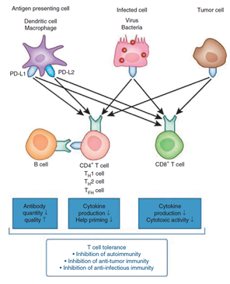

Functions of PD-1-PD-L signalling
- Maintenance of peripheral tolerance / prevention of autoimmunity.
PD-1-deficient mice develop autoimmunity. Phenotype varies with mouse genetic background (for example glomerulonephritis versus dilated cardiomyopathy with production of high titre autoantibodies versus cardiac troponin-1). Phenotypes are milder in Pdcd1-/- mice than in Ctla4-/- mice. The inhibitory mechanisms of PD-1 and CTLA-4 differ.
- Regulation of antibody responses
Germinal centre responses are regulated by PD-1 (there is high expression of PD-1 on T follicular helper (TFH) cells and T follicular regulatory (TFR) cells, subsets of CD4+ helper T cells found in the germinal centre). B cells in the germinal centre light zone express PD-L1 and PD-L2.
Some studies report attenuation of humoral responses, others report heightened responses when PD-1 – PD-L signalling is prevented.
- Regulation of the response to viral infection
In persistent viral infection, specific anti-viral T cells can become less functional (sometimes characterised as ‘exhaustion’), with the effect of minimising tissue damage (immunopathology). This state is associated with up-regulation of PD-1 on anti-viral T cells. A similar phenomenon may occur more broadly in infection / inflammation (for example in cancer due to persistence of tumour antigen).
Therapeutic blockade of negative immune regulators such as PD-1 can reverse immune exhaustion and theoretically promote clearance of viruses and tumours (in the setting of persistent viral infection, perhaps restoring immunopathology):
…it is important that anti–PD-1 be administered with caution in a clinical setting because immune exhaustion is a state imposed by an infected host to prevent severe immunopathology. Releasing T cells from this exhausted state holds great promise for the treatment of viruses and tumours, but can come with undesirable side effects…
- Regulation of the response to tumours
The PD-1 – PD-L1 pathway has a pivotal role in dampening immunosurveillance for tumours. Blockade of signalling essentially rekindles immunosurveillance.
It has been proposed (based on studies in human CD4+ T cells) that PD-1 blocks cell cycle progression and proliferation of T lymphocytes via selective effects of PD-1 on protein kinase B (Akt) and MEK-ERK signalling pathways:
Our studies showed that ligation of PD-1 during the stimulation of T cells through the TCR-CD3 complex and CD28 inhibited activation of the PI3K-Akt and Ras-MEK-ERK pathways.
If this observation is borne out, it will be interesting to look for any synergy or lack thereof with pembrolizumab and BRAF / MEK inhibitors.

Recent therapeutic advances in melanoma
Table 11 overviews registered agents indicated in advanced melanoma.

Table 11. Overview of currently registered agents for treatment of melanoma
Generic | Trade name | TGA-approved indication related to melanoma
Ipilimumab | Yervoy | Yervoy, as monotherapy, is indicated for the treatment of patients with unresectable or metastatic melanoma who have failed or are intolerant to prior therapy.
Trametinib | Mekinist | Mekinist in combination with dabrafenib is indicated for the treatment of patients with BRAFV600 mutation positive unresectable Stage III or metastatic (Stage IV) melanoma.  Mekinist as a monotherapy is indicated for the treatment of patients with BRAFV600 mutation positive unresectable Stage III or metastatic (Stage IV) melanoma and in whom either there is intolerance to BRAF inhibitors or BRAF inhibitors cannot be used.  Mekinist as monotherapy has not demonstrated clinical activity in patients who have progressed on BRAF inhibitor therapy.
Dabrafenib | Tafinlar | Tafinlar in combination with trametinib is indicated for the treatment of patients with BRAFV600 mutation positive unresectable Stage III or metastatic (Stage IV) melanoma.  Tafinlar as monotherapy is indicated for the treatment of patients with BRAF V600 mutation positive unresectable Stage III or metastatic (Stage IV) melanoma.
Vemurafenib | Zelboraf | Zelboraf is indicated for the treatment of unresectable stage IIIC or stage IV metastatic melanoma positive for a BRAF V600 mutation.
Interleukin-2 (high dose) | na | Unregistered (except for export)
Pembrolizumab | na | Unregistered
Dacarbazine (± combination chemo) | several | Chemotherapy of metastatic malignant melanoma… Note. The use of dacarbazine is restricted to hospitals with an oncology service.
Fotemustine | Muphoran | The indication ‘disseminated malignant melanoma’, including cerebral metastases, is currently the preferential indication for fotemustine, administered alone or in combination with other anticancer agents.
Temozolomide (± combination chemo) | Temodal | …first line treatment for patients with advanced metastatic malignant melanoma.
Interferon alfa-2b | Intron A | Intron A is indicated as an adjuvant therapy of malignant melanoma following surgery in patients who are at high risk of recurrence. The potential benefit to the patient should be assessed carefully. Although toxicity of the treatment may be substantial, for most patients, the benefit of therapy outweighed the risk.
Peginterferon alfa-2b | PEG-Intron | Not indicated
Imatinib for c-KIT mutated tumours | Glivec | Not indicated
Paclitaxel ± carboplatin | Taxol (and others) | Not indicated
Nanoparticle albumin-bound paclitaxel | Abraxane | Not indicated
Treatment of advanced melanoma has changed with recent availability of ipilimumab (anti-CTLA-4 antibody), vemurafenib (BRAF inhibitor), dabrafenib (BRAF inhibitor) and trametinib (MEK inhibitor).⁶ In the USA, pembrolizumab and nivolumab (PD-1 inhibitors) became available in 2014.
The US National Comprehensive Cancer Network (NCCN) melanoma guideline version 2.2015 preferred five regimens in treatment of advanced or metastatic melanoma:
- Ipilimumab
- Dabrafenib + trametinib
- Pembrolizumab
- Nivolumab
- Clinical trial
A recent version of National Comprehensive Cancer Network (NCCN) guidelines included BRAF inhibitor monotherapies and high dose IL-2 as ‘preferred therapies’; these now have ‘other active therapies’ status.
It is often noted that disease control by BRAF inhibitors is transient. With combined BRAF and MEK inhibition, progression has been further delayed for many (Figures 6 to 12 below); median PFS is now approximately 9 to 10 months. In Combi-V, in the combination arm, median duration of response was 13.8 months; in Combi-D, it was 9.2 months. These median durations of response are in the context of a relatively high response rate.
Use of ipilimumab in advanced melanoma is also on the understanding that responses are only attained in approximately 15% of subjects, and that approximately 15% develop severe (through to fatal) immune related AEs.
Some perspective is provided by the sponsor’s tabulation of outcomes with dacarbazine, previously a mainstay of treatment in advanced melanoma (Table 12).
Table 12. Efficacy data from randomised controlled trials including dacarbazine or other chemotherapies in patients with advanced melanoma, 1999-2012
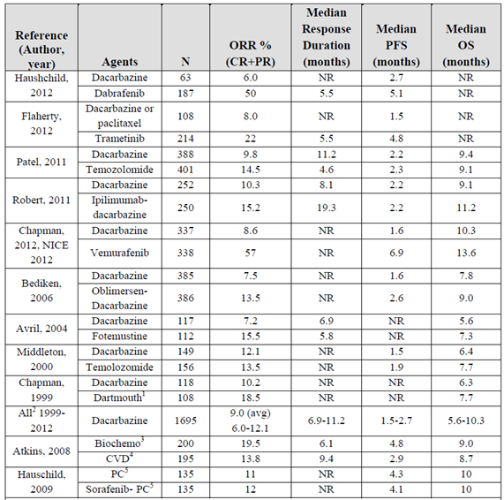
NR = not reported; ¹ Dartmout regimen = dacarbazine, cisplatin, carmustine, tamoxifen; ² inculdes all monotherapy cohorts except Flaherty 2012; ³ cisplatin, vinblastine, dacarbazine, interleukin-2, interferon alfa 2-b, ⁴ cisplatin, vinblastine, dacarbazine; ⁵ paclitaxel, carboplatin
Hauschild 2012,Flaherty 2012, Patel 2011,Robert 2011,Chapman 2012, NICE 2012, Bediken 2006, Avril 2004, Middleton 2000, Chapman 1999, Atkins 2008, Hauschild 2009

Quality
There were no objections to registration based on evaluation of the drug substance or drug product. Batch release conditions were proposed.

Nonclinical
The nonclinical evaluator has no objections to registration.
In relation to Pregnancy Category, the nonclinical evaluator reported that:
Numerous literature publications identify the PD-1 pathway as having a fundamental role in maintaining immune tolerance to the fetal allograft. The PD-L1 molecule is expressed at the uteroplacental interface and protects the concepti from maternal T cell mediated immunity.¹² Blockade of PD-L1 signalling in mice has been shown to abrogate foetomaternal tolerance, resulting in increased fetal resorbtion and abortion.^{12, 13} Accordingly, pembrolizumab can be reasonably expected to cause embryofoetal lethality in pregnant patients.
The sponsor has proposed Category C¹⁴, but the evaluator recommends Category D¹⁵:
Although they are pharmacologically mediated, given the extreme nature of the adverse effects predicted (that is, embryofoetal lethality), the proposed pregnancy category is considered inappropriate. The product should be assigned Pregnancy Category D instead.
The Delegate agrees that Pregnancy Category C is inappropriate. It is relevant that melanoma occurs commonly in women of child bearing age (the AIHW Australian Cancer Incidence and Mortality book for melanoma of the skin reports 2011 incidences ranging from 7.9 per 100,000 in 20 to 24 year olds to 52.6 per 100,000 in 45 to 49 year olds; a proportion of these will be advanced at diagnosis or progress to an advanced stage in women of child bearing potential).
The predicted risk of fetal death is high. On balance, Category X may be inappropriate as risk of death from melanoma is also high. The PI should communicate the substantial risk to the fetus of exposure to this product.

Clinical
The evaluator supported registration but with a restricted indication. This was after evaluation of the initial dossier.
Importantly, the initial dossier did not include top line results for Studies P002 and P006. Instead of a second round clinical evaluation, the sponsor’s answers to round 1 clinical questions have been considered in this overview, as have top line results for P002 and P006.

Overview of clinical data
The clinical development programme in melanoma includes studies as shown in Table 13.
Table 13. The clinical development programme for pembrolizumab use in melanoma.
Study name | Description | Inclusion in Dossier | Cut off date
P001 | Very large Phase 1 study  Parts A, B and D included patients with advanced melanoma | CSR version 1  Also: an updated interim analysis (summary data) | Cut-off date 18 Oct 2013 (for CSR version 1)  Cut-off date April 18 2014 (for summary data)
P002 | Randomised (pembrolizumab versus physician’s choice of chemotherapy) in IPI-refractory melanoma | Summary data for interim analysis 2 | 12 May 2014
P006 | Randomised (pembrolizumab versus ipilimumab) in IPI-naïve melanoma patients | Summary data for interim analysis 1 | 3 September 2014

Study P001
Study P001 is a multi-centre, open label, Phase 1 study of patients with locally advanced or metastatic cancer (melanoma, NSCLC and other tumour types). It was conducted in the USA (13 sites), Australia (2), France (1) and Canada (1). Via serial amendments, it has been divided into parts:
- Part A was the ‘first in human’ sub-study.
- Parts B1, B2, B3 and D were sub-studies in melanoma (efficacy data from B3 were not included in the initial dossier; summary data have been provided)
- Parts C and F studied NSCLC. Efficacy data were not included in the dossier.
Table 6 above shows the summary of the study parts of Study P001.
Table 14. P001 key sub-studies
Sub-study | Ref | Size | Population | Pembrolizumab | [Follow-up^{b}]
B2 | Robert et al 2014 | N=173 | IPI-refractory | 2 mg/kg Q3W versus 10 mg/kg Q3W (randomised) | ≥ 12 months
D | NA | N=103 | IPI-naive | 2 mg/kg Q3W versus 10 mg/kg Q3W (randomised) | ≥ 15 months
B1 | Hamid et al 2013 | N=135 | IPI- refractory, treated or naive | 10 mg/kg Q2W or Q3W or 2 mg/kg Q3W ª (sequential assignment; not randomised) | > 19 months
a. In B1, 2 mg/kg Q3W was only given to IPI-naïve subjects b. As of 18 April 2014. Minimum follow-up is time since last patient received first dose.
Many analyses were of pooled data from B1, B2 and D (not B3). Some 411 melanoma patients from B1, B2 and D were included in most pooled efficacy analyses. These analyses were based, in general, on the initial data cut off of 18 October 2013 (rather than the 18 April 2014 cut off). In this overview, most results are based on the initial cut off; key findings using the later cut off are included where specified.
Pembrolizumab was not compared with other agents directly in P001. Randomisation where it occurred was into different dose regimens (B2, B3, D).
There was no requirement for PD-L1 expression on tumour samples within sub-studies in melanoma patients in P001 (this was a requirement in sub-studies in NSCLC).

Study P001 detailed description by the delegate

Therapy after progression
Patients with asymptomatic progression could continue pembrolizumab treatment at the investigator’s discretion despite evidence of increasing tumour volume or new lesions for another 4 to 6 weeks if the patient was ‘clinically stable’. Clinically stable was defined as:
- Absence of symptoms and signs indicating clinically significant progressive disease (including worsening of laboratory values)
- No decline in Eastern Cooperative Oncology Group (ECOG) performance status and
- Absence of rapid progression of disease or of progressive tumour at critical anatomical sites (for example cord compression) requiring urgent alternative medical intervention.
If imaging 4 to 6 weeks after asymptomatic progression showed objective response or stable disease, clinically stable patients were allowed to continue pembrolizumab with resumption of tumour imaging studies every 12 weeks.

Inclusion and exclusion criteria
In Parts B and D of the study, patients must have had a histological or cytological diagnosis of melanoma with progressive locally advanced or metastatic disease that is not amenable to definitive local therapy with curative intent.
Also in Parts B and D, patients must have had measurable disease based on investigator evaluation per immune related response criteria.
Also, ECOG performance status was to be 0 or 1. There was a requirement for adequate organ function based on laboratory values.
Patients were excluded if they had a medical condition requiring chronic systemic steroids or required any other form of immunosuppressive medication (physiological replacement of corticosteroids was permitted).
Patients with risk factors for bowel obstruction or perforation (for example history of acute diverticulitis, intra-abdominal abscess, abdominal carcinomatosis) were excluded.
Patients with known active central nervous system (CNS) metastases and / or carcinomatous meningitis were excluded. History of treated brain metastases was not an exclusion, if patients were clinically stable with no new / enlarging brain metastases and were off steroids.
Patients with pneumonitis or interstitial lung disease were excluded.
Patients with active autoimmune disease or a documented history of autoimmune disease or syndrome requiring systemic steroids or immunosuppressive agents were excluded. Vitiligo and resolved childhood asthma / atopy were exceptions; patients with hypothyroidism stable on hormone replacement were also not excluded.
Patients with active infections requiring therapy were excluded. Patients with active HIV, hepatitis B virus (HBV) or hepatitis C virus (HCV) were excluded.

Part B
In sub-study B2 (‘IPI refractory’) the following conditions had to be met:
- at least two doses of IPI at ≥ 3 mg/kg
- progressive disease after IPI, as per immune related response criteria irRC, confirmed by second assessment or by rapid clinical progression
- documented progression within 24 weeks of the last IPI dose
- resolution of IPI related AEs to Grade 0-1 and to ≤ 10 mg/day prednisone or equivalent for at least 2 weeks prior to first dose of pembrolizumab
- no history of severe immune related adverse event (irAEs) (grade 4 requiring any steroids, or grade 3 requiring steroids ≥ 10 mg/day or equivalent for > 12 weeks); a minimum 4 week washout from last dose of IPI
- in patients with BRAF V600 mutant melanoma, prior treatment with an approved BRAF and / or MEK inhibitor; and
- progressive disease after the most recent treatment regimen.
In sub study B1, patients were either IPI naïve or IPI treated. IPI treated patients needed: unequivocal disease progression during or after IPI treatment (amendment 02) or within 6 months of last IPI (amendment 03); full resolution of all AEs from IPI and at least 12 weeks since first dose and 6 weeks since last dose of IPI; no severe irAEs from IPI.

Part D
In sub-study D, only IPI naïve patients who had received no more than two prior systemic therapies for melanoma were enrolled. In D, unlike B2, a BRAF inhibitor was not required in those with known BRAF mutations.

Baseline characteristics
Patients in B2 (IPI refractory) were heavily pre-treated. In sub-study D, 52% of patients received no prior therapy for advanced melanoma that is, pembrolizumab was first line therapy.
Within non-randomised groups (for example in sub study B1, groups defined by dose regimen) there were imbalances in some baseline characteristics.
Table 15. Baseline characteristics sub study groups of Study P001
Baseline characteristics | Substudy B2 (IPI-refract.) | Substudy D (IPI-naïve) | Substudy B1 (IPI-treated) | Substudy B1 (IPI-naive)
N = | 173 | 103 | 48 | 87
Age (median, yrs) | 61 | 60 | 59 | 64
Age (range, yrs) | 18 to 88 | 26 to 80 | 29 to 87 | 25 to 94
Age (% ≥ 65 yrs) | 36% | 36% | 42% | 48%
% male | 61% | 61% | 54% | 61%
ECOG 0 | 67% | 84.5% | 71% | 74%
ECOG 1 | 33% | 15.5% | 29% | 26%
BRAF V600 mutant | 18% | 35% | 23% | 22%
M1c | 57% | 54% | 63% | 55%
Brain metastases | 9% | 6% | 15% | 6%
LDH elevation | 39% | 34% | 27% | 31%
Median LD sum | 132 mm | 81 mm | 61 mm | 64 mm
Prior IPI | 100% | 0% | 100% | 0%
Only IPI as prior therapy | 28% | 0% | 31% | 0%
≥ 3 prior systemic therapies | 35% | 4% | 31% | 2%
BRAFi or MEKi use | 19.7% | 18% | 10% | 9.2%
In the 18 April 2014 cut off summary, B3 outcomes were reported. There were imbalances in baseline characteristics for Q3W and Q2W arms: 60% versus 71% males; mean age 61 versus 60 years; ECOG 0 in 60% versus 58%; M1c in 60% versus 55%; BRAF mutant in 27% versus 21%; brain metastases in 9.1% versus 6.5%; no prior systemic therapies in 31% versus 25%; 1 prior in 30% versus 38%; 2 prior in 25% versus 21%; 3 + prior in 15% per arm; median tumour size 123 versus 99 mm; elevated LDH in 37% versus 33%.

Efficacy methodology
The primary efficacy outcome in P001 was best overall response rate by independent central review using response evaluation criteria in solid tumours (RECIST) 1.1 in the Full Analysis Set.
Radiological disease assessment was every 12 weeks, with confirmation of response at 4 weeks, and confirmation of progression (at the discretion of the investigator) after 4 to 6 weeks.

Efficacy results
Tabular summary of efficacy outcomes is presented below in Table 16.
Table 16. Summary of efficacy outcomes for Study P001
IRO / APaT | B2 (IPI-refractory) |  | D (IPI-naïve) |  | B1 (IPI-mixed) Non-randomised |  |  | [B3 (mix of IPI-naïve and IPI-exposed)]
Dose regimen | 2 mg/kg Q3W  N=89 | 10 mg/kg Q3W  N=84 | 2 mg/kg Q3W  N=51 | 10 mg/kg Q3W  N=52 | 2 mg/kg Q3Wª  N=22 | 10 mg/kg Q3W^{b}  N=56 | 10 mg/kg Q2Wb  N=57 | 10 mg/kg Q3W  N=121 | 10 mg/kg Q2W  N=123
Partial or complete response (IRO, RECIST 1.1), confirmed (with 95% CI) | 24%  (15-34)  [25%] | 24%  (15-34)  [25%] | 33%  (21-48)  [33%] | 37%  (24-51)  [35%] | 41%  (21-64)  [41%] | 29%  (17-42)  [30%] | 49%  (36-63)  [44%] | [27%] | [33%]
Complete response | 1.1%  [3.4%] | 1.2%  [7.1%] | 7.8%  [9.8%] | 3.8%^{c}  [7.7%] | 9.1% ^{d}  [13.6%] | 5.4% ^{d}  [5.4%] | 19.3% ^{d}  [17.5%] | [2.5%] | [5.7%]
Duration of objective response | 6+ to 37+ wks^{e}  [12+ to 62+] | 8+ to 37+ wks^{e}  [12+ to 62+] | 7+ to 36+ wks^{e}  [7+ to 60+] | 6+ to 39+ wks^{e}  [6+ to 61+] | 9+ to 60+ wks^{e}  [12+ to 82+] | 11 to 72+ wks^{e}  [11 to 96+] | 8+ to 76+ wks^{e}  [22 to 98+] | [8+ to 36+] | [6+ to 36+]
Median PFS by IRO / RECIST 1.1 | 5.1 m  [4.9 m] | 3.2 m  [3.2 m] | 6.3 m  [5.5 m] | 5.3 m  [4.2 m] | 16.7 m^{f}  [13.6 m] | 5.5 m^{f}  [5.5 m] | 11.6 m^{f}  [8.8 m] | [3.0 m] | [5.2 m]
6 month PFS | 45%  [43%] | 37%  [35%] | 51%  [50%] | 48%  [41%] | 56%  [57%] | 44%  [46%] | 60%  [56%] | [40%] | [45%]
Overall survival^{g} | 13 m^{h}  [Not reached] | Not reached  [18.3 m]^{h} | Not reached  [Not reached] |  | Not reached  [Not reached] |  |  | [Not reached] | [Not reached]
6-month OS | 79%  [79%] | 79%  [77%] | 80%  [80%] | 77%  [77%] | 90.5%  [91%] | 92.9%  [93%] | 85.6%  [86%] | [75%] | [77%]
12-month OS | *  [60%] | *  [62%] | *  [72%] | *  [64%] | 86%  [86%] | 79%  [79%] | 82%  [82%] | [NA] | [NA]
In normal font are outcomes from the 18 October 2013 data-cut off analysis (per I independent radiology and oncology review RO in the All patients as treated (APaT) population, chosen ahead of Full analysis set (FAS) for comparability with data from 18 April 2014 cut off). In [parentheses and bold] are outcomes from the 18 April 2014 update, using IRO / APaT.
a All these patients were IPI-naïve b Mix of IPI-naïve and IPI-treated c Including 2 complete responses (CRs) in subjects excluded from FAS due to unmeasurable baseline disease (in the 10 mg/kg arm) d Including 5 CRs in 19 subjects excluded from FAS due to unmeasurable baseline disease e Median not reached. f See below for PFS curves. Impact of Week 12 imaging is apparent. g See below for OS curve (pooled across B2, D and B1 subjects) h Considered an unstable estimate by the sponsor due to small sample size. * heavy censoring at initial cut off (18 October 2013) OS = Overall Survival
The sponsor attributed the higher point estimates in B1 (for example compare B2 2 mg/kg Q3W and B1 2 mg/kg Q3W, both in IPI-naïve subjects) to longer follow-up in B1.

Time to response
In B2 and D, amongst responders, response was typically noted at first assessment, around Week 12. In sub-study B1 (with longer follow-up), response was typical at Week 12 but there were examples of late responses (4 partial responses (PRs) and 6 complete responses (CRs) at or after Week 36). In the 18 April 2014 update, there was evidence that some PRs were converting to CRs over time.

Durability of response
Objective response rates (ORRs) are better than historically low ORRs seen with chemotherapy, but are not high in absolute terms. The sponsor argues that responses are durable (compared with BRAF inhibitor monotherapy, where ORRs are high but not typically durable). Median duration of response has not been reached. Short follow-up does not allow durability of response to be well characterised, but most responses were ongoing at the data cut off.
In B2, only 4 out of 41 patients with a confirmed response have had subsequent progression (approximately 10 to 25 weeks after response). In D, only 2 out of 36 patients with a confirmed response have had subsequent progression; one of these had attained CR. In the 18 April 2014 update, median duration of response DoR was still not reached in B2 or D; 83 to 90% of responders were non-progressing at the cut off, down from 90 to 94%.
In B1 there has been longer follow up than in B2 and D. There was progressive disease in 5 out of 53 responders. Some subjects had not progressed despite discontinuing treatment. In the 18 April 2014 update, median DoR was still not reached; 73% of responders were non-progressing at the cut off, down from 91%.
In the 18 April 2014 update, based on Kaplan-Meier estimation, 82% of responders had a response lasting > 1 year.

Progression free survival curves
Figure 5. Kaplan-Meier estimates of progression free survival based on IRO assessment per RECIST 1.1 Part B1 patients (APaT population)
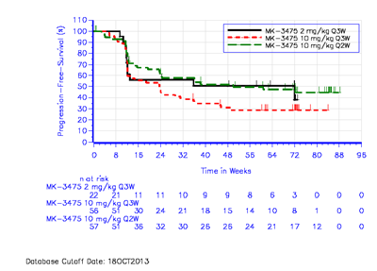

Progression at initial evaluation
There is a step down in PFS at 12 weeks, that is, first imaging. One view in the absence of any control arm is that it reflects a pembrolizumab-specific effect, for example a subset of patients with a negative response. Robert et al (2014), in a study of nivolumab versus DTIC in first line use in advanced melanoma, saw a similar step-down, as clear in the dacarbazine arm as the nivolumab arm., While it would have been ideal to have randomised, controlled data for pembrolizumab, I think it is reasonable to reject the view that pembrolizumab hastens progression in a subset of subjects. An early step down in PFS is not so distinct in studies of dabrafenib and vemurafenib. (PFS curves for selected pivotal studies are below in Figures 6, 7, 8, 9, 10, 11 and 12).
Figure 6. Vemurafenib versus dacarbazine (Chapman et al 2011)
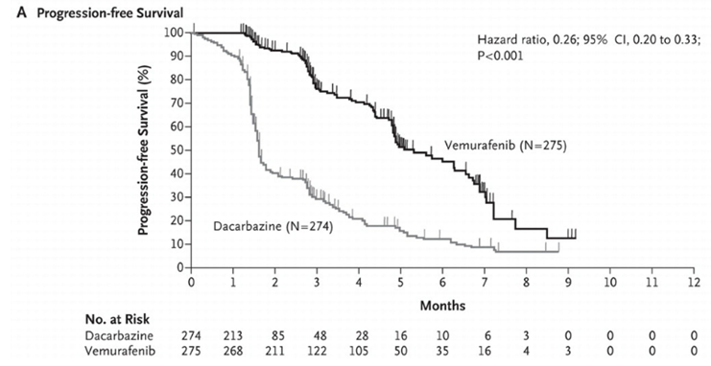
Figure 7. Dabrafenib versus dacarbazine (Hauschild et al, 2012)⁴⁵
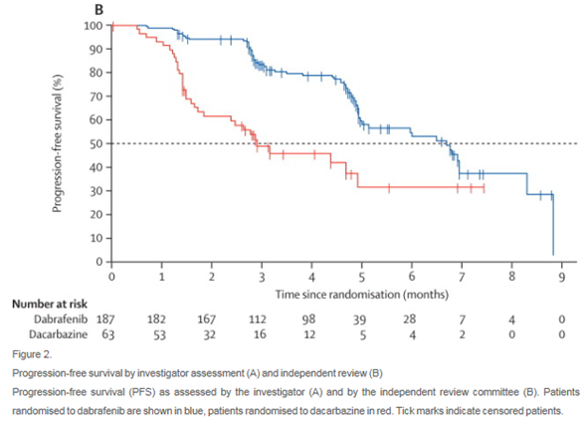
Figure 8. Dabrafenib + trametinib versus dabrafenib (Long et al 2014)⁴⁴
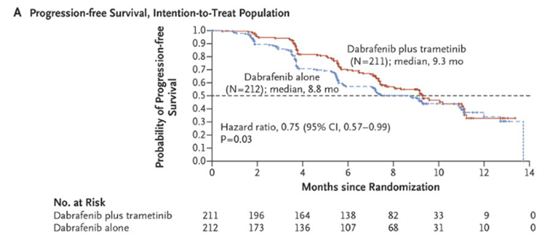
Figure 9. Dabrafenib + trametinib versus vemurafenib (Robert et al, 2015)⁴³
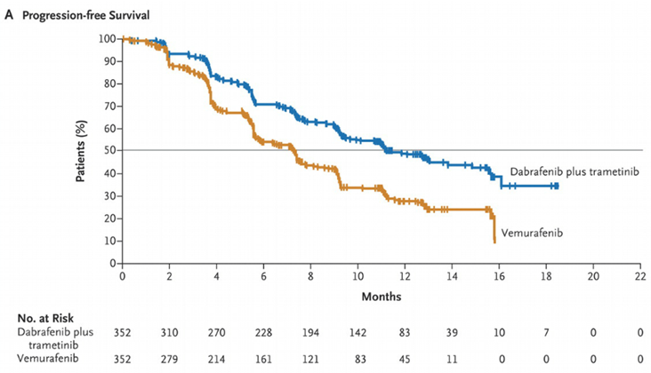
Figure 10. Vemurafenib + cobimetinib versus vemurafenib (Larkin et al 2014)
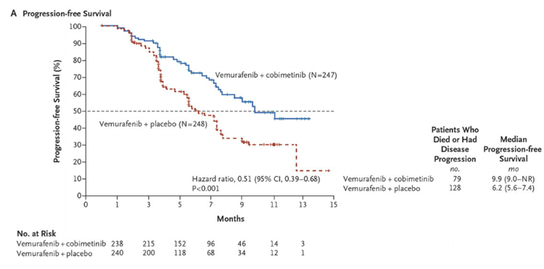
Figure 11. Nivolumab versus dacarbazine (Robert et al 2014)⁴³
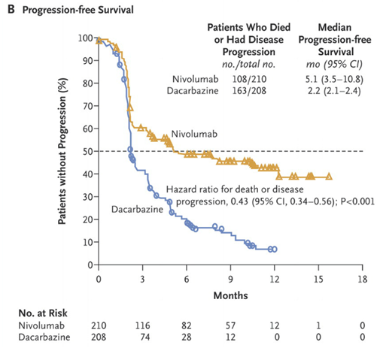
Figure 12. Pembrolizumab – P001 (B1, B2, D)
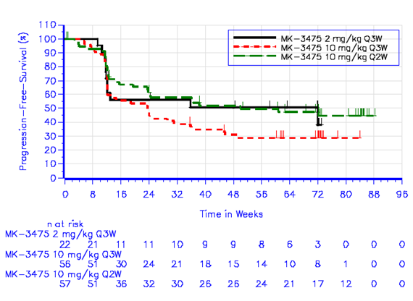

Overall survival curves
Figure 13. Kaplan-Meier estimates of overall survival Part B1+B2+D patients (APaT population)
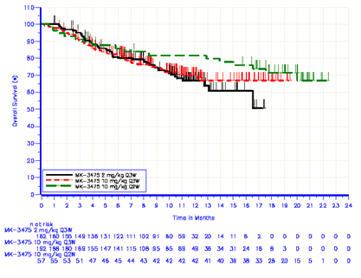

Sensitivity analyses

RECIST versus immune related response criteria (irRC)
A method of assessing activity other than by standard RECIST 1.1 criteria was by immune related response criteria, by both investigator and independent central review. The sponsor makes the following comment:
irRC differs predominantly from RECIST 1.1 by measurement of lesions using two dimensions rather than one, as well as inclusion of new lesions into the overall tumour burden calculation, rather than having new lesions automatically define progression. In addition, to call a progression event under irRC requires confirmation by a repeat, consecutive assessment no less than 4 weeks from the date of the first scan showing progression (in the absence of rapid clinical progression).
A sensitivity analysis using irRC rather than RECIST 1.1 was conducted. PFS was longer using irRC (for example B2: 2 mg/kg Q3W: PFS 22 weeks by RECIST but 36 weeks by irRC). The sponsor interprets this as suggesting a fraction of patients may not achieve an objective response by RECIST but may still derive clinical benefit. See Table 17 for details.
Table 17. Comparison of PFS by IRO per RECIST 1.1 and IRO per irRC (APaT population)
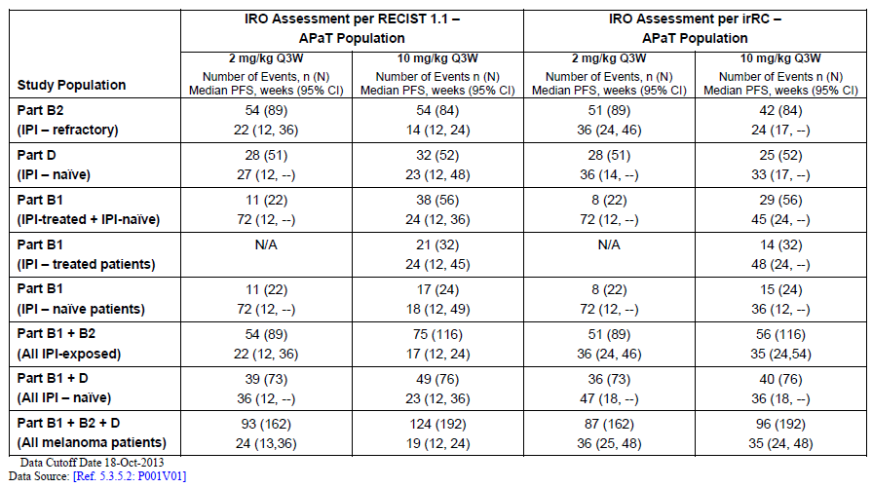
Out of 411 patients in the all patients as treated (APaT) population, 51 (12%) had progressive disease (or were not evaluable) by RECIST 1.1, but were assessed as having stable disease or better by irRC. Overall survival (OS) outcomes for this group and other are illustrated below in Figure 14.
Figure 14.OS outcomes for the group assessed as having stable disease or better by irRC.
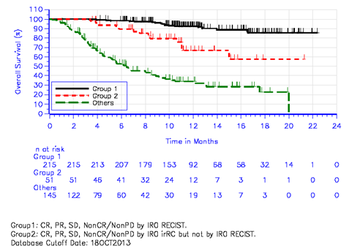

Full analysis set versus APaT populations
The primary efficacy endpoint, ORR was measured within the ‘Full Analysis Set’ (FAS), requiring measurable disease at baseline and receipt of at least one dose of study drug. 89% of subjects had centrally measurable disease; 11% had disease measurable by the investigator only, at baseline.
The APaT set was used to measure PFS and OS.
Across B1, B2 and D, the APaT set consisted of 411 subjects, and the FAS set of 365.
The FDA adopted the approach of analysing the APaT set for ORR. As per RECIST, patients without centrally measurable disease are unable to achieve PR by central review.

Central versus investigator assessment
There was acceptable concordance at the trial level between outcomes based on central versus investigator assessment.

Efficacy according to PD-L1 expression
Core biopsies or surgical specimens were stained in an immuno histochemical (IHC) assay for PD-L1 using an in-house mouse monoclonal antibody (clone 22C3). In approximately 1 out of 4 of subjects, there was too little viable tumour or too much melanin to obtain IHC results. From the sponsor’s report (03WMV4):
The … melanoma samples also demonstrated two low power patterns: formations of staining cells forming bands along the outer margins of the tumour nests (that is the ‘interface’ or ‘stroma’ pattern), and formations of staining cells forming lattices within the tumour nests (that is the ‘dendritic’ pattern).
Because it can be difficult to distinguish melanoma cells from mononuclear inflammatory cells by light microscopy, and because the PD-L1 expression by those mononuclear inflammatory cells may affect anti-tumour activity, the scoring method employed for melanoma is based on the aggregate proportion of cells, that is both tumour cells and inflammatory cells contained with the tumour nests, which stain for PD-L1.
The scoring method (Allred Proportion Score, APS) for PD-L1 ‘did not include intensity [of membrane staining], interface or dendritic pattern’ for the final analysis. The APS was modified so mononuclear inflammatory cells were counted as well as tumour cells.
The aim was for a test with high negative predictive value (that is high fraction of negative calls are truly negative). An APS ≥ 2 was chosen to indicate ‘positive’ PD-L1 expression (equivalent to ≥ 1 % of cells demonstrating membrane staining for PD-L1). This choice, ahead of APS ≥ 3 or 4, was to maximise the true positive rate and the NPV of the assay.
Table 18. Receiver Operating Characteristic table for melanoma training set
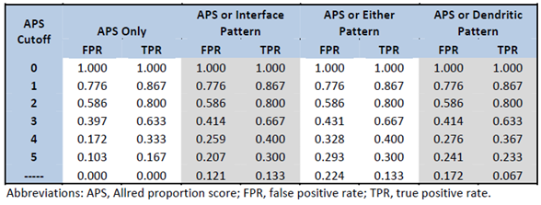
APS = 0 If there is no membrane staining on the slide (0%) APS = 1 If there is membrane staining in less than 1/100 of cells (< 1%) APS = 2 If there is membrane staining in at least 1/100 but less than 1/10 of cells (≥ 1% to < 10%) APS = 3 If there is membrane staining in at least 1/10, but less than 1/3 of cells (≥ 10% to < 33%) APS = 4 If there is membrane staining in at least 1/3, but less than 2/3 of cells (≥ 33% to < 66%) APS = 5 If there is membrane staining in at least 2/3 of cells (≥ 66%)
Efficacy by PD-L1 expression was considered. 77% of 248 subjects with data had PD-L1 positive tumour samples (membrane staining in ≥ 1 % of cells). There was an imbalance in some baseline features between patients with PD-L1 negative and positive tumours, for example 30% of PD-L1 negative patients were BRAF mutant positive, whereas 20% of PD-L1 positive subjects were BRAF mutant positive.
The ORR for the pooled PD-L1 evaluable FAS population (n=248) was 35% (95% CI 29 to 41%), and was comparable to the ORR for the all melanoma FAS population (n = 365), at 34% (95% CI 29 to 39%).

ORR in patients who were PD-L1 positive was 42% (95% CI: 35 to 49%) compared to 9% (95% CI 3 to 20%) in patients who were PD-L1 negative.
All complete responses were in PD-L1 positive patients (12 out of 194, versus 0 out of 54). The difference in ORR between the subgroups was 33% (p < 0.0001). The difference was more pronounced in IPI naïve subjects (difference of 42%) than in IPI treated subjects (27%). Table 19 below summarises best overall responses by PD-L1 status. Duration of response in PD-L1^{neg} subjects was unaffected, based on 81 PD-L1^{pos} responders and 5 PD-L1^{neg} responders (too small a sample size in the latter group for robust conclusions). Median PFS was 24 weeks in the positive group, versus 12 weeks in the negative group; the hazard ratio for progression was 0.5 (95% CI 0.36 to 0.69). There was a similar HR for OS.
Table 19. Summary of best overall response based on IRO assessment per RECIST 1.1 (Part B1 + B2 + D patients) by PD-L1 status (FAS population by IRC)
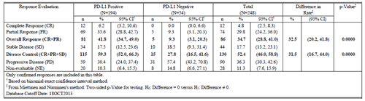
The sponsor speculated that responses observed in patients with PD-L1 negative tumours might be accounted for by heterogeneity of PD-L1 expression / sampling error, expression of PD-L2 or another ligand predicting response to treatment, or response even with very low levels of PD-L1 expression in some patients.

Efficacy according to tumour BRAF status
Table 20 is of ORRs in patients from P001 (18 October 2013 cut off), and it shows broadly higher ORRs in patients with BRAF wild type tumours.
Table 20. Overall response rates in patients from P001 (18 October 2013 cut off).
BRAF status | 2 mg/kg Q3W | 10 mg/kg Q3W | 10 mg/kg Q2W | total
Mutant | 8 out of 38 (21%) | 9 out of 45 (20%) | 7 out of 14 (50%) | 24 out of 97 (25%)
Mutant, use of BRAFi/MEKi |  |  |  | approximately 13 out of 66 (20%)
Mutant, no use of BRAFi/MEKi |  |  |  | approximately 11 out of 31 (35%)
Wild-type | 39 out of 124 (31%) | 46 out of 147 (31%) | 19 out of 39 (49%) | 104 out of 310 (34%)
In the 18 April 2014 cut off analysis of B1+B2+B3+D, there were 308 IPI naïve subjects and 342 IPI exposed subjects (many of whom were included in the above analysis). In Table 21 is presented the analysis of ORRs is by BRAF status and ipilimumab exposure.
Table 21. Analysis of overall response rates is by BRAF status and ipilimumab exposure
BRAF status | IPI-naive | IPI-exposed | total
Mutant | n=91  ORR = 27.5% | n=64  ORR = 17% | n=155  ORR = 23%
- Mutant, use of BRAFi/MEKi | n=45  ORR = 24% | n=56  ORR = 18% | n=101  ORR = 21%
- Mutant, no use of BRAFi/MEKi | n=46  ORR = 30% | n=8  ORR = 12.5% | n=54  ORR = 28%
Wild-type | n=217  ORR = 40% | n=277  ORR = 28.5% | n=494  ORR = 34%
Total | n=308  ORR = 36% | n=342  ORR = 27% | n=650  ORR = 31%

Safety results

Exposure
Exposure to pembrolizumab in 411 subjects with advanced melanoma within sub-studies B1, B2 and D was as follows, based on the 18 October 2013 cut off (values from the 18 April 2014 cut off follow, in bold and parentheses)
Table 22. Exposure to pembrolizumab in 411 subjects with advanced melanoma within sub-studies B1, B2 and D (values from the 18 April 2014 cut off are in bold)
Dose regimen | Number of subjects | Mean (range) administrations | Mean duration of exposure (range)
2 mg/kg Q3W | N=162 | 10 (1 to 26)  [13] | 196 (1-526) days  [259]
10 mg/kg Q3W | N=192 | 10 (1 to 28)  [13] | 197 (1-589) days  [265]
10 mg/kg Q2W | N=57 | 21 (1-47)  [24] | 315a (1-680) days  [361]
a All these patients were enrolled in B1, which completed enrolment prior to B2 / D (and within B1, patients were enrolled to 10 mg/kg Q2W first)

AE profile
AEs discussed below are from pooled P001-B1, -B2 and -D unless specified.
A summary of AE categories by dose regimen is shown in Table 23.
Table 23. A summary of AE categories by dose regimen Part B1 + B2 + D patients (APaT population)
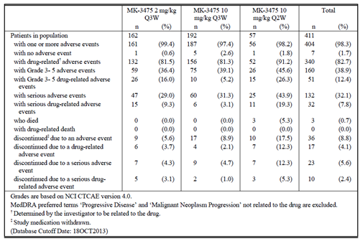

General issues
Many subjects reported severe and serious AEs, but these were not often found to be drug related. For example, 39% of patients reported grade 3 to 5 AEs, but only 12.4% reported grade 3 to 5 drug related AEs. 32% reported serious AEs; only 8% reported drug related SAEs. The absence of control arms makes interpretation of the causality of AEs more difficult, especially in an open label study such as P001.
In the advanced melanoma cohort (n = 411), one trend was for more AEs in the 10 mg/kg Q2W group. This could be linked to the higher exposure to pembrolizumab, although no major difference in AEs was observed between 2 mg/kg and 10 mg/kg dosing Q3W. It could be linked to longer duration of exposure, although this would suggest that risk of AEs persists over longer term exposure. It could be a product of smaller sample (n = 57), though the differences in AE frequency were substantial and possibly too big to be attributed solely to ‘sample size’.
The FDA’s medical review noted that the FDA’s Office of Scientific Investigation audited three clinical trial sites. In one site, AEs were being under reported (n = 7 patients were enrolled there). The FDA concluded this problem was not pervasive.

Deaths
There were four deaths due to AEs among 411 subjects with advanced melanoma. None of these was drug related. 3 of 4 occurred in the 10 mg/kg Q2W group.
Across P001, there was 1 drug related fatal AE, in a 76 year old male on 10 mg/kg Q2W; the investigator linked cryptococcal fungaemia to immunosuppression from steroids being used to treat a pembrolizumab AE.

Other serious AEs
Serious AEs occurred in 29% at 2 mg/kg Q3W, 31% at 10 mg/kg Q3W and 44% at 10 mg/kg Q2W. Dyspnoea, cellulitis and pneumonia were commoner SAEs; renal failure was relatively prominent, as was effusion (pericardial and pleural).

Discontinuations
At 2 mg/kg Q3W, 5.6% of subjects discontinued, 3.7% due to drug related AEs. At 10 mg/kg Q3W, 8.9% discontinued, 2.1% due to drug related AEs. At 10 mg/kg Q2W, 17.5% discontinued, 12.3% due to drug related AEs. Drug related AEs causing discontinuation in > 1 subject were fatigue, pain and pneumonitis (n = 2 to 3).

Common AEs
In B1+B2+D, common AEs were fatigue (45.5%), nausea (29.4%), cough (28.7%), diarrhoea (28%), pruritus (27.5%), arthralgia (24.6%), rash (23.8%), constipation (20.4%), decreased appetite (19%), dyspnoea (18.5%), headache (18%), anaemia (16.5%) and vomiting (15.8%).

AEs with potential autoimmune aetiology
These were captured by investigators as immune related AEs (irAEs) and also by the sponsor using a pre-specified list of AE terms as ‘Adverse Events of Special Interest’ (AEOSI). AEOSIs took into account grade as well as type of AE.
Immune related AEs (as assessed by the investigator) reported in > 1 subject were:
- hyperthyroidism (1.0%), hypothyroidism (3.4%), thyroiditis (0.5%)
- hypophysitis (0.5%)
- uveitis (0.5%)
- colitis (0.5%), diarrhoea (2.2%)
- asthenia, chills, fatigue, flu-like illness and pyrexia (0.5 to 1.2%)
- hepatitis (including autoimmune hepatitis) (0.5%)
- arthralgia (2.4%), arthritis (0.7%), muscle spasms (0.5%), myalgia (1.5%)
- headache (0.5%)
- renal failure / acute renal failure / renal impairment / autoimmune nephritis (together 1.0%)
- cough (1.5%), pneumonitis (1.7%)
- eczema (0.5%), erythema (1.0%), pruritus (3.2%), hair colour changes (0.5%), rash (including related terms) (5.6%), vitiligo (3.6%)
Some laboratory abnormalities aligned with similar AEs (including one report of ‘autoantibody positive’; the type was not specified).
These events reflected the type of event captured by the sponsor as an AEOSI.
The sponsor states no meaningful differences were observed in the safety profile of pembrolizumab by gender. Autoimmunity is generally more common in females than in males, for commoner autoimmune conditions. Analysis of irAEs by gender did not reveal major differences.

Immunogenicity
In 130 out of 449 patients with post dose samples, pembrolizumab levels were low enough to allow immunogenicity assessment. In 1 out of 130 patients, emergent anti-drug antibodies were detected (at day 83; two subsequent samples to day 253 were not conclusive); the ADAs at day 83 were neutralising. In that one patient, no hypersensitivity was reported, and no impact on exposure was reported. This analysis was based on a data cut off of 31 December 2013.

Important safety information from P001 (18 April 2014 cut off)
With 6 months further follow-up of patients in P001, there was a modest increase in incidence of commonly reported AEs, for example grade 3 to 5 AEs considered drug related rose from 12.4% to 14.4%; SAEs considered drug related rose from 7.8% to 8.5%; AEs leading to discontinuation of treatment and considered drug related rose from 4.1% to 5.4%; and AEOSIs rose from 12.4% to 14.3%. The sponsor’s view that the safety profile of pembrolizumab remains unchanged seems reasonable.
Summary data from P001 B3 (Table 24) were broadly consistent with these outcomes, though follow-up was shorter.

Table 24. Summary AE data from P001 B3
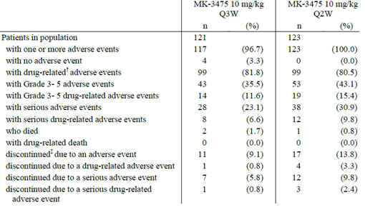

Study P002
P002 was a randomised trial of pembrolizumab (including two arms: 2 mg/kg Q3W and 10 mg/kg Q3W) versus investigator’s choice of chemotherapy in advanced melanoma patients refractory to ipilimumab. There were 179 to 181 patients in each arm. Summary data were provided for review.

Detailed description by the delegate of study P002

Design and interventions
P002 is a randomised, controlled trial of pembrolizumab versus investigator’s choice of chemotherapy in patients with advanced melanoma refractory to ipilimumab. The study was open label, except for double blinding of pembrolizumab dose.
Study enrolment started in November 2012 and completed in November 2013.
The results reported are from the second interim analysis. The first interim analysis concluded that the study should continue with both pembrolizumab dose regimens (that is one was not superior in efficacy to the other).
540 patients were randomised 1:1:1 to receive:
- IV pembrolizumab 2 mg/kg Q3W (N = 179)
- IV pembrolizumab 10 mg/kg Q3W (N = 180)
- chemotherapy (delivered according to standard of care or current clinical practice for treatment of melanoma), being the investigator’s choice of carboplatin + paclitaxel, paclitaxel alone, dacarbazine or temozolomide (TDZ) (IV except for oral TZD) (N = 181)
Randomisation was stratified by ECOG performance status (0 versus 1), LDH level (normal versus elevated) and BRAF status (wild type versus mutant).
Patients assigned to chemotherapy with progression per RECIST 1.1 confirmed by central review and meeting ‘crossover criteria’ at Week 12 could cross over to pembrolizumab (2 mg/kg or 10 mg/kg, assignment). 86 patients (48%) did cross over by May 12 2014. Crossover was not permitted before Week 12. Evidently, crossover may influence OS outcomes in the chemotherapy arm.

Inclusion and exclusion criteria
Patients required unresectable stage III or metastatic melanoma, not amenable to local therapy, with measurable disease by X-Ray computed tomography (CT) or magnetic resonance imaging (MRI) as defined by RECIST 1.1 (that is a lesion at least 10 mm in longest diameter, or lymph node at least 15 mm in short axis).
Patients were to be at least 18 years of age with an ECOG performance status of 0 to 1 and adequate organ function based on standard laboratory parameters.
Patients with uveal melanoma were excluded.
A requirement was that patients were to be refractory to ipilimumab, as outlined below:
- receipt of at least two doses (at least 3 mg/kg Q3W)
- progressive disease based on immune related response criteria (that is initial evidence of progression, confirmed 4 + weeks later in absence of rapid clinical progression as per investigator’s assessment)
- disease progression within 24 weeks of last dose of ipilimumab
- ipilimumab does not need to be last treatment prior to study entry
Use of IPI only as adjuvant was not allowed.
A further requirement was that there was resolution or improvement of IPI related AEs back to grade 0 to 1 (and ≤ 10 mg/day prednisone / equivalent for irAEs) for at least 2 weeks prior to first dose of study drug, and:
- no history of grade 4 irAEs with IPI
- no history of grade 3 AEs requiring steroids (> 10 mg/day prednisone / equivalent) for > 12 weeks
- minimum 4 weeks from last dose of IPI.
Patients with BRAF mutant melanoma required prior treatment with an approved BRAF and / or MEK inhibitor.
Patients on chronic systemic steroids (> 10 mg/day prednisone / equivalent) or any other form of immunosuppressive medication were excluded.
Patients with known active CNS metastases and / or carcinomatous meningitis were excluded. Patients with previously treated brain metastases were accepted if the brain metastases were inactive (that is no evidence of progression) and the patient was on ≤ 10 mg/day prednisone / equiv. for at least 2 weeks prior to study start.
Patients with active autoimmune disease or history of autoimmune disease requiring systemic steroids or immunosuppressive medications (excluding vitiligo and resolved childhood asthma / atopy) were excluded. Patients with hypothyroidism stable on hormone replacement were not excluded.
Other inclusions / exclusions were standard.

Baseline characteristics
These were broadly balanced across arms.
58 to 64% of subjects were male; median age was 60 to 63 years (mean age was 60 to 61 years); 41 to 45% of subjects were 65+ years of age. Almost all patients were White. 44 to 46% of patients were ECOG PS 1. 92 to 94% of patients had Stage IV disease, and approximately 70% of those had M1c. 22 to 24% of patients had BRAF mutant disease. Median baseline tumour size was 95 to 102 mm. 38 to 43% had elevated LDH.
PD-L1 status is described below in Table 25.
Table 25. PD-L1 status Study P002
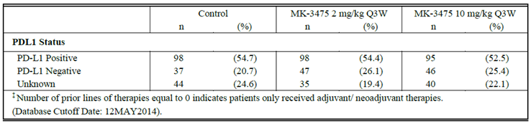
Thus in those with known status, 27 to 33% were PD-L1 negative.
Some 22 to 31% of subjects across arms had 1 prior line of therapy (that is only IPI); 37 to 44% had 2 prior lines; 18 to 19% had 3 prior lines; 7 to 10% had 4 prior lines; 4 to 9% had 5 or more prior lines of therapy. One of these prior therapies was IPI (and where BRAF V600 mutant, one was a BRAF or MEK inhibitor).

Efficacy methodology
The primary efficacy endpoints were PFS (blinded central review per RECIST 1.1) and OS. Secondary endpoints included ORR (confirmed responses from blinded central review) and response duration. Exploratory outcomes included quality of life (at Week 12).
The sponsor presented rank preserving structural failure time (RPSFT) analysis of OS, which adjusts for cross over from chemotherapy to pembrolizumab. The basic assumption of RPSFT is that the treatment effect is equal for all patients no matter when the treatment is received. Chemotherapy may affect the immune system or it may affect tumour factors that influence activity of pembrolizumab. With disease progression a patient’s capacity to benefit may be different from a patient at study baseline. Also, this trial involved an active comparator, yet RPSFT models require that patients are either on or off treatment, unless further assumptions are made. Lastly, a continuing treatment effect is plausible for pembrolizumab, yet the RPSFT model assumes a treatment effect is only received while on treatment. Therefore, the Delegate has not considered RPSFT analyses here.

Table 26. Efficacy results Study P002.
Endpoint | 2 mg/kg | 10 mg/kg | chemotherapy
Progression–free survival (IRO) (primary endpoint)
Hazard ratio versus chemo | 0.57 (0.45 to 0.73) | 0.50 (0.39 to 0.64)
Median | 2.9 months | 2.9 months | 2.7 months ^{b}
6 month PFS (95% CI) | 34.3% (27.4 to 41.3) | 37.7% (30.6 to 44.8) | 15.6% (10.5 to 21.5)
Progression-free survival (investigator)
Hazard ratio versus chemo | 0.49 (0.38 to 0.62) | 0.41 (0.32 to 0.52)
Median | 3.7 months | 5.4 months | 2.6 months
6 month PFS (95% CI) | 38.9% (31.6 to 46.1) | 44.9% (37.3 to 52.1) | 15.2% (10.2 to 21.0)
Overall survival
HR versus chemo | 0.88 | 0.78
Median ª | 11.4 months | 12.5 months | 11.6 months
6 month OS | 72% | 76% | 66% estimated from KM curve
Objective response rate (IRO)
ORR | 21.1% | 25.4% | 4.5%
Median response duration | Not reached (6+ to 50+ wks) | Not reached (5+ to 48+ wks) | 37 weeks (7+ to 41 weeks)
IRO = independent radiologist plus oncologist review a The sponsor recommends cautious interpretation of median OS due to extensive censoring and small number of patients at risk after 6 months. b Described as at the upper end of historical PFS outcomes for dacarbazine in RCTs.
The progression free survival curve (IRO; ITT) is as shown in Figure 15.
Figure 15. Kaplan Meier of Progression free survival based on IRO assessment (Primary censoring rule) (ITT population) Study P002.
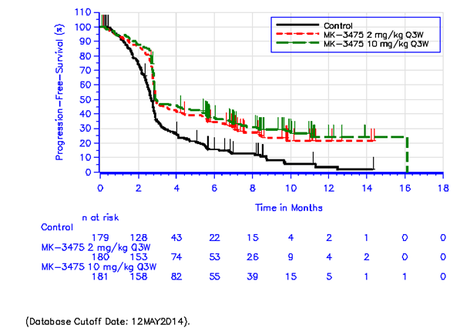
The sponsor interprets this to suggest that most IPI refractory patients progress by the time of the first disease assessment (performed at Week 12). The benefit of pembrolizumab over chemotherapy appears to reveal itself thereafter, that is, in those who do not progress early on treatment. The sponsor argued that ‘median PFS is not the measure that best represents the benefit of pembrolizumab’.
Regarding duration of response, 5 out of 8 chemo responders were progression free at the data cut off, whereas 35 out of 38 (2 mg/kg) and 40 out of 46 (10 mg/kg) pembrolizumab arm patients were progression free.
The sponsor states ‘1 in 4 IPI refractory patients treated with pembrolizumab can expect to respond to pembrolizumab and remain progression free for a prolonged period of time’ and this seems a reasonable interpretation of the above data.
While the sponsor argued that there were no major differences in efficacy between 2 mg/kg and 10 mg/kg dose regimens, there was a suggestion of modestly better efficacy at the higher dose, using some endpoints.
Subgroup analysis by PD-L1 status was reported. Positivity was as per P001, that is APS 2 + using IHC performed at a central core laboratory.

PD-L1 positive subjects

Table 27. PD-L1 positive subjects
Endpoint | 2 mg/kg (n=98) | 10 mg/kg (n=95) | Chemo (n=98)
Progression–free survival (IRO)
Hazard ratio versus chemo | 0.54 | 0.49
Median | 3.5 months | 4.0 months | 2.8 months
6 month PFS (95% CI) | 38.1% | 41.5% | 12.8%
Overall survival
HR versus chemo | 0.93 | 0.73
Median ª | Not reached | 14.8 months | 16.3 months
12 month OS ª | 50.0% | 50.6% | 55.8%
Objective response rate (IRO)
ORR | 23.5% | 29.5% | 4.1%
Median response duration | Not reached (6+ to 50+ wks) | Not reached (5+ to 48+ wks) | 37 weeks (7+ to 41 weeks)
a The sponsor recommends cautious interpretation of median OS due to extensive censoring and small number of patients at risk after 6 months; the Delegate agrees.

Table 28. PD-L1 negative subjects
Endpoint | 2 mg/kg (n=47) | 10 mg/kg (n=46) | Chemo (n=37)
Progression–free survival (IRO)
Hazard ratio versus chemo | 0.89 | 0.41
Median | 2.8 months | 2.8 months | 2.7 months
6 month PFS (95% CI) | 19.3% | 32.6% | 21.6%
Overall survival
HR versus chemo | 1.19 | 0.60
Median ª | 8.9 months | 10.8 months | 10.4 months
12 month OS ª | 37.0% | 49.7% | 40.6%
Objective response rate (IRO)
ORR | 10.6% | 19.6% | 8.1%
Median response duration | (N = 5) | (N = 9) | (N = 3)
IRO = independent radiologist plus oncologist review. a The sponsor recommends cautious interpretation of median OS due to extensive censoring and small number of patients at risk after 6 months; the Delegate agrees.
Other sub-group analyses revealed no concerning differences.
A comparison of overall results and results in PD-L1+/- subgroups is shown in Table 29. Patients with unknown PD-L1 status are only captured in ‘overall’ outcomes.

Table 29. A comparison of overall results and results in PD-L1+/- subgroups
 | 2 mg/kg |  |  | 10 mg/kg |  |  | Chemotherapy
 | PD-L1 pos | PD-L1 neg | all | PD-L1 pos | PD-L1 neg | all | PD-L1 pos | PD-L1 neg | all
N= | 98 | 47 | 180 | 95 | 46 | 181 | 98 | 37 | 179
Median PFS (IRO), months | 3.5 | 2.8 | 2.9 | 4.0 | 2.8 | 2.9 | 2.8 | 2.7 | 2.7
6 month PFS (IRO) | 38.1% | 19.3% | 34.3% | 41.5% | 32.6% | 37.7% | 12.8% | 21.6% | 15.6%
Median OS, months | NR | 8.9 | 11.4 | 14.8 | 10.8 | 12.5 | 16.3 | 10.4 | 11.6
ORR | 23.5% | 10.6% | 21.1% | 29.5% | 19.6% | 25.4% | 4.1% | 8.1% | 4.5%
The sponsor described the difference between 2 mg/kg and 10 mg/kg arms in the PD-L1 negative sub-group as possibly ‘spurious’, discounting the possibility of any dose response in the PD-L1 negative sub-group. Certainly, ORRs in P002 in the PD-L1 negative sub-group were more impressive than in P001. However, P002 may be considered a more robust study, in terms of design, than P001.
For patient reported outcomes, completion rate to Week 12 was 65% (control) versus 68 to 75% (pembrolizumab). LS mean change from baseline to Week 12 in global health status was -9.1 for chemo, -2.6 for 2 mg/kg and -2.6 for 10 mg/kg (based on those subjects with observations at baseline and Week 12). Also, pembrolizumab arms have a smaller proportion of patients who ‘deteriorated’ (10 point or greater change from baseline; baseline total scores were 63 to 66 per arm). Around 25 to 27% of patients improved across arms. Alignment between patient-reported outcomes in the symptom domain and top line AEs was not always obvious (for example dyspnoea was more commonly reported as an AE in the 10 mg/kg arm than other arms, but the proportion of patients with improvement in patient-reported dyspnoea was 22 to 23% across arms, and with deterioration was markedly lower in the 10 mg/kg arm than other arms).
Figure 16. EORTC QLQ-C30 score change from baseline to Week 12 (symptom scales)
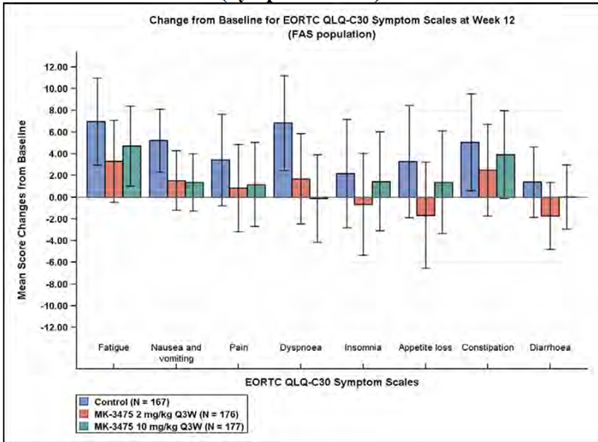
For EORTC QLQ-C30 symptom scales, a higher score denotes worse symptom.

Safety results
The median/mean exposure time to treatment was 113 to 144 days (2 mg/kg), 145 to 157 days (10 mg/kg) and 61 to 75 days (chemo). This may influence time at risk (although patients were exposed to different regimens, for example dosing every 3 weeks for pembrolizumab versus variable regimens for chemo; also pembrolizumab has a long half-life and arguably more potential for delayed onset of AEs after exposure).
Top line safety results follow. Grade 3 to 5 drug related AEs were less frequent with pembrolizumab (11 to 14%) than with chemotherapy; drug related serious AEs were seen at similar frequencies (8 to 11%). Discontinuations were seen at similar frequencies (10 to 15%). These top line results hide considerable differences in type of adverse event:
AEs that were more common in the chemo arm included anaemia (26% versus 11 to 17%), thrombocytopenia (12% versus 1 to 2%), nausea (42% versus 20 to 24%), vomiting (23% versus 8 to 18%), peripheral neuropathy (11% versus 2%), and alopecia (21% versus 1 to 3%).
AEs that were more frequent on pembrolizumab included endocrine disorders (1% versus 11 to 12%), abdominal pain (8% versus 13 to 14%), pyrexia (9% versus 12 to 15%), hyponatraemia (5% versus 7 to 11%), arthralgia (10% versus 12 to 15%), rash (8% versus14%), and pruritus (8% versus 25 to 30%).
It is interesting that infections were seen at similar levels across arms (33 to 38%). Neutropenia was not reported as having a frequency of ≥ 1 0% in one or more arms.
Pruritus has many causes, but it is potentially relevant that chronic spontaneous urticaria is mediated by autoantibodies in a substantial proportion of subjections.
AEOSI were observed in 4.7% (control), 7.3% (2 mg/kg) and 12.8% (10 mg/kg). Key outcomes included: pneumonitis (grade 2+) in 2.2% of 10 mg/kg patients but in no patients in other arms; and iritis in 1.1% of 10 mg/kg patients but no others. Regarding pneumonitis, it is potentially relevant that dyspnoea was significantly more frequent in the 10 mg/kg arm than other arms (17% versus 10 to 12%).

Table 30 AEs in Study P002.
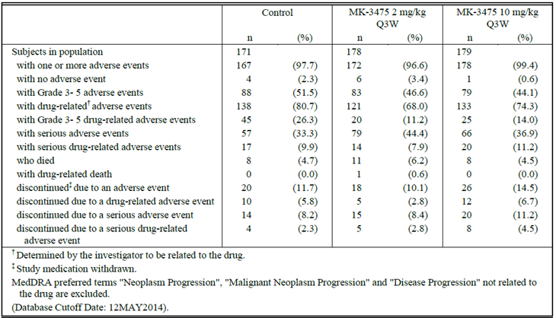
In P002, there was a drug related death, in the 2 mg/kg Q3W arm; details were unavailable.
In P002, serious AEs were seen in 44.4% of 2 mg/kg Q3W subjects and 36.9% of 10 mg/kg Q3W subjects (versus 33.3% of control subjects), but drug related SAEs were seen in 7.9%, 11.2% and 9.9% respectively. The breakdown of SAEs was not provided in the summary data document.
In P002, discontinuations due to AEs were seen at a higher rate: 10 to 15% across arms. However, only in 3 to 7% were discontinuations due to drug related AEs. The breakdown of discontinuations was not shown in the summary data document.

Study P006
P006 was a randomised trial of pembrolizumab (including two arms: 10 mg/kg Q2W and 10 mg/kg Q3W, given for up to 2 years) versus ipilimumab (3 mg/kg Q3W for 4 doses) in advanced melanoma patients naïve to ipilimumab. There were 277 to 279 patients in each arm. Summary data were provided for review. Details are provided below.
A Clinical Study Report (CSR) was not provided. An ‘early results memo’ dated 9 Feb 2015 with ‘top-line’ information was disclosed.
Please note that there are two separate reports provided by the Delegate with regard to P006, the initial one was for the request for ACPM Advice (dated 17 February 2015) and a subsequent update of this which was provided as a late paper to the ACPM (dated 27 March 2015)
Description by the Delegate for the ACPM Summary of Study P006 (17 February 2015)

Design and interventions
P006 is a randomised, controlled trial of pembrolizumab versus ipilimumab in advanced melanoma patients naive to ipilimumab. The study was open label. Study enrolment was completed within 6 months, on 3 March 2014.
The results reported are from the first interim analysis (data cut off for interim analysis 1 was 3 September 2014; database lock 4 February 2015), at which point all patients had been followed up for at least 6 months.
834 patients were randomised 1:1:1 to receive:
- IV pembrolizumab 10 mg/kg Q3W for up to 2 years (N = 277)
- IV pembrolizumab 10 mg/kg Q2W for up to 2 years (N = 279)
- ipilimumab 3 mg/kg Q3W for 4 doses (N = 278)
22 patients in the control arm and 1 in a pembrolizumab arm were randomised but did not receive assigned treatment, meaning the ‘all patients as treated’ cohort was slightly imbalanced (256 versus 277 to 278 patients).
Randomisation was stratified by ECOG performance status (0 versus 1), line of therapy (1st versus 2nd) and tumour PD-L1 status (high positive versus low positive by IHC, which the sponsor clarifies is equivalent to PD-L1 positive and negative as per P001).

Inclusion and exclusion criteria
The study sample was defined as follows:
Patients with a diagnosis of unresectable or metastatic melanoma that have not received IPI treatment may be enrolled. Patients must have measureable disease as defined by RECIST version 1.1
Details of inclusion and exclusion criteria were not supplied.

Baseline characteristics
Baseline characteristics within the ITT population are shown in Table 31.
Table 31. Baseline characteristics within the ITT population Study P006
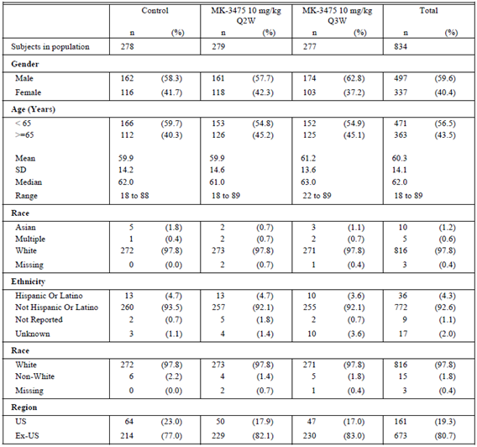
Table 31 (cont). Baseline characteristics within the ITT population Study P006
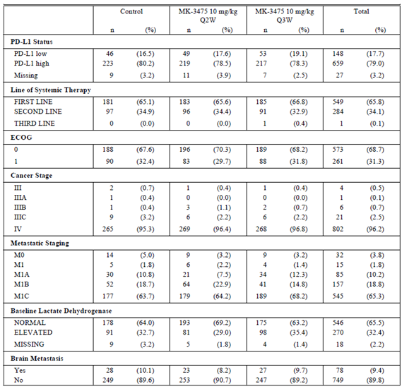
Table 31 (cont). Baseline characteristics within the ITT population Study P006
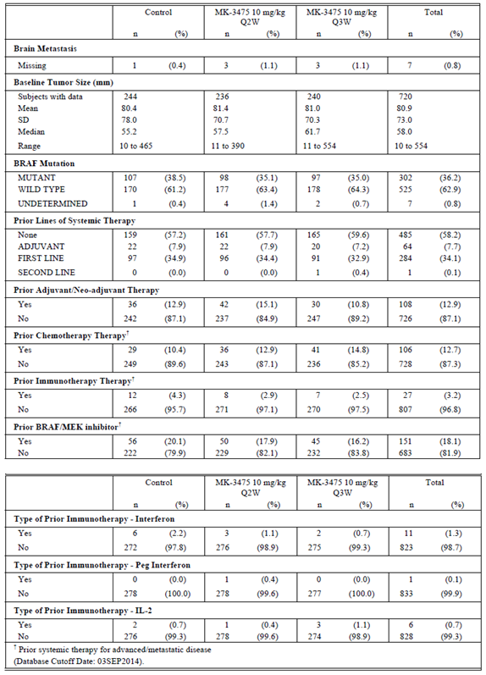

Efficacy methodology
The primary efficacy endpoints were PFS (independent radiologist plus oncologist review, per RECIST 1.1) and OS. Secondary endpoints included ORR (confirmed responses from blinded central review) and response duration. Exploratory outcomes included quality of life.
Investigator assessed response was according to immune related response criteria.

Efficacy results
Progression free survival (IRO using RECIST 1.1) is shown in Table 32 and Figure 17.
Table 32. Analysis of progression free survival based on ITO assessment (primary censoring rule) (ITT population)
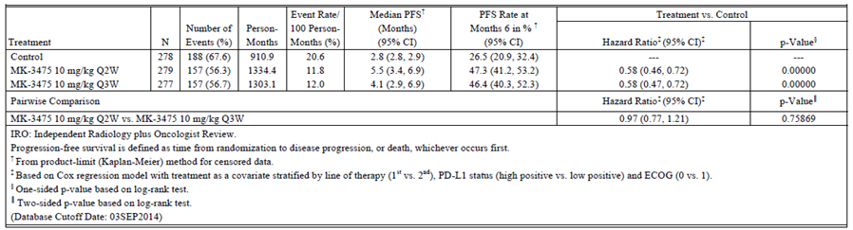
Figure 17. Kaplan-Meier of progression free survival based on IRO assessment (primary censoring rule) (ITT population)
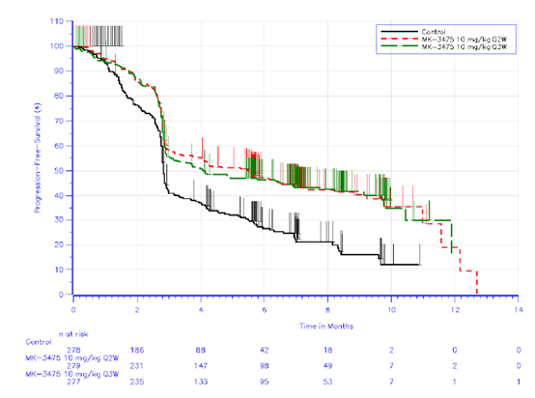
Figure 18. Forest plot of PFS hazard ratio by subgroup factors IRO assessment (primary censoring rule) MK 10 mg/kg Q3W versus control
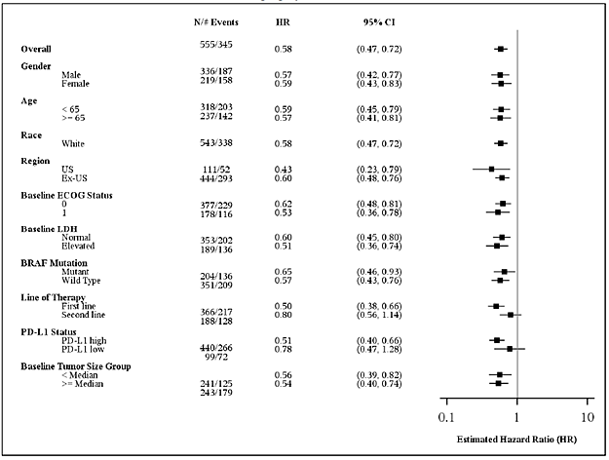

Progression-free survival (investigator using immune related response criteria)
Table 33. analysis of progression free survival based on investigator assessment per irRC (primary censoring rule) (ITT population)
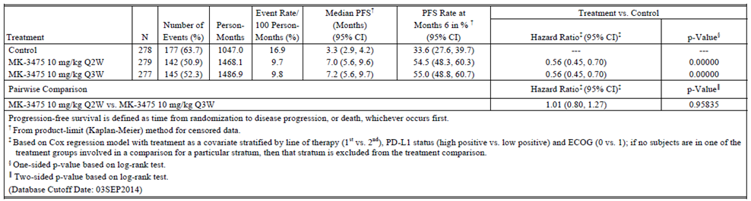
Figure 19. Kaplan-Meier of progression free survival based on investigator assessment per irRC (primary censoring rule) (ITT population)
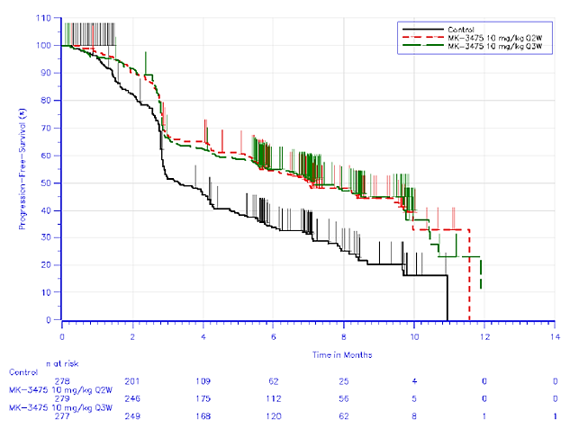

Overall survival

Table 34. Analysis of overall survival (ITT population) Study P006
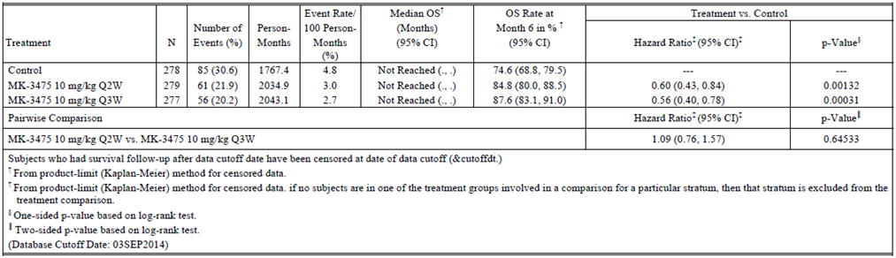
Figure 20. Kaplan-Meier of overall survival (ITT population) Study P006
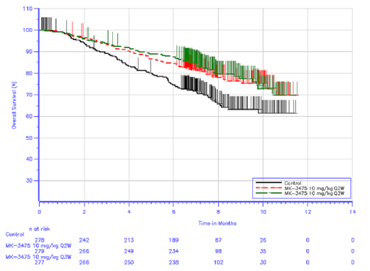
Figure 21. Forest pole of OS hazard ratio by subgroup factors MK3475 10 mg/kg Q3W versus control
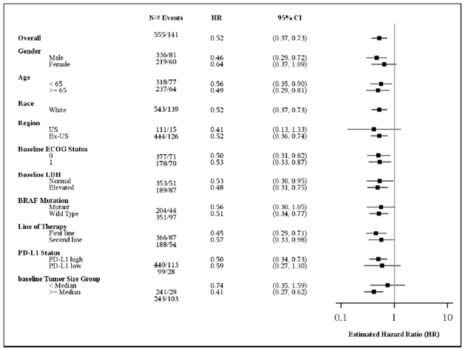

Objective response
Table 35. Analysis of overall response based on IRO assessment per RECIST 1.1 (ITT population) Study P006
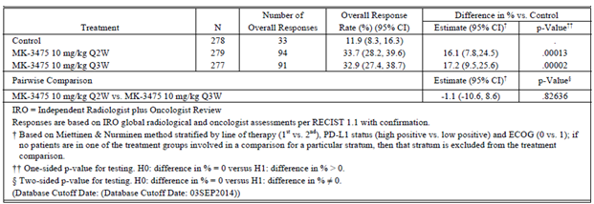
Table 36. Summary of time to response and response duration for subjects with objective response (ITT population) Study P006
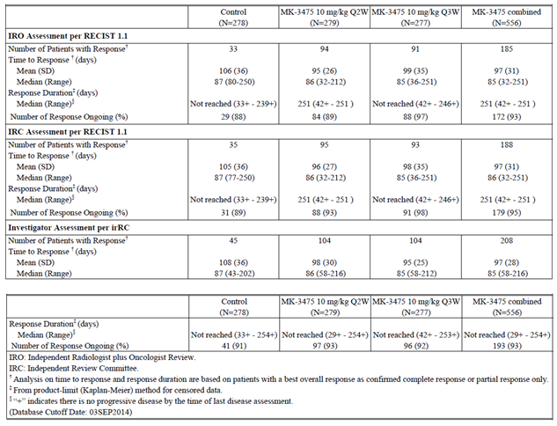

Safety results
Mean number of IPI doses was 3.3; median number was 4. Doses were given over a mean of approximately 50 days (from first to last dose).
Mean exposure to pembrolizumab was over 164 days (10 mg/kg Q2W) and 151 days (10 mg/kg Q3W).
AE data reflect cumulative incidences of AEs, not incidence rates. Patients on IPI were followed during treatment and after completing IPI every 3 weeks until disease progression or other discontinuation criteria were met. This implies that AEs for IPI include AEs well after the 4th dose; the early results memo was not sufficiently detailed to explore this issue further. The sponsor does note though, that patients on IPI generally had earlier disease progression, and the IPI arm had a higher rate of progression.
Table 37. Adverse event summary (APaT population) Study P006
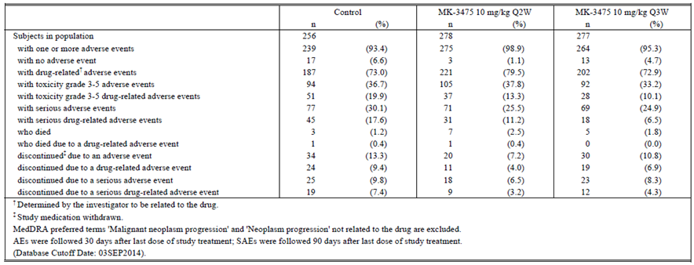
Table 38 Analysis of adverse event summary Tier 1 (APaT population) Study P006
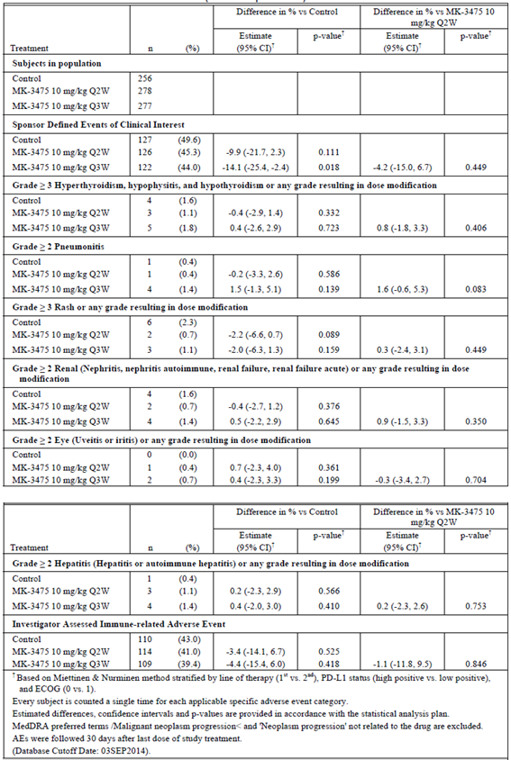
Table 39. Analysis of adverse event summary Tier 1 (APaT population) Study P006
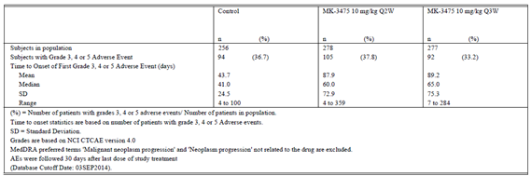
Addendum to Delegates response dated 27 March 2015

Background
This is an addendum to the Delegate’s overview for pembrolizumab. It is to provide context for the sponsor’s document ‘IAM_MK3475 PN006_IA2, which is being provided to the ACPM for consideration at the April 2015 meeting’s discussion of pembrolizumab.
Study P006 is a randomised study of pembrolizumab (10 mg/kg Q2W and 10 mg/kg Q3W arms) versus ipilimumab (3 mg/kg Q3W, 4 doses). The co-primary endpoints for P006 were PFS and OS. The studied population had advanced melanoma and was naïve to IPI; about two thirds of subjects were receiving first line treatment for advanced disease.
A clinical study report for P006 has not been written or provided to the TGA. The TGA’s evaluation of pembrolizumab to date has taken into account an early results memo for P006, dated February 2015, that reported top line results from the first interim analysis (IA1). Report IA1 included the primary analysis of PFS, and an analysis of OS data based on 46% of the target number of events at final analysis (202 subjects had died by the Report IA1 data cut off).
On 27 March.2015, the sponsor provided an updated early results memo for P006, dated 23rd March 2015, that reported top line results for the second interim analysis (IA2).
Based on Report IA2, the independent data monitoring committee recommended the study results be unblinded and pembrolizumab made available to patients on the control arm. The sponsor agreed to stop the trial early (although long term safety data will be collected, and all patients will be followed for OS until the final protocol described OS analysis, that is when there have been 435 deaths or when all patients have been followed up for 21 months, whichever comes first).

Key outcomes from interim analysis 2 (Report IA2)
Whereas the data cut off for Report IA1 was 3 September 2014 (with a minimum follow-up of 6 months for all patients), the data cut off for Report IA2 was 3 March 2015 (with a minimum follow-up of 12 months for all patients). Median OS follow-up is 13.8 months. 289 subjects had died by the data cut-off date.
Pembrolizumab at dose regimens tested delivers a statistically and clinically significant survival advantage relative to ipilimumab.
There is no clear difference in OS outcomes across 10 mg/kg Q2W and Q3W arms, although 12 month OS rates are higher in the Q2W arm than the Q3W arm.
Attention is drawn to sub-group analyses of OS:
- Patients with PD-L1 negative tumours (18% of the total study population) did not have a survival benefit relative to ipilimumab; the sponsor notes that Report IA1 showed favourable PFS and ORR for pembrolizumab versus ipilimumab in PD-L1 negative subjects (PFS HR versus IPI is 0.73; and ORR was 17.5% for pembrolizumab arms combined, versus 10.6% for IPI)
- The OS advantage of pembrolizumab over ipilimumab was clearer in patients with elevated LDH and ≥ median tumour size at baseline, although this signal was more prominent in the pembrolizumab Q3W versus IPI comparison; there was no clear signal of such an effect in the IA1 subgroup analysis of PFS
- Outcomes were similar by line of therapy (first versus second).
The early results memo for IA2 focused on OS and did not provided further information about other outcomes, including toxicity.

Conclusions
The second interim analysis of P006 confirms the benefit of pembrolizumab over ipilimumab, in that an overall survival benefit has been demonstrated (for the dose regimens tested).
The results are still in the format of an ‘early results memo’ (rather than a clinical study report) and have not been formally evaluated by a TGA clinical evaluator. However, the results are concordant with those from Report IA1 and also with conclusions drawn from cross study comparisons of pembrolizumab outcomes in P001 and ipilimumab outcomes in historical trials. Furthermore, the results were considered significant enough to stop the trial early, based on pre-specified stopping rules.
The early results memo for IA2 for P006 strengthens the conclusion in the Delegate’s overview that pembrolizumab offers better efficacy than ipilimumab, in the IPI naïve population under study. It seems reasonable to bridge to the first line context since two thirds of subjects in P006 were being treated first line, amounting to about 180 subjects per arm, and there was no signal of differential efficacy by line of treatment. There is also a reasonable argument to bridge from the dose regimens studied in P006 to the dose regimen proposed for use.
The updated early report memo for P006 does not change the conclusion reached in the Delegate’s overview that pembrolizumab can be registered for the indication:
Keytruda (pembrolizumab) is indicated as monotherapy for the treatment of unresectable or metastatic melanoma in adults.
Provision of the updated early report memo to the ACPM may be helpful in the ACPM’s consideration of the use of ‘top line’ data for P006, and may also help inform discussion about the value of the PD-L1 biomarker.

Pharmacology
The formulation proposed for commercial supply has been used throughout the clinical development programme. Manufacture has taken place using different supply chains, so that clinical trials have used Materials A, B and B’, each with a different origin. The sponsor contends Material B is comparable to Material A, and Material B’ is comparable to Material B. Material B’ is proposed for supply.
The proposed PI states that after adding 2.3 mL sterile water to the lyophilised powder, the pH is in the range 5.2 to 5.8.
The quality evaluation states osmolality of the infusion solution (220 to 270 mOsm/kg) is controlled by dilution with normal saline or 5% dextrose. It is unclear what the osmolality is after further dilution to 1 to 10 mg/mL; the sponsor was invited to clarify this.

Pharmacokinetics (PK)
PK characteristics have been evaluated by the clinical evaluator (see Attachment 2). The evaluator considered that PK had been adequately investigated and raised no issues of concern.
Pembrolizumab’s profile was typical of a monoclonal antibody. Half-life was approximately 26 days; steady state was achieved after 18 weeks of dosing, with 2 fold accumulation relative to a single dose.
A population PK evaluation report was written. The evaluator noted that in the proposed PI summary of PK relies on population PK analysis. The Pop PK evaluator considered the document ‘Modelling and Simulation Report of Population PK of MK-3475’. Study P001 contributed data from 476 subjects to this report. 13.1% of subjects had non-melanoma tumour types.

Pharmacodynamics
The T cell compartment was monitored via flow cytometry, in P001 Parts B1, B2 and D. Of 411 melanoma patients, 367 had lymphocyte subtyping data. FACS analysis was only protocol specified up to Cycle 4 (Week 9). Also, the 92 patients without available data had ‘insufficient quantity and / or quality to meet assay standards’ but it may be in the patients with an insufficient quantity of lymphocytes that relevant perturbations in the T cell compartment will be found. However, FACS analysis did not show obvious trends in absolute numbers of major T cell sub-types.
In 15% of patients, there was a meaningful decline in lymphocytes (in P001, B1+B2+D, 18 Oct 2013 cut off), defined as a shift from ‘less than grade 3’ (≥ 500/mm³) to grade 3 to 5 (< 500/mm³), or a shift from grade 0 (≥ LLN) to grade 2 (< 800/mm³). This may reflect a change in T and / or B cell compartments. Flow cytometry of the T cell compartment did not reveal any decline in absolute counts of CD4+ or CD8+ T cells. This suggests that B cells are affected, or that FACS analysis did not include patients with a decline in T lymphocytes, or that lymphocytes declined after Week 9 (that is that FACS analysis was too early to reveal changes). The observed clinically meaningful decline in lymphocytes (in 15% of patients) may be due to various factors, one being a drug effect. The decline was not well characterised and there is uncertainty about whether pembrolizumab induces lymphopenia. The sponsor is invited to clarify this issue.
The sponsor concluded that the proportion of activated T cells (as defined by HLA-DR positivity) rises with pembrolizumab treatment. The clinical significance of this finding is unclear. The sponsor contends that pembrolizumab does not non-specifically activate T cells (that is it potentiates immune responses only in the presence of antigen); however this does not rule out activation of T cells that do not target melanoma cells.

Exposure response
Exposure response assessment is relevant because of the considerable reliance in this application on data from use of pembrolizumab at higher doses (that is 10 mg/kg) and with a shorter treatment interval (that is Q2W) than proposed.
The sponsor claims that no clinically relevant exposure efficacy relationship has been found, and interprets this to indicate that ‘efficacy at the investigated dose levels is near the plateau’. The basis of the claim was analysis of tumour size reduction over time in B1+B2+D patients. Exposure to the drug (AUC over 6 weeks at steady state) was as per population PK modelling. There were responses across a range of AUCs as shown in Figure 22.
Figure 22. PK modelling of exposure response
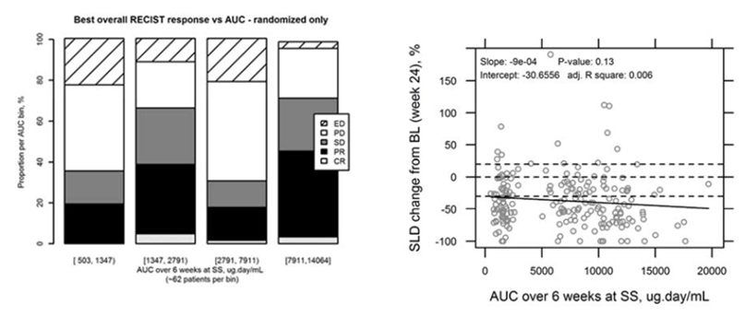
An alternative approach is to consider outcomes in B2, D and P002 (randomisation to 2 mg/kg versus 10 mg/kg Q3W, that is 5 fold higher dosing relative to that proposed) and B3 and P006 (10 mg/kg Q3W versus Q2W; 50% higher dosing).
Randomisation to 2 mg/kg versus 10 mg/kg:
- In B2, ORR is 25% at 2 mg/kg Q3W and 25% at 10 mg/kg Q3W
- In D, ORR is 33% at 2 mg/kg Q3W and 35% at 10 mg/kg Q3W
- In P002, median PFS was 2.9 months for both 2 mg/kg Q3W and 10 mg/kg Q3W with an IRO and 4.2 versus 5.6 months respectively with investigator assessment. In P002, ORR is 21% at 2 mg/kg Q3W and 25% at 10 mg/kg Q3W
Randomisation to Q2W versus Q3W:
- In B3, ORR was 27% at 10 mg/kg Q3W and 33% at 10 mg/kg Q2W (p = 0.3041)
- In P006, median PFS was 4.1 months for 10 mg/kg Q3W and 5.5 months for 10 mg/kg Q2W, based on IRO, and 7.0 versus 7.2 months respectively with investigator assessment. In P006, ORR is 32.9% and 33.7% respectively.
An assumption is that AUCss, 6 weeks, is a sufficient measure of ‘exposure’ (outcomes of B3 raise the possibility that trough levels might be relevant, though P006 presents a mixed picture). On balance, the Delegate agrees with the view that no clinically relevant exposure efficacy relationship has been found. This has several implications. First, the randomised sub-studies B2, B3 and D cannot be considered to demonstrate efficacy of pembrolizumab directly (in that efficacy of a high dose of pembrolizumab is not particularly better than efficacy of a low dose). Second, it is reasonable to consider efficacy from data pooled across different dose regimens (that is all other things being equal, it may be reasonable to bridge from 10 mg/kg to 2 mg/kg and from Q2W to Q3W). A caveat is that results from B3 and P006 leave open the possibility that dose interval influences efficacy; a 2 mg/kg Q2W dose was not tested.
No relationship was found between exposure and frequency of AEs, SAEs or immune related AEs of special interest (‘Cat 1’ = grade 3 or 4 AEs or SAEs; ‘Cat 2’ = AEOSIs):
Figure 23. Frequency of AEs and exposure
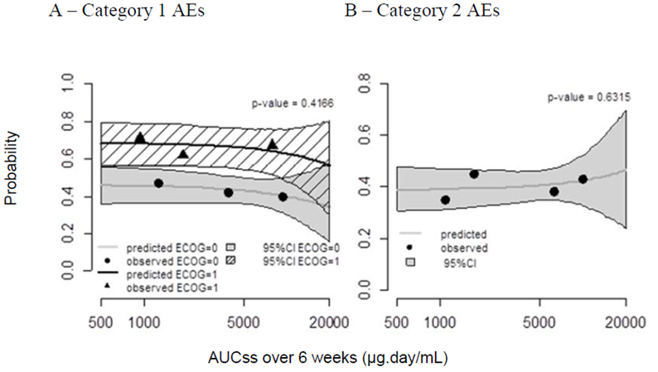
The sponsor’s view is supported by summary safety findings for sub-studies B2 and D, which showed no consistent picture of more toxicity in arms with more intense dosing. Interim assessment of randomised sub-study B3 suggests more toxicity with 10 mg/kg Q2W than 10 mg/kg Q3W (see Table 6 above), and interim results of P006 are generally consistent with this conclusion again raising the possibility that measures other than AUCss, 6 weeks, are relevant.
The sponsor nominated wide clinical bounds (the [0.5, 5.0] interval of geometric mean ratio, relative to typical exposure at 2 mg/kg Q3W) to study the clinical relevance of exposure effects (effects of age, gender, organ dysfunction, tumour type and burden, concomitant medications) The upper bound is defensible given similar safety profiles seen with 2 mg/kg and 10 mg/kg dosing. The lower bound is supported by modelling / projections, for example ‘a 1 mg/kg Q3W dose (0.5 fold dose and AUC) is still associated with a high (> 95%) target engagement at steady state trough levels’.

Efficacy; first line
The TGA has adopted the guideline which informs the following discussion.

Comparisons with ipilimumab
Ipilimumab does not have a first line indication in advanced melanoma, but it is funded via the Pharmaceutical Benefits Scheme (PBS) for first line induction / re-induction as monotherapy. Comparison of results with ipilimumab is appropriate.

Randomised, controlled studies using an appropriate comparator
The sponsor has disclosed top line results of P006, the randomised, controlled study of pembrolizumab versus ipilimumab in IPI naïve subjects. No clinical study report is available. The study is due to be complete mid-2016. In P006, approximately 66% of subjects were receiving pembrolizumab as a first line agent for advanced melanoma. Randomisation was stratified by line of therapy (1st versus 2nd), PD-L1 status and ECOG status. N = 181 to 185 patients per arm were receiving study drug for first line therapy of advanced disease. A 10 mg/kg dose was used (with Q2W and Q3W arms), so results do not directly support 2 mg/kg Q3W pembrolizumab dosing. PFS, OS and ORR outcomes all strongly favoured pembrolizumab and sub-group analysis by line of therapy (presented by Forrest plot in the top-line data) suggested good first line outcomes relative to IPI. The top-line results did not record any patient-reported outcomes, although quality of life (QoL) endpoints were mentioned in the protocol summary.

Cross study comparisons
Some patients in P001 received pembrolizumab as a first line agent. The acceptability of efficacy in this setting can be evaluated, to an extent, by considering results of sub-groups within the study (for example ORR in first line patients) and by cross study comparison.
Based on B1+B2+D (n=411) and the initial data cut off (18 October 2013), where 95 subjects had been identified as treatment-naïve for advanced melanoma, the following best objective response rates were obtained, by dose regimen as shown in Table 40.

Table 40. Objective response rates by dose regimen.
prior therapies | 2 mg/kg Q3W | 10 mg/kg Q3W | 10 mg/kg Q2W | total
0 | 15/38 = 39% | 18/41 = 44% | 7/16 = 44% | 40/95 = 42%
1 | 12/48 = 25% | 16/53 = 30% | 8/19 = 42% | 36/120 = 30%
2 | 13/44 = 30% | 10/56 = 18% | 10/15 = 67% | 33/115 = 29%
> 2 | 7/32 = 22% | 11/42 = 26% | 3/7 = 43% | 21/81 = 26%
Some 28% of those in B3 (that is 68 out of 244) were treatment naïve, bringing the total of treatment naïve subjects with advanced melanoma in P001 to approximately 161. However, in summary data for B3, there was no subgroup analysis by number of prior therapies.
The registration study for ipilimumab, MDX010-20, was not first line. In it, best ORR was 11% in the ipilimumab monotherapy arm, 6% in the ipilimumab + gp100 arm and 1.5% in the gp100 arm. Published data in support of first line ipilimumab monotherapy (3 mg/kg as per funding) are limited; this makes cross study comparison with first line pembrolizumab difficult. However, interim results of P006 suggest that first line IPI is likely to have a similar degree of efficacy (the IPI ORR in P006 was 11.9%; two thirds of patients were treatment naive).
Comparison of pembrolizumab’s efficacy as a first line agent in P001 with ipilimumab’s apparent efficacy as a first line agent suggests much better efficacy for pembrolizumab. This line of evidence supports the top line outcomes reported for P006.

Comparison with BRAF / MEK inhibition in patients with BRAF mutant tumours
BRAF and MEK inhibitors can be used in these patients as first line therapy, so efficacy of pembrolizumab in this sub-group is important to understand.

Randomised, controlled studies using an appropriate comparator
There are no RCTs of pembrolizumab versus BRAF/ MEK inhibition in patients with BRAF mutant tumours.

Cross study comparisons
Both P001 and P006 included patients with BRAF mutant tumours who were receiving pembrolizumab as first line therapy.
In B1+B2+D, 75.4% of patients had BRAF V600 WT tumours, and 23.6% had BRAF V600 mutant tumours. More typically in Australia, approximately 45 to 48% of patients with advanced melanoma have BRAF V600 mutant tumours. It is not clear why the proportion with BRAF mutation is lower in B1+B2+D. This limits generalizability of results. In P006, 36% of subjects had BRAF mutant tumours, a result more in line with expectations.
Estimates from P001 suggest slightly higher efficacy for pembrolizumab in patients with BRAF WT tumours (ORR 34%) than in patients with BRAF mutant tumours (ORR 23%) (Table 21). Conclusions cannot be drawn because a lack of randomisation introduces the potential for confounding (for example by PD-L1 status or by line of therapy), and because sample size in some sub-groups is limited.
Top line results for P006 did not detail efficacy in first line patients with BRAF mutant tumours. However, sub-groups analyses of PFS and OS by BRAF status did not point to variation in efficacy according to BRAF status. This means efficacy in first line patients represents efficacy in first line patients with BRAF mutant tumours. In the 10 mg/kg Q3W arm, ORR was 33% (97% of patients had ongoing responses); median PFS was 4.1 months (IRO; RECIST 1.1); median OS was not reached (6 month OS was 88%).
BRAF and BRAF+MEK inhibition have been well characterised in first line treatment of advanced (BRAF mutant) disease. For example, Long et al reported a 67% response rate in patients given first line dabrafenib + trametinib, versus a 51% response in patients on dabrafenib alone.⁴⁴ Median durations of response were 9.2 months and 10.2 months, respectively (‘on the basis of data that were highly censored because the majority of investigator-assessed responses (60%) were still ongoing’). Robert et al found similar ORRs, 64% for dabrafenib + trametinib versus 51% for vemurafenib; median durations of response were 13.8 months versus 7.5 months.⁴³ Larkin et al reported 68% for vemurafenib + the unregistered cobimetinib, versus 45% for vemurafenib alone; median durations of response were ‘not reached’ and 7.3 months respectively.
In these studies, median PFS for combination therapy ranged from 9.3 to 11.4 months, and OS at 6 months was in the range 92 to 95% (based on inspection of Kaplan Meier curves).
BRAF and MEK inhibitors are also indicated as monotherapy for first line use in patients with BRAF V600 mutant melanoma. PFS outcomes for monotherapy are lower than reported for combination therapy (median PFS is 6.2 to 8.8 months in the studies referred to above; the percentage of patients alive at 6 months is in the mid to high 80s).
It is reasonable to conclude that treatment naïve patients with BRAF mutant tumours would obtain a response with pembrolizumab in perhaps a third of cases. This ORR is considerably lower than for BRAF inhibitors (approximately 50% ORR) and for BRAF + MEKi (approximately 67%). In those who do respond, duration of response with pembrolizumab appears very good (for example in P001 Part D, with ≥ 1 5 months follow-up for all patients, 83% of responders are non-progressing). Comparison of duration of response is problematic. Median duration of response is approximately 9 to 14 months with BRAFi + MEKi combinations (a wide range), but more patients respond to combination therapy than to pembrolizumab.
PFS outcomes appear better for BRAF and / or MEK inhibition than for pembrolizumab, and OS as measured by survival at 6 months appears slightly better for combined BRAF + MEK inhibition. OS at 6 months (an early time-point) for pembrolizumab is similar to OS for BRAF or MEK inhibitor monotherapy.

Efficacy conclusions about first line use of pembrolizumab
Despite reliance on top line / interim results for P006 (and the need to bridge from 10 mg/kg Q3W and to use sub-group analysis) and cross study comparison for P001, there is sufficient evidence to support better efficacy for pembrolizumab than for ipilimumab in the first line setting.
There is no head to head study with BRAF / MEK inhibitors in patients with BRAF V600 mutant tumours. Based on cross study comparison, pembrolizumab has a substantially lower ORR. To an extent, this may be offset by longer duration of response. In P006, as revealed by top-line outcomes, tumour BRAF status did not influence efficacy. Median PFS with pembrolizumab varied depending on whether assessment was by independent radiology / oncology review (using RECIST 1.1) or by investigator (using immune related response criteria), but ranged from 4.1 to 7.2 months. This is approaching PFS outcomes reported for BRAF or MEK monotherapy; but combination therapy appears to result in a higher median PFS.
Median PFS may not reflect durability of response in a substantial minority of patients receiving pembrolizumab.
There was no formal comparison with dacarbazine, but cross study comparisons favour pembrolizumab (see Table 12 above).
Efficacy evidence may sometimes be obtained from trials comparing high and low doses of study drug. There was no indication efficacy varied in the dose range 2 to 10 mg/kg Q3W; randomised sub-studies in P001 do not contribute directly to efficacy assessment.

Efficacy; second or subsequent line
The sponsor has conducted P002, a randomised, controlled study of pembrolizumab versus investigator’s choice of chemotherapy in patient’s refractory to ipilimumab. Summary data from an interim analysis were available for review; a CSR was not provided.
P002 reveals acceptable efficacy of pembrolizumab in patients refractory to ipilimumab (and where BRAF mutant, with prior treatment using BRAF inhibition) on the basis of improved PFS (considering the survival curve rather than median outcomes) compared to investigator’s choice of chemotherapy. Quality of life outcomes were also promising.
P006 (in ipilimumab naïve subjects) informs about second line use of pembrolizumab; in a third of patients, pembrolizumab was second line (often after BRAF inhibitors). Pembrolizumab was clearly more efficacious in the second line setting than ipilimumab; there was insufficient detail to draw conclusions about whether pembrolizumab is ‘as’ efficacious in second line (for example after BRAF / MEK inhibition) as in first line.
There are also data from P001 that inform about efficacy of pembrolizumab in a second or subsequent line setting. For example, P001-B2 was in an IPI refractory population. ORR in P001-B2 was comparable to that seen in P002 (for 2 mg/kg Q3W, 25% versus 21% respectively), and 6 month PFS was near 40% in both studies. Broadly, the outcomes in B2 support the validity of outcomes in P002. P001-D was in an IPI naïve population; in the two arms, ORRs were 33 to 37% which is consistent with ORRs in P006 (33 to 34% over all lines of therapy).
Even in patients who had used more than 2 lines of therapy for advanced disease, ORRs were relatively good (26% across all treatment regimens, in P001).

Safety

Exposure
Safety in advanced melanoma has been characterised in P001 (open label; no active control arms), P002 (open label except for blinding to 2 versus 10 mg/kg pembrolizumab strength; chemotherapy control arm with distinctly lower exposure) and P006 (open label; ipilimumab arm with 4 doses).
In P001, the B1+B2+D pool included 162 patients on the 2 mg/kg Q3W regimen that is proposed for registration. These patients received a mean of 13 administrations over a mean of 259 days (18 April 2014 cut off). In P002, 179 APaT cohort patients were given 2 mg/kg Q3W; mean exposure in these patients was 144 days, suggesting half as many administrations as in P001, on average (12 May 2014 cut off). Many other subjects received higher doses of pembrolizumab, in P001, P002 and P006 (either 10 mg/kg Q3W or 10 mg/kg Q2W).

Methodology
Pembrolizumab has a half-life of approximately 26 days. The sponsor’s approach was to capture AEs reported within 30 days of the last dose of pembrolizumab (for serious AEs 90 days). A factor other than half-life that may contribute to onset of AEs well past 30 days after the last administration of pembrolizumab is the indirect mechanism of events, that is irAEs are due to de-repression of the immune system. It may take time for symptoms to occur after pembrolizumab triggers autoimmunity. For example, a case of nephritis occurred 5 months after the last dose.
In patients who received few doses, the ‘time at risk of AEs’ may be considerably longer than the period in which AEs were captured, for example if a patient received only 1 dose, AEs would be captured over 30 days, yet the time at risk of irAEs would be longer (based on half-life and the immune mediated mechanism of AEs). This concern is partially offset because serious AEs were captured within 90 days of the last dose.

Safety profile
Common AEs with pembrolizumab were, in descending order, fatigue (48%), nausea, cough, diarrhoea, pruritus, arthralgia, rash, constipation, decreased appetite, dyspnoea, headache, anaemia and vomiting (all with a frequency > 15% in P001). Consideration of frequency for preferred terms such as these may underestimate toxicity: other terms may overlap. For example, frequency of fatigue in the P001 B1+B2+D cohort (APaT; 18 April 2014 cut off) was 48%; but asthenia was reported separately, with a frequency of 15%, and lethargy was also reported separately.
Common serious drug related AEs with pembrolizumab were colitis (1.2%), fatigue (including asthenia; 0.7%), pyrexia (1.2%), glycaemic disorders (1.2%), renal failure (including acute renal failure; 1.2%) and pneumonitis (0.7%) (all with frequency > 0.5%, that is at least 3 patients out of 411, based on cumulative data from P001, B1+B2+D, APaT cohort, 18 April 2014 cut off).
In the summary data for P002, sponsor-defined events of clinical interest also revealed pneumonitis (4 out of 357 or 1.1% of pembrolizumab patients had grade 2 + pneumonitis; all in the 10 mg/kg Q3W arm) and renal dysfunction (5 out of 357 or 1.4% had nephritis or renal failure of grade 2 +) and further revealed hepatitis as a toxicity (4 out of 357 had grade 2 +).
In the summary data for P006 (allowing some degree of comparison with ipilimumab), sponsor defined events of clinical interest confirmed this profile. Reporting of specific AEs was very limited in the summary data for P006.
Clearly drug related AEs resulting in death were infrequent (n = 1 in P001; n = 1 in P002; n = 1 in P006) according to the sponsor.

Immune related AEs
The drug’s mechanism of action draws attention to autoimmune toxicities. These were reported irAEs and AEOSIs. There were sometimes large differences between frequencies of irAEs and general AEs. For example, in P001 (B1 + B2 + D; n = 411), frequency of vitiligo was reported as 11.4% (AE) and as 3.6% (irAE). Vitiligo is thought to have an autoimmune pathogenesis, and may be a marker of drug activity. These differences highlight the value of general AEs as well as ‘immune related AEs’ as defined by the investigator, in trying to understand the safety profile of the drug. AEOSIs were also reported, but they were defined in part by grade (for example, there were no reports of vitiligo as an AEOSI, presumably because reports were low grade).
Some 106 out of 411 patients were treated with topical or systemic steroids in P001 B1+B2+D, including 55 out of 411 receiving systemic steroids for an AE, 20 receiving topical steroids for an AE, and 31 receiving either form for unclear reasons. The characterisation of management and outcome of irAEs was not comprehensive, although for pneumonitis the update referred to above provided useful information.

Comparison with ipilimumab
A key question is how autoimmune AEs differ in nature and frequency from those seen with ipilimumab. The CSR for study P006 will answer this question, but top line results provide an indication. Also, some data from P001 and P002 can be used for cross study comparison, as noted below.

P006
Top line results from P006 show that, as expected from the study design, patients were on ipilimumab for less time than they were on pembrolizumab (median days of therapy, 63 versus 168 to 183 days; median number of administrations, 4 versus 9 to 13).
Severe or serious AEs were seen at broadly comparable rates across arms, but severe or serious AEs considered by the investigator to be drug related were seen at lower rates in pembrolizumab arms (severe drug related AEs were reported in 20% for IPI, 10 to 13% for pembrolizumab; serious drug related AEs were reported in 18% for IPI, 6.5 to 11% for pembrolizumab).
Discontinuations due to AEs were seen in 13% for IPI, 7 to 11% for pembrolizumab; and discontinuations due to serious, drug related AEs were seen in 7% for IPI, versus 3.2 to 4.3% for pembrolizumab.
Investigator assessed immune related AEs were reported in 43% for IPI, 39 to 41% for pembrolizumab.
The picture conveyed is that pembrolizumab causes as many AEs (including immune related AEs) as ipilimumab, but that pembrolizumab may produce less severe / serious AEs (at the population level). The CSR will allow better comparison; but top line results did reveal potentially more pneumonitis, uveitis / iritis and hepatitis with pembrolizumab than with ipilimumab.

Cross study comparison
In the design of P001 and P002, patients were excluded if they had earlier experienced severe IPI related irAEs. These patients were presumably excluded because they might be predisposed to severe irAEs with pembrolizumab. This makes comparison of severe immune related toxicity between IPI exposed pembrolizumab patients and IPI patients difficult, especially since the frequencies of some key AE categories differed in IPI naïve and IPI exposed patients in P001. IPI naïve pembrolizumab patients were studied (for example P001-D; some patients in P001-B1); it seems more reasonable to compare autoimmune toxicities of ipilimumab with those seen in IPI naïve subjects from P001.
Table 41compares selected ipilimumab and pembrolizumab studies. Other IPI studies may produce a different picture (for example Ascierto et al report lower frequencies), but those used in Table 41 have been widely reported and / or have local relevance. A further caveat is that cross study comparison may be misleading (for example due to differences in patient characteristics; drug exposure; methodology for reporting / defining irAEs; early / pre-emptive management of irAEs; etcetera).
Table 41 Exploratory comparison of ipilimumab and pembrolizumab; selected AEs and irAE
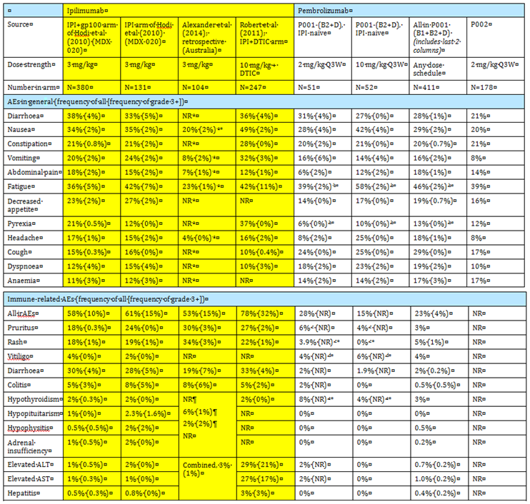
ª Alexander et al (2014) – excludes irAEs ^{b} fatigue excludes asthenia; pyrexia excludes chills ^{c} frequencies of pruritus reported as a general AE (that is not an irAE) were 20% and 31% respectively; for rash, 22% and 23% ^{d} frequencies of vitiligo reported as a general AE (that is not an irAE) were 6% and 14% respectively ^{e} frequencies of hypothyroidism reported as a general AE (that is not an irAE) were 16% and 8% respectively. ALT = alanine transaminase AST = aspartate transaminase
Immune related AEs and grade 3 + irAEs appear less frequent with pembrolizumab than with ipilimumab. For example, frequency of immune related diarrhoea is reported for ipilimumab at 19 to 33% (and frequency of grade 3 + immune related diarrhoea at 4 to 7%). Frequency of immune related diarrhoea for pembrolizumab is 2%, with few severe AEs. Yet, frequency of any diarrhoea is 33 to 38% for ipilimumab, 21 to 31% for pembrolizumab. The same applies for grade 3 + diarrhoea (4 to 5% versus 1 to 4% respectively). Colitis as an irAE seems less frequent with pembrolizumab than with ipilimumab, yet the frequencies of diarrhoea and abdominal pain are similar across treatments. A similar pattern emerges for other AEs, for example rash, pruritus, vitiligo. Top line data from P006 suggests comparable rates of investigator-assessed immune related AEs.
Based on cross study comparisons, some immune related AEs may be commoner with pembrolizumab than with ipilimumab. For example: pneumonitis and hypothyroidism.

Pneumonitis
Pneumonitis may be more frequent with pembrolizumab than with ipilimumab.
Pneumonitis appears to be rarely reported for ipilimumab, but was seen at a frequency of 2.7% in the P001 B1 + B2 + D population (18 October 2013 cut off). Also, frequency of cough / dyspnoea was relatively high, and might indicate sub-clinical pathology.
The sponsor provided a report about pneumonitis with pembrolizumab, based on later cut off (31 July 2014) and a wider range of clinical studies. A summary is shown in Table 42.
Table 42. Summary of interstitial lung disease (ILD) events with pembrolizumab
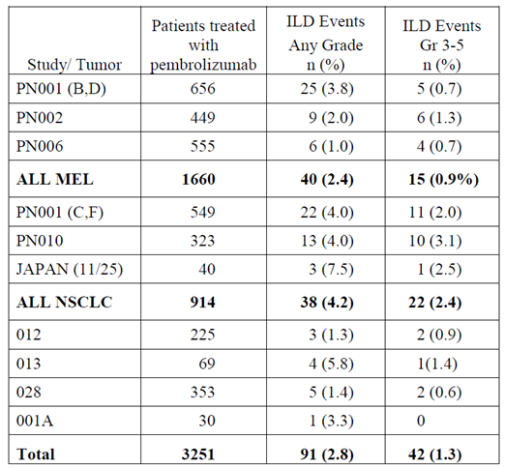
Of the 42 patients with at least severe events, 5 out of 42 patients died due to ILD (4 out of 5 in NSCLC; 1 out of 5 in salivary gland cancer), and 4 out of 42 had life threatening ILD (3 out of 4 in NSCLC, 1 out of 4 in gastric cancer). While the incidence of ILD is higher in NSCLC, the frequency in melanoma remains significant.
Some 81% of subjects were treated with prednisone ≥ 40 mg or equivalent. In melanoma patients, the median time to steroids was 3 days (versus 1 day in NSCLC). Rechallenge after a grade 2 event occurred in 14 out of 64 patients, and there were 2 patients with recurrence (manageable with corticosteroids and permanent discontinuation of pembrolizumab). Rechallenge after a grade 3 event occurred in 2 patients; in both the ILD recurred.
A common theme in patients with more severe ILD was the challenge of differentiating ILD from pneumonia. The sponsor recommends corticosteroid use for potential ILD if there is not a clear diagnosis.
In P001, an exclusion criterion was ‘history of pneumonitis or ILD.

Hypothyroidism
7% of patients in P001 B1 + B2 + D had clinical hypothyroidism (and 4.3% had clinical hyperthyroidism). Furthermore, TFTs were checked regularly. 16.9% of patients had subclinical hypothyroidism and 16% had subclinical hyperthyroidism. Overall, 38 out of 411 (9.2%) required thyroid hormone replacement, and 1 out of 411 required propylthiouracil.
In 2 out of 14 cases of significant hypothyroidism there had been a history of hypothyroidism.
Ipilimumab does not seem to induce hypothyroidism as often (Table 41) though the detailed results of P006 are awaited with interest in this regard.
These observations reinforce the value of head to head comparison of irAEs and AEs in general, as may be expected from the CSR for P006.

Comparison with BRAF / MEK inhibitors
Comparison of the safety profiles of pembrolizumab and BRAF + MEK inhibition is not simple, because of the absence of head to head studies. Cross study comparison is open to bias as mentioned earlier, but the following is a crude comparison; it does not suggest a massively improved safety profile with pembrolizumab.

Table 43. Cross study comparison of the safety profiles of pembrolizumab and BRAF + MEK inhibition
 | P006 (interim data) | P001 [18 April 2014; 2 mg/kg Q3W] | P002 (interim data) | COMBI-D (combination arm) | COMBI-V (combination arm)
Discontinuation due to AEs | 7 to 11% | 11% | 10% | 9% | 13%
Severe AEs | 33-38% | 43% | 47% | 35% | 52%
Top 5 AEs | not reported | fatigue (43%), nausea (32%), cough (30%), diarrhoea (28%), pruritus and rash (26%) | fatigue (39%), pruritus (25%), constipation (21%), diarrhoea (21%), nausea (20%) | pyrexia (51%), fatigue (35%), headache (30%), nausea (30%), chills (30%) | pyrexia (53%), nausea (35%), diarrhoea (32%), chills (31%), vomiting (29%)
For BRAF monotherapy, discontinuation due to AEs was reported in 5% (COMBI-D) and 12% (COMBI-V); and severe AEs in 37% (COMBI-D) and 63% (COMBI-V).

Other comparisons
Summary data from P002 are useful in the comparison of pembrolizumab and chemo. Differences in exposure across arms and the mix of control chemotherapies make head to head comparisons difficult, but pembrolizumab’s safety profile seems very different and relatively good (especially for the 2 mg/kg arm).

Other

Viral infection
PD-1’s role in human biology is not limited to the maintenance of tolerance. It regulates antibody responses and the response to viruses (as well as tumours). Some plausible ‘off-target’ effects related to these roles were not well-examined. For example, in HCV positive patients, it would have been useful to search for any evidence of altered control of the infection. There were cases of elevated LFTs and / or hepatitis, but no attempt to relate these cases to a history of HCV or HBV. It is possible that blockade of PD-1 – PD-L signalling might trigger immunopathology as previously exhausted virus-specific T cells are reactivated.
The FDA Summary Review states:
Data in the published literature demonstrates a correlation between PD-1 deficiency and exacerbation of viral and bacterial infections. Following infections with M. tuberculosis (TB) or lymphocytic choriomeningitis virus (LCMV), PD-1 deficient mice exhibited marked decreases in survival compared with wild type controls. In addition, Merck provided the results of a study in chimpanzees that had been naturally infected with HBV. Treatment with pembrolizumab led to greater liver dysfunction, without evidence of increased viral load; complete resolution of liver dysfunction was not evidence by the end of the 4 week post treatment recovery period.

Vaccination
The following requirement was included in the FDA’s approval letter:
2770-2 (final report submission October 2015)
To conduct an animal study that will measure the effect of PD-1 inhibition on the magnitude of the primary (first vaccination) and recall (second vaccination) antibody responses to antigen challenge (for example, tetanus toxoid or keyhole limpet hemocyanin (KLH)). This study will evaluate the effect of PD-1 inhibition on the primary immune response once steady state plasma levels have been achieved and will reassess the magnitude of the recall response after a suitable period in the presence or absence of continued dosing.
Blocking PD-1 activity may exacerbate responses to recall antigen stimulation. The role of PD-1 signalling in the germinal centre is complex and an effect of pembrolizumab is difficult to predict. For example, PD-1 is expressed on T follicular regulatory (TFR) and T follicular helper (TFH) cells, and PD-1 / PD-L1 deficient mice have increased lymph node TFR cells (with enhanced suppressive activity, resulting in decreased activation of naïve T cells and decreased antibody production).⁴⁰ The sponsor referenced ex vivo studies using human PBMCs to show increased antigen responsiveness in the presence of pembrolizumab, but this may be a separate effect to that of pembrolizumab on secondary lymphoid tissue.

Risk management plan

RMP version
The following documents were considered:
EU-RMP, version 1.0, dated 20 May 2014 and ASA, dated August 2014
The sponsor refers to an updated version (1.1) but this has not been provided to the TGA. This should be provided to the TGA for evaluation.

Alert cards and brochures
The Round 1 RMP Evaluation states:
It is recommended that the sponsor considers implementing additional risk-minimisation activities, including a Healthcare Professional FAQ Brochure and Patient Information Brochures including Alert Cards.
Given the range of autoimmune conditions that may arise with pembrolizumab, some of which may give rise to medical emergencies responsive to steroids and some of whose signs and symptoms may be difficult to ascribe to autoimmune phenomena, the Delegate agrees that both (a) Healthcare Professional FAQ Brochure and (b) Patient Information Brochures including Alert Cards should be ready for use prior to market launch. A commitment to this approach should be given prior to a decision on the application.

Post-authorisation safety study
The RMP evaluator has recommended a post-authorisation safety study. The Delegate accepts the sponsor’s argument that many other studies of pembrolizumab are underway / planned and that their conduct is sufficient to increase knowledge of pembrolizumab’s safety.

Active infection
The RMP evaluator has recommended that the RMP include in the ‘missing information’ category, ‘Safety in patients with an active infection’. This seems motivated by exclusion of subjects with active infection from P001. In that study, it was also recommended that active infections be treated prior to starting pembrolizumab.
The US PI reports that in animal models, inhibition of PD-1 signalling resulted in increased incidence of infection (the nonclinical evaluation report is silent on this issue). Also, PD-1 limits immunopathology in persistent viral infection (see Overview of PD-1 – PD-L signalling in human biology above) so there is a concern that starting pembrolizumab in patients with active viral infections may allow / encourage immunopathology.
There was no signal of an increase in serious infections in clinical studies (in B1 + B2 + D, 7% of subjects had grade 3 to 5 infections), although exclusion of a signal would be more definitive if randomised, controlled studies were fully reported. Characterisation of the AE profile was insufficient to conclude that infections, when they occurred in patients on treatment, resolved normally with standard management; but there was no striking evidence pembrolizumab interfered with standard treatment of infection. There was no signal for an increase in neutropenia, but in 27.5% of subjects in B1 + B2 + D, lymphocytes worsened from baseline, and approximately 15% of subjects had meaningful lymphopenia.
The Delegate notes the sponsor’s response on this issue but agrees with the RMP evaluator that the RMP should list ‘Safety in patients with an active infection’ as missing information. The sponsor should commit to making this change prior to a decision on the application.

Risk-benefit analysis

Delegate’s considerations

Study design
The TGA adopted the relevant guideline⁶⁴ states, and the Delegate agrees, that ‘whether a trial design includes [randomisation and blinding] is a critical determinant of its quality and persuasiveness’.
In a first line setting there was no randomised, controlled trial (RCT) with the proposed dose regimen versus dacarbazine, ipilimumab or; in patients with BRAF mutant tumours; BRAF inhibitors and / or MEK inhibitors.
Detailed evidence provided in support of pembrolizumab’s efficacy and safety was from P001, a very large Phase I study that was divided into sub-studies. Randomisation of treatment allocation in melanoma sub-studies was limited to different dose strengths in B2 and D and to different dose schedules in B3. P001 did not allow direct comparison of pembrolizumab with relevant comparators.
This deficiency was partially addressed by provision of ‘early result memos’ from P002 and P006. However, these memos provided top line data, without the detail required to fully understand trial outcomes. In the case of P006, evidence for first line use required sub-group analysis (seemingly a valid approach, since randomisation was stratified by line of therapy, and two thirds of subjects were treatment naïve) and bridging from 10 mg/kg Q3W to the proposed 2 mg/kg Q3W dose (also valid, since there is evidence from earlier datasets that efficacy does not vary much from 2 mg/kg to 10 mg/kg Q3W).
The sponsor made no formal use of cross study, historical comparisons. In the absence of more direct sources of information, the Delegate has used such comparisons to obtain a sense of major differences between pembrolizumab and important comparators. The Delegate acknowledges that the guideline⁶⁴ outlines many, major disadvantages with the use of historical controls. For example:
Externally controlled trials are most likely to be persuasive when the study endpoint is objective, when the outcome on treatment is markedly different from that of the external control and a high level of statistical significance for the treatment-control comparison is attained, when the covariates influencing outcome of the disease are well characterised, and when the control closely resembles the study group in all known relevant baseline, treatment (other than study drug), and observational variables. Even in such cases, however, there are documented examples of erroneous conclusions arising from such trials.
The biases introduced by cross study comparison mean the magnitude of differences in outcomes across studies, and the reproducibility of such differences, become critical.

Efficacy

Study populations
In P001, approximately 93 out of 411 patients (23%) were treatment naïve for advanced melanoma in the B1 + B2 + D group. A further 68 out of 244 patients (28%) in B3 were treatment naïve. Thus, across P001 and P002, the large majority of patients were not receiving pembrolizumab as first line treatment for advanced disease. Many patients were heavily pre-treated. In P006, a considerable number of subjects were treatment naïve (181 to 185 per arm).
Notable in P001 was the low proportion of subjects with BRAF mutant melanoma: 24% in B1+B2+D. A similarly low proportion was seen in P002. It is unclear if these patients differed materially from typical patients with BRAF mutant tumours. According to the sponsor, those progressing on BRAF inhibitors may have had insufficient performance status to enrol. The sponsor pointed to a study of nivolumab versus dacarbazine in a similar population, where 22% of patients had BRAF mutant tumours.⁵⁹ It is not entirely clear whether this explanation fully accounts for the low proportion. There was a higher percentage in the larger P006 study (36%).

Endpoints
Efficacy is most clearly established for an oncology drug if the drug improves OS and / or quality of life. Many other endpoints are considered surrogate, to varying extents.
In P001, emphasis was placed on objective response ahead of PFS and OS. For example, the primary endpoint for P001 was best ORR.
In P002 (for which only summary data were available), PFS and OS were co-primary. While demonstration of improved survival versus a relevant comparator is ideal, the built-in opportunity to cross to pembrolizumab at 12 weeks may obscure any overall survival difference between pembrolizumab and investigator’s choice of chemotherapy (despite statistical attempts to adjust for cross over). Comparison of observed survival with historical outcomes supplements use of PFS and ORR / DoR to establish efficacy. P002 also gathered important information on patient reported outcomes.
In P006 (for which, again, only summary data were available), PFS and OS were again co-primary. No cross over was permitted for IPI subjects.
Duration of response was emphasised in the sponsor’s analyses and was considered, by the sponsor, ‘remarkable’. Indeed, duration of response outcomes amongst responders are very promising. However, in cross study comparison with registered treatments such as dabrafenib + trametinib, it may be reasonable to compare the proportion of all treated subjects who attain a durable response; as this will take into account the higher ORR seen with BRAF pathway targeted therapy (median DoR outcomes with dabrafenib + trametinib might not reflect a tail of durable responses in a fraction of treated subjects that might be comparable to the fraction of durable responders with PD-1 blockade).

Subgroups defined by PD-L1
In P001, the ORR in patients who were PD-L1 positive was 42%, versus 9% in patients who were PD-L1 negative. All complete responses were in PD-L1 positive patients (12 out of 194, versus 0 out of 54). In P002, for ORR, a lesser difference was seen (24 to 30% for PD-L1 positive, versus 11 to 20% for PD-L1 negative); and PFS and OS outcomes were more robust in the PD-L1 positive subjects. The top line summary for P006 was less informative about PD-L1 IHC status and its influence on efficacy; relative to ipilimumab, pembrolizumab conferred moderately more benefit in patients with PD-L1 positive tumours than in patients with PD-L1 negative tumours.
The sponsor notes / implies that:
- A minority of subjects (22%) has PD-L1 negative tumours. (The fraction was higher in P002 at 27 to 33%, lower in P006 at 18%)
- Activity of pembrolizumab in these subjects is reasonable (ORs are less frequent, but they are durable when obtained)
- Some doubt has been cast on the validity of PD-L1 immunohistochemistry (IHC) results, because of lack of standard IHC approaches or because PD-L1 status may vary from metastatic site to site.
Also, the sponsor argues that the safety profile of pembrolizumab is relevant in deciding whether the agent is appropriate in patients with PD-L1 negative melanomas.
The Delegate is concerned that in subjects with PD-L1 negative tumours as defined by the sponsor, the proportion of patients with durable responses will be substantially lower than with some registered agents (namely, BRAF / MEK inhibitors, which are evidently only useful in patients with BRAF mutant tumours).
The sponsor argues that ‘prognostic significance of PD-L1 expression (determined by this assay) relative to clinical efficacy from standard of care treatments for melanoma patients is unknown’. The sponsor argues that if PD-L1 expression is associated with poor prognosis with standard agents, outcomes with pembrolizumab may be viewed as relatively favourable. Given the mechanistically plausible influence of PD-L1 tumour status on pembrolizumab’s activity (as opposed to, for example, BRAF / MEK inhibitors’ activity), this argument is not compelling.
A study of nivolumab versus dacarbazine⁵⁹ stratified randomisation by PD-L1 tumour positivity (membrane staining ≥ 5%) and found:
In the dacarbazine group, the median overall survival was slightly longer in the subgroup with positive PD-L1 status than in the subgroup with negative or indeterminate PD-L1 status (12.4 versus. 10.2 months)
In the subgroup with positive PD-L1 status, the objective response rate was; 10.8% (95% CI, 4.8 to 20.2) in the dacarbazine group. In the subgroup with negative or indeterminate PD-L1 status, the objective response rate was; 15.7% (95% CI, 10.0 to 23.0) in the dacarbazine group.
Results of this study in a similar population suggest dacarbazine, a recent ‘standard of care’ in this setting, has broadly similar outcomes (10 to 15% ORR, 10 to 12 month OS) in sub-groups defined by PD-L1 status. Pembrolizumab achieved a 9% ORR in subjects with PD-L1 negative tumours. The definitions for PD-L1 negativity varied in the two studies (P001 and Robert et al⁵⁹), with a lower cut off (1% of cells) used in P001 than in Robert et al (5%) so that all other things being equal more tumours would be declared positive in P001.
Evidence provided by the sponsor is not conclusive, but it seems that even in PD-L1 negative cases, pembrolizumab has efficacy no worse than dacarbazine (refer to Table 12).
For ipilimumab, it is possible that activity may vary by tumour PD-L1 status (for example if that biomarker reflects tumour / immune characteristics important for ipilimumab activity). However, in P006, it seems that efficacy conferred by pembrolizumab in patients with PD-L1 positive tumours is higher than in patients with PD-L1 negative tumours, and the simplest explanation is that the effect of tumour PD-L1 status is much more significant for pembrolizumab than for ipilimumab. Results in those patients with PD-L1 negative tumours are still positive for pembrolizumab, relative to ipilimumab.
In PD-L1 negative cases, pembrolizumab’s efficacy is broadly lower than that of BRAF ± MEK inhibitors, and it seems less likely that the activity of those targeted therapies would be strongly influenced by tumour PD-L1 status (although relationships between BRAF and PD-L1 tumour status, use of BRAF/MEK inhibitors and PD-1 blockade are complex).
A key issue is whether this concern should be reflected in the indication, or otherwise communicated in the PI (see ‘Overall benefit / risk and indications’ below).

Safety
Given the nature of advanced melanoma and the need for better therapies, the extent of exposure is considered adequate to characterise the toxicity of pembrolizumab, but the safety profile will be better understood as more data are accrued; especially from CSRs of P002 and P006.

Robustness of irAE frequency estimates
Immune related AEs were reported at low rates, yet rates of AEs that could conceivably be immune related were higher. For example:
- Immune related diarrhoea was reported in approximately 2% of patients in P001; diarrhoea was reported in approximately 20 to 30%. It seems unlikely that infectious diarrhoea accounts for most cases
- Immune related vitiligo was reported in 4%; vitiligo was reported in 11%.
Alongside top line results of P006 (for example, similar levels of investigator reported irAEs for pembrolizumab and ipilimumab), this suggests higher rates of irAEs for pembrolizumab than have been detailed in P001.

Comparison with ipilimumab
In the Clinical Overview, the sponsor noted ‘definitions of immune relatedness differ’ but stated ‘the immune related AE profile of MK-3475 (pembrolizumab) appears favourable compared to IPI’. This hope should be tempered by the possibility that methodological differences do not allow comparison of like with like. It was difficult to compare relevant aspects of patient care, for example extent and timing of use of steroids / other medications; monitoring of biochemical markers of irAEs; etcetera.
There is a signal from cross study comparisons that some irAEs may be seen at a higher rate with pembrolizumab than with ipilimumab (for example pneumonitis, hypothyroidism). In the top line results for P006, there was also a suggestion of more hepatitis and uveitis / iritis, requiring clarification when the CSR for P006 is evaluated.

Reversibility of irAEs
An important concern regarding irAEs is reversibility with treatment cessation and / or immunosuppression. Characteristics such as time to onset, duration, need for steroids / other management, etc, were not well summarised. Gyorki et al distinguished between short lived immune AEs (reversed by cessation of therapy ± corticosteroids) and autoimmunity which is often not reversible even with immunosuppression; but in the case of ipilimumab, irAEs are not necessarily reversible, and the same may apply for pembrolizumab. The sponsor provided a summary of narratives for selected irAEs but the characteristics mentioned above were not systematically addressed for irAEs in each organ system.

Overall benefit / risk and indications
The sponsor has asked for a broad indication in advanced melanoma, without reference to line of therapy. This is despite the lack of randomised trials of pembrolizumab using the proposed dose regimen against agents established as first line options (dacarbazine, ipilimumab and the various BRAFi and MEKi in patients with BRAF mutant tumours).
Cross study comparisons suggest ORRs are good relative to dacarbazine and IPI, and that responses are durable. Top line results of P006 strongly support the view that pembrolizumab is more efficacious than ipilimumab; but comparisons with BRAF / MEK inhibitors are difficult to make with the data at hand.
Pembrolizumab’s safety profile appears better than that of ipilimumab, but the detailed results of P006 will be useful to confirm this. There are several indications that the two agents will not have a dramatically different rate of immune related AEs.
The comparison of safety with other agents (dacarbazine, BRAF and MEK inhibitors) is hampered by absence of randomised clinical trials, and the difficulty of cross study comparison. There are serious safety concerns with BRAF / MEK inhibitors, and with pembrolizumab. Toxicity profiles are, however, fairly distinct.
One perspective regarding indication is that ipilimumab is used first line for advanced melanoma, and that based on indirect or top line but, in total sufficient evidence, pembrolizumab has a better benefit-risk profile than IPI. Similarly, dacarbazine has an indication that makes no reference to line of therapy.
A concern is whether pembrolizumab should be indicated regardless of whether BRAF and MEK inhibitors have been trialled in patients with BRAF mutant tumours. In those with PD-L1 negative tumours, the concern is magnified since pembrolizumab’s activity is substantially lower.
In the setting of first line therapy, in patients with BRAF V600 mutant tumours, has an acceptable benefit / risk balance been established?
- In those with PD-L1 positive tumours, the Delegate considers that an acceptable benefit / risk balance has been established, based on ORRs and durability of responses seen in P001, and assuming that PD-L1 IHC status does not markedly affect outcomes of BRAF / MEK inhibition. Of note, safety outcomes were not analysed according to tumour PD-L1 status. The Delegate also notes that because safety profiles are distinct (not necessarily better one way or the other), it may be useful in the clinic to have the option of pembrolizumab for first line treatment.
- In those with PD-L1 negative tumours, an acceptable benefit / risk balance is not clear. Cross study comparisons suggest lower activity for pembrolizumab than for BRAF and / or MEK inhibition, and a similar extent of important safety issues.
- It appears likely that tumour PD-L1 IHC status will be unknown, at least initially, in most or all patients, depending on local availability of a reliable assay. One take on this is that there is no ‘value’ raising concern about the low benefit / risk balance (in first line, that is relative to BRAF / MEK inhibition) of pembrolizumab in patients with BRAF mutant, PD-L1 negative tumours.
- Overall, the Delegate considers that pembrolizumab does have acceptable evidence of efficacy and safety in a first line setting in patients with BRAF V600 mutant tumours. Since it is possible that in-house assays may exist or be developed for PD-L1 IHC, the pembrolizumab PI must provide detailed information about the influence of tumour PD-L1 status on efficacy. This will allow more informed decision making about choice of first line agent in people with BRAF mutant tumours.
The sponsor should be encouraged to commercialise valid PD-L1 IHC testing, to provide the clinician and patient with important information about the benefit / risk balance of pembrolizumab for the individual patient.
The indication of a drug sometimes specifies whether use as monotherapy is endorsed. It is relevant that no data were provided about concomitant use, for example with BRAFi / MEKi or with ipilimumab. It is premature to encourage concomitant use with such agents: it could be expected that significant safety issues may arise, and the benefit / risk balance is entirely unclear with such approaches.

Summary of issues
- Study design
  - Lack of randomised comparison (at proposed dose / in all proposed populations) versus ipilimumab (IPI), dacarbazine and BRAF ± MEK inhibitors
  - Use of ‘top line’ data for studies P002 and P006
  - Role of cross study / historical comparisons.
- Efficacy
  - The fraction of subjects with BRAF V600 mutant tumours was low
  - In P001, there was an emphasis on objective response rate (ORR) as an endpoint
  - The proposed dose regimen is 2 mg/kg Q3W but in P001, P002 and P006 a variety of dose regimens was used for pembrolizumab
  - There was a large imbalance in efficacy (reflected by ORR) between subjects with PD-L1 positive and PD-L1 negative tumours in P001. A moderate imbalance was also seen in P002. Results in P006 are consistent with a moderate imbalance.
- Safety
  - Robustness of immune related adverse event (irAE) frequency estimates
  - Difficulty of comparison with all relevant agents
  - Depth of characterisation of irAEs, for example with regard to reversibility.
- Indication.
Considerations include:
  - lower activity apparent against PD-L1 negative tumours;
  - the likelihood of better anti-tumour activity with BRAF ± MEK inhibitors in patients with BRAF V600 mutant, PD-L1 negative tumours (approximately 10 to 15% of advanced melanoma patients)
  - access to PD-L1 immunohistochemistry (many / all patients will have ‘unknown’ PD-L1 IHC status)
  - uncertainty about use concomitant with other anti-cancer drugs.

Proposed action
Given the above issues, The Delegate supports the sponsor’s proposed broad indication, with the one modification being specification of monotherapy as follows:
Keytruda (pembrolizumab) is indicated as monotherapy for the treatment of unresectable or metastatic melanoma in adults.
The Delegate had no reason to say that the application should not be approved for registration, but the Delegate supports a modified indication.

Request for ACPM advice
The committee is requested to provide advice on any issues that it thinks may be relevant to a decision on whether or not to approve this application.

Response from sponsor
Merck Sharp and Dohme (MSD) has submitted the first in a new class of agents for the treatment of melanoma, pembrolizumab. Pembrolizumab is a humanised monoclonal antibody (IgG4/kappa isotype) against the cell surface receptor PD-1, which inhibits PD-1 – PD-L signalling. MSD concurs with the Delegate’s proposed recommendation for approval of Keytruda (pembrolizumab) for the following indication:
Keytruda (pembrolizumab) is indicated as monotherapy for the treatment of unresectable or metastatic melanoma in adults.
Furthermore, MSD notes that the PI supplied to the TGA Delegate on 5 March 2015 has addressed all of the recommendations made by the Delegate in the Delegate’s Overview, and that there are no outstanding issues relating to the evaluation. This response document will focus on the summary of issues outlined in the Delegate’s overview.

Study design
Summary of issue from delegate’s overview:
- Lack of randomised comparison (at proposed dose / in all proposed populations) versus ipilimumab, dacarbazine and BRAF ± MEK inhibitors
- Use of ‘top line’ data for studies P002 and P006
- Role of cross study / historical comparisons.
Sponsor’s response:
The Delegate’s overview supports a broad indication for Keytruda use in advanced melanoma, without reference to line of therapy. This support is based on the evidence for Keytruda, and as noted by the Delegate, ‘Comparison of results with ipilimumab is appropriate.’ Also as noted by the Delegate; Keytruda has a better benefit-risk profile compared with ipilimumab, which is currently used first line for advanced melanoma. In brief, as described in the overview this conclusion is based on cross study comparisons relative to dacarbazine and ipilimumab with demonstrated overall response rates and durability strongly favouring pembrolizumab. The Delegate further observes that pembrolizumab’s safety profile seems very different and relatively good when compared to ipilimumab.
The Delegate’s overview of recent therapeutic advances in melanoma emphasises the significant unmet medical need potentially addressed by pembrolizumab. In brief, disease control by BRAF inhibitors is transient, only approximately 15% of patients of patients treated with ipilimumab achieve responses, and average dacarbazine response rates are 9% (range 6.0 to 12.1%). In consideration of this unmet medical need, and after acknowledging ‘that ICH E10 outlines many, major disadvantages with the use of historical controls’, the Delegate has used the principles of external controls to compare Keytruda to other agents in his overview. The Guideline indicates that such comparisons are reasonable when the effect is ‘dramatic.’ The data supporting the favourable benefit: risk ratio of pembrolizumab is summarised in the Delegate’s overview.
Regarding the study design issues from the Delegates overview, MSD acknowledges that data comparing Keytruda treatment to other oncological agents was not available at the time of dossier submission. However, given the results from P001, and in light of the unmet medical need, an application was submitted to enable registration of Keytruda while additional study of the product was ongoing. MSD supplied early results memos (ERM) for Studies P002 (comparison to chemotherapy) and P006 (comparison to ipilimumab) to address the need for randomised comparison data during the review process. Although the ERM was provided during review the CSRs from these trials are now drafted, and the results and conclusions are not meaningfully different from the ERM. After finalization, these CSRs will be submitted to the TGA, after approval. The results from P002 and P006 confirm the results seen in Protocol 001, giving further support to the safety and efficacy of the product and the approvability of the application. The results from P002 and P006 confirm the favourable benefit-risk of Keytruda in ipilimumab refractory and naïve patients. In summary, given the urgency of the current unmet medical need, and the favourable benefit: risk profile the evidence supports a broad indication for Keytruda.

Efficacy
Summary of issue from delegate’s overview:
- The fraction of subjects with BRAF V600 mutant tumours was low.
- In P001, there was an emphasis on objective response rate (ORR) as an endpoint.
- The proposed dose regimen is 2 mg/kg Q3W but in P001, P002 and P006 a variety of dose regimens was used for pembrolizumab.
- There was a large imbalance in efficacy (reflected by ORR) between subjects with PD-L1 positive and PD-L1 negative tumours in P001. A moderate imbalance was also seen in P002. Results in P006 are consistent with a moderate imbalance.
Sponsor’s response:
While the Delegate’s overview describes overall support for a broad indication for pembrolizumab use in advanced melanoma, the Delegate noted areas where additional advice is requested from the ACPM.
The Delegate observes that the fraction of patients with BRAF mutant tumours was low. To address the low fraction of BRAF mutant tumours two observations could be considered. First, the low fraction of patients with BRAF mutant tumours likely reflects the actual fraction of trial eligible patients with BRAF mutant tumours. In the first pivotal trial of a BRAF inhibitor (vemurafenib versus dacarbazine), the study enrolled 32% of screened subjects (675 subjects enrolled out of 2,107 subjects screened), due to lack of BRAF V600E mutations in the screened population. Second, the low fraction also likely reflects the transience of response to BRAF targeted therapies, which is accompanied by rapid deterioration in patients failing BRAF inhibitor therapies. The median time to death after discontinuing BRAF inhibitors is 3.0 months and only 12% of subjects go on to receive any subsequent line of therapy following BRAF inhibitor discontinuation. The median PFS for ipilimumab following BRAFi is 2.7 months and OS is 5.0 months. Thus, patients who are BRAF positive, and have failed BRAF/MEK inhibitor treatment, are typically very sick and were therefore not eligible for enrolment in P001 (which required an ECOG performance status of 0 to 1 for enrolment). Indeed the low fraction of subjects with BRAF V600 mutant tumours eligible for later lines of therapy may actually reflect their importance as a subgroup with a high unmet medical need that could potentially be addressed by pembrolizumab.
As suggested by the Delegate, to help prescribers to make informed decisions, information in BRAF mutant and BRAF wild type tumours from P001 have now been included in the PI. Furthermore, the low fraction of BRAF mutant tumours in P002 and P006 should be considered in the perspective of the higher proportion of BRAF mutant patients seen in P006 where similar overall efficacy and safety results for the BRAF subgroups is demonstrated. As described by the Delegate:
‘In P006, as revealed by top line outcomes, tumour BRAF status did not influence efficacy.’
The use of objective response rate (ORR) as an endpoint in P001 was raised by the Delegate. As a single arm Phase I trial, ORR was the most appropriate choice of efficacy endpoint for P001. For conditions with significant unmet medical need, ORR is an increasingly accepted, based on the track record of ORR as a surrogate efficacy endpoint. Although the emphasis on ORR was appropriate for a single arm Phase I trial, the expansion of the study to explore issues of prior treatment and dose allowed for additional evaluations of response durability. The combination of ORR and response duration in P001 supported the overall positive view of the benefit: risk ratio. At this time, the robust data from P001 are supported by results in P002 and P006.
MSD acknowledges that patients were treated with a dosage regimen that differed from that which is proposed (10 mg/kg Q2W/Q3W as opposed to 2 mg/kg Q3W). However, there are no significant differences in terms of efficacy or safety between any of the tested dosage regimens in any of the available melanoma studies. P001 has shown that 2 mg/kg Q3W and 10 mg/kg Q3W are therapeutically equivalent based on:
- P001 Part B2 (IPI refractory melanoma) which directly compares 2 versus 10 mg/kg Q3W in 173 patients;
- P001 Part D (IPI naïve melanoma), which directly compares 2 versus 10 mg/kg Q3W in 103 patients, and
- P002 (IPI refractory melanoma), which directly compares 2 versus 10 mg/kg Q3W in 361 patients.
Data from P001 Part B3 show that the dose intervals of 10 mg/kg Q3W and 10 mg/kg Q2W had comparable efficacy and safety. Taken together, 10 mg/kg Q3W is common to all randomised comparisons, and we can conclude that if 2 mg/kg Q3W is therapeutically equivalent to 10 mg/kg Q3W and if 10 mg/kg Q3W is also therapeutically equivalent to 10 mg/kg Q2W, we can conclude that 10 mg/kg Q3W is also therapeutically equivalent to 2 mg/kg Q3W. The equivalence of these doses and schedules is acknowledged by the Delegate several times throughout the overview. For example the Delegate states:
‘On balance, I agree with the view that no clinically relevant exposure-efficacy relationship has been found.’
‘The sponsor’s view is supported by summary safety findings - which showed no consistent picture of more toxicity in arms with more intense dosing.’
MSD acknowledges the Delegate’s comment on the differences seen between PD-L1 positive and negative patients through the trials. Since the Delegate indicated that the overall benefit: risk ratio is acceptable for PD-L1 positive patients, the specific area for ACPM advice focuses on the PD-L1 negative population. As suggested by the Delegate, the difference in ORR between PD-L1 positive and negative patients is planned to be provided in the PI for prescribers to make informed treatment decisions. Although a moderate imbalance was observed in ORR between positive and negative subgroups, a positive benefit: risk profile in PD-L1 negative patients is still seen and there have been no differences observed yet in terms of OS between the groups. It is also important to note that an IHC test will not be available commercially at this time, therefore the PD-L1 status will not be known for most (if not all) patients.

Safety
Summary of issue from Delegate’s overview:
- Robustness of immune related adverse event (irAE) frequency estimates.
- Difficulty of comparison with all relevant agents.
- Depth of characterisation of irAEs, for example with regard to reversibility.
Sponsor’s response:
The safety of Keytruda is carefully assessed in P001, and throughout the clinical program. In addition to routine safety monitoring during the clinical program, AEOSIs were pre-specified as part of the study. Investigators reporting AEOSI occurring with the use of Keytruda could also assess whether they were believed these AEs to be immune mediated were reviewed by the sponsor for causality. This review resulted in a quantitative assessment of AEOSIs from P001 and P002 and was further supported by a cross program safety assessment as of 31 August 2014. This assessment identified new ADRs for pembrolizumab such as type 1 diabetes mellitus; infusion related reactions and further characterised AEOSIs for Keytruda. The data is included in the EU RMP v1.1 and provide a robust safety assessment of pembrolizumab based on P001 and P002.
During P001, the highest proportion of irAEs for continuously treated patients were observed 3 to 6 months after initiation of treatment, and rates did not increase after this, suggesting that the rates of irAEs do not increase over time.
The Delegate’s comments on the ‘difficulty of comparison with all relevant agents’ is addressed above.
Further information on immune related AEs has been added to the PI to address the Delegate’s comment on the ‘depth of characterisation of irAEs in the Delegate’s overview. Overall the outcome for the immune mediated events related to pembrolizumab from more than 1,000 patients receiving pembrolizumab in P001 and 002, as described in the warning and precautions section of the PI, was reported as resolved.
Additional information will be available in the educational materials provided to prescribers, outlining how to manage these adverse events. These educational materials will be developed in collaboration with physicians and nurses already experienced in the treatment of melanoma with both ipilimumab and Keytruda, though SAS programmes. Additional information will also be presented in the CSRs for P001 (to be updated with further data) and P002.

Indication
Summary of issue from Delegate’s overview:
Considerations include:
- lower activity apparent against PD-L1 negative tumours
- the likelihood of better anti-tumour activity with BRAF ± MEK inhibitors in patients with BRAF V600 mutant, PD-L1 negative tumours (approximately 10 to 15% of advanced melanoma patients)
- access to PD-L1 immunohistochemistry (many / all patients will have ‘unknown’ PD-L1 IHC status)
- uncertainty about use concomitant with other anti-cancer drugs.
Sponsor’s response:
The Delegate has raised the issue of activity of Keytruda against PD-L1 negative tumours. A response to this concern is provided above, with the main point being that Keytruda still provides benefit to patients who are PD-L1 negative; and there is currently no difference in OS benefit between PD-L1 positive and negative subgroups at this time. Similarly, Keytruda has a positive benefit: risk profile in patients who have BRAF V600 mutations. The sponsor believes an option should be made available to prescribers if they feel that a given patient would likely benefit from Keytruda therapy. The Delegate concurs with this assessment:
‘Overall, I consider that pembrolizumab does have acceptable evidence of efficacy and safety in a first line setting in patients with BRAF V600 mutant tumours.’
As stated above, PD-L1 positive and negative patients derive benefit from Keytruda. In addition a commercial IHC test for PD-L1 in melanoma is not currently available. Therefore, the level of PD-L1 expression will not be known for most patients. As such, we believe restricting the indication based on PD-L1 status would be inappropriate. However, based on the suggestion from the Delegate, MSD has agreed to provide efficacy results by PD-L1 status in the PI.
In regards to concomitant use with other agents, MSD has agreed to include ‘monotherapy’ as part of the indication, to reflect the clinical trial programme, which used Keytruda as a single agent.
In conclusion, MSD concurs with the Delegate that the submitted data support the proposed dosing regimen and indication for Keytruda:
‘Keytruda (pembrolizumab) is indicated as monotherapy for the treatment of unresectable or metastatic melanoma in adults.’
The sponsor trust’s that the ACPM will concur with the Delegate and recommend approval of Keytruda.

Advisory committee considerations
The ACPM, taking into account the submitted evidence of pharmaceutical quality, safety and efficacy advised that Keytruda, 50 mg lyophilised powder, in vials for single use only, containing pembrolizumab has an overall positive benefit–risk profile for the following amended indication:
Keytruda (pembrolizumab) is indicated as monotherapy for the treatment of unresectable or metastatic melanoma in adults.

Proposed conditions of registration
The ACPM agreed with the Delegate on the proposed conditions of registration.

Proposed Product Information (PI)/Consumer Medicine Information (CMI) amendments
The ACPM specifically advised on the following:
- Review the information in Table 2 of the PI ‘Adverse Reactions in ≥ 1 % of patients with unresectable or metastatic melanoma’ as it appears to be unduly long.
- Ensure that thyroid dysfunction is adequately described in the PI/CMI.

Specific advice
The ACPM advised the following in response to the specific Delegate’s questions on this submission:
Study Design
The ACPM noted that Studies P002 and P006 were not included in the dossier at the time of assessment by the clinical evaluator and were subsequently reviewed by the Delegate with both studies ongoing.
The ACPM advised that the dossier is complicated to assess and the data are quite premature. To assess issues such as patient selection and response rates properly, the complete data set is needed. However, the ACPM acknowledged that pembrolizumab seems to be more active than ipilimumab and less toxic.
Efficacy
The ACPM agreed with the Delegate that the fraction of patients with BRAF V600 mutant tumours was low.
The ACPM did not consider that objective response rate (ORR) should be used to assess efficacy. However, with the addition of the results from Study P006, the ACPM advised that the effectiveness of pembrolizumab can be supported.
The ACPM noted that most of the data provided were at a higher dose than proposed, but advised that there did not appear to be a significant difference in outcome based on different doses, therefore, the 2 mg/kg dose selected appears to be supported.
The ACPM agreed with the Delegate that there is a large imbalance in efficacy between PD-L1 positive /PD-L1 negative tumours seen in Study P001, with a moderate imbalance seen in Studies P002 and P006. The ACPM noted the sponsor’s pre ACPM response which stated that an IHC test will not be available commercially in the near future to detect PD-L1 status and therefore the PD-L1 status will not be known for most (if not all) patients. The ACPM advised that despite this, a positive benefit-risk profile in PD-L1 negative patients is still seen and that it is appropriate at this stage to allow access to both groups of patients.
Safety
The ACPM advised that there are insufficient safety data to make any firm conclusion regarding safety or to compare the safety of pembrolizumab with other similar agents. The ACPM advised that the results and analyses of Studies P002 and P006 will provide further insight into safety issues. At this time a boxed warning is not warranted until further toxicity data is available from Studies P002 and P006.
Indication
The ACPM advised that a first line indication was appropriate and did not have an objection to the addition of the wording ‘as monotherapy’ to the indication proposed by the Delegate, based on the results of Study P001. The ACPM noted the sponsor has agreed to the proposed change.
The ACPM advised that there are insufficient data to be more specific about which subset of patients to treat with pembrolizumab and at this stage the decision should be left to the discretion of the prescriber until further information is available.
The ACPM advised that implementation by the sponsor of the recommendations outlined above to the satisfaction of the TGA, in addition to the evidence of efficacy and safety provided would support the safe and effective use of this product.

Outcome
Based on a review of quality, safety and efficacy, TGA approved the registration of Keytruda pembrolizumab (rch) 50 mg powder for injection vial indicated for:
Keytruda (pembrolizumab (rch)) is indicated as monotherapy for the treatment of unresectable or metastatic melanoma in adults.

Specific conditions of registration applying to these goods
- Keytruda European Risk Management Plan (version 1.1, dated 9 February 2015) with Australian Specific Annex, dated August 2014 and revised to the satisfaction of the TGA, or any updates to these documents that are agreed by the TGA, must be implemented.
- It is a condition of registration that, as a minimum, the first five independent batches of Keytruda pembrolizumab (rch) 50 mg vial imported into in Australia are not released for sale until samples and/or the manufacturer's release data have been assessed and endorsed for release by the TGA Laboratories Branch (LB).

Attachment 1. Product Information
The PI for Keytruda approved with the submission which is described in this AusPAR is at Attachment 1. For the most recent PI, please refer to the TGA website at <https://www.tga.gov.au/product-information-pi>.

Attachment 2. Extract from the Clinical Evaluation Report

Therapeutic Goods Administration
PO Box 100 Woden ACT 2606 Australia
Email: info@tga.gov.au Phone: 1800 020 653 Fax: 02 6232 8605
https://www.tga.gov.au

Previously referred to as MK-3475, SCH 900475 and lambrolizumab
IgG4 has lower affinity than IgG1 for FcɣRs, but it binds to R1, RIIA, RIIB, RIIC and RIIIA_{V158}, suggesting cell-mediated effects are possible (Bruhns P et al, 2009). IgG4 does not activate complement. Module 2.4, Section 2.1.1.4, suggests pembrolizumab is like IgG4 in this regard. This is affirmed in the NCER (page 5); the Module 3 Round 2 evaluator notes that “as the mechanism of action for MK-3475 is independent of the recruitment of other molecules through the Fc domain the characteristics and control of this domain is not critical to the efficacy of the product”.
Pardoll DM The blockade of immune checkpoints in cancer immunotherapy. Nat Rev Cancer 2012; 12: 252-264
Dong H et al. Tumor-associated B7-H1 promotes T-cell apoptosis: a potential mechanism of immune evasion. Nat. Med. 2002; 8: 793–800.
Wolchok J and Chan T. Cancer: antitumour immunity gets a boost. Nature 2014; 515: 496-498
Curti B. Rapid evolution of combination therapy in melanoma. NEJM 2014; 371: 1929-1930
http://www.accessdata.fda.gov/drugsatfda_docs/appletter/2014/125514Orig1s000ltr.pdf
MSD letter to TGA dated 5.11.2014 (R14/1160665)
CHMP/ICH/731268/ 1998(ICH S6 [R1]) Preclinical safety evaluation of biotechnology-derived pharmaceuticals
(ICH S9) Nonclinical evaluation for anticancer pharmaceuticals
Dong H et al. Tumor-associated B7-H1 promotes T-cell apoptosis: a potential mechanism of immune evasion. Nat. Med. 2002; 8: 793–800.
Guleria I et al. A critical role for the programmed death ligand 1 in fetomaternal tolerance. J. Exp. Med. 2005; 202: 231–237
Wafula PO et al., PD-1 but not CTLA-4 blockage abrogates the protective effect of regulatory T cells in a pregnancy murine model. Am. J. Reprod. Immunol. 2009; 62: 283–292
Pregnancy Category C is classified as Drugs which, owing to their pharmacological effects, have caused or may be suspected of causing, harmful effects on the human fetus or neonate without causing malformations. These effects may be reversible. Accompanying texts should be consulted for further details.
Pregnancy Category D is classified as Drugs which have caused, are suspected to have caused or may be expected to cause, an increased incidence of human fetal malformations or irreversible damage. These drugs may also have adverse pharmacological effects. Accompanying texts should be consulted for further details.
Cancer Council Australia; 2014. Melanoma; 2014 March 25 [cited 15 October 2014];
Eggermont AMM et al. Cutaneous melanoma. Lancet; 2014; 383: 816–827
McDermott DF and Atkins MB. PD-1 as a potential target in cancer therapy. Cancer Medicine. 2013; 2: 662–673.
Tykodi SS. PD-1 as an emerging therapeutic target in renal cell carcinoma: current evidence. Onco Targets Ther. 2014; 7:1349-1359
Chen DS et al. Molecular Pathways: Next-Generation Immunotherapy- Inhibiting Programmed Death-Ligand 1 and Programmed Death-1. Clin Cancer Res. 2012; 18: 6580-6587
CPMP/EWP/205/95/Rev.4 European Medicines Agency. Guideline On The Evaluation Of Anticancer Medicinal Products In Man 2012
CHMP/EWP/89249/2004 European Medicines Agency. Guideline On The Clinical Investigation of The Pharmacokinetics Of Therapeutic Proteins 2007
CHMP/EWP/185990/06. Guideline on Reporting the Results of population Pharmacokinetic Analyses
Hodi FS et al. Improved Survival with Ipilimumab in Patients with Metastatic Melanoma. N Engl J Med 2010; 363:711-723.
EMA Guideline on good pharmacovigilance practices, module VII – period safety update report’ (EMA/816292/2011)
Previously referred to as MK-3475, SCH 900475 and lambrolizumab
Lo J and Fisher D. The melanoma revolution: from UV carcinogenesis to a new era in therapeutics. Science 2014; 346: 945
Clemente C et al. Prognostic value of tumor infiltrating lymphocytes in the vertical growth phase of primary cutaneous melanoma. Cancer 1996; 77: 1303-1310
Azimi F et al. Tumor-infiltrating lymphocyte grade is an independent predictor of sentinel lymph node status and survival in patients with cutaneous melanoma. JCO 2012; 30: 2678-2683
Massi D et al. PD-L1 marks a subset of melanomas with a shorter overall survival and distinct genetic and morphological characteristics. Ann Oncol 2014 Sept 15 (epub)
IgG4 has lower affinity than IgG1 for FcɣRs, but it binds to R1, RIIA, RIIB, RIIC and RIIIA_{V158}, suggesting cell-mediated effects are possible (Bruhns P et al, 2009). IgG4 does not activate complement. Module 2.4, Section 2.1.1.4, suggests pembrolizumab is like IgG4 in this regard. This is affirmed in the NCER (page 5); the Module 3 Round 2 evaluator notes that “as the mechanism of action for MK-3475 is independent of the recruitment of other molecules through the Fc domain the characteristics and control of this domain is not critical to the efficacy of the product”. [Bruhns P et al. Specificity and affinity of human Fcɣ receptors and their polymorphic variants for human IgG subclasses. Blood 2009; 113: 3716-3725]
Pardoll D. The blockade of immune checkpoints in cancer immunotherapy. Nature Reviews: Cancer. 2012; 12: 252-264
PD-L1 may be expressed on tumour infiltrating immune cells, and / or neoplastic cells themselves (not to mention native tissue stroma). See Taube J et al (2014).[ Taube J et al. Association of PD-1, PD-1 ligands, and other features of the tumor immune microenvironment with response to anti-PD-1 therapy. Clin Cancer Res 2014]
Sponsor document 03wmv4 page 9. “…many melanomas also contain mononuclear inflammatory cells which also express PD-L1 and which infiltrate the tumor nests. These inflammatory cells appear to be predominantly macrophages (but may include monocytes and large lymphocytes)…”
Marchingo J et al. Antigen affinity, costimulation and cytokine inputs sum linearly to amplify T cell expansion. Science 2014; 346: 1123-1127
Okazaki et al. A rheostat for immune responses: the unique properties of PD-1 and their advantages for clinical application. Nature Immunology 2013; 14: 1212-1218
Sharpe AH, Freeman GJ. The B7-CD28 superfamily. Nature 2002;2:116-126
Greenwald R et al. The B7 family revisited. Annual Review of Immunology 2005; 23: 515-548
Carter L et al. PD-1:PD-L inhibitory pathway affects both CD4(+) and CD8(+) T cells and is overcome by IL-2. Eur J Immunol 2002; 32: 634-643
Sage P et al. PD-1 controls lymph node and blood T follicular regulatory cells. Nat Immunol 2013; 14: 152-161
Zinselmeyer B et al. PD-1 promotes immune exhaustion by inducing antiviral T cell motility paralysis. JEM 2013; 210: 757-774
Patsoukis N et al. Selective effects of PD-1 on Akt and Ras pathways regulate molecular components of the cell cycle and inhibit T cell proliferation. Sci Signalling 2012; 5 (230) ra46
Robert C et al. Improved overall survival in melanoma with combined dabrafenib and trametinib. NEJM 2015; 372: 30-39
Long G et al. Combined BRAF and MEK inhibition versus BRAF inhibition alone in melanoma. NEJM 2014; 371: 1877-1888
Hauschild A et al. Dabrafenib in BRAF-mutated metastatic melanoma: a multicentre, open-label, phase 3 randomised controlled trial. Lancet 2012; 380 (9839): 358-365
Flaherty KT et al. Improved survival with MEK inhibition in BRAF-mutated melanoma. N Engl J Med 2012:1-8.
Patel PM et al. Extended schedule, escalated dose temozolomide versus dacarbazine in stage IV melanoma: Final results of a randomised phase III study (EORTC 18032). Eur J Cancer 2011;47:1476-1483.
Robert C et al. Ipilimumab plus dacarbazine for previously untreated metastatic melanoma. N Engl J Med 2011;364: 2517-2526.
Chapman PB et al. Updated overall survival (OS) results for BRIM-3, a phase III randomized, open-label, multicenter trial comparing BRAF inhibitor vemurafenib (vem) with dacarbazine (DTIC) in previously untreated patients with BRAFV600E mutated melanoma [Abstract]. J Clin Oncol 2012;30:abstract 8502.
NICE 2012 National Institute for Health and Clinical Excellence. Vemurafenib for treating locally advanced or metastatic BRAF V600 mutationpositive malignant melanoma. 2012
Bediken et al. Bcl-2 antisense (oblimersen sodium) plus dacarbazine in patients with advanced melanoma: The oblimersen melanoma study group. J Clin Oncol 2006; 24: 4738-4745
Avril MF et al. Fotemustine compared with dacarbazine in patients with disseminated malignant melanoma: A phase III study. J Clin Oncol 2004;22:1118-1125.
Middleton MR et al. Randomized phase III study of temozolomide versus dacarbazine in the treatment of patients with advanced metastatic malignant melanoma. J Clin Oncol 2000;18:158-166.
Chapman PB et al. Phase III multicenter randomized trial of the dartmouth regimen versus dacarbazine in patients with metastatic melanoma. J Clin Oncol 1999;17:2745-2751
Atkins MB et al. High-dose recombinant interleukin 2 therapy for patients with metastatic melanoma: Analysis of 270 patients treated between 1985 and 1993. J Clin Oncol 1999;17:2105-2116.
Hauschild A et al 2009 Results of a Phase III, Randomized, Placebo-Controlled Study of Sorafenib in Combination With Carboplatin and Paclitaxel As Second-Line Treatment in Patients With Unresectable Stage III or Stage IV Melanoma J Clin Oncol 2009;27:2823-2830.
Pregnancy Category X; Drugs which have such a high risk of causing permanent damage to the fetus that they should not be used in pregnancy or when there is a possibility of pregnancy.
The FDA Cross-Disciplinary Review states 82% M1c, after review of further information.
Robert C et al. Anti-programmed-death-receptor-1 treatment with pembrolizumab in ipilimumab-refractory advanced melanoma: a randomised dose-comparison cohort of a phase 1 trial. Lancet 2014; 384: 1109-1117
Robert C et al. Nivolumab in previously untreated melanoma without BRAF mutation. NEJM 2014;
Chapman P et al. Improved survival with vemurafenib in melanoma with BRAF V600E mutation. NEJM 2011; 364 (26): 2507-2516
Larkin J et al. Combined vemurafenib and cobimetinib in BRAF-mutated melanoma. NEJM 2014; 371: 1867-1876.
Wolchok J et al. Guidelines for the evaluation of immune therapy activity in solid tumours: immune-related response criteria. Clin Cancer Res 2009; 15: 7412-7420
That is, within the pooled analysis of the verification set and validation set, those subjects with a PD-L1 score and one measurable lesion at baseline (“PD-L1 evaluable FAS population”)
Sponsor’s response page 11/45 indicates 6/62 PD-L1 negative patients in B1+B2+D were responders; 5/6 had not progressed at time of the 18 April 2014 cut off analysis
M1c is defined as metastases to all other visceral sites or distant metastases to any site combined with an elevated serum LDH level
ICH Topic E10: Choice of Control Groups in Clinical Trials
pbs.gov.au/info/industry/listing/elements/pbac-meetings/psd/2012-11/ipilimumab
Menzies A et al. Distinguishing clinicopathologic features of patients with C600E and V600K BRAF-mutant metastatic melanoma. Clin Cancer Res 2012; 18: 3242 3249
Carlino M et al. Correlation of BRAF and NRAS mutation status with outcome, site of distant metastasis and response to chemotherapy in metastatic melanoma. Br J Cancer 2014; 111: 292-299
Larkin J et al. Combined vemurafenib and cobimetinib in BRAF-mutated melanoma. NEJM 2014; 371: 1867-1876
One report each of hyperglycaemia; insulin-resistant diabetes; and type 1 diabetes
Teulings H et al. Vitiligo-like depigmentation in patients with Stage III-IV melanoma receiving immunotherapy and its association with survival: a systematic review and meta-analysis. JCO online January 20, 2015
Ascierto P et al. Clinical experience with ipilimumab 3 mg/kg: real-world efficacy and safety data from an expanded access programme cohort. J Translational Medicine 2014; 12: 116
Alexander M et al. Ipilimumab in pretreated patients with unresectable or metastatic cutaneous, uveal and mucosal melanoma. MJA 2014; 201: 49-53.
Gyorki D et al. The delicate balance of melanoma immunotherapy. Clinical & Translational Immunology. 2013; 2: e5
Chapman PB et al. Improved survival with vemurafenib in melanoma with BRAF V600E mutation. N Engl J Med 2011: 364:2507-2516.

