First Round CER report: 19 November 2014

AusPAR Attachment 2

Extract from the Clinical Evaluation Report for Pembrolizumab (rch)
  - Proprietary Product Name: Keytruda
  - Sponsor: Merck Sharp & Dohme (Australia) Pty Ltd

About the Therapeutic Goods Administration (TGA)
- The Therapeutic Goods Administration (TGA) is part of the Australian Government Department of Health, and is responsible for regulating medicines and medical devices.
- The TGA administers the Therapeutic Goods Act 1989 (the Act), applying a risk management approach designed to ensure therapeutic goods supplied in Australia meet acceptable standards of quality, safety and efficacy (performance), when necessary.
- The work of the TGA is based on applying scientific and clinical expertise to decision-making, to ensure that the benefits to consumers outweigh any risks associated with the use of medicines and medical devices.
- The TGA relies on the public, healthcare professionals and industry to report problems with medicines or medical devices. TGA investigates reports received by it to determine any necessary regulatory action.
- To report a problem with a medicine or medical device, please see the information on the TGA website <https://www.tga.gov.au> .
About the Extract from the Clinical Evaluation Report
- This document provides a more detailed evaluation of the clinical findings, extracted from the Clinical Evaluation Report (CER) prepared by the TGA. This extract does not include sections from the CER regarding product documentation or post market activities.
- The words [Information redacted], where they appear in this document, indicate that confidential information has been deleted.
- For the most recent Product Information (PI), please refer to the TGA website <https://www.tga.gov.au/product-information-pi> .
Copyright
© Commonwealth of Australia 2016
This work is copyright. You may reproduce the whole or part of this work in unaltered form for your own personal use or, if you are part of an organisation, for internal use within your organisation, but only if you or your organisation do not use the reproduction for any commercial purpose and retain this copyright notice and all disclaimer notices as part of that reproduction. Apart from rights to use as permitted by the Copyright Act 1968 or allowed by this copyright notice, all other rights are reserved and you are not allowed to reproduce the whole or any part of this work in any way (electronic or otherwise) without first being given specific written permission from the Commonwealth to do so. Requests and inquiries concerning reproduction and rights are to be sent to the TGA Copyright Officer, Therapeutic Goods Administration, PO Box 100, Woden ACT 2606 or emailed to <tga.copyright@tga.gov.au> .

Contents
List of abbreviations 5
1. Introduction 8
1.1. Submission type 8
1.2. Drug class and therapeutic indication 8
1.3. Dosage forms and strengths 8
1.4. Dosage and administration 8
2. Clinical rationale 8
2.1. Guidance 9
3. Contents of the clinical dossier 9
3.1. Scope of the clinical dossier 9
3.2. Paediatric data 10
3.3. Good clinical practice 10
4. Pharmacokinetics 10
4.1. Studies providing pharmacokinetic data 10
4.2. Summary of pharmacokinetics 11
4.3. Evaluator’s overall conclusions on pharmacokinetics 12
5. Pharmacodynamics 12
5.1. Studies providing pharmacodynamic data 12
5.2. Summary of pharmacodynamics 13
5.3. Evaluator’s overall conclusions on pharmacodynamics 17
6. Dosage selection for the pivotal studies 17
7. Clinical efficacy 18
7.1. Pivotal efficacy study - Study P001 18
7.2. Analyses performed across trials (pooled analyses and meta-analyses) 43
7.3. Evaluator’s conclusions on clinical efficacy for melanoma 43
8. Clinical safety 44
8.1. Studies providing evaluable safety data 44
8.2. Patient exposure 45
8.3. Adverse events 46
8.4. Laboratory tests 54
8.5. Post-marketing experience 57
8.6. Safety issues with the potential for major regulatory impact 57
8.7. Other safety issues 58
8.8. Evaluator’s overall conclusions on clinical safety 59
9. First round benefit-risk assessment 60
9.1. First round assessment of benefits 60
9.2. First round assessment of risks 60
9.3. First round assessment of benefit-risk balance 60
10. First round recommendation regarding authorisation 61
11. Clinical questions 61
11.1. Efficacy 61
12. Second round evaluation of clinical data submitted in response to questions 61
13. References 62

List of abbreviations
Abbreviation | Meaning
AE | Adverse Event
AEOSI | Adverse event of special interest
ALT | Alanine Transaminase
APaT | All patients as treated
ARTG | Australian Register of Therapeutic Goods
AST | Aspartate Transaminase
AUC | Area under the curve
CI | Confidence interval
C_{max} | Maximum concentration
CMI | Consumer Medicines Information
CL | Clearance
CR | Complete Response
CT | X-Ray Computed Tomography
CV | Coefficient of variation
DCR | Disease Control Rate
DLT | Dose limiting toxicity
DoR | Duration of Response
eGFR | Estimated glomerular filtration rate
EMA | European Medicines Agency
FAS | Full analysis set
FDA | Food and Drug Administration
GCP | Good Clinical Practice
ICH | International Conference on Harmonisation
IgG | Immunoglobulin G
IHC | Immunohistochemistry
IL-2 | Interleukin 2
IPI | Ipilimumab
irAE | Immune-related adverse event
irRC | Immune-related response criteria
IV | Intravenous
L | Litre(s)
LDH | Lactate Dehydrogenase
MEDRA | Medical dictionary for regulatory activities
MRI | Magnetic Resonance Imaging
MTD | Maximum Tolerated Dose
NCI | National Cancer Institute
NSCLC | Non-Small Cell Lung Cancer
ORR | Overall response rate
OS | Overall Survival
PD | Pharmacodynamics
PD-1 | Programmed cell death receptor -1
PD-L (1 or 2) | Ligands for PD-1
PFS | Progression free survival
PI | Product Information
PK | Pharmacokinetics
PR | Partial Response
RECIST | Response evaluation criteria in solid tumours
SAE | Serious Adverse Event
SD | Stable Disease
TGA | Therapeutic Goods Administration
Tmax | Time of maximum concentration
TTP | Time to Progression
Vss | Volume of distribution at steady state

Introduction

Submission type
This is a full to submission to register the Keytruda pembrolizumab (rch) as a new chemical (biological) entity.

Drug class and therapeutic indication
Pembrolizumab (rch) is a monoclonal antibody, which targets the programmed cell death 1 (PD-1) receptor on activated T lymphocytes. There are currently no agents in this class registered in Australia.
The proposed indication is:
for the treatment of unresectable or metastatic melanoma in adults.

Dosage forms and strengths
The submission proposes registration of the drug as a powder for injection, in vials containing 50 mg. The powder is to be reconstituted with sterile water for injection (2.3 mL) and then added to normal saline or 5% dextrose prior to infusion.

Dosage and administration
The proposed dosage regimen is 2 mg/kg by IV infusion (over 30 minutes) every 3 weeks. Treatment is continued until progressive disease or unacceptable toxicity occurs.

Clinical rationale
According to Cancer Council Australia, there were 11,405 new cases of melanoma diagnosed in Australia in 2010, and 1,544 people died from the disease in 2011.
Until recently there were limited options available for the treatment of subjects who developed unresectable or metastatic disease. The cytotoxic agent dacarbazine was the most commonly used agent for many years. Other cytotoxic agents registered in Australia for advanced melanoma are temozolomide and fotemustine. Despite use of these agents the prognosis was poor, with median overall survival typically being 6 to 9 months.
In recent years a number of new agents have been registered for the treatment of advanced melanoma. These agents include the BRAF inhibitors vemurafenib and dabrafenib, which are effective in subjects with melanoma positive for a BRAF V600 mutation. The MEK inhibitor trametinib has also been registered for use in combination with dabrafenib, or as monotherapy in BRAF mutation-positive subjects in whom BRAF inhibitors cannot be used.
Another monoclonal antibody, ipilimumab (IPI), has also been registered as second-line therapy. This agent blocks the CTLA-4 receptor on activated T lymphocytes. Stimulation of the CTLA-4 receptor produces an inhibitory signal to the lymphocyte, and therefore blockage by ipilimumab results in enhanced T cell mediated anti-tumour effects.
Pembrolizumab is a monoclonal antibody that inhibits the PD-1 receptor (also known as CD279), which is expressed on activated T lymphocytes. Similar to the CTLA-4 receptor, stimulation of PD-1 results in an inhibitory effect on T cell function. The normal function of the PD-1 receptor is to limit or ‘check’ overstimulation of immune responses. There are two known normal ligands for PD-1: PD-L1 (also known as CD274 or B7-H1) and PD-L2 (also known as CD273 or B7-DC). Multiple normal tissues express PD-L1, whereas PD-L2 is expressed primarily on haematopoietic cells., ,
Several different tumours, including melanoma, express PD-L1.⁵ Tumour expression of PD-L1 may result in inhibition of T cell mediated antitumour effects. The clinical rationale for PD-1 receptor blockade with pembrolizumab is to remove such inhibition.
Various inhibitors of PD-1 or PD-L1 are currently under development. One of these, nivolumab, has been approved for the treatment of unresectable melanoma in Japan.

Guidance
The following EMA guidelines, which have been adopted by the TGA, are considered relevant to the current submission:
- Guideline on the evaluation of anticancer medicinal products.
- Guideline on the investigation of pharmacokinetics of therapeutic proteins.
Compliance with these guidelines is considered in the relevant sections of this report.
The clinical data in the submission came from a single clinical trial (P001), and the TGA has adopted an EMA guideline on submissions that are based on a single pivotal study. However, this guideline is not considered applicable to the current application. Study P001 commenced as a conventional Phase I trial, but was subsequently amended on multiple occasions by the addition of Phase II type cohorts. The study currently includes four separate cohorts of melanoma subjects (Cohorts B1, B2, B3 and D).

Contents of the clinical dossier

Scope of the clinical dossier
The submission contained the following clinical information:
- A study report for a single clinical trial (P001), which examined pharmacokinetics (PK), pharmacodynamics (PD), efficacy and safety, primarily in subjects with melanoma and non-small cell lung cancer (NSCLC). The study included multiple separate cohorts of patients as follows:
  - Cohorts A, A1 and A2: Subjects with various advanced solid tumours;
  - Cohorts B1, B2, B3 and D: Subjects with advance melanoma;
  - Cohorts C and F: Subjects with advanced NSCLC.
- The various cohorts are described further below in the clinical efficacy section.
- 1 population pharmacokinetic analysis.
- A series of other analyses which examined relationships between pembrolizumab PK and various PD, efficacy and safety parameters.
- Literature references.
The submission also contained a Clinical Overview, Summary of Biopharmaceutic Studies, Summary of Clinical Pharmacology, Summary of Clinical Efficacy and Summary of Clinical Safety.

Paediatric data
The submission did not include any paediatric data. From documents included in Module 1 of the submission it appears that the sponsor has obtained a waiver from the FDA from the need for paediatric studies on the grounds that the drug is an orphan drug in the USA. In Europe, it appears that a waiver has been granted for subjects under the age of 6 months, but that a study is being planned for subjects aged 6 months to 18 years. The study is not due to be completed until 2019.

Good clinical practice
The report for study P001 included an assurance that the trial ‘was conducted in conformance with Good Clinical Practice standards and applicable country and/or local statutes and regulations regarding ethical committee review, informed consent, and the protection of human patients participating in biomedical research’.

Pharmacokinetics

Studies providing pharmacokinetic data
Table 1 shows the studies relating to each pharmacokinetic topic.
PK sampling was included for all cohorts in Study P001. In Cohorts A, A1 and A2, intensive sampling was conducted after the first 1 or 2 doses. In the remaining cohorts sparse sampling (at peak and trough) was performed. Most of the information on the PK of pembrolizumab comes from a population PK analysis (Report 03TLC8) performed with PK data from all cohorts.

Table 1. Submitted pharmacokinetic studies
PK topic | Subtopic | Study ID
PK in special populations | Subjects with advanced cancer  - Single and multiple dose  - Single and multiple dose  - Single and multiple dose  Subjects with advanced melanoma §  - Single and multiple dose  - Single and multiple dose | Cohorts A and A1  Cohort A2  Cohort C  Cohorts B1 and B2  Cohort D
Population PK analyses | Population PK in subjects with advanced cancer/melanoma | 03TLC8
§ Subjects who would be eligible to receive the drug if approved for the proposed indication.
None of the pharmacokinetic studies had deficiencies that excluded their results from consideration. An early population PK analysis (based on PK data from cohorts A and A2 only) is not reviewed in this report, as it was superseded by Report 03TLC8.

Summary of pharmacokinetics

Pharmacokinetics in cancer subjects

Absorption
Pembrolizumab is for intravenous administration only. Absorption and bioavailability are therefore 100%.

Dose proportionality
According to the population PK model developed for pembrolizumab, increases in dose result in proportional increases in C_{max} and AUC over the 2 to 10 mg/kg Q3W dose range.

Bioavailability during multiple dosing
After repeated dosing with the proposed 2 mg/kg Q3W dose regimen, the population PK model predicts that steady state would be reached after 129 days (18.4 weeks). At steady state the accumulation ratio is approximately 2.1.

Distribution

Volume of distribution
The estimated volume of distribution at steady state was 7.66 L, indicating that pembrolizumab is largely confined to the intravascular space.

Plasma protein binding
As an antibody, pembrolizumab would not be expected to bind to plasma proteins other than the PD-1 receptor. It would be expected to bind to receptors for the IgG4 Fc region as a part of normal physiologic immunoglobulin turnover (such as the neonatal Fc receptor (FcRn)).

Metabolism and excretion
No clinical data on metabolism were presented. As a protein with a large molecular weight, clearance would be expected to occur through protein catabolism via non-specific proteases.

Clearance
In the population PK model, clearance was estimated to be 0.218 L/day.

Half-life
The half-life estimated by the population PK model was 25.8 days.

Intra- and inter-individual variability of pharmacokinetics
The sponsor assessed intra-individual variability to be low, as it was not found to be a significant factor affecting pembrolizumab PK during development of the population PK model. Inter-individual variability was also assessed to be low, with coefficients of variation (CV) of 28% for clearance, and 14% for volume of distribution.

Pharmacokinetics in other special populations

Pharmacokinetics in subjects with impaired hepatic function
In the population PK analysis, markers of impaired hepatic function (for example, increased AST or bilirubin) were not found to be associated with alterations in the PK of pembrolizumab. However, the effect of moderate or severe hepatic impairment could not be determined due to insufficient subjects in the dataset.

Pharmacokinetics in subjects with impaired renal function
In the population PK analysis, decreased eGFR was not found to be associated with alterations in the PK of pembrolizumab. However, the effect of severe renal impairment could not be determined due to insufficient subjects in the dataset.

Pharmacokinetics according to age
In the population PK analysis, increasing age was not found to be associated with alterations in the PK of pembrolizumab.

Pharmacokinetics related to other factors
In the population PK analysis, gender, baseline albumin and baseline IgG levels were found to be significant covariates in model for pembrolizumab PK. However the effects of these factors on pembrolizumab PK were found to be not clinically significant.

Pharmacokinetic interactions
No specific clinical studies examining interactions were submitted. Concomitant use of glucocorticoids was investigated as a possible covariate in the population PK analysis. It was not found to significantly influence pembrolizumab PK.

Evaluator’s overall conclusions on pharmacokinetics
The PK profile of pembrolizumab has been adequately investigated. It has similar PK to other monoclonal antibodies, with a small volume of distribution, slow clearance and a half-life of approximately 26 days.

Pharmacodynamics

Studies providing pharmacodynamic data
Summaries of the pharmacodynamic studies were provided. Table 2 shows the studies relating to each pharmacodynamic topic and the location of each study summary.

Table 2. Submitted pharmacodynamic studies
PD Topic | Subtopic | Study ID
Primary Pharmacology | Effect on interleukin-2 secretion (Population PK/PD analysis) | 03TLC9
Secondary Pharmacology | Effect on QT interval | 03TLCF

Summary of pharmacodynamics

Primary pharmacodynamic effects

Effect on interleukin-2 secretion
IL-2 secretion is a measure of T cell activation. Increasing concentration of pembrolizumab was associated with increasing levels of IL-2 in blood in an ex-vivo assay (Study 03TLC9).

Study 03TLC9

Objectives
The objectives of this analysis were to:
- Assess potential non-linearity’s in MK-3475 pharmacokinetics based on early clinical data
- Determine the pembrolizumab dose at which the target (PD-1) is saturated (or has a 95% target engagement (TE)) in blood, at trough pembrolizumab concentrations (based on IL-2 ex vivo responses).

Methodology
The analysis was based on 22 subjects who participated in Cohorts A (n = 9) and A2 (n = 13) of study P001. For details of design, treatments etcetera see the clinical efficacy of this evaluation. The analysis consisted of a population PK analysis and a population PK/PD analysis.
The population PK analysis was based on 241 measurements. As the population PK of pembrolizumab was the subject of a later, more detailed analysis (details were provided in report 03TLC8), the methodology and results are not reviewed in detail in this evaluation. Briefly, the PK of pembrolizumab were described by a two-compartment model with parallel non-linear and linear clearance mechanisms. Parameter estimates were 0.168 L/day for clearance and 5.73 L for volume of distribution at steady state.
The PD parameter of interest was release of interleukin-2 (IL-2) in peripheral blood. IL-2 is a cytokine and levels are a measure of T cell activity. The assay used involved incubation of peripheral blood with the superantigen Staphylococcal Enterotoxin B (SEB), to stimulate T cell activation and IL-2 release. The response triggered by SEB is inhibited by the PD-1 pathway and can be re-activated by pembrolizumab, a PD-1 inhibitor. If an excess amount of pembrolizumab is added to a whole blood sample, IL-2 secretion is maximised to approximately twice the levels seen when no pembrolizumab is added. The assay results were expressed as a ratio (IL-2 secretion with excess pembrolizumab ÷ Il-2 secretion at a given serum pembrolizumab concentration. The ratio could range from 2 (at pembrolizumab levels that produced little IL-2 secretion) to 1 (at pembrolizumab concentrations that produced maximum IL-2 secretion).

PD results
A direct I_{max} inhibition model described the IL-2 stimulation ratio. The IC50 was estimated to be 0.535 µg/mL and a minimal IL-2 ratio around 1 corresponding with a full PD-1 blockade. Results for IL-2 stimulation ratios (observed and predicted by the PK/PD model) are shown in the Figure 1.
Figure 1. Results for IL-2 stimulation ratios (observed and predicted by the PK/PD model).
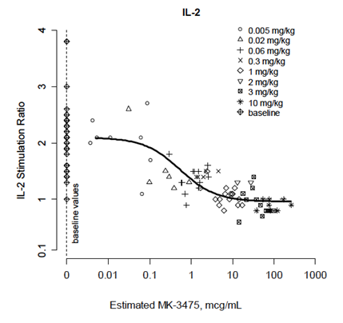
Simulations were conducted with the model to calculate the extent of target engagement (TE) at trough concentration for different doses.

Table 3. Percent target engagement (TE) at trough for a Q3W regimen
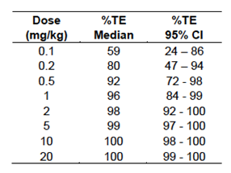
The model predicted that at doses ≥ 0.8 mg/kg, target engagement (that is PD-1 saturation) would be 95%, at the time of trough pembrolizumab concentration.
Comments: The study design, conduct and analysis were satisfactory. The sponsor’s report acknowledges that use of the IL-2 stimulation assay involves the following assumptions:
- That the interaction between pembrolizumab and PD-1 is the same in peripheral blood as it is in tumours
- Studies in mice had indicated that > 95% saturation of PD-1 receptors is required to elicit anti-tumour efficacy. It was assumed that this relationship would be similar in humans.

Effect on T cell subpopulations
In Cohorts B1, B2 and D, subjects had blood samples collected for analysis of T cell subpopulations (both CD4+ and CD8+) and the presence of activated T cells using flow cytometry. Samples were collected prior to pembrolizumab infusion on Day 1, for Cycles 1 - 5. A total of 367 subjects had a baseline sample and at least one post-baseline sample. Results are illustrated in Figure 2. Compared to baseline (Cycle 1, Day 1) the total numbers of CD4+ and CD8+ were unchanged following pembrolizumab treatment. However the percentage of activated cells was increased compared to baseline.
Figure 2. Cohorts B1, B2 and D – Changes in T-cell subpopulations (T cell immunophenotyping following treatment with MK-3475 demonstrates an increased percentage of activated (that is HLA-DR⁺) helper and cytotoxic T cells without increasing the total circulating T cell pool)
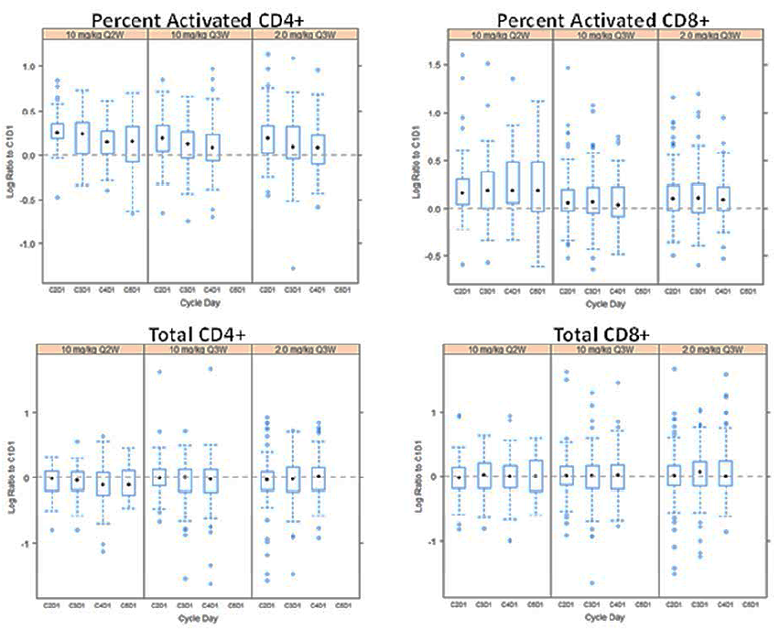
T cell immunophenotying was performed in patients enrolled in Part B1, Part B2 and D of Protocol 001 which included melanoma patients previously treated with and naïve to IPI, and treatments of 2 mg/kg Q3W and 10 mg/kg Q2W or Q3W. Top panels: log ratio of percent change from baseline of activated (HLA-DR⁺) helper T cells (CD3+ CD4+ CD8- lymphocytes and activated HLA-DR+) cytotoxic T cells (CD3+ CD4- CD8+ lymphocytes). Bottom panels: log ratio of change from baseline (that is C1D1) of total helper T cells and total cytotoxic T cells. C = cycle; D = day (for example C1D1 = Cycle 1 Day 1)

Secondary pharmacodynamic effects

QT prolongation
In an exposure-response analysis, serum concentrations of pembrolizumab that are likely to occur with the proposed dosage regimen were not predicted to increase the QTc interval as described below.

Exposure-QTc analysis (Report 03TLCF)

Objectives
The objectives of this analysis were:
- To characterise the relationship between pembrolizumab serum concentration (exposure) and QTc intervals in patients with progressive locally advanced or metastatic carcinomas
- To assess covariate effects, such as body weight, age, sex, race, baseline Eastern Cooperative Oncology Group performance status (ECOG score), and disease stage on the exposure-QTc relationship.

Methodology
The analysis was based on subjects enrolled in cohorts A, B1, B2, C and D. Subjects had a blood sample and a 12-lead ECG taken at screening and at the time of C_{max} (within 30 minutes of the end of the pembrolizumab infusion) in every 2nd cycle. The dataset consisted of 1093 pairs of measurements (serum concentration and ECG) taken from 434 subjects. A population exposure-QTc analysis was performed using a linear mixed effects modelling approach. Covariates tested in the analysis were body weight, age, sex, race, baseline ECOG score, and disease stage. The Fridericia method was found to be the most appropriate method for correction of the QT interval for heart rate.

Results
Weight, age and sex were found to be significant covariates and were included in the final model. The relationship between QTcF and pembrolizumab concentration, together with the observed QTcF measurements, are summarised in the following figure. A linear relationship was found. There was a high degree of variability in the observed QTcF measurements.
Figure 3. Observed QTcF measurements
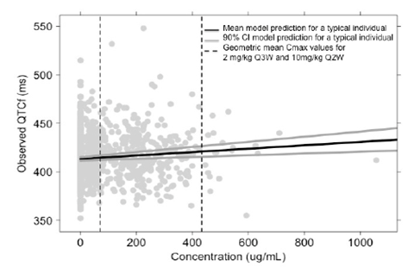
In Figure 3 showing individual QTcF observations versus MK-3475 serum concentrations the solid markers represent observed QTcF data. Black solid line represents estimated relationship between QTcF and MK-3475 concentrations for a typical patient with grey solid lines representing the two sided 90% confidence interval of that relationship. Dashed vertical lines represent representative mean steady state peak concentrations at 2 mg/kg Q3W (70.2 µg/mL) and 10 mg/kg (433 µg/mL).
Simulations were conducted with the final model to predict QTcF effects at estimated peak concentrations with two dosage regimens – 2 mg/kg Q3W and 10 mg/kg Q2W. It was predicted that for a typical patient (male, weight = 80 kg and age = 60 years), the C_{max} associated with the 2mg/kg Q3W regimen (70.2 µg/mL) would produce a QTcF prolongation of 0.83 ms (90%CI: 0.73 – 0.93). The C_{max} associated with the 10mg/kg Q2W regimen (433 µg/mL) would produce a QTcF prolongation of 5.10 ms (90%CI: 4.53 – 5.74).
The submission included a second exposure-QTc analysis (Report 03WKGP) conducted on data from NSCLC patients in Cohort F (164 measurement pairs from 75 subjects). The results obtained were similar, with the estimated QTc prolongation produced at C_{max} with the 2mg/kg Q3W regimen being 0.91 ms (90% CI: 0.47 – 1.4)
Comments: The study design, conduct and analysis were satisfactory. The data suggest that the proposed dosage regimen is unlikely to produce clinically significant QT prolongation. However, the study does not meet the criteria for a ‘thorough’ QT study according to the relevant EMA guideline adopted by the TGA. There were no placebo or positive control arms, only a single ECG was taken at each time point and only one time point in the dosage interval was examined. In general, monoclonal antibodies are unlikely to interact with cardiac ion channels due to their large size and high target specificity.

Evaluator’s overall conclusions on pharmacodynamics
Only limited clinical PD data were included in the submission. The submitted studies were acceptable.

Dosage selection for the pivotal studies
The lowest dose chosen for testing in advanced melanoma subjects was 2 mg/kg every 3 weeks. This dose was chosen on the basis of:
- Population PK/PD data (levels of IL-2 secretion) which suggested that maximum PD-1 receptor saturation was likely to occur at doses of ≥ 0.8 mg/kg (see Figure 1 and Table 3 above); and
- PK/PD modelling which suggested that the dose of 2 mg/kg Q3W gave a high probability of achieving a partial response (Figure 4).
Figure 4. Estimated MK-3475 Dose-Response for Probability of Anti-Tumour Efficacy Using Translational PK-PD Indicates Near-Maximal (> 90% Probability of Partial and Major) Responses Starting at Dose Regimens of 1 or 2 mg/kg Q3W
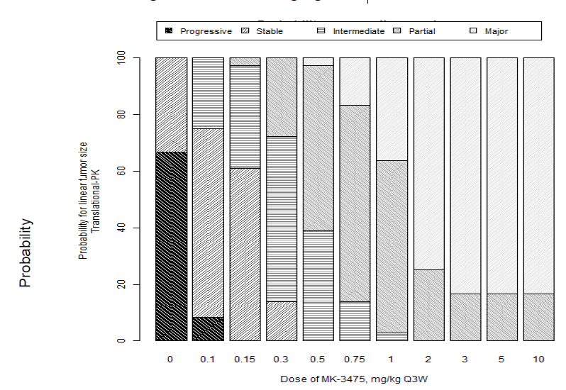
Probability predictions were derived under various scenarios for plausible human melanoma growth (fast, slow and intermediate) and tumour kill rate scaling (according to growth rate or blood flow), and took into account model parameter uncertainty for the fitted model components. The boundaries between different probability categories are defined as: Progressive: > 20% increase tumour size; Stable: between 20% increase and 10% decrease; Intermediate: 10% - 30% tumour size reduction; Partial: 30% - 50% tumour size reduction; Major: > 50% tumour size reduction.
Evaluator’s Comment: The rationale for the higher doses tested in the melanoma cohorts (10 mg/kg Q3W or Q2W), was not discussed in the study report.

Clinical efficacy

Pivotal efficacy study - Study P001

Study design, objectives, locations and dates
Study P001 is an open label, Phase I trial with multiple parts and cohorts, as follows:
- Part A was conducted in subjects with solid tumours and consisted of three cohorts:
  - Cohort A was a dose escalation study using a conventional 3+3 design. Sequential groups of patients received doses of 1, 3 and 10 mg/kg every 2 weeks.
  - Cohort A1 was a dose confirmation study in which all subjects received the maximum dose tolerated in Cohort A (which was 10 mg/kg Q2W). Cohort A1 commenced after completion of Cohort A.
  - Cohort A2 explored the use of a 3 weekly dosage interval. Subjects in Cohort A2 were randomised to one of three cohorts, and received the dosage regimens summarised in Table 4. In this cohort, doses below 1 mg/kg were used during the first cycle to explore the relationship between pembrolizumab PK and PD. Enrolment in Cohort A2 commenced following completion of enrolment in Cohort A1.

Table 4. Study P001 – Part A - Cohort A2 – dosage regimens
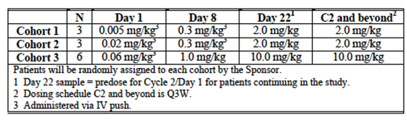
- Part B is being conducted in subjects with advanced melanoma and also consisted of three cohorts:
  - Cohort B1 enrolled subjects who were either ipilimumab (IPI)-naïve or IPI treated. Subjects were enrolled in one of three dosage cohorts: 10 mg/kg Q2W, 2 mg/kg Q3W or 10 mg/kg Q3W. Enrolment in these cohorts was in a sequential, non-randomised fashion.
  - Cohort B2 enrolled subjects who were IPI refractory. They were randomised to receive treatment with either 2 mg/kg Q3W or 10 mg/kg Q3W.
  - Cohort B3 enrolled subjects who were IPI naïve, IPI treated or IPI refractory. Subjects were randomised to receive 10 mg/kg Q2W or 10 mg/kg Q3W. The results for this cohort were not included in the study report as the data were premature, and hence no further review of this Cohort will be included in this evaluation.
- Part C is being conducted in subjects with advanced non-small cell lung cancer (NSCLC). All subjects were treated with 10 mg/kg Q3W.
- Part D is being conducted in subjects with advanced melanoma who were IPI naïve. Subjects were randomised to receive either 2 mg/kg Q3W or 10 mg/kg Q3W.
- Part F is being conducted in subjects with NSCLC and consisted of two cohorts. The results from this Part were not included in the study report, and hence no further review of this Part will be included in this evaluation.
  - Cohort F1 enrolled subjects with previously untreated disease, whose tumours expressed PD-L1. Subjects were randomised to receive 10 mg/kg Q2W or 10 mg/kg Q3W.
  - Cohort F2 enrolled subjects with previously treated disease, with or without PD-L1 expression. Subjects were randomised to receive 10 mg/kg Q2W or 10 mg/kg Q3W.
A summary of the various parts of the study is shown in Table 5.

Table 5. Summary of study parts. Study P001
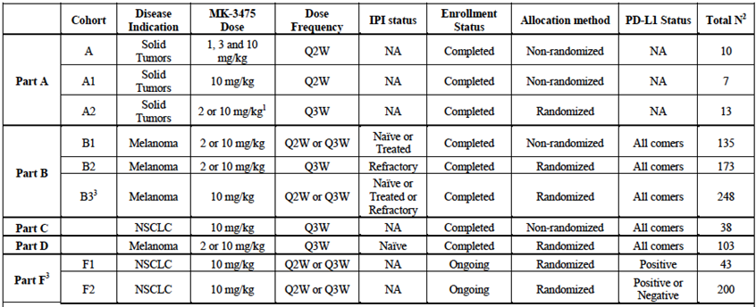
1 A2; three cohorts with separate Cycle 1 dose titration, followed by either 2 or 10 mg/kg Q3W starting with Cycle 2; 2 Total N as of 18 Oct 2013; 3 Not included in this interim CSR; IPI = ipilimumab; NSCLC = non-small cell lung cancer; Q2W = every 2 weeks; Q3W = every 3 weeks; NA = not applicable
Evaluator’s Comment: In terms of establishing the efficacy of pembrolizumab for the proposed indication of advanced melanoma, the relevant Parts of the study are Part B (Cohorts B1 and B2) and Part D. In these Parts, at least a proportion of the subjects received the proposed dosage regimen of 2 mg/kg Q3W. Review of efficacy data in this report will focus on these study Parts.
At one stage the study also included a Part E, to be conducted in NSCLC patients. This Part was subsequently removed from the protocol, apparently without any patients having been enrolled.

Primary objectives
The primary objectives of the study (as a whole) were as follows:
- To evaluate and characterise the tolerability and safety profile of single agent pembrolizumab in adult patients with unresectable advanced carcinoma (including NSCLC or melanoma);
- To evaluate anti-tumour activity of pembrolizumab in melanoma and NSCLC per RECIST 1.1 criteria;
- To evaluate the extent of tumour response that correlates with the degree of biomarker positivity in the tumours of IPI naïve patients treated with pembrolizumab, with the intent that the cut point for the PD-L1 assay will be explored and refined with tumour samples from IPI naïve melanoma;
- To evaluate anti-tumour activity per RECIST 1.1 of pembrolizumab in unselected melanoma patients refractory to IPI and melanoma patients refractory to IPI with PD-L1 expressing tumours;
- To evaluate anti-tumour activity per RECIST 1.1 of pembrolizumab in patients with NSCLC with at least one prior systemic therapy whose tumours express a high level of PD-L1.

Secondary objectives
Secondary objectives were:
- To evaluate the response rate of unselected patients with melanoma refractory to IPI and melanoma naïve to IPI, patients with melanoma refractory to IPI and melanoma naïve to IPI whose tumours express PD-L1, and patients with NSCLC with at least one prior systemic therapy whose tumours express a high level of PD-L1, per immune-related response criteria;
- To characterise the PK profile of single agent pembrolizumab;
- To evaluate target engagement and modulation in peripheral blood (PD-1 receptor occupancy and modulation of receptor activity);
- To investigate the relationship between candidate efficacy biomarkers and anti-tumour activity of pembrolizumab:
- To evaluate the correlation between PD-L1 expression levels and anti-tumour activity of pembrolizumab in patients with melanoma, excluding IPI refractory patients as stated in the primary objectives, and separately, non-small cell lung cancer.
- To investigate other biomarkers (for example, tumour infiltrating lymphocytes, PD-L2, PD-1; ribonucleic acid (RNA) signature profiles) that may correlate with tumour responses.
- To evaluate differences in tumour tissue characteristics in biopsies taken during or post-treatment with pembrolizumab versus baseline.
- To evaluate response duration, progression free survival and overall survival of melanoma patients who are treated with pembrolizumab;
- To evaluate response duration, progression free survival and overall survival of NSCLC patients who are treated with pembrolizumab.
The study is an ongoing trial. A total of 23 centres were to be involved. At the time of data cut-off for the submitted study report, a total of 17 centres had recruited patients. These centres were located in the USA (13), Australia (2), France (1) and Canada (1).
The study commenced in April 2011. The data cut-off date for the submitted (interim) study report was 18 October 2013. The study report itself was dated 21 May 2014. The results of Cohorts B1 and B2 have been published. ,

Inclusion and exclusion criteria
Inclusion criteria that were specific to Parts A, B and D are described below. Other inclusion criteria common to all study Parts are shown below. The exclusion criteria, which were common to all study Parts, are shown below.

Inclusion criteria specific to part A
In Part A of the study, patients must have had a histological of cytological diagnosis of melanoma or any type of carcinoma, progressive metastatic disease, or progressive locally advanced disease not amenable to local therapy:
- Please note: tumour types of primary interest in Part A are included but were not limited to malignant melanoma, RCC, hepatocellular carcinoma, ovarian carcinoma and colorectal carcinoma.
- Patients must have failed established standard medical anti-cancer therapies for a given tumour type or have been intolerant to such therapy, or in the opinion of the investigator have been considered ineligible for a particular form of standard therapy on medical grounds.

Inclusion criteria specific to part B
In Part B of the study, patients must have had a histological or cytological diagnosis of melanoma with progressive locally advanced or metastatic disease that is not amenable to definitive local therapy with curative intent.
Ipilimumab naïve Patients:
- Patients naive to IPI may not have received more than 2 prior systemic treatment regimens for treatment of melanoma.
Ipilimumab-treated Patients:
After the first 13 IPI naïve patients were enrolled, patients who had IPI were allowed to enrol, provided the following requirements were met:
- Full resolution of IPI related adverse effects (including immune-related adverse effects) and no treatment for these adverse events (AEs) for at least 4 weeks prior to the time of enrolment.
- Minimum of 12 weeks from the first dose of IPI and > 6 weeks from the last dose.
- No history of severe immune related adverse effects from IPI (CTCAE Grade 4; CTCAE Grade 3 requiring treatment > 4 weeks).
Ipilimumab-refractory Patients:
With Amendments 05, 06, 07 and 08, patients who had previously received IPI were allowed to enrol; provided the following requirements were met (these patients were considered IPI refractory):
- Received at least two doses of IPI (minimum dose of 3 mg/kg).
- Progressive disease after IPI was to be defined according to irRC (Appendix 6.5). The initial evidence of PD was to be confirmed by a second assessment, no less than four weeks from the date of the first documented PD, in the absence of rapid clinical progression (this evaluation is based on investigator assessment; sponsor was to collect imaging scans for retrospective analysis*). Once PD was confirmed, initial date of PD documentation was to be considered as the date of disease progression.
*Eligibility was determined based on investigator assessment and retrospective analysis is not included in this interim CSR.
- Documented disease progression within 24 weeks of the last dose of IPI. Patients who were re-treated with IPI and patients who were on maintenance IPI were allowed to enter the trial as long as there was documented PD within 24 weeks of the last treatment date (with IPI).
- Resolution of IPI related AEs (including irAEs) back to Grade 0-1 and ≤ 10 mg/day prednisone or equivalent dose for irAEs for at least two weeks prior to first dose of study drug.
  - No history of severe irAEs from IPI CTCAE Grade 4 requiring steroid treatment.
  - No history of CTCAE Grade 3 irAEs from IPI requiring steroid treatment (> 10 mg/day prednisone or equivalent dose) > 12 weeks.
  - Minimum of four weeks (wash out period) from the last dose of IPI.
- Patients with BRAF V600 mutant melanoma must have had a prior treatment regimen that includes vemurafenib, dabrafenib, or other approved BRAF and/or MEK inhibitors.
- Patient must have had progressive disease after the most recent treatment regimen.

Inclusion criteria specific to part D
In Part D of the study, patients must have had a histological or cytological diagnosis of melanoma with progressive locally advanced or metastatic disease that is not amenable to definitive local therapy with curative intent.
- Patients must have been naive to IPI and may not have received more than 2 prior systemic treatment regimens for treatment of melanoma.

Other inclusion criteria (all Parts)
- Measurable disease:
- In Part A of the study, patients may have had non-measurable disease.
- In Part B, C, D, and F of the study, patients must have had measurable disease based on investigators’ evaluation per irRC, Appendix 6.5 of the Study Protocol [16.1.1]:
  - Tumour mass: Must have been accurately measurable in 2 perpendicular diameters, with both its longest diameter and its longest perpendicular greater than or equal to 10 mm or 2 times the axial slice thickness. Clinical lesions were only to be considered measurable when they were superficial, such as skin or palpable lymph node. For melanoma patients who were being screened for enrolment in Part B, after approval of Amendment 07, clinical lesions alone were not to be considered as sufficient for enrolment; there must have been measurable disease evident on CT imaging.
  - Malignant lymph nodes: Must have been measurable in 2 perpendicular diameters, with both its longest diameter and its longest perpendicular, greater than or equal to 15 mm or 2 times the axial slice thickness.
- Patient was male or female and ≥ 18 years of age on day of signing informed consent.
- Patient must have had a performance status of 0 or 1 on the Eastern Cooperative Oncology Group (ECOG) Performance Scale, Appendix 6.2 of the Study Protocol [16.1.1].
- Patient must have had adequate organ function as indicated by the following laboratory values.

Table 6. laboratory values used to asses patient organ function
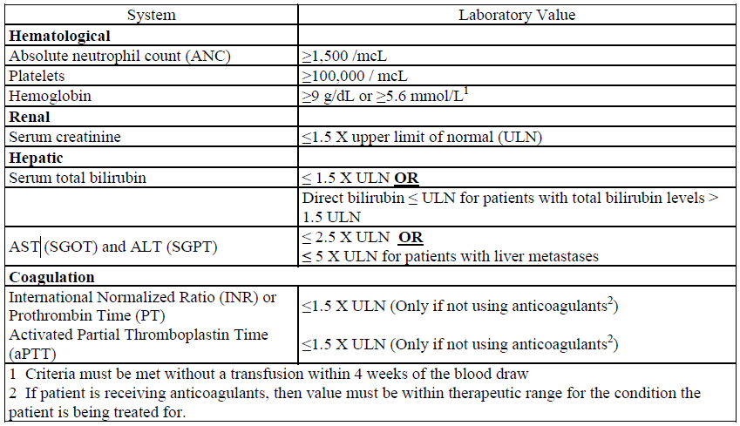
- Patient (Parts A, B, C, D and F) voluntarily agreed to participate by giving written informed consent. For Parts B, C, D and F, patient agreed to a newly obtained biopsy of tumour (that could be biopsied based on investigator's assessment) and to providing the acquired tissue for biomarker analysis. Tissue obtained for the biopsy must not have been previously irradiated. No systemic antineoplastic therapy may have been received by the patient between the time of the biopsy and the first administration of MK-3475. An archival specimen was mandatory to submit for Part B patients enrolled with Amendment 07; patients who did not have an available archival specimen were only to be enrolled after discussion with the sponsor.
- Female patient of childbearing potential had a negative urine or serum pregnancy test. If the urine test was positive or could not be confirmed as negative, a serum pregnancy test was required. The serum pregnancy test must have been negative for the patient to be eligible.
- Female patients enrolled in the study, who were not free from menses for > 2 years, post hysterectomy/oophorectomy, or surgically sterilised, must have been willing to use either 2 adequate barrier methods or a barrier method plus a hormonal method of contraception to prevent pregnancy or to abstain from heterosexual activity throughout the study, starting with Visit 1 through 120 days after the last dose of study therapy. Approved contraceptive methods included for example; intra uterine device, diaphragm with spermicide, cervical cap with spermicide, male condoms, or female condom with spermicide. Spermicides alone were not an acceptable method of contraception.
Male patients must have agreed to use an adequate method of contraception starting with the first dose of study drug through 120 days after the last dose of study therapy.
- Patient may also have provided consent/assent for Future Biomedical Research. However, the patient was eligible to participate in the main trial without participating in Future Biomedical Research.

Exclusion criteria (all parts)
A patient meeting any of the following criteria was not eligible to participate in this study:
- Patient who had chemotherapy, radioactive, or biological cancer therapy within 4 weeks prior to the first dose of study therapy, or had not recovered to CTCAE grade 1 or better from the adverse events due to cancer therapeutics administered more than 4 weeks earlier. Patient who had erlotinib, gefitinib, afatinib, or crizotinib within 1 week prior to the first dose of study therapy, or who has not recovered to CTCAE Grade 1 or better from the adverse events due to any of these drugs administered more than 1 week earlier.
Patient who had IPI therapy were eligible for enrolment in Part B or Part C of the study (after 13 IPI naïve patients were enrolled in Part B) if the requirements specified in Inclusion Criterion 1) were met.
- Patient was participating or had participated in a study of an investigational agent or used an investigational device within 30 days of administration of MK 3475.
- Patient was expected to require any other form of antineoplastic therapy while on study (including maintenance therapy with another agent for NSCLC).
- Patient had a medical condition that required chronic systemic steroid therapy or required any other form of immunosuppressive medication. However, patients that were using physiologic replacement doses of hydrocortisone, or its equivalent, were considered eligible; up to 20 mg hydrocortisone (or 5 mg of prednisone) in the morning and 10 mg hydrocortisone (or 2.5 mg of prednisone) in the evening.
- Patient had risk factors for bowel obstruction or bowel perforation (examples include but not limited to a history of acute diverticulitis, intra-abdominal abscess, abdominal carcinomatosis).
- Patient had a known history of a hematologic malignancy, malignant primary brain tumour or malignant sarcoma, or of another malignant primary solid tumour, unless the patient had undergone potentially curative therapy with no evidence of that disease for 5 years.
Note: The time requirement for no evidence of disease for 5 years did not apply to the tumour for which a patient was enrolled in the study. The time requirement also did not apply to patients who underwent successful definitive resection of basal cell carcinoma of the skin, superficial bladder cancer, squamous cell carcinoma of the skin, in situ cervical cancer, or other in situ cancers.
- Patient had known active central nervous system (CNS) metastases and/or carcinomatous meningitis. Patients with previously treated brain metastases may participate provided they were clinically stable for at least 4 weeks prior to study entry, had no evidence of new or enlarging brain metastases and were off steroids for at least 7 days from first dose of MK-3475.
- Patient previously had a severe hypersensitivity reaction to treatment with another mAb.
- Patient had a history of pneumonitis or interstitial lung disease.
- Patient had an active autoimmune disease or a documented history of autoimmune disease or syndrome that requires systemic steroids or immunosuppressive agents. Patients with vitiligo or resolved childhood asthma/atopy would be exception to this rule. Patients that required intermittent use of bronchodilators or local steroid injections were not excluded from the study. Patients with hypothyroidism that was stable on hormone replacement were not excluded from the study.
- Patient had prior treatment targeting PD-1: PD-L1 axis or CTLA (with exception of IPI in study Part B and Part C), or was previously randomised in any MK 3475 trial.
Examples of such agents include (but are not limited to): Nivolumab (BMS-936558 MDX-1106 or ONO- 4538); Pidilizumab (CT011); AMP-224; BMS-936559 (MDX 1105); MPDL3280A (RG7446); and MEDI4736.
- Patient had an active infection requiring therapy.
- Patient was positive for Human Immunodeficiency Virus (HIV) (HIV 1/2 antibodies), active Hepatitis B (HBsAg reactive) or Hepatitis C (HCV RNA (qualitative) is detected); patients with negative Hepatitis C antibody testing may not need RNA testing.
- Patient had a history or current evidence of any condition, therapy, or laboratory abnormality that might confound the results of the study, interfere with the patient’s participation for the full duration of the study, or is not in the best interest of the patient to participate, in the opinion of the treating investigator.
- Patient had known psychiatric or substance abuse disorders that would interfere with cooperation with the requirements of the trial.
- Patient was, at the time of signing informed consent, a regular user (including “recreational use”) of any illicit drugs or had a recent history (within the last year) of substance abuse (including alcohol).
- Patients with symptomatic ascites or pleural effusion. A patient who was clinically stable following treatment for these conditions (including therapeutic thoraco- or paracentesis) was eligible.
- Patient was pregnant or breastfeeding, or expecting to conceive or father children within the projected duration of the study.
Comment: Cohorts B1 and D enrolled melanoma subjects who were IPI naïve. The definition of ‘IPI naïve’ was the same for both cohorts.
Cohorts B1 and B2 enrolled melanoma subjects previously treated with IPI. However, the inclusion criteria for such subjects were different in the two cohorts. For example, in Cohort B2, BRAF-positive subjects were required to have failed BRAF inhibitor-based therapy, whereas this was not required for Cohort B1. Subjects in B1 were referred to as ‘IPI treated’ whereas those in B2 were referred to as ‘IPI refractory’.

Study treatments
All melanoma patients in Cohorts B1, B2 and D received pembrolizumab by intravenous infusion over 30 minutes. The protocol did not specify that any medications be given prior to, or after the infusion. In the melanoma cohorts, the following dosage regimens were studied:
- 2 mg/kg every 3 weeks (the regimen proposed for registration); in Cohorts B1, B2 and D
- 10 mg/kg every 3 weeks; in Cohorts B1, B2 and D
- 10 mg/kg every 2 weeks; in Cohort B1 only.
In all cohorts, treatment was continued until disease progression or unacceptable toxicity occurred. Treatment was also discontinued in the event of intercurrent illness that prevented further treatment, withdrawal of consent or pregnancy.
Doses were to be withheld in the event of certain toxicities defined in the protocol. Dosing could be resumed once the toxicity resolved to grade 0 or 1, however in these subjects the dosage interval was to be increased by one week (for example from 3 weekly to 4 weekly) for subsequent doses. Dose reductions or dose escalations were not permitted.
The protocol specified procedures to be undertaken in the event of an infusion reaction, including slowing or cessation of the infusion.
Prohibited medications included other cancer therapies, investigational agents, immunosuppressive agents and live vaccines. Although patients on chronic systemic steroid therapy were excluded from the trial, steroids could be commenced during the trial for the treatment of adverse events that were thought to be immune mediated.

Efficacy variables and outcomes
In the melanoma cohorts the main efficacy variables were:
- Reduction in tumour size on imaging (that is response rate)
- Measures of patient survival.
The primary efficacy outcome was the overall response rate (ORR) according to the RECIST (Response Evaluation Criteria in Solid Tumours) version 1.1 guidelines. Responses and disease progression were assessed by independent central review. Central review included review of images by independent radiologists and review of objective clinical data (for example qualitative skin photographs, biopsy reports from suspicious lesions if performed) when such data were available. This central analysis was referred to as the integrated radiology and oncology (IRO) assessment.
Secondary efficacy outcomes were:
- ORR as assessed by investigators using immune related response criteria (irRC). These are novel response criteria intended for immunotherapies for solid tumours. They take into account the observation that immunotherapy may result in a transient increase in lesion size, due to infiltration with inflammatory cells. Hence, an initial increase in lesion size is not necessarily classified as progressive disease. The irRC were developed based on experience with ipilimumab and are summarised in Table 7.
- Disease Control Rate (DCR); the sum of the proportions of patients who experienced complete response (CR), partial response (PR) or stable disease (SD). There did not appear to be any minimum duration specified for assignment of a best response of stable disease.
- Duration of Response (DoR); time from first documentation of a response to first documentation of disease progression.
- Progression-free Survival (PFS); time from start of treatment to documentation of definitive disease progression or death due to any cause, whichever occurs first.
- Overall survival (OS); time from treatment initiation to death due to any cause.

Table 7. Immune related response criteria (irRC)
irRC response criteria | irRC definition
irCR | Disappearance of all lesions (both measurable and non-measurable) in two consecutive observations not less than 4 weeks apart
irPR | Disappearance of all lesions in two consecutive observation not less than 4 weeks apart; OR  ≥ 50% decrease in SPD of all index lesions compared with baseline in two observations at least 4 weeks apart, in either the absence of new lesions or the unequivocal progression of non-index lesions: OR  ≥ 50%bdecrease in tumour burden compared with baseline in two observations at least 4 weeks apart
irSD | “Neither a” ≥ 50% decrease in SPD compared with baseline nor a ≥ 25% increase compared with nadir can be established in the absence of new lesions or unequivocal progression of non-index lesions
irPD | ≥ 25% increase in tumour burden compared with nadir (at any single time point) in two consecutive observations at least 4 weeks apart  The appearance of a new pathological lymph node will trigger a diagnosis of PD if it measures ≥ 15 x 15 mm. The reader will use their best clinical judgement for new lymph nodes which do not meet the threshold for pathologic and non-measurable of > 10 x 10 mm but < 15 x 15 mm and in their best clinical judgement are indicative of worsening disease  New non-measurable lesions do not define progression but preclude irCR
irNE | Not evaluable for any technical reason, such as unreadable image quality, anatomy missing from the field of view etcetera.
SPD = sum of the products of the perpendicular diameters of all index lesions.
Comment: With the exception of irRC, the endpoints chosen are standard for oncology studies.
In Parts B and D tumour imaging (CT scan or MRI) was performed every 12 weeks. If CR or PR was observed, confirmatory scanning was required after a further 4 weeks. If progressive disease was observed, confirmatory scanning was required after a further 4 - 6 weeks. For patients who discontinued without documented disease progression, tumour imaging was performed approximately every 3 months until;
- a total of 6 months without disease progression
- start of a new anti-cancer treatment
- documented disease progression, or
- death, whichever occurs first.
Other patients were followed up at 3 and 6 months after their last dose of pembrolizumab. All patients were then followed up by phone every 60 days for survival.

Randomisation and blinding methods
Subjects in Cohorts B2 and D were randomised to one of two treatment regimens. Treatment assignment was based an allocation schedule generated in-house by the sponsor. Subjects in Cohort B1 were not randomised to treatment.
There was no blinding to treatment allocation in any of the study cohorts.

Analysis populations
The Full Analysis Set (FAS) population included all subjects with measurable disease at baseline who received at least one dose of study treatment. The FAS population was used for the primary endpoint.
The All Patients as Treated (APaT) population included all subjects who received one dose of study treatment. This population was used for the analysis of PFS and OS.

Sample size
The protocol underwent multiple changes with respect to planned sample sizes. In the final version of the protocol, the stated planned sample sizes were as follows below.

Cohort B1 (IPI naïve subjects)
A total of 61 subjects were to be enrolled at both the 10 mg/kg Q2W and 10 mg/kg Q3W dose levels. If the null hypothesis was that pembrolizumab had an ORR of only 10%, the study would have approximately 97% power to detect an ORR of 25%, with a type 1 error rate of 5% (one sided).

Cohort B1 (IPI treated subjects)
A total of 40 subjects were to be enrolled. The null hypothesis was that pembrolizumab had an ORR of ≤ 5%. With a type 1 error rate of 5% (one-sided), the study would have approximately 92% power to rule out the null hypothesis, if the true ORR was 20%. It would have 98% power to rule out the null hypothesis if the true ORR was 25%.

Cohort B2 (IPI refractory subjects)
A total of 80 subjects were planned for each of the two dose groups (2 mg versus 10 mg/kg Q3W). The study would have an 85% power to detect a 15% difference in ORR between the two doses at the 10% type 1 error rate (one-sided), when the ORR in the inferior arm was 10%.

Cohort D (IPI naïve subjects)
A total of 44 subjects were planned for each of the two dose groups (2 mg versus 10 mg/kg Q3W). The study would have an 80% power to detect a difference in ORR of 30% versus 10% (or a 90% power to detect a difference in ORR of 25% versus 5%) at the 10% type 1 error rate (one-sided).

Statistical methods
For response rates, results were resented as means with 95% confidence intervals. In Cohorts B2 and D, differences in ORR between dosage regimens were tested using the method of Miettinen and Nurminen. For PFS, OS and duration of response, Kaplan-Meier plots and descriptive statistics were used.

Participant flow
A total of 609 subjects were screened for enrolment in the study. Of these, 479 (79%) were treated. The remainder did not meet exclusion or inclusion criteria. The APaT population consisted of 479 subjects and the FAS population (as assessed by the Independent Review Committee (IRC)) consisted of 419 subjects.
A total of 411 subjects were treated in the three melanoma Cohorts (135 in B1, 173 in B2 and 103 in D). The APaT population consisted of all 411 subjects and the FAS population of 365 subjects (116 in B1, 157 in B2, and 92 in D). Disposition of subjects in the melanoma cohorts is shown in Table 8 (Cohort B1), Table 9 (Cohort B2) and Table 10 (Cohort D). The proportions of subjects ongoing in the study at the time of data cut-off were: 38.5%, 42.2% and 47.6% respectively.

Table 8. Cohort B1. Subject disposition (APaT population)
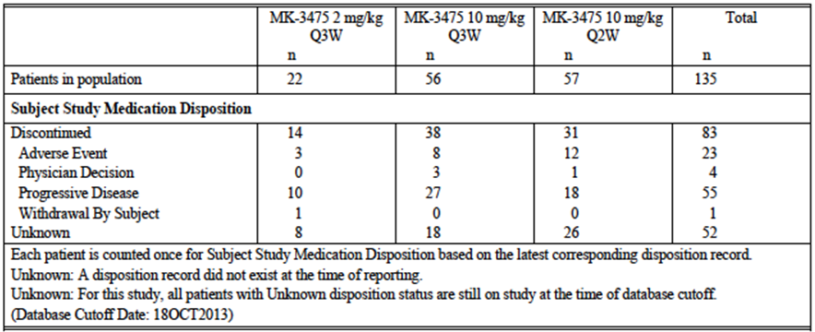

Table 9. Cohort B2. Subject disposition (APaT population)
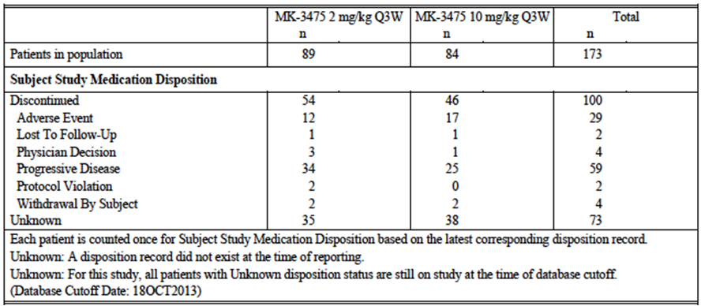

Table 10. Cohort D. Subject disposition (APaT population)
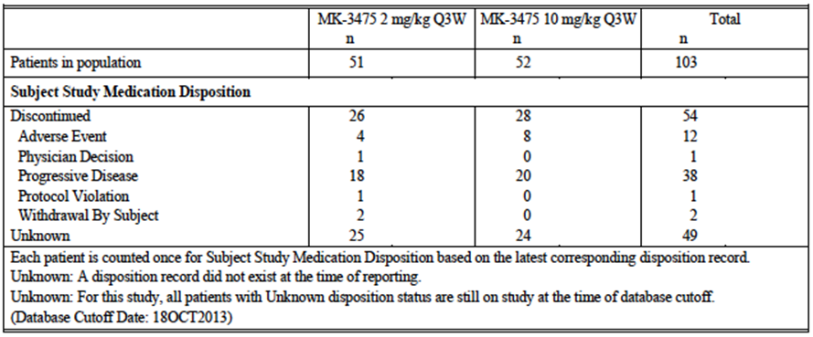

Major protocol violations/deviations
An appendix to the study report provided a summary of all protocol violations. The most common violations related to failure to meet the inclusion and exclusion criteria (n = 9 melanoma subjects). Five melanoma subjects received radiotherapy as palliative treatment. None of the violations had the potential to affect efficacy outcomes and all subjects were included in the efficacy analyses.

Baseline data up to here
Baseline demographic and disease characteristics were provided.
In all cohorts, subjects were predominantly male and White, with a median age of approximately 60 years and an ECOG performance status of zero (that is able to perform normal activity). The majority of subjects (≥ 69%) had lung or other visceral metastases (Stage M1b or M1c). The proportion of patients who had BRAF mutation-positive disease varied from 18 to 35% across cohorts.
The cohorts differed with respect to the number of prior systemic therapies that had been tried. In the IPI naïve cohorts (B1 IPI naïve and D), approximately 50% of subjects had received no prior systemic therapy. Less than 5% of these subjects had received 3 or more prior therapies. In the cohorts previously treated with IPI (B1 IPI treated and B2), approximately one third of subjects had received 3 or more prior therapies.
The therapies previously used were described. Chemotherapy had been used in 46 to 48% of subjects in the IPI treated cohorts, and in 18 to 26% of IPI naïve cohorts. The most commonly used chemotherapy agents in all cohorts were dacarbazine and temozolomide. Immunotherapies other than IPI had been used in 21 to 31% of subjects across the cohorts. The most commonly used agents were interferon and aldesleukin.

Results for the primary efficacy outcome
Response rates (in the FAS population, according to RECIST criteria and as assessed by independent central review) for the melanoma cohorts are summarised in Table 11 (Cohort B1, IPI treated subjects), Table 12 (Cohort B1, IPI naive subjects) Table 13 (Cohort B2) and Table 14 (Cohort D). For the primary endpoint of overall response rate the results (with 95%CI) were:
- Cohort B1 (IPI treated) 37.5% (22.7 to 54.2)
- Cohort B1 (IPI naive) 43.4% (32.1 to 55.3)
- Cohort B2 (IPI refractory) 26.1% (19.4 to 33.7)
- Cohort D (IPI naive) 37.0% (27.1 to 47.7)
When all the melanoma cohorts were pooled, the ORR was 33.7% (95%CI 38.9 to 38.8).

Table 11 Cohort B1 (IPI treated subjects) (FAS population by IRC). Overall response rate (summary of best overall response based on IRO assessment per RECIST 1.1)
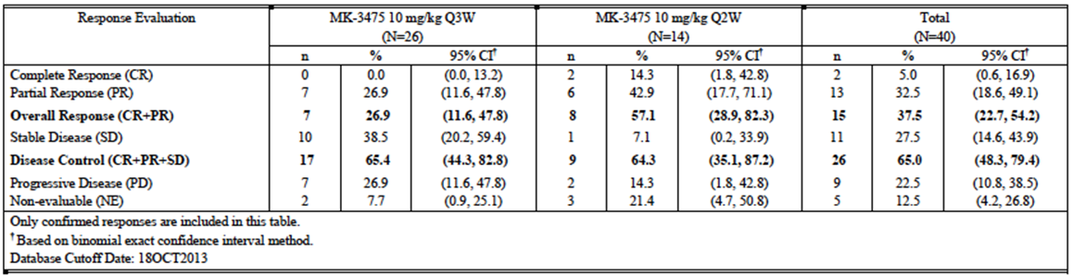

Table 12. Cohort B1 (IPI naive subjects) (FAS population by IRC; Overall response rate (summary of best overall response based on IRO assessment per RECIST 1.1)
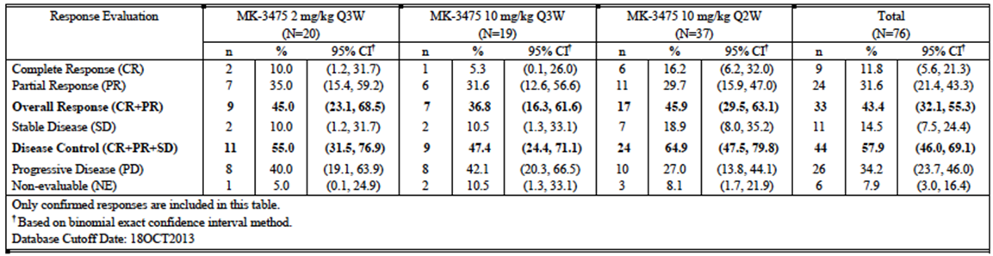

Table 13. Cohort B2 (IPI refractory subjects) FAS population by IR; Overall response rate summary of best overall response based on IRO assessment per RECIST 1.1
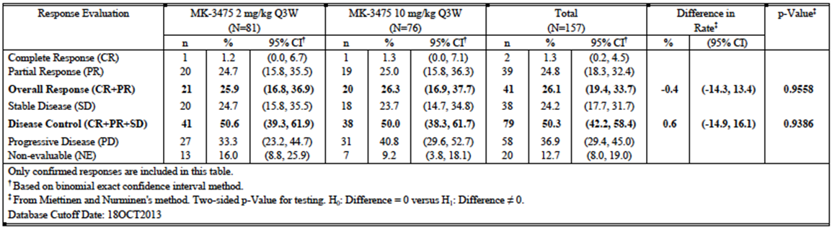

Table 14. Cohort D (IPI naive subjects) FAS population by IRC; Overall response rate summary of best overall response based on IRO assessment per RECIST 1.1
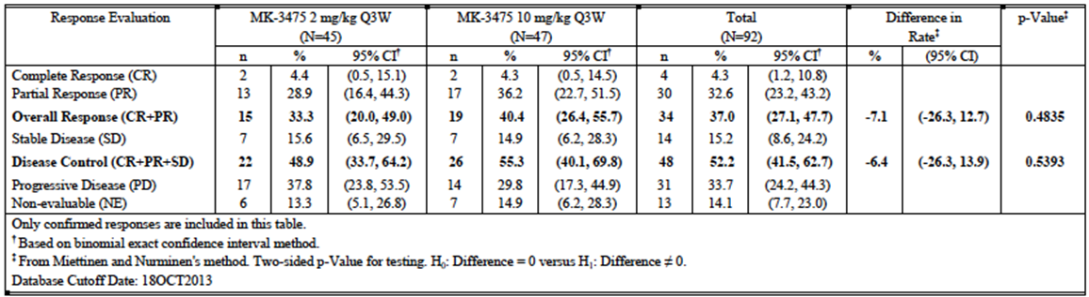
Comment: These results possibly suggest that pembrolizumab may be more effective IPI naïve subjects. Subjects in the IPI naïve cohorts in this study were less heavily pre-treated than those in the IPI treated/refractory cohorts.
In Cohorts B2 and D, the proposed dose of 2 mg/kg Q3W was compared with a higher dose (10 mg/kg Q3W). Differences in ORR between the two dose levels were not statistically significant. These two doses were also used in Cohort B1 IPI naïve subjects, along with a higher dose of 10 mg/kg Q2W. Although the differences in ORR between doses in this cohort were not subjected to statistical analysis, the 2 mg/kg Q3W dose produced a comparable ORR (45.0% versus 36.8% and 45.9%)
Most of the responses were partial responses, with complete response occurring in ≤ 5% of subjects. However, in Cohort B1 IPI naïve subjects, the CR rate was 11.8% (95%CI 5.6 to 21.3).
The study protocol indicated that in IPI naïve subjects, the null hypothesis would be supported if the ORR was 10% or less. It was also stated that the target response rate of interest in the IPI naïve population was 25%. In both the IPI naïve cohorts, the lower 95%CI for ORR was > 25%.

Results for other efficacy outcomes

ORR sensitivity analyses
The study report included multiple analyses of ORR examining the effects of using different assessors (central review by radiologist and oncologist versus central review by radiologist only versus investigator review), different response criteria (RECIST versus irRC) and different analysis populations (FAS versus APaT). Results for each cohort (combining all dose levels) were provided. The various analyses gave similar results to those obtained with the primary endpoint.

Disease control rate
The results for DCR in the FAS population are shown in Table 15 to Table 18. The results (with 95%CI) were:
- Cohort B1 (IPI treated) 65.0% (48.3 to 79.4)
- Cohort B1 (IPI naive) 57.9% (46.0 to 69.1)
- Cohort B2 (IPI refractory) 50.3% (42.2 to 58.4)
- Cohort D (IPI naive) 52.2% (41.5 to 62.7)

Table 15. Cohort B1 (IPI treated subjects) – Overall response rate (summary of best overall response based on IRO assessment per RECIST 1.1 Part B1 IPI treated patients (FAS population by IRC))
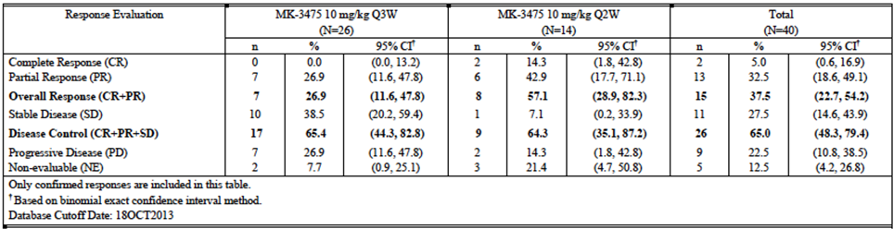

Table 16. Cohort B1 (IPI naive subjects); Overall response rate (summary of best overall response based on IRO assessment per RECIST 1.1 Part B1 IPI naïve patients (FAS population by IRC))
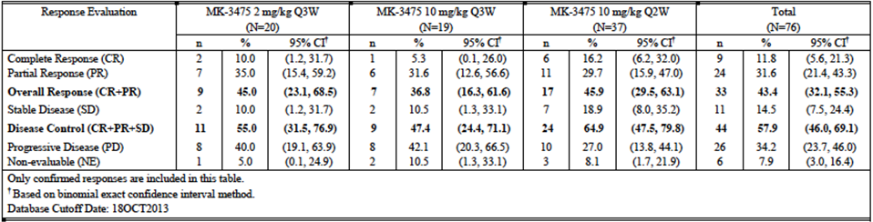

Table 17. Cohort B2 (IPI refractory subjects); Overall response rate (summary of best overall response based on IRO assessment per RECIST 1.1 Part B2 patients (FAS population by IRC))
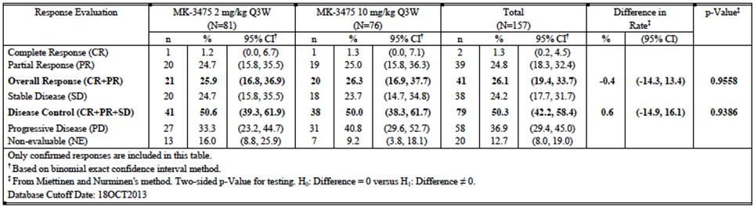

Table 18. Cohort D (IPI naive subjects); Overall response rate (summary of best overall response based on IRO assessment per RECIST 1.1 Part D patients (FAS population by IRC))
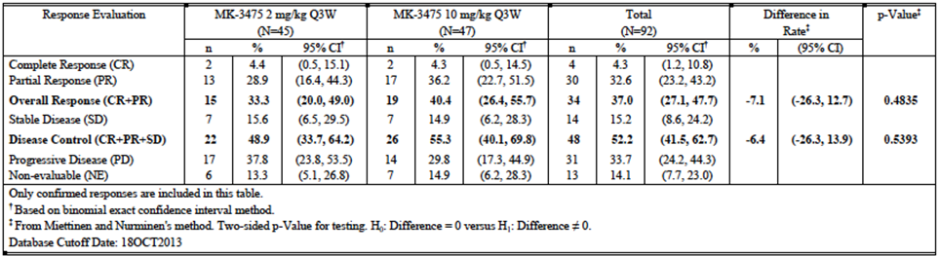

Duration of response
Analysis of duration of response was performed on the APaT population, by central review using RECIST criteria. Use of the APaT population enabled subjects with non-measurable disease who achieved a complete response to be included in the analysis. Results are summarised in Table 19 to Table 22.

Table 19. Cohort B1 (IPI treated subjects); Duration of/Time to Response
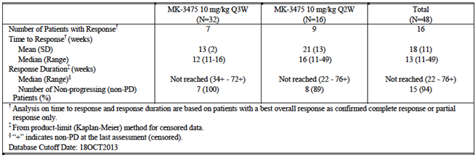

Table 20. Cohort B1 (IPI naïve subjects); Duration of/Time to Response
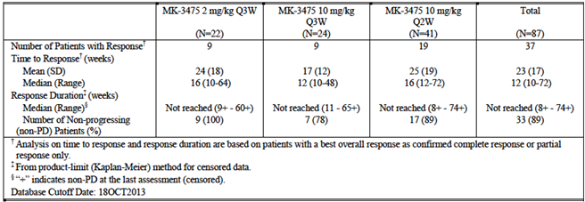

Table 21. Cohort B2. Duration of/Time to Response
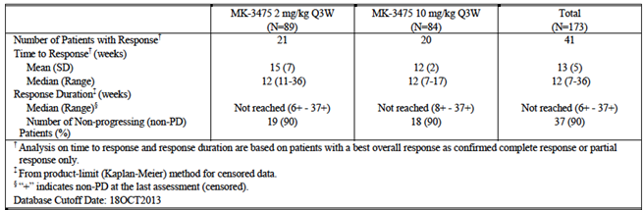

Table 22. Cohort D. Duration of/Time to Response
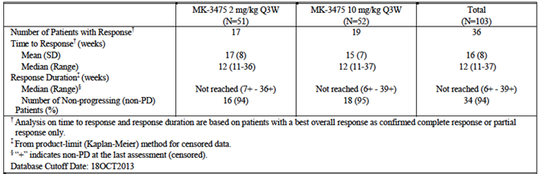
Comment: Only a small proportion of patients who achieved a response had subsequently developed progressive disease (6 to 11% across the melanoma cohorts). Median duration of response had therefore not been reached in any of the cohorts. In Cohort B1, which had the longest duration of follow up, the longest duration of response was 76 weeks (ongoing). Figure 5 shows a Kaplan-Meier curve for duration of response for all responding subjects in the melanoma cohorts. Although the data are not mature, this analysis suggests that responses are likely to be durable.
Figure 5. Pooled melanoma cohorts. Duration of response; Kaplan-Meier analysis (Kaplan-Meier estimates of objective response duration IRO assessment per RECIST 1.1 in patients with confirmed response Part B1 + B2 + D Patients (APat Population)
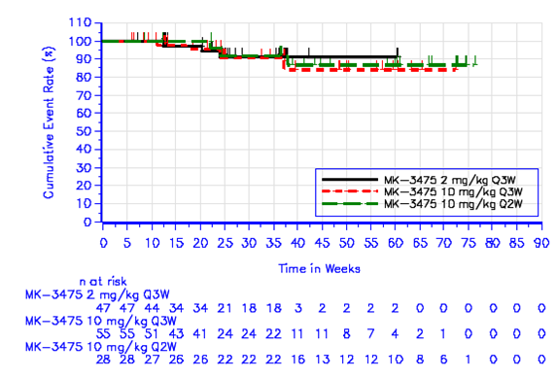

Time to response
Median time to response was consistent across the melanoma cohorts (12 to 13 weeks) –see Table 19 to Table 22.

Progression-free survival
Table 23 shows pooled PFS results for all melanoma cohorts. Median PFS was 23.7 weeks (95%CI 16.4 to 27.1). After 24 weeks, 46.8% of subjects were alive and progression free. Figure 6 shows Kaplan-Meier curves for PFS for the pooled melanoma cohorts. The sponsor argues that, after an initial sharp decline in PFS up to week 12, a plateau in PFS occurs and that such a plateau is not consistent with the natural history of advanced melanoma.
In Cohorts B2 and D, there were no significant differences between the two dosage levels.

Table 23. Pooled melanoma cohorts. Progression free survival (summary of progression free survival (PFS) based on IRO assessment per RECIST 1.1 Part B1 + B2 + D patients (APaT population)
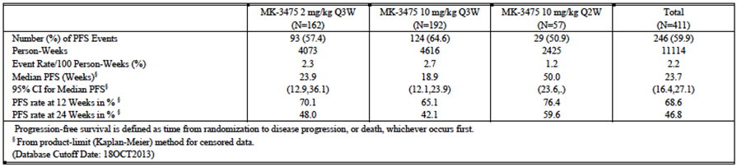
Figure 6. Pooled melanoma cohorts. Progression free survival (Kaplan-Meier estimates of progression free survival based on IRO assessment per RECIST 1.1 Part B1 + B2 + D Patients (APat Population)
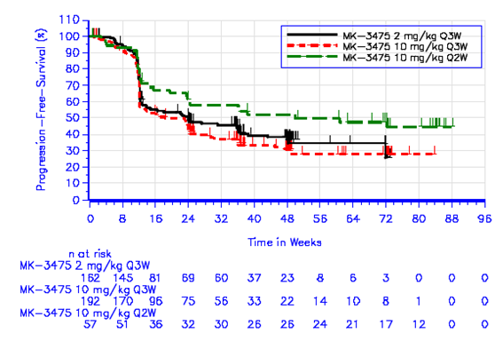

Overall survival
Overall survival data were not mature in any of the melanoma cohorts with < 30% of patients having died. Table 25 shows pooled OS results for all melanoma cohorts. The Kaplan-Meier estimate for the proportion of subjects who would still be alive at 12 months was 70.7%. Figure 7 shows Kaplan-Meier curves for OS for the pooled melanoma cohorts.

Table 25 Pooled melanoma cohorts; Overall survival (summary of overall survival Part B1 + B2 + D patients (APaT population)
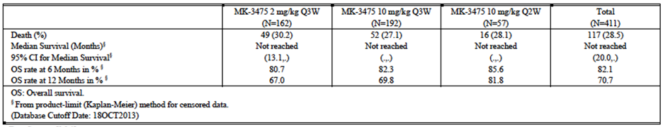
Figure 7. Pooled melanoma cohorts; Overall survival (Kaplan-Meier estimates of overall survival Part B1 + B2 + D patients (APaT population)
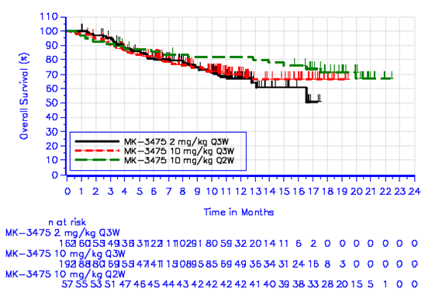

Subgroup analyses
Overall response rates for various patient subgroups are illustrated in Figure 8, for the pooled melanoma cohorts. Point estimates for ORR were generally between 25 and 35%.
Comment: Response rate appeared to decline with increasing number of prior therapies, and increasing baseline tumour size. ORR was low (19.7%) in patients who had previously received BRAF/MEK inhibitor therapy.
Figure 8. Pooled melanoma cohorts; Subgroup analysis of ORR Best overall response rate based on IRO assessment per RECIST 1.1 by subgroup factors. Point estimate and 95% confidence interval Part B1 + B2 + D patients (APaT population)
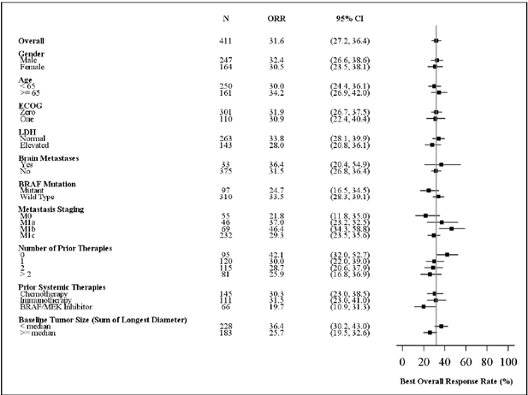

Exposure (AUC); response analysis for efficacy
The submission included an exposure-response analysis for efficacy in melanoma patients (Report 03TLCV). The analysis was based on data from the 365 subjects in the melanoma FAS population (from cohorts B1, B2 and D). A nonlinear mixed effects model was developed to describe change in tumour size over time. One of the covariates investigated was AUC over a period of 6 weeks at steady state. AUC values were derived from a population PK model. No significant relationship was found between tumour size and AUC as a covariate.
Simulations were conducted with the model to assess the magnitude of the exposure response relationship for four different dose levels (1, 2, 5, 10 mg/kg Q3W) by converting the change in tumour size into approximate RECIST response categories. Results are illustrated in Figure 9. The model predicted median objective response rate (PR+CR) at week 28 was 32.9% (90% CI: 28.2 to 37.7) in the 2mg/kg Q3W group and 35.9% (90% CI: 31.1 to 40.4) in the 10 mg/kg Q3W group. The difference between the two was not statistically significant. This indicated that over the studied dose range (1 to 10 mg/kg Q3W) the exposure-efficacy relationship is flat.
Figure 9. Model-based exposure response analysis
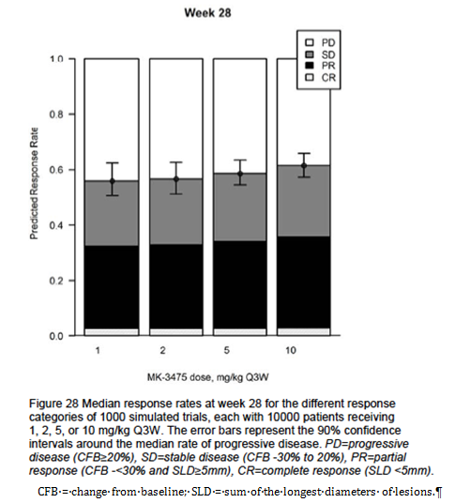

Biomarker analysis for efficacy
Relationships between efficacy and various biomarkers are being explored in study P001. The primary biomarker of interest is PD-L1 expression levels in tumour, as measured by immunohistochemistry (IHC). Other biomarkers of interest were stated to be tumour-infiltrating lymphocytes, PD-L2, PD-1 and ribonucleic acid (RNA) signature profiles. Identification of a biomarker that is predictive of efficacy might enable a more targeted use of the drug.
The submission included a report (03WMV4) that examined the relationship between efficacy and the level of PD-L1 expression in tumour, among melanoma subjects enrolled in P001 (Cohorts B1, B2 and D). Subjects enrolled were required to have had a biopsy obtained within 60 days of the first dose of pembrolizumab. Either a tru cut biopsy or surgically obtained specimen could be used.
The method for scoring the IHC assay was initially developed on a ‘training set’ of 138 subjects. Of these, 88 subjects had sufficient tumour sample for analysis and efficacy results assessed by independent central review. Subjects were classified as either ‘responders’ (CR or PR) or non-responders (SD, progressive disease or non-evaluable for response). IHC staining was assessed using the Allred Proportion Score (APS; see Table 26), various patterns of staining and various combinations of these. Based on analysis of Receiver Operating Characteristic (ROC) curves, the IHC parameter chosen was an APS of ≥ 2 (that is membrane staining is observed in at least 1% of cells). Therefore, tumours with an APS of ≥ 2 were deemed to be PD-L1 positive, and those with an APS < 2 were deemed to be PD-L1 negative.

Table 26. Allred Proportion Score
Score | The ratio of cells expressing PD-L1 at any intensity (weak, moderate or strong staining) that is ‘staining cells’, to all scorable cells is estimated in aggregate
APS = 0 | If there is no membrane staining on the slide
APS = 1 | If there is membrane staining in less than 1/100 of cells
APS = 2 | If there is membrane staining in at least 1/100 but less than 1/10 of cells
APS = 3 | If there is membrane staining in at least 1/10, but less than 1/3 of cells
APS = 4 | If there is membrane staining in at least 1/3, but less than 2/3 of cells
APS = 5 | If there is membrane staining in at least 2/3 of cells
Analyses of the relationship between PD-L1 positivity and response were conducted in a ‘verification set’ of 195 subjects (138 from the training set plus an additional 57), a ‘validation set’ of 216 completely separate subjects, and a ‘pooled analysis set’ which combined the verification and validation sets (n = 411). The results for the pooled analysis set are presented here.
The pooled analysis set included 411 subjects. Of these, 275 had adequate tumour samples for assessment of PD-L1 status. The proportion of subjects who had PD-L1 positive tumour was 77% (212 out of 275). A total of 248 subjects had both adequate tumour sample and measurable disease by central review. The results for best overall response rate in these subjects are summarised in Table 27. The ORR in PD-L1 positive subjects was 41.8 % (95%CI 34.7 to 49.0). In PD-L1 negative subjects the response rate was 9.3% (95%CI 3.1 to 20.3). The difference in response rate was statistically significant (p value < 0.0001). Median duration of response had not been reached in either group.

Table 27. Pooled melanoma cohorts; Overall response rate by tumour PD-L1 status
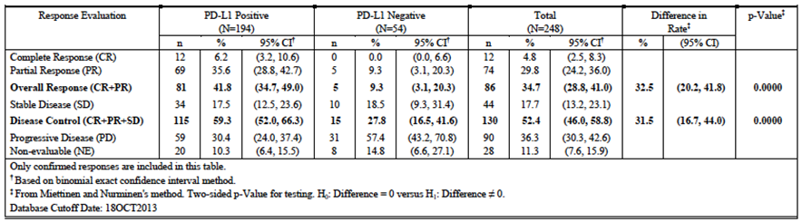
Results for PFS are summarised in Figure 10. Median PFS among PD-L1 positive subjects was 24.1 weeks. In PD-L1 negative subjects median PFS was 12.1 weeks. The difference between the subgroups was statistically significant (p value < 0.0001).
Figure 10. Pooled melanoma cohorts; PFS by tumour PD-L1 status (Part B1 + B2 + D patients by PD-L1 status (APaT population))
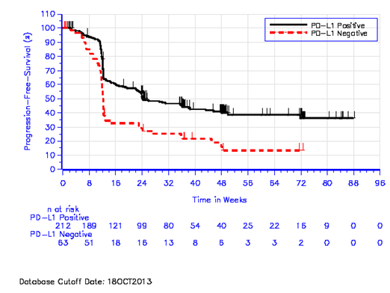
Overall survival data were not mature with only 80 out of 275 of subjects (29%) having died. However there was a trend towards improved survival among PD-L1 positive subjects (see Figure 11). The proportion of patients alive after 12 months was 73% for PD-L1 positive subjects and 59% for PD-L1 negative subjects.
Figure 11. Pooled melanoma cohorts; OS by tumour PD-L1 status (Part B1 + B2 + D patients by PD-L1 status (APaT population))
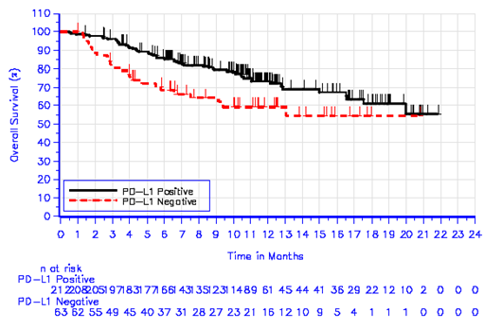
Further analyses presented included the following:
- Among IPI exposed subjects (n = 141), the ORR was 35.6% for PD-L1 positive subjects and 8.7% for PD-L1 negative subjects;
- Among IPI naive subjects (n = 107), the ORR was 51.3% % for PD-L1 positive subjects and 9.7% for PD-L1 negative subjects;
The sponsor argued that testing for PD-L1 positivity in order to select patients for pembrolizumab treatment was not appropriate for the following reasons:
- The prevalence of PD-L1 positivity is high (77% in the pooled analysis set) and therefore there is not much enrichment in the response rate achieved by excluding PD-L1 negative subjects. As shown in Table 27, the ORR was 34.7% for the total population and this increased to 41.8% in the PD-L1 positive subpopulation;
- A proportion of PD-L1 negative patients (9% in the pooled analysis) achieved a durable response.
Comment: The response rate in the PD-L1 subpopulation (9%) was very low. Responses were only observed in 5 subjects and all were partial responses. In these 5 subjects duration of response ranged from 24 weeks (ongoing) to 36 weeks (ongoing). Due to the limited sample and limited follow-up it may be premature to conclude that responses in PD-L1 negative subjects are durable. The drug is clearly more effective in subjects with PD-L1 positive disease.

Cohort A
In all of Part A there were 7 patients with malignant melanoma, and 4 of these (57%) had an objective response (3 PRs and 1 CR) by independent central review.

Analyses performed across trials (pooled analyses and meta-analyses)
Not applicable.

Evaluator’s conclusions on clinical efficacy for melanoma
The results of study P001 indicate that pembrolizumab produces objective responses in a substantial proportion of patients with advanced melanoma (approximately 33% overall). Meaningful response rates were also observed in the subgroup of subjects who had received 2 or more prior systemic therapies. These responses appear to be long lasting.
Median PFS was 23.7 weeks (approximately 5.5 months). Overall survival data were not mature. No quality of life data were collected in the study.
The efficacy results observed compare favourably with those obtained with other agents registered for the treatment of advanced melanoma. For example, in the pivotal study that led to the approval of ipilimumab, the observed response rate was 10.9% (95%CI: 6.3 to 17.4) and median PFS was only 2.86 months (95%CI: 2.76 to 3.02).
Doses greater than 2 mg/kg Q3W were not associated with improved efficacy.
The data are limited in that pembrolizumab has not been compared with a registered agent in a randomised controlled trial. Its place in the therapy of advanced melanoma is therefore uncertain. However the data clearly indicate that the drug has clinically significant activity in this disease.
Efficacy is clearly superior in subjects with PD-L1 positive disease. Responses are achieved in only a small percentage of subjects with PD-L1 negative disease and data on the durability of such responses are limited.

Clinical safety

Studies providing evaluable safety data
The main safety data included in the submission were those generated in study P001.
- Cohorts A, A1 and A2 enrolled small numbers of patients with various malignancies. The safety data from these cohorts has been reviewed briefly below
- Cohorts B1, B2 and D enrolled subjects with advanced melanoma (n = 411). These subjects are considered to be the main population of interest and will be the focus of the following review of safety;
- Cohort C enrolled a population of subjects with NSCLC (n = 38). Data from these subjects will be presented separately.
The submission also included limited data on serious adverse events (SAEs) from other ongoing studies.
Study P001 – Cohorts A and A1 brief review of safety data
Mean duration of therapy was 84 days (range 1 to 232). 16/17 subjects (94%) experienced at least 1 AE. Common AEs were fatigue (n = 7), pruritus (5), nausea (4) and decreased appetite (4). Some 4 out of 17 subjects experienced a total of 5 grade 3-5 AEs (anaemia, myocardial infarction, UTI, dehydration, urinary tract obstruction). Some 5 out of 17 subjects (29.4%) experienced an SAE (including 3 serious infections). Four subjects discontinued treatment due to AEs (myocardial infarction, weight loss, transitional cell carcinoma and pneumonitis). One subject died due to cryptococcal infection.
The incidence of AEs, grade 3-5 AEs and SAEs was not related to dose. No subject experienced dose limiting toxicity (DLT) as defined by the protocol and hence a maximum tolerated dose (MTD) was not reached.
Study P001 Cohort A2 brief review of safety data
Mean duration of therapy was 163 days (range 8 to 442). All 13 subjects experienced at least 1 AE.
The most common AEs were fatigue (n = 6), nausea (4), hypothyroidism (3) and decreased appetite (3). Some 5 out of 13 subjects (38.5%) experienced a total of 10 grade 3-5 AEs. (2 reports of dyspnoea, all other events occurred in 1 subject only). Some 4 out of 13 subjects (30.8%) experienced a total of 7 SAEs (all SAE events occurred in 1 subject only. 3 subjects (23.1%) discontinued treatment due to AEs (fatigue and decreased appetite, spinal cord compression and pleural effusion). No subject had a fatal AE.
The incidence of grade 3-5 AEs was higher in the 10 mg/kg Q2W cohort than in the 2 mg/kg cohorts (66% versus 0% and 33%). Otherwise there was no suggestion that AEs increased with increasing dose.
In all cohorts in P001, the following safety data were collected:
- General adverse events (AEs) were assessed at every cycle (that is every 2 or 3 weeks depending on the dosage regimen). MEDRA terminology (version 16.1) was used to describe AEs and AE severity was graded according to NCI Common Toxicity Criteria, version4.0. AEs were included in analyses if they occurred between the first dose and 30 days after the last dose. Serious AEs (SAEs) were included if they occurred between the first dose and 90 days after the last dose.
- AEs with a potential immune aetiology were examined as AEs of particular interest.
- Physical examination and measurement of vital signs occurred at every cycle;
- Haematology laboratory tests were performed at every cycle. Tests included were: white blood cell count (total and differential), absolute neutrophil count, absolute lymphocyte count, red blood cell count, haemoglobin, haematocrit and platelets.
- Biochemistry laboratory tests were performed at every cycle. Tests included were: sodium, potassium, chloride, calcium, phosphorus, magnesium, carbon dioxide (CO₂ or bicarbonate), urea nitrogen (BUN), creatinine, uric acid, total protein, albumin, total bilirubin, alkaline phosphatase, alanine aminotransferase (ALT), aspartate aminotransferase (AST), lactate dehydrogenase (LDH), direct and indirect bilirubin, glucose, total cholesterol and triglycerides.
- Immunoglobulins and thyroid function tests were tested every 2nd cycle.
- Urinalysis was performed at every 3rd or 4th cycle.
The safety data presented in the submission included the following
- An initial dataset with a data cut-off date of 18 October 2013; and
- A ’60 day safety update’ with a data cut-off date of 31 December 2013.
The 60 day safety update did not update all the relevant tables prepared from the initial dataset, and hence a mixture of tables has been used in the following review. Differences between the two datasets were minor.

Patient exposure

Pooled melanoma cohorts
Exposure to pembrolizumab in the pooled melanoma cohorts is summarised in Table 28. For all dosage regimens combined, the mean number of days on therapy was 238.9 (34 weeks). The median number of administrations was 10.0. Of the 411 subjects, 212 had received at least 6 months treatment and 115 had received at least 12 months treatment.

Table 28. Pooled melanoma cohorts (B1+B2+D); Summary of drug exposure
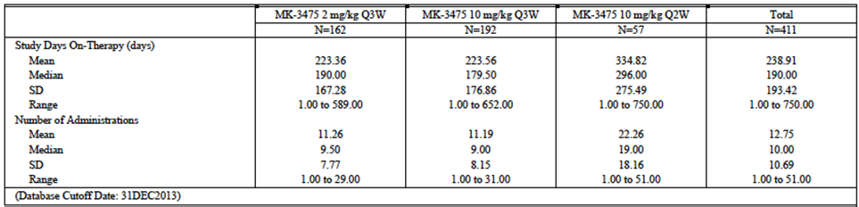

Cohort C (NSCLC)
In Cohort C, the mean number of days on therapy was 130.79 (18.7 weeks). The median number of administrations was 3.0.

Adverse events
An overall summary of AEs occurring in the pooled melanoma cohorts is shown in Table 29. An overall summary of AEs occurring in Cohort C is shown in Table 30.
Comment: In the pooled melanoma cohorts, toxicity appears to be dose-related with increasing dose being associated with increasing incidence of grade 3-5 AEs (36.4% versus 40.6% versus 45.6%), serious AEs (29.6% versus 32.8% versus 43.9%) and discontinuations due to AEs (4.9% versus 9.9% versus 17.5%). However, as shown in Table 28 average duration of treatment was notably longer in the subgroup that received the highest dose (10 mg/kg Q2W).

Table 29. Pooled melanoma cohorts (B1+B2+D); Summary of AEs
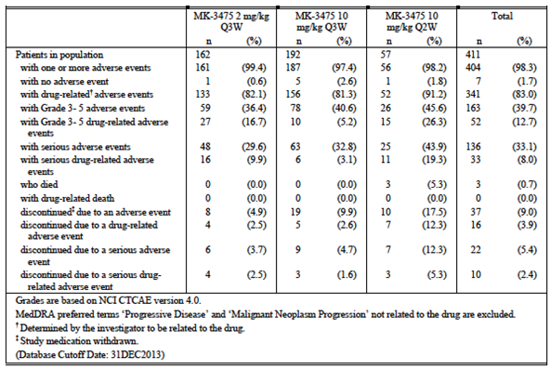

Table 30. Cohort C (NSCLC) – Summary of AEs
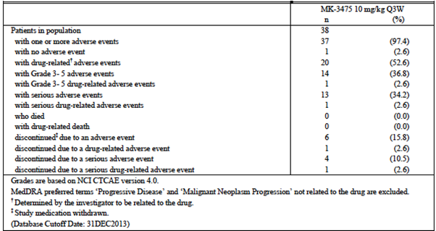

All adverse events (irrespective of relationship to study treatment)

Pooled melanoma cohorts
The overall incidence of AEs in the pooled melanoma cohorts was 98.3%. Common AEs (incidence > 10% in at least one dosage group) were provided. The most common adverse event terms (October 2013 cut-off) were as follows:
- Fatigue (45.5%)
- Arthralgia (24.6%)
- Gastrointestinal events; for example nausea (29.4%), diarrhoea (28.0%), constipation (20.4%) and decreased appetite (19.0%)
- Respiratory events; for example cough (28.7%) and dyspnoea (18.5%)
- Skin toxicity; for example pruritus (27.5%) and rash (23.8%).
Comment: The incidence of individual AEs was generally higher in the highest dose group (10 mg/kg Q2W). This is probably a reflection of the longer duration of treatment in this group. Average duration of treatment was similar in the other two groups. The incidence of individual AE terms in these two groups was comparable, despite a fivefold difference in dose (2mg versus 10 mg Q3W).

Cohort C (NSCLC)
The pattern of AEs in Cohort C was very similar to that seen in melanoma patients. Respiratory events were more prominent, as might be expected in an NSCLC population.

Treatment related adverse events (adverse drug reactions)

Pooled melanoma cohorts
The overall incidence of drug related AEs in the pooled melanoma cohorts was 83.0%. Common drug related AEs (incidence > 7.5% in at least one dosage group) are summarised in Table 31.
Comment: The pattern of toxicity is generally similar to that seen in the analysis of all AEs. However a number of the common drug related AEs are suggestive of immune related AEs (pneumonitis, vitiligo, dry eye, hypothyroidism).

Table 31. Pooled melanoma cohorts; Common drug related AEs (Incidence > 7.5%)
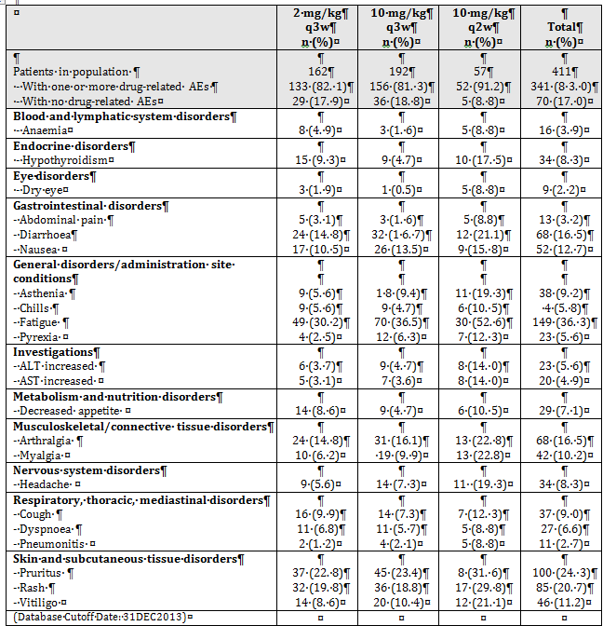

Cohort C (NSCLC)
Drug-related AEs occurred in 20 of 38 patients (52.6%) in Cohort C. A summary tabulation of events was not provided. However, a line listing of patients and their events was included. The pattern of events was generally consistent with that observed in the pooled melanoma cohorts.

Grade 3-5 adverse events

Pooled melanoma cohorts
Grade 3 - 5 AEs had occurred in a total of 39.7% of subjects by the 31 December 2013 cut-off. Grade 3 - 5 AEs occurring with an incidence of > 1% in at least one dosage group (by the October cut-off) were provided. Individual AE terms occurred infrequently at grade 3 - 5 severities. The most common was grade 3 - 5 anaemia, which occurred in 3.4% of subjects. Drug-related grade 3 - 5 AEs occurred in 12.7% of subjects.

Cohort C (NSCLC)
Grade 3 - 5 events occurred in 36.8% of subjects in Cohort C.

Fatal and other serious adverse events

Fatal AEs

Pooled melanoma cohorts
In the pooled melanoma cohorts, there were 4 adverse events with a fatal outcome within 90 days of the last dose. The investigators did not consider any of these deaths to be related to study drug. They were:
- A 49 year old female who received one dose of the 2 mg/kg Q3W regimen in Cohort B2. Approximately 9 days later she developed obstructive jaundice due to a mass in the pancreatic head. She was treated with an ERCP/sphincterotomy and improved. Approximately 1 month later she presented in septic shock, thought to be due to cholangitis. She died three days later.
- A 69 year old male received 4 doses of 10 mg/kg Q2W in Cohort B1. One week after his last dose he presented with a bowel perforation, a left lower quadrant abscess and cellulitis over the lower left quadrant. He underwent laparoscopic surgery and pathology demonstrated metastatic melanoma. He also developed a pulmonary embolus. His performance status deteriorated and he died one month later.
- A 94 year old male received 6 doses of the 10 mg/kg Q2W regimen in Cohort B1. He was in hospital for investigation of pneumonitis when he developed an acute myocardial infarction (two weeks after his last dose) and died one day later.
- A 77 year old female received 2 doses of the 10 mg/kg Q2W regimen in Cohort B1. She had surgery for mid-thoracic spinal cord compression due to melanoma. Approximately 10 days later presented with a pulmonary embolus and died on the same day.

Cohort C (NSCLC)
In Cohort C there were 2 AEs with a fatal outcome within 90 days of the last dose. The investigators did not consider either of these deaths to be related to study drug. They were:
- A 52 year old female received one dose of 10 mg/kg Q3W. At baseline she had a right upper lobe NSCLC lesion. Three days after her initial dose she developed shortness of breath, followed by right shoulder and back pain and a right pleural effusion. She was diagnosed with progressive disease and died 19 days after her initial treatment.
- A 63 year old female received one dose of 10 mg/kg Q3W. Over the next 6 weeks she was hospitalised three times for hypoxia/respiratory failure. Investigations demonstrated pleural effusion and collapse/consolidation. On the third occasion she presented unresponsive with severe respiratory failure and died the same day. The sponsor had no information as to whether an autopsy was performed.

Other cohorts
In Cohort A there was 1 fatal AE:
- A 76 year old male with advanced melanoma received 12 doses of the 10 mg/kg Q3W regimen in Cohort A. On day 170 he was diagnosed with gastritis, which was possibly immune related. He was treated with systemic steroids (prednisolone 60 mg daily). The patient presented on day 276 with shortness of breath, nausea, vomiting and hypoxia. He did not respond to treatment and died 12 days later. An autopsy showed the cause of death to be cryptococcal fungaemia. The investigator considered that the death could be related to the ongoing treatment with systemic steroids.
Comment: None of the deaths could reasonably be attributed directly to pembrolizumab toxicity. Several appear to be due to disease progression or known complications of advanced malignancy (for example pulmonary embolism).
The 60 day safety update included a brief report of one more fatal AE that occurred in Cohort F (NSCLC):
- A 79 year old male received 12 cycles of the 10 mg/kg Q2W regimen. He presented with increasing shortness of breath and died approximately one week later. An autopsy showed diffuse alveolar damage, which was thought to be due to infection. The investigator assessed the death as unlikely to be drug related.

Serious AEs
A serious AE was one that:
- Resulted in death; or
- Was life threatening; or
- Resulted in a persistent or significant disability/incapacity; or
- Results in hospitalisation or a prolongation of an existing hospitalisation; or
- Was a congenital anomaly/birth defect.
Other important medical events could be considered as SAEs when, based upon appropriate medical judgment, the event could jeopardise the patient and could require medical or surgical intervention to prevent one of the above outcomes.

Pooled melanoma cohorts
By the October 2013 cut-off 34.8% of subjects had experienced at least one serious AE. Individual AE terms that occurred in at least 2 subjects were provided. The most common serious events were dyspnoea (n = 10), cellulitis (9), pneumonia (9), abdominal pain (7), dehydration (7), renal failure (7) and pleural effusion (7). Of note, there were 2 cases of serious hypophysitis, 4 cases of serious colitis and 3 cases of serious pneumonitis.
The overall incidence of drug related serious AEs was 8.8%.

Cohort C (NSCLC)
In Cohort C, 39.5% of subjects experienced an SAE.

Discontinuation due to adverse events

Pooled melanoma cohorts
By the December 2013 cut-off, 37 out of 411 subjects (9.0%) had discontinued treatment due to an AE. Individual AE terms resulting in discontinuation (as of October 2013) are listed in Table 32. Of note, 3 subjects were discontinued due to pneumonitis.
The proportion of subjects who discontinued due to a drug related AE was only 3.9%.

Table 32. Pooled melanoma cohorts; AEs leading to discontinuation
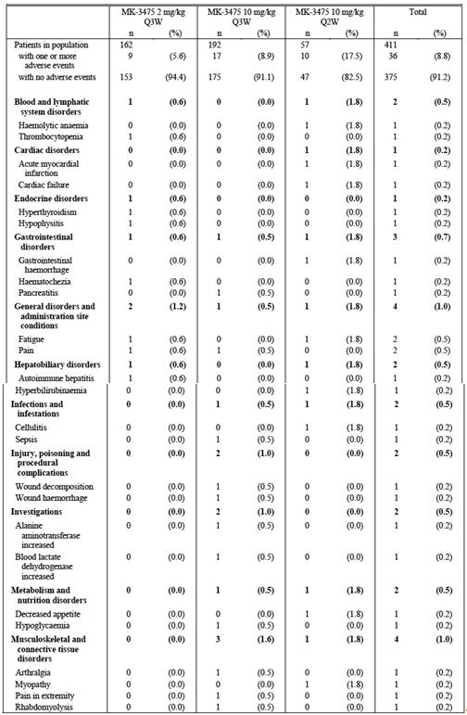

Table 32 (continued). Pooled melanoma cohorts; AEs leading to discontinuation
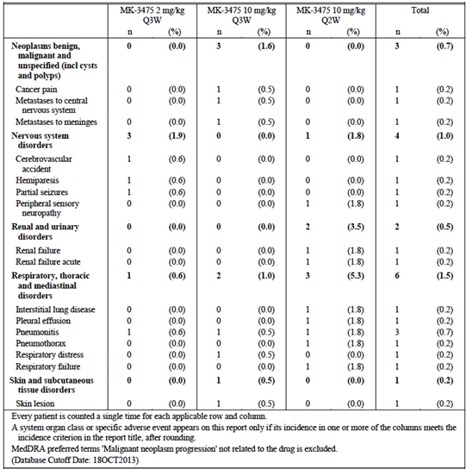

Cohort C (NSCLC)
In Cohort C, 15.8% of subjects discontinued due to an AE. Only one of these events (pulmonary oedema) was considered to be drug related.

AEs of special interest

AEs with potential immune aetiology
The sponsor implemented two procedures for identifying AEs with a possible immune aetiology:
- Investigators were asked to indicate whether any AE being reported was potentially immune related by checking a box on the case report form. Such AEs were referred to as investigator-reported immune related AEs or ‘irAEs’;
- A pre-specified list of AE terms of potential immune aetiology was developed. These were referred to as Adverse Events of Special Interest (AEOSI). The list current as of January 2014 is shown in Table 33.These events had to be reported by investigators regardless of whether they considered them to be immune related or not.
Immune related AEs (irAEs) were reported more frequently than AEOSI (overall incidence in the pooled melanoma cohorts 22.6% versus 12.4%). This review will focus on the AEOSI as this represents a more focussed and standardised approach for assessing AEs with a potential immune aetiology.

Table 33. Adverse events of special interest (AEOSI)
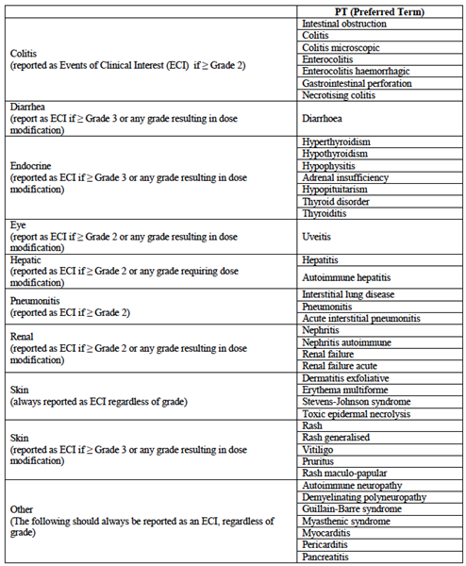

Pooled melanoma cohorts
Overall, 12.4% of subjects experienced at least 1 AE that fulfilled the criteria for an AEOSI. These are listed in Table 34. This table includes some AE terms (for example rash) that are not included in the current list of AEOSI (Table 33). Presumably these terms were included in a previous version of the list. Grade 3-5 AEOSI occurred in 6.8% of subjects and serious AEOSI in 6.1%.

Table 34. Pooled melanoma cohorts; AEOSI
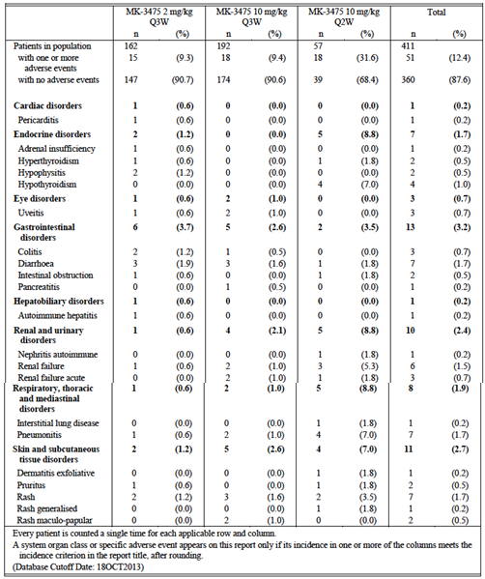

Cohort C (NSCLC)
In Cohort C, 2 subjects (5.3%) experienced an AEOSI; 1 case of diarrhoea and 1 case of pneumonitis.

Infusion reactions
Only 2 out of 479 subjects (0.4%) in study P001 were reported as having infusion related reactions. One subject had a moderate reaction requiring interruption of the infusion. The other had a mild reaction for which no action was taken. Both subjects received further infusions without any further reactions.

Laboratory tests
In the study report, laboratory testing results were only reported for the melanoma cohorts.

Liver function
Changes from baseline in LFTs are summarised in Table 35. The incidences of abnormal LFTs were provided. Clinically significant changes from baseline were uncommon. There were no cases that fulfilled the criteria for Hy’s law (that is, cases indicating that the drug might be associated with severe drug induced liver injury).

Table 35. Pooled melanoma cohorts: LFTs; changes from baseline
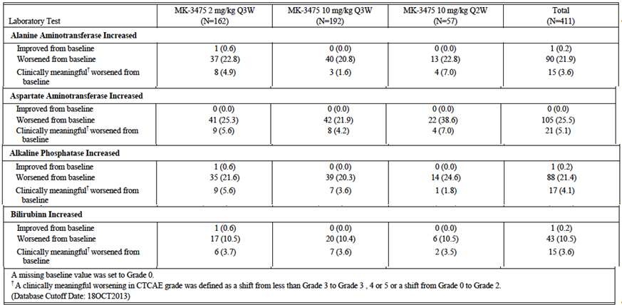

Kidney function
Changes from baseline in creatinine are summarised in Table 36. Clinically meaningful changes occurred in 1.9% of subjects. Results for urea were not reported, presumably because no clinically meaningful changes were observed.

Table 36. Pooled melanoma cohorts: Creatinine; changes from baseline
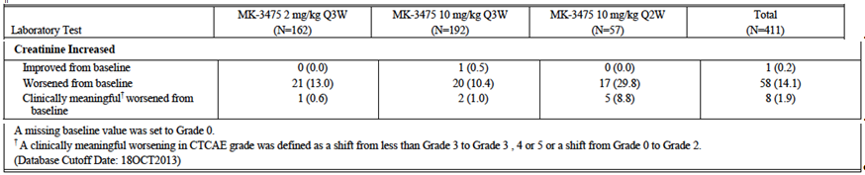

Other clinical chemistry
In the pooled melanoma cohorts, a clinically meaningful change (a shift from < Grade 3 to Grade ≥ 3 or a shift from Grade 0 to Grade 2) occurred with the following frequencies:
- Albumin decreased 10.0%
- Calcium decreased 2.2%
- Calcium increased 0.2%
- Cholesterol 2.4%
- Glucose decreased 1.9%
- Glucose increased 10.0%
- Magnesium decreased 0.2%
- Magnesium increased 1.0%
- Phosphate decreased 15.3%
- Potassium decreased 0.7%
- Potassium increased 3.2%
- Sodium decreased 0.2%
- Triglycerides 1.0%.

Haematology
The incidence of clinically meaningful changes in haematology parameters in the pooled melanoma cohorts is summarised in Table 37.

Table 37. Pooled melanoma cohorts; Haematology; incidence of clinically meaningful changes from baseline
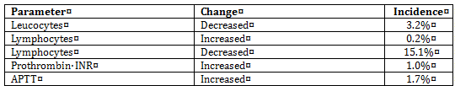

Thyroid function tests
Abnormalities of thyroid function testing are summarised in Table 38. 32.5% of subjects developed abnormalities. Both hypo- and hyperthyroidism were observed.

Table 38. Pooled melanoma cohorts: Thyroid function tests
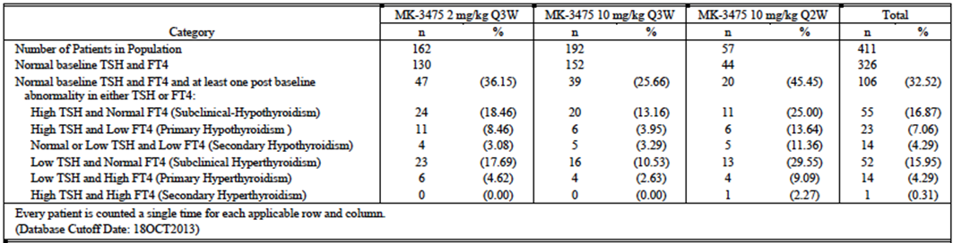

Electrocardiograph
Results of an exposure response analysis for QTc interval were provided (report 03TLCF). No analyses were presented of other ECG parameters.
Comment: The study design, conduct and analysis were satisfactory. The data suggest that the proposed dosage regimen is unlikely to produce clinically significant QT prolongation. However, the study does not meet the criteria for a ‘thorough’ QT study according to the relevant EMA guideline adopted by the TGA. There were no placebo or positive control arms, only a single ECG was taken at each time point and only one time point in the dosage interval was examined. In general, monoclonal antibodies are unlikely to interact with cardiac ion channels due to their large size and high target specificity.⁸

Vital signs
No analyses were presented for vital signs (blood pressure, heart rate, temperature etc.).

Urinalysis
No analyses were presented for urinalysis.

Post-marketing experience
No post-marketing data were included in the submission.

Safety issues with the potential for major regulatory impact

Liver toxicity
As indicated above, there were no cases suggestive of a potential for pembrolizumab to cause severe drug-induced liver injury.

Haematological toxicity
One case of pancytopaenia (grade 3) was reported in study P001. It resolved after treatment with steroids.

Serious skin reactions
No cases of Stevens-Johnson syndrome (SJS) or toxic epidermal necrolysis (TEN) were reported in study P001. However one case of SJS was reported in another ongoing study (Study 002). The investigator considered the case to be related to pembrolizumab.

Cardiovascular safety
Cardiovascular adverse events were not a prominent feature in the pooled melanoma cohorts. As of the October cut-off, 39 out of 411 subjects (9.5%) had experience at least one cardiac AE, and 67 out of 411 subjects (16.3%) had experienced at least one vascular AE. The AEs reported were provided.
The incidence of the more significant cardiovascular AEs was low:
- Grade 3-5 AEs 2.4% (cardiac) and 2.4% (vascular)
- Serious AEs 2.9% (cardiac) and 2.2% (vascular)
- Discontinuations due to AEs 0.2% (cardiac) and 0% (vascular).

Unwanted immunological events
Autoimmune-type events were a notable feature of pembrolizumab.

Immunogenicity
The submission included a report on immunogenicity testing conducted during study P001 (Report No 03VXM4). Subjects enrolled in the trial had pre- and post-baseline serum samples collected for measurement of anti-drug antibodies (ADA). A total of 449 subjects had a baseline and at least one post-baseline sample available. The presence of circulating pembrolizumab can interfere in the analytical detection of ADA. For 129 out of the 449 patients (29%), pembrolizumab concentrations were sufficiently low in the last post-dose sample to confirm a negative immunogenicity status.
Two subjects tested positive for ADA (after both screening and confirmatory assays). One of these subjects was found to have a positive test on the baseline sample. Therefore only one subject was classified as having a treatment emergent positive test. This subject had negative testing at baseline and Day 22, a positive test at Day 83, and inconclusive testing on Days 169 and 254. Therefore the overall positivity rate was 1 out of (129 + 1) = 0.77%.
The PK of pembrolizumab in the two patients who had positive tests was similar to the PK of other subjects. The patient who developed a treatment emergent test achieved stable disease as a best response and had no evidence of hypersensitivity.

Other safety issues

Safety in special populations

Age
An analysis of the overall incidence of AEs by age group (< 65 versus ≥ 65 years) was included in the submission. In general there was no apparent increase in the incidence of AEs in the elderly population, although discontinuations due to AEs were increased (12.4% versus 6.8%).

ECOG performance status
A similar analysis on the basis of ECOG status (0 versus 1) indicated that grade 3-5 AEs, serious AEs and discontinuations due to AEs were more common in patients with impaired performance status.
Comment: This difference may have been due to more advanced disease rather than any effect related to the drug.

Gender
A similar analysis on the basis of gender did not find a significant difference in the incidence of AEs.

Prior ipilimumab exposure
In the pooled melanoma cohorts, there were 190 subjects who were IPI naïve and 221 subjects who had been exposed to IPI. The overall incidence of AEs was comparable in the two groups. The incidence if irAEs was slightly higher in the IPI naïve population (26.8% versus 19.0%), as was the incidence of AEOSI (14.7% versus 11.3%).

Exposure (AUC)-response analysis for safety
The submission included an exposure response analysis for safety in melanoma patients (Report 03TLCN). The analysis was based on data from the 410 subjects in the melanoma population (from cohorts B1, B2 and D).
A nonlinear mixed effects modelling approach was used to analyse the relationship between AEs and pembrolizumab exposure. The measure of exposure was AUC over a period of 6 weeks at steady state. AUC values were derived from a population PK model (Report 03TLC8). Two different types of AEs were analysed:
- any grade 3 or grade 4 or serious AE and
- AEOSI.
Two types of analyses were performed:
- a logistic regression to analyze the frequency of AE experiences and
- a time-to-event (TTE) analysis to characterise the rate and time of AE occurrence. A number of covariates were also tested.
Overall, the analyses failed to demonstrate a relationship between exposure and the incidence of AEs. In the subgroup of patients who received the 10 mg/kg Q2W regimen, there was a trend for increased incidence of AEOSI with increasing AUC.

Safety data from other ongoing studies
The submission included tabulations of ‘notable’ SAEs that had occurred in other ongoing cohorts of P001 (Cohorts B3 and F) and other ongoing studies (P002, P006, P010 and P012). Many were consistent with an immune aetiology (pneumonitis, colitis/diarrhoea, hyperthyroidism, thrombocytopenia etcetera). There was one additional fatal AE.

Late breaking safety information
In October 2014 the sponsor distributed a ‘Dear Physician’ letter to doctors prescribing pembrolizumab in clinical trials or under the Special Access Scheme. The letter concerned pneumonitis/interstitial lung disease (ILD), and the fact that fatal cases had now been reported. A sponsor review of reported ILD events apparently indicated an incidence of 2.8% overall, 1.3% for grade 3-5 events and 0.15% for fatal events. A copy of the review was not provided. The letter emphasised the importance or early treatment with steroids.

Evaluator’s overall conclusions on clinical safety
All subjects enrolled in P001 received pembrolizumab. The absence of any control arm makes interpretation of the safety data difficult, in that many of the reported AEs may have been due to the disease under study rather than the drug. Patients with advanced melanoma would be expected to experience a variety of AEs as a result of their disease.
Given the mechanism of action of pembrolizumab, autoimmune type toxicity might be expected. Such effects are a feature of ipilimumab, a drug with a similar mode of action to that of pembrolizumab. A variety of such effects were observed in study P001 (and the other ongoing trials). The overall incidence of events that met the criteria for AEOSI was 12.4%. About half of these events were rated as serious AEs or grade 3-5 in severity. The sponsor’s recent safety warning indicates that fatal events of pneumonitis/ILD have occurred. Other events observed included colitis, thyroid disorders, autoimmune hepatitis, hypophysitis and uveitis.
Common AEs in melanoma subjects included fatigue, arthralgia, gastrointestinal AEs and skin disorders. However, most of these events were grade 1-2 in severity and not considered serious.
The overall incidence of serious AEs was fairly high at approximately 34.8%. However, SAEs that were assessed as drug related occurred in only 8.8% of subjects. Similarly, grade 3-5 events occurred in 39.7% of subjects, but drug related grade 3-5 events occurred in only 12.7%. Apart from fatal cases of pneumonitis reported recently by the sponsor, there was no clear evidence that pembrolizumab caused fatal AEs.
Approximately 9% of subjects had to discontinue pembrolizumab due to AEs. According to the investigators, only 3.9% of subjects discontinued due to AEs that were related to pembrolizumab. This suggests that pembrolizumab toxicity is manageable with the dose delays used in P001.
In general, toxicity did not appear to be related to dose, over the 2 to 10 mg/kg range when the drug was given at 3 weekly intervals. The incidence of AEs appeared to be increased in the subgroup of patients who received 10 mg/kg every 2 weeks. However, this may have been due to a longer period of follow-up in this group. If this is so, the incidence of AEs in the 2 mg/kg Q3W would be expected to increase with further follow-up and the data in the study report might underestimate the long-term toxicity of the proposed 2 mg/kg Q3W regimen.
Pembrolizumab is intended for subjects with a serious life-threatening disease and a limited life expectancy. The safety profile of pembrolizumab described above should not preclude its use in such a population. The drug is therefore considered to have acceptable safety given the intended patient population.

First round benefit-risk assessment

First round assessment of benefits
The benefits of pembrolizumab in the proposed usage are:
- Significant reduction in tumour size in a substantial proportion of patients (approximately 33%). The early data suggest that such effects are durable.

First round assessment of risks
The risks of pembrolizumab in the proposed usage are:
- Autoimmune phenomena such as pneumonitis, colitis, etcetera
- A variety of other adverse effects including fatigue, arthralgia, gastrointestinal and skin events. However, most of these are mild or moderate in severity (that is, grade 1 or 2).

First round assessment of benefit-risk balance
Overall, it is considered that the benefits of pembrolizumab outweigh its risks. However, the data submitted with this application are early. Specific limitations of the data include the following:
- Data on the duration of tumour responses was not mature;
- There were no randomised comparisons of pembrolizumab against other agents registered for use in the proposed patient population, for example:
  - Ipilimumab which is registered for patients who have failed prior therapy;
  - BRAF inhibitors (for example vemurafenib and dabrafenib), which are registered for the treatment of BRAF mutation positive disease.
Both of these therapies have been demonstrated to produce benefits in terms of overall survival or progression-free survival. In the absence of any randomised controlled trials, it cannot be concluded that pembrolizumab produces similar benefits.
Regulatory approval of new anticancer agents usually requires a favourable risk-benefit ratio demonstrated in a Phase III study using time-to-event endpoints such as overall survival or progression free survival. However, in situations where the indication is a life threatening condition and there are no other established therapies available, approvals have been granted based on non-comparative Phase II studies which used response rate as an endpoint.
The indication proposed by the sponsor is:
‘For the treatment of unresectable or metastatic melanoma in adults’.
This is a broad indication, which would include patients eligible for treatment with ipilimumab or BRAF inhibitors, even though comparable efficacy has not been demonstrated. The sponsor is currently conducting randomised controlled trials in melanoma comparing pembrolizumab with chemotherapy (Study P002) and ipilimumab (Study P006).
It is therefore recommended that pembrolizumab be approved for registration, but with a more restricted indication than the one proposed by the sponsor. The indication currently approved in the USA would be appropriate:
‘For the treatment of patients with unresectable or metastatic melanoma and disease progression following ipilimumab and, if BRAF V600 mutation positive, a BRAF inhibitor.’
The risk-benefit balance is less favourable in subjects with PD-L1 negative disease, due to limited efficacy. It may be appropriate to further limit the indication to subjects with PD-L1 positive tumours. However this would require the availability of appropriate testing. The sponsor should be asked to comment on this issue.

First round recommendation regarding authorisation
It is recommended that the application be approved, but with the restricted indication outlined above.

Clinical questions

Efficacy

Question 1
The sponsor should be asked to provide a short summary of any updated/new efficacy data relating to the following:
- Duration of response in the melanoma cohorts (B1, B2 and D) of Study P001. Any updated data on duration of response in subjects with PD-L1 negative disease should also be provided.
- Overall survival in the melanoma cohorts (B1, B2 and D) of Study P001;
- The relationship between biomarkers (other than PD-L1) and efficacy outcomes in melanoma in study P001;
- Results from Cohort B3 in Study P001;
- Results from the Phase III melanoma studies P002 and P006.

Question 2
The sponsor should be asked to comment on the availability in Australia of IHC testing for tumour expression of PD-L1. Are there any plans for the assay used in Study P001 to be made commercially available?

Second round evaluation of clinical data submitted in response to questions
The evaluation of the response to the clinical questions has been addressed in the Delegates review of the submission. Please see the AusPAR for this section of the evaluation.

References
Cancer Council Australia. [Internet]. Cancer Council Australia; 2014. Melanoma; 2014 March 25 [cited 15 October 2014]
Eggermont AMM, Spatz A and Robert C. Cutaneous melanoma. Lancet 2014; 383: 816–27
McDermott DF and Atkins MB. PD-1 as a potential target in cancer therapy. Cancer Medicine. 2013; 2: 662–673.
Tykodi SS. PD-1 as an emerging therapeutic target in renal cell carcinoma: current evidence. Onco Targets Ther. 2014; 7:1349-1359
Chen DS, Irving BA and Hodi FS. Molecular Pathways: Next-Generation Immunotherapy— Inhibiting Programmed Death-Ligand 1 and Programmed Death-1. Clin Cancer Res. 2012; 18: 6580-6587
European Medicines Agency. Guideline On The Evaluation Of Anticancer Medicinal Products In Man (CPMP/EWP/205/95/Rev.4); 2012. (Accessed 15 October 2014).
European Medicines Agency. Guideline On The Clinical Investigation of The Pharmacokinetics Of Therapeutic Proteins (CHMP/EWP/89249/2004); 2007. (Accessed 15 October 2014).
Food and Drug Administration. FDA News Release. FDA approves Keytruda for advanced melanoma. 4 September 2014. (accessed 15 October 2014).
Hamid O, Robert C, Daud A et al. Safety and Tumor Responses with Lambrolizumab (Anti–PD-1) in Melanoma. N Engl J Med. 2013; 369: 134-144.
Hodi FS, O’Day SY, McDermott DF et al. Improved Survival with Ipilimumab in Patients with Metastatic Melanoma. N Engl J Med; 2010; 363:711-723.
Robert C, Ribas A, Wolchok JD et al. Anti-programmed-death-receptor-1 treatment with pembrolizumab in ipilimumab-refractory advanced melanoma: a randomised dose-comparison cohort of a phase I trial. Lancet. 2014; 384: 1109-1117.
Eisenhauer EA, Theraase P, Bogaerts LH et al. New response evaluation criteria in solid tumours: Revised RECIST guideline (version 1.1). Eur J Cancer. 2009; 45: 228-247.
Wolchok JD, Hoos A, O'Day S, Weber JS, Hamid O, Lebbé C, et al. Guidelines for the evaluation of immune therapy activity in solid tumors: immune-related response criteria. Clin Cancer Res 2009; 15: 7412-7420.

Therapeutic Goods Administration
PO Box 100 Woden ACT 2606 Australia
Email: info@tga.gov.au Phone: 1800 020 653 Fax: 02 6232 8605
https://www.tga.gov.au

Cancer Council Australia; 2014. Melanoma; 2014 March 25 [cited 15 October 2014];
Eggermont AMM et al. Cutaneous melanoma. Lancet; 2014; 383: 816–827
McDermott DF and Atkins MB. PD-1 as a potential target in cancer therapy. Cancer Medicine. 2013; 2: 662–673.
Tykodi SS. PD-1 as an emerging therapeutic target in renal cell carcinoma: current evidence. Onco Targets Ther. 2014; 7:1349-1359
Chen DS et al. Molecular Pathways: Next-Generation Immunotherapy— Inhibiting Programmed Death-Ligand 1 and Programmed Death-1. Clin Cancer Res. 2012; 18: 6580-6587
CPMP/EWP/205/95/Rev.4 European Medicines Agency. Guideline On The Evaluation Of Anticancer Medicinal Products In Man 2012
CHMP/EWP/89249/2004 European Medicines Agency. Guideline On The Clinical Investigation of The Pharmacokinetics Of Therapeutic Proteins 2007
Rodriguez I et al. Electrocardiographic assessment for therapeutic proteins—scientific discussion. Am Heart J; 2010; 160: 627-634.
Hamid O et al. Safety and Tumor Responses with Lambrolizumab (Anti–PD-1) in Melanoma. N Engl J Med. 2013; 369: 134-144.
Robert C, et al. Anti-programmed-death-receptor-1 treatment with pembrolizumab in ipilimumab-refractory advanced melanoma : a randomised dose-comparison cohort of a phase 1 trial. Lancet. 2014; 384: 1109-1117.
Eisenhauer EA, et al. New response evaluation criteria in solid tumours: Revised RECIST guideline (version 1.1). Eur J Cancer. 2009, 45: 228-247.
Wolchok JD, et al. Guidelines for the evaluation of immune therapy activity in solid tumors: immune-related response criteria. Clin Cancer Res 2009; 15: 7412-7420.
Hodi FS et al. Improved Survival with Ipilimumab in Patients with Metastatic Melanoma. N Engl J Med; 2010; 363:711-723.

