First round report: 28 May 2017
Second round report: 14 September 2017

AusPAR Attachment 2

Extract from the Clinical Evaluation Report for Pembrolizumab
  - Proprietary Product Name: Keytruda
  - Sponsor: Merck Sharp and Dohme (Australia) Pty Ltd

About the Therapeutic Goods Administration (TGA)
- The Therapeutic Goods Administration (TGA) is part of the Australian Government Department of Health, and is responsible for regulating medicines and medical devices.
- The TGA administers the Therapeutic Goods Act 1989 (the Act), applying a risk management approach designed to ensure therapeutic goods supplied in Australia meet acceptable standards of quality, safety and efficacy (performance), when necessary.
- The work of the TGA is based on applying scientific and clinical expertise to decision-making, to ensure that the benefits to consumers outweigh any risks associated with the use of medicines and medical devices.
- The TGA relies on the public, healthcare professionals and industry to report problems with medicines or medical devices. TGA investigates reports received by it to determine any necessary regulatory action.
- To report a problem with a medicine or medical device, please see the information on the TGA website <https://www.tga.gov.au>.
About the Extract from the Clinical Evaluation Report
- This document provides a more detailed evaluation of the clinical findings, extracted from the Clinical Evaluation Report (CER) prepared by the TGA. This extract does not include sections from the CER regarding product documentation or post market activities.
- The words [Information redacted], where they appear in this document, indicate that confidential information has been deleted.
- For the most recent Product Information (PI), please refer to the TGA website <https://www.tga.gov.au/product-information-pi>.
Copyright
© Commonwealth of Australia 2018
This work is copyright. You may reproduce the whole or part of this work in unaltered form for your own personal use or, if you are part of an organisation, for internal use within your organisation, but only if you or your organisation do not use the reproduction for any commercial purpose and retain this copyright notice and all disclaimer notices as part of that reproduction. Apart from rights to use as permitted by the Copyright Act 1968 or allowed by this copyright notice, all other rights are reserved and you are not allowed to reproduce the whole or any part of this work in any way (electronic or otherwise) without first being given specific written permission from the Commonwealth to do so. Requests and inquiries concerning reproduction and rights are to be sent to the TGA Copyright Officer, Therapeutic Goods Administration, PO Box 100, Woden ACT 2606 or emailed to <tga.copyright@tga.gov.au>.

Contents
List of common abbreviations 5
1. Submission details 8
1.1. Identifying information 8
1.2. Submission type 8
1.3. Drug class and therapeutic indication 8
1.4. Dosage forms and strengths 8
1.5. Dosage and administration 8
1.6. Proposed changes to the product documentation 9
2. Background 9
2.1. Information on the condition being treated 9
2.2. Clinical rationale 12
2.3. Formulation 12
2.4. Guidance and references 12
2.5. Evaluator’s commentary on the background information 13
3. Contents of the clinical dossier 13
3.1. Scope of the clinical dossier 13
3.2. Paediatric data 14
3.3. Good clinical practice 14
3.4. Evaluator’s commentary on the clinical dossier 15
4. Pharmacokinetics 15
4.1. Study KN052 15
4.2. Study KN045 18
4.3. Study KN012 22
4.4. Population pharmacokinetics 23
4.5. Evaluator’s overall conclusions on pharmacokinetics 34
5. Pharmacodynamics 34
6. Dosage selection for the pivotal studies 35
7. Clinical efficacy 36
7.1. Studies providing evaluable efficacy data 36
7.2. Pivotal or main efficacy studies for indication 1 36
7.3. Pivotal or main efficacy study Indication 2 86
7.4. Analyses performed across trials: pooled and Meta analyses 127
7.5. Evaluator’s conclusions on clinical efficacy 127
8. Clinical safety 128
8.1. Studies providing evaluable safety data 128
8.2. Patient exposure 130
8.3. Adverse events 132
8.4. Events of clinical interest 147
8.5. Laboratory test abnormalities 148
8.6. Immunogenicity analysis 157
8.7. Other safety issues 160
8.8. Post-marketing experience 160
8.9. Evaluator’s overall conclusions on clinical safety and second round comments following sponsor’s response 161
8.10. First round benefit-risk assessment 162
8.11. First round assessment of benefits and risks 162
8.12. First round assessment of benefit-risk balance 164
9. First round recommendation regarding authorisation 165
9.1. Locally advanced or metastatic urothelial cancer following prior platinum therapy. 165
9.2. Locally advanced or metastatic urothelial cancer in patients not eligible for cisplatin. 165
10. Second round evaluation 165
10.1. Clinical questions 165
10.2. Efficacy 168
11. Second round benefit-risk assessment 198
11.1. Locally advanced or metastatic urothelial cancer following platinum chemotherapy. 198
11.2. Locally advanced or metastatic urothelial cancer in patients not eligible for cisplatin. 199
11.3. Outstanding issues 200
12. Second round recommendation regarding authorisation 201
13. References 201

List of common abbreviations
Abbreviation | Meaning
1L | First line
2L | Second line
3L | Third line
ADA | anti-drug antibody
AE | Adverse event
AEOSI | Adverse event of special interest
ALT | Alanine aminotransferase
APaT | All patients as treated
AST | Aspartate aminotransferase
BICR | Blinded independent central review
CI | Confidence interval
CPS | Combined positive score
CR | Complete response
CSR | Clinical study report
CTCAE | Common Toxicity Criteria for Adverse Events
DMC | Data Monitoring Committee
ECG | Electrocardiogram
ECI | Events of clinical interest
ECOG | Eastern Cooperative Oncology Group
ECOG-PS | Eastern Cooperative Oncology Group-Performance Status
eCRF | Electronic case report form
EOC | Executive Oversight Committee
EORTC QLQ-C30 | Electronic European Organization for Research and Treatment of Cancer Quality of Life Questionnaire Core 30 items
ePRO | Electronically collected patient-reported outcome
EQ-5D | European Quality of Life 5 Dimensions
ERC | Ethics Review Committee
ETA | random effects
EU | European Union
FAS | Full analysis set
FDA | Food and Drug Administration
FFPE | Formalin-fixed, paraffin-embedded
FWER | Family-wise type 1 error rate
GCP | Good Clinical Practice
HIV | Human immunodeficiency virus
HNSCC | Head and neck squamous cell carcinoma
HR | Hazard ratio
IA | Interim analysis
ICF | Informed consent form
ICH | International Council for Harmonization
IEC | Independent Ethics Committee
IND | Investigational New Drug
IRB | Institutional Review Board
ITT | Intent-to-treat
IV | Intravenous
LS | Least squares
MedDRA | Medical Dictionary for Regulatory Activities
mRECIST | Modified Response Evaluation Criteria in Solid Tumors
NCI | National Cancer Institute
NSCLC | Non-small cell lung cancer
ORR | Objective response rate
OS | Overall survival
PD | Progressive disease
PD-1 | Programmed cell death-1
PD-L1 | Programmed cell death 1- ligand 1
PD-L2 | Programmed cell death 1- ligand 2
PFS | Progression-free survival
PK | Pharmacokinetic
PR | Partial response
PRO | Patient-reported outcomes
PT | Preferred term
PTT | Partial thromboplastin time
Q2W | Every 2 weeks
Q3W | Every 3 weeks
QALY | Quality-adjusted life-year
QoL | Quality of life
RECIST | Response Evaluation Criteria in Solid Tumors
RPSFT | Rank Preserving Structural Failure Time
SAC | Scientific Advisory Committee
SAE | Serious adverse event
SAP | Statistical analysis plan
SD | Stable disease
SOC | System organ class (MedDRA)
TPS | Tumour progression score
ULN | Upper limit of normal
US | United States

Submission details

Identifying information
Submission number | PM 2016-04328-1-4
Sponsor | Merck Sharp Dohme (Australia) Pty Ltd
Trade name | Keytruda
Active substance | Pembrolizumab

Submission type
This is as application to extend the currently registered indications to urothelial carcinoma. It is noted that although this is likely to change, at the time of the application, the only approved indication was:
Keytruda (pembrolizumab) is indicated as monotherapy for the treatment of unresectable or metastatic melanoma in adults.
The proposed indications, as taken from the draft PI are:
Keytruda (pembrolizumab) is indicated for the treatment of patients with locally advanced or metastatic urothelial carcinoma who are not eligible for cisplatin-containing therapy.
Keytruda (pembrolizumab) is indicated for the treatment of patients with locally advanced or metastatic urothelial carcinoma who have received platinum-containing chemotherapy.

Drug class and therapeutic indication
Pembrolizumab is a monoclonal antibody, which targets the programmed cell death -1 (PD-1) receptor on activated T-lymphocytes. At the time of writing, the only approved indication for the product was ‘as monotherapy for the treatment unresectable or metastatic melanoma in adults.’

Dosage forms and strengths
Two presentations of pembrolizumab are currently registered, but only the 50 mg presentation is marketed in Australia:
- A vial containing 50 mg powder for injection. The powder is reconstituted with sterile water for injection (2.3 mL) and then added to normal saline or 5% dextrose prior to intravenous (IV) infusion.
- A vial containing a concentrated solution of 100 mg in 4 ml. This solution is added to normal saline or 5% dextrose prior to IV infusion.
No new formulation or presentation has been proposed.

Dosage and administration
The draft PI states the following:
‘Urothelial Carcinoma
The recommended dose of Keytruda is 200 mg administered intravenously over 30 minutes every 3 weeks.
Patients should be treated with Keytruda until disease progression or unacceptable toxicity. Atypical responses (that is, an initial transient increase in tumour size or small new lesions within the first few months followed by tumour shrinkage) have been observed. Clinically stable patients with initial evidence of disease progression can under some circumstances remain on treatment until disease progression is confirmed (see CLINICAL TRIALS section for a description of the circumstances where such continued treatment was allowed in the pivotal study).’

Proposed changes to the product documentation
The proposed PI changes are restricted to the Clinical Trials section, The Dosage and Administration section and the Indications and the Immunogenicity section.

Background

Information on the condition being treated
The sponsor states, ‘Urothelial carcinoma, also known as transitional cell carcinoma or urothelial bladder cancer, refers to carcinomas that arise from the urothelial endothelium that lines the renal pelvis, ureter, bladder and urethra, with more than 90% of urothelial carcinomas originating in the bladder. About 80–90% of all bladder cancers start from the urothelial cells that line the bladder wall. This is sometimes called transitional cell carcinoma. Urothelial carcinoma can be papillary or flat…, and it can also occur in the ureters and kidneys’.
This differs from squamous cell carcinoma (1-2% of all cases) and adenocarcinoma (1% of all cases) of the bladder, which is not the cancer type for which registration is being sought in this application.
Risk factors include smoking, exposure to environmental carcinogens, as well as inherited predisposition syndromes due to mismatch repair gene defects (Lynch syndrome) or PTEN mutations (Cowden syndrome).
Staging of urothelial carcinoma of the renal pelvis/ureter is similar to that for bladder cancer, and is based upon the recently revised Tumour Node Metastasis classification by the American Journal of Cancer Classification accessed via uptodate.com (staging sections using search terms urothelial bladder cancer, urethral carcinoma and renal pelvis or ureteric carcinoma. The stages which are captured within clinical trial inclusion criteria in both pivotal trials presented here include those, which are inoperable, locally advanced, and/or with distant metastases. Those with Stage IV disease include patients with locally invasive tumours spreading into surrounding tissues, and/or local nodal spread and/or distant metastases.
No contextualisation of the proposed usage in Australia was provided in the application. A separate report (Report title ‘04FZLR’), ‘Systematic literature review and meta-analysis’ was included comparing historical outcomes from 18 clinical trials in patients who were treated with first line therapy, but were not considered eligible for cisplatin-based therapies. Specific Australian statistics for the incidence of urothelial carcinoma as opposed to bladder cancer are not available. The Australian Institute of Health and Welfare (AIHW) statistics from 2006-2010 state that bladder cancer accounted for 2% of all cancers, making it the tenth most common cancer in Australia. These statistics indicate that more than 2400 Australians are diagnosed with bladder cancer each year, most of whom are 60 years of age or older. Men are three to four times more likely than women to be diagnosed with bladder cancer. Bladder cancer was noted to be the 8th most common cancer and the 13th most common cause of cancer death in men, and the 17th most common cancer and cause of cancer death in women (Cheluvappa et al, 2014). Extrapolating from these figures, approximately 2100 cases of urothelial carcinoma of the bladder are diagnosed each year in Australia. Statistics for the incidence of urothelial carcinoma of the upper urinary tract in Australia could not be found.
Anatomical location and histological grading have historically been the key determinants guiding treatment plans for patients with urothelial cancer. Low-grade urothelial cancer of the bladder has a different prognosis and treatment options compared with high-grade muscle-invasive disease. Patients presenting with muscle-invasive have a high risk of relapse and together with those with locally advanced or metastatic disease are recommended to receive chemotherapy with surgery or chemotherapy plus radiation as options for local control. Given the much higher frequency of bladder cancer, most studies have enrolled patients with tumours arising in the bladder rather than upper genitourinary tract urothelial carcinomas.

First line, good performance status and able to tolerate chemotherapy
Cisplatin-based combination therapy either in the form of methotrexate, vinblastine, doxorubicin, and cisplatin (MVAC) or gemcitabine plus cisplatin (GC) is the most commonly used regimens, for those able to tolerate chemotherapy. Initial response rates to combination chemotherapy are high in previously untreated patients, but long-term survival is rare. In a head-to-head study comparing GC with MVAC in patients with locally advanced inoperable or metastatic urothelial carcinoma of the bladder, median progression-free survival was 7.7 months and 8.3 months, overall survival for was 14.0 months and 15.2 months (MVAC), and 5-year progression-free survival rates were 13% and 15.3%, respectively Sternberg, C et al, 1989). Six-year continuous disease-free survival rates were reported as 3.7% in another study using MVAC (Saxman et al, 1997) Significant prognostic factors favouring overall survival included better baseline performance status, the absence versus presence of metastatic disease, low/normal alkaline phosphatase level, number of disease sites ≤3) and the absence of visceral metastases (von der Maase et al, 2006). The toxicities of chemotherapy are significant with a reported treatment-related death rate for MVAC of 3%, and high rates of ≥Grade 3 neutropaenia (58%) and associated sepsis (25%) (Sternberg, C et al, 1989); additional toxicities include nephropathy and neuropathy. It was noted that patients with poor performance status were unlikely to experience long-term disease-free survival with MVAC chemotherapy (Saxman et al, 1997).

First line, not able to tolerate cisplatin chemotherapy
Given the advanced age at which many patients are diagnosed and comorbidities that may include impaired renal function, many will not be able to tolerate chemotherapy, and in particular, cisplatin. A consensus working group (Galsky et al, 2011) defined those who were considered less likely to tolerate cisplatin as having the following features:
- World Health Organization (WHO)/Eastern Cooperative Oncology Group (ECOG) performance status ≥2 or a Karnofsky Performance Status of 60 to 70 percent or less;
- Creatinine clearance less than 60 mL/min;
- Hearing loss (measured at audiometry) of 25 dB at two contiguous frequencies;
- Grade 2 or greater peripheral neuropathy (that is, sensory alteration or paraesthesia, including tingling, but not interfering with activities of daily living);
- New York Heart Association class III or greater heart failure.
This is the patient group for whom the sponsor is seeking registration of pembrolizumab for use first line as monotherapy. Currently, for such patients, options include carboplatin-based combination regimens or a non-platinum-based regimen such as paclitaxel and gemcitabine. The following results were obtained in a randomised Phase II/III trial assessing gemcitabine/carboplatin and methotrexate/carboplatin/vinblastine in patients with advanced urothelial cancer who were deemed unable to tolerate cisplatin-based chemotherapy (De Santis et al, 2012):
- best ORRs were 41.2% (36.1% confirmed response) for patients receiving GC versus 30.3% (21.0% confirmed response) for patients receiving M-CAVI (P = .08);
- median OS was 9.3 months in the GC arm and 8.1 months in the M-CAVI arm (p = 0.64);
- no difference in PFS (p = 0.78) between the two arms.
- severe acute toxicity (death, Grade 4 thrombocytopaenia with bleeding, Grade 3 or 4 renal toxicity, neutropenic fever, or mucositis) was observed in 9.3% of patients receiving GC and 21.2% of patients receiving M-CAVI.
In 54 patients with ECOG-PS 0-2, receiving 2-weekly gemcitabine and paclitaxel as first line therapy for advanced urothelial carcinoma, the overall response rate was 37% (with 9.2% CR and 28% PR) with a median progression-free survival of 5.8 months and overall survival of 13.2 months (Calabro et al, 2009).

Second line following progression on cisplatin
There is no established standard of care for patients whose disease progresses after cisplatin chemotherapy. For those with Eastern Cooperative Oncology Group performance status of 0 or 1, vinflunine monotherapy has shown a very modest 1.5 month improvement in progression-free survival but no overall survival benefit. This is approved in Australia, and the PI contains the following precaution, ‘Vinflunine has a narrow safety threshold. If vinflunine is used in patients with poor performance status or patients likely to progress quickly to poor performance status, close observation is required since toxicity may be excessive.’ Dose reductions are required for those with ECOG-PS 1.
Combination gemcitabine/paclitaxel or a taxane alone may also be used as second line palliative treatment. Sternberg et al (2001) report response rates of 60% (95% confidence interval [CI], 45, 75%) including a complete response in 28% and partial response in 33% of patients treated with the combination following progression after MVAC given either in the neoadjuvant or metastatic setting. Response rates were higher in those treated following neoadjuvant chemotherapy compared with after metastatic disease progression (80% versus 27%); the median duration of survival after failing neoadjuvant or adjuvant M-VAC was 12 months (range, 2– 43) compared with 8 months (range, 2–28) for patients who had been treated after failure of prior therapy for metastatic disease. For all patients, the median duration of response was 6.4 months (range, 2–43.3 months), and the median survival was 14.4 months (range, 2–43).
Several immunotherapy agents are in development, and at the time this application was submitted, two were FDA approved for the second line treatment of urothelial carcinoma following progression on cisplatin. On 18 May, 2016, the FDA granted atezolizumab, a PD-L1 inhibitor, accelerated approval for the treatment of patients with urothelial carcinoma with either disease progression during or after chemotherapy or relapsing within 12 months of neoadjuvant or adjuvant platinum-containing therapy. On February 2, 2017, nivolumab was granted accelerated approval for the treatment of patients with platinum-refractory urothelial carcinoma as follows: locally advanced or metastatic urothelial carcinoma that has disease progression during or following platinum-containing chemotherapy or has disease progression within 12 months of neoadjuvant or adjuvant treatment with a platinum-containing chemotherapy. Durvalumab received breakthrough designation status from the FDA in February 2016 for the treatment of patients with PD-L1 positive inoperable or metastatic urothelial bladder cancer whose tumour has progressed during or after one standard platinum-based regimen. Pembrolizumab has received breakthrough designation therapy status for the treatment of previously treated patients with urothelial carcinoma, but not for treatment as a first line therapy.
Thus, there is significant unmet need at the time of writing this report, particularly for novel agents with a better toxicity profile but this is an area of intense clinical investigation and rapidly changing treatment algorithms.

Clinical rationale
The sponsor indicates that after KEYNOTE-012 Cohort C demonstrated that more than half of pembrolizumab-treated patients (64%) experienced tumour shrinkage with very limited toxicity and this indicated that an initial trial with pembrolizumab was reasonable and worthwhile for cisplatin-ineligible patients. In light of the relatively limited benefit from cytotoxic chemotherapy in subjects with advanced/unresectable (inoperable) or metastatic urothelial carcinoma who cannot receive cisplatin and the promising results with pembrolizumab and other anti-PD-1 pathway agents, pembrolizumab was evaluated as monotherapy in this population with KEYNOTE-052.
The sponsor states that, ‘Promising efficacy results from KEYNOTE-012 Cohort C provided provided the impetus to initiate the pembrolizumab clinical development program in urothelial carcinoma. The clinical development program in urothelial carcinoma includes KEYNOTE-012 (Cohort C), KEYNOTE-052, KEYNOTE-045, KEYNOTE-057, and KEYNOTE-361.’

Formulation

Formulation development
No changes proposed.

Excipients
No changes proposed.

Guidance and references
EMA Guideline on Points to consider on application with one pivotal study
EMA Guideline on Population Exposure: The Extent of Population Exposure to Assess Clinical Safety
EMA Guideline on the evaluation of anticancer medicinal products in man.
FDA Guidance for Industry Adaptive design clinical trials for drugs and biologics
Uptodate.com for urothelial bladder cancer, renal pelvis/ureteric urothelial carcinoma, urethral carcinoma accessible at uptodate.com accessed on 31 March 2017
https://www.uptodate.com/contents/overview-of-the-initial-approach-and-management-of-urothelial-bladder-cancer?source=search_result&search=carcinoma%20urethra&selectedTitle=3~150#H2045790886
https://www.uptodate.com/contents/malignancies-of-the-renal-pelvis-and-ureter?source=search_result&search=carcinoma%20ureter&selectedTitle=1~31#H15
https://www.uptodate.com/contents/urethral-cancer?source=search_result&search=carcinoma%20urethra&selectedTitle=4~150

Evaluator’s commentary on the background information
The sponsor provided no background information on the current clinical algorithm and approved products for the treatment of urothelial carcinoma in Australia to support this application. The information about any potential differences in the datasets lodged with the different regulatory authorities was not stated and clarification has been sought.

Contents of the clinical dossier

Scope of the clinical dossier
The sponsor has submitted an application to register two indications to treat urothelial carcinoma supported by two different pivotal studies. These are various referred to as PN045 and PN052, or Keynote-045 (KN-045) and Keynote-052 (KN-052) and these terms have been used interchangeably according to how they were cited in the particular document under review. These have not been integrated and essentially constitute two separate applications, each with its own separate summary as these were lodged separately with the FDA and EMA. Additional efficacy data were provided after commencement of the first round evaluation.
- 2 Pivotal studies (one for each indication) each with a separate Clinical Overview, Summary of Efficacy and Summary of Safety.
- 1 ‘TGA KN52 Update.pdf (provided after commencement of evaluation).
- 1 supportive Phase Ib study.
- 4 reports containing PK tables and figures, and a modelling, simulation report including data from urothelial cancer studies:
  - Report 04JQ34 Modeling and simulation report – Extension of population PK analysis of pembrolizumab to patients with urothelial carcinoma (Protocol 001, 002, 006, 012 cohort C, 045, 052).
  - Report 04JR0J PK tables and figure for pembrolizumab Study KN052 and comparison of PK across indications. November 9, 2016.
  - Report 04JT5G PK tables and figure for pembrolizumab Study KN045 and comparison of PK across indications. November 11, 2016.
  - Report 04JQV8 PK Tables and Figures for Pembrolizumab Study KN012 Cohort C Urothelial Carcinoma (UC) and comparison of PK across indications. November 11, 2016.
- 2 modelling and simulation reports for QTc:
  - Report 03TLCF modelling and simulation report – Exposure-QTc analysis of MK-3475 Date February, 2014
  - Report 03WKGP modelling and simulation report – Exposure-QTc analysis of MK-3475 – P001 Part F Date April 2014
- Report pertaining to immunogenicity:
  - Report 04L4FS Integrated pembrolizumab Immunogenicity analysis, January 11, 2017
- Clinical studies providing pivotal efficacy and safety data:
  - ‘First line not eligible for cisplatin’
    - Study PN052 A Phase II Clinical Trial of Pembrolizumab (MK-3475) in Subjects with Advanced/Unresectable or Metastatic Urothelial Cancer
  - ‘Recurrent or Progressive Metastatic Urothelial cancer’:
    - Study PN045 A Phase III Randomised Clinical Trial of Pembrolizumab (MK-3475) versus Paclitaxel, Docetaxel or Vinflunine in Subjects with Recurrent or Progressive Metastatic Urothelial Cancer.
- Supportive study:
  - Study PN012V02 A Phase Ib Multi-Cohort Study of MK-3475 in Subjects with Advanced Tumors.
The approach adopted by the sponsor for demonstration of the proposed first line strategy is has elements of a hybrid submission that is, a combination of data with reliance upon a systematic literature review and meta-analysis undertaken by the sponsor to provide comparative or historical data. The literature search strategy for the systematic review and meta-analysis was not presented to the TGA prior to submission. This document, Report 04FZLR, has not been formally evaluated.
- Integrated summary of efficacy No data included as Study PN-052 is the sole basis for the application for first line usage. There is no mention of Study PN-045 in this document.
- Integrated summary of safety.
- Report 04FZLR A meta-analysis entitled ‘Systematic literature review and meta-analysis of response to first line therapies for advanced/metastatic urothelial cancer in subjects who are ineligible for cisplatin-based therapies’ This has been reviewed but not formally evaluated as the approach has not been agreed upon by the TGA.
- Report 04K3WW No title. Merck document presenting the training set data used to establish the CPS 10% cut-off. This report is pertinent to evaluation of the clinical validity of the biomarker and assay and has been reviewed but not formally evaluated given it pertains to the IVD validation rather than efficacy or safety and thus falls outside the scope of this clinical evaluation.
Comment: This report would be most pertinent to the evaluation of the clinical validity of the in vitro diagnostic device used in this study, noting that this is the same IVD as that approved for use, and the basis for establishing the cut-off score for use in first line and second line treatment of NSCLC.
Note is made in this report that it is stated that the populations enrolled into two further studies in bladder cancer (Keynote-057 and Keynote -0361) are not restricting enrolment using a PD-L1 CPS cut-off.
- Report 04K3WX ‘PD-L1 assessment in Merck Urothelial Cancer Trials of Pembrolizumab’. No date provided. As this report pertains largely to the analytical validity of the PD-L1 IHC 22C3 Dako PharmDx assay which is outside the scope of this clinical evaluation; it has not been formally evaluated.

Paediatric data
No paediatric data are provided which is acceptable.

Good clinical practice
The sponsor states that these studies were conducted in substantial conformance with GCP requirements and applicable country and/or local statutes and regulations regarding ethical committee review, informed consent, and the protection of human subjects participating in biomedical research.

Evaluator’s commentary on the clinical dossier
The clinical dossier contains two studies in support of the proposed 2 indications, multiple PK reports and separate documents pertaining to each pivotal clinical study report and proposed indication. Additional data were provided based on responses to the FDA’s questions regarding Study KN-052 and provided to the TGA after commencement of the first round evaluation.

Pharmacokinetics
The dossier included a number of reports (including in some just tables and figures), as well as a population pharmacokinetic analyses in urothelial cancer patients

Study KN052
Report 04JR0J PK: Tables and figure for pembrolizumab Study KN052 and comparison of PK across indications dated November 9, 2016.
Objective 1 was to evaluate pembrolizumab serum concentrations from KN052 urothelial cancer (UC) subjects:

Table 1: Number of subjects in Study KN052 of urothelial cancer (UC)
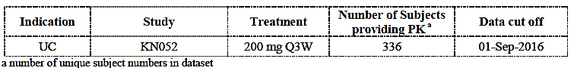
PK sample schedule in KN052: Pre-dose pembrolizumab serum concentrations (C_{trough}) were obtained within 24 hours prior to dosing at Cycles 1, 2, 4, 8 and every 4 cycles (12 weeks) thereafter. Post-dose serum concentrations (C_{max}) were drawn within approximately 30 minutes after the end of the infusion in Cycle 1 and Cycle 8. Additional PK samples are drawn between 72 and 168 hours (3-7 days) and Day 15 after Cycle 1 dosing. Summary statistics for C_{max} (post dose) and C_{trough} (pre-dose) were calculated based on nominal time after first dose. Samples with an actual PK time deviation of 42 days compared to the nominal PK time were omitted. Unscheduled, missing and unreliable data as well as samples drawn at end of treatment and safety-follow up visits were omitted from these calculations.
Comment: Caution must be exercised when attempting to interpret any of the following tables as there were very few patients contributing data due to the short follow-up time and high rates of early discontinuation. The extent of the latter is not yet apparent due to the submission of these study results very early in the course of the study.

Table 2: Study KN052 Summary statistics of pembrolizumab pre-dose (C_{trough}), Post-dose (C_{max}) post cycle 1 serum concentration 200 mg Q3W
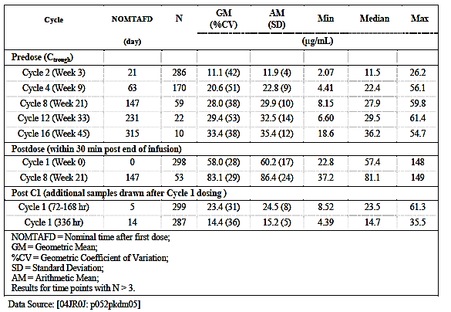
Figure 1: Study KN052 Arithmetic mean (SD) pembrolizumab C_{trough} time profiles following multiple doses 200 mg Q3W
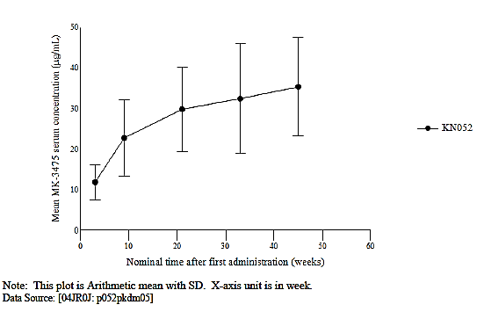
Objective 2 was to compare PK among KN001 melanoma and NSCLC and KN052 urothelial carcinoma patients, using the following datasets:

Table 3: Number of subjects in study cohorts KN001 and KN052 of urothelial cancer (UC)
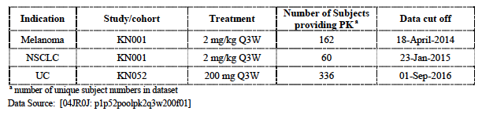

Table 4: Study KN052 Geometric mean (GMCV%) serum concentration values of pembrolizumab after administration at 200 mg IV Q3W in KN052, and 2 mg/kg Q3W IV in melanoma and NSCLC patients
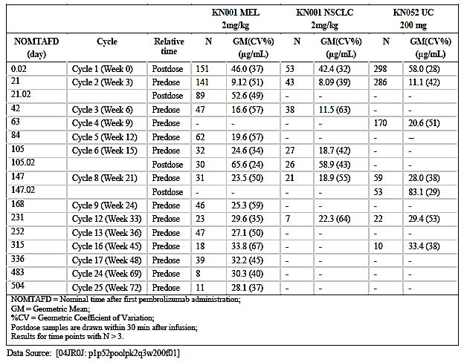
Comments:
- The very small numbers providing data at Cycle 8 and beyond are due to both the short duration of exposure (immature data) and early discontinuation seen in this population (median duration of treatment 2.8 months).
- The higher geometric mean at week 21 is consistent with the 200 mg dose representing a higher level of dosing than the 2 mg/kg dosing because the median bodyweight in the UC population was 72 kg.
Figure 2: Pembrolizumab exposure across indications at clinically tested doses (Log scale)
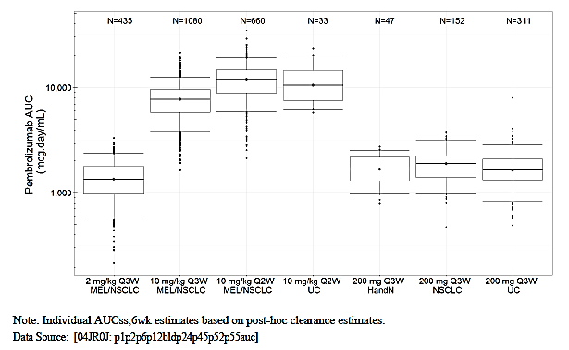
Comment: While this figure potentially offers the most relevant information in comparing patients with different malignancies receiving the same regimen, caution should be exercised when trying to interpret the results:
The information provided with this figure was very limited, which restricts what can be interpreted from it and there was no accompanying text.
It is unclear from which sample results/time point this AUC_{ss 6wk} was estimated.
While 311 patients are listed at the top of the graph for the UC population, only 298 provided samples for the PK analysis at Cycle 1, 286 at Cycle 2 and 59 at Cycle 8. Therefore, steady state will not have been achieved until the Cycle 8 time point as the PI states, ‘Near steady-state concentrations of pembrolizumab were achieved by 19 weeks’.
The note indicates that the AUC_{ss,6wk} estimates are based on post hoc clearance estimates. It is noted from the population PK report that clearance was highly variable in this PN052 population.

Study KN045
Report 04JT5G PK: Tables and figure for pembrolizumab Study KN045 and comparison of PK across indications dated November 11 2016.
Objective 1 was to evaluate pembrolizumab serum concentrations from KN045 urothelial cancer (UC) patients:

Table 5: Number of subjects in Study KN045 of urothelial cancer (UC)
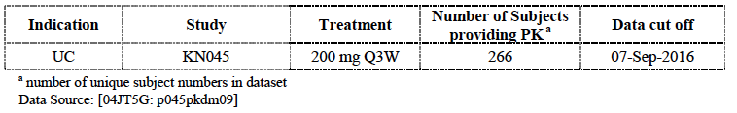
PK sample schedule in KN045: Pre-dose pembrolizumab serum concentrations (C_{trough}) were obtained within 24 hours prior to dosing at Cycles 1, 2, 4, 8 and every 4 cycles (12 weeks) thereafter. Post-dose serum concentrations (C_{max}) were drawn within approximately 30 minutes after the end of the infusion in Cycle 1 and Cycle 8. One additional PK sample is drawn between 72 and 168 hours (3-7 days) after Cycle 1 dosing. Summary statistics for C_{max} (post-dose) and C_{trough} (pre-dose) were calculated based on nominal time after first dose. Samples with an actual PK time deviation of 42 days compared to the nominal PK time were omitted. Unscheduled, missing and unreliable data as well as samples drawn at end of treatment and safety-follow up visits were omitted from these calculations.

Table 6: Study KN045 summary statistics pre-dose (C_{trough}), post-dose (C_{max}), and post cycle 1 serum concentration values after 200 mg IV Q3W
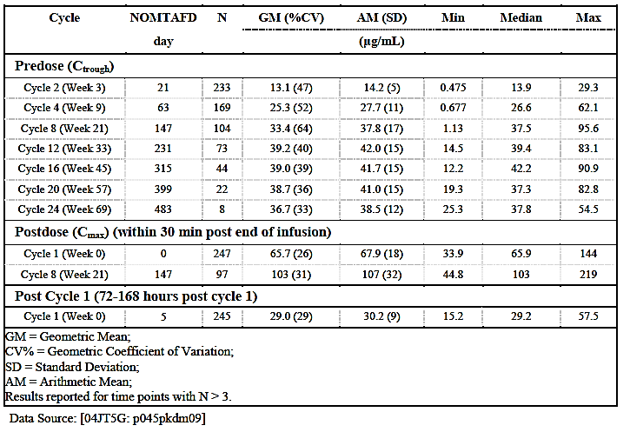
Comment: The small numbers contributing data at cycle 8 and beyond reflect the very high rates of discontinuation due to early progression seen in this study. Note is made that the data are more mature in this study than for KN052, therefore, discontinuations due to progression or adverse events account for the diminishing numbers.
Figure 3: Study KN045 Arithmetic mean (SD) pembrolizumab C_{trough} time profiles following multiple doses 200 mg Q3W
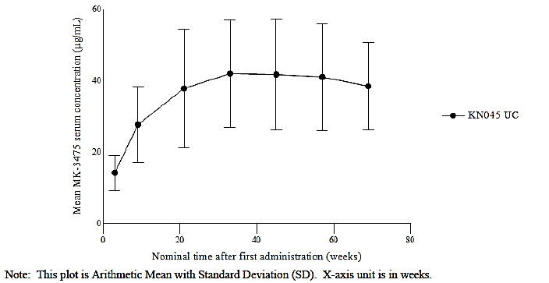
Objective 2: To compare PK among KN001 melanoma, KN001 NSCLC and KN045 UC patients using the following datasets:

Table 7: Number of subjects in study cohorts KN001 and KN045 of urothelial cancer (UC)
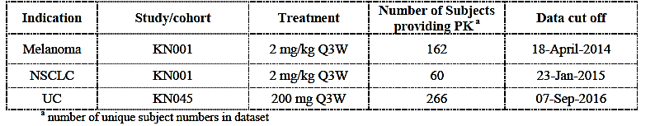
Figure 4: Study KN045 Boxplots with serum pembrolizumab concentration values from KN045 UC 200 mg Q3W regimen compared with KN001 melanoma and NSCLC 2 mg/kg Q3W regimen
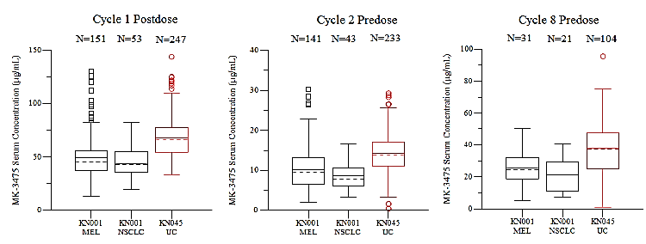
Comment: The higher median exposure but also the very significant inter-individual variability is evident in the KN045 population, particularly at cycle 8. The diminishing numbers of patients providing samples increases this further.

Table 8: Study KN045 Geometric mean (GMCV%) serum concentration values of pembrolizumab after administration at 200 mg iv Q3W in KN045, and 2 mg/kg Q3W iv in melanoma and NSCLC patients
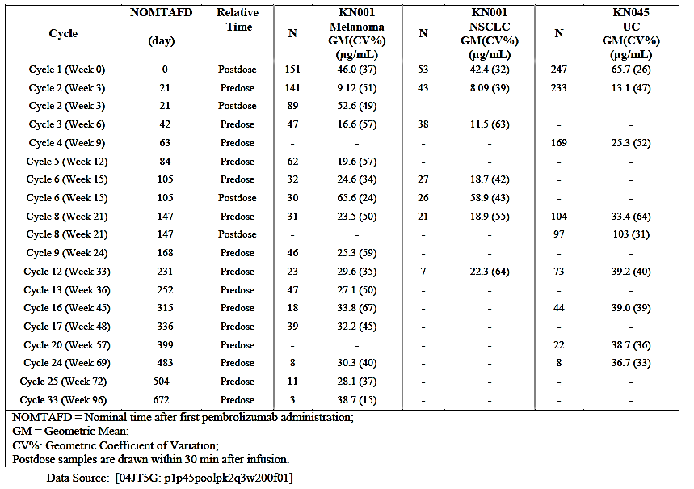
Comment: The exposure is generally higher which reflects that for most UC patients, the 200 mg flat dosing exceeds the dose they would have received if administered as 2 mg/kg due to their much lower body weight than the melanoma and NSCLC population when combined.
Figure 5: Pembrolizumab exposure across indications at clinically tested doses (log scale)
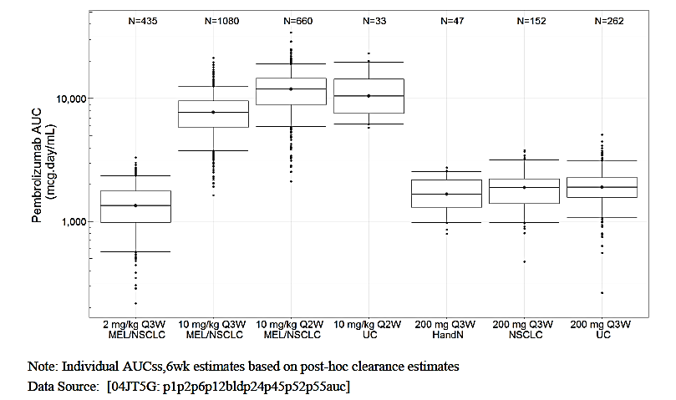
Comment: These comments are similar to those for the equivalent figure for KN052 above. While this figure potentially offers the most relevant information in comparing patients with different malignancies receiving the same regimen, caution should be exercised when trying to interpret the results:
- The information provided with this figure was very limited, which restricts what can be interpreted from it and there was no accompanying text. Many patients in the UC population have outlying values beyond the whisker part of the box plot.
- It is unclear from which sample results/time point this AUC_{ss} 6wk was estimated.
- While 262 patients are listed at the top of the graph for the UC population, 247 provided samples for the PK analysis at Cycle 1, 233 at Cycle 2 and 104 at Cycle 8. Therefore, steady state will not have been achieved until the Cycle 8 time point as the PI states, ‘Near steady-state concentrations of pembrolizumab were achieved by 19 weeks’.
- The note indicates that the AUC_{ss,6wk} estimates are based on post hoc clearance estimates. It is noted from the population PK report and the box-plots in the figure above, that clearance was highly variable in this PN045 population, and the large number of patients falling outside the whisker part of the box plot indicates that population-based assessments are likely to be poor predictors of exposure in individuals.

Study KN012
Report 04JQV8: PK Tables and Figures for Pembrolizumab Study KN012 Cohort C Urothelial Carcinoma (UC) and comparison of PK across indications dated November 11, 2016
Objective 1: To evaluate pembrolizumab serum concentrations from 10 mg/kg Q2W in KN012 in urothelial cancer (UC) cohort:

Table 9: Number of subjects in Study cohort KN012 of urothelial cancer (UC)
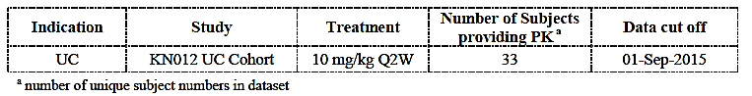
PK sample schedule in KN012: Pre-dose pembrolizumab serum concentrations (C_{trough}) were obtained within 24 hours prior to dosing at Cycles 1, 2, 5, 9 and every 4 cycles (8 weeks) thereafter up to Cycle 37. Post-dose serum concentrations (C_{max}) were drawn within approximately 30 minutes after the end of the infusion in Cycle 1 and Cycle 2. One additional PK sample is drawn between 24 and 96 hours (1-4 days) after Cycle 1 dosing.
Summary statistics for C_{max} (post-dose) and C_{trough} (pre-dose) were calculated based on nominal time after first dose. Samples with an actual PK time deviation of 28 days compared with the nominal PK time were omitted. Unscheduled, missing and unreliable data as well as samples drawn at end of treatment and safety-follow up visits were omitted from these calculations.

Table 10: Study KN012 summary statistics pre-dose (C_{trough}), post-dose (C_{max}), and Post cycle 1 serum concentration values after multiple IV 10 mg/kg Q2W doses
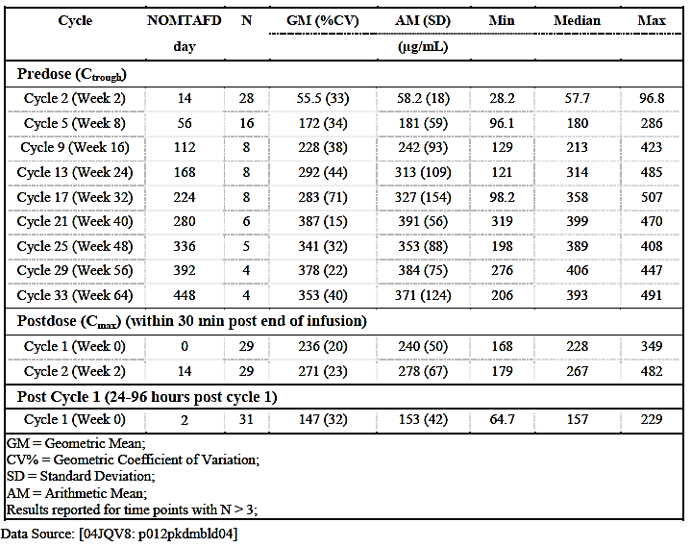
Comment: Cohort C enrolled 33 patients with UC who had previously received systemic therapy for their advanced or metastatic disease. The small numbers providing samples (28), the much higher dose regimen means these data do not provide support for, nor inform regarding the proposed usage. The graph depicting pembrolizumab exposure in Figure 5 above indicates the much higher exposure achieved with 10 mg/kg Q2W.

Population pharmacokinetics

Report 04JQ34 Modeling and simulation report Extension of population PK analysis of pembrolizumab to patients with urothelial carcinoma (Protocol 001, 002, 006, 012 cohort C, 045, 052) date November 2016
This report builds upon that presented in the submission (Report 04DDV3) submitted as part of another application. It is noted that the first round clinical evaluation report has been completed but the sponsor’s response to the issues raised below have not been received as yet. The following is taken from that Clinical evaluation report and identifies the following issues that must therefore, impact an assessment of this report:
‘Report 04DDV3 Update to Population Pharmacokinetic Analysis of Exposure to Pembrolizumab (MK-3475) Using a Pooled Protocol 001, 002 and 006 Dataset, Date May 2016
The sponsor states: Updated report: The assembled datasets for population PK modeling were revised after the initial analysis to implement some additional imputation and exclusion rules for individual data records. This report update captures the rerun of the initially completed analysis [Ref. 5.3.5.3: 044WBG] with the updated dataset. The model development was rerun with the new dataset and results are presented in this updated version of the report.
Comment: This model represents an update, based on the addition of patients from the Melanoma PN006 trial. These data do not include the proposed dosage or data from the trial PN010 that investigated the treatment of 691 patients who had previously received treatment for NSCLC. While PN 001 included 550 previously treated patients, this exposure analysis has been superseded by a model which includes patients from PN010. Furthermore, increasing the proportion of melanoma patients when the predicted AUC and C_{trough} in the target NSCLC population are approximately 15% below that of the melanoma patients’ will increase uncertainties about the utility and validity of this model.
The stated Ref. 5.3.5.3: 044WBG is the population PK report that was listed as being included in the Presubmission Planning Form and is described in the email to the TGA Delegate but was not actually included in the dossier.
Thus it is not possible to determine the impact and validity of this population PK update because:
This update is based on including more patients with melanoma, and as the two cancers do not have same predicted PK parameters, the validity and generalisability of increasing the proportion of melanoma patients is questionable. This would be potentially of more relevance and utility for an application related to use in melanoma.
As with all the other reports, the imputation rules and exclusion criteria have not been provided nor justified. As these rules appear to have affected multiple PK models and analyses to differing extents, this would have to be presented for each update report;
The previous population PK model on which this update is based has not been provided for evaluation.’
In Report 04JQ34, the sponsor states with reference to Report 04DDV3, ‘Previously, a population pharmacokinetic analysis was performed to address the clinical pharmacology aspects of the molecule and to guide any potential dose adjustments for special populations pooling data across both advanced melanoma and NSCLC indications from three studies (KN001, KN002 and KN006) [Ref. 5.3.5.3: 04DDV3]. The prior analysis was considered to be the definitive pembrolizumab population PK analysis to inform PK characteristics including covariate effects as the further addition of data beyond the 2188 subjects in that analysis was not expected to meaningfully impact the results obtained. This model has been extended to patients with UC from studies KN012 (Cohort C), KN045 and KN052 in this report.’
Comment: Without the responses to clinical questions from the evaluation of Report 04DDV3, it is difficult to determine the validity of this modeling and simulation report. Any statements may need to be revised once the sponsor’s response to the prior evaluation has been considered.
Objectives
The objectives of the population PK analysis described in this report were to:
- Assess the population pharmacokinetics of pembrolizumab in patients with UC
- Assess the similarity in pembrolizumab pharmacokinetics in UC as compared with other tumour indications (melanoma, NSCLC)
Overall approach
Serum pembrolizumab concentration data from UC patients were added to the dataset, and the parameters from the existing model were re-estimated. Reliability and robustness of the subsequent final model were assessed using goodness of fit plots. Post hoc parameter estimates from the final model were used to compare pharmacokinetic parameters as well individual pembrolizumab exposure estimates between UC and melanoma or NSCLC patients.
The software package NONMEM, version VII (ICON Development Solutions, Ellicott City, Maryland USA) was used in the population PK analysis. Model fitting was performed in a UNIX environment with Intel FORTRAN Compiler, version 11.1 (Intel Corporation, 2200 Mission College Blvd., Santa Clara, CA 95054).
It is stated, ‘Data manipulations were applied to create the final analysis dataset. The data manipulation performed for the data from studies KN001, KN002 and KN006 is described in [Ref. 5.3.5.3: 04DDV3]’ and ‘The exclusion rules are specified in the MAP [Ref. 5.3.5.3: 04HHT8].’
Comment: As noted above, clarification has been sought in the previous evaluation to understand the impact of these data manipulations and the Report 04HHT8 was not included in this application.
The reasons for exclusion of data were presented and include the following:
- Missing sample time
- Missing dose information
- ‘Not real BIL value of 0’
- ‘very high ALB value’
- ‘unreliable result’
- ‘BIL or high Bil extreme high value’
- ‘value identified as an outlier’
Missing data and Outliers
Continuous covariates that contained more than 35% missing values were not included as part of the covariate evaluation but were kept in the dataset for diagnostic plots. Categorical covariates were included in the evaluation if at least 5% of subjects belong to that category. Data were classified as outliers using the population conditional weighted residuals (CWRES) and individual weighted residuals (IWRES). Data with |CWRES|>6 or |IWRES|>6 for the final base were considered potential outliers. If any of the outlying data were excluded, the final model was re-run after reintroduction of the outlying data points. Effects of outliers on parameter estimates and uncertainty were assessed and reported.
Pharmacokinetic model development
Model performance was assessed by the following criteria:
- Successful minimization and completion of covariance ($COV) steps in NONMEM.
- Assessment of goodness-of-fit plots overlaying geometric means of observations (OBS) with geometric means of typical individual predictions (PRED) and geometric means of individual predicted values (IPRED).
- Residual plots of population conditional weighted residuals (CWRES) and individually weighted residuals (IWRES) versus TIME to evaluate randomness of scatter around the zero line and versus IPRED to evaluate homogeneity of variance.
The definitive population PK models for pembrolizumab had two-compartment model structure with a linear clearance from the central compartment, parameterized in terms of clearance (CL), inter-compartmental clearance (Q), central compartment volume of distribution (Vc), and peripheral compartment volume of distribution (Vp).

Table 11: Covariates included in the pharmacokinetic model
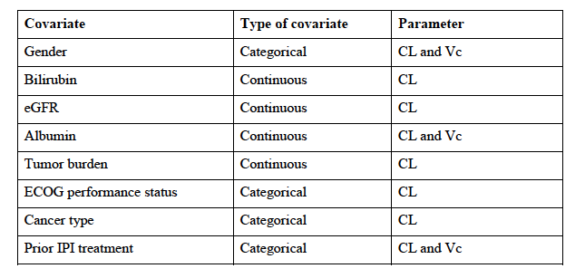
The sponsor states, ‘the covariate cancer type was redefined in the model in order to have a single category represent the existing (melanoma and NSCLC) dataset to allow comparison of the newly added UC indication.’
Comment: Without the sponsor’s response to the evaluation of Report 04DDV3, the generation of a single category is not accepted as valid based on the concerns raised in point 1 above relating to the evaluation of Report 04DDV3, copied again here: ‘This update is based on including more patients with melanoma, and as the two cancers do not have same predicted PK parameters, the validity and generalizability of increasing the proportion of melanoma patients is questionable. This would be potentially of more relevance and utility for an application related to use in melanoma.’
The final model as established in the pooled population PK analysis of data from studies KN001, KN002 and KN006 was used as starting point and estimated on the full data set from studies KN001, KN002, KN006, KN012, KN045 and KN052. The following goodness-of-fit plots were utilised to assess the adequacy of the structural model to describe the pooled dataset. All plots included a specific highlighting of the data from UC patients through the use of different markers to enable an assessment of the adequacy of the model specifically for this group of patients.
- Observations versus population and individual predictions log-log plots overall and by study
- Population and individual weighted residuals versus time by study
- Population weighted residuals versus population predictions
- Conditional weighted residuals versus population predictions
- Individual weighted residuals versus individual predictions
Apart from goodness-of-fit, precision of the parameter estimates was applied as a criterion for the existing structural model to be applied unchanged to the new pooled dataset. Should any of the parameters have been estimated with an RSE > 50% the associated model component was to be re-evaluated and optimised.
The Random effects model included the following PK parameters: inter-individual variability of clearance, volume of distribution of the central and peripheral compartments, and inter-compartmental clearance.
Goodness of fit plot and appropriateness of the random effects model were assessed, with highlighting of urothelial carcinoma patients where feasible.

Covariates
No formal covariate evaluation was planned; instead, the existing covariate relationships were re-estimated and the covariate of cancer was initially removed then retested divided into 2 categories: melanoma, NSCLC and other versus urothelial carcinoma.

Model performance
A comparison was made of parameter estimates between the model with and without the KN012, KN045, and KN052 populations. Further assessments of parameter precision through bootstrapping were not undertaken for the new pooled dataset.
Comment: That bootstrapping was not required is based on the assumption that this model fits well for the new dataset.
Comparison of urothelial carcinoma versus other indications
Following finalisation of the population PK model on the pooled dataset, the final model was used to enable comparisons of the pharmacokinetics of pembrolizumab between UC subjects and those from other indications. The following comparisons were included in this assessment:
- Comparison of individual post hoc parameter estimates, through boxplots summarizing individual parameter estimates for the different indications and the calculation of descriptive statistics for post hoc parameter estimates for UC and other indications
- Comparison of derived individual PK parameters (C_{max}, AUC_{ss}, t_{1/2}, C_{min,ss}) for selected dose regimens between UC and other indications by means of boxplots and tabular summaries of descriptive statistics
- Visualisation of consistency in pharmacokinetics in UC and as established in definitive population PK model, through overlay plots of Cycle 1 and steady state data from UC subjects and median prediction and 90% prediction interval from the definitive population PK model.

Samples
The final analysis data set comprised of a total of 14976 pembrolizumab concentrations from 2794 patients, of which 2743 observations were from 606 UC patients. The number of subjects and PK observations by dose in the pooled analysis dataset are provided in Table 12 below.

Table 12: Number of patients and observations by dose and dosing regimen in the pooled analysis dataset (KN001, KN002, KN006, KN012, KN045, KN052)
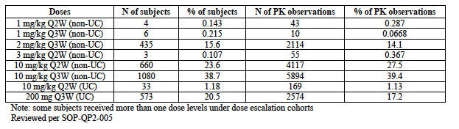
Comment: The urothelial carcinoma patients overall, constitute 21% of the population and provide 18.3% of the samples. It is noted that this population does not include other populations where the dosing regimen was the same (200 mg Q3W).
In the summary of the covariates, differences in the urothelial carcinoma population include:
- Median age: 71 years versus 62
- Median and mean ALP higher, but not accompanied by similar increases in other liver enzymes or bilirubin and therefore suggestive of more bone metastases;
- Lower eGFR: median 58.9 versus 88.7 ml/min (Q1 47.3 versus 73.6ml/min, Q3 75.3 versus 105 ml/min)
- Median body weight: 72.9kg versus 77.2 kg
Comment:
- The urothelial carcinoma patients were older, weighed less and had much poorer renal function than the patients with other cancers in the pooled dataset.
- Baseline haemoglobin, identified by Bellmunt et al as a poor prognostic factor, which is specifically relevant to this population was not included in the model covariates.
- Notably, patients in the 3rd quartile had renal function well below the median for the rest of the pooled dataset populations of melanoma (predominantly) and NSCLC. This in part reflects the inclusion criterion for the study for first line indication, but also the nature of this cancer. This may also explain the increased adverse events compared with other populations studied to date, of rise in blood creatinine, acute kidney injury and renal failure observed in both KN045 and KN052 patients due to a diminished renal reserve.
- Inclusion of the patient with the minimum eGFR value of 22.2 ml/min is a major protocol violation as the cut-off for enrolment was >30 ml/min.
- Although tumour burden was included, how this was measured is not stated but is presumed to be the sum of the target lesions, which reflects the size of some metastases but not necessarily the extent of the distant spread. LDH was not one of the covariates presented.

Categorical covariates
Gender, cancer type, baseline ECOG performance status (0 or 1) and ipilimumab prior treatment status were all included.
The UC population had a lower performance status than the rest of the patients in the model, with 67% ECOG-PS 1 compared with 42.4% in the rest of the pooled dataset.
Comment: That this base model has been developed for a very different population is very apparent:
- No patients in these UC trials were treated with ipilimumab; and
- The ECOG baseline PS of 0 or 1 does not capture the generally poorer performance status of patients enrolled with UC overall;
- Is not reflective of the intent of the first line study, which permitted enrolment of those with significant comorbidities limiting treatment options, and in particular, those with ECOG-PS 2. Due to very restrictive entry criteria in PN052, only 6 patients with ECOG-PS 2 were actually enrolled, but these patients cannot be represented in this analysis based on these covariates.

Model performance
In establishing the final model on the new dataset, the covariate cancer type was reassessed. Upon reassessment of the impact of cancer type (categorised as UC or Melanoma+NSCLC+other) a statistically significant effect of the covariate was observed on clearance, representing an increased clearance (by 14.6%) in UC patients relative to the non- UC patients.
Comments:
- The integration of the UC population into the model is presented in the Table 13, but no data have been presented for the individual PK parameters as estimated by the model for the UC population separately. The sponsor is requested to provide these. (Clinical question). See Table 14 below copied from the sponsor’s response and evaluator’s comments below, also Section 13 where all sponsor’s responses and evaluation of those responses are discussed in detail. The effects of the additional 18% of samples from UC patients to this model, given this excluded outliers, is difficult to interpret as currently presented.
- In the models presented in a previous submission, a relationship between increased clearance and decreased efficacy was observed.

Table 13: Comparison of population pharmacokinetic parameters of pembrolizumab (MK-3475) from the previous model with non-UC versus updated model including UC subjects
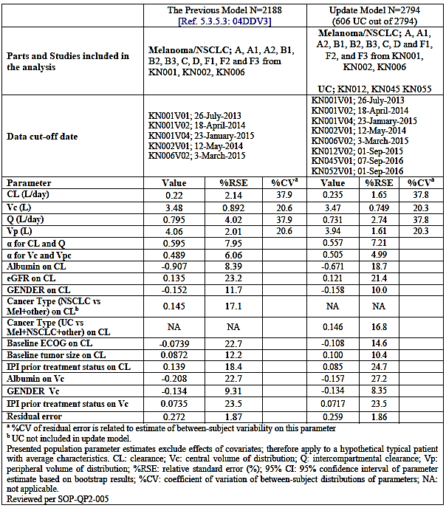

Comparison of PK in UC versus other Indications

Table 14: Integrated table of estimated individual PK parameters for model, individual and combined UC studies
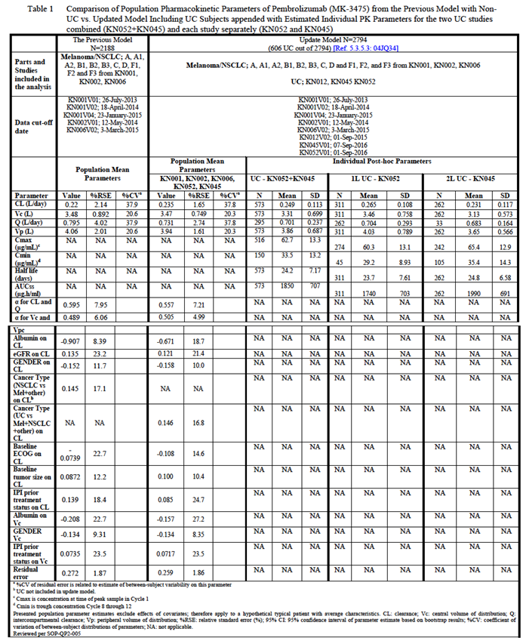
Comment: The mean exposure AUC_{ss} is higher and the clearance lower in the second line UC population compared with the first line population, which is somewhat surprising as these patients would be expected to have more advanced disease which the sponsor has postulated is associated with a higher clearance due to a catabolic state. This difference is also evident in the box plots of C_{trough} provided with the response to the next question, with the second line patients (green) having a higher exposure. Note is made of the very small number of patients in the HNSCC group (red).
Figure 6: Boxplots with pembrolizumab serum concentration values from UC and Non-UC (1L NSCLC and SCCHN) subjects with 200mg Q#W regiment (C_{max}=Post dose at Cycle 1; C_{trough}=Pre dose at Cycles 2, 4 and 8. Observed peak and trough pembrolizumab serum concentrations from UC and non-UC studies where patients treated with 200 mgQ3W
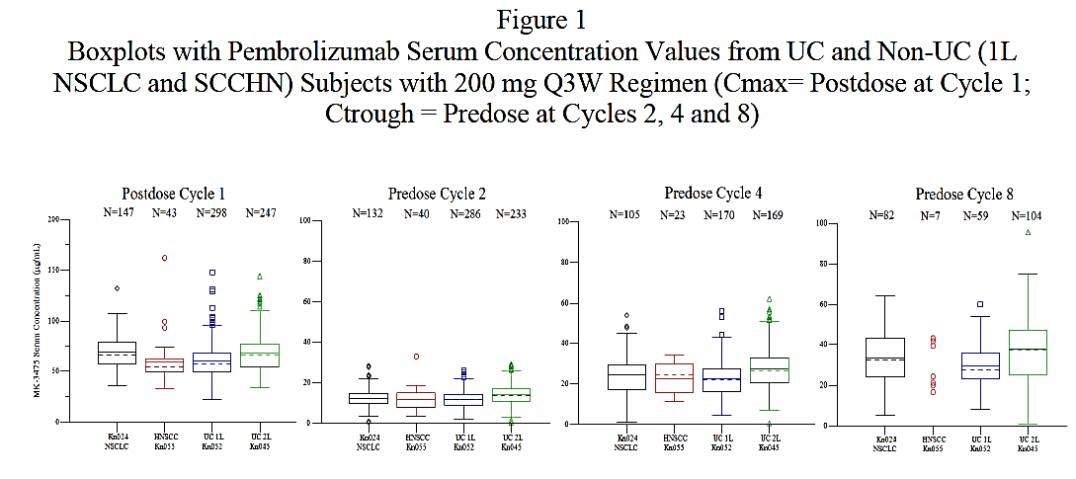

Pembrolizumab serum concentrations
Data were presented for the 1o mg/kQ2W regimen but these are not considered further as there were very few samples and this is not the proposed usage. Note is made that the exposure is much higher with this dosing regimen as would be expected.
The predicted exposure and observed exposure are presented in Figure 7 after the first dose and at steady state.
Figure 7: Observed concentrations in UC patients with predictions based on ‘definitive population PK model’: Pembrolizumab concentration-time profiles during the first dose (left) and at steady sate (right) of repeated dosing 200 mg Q3W
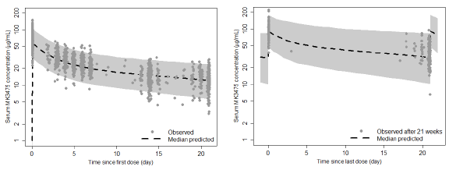
Comments:
- The sponsor states the ‘dashed line is median prediction from the model for a regimen of 200 mg Q3W’. Given no patients in the model described by KN001, KN002 and KN006 included any patients receiving this dose regimen, the sponsor is requested to provide the source of and datasets included in, this ‘definitive population PK model’ for this dose regimen. (Clinical question); see Figure 7 above from sponsor’s response.
- The distribution of exposure relative to the median predicted from the ‘definitive population PK model’ sees many below the median predicted value and below the 90% prediction interval after the first dose; in comparison, a much smaller proportion are below the predicted median at 21 weeks. It would be of interest to determine the exposure closer to the median duration of exposure for each study population.
- It is possible there is a relationship between efficacy and exposure accounting for this change in observed exposure at 21 weeks, given a majority of patients in both trial populations had discontinued by this stage due to disease progression.
- Caution should be exercised in extrapolating these findings, as very few patients would have provided samples at the 21 week time point (Table 15 below suggests 26% (150/606) UC patients):
  - In PN052, 42.4% had received treatment for (≥ 13 months and 19.5% had received treatment for ≥6 months;
  - In PN045, 32.5% received treatment for (≥ 13 months and 11.4% had received treatment for (≥ 16 months.
Additional figures of observed and predicted concentrations were also presented. These indicate that the median exposure of patients in PN052 was generally lower than those in PN045, with many of these falling beneath the 90% prediction interval. Additional graphs depicting the Clearance indicate this is greater than for either the melanoma or NSCLC, with very high inter-individual variability indicated by the wide confidence intervals.
Comment: This would be consistent with the increased clearance observed in this population compared with the remainder of the population in the model presented. Clarification is required as to how the 90% prediction interval has been calculated (that is, whether this reflects other populations who received the 200 mg Q3W regimen or is drawn from studies based on a different regimen) and to see the individual parameters for the UC populations (together and separately according to Study PN045 and PN052).

Table 15: Descriptive statistics of individual PK parameters (CL, Vc) and derived parameters (C_{max}, AUC_{ss,} t_{1/2}, C_{minss}) at 200 mg Q3W
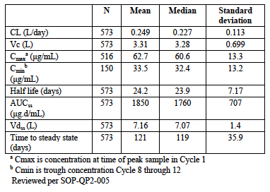
Figure 8: Individual random effects (ETA) estimates of CL (left) and Vc (right) versus age
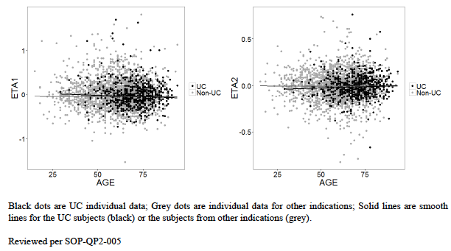
Comment: It is difficult to determine an effect of age on either clearance of volume of central distribution from these graphs. The concentration of dots to the right of each graph indicates the older age of this population, and the degree of scatter appears greater for the black dots (UC patients) for clearance. Comparisons would be easier if presented as descriptive statistics.

Discussion
The analysis reported was aimed to characterize the population pharmacokinetic of pembrolizumab in patients with UC. The sponsor identified body weight as the only significant factor in previous comparisons and modeling of the different indications, and re-estimated the model with inclusion of the 606 patients with UC. Differences between the base model and UC populations were the higher median age, lower weight, markedly worse renal function and poorer ECOG status in the latter group. Individual PK parameters for the UC population as estimated by the model and a reference patient were not presented to provide direct comparisons between the populations.
The clearance was notably higher with greater inter-individual variability in the UC patients, mostly attributable to the PN052 population, and resulting in lowered exposure in this group. An effect of exposure on efficacy cannot be excluded, given the higher exposure observed for the small number of patients still on treatment at 21 weeks compared with that after the first dose. Those remaining on treatment had exposure much closer to the median predicted value than those at the start of the trial.
The sponsor indicates that the exposure is not affected by the observed increase in clearance, based on comparison with the exposure in patients with melanoma and NSCLC who received 2 mg/kg Q3W or 1o mg/kg regimens. The observed exposure with the flat dosing 200 mg Q3W in the UC patients exceeded that in the 2 mg/kg cohort, which is consistent with the relatively higher dosing given the lower body weight of these patients (third quartile only 84.5kg). More relevant, would be a comparison with the observed exposure of other populations receiving the same regimen.
The sponsor concludes the previously developed population PK model adequately describes the clinical PK of pembrolizumab in UC patients, and indicates a general similarity of these parameters among the different cancers.

Evaluator’s overall conclusions on pharmacokinetics
The data for the first line usage are too immature to characterize the PK adequately as there are insufficient patients contributing data due to both early discontinuations and the immaturity (short duration of exposure and follow up) of this study. On what was presented, these appeared to have different clearance and exposure compared with other solid tumours and in comparison with the previously treated UC patients. Comparisons of observed PK parameters based on the same dosing strategy of 200 mg Q3W would provide more relevant comparisons once more mature data for this study are available.
The model does not adequately account for the differences between the populations in terms of ECOG; no data were presented on the effect of the poorer ECOG on key parameters, and those with ECOG-PS 2 were not accommodated by the existing fields in the model and presumably censored.
No data were presented on the clearance as determined by body weight in this generally lighter population. The data on the effect of increasing age of these patients on clearance and volume of distribution was difficult to interpret.
It is noted that in a previous evaluation, that the sponsor has been requested to provide key information about the development of the base model. While the sponsor has presented this model as established for use in this report, this has yet to be confirmed by a TGA evaluation. Thus, there is a caveat, that acceptance of the validity of this model is required.
Second round evaluator comment: This response has been provided to the TGA and the model is considered acceptable.
Overall, this model does not provide any insights into the PK for this population, nor is it possible given the very wide inter-individual variability observed in the PK parameters including clearance and exposure, for each of the individual UC populations, to have confidence in the ability of the model to provide accurate predictions at an individual level. Its utility is very uncertain. Fittingly, no changes are proposed to the PI based on this report. Note is made that the Pharmacokinetics section does not incorporate a discussion of the 200 mg Q3W flat regimen and this should be addressed, given the number of indications for which this dosing strategy is proposed and the 2 mg/kg Q3W appears to have been largely superseded. (PI Comments)

Pharmacodynamics
No new studies were provided but two reports on the effect of pembrolizumab exposure on QTc were included. Data populations were from KN001 (melanoma and NSCLC) and the dose regimens studied included patients receiving 2 mg/kg Q3W and 1o mg/kg Q3W. As such, this spans the likely exposure seen for the patients receiving the proposed dosage for this application of 200 mg Q3W but does not directly inform regarding this usage.
No PI changes are proposed based on these modelling and simulation reports and given neither indicated a clinically relevant change in QTc at the highest exposure and dose level, these documents were reviewed but have not been evaluated in detail as per discussion with the TGA delegate. Note is made of the sponsor’s proposed shift to the 200 mg Q3W dose regimen for all future clinical studies.

Report 03TLCF Modelling and simulation report – Exposure-QTc analysis of MK-3475 Date February, 2014

Objectives
- To characterise the relationship between MK-3475 serum concentration (exposure) and QTc intervals in patients with progressive locally advanced or metastatic carcinomas, and specifically malignant melanoma or non-small cell lung carcinoma
- To assess covariate effects, such as body weight, age, sex, race, baseline Eastern Cooperative Oncology Group performance status (ECOG score), and disease stage on the exposure-QTc relationship
This analysis was based on data from study P001 (Protocol 001), a Phase I study of MK-3475 in patients with progressive locally advanced or metastatic carcinoma, specifically melanoma, and non-small cell lung carcinoma.

Report 03WKGP modelling and simulation report – Exposure-QTc analysis of MK-3475 – P001 Part F (non-squamous NSCLC treated at up to 1o mg/kg/Q3W) Date April 2014
This report included a re-run of the data testing the covariates from the model developed above using the triplicate ECGs obtained in this cohort to ensure a more robust dataset. Limitations affecting both datasets include the lack of placebo data, inability to correct for diurnal changes in QT and infrequent ECG measurements due to the nature of oncology trial design as well as a relatively small fraction of ECG observations at very high exposures of MK-3475.
The sponsor’s conclusions are:
- The initial population examined and also Part F data confirms a statistically significant but not clinically relevant linear relationship between MK-3475 exposure and QT.
- Mean QTc prolongation is predicted to remain below 20 ms (pre-determined safety threshold) up to a MK-3475 serum concentration of 1200 g/mL, which is well above any observed concentrations at the highest doing regimen tested thus far and 17 times higher than the peak concentration at 2 mg/kg Q3W.
- In the melanoma and NSCLC cohort reported in 03TLCF, age was found to influence the MK-3475 exposure-QTcF relationship, suggesting a smaller effect on QTcF in the non-elderly (<65 years) than in the elderly (≥65 years) populations. However, QTcF prolongation remains well below 20 ms for the different age subpopulations, which is determined to be not clinically relevant.
- The totality of data in P001 confirms that QTc prolongation in relation to MK-3475 treatment remains well below 20 ms, which is determined to be not clinically relevant.
Comment: Given there is no known mechanism for pembrolizumab to affect cardiac repolarisation and the small degree of change observed at even very much higher doses and with exposures exceeding those likely to result from the 200 mg Q3W regimen, these conclusions seem reasonable.

Dosage selection for the pivotal studies
The dosage proposed is 200 mg Q3W, which is being used in the clinical development program for pembrolizumab. Initial studies investigated differing regimens: 2 mg/kg Q3W, 1o mg/kg Q3W and 1o mg/kg Q2W.
The flat-dosing schedule is approved for the treatment of NSCLC (previously untreated) and applications are evaluation for the same dose regimen in melanoma and previously treated NSCLC.

Clinical efficacy

Studies providing evaluable efficacy data
Study PN045 Phase III randomised, open label, active-controlled study in patients with recurrent or progressive urothelial cancer following cisplatin-based therapy (200 mg Q3W).
Study PN052 Phase II non-randomised open label trial in patients who have received no prior systemic therapy and who are ineligible for cisplatin (200 mg Q3W).
Study PN012v02 Phase Ib multi-cohort study of MK-3475 in subjects with advanced tumours (10 mg/kg Q2W).

Pivotal or main efficacy studies for indication 1
Treatment of patients with locally advanced or metastatic urothelial carcinoma who have received platinum-containing chemotherapy

Study PN045 Phase III randomised, open label, active-controlled study in patients whose disease has progressed or recurred following cisplatin-based therapy (200 mg Q3W).
The CSR provided is based on an analysis undertaken at a time point after the second planned interim analysis (defined as at least 277 deaths in the study and 82 in the PD-L1≥ 10% subgroup) but prior to the planned final analysis (to be undertaken after 370 deaths).

Study design, objectives, locations and dates
KEYNOTE-045 is an ongoing randomised, active-controlled, multisite, open-label trial of pembrolizumab monotherapy versus the Investigator’s choice of paclitaxel, docetaxel or vinflunine in subjects with locally advanced or metastatic urothelial carcinoma who have received platinum-containing chemotherapy.
Subjects were assigned randomly to 1 of 2 treatment arms in a 1:1 ratio, that is, to either pembrolizumab or the Investigator’s choice of paclitaxel, docetaxel, or vinflunine (chosen by the Investigator before randomisation occurred). Randomisation was stratified by ECOG-PS (0/1 versus 2), presence or absence of liver metastases, haemoglobin (≥ 10 g/dL versus <10 g/dL), and time from completion of most recent chemotherapy (<3 months or ≥3 months). Subjects with ECOG-PS=2 could not have additional poor prognosis factors (such as liver metastases, haemoglobin<10 g/dL, and time from completion of most recent chemotherapy <3months [90 days]).
Comments:
- Stratification was by factors that differ from those reported as prognostic by Bellmunt et al. (2010) in patients considering second line cytotoxic therapy after progression on a platinum-based regimen. Specifically, these authors identified ECOG-PS >0 to be prognostic, Hb<10 g/dL and presence or absence of liver metastases in patients with disease progression after platinum therapy, but there is no mention of time since last chemotherapy. Based on these 3 factors, Bellmunt proposed 4 risk groups for those with 0, 1, 2 or 3 factors. Of note, the authors caution of the validity of their prognostic factors for other agents or regimens that may correct for these factors. This is discussed further in Efficacy section discussing OS.
- Note is made that those with ECOG-PS 2 were only to be enrolled if it had been > 3 months since their last chemotherapy treatment. This is a significant source of selection bias and excludes those with rapidly progressing disease, and means the lower ECOG-PS of any patients recruited is more likely to be related to comorbidities than their cancer; that only 6 such patients were enrolled reflects that this limited recruitment. The population recruited cannot be regarded as representative due to the small numbers as well as their unusual profile compared with all patients with urothelial carcinoma with ECOG-PS 2. It is appreciated that this may have been designed to ensure enrolment and randomisation to chemotherapy arm was an acceptable option but this has compromised the external validity of any findings and it does not support the generalisability of any findings in these patients to those with the same ECOG-PS. The PI needs to reflect this in describing the ECOG-PS in the Clinical Trials section. It is also proposed that the indication state that ‘No benefit in PFS, OS or quality of life has been demonstrated in patients with ECOG-PS>1’.
- Investigators determined whether there was evaluable disease and the sponsor is requested to state how many patients in each arm were found not to have evaluable disease by central review. (Clinical question).

Sponsor’s response to Clinical question 25
Comment: The sponsor provided the following table which indicates many more patients – totaling approximately 7% in each arm - were deemed not to have measurable disease when reviewed centrally. There is substantial discordance between the BICR and the investigators at baseline and therefore, potentially any efficacy measures of response, including one of the co-primary endpoints, PFS; OS will not be affected. Note is made that although the primary endpoint was BICR assessed, that the protocol required investigator assessment of baseline disease and therefore these do not constitute additional major protocol violations. However, this degree of discordance over a fundamental baseline efficacy variable underscores the importance of independent reviews.

Table 16: Subjects with no measurable disease by blinded independent central review
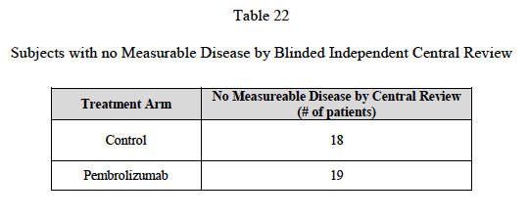

Study PN045 design
Figure 9: Study PN045 design
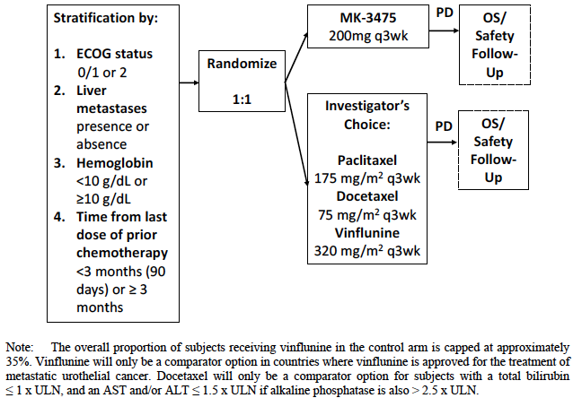
Comment: It is noted that the enrolment to comparator arm for vinflunine was capped at 35%. This may be due to this not being available as an approved therapy in the US and other countries, limiting the generalizability of the study findings in those countries if approved. The sponsor is invited to comment if this is not the reason.
Approximately 470 subjects were planned to be enrolled in this trial but 542 subjects were actually randomised and included in the ITT population (control: 272; pembrolizumab: 270). Subjects were evaluated for response initially at Week 9 (±7days), then every 6 weeks (±7 days) thereafter for the first year and every 12 weeks (±7 days) thereafter.
Comment: Actual recruitment exceeded the planned sample size by 15%.
Images obtained on study were submitted for independent central review by radiologists unaware of treatment allocation and were assessed based on the Response Evaluation Criteria on Solid Tumours Version 1.1 (RECIST1.1) for determination of overall response rate (ORR) and progression-free survival (PFS). Investigator/local site assessment of measurable disease, based on RECIST 1.1, was used to determine subject eligibility. Investigator assessment based on modified RECIST and site radiology reading(s) was used for treatment decisions and subject management.
To capture the responses per modified RECIST criteria, if radiological imaging by local/site assessment showed PD, tumour assessment could have been repeated by the site (≥ 14 weeks later in order to confirm PD with the option of continuing treatment while awaiting radiological confirmation of progression. If repeat imaging showed SD, PR, or CR, treatment could have continued as per treatment calendar. If repeat imaging still met the threshold for PD ((≥ 120% increase in tumour burden compared to nadir), but showed a reduction in tumour burden compared with the previous time point, treatment could have continued as per treatment calendar after consultation with sponsor. If repeat imaging confirmed PD without reduction in tumour burden compared to the previous time point, subjects were discontinued from study therapy.
The trial team, consisting of clinical, statistical, statistical programming, and data management personnel, was blinded to any subject level PD-L1 biomarker results (including combined positive score [CPS] ≥ 1%) until the cut-off value of PD-L1 expression level for CPS ≥ 10% was established and formally documented. The PD-L1 CPS ≥ 10% was determined based on data outside of this particular trial. Access to the allocation schedule for summaries or analyses were restricted to an unblinded external statistician and, as needed, an external scientific programmer performing the analysis, who had no other responsibilities associated with the trial.
If a subject discontinued study treatment without documented disease progression, every effort was made to continue monitoring their disease status by radiologic imaging every 6 weeks (42 ± 7 days) in the first year and every 12 weeks (84 ±7days) after year 1 until whichever of the following occurs first:
- The start of new anti-cancer treatment, or
- Disease progression as assessed by investigator/site radiologist, or
- Death, or
- The end of the study.
Once a subject stopped receiving study treatment, the subject was followed for survival. Once a subject stopped imaging assessments, the subject moved into the survival follow-up phase and was contacted by telephone every 12 weeks (± 7 days) to assess for survival status. Post study treatments and the subject’s response to them were also collected.

Objectives
Comment: These objectives and hypotheses changed from those initially outlined after serial protocol amendments in response to data external to this trial (see Protocol Amendments, Statistical Analysis Plan sections).

Primary
- To evaluate progression-free survival (PFS) per RECIST 1.1 by blinded independent radiologists’ review of all subjects with recurrent/progressive metastatic urothelial cancer treated with pembrolizumab (MK-3475) compared to paclitaxel, docetaxel, or vinflunine.
- To evaluate the overall survival (OS) of all subjects with metastatic or locally advanced/unresectable urothelial cancer that has recurred or progressed following platinum-based chemotherapy (recurrent/progressive metastatic urothelial cancer), when
- To evaluate the PFS per RECIST 1.1 by blinded independent radiologists’ review of subjects with platinum-refractory recurrent/progressive metastatic PD-L1 positive urothelial cancer treated with pembrolizumab compared to paclitaxel, docetaxel, or vinflunine.
- To evaluate the OS of subjects with platinum-refractory metastatic or locally advanced/unresectable PD-L1 positive urothelial cancer, when treated with pembrolizumab compared to paclitaxel, docetaxel, or vinflunine.
- To evaluate the PFS per RECIST 1.1 by blinded independent radiologists’ review of subjects with platinum-refractory recurrent/progressive metastatic PD-L1 strongly positive urothelial cancer treated with pembrolizumab compared to paclitaxel, docetaxel, or vinflunine.
- To evaluate the OS of subjects with platinum-refractory metastatic or locally advanced/unresectable PD-L1 strongly positive urothelial cancer, when treated with pembrolizumab compared to paclitaxel, docetaxel, or vinflunine.
The study would be considered to have met its primary objective if the pembrolizumab arm was superior to paclitaxel, docetaxel, or vinflunine in any of the following:
- H1: PFS in all subjects (regardless of PD-L1 expression)
- H2: OS in all subjects (regardless of PD-L1 expression)
- H3: PFS in subjects with PD-L1 positive expression
- H4: OS in subjects with PD-L1 positive expression
- H5: PFS in subjects with PD-L1 strongly positive expression
- H6: OS in subjects with PD-L1 strongly positive expression
PD-L1 positive was defined as CPS ≥ 1%. The specific cut-off of PD-L1 strongly positive was independently determined by data outside of the current trial to be CPS ≥ 10%. Biomarker cut-offs were defined from data external to KEYNOTE-045.
Comments:
- The Summary of Changes for the Protocol version 13 (noting Version 14 was the same protocol submitted to Germany) states that this version,’clarified that the basis for PDL1 positive and strongly positive categories using CPS cut points has been determined outside this study (that is, from protocols Keynote 012, Keynote 052, and epidemiologic studies).
- Data from the 2 Keynote studies are included in this dossier but no data from the ‘epidemiologic studies’ as mentioned have been presented.
- Although stated to be objectives, after the first interim analysis, no formal statistical analysis was undertaken to establish objectives 3 and 4, or to test hypotheses 3 and 4. (See Statistical Analysis Plan section).

Secondary objectives
- To evaluate the safety and tolerability profile of pembrolizumab in subjects with recurrent/progressive metastatic urothelial cancer.
- To evaluate the objective response rate (ORR) per RECIST 1.1 by independent radiologists’ review in PD-L1strongly positive, PD-L1 positive, and all subjects with recurrent/progressive metastatic urothelial cancer treated with pembrolizumab compared to paclitaxel, docetaxel, or vinflunine.
- To evaluate PFS per modified RECIST by independent radiologists’ review of PD-L1 strongly positive, PD-L1 positive and all subjects with recurrent/progressive metastatic urothelial cancer treated with pembrolizumab compared to paclitaxel, docetaxel, or vinflunine.
- To evaluate the ORR per modified RECIST by independent radiologists’ review in PD-L1 strongly positive, PD-L1 positive and all subjects with recurrent/progressive metastatic urothelial cancer treated with pembrolizumab compared to paclitaxel, docetaxel, or vinflunine.
- To evaluate response duration per RECIST 1.1 by independent radiologists' review in PD-L1 strongly positive, PD-L1 positive and all subjects with recurrent/progressive metastatic urothelial cancer treated with pembrolizumab compared to paclitaxel, docetaxel, or vinflunine.
- To evaluate PFS per RECIST 1.1 from randomisation to specific time points (6 months, 12 months) by independent radiologists’ review in PD-L1 strongly positive, PD-L1 positive, and all subjects with recurrent/progressive metastatic urothelial cancer treated with pembrolizumab compared to paclitaxel, docetaxel, or vinflunine.

Hypotheses
- Pembrolizumab (MK-3475) prolongs PFS by RECIST 1.1 by blinded independent radiologists’ review in all subjects with recurrent/progressive metastatic urothelial cancer compared to paclitaxel, docetaxel, or vinflunine.
- Pembrolizumab (MK-3475) prolongs OS in all subjects with recurrent/progressive metastatic urothelial cancer compared to paclitaxel, docetaxel or vinflunine.
- Pembrolizumab prolongs PFS by RECIST 1.1 by blinded independent radiologists’ review in subjects with platinum-refractory recurrent/progressive metastatic PD-L1 positive urothelial cancer compared to paclitaxel, docetaxel, or vinflunine.
- Pembrolizumab prolongs OS in subjects with platinum-refractory recurrent/progressive metastatic PD-L1 positive urothelial cancer compared to paclitaxel, docetaxel or vinflunine.
- Pembrolizumab prolongs PFS by RECIST 1.1 by blinded independent radiologists’ review in subjects with platinum-refractory recurrent/progressive metastatic PD-L1 strongly positive urothelial cancer compared to paclitaxel, docetaxel, or vinflunine.
- Pembrolizumab prolongs OS in subjects with platinum-refractory recurrent/progressive metastatic PD-L1 strongly positive urothelial cancer compared to paclitaxel, docetaxel, or vinflunine.
- Pembrolizumab improves ORR per RECIST 1.1 by independent radiologists’ review in PD-L1 strongly positive, PD-L1 positive, and all subjects with recurrent/progressive metastatic urothelial cancer compared to paclitaxel, docetaxel, or vinflunine.
- Pembrolizumab prolongs PFS per modified RECIST by independent radiologists’ review in PD-L1 strongly positive, PD-L1 positive, and all subjects with recurrent/progressive metastatic PD-L1 strongly positive urothelial cancer compared to paclitaxel, docetaxel or vinflunine.
- Pembrolizumab (MK-3475) improves ORR per modified RECIST by independent radiologists’ review in PD-L1 strongly positive, PD-L1 positive, and all subjects with recurrent/progressive metastatic urothelial cancer compared to paclitaxel, docetaxel, or vinflunine.
The sponsor states the following in Protocol MK-3475-13 Final Protocol, ‘Data from KN052 (a single arm, open label study of pembrolizumab in first line cisplatin-ineligible urothelial carcinoma patients) demonstrated a clinically meaningful response rate and durable responses in all subjects, including those who were considered to be PD-L1 negative (CPS <1%). Response rates were also meaningfully increased when a CPS cut point of 10% was applied. In contrast, the magnitude of enrichment using a 1% CPS cut point in this population was not clinically meaningful. Based on these observations from KN052, a single CPS cut point of 10% has been identified for urothelial cancer. Therefore, in the second interim analysis (IA2) and final analysis, only primary hypotheses of PD-L1 strongly positive subjects and all subjects will be included in the multiplicity controlled statistical testing.’
Comments:
- The adaptive nature of the study means data presented in this dossier are related to the modified objectives, and any analyses of enrichment by PD-L1 ≥ 1% beyond the first interim analysis do not appear to be subject to controls for multiplicity. However, it is noted that PFS and OS data are presented for this subpopulation in the Efficacy section labelled as ‘primary endpoints’.
- The data for determining the PD-L1 cut-off was in patients deemed ineligible for treatment with cisplatin in the metastatic setting in Study PN052 that is, those not previously treated for metastatic urothelial carcinoma. The validity of extrapolating a PD-L1 cut-off of ≥ 10% determined in a single arm open label study, based on ORR endpoints in a different line of therapy is uncertain. The utility of this biomarker in this second line population has not been previously tested.
Planned duration of trial: It was estimated that the trial would require approximately 30 months from the time the first subject signed the Informed Consent Form until the last subject’s last visit.

Locations
KEYNOTE 045 was an international multicentre study with 120 contributing centres in 29 countries. The largest numbers of centres were in Japan (20) and the U.S. (19) with most of the remainder in European countries. There were 3 Australian centres. 71% of subjects were characterised as White, 21% as Asian.

Dates
Commencement Date: 23-Oct-2014 (estimated that the trial would require approximately 30 months from the time the first subject signed the Informed Consent Form until the last subject’s last visit)
Completion date: ongoing, data cut-off date for CSR 07 September 2016; database lock 07 October 2016.
Report Date 23 November 2016
Revised Report Date: 14 December 2016
Comments:
This is a large multicentre randomised study of pembrolizumab against chemotherapy for advanced urothelial cancer after prior platinum chemotherapy.
The randomisation 1:1 against an investigator’s choice from three chemotherapy options reflects the lack of a current standard treatment in patients relapsed after platinum based therapy, and presumably reflects international and inter-institutional variations in current patterns of care. It is a reasonable structure to adopt in these circumstances and does not raise concern about randomisation of pembrolizumab against an inappropriate, ineffective comparator.
The primary endpoints of PFS and OS for all subjects are appropriate. Additional primary endpoints were also designated in respect of PFS and OS for subjects with cancers, expressing any PD-L1 (>1%) and strongly expressing (≥ 10%). Subsequently, on the basis of the data from Keynote 052, the protocol was amended in respect of statistical analysis, leaving only two categories for analysis of response by any PD-L1 (>1%) and strongly expressing (≥ 10%). The addition and subsequent alteration of these additional endpoints reflects the adaptive nature of the clinical trial, but they do not affect the most fundamental primary outcomes of the study, of PFS and OS in all comers.

Inclusion and exclusion criteria
Male and female subjects of at least 18 years of age with recurrent/progressive metastatic urothelial carcinoma were enrolled in this trial.

Inclusion Criteria
In order to be eligible for participation in this trial, the subject had to:
- Be willing and able to provide written informed consent/assent for the trial. The subject could also provide consent/assent for Future Biomedical Research. However, the subject could participate in the main trial without participating in Future Biomedical Research.
- Be ≥ 18 years of age on day of signing informed consent.
- Have histologically or cytologically-confirmed diagnosis of urothelial cancer of the renal pelvis, ureter, bladder, or urethra. Both transitional cell and mixed transitional/non-transitional cell histologies were allowed, but transitional cell carcinoma had to be the predominant histology. Subjects with non-urothelial cancer of the urinary tract were not allowed.
- Have had progression or recurrence of urothelial cancer following receipt of a 1L platinum-containing regimen (for example, cisplatin or carboplatin):
- Received a 1L platinum-containing regimen in the metastatic setting or for inoperable locally advanced disease; or
- Received adjuvant platinum-containing therapy following cystectomy for localized muscle-invasive urothelial cancer, with recurrence/progression ≤ 12 months following completion of therapy.
- Received neoadjuvant platinum-containing therapy prior to cystectomy for localized muscle-invasive urothelial cancer, with recurrence ≤ 2months following completion of therapy.
Note: Primary chemo-radiation given for subjects who were not considered surgical candidates was not considered a line of therapy for the purpose of this study.
Note: Subjects with locally advanced unresectable disease who subsequently became eligible for surgery after platinum-containing therapy were not eligible for this study, unless they subsequently had disease recurrence in the metastatic setting.
- Have received no more than 2 prior lines of systemic chemotherapy for metastatic urothelial cancer. Subjects for whom the most recent therapy was a non-platinum-based regimen following progression/recurrence on platinum-based therapy (that is, third-line [3L] subjects) were eligible if they had progressed/recurred on their most recent therapy.
- Note: Primary chemo-radiation for unresectable muscle-invasive bladder cancer with the aim of bladder preservation was not considered a prior line of systemic therapy for the purposes of determining study eligibility.
- Have provided tissue for biomarker analysis from an archival tissue sample or newly obtained core or excisional biopsy of a tumour lesion not previously irradiated. A newly-obtained biopsy was strongly preferred but not required if archival tissue was adequate for analysis. Adequacy of the archived or freshly-obtained biopsy specimen had to be confirmed by the central laboratory during the screening period prior to enrolment.
- Have measureable disease based on RECIST1.1 as assessed by the Investigator/site radiologist. Tumour lesions situated in a previously irradiated area were considered measureable if progression had been demonstrated in such lesions.
- Have a performance status of 0, 1, or 2 on the Eastern Cooperative Oncology Group (ECOG) Scale. Subjects with a performance status (ECOG-PS) of 2 had to have a haemoglobin ≥ 10 g/dL, could not have liver metastases, and must have received the last dose of their last prior chemotherapy regimen ≥3months (90 days) prior to enrolment.
- Demonstrate adequate organ function as defined below. All screening laboratory investigations should have been performed within 10 days of treatment initiation.
Haematological:
Absolute neutrophil count ≥ 1,500/µL. Platelets ≥ 100,000/µL, Haemoglobin ≥90 g/L
Renal
Creatinine OR Measured or calculated creatinine clearance (CrCl) (Glomerular filtration rate [GFR] can also be used in place of creatinine or CrCl) ≤1.5 x ULN OR ≥30 mL/min for subjects with creatinine levels >1.5×institutional ULN.
Creatinine clearance could be calculated per institutional standard. For subjects with a baseline calculated creatinine clearance below normal institutional laboratory values, a measured baseline creatinine clearance could be determined.
Hepatic
- Total bilirubin ≤1.5× ULN OR Direct bilirubin ≤ULN for subjects with total bilirubin levels >1.5× ULN.
- AST and ALT ≤2.5× ULN OR ≤5× ULN for subjects with liver metastases.
Note: Docetaxel was a comparator option only for subjects with a total bilirubin ≤1×ULN, and an AST and/or ALT ≤1.5x ULN if alkaline phosphatase was also >2.5×ULN.
Coagulation
International normalized ratio (INR) or prothrombin time
- Activated partial thromboplastin time (aPTT) or PTT ≤1.5× ULN unless subject was receiving anticoagulant therapy as long as PT or partial thromboplastin time (PTT) was within therapeutic range of intended use of anticoagulants.
- Female subjects of childbearing potential had to have a negative urine or serum pregnancy test within 72hours prior to receiving the first dose of study medication. If the urine test was positive or could not be confirmed as negative, a serum pregnancy test was required.
- Female subjects of childbearing potential had to be willing to use 2 methods of birth control or be surgically sterile, or abstain from heterosexual activity for the course of the study through 120days after the last dose of pembrolizumab or 180days after the last dose of paclitaxel, docetaxel, or vinflunine. Subjects of childbearing potential were those who had not been surgically sterilized or had not been free from menses for >1year.
Note: Abstinence was acceptable if this was the usual lifestyle and preferred contraception for the subject.
- Male subjects had to agree to use an adequate method of contraception starting with the first dose of study therapy through 120 days after the last dose of pembrolizumab or 180days after the last dose of paclitaxel, docetaxel, or vinflunine.
Note: Abstinence was acceptable if this was the usual lifestyle and preferred contraception for the subject.
Comment: The requirement that those with ECOG-PS 2 performance status have a treatment interval greater than 90 days, would suggest that their poorer performance status would be due to reasons other than their bladder cancer, and so excludes those in decline from rapidly progressive disease. This represents a very limited subset – as evidenced by only six patients recruited who has ECOG-PS 2 - and should be mentioned in the clinical trials section of the PI. (PI Comments).

Exclusion Criteria
The subject was excluded from participating in the trial if the subject:
- Had disease that was suitable for local therapy administered with curative intent.
- Was currently participating in or had participated in a study of an investigational agent or was using an investigational device within 4 weeks prior to the first dose of trial treatment.
- Had a diagnosis of immunodeficiency or was receiving systemic steroid therapy or any other form of immunosuppressive therapy within 7days prior to the first dose of trial treatment. The use of physiologic doses of corticosteroids could have been approved after consultation with the sponsor.
- Had a prior anticancer monoclonal antibody within 4weeks prior to study Day 1 or who had not recovered (that is, ≤Grade1 or at baseline) from AEs due to agents administered more than 4 weeks earlier.
- Had prior chemotherapy, targeted small molecule therapy, or radiation therapy within 2 weeks prior to study Day 1 or who had not recovered (that is, ≤Grade1 or at baseline) from AEs due to a previously administered agent.
Note: Subjects with ≤Grade2 neuropathy or ≤Grade2 alopecia were an exception to this criterion and could qualify for the study.
Note: If a subject received major surgery, they must have recovered adequately from the toxicity and/or complications from the intervention prior to starting therapy.
- Had a known additional malignancy that was progressing or required active treatment. Exceptions included basal cell carcinoma of the skin, squamous cell carcinoma of the skin that had undergone potentially curative therapy, or in situ cervical cancer. A history of prostate cancer that was identified incidentally following cystoprostatectomy for bladder cancer was acceptable, provided that the following criteria were met: StageT2N0M0 or lower; Gleason score ≤6, prostate-specific antigen undetectable.
- Had known active central nervous system metastases and/or carcinomatous meningitis. Subjects with previously-treated brain metastases could participate provided they were stable (without evidence of progression by imaging for at least 4 weeks prior to the first dose of trial treatment and any neurologic symptoms had returned to baseline), had no evidence of new or enlarging brain metastases, and were not using steroids for at least 7days prior to trial treatment. This exception did not include carcinomatous meningitis, which was excluded regardless of clinical stability.
- Had an active autoimmune disease requiring systemic treatment within the past 3months or a documented history of clinically severe autoimmune disease, or a syndrome that required systemic or immunosuppressive agents. Subjects with vitiligo, Type I diabetes, or resolved childhood asthma/atopy could be an exception to this rule. Subjects who required intermittent use of bronchodilators, inhaled steroids, or local steroid injections were not excluded from the study. Subjects with hypothyroidism stable on hormone replacement or Sjögren’s syndrome were not excluded from the study.
- Had active cardiac disease, defined as:
  - Myocardial infarction or unstable angina pectoris within 6 months of the first date of study therapy.
- History of serious ventricular arrhythmia (that is, ventricular tachycardia or ventricular fibrillation), high-grade atrioventricular block, or other cardiac arrhythmias requiring antiarrhythmic medications (except for atrial fibrillation that was well controlled with antiarrhythmic medication); history of QT interval prolongation.
- New York Heart Association Class III or greater congestive heart failure, or left ventricular ejection fraction of <40%.
- Had evidence of interstitial lung disease or active non-infectious pneumonitis.
- Had an active infection requiring systemic therapy.
- Had a history of severe hypersensitivity reaction (for example, generalized rash/erythema, hypotension, bronchospasm, angioedema, or anaphylaxis) to paclitaxel or to other drugs formulated with polyoxyethylated castor oil, to docetaxel or other drugs formulated with polysorbate80, or to vinflunine or other vinca alkaloids.
- Required ongoing therapy with a medication that was a strong inhibitor or inducer of the CYP3A4 enzymes; a common list of such agents is in Section12.9 of the protocol [16.1.1].
- Had a history or current evidence of any condition, therapy, or laboratory abnormality that could confound the results of the trial, interfere with the subject’s participation for the full duration of the trial, or was not in the best interest of the subject to participate, in the opinion of the treating Investigator.
- Had known psychiatric or substance abuse disorders that would interfere with cooperation with the requirements of the trial.
- Was pregnant or breastfeeding, or expecting to conceive or father children within the projected duration of the trial, starting with the screening visit through 120 days after the last dose of trial treatment.
- Had received prior therapy with an anti-PD-1 or anti-PD-L1 agent, or with an agent directed to another co-inhibitory T-cell receptor (for example, CTLA-4, OX-40, and CD137).
- Had received prior chemotherapy for urothelial cancer with all available study therapies in the control arm (that is, both prior paclitaxel and docetaxel in regions where vinflunine was not an approved therapy, or prior paclitaxel, docetaxel and vinflunine in regions where vinflunine was an approved therapy).
- Had a known history of HIV (HIV-1/2 antibodies).
- Had known active Hepatitis B (for example, HBsAg reactive) or hepatitis C (for example, hepatitis C virus ribonucleic acid [qualitative] was detected).
- Had received a live virus vaccine within 30days of planned start of trial treatment.
- Was or had an immediate family member (for example, spouse, parent/legal guardian, sibling, or child) who was investigational site or Sponsor staff directly involved with this trial, unless prospective IRB approval (by chair or designee) was given allowing exception to this criterion for a specific subject.
Comment: The inclusion and exclusion criteria are standard for a randomised clinical trial involving traditional cytotoxic agents and an anti PD-1 monoclonal antibody and do not raise particular concerns. It should be noted, however, in a study of advanced urothelial cancer, that this study did not include subjects with creatinine clearance <30 mL/min and that subjects with ECOG-PS >2 and also subjects with ECOG =2 who did not meet additional criteria, were excluded.

Study treatments

Treatments Administered:
- Pembrolizumab 200 mg Q3W IV infusion Day 1 of each cycle (Experimental).
- Paclitaxel 175 mg/ m² Q3W IV infusion Day 1 of each cycle (Active comparator)
- Docetaxel 75 mg/ m² Q3W IV infusion Day 1 of each cycle (Active comparator)
- Vinflunine 320 mg/m² Q3W IV infusion Day 1 of each cycle (Active comparator)
In case of mild hepatic impairment (total bilirubin ≥ 1.25×ULN), paclitaxel was to be started at a dose of 135mg/m². Docetaxel was a comparator option only for subjects with a total bilirubin ≤1×ULN, and an AST and/or ALT ≤1.5×ULN if alkaline phosphatase was also >2.5×ULN.
In case of ECOG-PS of ≥ 1 or ECOG-PS of 0 and prior pelvic irradiation, vinflunine was to be started at a dose of 280 mg/m². In the absence of any haematological toxicity during the first cycle causing treatment delay or dose reduction, the dose was to be increased to 32o mg/m² Q3W for the subsequent cycles. See Section 5.2.1.2.1 of the protocol for additional guidelines on dose modification for vinflunine, including starting doses in the setting of mild renal and hepatic impairment and in the elderly.
Note: Vinflunine was only a comparator option in countries where vinflunine was approved for the treatment of metastatic urothelial cancer, and recruitment to this particular treatment was capped at 35% of patients in the comparator arm.
Trial treatment began on the day of randomisation or as close as possible to the date on which the subject was allocated/assigned.

Efficacy variables and outcomes
According to the interim supplementary Statistical Analysis Plan in the last Clinical Study Protocol, MK-3475-045-13, dated 05 Oct 2016:
The ITT population served as the primary analysis population in this trial.

Co-Primary efficacy endpoints
- PFS (that is, time from randomisation to documented PD or death due to any cause, whichever occurred first).
And
- OS (that is, time from randomisation to death due to any cause) in PD-L1CPS ≥ 10%, PD-L1CPS ≥ 1%, and all subjects.
The primary analysis of PFS was based on central radiology assessment using RECIST1.1, and supportive analyses were also performed based on Investigators’ assessments using RECIST1.1.
Comment: the sSAP stated that multiplicity would only be controlled in analyses involving all patients, or those with tumours expressing a cut-off of PD-L1 CPS ≥ 10%. Note is made of the plan and subsequent presentation of data pertaining to the PD-L1 positive population.

Table 17: Study PN045 efficacy analysis methods for primary efficacy endpoints
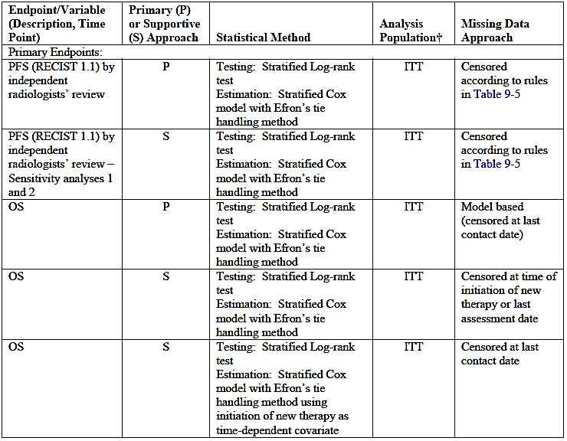

Secondary endpoints
- PFS per mRECIST
- ORR per RECIST1.1
- Modified RECIST based on BICR.
In order to evaluate the robustness of the PFS endpoint, sensitivity analyses were performed with different sets of censoring rules.
All the stratified analyses were based on the stratification factors implemented for enrolment, including ECOG-PS (0/1vs 2), presence or absence of liver metastases, haemoglobin (≥ 110 g/dL versus<10 g/dL), and time from completion of most recent chemotherapy (<3 months or ≥ 3 months). An outline of the efficacy analysis strategy was presented.
The strategy to address multiplicity issues with regard to multiple efficacy endpoints, multiple comparisons, multiple populations, and interim analyses is described in Section8.2.6 and Section 8.2.9 of the protocol.

Table 18: Study PN045 Efficacy analyses for secondary efficacy endpoints
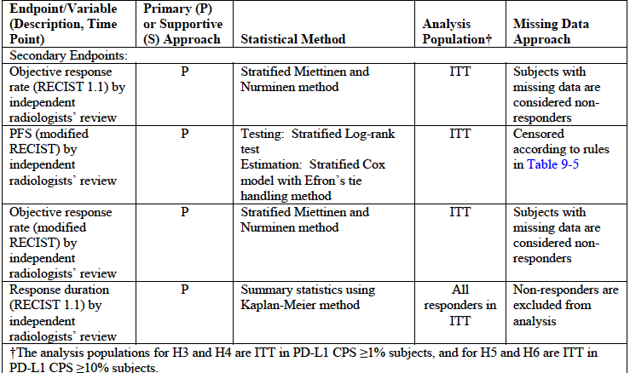

Exploratory endpoints
These included, but were not limited to:
- PFS2 (time from randomisation to subsequent disease progression after initiation of new anti-cancer therapy, or death from any cause, whichever first,)
- Disease control rate
- Response to treatment by biomarker subgroups.
- Patient-reported outcomes (PROs) while on treatment and post-discontinuation The Clinical Study Protocol states: ‘EuroQol EQ-5D and EORTC QLQ-C30 questionnaires will be administered by trained site personnel and completed electronically by subjects.’ Missing data was to be handled using several approaches:
  - Truncating the analysis observation period at the visit closest to median duration of treatment in the comparator arm
  - Hierarchical pattern mixture models incorporating reason for
  - Missingness (a model that treats disease progression as a time-varying covariate
  - Multiple imputation methods (no further details provided).

Randomisation and blinding methods
There was no blinding of investigators or patients as this was an open-label trial.
Randomisation occurred centrally using an interactive voice response system/integrated web response system (IVRS/IWRS). Subjects were randomised in a 1:1 ratio to pembrolizumab OR the Investigator’s choice of paclitaxel, docetaxel, or vinflunine. Investigators had to select 1 treatment among the control arm options before randomisation occurred to use in the event that the subject was randomised to the control arm. After the subject completed baseline screening procedures and the PI determined that the subject met the inclusion and no exclusion criteria, the subject was assigned a unique allocation number (AN) through the IVRS/IXRS. The AN was unique and once assigned, it became the permanent trial identifier for that subject. In the event a subject was assigned an AN but did not receive study treatment, that subject’s AN was not reassigned. Subjects who did not meet entry criteria were not to be assigned an AN. A single subject was not assigned more than 1 allocation number.
- Randomisation was stratified according to the following factors:
- ECOG-PS (0/1 versus 2)
- Presence or absence of liver metastases
- Haemoglobin (≥ 10 g/dL versus<10 g/dL)
- Time from completion of most recent chemotherapy (< 3months or ≥ 3months [90days])
Note: Subjects with ECOG-PS of 2 could only be enrolled if liver metastases were absent, haemoglobin was ≥ 100g/L, and time from completion (last dose) of most recent chemotherapy was ≥3months (90days).
Comment: The sponsor outlined errors in 31 patients pertaining to incorrect stratification: overall, these do not appear to have resulted in significant imbalances, but as previously mentioned patients with ECOG-PS 2 are not well represented and several patients were stratified on incorrect information.

Analysis populations

Efficacy analysis population
The analysis of primary efficacy endpoints are based on the intention -to-treat (ITT) population, that is, subjects will be included in the treatment group to which they are randomised. Details on the approach to handling missing data are provided in Section Statistical Methods below.

Safety analysis populations
The All Patients as Treated (APaT) population will be used for the analysis of safety data in this study. The APaT population consists of all randomised subjects who received at least 1 dose of study treatment. Subjects will be included in the treatment group corresponding to the trial treatment they actually received for the analysis of safety data. Subjects who take incorrect trial treatment for the entire treatment period will be included in the treatment group corresponding to the trial treatment actually received. The baseline measurement and at least one laboratory or vital sign measurement obtained subsequent to at least one dose of trial treatment is required for inclusion in the analysis of each specific parameter.
Comment: The study population is broadly reflective of the population of patients with advanced/metastatic urothelial cancer encountered in clinical practice, in respect of demographics and prior therapies, except that it is noted that patients with creatinine clearance <30 mL/min were excluded, as were subjects with ECOG performance status >2, while only 6 subjects of ECOG status =2, who had met several other quite restrictive criteria, were admitted to the trial. Of subjects rejected for randomisation, poor ECOG performance status was the most prevalent reason for rejection, very likely reflecting the frequency with which this is encountered in practice.
The applicability of the study results to these excluded populations remains to be established and in particular they cannot be taken as demonstrating safety or efficacy in patients of ECOG status >2 or in unselected patients of ECOG status =2.

Sample size
The trial planned to randomize 470 subjects in a 1:1 ratio between pembrolizumab and the control arm. The trial was event driven and sample size calculation was driven by survival events. Assuming the prevalence rates of PD-L1 CPS ≥ 1% subjects and PD-L1 CPS ≥ 10% subjects among the overall population would be 55% and 33%, respectively, a sample size of 470 all subjects would provide approximately 260 PD-L1 CPS ≥ 1% subjects and 156 PD-L1 CPS ≥ 10% subjects.
The sample size and power calculation of PFS was based on the following assumptions:
- PFS follows an exponential distribution with a median of 4 months in the standard treatment arm;
- The true hazard ratios between pembrolizumab and standard therapy are 0.45, 0.5, and 0.5 for PD-L1 CPS ≥ 10%, PD-L1 CPS ≥ 1%, and all subjects, respectively;
- An enrolment period of 12 months;
- A yearly dropout rate of 5%.
The numbers of PFS events in PD-L1 CPS ≥ 10% and all subjects at the final PFS evaluation were estimated to be 137 and 420, respectively. The trial provides 97% power for the PFS hypothesis in PDL1 CPS ≥ 10% subjects and >99% power for the PFS hypothesis in all subjects.
The final OS analysis is to be carried out after approximately 370 deaths in all subjects and 110 deaths in PD-L1 CPS ≥ 10% subjects had occurred between the pembrolizumab arm and the standard treatment arm for all subjects, barring early stopping for futility or efficacy.
With the above numbers of events and before any alpha roll-over, the trial provides 88% and 86% power to demonstrate superiority of OS of pembrolizumab relative to standard therapy at the pre-specified initial alpha (one-sided) levels in PD-L1 CPS ≥ 10% and all subjects, respectively. The sample size and power calculation of OS are based on the following assumptions: (1) OS follows an exponential distribution with a median of 8 months in the standard treatment arm; (2) the hazard ratio for OS between pembrolizumab and control subjects, respectively (deemed to be clinically meaningful in this population); (3) an enrolment period of 12 months and a minimum of 18 months follow-up after enrolment completion; and (4) a yearly drop-out rate of 2%.

Clinical study protocol and amendments
Comments: Changes to the Clinical Study Protocol, originally activated 23 June 2014, were made after two interim analyses of the data by an unblinded statistician, and also incorporated analyses of data external to this trial.
Protocol amendments are listed below. Several are purely administrative. The decision to add docetaxel to chemotherapy options was made 3 months before accrual began.
The significant protocol changes all relate to the evolving strategy in respect of interpretation of the data in the context of biomarker expression. These changes were made serially during the course of the trial. They do not affect the clinical conduct of the trial or the outcomes in respect of the overall ITT population but do alter statistical analyses in respect of subjects stratified by PD-L1 expression, which was not stated to be a stratification factor at randomisation but was introduced in Amendment 4 as a basis for expanded primary endpoints (PFS and OS in PD-L1 positive and strongly positive groups) and then further modified (Protocol Amendment 13, 19-09-2016) in which the category of PD-L1 positive >1% ,<10% is eliminated from second interim and final analyses, leaving a category of subjects with PD-L1 > 10%, enriched for response to pembrolizumab, and a category of PD-L1 <10% which could be expected to do better than, but incorporates, the previous PD-L1 negative category.
The changes in the treatment of data according to PD-L1 status are not critical or even directly relevant in respect of an application seeling registration for second line use after prior platinum therapy, without reference to PD-L1 status, based on a randomised trial that shows a significant overall survival benefit for pembrolizumab in all comers (see below). Positive or strongly positive PD-L1 biomarker status, while correlated with an increased likelihood of benefit from pembrolizumab, is not necessary for response.

Protocol Amendment 01 (01-Aug-2014)
In Protocol Amendment 01, which was applicable only in Germany, the timing for follow-up radiographic imaging was changed to every 12 weeks (±7 days) following the initial radiographic assessment at 9 weeks or sooner if clinically indicated.

Protocol Amendment 02 (26-Aug-2014)
In Protocol Amendment 02, the protocol was updated to include docetaxel as a chemotherapy treatment option.

Protocol Amendment 03 (28-Aug-2014)
In Protocol Amendment 03, which was applicable only in Germany, modifications made in Amendment 02 were incorporated into this country-specific amendment.

Protocol Amendment 04 (no date stated)
Protocol Amendment 04 incorporated agency feedback and updates to the statistical analysis plan, including elevating PFS and OS in subjects with PD-L1 positive and PD-L1 strongly positive tumours to co-primary objectives. Due to a change in the Applicant’s biomarker strategy, this amendment was not released to the Health Authorities.

Protocol Amendment 05 (no date stated)
Protocol Amendment 05, was applicable only in Germany, and included the modifications that were planned for Amendment 04. Finalization of this amendment was held after it was determined that Amendment 04 would not be released to the Health Authorities (as explained above).

Protocol Amendment 06 (15-Jan-2015)
Protocol Amendment 06 was applicable only in the UK. At the request of the UK Health Authority, this amendment excluded subjects who required ongoing therapy with medications that are strong inducers of the CYP3A4 enzymes.

Protocol Amendment 07 (20-Feb-2015)
Protocol Amendment 07 was applicable only in France. At the request of the French Health Authority, this amendment incorporated the current ECI Guidance Document (18-Dec-2014).

Protocol Amendment 08 (no date stated)
Protocol Amendment 08 was applicable only in France and included the modifications that were planned for Amendment 04. Finalization of this amendment was held after it was determined that Amendment 04 would not be released to the Health Authorities (as explained above).

Protocol Amendment 09 (27-Feb-2016)
Protocol Amendment 09 included the planned changes for Amendment 04 (that is, incorporated agency feedback and PFS and OS in subjects with PD-L1 positive [CPS ≥ 1%] and PD-L1 strongly positive tumours became co-primary objectives due to emerging evidence suggesting that PD-L1 status may correlate to outcomes of subjects with recurrent or progressive metastatic urothelial carcinoma treated with pembrolizumab). In addition, the statistical analysis plan was updated throughout to reflect the incorporation of the analyses of the primary hypotheses on PD-L1 positive (CPS ≥ 1%) and PD-L1 strongly positive subjects.

Protocol Amendment 10 (10-Mar-2016)
In Protocol Amendment 10, which was applicable only in Germany, modifications made in Amendment 09 were incorporated into this county-specific amendment.

Protocol Amendment 11 (26-May-2016)
Protocol Amendment 11 updated the statistical analysis plan to account for the number of events in the PD-L1 positive (CPS ≥ 1%) subjects in timing and conduct of the interim and final analysis, because most of the alpha for testing OS was allocated to the PD-L1 positive (CPS ≥ 1%) biomarker subgroup. The statistical analysis plan was also updated to account for the possible postponement of the second interim analysis and/or the final analysis for up to 4 additional months to accrue enough OS events in the PD-L1 positive (CPS ≥ 1%) subjects after the planned number of OS events in all subjects is achieved.

Protocol Amendment 12 (21-Jun-2016)
In Protocol Amendment 12, which was applicable only in Germany, modifications made in Amendment 11 were incorporated into this county-specific amendment.

Protocol Amendment 13 (19-Sep-2016)
Protocol Amendment 13 clarified that the basis for PD-L1 positive and strongly positive categories using CPS cut points was determined outside of this trial (045) (that is, from protocols KEYNOTE-012, KEYNOTE-052, and epidemiologic studies). Definitions of PD-L1 positive as CPS ≥ 1% and PD-L1 strongly positive as CPS ≥ 10% for this trial were set based on these external data.
The biomarker strategy was changed based on emerging data external to this trial. Primary hypotheses on PD-L1 positive (CPS ≥ 1%) subjects would not be formally tested at the second interim analysis and the final analysis. Alpha allocation among the primary hypotheses for interim and final analyses was revised accordingly to reflect the change in biomarker strategy. The reallocation of alpha occurs after the conduct of IA1, and proper adjustment was made to maintain the control of family-wise type I error rate (FWER) with implementation of this change (refer to Section 8.2.6 of the protocol).

Protocol Amendment 14 (19-Sep-2016)
In Protocol Amendment 14, which was applicable only in Germany, modifications made in Amendment 13 were incorporated into this county-specific amendment.

Statistical analysis plan
The sponsor included the Statistical Analysis Plans (SAP) within the Clinical Study Protocol (latest version dated 19 September) and also provided a supplemental SAP (sSAP) dated 05 October 2016 (the data cut-off date was 07 Sept 2016). It is stated in the SAP of the Study Protocol, ‘If, after the study has begun, but prior to any unblinding, changes made to primary and/or key secondary hypotheses, or the statistical methods related to those hypotheses, then the protocol will be amended (consistent with ICH Guideline E-9). Changes to exploratory or other non-confirmatory analyses made after the protocol has been finalized, but prior to unblinding, will be documented in a supplemental SAP (sSAP) and referenced in the Clinical Study Report (CSR) for the study. Post hoc exploratory analyses will be clearly identified in the CSR.’
The sSAP was amended to align with Protocol Amendment 13 and to include statistical considerations on patient-reported outcomes (PRO).

Interim analysis plan
Two interim analyses were planned based on all subjects and PD-L1 CPS ≥ 10%. For PD-L1 CPS ≥ 1%, the hypotheses of PFS and OS were only tested at IA1. The futility bounds of this trial are nonbinding and the bounds are considered guidance rather than strict bounds. Results of the interim analysis were to be reviewed by an external DMC (eDMC). Based on its recommendation, the sponsor may prepare a regulatory submission if any of the 6 primary objectives are met at interim analysis.
The timing, sample size, and decision guidance for the planned PFS and OS analyses for PD-L1 CPS ≥ 10% and all subjects under one hypothetical scenario with initially assigned type I rates only are summarized in Table 19 below.

Table 19: Study PN045 Summary of timing, sample size and decision guidance at the planned PFS and OS analyses
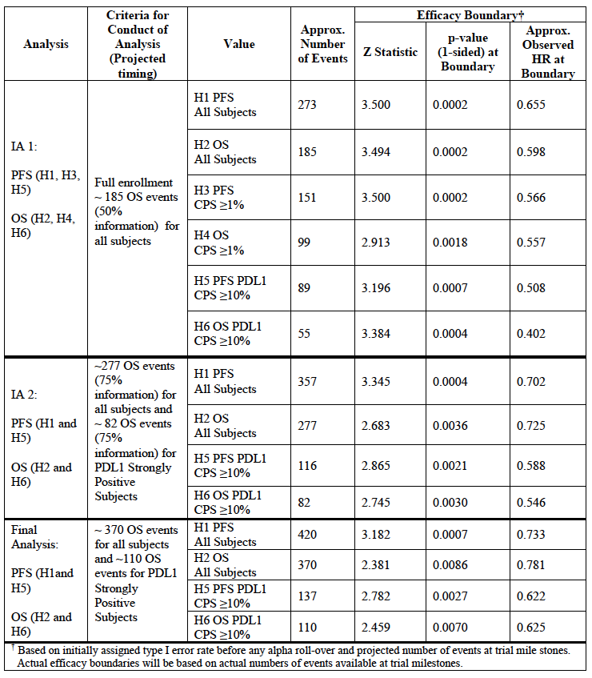
Comment: At the IA2 and final analyses, there is both a formal testing of the hypothesis for the co-primary (PFS and OS) endpoints in the whole study population and in those with a CPS ≥ 10% that is, there is no statistical analysis of efficacy in the PD-L1>1% population (previously H3 and H4) in the objectives. As previously stated, this approach supports the indication being sought and provides some additional information about the potential for PD-L1 as a complementary diagnostic test.

Table 20: Study PN045 Summary of futility boundary at the planned interim analyses on OS
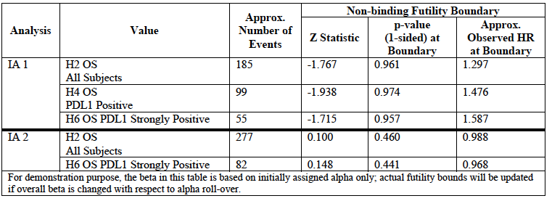
Comment: Based on the details in the table, this submission is based on the outcomes after the second interim analysis (334 patients had died at the data cut-off of 07 September 2016). Should this indication be approved, it is recommended that the sponsor be required to submit the final study report as a condition of registration.
Efficacy results will be considered to be statistically significant after consideration of the strategy for controlling the Type I error for multiplicity. Nominal p-values may be computed for other efficacy analyses as a measure of strength of association between the endpoint and the treatment effect rather than formal tests of hypotheses.
The strategy to address multiplicity issues with regard to multiple efficacy endpoints and multiple analyses was described in the sSAP (05 Oct 2016).
The initial alpha allocation among the primary hypotheses was revised in Amendment 13 onward to reflect the change in biomarker strategy. The reallocation of alpha was to occur after the conduct of IA1, and proper adjustment had been made to maintain the control of FWER with the implementation of this change. The type I error actually spent at IA1 was to be kept intact and the reallocation was to be applied only to the remaining unspent alpha. The family-wise type I error rate for this trial was to be strongly controlled at 2.5% (one-sided) across all primary hypotheses on PFS and OS and the secondary hypothesis on ORR, with the following alpha allocation before any alpha roll-over or adjustment for actual information fraction:
- 0.1% allocated to the PFS hypothesis in all subjects (H1) with 0.02% planned at IA1
- 1.0% allocated to the OS hypothesis in all subjects (H2), with 0.02% planned at IA1
- 0.02% allocated to the PFS hypothesis in PD-L1 CPS ≥ 1% (H3) at IA1 only
- 0.18% allocated to the OS hypothesis in PD-L1 CPS ≥ 1% subjects (H4) at IA1 only
- 0.38% allocated to the PFS hypothesis in PD-L1 CPS ≥ 10% subjects (H5), with 0.07% planned at IA1
- 0.82% allocated to the OS hypothesis in PD-L1 CPS ≥ 10% subjects (H6), with 0.04%planned at IA1 where the alpha spent at IA1 was based on the assumption of the planned information fractions along with the original pre specified alpha allocation prior to Amendment 13 by alpha spending function of Hwang-Shih-DeCani (HSD) with gamma parameter.
Under the revised alpha allocation, the alpha spending at IA2 and final analysis were determined by first applying the same HSD gamma (-4) spending function to distribute unspent alpha to IA2 and final analysis, respectively, and then incorporating them with the alpha that has already been spent at IA1 to form an interpolated alpha spending among the 3 analyses.
Therefore the following was according to the revised/actual plan. The updated efficacy boundary after alpha rollover at IA2 is shown in Table 21 below based on actual observed data.

Table 21: Study PN045 Updated efficacy boundary after alpha rollover
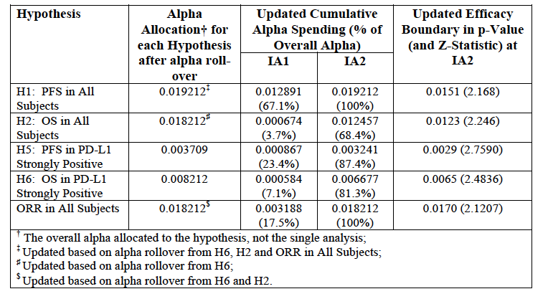
The revised decision guidance for PFS and OS with respect to the rolled-over alpha from the rejection of other hypotheses is summarized in Table 22. The actual boundaries for the alpha spending function could be adjusted based on the actual number of events and/or ORR information fractions observed at the time of the corresponding analysis.

Table 22: Study PN045 Summary of revised efficacy decision guidance (selected scenarios)
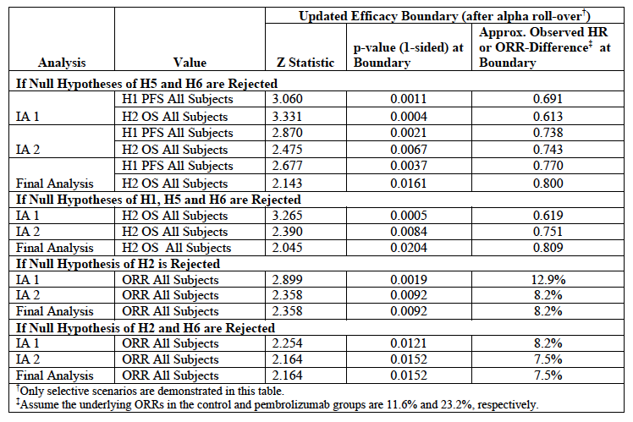
Comment: The clinical evaluator note the adaptive design of the clinical trial, modification of the clinical trial objectives and hypotheses in response to interim data analyses, emerging data external to the trial, the, multiple protocol amendments and event-driven nature of the analyses. The statistical analyses including determination of the alpha spending are not fixed, and could be adjusted based on the actual number of events and/or ORR information. It is noted that the IA2 was undertaken at a time and event point closer to the number of events for the final analysis (334 (amended from 344 as per s31 response) actual events compared with 277 required for IA2 analysis and the 370 deaths required for the final analysis). The reasons for this are not clear. Thus, the statistical parameters are likely to be different from those stated above for determining whether to accept or reject the 4 remaining hypotheses, as well as the p value required for determining the statistical significance of the findings. The sponsor has been requested to provide these. (Clinical question)
Sponsor’s response to the TGA’s request for further information
The multiplicity-adjusted alpha boundary for the reference of statistical significance is derived as 0.0123 per the pre-specified alpha allocation and roll-over strategy with the actual information fraction at this analysis.

Participant flow
A total of 542 subjects were randomised into this trial and included in the ITT population (control: 272; pembrolizumab: 270) (see Table 23). 205 subjects were not accepted for randomisation due to failure to meet entry criteria, principally inadequate ECOG performance status or unacceptable recency of chemotherapy, or due to meeting one or more exclusion criteria (see below).
Of the 542 subjects randomised into this trial, more subjects in the pembrolizumab arm started study treatment (266 of 270) compared with the control arm (255 of 272).
Comments:
- A higher number of patients withdrew prior to treatment if they were allocated to the chemotherapy arm (17 versus 4 patients); while reasons for this were not presented, this suggests that patients were enrolling potentially for access to pembrolizumab perhaps rather than treatment per se. This represents a source of selection bias, and potentially those patients withdrawing did not receive any treatment, which may favour the investigational arm analyses of efficacy using the ITT population. Higher numbers also withdrew consent during the course of the trial in the comparator arm (29 patients versus 3), which may reflect the unacceptability of chemotherapy and/or unacceptable toxicities. Taken together, these two rates of withdrawal confirm the high unmet need for a more effective, less toxic alternative to chemotherapy.
- A much higher number in the chemotherapy arm were discontinued due to ‘physician decision’ (10.6% versus 2.3%) when there are already categories of ‘adverse event’ or ‘clinical progression’ which might capture clinical reasons for stopping. This is a potential source of bias in an open label trial and the sponsor is requested to explain the basis for these decisions. (Clinical question)

Table 23: Study PN045 Patient disposition (ITT Population)
More patients in the pembrolizumab arm remain in the trial (40% versus 24.6%), and more continued to receive the allocated treatment on trial compared with the control arm (18.4% versus 1.2%).In the control arm, more patients discontinued from the study due to death compared to the pembrolizumab arm (58.1% versus 50.7%), or due to withdrawal by patient (11.0% versus 2.6%) compared with the pembrolizumab arm. A similar proportion of patients in both arms discontinued the trial due to adverse event, physician decision, or lost to follow-up; 1 subject in the pembrolizumab arm was discontinued due to a protocol violation; this last subject was included in the ITT.
Of the 542 subjects randomised into this trial, more subjects in the pembrolizumab arm started study treatment (266 of 270) compared with the control arm (255 of 272). Among subjects who started study treatment, the majority of subjects in the trial had discontinued study treatment (81.6% in pembrolizumab arm, 98.8% in control arm), with approximately half of subjects in both arms discontinuing study treatment due to PD.
Fewer subjects in the pembrolizumab arm compared with the control arm discontinued study treatment due to adverse event (10.9% versus 15.7 %,), withdrawal by subject (1.1% versus 11.4%), or physician decision (2.3% versus 10.6%). The same proportion of subjects across the 2 arms discontinued study treatment due to clinical progression of disease (9.4%). Seven subjects (2.4%) in the pembrolizumab arm discontinued study treatment due to achieving a complete response, compared with 1 subject (0.4%) in the control arm. The disposition of subjects in the APaT population was similar to that in ITT population.

Major protocol violations/deviations
A pre-defined list of major protocol deviations was created at the start of the trial; however, as the trial progressed with continued monitoring, the sponsor indicated the list of major deviations might change. Major protocol deviations listed in this report reflect any reclassified and/or re-categorised deviations based on the final protocol deviation classification/categorization for this trial.
The sponsor documented the following major protocol deviations as of 07-Oct-2016 (n=483) as clinically relevant (n=28). These occurred in patients who:
- Did not meet entry criteria (16);
- Continued on study treatment after confirmed progression without applicant approval (1);
- Received prohibited medication while on study treatment (11).
No subject was excluded from the analyses due to a protocol deviation.
Comment: The protocol deviations listed as clinically relevant relate principally to concurrent use of prohibited drugs in 11 cases (glucocorticoids in various forms for miscellaneous indications) and deviations from entry criteria in 16 cases (absence of required blood test data in 5, low Hb in 3, marginally low creatinine clearance in 1, absence of measurable lesions in 2, on prohibited drugs at time of entry in 2, stage 2 urothelial cancer in 1, concurrent early stage prostate cancer of Gleason grade 8 in 1, Hepatitis B serology in 1). This miscellany of deviations does not arise predominantly from any specific country or treatment centre and does not give rise to serious concern about the performance of the trial.

Other changes to the conduct of the trial
In a Note to File of the sSAP the sponsor reported incorrect stratification factors applied incorrectly for 31 of 542 subjects (5.7%).
The incorrect factors included:
- Haemoglobin incorrectly stated to be greater than or equal to 10 g/dl (n=1);
- Liver metastases stated incorrectly to be absent (n=7);
- Liver metastases stated incorrectly to be present (n=1);
- Time from completion of most recent chemotherapy stated incorrectly to be greater than or equal to 3 months (n=14);
- Time from completion of most recent chemotherapy stated incorrectly to be less than 3 months (n=8).
The factors applied at randomisation were not altered; all analyses were based on IVRS stratification.
One subject was listed as a screen failure but was entered in duplicate by error; [information redacted] was created in error and is actually [information redacted], who was subsequently randomised. Therefore, there were 205 subjects who were not randomised (not 206 subjects), all due to not meeting inclusion/exclusion criteria.
Comments:
- Any potential imbalances between the arms arising from the incorrect stratification are difficult to determine as treatment allocation is not included in the table. The sponsor is requested to add a column to this table indicating which treatment arm for each patient.
- These errors remain uncorrected and this is a potential source of bias if the errors favour one arm or the other. This is particularly important for the subgroup analyses which have smaller numbers, and for the analyses by PD-L1 status which are already have imbalanced due to this not being a stratification factor. It is noted that for 22/31 patients, these errors led to a misclassification of having a more favourable prognosis.
- It is noted that the sponsor used two of the three prognostic factors identified by Bellmunt et al (2010) to stratify patients for this study (Hb and liver metastases (the limitations of this are discussed in the efficacy data section) with the third being ECOG-PS>0.
- The majority of errors pertained to time since chemotherapy, which was associated with a poorer outcome in the efficacy analyses in this study.
- The sponsor is requested to provide sensitivity analyses comparing the outcomes for the relevant subgroup analyses for PFS, OS and ORR when these factors are corrected. (Clinical question).

Baseline data
Baseline characteristics of the ITT population are presented in the following tables. The majority of subjects in both arms were male, ≥65 year of age, White, and former or current smokers.
The majority of subjects in both arms had an ECOG-PS of 1, had visceral metastatic disease (including 34.3% with liver metastases), baseline haemoglobin ≥ 100 g/L, and had completed prior therapy ≥3 months before being randomised to this trial.
Slightly more subjects in the pembrolizumab arm were in the ≥65 years of age (61.1% versus 54.0%), had ECOG-PS = 0 (44.1% versus 39%) and were never smokers (38.5% versus 30%) compared with the control arm.
Slightly fewer subjects in the pembrolizumab arm were in the PD-L1 CPS ≥ 10% group (27.4% versus 33.1%) compared with the control arm, as PD-L status was not a stratification factor.
Comment: The relatively small proportion with upper urinary tract carcinomas (13.6% and 14.1% in the control and pembrolizumab arms, respectively) is consistent with this much less common cancer, and very few had only locally advanced disease (3.7% in each arm designated M0). As per AJCC staging where distant metastases are not required to be classed as Stage IV disease, only a single patient was considered as non-Stage IV.

Table 24: Study PN045 Patient characteristics (ITT population) (continues over next 3 pages)

Table 24 continued: Study PN045 Patient characteristics (ITT population) (continues over next 3 pages)

Table 24 continued: Study PN045 Patient characteristics (ITT population) (continues over next 3 pages)
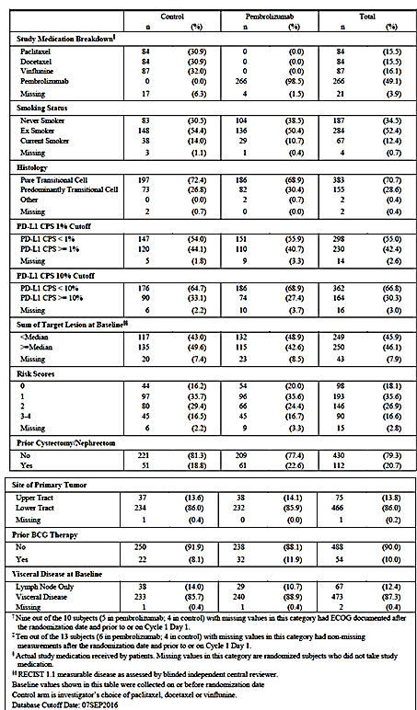
Comments: Baseline data as presented in the CSR show the arms to be well balanced for baseline characteristics. Imbalances in respect of a greater proportion of older patients and never-smoker in the pembrolizumab arm may have mildly favoured the control arm, but the magnitude of any such effect would be small.
The patient characteristics for the ITT population by PD-L1 CPS ≥ 10% status were summarised. Ninety patients enrolled in the control arm and 74 in the pembrolizumab arm were found to have PD-L1≥ 10%; of these, 84 and 71 received their allocated treatment, respectively. From the information presented, apart from the absolute numbers in each arm, the arms were relatively well balanced. While the control arm patients were younger (55.6% < 65 years of age) compared with the pembrolizumab arm (44.6% <65 years) and they were more likely to have had a greater than 3-month interval since chemotherapy, this group included more patients with poorer performance status (ECOG 1: 62.7% versus 53.5%).
There is some uncertainty about the balance between the arms for patients with respect to time since chemotherapy given the errors in the data at randomisation.
The actual chemotherapy received appears to be missing for 7.8% in the control arm, despite this information being required at randomisation.

Results for the primary efficacy outcome

Overall survival among all subjects
A total of 334 (61.6%) deaths were observed among all subjects in the ITT population as of the data cut-off date of 07-Sep-2016. The median OS was 10.3 months (95% CI: 8.0, 11.8) in the pembrolizumab arm versus 7.4 months (95% CI: 6.1, 8.3) in the control arm. The HR for OS was 0.73 (95% CI: 0.59, 0.91), with a one-sided p-value of 0.002 in favour of pembrolizumab over the control.
The median (range) follow-up duration for all subjects in the intent-to-treat (ITT) population was 10.3 (0.2 to 20.8) months in the pembrolizumab arm and 7.9 (0.3 to 20.3) months in the control arm.

Table 25: Study PN045 Analysis of overall survival (ITT population)
Figure 10: Study PN045 Kaplan-Meier estimates of overall survival (ITT population) as of 07 Sept 2017
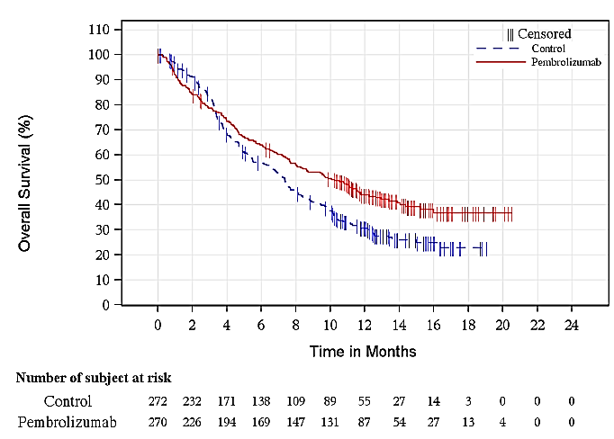
The estimated OS rates at 6 months were 63.9% for pembrolizumab and 56.7% for control, and at 12 months was 43.9% for pembrolizumab and 30.7% for control.
Comments:
- The HR, alpha allocation and p value for rejection of the null hypothesis in the population as whole when there have been 334 deaths overall and 104 in the PD-L1≥ 10% cohort are not presented. (Clinical question).
- The reported significant p value and the HR are noted for the median OS in the pembrolizumab arm compared with control. It is also noted that the 95% confidence intervals overlap.
- Given there was an imbalance in the numbers who actually received treatment between the arms for the ITT population, the sponsor is requested to undertake a sensitivity analysis for both PFS and OS including only those who received at least one dose of their allocated study treatment. (Clinical question).
- Initially more patients die in the pembrolizumab arm. This may reflect the delayed time for an effect in patients with rapidly progressing disease and the sponsor is requested to provide a breakdown of the PD-L1 status of those patients progressing or dying within the first 3 months and to provide any insights from other subgroup analyses (Clinical question).
- With a median follow-up of only 10 months, there is a high rate of censoring and it is unclear how many patients with a CR, PR or stable disease have durable responses; the shape of the K-M curve beyond 10 months should be interpreted with caution.

Analyses of OS by subgroup
The sponsor presented multiple subgroup analyses in a Forest plot (see the tables included in Figure 11). Included in these reported analyses were ‘Bellmunt risk scores’ (no citation included in the text); see Comments below.
Accepting the limitations, those not appearing to have improved OS were patients described as ‘non-White’, those from East Asia and never smokers.

Figure 11: Study PN045 OS by subgroup point estimate and nominal 95% confidence intervals (ITT population)
Figure 11 continued: Study PN045 OS by subgroup point estimate and nominal 95% confidence intervals (ITT population)
Figure 11 continued: Study PN045 OS by subgroup point estimate and nominal 95% confidence intervals (ITT population)
While no substantial difference appeared when patients were divided into <65 years and ≥ 65 years, the OS data by age groups presented in Tables 14.2-12 - 14.2-15 copied below (Tables 26-29), indicate that patients ≥75 age<85 years fared substantially worse than those receiving chemotherapy (HR 1.52; 95% CI: 0.79, 2.89). There were no patients randomised to receive chemotherapy amongst the 6 patients over the age of 85 participating and therefore no comparison can be made.

Table 26: Study PN045 Overall survival analyses of patients aged <65 years (ITT population)
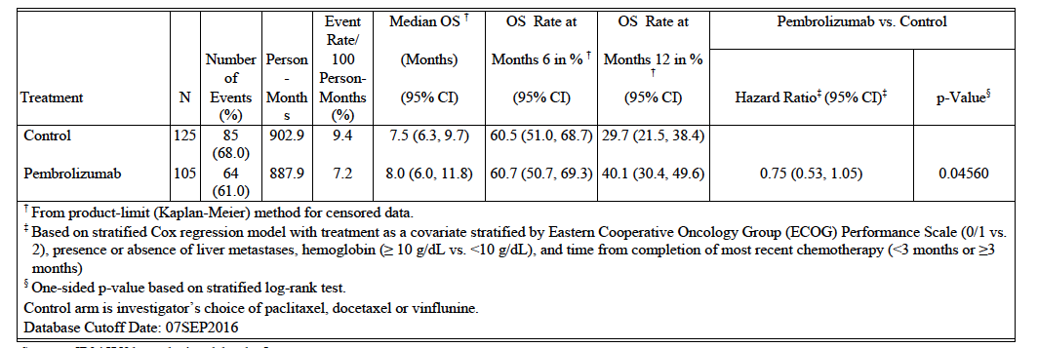

Table 27: Study PN045 Overall survival analyses of patients 65 years ≤ age<75 years (ITT population)
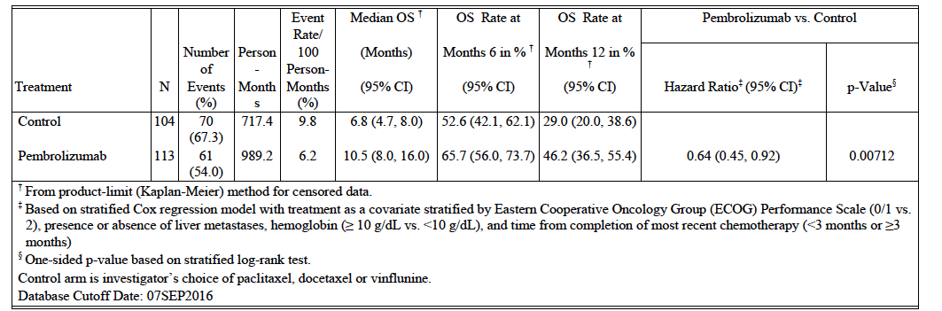

Table 28: Study PN045 Overall survival analyses of patients 75 years ≤ age<85 years (ITT population)
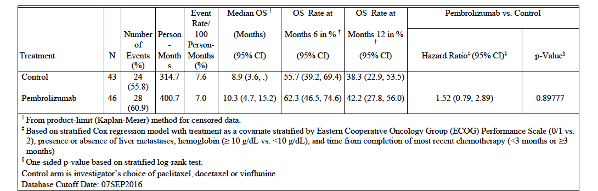

Table 29: Study PN045 Overall survival analyses of patients aged ≥85 years (ITT population)
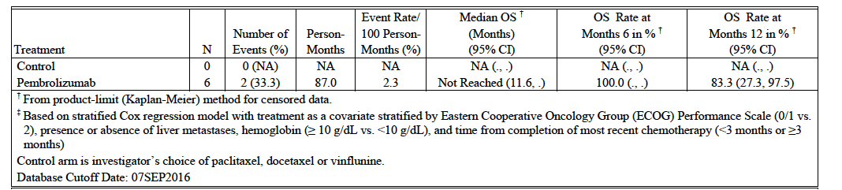
Comments:
- The limitations of subgroup analyses are acknowledged and there appeared to be a much better than expected performance in the chemotherapy arm for those aged between 75 and 85 years; nonetheless, the very poor outcomes in older patients receiving pembrolizumab raises uncertainties about the benefit-risk in this population, which requires further investigation.
- There is an apparently higher risk of harm with pembrolizumab in those over the age of 75 (HR for death 1.52 (95% CI: 0.79, 2.89), and there is no comparative evidence for patients beyond the age of 85 to provide evidence of safety and efficacy in this subpopulation. Whether a small percentage of responders experience a durable response is not clear, and whether there is any way of selecting such patients remains unclear. The PI currently states that there are no differences in safety or efficacy, using the cut-off of over or under 65 years. Results from this study do not support that statement and the PI needs to be amended to include that more deaths were observed with pembrolizumab in patients over the age of 75 with urothelial cancer and caution should be used in this population.
- The sponsor refers to the ‘Bellmunt risk score’ without citation or provision of the reference in the Efficacy results section. Bellmunt et al (2010), identified poor prognostic factors in patients with urothelial carcinoma whose disease had progressed following platinum treatment and were being randomised to vinflunine or best supportive care, as Hb<10 g/dL, ECOG-PS>0 and the presence of liver metastases. The authors specifically caution, ‘One potential weakness of this study is that other agents potentially more effective than vinflunine might counteract the adverse impact of some of the recognized prognostic factors. Therefore generalization of the consistency of prognostic factors between regimens might need to be re-evaluated as additional large second line trials are reported with other agents.’ Thus, these prognostic factors have not been validated for use in the current study, and the validity of any comparisons is uncertain.
- It is difficult to interpret many of the subgroup analyses due to small numbers, such as those of non-white race or from the East Asian region.
- Of note, never smokers appear to benefit less than current or former smokers. This is consistent with other cancers where smoking is an aetiological factor such as non-small cell lung cancer, where a history of smoking is associated with a greater response, perhaps as a surrogate of mutational load and reliance on dampening of immune recognition pathways is greater. Urothelial carcinoma occurs more commonly in patients with mismatch repair gene deficiencies, which is also associated with a high mutational load; no data have been presented.
- Only 5 of 6 patients with ECOG-PS 2 received treatment (3 in the chemotherapy arm, 2 in the pembrolizumab arm) and no conclusions can be drawn about efficacy and safety in this group.
Sponsor’s response to Clinical question 26 where the sponsor was requested to provide sub-group analysis in respect of those subjects with (a) death or (b) disease progression within the first three months after initiation of treatment.
The sponsor stated there were ‘no significant differences in baseline characteristics across arms, though some slight imbalances were noted.’
Evaluator’s Second round comment: accepting the limitations of a subgroup analyses from the tables of baseline characteristics presented for those dying or experiencing progression within 3 months, there was an imbalance indicating:
- A higher risk of progression for the following groups receiving pembrolizumab:
- Age ≥65 years (PFS rate 57.7% with pembrolizumab vs. 50.7% in control arm)
- Asian patients (PFS rate 27.6% with pembrolizumab vs. 15.8% in control arm
- Never smokers (PFS rate 41.7% with pembrolizumab vs. 31.5% in control arm)
A lower risk of progression for the following groups receiving pembrolizumab:
- ‘White’ race (PFS rate 65.6% with pembrolizumab vs. 79.5% in control arm)
It is also noted that the proportion with PD-L1 expression CPS ≥ 10% experiencing early progression was reasonably similar in the pembrolizumab arm (n=48, 29.4%) and in the control arm (n=51, 34.9%), suggesting this is not useful in identifying those likely to benefit, including within the first 3 months.

Progression-free survival per RECIST 1.1 by central radiology assessment among all subjects
A total of 437 PFS events were reported at the time of the data cut-off. The median PFS was 2.1 months (95% CI: 2.0, 2.2) in the pembrolizumab arm versus 3.3 months (95% CI: 2.3, 3.5) in the control arm (HR [95% CI] = 0.98 [0.81, 1.19]; p=0.416).
Subgroup analyses tables by age presented in 14.2-7- 14.2.10 mirror those for OS, with the 75-85 year olds having a poorer outcome with a median PFS of 2.1 months (91% CI: 2.0, 4.8) compared with 3.7 months for the control (95% CI: 2.1, 5.2) with a HR 1.52 (95% CI: 0.88, 2.64). No comparison is possible for those > 85 years, but 5/6 patients actually treated with pembrolizumab had an event (1 patient randomised to the pembrolizumab arm was not treated).
Other notable differences were in those patients with more heavily pre-treated disease receiving the pembrolizumab as their 3rd line of treatment in the trial, those with less than 3 months since their previous chemotherapy regimen and those with greater tumour volume.
The median PFS, HRs, and p-values by Site Radiology Assessment are similar compared with the results by Central Radiology Assessment.
Comments:
- The poorer median PFS overall in those receiving pembrolizumab is of concern; although the HR is not statistically significant, the 95% confidence intervals do not overlap suggesting a real difference. Within this group with earlier progression when treated with pembrolizumab, a proportion die earlier than those in the control arm. The sponsor has been asked to provide a subgroup analysis for those progressing or dying early. (Clinical question) The table in the Clinical Trials section includes the PFS responses to inform clinicians.
- A notable group experiencing a higher risk of progression and earlier death are those aged 75-85. This appears to be due in part to a higher than expected response rate to chemotherapy compared with the general population (see Section on ORR) and whether there are more durable responses in this age group with pembrolizumab will be a key.
- Those with more rapidly progressing disease, including those more heavily pre-treated, appear less likely to benefit as indicated by HRs that cross 1. Whether those progressing within 3 months of chemotherapy also benefit is unclear due to data recording errors at randomisation which were not corrected in the ITT analyses – the sponsor has been requested to undertake sensitivity analyses including the correct data. A PI statement has been recommended to use caution in commencing pembrolizumab in these circumstances.
- In the Dosage and Administration section, the PI currently contains advice regarding continuing treatment beyond progression based on the phenomenon of pseudoprogression and non-conventional clinical benefit. The sponsor has been requested to provide any data from this trial that clearly supports demonstration of any such benefit and in particular any PRs or CRs. In the absence of evidence, the PI should not recommend continuation beyond progression in this population and a specific statement should be included in the Clinical Trials and Dosage and Administration section advising no CRs or PRs have been observed to balance the decision.
- The PI table 5 currently includes response duration which is based on immature data and should be removed. This table should only include data from the co-primary endpoints and ORR data should be mentioned in the text
Figure 12: Kaplan-Meier estimates of PFS based on RECIST1.1 per Central Radiological Assessment (ITT population)
Additional primary endpoints as of Amendment 13 included OS and PFS in patients with PD-L1 CPS ≥ 10% and PD-L1 CPS > 1%
Note is made that the analyses for the PD-L1 positive population (that is, CPS ≥ 1%) do not include corrections for multiplicity.
Overall survival among patients with PD-L1 CPS ≥ 10%
A total of 104 deaths were observed among patients with PD-L1 CPS ≥ 10% as of the data cut-off date of 07-Sep-2016. The estimated median OS was 8.0 months (95% CI: 5.0, 12.3) versus 5.2 months (95% CI: 4.0, 7.4), respectively (observed HR [95% CI] = 0.57 [0.37, 0.88]; p=0.005).
The median OS in this subpopulation was lower than in the overall population in both pembrolizumab and control arms, which the sponsor attributed to PD-L1 CPS ≥ 10% potentially being a negative prognostic factor.
Comments:
- Rather than identifying a population with an improved median OS, use of this biomarker cut-off has identified a group with a shorter-lived response and survival. Any long term responses observed within this group may be coincidental and unrelated to PD-L1 expression.
- This suggests that this cut-point for PD-L1 expression cannot be used as a predictive biomarker to enrich OS outcomes for all comers.
- The sponsor’s hypothesis that it might be associated with a poorer prognosis requires prospective validation. There are potentially many confounding factors, such those with a higher CPS being older, having more advanced or more rapidly progressing disease which appear to be associated with a poorer prognosis in this particular study. The PD-L1 selected populations were not stratified at the outset of the trial, already have numeric imbalances, and may be vulnerable to additional imbalances with errors in the stratification factor data and randomisation.
- The ITT analysis will include an imbalance in patients who did not receive their allocated treatment, which is likely to affect the chemotherapy arm more. The sponsor is requested to present a sensitivity analysis in this subgroup with PD-L1 CPS ≥ 10% for those who received at least one dose of treatment. (Clinical question)

Table 30: Study PN045 Analysis of overall survival in patients with PD-L1 CPS ≥ 10% (ITT population)
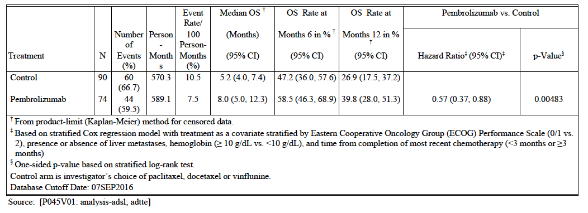
The subgroup analyses are presented in the CSR but any conclusions are limited by the small numbers and large confidence intervals. This was not a stratification factor due to the late inclusion in the Study Protocol after the study was underway, and imbalances have resulted between arms, further limiting interpretation.
Comment: Of note, those never smokers and those more heavily pre-treated (at least 2 prior chemotherapy regimens in the metastatic setting) appeared to have worse outcomes, regardless of whether the tumour expressed higher levels of PD-L1 which suggests pembrolizumab may not be the best choice of treatment in such patients. A PI change has been recommended for those with aggressive, rapidly progressing disease. (PI Comments)

Progression-free Survival Based on Central Radiology Assessment among patients with PD-L1 CPS ≥ 10%
A total of 131 PFS events were reported at the time of the data cut-off. The median PFS was 2.1 months (95% CI: 1.9, 2.1) in the pembrolizumab arm versus 3.1 months (95% CI: 2.2, 3.4) in the control arm (HR [95% CI] = 0.89 [0.61, 1.28]; p=0.240).

Table 31: Study PN045 Analysis of progression-free survival based on RECIST1.1 per Central Radiology Assessment in patients with PD-L1 CPS ≥ 10% (ITT population)
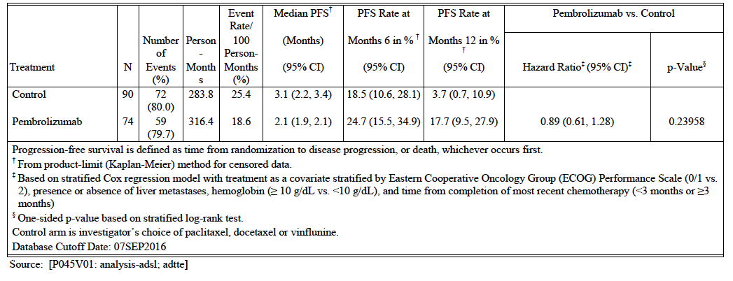
Comment: These results mirror those of the OS data with a shorter median PFS in patients with the higher PD-L1 expression and non-overlapping confidence intervals. The comments made above with regard to the OS outcomes in this group apply to this endpoint, and have not been repeated.

Overall Survival Among patients with PD-L1 CPS ≥ 1%
A total of 142 deaths were observed among subjects with PD-L1 CPS ≥ 1% as of the data cut-off date of 07-Sep-2016. The median OS was 11.3 months [95% CI: 7.7, 16.0] versus 6.9 months [95% CI: 4.7, 8.8], respectively) (HR [95% CI] = 0.61 [0.43, 0.86]; p=0.002). Note: this p-value is not multiplicity-adjusted.
The subgroup analyses as presented were similar to those reported for the study population as a whole.

Table 32: Study PN045 Analysis of overall survival in patients with PD-L1 CPS ≥ 1% (ITT population)
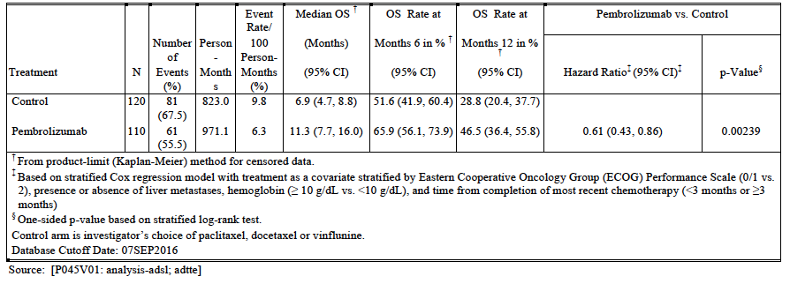

Progression-free survival with central radiology assessment among patients with PD-L1 CPS ≥ 1%
The median PFS was 2.1 months (95% CI: 2.0, 2.4) in the pembrolizumab arm versus 3.2 months (95% CI: 2.2, 3.4) in the control arm (HR [95% CI] = 0.91 [0.618, 1.24]; p=0.264). This p-value is not multiplicity-adjusted.

Table 33: Analysis of progression-free survival based on RECIST1.1 per Central Radiology Assessment in patients with PD-L1 CPS ≥ 1% (ITT population)
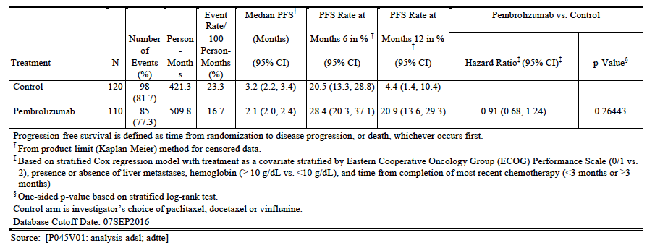
No substantial differences were noted in median PFS, HRs, and p-values by Site Radiology Assessment compared with the results by Central Radiology Assessment.

Sponsor response
The sponsor was requested to present the equivalent data for the PD-L1<1% population. The comparable tables for OS, PFS and Summary of best overall response are presented here for continuity as well as in Section 12.
The median OS in patients with PD-L1 CPS<1% in the pembrolizumab (9.6 months) and control arms (7.5 months) were slightly lower than the median OS in the pembrolizumab (10.3 months) and control arms (7.4 months) in the overall ITT population. The point estimate of the HR for OS (0.89 (95% CI 0.66, 1.20; p value 0.22)) suggests there is not a statistically significant difference between the two groups, and the OS rate at 12 months was greater in the pembrolizumab arm (42%) compared with the control arm (32%).

Table 34: Analysis of overall survival based on RECIST1.1 per Central Radiology Assessment in patients with PD-L1 CPS<1% (ITT population)
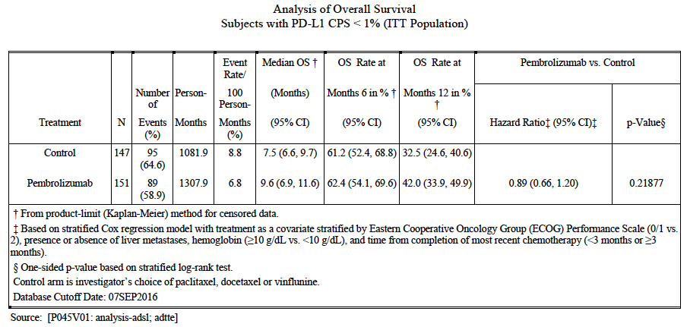
Given a larger number of patients were not treated once randomised to the chemotherapy arm, the sponsor was requested to provide a sensitivity analysis of OS and PFS with these patients censored that is, based on the All Patients as Treated analysis population and adjusted for those patients incorrectly stratified. This has not changed the outcomes significantly, due to the small numbers involved.
The median PFS in subjects with PD-L1 CPS<1% in the pembrolizumab (3.3 months) and control arms (2.1 months) were the opposite of what was seen for the median PFS in the pembrolizumab (2.1 months) and control arms (3.3 months) in the overall population. The point estimate of the HR for PFS (1.07 (95% CI 0.82, 1.39)) demonstrates no difference in terms of PFS between pembrolizumab and the control arm. However, the PFS rate at 12 months was greater in the pembrolizumab arm (13.4%) compared with the control arm (6.8%).

Table 35: Analysis of progression-free survival based on RECIST1.1 per Central Radiology Assessment in patients with PD-L1 CPS ≥ 1% (ITT population)
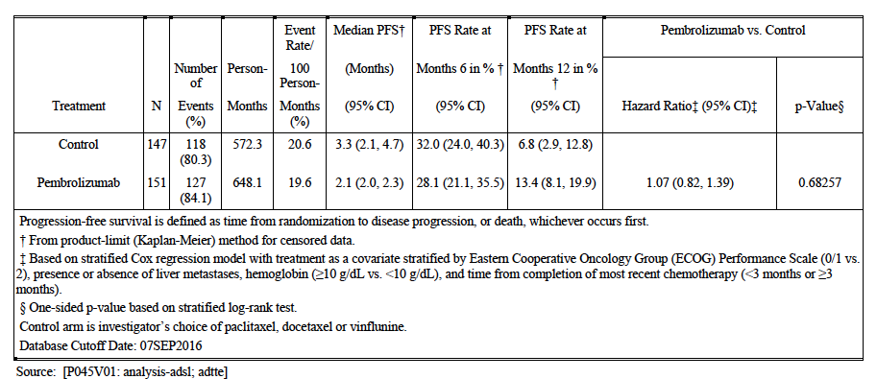

7.2.1.13 Results for other efficacy outcomes

Objective Response Rate per Confirmed RECIST 1.1 by Central Radiology Assessment among All Subjects
The confirmed ORR was 21.1% (95% CI: 16.4, 26.5) in the pembrolizumab arm compared with 11.4% (95% CI: 7.9, 15.8) in the control arm; the estimate of the difference was 9.6 (95% CI: 3.5, 15.9); p=0.001.
The sponsor reported unconfirmed response rates in the pembrolizumab arm in 118 of 219 subjects (53.9%) with at least 1 baseline imaging assessment had a reduction in tumour burden. In the control arm, 109 of 200 subjects (54.5%) with at least 1 baseline imaging assessment had a reduction in tumour burden.
Comments:
RECIST 1.1 requires a confirmatory scan no later than 6 weeks after the first scan. The apparent discordance of higher ORR in the pembrolizumab arm and higher reduction of tumour burden in the control arm appears to be due to the greater number in the control arm who had a reduction in tumour burden of 0-30%, which does not qualify as an objective response. Whether with longer follow-up and confirmatory scans, this differential in ORR is maintained is uncertain. The sponsor is requested to provide an updated ORR based on confirmed scans as per RECIST 1.1 (Clinical question).

Table 36: Study PN045 Analysis of confirmed ORR based on RECIST 1.1 by central radiology assessment all subjects (ITT population)

Sponsor response to clinical question 32
The sponsor provided an updated table of overall response as of 18 Jan 2017; this indicates this difference in ORR is maintained between the arms with longer follow-up. Between the two data cut-off dates, there is one less patient in the control arm with a confirmed response.
Comment: The proportion of patients with stable disease has raised the disease control rate (CR+PR+SD), which is elsewhere referred to as the ‘clinical benefit rate’ and which is relevant to patients, for the chemotherapy arm above that of the pembrolizumab arm. However, more patients in the pembrolizumab arm experienced a benefit as defined by CR and PR, and it was more durable, and despite a higher initial rate of progressive disease, this has translated into an improved OS benefit. No information is provided on the comparative durability of the stable disease in either arm.

Table 37: Study KN045 Updated summary of best overall response based on RECIST 1.1 by central radiology assessment all patients (ITT population) as of 18 Jan 2017
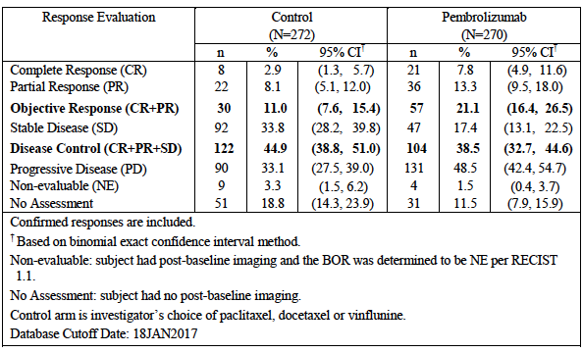
The ORR determined by site investigators was the same for the control arm, but they reported 6 more patients as having an ORR in the pembrolizumab arm. Response rates reported by central radiological review using mRECIST 1.1 criteria included an extra response in the control arm (32 patients) and an extra 11 patients in the pembrolizumab arm (68 patients).

ORR by subgroup factors
The ORR by subgroup analysis indicated a response rate that was similar for patients who had received 2 lines of prior chemotherapy (10% in the control, 10.9% in the pembrolizumab arm) while no responses were observed in the very few patients with ECOG-PS 2 PS in either arm.
Notably, use of the cut-point CPS ≥ 10% for PD-L1 expression yielded a similar ORR to <10% and to those deemed PD-L1 negative (see Table 38). The sponsor provided a p value for the observed difference between the ORR rates for patients with ≥ 10% of p=0.0002 but this was not corrected for multiplicity.
Comment: PD-L1 status does not predict response to treatment as measured by ORR in patients receiving pembrolizumab after disease progression on a platinum-based regimen.

Table 38: Study PN045 ORR based on RECIST 1.1 per central radiology assessment by subgroup factors point estimate and nominal 95% confidence interval all patients (ITT population)
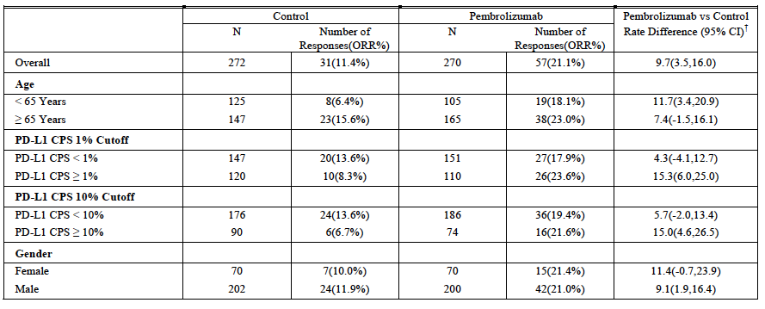
Of note, the ORR in patients by age revealed a higher response rate in those in the control arm in the 75-85 year age group than the overall population (see Table 39 below), and may reflect a chance finding. No data are available for comparison in those >85 years of age as none was randomised to receive chemotherapy.
Comment: Considerable uncertainty remains as to whether there is a benefit in this age group due to this unexpectedly high ORR. The duration of responses will be important but the small numbers may limit inferences.

Table 39: Study PN045 ORR based on RECIST 1.1 per central radiology assessment by subgroup factors point estimate and nominal 95% confidence interval; patients 75 years ≥ age> 85 years (ITT population)
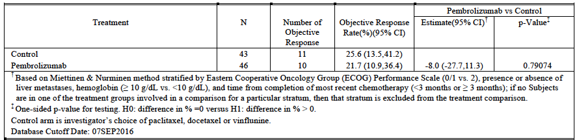

Time to response and response duration by central radiology assessment among all subjects
Time to response (TTR) was defined as the time from randomisation to the first assessment of a complete response (CR) or partial response (PR). Response duration was defined as the time from the first CR/PR to documented PD. Only confirmed CR/PRs were included in the analysis for TTR and response duration. Subjects who did not have PD were censored at the time of the last disease response assessment.
The median TTR for responders per Central Radiology Assessment was similar in the pembrolizumab (2.1 months, range: 1.4 to 6.3) and control (2.1 months, range: 1.7 to 4.9) arms.
Median DOR for the 57 subjects receiving pembrolizumab with confirmed CR/PR had not yet been reached at the time of data cut-off (range: 1.6+ to 15.6+ months), whereas median DOR for the 31 subjects receiving control with confirmed CR/PR was established at 4.3 months (range: 1.4+ to 15.4+ months).
Comment: The sponsor is requested to provide an updated median duration of response for both arms as the inclusion of ‘+’ suggests the data are immature. It would appear that the duration of responses to chemotherapy is shorter. (Clinical question)

Sponsor response
The sponsor presented an updated analysis (database lock 18 Jan 2017) of ORR and duration of response (DOR). The median duration of response with an additional follow-up of nearly 5 months, has still not been reached in the pembrolizumab arm compared with 4.4 months in the chemotherapy arm.

Evaluator Second round comment
Not only is the proportion of patients with a CR or PR greater in the pembrolizumab arm, but the duration of response is greater as indicated by those still responding at 6 months and 12 months.

Table 40: Study KN045 Summary of time to response and response duration based on RECIST 1.1 per central radiology assessment in patients with confirmed response – ITT population as of 18 Jan 2017
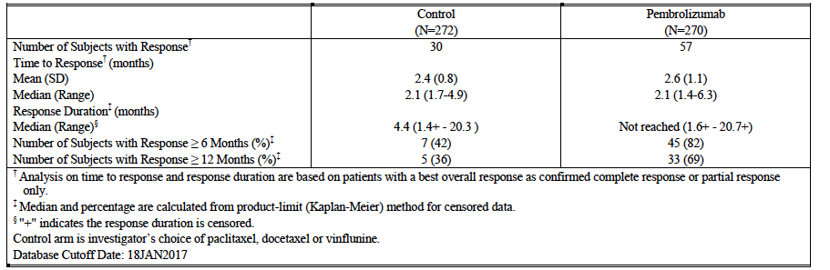

Progression-free survival per RECIST 1.1 by central radiology at 6 and 12 months among all subjects
In the ITT population at 6 months and 12 months of treatment, the PFS rate (95% CI) for the pembrolizumab arm was 28.8% (23.5, 34.3) compared with 26.8% (21.2, 32.6) in the control arm, and at 12 months, the PFS rate for the pembrolizumab arm was 16.8% (12 .3, 22 .0) compared with 6.2% (3.3, 10.2) in the control arm.
Comments: These data are based on estimates as the median duration of follow-up is approximately 10 months and should be interpreted with caution, particularly for the 12-month PFS rates. As such, these should not be included in the PI. (PI Comments)

Secondary and Supportive Endpoints—PD-L1 CPS ≥ 10% Population
Comment: All of the following analyses pertain to small numbers, and with PD-L1 not being a stratification factor, the numbers in each arm are not balanced with respect to prognostic factors, and may be affected more by the errors in the stratification factors at randomisation. Caution should be exercised in any interpretations.
Objective Response Rate per Confirmed RECIST 1.1 by Central Radiology Assessment among Subjects with PD-L1 CPS ≥ 10% - these are discussed above in the subgroup analysis for ORR.
Comment: Analyses of ORR by subgroups were presented but the small numbers, and the potential for misclassification of adverse prognostic factors at randomisation preclude any definitive statements or conclusions.
Best overall response rates were presented by central radiological assessment (see Table 41), site assessment and central assessment using modified RECIST.
Comment: Applying modified RECIST criteria increased disease control rate in both arms but to a greater extent in the pembrolizumab arm.

Evaluator Second round comment:
The rate of stable disease was much higher in the control arm, indicating a treatment effect and there were higher rates of progression in the pembrolizumab arm without apparent response. Balanced against this, the patients who did respond in the pembrolizumab arm have more durable responses. The proportion with ‘No assessment’ was higher in the control arm compared with the pembrolizumab arm, and indicates either no treatment at all, early discontinuation before a scan or lack of a baseline measurable disease.

Table 41: Study PN045 Best overall response based on RECIST 1.1 per Central radiology assessment, patients with PD-L1 CPS ≥ 10% (ITT population)
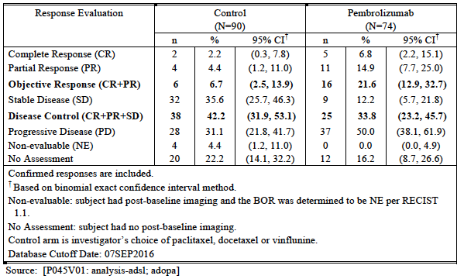
To date, there were 14 subjects with PD-L1 CPS ≥ 10% in the pembrolizumab arm and 1 subject in the control arm with responses ≥6 months, and 3 versus 0 with ongoing response at 12 months, respectively. However, the numbers small in both arms and the data appear to be immature with ongoing responses in both arms. Thus, although pembrolizumab appears to have longer response duration, few conclusions can be drawn about the time to response and duration of response in this subgroup at this time.

PFS at 6 and 2 months
Results showed that at 6 months, the PFS rate for the pembrolizumab arm was 24.7% compared with 18.5% in the control arm, and at 12 months, the PFS rate for the pembrolizumab arm was 17.7% compared with 3.7% in the control arm.

Secondary and Supportive Endpoints PD-L1 CPS ≥ 1% Population
Objective Response Rate per Confirmed RECIST 1.1 by Central Radiology Assessment among Subjects with PD-L1 CPS ≥ 1%
Confirmed ORR rates are provided in Table 42, and were similar when using modified RECIST (one less response in the control and 2 more in the pembrolizumab arm). Twenty patients were reported to have an ongoing response in the pembrolizumab arm compared with 4 in the control arm, with a median follow-up of 13.5 months (range 9.1-19.5).

Table 42: Study PN045 Objective response rates per confirmed RECIST 1.1 by central radiological assessment in patients with PD-L1 CPS ≥ 1%
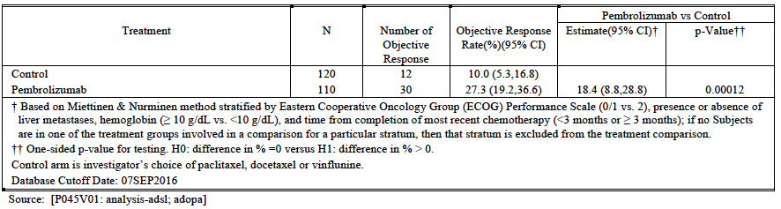
Subgroup analyses for ORR in patients with PD-L1≥ 1% were presented but the numbers are small, randomisation errors occurred for prognostic factors and few conclusions can be drawn.
A notable pattern was the serial decline in response rates with increasing risk score, and the poor outcomes in never smokers and those treated within 3 months (although errors occurred in this stratification factor data which limit interpretations).
Comment: These findings mirrored the overall population, which further suggests that selection by PD-L1 expression status does not enrich or overcome negative prognostic factors.
Best overall response (BOR) rates by RECIST 1.1 were comparable to those reported for a PD-L1 CPS ≥ 10% and are presented in, below. These demonstrate that these are maintained and appear independent of the PD-L1 positive cut-off used.
The sponsor is requested to provide the BOR rates for the PD-L1 negative patients in the study. (Clinical question); see Table 43 copied from sponsor’s response, below.

Table 43: Study PN045 Best overall response based on RECIST 1.1 by central radiological assessment in patients with PD-L1 CPS ≥ 1% ITT population
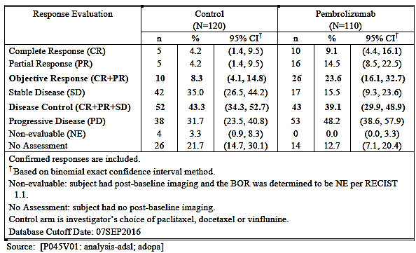

Evaluator second round comment
The ORR is higher in the pembrolizumab arm is higher, while the disease control rate is higher in the chemotherapy arm (43.3% versus 39.1%), due to the substantially greater number of patients experiencing stable disease with chemotherapy than pembrolizumab (35% versus 15.5%). The ORR translates in to better long term control and this is seen in the improved median OS in the pembrolizumab arm. It is noteworthy that there is an increase in early progression or death in the pembrolizumab arm, but no clear group can be identified amongst those with early progression or death to predict those most at risk (discussed above).

Table 44: Study KN045 Summary of best overall response based on RECIST 1.1 per central radiology assessment, patients with PD-L1 CPS<1% (ITT population)
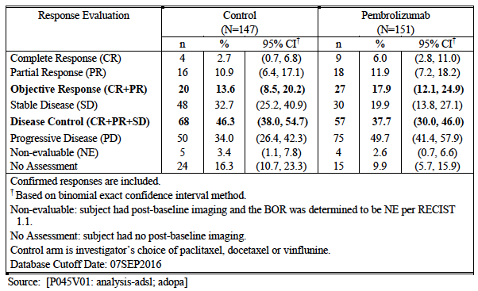

Evaluator second round comment
Notably, similar to the other PD-L1 cut-offs used, the disease control rate (which includes stable disease) was greater with chemotherapy than pembrolizumab for this PD-L1 <1% cohort due to the increase in stable disease. A modest improvement in ORR was observed and while numerically increased, the median OS difference was not significantly improved in the pembrolizumab arm. Imbalances in prognostic factors may also contribute to these findings, as PD-L1 status was not a stratification factor, and therefore hypotheses, rather than conclusions can be made from these analyses.

Exploratory endpoints

Patient reported outcome analyses
Patient-reported outcomes (PRO) based on EORTC QLQ-30 and the eEuroQoL-5D [eEQ-5D] questionnaires were presented. The primary analysis approach for the pre-specified PRO endpoints was based on a quality-of-life-related full analysis set (FAS) population, which consists of all randomised subjects who received at least 1 dose of study treatment, and had completed at least 1 PRO assessment.

EORTC QLQ-30 and EQ-5D compliance rate and completion rate
In the PRO FAS population, there were 266 subjects in the pembrolizumab arm and 254 subjects in the control arm. Baseline completion rates were similar for both questionnaires in the pembrolizumab and control arms (97.7% versus 95.7%), decreased to 78.3% and 80.8% by Week 6 and 69.3% and 75.2% by Week 9, respectively. Week 9 is the first scheduled visit for assessing radiological response, and by week 15 only 46.5% and 50% provided responses to the sponsor, mostly due to ‘Missing by Design’ reasons of discontinuation. Similar numbers had experienced disease progression and this would have made informative reading as to how these patients were functioning.
At Week 21, only 32.7% and 53.8% in the control and pembrolizumab arms were expected to be available due to discontinuations or death.

EORTC QLQ-C30 analyses and eEuroQol- SD analysis

EORTC QLQ-C-30
Baseline global health status/QoL scores were similar between treatment arms. Analyses, not controlled for multiplicity, are presented for Weeks 9 and 15 in the tables below.
A mean difference of 10 points or more has been widely viewed as being clinically significant when interpreting the results of randomised trials employing EORTC QLQ-C30, although none was pre-specified in the SAP, which outlined only very general strategies for the analysis. Details were also not provided in the SAP as to how imputations for missing data within questionnaires would be handled. The mean difference and the LS mean difference for the change in baseline does not reach 10 for either time point.

Table 45: Study PN045 Analysis of change from baseline EORTC QLQ-C30 global health status/QoL at week 9 (FAS population)
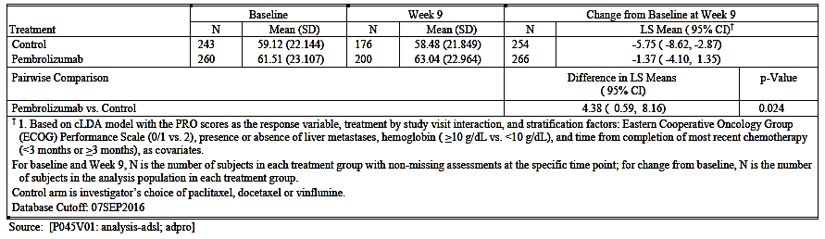

Table 46: Study PN045 Analysis of change from baseline EORTC QLQ-C30 global health status/QoL at week 15 (FAS population)
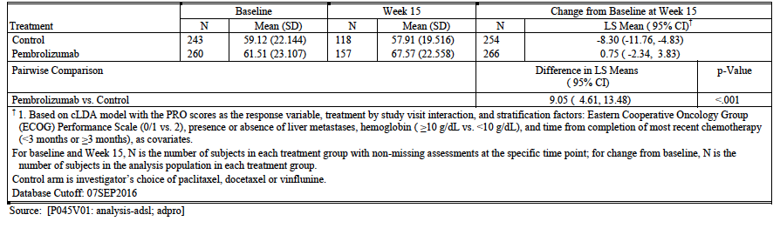

EQ-5D
The EQ-5D utility and visual analogue scores were presented across a range of tables. With no clinically meaningful difference pre-specified, few conclusions can be drawn.
Comment on HRQoL data:
- Large amounts of missing data from Week 9 onwards limit the assessment reduce the power to detect significant differences, and no meaningful differences were noted in the mean scores prior to that. A significant proportion of patients had discontinued by Week 15, and the impact is uncertain for the many patients would have been awaiting confirmatory scans after the Week 9 assessment to determine progression and continuation. A clinically meaningful difference was not pre-specified in the sSAP, which also does not explain clearly how missing data within the questionnaires would be imputed. The effect on patient reported outcomes cannot be determined, and all statements should be removed from the PI. (PI Comments)

Evaluator commentary
Keynote 045 is an ongoing, multicentre, randomised international trial following an adaptive design, designed to investigate whether pembrolizumab is superior to investigator’s choice of any one of three cytotoxic drugs in locally advanced/metastatic urothelial cancer that had previously been treated with a platinum-containing regimen. The intention to treat population of 542 was modestly in excess of planned recruitment, and the cut-off date does not conform to the pre-specified event rate for either the IA2 or final study report. It is likely that the number of deaths specified for the final report to be generated will have been reached in the intervening months (370). Some of the endpoints, in particular the duration of response data and OS data were immature in terms of describing the extent of clinical benefit in those with an ORR demonstrated with pembrolizumab compared with chemotherapy.
Randomisation was based upon factors (ECOG-PS 0/1 versus 2, Hb<10g/l, liver metastases, prior chemotherapy within 3 months), which differ from those determined from earlier chemotherapy studies by Bellmunt et al (2010) (Hb<10g/l, ECOG-PS >0 and liver metastases); the source of the ‘Bellmunt risk score’ used in the subgroup analyses of the data was not referenced nor the factors making up that score provided. Given the authors’ own concerns about the generalizability of these factors for other therapies, these may not be valid for use with an immunotherapy. Errors within the stratification data reported for randomisation occurred in 31 patients, were described incompletely (no presentation by treatment allocation) and were not corrected or analysed for potential impact in sensitivity analyses. The potential effect of further prognostic factor imbalances is greatest for the subsequently introduced analyses of subgroups by PD-L1 expression as this was not a stratification factor, numbers are small and already unequal in each arm and prognostic factor imbalances may already be present. Sensitivity analyses, correcting misallocation at randomisation have been requested. Overall, aside from these uncertainties, randomisation achieved good balance between the control and pembrolizumab arms.
The inclusion criteria were very restrictive for patients with ECOG-PS 2, with additional constraints resulting in only six patients entering the trial, five of whom were treated. This is inadequate to demonstrate safety and efficacy for the proposed usage in this higher risk population and the Evaluators have made recommendations for alterations to the existing draft PI text to ensure this is clearly and accurately communicated. It should be noted that, while the study population broadly reflected clinical practice as to demographics, distribution and burden of disease, and prior treatment, important groups were excluded from study, notably those with creatinine clearance <30 mL/min and those with ECOG-PS >2.
Major protocol violations were not notable for their frequency and are not likely to be significant for outcome.
Serial protocol modifications were made during the course of the study (after commencement of recruitment) relating to the inclusion (Amendment 4), and analysis and interpretation (Amendments 4 and 13) of PD-L1 expression as a marker of response, based on external data. New objectives and hypotheses and primary efficacy variables were generated in the Protocol Amendments and SAP relating to PD-L1 expression levels, in addition to retaining those for the population as a whole irrespective of PD-L1 status. This elevation to a primary endpoint status provided the option to apply for registration if any of six planned primary efficacy analyses and hypotheses being tested, generated statistically significant results. These changes did not appear to affect the clinical conduct of the trial nor the principal positive outcome in the whole patient group, of improved overall survival (median 10.3 versus 7.4 months) with pembrolizumab.
Median overall survival is longer at 10.3 months in the pembrolizumab arm compared with 7.4 months for the control arm, albeit with overlapping confidence intervals but supported by a favourable hazard ratio and p value. There is a perceptible flattening in the pembrolizumab arm in the Kaplan Meier plot but heavy censoring occurred around the 10 month point as the data are still immature, and the shape of the K-M curve beyond this is an estimate requiring confirmation with longer-term follow-up. The median progression-free survival was shorter with pembrolizumab and there was a transient trend to excess of disease progression and death in the first 3 months approximately, but thereafter PFS improves in the pembrolizumab arm with flattening of the pembrolizumab Kaplan-Meier curves, and the suggestion of a survival plateau, as has been seen with anti-PD-1 immunotherapies in studies of other tumour types including melanoma and bronchogenic carcinoma. Of secondary and exploratory endpoints, median time to response was not significantly different between the pembrolizumab and control arms but the range was greater in the pembrolizumab arm indicating a greater time taken to achieve a maximal treatment effect. This delayed effect may explain the poorer outcomes identified in those with more aggressive disease, and inclusion of a PI statement has been recommended to reflect this. Unconfirmed response rates were high in both arms; 54.5% in the pembrolizumab and 58.5% in the chemotherapy arms, but the depth of response as measured by objective response rate (CR and PR) favours pembrolizumab. Data for the duration of response are still immature in the pembrolizumab arm, but the median has been reached in the chemotherapy arm and indicates that responses are maintained longer in pembrolizumab.
These data confirm that urothelial carcinoma is still chemo-sensitive in more than half of the population, but observed responses are minor and with the occasional exception, short-lived; this accounts for the later separation of the PFS and OS curves, as these patients relapse and die earlier.
Subgroup analyses that raise but do not answer clinical questions are (a) the improved OS with pembrolizumab in White or non-East Asian subjects, (b) improved OS with pembrolizumab in past or current smokers (c) improved OS with pembrolizumab for a group of parameters that could be markers of lower disease burden or less aggressive disease: Hb >10 g/dL, absence of liver metastases, >3months since prior therapy, less than median baseline tumour volume. The consistently poorer outcomes with pembrolizumab treatment in all subgroup analyses of never smokers, those with more recently or more heavily pre-treated disease has potentially identified poor prognostic groups for treatment with immunotherapy in this population. There are biologically plausible rationales to explain these observations: potentially lower mutational load in non-smokers, and insufficient time to generate a response in those with more aggressive disease. Consideration to making these stratification factors in future studies is recommended. These outcomes did not appear to be modified by using either the absolute or differing expression level of PD-L1 expression status as a biomarker of response.
Thus, although an OS improvement becomes apparent after 6 months for some patients, it is likely that there is a subgroup of patients who are disadvantaged by the choice of pembrolizumab over chemotherapy, and are at higher risk of early progression with the former. There is a suggestion that rapidly progressing disease and high tumour burden are features of this group. The currently presented data do not support use of PD-L1 as a predictive biomarker in this population, and raise uncertainties in interpretation of PD-L1-selected outcomes for patients in Study PN052.

PD-L1 as a biomarker in previously treated UC
The role of PD-L1 as a biomarker for selecting patients with UC who might benefit from pembrolizumab rather than chemotherapy remains unclear. This was included in the study design after commencement of enrolment based on data external to the trial, and therefore was not a stratification factor. This is a significant weakness as imbalances in numbers as well as for other prognostic factors is likely to introduce bias into any findings.
Observed ORRs based on central radiological review stratified by negative, positive and CPS ≥ 10% cut-offs were 17.9%, 23.6% and 21.6%, respectively; this suggests selection by PD-L1 expression level does not result in a clinically meaningful enrichment of response rates, and that the treatment effect might even be largely independent of PD-L1 expression as measured using the PD-L1 IHC 22C3 pharmDx assay (Dako). Results stratified for strength of PD-L1 expression yielded very similar best overall response rates across the subgroups (CR, PR and SD) in those PD-L1 ≥ 1% or ≥ 10%, but data were not presented for those with tumours negative for PD-L1 expression (Clinical question).
Of note, a shorter median OS was observed in those whose tumours expressed higher levels of PD-L1 (CPS ≥ 10%) in both the chemotherapy and the pembrolizumab arms, compared with the respective arms for the population as a whole unselected by PD-L1 status. The sponsor has suggested that higher PD-L1 expression may be a poor prognostic factor but this requires prospective assessment and validation in a trial adequately powered to identify differences between those who are PD-L1 negative and PD-L1 ≥ 10%. If it transpires that PD-L1 expression is a negative prognostic factor in UC, it is noteworthy that PD-1 blockade was not able to abrogate this apparent effect.
Pembrolizumab appears to result in improved OS and similar PFS profile within the PD-L1 positive subgroups compared with chemotherapy and the contours of the Kaplan Meier curves for these groups broadly conform to those of the overall group. The initial excess PFS and OS events in the pembrolizumab arms in the first few months appear to be followed by a plateau in the pembrolizumab arm. For patients with tumours expressing PD-L1 <1% (deemed negative), the improved HR for OS falls short of statistical significance (HR 0.89, interval 0.66 to 1.20) as shown in the Forest plot (Figure 11). However, there are responses within this population, and this may reflect the limitations of non-pre-specified subgroup analyses, particularly in an adaptive study design where the discriminating factor is introduced for analysis without stratification for other poor prognostic factors.
In contrast to PD-L1 positive subjects, limited data have been presented for the PD-L1 negative group and tabulated OS, PFS and BOR data and Kaplan Meier OS and PFS curves should be made available. (Clinical question).
It is noted that in Report 04K3WW, which presented the training set data used to establish the CPS 10% cut-off, it is stated that the populations enrolled into two further studies in bladder cancer (Keynote-057 and Keynote -0361) are not to be selected on the basis of PD-L1 CPS expression. It was not clear if this would be a stratification factor within these trials.

Pivotal or main efficacy study Indication 2

Treatment of patients with locally advanced or metastatic urothelial carcinoma who are not eligible for cisplatin-containing chemotherapy

Study PN052 Phase II non-randomised, open label trial in patients who have received no prior systemic therapy and who are ineligible for cisplatin chemotherapy (200 mg Q3W)

Study design, objectives, locations and dates
KEYNOTE-052 was a non-randomised, multi-site, open-label trial of pembrolizumab in subjects with advanced/unresectable (inoperable) or metastatic urothelial carcinoma, who have not received prior systemic chemotherapy (that is, first line) and who are not eligible to receive cisplatin. Prior neoadjuvant/adjuvant platinum based chemotherapy, with recurrence >12 months from completion of the prior therapy, was permitted.
Subjects were administered pembrolizumab 200 mg intravenously every 3 weeks (Q3W).
Comment: This study followed an adaptive design, with protocol amendments ‘based on the routine review of accumulating data’ leading to changes in the trial objectives.
Figure 13: Study PN-052 design
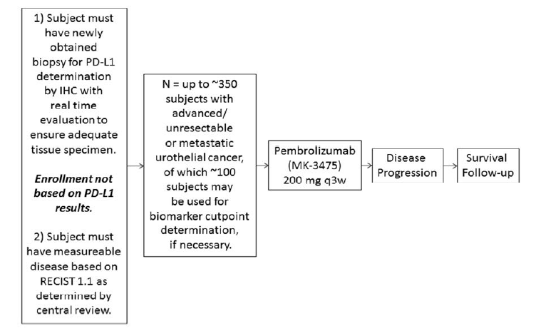

Primary objectives
To evaluate anti-tumour activity of pembrolizumab as first line therapy by:
- ORR based on RECIST 1.1 by independent radiology review in all subjects.
- ORR based on RECIST 1.1 by independent radiology review in subjects whose tumours are PD-L1 positive (CPS ≥ 1%).
- ORR based on RECIST 1.1 by independent radiology review in validation cohort subjects whose tumours are PD-L1 strongly positive (CPS cut-point to be determined in biomarker discovery population – if no cut-point identified, then efficacy objectives for ‘strongly positive’ will not be pursued)
Comment: There is no plan to present data separately for patients whose tumours have a CPS of <1%. These patients’ results will be subsumed within those of the entire study population. This does not allow an adequate assessment as to whether PD-L1 is a useful marker in urothelial carcinoma. The evaluator considers that the comparisons should be for those with a CPS of <1%, ≥ 1% to <10% and ≥ 10%. This is requested for all endpoints. (Clinical question)

Secondary objectives
- To evaluate the anti-tumour activity of pembrolizumab as first line therapy in all subjects, in CPS ≥ 1% subjects, and in strongly positive subjects from the validation cohort:
  - By DOR based on RECIST 1.1 by independent radiology review
  - By PFS based on RECIST 1.1 by independent radiology review and overall survival (OS)
  - By PFS rate based on RECIST 1.1 by independent radiology review and OS rate at 6 and 12 months
- To establish a cut point for PD-L1 strongly positive status if this is not determined by other biomarker discovery populations, and to investigate the association between PD-L1 protein expression by IHC and anti-tumour activity.
- To determine the safety and tolerability of pembrolizumab as first line therapy.
Comment: A biopsy following completion of any prior systemic treatment was required but Protocol Amendment 02 removed the requirement for it to be done within 56 days of study commencement, to no specific time requirement. The reliability and quality of results obtained by PD-L1 IHC assessment due to sample degradation are known to deteriorate with time, particularly beyond 6 months.

Exploratory objectives and hypotheses
In subjects with advanced/unresectable or metastatic urothelial carcinoma who are ineligible to receive cisplatin-based therapy:
- To investigate the relationship between candidate efficacy/resistance biomarkers and anti-tumour activity of pembrolizumab utilizing pre- and post-treatment tumour biopsies and blood sampling in PD-L1 strongly positive, PD-L1 positive, and all subjects, respectively.
- To explore the pharmacokinetic (PK) profile of pembrolizumab 200 mg every 3 weeks (Q3W) as 1L therapy in PD-L1 strongly positive, PD-L1 positive, and all subjects, respectively.
- To evaluate changes in health-related quality-of-life assessments from baseline using the European Organization for Research and Treatment of Cancer Quality of Life Questionnaire Core 30 items (EORTC QLQ-C30), in PD-L1 strongly positive, PD-L1 positive, and all subjects, respectively.
- To characterise utilities using the European Quality of Life Five Dimensions Questionnaire [EQ-5D], in PD-L1 strongly positive, PD-L1 positive, and all subjects, respectively.
- To evaluate anti-tumour activity of pembrolizumab as 1L therapy in PD-L1 strongly positive, PD-L1 positive, and all subjects by ORR, DOR and PFS based on modified RECIST 1.1 by independent radiology review.
Comment: This population is regarded as incurable and treatments with palliative intent should examine quality of life as a primary or secondary endpoint. This is particularly important in a single arm trial using a surrogate endpoint where other more established and accepted endpoints such as OS may not yet be reported due to immaturity of the data.
This trial was conducted at 77 centres, all of which had subjects enrolled and treated with pembrolizumab. Twenty-eight of these centres were in the United States; 9 in Spain; 8 in Canada; 5 in Israel; 4 each in Hungary and the United Kingdom; 3 each in Italy and the Republic of Korea; 2 each in Denmark, Guatemala, Singapore and Taiwan; and 1 each in Australia, Ireland, Malaysia, Netherlands, and Puerto Rico.
The trial commenced on 20 April 2015, and is ongoing. This is an interim report, dated 02 December 2016, with a data cut-off date of 1 September 2016.

Inclusion criteria
- Be willing and able to provide written informed consent/assent for the trial. The subject may also provide consent/assent for Future Biomedical Research. However, the subject may participate in the main trial without participating in Future Biomedical Research.
- Be ≥ 18 years of age on day of signing informed consent.
- Have histologically or cytologically-confirmed diagnosis of advanced/unresectable (inoperable) or metastatic urothelial cancer of the renal pelvis, ureter, bladder, or urethra. Both transitional cell and mixed transitional/non-transitional cell histologies are allowed. Subjects with non-urothelial cancer of the urinary tract are not allowed.
- Be considered cisplatin-ineligible to receive cisplatin-based combination therapy, based on having at least one of the following criteria:
  - Eastern Cooperative Oncology Group (ECOG) performance status (PS) of 2 (the proportion of ECOG-PS 2 subjects will be limited to approximately 50% of the total population)
  - Creatinine clearance (calculated or measured) <60 mL/min but ≥30 mL/min
  - Note: Subjects with a creatinine clearance (calculated or measured) < 30 mL/min or on dialysis are excluded from the trial.
  - CTCAE v.4, Grade ≥2 audiometric hearing loss (25dB in two consecutive wave ranges)
  - CTCAE v.4, Grade ≥2 peripheral neuropathy
  - New York Heart Association (NYHA) Class III heart failure
- Have received no prior systemic chemotherapy for advanced/unresectable (inoperable) or metastatic urothelial cancer.
  - Adjuvant platinum based chemotherapy, following radial cystectomy, with recurrence 12 months from completion of therapy is permitted.
  - Neoadjuvant platinum based chemotherapy, with recurrence > 12 months since completion of therapy is permitted.
Note: Low-dose chemotherapy (for example, low dose cisplatin, cisplatin+5FU, mytomycin+5FU, or cisplatin+paclitaxel) given concurrent with radiation to the primary tumour site is not considered as systemic therapy.
- Have provided tissue for biomarker analysis from a newly obtained core or excisional biopsy of a tumour lesion not previously irradiated (mandatory). Adequacy of the biopsy specimen for PD-L1 biomarker analysis must be confirmed by the central laboratory.
- Have measureable disease based on RECIST 1.1 as determined by central review. Tumour lesions situated in a previously irradiated area are considered measureable if progression has been demonstrated in such lesions.
- Have a performance status of 0, 1 or 2 on the ECOG Performance Scale, as assessed within 10 days prior to treatment initiation.
- Demonstrate adequate organ function. All screening labs should be performed within 10 days of treatment initiation.
- Female subject of childbearing potential must have a negative urine or serum pregnancy test within 72 hours prior to receiving the first dose of study medication. If the urine test is positive or cannot be confirmed as negative, a serum pregnancy test will be required.
- Female subjects of childbearing potential must be willing to use 2 methods of birth control or be surgically sterile, or abstain from heterosexual activity for the course of the study through 120 days after the last dose of study medication. Subjects of childbearing potential are those who have not been surgically sterilized or have not been free from menses for >1 year.*
- Male subjects must agree to use an adequate method of contraception starting with the first dose of study therapy through 120 days after the last dose of study therapy.*
*Note: Abstinence is acceptable if this is the usual lifestyle and preferred contraception for the subject.

Exclusion criteria
The subject must be excluded from participating in the trial if the subject:
- Has disease that is suitable for local therapy administered with curative intent.
- Is currently participating and receiving study therapy or has participated in a study of an investigational agent and received study therapy or used an investigational device within 4 weeks prior to the first dose of treatment.
- Has had a prior anti-cancer monoclonal antibody (mAb) for direct anti-neoplastic treatment within 4 weeks prior to study Day 1 or who has not recovered (that is, ≤ Grade 1 or at baseline) from adverse events due to agents administered more than 4 weeks earlier.
- Has had prior chemotherapy, targeted small molecule therapy, or radiation therapy within 2 weeks prior to study Day 1 or who has not recovered (that is, ≤ Grade 1 or at baseline) from adverse events due to a previously administered agent.
- Note: Subjects with neuropathy or ≤ Grade 2 alopecia are an exception to this criterion and may qualify for the study.
- Note: If subject received major surgery, they must have recovered adequately from the toxicity and/or complications from the intervention prior to starting therapy.
- Has a known additional malignancy that is progressing or requires active treatment. Exceptions include basal cell carcinoma of the skin, squamous cell carcinoma of the skin that has undergone potentially curative therapy or in situ cervical cancer. A history of prostate cancer that was identified incidentally following cystoprostatectomy for bladder cancer is acceptable, provided that the following criteria are met: stage T2N0M0 or lower; and Gleason score ≤6, and undetectable prostate specific antigen (PSA).
- Has known active central nervous system (CNS) metastases and/or carcinomatous meningitis. Subjects with previously treated brain metastases may participate provided they are stable [without evidence of progression by imaging (confirmed by computerized tomography (CT) scan if CT used at prior imaging, or confirmed by magnetic resonance imaging (MRI) if MRI was used at prior imaging) for at least four weeks prior to the first dose of trial treatment and any neurologic symptoms have returned to baseline], have no evidence of new or enlarging brain metastases, and are not using steroids for at least 7 days prior to trial treatment. This exception does not include carcinomatous meningitis which is excluded regardless of clinical stability.
- Has an active autoimmune disease that has required systemic treatment in past 2 years (that is, with use of disease modifying agents, corticosteroids or immunosuppressive drugs). Replacement therapy (for example, thyroxine, insulin, or physiologic corticosteroid replacement therapy for adrenal or pituitary insufficiency, etc.) is not considered a form of systemic treatment.
- Has evidence of interstitial lung disease or active non-infectious pneumonitis.
- Has an active infection requiring systemic therapy.
- Has a history or current evidence of any condition, therapy, or laboratory abnormality that might confound the results of the trial, interfere with the subject’s participation for the full duration of the trial, or is not in the best interest of the subject to participate, in the opinion of the treating investigator.
- Has known psychiatric or substance abuse disorders that would interfere with cooperation with the requirements of the trial.
- Is pregnant or breastfeeding, or expecting to conceive or father children within the projected duration of the trial, starting with the screening visit through 120 days after the last dose of trial treatment.
- Has received prior therapy with an anti-PD-1, anti-PD-L1, or anti-PD-L2 agent, or with an agent directed to another co-inhibitory T-cell receptor (for example, CTLA-4, OX-40 or CD137).
- Has a known history of Human Immunodeficiency Virus (HIV) (HIV-1/2 antibodies).
- Has known active Hepatitis B (for example, HBsAg reactive) or Hepatitis C (for example, HCV RNA [qualitative] is detected).
- Has received a live virus vaccine within 30 days of planned start of trial treatment.
- Is or has an immediate family member (for example, spouse, parent/legal guardian, sibling or child) who is investigational site or Applicant staff directly involved with this trial, unless prospective IRB approval (by chair or designee) is given allowing exception to this criterion for a specific subject.
Comment: The inclusion and exclusion criteria are appropriate for the study aims.

Study treatments
200 mg pembrolizumab Q3W was administered intravenously on Day 1 of each cycle until progressive disease (see below for clarification), intolerance or withdrawal of consent.
Rules for determining and defining radiological progression are included in Table 47. If a subject with confirmed radiographic progression (that is, 2 scans at least 28 days apart demonstrating progressive disease) is clinically stable or clinically improved, and there is no further increase in the tumour dimensions at the confirmatory scan (as assessed by the investigator/site radiologist), an exception may be considered to continue treatment upon consultation with the sponsor.

Table 47: Imaging and treatment after first radiologic evidence of PD
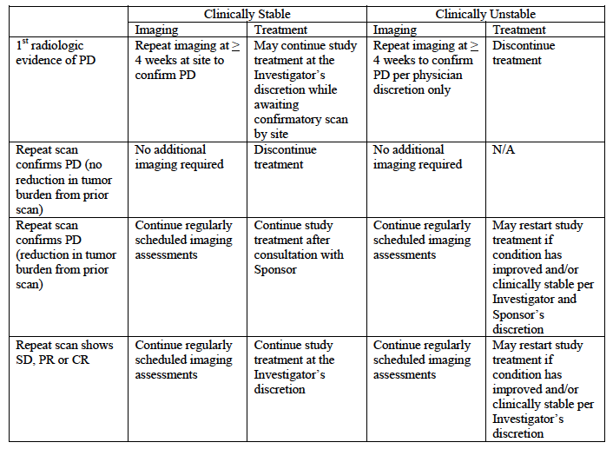
Discontinuation of treatment may be considered for subjects who have attained a confirmed CR that have been treated for at least 24 weeks with pembrolizumab (MK-3475) and had at least two treatments with pembrolizumab (MK-3475) beyond the date when the initial CR was declared. Subjects who then experience radiographic disease progression may be eligible for up to one year of additional treatment with pembrolizumab (MK-3475) at the discretion of the investigator if no cancer treatment was administered since the last dose of pembrolizumab (MK-3475), the subject meets the safety parameters listed in the Inclusion/Exclusion criteria, and the trial is open. Subjects will resume therapy at the same dose and schedule at the time of initial discontinuation. Response or progression in this Second Course Phase will not count towards the ORR as the primary endpoint in this trial.
Comments:
- These stopping rules are included for completion but no patients in this study have reached that time point due to this being an interim report.
- Whether pseudoprogression is observed in patients with urothelial carcinoma treated with PD-1 inhibitors is not yet known. It is extremely uncommon in NSCLC and squamous cell carcinoma of the head and neck, but observed in melanoma and renal cell carcinoma. The sponsor is requested to provide the numbers, duration of treatment beyond progression (median, range) and outcomes for all patients who continued treatment beyond initial documented progression in Studies PN052 and PN045. The sponsor is requested to state whether the subsequent scans were assessed by blinded independent central review. (Clinical question)

Efficacy variables and outcomes
The final Study Protocol version 02 states, ‘Imaging should be performed at 9 weeks (63 ± 7 days) after the first dose of trial treatment on Day 1 Cycle 1, and every 6 weeks thereafter (42 days ± 7 days) regardless of any treatment delays. After 12 months, imaging frequency should be reduced to every 12 weeks (84 ± 7 days).’

Primary endpoint
ORR Objective response rate per RECIST 1.1 as assessed by BICR, defined as the percentage of subjects having a complete response (CR) or partial response (PR) during the trial.

Secondary endpoints
- Duration of response per modified RECIST as assessed by BICR, defined as time from first RECIST 1.1 response to disease progression in subjects who achieve a PR or CR.
- PFS and OS
  - Progression free survival per RECIST 1.1 as assessed by BICR, the time from first dose to the first documented disease progression according to RECIST 1.1 or death due to any cause, whichever occurs first.
  - Overall survival, vital status of subjects individually expressed in units of time from the start of study therapy and / or the percentage of subjects alive at a given time point when expressed as an aggregate.
- PFS and OS rate
  - Progression free survival rate, based on RECIST 1.1 as assessed by BICR, and OS rate at 6 and 12 months.
- CPS strongly positive cut point
  - Extracellular PD-L1 expression level among tumour and immune cells within the tumour microenvironment will be characterized by IHC and explored in relation to therapeutic efficacy with pembrolizumab.
Amendment 02, dated 11 March 2016 of the Clinical Study Protocol changed RECIST 1.1 to modified RECIST (with a set of modifications as developed by the sponsor).
Comment: The sponsor states there was a protocol change to clarify that modified RECIST 1.1 were being used but the CSR and Protocol Version 02 still refer to RECIST 1.1 being used for central radiological determination of the endpoints. The sponsor is requested to clarify to which endpoints the modified RECIST applies, and provide the modifications.

Sponsor response
During the course of the evaluation, there were some uncertainties regarding the use of the term ‘confirmed’ response when reporting the primary and key secondary efficacy endpoints (see Section Clinical questions 16, 17 and 18 for Study KN052 for further details).
The sponsor has clarified as follows: ‘The term ‘confirmed’ is used throughout the CSR and CTD to refer to the need for verification of radiographic responses with a set of scans performed at a subsequent time-point. This is a RECIST 1.1 guideline for single-arm phase 2 clinical trials. All objective response rate (ORR) tables included in the CSR and CTD reported only confirmed responses unless otherwise specified.’

Randomisation and blinding methods
This was an open label trial so there was no randomisation or blinding to treatment allocation.

Statistical analysis plan

Efficacy analyses
The SAP, in the Clinical Study Protocol v2 states, ‘Efficacy will be available for PD-L1 strongly positive subjects, PD-L1 positive subjects, and all subjects. The first 100 study subjects (biomarker discovery population) will be evaluated for biomarker cut-point determination. The biomarker discovery population will be excluded from the primary and secondary objectives for the PD-L1 strongly positive subjects.’
This is further clarified as follows in the Statistical Analysis Plan, section 8.2.4.1 version 2 of the Clinical Study protocol: ‘The biomarker discovery population, subjects in this trial used for the determination of the PD-L1 strongly positive cut-point, will be excluded from efficacy analyses for the PD-L1 strongly positive population. These subjects will still be included in the efficacy analyses for all and PD-L1 positive subjects.
Comment: The evaluator believes the Biomarker Discovery population should have been kept separate from the entire analysis of efficacy as this cannot be a validation set if it includes any of the patients whose outcomes were already known and determined statistically within that cohort to be superior. Such an approach favours a demonstration of efficacy in the PD-L1>1% population and given it was established that there was a differential between the ≥ 1% and ≥ 10% marks, this represents a source of bias. The validation cohorts and biomarker cohorts should be kept entirely separate.
For the primary efficacy endpoint, the ORR based on modified RECIST by independent radiology review, the point estimate, 95% confidence interval (as determined by the upper and lower 97.5% one-sided confidence bounds), and p-value for testing the null hypothesis that RECIST 1.1 ORR is no greater than 30% will be provided using an exact binomial distribution. Subjects without response data will be counted as non-responders.
Comment:
- The sponsor stated in version 2 of the SAP that there are no hypotheses being tested and this is an exploratory study making an estimation of the efficacy of pembrolizumab in urothelial carcinoma.
- This is stated to be an interim report but a definition of the time point of events required to be able to prepare the final CSR could not be located. The sponsor is requested to clarify when the study is deemed complete and what are the requirements with respect to events or time for preparation of the final study report (Clinical question).

Sponsor response
See Table 48 below provided in the sponsor’s response. A final study report will be written when all responders in KN052 have had an opportunity for at least two years of follow-up. This milestone is anticipated in 2Q 2019.
Comment: The evaluator recommends that if this indication is approved, that submission of this report to the TGA upon completion be required.

Table 48: KN052 Formal database locks and interim analysis
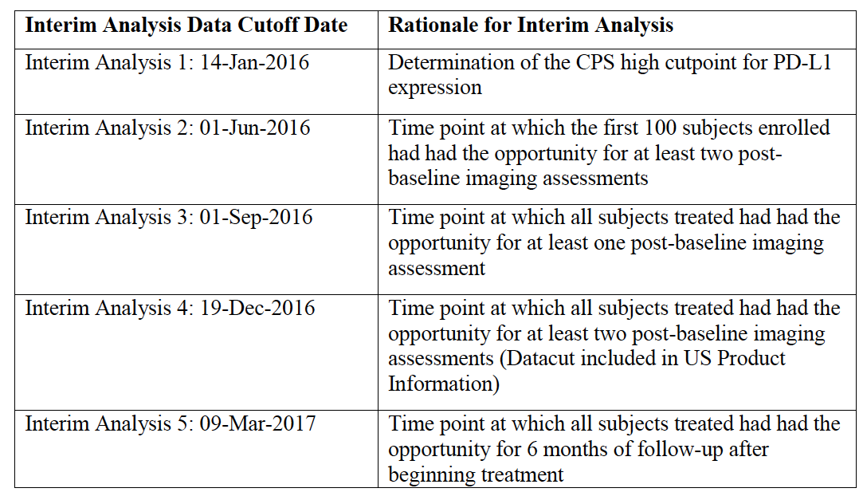
Duration of responses (DOR) based on RECIST 1.1 by independent radiology review will be summarised descriptively using Kaplan-Meier medians and quartiles. Only the subset of subjects who show a complete response or partial response will be included in this analysis.
For PFS and OS, Kaplan-Meier (KM) curves, median estimates, and survival at 6 and 12 months based on the KM curves (95% CI is based on Greenwood's formula) will be provided as appropriate. Subjects without efficacy evaluation data or without survival data will be censored at Day 1.

Table 49: Study PN052 Analysis strategy for efficacy endpoints
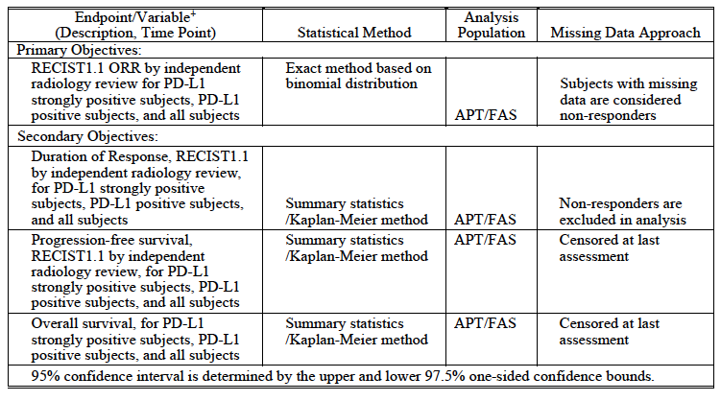
Comment: The evolving study design can be seen with the difference in the primary objectives between the revised (see Table 49) and initial protocol (see Table 50).

Table 50: Study PN052 Analysis strategy for efficacy endpoints
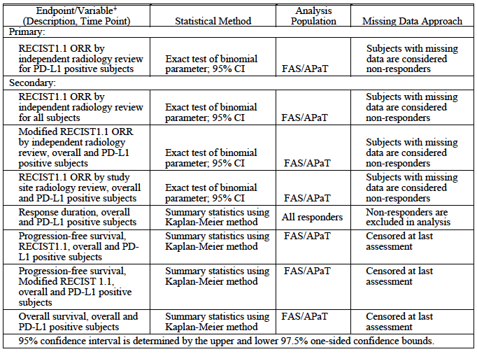

Safety analyses
Safety and tolerability will be assessed by clinical review of all relevant parameters including adverse experiences (AEs), laboratory tests, and vital signs. Summary statistics (counts, percentage, mean, standard deviation, etc.) will be provided for the safety endpoints as appropriate. The 95% confidence interval for the incidence rate of Grade 2 or higher adverse events with an immune etiology and the incidence rate of Grade 3-5 AEs will be provided.
Comment: Combining AEs of Grade 3-5 incorporates as a single figure, AEs with vastly different severity and outcomes. Events of Grade 3/4 severity can be incorporated but deaths should be presented separately. The proposed approach is not supported.

Biomarker discovery population
The biomarker analysis will be based on all subjects within the first 100 enrolled by time that are deemed clinically evaluable, which is defined as any subjects who received at least one dose of study drug and had Week 9 and Week 15 scans, or discontinued due to radiographic/clinical progression or death before reaching Week 15. The biomarker discovery population will be identified through routine review of accumulating data.
Comment: There is a potential source of bias, in an open label single arm study in that patients who are not responding at all might progress or deteriorate clinically prior to the Week 9 scan, or not receive a Week 15 scan but still be alive and hence not eligible for inclusion in any PD-L1 analyses.
The evaluation of a general positive association between CPS and ORR will be investigated via standard logistic regression as well as generalized additive models. The potential to achieve a cut-off greater than CPS = 1% for defining a PD-L1 strongly positive population will involve a review of how the positive predictive value (PPV, response rate in those above a cut-off), negative predictive value (NPV, non-response rate in those below the cut-off), and fraction of patients defined as strongly positive change as a function of increasing cut-offs and whether there is evidence for a relative improvement in clinical utility relative to the 1% CPS cut-off. A PD-L1 strongly positive cut-off that maintains high NPV (for example near or above 90%) while achieving meaningful enrichment of response and largely capturing patients showing durable clinical benefit is sought. The profiles of PPV, NPV, and the percentage of patients above a given cut-off along with intervals quantifying the uncertainty in those profiles will be estimated as a function of potential cut-offs. Receiver operating characteristic curve analysis will also be used to understand the sensitivity and specificity profile and examine cut-offs that might be suggested based on the ROC curve and their appropriateness with regard to PPV and NPV. CPS ranges for any promising cut-offs will also have to be gauged in the context of practical implementation and interpretation by pathologists in clinical practice.

Clinical study protocol and amendments
Comment: The CSR provides an incomplete and confusing summary of the key protocol changes, one of which was to remove the biomarker discovery population having eligibility criteria that differed from the trial population. This key change was made by letter of clarification to investigators dated 17 April 2015, 3 days before commencement of the first enrolment. This was subsequently included in the protocol version 2 but this is not captured in the CSR.

Protocol amendment 01 (dated 08 October 2014)
This allowed plan for patients to be enrolled for the biomarker population to determine the biomarker cut point who were not necessarily treatment naive or cisplatin ineligible that is, the eligibility criteria are different were to be different between the biomarker and formal trial population.
Comments:
- The date of the Protocol Version 01 resulting from this amendment was 08 Oct 2014, with a clarification letter sent to investigators on 17 April 2015 stating this was no longer the case and all patients should be treatment naïve and cisplatin-ineligible. Given the trial commenced only 3 days after this letter is dated, the sponsor is requested to state how many patients were enrolled in the biomarker population who did not meet the criteria as revised in the letter of clarification.
- Other changes are not considered likely to have any meaningful impact on the study outcomes.

Protocol Amendment 02 (dated 11 March 2016)
The first 100 patients to be enrolled form a biomarker population for the biomarker analysis (separate SAP) and are not included in the efficacy analyses.

Analysis populations
The all-patients treated population (APT) will serve as the population for efficacy and safety analyses. The Full Analysis Set (FAS) that is, those who received at least one treatment and had measurable disease at baseline, will be used in a sensitivity analysis.
Safety will be summarised overall and by PD-L1 status.
The biomarker analysis will be based on all subjects within the first 100 enrolled by time that are deemed clinically evaluable, which is defined as any subjects who received at least one dose of study drug and had week 9 and week 15 scans, or discontinued due to radiographic/clinical progression or death before reaching week 15. The biomarker discovery population will be identified through routine review of accumulating data.
The sponsor’s clinical biostatistics department was responsible for all analyses, which were conducted by a statistician unblinded to PD-L1 results. The Study team was to remain blinded to PD-L1 status of patients until the database lock for the primary study report.

Sample size
The objectives of this study changed substantially between the initial study protocol/statistical analysis plan and the final statistical analysis plan within the Study Protocol version 2 (dated 11 March 2016); whereas previously, the sample size of this study is driven by the primary efficacy hypothesis for the PD-L1 positive population, this was now defined by the PD-L1 strongly positive population according to Version 02 of the Study Protocol, with an estimated 350 patients to be enrolled.
Comment: The sponsor is requested to state at what time points during the trial data were analysed or whether this was a continuous process as data accumulated.
Up to 350 subjects will be enrolled. Assuming a 33% prevalence rate of PD-L1 strongly positive subjects and 100 for biomarker discovery population, there is 88% chance to have at least 75 PD-L1 strongly positive subjects and 99.9% chance to have at least 60 PD-L1 strongly positive subjects in the confirmation group. For all and PD-L1 positive subjects, the expected sample sizes (350 and 225, respectively) are adequate for efficacy estimation. Thus, if strongly PD-L1 positive cannot be determined, the study may stop enrollment after ~225 subjects are enrolled.

Subgroup and interim analyses
No subgroup analyses other than the efficacy analysis in the PD-L1 positive and overall population are planned.
Enrolment of PD-L1 negative population will stop at 25 with an interim analysis of efficacy and PD-L1 IHC data – ≥ 1/25 response is required for further enrolment of this population.

Participant flow
At the data cut-off for this report, 226 patients (61.1%) remained in the trial and 37% were still receiving pembrolizumab, 29.5% had died and 9% had withdrawn due to an AE or withdrawal of consent. 46/233 patients (approximately 20%) of discontinuations were due to ‘physician decision’.
Comment: The sponsor is requested to explain why such a high proportion of patient discontinuations are labelled as ‘physician decision’ and to provide details in a table of the reasons. In an open label trial, this is a potential source of bias for example if patients were discontinued prior to RECIST-defined and declared progression. (Clinical question); see Table 52 and Evaluator comments below and sponsor’s response to Clinical questions.

Table 51: Study PN052 Subject disposition all subjects (APaT population)
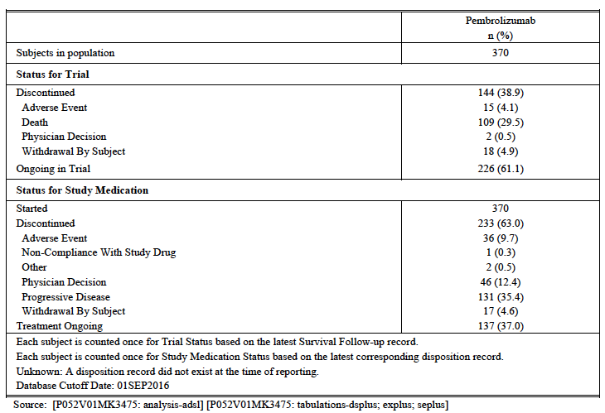
Comment: The APaT description of the population was stated to be replaced by the APT. It is not clear why this was retained for the disposition description.

Table 52: Study 052 Reason for Physician decision to discontinue study medication
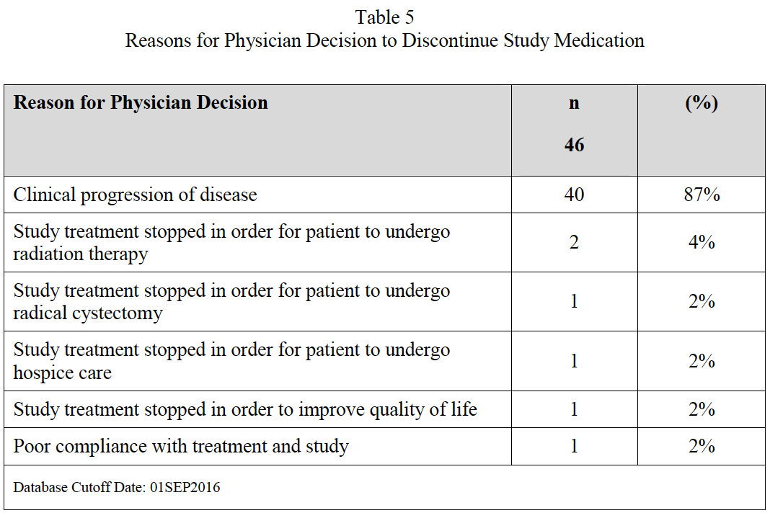

Second round evaluator comment
The vast majority of these patients appear to have discontinued due to disease progression and a smaller number due to toxicity or progression. A sensitivity analysis is required to determine the effects of treating all these patients as having progressive disease rather than being censored from analyses due to failure to meet RECIST 1.1 criteria.

Major protocol violations/deviations
The sponsor states ‘No subjects were excluded from the analysis due to a protocol deviation.’

Sponsor response
In response to a question about why scans in some patients were deemed ‘non-evaluable’, the sponsor stated, ‘Ten subjects (3%) among the APT population had post-baseline imaging performed, but, for 9 of these subjects, this post-baseline imaging was performed within 6 weeks of the beginning of treatment. Thus, these patients were deemed non-evaluable in follow-up. One subject did not have RECIST-measurable disease at study entry, and, therefore, was considered non-evaluable in follow-up.’
Comment: Enrolment of the patient without measurable disease at baseline should be a major protocol violation as this would result in exclusion from the FAS based on the SAP; for the other 9 patients, not fulfilling RECIST 1.1 criteria has resulted in the data from these patients being excluded for the primary efficacy endpoints of ORR, and secondary analyses of PFS as well as DOR will not be evaluable and thus, although data from these patients may contribute to the safety and OS analyses. As such these patients have protocol deviations that have led to exclusion from a critical part of the analysis, and the first patient has a major protocol deviation that should have resulted in exclusion from the FAS.
The sponsor identified 9 major protocol deviations deemed clinically relevant from 6 different sites:
- Enrolment with more abnormal laboratory values than permitted (2 patients);
- Use of corticosteroids (2 patients);
- ‘Recent history of Gleason 8 prostate cancer’ (1 patient);
- No follow-up bone scans despite having known bony metastases (4 patients).
Additionally, 2 patients appeared to have been erroneously identified as having baseline RECIST measurable disease – at the time of analysis, no target lesions could be identified.
Comment:
- Clinical question: For Patient [information redacted] established that any metastatic disease sites prior to entering the study were metastatic urothelial cancer rather than prostate cancer;

Second round evaluator comment
On balance, this patient appears to be most likely to have metastatic disease from his urothelial cancer but in the absence of a biopsy, this is not certain.
- Disease progression in the 4 patients without bone scans may have been missed which would lead to inaccurate, potentially inflated response rates. Given this uncertainty and that the primary endpoint is ORR, the sponsor is requested to present the primary and secondary endpoints with these patients censored. (see Clinical question below)
- While it is unfortunate if a central error occurred in patients, their disease status is not evaluable; therefore, data from these 2 patients should be retained in the safety analysis, but all efficacy results should be censored. Please present the primary and secondary outcomes with these patients. (see Clinical question below)
The evaluator calculated 224 major protocol deviations. While many were more administrative in nature, the following are noteworthy:
- 1 patient did not meet criteria with respect to prior systemic chemotherapy (patient [information redacted; no details provided;
- 12 patients did not have screening laboratory tests performed;
- 21 SAEs or ‘events of clinical interest’ were ‘not reported in a timely manner’;
- 5 patients did not have required study procedures done at discontinuation visit or safety follow-up done; 4 of these occurred in one site (USA 0171, which enrolled 19 patients);
- in 6 patients, required safety laboratory tests were not done;
Comment:
- 1 patient with prior systemic chemotherapy was not eligible and given this is then not first line use, the data from this patient should be censored for both safety and efficacy, as these do not inform regarding the proposed usage.
- Given the study entry criteria specify laboratory values to be within a certain range, the patients without screening tests cannot have been certain to have been eligible.

Clinical question
The evaluator considers that there are clinically relevant major protocol violations affecting the relevance or reliability of data to support the proposed usage from 8 (or potentially 9) patients. Accordingly, the sponsor is requested to provide an updated efficacy analysis for all primary and secondary endpoints, with the following patients all censored for efficacy and biomarker outcomes and as stated above:
- the 4 patients with missing follow-up bone scans;
- the 2 patients without apparent target lesions;
- patient [information redacted] who had received prior systemic chemotherapy;
- if there is any uncertainty about the metastatic disease status of the patient who had prostate cancer, please also censor this patient’s data;
Safety data from the patient with prior systemic chemotherapy should also be censored.
Baseline data NB an updated table is included as provided to the TGA after commencement of First round evaluation.

Table 53: Study PN052 Patient Characteristics with updated M stage (APT population) (TGA KN52 Update)
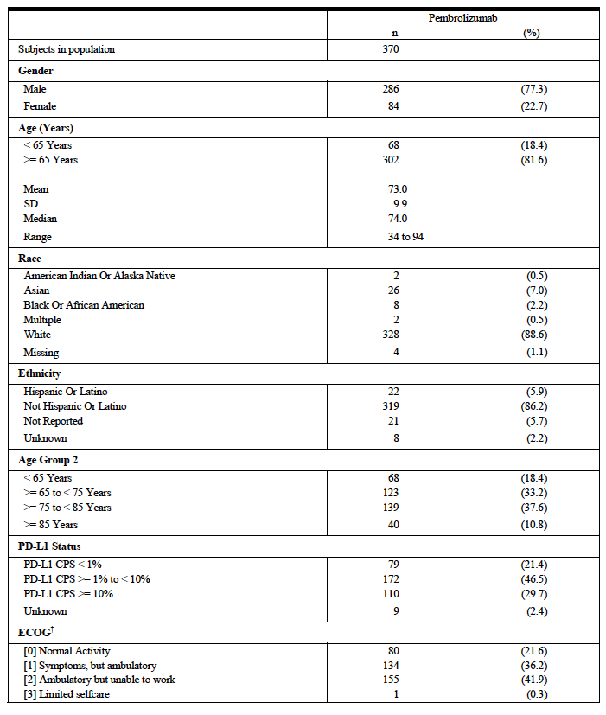

Table 53 continued: Study PN052 Patient Characteristics with updated M stage (APT population) (TGA KN52 Update)
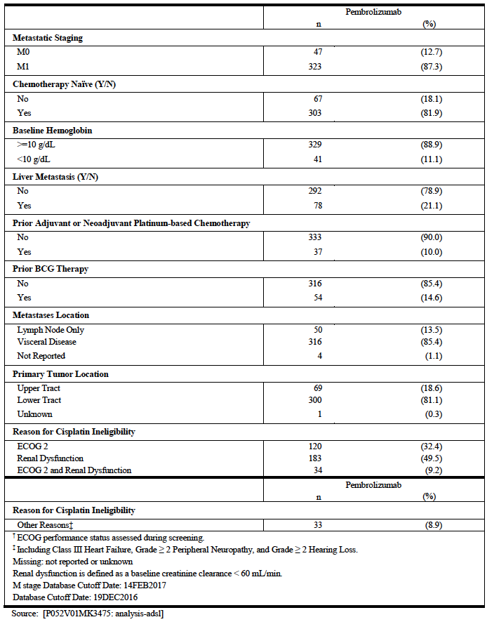

Table 54: Study PN052 Superseded table of patient characteristics showing differences in data following update All subjects APT population
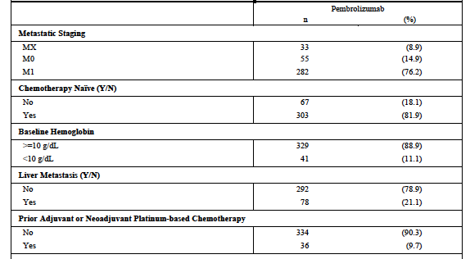
Comment:
Baseline characteristics
In response to the questions from the FDA, the sponsor provided an updated table of baseline characteristics where those previous labelled as having Mx disease were re-classified, as established disease stage was a fundamental entry criterion. The updated table has been included plus the section of the table prior to the revision. As can be seen from the table, and the response below, there was substantial revision of the status of patients based on not only clarification of these patients’ status but also correction of errors made for deemed previously to have M1 (+43 patients) or M0 (+8 patients) . Given the original data informs the ITT analysis, no meaningful conclusions about responses by subgroup analyses of M0 versus M1 can be made unless this revised and more accurate dataset are used.
The population is notable for its older age group, including a 94 year old, and the distribution of men to women reflects the higher frequency of this cancer in men. 42% had an ECOG-PS of 2, but renal function impairment was the single most common reason for not being considered eligible for cisplatin. Poor prognostic features include lower haemoglobin (11.1% of patients), poorer PS (42% had ECOG-PS 2) and visceral metastases (21.1% had liver metastases). No data are provided on baseline ALP in this table (but it was noted to be much higher in the PK data provided for the population PK analyses), and number of disease sites and the sponsor is requested to provide these (see below).
The sponsor is requested to clarify:
- 18.1% had received prior systemic chemotherapy but it is stated that only 10% received this as adjuvant or neoadjuvant treatment (9.7% in original table with CSR). One patient is known to have a major protocol deviation of prior systemic chemotherapy but it is not presented whether the rest of these patients received radio-sensitising chemotherapy with radiation (not considered primary systemic chemotherapy). Please provide clarification.
- Please provide a breakdown of what sites are encompassed when using the term ‘visceral disease’, and the numbers within each and also those with bone-only metastases. (Clinical question)
- Please also provide a breakdown for patients of the numbers of metastatic disease sites (0, 1, 2, 3, >3) and baseline alkaline phosphatase levels. Second round comment: this was provided in the response dated, 14 Sept 2017

Table 55: Subject count by number of metastatic sites and by baseline alkaline phosphatase levels
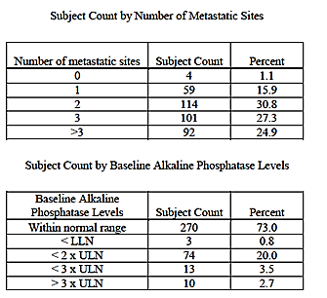

Sponsor response
Approximately 9.7% of subjects were treated with chemotherapy prior to study entry either as neoadjuvant or adjuvant chemotherapy. This chemotherapy was dosed at high dose (systemic dosing) - methotrexate / vinblastine / Adriamycin / cisplatin (MVAC) or gemcitabine / cisplatin. The remaining patients, approximately 8%, were treated either with low-dose, radio-sensitising chemotherapy or with intravesical chemotherapy for non-invasive disease earlier in the course of treatment for the disease under study. These were allowed as prior treatments for subjects enrolled onto KN052.
Comment: The prior use of cisplatin as the main backbone of the regimens in 9.7% of patients suggests that these patients may be considered ‘cisplatin–ineligible’ due to treatment progression and being refractory, rather than due to comorbidities preventing use of this regimen. This raises some challenges in defining this population.

Results for the primary efficacy outcome
Note: Updates to these data were provided by the sponsor in response to FDA questions with an updated data cut-off date of 19 December 2016 compared with 1 September 2016
Comment: Provision of these data has led to revisions of the report below to incorporate the responses. The additional data will be included in text boxes, as these are not in the CSR for any review by the Delegate. Note is made that only limited updates are provided and comments elsewhere (for example PK section) are still relevant.
Most of the endpoints assessed in this study used the cut-off date in the CSR (01 Sept 2016). Updated data with longer follow up based on a new cut-off date of 19 December 2016, were presented for:
- Best ORR, response duration with confirmation based on RECIST1.1 per central radiology assessment, all patients;
- Summary of Time to Response and Response Duration Based on RECIST 1.1 per Central Radiology Assessment in Subjects with Confirmed Response, All patients;
- Summary of Response Duration Based on RECIST 1.1 per Central Radiology Assessment in Subjects with Confirmed Response All Subjects (APT Population)
- Summary of best ORR based on RECIST 1.1 criteria per central radiology assessment in patients with confirmed response;
- Best ORR with confirmation based on RECIST1.1 per central radiology assessment, patients with PD-L1 CPS ≥ 10%;
- Summary of response duration based on RECIST 1.1 criteria per central radiology assessment in patients with confirmed response, patients with PD-L1 CPS ≥ 10%;
- Updated Follow-up Duration for All Subjects - Summary of Follow-up Duration All Subjects (APT Population);
- Objective Response Rate with Confirmation Based on RECIST 1.1 per Central Radiology Assessment by Subgroup Factors All Subjects (APT Population).
The sponsor states that no subjects were excluded from the efficacy analysis in the CSR, while the following is stated in the SAP, ‘Subjects without efficacy evaluation data or without survival data will be censored at Day 1.’

Second round evaluator comment
From the response to Clinical question 16, non-compliance with RECIST 1.1 criteria scan interval or baseline measurable disease meant 10 patients did not have evaluable data for the primary efficacy endpoint nor the key secondary efficacy endpoints of PFS and DoR but OS data would be available. Thus, these patients are not fully excluded from the efficacy analysis but do not contribute data. These patients were not censored at Day 1.
Comment: The sponsor has already been requested to clarify the conditions leading to early discontinuation prior to a scan for the approximately 10% who were stated not to have had a scan. Censoring these patients who did not have a scan at Day 1 and thus are without a declaration of progression would miss those with rapidly progressive disease. While the denominator of the All Treated Population reflects their inclusion, a sensitivity analysis incorporating all those without scans/evaluable efficacy as progression is requested for all analyses involving PFS and OS endpoints, and duration of response. (Clinical question)
The sponsor states, ‘KEYNOTE-052 is an ongoing study. At the time of data cut-off, the last subjects enrolled had only approximately 2 months follow-up time. For this reason, 2 subgroups were established for sensitivity analysis to fully characterize pembrolizumab efficacy. First, ORR was estimated for subjects enrolled at least 4 months (120 days) prior to data cut-off. These 307 subjects had the opportunity to have at least 2 post-baseline imaging assessments if they remained on study. Second, ORR was estimated for subjects enrolled at least 6 months (180 days) prior to data cut-off. These 232 subjects had the opportunity to have at least 3 post-baseline imaging assessments.’
As of Sept 1 2016 cut-off date, the median duration of treatment for the 370 patients enrolled was 5 months (range 0.1-16.5 months). The Clinical Study Protocol version 2 (11 March 2016) states, ‘Per RECIST 1.1, response should be confirmed by a repeat radiographic assessment not less than 4 weeks from the date the response was first documented.’
As of the updated cut-off of 19 Dec 2016, the median follow-up duration was 7.8 months (range 1-20 months).
Comment: This later cut-off should allow a greater percentage of patients to have undergone a second confirmatory scan as described by RECIST 1.1 criteria to determine the ORR.

Second round evaluator comment
The sponsor has confirmed that the 106 patients in whom an ORR was reported had all had confirmatory second post-baseline imaging.
Comment: Overall, as of the 10 Sept 2016 cut-off, the data are very immature, and are insufficient to meet the objective of the primary efficacy endpoint as described in the Statistical Analysis Plan. Many of these patients will not have had the requisite second scan to have an initial response confirmed. The departure from the planned analysis with the use of 2 subgroups not pre-specified, and the use of 2 post-baseline scans does not provide sufficient information to make any statements overall response rates or about the durability of any observed responses.
Based on the duration of follow-up, more than half of the patients would have had at least 2 scans which would allow some assessment, but still incomplete for the entire population, of ORR.
The sponsor has been requested to present the data with the results from patients identified by the evaluator as having clinically significant major protocol violations censored from the analyses.

ORR (APT population)
The CSR reports ‘The confirmed, objective response rate, defined as the percentage of subjects who had a complete response (CR) or partial response (PR) per RECIST 1.1 as assessed by blinded independent central radiology review (BICR), was 24.1% (89/370) among the APT Population’. Based on these results as reported, 89/370 are stated to have had a PR or CR by blinded central independent review, 17 patients achieving a CR. Disease control rate (CR+PR+stable disease) was reported in 46.8%.
Comment and clinical question:
The sponsor is requested to clarify what is meant by ‘confirmed’ in this sentence. The Summary of Clinical Efficacy states that these patients had not all had follow-up confirmation scans as required by RECIST 1.1. That is not mentioned here. Thus, there appear to be two uses of the term of ‘confirmed’ in the sponsor’s presentation of the data in this CSR, used somewhat interchangeably: 1) meaning established by central radiology review (this endpoint was determined by BICR so stating these as confirmed is redundant), and 2) as per RECIST 1.1 which means subject to a confirmatory scan which endorses the original findings of a response. This issue has affected all assessments that are drawn from the primary ORR statistics, including for all the PD-L1 cut-offs presented, and the duration of response assessments.
The update provided information about patients who had at least 2 scans (Table 56) and the duration of response data as of cut-off date of 19 Dec 2016: 106 patients were reported to have had a centrally confirmed ORR (Table 56), and of these 55/370 (14.9%) patients were stated to have had a CR or PR response based on RECIST 1.1 confirmed by central review (CR or PR) lasting ≥6 months with a median duration not reached (95% CI: 11.1, NR).
Comment: These 55 patients would have had at least 2 scans in this time period, and have had central radiological review and therefore appear to have met the criteria for RECIST 1.1 of two scans and central review to establish the basis for a claim of efficacy. This information suggests that the response rate meeting the criteria as defined in the SAP is 14.9%. This is well below the response rate cut-off of 30%, the sponsor had pre-specified as being of clinical importance. However, response duration in excess of 6 months is notable, and clinically relevant for this population. Caution needs to be exercised in interpreting these results as there was no comparator arm and first line UC is a chemosensitive disease with response rates which exceed this. Updated data based on a longer follow-up would allow an assessment of the durability of this response which is the hallmark of benefit from immunotherapy.
The sponsor provided an updated table with the new data cut-off date of 19 December 2016 with the title indicating that the best overall response rate is confirmed by central radiology review based on RECIST 1.1. The reported ORR was 28.6% (106/370), with 6.7% achieving a CR and 21.9% achieving a PR. 41.9% are stated to have had progressive disease but an additional 10.8% did not have an assessment or were deemed non-evaluable. Stable disease was reported in 18.6%.
Comment: In this updated data, it remains unclear to the evaluator how the term ‘confirmed’ is being used here. Had these patients all had at least 2 scans as required per RECIST 1.1 criteria? (Clinical question)

Sponsor response
The sponsor states, ‘All 106 subjects had responses confirmed with a second set of imaging performed at least 4 weeks after the initial response time point.
- With a median follow up for the entire population of 7.8 months (range 0.1-20), and some patients still early in their treatment course, these data are difficult to interpret.
- Given the mechanism of pembrolizumab, the duration of response is key and information is very limited at this time.

Table 56: Summary of best overall response with ‘confirmation’ based on RECIST 1.1 per Central Radiology Assessment (All patients treated)
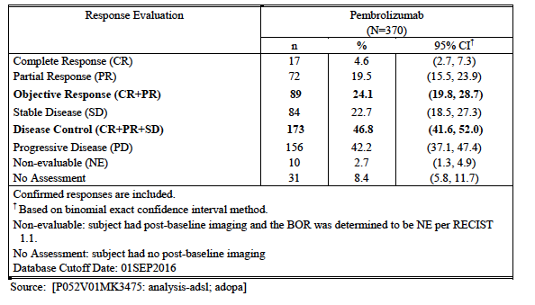
8.4% had no post-baseline imaging due to ‘progression of the underlying medical condition’ leading to study discontinuation.
Comments:
- The sponsor is requested to clarify what is meant by the broad term, ‘underlying medical condition’, as this potentially includes a condition other than the malignancy, and could reflect an adverse effect of treatment. (Clinical question)

Sponsor response:
The sponsor has indicated that this term pertains to the urothelial carcinoma, not to other medical conditions in this patient group where eligibility was essentially defined by the presence of comorbidities.
- The sponsor is requested to explain why scans post-baseline were deemed ‘non-evaluable’ if a central review and confirmation of target lesions was required at baseline to determine eligibility. (Clinical question)

Sponsor response
10 (3%) patients did not meet RECIST 1.1 criteria for evaluable disease: 1 had no baseline measurable disease (see Comments on Major Protocol deviation; 9 patients had baseline imaging prior to the minimum window of 6 weeks after commencing treatment).
- Patients with rapidly progressing disease that does not respond, that is, those least responsive to immunotherapy, would not have been included in the PD-L1 biomarker discovery population as this required at least a 9 week scan and a 15 week scan, unless the patient had already died. As indicated by the evaluator earlier, this questions the internal and external validity of the biomarker discovery population and indicates they cannot be said to be representative of all patients in this study, or generalised to real world patients not eligible for cisplatin. This limits the predictive capacity of using any cut-off established this way, which by definition has not characterized those least likely to respond.
- The sponsor is requested to provide the breakdown of the PD-L1 status of this 8.4% with no radiological assessment. (Clinical question).
- Note is made that different data are presented in the PI. The sponsor has included the data from the subset of patients participating for ≥ 120 days, which is not the whole study population. A further new set of data have been presented in the latest update and the sponsor is requested to update the draft PI to reflect this in the sponsor’s response for evaluation; inclusion of the population participating ≥ 120 days is not considered acceptable. (PI Comments).

Table 57: Study PN052 Updated Summary of best overall response with 'confirmation' based on RECIST 1.1 per central radiology assessment all subjects APT population
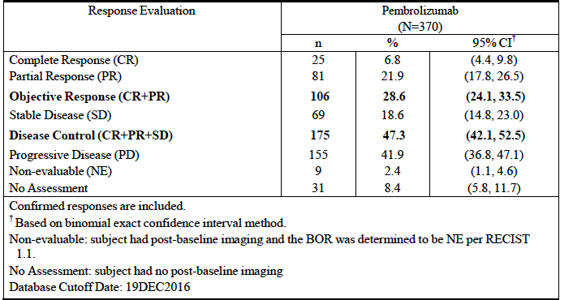

ORR in patients with PD-L1≥ 1%
The ‘confirmed’ ORR was 26.6% (75/282), with 5% having a CR (see Table 58) and 2.1% were non-evaluable and 7.1% did not have a post baseline scan. This population includes all those who participated in the biomarker study population as well as those subsequently recruited.
Comment:
- Please provide the number and percentage of these patients state to have a ‘confirmed ORR’ where the ORR was actually confirmed by a second scan at the time of the cut-off date of 01 September 2016, and for the updated data cut-off of 19 December 2016.

Second round evaluator comment
The sponsor states with respect to the question above:
- ‘Regarding the 89 subjects in question (from the question above, data cut-off 1 Sept 2016), all had a radiographic response that was confirmed with a second study performed at least 4 weeks after the initial response time point.’
- Regarding the data in the table above for the update, with the data cut-off 19 December 2016, ‘All 106 subjects had responses confirmed with a second set of imaging performed at least 4 weeks after the initial response time point.’
- The inclusion in this population of all those who were deemed to have a ≥ 10% expression from the biomarker population will inflate the apparent response rates in this group. The sponsor is requested to censor these patients and all patients with subsequently found to have a CPS ≥ 10% to allow a clear picture of the effect of a lower level of expression on efficacy outcomes. (Clinical question)
The evaluator believes the Biomarker Discovery population should have been kept separate from the entire analysis of efficacy as this cannot be a validation set if it includes any of the patients whose outcomes were already known and determined statistically within that cohort to be superior.
Such an approach favours a demonstration of efficacy in the PD-L1>1% population and given it was established that there was a differential between the ≥ 1% and ≥ 10% marks, this represents a bias. The validation cohorts and biomarker cohorts should be kept entirely separate.

Table 58: Summary of best overall response with ‘confirmation’ based on RECIST 1.1 per central radiology assessment for patients with PD-L1 CPS ≥ 1% (APT population)
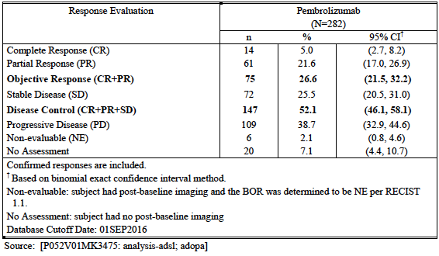
Comment: These data are too immature to make any statements about PD-L1 expression and efficacy of pembrolizumab. In particular, it is too early to determine whether this ORR translates into durable response or whether those declared to have stable disease are truly stable. This table was not updated in the information provided during the evaluation.

ORR among subjects with PD-L1≥ 10%
ORR was 38.8% of patients with tumours with a CPS ≥ 10% (31/80) and 10% were reported to have a CR. 6.3% did not have a post-baseline scan.
How many patients had follow-up scans as per RECIST 1.1 is not stated.

Table 59: Summary of best overall response with 'confirmation' based on RECIST 1.1 per central radiology assessment for patients with PD-L1≥ 10%, Efficacy Validation population (Source CSR)
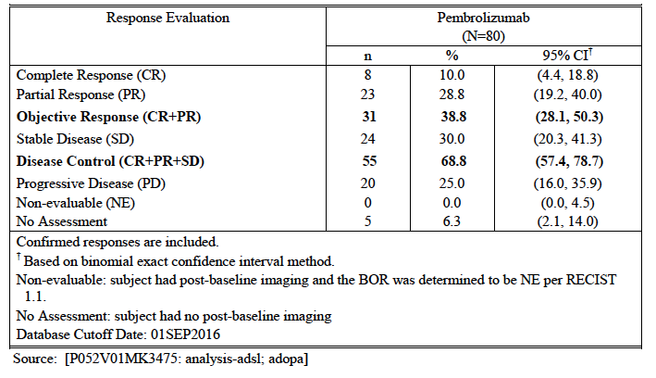

Table 60: Summary of best overall response with confirmation based on RECIST 1.1 per central radiology assessment, patients with PD-L1 CPS ≥ 10% (APT population
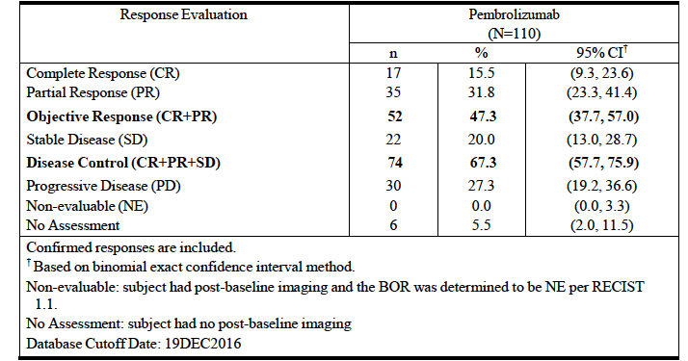
Comments:
- The populations appear to have changed for the reporting of the PD-L1 CPS ≥ 10% between the two data cuts – for the earlier cut-off, patients from the validation set (that is, those recruited after the cut-point was determined and the later data cut includes patients from the entire population. This introduces a bias, as the biomarker detection set included patients deemed to have performed better, with the hypothesis that this is related to the PD-L1 expression level. The sponsor is requested to provide the updated ORR for the validation set as of December 19, 2016.
- Please provide the number and percentage of patients with a PD-L1 CPS 10% stated to have a ‘confirmed ORR’ where the ORR was actually confirmed by a second scan and independent radiology review at the time of the 19 December 2016 cut-off date. (Clinical question).

Sponsor response
The sponsor states, ‘All responding subjects presented in the ORR analysis in question had responses confirmed with a second subsequent imaging study performed at least 4 weeks after the initial response time point.’

Second round evaluator comment
This is accepted. The Clinical question asked for these data to be confirmed for the validation set only, but given relatively few patients were excluded from the biomarker discovery set, inclusion of this group in the dataset is acceptable.
- As with the efficacy results for CPS ≥ 1%, these data are too immature to make any statements about the efficacy of pembrolizumab in first line urothelial carcinoma. In particular, it is not possible remains uncertain and unproven whether this ORR translates into durable response, or whether those declared to have stable disease are truly stable.
- The sponsor claims this validates the cut-off point selected. However, this was cut-point determined from a subset of patients without aggressive, non-responsive disease and lacks external validity and cannot be used to screen all comers. Of note, in patients in PN045, the OS was shorter in patients expressing PD-L1 CPS ≥ 10%, and it is quite possible that significant bias has been introduced with the exclusion of those likely to have an early relapse.
- There appear to be patients with non-evaluable disease and also those with no assessment at a very similar rate to the cut-off using CPS ≥ 1%. Those with ‘no assessment’ should be taken conservatively to mean those not responding and when added to those with progressive disease, this represents a 31.3% false positive rate using CPS ≥ 10% as a cut-off.
The Statistical Analysis Plan states, ‘A PD-L1 strongly positive cut-off that maintains high NPV (for example near or above 90%) while achieving meaningful enrichment of response and largely capturing patients showing durable clinical benefit is sought.’
Comment: No data equivalent to that presented for the ≥ 1% and ≥ 10% CPS PD-L1 expression have been presented for the patients with PD-L1 <1%, and thus the negative predictive value cannot be demonstrated for PD-L1 as a test. This should be presented for the latest data cut-off.
- The sponsor is requested to provide a similar table for these patients with PD-L1<1% to determine whether the PD-L1>1% has any value as a cut-off in urothelial carcinoma. (Clinical question).
- The sponsor is requested to calculate the positive predictive value, the negative predictive value for the cut-off of ≥ 10%, using the latest data confirmed by both RECIST 1.1 (2 scans) and central review and discuss whether this meets the objective outlined in the SAP. (Clinical question).
ORR for biomarker discovery population (not a specified efficacy endpoint but included by the sponsor).
The CSR states, ‘The PD-L1 CPS strongly positive cut point for efficacy was determined among subjects in the discovery cohort to be CPS ≥ 10% through a systematic assessment that included analysis of the positive and negative predictive values and receiver operating characteristics (ROC) across a wide range of potential CPS cut points (reference available upon request).’
Comment: This is an exploratory component of the study, involving 30 patients only, and still requires validation as these data were determined by examining various cut-points. The information cannot be evaluated as the data underpinning the establishment of the CPS ≥ 10% have not been provided – the sponsor is requested to provide these data. It is unclear what reference the sponsor is referring to in this statement. Note again is made that more than 31.3% of the patients with a CPS ≥ 10% either experienced disease progression or did not have an assessment.
Additional analyses not pre-specified in the SAP were included by the sponsor as ‘supportive’.

Concordance assessment between the investigators and blinded independent central review
Absolute disagreement about whether there was progression or not occurred in 48/331 (14.5%) of patients where the independent reviewers had access to scans: 14 were deemed not to have radiological evidence of progression, and 34 additional patients were declared to have progressed by central reviewers. When local investigators declared progression, there was central agreement over the timing for only 62.9% of these events. Notably, independent reviewers declared an earlier progression time point for 22.5% of cases whereas local investigators declared progression earlier in only 6.7% of cases.
There was a lower discordance between site and central reviewers for scans declared by the investigators as indicating non-progression, with independent reviewers declaring progression in an additional 34/153 evaluable patients (22.2%).
While the final ORR figure was the same between site and central reviewers, one CR was downgraded to a PR by the blinded central reviewers. Note is made that 38 (10.3%) patients did not have scans available for central review and the high rate of discontinuations attributed to ‘physician decision’ from the disposition table (8.4%).
Comment: These assessments compared rates of declaration of CR and PR rates between the two groups as reported, some of which will be without a follow-up scan for the whole study population. As this reflects a comparison between the two groups using identical data, the comparison of concordance is valid but the absolute figures should be regarded with some caution, pending confirmation by the sponsor.

Table 61: Study PN052 Concordance analysis of progression events (local versus central) all patients treated population
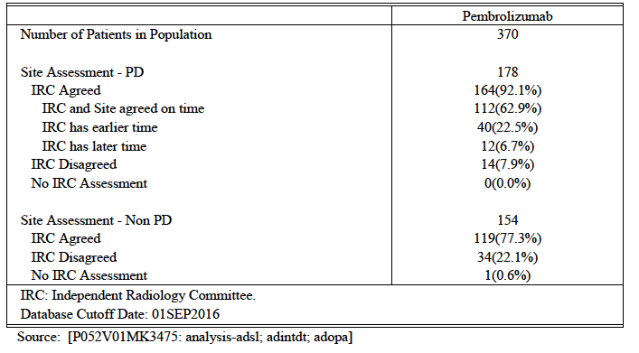
Comment: The absolute declaration of events of progression were lower when assessed by site investigators, and more likely to be declared at a later time point – both favour a greater treatment effect being demonstrated if results were based on local site investigators’ assessments. Further assessment of this potential bias is not required as the primary and secondary endpoints are all based on analyses from data determined by the central assessors. It is to be noted that this more robust and objective assessment requirement offsets most of the potential bias inherent in an open label study, although the withdrawal of patients before scans could confirm progression whose will have resulted in a higher declared median for all endpoints involving assessment of progression. Sensitivity analyses for this effect (10.3% of patients) should be undertaken, declaring all as progression at the time point of discontinuation, should be undertaken for all such endpoints. (Clinical question)

ORR among subjects with varying follow-up time
The sponsor provided data for those 307/370 patients (83% or total population) enrolled for >120 days and who would have had 2 or more post-baseline scans if still ongoing in the study; and for those 232/370 (62.7%) enrolled at least 180 days where at least 3 post-baseline imaging studies were undertaken if still on study. Further analyses on these 2 populations of age, CPS score, gender, race, ECOG-PS, prior chemotherapy, metastatic location, site of primary and reason for cisplatin-ineligibility were explored. Kaplan-Meier curves were generated estimating OS for each of these groups.
The results are presented in Tables 62 and 63 below.

Table 62: Summary of best overall response with confirmation based on RECIST 1.1 per central radiology assessment for all patients enrolled 120 days or earlier prior to the cut-off date
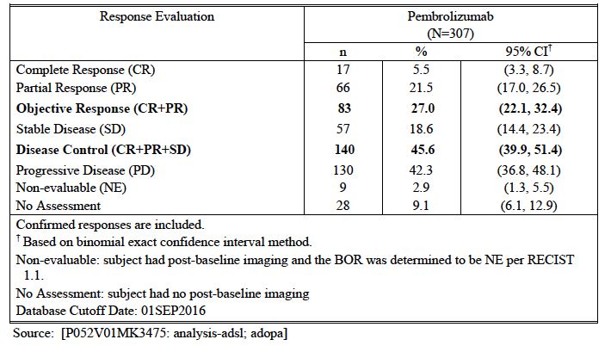

Table 63: Summary of best overall response with confirmation based on RECIST 1.1 per central radiology assessment for all patients enrolled 180 days or earlier prior to the cut-off date
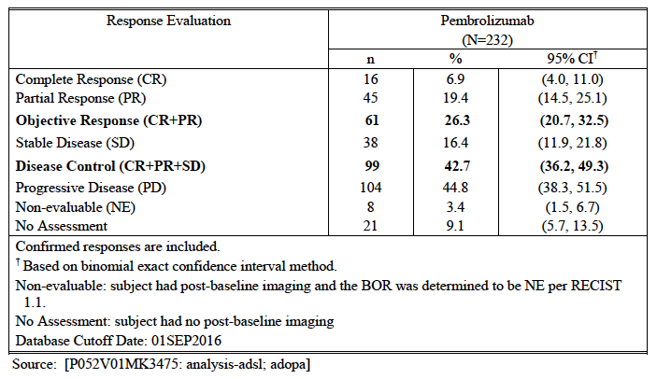
Note is made that only patients participating for this duration, can have the ORR data reported correctly as per RECIST 1.1 as at least two scans are required.
Comments:
- These two datasets indicate that a response rate of 26.3% or 27% was found in this first line population, and provide some assurance regarding the likelihood of an initially determined response rate being confirmed when RECIST 1.1 are followed. The 180 day population is a subset of the 120-day population, which may also explain the consistency.
- These assessments have been undertaken as the data are very immature, but cannot compensate for this; furthermore, the study was not designed to present rolling data assessments of subgroups driven by time since enrollment. All the results are exploratory, and any conclusions could only be regarded as speculative, requiring confirmation in an appropriately designed study. This is not sufficient to demonstrate the efficacy of the proposed usage.
- Note is made that in the original Clinical Study Protocol, that the following hypothesis was: ‘Intravenous administration of single agent pembrolizumab (MK-3475) as 1L therapy to subjects with advanced/unresectable (inoperable) or metastatic urothelial cancer who are ineligible for cisplatin-based therapy and whose tumors express PD-L1 protein (IHC) will result in an clinical meaningfully overall response rate (ORR) greater than 30% based on RECIST 1.1 as assessed by independent radiology review.’
- Following the amendment 2, the hypotheses were dropped, but the following was still stated in the ‘Rationale for Endpoints’, ‘The RR results obtained in this trial will be compared to an historical RR of 30%. A 30% RR is at the high end of RRs observed with existing agents tested in the first line setting in populations actually more likely to respond than the cisplatin ineligible patients included in this trial. Considering the effect of pembrolizumab on duration of response and the population of cisplatin ineligible patients being studied, a RR of 30% is considered clinically important.’

ORR among all subjects with CPS ≥ 10%
Contrary to the SAP, the sponsor presented the results from all patients with CPS ≥ 10%, including the biomarker discovery population.
Results were stated to be similar across the groups, but the proportion with a second a confirmatory scan as required by RECIST 1.1 is unknown.
Comments:
- Please provide the number and percentage of these patients state to have a ‘confirmed ORR’ where the ORR was actually confirmed by a second scan at the time of the cut-off date of 19 December 2016.
- As with all the other analyses, these data are immature and there is no information about durability of the observed responses. In addition, the sponsor has deviated away from the planned analyses in presenting these data as the primary efficacy endpoint cannot be determined due to immaturity of the data. They do not establish efficacy for the proposed usage.

ORR among protocol-specified subgroups
At the interim cut-off date (01 Sept 2016), the sponsor states, ‘the treatment effect of pembrolizumab is consistent across subgroups’.
Figure 14: Study PN052 ORR with confirmation based on RECIST 1.1 per central radiology assessment by subgroup factors (APT population)
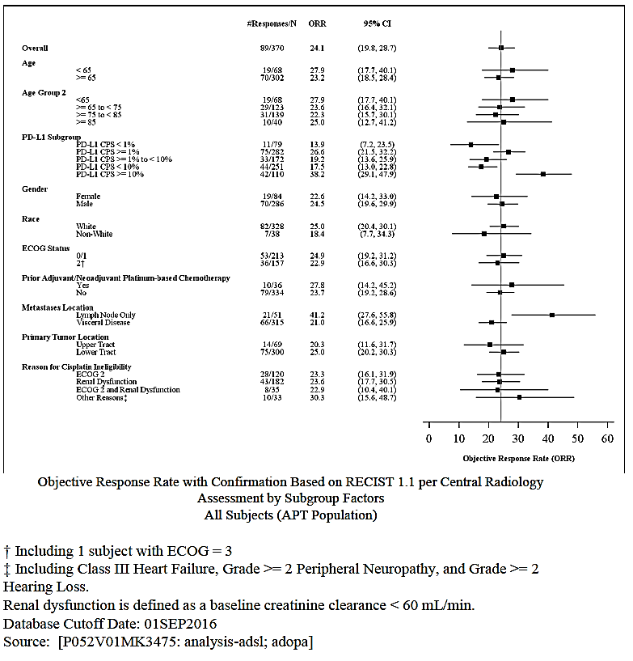
Figure 15: Objective response rate with confirmation based on RECIST 1.1 per central radiology assessment by subgrouping factors all patients (APT population) (TGA KN52 update)
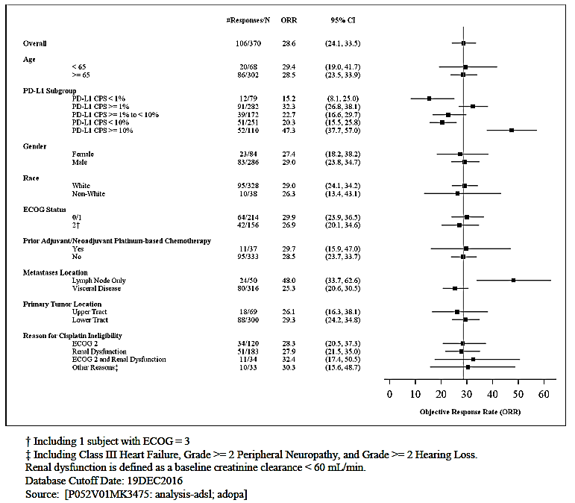
Comment:
- Note should be made that these analysis censored all those without evaluable efficacy data, which includes those with rapid progression and no scan, and the breakdown of this group across these subgroups is unknown.
- The evaluator does not agree that the treatment effect is consistent and notes that on the data presented those with CPS ≥ 10% and lymph node-only disease appear to be greater. A break-down of PD-L1 status within those with lymph node only disease is required to ensure this is not a confounding factor. (Clinical question)
- The response rate among those with PD-L1 stated to be negative. This does not predict absence of a response (which was still in the order of 15.2%) and the sponsor has already been requested to provide data on the extent (CR, PR and SD) and duration of response for these patients, and the negative and positive predictive values for PD-L1<1% in this study. (Clinical question)
- Note is made that the CPS ≥ 10% includes all patients from the biomarker discovery and validation sets. The sponsor had stated that the biomarker group would be excluded from any analyses using CPS ≥ 10%. This pertains to both the cut-off dates and is a significant source of bias.
- Caution must be exercised in interpreting these data due to the censoring, small numbers within many of the subgroups resulting in the wide confidence intervals. The immaturity of the data, mean it is not possible to make any further comments on the clinical relevance and in particular, on the durability of these responses.

Results for secondary Endpoints DOR, PFS, OS

Duration of response
The median time to response (calculated from those with a CR or PR) was 2 months (range 0.2-4.8). Of 89 with a confirmed response meeting RECIST 1.1 criteria, 1 commenced another anticancer treatment (therefore must have progressed or experienced an AE), and 74 were stated to have had an ongoing response. 31/78 patients are presented as having a response ≥ 6 months, but this figure includes some who have subsequently experienced progression.
The update provided information about patients who had at least 2 scans as of cut-off date of 19 Dec 2016: 106 patients were reported to have had a centrally confirmed ORR, and of these 55/370 patients were stated to have had a CR or PR response based on RECIST 1.1 confirmed by central review (CR or PR) for ≥6 months.
Comment: Most patients responded relatively quickly, and this would be consistent with those with lower bulk of disease being the patients appearing to gain the greatest benefit in the subgroup analysis above. The data, while appearing promising, are immature and it is not possible to determine how many patients will experience a durable response, particularly among those with poor prognostic features.

Table 64: Study PN052 Summary of time to response and response duration based on RECIST 1.1 per central assessment in subjects with confirmed response all patients (APT)
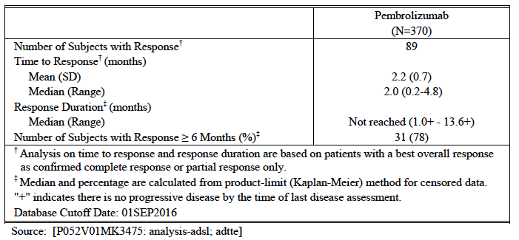
Figure 16: Plot of time to response and time to progression based on RECIST 1.1 per central radiology assessment among the 89 with a PR or CR
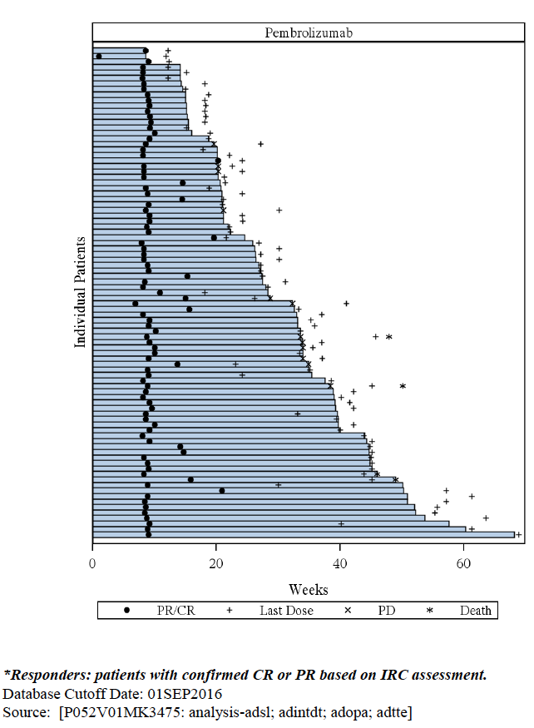
The median duration of response within this cohort has not been reached due to relatively immature data with many patients still early in their treatment course, few responders having progressed and only 2 deaths. Similarly the median time to response and response duration for the whole population, or by CPS ≥ 1% or by CPS ≥ 10% has not been reached due to data immaturity with 64/75 and 26/32 still ongoing in each group, respectively.
Comments:
- It is unclear if the blue line stopping without an ‘x’ indicates a CR has been reached or a partial response has reached a plateau. Several patients appear to be experiencing continuation of a response beyond discontinuation.
- From this graph, 9 patients appear to have been treated beyond progression. Two patients died in this group, but the sponsor is requested to state the median time and range of continued treatment beyond progression for all9, and the clinical outcomes for the remaining 7.
- Please state how many of these 89 responders had PD-L1 status <1% as there were documented responders in the subgroup analysis. (Clinical question)
Figure 17: Study PN052 Plot of time to response and time to progression based on RECIST 1.1 per central assessment for responders with CPS ≥ 10%, efficacy validation population
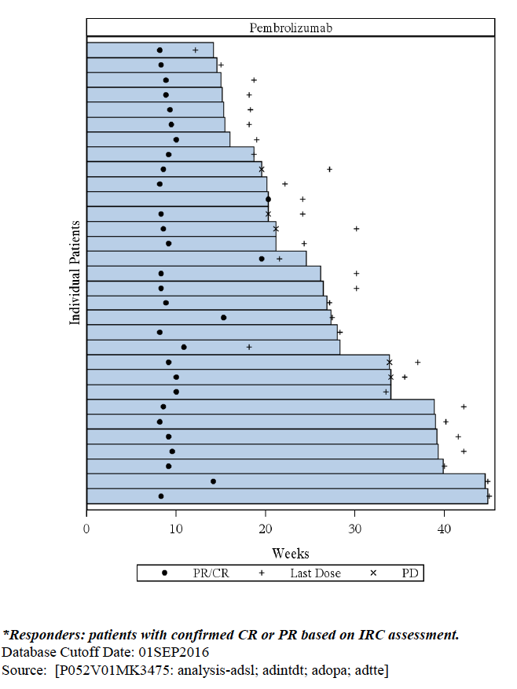
Comment: This figure indicates the relatively short duration of study participation those with a response. Treatment beyond declared progression has occurred in 5 patients.

Progression-free survival
As of the 1 September 2016 cut-off, 248/370 patients (67%) had experienced an event by central radiology assessment, and the median PFS was 2.1 months (95% CI: 2.1, 3.0). The Kaplan-Meier estimate of PFS rate at 6 months was 30 % (95% CI: 24.9, 35.3) and at 12 months was 18.6% (12.8%, 25.2%).
Figure 18: Study PN052 Kaplan-Meier estimate of progression-free survival based on RECIST 1.1 pre central radiology assessment all patients treated
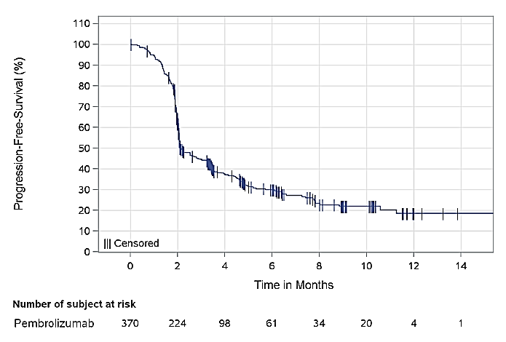
Comment: There is considerable uncertainty at present about the extent of any benefit in this population due to the immaturity of the data. Most patients discontinue early due to having no response, and this figure should be higher but for the censoring of the patients who did not reach the time point for the first scan. Amongst those still ongoing, many are still very early in their treatment course of the study and therefore the extent of their response and the true PFS rate is some time from being known. Note is made of the very few patients at risk in the tail of the curve and the very few patients who have reached this time point in the study.

PFS among subjects with PD-L1 CPS ≥ 1%
The median PFS for CPS ≥ 1% is 3.0 (range 2.1-3.5) months. At the time of data cut-off, the estimated 6-month and 12-month PFS rates for these subjects were 32.7% and 21.3%.
Comment: There is no clinically meaningful difference between the median PFS for this population and the entire study population, and the data are too immature to be certain of the true rather than estimated PFS rates. These patients include those with a cut-point of ≥ 10% for the PD-L1 CPS and it is difficult to know how much impact these patients are having, especially on longer-term outcomes. The sponsor is requested to present the PFS data for those with a CPS score ≥ 1% but <10%. (Clinical question)

PFS among subjects with PD-L1 CPS ≥ 10%
Among the 80 patients in the efficacy validation population, 37 had experienced events of disease progression thus the median PFS has not yet been reached and immaturity of the data affects all assessments. From the response curves in Figure 17 above, it is clear that many of these patients are early in their treatment course and the mean treatment exposure is 3 months. The numbers are relatively small in this subgroup and the confidence intervals are wide. Although these data appear promising, the data are too immature to draw any conclusions about clinical benefit. Information about the proportion of patients progressing rapidly prior to a scan would assist in understanding the predictive capacity of this test.

Other data presented
Data of PFS events by age and overall, indicate a tendency to a higher event rate with increasing age (66.2% in the <65 year olds, 59.3% in the 65-75 year olds; 70.5% in the 75-85 year olds; 80% in the ≥85 year old) but until the study is complete, no meaningful comment can be made as treatment duration by age was not presented, and competing causes for death cannot be ruled out.
The sponsor is requested to present the PFS, estimated 6-month and 12-month PFS rates for patients in the study negative for PD-L1 that is, with a CPS<1% (Clinical question).

Overall survival (OS)
OS data are immature with 130/371 (35.1%) deaths in the study to date. The sponsor prepared figure for median OS estimated to be 10.9 months (9.7, NR) but these are very uncertain due to the immaturity of the data.

OS for patient with PD-L1 CPS ≥ 1%
The event rate in this group was 85/252 (30.1%) therefore the median OS had not been reached. The sponsor presented the following estimated figures: median OS 11.6 months (range 10.1, NE), and OS rates at 6-months and 12-months were 70.5% and 49.3%, respectively.
Comment: The data are too immature to make a reliable assessment of this outcome.

OS for patient with PD-L1 CPS ≥ 1%
The event rate in this group was even lower at 18/80 (22.5%) and the median OS had not been reached. The sponsor presented the following estimates: median OS of 8.4 months and OS rate of 76.5% (95% CI; 63.4, 85.5) at 6 months, but not reached at 12 months.
Comment: The data are too immature to make a reliable assessment of this outcome. No updated data were provided.

Exploratory endpoints

Patient-reported outcomes
These were scheduled to be completed at each visit for the first 4 cycles and then every second visit thereafter, at discontinuation and 30 days after discontinuation.
367/370 patients met the requirements for the PRO. Overall the compliance rates for completion were high amongst those available was high (90.7%, 91.4%, 85.2% and 86.9% at baseline, week 3, week 6 and week 9, respectively). However, patients not scheduled to have a visit (which implies a treatment delay or discontinuation) were not included in calculating this figure. Reasons for patients not being available were predominantly site-related errors initially (‘with visit, no record’), and with increasing treatment duration, ‘visit not scheduled’ and disease-related events became more common reasons.
Comment: The lack of input from those not visiting will not capture those experiencing disease progression or dose delays due to adverse events; both of which will adversely affect quality of life. A more flexible means of providing the questionnaires at the given time point would increase response rates, and capture these meaningful responses.
No specification of the minimally important clinical differences is included in the SAP or Protocol.

EORTC QLQ-C30 analysis
The sponsor states, ‘The majority of the subjects experienced improvement of 10 or more points (31%) or stable global health status/QoL (42%) at Week 9 [Table 14.2-40]. Similarly, the majority of the subjects experienced improved (by 10 or more points) or stable QoL in all EORTC functioning and symptom domains at Week 9.’
Comments:
- The SAP and Clinical Protocol do not mention anything about how the quality of life data will be analyzed: specifically, there is no mention of any imputation of missing values, or any specification of minimally important clinical differences for these quality of life tools in urothelial carcinoma to contextualize results.
- [Table 14.2-40] does not provide information to support these claims as cited. No break-down of points or figures indication of stability of responses are presented in this table which presents the mean score with standard error at each visit up to Week 27. The use of mean statistics assumes normal distribution (no median or range are presented). The approach of only collecting data if patients attend rather than at the pre-specified time point does not include data from those missing their visit presumably due to treatment delays or discontinuations and the potential impact of experiencing an adverse event, and are also skewed by those responding being retained in the evaluable dataset and being the source of the data, particularly beyond Week 9.
- The title of [Table 14.2-41] is ‘Summary of EORTC QLQ-C30 Scores with Multiple Imputation Based on MAR Assumption at Treatment WEEK 9 (FAS Population)’.
- This information as presented cannot be evaluated.
- The lack of a comparator makes interpretation of any reported findings difficult.
Comment: Other exploratory endpoints included in the objectives, but for which no data were presented include: analysis of the quality of life endpoints by PD-L1 status, characterisation of biomarkers that might predict resistance to pembrolizumab. PK endpoints were presented separately as a series of tables and are discussed in the PK section.

Evaluator commentary
Study PN052 is an ongoing open label single arm with an adaptive design, which included several different aims. The clinical study protocol and statistical analysis plan changed substantially with between versions to reflect this. The final objectives were to investigate the efficacy and safety of first line treatment with pembrolizumab, and the impact of PD-L1 expression levels on the efficacy endpoints, in this population characterised by comorbidities or lower performance status that limit their chemotherapy options. The statistical analysis plan specified that there were no hypotheses and the aim was to generate estimations for the efficacy endpoints assessed. Health-related quality of life data were included as exploratory endpoints. In addition, a biomarker discovery analysis was undertaken on data from the first 100 patients enrolled to determine whether a clinically relevant and reproducible predictive cut-point for PD-L1 status could be determined to inform and guide treatment decision-making. The cut-off point generated from an interim analysis of these data, were then incorporated into the objectives and analysis plan of the study results beyond that point, with patients recruited after the biomarker set was complete, as an efficacy validation set.
It is not clear what criteria define the end of the study and the generation of the final Clinical Study Report and the sponsor has been requested to provide this information.
Based on results from this study, the sponsor is seeking to approval as follows: ‘Keytruda® (pembrolizumab) is indicated for the treatment of patients with locally advanced or metastatic urothelial carcinoma who are not eligible for cisplatin-containing therapy.’
The CSR states that the ‘confirmed objective response rate’ for all study patients as determined by independent review was 24.1%, of which 4.6% were complete responses and 19.5% were partial responses. However, the Summary of Clinical Efficacy states that RECIST 1.1 requires confirmation in the form of a second scan and for that reason the whole study population ORR was not actually confirmed. This issue pervades all the efficacy analyses involving ORR (including by PD-L1 status, duration of response) and many of the supportive analyses provided involving the presentation of ORR data based on the All Patients Treated population using the cut-off date.
The issue arises largely because the median duration of follow-up for the 370 patients in the trial was 5 months (range 0.1-16.5 months), which is too short to establish the study’s primary endpoint as designed. Instead of the intended population specified for demonstrating the primary efficacy endpoint, and in an attempt to address this, the sponsor in the Summary of Clinical Efficacy focussed only on those 307/370 patients with at least two scans and included results from this the population in the draft PI. As stated above, the primary ORR endpoint was for the whole population, and use of a non-prespecified subgroup due to the immaturity of the trial data is not acceptable. In these 307 patients, for whom at least two scans were available, the RECIST 1.1-confirmed objective response rate was 27.3% by independent review. The sponsor states in the Rationale for Endpoints that, ‘The RR results obtained in this trial will be compared to an historical RR of 30%. A 30% RR is at the high end of RRs observed with existing agents tested in the first line setting in populations actually more likely to respond than the cisplatin ineligible patients included in this trial. Considering the effect of pembrolizumab on duration of response and the population of cisplatin ineligible patients being studied, a RR of 30% is considered clinically important.’ This result is inferior to that initially included in the hypothesis and retained as the benchmark for consideration of a clinically meaningful result.
In response to the questions from the FDA, the sponsor provided updated data in which the a total of 106/370 (28.6%) patients were reported to have an ORR, with 55/370 patients in the entire study are described as having a response duration exceeding 6 months, as of the latest cut-off date. These 55 patients would have had at least 2 scans in this time period, and have had central radiological review and therefore appear to have met the criteria for RECIST 1.1 of two scans and central review to establish the basis for a claim of efficacy. This information suggests that the response rate meeting the criteria as defined in the SAP is 14.9%, and this is the only figure to inform regarding durability of responses. This is well below the response rate cut-off of 30%, the sponsor had prespecified as being of clinical importance. However, response duration in excess of 6 months is notable, and clinically relevant for this population. Caution needs to be exercised in interpreting these results as there was no comparator arm and first line UC is a chemo-sensitive disease with response rates which exceed this. Updated data based on a longer follow-up would allow an assessment of the durability of this response which is the hallmark of benefit from immunotherapy.
The clinical utility of the PD-L1 biomarker is uncertain in this population. The updated data included a population with a PD-L1 CPS ≥ 10% which appeared to include those on which the biomarker cut-point was chosen, that is, those deemed to have an improved response rate but requiring at least 2 scans to demonstrate this. This strategy excludes those who might have a high cut-point but have relapsed early and given the overall survival for those with PD-L1≥ 10% in the KN045 study was inferior to the study population as a whole (and not overcome by introducing blockade of PD-1), the relevance of this biomarker remains uncertain. Presentation of the data for the validation set has been requested.
The evaluator does not consider that there has been a satisfactory demonstration of efficacy, and that while longer term data may provide some information about more established endpoints, in the absence of an appropriate comparator, it cannot be certain that this is a treatment advantage. Based on the rationale and in the initial stages before they were dropped, the hypotheses, this does not meet the prespecified 30% response rate considered clinically important when designing this study, even with slightly longer follow up. Given this and also that there is a standard of care for these patients this would appear to be best addressed in a randomised controlled trial with an active comparator.

Additional efficacy issues raised by the CSR endpoints
Information on the analyses, particularly the calculations for the negative predictive value, leading to the cut-point was determined were not presented, and have been requested. The inclusion criteria for the biomarker discovery set excluded those with an aggressive cancer phenotype as they would not have met the requirement of having both a 9-week scan and a 15 week scan (patients who died after the 9 week scan but before the 15 week scan could be included, but not those still alive at 15 weeks without a scan). It is not clear how many patients were deemed ineligible and the sponsor has been requested to provide this information. (Clinical question) This is a significant source of selection bias as the PD-L1 assessments and efficacy results are then based on a population selected based on having a demonstrably better prognosis.
The information as presented and the datasets do not clarify the utility of PD-L1 as a predictive biomarker for patients with urothelial carcinoma. Essentially no data are presented on the PD-L1<1% population other than their inclusion in the forest plot for subgroup analyses. Exclusion of this key subgroup means false negative rates of the biomarker test cannot be determined, and the positive and negative predictive values cannot be determined. Without these, the clinical utility of the test cannot be confirmed in urothelial cancer patients who have not previously been treated for their advanced disease.
The analyses for those whose tumours have a CPS for PD-L1≥ 1% are presented for the APT population as a whole, and not limited to the patients recruited subsequently. Thus, this includes all patients participating in the biomarker discovery as well as those subsequently recruited whose tumours are positive for PD-L1. Given the biomarker discovery population includes those patients with tumours already established as having higher levels of expression, the extent of the influence of these higher levels of expression compared with the lower levels is not known. The clinical utility of the test would be better characterised and its utility better demonstrated if efficacy results for a cut-off of ≥ 1% but <10% presented separately for comparison with negative levels of expression (<1%) and the proposed higher cut-off (≥ 10%). The sponsor has been requested to provide these analyses as well as the data leading to the selection of the 10% cut-off.
The PD-L1≥ 10% excludes the population from the biomarker discovery arm and just includes the 80 patients subsequently recruited found to have this level of expression, to form the efficacy validation set. Results are presented separately for these 80 patients when analysing the effect on efficacy results by selection with the ≥ 10% cut-off. Comparison with the results from those expressing PD-L1 ≥ 1% but <10% drawn from the patients recruited following the completion of the biomarker discovery set would allow presentation of a result from a population not influenced by assessments of expression levels.
The results from the analysis of ORR in the efficacy validation set for those with a cut-point of PD-L1 CPS ≥ 10% indicated that the false positive rate (that is, non-responders due to progression or no results being available) was more than 40%. While the results from this interim analysis indicate a higher response rate than the larger study population with a CPS score ≥ 1%, these data are very immature and cannot yet inform as to whether this translates into a clinically meaningful increase in progression-free survival or overall survival in this group. The limitations of the single arm study design with its lack of a comparator arm, important as these patients have a treatment option, limits to description only the statistical analyses possible from this study. This study design is appropriate where there is a conditional or provisional registration process available to regulatory authorities, but it is to be noted that Australia does not have such an approval pathway.
Very limited information is provided and limited data presented for those with a tumour PD-L1 CPS <1% (deemed negative) meaning that the negative predictive value cannot be assessed. In general, efficacy results for patients with a negative have not been presented and the results as such cannot be contextualised. Some of these patients did respond, so as such, this was aiming to develop a complementary rather than a companion diagnostic.
On the basis of the data presented, a higher PD-L1 cut-off appears to enrich the response rate but is a poor test for predicting those who do not respond to treatment. The Statistical Analysis Plan states, ‘A PD-L1 strongly positive cut-off that maintains high NPV (for example near or above 90%) while achieving meaningful enrichment of response and largely capturing patients showing durable clinical benefit is sought.’ 31.3% of patients in the ≥ 10% efficacy validation set experienced progression which does not support this test. It is noted that the sponsor is not seeking an indication with reference to this test and has not proposed inclusion of any information in the PI regarding PD-L1 to guide treatment.
The current data, particularly the absence of negative and positive predictive values, and the high false positive rate in those selected according to the higher cut-off do not support consideration of PD-L1 assay as a companion diagnostic for use in selecting patients for treatment. Currently the data are also not sufficient to consider it a complementary diagnostic.

Study PN012V02 Phase 1b multi-centre, non-randomised, open label multi-cohort study in subjects with advanced tumours – cohort C (urinary tract cancers)
KEYNOTE-012 was a multi-cohort phase 1b trial with subjects enrolled into Cohort A for triple negative breast cancer (TNBC), Cohort B and B2 for head and neck squamous cell carcinoma (HNSCC), Cohort C for urinary tract cancer and Cohort D for gastric cancer. This report provides data from KEYNOTE-012 as of the 01-Sep-2015 data cut-off, and only includes the 33 subjects that comprise Cohort C. This trial was conducted at 16 centers, 8 of which had subjects allocated to trial treatment in Cohort C. Six (6) of these trial centres were in the US and 2 were in Israel.
Subjects in Cohort C received pembrolizumab 10 mg/kg every 2 weeks. Subjects were evaluated every 8 weeks (56 days ± 7 days) with radiographic imaging to assess response to treatment. The RECIST 1.1 response rate was assessed by blinded independent central review (BICR) and this assessment was used to determine the overall response rate in the trial which was the primary efficacy endpoint.

Results
The data cut-off was 1 September 2015, and with the median follow-up duration of 11.4 months, the ORR (CR+PR) in 33 urinary tract cancer subjects in the ASaT population was 21.2% (7/33) as measured by RECIST 1.1 by BICR. Similarly, the ORR was 21.2% by site assessment and when measured by irRECIST. The ORR was 25.9% (7/27) in the primary endpoint FAS population both by BICR and site assessment. Notably, 48% (16/33) of urinary tract cancer subjects demonstrated tumour reduction, and this shows benefit in a larger pool of subjects beyond those who experienced a confirmed response from pembrolizumab as measured by RECIST 1.1. A response of at least 6 months in duration based on Kaplan-Meier estimate was seen in 4 subjects (67% based on Kaplan-Meier estimation) who had a response as measured by RECIST 1.1. The pre-defined efficacy objective (a 95% lower confidence limit of the observed ORR greater than 10%) was not met in the ASaT population, but was met in the FAS population.

Table 65: Summary of best overall response based on RECIST 1.1 per central radiology assessment (Urinary tract cancer cohort C) all patients as treated
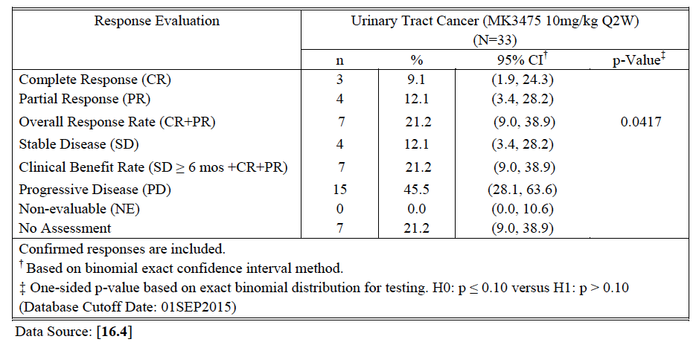
The PFS rate in the ASaT population of urinary tract cancer subjects was 22.6% at 6 months and 12.9% at 12 months, and was similar to the FAS population. The median OS was 9.3 months. The OS rate was 56.1% at 6 months and 42.1% at 12 months.
1 patient completed 2 years of treatment.

Evaluator commentary on other efficacy studies
This study is in a small number of patients (33) with urinary tract cancers, many of whom had been heavily pre-treated, who received pembrolizumab monotherapy using a very different regimen than proposed here. The response rate of 25.9% which was durable in 4/7 patients indicates there is a treatment effect, albeit achieved with much higher exposure than would be achieved with the proposed regimen.

Analyses performed across trials: pooled and Meta analyses
None provided.

Evaluator’s conclusions on clinical efficacy

Indication 1: For the treatment of patients with locally advanced or metastatic urothelial carcinoma who have received platinum-containing chemotherapy
The Keynote 045 study demonstrates a statistically significant and clinically meaningful improvement in overall survival in the study population of patients with locally advanced or metastatic urothelial cancer who have received platinum-containing chemotherapy. Progression free survival was not improved but secondary and exploratory endpoints (ORR, TTP data) support the positive conclusion based on OS.
It should be noted that only 6 subjects with performance status ECOG-PS 2 were included in this study and those with ECOG-PS >2 were excluded, and clinical efficacy has not been demonstrated in these groups.

Indication 2: For the treatment of patients who have received no prior systemic therapy for urothelial carcinoma who are not eligible for platinum-containing chemotherapy
In this open label, single arm study with very short median durations of follow-up and exposure, establishing whether there has been a clinically meaningful benefit of therapy is more difficult. The sponsor provided an update of ORR and duration of treatment in response to questions from the FDA, with a reported rate of ORR of 106/370 (28.6%). However, the use of the term ‘confirmed’ ORR is still somewhat unclear and requires the response to the evaluator’s clinical questions as it is not clear if this refers to RECIST 1.1 confirmation (minimum of 2 scans) or that is was confirmed on other RECIST 1.1 criteria by central radiological review. Based on the updated data, 55 of these 106 patients treated to date had a response duration exceeding 6 months. This appears to be the strongest data in support of a clinically meaningful response as these patients would have had at least 2 scans in this time period, and have had central radiological review and therefore appear to establish the basis for a claim of efficacy. This evaluator accepts that this information indicates that the response rate meeting the criteria as defined in the SAP at least 14.9%, and may be revised with the sponsor’s clarification. The reported ORR of 28.6% is marginally below the figure of 30% the sponsor had prespecified as being of clinical importance.
However, response duration in excess of 6 months is notable for this population, but caution has to be exercised in interpreting these results as there was no comparator arm and UC is a chemo-sensitive disease. Updated data would allow an assessment of the extent of and the durability of any observed response, with the latter the hallmark of benefit from immunotherapy. Updated data are also required as this rate may change as more patients reach the time point where a RECIST 1.1 confirmed response can be determined.

Clinical safety

Studies providing evaluable safety data
A single randomised Phase III trial was provided in support of the indication for previously treated patients, and a Phase II open label, single arm study in support of the indication for patients who have received no prior systemic therapy. In the evaluation of the safety data, the randomised study data are provided as the pivotal safety dataset with supportive evidence at the same dose level from the Phase II study. The Phase Ib study population received a different dose regimen, and will be evaluated for safety signals only. The sponsor has not provided an integrated safety summary of the first and second line populations and thus, these datasets will all be considered separately.

Pivotal studies that assessed safety as the sole primary outcome
None provided.

PN045 Phase III randomised, open label, active-controlled study in patients with recurrent or progressive urothelial cancer following cisplatin-based therapy
Safety and tolerability were secondary endpoints for this study and were assessed by clinical and statistical review of all relevant parameters including AEs and laboratory test abnormalities during the treatment period up to the data cut-off date of 07-Sep-2016.
The All-Patients-as-Treated (APaT) population, consisting of all randomised subjects who received at least 1 dose of study treatment (that is, n=521 subjects; 266 in the pembrolizumab arm and 255 in the control arm) was used for the analysis of safety data in this trial.

Safety measurements assessed and timing of assessment
The protocol provides information related to the collection and evaluation of safety information during the trial (evaluating, recording, and reporting AEs, definition and reporting of an overdose).

Clinical and laboratory measurements for safety
Vital signs, weight, physical examinations, ECOG-PS, electrocardiogram (ECG), and laboratory safety tests (for example, urinalysis, complete blood count [CBC], prothrombin time/aPTT, serum chemistries, thyroid function, and auto-antibodies) were obtained and assessed at designated intervals throughout the trial.

Safety endpoints (from trial protocol)
The following approach was taken to characterise the safety and tolerability of pembrolizumab (MK-3475) in this study was based on collection and analysis of:
- toxicities as defined by CTCAE criteria, including grade and severity, including serious adverse events
- (SAEs), deaths
- events of clinical interest (ECIs) including specific immune-related adverse events (irAEs)
- laboratory changes
The mandatory Safety Follow-Up Visit should be conducted approximately 30 days after the last dose of trial treatment or before the initiation of a new anti-neoplastic treatment, whichever comes first. All AEs that occur prior to the Safety Follow -Up Visit should be recorded. Subjects with an AE of Grade > 1 will be followed until the resolution of the AE to Grade 0-1 or until the beginning of a new anti-neoplastic therapy, whichever occurs first. SAEs that occur within 90 days of the end of treatment or before initiation of a new anti -neoplastic treatment should also be followed and recorded.
Comment: The safety protocol for Keynote 045 is sufficiently comprehensive to capture adverse events including adverse events of particular interest such as immune-related events.

Other studies

PN052 Phase II non-randomised, open label trial in patients who have received no prior systemic therapy and who are ineligible for cisplatin chemotherapy (200 mg Q3W)
Safety and tolerability were assessed as secondary endpoints by clinical and statistical review of all relevant parameters including AEs and laboratory test abnormalities during the treatment period up to the data cut-off date of 01-Sep-2016.
The APaT population was used for all safety analyses and consisted of all enrolled subjects who received at least 1 dose of study treatment (370 patients).
Comment: This is a very immature study with a median duration of exposure of less than 3 months, which will lead to an underestimate of the apparent rate of adverse events and as such, cannot be compared with other studies.

PN012v02 Phase Ib multi-cohort study of MK-3475 in subjects with advanced tumours (1o mg/kg Q2W)
Study PN012 cohort C enrolled 33 patients with advanced ‘urinary tract cancer’, with one of the primary objectives being to investigate the safety and tolerability of pembrolizumab 1o mg/kg Q2W (with a planned duration of therapy of 2 years). 32/33 patients had metastatic disease at enrolment and none were treatment naïve with respect to systemic therapy that is, all had received prior treatment, either in the adjuvant/neoadjuvant or metastatic setting. 8/33 patients had not received prior systemic treatment in the metastatic setting.
Comment: This study provides only very limited support for the proposed usage and will only be evaluated for safety signals for the following reasons:
- The treatment regimen is different with both a higher dose and frequency, with greater exposure anticipated in this cohort than the proposed usage;
- There are only very small numbers of patients in this open label, non-randomised Phase 1b trial;
- Some patients had been very heavily pre-treated;
- There is a randomised controlled trial presented in support of safety for this population.

Studies that assessed safety as the sole primary outcome
None provided.

Patient exposure

PN045 Phase III randomised, open label, active controlled study in patients with recurrent or progressive urothelial cancer following cisplatin-based therapy
The durations of exposure (median months on therapy) for the APaT population were 3.45 months for the pembrolizumab arm compared with 1.54 months in the control arm (paclitaxel: 1.45 months; docetaxel: 1.43 months; vinflunine: 2.10 months).
Of the 266 subjects in the pembrolizumab arm, 95 (35.7%) received treatment for ≥6 months and 43 (16.2%) received treatment for ≥ 12 months. Of 255 subjects in the control arm, 29 (11.4%) received treatment for ≥6 months and 3 (1.2%) received treatment for ≥ 12 months.

Table 66: Study PN045 Summary of drug exposure all patients as treated

Table 67: Study PN045 Duration of exposure
Comment: While only a relatively small proportion are still receiving pembrolizumab treatment at 12 months, this is greater than the control arm and will provide some information about the longer term safety profile in this population.

PN052 Phase II non-randomised, open label trial in patients who have received no prior systemic therapy and who are ineligible for cisplatin chemotherapy (200 mg Q3W)
KN052 is an ongoing study. The last subject was enrolled on 21-Jun-2016. At the time of data cut-off, the median duration of follow-up was 2.79 months (range 0.03-15.84 months).

Table 68: Study PN052 Clinical trial exposure APaT population
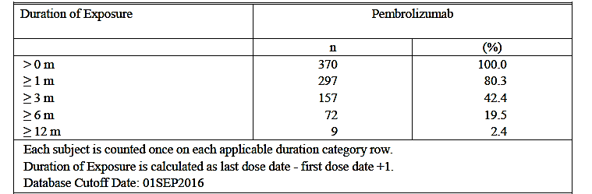
Comment: The median duration of follow-up indicates the immaturity of these data and this, together with the open label, single arm study design limits the ability of this study to detect new safety signals or to confirm the safety profile with longer exposure for this usage. There is reliance upon the investigator’s assessment given the specialist expertise of these oncologists in treating this malignancy to determine likelihood of any AEs being treatment-related.

PN012v02 Phase Ib multi-cohort study of MK-3475 in subjects with advanced tumours (1o mg/kg Q2W)
All 33 patients received at least one dose of study treatment.

Table 69: Study PN012 Cohort C Duration of exposure
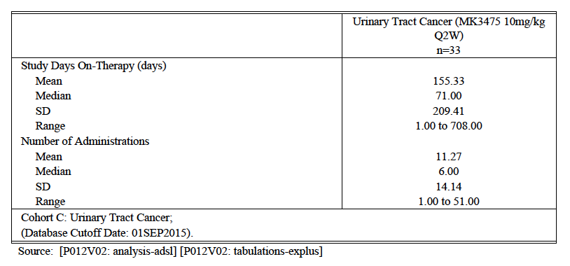
Comment: The pattern for the duration of exposure is similar to Study PN045, with 18.2% still receiving treatment after 12 months, but half ceasing treatment within 3 months.

Adverse events

Treatment-emergent adverse events (irrespective of relationship to study treatment)

PN045 Phase III randomised, open label, active-controlled study in patients with recurrent or progressive urothelial cancer following cisplatin-based therapy
Overall, 93.2% of subjects in the pembrolizumab arm experienced at least 1 AE compared with 98.0% of subjects in the control arm. Fewer patients in the pembrolizumab arm compared with the control arm, respectively, experienced:
- Drug-related AEs (60.9% versus 90.2%)
- Grade 3 to 5 AEs (52.3 versus 62.7%)
- Grade 3 to 5 drug-related AEs (15.0% versus 49.4%)
- Drug-related AEs leading to treatment discontinuation (5.6% versus 11.0%).

Table 70: Study PN045 Adverse event summary all patients (APaT population)

Table 71: Adverse event summary comparing patients treated in Study PN045 with the reference safety dataset (patients from KN001, KN002, KN006, KN010, KN012, KN013, KN016, KN024, KN052, KN087 and KN164)
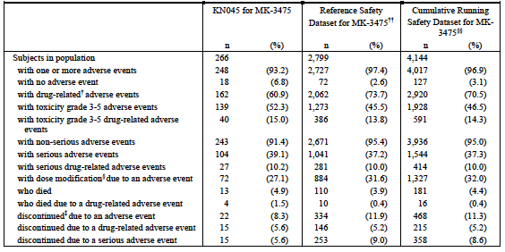
Comment: The table above indicates that although there were fewer AEs overall, a higher proportion of these were Grade 3-5 events, and resulted in with a higher rate of discontinuations and deaths attributed to treatment.
When the rates of AEs were compared with the reference safety dataset, noting that this population includes patients from KN052 (the first line study), the following occurred at higher frequencies in the PN045 population: anaemia (17.3% versus 12.4%), haematuria (11.3% versus 1.4%), acute kidney injury (5.6% versus 1.4%) and blood creatinine increase (4.9% versus 3.9%).
Comment: These are likely to be related to the underlying disease but emerged during treatment and

Treatment-emergent AEs
Of all the TEAEs, the most common (≥20% of subjects in ≥ 1 of the treatment arms) were: fatigue, anaemia, constipation, nausea, decreased appetite, alopecia, asthenia, and pruritus.
In the pembrolizumab arm compared with the control arm, the AEs observed in ≥20% of the subjects, were:
- Fatigue (25.9% versus 33.7%)
- Pruritus (23.3% versus 5.5%),
- Decreased appetite (21.1% versus 20.8%)
- Nausea (20.7% versus 28.6%).
In the control arm, additional AEs observed in ≥20% of the subjects were as follows (pembrolizumab versus control frequency):
- Alopecia (0.8% versus 38.8%)
- Anaemia (17.3% versus 35.7%)
- Constipation (18.8% versus 31.8%)
- Asthenia (11.3% versus 20.8%).
The observed frequency of pruritus is consistent with the previously described frequency of pruritus AEs with pembrolizumab.
Comment: There is adequate information regarding pruritus in the PI.
The observed frequency of urinary tract infection and haematuria was greater than the previously described frequency with pembrolizumab, and were similar to the control arm.
Comment: The evaluator is in agreement with the sponsor that this is likely to be due to the underlying condition.

Grade 3 to 5 Adverse Events

Table 72: Study PN045 Grade 3-5 TEAEs by decreasing incidence (Incidence ≥ 5%) all patients as treated
Fewer subjects in the pembrolizumab arm experienced Grade 3 to 5 AEs compared with the control arm (52.3% versus 62.7%, respectively).
The most frequently reported Grade 3 to 5 AEs (reported in ≥5% of subjects in one of the treatment arms) were:
- Anaemia
- Neutropaenia
- Neutrophil count decreased
- Fatigue
- Febrile neutropaenia.
In the pembrolizumab arm, anaemia was the Grade 3-5 AE reported in ≥5% of subjects and occurred less often than in the control arm (8.3% versus 12.2%).
In the control arm, additional Grade 3 to 5 AEs reported in ≥5% of the subjects were as follows (pembrolizumab versus control frequency):
- Neutropaenia (0.0% versus 14.5%)
- Neutrophil count decreased (0.4% versus 12.5%)
- Febrile neutropaenia (0.0% versus 7.5%)
- Fatigue (3.8% versus 5.9%)
- White cell count decreased (0.4% versus 5.5%)
- Asthenia (0.8 versus 5.1%).
Among the 22 subjects in the pembrolizumab arm with AEs of Grade 3-5 anaemia; 2 events were considered drug-related by the Investigator while the sponsor deemed these more likely related to the underlying medical condition.
The median time to onset of the first Grade 3 to 5 AE was longer for subjects in the pembrolizumab arm (6.0 months) than for subjects in the control arm (1.0 month).

Table 73: Study PN045 Patients with adverse events by decreasing incidence (Incidence ≥ 10% in one or more treatment groups) all patients as treated

PN052 Phase II non-randomised, open label trial in patients who have received no prior systemic therapy and who are ineligible for cisplatin chemotherapy (200 mg Q3W)
Adverse events were graded according to the NCI Common Terminology for Adverse Events (CTCAE), version 4.0.
354 (95.7%) subjects experienced at least 1 AE. Grade 3 to Grade 5 AEs that were assessed by the Investigators as drug-related were reported for 58 (15.7%) subjects, and 19 (5.1%) subjects were discontinued from study medication due to a drug-related AE.
Comment: A comparative presentation of the rates of AEs with the reference safety dataset was presented (see Table 74) but caution should be exercised in interpreting these comparisons because:
- The median durations of follow-up and of exposure are less than 3 months, therefore the total number of events in the trial arm will be lower than at the final cut-off date;
- There is no comparator arm within the study design to inform regarding the proposed first line usage in a new cancer. Safety is most accurately characterized in a randomised controlled trial against the standard of care.

Table 74: Study PN052 Adverse event summary all patients as treated population compared with reference safety dataset
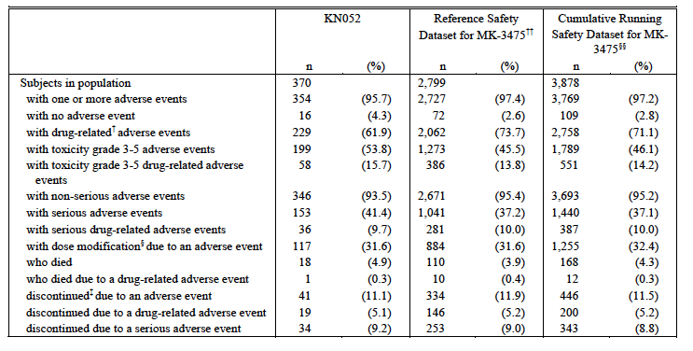

Table 74 continued: Study PN052 Adverse event summary all patients as treated population compared with reference safety dataset
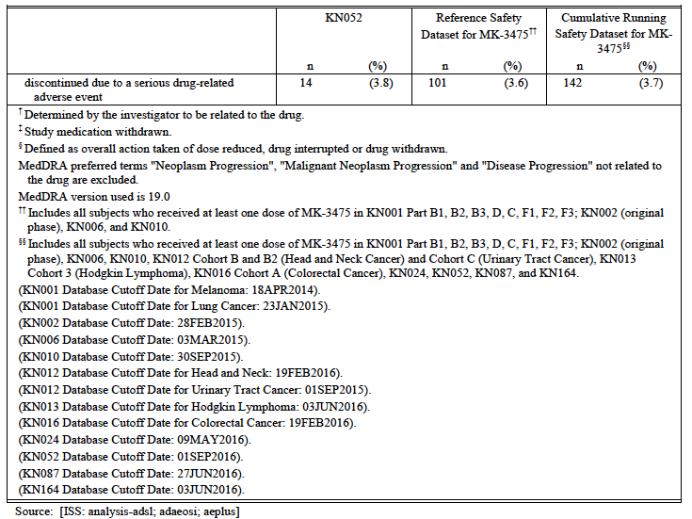
The 3 AEs reported most often (>20%) in the target population were fatigue (115 [31.1%]), decreased appetite (80 [21.6%]), constipation (78 [21.1%]), pruritus (18.9%), urinary tract infection (18.9%), diarrhoea (18.6%) and anaemia (16.5%) (see Table 75).

Table 75: Study PN052 Adverse events by decreasing incidence (Incidence ≥ 10%) all patients as treated population
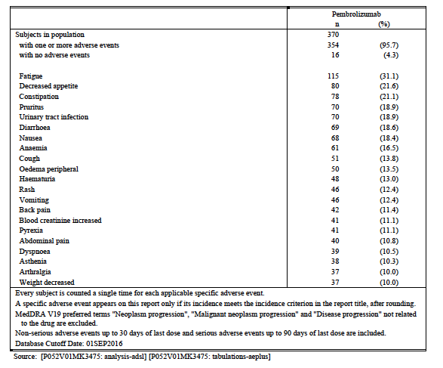
A review of the AE listing of all events includes the following new signals (that is, those not included in the PI or CMI):
- ‘Eye colour change’ in 1 patient (0.3%)
- 1 case of myocarditis (Grade 4).
Musculoskeletal events (39.2%; Grade 1, 15.9%; Grade 2, 14.9%; Grade 3, 8.1%). Rates for the more specific terms under the SOC included:
- ‘Autoimmune arthritis’ 1 Grade 3 event;
- ‘Muscular weakness’ (4.9%) including 7 patients (1.9%) with Grade 3;
- ‘Myalgia’ (4.1%) including 1 Grade 3 event;
- ‘Myositis’ in 1 patient resulting in death.
Comment: These events are not adequately represented in the PI.
- Myocarditis and Study PN052 should be added to the list in ‘Other immune-mediated adverse events’.
- There is currently no mention of musculoskeletal disorders in the PI although ‘joint pains’ are mentioned in the CMI. The observed frequency and severity, ranging from pain to weakness all observed at up to Grade 3 level, that it merits a heading in the Precautions to make health care professionals aware of the need to warn patients and to consider appropriate management and investigation. Table 7 in the PI does not accurately or adequately represent the incidence of these disorders. In this study alone, the rates of Grade 3 Musculoskeletal events were 8.1% (PI Comments).
- It would be reasonable to include the eye colour change in the CMI. (CMI Comments)

PN012v02 Phase Ib multi-cohort study of MK-3475 in subjects with advanced tumours (1o mg/kg Q2W)
The most common treatment-emergent AEs were fatigue (51%), decreased appetite (39.4%), oedema peripheral (36.4%), fatigue (51.5%), constipation (33.3%), blood creatinine increased (27.3%), nausea (27.3%), and pyrexia (27.3%). Of note, the CSR also includes 2 cases of myositis with one of the patients experiencing rhabdomyolysis and ‘neuromuscular dysfunction’ considered by the investigator to be treatment-related. The sponsor agreed with the attribution for the rhabdomyolysis and myositis. Both cases were also reported as SAEs.
Comment: Rhabdomyolysis is not currently mentioned in the PI at present and this needs to be updated, including details of the events and the studies in which they occurred in either the evaluator’s proposed Musculoskeletal Precaution section or the ‘Other Immune-mediated Adverse Events’ section (PI Comments).
72.7% (24/33) of patients experienced a Grade 3-5 adverse event, of which 15.2% were considered treatment-related (these were all Grade 3 or 4).
Comment: New signals (that is, those not already included in the PI) include thrombocytopaenia and rhabdomyolysis.

Table 76: PN012 Cohort C Summary of adverse events All patients
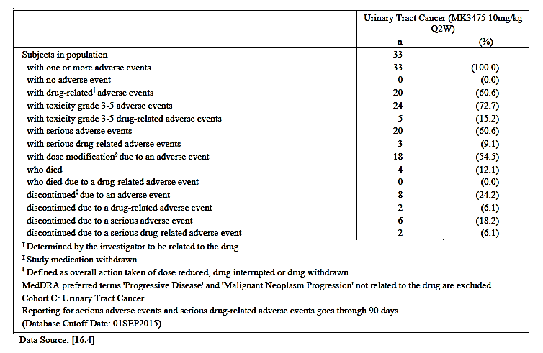

Treatment-related adverse events (adverse drug reactions)

PN045 Phase III randomised, open label, active-controlled study in patients with recurrent or progressive urothelial cancer following cisplatin-based therapy

Summary of All Treatment-related Adverse Events
Many fewer subjects in the pembrolizumab arm experienced drug-related AEs compared with the control group (60.9% versus 90.2%, respectively). The most commonly reported drug-related AEs (reported in ≥ 10% of subjects in one of the treatment arms) were: fatigue, alopecia, nausea, anaemia, decreased appetite, pruritus, constipation, diarrhoea, asthenia, neutropaenia, neutrophil count decreased, peripheral sensory neuropathy, and neuropathy peripheral.
In the pembrolizumab arm, the drug-related AEs observed in ≥ 10% of patients, and their prevalence in the control arm was respectively:
- Fatigue (13.9% versus 27.8%)
- Nausea (10.9% versus 24.3%)
- Pruritus (19.5% versus 2.7%)
In the control arm, additional drug-related AEs observed in ≥ 10% of the subjects were as follows (pembrolizumab versus control): alopecia (0.0% versus 37.6%), anaemia (3.4% versus 24.7%), decreased appetite (8.6% versus 16.1%), constipation (2.3% versus 20.4%), diarrhoea (9.0% versus 12.9%), asthenia (5.6% vs14.1%) neutropaenia (0.0% versus 15.3%), neutrophil count decreased (0.4% versus 14.1%), peripheral sensory neuropathy (0.8% versus 11.0%), and neuropathy peripheral (0.4% versus 10.6%).
Comment: Pruritus is a known adverse drug reaction for pembrolizumab and is included in the PI.

Treatment-related Grade 3 to 5 Adverse Events
Fewer subjects in the pembrolizumab arm experienced drug-related Grade 3 to 5 AEs compared with the control arm (15.0% versus 49.4%, respectively). The most commonly reported drug-related Grade 3 to 5 AEs (reported in ≥5% of subjects in one of the treatment arms) were neutropaenia, neutrophil count decreased, anaemia, febrile neutropaenia, and white blood cell decreased.
In the pembrolizumab arm, no drug-related Grade 3 to 5 AEs were observed in ≥5% of subjects. In further detailed analysis of the data, the drug-related Grade 3 to 5 AEs reported in ≥ 1% of subjects in the pembrolizumab arm are all known AEs for pembrolizumab:
- Pneumonitis (n=4, 1.5%)
- AST increased (n=3, 1.1%),
- Diarrhoea (n=3, 1.1%)
- Fatigue (n=3, 1.1%)
In the control arm, the drug-related Grade 3 to 5 AEs observed in ≥5% of the subjects were as follows (pembrolizumab versus control):
- Neutropaenia (0% versus 13.3%)
- Neutrophil count decreased (0.4% versus 12.2%)
- Anaemia (0.8% versus 7.8%)
- Febrile neutropaenia (0.0% versus 7.1%),
- White blood cell decreased (0.4% versus 5.1%).
Comment: The nature and higher rate of severe AEs in the control arm reflects the known effects of chemotherapy and indicates clearly the much better safety profile of pembrolizumab.

Table 77: Study PN045 Treatment-related adverse events by decreasing incidence (Incidence ≥ 5%) on one or more treatment groups in all patients as treated population
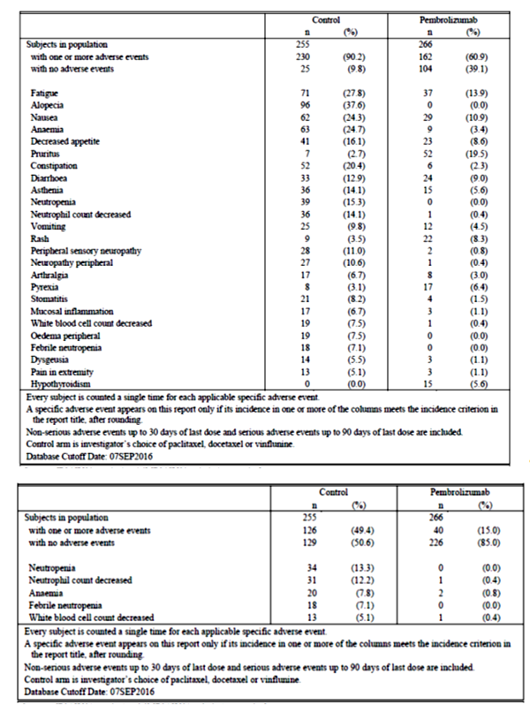
Comment: Adverse drug effects were generally as expected from the previously established toxicities of pembrolizumab and of the chemotherapy controls. There were fewer adverse drug effects and fewer serious drug effects in the pembrolizumab arm, and the common pembrolizumab toxicities of fatigue, asthenia, pruritus, rash, diarrhoea pyrexia and hypothyroidism are in line with pembrolizumab toxicities in studies with other cancers. No new pembrolizumab toxicities appear to have emerged from this study (see also comments below in respect of serious toxicities, deaths and events of clinical interest).

PN052 Phase II non-randomised, open label trial in patients who have received no prior systemic therapy and who are ineligible for cisplatin chemotherapy (200 mg Q3W)
229 patients (61.9%) experienced a treatment-related AE, with 58 (15.7%) of patients experiencing Grade 3 to Grade 5 AEs and 19 (5.1%) patients were discontinued from study medication due to a drug-related AE.

Table 78: Study PN052 Treatment-related adverse events by decreasing incidence (≥ %) all patients (APaT population)
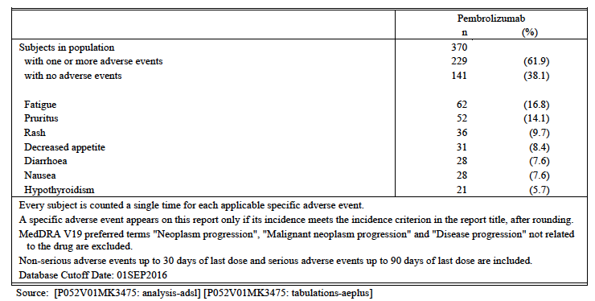
A review indicates that an additional safety signal is not currently in the PI of myocarditis (1 patient), and this needs to be updated. (PI Comment)
Comment: New safety signals were detected including pericarditis, myocarditis. Myositis is described under ‘Other immune-mediated adverse events’ but this section does not mention fatalities. This section of the PI should be updated with the fatality from myositis in KN-052. Myocarditis is not currently mentioned in the PI and this needs to be updated. (PI Comments)

PN012v02 Phase Ib multi-cohort study of MK-3475 in subjects with advanced tumours (1o mg/kg Q2W)
60.6% experienced a treatment-related AE, most commonly fatigue (18.2%) and peripheral oedema (12.1%). The cases of myositis and rhabdomyolysis were considered treatment-related and have been commented on above. Other reports include uveitis (mentioned in the PI), but no other new signals were detected on review.

Deaths and other serious adverse events

PN045 Phase III randomised, open label, active-controlled study in patients with recurrent or progressive urothelial cancer following cisplatin-based therapy

Summary of deaths
4.9% (n=13) of patients in the pembrolizumab arm and 3.1% (n=8) of subjects in the control arm had AEs that resulted in death within 90 days of the last dose. As can be seen from Table 79, the majority of these fatal events were from conditions more likely to be related to the underlying disease.

Table 79: Study PN045 Deaths resulting from adverse events up to 90 days after the last dose, all patients as treated population
Comment: Four deaths were attributed by investigators to pembrolizumab therapy (see table above). The sponsor did not accept this attribution. One death due to pneumonitis is consistent with known pembrolizumab toxicity. One death occurred suddenly, outside hospital, 5 days after the 2nd pembrolizumab dose in a patient with cardiovascular risk factors. Two deaths, attributed to ‘urinary tract obstruction’ and ‘malignant neoplasm progression’ might possibly relate to immunologically mediated tumour swelling or ‘pseudoprogression’ but could (and in the evaluator’s opinion on review of the narratives, more likely did) occur due to progression of disease. Both occurred within a few days of the first pembrolizumab dose.
The recorded deaths due to adverse events do not raise concerns about new fatal toxicities of pembrolizumab nor about a different profile or frequency of fatal toxicities in this study population. The PI contains appropriate information and does not need to be updated.

Serious Adverse Events
39.1% of subjects in the pembrolizumab arm and 40.8% of patients in the control arm experienced 1 or more SAEs up to 90 days after the last dose of study treatment.
In the pembrolizumab arm, no SAEs were reported in ≥ 5% of patients. In further detailed analysis, the SAEs observed in ≥ 1% of subjects in the pembrolizumab arm, and their prevalence in the control arm was respectively:
- Urinary tract infection (4.5% versus 4.7%),
- Pneumonia (3.4% versus 3.1%)
- Anaemia (2.6% versus 3.1%)
- Pneumonitis (2.3% versus 0.0%)
- Haematuria (1.9% versus 2.0%)
- Pyrexia (1.9% versus 2.0%)
- Acute kidney injury (1.5% versus 2.4%)
- Cancer pain (1.5% versus 1.2%)
- Urosepsis (1.5% versus 0.4%)
- Colitis (1.5% versus 0.0%)
- Dehydration (1.1% versus 0.8%)
- Diarrhoea (1.1% versus 0.8%)
- Dyspnoea (1.1% versus 0.8%)
- Urinary tract obstruction (1.1% versus 0.4%)
- Device dislocation (1.1% versus 0.0%)
- General physical health deterioration (1.1% versus 0.0%).
Pneumonitis, colitis (and the associated events of dyspnoea, and dehydration and diarrhoea, respectively) all occurred more commonly in receiving pembrolizumab. Pneumonitis and colitis are known adverse drug reactions for pembrolizumab.
Drug-related SAEs, as assessed by the Investigators, occurred less commonly in the pembrolizumab arm (10.2% versus 22.4%). In the pembrolizumab arm, the drug-related SAEs observed in ≥ 1% of subjects and their prevalence in the control arm, were respectively: pneumonitis (1.9% versus 0) and colitis (1.5% versus 0).
In the control arm, the drug-related SAEs occurring in ≥ 1% of the subjects were as follows (pembrolizumab versus control): febrile neutropaenia (0.0% versus 5.9%), constipation (0.0% versus 2.7%), anaemia (0.0% versus 2.0%), intestinal obstruction (0.0% versus 2.0%), neutropaenia (0.0% versus 2.0%), urinary tract infection (0.0% versus 1.6%), and neutrophil count decreased (0.0% versus 1.2%).
Comment: No new safety issues arise from the documented SAEs.

PN052 Phase II non-randomised, open label trial in patients who have received no prior systemic therapy and who are ineligible for cisplatin chemotherapy (200 mg Q3W)

Deaths
There were 18 (4.9%) AEs associated with a fatal outcome during the study.
Comment: The evaluator is in agreement with the investigators’ and sponsor’s assessment that only the case of myositis is likely to be treatment-related. The PI reports this risk but not that fatalities have been associated with it, and it is recommended this be included. (PI Comments) The other causes of death are consistent with other conditions or the underlying cancer.

Table 80: Study PN052 Deaths resulting from adverse events up to 90 days after the last dose
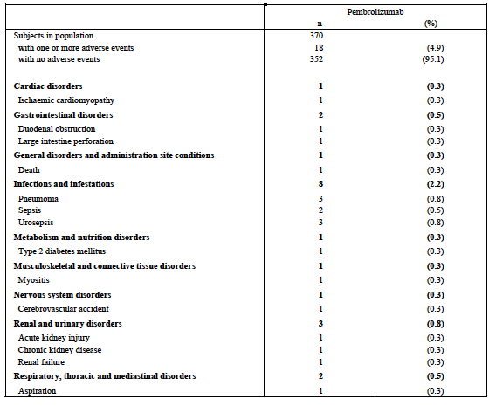

Serious adverse events
Serious adverse events were reported for 153 (41.4%) subjects. Of these, investigators reported 36 (9.7%) as drug-related (see Table 81).
Comment: In the absence of a control arm, it is difficult to make attributions but most of these are consistent with either known adverse effects of pembrolizumab or the underlying condition. The event of myocarditis has been commented upon already.

Table 81: Study PN 052 Serious adverse events up to 90 days after last dose by decreasing incidence all patients
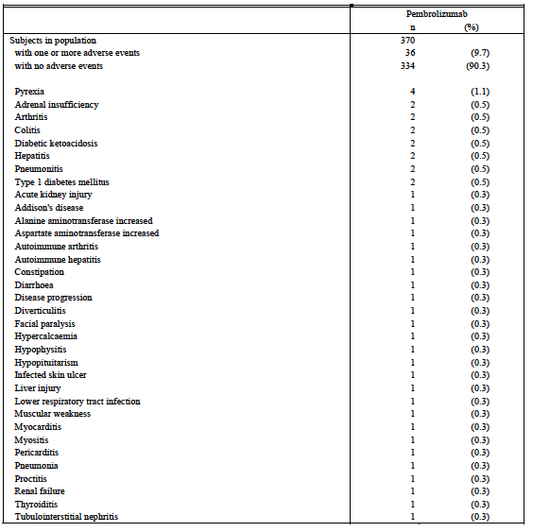
Fourteen (3.8%) subjects were discontinued from study medication due to a drug-related SAE.

PN012v02 Phase Ib multi-cohort study of MK-3475 in subjects with advanced tumours (1o mg/kg Q2W)
The narratives for the 4 deaths from sepsis, subarachnoid haemorrhage, cardiac arrest and pneumonia were reviewed, and these do not suggest a treatment-related cause of death:
One patient ([information redacted]) had the following summary at the time of death. Although this patient’s cause of death was sepsis, probably unrelated, there were significant other comorbidities which seem likely to be related.
The patient was investigated extensively with biopsies, including of the bone marrow and skin, which demonstrated multiple immune-related processes. The sponsor’s report states, ‘In the opinion of the investigator, the serious adverse event of myositis (Grade 2), hypercalcaemia (Grade 3), and immune system disorder, HLH (Grade 4), were considered related to study treatment. The event of sepsis (Grade 5) was considered not related to study drug or study procedure, but possibly related to long-term steroid use.
In the opinion of the investigator, the serious adverse event of myositis (Grade 2) and immune system disorder, HLH (Grade 4), and hypercalcemia (Grade 3) were considered immune-related.
The events of hypercalcaemia (Grade 3) and immune system disorder, HLH (Grade 4) were considered clinical interest by the investigator.
The sponsor considered the event of myositis (Grade 2) as an adverse event of special interest.
Based on the clinically relevant information currently available for this individual case, the reported events are considered by the sponsor to be unlikely related to investigational therapy.
The evidence is not sufficient to suggest a relationship between the investigational therapy and the reported serious adverse events. Causality assessment is impacted by subject’s concurrent conditions (notably myalgia and sensory neuropathy due to prior chemotherapy), concomitant medications (especially long-term use of steroids), and underlying diseases.’
Comment: Based on the extensive investigations, the evaluator is in agreement with the investigator and other specialists involved in this patient’s care, that the events of haemophagocytic lymphohistiocytosis (HLH) in conjunction with a severe panniculitis, and myositis were probably related to treatment with pembrolizumab. It is recommended that this be included as an important potential risk in the RMP. (RMP comments)

Serious adverse events
60.6% (20/33) patients experienced an SAE, and those occurring in more than one subject were urinary tract infection (9.1%), sepsis (6.1%), and myositis (6.1%). There were no new safety signals amongst the remaining cases, several of which were not considered treatment-related. Of those 3 cases with 5 SAEs considered treatment-related, the case of toxic encephalopathy was complicated by concomitant medications including opioids.
Comment: Myositis is considered related to treatment and recommendations have been made for changes to the PI.

Discontinuations due to adverse events

PN045 Phase III randomised, open label, active-controlled study in patients with recurrent or progressive urothelial cancer following cisplatin-based therapy
Adverse events resulting in treatment discontinuation
A total of 22 (8.3%) subjects in the pembrolizumab arm had an AE resulting in treatment discontinuation. The most common AE resulting in treatment discontinuation was pneumonitis (n=5, 1.9%).
A total of 32 (12.5%) subjects in the control arm had an AE resulting in treatment discontinuation. The AEs resulting in treatment discontinuation in ≥ 1% were peripheral sensory neuropathy (n=5, 2.0%) and neuropathy peripheral (n=4, 1.6%).
Comment: This rate of discontinuation is more than twice that that reported in the PI (4%) which is likely to reflect differences between the population with urothelial carcinoma and the mixed population currently reported in the PI, which is mostly made up of melanoma patients. This increased rate of discontinuations should be included under a specific heading for Urothelial Carcinoma in the Adverse Events section in addition to the current statement under the heading ‘Other Cancers’ statement that the ‘Adverse events’ section just above Dosage and Administration.

Adverse events resulting in treatment interruption

Any adverse event
Similar numbers of patients in the pembrolizumab arm and control arm had an AE resulting in treatment: 54 (20.3%) versus 57 (22.4%), respectively.
AEs in the pembrolizumab treatment arm affecting ≥ 1% of subjects were: urinary tract infection (n=4, 1.5%), diarrhoea (n=4, 1.5%), and colitis (n=3, 1.1%); and in the control arm, AEs affecting ≥ 1% of patients were anaemia (n=14, 5.5%); neutropaenia (n=5, 2.0%); asthenia and neutrophil count decrease (n=4, 1.6% each); urinary tract infection, nausea, and infusion-related reaction (n=3, 1.2% each).
28 (10.5%) patients in the pembrolizumab arm had a drug-related AE resulting in treatment interruption. The AEs affecting ≥ 1% patients were colitis and diarrhoea (n=3, 1.1% each).
40 (15.7%) subjects in the control arm had a drug-related AE resulting in treatment interruption. The drug-related AEs resulting in treatment interruption in ≥ 1% of subjects were anaemia (n=12, 4.7%), neutropaenia (n=5, 2.0%), asthenia and neutrophil count decrease (n=4, 1.6% each), and infusion-related reaction (n=3, 1.2%).
Comment: AEs leading to treatment discontinuation or interruption do not raise new safety concerns. The most frequent cause of treatment discontinuation in the pembrolizumab arm was pneumonitis (5 events, 1.9%) reflecting the expected frequency of this known toxicity.

PN052 Phase II non-randomised, open label trial in patients who have received no prior systemic therapy and who are ineligible for cisplatin chemotherapy (200 mg Q3W)
A total of 41 (11.1%) subjects had an AE resulting in treatment discontinuation. No AE leading to treatment discontinuation was reported in a frequency >1%. A total of 19 (5.1%) subjects had a drug-related AE resulting in treatment discontinuation. No drug-related AE leading to treatment discontinuation was reported in a frequency >0.5%.
82/370 (22.2%) patients had an AE resulting in treatment interruption, with 43 (11.6%) considered related to treatment. Those reported with a frequency>1% included abnormal liver function test(s) and diarrhoea.
Comment: The short follow-up period means that these are likely to significantly underestimate the rates of discontinuation and interruption required in this first line population.

PN012v02 Phase Ib multi-cohort study of MK-3475 in subjects with advanced tumours (1o mg/kg Q2W)
8/33 (24.2%) patients discontinued due to an AE with 2 of these patients discontinuing due to an AEs considered related to treatment: rhabdomyolysis and myositis (1 patient) and hypercalcaemia.

Events of clinical interest
These were defined as overdose, drug-induced liver injury laboratory parameters, selected AE terms of potential immune aetiology called adverse events of special interest occurring within 90 days after the last dose or 30 days if a new anticancer treatment was initiated.

PN045 Phase III randomised, open label, active-controlled study in patients with recurrent or progressive urothelial cancer following cisplatin-based therapy

Overview of adverse events of special interest
Adverse events of special interest (AEOSI) are immune-mediated events and infusion-related reactions considered to be identified risks (adverse drug reactions) or potential risks for pembrolizumab. A prespecified list of preferred terms (PTs) was developed for assessing AEOSIs. These PTs are considered to be clinically equivalent to the immune-mediated events and infusion-related reactions. The prespecified list allowed the sponsor to consistently evaluate each AEOSI across the clinical program. All prespecified AE terms were included in the assessment of frequency and nature of AEOSIs for pembrolizumab, regardless of causality as reported by Investigators.
45 (16.9%) subjects in the pembrolizumab arm had 1 or more AEOSIs. In general, the frequency and severity of each AEOSI observed during the trial were similar to the previously described characterization of the safety profile of pembrolizumab.
No indication-specific AEOSI was identified (new immune-mediated event causally associated with pembrolizumab).
Comment: Events of special interest that were reported in 45 patients in the pembrolizumab arm included 29 cases of thyroid disease (17 hypothyroid, 10 hyperthyroid, 2 thyroiditis), 11 pneumonitis, 6 colitis, 2 each of nephritis, infusion reaction and severe skin reaction. All other events were in single patients. These events reflect known toxicity of the drug.

PN052 Phase II non-randomised, open label trial in patients who have received no prior systemic therapy and who are ineligible for cisplatin chemotherapy (200 mg Q3W)
To date, there have been 63 (17.0%) patients with 1 or more AEOSIs:
- 38 (10.3%) of subjects experienced Grade 1 and 2 AEOSIs
- 25 (6.8%) experienced Grade 3 or higher AEOSIs
- 1 patient died from myositis
While the frequencies and severity of each of the AEOSIs observed during the trial were generally similar to the previously described characterization of the safety profile of pembrolizumab, one patient had an AEOSI of severe myositis with a fatal outcome.
Comment: This may change with increased duration of exposure, as this trial is ongoing.

PN012v02 Phase Ib multi-cohort study of MK-3475 in subjects with advanced tumours (1o mg/kg Q2W)
Not reported in the CSR.

Laboratory test abnormalities

Liver function and liver toxicity

PN045 Phase III randomised, open label, active-controlled study in patients with recurrent or progressive urothelial cancer following cisplatin-based therapy
A summary of subjects with liver function laboratory abnormalities that met predetermined criteria is provided below. The most frequent liver function finding observed was alkaline phosphatase ≥ 1.5 x upper limit of normal (ULN) (31.6%), observed at a similar rate as in the control arm (28.5%). No liver function abnormalities consistent with severe drug injury (Hy’s Law) were reported.

Table 82: Subjects with liver function related laboratory findings that met predetermined criteria all subjects

PN052 Phase II non-randomised, open label trial in patients who have received no prior systemic therapy and who are ineligible for cisplatin chemotherapy (200 mg Q3W)
The most frequent liver function finding observed was alkaline phosphatase ≥ 1.5 x upper limit of normal (ULN) (24.5%), but the sponsor states no cases consistent with Hy’s Law were observed. One Grade 3 increase in bilirubin was reported, 13 cases of ≥Grade 3 aspartate transaminase and 11 cases of ≥Grade 3 alanine transaminase.
Comment: The laboratory values are presented in tables but cannot be evaluated further as there are no clinical details presented for the patients where marked abnormalities were observed.

PN012v02 Phase Ib multi-cohort study of MK-3475 in subjects with advanced tumours (1o mg/kg Q2W)
Grade 3 or 4 events increases in aspartate aminotransferase occurred in 2 patients (6.1%) but there were no notable increases in other liver function tests.

Renal function and renal toxicity

PN045 Phase III randomised, open label, active-controlled study in patients with recurrent or progressive urothelial cancer following cisplatin-based therapy

Table 83: Summary of laboratory for highest toxicity grade in subjects that worsened from baseline and had baseline and post-baseline results all subjects
Comment: Renal toxicity has not emerged as a major toxicity of pembrolizumab in other studies, in other cancers. No renal toxicity was tabulated as a drug-related toxicity in this study. Increased in creatinine from baseline are tabulated above and are similar for the pembrolizumab and control arms. Among tabulated severe AEs (not necessarily drug related) were two cases of renal failure in the pembrolizumab arm and one in the control arm. 4 cases of acute kidney injury were reported in the pembrolizumab arm, 6 in the control arm. Haematuria and urinary infection were similar between arms and both are likely to reflect the pathology of urothelial cancer. There is no signal here for new concern about nephrotoxicity.
However, it should be noted that subjects with baseline creatinine clearance <30 mL/min were excluded from the study, and the drug cannot be regarded as showing a satisfactory safety profile (or efficacy) in such patients. The sponsor should provide information documenting safety of pembrolizumab in patients with lower creatinine clearance, if available.

PN052 Phase II non-randomised, open label trial in patients who have received no prior systemic therapy and who are ineligible for cisplatin chemotherapy (200 mg Q3W)
No summary or discussion is provided in the CSR. From a table included, the number of patients with any rise in creatinine was 36.3%, with 4.2% ≥Grade 3.
Comment: Due to the single arm study design and lack of a control arm, and without clinical information to provide a context, it is not possible to make a further comment on these data, especially given these patients have malignancies affecting the urothelial tract. The sponsor has been requested to provide data or evidence to support the safety of pembrolizumab in patients with severe renal impairment.

PN012v02 Phase Ib multi-cohort study of MK-3475 in subjects with advanced tumours (1o mg/kg Q2W)
Pages of tables were included in the CSR but no summary or clinical details provided. 1 case each of Grade 3 and Grade 4 increase in creatinine is noted.
There was no discussion in the CSR, and the non-randomised study design involving only small numbers of patients, many of whom had been heavily pre-treated, limits the ability to interpret any results presented.

Other clinical chemistry

PN045 Phase III randomised, open label, active-controlled study in patients with recurrent or progressive urothelial cancer following cisplatin-based therapy
Comment: Review of the clinical chemistry data show no excess of changes from baseline data in respect of sodium, potassium, calcium, magnesium, phosphate triglycerides or glucose in the pembrolizumab arm as compared with controls.

PN052 Phase II non-randomised, open label trial in patients who have received no prior systemic therapy and who are ineligible for cisplatin chemotherapy (200 mg Q3W)
≥Grade 3 changes were observed across almost all parameters. Notable increases in glucose levels occurred: 28.4% all grades, including 6.5% Grade 3, 1.1% Grade 4 events.
Comment: In the absence of a control arm and clinical details, these data are difficult to interpret, and it is not clear if these patients had pre-existing diabetes, were taking corticosteroids to control immune-mediated events or other conditions, or had new events as a result of a treatment-related endocrinopathy.

PN012v02 Phase Ib multi-cohort study of MK-3475 in subjects with advanced tumours (1o mg/kg Q2W
Comment: No notable changes in other clinical chemistry parameters were noted but caution should be exercised given the small numbers of patients (33), which limits the ability to interpret any results presented or to identify new treatment-related safety signals.

Haematology and haematological toxicity

PN045 Phase III randomised, open label, active-controlled study in patients with recurrent or progressive urothelial cancer following cisplatin-based therapy

Table 84: Summary of laboratory for highest toxicity grade in subjects that worsened from baseline all subjects
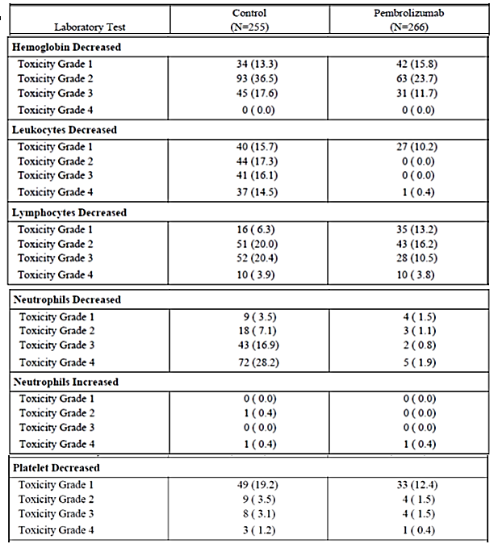
Comment: Haematological toxicity is tabulated above and shows minor toxicity for pembrolizumab compared with the chemotherapy controls. One incident of Grade 3 or 4 neutropaenia and 2 incidences of Grade 3 or 4 anaemias were reported.

PN052 Phase II non-randomised, open label trial in patients who have received no prior systemic therapy and who are ineligible for cisplatin chemotherapy (200 mg Q3W)
The following changes are noteworthy:
12 patients (3.2%) had Grade 4 ‘Neutrophils decreased’ (3.7% ≥Grade 3)
43 patients had ≥Grade 3 lymphocyte decrease; including 14 patients (3.8%) with Grade 4 laboratory abnormalities.
1 patient (0.3%) had a Grade 4 event of ‘platelets decreased’
Comment: The rate and the severity of the observed neutropaenia are unexpected given these patients have not had prior systemic treatments in the metastatic setting. The sponsor is requested to provide a discussion as to possible reasons as no clinical context is provided with these tables. Lymphopaenia is a recognised AE for pembrolizumab and similar rates are included in the PI, but for the different dose level and schedule (1o mg/kg every 2 or 3 weeks) in melanoma patients.

PN012v02 Phase Ib multi-cohort
Pages of tables were included in the CSR but no summary provided.
Comment: As mentioned above, it is not possible to evaluate this information for treatment-related safety signals.

Other Laboratory Tests

PN045 Phase III randomised, open label, active-controlled study in patients with recurrent or progressive urothelial cancer following cisplatin-based therapy
17 cases of hypothyroidism and 10 cases of hyperthyroidism were recorded on the pembrolizumab arm, reinforcing the known requirement to monitor for thyroid abnormalities in patients receiving this drug.

PN052 Phase II non-randomised, open label trial in patients who have received no prior systemic therapy and who are ineligible for cisplatin chemotherapy (200 mg Q3W)
2 patients (0.6%) had Grade 4 events of lipase increased and 6 (1.6%) experienced a Grade 3 increase in prothrombin ratio.

PN012v02 Phase Ib multi-cohort study of MK-3475 in subjects with advanced tumours (1o mg/kg Q2W)
A single case of Grade 4 creatine kinase is noted. No other new signals were identified.

Vital signs and clinical examination findings

PN045 Phase III randomised, open label, active-controlled study in patients with recurrent or progressive urothelial cancer following cisplatin-based therapy
No important issues arose specifically in respect of data relating to vital signs or clinical findings.

PN052 Phase II non-randomised, open label trial in patients who have received no prior systemic therapy and who are ineligible for cisplatin chemotherapy (200 mg Q3W)
These were presented across pages of tables, without accompanying text in the CSR making the results difficult to interpret, particularly as these patients may well have comorbidities or other causes for any observed changes.
Comment: The lack of clinical context and comparator arm make detection of new treatment-related signals difficult.

PN012v02 Phase Ib multi-cohort study of MK-3475 in subjects with advanced tumours (1o mg/kg Q2W)
These were presented across pages of tables, without accompanying text in the CSR making the results difficult to interpret, particularly as these patients may well have comorbidities or other causes for any observed changes.
Comment: the lack of clinical context and comparator arm, and the small numbers of patients, make detection of new treatment-related signals difficult.

Immunogenicity and immunological events

PN045 Phase III randomised, open label, active-controlled study in patients with recurrent or progressive urothelial cancer following cisplatin-based therapy
Immunological events have been captured in the category of adverse events of special (clinical) interest (AEOSI) and are discussed in the relevant section above. These were as expected from the known immunological toxicity of anti PD-1 monoclonal antibodies including pembrolizumab. The usual initial treatment for immunologically mediated treatment complications is with glucocorticoid drugs and the frequency with which these were prescribed for AEOSI is tabulated below.

Table 85: Summary of concomitant corticosteroid use for Grade 1-2 AEOSI episodes all subjects

Table 86: Summary of concomitant corticosteroid use for Grade 3-5 AEOSI episodes all subjects
Comment: This study does not identify any previously unrecognised immunotoxicity of pembrolizumab or identify a higher than expected incidence of immunotoxicity in the study population.

PN052 Phase II non-randomised, open label trial in patients who have received no prior systemic therapy and who are ineligible for cisplatin chemotherapy (200 mg Q3W)
The AEOSIs are described above and no data regarding immunogenicity were included in the CSR.

PN012v02 Phase Ib multi-cohort study of MK-3475 in subjects with advanced tumours (1o mg/kg Q2W)
No data presented in the CSR for evaluation.

Serious skin reactions

PN045 Phase III randomised, open label, active-controlled study in patients with recurrent or progressive urothelial cancer following cisplatin-based therapy
Pruritus (23.3%) and rash (10.9%) were common in the pembrolizumab arm but only two serious skin reactions were reported.
Comment: The PI informs adequately about these risks and their management.

PN052 Phase II non-randomised, open label trial in patients who have received no prior systemic therapy and who are ineligible for cisplatin chemotherapy (200 mg Q3W)
Skin-related adverse events were common (37.6% any grade, 1.4% Grade 3) and were mostly pruritus and rash. No Grade 4 events or deaths occurred related to skin AEs.

PN012v02 Phase Ib multi-cohort study of MK-3475 in subjects with advanced tumours (1o mg/kg Q2W)
Skin reactions were common (30.3% any grade, most commonly pruritus), but there were no new signals and the PI reflects the events adequately.

Other safety parameters

Integrated safety analyses
Comment: The integrated safety analyses appear to have used a single ‘Reference safety dataset for MK-3475’ including 2799 patients. This reference dataset is used for comparison with PN052 AEs, but does not appear to include one of the notable Grade 4 events of myocarditis experienced in that study.
The sponsor is requested to confirm:
The exact patient study populations and numbers of patients contributing to the dataset;
To explain this apparent discrepancy of myocarditis not appearing in the reference dataset when it occurred in the PN052 population;
If patients from PN052 are indeed included in the dataset, please discuss the rationale for and validity of comparing that study against a reference which includes it.

PN052 Phase II non-randomised, open label trial in patients who have received no prior systemic therapy and who are ineligible for cisplatin chemotherapy (200 mg Q3W)

The SCS included a comparison of the data from the reference safety dataset (comprised of patients from Studies KN001, 002, 006, 010, 02, 013,016, 024, 087 and 164).
These indicate, even after the study has been running for only a relatively short time with limited duration of exposure that the following events occurred more commonly: constipation, urinary tract infection, anaemia, peripheral oedema, haematuria, blood creatinine increased, abdominal pain and weight decreased. When the incidence data are included for severe events occurring at ≥ 1% frequency and restricted to those considered related to treatment, additional severe events appear to be increased: fatigue and muscular weakness.
Comment:
- The validity of comparing rates of events is limited so early in the course of a study and with such a short duration of treatment and follow-up.
- While many of these are likely to be directly related to the underlying disease (particularly haematuria, urinary tract infection and abdominal pain), these also indicate that tolerance of the treatment is not the same in this population as in others. In particular, it is considered important that further data are presented and collected about the risk for those with new or underlying renal dysfunction, which may be less frequent in the other populations in which registration has been approved for this therapy.
- The increased rates of renal failure and acute kidney injury reported by investigators should be included in the PI under the heading ‘Other Cancers’ where it currently states that the rates of adverse events for patients with urothelial carcinoma are generally similar. (PI Comments)

Table 87: Adverse event rates (incidence≥ 10% in one or more treatment groups) in patients in Study PN052 and the reference safety dataset
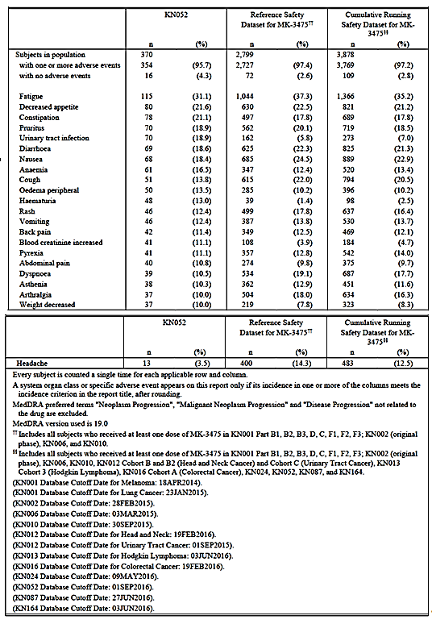

Immunogenicity analysis

Report 04L4FS Integrated pembrolizumab immunogenicity analysis date January 11 2017
As part of the clinical development program for pembrolizumab (also known as MK-3475), pre- and post-baseline serum samples from 3727 patients treated with pembrolizumab were analyzed for anti-drug antibodies from the following cohorts: melanoma (1535), NSCLC (1238), HNSCC (101), MSI-H (54), HL (220) and UC (579). Out of the 3727 subjects included in the immunogenicity assessment, 2034 subjects were evaluable (Table 88). The overall immunogenicity incidence was defined as the proportion of treatment emergent positive subjects to the total number of evaluable subjects (treatment emergent positive, non-treatment emergent positive and negative immunogenicity status).
The observed incidence of treatment emergent ADA in evaluable subjects based on a pooled analysis of melanoma, NSCLC, HNSCC, MSI-H, HL and UC subjects is 1.8% (36 out of 2034), based on 36 subjects with confirmed treatment emergent positive status, relative to all evaluable subjects including 36 with treatment emergent positive, 21 with non-treatment-emergent positive and 1977 with negative immunogenicity status.
With availability of the neutralizing antibody assay, in total, two (1 melanoma and 1 NSCLC) of the 21 non-treatment emergent subjects tested positive for neutralizing antibodies, and these two subjects were considered as ‘non-treatment emergent neutralizing positive’. Of the 36 treatment emergent positive subjects, nine (1 melanoma, 5 NSCLC, 1 HL and 2 UC) tested positive in the neutralizing assay and thus were considered as ‘treatment emergent neutralizing positive’. The 9 subjects that were positive in the neutralizing assay accounted for a total incidence rate of treatment emergent neutralizing positive subjects of 0.4% (9 out of 2034) in the overall population.
In the subgroup of subjects with UC indication, out of 579 subjects included in the immunogenicity analysis, 509 subjects were evaluable. Seven of the 509 evaluable subjects (497 negative, 5 non-treatment emergent and 7 treatment emergent) had treatment emergent ADA yielding an incidence rate for treatment emergent antibodies of 1.4%. The incidence of treatment emergent neutralizing positive subjects was 0.4% in this subpopulation (2 out of 509).
Furthermore, the immunogenicity evaluation was stratified by treatment (2 mg/kg, 10 mg/kg or 200 mg) or indication (melanoma, NSCLC, HNSCC, MSI-H, HL and UC subjects). The incidence of treatment emergent ADA was low (less than 2.9%) for all different stratifications used (treatment or indication).

Table 88: Summary of patient immunogenicity results (pooled analysis)
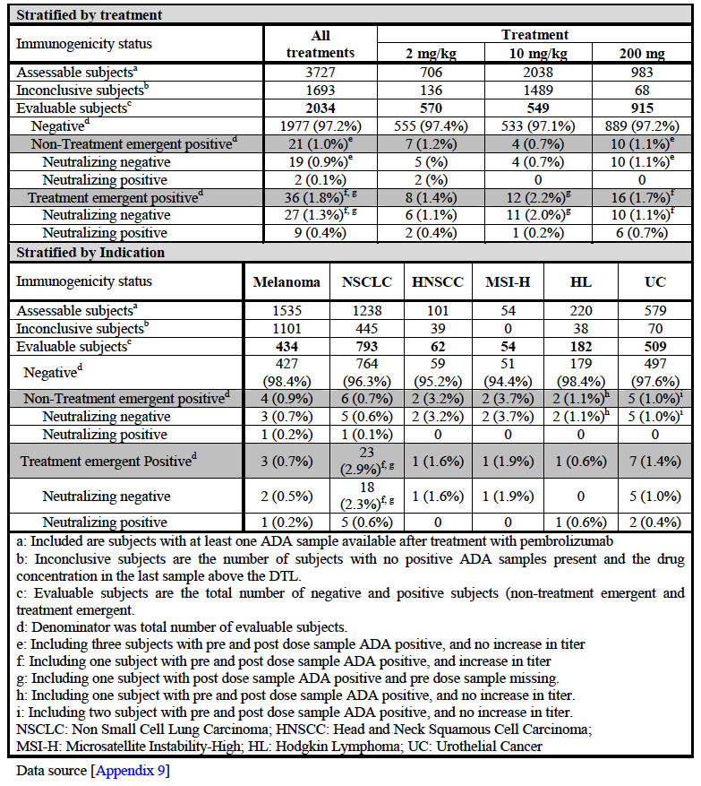
The subjects (N=36) with a treatment emergent immunogenicity response were evaluated for potential impact on exposure, safety and efficacy. Pembrolizumab exposures for these treatment emergent subjects were in the range of exposures observed for other non-positive subjects (negative and inconclusive subjects) who were treated with pembrolizumab in the same regimen. Therefore, exposure to pembrolizumab was not compromised by the observed immune response. The treatment emergent positive subjects did not have any adverse events associated with neutralizing antibodies, such as hypersensitivity events (for example anaphylaxis, urticaria, and angioedema) or injection site reactions. No clinically significant impact on efficacy (that is, tumour size change) was established.
The evaluation has confirmed the assessment that pembrolizumab has a limited potential to elicit the formation of ADA and that there is minimal impact on pembrolizumab PK in the limited cases where ADA formation occurs. This is consistent with the results of prior immunogenicity evaluations of pembrolizumab.

Approach
For the screening assay, the cut-point was established based on a 5% false positive rate in assay validation testing. The standard 3-tiered approach was adopted consisting of screening (Tier 1), confirmation (Tier 2) and antibody titre assessment (Tier 3). Only Tier 2 confirmed ADA positive samples were moved to Tier 3 and reported with a titre value and a NAb result. Due to pembrolizumab potentially interfering with the antibody assays, drug levels were measured for any negative results at the Tier 2 stage to determine whether the results were interpretable for negative results. Neutralising Ab assay was based on the ability of the ADA to prevent binding to the target PD-1.
All samples (N=16061) were tested in the ADA screening assay,
- 8019 samples were tested at Intertek (KN001, KN002, KN006, KN010, and KN012);
- 8240 samples were tested at PPD (KN001, KN006, KN010, KN012, KN013, KN024, KN045, KN052, KN055, KN087 and KN164), including 198 samples reanalyzed at PPD because of non-reportable or missing results from Intertek.
The testing methods between these two providers were not identical and the PPD test for neutralizing Ab used a lower cut-point for false positive results (1%), reducing the need for an additional step, and included a purification process to reduce interference from pembrolizumab in the sample.
Comments:
- From the results presented below, there is a very substantial difference between the rates of detection of antibodies when assayed by PPD compared with Intertek. In particular, the re-screening of 198 ‘non-reportable or missing’ Intertek results has identified 10 additional samples determined to be ADA-positive by PPD. This raises uncertainties about the performance of the Intertek assay as this represents 15.6% (10/64) of the PPD ADA positive samples. How many more would be deemed positive if the entire 8019 samples assayed by Intertek were re-analysed using the methods developed by PPD is unclear. It is not stated clearly at which part of the process these were detected and whether this reflects the perhaps more refined and accurate NAb detection process developed by PPD or sensitivity issues at an earlier stage of the process.
- The imbalance in detection at every point between the providers of the testing is substantial with 13-fold higher rate of detection of positive antibodies for samples tested at PPD compared with Intertek. There is a very high rate of ‘missing’ results 62/230 (27%) for the Tier 2 assessment by Intertek, which raises concerns about the reliability of these results.
- The report states (p31), ‘False positive rate was calculated for all the results originated from Intertek (including the samples that are reanalyzed at the new vendor) and PPD separately.’ Please provide these data for evaluation.

Sponsor response
The integrated false positive rate evaluation from immunogenicity assessment of subjects from number of indications, Melanoma, NSCLC, HNSCC, MSI-H, HL and UC, was performed and summarized in the section of the Immunogenicity Analysis Report. In summary, 225 out of 7985 samples tested at Intertek were concluded to be false positive in the assay yielding a false positive rate of 2.8%. For samples tested at PPD, 294 out of 8176 samples were concluded to be false positive with a false positive rate of 3.6%.
- The more reliable dataset appears to be that from PPD and these results should form the basis for determining what information is included in the PI. The sponsor is requested to calculate the rates of detection of antibodies (treatment-emergent, non-treatment-emergent and neutralizing antibodies) based on the PPD sample analyses. (Clinical question) Sponsor response: This had been amended as requested.
- The proposed PI changes cannot be verified without this information. (PI Comments) after the sponsor’s response, the proposed changes are considered acceptable.

Table 89: Overview of false positive rate of the screening binding assay for anti-pembrolizumab antibodies
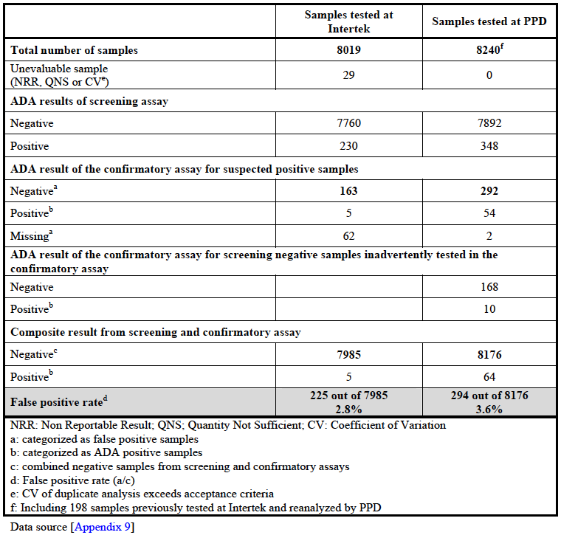

Other safety issues

Safety in special populations
In Study PN045, the majority of subjects were over 65 years of age and there was no major increase in adverse events in over 65s compared with younger subjects although serious drug related AEs were more common (12.3 versus 6.8%) in the older group. Insufficient data were available to comment on safety in those with a poorer ECOG (≥ 2).
In Study PN052, the data are too immature to make a definitive statement regarding whether the treatment tolerability is similar between this and other cancers for the different age groups (that is, in comparison with the reference safety dataset), and there is no comparator arm to demonstrate whether it is better tolerated than alternative treatment options, such as chemotherapy or best supportive care.

Post-marketing experience
At the time of the second round report, this indication has only been registered in the US, and the CHMP of the EMA has made a recommendation for approval of the two proposed indications. There is no post-marketing information available yet for the proposed usage.

Evaluator’s overall conclusions on clinical safety and second round comments following sponsor’s response

PN045 Phase III randomised, open label, active-controlled study in patients with recurrent or progressive urothelial cancer following cisplatin-based therapy
The overall safety profile of pembrolizumab as demonstrated in the current study was clearly superior to the control regimen of cytotoxic therapy (whichever of the 3 available control drugs was chosen). Pembrolizumab toxicities were as expected from those established in previous studies. Renal impairment, including acute kidney injury was increased in the pembrolizumab arm in this study. Pruritus, fatigue, nausea, rash and pyrexia were the common AEs attributed to the drug. Overall treatment discontinuation due to AE occurred in 8.3%, with 5.6% due to treatment-related AEs in the reference safety dataset. Pneumonitis (1.9%) was the most common AE leading to treatment discontinuation. The safety of pembrolizumab, while superior to cytotoxic options in the setting of post-platinum urothelial cancer, appears broadly similar to that reported for other monoclonal antibodies targeting PD-1. There was no signal of cardiac toxicity in this study.

PN052 Phase II non-randomised, open label trial in patients who have received no prior systemic therapy in the metastatic setting and who are ineligible for cisplatin chemotherapy (200 mg Q3W)
Most of the adverse events observed in this open label, single arm study in patients with urothelial carcinoma, of whom 10 percent had received adjuvant or neoadjuvant cisplatin-based chemotherapy, who had not received prior systemic therapy in the metastatic or inoperable setting, and who were not eligible to receive cisplatin, appear consistent with those reported for pembrolizumab. Early safety signals from the comparison with the previously treated population and particularly compared with the reference safety dataset include a higher rate of events in this population including constipation, urinary tract infection, anaemia, peripheral oedema, haematuria, blood creatinine increased, abdominal pain and weight decreased. When the incidence data are included for severe events occurring at ≥ 1% frequency and restricted to those considered related to treatment, additional severe events appear to be increased: fatigue and muscular weakness. While these are most likely to be attributable to the underlying disease, it does raise concerns about the tolerability and safety profile of pembrolizumab in those with significant comorbidities and in particular, pre-existing renal impairment. In the absence of a comparator arm, and given this trial is very immature with only a very short median duration of treatment and follow-up, no comments can be made about the comparative rates of these events at this time with any other population.
A [information redacted] signal that requires further investigation was severe neutropaenia, for which there is no clear explanation at this time. One patient developed myocarditis and the PI needs to be updated to include this serious adverse event. The severity of events observed in this trial, including a fatal event of myositis, require updates to be made to the PI.
No comparator arm was included in this study design, which limits the characterization of the safety profile for this population. However, it might be reasonable to infer that treatment with pembrolizumab will be better tolerated than the chemotherapy options available to this population, but as no quality of life data were presented, it cannot be stated that it is better tolerated.

PN012v02 Phase Ib multi-cohort study of MK-3475 in subjects with advanced tumours (1o mg/kg Q2W) Cohort C
Limited data are available from this small cohort of patients with advanced and often heavily pre-treated ‘urinary tract cancers’. Safety signals included myositis and rhabdomyolysis, with the latter needing to be included in the PI.

First round benefit-risk assessment
There are multiple clinical questions regarding the PK, efficacy, safety and immunogenicity data provided in support of the proposed usage, and to update the PI. Responses to these are required to provide clarification and to address uncertainties where possible. Responses to these may lead to a change in the assessments below.

First round assessment of benefits and risks

Locally advanced or metastatic urothelial cancer following platinum chemotherapy.
The proposed indication is for an area of need as the current options (cytotoxic drug regimens) yield a modest rate of response and poor overall survival and carry high risks of serious toxicity.

Potential benefits
- Improved median OS of almost 3 months compared with cytotoxic therapy; statistically significant and clinically meaningful, across whole study population.
- Higher overall confirmed response rate, with apparently greater depth of response.
- Early data suggested a prolonged duration of response in some individuals but extent unclear.
- Better safety profile with fewer serious drug-related AEs compared with chemotherapy.
- Tendency of survival curve to plateau, suggesting that a relatively small subset of patients may have long-term benefit, which is rarely seen with cytotoxic therapy. This requires confirmation with longer-term data from this study.
- Treatment population broadly reflective of that encountered in clinical practice in terms of age, with a majority of patients over 65 years.

Risks
- Higher rate of discontinuations, adverse events and shorter median duration of treatment than currently reported for other cancer types in the PI. However, this was better than the chemotherapy arm.
- Pembrolizumab is associated with specific toxicities, seen again in this population.
- Pembrolizumab is associated with a non-significantly shorter interval of progression-free survival and an excess of early progression and early mortality in the first three months approximately, compared with the control arm of cytotoxic chemotherapy.
- Worse initial PFS and OS (that is, earlier progression and mortality) in a substantial subset of the whole population, including the PD-L1 positive and strongly positive subpopulations, in the pembrolizumab arm followed later by an improvement as indicated by crossing and lying above the control arm on the Kaplan-Meier plots.

Uncertainties
- Although sufficient to establish an overall survival advantage, follow-up is relatively short and the number of long-term survivors is unclear.
- Progression-free survival was not improved. The reasons for the discordance between OS and PFS are not fully clear but an excess of early progression occurs in the pembrolizumab group compared with cytotoxic recipients.
- The study was effectively restricted to subjects of ECOG-PS 0-1 performance status due to stringent inclusion criteria for ECOG-PS 2 (resulting in only 6 patients with ECOG-PS 2 being recruited, of whom only 2 received pembrolizumab), and ECOG-PS>2 were excluded. Generalisability of results (efficacy and toxicity) to patients of ECOG-PS ≥2 is not established.
- The importance and clinical utility of PD-L1 expression is not clear:
  - Expression levels appear much lower in UC than in other cancer types;
  - In this population, higher levels of expression were associated with a poorer OS in both the treatment and control arms, compared with the overall study population. Reasons for this are not clear.
  - PD-1 blockade appeared to improve OS, but did not abrogate this observed apparent poor prognostic signal in those with a PD-L1 CPS ≥ 10%;
  - PD-L1 positivity has an association with improved OS with pembrolizumab but some PD-L1 negative cancers also respond;
  - There is a lack of detailed data presented on the PD-L1 negative group.
  - PD-L1 was introduced as an endpoint well after the study commenced, was not a stratification factor and therefore confounding factors cannot be excluded to explain the differing outcomes within each PD-L1 subgroup.
- There is a lack of detailed analysis of the patients progressing, or dying, in the early months after commencement of pembrolizumab. Allowing that small numbers may result in large confidence intervals, it would nonetheless be potentially highly informative to have detailed analysis of subjects progressing or dying in the first 3 months, with Forest Plot analysis of sub-groups. In the absence of such data there is an impression that early progression and mortality in the pembrolizumab arm may be particularly concentrated on those subjects with rapidly progressing disease and/or large tumour volumes, and they possibly an identifiable sub-group who are disadvantaged by the use of pembrolizumab rather than chemotherapy, notwithstanding the benefit to the overall group.

Locally advanced or metastatic urothelial cancer in patients not eligible for cisplatin.

Potential benefits
- Somewhat uncertain, but there appears to be efficacy demonstrated via an overall response rate that lasted ≥ 6months in 55/307 patients.

Risks
- No comparator arm to inform safety and efficacy accurately in this frail population.
- Higher rate of discontinuation than other populations receiving pembrolizumab, including the previously treated UC population in Study KN045 (PI needs updating).
- Higher incidence than currently indicated in the PI of constipation, urinary tract infection, anaemia, peripheral oedema, haematuria, blood creatinine increased, abdominal pain and weight decreased. When the incidence data are included for severe events occurring at ≥ 1% frequency and restricted to those considered related to treatment, additional severe events appear to be increased: fatigue and muscular weakness fatigue, renal injury, increase in blood creatinine, anaemia, musculoskeletal pain.
- Some new toxicities, including myocarditis, and more severe toxicities than currently described in the PI including a death from myositis, requiring inclusion in the PI. The remainder of the treatment related toxicities were in general consistent with the known profile of pembrolizumab.
- An unexplained high rate of severe neutropaenia, which is a new signal.

Uncertainties
- No comparator arm to determine if superior to existing treatment options – safety would appear likely to be improved, but this population is frail compared with those in PN045 (discontinuation rate due to AEs of 22% compared with 8.3%) and extrapolation is not possible.
- With the submission of very early data for registration, there are short median durations of follow-up and exposure in this ongoing trial. Durations of responses not established (hallmark of benefit of immunotherapy).
- This study relies on ORR, with secondary endpoint of duration of response.
- Open label, single arm study with risk of bias.
- Apparent use different meanings for the term ‘confirmed’ when describing endpoints, which requires clarification for all endpoints.
- Overall response rate yet to be clarified.
- The importance of PD-L1 expression is uncertain and requires prospective validation in a randomised controlled trial. Apparent enrichment of response in this study population likely to be confounded by inclusion of population used to determine biomarker cut-off in analyses, and exclusion of patients with early relapse before 2 scans in setting this cut-off. Study PN045 indicated worse prognosis in those with higher expression. PD-L1 CPS ≥ 10% cut-off appears to have poor predictive value as response rates seen in those deemed negative and with lower expression.
- Note is made that PD-L1 expression is not included as selection criteria in future studies planned for urothelial cancer.
- Planned to undertake randomised controlled trial versus chemotherapy (platinum and non-platinum) as confirmatory study for recent US accelerated approval for this usage. Final CSR not anticipated before 2021.

First round assessment of benefit-risk balance

Locally advanced or metastatic urothelial cancer following prior platinum therapy.
The overall balance of risks and benefits favours pembrolizumab. The establishment of an overall survival benefit is the most fundamental basis for this favourable assessment, and it is supported by improvement in secondary/exploratory endpoints such as ORR and quality of life data, and by lesser toxicity. Some patients appear to be disadvantaged and have a shorter median progression-free survival and as yet, there is no reliable way of identifying such individuals.

Locally advanced or metastatic urothelial cancer in patients not eligible for cisplatin.
The proposed indication is for an area of need as the current options (cytotoxic drug regimens) are limited due to comorbidities and yield a modest rate of response and poor overall survival and carry high risks of serious toxicity. No benefit-risk equation can be presented at this stage until a response to the clinical questions is provided.

First round recommendation regarding authorisation

Locally advanced or metastatic urothelial cancer following prior platinum therapy.
Subject to the PI changes being made, the evaluators recommend approval of pembrolizumab for this indication. The evaluators note that the study population did not include poor performance status subjects (no ECOG-PS > 2 and only six with ECOG-PS = 2) and it is difficult in the absence of data to recommend approval for use in patients beyond ECOG 0-1 on the basis of the KEYNOTE 045 study.

Locally advanced or metastatic urothelial cancer in patients not eligible for cisplatin.
No recommendation can be made at this time.

Second round evaluation
Where a response was considered pivotal to the continuity of the report, the response and comments have been copied in to the body of the report, with clear annotation that this is part of the Second round evaluation.

Clinical questions

Pharmacokinetics

Question 1
In Report 04JQ34, the integration of the UC population into the model is presented, but no data have been presented for the individual PK parameters as estimated by the model for the UC population separately. The sponsor is requested to provide these in a table, preferably in a column alongside the existing data.

Sponsor’s response
The individual PK parameters for these two studies combined and, in addition, separately for studies KN052 and KN045, are appended to the original table and are provided together in [Table 90] below. There is no clinically meaningful difference in PK parameters and exposure (AUC_{ss}, C_{min} and C_{max}) values between 1L and 2L UC patients with considerable overlap in the range. Further, there is no difference in half-life values between 1L and 2L UC patients.

Table 90: Comparison of population PK parameters of pembrolizumab from the previous model with non-UC versus updated model including UC subjects appended with estimated individual PK parameters for the two UC studies combined (KN052 and KN045) and each study separately (KN045 and KN045)
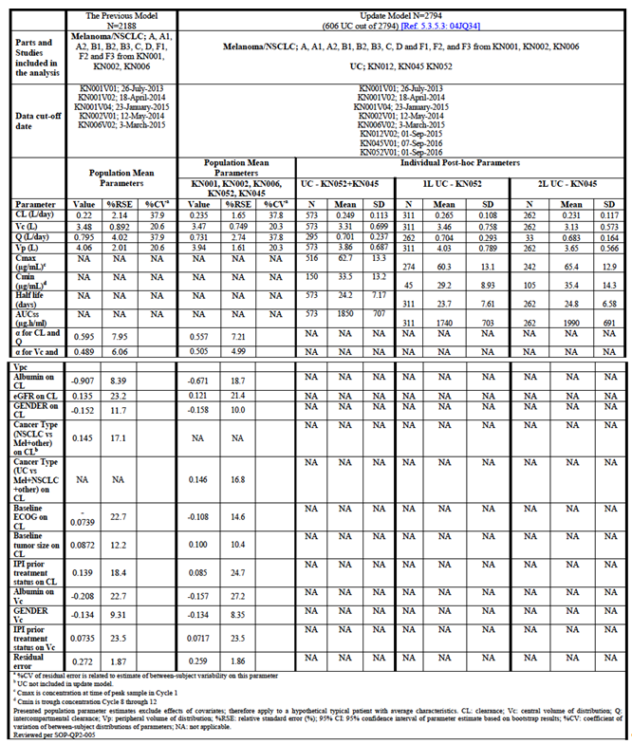

Evaluator’s comment
The sponsor indicated where the combined data were in the dossier but provided the table as requested to facilitate comparison of the individual estimated parameters for each urothelial carcinoma, study as well as in combination. The mean exposure AUC_{ss} is higher and the clearance lower in the second line UC population compared with the first line population, which is somewhat surprising as these patients would be expected to have more advanced disease which the sponsor has postulated is associated with a higher clearance due to a catabolic state. This difference is also evident in the box plots of C_{trough} provided with the response to the next question, with the second line patients (green) having a higher exposure. Note is made of the very small number of patients in the HNSCC group (red).
Figure 19: Boxplots with pembrolizumab serum concentration values rom UC and Non-UC (IL NSCLC and SCCHN) subjects with 200 mg QW3 regimen (C_{max}=post dose at Cycle 1, C_{trough}=pre dose at Cycles 2, 4 and 8)

Question 2
The sponsor states the ‘dashed line is median prediction from the model for a regimen of 200 mg Q3W’. Given no patients in the model described by KN001, KN002 and KN006 included any patients receiving this dose regimen; the sponsor is requested to provide the source and datasets of patients providing this ‘definitive population PK model’ for this dose regimen. If this is from the KN001, 002 and 006-derived model, the sponsor is requested to present the observed exposure of patients with UC against the actual observed exposures for patient populations who received the 200 mg Q3W population including the NSCLC and SCCHN populations.

Sponsor’s response
See Figure 19 above. The requested observed exposure of patients with UC against the actual observed exposures for patient populations including NSCLC and SCCHN are presented (above) in [Figure 19]. The available concentrations (peak and trough, at each available cycle) after administration of the fixed dose of 200 mg Q3W for NSCLC (KN024), SCCHN (KN055) and UC (KN052 and KN045) are graphically compared at each cycle by time point for comparison of PK among these indications based on observed concentrations (C_{max}= Post dose at Cycle 1; C_{trough} =Pre dose at Cycles 2, 4 and 8). Overall, the distribution of pembrolizumab exposure in patients with UC (KN052 and KN045) is generally consistent with that in patients with 1L NSCLC (KN024) and 2L SCCHN (KN055), with no clinically meaningful differences.

Evaluator’s comment
Overall, the observed median exposures are similar across the 4 populations, and as noted, the C_{trough} is lower in the previously untreated UC patients compared with first line, including at Cycles 4 and 8 when steady state would have been reached. No statements can be made about the clinical meaningfulness of the observed differences as there are only 59/298 patients remaining of the first line UC population compared with 104/247 in the second line population at Cycle 8; those that remain at Cycle 8 in KN052 have a higher median exposure than at Cycle 4 and whether those with a lower median exposure are more likely to discontinue due to progression is unclear - whether this is due to relative loss of efficacy and/or confounding associated with increased clearance cannot be determined.

Efficacy

Study PN052

Question 1
The sponsor is requested to state at what time points during the trial, data were analyzed or whether this was a continuous process as data accumulated.

Sponsor’s response
KN052, a single-arm Phase II clinical trial, has undergone four formal database locks with subsequent interim analysis. These database locks and interim analyses are shown below in [Table 91].

Table 91: KN052 Formal database locks and interim analyses
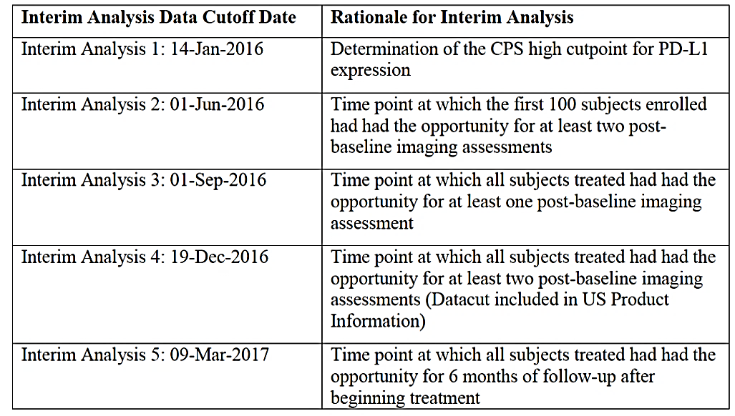

Evaluator’s comment
This indicates regular data scanning consistent with the goals of the trial to determine whether there was a positive signal for a treatment effect with pembrolizumab.

Question 2
This is stated to be an interim report but a definition of the time point of events required to be able to prepare the final CSR could not be located. The sponsor is requested to clarify when the study is deemed complete and what are the requirements with respect to events or time for preparation of the final study report.

Sponsor’s response
A final study report will be written when all responders in KN052 have had an opportunity for at least two years of follow-up. This milestone is anticipated in 2Q 2019.

Evaluator’s comment
The evaluator recommends that if this indication is approved, that submission of this report to the TGA upon completion be required.

Question 3
Whether pseudoprogression is observed in patients with urothelial carcinoma treated with PD-1 inhibitors is not yet known. It is extremely uncommon in NSCLC and squamous cell carcinoma of the head and neck, but observed in melanoma and renal cell carcinoma. The sponsor is requested to provide the numbers, duration of treatment beyond progression (median, range) and outcomes for all patients who continued treatment beyond initial documented progression in Studies PN052 and PN045. The sponsor is requested to state whether the subsequent scans were assessed by blinded independent central review.

Sponsor’s response (provided 14 September 2017)
‘In accord with the pembrolizumab clinical development program, the KN045 and KN052 protocols allow for subjects to continue treatment beyond initial radiographic progression until confirmation of progression. The decision to continue study treatment as such is at the discretion of the Investigator and subject provided that the subject is clinically stable (protocol section 5.8.1). For these subjects, protocols mandate that disease progression be confirmed with subsequent imaging (≥ 128 days following initial radiographic progression. Typically, this is done at the next imaging time point (42 days +/ - 7 days). Subjects for whom progressive disease is confirmed with subsequent imaging who are clinically stable or clinically improved and who have no further increase in tumor dimensions at confirmation may continue treatment further upon consultation with the sponsor. These subjects were required to stop treatment upon further progression beyond their initial progressive disease. One hundred fifty-five subjects in KN045 (29%) and 122 subjects in KN052 (33%) continued treatment beyond initial radiographic progression at the time of the data cut-off for each study, 07SEP2016 and 19DEC2016 for KN045 and KN052, respectively. Of these subjects, some were treated for only a short time beyond initial radiographic progression but stopped prior to confirmation of progression – 17 subjects from KN045 (3%) and 11 subjects from KN052 (3%). The remainder of subjects within each study continued treatment beyond initial radiographic progression and had subsequent imaging – 136 in KN045 (25%) and 111 in KN052 (30%). A summary of these subjects is provided below [Table 92].

Table 92: Summary of subjects continuing study treatment after initial radiographic progression in KN045 and KN052
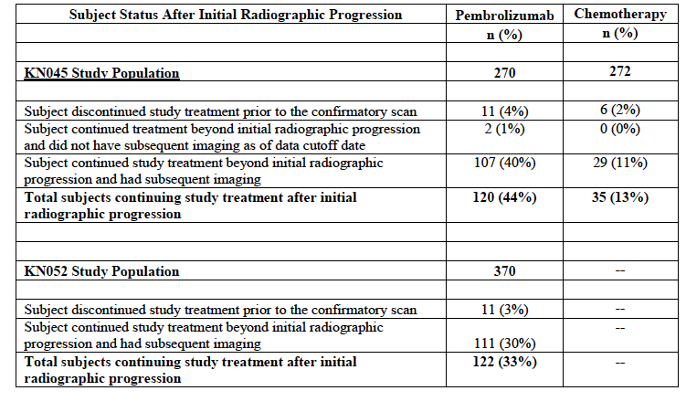

Table 93: Summary of overall response after initial progression by BICR for KN052 and KN045
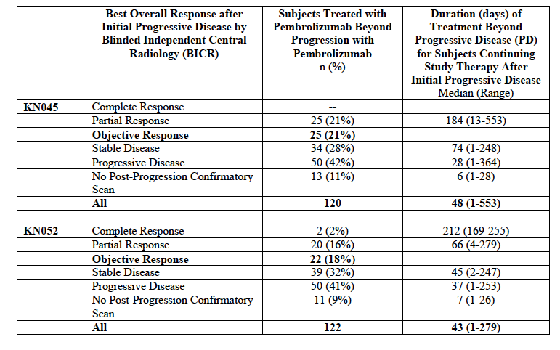

Evaluator’s comment
Continuation post initial progression was common in Study KN045 (44% - 4% discontinued before the next imaging and 40% had subsequent imaging) and Study KN052 (33% - 3% discontinued before the next scan and 30% had further imaging).

Best overall response after initial progression
KN052 Of the 30% with subsequent imaging, ORR by investigator assessment was 18% including 2% with a CR, and 32% continued to have stable disease. Treatment duration ranged up to 279 days as of this report, indicating durable responses in some of those patients. Progressive disease occurred 41% but it is noted there is still quite a lengthy duration of treatment suggesting benefit may be being assessed in a different way. 42% had progressive disease as their response to the continued therapy.
KN045 Of the 40% with subsequent imaging, ORR by investigator assessment was 21% (all PR) and stable disease occurred in 28%. Continued duration of treatment beyond progression ranged up to 553 days, indicating durable benefit for some patients.
This indicates and supports that continuation beyond initial progression is valid and benefits a significant proportion of patients. Approximately half of patients derived some benefit, and half experienced progression (taking into account those who discontinued without imaging as well as those with progressive disease on subsequent imaging). This information should be included in the Clinical Trials section as it informs prescribers of the magnitude of potential benefit with continuation beyond initial progression. It would be of interest to learn the outcomes of those on chemotherapy for comparison. Please include the proportion who continued in the chemotherapy arm. (Second round PI Outstanding Issues) The statements proposed for the Dosage and Administration are considered acceptable based on the response provided.

Question 4
The method for determining inclusion in the biomarker discovery set excluded patients with an aggressive cancer phenotype as they would not have met the requirement of having both a 9-week scan and a 15 week scan (patients who died after the 9-week scan but before the 15-week scan could be included, but not those still alive at 15 weeks without a scan). It is not clear how many patients were deemed ineligible and the sponsor has been requested to provide this information.

Sponsor’s response
Positive predictive value, negative predictive value, and ROC analyses were used along with additional considerations such as biomarker prevalence to determine the CPS high cut-point for PD-L1 expression in the sponsor’s urothelial carcinoma program. These discovery analyses were performed using the biomarker IHC staining results and treatment efficacy pertaining to the first 100 subjects enrolled onto KN052 so long as they met the following criteria:
- Had a PD-L1 CPS score determined from analysis of baseline tumor material;
- Had RECIST 1.1 measurable disease present per central radiology review; and
- Had efficacy results available as either one of the following
  - Had a minimum of two post baseline imaging studies performed prior to the data cut-off for discovery analysis, or
  - Had discontinued therapy prior to the obtainment of two post-baseline imaging studies due to progressive disease, clinical progression, or death.
Subjects with aggressive cancer phenotypes were included in the discovery analyses as outcomes of clinical progression and/or death still mandated inclusion.
Eight subjects were excluded from the discovery analyses performed to determine the CPS high cut-point. A CPS score could not be determined for six of subjects. Two subjects were not evaluable for outcome because they stopped treatment due to adverse event prior to reaching reassessment time points.

Evaluator’s comment
The requirement 3(b) would ensure that patients were included who had progressed or died. It is evident that baseline information was the most common and an acceptable reason for exclusion; however, this exclusion should be prespecified and done at the start of the study, rather than post hoc in an open label single arm trial to avoid selection bias.

Question 5
The date of the Protocol Version 01 resulting from this amendment was 08 Oct 2014, with a clarification letter sent to investigators on 17 April 2015 stating this was no longer the case and all patients should be treatment naïve and cisplatin-ineligible. Given the trial commenced only 3 days after this letter is dated, the sponsor is requested to state how many patients were enrolled in the biomarker population who did not meet the criteria as revised in the letter of clarification.

Sponsor’s response
Pembrolizumab bladder cancer program: As such, the original versions of the protocol (KN052-00 and KN052-01) did permit subjects to be cisplatin eligible for the biomarker discovery population. The protocol was subsequently amended (and clarification provided via a clarification letter) to remove this allowance in order to consolidate the focus of the study on the cisplatin-ineligible population. All subjects enrolled in KN052, including the first 100 subjects enrolled and included in the biomarker discovery population met cisplatin-ineligibility criteria.

Evaluator’s comment
The amendment required patients to be both cisplatin-ineligible and treatment-naïve. The sponsor has indicated that all patients were cisplatin-ineligible but not all patients in KN052 were treatment-naïve as 10% had received prior cisplatin in the adjuvant or neoadjuvant setting. This was clarified in the sponsor’s response received 14 September 2017.

Question 6
The sponsor is requested to explain why such a high proportion of discontinuations of study treatment are labelled as ‘physician decision’ and to provide details in a table of the reasons. In an open label trial, this is a potential source of bias for example if patients were discontinued prior to RECIST-defined and declared progression.

Sponsor’s response
In the original CSR (01SEP2016 data cut-off), it is reported that 46 out of 370 subjects (12.4%) discontinued study treatment due to physician decision. Details regarding investigator decision-making are shown in [Table 94].

Table 94: Reasons for physician’s decision to discontinue study medication

Evaluator’s comment
The vast majority of the patients appear to have discontinued due to disease progression, and a smaller number due to either progression or toxicity. A sensitivity analysis is required to determine the effects of treating all these patients as having progressive disease rather than being censored from analyses due to failure to meet RECIST 1.1 criteria.
- For [information redacted], the sponsor is requested to provide details about how it was established that any metastatic disease sites prior to entering the study were metastatic urothelial cancer rather than prostate cancer;

Sponsor’s response
[information redacted] had a history of locally confined Gleason 8 prostate cancer that had been treated with definitive intent prior to study entry. This was not allowed (exclusion criterion). The site reported this history well after the patient had been enrolled onto KN052. This was classified as a major protocol deviation; however, the subject was allowed to continue treatment. The subject’s metastatic lesions were not biopsied prior to enrollment onto
KN052. It was in the opinion of the investigator that the metastatic sites were from the subject’s urothelial cancer and that the subject had remained cured from prostate cancer. The subject’s prostate-specific antigen (PSA) at study entry was 0.5 ng/ml.

Evaluator’s comment
There is uncertainty about the source of the metastatic disease in a patient with a past history of high-grade prostate cancer. Biopsy would provide definitive answer, while the negative PSA provides some limited assurance.

Question 7
The sponsor is requested to provide an updated efficacy analysis for all primary and secondary endpoints, with the following patients all censored for efficacy and biomarker outcomes:
  - the 4 patients with missing follow-up bone scans;
  - the 2 patients without apparent target lesions;
  - patient [information redacted] who had received prior systemic chemotherapy;
  - if there is any uncertainty about the metastatic disease status of the patient who had prostate cancer, please also censor this patient’s data;

Sponsor’s response
The sponsor provided the responses in table form in the response received 14 September 2017, copied in part below.

Table 95: Reasons for excluding subjects from sensitivity analyses
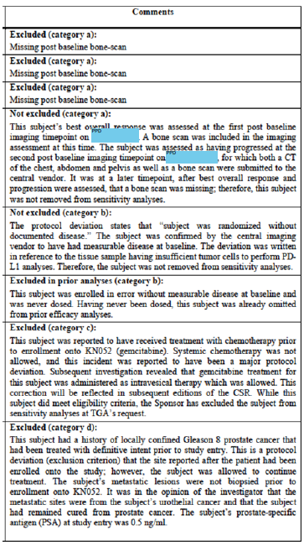

Evaluator’s comment
Evaluation of the response indicates that exclusion of these patients does not affect the results for the overall population.

Question 8
Safety data from the patient with prior systemic chemotherapy should also be censored.

Sponsor’s response
One subject, [information redacted] had been reported to have received treatment with chemotherapy prior to enrollment onto KN052 (gemcitabine). Systemic chemotherapy was not allowed, and this incident was reported to have been a major protocol deviation. Subsequent investigation, however, revealed that gemcitabine treatment for this subject was administered as intravesical therapy which was an allowed prior therapy. This correction will be reflected in subsequent editions of the CSR. As such, this subject will not be removed from safety sensitivity analyses.

Evaluator’s comment
This is acceptable.

Question 9
18.1% had received prior systemic chemotherapy but it is stated that only 10% received this as adjuvant or neoadjuvant treatment (9.7% in original table with CSR). One patient is known to have a major protocol deviation of prior systemic chemotherapy but it is not presented whether the rest of these patients received radiosensitising chemotherapy with radiation (not considered primary systemic chemotherapy) - please provide clarification.

Sponsor’s response
Approximately 9.7% of subjects were treated with chemotherapy prior to study entry either as neoadjuvant or adjuvant chemotherapy. This chemotherapy was dosed at high dose (systemic dosing) - methotrexate / vinblastine / Adriamycin / cisplatin (MVAC) or gemcitabine / cisplatin. The remaining patients, approximately 8%, were treated either with low-dose, radiosensitising chemotherapy or with intravesical chemotherapy for non-invasive disease earlier in the course of treatment for the disease under study. These were allowed as prior treatments for subjects enrolled onto KN052.

Evaluator’s comment
The prior use of cisplatin as the main backbone of the regimens in 9.7% of patients suggests that these patients may be considered ‘cisplatin–ineligible’ due to treatment progression and being refractory, rather than due to comorbidities preventing use of this regimen. This raises some confusion in defining this population.

Question 10

Please provide a breakdown of what sites are encompassed when using the term ‘visceral disease’, and the numbers within each and also those with bone-only metastases.

Sponsor’s response
The sites of metastatic disease for subjects with visceral disease are shown below [Table 96].
Note that groups are not mutually exclusive; for example, a subject with lung metastases and liver metastases are counted in both the lung and liver groups. No subjects were enrolled with bone-only disease as subjects were required to have RECIST 1.1 measurable disease for study entry.

Table 96: Site of metastatic disease for visceral metastatic disease subjects
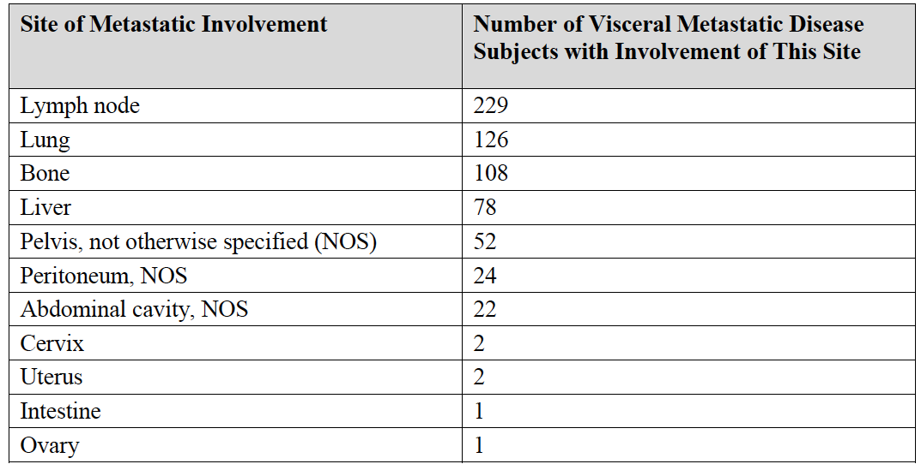

Evaluator’s comments
- It is noted that the sponsor reclassified the numbers of patients with metastatic disease in the response to the FDA query about this (submitted part way during the evaluation. It is unclear if this breakdown pertains to the updated dataset or information derived from the CRF which has been superseded.
- The evaluator does not consider lymph node involvement to be visceral metastatic disease sites.

Question 11
The sponsor is requested to provide the breakdown of the PD-L1 status of this 8.4% with no radiological assessment.

Sponsor’s response
A breakdown by PD-L1 status for the 31 subjects with no post baseline radiological assessment is shown in the table below [Table 97]. The proportion of subjects within each PDL1 category is comparable to that of the overall population.

Table 97: PD-L1 expression status for subjects with no post baseline radiological assessment
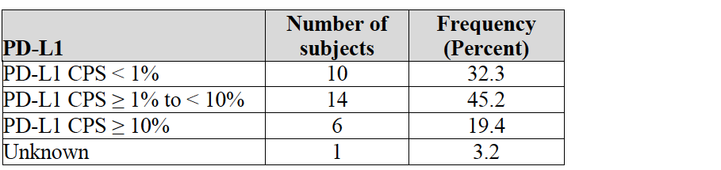

Evaluator’s comment
Only a slightly higher proportion of those without post-baseline imaging had lower PD-L1 scores, but no definitive statements or conclusions can be drawn.

Question 12
The sponsor is requested to clarify what is meant by the broad term, ‘underlying medical condition’, as this potentially includes a condition other than the malignancy and could reflect an adverse effect of treatment.

Sponsor’s response
The sponsor clarifies that ‘underlying medical condition’ was used to refer to urothelial carcinoma, the disease under study, and / or procedures or complications required or arising as a result of urothelial carcinoma. In particular, the term was inserted in the CTD to indicate that a particular AE was evaluated by the sponsor using all available data and deemed more likely related to the natural history of the urothelial cancer (the underlying medical condition) or clinical procedures commonly performed to manage or to treat urothelial cancer in the target population (for example cystoscopy).

Evaluator’s comment
The sponsor has provided clarification and this accepted. In a population who by definition have significant comorbidities, this characterisation of ‘underlying medical condition’ pertaining to any condition relating to their urothelial cancer, is key.

Question 13
The sponsor has already been requested to clarify the conditions leading to early discontinuation prior to a scan for the approximately 10% who were stated not to have had a scan. Censoring the patients at Day 1 who did not have a scan and thus are without a declaration of progression would miss those with rapidly progressive disease. While the denominator of the All Treated Population reflects their inclusion, a sensitivity analysis incorporating all those without scans/evaluable efficacy as progression is requested for all analyses involving ORR, PFS endpoint assessments and duration of response. The sponsor is also requested to state whether these patients were included in the OS analyses.

Sponsor’s response
The sponsor has indicated that 28/31 patients among those with no post-baseline scans had died and therefore were included in PFS analyses. Sensitivity analyses censoring the remaining as having progressive disease did not change the median PFS. Median PFS remains the same at 2.3 months.
Objective response rate (ORR) was estimated by determining the proportion of subjects with complete response (CR) or partial response (PR) among all 370 subjects in the APT population and therefore not affected by censoring these patients.
Overall survival (OS) analysis is based on mortality events among all APT subjects and also is determined irrespective of post-baseline imaging. Subjects with rapid progression who had no post-baseline imaging were included in the OS analysis.

Evaluator’s comment
This response is accepted.

Question 14
The sponsor is requested to explain why scans were deemed ‘non-evaluable’ if a central review and confirmation of target lesions was required at baseline to determine eligibility.

Sponsor’s response
Ten subjects (3%) among the APT population had post-baseline imaging performed, but, for 9 of these subjects, this post-baseline imaging was performed within 6 weeks of the beginning of treatment. Thus, these patients were deemed non-evaluable in follow-up. One subject did not have RECIST-measurable disease at study entry, and, therefore, was considered non-evaluable in follow-up.

Evaluator’s comment
It is unfortunate that violations of the protocol (which should be considered major protocol deviations as they have rendered the efficacy data unusable for 3 out of 4 efficacy endpoints including the primary efficacy endpoint.)

Question 15
The sponsor is requested to clarify what is meant by ‘confirmed’ in this sentence. The Summary of Clinical Efficacy states that these patients had not all had follow-up confirmation scans as required by RECIST 1.1. Thus, there appear to be two uses of the term of ‘confirmed’ in the presentation of these data: 1) established by BICR, and 2) as per RECIST 1.1, which means subject to a confirmatory scan which endorses the original findings of a response. Please provide the percentage of these 89 patients where the ORR was confirmed by a second scan at the time of the cut-off date of 01 September 2016.

Sponsor’s response
The term ‘confirmed’ is used throughout the CSR and CTD to refer to the need for verification of radiographic responses with a set of scans performed at a subsequent time-point. This is a RECIST 1.1 guideline for single-arm Phase II clinical trials. All objective response rate (ORR) tables included in the CSR and CTD reported only confirmed responses unless otherwise specified. Regarding the 89 subjects in question, all had a radiographic response that was confirmed with a second study performed at least 4 weeks after the initial response time point.

Evaluator’s comment
This information is accepted and has been included in the body of the report as it is critical to the evaluation and interpretation of the data presented.

Question 16
In the updated ORR data for all 106 patients, it remains unclear to the evaluator how the term ‘confirmed’ is being used here. Had these patients all had at least 2 scans as required per RECIST 1.1 criteria? (Clinical question)

Sponsor’s response
The term ‘confirmed’ is being used with respect to the updated data in the same sense as that described in the aforementioned response (response Question 16). All 106 subjects had responses confirmed with a second set of imaging performed at least 4 weeks after the initial response time point.

Evaluator’s comment
This information is accepted and has been included in the body of the report as it is critical to the evaluation and interpretation of the data presented.

Question 17
Pease provide the number and percentage of these patients state to have a ‘confirmed ORR’ where the ORR was actually confirmed by a second scan at the updated data cut-off of 19 December 2016 for both all patients and those with a PD-L1 CPS ≥ 10% (validation set only, not APT population).

Sponsor’s response
All responding subjects presented in the ORR analysis in question had responses confirmed with a second subsequent imaging study performed at least 4 weeks after the initial response time point.

Evaluator’s comment
This is accepted and has been included in the body of the report. The Clinical question asked for these data to be confirmed for the validation set only rather than the APT but given the response to an earlier question indicates that relatively few patients were excluded from the biomarker discovery set, inclusion of this group in the dataset is acceptable.

Question 18
No ORR, PFS, OS or duration of response data have been presented specifically for the patients with PD-L1 <1%, and thus any negative predictive value or discriminatory value of a CPS PD-L1 ≥ 1% cannot be said to be demonstrated. The sponsor is requested to provide a similar table for these patients as for the >1%, ≥ 10% to determine whether the PD-L1>1% has any value as a cut-off as of the updated cut-off date of 19 December 2016. Additionally, the sponsor is requested to provide the positive and negative predictive values for negative PD-L1 expression as defined by those with a CPS<1%. This response should be use the updated cut-off data as of 19 December 2016.

Sponsor’s response
ORR, duration of response (DOR), PFS, and OS for those subjects in the APT population with CPS < 1% PD-L1 expression are presented below in [Table 98], [Table 99] and [Table 100], using data from the 19DEC2016 data cut-off.’ Table 101 (below) shows the ORR for subjects with CPS (≥ 11% and Table [98] … summarises ORR for subjects with CPS < 1% (19DEC2016 data cut-off). The positive predictive value (PPV) associated with the 1% cut-point is equal to the ORR in patients with CPS (≥ 11% and is 32.3% (Table 101). The negative predictive value (NPV) associated with the 1% cut-point for the CPS < 1% patients (non-response rate for CPS <1% patients) is 84.8% (Table 98).

Evaluator’s comment
These data indicate that the ORR in this population is 15.2% (95% CI 8.1, 25%) with 2/12 patients experiencing a CR. The durability of this response is somewhat uncertain with only 10.1% of patients estimated to still be progression-free at 12 months. This does highlight that although the reported ORR in those with tumours expressing PD-L1≥ 10% was greater, 15.2% of patients experienced a clinically meaningful ORR in the group with PD-L1<1% - thus the assay has limited negative predictive value (84.8%) and cannot be used to determine the decision not to treat. The positive predictive value is similarly relatively low, at 32.3% for a cut-point of PD-L1≥ 1%. The clinical utility of PD-L1 as a biomarker in urothelial carcinoma is very limited and may at best be considered a complementary assay based on these results for this population. The results from the KN045 study indicate a complexity, in that selection by PD-L1 status may define a population with a poorer prognosis. It is appropriate that no information is included in the PI.

Table 98: Summary of best overall response with confirmation based on RECIST 1.1 per Central Radiology Assessment Subjects with PD-L1 CPS <1% (APT population)
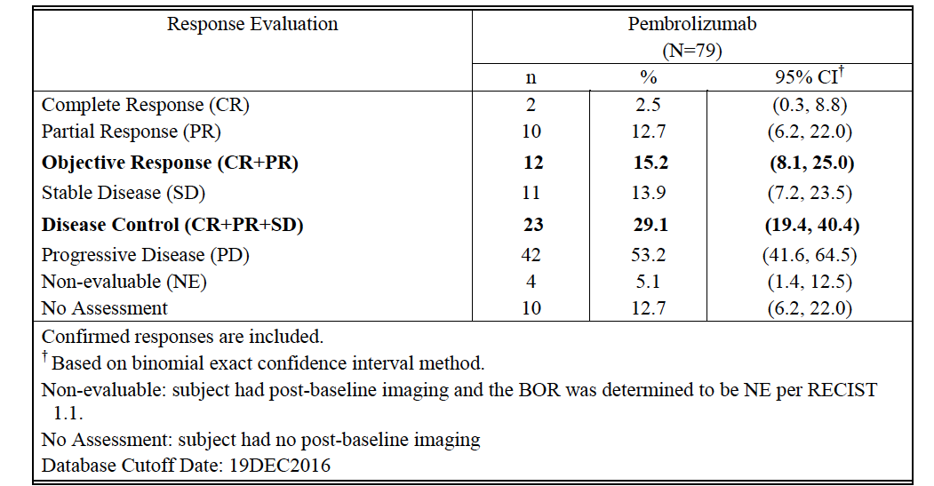

Table 99: Summary of time to response and response duration based on RECIST 1.1 per Central Radiology Assessment Subjects with PD-L1 CPS <1% (APT population)
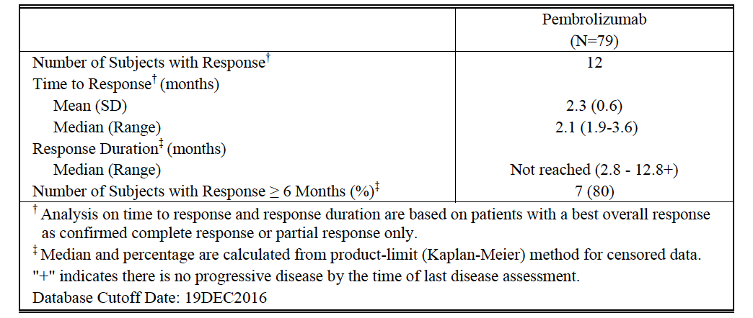

Table 100: Summary of progression free survival (PFS) based on RECIST 1.1 per Central Radiology Assessment Subjects with PD-L1 CPS <1% (APT population)
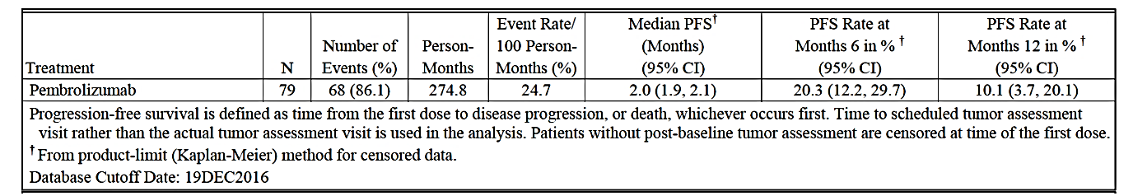

Table 101: Summary of overall survival subjects with PD-L1 CPS <1% (APT population)
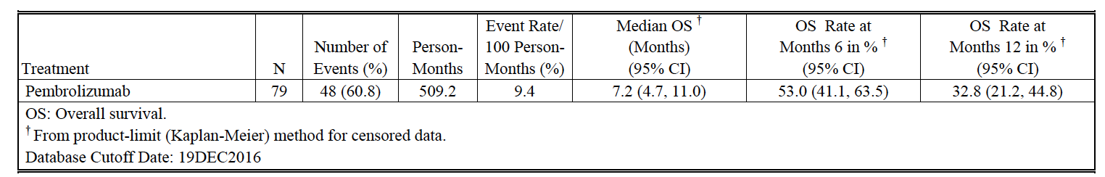

Table 102: Summary of best overall response with confirmation based on RECIST 1.1 per Central Radiology Assessment Subjects with PD-L1 CPS <1% (APT population)
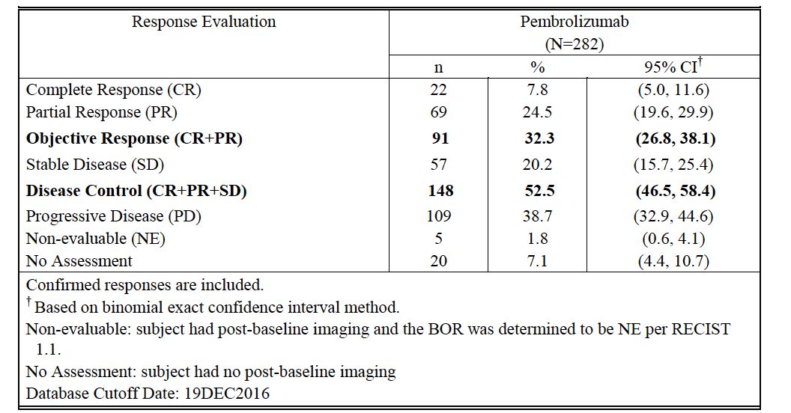

Question 19
The inclusion in this population deemed to have PD-L1≥ 1% of all those who were deemed to have a ≥ 10% expression from the biomarker population will inflate the apparent response rates in this group. The sponsor is requested to censor these patients and all patients subsequently found to have a CPS ≥ 10% to allow a clear picture of the effect of a lower level of expression on efficacy outcomes.

Sponsor’s response
The sponsor presented data in tables for ORR, DOR, PFS and OS for patients among the APT population with CPS (≥ 11% and excluding subjects with CPS (≥ 110% PD-L1 expression.

Evaluator’s comment
These data suggest a gradually improved ORR with an increasing PD-L1 cut-off, but the negative predictive value does not support its used as companion diagnostic in this cisplatin-ineligible population, but these findings require prospective validation in an appropriately powered randomised trial setting.

Table 103: Summary of best overall response with confirmation based on RECIST 1.1 per Central Radiology Assessment Subjects with PD-L1 CPS <1% (APT population)
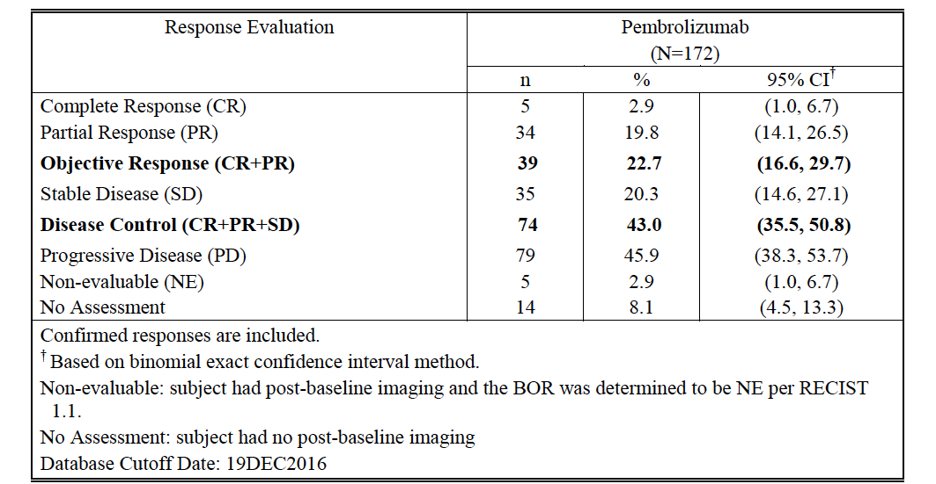

Table 104: Summary of time to response and response duration based on RECIST 1.1 per Central Radiology Assessment in subjects with confirmed response subjects with PD-L1 CPS <1% to <10% (APT population)
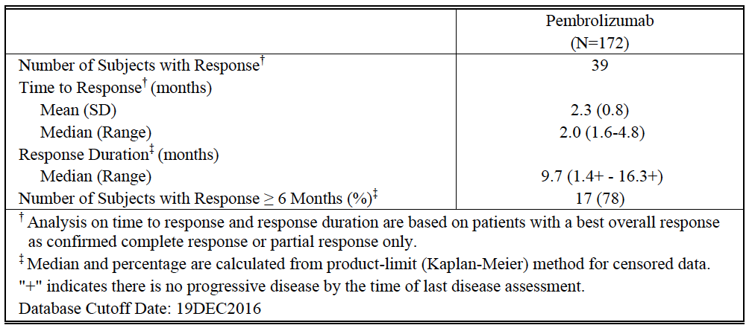

Table 105: Summary of progression free survival based on RECIST 1.1 per Central Radiology Assessment Subjects with PD-L1 CPS ≥1% to <10%(APT population)
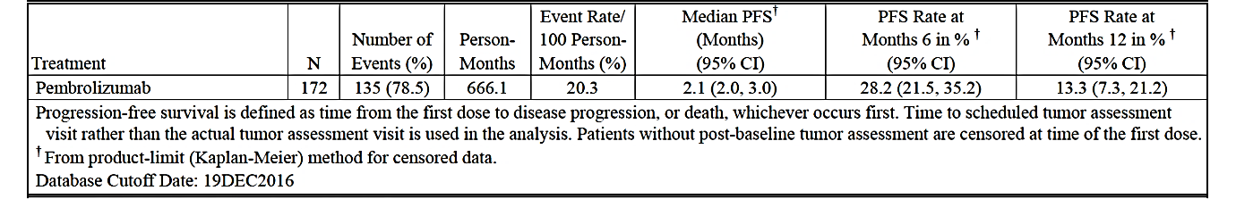

Table 106: Summary of overall survival subjects with PD-L1 CPS ≥1% to <10%(APT population)
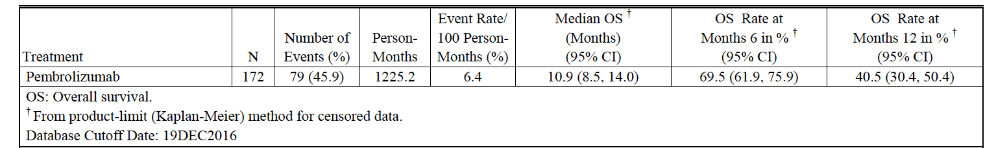

Question 20
No data have been presented for the patients with PD-L1 <1%, and thus the negative predictive value cannot be demonstrated for PD-L1.
  - The sponsor is requested to provide a similar table for these patients with PD-L1<1% to determine whether the PD-L1>1% has any value as a cut-off in urothelial carcinoma.
  - The sponsor is requested to calculate the positive predictive value, the negative predictive value for the cut-off of ≥ 10% and discuss whether this meets the objective outlined in the SAP. (Clinical question)

Sponsor’s response
  - See the responses to question 19.
  - The second Secondary Objective of KN052 is ‘to establish a cut-point for PD-L1 strongly positive status if this is not determined by other biomarker discovery populations, investigate the association between PD-L1 protein expression by IHC and anti-tumor activity.’ This objective was investigated using ROC curve analysis along with the ORR and biomarker prevalence profiles of a range of CPS cut-offs greater than CPS (≥ 11%. CPS (≥ 110% was determined to be the preferred enrichment cut-off for predicting response among subjects in the training set (first 100 subjects enrolled). The ORR for subjects in the APT population with CPS (≥ 110% PD-L1 expression in their tumors using the 19DEC2016 data cut-off was 47.3%. The PPV associated with CPS (≥ 110%, equal to the ORR associated with this cut-point, therefore, is 47.3%. The NPV associated with the 10% cut-point is 79.7% using the 19DEC2016 data cut-off (100% ORR for subjects with CPS ≥ 10%). These findings for the PPV and NPV associated with the 10% cut-point for all subjects in the APT population using the 19DEC2016 data cut-off support the original conclusion that CPS (≥ 110% strongly enriches for response to pembrolizumab among patients with advanced / metastatic urothelial carcinoma.

Evaluator’s comment
These tables have not all been copied into this report, but the data suggest a gradually improved ORR with an increasing PD-L1 cut-off, but the negative predictive value does not support its used as companion diagnostic in this cisplatin-ineligible population. These preliminary findings require prospective validation in an appropriately powered randomised trial setting and should be interpreted with caution, particularly in light of the complexity of PD-L1 as a biomarker in Study 045 (previously treated patients with urothelial carcinoma). No information should be included in the PI for PD-L1.

Question 21

The subgroup analysis demonstrated apparently greater response rates among those with PD-L1≥ 10% and those with lymph node-only disease. The sponsor is requested to provide a break-down of the rates of expression of PD-L1 in those with spread confined to the lymph nodes.

Sponsor’s response
The sponsor provided the requested analysis, with a caution about the small numbers involved.

Table 107: PD-L1 status in subjects with lymph node only disease (n=51)
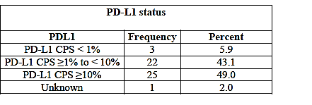

Evaluator’s comment
The apparent increase in responsiveness may be due to the skewed PD-L1-positive expression, which in this study was associated with an improved ORR. No conclusions can be drawn.

Question 22
The PFS data from patients with a PD-L1 CPS ≥ 1% include those with a cut-point of ≥ 10% from both the efficacy validation and the biomarker discovery sets, and it is difficult to know how much impact these patients are having, especially on longer term outcomes. The sponsor is requested to present the PFS data for those with a CPS score ≥ 1% but <10%.

Sponsor’s response
See response to Question 20.

Evaluator’s comment
See response to Question 20.

Question 23
The sponsor is requested to present the PFS, estimated 6-month and 12-month PFS rates for patients in the study negative for PD-L1 that is with a CPS<1%.

Sponsor’s response
See response to Question 19.

Evaluator’s comment
See response to Question 20.

Question 24
Study PN045: Investigators determined whether there was evaluable disease and the sponsor is requested to state how many patients in each arm were found not to have evaluable disease by central review.

Sponsor’s response
The number of subjects in each treatment arm found not to have measurable disease per RECIST 1.1 by blinded independent central review (BICR) is provided in [Table 108] and is balanced across arms. It is important to note that per the KN045 protocol, baseline confirmation of measureable disease by BICR was not required. The eligibility criterion of measureable disease (per RECIST 1.1) was based on investigator/site radiologist assessment (inclusion criteria #7).
Three subjects did not have measureable disease at baseline per investigator/site radiologist assessment (pembrolizumab, n=2; control, n=1) and were documented as major protocol deviations.

Table 108: Subjects with no measurable disease by blinded independent central review

Evaluator comment
The sponsor provided the following table which indicates many more patients, totaling approximately 7% in each arm, were deemed not to have measurable disease when reviewed centrally. There is substantial discordance between the BICR and the investigators at baseline and therefore, potentially any efficacy measures of response, including one of the co-primary endpoints, PFS; OS will not be affected. Note is made that although the primary endpoint was BICR-assessed, that the protocol required investigator assessment of baseline disease and therefore these do not constitute additional major protocol violations. However, this degree of discordance over a fundamental baseline efficacy variable underscores the importance of independent reviews.

Question 25
The sponsor is requested to provide sub-group analysis in respect of those subjects with (a) death or (b) disease progression within the first three months after initiation of treatment.

Sponsor’s response
‘The sponsor has reviewed data from subjects with death or disease progression within the first three months after initiation of treatment to identify potential factors that may relate to an early progression event. Baseline characteristics of subjects who experienced a PFS event (death or disease progression) within the first 3 months after randomisation are herein presented. In general, there were no significant differences in baseline characteristics across arms, though some slight imbalances were noted. Given the small sample size of these analyses, results are to be considered with caution. Of note, in KN045, PFS and OS were calculated as relative to the date of randomisation, not the date of treatment initiation, in accordance to the ITT principle, hence the analysis presented is relative to the date of randomisation.’
With regards to poor prognostic features among subjects who experienced an early PFS event, a slightly greater percentage of subjects in the control arm had ECOG-PS >1 compared with the pembrolizumab arm (n= 100, 68.5% vs n=96, 58.9%, respectively). The percentage of subjects with liver metastasis (n=72, 44.2% in the pembrolizumab arm and n=66, 45.2% in the control arm), hemoglobin <10 g/dL (n=34, 20.9% in the pembrolizumab arm and n=28, 19.2% in the control arm) and time from completion of prior chemotherapy <3mo (n=75, 46% in pembrolizumab arm and n=62, 42.5% in the control arm) were similar across arms.
The percentage of subjects in each of the Bellmunt risk score categories (0, 1, 2 and 3-4) was similar across treatment arms. It is also noted that the prevalence of PD-L1 expression CPS (≥ 110% was overall similar in the pembrolizumab arm (n=48, 29.4%) and in the control arm (n=51, 34.9%).

Evaluator’s comment
Accepting the limitations of a subgroup analyses, looking at the tables of baseline characteristics presented for those dying or experiencing progression within 3 months, there was an imbalance indicating:
A higher risk of progression for the following groups receiving pembrolizumab:
- Age ≥ 65 years (PFS rate 57.7% with pembrolizumab versus 50.7% in control arm)
- Asian patients (PFS rate 27.6% with pembrolizumab versus 15.8% in control arm
- Never smokers (PFS rate 41.7% with pembrolizumab versus 31.5% in control arm)
A lower risk of progression for the following groups receiving pembrolizumab:
- ‘White’ race (PFS rate 65.6% with pembrolizumab versus 79.5% in control arm)
It is also noted that the proportion with PD-L1 expression CPS (≥ 110% experiencing early progression was reasonably similar in the pembrolizumab arm (n=48, 29.4%) and in the control arm (n=51, 34.9%), suggesting this does not predict those likely to experience an early benefit.

Question 26
The sponsor is requested to provide the following for those subjects classified as PD-L1 negative, as has been done for the PD-L1 positive and strongly positive sub-groups:
  - Tabulated data for Overall Survival, Progression-Free Survival, best overall response
  - Kaplan-Meier curves for OS and PFS
  - Baseline data at randomisation for this patient subpopulation (given this is a non-stratified subgroup analysis);
  - Provide sensitivity analyses correcting for those who were not treated at all in each arm and those with incorrectly captured stratification factors at randomisation.

Sponsor’s response
The sponsor herein provides the results of exploratory analysis requested by the agency. It is important to note that these ad hoc analysis need to be considered with caution, given the small size of the subgroups.
  - Tabulated data for Overall Survival, Progression-Free Survival, best overall response
The sponsor’s response states, ‘Results of Overall Survival [Table 109], Progression Free Survival and Best Overall Response [Table 110] in subjects with PD-L1 CPS<1% are in general consistent with the primary analysis, noting the limitations of the data, as explained above.
The median OS in subjects with PD-L1 CPS<1% in the pembrolizumab (9.6 mo) and control arms (7.5 mo) were overall similar to the median OS in the pembrolizumab (10.3 mo) and control arms (7.4 mo) in the overall ITT population. The point estimate of the HR for OS (0.89 (95% CI 0.66, 1.20)) favors pembrolizumab, and the OS rate at 12 months was greater in the pembrolizumab arm (42%) compared with the control arm (32%).
The median PFS in subjects with PD-L1 CPS<1% in the pembrolizumab (3.3 mo) and control arms (2.1 mo) were overall similar to the median PFS in the pembrolizumab (2.1 mo) and control arms (3.3 mo) in the overall population. The point estimate of the HR for PFS (1.07 (95% CI 0.82, 1.39)) demonstrates no difference in terms of PFS between pembrolizumab and the control arm. However, the PFS rate at 12 months was greater in the pembrolizumab arm (13.4%) compared with the control arm (6.8%).
The percentage of subjects with PD-L1 CPS<1% who achieved an Objective Response (CR+PR) was greater in the pembrolizumab arm (21.9%) compared with the control arm (17.7%).’

Table 109: Analysis of overall survival subjects with PD-L1 CPS <1% ITT Population

Table 110: Summary of best overall response based on RECIST 1.0 per Central Radiology Assessment subjects with PD-L1 CPS <1% ITT population
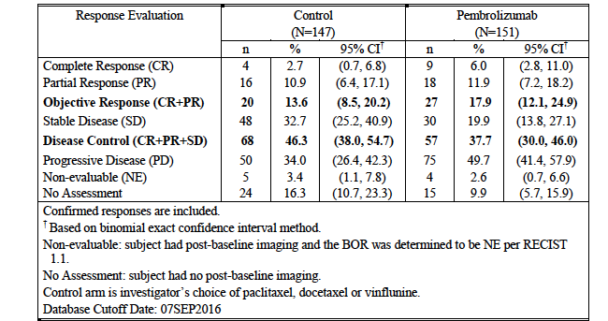

Evaluator’s comment
The median OS in this subgroup was numerically but not statistically significantly increased, and there was only a modest improvement in ORR. However, within the ORR, the depth of the responses was greater. Notably, the disease control rate (which includes stable disease) was greater with chemotherapy than pembrolizumab for this PD-L1 <1% cohort. Imbalances in prognostic factors may also contribute to these findings, as PD-L1 status was not a stratification factor, and therefore hypotheses, rather than conclusions can be made from these analyses.
- Kaplan-Meier curves for OS and PFS
Figure 20: Kaplan-Meier estimates of overall survival subjects with PD-L1 <1% ITT population
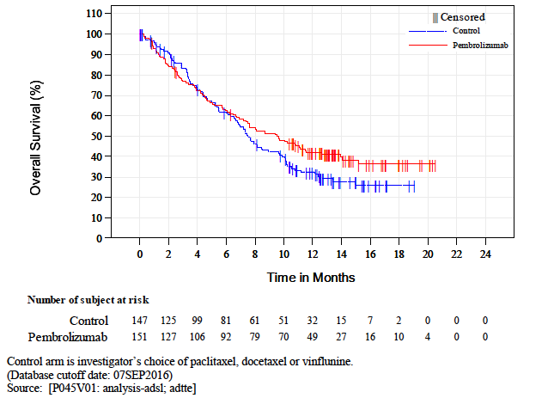

Figure 21: Kaplan-Meier estimates of PFS based on RECIST 1.0 per Central Radiology Assessment (primary censoring rule) subjects with PD-L1 CPS <1% ITT population
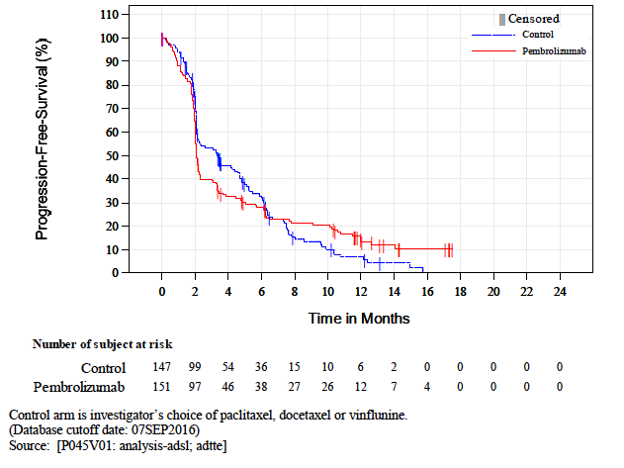

Evaluator comment
These demonstrate the poorer PFS and OS, followed by an improvement in OS.
- Baseline data at randomisation for this patient subpopulation (given this is a non-stratified subgroup analysis)

Sponsor response
These were presented (not reproduced here) and the sponsor states, ‘While mild imbalances in some characteristics are noted, these are influenced by the small sample size and are not considered clinically or statistically significant.’

Evaluator comment
This was a large group, comprising 147/270 patients from the control arm and 151/272 patients in the pembrolizumab arm.
Of note, there were no imbalances between the arms with regard to Asian patients, who appear to have a poorer outcome, but there were more never smokers in the pembrolizumab arm who do not appear to respond as well to this treatment.
The following figures of the response for the breakdown by PD-L1 CPS cut-off were difficult to reconcile, as the patient group with a PD-L1 <10% ought to be larger than the PD-L1<1% when using the 10% mark. Why do these patients appear to be reclassified when using a higher cut-off value? This is not listed as a significant Outstanding Issue for Section 15 because no claim with respect to PD-L1 status is being made.

Table 111: PD-L1 CPS cut-off
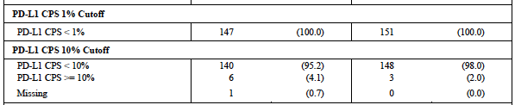
  - Provide sensitivity analyses correcting for those who were not treated at all in each arm and those with incorrectly captured stratification factors at randomisation.

Sponsor response
The sponsor provided these analyses in the response, and they do not change substantially the findings for this population as defined by the ITT analysis.
The sponsor states, ‘In summary, the totality of the data supports the proposed indication of pembrolizumab in subjects with locally advanced or metastatic urothelial carcinoma who have previously received platinum-containing chemotherapy, independent of PD-L1 expression levels.’

Evaluator comment
The evaluator is in agreement that PD-L1 expression does not identify a population more likely to benefit; in particular, it does not identify those whose disease progresses rapidly and who do not benefit from pembrolizumab.

Question 27
Any potential imbalances between the arms arising from the incorrect stratification are difficult to determine as treatment allocation is not included in the table (p35 sSAP). The sponsor is requested to add a column to this table indicating which treatment arm for each patient. The sponsor is requested to provide sensitivity analyses comparing the outcomes for the relevant subgroup analyses for PFS, OS and ORR when these factors are corrected.

Sponsor’s response
Out of the 31 subjects with incorrect stratification, 17 were in the control arm and 14 were in the pembrolizumab arm. The response provided details of the incorrect and corrected stratification factors. Sensitivity analyses for OS, PFS and confirmed ORR indicate there was no substantial difference from the ITT analysis findings.

Evaluator’s comment
The most frequent incorrect factor was the time since last chemotherapy followed by liver metastases. Overall, these imbalances occurred fairly evenly across the arms in terms of likelihood of an imbalance in prognostic factors.

Question 28
The sponsor is requested to provide the HR, alpha and p value used for testing H2 in the analysis of OS after 344 deaths, given the number of deaths is closer to that required for the final assessment than the IA2.

Sponsor’s response
The sponsor indicated the number of deaths was 334 at IA2 not 344 as stated in the first round report. The multiplicity-adjusted alpha boundary for the reference of statistical significance is derived as 0.0123 per the pre-specified alpha allocation and roll-over strategy with the actual information fraction at this analysis.

Evaluator’s comment
The evaluator’s error is noted and has been corrected in the body of the report for this second round evaluation. The information has been inserted in the correct section of the report.

Question 29
A much higher number in the chemotherapy arm were discontinued due to ‘physician decision’ (10.6% versus 2.3%) when there are already categories of ‘adverse event’ or ‘clinical progression’ which might capture clinical reasons for stopping. This is a potential source of bias in an open label trial and the sponsor is requested to explain the basis for these decisions.

Sponsor’s response
Sensitivity analyses for OS excluding subjects who discontinued study medication due to ‘withdrawal by subject’ or ‘physician decision’ were performed in the overall population. These analysis demonstrated consistent OS benefit favoring pembrolizumab over chemotherapy with HR 0.72 (overall) and does not change any conclusions from the study.

Table 112: Reasons for withdrawal by subject or physician decision
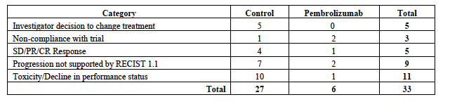

Evaluator’s comment
The evaluator is in agreement with the sponsor’s conclusions on the sensitivity analysis. Most of the reasons for discontinuation suggest toxicity or lack of efficacy, with the chemotherapy arm affected more than the pembrolizumab arm. Given the poorer PFS overall for pembrolizumab, this could reflect a source of bias, as median PFS was worse in the pembrolizumab arm, and events of progression more common, especially early in the trial. The reliance on scans to demonstrate this may reflect a concern not to stop pembrolizumab without compelling evidence of progression.

Question 30
Given there was an imbalance in the numbers who actually received treatment between the arms, the sponsor is requested to undertake a sensitivity analysis for both OS and PFS including only those who received at least one dose of their allocated study treatment.

Sponsor’s response
Sensitivity analyses for OS and PFS in the APaT (all patients as treated, which excludes subjects who were randomised and never treated) population were performed. The OS benefit favouring pembrolizumab over chemotherapy was observed (HR 0.73 and no improvement in PFS was observed (HR 0.96)).

Evaluator’s comment
The evaluator agrees that these sensitivity analyses are consistent with the ITT analyses.

Question 31
The apparent discordance of higher ORR in the pembrolizumab arm and higher reduction of tumour burden in the control arm appears to be due to the greater number in the control arm who had a reduction in tumour burden of 0-30%, short of an objective response. Whether with longer follow-up and confirmatory scans, this differential in ORR is maintained is uncertain. The sponsor is requested to provide an updated ORR and duration of response based on confirmed scans as per RECIST 1.1.
Given, the importance of these updated results, they have been incorporated into the relevant section of the report in a text box to highlight that they represent updated information.

Sponsor’s response
The sponsor provided an updated table of overall response as of 18 Jan 2017 – this indicates this difference in ORR is maintained between the arms with longer follow-up. Between the two data cut-off dates, there is one less patient in the control arm with a confirmed response.

Evaluator comment
The proportion of patients with stable disease has raised the disease control rate (CR+PR+SD), which is elsewhere referred to as the ‘clinical benefit rate’ and which is relevant to patients, for the chemotherapy arm above that of the pembrolizumab arm. However, when patients in the pembrolizumab arm experienced a benefit as defined by CR and PR, it was more durable, and this has translated despite a higher initial rate of progressive disease, into an improved OS benefit. No information is provided on the comparative durability of the stable disease in either arm.

Table 113: Summary of best overall response based on RECIST 1.0 per Central Radiology Assessment All Subjects ITT population
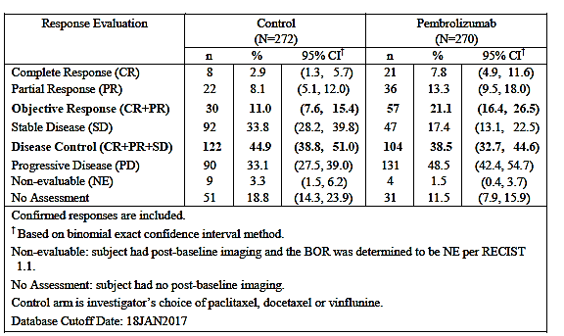
The sponsor presented an updated analysis (database lock 18 Jan 2017) of ORR and duration of response (DOR). The median duration of response with an additional follow-up of nearly 5 months, has still not been reached in the pembrolizumab arm compared with 4.4 months in the chemotherapy arm (Table 114 below).

Evaluator second round 2 comment
Not only is the proportion of patients with a CR or PR greater in the pembrolizumab arm, but the duration of response is greater as indicated by those still responding at 6 months and 12 months.

Table 114: Summary of time to response and response duration based on RECIST 1.0 per Central Radiology Assessment in subjects with confirmed response all subjects ITT population
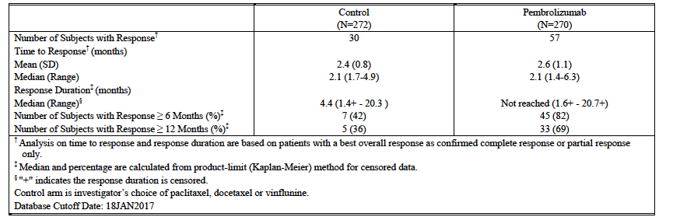
Evaluator comments are provided in the body of the report. Essentially, the tables provided with this response (see Table 115 below) based on an updated cut-off date of 18 Jan 2017, provide a clear indication that not only do more patients have a PR or CR, but that when it occurs, it is more durable.

Question 32
The evaluator acknowledges the sponsor responding to this question which was not copied into the Clinical question section. Agency question CER #2: (KEYNOTE-052) - Please also provide a breakdown for patients of the numbers of metastatic disease sites (0, 1, 2, 3, >3) and baseline alkaline phosphatase levels.
Please note this question was not captured as part of the consolidated request for further information.

Sponsor response #2
Sponsor will provide a response at a later date in September 2017.

Evaluator comment
This information has also been copied in to the relevant section of the report.

Table 115: Subject count by number of metastatic sites and baseline alkaline phosphatase levels
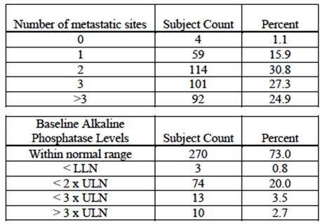

Safety

Question 1
The sponsor is requested to state whether Patient [information redacted] in Study PN-052 who experienced myositis and myocarditis had recently had an influenza immunisation or other predisposing factors.

Sponsor’s response
There is no evidence that the subject [information redacted] had influenza immunization or other predisposing factors for myositis and myocarditis.

Evaluator’s comment
This clarification is acceptable, although may reflect that this information is unknown rather than it is not related to a prior immunization.

Question 2
From Study PN045, higher rates of creatinine rise from baseline were observed in the pembrolizumab arm compared with chemotherapy. Patients with creatinine clearance ≤30ml/ min were excluded from this study. The sponsor is requested to provide evidence supporting pembrolizumab of safety in those with creatinine clearance <30 mL/min.

Sponsor’s response:
The sponsor has conducted a pharmacokinetic (PK) analysis in patients with normal and impaired renal function and has evaluated safety of pembrolizumab in subjects with impaired renal function. Based on the population PK analysis, both clearance and exposure of pembrolizumab are similar regardless of renal impairment status based on estimated glomerular filtration rate (eGFR). Evaluation of safety data indicates that the risk of adverse events (AEs) and Adverse Events of Special Interest (AEOSIs) in patients receiving pembrolizumab is not impacted by their renal function. Details of both of these analyses are provided below.
Pharmacokinetic analysis in patients with normal and impaired renal function: The estimated individual clearances based on the submitted population PK model (KN-001, - 002, -006, -012UC, -052 and -045) across renal impairment categories are presented in [Figure 22a] below. Further, the individual estimated exposures for studies KN052 and KN045 (which used the 200 mg Q3W fixed dose) across renal impairment categories are presented in [Figure 22b] below. It is observed that both clearance and exposure of pembrolizumab are similar regardless of eGFR or renal impairment status. Note that there are very limited number of subjects with eGFR < 30 mL/min/1.73 m². eGFR was calculated based on the Modification of Diet in Renal Disease (MDRD) formula (shown below) and renal function was classified as normal for eGFR (≥ 190 mL/min/1.73 m², mild impairment for eGFR between 60 and 89 mL/min/1.73 m², moderate impairment for eGFR between 30 and 59 mL/min/1.73 m², and severe impairment for eGFR < 30 mL/min/1.73m². Note that the number of subjects with eGFR < 30 mL/min/1.73 m² is limited (N=18 for clearance, Figure 22a; N=13 for exposure, Figure 22b). MDRD formula for serum creatinine (Scr) in μmol/L eGFR= 32788 × (Scr)-1.154 × (Age)-0.203 × (0.742 if female) × (1.212 if African American)
Figure 22 a and b: Effect of eGFR on a) clearance and b) exposure (AUC) of pembrolizumab, based on individual parameter estimates from PK model (KN-001, 002, 006, 012UC, -052 and -045)
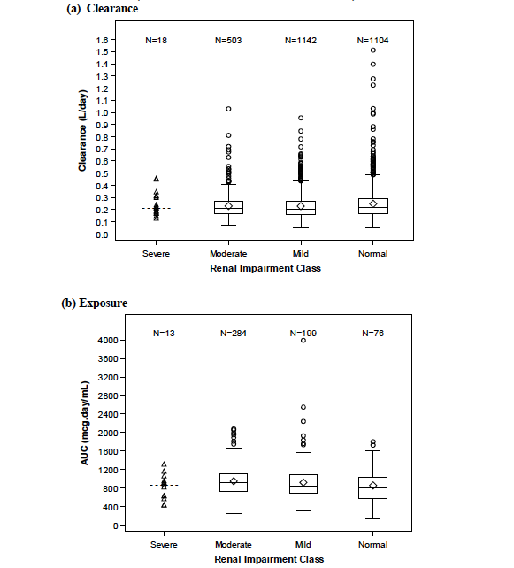

Table 116: Adverse event summary by eGFR subjects treated with MK-3475 from KN-045, 001, 002, 006, -10, 012, 013, 016, 024, 052, -087 and -164
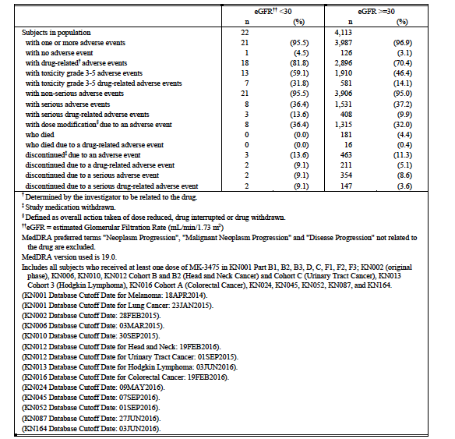

Evaluator’s comment
There are too few patients with severe renal impairment to draw any reliable conclusions, particularly as imbalances in other prognostic and disease-related factors as well as comorbidities which will confound the comparison. Compared with those with an eGFR≥ 30, these patients experienced a higher rate of drug-related AEs and higher grades of toxicity. This may translate into a small increased risk of discontinuation, but there were no treatment-related deaths reported. There is insufficient evidence to support any statement in the PI about use in those with severe renal impairment. AEOSIs were difficult to assess given the very small sample size.
While the PopPK may not identify an increase in exposure or difference in clearance, the numbers were very small being used to inform the severe renal impairment population (18) and caution should be exercised in extrapolating these findings. The use of population PK has limitations and is not an adequate substitute for direct observations. Given the very high likelihood of use of pembrolizumab in patients with significant renal function either related to their cancer and previous treatment (for example nephrectomy, cisplatin etc), dedicated post-marketing studies and data collection with use in real world patients would address this best and potentially enable and inform broader usage.

Question 3
In Study PN052, the rate and the severity of the observed neutropaenia is unexpected given these patients have not had prior systemic treatment in the metastatic setting. The sponsor is requested to provide a discussion as to possible reasons as no clinical context is provided with these tables.

Sponsor’s response
‘A total of 7 (8%) subjects from KN052 had a Grade 3-4 neutrophil decreased laboratory result that worsened from baseline, among subjects with baseline and post-baseline results, and 10 (10%) had a ‘clinically meaningful worsened from baseline’ change defined as shift from less than Grade 3 to Grade 3-5, or from grade 1-2 to more than Grade 3. A total of 12 (3.2%) subjects in KN052 had Grade 4 neutrophil decreased that worsened from based line laboratory result.’
‘The KN052 Investigators, although aware of laboratory changes in neutrophil counts did not report any event of neutropaenia AE, SAE, and AE leading to treatment interruption during KN052, which impacts the interpretation of the data. A single event (0.3%) PT neutrophil count decreased was reported, but the event was not considered related to pembrolizumab by the Investigator. More importantly, no event PT febrile neutropaenia AE, SAE, AE leading to discontinuation or Grade 3-5 AE was reported by the Investigators during KN 052. Finally, the number of subjects with events coded under the SOC Infections and infestations from KN052 is comparable to the number of subjects from the RDS: 146 (39.5%) versus 1180 (42.2%), respectively.’

Evaluator’s comments
The abnormalities have been detected largely through laboratory results, and not reported as AEs except for one patient. This may reflect an attribution bias among investigators or possibly that this was not expected or recognized as treatment-related. However, changes as significant as this and in such a large proportion of the patients cannot be ignored.
The sponsor has not presented the rate of laboratory events of neutropaenia for the reference safety dataset which is more comparable than the infection rate.
The sponsor presents the lack of difference in infection rates compared with the reference safety dataset, but this is not appropriate to inform of the risk for this population which has its own risk profile particularly for urinary tract infections, and the populations and cancers within this large dataset have intrinsically different baseline risk profiles for infection, including site-specific infection risks (for example increased risk of lung infection for lung cancer patients).
The absence of a comparator in this single arm study KN052 means causality cannot be excluded (although noting that comparison with chemotherapy would be confounded).
The frailty of the population in terms of renal function, hearing, cardiac function and the ECOG-PS 2 of 40% participants noted, but none of these has a direct effect on neutrophil count and are not in themselves plausible explanations for the observed significant and serious decline in neutrophil count observed in at least 10% of patients.
This population had newly diagnosed/previously untreated metastatic disease and therefore would unlikely to have bone marrow infiltration, to account for this finding. Furthermore, this would be manifest initially as thrombocytopaenia and this was not noted to be increased in this population. A decline in Hb in this population would not be a sensitive indicator of bone marrow infiltration.

Evaluator conclusion
This remains an outstanding issue requiring inclusion in the RMP list of ‘Important potential risks’.

Question 4
The report states, ‘False positive rate was calculated for all the results originated from Intertek (including the samples that are reanalyzed at the new vendor) and PPD separately.’ Please provide these data for evaluation.

Sponsor’s response
The integrated false positive rate evaluation from immunogenicity assessment of subjects from number of indications, Melanoma, NSCLC, HNSCC, MSI-H, HL and UC, was performed and summarised in the Immunogenicity Analysis Report. In summary, 225 out of 7985 samples tested at Intertek were concluded to be false positive in the assay yielding a false positive rate of 2.8%. For samples tested at PPD, 294 out of 8176 samples were concluded to be false positive with a false positive rate of 3.6%.

Evaluator’s comment
This information is accepted.

Question 5
The more reliable dataset appears to be that from PPD and these results should form the basis for determining what information is included in the PI. The sponsor is requested to calculate the rates of detection of antibodies (treatment-emergent, non-treatment-emergent and neutralizing antibodies) based on the PPD sample analyses.

Sponsor’s response
The dataset used for the information in the PI included a total of 16061 samples were tested for ADA screening assay. Of those, 8019 samples were tested at Intertek and 8240 samples were tested at PPD, with validated assays. The observed false-positivity rates based on the conclusive datasets were similar between the two laboratories, 2.8% at Intertek and 3.6% at PPD. The sponsor believes that the data generated at Intertek is reliable and only conclusive datasets that followed the acceptance criterion and that were within the drug tolerance limits have been used for analyses. The sponsor also confirms that the rates of detection of antibodies (treatment-emergent, non-treatment-emergent and neutralizing antibodies) were calculated excluding inconclusive samples (where ADA might not be detected due to excess drug). Overall, based on clinical experience with multiple trials across diverse oncology indications that were analyzed both at Intertek and PPD, Keytruda has a very low immunogenicity profile with no visible impact on exposure, efficacy and safety. Hence, the sponsor considers it appropriate to include all the data in the PI and notes the data from this combined dataset are included in the US PI and the EU SmPC.

Evaluator’s comments:
The response is considered acceptable, and the proposed updated figures are recommended for inclusion in the PI. It is noted that the sponsor has incorporated the information about neutralizing antibodies as requested.
The evaluator notes that the US label, at the time of preparing this report, does not contain the updated immunogenicity data proposed for inclusion in the PI in this application.

Second round benefit-risk assessment

Locally advanced or metastatic urothelial cancer following platinum chemotherapy.
The proposed indication is for an area of need as the current options (cytotoxic drug regimens) yield a modest rate of response and poor overall survival and carry high risks of serious toxicity.

Potential benefits
- Improved median OS of almost 3 months compared with cytotoxic therapy; statistically significant and clinically meaningful, across whole study population.
- Higher overall confirmed response rate, with greater depth and duration of response (median duration of response yet to be reached with pembrolizumab compared with 4.4 months in the chemotherapy arm, at updated data cut-off, sponsor’s response).
- Better safety profile with fewer serious drug-related AEs compared with chemotherapy.
- Tendency of survival curve to plateau, suggesting that a relatively small subset of patients may have long-term benefit, which is rarely seen with cytotoxic therapy. This requires confirmation with longer-term data from this study.
- Treatment population broadly reflective of that encountered in clinical practice in terms of age, with a majority of patients over 65 years.

Risks
- Higher rate of discontinuations, adverse events and shorter median duration of treatment than currently reported for other cancer types in the PI. However, this was better than the chemotherapy arm. This is not currently adequately presented in the PI.
- Increased risk of renal toxicity: 7.5% versus 4.7%; this is not currently included in the PI and is a new safety signal (also noted in FDA label for NSCLC treated with pembrolizumab + chemotherapy).
- Pembrolizumab is associated with specific toxicities, seen again in this population.
- Pembrolizumab is associated with a non-significantly shorter interval of progression-free survival and an excess of early progression and early mortality in the first three months approximately, compared with the control arm of cytotoxic chemotherapy. A subgroup analysis in the sponsor’s response suggested that compared with the whole study population, a greater proportion of the following subgroups experienced early disease progression or death: >65 years; Asian patients, and never smokers, with no predictive value for PD-L1 CPS status in identifying those at increased risk. Patients of ‘White’ race appeared to have a lower proportion with early death or progression. These analyses cannot be used to select or counsel patients, as responses were observed across all subgroups.
- Worse initial PFS and OS (that is, earlier progression and mortality) in a substantial subset of the whole population, including the PD-L1 positive and strongly positive subpopulations, in the pembrolizumab arm followed later by an improvement as indicated by crossing and lying above the control arm on the Kaplan-Meier plots.

Uncertainties
- Although sufficient to establish an overall survival advantage, follow-up is relatively short and the number of long-term survivors is unclear.
- Progression-free survival was not improved. The reasons for the discordance between OS and PFS are not fully clear but an excess of early progression occurs in the pembrolizumab group compared with cytotoxic recipients.
- The study was effectively restricted to subjects of ECOG 0-1 performance status due to stringent inclusion criteria for ECOG-PS 2 (resulting in only 6 patients with ECOG-PS 2 being recruited, of whom only 2 received pembrolizumab), and ECOG-PS>2 were excluded. Generalizability of results (efficacy and toxicity) to patients of ECOG-PS ≥2 is not established. The inclusion criteria have been clearly stated in the Clinical Trials section.
- PD-L1 CPS expression appears to lack clinical utility in UC, and it is appropriate no information is included in the PI:
  - Expression levels appear much lower in UC than in some other cancer types;
  - In this population, higher levels of expression were associated with a poorer OS in both the treatment and control arms, compared with the overall study population. Reasons for this are not clear.
  - PD-1 blockade appeared to improve OS, but did not abrogate this observed apparent poor prognostic signal in those with a PD-L1 CPS ≥ 10%;
  - Increasing strength of PD-L1 positivity has an association with improved ORR and OS with pembrolizumab, but some PD-L1 negative cancers also respond;
  - PD-L1 was introduced as an endpoint well after the study commenced, was not a stratification factor and therefore confounding factors cannot be excluded to explain the differing outcomes within each PD-L1 subgroup.
- There is an impression that early progression and mortality in the pembrolizumab arm may be particularly concentrated on those subjects with rapidly progressing disease and/or large tumour volumes, and they are possibly an identifiable sub-group who are disadvantaged by the use of pembrolizumab rather than chemotherapy, notwithstanding the benefit to the overall group. The sponsor has included a statement to this effect in the PI.
- Higher disease control rate/clinical benefit rate (CR+PR+SD) was observed overall in the chemotherapy arm, due to higher rates of stable disease, but no data on the duration of these stable disease responses were provided; the CR and PR were shorter in the chemotherapy arm. This may suggest some role for synergy with chemotherapy and immunotherapy in this population, perhaps for those presenting with rapidly progressive disease or heavy disease burden.

Locally advanced or metastatic urothelial cancer in patients not eligible for cisplatin.

Potential benefits
- With a median duration of follow-up of 8 months, the overall response rate was 28% including 7% with complete responses.
- The median duration of response has yet to be reached, and 79% of those responding have had at least 6 months of response.

Potential Risks
- No comparator arm to inform safety and efficacy accurately in this frail population.
- Early data mean only limited safety data are available to inform regarding rates and severity of AEs, discontinuations and treatment interruptions.
- Higher rate of adverse events affecting >10% population compared with KN045 patients, discontinuation due to adverse events (not just those deemed treatment-related) than other populations receiving pembrolizumab, including the previously treated UC population in Study KN045 (PI needs to include information specifically pertaining to this group).
- Higher incidence than currently indicated in the PI of constipation, urinary tract infection, anaemia, peripheral oedema, haematuria, blood creatinine increased, abdominal pain and weight decreased. When the incidence data are included for severe events occurring at ≥ 1% frequency and restricted to those considered related to treatment, additional severe events appear to be increased: fatigue and muscular weakness fatigue, renal injury, increase in blood creatinine, anaemia, musculoskeletal pain.
- An unexplained high rate of severe neutropaenia, which is a new signal.
- Some new toxicities, including myocarditis, and more severe toxicities than currently described in the PI including a death from myositis, requiring inclusion as a fatal event in the PI. The remainder of the treatment related toxicities were in general, consistent with the known profile of pembrolizumab.

Uncertainties
- No comparator arm to determine if superior to existing treatment options; safety would appear likely to be improved, but this population is frail compared with those in PN045 (discontinuation rate due to TEAEs of 11.1% compared with 8.3%) and extrapolation is not possible.
- With the submission of very early data for registration, there are short median durations of follow-up and exposure in this ongoing trial. Durations of responses not established (hallmark of benefit of immunotherapy).
- This study relies on ORR, with secondary endpoint of duration of response.
- Open label, single arm study with risk of bias.
- Overall response rate yet to be clarified for entire population.
- The importance of PD-L1 expression is uncertain and requires prospective validation in a randomised controlled trial. Some apparent enrichment of response in this study population, but this lacks predictive value as responses were still observed in those deemed negative for PD-L1 expression.
- Note is made that PD-L1 expression is not included as selection criteria in future studies planned for urothelial cancer.
- Planned to undertake randomised controlled trial versus chemotherapy (platinum and non-platinum) as confirmatory study for recent US accelerated approval for this usage. Final CSR not anticipated before 2021.

Outstanding issues

Product Information
The PI does not currently present any data on the KN052 population and confines adverse events to those treatment-related discontinuations, whereas treatment discontinuation in a frail population due to any event informs of benefit-risk and likelihood of completion.
Several changes to the PI have been recommended to improve clarity and information specific to the rapidly expanding range of very different cancers for which pembrolizumab is approved. This is a significant outstanding issue precluding recommendation of an approval of the PI at this time.

Neutropaenia in Study KN052
7 (8%) subjects from KN052 had a Grade 3-4 neutrophil decreased laboratory result that worsened from baseline, among subjects with baseline and post-baseline results, and 10 (10%) had a ‘clinically meaningful worsened from baseline’ change defined as shift from less than Grade 3 to Grade 3-5, or from grade 1-2 to more than Grade 3. A total of 12 (3.2%) subjects in KN052 had Grade 4 neutrophil decreased that worsened from the baseline laboratory result.
The absence of a comparator arm means the causality cannot be assessed or excluded although it is noted that a chemotherapy comparator would confound the issues through its own toxicity profile. No clear explanation can be proposed and this should be listed as an important potential risk. The evaluator does not consider the frailty of the population in terms of renal function, hearing, cardiac function and the ECOG-PS 2 of 40% participants to have a direct effect on neutrophil count and are not in themselves plausible explanations for the observed significant and serious decline in neutrophil count observed in at least 10% of patients.
Ninety percent of this population had newly diagnosed and previously untreated metastatic disease (10% had received systemic therapy in the neoadjuvant setting) and therefore would be unlikely to have bone marrow infiltration, to account for this finding. Furthermore, this would be manifest initially as thrombocytopaenia and this was not increased in this population. A decline in Hb in this population would not be a sensitive indicator of bone marrow infiltration due to the multiple other potential causes.

Evaluator conclusion
This remains an outstanding issue requiring consideration for inclusion in the RMP list of ‘Important potential risks’.

Renal toxicity in KN045
This is not currently included in the PI but represents a real risk for those patients who may already have undergone a nephrectomy for their urothelial cancer.

Second round recommendation regarding authorisation
Subject to changes being made to the PI to the satisfaction of the TGA, the evaluator recommends the following modified indications for authorisation:
Keytruda® (pembrolizumab) is indicated for the treatment of patients with locally advanced or metastatic urothelial carcinoma whose disease has progressed during or following platinum-containing chemotherapy.
Given the early nature of the efficacy data and use of a surrogate endpoint with relatively limited follow-up duration, this needs to be presented clearly to indicate the basis on which any decision to approve may be based, for those patients ineligible for cisplatin.
Keytruda® (pembrolizumab) is indicated for the treatment of patients with locally advanced or metastatic urothelial carcinoma who are not eligible for treatment with cisplatin-containing chemotherapy. This approval is based on overall response rate and duration of response, and no improvement in progression-free survival, overall survival or quality of life have been demonstrated.

References
Australian Institute of Health and Welfare website accessed 11 March 2017. http://www.aihw.gov.au/WorkArea/DownloadAsset.aspx?id=10737422721
Bellmunt, J et al Prognostic factors in patients with advanced transitional cell carcinoma of the urothelial tract experiencing treatment failure with platinum-containing regimens. J Clin Oncol. 2010 Apr 10;28(11):1850-5.
Calabro, F Gemcitabine and paclitaxel every 2 weeks in patients with previously untreated urothelial carcinoma. Cancer. 2009;115(12):2652.
Cheluvappa R et al, A comprehensive evaluation of bladder cancer epidemiology and outcomes in Australia. Int Urol Nephrol 2014; 46(7):1351-60
Cocks K, et al, ‘Evidence-based guidelines for determination of sample size and interpretation of the European Organisation for the Research and Treatment of Cancer Quality of Life Questionnaire Core 30.’ J Clin Oncol. 2011, 29: 89-96. 10.1200/JCO.2010.28.0107.
De Santis, M ‘Randomised phase II/III trial assessing gemcitabine/carboplatin and methotrexate/carboplatin/vinblastine in patients with advanced urothelial cancer who are unfit for cisplatin-based chemotherapy: EORTC study 30986.’ J Clin Oncol. 2012;30(2):191.
Galsky, M et al., A consensus definition of patients with metastatic urothelial carcinoma who are unfit for cisplatin-based chemotherapy. Lancet Oncol. 2011;12(3):211.
McKiernan JM, Hansel DE, Bochner BH, et al. Renal Pelvis and Ureter. In: AJCC Cancer Staging Manual, 8th, Amin MB. (Ed), Springer, New York 2017. p.749.
Osoba D. ‘Interpreting the meaningfulness of changes in health-related quality of life scores: lessons from studies in adults.’ Int J Cancer Suppl. 1999, 12: 132-7.
Saxman SB, Propert KJ, Einhorn LH, et al: Long-term follow-up of a phase III intergroup study of cisplatin alone or in combination with methotrexate, vinblastine, and doxorubicin in patients with metastatic urothelial carcinoma: A cooperative group study. J Clin Oncol 1997 15: 2564,1997-2569
Sternberg CN, et al. Chemotherapy with an Every-2-Week Regimen of Gemcitabine and Paclitaxel in Patients with Transitional Cell Carcinoma Who Have Received Prior Cisplatin-Based Therapy Cancer. 2001;92:2993-8
Sternberg CN, et al. Methotrexate, vinblastine, doxorubicin, and cisplatin for advanced transitional cell carcinoma of the urothelial: Efficacy and patterns of response and relapse Cancer. 1989;64:2448-582
Von der Maase, H et al ‘Long-term survival results of a randomised trial comparing gemcitabine plus cisplatin, with methotrexate, vinblastine, doxorubicin, plus cisplatin in patients with bladder cancer.’ J Clin Oncol 2005; 23 (21): 4602-8

Therapeutic Goods Administration
PO Box 100 Woden ACT 2606 Australia
Email: info@tga.gov.au Phone: 1800 020 653 Fax: 02 6232 8605
https://www.tga.gov.au

Sponsor clarification: Based on PK data from studies KN052, KN045 and KN012.

