20 December 2013

AusPAR Attachment 2

Extract from the Clinical Evaluation Report for Peginterferon beta 1a (rch)
  - Proprietary Product Name: Plegridy
  - Sponsor: Biogen Idec Australia Pty Ltd

About the Therapeutic Goods Administration (TGA)
- The Therapeutic Goods Administration (TGA) is part of the Australian Government Department of Health, and is responsible for regulating medicines and medical devices.
- The TGA administers the Therapeutic Goods Act 1989 (the Act), applying a risk management approach designed to ensure therapeutic goods supplied in Australia meet acceptable standards of quality, safety and efficacy (performance), when necessary.
- The work of the TGA is based on applying scientific and clinical expertise to decision-making, to ensure that the benefits to consumers outweigh any risks associated with the use of medicines and medical devices.
- The TGA relies on the public, healthcare professionals and industry to report problems with medicines or medical devices. TGA investigates reports received by it to determine any necessary regulatory action.
- To report a problem with a medicine or medical device, please see the information on the TGA website <http://www.tga.gov.au>.
About the Extract from the Clinical Evaluation Report
- This document provides a more detailed evaluation of the clinical findings, extracted from the Clinical Evaluation Report (CER) prepared by the TGA. This extract does not include sections from the CER regarding product documentation or post market activities.
- The words [Information redacted], where they appear in this document, indicate that confidential information has been deleted.
- For the most recent Product Information (PI), please refer to the TGA website <https://www.tga.gov.au/product-information-pi>.
Copyright
© Commonwealth of Australia 2013
This work is copyright. You may reproduce the whole or part of this work in unaltered form for your own personal use or, if you are part of an organisation, for internal use within your organisation, but only if you or your organisation do not use the reproduction for any commercial purpose and retain this copyright notice and all disclaimer notices as part of that reproduction. Apart from rights to use as permitted by the Copyright Act 1968 or allowed by this copyright notice, all other rights are reserved and you are not allowed to reproduce the whole or any part of this work in any way (electronic or otherwise) without first being given specific written permission from the Commonwealth to do so. Requests and inquiries concerning reproduction and rights are to be sent to the TGA Copyright Officer, Therapeutic Goods Administration, PO Box 100, Woden ACT 2606 or emailed to <tga.copyright@tga.gov.au>.

Contents
List of commonly used abbreviations 5
1. Clinical rationale 7
2. Contents of the clinical dossier 9
2.1. Scope of the clinical dossier 9
2.2. Paediatric data 9
2.3. Good clinical practice 9
3. Pharmacokinetics 9
3.1. Studies providing pharmacokinetic data 9
3.2. Summary of pharmacokinetics 10
3.3. Pharmacokinetics in healthy subjects 12
3.4. Pharmacokinetics in the target population 19
3.5. Pharmacokinetics in other special populations 19
3.6. Pharmacokinetic interactions 23
3.7. Evaluator’s overall conclusions on pharmacokinetics 24
4. Pharmacodynamics 25
4.1. Studies providing pharmacodynamic data 25
4.2. Summary of pharmacodynamics 26
4.3. Evaluator’s overall conclusions on pharmacodynamics 33
5. Dosage selection for the pivotal studies 34
5.1. Dose equivalence with Avonex 34
5.2. Accumulation between doses 35
5.3. Frequent versus infrequent interferon beta 1a treatment in MS 36
5.4. Single-dose tolerability 38
5.5. Multi-dose tolerability 39
5.6. Overall conclusions on the appropriateness of dose selection 41
6. Clinical efficacy 41
6.1. Pivotal efficacy study, 105MS301 (Study 301, n=1512) 42
6.2. Extension study, 105MS302 68
6.3. Analyses performed across trials 74
6.4. Supportive evidence from related beta-interferon studies 74
6.5. Sponsor’s justification for performing a single pivotal efficacy study 76
6.6. Evaluator’s conclusions on clinical efficacy 77
7. Clinical safety 78
7.1. Studies providing evaluable safety data 78
7.2. Patient exposure 80
7.3. Adverse events 83
7.4. Laboratory tests 97
8. Post-marketing experience 109
8.1. Safety issues with the potential for major regulatory impact 110
8.2. Other safety issues 113
8.3. Evaluator’s overall conclusions on clinical safety 114
9. First round benefit-risk assessment 115
9.1. First round assessment of benefits 115
9.2. First round assessment of risks 116
9.3. First round assessment of benefit-risk balance 116
10. First round recommendation regarding authorisation 116
11. Clinical questions 117
11.1. Pharmacokinetics 117
11.2. Pharmacodynamics 117
11.3. Efficacy 117
11.4. Safety 117
12. Second round evaluation of clinical data submitted in response to questions 117
13. References 118

List of commonly used abbreviations
Abbreviation | Meaning
9HPT | 9-hole peg test
Ab | antibody
AE | adverse event
ARR | annualised relapse rate
AUC | area under the curve
AUC_{0-168,} AUC₀₋₂₄₀ | AUC up to 168 h post-dose, 240 h post-dose
AUC_{0-inf} | area under the time-concentration curve from time zero to infinity
BAb | binding antibody
BIIB017 | peginterferon beta-1a
BMI | body mass index
CHMP | Committee for Medicinal Products for Human Use
CI | confidence interval
CL/F | apparent total body clearance
C_{max} | maximum serum concentration
CNS | central nervous system
CPE | cytopathic effect
CSR | clinical study report
CV | coefficient of variation
DMT | disease-modifying treatment
E_{AUCt} | area under the effect-time curve partial
EDSS | Expanded Disability Status Scale
eGFR | estimated glomerular filtration rate
ELISA | enzyme-linked immunosorbent assay
Emax | peak concentration observed minus baseline concentration
EQ-5D | EuroQoL (quality of life) questionnaire consisting of 5 domains
ESRD | end stage renal disease
Gd | gadolinium
HV | healthy volunteers
IFN β | interferon beta
IFN β-1a | interferon beta-1a
IM | intramuscular
INEC | Independent Neurology Evaluation Committee
ITT | intent-to-treat
IXRS | Interactive Voice/Web Response System
kDa | kiloDalton
MDRD | Modification of Diet in Renal Disease
MIU | million international units
MRI | magnetic resonance imaging
mRNA | messenger ribonucleic acid
MS | multiple sclerosis
MSIS | Multiple Sclerosis Impact Scale
MSFC | MS Functional Composite
N/A | not applicable
NAb | neutralising antibody
NC | not calculated
NCA | non-compartmental analysis
OAS, OAS 2’,5’ | oligoadenylate synthetase
PASAT | Paced Auditory Serial Addition Test
PD | pharmacodynamic
PEG | polyethylene glycol
PFP | prefilled pen
PFS | prefilled syringe
PI | Product Information
PK | pharmacokinetic
PP | per-protocol
PPMS | primary progressive multiple sclerosis
Q2W | every 2 weeks
Q4W | every 4 weeks
qPCR | real-time (quantitative) PCR
RI | renal impairment
RNA | ribonucleic acid
RRMS | relapsing remitting multiple sclerosis
SAE | serious adverse event
SC | subcutaneous
SCE | Summary of Clinical Efficacy
SD | standard deviation
SF-12 | 12-Item Short Form Health Survey
t_{½} | terminal half-life
TEAE | treatment-emergent adverse event
T_{max} | time to peak concentration

Clinical rationale
Multiple sclerosis (MS) is the most common chronic neurological disease of young adults. It is an inflammatory disease of the central nervous system (CNS), with characteristic plaques of demyelination, which represent sites of myelin destruction. Plaques are most common in the white matter of the CNS but may also affect the grey matter.
MS may show a number of different temporal patterns. In the most common form, relapsing and remitting MS (RRMS), patients experience bouts of inflammation (“relapses”) followed by complete or partial recovery (“remissions”). The symptoms of each relapse depend on which part of the CNS is affected, and may involve focal weakness, incoordination, sensory loss, visual disturbance or bladder and bowel dysfunction.
Most subjects with RRMS eventually show sustained progression of disability, arising from a combination of incomplete recovery from discrete relapses, the cumulative effect of poorly defined or subclinical relapses, and background progression of disease between relapses.. This phase is known as secondary progressive MS. It is usually subdivided according to whether identifiable relapses are still occurring.
In the less common form of the disease, primary progressive MS (PPMS), patients show progressive disease from the onset of the disease, without ever exhibiting identifiable relapses. Such patients generally show a poor response to immune-modifying treatments.
The aetiology of MS remains unclear despite decades of research, but it is widely considered to be an autoimmune disease. Active plaques show lymphocytic infiltration of the brain parenchyma, the cerebrospinal fluid shows bands of antibodies on electrophoresis, and immunosuppressive treatments including steroids can suppress disease activity.
The treatment of MS usually involves a combination of symptomatic treatments (such as antispasm agents or analgesia), corticosteroids for acute relapses, and disease-modifying agents that seek to alter the course of the disease. The beta interferons (Avonex, Rebif and Betaferon) have been used for many years as disease-modifying agents in the treatment of RRMS. Along with glatiramer acetate (Copaxone), these injectable agents have been considered first-line treatments, capable of reducing relapse rate and slowing progression of disease.
More recently, several oral therapies have been developed, and monoclonal antibodies such as natalizumab have been employed, directed at various targets in the immune system. None of the treatments is capable of suppressing all disease activity, though some patients achieve lasting states of remission. Natalizumab is particularly effective, but its use is associated with a risk of progressive multifocal leukoencephalopathy (PML), a very serious cerebral disease caused by opportunistic infection with the JC virus. The oral treatments are associated with some safety concerns. Fingolimod may cause macular swelling with visual loss, as well as first-dose bradycardia that has at least once been fatal. Teriflunomide has some nuisance side effects, and exhibits only moderate efficacy compared to the interferons. Dimethyl fumarate appears to be reasonably safe, but can cause flushing and diarrhoea. Cladribine is no longer marketed because of safety issues. The chemotherapy agent mitoxantrone has been used as a second-line MS agent, but it causes cumulative cardiac toxicity that limits its use.
The traditional first-line injectable agents, including Avonex, also have a number of side effects, but most of these represent tolerability issues rather than safety concerns. The interferons can cause flu-like malaise, mood changes, fatigue, an increase in spasm, and derangements of liver and thyroid function tests. Subjects can develop antibodies to the injected treatment, which is usually considered an efficacy concern rather than a safety issue, because the antibodies may neutralise the desired pharmacological effects of the interferon. Glatiramer acetate is often better tolerated but may cause flushing. All of the injectable treatments can cause injection-site reactions. Patients may also develop “injection fatigue”, characterised as an increasing reluctance to inject, increasing problems with compliance, and eventual abandonment of the treatment.
Peginterferon does not offer a new mechanism of action, and its side effects are expected to be similar to existing interferons, but the proposed dosing regimen. with injections every two weeks, is likely to be welcomed by patients. Existing injectable treatments require injection every day, in the case of glatiramer acetate, 3-4 times per week, in the case of Betaferon and Rebif, or once per week, in the case of Avonex. If peginterferon delivered the same efficacy as these existing treatments, but with less injections, this would reduce the overall burden of treatment. There could be resulting improvements with compliance, though this has not been directly demonstrated.

Contents of the clinical dossier

Scope of the clinical dossier
The submission contained the following clinical information:
- Module 5
  - 4 clinical pharmacology studies, all of which provided pharmacokinetic and 3 of which provided pharmacodynamic data.
  - 1 population pharmacokinetic analysis based on the pivotal efficacy study.
  - 1 pivotal efficacy/safety study, with its dose-blinded extension.

Paediatric data
The submission did not include paediatric data. The draft PI includes the comment:
“The safety and efficacy of PLEGRIDY in patients below 18 years of age has not been studied.”

Good clinical practice
The clinical summaries and individual study reports contained assurances that the studies were performed in accordance with Good Clinical Practice (GCP), and the studies described appear to have been conducted in a professional and ethical manner.

Pharmacokinetics

Studies providing pharmacokinetic data
The sponsor submitted four Phase 1 PK studies, as well as a PK/PD substudy based on intensive sampling of a small group of subjects from the pivotal efficacy study, and a population-PK report based on sparse sampling of all subjects in the pivotal efficacy study. Table 1, below, shows the studies relating to each pharmacokinetic topic.
None of the pharmacokinetic studies had deficiencies that excluded their results from consideration.

Table 1. Submitted pharmacokinetic studies.
PK topic | Subtopic | Study ID | *
PK in healthy adults | General PK - Single dose | 105HV101 | *
PK in healthy adults | - Multi-dose | 105HV102 | *
PK in healthy adults | Bioequivalence of different routes of administration - Single dose, SC vs IM | 105HV101
PK in healthy adults | - Single dose, PFP vs AI | 105HV103 | *
PK in healthy adults | - Multi-dose | n/a
PK in healthy adults | Food effect | n/a
PK in special populations | Target population §- Single dose | n/a
PK in special populations | - Multi-dose | Intensive PK substudy of 105MS301
PK in special populations | Hepatic impairment | n/a
PK in special populations | Renal impairment | 105RI101 | *
PK in special populations | Neonates/infants/children/adolescents | n/a
PK in special populations | Elderly | n/a
Genetic/gender-related PK | Males vs. females | Pop-PK analysis of 105MS301
PK interactions | Multiple drugs | Pop-PK analysis of 105MS301
Population PK analyses | Healthy subjects | n/a
Population PK analyses | Target population | 105MS301
* Indicates the primary aim of the study.
§ Subjects who would be eligible to receive the drug if approved for the proposed indication.
PFP – pre-filled pen, AI – auto-injector
Erratum: Comparative pharmacokinetic studies 105HV101 and 105HV103.

Summary of pharmacokinetics
The information in the following summary is derived from conventional pharmacokinetic studies unless otherwise stated.

Table 2. Summary of pharmacokinetics in healthy volunteers, renal impairment subjects and MS subjects
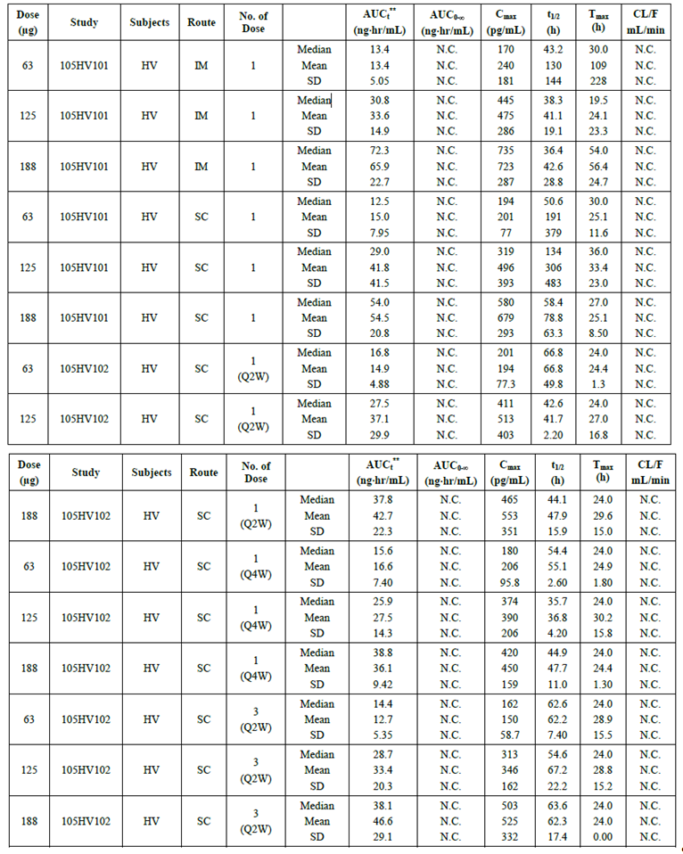

Table 2 continued. Summary of pharmacokinetics in healthy volunteers, renal impairment subjects and MS subjects
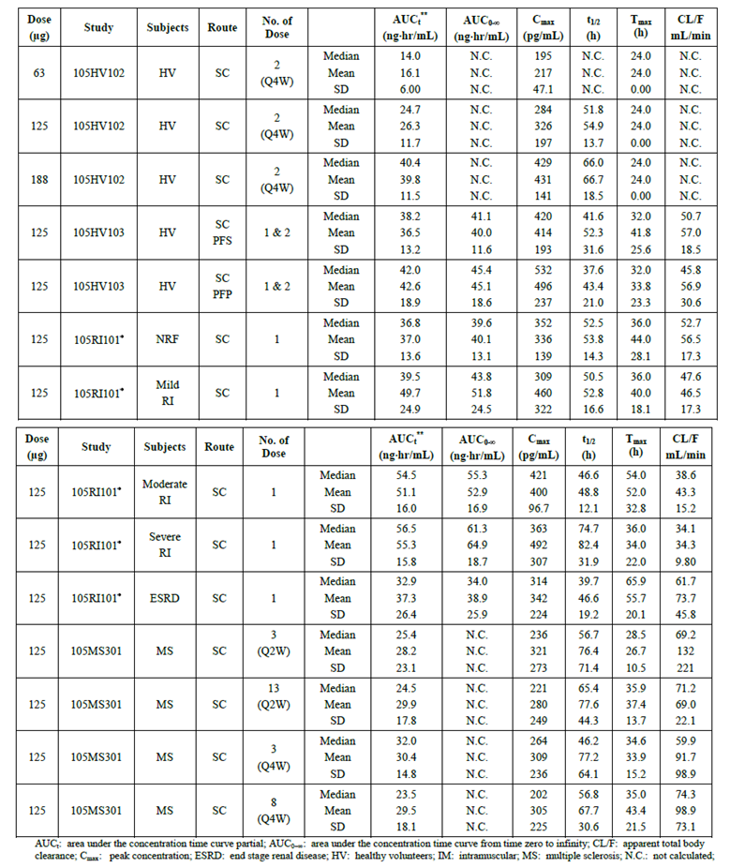

Pharmacokinetics in healthy subjects

Absorption

Sites and mechanisms of absorption
As a complex protein, peginterferon is not expected to be effective orally, because it would face degradation by digestive processes in the gut. Instead, like other interferons including non-pegylated interferon beta-1a, it must be administered subcutaneously (SC) or intramuscularly (IM). The sponsor has proposed the SC route.
Following SC injection, peginterferon reaches a peak concentration in 1-1.5 days post-dose, as shown in the following table and figure from the main single-dose Phase 1 PK study, 105MS101. This study compared the PK of three different doses of peginterferon (63mcg, 125mcg and 188mcg), administered by the SC or IM route, with that of non-pegylated interferon beta 1-a (Avonex, 30mcg) administered via the IM route. Note that, although the dose of Avonex used in this study was lower than the peginterferon doses when measured in micrograms, it was equivalent in terms of international units of interferon beta, as quantified by a cyopathic effect (CPE) assay. This partly reflects the fact that each molecule of peginterferon is almost twice as heavy as a non-pegylated interferon molecule.
The median T_{max} for IM and SC peginterferon ranged from 30-36 hours, compared to 12 hours with IM Avonex.
The median C_{max} for peginterferon was approximately 2-fold higher with peginterferon 63mcg (6MIU) than with Avonex 30mcg (also 6MIU), reaching 41.6 IU/mL via the IM route and 38.9 IU/mL via the SC route, compared to 20.8 IU/mL with IM Avonex. Higher doses of peginterferon (125mcg/12MIU and 188mcg/18MIU) produced proportionately higher C_{max} values, with a similar T_{max}. The AUC for peginterferon was also increased, but this partly reflects delayed clearance, rather than differences in absorption.

Table 3. Median (range) pharmacokinetic parameters based in CPE assay (Study 105HV101).
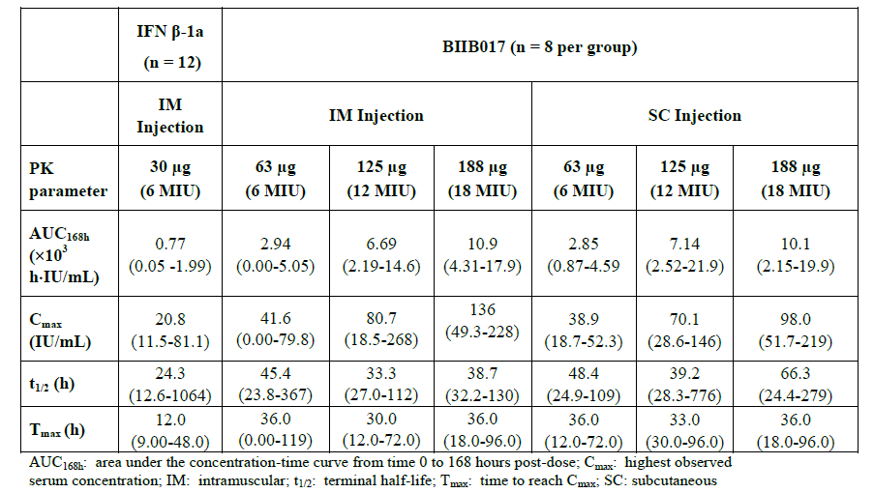
Figure 1. Pharmacokinetic profiles of BIIB017 SC administration at a dose of 63 mcg, 125 mcg or 188 mcg and of IFN beta-1a following a dose of 30 mcg IM (Study 105HV101)
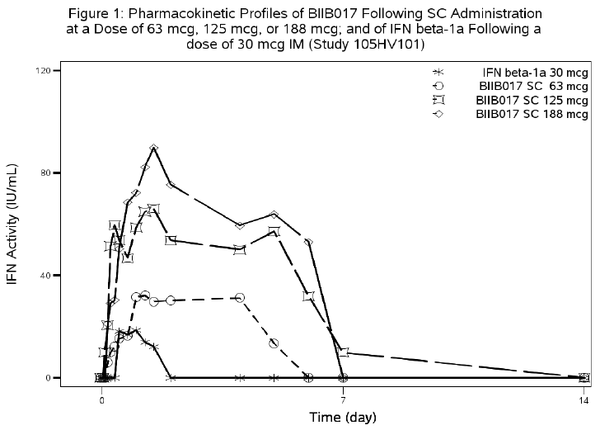

Bioavailability
Considerations of oral bioavailability do not apply to this drug, but the availability of peginterferon from sites of injection appears to be incomplete in some subjects, given the high degree of inter-individual variability in exposure that was observed after SC or IM injection of standardised amounts in the Phase 1 studies. This is discussed further in Section Intra- and inter-individual variability of pharmacokinetics.
The sponsor did not compare the bioavailability of peginterferon via the IM or SC route to the theoretically complete exposure achieved with intravenous injection, so the extent of absorption via these routes remains unclear.
The sponsor did compare the IM and SC route, however, finding no substantial differences in bioavailability. Study 105HV101 compared the PK of three different doses of peginterferon (63mcg, 125mcg and 188mcg), administered by the SC or IM route, with that of non-pegylated interferon beta 1-a (Avonex, 30mcg) administered via the IM route. There were no substantial or consistent differences between the IM and SC routes, when matched for dose (see the table above).
The sponsor also performed a small study comparing absorption after injection with a pre-filled syringe (PFS) or an auto-injector (AI), also known as a pre-filled pen (PFP). Although this study was unblinded and descriptive in nature, no substantial differences were seen with the two devices (see the figure below).
Figure 2. Median serum concentrations of peginterferon beta-1a
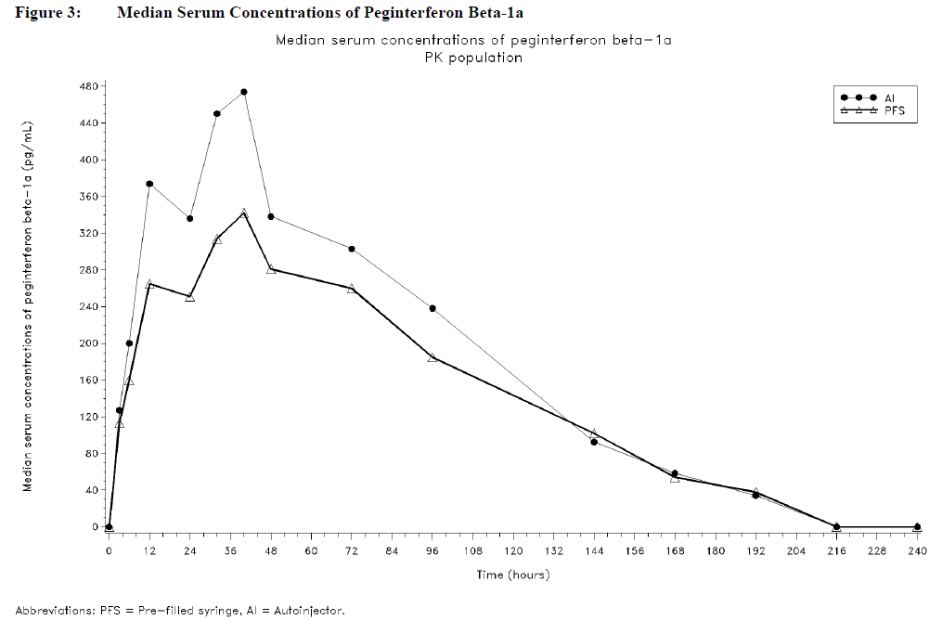

Distribution

Volume of distribution
According to the sponsor’s draft Product Information (PI) sheet, peginterferon is distributed with a volume of distribution of 481 ± 105 L (mean±SE). This value appears to be derived from the Week 24 dose in the intensive PK subgroup of the pivotal study, in subjects receiving peginterferon at the proposed dose (125mcg) and frequency (Q2W).
Results in the 125mcg Q4W group of the same study were substantially different (mean volume of distribution 726 L), and the range across subjects was large (minimum 84L; maximum 2399 L), suggesting that the volume of distribution is itself highly variable or that variation in absorption from injection sites has led to errors in calculating this value.

Plasma protein binding
Plasma protein binding was not discussed by the sponsor. As peginterferon is itself a large protein, it is not expected to be bound significantly to plasma proteins.

Erythrocyte distribution
Erythrocyte distribution was not discussed by the sponsor, but is not expected to be significant given that peginterferon is a large protein.

Tissue distribution
Tissue distribution was not addressed in any clinical (human) studies, but was the subject of a preclinical study in guinea pigs. The sponsor summarises this preclinical evidence as follows (emphasis added):
It was important to evaluate the effects of pegylation on the distribution of interferon beta-1a and to determine if the distribution profile of the protein had been modified by pegylation. Thus, a single dose study in guinea pigs (Study P017-10-01) was conducted comparing the tissue distribution of 125I-labeled BIIB017 and 125I-labeled interferon beta-1a (2.6.4 Pharmacokinetics Written Summary, Section 4.1). Based on the Q2W or the Q4W dosing frequencies used in the pivotal Phase 3 study and the half-life of BIIB017 in humans of 36-60 h [Hu 2012], BIIB017 is not anticipated to accumulate following repeat doses, thus a single dose was selected. The tissue distribution of BIIB017 and interferon beta-1a was similar with highest exposure in the kidney, spleen, liver, and lung; and lower exposure in brain and spinal cord. However, due to the larger molecular size of BIIB017, BIIB017 distribution was more restricted to serum and less distributed to tissues as compared to interferon beta-1a. This is consistent with the low volume of distribution observed in PK studies in rats [Baker 2006] and rhesus monkeys (Study P017-06-01). The estimated half-life of BIIB017 in highly-distributed tissues was similar to that of BIIB017 in serum, indicating similar elimination rates of BIIB017 in these tissues, as compared to the elimination rate in serum. Similar to interferon beta-1a, renal clearance was the major clearance route of BIIB017. The majority of the radioactivity was recovered in urine, 84.5 and 63.6% recovered for BIIB017 and interferon beta-1a, respectively.
The radioactivity present in urine was primarily associated with molecules with molecular weights less than 12.3 kDa, with no intact BIIB017 detected. In contrast, SDS-PAGE indicated that radioactivity present in serum (up to 72 h post-dose), in spleen and kidney (up to 24 h postdose), and liver (up to 6 h post-dose) was primarily associated with the intact pegylated interferon beta-1a. In summary, the tissue distribution study demonstrated that BIIB017 had a similar tissue distribution as interferon beta-1a, but was more restricted to serum and less distributed to tissues. The similar distribution profile for BIIB017 and interferon beta-1a is consistent with the toxicology data where no new toxicology findings were observed for BIIB017. (Section 3.4, Non-clinical Overview, p25 of 45).
A critical assessment of these claims is beyond the scope of this clinical evaluation report.

Metabolism

Interconversion between enantiomers
Not applicable.

Sites of metabolism and mechanisms / enzyme systems involved
The sponsor did not perform any human studies exploring the sites of metabolism of peginterferon. According to the draft PI, the sponsor postulates that renal elimination is a major excretory pathway for peginterferon, but the extent of extra-renal metabolism was not directly addressed. Indirect estimations of non-renal clearance were derived from a clinical study in subjects with renal impairment, using a linear regression model in which renal clearance accounted for 47% of clearance, leaving 53% of clearance (95%CI 33-77%) to be accounted for by non-renal mechanisms.
As a large, complex protein, peginterferon would be expected to undergo proteolysis, and the preclinical mass-balance study in guinea pigs, cited above, includes the observation that “The radioactivity present in urine was primarily associated with molecules with molecular weights less than 12.3 kDa, with no intact BIIB017 detected.” This indicates substantial pre-renal proteolysis, at least in guinea pigs, followed by renal elimination.
Neither the PI for Avonex nor the proposed PI for peginterferon contains a detailed discussion of the mechanisms of the metabolism or clearance of interferon beta-1a. This is appropriate for Avonex, which is essentially identical to a native human immune protein, but some clarification of the metabolism of the PEG moiety would be appropriate in the case of peginterferon.

Metabolites identified in humans
Not applicable.

Consequences of genetic polymorphism
There are no known genetic polymorphisms affecting the PK of peginterferon.

Excretion

Routes and mechanisms of excretion
The sponsor proposes that renal elimination is a major excretory pathway for peginterferon. The PEG moiety of peginterferon is partially cleared by non-renal routes, but the relative contribution of the various routes of excretion was not directly assessed in any clinical study, and was not discussed in the proposed PI.
A clinical PK study in subjects with renal impairment showed that variations in renal function accounted for a substantial part of the variation in clearance. Based on a linear regression model, renal clearance was estimated to account for 47% of the total clearance of peginterferon, with non-renal clearance accounting for the other 53%. This data is indirect, and may reflect renal contributions to variations in clearance more accurately than the true renal contribution to clearance.
The sponsor’s Summary of Clinical Pharmacology refers to preclinical data and the published literature:
With regard to free PEG, the exposure/toxicity relationship in animals and humans has been thoroughly investigated and the metabolism and excretion is also well understood. Based on the literature data, gastrointestinal organs, liver, and kidney were the major tissues in which 20 kDa free PEG was distributed [Fruijtier-Pölloth 2005; Webster 2007; Webster 2009]. Urinary clearance predominates for PEG, and hepatic metabolism and biliary excretion serve as a minor route for clearance. Specifically, in the case of 20 kDa PEG, approximately 42% of the administered dose was recovered from the urine of mice at 4 hours after intravenous (IV) dosing, indicating that the renal clearance of 20 kDa PEG might be rapid in humans [Yamaoka 1994].
It would be appropriate for the PI to contain a brief summary of this information.
The addition of a PEG moiety by covalent binding is thought to slow pre-renal proteolysis as well as reduce renal clearance, thereby extending the half-life of the circulating protein compound. In keeping with this, the half-life (t_{½}) of peginterferon was about twice that of non-pegylated interferon beta-1a, when both were administered at a dose of 6MIU IM to healthy volunteers in the major Phase 1 single-dose PK study (t_{½} for peginterferon 63mcg SC, 48.4hrs; IM, 45.4 hrs; t_{½} for Avonex, 24.3hrs).
As with many other PK parameters derived from the submitted studies, the t_{½} showed significant variability between individuals and across studies. In the intensive PK cohort of the pivotal MS study, 105MS301, the t_{½} of peginterferon was estimated to be 78±15 hrs at steady state (at Week 24) in subjects receiving peginterferon the proposed dose (125mcg) and frequency (Q2W). In the single-dose healthy volunteer study, by contrast, the t_{½} for peginterferon 125mcg SC was 39.2 hrs. The sponsor did not provide any explanation for these differences. The draft PI cites the t_{½} derived from MS patients, which is reasonable, but omits any mention of the different results in other studies.
The mean steady-state clearance of peginterferon, as estimated in MS patients receiving the proposed dose and frequency, is 4.1 ± 0.4L/hr (mean ± SE), according to the proposed PI. This figure was derived from the PK substudy of the pivotal efficacy trial.

Mass balance studies
No mass balance studies were performed in humans. See Tissue distribution above for a brief description of a mass balance study in guinea pigs.

Renal clearance
Renal clearance is postulated as a major excretory pathway for peginterferon, a notion that is supported by preclinical studies in animals. Linear regression analysis suggests that renal clearance may account for 47% of the total clearance of peginterferon.
Renal function was not found to be a significant factor in determining the PK of subjects with MS in the pivotal efficacy study, but this is likely to reflect the exclusion of subjects with significant renal disease at baseline.

Intra- and inter-individual variability of pharmacokinetics
In the intensive PK cohort of Study 105MS301, high inter-individual variability was observed in all PK parameters for both the Week 4 and Week 24 doses. The %CV ranges for the major parameters were as follows:
- AUC_{tau} – 41% to 68%
- C_{max} – 74% to 89%
- t_{½} – 45% to 93%.
For two key measures of exposure, AUC and C_{max}, an estimate of inter-individual variability across all studies can be inferred from the figure below, in which each box represents the 25th to 75th percentile, and the outer limits of the plots represent the minimum and maximum values. Despite large differences between the minimum and maximum values, the middle 50% of values cover a relatively small range.
Figure 3. AUC and Cmax comparison between healthy volunteers versus MS patients
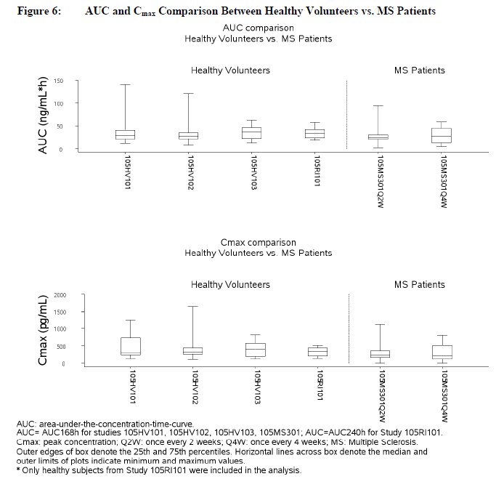
Intra-individual variability was not directly assessed in any study.

Pharmacokinetics in the target population
Pharmacokinetics in the target population were studied in two ways.
Firstly, ~5% of the study population in the pivotal study (105MS301) entered an intensive PK/PD sampling cohort. Unfortunately, only a small number of patients in each active group (Q2W, n=12; Q4W, n=13) had sufficient samples for this intensive PK and PD analysis.
Secondly, all patients in the pivotal study provided samples for PK and PD analysis according to a sparsely monitored timetable, and these results were incorporated into a population-PK/PD analysis.
The pharmacokinetics of peginterferon in patients with MS are broadly similar to those demonstrated in healthy volunteers. The figure above, in the previous section shows the spread of AUC and C_{max} values for peginterferon in all submitted studies, including the intensive PK cohort of the pivotal study. There are no systematic differences between MS subjects and healthy volunteers, with the ranges for AUC and C_{max} showing substantial overlap across studies. Similarly, the multi-page table in Summary of Pharmacokinetics summarises the key PK findings in all of the submitted studies, with the results in MS subjects at the end of the table.
The population-PK analysis found that most demographic variables did not affect the PK of peginterferon, but BMI was found to have a significant influence on exposure. The range of BMIs found in the MS population are similar to those found in the general population, so this is not likely to create a systematic difference in exposure between the target population and healthy volunteers. The other major factor affecting exposure, renal function, is normal in most subjects with MS.
Overall, there is no reason to suspect that the PK of peginterferon in the target population is substantially different to that of healthy volunteers in the Phase 1 studies.

Pharmacokinetics in other special populations

Pharmacokinetics in subjects with impaired hepatic function
No studies were submitted that addressed the PK of peginterferon in subjects with impaired hepatic function. Previous experience with non-pegylated interferon beta has not suggested that dosage adjustment is necessary in the setting of moderate hepatic impairment. Metabolism of the PEG moiety could be altered by hepatic disease, but this moiety is pharmacologically inactive.

Pharmacokinetics in subjects with impaired renal function
The sponsor performed a Phase 1 study specifically addressing the PK of peginterferon in the setting of renal impairment (Study 105RI101). Thirty-five subjects were classified into normal, mild renal impairment, moderate renal impairment, severe renal impairment and end-stage renal disease (ESRD) groups, based on the estimated creatinine clearance (eCRCL) using the Cockcroft-Gault equation (FDA 1998). Patient numbers in each group were low. Three subjects in the mild renal function group and 2 subjects in the severe renal function group received peginterferon 63 mcg SC, and 6 subjects each in the normal, mild, moderate, severe, and ESRD groups were dosed with the proposed dose of peginterferon, 125mcg.
Increasing degrees of renal impairment resulted in increasing exposure to peginterferon. Subjects with mild, moderate, and severe renal impairment had a 30%, 40%, and 53% increase in mean AUC_{336h} and a 27%, 26%, and 42% increase in C_{max}, respectively, compared with subjects with normal renal function. The geometric mean t_{½} of peginterferon was longer (77.8 hours) in the severe renal impairment group, but was similar among other renal function groups (44.2 to 52.4 hours).
Based on a linear regression model, renal clearance was estimated to account for 47% of the total clearance of peginterferon, with non-renal clearance accounting for the other 53% (90% CI, 33%, 77%).
For subjects with ESRD, the situation was different. Each haemodialysis session reduced the pre-dialysis concentration of peginterferon by ~24%. As a result, haemodialysis sessions at the usual frequency of 3 times weekly led to AUC_{336h} and C_{max} values that were similar to the normal renal function group.
In the population-PK analysis of sparsely monitored subjects from the pivotal efficacy study, 105MS301, renal function was not shown to be a major determinant of exposure, probably because subjects with significant renal disease were excluded at baseline.
In a theoretical PK model derived from the population-PK analysis, but incorporating the effect of renal clearance deduced from the renal-impairment study, severe renal impairment was associated with increased exposure, as shown in the figure below.
Figure 4. Simulated steady state PK profiles of BIIB017 (125 µg; once every other week) for MS subjects with normal renal function versus MS subjects with severe renal impairment.
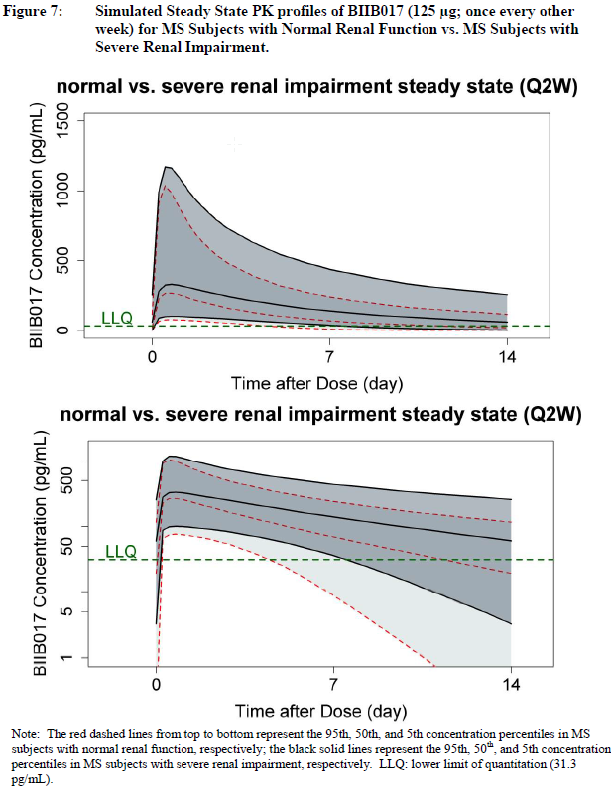
Although exposure is increased in the setting of severe renal impairment, there is substantial overlap between normal subjects and subjects with renal disease, and the main effect of renal disease is to prolong the elimination phase rather than to create high peak levels. Also, tolerability studies in healthy volunteers (such as 105HV101) showed that doses of 188mcg (18MIU), which is 50% higher than the proposed dose of 125mcg (12MIU), were well tolerated. Given that pegylation of interferon beta-1a was performed with the aim of slowing elimination, and that the two-weekly injection interval is largely based on patient convenience rather than on any need to wash out the drug between doses, the slower elimination of peginterferon in subjects with renal impairment is not expected to produce major safety concerns. Delayed elimination might even be expected to improve efficacy, though this has not been demonstrated directly.
On balance, there does not appear to be a need for dose adjustment in the setting of renal impairment. The draft PI reports the increased exposure in this population without making a recommendation about dose adjustment:
“A single-dose study in healthy subjects and subjects with various degree of renal impairment showed a fractional increase in AUC (30-53%) and Cmax (26-42%) in subjects with mild (creatinine clearance 50 to ≤ 80 mL/minute), moderate (creatinine clearance 30 to <50 mL/minute), and severe (creatinine clearance <30 mL/minute) renal impairment, compared to subjects with normal renal function (creatinine clearance >80 mL/minute). Subjects with end stage renal disease requiring haemodialysis 2-3 times weekly showed similar AUC and Cmax as compared to subjects with normal renal function. Each haemodialysis reduced peginterferon beta-1a concentration by approximately 24%, suggesting that haemodialysis partially removes peginterferon beta-1a from systemic circulation.” (Draft PI).
This wording seems appropriate on the basis of the available evidence.

Pharmacokinetics according to age
The population-PK analysis did not suggest that age played a significant role in the PK of peginterferon. To the extent that older subjects are more likely to have renal impairment, exposure in older subjects could be increased.

Pharmacokinetics related to genetic factors
There are no known genetic factors influencing the PK of peginterferon. Race and gender were not significant factors in the population-PK analysis.

Pharmacokinetics related to anti-interferon and anti-PEG antibodies
Antibodies to peginterferon were assessed in the pivotal study, and the incidence is summarised in the tables below. Three types of antibodies need to be distinguished: antibodies that bind to interferon (binding antibodies, BAbs); antibodies that bind to interferon and neutralise its biological effects (neutralising antibodies, NAbs); and antibodies to the PEG moiety (anti-PEG Abs).
In general, there was no evidence of a clinically relevant PK effect from antibodies to peginterferon, but the rarity of sustained antibody responses and lack of intensive PK monitoring across all subjects makes it difficult to draw any firm conclusions. In the intensive PK substudy of the pivotal study, 105MS301, serum concentration of peginterferon was reduced in two subjects with detectable levels of BAbs. Neither of these subjects developed NAbs, and in both subjects the PD effect on neopterin responses was maintained, suggesting that the BAbs produced technical interference with the ELISA quantification method rather than inducing true changes in the PK of peginterferon.
The impact of anti-PEG antibodies was evaluated in the healthy-volunteer study 105HV103, as well as the pivotal efficacy study. In Study 105HV103, 5 subjects developed anti-PEG antibodies after peginterferon, but four of these subjects had antibodies at only one sampling time point. The fifth subject developed a high titre of anti-PEG Abs (3200), and peginterferon serum concentration was reduced below the limit of quantitation (BLQ) on day 22. This study did not include PD monitoring that would allow inferences to be made about whether peginterferon was still present, or whether the assay itself had been compromised. In Study 105MS301, two intensive PK sub study subjects developed anti-PEG antibodies on treatment, but they showed no reduction in peginterferon levels or PD effects.
The population PK and PD model, derived from sparse sampling in all subjects from the pivotal study, showed no PK impact of anti-PEG antibodies.

Table 4. Incidence and categorization of antibodies against IFN β 1a in MS subjects over 48 weeks.
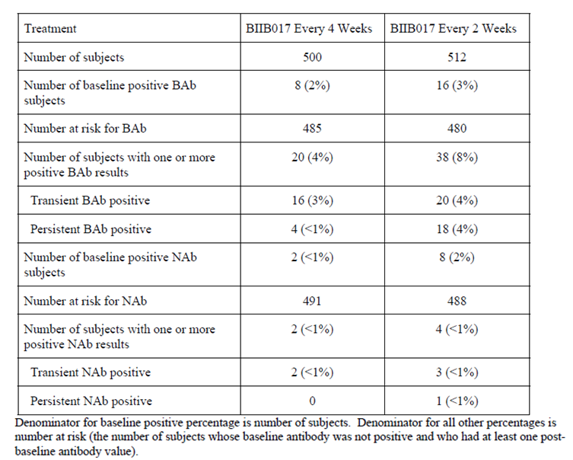

Table 5. Incidence and categorization of anti-PEG antibodies in MS subjects over 48 weeks
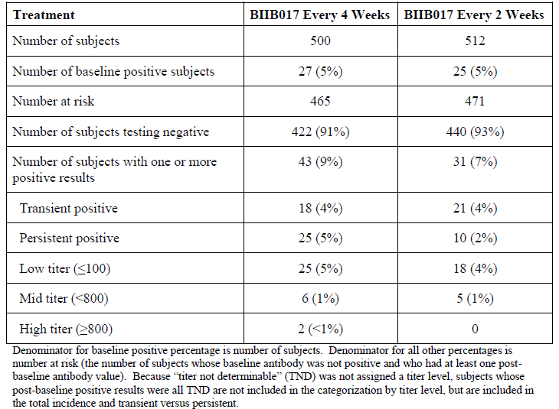

Pharmacokinetic interactions

Pharmacokinetic interactions demonstrated in human studies
No formal drug interaction studies were submitted.
A population-PK analysis based on subjects in the pivotal efficacy study, 105MS301, did not find that any concomitant medications were significant factors. Among the drugs tested were a number of agents commonly used in this population, such as paracetamol, ibuprofen, methylprednisolone, naproxen, modafinil, gabapentin, and baclofen. Although this is broadly reassuring, it is important to note the pivotal study was not specifically powered to address such interactions, and the sponsor did not provide confidence intervals for the possible effects of such interactions. Concomitant drug use was non-randomised and ad hoc, with sparse and inconsistent use of the drugs across the study population. Furthermore, the wide inter-subject variability in the PK of peginterferon could have masked the effects of any potential interactions. The absence of a significant finding does not, therefore, provide robust evidence of the lack of such an effect – “absence of proof” is not “proof of absence”.
On the other hand, for the non-pegylated versions of interferon beta, including interferon beta-1a, significant pharmacokinetic drug interactions have not been identified after many years of use (Avonex SmPC ; Betaferon SmPC; Rebif SmPC), so it seems relatively unlikely that pharmacokinetic drug interactions will be clinically important in the use of peginterferon. Also, peginterferon, like non-pegylated interferon beta-1a, appears to be a drug with a relatively broad therapeutic window, so the possibility of minor PK interactions does not raise significant clinical concerns.

Clinical implications of in vitro findings
The non-clinical study program did not directly address the potential for drug interactions. The sponsor defended this with the following comment:
“There is limited value in the qualitative and quantitative projection of clinical interactions between therapeutic proteins and drug metabolizing enzymes from in vitro or in vivo nonclinical drug interaction studies [Morgan 2009; Morgan 2008]. Furthermore, there has been a lack of drug-drug interactions reported for interferon beta products in the clinical and commercial settings [Avonex® SmPC; Betaseron® SmPC; Rebif® SmPC]. Thus, no preclinical drug interaction studies were conducted and consequently, no study reports are included in Module 4.2.2.6.” Non-clinical Overview, p27 of 45.
The cited references, Morgan 2008 and Morgan 2009, do not argue that drug interactions with immunomodulatory proteins do not occur, but simply that they are difficult to predict on the basis on nonclinical studies. In fact, Morgan (2009) includes the following comment:
“Interferons (IFN) and proinflammatory cytokines can down-regulate P450 expression in vivo and in hepatocyte cultures, and these mediators are thought to be the main cause ofP450 down-regulation in inflammatory states. IFNs and IL-2 are used in the therapy of various cancers, and therefore they have the potential to cause drug-drug interactions. Several studies have found that therapy with IFNα or IFNβ was associated with decreased P450-dependent drug clearance (Mahmood I, Green MD. Drug interaction studies of therapeutic proteins or monoclonal antibodies. J. Clin. Pharmacol. 2007; 47:1540–54. [PubMed: 17962422]). Overall, different IFNα or β preparations tended to consistently reduce CYP1A2 activities and clearances, whereas effects on other P450s were more variable.”
Despite this comment, which suggests that the interferons could modify hepatic metabolism of other drugs, the effect of interferons on P450 expression appears to be limited. The sponsor notes the historical observation that, as a class, interferon beta has only minimal effects on hepatic enzyme systems: it is only a weak inhibitor of CYP1A2, shows no effect on CP2C19 and CYP2D6, and has not been reported to have effects on other CYP enzymes (Hellman 2003, Okuno 1993).
Overall, despite some indications in the literature that there might be a potential for drug interactions between interferons and drugs metabolised by hepatic P450 enzymes, there is no strong in vitro evidence that this is significant, and the issue was not further explored by the sponsor. Given the lack of evidence of clinically significant drug interactions with a variety of commercial interferon beta products already used in the treatment of multiple sclerosis, including non-pegylated interferon beta-1a, this omission seems acceptable.

Evaluator’s overall conclusions on pharmacokinetics
The pharmacokinetics of peginterferon show substantial inter-individual variability, with exposure in some subjects greatly reduced compared to the median exposure in a cohort of healthy subjects, as illustrated in the figure below from the intensive PK cohort of the pivotal MS study.
With this limitation in mind, the overall PK of peginterferon has been adequately characterised by the sponsor. When administered subcutaneously, at the proposed dose of 125mcg, the serum levels of peginterferon peak in 1 to 1.5 days, and then decline over the course of a week to ten days. Thus, the drug is not expected to maintain significantly elevated levels throughout the proposed two-week dose cycle.
The drug is associated with an apparent volume of distribution of 481 ± 105 L (mean±SE). It undergoes proteolysis and renal clearance, with renal clearance accounting for about half (~47%) of the elimination of the drug. The elimination half-life is approximately 78±15 hrs at steady state, but varies considerably between subjects and across studies. In healthy volunteers, the elimination half-life of peginterferon was approximately double that of non-pegylated interferon beta-1a (Avonex), when both were administered as 6MIU, and the AUC and C_{max} were also increased with the pegylated form.
Exposure is increased in subjects with renal impairment, and in those with a low BMI, but exposure does not appear to be affected by race or gender. The effect of hepatic impairment has not been studied. A population-PK analysis did not find that concomitant drugs had a major effect on the PK of peginterferon, but the power of this analysis is unclear. Historically, beta interferons have not been associated with clinically significant pharmacokinetic drug interactions, and this is expected to be true of peginterferon as well, but the question has not been directly addressed.
The PK details provided in the draft PI are consistent with the submitted evidence. The PI does not discuss the metabolism or excretion of peginterferon and some additional comments would be appropriate.
Figure 5. Medians and ranges of serum BIIB017 concentration from ELISA by treatment group and time-evaluable subjects in Intensive PK population
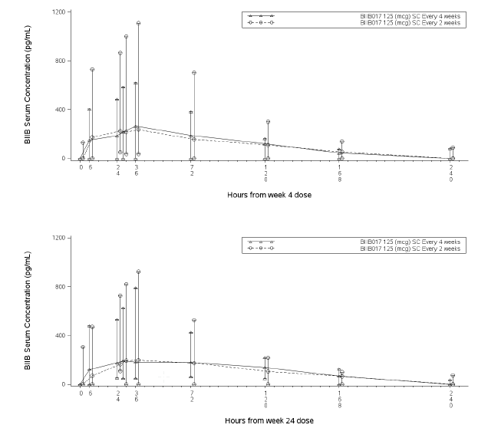

Pharmacodynamics

Studies providing pharmacodynamic data
All submitted clinical studies except 105HV103 included a PD assessment using established surrogate biomarkers for the immunomodulatory actions of beta-interferon, such as neopterin and OAS (2',5'-oligoadenylate synthetase, 2’, 5’-OAS).
Table 6 below, shows the studies relating to each pharmacodynamic topic and the location of each study summary.

Table6. Submitted pharmacodynamic studies.
PD Topic | Subtopic | Study ID | *
Primary Pharmacology | N/a – primary mechanism of action for beta-interferon in MS remains unclear
Secondary Pharmacology  (surrogate markers) | Effect on neopterin & OAS | 101HV101
Secondary Pharmacology  (surrogate markers) | Effect on neopterin & OAS | 101HV102
Gender, other Genetic and Age-Related Differences in PD Response | Effect of gender | see Pop-PK/PD analysis
 | Effect of renal impairment | 105RI101
 | Effect of BMI | see Pop-PK/PD analysis
 | Effect of age | see Pop-PK/PD analysis
PD Interactions | Multiple concomitant drugs | Pop-PK/PD analysis
Population PD and PK-PD analyses | Healthy subjects | N/a
Population PD and PK-PD analyses | Target population § | 105MS301, Report CPP-12-016-BIIB017
* Indicates the primary aim of the study. § Subjects who would be eligible to receive the drug if approved for the proposed indication. N/a – not applicable.
None of the pharmacodynamic studies had deficiencies that excluded their results from consideration.

Summary of pharmacodynamics
The information in the following summary is derived from conventional pharmacodynamic studies in humans unless otherwise stated.

Mechanism of action
Human interferon beta is a member of the type I interferon family, and as such it is a type of cytokine. It is a naturally occurring glycoprotein, produced by fibroblasts and other cells, that exhibits a range of immunomodulatory, antiviral and antiproliferative effects (Baron 1991), including the regulation of other cytokines such as interleukins (IL).
Interferon beta is usually considered to play an immunomodulatory role in MS, rather than exhibiting a straightforward anti-inflammatory or immunosuppressive action. It does not appear to suppress active MS plaques, but it reduces the rate of clinical relapses, slows the accumulation of physical disability, and reduces the development of brain MRI lesions. These clinical effects are common to all commercially available interferon beta preparations [Jacobs 1996; PRISMS Study Group 1998; Simon 1998; The IFNB Multiple Sclerosis Study Group 1993].
The currently available interferon beta therapies, including Avonex (interferon beta-1a), Rebif (interferon beta-1a) and Betaferon (interferon beta-1b) were initially shown to provide an approximate 30% reduction in the annualised relapse rate (Mikol 2008). (The benefit obtained in these early studies may not reflect the potential efficacy in newly diagnosed patients, because there has been a trend over many years towards earlier diagnosis and treatment of MS, and patients at an earlier stage of their disease are likely to be more responsive to treatment.)
Interferon beta therapies have been used in the treatment of multiple sclerosis for over 15 years, and many distinct immunomodulatory actions have been identified, without a clear consensus emerging as to which of these actions are most important in mediating the beneficial effects of interferon beta. It is known, however, that the immunomodulatory properties of interferon beta are mediated through its interactions with specific cell receptors (interferon receptors) found on the surface of a number of human cells, particularly in immune tissues. The binding of interferon beta to these receptors induces the expression of several gene products that are, in turn, believed to mediate of the biological actions of interferon beta. Interferon beta has an action that is antagonistic to the pro-inflammatory cytokine, interferon gamma; it both decreases the binding affinity of interferon gamma and enhances the degradation of the interferon-gamma receptor. Interferon beta also enhances the suppressor activity of peripheral blood mononuclear cells.
According to the sponsor’s draft Product Information (PI) sheet, potential mechanisms of action for interferon beta include up-regulation of anti-inflammatory cytokines (e.g. IL-4, IL-10, IL-27), down-regulation of pro-inflammatory cytokines (e.g. IL-2, IL-12, interferon-γ, Tumour Necrosis Factor-α [TNF-α]) and inhibition of the migration of activated T cells across the blood brain barrier. Insight into these mechanisms has come from pre-clinical studies of peginterferon, as well as decades of study of non-pegylated interferons. Clinical PD studies with peginterferon beta 1-a have been based on surrogate biomarkers and have not been directed at clarifying the mechanism of action.

Pharmacodynamic effects

Primary pharmacodynamic effects
Data on the primary pharmacodynamic effects of peginterferon are limited. In vitro studies, performed as part of the nonclinical study program, suggest that it binds to the type 1 interferon receptor, which is composed of the IFNAR1 and IFNAR2 chains. Binding affinities to the IFNAR2 chain appeared to be unaffected by pegylation, but in vitro activity measured with antiviral and proliferative assays appeared to be compromised by pegylation, suggesting reduced transmission of the interferon signal to intracellular mediators. A critical evaluation of this nonclinical work is beyond the scope of this clinical evaluation, but the sponsor summarised the data as follows (emphasis added):
There was no apparent difference in the affinity of either interferon beta-1a or BIIB017 for IFNAR2 (2.6.2 Pharmacology Written Summary, Section 2.1.1) indicating that in solution, the 20 kDa mPEG moiety did not interfere with receptor binding. However, the observation that BIIB017 showed a modest 2-fold reduction of in vitro antiviral and antiproliferative activity compared to interferon beta-1a (2.6.2 Pharmacology Written Summary, Section 3.1) suggests that the affinity for the type I interferon receptor, composed of the full-length IFNAR1 and IFNAR2 chains expressed on the cell surface, may be affected by the attached 20 kDa mPEG. Moreover, the observation that interferon beta-1a modified at the N-terminus with 20, 15, 10, 5, and 2 kDa mPEG shows successively higher in vitro antiviral potencies indicates a sizedependent effect of the mPEG moiety [Baker 2010].
Note that, to some extent, the 2-fold reduction in vitro activity mentioned here is already factored in when referring to interferon beta doses via international units (IU), which use a standardised in vitro functional assay (the cytopathic effect assay, or CPE assay).
The pre-clinical program did not include any in vivo animal studies of the primary PD effect of peginterferon, largely because the precise mechanism of action in humans is unknown and no entirely suitable animal models of MS exist.
The sponsor comments as follows:
“Primary in vivo pharmacodynamic studies utilizing animal models of MS were not carried out as part of the nonclinical evaluation of BIIB017. While mouse and rat experimental autoimmune encephalomyelitis (EAE) models have been developed that reflect certain aspects of the pathophysiology of MS, the fact that mice and rats do not respond to human interferon beta-1a precluded such studies. Correspondingly, testing of mouse or rat interferon beta modified with 20 kDa mPEG-O-2-methylpropionaldehyde in EAE models was not considered relevant as the data would not necessarily reflect the pharmacology of BIIB017 in humans. Moreover, as interferon beta-1a has already been demonstrated to be effective in MS, data on the efficacy of BIIB017 in a preclinical animal model did not seem necessary.”
The clinical program did not include any direct clinical studies of the primary PD effect of peginterferon in humans, which is understandable given the complex and largely unconfirmed mechanisms of action thought to mediate its clinical benefit. Previous interferon beta preparations used in the treatment of MS have suffered a similar lack of primary PD data in humans, and have instead relied on surrogate biomarkers known to be induced by interferon beta.

Secondary pharmacodynamic effects
The sponsor used neopterin as a surrogate biomarker to detect the biological action of interferon beta. This is a standard approach in the study of interferon beta in MS. Neopterin is also known as D-erythro-1, 2, 3,-trihydroxypropylpterin, and it is a product of the interferon-inducible enzyme, GTP-cyclohydrolase I. It is a catabolic product of guanosine triphosphate (GTP), a purine nucleotide, and belongs to the chemical group known as pteridines. It is synthesised by macrophages upon stimulation with the cytokine interferon-gamma and is usually considered indicative of a pro-inflammatory immune status, but levels also increase under the immunomodulatory actions of interferon beta. This is a counter-intuitive situation, with neopterin acting as a biomarker of pro-inflammatory activity and also as a marker of treatment with interferons intended to prevent inflammatory episodes. The apparent contradiction reflects the fact that interferon beta has complex actions, inducing a relative shift in various components of immune responses rather than merely suppressing immune responses.
The sponsor also used OAS (2',5'-oligoadenylate synthetase, 2’, 5’-OAS) as an additional biomarker in some studies. OAS is an antiviral enzyme that counteracts viral infections by degrading viral RNA, and levels increase in response to beta interferons.
Using neopterin concentration as the primary measure of interferon effect, the sponsor defined E_{max} as the maximum baseline-subtracted neopterin concentration reached, E_{AUC} as the area under the baseline-subtracted neopterin concentration time curve and E_{Tmax} as the time taken to reach maximum neopterin concentration.
The results in all submitted studies are summarised in the multi-page table starting over the page. In MS subjects receiving peginterferon at the proposed dose and frequency, the mean E_{max} was 11.3 to 11.4 ng/mL, but the standard deviations were large. E_{max} results in healthy volunteers receiving single or multiple 125mcg doses of peginterferon were similar to those seen in MS subjects. For healthy subjects receiving doses lower (63mcg) and higher (188mcg) than the proposed dose (125mcg), a less than proportional increase in E_{max} was observed with increasing doses. In many studies, the peak neopterin response to 188mcg was similar to or lower than that seen with 125mcg, possibly indicating a saturation effect (see the table below). The E_{AUC} was consistently greater with 188mcg than with 125mcg, however, and the E_{AUC} with 63mcg was lower than with 125mcg, partly reflecting the longer period of above-baseline peginterferon concentrations with higher doses.
The peak neopterin response to peginterferon was similar to that seen with non-pegylated interferon beta-1a (Avonex), when doses were matched in terms of international units (interferon beta-1a 30mcg = 6MIU; peginterferon 63mcg = 6MIU), as shown below.
Figure 6. Pharmacodynamic profiles of neopterin following SC administration of BIIB017 at a dose of 63 mcg, 215 mcg or 188 mcg or following IM administration of IFN beta-1a at a dose of 30 mcg (Study 105HV101)
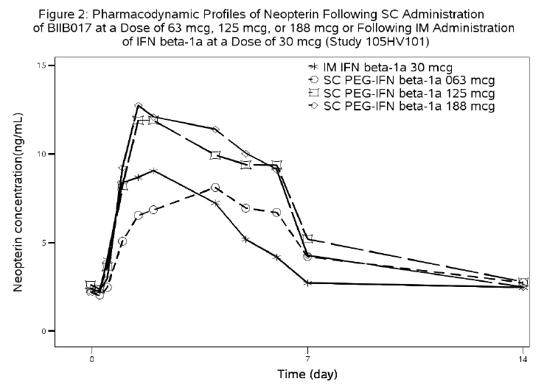

Table 7. Summary of neopterin PD parameters in healthy volunteers, renal impairment subjects and MS subjects.
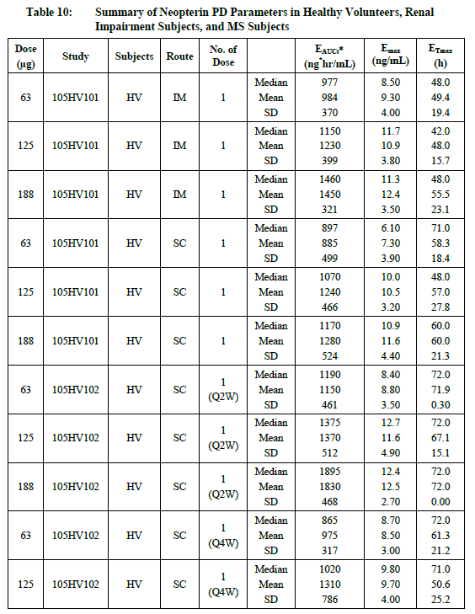

Table 7 continued. Summary of neopterin PD parameters in healthy volunteers, renal impairment subjects and MS subjects.
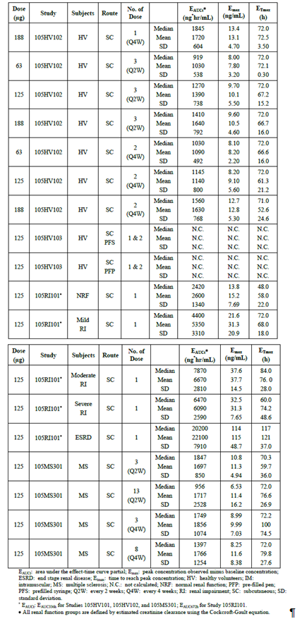
The results with OAS as a secondary marker were qualitatively similar to those seen with neopterin, as shown in the summaries of individual PK/PD studies.

Time course of pharmacodynamic effects
The time course of primary pharmacodynamic effects was not addressed in any submitted study.
The time course of expression of the secondary biomarker neopterin, following injection with peginterferon, was compared to that seen with non-pegylated interferon beta-1a (Avonex), in study 105HV101, as shown in the figure in the section above. The pegylated form of interferon beta produced a similar peak, when dose-matched with Avonex, but the peak was delayed and the overall duration of the neopterin response was prolonged.
The median time to maximum neopterin concentration (E_{Tmax}) is listed for each dose and each study in the table above, and ranged from 48-72 hrs in subjects with normal renal function. In subjects with impaired renal function, peak neopterin response was somewhat delayed, though the effect was variable (mild renal impairment 72 hrs; moderate 84 hrs; severe 60 hrs).
The duration of the neopterin response was longer than the concentration-time profile of peginterferon itself, indicating lingering effects from induced genes. Whereas peginterferon peaked in 1-1.5 days and reduced to low levels between 7 and 10 days, neopterin peaked in ~3 days and returned to baseline after >10 days.
For the intensive PK/PD cohort of the pivotal study, the neopterin profile is shown in the figure below. At ten days (240 hours), median levels had not fallen to baseline.
Figure 7. Median and range of neopterin concentrations (ng/mL) by treatment group-intensive PD population
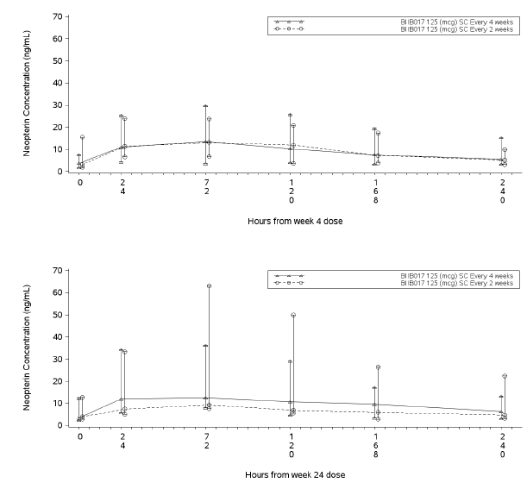
As shown in the figure, there was no difference between the two-weekly (Q2W) dose group and the four-weekly (Q4W) dose group when they were assessed early in the study (week 4, top curves). The response was slightly blunted 20 weeks later (bottom curves); this effect was slightly more pronounced in the Q2W group (who had received a greater number of active doses) but there was substantial overlap between the curves due to high inter-individual variability. It seems unlikely that this represents a clinically important effect. Although it is theoretically possible that the PD effect of peginterferon wanes over multiple doses, the curves above suggest that the peak PD effect as estimated by neopterin response is still considerable after 24 weeks of treatment. Even if there were some loss of efficacy due to tachyphylaxis, this would be expected to be at least partially accounted for in the efficacy results, given that placebo-controlled treatment continued for a year (and dose-frequency-controlled treatment continued for up to one more year after that). Of more concern is the fact that neopterin levels during the last four days of the two-week dose cycle were not studied, which represents a serious deficiency of the PD monitoring program.
In Studies 105HV101 and 105HV102, samples were taken for neopterin levels at Day 7 and Day 14 post-dose, but not between these times. By Day 14, neopterin levels were low in both studies, so it is unclear when levels fell to baseline. In Study 105HV103, PD was not assessed. In Study 105RI101, the remaining PK/PD study, samples were taken after Day 10, and this provides the only reasonable estimate of PD response in the last part of the proposed two-week dose cycle. In subjects with normal renal function, the last sample that showed substantial neopterin induction was taken on Day 10 (240 hrs), with fluctuating but low levels thereafter.
Figure 8. Median serum concentrations of neopterin on a logarithmic scale
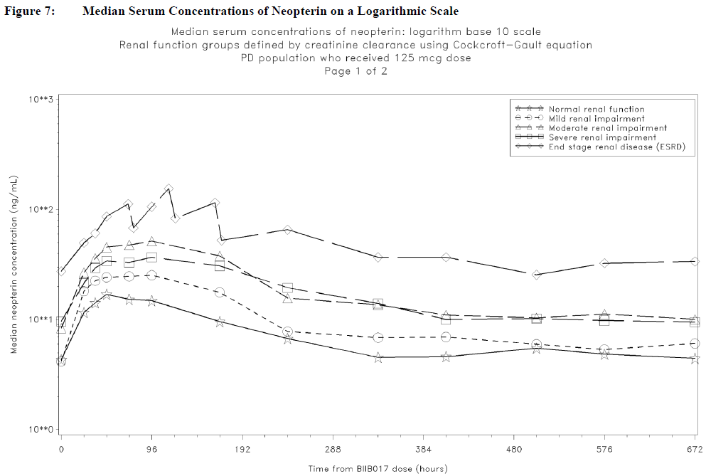
Overall, it seems likely that neopterin induction in the last four days of a two-week cycle is substantially less than that achieved for the first week of the cycle, and the sponsor provided no evidence to show that the low levels associated with the last few days of the cycle are adequate to suppress disease activity in MS.

Relationship between drug concentration and PD effects
The sponsor did not directly assess the relationship between peginterferon concentration and its pharmacodynamic effect. Also, the sponsor did not perform any studies relating drug concentration to efficacy, or exploring the link between biomarkers and efficacy.
Visual comparison of the concentration-time curves for peginterferon and neopterin suggests that onset of the pharmacodynamic effect of peginterferon is delayed, relative to the rise of peginterferon levels in the serum, and also outlasts the subsequent decline of peginterferon levels, presumably reflecting the delay in turning response genes on and then off as the interferon level rises and falls.
The interrelation between dose, pharmacokinetics, secondary biomarkers and efficacy for peginterferon and other interferon betas is considered in Section Efficacy.

Genetic-, gender- and age-related differences in pharmacodynamics
No PD studies directly addressed the effects of genes, gender and age on the PD profile of peginterferon, but a population-PD analysis was performed on subjects in the pivotal study, and no demographic factor appeared to make a substantial difference in the regression analysis.

Differences in pharmacodynamic response related to renal impairment
Renal impairment increases exposure to peginterferon but the study in subjects with renal impairment (105RI 101) suggests that, in addition to this, the AUC for neopterin is even more significantly affected by renal impairment. This suggests that neopterin itself has delayed clearance in the setting of renal impairment. Whether the same applies to other mediators of the interferon beta effect, and whether this has a substantial overall effect on the primary pharmacodynamic response to interferon beta remains unclear. The relatively long duration of the neopterin response in subjects with renal impairment might be expected to reflect a prolonged PD response and improved efficacy, but this remains speculative. Subjects with significant renal disease were not included in the pivotal efficacy study, so the efficacy of peginterferon in this population cannot be assessed with the current evidence.

Pharmacodynamic interactions
No specific PD interaction studies were performed. Given the known side-effect profile of non-pegylated interferon beta, and the submitted safety data that suggests peginterferon has a similar side-effect profile to other interferon betas, it might be expected that some drugs could have synergistic effects with peginterferon in producing some side effects. This issue is discussed further in the Safety section.
The safety of combining interferon beta with other immunomodulatory agents is unknown, and combination therapy with disease-modifying agents in MS is rarely attempted because of fears that synergistic immune suppression might result. One exception is the use of intravenous and oral corticosteroids (methylprednisolone and prednisolone), which are widely used to treat acute relapses in MS regardless of whether subjects are on disease-modifying agents. Steroids were used as needed in the pivotal study in this submission, in line with standard clinical practice for subjects receiving interferon beta. There was no evidence of any significant pharmacodynamic interaction between steroids and peginterferon, as discussed further in the Safety section, but this evidence is indirect.

Pharmacodynamic effects of anti-interferon and anti-PEG antibodies
There was no evidence of a significant reduction in neopterin response in the setting of antibodies to interferon or PEG, even in subjects that appeared to have reduced levels of peginterferon in association with antibodies. The preservation of the PD response, in the setting of apparently low peginterferon levels, is likely to reflect that peginterferon levels were higher than measured, and that the antibodies interfered with the drug assay, as discussed in Section Pharmacokinetics related to anti-interferon and anti-PEG antibodies.

Evaluator’s overall conclusions on pharmacodynamics
The primary PD effects of peginterferon were not studied, but the primary effects of interferon betas are complex and poorly understood. Using the secondary biomarker neopterin, the sponsor has demonstrated that the peak PD response to peginterferon is slightly delayed relative to non-pegylated interferon, but also more prolonged. Neopterin levels fall to baseline after about 10 days, but this part of the proposed two-week dose cycle was not adequately studied. It seems likely that neopterin levels are low for the last few days of each dose-cycle, and it is unclear if this compromises efficacy. Based on the interferon literature, discussed below, it seems likely that the waning of PD response after 10 days would compromise efficacy, but this has not been directly addressed.

Dosage selection for the pivotal studies
The sponsor reports that the following issues were considered when choosing the 125mcg (12MIU) two-weekly regimen for further study:
- the single-dose and multiple-dose PK and PD (neopterin) responses
- the comparison with non-pegylated interferon beta-1a PK and PD
- the likelihood of accumulation with repeated dosing
- in vitro biological activity
- the safety and tolerability data from Phase 1 studies
The guiding principle in dose selection appears to have been matching the approved dose of Avonex while aiming for the lowest feasible dosing frequency. It is not clear that this approach has led to the sponsor choosing the most efficacious regimen. Low dosing frequency is likely to represent a major marketing advantage for peginterferon, but indirect evidence suggests that it may compromise efficacy.

Dose equivalence with Avonex
There are multiple different ways of expressing dose equivalence, as shown in the table below. The proposed dose for peginterferon treatment, 125mcg two-weekly, matches the approved dose for non-pegylated interferon beta-1a (Avonex) in terms of international units administered per month. Avonex 30mcg is equivalent to 6MIU using in vitro cytopathic effect assays; when administered weekly this provides 24MIU per 4-week period. Peginterferon 125mcg is equivalent to 12MIU in CPE assays; when administered two-weekly this also provides 24MIU per 4-week period.

Table 8. PK, PD and biological activity considerations for dose selection.
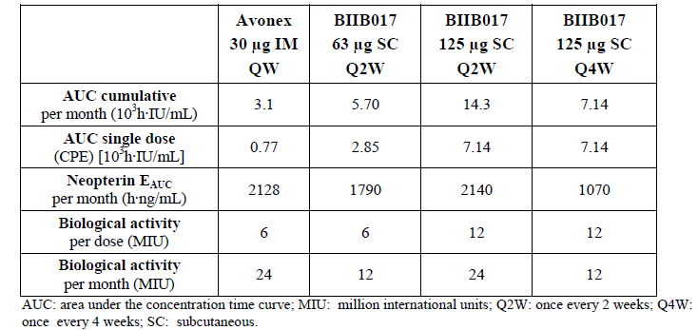
Note that these basic calculations refer to the in vitro biological activity of isolated quantities of interferon. Because of delayed clearance of the pegylated form, the cumulative AUC for peginterferon 6MIU is higher than for a single dose of Avonex 6MIU (5.7 vs 3.1x10³h*IU/mL). Over 4 weeks at the proposed dose, the AUC for peginterferon (14.3 x10³h*IU/mL) is considerably higher than that achieved with Avonex (3.1x10³h*IU/mL) even though both amount to the same total administered activity (24MIU). In this sense, the proposed dose of peginterferon could be considered to be higher than the approved Avonex dose.
On the other hand, the cumulative AUC for neopterin , a surrogate PD biomarker, more closely reflects the total administered dose, in MIU, rather than the interferon AUC, in h*IU/mL; the estimated E_{AUC} per 4 week period is very similar for Avonex 4x6MIU (2128 h*ng/mL) and peginterferon 2x12MIU (2140 h*ng/mL). Thus, despite differences in exposure as reflected in interferon AUC, the proposed dose for peginterferon is matched to the approved Avonex dose in terms of administered in vitro activity and in vivo pharmacodynamic response, with the effects of delayed clearance and less frequent dosing with the pegylated version approximately cancelling out in terms of the cumulative neopterin response.
The discrepancy between the interferon AUC and the neopterin AUC partly indicates that the biological effects of interferon beta persist for 3 days or more after gene induction has occurred. They also reflect the non-linear saturable neopterin response to increasing interferon doses: peginterferon at a dose of 6MIU two-weekly provides substantially more than half of the neopterin response achieved with 12MIU at the same frequency (1790 vs 2140 h*ng/mL). On the other hand, a peginterferon regimen of 6MIU every two weeks provides the same administered activity as 12MIU Q4W (12MIU/month), but the neopterin response for the infrequent dosing regimen is much less (1070 vs 1790 h*ng/mL), indicating that neopterin induction increases in a less than proportional fashion to higher doses, and drops away between the infrequent doses, so that higher doses cannot fully compensate for low-frequency dosing.

Accumulation between doses
The sponsor suggests that one benefit of the proposed dose (125mcg Q2W) is that it is not associated with evidence of accumulation between doses. It is unclear, though, if this is a point in favour of the proposed dosing regimen.
Most drugs are administered at a frequency that prevents them from being completely eliminated between doses; that is, some degree of accumulation from one dose to the next is usually considered desirable because it produces a smooth and sustained pharmacodynamic response with some efficacy maintained through the trough of each dose cycle. Usually, accumulation is only considered a problem if a stable and safe steady-state cannot be achieved, or if some tissue susceptible to toxicity needs an intermittent reprieve from the drug. There is no evidence that this is the case for peginterferon.
Figure 9. Pharmacokinetic profiles of BIIB017 following SC administration at a dose of 63 mcg, 125 mcg or 188 mcg; and IFN beta-1a following a dose of 30 mcg IM Study 105HV101
Peginterferon levels reach baseline ~7-10 days after dosing, , as shown in the figure above (from 105HV101), but with considerable inter-individual variability. If peginterferon were to be administered weekly, rather than two-weekly, some residual peginterferon would be present at the start of each dose cycle, from the previous dose, but it would be a small proportion of the total interferon beta in circulation post-dose and it would be eliminated almost completely as the new dose also fell to its trough level over the subsequent 7 days. The result would probably be a sustained induction of neopterin and other immunomodulatory mediators, rather than a pulsatile induction with neopterin levels falling away between doses, some time between 7 and 14 days. The actual PD response to this hypothetical treatment regimen is unfortunately not known, because the sponsor never tested it.
In this context, it should be noted that the submitted PK/PD studies did not monitor neopterin levels between 7 and 14 days, so the duration of the PD effect of peginterferon is not well characterised. The straight line drawn from Day 7 to Day 14 in the figure below (from 105HV101) is almost certainly a misrepresentation of the true neopterin curve, which falls rapidly from Day 6 to Day 7 and would therefore be expected to continue to fall rapidly from Day 7 to Day 8 rather than switch to a slow linear decline as illustrated.
Figure 10. Pharmacodynamic properties of neopterin following SC administration of BIIB017 at a dose of 63 mcg, 125 mcg or 188 mcg; and IFN beta-1a following a dose of 30 mcg IM Study 105HV101
The sponsor has not mounted any argument demonstrating that “accumulation” of peginterferon – that is, persistence of some drug across dose cycles – would be undesirable. In fact, the literature on the use of interferon beta in multiple sclerosis strongly suggests that high-dose, high-frequency treatment may be more effective than infrequent, pulsatile treatment, as discussed below.

Frequent versus infrequent interferon beta 1a treatment in MS
There are two commercial forms of (nonpegylated) interferon beta-1a available, Rebif and Avonex, which are almost identical products, sharing the same amino acid sequence and undergoing a similar glycosylation process during manufacture. Evidence related to the dose-response relationship and dose-frequency-response relationship for these non-pegylated products provides insights into the likely optimal regimen for peginterferon. This is particularly important because proper dose-response efficacy studies have not been performed with peginterferon, and the limited pharmacodynamic information suggests that the proposed regimen of peginterferon does not achieve a sustained pharmacodynamic response throughout the two-week dose cycle. Also, the proposed dose regimen for peginterferon has been based on the approved dose regimen for Avonex (as discussed above), so if there is evidence that the Avonex regimen is suboptimal then this would imply that the proposed peginterferon regimen may also be suboptimal.
Rebif and Avonex were compared in a head-to-head study known as the EVIDENCE trial (EVidence of Interferon Dose-response: European North American Comparative Efficacy, Panitch et al 2002). This was a randomised, active-controlled, assessor-blinded, parallel-group study of 677 patients with RRMS that appeared to show superior efficacy of IFN β 1-a 44 μg s.c. t.i.w. (Rebif ) compared to IFN β 1a 30 mcg IM weekly (Avonex). In this study, patients with RRMS and at least 2 exacerbations of MS in the prior 2 years, and EDSS scores of 0–5.5, were enrolled at multiple centres. A total of 338 patients received IFN β 1a IM at the dose of 30 mcg weekly and 339 received IFN β 1a at the dose of 44 mcg SC three times weekly (t.i.w). Treatment was continued for 48 weeks. Because the study was not completely double-blind, it was potentially susceptible to bias, but it is the only study directly comparing Avonex once-weekly to more frequent regimens. The primary endpoint was the proportion of patients remaining relapse-free.
Manfredonia et al (2008*) summarise the results as follows:
“The results over the initial 24 weeks of treatment showed that 75% of patients in the 44 μg s.c. t.i.w. group and 63% of those in the 30 μg i.m. q.w. group remained relapse free. The odds ratio (OR), adjusted for center, was 1.9 (p < 0.0005), indicating a relative increase of 90% in the odds of remaining relapse free during the first 24 weeks of therapy for patients receiving 44 μg s.c. t.i.w. compared with those receiving 30 μg i.m. q.w. The response was maintained over 48 weeks of treatment albeit less marked, as 62% of patients in the 44 μg s.c. t.i.w. group and 52% of those in the 30 μg i.m. q.w. group remained relapse free. The OR, adjusted for center, was 1.5 (p < 0.009), indicating a relative increase of 50% in the odds of remaining relapse free for patients receiving 44 μg s.c. t.i.w. compared with those given 30 μg i.m. q.w.”
Positive findings in favour of Rebif were also found for radiological endpoints This study suggests that the Avonex dose of 30mcg IM weekly is not optimal, and that higher, more frequent doses of interferon beta-1a are able to produce a more pronounced clinical effect.
The original pivotal study for Rebif, the PRISMS study (PRISMS Study Group 1998), assessed regimens of 22mcg SC tiw (total 66mcg per week) and 44mcg SC tiw (total 132 mcg per week), finding superior efficacy of the higher dose, which has since become the standard approved regimen for Rebif. On the basis of total weekly dose, the currently approved Avonex dose is less than half the dose of Rebif administered in the low-dose group of the PRISMS study, and less than one quarter of the standard Rebif dose, suggesting that higher total weekly doses of Avonex could be more effective.
By contrast, in another dose-response study of interferon beta-1a, Avonex 30mcg IM weekly was compared with Avonex 60mcg IM weekly, and this study found no additional benefit of the higher dose** (Clanet 2002). The study did not address the possibility that more frequent dosing with Avonex (such as 30mcg two or three times weekly) could be more effective than the standard once-weekly dose, but instead showed that increasing the dose of Avonex did not improve efficacy if the dose frequency was kept at one week.
In combination with the EVIDENCE and PRISMS studies, this Avonex dose-response study suggests that the efficacy of Avonex 30mcg IM once weekly may be limited by the low dose frequency, rather than by the low total dose. This is consistent with observations of biomarkers such as neopterin, which show a response to standard-dose Avonex that does not persist throughout the dose cycle. The approved PI for Avonex claims a pharmacodynamic response for “at least 4 days”, implying that a substantial proportion of treated subjects have near-baseline levels of response markers for up to 3 days per week.
“The biological effects of AVONEX are sustained beyond the period in which levels are measurable in blood. Biological response markers (e.g. neopterin and β2-microglobulin) increase within 12 hours of dosing and remain elevated for at least 4 days. Peak biological response markers are typically observed 48 hours after dosing. ”(Avonex PI).
In one study of healthy volunteers, it was shown that the biological response to Rebif was increased when a weekly dose of 66mcg was divided into three separate smaller doses of 22mcg rather than administered once-weekly. (Rothuizen et al, 1999)**.
There is a clear parallel with the proposed peginterferon regimen, which also does not appear to produce a sustained pharmacodynamic response (see Section Evaluator’s overall conclusions on pharmacodynamics). By matching the peginterferon dose to Avonex, the sponsor has matched to the lowest-dose interferon regimen in the marketplace, and one for which there is already reasonable evidence of suboptimal dosing.

Single-dose tolerability
In study 105HV101, the PK, PD and tolerability of peginterferon at three doses (6MIU, 12MIU and 18MIU) and via two routes (IM and SC) was compared to Avonex 30mcg (6MIU). The proportion of subjects with an adverse event was high, and similar in each treatment group: one individual receiving Avonex and one individual receiving peginterferon 125mcg IM did not report an AE; everyone else did (58 subjects). A better indication of the relative tolerability of the different doses is the incidence of specific side effects known to be associated with interferon beta treatment: headache, chills and myalgia. These increased with increasing doses of peginterferon, as shown in the table below.
Pooling SC and IM results, headache was reported by 9, 10 and 13 of 16 subjects in the 63mcg, 125mcg and 188mcg dose groups, respectively; chills were reported by 6, 3 and 13 of 16 subjects, respectively; myalgia was reported by 3, 8 and 11 subjects, respectively. These side effects were reported by Avonex subjects with a broadly similar incidence as in the 125mcg SC peginterferon group, and both the 188mcg groups (SC and IM) showed a higher incidence of these dose-related side effects than was reported in the Avonex group. Thus, overall, single doses of peginterferon 125mcg offered a similar tolerability profile to single administrations of the approved dose of Avonex, whereas higher peginterferon doses appeared to produce more systemic side effects than either peginterferon 125mcg or Avonex 30mcg, particularly within the broad spectrum of flu-like symptoms. Peginterferon 63mcg produced less systemic side effects than Avonex, but this dose is expected to have inadequate efficacy on pharmacodynamic grounds.
On this basis, the selection of 125mcg for each single dose of peginterferon appears appropriate, but the tolerability of more frequent regimens was not assessed.

Table 9. Treatment emergent adverse events by preferred term with an incidence of 10% or more.
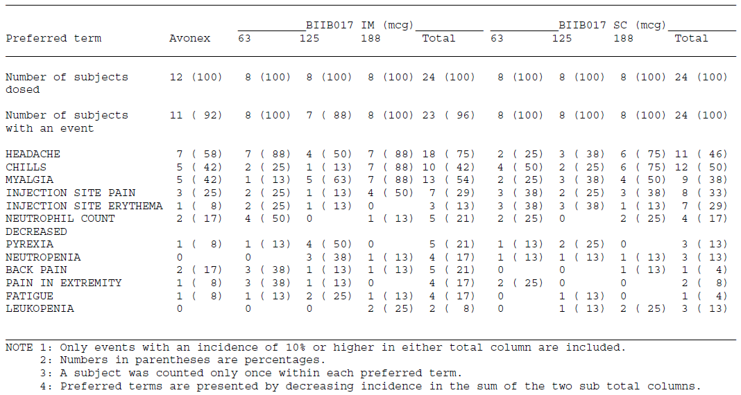

Multi-dose tolerability
The multi-dose PK study, 105HV102, also compared 3 dose regimens of peginterferon, but it differed from 105HV101 in that it involved multiple doses and also in that it had a placebo control group instead of an Avonex control group. Most subjects reported an AE, but only in the highest dose groups were AEs reported in 100% of subjects. There was an overall dose trend showing a higher incidence of moderate and severe events with increasing dose, as shown in the table below.
Unlike the previous study, there was no clear trend showing a higher incidence of headache, chills and myalgias with 188mcg compared to 125mcg. In subjects receiving two-weekly injections, headaches occurred at the same incidence with the two doses, myalgia was more common at 188mcg and chills were more common at 125mcg. Both chills and myalgias were less common with 63mcg than with higher doses. In subjects receiving four-weekly injections, there was a clearer excess of typical flu-like side effects at 188mcg than at 125mcg.
Thus, on balance, this study provides some additional support for the notion that 125mcg is better tolerated than 188mcg. Coupled with the results of the single-dose study discussed above, it suggests that 188mcg would have unacceptable tolerability, with more side effects than observed with Avonex treatment.

Table 10. Summary analysis of treatment emergent adverse events
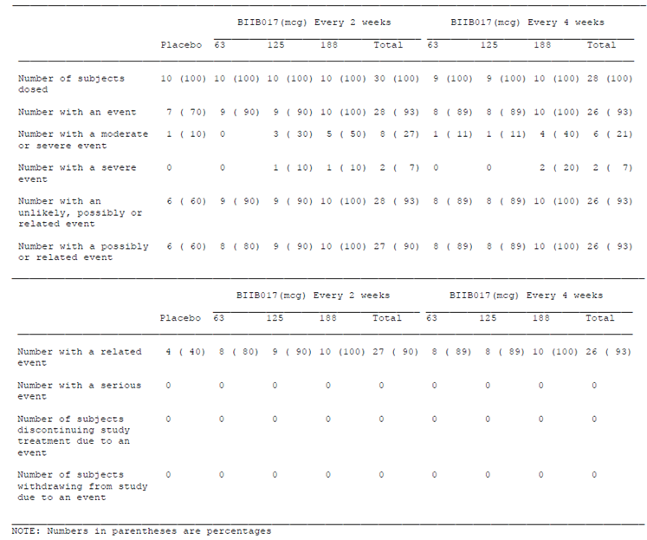

Table 11. Treatment emergent adverse events by preferred term with an incidence of 10% of more
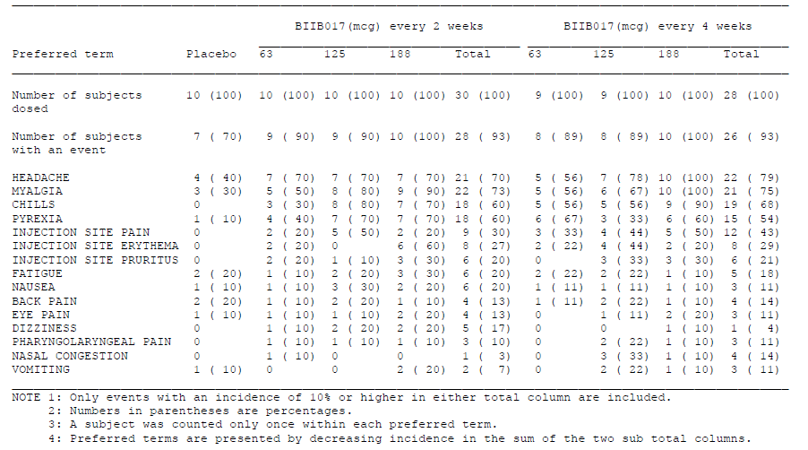

Overall conclusions on the appropriateness of dose selection
On balance, the sponsor has provided good evidence that peginterferon 125mcg two-weekly (the proposed dose) provides a broadly similar pharmacodynamic effect as Avonex 30mcg weekly (the approved dose), as indicated by total dose administered per 4-week period (24MIU) and the resulting cumulative AUC for the biomarker neopterin. They have also shown that 125mcg is likely to be better tolerated than 188mcg, and to have similar tolerability to Avonex 30mcg. The sponsor therefore selected the dose of 125mcg two-weekly for further study, and also assessed a less frequent dosing regimen (125mcg four-weekly) on the grounds that, if effective, this would provide greater convenience to patients.
What the sponsor has not done, however, is test a dosing regimen likely to give a continuous pharmacodynamic response throughout the dose cycle, such as 125mcg weekly. Firstly, the PK/PD studies did not assess the PD response in detail between 7 and 14 days, so it remains unclear when neopterin levels fall to baseline over the course of a two-week dose cycle, and thus how long patients are effectively left untreated by the proposed two-weekly regimen. Secondly, the sponsor did not include a treatment arm in the pivotal studies assessing the safety and efficacy of 125mcg weekly.
The limited evidence from head-to-head studies of Avonex against its competitors suggests that infrequent interferon beta dosing, although more convenient for patients, is less effective than more frequent dosing. Avonex treatment produces a pharmacodynamic response that does not last through the weekly dose cycle, and this appears to compromise efficacy. Pegylation could have been adopted as a means of addressing the deficiencies of a once-weekly Avonex regimen, but this opportunity has not been pursued. Instead, the sponsor has used pegylation to find a dosing regimen even lower in frequency than is the case with Avonex, and which still leaves some patients with a weak or nonexistent pharmacodynamic response for the last part of each dose cycle.
The proposed peginterferon regimen is likely to have market appeal with patients, because of its convenience, but it is probably not the most effective possible regimen. This represents the single biggest deficiency in the sponsor’s submission.

Clinical efficacy
The submission rests on the first year of a single, pivotal efficacy study, 101MS301 (Study 301). The study was designed to follow patients for two years, but only the first year was placebo-controlled, so the second-year data is merely supportive.
Patients completing the second year were invited to join a follow-up study, 101MS302 (Study 302) but this study was ongoing at the time of submission, and very few patients had completed an additional year of follow-up. The follow-up study also lacks a placebo control group. Thus, in its current incomplete form, Study 302 should be rejected as an efficacy study, though it does provide useful safety data.
These were the only two clinical studies performed in MS patients. The sponsor wrote a justification of their decision to perform just one adequate efficacy study, and this is considered in Section Sponsor’s justification for performing a single pivotal efficacy study.
The study conforms to recommendations on the conduct of studies in MS. Although the European Guidelines for the conduct of MS studies generally recommend a two-year duration of placebo-controlled treatment, an accepted alternative explicitly discussed in the Guidelines is a one-year placebo-controlled efficacy phase followed by a switch to active treatment.
A significant deficiency in the study program was the sponsor’s failure to perform a study assessing the efficacy and safety of more frequent dosing regimens of peginterferon, such as 125mcg weekly, in comparison to peginterferon 125mcg Q2W.

Pivotal efficacy study, 105MS301 (Study 301, n=1512)

Title
A Multicenter, Randomized, Double-Blind, Parallel-Group, Placebo-Controlled Study to Evaluate the Efficacy and Safety of PEGylated Interferon Beta-1a (BIIB017) in Subjects with Relapsing Multiple Sclerosis.

Design

Study design, objectives, locations and dates
Study 301 was a “two-year” (96 weeks) study with two distinct stages. In the first “year” (first 48 weeks), it used a randomised, placebo-controlled, double-blind design to assess the efficacy of peginterferon beta-1a (hereafter, peginterferon) at two dosing frequencies (125mcg two-weekly, Q2W, or 125mcg four-weekly, Q4W) in comparison with placebo, in subjects with relapsing and remitting MS.
In the second “year” (second 48 weeks), subjects initially randomised to placebo were reassigned to active treatment and received peginterferon 125mcg at either of the two dosing frequencies (Q2W or Q4W). Subjects initially randomised to active treatment continued active treatment at their original dosing frequency. All subjects in the second year ostensibly remained blinded to dosing frequency and to their original treatment allocation.
The submission was finalised with a data cut-off at the end of the first 48 weeks (24 October, 2012), which can be considered the pivotal stage of the study. Ongoing follow-up in the second 48 weeks is of interest, but does not provide robust evidence of efficacy given the lack of a placebo control group and the incomplete follow-up; only 46% of subjects entering Year 2 had completed it at the time of data cut-off.
The study was conducted in multiple centres, from 26 countries: Belgium, Bulgaria, Canada, Chile, Colombia, Croatia, the Czech Republic, Estonia, France, Georgia, Germany, Greece, India, Latvia, Mexico, the Netherlands, New Zealand, Peru, Poland, Romania, the Russian Federation, Serbia, Spain, the Ukraine, the United Kingdom (UK), and the United States (US). The study commenced on 5th June, 2009. The submitted study report had a data cut-off of 24th October 2012, but the study was ongoing at the time of submission.

Inclusion and exclusion criteria
Subjects were potentially eligible if they had RRMS, as defined by McDonald 2005 criteria (Polman 2005). The McDonald criteria have since been modified further, but the 2005 criteria were the most appropriate to use at the time that the study was initiated. The McDonald criteria represent the diagnostic consensus amongst MS specialists and are subject to regular revision; most MS treatment studies have employed whichever iteration of the McDonald criteria was available at the time of recruitment.
Inclusion criteria also sought to define a population with active relapsing disease in the early-to-middle stages of MS. In particular, subjects required:
- An EDSS score between 0.0 and 5.0;
- At least 2 documented relapses within the last 3 years, at least 1 of which was within the past 12 months;
- Age 18 to 65 years.
Subjects with progressive disease (primary progressive, secondary progressive or progressive relapsing MS) were excluded, even if ongoing relapses were present. Progression was defined as continuous clinical disease worsening over a period of at least 3 months, without a clinically stable period or phase of clinical improvement.
To avoid confounding effects of previous treatments, the following exclusion criteria applied:
- Prior treatment with IFN could not exceed 4 weeks, and subjects had to have discontinued IFN treatment 6 months prior to Baseline.
- Prior treatment with agents expected to produce long-lasting immunosuppression was prohibited, including total lymphoid radiation, fingolimod, cladribine, T cell or T-cell receptor vaccine, or any therapeutic monoclonal antibodies, such as rituximab, natalizumab, or alemtuzumab.
- Prior treatment with other immune-modifying agents was allowed, but specific washout periods were required as defined by the protocol, depending on the agents involved (cytoxan, mitoxantrone, azathioprine, methotrexate, systemic corticosteroids, glatiramer acetate).
Patients with other major neurological or systemic illnesses were also excluded, to minimise confounding variables. Female subjects were required to take measures to avoid pregnancy.

Study treatments
In Year 1 (Weeks 0 to 48) of the study, subjects were randomised to receive placebo, peginterferon 125 mcg SC every 2 weeks (Q2W), or peginterferon 125 mcg SC every 4 weeks (Q4W).
In Year 2 (Weeks 48 to 96), placebo-treated subjects were re-randomised to peginterferon every 2 or 4 weeks while subjects on active treatment remained on their assigned dosing regimen.
Placebo injections were used as necessary to ensure that all subjects received an injection every two weeks, regardless of treatment group, in both years of the study.

Efficacy variables and outcomes
The two main clinical efficacy variables in Study 301 were relapses, with each potential relapse assessed by an independent neurological committee (INEC), and disability, as measured by the EDSS.
According to the sponsor, relapses were defined as “new or recurrent neurologic symptoms not associated with fever or infection, lasting at least 24 hours, and accompanied by new objective neurological findings upon examination.” This definition is consistent with criteria outlined in the revisions to the McDonald Criteria for MS (Polman 2011a; Polman 2011b; Polman 2005).
The sponsor defined a clear pathway for the assessment of potential relapses. Subjects who experienced new neurological symptoms were instructed to contact their treating neurologist within 48 hours of symptom onset. If a relapse was suspected, they were evaluated in person by their treating neurologist within 72 hours of the onset of the potential relapse. Subjects then underwent a detailed neurological examination, including EDSS assessment, by an examining neurologist, whose role was independent of the treating neurologist. If new, objective findings were found by the examining neurologist, a suspected protocol-defined relapse was recorded; all such protocol-defined objective relapses were subsequently reviewed by a treatment-blinded INEC. This process, utilising two neurologists, is fairly standard for modern MS studies. The requirement for new neurological signs to be confirmed by a neurologist not involved in the patient’s care increases the objectivity of this definition, which is important given the potential for unblinding of the treating neurologist by treatment side effects. It should be noted, though, that the objectivity comes at the expense of reduced sensitivity, and some genuine relapses would not count as INEC-confirmed relapses by this process. A mild sensory relapse, for instance, would be missed by this process if it primarily caused subjective sensory changes rather than objective signs. (More inclusive definitions of relapse should therefore be considered in sensitivity analyses, as was done in this case.)
The EDSS was used to define the initial target population and to monitor subjects for disease progression. The EDSS is a standard disability scale that has been used in MS for decades. It uses an ordinal scale ranging from 0 (no disability) to 10 (death due to MS), with 7 representing severe disability (wheelchair-bound), as described by Kurtzke (1983). The EDSS has been widely validated in terms of inter-rater reliability, and it has become the gold standard for defining disability in MS trials, but it has been criticised for having poor sensitivity to minor changes in function, and for typically progressing in a non-linear fashion. Overall, it is still the most appropriate measure to use in a study of this nature, largely because it is so well known and characterised. In a study with only a single year of placebo-controlled treatment, it would be expected to be a fairly insensitive measure, with few subjects showing sustained disability progression. (The progression rate in the placebo group was ~10%).
The sponsor defined disease progression as an increase in EDSS sustained for 12 weeks, which is a more inclusive definition than many other MS studies, which require a 24-week sustained increase in EDSS. Given the relatively short period of placebo-controlled treatment, this is appropriate. At Week 48, only progression beginning in the first 24 weeks of treatment has had the potential to be confirmed 24 weeks after onset. A sensitivity analysis using a 24-week definition produced similar results.
In addition to relapses and EDSS, several radiological markers of disease were used as supportive efficacy variables:
- Number of new or newly enlarging T2 hyperintense lesions at 1 year
- Number of gadolinium-enhancing (Gd-enhancing, Gd+) lesions at 1 year
- Number of new T1 hypointense lesions at 1 year
The number of T2 hyperintensities is a marker of the number of “plaques”, or areas of inflammation in the brain. Lesions appearing between scans indicate new areas of inflammation, whereas enlarging lesions reflect new activity at old sites of inflammation. Gd-enhancing lesions represent an acute subset of the T2 hyperintense lesions, with enhancement indicating ongoing compromise of the blood-brain barrier at the time of the scan. T1 hypointense lesions represent areas of low density, usually because of axonal loss, and are thought to correlate with areas of permanent damage and hence the accumulation of disability. All three radiological measures are standard outcomes used in most modern MS studies and have been widely validated as a sensitive marker of disease activity. Compared to clinical relapses, radiological changes are known to occur with much higher frequency in MS subjects, so that the clinically overt relapses are a small subset of the overall level of disease activity; thus MRI endpoints are generally more sensitive than clinical endpoints for most MS treatments. MRI endpoints are not suitable as primary endpoints, however, because imunomodulatory agents could reduce the radiological markers of inflammation in an MS plaque, such as oedema, without necessarily reducing the actual damage; thus, appropriately, the sponsor has treated these as secondary and tertiary variables, as is common practice with MS studies.
Minor efficacy variables included:
- Annualised rate of relapse requiring IV steroids
- Annualised rate of MS-related hospitalisation
- Multiple Sclerosis Functional Composite (MSFC), a composite score based on
  - Timed 25-Foot Walk
  - Nine-Hole Peg Test [9HPT] with both upper extremities
  - 3 Second Paced Auditory Serial Addition Test [PASAT 3]
- Visual Function Test as measured by low-contrast Sloan letter charts
- Symbol Digit Modality Test
- Quality of Life as assessed using SF-12, EQ-5D, and MSIS-29 scales.
Where necessary, these scales are explained in more detail with the relevant results.
The primary efficacy endpoint in Study 301 was the annualised relapse rate (ARR) in the placebo-controlled first year of the study. This is a standard efficacy measure used in MS studies. Reducing relapses is a worthwhile clinical goal in its own right, because relapses are associated with morbidity and disability during the relapse. Also, because relapses are often associated with incomplete recovery, preventing relapses may prevent the accumulation of disability. (Previous observational studies have suggested that 42% to 57% of relapses are associated with residual neurological deficits; Hirst 2008; Lublin 2003.) Most agents on the market for MS have been approved on the basis that they reduce the incidence of relapses; to a variable extent this reduction in relapse rate has been associated with a delay in the progression of disability. Ultimately, patients and clinicians are more concerned about the accumulation of disability than the frequency of relapses, but the disability is generally a less sensitive endpoint, requiring longer follow-up, and is therefore treated as a secondary endpoint in most MS studies.
Secondary and key tertiary efficacy endpoints are shown in the table below, listed in rank order. The rank was used to determine statistical significance in the setting of multiple endpoints, with lower ranking endpoints only considered significant if higher ranking endpoints had already achieved significance.

Table 12. Study 301 primary, secondary and key tertiary efficacy endpoints
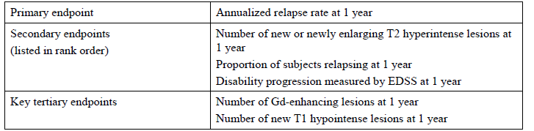

Randomisation and blinding methods
Subjects were randomised to receive peginterferon 125mcg SC every 2 or 4 weeks or placebo in a 1:1:1 ratio, using a centralized Interactive Voice/Web Response System (IXRS), stratified by site. At randomisation, the IXRS assigned a unique 6-digit subject identification number to each subject, which was used on each subject’s case report forms (CRFs). A unique treatment number was also assigned to each subject, providing the link between a subject’s CRF and blinded treatment assignment. At the completion of Year 1 (Week 48), placebo subjects were re-randomised to active treatment (125mcg Q2W or Q4W) through IXRS.
Given the potential for unblinding through flu-like side effects, all subjects receiving active treatment started with a low dose (63mcg) and increased every 2 weeks to the target dose of 125 μg, as illustrated in the figure below. This titration was performed in a blinded fashion. All subjects injected study treatment every 2 weeks, using placebo for every second dose in the Q4W group, to maintain blinding. On the initiation of active treatment in placebo subjects at the end of Year 1, a similar blinded titration schedule was used.
Figure 11. Dose titration scheme
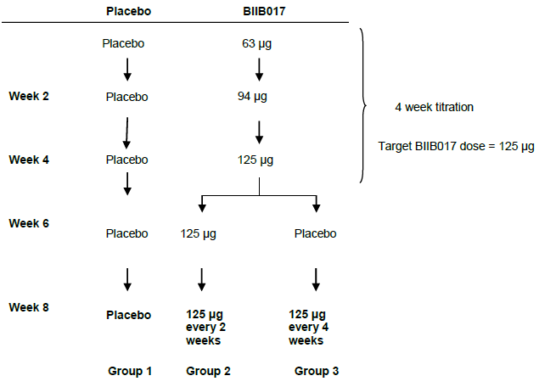
The study also employed the use of separate personnel for the treatment of patients and assessment of their neurological signs and radiology, so that any potential unblinding in the treating physician would be expected to have reduced impact on the major efficacy variables.
The adequacy of these measures is unclear. The extent of unblinding could have been assessed by asking clinicians and patients to guess what treatment had been assigned, but this was not done. Instead, the sponsor performed post-hoc subgroup analyses in patients with flu-like symptoms and patients with injection site reactions, to see if they showed similar efficacy to those without such telltale side effects. The results are discussed in Section Subgroup analyses based on methodological concerns. There was no strong suggestion that unblinding played a major role in determining the outcome of the study, but some unblinding is almost certain.

Analysis populations
All efficacy endpoints were evaluated in the intent-to-treat (ITT) population, defined as all subjects who were randomised and received at least 1 dose of study treatment (peginterferon or placebo).
In addition, the primary and secondary efficacy endpoints (but not minor endpoints) were evaluated in the per-protocol (PP) population, defined as subjects from the ITT population without any major protocol deviations.
Analyses performed on the ITT population were considered primary, and analyses based on the PP population were considered supportive.
The sponsor also defined a PK population, which included subjects who received at least 1 dose of peginterferon and who had at least 1 post-baseline measurable drug concentration, and a PD population, which included all subjects who received at least 1 dose of peginterferon or placebo treatment and had at least 1 post-baseline serum neopterin concentration.

Sample size
Sample size estimations were based on the primary endpoint, Year 1 annualised relapse rate (ARR). Based on previous experience with non-pegylated interferon beta, it was assumed that peginterferon would produce a ~32% reduction from placebo in ARR. Using a standard type I error rate of 0.05 and assuming a dropout rate of 10%, a sample size of 420 per treatment group was planned initially, which would provide approximately 90%, 87%, or 85% power when the placebo Year 1 ARR was 0.6, 0.55, or 0.5 relapses/year, respectively.
During the study, as specified prospectively in the protocol, the placebo ARR was estimated from the pooled annualised relapse rate, using the assumed treatment effect, and the placebo ARR was found to be lower than initially assumed. The sample size was therefore increased from 420 to 500 subjects per group in later versions of the protocol.
Given that the study easily achieved statistical significance for its major endpoints, the assumptions made during power estimations were broadly vindicated, and the study can be considered to have had adequate power for efficacy endpoints. It was not specifically powered to allow a definitive comparison of the two active regimens.

Statistical methods
The main statistical approaches for various endpoints are listed in the table below. For all analyses, the main data set under consideration was the intent-to-treat (ITT) population. Sensitivity analyses were also performed in the per-protocol (PP) population, producing similar results.
For the primary endpoint of annualised relapse rate (ARR), a negative binomial regression model was used. This type of model is generally applicable to a sparsely occurring endpoint, and seems appropriate overall given that most subjects did not experience a relapse. The ARR was adjusted on the basis of age, disease activity (relapse rate in the three years prior) and disease stage (EDSS), which is also broadly appropriate. A standard statistical alpha level of p ≤ 0.05 was considered to indicate a significant result.
Statistical results were not adjusted to account for multiple endpoints. Instead, for secondary and subsequent endpoints, a closed hierarchical method was used, with significance to be inferred only when all higher-ranking endpoints were also statistically significant (p ≤ 0.05). A similar process was used to account for the presence of multiple dose-frequency groups: for the primary endpoint, the Q2W group was compared to placebo; if the difference between the Q2W versus placebo was statistically significant (p ≤ 0.05), the analysis of the Q4W group could be performed and considered statistically significant if p ≤ 0.05, but if significance was not achieved with the Q2W group, the comparison of the Q4W group versus placebo would not be considered statistically significant, regardless of p-value.
For the proportion of subjects relapsed, a Cox proportional hazards model was used, with similar adjustments as used for the primary endpoint, plus an adjustment based on the presence or absence of Gd-enhancing lesions on the baseline MRI. It could be argued that Gd-enhancing lesions might have been useful in the negative binomial regression of the primary endpoint, not just the Cox proportional hazards model of the secondary endpoint, because Gd+ patients had a more pronounced response to treatment and there were group differences in the baseline prevalence of Gd+ scans.
The statistical methods chosen for other endpoints seem broadly appropriate. The baseline value of the variable being assessed (EDSS, number of lesions, and so on) was a term in the model for most analyses.
The sponsor also presented a range of sensitivity analyses using different approaches, suggesting that the choice of statistical method did not play a major role in determining the outcome of the study.

Table 13. Statistical methods used to analyse the clinical and MRI efficacy endpoints in Study 301
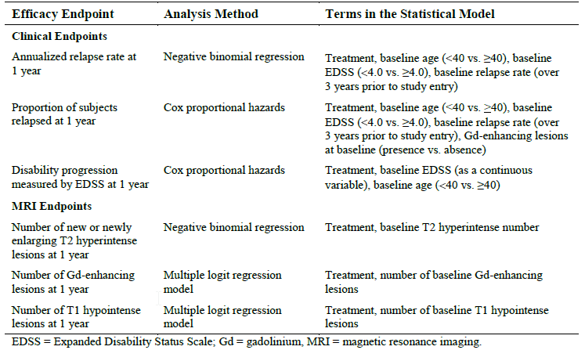

Results

Participant flow
The ITT cohort includes 1512 subjects who received at least 1 dose of study treatment (placebo n=500, peginterferon Q4W n=500, and peginterferon Q2W n=512).
Most subjects (1332, 88%) completed 48 weeks of treatment; discontinuations in Year 1 were more common in the peginterferon Q4W group (12%) and Q2W group (14%) than with placebo (9%), largely because of a higher rate of withdrawals due to AEs in the active treatment groups (5% in each active group, compared to 1% in the placebo group).
The slightly higher withdrawal rate in the active groups potentially introduced some withdrawal bias. The sponsor made some attempt to perform a post hoc analysis of the potential for withdrawal bias, which is discussed further in Section Subgroup analyses based on methodological concerns.
Figure 12. Overview of subject disposition Year 1
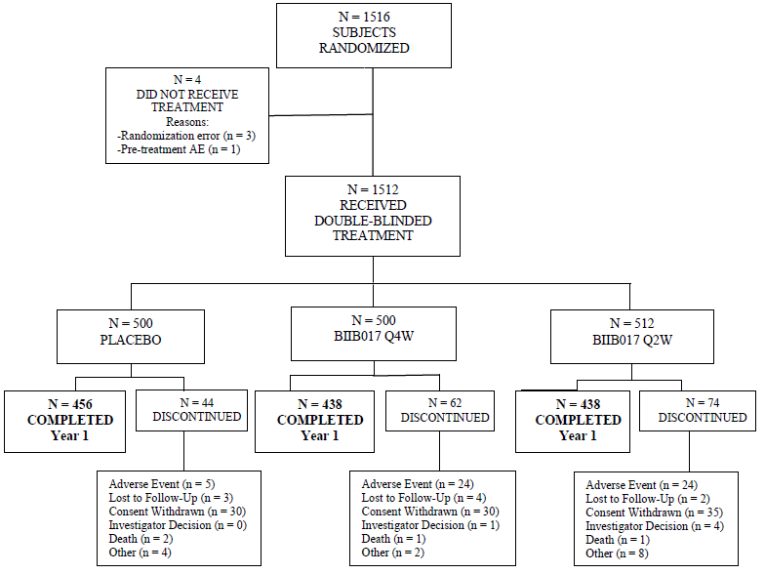
All 1332 subjects who completed Year 1 received ≥ 1 dose of study treatment in Year 2. The 456 placebo subjects who completed Year 1 were randomised equally to peginterferon every 4 weeks or every 2 weeks group (n=228 in each placebo-to-active crossover group). Subjects who received active treatment in Year 1 continued the same treatment in Year 2 (n = 438 subjects continuing in each active dose group).
At the date of data cut-off (24 October 2012), 608 subjects (40% of the original cohort, 46% of those completing Year 1) had completed 2 years of treatment and 625 subjects (41% of the original cohort, 47% of those completing Year 1) were continuing dose-blinded treatment in Year 2, as shown in the figure below.

Figure 13. Overview of subject disposition Year 2
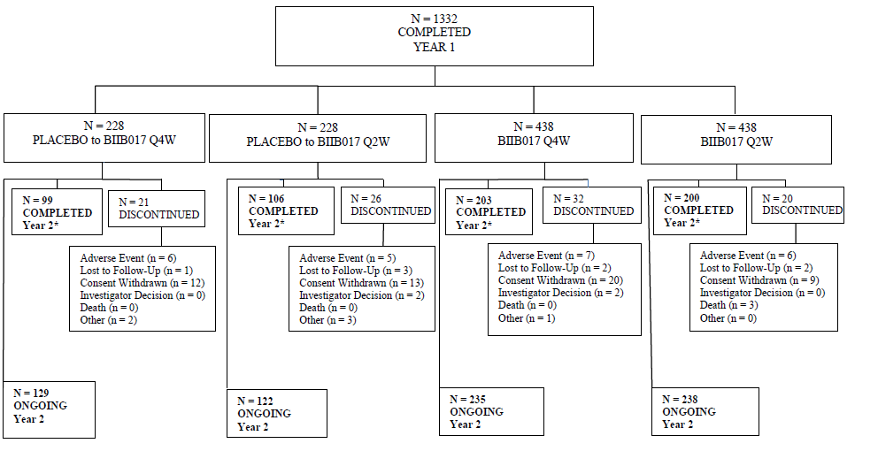

Major protocol violations/deviations
Major protocol deviations were infrequent, with only 47 subjects (3%) exhibiting a major protocol deviation, leading to their exclusion from the per-protocol population. The most common major violations were use of prohibited concomitant medications (n = 18) and poor study treatment compliance (n = 17), defined as missing more than 2 consecutive doses or more than 4 total doses. Thirteen subjects were excluded due to violation of the inclusion and exclusion criteria. Overall, the incidence of protocol violations was acceptable for a study of this nature, and 3% represents a small proportion of patients relative to the difference in proportions of relapsed patients in each group.

Baseline data
The three treatment groups were reasonably well-matched at baseline, as shown in the table below.
This was not a newly diagnosed population: the mean time since the occurrence of the first symptoms of MS was 6.6 years (range 0 to 40 years), and the mean time since MS diagnosis was 3.6 years (range 0 to 40 years).
Of all the factors shown in the table, only the prevalence of Gd-enhancing (Gd+) lesions appears to have shown a notable difference between groups. Recipients of the proposed dose (peginterferon 125mcg Q2W) had slightly fewer Gd+ lesions, on average, than placebo recipients (mean 1.2 vs 1.6 lesions), and both of these groups had fewer Gd+ lesions than the Q4W group (mean 1.8). Recipients of the active Q2W dose were also slightly more likely to be free of Gd+ lesions (65% had no Gd+ lesions) than the other two groups (both 59%). Although this could indicate that recipients of the proposed dose had less active disease, they were slightly more likely to have had >2 clinical relapses in the previous 3 years (39% in the Q2W group, 37% in the placebo group and 35% in the Q4W group). Subgroup analyses showed a numerically favourable treatment effect regardless of Gd+ status, but the treatment effect was only statistically significant in Gd+ subjects. It would be appropriate to perform a reanalysis with Gd+ status in the model.

Table 14. Study 301: Summary of demographics and baseline disease characteristics
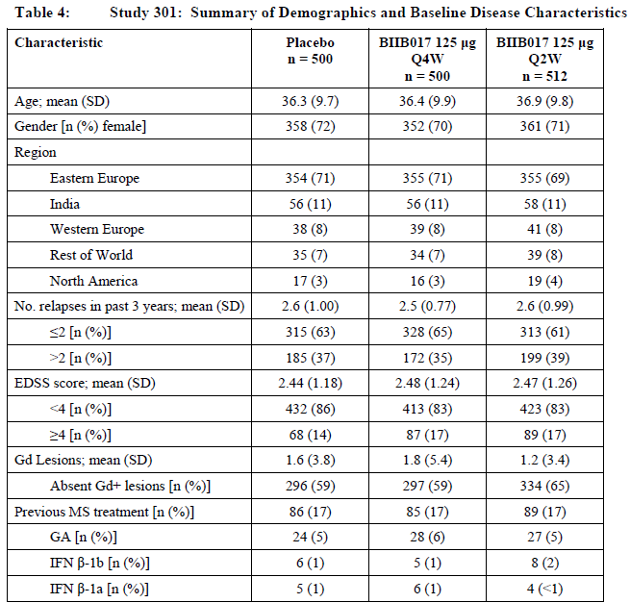
The gender balance (~70% female) and age (~36 years) are typical of the population of MS patients seeking disease-modifying treatment. Most subjects had minimal or mild disability (EDSS<4), which is also typical of the target population.

Results for the primary efficacy outcome
Results for the primary efficacy endpoint, annualised relapse rate (ARR), are shown for each treatment group in the table excerpt below. The ARR in the placebo group was ~0.4 relapses per year, and this was reduced by 35.6% with the proposed dose of peginterferon (125mcg Q2W). The difference was highly statistically significant (p=0.0007), making it a robust result unlikely to have been substantially affected by minor methodological issues such as withdrawal bias or slight inhomogeneity of the groups at baseline with respect to Gd+ status. The finding is also consistent with previous studies of non-pegylated beta interferon, which demonstrated a similar reduction in ARR, giving this study some external validity. Finally, the results were compatible with the expectations of investigators in their power calculations, where it was assumed that peginterferon would produce a ~32% reduction from placebo in ARR.
This treatment effect is modest, but experience with non-pegylated beta-interferons has shown that a reduction in ARR of ≥ 30% is considered clinically worthwhile by most clinicians and patients. Most relapses are considered unpleasant by patients, and many are at least temporarily disabling, so even the modest result of preventing every third relapse, on average, is considered by most patients to be useful. Given that any individual relapse can be associated with incomplete recovery, preventing about one third of relapses would also be expected to lessen the accumulation of disability, though this needs to be demonstrated by considering disability endpoints directly.

Table 15. Study 301 summary of key efficacy results at 1 Year by treatment group.
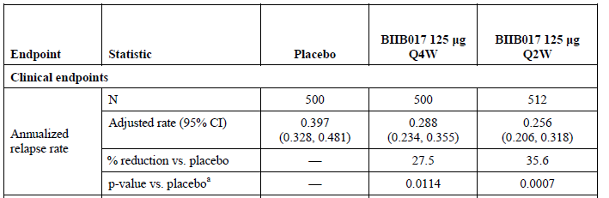
Less frequent dosing (peginterferon 125mcg Q4W) was also associated with a significant treatment effect, with a relative reduction in ARR of 27.5%, relative to placebo (p = 0.0114), but the results were less favourable than observed with Q2W treatment.
The primary endpoint was based on INEC-confirmed relapses, but a similar reduction in relapse rate was observed in more loosely defined relapse categories, as shown below. Of note, the INEC confirmed 181/213 relapses (85%) in the placebo group, 125/142 (88%) in the Q4W group, and 116/132 (88%) in the Q2W group. The similarity of these proportions suggests that unblinding of treating clinicians did not substantially influence the number of potential relapses referred to the examining clinician and then to the INEC.

Table 16. Number of reported relapses at Year 1
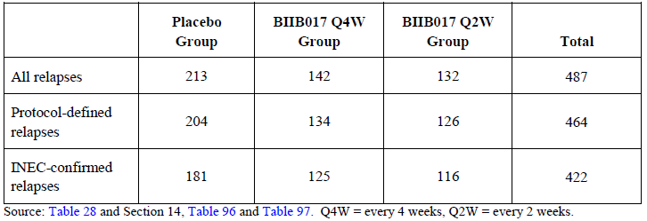
There was a numerical trend suggesting that more frequent dosing (Q2W) was more effective than less frequent dosing (Q4W). The observed difference between the two dosing frequencies, in terms of relative reduction in relapse rates compared to placebo, was 8.1% (35.6% risk reduction with Q2W versus 27.5% reduction with Q4W), which is small but likely to be considered clinically significant by patients and their physicians. Relative to the relapse rate experienced in the Q4W group (0.288 per year), treatment at the higher Q2W frequency would be expected to reduce the ARR by an additional 0.032 relapses (1 relapse every 31 patients over the course of one year), or by 11% of the Q4W annualised relapse rate. Direct comparisons of te two active groups are considered in Section Post hoc comparison of Q2W vs Q4W dosing.
Given that the mechanism of action of peginterferon is expected to be similar to non-pegylated interferon betas, the demonstration of a reduction in ARR that is similar for peginterferon Q2W as was previously demonstrated with other forms of interferon beta suggests that the proposed dose and frequency of peginterferon are broadly appropriate. It should be noted, however, that Phase 2 dose-ranging studies were not performed for peginterferon, and that the pharmacodynamic effects of once-weekly peginterferon were not assessed. This pivotal study suggests that Q2W is more effective than Q4W, but does not address the question of whether weekly peginterferon would be even more effective; nor does it assess the efficacy of doses higher than 125mcg.
The sponsor repeated the analysis of the primary endpoint in the per-protocol population, obtaining similar results, as shown in the table below.

Table 17. Summary of annualised relapse rate (INEC-Confirmed relapses) at 1 Year-Per protocol population
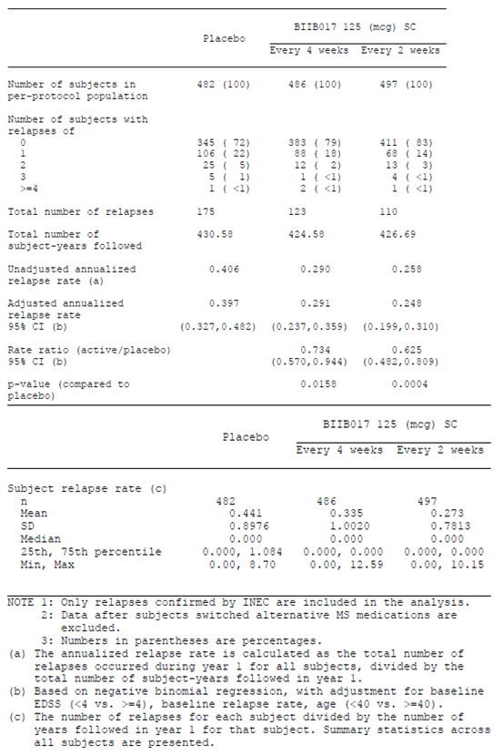

Subgroup analyses for the primary efficacy outcome
The sponsor performed a number of subgroup analyses based on baseline demographics and disease characteristics, as summarised in the figure and table below. In all subgroups examined, there was a numerical trend in favour of active treatment, though the analysis was often not sufficiently powered to show a statistically significant benefit; in the figure below this is represented by the horizontal line, indicating the 95%CI for the rate ratio, crossing unity for that subgroup.
The groups were reasonably well-matched at baseline, but there were slight differences in the prevalence of Gd+ lesions. The subgroup analysis based on the presence or absence of Gd+ lesions at baseline is reassuring in that it shows a broadly consistent benefit in both subgroups. The treatment effect was not statistically significant in those without Gd+ lesions at baseline, but the trend was favourable in these subjects and there was broad overlap between the two subgroups in terms of the 95%CI for the rate ratios of ARR.
Figure 14. Annualised relapse rate (INEC-confirmed relapses) at 1 Year-Rate ratio and 95% CI by subgroups
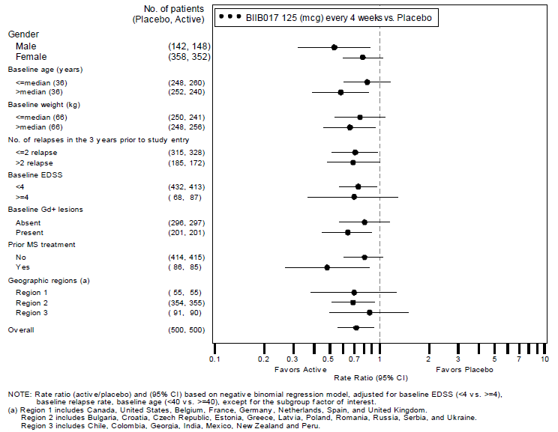

Table 18. Summary of annualised relapse rate (INEC-Confirmed relapse) at 1 Year-ITT population by baseline disease characteristics subgroups.
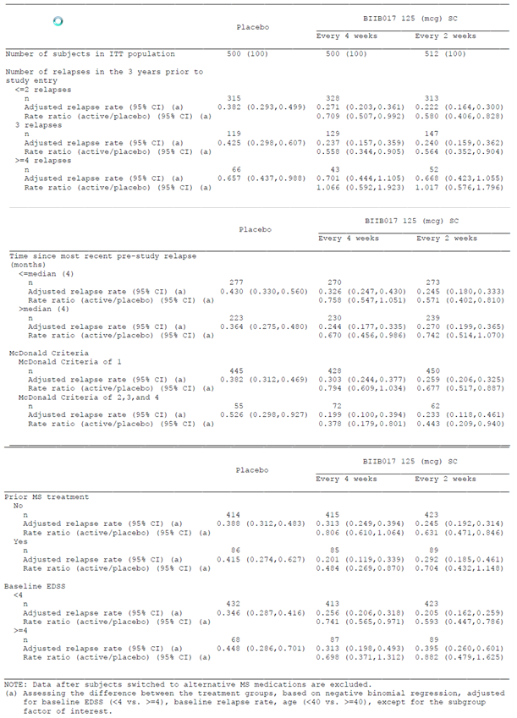

Table 18 continued. Summary of annualised relapse rate (INEC-Confirmed relapse) at 1 Year-ITT population by baseline disease characteristics subgroups.
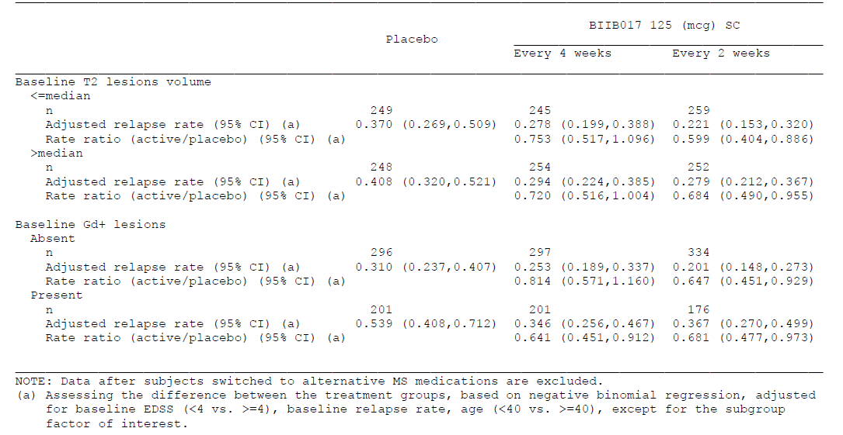
The effects of antibodies to peginterferon were also assessed but too few patients were affected for meaningful subgroup analysis. This issue is discussed separately in Section Effects of antibodies to peginterferon.

Subgroup analyses based on methodological concerns
The sponsor performed a couple of post hoc subgroup analyses based on potential methodological concerns, including unblinding side effects and withdrawal bias.
Given the characteristic side effects of interferon beta, such as flu-like symptoms (FLS) and injection site reactions (ISR), there is a considerable risk that subjects and clinicians might guess treatment allocations, and hence become unblinded. Accordingly, the sponsor performed a post hoc analysis that assessed the treatment effect in subgroups defined by the presence or absence of these symptoms.
In subjects with potentially unblinding FLS symptoms who received peginterferon, the relapse rate was actually higher than in peginterferon recipients who did not have FLS, as shown in the table below. (If unblinded physicians were reluctant to report relapses in subjects on active treatment, the opposite trend would be expected.) In both subgroups (those with and without FLS), and at both dosing frequencies (Q2W and Q4W), the ARR was lower with active treatment than with placebo, though the difference was not always significant.
In subjects who received the proposed dose of peginterferon (125mcg Q2W), the ARR was very similar in those with ISR and those without, and in both subgroups the ARR was at least numerically superior to that observed with placebo, as shown in the table.
Overall, this suggests that the treatment effect was not strongly influenced by potential unblinding due to telltale side effects.

Table 19. Summary of annualised relapse rate (INEC-Confirmed relapse) at 1 Year-ITT population by special interest AEs (experienced at least one vs none).
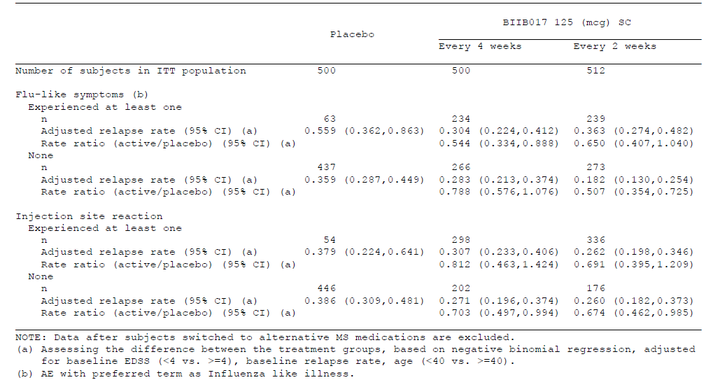
To assess for the possibility of withdrawal bias, the sponsor performed post hoc subgroup analyses in subjects who withdrew during Year 1 and in those who completed Year 1. The results, shown in the table below, reveal that relapse rates were substantially higher in patients who withdrew than in those who continued, regardless of treatment assignment. This effect was most marked in placebo recipients, which is not surprising because these subjects are relatively unlikely to have withdrawn because of side effects, and those withdrawing because of treatment failure would therefore constitute a higher proportion of the total withdrawals. In recipients of active treatment, a higher relapse rate appears to have contributed to withdrawal (given the higher ARR in withdrawing subjects), but the withdrawing subjects had less active disease, on average, than the withdrawing placebo recipients. This could partly reflect on-going efficacy of the discontinued active treatment in withdrawing subjects, but it is also likely that side effects in the active groups modified the willingness of subjects to put up with relapses, leading to withdrawals that were partly due to relapses and partly due to side effects.

Table 20. Summary of annualised relapse rate (INEC-Confirmed relapse) at 1 Year-ITT population by status in Year 1 of Study 301 (withdrawal vs completion).
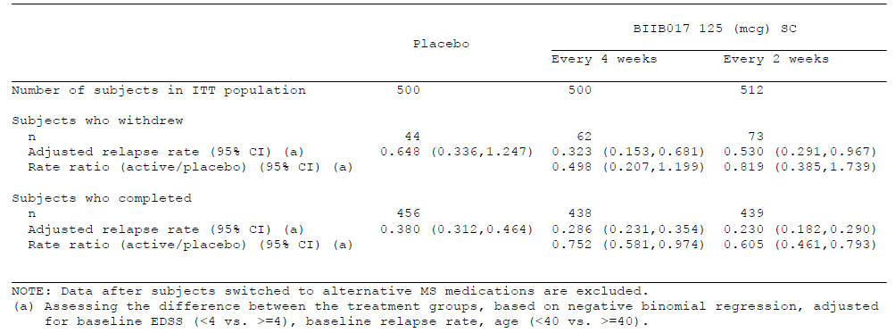
The most important comparison to note is between the ARR in withdrawing subjects in the active groups and the overall placebo ARR (reflecting the average natural history of the disease), which is not shown in the table. For the Q2W group, the ARR rate of withdrawing subjects (0.530 relapses/yr) was higher than the overall placebo rate (0.397 relapses/yr), suggesting that the Q2W group was progressively enriched with milder-than-average cases during the withdrawal process. The placebo group was also enriched by withdrawal of worse-than-average cases, but this effect was potentially less marked in the placebo group because the number of withdrawals was less with placebo. The table therefore suggests that a withdrawal effect is possible.
In pre-submission correspondence with the TGA, the sponsor claimed to have done a sensitivity analysis to check for withdrawal bias. This claim is only partially accurate. Apart from noting the treatment effect in completers versus withdrawing subjects, as above, the sponsor did not perform a detailed sensitivity analysis of the potential for withdrawal bias. For instance, the sponsor did not repeat any of their analyses with pessimistic imputation methods to judge the extent to which the results might have been influenced by progressive enrichment of the active groups with patients who were doing well enough in terms of disease control to put up with side effects, and progressive exclusion of patients who were not prepared to put up with the combination of poor efficacy and side effects.
Nonetheless, a simple post hoc calculation by the evaluator suggests that withdrawal bias is unlikely to have played a major role. Taking the worst ARR in the table above (0.648, the rate observed in withdrawing placebo recipients) and assigning it to all withdrawing patients allows a pessimistic estimate of what the ARR might have been in each treatment group if follow-up data were available. This approach is potentially biased against the active treatment group, because it assigns a final ARR to withdrawing subjects that is considerably worse than what had actually been observed in the withdrawing/active subgroup up to the point of withdrawal. If the ARR calculated by this highly pessimistic method still favoured active treatment at the proposed dose over placebo, then it would be unlikely that the positive findings in this study were primarily due to withdrawal bias.
In the placebo group, the mean ARR resulting from this calculation would be [44x0.648 + 456x0.380]/500 = [28.512 + 173.28]/500 = 201.792/500 = 0.403, close to what was estimated in the placebo group in the original primary analysis (0.397, 95%CI 0.328 to 0.481). In the Q2W group, the mean ARR estimated by this pessimistic approach would be [73x0.648 + 439x0.230]/512 = [47.304 +100.97 ]/512 = 148.274/512 = 0.290, which is worse than the results actually achieved in the Q2W group in the primary analysis (0.256 relapses/year 95%CI 0.206 to 0.318), but still outside the estimated 95%CI for the placebo rate (0.328 to 0.481). Note that this quick-estimate approach does not produce 95%CIs for the resulting ARR in the active group, but the shift in ARR would be sufficient to cause overlap between the placebo and active ARR, given that the 95%CIs for the placebo results and Q2W results were separated by only 0.01 (0.318 for the upper bound of the Q2W results vs 0.328 for the lower bound of the placebo results). It seems very likely, then, that the overall results would be insignificant if this pessimistic imputation method were employed, but the trend would still be numerically in favour of active treatment.
A similar pessimistic analysis based on the proportion of subjects relapsed produced broadly similar conclusions, and suggested that withdrawal bias is unlikely to have had a major impact on the results.*

Results for secondary endpoints
Results for all of the major endpoints, including the primary endpoint just discussed, are shown in the table below. For all of the major endpoints, a statistically significant benefit was demonstrated with the proposed Q2W dose, relative to placebo. For most endpoints (all of the clinical endpoints, and one of three MRI endpoints), a significant benefit was also demonstrated with Q4W dosing, but for each endpoint the benefit was numerically inferior to the benefit seen with the proposed Q2W dose.
The proportion of subjects relapsed after one year, a key secondary endpoint, broadly followed the results for the primary endpoint. The proportion relapsed is potentially a less sensitive endpoint than ARR, because only first relapses in the period of interest are counted, but a high level of significance was nonetheless demonstrated (p=0.0003). After adjustment, approximately 29.1% of placebo subjects relapsed after one year, compared to 22.2% of subjects receiving peginterferon Q4W and 18.7% of subjects receiving peginterferon Q2W (see the figure and table below).

Table 21. Summary of key efficacy results at Year 1 by treatment group
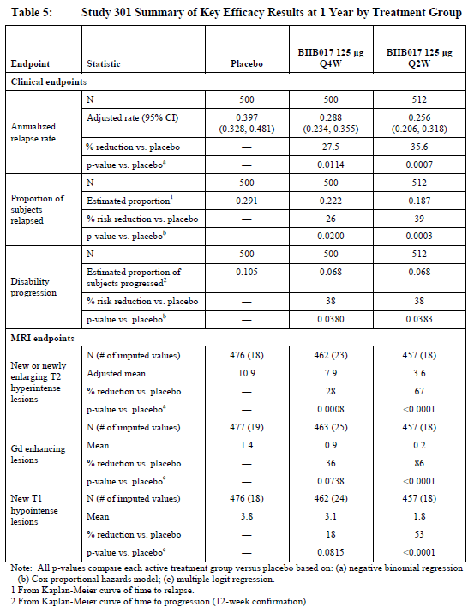
Figure 15. Time to first relapse
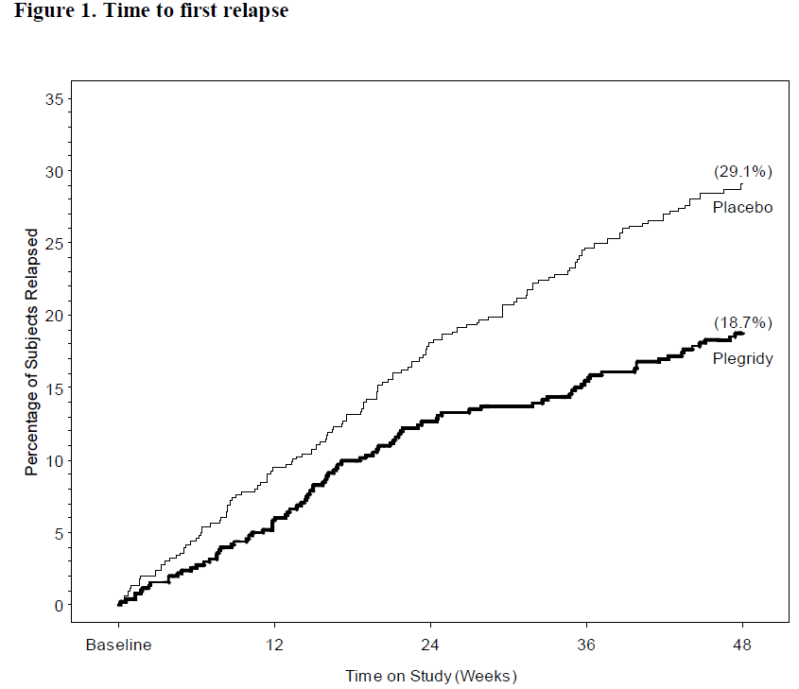
For disability progression, the relative risk reduction compared to placebo was broadly similar to that achieved with other endpoints, but the statistical significance of the result was less marked, reflecting the lower sensitivity of this endpoint. As shown in the table above, an estimated 10.5% of placebo recipients would be expected to progress (after adjustment), compared to 6.8% of the Q2W group and 6.8% of the Q4W group (for this endpoint the two active groups were identical). This represents a 38% relative risk reduction for progression over one year (p=0.038).
The Sponsor performed a post-hoc sensitivity analysis of EDSS progression confirmed at 24 weeks, instead of 12 weeks. This showed that peginterferon reduced the risk of disability progression by 31% (Q4W) and 50% (Q2W) relative to placebo, with statistical significance versus placebo demonstrated for the Q2W group (p=0.0166).
For MRI endpoints, the results strongly favoured peginterferon Q2W over placebo, and more weakly favoured Q4W over placebo. For peginterferon Q2W, the percentage reduction in mean lesion count, compared to placebo, was 67%, 86% and 53% for new/enlarging T2 lesions, Gd+ lesions and new T1 hypointense lesions, respectively, and for all three reductions the effect was highly statistically significant (p<0.0001) . For peginterferon Q4W, the corresponding reductions over placebo were 28%, 36% and 18%, with only the reduction in T2 lesions showing statistical significance (p=0.0008). These highly significant objective results provide further confirmation that the positive findings for this study are not likely to be due to unblinding or other methodological flaws.

Results for tertiary endpoints
Minor efficacy variables included:
- Multiple Sclerosis Functional Composite (MSFC), a composite score based on
  - Timed 25-Foot Walk
  - Nine-Hole Peg Test [9HPT] with both upper extremities
  - 3 Second Paced Auditory Serial Addition Test [PASAT 3]
- Visual Function Test as measured by low-contrast Sloan letter charts
- Symbol Digit Modality Test
- Quality of Life as assessed using SF-12, EQ-5D, and MSIS-29 scales
The annualised rate of relapse requiring IV steroids was significantly reduced over the 1-year treatment period by active treatment compared with placebo, by 25.6% in the Q4W group (p = 0.0395) and 34.2% in the Q2W group (p = 0.0049).
The annualised rate of MS-related hospitalisations at 1 year was reduced by 16.6% and 44.1% by active treatment in the Q4W and Q2W groups, respectively (p = 0.3926 and p =0.0148).
The MS Functional Composite (MSFC) measures disability by getting a subject to perform functional tasks and expressing all performance measures as Z-scores (proportions of a standard deviation in a reference population). It has been proposed as an alternative to the EDSS (Fischer et al, 1999) but is still considered secondary to the EDSS in importance (EMEA Guidelines), and it fails to capture disability in several neurological domains, such as vision and sensory function. The MSFC consists of 3 components:
- Average scores from the 4 trials on the 9-Hole Peg Test, 9HPT (2 trials for each hand are averaged and converted to reciprocals for each hand; then the 2 reciprocals are averaged)
- Average scores for the 2 Timed 25 Foot Walks (T25FW)
- The number correct on the Paced Auditory Serial Addition Test, version 3 (PASAT 3)
In this study, it proved to be too insensitive to show a significant slowing of disability progression with active treatment. Changes from baseline in the MSFC composite Z-score at 1 year in the active groups were not significantly different (p = 0.1894 and p = 0.2159, respectively) from those of the placebo group, and there were no clear trends, as shown in the figure below. (Positive changes in the composite z-score indicate improvements).
Figure 16. MSFC: Change of z-score from baseline over time-Year 1-ITT population
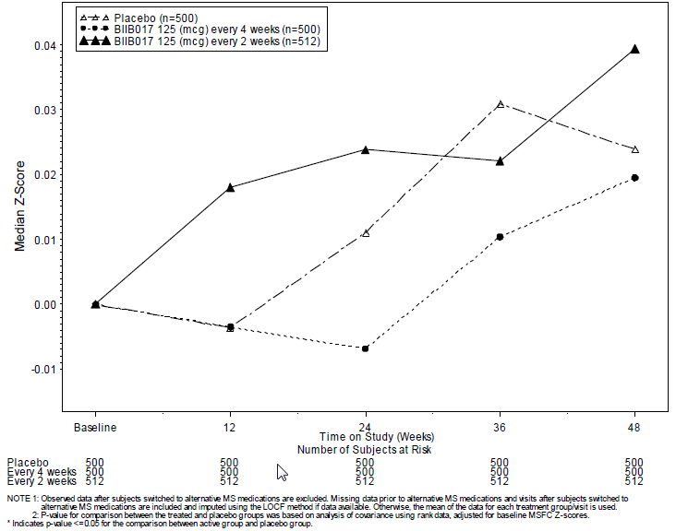
Sub-components of the MSFC, including progression of cognitive disability measured on the PASAT3, also failed to show a benefit with active treatment. Similarly, other performance-based tests, including the Symbol Digit Modalities Test (SDMT) and the Visual Function Test (VFT) showed no significant difference between groups. This is likely to reflect the heterogeneous nature of MS, which causes different neurological symptoms in different patients, such that too few patients show disability in any single domain over the course of a year for this to produce a clear signal of efficacy.
Other tertiary endpoints included MRI variables assessed at time intervals other than one year; these were consistent with the one year results. The benefit of treatment was apparent within 24 weeks: significant reductions in the number of new active T2 lesions were observed at the first MRI assessment at Week 24, with reductions of 28% (p = 0.0006) in the Q4W group and 61% (p <0.0001) in the Q2W group. The two-year MRI results were also considered tertiary, but these are discussed separately in the next section.
The final group of tertiary endpoints included a number of quality-of-life (QOL) assessments: the MSIS-29, the SF-12 and EQ-5D. None of these tests showed a significant treatment effect, and in most cases there was little change from baseline, indicating that one year of follow-up was too short a time to show a major change in quality of life in the study population.
These tests are standard QOL instruments, which have been described and validated previously and used in a variety of MS studies. Given the minor role they played in this study, details of their conduct and validation is not repeated here, but they are briefly summarised below.
The MSIS-29 (MS Impact Scale) measures 20 physical items and 9 psychological items addressing the impact of MS from a subject’s perspective. The effect of peginterferon on the change from baseline to Week 48 in the MSIS-29 physical score was analysed using an analysis of covariance (ANCOVA) model, adjusting for the baseline score. The mean MSIS-29 scores decreased across all groups at 1 year, indicating improvement, but no significant differences were observed between the placebo and active groups.
The SF-12 (12-Item Short Form Health Survey) is a non-MS-specific quality of life tool that measure functional health and well-being from the patient’s point of view. It has 8 domains that are grouped into 2 summary scores: the physical and mental component scale (PCS and MCS). Higher scores indicate better function. Changes from baseline were compared between treatment groups using an ANCOVA model, adjusted for baseline SF-12 scores. Mean scores were similar at baseline and the mean changes from baseline were similar across all groups at each time point.
The EQ-5D™ (European Quality-of-life questionnaire consisting of 5 domains) is a subject-rated QOL instrument that includes a descriptive system and a visual analogue scale, the EQ-VAS. The descriptive system provides a profile of the subject’s health state in 5 dimensions: mobility, self-care, usual activities, pain/discomfort, and anxiety/depression. The VAS records the respondent’s self-rated health on a scale of 0 (Worst imaginable health state) to 100 (Best imaginable health state).
At baseline, the mean EQ-5D index and EQ-VAS were similar across all 3 treatment groups. There was no mean change over 1 year for either of the active groups. Scores in the placebo group indicated a slight decreasing trend, indicating deteriorating function, but no significant differences were observed between the placebo and active groups.

Effects of antibodies to peginterferon
A review of ARR according to antibody status did not show a detrimental effect of antibodies upon the efficacy of peginterferon. For binding antibodies (BAbs), subjects who were ever positive had a lower ARR than subjects who were never positive, in both active groups. For neutralising Abs (NAbs), those who were ever positive had a relapse rate of zero, which reflects the low number of patients in this group. For anti-PEG Abs, the ARR was similar in subjects who were ever positive or never positive.

Table 22. Annualised relapse rate at 1 Year by antibody status
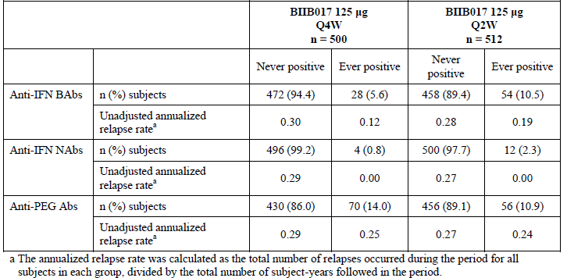
It remains possible that a larger study would reveal that NAbs compromised efficacy, as has been demonstrated with non-pegylated interferon treatments, but the current evidence doses not suggest that this is a particular concern with peginterferon.

Results in the non-placebo controlled second year
Only the first year of Study 301 was placebo-controlled. In the second year, subjects initially randomised to placebo were re-randomised to peginterferon 125mcg Q2W or Q4W. A total of 1332 subjects who received at least some peginterferon in Year 2 and, at data cut-off, 608 subjects had completed the entire 2-year study period (205 subjects who switched from placebo and 403 subjects who continued active treatment through both years).
Data from the second year can only be considered supportive, but it is generally reassuring.
For the primary endpoint (ARR), results in the 1332 subjects who had at least some second year data are summarised below. Year 1 results refer to 48 weeks of placebo-controlled treatment, whereas the Year 2 results refer to variable periods of incomplete follow up. The ARR in subjects who initially received placebo improved on switching to active treatment, though this was not statistically significant, as indicated by overlapping 95%CIs. Subjects who continued peginterferon Q4W showed persistence of the same ARR across both years, whereas subjects receiving peginterferon Q2W showed a trend towards further improvement in the second year.
Figure 17. Summary of annualised relapse rate (INEC-Confirmed relapse) by study year -ITT population dosed in Year 2.
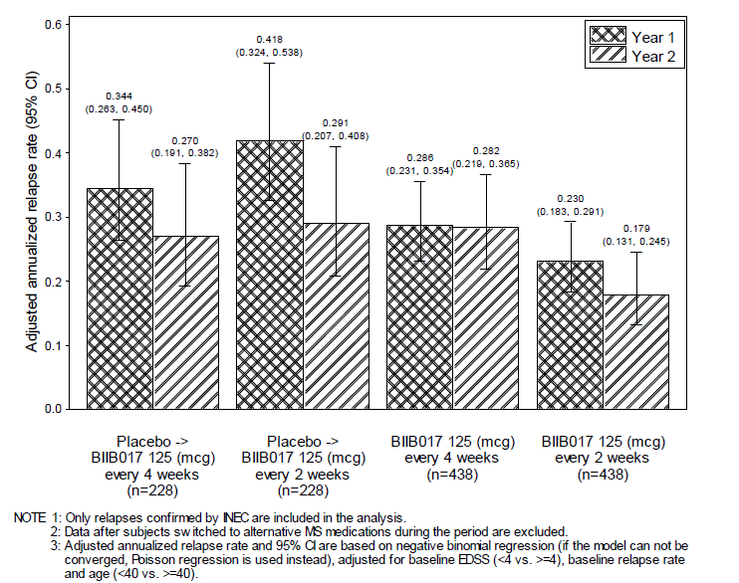
Although not significant in their own right, these observations add to the robustness of the first year results. They also suggest that the superior efficacy of Q2W treatment over Q4W in the first year was not simply due to a slow onset of efficacy in the Q4W group, because the Q4W group still had a higher relapse rate than the Q2W group in the second year.
Relapses were also analysed with a Kaplan-Meier estimate of the time to first relapse over the course of two years. For this analysis, subjects who initially received placebo were pooled, even though they were split into two different active dosing frequencies in the second year. The curve shows that both active groups were similar in the first year of treatment, but separated towards the end of the first year and kept diverging in the second year. Again, this suggests that Q2W treatment shows sustained superiority over Q4W treatment, and the first year results did not simply reflect a delayed onset of benefit in the Q4W group. In both of the continuous active treatment groups, the time to first relapse was significantly delayed compared to subjects who had a year of placebo treatment. On switching to active treatment, the curve for the initial placebo recipients adopted a gradient similar to that of the continuous active treatment groups, but this is difficult to interpret given the lack of a control group; it might reflect regression to the mean or the natural history of multiple sclerosis, which is known to show less frequent relapses as the disease matures.
Figure 18. Time to first relapse (INEC-confirmed relapses) over 2 years-ITT population.
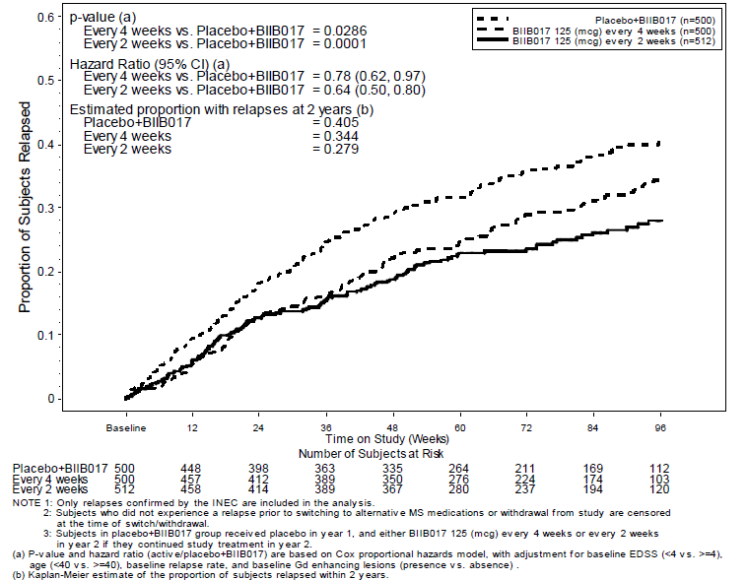
Kaplan-Meier analysis was also used to assess the third major clinical endpoint, disability progression. As shown in the figure below, disability progression at the end of the first year was more common in subjects on placebo, and even when all subjects received active treatment, the initial placebo recipients remained more likely to have progressed. The group who received peginterferon Q2W continuously were significantly superior to those who began treatment with placebo (p=0.0223), whereas those who received peginterferon Q4W continuously merely showed a trend towards superiority over initial placebo recipients (p=0.0822).
Figure 19. Time to sustained progression of disability as measured by increase in EDSS over 2 years-ITT population.
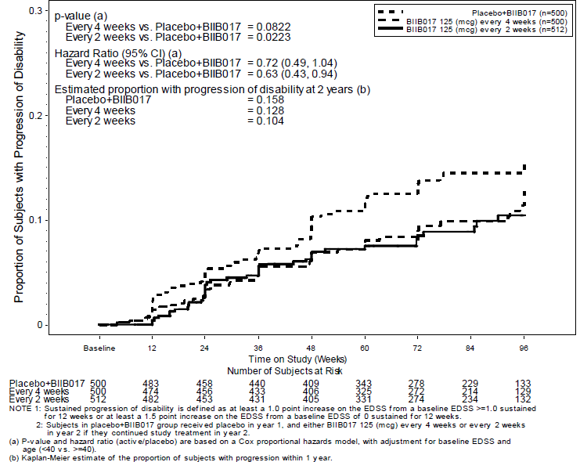
For the major radiological measure, number of new or newly enlarging T2 lesions, all groups showed an improvement in the second year of treatment. Without an untreated control group, it is difficult to know to whether this represents a response to treatment or the natural history of the condition. As shown in the figure below, active dosing with peginterferon Q2W in the second year was superior to Q4W dosing; even in subjects that had received placebo in the first year, the number of lesions in the second year was lower in those switching to Q2W treatment than in those who had continued Q4W dosing throughout the study. This strongly suggests that much of the improvement in the second year was a genuine response to treatment, not merely natural improvement, and that Q2W treatment is more effective than Q4W treatment, even when Q4W treatment has had a more than a year to exert its effects. These results were only presented with descriptive statistics, but the superiority of Q2W dosing over Q4W dosing in suppressing MRI lesions over two years was presented with comparative statistics, discussed below, and the difference was significant.
Figure 20. Number of new or newly enlarging T2 lesions by study year-ITT population dosed in Year 2.
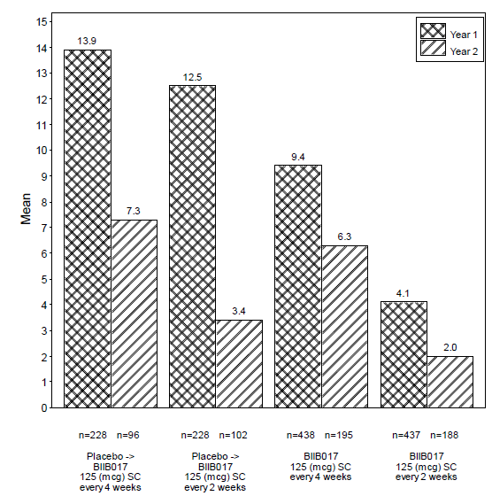
In general, the two-year results did not show any apparent waning of efficacy, but without an untreated control group, it is not possible to draw firm conclusions.

Post hoc comparison of Q2W vs Q4W dosing
The study was not designed or powered for direct comparison of the two active doses, but the sponsor performed a post hoc comparison of Q2W and Q4W dosing for all major endpoints. The table below shows the relative treatment effect of Q2W dosing vs Q4W dosing at the end of Year 1 and at the end of Year 2, based on subjects who received continuous active treatment (that is, excluding subjects who switched from placebo treatment).
None of the Q2W/Q4W comparisons based on clinical endpoints achieved statistical significance, but the ARR over two years showed a strong trend (p=0.0590).
For most clinical endpoints, the rate ratio of Q2W to Q4W was in the range 0.79 to 0.89, indicating that Q2W treatment is associated with 80-90% of the disease activity seen with less frequent dosing. This includes disability progression over 2 years, even though disability progression at one year was the same in both active groups.
The radiological endpoints, which are generally more sensitive than clinical endpoints, more strongly favoured Q2W treatment, with the rate ratio for active T2 lesions being 0.46 in the first year and 0.36 over two years, compared to Q4W treatment; this was highly statistically significant (P<0.0001 for both periods).

Table 23. Relative treatment effect of BIIB017 dose regimens in Year 1 and over 2 years in Study 301. Post hoc analysis in the ITT population.
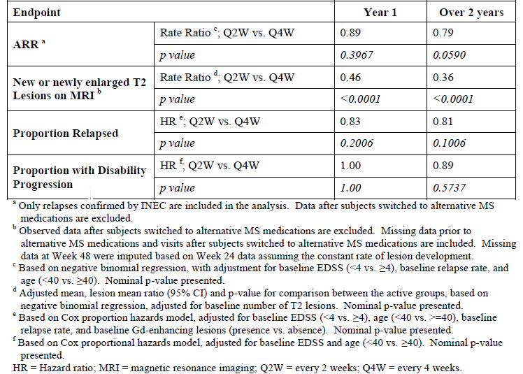
These comparisons are presented graphically, below.
Figure 21. Summary of comparison between 2 active groups for key clinical endpoints over 2 years-ITT population.
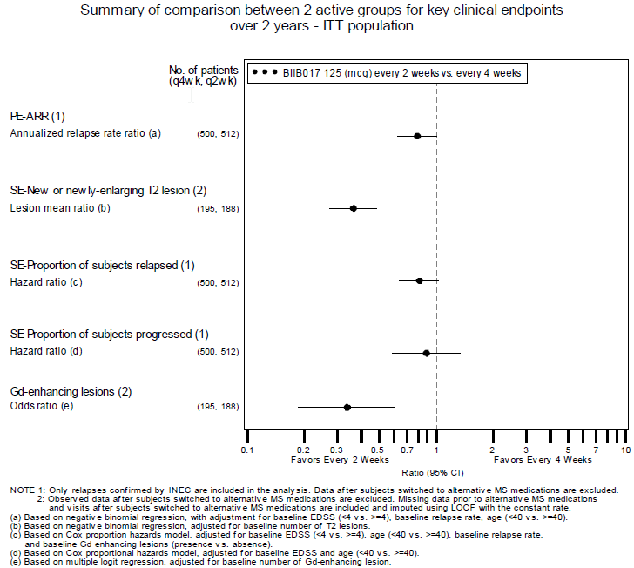
Overall, this post-hoc analysis strongly suggests that peginterferon 125mcg Q2W is superior to Q4W treatment, and that the benefit of more frequent dosing is maintained or even extended in the second year of treatment.
Unfortunately, this also strongly raises the question of whether weekly treatment would be even more effective than Q2W treatment.

Extension study, 105MS302

Title
A Dose-Frequency Blinded, Multicenter, Extension Study to Determine the Long Term Safety and Efficacy of PEGylated Interferon Beta-1a (BIIB017) in Subjects with Relapsing Multiple Sclerosis.

Design

Objectives, locations and dates
This study was designed as an extension of the pivotal study described above, with the primary objective of gathering long-term safety and tolerability data, and the secondary objective of gathering more efficacy follow-up.
It is still on-going, and is being conducted in the same centres as the parent study, 101MS301. It began on 11th April, 2011, with a data cut-off at the time of submission of 24th October 2012
At the time of data cut-off, 517 subjects have been enrolled; 508 subjects have received at least 1 dose; and 407 subjects have received at least 1 dose and attended for a post-baseline safety follow-up.

Inclusion and exclusion criteria
The primary eligibility criterion was completion of Study 301. Key exclusion criteria were a period of >6 weeks since completion of the Week 96 Visit of Study 301, or any significant change in medical condition that, in the opinion of the Investigator, would have excluded the subject from participation in Study 301.

Study treatments
Subjects continued to receive their peginterferon 125mcg at the same randomised dosing frequency they had received in the second year of the pivotal study (Q2W or Q4W). This included patients who had received the same regimen from the start of the pivotal study, as well as those who had switched to active treatment from placebo.

Efficacy variables and outcomes
The main clinical efficacy variables were:
- annualized relapse rate
- proportion of subjects relapsed
- number of relapses requiring intravenous (IV) steroid use
- number of MS-related hospitalizations
- progression of disability as measured by the Expanded Disability Status Scale (EDSS)
- cognitive changes measured by the Symbol Digit Modalities Test (SDMT)
The radiological endpoints were:
- number of new or newly enlarging T2 hyperintense lesions on MRI scans
- number of new active lesions on brain MRI scans
- number of new T1 hypointense lesions on brain MRI scans
- number of Gd-enhancing lesions on brain MRI scans
- volume of T2 hyperintense lesions on brain MRI scans
- volume of T1 hypointense lesions on brain MRI scans
- volume of Gd-enhancing lesions on brain MRI scans
- whole brain atrophy
The sponsor did not designate a single efficacy variable as primary, because of the lack of a placebo comparator group. In general, the results were presented descriptively. Given that the initial study used annualised relapse rate (ARR) as the primary efficacy outcome, this should be considered the most important efficacy measure for the extension study.

Randomisation and blinding methods
All subjects were already receiving active treatment, with alternate placebo and active injections in the Q4W group, to maintain blinding. This treatment continued in a double-blind fashion through to the extension study.

Analysis populations
The analysis population for efficacy was the ITT population, consisting of subjects who received at least one dose in Study 302.
The sponsor identified two treatment groupings and two datasets, based on treatment and observations in Study 302 alone (Study 302 Treatment Grouping and Study 302 Data); and on treatment and observations spanning the subjects’ involvement across both studies, based on their treatment assignment across both years of Study 301 (Combined Treatment Grouping and Combined Data). In the Combined Treatment Grouping, four treatment arms were considered: placebo-peginterferon Q4W; placebo-peginterferon Q2W; continuous peginterferon Q4W; continuous peginterferon Q2W.
All efficacy analyses were conducted using the Study 302 Intent-to-Treat (ITT) Population, based on the Study 302 Treatment Grouping and the Study 302 Data.
Selected efficacy analyses, including annualised relapse rate, proportion of subjects relapsed, and disability progression, used the Study 302 ITT Population with Combined Treatment Grouping and Combined Data.
For safety assessments, the sponsor defined a Safety Population, which included all subjects who received at least 1 dose of study treatment in Study 302 and had any post-baseline safety follow-up, defined as any treatment-emergent AE or any post-baseline laboratory, vital signs, or physical exam assessment in Study 302.

Sample size
Sample size was solely determined by the availability of patients exiting the parent study. As the study is on-going, with relatively few patients having received treatment in the study for a year (n=46), the statistical power of the study is severely limited. Because of this, and the lack of a placebo control group, the sponsor did not attempt to perform formal statistical hypothesis testing.

Statistical methods
Analyses were descriptive in nature without formal statistical hypothesis testing, and they were based on observed data without imputation for missing values. This is appropriate for an extension study lacking a placebo comparator.
Where appropriate, confidence intervals (CIs) were provided for each treatment group to indicate the estimated variability around efficacy measure, but without a placebo comparator this cannot be used to infer a significant treatment effect.
For the major endpoint of ARR, 95% CI were calculated using a negative binomial regression model, adjusting for baseline EDSS score (<4.0 versus ≥4.0), baseline age (<40 versus ≥40 years old), and baseline relapse rate (based on the 3 years prior to the day of screening of Study 301) as covariates.
The proportion of subjects relapsed was estimated as the probability of relapse from the Kaplan Meier curve of the time to the first relapse (i.e., Kaplan-Meier product-limit estimator). The time to sustained disability progression was also based on Kaplan-Meier curves, as was the estimated proportion of subjects with sustained disability progression at key time-points.

Results

Participant flow
Subject disposition is summarised in the figure below. A small number of subjects (n=19) have withdrawn from the extension study; most enrolled subjects have received at least one dose (n=508) and remain in the study. Exposure in those subjects is limited; at data cut-off it ranged from 2 weeks to 80 weeks; 46 subjects had completed 1 year of treatment and no subjects had completed the planned 2 years.
Figure 22. Overview of subject disposition
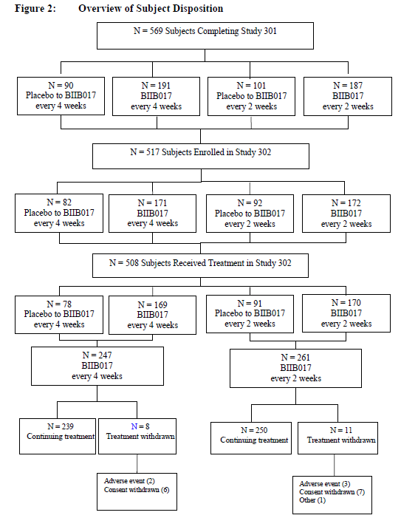

Major protocol violations/deviations
Protocol deviations were not summarised by the sponsor, but were listed in a 38-page table. Most protocol deviations were minor, and most subjects with protocol deviations have continued in the study. Because this was an extension study without formal statistical hypothesis testing, a per-protocol population was not defined.

Baseline data
The population of this extension study resembled the original population in the pivotal study: 72% of subjects were women; they ranged in age from 20 to 57 years (mean: 38.1 years). At the baseline of Study 302, most had EDSS scores of <4.0 (84%). The mean EDSS scores in the Q2W group were slightly lower (2.39) than in the Q4W group (2.51). The baseline MRI characteristics were similar across groups, and typical of a RRMS population with mean values of the pooled population as follows: (Gd-enhancing lesion number [0.4] and volume [0.052 cm3], T2 hyperintense lesion volume [9.977 cm3], and T1 hypointense lesion volume [3.772 cm3]). These values were similar across the two dose-frequency groups.
Overall, there were no important differences.

Efficacy results
Relapses during the first year of the extension study are shown in the figure below. The number of subjects with 48 weeks of data is very low (at risk n=31), so it is not possible to infer annualised relapse rates or proportion of subjects relapsed with confidence, but the curves suggest that the superiority of Q2W versus Q4W dosing has continued through the third year of treatment.
Figure 23. Time to first relapse (objective relapses). Study 320 ITT population. Study 302 data.
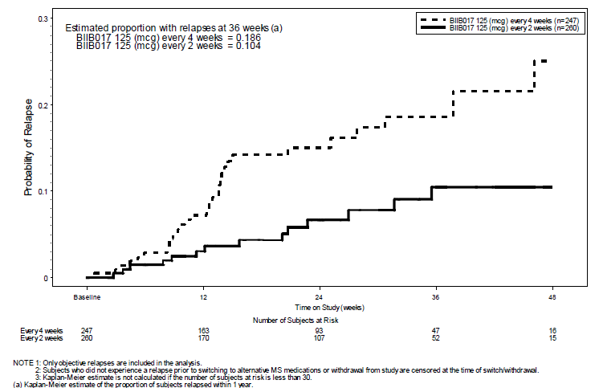
The following tables attempt to quantify the relapse rates and proportion relapsed. Note that it is not apparent from the tables how few subjects have contributed to the analysis, because the number of subjects cited refers to those who have entered the ITT population, some of whom have only received a single dose. This explains the discrepancy between the number of subjects indicated as having relapsed (5% of the Q2W group) and the projected proportion relapsed (at least 10% by Week 36).
In the pivotal study, the Q2W group had a relapse rate of 0.256 (95%CI 0.206 to 0.318) in the first placebo-controlled year, whereas the first year of the extension study shows a relapse rate of 0.203 (95%CI 0.116 to 0.355) with the same dosing regimen. The Q4W group appears to have done less well; they had a relapse rate of 0.288 (95%CI 0.234 to 0.355) in the first year of the pivotal study, compared to 0.410 (95%CI 0.260 to 0.645) in the extension study. Note that the rate observed with Q4W dosing in Study 302 is actually slightly worse than the placebo ARR in the pivotal study (0.397), but the 95%CIs for the ARR in the two periods of Q4W dosing overlap with each other, and the 95%CI for Q4W treatment in the extension study includes the possibility of a rate as low as 0.260. Potentially, this apparent trend to declining efficacy with Q4W dosing indicates another reason to prefer Q2W dosing.

Table 24. Summary of annualised relapse rate (Objective relapses) at Study 320 Year 1 -ITT population (Study 302 data).
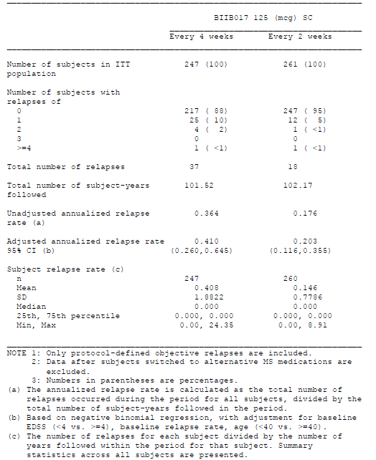
In the combined dataset across the pivotal study and its extension, the best overall results were seen in subjects who started active treatment with Q2W dosing in the pivotal study and continued it into the extension study, as shown in the figure below. Because patient numbers in the extension study were low, 95%CIs were broad and overlapping, and no firm conclusions can be drawn.
Figure 24.Annualised relapse rate (Objective relapses) by yearly interval-Study 320 -ITT population (Study 301 and 302 data combined).
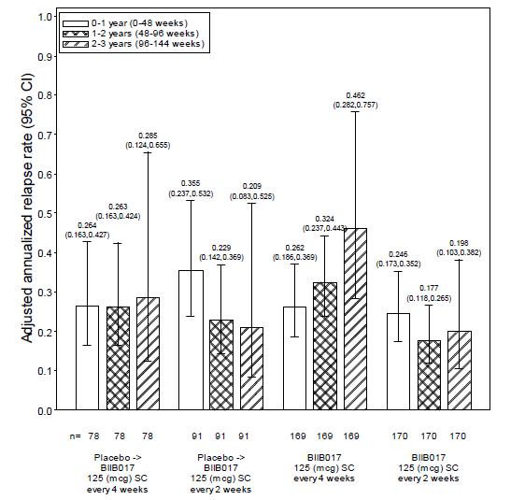
For the proportion relapsed during Study 302, there was apparent superiority of Q2W dosing over Q4W dosing, as shown below, but the numbers are too low to provide an estimate for the proportion relapsed after one year in Study 302, so this preliminary evidence can only be considered weakly supportive.

Table 25. Summary of proportion of subjects relapsed (objective relapses) at Study 302 Year 1-Study 302 ITT population (Study 302 data)
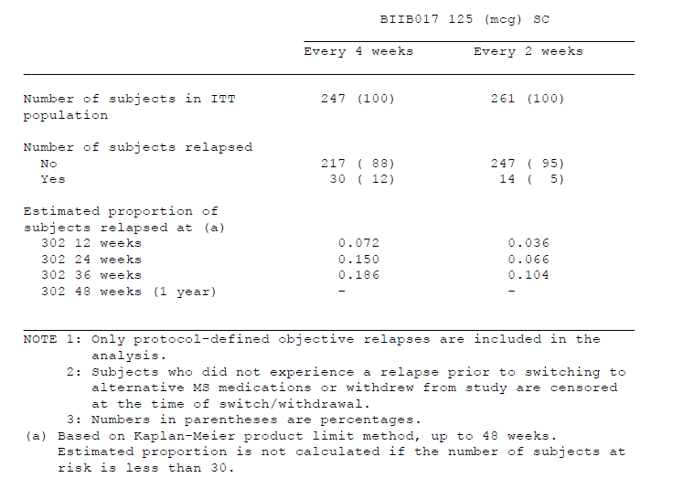
Overall, despite the methodological limitations of the study, including the potential for bias arising from the selection of patients willing to enter the extension study, the efficacy data from Study 302 is broadly reassuring. There is, at least, no apparent loss of efficacy with continued use of the Q2W regimen. The limited extension data does suggest, however, that Q4W dosing does not produce sustained efficacy.
Because of the relatively short follow-up available in Study 302, it is too early to have a robust measure of the proportion of subjects showing disability progression within Study 302. Using the criterion of a 24-week sustained EDSS progression, disability progression over 3 years was confirmed for:
- 4 subjects (5%) in the placebo to peginterferon Q4W group ;
- 8 subjects (9%) in the placebo to peginterferon Q2W group ;
- 17 subjects (10%) in the peginterferon Q4W group ;
- 8 subjects (5%) in the peginterferon Q2W group
Because of the small number of subjects with more than 24 weeks of follow-up in Study 302, the proportion of subjects with 24-week confirmed progression could not be reliably estimated at Week 48. The Kaplan-Meier estimate of the proportion of subjects with 24-week sustained disability progression at the earlier time-point of Week 24 of Study 302 was 0.051 for the placebo to peginterferon Q4W group, 0.093 for the placebo to peginterferon Q2W group, 0.101 for the peginterferon Q4W group, and 0.047 for peginterferon Q2W group. These results suggest that the least treated group (those switching from placebo to Q4W treatment) progressed at about the same rate as the most treated group (those receiving Q2W for 3 years). This conclusion is not consistent with the overall results, and is likely to reflect the low patient numbers reaching this endpoint. Also, in the absence of a placebo control group, no real conclusions can be drawn from this data.

Analyses performed across trials
The only analyses performed across trials were those already considered in which the results of the extension study, Study 302 incorporated data from its pivotal parent study, Study 301, as discussed above.

Supportive evidence from related beta-interferon studies
Several studies have been performed that demonstrate the efficacy of interferon beta in the treatment of RRMS, and a full review of all those studies is beyond the scope of this evaluation. The sponsor provided a table summarising the available data, and an excerpt from that table is reproduced below. Inspection of the table shows that peginterferon 125mcg Q2W has an efficacy that is broadly consistent with other interferon beta treatments, reducing relapse rate by 36%, compared to other interferon beta preparations that reduce the relapse rate by 31-32%. (The ARR reduction with Avonex was only 18% overall, but the study was stopped early and the reduction was 32% in those who completed the study as planned). The efficacy of peginterferon and other interferon beta therapies appears to be inferior to some other available agents, such as natalizumab, which is not shown in the table, but some of the more effective agents in MS come with significant safety concerns.

Table 26. Comparison of MS disease modifying therapies (continued)
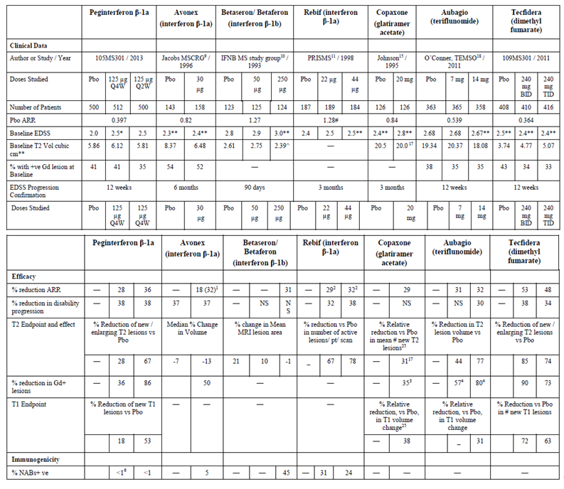
Although studies performed with other interferon beta agents do not directly address the efficacy of peginterferon, they do provide a context in which the affects of pegylation can be judged. Apart from allowing less frequent dosing, pegylation does not appear to have had a major effect on the efficacy of interferon beta -1a, because peginterferon produced a broadly similar reduction in relapse rate and disability progression as achieved with non-pegylated interferon beta-1 (albeit in different populations with different placebo groups).
Cross-study comparisons cannot truly address the relative efficacy of competing products, however, and the few head-to-head studies that have been done in MS suggest that more frequent dosing is usually more effective than infrequent dosing, as discussed previously (Section 5.3, p35). The submitted evidence suggests that Q2W dosing is more effective than Q4W dosing, but pharmacodynamic and literature considerations suggest that it may not be the most effective possible regimen of peginterferon. In the absence of studies specifically addressing the efficacy of weekly peginterferon regimens, such as 125mcg weekly, it is impossible to determine which peginterferon regimen is the most effective, and how peginterferon will ultimately rank in terms of effectiveness relative to its competitors.

Sponsor’s justification for performing a single pivotal efficacy study
The sponsor’s Clinical Overview included a section specifically defending the use of a single pivotal study to demonstrate efficacy of peginterferon. Those comments are quoted verbatim below, with bullet points replaced by numbers for ease of reference.
- Data are derived from a large, multicenter study in which multiple measures were implemented to ensure blinding and consistent assessment of the primary endpoint and in which no single investigator enrolled >4% of subjects providing data in the study.
- The findings on the primary endpoint are statistically very persuasive, particularly for the every 2 weeks regimen for which the difference versus placebo was significant at a level of <0.001, and are further supported by positive results with all pre-specified sensitivity analyses.
- Consistent evidence for efficacy is demonstrated across multiple, distinct measures of efficacy including relapse, progression of disability, and well-accepted MRI biomarkers of disease activity.
- Consistent trends for efficacy are demonstrated across important study subgroups including those based on age, gender, baseline disease stage and activity.
- Negligible concern for bias related to theoretical unblinding as reflected by
- the consistent evidence for efficacy reflected by rigorously assessed clinical endpoints and more objective measures (i.e., annualized relapse rate and disability versus MRI)
- consistent effects in subgroups with and without reported treatment-related adverse events (influenza-like symptoms or ISR)
- Substantial external biologic plausibility of the findings exists given the well-established efficacy of the interferon class in MS and the nonclinical and healthy volunteer data with BIIB017 demonstrating that BIIB017 has the pharmacologic properties anticipated with such a molecule.
Overall, these arguments are reasonable. They are considered in turn below.
- The submitted study took reasonable measures to prevent unblinding, but the sponsor did not ask subjects to guess their treatment assignment and it seems very likely that telltale side effects did allow some subjects to deduce that they were on active treatment. The potential effect of such unblinding is lessened by the use of an independent examining neurologist, as well as blinded radiologists.
- The results for the primary endpoint were highly statistically significant, so minor matching imbalances at baseline or other methodological flaws including unforeseen biases would have had to play an implausibly strong role to produce the observed results.
- All major endpoints including objective MRI measures were broadly concordant, so potential biases affecting one endpoint would not have had the potential to shift the overall weight of the evidence.
- Subgroup analysis showed the benefit to be broadly consistent in demographic- and disease-defined subgroups, so baseline mismatches cannot account for the results.
- Unblinding, even if it occurred, appears not to have played a major role in biasing the results, as suggested by positive findings for objective MRI endpoints as well as a lack of interaction between potentially telltale side effects and efficacy.
- Finally, the single pivotal efficacy study is concordant with other studies of interferon beta, including nonpegylated interferon beta-1a, producing a reduction in relapse rate very close to that predicted on the basis of previous experience. Also PD studies with peginterferon suggest that, at the proposed dose, it produces a similar induction of neopterin over the course of 4 weeks as the approved dose of Avonex.
Thus, given that peginterferon is not a new class of agent, and behaved as expected in pharmacodynamic studies as well as the pivotal efficacy study, it is reasonable to accept the submission of a single well-controlled study.
The downside of this approach is that other dosing regimens have not been explored. A single study that included a Q1W treatment arm as well as Q2W and Q4W arms would have been more appropriate.

Evaluator’s conclusions on clinical efficacy
The efficacy of peginterferon has been established through a single year of placebo-controlled treatment, with some supportive data gathered from a second year of dose-frequency-blinded treatment in the same study, and further dose-frequency-blinded treatment in an extension study. The placebo-controlled phase of the pivotal study had no substantial methodological flaws, reasonable attempts were made to preserve blinding where possible, and the results were robust enough that they do not appear likely to have arisen from any systemic bias.
Relative to placebo, peginterferon at the proposed dose of 125mcg Q2W was associated with a reduction in annualised relapse rate of 35.6% (p=0.0007), a reduction in the proportion relapsed after one year of 39% (p=0.0003) and a reduction in sustained disability progression of 38% (p=0.0383). With respect to MRI endpoints, peginterferon 125mcg Q2W was associated with a reduction in new or newly enlarged T2 lesions of 67% (p<0.0001), a reduction in Gd-enhancing lesions of 86% (p<0.0001) and a reduction in new T1 hypointensities of 53% (p<0.0001).
The pivotal study also assessed a less frequent dose regimen, 125mcg Q4W, but this regimen was clearly inferior, achieving reductions for most of the endpoints that were intermediate between the placebo and Q2W results. An exception was disability progression, which was reduced by the same extent in each active group. Most Q4W endpoints achieved statistical significance in comparison to placebo, apart from Gd-enhancing lesions and T1 hypointense lesions. All of these endpoints are summarised in the table over the page.
Most tertiary endpoints, including quality-of-life measures, were too insensitive to show a significant benefit.
Subgroup analyses did not reveal any significant reduction in efficacy in groups defined by demographic or disease characteristics, or by the presence or absence of potential telltale side effects that could have led to unblinding.
Rough post hoc calculations with pessimistic imputation suggest that withdrawal bias did not play a major role in producing the positive findings.
The second year of the pivotal study, and the on-going extension study in the same population, are difficult to interpret because they lacked a placebo control. The efficacy data from the second and third year of treatment were generally reassuring, however, in that the relapse rate in the Q2W group continued to stay low, and was similar to that seen in the placebo-controlled first year. Continued treatment with the Q4W regimen did not produce comparable efficacy, and was clearly inferior.
The efficacy of peginterferon 125mcg weekly remains untested, but on pharmacodynamic grounds, appears likely to be more effective than the proposed regimen.

Table 26. Study 301 summary of key efficacy results at 1 Year by treatment group

Clinical safety

Studies providing evaluable safety data
The following six studies provided evaluable safety data:
Figure 25. Overview of the clinical development program of BIIB017
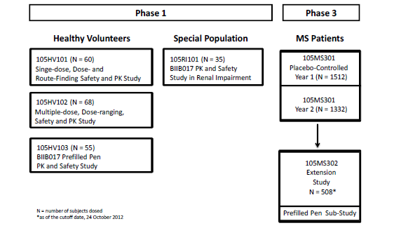

Pivotal efficacy study (105MS301, n=1512)
In the pivotal efficacy study (Study 301, or 105MS301), the following safety data were collected:
- General adverse events (AEs) were recorded during scheduled trial visits or other unscheduled hospital attendances, then characterised by organ system and preferred term.
- AEs of particular interest given the known side effect profile of interferon betas were collected and treated to additional analysis; these included flu-like symptoms, fever, myalgia, depression and injection site reactions.
- Depression was monitored with the Beck Depression Inventory, version II.
- Laboratory tests included standard monitoring of electrolytes, renal function and liver function, as well as antibodies to peginterferon.
This two-year study was placebo-controlled in the first year of treatment, but in the second year placebo subjects were re-randomised to one of the active arms: peginterferon 125mcg Q2W or peginterferon 125mcg Q4W. The placebo-controlled data constitutes the primary safety data pool, whereas second-year data provides long-term supportive data.

Long-term extension study (105MS302, n=1332)
Study 302 (105MS302) was an extension of the pivotal efficacy study, Study 301 (105MS301). Its primary objective was to assess the long-term safety and tolerability of peginterferon. Because it was an extension of the pivotal efficacy study, it is described in the Efficacy section. Safety data from this extension study was not placebo-controlled, and the patient population is merely a subset of the pivotal population already exposed to peginterferon, but the study provides the only long-term safety assessment of subjects treated with peginterferon for more than two years.
The sponsor’s Integrated Safety Analysis refers to two different datasets derived from these two major studies: the “Placebo-Controlled BIIB017 Experience”, which includes the first year of Study 301, and the “Overall BIIB017 Experience”, which is an integrated analysis of actively treated subjects in Study 301 and Study 302. In both categories, analysis of AEs was based on the principle of treatment emergence: for the placebo-controlled dataset, an AE was considered treatment emergent if it began during the placebo-controlled period (pre-existing conditions were excluded); for the overall dataset, an AE was considered treatment emergent in the “Overall BIIB017 experience” if it began on or after the date of first active dose (that is, not during placebo treatment for the subjects who switched after one year). Safety analyses generally excluded data after subjects switched to alternative MS medications, but AEs that occurred after switching were collected and considered separately.

Table 27. Presentations if the data for the Integrated Safety Analysis
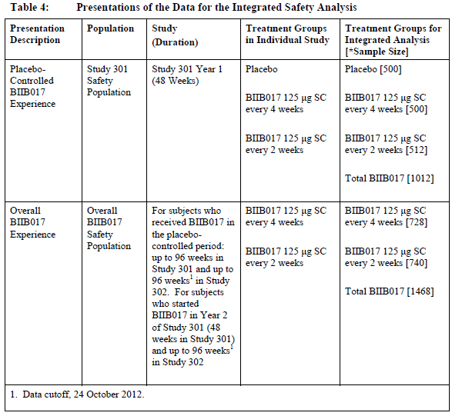

Other studies
Adverse events were collected in all four of the Phase 1 PK/PD studies. Study 105HV101 (n=60) was merely a single-dose study, but it provided the only chance to compare the tolerability of peginterferon at different doses with an active control, Avonex 30mcg. Study 105HV102 (n=68) was a multi-dose study with a placebo control. Study 105HV103 (n=55) compared two different injection devices, but it is of limited utility as a source of safety data because it lacked a suitable control group. Study 105RI101 (n=35) assessed the PK/PD of peginterferon in subjects with renal impairment, but it was small and only added minimal safety data. Because most of this Phase 1 data was short-term and non-controlled, it provides only basic tolerability data.

Patient exposure
Exposure to peginterferon is summarised in the tables below. The first table shows the extent of exposure in the placebo-controlled first year of Study 301, whereas the second table shows the experience across the two major studies.
Allowing for the persistence of biological effects for up to two weeks after the last dose, the mean duration of exposure to peginterferon in Year 1 of Study 301 was 44.3 weeks, with a similar duration of exposure between the two dose-frequency groups. The total number of subject-years of placebo-controlled exposure was 429.2 subject-years for the Q4W group and 430.5 subject-years for the Q2W group, and the vast majority of this exposure was to the proposed dose of 125mcg, apart from initial titration with lower doses.
In the overall experience (Studies 301 and 302 pooled), a total of 1468 subjects were exposed to at least 1 dose of peginterferon. The mean time on study was 68.7 weeks and the total exposure was 1934.0 subject-years. Total exposure to the Q4W regimen was 960.5 subject-years and to the Q2W regimen 971.9 subject-years. Overall, 1093 subjects were exposed for ≥48 weeks, and 415 subjects for ≥96 weeks. This represents an adequate overall exposure for the detection of uncommon side effects.
The third table below deals with the Phase 1 program, in which exposure was generally brief. Subjects in the PK/PD study 105HV101 received a single dose of Avonex or peginterferon. In Study 105HV102, subjects received 2-4 injections, depending on dose frequency: subjects in the Q2W group received 4 injections of active peginterferon and subjects in the Q4W group received 2 injections of active peginterferon and two injections of placebo. In Study 105HV103, subjects received one dose of peginterferon by pre-filled syringe and another by auto-injector.

Table 28. Placebo-controlled experience Overall extent of exposure Year 1
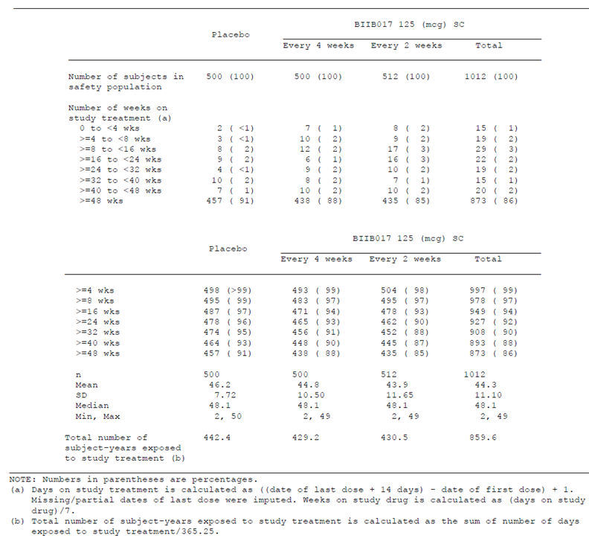

Table 29. Overall extent of experience. Overall BIIB017 experience
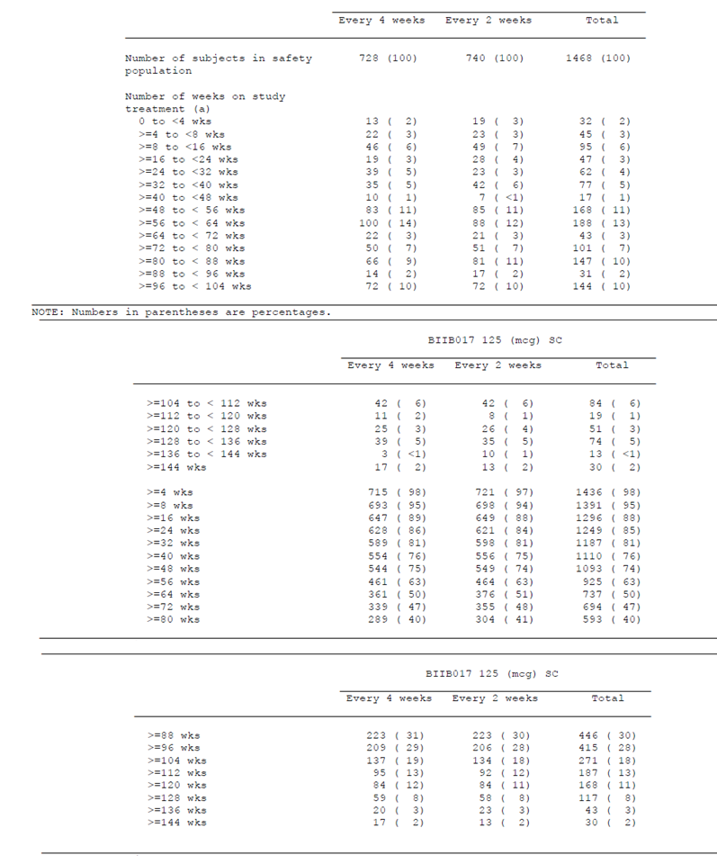

Table 29 continued. Overall extent of experience. Overall BIIB017 experience
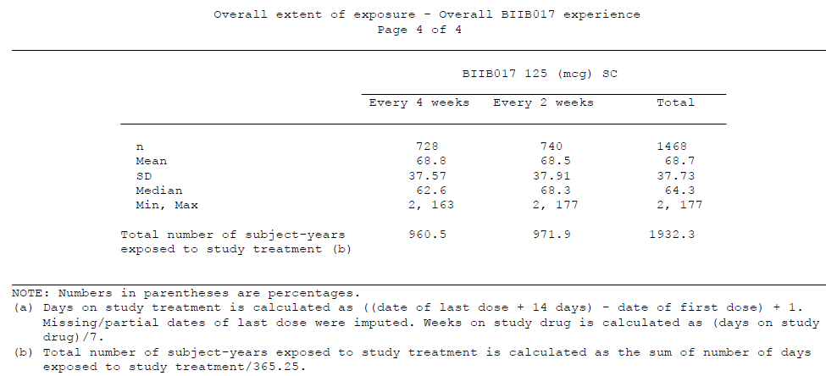

Table 30. Phase 1 Exposure. Extent of exposure to BIIB017 in Phase 1 studies in healthy volunteers in subjects with renal impairment
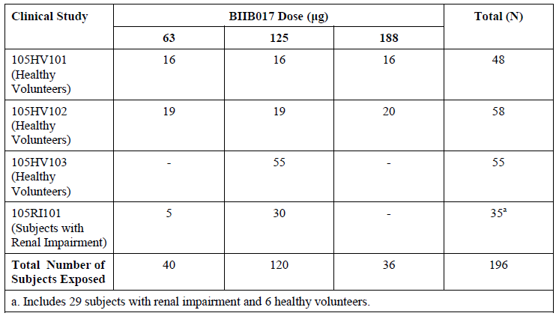

Adverse events

All adverse events (irrespective of relationship to study treatment)

Placebo-controlled experience
Most subjects including placebo recipients had an AE during the first year of treatment, which in many cases simply reflects the occurrence of common ailments in any population studied for a year, but AEs were more common with active treatment (placebo 83%, Q4W 94%, Q2W 94%). The excess incidence of AEs in each active group was 11% (a substantial proportion of the notional 17% left unaffected by the background placebo incidence of AEs).
Severe events were uncommon, but increased with overall dose, occurring in 11% of placebo recipients, 16% of the Q4W group and 18% of the Q2W group. Serious events were actually less common with active treatment, occurring in 15%, 14% and 11% of the placebo, Q4W and Q2W groups, respectively.
The second table below indicates the types of AEs that were reported more commonly with active treatment at the proposed Q2W dose than with placebo, grouped by organ system. The most common side effects were headache (placebo 33% vs Q2W 44%), myalgia (placebo 6% vs Q2W 19%) arthralgia (placebo 7% vs Q2W 11%), injection-site erythema (placebo 7% vs Q2W 62%), influenza-like illness (placebo 13% vs Q2W 47%), pyrexia (placebo 15% vs Q2W 45%), chills (placebo 5% vs Q2W 17%), various other injection-site terms (see table), and abnormal liver function tests (increased ALT, placebo 3% vs Q2W 6%).
The third table below lists AEs that were rated as severe; this reflected the overall incidence of AEs with active treatment, with headaches, flu-like symptoms and injection site reactions featuring most prominently.

Table 31. Summary analysis of adverse events Year 1
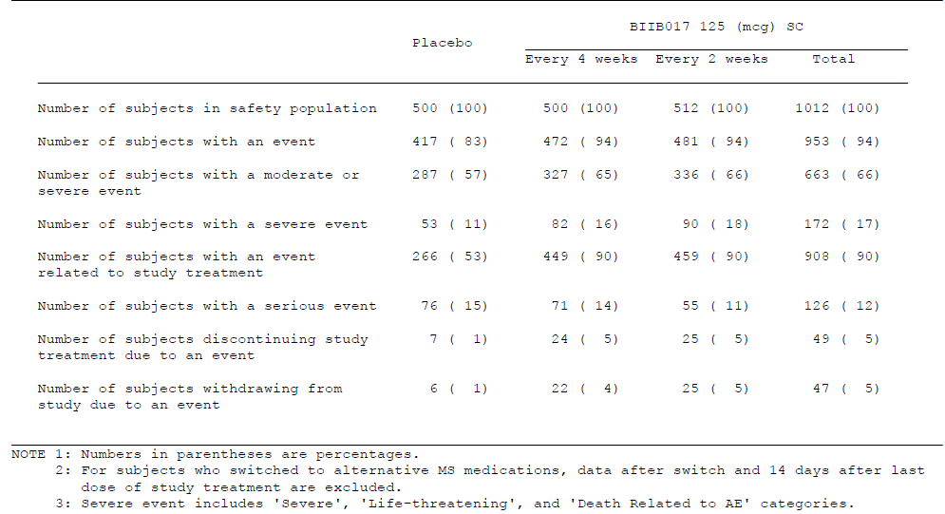

Table 32. Adverse events at least 2% higher in incidence by System Organ Class and Preferred Term for BIIB017 every 2 weeks compared with placebo. Year 1
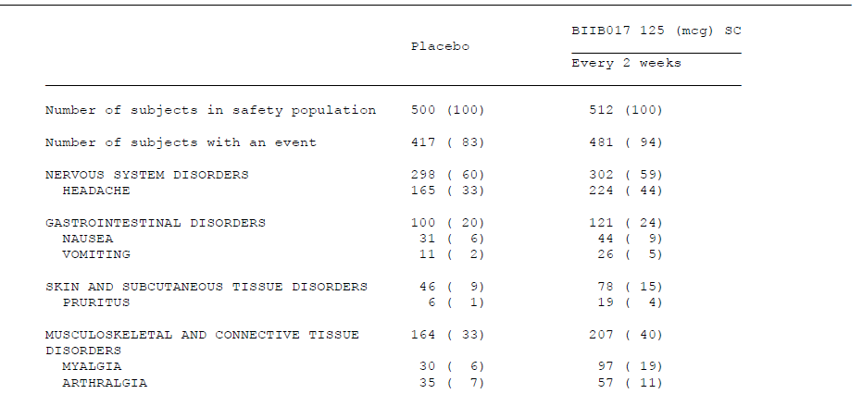

Table 32 continued. Adverse events at least 2% higher in incidence by System Organ Class and Preferred Term for BIIB017 every 2 weeks compared with placebo. Year 1
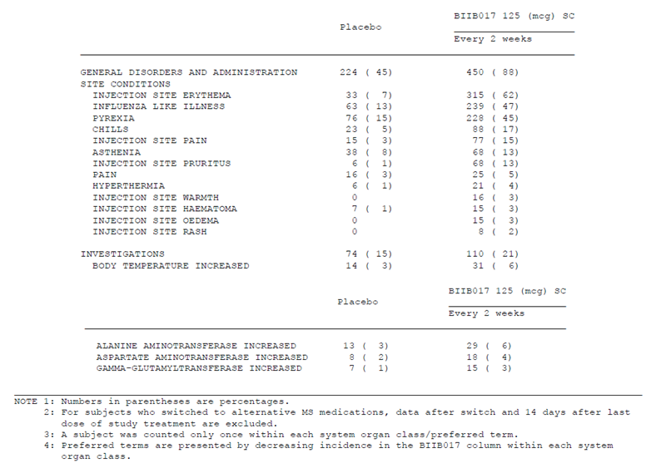

Table 33. Incidence of adverse events experienced by at least 3 subjects in any treatment group by System Organ Class and Preferred term. Year 1
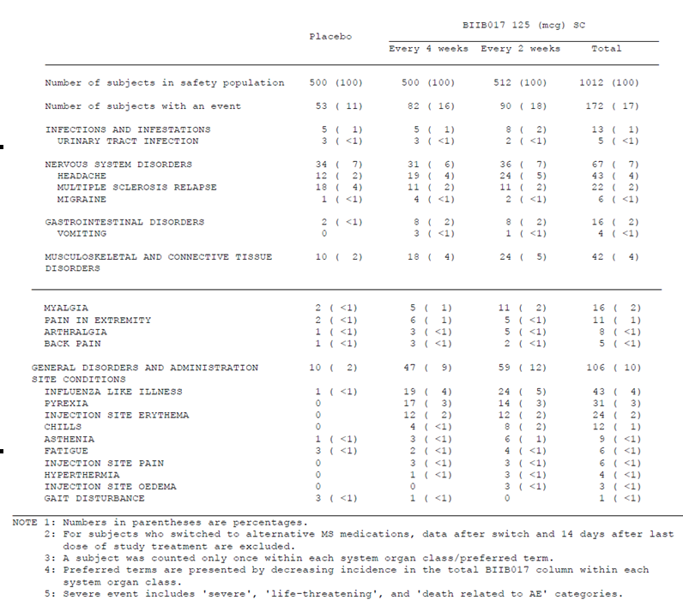
Overall, the AEs observed with peginterferon are consistent with those experienced with other forms of interferon beta, and in most cases they represent tolerability issues rather than serious safety concerns.

Overall experience
In the overall experience of peginterferon pooled across both major studies, the incidence of AEs was very similar to that seen in the first year of the pivotal study. The table below lists the reported AEs by organ class, showing that infections and nervous system disorders were the most common AEs. This is likely to reflect the high incidence of respiratory infections, urinary infections and headaches in any population studied for years.

Table 34. Incidence of adverse events by System Organ Class-Overall BIIB017 experience
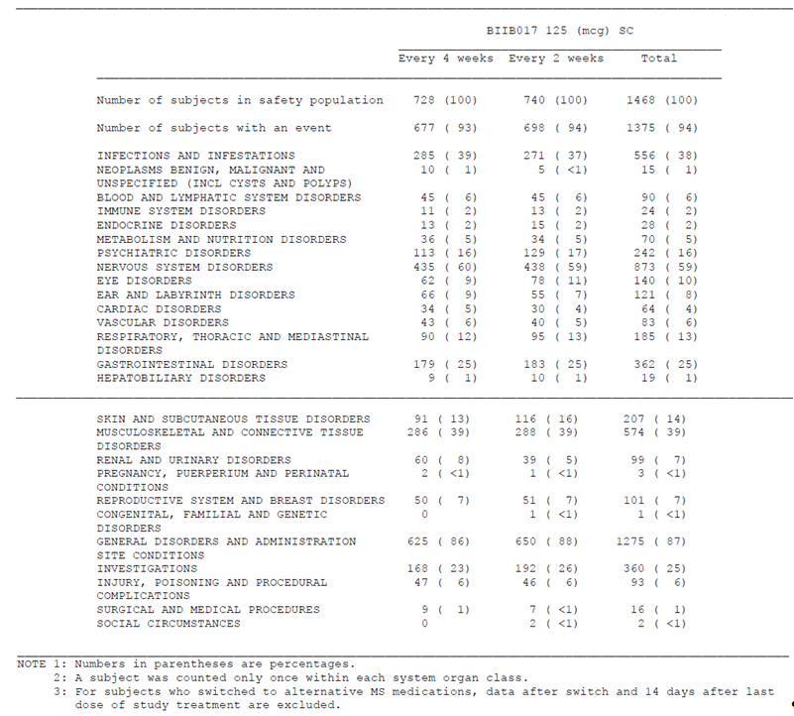
Individual AEs were listed by the sponsor in a 53-page table, which is not reproduced in this report. Instead, the shorter summary table below includes only those AEs that were reported by ≥ 5% of subjects in any dose frequency group. Most of the common AEs were those expected in the general community (such as respiratory infections, urinary infections, headaches and musculoskeletal complaints) or fell within the spectrum of interferon beta side effects already identified in the placebo-controlled dataset (such as flu-like symptoms, fatigue/asthenia and injection-site reactions). Multiple sclerosis relapses were also reported commonly, but are more appropriately considered as an efficacy measure. Depression was reported in 6% of peginterferon recipients in both groups, and elevated ALT was reported in 6% of peginterferon recipients overall (Q4W 5%, Q2W 7%).
Without a placebo control group, it was difficult to know what proportion of these complaints was attributable to active treatment, but the long-term data did not detect new or unexpected side effects.

Table 35. Adverse events by Preferred Term with an incidence of 5% or more in any treatment group. Overall BIIB017 experience
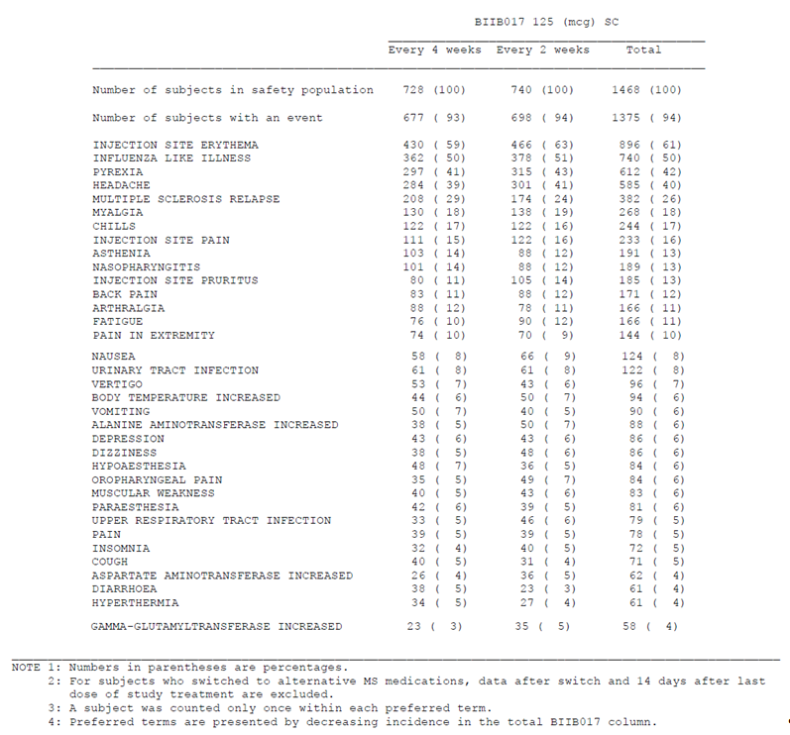

Phase 1 comparison with Avonex
AEs in the Phase 1 study program were generally within the spectrum of expected side effects of interferon beta. The tolerability of different doses of peginterferon, particularly in relation to the active control Avonex, has already been discussed in Sections Single-dose tolerability and Multi-dose tolerability. Essentially, in the Phase 1 study 105HV101 (pError! Bookmark not defined.), single doses of peginterferon 125mcg were tolerated about as well as single doses of Avonex 30mcg whereas peginterferon 188mcg appeared to produce more systemic side effects than either peginterferon 125mcg or Avonex 30mcg, particularly those within the broad spectrum of flu-like symptoms. Peginterferon at a dose of 63mcg produced less systemic side effects than Avonex, but is expected to be an inadequate dose on pharmacodynamic grounds.

Table 36. Treatment emergent adverse events by Preferred term with an incidence f 10% or more.
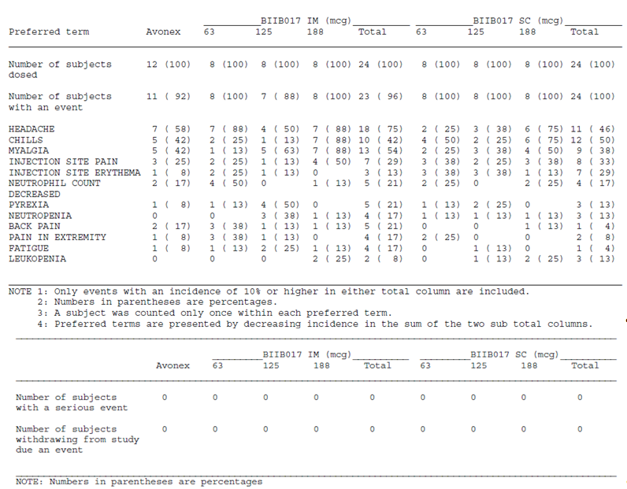

Treatment-related adverse events (adverse drug reactions)
In both of the major studies, AEs were characterised by investigators as treatment-related or unrelated. Attribution of a causal link may be difficult in individual cases, so this process does not necessarily provide an accurate indication of which events were truly caused by active treatment, but the overall incidence of treatment-related AEs was higher with peginterferon treatment than with placebo (53% placebo versus 90% in each peginterferon treatment group).
The most commonly reported AEs that were reported as related to treatment were injection-site reactions, flu-like symptoms, and headache.
A similar pattern was observed in the overall experience across both major studies.

Serious adverse events

Placebo-controlled experience
The overall side effect profile of peginterferon was dominated by tolerability issues rather than major safety concerns. This is reflected in the incidence of serious adverse events in the placebo-controlled first year of Study 301, when SAEs slightly less common with active treatment. Unfortunately, this comparison is confounded by SAEs related to “multiple sclerosis relapse” which would be more appropriately considered as an efficacy outcome. Subtracting the incidence of MS-relapse SAEs from the total incidence of SAEs in each group produces an incidence in all treatment groups that is essentially the same (~4%).
The types of SAEs observed in each group were also very similar, and raised no new safety concerns.

Table 37. Incidence of serious adverse events experienced by at least 2 subjects in any treatment group-by System organ Class and Preferred Term.
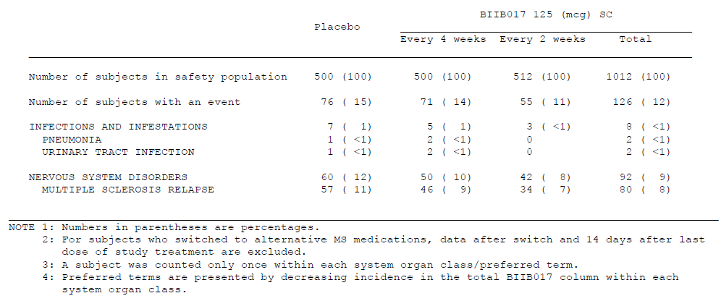

Overall experience
SAEs in the overall experience across both studies followed a similar pattern as the placebo-controlled experience, except that SAEs were more common as expected for the longer period of monitoring. The most common SAE was MS relapse, and all other SAEs occurred in <1% of subjects in each treatment group. Apart from relapses, the only individual events occurring in more than 2 subjects were urinary tract infection (7 subjects); pneumonia (4); sepsis (4) and falls (3).
SAEs related to the known side effect profile of interferon beta did not occur in more than two subjects, but elevated ALTs and convulsions, both of which are more common in interferon beta recipients, occurred as SAEs in 2 subjects each.
No new safety concerns were raised by this analysis.

Table 38. Incidence of serious adverse events by Preferred Term-Overall BIIB017 experience
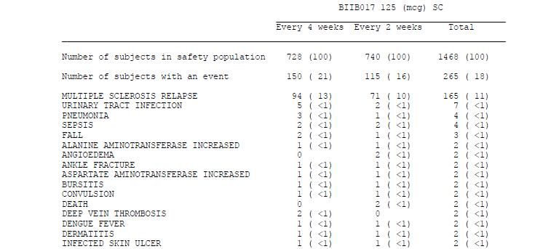

Table 38 continued. Incidence of serious adverse events by Preferred Term-Overall BIIB017 experience
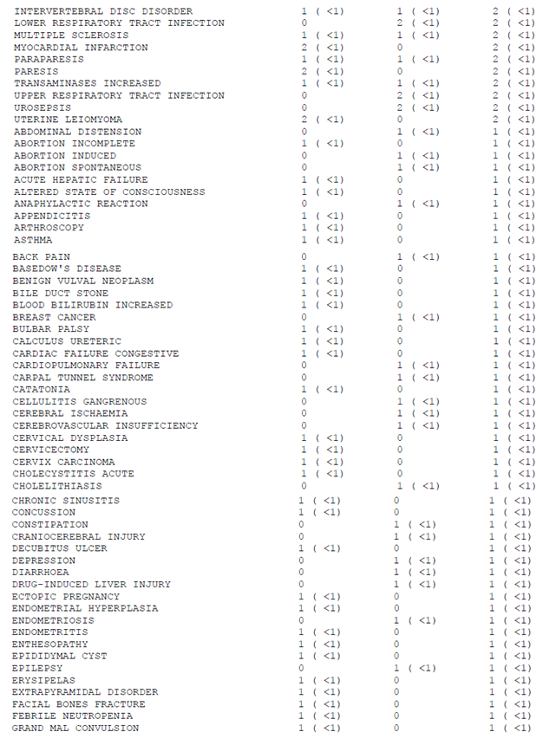

Table 38 continued. Incidence of serious adverse events by Preferred Term-Overall BIIB017 experience
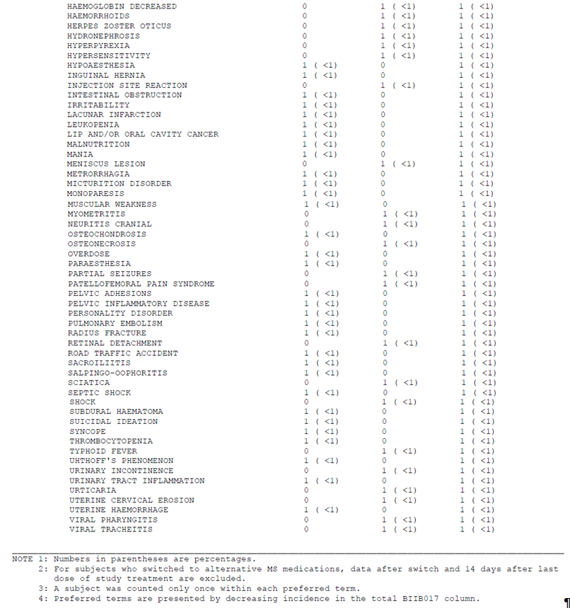

Deaths
Deaths in Study 301 are listed below. The first year provides a placebo-controlled context, which shows that deaths were uncommon in all groups, but more common in the placebo group than the active groups. No deaths have been reported in Study 302 as of the data cut-off date, and no deaths occurred in the Phase 1 studies.
A review of the individual narratives did not raise particular concerns. Two cases were designated as “related” to study treatment, but this appears to reflect a highly precautionary approach to attribution by individual investigators.

Table 39. Listing of deaths in Study 105MS301 as of 24 October 2012*
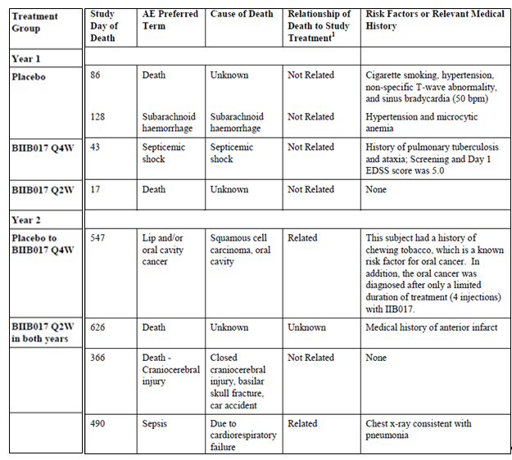
*Patient identification numbers and patient details have been removed from table.

Discontinuation due to adverse events

Placebo-controlled experience
Discontinuations due to AEs were more common with active treatment than with placebo, occurring in 5% of each active group in the first year, compared to 1% of placebo recipients. AEs causing withdrawal of at least two subjects in any group are listed below, and reflect the known side effect profile of interferon beta treatment. Suicidal ideation, which had not been a common AE in the overall distribution of AEs, caused withdrawal of 4 peginterferon recipients (two in each dose frequency group) and one placebo recipient. Depression was reported in 3 peginterferon recipients, but the extent of overlap among these cases and those with suicidal ideation is unclear. Depression and suicidal ideation are known side effects of interferon beta treatment – particularly in subjects with pre-existing depression, who may experience an exacerbation on treatment.

Table 40. Incidence of adverse events that led to discontinuation of study treatment experienced by at least 2 subjects in any treatment group-by Preferred Term-Year 1
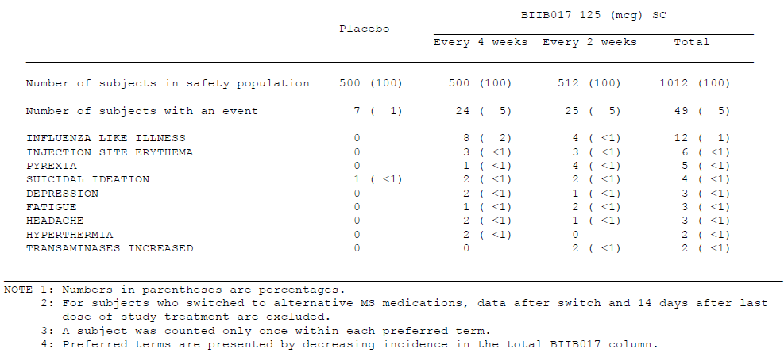

Overall experience
Discontinuations due to AEs in the overall peginterferon experience followed a similar pattern to that seen in the placebo-controlled first year, and was balanced between the two dose frequency groups (Q4W 5% vs Q2W 6%). AEs leading to treatment discontinuation in ≥4 subjects included influenza-like illness (11 and 8 subjects in the Q4W and Q2W groups, respectively), pyrexia (2 and 6), injection-site erythema (3 and 3), and ALT increased (3 and 1).

Adverse events of special interest
Several AEs are known to occur with interferon beta treatment. These were collated and considered separately from the overall AEs, pooling similar items. These AEs of special interest included: flu-like symptoms (FLS), injection site reactions (ISRs), cardiovascular disorders, hepatic disorders, autoimmune disorders, seizures, depression and suicidal ideation, and hypersensitivity reactions.
Also, because peginterferon is an immunomodulator, the incidences of infections and malignancies were carefully evaluated, though these are not generally increased with other interferon beta treatments.
The incidence of these AEs of interest in the pooled Study 301 and Study 302 experience was similar to that seen in the placebo-controlled dataset, but without a placebo control it was impossible to estimate the extent to which these symptoms were treatment related.
Each of these AEs of interest is discussed separately, below, or in the relevant parts of Section Safety issues with the potential for major regulatory impact. The overall incidence of typical interferon side effects is summarised in the table excerpt below, in comparison to those reported with other interferon beta products and glatiramer acetate. In broad terms, the incidence with peginterferon falls within the expected spectrum, and results are similar across products. One exception is injection site reactions, which are more common with peginterferon and other SC treatments than with Avonex, an IM treatment, as expected given the depth of the injection. Also, major elevations of hepatic enzymes (>5 x ULN) are less common with peginterferon and Avonex than with higher-dose regimens such as Betaferon and Rebif.

Table 41. Comparison of MS disease modifying therapies (continued)
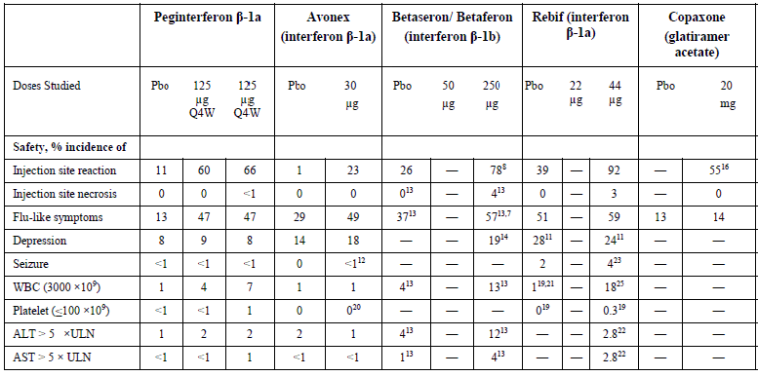
Flu-like syndrome was assessed under a narrow definition (for which “influenza like illness” was the preferred term) and a broad, inclusive definition (gathering related terms that indicated the cluster of symptoms expected in a flu-like syndrome). By the narrow definition (used in the table above), FLS occurred at a similar incidence in the two peginterferon groups (47% in each), which was considerably higher than in the placebo group (13%). When a broader definition of FLS was used, the incidence of FLS was also higher in both active treatment groups (77% and 78% in the Q4W and Q2W groups, respectively) than the placebo group (33%). Severe FLS (by the broad definition) was reported by 8% and 9% in the Q4W and Q2W groups, respectively, and 1% of subjects in the placebo group.
For the overall experience, the incidence of FLS by the narrow definition was only slightly higher than in the first year (Q4W 50% and Q2W 51%), indicating that those who were likely to experience this side effect had already encountered it in the first year.
As shown in the figure below, this symptom showed only minor abatement with continued use, in terms of prevalence.

Figure 26. Incidence of Flu-like symptoms (narrow definition) by 4 week intervals Year 1
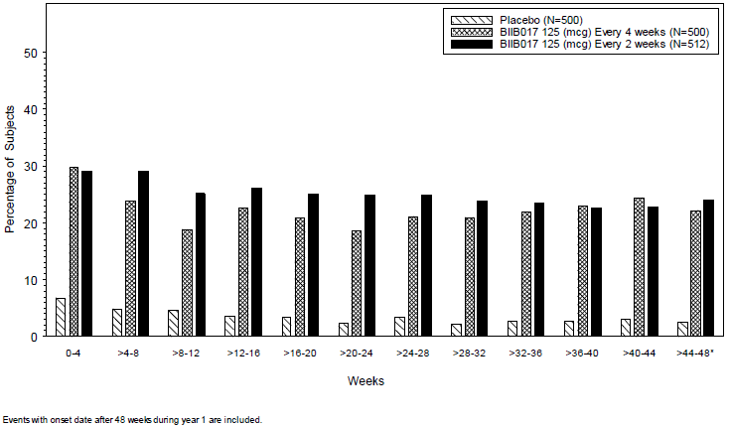
Injection-site reactions were common during the placebo-controlled experience, and showed a clear excess with active treatment (Q4W 60% and Q2W 66%) compared with the placebo group (11%). The most common AEs grouped as ISRs were injection-site erythema, injection-site pain, and injection-site pruritus. Most ISRs in the placebo-controlled experience were mild or moderate, but severe ISRs were reported by 3% of subjects in each of the active groups, compared to none in the placebo group, and one ISR in a Q2W recipient was reported as an SAE and resulted in discontinuation of study treatment.
In the overall experience, ISRs occurred with a similar incidence (62% and 68% in the Q4W and Q2W groups, respectively) as in the placebo-controlled experience, despite the longer period of monitoring, indicating that this side effect usually appears in the first year in subjects prone to ISRs. The total number of subjects with serious ISRs was 2 subjects (<1%) of 1468 MS subjects treated with peginterferon, compared with none in the placebo group. Both events resolved with medical treatment.
The incidence of ISRs showed no apparent relationship to the presence of neutralizing antibodies (NAbs), binding antibodies (BAbs), or anti-PEG antibodies. *
Infections occurred with a similar incidence across all treatment groups in the placebo-controlled phase (39% placebo versus 37% and 33% in Q4W and Q2W groups, respectively), and the incidence of serious infections was also similar across treatment groups (7 placebo subjects [1%], compared to 5 subjects [1%] and 3 subjects [<1%] in the Q4W and Q2W groups, respectively). The most common serious infections were dengue fever (in India where dengue fever is endemic), pneumonia, and urinary tract infection, and the incidence was similar between the placebo and active treatment groups.
In the overall experience, the incidence of infections was similar to the placebo-controlled experience (39% and 37% in the Q4W and Q2W groups, respectively).
A search of the reported infectious AEs found no evidence of an increased risk of opportunistic infections. Occasional infections were flagged as potentially opportunistic, but a review of the individual patient narratives generally found that the infection was endemic to the area and known to occur in non-immunocompromised subjects.
Cardiovascular events are discussed in Section Cardiovascular safety. There was no evidence of increased risk with peginterferon.
Hepatic abnormalities are discussed in Section Liver toxicity. The incidence of abnormal liver function tests is also considered in Section Liver function.
Autoimmune disorders were assessed in view of the fact that peginterferon is an immuno-modulatory agent. In the placebo-controlled experience, 4 subjects (<1%) had autoimmune disorders other than MS, but the incidence was highest with placebo (3 subjects in the placebo group and 1 subject in the Q2W group). The 3 events in the placebo group (1 of rheumatoid arthritis, and 2 of autoimmune thyroiditis) were assessed as mild; the 1 event in the peginterferon Q2W group (autoimmune thyroiditis) was assessed as moderate. No events were assessed as severe, and none were classified as SAEs. In the overall experience, 2 subjects in each dose frequency group (<1%) reported an autoimmune disorder. On the basis of this data, the incidence of autoimmune disorders does not appear to be increased by peginterferon.
Hypersensitivity reactions have been reported with protein-based biological therapies, including interferon beta. Peginterferon appears to pose a low risk of hypersensitivity reactions, similar to that seen with other interferon beta therapies. The incidence of hypersensitivity reactions is discussed further in Section Unwanted immunological events.
Malignancy did not appear to be increased above the expected rate in a population of this size. In the placebo-controlled year of treatment, 2 subjects (<1%) were identified as having malignancies: 1 case of cervical cancer in the Q4W group, and 1 case of breast cancer in the Q2W group. In the overall experience, malignancies were identified in 2 additional subjects, both in the Q4W group (basal cell carcinoma and oral cancer). No firm conclusions can be drawn about the cause of these individual cases, but there is no overall pattern to suggest that peginterferon played a role.
Seizures have been reported as occurring with increased frequency in MS patients, and there appears to be a slightly increased risk with interferon beta treatment. In the placebo-controlled dataset, there were 5 subjects (<1%) who had seizures (1 subject each in the placebo and Q4W groups, and 3 subjects in the Q2W group). All of these subjects had a prior history of seizures. In the overall experience, 9 subjects had seizures (4 in the Q4W groups and 5 in the Q2W group). This evidence is inconclusive but it seems likely that peginterferon carries a low risk of promoting seizures, similar to other interferon beta therapies.
Psychiatric disorders are common in MS patients, particularly depression, which in many cases may be a reaction to loss of health. Patients with MS are also known to have higher suicide rates. Depression and suicidal ideation have been observed at increased rate in MS subjects who are treated with interferon beta, and a history of major depression is often considered a relative contraindication to use of these agents.
Despite this, in the placebo-controlled dataset, the incidence of AEs related to depression and suicidal ideation was similar across all treatment groups including placebo (8% placebo versus 9% and 8% in the Q4W and Q2W groups, respectively). Most of these events were rated as mild or moderate; severe events were reported infrequently, but potentially showed a dose-trend: 1 subject (<1%) in the placebo group, 1 subject (<1%) in the Q4W group, and 3 subjects (<1%) in the Q2W group had a severe event. SAEs related to depression were evenly spread across the groups: 1 subject (<1%) in the placebo group (suicidal ideation), 1 subject (<1%) in the Q4W 4 weeks group (suicidal ideation), and 1 subject (<1%) in the Q2W group (depression).
In the overall experience, the incidence of depression and related AEs was 10% and 9% in the Q4W and Q2W groups, respectively.
No suicides were reported in either study.
The sponsor also performed additional safety monitoring for this group of side effects, using a previously validated assessment tool (the Beck Depression Inventory-II, or BDI-II) to detect depressive symptoms in subjects in the pivotal study. The incidence of high scores consistent (>18) with depression, suicidal tendency, and suicide attempt was similar across all 3 treatment groups in the placebo-controlled first year (31% placebo versus 28% and 27% in the Q4W and Q2W groups, respectively). The scores also remained stable over time. (Mean BDI-II scores at Week 12, 24, and 48 were 10.0, 10.1, and 10.2, respectively, in the placebo group; 10.0, 9.4, 9.6, and 9.2 in the Q4W group; and 10.3, 9.7, 9.4, and 9.4 in the Q2W group). Across both studies, the incidence of high scores on the BDI-II (score >18) was similar to the first year results (30% in each dose frequency group).
Overall, this data is reassuring, and suggests that the risk of depression and suicidality is no worse with peginterferon than with other interferon betas. In fact, there is currently no clear evidence that the risk of depression with peginterferon is worse than the risk with placebo. Based on the previous experience with other agents, however, a cautious approach is recommended and it is appropriate for the Product Information sheet to carry warnings about the risk of increased depression in susceptible subjects.

Laboratory tests

Liver function

Placebo-controlled experience
Abnormal liver function tests (LFTs) are known to be more common with interferon beta treatment, and the placebo-controlled dataset confirmed that this effect is also a feature of peginterferon treatment. A review of the mean ALT levels indicates that the overall population of peginterferon recipients showed an elevation in ALT, which became more prominent over the first 6-12 weeks of treatment, followed by a decline. The mean level stayed below the upper limit of normal, but this does not reflect the spread of values.

Figure 27. Blood chemistry parameters – Mean values (±SE) Over time-Year 1
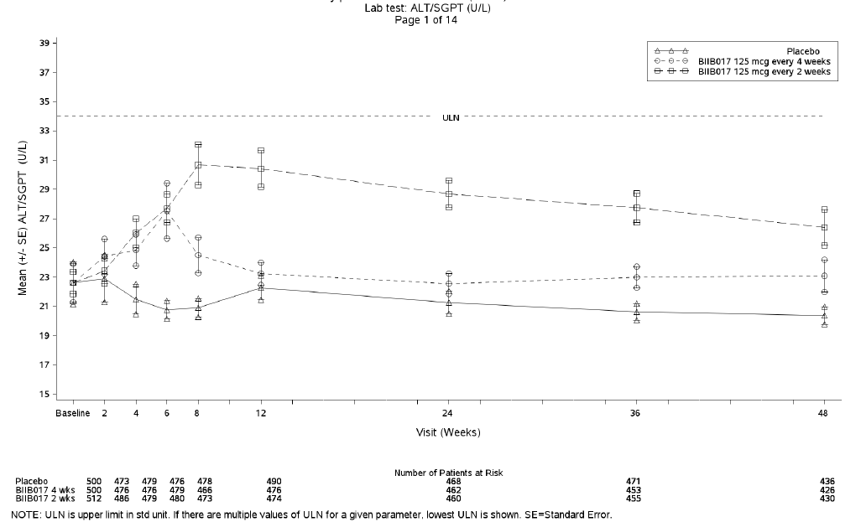
The incidence of elevated ALT (greater than the upper limit of normal, but not necessarily clinically significant) was 26% in the placebo group, compared to 35% in the Q4W group and 50% in the Q2W group. More substantial elevations of ALT and AST were also more common with active treatment, as shown in the table below.
Of the subjects with ALT or AST ≥3 ×ULN, 1 subject also had concurrent elevation of total bilirubin >2 × ULN, which is usually considered a clinically serious indicator of a potential hepatic drug reaction. This subject was admitted to hospital with hepatic failure, which was ultimately attributed to corticosteroids and recurred some months later on re-exposing the patient to steroids in the setting of an MS relapse.

Table 42. Summary of post-baseline ALT and AST values by treatment group. Year 1 Study 301
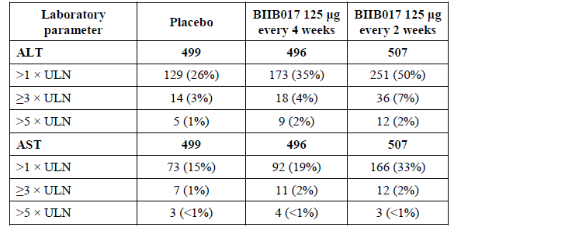

Overall experience
In the overall experience across both major studies, the incidence of abnormal LFTs increased further still, reflecting the increased period of monitoring, but the incidence of severely elevated ALT (>3 x ULN) was 6%, similar to that observed in the first year of Study 301. In addition to the case already discussed (hepatic failure attributed to corticosteroids), one new case of concurrent elevation of ALT and AST ≥3 × ULN and total bilirubin >2 × ULN occurred. This subject was receiving peginterferon in the Q2W group, and developed an SAE of asymptomatic increased ALT, AST and bilirubin which was attributed to peginterferon and resolved on stopping treatment.
The incidence of abnormal LFTS across both major studies is summarised in the table below.
The overall incidence of hepatic disorders, combining clinical AEs with abnormal LFTs, is discussed further in Section Liver toxicity. The conclusion to be drawn from this evidence is that peginterferon, like other interferon beta therapies, can cause hepatic abnormalities that in most cases are mild but can occasionally be clinically serious. These appear to resolve upon cessation of peginterferon in the cases observed so far.

Table 43. Summary of maximum post-baseline values-Liver enzymes (ALT, AST and total bilirubin)-Overall BIIB017 experience
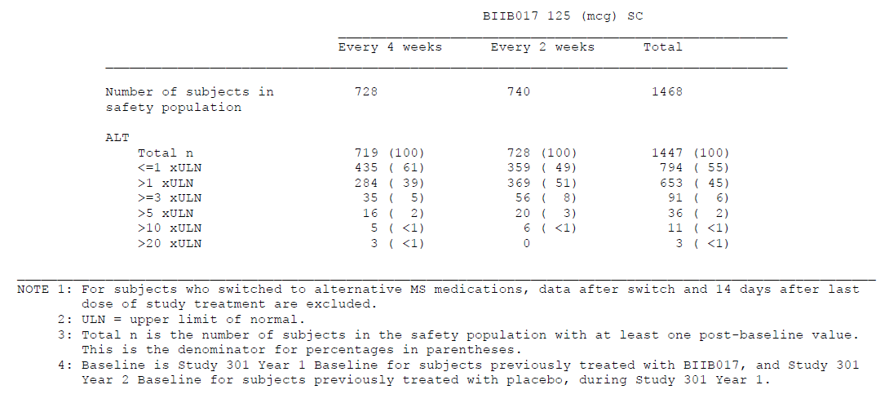

Table 43 continued. Summary of maximum post-baseline values-Liver enzymes (ALT, AST and total bilirubin)-Overall BIIB017 experience
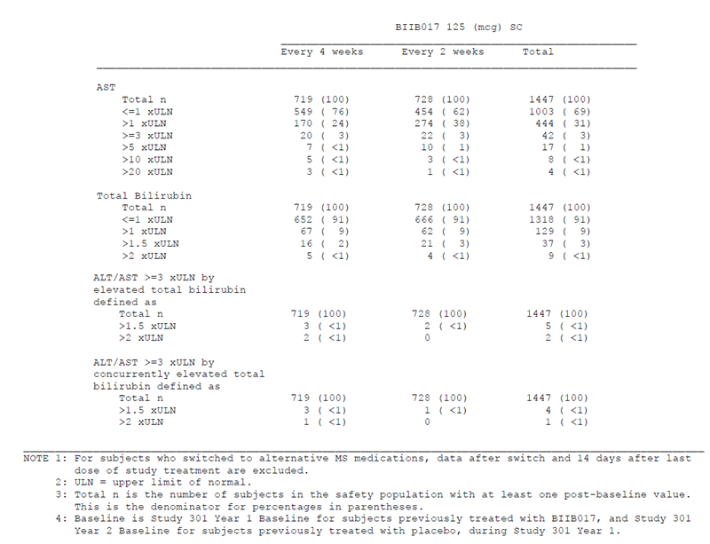

Kidney function and other clinical chemistry

Placebo-controlled experience
Experience with other interferon betas has not revealed any risk of renal toxicity or electrolyte disturbances, and monitoring in the major peginterferon studies suggests that peginterferon is similar to other interferon beta therapies in that regard.
In the placebo-controlled dataset, the proportion of subjects with shifts to abnormal values in urea or creatinine was small (≤4%), and similar for the placebo and active groups, as shown in the table below. Also, there were no SAEs or discontinuations associated with elevated urea or creatinine.

Table 44. Summary of shifts from baseline-Kidney function and other blood chemistry Year 1
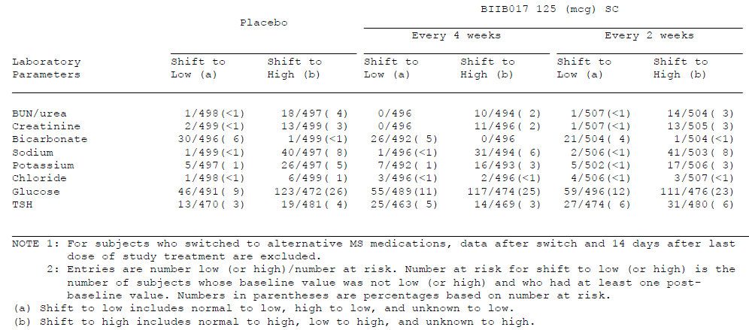
Thyroid abnormalities have been reported with interferon beta therapy, but shifts in TSH to low or high values were only slightly more common with active treatment than with placebo, as shown in the table above.

Overall experience
In the overall peginterferon experience, the incidence of shifts in biochemical parameters was slightly higher, reflecting the longer monitoring period, but there were no concerning trends.

Table 45. Summary of shifts from baseline-Kidney function and other blood chemistry-Overall BIIB017 experience-Data after subjects switched to alternative MS medication are included
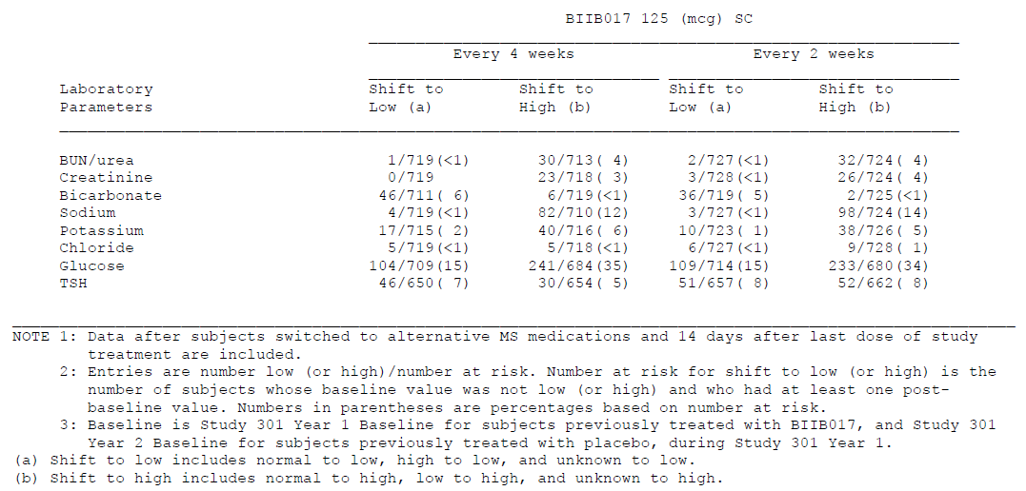

Haematology

Placebo-controlled experience
Interferon therapy has been associated with asymptomatic declines in cell counts, and the data suggests that this also occurs with peginterferon. Changes from baseline in mean white blood cell (WBC) counts were observed over the 48 weeks treatment, with an apparent dose trend suggesting greater decreases in the Q2W group, as shown in the figure below. At Week 48, the mean WBC values were 6.967 × 10⁹ cells/L in the placebo group, 6.322 × 10⁹ cells/L in the Q4W group and 5.874 × 10⁹ cells/L in the Q2W group; this is equivalent to a mean percentage decrease from baseline of ~3% in the Q4W group and ~ 10% in the Q2W group, compared with the placebo group. Similar changes were observed in the mean lymphocyte and neutrophil counts.
Figure 28. Haematology parameters-Mean values (±SE) Over time-Year 1
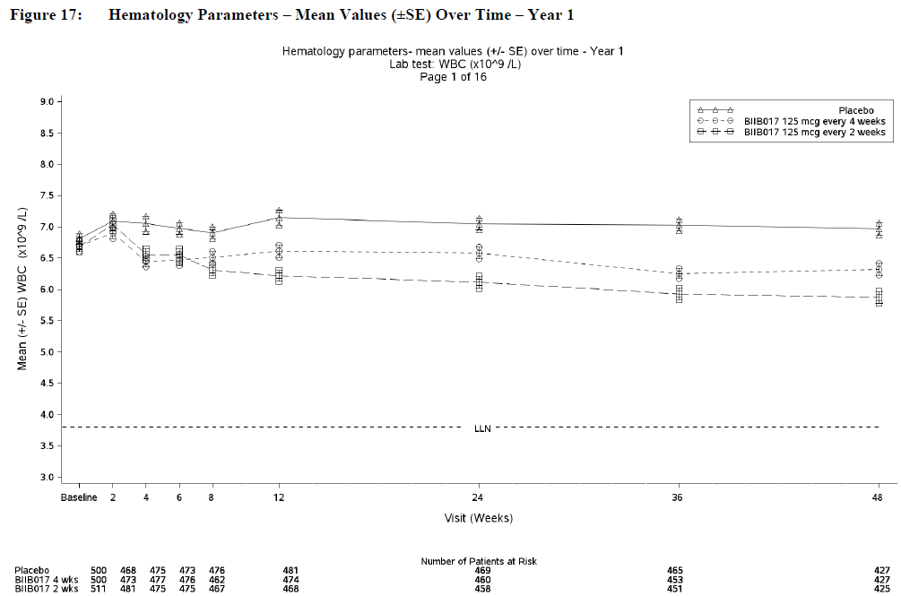
The tables below summarise the incidence of abnormal haematology results, or shifts from normal to abnormal. The first table only deals with extremely low counts, and patient numbers are therefore low, whereas the subsequent table looks at a broader range of abnormalities including elevations in counts, and the numbers affected are therefore higher. The most marked difference between the active and placebo groups is in the incidence of WBC counts <3x10⁹/L, which were seen in 1% of placebo recipients, compared to 4% and 7% in the Q4W and Q2W groups, respectively. Lymphocyte and neutrophil counts both tended to be lower in the active groups, but lymphocyte counts <0.5 x10⁹/L and neutrophil counts <1 x10⁹/L were uncommon (<1%). Red cell parameters did not show a substantial change with treatment or difference between groups, but there were small dose-related decreases from baseline in mean in RBC count, haemoglobin, haematocrit, and platelets for peginterferon-treated subjects between Weeks 2 and 48, compared with placebo, and a slight excess of shifts to low for red cell and platelet indices, as shown in the tables below.
There were no SAEs and no AEs leading to discontinuation associated with abnormal RBC counts during Study 301, and no AEs leading to discontinuation or study withdrawal associated with low haemoglobin. One SAE of low haemoglobin was reported, but considered unrelated to peginterferon treatment; this subject had a prior history of iron deficiency anaemia.
There was one SAE of severe thrombocytopenia and one AE of thrombocytopenia that led to the discontinuation of peginterferon. The SAE was characterised by a platelet count of 8 x 10⁹/L, which was treated with a platelet transfusion and recovered without sequelae after peginterferon ws ceased, but which was considered related to treatment.

Table 46. Summary of potentially clinically significant laboratory abnormalities in WBC, platelets and TBC during Year 1
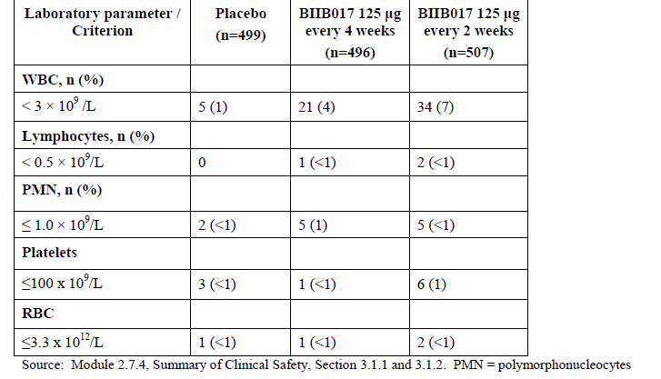

Table 47. Potentially clinically significant hematology laboratory abnormalities Year 1
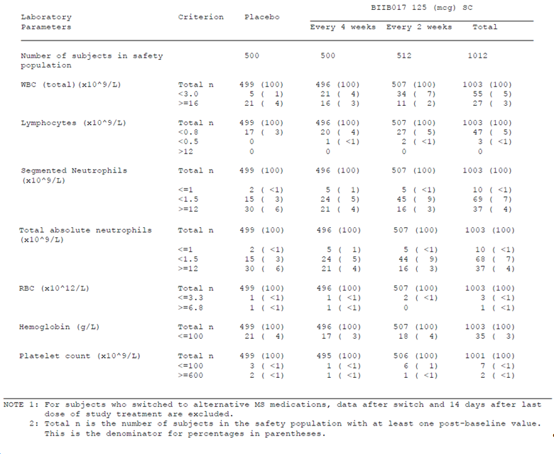

Table 48. Summary of shifts from baseline Hematology Year 1
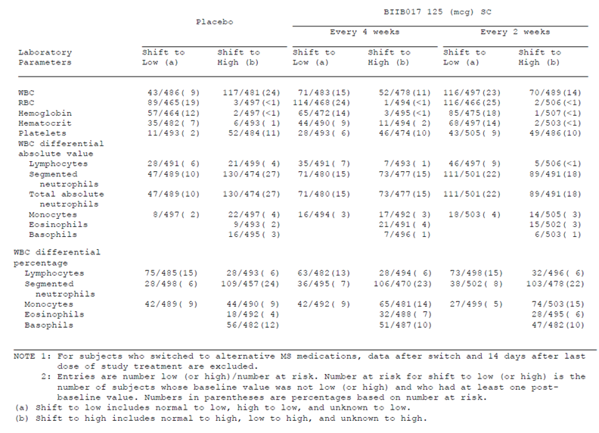

Overall experience
Haematology monitoring in the overall pooled dataset showed similar changes as had been observed in the placebo-controlled first year. At Week 108, mean decreases in WBC counts were approximately 5% and 9%, in the Q4W and Q2W groups, respectively. After that subject numbers were too low for meaningful analysis.
Potentially clinically significant abnormalities and shifts in haematology parameters are listed in the tables below. These broadly follow the pattern observed in the placebo-controlled dataset, with a tendency for WBC, lymphocyte and neutrophil counts to shift to lower values.

Table 48. Potentially clinically significant hematology laboratory abnormalities-Overall BIIB017 experience
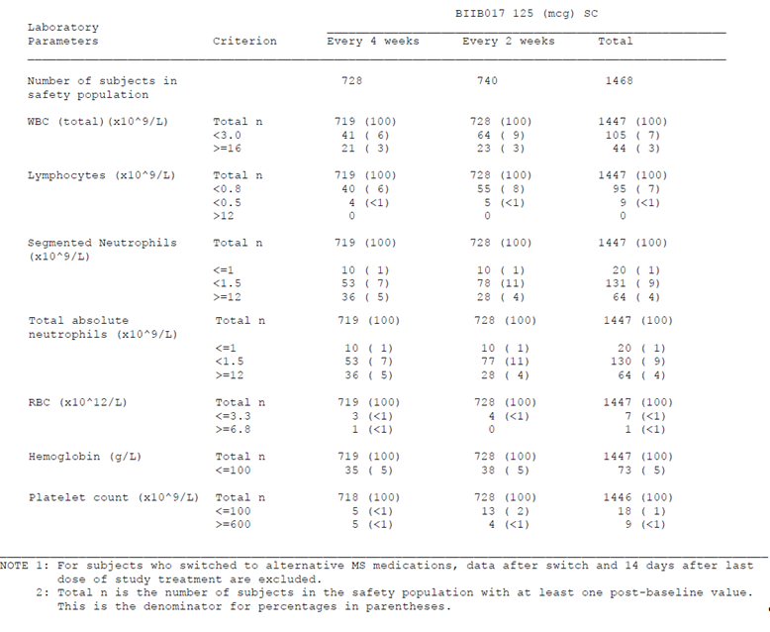

Table 49. Summary of shifts from baseline-Hematology-Overall BIIB017 experience
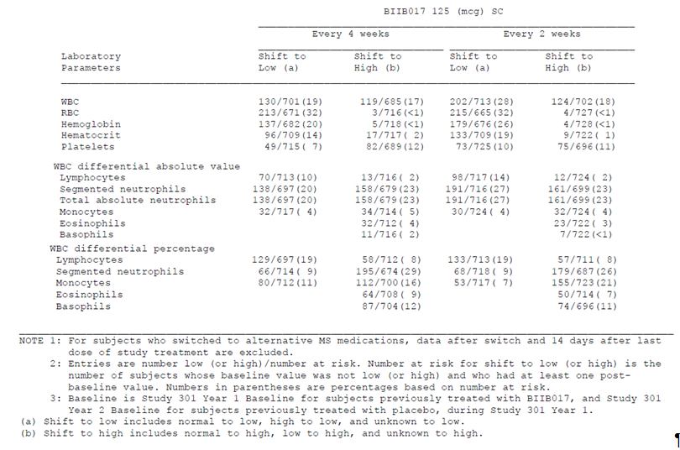

Immunogenicity
Most interferon beta therapies are associated with the development of anti-interferon antibodies in some subjects, the clinical significance of which is often debated. Antibodies are usually subdivided into binding antibodies (BAbs), which bind the interferon protein without necessarily interfering with its biological function, and neutralising antibodies (NAbs), which bind to functionally important sites and neutralise the function of interferon as assessed with in vitro functional assays. There is already some evidence in the literature that, for non-pegylated interferon therapies, both side effects and efficacy may be reduced by neutralising antibodies (Kappos et al, 2005)*. Pegylated therapies may also induce anti-PEG antibodies directed against the PEG moiety, and even at baseline some individuals have pre-existing anti-PEG antibodies that appear to have been induced by environmental or dietary antigens; PEG is a common additive in food products and in many over-the-counter medicines. In Study 301, baseline positivity for anti-PEG antibodies ranged from 8% (39/500) in the placebo group to 5% (52/1012) in the combined peginterferon groups.
Although the development of NAbs is an unwanted side effect, and hence considered here as a safety issue, the primary concern with NAbs is that they might compromise efficacy by blocking the biological effect of the injected treatment. The efficacy implications of NAbs were discussed in Section Effects of antibodies to peginterferon; the data is inconclusive because of the rarity of persistent NAbs but there is currently no strong evidence that peginterferon efficacy is compromised in subjects with NAbs. With regards to safety, there was no evidence that any antibodies to interferon (NAbs, BAbs or anti-PEG Abs) increased the risk of adverse events, including hypersensitivity reactions. The incidence of AEs in subjects with positive anti-interferon antibodies (including transiently positive Abs) was 86% (18 of 21 subjects), 96% (25 of 26 subjects) and 83% (44 of 53) subjects in the placebo, Q4W and Q2W groups, respectively. This incidence is similar to that seen in the overall cohort. Similarly, in the individual categories of BAbs, NAbs and anti-PEG Abs, the incidence of AEs was broadly consistent with the overall experience. The incidence of AEs in subjects ever positive for BAbs was 21 subjects (84%), 27 subjects (96%), and 45 subjects (83%) in the placebo, Q4W and Q2W groups, respectively. The incidence of AEs in those ever positive for NAbs was 4 subjects (57%), 4 subjects (100%), and 8 subjects (67%) in the placebo, Q4W and Q2W groups, respectively, with comparison rendered difficult by the low numbers affected. The incidence of AEs in subjects with ever positive anti-PEG antibodies was 43 subjects (68%), 68 subjects (97%), and 53 subjects (95%) in the placebo, Q4W and Q2W groups, respectively.
This is generally reassuring. Furthermore, the immunogenicity of peginterferon appears low compared to other commercially available interferon beta therapies (peginterferon ~1%; Avonex 5%; Betaferon 45%; Rebif 24%), so peginterferon does not seem to pose new risks related to immunogenicity.
The tables below summarise the incidence of antibodies in each of these three categories, NAbs, BAbs, and anti-PEG Abs. The incidence of NAbs was low, with only 1 subject of 979 showing persistent NAbs during the placebo-controlled first year of treatment, and 5 subjects of 1360 showing persistent NAbs in the pooled experience. BAbs and anti-PEG Abs were more common, but are not known to have significant clinical consequences.

Placebo-controlled experience

Table 50. Incidence of positive antibody tests by subgroups Category Year 1
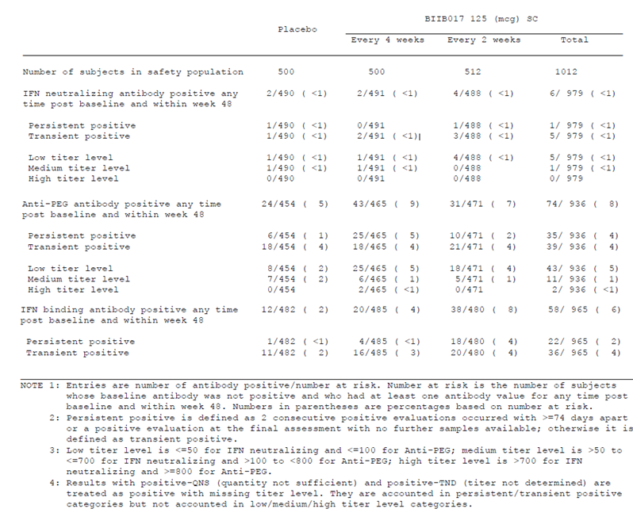

Overall experience

Table 51. Incidence of positive antibody test by sub-category-Overall BIIB017 experience
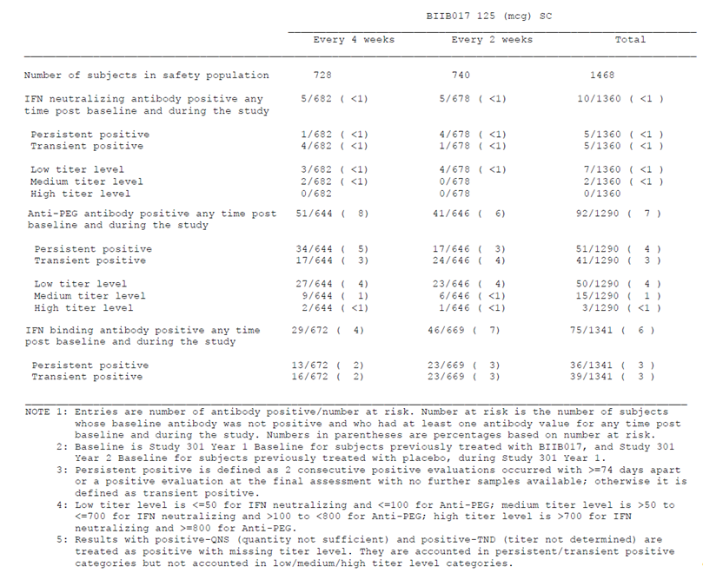

Urinalysis
As shown in the tables below, shifts in urinalysis parameters were reasonably common in all treatment groups, including the placebo group, and there was no excess of shifts in the active groups. Interferon beta therapies are not known to affect urinalysis parameters, and this data suggests that peginterferon does not pose any significant risks that might be detected on urinalysis.

Placebo-controlled experience

Table 52. Summary of shifts from baseline-Urinalysis Year 1
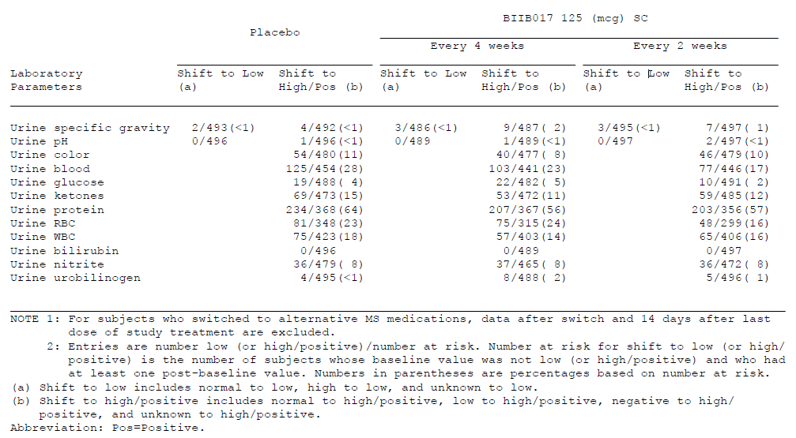

Overall experience

Table 53. Summary of shifts from baseline-Urinalysis -Overall BIB017 experience
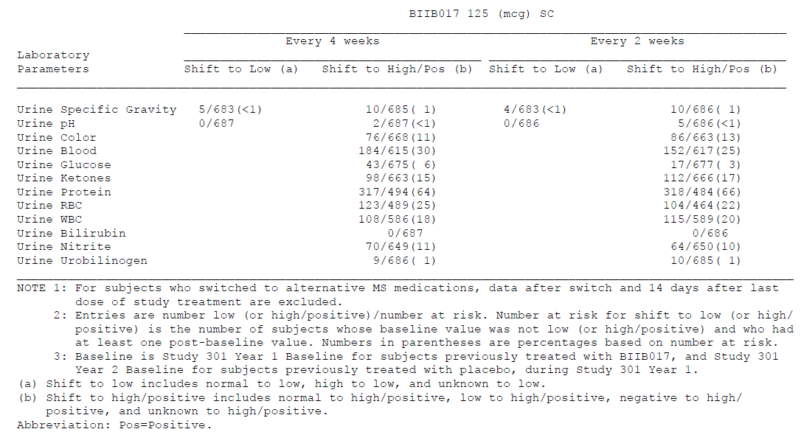

Electrocardiograph
Abnormal electrocardiographs (ECGs) were reasonably common in the study population, including the placebo group, but there was no excess of shifts to abnormal seen in the active groups. With the longer follow-up provided in the overall pooled analysis of Studies 301 and 302, the incidence of abnormal ECGs increased only slightly, and remained similar in the two dose frequency groups.

Placebo-controlled experience

Table 54. Summary of shifts in ECG results Year 1
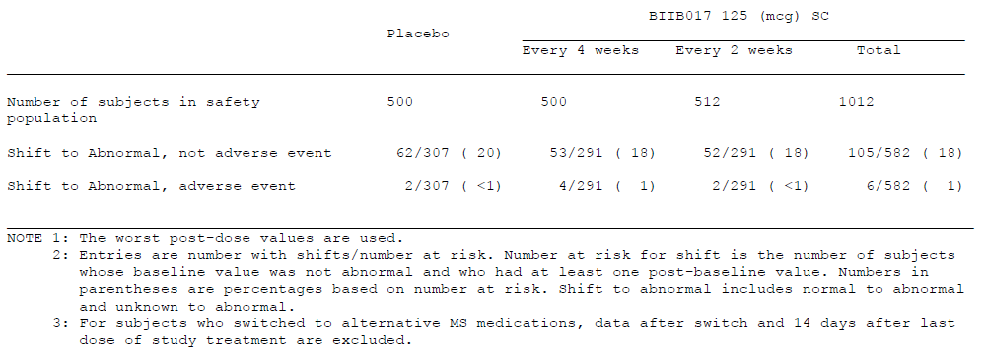

Overall experience

Table 55. Summary of shifts in ECG results-Overall BIIB017 experience
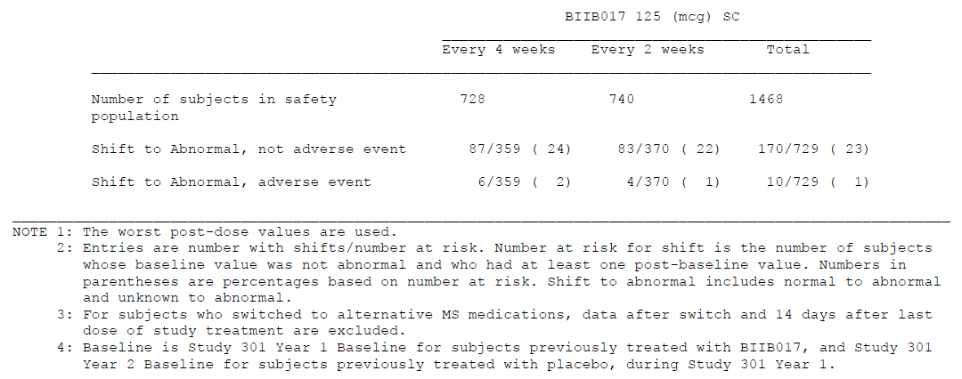

Vital signs
There was no evidence that peginterferon has an effect on vital signs. In the placebo-controlled experience, mean values for blood pressure, pulse rate and temperature remained within normal ranges throughout the study, with no important differences between the placebo and active treatment groups. At Week 48, the mean systolic/diastolic blood pressure was 118.9/75.8 mmHg in the placebo group versus 118.9/75.8 and 119.1/76.2 mmHg in the Q4W and Q2W groups, respectively. The mean pulse rate was 74.0 bpm in the placebo group versus 74.2 and 73.8 bpm in the Q4W and Q2W groups, respectively. The mean body temperature was 36.51°C in the placebo group versus 36.54°C and 36.48°C in the Q4W and Q2W groups, respectively. Similarly, no differences emerged between the dose frequency groups in the overall pooled experience.

Post-marketing experience
At the time of submission, peginterferon is an investigational product that has not been marketed in any countries, so there is no post-marketing experience with the pegylated form of interferon beta-1a.
On the other hand, there is extensive experience with non-pegylated forms of interferon beta. The known side effect profile of interferon beta includes flu-like symptoms, injection site reactions, mood changes, abnormalities of liver function, and reductions in white blood cell counts, all of which are considered in Section Adverse events of special interest. Overall, peginterferon appears to have a safety and tolerability profile that is consistent with the profile expected from the pivotal studies and post-marketing experience of other interferon beta therapies.

Safety issues with the potential for major regulatory impact

Liver toxicity
Hepatic abnormalities are known to be increased by interferon beta treatment. In the placebo-controlled experience, the incidence of hepatic disorders was low, but increased in the active groups (2 subjects in the placebo group and 4 subjects in each of the peginterferon groups), as indicated below. The incidence of abnormal liver function tests was considered in Section 7.4.1 (p96).

Table 56. Incidence of hepatic disorders by System organ Class and Preferred Term Year 1
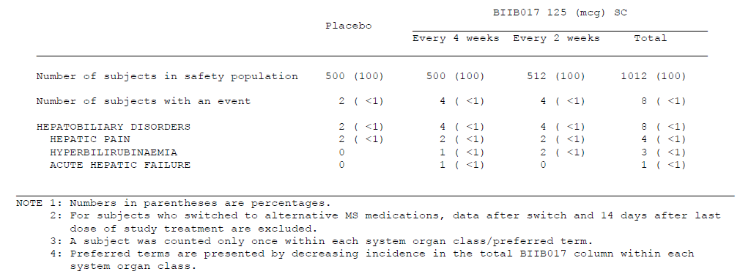
In the overall experience, the incidence of hepatic disorders was higher, consistent with the increased duration of monitoring. The incidence was similar between the two dose frequency groups (5 and 6 subjects [<1%] in the Q4W and Q2W groups, respectively). Hepatic pain was the most common disorder (2 and 3 subjects in Q4W and Q2W groups, respectively).
A list of all hepatic AEs leading to discontinuation in Study 301 is tabulated below; there were no discontinuations due to hepatic AEs in Study 302.
The most significant hepatic event was an episode of acute hepatic failure thought not to be related to study treatment. The subject developed liver failure in the setting of corticosteroid treatment, recovered, and then months later had another episode when corticosteroids were used to treat another MS relapse. An independent liver specialist assessed the liver failure as being due to the corticosteroids.

Table 57. List of adverse events that led to discontinuation of study treatment or study withdrawal associated with hepatic disorders and elevated liver enzymes.
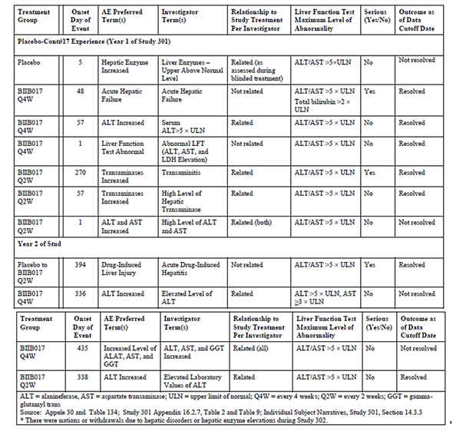
*Patient identification numbers have been removed from table.
The draft PI contains the following warning, which fairly summarises this data:
“Hepatic injury, including elevated serum hepatic transaminase levels, hepatitis, and autoimmune hepatitis, and rare cases of severe hepatic failure, has been reported with interferon beta. Elevations in hepatic enzymes and hepatic injury have been observed with the use of PLEGRIDY. Patients should be monitored for signs of hepatic injury.”

Haematological toxicity
As discussed in Section Haematology, peginterferon treatment was associated with a decline in mean white blood cell counts across the active groups, and an increased incidence of shifts to low WBC, lymphocyte and neutrophil counts. There were also minor declines in mean red blood cell counts and platelet counts. Abnormal counts did not usually lead to withdrawal (white cells, no withdrawals; red cells, no withdrawals; platelets, n=2). All subjects recovered without sequelae.
The incidence of haematological abnormalities was low, and there is no evidence of permanent bone marrow suppression in the safety experience so far, but caution is advised when administering peginterferon. Routine haematological monitoring at baseline and after commencing the drug could be useful to detect abnormal counts, and the drug should be used with particular caution in those with a history of abnormal counts.
The proposed PI contains the following warning, which is appropriate:
“Decreased peripheral blood counts in all cell lines, including rare pancytopenia and severe thrombocytopenia, have been reported in patients receiving interferon beta. Cytopenias, including rare severe neutropenia and thrombocytopenia, have been observed in patients treated with PLEGRIDY. Patients should be monitored for symptoms or signs of decreased peripheral blood counts.”

Serious skin reactions
Not counting injection-site reactions, which have already been considered, dermatological reactions to peginterferon were uncommon. AEs in the body system “skin and subcutaneous tissue disorders” occurred in 9% of the placebo group and 15% of the Q2W group, with pruritus as the only individual AE that was at least 2% more common with Q2W treatment (4%) than with placebo (1%).
Rash was reported in 6 subjects (1%) in the Q2W group of the placebo-controlled dataset, but was not rated as severe in any subject. Erythema was reported in 8 subjects (2%), and was again not rated as severe in any subject. All other dermatological AEs occurred in <1% of the Q2W group. Results in the Q4W group were similar (pruritus 2%, rash 1%, erythema <1%).
Amongst SAEs in the overall experience of peginterferon, rash did not appear as a preferred term, but two subjects in the Q2W group had angioedema.
Overall, peginterferon appears to be associated with a relatively low incidence of serious skin reactions.

Cardiovascular safety
Cardiovascular events were assessed by the sponsor as an AE of special interest, because of isolated reports of a potential link with interferon beta therapy. Generally, interferon beta is not considered to pose a significant cardiovascular risk. In the placebo-controlled experience, the incidence of cardiovascular AEs was similar between the active and placebo groups (7% placebo versus 9% Q4W and 7% Q2W). Individual cardiovascular AEs reported by ≥2 subjects included syncope, loss of consciousness, tachycardia, palpitations, angina pectoris, sinus bradycardia, right bundle branch block, arrhythmia, chest pain, abnormal ECGs. Most the cardiovascular AEs were assessed as mild or moderate; the only severe AE (one subject with chest pain) was reported in the placebo group.
In the overall experience, the incidence of cardiovascular AEs was similar between dose frequency groups (10% and 9% in the Q4W and Q2W groups, respectively).

Unwanted immunological events
Hypersensitivity reactions have been reported with protein-based biological therapies, including interferon beta. Peginterferon appears to pose a low risk of hypersensitivity reactions, similar to that seen with other interferon beta therapies.
In the placebo-controlled dataset, the incidence of hypersensitivity events was similar between treatment groups (14%, 13% and 16% in the placebo, Q4W and Q2W groups, respectively). The most common AEs potentially linked to hypersensitivity were cough (6%, 5% and 4% in the placebo, Q4W and Q2W groups, respectively), and pruritus (1%, 2% and 4% in the placebo, Q4W and Q2W groups, respectively).
Most hypersensitivity AEs were rated as mild or moderate; severe AEs were reported in 2 subjects in the placebo group (<1%), 3 in the Q4W group (<1%), and 4 subjects in the Q2W group (<1%).
In the placebo-controlled dataset, there were 3 hypersensitivity SAEs in the active groups, and none in the placebo group. One SAE (asthma) was reported in 1 subject in the Q4W group, and 2 SAEs (anaphylactic reaction and hypersensitivity) were reported in the Q2W group. None of these events was considered related to treatment, and none were associated with the presence of antibodies to the interferon or the mPEG moiety of peginterferon. Two of these events had alternative potential causes: the asthma case occurred in a patient with pre-existing asthma who did not develop asthma following a subsequent rechallenge with peginterferon; the anaphylactic reaction appeared to be secondary to MRI contrast in a patient with known allergy to MRI contrast agents). In the third case, the event was entered as an SAE of “hypersensitivity” but was not diagnosed as an allergic reaction by the dermatologists who evaluated the patient; furthermore, it resolved with continued peginterferon treatment.
In the overall experience, there were 4 additional SAEs in the hypersensitivity category (shock, angioedema, angioneurotic edema, and urticaria). The case of shock appeared to be related to sepsis, and not to study treatment, but the 3 other cases appeared to be related to peginterferon. All resolved with standard medical treatment.
The incidence of hypersensitivity reactions did not appear to be increased in subjects with antibodies. The number of subjects with hypersensitivity events was 18% and 22% in the Q4W and Q2W groups, respectively, amongst those with positive BAbs at any time-point, compared to 14% and 16%, respectively, in subjects that never had BAbs.
Overall, the incidence of hypersensitivity reactions with peginterferon appears to be low, and hypersensitivity events observed so far have all resolved without serious sequelae. As a protein-based agent, peginterferon should be used with the usual caution.

Other safety issues

Safety in special populations
There was no evidence that the AE profile varied according to demographic characteristics. An important limitation of the safety database was that it did not include paediatric subjects or elderly subjects. Peginterferon is not currently being proposed for use in paediatric settings, where MS is rare. It should be used with caution in older subjects.
Given the side effect profile that peginterferon appears to share with other interferon beta therapies, particular care should be used in subjects at heightened risk for those side effects. Peginterferon should be used with caution, or not at all, in subjects with a history of mood disorders, abnormal liver function, and low white cell counts.
Given that interferon therapy has also been associated with an increased risk of seizures, spasm and fatigue in MS subjects, patients with high levels of those symptoms at baseline should be warned that such symptoms might increase further with peginterferon treatment, and other disease-modifying agents might be more suitable.

Safety related to drug-drug interactions and other interactions
The incidence of AEs did not show any apparent relationship to concomitant drug use, except that the AE of MS relapse was much more common in subjects who used intravenous steroids than in subjects who did not use steroids; this is expected given that the steroids were used to treat the MS relapse in nearly every case.
The incidence of AEs did not appear to be affected by prior MS therapies, but the number of patients who had received previous disease-modifying therapy was too low to draw any definitive conclusions.

Safety and tolerability according to dose frequency
The Phase 1 study program provided evidence that the single-dose tolerability of peginterferon 125mcg IM or SC was intermediate between the tolerability of 63mcg and 188mcg, and similar to the tolerability of the standard dose of Avonex 30mcg (see Section 5.4, p37). In Phase 3 studies, 125mcg was the only dose assessed, so the long-term safety of other doses is unclear. The two Phase 3 studies do allow comparison of two different dose frequencies, however, 125mcg Q2W and Q4W. Pharmacodynamic considerations suggest that the biological effects of the Q4W dose should be less than the Q2W dose, and the efficacy data shows that Q4W is less effective in the treatment of MS.
It might be expected, then, that tolerability of this dose could be better than with Q2W, but this is not readily apparent in the data. The figure below shows the risk differences (and 95% CI) per 1000 patients treated for one year. In most cases, the differences were slight and the 95%CI extended similarly across both sides of the no-difference line. Decreased white cell counts were the exception, where a strong trend was demonstrated for less risk with infrequent dosing.
An obvious consideration not captured by this analysis, but likely to be important to patients, is that many symptoms, including injection-site reactions and flu-like symptoms, are related to the time of the injection, being most prominent in the 1-2 days post-dose. Thus, Q4W dosing might be just as likely to produce flu-like symptoms after each dose as Q2W dosing, but this would happen only once per four-week cycle, instead of twice as expected with the proposed Q2W dose. (Conversely, weekly dosing with 125mcg might be expected to produce more bouts of flu-like symptoms per month that the proposed dose. The increased frequency of dose-related side effects could offset some of the hypothesised benefits of this untested regimen.)
Figure 29. Overall assessment (Risk differences and 95%CI per 1000 patients treated for 1 Year) comparison of BIIB017 125 µg every 2 weeks versus BIIB017 125 µg every 4 weeks
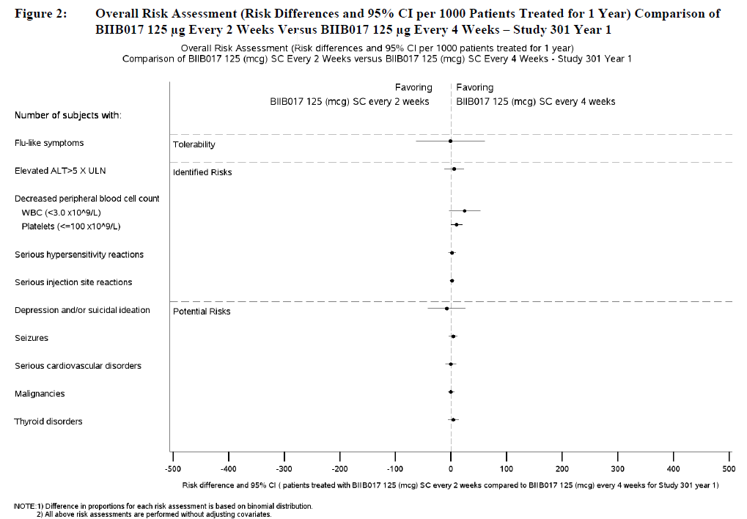

Evaluator’s overall conclusions on clinical safety
The safety of peginterferon has been adequately studied in the Phase 3 program, with an overall exposure of 1932 patient-years in 1468 patients.
The evidence suggests that the safety and tolerability of peginterferon is similar to other interferon beta products. Most of the adverse events observed in the safety database relate to tolerability, rather than to severe health risks. The main tolerability issues are flu-like symptoms and injection-site reactions. Another issue is a tendency for peginterferon recipients to have asymptomatic abnormalities on blood tests, including reduced white cell counts and elevated liver enzymes.
More serious toxicity was rare, but isolated case of severe injection site reactions, hypersenstitivity reactions, or haematological disturbances were observed, including one case of severe thrombocytopaenia and one of severe neutropaenia, both of which resolved on cessation of treatment. The incidence of serious hypersensitivity events was <1%, and all serious hypersensitivity reactions resolved with discontinuation of peginterferon and standard medical treatment; none were associated with hypotension. A single case of anaphylaxis was likely to be due to an allergy to MRI contrast. Reduced white cell counts were not associated with an increased risk of infection. Combined elevations of ALT and AST >3 × ULN and total bilirubin >2 × ULN were very uncommon, and were reported in only 2 of 1468 peginterferon -treated subjects – one of these case was more likely to be attributable to steroids, and the other was asymptomatic and resolved on discontinuation of peginterferon.
Treatment with peginterferon was not associated with an increased incidence of cardiovascular events, depression and suicidal ideation, malignancy, infections, seizures, or autoimmune disorders compared with placebo. Based on previous experience with interferon beta, however, it is expected that more extensive use of peginterferon might eventually reveal an increased risk of depression, seizures, spasms and fatigue.
Most side effects were equally prevalent with the Q2W and Q4W regimen, but injection-related symptoms would clearly occur less frequently with less frequent injections. There was a trend suggesting that white cell counts were less likely to be depressed by the Q4W regimen.
Peginterferon had low immunogenicity, and the incidence of hypersensitivity reactions and other AEs was not affected by the presence of antibodies (NAbs, BAbs or anti-PEG Abs).
In conclusion, the safety and tolerability of peginterferon is acceptable, and similar to other agents in its class. Furthermore, the description of adverse effects in the draft PI appears to be consistent with the submitted data.

First round benefit-risk assessment

First round assessment of benefits
The benefits of peginterferon in the proposed usage are:
- a reduction in annualised relapse rate of 35.6% (p=0.0007);
- a reduction in the proportion relapsed after one year of 39% (p=0.0003);
- a reduction in sustained disability progression of 38% (p=0.0383).;
- a reduction in new or newly enlarged T2 lesions of 67% (p<0.0001);
- a reduction in Gd-enhancing lesions of 86% (p<0.0001);
- a reduction in new T1 hypointensities of 53% (p<0.0001).
This represents similar efficacy to that provided by existing interferon beta treatments, but with the advantage of only needing 2 injections per four week cycle, compared to 4 with Avonex, 12 with Rebif, or 14 with Betaferon.

First round assessment of risks
The main risks of peginterferon in the proposed usage are:
- flu-like symptoms
- injection-site reactions
- elevated liver enzymes
- reduced white cell counts
A more complete discussion of safety issues can be found in Section Evaluator’s overall conclusions on clinical safety.
Overall, these risks are comparable to those that subjects would face with competing interferon beta products, so that there is no definite increase in risk when using peginterferon in place of another agent from its class.

First round assessment of benefit-risk balance
The benefit-risk balance of peginterferon, given the proposed usage, is favourable, and appears to be similar to other agents in its class. Compared to other interferon beta preparations, peginterferon offers the potential advantage of less frequent injections for broadly similar overall benefit, though it is not possible to compare agents in the absence of head-to-head studies.
The sponsor has not adequately confirmed that the proposed regimen is the optimal regimen, and it seems at least possible that weekly treatment with the same dose would offer a more favourable benefit-risk balance – that it would be more effective than two-weekly treatment, with no major change in safety. Firstly, the submitted pharmacodynamic studies suggest that the biological effects of peginterferon wane after about 10 days, leaving a gap of about 4 days prior to the next dose in which the patient does not experience any effective immunomodulation. Secondly, the sponsor did not perform any Phase 2 dose-finding studies that could have explored the efficacy of more frequent dosing, so the efficacy of a weekly regimen is completely untested. Thirdly, the literature on non-pegylated interferon beta suggests that more frequent dosing is generally more effective – that pulsatile regimens, which allow biomarkers to fall between doses, are less effective than more frequent regimens, which maintain elevation of biomarkers. Thus, it is expected that peginterferon Q2W would be less effective than other interferon betas with more frequent dosing.

First round recommendation regarding authorisation
Recommendations regarding authorisation depend on policy considerations. If it is considered that the sponsor’s obligation is merely to demonstrate that peginterferon has acceptable safety and is more effective than placebo, then the submitted evidence is sufficient to support the application. If the sponsor is considered to have an obligation to find the most effective regimen, with the best trade-off between efficacy and tolerability, it appears that they have not fully discharged that obligation.
In general, marketing applications to the TGA are approved if the proposed regimen is safe and more effective than placebo. On this basis, approval is recommended in this report, but it would also be reasonable to reject the Sponsor’s application until the efficacy of peginterferon 125mcg weekly has been assessed.
Peginterferon should be authorised for use at a dose of 125mcg two-weekly, for the prevention of relapses in subjects with relapsing and remitting multiple sclerosis.
The sponsor should be encouraged to explore the efficacy and safety of more frequent dosing regimens.

Clinical questions

Pharmacokinetics
No questions.

Pharmacodynamics
Most PD studies assessed biomarkers only sparsely between 7 and 14 days post-dose. As a result, the proportion of subjects with clinically meaningful elevation of biomarkers in the last few days of the proposed two-week dose cycle is unclear.
This raises four closely related questions:
- What levels of neopterin are consistent with a clinically meaningful response to immunomodulation with interferon beta?
- What levels of neopterin are associated with the optimal clinical response to immunomodulation with interferon beta?
- With the proposed dosing regimen, what proportion of subjects have clinically meaningful elevations of neopterin throughout the proposed two-week cycle?
- With the proposed dosing regimen, what proportion of subjects have optimal elevations of neopterin throughout the proposed two-week cycle?

Efficacy
- Why was no attempt made to assess the efficacy of peginterferon 125mcg once-weekly?
- Does the sponsor concede that previous published experience with non-pegylated interferons suggests that, in general, greater efficacy is achieved with more frequent dosing?
- It would be of interest to report the adjusted ARR results in a post hoc analysis in which Gd+ status was included in the binomial regression model, but such an analysis would carry less weight than the prospectively defined primary analysis.

Safety
No questions.

Second round evaluation of clinical data submitted in response to questions
The clinical evaluator asked questions regarding the pharmacodynamics of peginterferon beta-1a. While these questions are of interest responses are unlikely to alter the decision on registration of peginterferon beta-1a. For this reason a second round evaluation was not requested.

References
Arnett PA, Strober LB. Cognitive and neurobehavioral features in multiple sclerosis. Expert Rev Neurother. 2011;11(3):411-24.
Axtell RC, Steinman L. Type 1 interferons cool the inflamed brain. Immunity. 2008;28(5):600-2.
Bagnato F, Jeffries N, Richert ND, et al. Evolution of T1 black holes in patients with multiple sclerosis imaged monthly for 4 years. Brain. 2003;126(Pt 8):1782-9.
Barkhof F. MRI in multiple sclerosis: correlation with expanded disability status scale (EDSS). Mult Scler. 1999;5(4):283-6.
Barkhof F, Filippi M, Miller DH, et al. Comparison of MRI criteria at first presentation to predict conversion to clinically definite multiple sclerosis. Brain. 1997;120 ( Pt 11):2059-69.
Barkhof F, Simon JH, Fazekas F, et al. MRI monitoring of immunomodulation in relapse-onset multiple sclerosis trials. Nat Rev Neurol. 2012;8(1):13-21.
Baron S, Tyring SK, Fleischmann WR, et al. The interferons. Mechanisms of action and clinical applications. JAMA. 1991;266(10):1375-83.
Bitsch A, Kuhlmann T, Stadelmann C, et al. A longitudinal MRI study of histopathologically defined hypointense multiple sclerosis lesions. Ann Neurol. 2001;49(6):793-6.
Bruck W, Bitsch A, Kolenda H, et al. Inflammatory central nervous system demyelination: correlation of magnetic resonance imaging findings with lesion pathology. Ann Neurol. 1997;42(5):783-93.
Brønnum-Hansen H, Stenager E, Hansen T, et al. Survival and mortality rates among Danes with MS. Int MS J. 2006;13(2):66-71.
Caliceti P, Veronese FM. Pharmacokinetic and biodistribution properties of poly(ethylene glycol)-protein conjugates. Adv Drug Deliv Rev. 2003;55(10):1261-77.
Clanet M, Radue EW, Kappos L, Hartung HP, Hohlfeld R, Sandberg-Wollheim M, Kooijmans-Coutinho MF, Tsao EC, Sandrock AW; European IFNbeta-1a (Avonex) Dose-Comparison Study Investigators. A randomized, double-blind, dose-comparison study of weekly interferon beta-1a in relapsing MS. Neurology, 2002 Nov 26;59(10):1507-17.
Cotton F, Weiner HL, Jolesz FA, et al. MRI contrast uptake in new lesions in relapsing-remitting MS followed at weekly intervals. Neurology. 2003;60(4):640-6.
De Stefano N, Narayanan S, Matthews PM, et al. In vivo evidence for axonal dysfunction remote from focal cerebral demyelination of the type seen in multiple sclerosis. Brain. 1999;122 ( Pt 10):1933-9.
Devonshire V, Lapierre Y, Macdonell R, et al. The Global Adherence Project (GAP): a multicenter observational study on adherence to disease-modifying therapies in patients with relapsing-remitting multiple sclerosis. Eur J Neurol. 2011;18(1):69-77.
European Medicines Agency. Avonex European Public Assessment Report (EPAR), 2006
European Medicines Agency. Rebif European Public Assessment Report (EPAR), 2006
European Medicines Agency. Guideline on clinical investigation of medicinal products for the treatment of multiple sclerosis. CPMP/EWP/561/98 Rev. 1. November 16, 2006. <http://www.ema.europa.eu/docs/en_GB/document_library/Scientific_guideline/2009/09/WC500003485.pdf>.
Ferguson B, Matyszak MK, Esiri MM, et al. Axonal damage in acute multiple sclerosis lesions. Brain. 1997;120 ( Pt 3):393-9.
Frohman EM, Racke MK, Raine CS. Multiple sclerosis--the plaque and its pathogenesis. N Engl J Med. 2006;354(9):942-55.
GilenyaTM Summary of Product Characteristics, 06 July 2013, Novartis.
Healy BC, Degano IR, Schreck A, et al. The impact of a recent relapse on patient-reported outcomes in subjects with multiple sclerosis. Qual Life Res. 2012;21(10):1677-84.
Hirst C, Ingram G, Pearson O, et al. Contribution of relapses to disability in multiple sclerosis. J Neurol. 2008a;255(2):280-7.
Hirst C, Swingler R, Compston DA, et al. Survival and cause of death in multiple sclerosis: a prospective population-based study. J Neurol Neurosurg Psychiatry. 2008b;79(9):1016-21.
The IFNB Multiple Sclerosis Study Group. Interferon beta-1b is effective in relapsing-remitting multiple sclerosis. I. Clinical results of a multicenter, randomized, double-blind, placebo-controlled trial. Neurology. 1993;43(4):655-61.
Jacobs L, Cookfair D, Rudick R, et al. Intramuscular interferon beta-1a for disease progression in relapsing multiple sclerosis. The Multiple Sclerosis Collaborative Research Group (MSCRG). Ann Neurol. 1996;39(3):285-94.
Johnson KP, Brooks BR, Cohen JA, et al. Copolymer 1 reduces relapse rate and improves disability in relapsing-remitting multiple sclerosis: results of a phase III multicenter, double-blind placebo-controlled trial. The Copolymer 1 Multiple Sclerosis Study Group. Neurology. 1995;45(7):1268-76.
Kappos L, Moeri D, Radue EW, et al. Predictive value of gadolinium-enhanced magnetic resonance imaging for relapse rate and changes in disability or impairment in multiple sclerosis: a meta-analysis. Gadolinium MRI Meta-analysis Group. Lancet. 1999;353(9157):964-9.
Kappos L, Clanet M, Sandberg-Wollheim M, Radue EW, Hartung HP, Hohlfeld R, Xu J, Bennett D, Sandrock A, Goelz S; European Interferon Beta-1a IM Dose-Comparison Study Investigators. Neutralizing antibodies and efficacy of interferon beta-1a: a 4-year controlled study. Neurology. 2005 Jul 12;65(1):40-7.
Kobelt G, Berg J, Atherly D, et al. Costs and quality of life in multiple sclerosis: a cross-sectional study in the United States. Neurology. 2006a;66(11):1696-702.
Kobelt G, Berg J, Lindgren P, et al. Costs and quality of life of patients with multiple sclerosis in Europe. J Neurol Neurosurg Psychiatry. 2006b;77(8):918-26.
Kozlowski A, Charles SA, Harris JM. Development of pegylated interferons for the treatment of chronic hepatitis C. BioDrugs. 2001;15(7):419-29.
Kurtzke JF. Rating neurologic impairment in multiple sclerosis: an expanded disability status scale (EDSS). Neurology. 1983;33(11):1444-52.
Levitan B. A concise display of multiple end points for benefit-risk assessment. Clin Pharmacol Ther. 2011;89(1):56-9.
Lublin FD, Baier M, Cutter G. Effect of relapses on development of residual deficit in multiple sclerosis. Neurology. 2003;61(11):1528-32.
Lublin FD, Reingold SC. Defining the clinical course of multiple sclerosis: results of an international survey. National Multiple Sclerosis Society (USA) Advisory Committee on Clinical Trials of New Agents in Multiple Sclerosis. Neurology. 1996;46(4):907-11.
McDonald WI, Compston A, Edan G, et al. Recommended diagnostic criteria for multiple sclerosis: guidelines from the International panel on the diagnosis of multiple sclerosis. Annals of Neurology. 2001;50(1):121-7.
McFarland HF, Barkhof F, Antel J, et al. The role of MRI as a surrogate outcome measure in multiple sclerosis. Mult Scler. 2002;8(1):40-51.
Mikol DD, Barkhof F, Chang P, et al. Comparison of subcutaneous interferon beta-1a with glatiramer acetate in patients with relapsing multiple sclerosis (the REbif vs Glatiramer Acetate in Relapsing MS Disease [REGARD] study): a multicentre, randomised, parallel, open-label trial. Lancet Neurol. 2008;7(10):903-14.
Miller DH. Biomarkers and surrogate outcomes in neurodegenerative disease: lessons from multiple sclerosis. NeuroRx. 2004;1(2):284-94.
Miller E. Multiple sclerosis. Adv Exp Med Biol. 2012;724:222-38.
Nicoletti A, Sofia V, Biondi R, et al. Epilepsy and multiple sclerosis in Sicily: a population-based study. Epilepsia. 2003;44(11):1445-8.
O'Connor P, Filippi M, Arnason B, et al. 250 microg or 500 microg interferon beta-1b versus 20 mg glatiramer acetate in relapsing-remitting multiple sclerosis: a prospective, randomised, multicentre study. Lancet Neurol. 2009;8(10):889-97.
Peters M. Actions of cytokines on the immune response and viral interactions: an overview. Hepatology. 1996;23(4):909-16.
Polman CH, Reingold SC, Banwell B, et al. Diagnostic criteria for multiple sclerosis: 2010 Revisions to the McDonald criteria. Ann Neurol. 2011;69(2):292-302.
Polman CH, Reingold SC, Edan G, et al. Diagnostic criteria for multiple sclerosis: 2005 revisions to the "McDonald Criteria". Ann Neurol. 2005;58(6):840-6.
Poser CM, Brinar VV. Epilepsy and multiple sclerosis. Epilepsy Behav. 2003;4(1):6-12.
Poser CM, Paty DW, Scheinberg L, et al. New diagnostic criteria for multiple sclerosis: guidelines for research protocols. Ann Neurol. 1983;13(3):227-31.
PRISMS Study Group. Randomised double-blind placebo-controlled study of interferon beta-1a in relapsing/remitting multiple sclerosis. Lancet. 1998;352(9139):1498-504.
Ransohoff RM. Pathogenesis of multiple sclerosis: relationship to therapeutic strategies. In: Rudick RA, Goodkin DE, editors. Treatment of mulltiple sclerosis: trial design, results, and future perspectives. London, England: Springer-Verlag; 1992. p. 123-33.
Rebif® Summary of Product Characteristics, 06 February 2013, Merck Serono.
Redelings MD, McCoy L, Sorvillo F. Multiple sclerosis mortality and patterns of comorbidity in the United States from 1990 to 2001. Neuroepidemiology. 2006;26(2):102-7.
Reuss, R. PEGylated interferon beta-1a in the treatment of multiple sclerosis – an update Biologics. 2013; 7: 131–138.
Rudick RA, Lee JC, Simon J, et al. Significance of T2 lesions in multiple sclerosis: A 13-year longitudinal study. Ann Neurol. 2006;60(2):236-42.
Sen GC, Lengyel P. The interferon system. A bird's eye view of its biochemistry. J Biol Chem. 1992;267(8):5017-20.
Silber E, Sharief MK. Axonal degeneration in the pathogenesis of multiple sclerosis. J Neurol Sci. 1999;170(1):11-8.
Simon JH, Jacobs LD, Campion M, et al. Magnetic resonance studies of intramuscular interferon beta-1a for relapsing multiple sclerosis. The Multiple Sclerosis Collaborative Research Group. Ann Neurol. 1998;43(1):79-87.
Sormani MP, Bonzano L, Roccatagliata L, et al. Magnetic resonance imaging as a potential surrogate for relapses in multiple sclerosis: a meta-analytic approach. Ann Neurol. 2009;65(3):268-75.
Sormani MP, Bonzano L, Roccatagliata L, et al. Surrogate endpoints for EDSS worsening in multiple sclerosis. A meta-analytic approach. Neurology. 2010;75(4):302-9.
Sormani MP, Stubinski B, Cornelisse P, et al. Magnetic resonance active lesions as individual-level surrogate for relapses in multiple sclerosis. Mult Scler. 2011;17(5):541-9.
Trapp BD, Peterson J, Ransohoff RM, et al. Axonal transection in the lesions of multiple sclerosis. N Engl J Med. 1998;338(5):278-85.
Treadaway K, Cutter G, Salter A, et al. Factors that influence adherence with disease-modifying therapy in MS. J Neurol. 2009;256(4):568-76.
Truyen L, van Waesberghe JH, van Walderveen MA, et al. Accumulation of hypointense lesions ("black holes") on T1 spin-echo MRI correlates with disease progression in multiple sclerosis. Neurology. 1996;47(6):1469-76.
Tysabri® Summary of Product Characteristics, 18 February 2013, Biogen Idec Inc.
van Waesberghe JH, Kamphorst W, De Groot CJ, et al. Axonal loss in multiple sclerosis lesions: magnetic resonance imaging insights into substrates of disability. Ann Neurol. 1999;46(5):747-54.
van Walderveen MA, Kamphorst W, Scheltens P, et al. Histopathologic correlate of hypointense lesions on T1-weighted spin-echo MRI in multiple sclerosis. Neurology. 1998;50(5):1282-8.
Veronese FM, Mero A. The impact of PEGylation on biological therapies. BioDrugs. 2008;22(5):315-29.
WHO. Atlas: multiple sclerosis resources in the world 2008. World Health Organization Website. <http://www.who.int/mental_health/neurology/Atlas_MS_WEB.pdf. Published 2008>

Therapeutic Goods Administration
PO Box 100 Woden ACT 2606 Australia
Email: info@tga.gov.au Phone: 1800 020 653 Fax: 02 6232 8605
http://www.tga.gov.au

*Francesco Manfredonia, Livia Pasquali, [...], and Fabio Monzani. Review of the clinical evidence for interferon β 1a (Rebif®) in the treatment of multiple sclerosis. Neuropsychiatr Dis Treat 2008 April: 4(2): 321—338.
**Clanet M, Radue EW, Kappos L, Hartung HP, Hohlfeld R, Sandberg-Wollheim M, Kooijmans-Coutinho MF, Tsao EC, Sandrock AW; European IFNbeta-1a (Avonex) Dose-Comparison Study Investigators. A randomized, double-blind, dose-comparison study of weekly interferon beta-1a in relapsing MS. Neurology, 2002 Nov 26;59(10):1507-17.
** Rothuizen LE, Buclin T, Spertini F, et al. Influence of interferon β-1a dose frequency on PBMC cytokine secretion and biological effect markers. J Neuroimmunol. 1999;99:131–41. <http://www.ncbi.nlm.nih.gov/pubmed/10496186>.
Erratum: 105MS301
*Another check of the robustness of the results in the face of possible withdrawal bias can be achieved by looking at the proportion of subjects who relapsed (a secondary endpoint), and pessimistically assuming that 0.648 of withdrawing subjects would have had at least one relapse in Year 1. This is pessimistic, because it assumes that the average relapse rate in placebo-withdrawals is assigned to all withdrawing subjects, and then distributed evenly to maximise the number of relapsed subjects. In placebo recipients, the estimated proportion of relapsed subjects was 0.291 (29.1%) and 44/500 (8.8%) subjects withdrew; 8.8% x0.648=5.7%, for an estimated total of 34.8% of subjects who would have relapsed if the withdrawals had been adequately followed. In the Q2W group, the estimated proportion of subjects relapsed was 0.187 (18.7%) and 73/512 (14.3%) subjects withdrew; 14.3%x0.648=9.3%, for a notional total of 23.6% who would have relapsed in the Q2W group. The proportion of relapsing subjects in the Q2W group, by this highly pessimistic method, is considerably better than estimated in the placebo group by the same method (23.6% vs 34.8%), and the relative reduction in notional proportion relapsed is broadly similar to that observed in the original analysis, with a 32% relative reduction in the risk of relapsing (1 - 23.6/34.8 = 1-0.678 = 0.32). Although simplistic, this rough pessimistic calculation suggests that withdrawal bias does not account for the positive findings in this study.
Erratum: 105MS301
*The number (%) of subjects with ISRs was, for the Q4W, Q2W and total peginterferon groups, respectively, as follows: Amongst subjects ever positive for NAbs: Number with an ISR event - 6 (60%) 9 (53%) 15 (56%) Amongst subjects ever positive for BAbs: Number with an ISR event - 32 (63%) 50 (69%) 82 (67%) Amongst subjects ever positive for anti-PEG: Number with an ISR event - 61 (62%) 61 (65%) 122 (63%) This is very similar to the incidence of ISRs in the overall cohort (62% and 68% in the Q4W and Q2W groups, respectively).
*Neurology. 2005 Jul 12;65(1):40-7.Neutralizing antibodies and efficacy of interferon beta-1a: a 4-year controlled study. Kappos L, Clanet M, Sandberg-Wollheim M, Radue EW, Hartung HP, Hohlfeld R, Xu J, Bennett D, Sandrock A, Goelz S; European Interferon Beta-1a IM Dose-Comparison Study Investigators.
Text copied from Delegate’s Overview.

