November 2019

Australian Public Assessment Report for Pegfilgrastim
  - Proprietary Product Name: Ziextenzo
  - Sponsor: Sandoz Pty Ltd

About the Therapeutic Goods Administration (TGA)
- The Therapeutic Goods Administration (TGA) is part of the Australian Government Department of Health and is responsible for regulating medicines and medical devices.
- The TGA administers the Therapeutic Goods Act 1989 (the Act), applying a risk management approach designed to ensure therapeutic goods supplied in Australia meet acceptable standards of quality, safety and efficacy (performance) when necessary.
- The work of the TGA is based on applying scientific and clinical expertise to decision-making, to ensure that the benefits to consumers outweigh any risks associated with the use of medicines and medical devices.
- The TGA relies on the public, healthcare professionals and industry to report problems with medicines or medical devices. TGA investigates reports received by it to determine any necessary regulatory action.
- To report a problem with a medicine or medical device, please see the information on the TGA website <https://www.tga.gov.au>.
About AusPARs
- An Australian Public Assessment Report (AusPAR) provides information about the evaluation of a prescription medicine and the considerations that led the TGA to approve or not approve a prescription medicine submission.
- AusPARs are prepared and published by the TGA.
- An AusPAR is prepared for submissions that relate to new chemical entities, generic medicines, major variations and extensions of indications.
- An AusPAR is a static document; it provides information that relates to a submission at a particular point in time.
- A new AusPAR will be developed to reflect changes to indications and/or major variations to a prescription medicine subject to evaluation by the TGA.
Copyright
© Commonwealth of Australia 2019
This work is copyright. You may reproduce the whole or part of this work in unaltered form for your own personal use or, if you are part of an organisation, for internal use within your organisation, but only if you or your organisation do not use the reproduction for any commercial purpose and retain this copyright notice and all disclaimer notices as part of that reproduction. Apart from rights to use as permitted by the Copyright Act 1968 or allowed by this copyright notice, all other rights are reserved and you are not allowed to reproduce the whole or any part of this work in any way (electronic or otherwise) without first being given specific written permission from the Commonwealth to do so. Requests and inquiries concerning reproduction and rights are to be sent to the TGA Copyright Officer, Therapeutic Goods Administration, PO Box 100, Woden ACT 2606 or emailed to <tga.copyright@tga.gov.au>.

Contents
Common abbreviations 4
I. Introduction to product submission 6
Submission details 6
Product background 7
Regulatory status 7
Product Information 7
II. Registration timeline 8
III. Submission overview and risk/benefit assessment 8
Background 8
Quality 9
Nonclinical 10
Clinical 10
Risk management plan 14
Risk-benefit analysis 14
Outcome 14
Attachment 1. Product Information 15

Common abbreviations
Abbreviation | Meaning
≥ | At or greater than
≤ | At or lesser than
< | Less than
> | Greater than
AE | Adverse event
ANC | Absolute neutrophil count
ARTG | Australian Register of Therapeutic Goods
AUC | Area under the concentration-time curve
CI | Confidence interval
C_{max} | Maximum plasma concentration
DSN | Duration of severe neutropaenia
EMA | European Medicines Agency (EU)
EU | European Union
FAS | Full analysis set
FDA | Food and Drug Administration (US)
G-CSF | Granulocyte colony-stimulating factor
L | Litre
LA-EP2006 | Ziextenzo (drug development code name)
mg | Milligram
mL | Millilitre
Neulasta | Pegfilgrastim
Neulasta EU | European Union-authorised Neulasta
PEG | Polyethylene glycol
PI | Product Information
PP | Per protocol
rhG-CSF | Recombinant human granulocyte colony-stimulating factor
SAF | Safety analysis set
SC | Subcutaneous
TAC | Taxotere (docetaxel), Adriamycin (doxorubicin), and Cytoxan (cyclophosphamide) chemotherapy regimen
TEAE | Treatment emergent adverse event
TGA | Therapeutic Goods Administration
t_{max} | Time of maximum concentration
US | United States
Ziextenzo | LA-EP2006

I. Introduction to product submission

Submission details
Type of submission: | Biosimilar
Decision: | Approved
Date of decision: | 9 July 2019
Date of entry onto ARTG: | 6 September 2019
ARTG number: | 308367
Black Triangle Scheme | No
Active ingredient: | Pegfilgrastim
Product name: | Ziextenzo
Sponsor’s name and address: | Sandoz Pty Ltd  54 Waterloo Road  Macquarie Park NSW 2113
Dose form: | Solution for injection
Strength: | 6 mg/0.6 mL
Container: | Prefilled syringe with automatic needle guard
Pack size: | 1
Approved therapeutic use: | Ziextenzo is indicated for the treatment of cancer patients following chemotherapy, to decrease the duration of severe neutropenia and so reduce the incidence of infection, as manifested by febrile neutropenia.
Route of administration: | Subcutaneous
Dosage: | The recommended dosage of Ziextenzo is a single subcutaneous injection of 6 mg administered once per chemotherapy cycle, approximately 24 hours after the administration of cytotoxic chemotherapy.  For further information refer to the Product Information (PI).

Product background
This AusPAR describes the application by Sandoz Pty Ltd (the sponsor) to register Ziextenzo (pegfilgrastim) for the following indication:
Ziextenzo is indicated for the treatment of cancer patients following chemotherapy, to decrease the duration of severe neutropenia and so reduce the incidence of infection, as manifested by febrile neutropenia.
The treatment of cancer patients can involve the use of chemotherapy, which is often associated with marked neutropaenia (low level of neutrophils). Severe neutropenia is the underlying cause for chemotherapy-associated infections and contributes to cancer-associated morbidity.
Granulocyte colony-stimulating factor (G-CSF) is a lineage-specific colony-stimulating factor produced by monocytes, fibroblasts, and endothelial cells. Physiologically, G-CSF plays an important role in granulopoiesis during the inflammatory process. G-CSF regulates the production of neutrophils within the bone marrow as well as affects neutrophil progenitor proliferation, differentiation, and selected end-cell functional activation. It also facilitates the migration of mature cells into the peripheral blood. This has led to the clinical use of recombinant human G-CSF (rhG-CSF) in conditions characterised by neutropenia. Over the last decades, rhG-CSF products, such as Amgen’s filgrastim (Neupogen) and pegfilgrastim (Neulasta), have become an established treatment option for reducing the duration of neutropenia and hence the incidence of febrile neutropenia, in patients with malignancies treated with myelosuppressive chemotherapy regimens.
Filgrastim is a rhG-CSF. The relatively short elimination half-life of filgrastim makes a daily administration schedule necessary. Pegfilgrastim is a covalent conjugate of filgrastim, with a 20,000 dalton polyethylene glycol (PEG) covalently bound to filgrastim. Pegylation of filgrastim results in minimal renal clearance and a long half-life. Therefore, pegfilgrastim can be administered as a single subcutaneous (SC) dose after chemotherapy and does not require multiple daily administrations. Pegfilgrastim increases the absolute neutrophil count (ANC) via stimulation of the G-CSF receptor, thereby reducing the duration of severe neutropaenia in patients treated with chemotherapy.
Neulasta (pegfilgrastim) is currently licensed to Amgen in the European Union (EU), the United States (US) and Australia. The sponsor developed Ziextenzo as a biosimilar product to Neulasta. The EU-authorised Neulasta (Neulasta EU) was used as the reference product in this submission.

Regulatory status
Ziextenzo is a new biosimilar medicine for Australian regulatory purposes.
At the time the TGA considered this application, a similar application had been approved in the EU (22 November 2018) and was under consideration in the US.

Product Information
The PI approved with the submission which is described in this AusPAR can be found as Attachment 1. For the most recent PI, please refer to the TGA website at <https://www.tga.gov.au/product-information-pi>.

II. Registration timeline
Table 1 captures the key steps and dates for this application and which are detailed and discussed in this AusPAR.
Table 1: Timeline for Submission PM-2018-03328-1-6
Description | Date
Submission dossier accepted and first round evaluation commenced | 28 September 2018
First round evaluation completed | 29 April 2019
Sponsor provides responses on questions raised in first round evaluation | 3 May 2019
Second round evaluation completed | 31 May 2019
Delegate’s Overall benefit-risk assessment and request for Advisory Committee advice | 1 July 2019
Sponsor’s pre-Advisory Committee response | Not applicable
Advisory Committee meeting | Not applicable
Registration decision (Outcome) | 9 July 2019
Completion of administrative activities and registration on ARTG | 6 September 2019
Number of working days from submission dossier acceptance to registration decision* | 153
*Statutory timeframe for standard applications is 255 working days

III. Submission overview and risk/benefit assessment
The submission was summarised in the following Delegate’s overview and recommendations.

Background
The application is to register a new chemical entity, LA-EP2006; as a biosimilar product to Neulasta (Amgen), to manage neutropaenia secondary to myelosuppressive chemotherapy.
For the purposes of this document, LA-EP2006 will be referred to by the tradename Ziextenzo.
Ziextenzo is a recombinant human G-CSF which is covalently bound to a PEG moiety to increase its half-life, allowing once cycle dosing.
Neulasta was registered by the TGA in 2002.
Applications to register Ziextenzo were made to the European Medicines Agency (EMA) and Food and Drug Administration (FDA) in 2015. At the time this submission was under consideration the FDA evaluation was ongoing. The initial EMA application was not approved on the basis of a lack of pharmacokinetic similarity between comparators in the submitted study (Study LA-EP06-101). However, EMA approval was granted in November 2018 following resubmission of a further pharmacokinetic study (Study LA-EP06-103).

Quality
The quality evaluator has raised no outstanding objections to the registration of Ziextenzo.
Regarding biosimilarity between Ziextenzo and the comparator, Neulasta, the sponsor has submitted a comprehensive analysis of Ziextenzo and Neulasta from both the EU and US markets. This includes bioactivity, content, di-pegylated filgrastim, dimers/high-molecular weight variants/aggregates, wrongly-pegylated filgrastim and non-pegylated filgrastim.
All tested quality attributes of Ziextenzo were within the global originator product range. Hence, the quality evaluator has concluded that the Australian product and the originator products from the EU and US are indistinguishable with respect to identity, content, potency, purity, impurities and higher order structures.
The sponsor has further provided a bridging study comparing Ziextenzo to Australian-sourced Neulasta. This demonstrates similarity in all tested attributes.
Figure 1: Bridging approach to demonstrate biosimilarity between Ziextenzo and Neulasta
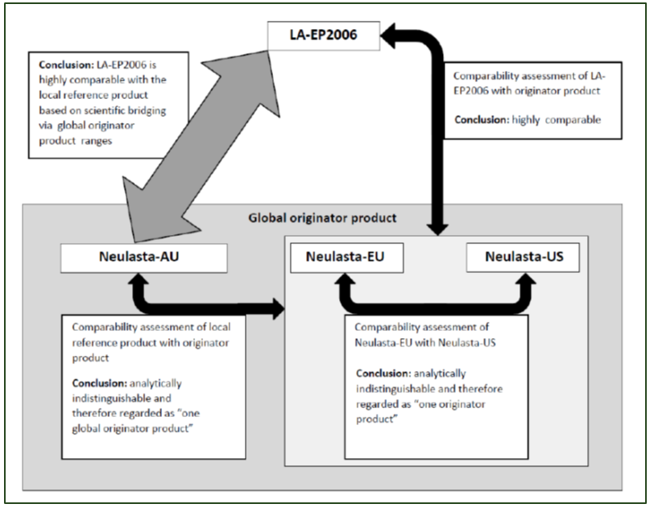
Figure 1 summarises the data comparing similarity between Ziextenzo and Neulasta. The equivalence between Ziextenzo and EU-authorised Neulasta is of significance because the pivotal clinical trials employed EU-authorised Neulasta as a comparator.

Nonclinical
The sponsor provided a nonclinical dossier which was considered acceptable by the nonclinical evaluator with the proviso that biosimilarity between Ziextenzo and Neulasta is otherwise established.
No new nonclinical issues were identified in the Ziextenzo data.

Clinical

Pharmacology
The evaluator has noted that of the two bioequivalence studies, Studies LA-EP06-101 and LA-EP06-103, the former failed to demonstrate bioequivalence between Ziextenzo and Neulasta for maximum plasma concentration (C_{max}) and area under the concentration time curve (AUC). The evaluator has noted, however, that the differences observed in these parameters are unlikely to be clinically significant and bioequivalence between both comparator products was demonstrated in Study LA-EP06-103.
The clinical evaluator noted that time of maximum concentration (t_{max}) observed in these healthy volunteers trials was lower (approximately 12 hours) than in the pivotal trials (approximately 40 hours). The sponsor has indicated that this is because the clearance of Ziextenzo depends on binding and turnover of neutrophil receptors, which is less prevalent in patients receiving myelosuppressive therapy than in healthy subjects.

Efficacy
Two pivotal studies were submitted, Studies LA-EP06-301 and LA-EP06-302. Both were designed to compare the efficacy of Ziextenzo with EU-authorised Neulasta in women suffering from breast cancer and receiving TAC chemotherapy. Patients were randomised 1:1 in each study; 316 in Study LA-EP06-301 and 308 in Study LA-EP06-302 to receive either Neulasta or Ziextenzo on Day 2 of each of six treatment cycles of the TAC regimen. The primary endpoint was the mean duration of severe neutropaenia (DSN) defined as the presence of a total neutrophil count of < 0.5 x 10⁹/L.
Table 2: Duration of severe neutropaenia (DSN) from pivotal Studies LA-EP06-301 (upper panel) and LA-EP06-302 (lower panel)
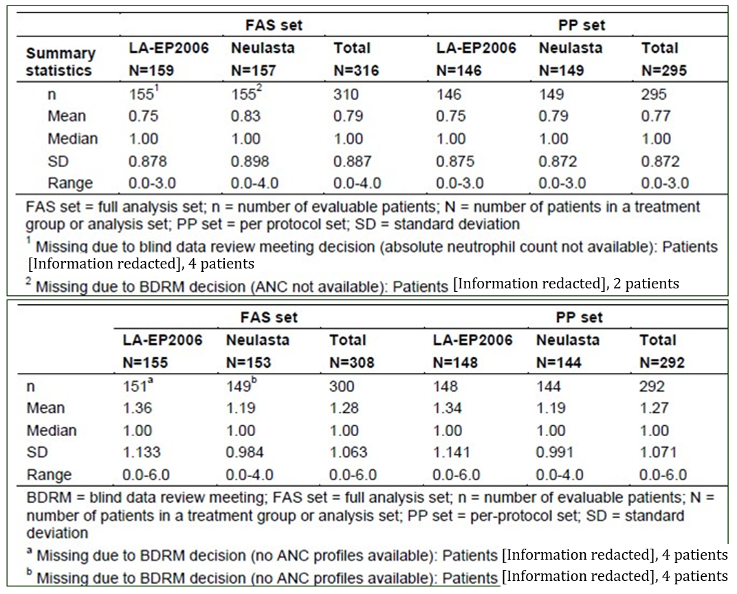
The two treatments were considered equivalent if there was no more than 1 day difference in DSN. As the 95% confidence interval (CI) of the difference between the DSN observed in Ziextenzo and Neulasta treated patients in each trial was < 1 day (0.07 days and -0.16 days in Study LA-EP06-301 and LAEP-302, respectively); and equivalence of effect was demonstrated.

Safety
Adverse events and treatment-related adverse events which occurred in the pivotal trials at similar rates between Ziextenzo and Neulasta treated patients (see Table 3 and Table 4).
Table 3: Overview of number of patients with at least 1 adverse event (SAF set), Study LA-EP06-301
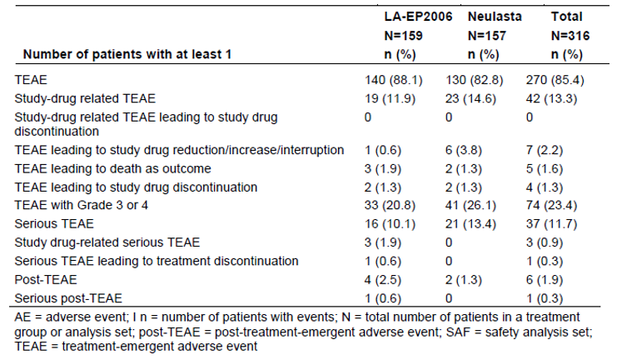
AEs were defined as TEAEs if the onset date of an AE was on or after the date of the first administration of chemotherapy and not later than 30 days after the last dose of chemotherapy. Post-treatment-emergent AEs (AEs occurring within the 6 month safety follow-up period) were defined as AEs with a date of onset after the time point of 30 days after the last chemotherapy administration (that is, the end time range of the TEAE period).
Table 4: Incidence of TEAEs by Preferred Term (at least 3% incidence in either treatment group) (SAF set), Study LA-EP06-301
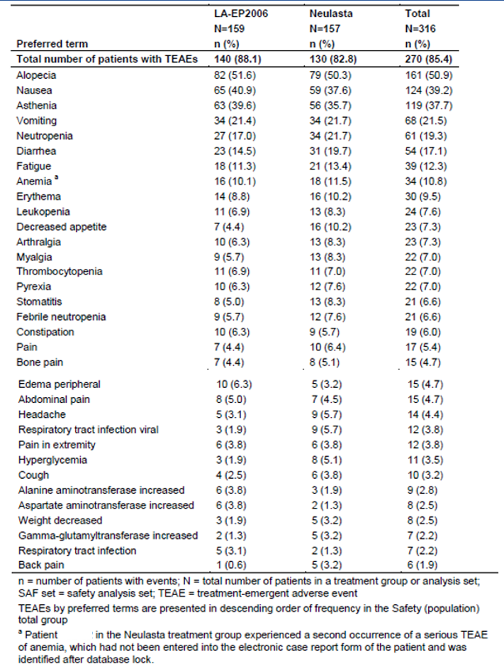
The adverse events observed were consistent with the known adverse events profile of Neulasta and no novel safety signal was identified.
The incidence of positive anti-drug antibodies was comparable between treatments with Ziextenzo and with Neulasta (12.6% with Ziextenzo versus 13.4% with Neulasta in Study LA- EP06-301; 8.4% versus 12.4% in Study LA-EP06-302). No neutralising antibodies were detected in Study LA-EP06-301. One patient in the Ziextenzo arm of Study LA-EP06- 302 who had a positive neutralising antibody result developed it pre-dose at Cycle 1, Day 1.
The clinical evaluator has concluded that the risk-benefit balance for Ziextenzo is positive for the proposed use.

Risk management plan
There was no requirement for a risk management plan evaluation for a submission of this type.

Risk-benefit analysis

Delegate’s considerations
The Delegate has concluded that biosimilarity between Ziextenzo and Neulasta is well supported by the chemistry, nonclinical and clinical data evaluated. This supports registration of Ziextenzo as a biosimilar product to Neulasta with the same indication.

Proposed action
The Delegate proposes to include Ziextenzo in the Australian Register of Therapeutic Goods (ARTG) for the indication:
Ziextenzo is indicated for the treatment of cancer patients following chemotherapy, to decrease the duration of severe neutropenia and so reduce the incidence of infections, as manifested by febrile neutropenia.

Advisory Committee Considerations
The Delegate did not refer this application to the Advisory Committee on Medicines (ACM) for advice.

Outcome
Based on a review of quality, safety and efficacy, TGA approved the registration of Ziextenzo (pegfilgrastim) solution for injection, indicated for:
Ziextenzo is indicated for the treatment of cancer patients following chemotherapy, to decrease the duration of severe neutropenia and so reduce the incidence of infection, as manifested by febrile neutropenia.

Specific conditions of registration applying to these goods
For all injectable products the Product Information must be included with the product.

Attachment 1. Product Information
The PI for Ziextenzo approved with the submission which is described in this AusPAR is at Attachment 1. For the most recent PI, please refer to the TGA website at <https://www.tga.gov.au/product-information-pi>.

Therapeutic Goods Administration
PO Box 100 Woden ACT 2606 Australia
Email: info@tga.gov.au Phone: 1800 020 653 Fax: 02 6232 8605
https://www.tga.gov.au

LA-EP2006 is the drug development name for Ziextenzo pegfilgastrim.
TAC regimen: a combination chemotherapy regimen consisting of Taxotere (docetaxel), Adriamycin (doxorubicin), and Cytoxan (cyclophosphamide).
Neulasta minus Ziextenzo.
The sponsor must still comply with routine product vigilance and risk minimisation requirements.
The ACM provides independent medical and scientific advice to the Minister for Health and the Therapeutic Goods Administration (TGA) on issues relating to the safety, quality and efficacy of medicines supplied in Australia including issues relating to pre-market and post-market functions for medicines. The Committee is established under Regulation 35 of the Therapeutic Goods Regulations 1990. Members are appointed by the Minister. The ACM was established in January 2017 replacing Advisory Committee on Prescription Medicines (ACPM) which was formed in January 2010. ACM encompass pre and post-market advice for medicines, following the consolidation of the previous functions of the Advisory Committee on Prescription Medicines (ACPM), the Advisory Committee on the Safety of Medicines (ACSOM) and the Advisory Committee on Non-Prescription Medicines (ACNM). Membership comprises of professionals with specific scientific, medical or clinical expertise, as well as appropriate consumer health issues relating to medicines.

