Report date: 27 February 2017

AusPAR Attachment 2

Extract from the Clinical Evaluation Report for Pegaspargase
  - Proprietary Product Name: Oncaspar
  - Sponsor: Baxalta Australia

About the Therapeutic Goods Administration (TGA)
- The Therapeutic Goods Administration (TGA) is part of the Australian Government Department of Health, and is responsible for regulating medicines and medical devices.
- The TGA administers the Therapeutic Goods Act 1989 (the Act), applying a risk management approach designed to ensure therapeutic goods supplied in Australia meet acceptable standards of quality, safety and efficacy (performance), when necessary.
- The work of the TGA is based on applying scientific and clinical expertise to decision-making, to ensure that the benefits to consumers outweigh any risks associated with the use of medicines and medical devices.
- The TGA relies on the public, healthcare professionals and industry to report problems with medicines or medical devices. TGA investigates reports received by it to determine any necessary regulatory action.
- To report a problem with a medicine or medical device, please see the information on the TGA website <https://www.tga.gov.au>.
About the Extract from the Clinical Evaluation Report
- This document provides a more detailed evaluation of the clinical findings, extracted from the Clinical Evaluation Report (CER) prepared by the TGA. This extract does not include sections from the CER regarding product documentation or post market activities.
- The words (Information redacted), where they appear in this document, indicate that confidential information has been deleted.
- For the most recent Product Information (PI), please refer to the TGA website <https://www.tga.gov.au/product-information-pi>.
Copyright
© Commonwealth of Australia 2018
This work is copyright. You may reproduce the whole or part of this work in unaltered form for your own personal use or, if you are part of an organisation, for internal use within your organisation, but only if you or your organisation do not use the reproduction for any commercial purpose and retain this copyright notice and all disclaimer notices as part of that reproduction. Apart from rights to use as permitted by the Copyright Act 1968 or allowed by this copyright notice, all other rights are reserved and you are not allowed to reproduce the whole or any part of this work in any way (electronic or otherwise) without first being given specific written permission from the Commonwealth to do so. Requests and inquiries concerning reproduction and rights are to be sent to the TGA Copyright Officer, Therapeutic Goods Administration, PO Box 100, Woden ACT 2606 or emailed to <tga.copyright@tga.gov.au>.

Contents
List of abbreviations 5
1. Introduction 8
1.1. Submission type 8
1.2. Drug class and therapeutic indication 8
1.3. Dosage forms and strengths 8
1.4. Dosage and administration 8
1.5. Information on the condition being treated 8
1.6. Current treatment options and clinical rationale 10
2. Clinical rationale 11
2.1. Evaluator’s commentary on the background information 11
3. Contents of the clinical dossier 12
3.1. Scope of the clinical dossier 12
3.2. Paediatric data 12
3.3. Good clinical practice 12
3.4. Evaluator’s commentary on the clinical dossier 12
4. Pharmacokinetics 13
4.1. Studies providing pharmacokinetic information 13
4.2. Summary of pharmacokinetics 36
4.3. Evaluator’s overall conclusions on pharmacokinetics 39
5. Pharmacodynamics 39
5.1. Studies providing pharmacodynamic information 39
5.2. Summary of pharmacodynamics 57
5.3. Evaluator’s overall conclusions on pharmacodynamics 58
6. Dosage selection for the pivotal studies 58
7. Clinical efficacy 60
7.1. Studies providing evaluable efficacy data 60
7.2. Formal Clinical Trials 70
7.3. Published Studies 111
7.4. Analyses performed across trials: pooled and meta analyses 140
7.5. Evaluator’s conclusions on clinical efficacy 146
8. Clinical safety 150
8.1. Drug Exposure and Adverse Events 150
8.2. Published studies 167
8.3. Other safety issues 188
8.4. Post marketing experience 188
8.5. Evaluator’s overall conclusions on clinical safety 190
9. First round benefit-risk assessment 192
9.1. First round assessment of benefits 192
9.2. First round assessment of risks 193
9.3. First round assessment of benefit-risk balance 193
10. First round recommendation regarding authorisation 194
11. Clinical questions 194
12. Second round benefit-risk assessment 194
13. Second round recommendation regarding authorisation 194
14. References 195

List of abbreviations
Abbreviation | Meaning
ALL | Acute Lymphoblastic Leukaemia
BFM | Berlin Frankfurt Munster
BM | Bone Marrow
BSA | Body Surface Area
CALGB ALL | Cancer and Leukaemia Group B ALL
CCG | Children’s Cancer Group
CCR | Continuous Complete Remission
CD | Cluster of Differentiation
CNS | Central Nervous System
COG | Children’s Oncology Group
CR | Complete Response
CSF | Cerebrospinal Fluid
CSR | Clinical Study Report
CTC | Common Toxicity Criteria
CTCAE | Common Technical Criteria for Adverse Events
DFCI | Dana Faber Cancer Institute
DI | Delayed Intensification
EFS | Event Free Survival
EMA | European Medicines Agency
EPAR | European Public Assessment Report
FDA | Food and Drug Administration
GMALL | German Multicentre Study Group for ALL
GRAALL | Group for Research on Adult Acute Lymphoblastic Leukaemia
HR | High Risk
Hyper-CVAD | Hyper Cyclophosphamide Vincristine Adriamycin (doxorubicin) and Dexamethasone
IQR | Interquartile Range
INTERFANT 06 | International collaborative treatment protocol for infants under one year with acute lymphoblastic or biphenotypic leukemia
IU | International Units
LFS | Leukaemia Free Survival
MRD | Minimal Residual Disease
MTD | Maximum Tolerated Dose
MTX | Methotrexate
NCE | New Chemical Entity
NHL | Non-Hodgkin’s Lymphoma
NOPHO | Nordic Society of Paediatric Haematology and Oncology
OR | Odds Ratio
OS | Overall Survival
PD | Progressive Disease
PEGL ASNase | PEGL, Pegaspargase, PEG-L-ASNase, pegylated asparaginase, Oncaspar
PH | Philadelphia Chromosome
PR | Partial Response
PSUR | Periodic Safety Update Report
PT | Prothrombin Time
PTT | Partial Thromboplastin Time
RER | Rapid Early Responders
RR | Response Rate
SEM | Standard Error of the Mean
SER | Slow Early Responders
SGPT | Serum Glutamic Pyruvic Transaminase
SLR | Systematic Literature Review
SOC | System Organ Classification
SR | Standard Risk
WCC | White Cell Count

Introduction

Submission type
New chemical entity.

Drug class and therapeutic indication
Anti-neoplastic agent. The proposed indication is:
Oncaspar is indicated as a component of antineoplastic combination therapy in patients with Acute Lymphoblastic Leukaemia (ALL).
Comment: One should take from the indication that it includes both adults and children, and use as part of both first line and second line therapies. These uses are thus what must be supported by the submitted clinical data.

Dosage forms and strengths
The dose form is a vial for IM or IV injection. The vial contains 5mL of solution and each mL contains 750 units (U) of pegaspargase. One unit of pegaspargase is defined as the amount of enzyme required to liberate one micromole of ammonia per minute at pH 7.3 and 37 degrees Celsius. One vial contains 3,750 U of pegaspargase.

Dosage and administration
Dosage recommendations vary dependent upon age. For paediatric and adult patients less than or 21 years old, the recommended dose is:
- For paediatric patients with a body surface area of < 0.6 square metres, 82.5 U per kg bodyweight every 14 days.
- For those with body surface area ≥ 0.6 square metres, 2,500 U per square metre body surface area every 14 days.
For adult patients over 21 years old, the recommended dose is 2000 U per square metre body surface area every 14 days.
Recommended dosage for patients 65 years or over has not been established. This is essentially a result of little or no data in that age group.

Information on the condition being treated
Acute Lymphoblastic Leukaemia (ALL) results from an uncontrolled proliferation of monoclonal lymphoblasts. The disease is heterogeneous, and is divided into sub types on the basis of B or T cell lineage-specific differentiation antigens detected on the surface of blast cells. Precursor B cell ALL is the most common sub type (70 to 80%) in children and adults. Mature B cell ALL (Burkitt’s lymphoma/leukaemia) has been reported in 2 to 5% of children and adults diagnosed with ALL. T cell ALL is present in 15 to 25% of paediatric and adult patients diagnosed with ALL. Clinical outcome varies markedly between children and adults and age is a prognostic factor as a result.
Symptoms and signs are non-specific and can include fever, infection, bleeding, bone pain and lymphadenopathy. Essentially the physical and physiological consequences of a lymphoblast clone crowding out the bone marrow and in the process the production of other blood cells.
Acute leukaemia is the most common form of cancer in children and comprises approximately 30% of childhood malignancies. Of these, five in six are acute lymphoblastic leukaemia. There is an approximate incidence of 3.4/100,000 each year in the USA. Peak incidence occurs between two and five years, more commonly with boys. Most of the cancers are not linked to genetic or environmental risk factors, but certain genetic and immunodeficiency syndromes confer a higher risk (for example Down’s Syndrome). Median age of precursor B cell ALL in adults is 39 in the USA.
Classification of the particular subtype of disease is complicated. Leukaemia cells are classified according to immuno-phenotype using a panel of monoclonal antibodies to cell surface ‘cluster of differentiation’ (CD) markers. Those used to classify cells by lineage are used for adults as well. This immunologic subtype is used in risk group stratification.

Table 1: Relative frequency of acute lymphoblastic leukaemia subtypes in children
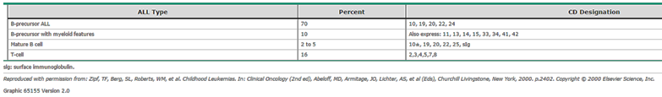From (Up to Date 14.09.2016 – Overview of the presentation and diagnosis of acute lymphoblastic leukaemia in children and adolescents – Table 1)
Cytogenetics is also used to classify disease as chromosomal abnormalities are associated with ALL in some childhood cases. Risk group stratification and information to guide therapy choice are chiefly what is provided by this information.
Commonly recognized abnormalities associated with a poor outcome include the following:
- t(9;22) BCR/ABL1 translocation (Philadelphia chromosome); Present in 3 to 4 percent of ALL patients; often occurs in older children.
- BCR/ABL1-like ALL; A small percentage of patients have a distinct gene expression profile that is very similar to Philadelphia positive ALL, but does not contain the t(9;22) translocation. These patients have genetic alterations that involve either an ABL kinase or contain mutations/fusions in the JAK-STAT pathway.
- t(variable; 11q23); Rearrangements involving the MLL gene are present in 5 percent of paediatric ALL patients and 60 percent of infant ALL patients.
- iAMP21; Intrachromosomal amplification of chromosome 21
- Extreme hyperdiploidy (59 to 84 chromosomes) or hypodiploidy (fewer than 45 chromosomes) is associated with poor outcome.
The following abnormalities are associated with a favourable prognosis:
- t(12;21) ETV6/RUNX1 (formerly referred to as TEL/AML1) rearrangement in B precursor ALL, which occurs in 20 to 25 percent of cases of childhood ALL.
- Hyperdiploidy (54 to 58 chromosomes); Hyperdiploidy is present in 20 to 25 percent of childhood ALL. Children with lymphoblasts exhibiting hyperdiploidy (not extreme hyperdiploidy) have the best prognosis, particularly if associated with the combined trisomies of chromosomes 4 and 10. Trisomy of 4 and 10 are commonly used to risk stratify patients to less intense chemotherapy.
Of most importance is age at diagnosis and cytogenetic/genetic findings in predicting prognosis.

Current treatment options and clinical rationale
ALL cells express very low levels of the enzyme asparagine synthetase; hence they are incapable of synthesizing asparagine from aspartate. This characteristic, therefore, is a biologically plausible method of attacking such cells while sparing others.
In general, ALL treatment has a remission/induction phase of treatment, an ‘intensification’ (or consolidation) phase and then continuation and maintenance therapy. Treatment is also directed to the CNS to prevent relapse attributable to leukaemic cells sequestered in this site. All phases of treatment involve combination chemotherapy.
Multiple induction regimens have been developed and most are based on those for children. There are little or no data on comparison between regimens, but most contain vincristine, a corticosteroid, and an anthracycline. Typically, some sort of CNS prophylaxis is also incorporated. Drugs would typically include vincristine, prednisolone, cyclophosphamide, doxorubicin and l-asparaginase. Cytarabine and methotrexate are often added during consolidation treatment, and maintenance therapy often includes 6-mercaptopurine, methotrexate, steroids and vincristine.
There is little to be gained by discussing here the multitude of treatment regimens based upon prognostic factors. Perhaps of key importance to the submission is this excerpt with respect to asparaginase.

Asparaginase
Asparaginase is a key component of the ALL regimens for children leading to superior CR and disease free survival rates. For adults, it is a component of the CALGB ALL regimen, the BFM regimen, the GRAALL 2003 regimen, and the modified Hyper-CVAD regimen, but not the standard Hyper-CVAD regimen.
The importance of asparagine depletion in adults was illustrated in a prospective study of pegylated asparaginase that demonstrated a significant improvement in median overall survival (31 versus 13 months) in those patients who achieved plasma asparagine depletion. Further support comes from paediatric trials that suggest that clinical outcomes improve as the period of complete asparagine depletion in the plasma increases. Protocols for adults must balance the desire to achieve maximum asparagine depletion with the understanding that prolonged depletion is difficult for most adults to tolerate.
Asparaginase can be associated with allergic reactions, coagulopathies, acute pancreatitis, and increased liver transaminases. Asparaginase induces a hypercoagulable state that can result in catastrophic thrombosis of the inferior vena cava or the superior sagittal sinus in addition to deep vein thromboses of the legs or arms. In addition, adults receiving asparaginase commonly develop fatigue, anorexia, confusion, and listlessness.
There are three formulations of asparaginase available, each with different half-lives:
- Native Escherichia coli asparaginase (not available in the US); Half-life approximately one day
- Erwinia asparaginase; Half-life approximately 14 hours
- Pegylated Escherichia coli asparaginase (pegaspargase, Oncaspar); Half-life approximately six days
The dose and schedule of asparaginase administration varies depending upon the formulation chosen and whether given to children or adults. Investigations are ongoing to determine the ideal dose and schedule. Pegylated asparaginase has become the preferred preparation for most circumstances because it appears to be less immunogenic while providing equal or greater efficacy when compared with the other formulations. In addition, patients who receive pegylated asparaginase appear to be less likely to develop antibodies that result in increased clearance of asparaginase from the circulation and possibly reduced efficacy. These two points are key advantages presented in this dossier as well.
- Pegylated asparaginase; A reasonable schedule for pegylated asparaginase would be either 2,000 units/m² given every two weeks or 1,000 units/m² given weekly. These doses should result in asparagine depletion in the vast majority of adults for a two week period. Generally, this has been intercalated between courses of more cytotoxic therapy or the combination of vincristine plus corticosteroids.
- Non-pegylated preparations; Non-pegylated asparaginase preparations have a shorter half-life and require daily or every other day administration. They are also more immunogenic. The dose of L-asparaginase used varies from 6000 units/m² (in the CALGB regimen) to a fixed dose of 20,000 units (in the modified Hyper-CVAD regimen).
Comment: This evaluator notes at present there appears to be one asparaginase product on the ARTG; that of Leunase 10,000 KU injection vial. This is a non-pegylated preparation of asparaginase.

Clinical rationale
The rationale for this submission is to register Oncaspar in Australia with a broad indication that allows use both in first and second line therapy in ALL patients that are either children or adults. This is a consolidation, as it were, of the avenue of approvals that have occurred in other regulatory jurisdictions over a longer time period to result in effectively the same broad approved indication in both the USA and Europe.

Evaluator’s commentary on the background information
The drug has been used in major regulatory jurisdictions for many years, most particularly for second line treatment. Post-market experience is therefore extensive and this evaluator considers the utility of the product in treatment regimens for ALL is largely considered accepted in the public domain literature. The pegylation of the asparaginase in the case of Oncaspar prolongs half-life as well as allegedly reducing potential immunogenicity of the drug compared to, for example, native E.coli asparaginase. This application seeks a broad indication that incorporates both first and second line use of the drug in both children and adults. In essence, it consolidates the approvals gained in the EU and USA over time into one submission.

Contents of the clinical dossier

Scope of the clinical dossier
There are formal trials which supported second line use of the drug in the past, and more recent formal trials supporting first line use, largely in children. Published literature has been gathered via extensive database searching that is intended to support both paediatric and adult use in first line treatment of ALL, as well as supplement the second line use indication in some instances. The dossier is highly complex given the overview documents do not encompass all data in the dossier in an easily referred to manner, and their dates of creation or edit are not readily apparent as document control pages are not present in most if not all of these documents. It is difficult to identify the totality of data for each component of the submission; that is first line use in children; first line use in adults; second line use in children and second line use in adults. This evaluator has gone to great lengths to try to identify all submitted data intended to support each part of the indication and the safety profile of the drug. The focus has deliberately been on publications that make use of pegylated asparaginase rather than solely asparaginase.

Paediatric data
The submission intends to support use in ALL in children as both first and second line treatment; thus paediatric data are a plentiful component of this submission and indeed by far more extensive than that for adults.

Good clinical practice
The formal studies are stated to have met GCP standards. Some of the published data state this in their content; most do not. It is anticipated that such publications meet GCP standards as acceptance for publication has required this as mandatory in recent years. Therefore this evaluator is confident that publications up to 10 years old would almost certainly be studies conducted to international standards of GCP.

Evaluator’s commentary on the clinical dossier
One cannot convey the time and effort undertaken to present this report in an orderly fashion. A single, all-encompassing clinical overview would have saved a great deal of time and effort in the view of this evaluator.
As a small example, the data placed in the dossier as PK data do not match with that cited in the clinical overview. Furthermore, for this submission, a full list of supporting data regardless of how it was derived (trials, EU SLR, TGA SLR) could have been provided for each sub-indication to allow easier assessment. In addition, there is no breakdown of published studies according to recognised hierarchy-of-evidence criteria. Criteria in the SLRs excluded some papers on this basis, but the criteria were fairly loose and in any case do not organise the data as a hierarchy would. These two methodology steps, that is listing all data for each sub-indication and placing them in an evidence hierarchy, would have immeasurably assisted evaluation. Lastly, a number of data documents are effectively double-ups as there may be a trial and publication, or multiple publications of the same data set. This evaluator may or may not have determined them all. Where there has been a double-up of formal trial and the publication of the same data, and this evaluator has identified this as such, the data have not been presented twice. In conclusion, this evaluator is confident sufficient data are identified and reviewed to enable a risk/benefit assessment to be made. It is highly unlikely any data exist in the submission that substantially contradicts that presented and commented upon in this report.

Pharmacokinetics

Studies providing pharmacokinetic information
The submission cites the following publications as providing PK information:
- ASP-301:Asselin et al. 1993
- Angiolillo 2014
- Avramis 2002
- Panosyan 2004
- Pieters 2008
- Rosen 2003
In addition, the EMA EPAR (p37) cites the clinical studies:
- ASP-001
- ASP-302
- ASP-304
- CCG-1962 (Avramis 2002 above)
- DFCI-87-001/ (Asselin 1999a)
- AALL07P4 (Angiolillo 2014)
The summary document of Biopharmaceutical Studies (Module 2.7.1 dated 7 December 2015 p1) lists some of the formal trials above as well as the following:
- DFCI-05-001 (Place et al. 2015)
- CCG-1961 (Published as Panosyan 2004 above)
Therefore, to the best of this evaluator’s review, these are the totality of data in support of PK profile. There are formal studies:
- ASP-001
- ASP-302
- ASP-304
- CCG-1962
And publications:
- Asselin et al. 1993, 1999
- Angiolillo 2014
- Panosyan 2004
- Pieters 2008
- Place et al. 2015
- Rosen 2003
Some of the immediately above publications are the literature publications of formal studies. In any case, the following represent in this evaluator’s view the entirety of the PK data submitted for review.

ASP-001
This was a Phase I/II open label, ascending dose study of PEG-L-asparaginase (PEGL ASNase) in malignant haematological disorders. Objectives were to define toxicities, MTD and evaluate clinical pharmacology and efficacy of PEGL ASNase administered as a one hour IV infusion every two weeks.
Thirty seven heavily pre-treated patients with refractory haematological malignancies aged 15 to 73 were enrolled. The study had an open label, ascending multiple dose design. Cohorts of 3 patients were entered at each dose level, starting at 500 U/m², with subsequent cohorts at higher doses until dose limiting toxicity was observed. Dose was also escalated in individual patients until a biological effect or a dose limiting toxicity was observed.

Inclusion and exclusion criteria
Inclusion and exclusion criteria were as follows:

Inclusion
- Male or female ≥ 15 years of age.
- Life expectancy ≥ 6 weeks.
- Histologically proved leukaemia or other haematological malignancy refractory to conventional therapeutic regimens and with evidence of measurable disease.

Exclusion:
- History of pancreatitis or coagulopathy.
- Chemotherapy or radiation within 3 weeks prior to study start, or failure to recover from any toxic effect of previous therapy (including insufficient time since last treatment to show expected delayed toxicities).
Patients refractive to prior native asparaginase were not excluded. The investigator was permitted to make exceptions to the entry criteria at his/her discretion.

Treatment
Patients with a response received two to four courses of the drug at the dose that produced the response. PK samples were obtained prior to infusion, and at 1, 6, and 12 hours afterwards, as well as then daily for seven days and a final sample prior to the next dose on Day 14.
Here (Table 2) this evaluator will present solely the PK results. Samples were collected from 31 patients, with four having insufficient samples to allow the determination of PK parameters. Two patients experienced anaphylactic reaction and were discontinued from analysis due to rapid removal of the enzyme as a result of the immune response. One of these patients had circulating antibodies to the drug. PK parameters based upon the remaining 25 subjects are as follows in Table 2.

Table 2: Pharmacokinetics of Peg-L-Asparaginase
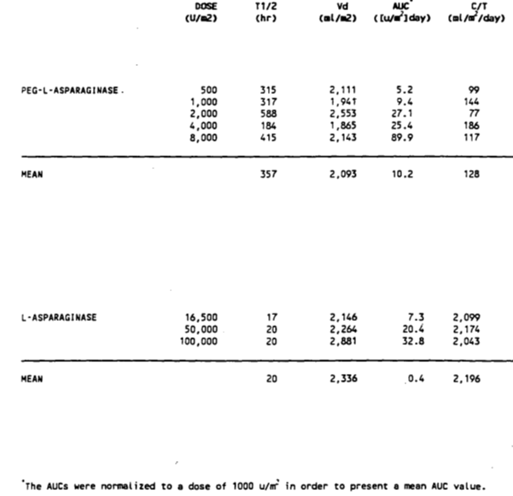
Mean elimination half-life of PEGL was 357 ± 243 hours, approximately 12 times that of native L-asparaginase. Volume of distribution and clearance were independent of the dose at these dosages. It was noted that with a 2 week dosing schedule, accumulation of PEGL ASNase could occur as a result of the prolonged half-life. Peak concentrations after infusion, trough concentrations at Day 14, and AUC were proportional to the dose administered. One-way analysis of variance was performed to determine whether there was a significant difference in the half-lives across the five dose groups. Resultant F-tests showed that there were no differences (F = 1.604; p = 0.213).

ASP-302
This was an open label trial to primarily obtain PK and long term safety data for PEGL ASNase. It was part of a multi-drug trial for the treatment of relapsed ALL patients. Twenty one relapsed ALL patients were enrolled (13 male, 8 female) aged 1 to 35 years. All had childhood ALL. Four had known hypersensitivity to native L-asparaginase. There was three phases: Phase 1 (early Tx), Phase 2 (re-induction) and Phase 3 (remission/maintenance). PEGL ASNase was dosed at 2,500 IU/m² BSA every two weeks for a total of 29 doses as part of a multi-drug chemotherapy regimen.
Patients were eligible for inclusion if they had evidence of bone marrow relapse during or after treatment with multi-agent rotational chemotherapy. Patients were excluded if they had a history of life threatening sensitivity to VM-26 (teniposide). A known hypersensitivity to other (non-PEGylated) forms of L-asparaginase did not exclude a patient from participation.
Samples for determination of PK were taken at 1, 2, 3, 5, 7, 10 and 14 days after each of the first two doses of drug during Phase 2 of the trial and in weeks 2 and 8 of continuous therapy. Day 1 sample was obtained 24 hours after dosing.
Of the 21 patients enrolled, eleven were evaluated for PK in that they had sufficient samples collected. Of these, two were hypersensitive to the drug and nine non-hypersensitive. Summary PK data are as shown in Table 3.

Table 3: Study ASP-302. Pharmacokinetic data
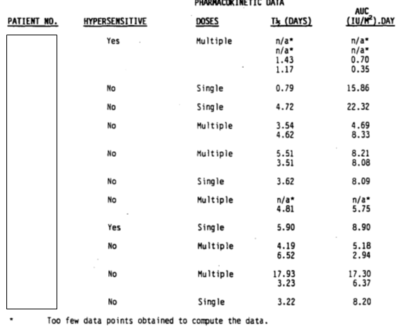
Mean half-life for the two hypersensitive patients was 2.69 days and for the non-hypersensitive patients 4.83 days. Mean AUC for hypersensitive patients was 3.52 IU/mL/day and for non-hypersensitive 10.35 IU/mL/day.

Table 4: Study ASP-302. Pharmacokinetics summary by patient population
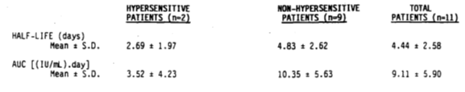
Comment: One can clearly note the substantial difference in half-life and drug exposure in hypersensitive patients.

ASP 304
This study assessed PEGL ASNase versus native L-asparaginase in combination therapy as second induction treatment for children with ALL in bone marrow relapse. The objectives were to compare efficacy and toxicity of Oncaspar to native L-asparaginase (Elspar) in children with ALL who were in second haematologic relapse.
Comment: This is a useful head-to-head comparison with native E.coli asparaginase.
Patients without a history of hypersensitivity were randomised to either treatment. Elspar was given 10,000 IU/m² three times a week for four weeks, with Oncaspar given IM at 2,500 IU/m² on Days one and fifteen (two study doses) Pharmacokinetic assessment samples were taken prior to administration on Days 1, 2, 3, 4, 8, 15, 22, 29 and 36. CSF levels for Oncaspar were taken on Days 1 and 29.
Patients were eligible for inclusion in the study if they met the following criteria:
- Diagnosis of ALL before age 21 years and in the second haematological relapse.
- Life expectancy ≥ 4 weeks.
- Adequate hepatic and renal function (SGPT < 200 IU/L; creatinine < 2 mg/dL).
Exclusion criteria were as follows:
- Presence of CNS disease (unless the investigator judged it appropriate to withhold intrathecal chemotherapy during the 4 weeks of Oncaspar combination chemotherapy; intrathecal medication could be given with the screening lumbar puncture at the discretion of the physician).
- Failure of other induction regimens which contained L-asparaginase.
For each patient in the Oncaspar treatment groups, the pharmacokinetic variables half-life (t_{½}), peak concentration (C_{max}), time to peak concentration (T_{max}), and area under the curve to the last assay value (AUC) for plasma blood levels of L-asparaginase after the first dose but prior to the second dose were calculated. The estimate of the half-life was computed independent of a model by choosing a minimum of at least two points past the peak concentration representing a linear elimination phase. If there were not at least two points past the peak which were consistent with a linear elimination phase (due to insufficient samples, a plateauing elimination pattern or too-rapid elimination), the half-life was not calculated. The estimated half-life was calculated as (ln2)/K, where K was the absolute value of the slope of the line for the linear regression of the natural logarithm of the plasma concentration versus time.
Of the 76 patients, 16 patients completed the study and 60 patients were terminated from the study. The number of patients and the reasons for termination were: four were on-study deaths; three for toxicity; one refused further therapy; 18 relapsed; 27 for progressive disease; and seven for bone marrow transplant.
Summary pharmacokinetic data are given as shown in Table 5.

Table 5: ASP-304; Oncaspar, pharmacokinetic results
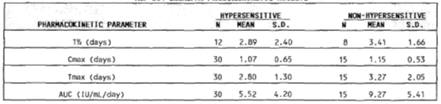
The above AUCs were calculated regardless of whether subjects had a half-life value that could be calculated. When one restricts collective results to data from subjects who could have such a half-life calculated, the following results as shown in Table 6 are obtained.

Table 6: ASP-304 Limited Oncaspar pharmacokinetic results
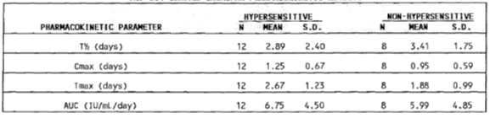
Reasons for exclusion were the following as shown in Table 7.

Table 7: ASP-304 reason for exclusion from half-life calculations
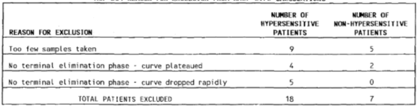
Brief data on antibodies to the drug are given as shown in Table 8.

Table 8: ASP-304 Day 0 / Day 28 antibody level by hypersensitivity status
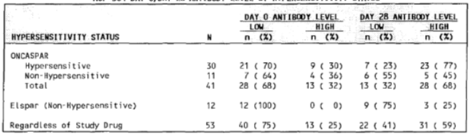
While three quarters of subjects entered the study with a low level of antibody, only 41% completing the 28 day induction retained that status. Eighteen converted to higher levels of antibodies. PK results based upon Day 14 antibody level As Shown in Table 9.

Table 9: ASP-304 Oncaspar pharmacokinetic results by Day 14 antibody level
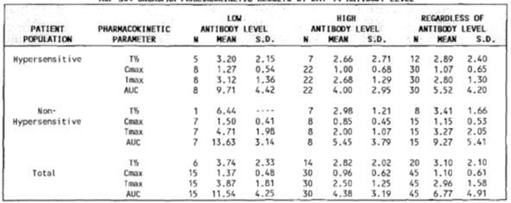
Comment: These suggest more rapid clearance in high antibody titre subjects. They also suggest that treatment over time elicits antibody formation regardless. Of particular interest in this context to this evaluator is the development of high titre antibodies with Oncaspar versus that for native E.coli ASNase. If one compares the two groups that were non-hypersensitive initially, however, then received either drug, the outcome in terms of antibody titres at Day 28 is not possible to judge between the two treatments based solely upon this study.

CCG-1962
This was a randomised comparison of PEG-L-Asparaginase and Native E.coli Asparaginase in the standard treatment arm of Study CCG-1952 for standard risk ALL in 118 newly diagnosed children. This study will be fully described under the efficacy heading of this report. Efficacy, safety and PK were compared between PEGL and native E.coli asparaginase as part of combination therapy. Hence this study was also useful as a head-to-head comparison. There was a four week induction phase, four week consolidation phase, two eight week interim maintenance phases, two eight week delayed intensification (DI) phases and thereafter maintenance therapy. Patients were aged 1 to 9 years and n = 59 subjects received each drug.
PEGL was administered on Day 3 of induction and Day 3 of both DI phases. Native asparaginase was administered on Days 3, 5, 8, 10, 12, 15, 17, 19 and 22 of induction and Days 3, 5, 8, 10, 12 and 15 of both DI phases.

Figure 1: CCG-1962 Treatment schema
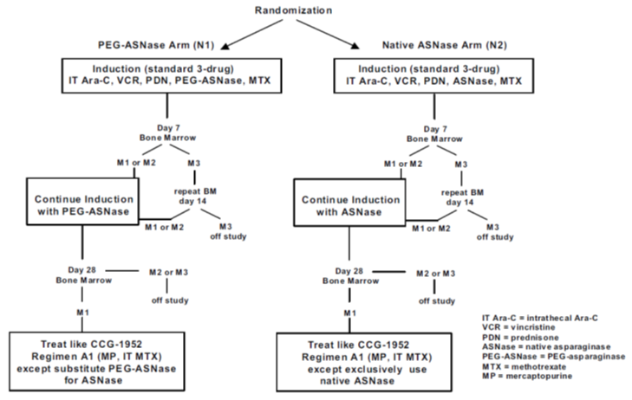

Table 10: CCG-1962 Patient disposition
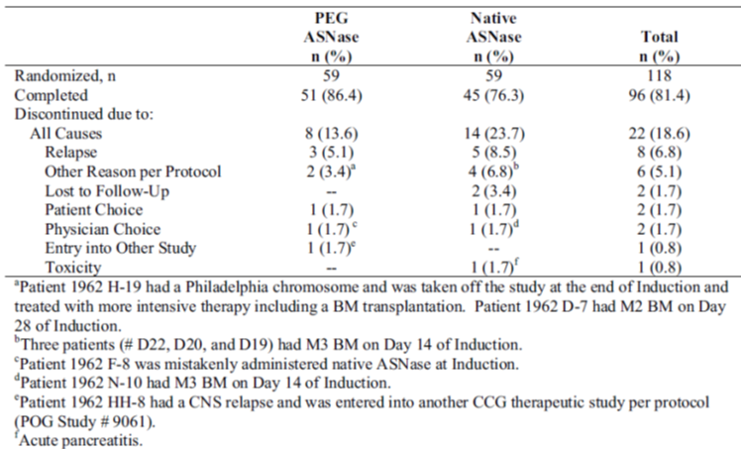
One can see that 96 subjects completed treatment. Fewer subjects given PEGL ASNase were discontinued.
PK was assessed at end of induction and end of DI periods one and two as shown in Table 11.

Table 11: CCG-1962 schedule of procedures and assessments
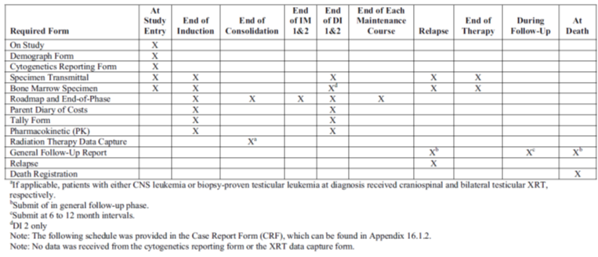
One of the primary objectives was to determine if the incidence of high titre anti-ASNase antibodies in those treated with pegylated drug was decreased by at least 50% compared with those given native drug in DI phase 1. A secondary endpoint determined if this occurred at the end of DI phase 2.
The following graphic shows the mean ASNase activity over time after the first 2,500 IU/m² dose (Figure 2).
Figure 2: CCG-1962 Pharmacokinetic profile of PEG_ASNase enzymatic activity in sera of paediatric patients with standard risk ALL at induction
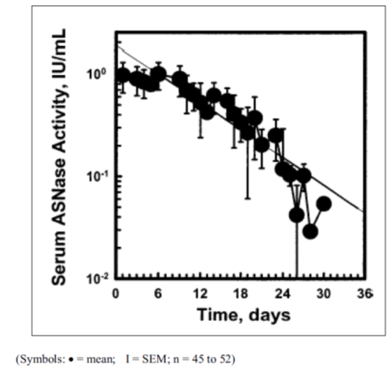
Comment: This graph gives a clear indication that such a dose (that intended for marketing), in this population, keeps the serum ASNase activity over 0.1 IU/mL for at least the 14 day dose interval. Indeed it appears in this instance to do this until Day 26.
Mean activity peaked on Day 5 given an IM dose, and averaged 1 IU/mL. Elimination half-life was 5.5 days. One compartment analysis showed a volume of distribution of 1.5L/m² and AUC was 14.7 IU/mL/day. Clearance by non-compartmental and 1-compartment models was 0.169 and 0.18 L/m² per day, respectively. Vss estimated from MRT times clearance ranged from 1.86L/m² to 1.97L/m². One can see that at Day 14 in the graph above (Figure 2), therapeutic ASNase levels were maintained, important for the proposed PI dosing interval.
The mean ± standard error of the mean (SEM) antibody ratio in DI #1 was 1.9 ± 0.8 (n = 47) for children treated with PEG-ASNase and 3.0 ± 0.7 (n = 43) for those treated with native ASNase (p = 0.001). The percentage of patients with a maximum ratio of high titre antibodies at least 2.5 times greater than the average control level was 26% in native ASNase patients and 2% in PEG-ASNase patients (p = 0.001). Over 40% of native ASNase patients had ratios of ≥ 1.5 compared to only 11% of PEG-ASNase patients. The respective mean ± SEM ratios for PEG-ASNase and native ASNase were 1.3 ± 0.2 (n = 41) and 2.3 ± 0.9 (n = 47) for Induction and 2.1 ± 0.8 (n = 45) and 2.1 ± 0.6 (n = 45) for DI #2.
High titre antibodies were associated with low ASNase activity in the native arm, but not in the PEG-ASNase arm. None of the samples with antibody ratios of ≥ 1.5 had low ASNase activity in the PEG-ASNase arm. Thus, the antibody did not appear to neutralize or speed the clearance of PEG-ASNase. In contrast, during DI #1, only 50% of samples from native ASNase patients with antibody ratios of ≥ 1.5 had ASNase activity > 0.1 U/mL. The association between increased antibody ratio and low ASNase activity also was seen in DI #2.
Of particular interest, this study provides data on the actual depletion of asparagine as a surrogate biologically plausible outcome measure, and provides information for native E.coli ASNase as well PEGL ASNase (Figure 3).
Figure 3: CCG-1962 Asparagine and glutamine in serum after pegasparaginase or native asparaginase treatment during induction
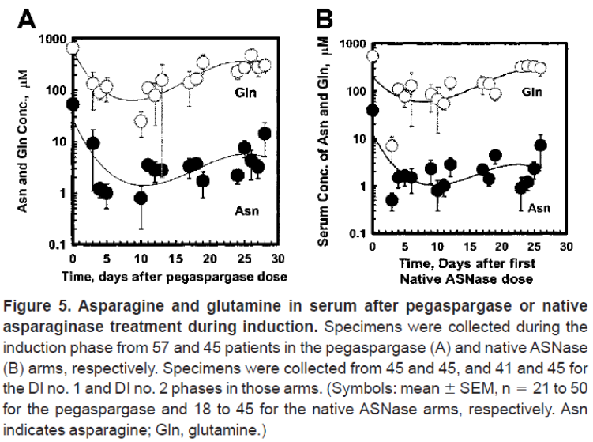
More than 90% of subjects treated with PEGL ASNase had activity serum levels considered satisfactory to deplete asparaginase at Day 21. Asparagine fell to less than 3 mM in most patients when ASNase activity was more than 0.1 IU/mL. This supports the threshold level of 0.1 IU/m² that seems to permeate the literature. Given the intended dose interval is 14 days, this study would suggest that dose will almost certainly ensure a greater than threshold level of 0.1 IU/mL of serum ASNase.
Comment: In other words, on these data, a lower dose might suffice but this dose seems to ensure an appropriate asparaginase activity level for all patients regardless of any individual variation in clearance etcetera.

Asselin et al. 1993
This publication studied the PK profile of both E.coli ASNase and PEGL ASNase. Patients with childhood ALL on protocols using IM ASNase during induction and for at least 20 weeks after remission were studied. Oncaspar was the PEGL ASNase studied. The PEGL ASNase dose studied was 2,500 IU/m². Two doses of native E.coli ASNase were studied; 25,000 (n = 17) and 2,500 IU/m² (n = 16).
The drug appeared dose-proportional for the native ASNase doses given (Figure 4).
Figure 4: Asselin et al. 1993. Serum ASNase concentration-time curve
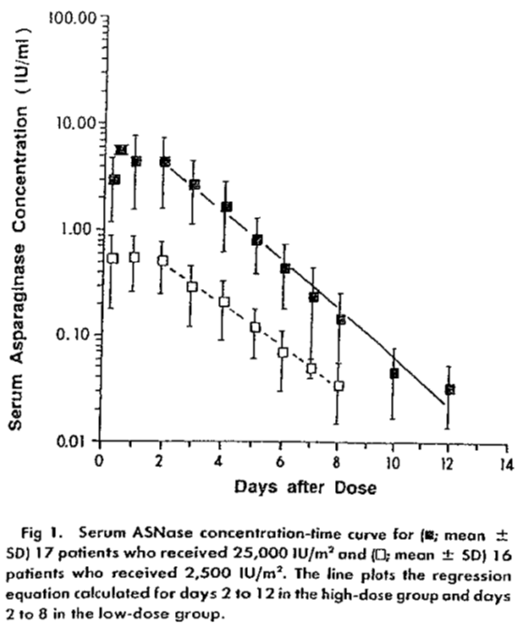
Repeated dosing did not affect the apparent half-life.
Figure 5: Asselin et al. 1993. Serum t_{½} of E coli ASNase as a function of repeated doses
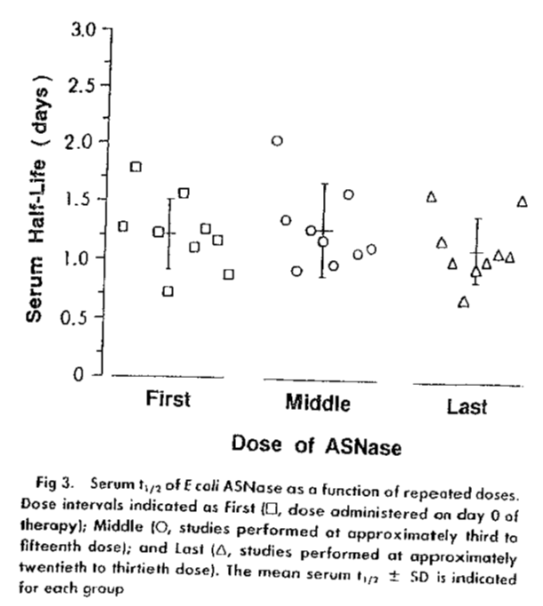
The following graphic compares all doses studied and demonstrates the prolonged concentrations achieved with PEGL (black diamond) (Figure 6).
Figure 6: Asselin et al. 1993 disappearance of serum ASNase activity as a function of time for patients treated with one of three different ASNase preparations
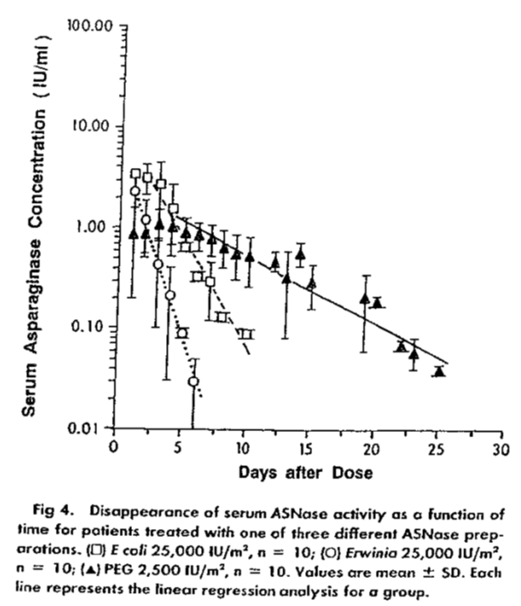
Comment: Again, the above graph suggests a PEGL ASNase level above 0.1 IU/mL for over 20 days.
ASNase activity for PEGL ASNase was stated as measurable (as in greater than 0.01 IU/mL) for the entire 26 day observation time. Half-life had a mean value of 5.73 ± 3.24 days (SD) which was statistically significantly greater than that of native ASNase (p < 0.0001). Seven patients had sufficient time points to study two separate mean half-lives, namely that for Days 4 to 14 and for Days 15 to 26 for PEGL. These were demonstrated to be 6.86 and 2.99 days, respectively. Five patients with a history of hypersensitivity were found to have a half-life with PEGL of 1.82 ± 0.26 days, significantly shorter than those patients given PEGL who had not previously received any form of ASNase. While half-life was shortened in these cases, it remains prolonged compared to native ASNase.
Comment: This study again supports the idea that a 14 day dosing interval will ensure ASNase levels at or above that considered the threshold to ensure asparagine depletion. However, it again raises the question of adequate dosing at 14 day intervals if hypersensitivity is in place with high antibody titres and subsequent rapid drug clearance.

AALL07P4 (Angiolillio 2014)
This study evaluated population PK of Oncaspar from the treatment of patients with high risk ALL.
The study was a multicentre, randomised, open label, active comparator controlled trial in patients (> 1 year and < 31 years of age at the time of diagnosis) with newly diagnosed high risk B-precursor ALL. Eligible patients were randomised in a 2:1 ratio to receive the experimental drug at a dose of 2,100 IU/m² or 2,500 IU/m² IV or Oncaspar 2,500 IU/m² IV plus full augmented Berlin-Frankfurt-Münster (BFM) multi-agent chemotherapy. It was planned to recruit 186 patients (62 randomised to Oncaspar).
The study design includes a 35 day Induction period, a 2 week Extended Induction period (for patients with m² marrow or marrow with ≥ 1% MRD), an 8 week Consolidation period, up to two 8 week IM periods, up to two 8 week drug induction (DI) periods, and Maintenance therapy. Maintenance therapy consists of repeated 12 week cycles. The total duration of therapy is 2 years from the start of Interim Maintenance I for female patients and 3 years from the start of Interim Maintenance I for male patients.
Rapid early responders (RER) received one IM and one DI phase, and those classified as slow early responders (SER) and/or CNS3 positive received two IM, two DI phases. PEGylated asparaginase was administered on Day 4 of Induction, on Day 4 of Extended Induction (if applicable), on Days 15 and 43 of Consolidation, on Days 2 and 22 of both Interim Maintenance periods, and on Days 4 and 43 of both DI periods. All patients had PK and PD evaluations after administration of randomised study drug on Days 4, 5, 6, 8, 15, 22, and 29 of Induction, and Days 15, 16, 17, 22, 29, 36, and 43 of Consolidation. Evaluation of minimal residual disease (MRD) was performed at induction Day 29.
All patients were to have had a complete PK and PD evaluation after administration of calaspargase pegol or Oncaspar on induction Day 4 and Consolidation Day 15 until it had been determined that 135 patients were evaluable for full PK analyses.(EMA EPAR pp39-40 emphases added).
The following Tables 12 and 13, show the PK parameters following both induction and consolidation phases.

Table 12: AALL07P4 (Angiolillio 2014) Pharmacokinetics of L-Asparaginase following Oncaspar administration in induction phase
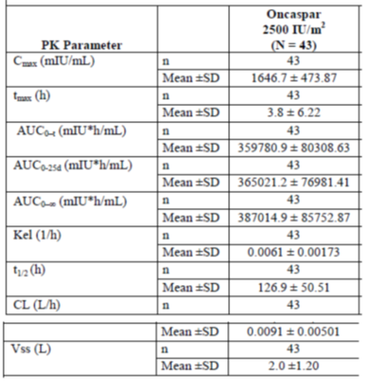
If one converts the values above to conventions used in other data, for example the half-life values readjusted to days, one gets results in keeping with the other data presented, for example, with the above table (Table 12), 5.29 days.

Table 13: AALL07P4 (Angiolillio 2014) Pharmacokinetics of L-Asparaginase following Oncaspar administration in consolidation phase
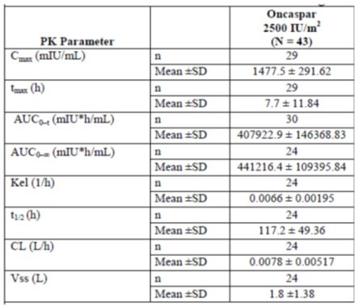
Further data on asparagine levels is provided by the study which suggests that effective levels of ASNase may even be lower than 0.1 IU/mL (Figure 7).
Figure 7: AALL07P4 (Angiolillio 2014) Mean plasma asparaginase activity versus asparagine concentration by treatment group over time during induction and consolidation
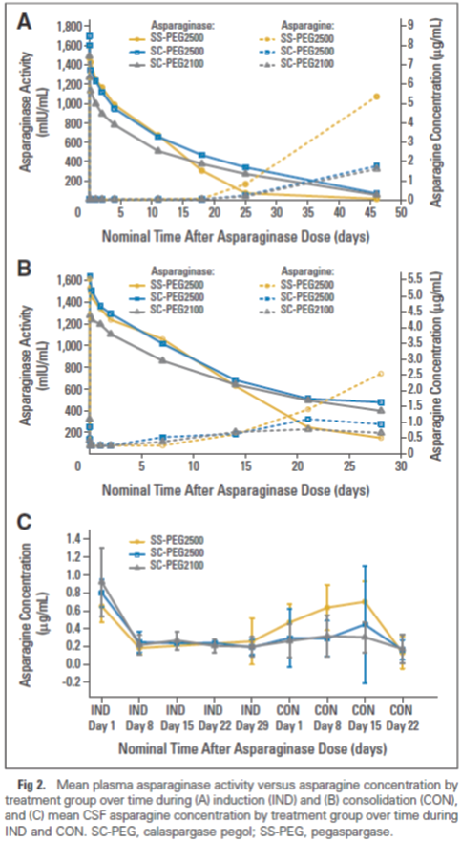
Comment: Note that the mean ASNase concentration over time is above the 0.1 IU/m² threshold level but, more importantly, if one considers the graph B for the consolidation treatment phase for example, one can see that ASNase activity up to about 7 days where the threshold is at or over 0.1 IU/mL, the asparagine concentration is depleted. Below this, level, asparagine recovers to a degree (see dotted lines). The circle line is of most import to this submission, since it refers to PEGL ASNase specifically (pegaspargase). At induction, this dose of pegaspargase keeps asparagine levels minimal for well over 15 days with activity levels as low as 400m IU/mL (that is 0.04 IU/mL versus the more touted 0.1 IU/mL) (see graph A, Figure 7)). This is further supportive evidence in this evaluator’s view that the dose of ASnase chosen and the time interval between doses ensure adequate asparagine depletion in circumstances where high antibody titres do not figure.

Panosyan 2004
This is a publication of the investigation of anti-asparaginase activity in 1,001 eligible patients with high risk ALL (the publication of Study CCG-1961 apparently). All patients received nine doses of native E.coli ASNase during induction, on a Monday, Wednesday, and Friday schedule (three doses per week). Rapid early responders (RERs) assigned randomly to standard-intensity arms (for example arms A and B) received 6 or 12 additional doses of native ASNase during intensifications 1 and 2, while RERs assigned randomly to stronger intensity arms (for example, arms C and D) received 6 or 10 doses of PEG-ASNase during consolidation, interim maintenance, and intensifications 1 and 2. All slow early responders (SERs) subsequently received 10 doses of PEG-ASNase after induction. Erwinia ASNase was used only if the patient developed clinical signs of allergy to the E.coli or PEGL preparation.
Figure 8: Panosyan 2004. CCG-1961 study design and the summary of asparaginase doses in different arms of the regimen
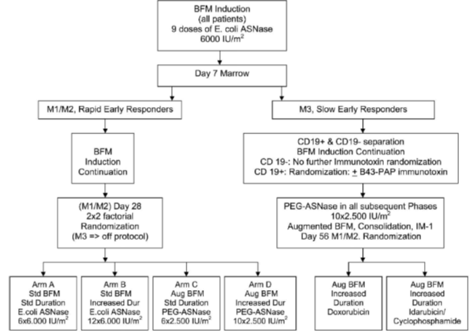

Table 14: Panosyan 2004 Summary of ASNase doses in CCG-1961 in different arms of the regimen
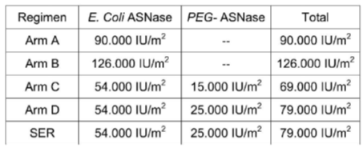
661 subjects had an elevated antibody titre greater than 1.1. Of these, 447 had no measurable asparaginase activity during therapy. Those who were antibody positive experienced a decline in E.coli asparaginase activity and no detectable activity was found in 81 of 88 antibody positive patients shortly after receiving injections of the drug (94% neutralising antibodies).
The study design was concluded to be potentially immunogenic by administering native E.coli ASNase to all subjects initially. The PEGL ASNase used was at the 2,500 IU/m² dose as shown in the study design schematic (Figure 8 above).
Rapid early response was categorised as less than 25% blast cells on marrow smear, slower response was greater than this percentage.
Table 15 presents the Ab-positive ratio values over negative control per phase of treatment.

Table 15: Ab-positive ratio values over negative control per phase of treatment
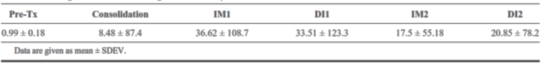
Once high antibody positivity appeared, it tended to persist. When native ASNase was used, titres tended to rise and when PEGL ASNase was used, Ab titres tended to fall.
Comment: While this publication provides information on immunogenicity, in a considerable number of patients, PK profiling is essentially absent. It essentially simply reinforces the more rapid clearance of either drug when high titre antibodies appear.

Pieters 2008
This was a randomised Phase II trial of E.coli ASNase compared with ASNase ‘medac’. This ‘medac’ preparation does not appear to be PEGL ASNase (this is unclear), but rather a preparation where ‘aggregates’ (octamers, etcetera having less enzymatic activity and potentially expressing new antigens) were minimised to less than 1% from approximately 20% with typical E.coli ASNase preparations.
Thirty two (of 37) children with ALL were randomised to receive one or the other of these agents at a dose of 5,000 IU/m² every three days for 8 doses during induction treatment. Patient characteristics were as shown in Table 16.

Table 16: Pieters 2008; Patient characteristics
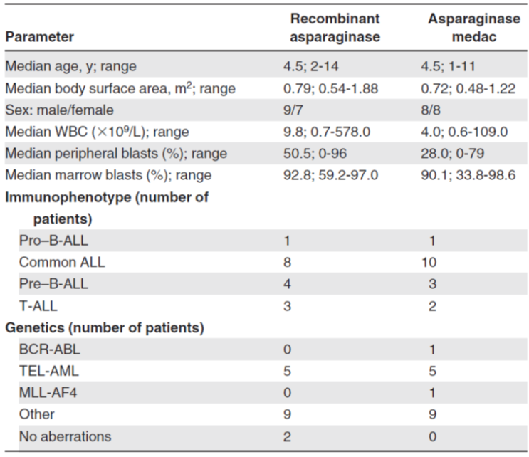
Asparaginase was completely depleted in both treatment groups in serum and CSF; however glutamine levels were only moderately influenced. There was no significant difference between treatments in terms of asparaginase depletion, duration of depletion, complete remission rate and minimal residual disease at the end of induction treatment.
The course of asparaginase activity is given by the following graph (Figure 9).
Figure 9: Pieters 2008 Time course of asparaginase activity after first administration of MC 1003
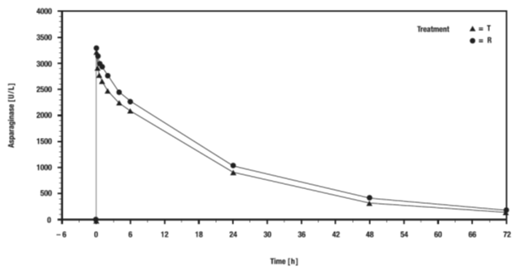
T indicates recombinant asparaginase and R Asparaginase medac
After administration of the first dose, serial blood samplings (1 to 2 mL) were performed within 72 hours and analysed for asparaginase serum levels. The resulting data were used for calculation of pharmacokinetic parameters and for demonstrating bioequivalence of both asparaginase preparations. All subsequent doses of asparaginase were administered in a volume of 50 to 250 mL over 1 hour using conventional infusion equipment. For the determination of asparaginase trough levels and amino acids in serum, additional blood samples were drawn just before asparaginase infusions 2 to 8. Further blood samples were drawn after the last asparaginase infusion on protocol Days 39, 45, 52, 59, and 64.
Before intrathecal chemotherapy instillation at Days 1, 15, and 33 (and during treatment Phase B at Days 45 and 59), cerebrospinal fluid (CSF) samples (0.5 mL) were drawn for determination of amino acid levels.
Although not of any interest in terms of PEGL ASNase, PK data for the preparations may be summarised by the following table (Table 17).

Table 17: Pieters 2008 Pharmacokinetic parameters of serum activities of asparaginase
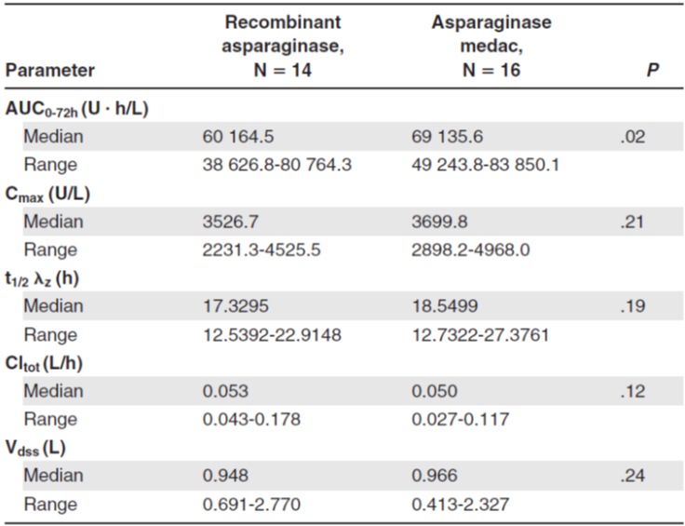
Comment: While these data demonstrate the much reduced half-life and exposure of non-pegylated asparaginase that is essentially the limit of their usefulness for this submission.

Place 2015 (DFCI-05-001)
This study compared IV PEGL ASNase with IM native E.coli ASNase in newly diagnosed childhood ALL. It was a randomised, open label, Phase III trial. Thus a useful head-to-head comparison.
Patients aged 1 to 18 with newly diagnosed ALL were enrolled from multiple sites in the USA and Canada. They were assigned to a risk group, underwent induction therapy, then those who achieved a remission were given a final risk group category and randomised to PEGL ASNase at 15 doses of 2,500 IU/m² fortnightly or 30 doses of native ASNase 25,000 IU/m² weekly.
The primary endpoint was overall frequency of ASNase related toxicities (allergy, pancreatitis, and thrombosis or bleeding complications). Serum ASNase activity was one of the secondary endpoints.
A total of n = 551 patients were enrolled with 526 achieving remission and 463 received randomisation into one or the other treatment groups (n = 231 in native ASNase, n = 232 in PEGL ASNase).
There was no statistically significant difference between the two treatment groups in terms of ASNase related toxicities. 28% in PEGL ASNase versus 26% in native ASNase, respectively (p = 0.60). Indeed, there was no significant difference in frequency of specific toxicities between individual groups either.
The median nadir ASNase activity was higher for PEGL ASNase and clearly above the therapeutic threshold set by many publications, of 0.1 IU/mL (as shown in Figure 10).
Figure 10: Place 2015 (DFCI-05-001) serum asparaginase activity
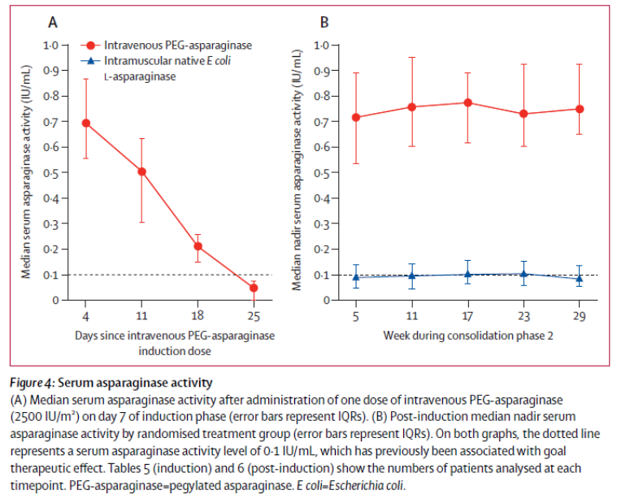
Comment: While this study reaffirms the longer half-life of the pegylated version of asparaginase, it does not present additional pharmacokinetic parameters. PEGL ASNase was substantially over the required threshold level for more than 14 days which is the proposed dosing interval, with the 2,500 IU/m² dose used (that is seemingly 0.7 IU/mL rather than the accepted level required of 0.1 IU/mL).

Rosen 2003
This was a small pilot study in adult patients (n = 26) using PEGL ASNase and high dose methotrexate as an ALL consolidation therapy. The principal aim was to compare two different doses with attention focussed on the depletion of asparagine in serum as a result and toxicity of the drug.
PK monitoring evaluated effects of dose escalation from 500 to 1,000 IU/m² in successive doses, targeting ASNase activity at more than 100 IU/L for 1 week (that is 0.1 IU/mL) and over 50 IU/L for 10 days (this second value is not universally considered by the literature to be a therapeutic threshold, however that may not have been commonly agreed in 2003). 500 IU/m² was given on Day 2 and 1,000 on Day 16. PK samples were taken at the end of PEGL ASNase administration on Days 2 and 16. Subsequent samples were taken on Days 5, 8 and 12 after 500 IU/m² dosing and Days 19, 22 and 26 after 1,000 IU/m² dosing. Trough levels were determined immediately before the second administration on Day 16.
Hypersensitivity reactions still occurred in 5 patients of 23 administered the ‘second’ course of treatment, with 18 thus available in terms of measurements to provide PK data.
An effective depletion of ASNase activity could be anticipated within 10 days, and no pancreatic or CNS toxicity occurred in this study.
This study demonstrates some evidence for the 2,500 IU/m² fortnightly dose of drug, given that smaller doses were not found to provide a satisfactory threshold level of activity over that required for a satisfactory dosing interval.
The activity of the drug in terms of threshold levels is given in Table 18.

Table 18: Rosen 2003 Course of activity after pegylated asparaginase (PEG-ASP) administration
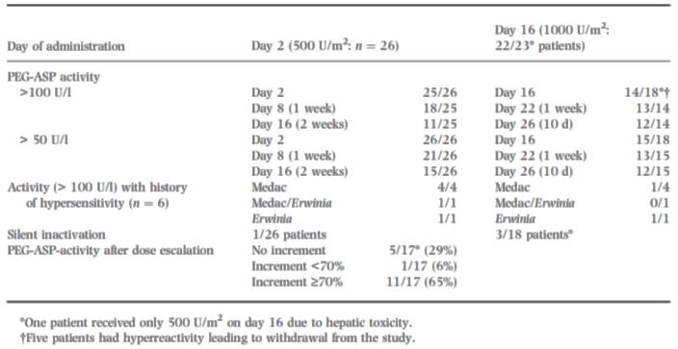
Comment: One can see that a 500 IU/m² dose was insufficient to maintain threshold therapeutic levels out to 2 weeks, with only 11 out of 25 patients having > 0.1 IU/mL. On the other hand, most subjects with the 1,000 IUI/m² dose (12/14) had satisfactory levels at Day 10. Hence with a dosing interval of 14 days as desired in the PI, the 1,000 IU/m² dose would also not be satisfactory. A higher initial dose is needed to maintain serum concentrations at a satisfactory level for such a period of time, taking into account toxicity risks. This study provides some evidence for dose finding rather than simply picking a dose that ensures ASNase activity is over a presumed threshold level, shown in other publications as sufficient to deplete serum asparagine.

DFCI-87-001/Asselin 1999a
This study provided PK information on three preparations of ASNase:
- Native E.coli
- Oncaspar
- Enzyme from Erwinia chrysanthemi (Erwinase)
Patients had childhood ALL and had been on protocols that included IM asparaginase during remission induction for at least 20 weeks after achieving remission. One of a series of treatment protocols were used over the timespan of the trial, from 1987 to 1995.
Between 1987 and 1991 the DFCI protocol 87-001 was used. Subjects received one of the three ASNase preparations as a single IM injection on the first day of therapy as part of a 5 day investigative window. PEGL ASNase dose was 2,500 IU/m², that proposed for registration. The other preparations were given as 25,000 IU/m².
Half-life and asparagine depletion of each preparation is given as shown in Table 19.

Table 19: DFCI-87-001/Asselin 1999a; Pharmacologic properties of different asparaginase preparations in naïve patients
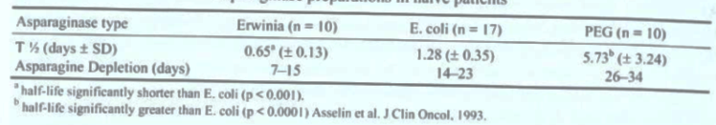
Induction therapy was followed by multi-drug intensification therapy, with administration of intensive E.coli ASNase 25,000 IU/m² weekly for at least 20 weeks; quite a high dose. For middle and last dose examination, blood was obtained on each of Day 4 or 5 in the one week interval following one of the doses; (middle was 3rd to 15th dose, ‘last’ was 20th to 30th dose). Nine patients were studied in these doses and no difference in half-life between first, middle or last dose was observed.
Figure 11: DFCI-87-001/Asselin 1999a Serum half-life as function of repeated doses.
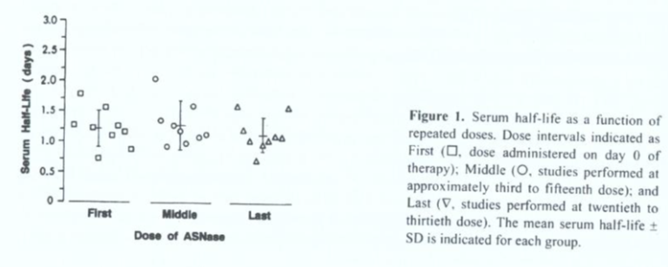
Table 20 shows the PK data for those patients suffering a hypersensitivity reaction to initial E.coli ASNase. Five patients were evaluated in the week following an apparent hypersensitivity reaction. ASNase activity was markedly decreased and it was impossible as a result to properly calculate half-life. Five patients with a history of this hypersensitivity to E.coli ASNase were studied following a dose of PEGL ASNase. As shown, half-life was markedly decreased, although calculable, in comparison to the overall measures (as shown in Table 20).

Table 20: DFCI-87-001/Asselin 1999a Half-lives of asparaginase in patients with a previous hypersensitivity reaction to E coli
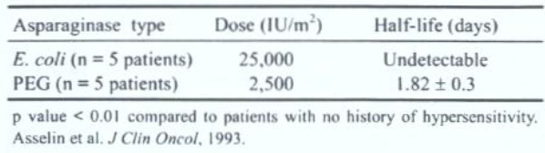
PK of PEGL ASNase was evaluated in 51 patients who had previously been treated with native E.coli ASNase, some of whom had previously had hypersensitivity reactions. PEGL ASNase was administered at the proposed dose for registration in children, 2,500 IU/m² on a 7 day or 14 day cycle (the 14 day being that proposed for registration in this submission). Non-hypersensitive patients were exposed on a 14 day schedule. In those with low antibody titres, mean half-life was 7.05 days whereas in high titre patients it was 2.59, a statistically significant difference (p = 0.0003).
Comment: This emphasises the findings in other studies, that high titre antibodies spell a much reduced half-life of Oncaspar.
The following table (Table 21) shows the reduced number of days that ASNase was measurable in those with high antibody titres, as a surrogate measure for asparaginase depletion.

Table 21: DFCI-87-001/Asselin 1999a Duration of PEG asparaginase enzyme activity in patients previously treated with the E coli and Erwinia preparation
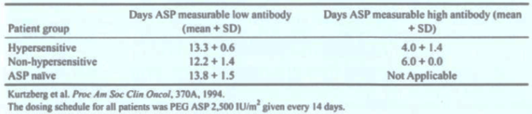
Comment: The study provides additional data on the reduction in ASNase activity when a patient has previously been hypersensitised. This has implications on dose and dose interval in the treatment of a patient if they are known to have had a previous hypersensitive episode. It further suggests monitoring is required, as, if a patient becomes hypersensitised, the subsequent reduction in half-life would seem to effectively mean that serum ASNase will be depleted far quicker and thus the dosing interval proposed for PEGL ASNase will not be adequate to deplete/suppress serum asparagine in the time interval between doses.

Summary of pharmacokinetics

Physicochemical characteristics of the active substance
Pegaspargase is a modified version of the enzyme asparaginase. The active substance is a covalent conjugate of E.coli derived asparaginase with monomethoxypolyethylene glycol using a succinimidyl-succinate linker.

Pharmacokinetics in patients

Absorption
The drug is not absorbed by the GI tract and thus is given either IV or IM. AUC data (0-∞) are available for ASP-001 (10.2 IU/m^{2.}day); ASP-302 (hypersensitive 3.52 ± 4.23 IU/mL/day, non-hypersensitive 10.35 ± 5.63 IU/mL/day); ASP-304 (5.52 ± 4.20 IU/mL/day – hypersensitive, 9.27 ± 5.41 IU/mL/day – non-hypersensitive); CCG1962 (14.7 IU/mL/day); AALL07P4 (387014.9 ± 85752.87m IU/mL/day – induction phase, 441216.4 ± 109395.84 m IU/mL/day – consolidation phase). It would appear that in the non-hypersensitive patient exposure is roughly 10 IU/mL/day with hypersensitive individuals experiencing half that or less as a result of increased clearance through immunological mechanisms.
C_{max} data from the above studies for PEGL ASNase indicates values of: 1.07 ± 0.65 IU/mL (hypersensitive), 1.15 ± 0.53 IU/mL (non-hypersensitive)(ASP-304)

Distribution
At a 2,000 IU/m² dose, volume of distribution was 2,553ml/m² (ASP-001 - adults) with a mean of 2,093ml/m².
Study CCG-1962 (children) showed a value of 1.5L/m² with one-compartment analysis.
In AALL07P4 (age range 1 to 30), Vss (mean ± SD) was 2.0 ± 1.20L in the induction phase and 1.8 ± 1.38 in the consolidation phase.
Information about dose proportionality was provided from Study ASP-001. The volume of distribution and clearance were independent of the administered dose. Doses ranged from 500 IU/m² to 8,000 IU/m² given intravenously every two weeks. In 25 of 37 patients, the median half-life was 11.1 days and dose proportionality was observed. One-way analysis of variance was performed to determine whether there was a significant difference in the half-lives across the five dose groups. Resultant F-tests showed that there were no differences (F = 1.604; p = 0.213). (EU EPAR p51)
Comment: It is probably reasonable to deduce that in light of these data, the volume of distribution is roughly equivalent to the plasma volume.

Metabolism and excretion
The disappearance of L- asparaginase activity from blood is at least partly due to the distribution of the enzyme into the extravascular fluid and clearance via the reticuloendothelial system. In one study in humans, the results of serum and urine ELISA suggest that PEG-L-asparaginase activity and the protein were cleared by mechanisms other than urinary excretion (Asselin, 1993). Possible mechanisms that are consistent with the results of this study include proteolysis of the enzyme and/or removal by an organ other than the kidneys. Authors suggested that, although previous reports suggest this might not be the case, PEG-L-asparaginase may be metabolized by the liver, excreted in the bile, or filtered from the plasma by the RES (Asselin, 1993). There are no data presented on the metabolism of the PEG associated with PEGylated proteins; information reported in literature suggests that urinary excretion of unchanged material will be the major route of clearance of any PEG released by degradation of conjugate. (EU EPAR p42).
Half-lives were measured in several studies. Values include 357 hours (ASP-001); 2.69 days (hypersensitive) and 4.83 days (non-hypersensitive) (ASP-302); 2.89 days (hypersensitive) and 3.41 days (non-hypersensitive) (ASP-304); 5.5 days (CCG-1962); 5.73 ± 3.24 days (Asselin 1993); 5.73 ± 3.24 (non-hypersensitive) and 1.82 ± 0.3 (hypersensitive) (Asselin 1999); 126.9 ± 50.51 hours (induction, AALL07P4) and 117.2 ± 49.36 (consolidation, AALL07P4). It is clear from the data presented in this report that the half-life of the drug is substantially prolonged by pegylation compared with the native E.coli asparaginase product, hence allowing the dosing interval to be so much greater. In addition, hypersensitisation to previous or current ASNase products results in increased clearance.
In Asselin 1993, for 7 patients treated with Oncaspar, there were enough time points studied to allow calculation of the serum t_{½} between Days 4-14 and Days 15-26 separately. The mean ± SD t_{½} was 6.86 ± 3.08 days and 2.99 ± 1.57 days for Days 4-14 and Days 15-26, respectively. Thus, the early t_{½} was significantly longer than the later t_{½} (p = 0.001).
Half-life data suggest clearance is increased in subjects already sensitised to the drug, typically by native E.coli ASNase.

Pharmacokinetics in the target population
All data presented are from patients in the target population. Healthy volunteers are not present in the PK data.

Pharmacokinetics in special populations

Pharmacokinetics in subjects with impaired hepatic function
Specific studies are not presented.

Pharmacokinetics in subjects with impaired renal function
Specific studies are not presented.

Pharmacokinetics according to age
Values in relation to age differences are not robust enough from the given data to draw any meaningful conclusion. Certainly there are data from ‘adults’ and ‘children’ but the error associated with the values as well as the variation in the mean values of each study mean that such values are similar across ages and indeed seem independent of age. The principal factor influencing PK parameters appears to be previous sensitisation with ASNase, whether pegylated or not (mostly not in these studies) leading to increased clearance and shorter half-life when PEGL ASNase is administered. Some of the study designs created this situation and clearance was observed to be increased as a result, giving significant disparity in half-life as a result; although even in sensitised individuals, half-life is greater than that of native E.coli ASNase.

Population pharmacokinetics

PopPK analysis AALL07P4
For Study AALL07P4, a population pharmacokinetic (Pop PK) model was developed to describe the pharmacokinetics of Oncaspar, the factors affecting the variability of pharmacokinetic parameters in this population, and to simulate single and steady state peak concentrations (C_{max}) and exposure (AUC). A 2 compartment model with nonlinear clearance was found to be the best model for Oncaspar, (despite other studies using a one-compartment model for analysis).
The AUC and C_{max} values at steady state were also determined from the simulated data. The results are summarised in Table 22 below.

Table 22: Descriptive statistics of the simulated asparaginase activity C_{max} and AUC following fifteen monthly doses of Oncaspar
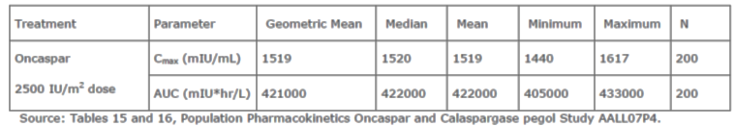
The accumulation ratios were calculated and are summarized in Table 23 below. The accumulation ratio was calculated by dividing the steady state parameter by the single dose parameter using the geometric mean values of the 200 simulated study geometric means. At steady state, the accumulation ratio was approximately 1 for both C_{max} and AUC_{0-∞}.

Table 23: Accumulation of asparaginase activity at steady state
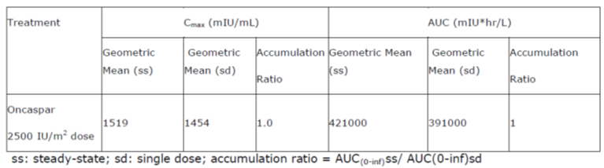
Population PK analysis showed that children and adolescents exhibited a significantly lower volume of distribution normalized to BSA when compared to adults (1.05 versus 2.94 L/m²). On the other hand, the volume of distribution normalized to BSA remains stable for adults up to about 80 years of age. (EU EPAR pp52-53)

Evaluator’s overall conclusions on pharmacokinetics
If one accepts the threshold level for therapeutic activity as 0.1 IU/mL, which is strongly supported by two of the publications presented, then data in these studies show that asparaginase activity levels and subsequent decreases in levels of asparagine are achieved at ASNase concentrations at or above this threshold level. The doses of pegylated ASNase of 2,000 IU/m² in adults and 2,500 IU/m² in children appear more than sufficient to keep subjects over this threshold concentration for the dosing interval timeframe, antibody formation notwithstanding. Toxicity at these dosing levels is not a particular concern based solely upon these data, although immunogenicity is still an issue for some patients, despite the pegylated form of the drug, leading to increased clearance. Thus, such patients need identification as they may need to switch treatment to an alternative preparation of asparaginase, as the draft PI document suggests. What one derives from the PK data is that the doses and dose interval are probably satisfactory, and based upon biological plausibility, but must be monitored for events that skew the drug’s activity level, such as hypersensitisation and antibody formation. Also, this evaluator is of the view that, based solely upon the PK data presented here, it may even be the case that a slightly lower dose would achieve optimum therapeutic outcome in the non-hypersensitised patient. Data simply do not exist to circumscribe this with any certainty.

Pharmacodynamics

Studies providing pharmacodynamic information
Similarly with the studies put forward in the dossier for PK information, there is a disparity in the totality of data listed in different locations. The submission cites the following documents as PD data:
- CSR ASP-001
- CSR ASP-102
- Place 2015
- Avramis 2002 (CCG-1962)
- Pieters 2008
- Rosen 2003
- Silverman 2011, 2013. (These publications seem to relate the DFCI-ALL-05-001 data, also contained in Place 2015)
- Van der Sluis 2013.
The clinical overview cites the following additional references:
- ASP-304 (post-dose activity)
- DFCI-87-001(Asselin 1999) (immunogenicity, post-dose activity)
- CCG-1961 (immunogenicity)
- AALL07P4 (Angiolillo 2014) (immunogenicity)
- ASP-301 (early leukaemic cell kill)
- (Multiple review articles summarised in the clinical overview).
In addition, literature references are added in the clinical overview, that are stated to pertain to ‘clinical pharmacology’:
- Liuet al 2012
- Schrey et al 2011
- Schrey et al 2010
- Zalewska-Szewczyk et al 2009
- Muller et al 2000
- Viera Pinheiro et al 2001
- Jurgens et al 1988
- Van den Berg 2011
- Zeidan et al 2009
- Avramis & Panosyan 2005
- Avramis & Tiwari 2006.
This evaluator can only be guided principally by the summary of clinical pharmacology document after summarising the above citations. The references of the clinical overview are tabulated and these will be presented here in this form, with critique following.

ASP-001
This study has been previously described in the PK section of this report. Essentially, the study was to investigate the safety profile of Oncaspar administered as a one hour infusion (PEGL ASNase) every two weeks. Toxicities and maximum tolerated dose were investigated in terms of PD parameters.
Thirty seven heavily pre-treated patients with refractory haematological malignancies aged 15 to 73 were enrolled. The study had an open label, ascending multiple dose design. Cohorts of 3 patients were entered at each dose level, starting at 500 U/m², with subsequent cohorts at higher doses until dose limiting toxicity was observed. Dose was also escalated in individual patients until a biological effect or a dose limiting toxicity was observed.
Dose numbers and dose range are given by the following table (Table 24).

Table 24: First and last Oncaspar dose levels (Study ASP-0010)
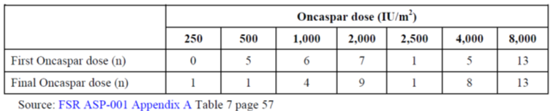
Asparaginase was not detected in urine samples collected from the first 9 patients to be studied. It was concluded that the molecule is too large to pass into the glomerular ultrafiltrate. Accordingly, no further urine collection or analysis was performed.
Comment: The study found that, in this relatively limited population (but with ages ranging from children to relatively young adults) the PEGL ASNase was well tolerated right up to the maximum 8,000 IU/m² fortnightly dose. No consistent dose limiting toxicities were noted. Severe hypersensitivity reactions occurred in three patients but all recovered and one must remember that the subjects were heavily pre-treated individuals. Other literature in the submission notes the prior use of non PEGL ASNase preparations can result in more hypersensitivity reactions than in naïve subjects. The dosing study supports the choice of drug dose and interval purely from the perspective of effectively depleting asparagine in order to plausibly have the greatest effect.

ASP 102
This study has not been presented earlier in this report. It was a Phase I study of methotrexate and PEGL ASNase in refractory solid tumours and lymphomas. The main objective was to determine the maximal tolerated dose of methotrexate when followed by PEGL ASNase, and to determine a suitable dose for PEGL ASNase for subsequent Phase II studies. Eleven subjects, 9 female, aged 18 to 74 years entered the study. There were various cancers and the only blood related cancer was a single case of non-Hodgkin’s lymphoma.
Average dosing occurrences ranged from once to 17 times per patient, but collectively 39 doses were administered. Thus a small number received a high proportion of the doses.
Five cohorts of 3 patients each were given ascending doses of methotrexate in four divided doses every 6 hours, followed by IM injection of 2,000 IU/m² PEGL ASNase 24 hours after the first dose of methotrexate. Methotrexate doses for each cohort were 40, 50, 60, 70 and 80 mg/m². Given the focus on methotrexate, the study protocol did not contain means to reduce the PEGL ASNase dose but this was changed with an amendment after the first patient was judged to have toxicity. A reduction to 1,000 IU/m² was then permitted.
If patients within a given cohort did not experience toxicity (of methotrexate) the next cohort was given the higher dose of methotrexate.
The doses of PEGL ASNase administered in this small study are given as follows:

Table 25: Doses of PEGL ASNase administered; Study ASP 102
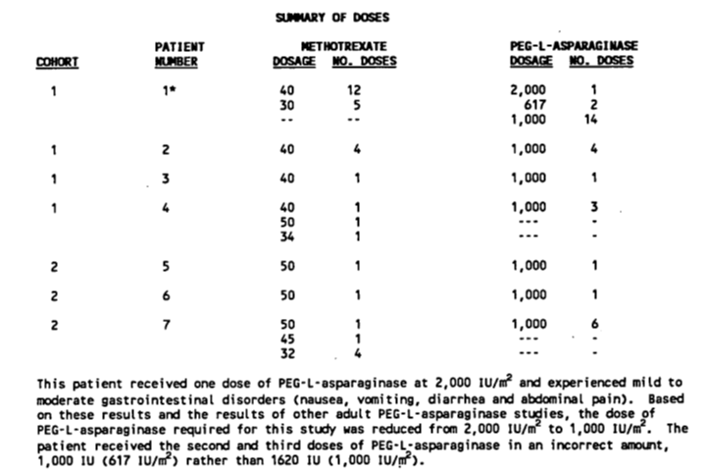
Comment: One can see from these data that only one patient here received one of the proposed PI treatment doses of PEGL ASNase in this study. All other patients receiving the drug were given a 1,000 IU/m² dose. From the perspective of this submission, it simply suggests that with this study in isolation, and in these very small numbers, 1,000 IU/m² dosages were well tolerated. Also, only one subject actually had the diagnosis related to the proposed PI. So the study is of limited added value compared to others in the context of this submission.

Silverman 2011, 2013
Note: These publications relate to the DFCI-ALL-05-001 data, also contained in Place 2015.
This study was presented in the PK section. Essentially the trial was a Phase III open label design comparing native E.coli ASNase IM with IV PEGL ASNase in newly diagnosed childhood ALL (that is, up-front, first line induction therapy). As noted previously, the dosage of PEGL ASNase used in the study is that proposed for the treatment of children in the draft PI of this submission.
All patients received one dose of IV Oncaspar (2,500 IU/m²) during multi-agent remission induction therapy. At the completion of the 32 day induction phase, bone marrow aspirate and biopsy and lumbar puncture were performed to assess response.
Complete remission was defined as a marrow specimen with < 5% marrow blasts and evidence of normal haematopoiesis, absence of extramedullary disease, and recovery of peripheral blood counts. Patients who achieved complete remission were eligible to participate in the asparaginase randomisation. Post induction asparaginase administration was initiated at the start of CNS intensification phase (standard risk and high risk patients) or during the second week of consolidation phase 1C (very high risk patients).
Patients received 30 weeks of post induction asparaginase, either IV Oncaspar 2,500 IU/m² every 2 weeks for 15 doses or IM native E.coli L-asparaginase 25,000 IU/m² weekly for 30 doses. Patients who developed severe pancreatitis (defined as symptoms persisting for > 72 hours) during induction were not eligible for randomisation. Serum asparaginase activity was measured at 4, 11, 18, and 25 days after the IV Oncaspar dose administered during induction using a validated assay with a lower limit of quantitation of 0.025 IU/mL. Samples for nadir serum asparaginase activity analysis were obtained before the first post induction dose of either treatment and then before the doses administered at weeks 5, 11, 17, 23, and 29 of post induction treatment. Serum samples to test for the presence of anti-asparaginase antibodies were obtained before the induction dose of asparaginase, at the end of induction treatment, and at the same time points used for nadir serum asparaginase activity assessment.
Comment: Serum asparaginase activity remained above the designated therapeutic threshold of 0.1 IU/mL for 18 days in 87% of patients. The proportion of patients with at least one post induction nadir serum asparaginase sample over this level also favoured the PEGL ASNase which is of interest as this is somewhat divorced from the dosing regimen and PK profile of the two products per se (99% versus 71%; p = 0.0001).
A summary of the asparaginase activity for the study is given as follows (Table 26) for both treatments.

Table 26: Serum asparaginase activity
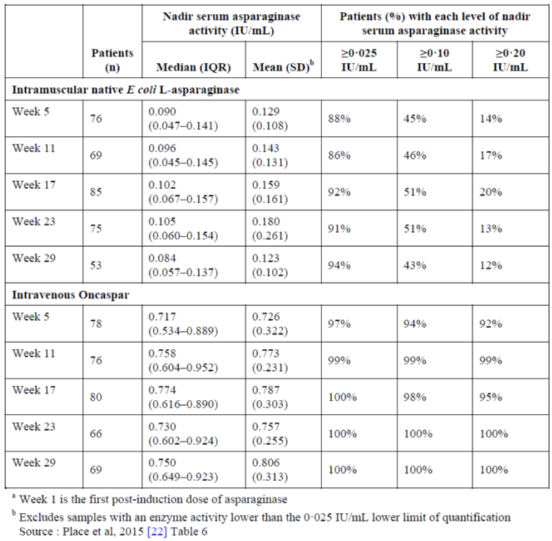

CCG-1962 (Avramis 2002)
This study was presented in the PK section. The study was a randomised open label comparison of Oncaspar versus native E.coli asparaginase in patients with standard risk ALL. The primary purpose was a PD one, namely that Oncaspar would induce lower antibody formation than native E.coli ASNase in patients with no prior exposure to any form of ASNase (that is this gives an idea of naïve response to the drug; many other studies were using Oncaspar in patients that had already experienced native E.coli ASNase or indeed the study design exposed then to it prior to PEGL ASNase exposure).
The dose of Oncaspar used was one of those proposed for use, namely 2,500 IU/m² on Day 3 of induction therapy and delayed intensification Periods #1 and #2.
For the determination of asparaginase activity, anti-asparaginase antibodies and amino acids, blood was collected during Induction Days 0, 7, 14, 21 and 28 and cerebrospinal fluid (CSF) was collected during Induction Days 0, 7 and 28. At least four blood samples were collected from 57 patients in the Oncaspar group and from 45 patients in the native E.coli asparaginase group.
PK and PD analyses were conducted on the samples using a one compartment open model to fit the serum asparaginase enzymatic activity and asparagine concentrations. The primary endpoint was the incidence of high titre asparaginase antibodies in Delayed Intensification #1. The following table summarises the asparaginase activity above 0.1 IU/mL for Oncaspar at Day 21 of the two delayed intensification stages (note this is three weeks later versus a two week PI dosing regimen, hence the percentage of patients would be the same or higher at Day 14 post-dose (see Table 27).

Table 27: Percentage of patients with adequate serum asparaginase activity
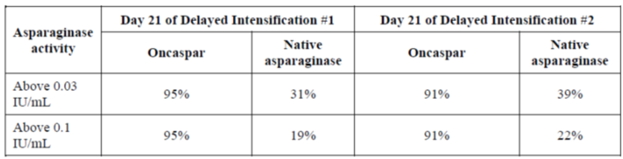
How did Oncaspar perform with respect to depleting asparagine? Serum asparagine levels fell rapidly when subjects received either drug. Mean serum concentrations were slightly higher for PEGL ASNase than native E.coli ASNase however this evaluator is not of the view that the numerical differences are clinically significant (Table 28).

Table 28: Median CSF asparagine levels during induction therapy
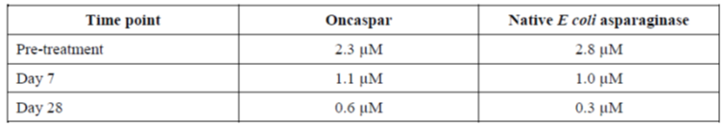
It would appear that the FDA requested a non-compartmental analysis of PK and PD outcomes (March 2006), which are also summarised in this dossier. Asparaginase activity still recorded over 90% of subjects for the 0.1 IU/mL threshold at Day 21 in the intensification phases, so these data are not disparate from those initially calculated.

Table 29: percentage of patients with adequate serum asparaginase activity (new PD analysis)
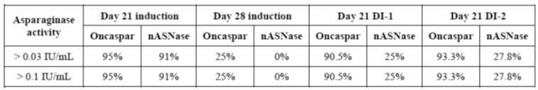
And with respect to asparagine levels, these remained comparable with the two treatments when measured across a treatment cycle, with no specific pattern to differentiate the two treatments (Table 30).

Table 30: Median CSF asparagine levels during induction therapy
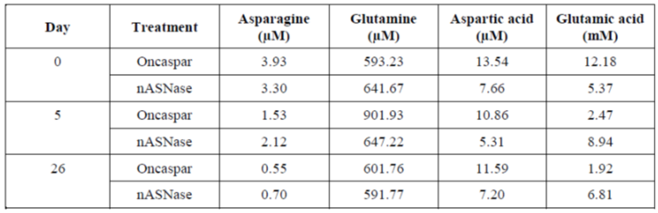
Comment: The study provides support for the biological plausibility/mechanism of action of the drug in depleting asparagine and suggests that the dose of Oncaspar and the dosing regimen proposed will effectively achieve its objective of satisfactorily depleting asparagine levels as the dosing interval in the proposed PI is 14 days. Other studies examine the minimum dose necessary to do this, not this study in particular.

Pieters 2015
This study has been presented in the PK section of this report. It describes a Phase II trial examining PK, PD, efficacy and safety of a new recombinant asparaginase preparation (medac) compared with E.coli ASNase treatment in children with previously untreated ALL.
As previously described, this study does not examine Oncaspar or any form of pegylated asparaginase. It examines a ‘purified’ form of recombinant asparaginase whereby ‘higher aggregates’ (octamers, dodecamers etcetera of the 4 subunit tetramer asparaginase enzyme) have been removed. For this reason this evaluator considers this study of lesser interest in the context of this submission. Asparaginase activity was slightly higher over time after first dosing with the medac preparation (Figure 12).
Figure 12: Time course of asparaginase activity after first administration of MC 1003
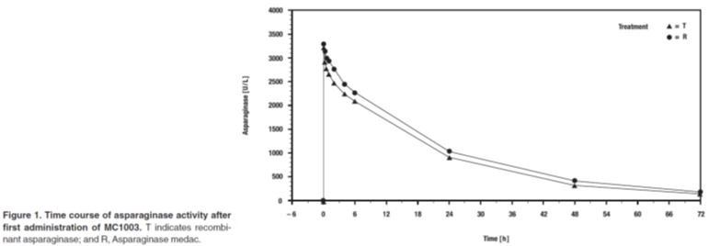
The mean depletion of asparagine in serum remained greater than 99% under treatment from immediately after the first infusion on Day 12 until the last infusion on Day 33 under both treatments (Figure 13).
Figure 13: Arithmetic means of asparagine concentrations in serum
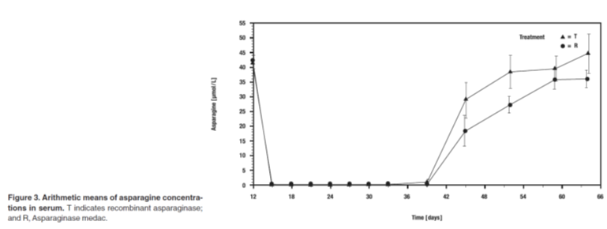
Comment: There was significant correlation between asparagine depletion and concentration of ASNase. Both drugs were concluded to be equally effective at depleting serum asparagine. What one can take from this study in terms of this submission is the fact that it again supports the depletion of asparagine as the mechanism of action for the drug. PEGL ASNase works by this same mechanism, the molecule is simply pegylated to give prolonged half-life with fewer doses needed.

Rosen 2003
This study has been presented in the PK section of this report. It was a pilot study of the use of PEGL ASNase (Oncaspar) in combination with methotrexate for the consolidation phase of treatment in adult ALL.
PEGL ASNase activity has also been documented in the PK section of this report, however in brief the study postulated that PEGL ASNase levels above 50 or 100 IU/mL were likely to result in asparagine depletion. The highest dose used was 1,000 IU/m², half that of the lowest dose proposed for registration of Oncaspar. The course of activity of the drug after administration and its length of time over 100 and 50 IU/L (0.1 and 0.05 IU/mL for consistency) are given in the following table (Table 31).

Table 31: Course of activity after pegylated asparaginase (PEG-ASP) administration
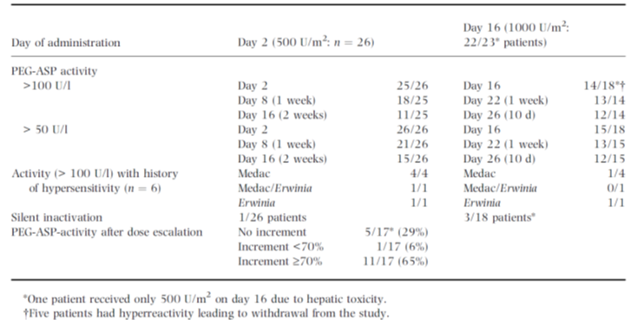
Comment: If one takes Day 16 as a reasonable comparator for a 14 day dosing interval as the drug was administered on Day 2, one can see that after 14 days, 14 of 18 such patients had a PEGL ASNase level above 100 IU/L. Therefore a dose of 2,000 IU/m² would ensure this percentage or higher of patients had such adequate serum levels of PEGL ASNase. Conversely the 500 IU/m² dose did not satisfactorily bring the majority of patients over the 100 IU/L threshold at Day 16 (n = 11/25). These data support a necessary dose higher than 1,000 IU/m² per fortnight to ensure all patients achieve a trough level of drug that has been demonstrated to adequately result in asparagine depletion.
Severe side effects such as pancreatic toxicity, CNS toxicity or coagulation disorders were observed.

Van der Sluis 2013
This study examined 12 infants treated with a new recombinant ASNase preparation for ALL, receiving up to 10,000 IU/m² infusions on Days 15, 18, 22, 25, 29 and 33 of remission induction treatment.
All children received the induction therapy of a trial designated ‘INTERFANT-06’ and received combination chemotherapy treatment consisting of a prednisone pre-phase (60 mg/m²/day; Days 1 to 7), dexamethasone (6 mg/m²/day Days 8 to 28, followed by 1 week tapering off), vincristine (1.5 mg/m²/day; Days 8, 15, 22, and 29), cytarabine (75 mg/m²/day; Days 8 to 21), daunorubicin (30 mg/m²/day; Days 8 and 9), rASNase (10 000 U/m²/day; Days 15, 18, 22, 25, 29, and 33), plus intrathecal injections with methotrexate/prednisolone and cytarabine/prednisolone.
Dose was individually adjusted to 67% of the calculated dose for infants less than 6 months old, and 75% of the calculated dose for infants aged 6 to 12 months. Trough ASNase levels were above 100 IU/L in only 74% three days after infusion. However, asparaginase was completely depleted in all but one patient, who was the youngest subject. Trough ASNase activity and amino acid levels in serum were determined prior to administration of rASNase infusion 1 (Day 15; Baseline value), 2 (Day 18), 4 (Day 25), and 6 (Day 33) during remission induction treatment.
Trough levels are shown in the following table (Table 32) but are of anecdotal interest given PEGL ASNase was not used.

Table 32: Descriptive statistics of serum trough ASNase concentration (U/L) versus day of induction
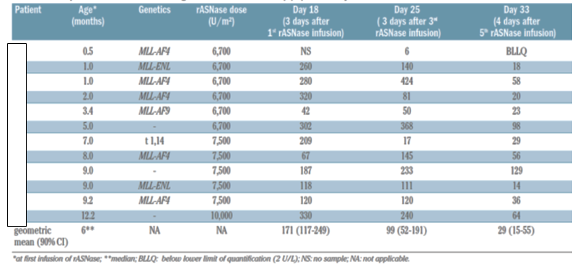
No infants developed anti-ASNase antibodies during the observation period. What is of particular interest is that the threshold level of 100 IU/L for asparaginase depletion appears to be more than may be necessary to achieve asparaginase depletion, at least anecdotally from this publication and some others. Knowing the trough concentrations given above, the level of asparaginase depletion in patients was nonetheless as follows (shown in Table 33).

Table 33: Patients with complete asparagine depletion during induction treatment
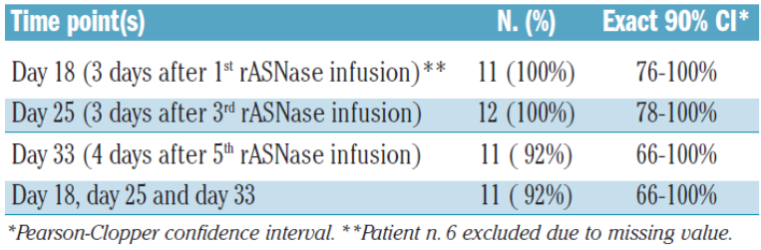
The authors conclude that ASNase levels lower than 100 IU/L seem sufficient to deplete asparagine.
Comment: While this evaluator does not think this is definitively proven by this small study, it does add to a suggestion in one other study that levels of ASNase activity higher than 0.05 IU/mL can nonetheless have therapeutic effect. This is a consideration when weighing against safety profile later in this evaluation, but this evaluator is of the view that insufficient data are present to support asparagine depletion of 0.05 IU/mL being effective, and even if so, it would then raise the questions of what dose interval would be satisfactory as well as what dose to achieve this lower level of ASNase activity. Neither of these questions can be definitively answered by the data presented in the submission as the overwhelming majority of trials are conducted with doses that reflect the proposed doses and dosing intervals present in the draft PI.

ASP-304
This study was presented in the PK section. It examined PEGL ASNase compared with other agents in the second induction treatment of children with ALL in bone marrow relapse.
This study essentially demonstrates that PK parameters are influenced by hypersensitivity of patients to the drug or to other such ASNase preparations before treatment, shown in Table 34.

Table 34: ASP-304 Oncaspar pharmacokinetic results by Day 14 antibody level
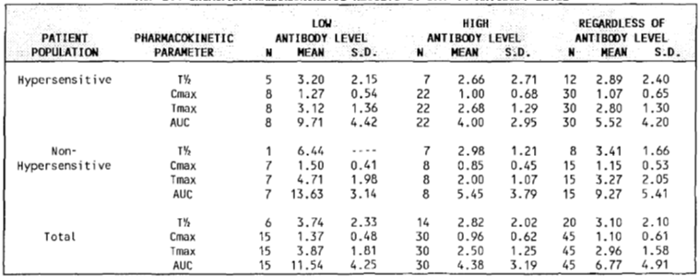
A more rapid clearance of drug in high-antibody patients is suggested.
The development of antibodies without evidence of clinical hypersensitivity to L-asparaginase has been demonstrated to result in more rapid clearance of the drug in the absence of clinical allergic signs and symptoms. This type of allergic reaction occurs with some regularity but is ‘silent’ because L-asparaginase activity, L-asparagine levels or anti-L-asparaginase antibodies are not routinely monitored during treatment and there are no clinical manifestations of allergy.
In order to determine whether there may be a correlation between anti-L-asparaginase antibody levels (pooled immunoglobulin) and any of the clinical results, the plasma antibody levels at Day 0 and Day 28 of study drug administration were summarized by the patients' hypersensitivity status (for the subset of patients for whom antibody levels were available) as follows as shown in Table 35.

Table 35: ASP-304 Day 0 / Day 28 antibody level by hypersensitivity status
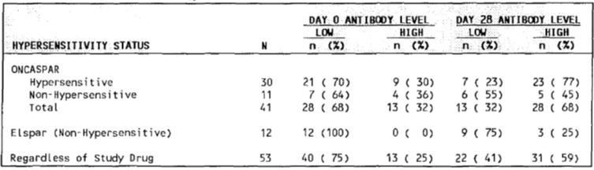
These data demonstrate that while 75% of the relapsed patients entering the study had a low level of antibody, only 41% of the patients completed 28 days of induction therapy with low antibody levels. Eighteen (45%) of the 40 patients, converted from low, to high levels of antibody during therapy.
There appeared to be a correlation between patients starting treatment as hypersensitive and then going on to develop high titre antibody levels. Previous hypersensitivity is not correlated with the starting status of antibody level.
This study states as fact that asparagine is undetectable in plasma when ASNase activity is over 0.03 IU/mL. This is not categorically shown by the other studies put forward, but is cited in this paper. Nonetheless, the days Oncaspar levels were above this threshold, stratified by hypersensitivity status and 14 day antibody level, were calculated as shown in Table 36.

Table 36: ASP-304 mean interval of days of Oncaspar levels above 0.03 IU/mL
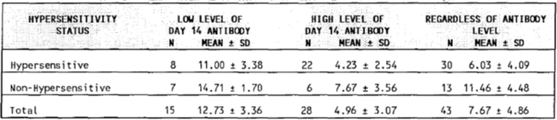
Comment: Both these factors resulted in differences under ANOVA calculations that were statistically significant; hardly surprising from the figures above. While this evaluator does not agree with some of the interpretations the study authors take from these data, one agreed statement is that to optimise therapy an individualised dosing schedule might be needed based upon asparaginase levels being monitored. Alternatively one might speculate that, in the doses proposed in the PI, 14 day ASNase levels are likely to be above the necessary threshold regardless of antibody or hypersensitivity status in most patients; yet then adverse events at this dose and dosing interval would need to be carefully considered in deciding whether to research a refined dose and dosing interval. Certainly data to support a different dose and dosing interval are not adequate in this submission and this is hardly surprising when no formal dose finding studies were carried out.

DFCI-87-001(Asselin 1999) (immunogenicity, post-dose activity)
This study has been presented in the PK section. Data on the depletion of asparagine are provided by this study, in three different preparations. Not surprisingly, the duration was significantly different (p < 0.01 on t-test). Notably, the entire 26 day observation period after dosing demonstrated an ASNase activity for Oncaspar greater than 0.01 IU/mL, the threshold above which asparagine depletion seems certain based upon multiple data sources in this dossier.
In terms of immunogenicity, three patients had positive testing and this was associated in each case with lower ASNase activity on the day of measurement. There were no patients with a positive immunogenicity test who then had a subsequent negative immunogenicity test during the time frame in which PK/PD data were collected. It is therefore not feasible to compare (within the same patient) PK/PD data at the time of a positive immunogenicity test compared with later time points at which a negative immunogenicity test occurred. It was also not possible to compare within the same patient ASNase activity at times of negative and positive immunogenicity tests.

CCG-1961 (Panosyan 2004)
This study was presented in the PK section. Anti-ASNase antibodies and asparaginase enzymatic activity in the sera of 1001 patients with high risk ALL were investigated. The study design gave all subjects native E.coli ASNase initially then two groups were formed, one with half of rapid early responders continuing to receive this drug, the second with the other half and all slow responders receiving 6 or 10 doses of Oncaspar. The 1001 patients enrolled provided 3,193 samples for examination.
A random selection of 73 patients representative of patient demographics were chosen to assess asparagine depletion and amino acid levels.
Correlations of the changes of the serum amino acids and asparaginase activity levels produced 2 subgroups of data based on the asparaginase level: 0.02 to 0.39 and 0.4 to 1.69 IU/mL ranges as shown in Table 37.

Table 37: Two sub groups by < or ≥ 0.4 IU/mL asparaginase activity and commensurate % changes (or deamination) of the serum amino acids levels
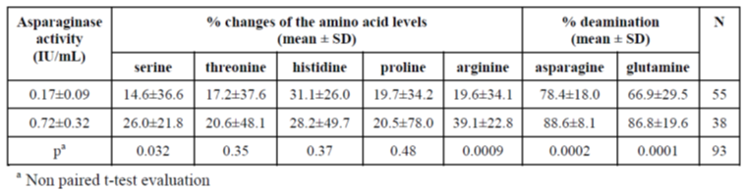
Asparagine and glutamine percentage deamination values correlated highly with serum asparaginase activity in these patients, p = 0.0002 and p = 0.0001, respectively. Serine and arginine level changes were correlated with serum asparaginase activity levels, as evidenced by p values of 0.032 and 0.009, respectively.
The following statement is of particular interest in determining the threshold ASNase level that is satisfactory in depleting asparagine;
‘asparaginase activity 0.75 IU/mL provided ≥ 90% deamination of asparagine and glutamine. Thus, asparaginase significantly contributes to remission induction in ALL patients by deaminating the asparagine and glutamine.’
Comment: Hence in the case of these data, the threshold required seems to be slightly lower than the 0.0 IU/mL to deplete asparagine, however to ensure near to 100% depletion in all studies, one could argue these data support the 0.1 IU/mL threshold of ASNase activity.

AALL07P4 (Angiolillo 2014) (immunogenicity)
This study was presented in the PK section. It compared two doses of calaspargase pegol (2,100 or 2,500 IU/m² with pegaspargase 2,500 IU/m² (one of the doses proposed in this submission and draft PI). Both calaspargase doses were found to have more than 2.5 x the half-life of pegaspargase. Importantly for this submission, after one dose on induction Day 4, plasma asparagine was undetectable for the following 11 days; (but 18 days for the calaspargase groups). Twenty-five days after administration, plasma asparagine levels were undetectable in some patients in all three groups (88%, 95%, and 96%in SS-PEG2,500, SC-PEG2,500, andSC-PEG2100 groups, respectively). After this time point, the rate of plasma asparagine rise was greatest in the SS-PEG group. Obviously this study suggests a degree of advantage with the calaspargase drug given the dosing interval may be even greater than that proposed and used world-wide for pegaspargase.
Anti-asparaginase antibodies occurred in 4 of the pegaspargase treated subjects, and 4 of the calaspargase treated subjects. No subjects had positive neutralising antibody assays, but three treated with pegaspargase and one treated with calaspargase were noted to have more rapid clearance of the drugs compared with others in their treatment groups. Two of the eight patients with anti-asparaginase antibodies had positive binding antibodies in the pre-induction dose sample and no subsequent positive tests, with no effect on asparaginase activity being noted.
In the patients with positive binding antibodies, allergic or hypersensitivity reactions were reported in two of four SS-PEG2,500 patients, one of two SC-PEG2,500 patients, and no patients in the SC-PEG2100 group.

ASP-301 (early leukaemic cell kill; Asselin 1993)
This study was presented in the PK section and PD endpoints summarised these along with PK endpoints. Serum ASNase activity is presented.
In vivo early cell kill using different formulations of ASNase in children with newly diagnosed ALL was determined in this study using radioactive rhodium₁₂₃. Results were as follows (see Table 38).

Table 38: Rhodamine-123 in vivo cell kill
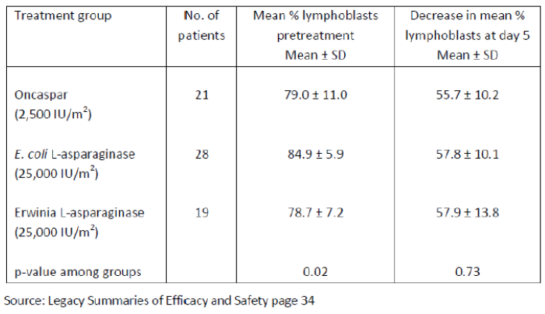
One can see that the treatments are comparable in bringing about a reduction in blast cells.
Study ASP 102 investigated the use of sequential methotrexate and native L-asparaginase. The antitumor activity of the combination of methotrexate and native L-asparaginase was dose dependent. Pharmacokinetics synergy occurred when native L-asparaginase is administered 24 hours after methotrexate (page 54 EMA EPAR).

Tabulated Clinical Overview publications

Table 39: publications relevant to clinical pharmacology of Oncaspar
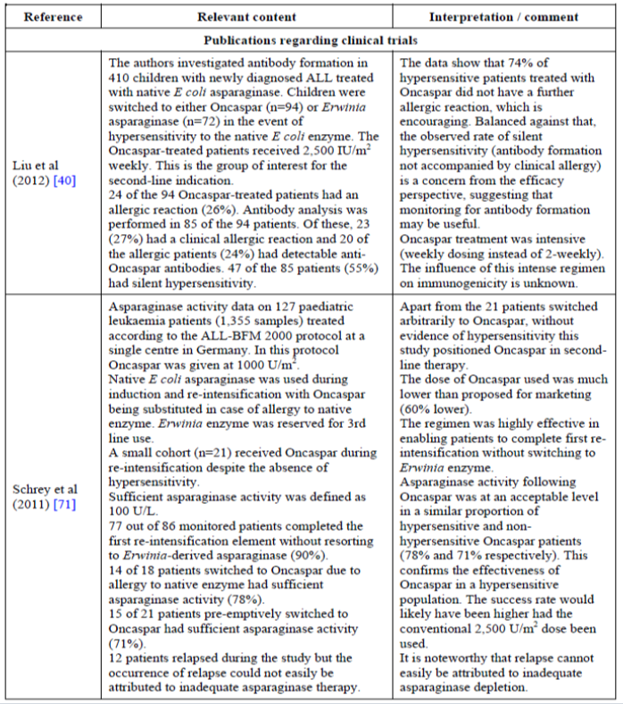

Table 39 (continued): publications relevant to clinical pharmacology of Oncaspar
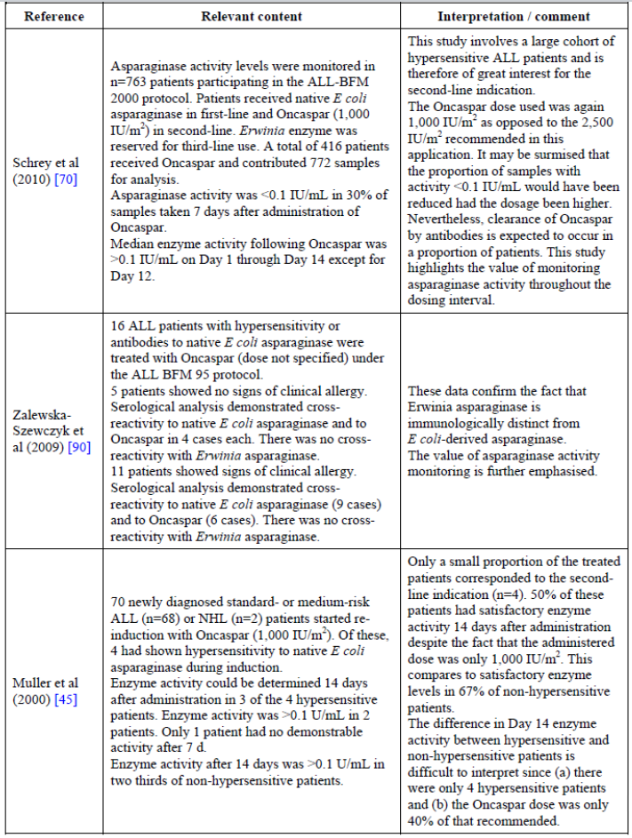

Table 39 (continued): publications relevant to clinical pharmacology of Oncaspar
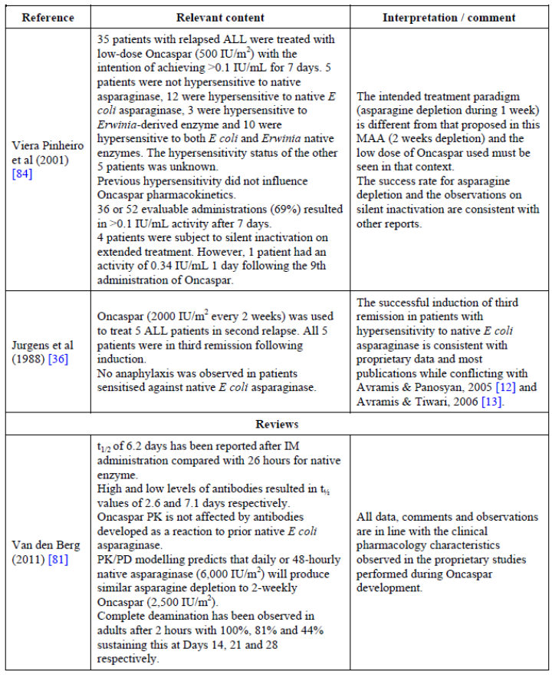

Table 39 (continued): publications relevant to clinical pharmacology of Oncaspar
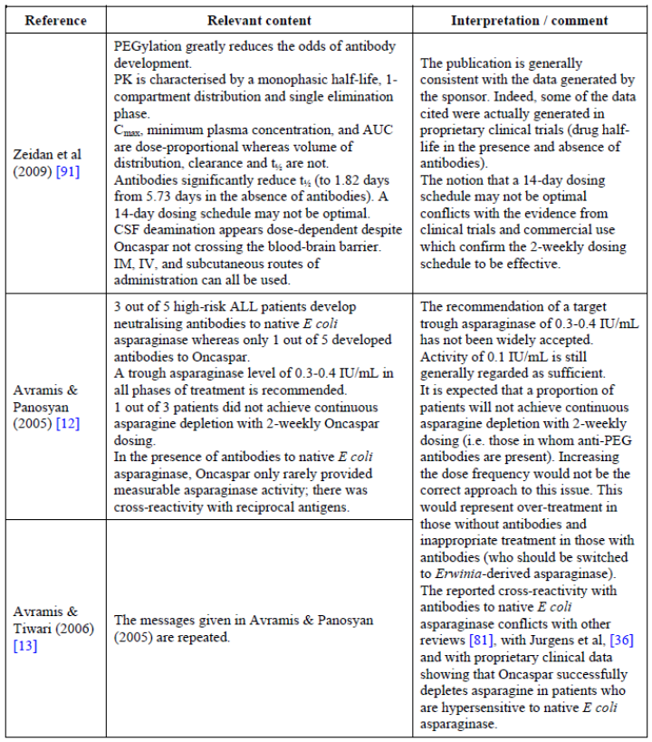
The following points of note arise from these publications:
- Monitoring for hypersensitivity or anti ASNase antibodies is probably necessary during treatment such that patients may be switched to another preparation; as recommended in the PI, this is essentially Erwinia derived asparaginase if one is already receiving Oncaspar.
- Some evidence exists that supports other studies to the effect that an even lower ASNase threshold that 0.1 IU/mL will still deplete serum asparagine satisfactorily, however these data is not robust enough to definitively claim that.
- Contrary to the dot point above, other data suggest a higher trough level of ASNase might be necessary for therapeutic effect. However, this evaluator is satisfied that the preponderance of evidence supports a threshold of 0.1 IU/mL is a satisfactory ‘bar’ for which serum ASNase level should be kept above.
- The three types of ASNase seem somewhat immunologically independent, in that they might be used if hypersensitivity to another form has developed. However, in some publications in the PK/PD evidence in this report, it would appear that previous sensitisation with native E.coli ASNase led to greater clearance of PEGL ASNase when subjects were subsequently given this. Erwinia derived ASNase seems to be the alternative if short half-life ensues when patients are given PEGL ASNase.

Summary of pharmacodynamics

Mechanism of action
No specific studies were provided for this.

Pharmacodynamic effects

Primary pharmacodynamic effects
What one would consider the primary pharmacodynamic effect is the depletion of serum asparagine concentration to negligible or unmeasurable levels. These levels have been demonstrated in the case of PEGL ASNase in the studies presented to occur with PEGL ASNase in the doses chosen for registration, for a period of approximately 10 + days if one considers all the data. This is the minimum time and some studies demonstrate longer timespans. In addition, as a measure of this effect, the correlation between this and ASNase concentrations has been studied to the effect that, in the view of this evaluator, a serum level of 100 IU/mL and over ensures a depletion of asparagine to a level that is clinically effective for all patients. Again, some of the presented studies argue this is a high figure and such an effect occurs even down to 0.03 IU/mL. However using 0.1 IU/L in the view of this evaluator gives a level of confidence in the effect produced and the time period for which this occurs.

Secondary pharmacodynamic effects
Leukaemic cell kill was presented in one of the studies above. Different forms of ASNase with their dose and dosing schedules were comparatively similar in the result of cell kill.

Time course of pharmacodynamic effects
The key time course is the duration of serum asparagine depletion after a dose of PEGL ASNase. The bulk of data suggest the dose of pegaspargase will deplete serum asparagine for at least the 14 day dosing interval. Other pharmacodynamics effects that impact upon the safety profile, that is adverse events that occur as a result of the drug’s pharmacodynamics effects, will be discussed in the safety section of this report.

Relationship between drug concentration and pharmacodynamic effects
Multiple data sources presented cite the threshold level of 0.01 IU/mL of pegaspargase as the necessary concentration above which the intended depletion of asparagine occurs. This evaluator would say that this is certainly the case, in fact the depletion of asparagine to a satisfactory level to achieve optimal clinical outcome may be below this as suggested by a small number of publications, but certainly the 0.1 IU/mL level appears to achieve this. Any greater concentration is superfluous and significantly below this does not sufficiently deplete asparagine to result in a biologically plausible clinical effect for all patients, in the opinion of this evaluator.

Genetic, gender and age related differences in pharmacodynamic response
Evidence has been presented to suggest that a younger age group (infants and young children) require a larger dose of the drug to elicit similar effects. Hence the proposed dose in the PI is greater by 25% in children than adults.

Pharmacodynamic interactions
Study ASP 102 demonstrated a pharmacokinetic synergy when native E.coli ASNase was administered 24 hours after methotrexate. No data are present to clearly define the optimal dose of methotrexate in combination with PEGL ASNase. (page 54 EU EPAR).
No data are present about food interactions.
No data are present about drug-drug interactions.
Interactions would clearly centre around the effects of asparagine depletion. These are perhaps best examined in the Safety section of this report.

Evaluator’s overall conclusions on pharmacodynamics
Asparaginase hydrolyses asparagine to aspartic acid and ammonia. Asparagine is a non-essential amino acid synthesised by the body from aspartic acid and glutamine by asparagine synthetase. In ALL, tumour cells can’t make asparagine because they lack asparagine synthetase and thus can only obtain it by diffusion from the outside environment. Most other cells are spared, but ASNase can affect high-turnover healthy cells or those that are also reliant upon asparagine diffusing into the cell from its external environment.
The clinical author of the overview in this submission presents some of the Oncaspar activity presented in this report, specifically from ASP-304 and DFCI-87-001. This provides data from adults and children and also demonstrates the differences in clearance when subjects have become hypersensitive to the drug. The duration of adequate asparaginase concentration (that is if one considers the threshold to be 0.1 IU/mL) is satisfactory for the non-hypersensitive and those with a low antibody titre who are hypersensitive. But for others with high antibody titres, half-life is much reduced, and the clinical overview author recommends changing to Erwinia L-Asparaginase, hence monitoring for hypersensitivity is required in the view of this evaluator. This evaluator agrees with the facts that 0.1 IU/mL is a reasonable threshold above which asparaginase activity can be considered satisfactory for clinical effect, and that, in those without hypersensitivity or low antibody titres, half-life is more than satisfactory to support the dosing interval proposed in the PI.
The drug doses and dosing interval proposed will, in the view of this evaluator, result in sufficient serum ASNase concentrations to deplete asparagine to negligible levels and thus have the desired therapeutic effect. The small amount of leukaemic cell kill data suggest that asparagine depletion does indeed translate to the direct clinical outcome of plasma lymphoblast cell death. Hence, as given by the multitude of literature publications to be presented in the efficacy section of this report, the drug appears successful in use both in first and second line treatment of ALL in adults or children, although there is of course a significant safety profile to also be examined as well as the complication of hypersensitisation.

Dosage selection for the pivotal studies
No studies are formally presented as dose finding studies. Dosage was overwhelmingly that proposed in the draft PI document for the various age groups for the submitted studies. Studies that varied dosage or dose interval are briefly cited for convenience below, but are presented elsewhere in this report, primarily in the PK and PD sections. Dosage is not always cited in some of the data presented.

Table 40: Submitted Studies with dose or regimen varying from that in the proposed draft PI
Study | Dosage Regimen
PK/PD
ASP-001 | Cohorts at starting dose of 500 IU/m² escalating in increments of 500 IU until toxicity was observed. Range of dose 500-8000 IU/m² for Oncaspar.
AALL07P4 | Either, 2100 IU/m² or 2,500 IU/m² per fortnight.
Rosen 2003 | 500 IU/m² or 1,000 IU/m² per fortnight.
ASP-102 | 2,000 IU/m² reducible to 1,000 IU/m²
Scherey et al. 2011, 2010 | 1,000 IU/m²
Muller et al. 2000 | 1,000 IU/m²
Viera Pinheiro et al. 2001 | 500 IU/m²
Phase II/III
NOPHO ALL2008 | 1,000 IU/m²
ASP-201A | 2,000 IU/m²
ASP400 | 2,000 IU/m²
ALL0331 | 3 week intervals, PI proposed dose.
Comment: This evaluator is not going to analyse these studies here. The discussion of dosage, in the view of this evaluator, is one of balance between toxicity and ensuring adequate serum levels of ASnase sufficient to deplete asparagine in the body. It would appear from the PD studies presented that such a serum level is 0.1 IU/mL; potentially even 0.05 IU/mL. This is definitively achieved by the dosages proposed in the draft PI document, when one examines the PD data. The dosages in many cases provide adequate serum ASNase levels far longer than the 14 day dosage interval timeframe required, and some study data have shown it might be possible to achieve efficacy outcome on lower doses of drug. However, as this has not been formally studied, the dosages proposed and dose interval proposed are a result of empirical evidence in the many thousands of patients treated as part of ALL drug regimens.
Given the proposed dosages are those doses and dose intervals that have been studied the most in the data submitted, particularly in one or two studies of many thousands of patients eclipsing the patient numbers in other trials, this evaluator is satisfied that the proposed doses are satisfactory for infants, children and adults. What is clear from the PD data is that any antibody formation to the drug results in more rapid clearance and would require dose adjustment or transfer to another type of asparaginase. Such methods have been shown in the study data in terms of switching from native E.coli ASNase to Oncaspar, for example.

Clinical efficacy
There is no all-encompassing clinical overview presenting these data in the dossier. The presentation of the data has taken some time for this evaluator to organise and the data presented in this report are, in the opinion of this evaluator, satisfactory for registration decisions to be made. The data presented in this report are, in this evaluator’s view, the totality of data submitted with specific experience of Oncaspar. Other studies are presented in some summary tables taken from the clinical overview, but these are solely studies with other forms of asparaginase, almost entirely native E.coli asparaginase.
The submission includes:
- a clinical overview that was presented in the European submission
- an ‘addendum’ document based upon a literature review conducted for the TGA, and
- a further literature review conducted as part of the Day 180 questions from the EMA.
This evaluator has done his best to try and determine the totality of data submitted to support the indication proposed in the draft PI. The EMA SLR focussed on first line treatment in children, which the TGA SLR expanded to include first line treatment in adults. Data on second line treatment does not appear to have been part of the search strategy objectives in either case and might stem from the fact that in other regulatory jurisdictions use in second line treatment has been approved for very many years. What has been confirmed by the sponsor is that the TGA SLR encompasses everything from the EMA SLR, thus the lists of literature for review have been verified. The SLR inclusion and exclusion criteria have been examined for both SLRs and although differing slightly in the type of publications included, this evaluator is quite satisfied that the searches were extensive and have revealed worthwhile information while not excluding data that might be detrimental to the use of the drug.

Studies providing evaluable efficacy data
One must remember that this submission seeks use of the drug in both first line and second line therapy, in both children and adults.
The primary trials for this drug were carried out in the late 1980s. Development was for ALL patients with known hypersensitivity to native L-asparaginase.

First line (formal trials) treatment data (children and adults)
Six studies in 3,643 patients (1,186 treated with Oncaspar) with newly diagnosed ALL provide the initial data supporting first line use of the drug. These studies are given as follows in Table 41.

Table 41: Summary of first line therapy clinical data package for Oncaspar
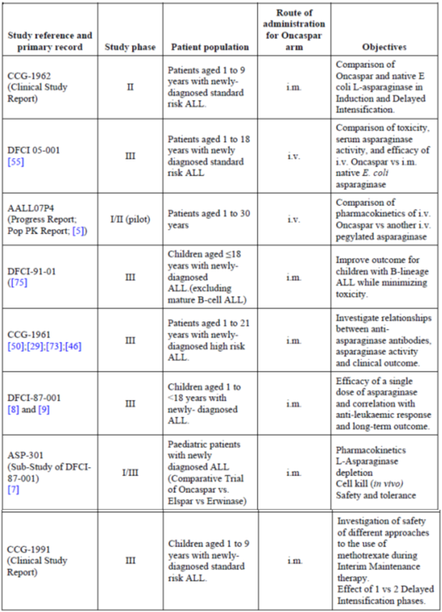
As one can see, these data, while supporting first line ALL use, encompass children only apart from Study AALL07P4, which extends to those aged to 30 years.
The addendum to the clinical overview in light of the TGA SLR cites the following additional trials:
- AALL0232
- AALL0331
- UKALL2003
- NOPHO ALL2008
Comment: This evaluator suggests, therefore, that these are the totality of formal trials in first line treatment.

Second line treatment data (formal trials) in children and adults
Eight trials with n = 218 in total are cited in the clinical overview as supporting Oncaspar use in second line treatment. (p12) It is uncertain whether this was a specific development programme or evolved over time. The clinical overview author states many of the studies were conducted in an academic environment and the publication is the main reference, which explains the doubling-up and some confusion determining how many actual discrete bodies of data have been submitted. One can note that, in this data set, all ages are encompassed by the data (see Table 42).

Table 42: Summary of second line clinical data package for Oncaspar
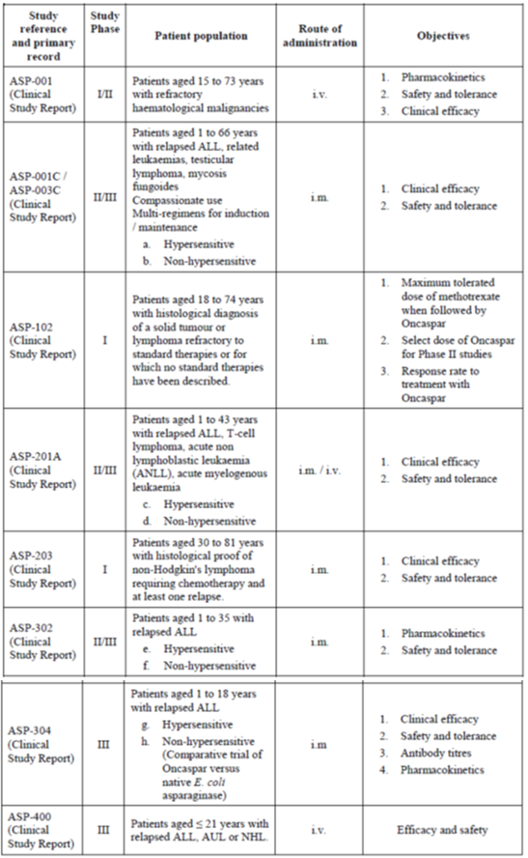
There does not appear to be a table of additional formal trials derived from the SLRs that add to these in terms of second line treatment. The search strategy of these SLRs did not encompass second line treatment using the drug. Therefore, these trials tabulated above appear to be the totality of formal trial documents available to support second line Oncaspar use.
On the basis of these two ‘primary’ data sets, as it were, in the view of this evaluator, the formal trial data (that is CSRs) reflect primarily support for ALL treatment as first line in children and as second line in both children and adults. Given the nature of the registration history world-wide, it is not surprising that a focus on first line treatment is apparent in the data set.

Presentation of published data sources
In addition to these data, the clinical overview cites ‘important publications’ in the published literature. It is not made clear how these were arrived at or what makes their status ‘important’ per se. The clinical overview refers to first line use of Oncaspar in ALL as being extensive and the subject of a literature review. This literature review upon investigation and confirmation by the sponsor is that conducted as part of 180 day questions from the EMA.
Published literature considered key to the second line use of the drug are contained in Table 8 of the clinical overview and are 11 in number. It is again not clear how the decision about their relevance was made, or how they were located.
The clinical overview then states that first line use (children and adults) is extensively discussed in the systematic literature review of first line use of Oncaspar. One assumes this is referring to the review conducted for the EMA as part of the Day 180 questions, as this was specifically targeted at use of Oncaspar in first line treatment of ALL in paediatric patients. The cut-off date of 15 October 2015 referred to in the clinical overview confirms it. Apparently 13 unique studies of 40 articles gathered used Oncaspar as first line therapy. One (CCG-1962) had head-to-head comparison data of Oncaspar and native E.coli ASNase used at induction for ALL.
Few studies, in comparison to first line use, studied Oncaspar use in second line treatment, with subjects already hypersensitive to native E.coli ASNase. Publications relevant to this are given in Table 13, clinical overview. Again, how these studies were determined is not made clear.
In summary, the original clinical overview cites the trial data and EMA SLR pivotal literature that is intended to support the product in the proposed indication. The addendum documents discuss additional data retrieved via the SLR done for the TGA. Given the nature of the searches, this is primarily data that supports the use of the drug as first line in adults.

‘Addendum’ to module 2.5; TGA Oncaspar
This addendum document is intended to supplement the information in the clinical overview from the perspective of the systematic literature review conducted for the TGA. The SLR is described as simply an extension of the EMA SLR, with a new cut-off date of 6 June 2006 and of course a wider set of search parameters. After application of inclusion and exclusion criteria, 92 publications were retrieved (62 for paediatric indication, 30 for adults). Specific to Oncaspar use, 39 studies provided paediatric data and 10 provided adult data. This evaluator proposes to focus upon these, as the role of native E.coli ASNase is not the subject of this submission except insofar as it is compared in efficacy and safety profile with Oncaspar. This then explains the literature reviewed in Section 7.3 of this report.

Published data of first line treatment
This evaluator located a tabular summary of the trials (Table 43), associated publications, and their reference to the EMA SLR or TGA SLR in the TGA SLR documents themselves intended to support first line treatment.

Table 43: List of tables selected for inclusion in the SLR
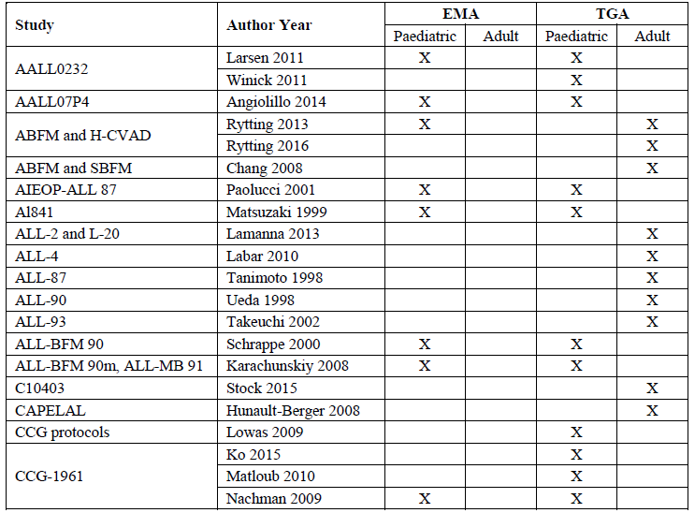

Table 43 continued: List of tables selected for inclusion in the SLR
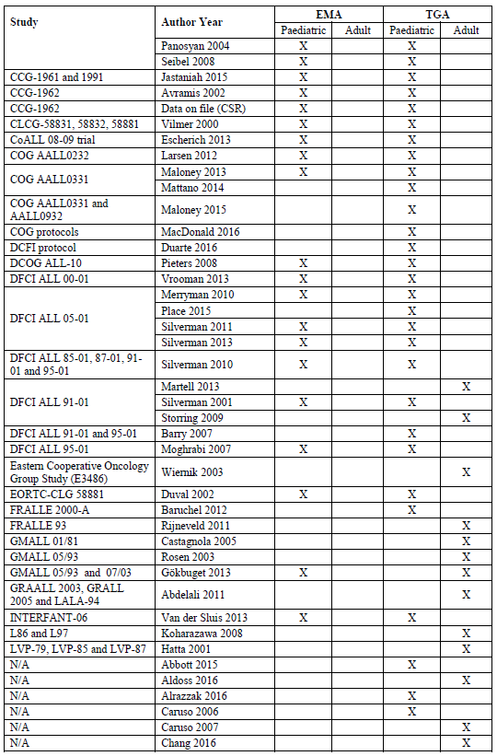

Table 43 continued: List of tables selected for inclusion in the SLR
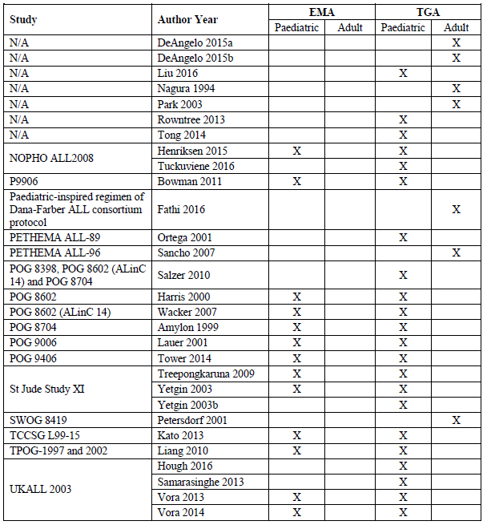
The presentation of these data is complicated by the fact that no framework is consistently adhered to. In some documents, data are separated by the fact they address first line or second line treatment, in others, whether they address treatment of adults or children. Nowhere that this evaluator could find is there a simple list of formal trials and publications that address first line treatment and break that down into adults and children, the second line treatment broken down as well. As such, this evaluator is going to present first line treatment data, then second line treatment data. Formal trials will be presented first, then publications. Where publications are simply that of data from the formal trials, they will not be re-presented unless they add, useful information; in the view of this evaluator.

Published data of second line treatment

Formal trials in second line treatment
See Table 42 above Summary of second line clinical data package for Oncaspar The above tables appear to summarise the totality of formal trials in second line use of Oncaspar.

Published literature in second line treatment
In terms of published literature from the EMA SLR:
For the second line indication, few data existed in literature. However published information cited in the clinical overview are shown in Table 44.

Table 44: Publications relevant to the efficacy of Oncaspar in ALL (second line indication)
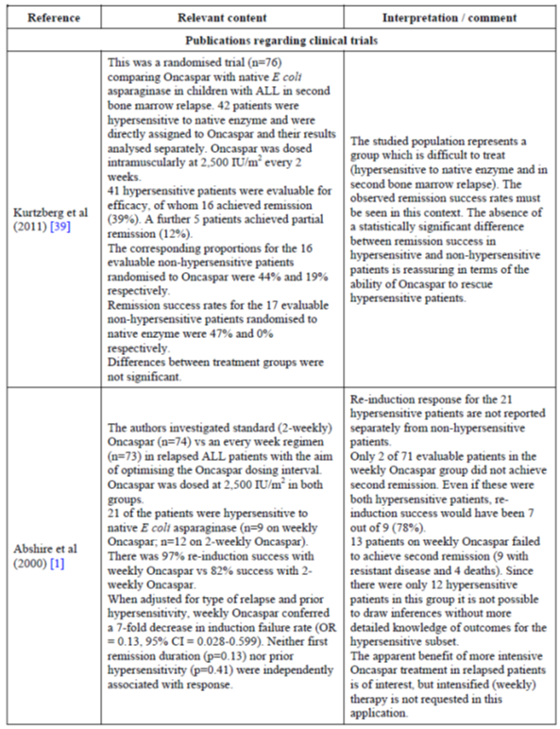

Table 44 continued: Publications relevant to the efficacy of Oncaspar in ALL (second line indication)
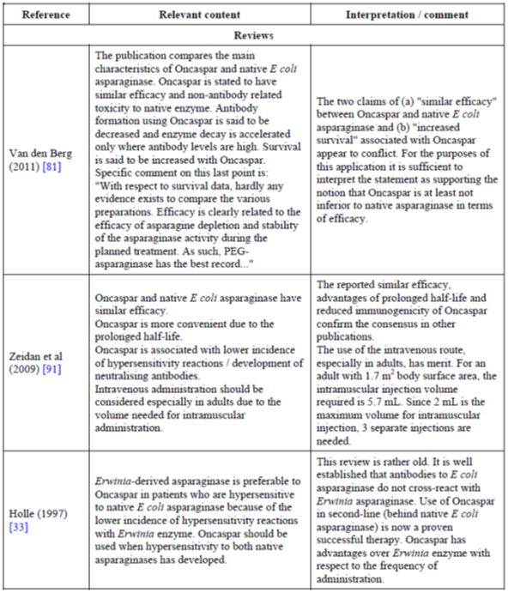
The TGA SLR does not appear to have added to the above publications given it was directed at first line treatment. So only those publications tabulated above, refer to publications focussed upon second line treatment. This evaluator hopes the above has explained as well as possible the data submitted for review.

Formal clinical trials

First line treatment

CCG 1962
This was a randomised comparison trial of PEGL ASNase and native E.coli ASNase in ‘standard’ risk ALL in 118 patients). It was a Phase II pilot study. The primary objective was to observe the safety of the drugs in the induction and delayed intensification Phases 1 and 2 in children with newly diagnosed standard risk ALL. Also a primary goal was to see if high titre ASNase antibodies were present in 50% or fewer cases using the PEGL ASNase in DI #1.
Secondary objectives of note included determining whether the incidence of high titre anti-ASNase antibodies in children treated with PEG-ASNase was decreased by at least 50% compared with children treated with native ASNase in DI #2; and; to determine the duration that serum ASNase levels remained > 0.03 IU/mL and serum asparagine (ASN) concentration remained < 1 μM in children treated with PEG-ASNase or native ASNase in Induction and in both DI phases. Note that the serum ASNase levels considered effective here are a third that considered clinically effective by the PK/PD data in this report. (0.1 IU/mL).
The study consisted of a 4 week induction phase, a four week consolidation phase, two eight week maintenance phases, two eight week DI phases, then maintenance therapy.
The target population were children aged 1 to 9 who had standard risk ALL defined as WBC counts of < 50,000/µL and < 25% L3 blasts.
Oncaspar was given as 2,500 IU/m² IM doses. PEG-ASNase was administered on Day 3 of Induction and Day 3 of both DI phases, or native ASNase was administered on Days 3, 5, 8, 10, 12, 15, 17, 19, and 22 of Induction and Days 3, 5, 8, 10, 12, and 15 of both DI phases. Native ASNase (Elspar), 6000 IU/m² IM, 9 injections over 20 days during Induction and 6 injections over 12 days during each of two periods of DI.
Efficacy measures included development of high titre antibodies to ASNase, Induction response rates, post dose serum ASNase activity, serum ASN and glutamine (Gln), CSF ASN, and event free survival (EFS). Safety measures included Grade 3 or 4 toxicities.
Statistical tests included χ² tests for comparisons of response rates and some categorical analyses of ASNase activity groupings and antibody ratio levels (antibody ratio calculated for the patient sample to the negative control value for each assay); Wilcoxon rank test for comparisons of actual antibody values and antibody ratios. Kaplan-Meier estimates for life-table estimation; log-rank tests were used to compare EFS outcomes.
While the above summarises the study framework, the results shall be presented from the addendum CSR that provided end results.

Patient disposition
A summary of patient disposition and discontinuation is given by the following table (Table 45).

Table 45: Patient disposition by study phase (excluding maintenance) (Study CCG-1962)
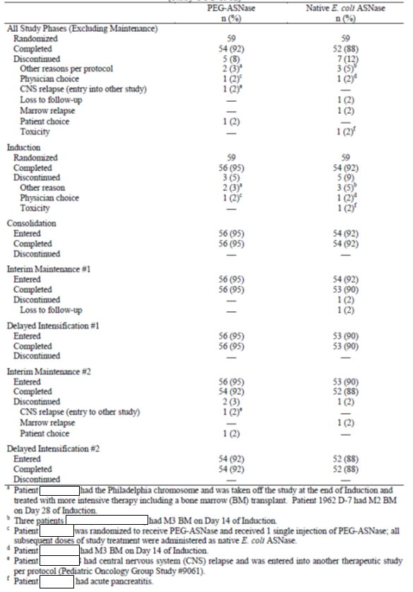
Relevant demographic characteristics are given by the following table (Table 46).

Table 46: Demographic and Baseline characteristics (Study CCG-1962)
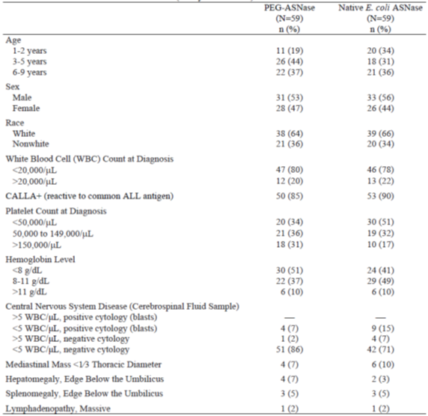
Comment: It is of note that groups were well matched in terms of WBC count. It is noted that more subjects in the native ASNase group had CNS disease and a mediastinal mass, while more subjects in the PEG-ASNase group had hepatomegaly.

Final results
The study had insufficient power to detect changes between treatment groups. Therefore the results show possible trends only and p-values are simply for reference.
The primary endpoint of this study was a ≥ 50% reduction in the incidence of high titre (> 2.5) anti-ASNase antibodies in children treated with PEG-ASNase in DI #1 compared with those treated with native E.coli ASNase. During the DI #1 treatment phase of this study, high titre antibodies were detected in 7 of 46 (15%) patients treated with native E.coli ASNase and 3 of 49 (6%) patients treated with PEG-ASNase (p = 0.149; Table 47). The study was powered (80% with a 1-sided significance level of 0.05) to detect a 25% reduction in patients with high titre antibodies during DI #1. The initial underlying assumption that 50% of patients receiving native E.coli ASNase would develop high titre antibodies was incorrect. Thus, the study is underpowered to detect a difference in the incidence of high titre anti-ASNase antibodies. During DI #2, high titre antibodies were detected in 1 of 44 (2%) patients treated with native E.coli ASNase and 5 of 45 (11%) patients treated with PEG-ASNase.

Table 47: Patients with antibodies to ASNase (Study CCG-1962)
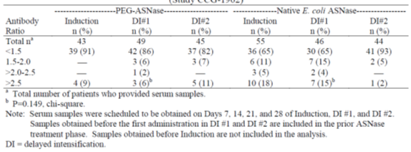
Comment: Those treated with PEGL ASNase do appear to have greater numbers of patients achieving an ASNase activity level greater than 0.1 IU/mL on the days of highest antibody titre.
ASNase activity was assessed at the time at which the highest titre was reported (Table 48).

Table 48: Patients with ASNase activity greater than 0.1 IU/mL on day of highest antibody titre (Study CCG-1962)
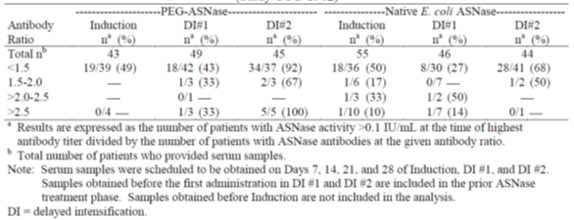
Event free survival (EFS) was similar (p = 0.414) between the 2 treatment groups. The log-rank p-value should be interpreted with caution, as the EFS data are heavily censored. Event free survival rates for the PEG-ASNase group were 83% at 3 years, 78% at 5 years, and 75% at 7 years. Corresponding EFS rates for the native E.coli ASNase group were 79%, 73%, and 66%, respectively.
Comment: Based on the numbers in the trial, one can state that event free survival was similar between groups, so this supports, as does the bulk of the literature presented in this submission, that PEGL-ASNase and Native E.coli ASNase have similar treatment outcome measures. While the study suggests an advantage in terms of antibody formation and persistence of adequate ASNase activity, it cannot definitively establish this due to the small numbers in the study. It is of note due to the head-to-head comparison of efficacy outcome and the same dosage and dosage interval as proposed for the PI in this submission.

DFCI-05-001
The CSR for this study does not appear to be in the submission. However, its findings are presented in multiple publications. The Table 42 above cites several publications, but only Place 2015 is presented in full; the others are only given in abstract format.
Referring to Place 2015 then, this was a randomised, Phase III open label trial where IV PEGL ASNase and IM Native E.coli ASNase were compared in the treatment of newly diagnosed ALL in children. Subjects aged 1 to 18 with newly diagnosed ALL were recruited across the US and Canada and assigned an initial ‘risk’ classification and then underwent 32 days of induction therapy. Those who achieved complete remission were assigned a final risk group and then participated in a randomised comparison of PEGL ASNase versus Native E.coli ASNase.
Comment: This study is of particular value as it is a large randomised comparison of PEGL versus typical asparaginase treatment in children with the diagnosis of the proposed indication.
The trial profile and subject numbers are usefully summarised as follows in Figure 14.
Figure 14: DFCI-05-001 Trial profile
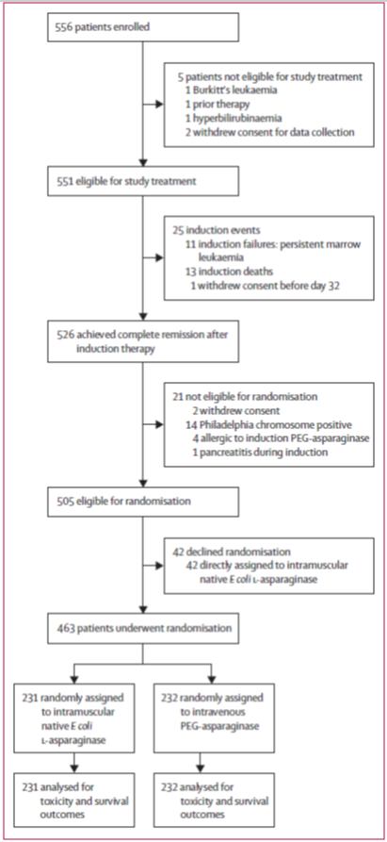
In terms of assignment to risk groups, Patients with any of the following features were classified as high risk: age 10 years and older, a white blood cell count of 50 000 cells per μL or higher, initial spinal fluid sample with the presence of lymphoblasts and five or more white blood cells per high power field (CNS 3), or a T cell phenotype. All other patients were classified as standard risk. Final risk group was assigned based on end-induction minimal residual disease and cytogenetics. Any patient with MLL gene rearrangement or hypodiploidy (< 45 chromosomes), and any patient with B cell acute lymphoblastic leukaemia and high end induction minimal residual disease were assigned to the very high risk group. Patients with t(9;22), that is, Philadelphia chromosome positive acute lymphoblastic leukaemia; were classified as high risk and received imatinib starting on Day 18 of induction. For all other patients, final risk group assignment was the same as their initial risk group.
Randomised patients went on to receive 30 weeks of post induction treatment, using either IV PEGL ASNase 2,500 IU/m² every 2 weeks for 15 doses, or IM E.coli ASNase 2,5000 IU/m² weekly for 30 doses.
Comment: Note that the dosing schedule of PEGL ASNase is identical to that proposed for children in the draft PI of this submission. Hence this trial is of particular note as a result as it is a large, randomised head to head comparison using the proposed dose of PEGL ASNase.
After the induction phase (thus assignment to the two treatment groups) any allergy to IM E.coli ASNase was dealt with by treatment with PEGL ASNase (same dose as PEGL ASNase group but weekly), and if a second allergic reaction occurred treatment was switched to Erwinia ASNase twice weekly IM. Those with Grade 2 or worse allergic reactions in the PEGL ASNase group were switched to the same dosing of Erwinia ASNase.
ASNase was temporarily withheld in cases of mild to moderate pancreatitis or thrombosis (if 72 hour resolution), and withdrawn in severe or recurrent pancreatitis. Discontinued patients within 10 weeks of post induction treatment had intensified other therapy drugs; (for example more doses of doxorubicin).
The primary endpoint of the study was the overall frequency of asparaginase related toxicity, as defined by allergy, pancreatitis and thrombotic or bleeding complications. Secondary endpoints included disease free survival, nadir serum ASNase activity, and quality of life as well as overall and event free survival.
Baseline patient characteristics are shown by the following two part table (Table 49).

Table 49: Baseline characteristics of randomised patients
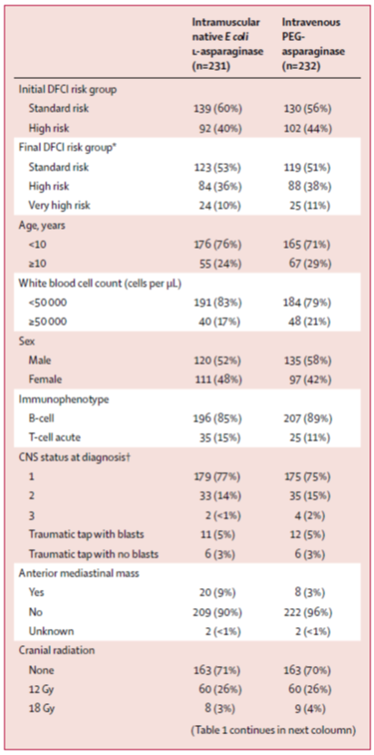

Table 49 continued: Baseline characteristics of randomised patients
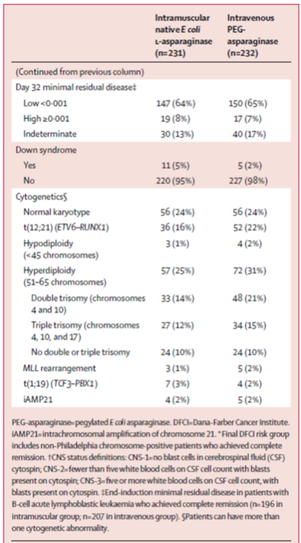
Comment: Characteristics would appear to either, be well balanced or favour the Native E.coli ASNase group, that is, consider trisomy, for example.
The study was designed to test for a difference in the incidence of asparaginase related toxicity between the randomised treatment groups and randomisation was stratified by final risk classification. A total of 556 patients were enrolled to achieve a goal accrual of 460 randomised patients, with which the study had 83% power to detect a 13% difference in the overall frequency of asparaginase related toxicity using a two-sided alpha level of 0.05.
During the induction treatment phase, there were 13 (2%) deaths and 11 (2%) induction failures. 526 (96%) of 551 patients achieved complete remission. Of the 11 patients who were induction failures, two had asparaginase related toxicity during induction: one allergic reaction and one bleeding event.
Seven patients (1%) of 551 experienced an allergy to intravenous PEGL ASNase during induction therapy. These included two Philadelphia chromosome positive patients, one patient with induction failure, and four who remained on study and received intramuscular Erwinia asparaginase post induction. Of these four patients, two relapsed (and died) and two remain alive and relapse-free at the time of last follow-up (19 August 2014).
Final risk group was assigned to 524 of 526 patients who achieved complete remission at the end of the induction phase (two withdrew consent before final risk group assignment). 505 of these 524 patients with final risk group assignment were eligible to participate in the randomised comparison. 42 (8%) of these 505 patients declined to participate in the randomised comparison and 463 (92%) were randomly assigned: 231 patients to intramuscular native E.coli L asparaginase and 232 to intravenous PEG asparaginase.
While the primary endpoint for this trial is safety-related, suffice to say that the overall frequency of asparaginase related adverse events did not differ between randomised treatment groups (p = 0.60) and indeed for specific, known adverse events, frequencies were not statistically significantly different between treatment groups either. Pancreatitis (p = 0.55), allergy (p = 0.36) and thrombosis or bleeding (p = 0.26) did not exhibit statistically significant differences in frequency between treatment groups.
Of note is that, of the 28 hypersensitivity reactions recorded with post induction intravenous PEG asparaginase, 25 (89%) occurred at the first or second post induction dose, and 14 (50%) of all reactions were Grade 3 or 4. Of the 21 hypersensitivity reactions recorded with post induction intramuscular native E.coli L asparaginase, two (10%) occurred at the first or second post induction dose, and six (29%) of all the reactions were Grade 3 (none was Grade 4).
The 5 year disease free survival was 90% (95% CI 86 to 94) for patients randomly assigned to intravenous PEG-asparaginase, 89% (85 to 93) for those randomly assigned to intramuscular native E.coli L asparaginase, and 88% (74 to 95) for those who declined to undergo randomisation and were directly assigned to intramuscular E.coli L asparaginase.
The 5 year overall survival was 96% (93 to 98), 94% (89 to 96), and 95% (82 to 99) for these three patient groups, respectively. No differences in disease free survival between randomised groups were noted within patient subsets.
Serum asparaginase activity was assessed 4, 11, 18, and 25 days after the dose of intravenous PEG-asparaginase during induction. Serum asparaginase activity remained above 0.1 IU/mL for 18 days after the dose of intravenous PEG asparaginase in the majority (87%) of patients, but was below this value in most (88% of patients) by 25 days after the dose.
At each post induction time point, the median nadir serum asparaginase activity and the proportion of patients with nadir serum asparaginase activity of 0.1 IU/mL or above were both significantly higher in patients who received intravenous PEG asparaginase than in those who received intramuscular native E.coli L asparaginase (p < 0.0001) at each time point. The proportion of patients with at least one post induction nadir serum asparaginase sample of
0.1 IU/mL or above was higher in the intravenous PEG asparaginase treatment group than in the intramuscular native E.coli L asparaginase treatment group (166 (99%) of 168 patients with at least one evaluable post induction nadir serum asparaginase level versus 120 (71%) of 170; p < 0.0001).
Figure 15: Serum asparaginase activity
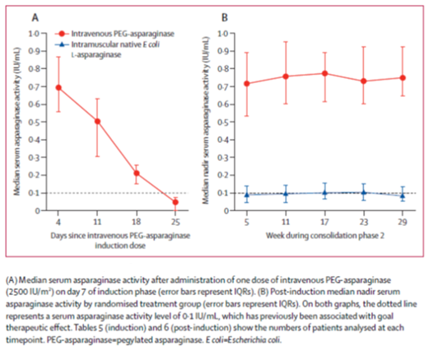
Comment: These data suggest that the dosing schedule proposed for children will indeed result in a serum ASNase activity of 0.1 IU/mL or greater in the dosing interval under normal circumstances (that is no neutralising antibodies, for example). Further, the PK/PD data have suggested the threshold of 0.1 IU/mL is a reasonable marker of serum asparagine depletion, providing a biologically plausible level at which clinical effect should ensue.
Potential disease outcome measures appear comparable between different preparations of asparaginase. Hence assuming the drug per se has been established as providing benefit to a multi-drug regimen for ALL, then PEGL ASNase as well as Native E.coli ASNase perform similarly at these doses for this indication in children. Hence efficacy seems comparable with the advantage of greater treatment interval based upon this study, and safety profile essentially unchanged.

AALLO7P4 (Angiolillo 2014)
This was a study assessing primarily PK and PD of calaspargase pegol E.coli L asparaginase in treatment of patients with ALL. The trial assessed this calaspargase (with a succinimidyl carbamate linker (SC)) versus pegaspargase (with a succinidimyl succinate linker (SS)) as first line, in children with newly diagnosed high risk ALL. High risk in this case meant B cell ALL with age ≥ 10 years and/or initial WCC ≥ 50,000/µL.
165 patients were randomised in a 2:1 ratio to receive 2,100 IU/m² SC-PEG (Oncaspar, n = 69) or 2,500 IU/m² SC-PEG 2,500, n = 42) versus SS-PEG 2,500 IU/m² (n = 54). Otherwise, treatment was an identical Berlin-Frankfurt-Munster chemotherapy regimen.
Secondary end points included: safety, serum and CSF asparagine levels, immunogenicity, end induction minimal residual disease (MRD), percentage of patients who were rapid early responders (RERs), and complete remission and event free survival rates.
A cut-off of > 0.1% MRD was used for treatment stratification; however, for outcome analysis, positive MRD was defined as > 0.01%, because multivariable analyses found this to be the most important prognostic variable in other COG trials. Patients with < 5% blasts by morphologic bone marrow analysis on Day 8 or 15 and Day 29 and MRD < 0.1% were RERs; all others were slow early responders (SERs).
In December 2010, after data safety monitoring committee review of MRD suggested inferior results with SC-PEG2100, having crossed predefined response monitoring boundaries, the trial was closed to accrual.

Results to note
The PK and PD results have already been presented from this study.
Anti-ASNase binding antibodies were found in eight patients; four receiving SS-PEG2,500, two in SC-PEG2,500, and two in SC-PEG2100. None of these had positive neutralising antibody assays, but three treated with SS-PEG and one treated with SC-PEG had more rapid decrease in ASNase activity. Two of the eight patients (one with SC-PEG2,500, one SC-PEG2100) had positive binding antibodies in pre-induction dose sampling, but no subsequent test was positive and there was no change in ASNase activity decrease over time compared to other subjects.
Rates of RERs and MRD were similar in the SC-PEG2,500 and SS-PEG2,500 groups, but lower in the SC-PEG2100 group; (p = 0.15 and 0.18 respectively); not statistically significant, but suggestive of a trend which led to transition of all SC-PEG2100 patients to SS-PEG2,500.
Comment: The study supports similarly efficacious treatment outcomes between SS-PEG2,500 and SC-PEG2,500 in children. Little more can be said in terms of this submission.

DFCI-91-01 (Silverman 2001)
This trial studied treatment of ALL in children, where post-remission therapy was intensified by prolonging asparaginase intensification from 20 to 30 weeks, and substituting dexamethasone for prednisone.
Three hundred and eighty six children were enrolled and 377 enrolled and classified into 137 standard risk and 240 high risk patients. Nine were ineligible because of incorrect diagnoses. In fact, three risk classifications were used, standard risk (all those not in high or infant high risk categories), high risk (one or more of WCC > 20; age 0 to 2 or 9 +; blasts in CSF; mediastinal mass; T cell immunophenotype) and infant high risk (all those less than 12 months at diagnosis).
At 5 year median follow-up, estimated 5 year event free survival for all was 83% ± 2%, superior to prior DFCI protocols. There was no significant difference in EFS in terms of stratification into SR or HR, (87% ± 3% SR, 81% ± 3% HR, p = 0.24) but age at diagnosis was a factor with worse outcomes if diagnosed at age 9 or older (p = 0.03).
In terms of asparaginase treatment, patients who received 25 or fewer weeks of ASNase treatment as a result of tolerability issues fared worse than those who received at least 26 weeks of treatment; (p < 0.01).
Three additional randomisations were designed to evaluate whether acute or late toxicities could be mediated. The one of note here is a comparison of PEGL ASNase versus Native E.coli ASNase.
Asparaginase preparation was switched after a mild allergic event (local reaction, rash). Patients receiving E.coli asparaginase were switched to weekly PEG asparaginase, and those receiving PEG were switched to E.coli asparaginase to complete 30 weeks of therapy. All patients were switched to twice weekly Erwinia asparaginase (25,000 IU/m² per dose) if they experienced a subsequent allergic event. Asparaginase therapy was held until resolution of mild pancreatitis or deep venous thrombosis, and the therapy was permanently stopped after severe allergic events (bronchospasm and/or lip or tongue swelling), severe pancreatitis (abdominal pain for at least 72 hours with elevated pancreatic enzymes), CNS thrombosis, or mild allergic events to all 3 preparations (E.coli, PEG, and Erwinia). Therapy for all patients was discontinued after patients had achieved 24 months of continuous complete remission (CCR).
To determine whether PEG asparaginase was associated with decreased toxicity, patients were randomized to receive either 2,500 IU/m² PEG asparaginase intramuscularly (IM) every other week for 15 doses or native 25,000 IU/m² E.coli asparaginase IM every week for 30 doses during the intensification phase of therapy. Because PEG asparaginase was not available in Canada, children treated at Canadian institutions (n = 127) were not eligible for the asparaginase randomization and were directly assigned to receive E.coli L asparaginase during intensification.
Outcome events were death during induction therapy, failure to achieve complete remission (defined as persistent leukaemia at Day 52 after diagnosis), death during remission, and relapse. EFS was the time from complete remission to the first outcome event; induction failure and induction deaths were considered events at time zero. Leukaemia free survival (LFS) was the time from complete remission to relapse; induction failure was considered a relapse at time zero. Overall survival (OS) was the time from start of treatment to death from any cause. CNS LFS was the time from complete remission to a relapse involving the CNS (whether isolated or combined with other sites).
Various patient characteristics and their associated 5 year EFS are presented as follows in Table 50.

Table 50: Patient characteristics and outcome on Protocol 91-01
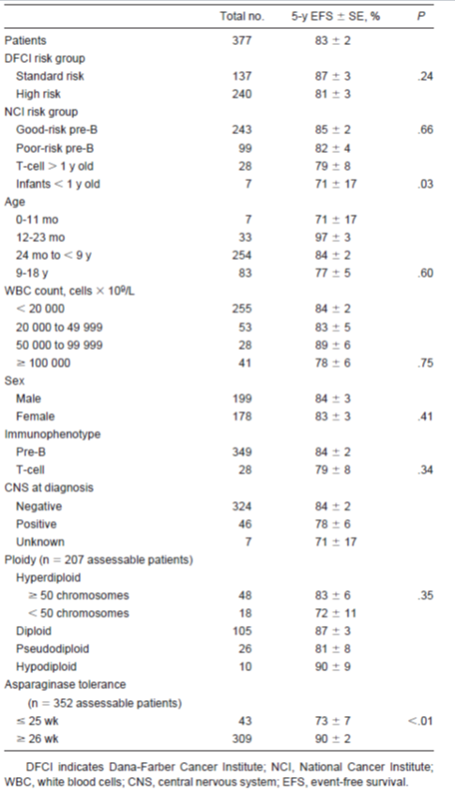
Comment: There is nothing particularly surprising in the above table. Slightly poorer outcome is associated with CNS involvement at diagnosis, age differences, and whether of B or T cell immunophenotype, to mention some obvious conclusions. Of note is that tolerance to ASNase clearly developed more in those who received it for longer than 25 weeks, yet event free survival was improved; one speculates this is as a result of both longer therapy despite some tolerance and the potential longer duration on other drugs.
Outcomes were similar across risk groups (see Table 51).

Table 51: Results of Protocol 91-01 for 377 children with ALL
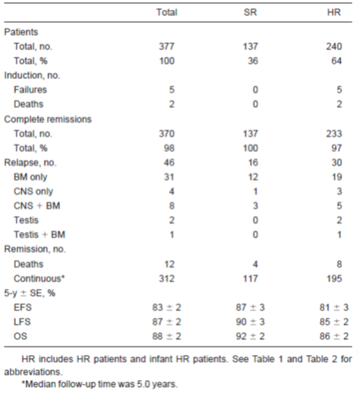
There was no statistically significant difference in 5 year EFS between PEGL ASNase and Native E.coli ASNAse (see Table 52).

Table 52: Outcome by randomisations
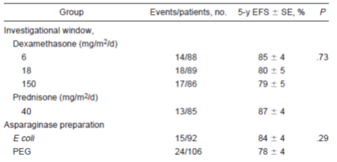
Of the 352 patients included in the analysis, 54 (15%) patients experienced one or more allergic events. There was no difference in EFS when comparing those patients who developed an asparaginase allergy with those who did not (p = 0 .31). Of the 352 patients, 43 (12%) patients received less than 25 weeks of asparaginase. The remaining 308 (88%) patients received at least 26 weeks of asparaginase. Of the 43 patients who received less than 25 weeks of asparaginase, 37 (86%) patients experienced an asparaginase related dose limiting toxicity including pancreatitis (39% of 43 patients), allergy to one or more preparations (19%), CNS thrombosis/haemorrhage (12%), non-CNS deep venous thrombosis (7%), hyperglycaemia (5%), hyperlipidaemia (2%), and hepatitis (2%). Six (14%) patients received truncated therapy for other reasons including 2 patients with toxicities not clearly related to asparaginase (paraesthaesias and sepsis), 2 patients with non-protocol alteration in therapy, and 2 patients for unknown reasons.
Comment: While this study is of limited value in the context of this submission, it does demonstrate acceptable EFS levels with this protocol that are superior to typical ones used in prior such protocols. The use of PEGL ASNase appears non-inferior to native ASNAse (although specific statistical proof for non-inferiority wasn’t described) and safety profile appears similar. Efficacy in childhood ALL is demonstrated in first line treatment.

CCG 1961 (Panosyan 2004)
This has been previously presented in this report and is a huge trial assessing ASNase antibody and ASNase activity in children with higher risk ALL. 1001 patients had their sera investigated for antibodies and ASNase enzyme activity.
The study design may be well summarised by the following Figure 16.
Figure 16: CCG-1961 Study design
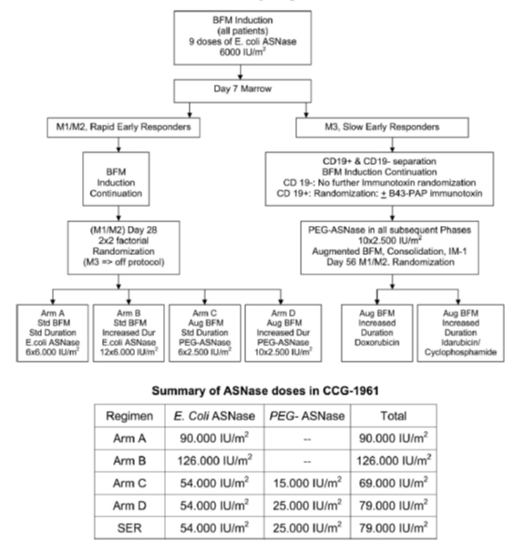
Comment: As one can see those who received PEGL ASNase received it in the recommended dosage proposed in the draft PI document.
Three hundred ninety of 1,001 patients (39%) had no elevation of Ab among multiple evaluations; that is, were Ab negative (< 1.1 over negative control), and 611 patients (61%) had an elevated Ab titre (> 1.1).
Among these 611 patients, 447 had no measurable asparaginase activity during therapy. Patients who were Ab positive but had no clinical allergies continued to receive E.coli asparaginase, the activity of which declined precipitately. No detectable asparaginase activity was found in 81 of 88 Ab positive patients shortly after asparaginase injections (94% neutralizing Ab). The Ab positive patients with clinical allergies subsequently were given Erwinase and achieved substantial activity (0.1 to 0.4 IU/ml). An interim analysis of 280 patients who were followed for 30 months from induction demonstrated that the Ab positive titres during interim maintenance-1 and in delayed intensification-1 were associated with an increased rate of events. The Study CCG-1961 treatment schedule was very immunogenic, plausibly due to initially administrated native asparaginase. Anti-asparaginase Ab was associated with undetectable asparaginase activity and may be correlated with adverse outcomes in HR ALL.
Asparaginase enzymatic activity was calculated from an ASNase standard curve in the range of 0.0125 to 0.6 IU/mL. Anti-ASNase antibody titres were measured using an antibody capture ELISA.

Table 53: Interim analysis of anti-ASNase Ab and outcome in patients with High risk ALL. CCG-1961
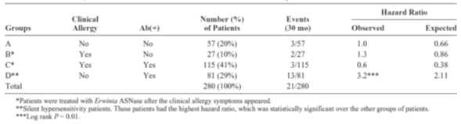
Comment: One can see that 70% of subjects were ASNase antibody positive. Those in group D above were considered ‘silent hypersensitivity’ patients and had the highest hazard ratio, which is not surprising when one considers the likelihood of their clearing the drug must faster than anticipated and thus having tangible asparagine levels in serum between dosing which would not be evident without specific monitoring.

DFCI-87-001 (reported here from Asselin 1999)
This study described the findings of 3 pharmacologic endpoints with three asparaginase preparations: E.coli, Erwinia, and Oncaspar. The endpoints were ASNase enzymatic activity, depletion of asparagine and development of anti-ASNase antibodies. The study has previously been presented in this report.
Treatment naïve children with newly diagnosed ALL demonstrated significant differences between preparations for apparent half-life and days of asparagine depletion. Patients were studied for at least 20 weeks during remission induction and afterwards. Various treatment protocols were used but all included ASNase of some type. Doses were E.coli ASN 25,000 IU/m², Erwinia 25,000 IU/m² and Oncaspar 2,500 IU/m². Serial serum samples were drawn throughout the 26 day induction period and analysed for ASNase activity and asparagine depletion. Of note for the submission from this study is that the half-life of Oncaspar was significantly greater than E.coli ASNase (p < 0.0001) and those receiving Oncaspar had ASNase activity over 0.1 IU/mL for the entire 26 day observation period. In addition, those who had received E.coli ASNase and then developed hypersensitivity and subsequently had a dose of Oncaspar were shown to have a significantly shorter half-life of the drug as a result (mean 1.82 days versus 5.73 days (n = 5).
The study appears to have 74 fully evaluable patients in a protocol designated number 8866. Thirty five patients without prior hypersensitivity were randomised to either Oncaspar 2,500 IU/m² fortnightly or E.coli ASNase 10,000 IU/m² weekly. Thirty nine with a history of hypersensitisation were assigned to Oncaspar. Response rates in terms of CR + PR were not significantly different between these three groups. However, a subset of 26 patients cleared the drug more rapidly and had a response rate of 26%.
Comment: It would appear monitoring for hypersensitivity and antibody formation should be carried out with either routine or high level of suspicion as any hypersensitisation can potentially impact clinical outcome in the view of this evaluator.

ASP-301 (Asselin 1993)
This study has previously been presented in this report. This evaluator does not consider it necessary to re-present the information. Essentially it supports the ideas that those with previous hypersensitivity to E.coli ASNase can have decreased half-life of either E.coli ASNase or PEGL ASNase subsequently.

CCG-1991
This was a ‘successor’ study to CCG-1952 and includes newly diagnosed and previously-untreated patients with ALL from ages 1 to 9 inclusive with an initial WCC < 50000/µL. The study was a randomised 2 x 2 design investigating two treatment factors, namely different approaches to the use of methotrexate in interim maintenance, and secondly the approach to delayed intensification therapy, where patients received either a single delayed intensification or two DI phases in treatment.
Subject numbers at data cut off were 2957. 2,034 eligible patients were randomised.
For patients currently enrolled on study, the mean and median age at study entry are 53.5 months and 48.0 months, respectively. Mean and median WBC were 11,255 and 6,800, respectively. Platelet counts below 50 K occur in 46% of the patients. Fifty-five percent of the study population are male and 68% are Caucasian (18% are Hispanic and 4% are African-American). Significantly enlarged organomegaly rates (that is, Grade 3 enlargement) are 5% for splenomegaly, 4% for lymphadenopathy, and 1% for mediastinal mass. Twenty-one males had either unilateral (15) or bilateral enlargement (6 of testes suggesting possible testicular involvement at diagnosis). Ninety-nine had Down syndrome (3.6%). CNS involvement at diagnosis occurs in 1.5% and 5.4% have CNS-2 status.
The PDF document provided for this study is not typically set out as a CSR. Study description and materials and methods are not detailed. The study may be represented graphically by Figure 17.
Figure 17: Treatment Plan Study CCG-1991
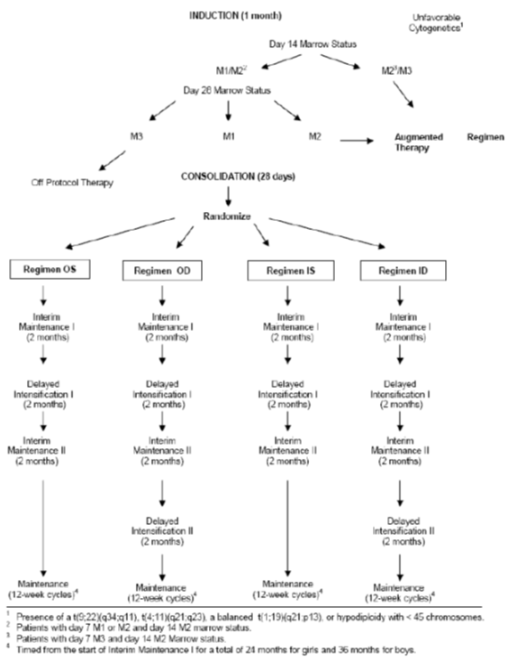
The utility of this large study from the perspective of PEGL ASNase use in children with ALL as first line treatment is perhaps explained by the following description of treatment groups:
For the purpose of these analyses, data were categorized into 4 different treatment groups on the basis of the scheduled number of PEG-ASNase doses, randomization status, and disease characteristics:
- Randomized Arms: Data from the 4 randomized treatment groups (OS, OD, IS, ID) were pooled into 1 treatment group because these patients received PEGL-ASNase during the same treatment phases (Induction, DI #1, and DI #2).
- Augmented Arm: Data from patients with unfavourable marrow status or unfavourable cytogenetics were summarized separately due to the more frequent administration of PEGL-ASNase and the more intense chemotherapy regimen.
- OD Nonrandomized: Data from patients with CNS disease at diagnosis who had M1 marrow status at Day 28 and lacked unfavourable cytogenetics were summarized separately because the toxicity profile for patients with CNS disease is expected to differ from that for the other treatment groups.
- Others: Data for patients in this group were summarized separately because of 2 reasons:
  - Patients received only Induction and/or Consolidation therapy, or
  - Patients had missing or unspecified codes for treatment assignment.
Treatment assignment and subject demographics are summarised as shown in Table 54.

Table 54: Treatment assignment Study CCG-1991
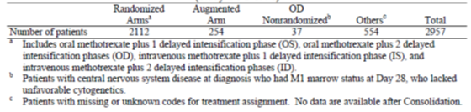
Demographic characteristics; of other 2,957 enrolled patients 48% were 3 to 5 years of age 55% were male and 68% were White (Table 2).

Table 55: Demographic characteristics. Study CCG-1991
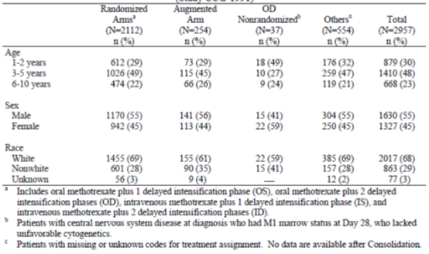
Comment: This study is large but efficacy outcomes appear not to have been a well scrutinised part of the study. It represents a significant use of PEGL ASNase as first line therapy in children with ALL but conclusions are simply that the drug was well tolerated and did not raise unexpected adverse events based upon its already known profile. This study therefore adds more to the safety consideration of Oncaspar than anything to the efficacy of it. Efficacy appears assumed.

AALL0232 (Larsen 2011 and Winick 2011)
This was a Children’s Oncology Group study, a Phase III randomised trial for patients 1 to 30 years with high risk B cell precursor ALL. It was a Phase III randomised trial to test safety and efficacy of interventions to enhance CNS disease control including both high dose methotrexate compared to Capizzi methotrexate plus ASNase in interim maintenance, and in addition the use of dexamethasone versus prednisolone during induction. Pegylated ASNase was used in the treatment protocols.
Patients were randomized to receive DEX 10 mg/m²/day for 14 days versus PRED 60 mg/m²/day for 28 days during Induction and high dose methotrexate (HD MTX) versus Capizzi escalating methotrexate plus PEG asparaginase (CMTXASNase) during Interim Maintenance 1, forming four arms: DH, DC, PH, and PC. In June 2008, a protocol amendment excluded those > 10 years from the induction steroid due to an excessive incidence of osteonecrosis.
Between January 2004 and September 2010, 802 patients 1 to 9 years of age, and prior to June 2008, 1035 patients > 10 years of age were randomized to the four arms. The 5 year event free survival (EFS) for patients 1 to 9 years of age randomized to receive DH, DC, PH, or PC was 93.7 + 5.4%, 84.1 + 8.4%, 81.2 + 7.7%, and 84.0 + 6.9%, respectively, p = 0.03.
The 5 year EFS of patients > 10 years of age randomized to DEX versus PRED prior to June 2008 was 74.7 + 4.6% and 76.5 + 4.6%, respectively, p = 0.80. The incidence of osteonecrosis at 36 months for patients 1 to 9 and > 10 years of age was 3.1 + 0.9% and 19.6 +1.6%, respectively. For patients > 10 years old, there was a higher rate of osteonecrosis among those randomized to DEX before June 2008 as compared to PRED (24.3% versus 15.1%, p = 0.0007). Induction death rates were similar between the DEX and PRED arms in both age groups (Winick N J et al 2011).
Planned interim results showed 5 year EFS for patients randomised to receive high dose methotrexate (n = 1209) was 82 ± 3.4% versus 75.4 ± 3.6% (n = 1217) for the C-MTX/ASNase regimen. The conclusions were that the DH regimen was preferred for 1 to 9 year old patients and prednisolone during induction was preferred for those > 10 years.
Comment: In the context of efficacy of the use of Oncaspar in first line treatment of ALL in children and young adults (to 30 years), these data seem to suggest high dose methotrexate was more efficacious, taking those data in isolation. Nonetheless the use of Oncaspar has resulted in satisfactory EFS to 5 years which is comparable to other data that show high 70th percentiles and into the 80s. One must remember patients over 10 years have less stellar outcome data than younger children.

AALLO331 (Maloney 2015)
Essentially a poster presentation is provided by Maloney 2015. This evaluator did not see the CSR for this trial in the dossier.
Maloney 2015 describes this trial as well as AALL0932. AALL0331 assessed IV and IM pegaspargase in standard risk B precursor ALL. It was initially designed as a 2 x 2 factorial design to study standard versus intensified consolidation and standard interim maintenance and DI versus intensified interim maintenance and DI. The protocol was subsequently amended so all patients could receive IV escalating methotrexate. Data were gathered from 4 arms of the study where two doses of PEGL ASNase were used; one in induction, and one in delayed intensification.
The only difference that seems to have been noted is that the rate of anaphylaxis or allergic reaction in DI was 0.5% for IM dosing versus 1.8% for IV, (p = 0.007). Rates of other specific adverse events were similar regardless of IM or IV route of administration.
Comment: This poster presentation adds little from the summary provided in terms of efficacy of PEGL ASNase. It is essentially considered common knowledge that the drug has efficacy and other matters have been the focus of the study.

UKALL2003 (Vora 2013, 2014)
This study is cited in 5 publications but this evaluator has chosen the above 2 to represent the findings of the trial.
Considering Vora 2013 firstly, the study was a randomised controlled trial in children and young adults (1 to 24 years) assessing whether the intensity of treatment for low risk ALL could be ‘adjusted’ by using minimal residual disease as a risk stratification.
The premise of the study is that MRD has been shown to be a sensitive and specific predictor of relapse. Patients with undetectable MRD at end of induction have negligible relapse, while those with more than 0.01% have a relapse risk of more than 20%. The study attempted to see if adjustment of treatment intensity guided by this MRD risk was feasible.
Patients younger than 1 year or with mature B cell ALL or Philadelphia chromosome, were not eligible.
- Patients were stratified according to initial clinical risk of relapse, on the basis of three metrics: The National Cancer Institute (NCI) risk criteria (NCI standard risk: patients younger than 10 years with a white blood cell count of less than 50 x 10⁹ per L; NCI high risk: patients aged 10 years or older and those with a white blood cell count of at least 50 x 10⁹ per L)
- Leukaemia cytogenetics (all patients with a cytogenetic abnormality involving rearrangement of the MLL gene, hypodiploidy (< 45 chromosomes), or intra-chromosomal amplification of chromosome 21 were classified as clinical high risk), and
- Early response to induction therapy as assessed by bone marrow morphology on Days 8 and 15 of treatment in patients younger than 16 years.
Patients who had more than 25% of the marrow made up of blast cells at Day 8 (NCI high risk) or 15 (NCI standard risk) were reclassified to the clinical high risk group irrespective of initial classification and were not eligible for MRD stratification and randomisation. NCI standard risk patients had to have an early response of less than 25% marrow blasts at the Day 15 assessment (reclassified as clinical standard risk) and NCI high risk patients who had less than 25% marrow blasts at Day 8 were reclassified as clinical intermediate risk to be eligible for randomisation. All patients who were 16 years or older were treated as clinical intermediate risk irrespective of Day 8 or 15 bone marrow response and were eligible for MRD stratification and randomisation.
Investigators stratified clinical standard and intermediate risk groups by bone marrow MRD at the end of induction and recovery from consolidation (before start of interim maintenance). Clinical high risk patients were not eligible for MRD stratification.
Patients with undetectable MRD after induction (Day 29) and before interim maintenance were classified as MRD low risk, as were those with detectable; (less than 0.01%) MRD at the end of induction, but undetectable MRD before the start of interim maintenance. Those with at least 0.01% MRD at the end of induction were classified as MRD high risk. Patients in whom MRD could not be measured because no or poor quality samples were available and those with persistent disease which was less than 0.01% MRD before the start of interim maintenance were classified as MRD indeterminate.
Of 3,207 patients registered in the trial overall, 521 MRD low risk patients were randomly assigned to receive one (n = 260) or two (n = 261) delayed intensification courses. Median follow-up of these patients was 57 months (IQR 42–72). There was no significant difference in EFS between the group given one delayed intensification (94·4% at 5 years, 95% CI 91·1 to 97·7) and that given two delayed intensifications (95·5%, 92·8 to 98·2; unadjusted odds ratio 1·00, 95% CI 0·43 to 2·31; two-sided p = 0·99). The difference in 5 year EFS between the two groups was 1·1% (95% CI –5·6 to 2·5). 11 patients (actuarial relapse at 5 years 5·6%, 95% CI 2·3 to 8·9) given one delayed intensification and six (2·4%, 0·2 to 4·6) given two delayed intensifications relapsed (p = 0·23).
Three patients (1·2%, 0 to 2·6) given two delayed intensifications died of treatment related causes compared with none in the group given one delayed intensification (p = 0·08). There was no significant difference between groups for serious adverse events and Grade 3 or 4 toxic effects; however, the second delayed intensification course was associated with one (< 1%) treatment related death, and 74 episodes of Grade 3 or 4 toxic effects in 45 patients (17%).
Comment: These data support the use of PEGL ASNase in a treatment regimen for first line treatment of ALL in children and young adults. The trial endpoints, however, were not directly focussed upon efficacy outcome as this was essentially considered already established. For clarity, the trial framework is given as shown in Figure 18.
Figure 18: Trial profile. UKALL2003
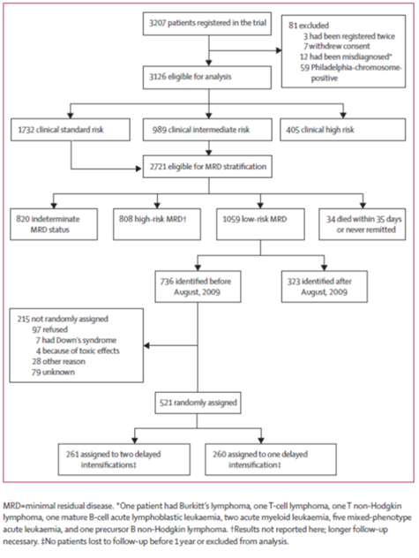
In Vora 2014, the part of the study that dealt with the standard and high risk patients was reported. This was an augmented post-remission treatment scenario based upon the MRD measure.
533 MRD high risk patients were randomly assigned to receive standard (n = 266) or augmented (n = 267) post-remission therapy. After a median follow-up of 70 months (IQR 52 to 91), 5 year event free survival was better in the augmented treatment group (89.6% (95% CI 85.9 to 93.3)) than in the standard group (82.8% (78.1 to 87.5); odds ratio (OR) 0.61 (95% CI 0.39 to 0.98), p = 0.04). Overall survival at 5 years was numerically, but not significantly, higher in the augmented treatment group (92.9% (95% CI 89.8 to 96.0)) than in the standard therapy group (88.9% (85.0 to 92.8); OR 0.67 (95% CI 0.38 to 1.17), p = 0.16). More adverse events occurred in the augmented treatment group than in the standard group (asparaginase related hypersensitivity in 18 (6.7%) in the augmented group versus two (0.8%) in the standard group and asparaginase related pancreatitis in eight (3.0%) versus one (0.4%); intravenous methotrexate related mucositis in 11 (4.1%) versus three (1.1%) and methotrexate related stomatitis in 48 (18.0%) versus 12 (4.5%)).
Those in the augmented post-remission therapy received eight additional doses of PEGL ASNase, an extra 18 doses of vincristine and escalated dose IV methotrexate. Hence while PEGL ASNase is certainly considered to be a contributor to efficacy outcome, it has not been isolated and measured in this trial; the trial simply provides information that supports the use of PEGL ASNase in a treatment protocol for ALL in first line treatment in children.
Comment: Again, the use of PEGL ASNase is considered par for the course in these treatment protocols and the augmentation used was not the sole drug change in the augmented treatment regimen. One can only really draw from this study, in terms of PEGL ASNase, that it is supported as a component of treatment protocols as first line therapy in children and young adults with ALL. This is clearly one of the subsets of patients for whom approval is sought by the broad proposed indication.

NOPHO ALL2008 (Henriksen 2015, Tuckuviene 2016)

Henriksen 2015
Henriksen examined PEGL ASNase allergy in children with ALL in the Nordic Society of Paediatric Haematology and Oncology (NOPHO) ALL2008 treatment protocol. Children 1 to 17 years were enrolled into this protocol and those who developed allergy to PEGL ASNase were identified through the study’s toxicity registry.
ASNase is accepted as a component of multi-drug ALL treatment. It has variable adverse events and allergy is claimed to be the most frequent, with a typical presentation being that of urticaria, with a range of events also including erythema to anaphylaxis. If allergy develops, typically one form of ASNase is switched to another. The impact of ASNase truncation as a result of allergy can depend upon the timing of the event, successful substitution of another form of drug, and the development of any ASNase neutralising antibodies.
In the NOPHO protocol, PEGL ASNase is used as a first line treatment at an IM dose of 1,000 IU/m². The protocol itself recruits patients 1 to 45 years with B cell precursor or T cell ALL and patients are stratified into standard risk, intermediate risk, high risk chemotherapy and high risk chemotherapy stem cell transplant. For all but transplant patients, the duration of therapy is 2.5 years.
PEGL ASNase therapy for the protocol is shown by Figure 19.
Figure 19: from Henriksen 2015 page 428
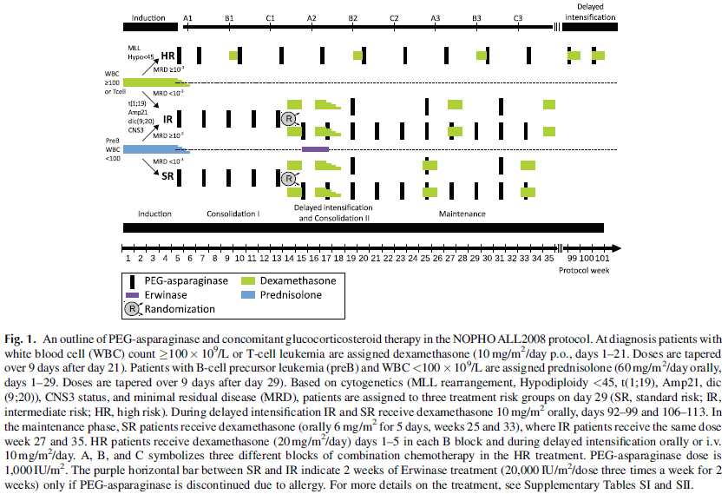
Between July 2008 and August 2011, 623 children 1 to 17 years with Philadelphia chromosome negative B cell precursor ALL were enrolled. Eight were excluded due to induction failure. By January 2012, 82 of the remaining 615 subjects had been identified with PEGL ASNase allergy. Of these, three were incorrect.
In the case of severe allergic reaction, PEGL ASNase was to be discontinued and replaced with Erwinase. A summary of allergy to PEGL ASNase is as follows:
Between July 2008 and August 2011, 623 children 1 to 17 years with Philadelphia chromosome negative B cell precursor ALL were enrolled. Eight were excluded due to induction failure. By January 2012, 82 of the remaining 615 subjects had been identified with PEGL ASNase allergy. Of these, three were incorrect.
In the case of severe allergic reaction, PEGL ASNase was to be discontinued and replaced with Erwinase. A summary of allergy to PEGL ASNase is as follows (shown in Table 56).

Table 56: Clinical characteristics (from page430 Henriksen 2015)
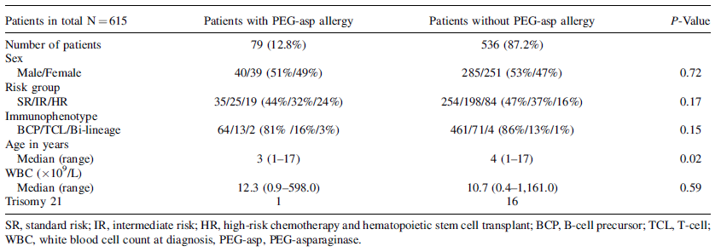
Of 79 patients, only two patients received no supportive treatment as their allergic reactions were mild. Three received corticosteroids only, nine antihistamines only, and depending on symptoms, the remaining 68 patients were treated with combinations of antihistamines, corticosteroids, adrenaline, intravenous fluids, oxygen, and beta-2-agonists.
Among 79 patients with clinical allergy to PEG-asparaginase, 74 were eligible for receiving subsequent Erwinase substitution as the allergic reaction occurred before the beginning of delayed intensification I (scheduled Erwinase for SR and IR). Of 74 eligible patients 68 patients, (including 30 SR-, 21 IR-, and 16 HR-patients) received Erwinase.
Reasons for not giving Erwinase were as follows; one patient had a severe urticaria reaction to PEG-asparaginase; another patient had a previous pulmonary thrombosis during PEG-asparaginase therapy; and one had died before Erwinase was scheduled. In three patients the reason for omitting Erwinase was uncertain. Four of the 68 patients (6%) developed clinical allergy to Erwinase (one SR, one IR, and two HR patients). The allergic reactions to Erwinase all appeared within 2 hours after the injection. Two of four patients (one with a previous anaphylactic reaction to PEGasparaginase and one with a Grade 2 reaction) both had an anaphylactic reaction to Erwinase. The remaining two patients, one with a Grade 2 and one with a Grade 3 reaction to PEGasparaginase reacted with similar severity to Erwinase. The number of doses administered prior to reaction towards Erwinase ranged 2 to 7.
Comment: In summary these data suggest that:
- PEGL ASNase is a routine component of ALL treatment, however the publication does not provide efficacy outcome measures
- the cumulative risk of development of allergy to PEGL ASNase was 13.2%, therefore it is certainly something to be aware of in prescribing the drug, and
- those who then receive Erwinase as a substitute have quite low levels of allergy to this preparation but a small number do occur, so allergy and anaphylaxis must always be in the mind of the prescriber, particularly within the first two hours of administration.
This is noteworthy for the draft PI.

Tuckuviene 2016
Tuckuviene 2016 reports on a study of thromboembolism in 1,038 children in the NOPHO study. The study followed those diagnosed between 2008 and 2013 and treated with the NOPHO protocol, with follow-up to December 2014. Sixty three thromboembolic events occurred, with 52 in association with PEGL ASNase administration. Thromboembolism is a known risk in the safety profile of this drug. The cumulative incidence was 6.1% (95% CI 4.8 to 7.7) and such events led to a 30 day case fatality of 6.4% (95% CI 1.8 to 15.5%) and perhaps of particular interest, truncation of therapy in 36.2% (21/58 subjects).
Comment: This evaluator has chosen not to detail this publication as it solely focusses upon thromboembolism. Typical outcome measures for efficacy are not within the publication and this evaluator cannot locate the CSR for the study (if indeed there is one) within the dossier. The data highlight a known adverse event with PEGL ASNase treatment in a large cohort of patients but apart from the fact that we are clear PEGL ASNase forms part of the treatment regimen and thus is an accepted, current part of treatment protocols, actual outcome data are absent.

Summary data for formal trials of first line treatment of ALL

CCG-1962
This was a randomised, comparison study in first line treatment in children with ALL given Oncaspar or the native E.coli ASNase as part of their multi-drug treatment regimen. While ‘efficacy’ did not focus on actual event free survival or overall survival, there was a favourable trend in antibodies to ASNase in favour of children treated with PEGL ASNase compared with native E.coli ASNase, as borne out by Figure 20.
Figure 20: Percentage of patients with Anti-ASNase antibody ratio over negative control > 1.5, 2.0 and 2.5 in CCG-1962
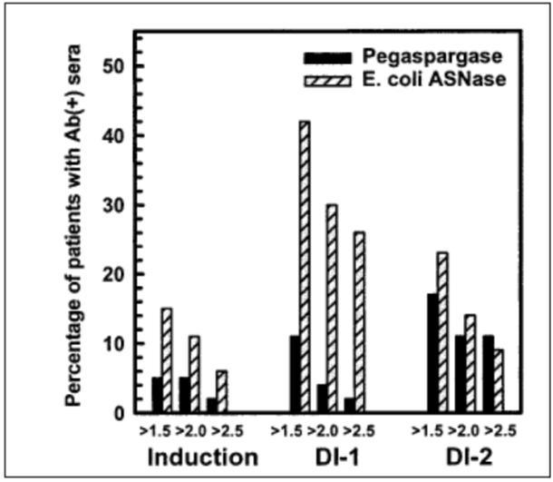
Patients treated with PEG-ASNase showed two major differences: fewer samples had elevated antibody ratios and all PEG-ASNase samples with antibody ratios of ≥ 1.5 had adequate ASNase activity as shown in Table 57.

Table 57: Fraction of samples with ASNase activity above 0.1 IU/mL
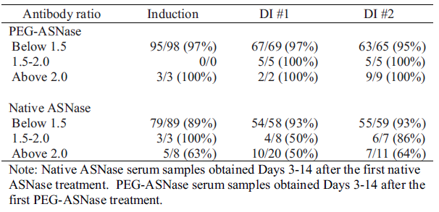
Like other studies presented in this formal trial/first line treatment collection, the actual efficacy of the drug itself was not presented; the above measures were assessed as the experimental question, with the actual question of efficacy against disease seemingly already ‘understood’.
Comment: Hence this study’s’ value, despite inadequate power, is demonstrating a trend to reduced incidence of antibody formation, and a support for the serum threshold of > 0.1 IU/mL, considered the biologically plausible level that corresponded to asparagine depletion, at a dose that is identical to that proposed for the draft PI in children.

DFCI-05-001
This is perhaps the most important trial presented here in the view of this evaluator. It is a randomised open label head-to-head comparison of PEGL ASNase and native E.coli ASNase in newly diagnosed ALL in children and young adults. This study, with n = 463 randomised to treatment, showed comparable EFS and overall survival at 5 years between groups. This supports the at least equivalent nature of Oncaspar as an asparaginase in an ALL treatment regimen compared with native E.coli ASNase.
The 5 year disease free survival was 90% (95% CI 86 to 94) for patients randomly assigned to intravenous PEG-asparaginase, 89% (85 to 93) for those randomly assigned to intramuscular native E coli l-asparaginase, and 88% (74 to 95) for those who declined to undergo randomisation and were directly assigned to intramuscular E coli l-asparaginase.
The 5 year overall survival was 96% (93 to 98), 94% (89 to 96), and 95% (82 to 99) for these three patient groups, respectively. No differences in disease free survival between randomised groups were noted within patient subsets.
The data also show 87% of those receiving PEGL ASNase having threshold levels of drug > 0.1 IU/mL at Day 18 post-dose, further supporting the chosen dose and dosing interval for marketing.

AALL07P4
The value of this study is largely from its PK/PD data presented elsewhere in this report.

DFCI-91-01
This was a large trial (n = 377) where children with ALL were treated post remission induction with intensified ASNase treatments, some of which included the proposed PI dose of Oncaspar. While data on EFS are not stratified to the type of ANSase given, outcomes for EFS were comparable to other trials (83% ± 2% at 5 years), and those who received 25 or less weeks of any ASNase fared poorly compared to those who received 26 weeks or more (p < 0.01).

CCG-1961
This trial simply highlights the need to be aware of antibody formation as half-life of drug can be dramatically affected by this and needs addressing to ensure adequate treatment and asparagine depletion.

DFCI-87-001
Relevant data from this study have been presented in greater detail elsewhere in this report.

ASP-301
The data from this study have been presented elsewhere in this report.

CCG-1991
This study treated a great many children with ASNase as part of their treatment regimen but due to the method of presentation of its data, does little to support the use of the drug as first line treatment for ALL; rather it demonstrates that the drug is used for this purpose and this appears to be an accepted method of treatment.

AALL0232
This provides Phase II data for treatment experience in children and younger adults in the treatment of high risk B cell precursor ALL. Age range was up to 30 years. It is of particular note as it too provides 5 year EFS data for patients and PEGL ASNase was used in the treatment protocols.
The 5 year event free survival (EFS) for patients 1 to 9 years of age randomized to receive DH, DC, PH, or PC was 93.7 + 5.4%, 84.1 + 8.4%, 81.2 + 7.7%, and 84.0 + 6.9%, respectively, p = 0.03. While outcomes for those aged 10 or greater were worse, this is known as age is a predictor of outcome in the treatment of ALL. This study provides satisfactory outcome data in 1,035 patients treated first line for ALL with pegylated asparaginase.

AALL0331
This poster was of little value in contributing to the key issues of this submission.

UKALL2003
This study primarily showed that MRD could be used to adjust intensity of treatment for ALL in children. There were 3,207 patients enrolled in the trial in total and thus a huge pool of children for whom PEGL ASNase was used as part of their treatment regimen. It also provided 5 year EFS data for low, intermediate and high risk patients based upon adjusting (or not) their drug therapy regimen. Nevertheless, all experienced EFS rates that one would consider acceptable in terms of 5 year EFS for the treatment of this disease. Hence the trial supports the use of PEGL ASNase within a treatment regimen as first line therapy in children.

NOPHOALL2008
This study provided supportive data for the first line use of PEGL ASNase in children, despite mainly being focussed upon allergy caused by PEGL ASNase. The body of data examines 613 subjects in an open label, prospective fashion. One must also note that the dose used here was different and lower than that intended for marketing in Australia. While EFS data are not provided, the study details the experience in several hundred children and highlights that allergy is a risk with PEGL ASNase and the role of Erwinase as a ‘switching’ drug, which is stated in the draft PI.

Conclusions on formal trials for first line Oncaspar treatment in ALL in children and adults
What one would consider ‘true’ outcome data in terms of event free or overall survival were not gathered in all of these studies; in the view of this evaluator because the studies focussed upon specific matters in treatment, rather than the overall question of the efficacy of ASNase of any sort, which was essentially considered established by the various authors. In terms of supporting data for patient event free survival, however, studies DFCI-05-001, DFCI-91-01, AALL0232 and UKALL2003 provide large bodies of data for the first line treatment of ALL in children and younger adults with pegylated asparaginase in the treatment regimen, with satisfactory 5 year EFS data as presented.

Second line treatment

ASP-001
This was a Phase I/II open label, ascending dose study of PEG-L asparaginase (PEGL ASNase) in malignant haematological disorders. Objectives were to define toxicities, MTD and evaluate clinical pharmacology and efficacy of PEGL ASNase administered as a one hour IV infusion every two weeks.
Thirty seven heavily pre-treated patients with refractory haematological malignancies aged 15 to 73 were enrolled; (hence both adults and children treated in a second line setting). The study had an open label, ascending multiple dose design. Cohorts of 3 patients were entered at each dose level, starting at 500 U/m², with subsequent cohorts at higher doses until dose limiting toxicity was observed. Dose was also escalated in individual patients until a biological effect or a dose limiting toxicity was observed.
Inclusion and exclusion criteria were as follows:
Inclusion:
- Male or female ≥ 15 years of age.
- Life expectancy ≥ 6 weeks.
- Histologically proved leukaemia or other haematological malignancy refractory to conventional therapeutic regimens and with evidence of measurable disease.
Exclusion:
- History of pancreatitis or coagulopathy.
- Chemotherapy or radiation within 3 weeks prior to study start, or failure to recover from any toxic effect of previous therapy (including insufficient time since last treatment to show expected delayed toxicities).
Patients refractive to prior native asparaginase were not excluded. The investigator was permitted to make exceptions to the entry criteria at his/her discretion.
Patients with a response received two to four courses of the drug at the dose that produced the response. In those who experienced toxicity, re-treatment was commenced at a 50% reduced dose from the last dose the patient received. Later enrolments were started at doses known to be safe from the initial patients. Dose commencement and adjustment was essentially entirely at investigator discretion.
Definitions of CR, PR, HI and PD for leukaemia patients are:
- Complete Remission: disappearance of all clinical evidence of leukaemia for a minimum of four weeks. The patient must be free of all symptoms and have a neutrophil count > 1,000/mm³ and platelet count > 100,000/ mm³, no circulating blast cells and a normal bone marrow differential with < 5% lasts in a normocellular or hypercellular specimen.
- Partial remission: disappearance of all clinical evidence of leukaemia for a minimum of four weeks, except for the presence of 5 to 25% blasts in the bone marrow.
- Haematologic Improvement: return of peripheral blood counts to normal for a period of > 4 weeks not including partial remission.
- Progressive Disease: Increasing peripheral blast cell count, increasing marrow infiltrate or development of organ failure or extramedullary infiltrates due to leukaemia.
Four patients withdrew due to adverse events and three due to lack of response. Twelve received one course of PEGL ASNase, 16 two courses, 4 three courses and one each received 6, 14 and 22 courses.
In terms of results, doses were administered ranging from 500 to 8,000 IU/m² of PEGL ASNase. Three patients reported hypersensitivity reactions, although it is stated all three were treated from a batch which had high levels of endotoxins. One of these three patients had antibodies to ASNase and they had previously had an anaphylactic reaction to native E.coli ASNase. Eleven deaths occurred during the trial and all were a result of progressive disease. Classic ADRs such as pancreatitis and coagulopathy were not observed. However, prolonged PTT and reduced fibrinogen were noted.
Objective responses were detailed in three patients. Each achieved, at least initially, a complete remission (ALL, lymphoma and reticulum cell sarcoma).
The authors make the valid point that once asparagine is depleted, escalating the dose simply to when toxicities are observed is not particularly useful, and plasma asparagine levels would be a more logical basis for treatment dose. This has been reviewed in the PK section of this report.
Comment: This very early trial demonstrates the potential efficacy of the drug in patients who may have received multiple previous treatments. While the trial was more focussed upon tolerability, it shows a potential benefit to ALL patients for second line treatment.

ASP-001C/ASP-003C
This study was an open label trial of PEGL ASNase as a single agent or in combination with other chemotherapy agents, in inducing and maintaining remission in patients with various refractory haematological malignancies or ALL patients with known hypersensitivity to native ASNase and did not qualify for enrolment into existing trials.
Forty one relapsed patients were enrolled, 27 males and 14 females, with age 1 to 66 years. Thirty four had ALL, five other leukaemias, one testicular lymphoma and one mycosis fungoides. Thirty patients were hypersensitive to native ASNase. Twenty nine of these were ALL patients.
PEGL ASNase was administered at 2,000 IU/m² IM as a single agent or in combination to induce remission. One investigator was permitted to use 2,500 IU/m² as a dose, but it is unclear how many subjects this pertains to. Dosing interval was ‘not less than 1 week’ as determined by the investigator, so not a rigid fortnightly dosing interval. Maintenance therapy was at 2,000 IU/m².
A summary of overall response is as follows in Table 58.

Table 58: ASP-001C/ASP-003C; Highest therapeutic responses
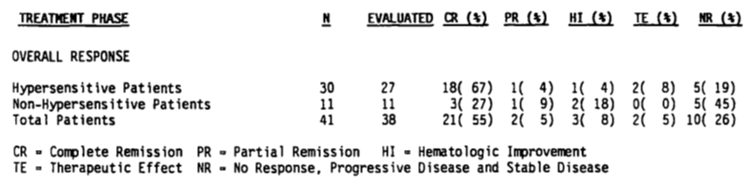
Comment: As one can see the PEGL ASNase had some form of benefit for 31 patients, bearing in mind such patients had already been heavily pre-treated with various treatments and 30 were known to be hypersensitive to native E.coli ASNase. Dosing was similar to that proposed for market, with the dosing interval more flexible. This is of note, as data have already been presented in this report to indicate that subjects previously hypersensitised may require more frequent dosing due to increased clearance of drug. This short open label trial also provides clinical utility experience in both adults and children with ALL in second line therapy.

ASP-102
This was a Phase I study of methotrexate and PEGL ASNase in refractory solid tumours and lymphomas. The objective was to determine the maximum tolerated dose of methotrexate when followed by PEGL ASNase; to determine a suitable PEGL ASNase dose, and; to determine the PEGL ASNase response rate to treatment.
Eleven patients entered the study; nine females and two males ranging from 18 to 74 years old. There were various cancer diagnoses but no patient had ALL.
Five cohorts of 3 patients were treated with ascending doses of methotrexate and within 24 hours a 2,000 IU/m² dose of PEGL ASNase. During the study, the protocol was amended to reduce the PEGL ASNase dose to 1,000 IU/m² due to toxicities experienced by the first patient on the study. If therapeutic effect and no toxicity were noted, the regimen continued until a maximum tolerated dose for methotrexate was observed.
Nine of the enrolled patients were evaluated for an efficacy response. Five exhibited stable disease and four progressive disease.
Comment: This evaluator has not presented this study in any detail as the dose is lower than has been determined from other studies and below that in the draft PI for this submission. In addition, no patient in this small Phase I study had the diagnosis proposed for treatment. The study is little more than a case series aimed at dose finding for methotrexate. PEGL ASNase is a secondary issue.

ASP-201A
This was an open label study assessing PEGL ASNase in the treatment of ALL or acute undifferentiated leukaemia in children.
The prime objective was to assess the dose of 2,000 IU/m² PEGL ASNase given once every two weeks for a total of three doses in inducing remission in relapsed children during a five week induction period.
Forty two relapsed patients ranging in age from 1 to 43 (yes 43) years with 30 male and 12 female were enrolled. Thirty seven had a diagnosis of ALL. Hence this study was not just in children as the title presupposes. Nine patients were hypersensitive to native E.coli ASNase, seven of whom had a diagnosis of ALL.
The treatment schedule was as shown in Table 59.

Table 59: Study ASP-201A Study treatment schedule
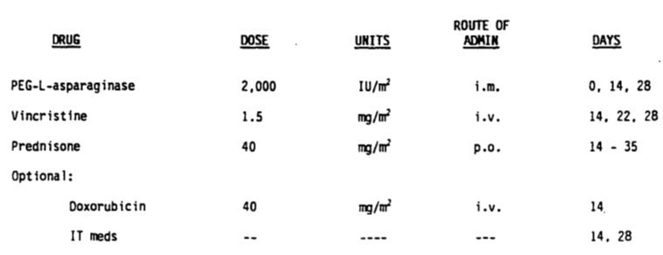
Results were simply descriptive. Of the hypersensitive population, eight subjects were assessable, with three CRs, and two PRs. Three did not respond and five continued to receive the drug into extension therapy where four CRs and one PR were achieved. Response rate was 50% as a single agent and 62% in combination chemotherapy.
Of the 33 non hypersensitive patients, 25 were evaluable after receiving induction chemotherapy. There were 16 CRs, 3 PRs and two ‘therapeutic effects’. Four patients did not respond, and 11 continued to receive PEGL ASNase in extension therapy where 8 CRs and two PRs were achieved.
Dosing of PEGL ASNase ranged from one to 33 doses per patient. The entirety of doses provided was 204. Overall, response rate was 57% as a single agent and 84% as part of standard induction therapy.
Comment: This small trial demonstrates an efficacy in children and adults with ALL receiving PEGL ASNase as a secondary treatment therapy. The subject numbers are small and there is no comparator group.

ASP-203
This study did not examine the efficacy of PEGL ASNase in ALL but in non-Hodgkin’s lymphoma. Subjects were 18 or over and had histological proof of the disease with at least one relapse in treatment. There were 21 subjects, with nine males and 12 females ranging in age from 39 to 81 years with at least one relapse. Twelve patients had had three or more treatment regimens and 13 were classified as stage IV disease. Hence the study population had particularly advanced disease and had proven refractory to treatment.
The study was open label with no comparator. Patients received a dose the same as the draft PI of 2,000 IU/m² every two weeks for two to six treatment courses (as a single treatment agent).
Efficacy was measured every 4 weeks via measurements of tumour, liver, spleen and lymph nodes along with profiles of peripheral blood and bone marrow.
Seven patients received one dose of drug; nine received two and five received three to five. Ten were discontinued from the study as a result of non-responsiveness to treatment, nine as a result of ADRs, one due to non-compliance and one due to death.
The results for this trial are hardly stellar. A summary table is given as shown in Table 60.

Table 60: Clinical response by treatment course. Number of patients and percent by treatment course
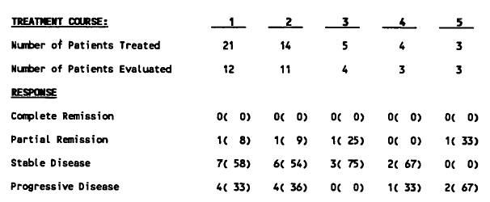
Two of the patients were assessed as having a partial response. The study drug was discontinued in each case after differing doses (two courses in one, five in another).
Comment: The study provides some small no-comparator data in adults receiving the proposed dose and dose interval of drug, but the diagnosis for treatment differs. Hence the study probably provides tolerability data rather than efficacy. The efficacy is, overall, poor in the view of this evaluator.

ASP-302
This was an open label trial that was primarily focussed upon safety and PK data for PEGL ASNase. It treated children with relapsed ALL in an intensified fashion.
Twenty one relapsed patients were enrolled. These included 13 male and 8 female patients ranging in age from 1 to 35 years old. Hence some treatment experience in second line ALL with both children and youngish adults. However all had childhood ALL. Four subjects had known hypersensitivity to native E.coli ASNase prior to enrolment.
The study had three phases, early therapy, re-induction therapy and maintenance. PEGL ASNase was given at a dosage of 2,500 IU/m² every two weeks, just as is proposed for children in the draft PI of this submission. The latter two phases had PEGL ASNase given with various other drugs in standard regimens for ALL. In Phase II, it was given on Days 1, 15 and 29. In Phase III, it was given every two weeks to Week 52. Most received the three doses in Phase II, but few received all 26 doses in Phase III.
Four hypersensitive patients were treated in the study with a collective 72 doses of drug and all 4 achieved complete remission. The 17 non hypersensitive patients received a total of 107 doses of PEGL ASNase ranging from 2 to 15 doses per patient. There were nine CRs and two PRs.
So in total the 21 patients received 179 doses of drug ranging from 2 to 29 per patient. 13 CRs and 2 PRs were observed (as shown in Table 61).

Table 61: Study ASP-302 Response to treatment
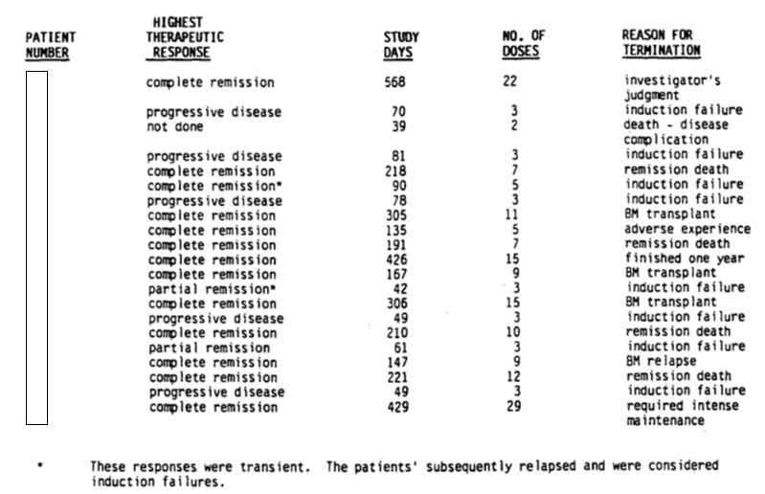
Comment: The study shows in what is essentially an organised case series the efficacy of PEGL ASNase as second line therapy in combination multi-drug treatment in children and young adults with ALL. Obviously the study was not randomised and there was no comparator. All data are essentially descriptive.

ASP-304
Unlike those before it in this section, this study was indeed a comparison between PEGL ASNase and native E.coli ASNase in combination with standard agents for second induction therapy for children with ALL. The primary purpose of the study assessed Oncaspar versus Elspar. Plasma levels assessed half-life as already presented in this report.
Patients without a history of hypersensitivity were randomised to either treatment. Elspar was given 10,000 IU/m² three time s a week for four weeks; with Oncaspar given IM at 2,500 IU/m² on Days one and fifteen (two study doses). Patients with a history of hypersensitivity to native E.coli ASNase were directly assigned to Oncaspar, and did not participate in randomisation.
Patients were eligible for inclusion in the study if they met the following criteria:
- Diagnosis of ALL before age 21 years and in the second haematological relapse.
- Life expectancy ≥ 4 weeks.
- Adequate hepatic and renal function (SGPT < 200 IU/L; creatinine < 2 mg/dL).
Exclusion criteria were as follows:
- Presence of CNS disease (unless the investigator judged it appropriate to withhold intrathecal chemotherapy during the 4 weeks of Oncaspar° combination chemotherapy; intrathecal medication could be given with the screening lumbar puncture at the discretion of the physician).
- Failure of other induction regimens which contained L-asparaginase.
The induction regimen was as shown in Table 62.

Table 62: ASP-304 Induction chemotherapy
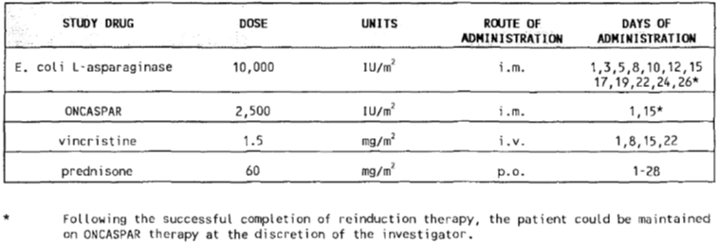
Efficacy outcomes were defined as:
- Complete response/remission: M1 marrow < 5% blasts.
- Partial response/remission: m² marrow ≥ 5 ≤ 25% blasts.
- Minor response: 75% decrease in circulating blasts or organomegaly with no change in marrow.
- Stable disease: no change in clinical or marrow status.
- No response: M3 marrow > 25% blasts without improvement in organomegaly or peripheral blood.
- Progressive disease: > 25% blast increase in marrow or peripheral blood, or rapid and advancing organomegaly.
Response to treatment was assessed at each clinic visit based upon symptomatology, liver spleen and lymph node measurements, and profiles of peripheral blood or bone marrow. On Day 35, the objective response was assessed.
Seventy six patients with ALL that had had a second relapse (M3 marrow > 25% blasts) and were less than 21 years old at diagnosis were eligible to be enrolled. Patients were not randomised if they had a history of prior allergy or skin reaction (Grades 2 and 3 respectively) to native E.coli ASNase. They were directly assigned PEGL ASNase.
They only formal statistical comparison in the study was between the two treatments during the induction period.
Seventy six patients were enrolled. Forty were directly assigned to Oncaspar, with 19 randomised to Oncaspar. Hence the treatment groups were 59 for Oncaspar, 17 to Elspar. Sixty patients were terminated from the study and 16 completed it. By far the greatest reasons for termination were relapse (18) and progressive disease (27). There were four deaths and seven bone marrow transplants.
Patient demographics were comparable between groups and as shown in Table 63.

Table 63: ASP-304; Demographics and Baseline characteristics by treatment group
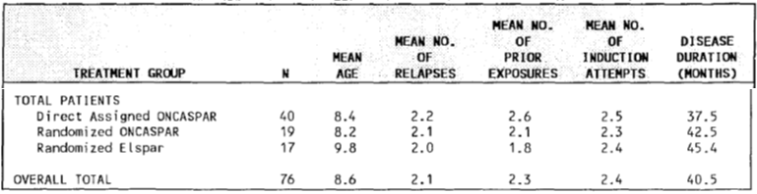
Comment: If anything, the demographic distribution showed favoured Elspar. More prior exposures occurred for Oncaspar. However, the Elspar group this evaluator notices was slightly ‘older’ which has been shown to be a predictor of poorer clinical outcome.
Demographic data for ALL patients is given by Table 64.

Table 64: ASP-304 Demographics directly assigned patients treatment group: PegL Asparaginase
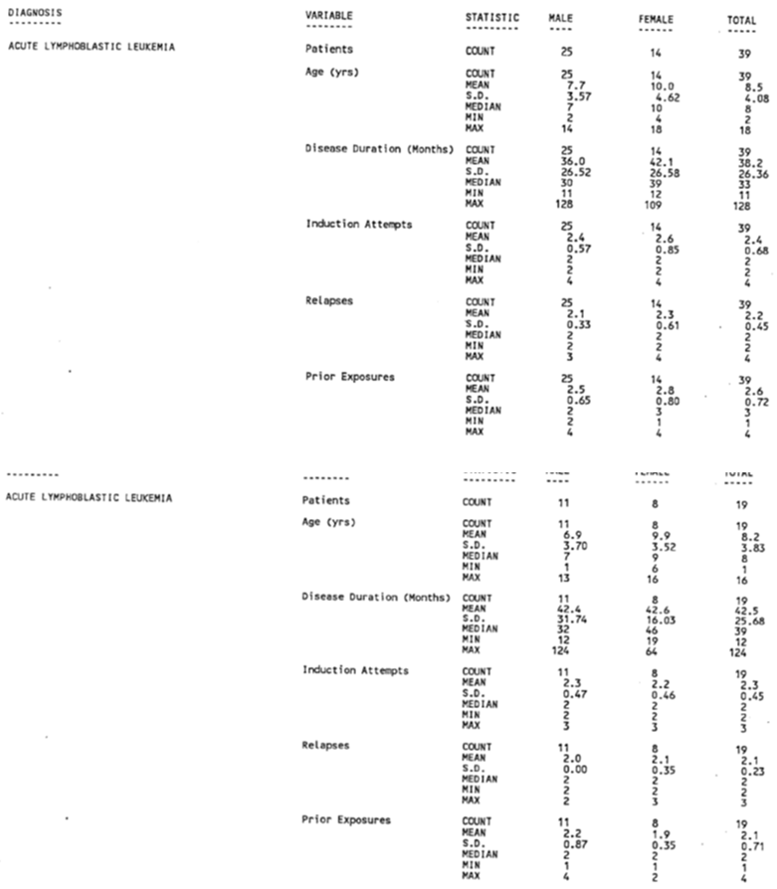
Comment: The demographics support the notion that subjects were pre-treated and had at least 2 prior relapses.
The 19 randomized Oncaspar patients received a collective total of 36 (mean of 1.9, range of 1 to 2) doses during induction combination chemotherapy. The 40 direct assigned Oncaspar patients received a collective total of 79 (mean of 2.0, range of 1 to 2) doses during induction combination chemotherapy.
Pharmacology results have already been presented in this report for this trial. However, in terms of comparative efficacy, the trial checked if Oncaspar during induction therapy compromised the Day 28 remission rates in paediatric ALL patients in relapse. Response rates were, in fact, similar with a favourable trend to Oncaspar (RR = CR+PR, Oncaspar 56%, Elspar 47%, chi square p = 0.615). Complete remission rates were similarly non-statistically significant in any difference, but favoured Elspar (39% Oncaspar, 47% Elspar, chi square 0.625).
Antibody data have already been presented earlier in this report for this trial.
Comment: The data show a comparative efficacy with Elspar in previously relapsed children with ALL. This is despite numbers of subjects having already been hypersensitised to Elspar previously. Whether the statistical power is sufficient to properly detect a difference is uncertain. Nonetheless raw numbers indicate likely outcomes well enough. The data support a role for Oncaspar in previously hypersensitised patients, while having the dosing advantage of a wider dose interval. Antibody formation is still an issue in the opinion of this evaluator and other data suggest a degree of sensitisation in the past may make it more likely that antibodies are formed to Oncaspar. The level of ASNase activity and antibody formation are two things that appear, in the view of this evaluator, to need monitoring during treatment, particularly in cases of prior hypersensitivity.

ASP-400
This was a pilot study for Oncaspar in treating relapsed patients with a diagnosis of ALL. It was an open label study with children who had a diagnosis of either ALL or non-Hodgkin’s lymphoma. Fifty one patients, aged 21 or younger, were enrolled with 47 of these patients’ medical records available. Upon examination, 44 were able to be evaluated and constitute the study population. Twenty-six were male, 18 female, and thirteen had known hypersensitivity to native E.coli ASNase.
Subjects could be enrolled if they were 21 or younger, had histological proof of ALL or NHL or AUL and had at least one relapse previously. Exclusions were few and only the age restriction is considered relevant to mention here.
There were three phases to the study. The first was induction treatment lasting 15 days, where Oncaspar was administered at a dose of 2,000 IU/m² on Day 12. The second was consolidation which started at week 3 and lasted 7 days. Oncaspar was again given at the same dosage on Day 5 of this. The final phase was a second consolidation phase which started at week 6 and lasted 7 days. A third dose was administered on Day 5 of this phase. The study ceased at week 12. If complete remission had been achieved and maintained, such patients were eligible for bone marrow transplantation.
Treatments in entirety were as shown in Table 65.

Table 65: ASP-400 Study treatment schedule
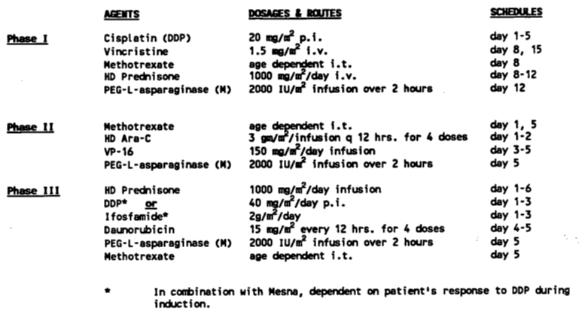As the study was open label and uncontrolled with a small number of patients, no formal statistical analysis was conducted. Descriptive statistics are provided.
The 44 patients evaluable received a collective 118 doses of Oncaspar with dosing ranging from 1 to 7 over the course of the trial. There were 26 complete remissions, 5 partial remissions, and one patient with haematologic improvement. Eleven patients did not respond.
Of the 13 hypersensitised patients, 6 achieved complete remission, 1 partial remission and 1 haematologic improvement. Five did not respond.
Efficacy assessment consisted of review of measures of the liver, spleen and lymph nodes as well as profiles of peripheral blood or bone marrow. Duration of response was calculated from the start of treatment until either progressive disease or study termination (for the patient) occurred.
Subject demographics are summarised as follows (see Table 66) for gender, disease, and disease duration.

Table 66: Study ASP-400 Total patient population demographics
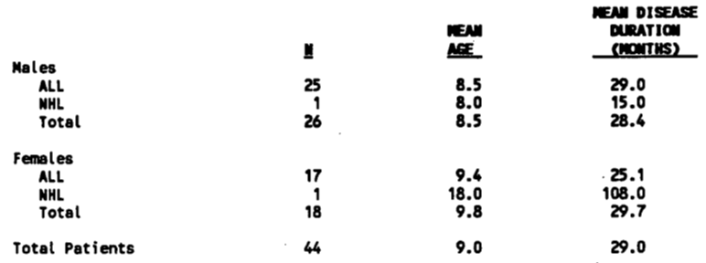
In terms of response to treatment, the highest rating achieved by regular investigator assessment was taken to be the therapeutic response to treatment. The highest therapeutic response for the overall study population of 44 was 27 complete remissions, five partial remissions and one haematologic improvement. Eleven did not respond.
Broken down by hypersensitisation, the results were as shown in Table 67.

Table 67: Study ASP-400 Highest therapeutic reponses
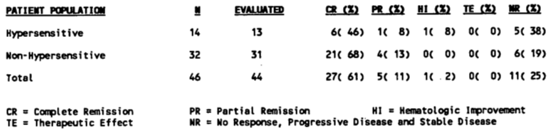
Comment: One can see the reduced percentages of complete response/remission in the hypersensitive patients. The data support the use of Oncaspar in achieving outcomes, but there is no way to know the quantification of the contribution made by Oncaspar as the trial is uncontrolled. These results simply seem to mirror those achieved for Oncaspar in this array of ‘ASP’ studies, and compare to the native E.coli ASNase outcomes when used as part of multi-drug chemotherapy in studies that compare the ‘standard’ ASNase to the pegylated version. The dose used in this study was slightly below that proposed for children in the draft PI and used in most of the other literature presented.

Summary data for formal trials of second line treatment of ALL
Data from the above presented formal studies in second line treatment of ALL that are considered of most weight are presented below.

ASP-304
This is really the only study considered of more weight than the remaining ones submitted. It was a randomised comparison with active control of second line treatment of ALL using native E.coli ASNase versus Oncaspar in people diagnosed before the age of 21. While subject numbers were still small (n = 76, 59 Oncaspar, 17 Elspar) and hence results were descriptive only, nonetheless it provides a much needed comparison of these treatments in second line therapy. Efficacy outcomes are summarised as shown in Table 68.

Table 68: ASP-304 Induction efficacy data
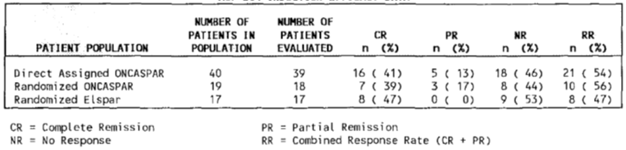
Response rate overall was 56% for Oncaspar and 47% for Elspar (chi square 0.615). If one considers complete remissions alone, it is 39% for Oncaspar and 47% for Elspar (chi square 0.625). Also 54% of those directly assigned to Oncaspar that had previous hypersensitivity reactions to Elspar achieved a response, thus these data support the use of Oncaspar when native E.coli ASNase has previously induced a reaction.
The remaining trials were essentially uncontrolled small trials assessing Oncaspar either alone or in combination with ‘standard’ chemotherapy regimens that were standard at the time the trials were carried out, which is a number of decades ago in some cases. The trials had small numbers of patients and statistics were essentially descriptive in all cases. The trials were aimed in most cases at ALL, but in some the diagnosis was either open to other cancers or entirely in other cancers.

Conclusions on formal trials for second line treatment in ALL in children and adults
Study ASP-304 provides some active comparator data, albeit in small numbers and from 1994, that Oncaspar, when used in multiple-drug regimens as induction and maintenance therapy for ALL in relapsed patients, can induce complete or partial remissions in a sizable percentage of treated patients. Statistical non-inferiority to Elspar is not possible, only numerical trends can be judged.
The remaining trials provide relatively low level prospective open label trial evidence that Oncaspar has positive efficacy outcomes when used to treat ALL in children (and less so in adults numbers wise) as a second line therapy, and they also suggest, as has other data in this report, that Oncaspar can be a viable alternative treatment choice for those who may already be hypersensitive to native E.coli ASNase.
Overall, these ‘ASP’ formal studies are relatively low evidence of the use of ASNase of any sort in the second line treatment of ALL. They are anecdotally suggestive of benefit but provide no real currency of information; that is demonstrating their clear statistical benefit or indeed non-inferiority to native E.coli ASNase in the treatment of ALL with current medical knowledge and regimens of treatment for ALL.

Published studies

First line treatment with Oncaspar; children
The following represent those studies listed for the use of pegylated asparaginase in children in one or more parts of first line treatment:

Larsen 2011, Winnick 2011, Larsen 2012
These publications are submitted here as abstracts but in any case simply given the same results presented for Study AALL0232 that has already been presented in this report.

Maloney 2013, Mattano 2014, Maloney 2015 (AALL0331)
These publications were all presenting data from the same Study, AALL0331. While cited earlier in this report, this evaluator was only aware of one of the publications pertaining to this study. Given there are three cited now, this evaluator looked at the other two put forward and found additional information, notwithstanding they represent abstracts from the literature only.
AALL0331 enrolled 5377 SR‐ALL patients from 4/2005‐5/2010. All patients received standard induction (vincristine (VCR), dexamethasone (DEX), PEG‐ASNase, intrathecal methotrexate (IT MTX)). At the end of induction, 1,857 patients meeting SR‐Low criteria were randomized to one of two regimens, Low Risk Standard (LRS) or Low Risk ASNase (LRA), with identical consolidation (mercaptopurine (MP) 75 mg/M d1‐28, VCR 1.5 mg/M d1, IT MTX d1,8,15) and interim maintenance (DEX d1‐5,29‐33, MP d1‐50, oral MTX weekly x 8, IT MTX d29) phases except for additional PEG‐ASNase (2,500 IU/M /dose) in Low Risk ASNase (CON d1,22 and IM d15,36). Subsequent delayed intensification (DI) and maintenance (MTC) phases were identical After 6/2008, based on CCG‐1991 SR‐ALL efficacy analyses, the IM backbone was changed to escalating dose intravenous (IV) MTX (VCR d1,11,21,31,41, MTX d1,11,21,31,41, IT MTX d31) in both regimens (LRS‐IV and LRA‐IV).
The standard risk to low group was defined by favourable cytogenetics (triple trisomies of chromosomes 4 + 10 + 17 or ETV6-RUNX1); no CNS or testicular leukaemia, and; rapid marrow response (< 5% blasts by Day 15 and end-induction minimal residual disease < 0.1%).
From Maloney 2013, five year EFS data were available for specific groups of minimal residual disease. Intensive consolidation did not significantly improve outcome for SR ALL patients, with 5 year continuous complete remission (CCR) rates for Standard versus Intensive consolidation of 88% (1.6%) versus. 89.3% (1.5%) (p = 0.13) and 5 year OS rates for SC versus. IC of 95.8% (1.0%) versus. IC 95.7% (1.0%) (p = 0.93).
The 5 year CCR rates for pts with MRD 0.01% to < 0.1% were 77% (6%) and 76% (6%) for SC and IC (p = 0.31) and 89% (1.6%) versus 91.5% (1.5%) for IC (p = 0.08) for MRD < 0.01%.
Overall survival for standard risk B cell ALL patients was 96%. Table 69, shows data for various risk sub groups:

Table 69: Data for various risk subgroups
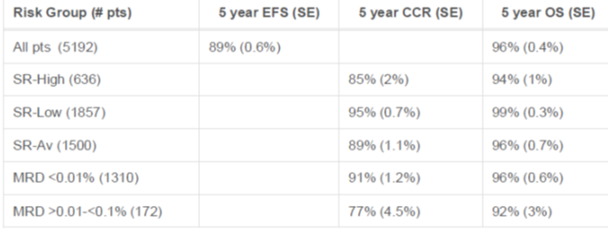
In Mattano 2014, data for children with ‘standard risk-low (SR-low) ALL were presented from trial AALL0331. The study randomised these patients to standard post induction therapy with or without 4 additional doses of Oncaspar given at three week intervals in the consolidation and interim maintenance phases. The 5 year continuous complete remission (CCR) and OS rates (SE) for SR‐Low patients (n = 1857) were 95.2% (0.6) and 98.8% (0.3). Consistent with the results of CCG‐1991, the 3‐year EFS was numerically higher with IV MTX (99.0% (0.4) versus 97.0% (0.5), p = 0.16) but the difference did not reach statistical significance. PEG‐ASNase intensification did not significantly improve outcome, with 5 year CCR rates for LRA/LRA‐IV versus LRS/LRS‐IV of 96.0% (0.8) versus 94.4% (1.0) (p = 0.1), and 5 year OS rates of 98.3% (0.6) versus 99.3% (0.4) (p = 0.05).
Comment: The study enrolled vast numbers of patients and indeed is stated to be the largest trial of standard risk B cell ALL patients ever conducted. This evaluator believes this information is at least an example of the use of Oncaspar in the treatment regimen for B cell, ALL patients that has demonstrated favourable EFS and OS data in vast numbers of patients. The currency of the data is also much more recent than early formal trials using the drug.

Angiolillo 2014 (AALL07P4)
These data have been presented above.

CCG 1962 (Avramis 2002)
These data have been presented above.

Matloub 2010
This was provided as an abstract (2 pages) discussing what appears to be a subset of patients from the Study CCG-1991 already presented in this report. The title of the paper relates its purpose, namely the reporting of outcome data in terms of 5 year EFS for children with Down’s syndrome with a diagnosis of Standard Risk ALL when treated with escalating doses of IV methotrexate as part of the protocol of Study CCG-1991.
As has been reported, the Study CCG-1991 attempted to quantify the benefit of double delayed intensification over single delayed intensification in a modified BFM therapy that used dexamethasone as the sole corticosteroid. Secondly, it compared the treatment outcome of treatment that included escalating doses of IV methotrexate without leucovorin, and vincristine, to one containing oral methotrexate, mercaptopurine, vincristine and dexamethasone during interim maintenance phases of therapy.
Patients received vincristine, Oncaspar and dexamethasone along with intrathecal cytarabine and methotrexate, then consolidation, delayed intensification, interim maintenance and maintenance phases of therapy. Slow early responders were assigned to a COG augmented BFM therapy, while rapid early responders were randomised to a 2 x 2 factorial design of 4 regimens as shown in Table 70.

Table 70: Study CCG-1991; trial design
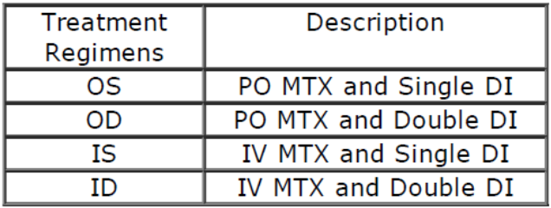
One hundred and eight patients with Down’s syndrome were enrolled with 77 randomised to one of the four regimens above. Forty five were randomised to the arms with oral methotrexate during interim maintenance, and thirty two to those containing IV methotrexate. Five year survival for these groups is represented as follows in Table 71.

Table 71: Five year survival of the study groups
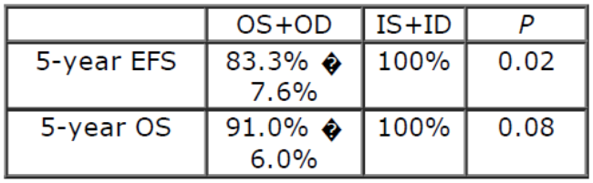
Hence, the conclusion was those with Down’s syndrome and standard risk ALL without adverse features could be cured with modified COG BFM therapy with escalating IV methotrexate dose without leucovorin rescue during the interim phases of therapy.
Comment: This publication, from a submission perspective, simply supports the first line use in children of Oncaspar in the treatment of ALL. The EFS and OS rates are comparable with other data. It is not additional data but rather a subset of trial CCG-1991 which has already been presented in this report.

Lowas 2009
This was a publication provided in full. It focuses upon the prevalence of transient hyperglycaemia during induction chemotherapy when children are treated for ALL.
This was a retrospective study from case records. Hyperglycaemia is a known side effect from corticosteroids and ASNase. Subjects were identified from the database at Oregon Health and Science University. They comprised children aged 2 to 18 years with ALL diagnosed from 1999 through to 2006. Children had been treated either on Children’s Cancer Group (CCG) or Children’s Oncology Group (COG) protocols; that is apparently these are CCG-1952, CCG-1961, CCG-1991 and COG AALL0232. This information is of interest more broadly for this submission as the origin of these protocols and hence trials, was not known by this evaluator.
Comment: On this basis, there were 162 children identified. However, in terms of actual outcome data, these would be incorporated in the respective clinical trials already presented. This publication discussed transient hyperglycaemia which while of interest to the safety section of this report, is not of interest in terms of standard efficacy outcome data for treatment of children in ALL. Standard outcome data are not discussed and hence this paper is of little value in assessing efficacy of Oncaspar as part of the treatment regimen in children receiving first line treatment for ALL.

CCG 1961 (Panosyan 2004, Ko 2015, Nachman 2009, Seibel 2008)
This trial has already been presented above.

CCG 1961 and CCG1991 (Jastaniah 2015)
These trials are presented from their full CSRs above.

Escherich 2013 (CoALL 08-09 trial)
This publication describes itself as a ‘feasibility report’ from the CoALL 08-09 trial (Co-operative study group for the treatment of ALL), with clofarabine in combination with PEGL ASNase for the first line treatment of children with ALL. (The drug had relatively recently at that time been approved by the FDA in second line therapy: relapsed or refractory ALL).
To investigate the utility of clofarabine it was given 5 x 40 mg/m² in combination with PEGL ASNase 2,500 IU/m² in high risk ALL patients (defined by PCR investigation of minimal residual disease) as a post induction element in the CoALL trial 08-09.
Newly diagnosed ALL patients, defined by a significant minimal residual disease (MRD) load at the end of induction (B-progenitor ALL at Day 29 ≥ 10-4 and T-ALL at Day 43 ≥ 10-3) were eligible for this Phase II trial. All other patients received the standard treatment consisting of high dose cytarabine (HIDAC) 4 x 3 g/m² in combination with Peg-ASP 2,500 IU/m².
In the CoALL 08-09 trial, all patients received an identical three-drug induction therapy consisting of orally administered prednisolone 60 mg/m² for 28 d, four weekly doses of vincristine 1 to 5 mg/m² and four doses of daunorubicin 36 mg/m², both intravenously. Patients without central nervous system (CNS) involvement received one single dose of intrathecal methotrexate within the first 7 days after diagnosis. Patients with suspected or proven CNS-involvement received two additional doses of intrathecal methotrexate.
At Day 29 of induction treatment, response was analysed within the bone marrow by microscopy and PCR-based measurement of MRD. Hence patients were then given either standard treatment of the clofarabine regimen.
Forty-two patients (39 B-progenitor; 3 T-ALL) fulfilled the criteria, were stratified and received the clofarabine/PEG-ASP treatment resulting in 24/39 (61%) MRD-negative B-progenitor patients compared to 18/39 (46%) after HIDAC/PEG-ASP in CoALL 07-03. Sixty-four MRD-stratified low risk patients received the standard HIDAC block combined with PEG-ASP. Complete toxicity data was available for 61/64 HIDAC patients. Three patients with induction failure (Day 29) were taken off protocol.
Comment: The study essentially provides additional data on first line use of Oncaspar in the accepted treatment regimens of childhood ALL.

MacDonald 2016 (COG protocols)
This paper specifically examined allergic reactions to IV versus IM PEGL ASNase in children with high risk ALL. This was a retrospective piece of research derived from hospital records at the IWK Health Centre in Canada. All children who received any asparaginase product by IM or IV route are stated to have been eligible for the study between January 2005 and December 2013 (this somewhat is contradictory to the study title where pegaspargase is specifically cited).
The dose used for the children is cited at 2,500 IU/m² hence similar to that in the proposed PI document. Under the ‘COG’ protocols upon which this research was based, patients were monitored for allergic reactions for an hour after the end of an IV infusion and 2 hours after IM administration. Families were told to be vigilant for signs and symptoms of reaction after leaving hospital.
In 128 patients (standard risk n = 90, high risk n = 38), allergic reactions were documented in 3% and 14% of those who receive IM and IV pegaspargase, respectively (p = 0.29). These data are compared with other publications that either found no real difference in frequency of allergic reactions comparing the IM and IV route, or a preponderance of allergic reactions in IV administration.
Comment: While outcome data are not presented, the publication highlights the use of PEGL ASNase at a dose the same as that proposed for a certain age group in the draft PI of this submission, and demonstrates contemporary use of PEGL ASNase in children as (potentially) first or second line therapy for ALL (no differentiation is made in the selection criteria). It also suggest IM administration might reduce frequency of allergy related ADRs.

Duarte 2016 (DFCI protocol)
This was a single centre cohort study specifically focussed upon the safety issue of CNS thrombosis in paediatric ALL during intensive asparaginase treatment.
This was a retrospective cohort study on patients enrolled in DFCI trial protocols (Dana Farber Cancer Institute). Three hundred and forty six paediatric (1 to 16 years) ALL patients were identified and studied.
The 346 patients analysed had a median age of 4 years (1 to 16), 45% (155) were female and 12% (43) were obese. The large majority had B-ALL (86%) and no CNS involvement (95%). Approximately half of the patients (57%) were classified as high risk according to the DFCI protocol. Thirty-seven patients (11%) received treatment according to DFCI 81-01 protocol, 156 (45%) DFCI 91-01, 23 (7%) DFCI 00-01 and the remaining 130 (38%) were treated with DFCI 05-01 protocol. The predominant asparaginase treatment was heterogeneous, with 199 patients (58%) receiving native E.coli asparaginase, 96 (28%), Erwinia asparaginase and 27 (8%) pegylated asparaginase. The remaining 24 patients received a combination of different asparaginase formulations, without a predominant type.
Comment: While the publication mentions several trials, which appear in the submission dossier in various forms, it does not report basic efficacy outcomes. In any case, those patients receiving pegylated ASNase are (1) 27 in number and (2) part of the data analysed when the cited trials are discussed in this evaluation report. While it seeks to further characterise the known safety issue of thrombosis in use of asparaginases, it does not, prima facie, add specific data to the body of knowledge supporting efficacy of Oncaspar use in treatment of ALL in children or adults.

Place 2015 (DFCI-05-001)
These data have already been presented in section 7.2.1.2.

Barry 2007 (DFCI 91-01 and 95-01)
The DFCI 91-01 Study has already been presented in section 7.2.1.4.

Silverman 2013, Silverman 2011, Merryman 2010 (DFCI ALL 05-001)
This study is presented from the only full literature publication on it; that of Place 2015 in section 7.2.1.2.
Silverman 2001, Silverman 2010 (DFCI 87-01, 85-01, 91-01, 95-01).
Trials 91-01, 87-001 and 05-01 have already been presented in this evaluation report. This leaves trials 85-01 and 95-01.
Silverman 2010 is the publication that summarises the data fully. Silverman 2001 is a report on the 91-01 protocol only.
The DFCI ALL consortium has conducted multiple trials since 1981. Key treatment has incorporated 20 to 30 weeks of ASNase therapy during intensification and vincristine/corticosteroid pulses during the continuation phase.
From 1985 to 2000, n = 1457 children aged 0 to 18 were treated on 4 consecutive protocols, namely 85-01, 87-01, 91-01 and 95-01. Ten year event free survival was, respectively, 77.9 ± 2.8%, 74.2 ± 2.3%, 80.8 ± 2.1% and 80.5 ± 1.8%. Study 81-01 stratified patients into two risk groups, and therapy was de-intensified for those with a lower risk of relapse as based upon age, leukocyte count and immunophenotype, with lower doses of anthracycline and corticosteroid. Overall EFS was 74% at 5 years and for T cell ALL 77%.
Later trials (1985-2000) focussed upon improving survival yet minimizing toxicities. Trial 91-01 substituted dexamethasone for prednisolone during post induction therapy, and employed use of high dose IV mercaptopurine rather than standard dose oral treatment in the first year of therapy. Other strategies included high dose methotrexate during remission induction, and intensification of treatment for patients considered at high risk of relapse, for example leucocyte counts > 100 x 10⁻⁹. (85-01, 87-01, 91-01).
Of most note to this submission, testing of alternative preparations of ASNase including Oncaspar was undertaken in studies 91-01 and 95-05. Study 91-01 has already been presented in this evaluation report. As a result, this evaluator has chosen to focus upon Study 95-01 data from this publication:
Study 95-01 was conducted from 1996-2000, and comprised 491 patients. In this protocol, (95-01), asparaginase was given as either native E.coli ASNase or Erwinia ASNase for 20 weeks during the intensification phase. Pegylated ASNase does not appear to have featured, which may explain why the dossier does not present this trial separately.
For Protocol 95-01, induction failure was defined as persistent leukaemia at Day 30 after diagnosis. Event free survival (EFS) was measured from the date of complete remission to the first event or until the date of last contact for event free survivors. For EFS, induction failure and induction death were considered events at time zero. Overall survival (OS) was measured from the date of starting treatment to death from any cause. EFS and OS were estimated by the method of Kaplan and Meier and compared with the log-rank test. Multivariable regression was performed using the Cox proportional hazard model to assess prognostic factors for EFS and OS.
Of the 491 evaluable patients, 480 entered CR (98%), 79 relapsed (16%) and 3 patients died in CR (0.6%). 395 (80%) remain alive and free of adverse events. The 10 year CI estimates for isolated marrow and any marrow relapses were 12.1 ± 1.5% and 15.9 ± 1.8%, respectively. The 10 year CI estimates for isolated CNS and any CNS relapses were 0.7 ± 0.4% and 3.8 ± 1.0%, respectively. Of the 274 evaluable male patients, the 10 year cumulative incidence of any and isolated testicular relapse was 1.9 ± 0.9% and 0.8 ± 0.5%, respectively. The 10 year EFS and OS were 79.0 ± 2.1% and 88.9 ± 1.5%, respectively. For SR patients, the 10 year EFS and OS rates were 83.1 ± 2.5% and 93.1 ± 2.1%, and the rates for HR/VHR patients were 74.1 ± 3.3% and 83.7 ± 2.5%.
Graphical representation of Study 95-01 outcome is as follows in Figure 21.
Figure 21: Event free survival and cumulative incidence of isolated or any CNS relapse for 401 patients treated on protocol 95-01 (19960-2000). Median follow up was 8.6 years
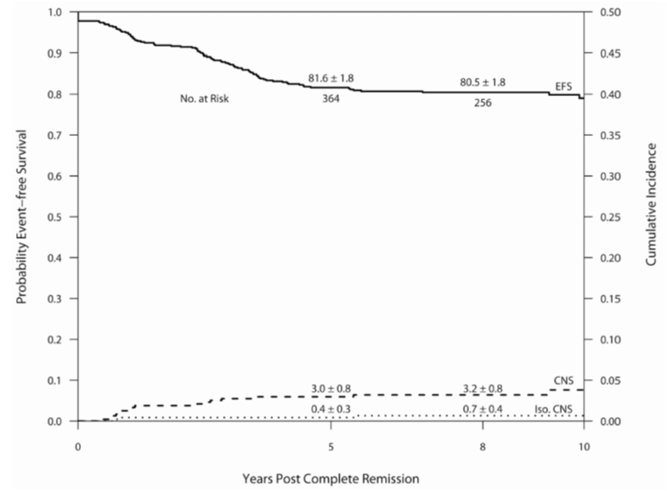

Table 72: Outcome by protocol (1985-2000)
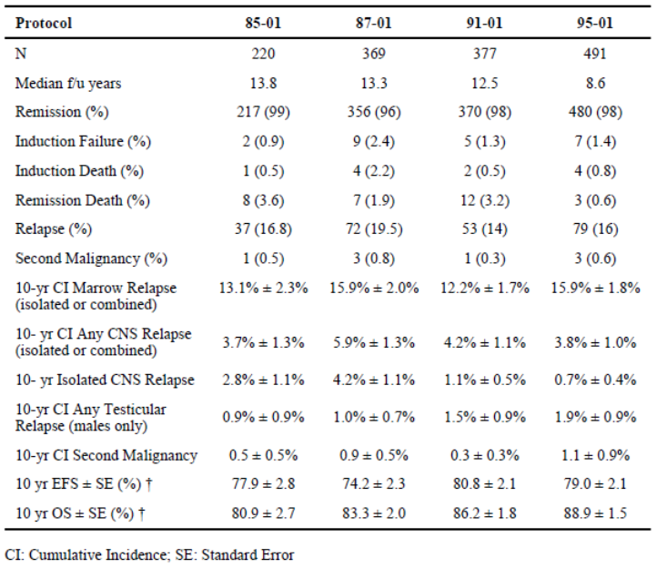
Comment: While Study 95-01 has been presented here because it was not presented elsewhere in this report, it does not, in fact, make use of PEGL ASNase. Nonetheless, this publication of Silverman 2010 summarises outcome data for 1,457 children treated for ALL, and one can see in the table directly above that studies 87-01 and 91-01 that have been presented in this report compare favourably to the other studies in terms of EFS and OS outcome data. Hence they support the use of Oncaspar in treatment of ALL in children, and the use of ASNase in general for ALL.

Tong 2014
This study primarily examined the incidence of hypertriglyceridaemia and hypercholesterolaemia in prolonged use of PEGL ASNase and Erwinia ASNase in treating children with acute ALL. Eighty nine children were given the Dutch Childhood Oncology Group ALL 10 medium risk intensification programme, which involves 15 fortnightly doses of 2,500 IU/m² PEGL ASNase over 30 weeks. Erwinia ASNase was given at 20,000 IU/m² 2 to 3 times per week when allergy or silent inactivation of PEGL ASNase occurred. If ASnase levels were particularly high, dose interval of Erwinia ASNase was prolonged. Initial induction involved native E.coli ASNase 500 IU/m² every three days.
Median age of children was 4.9 years (range 1.2 to 16.2) and 78 had precursor B cell ALL and 11 had T cell. Twenty two had to be switched to Erwinia ASNase, however this needs to be taken in context. This evaluator has noted the ‘priming’ of hypersensitivity that can occur by initial native ASNase dosing in some studies.
Triglyceride and total cholesterol measures were non-fasting and taken at baseline and Weeks 3, 5, 7, 9, 15 and 25 in the intensification phase and Week 37, at least 6 weeks after any ASNase dose.
A summary of toxicity profile is as follows in Table 73.

Table 73: Toxicity of PEG asparaginase and Erwinia asparaginase
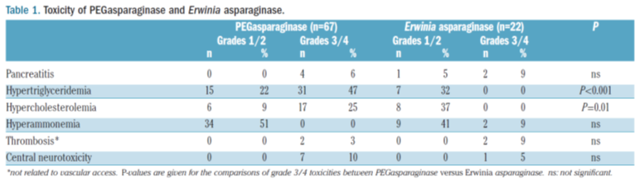
Comment: This study has no comparator so it is essentially studying frequency and severity of known ADRs. In the context of being presented as efficacy data, it simply shows that a study conducted in recent years used PEGL ASNase to treat childhood ALL as first line. Clinical outcome data for efficacy are not part of the publication.

Van der Sluis 2013 (INTERFANT-06)
This study examined children less than a year in age with ALL. This is of note as dosage instructions are different in the draft PI for very small children, but dose goes by body surface area, not age, in that respect. Twelve patients received the INTERFANT-06 protocol and up to 10,000 IU/m² ASNase on Days 15, 18, 22, 25, 29 and 33 of induction treatment. The dose was individually adjusted less than 6 months of age and 75% of standard dosing for those 6 to 12 months.
Trough serum ASNase levels were above 100U/L in only 51% yet asparagine was completely depleted in serum apart from one patient who was the youngest in the study. No antibodies were detected at this stage of treatment.
Comment: This study did not make use of PEGL ASNase and simply provides evidence of contemporary ASNase use in a small number of very young children with ALL. This evaluator notes that this trial used PEGL ASNase as part of consolidation treatment later in the patients’ regimens. Pharmacodynamic outcomes such as ASNase levels and asparagine depletion as well as antibodies are reported but no actual clinical outcomes.

Abbott 2015
This was a retrospective review of PEGL ASNase focussing on allergic reactions and their relative frequency with IM versus IV administration. A chart review from 1 March 2010 to 1 January 2012 at the Hospital for Sick Children, Toronto, retrieved 109 patients who received PEGL ASNase.
In summary, there were 14 out of 40 (35%) who had allergic reactions after receiving the drug IV, with 8 out of 69 (12%) who received the drug IM having allergic reactions. (OR 4.11, 95% CI 1.54, 10.97; p = 0.005).
After applying multivariate logistic regression, the rose route remained independently significant (p = 0.011). Of additional interest is that those with ‘lower risk’ ALL had a lower risk of allergy than those with ‘higher risk’ disease. (11% versus 31%, OR 3.36, 95% CI 1.16, 9.72; p = 0.025).
Comment: These data do not provide clinical efficacy data per se apart from the fact patients received the drug for ALL. They support other data in this submission that suggest a reduced incidence of allergic reaction with IM administration.

Alrazzak 2016
This study examined the incidence of hypersensitivity reactions to PEGL ASNase. A retrospective review of 96 medical records of paediatric patients suffering from ALL was conducted looking for allergy, from localised skin reaction to anaphylaxis. Ninety one patients were in the final analysis with 31 having received PEGL ASNase IV and 60 IM.
The incidence of any Grade ≥ 2 hypersensitivity reaction in patients who received IV ASNase was 32.2% compared with 13.3% in the IM group (p = 0.032). There was no difference in higher grade hypersensitivity reactions (19.4% versus. 11.7%). Most reactions tended to occur during periods of leukaemia therapy that did not include concomitant steroid therapy.
Comment: The data again support the idea of fewer allergic reactions using IM administration. Clinical outcome data such as EFS and OS were not present.

Henriksen 2015, Tuckviene 2016 (NOPHO ALL2008)
These data were presented in section 7.2.1.12.

Lauer 2001 (POG 9006)
This was a prospective randomised multicentre study evaluating two different early intensive therapy regimens for B cell ALL in children at high risk for relapse. The trial was Paediatric Oncology Groups (POG) 9006 Phase III trial conducted from 1991 to 1994. Subjects (n = 470) went through an induction of prednisolone, vincristine, asparaginase and daunorubicin, then were randomised to receive either 12 intensive treatments over 24 weeks of 1g/m² methotrexate and mercaptopurine (A), or 12 intensive courses of alternating myelosuppressive drug combinations over 30 weeks (B).
These drug combinations included MTX/MP, teniposide (VM-26)/cytosine arabinoside (AC) and VCR/PDN/DNR/AC/ASP. Central nervous system (CNS) prophylaxis was age adjusted triple intrathecal chemotherapy. Patients with CNS disease at diagnosis were treated with craniospinal irradiation after the intensive phase. Continuation was standard doses of MTX and MP for 2 years.
Patient characteristics were as follows in Table 74.

Table 74: Study POG 9006; presenting patient characteristics
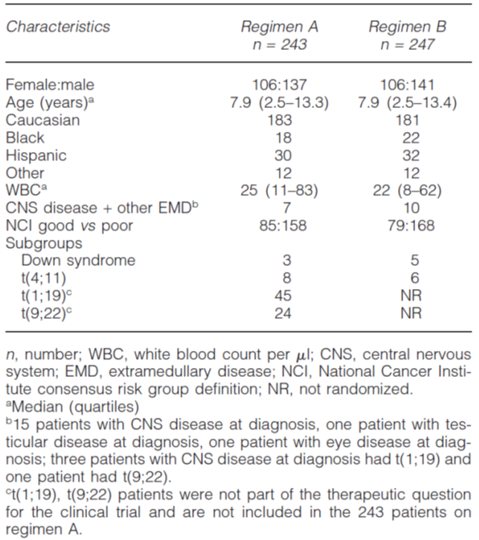
Two hundred and thirty two were randomized to regimen A and 238 to regimen B. The estimated 4 year event free survival (EFS) for patients treated with regimen A is 61.6 % (S.E. = 3.3%) and with regimen B is 69.4% (S.E. = 3.1%), p = 0.091. Toxicities were more frequent on regimen B. In conclusion, for children with B precursor ALL at high risk to relapse, early intensification with myelosuppressive combination chemotherapy was more toxic but produced no significant difference in EFS when compared to those treated with parenteral methotrexate and mercaptopurine.
The use of ASNase occurs in induction with native ASNase 6,000 IU/m² IM on Days 2, 5, 8, 12, 15 and 19. In Regimen B, PEGL ASNase was given 2,500 IU/m² IM on Day 1 of weeks 8, 18 and 28 as shown in Figure 22.
Figure 22: Patient characteristics
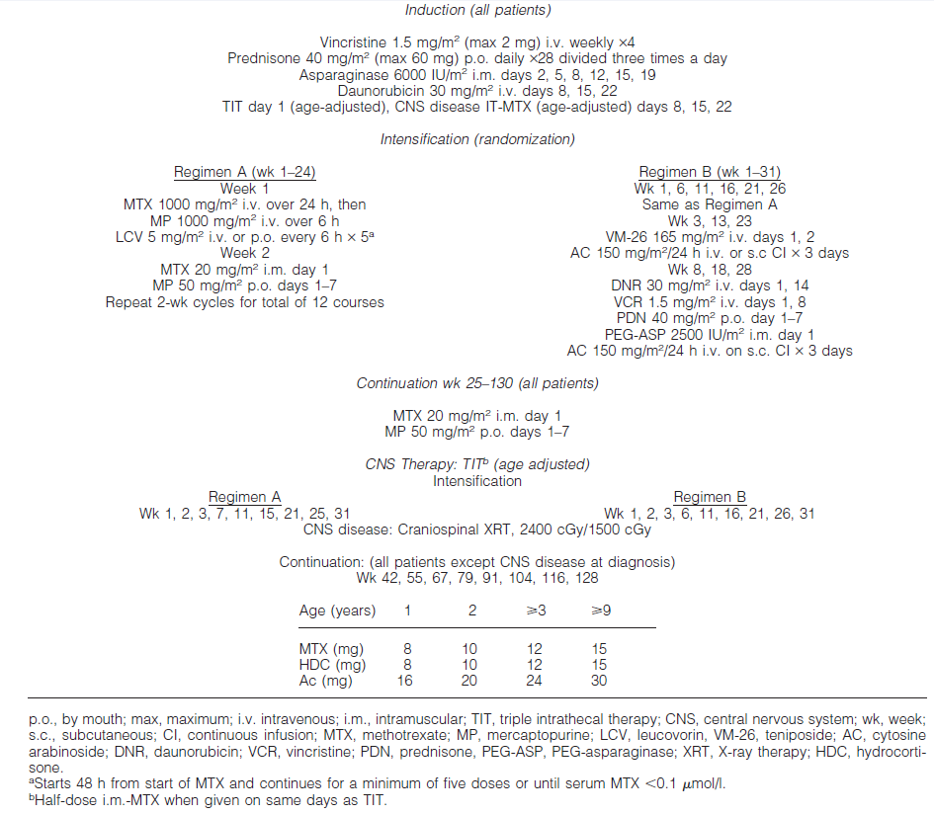
Comment: While these data do not compare PEGL ASNase with native ASNase or other forms, they do provide a significant recent experience of the use of PEGL ASNase in an intensification regimen for B cell ALL in children. Such a regimen appears to have delivered better 4 year EFS when compared with the other regimen used for intensification.

Tower 2014 (POG 9406)
This is a publication reporting on a trial designated POG 9406, from the Paediatric Oncology Group. It compared higher dose versus standard dose of IV methotrexate and pulses of high dose arabinoside with asparaginase versus standard dose cytosine arabinoside and teniposide during intensified continuation therapy for higher risk B precursor acute ALL.
POG 9406 randomized patients in a 2 x 2 factorial design to MTX, 1 gm/m² (Regimens A/B) versus 2.5 gm/m² (Regimens C/D) and to teniposide/ara-C (Regimens A/C) versus high dose ara-C/asparaginase (Regimens B/D). Patients with t(4;11) or t(9;22) were excluded from randomization and were assigned to Regimen A. Patients with Down syndrome were randomized to receive only Regimens A or B (lower MTX dosing). Patients with induction failure were not eligible to receive post induction therapy.
Patients aged 1 to 9.99 years with initial WBC < 50,000/μL received 3 drug induction. All other patients received 4 drug induction therapy. Intrathecal therapy was given. If the Day 29 bone marrow had 5 to 25% blasts, two weeks of extended induction was given with prednisolone, vincristine, and L-asparaginase. Patients with > 25% marrow blasts at Day 29 or ≥ 5% blasts at Day 43 were considered to be induction failures. Intensified continuation therapy was started after remission and count recovery.
Patients who achieved a complete remission were randomized in a 2 x 2 factorial design to 30 weeks of intensification with Regimens A, B, C, or D. Regimens A and B had standard MTX dosing (1 gm/m²), while Regimens C and D had a higher dose of MTX (2.5 gm/m²). Leucovorin dosing was the same for all regimens. Regimens A and C used teniposide/ standard dose ara-C, while Regimens B and D contained high dose ara-C/asparaginase.
Comment: Hence it is induction regimens as well as regimens B and D that provide some information about ASNase.
Interim analyses by the Data Monitoring Committee revealed outcomes on the higher dose MTX arms were inferior to the standard dose MTX arms, and it was unlikely that the higher dose arm could ever prove to be superior to the standard dose arm. Therefore, on 15 November 1999, all patients in intensification were switched to the lower dose of MTX.
POG 9406 was originally designed to enrol 673 patients to detect an improvement in 4 year continuous complete remission rates between treatment arms from 60% to 68.75% with 80% power and alpha at 5% using a 1-sided log-rank test. Accrual was extended since there were fewer events than projected in the statistical section which would have resulted in lower power than originally projected. Down syndrome patients were not included in the power calculations. Follow-up data was completed for the study.
910 patients were enrolled. Three patients were ineligible and 2 Down syndrome patients were made non-evaluable after enrolment. Of the 905 eligible patients, 35 were removed from protocol therapy prior to intensified continuation due to induction failure (n = 15), death (n = 7), toxicity (n = 12), and refusal of randomization (n = 1). Twenty-four patients did not achieve CR (7 early deaths, 1 partial response, 14 progressive disease and 2 patients not evaluable for response and off Induction therapy for toxicity). The remission rate was 97.3% (881 out of 905).
784 patients without Down syndrome were randomized in a 2 x 2 factorial design to post induction therapy on this trial: Regimen A (n = 198); Regimen B (n = 197); Regimen C (n = 193); Regimen D (n = 196). Eighteen patients with t(4;11) and 47 patients with t(9;22) were excluded from randomization and received Regimen A.
The 5 year DFS and OS in all patients were 69 ± 1.6% and 80.4 ± 1.4%, respectively. Five-year cumulative incidence rates were 14.9 ± 1.2 % for isolated bone marrow relapse, 3.9 ± 0.66% for isolated CNS relapse, 1.1 ± 0.35% for isolated testicular relapse, and 7.2 ± 0.9% for relapse at other sites (including combined relapse). There were 3.7% (32 out of 870) remission deaths; the 5 year cumulative incidence rate was 3.2 ± 0.6%.
Patients who received standard dose MTX (Regimens A/B; n = 395) had 5 year DFS of 71.8 ± 2.4% while patients treated with higher dose MTX (Regimens C/D; n = 389) had 5 year DFS of 71.7 ± 2.4% (Hazard Ratio (HR) = 1.1; 95% CI: 0.84, 1.4; p = 0.55). Outcomes for patients on ara-C/teniposide (Regimens A/C: DFS of 70.4 ± 2.4%; n = 391) were similar to patients on higher dose ara-C/asparaginase (Regimens B/D: DFS of 73.1 ± 2.3%; n = 393) (HR = 1.1; 95% CI: 0.86, 1.4; p = 0.41). DFS for Regimens A, B, C, and D were 68 ± 3.5%, 75.5 ± 3.2%, 72.7 ± 3.3%, and 70.7 ± 3.3%, respectively (p = 0.55). However, this trial was not designed as a four arm study and has insufficient power to determine which regimen is superior.
Survival rates were not significantly different between patients receiving standard versus higher dose MTX or high dose ara-C/asparaginase versus standard dose ara-C/ teniposide.
EFS for this study was better than the previous POG higher risk ALL trial, 9006 (presented in this evaluation report above), which had 4 year EFS of 61.6 ± 3.3% and 69.4 ± 3.1% for its regimens. The improvement is in part due to the incorporation of the best regimen of 9006 as the standard regimen of this trial and better supportive care.
Comment: In summary, this trial shows a clinical experience in several hundred patients receiving asparaginase as part of induction ± intensification in contemporaneous research. It is not possible to be certain upon reading the publication if PEGL ASNase was used or not. It appears to this evaluator more likely that standard E.coli ASNase was used. Hence the value of this publication in supporting use of Oncaspar diminishes somewhat as it simply supports current use of ASNase per se in multi-drug regimens for high risk B precursor ALL.

Rowntree 2013, Vora 2014, Samarasinghe 2013, Vora 2013, Hough 2016 (UKALL 2003)
These data are presented in section 7.2.1.11.

Summary information for publications with data on paediatric use of Oncaspar in first line treatment modalities for ALL
The following are considered pivotal data this evaluator has distilled from the data presented as published literature supporting first line treatment with Oncaspar in children.

ALL0331
This study with information derived from multiple publications shows a treatment experience in 5,377 patients with standard risk B cell ALL who all received PEGL ASNase as part of their induction regimen, which is referred to (in these very recent publications) as standard. Hence it is a strong support of first line treatment in children with ALL using Oncaspar. Sub groups of the trial also received Oncaspar for later stages of treatment. The dose used mirrors that for children over 1 year as reflected in the draft PI of this dossier.
Children classified as ‘standard risk-low’ ALL were also randomised to post induction therapy with or without 4 additional doses of Oncaspar at three week intervals in the consolidation and interim maintenance phases. So this allowed a degree of measure of the effect of additional doses of Oncaspar alone, rather than outcome measured as a result of multi-drug treatment as in most trials. However, the additional doses did not statistically significantly improve outcomes.
5 year continuous complete remission rates were, for Standard versus Intensive consolidation, 88% (1.6%) versus. 89.3% (1.5%) (p = 0.13) and 5 year OS rates for SC versus. IC of 95.8% (1.0%) versus IC 95.7% (1.0%) (p = 0.93).
For all trial patients, 5 year EFS was (EFS (SE)) 89% (0.6%) and 5 year overall survival 96% (0.4%).
Although, as in most trials without direct comparison of ASNase as part of the design, outcomes are assumed to be contributed in part by ASNase, in this case Oncaspar, the trial is nevertheless a huge contemporary study in thousands of patients that supports the use of first line Oncaspar for B cell ALL in children.

CCG-1962
This trial is of particular importance as it was a randomised comparison of Oncaspar and native E.coli ASNase in standard risk ALL in children. While only having 118 patients, the dose of Oncaspar used is that proposed in the draft PI of this submission and both comparative antibody titres and EFS were efficacy measures. Titres were detected in 7 of 46 subjects given native ASNase and 3 of 49 given Oncaspar in the first delayed intensification phase (p = 0.149). Hence Oncaspar seems at least as favourable as native ASNase in this regard with a trend to better outcome.
Event free survival (EFS) was similar (p = 0.414) between the 2 treatment groups. The log-rank p value should be interpreted with caution, as the EFS data are heavily censored. Event free survival rates for the PEG-ASNase group were 83% at 3 years, 78% at 5 years, and 75% at 7 years. Corresponding EFS rates for the native E.coli ASNase group were 79%, 73%, and 66%, respectively.
Although inadequately powered, the data suggest at least as good performance of Oncaspar in comparison to native E.coli ASNase and a reduced rate of antibody formation.

DFCI consortium studies
This collection of studies presented in various publications represents an experience of 1,457 children with ALL treated in 4 consecutive protocols, that is 85-01, 87-01, 91-01 and 95-05. Oncaspar was used in studies 91-01 and 95-05.
For protocol 95-01, for SR patients, the 10 year EFS and OS rates were 83.1 ± 2.5% and 93.1 ± 2.1%, and the rates for HR/VHR patients were 74.1 ± 3.3% and 83.7 ± 2.5%.

DFCI-05-001
This was a randomised, Phase III open label trial where IV PEGL-ASNase and IM native E.coli ASNase were compared post induction in the treatment of newly diagnosed ALL in children. Hence the value of it as a comparator to ‘standard’ ASNase. Why PEGL ASNase was to be given IV is uncertain as other data suggest allergic reactions are fewer via the IM route, hence the design may have favoured E.coli ASNase at the outset.
Randomised patients (n = 463) went on to receive 30 weeks of post induction treatment, using either IV PEGL-ASNase 2,500 IU/m² every 2 weeks for 15 doses, or IM E.coli ASNase 25,000 IU/m² weekly for 30 doses. Note the dosing is as mirrored in the draft PI of this dossier.
The 5 year disease free survival was 90% (95% CI 86 to 94) for patients randomly assigned to intravenous PEG-asparaginase, 89% (85 to 93) for those randomly assigned to intramuscular native E coli l-asparaginase, and 88% (74 to 95) for those who declined to undergo randomisation and were directly assigned to intramuscular E coli l-asparaginase.
The 5 year overall survival was 96% (93 to 98), 94% (89 to 96), and 95% (82 to 99) for these three patient groups, respectively. No differences in disease free survival between randomised groups were noted within patient subsets.
Comment: This trial compares native E.coli ASNase and Oncaspar at the proposed treatment dose in first line treatment of children with ALL. 5 year overall survival is very good and despite the primary outcomes of the study being safety related, the trial shows a treatment role for Oncaspar which is at least as good as native E.coli ASNase in the opinion of this evaluator.

UKALL2003
This was a large study (n = 3,207) with parts reported in different publications. As one example, if one observes the trial design (Figure 18), 521 MRD low risk patients were randomly assigned to receive one (n = 260) or two (n = 261) delayed intensification courses. Median follow-up of these patients was 57 months (IQR 42 to 72). There was no significant difference in EFS between the group given one delayed intensification (94·4% at 5 years, 95% CI 91·1 to 97·7) and that given two delayed intensifications (95·5%, 92·8 to 98·2; unadjusted odds ratio 1·00, 95% CI 0·43 to 2·31; two-sided p = 0·99). The difference in 5 year EFS between the two groups was 1·1% (95% CI –5·6 to 2·5). 11 patients (actuarial relapse at 5 years 5·6%, 95% CI 2·3 to 8·9) given one delayed intensification and six (2·4%, 0·2 to 4·6) given two delayed intensifications relapsed (p = 0·23).
The trial provides no particular comparison data but does show the use of Oncaspar in drug regimens for the treatment of children with ALL in thousands of patients. The sheer numbers are what give weight to the efficacy outcome data and these are comparable in terms of EFS and OS with other trial data in this dossier. Hence the study supports the use of Oncaspar in first line treatment of ALL in children.

Conclusions from published literature on the use of Oncaspar in first line paediatric ALL
Based upon the data reviewed, this evaluator is of the opinion that:
Use of asparaginase per se is an accepted part of current first line treatment in children with ALL.
- Oncaspar appears to have similar efficacy outcomes in terms of EFS and OS compared with native E.coli asparaginase.
- Oncaspar has a treatment advantage of wider dose intervals.
- Oncaspar appears to elicit fewer allergic reactions when given IM, although data are weak.
- Oncaspar appears to elicit lower rates of antibody formation than native E.coli asparaginase, although one cannot claim this definitively.
- The dose of Oncaspar proposed in the draft PI matches virtually all of the trial doses used.
- Monitoring asparaginase serum levels and/or serum levels of asparagine appears a useful activity given the uncertainty of hypersensitivity/antibody development and the resulting effects this can have on drug clearance and thus asparagine presence in the body.
- The use of Oncaspar in the first line treatment of children with ALL has been satisfactorily established in the opinion of this evaluator.

First line treatment with Oncaspar; Adults
The following represent those studies presented in adults using pegylated asparaginase in one or more parts of first line treatment:

Rytting 2013 (ABFM and H-CVAD)
This was a study presented as an abstract that examined augmented Berlin-Frankfurt-Muenster (ABFM) base therapy for young adults with ALL. This therapy was administered to patients aged 12 to 40 years in a prospective fashion, then retrospectively compared to the HYPER CVAD regimen, described as the historical adult treatment regimen used at the hospital where the trial was conducted.
Eighty five patients with de novo Philadelphia chromosome negative ALL completed at least 6 months of therapy at the time of authorship. There were 69 (81%) patients with pre-B ALL and 16 (18%) of patients with T cell ALL/lymphoma. The age range was 13 to 39 with a median of 21. The median WBC at diagnosis was WBC = 14 thousand/microliter (range 0.4 to 494). 80/85 (94%) patients entered remission (< 5% blasts on Day 29 marrow morphology).
At the end of induction, 46 (58%) patients were minimal residual disease (MRD) negative by flow cytometry (< 0.01% blasts). By approximately Day 84 of treatment, 55 (69%) patients were negative for MRD and 13 (16%) were positive or suspicious.
For the entire cohort, the estimated 3 year overall survival (OS) is 75% and 3 year complete remission duration (CRD) is 71%. In univariate analysis, negative MRD at Day 29 was associated with improved OS and Day 84 negative MRD was associated with improved CRD. The presenting WBC was associated with OS and CRD. On multivariate analysis, only WBC over 50,000/μL maintained significance for OS and CRD. In comparing ABFM to HYPER CVAD, there is no significant difference in OS or CRD. This lack of difference in OS and CRD persists when patients are stratified for age > or < / = 21 years, for presenting WBC over 50,000, and for MRD at the end of induction.
Comment: While these data suggest a comparable outcome between the regimens cited, the regimens themselves are not described and it is not clear whether pegylated ASNase was a part of one or both. At this level of detail, the reference is unhelpful in establishing the use of Oncaspar in first line treatment of ALL in adults.

Rytting 2016 (ABFM and H-CVAD)
This citation appears to be the final results of the publication by the same author in 2013 (that is the citation presented directly above).
One hundred and six adolescent and young adult patients (median age 22 years) with Philadelphia chromosome (Ph) negative ALL received ABFM from October 2006 through March 2014. Their outcome was compared to 102 such patients (median age 27 years), treated with hyper-CVAD.
The complete remission (CR) rate was 93% with ABFM and 98% with hyper-CVAD. The 5 year complete remission durations (CRD) were 53% and 55% respectively (p = 0.98). The 5 year overall survival (OS) rates were 60% and 60%, respectively.
ABFM and hyper-CVAD resulted in similar efficacy outcomes, but were associated with different toxicity profiles, asparaginase related with ABFM and myelosuppression-related with hyper-CVAD.
PEGL ASNase was used in the ABFM regimen 2,500 IU/m² on Day 4 of induction, Weeks 3 and 4 of consolidation 1, and Weeks 1 and 4 of consolidation 2. It was used in Week 1 of consolidation 3A, and Week 3 of consolidation 3B.
HCVAD consisted of hyper-fractionated cyclophosphamide, vincristine, Adriamycin and dexamethasone.
Comment: In summary the study simply provides some support for the use of Oncaspar in current treatment regimens for first line ALL treatment in adults. Comparison with another regimen without PEGL ASNase appears to have had comparable outcomes but there is no comparison here to other forms of asparaginase used in the same regimen, thus it is impossible to quantify the sole contribution of PEGL ASNase.

Lamanna 2013 (ALL-2 and L-20)
This was a prospective randomised trial of the ‘ALL-2’ regimen (cytarabine 3g/m² daily for 5 days with mitoxantrone 80 mg/m² as an induction regimen versus a ‘standard 4 drug regimen’ (L-20).
The following extract from this study summarises current ALL treatment quite well in the opinion of this evaluator:
‘Current regimens induce a complete response/complete remission (CR) in approximately 60% to 90% of patients. However, there is a substantial relapse rate, and only 20% to 40% of patients ultimately will be cured of their disease. Multiple studies have confirmed the importance of several prognostic features, including age, immunophenotype, white blood cell (WBC) count, cytogenetic abnormalities, and the time to achieve a CR. On the basis of these observations, several groups have tested more aggressive acute myeloid leukaemia ‘‘(AML)-style’’ induction therapies to induce more rapid CRs and, in this manner, attempt to increase the likelihood of a cure.’
This is essentially what this trial is doing, testing a more aggressive induction therapy.
The aggressive induction regimen is as shown in Table 75.

Table 75: The ALL-2 induction regimen with high dose mitoxantrone and cytarabine
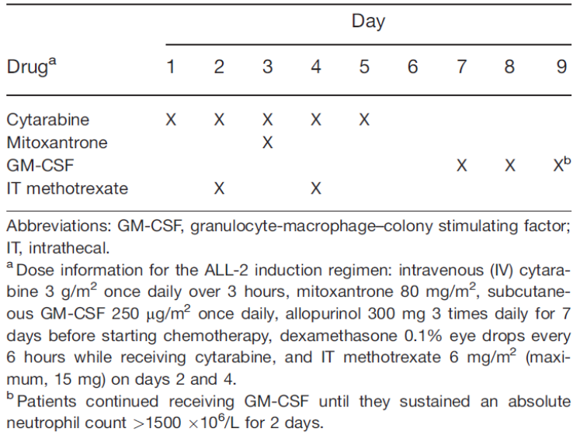
The L-20 induction regimen is vincristine, prednisolone, cyclophosphamide and doxorubicin, followed by 4 cycles of consolidation (A-D) (Table 76).

Table 76: L-20 induction regimen
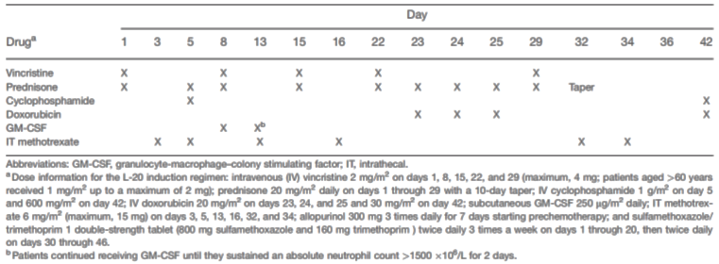
The third consolidation, Consolidation C, included pegaspargase (Oncaspar) (Table 77).

Table 77: L-20 regimen: consolidation C
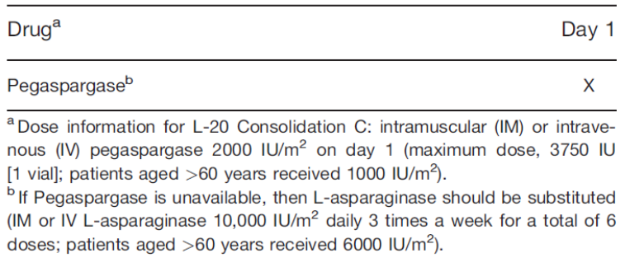
The primary endpoint was a comparison of the frequency of response between the two regimens. The full description of the regimens and their 4 consolidation phases is not reproduced here. What matters in this context is that pegaspargase formed part of the consolidation regimen of the standard treatment arm.
The study was designed to detect a 20% improvement in the probability of CR from 67% to 87% using a sequential design. The target accrual was 77 evaluable patients per arm to detect this difference with a power of at least 80%, and the O’Brien and Fleming stopping rule was used to maintain an overall significance level of 5%. The sequence of nominal significance levels used was p = 0 .0005, p = 0 .0124, and p = 0.0455 for the interim and final analyses, respectively.
The median follow-up for survivors was 7 years, and the median patient age was 43 years. Responses were evaluated in 164 patients. The treatment arms were balanced in terms of pre-treatment characteristics. The frequency of complete remission for the ALL-2 regimen versus the L-20 regimen was 83% versus 71% (p = 0 .06). More patients on the L-20 arm failed with resistant disease (21% versus 8%; p = 0.02). Induction deaths were comparable at 9% (ALL-2) versus 7% (L-20). The median survival was similar; and, at 5 years, the survival rate was 33% alive on the ALL-2 arm versus 27% on the L-20.
Comment: The message to be taken from this study in the context of this submission is that pegaspargase was viewed as a routine part of the L-20 standard ALL treatment regimen and achieved typical outcome results in comparison to other studies. The data support use of the drug in first line use in adult patients with ALL. The contribution of the Oncaspar itself to the outcome data is again uncertain but the regimen as a whole delivered comparable outcome data to other studies. Despite numerical superiority in remission and survival data at 5 years, there was no statistical significance between the standard treatment regimen, using Oncaspar and the more aggressive therapy typically used to treat AML.

Stock 2014 (C10403)
This is provided as an abstract, and describes the ‘early results’ of a trial designated C10403, reporting on n = 796 favourable outcomes for older adolescents and young adults with ALL.
The purpose of the trial was to examine the feasibility of treating patients aged 16 to 39 with ALL using the standard arm of the Children’s Oncology Group Regimen (COG) from Study AALL0232, which has been presented in this report.
Newly diagnosed ALL B or T cell patients could enrol but Philadelphia chromosome and Burkitt’s disease types were excluded.
The regimen was identical to the Capizzi methotrexate arm of COG AALL0232 and consisted of four intensive courses: remission induction, remission, consolidation, interim maintenance, delayed intensification, and prolonged maintenance therapy. Patients with m² marrow response (> 5% but < 25% lymphoblasts) after remission induction received an extended remission induction on course of therapy.
Of 296 evaluable patients, the median age at diagnosis was 24 years (range: 17 to 39): 25% were 17 to 20 years, 53% were 21 to 29 years, and 22% were 30 to 39 years. The majority had B‐ALL (76%) and were male (61%). Approximately 25% were non‐Caucasian and 15% were Hispanic or Latino. 32% of patients were obese (BMI ≥ 30).
To the date of authorship, 70 deaths had occurred and 87 patients remained on treatment. Median follow up was 28 months for surviving patients with 105 events observed. EFS overall was 59.4 months (95% CI 38.4, NR) and 2 year EFS 66% (95% CI 60, 72%). The 2 year OS rate was 78% (95% CI 72 to 83%).
The results allowed the rejection of the null hypothesis, specifically that the true median EFS was, at most, 32 months. In multivariate analysis, of note, age > 20 years and initial WCC ≥ 30,000/µL were associated with statistically significantly worse EFS and OS. This has been shown in other studies in this dossier. It is also of note that those with no detectable MRD at Day 28 of induction were associate with 100% EFS (p = 0.0006).
Comment: While the study was not controlled, the authors concluded that the use of an intensified paediatric treatment regimen for adolescents and young adults resulted in improved clinical outcomes when compared to historical controls. As this was simply an abstract, the control rates for EFS and OS were not presented, however one can at least conclude that the study demonstrates the use of PEGL ASNase in first line treatment of adult age patients with ALL. If one refers to the AALL0232 trial, PEGL ASNase was used in interim maintenance treatment (see 7.2.1.9. of this report).

De Angelo 2015a (DFCI ALL)
This was an abstract presenting a Phase II uncontrolled study that examined a dose intensified PEGL ASNase paediatric regimen in adult treatment for those with untreated ALL (that is first line). It was conducted by the DFCI consortium.
De novo ALL patients aged 18 to 50 were eligible. The primary objective of the study is stated as discovering the feasibility of a single PEGL ASNase dose every two weeks in both induction and a 30 week consolidation period.
Treatment was based on the very high risk arm of the DFCI-05-001 trial protocol. Induction chemotherapy consisted of doxorubicin, prednisolone, vincristine, PEGL ASNase and triple intrathecal therapy.
Consolidation consisted of high dose methotrexate followed by BFM like intensification and a course of high dose cytarabine, etoposide and dexamethasone. Intensification consisted of eight, three week courses of doxorubicin, vincristine, dexamethasone, 6-mercaptopurine and 30 weeks of PEGL ASNase at a dose of 2,500 IU/m² every two weeks. Note this dose is higher than that recommended for over 21 years patients in the draft PI of 2,000 IU/m².
112 patients were enrolled and 110 eligible for treatment. The first 65 were given the intended dose of PEGL ASNase, however significant toxicities were encountered which resulted in a reduction of dose to 2,000 IU/m² every three weeks in the consolidation phase for the subsequent 45 patients.
The CR rate after 4 weeks was 89%. 70 patients had the opportunity to receive PEGL ASNase intensification therapy (42 at the 2,500 IU/m² every 2 weeks schedule and 28 on the 2,000 IU/m² every 3 weeks schedule). Of the 42, 18 patients (43%; 80% CI, 32 to 54%) on the 2 week schedule completed at least 13 of 15 doses of peg-asp (26 weeks) and 22 of 28 patients (79%; 80% CI, 65 to 88%) on the 3 week schedule completed at least 8 of 10 doses of PEGL ASNase, which met the feasibility endpoint (lower bound CI > 60%). The median asp levels post the induction dose of peg-asp were 0.025, 0.78, 0.28, 0.10, at baseline, 7, 11 and 25 days and > 0.20 for each consolidation time point for both the 2 and 3 week cohorts.
Comment: The above information provides a rationale for the draft PI dosage in adults as dosages similar to the proposed dose were trialled and the balance between efficacy outcomes and toxicity was judged based upon these and other data.
The conclusion of the study was that a dose intensified paediatric regimen could be applied top adults, however the dosage and dosage interval for adults was of necessity less due to toxicity outcomes (Table 78).

Table 78: Outcome summary
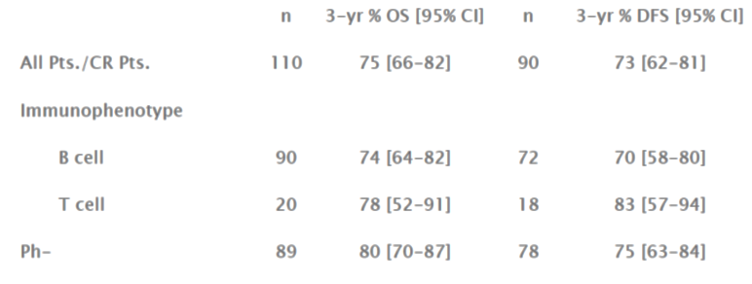
Comment: These data support the use of a PEGL ASNase containing regimen in the first line treatment of ALL in adults. While the study is not controlled the CR outcomes are comparable and indeed favourable to other numbers in other adult studies.

Rosen 2003 (GMALL)
The term ‘GMALL’ derives from German Multicentre Study Group for ALL. This publication describes the use of PEGL ASNase with high dose methotrexate for consolidation treatment in adult ALL for those in first remission; that is it qualifies as ‘first line’ therapy.
This was a small pilot study and 26 adults in first complete remission were recruited in 1998 to 2000 and treated according to the protocol of the 05/93 GMALL Study (see Section 7.3.2.7.). All but one had previous exposure to native ASNase and the last had previous exposure to Erwinase (Erwinia derived ASNase). Patient characteristics were as follows (Table 79).

Table 79: GMALL Patient characteristics
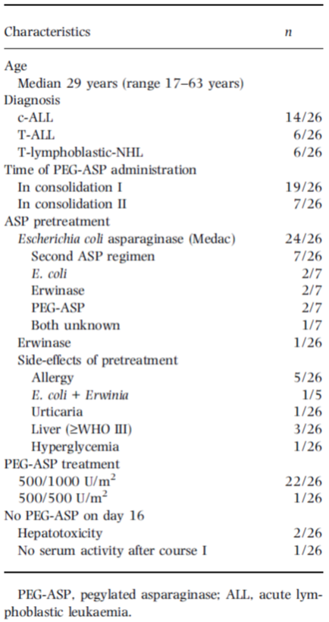
For consolidation treatment, native ASP was substituted by PEGL ASNase. The regimen was scheduled twice in the standard risk group and once in the high risk and T-ALL group. The study drug was administered IV over 2 hours, with 500 U/m² on Day 2 and an escalated dose of 1,000 U/m² to the same patient was given on Day 16. Hence the dosing was somewhat lower than that proposed in the draft PI.
Concomitantly, the patients received HD-MTX at 1,500 mg/m² on Days 1 and 15, respectively, and mercaptopurine at 25 mg/m² on Days 1 to 5 and 15 to 19. Five patients had a history of hypersensitivity due to native E.coli ASP in induction or consolidation I. The aim was to assess the toxicity and pharmacokinetics of PEG-ASP.
Comment: The publication goes into details surrounding ASNase serum levels and asparagine depletion. This evaluator is not presenting them as the data identifying likely serum levels needed for asparagine depletion have already been presented in the PK/PD sections of this report. Similarly safety data are detailed which will not be presented here. Hypersensitivity and particular ADRs were of the rate and variety seen in previously treated patients in other studies.
The study was not designed to measure any additional therapeutic benefit of PEGL ASNase. It was concluded that the dosing depleted asparagine sufficiently for up to 2 weeks.
Comment: While showing PEGL ASNase use first line in adults with ALL, these data add little to outcomes already presented in much larger numbers in other studies.

Goekbuget 2013 (GMALL 05/93 and 07/03)
This article is an opinion piece/poster abstract by the author that discusses the treatment of ALL in adults. It raises again the idea of treating adults with ALL with a paediatric derived protocol of treatment. Results for 1,529 adolescents and young adults are presented after being treated in two separate clinical trials with such protocols.
The trials describe the use of PEGL ASNase.
The major innovations in Study 07 were: intensified, shortened induction with dexamethasone instead of prednisone, PEG-asparaginase instead of native ASNase, intensified first consolidation, 6 x HDMTX (high dose methotrexate)/ASNase during consolidation, matched unrelated SCT for HR/VHR patients without sibling donor and stem cell transplant (SCT) indication in patients with persistent MRD. After amendments in trial 07 patients partly also received intensified PEG-ASP, rituximab in CD20+ ALL and imatinib in Ph+ ALL.
Overall, 1,529 of 3,060 (50%) patients recruited into both trials were aged between 15 to 35 years. 642 patients from 94 centres were recruited to Study 05 and 887 patients from 130 centres to Study 07. Patient characteristics were similar for both trials. 70% had B-Lin and 30% T-ALL (61% c/preB, 9% proB, 7% early T, 6% mature T, 17% thy T) with no significant differences across age subgroups (15 to 17, 18 to 25 and 26 to 35 years). Allocation to SR, HR and VHR was 51%, 35% and 14%. VHR incidence increased from 3%, 11% to 19% in age groups (p < 0.0001).
The CR rate increased in studies 05 to 07 from 88% to 91% (p = 0.001), most prominently within the age range of 26 to 35 years (86% to 90%; p = 0.001). The OS increased from 46% to 65% (p < 0.0001) (significant in all age groups). Remission duration (RD) at 5 years increased from 49% to 61% (p = 0.0001), most prominently within the age range of 26 to 35 years (46% versus 59%; p = 0.005). OS improved from Study 05 to Study 07 in B-Lin (45% versus 66%; p < 0.0001) and T-ALL (47% versus 63%; p = 0.0007) overall and in subgroups as c/pre B (50% versus 68%;p < 0.0001), pro B (45% versus 67%;p = 0.05), mature T (19% versus 61%; p = 0.005) and thymic T (59% versus 70%;p = 0.09) but to a lesser extent in early T (35% versus 48%;p > 0.05). OS increased in SR (58% to 74%; p < 0.0001), HR (24% to 58%; p < 0.0001) and VHR (36% versus 55%; p = 0.0003).
Comment: While these data show outcomes for an overall optimised regimen of treatment and thus outcomes cannot be solely attributed to the use of PEGL ASNase, nevertheless the data show contemporary use of the drug in a treatment regimen for adults with various types of ALL that resulted in improved outcomes compared to previous ‘standard’ treatment. They represent a huge cohort of patients and contribute to the knowledge of use in first line therapy. The use of Study 05 enables a comparison of efficacy between the two regimens as a whole and further adds to the idea raised in other data about the benefits from modified paediatric treatment regimens for adults.

Chang 2016
This short paper focussed upon allergic reactions with PEGL ASNase in adults. One hundred and thirty nine ALL patients were identified retrospectively from 1 May 2008 to 30 July 2014. Allergic reactions were sought based upon Common Terminology Criteria for Adverse Events (CTCAE). Fourteen reactions were found in 13 patients. Of interest, the rate of reaction did not differ between those dosed with pre-medications (corticosteroid, acetaminophen, diphenhydramine) and those who were not. Those who received IV dosing experienced higher rates of reaction and this fact been noted in other data presented in this report. (14% versus 1.6% for IM dosing, p = 0.010). Six of the seven patients noted to have a Grade 4 reaction were given IV dosing. There was also a suggestion that a larger dose of drug was associated with slightly higher rate of reaction. Doses over 3,750 units (n = 149) had nine reactions (6.0%) while those with doses capped at 3,750 regardless of body surface area had two reaction (n = 86 doses, 2.3%). However, this was not statistically significant (p = 0.194).

Aldoss 2016
This study examined the toxicity of incorporating PEGL ASNase into a paediatric type regimen for ALL treatment in adults. All doses of 2,000 IU/m² given at a treatment centre to adults were reviewed. One hundred and fifty-two subjects were identified, aged 18 to 60 and having received 522 doses of PEGL ASNase.
Toxicities of over 5% were known ADRs and consisted of triglyceridaemia Grade 3-4 (50.9%), hypofibrinogenaemia (< 100 mg/dL; 47.9%), pancreatitis (12.6%), venous thromboembolism (11.2%), allergic reaction (7.2%) and any grade bleeding (5.3%).
PEGL ASNase was discontinued if a Grade 3-4 pancreatitis occurred or any allergic reaction. Otherwise the ADRs did not preclude treatment.
Comment: This information adds to the idea that the ADRs for PEGL ASNase are known and that they can generally be managed. It also provides some data on the safe use of a dosage commensurate with the draft PI. Further, it shows usage up to 60 years of age is possible.

Fathi 2016
This describes a Phase II study of intensified chemotherapy and stem cell transplantation for older patients with ALL. The trial was to investigate an intensified treatment regimen developed from a trial in younger patients. Induction comprised vincristine, prednisolone, doxorubicin and PEGL ASNase. Imatinib was used where there was Ph+ disease. After induction and consolidation 1 treatment, patients in remission were eligible to proceed to stem cell transplant.
The primary outcome variable was overall survival at one year. Thirty patients were enrolled, with 19 achieving remission after induction and one achieving remission after consolidation 1 treatment. This gave a CR rate of 67%. Sixteen patients underwent stem cell transplant.
The primary endpoint was 63% alive at one year. This was 52% (30) at year two and disease free survival at year two was 20 patients.
Hyperbilirubinaemia required dose-adjustment of PEGL ASNase.
Comment: Outcomes for older patients are typically worse than younger individuals, with those over 60 years having a reported 17% 3 year overall survival. These data show improved outcome data in an uncontrolled setting using a so-called ‘optimised’ paediatric regimen to treat adults.
Elderly patients 51 to 75 years were eligible for this study (excluding mature B cell ALL) and the age range ended up being 51 to 72, with median age 58. 90% were Caucasian, and 29 had B cell ALL, with one T cell ALL.
PEGL ASNase appears to have been given at a low dose, that is 500 IU/m² although several received higher doses. A flowchart of treatment and outcomes is as follows (Figure 23).
Figure 23: Flow diagram of the patients treated with protocol based therapy
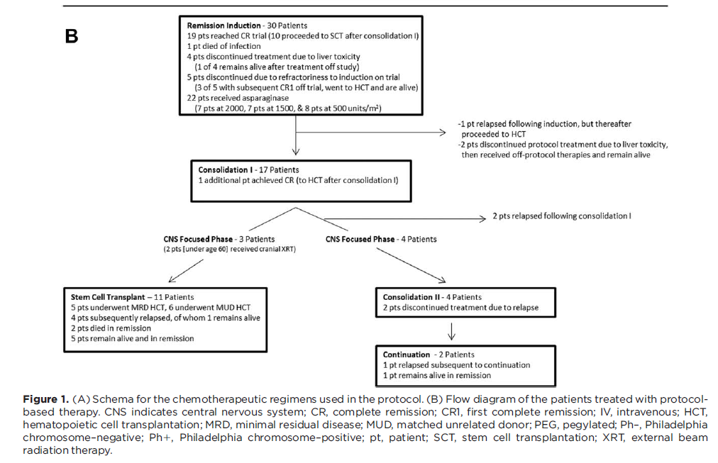

Comment: This publication demonstrates how a PEGL ASNase containing regimen can be competitive with current types of treatment for ALL in older adults. It provides valuable data on older adult treatment as first line therapy.

Summary information for publications with data on adult use of Oncaspar in first line treatment modalities for ALL
Of note for these studies presented:
- Goekbuget 2013 provides substantial data in abstract form with 1,529 adolescents and young adults treated for ALL in two clinical trials. The 07 trial made use of an intensified regimen with PEGL ASNase and resulted in CR of 91%, OS of 65% and remission duration at 5 years of 61%. While presented in little detail, it is of particular weight given the use of PEGL ASNase and the substantial numbers of subjects treated. It supports PEGL ASNase as a component of first line treatment regimens in adults.
- PEGL ASNase was used in the ABFM treatment regimen in Rytting 2016, with comparable outcome to the H-CVAD protocol, that is in 102 patients with median age 27 years, CR was 93% versus 98% respectively with 5 year overall survival 60% in both groups. Hence a PEGL ASNase containing regimen had similar outcomes at 5 years.
- Lamanna 2013 (n = 164) showed PEGL ASNase as part of the third consolidation phase of one treatment arm (L-20) in adults with ALL compared favourably with a proposed more aggressive regimen (ALL-2), with similar median survival at 5 years of 33% (ALL-2) versus 27% (L-20). Complete remissions neared statistical significance favouring the more aggressive treatment (ALL-2) with 83% versus 71% for the PEGL ASNase containing regimen (p = 0.06).
- Stock 2014 used the ‘standard’ treatment regimen from Study AALL0232 to treat adolescents and young adults with ALL. Two-year EFS was 66% (95% CI 60, 72%) and 2 year OS 78% (95% CI 72-83%) in 296 patients.
- De Angelo 2015a showed adult ALL in 18 to 50 year olds could be favourably treated with a regimen containing 2,500 IU/m² fortnightly or 2,000 IU/m² three weekly PEGL ASNase. This trial is one that clearly contributed to the proposed dose of 200 IU/m² bi-weekly for adults as toxicities necessitated a reduced dose and greater dosing interval. However, the 110 treated patients demonstrated CR at 4 weeks of 89%.
- This evaluator considers Aldoss 2016 of relevance because it studied 152 adults up to 60 years of age and supported the proposed PI dose of 2,000 IU/m² fortnightly dosing when treating ALL.

Conclusions from published literature on the use of Oncaspar in first line adult ALL
- The body of evidence for first line treatment in adults is smaller than that for children.
- The degree of detail provided in some of the citations was poor.
- The data collectively represent many hundreds of patients treated first line for ALL with PEGL ASNase as a component of that treatment.
- The proposed dose of 2,000 IU/m² was used in several instances, supporting this choice of dose as balancing against known toxicities.
- Often the use of PEGL ASNase in a given trial is compared to a regimen without PEGL ASNase, but one which also differs from that of the PEGL ASNase-containing regimen, making it difficult to ascribe a quantified benefit from the PEGL ASNase itself.
- Adults from 18 to 72 are shown to derive benefit from ALL treatment regimens containing PEGL ASNase. These regimens have, on balance, produced similar outcomes as other treatment regimens for ALL where comparisons have been present.
- While not an ideal data set, this evaluator considers the role of PEGL ASNase in the treatment of adults with ALL has been satisfactorily demonstrated. The reduction of dose from paediatric levels appears directly as a result of greater toxicity in adults at paediatric doses.

Second line treatment with Oncaspar – additional trials
These trials were taken from the Clinical Overview and the manner of their retrieval is uncertain.

Kurtzberg 2011
This details a Paediatric Oncology Group trial (POG 8866) that compared PEGL ASNase and native ASNase in combination with standard agents for the treatment of second bone marrow relapse in ALL in children. Patients were enrolled if they had ALL in second marrow relapse (M3: > 25% blasts) and were younger than 21 years old. Exclusion criteria included life expectancy of less than a month or inadequate liver or renal function as defined by laboratory testing.
Seventy six patients received vincristine and prednisolone. Both ASNase preparations were administered in combination with a standard induction regimen consisting of weekly vincristine of 1.5 /m²/dose intravenously on Days 1, 8, 15, and 22 (maximum dose = 2 mg), and daily prednisone of 60 mg/m²/d on Days 1 through 28 (maximum dose = 60 mg/d). This is useful as the only variable of drug regimen was the ASNase preparation, allowing better comparison of the effect of asparaginases specifically. Non-hypersensitive patients were randomised to either PEGL ASNase 2,500 IU/m² on Days 1 and 15 or 10,000 IU/m² of native E.coli ASNase on Days 1, 3, 5, 8, 10, 12, 15, 17, 19, 22, 24 and 26. Patients with any history of allergy to standard ASNase were immediately assigned to PEGL ASNase. Hence 42 were directly assigned to PEGL ASNase, and 17 others were randomised to each treatment group. ASNase serum levels and anti-ASNase antibody titres were monitored.
The mean age at the start of treatment was 9.18 ± 4.19 years (range, 1 to 18 years). Forty seven (62%) were male. Fifty (66%) were White, 13 (17%) were African American, 9 (11.8%) were Hispanic, and 4 were another racial ethnic group. There were no significant differences between the 2 treatment groups related to sex, age, racial background, or prior hypersensitivity status.
Response to treatment was evaluated via bone marrow aspirate, peripheral blood and CSF fluid on Day 29 of treatment, or earlier if patients were taken off treatment for other reasons. Two patients refused therapy and thus outcomes are based only upon 74 patients.
The overall complete response rate (≤ 5% marrow blasts) was 41%, with no statistically significant difference between PEGL ASNase (47%) and native E.coli ASNase (41%).
In this study, PEGL ASNase demonstrated similar efficacy and toxicity compared with native asparaginase in the randomized patients. The study had been powered to detect a 25% improvement in CR rate in PEG patients with 80 randomized patients or a 20% improvement with 92 randomized patients. Slower than expected enrolment prompted early study closure. Therefore, failure to detect a difference does not preclude a meaningful improvement (or worse outcome) in the PEGL ASNase patients.
Comment: Hence outwardly the data here show similar efficacy outcomes and safety profiles using the two forms of ASNase. The lack of statistical power only allows numerical comparisons and trends to be examined but it would appear the PEGL ASNase performs favourably.

Abshire 2000
This was another study by the paediatric oncology group (POG) examining weekly versus fortnightly dosing of PEGL ASNase in childhood relapsed ALL (POG 9310).
Children with B precursor ALL in first marrow or extramedullary relapse were eligible for inclusion and received re-induction treatment of doxorubicin on Day 1, prednisolone for 28 days, vincristine weekly for 4 weeks and PEGL ASNase either weekly or fortnightly (this part was randomised).
One hundred and twenty nine patients of 144 achieved a complete remission (90%). There was a statistically significant difference in the rate of this between the two different groups of PEGL ASNase dose (97% versus 82%, p = 0.003) in favour of weekly dosing.
Monitoring of ASNase serum levels and antibodies showed the same trends noticed in other data, namely that low ASNase levels were associated with high ASNase antibody titres and increased ASNase serum levels suggested improved CR rate.
A comparison of weekly and fortnightly dosing in terms of response is given as shown in Table 80.

Table 80: Re-induction results comparing weekly and every other week PEGAsp in patients with bone marrow and isolated extramedullary involvement
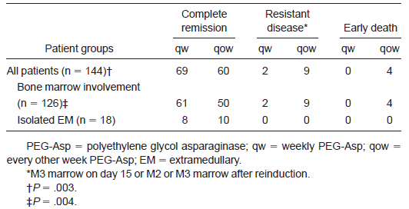
The above results certainly favour weekly dosing in terms of complete remission rate, resistant disease occurrence and early death. While not relevant in this part of the report, toxicities do not appear to have differed substantially between randomised groups.
Comment: These data again show the utility of PEGL ASNase in second line use in children, however suggest an even more intense dosing interval than proposed in the draft PI. Dosing was identical to the PI in terms of over age 1 fortnightly dosing as shown in Table 81.

Table 81: POG 9310 Induction treatment schedule
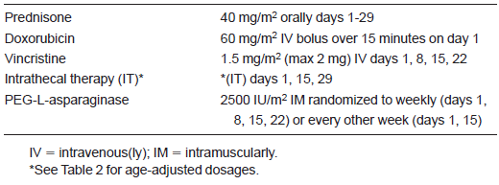
Comment: While these data suggest a place for more intense dosing, the collective data in this report suggest to this evaluator a satisfactory result with fortnightly dosing, and the biological plausibility in terms of ASNase serum levels and asparagine depletion seem to support that. An exception in a clinical setting would be silent hypersensitivity where antibody formation not otherwise monitored would be ameliorated by weekly dosing as the drug would be more rapidly inactivated.

Van den Berg 2011
This is a relatively recent publication discussing various asparaginases. In the view of this evaluator it does not add new facts so will not be summarised here. Of interest is a simple diagram showing the mode of action of asparaginase (Figure 24).
Figure 24: Mode of action of asparaginase
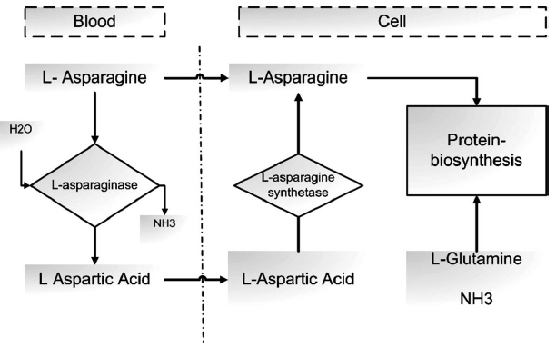
Also a useful comparison of available asparaginases is provided in Table 82.

Table 82: Main characteristics of various asparaginases
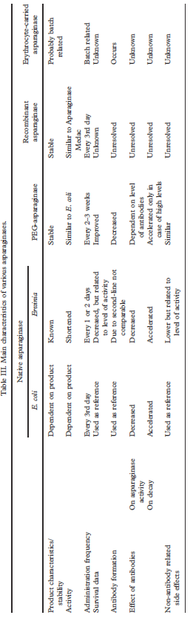
Comment: Of particular note is that PEGL ASNase is described as having reduced effect in the presence of high antibody titres, something which appears to have been demonstrated by the data in this submission, while exhibiting similar activity and side effects in comparison with native E.coli ASNase.

Zeidan 2009
This is an expert opinion piece which highlights the issues of toxicity, antibody formation and frequent dosing that are characterised by native E.coli ASNase. Hence the creation of Oncaspar to prolong half-life and in theory result in decreased immunogenicity.
While the paper discusses some useful information, the data are presented elsewhere in this report as they cite various trials that have already been presented. For ease of comparison, the following table was chosen by this evaluator to show the two key trials where PEGL ASNase is compared directly with native E.coli ASNase as shown in Table 83.

Table 83: Paediatric randomized trials comparing E.coli asparaginase (EC-ASP) and PEG-ASP in newly diagnosed acute lymphoblastic leukaemia patients
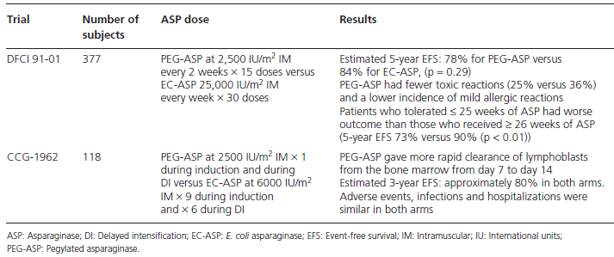
Comment: The paper concludes with what this evaluator has also concluded that Oncaspar has been associated with similar efficacy to native E.coli ASNase in randomised trials in children and non-randomised trials in adults. One conclusion that is made that this evaluator does not agree with is that IV administration has not been associated with higher levels of allergic side effects. There are data to support both points of view of this argument and this evaluator would conclude a definitive answer to whether or not PEGL ASNase is less immunogenic is not yet fully apparent.

Holle 1997
This paper is a review of the PK, PD, safety and efficacy as well as dosage and administration of PEGL ASNase. In the view of this evaluator the same data are present elsewhere in the submission and the relative age of the publication means it is not adding anything significant to the question of registration in this report.

Conclusions from additional published literature on the use of Oncaspar in second line treatment of ALL
- Kurtzberg 2011 is of note as it is a direct comparison of PEGL ASNase and native E.coli ASNase in the treatment of second bone marrow relapse in ALL in children, in combination with standard multi-drug regimens. Overall response rate to treatment was CRR 47% using PEGL ASNase and 41% using native E.coli ASNase, however the numerical superiority of PEGL ASNase use was not statistically significant. These data again support at least comparable outcomes using PEGL ASNase.
- Abshire 2000 is of note because of the trial of dose interval used for PEGL ASNase, with weekly or fortnightly dosing. There was in fact a statistically significant difference favouring weekly dosing in 144 patients treated, with complete remission in 97% versus 82% for weekly and fortnightly dosing, respectively.
- This evaluator notes the other additional publications, but does not consider they add significantly to the overall body of data supporting second line use for ALL in adults or children. Of interest is Kurtzberg 2011 as it is a rare head-to-head comparison and Abshire gives some insight into dosing interval, which is also circumscribed in other studies including those experimenting with dose finding to arrive at the proposed dosing regimens for the draft PI document of this submission.

Analyses performed across trials: pooled and meta analyses
This evaluator is of the view that the collective data described in the addendum to the clinical overview are best presented here. While this evaluator focussed of necessity on the data specifically involving PEGL ASNase, the clinical overview also presented a number of publications that showed the utility of native E.coli ASNase, the principal utility of which in this context is to give the reader an idea of the outcome data achieved by native E.coli ASNase and be able to compare those to PEGL ASNase. To that end, the addendum to the Clinical Overview describes a collective 7,251 standard risk ALL paediatric patients treated with native E.coli ASNase and 8,924 treated with Oncaspar. There were a claimed 3,814 high risk patients treated with native E.coli ASNase and 7,682 + (number can’t be exact) treated with PEGL ASNase.
For key publications in this regard, standard risk 5 year EFS for paediatric patients is demonstrated collectively by the following forest plot as shown in Figure 25.
Figure 25: Individual estimates and pooled 5 year EFS for Standard Risk ALL patients in paediatric studies treated first line with either PEG-ASP (Oncaspar) or native E Coli asparaginase
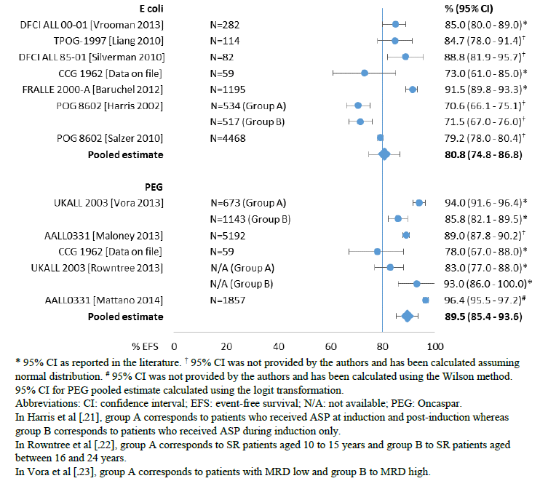
Similarly, high or very high risk paediatric patients are summarised collectively for 5 year EFS as shown in Figure 26.
Figure 26: Individual estimates and pooled 5 year EFS for High Risk/Very High Risk ALL patients in paediatric studies treated first line with either PEG-ASP (Oncaspar) or native E Coli asparaginase
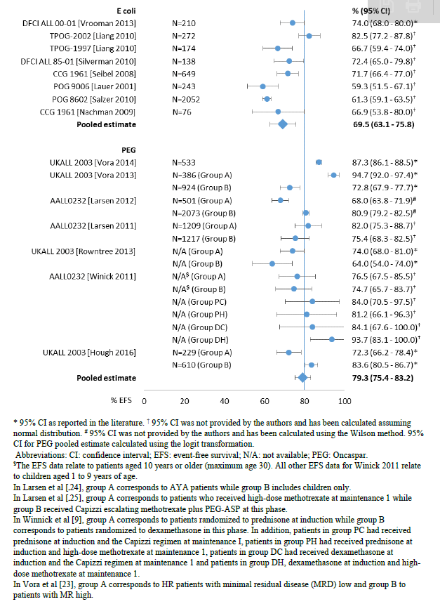
Comment: It is clear from these graphics that outcomes using PEGL ASNase instead of native E.coli ASNase are comparable across multiple trials, despite significant error margins in some studies. Treatment regimens may vary but the assumption is that the collective similar EFS data indicate there is not a substantial difference in the efficacy of PEGL ASNase compared to native E.coli ASNase. Outcomes in paediatric patients as first line treatment are thus additionally supported by this information.
Overall survival figures showed a similar result. Outcomes were comparable across native E.coli ASNase use and PEGL ASNase use for both standard and high risk paediatric patients.

Standard Risk
Figure 27: Individual estimates and pooled 5 year OS for Standard Risk ALL patients in paediatric studies treated first line with either PEG-ASP (Oncaspar) or native E Coli asparaginase
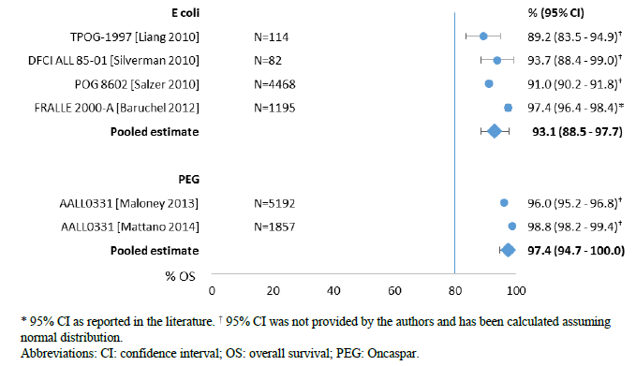

High or Very High Risk
Figure 28: Individual estimates and pooled 5 year OS for High Risk/Very High Risk ALL patients in paediatric studies treated first line with either PEG-ASP (Oncaspar) or native E Coli asparaginase
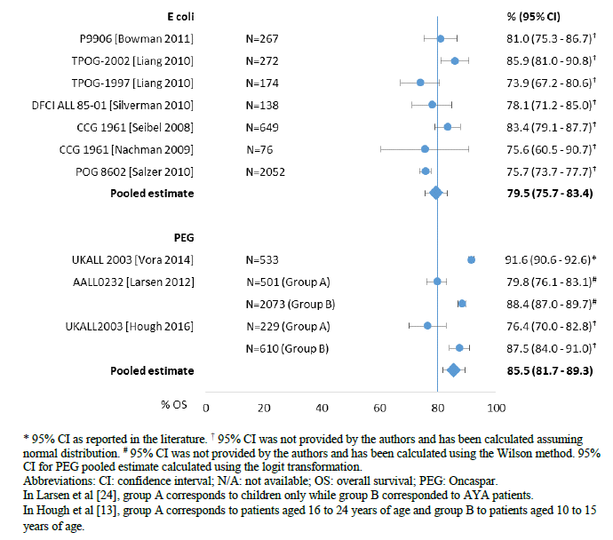
Comment: In all the summary plots above one should bear in mind the 80% line is simply to give a frame of reference as most common outcome measures used are roughly within 10% of this.
Focussing now on first line treatment in adults, the pool of data is, as has been stated in this report, much smaller. One can note the few subject numbers for the individual studies is shown in Figure 29.
Figure 29: Individual estimates and pooled 2-year EFS for ALL adult patients treated in first line with either PEG-ASP (Oncaspar) or native E Coli asparaginase
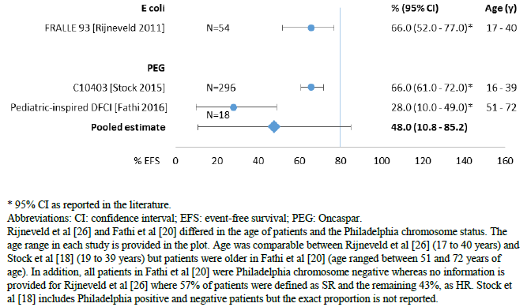
Comment: One can see with the error margins that Stock 2015 provides the only really meaningful outcome measure for 2 year EFS data in the view of this evaluator for PEGL ASNase. This is similarly the case for 2 year OS outcome data as shown in Figure 30.
Figure 30: Individual estimates and pooled 2 year OS for ALL adult patients treated first line with either PEG-ASP (Oncaspar) or native E Coli asparaginase
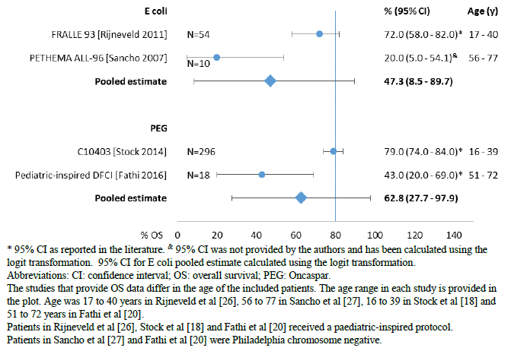
Comment: With few comparators trialling native E.coli ASNase, it is similarly difficult to discern whether the two treatments produce similar results, and if so, how similar. Certainly Stock 2014 seems comparable with, or trending to superior against, Rijneveld 2011.
In terms of OS, 5 year data (irrespective of risk) are more informative when comparing the two drugs as native E.coli ASNase has more data as shown in Figure 31.
Figure 31: Individual estimates and pooled 5 year OS for ALL adults treated first line with either PEG-ASP (Oncaspar) or native E Coli asparaginase
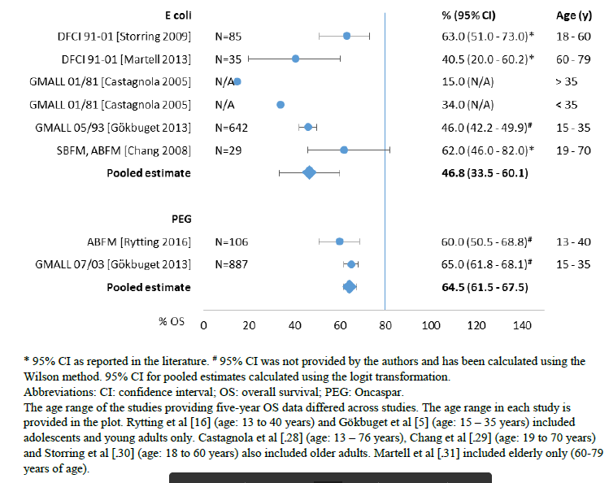
Comment: When one considers high risk or very high risk patients, the trend is one of PEGL ASNase having some advantage, although if statistically significant and in what quantum are unknown as shown in Figure 32.
Figure 32: Individual estimates and pooled 5 year OS for High Risk/Very High Risk ALL adults treated first line with either PEG-ASP (Oncaspar) or native E Coli asparaginase
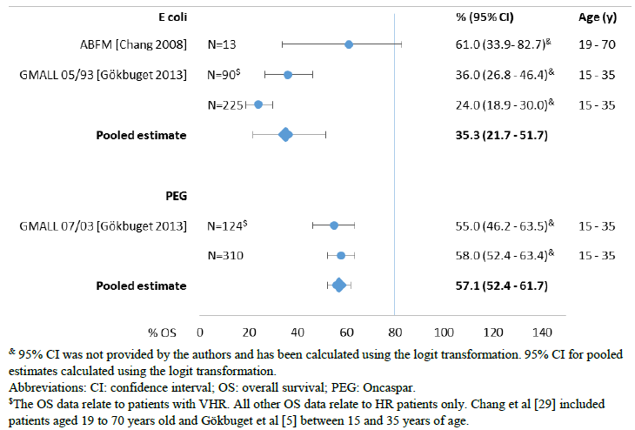
Comment: From the pooled data summaries provided and the detailed scrutiny of the individual relevant publications using PEGL ASNase, this evaluator is of the view that PEGL ASNase can perform as well as native E.coli ASNase in the treatment of ALL in adults and children in terms of efficacy outcomes. The overwhelming data support first line use, although there are data in second line treatment, mainly in formal trials conducted some time ago rather than public domain literature. Second line treatment data are quite adequate for children in this submission, it is only adults where the data are sparse and few studies examine age groups beyond the 30’s. Nonetheless some data were present for patients up to 72 years old.

Evaluator’s conclusions on clinical efficacy
In the view of this evaluator, key data for the support of the use of PEGL ASNase in treating ALL is as follows. Obviously other data support these, but the following are considered particularly useful either for reasons of design, subject numbers, outcome measures or simply the level of detail provided in the dossier. They are described in detail earlier in this report.

Table 84: Key efficacy data
Trial/Publication |  | Design/subjects | Outcome(s) of interest in this context | Results
First Line ALL Formal Trials
CCG-1962 | Randomised comparison of native E.coli ASNase and PEGL ASNase, n = 59 in each treatment groups |  | Induction response, high titre antibody development, EFS. | Mean ± SEM antibody ratio in DI #1 was 1.9 ± 0.8 (n = 47) for children treated with PEGL ASNase and 3.0 ± 0.7 (n = 43) for those treated with native ASNase (p = 0.001, Wilcoxon test).  High titre antibodies were associated with low ASNase activity (≤ 0.1 IU/mL) in the native arm, but not in the PEGL ASNase arm.  The 3-year EFS rates for PEGL ASNase and native ASNase were 85% and 78%, respectively (p = 0.773).
DFCI-05-001 | Randomised open label head to head comparison of PEGL ASNase and native E.coli ASNase. (n = 463) |  | EFS/OS | The 5 year disease free survival was 90% (95% CI 86 to 94) for patients randomly assigned to intravenous PEG-asparaginase, 89% (85–93) for those randomly assigned to intramuscular native E coli l-asparaginase, and 88% (74 to 95) for those who declined to undergo randomisation and were directly assigned to intramuscular E coli l-asparaginase.  The 5 year overall survival was 96% (93 to 98), 94% (89 to 96), and 95% (82 to 99) for these three patient groups, Respectively.
AALL0232 | Phase II cohort of B cell precursor ALL with PEGL ASNase in treatment regimens. Age to 30 years. n = 1035. |  | EFS | The 5 year event free survival (EFS) for patients 1 to 9 years of age randomized to receive DH, DC, PH, or PC was 93.7 + 5.4%, 84.1 + 8.4%, 81.2 + 7.7%, and 84.0 + 6.9%, respectively, p = 0.03.
UKALL2003 | A huge trial of n = 3207 patients, where a subset of 521 MRD low risk patients randomised to one or two DI courses with PEGL ASNase (n = 260, 261) |  | EFS | There was no significant difference in EFS between the group given one delayed intensification (94·4% at 5 years, 95% CI 91·1 to 97·7) and that given two delayed intensifications (95·5%, 92·8 to 98·2; unadjusted odds ratio 1·00, 95% CI 0·43 to 2·31; two-sided p = 0·99).
First Line ALL publications in Children
ALL0331 | N = 5377 paediatric patients with standard risk b cell ALL. PEGL ASnase used in induction regimen for all. ‘Standard risk-low’ patients randomised to intensive or standard consolidation. |  | EFC, CR, OS | 5 year continuous complete remission rates were, for Standard versus Intensive consolidation, 88% (1.6%) versus. 89.3% (1.5%) (p = 0.13) and 5 year OS rates for SC versus. IC of 95.8% (1.0%) versus. IC 95.7% (1.0%) (p = 0.93).  For all trial patients, 5 year EFS was (EFS (SE)) 89% (0.6%) and 5 year overall survival 96% (0.4%).
First Line ALL publications in Adults
Goekbuget 2013 | N = 1529, n = 642 for Study 05/93 and 887 for Study 07/03. Study 07/03 was an intensified regimen. |  | CR, OS | The CR rate increased in studies 05 to 07 from 88% to 91% (p = 0.001), most prominently within the age range of 26 to 35 years (86% to 90%; p = 0.001). The OS increased from 46% to 65% (p < 0.0001) (significant in all age groups). Remission duration (RD) at 5 years increased from 49% to 61% (p = 0.0001), most prominently within the age range of 26 to 35 years (46% versus 59%; p = 0.005). OS improved from Study 05 to Study 07 in B-Lin (45% versus 66%; p < 0.0001) and T-ALL (47% versus 63%; p = 0.0007) overall.
Rytting 2016 | 106 adolescent and young adult patients (median age 22 years) with Philadelphia chromosome (Ph) negative ALL received ABFM from 10/2006 through 3/2014. Their outcome was compared to 102 such patients (median age 27 years), treated with hyper-CVAD. |  | CR, OS, CRD | The complete remission (CR) rate was 93% with ABFM and 98% with hyper-CVAD. The 5 year complete remission duration (CRD) were 53% and 55% respectively (p = 0.98). The 5 year overall survival (OS) rates were 60% and 60%, respectively.
Stock 2014 | N = 296 patients given the standard regimen from Study AALL0232 in adolescents and young adults with ALL. |  | EFS, OS | Two-year EFS was 66% (95% CI 60, 72%) and 2 year OS 78% (95% CI 72-83%) in 296 patients.
De Angelo 2015a | N = 110 patients aged 18 to 50 treated with a regimen including PEGL ASNase. |  | CR | CR at one month was 89%.
Second Line ALL Formal Trials
ASP-304 |  | Randomised comparison of second line treatment (second bone marrow relapse) of ALL using native E.coli ASNase versus PEGL ASNase in individuals under 21 years. Previously hypersensitive patients were assigned to PEGL ASNase. n = 76; 59 PEGL ASNase, 17 native E.coli ASNase. | CR, efficacy in light of previous hypersensitisation. | Response rate overall was 56% for PEGL ASNase and 47% for native E.coli ASNase (chi square 0.615). If one considers complete remissions alone, it is 39% for PEGL ASNase and 47% for native E.coli ASNase (chi square 0.625). Also 54% of those directly assigned to Oncaspar that had previous hypersensitivity reactions to native E.coli ASNase achieved a response.
Second Line ALL Publications in Adults or Children
Kurtzberg 2011 |  | Compared PEGL ASNase and native ASNase in combination with standard agents for the treatment of second bone marrow relapse in ALL in children.  Non-hypersensitive patients were randomised to either PEGL ASNase 2,500 IU/m² on Days 1 and 15 or 10,000 IU/m² of native E.coli ASNase on Days 1, 3, 5, 8, 10, 12, 15, 17, 19, 22, 24 and 26. Patients with any history of allergy to standard ASNase were immediately assigned to PEGL ASNase. Hence n = 76 with n = 59 given PEGL ASNase and 17 given native E.coli ASNase. | CRR | The overall complete response rate (≤ 5% marrow blasts) was 41%, with no statistically significant difference between PEGL ASNase (47%) and native E.coli ASNase (41%).
This evaluator is of the opinion that first line treatment in children of ALL with PEGL ASNase as part of the treatment regimen has been demonstrated in significant patient numbers in a variety of different study designs and treatment scenarios, which similar outcome data across studies as the forest plots in the clinical overview addendum attest. It also has been shown to be comparable to current standard treatment with native E.coli ASNase in terms of efficacy outcomes, whether comparing similar regimens but for asparaginases, or different regimens entirely. Similarly there are a number of sizeable trials showing efficacy comparable or trending better than standard treatments for children or adults given PEGL ASNase as part of second line treatment. Second line treatment has a smaller data set for both children and adults and this is quite small in adults one must concede, however data still support the use of asparaginase and PEGL ASNase in particular in the trials presented, and second line treatment has been approved in two major regulatory jurisdictions for over 20 years. It would seem counter intuitive to require additional data for second line use when clearly the biological plausibility of utility for the drug is reflected in its ability to deplete asparagine. This in turn is only really different in the setting of high titre antibodies, where, first or second line, typically the type of asparaginase is switched. Hence this evaluator is of the view that the data for first and second line use both lend weight to each other in terms of outcome data in most respects.

Clinical safety
Given the nature of the data, the safety information will be discussed in terms of first line and second line use as well as adverse events, lab and clinical signs, special groups and post-market information. Obviously the safety profile of the drug is well circumscribed given the decades of real-world use after initial registration. The submission is further complicated by a summary of clinical safety, then an ‘addendum’ to this where changes to the document are ‘described’ but not actually present in the document itself. This evaluator does not understand why the original summaries were not simply edited prior to submission.

Drug exposure and adverse events
Overall approximately 100,200 + patients have received Oncaspar over 20 years, although most patients would not have done so in clinical studies.

First line studies
Formal studies supporting first line use of Oncaspar in children or adults were:
- CCG-1962
- DFCI-05-001
- AALL07P4
- DFCI-91-01
- CCG-1961
- DFCI-87-001/ASP-301
- CCG-1991

Table 85: Overview of clinical studies investigating first line use of Oncaspar
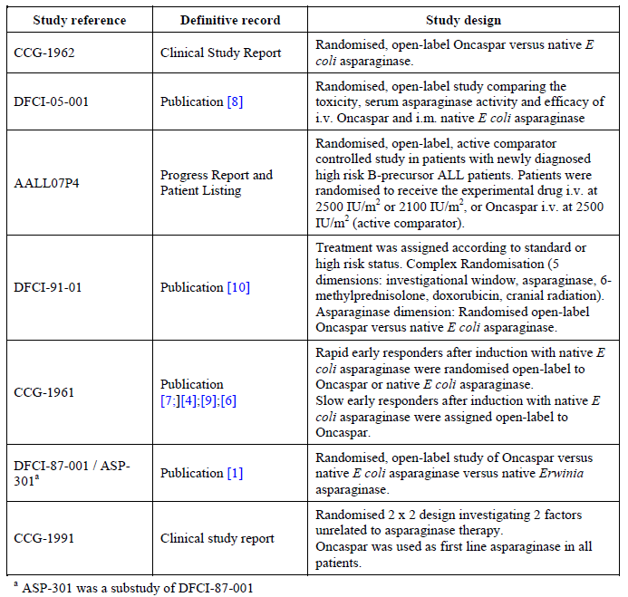
The studies were heterogeneous and five of the above were the basis of the second line approval by the FDA.
The seven studies above comprise approximately 4,140 patient exposures, including 51 patients in AALL07P4 where the drug was an active comparator, and principally 2957 patients in CCG-1991 where the drug formed part of background treatment. Exact numbers of patients is difficult as not all publications detailed this satisfactorily. However, in the EMA EPAR, figures for these as well as the second line ‘ASP’ studies are given exactly (Table 86).

Table 86: from EMA EPAR
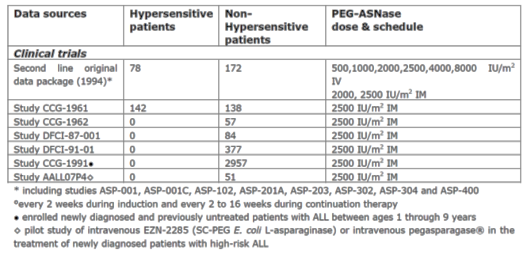
Regardless, the figures are substantial for non-hypersensitive patients, and particularly children and younger adults.
The data in the first line studies were not pooled due to lack of homogeneity and thus selected data will be presented from narratives for each.

CCG-1962
Only Grade 3 or 4 toxicities were reported, and these are summarised as follows in Table 87.

Table 87: Grade 3 and 4 toxicities during asparaginase treatments
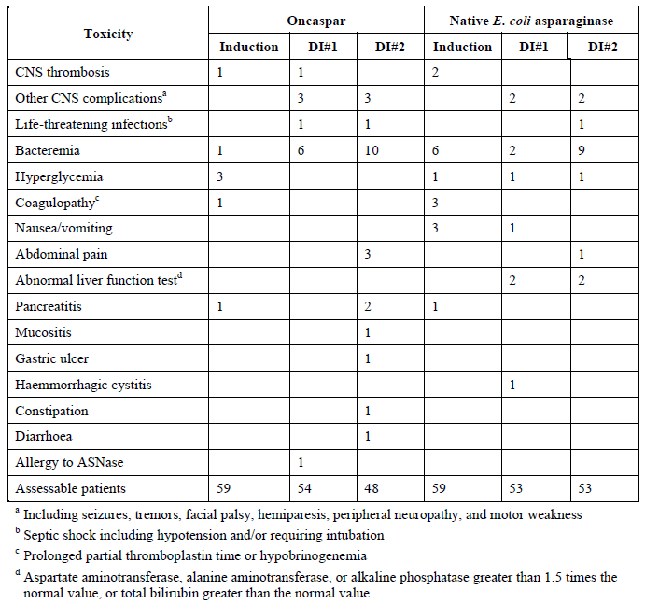
Given the assessable patient numbers in this trial the array of AEs were similar across both native E.coli ASNase and PEGL ASNase. The AEs seen are also known to be part of the safety profile of the drug, for example CNS thrombosis for example. Other CNS complications were not all ascribed to ASNase, such as motor weakness after intrathecal methotrexate, and were similar between the two drugs.
Infection was the most common AE and seen across the two drugs and the treatment phases as shown in Table 88.

Table 88: Infections during all 3 asparaginase-containing treatment phases
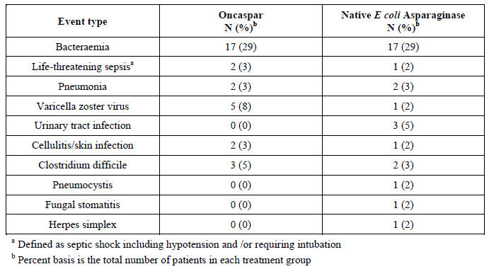
A re-examination of all CRFs for patients in this study was carried out and one MedWatch form specific to Oncaspar was revealed. This was a sudden left hemiparesis, abdominal pain and pancreatitis after Oncaspar dose. There was indeed CNS thrombosis and haemorrhage, and a coagulopathy on blood tests, with elevations of amylase and lipase. These vents are a known complication of ASNase use.
No deaths were attributed to drug toxicity.

DFCI-05-001
The overall frequency of asparaginase related AEs was not significantly different between treatment groups; 28% (65 out of 232 patients) in the IV Oncaspar group and 26% (59 out of 231 patients) in the IM native E coli asparaginase group (p = 0.60). The individual frequencies of the predefined cytotoxic AEs of allergy (p = 0.36), pancreatitis (p = 0.55) and thrombotic or bleeding complications (p = 0.26) in both groups were similar.
The most common ≥ Grade 3 AE was bacterial or fungal infections in both groups, with similar frequencies of 20% (47 out of 232 patients) in the IV Oncaspar group and 22% (51 out of 231 patients) in the IM native E coli asparaginase group.
Although SAEs were not reported in DFCI-05-001, Grade 4/5 toxic AEs were reported. There were 8 types of Grade 4/5 toxic AEs occurring in ≥ 2 patients (≥ 1%) in the Oncaspar group; hypertriglyceridaemia (19 patients, 8%), infection (11 patients, 5%), lipase (10 patients, 4%), hypokalaemia (5 patients, 2%) and allergic reaction, hyperbilirubinaemia, hypotension and pancreatitis all occurring in 2 patients (1%).
There were 8 types of Grade 4/5 toxic AEs occurring in ≥ 2 patients (≥ 1%) in the E.coli asparaginase group; lipase (11 patients, 5%), hypertriglyceridaemia (8 patients, 4%), hypokalaemia (7 patients, 3%), infection (4 patients, 2%) and CNS haemorrhage, hypoglycaemia, mood changes or depression, and seizure occurring in 2 patients (1%).
There was one death in each treatment group, with that of Oncaspar being CNS haemorrhage. Such CNS events seem to be apparent with the use of this drug. On balance while the AEs actually occurring may have numerically differed between treatments, the safety profile of the two drugs seems similar to this evaluator and frequencies of events are such that the risk appears worthwhile for the potential benefit, albeit with intensive patient monitoring for development of AEs.

AALL07P4
Treatment emergent and treatment related AEs for this study are summarised as follows in Table 89.

Table 89: Treatment-emergent and treatment related AEs
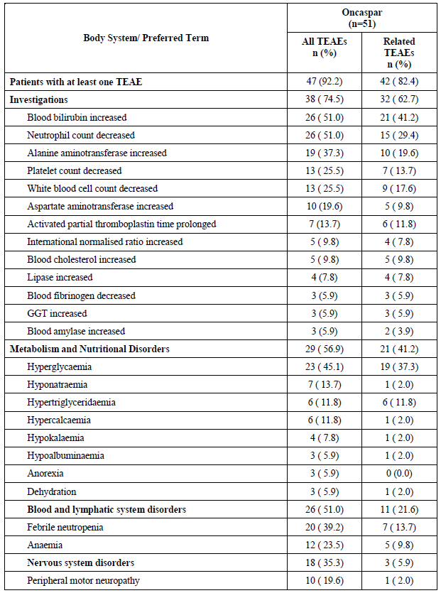

Table 89 (continued): Treatment-emergent and treatment related AEs
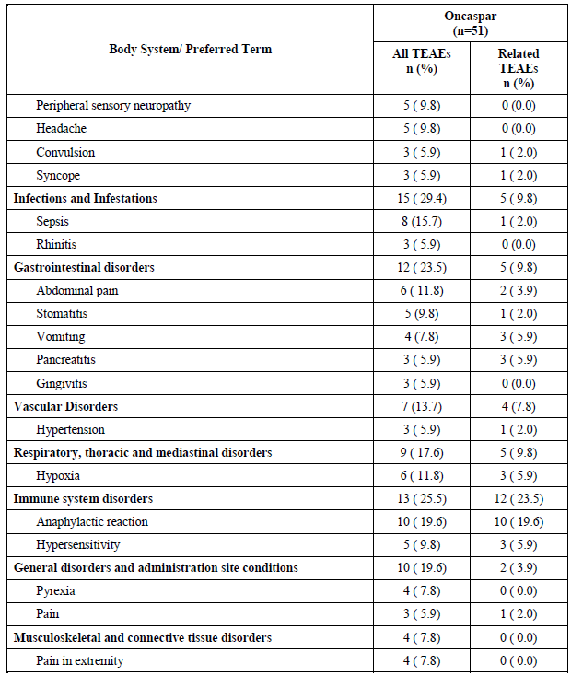
There were eight deaths in this study but only one in a patient receiving Oncaspar. The patient appears to have died from a fungal sepsis but details were not available. Infection is a clear risk for the use of the drug.

DFCI-91-01
The description gleaned from the publication in terms of safety is as follows:
Overall, asparaginase related toxicities occurred in 29% of the 377 patients. The most frequently reported toxicities included allergic reactions (15%), pancreatitis (7%) and coagulopathy (4.5%), which was defined as thromboses or clinical bleeding. Patients aged 9 to 18 years were more likely to experience an asparaginase related toxicity compared with those less than 9 years (48% versus 24%, p = 0.01).
Of the patients randomised to Oncaspar, 25% experienced a toxic reaction compared with 36% of patients randomised to native E coli asparaginase (p = 0.09). Oncaspar was associated with a lower incidence of mild allergic reactions (p = 0.02). There were no differences between the two preparations in the rates of dose limiting toxicities including severe allergic reactions (p = 0.22), severe pancreatitis (p = 0.78) and CNS thrombosis (p = 1.00). Asparaginase intolerance (defined as failure to receive at least 26 weeks of asparaginase) was associated with older age at diagnosis but not with initial type of asparaginase therapy (Oncaspar or native E coli enzyme).
There were three deaths in the induction treatment all as a result of sepsis. It is not clear whether the patients were treated with Oncaspar but sepsis or rather infection appears to be a known adverse event when using the drug or indeed native E.coli ASNase.

CCG-1961
There is little safety information available from the publications relevant to this study.
The major toxicities observed in Rapid Early Response patients were osteonecrosis and infections. There was no difference in the frequencies of osteonecrosis or infections between the standard post-intensification (SPII) (E.coli asparaginase) and intensive post intensification (IPII) (Oncaspar) groups.
There were 12 deaths in randomised RER patients in the SPII group (E.coli asparaginase) and 12 deaths in randomised RER patients in the IPII group (Oncaspar).

DFCI-87-001
This study trialled three types of ASNase of which Oncaspar was one. Only a single dose was administered.
During Induction, 22 patients (6%) had hyperamylasaemia on at least 1 day and clinical pancreatitis developed in 10 patients (3%). Of these 10, 4 had received native E.coli asparaginase, 2 had received Erwinia enzyme and 4 had received Oncaspar. Severe pancreatitis developed in the 3 of these 10 patients who received further asparaginase during Intensification. The incidence of dose limiting pancreatitis occurring any time during asparaginase therapy (Induction and Continuation) was 8.4% (29 of 344 patients).
During the 5 day investigational window, no hypersensitivity reactions occurred. There were 4 deaths during Induction in the study; 2 occurred following native E coli asparaginase, 1 following Erwinia asparaginase and 1 after Oncaspar.
This study has relatively little safety information except the recurrence of the known AE of pancreatitis. The cause of the deaths is not certain.

CCG-1991
The data presented for this study was from study start up to May 2005. A summary of case reports from this trial is as follows as shown in Table 90.

Table 90: Case report age and seriousness data by suspect drug category
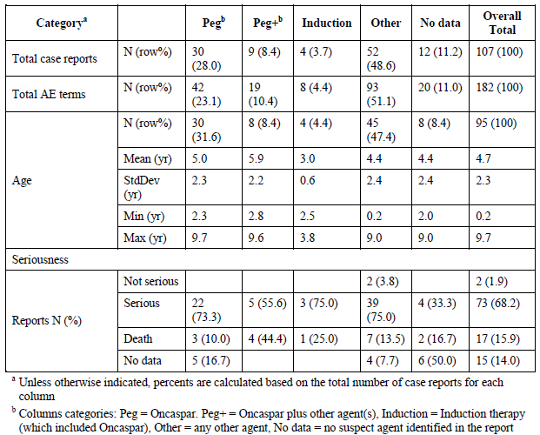
Overall, there were a total of 107 cases with 182 associated AE terms. Only 2 cases (1.9%) were judged not serious. A total of 73 reports (68.2%) were serious and there were 17 reported deaths (15.9%). There were no outcome data for 15 (14.0%) of the cases.
A total of 95 cases (88.8%) had age data with an overall mean age of 4.7 years. There were no important differences in the mean ages across the categories.
There were a total of 43 (40.2%) cases with 69 (37.9%) reported AE terms in which Oncaspar was or may have been a suspect agent. Across the 3 suspect drug categories in which Oncaspar was the suspect agent or possible suspect agent, there were 30 serious cases and 8 deaths. Five cases in the Peg category had no reported outcome data.
The following table (Table 91) summarises adverse events by System Organ Classification.

Table 91: AE Terms for all reports by SOC and suspect drug category
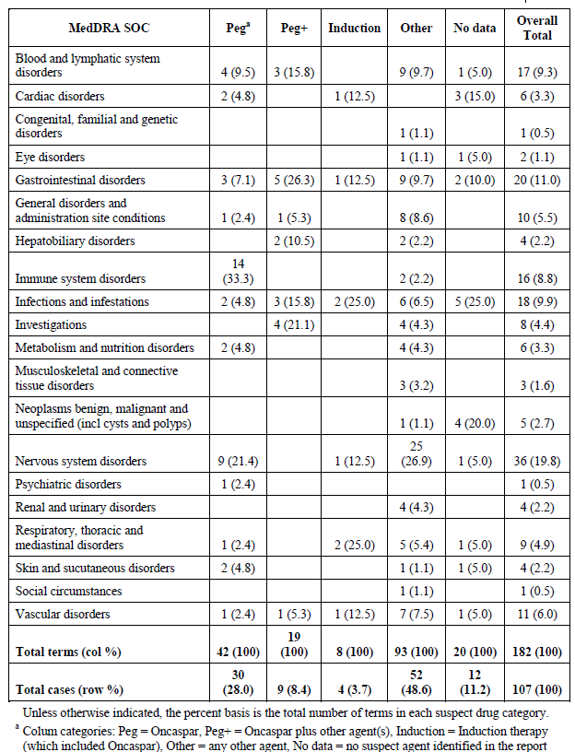
By far, the most frequent SOCs were nervous system disorders at 19.8% and GI disorders at 11.0%. For those where Oncaspar was a suspect or possible suspect agent, immune system disorders had the highest rate of all at 20.3% (14/69).
For the PEG category considered alone, the reporting rate for immune system disorders was substantially higher than that observed overall (33.3%, 14 out of 42 terms versus 8.8%, 16 out of 182 terms).
Comment: This would appear to be a clear indication of the link between Oncaspar and adverse events of this nature.
Of more specific interest is the actual adverse events themselves, in other words, of interest would be how much of GI disorders was pancreatitis, as one relevant example. The summary of adverse events that were common, in decreasing order of frequency, is as follows in Table 92.

Table 92: Most frequent AE terms by drug category (All Reports by MedDRA term)
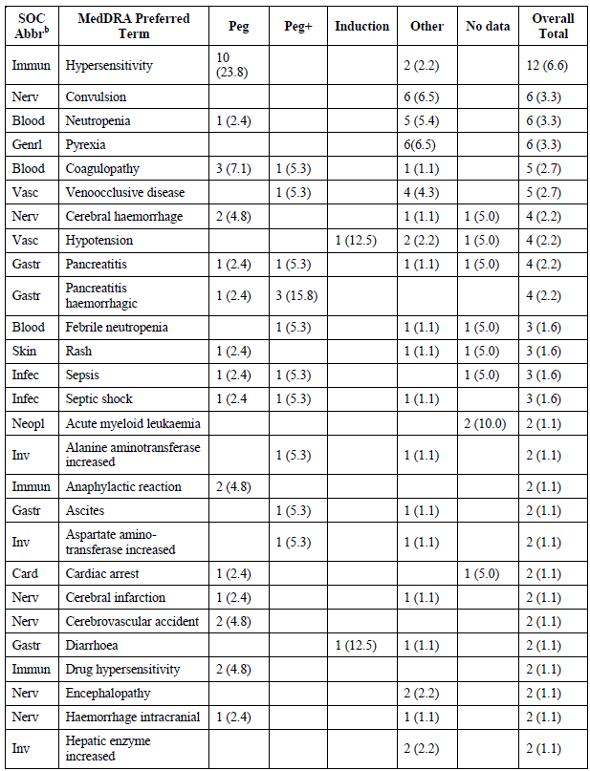

Table 92 (continued): Most frequent AE terms by drug category (All Reports by MedDRA term)
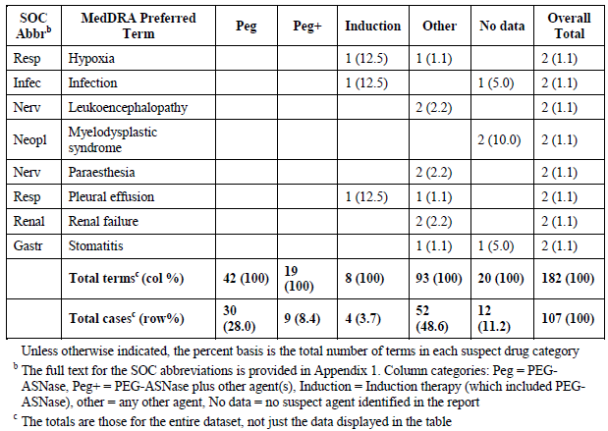
Comment: Once can see from the above table that immunology, cardiology, gastroenterology and neurology AEs again feature prominently as they encompass AEs that are known to occur with asparaginases. The table does not raise additional AEs that appear unusual in terms of frequency or type of AE to warrant concern over a new adverse effect that has not been circumscribed.
Among the drug categories involving or possibly involving Oncaspar (Peg, Peg +, Induction), hypersensitivity was the most frequently occurring AE term and represented 14.5% (10 out of 69 terms) of all terms across the 3 categories. Drug hypersensitivity and anaphylactic reaction each contributed an additional 2 terms for a total of 20.3% (14 out of 69 terms) of terms in the 3 drug categories combined. By combining the frequencies of terms representing the same or similar events, there were 2 other groups with frequencies worthy of note. Cerebral haemorrhage (n = 2), haemorrhage intracranial (n = 1), cerebrovascular accident (n = 2) and cerebral infarction (n = 1) accounted for a total of 6 reported terms across the events (8.7%, 6 out of 69 terms). Similarly, pancreatitis (n = 2), pancreatitis haemorrhagic (n = 4) and pancreatitis necrotising (n = 1) accounted altogether for 7 (10.1%, 7 out of 69 terms) reported terms.
Comment: Hence one can see these adverse events support the pattern of CNS vascular issues as well as pancreatitis and hypersensitivity.
Overall, there were a total of 73 cases with 131 applied AE terms for reports categorised as serious. Of these, 41.1% of the cases (30 out of 73 cases) and 34.4% of the reported terms (45 out of 131 terms) were in the 3 suspect drug categories involving Oncaspar or an Oncaspar-containing phase of treatment (Peg, Peg +, or Induction).
The two SOCs with the highest frequencies of reported terms for the 3 drug categories involving Oncaspar were the same as observed for All Reports. Together, immune system disorders (22.2%) and nervous system disorders (17.8%) accounted for 40.0% of all the reported terms across the 3 suspect agent categories. For the Peg category considered alone, the reporting rate for immune system disorders was substantially higher than that observed overall (40.0% versus 8.4%). Note that the Peg category accounted for 10 out of the 11 terms overall for the immune system disorder SOC.
Across the drug categories involving or possibly involving Oncaspar (Peg, Peg +, Induction), hypersensitivity was the most frequently occurring term and represented 17.8% of all terms across the 3 categories. Drug hypersensitivity contributed an additional 2 terms for a total of 22.2% (10 out of 45 terms) of terms in the 3 drug categories. Cerebral haemorrhage (n = 1), haemorrhage intracranial (n = 1) and cerebrovascular accident (n = 2) accounted for a total of 4 reported terms across the events (8.9%, 4 out of 45 terms). Similarly, pancreatitis (n = 2), pancreatitis haemorrhagic (n = 1) and pancreatitis necrotising (n = 1) accounted for 4 reported terms (8.9%).
There were a total of 17 deaths described by 24 AE terms. Eight of the 17 reports of death (47.1%) and 14 of the 24 applied terms (58.3%) were in the 3 suspect drug categories involving Oncaspar (Peg, Peg+, or Induction). Across the 3 suspect drug categories involving Oncaspar, only the gastrointestinal disorders SOC (4 terms) and the infections and infestations SOC (3 terms) had more than two reported terms.
Comment: The data on deaths for this study again show the adverse events of GI disorders and infections, known side effects of the use of asparaginases. Unknown or odd frequencies of other adverse events are not present.
The dosing regimens for Oncaspar in the trial are summarised by the following table (Table 93).

Table 93: CTC toxicity data - Oncaspar exposure by treatment phase and regimen
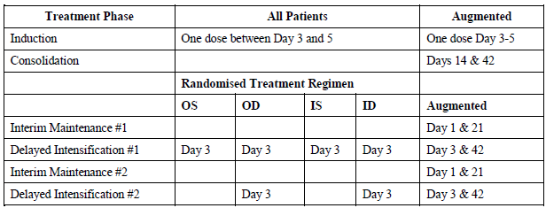
The dose given was 2,500 IU/m² IM in each case.
The incidence of total clinical toxicities expressed as a fraction of the total patient-phase exposures was analysed (one patient-phase exposure = one patient exposed during one treatment phase, regardless of the number of doses of drug during that treatment phase). There were 5,416 patient-phase exposures for Oncaspar. The frequency of selected toxicities was as follows:
- SGPT increase n = 314 (5.8%)
- Clinical pancreatitis n = 22 (0.4%)
- Hyperglycaemia n = 144 (2.7%)
- Thrombosis n = 17 (0.3%)
Among toxicities recognised to be associated with asparaginase were hepatotoxicity as reflected by SGPT / ALT (n = 314) and SGOT / AST (n = 129), pancreatitis (n = 22), lipase (n = 30), amylase (n = 14), coagulation disorders including fibrinogen (n = 169), Partial Thromboplastin Time (PTT) (n = 28), thrombosis / embolism (n = 17) and CNS cerebrovascular ischaemia (n = 18). Despite the seriousness of several of these toxicities, they do not represent unexpected clinical phenomena.
Comment: In summary, the first line formal studies demonstrate a number of common themes in terms of the safety profile and these characteristic events are present in the draft PI. This will be commented upon again later in this report. Importantly, the frequency of these events do not appear overall disparate with the PIs text, nor are there any events one can discern that are not characteristic of the safety profile of this drug established over decades.

Second line studies
Formal studies supporting second line use of Oncaspar in children or adults included:
- ASP-001
- ASP-001C-003C
- ASP-102
- ASP-201A
- ASP-203
- ASP-302
- ASP-304
- ASP-400
These studies were smaller and their data are presented in a combined fashion. Three hundred and eighty four doses of Oncaspar were administered to 78 hypersensitive patients (326 IM and 58 IV) and 650 doses were given to the 172 non-hypersensitive patients (432 IM and 218 IV). For safety analysis, any patient who received more than 2 doses of Oncaspar was included and thus data in this second line group of studies were available for 121 patients. Data for doses received less than this numbered 250 patients.
The median number of days on study was 43 (range 1 to 640 days) for all patients, 43 days (range 1 to 559 days) for the hypersensitive patients and 43 days (range 1 to 640 days) for the non-hypersensitive patients. The median number of doses of Oncaspar administered was 2 (range 1 to 37 doses) for all patients, 2 (range 1 to 29 doses) for the hypersensitive patients, and 3 (range 1 to 37 doses) for the non-hypersensitive patients.
Common adverse reactions from the drug’s safety profile are cited by the SmPC document with conventional frequency categories as shown in Table 94.

Table 94: Common adverse reactions to Oncaspar
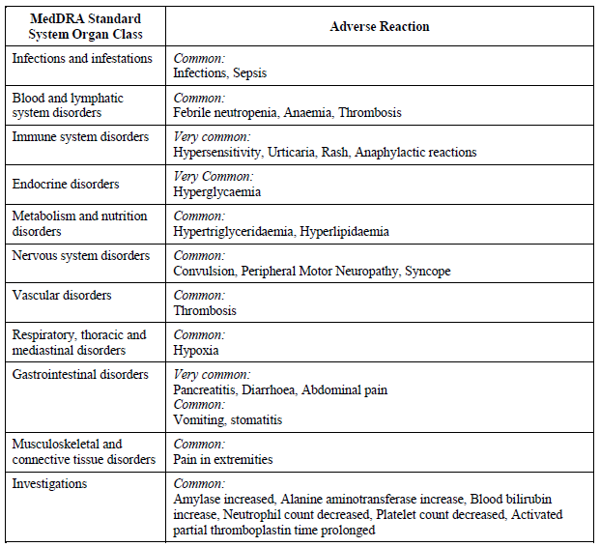
Comment: One can see this encompasses thrombosis, infection, hypersensitivity/anaphylaxis and blood dyscrasia. Of interest specific thrombosis or haemorrhage in the CNS is not mentioned although this is not surprising as although it occurs it does not occur at a ‘common’ or greater frequency. Of note to say at this point also is that the studies did not suggest upon evaluation that the majority of adverse events associated with Oncaspar occurred at different frequencies than those with other ASNase preparations. The types of AEs also appear broadly similar which is hardly surprising given the mechanism of action is similar for all. Although hypersensitivity and immune-based reactions did differ in frequency in some studies, giving the suggestion that Oncaspar could be used when hypersensitivity to native E.coli ASNase existed. Furthermore there was an impression given by some study data that hypersensitivity was reduced when using the IM route rather than IV. However other studies found no difference in these rates.
There were 102 deaths among the 250 patients treated with Oncaspar in the second line use trials. Of these, 22 were on-study and 80 off study. All were considered disease related rather than drug related.
A total of 104 (48%) of the 218 patients (26 hypersensitive and 78 non-hypersensitive) who received Oncaspar reported CTC Grade 3 or 4 non-allergic toxicities which were possibly, probably or definitely related to Oncaspar.
Changes in coagulation profiles were noted in 42 patients (19%; 13 hypersensitive and 29 non-hypersensitive). The fibrinogen levels tended to fall and Prothrombin Time (PT) and PTT were likely to be prolonged during therapy with Oncaspar in both the hypersensitive and non-hypersensitive patients. Changes in liver function tests were noted in 76 patients (36%; 17 hypersensitive and 59 non-hypersensitive).
Hyperglycaemia (CTC Grades 3 and 4) occurred in 10 patients (5%; 1 hypersensitive and 9 non-hypersensitive), 3 of whom required insulin. Increases in amylase (CTC Grades 3 and 4) occurred in 4 patients (2%; 1 hypersensitive and 3 non-hypersensitive). Two of these patients experienced concurrent clinical pancreatitis.
Six patients (3%) experienced CTC Grade 3 increases in blood urea nitrogen (BUN) and 2 (1%) had neurological dysfunctions (convulsions; CTC Grade 3 and 4).
Although, the total patient population in the second line studies receiving Oncaspar was 250 (158 IM and 92 IV), 32 adult patients from ASP-102 and ASP-203 were not included in hypersensitivity analysis. A total of 46 (21%) of 218 patients (28 hypersensitive and 18 non-hypersensitive) receiving Oncaspar reported hypersensitivity reactions that were possibly, probably or definitely related to Oncaspar.
Six (21%) of the 28 hypersensitive patients who experienced hypersensitivity reactions (possibly, probably or definitely related to Oncaspar) had a CTC Grade 3 or 4 reaction. The remaining 22 hypersensitive patients (79%) experienced 11 CTC Grade 2 reactions and 11 CTC Grade 1 reactions. Twelve hypersensitive patients experienced dose limiting hypersensitivity reactions.
Five (31%) of the 16 non-hypersensitive patients who experienced a hypersensitivity reaction (possibly, probably or definitely related to Oncaspar) had a CTC Grade 3 or 4 reaction. The remaining 11 non-hypersensitive patients (69%) experienced 7 CTC Grade 2 reactions and 6 CTC Grade 1 reactions. Five non-hypersensitive patients experienced dose limiting hypersensitivity reactions.

Hypersensitivity and the intramuscular route of administration of Oncaspar
A total of 25 of 158 patients (16%; 19 hypersensitive and 6 non-hypersensitive) receiving Oncaspar IM reported hypersensitivity reactions that were possibly, probably or definitely related to Oncaspar.

Hypersensitivity and the intravenous route of administration of Oncaspar
A total of 21 of the 92 patients (23%; 9 hypersensitive and 12 non-hypersensitive) who received Oncaspar IV reported hypersensitivity reactions that were possibly, probably or definitely related to Oncaspar.(p62 summary of clinical safety).
Comment: A more detailed analysis was carried out to determine if the hypothesis of greater hypersensitivity with the IV route was borne out by the data. Strata of hypersensitivity yes/no and IM or IV administration were created and evaluated by Kaplan-Meier product limit method using as survival data the number of days on study or number of doses to first occurrence of hypersensitivity.
The overall survival analysis among the 4 strata are significant based upon either days on study (p = 0.0001) or the number of doses (p = 0.0001) to an initial hypersensitivity reaction. Furthermore, the ordering of the Kaplan-Meier survival curves is as expected. Patients with a prior history of hypersensitivity who received Oncaspar IV were the most likely to experience a hypersensitivity reaction and patients with no prior history of hypersensitivity that received Oncaspar IM were the least likely to experience a hypersensitivity. It was also observed across all strata that the survival curves flattened after the initial 3 doses indicating that the probability of a patient developing a hypersensitivity reaction is greatest in response to the initial 3 doses of Oncaspar regardless of the route of administration or hypersensitivity history.

Previous sensitisation
For the IV versus IM subgroup analyses, the percentage of patients in the IV subgroup who did not experience a hypersensitivity reaction for the hypersensitive and non-hypersensitive patients was 56% and 87%, respectively. The differences, based on the number of doses and the number of days on study, were statistically significant (p = 0.0054 and 0.0003, respectively). In the IM subgroup, the percent of patients who did not experience a hypersensitivity reaction for the hypersensitive and non-hypersensitive patients was 72% and 94%, respectively. The differences, based on the number of doses and the number of days on study, were statistically significant (p = 0.0004 and 0.0003, respectively).
These two sets of results support the first hypothesis that, regardless of the route of administration, patients previously hypersensitive to native L-asparaginase will be more likely to experience a hypersensitivity reaction than patients with no prior history of hypersensitivity.

Route of administration
For the hypersensitive versus non-hypersensitive patient subgroup analyses, 56% of patients receiving Oncaspar IV and 72% of patients receiving Oncaspar IM in the hypersensitive patient subgroup did not experience a hypersensitivity reaction. The differences, based on the number of doses and the number of days on study, were not statistically significant (p = 0.1101 and 0.1113, respectively).
Within the non-hypersensitive patient subgroup, 87% of the patients receiving Oncaspar IV and 94% of the patients receiving Oncaspar IM did not experience a hypersensitivity reaction. The differences, based on the number of doses and the number of days on study, were statistically significant (p = 0.0306 and 0.0437, respectively).
Therefore, the second hypothesis, that patients receiving Oncaspar IV are more likely to experience a hypersensitivity reaction than patients receiving it IM, is supported statistically only in the non-hypersensitive patient subgroup.
Comment: Based upon the second line formal trial data, the contention that hypersensitisation is more likely using the IV route of administration is not borne out. This evaluator is not of the view that such a contention is false based upon these data; simply that sufficient data are not available in a useful form in this dossier to be sure one way or the other.

Laboratory evaluations
No formal analysis is given. Information from the SmPC is put forward as a description of what to monitor with laboratory tests while treating a patient with Oncaspar. These include:
- Peripheral blood count and bone marrow
- Serum amylase
- Blood sugar
- Liver dysfunction if used in association with hepatotoxic chemotherapy
- Fibrinogen, PT and PTT.
Comment: Based upon review of the formal trials and published studies presented in the dossier, this evaluator suggests that serum asparaginase should be monitored and/or anti-asparaginase antibodies in some sort of systematic, regular fashion. Hypersensitivity, antibody formation, and subsequent rapid clearing of asparaginase can occur with no other outward sign, resulting in inadequate serum asparaginase levels to properly deplete asparagine and thus result in sub-optimal treatment. Certainly the PD data suggest that with antibodies present, the serum asparagine is not maintained adequately over a 14 day dose interval to ensure complete depletion of asparagine in the blood.

Vital signs, physical examination
No formal analysis was performed. Given the majority of data derived from large published studies, detailed information typically available for CSRs with respect to these parameters is not available.

Published studies
It is difficult to present published studies in terms of safety as the detail present is often of low quantity and quality. The clinical overview presents tabulated summaries of the studies considered relevant to safety with a short interpretive comment. It is not clear where the publications derive from. Additional publications are added in the addendum to the clinical overview, 14 and 8 studies in paediatric and adult patients respectively were retrieved using the TGA SLR. This evaluator sees little option, but to presented the tabulations here, and then comment upon them in general.

Table 95: Publications relevant to the safety of Oncaspar in ALL
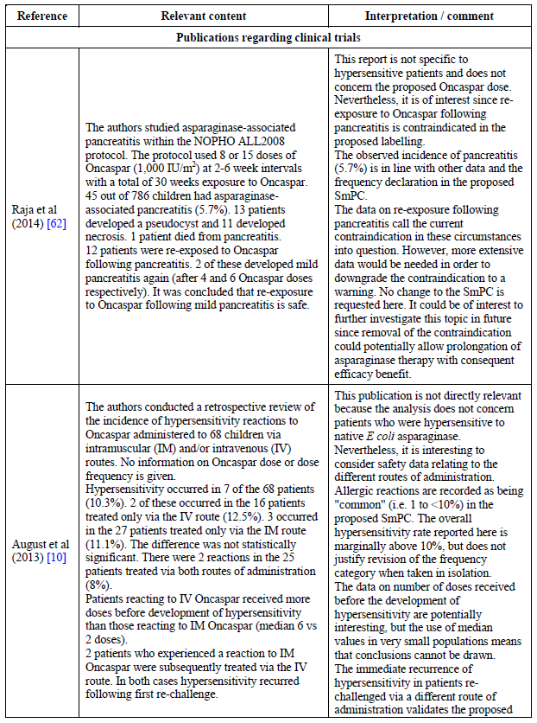

Table 95 (continued): Publications relevant to the safety of Oncaspar in ALL
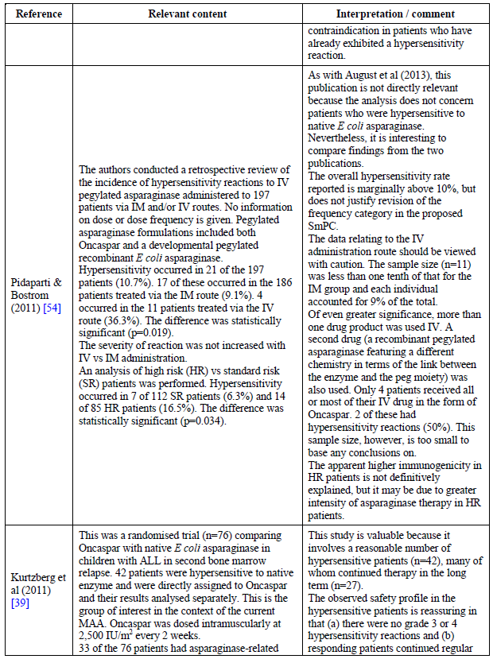

Table 95 (continued): Publications relevant to the safety of Oncaspar in ALL
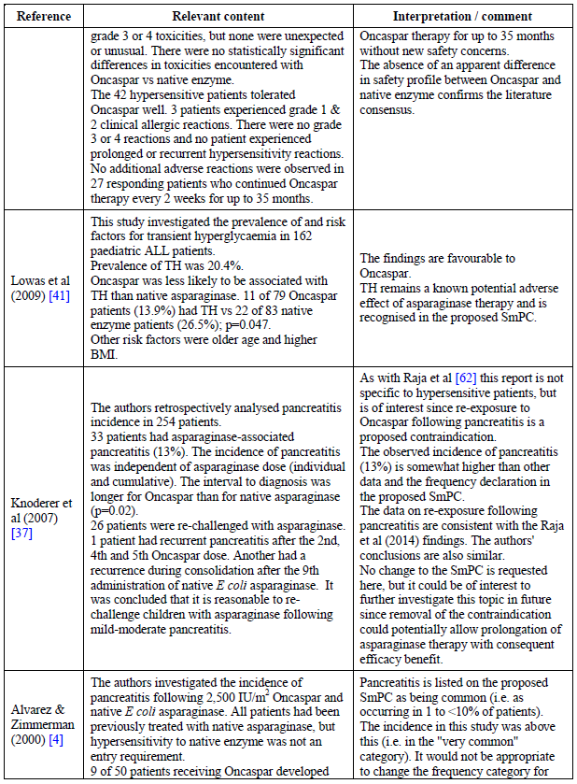

Table 95 (continued): Publications relevant to the safety of Oncaspar in ALL
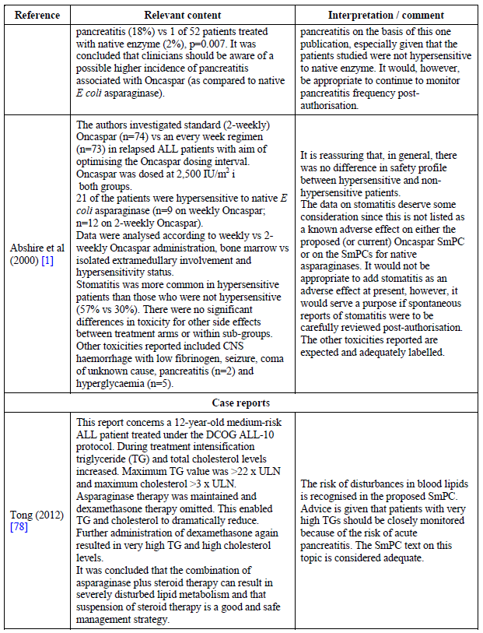

Table 95 (continued): Publications relevant to the safety of Oncaspar in ALL
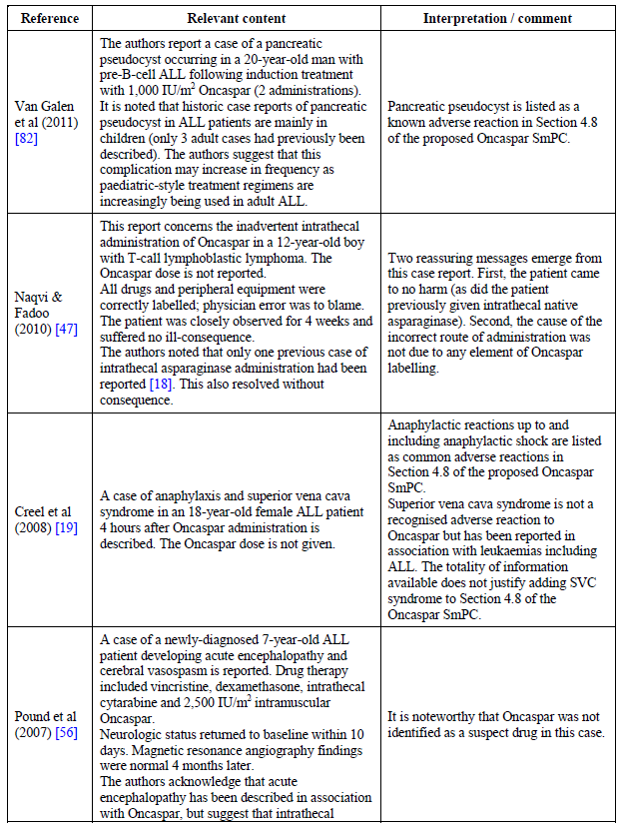

Table 95 (continued): Publications relevant to the safety of Oncaspar in ALL
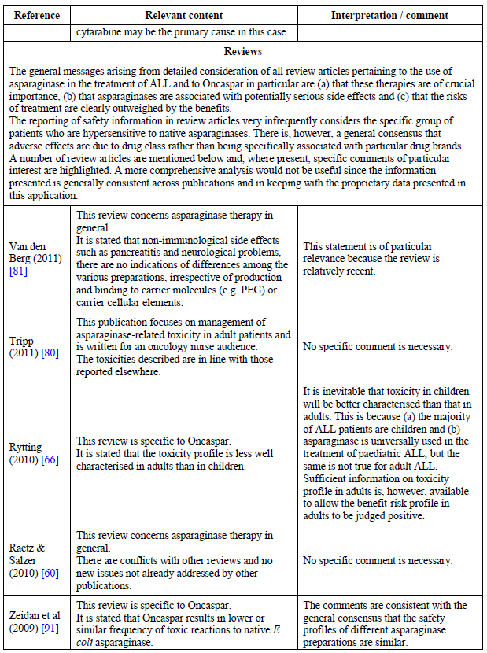

Table 95 (continued): Publications relevant to the safety of Oncaspar in ALL
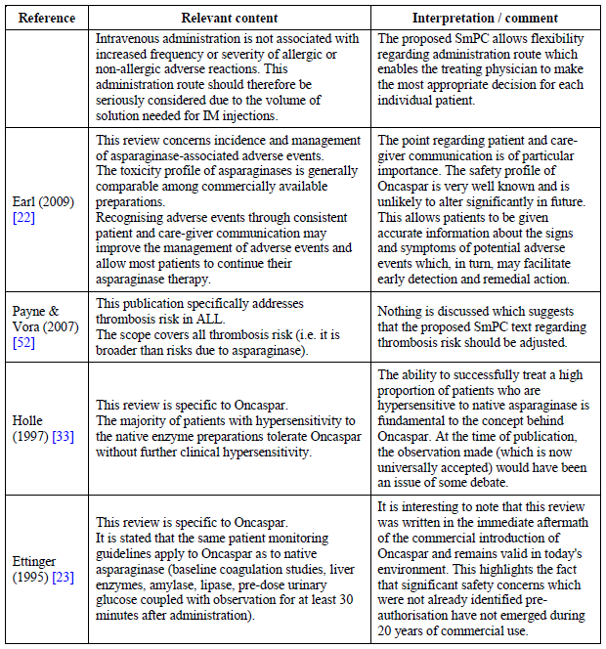
The following points on safety can be drawn from these studies:
- The constellation of specific adverse events occurring as a result of asparaginase use is apparent from these studies.
- A higher incidence of hypersensitivity using the IV dosing route is trending to possible but cannot be stated as established.
- Some studies trended towards higher frequency of pancreatitis, but the body of data supporting current frequency in the draft PI is more robust than these individual studies.
- Stomatitis was raised as a potentially ADR in Abshire et al 2000, and is something for the sponsor to monitor in world-wide post market review.
- Non-immunological AEs appear to occur at similar frequencies for the different asparaginase products.
Additional studies identified in paediatric patients as a result of the TGA SLR were as follows in Table 96.

Table 96: Publications relevant to the safety of Oncaspar in paediatric studies
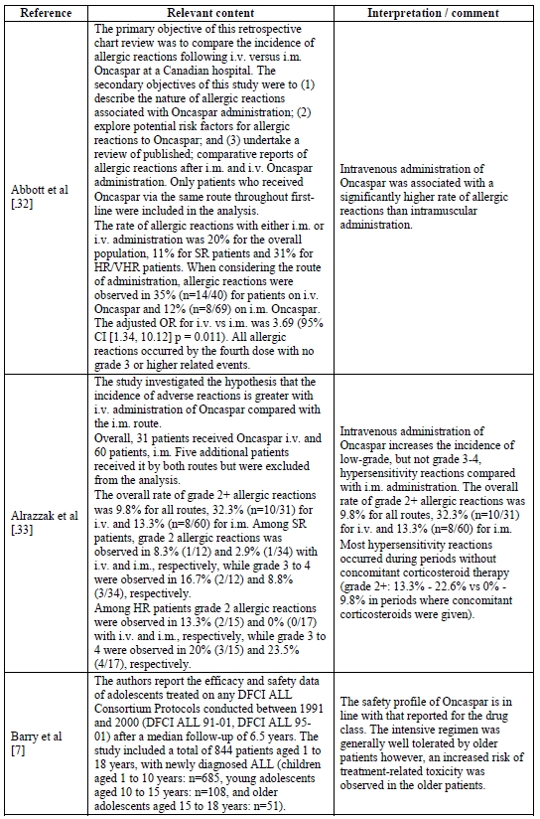

Table 96 (continued): Publications relevant to the safety of Oncaspar in paediatric studies
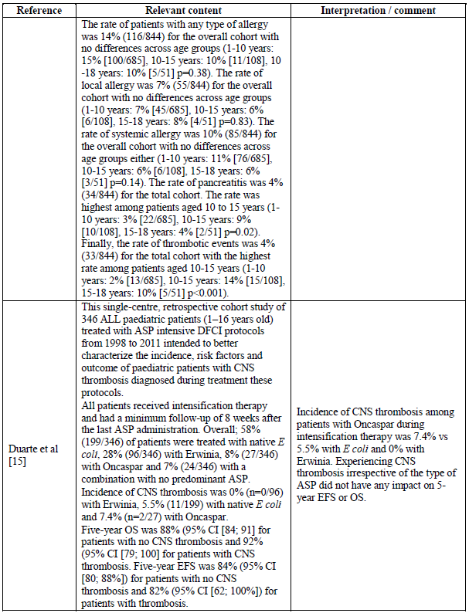

Table 96 (continued): Publications relevant to the safety of Oncaspar in paediatric studies
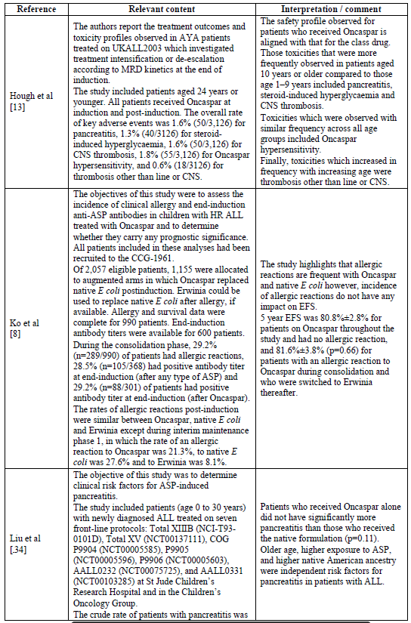

Table 96 (continued): Publications relevant to the safety of Oncaspar in paediatric studies
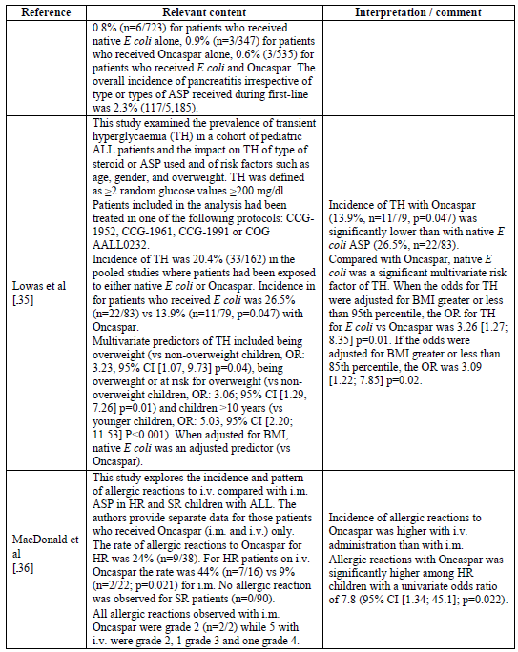

Table 96 (continued): Publications relevant to the safety of Oncaspar in paediatric studies
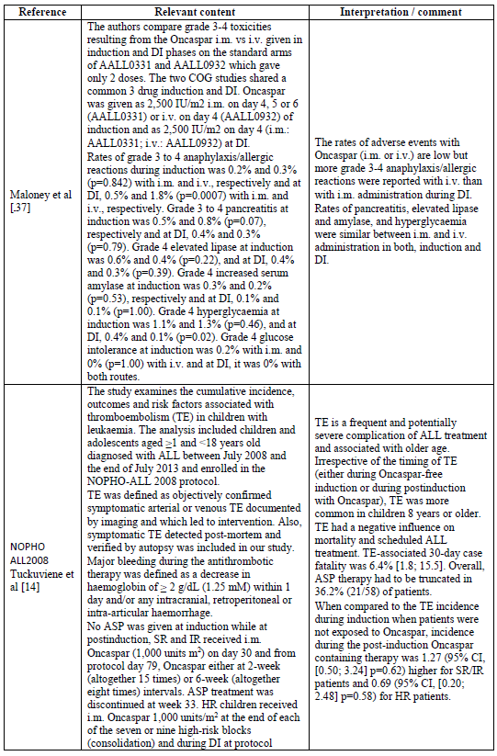

Table 96 (continued): Publications relevant to the safety of Oncaspar in paediatric studies
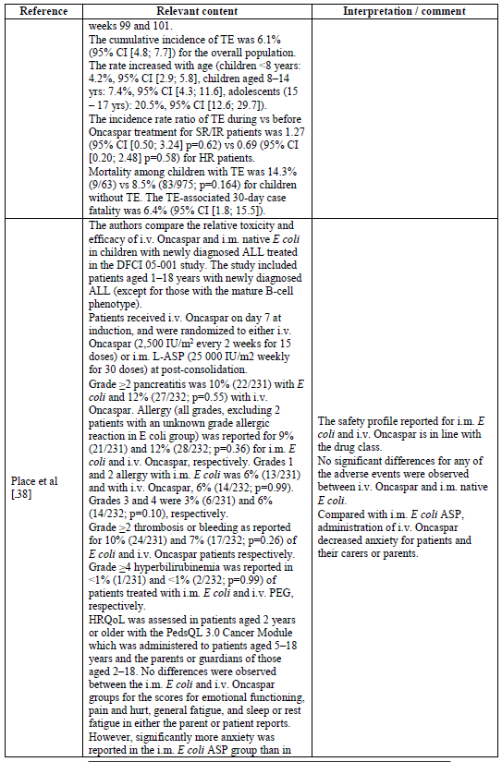

Table 96 (continued): Publications relevant to the safety of Oncaspar in paediatric studies
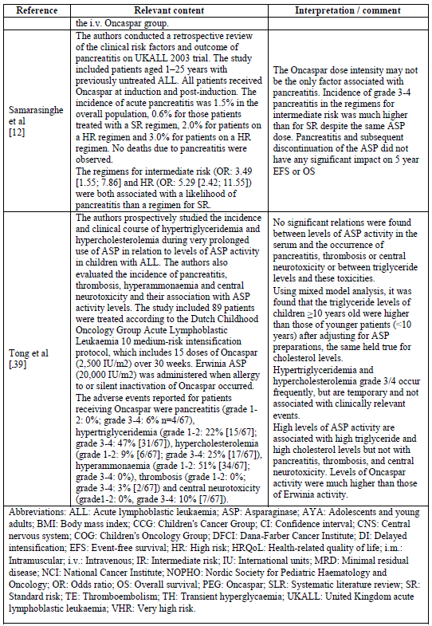

Hypersensitivity and allergy
Seven of these studies provided information with respect to allergy. For those receiving at least one dose of drug, allergic reaction rates varied from 1.8% to 70%. One must bear in mind these reflect different doses, dose intervals, stage of treatment and ‘risk’ status of the patients. Hence it is not surprising rates vary and it is therefore difficult to gauge a ‘standard’ rate of allergic reaction. Place 2015 compared Oncaspar to native E.coli ASNase and there was no significant difference observed in the rate of any grade (native E coli-ASP: 9%; Oncaspar: 12%; p = 0.36), Grade 1-2 (native E.coli-ASP: 6%; Oncaspar: 6%; p = 0.99) or Grade 3-4 (native E coli-ASP: 3%; Oncaspar: 6%; p = 0.10) allergic events between the two types of ASP.
Several studies examined the occurrence of allergic reaction in relation to route of administration of Oncaspar. While this question is not entirely answered, the likelihood for any grade allergic reaction was increased by four fold (odds ratio (OR): 4.11, 95% confidence interval (CI) (1.54; 10.97), p = 0.005) in Abbott et al. and the odds of Grade 2 or higher by two-fold (OR: 2.42 95% CI (1.06; 5.51), p = 0.032) in Alrazzak et al.
However, Ko et al. reports the rate of allergic reactions for those children included in the Children's Cancer Group (CCG) 1961 (HR children) who received an augmented treatment in which Oncaspar replaced native E.coli ASP post induction. The percentage of patients with allergic reactions among those patients who received Oncaspar was 28.6% at consolidation, 21.3% at interim maintenance 1 (IM), 4.8% at delayed intensification 1 (DI1), 10.4% at IM2 and 1.8% at DI2. Compared with native E coli ASP, Oncaspar was associated with an OR of 0.74 (95% CI (0.46; 1.17)) at consolidation, 0.71 (95% CI (0.43; 1.18)) at IM1, 1.54 (95% CI (0.35; 6.67)) at DI1, and 0.30 (95% CI (0.06; 1.59)) at DI2.

Pancreatitis
Six of these studies provided data on rates of pancreatitis in ALL for patients who received at least one dose of Oncaspar. Rates varied from 0.8% to 6%:
- In UKALL 2003, overall rate was 1.6% (50/2136). Generally speaking, rates increased with age. Rate of Grade 3 or 4 pancreatitis was 1.5%.
- Rates of pancreatitis did not seem linked to route of administration (Tong et al; Maloney et al.)
- In Liu et al. the rate was 2.3% (n = 117/5,185), a huge patient experience.

Liver dysfunction
Three studies provided information on liver testing:
AALL0331 and AALL0932 are reported in Maloney et al. and show Grade 4 lipase increases that wary in rates depending upon the time of treatment from 0.3 to 0.6%. At some time-points this was significant in terms of IM or IV route of administration, but not at others.
Place et al. reported a rate of Grade 4 or higher hyperbilirubinaemia of < 1%.
Tong et al. reported upon rates of hypertriglyceridaemia and hypercholesterolaemia. The proportion of patients with Grade 1-2 hypertriglyceridemia events was 22% (n = 15/67) and that for Grade 3 or 4, 47% (31/67). The proportion of patients with Grade 1 or 2 hypercholesterolemia was 9% (n = 6/67) and that of Grade 3 or 4, 25% (17/67).

Hyperglycaemia
In AALL0932 (IV Oncaspar), at induction, 1.1% and 1.3% (p = 0.46) of patients on IM and IV Oncaspar, respectively, had Grade 4 hyperglycaemia events. At DI this proportion was 0.4% and 0.1% (p = 0.02), respectively.
In UKALL2003, 1.3% (n = 40/3,126) of patients had hyperglycaemia that met the criteria of a serious adverse event but the authors associate these events to the steroids administered to patients at induction rather than to Oncaspar.
Among children treated for ALL on Children’s Cancer Group (CCG), Children’s Oncology Group (COG) study protocols (CCG-1952, CCG-1961, CCG-1991, COG AALL0232) or according to the guidelines of the most recently completed CCG therapeutic protocol. Overall, 13.9% (n = 11/79) of patients experienced transient hyperglycaemia with Oncaspar. Incidence was lower than with native E.coli-ASP (26.5%, n = 22/83; p = 0.047).

Thrombosis
Five of these publications provide data on thrombosis. In UKALL2003, CNS thrombosis was 1.6% (50/3126). In Duarte et al. CNS thrombosis was 7.4% (2/27). In Place et al. the rate of Grade 2 or higher thrombosis or bleeding was 7% (n = 17/232) among patients with IV Oncaspar at induction and consolidation. This rate was 10% (n = 24/231; p = 0.26) for patients on Oncaspar at induction and IM native E.coli at consolidation. The rate of CNS thrombosis was 3% (6/232) and 1% (3/231) with Oncaspar and native E.coli at consolidation, respectively (p = 0.50). No significant differences were observed either for non-CNS thrombosis between Oncaspar (5%, n = 12/232) and native E coli (9%, n = 21/231; p = 0.11) at consolidation.
In Tuckuviene et al., the cumulative rate of thromboembolism was 6.1% (95% CI (4.8; 7.7)) with a significantly higher rate for adolescents (15 to 17 years of age: 20.5%, 95% CI (12.6; 29.7)).
In Tong et al., 3% had Grade 3 or 4 thrombosis.
Comment: Of note from these studies are the following opinions of this evaluator:
- IV administration of Oncaspar trends toward greater allergic reactions and hypersensitivity, but cannot be stated with certainty.
- CNS thrombosis was a feature of Oncaspar use. It is uncertain if the drug causes this at a greater rate than other asparaginase preparations.
- Pancreatitis emergence as an ADR may not be dose-dependent but rather a threshold event.
- Thrombosis is a biologically plausible and significant adverse event for Oncaspar but doesn’t appear to occur at greater rates than with native E coli ASNase. CNS thrombosis is more rare yet a significant source of morbidity this evaluator would postulate.
And additional studies identified in adults, representing new data, were as follows in Table 97.

Table 97: Publications relevant to the safety of Oncaspar in adult studies
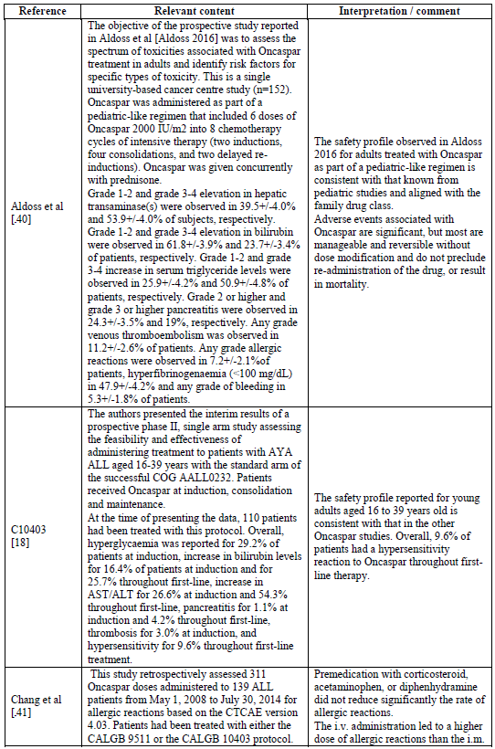

Table 97 (continued): Publications relevant to the safety of Oncaspar in adult studies
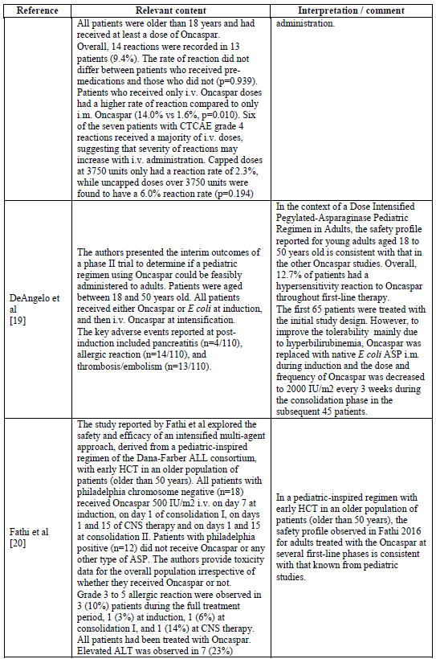

Table 97: Publications relevant to the safety of Oncaspar in adult studies
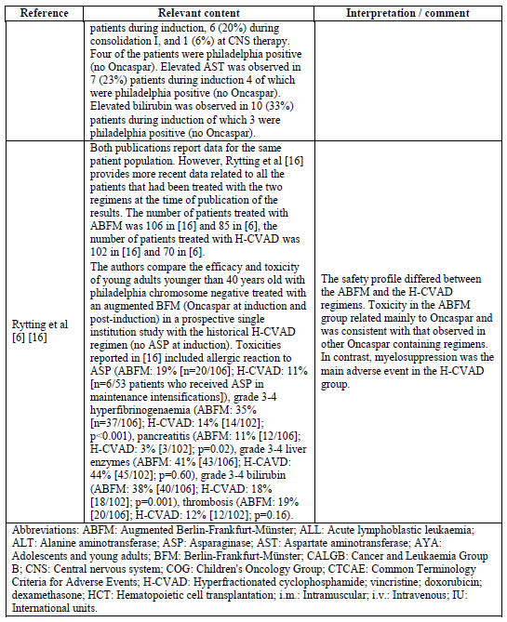

Allergy
Five studies provided data for Oncaspar that had rates ranging from 7.2% and 19%. In Stock et al., Grade 3-5 reactions occurred at 9.6% throughout first line treatment. Chang et al. retrospectively analysed 311 Oncaspar doses. Fourteen allergic reactions were noted in 13 of 139 patients (9.4%). IV dosing had a much higher rate of reaction than IM, (14% versus 1.6%; p = 0.01).

Pancreatitis
Two studies provide rates for this adverse event with Oncaspar. Rate of pancreatitis in ALL adults exposed to Oncaspar was 11% (n = 12/106) in Rytting et al. In this study, young adults aged 13 to 39 years were treated with the ABFM protocol. In contrast, no patient had any pancreatitis among the 26 patients who received Oncaspar at consolidation in Rosen et al. Rates with native E.coli ASNase were 0 to 5.2% but these figures are based upon relatively small numbers. No conclusions around the comparison of rates of pancreatitis between treatments can be made for adults.

Liver dysfunction
The proportion of patients with Grade 3 or higher increase in bilirubin ranged between 23.7% (Aldoss et al.) and 38% (Rytting et al.) of patients exposed to Oncaspar at induction and subsequent phases. The proportion of patients with Grade 3 or 4 increase in liver enzymes throughout first line treatment was 41% in Rytting et al., 53.9% in Aldoss et al. and 54.3% (Grade 3-5) in Study C10403.
Multiple studies report liver events with exposure to native E.coli ASnase. Increases in serum bilirubin range from Grade 3 or 4 events at 1.1% to 24.1%. Increases in serum transaminases of Grade 3 or 4 range from 37.9% to 45%.

Hyperglycaemia
Fathi et al. demonstrated an incidence in adults of 23% (7/30) in first line treatment. For native E.coli ASnase, rates have been noted of 6% (DFCI-91-01) and 39% (DFCI- ALL 01-175; n = 36/92)

Thrombosis
Five studies provide data on Oncaspar in first line treatment. In Rytting et al., rate of thrombosis was 19% (20/106). Only three stroke like events occurred. In GMALL 05/93, no events occurred (n = 25). In Aldoss et al., 11.2% had a venous thromboembolism but no arterial thrombosis occurred. Stock et al. reported a 3.0% rate of thrombosis in adults with Grade 3-5 thrombosis.
In DeAngelo et al., rate of thrombosis post induction was 11.8% (13/110).
Data for native E.coli ASNase reports a range of thrombosis rates from zero to 17%. Those studies with larger numbers reported 7.2% (6/114) in Caruso et al. and 9.3% (20/214) in Hunault-Berger et al.
Comment: Matters of safety relevance from these studies are as follows in the view of this evaluator:
- The studies identify the known constellation of adverse events associated with Oncaspar.
- These events do not appear to occur at significantly different frequencies from that already known for native E.coli ASNase, except perhaps for immunologically based events, which trend to occur at a reduced rate with Oncaspar.
- Hypersensitivity reactions are relatively common.
- The data in adults suggests allergic reactions are more common in adults. A rate of around 10% is typical.
- These data do not alter in material respect any of the already known safety profile for Oncaspar. The safety profile is broadly similar to that of other asparaginases.
- The data are multiples of discrete studies rather than collective inferences, but some studies had thousands of patients and so by their very size provide a degree of robustness to the AE data coming from them.
The published literature retrieved essentially supports the findings of formal clinical trials in terms of the risk/benefit profile of Oncaspar. The drug has known significant adverse events associated with its use, however by knowing this and monitoring for the development of these events in their early stages, the use of the drug can be considered positive overall. The drug is a major component of almost all treatment regimens for ALL in adults and children.

Other safety issues

Safety in special populations
Oncaspar cannot be used during pregnancy and adequate contraception must be used during treatment as no formal studies in reproduction have been done in animals and malformations and embryo lethal effects are caused by the drug.

Safety related to drug-drug interactions and other interactions
No formal analysis was made or indeed trials investigating drug/drug interactions were performed. Potential issues highlighted in the SmPC are:
- A decrease in serum proteins that can occur can obviously affect those drugs that are significantly protein bound.
- Drugs which require cell division for their effect are likely to be effected via inhibition of protein synthesis and cell division.
- Enzyme detoxification in the liver of other drugs might be affected.
- Fluctuations in coagulation profile can lead to thrombosis and haemorrhage. Caution is needed for drugs influencing coagulation such as NSAIDS and warfarin, heparin, etcetera
- Synchronous treatment with vincristine can increase the toxicity of Oncaspar.
- Hepatically cleared drugs may be affected where Oncaspar brings about hepatotoxicity and thus slows the clearance of hepatically cleared drugs.
- Use of live vaccines can increase infection risk.

Post marketing experience

PSURs
EU authorisation was transferred from Medac to Sigma-Tau in 2012. A PSUR for August 2009 to July 2012 was presented. Approximately 207 million units of product were sold during this period for an estimated 13,824 treated patients. Ninety three case reports were received over the same period, with 128 listed reactions and 9 unlisted reactions. Twenty seven were spontaneous reports, 55 from studies and 11 identified in the literature.
The PSUR concluded that the risk benefit profile was unchanged and no action to change SmPC or implement other safety related changes was deemed necessary.

Data from US launch date
Dates from September 1994 to March 2012 identified an exposure of approximately 57,000. A collection of 843 post-authorisation safety reports showed 2,657 preferred terms. Of those reported 20 or more times, the following were encompassed as described in Table 98.

Table 98: Preferred Terms reported ≥ 20 times in US spontaneous reporting (September 1994 to March 2012)
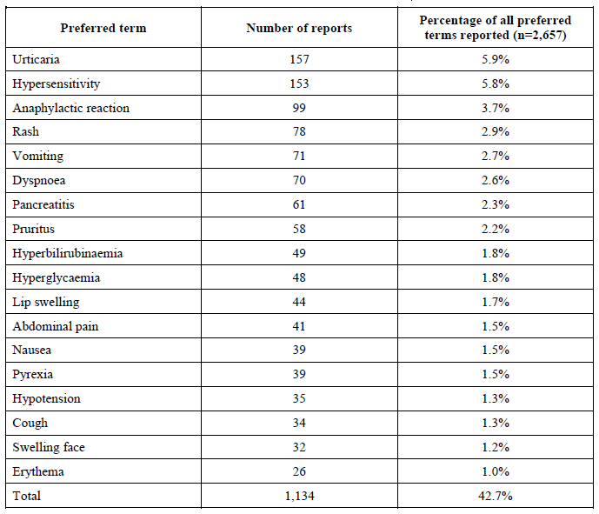
The three most common terms accounted for 15.4% of the total and are immunological in basis. The data reflect both first and second line use as first line was authorised in 2006 in the USA.

Non-proprietary clinical trials
Studies that used Oncaspar as a backbone of therapy are given as follows. Most are ongoing and some are presented in this report as shown in Table 99.

Table 99: Non-proprietary clinical trials involving Oncaspar as backbone therapy
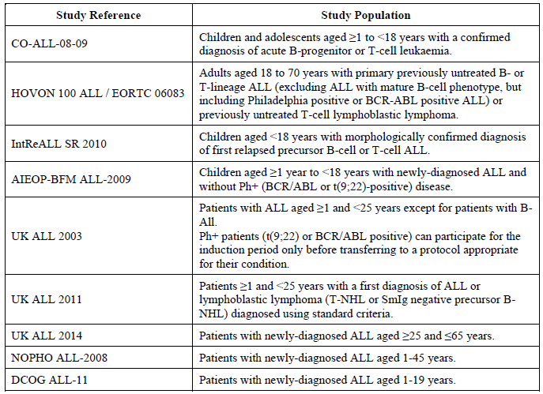
Safety reports over a short span of time for these trials have been summarised. Forty two reports were apparent and cover hypoglycaemia, pancreatitis, infection, CNS thrombosis, embolism, fever, haemorrhage and liver derangement.
Only 3 preferred terms were reported as the main event on more than one occasion. These were hypoglycaemia (n = 3), febrile neutropenia (n = 3) and liver function test abnormal (n = 2). Even were all these considered related to the drug, they are known adverse events at acceptable frequency.

Evaluator’s overall conclusions on clinical safety
There were seven formal trials supporting fist-line use of Oncaspar in children or adults. The bulk of subject numbers were children or quite young adults. These data comprised approximately 4,140 patient exposures/treatments. The majority of exposures were in Study CCG-1991 where the drug formed part of background treatment in a multi-drug regimen. Only trial AALL07P4 used the drug in a head to head comparison in n = 51 patients.
Adverse events were broadly similar in frequency across Oncaspar and native E.coli ASNase, and trial CCG-1962 bears this out. CNS complications, infection, pancreatitis, hyperglycaemia, liver dysfunction and bacteraemia in general featured as adverse events. What is also clear is that Oncaspar appears to have been associated in several instances with a lower rate of hypersensitivity.
Second line formal studies comprised the much smaller-numbered ‘ASP’ trials, as collectively called by this evaluator. Three hundred and eighty four doses were given to 78 hypersensitive patients and 650 doses to 172 non-hypersensitive patients. Obviously second line use is a reduced totality of experience in terms of formal trials, yet it is important in terms of pre-sensitisation to try and understand adverse events as a result of hypersensitivity. The Median number of doses of Oncaspar administered was two, with a range of 1 to 37 doses.
Common adverse events are detailed in the EU SmPC as well as the draft Australia PI document. They encompass the most important adverse events noticed in the totality of submission data.
The IM route of administration seems to reduce the likelihood of a hypersensitivity reaction. In the second line trials, 72% did not experience a hypersensitivity reaction via the IM route while only 56% patients didn’t using the IV route of administration, in those who were previously hypersensitive. However, these results were not statistically significant between groups (p = 0.1101 and 0.1113, respectively, for number of doses and days on study. What was statistically significant was that within the non-hypersensitive group of patients, 87% receiving drug IV and 94% receiving IM did not experience a hypersensitivity reaction. This was statistically significant, both for number of doses (p = 0.0306) and days on study, (p = 0.0437, respectively). So it would appear that non-hypersensitive patients are more likely to experience a reaction if the IV route is used, giving a reasonable argument for using the IM route in such persons where possible.
Fourteen and 8 published studies were but forward as a result of the TGA SLR in paediatric and adult patients, respectively. In brief, the following conclusions are made:
- The array of adverse events in these trials is similar to that for the formal studies.
- Trends in higher hypersensitivity reactions via dosing the IV route were noted.
- Non-immunological adverse events seem to occur at similar frequencies for Oncaspar and native E.coli ASNase.
- Rates of pancreatitis in treated patients vary from 0.8% to 11.0%.
- Various liver markers are changed during treatment. These include Grade 4 lipase increase (0.3% to 0.6%); Grade 4 + hyperbilirubinaemia (< 1%); Grade 1-2 hypertriglyceridaemia 22% and Grade 3 or 4, 47%; Grade 1 or 2 hypercholestrolaemia 9% and Grade 3-4 25%.
- Hyperglycaemia varies in frequency but a range of 1.1% to a maximum of 23% depending upon age and stage of treatment experienced transient hyperglycaemia. These events are considered associated with the use of steroids rather than Oncaspar use in the multi-drug regimens.
- CNS thrombosis has been reported in various publications from 1.6% to 7.4%.
- Thrombosis or bleeding (Grade 2 or higher) has varied from 7% to 19%. In one publication, Tuckuviene et al., cumulative rate of thromboembolism in adolescents 15 to 17 years was 20.5% (95% CI (12.6, 29.7)).
- PSUR data (August 2009 to July 2012) represents an estimated 13,824 patient treatment experience. The data do not alter the conclusions reached on the safety profile of the drug from clinical studies.
- Data on approximately 57,000 exposures since the USA launch date to March 2012 do not suggest (1) previously unknown adverse events, nor (2) and significant disparity in their frequency. If anything, the AEs occur at lower rates, but given the nature of spontaneous reporting, this is hardly surprising that formal or published trials suggest higher rates with the closer level of safety scrutiny and reporting in that paradigm.
- Many of these adverse events appear to have higher rates in adults; the adult data often provide the upper range in the information cited directly above.
- Apart from hypersensitivity profiles for each ASNase preparation, available data do not make it possible to deduce whether particular adverse events occur at differing frequencies depending upon the ASNase product used. Broadly, the safety profile is similar to that for native E.coli ASNase.
Given that hypersensitivity and anti-drug antibodies can develop in a sizable fraction of the treated population, and that this has significant impact upon clinical effectiveness, as well as possibly occurring without any outward sign, this evaluator is of the view that serum asparaginase and anti-asparaginase antibodies should be monitored when treating patients. More detailed comments are contained in the comment upon the draft PI document for this submission.
This evaluator has formed the impression that Oncaspar has a similar constellation of adverse events to that of native E.coli ASNase, with potential advantages in terms of hypersensitivity or cross-reactivity of sensitisation from native E.coli ASNase. As a result, with similar or better efficacy outcomes, the risk benefit profile of the drug for the indications presented is, in the view of this evaluator, not precisely circumscribed but nonetheless favourable.

First round benefit-risk assessment

First round assessment of benefits
The specifics of efficacy and safety are presented in summaries in the respective parts of this report. To summarise:
- The drug has objective benefit when compared head-to-head in a small number of patients using both Oncaspar and native E.coli ASNase. Hence it would appear to be at least as efficacious as native E.coli ASNase when interpreting the data collectively.
- The drug demonstrates in non-comparative trials EFS and OS data that are comparable or better to that achieved with native E.coli ASNase, for children and adults, albeit with fewer data in adults. The collective forest plots in this report best demonstrate this.
- If one compares EFS or OS data up to 5 years of follow up, EFS and OS are comparable or better than using native E.coli ASNase when Oncaspar is used in a multi-drug regimen treating ALL in adults or children.
- Outcomes in children up to 10 years are superior to those after, however this is in keeping with the use of native E.coli ASNase as well. Younger patients fare better as a general observation, and age is a prognostic factor.
- While outcome data in adults, particularly in second line treatment, are few compared to the wealth of data for first line treatment, nonetheless sizable subject outcomes are still available upon which to base a judgement of efficacy. If one accepts that efficacy pivots on the ability of asparaginases to deplete asparagine, then the true issue becomes one of (1) antibody monitoring and drug switching where necessary, and (2) the tolerability of dosing, where children clearly tolerate a larger dose.
- Oncaspar demonstrates what appears to be an objectively defined serum level (≥ 0.1 IU/mL) between doses using a 14 day dosing interval that satisfactorily depletes serum asparagine where high titres of anti-drug antibody are not present. Hence the dose and dosing interval have some biologically plausible support as well as pharmacodynamics evidence based upon the mechanism of action.
- While formal dose ranging studies are absent, the trials present that have varied doses do give some objective support to the doses chosen for the draft PI. The question of whether a serum level of ASNase lower than 0.1 IU/mL effectively depletes serum asparagine, in the view of this evaluator, is uncertain. Hence it is also uncertain whether a slightly lower dose might still suffice to deplete serum asparagine (a different dose being likely for adults or children, due to differing ability to tolerate the drug, as is the case now). This evaluator certainly thinks than a serum asparaginase level of 0.1 IU/mL has been shown to adequately deplete asparagine for at least the 14 day dose interval period unless hypersensitisation and antibody formation results in increased clearance of drug. Hence the drug doses chosen do, in the view of this evaluator, achieve their objective from a mechanism of action perspective.
- Oncaspar has the advantage of a prolonged dosing interval in comparison to native E.coli ASNase. It also has a theoretical advantage of a reduced size of dose at each dosing time, due to the prolonged half-life of the preparation. This may theoretically benefit users in terms of adverse events that may have threshold ASNase levels, although the dossier does not explore this; this is an opinion of this evaluator.
- Oncaspar has been shown to be of utility where hypersensitisation to native E.coli ASNase has occurred in patients. It can potentially confer better efficacy than continuing to give native E.coli ASNase, and furthermore elicit lower anti-drug antibody formation in such patients than that for native E.coli ASNase. Data in adults are few but this evaluator sees little reason to consider that a significant issue. The issue is one of sensitization and the need to switch to Oncaspar or Erwinase, not one of age.
- Oncaspar is a useful potential choice to switch a patient to where any issue with native E.coli ASNase arises, in particular allergy, hypersensitisation, or anaphylaxis.
- Oncaspar appears to have a similar safety profile to native E.coli ASNase in terms of the nature and frequency of adverse events. The only situation where there is evidence this is disparate appears to be immunologically-based adverse events, where the drug may offer an advantage in specific clinical settings.

First round assessment of risks
- Oncaspar has a repertoire of significant and serious possible adverse events, in particular CNS thrombosis/haemorrhage, thrombosis in general, and pancreatitis. Other serious events include infection, liver chemistry derangement and lipid abnormalities. The suite of adverse events appear similar to that for native E.coli ASNase, however, in terms of immune-based AEs, Oncaspar may perform better than native E.coli ASNase.
- As for other ASNase preparations, there is a risk of antibody formation against the drug which, if present in high titre, can result in substantially increased clearance of drug and reduced half-life.

First round assessment of benefit-risk balance
The drug is proposed for first line or second line treatment of ALL in adults and children, as part of various accepted treatment protocols with multiple medications. Outcome data for ALL has been discussed at the commencement of this report, and it is the judgement of this evaluator that the use of asparaginases in the treatment of ALL results in comparable or improved EFS and/or OS at multiple time points when compared with other treatment regimens. While this is true for native E.coli ASNase, it is also true for Oncaspar and indeed some advantages as described above are presented with the use of Oncaspar. Indeed, the place of this drug in the published literature appears to be a matter of ‘utility understood’ rather than subject to judgement. To clarify, many of the publications examine other lesser matters associated with the treatment of ALL with Oncaspar, not the question of whether it had acceptable risk/balance in the first instance.
The collective data demonstrate a clear positive outcome in terms of objective measures of EFS and OS for ALL patients. While the safety profile contains substantial potential adverse events, this is clearly offset in the view of this evaluator by EFS data. What would have been additionally helpful in assessing this point would have been more patient-centric outcome points for quality of life. Nonetheless, the drug has been approved in the USA and EU for the same breadth of indications at this point, and indeed the data set is more extensive than that provided and later expanded to the EU via an SLR. The Australian SLR addressed the important question of additional recent outcome data in adults; however the SLR revealed scant publications and these tended to confirm the known efficacy and safety profile rather than raise issues with new or unforeseen risks or ADRs that had not been observed previously.
In light of the above facts, the efficacy outcome data, the safety profile in comparison to other asparaginases and the apparent trend for improved outcomes with respect to immune based adverse events, this evaluator is of the view that Oncaspar, with decades long use in the real world and trial experience in many thousands of patients, has a relatively well circumscribed efficacy/safety profile and thus the overall risk benefit can be regarded as positive. While data in adults are scant in comparison to those in children, there are still significant data showing acceptable risk/benefit in adults. This evaluator is of the view that the utility of the drug is via a known mechanism and so long as treatment includes monitoring for hypersensitisation and antibody formation, the drug’s efficacy will be as demonstrated. The paucity of data in adults or indeed adults who have been previously hypersensitised with native E.coli ASNase is not considered a key issue.

First round recommendation regarding authorisation
Oncaspar is recommended for approval with the breadth of indication proposed in the draft PI.

Clinical questions
There were no questions raised in this evaluation other than those pertaining to the PI and these are beyond the scope of the AusPAR.

Second round benefit-risk assessment
Not applicable.

Second round recommendation regarding authorisation
Not applicable.

References
Abbott LS et al. Allergic Reactions Associated with Intravenous versus Intramuscular Pegaspargase: A Retrospective Chart Review. Paediatr Drugs. 2015; 17:315-321.
Abdelali R B et al 2011 Pediatric-inspired intensified therapy of adult T-ALL reveals the favourable outcome of NOTCH1/FBXW7 mutations, but not of low ERG/BAALC expression: a GRAALL study. Blood 2011; 118: 5099-5107
Aldoss I et al. Toxicity profile of repeated doses of PEG-asparaginase incorporated into a pediatric-type regimen for adult acute lymphoblastic leukemia. Eur J Haematol. 2016; 96:375-380.
Alrazzak M et al. The Incidence of Hypersensitivity Reactions to Pegylated Asparaginase in Children With Acute Lymphoblastic Leukemia: A City-wide Experience. J Pediatr Hematol Oncol. 2016 Jan;38(1):e16-20. doi:10.1097/MPH.0000000000000465.
Amylon M D et al 1999 Intensive high dose asparaginase consolidation improves survival for pediatric patients with T cell acute lymphoblastic leukemia and advanced stage lymphoblastic lymphoma: a Pediatric Oncology Group study. Leukemia 1999);13: 335-342
Angiolillo A L et al 2014 Pharmacokinetic and Pharmacodynamic Properties of Calaspargase Pegol Escherichia coli L-Asparaginase in the Treatment of Patients With Acute Lymphoblastic Leukemia: Results From Children’s Oncology Group Study AALL07P4 Journal of Clinical Oncology 2014; 32: 3874-3882.
Asselin BL et al. 1993 Comparative Pharmacokinetic Studies of Three Asparaginase Preparations. Journal of Clinical Oncology 1993; 11: 1780-1786
Asselin B L 1999a. The three asparaginases. Comparative pharmacology and optimal use in childhood leukemia. In Drug Resistance in Leukemia and Lymphoma III, edited by Kaspers et al Kluwer Academic/ Plenum Publishers New York 1999.
Asselin B L et al 1999b. Prognostic significance of early response to a single dose of asparaginase in childhood acute lymphoblastic leukemia. J Pediatr Hematol Oncol. 1999b; 21: 6-12
Avramis VI et al 2002 A randomized comparison of native Escherichia coli asparaginase and polyethylene glycol conjugated asparaginase for treatment of children with newly diagnosed standard risk acute lymphoblastic leukemia: a Children’s Cancer Group study. Blood. 2002; 99: 1986-1994
Avramis VI et al. A randomized comparison of native Escherichia coli asparaginase and polyethylene glycol conjugated asparaginase for treatment of children with newly diagnosed standard risk acute lymphoblastic leukemia: a Children’s Cancer Group study. Blood 2002; 99: 1986-1994
Avramis V I and Panosyan E H 2005 Pharmacokinetic/Pharmacodynamic Relationships of Asparaginase Formulations The Past, the Present and Recommendations for the Future Clin Pharmacokinet 2005; 44: 367-393
Avramis V I and Tiwari P N 2006 Asparaginase (native ASNase or pegylated ASNase) in the treatment of acute lymphoblastic leukemia. International Journal of Nanomedicine 2006: 1; 241-254
Barry E et al 2007 Favorable Outcome for Adolescents With Acute Lymphoblastic Leukemia Treated on Dana-Farber Cancer Institute Acute Lymphoblastic Leukemia Consortium Protocols J Clin Oncol 2007; 25: 813-819.
Baruchel A et al 2012 Daunorubicin or Not During the Induction Treatment of Childhood StandardRisk BCell Precursor Acute Lymphoblastic Leukemia (SRBCPALL): The Randomized Fralle 2000A Protocol. 54th ASH Annual Meeting and Exposition poster 135
Bowman WP et al. Augmented therapy improves outcome for pediatric high risk acute lymphocytic leukemia: Results of Children's Oncology Group trial P9906. Pediatr Blood Cancer 2011; 57: 569-577
Caruso V et al 2006 Thrombotic complications in childhood acute lymphoblastic leukemia: a meta-analysis of 17 prospective studies comprising 1752 pediatric patients. Blood 2006;108: 2216-2222
Caruso V, et al. Venous thrombotic complications in adults undergoing induction treatment for acute lymphoblastic leukemia: results from a meta-analysis. J Thromb Haemost. 2007; 5: 621-623.
Castagnola C et al. Long-term outcome of ph-negative acute lymphoblastic leukaemia in adults: a single centre experience. Acta Haematol. 2005; 113: 234-240.
Chang JE et al. Augmented and standard Berlin-Frankfurt-Munster chemotherapy for treatment of adult acute lymphoblastic leukemia. Leuk Lymphoma. 2008; 49: 2298-2307.
Chang A et al. Allergic reactions associated with pegaspargase in adults. Leuk Lymphoma. 2016 Mar 14:1-4. (Epub ahead of print)
DeAngelo DJ et al. 2015 a A Multicenter Phase II Study Using a Dose Intensified Pegylated-Asparaginase Pediatric Regimen in Adults with Untreated Acute Lymphoblastic Leukemia: A DFCI ALL Consortium Trial. American Society for Hematology 57th annual meeting and exposition.
DeAngelo DJ et al.2015 b Long-term outcome of a pediatric-inspired regimen used for adults aged 18 to 50 years with newly diagnosed acute lymphoblastic leukemia. Leukemia. 2015; 29: 526-534.
Duarte X et al. Incidence and risk factors for Central Nervous System thrombosis in paediatric acute lymphoblastic leukaemia during intensive asparaginase treatment: a single-centre cohort study. Br J Haematol. 2016 Mar 28. doi: 10.1111/bjh.14048. (Epub ahead of print)
Duval M et al 2002 Comparison of Escherichia coli-asparaginase with Erwinia-asparaginase in the treatment of childhood lymphoid malignancies: results of a randomized European Organisation for Research and Treatment of Cancer-Children’s Leukemia Group phase 3 trial. Blood. 2002;99: 2734-2739
Escherich G et al 2013 Clofarabine in combination with pegylated asparaginase in the frontline treatment of childhood acute lymphoblastic leukaemia: a feasibility report from the CoALL 08-09 trial. British Journal of Haematology 2013; 163: 240–247
Fathi AT et al. Phase 2 study of intensified chemotherapy and allogeneic hematopoietic stem cell transplantation for older patients with acute lymphoblastic leukemia. Cancer. 2016 May 12. doi: 10.1002/cncr.30037. (Epub ahead of print)
Gokbuget N et al. Significant improvement of outcome in adolescents and young adults (AYAs) aged 15-5 years with acute lymphoblastic leukemia (ALL) with a pediatric derived adult ALL protocol; results of 1529 AYAs in 2 consecutive trials of the German Multicenter Study Group For Adult ALL (GMALL). 2013. 55th ASH meeting. Oral Session: 614 GMALL 05/93 and 07/03
Harris MB et al 2000 Treatment of children with early pre-B and pre-B acute lymphocytic leukemia with antimetabolite-based intensification regimens: a Pediatric Oncology Group Study. Leukemia 2000; 14: 1570-1576
Hatta Y et al. Analysis of 20-year follow-up study of LVP regimen for adult acute lymphoblastic leukemia. Int J Hematol. 2001; 74: 157-164.
Henriksen L T et al 2015 PEG-Asparaginase Allergy in Children With Acute Lymphoblastic Leukemia in the NOPHO ALL2008 Protocol. Pediatr Blood Cancer 2015; 62: 427-433.
Hough R. et al; 2016 Efficacy and toxicity of a paediatric protocol in teenagers and young adults with Philadelphia chromosome negative acute lymphoblastic leukaemia: results from UKALL 2003 British Journal of Haematology 2016; 172: 439-451
Hunault-Berger M, et al; GOELAMS (Groupe Ouest-Est des Leucémies Aigues et Maladies du Sang). Changes in antithrombin and fibrinogen levels during induction chemotherapy with L-asparaginase in adult patients with acute lymphoblastic leukemia or lymphoblastic lymphoma. Use of supportive coagulation therapy and clinical outcome: the CAPELAL study. Haematologica. 2008; 93: 1488-1494.
Jastaniah W et al. 2015 Identifying causes of variability in outcomes in children with acute lymphoblastic leukemia treated in a resource-rich developing country. Pediatr Blood Cancer. 2015; 62: 945-950
Jurgens H et al 1988 Klinische Erfahrungen mit polyathylenglykol-gekoppelter E.coli L asparaginase bei Patienten mit ALL Mehrfachrezidiv. Klin Padiatr 1988; 200: 184-189
Karachunskiy A et al 2008 Results of the first randomized multicentre trial on childhood acute lymphoblastic leukaemia in Russia. Leukemia 2008; 22: 1144-1153
Kato M et al 2013 No impact of high dose cytarabine and asparaginase as early intensification with intermediate-risk paediatric acute lymphoblastic leukaemia: results of randomized trial TCCSG study L99-15. British Journal of Haematology, 2014: 164; 376-383
Ko R H et al 2015 Allergic Reactions and Antiasparaginase Antibodies in Children With High risk Acute Lymphoblastic Leukemia: A Children’s Oncology Group Report. Cancer 2015; 121: 4205-4211
Koharazawa H, et al. Long-term outcome of L86 and L97 protocols for adult acute lymphoblastic leukemia. Leuk Lymphoma. 2008; 49: 2133-2140.
Labar B et al 2010 Dexamethasone compared to prednisolone for adults with acute lymphoblastic leukemia or lymphoblastic lymphoma: final results of the ALL-4 randomized, phase III trial of the EORTC Leukemia Group. Haematologica 2009; 95: 1489-1495.
Lamanna N et al 2013 Treatment of Adults With Acute Lymphoblastic Leukemia: Do the Specifics of the Regimen Matter? Results From a Prospective Randomized Trial. Cancer 2013; 119: 1186-1194.
Larsen EC et al. 2011 Comparison of high dose methotrexate (HD-MTX) with Capizzi methotrexate plus asparaginase (C-MTX/ASNase) in children and young adults with high risk acute lymphoblastic leukemia (HR-ALL): A report from the Children’s Oncology Group Study AALL0232. J Clin Oncol (Meeting Abstracts) 2011; 29:Suppl 3
Larsen EC et al. 2012 Outcome in adolescent and young adult (AYA) patients compared with younger patients treated for high risk B-precursor acute lymphoblastic leukemia (HRALL): A report from the Children’s Oncology Group study AALL0232. J Clin Oncol (Meeting Abstracts) 2012; 30. Suppl; abstr CRA9508
Lauer SJ et al.2001 A comparison of early intensive methotrexate/mercaptopurine with early intensive alternating combination chemotherapy for high risk B-precursor acute lymphoblastic leukemia: A Pediatric Oncology Group phase III randomized trial. Leukemia. 2001; 15: 1038-1045
Liang DC et al. 2010 Long-term results of Taiwan Pediatric Oncology Group studies 1997 and 2002 for childhood acute lymphoblastic leukemia. Leukemia 2010; 24: 397-405
Liu C et al 2012 Clinical utility and implications of asparaginase antibodies in acute lymphoblastic leukemia Leukemia 2012; 26: 2303-2309
Liu C et al. Clinical and Genetic Risk Factors for Acute Pancreatitis in Patients With Acute Lymphoblastic Leukemia. J Clin Oncol. 2016 Apr 25. doi:pii: JCO645812. (Epub ahead of print)
Lowas S R et al 2009 Prevalence of Transient Hyperglycemia During Induction Chemotherapy for Pediatric Acute Lymphoblastic Leukemia. Pediatr Blood Cancer 2009; 52: 814-818
MacDonald T et al. Allergic Reactions With Intravenous Compared With Intramuscular Pegaspargase in Children With High risk Acute Lymphoblastic Leukemia: A Population-based Study From the Maritimes; Canada. J Pediatr Hematol Oncol. 2016 Feb 26. (Epub ahead of print)
Maloney KW et al. 2013 Excellent event free (EFS) and overall survival (OS) for children with standard risk acute lymphoblastic leukemia (SR ALL) despite the absence of a significant impact on outcome with the addition of an intensified consolidation: Results of Children’s Oncology Group (COG) AALL0331. Blood 2013; 122: 837
Maloney KW et al. Association of intravenous (IV) and intramuscular (IM) pegaspargase (PEG) administration with rate of adverse events (AE) in standard risk (SR) acute lymphoblastic leukemia (ALL) Children's Oncology Group (COG) trials. Journal of Clinical Oncology; 2015; 33(15 (supplement)): 10035
Martell MP et al. Treatment of elderly patients with acute lymphoblastic leukaemia using a paediatric-based protocol. Br J Haematol. 2013; 163: 458-464.
Matloub Y et al 2010 Children with Down Syndrome (DS) and NCI Standard Risk (SR) Acute Lymphoblastic Leukemia (ALL) Have a Superior Five Year Event Free Survival (EFS) When Treated with Escalating Intravenous Methotrexate on the Children’s Cancer Group (CCG) Study 1991 53rd ASH Annual meeting and exposition Abstract 497
Matsuzaki A et al 1999 Treatment of standard risk acute lymphoblastic leukemia In children: The Results of Protocol AL841 from the Kyushu–Yamaguchi Children’s Cancer Study Group in Japan. Pediatric Hematology and Oncology, 1999; 16: 187-199
Mattano L A et al 2014 793 Outstanding Outcome for Children with Standard Risk‐Low (SR‐Low) Acute Lymphoblastic Leukemia (ALL) and No Benefit to Intensified Peg‐Asparaginase (PEGASNase) Therapy: Results of Children’s Oncology Group (COG) Study AALL0331 56th ASH Annual Meeting and Exposition poster 793
Merryman R et al 2010 Asparaginase-Associated Myelosuppression and Effects on Dosing of Other Chemotherapeutic Agents In Children and Adolescents with Acute Lymphoblastic Leukemia. Blood (ASH Annual Meeting Abstracts) 2010; 116: Abstract 3249
Moghrabi A et al 2007 Results of the Dana-Farber Cancer InstituteALL Consortium Protocol 95-01 for children with acute lymphoblastic leukemia. Blood. 2007; 109: 896-904
Muller H-J et al 2000 Pegylated asparaginase (Oncaspar) in children with ALL: drug monitoring in reinduction according to the ALL/NHL-BFM 95 protocols. British Journal of Haematology, 2000, 110, 379-384
Nachman JB et al. 2009 Young adults with acute lymphoblastic leukemia have an excellent outcome with chemotherapy alone and benefit from intensive postinduction treatment: a report from the children's oncology group. J Clin Oncol 2009; 27: 5189-5194
Nagura E et al 1994 Natio-wide randomized comparative study of doxorubicin, vincristine and prednisolone combination therapy with and without L-asparaginase form adult acute lymphoblastic leukemia. Cancer Chemother Pharmacol 1994; 33: 359-365
Ortega J-J et al 2001 Early and delayed consolidation chemotherapy significantly improves the outcome of children with intermediate-risk acute lymphoblastic leukemia. Final results of the prospective randomized PETHEMA ALL-89 TRIAL. Haematologica 2001; 86: 586-595
Panosyan E H et al 2004. Asparaginase Antibody and Asparaginase Activity in Children with Higher-Risk Acute Lymphoblastic Leukemia Children’s Cancer Group Study CCG-1961 J Pediatr Hematol Oncol 2004; 26: 217–226
Paolucci G, et al. Treatment of childhood acute lymphoblastic leukemia: longterm results of the AIEOP-ALL 87 study. Haematologica. 2001; 86: 478-484.
Park S-R et al 2003 Treatment Outcome of Adult Acute Lymphocytic Leukemia with VPD(L) Regimen: analysis of prognostic factors. The Korean Journal of Internal Medicine 2003; 18: 21-28
Petersdorf S H et al 2001 Comparison of the L10M consolidation regimen to an alternative regimen including escalating methotrexate/L-asparaginase for adult acute lymphoblastic leukemia: a Southwest Oncology Group Study. Leukemia 2001; 15: 208-216
Pieters R et al 2008. Pharmacokinetics, pharmacodynamics, efficacy, and safety of a new recombinant asparaginase preparation in children with previously untreated acute lymphoblastic leukemia: a randomized phase 2 clinical trial. Blood 2008; 112: 4832-4838
Pieters 2015 the sponsor is requested to provide this citation
Place AE et al. 2015. Intravenous pegylated asparaginase versus intramuscular native Escherichia coli L-asparaginase in newly diagnosed childhood acute lymphoblastic leukaemia (DFCI 05-001): a randomised, open label phase 3 trial. Lancet Oncol 2015; 16: 1677-1690
Rijneveld AW et al.; Dutch-Belgian HOVON Cooperative group. Intensified chemotherapy inspired by a pediatric regimen combined with allogeneic transplantation in adult patients with acute lymphoblastic leukemia up to the age of 40. Leukemia. 2011; 25: 1697-1703.
Rosen O et al. 2003 Pegylated asparaginase in combination with high dose methotrexate for consolidation in adult acute lymphoblastic leukaemia in first remission: a pilot study. British Journal of Haematology 2003; 123: 836–841
Rowntree C. et al 2013 Outcomes Of Teenagers and Young Adults On The UKALL 2003 Paediatric Trial For Children and Young People With Acute Lymphoblastic Leukaemia. Blood 2013; 122: 57
Rytting M E et al (2013) Augmented Berlin-Frankfurt-Muenster Based Therapy For Young Adults With Acute Lymphoblastic Leukemia (ALL) Session: 612. Acute Lymphoblastic Leukemia: Pathophysiology & Clinical Studies: Poster I Saturday, December 7, 2013, 1400
Rytting M E et al. 2016 Final Results of a Single Institution Experience with a Pediatric-based Regimen, the Augmented Berlin-Frankfurt-Münster (ABFM), in Adolescents and Young Adults (AYA) with Acute Lymphoblastic Leukemia (ALL), and Comparison to the Hyper-CVAD Regimen American Journal of Hematology 2016
Salzer W L et al 2010 Long-term Results Of the Pediatric Oncology Group Studies For Childhood Acute Lymphoblastic Leukemia 1984-2001: A Report From The Children’s Oncology Group. Leukemia. 2010; 24: 355-370
Samarasinghe S et al. Incidence and outcome of pancreatitis in children and young adults with acute lymphoblastic leukaemia treated on a contemporary protocol; UKALL 2003. Br J Haematol. 2013; 162: 710-713.
Sancho JM et al.PETHEMA Group. Results of the PETHEMA ALL-96 trial in elderly patients with Philadelphia chromosome-negative acute lymphoblastic leukemia. Eur J Haematol. 2007; 78: 102-110.
Schrappe M et al 2000 Improved outcome in childhood acute lymphoblastic leukemia despite reduced use of anthracyclines and cranial radiotherapy: results of trial ALL-BFM 90 Blood. 2000; 95: 3310-3322
Schrey D et al 2011 Five-Year Single-Center Study of Asparaginase Therapy Within the ALL-BFM 2000 Trial Pediatr Blood Cancer 2011; 57: 378-384
Schrey D et al 2010 Therapeutic Drug Monitoring of Asparaginase in the ALL-BFM 2000 Protocol Between 2000 and 2007 Pediatr Blood Cancer 2010; 54: 952-958
Seibel ML et al 2008. Early postinduction intensification therapy improves survival for children and adolescents with high risk acute lymphoblastic leukemia: a report from the Children’s Oncology Group. Blood 2008; 111: 2548-2555
Silverman LB et al 2001 Improved outcome for children with acute lymphoblastic leukemia: results of Dana-Farber Consortium Protocol 91-01. Blood 2001;97: 1211-1218
Silverman LB et al 2010 Long-term results of Dana-Farber Cancer Institute ALL Consortium protocols for children with newly diagnosed acute lymphoblastic leukemia (1985-2000). Leukemia 2010; 24: 320-334
Silverman 2011, 2013. (These publications seem to relate the DFCI-ALL-05-001 data, also contained in Place 2015)
Silverman LB et al 2013 Results Of The DFCI ALL Consortium Protocol 05001 For Children and Adolescents With Newly Diagnosed ALL 55th ASH Annual Meeting and Exposition 2013 Abstract 838
Stock W et al. Favorable outcomes for older adolescents and young adults (AYA) with acute lymphoblastic leukemia (ALL): Early results of US Intergroup trial C10403. Proc ASH 2014;Abstract 796.
Storring JM et al. Treatment of adults with BCR-ABL negative acute lymphoblastic leukaemia with a modified paediatric regimen. Br J Haematol. 2009; 146: 76-85.
Takeuchi J et al 2002 Induction therapy by frequent administration of doxorubicin with four other drugs, followed by intensive consolidation and maintenance therapy for adult acute lymphoblastic leukemia: the JALSG-ALL93 study. Leukemia 2002; 16: 1259–1266
Tanimoto M, et al Response oriented individualized induction therapy followed by intensive consolidation and maintenance for adult patients with acute lymphoblastic leukemia: the ALL-87 study of the Japan Adult Leukemia Study Group (JALSG). Int J Hematol. 1998; 68: 421-429.
Tong WH et al 2014 A prospective study on drug monitoring of PEGasparaginase and Erwinia asparaginase and asparaginase antibodies in pediatric acute lymphoblastic leukemia Blood 2014
Tower RL et al 2014 Dose intensification of methotrexate and cytarabine during intensified continuation chemotherapy for high risk B-precursor acute lymphoblastic leukemia: POG 9406: a report from the Children's Oncology Group. J Pediatr Hematol Oncol. 2014; 36:353-361
Treepongkaruna et al 2009 Acute pancreatitis in children with acute lymphoblastic leukemia after chemotherapy. J Pediatr Hematol Oncol 2009; 31:812-815
Tuckuviene R et al 2016 Prospective study of thromboembolism in 1038 children with acute lymphoblastic leukemia: a Nordic Society of Pediatric Hematology and Oncology (NOPHO) study. Journal of Thrombosis and Haemostasis 2016; 14: 485-494
Ueda T et al 1998 Response orientated individualized induction therapy with six drugs followed by four courses of intensive consolidation, 1 year maintenance and intensification therapy: the ALL90 study of the Japan Adult Leukemia Study Group. International Journal of Hematology 1998; 68: 279-289
Viera Pinheiro JP et al 2001 (84)Drug monitoring in low-dose PEG-asparaginase (Oncaspar) in children with relapsed acute lymphoblastic leukaemia. British Journal of Haematology 2001: 113: 115-119
Van Den Berg H 2011 Asparaginase revisited. Leukemia & Lymphoma, 2011; 52: 168-178
Van der Sluis I et al 2013 Efficacy and safety of recombinant E.coli-asparaginase in infants (less than one year of age) with acute lymphoblastic leukemia. Haematologica 2013; 98; 1697-1701
Vilmer E et al. Long-term results of three randomized trials (58831, 58832, 58881) in childhood acute lymphoblastic leukemia: a CLCG-EORTC report. Children Leukemia Cooperative Group. Leukemia. 2000; 14: 2257-2266
Vora A et al 2013 Treatment reduction for children and young adults with low risk acute lymphoblastic leukaemia defined by minimal residual disease (UKALL 2003): a randomised controlled trial. Lancet Oncol. 2013; 14:199-209
Vora A et al 2014Augmented post-remission therapy for a minimal residual disease-defi ned high risk subgroup of children and young people with clinical standard risk and intermediate-risk acute lymphoblastic leukaemia (UKALL 2003): a randomised controlled trial. Lancet Oncol 2014; 15: 809-818
Vrooman L M et al 2013 Postinduction Dexamethasone and Individualized Dosing of Escherichia Coli L-Asparaginase Each Improve Outcome of Children and Adolescents With Newly Diagnosed Acute Lymphoblastic Leukemia: Results From a Randomized Study-Dana-Farber Cancer Institute ALL Consortium Protocol 00-01. J Clin Oncol 2013; 31: 1202-1210
Wacker P et al 2007 Allergic Reactions to E.coli L-Asparaginase Do Not Affect Outcome in Childhood B-precursor Acute Lymphoblastic Leukemia A Children’s Oncology Group Study. J Pediatr Hematol Oncol 2007; 29: 627-632
Wiernik P H et al 2003 A Randomized Trial of Induction Therapy (Daunorubicin, Vincristine, Prednisone versus Daunorubicin, Vincristine, Prednisone, Cytarabine and 6-Thioguanine) in Adult Acute Lymphoblastic Leukemia with Long-term Follow-up: An Eastern Cooperative Oncology Group Study (E3486) Leukemia& Lymphoma, 44; 9: 1515-1521
Winick N J et al 2011 Dexamethasone (DEX) versus prednisone (PRED) during induction for children with Highrisk acute lymphoblastic leukemia (HRALL): A report from the Children’s Oncology Group Study AALL0232. J Clin Oncol: 2011; 29: (suppl; abstr 9504)
Yetgin S et al 2003a The Dose Related Effect of Steroids on Blast Reduction Rate and Event Free Survival in Children with Acute Lymphoblastic Leukemia. Leukemia & Lymphoma 2003; 44: 489-495
Yetgin S et al 2003b Benefit of high dose methylprednisolone in comparison with conventional-dose prednisolone during remission induction therapy in childhood acute lymphoblastic leukemia for long-term follow-up Leukemia 2003; 17: 328-333
Zalewska-Szewczyk B et al 2009 The cross-reactivity of anti-asparaginase antibodies against different L-asparaginase preparations Clin Exp Med 2009; 9:113-116
Zeidan A et al 2009 Pegasparaginase: where do we stand? Expert Opin. Biol. Ther. 2009; 9: 111-119

Therapeutic Goods Administration
PO Box 100 Woden ACT 2606 Australia
Email: info@tga.gov.au Phone: 1800 020 653 Fax: 02 6232 8605
https://www.tga.gov.au

From Up to Date 14.09.2016; Overview of the presentation and diagnosis of acute lymphoblastic leukaemia in children and adolescents
Up to Date 14.09.2016 Clinical manifestations, pathologic features and diagnosis of precursor B cell acute lymphoblastic leukaemia/lymphoma
Up to Date 14.09.16; Induction therapy for Philadelphia chromosome negative acute lymphoblastic leukaemia in adults

