September 2019

Australian Public Assessment Report for patiromer sorbitex calcium
  - Proprietary Product Name: Veltassa
  - Sponsor: Vifor Pharma Pty Ltd

About the Therapeutic Goods Administration (TGA)
- The Therapeutic Goods Administration (TGA) is part of the Australian Government Department of Health and is responsible for regulating medicines and medical devices.
- The TGA administers the Therapeutic Goods Act 1989 (the Act), applying a risk management approach designed to ensure therapeutic goods supplied in Australia meet acceptable standards of quality, safety and efficacy (performance) when necessary.
- The work of the TGA is based on applying scientific and clinical expertise to decision-making, to ensure that the benefits to consumers outweigh any risks associated with the use of medicines and medical devices.
- The TGA relies on the public, healthcare professionals and industry to report problems with medicines or medical devices. TGA investigates reports received by it to determine any necessary regulatory action.
- To report a problem with a medicine or medical device, please see the information on the TGA website <https://www.tga.gov.au>.
About AusPARs
- An Australian Public Assessment Report (AusPAR) provides information about the evaluation of a prescription medicine and the considerations that led the TGA to approve or not approve a prescription medicine submission.
- AusPARs are prepared and published by the TGA.
- An AusPAR is prepared for submissions that relate to new chemical entities, generic medicines, major variations and extensions of indications.
- An AusPAR is a static document; it provides information that relates to a submission at a particular point in time.
- A new AusPAR will be developed to reflect changes to indications and/or major variations to a prescription medicine subject to evaluation by the TGA.
Copyright
© Commonwealth of Australia 2019
This work is copyright. You may reproduce the whole or part of this work in unaltered form for your own personal use or, if you are part of an organisation, for internal use within your organisation, but only if you or your organisation do not use the reproduction for any commercial purpose and retain this copyright notice and all disclaimer notices as part of that reproduction. Apart from rights to use as permitted by the Copyright Act 1968 or allowed by this copyright notice, all other rights are reserved and you are not allowed to reproduce the whole or any part of this work in any way (electronic or otherwise) without first being given specific written permission from the Commonwealth to do so. Requests and inquiries concerning reproduction and rights are to be sent to the TGA Copyright Officer, Therapeutic Goods Administration, PO Box 100, Woden ACT 2606 or emailed to <tga.copyright@tga.gov.au>.

Contents
Common abbreviations 5
I. Introduction to product submission 7
Submission details 7
Product background 7
Regulatory status 9
Product Information 9
II. Registration time line 9
III. Quality findings 10
Introduction 10
Drug substance (active ingredient) 11
Drug product 11
Biopharmaceutics 12
Quality summary and conclusions 12
IV. Nonclinical findings 12
Introduction 12
Pharmacology 13
Pharmacokinetics 14
Toxicology, 15
Nonclinical summary and conclusions 18
V. Clinical findings 19
Introduction 19
Pharmacokinetics 21
Pharmacodynamics 23
Dosage selection for the pivotal studies 27
Efficacy 28
Safety 29
First round benefit-risk assessment 34
First round recommendation regarding authorisation 34
Clinical questions and second round evaluation 35
Second round benefit-risk assessment 36
Second round recommendation regarding authorisation 37
VI. Pharmacovigilance findings 37
Risk management plan 37
VII. Overall conclusion and risk/benefit assessment 39
Quality 39
Nonclinical 39
Clinical 40
Safety 46
Risk management plan 46
Risk-benefit analysis 46
Outcome 56
Attachment 1. Product Information 57

Common abbreviations
Abbreviation | Meaning
ACR | Albumin:creatinine ratio
AE | Adverse event
ACE | Angiotensin converting enzyme
AUC0‑inf | Area under the plasma concentration time curve extrapolated to infinity
BID | Twice daily
BMI | Body mass index
BP | Blood pressure
CI | Confidence interval
CKD | Chronic kidney disease
Cmax | Maximum observed plasma concentration
CRO | Contract research organization
CSR | Clinical Study Report
DB | Doubleblind
eGFR | Estimated glomerular filtration rate
ECG | Electrocardiograph
GCP | Good clinical practice
GIT | Gastrointestinal tract
HR | Heart rate
ICH | International Conference on Harmonization
IP | Investigational product
ITT | Intent to treat
IWRS | Interactive web response system
K | Potassium
LOCF | Last observation carried forward
LTMP | Long term maintenance period
Module | A subset of specific information relating to the submission
OD | Once daily
PD | Pharmacodynamics
PK | Pharmacokinetics
PI | Product information
PP | Per protocol
PSC | Patiromer sorbitex calcium (RLY5016 plus sorbitol in final formulation)
RAS | Renin‑angiotensin system
RAASi | Renin‑angiotensin system inhibiting drug(s)
RLY5016 | Patiromer with calcium salt
RLY5016S | Patoromer sorbitex calcium
RMP | Risk management plan
SAE | Serious adverse event
SAP | Statistical analysis plan
SD | Standard deviation
SK | Serum potassium concentration
SPS | Sodium polystyrene sulfonate
SRB | Safety Review Board
T2DM | Type 2 diabetes mellitus
TEAE | Treatment-emergent adverse event
TDS | Three times daily
TIP | Treatment initiation period
WD | withdrawal
XO | Cross-over

I. Introduction to product submission

Submission details
Type of submission: | New chemical entity
Decision: | Approved
Date of decision: | 5 December 2017
Date of entry onto ARTG | 12 December 2017
ARTG numbers: | 281012, 281013 and 281014

Active ingredient: | Patiromer sorbitex calcium
Product name: | Veltassa
Sponsor’s name and address: | Vifor Pharma Pty Ltd  Level 8 / 80 Dorcas Street  Southbank Victoria 3006
Dose form: | Powder for oral suspension
Strengths: | 8.4 g, 16.8 g, 25.2 g
Container: | Sachet
Pack size: | 30
Approved therapeutic use: | Veltassa is indicated for the treatment of hyperkalaemia in adults
Route of administration: | Oral
Dosage: | Starting dose of at least 8.4 g once daily (OD) taken as an oral suspension with food, to be titrated based on serum potassium concentration (SK) up to a maximum dose of 25.2 g once daily

Product background
This AusPAR describes the application by Vifor Pharma Pty Ltd to register Veltassa patiromer sorbitex calcium , a new chemical entity for the following indication:
The treatment of hyperkaelemia in adults
Patiromer sorbitex calcium (PSC) is an insoluble, non-absorbable polymer (cross-linked fluroacrylate units with a carboxylate group), which is responsible for binding potassium ions; predominantly in the colon. The trapped potassium ions are excreted from the body, together with the PSC in the faeces. Serum potassium concentration is closely correlated with the potassium concentration of intestinal fluid, so binding of potassium within the gastrointestinal tract (GIT), and its subsequent elimination from the body results in a reduction in serum potassium (SK) concentration. It is claimed that the use of calcium rather than sodium as the exchange cation avoids increased intestinal absorption of sodium and the risk of volume overload that can occur with sodium polystyrene sulfonate (SPS), a currently registered potassium binder.
Hyperkalaemia is a common clinical problem. It occurs most frequently in patients where there is a disruption in the usual mechanisms for potassium homeostasis, such as with poor renal function, or conditions that cause hypoaldosteronism (primary or secondary). It is also commonly seen with medicines that increase serum potassium. High serum potassium levels have been associated with increased mortality; hence it is assumed that reducing serum potassium will reduce mortality.
Methods currently employed to manage hyperkalaemia include dietary restriction of potassium, ceasing medications that can increase serum potassium, short term use of potassium binding agents such as sodium or calcium resonium, or dialysis.
The only other potassium binding medicines on the Australian Register of Therapeutic Goods (ARTG) are sodium resonium and calcium resonium. These medicines have a similar mechanism of action to Veltassa in that they bind potassium in the lower GIT. These medicines have been available since the 1950’s. Their indications are also broad. The use of these agents is limited due to poor tolerance, concerns about serious adverse events (including intestinal necrosis), and concerns about sodium overload with sodium resonium. At the time of initial patiromer development, there were no randomised controlled trials with sodium polystyrene sulfonate or calcium polystyrene sulfonate. One retrospective study of calcium resonium has been conducted with median follow up time of 2.1 months.
Table 1: Other potassium binding medicines on the ARTG
Medicine | Indications | Contraindications
Calcium resonium | Recommended for the treatment of hyperkalaemia associated with anuria and severe oliguria. It is also used to treat hyperkalaemia in patients requiring dialysis and in patients on regular haemodialysis or on prolonged peritoneal dialysis. | Hypersensitivity  Serum potassium < 5 mmol/L  Conditions associated with hypercalcaemia  Obstructive bowel disease  Orally in neonates
Sodium resonium | Treatment of hyperkalaemia | Hypersensitivity  Serum potassium < 5 mmol/L  Obstructive bowel disease  Orally in neonates

Regulatory status
Patiromer sorbitex calcium was approved by the the United States (US) Food and Drug Administration (FDA) in October 2015. The approved indication is:
Veltassa is indicated for the treatment of hyperkalemia.
Patiromer sorbitex calcium was approved by the European Medicines Agency (EMA) in July 2017. The approved indication is:
Veltassa is indicated for the treatment of hyperkalemia in adults.
The table below contains the international regulatory status of Veltassa at the time of this submission.
Table 2: International regulatory status of Veltassa at the time of submission
Country | Submission Date | Current Status | Approval Date | Approved Indications
USA | 21 October 2014 | Approved | 21 October 2015 | Veltassa is indicated for the treatment of hyperkalemia.  Limitation of Use: Veltassa should not be used as an emergency treatment for life- threatening hyperkalemia because of its delayed onset of action.
EU Centralised procedure | 18 April 2016 | Approved | 19 July 2017 | Veltassa is indicated for the treatment of hyperkalaemia in adults.
Switzerland | 2 August 2016 | Under evaluation |  | Veltassa is indicated for the treatment of hyperkalaemia in adults.

Product Information
The Product Information (PI) approved with the submission which is described in this AusPAR can be found as Attachment 1. For the most recent PI, please refer to the TGA website at <https://www.tga.gov.au/product-information-pi>.

II. Registration time line
The following table captures the key steps and dates for this application and which are detailed and discussed in this AusPAR.
Table 3: Registration timeline
Description | Date
Submission dossier accepted and first round evaluation commenced | 31 October 2016
First round evaluation completed | 2 May2017
Sponsor provides responses on questions raised in first round evaluation | 4 July 2017
Second round evaluation completed | 2 August 2017
Delegate’s Overall benefit-risk assessment and request for Advisory Committee advice | 5 September 2017
Sponsor’s pre-Advisory Committee response | 19 September 2017
Advisory Committee meeting | 6 October 2017
Registration decision (Outcome) | 5 December 2017
Completion of administrative activities and registration on ARTG | 12 December 2017
Number of working days from submission dossier acceptance to registration decision* | 231
*Legislative timeframe for standard applications is 255 working days.

III. Quality findings

Introduction
The proposed new chemical entity, patiromer (as sorbitex calcium) is a 3 dimensional (3D), cross-linked, non-selective, cation exchange polymer. Patiromer is the free acid form of the drug substance and it is the acid form of the active moiety that is the patiromer anion. Patiromer sorbitex calcium is an amorphous free-flowing powder that is composed of individual spherical beads with an average target particle size of approximately 100 microns, and an average molecular weight of 5.6 x 10¹⁷ g/mol. Each particle is a single molecule.
Patiromer (as sorbitex calcium) increases faecal potassium excretion through the binding of potassium in the lumen of the GIT. Binding of potassium reduces the concentration of free potassium in the gastrointestinal lumen, resulting in a reduction of serum potassium levels. Whilst the drug substance is non-selective and can bind other cations, it is stated that potassium is effectively removed from the body by the drug substance as concentration of potassium (K⁺) in the colon (towards the end of the GI tract) is significantly higher than the concentrations of the other cations (for example, Mg²⁺, Ca^{2+,} Na⁺, NH^{4+).}
However, the drug product does bind other cations in the GI tract resulting in their removal and hypomagnesaemia is an adverse event (rate of occurrence approximately3% from pivotal study RLY5016-301).
The drug product has been formulated as a non-soluble, amorphous free flowing powder designed as a powder for oral administration after suspension in water, apple juice or cranberry juice. The drug product is essentially the drug substance and a very small amount of xanthan gum and three dose strengths are proposed for registration. These contain 16.8 g, 33.6 g and 50.4 g of patiromer sorbitex calcium equivalent to 8.4 g, 16.8 g and 25.2 g of patiromer anion respectively.
The maximum recommended daily dose of Veltassa is 50.4 g of the sorbitex calcium complex, equivalent to 25.2 g of patiromer.
The drug product is to be packed in five layer aluminium foil laminate sachets (Paper/Polyester/PE/Aluminium foil/PE) with a pack size of 30 sachets proposed.

Drug substance (active ingredient)
The drug substance is a crosslinked polymer that contains three repeating units: a negatively charged 2-fluoro-2-propentonate, and two di-functional molecules, divinylbenzene (DVB) and 1,7-octadiene (ODE) that crosslink the polymer. The chemical structure and degree of crosslinking are based on the polymerisation of the three starting material monomers, namely methyl-2-fluoroacrylate (MFA), DVB, and ODE. A calcium–sorbitol complex is the counter ion to the negatively charged and cross-linked polymer anion. No regular order of the monomers is implied by the structure as cross-linking is expected to occur randomly along the polymer chains. Patiromer is the free acid form of the drug substance and it is the acid form of the active moiety that is the patiromer anion.
Patiromer sorbitex calcium is an amorphous off-white to light-brown, free-flowing powder that is composed of individual spherical beads with an average target particle size of approximately 100 microns, and an average molecular weight of 5.6 x 10¹⁷ g/mol.
The drug substance is completely insoluble in water and 0.1 M hydrochloric acid, methanol and n-heptane.

Manufacturing
Two manufacturing sites are proposed for the supply of the drug substance.
Patiromer sorbitex calcium is manufactured in two main steps (suspension polymerization and post polymerisation processing) using commercially available well defined starting materials with acceptable specifications.
The quality of the drug substance is controlled by a specification that includes test and limits for appearance, identification, fluorine content, calcium content, patiromer anion content, sorbitol content, total potassium exchange capacity (TKEC), particle size distribution, loss on drying, swelling index, methanol content, impurities, extractable polymeric impurities, nitrite content, elemental impurities, fluoride content, and microbial purity.
The drug substance specification has been finalised and is now considered acceptable for determining batch to batch consistency for future batches of patiromer sorbitex calcium.
The analytical methods used to analyse the product were adequately described and validated.
The drug substance shows good solid state stability, and adequate stability data have been provided to support a retest period for the drug substance of 18 months when stored between 2 and 8 degrees C.

Drug product
The drug product has been formulated as a non-soluble, amorphous free flowing powder designed as a powder for oral administration after suspension in water, apple juice or cranberry juice. The drug product is essentially the drug substance and a very small amount of xanthan gum and three dose strengths are proposed for registration. These contain 16.8 g, 33.6 g and 50.4 g of patiromer sorbitex calcium equivalent to 8.4 g, 16.8 g and 25.2 g of patiromer anion respectively.
The drug product is to be packed in five layer aluminium foil laminate sachets (Paper/Polyester/PE/Aluminium foil/PE) with a pack size of 30 sachets proposed.
The quality of the drug product is controlled by an acceptable specification that includes tests and limits for Appearance, Suspendability of the drug product, Identification (IR and calcium), Patiromer anion content, Uniformity of Dosage Units, Total potassium exchange capacity (TKEC), Loss on Drying, Fluoride content, and Impurities.
The analytical methods used to analyse the product were adequately described and validated.
The stability data supplied supported a shelf life of 3 years for the unopened product in five layer aluminium foil laminate sachets (Paper/Polyester/PE/Aluminium foil/PE), when stored between 2 to 8 degrees celcius. Stability data also provided supports an ‘in-use’ shelf life of 6 months when stored at or below 25°C.
The Product Information (PI) document has been finalised from a pharmaceutical chemistry and quality control perspective.
The Product Labelling has been finalised from a pharmaceutical chemistry perspective and complies with the requirements of TGO 91.

Biopharmaceutics
No bioavailability data are required as the product is intended to act without systemic absorption.
The Veltassa drug product formulation used in the pivotal Phase III study RLY5016-301 is the same as proposed for marketing.

Quality summary and conclusions
Approval is recommended from a pharmaceutical chemistry and quality control aspect.

IV. Nonclinical findings

Introduction
Veltassa is proposed to be used for the treatment of hyperkalaemia in adults. The proposed starting dose is at least 8.4 g patiromer once daily. The daily dose is expected to be adjusted based on serum potassium level and the desired target range. The maximum daily dose is stated to be 25.2 g patiromer. Veltassa is to be taken with food.

Pharmacology

Primary pharmacology
Patiromer sorbitex calcium is intended as a non-absorbed cation exchange polymer, exchanging calcium ions for potassium ions within the gastrointestinal (GI) tract. The potassium ions are then excreted, bound to the polymer, via the faeces. By reducing levels of free potassium in the GI lumen, the drug is intended to reduce serum potassium levels in hyperkalaemic subjects.
The large intestine is considered to be the primary site of action for patiromer. This is based on the abundance of potassium ions and the long residence time of the polymer in this section of the GI tract, and being the section of the GI tract where the greatest proportion of patiromer will be in the ionised form. Patiromer has a pKa of approximately 6, and more drug will be ionised at the higher pH in the fluid of the large intestine (pH approximately6.8) than in the small intestine (pH approximately4.5) or stomach (pH approximately1.2). In vitro in a buffered solution of pH 6.5, patiromer anion bound 8.53 to 8.77 mmol K⁺/g polymer. The drug substance specification states that the total potassium exchange capacity of patiromer is 8.4 to 10 mmol/g polymer. Therefore, patiromer retains the majority of its cation binding ability at a pH relevant to the large intestine.
The effect of patiromer calcium on faecal, urine and serum electrolytes was examined in vivo in rats and pigs with normal renal function, and in a rat model of hyperkalaemia associated with chronic renal failure. Doses tested in animals were 1.7 to 5 times higher than the maximum clinical dose on a g/kg basis. Overall, there was no significant difference in findings between normal and hyperkalaemic rats, and only minor differences across species. A higher concentration of potassium ions was seen in the faeces of both species with treatment, accompanied by a reduction in urinary potassium levels in pigs and serum potassium levels in rats. Therefore, the submitted pharmacology studies offer some support for the proposed indication.

Secondary pharmacodynamics and safety pharmacology
Patiromer is a non-specific cation exchanger. Accordingly, in addition to effects on potassium levels, the levels of other cations were affected following administration of patiromer calcium. Higher faecal sodium excretion was seen in treated animals, and binding of sodium, ammonium and magnesium to patiromer beads isolated from treated human subjects was evident. The increase in electrolyte excretion did not have a consistent effect on serum levels of these electrolytes, likely as a result of compensatory homeostatic mechanisms.
In simulated gastric fluid (pH 1.16), there was evidence of calcium-sodium exchange, as well as calcium-proton exchange, based on an increase in pH (to 2.7 at 20 mg/mL patiromer; a concentration approximately5 times lower than the estimated stomach concentration in a human subject following consumption of the maximum recommended dose). An increase in gastric pH has the potential to affect the oral absorption of co-administered drugs. As well, because of the ionic nature of the polymer, cationic compounds (including co-administered drugs) are likely to bind to this polymer, thereby affecting their absorption. These matters are discussed under Pharmacokinetic Drug Interactions below.
Specialised safety pharmacology studies assessed effects on the central nervous, cardiovascular, respiratory and gastrointestinal system. Patiromer calcium was the test item in all studies. No significant behavioural or respiratory effects were seen in rats dosed orally with up to 6 g/kg patiromer (12 times the maximum clinical dose on a g/kg basis). No ECG abnormalities were seen in dogs dosed with ≤ 3.5 g/kg PO patiromer (7 times the maximum clinical dose on a g/kg basis). Gastrointestinal transit distance was unaffected in rats treated with ≤ 6 g/kg PO patiromer; however, there was an increase in stomach plus contents weight at ≥ 1 g/kg PO, but possibly reflecting residual polymer in the stomach (due to the large doses administered) rather than signifying actual inhibition of stomach emptying.

Pharmacokinetics
The drug substance is a powder of spherical beads, to be administered as an oral suspension. The beads have a distribution of sizes, with an average of approximately100 µm and a negligible amount being in the absorbable size range (below approximately1 to 3 µM⁽⁾). Consistent with this, very little radioactivity was detected in the plasma of rats and dogs following a single PO dose of ¹⁴C patiromer calcium. The peak amount detected in plasma was estimated to account for 0.004% and 0.002% of the administered dose in the respective laboratory animal species. Tissue distribution of radioactivity in rats following PO administration of ¹⁴C patiromer calcium was very limited, with radioactivity only detectable in GI tissues. Excretion of radioactivity following oral dosing to rats and dogs was almost entirely in the faeces, with only 0.06 to 0.15% of the dose of radioactivity recovered in urine in the two species. Radioactivity detected in the plasma and urine appears to be mostly attributable to an impurity in the radiolabelled drug substance. No metabolism studies were submitted, which is considered acceptable given the negligible oral absorption of patiromer.

Pharmacokinetic drug interactions
Patiromer is a non-specific cation binder and therefore has the potential to bind positively charged co-administered drugs. In silico modelling suggested the ionisation potential and electron affinity of patiromer and the lipophilicity of the co-administered compounds were important factors in predicting potential interactions. In vitro, patiromer was shown to bind amlodipine, cinacalcet, ciprofloxacin, quinidine, thiamine and trimethoprim in media simulating gastric, small intestinal and large intestinal fluids (pH 1.2, 4.5 and 6.8). Weak binding was observed with clopidogrel, furosemide, verapamil and warfarin in simulated gastric fluid, and with lithium and metoprolol in simulated large intestinal fluid. These interactions were suggested to be either associated with ionic interactions or due to lipophilicity. Levothyroxine was insoluble in the presence of patiromer sorbitex calcium, probably as a result of calcium binding and therefore, patiromer sorbitex calcium may affect the absorption of co-administered levothyroxine. With the exception of quinidine and thiamine, in vivo interactions with the above drugs have been explored in clinical studies.
No significant binding interactions were seen with allopurinol, amoxicillin, apixaban, aspirin, atorvastatin, cephalexin, digoxin, glipizide, lisinopril, phenytoin, riboflavin, rivaroxaban, spironolactone and valsartan in vitro.
In vitro data indicate the potential for patiromer sorbitex calcium to increase stomach pH by binding H⁺, affecting co-administered drug solubility and consequent absorption, and giving rise to pharmacokinetic interactions similar to those caused by antacids. In the clinical context, though, the drug is to be taken with food (which itself raises gastric pH substantially: typically from 1–2 to 4–5 ⁽⁾) and any additional increase due to patiromer sorbitex calcium is likely to only be modest. Accordingly, such an interaction when Veltassa is taken with food (as directed in the PI) appears unlikely. Temporal separation of dosing will further reduce the possibility of pharmacokinetic interactions in patients receiving Veltassa therapy, caused by reduced absorption from the GI tract.

Toxicology,

Acute toxicity
No single-dose toxicity studies were submitted which is considered acceptable. Based on the findings in the pivotal repeat-dose toxicity studies, patiromer is considered to have a low order of toxicity.

Repeat-dose toxicity
Repeat-dose toxicity studies were conducted in rats (up to 6 months) and dogs (up to 9 months) using the proposed clinical route (PO; as a dietary admixture in rats and via a capsule in dogs). Dosing was once daily in all rat studies and in a 2 week pilot study in dogs; twice daily dosing (approximately4 h apart) was used in all of the other dog studies. Although different from the clinical dosing regimen (that is, once daily), the administration of divided doses in dogs is not considered to affect the validity of the studies. The pivotal studies used the proposed drug substance (patiromer sorbitex calcium) as the test item, while patiromer calcium (no sorbitol) was used in the remaining studies. The pivotal studies were adequately conducted, of acceptable duration, featured appropriate group sizes and included suitable monitoring and analyses.

Relative exposure
Exposure ratios have been calculated based on comparison of animal:human g/kg dose. This is considered more appropriate than comparisons based on g/m² body surface area given absent or negligible entry into the systemic circulation. Doses used in the studies are considered appropriate as they exceeded the limit dose without causing excessive toxicity (excluding two studies, which are discussed further below) and adequate animal:human exposure ratios were achieved.
Table 4: Relative exposure in selected repeat-dose toxicity studies
Species | Study duration  (Study no.) | Dose  (g/kg/day); PO | Exposure ratio#
Rat  (SD) | 4 weeks  (Study TR 350-07-018) | 3.6 | 7
Rat  (SD) | 4 weeks  (Study TR 350-07-018) | 8.8 | 18
Rat  (SD) | 4 weeks  (Study TR 350-07-018) | 13.4 | 27
Rat  (SD) | 26 weeks  (Study TR 350-09-001)  (pivotal) | 1 | 2
Rat  (SD) | 26 weeks  (Study TR 350-09-001)  (pivotal) | 2.5 | 5
Rat  (SD) | 26 weeks  (Study TR 350-09-001)  (pivotal) | 5 | 10
Dog  (Beagle) | 4 weeks  (Study TR 350-07-019) | 1 | 2
Dog  (Beagle) | 4 weeks  (Study TR 350-07-019) | 3 | 6
Dog  (Beagle) | 4 weeks  (Study TR 350-07-019) | 7 | 14
Dog  (Beagle) | 39 weeks  (Study TR 350-10-001)  (pivotal) | 1 | 2
Dog  (Beagle) | 39 weeks  (Study TR 350-10-001)  (pivotal) | 2 | 4
Dog  (Beagle) | 39 weeks  (Study TR 350-10-001)  (pivotal) | 3.75 | 8
Human | – | 0.5* | –
# = animal:human g/kg/day dose; * = assuming administration of the maximum recommended human dose (25.2 g patiromer per day) to a 50 kg patient as a conservative measure

Major toxicities
No adverse effects attributable to patiromer sorbitex calcium or patiromer calcium were seen in rats and dogs. Minor electrolyte changes (higher serum phosphorus levels and increased urinary calcium excretion) were seen in treated rats, but only at very high doses (NOEL, 18 times the clinical dose). Treated dogs had dry and orange/yellow faeces. This is attributable to excretion of the test item and is not considered a toxicological effect.
Unusually high toxicity was seen in two, 4 week toxicity studies (not listed in the table above). The finding is considered to be linked to the presence of toluene as a residual solvent in the drug batches used in these studies. Present at 118 to 446 ppm, treated rats and dogs received doses of toluene of up to approximately3 mg/kg/day. Findings of toxicity were not reproduced when the studies were repeated with drug batches that were manufactured using ethanol in place of toluene (included in the table above). Toluene is not used as a solvent in the commercial manufacturing process. As such, no relevance to patients receiving Veltassa is seen. However, as the daily dose of patiromer sorbitex calcium is quite high cf. most orally-administered drugs, contaminants and residuals should be strictly limited in the final drug substance given that even low concentrations will yield significant doses of impurities.

Genotoxicity and carcinogenicity
The genotoxic potential of patiromer calcium was investigated in a bacterial mutagenicity assay, an in vitro clastogenicity assay (in CHO cells) and in vivo in a rat micronucleus test. The studies were appropriately conducted and validated. Negative results were returned in all assays.
No carcinogenicity studies were submitted. This is acceptable as patiromer is not absorbed systemically, is not genotoxic, and there were no hyperplastic or pre-neoplastic lesions evident in the general repeat-dose toxicity studies (including in the GI tract) that would give cause for concern.

Reproductive toxicity
Reproductive toxicity studies examined effects on fertility (rats) and embryofetal development (rats and rabbits). The test item was patiromer sorbitex calcium in all studies, with the exception of the embryofetal development study in rats, where the test item was patiromer calcium. Dosing was once daily in rats and twice daily in rabbits. Dosing was via gavage in the embryofetal development studies and as a dietary admixture in the fertility study. Adequate animal numbers were used in the pivotal studies, and dose selection and the timing/duration of treatment were appropriate.
Table 5: Relative exposure in reproductive toxicity studies
Species | Study (Study no.) | Patiromer dose (g/kg/day) | Exposure ratio#
Rat (SD) | Fertility (Study RLY-TR-0006) | 1 | 2
Rat (SD) | Fertility (Study RLY-TR-0006) | 2.5 | 5
Rat (SD) | Fertility (Study RLY-TR-0006) | 5 | 10
Rat (SD) | Embryofetal development (Study TR 350-08-001) | 1 | 2
Rat (SD) | Embryofetal development (Study TR 350-08-001) | 3 | 6
Rat (SD) | Embryofetal development (Study TR 350-08-001) | 6 | 12
Rabbit (NZW) | Embryofetal development  (Study RLY-TR-0005) | 0.5 | 1
Rabbit (NZW) | Embryofetal development  (Study RLY-TR-0005) | 1 | 2
Rabbit (NZW) | Embryofetal development  (Study RLY-TR-0005) | 3 | 6
Human | – | 0.5* | –
# = animal:human g/kg/day dose; * = assuming administration of the maximum recommended human dose (25.2 g patiromer per day (from 50.4 g patiromer sorbitex calcium)) to a 50 kg patient as a conservative measure
Fertility was functionally unaffected in rats when treated males were mated with treated females, despite a minor reduction in one aspect of sperm motility (straight line velocity) at the highest tested dose. The NOAEL for male and female fertility was 5 g/kg/day PO (10 times the maximum recommended clinical dose). No or negligible placental transfer of patiromer would be expected, in keeping with the absence or near absence of oral absorption. No adverse effects on embryofetal development were seen in rats or rabbits up to the highest tested doses (6 and 3 g/kg/day in the respective species; 12 and 6 times the maximum clinical dose, on a g/kg basis). A pre/postnatal study was not submitted. This is acceptable given the negligible systemic absorption of patiromer and the absence of findings in the embryofetal development studies.

Pregnancy classification
The sponsor initially proposed Pregnancy Category B2. This category is generally for drugs where studies in animals are inadequate or lacking. As the submitted embryofetal development studies were considered adequate, and no adverse embryofetal development effects were observed, Category B1 is considered more appropriate.

Paediatric use
Patiromer is not proposed for paediatric use and no specific studies in juvenile animals were submitted. No effects of patiromer on developing systems were seen in the general repeat-dose toxicity studies, conducted in young adult animals.

Exposure ratios
Impurity limits contained in the revised drug product and drug substance specifications provided in the second round are considered to be toxicologically acceptable.

Nonclinical summary and conclusions
- The maximum recommended daily dose is stated to be 25.2 g patiromer. The submitted nonclinical dossier was of acceptable quality, with all pivotal safety-related studies conducted according to GLP conditions.
- In vitro studies demonstrated cation exchange by patiromer in solutions with pH values relevant to the GI tract. Greater faecal excretion of potassium ions was demonstrated in treated rats and pigs, albeit at doses higher than the maximum recommended clinical dose. The submitted pharmacology studies somewhat support for the proposed indication.
- Patiromer is a non-specific cation exchanger. There were no consistent effects on serum levels of sodium, ammonium, magnesium in treated animals, however.
- In specialised safety pharmacology studies, CNS and respiratory function were unaffected in rats and no ECG abnormalities were seen in dogs. Gastrointestinal function in rats was not directly affected by patiromer treatment.
- Findings in pharmacokinetic studies were indicative of a negligibly absorbed drug.
- In vitro studies revealed binding of patiromer to a number of drugs. Clinical drug-drug interaction studies have been conducted with these drugs, with the exception of quinidine and thiamine.
- Repeat-dose toxicity studies by the oral route were conducted in rats (up to 6 months) and dogs (up to 9 months). No adverse effects were seen at high doses (up to 10 and 8 times, respectively, the clinical dose on a g/kg basis).
- Patiromer was not genotoxic in the standard battery of tests. Carcinogenicity studies have not been conducted, which is considered acceptable.
- No adverse effects were seen on fertility (in rats) or on embryofetal development (in rats and rabbits) at reasonably high doses (6 to 12 times the maximum clinical dose on a g/kg basis).
- At Round 1, the sponsor was requested to lower the proposed limit for fluoride as an impurity in the Veltassa drug product on safety grounds, and to revise the draft Product Information as directed, including re-assignment to Pregnancy Category B1 (rather than B2 as the sponsor had initially proposed). For the second round, the sponsor has lowered the proposed limit for fluoride to an acceptable level, and made most of the requested changes to the Product Information document.
- There are no objections on nonclinical grounds to the registration of Veltassa for the proposed indication.

V. Clinical findings
A summary of the clinical findings is presented in this section.

Introduction

Clinical rationale
Hyperkalaemia is an elevation in the serum potassium (SK) concentration above the normal range (usually 3.5 to 5.0 mM/L in adults), which, if severe, can lead to muscle weakness or cardiac arrhythmias. It is commonly associated with with diabetes mellitus, heart failure and chronic kidney disease (CKD), particularly diabetic nephropathy, and can also occur in acute kidney injury from rhabdomyolysis or tumour lysis syndrome and as a consequence of the use of drugs that interfere with potassium secretion, such as angiotensin-converting enzyme (ACE) inhibitors, potassium-sparing diuretics and nonsteroidal anti-inflammatory drugs.
PSC is an insoluble, non-absorbable polymer (cross-linked fluroacrylate units with a carboxylate group), which is responsible for binding potassium ions (K⁺), predominantly in the colon. The trapped potassium ions are excreted from the body, together with the PSC, in the faeces. Serum potassium concentration is closely correlated with the potassium concentration of intestinal fluid, so binding of potassium within the GI tract, and its subsequent elimination from the body, results in a reduction in serum potassium. It is claimed that the use of calcium rather than sodium as the exchange cation avoids increased intestinal absorption of sodium and the risk of volume overload that can occur with sodium polystyrene sulfonate (SPS), a currently registered potassium binder.
The goal of the development program was a product that would be effective in lowering serum potassium and well-tolerated in long-term chronic use. The clinical rationale is acceptable.

Contents of the clinical dossier
The clinical dossier comprised eight clinical studies (details below), which evaluated the pharmacodynamics (PD), safety, tolerability and efficacy of PSC in healthy volunteers and patients with hyperkalaemia.
Given that the product remains within the lumen of the gastrointestinal tract (GIT), which is its site of action, and is not absorbed systemically, no formal pharmacokinetic (PK) studies have been done. This is a reasonable approach, given that it has been demonstrated in preclinical studies that there is negligible absorption.
The submission contained the following clinical information:
- two Phase I clinical pharmacology studies (in healthy subjects), assessing pharmacological effects, safety and tolerability:
  - Study RLY5016-101, which had a double-blind design; and
  - Study RLY5016-102, which was an open-label, single arm study.
- three Phase II studies, all of which provided PD data, including dose-finding and time-course of action:
  - Studies RLY5016-103 in patients with CKD (open label; PD, time to onset; designated as Phase I by sponsor, but better fits criteria for Phase II));
  - Study RLY5016-201 in haemodialysis patients (open-label; PD); and
  - Study RLY5016-204 in patients with CKD and heart failure (open-label; PD, dose titration).
- three Phase III studies; of efficacy and safety, also providing some pharmacodynamic data:
  - Study RLY5016-301 in patients with CKD (designated as pivotal in the submission; evaluator agrees) (single-blind, 12 weeks; partly placebo-controlled);
  - Study RLY5016-202 in patients with heart failure with or without CKD (double-blind, placebo-controlled; prevention of hyperkalaemia); and
  - Study RLY5016-205 in patients with diabetic nephropathy and hypertension, receiving RAS-inhibiting drugs (open-label 52 weeks study).
- twelve drug interaction studies in healthy volunteers, examining the impact of PSC on the PK of amlodipine, metoprolol, ciprofloxacin, lithium, metformin, trimethoprim, clopidogrel, warfarin, cinacalcet, frusemide, verapamil, and levothyroxine.
- Clinical Overview, Summary of Clinical Pharmacology Studies, Summary of Clinical Efficacy, Summary of Clinical Safety, Synopses of Individual Studies and literature references.
Please note, all study numbers commence with ‘RLY5016-‘; this will be omitted from here on.
The development program includes few blinded comparative studies, with only three placebo controlled studies fitting this description, and one of them being only single-blinded. One of these was a Phase I study in healthy volunteers and thus does not provide information regarding the effect of PSC on hyperkalaemia. The other was a Phase III study in patients with heart failure with or without CKD. The remaining studies were either open-label single-arm studies (one Phase I and three Phase II) or single-blind placebo-controlled (Part B of the large Phase III study). Given that objective endpoints (based on changes in serum potassium) were used in the studies, the lack of double-blinding is not a major confounder, but does appear to represent a lost opportunity to achieve a more rigorous study design.
The submission was generally well presented and there were no problems locating the required information related to efficacy. One feature that slowed down the evaluation was that the pooled safety analysis provided in the Clinical Overview included only four of the eight submitted studies, thus requiring the evaluator to consider safety de novo, rather than being able to rely on the summary provided.

Paediatric data
The submission did not include paediatric data. Given that the proposed indication is restricted to use in adults, this is reasonable at this stage.
A Paediatric Development Plan was provided. No paediatric data have been submitted in the US or Europe, but there is an agreed Pediatric Plan under the Pediatric Research Equity Act in the USA. Under this plan, the due date for the submission of paediatric data is September 2021.
Hyperkalaemia, which is closely associated with reduced kidney function, arises much more commonly in adults than in children, and it is reasonable to defer development in the paediatric population at this stage. It seems very likely, based on the mechanism of action, that the compound would have similar effects in children as in adults.

Good clinical practice
All clinical studies in the submission complied with current International Conference on Harmonisation (ICH) Good Clinical Practice (GCP) guidelines.

Pharmacokinetics
Not applicable in relation to the PK of PSC.
The mode of action of PSC is binding of potassium within the gut lumen, particularly in the colon. Thus systemic absorption is not required for its activity. It has been adequately shown in preclinical studies that there is less than 1% absorption of the compound in dogs, and that 0.002% of administered radiolabel was present in the plasma after oral administration of labelled PSC. Pharmacokinetic studies in human subjects are therefore not required.
No tabulation or summaries of pharmacokinetic studies relating to the PK of PSC are provided in this report, and this is appropriate.
Given its structure and mode of action, there is the potential for PSC to bind to other drugs, and thus cause significant changes to the pharmacokinetics of the other drug. Twelve interaction studies have been carried out.

Pharmacokinetic interactions

Pharmacokinetic interactions in human studies
The interaction studies are summarised in Table 6. These have not been fully evaluated, but are summarised here. All had a similar design (open label, crossover in healthy volunteers) with measurement of the PK of the potentially affected drug in conventional manner, based on plasma concentrations measured over time. The PK parameters of interest were the area under the plasma concentration-time curve, extrapolated to infinity (AUC_{0-inf}) and the maximum observed plasma concentration (C_{max}). In all cases, the study had a three-phase design, with the subject drug being given alone in phase A, concomitantly with PSC 25.2 g in Phase B, and 3 hours before and 21 hours after PSC in Phase C. The order of phases was randomised, and each subject took part in all three phases. Ratios of the geometric mean values for the AUC_{0-inf} and C_{max} were used to compare the PK of the target drug in the three phases. The no-effect criterion was a 90% confidence interval within the range of 80 to 125%. This is a reasonable approach.
Table 6: Submitted interaction studies
Study number | Drug tested | Number of subjects | Summary of results (ratios of geometric means for AUC0-inf) |  | Interaction with 3 h gap in dosing?*
Study number | Drug tested | Number of subjects | Concomitant dosing | 3 hour gap in dosing | Interaction with 3 h gap in dosing?*
104 | Amlodipine | 15 | 0.863 | 0.982 | NO
105 | Metoprolol | 27 | 0.854 | 0.963 | NO
106 | Ciprofloxacin | 22 | 0.715 | 0.956 | NO
107 | Lithium | 16 | 1.023 | 0.961 | NO
108 | Metformin | 18 | 0.806 | 0.981 | NO
109 | Trimethoprim | 18 | 0.878 | 0.878 | NO
110 | Clopidogrel | 51 | 0.901 | 0.977 | NO
111 | S-Warfarin | 15 | 0.984 | 1.011 | NO
112 | Cinacalcet | 45 | 0.864 | 0.971 | NO
113 | Frusemide | 40 | 0.848 | 0.938 | NO
114 | Verapamil | 67 | 0.959 | 1.001 | NO
115 | Levo-thyroxine | 36 | 0.814 | 0.981 | NO
* based on 90% confidence limits for AUC_{0-inf} lying outside range of 80 to125%
While concomitant administration with PSC resulted in a significant reduction in the total extent of absorption of levo-thyroxine, metformin and ciprofloxacin, no reduction in bioavailability was observed for any of the tested drugs when the doses were separated by at least 3 hours. The proposed PI includes instruction regarding the avoidance of drug interactions by separation of dosing of PSC and specific other drugs (ciprofloxacin, thyroxine, metformin and quinidine) by 3 hours. The product information in the USA had originally a boxed warning that instructs that doses of PSC be separated from other orally administered drugs by at least 6 hours. In 2016, the boxed warning was removed and the recommended separation reduced to at least 3 hours.

Clinical implications of in vitro findings
A biologically relevant in vitro test system was used to evaluate potential interactions between PSC and 28 orally administered compounds commonly used in the target patient population. The studies were conducted in 3 different matrices simulating the conditions in different parts of the GIT over a range of pH values, using the highest proposed dose of PSC (25.2g). Fourteen compounds were reported to demonstrate binding by PSC at 30% of the dose or more, and twelve of these were chosen for the clinical studies described. The rationale for omitting two compounds from clinical study (quinidine, which is rarely used, and thiamine, which is widely available in a normal diet) is clinically reasonable. Given the availability of clinical data for the other twelve drugs, no extrapolation from the in vitro findings is required.

Evaluator’s overall conclusions on pharmacokinetics
Adequate evidence is provided from nonclinical studies to support the conclusion that PSC is not absorbed systemically. Therefore there is no requirement for consideration of the PK of PSC. The potential for binding interactions with other drugs has been considered by in vitro investigation of 28 orally administered compounds commonly used in the target population, followed up by twelve clinical interaction studies examining the impact of PSC on the PK of twelve potentially interacting drugs, both when administered concomitantly and when PSC was administered 3 hours after a dose of the other drug. These studies had conventional crossover bioavailability designs, and were reported to show that, while there was some reduction in overall extent of absorption of three compounds when administered concomitantly, there was no effect when PSC was administered 3 hours after the other drug.
The impact of food on the action of PSC is of interest, but would be appropriately classified as a pharmacodynamic (PD) interaction, since there is no potential impact on the PK of PSC.

Pharmacodynamics

Studies providing pharmacodynamic data
The table shows the studies relating to each pharmacodynamic topic.

Table 7: Submitted pharmacodynamic studies
PD Topic | Subtopic | Study ID | *
Primary Pharmacology | Effect on faecal potassium excretion in healthy volunteers | 101 | *
 | Effect of three different dosing regimens on faecal potassium excretion in healthy volunteers | 102 | *
 | Effect on serum potassium in hyperkalaemic subjects § | 301
 | Effect on serum potassium and faecal potassium excretion in hyperkalaemic subjects on haemodialysis § | 201 | *
 | Dose ranging study in hyperkalaemic subjects with diabetes and hypertension § | 205
 | Time to onset of effect on serum potassium in hyperkalaemic subjects § | 103 | *
 | Effect on prevention of hyperkalaemia in patients with heart failure commencing spironolactone | 202 | *
 | Feasibility of individualised dose titration to prevent hyperkalaemia in patients with CKD commencing spironolactone | 204 | *
 | Effect of food on the binding of potassium | No studies
Secondary Pharmacology | Binding of other cations (for example magnesium, calcium) | 101
* Indicates the primary aim of the study;.§ Subjects who would be eligible to receive the drug if approved for the proposed indication.
The table below lists pharmacodynamic results that were excluded from consideration due to study deficiencies.

Table 8: Pharmacodynamic results excluded from consideration
Study ID | Subtopic(s) | PD results excluded
204 | Dose titration | Effect on serum potassium
205 | Long term effect | Effect on serum potassium beyond 4 weeks

Summary of pharmacodynamics
The information in the following summary is derived from conventional pharmacodynamic studies in humans unless otherwise stated.

Mechanism of action
In vitro studies of the binding capacity of patiromer were reported to demonstrate that at pH 6.5, the protonated polymer bound 8.6 to 8.8 mEq/g of potassium over 24 hours at room temperature. Preclinical studies in rats and pigs were reported to demonstrate the ability of patiromer to increase faecal potassium excretion, and, in a rat hyperkalaemia model, to reduce serum potassium. Significant increases in faecal excretion of other cations, including sodium, magnesium and calcium, were reported in rats and pigs, associated with a reduction in serum magnesium concentrations in rats receiving high doses.
Clinical PD studies in healthy volunteers have investigated faecal potassium excretion and found it to be increased following ingestion of patiromer anionic polymer (Studies 101 and 102). Further evidence of increased faecal potassium excretion was obtained from Study 201 in patients with CKD. Sufficient evidence has been provided to demonstrate that PSC binds potassium both in vitro and in vivo, and that its therapeutic effects are predominantly due to removal of potassium from intestinal fluid, which is in equilibrium with blood plasma, thus leading to a reduction in circulating serum potassium.
The major clinical safety concerns that would be anticipated include excessive reductions in serum potassium, and reductions in the serum concentrations of other cations, particularly magnesium.

Pharmacodynamic effects

Primary pharmacodynamic effects
The primary pharmacodynamic effect leading to the efficacy of PSC in hyperkalaemia is the binding of potassium ions within the GIT, particularly the colon, by the patiromer anionic polymer, resulting in increased faecal excretion of potassium. Reduced potassium concentration in intestinal fluid leads to a reduction in serum potassium by simple equilibrium. Potassium binding by the patiromer anionic polymer has been adequately demonstrated in vitro and in animal studies, and statistically and clinically significantly increased faecal excretion of potassium and reduced serum potassium have both been demonstrated in healthy volunteers (Studies 101 and 102) and in patients with CKD (Study 201).

Secondary pharmacodynamic effects
The anionic polymer is not specific for potassium, and there is the potential for binding of other cations such as magnesium. Faecal magnesium excretion was measured in Studies 101 and 102 in healthy volunteers. In Study 101, faecal magnesium excretion was increased in a dose dependent fashion after 8 days of dosing with daily doses of 10 g or higher, with mean increases of 65.9 mg/day and 61.3 mg/day in the 10 g and 20 g groups respectively, compared with 22.1 mg/day in placebo group. Serum magnesium concentrations remained within the reference range in these healthy volunteers.
In Study 102, after 6 days of dosing of a daily dose of 30 g, mean faecal magnesium excretion was elevated by between 31 and 75 mg/day in the once daily and three times daily dosing groups respectively. These increases were not regarded as clinically significant, and mean magnesium serum concentrations showed only small reductions, which again were not regarded as clinically significant. These subjects were healthy subjects, with normal renal function, and able to compensate for changes in faecal magnesium excretion.
In patients with CKD on haemodialysis, faecal excretion of magnesium was measured in Study 201, and was found to be increased by a small amount (baseline mean: 196.3 mg/day compared with Day 7 mean: 238.5 mg/day; not statistically significant). Serum concentrations of magnesium were measured as a safety outcome in all studies and occurrences of hypomagnesaemia are discussed.

Time course of pharmacodynamic effects
The primary objective of Study 103; (in 6 haemodyalisis patients) was to assess the time to onset of serum potassium lowering in patients with hyperkalaemia (mean baseline serum potassium of 5.9 mEq/L). While a downwards trend is observable from the first measurement made following the initial dosing (4 hours), the first statistically significant reduction in serum potassium was observed at 7 hours, and further reduction occurred up to 41 hours after commencement of dosing. serum potassium stabilised and started to increase after cessation of the dosing at 34 hours. The rate of onset is reasonable rapid, but takes several hours to become clinically significant, so that these data do not support emergency treatment of very severe hyperkalaemia.
Figure 1: Time course of pharmacodynamics effect (mean (95% CI) serum potassium over time in haemodialysis patients receiving PSC 16.8 g daily (as 8.4 g doses at 0, 10, 24 and 34 hours)
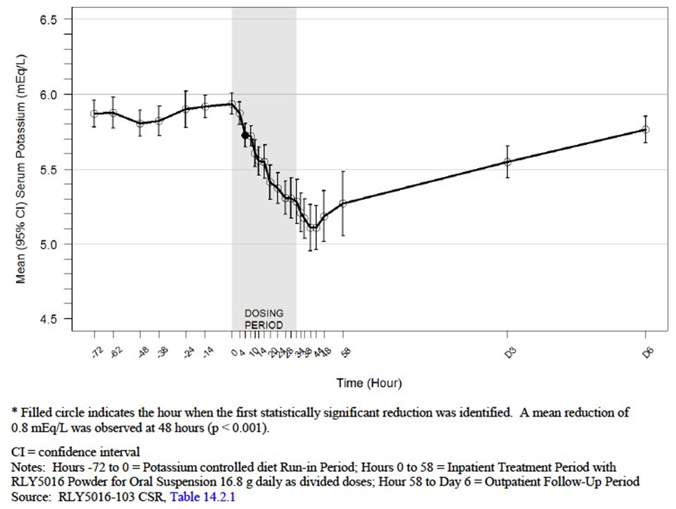

Relationship between drug concentration and pharmacodynamic effects
Not applicable, given non-absorbability of PSC.
Gender and age related differences in pharmacodynamic response
Gender and age related differences in PD would not be expected, given the mechanism of action of the compound, and have been analysed in several studies but not clearly reported. The Clinical Overview is deficient in its handling of this issue, stating only that the effects of age and sex have been evaluated in Phase II and Phase III studies, but not included any outcome of this evaluation. An analysis of efficacy by age and gender has been included in the Summary of Clinical Efficacy, providing the results from Studies 301 and 205. No consistent differences in the effect on serum potassium were noted between subgroups.
Pharmacodynamic interactions
No pharmacodynamic drug interactions are likely to occur because of the non-absorbability of PSC. Any drug interactions would be expected to be due to binding of the interacting drug within the GIT lumen, thus causing changes in PK of the drug, rather than changes in PD. The potential for PK interactions has been addressed but not yet adequately dealt with.
The issue of a possible PD interaction with food has not been addressed in the development program. In all clinical studies, patiromer in its various forms was administered with food, and thus its capacity to bind potassium in the presence of food has been demonstrated. From first principles, the absence of food would be very unlikely to reduce its potassium binding capacity.

Evaluator’s conclusions on pharmacodynamics
The mechanism of action of PSC has been adequately demonstrated to be the binding of potassium within the GIT lumen, and its time of onset has also been adequately supported (7 hours). The in vitro and animal studies are consistent with the results of studies in healthy volunteers and in patients with CKD. The mode of action is similar to that of other potassium-binding compounds.
The major deficiency in the dossier is an absence of any data dealing with the impact of food on the effect of PSC on SK. However, experience with other potassium-binding compounds, together with the fact that the site within the GIT where PSC has its major effect is the colon, suggests that food is very unlikely to have any impact on efficacy or safety. All clinical studies were carried out with administration of PSC with food, and the PI and CMI provide clear instructions regarding dosing with food.

Dosage selection for the pivotal studies
A dose ranging study was carried out in healthy volunteers (101) using four dose levels (1 g TDS, 5 g TDS, 10 g TDS and 20 g TDS, expressed as the calcium form), which demonstrated that the minimum dose of RLY5016 that statistically significantly increased faecal potassium excretion was 5g TDS and that the effect was dose dependent, with 10 g TDS and 20g TDS showing progressively greater effects. In Study 102, healthy volunteers were given a total daily dose of 30 g in three dosing regimens (30 g once daily, 15 g BID and 10 g TDS). All three dosing frequencies resulted in significant increases in faecal potassium excretion and there were no significant differences between them. On this basis, the frequency of dosing chosen for the pivotal study was twice daily, and this is appropriate.
Study 205 was a dose-ranging study in patients with CKD who were hyperkalaemic at Baseline.. Although there were several features of the design and conduct of the study that resulted in difficulty with interpretation of its results, the primary endpoint (change in serum potassium from Baseline to Week 4) was interpretable and showed a statistically significant reduction in all dosing groups, including the lowest dose (8.4 g/day of anionic polymer), which was given to participants with baseline serum potassium of > 5.0 and ≤ 5.5 mEq/L. The lowest dose given to those with baseline serum potassium of > 5.5 and < 6.0 mEq/L was 16.8 g/day, and this was also associated with a significant reduction in serum potassium over four weeks.
The dosage regimen selected for the single pivotal study (Study 301) was based on these results, with hyperkalaemic subjects stratified by baseline serum potassium to similar groups as in Study 205 (Dose group 1 was the same as the lower serum potassium group in Study 205 while Dose group 2 extended serum potassium from 5.5 to < 6.5 mEq/L).
The two dose groups received starting doses of 4.2g BID and 8.4g BID respectively. All doses were administered with food, and the dose of PSC was titrated to achieve a serum potassium target range of 3.8 to < 5.1 mEq/L, up to a maximum daily dose of 50.4 g. The starting doses and the titration of dosage in Study 301 were appropriate, although it is noted that the recommended dose in the submission varies from this (once daily dosing, starting at 8.4 g and titrating upwards to 25.2 g/day).

Efficacy

Studies providing efficacy data
The submission contained only one study (Study 301) designated by the sponsor as a pivotal study, with several supporting studies (dose-finding, pharmacodynamics). Having regard to the TGA adopted EU Guideline CPMP/EWP/2330/99 Points to Consider on Applications with 1. Meta Analyses; 2. One Pivotal Study, one pivotal study can be sufficient if it has statistically compelling and clinically relevant results, and where the study has strong internal and external validity, strong statistical significance, and high quality data. Study 301 meets these requirements.
Other studies providing information about efficacy include some of the Pharmacodynamic studies already considered which were carried out in hyperkalaemic patients (Study 103 in hyperkalaemic subjects with CKD, Study 201 in hyperkalaemic dialysis patients, and Study 205 in hyperkalaemic subjects with diabetes and hypertension taking RAS inhibiting drugs). A tabulation of the main efficacy results appears below.

Table 9: Summary of efficacy results derived from pharmacodynamic studies
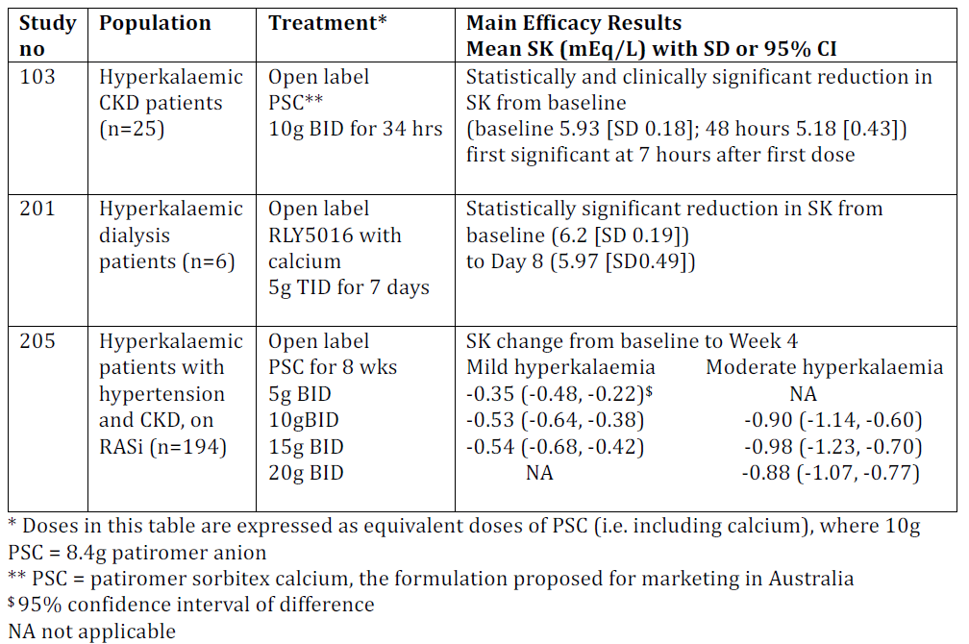

Evaluator’s conclusions on efficacy
The clinical dossier is relatively light in data, and includes only one Phase III study and one double-blinded study. Most studies were non-comparative in design. Of the eight clinical studies, only four provide data relevant to the indication (that is treatment of hyperkalaemia), and all of these had non-comparative, single-blind designs . The other four provide supporting data related to the mechanism of action of PSC in healthy subjects and to the prevention of hyperkalaemia in patients with CKD commencing on RAASi drugs. It seems likely that the compound would be effective for the latter purpose, but this indication has not been proposed in the current submission.
Randomisation methods, in studies with comparators, were adequate. All studies used clinically relevant outcome measures, and the treatment studies used various parameters related to serum potassium, which is appropriate.
- The pharmacological mechanism of action is well understood
- Binding of potassium within the gut lumen is a well established approach to treating hyperkalaemia
- Phase I and II data confirm the mechanism of action in both healthy volunteers and patients with hyperkalaemia
- Study 301 has strong internal and external validity, adequate data quality and internal consistency, has demonstrated a clinically relevant effect of PSC, and the statistical significance is stronger than p < 0.05.
Taken overall, the data adequately demonstrate that PSC binds potassium in the GIT lumen, and in so doing reduces serum potassium in hyperkalaemic patients to a clinically relevant extent. Although the data relating to treatment of existing hyperkalaemia have all been obtained in patients with CKD and eGFR of 15 to 60 mL/min/1.73m², there is no reason to suspect that the effect would be limited to this group, given the mechanism of action. There are no differences in the efficacy in subpopulations defined by gender or age, and there were too few subjects of varying ethnicity to allow assessment of any differences, but it seems unlikely that these would exist.
The proposed dose has been adequately explored, and a starting dose of 8.4g once daily is appropriate, with subsequent dose titration according to serum potassium, up to a maximum of 25.2g daily. Long-term dosing is supported only by the pivotal study, which monitored efficacy to a total of 12 weeks of treatment. A long-term (52 week) study (Study 205) had significant flaws in its design and conduct, which prevent the long term data from being reliable in relation to efficacy. These have not been identified in the Clinical Overview, which appears to regard the data from the study as reliable.
However, this study does provide relevant safety data. There are no other important areas of disagreement with the Clinical Overview.

Safety

Studies providing safety data
The following studies provided evaluable safety data.

Pivotal efficacy study
In the pivotal efficacy and safety study (Study 301), the following safety data were collected:
- Part A: General adverse events (AE) were assessed by open-ended questioning, vital signs and physical examination at all scheduled visits.
- Part B: General AEs were assessed by open-ended questioning and vital signs on Day 3, then Weeks 1, 2, 3, 4, 5, 6, 7 and 8.
- Laboratory tests, including serum chemistry (including renal function), plasma renin activity and serum aldosterone, were performed at all scheduled visits in both Parts A and B.
- Part A: at Baseline and Week 4, or at early withdrawal from Part A, additional investigations included haematology, haemoglobin A1c, urinalysis and urine albumin: creatinine ratio (ACR).
- Part B: at Baseline, Week 4 and Week 8, or at early withdrawal from Part B, additional assessments included haematology, urinalysis, urine ACR; at Baseline and Week 8, additional assessments included haemoglobin A1c and physical examination.
- AEs of particular interest, including hypokalaemia and hypomagnesaemia, were assessed by biochemistry testing at each study visit as above
- 12 -lead electrocardiogram (ECG) was performed at all study visits in both Parts A and B.

Pivotal studies that assessed safety as a primary outcome
There were no additional pivotal studies that assessed safety as a primary outcome.

Dose response and non pivotal efficacy studies
The dose-response and non-pivotal efficacy studies provided safety data, as follows:
- Studies 101 and 102 provided data on safety and tolerability in healthy subjects over 8 and 18 days of treatment, respectively; Study 101 used unformulated RLY5016, with the potential to release fluoride from the crystalline compound, while Study 102 used unformulated RLY5016S, with a calcium–sorbitol counterion complex to achieve greater stability.
- Study 103 provided data on short-term safety and tolerability in patients with hyperkalaemia and CKD over 2 days of treatment, using PSC (the formulation proposed for marketing).
- Study 201 provided data on short-term safety and tolerability in patients on haemodialysis over 7 days of treatment with unformulated RLY5016, with the potential to release fluoride.
- Study 202 provided data on safety and tolerability in patients with heart failure with or without CKD who were commencing on RAASi treatment, over 28 days of treatment with formulated RLY5016S with multiple excipients.
- Study 204 provided data on safety and tolerability in patients with CKD and heart failure commencing on RAASi treatment, over 56 days of treatment with the same formulation as Study 202.
- Study 205 provided data on safety and tolerability in hyperkalaemic patients with CKD, type 2 diabetes mellitus and hypertension over one year’s treatment with PSC.

Other studies evaluable for safety only
There were no studies that were completely omitted from consideration in relation to efficacy.

Patient exposure
In the pooled analysis in the Clinical Overview, 734 subjects are identified as having been exposed to at least one dose of PSC and related compounds. This is confirmed by reference to the CSRs for all studies. Of these, 37 healthy volunteers were exposed in clinical pharmacology studies, 578 hyperkalaemic subjects were exposed to PSC in treatment studies, and 119 subjects who were at risk of hyperkalaemia were exposed in prevention studies. The Clinical Overview includes only 666 subjects in the pooled safety analysis, omitting the 37 healthy volunteers in the clinical pharmacology studies (Studies 101 and 102), the 25 patients with hyperkalaemia and CKD in treatment Study 103, and the 6 patients on haemodialysis in treatment Study 201. The following tables reinstate these subjects to the overall safety analysis.
A further 365 healthy subjects were exposed to 25.2 g PSC for 2 doses in the 12 additional drug-drug interaction studies. At the time of writing of the clinical overview (11 March 2016), safety data from these studies was ‘not yet available’ and not included in the safety analysis. Safety data from these studies (Studies 102 to 115 inclusive) were not included in the PK reports describing the results of each of these studies and were thus not available to this evaluator. This is a significant exposure to PSC that has not contributed to the safety assessment, and these subjects are not included in the table below.

Table 10: Exposure to patiromer and related compounds and comparators in clinical studies
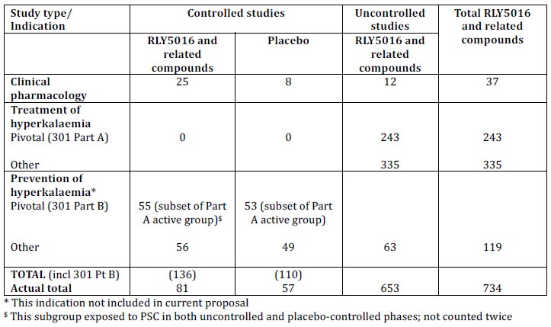

Table 11: Exposure to PSC and related compounds in clinical studies according to starting dose and duration
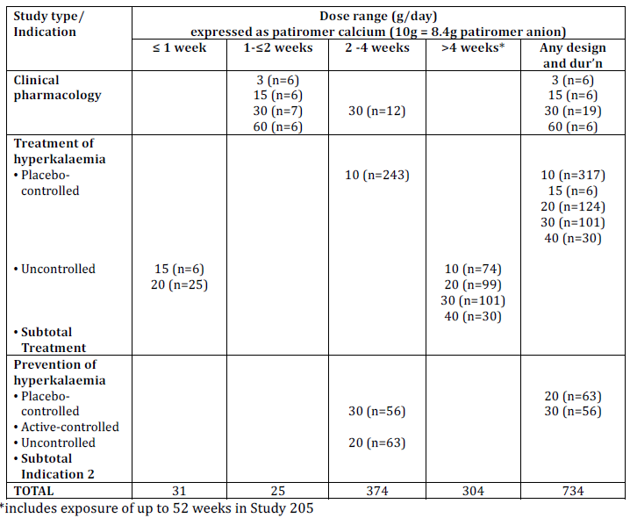

Postmarketing data
Patiromer sorbitex calcium was approved by the US FDA on 21 October 2015 for the treatment of hyperkalaemia in adults and was launched early in 2016. No post-marketing surveillance data are provided in the submission.

Evaluator’s conclusions on safety
The submission has demonstrated that PSC is not systemically absorbed, although fluoride, an impurity present in the patiromer anion, was released from early forms of the compound. Thus systemic safety issues are limited to the downstream effects of the actions of PSC within the GIT lumen. These include hypomagnesaemia and the potential for fluoride toxicity. There is no evidence for significant effects on calcium homeostasis or sodium homeostasis. The commonest treatment emergent adverse events (TEAE) reported in the pivotal study (Study 301) and the other clinical studies were related to the local effects of PSC within the GIT, manifested as constipation, diarrhoea, abdominal discomfort or pain, flatulence and vomiting. These were also the commonest AEs regarded as related to treatment with PSC and related compounds.
Many of the other TEAEs reported in the clinical trials program were related to the underlying co- morbidities of the subjects enrolled in the studies, all of whom either had hyperkalaemia or were at risk of hyperkalaemia because of the presence of various combinations of CKD, type 2 diabetes mellitus, heart failure and treatment with drugs that tend to raise serum potassium (such as RAASi drugs). The two studies with placebo-controlled treatment phases (Study 301 Part B and Study 202) provide useful information about the baseline rate of AEs in this subject demographic. An important observation is that the exacerbation of renal dysfunction occurred at similar rates in both the active and placebo treated groups. It is reasonable to conclude that the AEs of most relevance to treatment with PSC include GIT disorders and hypomagnesaemia and that PSC in itself does not cause exacerbations of renal or heart failure.
The analysis of deaths and serious adverse events demonstrates a similar pattern. While there were several deaths during the clinical program (one in the pivotal Study 301, and 18 in other clinical trials), none of these was attributed to treatment with PSC or related compounds, and all were related to underlying co-morbidities. The sponsor’s analysis of the expected death rate in the population included in the long-term treatment trial indicates that the death rate in the trial was similar to what would have been expected over the 52 week treatment period.
No concerns regarding safety of PSC are raised by the discontinuations from active treatment (occurring in 6 to 12% of patients), most of which were due to GIT disorders or to events related to the underlying co-morbidities within the population.
The laboratory data indicate that treatment with PSC does not exacerbate renal dysfunction (see Figure 2, for the mean eGFR over time in the pivotal study). There are no concerns about liver toxicity. There are two findings of potential concern. One is a clear propensity for PSC to cause hypomagnesaemia, which is probably exacerbated by concomitant use of magnesium-wasting drugs such as diuretics. PSC is known to bind magnesium ions within the GIT lumen, and there was a clear temporal relationship between cessation of treatment in those with hypomagnesaemia and resolution of the abnormality. There is some concern relating to the variable onset of hypomagnesaemia that was observed in the long-term treatment study, which suggests that monitoring of serum magnesium only during the first month of treatment (as advised in the draft PI) will not detect the majority of cases and that monitoring will need to continue for the duration of treatment.
Figure 2: Mean eGFR (ml/min/1.73m2) over time while on PSC during Part A and on IP during Part B (Part B Safety Population)
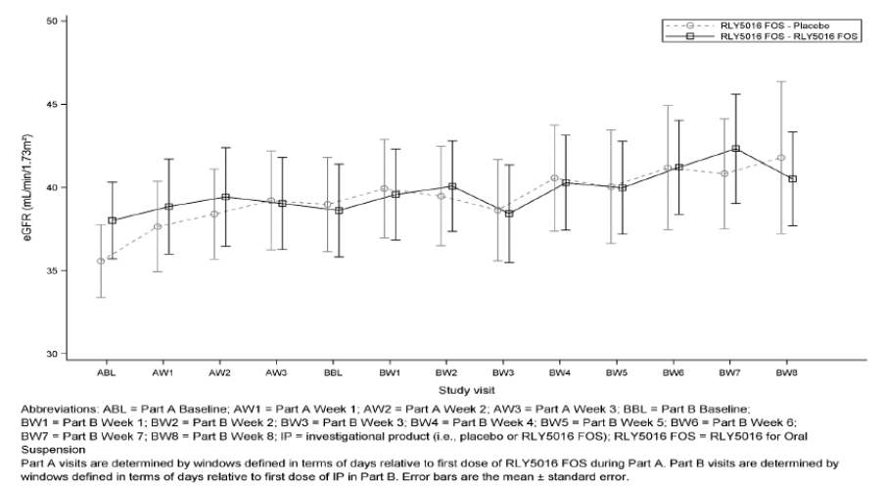
The second finding of potential concern is the observation that serum fluoride increases during treatment with patiromer compounds. This is related to the known impurity in the polymer anion, and has been reduced, but not completely eliminated, by changes in the formulation of the compound. However, both the maintenance treatment phase of Study 301 and the long-term treatment Study 205 provide some reassurance that the formulation proposed for marketing causes only a small rise in fluoride levels, that is not clinically significant and does not progress over 52 weeks of treatment.
There are no important disagreements with the Clinical Overview in relation to safety, although it does appear to minimise the importance of the reductions in serum magnesium more than is warranted.

First round benefit-risk assessment

First round assessment of benefits
The benefits of patiromer sorbitex calcium in the proposed usage are:
- Reduction in serum potassium in patients with hyperkalaemia; onset within 7 hours and clinically significant reduction achieved; recurrence prevented in the majority of patients with continued maintenance treatment
Note that calculation of the number needed to treat to achieve the desired outcome is not possible in the absence of placebo-controlled treatment trials.

First round assessment of risks
The risks of patiromer sorbitex calcium in the proposed usage are:
- Binding of magnesium within the GIT leading to potentially significant hypomagnesaemia, which may be exacerbated in the presence of concomitant treatment with magnesium-wasting drugs
- Binding of other drugs within the GIT leading to potential drug interactions

First round assessment of benefit-risk balance
The benefit-risk balance of patiromer sorbitex calcium (Veltassa) is unfavourable given the proposed wording of the draft PI, but would become favourable if the changes to the PI recommended are adopted.
PSC is effective in the treatment of hyperkalaemia and maintenance of normokalaemia in patients with CKD, the commonest cause of chronic hyperkalaemia. For it to be used safely, prescribers will need to understand its associated risks, particularly related to hypomagnesaemia and potential drug interactions as above. These risks are likely to be manageable with appropriate attention to the information provided in the PI.

First round recommendation regarding authorisation
At this point in time, there are no clinical reasons to reject the application, subject to changes to the draft PI to deal with the issues of hypomagnesaemia and drug interactions.

Clinical questions and second round evaluation

Safety
- No comment on safety is made in the Drug interaction reports provided and the 365 participants were not included in the pooled safety analysis in the Clinical Overview. What was the safety profile of PSC in the 12 drug-drug interaction studies (Studies 102 to 115 inclusive) carried out in healthy volunteers?

Sponser response
The response includes a tabulated summary of adverse events in the drug-drug interaction Studies RLY5016-104 to 115, conducted in normal human volunteers. Each study had three phases, and PSC was given in two of them, at a single dose of 25.2 g in Phase B and as two doses of 25.2 g given 24 hours apart in Phase C. In Phase A, the potentially interacting drug was given alone. There was a significant reduction in the total extent of absorption of levo-thyroxine, metformin and ciprofloxacin when given concomitantly with PSC, but there was no reduction in bioavailability when the doses were separated by at least three hours.
The safety data for each study have now been provided. There were no deaths or treatment-related serious adverse events (SAE) in any study. One subject was discontinued from Study 112 because of appendicitis which was judged to be unrelated to treatment.

Table 12: Number of adverse events in the various treatment phases, by study
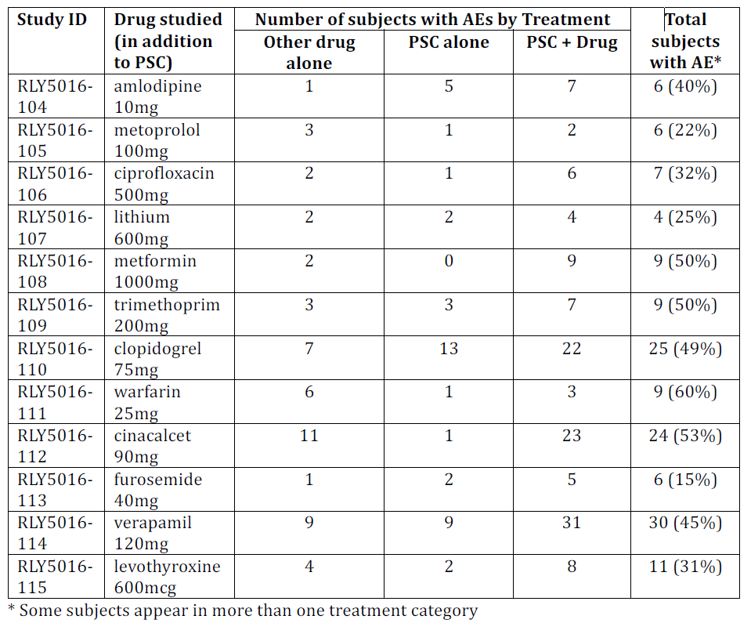
The total number of subjects experiencing AEs was relatively high for such short-term studies in healthy volunteers, and more subjects reported AEs during the combination treatment phases than the single drug phases. This may be explained by the effects of the various combinations, or the additive effects of two drugs, or the fact that Phase C included 2 doses of PSC (one 21 hours before dosing with the target drug and one given 3 hours after).
The nature of AEs observed in the drug interaction studies is summarised below. No information was available in the response to link specific AEs to the different treatment phases.

Table 13: Nature of AEs observed in the drug-drug interaction studies
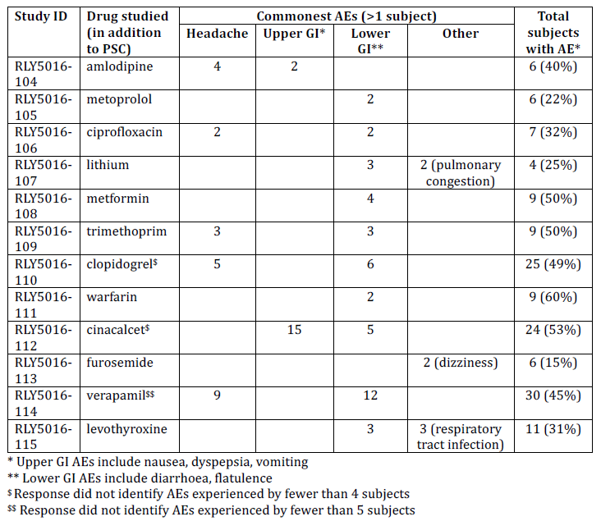

Evaluation of response
While the summary does not provide detail of all AEs experienced during these short-term studies, during which each subject received a total of three doses of PSC, the commonest events were consistent with the safety profile observed in the clinical treatment studies. The summary did not reveal whether or not serum magnesium was measured in these subjects, but this is not a critical omission since it would be unlikely for changes in magnesium to be observed after only three doses of PSC

Second round benefit-risk assessment

Second round assessment of benefits
The assessment of benefits has not changed following the evaluation of the response, which was not asked to address benefits.

Second round assessment of risks
The additional safety data provided do not alter the assessment of risks of patiromer sorbitex calcium. The risks of PSC in the proposed usage are:
- Binding of magnesium within the GIT leading to potentially significant hypomagnesaemia
- Binding of other drugs within the GIT leading to potential drug interactions.

Second round assessment of benefit-risk balance
Given the changes to the draft PI, which now adequately inform prescribers of the potential risks of the use of PSC and their mitigation, the benefit-risk balance of patiromer sorbitex calcium is favourable.

Second round recommendation regarding authorisation
Given that appropriate modifications have been made to the draft PI to deal with the issues of hypomagnesaemia and drug interactions, there are now no clinical reasons to reject the application.

VI. Pharmacovigilance findings

Risk management plan

Summary of RMP evaluation
- The EU-RMP version 1.0 dated 15 March 2016 (data lock point 20 January 2016) with Australian Specific Annex (ASA) version 1.0 dated 15 September 2016 was submitted in support of this application. The sponsor has provided the updated EU-RMP version 1.4 dated 17 May 2017 (data lock point 20 January 2016) with ASA version 1.1 dated 27 June 2017 with the post-first round evaluation response.
- The proposed Summary of Safety Concerns and their associated risk monitoring and mitigation strategies are summarised below in Table 14.

Table 14: Summary of safety concerns and their associated risk
Summary of safety concerns |  | Pharmacovigilance |  | Risk Minimisation
 |  | Routine | Additional | Routine | Additional
Important identified risks | Hypomagnesaemia/low magnesium |  | – |  | –
Important potential risks | Increased risk of intestinal perforation in patients with current or history of severe  GI disorders¹ |  | – |  | –
Important potential risks | Increased risk in patients with current or history of hypercalcaemia¹ |  | – |  | –
Missing information | Use in pregnant or lactating women |  | – |  | –
Missing information | Use in patients < 18 years old |  | ³ |  | –
Missing information | Safety with long-term use (> 1 year)^{1, 2} | - | - | - | -
Missing information | Use in aboriginal and Torres Strait islanders^{1, 2} |  | – | - | –
¹Safety concerns added in the updated RMP in response to the round 1 evaluation ²Australian-specific safety concerns ³Paediatric investigation plan
- Routine pharmacovigilance is proposed to monitor all the safety concerns. A paediatric investigation plan has been agreed with the EMA to monitor safety in patients under the age of 18 years.
- Routine risk minimisation has been proposed for all the safety concerns. No additional risk minimisation is considered necessary by the sponsor.

New and outstanding recommendations from second round evaluation
The recommendation made in the first round evaluation, along with consideration of the sponsor response.
This is an outstanding recommendation from Recommendation 2 of the first round RMP evaluation. The sponsor advised that ‘safety with long-term use (> 1 year)’ had been added to the ASA in its response. However, the evaluator could not locate the safety concern in the updated ASA. The sponsor should update the ASA to reflect this addition.

Proposed wording for conditions of registration
Any changes to which the sponsor has agreed should be included in a revised RMP and ASA. However, irrespective of whether or not they are included in the currently available version of the RMP document, the agreed changes become part of the risk management system.
The suggested wording is:
The EU-RMP version 1.4 dated 17 May 2017 (data lock point 20 January 2016) with ASA version 1.1 dated 27 June 2017 to be revised to the satisfaction of the TGA, must be implemented (see outstanding issues above).

VII. Overall conclusion and risk/benefit assessment
The submission was summarised in the following Delegate’s overview and recommendations.

Quality
The chemistry evaluator recommends approval.
Patiromer (as sorbitex calcium) is a 3 dimensional (3D), cross-linked, non-selective, cation exchange polymer. Patiromer is the free acid form of the drug substance and it is the acid form of the active moiety that is the patiromer anion. Patiromer sorbitex calcium is an amorphous free-flowing powder that is composed of individual spherical beads with an average target particle size of approximately 100 microns, and an average molecular weight of 5.6 x 10¹⁷ g/mol. Each particle is a single molecule. The drug substance is a non selective cation binder, thus can bind other drugs such as magnesium, calcium, sodium and ammonium. The drug product has been formulated as a non-soluble, amorphous free flowing powder designed as a powder for oral administration after suspension in water, apple juice or cranberry juice. The drug product is essentially the drug substance and a very small amount of xanthan gum (approximately 0.7%) and three dose strengths are proposed for registration. These contain 16.8 g, 33.6 g and 50.4 g of patiromer sorbitex calcium equivalent to 8.4 g, 16.8 g and 25.2 g of patiromer anion respectively.
The proposed drug substance manufacturing process produces a polymer with a low swelling index, and high potassium binding capacity at approximately 9mmol/g. Both the total potassium binding capacity (TKEC) and swelling index are controlled in the drug substance specifications.
It is important to note that the hydrated ionic diameters of potassium, magnesium and calcium are similar to each other (0.662, 0.856, and 0.824 nm respectively) but are several orders of magnitude smaller than the pore size of the drug substance that is 140 to 220 nm. Therefore, the crosslinking density, and consequently the pore size does not affect the diffusion of the cations into the interior space of the polymer or cause differential binding site access to magnesium as compared to potassium or calcium. As such, pore size was not considered to be a critical quality attribute for the drug substance and is not monitored in the drug substance specification.

Nonclinical
The non clinical evaluator had no concerns.
Patiromer has a acid dissociation constant (pKa) of 6, therefore more drug will be ionised in the high pH of the large intestine than the small intestine.
The effect of PSC on faecal, urine and serum electrolytes were examined in rats and pigs with normal kidney function and rats with hyperkalaemia. Increased excretion of faecal potassium was seen in both species, accompanied by a decrease in urinary excretion of potassium in pigs and decrease in serum potassium in rats. Higher faecal sodium excretion was also seen in treated animals. There was binding of sodium, ammonium and magnesium to patiromer beads isolated from humans.
A biologically relevant in vitro test system was used to evaluate potential interactions between PSC and 28 orally administered compounds commonly used in the target patient population. The studies were conducted in 3 different matrices simulating the conditions in different parts of the GIT over a range of pH values, using the highest proposed dose of PSC (25.2 g). Fourteen compounds were reported to demonstrate binding by PSC at 30% of the dose or more, and twelve of these were chosen for the clinical studies. The sponsor omitted including quinidine, which is rarely used, and thiamine, from the clinical studies. Hence there is no data about the impact of long term use of PSC on thiamine deficiency in humans.
In vitro data indicate the potential for PSC to increase stomach pH by binding hydrogen ions (H⁺), affecting co-administered drug solubility and consequent absorption and giving rise to pharmacokinetic interactions similar to those caused by antacids. In the clinical context however, PSC is to be taken with food, which itself raises pH, thus any additional effects of PSC will be modest.

Clinical

Formulation
Different forms of the drug substance were used during the clinical evaluation program. The pivotal clinical study used the formulation proposed to marketing. The evaluator considered that it is reasonable to use the data from the studies using different formulations, but noted caution in interpreting doses as this differ according to whether the anion or salt are used.

Pharmacology
No PK studies were performed in humans. In dogs, < 1% of the drug was absorbed.
12 clinical drug interaction studies were performed. These were open label cross over studies in healthy volunteers using 25.2 g PSC. The medicines tested included amlodipine, metoprolol, ciprofloxacin, lithium, metformin, trimethoprim, clopidogrel, warfarin, cinacelcet, frusemide, verapamil and levo-thyroxine. Concomitant administration of PSC resulted in significant reduction in the total extent of absorption of levo-thyroxine, metformin and ciprofloxacin, however no reduction in bioavailability was observed when the doses were separated by at least 3 hours.
The FDA approved PI originally had a boxed warning that recommended doses of PSC be separated from other orally administered drugs by at least 6 hours. In 2016, theboxed warning was removed and the recommended separation reduced to at least 3 hours. In the EU, the Summary of Product Characteristics (SmPc) and in the proposed Australian PI, it is recommended that Veltassa be administered 3 hours before or after other medicines.
There were no studies to examine the effect of food on PSC. All studies in humans were performed when the drug was given with food.
Clinical studies showed PSC increases the faecal excretion of potassium in healthy volunteers and patients with chronic kidney disease. In healthy volunteers, faecal magnesium concentrations increased with daily doses of 10 g or higher, but serum magnesium remained normal. However in clinical studies in patients with chronic kidney disease, faecal magnesium increased and low serum magnesium levels were observed in some patients.
After a single dose, the serum potassium begins to fall at 4 hours, has it’s peak effect after 7 hours, the effects have disappeared by approximately 24 hours.
In healthy volunteers, the minimum effective dose was 5 g three times a day, with increasing response with increasing dose. There was no significant difference in serum potassium when healthy volunteers were given 30 g as a daily dose versus in two or three divided doses.
Figure 3: Time course of pharmacodynamics effect (mean (95% CI) serum potassium over time patients receiving PSC 16.8 g daily (as 8.4 g doses at 0, 10, 24 and 34 hours)
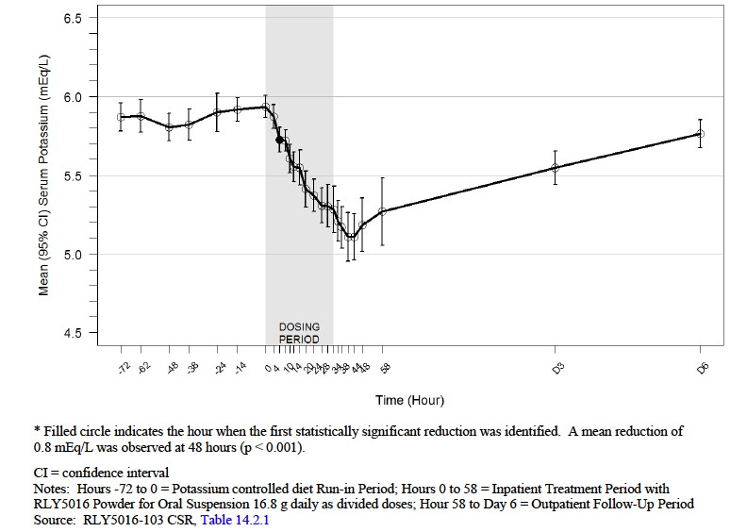

Efficacy
The efficacy of PSC was demonstrated by evidence based on clinical data from the following studies:
- Study 301: (Phase III) Part A: Treatment phase; Part B: Randomised withdrawal phase.
- Study 205: (Phase II) Dose finding study.
- Study 103: (Phase I) PD study.

Study 301 (Pivotal Study)
Study 301 was a 12 week, two-part Phase III study, designed to determine the efficacy and safety of PSC for the treatment of hyperkalaemia in patients with CKD receiving a stable dose of at least one RAASi (renin-angiotensin-aldosterone system inhibitors).
No dose adjustment of RAASi medications were made during part A of the study.
- Key exclusion criteria:
  - Potassium-related ECG changes
  - Severe GI disorders
  - Type 1 diabetes mellitus (T1DM)
  - Stroke
  - Uncontrolled or unstable arrhythmias
  - NYHA class IV heart failure.

Treatment
The starting dose of PSC was based on severity of hyperkalaemia.Subjects with mild hyperkalaemia (Group 1, serum potassium: 5.1 to ≤ 5.4 mEq/L): 4.2 g PSC BID. Subjects with moderate-to-severe hyperkalaemia (Group 2, serum potassium: 5.5 to < 6.5 mEq/L): 8.4 g PSC BID.
The dose of PSC was adjusted during the initial treatment phase to reach and maintain target potassium according to a pre-specified algorithm, with a maximum daily dose of 50.2 g of PSC.

Study endpoints
Part A
- Primary efficacy endpoint: Mean change in potassium from Baseline to Week 4.
- Secondary efficacy endpoint: Proportion of subjects who had reached the target potassium range (3.8 to < 5.1 mEq/L) at Week 4.
Part B
- Primary efficacy endpoint: Difference in median change in potassium between groups from the start of the withdrawal phase to Week 4 or the earliest visit when the subject’s potassium was < 3.8 mEq/L or ≥ 5.5 mEq/L.
- Secondary efficacy endpoint: Proportion of subjects that had a recurrence of hyperkalaemia (at least one potassium value ≥ 5.5 mEq/L).

Baseline characteristics
243 patients were enrolled in Part A. The mean serum potassium was 5.6 ± 0.5 mEq/L (38% had serum potassium of 5.1 to < 5.5 mEq/L and 62% had a serum potassium of 5.5 to < 6.5 mEq/L); 97% of patients had hypertension and 42% had heart failure; 45% had eGFR < 30 mL/min/1.73m². The compliance rate was satisfactory with 92% of patients in Group 1 and 89% of patients in Group 2 who were enrolled in Part A completed the study period, indicating that the drug was well tolerated.

Results
The study achieved primary efficacy endpoint (reduction from baseline in serum potassium of at least 0.7 mEq/L with a p-value < 0.05, as established with FDA).
The mean change of serum potassium across dose groups (Dose group 1 and 2) at 4 weeks was -1.01 (standard error of the mean (SEM) 0.031; p< 0.001). The mean daily dose of PSC was 12.8 g and 21.4 g in mild and moderate-to-severe hyperkalaemic subjects respectively.

Table 15: Estimated change in serum potassium (mEq/L) (Part A, ITT population)
Figure 4: Observed means with standard error (SE) of serum potassium (mEq/L): Part A (ITT population)

Secondary efficacy endpoint
At Week 4, 76% (95% CI 70 to 81%) of the total patient population achieved serum potassium within the range 3.8 to < 5.1 mEq/L. Of the remainder, 24% discontinued from the study, 3% had serum potassium < 3.8 mEq/L, and 11% had serum potassium ≥ 5.1 mEq/L.
Part B: 107 subjectsentered the 8 week randomised withdrawal phase. The median change in serum potassium in the placebo group (who had withdrawn from PSC at Part B Baseline) was an increase of 0.72 mEq/L, whereas the group who continued on PSC had no change in their serum potassium.

Study 205
The 52 week Phase II, open-label, dose ranging study evaluated the efficacy and safety of PSC in patients with hyperkalaemia and diabetic nephropathy. This study was designed to determine the optimal starting and maintenance dose of PSC. All subjects in the study were on an angiotensin converting enzyme inhibitor (ACEi) or an angiotensin II receptor blocker (ARB), with or without spironolactone.
Subjects with CKD, T2DM, and potassium > 5.0 mEq/L were enrolled, categorised as shown in Table 16 (shown below) and randomised to receive one of four starting doses of PSC.
Table 16: Study 205 study design

Inclusion criteria
- Age 30 to 80 years at screening
- Diagnosis of T2DM
- CKD with eGFR 15 to < 60 mL/min
- Documented hyperkalaemia
- Receiving an ACEi or ARB for at least 28 days prior to screening.

Key exclusion criteria
- T1DM
- Diabetic gastroparesis
- Non-diabetic CKD
- Severe GI disorders.

Study design
The study was divided into three groups based on clinical characteristics. Subjects in Cohort 1 and 2 were normokalaemic at screening and developed hyperkalaemia during the run-in phase. Cohort 3 had pre-existing hyperkalaemia and were directly randomised to receive PSC. PSC dose initiation was determined by baseline serum potassium. The dose of PSC was titrated as needed to achieve and maintain a potassium level of ≤ 5.0 mEq/L.

Results
A total of 306 subjects were randomised, out of which 241 patients were analysed for efficacy in Per Protocol (PP) population. In all three cohorts, statistically significant reductions in serum potassium across starting dose groups were seen within 48 hours of initiating PSC. A statistically significant decrease in potassium from Baseline to Week 4 was seen in all study groups. The observed least square mean (LSM) of potassium within the normal range (3.8 to 5.0 mEq/L) was maintained up to 1 year with continued PSC treatment. A rise in potassium was noted after PSC discontinuation. The most common AEs over 52 weeks were worsening of CKD (9.2%), followed by hypomagnesaemia (8.6%).
The lowest effective doses of patiromer for to achieve normokalaemia for a baseline serum potassium of 5.1 to < 5.5 mEq/L and serum potassium 5.5 to < 6.5 mEq/L were 8.4 g/day and 16.8 g/day respectively.
Figure 5: Mean serum potassium during the entire treatment period and follow-up by cohort (ITT population)
Significant (p < 0.001) increases in least squares mean serum potassium levels were seen by Day 3 post-treatment in patients with mild hyperkalaemia. Twenty-eight days following the cessation of patiromer treatment, the least squares mean increase in serum potassium level was 0.39 (95% CI, 0.32 to 0.46) mEq/L in patients with mild hyperkalaemia (n = 126) and 0.48 (95% CI, 0.31 to 0.62) mEq/L in those with moderate hyperkalaemia (n = 47) (p < 0.001 for both strata)(Figure 4).

Study 103
This was a Phase I, open-label, single arm study to determine the time to onset of action of PSC in subjects with CKD and hyperkalaemia.

Treatment
During a 3 day diet run-in period, subjects received a controlled diet containing 60 mEq/day potassium and 100 mEq/day sodium, part of standard of care for managing CKD patients with hyperkalaemia. The first dose of PSC was administered immediately after the baseline blood sample was drawn and with the morning meal on Day T1 (Time 0). Subjects received 3 more doses of 8.4 g patiromer each with meals at 10, 24, and 34 hours after the initial dose, for a total of four doses.

Results
25 subjects were treated and completed the study. The mean baseline serum potassium level was 5.93 mEq/L; 68% of subjects had baseline serum potassium levels ≤ 6.0 mEq/L and the remainder (8 subjects, 32%) had levels > 6.0 mEq/L.
The time of onset of action of PSC was determined to be 7 hours, 40% of subjects achieved normokalaemia at 44 hours after administration of four doses of 8.4 g patiromer.
After the last dose of PSC at Hour 34, mean serum potassium values continued to decline reaching a mean (SD) maximal reduction of 0.83 (0.454) mEq/L at Hour 41; by Hour 58 (that is, 24 hours following the last dose), the mean serum potassium had returned to a level similar to that at the time of the last dose (that is, Hour 34) of PSC.

Safety

Study 301
Overall, 15% of patients reported mild-moderate constipation. An increased incidence of adverse events was noted in Group 2 with higher PSC dose. Hypokalaemia was reported in 3% of subjects, which were transient and reversed by dose adjustment. Hypomagnesaemia was reported in 3% of subjects. Non-significant increase in serum calcium levels were observed in first week after dosing in Part A, with no mean increases in subsequent visits.

Study 205
The frequency of discontinuation of study drug due to TEAEs was low (9.2%). The TEAEs that occurred most frequently were chronic renal failure (CRF) (9.2%), hypomagnesaemia (8.6%), hypertension (7.9%), constipation (6.3%) and diarrhoea (5.6%).
Overall, CRF, hypomagnesemia and mild-moderate constipation were the common reported AEs.

Risk management plan
The updated Australian Specific Annex was considered as acceptable by the RMP evaluator. The RMP evaluator has suggested the following wording for conditions for registration:
Implement the EU-RMP version 1.4 dated 17 May 2017 (data lock point 20 January 2016) with ASA version 1.2 dated 9 August 2017 and any future updates as a condition of registration.

Delegate’s comments on the RMP
The incidence of hypokalaemia across all studies was 4.7%, and 5 patients in Study 205 were discontinued due to hypokalaemia. The Delegate recommends hypokalaemia be included as an important identified risk.
Patients with CKD frequently experience anorexia and associated malnutrition, including thiamine deficiency. The in vitro studies with SPC indicate potential binding with thiamine. However, this aspect was not examined in clinical studies. Considering the binding action of SPC in the gut, the Delegate has concerns over non-specific binding of SPC to thiamine, particularly with long term treatment and further, potentially contributing to its deficiency in this patient population. The Delegate recommends that thiamine deficiency be included as a potential risk.

Risk-benefit analysis

Delegate’s considerations

Efficacy
Study 301 demonstrated efficacy in reducing serum potassium in patients with mild to moderate CKD, serum potassium ranging from 5.1 to 6.5mmol/L and on treatment with RAASi. The mean change of serum potassium at 4 weeks was statistically significant (-1.01 (SEM 0.031; p< 0.001). During the 8 week randomised withdrawal phase, all of the patients who continued on SPC maintained serum potassium within the target range, as opposed to 60% of patients where SPC was withdrawn who had serum potassium > 5.1mmol/L at any one time point.
Study 205 demonstrated efficacy and safety of PSC in the treatment of mild to moderate hyperkalaemia in 238 patients with diabetic nephropathy over a period of one year. A statistically significant reduction in serum potassium was achieved at Week 4 and maintained for the rest of the study period. On cessation of treatment, there was a statistically significant increase in serum potassium over follow-up period of 28 days.
Thus, the clinical development program demonstrated efficacy in reducing serum potassium in a population of subjects with mild-moderate renal disease and on treatment with medications that can increase serum potassium. This is a more restricted population than is proposed in the indication.
The clinical development program did not adequately address:
- Whether treatment improved patient symptoms, delayed the need for dialysis, improved survival, or improved quality of life.
- Whether PSC is efficacious in patients on haemodialysis or peritoneal dialysis.
- Use in acute hyperkalaemia or hyperkalaemia associated with tissue necrosis, acidosis and endocrine disorders.

Safety
Overall, PSC was well tolerated across studies. The main adverse events were mild-moderate GI-related AEs.
The following described adverse events warrants close monitoring of patients on treatment with PSC:
- Hypomagnesaemia was reported in 3% and 8.6% of patients in Studies 301 and 205 respectively, which is indicative of non-specific binding.
- Incidence of hypokalaemia in 4.7% of patients across all studies and 5 patients in study 205 who had to discontinue from the study for this AE, despite weekly monitoring of serum electrolytes and rigorous diet counselling.
- Statistically significant rebound hyperkalaemia over 28 days, following cessation of PSC therapy in Study 205.
There are a number of additional safety concerns:
- There is no evidence that this medicine is helpful for acute severe hyperkalaemia. Severe hyperkalaemia is associated with increased mortality due to cardiac arrhythmias and morbidity due to muscle weakness. The delayed onset of action of PSC would make it inappropriate for use in an acute setting, except in conjunction with other agents. This is noted in the precautions section of the PI.
- Long term use: There is no data on the use of PSC over 12 months. This is currently included in the precautions section of the PI..
- In the clinical trials, electrolytes were measured weekly; however, a small proportion of patients still developed electrolyte abnormalities. There is currently no advice in the PI in relation to monitoring.
- Use in patients on phosphate binders: Patients treated with phosphate binders were excluded from the clinical trials. The PI needs to include the use of phosphate binders as a contraindication and/or as a precaution and/or in the drug interactions section.

Dosing recommendations
The dosing regimen in submitted PI is as follows:
The recommended starting dose of Veltassa is at least 8.4 g patiromer (as sorbitex calcium) once daily.
These instructions differ from the dosing regimens in the clinical studies in that it is a single daily dose and there is no stratification based on serum potassium. Furthermore, it is likely that an individual’s response to therapy will also depend upon their dietary potassium intake, other medications, residual renal function, and other systemic disease (forexample, heart failure or hypotension). These factors are not mentioned.
The EU and US PIs also recommended a similar dosing algorithm. The sponsor submitted a Phase I study that showed daily, twice daily and three times daily dosing had similar efficacy in reducing potassium in healthy volunteers. Daily dosing is more practical given the dose needs to be separated from other drugs by over 3 hours. The single starting dose is also the same as in EU and US PIs, however it is unclear why a higher dose is not recommended in those with serum potassium levels 5.5 to 6.5 mmol/L as was used and shown to be efficacious in the clinical studies.

Indication
The current indication is broad, and in the Delegate’s opinion is not supported by the clinical studies. However this indication is also used for other potassium binders (where there is less evidence for their use and more safety concerns) and for Veltassa in the USA and EMA.

Conclusion
The sponsor has provided pharmacodynamic and clinical data that demonstrates PSC binding to serum potassium in the lower GIT and its efficacy in lowering serum potassium. PSC is non selective; and also binds to magnesium. The potential for some drug interactions has been investigated, however a number of medications have not been studied.
The safety profile would suggest that this medicine is probably better tolerated than other available oral potassium lowering medicines. However, the concern is that PSC may be recommended as a better long term option in this aspect. The Delegate is concerned that there is insufficient evidence to support the long term efficacy and safety of PSC and moreover, in a community setting, where patients are less closely monitored than a clinical trial, hypokalaemia and hypomagnesaemia will become significant safety issues.
The sponsor has proposed a very broad indication; with little clinical justification. A major limitation of the clinical trials was that there was no placebo (or active controlled) arm. The sponsor has justified this as being unethical; however the Delegate would not consider standard of care as unethical. Moreover, the risks of treatment need to be balanced against risks of non treatment, or alternative treatments (for example stopping medication, dietary restriction).
Although observational studies have demonstrated that high potassium levels are been associated with mortality in patients with cardiovascular disease, chronic kidney disease and the elderly;, ,,. , there is no evidence that treatment of hyperkalaemia reduces mortality. Low serum potassium levels are also associated with increased mortality ¹⁶ ¹⁹ , thus it is possible that treatment poses a greater risk.
Figure 6: Log hazard ratio for overall mortality in relation to serum potassium with end-stage renal disease
The argument for the use of a potassium binder to control serum potassium in patients with chronic renal and or cardiovascular disease where dietary measures are inappropriate or have failed, and medications which raise potassium are required makes physiological sense. However there is little data that this will actually reduce mortality, and excessive reduction in serum potassium may also have negative consequences. As the currently available potassium binders have low GIT tolerance, there probably is an unmet need in this population.
The Delegate is of the opinion that if this medicine is to be approved for registration, amendments to the PI, CMI and RMP are required to ensure this is used safely. Further controlled studies of the effect of potassium binders on morbidity and mortality, and ongoing periodic safety update reports (PSUR) documenting AEs and drug interactions would be helpful.

Summary of Issues
- Efficacy in reducing serum potassium was demonstrated.
- The clinical trials had no comparator to placebo or currently available potassium binders.
- The proposed indication is broad indication. However the sponsor has not provided any clinical studies with duration greater than 12 months; most patients in the clinical studies had eGFR > 15 mL/1.73m² and (only 6 patients were on haemodialysis, no patients were on peritoneal dialysis); phosphate binders were excluded from the clinical studies; patients with serum potassium > 6.5 mmol/L were excluded from clinical studies.
- Overall, AEs were mild; however hypokalaemia and hypomagnesaemia were commonly seen despite regular monitoring.
- The sponsor performed 28 drug interaction studies using an in vitro model, and 12 in an in vivo model. It is recommended that Veltassa be given 3 hours before or after food.

Proposed action
The Delegate had no reason to say, at the time, that the application for Veltassa should not be approved for registration provided that amendments are made to the PI, CMI and RMP to ensure that this medicine is used safely.

Request for ACM advice
The committee is requested to provide advice on the following points raised by the Delegate:
- Please comment on the role of potassium binders in the management of hyperkalaemia.
- Is the indication acceptable?
- Is further evidence in relation to morbidity and mortality required?
- Please comment if the proposed changes to the PI and CMI and RMP will be sufficient to mitigate the potential risks.

Response from sponsor
The proposed indication for Veltassa is as follows:
‘Veltassa is indicated for the treatment of hyperkalaemia in adults.’
We note the Delegate’s questions to the Australian Committee on MedicinesACM, and the requested amendments to the PI, CMI and the RMP and provide a response to each of the questions and comments.

Questions for the ACM
- Please comment on the role of potassium binders in the management of hyperkalaemia.

Sponsor’s response:
As mentioned in the Delegate’s Overview, management of hyperkalaemia currently relies on dietary restrictions, therapies that eliminate serum potassium from the body (primarily diuretics or oral potassium binding resins), addressing reversible causes, or in those with end stage renal disease, dialysis. In many cases, the underlying cause is a combination of the presence of chronic kidney disease (CKD) and administration of renal and cardiovascular disease modifying drugs, such as renin-angiotensin-aldosterone system inhibitors (RAASi) and beta blockers. Hyperkalaemia is a known side effect in patients who receive these therapies, but their discontinuation is certainly not optimal as RAASi are life-saving medications in chronic heart failure (HF) and have also markedly improved the therapeutic approach to the treatment of hypertension, CKD and diabetic nephropathy. The combination therapy with mineralocorticoid antagonists (MRA) and angiotensin converting enzyme inhibitors or angiotensin receptor blockers have the highest-level recommendations (I A) for cardio-renal patients from all Cardiology and Nephrology professional societies, such as the European Society of Cardiology, European Society of Hypertension, American Heart Association, KDIGO, and NKF-KDOQ.
These medications improve survival and reduce hospitalisations in patients with moderate and severe HF with reduced ejection fraction, one of the major causes of cardiovascular death and disease in Europe and worldwide today. In addition, RAASi medications are reno- protective because they slow disease progression in patients with CKD and albuminuria.
These medications are also essential for cardio-renal patients with the highest risk for poor outcomes due to additional risk factors such as diabetes mellitus and hypertension.
As RAASi medications can provoke hyperkalaemia in patients with reduced renal function, several studies indicate that the fear of inducing hyperkalaemia keeps many clinicians from initiating or even using RAASi medication in patients who need them. Health care providers are forced to balance the risk of provoking hyperkalaemia with the benefit of providing lifesaving therapies.
Since other approaches mentioned above are limited by poor patient adherence, adverse effects on electrolyte and fluid balance, or are too invasive, most physicians decide to reduce the dose or even to discontinue life saving RAASi medications.
Patiromer is an innovative therapy that will support physicians and patients by enabling continuation of RAASi therapy with reduced risk of hyperkalaemia. It will enable physicians and patients to avoid unnecessary RAASi dose reduction or discontinuation, thus allowing patients to experience the full benefits of these therapies with regards to their cardiorenal morbidity and mortality risk.
- Is the indication acceptable?

Sponsor response
The Delegate’s Overview mentions limited clinical data for patients with advanced CKD (end-stage renal disease). Although the number of patients treated with patiromer in the clinical study programme with an eGFR < 15 mL/min/1.73 m² is limited, the results of this analysis suggest that even in those clinical trial patients with severe CKD, patiromer provided both clinically meaningful and statically significant reductions in serum potassium without the risk of more drug-related AEs. Patiromer was as efficacious in the small (N = 21) group of patients with eGFR of < 15 mL/min/1.73 m² as in other eGFR groups.
Neither unexpected nor major differences in the safety profile that were not attributable to the differences in renal function or the small group size were identified in patients with severe CKD compared to those with mild to moderate CKD. Gastrointestinal AEs and the proportion of patients developing hypokalaemia were low and similar between the groups. The most important determinant in predicting the efficacy of patiromer or the magnitude of reduction in serum potassium is the baseline serum potassium. Greater efficacy and larger reductions were observed with high baseline serum potassium. Mechanistically, patiromer should work as effectively in patients with severe CKD as it does in those with mild to moderate CKD. This analysis supports the use of patiromer in this patient group. In addition, the safety, efficacy, and pharmacodynamic effects of patiromer were assessed in an open label, multiple dose, Phase II study (Study RLY5016-201 (referred to as Study 201 in this AusPAR)) in hyperkalaemic haemodialysis patients followed for 7 consecutive days. The limitations of the clinical data are already noted in the precautions section of the PI.
The Delegate’s Overview mentions limited clinical data for patients with severe hyperkalaemia. Patients with severe acute hyperkalaemia, or with electrocardiogram changes related to hyperkalaemia, constitute a medical emergency and are generally already hospitalised or sent to the hospital (emergency room) for urgent treatment. The therapeutic goals (and therapeutic agents) for this emergency setting in such hospitalised patients with severe hyperkalaemia are to:
- temporarily stabilise the myocardium (intravenous calcium gluconate/chloride);and
- rapidly reduce serum potassium by temporarily shifting potassium from the extracellular to the intracellular compartments (intravenous insulin, inhaled beta- adrenergic agonists and/or bicarbonates).
No oral potassium binding agent will provide the immediate, clinically meaningful reductions in serum potassium required in an emergency setting and should therefore not replace the intravenous options described above. Given the short-lived effect of intravenous insulin in lowering serum glucose, the use of an oral potassium binding agent serves as an important adjunct to intravenous options in the emergency setting by helping to remove excess potassium from the body. The sponsor agrees that patiromer should not replace these intravenous emergency treatments, and this is already clearly noted in the precautions section of the PI.
The Delegate’s Overview mentions limited long-term data from the clinical trials, the sponsor is of the opinion that for a non-absorbed polymer with no systemic exposure and therefore no expected off-target effects, the number of exposed subjects (219 for at least 6 months, 149 for at least 1 year) provides sufficient data to characterise the pattern of adverse drug reactions over time and to assess the safety of patiromer as a long-term treatment. Analyses of AEs by duration of exposure showed that most events, including patiromer adverse reactions such as constipation, diarrhoea, abdominal pain, flatulence, nausea, and hypomagnesaemia, started within the first 4 weeks of treatment with no evidence for patiromer-related safety signals emerging while continued treatment beyond 4 weeks. No consistent trends of increases in the incidence of AEs of interest with higher total doses received were observed. Based on the lack of association between patiromer dose or exposure with patiromer adverse reactions, there is sufficient information to support the use of patiromer on a long-term basis.
The Delegate’s Overview mentions the lack of placebo-controlled data; in this regard, the sponsor would like to point out that of the five efficacy trials, two were randomised trials with a placebo comparator. Study 202 randomised subjects on RAASi to patiromer or placebo at the time spironolactone was added to the treatment regimen to evaluate efficacy in terms of changes in serum potassium and incidence of hyperkalaemia. Study 301 Part B included a placebo group to evaluate randomised withdrawal of patiromer after control of serum potassium had been achieved with patiromer during Part A. More details on the choice of controls, including the factors precluding active comparators, are described in the dossier.
- Is further evidence in relation to morbidity and mortality required?
Sponsor Response
As mentioned in the Delegate’s Overview, abnormal serum potassium is associated with increased mortality, thus there is a strong interest of normalising and managing serum potassium levels in hyperkalaemic patients. Patiromer was specifically developed for the treatment of hyperkalaemia to overcome the limitations of current therapies in relation to long term use and safety.
The Delegate’s Overview mentions the risk of low serum potassium levels (hypokalaemia), and given patiromer’s mechanism of action (that is, binding potassium within the lumen of the GI tract), hypokalaemia was indeed carefully assessed during clinical development.
Hypokalaemia occurred in a low frequency in the safety population, with 4.7 % of subjects experiencing serum potassium values < 3.5 mEq/L and no subject experiencing a serum potassium value < 3.0 mEq/L . However, using a fixed-dose regimen compared to individualised dose titration was associated with higher rates of serum potassium values < 3.5 mEq/L; subjects in Study RLY5016-202 that used a fixed-dose regimen had an event rate of 7.1%, while the rates were lower in those studies that used individualised dose titration (Study RLY5016-205 (Study 205), 1.6%; Study RLY5016-301 (Study 301) Part A, 2.5%; Study RLY5016-204 (Study 204), 1.6%). Based on these findings, the proposed PI recommends starting at the lowest effective dose with individualised dose titration to minimise the risk of hypokalaemia.
The Delegate’s Overview mentions that use of a potassium binder to control serum potassium in patients with chronic renal and or cardiovascular disease on RAASi medications which raise potassium makes physiological sense, but that there is little data that the benefits of the RAASi are observed in this situation. However, there is no mechanistic reason to suggest that the documented protective cardiorenal benefits of RAASi medications in high risk populations would be diminished, even though beneficial long-term clinical outcomes of RAASi therapy that can be enabled by patiromer have not been evaluated. In fact, the available evidence suggests that the opposite would occur because more optimal dosing of RAASi medications would be likely. Patients who must discontinue RAASi due to hyperkalaemia are more likely to have lower GFRs and diabetes; however, they do not otherwise represent a different type of patient population than those who do not develop hyperkalaemia, and such patients still benefit from RAASi treatment. Thus, adequately managing a primary reason for discontinuation of these life-saving drugs is an important goal in treating patients with heart failure and CKD. The use of patiromer in such situations represents a modest paradigm shift for the management of RAASi induced hyperkalaemia and has already been anticipated. Patiromer provides physicians another option when weighing risk vs benefit in a hyperkalaemic patient taking or starting RAASi therapy.
- Please comment if the proposed changes to the PI and CMI and RMP will be sufficient to mitigate the potential risks.

Sponsor Response
The sponsor believes that the proposed Veltassa PI and CMI contain the necessary information for the safe and effective use of Veltassa. The proposed PI is also aligned with the approved US PI and the EU SmPC. Please refer to sponsor’s comments on the proposed changes to PI and CMI and foreign PI [presentation of these comments is beyond the scope of this AusPAR].
The sponsor also believes the proposed EU-RMP accompanied by the Australian Specific Annex (ASA) are sufficient to assess and mitigate any potential risks associated with Veltassa. Please see the sponsor’s comments on the RMP below.

Sponsors comments on the RMP
Recommended changes to the ASA: Known risks: hypokalaemia; Potential Risks: thiamine and other vitamin deficiencies; Missing information: unstudied drug interactions.

Sponsor response
The sponsor does not agree with the classification of hypokalaemia as an ‘Important Identified Risk’. Hypokalaemia, which is directly related to the efficacy of Veltassa, is sufficiently addressed by the proposed monitoring and dose titration recommendations (see PI sections ‘Precautions’ and ‘Dosage and Administration’).
The sponsor does not agree with the classification of thiamine and other vitamin deficiencies as an ‘Important Potential Risk’. The recommended dietary thiamine intake for adults in Australia is 1.2 mg per day for men and 1.1 mg per day for women, without any adjustment recommended for those with CKD, end stage renal disease or heart failure (Nutrient Reference Values for Australia and New Zealand https://www.nrv.gov.au/) .Australia mandates thiamine enrichment of baking flour, and since enactment of thiamine enrichment, the occurrence of Wernicke-Korsakoff syndrome, which is caused by thiamine deficiency, has become very uncommon in Australia. No reports of any thiamine deficiencies have occurred during patiromer clinical trials, and there was no evidence of thiamine deficiency from nonclinical studies. Administering Veltassa once a day also allows sufficient absorption of vitamins throughout the rest of the day, so that the risks of vitamin deficiencies are minimal.
The sponsor agrees to add ‘unstudied drug interaction’ as missing information, with routine Risk Minimisation Activities covered by the proposed PI, and commits to update the ASA accordingly.

Response to other issues

Safety; Hypokalaemia and Hypomagnesaemia
The Delegate’s Overview mentions the concern that hypokalaemia and hypomagnesaemia might represent significant safety issues.
The risk of hypokalaemia is discussed in more detail above. Specifically, hypokalaemia rates were very low in studies allowing dose titration (as in the proposed PI), and there was no subject experiencing a serum potassium value < 3.0 mEq/L. In addition, the PI recommends serum potassium monitoring and states: ‘If serum potassium falls below the desired range, the dose should be reduced or discontinued.’
In the pooled studies, low baseline serum magnesium levels < 1.8 mg/dL and < 1.4 mg/dL were recorded in approximately 10% and < 1% of patients with values, respectively. These deficiencies in magnesium at Baseline may be related to concomitant use of magnesium wasting loop or thiazide diuretics or proton pump inhibitors.
Analyses of changes from Baseline indicate that there was a small decrease in the mean serum magnesium values in the overall patiromer group, however no subjects experienced a serum magnesium level < 1.0 mg/dL and no SAEs of hypomagnesaemia were reported. Furthermore, low magnesium levels were able to be managed with magnesium supplementation. In this context, the recommendation in the proposed PI to monitor magnesium levels for at least 1 month after treatment initiation, and to consider magnesium supplementation in case of low serum magnesium, is considered sufficient to control the risk of hypomagnesaemia (whether pre-existing or related to patiromer treatment).

Dosing recommendations; Starting dose
The Delegate’s Overview mentions the difference in starting dose recommendations between clinical studies and PI (including the US and EU PI).
Starting doses for Study 301 (8.4 g/day patiromer or 16.8 g/day patiromer based on serum potassium levels) were chosen based on a pre-planned dose-finding interim analysis of Study 205. Study 301 confirmed the safety and efficacy of the 8.4 and 16.8 g/day patiromer starting doses based on the primary and secondary efficacy endpoints. However, further analysis of efficacy data from Studies 205 and 301 indicate that the magnitude of reduction in serum potassium at the 8.4 g/day and 16.8 g/day patiromer starting doses are similar for subjects within the same serum potassium stratum and that normokalaemia is achieved in similar proportions of patients at both starting doses, irrespective of baseline serum potassium. A single starting dose is therefore supported by the study data and will facilitate patients receiving the lowest effective dose, thus minimising the risk of hypokalaemia. Additionally, titration according to potassium responses will ensure effective control of hyperkalaemia.
Although the clinical efficacy studies were conducted using a twice per day dosing regimen, its mechanism of action as well as further clinical data support a once per day dosing regimen. The mechanism of action of patiromer depends on a relatively long residence time in the colon, where binding of potassium predominantly occurs. Data from Study 102 and Study 103 demonstrate that once per day and twice per day dosing regimens produce similar effects on faecal potassium excretion and that the effect of potassium reduction persists for ≥ 24 hours, respectively. These findings indicate that patiromer has a pharmacodynamic profile that supports a once daily dosing regimen, and strongly suggests that once daily dosing of patiromer will result in clinically meaningful reductions in serum potassium in patients with hyperkalaemia. Such a regimen will provide greater convenience for patients and enhance compliance. Using a once daily dosing regimen will allow flexibility in dosing times while observing a sufficient separation period (3 hours) between patiromer and a potentially interacting oral concomitant medication.

Conclusion
Given the need for effective and well-tolerated therapies for the treatment of hyperkalaemia, the efficacy and safety profile of Veltassa in the clinical studies and the potential fatal consequences of hyperkalaemia, the data support a positive benefit risk profile assessment for Veltassa for the treatment of hyperkalaemia.

Advisory committee considerations
The Advisory Committee on Medicines (ACM), having considered the evaluations and the Delegate’s overview, as well as the sponsor’s response to these documents, advised the following:
That Veltassa Powder for oral suspension containing 8.4 g, 16.8 g, and 25.2 g of Patiromer as sorbitex calcium to have an overall positive benefit-risk profile for the proposed indication:
The treatment of hyperkaelaemia in adults
In making this recommendation the ACM:
- noted efficacy in reducing serum potassium was demonstrated
- noted that the clinical trials had no comparator to placebo or currently available potassium binders
- noted that the proposed indication is broad, the sponsor has not provided clinical studies with a duration of greater than 12 months and trials had extensive exclusion criteria
- noted that adverse effects such as hypokalaemia and hypomagnesaemia were common.
Proposed conditions of registration
The ACM agreed with the Delegate on the proposed conditions of registration.
- Subject to satisfactory implementation of the Risk Management Plan most recently negotiated by the TGA
- Negotiation of the Product Information and Consumer Medicine Information to the satisfaction of the TGA.

Specific advice
The ACM advised the following in response to the Delegate’s specific questions on the submission:
- Please comment on the role of potassium binders in the management of hyperkalaemia.
The ACM noted that while potassium binders have a relatively slow onset of action, they are still used in the management of acute hyperkalaemia.
- Is the indication acceptable?
The ACM advised that the proposed indication is acceptable.
- Is further evidence in relation to morbidity and mortality required?
The ACM agreed that further evidence in relation to morbidity and mortality was not required as the intent was to treat recurrent hyperkalaemia and that the onus would be more on recommending routine examinations and monitoring of patients. The morbidity and mortality of hyperkalaemia is well established.
- Please comment if the proposed changes to the PI and CMI and RMP will be sufficient to mitigate the potential risks.
The ACM agreed with the Delegate’s PI changes with the following additional recommendations:
- The statement under ‘Precautions,, emergency treatement’ needs to be further emphasised to the following wording:
‘Veltassa should not replace emergency treatment for life-threatening hyperkalaemia’
- The ACM agreed that under Precautions – gastrointestinal disorders, the gastrointestinal tract (GIT) issues that excluded patients should not become a group to ‘monitor carefully’ in the PI
The statement under ‘Precautions, discontinuing Veltassa and renin – angiotensin – aldosterone system (RAAS)’ could be could be clearer with the proposed wording:
‘Veltassa binds potassium. On cessation of this medication, potassium levels will return to pre-treatment levels, reflecting the combined effect of the patient’s other medications (eg RAAS inhibitors), dietary intake and medical conditions (eg CKD). Patients should be instructed not to discontinue therapy without consulting their physicians. In clinical studies, serum potassium increased as early as 2 days after the last patiromer sorbitex calcium dose’.
The statement under interactions with other medicines – remove the word ‘could’.
‘Patiromer sorbitex calcium has the potential to bind some oral co – administered drugs, which decrease absorption and efficacy…’
The ACM noted that the recommended PI changes would also need to be reflected in the CMI.
The ACM advised that implementation by the sponsor of the recommendations outlined above to the satisfaction of the TGA, in addition to the evidence of efficacy and safety provided would support the safe and effective use of these products.

Outcome
Based on a review of quality, safety and efficacy, TGA approved the registration of:
- Veltassa patiromer (as sorbitex calcium) 8.4 g powder for oral suspension sachet
- Veltassa patiromer (as sorbitex calcium)16.8 g powder for oral suspension sachet
- Veltassa patiromer (as sorbitex calcium) 25.2 g powder for oral suspension sachet
For the following indication:
Veltassa is indicated for the treatment of hyperkalaemia in adults.

Specific conditions of registration applying to these goods
- The Veltassa patiromer sorbitex calcium EU Risk Management Plan (RMP), version 1.4, dated 17 May 2017 (data lock point 20 January 2016) with Australian Specific Annex (ASA), version 1.3, dated 7 November 2017, and any subsequent revisions, as agreed with the TGA will be implemented in Australia
- Further, the sponsor should submit data from any paediatric studies when these are available.

Attachment 1. Product Information
The PI for Veltassa approved with the submission which is described in this AusPAR is at Attachment 1. For the most recent PI, please refer to the TGA website at <https://www.tga.gov.au/product-information-pi>.

Therapeutic Goods Administration
PO Box 100 Woden ACT 2606 Australia
Email: info@tga.gov.au Phone: 1800 020 653 Fax: 02 6232 8605
https://www.tga.gov.au

Yu, M.Y., et al., Long-term efficacy of oral calcium polystyrene sulfonate for hyperkalemia in CKD patients. PLoS One, 2017. 12(3): p. e0173542.
https://www.tga.gov.au/book/export/html/730188
Jung T., et al. (2000) Biodegradable nanoparticles for oral delivery of peptides: is there a role for polymers to affect mucosal uptake? Eur. J. Pharm. Biopharm. 2000; 50: 147–160.
Charman W.N., et al. (1997) Physiochemical and physiological mechanisms for the effects of food on drug absorption: the role of lipids and pH. J. Pharm. Sci. 1997; 86: 269–282.
Careful consideration of the doses used in nonclinical studies is necessary to fulfil the scientific needs of safety assessment and to satisfy regulatory authorities. The current Committee for Proprietary Medicinal Products (CPMP) note for guidance on repeated dose toxicity studies indicates that doses should be selected to establish a dose or exposure response to treatment. This can generally be achieved by the use of three groups of animals receiving the test item, at low, intermediate and high doses, plus a control group which receives vehicle alone. Experience has shown that three doses will usually cover the span between no effect and adverse effects although there are exceptions. The CPMP guidance also indicates that the high dose should be selected to enable identification of target organ toxicity, or other non-specific toxicity, or until limited by volume or limit dose. In addition to establishing toxicity, it is necessary from a scientific perspective to establish the No Observed Effect Level (NOEL) and/or the No Observed Adverse Effect Level (NOAEL) that may be used along with other information, such as the pharmacologically active dose, to determine the first dose in human studies.
LD=low dose, MD=middle dose and HD=high dose used in a particular nonclinical study.
Pregnancy Category B2 is defined as: Drugs which have been taken by only a limited number of pregnant women and women of childbearing age, without an increase in the frequency of malformation or other direct or indirect harmful effects on the human fetus having been observed. Studies in animals are inadequate or may be lacking, but available data show no evidence of an increased occurrence of fetal damage
Pregnancy Category B1 is defined as: Drugs which have been taken by only a limited number of pregnant women and women of childbearing age, without an increase in the frequency of malformation or other direct or indirect harmful effects on the human fetus having been observed. Studies in animals have not shown evidence of an increased occurrence of fetal damage
In toxicology, the animal; human exposure ratio (also margin of exposure) of a substance is the ratio of its no-observed-adverse effect level (NOEL) to its theoretical, predicted or estimated dose or concentration of human intake. It is used in risk assessment to determine the dangerousness of substances. This approach is preferred by both the World Health Organization and the European Food Safety Authority for the evaluation of the risk of carcinogens.
Clarification: Study RLY5016-205 is not a Phase III study, it is a dose ranging and long-term use study in patients with HK
The primary objective of the study was: to evaluate the time to onset of potassium-lowering action of RLY5016 for oral suspension in subjects with chronic kidney disease (CKD) and hyperkalaemia.
Clarification: After the last dose of RLY5016 for oral suspension at Hour 34, mean serum potassium values continued to decline, reaching a maximal reduction at Hour 41; by Hour 58 (that is, 24 hours following the last dose), the mean serum potassium had returned to a level similar to that at the time of the last dose (that is, Hour 34) of RLY5016 for oral suspension.
Clarification: baseline hyperkalaemia (serum potassium > 5.0 to < 6.0)
Routine risk minimisation activities may be limited to ensuring that suitable warnings are included in the product information or by careful use of labelling and packaging. Routine pharmacovigilance practices involve the following activities: • All suspected adverse reactions that are reported to the personnel of the company are collected and collated in an accessible manner; • Reporting to regulatory authorities; • Continuous monitoring of the safety profiles of approved products including signal detection and updating of labeling; • Submission of PSURs; • Meeting other local regulatory agency requirements.
Clarification: increased incidence of adverse events was noted in Group 2 with higher PSC dose; 48% versus 46%
Cheungpasitporn, W., et al., Impact of Admission Serum Potassium on Mortality in Patients with Chronic Kidney Disease and Cardiovascular Disease. QJM 2017; 110: 713-719.
Das, S., et al., Efficacy and Safety of Patiromer in Hyperkalemia.: A systematic review and meta analysis J Pharm Pract, 2017: 31: 6-17
Heras Benito, M., et al., Serum potassium levels and long-term mortality in the elderly with hypertension. Hipertens Riesgo Vasc, 2017; 34: 115-119
Hoss, S., et al., Serum Potassium Levels and Outcome in Patients With Chronic Heart Failure. Am J Cardiol, 2016; 118: 1868-1874
Turgutalp, K., et al., Community-acquired hyperkalemia in elderly patients: risk factors and clinical outcomes. Ren Fail, 2016; 38: 1405-1412
Hughes-Austin, J.M., et al., The Relation of Serum Potassium Concentration with Cardiovascular Events and Mortality in Community-Living Individuals. Clin J Am Soc Nephrol, 2017; 12: 245-252
Lee, S., et al., Lower serum potassium associated with increased mortality in dialysis patients: A nationwide prospective observational cohort study in Korea. PLoS One, 2017. 12(3):
Bushinsky, D.A., et al., Patiromer Decreases Serum Potassium and Phosphate Levels in Patients on Hemodialysis. Am J Nephrol, 2016; 44: 404-410
The ACM provides independent medical and scientific advice to the Minister for Health and the Therapeutic Goods Administration (TGA) on issues relating to the safety, quality and efficacy of medicines supplied in Australia including issues relating to pre-market and post-market functions for medicines. The Committee is established under Regulation 35 of the Therapeutic Goods Regulations 1990. Members are appointed by the Minister. The ACM was established in January 2017 replacing Advisory Committee on Prescription Medicines (ACPM) which was formed in January 2010. ACM encompass pre and post-market advice for medicines, following the consolidation of the previous functions of the Advisory Committee on Prescription Medicines (ACPM), the Advisory Committee on the Safety of Medicines (ACSOM) and the Advisory Committee on Non-Prescription Medicines (ACNM). Membership comprises of professionals with specific scientific, medical or clinical expertise, as well as appropriate consumer health issues relating to medicines.

