October 2017

Australian Public Assessment Report for Paritaprevir / Ritonavir / Ombitasvir
  - Proprietary Product Name: Technivie
  - Sponsor: AbbVie Pty Ltd

About the Therapeutic Goods Administration (TGA)
- The Therapeutic Goods Administration (TGA) is part of the Australian Government Department of Health and is responsible for regulating medicines and medical devices.
- The TGA administers the Therapeutic Goods Act 1989 (the Act), applying a risk management approach designed to ensure therapeutic goods supplied in Australia meet acceptable standards of quality, safety and efficacy (performance) when necessary.
- The work of the TGA is based on applying scientific and clinical expertise to decision-making, to ensure that the benefits to consumers outweigh any risks associated with the use of medicines and medical devices.
- The TGA relies on the public, healthcare professionals and industry to report problems with medicines or medical devices. TGA investigates reports received by it to determine any necessary regulatory action.
- To report a problem with a medicine or medical device, please see the information on the TGA website <https://www.tga.gov.au>.

About AusPARs
- An Australian Public Assessment Report (AusPAR) provides information about the evaluation of a prescription medicine and the considerations that led the TGA to approve or not approve a prescription medicine submission.
- AusPARs are prepared and published by the TGA.
- An AusPAR is prepared for submissions that relate to new chemical entities, generic medicines, major variations and extensions of indications.
- An AusPAR is a static document; it provides information that relates to a submission at a particular point in time.
- A new AusPAR will be developed to reflect changes to indications and/or major variations to a prescription medicine subject to evaluation by the TGA.
Copyright
© Commonwealth of Australia 2017
This work is copyright. You may reproduce the whole or part of this work in unaltered form for your own personal use or, if you are part of an organisation, for internal use within your organisation, but only if you or your organisation do not use the reproduction for any commercial purpose and retain this copyright notice and all disclaimer notices as part of that reproduction. Apart from rights to use as permitted by the Copyright Act 1968 or allowed by this copyright notice, all other rights are reserved and you are not allowed to reproduce the whole or any part of this work in any way (electronic or otherwise) without first being given specific written permission from the Commonwealth to do so. Requests and inquiries concerning reproduction and rights are to be sent to the TGA Copyright Officer, Therapeutic Goods Administration, PO Box 100, Woden ACT 2606 or emailed to <tga.copyright@tga.gov.au>.

Contents
About AusPARs ii
Common abbreviations 5
I. Introduction to product submission 8
Submission details 8
Product background 8
Regulatory status 9
Product Information 11
II. Quality findings 11
Introduction 11
Drug substance (active ingredient) 11
Drug product 11
Biopharmaceutics 12
Quality summary and conclusions 12
III. Nonclinical findings 13
IV. Clinical findings 13
Introduction 13
Pharmacokinetics 16
Pharmacodynamics 16
Dosage selection for the pivotal studies 16
Efficacy 17
Safety 17
First round benefit-risk assessment 20
First round recommendation regarding authorisation 21
Clinical questions 21
Second round evaluation 22
Second round benefit-risk assessment 22
Second round recommendation regarding authorisation 22
V. Pharmacovigilance findings 22
Risk management plan 22
VI. Overall conclusion and risk/benefit assessment 26
Quality 26
Nonclinical 27
Clinical 27
Risk management plan 36
Risk-benefit analysis 36
Outcome 45
Attachment 1. Product Information 45
Attachment 2. Extract from the Clinical Evaluation Report 45

Common abbreviations
Abbreviation | Meaning
2-DAA | ABT-450 150 mg plus ritonavir 100 mg plus ABT-267 25 mg
ABT-450 | paritaprevir
ABT-450/r | ABT-450 co-administered with ritonavir
ABT-267 | ombitasvir
ACPM | Advisory Committee on Prescription Medicines
ADME | absorption/distribution/metabolism/excretion
AE | adverse event
AFP | alpha foetoprotein
ALT | alanine aminotransferase
ANC | absolute neutrophil count
ANOVA | analysis of variance
AST | aspartate aminotransferase
AUC | area under the curve
BID | twice daily
BMI | body mass index
CTCAE | Common Terminology Criteria for Adverse Events
CYP | cytochrome P450
DAA | direct-acting antiviral agent
DDI | drug-drug interaction
ECG | electrocardiogram
EOTR | end-of-treatment response
FDC | fixed dose combination
GCP | Good Clinical Practice
GT1a | genotype 1a
GT1b | genotype 1b
GT4 | genotype 4
HBsAg | hepatitis B surface antigen
HBV | hepatitis B virus
HCC | hepatocellular carcinoma
HCV | hepatitis C virus
HIV | human immunodeficiency virus
ICH | International Conference on Harmonisation
IEC | Independent Ethics Committee
IgG | immunoglobulin G
IgM | immunoglobulin M
IL28B | interleukin 28B
IP-10 | interferon gamma-induced protein 10
IRT | interactive response technology
ITT | intent-to-treat
IU | international units
LCB | lower bound of the 95% confidence interval
LLN | lower limit of normal
LLOD | lower limit of detection
LLOQ | lower limit of quantitation
MedDRA | Medical Dictionary for Regulatory Activities
MEMS | Medication Event Monitoring System
mRNA | messenger RNA
NS3 | non-structural protein 3
NS4A | non-structural protein 4A
NS5A | non-structural protein 5A
NS5B | non-structural protein 5B
PCS | potentially clinically significant
pegIFN | pegylated interferon
PI | Product Information
PP | per protocol
PT | preferred term
PT | post-treatment
PVF | primary virologic failure
QD | once daily
r | ritonavir
RBV | ribavirin
RNA | ribonucleic acid
RVR | rapid virologic response
SAE | serious adverse event
SAF | safety population
SmPC | summary of product characteristics
SOC | System Organ Class
SVR | sustained virologic response
SVR₄ | sustained virologic response 4 weeks post-dosing
SVR₁₂ | sustained virologic response 12 weeks post-dosing
SVR₂₄ | sustained virologic response 24 weeks post-dosing
ULN | upper limit of normal
VAS | visual analogue scale
WBC | white blood cell

I. Introduction to product submission

Submission details
Type of submission: | Extension of indications
Decision: | Approved
Date of decision: | 17 November 2016
Date of entry onto ARTG | 30 November 2016
Active ingredients: | Paritaprevir / ritonavir / ombitasvir
Product name: | Technivie
Sponsor’s name and address: | AbbVie Pty Ltd  Level 7, 241 O’Riordan Street  Mascot NSW 2020
Dose form: | Fixed dose combination tablets
Strengths: | Paritaprevir / ritonavir / ombitasvir 75/50/12.5 mg
Container: | Components co-packaged within a PVC/PE/PCTFE (Aclar)/Al blister pack
Pack size: | 56 paritaprevir/ritonavir/ombitasvir 75/50/12.5 mg tablets (28 day supply)
Approved therapeutic use: | Technivie is indicated in combination with ribavirin for the treatment of adult patients with genotype 4 chronic hepatitis C virus (HCV) infection
Route of administration: | Oral
Dosage: | Recommended dose is two tablets once daily (in the morning) with a meal
ARTG number: | 263912

Product background
This AusPAR describes the application by AbbVie Pty Ltd to extend the indications for its antiviral fixed dosed combination (FDC) film coated tablet comprising of 75 mg paritaprevir, 50 mg ritonavir and 12.5 mg ombitasvir in PVC/PE/PCTFE (Aclar)/Al blister packs, under the tradename, Technivie.
The Technivie combination tablet has already been registered as a component of AbbVie’s composite packs Viekira Pak and Viekira Pak-RBV, which are company packaged with dasabuvir and/or ribavirin (RBV) tablets. These registered combination therapy packs are indicated for the treatment of:
genotype 1 chronic hepatitis C infection, including patients with cirrhosis
However, the combination tablet component is now proposed for registration as a standalone product Technivie with different indications:
for the treatment, in combination with ribavirin, for the treatment of genotype 4 chronic hepatitis C virus (HCV) infection without cirrhosis.
Technivie (Figure 1) was developed as a two direct acting antiviral (2-DAA) FDC of paritaprevir (ABT-450) and ritonavir plus ombitasvir (ABT-267), which is identical to that used in Viekira Pak. Paritaprevir is a NS3/4A protease inhibitor of HCV GT1, while ombitasvir is a NS5A inhibitor with activity against GT1a and GT1b. The drug substances paritaprevir and ombitasvir are DAAs, while ritonavir – a potent inhibitor of CYP 3A4 – is not active against HCV but acts as a pharmacokinetic enhancer to increase exposure to paritaprevir, which is primarily metabolised by cytochrome P450 3A. Dasabuvir (ABT-333), which is a non-nucleoside NS5B polymerase inhibitor of HCV GT1a and GT1b, has no activity against HCV GT4. Technivie should be used in combination with RBV for a treatment duration of 12 weeks. The recommended dose of RBV is based on body weight: 1000 mg/day for patients weighing ≤75 kg, and 1200 mg/day for those weighing >75 kg.
Viekira Pak (Figure 1), with or without RBV, was approved for the treatment of HCV GT1 infection, including patients with compensated cirrhosis, by TGA in 2015. It is a combination product of three DAAs co-formulated with ritonavir, with different mechanisms of action and with potent activity against HCV GT1. Viekira Pak is presented as a combination pack containing two co-formulated tablets of paritaprevir, ritonavir and ombitasvir, co-packaged with two tablets of dasabuvir. Viekira Pak-RBV is co-packaged with RBV.
Figure 1: Technivie and Viekira Pak daily dose packs.
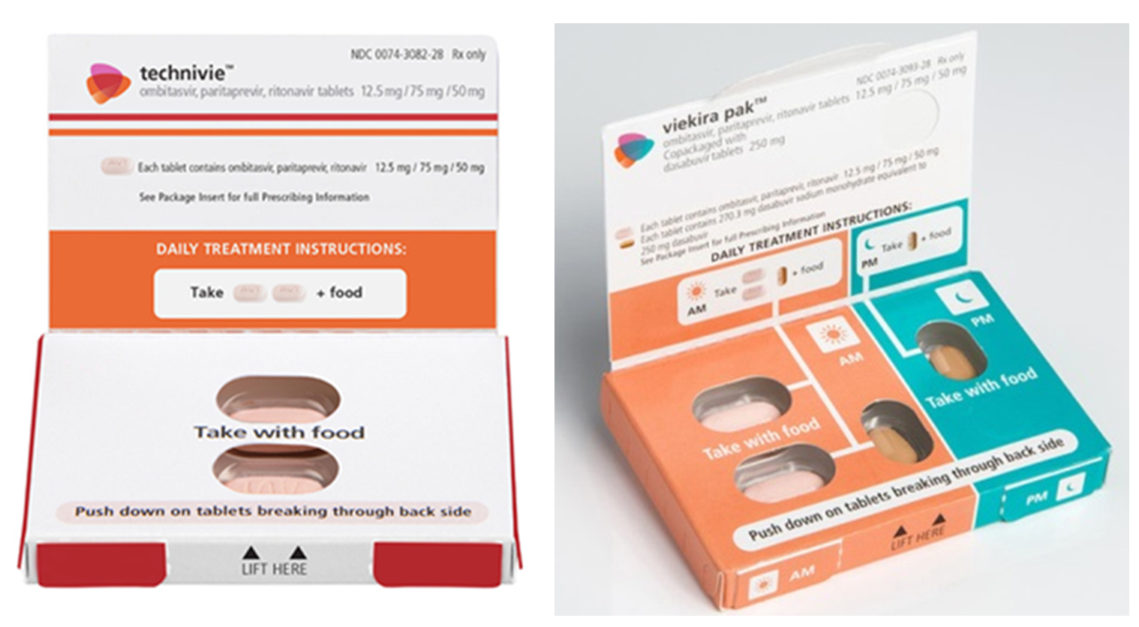
The recommended daily dose of Technivie is two tablets once daily (in the morning) with a meal without regard to fat or calorie content. This is the same as recommended for the combination tablet component of the registered Viekira Pak and Viekira Pak-RBV combination therapy packs. No new dosage forms or strengths are proposed.

Regulatory status
The international regulatory status for the paritaprevir/ritonavir/ombitasvir tablet is listed in Table 1.
Table 1: International regulatory status.
Region | Submission date | Status
EU (centralised procedure) | 6 May 2014 | Approved: 18 Aug 2016  Indication: Viekirax is indicated in combination with other medicinal products for the treatment of chronic hepatitis C (CHC) in adults (see sections 4.2, 4.4, and 5.1).  Patient population: Genotype 4, without cirrhosis or with compensated cirrhosis  Treatment: Viekirax + ribavirin  Duration: 12 weeks
US | 27 Feb 2015 | Approved: 24 Jul 2015  Indication: Technivie is indicated in combination with ribavirin for the treatment of patients with genotype 4 chronic hepatitis C virus (HCV) infection without cirrhosis.  Note: The supplement to add HCV GT4-infected patients with cirrhosis was submitted to US FDA on 27 Apr 2016. AbbVie obtained approval for Technivie use in HCV GT4 patients with compensated cirrhosis on 27 Feb 2017.
Canada | 25 Mar 2015 | Approved: 20 Oct 2015  Indication: Technivie (ombitasvir/paritaprevir/ ritonavir) tablets with ribavirin is indicated for the treatment of adults with genotype 4 chronic hepatitis C virus infection without cirrhosis who are either treatment naïve or previously treated with peginterferon and ribavirin.  Note: The supplement to add HCV GT4-infected patients with cirrhosis was submitted to Health Canada on 27 May 2016. AbbVie obtained approval for Technivie use in HCV GT4 patients with compensated cirrhosis on 8 May 2017.
Switzerland | 27 Apr 2015 | Approved: 21 Oct 2016  Indication: Viekirax is indicated in combination with ribavirin for the treatment of adults with genotype 4 chronic hepatitis C (CHC) infection (see Posology and method of administration, Warnings and Precautions, and Clinical Studies).
New Zealand | N/A | No submission has been made for GT4 indication
No application for the product has been rejected, withdrawn, or repeatedly deferred in any country.

Product Information
The approved Product Information (PI) current at the time this AusPAR was prepared can be found as Attachment 1. For the most recent PI, please refer to the TGA website at <https://www.tga.gov.au/product-information-pi>.

II. Quality findings

Introduction
The intended commercial presentation of Technivie provides a 28 day supply which will include daily blister wallets, each with a two paritaprevir/ritonavir/ombitasvir 75/50/12.5 tablets within a PVC/PE/PCTFE (Aclar)/Al blister card with an outer cardboard cover. The wallets are packaged into weekly boxes (7 wallets per box). Four weekly boxes are supplied in an outer carton providing a total of 56 paritaprevir/ritonavir/ombitasvir 75/50/12.5 tablets.

Drug substance (active ingredient)
The manufacture and quality control of the drug substances paritaprevir, ritonavir and ombitasvir are identical to that approved during registration of the Viekira Pak and Viekira Pak-RBV combination therapy packs. No further data regarding the drug substance was submitted in this submission.
Chemical structures are shown in Figure 2.
Figure 2: Chemical structures of active ingredients.
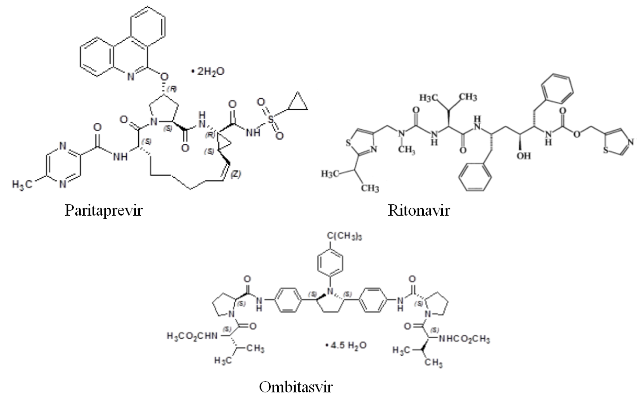

Drug product
Details of finished product manufacture are as described during registration of Viekira Pak and Viekira Pak-RBV combination therapy packs. No further data regarding the manufacture and quality control of the finished product was submitted in this submission.
The sponsor has sought a shelf-life of 24 months with storage below 30°C and this supported by stability data previously-submitted for the proposed combination tablets as part of the registration of Viekira Pak. However it is noted that lower temperature storage (‘below 25°C’) was assigned to the tablets as a component of the composite packs Viekira Pak and Viekira Pak-RBV, since combination packs must have a shelf-life equal to the shortest/most restrictive of the individual components (in that case, the RBV tablet component of Viekira Pak-RBV). The proposed shelf-life of 24 months with storage below 30°C, is considered appropriate for the combination tablets as a ‘stand-alone’ product.

Biopharmaceutics
A Food Effect Study for the proposed Paritaprevir / Ritonavir / Ombitasvir 75/50/12.5mg tablets (Study M11-389) was evaluated during the registration of Viekira Pak. The study conclusions were considered to adequately support the proposed PI statement:
To maximise absorption, Viekira Pak should be taken with food without regard to fat or calorie content.
No absolute bioavailability study was provided in the Viekira Pak submission, but instead a justification for not providing such a study was submitted. In this submission for registration of Technivie, a study assessing the absolute bioavailability of paritaprevir and ombitasvir in the combination tablet was provided and evaluated:
- Study M14-229: ‘A Phase I, Open-Label, Single Centre Study Designed to Determine the Absolute Bioavailability of Paritaprevir ‘ABT-450’ (150 mg) and Ombitasvir ‘ABT-267’ (25 mg) when Administered as an Oral Co-Formulated Product with Ritonavir (100 mg), (paritaprevir/ritonavir/ombitasvir), to Healthy Adult Subjects’.
The following was concluded:
- Following single dose administration of paritaprevir as an oral co-formulated product with ombitasvir and ritonavir under non-fasting conditions with an IV dose of ¹⁴C-radiolabelled paritaprevir, the geometric mean absolute bioavailability of paritaprevir was 52.6%.
- Following single dose administration of ombitasvir as an oral co-formulated product with paritaprevir and ritonavir under non-fasting conditions with an IV dose of 14C-radiolabelled ombitasvir, the geometric mean absolute bioavailability of ombitasvir was 48.1%.
- The study is considered to adequately support the statement in the PI:
The absolute bioavailability of ombitasvir and paritaprevir when administered with ritonavir as Technivie was approximately 48.1% and 52.6%, respectively.

Quality summary and conclusions
Registration of the proposed Technivie paritaprevir/ritonavir/ombitasvir 75/50/12.5 tablets, packaged in PVC/PE/PCTFE (Aclar)/Al blisters as a 56 tablet pack is recommended with respect to quality and biopharmaceutic aspects. All issues raised during the initial evaluation of this application have been satisfactorily resolved apart from the requirement to obtain extensions for GMP clearances for two overseas manufacturing sites.
As no significant pharmaceutical chemistry issues were identified, the Chemistry, Manufacturing, and Controls (CMC) aspects of the submission were not referred to the Pharmaceutical Subcommittee of the ACPM, in keeping with recent branch policy.

III. Nonclinical findings
Rats received ombitasvir via oral gavage daily for up to 104 weeks during this study. Group sizes of 65 per sex were appropriate and there were sufficient animal numbers surviving treatment to assess the carcinogenic potential at the doses administered. Dose levels were selected based on a 3 month toxicity and toxicokinetic study in Sprague-Dawley rats (previously evaluated). In this study 30mg/kg/day of ombitasvir (that is, 17 times the human dose, see Table 2), produced maximum feasible systemic exposure in rats and therefore, was adequate to use as a high dose. The range of doses tested was adequate and allowed for a dose response evaluation of findings. There were no neoplastic or non-neoplastic lesions due to the test article in both male and female rats. Though mortality in females was observed to be significantly test article related, this would not be relevant to human safety assessment due to the primary cause of death being pituitary and mammary tumours which are the most common tumours observed in this species of rats. Therefore, based on this study, ombitasvir is not expected to pose a carcinogenic risk during clinical use.
Table 2: Relative exposure in the carcinogenicity study
Species | Dose  (mg/kg/day PO) | AUC_{0–24 h} (µg∙h/mL) | Exposure ratio#
Rat (CRL:SD) | 3 | 3.26 | 2
Rat (CRL:SD) | 10 | 8.54 | 6
Rat (CRL:SD) | 30 | 23.4 | 17
Human (healthy volunteers) | 25 mg /day | 1.37
# = animal:human plasma AUC_{0–24 h}; ª data obtained from clinical study R&D/14/0050
The nonclinical overview stated that paritaprevir and ombitasvir exposures at the recommended clinical doses in the 2 antiviral drug regimen were comparable or slightly lower than in the 3 drug regimen (Viekera), that is, 4.77 and 1.37 µg.h/mL, respectively (clinical study R&D/14/0050). Exposure ratios for VIEKERA were previously calculated using respective values of 6.99 and 1.42 µg.h/mL.

IV. Clinical findings
A summary of the clinical findings is presented in this section. Further details of these clinical findings can be found in Attachment 2.

Introduction

Clinical rationale
It is estimated that 130 to 210 million people worldwide are infected with HCV with 2 to 4 million new infections annually. Approximately 80% of infections are related to IV drug use, with lesser numbers attributed to sexual transmission, blood transfusions and tattoos. Approximately 300,000 Australians were infected with HCV in 2011. Acute infections become chronic in 70% to 90% of cases and this leads commonly to cirrhosis, chronic liver failure, hepatocellular carcinoma, liver transplantation and death. After 20 years of infection, 20-30% of patients will have progressed to cirrhosis, 5-10% will have developed end-stage liver disease and 4-8% will have died of liver related causes. HCV has six GT and multiple subtypes with GTs 1 to 3 distributed worldwide. GTs 1a and 1b account for 60% of global HCV infections. In Australia, the most common GTs are 1a and 1b (54% prevalence) and 3a (37% prevalence). The incidence of HCV GT4 infection is low in the US (~1%) and in Europe (~5% on average). However, in North Africa and the Middle East, it has a prevalence of ~50% (up to 90% in Egypt) and it is spreading to Europe and the rest of the world through immigration and IV drug use. Until recently, the standard of care treatment for chronic HCV infection for all GTs was the combination of pegylated interferon and RBV (pegIFN/RBV) for 48 weeks. The response to this treatment varies according to HCV GT and host IL28B genotypic subtypes (CC, CT and TT). Patients with the IL28b CC GT are able to mount stronger immune responses to the HCV virus and spontaneous viral clearance rates and responsiveness to antiviral therapy are enhanced. In patients with HCV GT1 infection, sustained viral response (SVR) rates following pegIFN/RBV therapy are only 45% in treatment-naïve patients and significantly lower in prior relapsers and non-responders. Moreover, the side effect profile of pegIFN/RBV is unfavourable with a high incidence of lethargy, fatigue, depression and anaemia.
The NS3/4A protease inhibitors boceprevir, telaprevir, and simeprevir, and the NS5B polymerase inhibitor sofosbuvir used singly in combination with pegIFN/RBV have improved SVR rates in treatment naïve and treatment-experienced patients and shortened treatment duration to 24 weeks in many patients with HCV GT1 infection. The combinations of sofosbuvir and RBV with or without pegIFN and simeprevir and pegINF with RBV, have shown promise in patients with HCV GT4 infection (Table 3). However, these 1-DAA combinations are associated with increased rates and severity of AEs, including rash in addition to the common side effects of pegIFN/RBV. Simeprevir and sofosbubvir are well tolerated and have the advantage of once daily dosing. However, telaprevir and boceprevir both require TID therapy.
Table 3: SVR₁₂ rates in studies of patients with HCV GT4 infection.
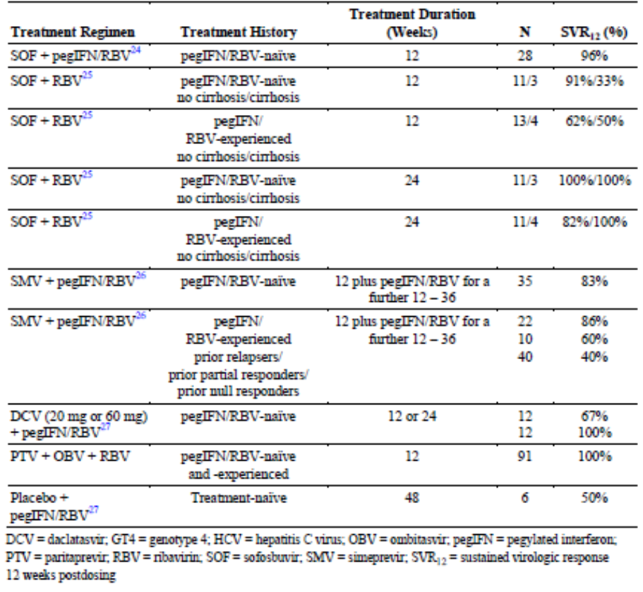
Most recently, Viekira Pak has been approved for the treatment of patients with HCV GT1. It is a combination product of three DAAs with different mechanisms of action and which all have potent activity against HCV GT1. They have non-overlapping viral resistance profiles and they also appear to have non-overlapping toxicity with RBV. Paritaprevir (ABT-450), ombitasvir (ABT-267) and dasabuvir (ABT-333) are potent DAAs; however, resistance develops to each agent when used as monotherapy. The 3-DAA regimen used in Viekira Pak obviates the need for concomitant pegIFN/RBV therapy; increases SVR rates compared with 1-DAA + pegIFN/RBV combination therapy; shortens treatment duration from 24 to 12 weeks; and improves safety and tolerability. Dasabuvir has no activity against HCV GT4 but paritaprevir and ombitasvir have potent activity. For this reason, Technivie was developed as a fixed dose 2-DAA combination of paritaprevir and ombitasvir plus ritonavir which is otherwise identical to that used in Viekira Pak. It is proposed that this 2-DAA combination may have value for the treatment of patients with HCV GT4 infection.

Guidance
The submission complies with the pre-submission planning form and planning letter. No specific guidance was provided for the 2-DAA submission. However, the 3-DAA development program was conducted in accordance with the relevant US and EMA guidelines, with specific scientific advice from the FDA and CHMP.

Contents of the clinical dossier
The submission contains two new clinical studies as follows:
- One clinical pharmacology Study M14-229 which provided absolute bioavailability data;
- One Phase II efficacy and safety Study M13-393.

Paediatric data
The submission did not include paediatric data.

Good clinical practice
The clinical studies were performed according to the principles of ICH GCP.

Pharmacokinetics

Studies providing pharmacokinetic data
A summary of the single pharmacokinetic Study M14-229 is presented.

Evaluator’s conclusions on pharmacokinetics
The absolute bioavailability of dasabuvir was measured during the Viekira Pak development program, but not the components of the 2-DAA regimen. The absolute bioavailabilities of ABT-450 and ABT-267 estimated in the healthy subject Study M14-229 are acceptable.
In M13-393, the steady state concentrations of ABT-450 were notably lower in patients with GT4 infection compared with those with GT1b infection. The sponsor suggests that this anomaly was probably due to cross study comparisons, as the GT of HCV should not affect the pharmacokinetics of the DAAs.
The sponsor points out that possible PK differences can be discounted as efficacy rates were high in all groups. However, in Group 1 (treatment naïve, non-cirrhotic GT4 patients, 2-DAA without RBV), 9.1% of patients were non-responders; almost twice the 4.8% number observed in the corresponding GT1b patients in Group 2. Moreover, the SVR₂₄ rate was ‘only’ 86.4% in Group 1. With the advent of highly effective combination DAA therapies such as Viekira Pak, SVR₁₂ rates of up to 100% are a realistic therapeutic target. While accepting that 90% efficacy (SVR₂₄ 86.4% ) rates are outstanding, a two-fold difference in non-response rates in GT4 patients compared with GT1b patients should not be dismissed as unimportant.
The sponsor did not conduct drug concentration/response analyses as efficacy was considered adequate in all groups. However, in light of the comments above, it would be useful to compare the PK parameters in responder and non-responder patients in M13-393.

Pharmacodynamics
No new studies have been performed.

Dosage selection for the pivotal studies
Dosage selection was based on similar in vitro data between the GT1b and GT4 subtypes and the optimal dose in patients with GT1 infection. No new dose ranging studies have been performed to support the Technivie submission.

Efficacy

Studies providing efficacy data
Study M13-393 (PEARL-1): “Technivie is indicated in combination with ribavirin for the treatment of patients with genotype 4 chronic hepatitis C virus (HCV) infection” was an open-label, randomised, Phase II, efficacy and safety study of the 2-DAA combination treatment (ABT-450/r administered with ABT-267, with and without RBV) in adults with chronic HCV infection.

Evaluator’s conclusions on efficacy
The 2-DAA regimen with and without RBV has been studied in 135 treatment-naïve and treatment-experienced patients with HCV GT4 infection. The majority of patients carried a non-CC IL28 GT which predicts a lesser response to treatment. In patients with HCV GT4 infection treated with 2-DAA for 12 weeks, the SVR₁₂ rate was 90.9% (95% CI: 78.3, 97.5). In treatment-naïve and treatment-experienced patients treated with 2-DAA + RBV for 12 weeks, the SVR₁₂ rates were 100% (95% CI: 91.6, 100.0) and 100 % (95% CI: 92.7, 100.0), respectively. Response rates in subgroups were not assessed as the overall response was 100%.
The assessment of efficacy is based on a single, randomised, Phase 2 pilot study with approximately 40 patients in each treatment group. The study was appropriately designed and conducted in accordance with the EU guideline for the treatment of HCV. It was necessarily conducted open label but the efficacy endpoints were objective. Although patient numbers were low, the 100% efficacy rate in patients treated with 2-DAA with RBV is sufficient to justify an indication in non-cirrhotic patients with HCV GT4 infection. The efficacy rate in patients treated with 2-DAA without RBV were also impressive and sufficient to justify the use of Technivie in patients who are unable to tolerate RBV. However, reduced exposure for each component of the 2-DAA regimen in GT4 patients may have contributed to the 9.8% SVR₁₂ non-response rate in this group. Dose adjustments (for ABT-450 in particular) might be an alternative to the use of RBV in treatment-naïve patients.
The sponsor offers no discussion or justification to support use in cirrhotic patients. All patients with HCV GT4 infection were non-cirrhotic and there are no data to support the use of Technivie in HCV GT4 patients with compensated cirrhosis. Despite the need for improved treatments in cirrhotic patients with GT4 infection, it is not appropriate to assume comparable efficacy rates in non-cirrhotic and cirrhotic patients; or to extrapolate efficacy rates from studies in cirrhotic patients with GT1b infection who were treated for 24 weeks (even though SVR₄ rates were nearly 100%). Additional studies in GT4 patients with and without cirrhosis commenced in Q4 2014 (M11-655 and M14-250) and these should be evaluated to justify use in cirrhotic patients.

Safety

Studies providing safety data
The following studies provided evaluable safety data:

Pivotal Phase II efficacy Study M13-393
In the single efficacy study, the following safety data were collected:
- General adverse events (AEs) were coded using MedDRA and assigned by preferred term (PT) and system organ class (SOC).
- AEs of particular interest including ALT elevations, anaemia and skin reactions.
- Laboratory tests, including routine biochemistry and haematology, were performed at central laboratories.

Dose response and non-pivotal efficacy studies
No studies were performed.

Other studies evaluable for safety only
No studies were performed.

Clinical pharmacology study
The absolute bioavailability study in healthy subjects (M14-229) has not been included in the overall safety evaluation.

Patient exposure
In M13-393, study drug exposures in non-cirrhotic GT4 and GT1b Groups are shown in Table 4 and in cirrhotic GT1b Groups in Table 5. The mean exposure in Groups 1 + 2 + 3 (2-DAA for 12 weeks) was 83.3 days and in Groups 4 + 6 (2-DAA + RBV for 12 weeks) it was 84.4 days. The mean exposure in Groups 7 + 8 (2-DAA for 24 weeks) was 165.0 days.
Table 4: Study M13-393 Study drug exposure non-cirrhotic GT4 and GT1b Groups.
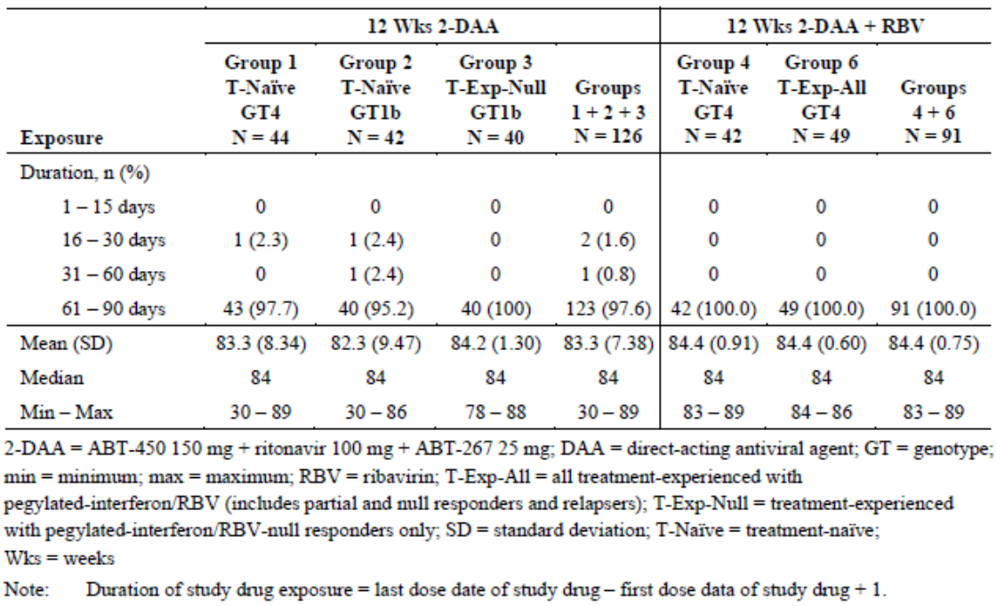
Table 5: Study M13-393 Study drug exposure cirrhotic GT4 and GT1b Groups.
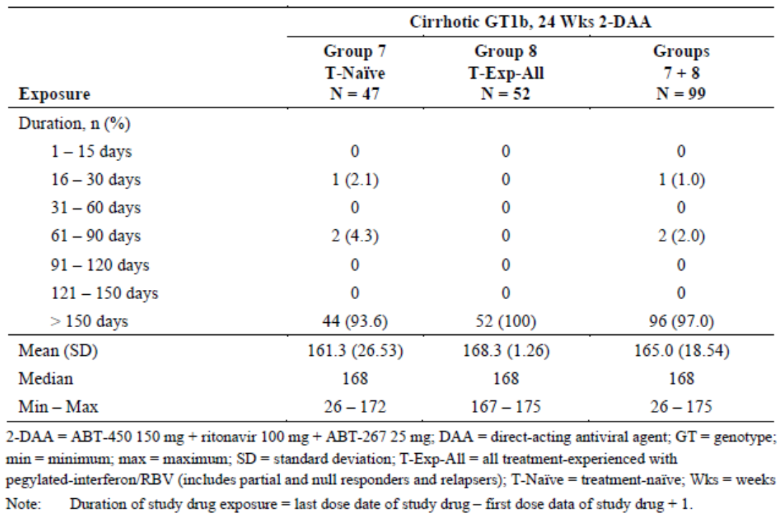

Safety issues with the potential for major regulatory impact

Liver toxicity
No new safety signals were observed.

Haematological toxicity
No new safety signals were observed.

Serious skin reactions
No new safety signals were observed.

Cardiovascular safety
No new safety signals were observed.

Unwanted immunological events
Not applicable.

Other safety issues

Safety in special populations
No new data were submitted.

Safety related to drug-drug interactions (DDIs) and other interactions
No new data were submitted.

Post marketing data
Not applicable.

Evaluator’s conclusions on safety
No significant new safety concerns have been identified in the PEARL-I study. The safety of 2-DAA with and without RBV was assessed in 316 patients who received at least one dose of study drug, including 135 non-cirrhotic patients with HCV GT4 infection. Overall, the 2-DAA regimen was well tolerated although, as expected, AEs occurred more commonly in patients given RBV. Most AEs were mild to moderate in severity.
While the patient numbers were low in PEARL-I, more than 2,500 study patients have received 2-DAA as a component of the Viekira Pak 3-DAA regimen, with or without RBV, in patients with HCV GT1 infection. The pattern of AEs in PEARL-I was comparable to that of the 3-DAA regimen and no new safety signals were detected. For this reason, the sponsor has opted not to change the ADR profile of the 3-DAA combination summarised in the current Viekira Pak PI. The 3-DAA regimen contains dasabuvir but the 2-DAA regimen does not. Nonetheless, it is reasonable to retain the larger data set and the following most common ADRs are identified:
- 2-DAA: asthenia (13%), nausea (10%), fatigue (7%), pruritus (6%), skin reactions (3%) and insomnia (2%).
- 2-DAA + RBV: asthenia (29%), fatigue (15%), nausea (14%), insomnia (13%), pruritus (7%) and skin reactions (7%).
Subgroups based on race, age, gender, body weight, renal and hepatic function and prior treatment for HCV were analysed in the 3-DAA program and no unexpected issues were identified in the 2-DAA. Potential DDIs were identified in the 3-DAA program and, with minor differences due to the absence of dasabuvir, dosing precautions remain unchanged. The pattern of laboratory events (anaemia, rash and hepatic events) was comparable in the 2-DAA and 3-DAA studies with few significant treatment emergent ALT elevations.

First round benefit-risk assessment

First round assessment of benefits
The benefits of Technivie given with RBV in the proposed usage are:
- The potential for 100% SVR rates when given with RBV for 12 weeks in treatment-naïve and treatment experienced non-cirrhotic patients with chronic HCV GT4 infection.
- The potential for 90% SVR12 (86.4% SVR24) rates when given without RBV for 12 weeks in treatment naïve non-cirrhotic patients with chronic HCV GT4 infection.
- Well tolerated with mostly mild to moderate ADRs.
- Few dose interruptions or discontinuations.
- More effective with a superior safety profile compared with DAA plus pegIFN therapies.
- The potential for DDIs well understood.
- Contraindications and precautions identical to those identified in the Viekira Pak 3-DAA development program.

First round assessment of risks
The risks of Technivie given with RBV in the proposed usage are:
- Efficacy rates based on low patient numbers in a single Phase II study.
- No data available in patients with compensated cirrhosis.
- Potential for severe ADRs, in particular anaemia and ALT elevations.
- Risks associated with DDIs, in particular systemic oestrogen medications.
- Limited viral resistance data due to high efficacy rates.

First round assessment of benefit-risk balance
The benefit-risk balance of Technivie is unfavourable given the proposed usage, but would become favourable if the changes recommended in next section are adopted.

First round recommendation regarding authorisation
Authorisation is not recommended for the proposed indication:
Technivie is indicated in combination with ribavirin for the treatment of patients with genotype 4 chronic hepatitis C virus (HCV) infection.
However, authorisation is recommended for the following modified indication:
Technivie is indicated in combination with ribavirin for the treatment of adult patients without cirrhosis with genotype 4 chronic hepatitis C virus (HCV) infection.
There are no data to support the use of Technivie, with or without RBV, in patients with HCV GT4 infection and compensated cirrhosis. Technivie without RBV was effective in patients with HCV GT1b and compensated cirrhosis and it is almost certain to have value in similar patients with HCV GT4 infection. However, the HCV GT1b patients were treated for 24 weeks and it is not appropriate to extrapolate the data to HCV GT4 patients with cirrhosis treated for only 12 weeks (even though SVR4 rates were nearly 100% in the HCV GT1b patients and RBV co-administration is recommended).

Clinical questions

Pharmacokinetics
Question 1
Please refer to comments and address the following questions and issues:
- Please explain how cross-study comparisons may have contributed to the consistent PK differences observed between groups in a randomised study.
- Are there any known differences in hepatic pathophysiology or drug handling between patients with HCV GT4 and GT1b infections?
- Drug concentration/response analyses were not performed as efficacy was considered adequate in all groups. However, in light of the concerns raised, please provide a comparison of the PK parameters in responder and non-responder patients in Groups 1 and 2 in study M13-393.

Efficacy
Question 2
In the absence of clinical data, please provide a justification for the use of Technivie with RBV in HCV GT4 patients with compensated cirrhosis. Should patients be treated for 12 or 24 weeks, with or without RBV, and on what evidence is this recommendation based?

Question 3
Please provide a status update for ongoing studies (M11-655 and M14-250), including summaries of interim analyses if they are available. Will population PK analyses be available?

Safety
No questions.

Second round evaluation
Details of sponsor’s responses to clinical questions and evaluator’s subsequent comments are contained in Attachment 2.

Second round benefit-risk assessment

Second round assessment of benefits
No change to the first round assessment.

Second round assessment of risks
No change to the first round assessment.

Second round assessment of benefit-risk balance
No change to the first round assessment.

Second round recommendation regarding authorisation
Authorisation is recommended for the indication:
Technivie is indicated in combination with ribavirin for the treatment of adult patients with genotype 4 chronic hepatitis C virus (HCV) infection.

V. Pharmacovigilance findings

Risk management plan
The sponsor submitted an EU-RMP Version 2.0 (dated October 2015, Data Lock Point 15 July 2015) and Australian Specific Annex (ASA) Version 2.0 (dated October 2015), which was reviewed by the RMP evaluator.

Safety specification
The sponsor provided a summary of ongoing safety concerns which are shown at Table 6.
Table 6: Ongoing safety concerns.
Important identified risks | Drug-drug interactions:  Concomitant use with drugs that are moderate or strong inducers of CYP3A and/or strong inducers of CYP2C8. Examples include carbamazepine, phenytoin, phenobarbital, efavirenz, nevirapine, etravirine, enzalutamid, mitotane, rifampicin, and St. John’s Wort (Hypericum perforatum)  Concomitant use with drugs that are sensitive CYP3A substrates (for example, ergotamine, lovastatin, and salmeterol)  Concomitant use with drugs that are strong CYP3A4 inhibitors  Concomitant use with drugs that are strong CYP2C8 inhibitors (for example, gemfibrozil) with the 3-DAA regimen  Hepatotoxicity when co-administered with ethinyl estradiol-containing medications
Important potential risks | Drug-drug interactions:  Concomitant use with drugs that are primarily metabolised by CYP3A and CYP2C19; drugs that are sensitive substrates of UGT1A1; drugs that are substrates of BCRP, OCT1, OATP1B1/1B3, or P-gp, including antiretroviral regimens that contain ritonavir; or immunosuppressant medications  Hepatotoxicity among non-users of ethinyl estradiol-containing medications  Potential for off-label use including:  Use of the DAA regimen in patients with genotypes other than those specified in applicable product labelling  Use in other DAA combinations  Use in paediatric patients  Medication errors  Risk of resistance development  Foetal development toxicity (ombitasvir/paritaprevir/ritonavir only; added to the EU RMP per CHMP request)
Important missing information | Safety in patients with hepatic impairment (Child-Pugh B)  Safety in patients with renal impairment (creatinine clearance < 60 mL/min)  Safety in post live transplant patients  Safety in patients co-infected with HIV-1  Safety in pregnancy in patients using a DAA regimen without RBV  Safety in patients co-infected with HBV  Safety in elderly patients  Safety in patients who have failed prior DAA treatments  Safety in GT4-infected patients with cirrhosis (Note: this applies to regions where the 2-DAA regimen is approved for GT4)

RMP evaluator comment
Subject to the evaluation of the nonclinical and clinical aspects of the Safety Specification, this is considered acceptable.

Pharmacovigilance plan
The sponsor proposes routine and additional pharmacovigilance activities.

RMP evaluator comment
The proposed pharmacovigilance plan appears reasonable and is considered acceptable at this stage. More recommendations may be made at the Round 2 stage.

Risk minimisation activities
The sponsor has proposed routine risk minimisation. The sponsor is not proposing additional risk minimisation activities.

RMP evaluator comment
The sponsor’s conclusion is satisfactory in the context of this application.

Reconciliation of issues outlined in the RMP report
The following section summarises the first round evaluation of the RMP, the sponsor’s responses to issues raised by the TGA RMP reviewer, and the RMP reviewer’s evaluation of the sponsor’s responses.

Recommendation #1 in RMP evaluation report
Safety considerations may be raised by the nonclinical and clinical evaluators through the consolidated Section 31 request and/or the nonclinical and clinical evaluation reports respectively. It is important to ensure that the information provided in response to these includes a consideration of the relevance for the RMP, and any specific information needed to address this issue in the RMP. For any safety considerations so raised, please provide information that is relevant and necessary to address the issue in the RMP.

Sponsor response
AbbVie has reviewed the safety considerations raised by nonclinical and clinical evaluators in the consolidated Section 31 request and/or the nonclinical and clinical evaluation reports. No safety issues were identified relevant to be addressed in the RMPs. However, since safety data are deemed sufficient to support an application for an indication in GT4-infected patients with compensated cirrhosis, AbbVie has determined that this prior safety concern should no longer be considered missing information. Therefore, the Missing Information Safety Concern of "Safety in GT4-infected patients with cirrhosis" has been removed in the updated RMP.

Evaluator’s comment
The sponsor’s response to this recommendation is considered adequate as there were no recommendations in the nonclinical or clinical evaluation reports that required update to the RMP. The justification for removing GT4-infected patients from the missing information is considered appropriate, given the application for use in this patient group. Risks associated with use in patients with cirrhosis are addressed by information in the PI.

Recommendation #2 in RMP evaluation report
‘Section VI.2.7 Summary of Changes to the Risk Management Plan Over Time’ should be populated with relevant information.

Sponsor response
AbbVie has updated ‘Section VI.27. Summary of Changes to the Risk Management Plan Over Time’. An updated version of the RMP, with the ASA, is provided as part of AbbVie's response to RMP Evaluation Report.

Evaluator’s comment
The evaluator notes the updated table and this is adequate for this recommendation.

Recommendation #3 in RMP evaluation report
In the ‘Precautions’ section, under the ‘Use in Pregnancy’ heading, the sponsor should make reference to RBV and its pregnancy category, its teratogenic and embryocidal potential, and the need for effective contraception.

Sponsor response
AbbVie agrees with the requested revision. Please refer to the updated product information submitted with this response.

Evaluator’s comment
The evaluator has reviewed the updated PI; it adequately addresses this recommendation.

Summary of recommendations

Outstanding issues

Issues in relation to the RMP
There are no outstanding issues in relation to the RMP for this submission.

Comments on the safety specification of the RMP

Clinical evaluation report
The clinical evaluator made the following comment:
The Safety Specification in the draft Risk Management Plan is satisfactory. It is an updated version of the Australian RMP for Viekira Pak dated October 2015. The incidence and prevalence of HCV infection in Australia are described, as are the demographics, co-morbidities and concomitant medications commonly used in this patient population. The use of 3-DAA with and without RBV has been extensively investigated in treatment-naïve and treatment-experienced patients, with and without compensated cirrhosis in patients with HCV GT1 infection. Only small numbers of significant safety signals have been detected in the overall population. No specific safety signals have been detected in demographic sub-groups but the RMP identifies patient groups in which further studies are in progress or planned. These include HIV and HBV co-infection, Asian populations (Chinese and Japanese), patients with moderate to severe renal or hepatic impairment, liver transplant patients, paediatric patients aged 3 - <18 years and patients who experience virologic failure with a 3-DAA or 2-DAA regimen. The high risk of multiple DDIs has been addressed in the PI and will be monitored post-marketing. The Sponsor will be responsible for pharmacovigilance in Australia and standard methods applicable in Australia will be used to identify emerging ADRs.

Nonclinical evaluation report
The nonclinical evaluator did not comment on the safety specification in the RMP.

Key changes to the updated RMP
EU-RMP Version 2.0 (dated October 2015, DLP 15 July 2015) and ASA Version 2.0 (dated October 2015) has been superseded by:
- EU-RMP Version 3.1 (dated May 2016, DLP 19 December 2015) + Australian-specific Annex (version 2.1, June 2016)
In their response to the TGA Section 31 requests, the sponsor provided an updated RMP (version, date). Key changes from the version evaluated at Round 1 are summarised below.
Table 7: Summary of key changes between EU-RMP V2.0 and EU-RMP V3.1.
Summary of key changes between EU-RMP V2.0 and EU-RMP V3.1
Safety specification | Identified Risk Added:  Hepatic decompensation and hepatic failure in patients with cirrhosis  Missing Information Removed:  Safety in GT4-infected patients with cirrhosis

RMP evaluator comment
The evaluator has no objection to the above changes and recommends to the Delegate that the updated version is implemented (see below).

Suggested wording for conditions of registration

RMP
Any changes to which the sponsor agreed become part of the risk management system, whether they are included in the currently available version of the RMP document, or not included, inadvertently or otherwise.
The suggested wording is:
- Implement RMP (version 3.1, May 2016, DLP 19 December 2015) with ASA (version 2.1, June 2016) and any future updates as a condition of registration.

VI. Overall conclusion and risk/benefit assessment
The submission was summarised in the following Delegate’s overview and recommendations:

Quality
Registration of the proposed products was recommended with respect to pharmaceutical chemistry aspects, pending extension of GMP clearances for a couple of the manufacturing sites.

Nonclinical
Adequate nonclinical data for each of the three DAA drugs paritaprevir/ritonavir, ombitasvir and dasabuvir have been previously evaluated for registration of the 3-DAA combination (Viekira Pak) for treatment of HCV GT1, and are adequate to support the current application for the 2-DAA combination of paritaprevir/ritonavir/ombitasvir (Technivie) with RBV. Paritaprevir and ombitasvir were previously shown to have a high level of activity against HCV GT4 in vitro.
New data in the current submission consisted of a two-year carcinogenicity study for ombitasvir in rats, which was negative, confirming a previous negative result in a 6-month transgenic mouse study. A statement summarising the new study has been recommended for addition to the PI. Two minor corrections to the ‘Use in Pregnancy’ section were also recommended on the basis of slightly lower clinical drug exposures in the 2-DAA regimen. The sponsor has indicated that these will be corrected and submitted with the pre ACPM response.

Clinical

Pharmacology

Bioavailability study M14-229
A study (M14-229) to determine the absolute bioavailability of ABT-450 (paritaprevir) (150 mg) and ABT-267(ombitasvir) (25 mg) as an oral co-formulated product with ritonavir (100 mg) was conducted in 16 healthy subjects, with 8 subjects in two groups. The absolute bioavailability of paritaprevir and ombitasvir had not been assessed during the Viekira Pak development program. The study was evaluated by both the chemistry and clinical evaluators.
As an oral co-formulated product with ritonavir, the mean geometric bioavailabilities of ABT-450(paritaprevir) and ABT-267(ombitasvir) under non-fasted conditions were 52.6% and 48.1%, respectively and the evaluators were satisfied that new information in the PI was adequately supported by this study.

PK in target patient population, Study M13-393
The clinical evaluator questioned the PK findings of the 2-DAA regimen measured in M13-393 (target population), highlighting that the steady state concentrations of ABT-450 were notably lower in patients with GT4 infection compared with those with GT1b infection. The sponsor suggested that differences in exposures between the GT4 and GT1b subjects could have occurred by chance and that this was supported by the population PK analysis of data from M13-393. There are no known differences in hepatic pathophysiology or drug handling between patients with HCV GT4 and GT1b infections. PK data were provided by the Sponsor for GT4 and GT1 treatment naïve patients receiving 2-DAA (without RBV) and showed comparable DAA exposures in responders and non-responders. There was no apparent relationship between virologic response and DAA exposure for treatment naïve GT4 or GT1b patients in M13-393. Exposure response analysis could not be performed for the recommended HCV GT4 of regimen 2-DAA with RBV as no failures occurred in subjects receiving this regimen.
The clinical evaluator was satisfied with these responses.

Efficacy
Data to support the HCV GT4 indication were primarily derived from the completed study M13-393 (PEARL-1). Further information to support the indication for HCV GT4 infection in compensated cirrhosis was provided with the Section 31 response and included interim results for the M11-665 (AGATE-1) and M14-250 (AGATE-2) studies.
Table 8: Overview of clinical studies for patients with HCV GT4 infection.
Study and dates | Design | Population | Number of subjects treated | Study duration | Status
M13-393 (PEARL-1)  2012 - 2015 | Open-label, multicentre, randomised, international Phase II, efficacy and safety study | Treatment-naïve and treatment-experienced non-cirrhotic patients with HCV GT4 infection and patients with and without cirrhosis with HCV GT1b infection | 316  (135 patients with GT4, 181 patients with GT1b) | 48 weeks following the last dose of study treatment | Completed
M11-665 (AGATE-1)  Commenced 2014 | Phase III, randomised, open-label, multicentre, international study | HCV GT4-infected subjects with compensated cirrhosis | 184 | 48 weeks following the last dose of study treatment | Ongoing
M14-250 (AGATE-2)  Commenced 2014 | Phase III, open-label, randomised, multicentre study in Egypt | HCV GT4-infected subjects with and without compensated cirrhosis | 160 | 48 weeks following the last dose of study treatment | Ongoing

PEARL-1, M13-393
This was an open label, randomised, Phase II, efficacy and safety study of the 2-DAA combination treatment administered with and without RBV in adults with chronic HCV infection.
The study objectives were to compare the effects of the 2-DAA regimen with and without RBV on SVR12 rates in treatment naïve and treatment experienced non-cirrhotic patients with HCV GT4 infection and in patients with and without cirrhosis with HCV GT1b infection. The study drugs were given as tablets (ABT-450, ABT-267 and RBV) or capsules (ritonavir) and the FDC formulation proposed for marketing was not used.
Preliminary results at 12 weeks post treatment (SVR12) have been published. It was stated that the rationale for examining this combination regimen in HCV GT4 infected patients was based on the comparable in vitro potency of these two DAA antiviral drugs for HCV GT1b and GT4a.
During the treatment periods, patients were given the 2-DAA regimen with or without RBV for 12 or 24 weeks. During the post treatment period, patients who completed the study or prematurely discontinued during the treatment period were followed for a total of 48 weeks to assess HCV RNA levels and the emergence of viral resistance. The study was divided into two sub-studies in treatment naïve and treatment experienced non-cirrhotic patients and patients with compensated cirrhosis.
Of note, patients with HCV GT4 and cirrhosis were not included.
The primary efficacy outcome was a comparison of the percentage of patients achieving SVR₁₂ after treatment with:
- The 2-DAA regimen
  - among treatment naïve and prior pegIFN/RBV null responder HCV GT1b-infected patients without cirrhosis
  - among treatment naïve and pegIFN/RBV treatment experienced HCV GT1b-infected patients with compensated cirrhosis
- The 2-DAA regimen with and without RBV
  - among treatment-naïve and pegIFN/RBV treatment experienced HCV GT4-infected patients
Other efficacy outcomes included:
- The percentage of patients achieving SVR₂₄
- The percentage of patients with on-treatment virologic failure
- The percentage of patients with post-treatment relapse

Sample size
For the primary endpoint of SVR12, the assumed rates were 70% in Group 3 and 95% in Group 2. Using Fisher’s exact test with a 2-sided significance level of 0.05, 40 patients in each group had 80% power to detect a difference of 25% between the non-cirrhotic HCV GT1b infected treatment naïve patients and prior null responders treated with the 2-DAA regimen for 12 weeks.
Figure 3: Study schematic M13-393.
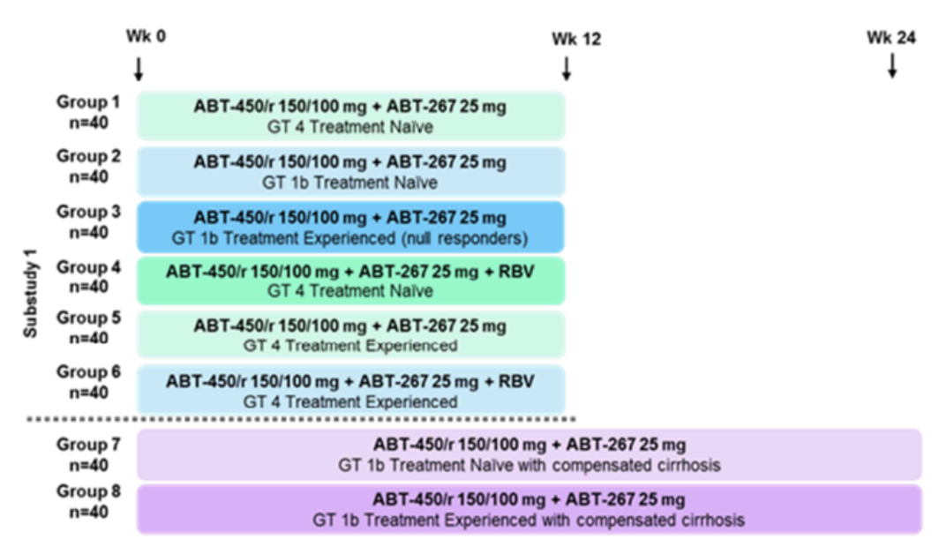
Note: Group 5 was cancelled and no patients were enrolled.

Results
HCV GT4 Groups
A total of 120 patients were planned and 135 patients were randomised in Groups 1, 4 and 6. A total of 130 patients completed the study.
HCV GT1b Groups
A total of 80 non-cirrhotic patients were planned and 82 patients were randomised in Groups 2 and 3. A total of 79 patients completed the study.
A total of 80 patients with compensated cirrhosis were planned and 99 patients were randomised in Groups 7 and 8. A total of 96 patients completed the study.

Results for the primary efficacy outcome
HCV GT4 Groups
SVR₁₂ was achieved in 90.9% (95% CI: 78.3, 97.5) of treatment naïve patients treated with 2-DAA (Group 1); in 100% (95% CI: 91.6, 100.0) of treatment naïve patients treated with 2-DAA + RBV (Group 4); and in 100% (95% CI: 92.7, 100) of treatment experienced patients treated with 2-DAA + RBV (Group 6). The adjusted treatment difference between Groups 1 and 4 was -9.16% (95% CI: -19.61, 1.29) which was not statistically significant (p = 0.086). Four patients (all in Group 1) were non-responders.
Figure 4: Results for primary outcomes in patients with HCV GT4 infection.
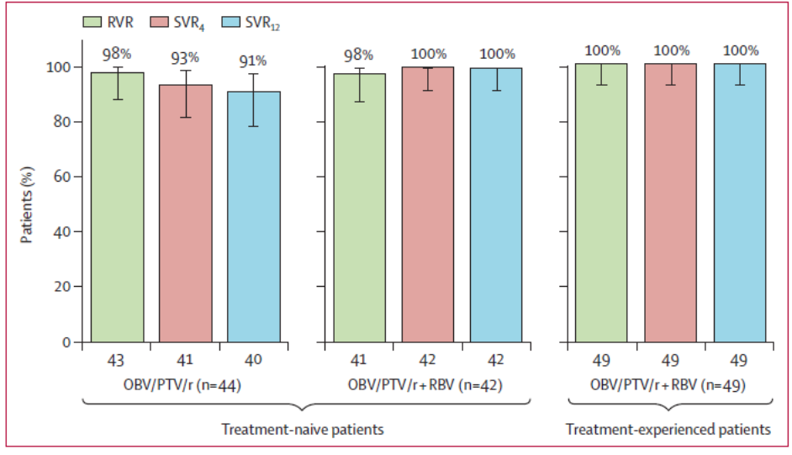
Error bars represent 95% CIs. HCV = hepatitis C virus. OBV = ombitasvir. PTV = paritaprevir. r = ritonavir. RBV = ribavirin. RVR = rapid virological response (HCV RNA <25 IU/mL at treatment week 4). SVR4 = sustained virological response (HCV RNA <25 IU/mL) 4 weeks after the last dose of study medication. SVR12 = sustained virological response 12 weeks after the last dose of study drug (primary endpoint)

HCV GT1b groups
In the primary comparison of Groups 2 and 3, SVR12 was achieved in 95.2% (95% CI: 83.8, 99.4) of treatment naïve patients, compared with 90% (95% CI: 76.3, 97.2) of treatment experienced null responders, all treated with 2-DAA for 12 weeks. Two patients in Group 2 and four patients in Group 3 were non-responders. The adjusted estimate of the treatment difference between Groups 2 and 3 was 5.53% (95% CI: -8.48, 19.55) which was not statistically significant (p = 0.439). In patients with cirrhosis treated with 2-DAA for 24 weeks, SVR12 was achieved in 97.9% (95% CI: 88.7, 99.9) of treatment naïve patients (Group 7) and 98.1% (95% CI: 89.7, 100) of treatment experienced patients (Group 8). One patient (1.0%) in each group was a non-responder.
The evaluator commented that the study was powered to only detect a 25% difference between groups. Patients with GT1b infection did not receive RBV. However, all non-cirrhotic GT4 patients achieved SVR12 after 12 weeks treatment with 2-DAA + RBV.

Results for other efficacy outcomes

HCV GT4 groups
SVR24 was achieved in 86.4% (95% CI: 72.6, 94.8) of treatment naïve patients treated with 2-DAA (Group 1); in 100% (95% CI: 91.6, 100.0) of treatment naïve patients treated with 2-DAA + RBV (Group 4); and in 100% (95% CI: 92.7, 100) of treatment experienced patients treated with 2-DAA + RBV (Group 6). The adjusted treatment difference between Groups 1 and 4 was -13.74% (95% CI: -2.08, -25.40) which was statistically significant (p = 0.021). Six patients (all in Group 1) were non-responders.

Virologic failure and post-treatment relapse

HCV GT4 groups
No virologic failures or relapses during the post treatment period were observed in GT4 patients treated with 2-DAA + RBV (Groups 4 and 6). In the treatment naïve patients treated with 2-DAA (Group 1), one patient had on-treatment virologic failure and two patients relapsed within 12 weeks post treatment.
Other efficacy outcomes for HCV GT1b Groups are summarised in the clinical evaluation report.

Conclusions on clinical efficacy
Data to support the application to register Technivie are derived from a Phase II, randomised, open label, combination treatment study with 2-DAA, of which 135 treatment naïve and treatment experienced patients with GT4 infection received 2-DAA with or without RBV. At the pre-submission stage, the sponsor approached TGA about the design and small number of GT4 patients to support an application. The clinical evaluator was of the opinion that although patient numbers were low, the 100% efficacy rate in patients treated with 2-DAA with RBV was sufficient to justify an indication in non-cirrhotic patients with HCV GT4 infection and that the efficacy rate in patients treated with 2-DAA without RBV was also sufficient to justify the use of Technivie in patients who are unable to tolerate RBV.
The Delegate notes that given that SVR24 rates were lower for HCV GT4 treatment naïve patients treated with 2-DAA alone (Group 1): 86.4% (95% CI: 72.6, 94.8), these data further support the recommendation for use of 2-DAA with RBV for HCV GT4.
Concern was raised by the evaluator in regards to the lack of data to support use in patients with HCV GT4 infection and compensated cirrhosis. An interim analysis of studies M11-665(AGATE-1) and M14-250 (AGATE-2) was provided to support treatment with 2-DAA + RBV for 12 weeks in GT4 patients with compensated cirrhosis by the sponsor in response to the Section 31 request for information.

M11-665: HCV GT4 patients with compensated cirrhosis (AGATE-1) (Section 31 response)
This is an ongoing, open label, multicentre randomised, Phase III trial of 2DAA +RBV given to HCV GT4 patients with compensated cirrhosis. The study was divided into 2 parts enrolling 184 subjects total. Part I (Arms A and B) included 120 subjects who were randomised to receive either 12 weeks (Arm A; n = 59) or 16 weeks (Arm B; n = 61) of treatment and Part II (Arms C and D) included subjects receiving 24 weeks of treatment with ombitasvir/paritaprevir/ritonavir co-administered with RBV.
Treatment was given for 12 weeks (Arm A), 16 weeks, (Arm B), or 24 weeks (Arm C). A fourth arm (Arm D) will study 2-DAA + RBV given for 24 weeks to GT4 patients with compensated cirrhosis who have previously failed prior treatment with sofosbuvir/pegIFN/RBV or sofosbuvir/RBV. The primary objective was the superiority of SVR12 rates in treatment naïve or treatment experienced patients compared with a historical control rate in patients with and without cirrhosis.

Results
The sponsor presented efficacy and safety data for subjects in Part I through to 27 November 2015. At the time of the database lock, all subjects in Arms A and B had completed the Treatment Period (12 weeks or 16 weeks of treatment with active study drugs [ombitasvir/ABT-450/r + RBV]) and through to the Post-Treatment Week 12 Visit or prematurely discontinued from the study.
A total of 120 patients were randomised into Arm A (n = 59), or Arm B (n = 61). A total of 50% of patients were treatment experienced (55% null responders, 20% partial responders, and 25% relapsers). The majority of patients (84.2%) had non-CC IL28B infection. In the ITT population, SVR12 was achieved by 96.6% (97.5% CI: 86.7, 99.2) of patients in Arm A, and by 98.4% (97.5% CI: 89.6, 99.8) of patients in Arm B.
Table 9: M11-665 SVR12 in patients given 2-DAA + RBV for 12 or 16 weeks in the Part I ITT population.
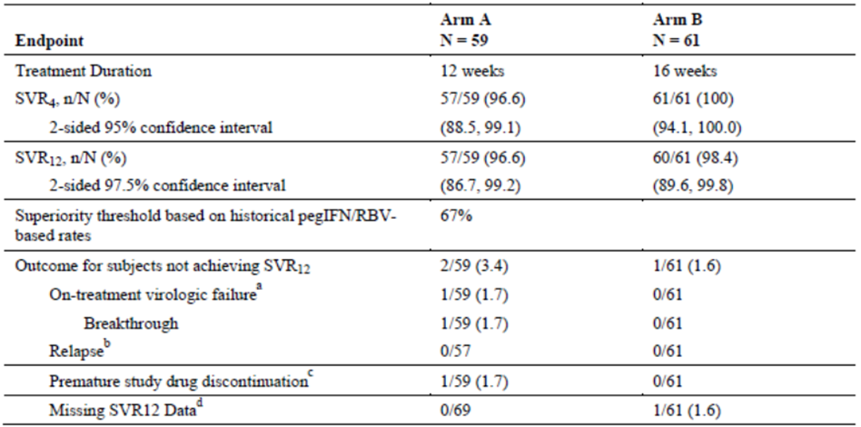
a On-treatment virologic failure was defined as breakthrough (confirmed HCV ≥ 25 IU/mL after HCV RNA < 25 IU/mL during treatment [LLOQ], confirmed 1 log10 IU/mL increase in HCV RNA from nadir during treatment) or failure to suppress (HCV RNA persistently ≥ 25 IU/mL during treatment with at least 6 weeks of treatment).
b Relapse was defined as confirmed HCV RNA ≥ 25 IU/mL post-treatment before or during SVR12 window among subjects with HCV RNA less than 25 IU/mL at the Final Treatment Visit and who complete treatment (duration ≥ 77 days for Arm A and ≥ 105 days for Arm B).
c Premature study drug discontinuation = prematurely discontinued study drug (duration < 77 days for Arm A and < 105 days for Arm B) and did not meet the on-treatment virologic failure definition.
d Missing SVR12 data was defined as no follow-up data in the SVR12 window (defined as any subject who completed study drug without data in the SVR12 window after applying the imputation rules) and not meeting the definitions of above categories.
Sparse PK sampling was performed in Study M11-665. C_{trough} concentrations of ombitasvir, ritonavir, and RBV were comparable to those in GT1 cirrhotic patients. C_{trough} concentrations of paritaprevir were 32% lower in GT4 patients receiving 2-DAA, compared with GT1 patients receiving 3-DAA (a known effect of the dasabuvir and paritaprevir interaction).

Study M14-250. (AGATE-2) treatment naïve or treatment experienced HCV GT4 patients, with or without compensated cirrhosis in Egypt
This is an ongoing open label, randomised, Phase III study of 2-DAA + RBV conducted at five sites in Egypt enrolling treatment naïve or treatment experienced HCV GT4 patients, with or without compensated cirrhosis. Arm A consists of patients without cirrhosis treated with 2-DAA + RBV for 12 weeks. Arms B and C consist of patients with compensated cirrhosis treated with 2-DAA + RBV for 12 and 24 weeks, respectively. The primary objective was to assess SVR12 rates in patients with and without cirrhosis.
Figure 5: Study schematic M14-250.
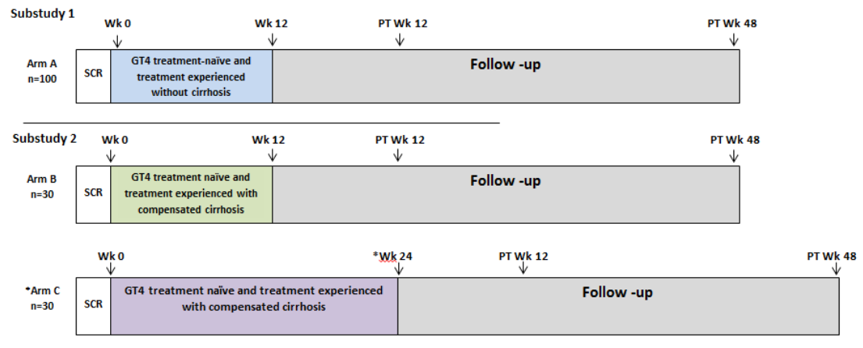
A total of 160 patients were enrolled in Arm A (n = 100), Arm B (n = 31), and Arm C (n = 29). SVR12 was achieved 94.0% (95% CI: 87.5, 97.2), 96.8% (95% CI: 83.8, 99.4), and 93.1% (95% CI: 78.0, 98.1) of patients in Arms A, B, and C, respectively. Efficacy rates were comparable in patients without cirrhosis (Arm A), and with cirrhosis (Arm B).
The Delegate notes that the results of Study M11-665 have been included by the sponsor in the PI [version 2, 27 June 2016] submitted with the Section 31 response. The results of study M14-250 have not been included in the proposed PI, presumably as complete results are not yet available (see questions for the sponsor). An application to the FDA is currently under review to expand the indication of Technivie co-administered with RBV for 12 weeks in HCV GT4-infected patients with compensated cirrhosis in the US.

Safety
No significant new safety concerns were identified in the PEARL-I study (M13-393). The 2-DAA regimen was well tolerated with AEs occurring more commonly in patients given RBV. The most common ADRs identified in Groups 1+ 2 + 3 were headache (20.6%), asthenia (11.9%), nausea (7.1%), dry skin (5.6%), and pruritus (5.6%). The most common AEs reported in Groups 4 + 6 (that is, those also taking RBV) were asthenia (23.1%), headache (20.9%), fatigue (12.1%), nausea (9.9%) and insomnia (7.7%). The most common AEs reported in Groups 7 + 8 were pruritus (16.2%), nausea (9.1%), headache (9.1%), diarrhoea (6.1%) and fatigue (5.1%). No deaths were reported in the non-cirrhotic GT4 and GT1b patient groups. Two deaths were reported in the treatment naïve cirrhotic GT1b group, due to complications of cirrhosis, more than 3 months after the last dose of study medication.
For the AGATE-1 study (M11-665) preliminary results, most patients reported at least one AE, with most AEs mild or moderate and related to RBV. AEs were reported more commonly in Arm B (16 weeks), consistent with the longer treatment duration. The pattern of AEs in the two groups was comparable, and similar to the safety profile in the pivotal studies. No deaths were reported.
For the AGATE-2 study (M14-250), similar results were observed, with most AEs mild to moderate and related to RBV. One death was reported, due to apnoea following a suxamethonium injection. It is requested that safety and efficacy results for this study be included in the proposed PI (see Issues for sponsor).
Major safety issues identified with the Viekira Pak submission and highlighted by FDA included:
- An exposure-response relationship for paritaprevir for transaminase elevations and other safety parameters
- Food effect
- Increased exposures with hepatic impairment
- Multiple DDIs
- A DDI with oestrogen based oral contraceptives (of unknown mechanism) that increases the frequency of transaminase elevations.
It is expected that the majority of patients taking Technivie will need to take RBV, which carries a risk of haemolytic anaemia.
The Delegate agrees that the ADR profile of the 3-DAA combination summarised in the current Viekira Pak/Viekira Pak RBV PI should be retained in the Technivie PI. While Technivie will not be co-packaged with RBV, some of the information relating to RBV included in the Viekira Pak RBV PI would be useful for Technivie, given the co-administration.

DDIs
A number of DDI studies were conducted as part of the clinical development program for Viekira Pak and Viekira Pak-RBV with the presentation and clarity of drug interaction information in the PI extensively reviewed by the TGA and the sponsor. This information on drug interactions has been retained in the Technivie product information, with the exception of references to dasabuvir. The FDA summary review highlighted that the DDI data obtained using the 2-DAA regimen from DDI trials submitted as part of the Viekira Pak application were reviewed for the Technivie submission, with the basis for the drug-interaction labelling recommendations for the two DAA regimen compared to the three DAA regimen. For most co-administered drugs, labelling recommendations were the same for the two regimens, while for other co-administered drugs, recommendations differed. The FDA medical review highlighted that there were differences in dosing recommendations between Technivie and Viekira Pak for DDIs with rosuvastatin (dose should not exceed 20 mg per day with Technivie), digoxin (dose should be reduced by 30-50% with Technivie), and gemfibrozil (no adjustment required with Technivie, as this interaction relates to dasabuvir).
Many of the clinically relevant drug interactions for Technivie relate to paritaprevir being extensively metabolised by CYP3A4, with ritonavir a potent inhibitor of CYP3A4. Co-administration of Viekira Pak with strong inhibitors of CYP3A may increase paritaprevir and ritonavir concentrations. Conversely, drugs which are moderate or strong inducers of CYP3A may result in substantially lower concentrations of paritaprevir and ritonavir and reduced therapeutic effect. The drugs in Viekira Pak and Technivie also inhibit P-glycoprotein and organic anion transporting polypeptide (OATP) transporters, further increasing the possibility of DDIs. Ombitasvir does not appear to contribute substantially to DDIs observed and is metabolised via amide hydrolysis followed by oxidative metabolism.
In practice, many clinicians will use information sources such as the University of Liverpool’s Hepatitis Drug Interactions website in reviewing a patient’s concomitant medications before commencing DAA therapy.

Post-marketing data
Post-marketing exposure for 2-DAA + RBV for GT4 was not described in detail in this submission or the clinical evaluation. The Delegate has requested that the sponsor provide an updated number of patients exposed to 2-DAA + RBV for GT4 in clinical trials and an estimated number of post-marketing exposures to 2-DAA + RBV. Patients in Australia have been receiving 2-DAA + RBV for GT4 under the Special Access Scheme, and a report of this program, including the number of patients supplied, AEs including treatment failures has also been requested with the pre ACPM response.
Serious hepatotoxicity, including liver transplantation and death in patients with advanced liver disease receiving Viekira Pak and Technivie, was reported in late 2015, with consequent modifications to the PI required by regulatory authorities. While some of these changes have been retained in the proposed PI for Technivie, the Delegate requests all relevant changes be included in relation to hepatic decompensation (see review of PI).

Risk management plan
The submission was not referred to Advisory Committee on Safety of Medicines (ACSOM). There were no outstanding issues in relation to the RMP for this submission.

Risk-benefit analysis

Delegate’s considerations
Overseas approval by FDA and Health Canada has not yet included patients with compensated cirrhosis. EMA has approved use of Viekirax with RBV in patients with HCV GT4, with and without compensated cirrhosis.
Given the post-marketing reports of serious hepatotoxicity in patients receiving Viekira Pak and Technivie and contra-indicated use in severe hepatic impairment, it is assumed that prescribers will be aware of these risks, which can be handled appropriately by adequate information in the PI in addition to risk minimisation activities directed at prescribers and patients.
Safety data for Technivie is reliant on the larger database for Viekira Pak and it is appropriate that the larger ADR and complex drug interaction profile of the 3-DAA combination be retained in the PI for Technivie, with some minor differences. Safety data from clinical trials for Technivie will be limited to the smaller trials for patients with GT4 infection.
Technivie is to be marketed as a separate and distinct good from Viekira Pak/Viekira Pak RBV, however there is the potential for market confusion given the similarity of the products and the variation in presentation of the product information.
The Delegate is of the opinion that data are sufficient to recommend registration of Technivie in combination with RBV for the treatment of patients with HCV GT4 infection. Approval is subject to implementation of RMP (version 3.1, May 2016, DLP 19 December 2015) with ASA (version 3.1, May 2016) and any future updates as a condition of registration.

Summary of issues
HCV GT4 infection is rare in Australia. Data to support this application was initially based on a small Phase II study, which included 135 GT4 patients without cirrhosis as a subgroup. The application has been substantiated with the availability of interim data from two studies which include GT4 patients with compensated cirrhosis.
Technivie is to be marketed as a separate and distinct good from Viekira Pak and Viekira Pak RBV; however, there is the potential for market confusion given the similarity of the products and the variation in presentation of the PI.

Issues for sponsor
- Please provide an update of the overseas regulatory status.
- Although not directly relevant to the indication sought (GT4 infection), what are AbbVie’s comments on the implications of the PEARL-1 study for using 2-DAA for GT1b, given the efficacy results in this patient population?
- Please include the most recent efficacy and safety results of Study M14-250(AGATE-2) in the proposed PI.
- In relation to interactions with other medicines, please provide a summary, in tabular format, highlighting the co-administered drugs where recommendations are different for Viekira Pak/Viekira Pak RBV and Technivie and the reasons for this, with reference to the proposed PI for Technivie.
- Why was the FDC proposed for marketing not used for the PEARL-1 study? The FDA Clinical Pharmacology and Biopharmaceutics Review highlighted that the Phase III 3-DAA studies used the co-formulated product and that the co-formulated product had higher ABT-450 (paritaprevir) exposures than the individual tablets. Did the AGATE-1 and AGATE-2 studies use the FDC?
As requested by email:
- Please provide an updated number of patients exposed to 2-DAA + RBV for GT4 in clinical trials and an estimated number of post-marketing exposures to 2-DAA + RBV.
- Please provide a report of the Special Access Scheme for patients receiving 2-DAA + RBV for GT4, including the number of patients supplied and AEs including treatment failures.

Proposed action
The Delegate has no reason to say, at this time, that the application for Technivie should not be approved for registration.
Approval is subject to implementation of the EU-RMP (version 3.1, May 2016, DLP 19 December 2015) with ASA (version 3.1, May 2016) and any future updates as a condition of registration.

Request for ACPM advice
The committee is requested to provide advice on the following specific issues:
- There is variation in the presentation of production information for Technivie, compared with overseas regulators and compared to Viekira Pak and Viekira Pak RBV. The Australian PI for Technivie is proposed as a stand-alone PI, similar to the US and Canada. Please comment on the presentation of the proposed PI and the potential for market confusion with Viekira Pak and Viekira Pak RBV in Australia.
- Technivie will not be packaged with RBV but is recommended to given with RBV, as per the indication. Please comment of the adequacy of the Technivie PI with respect to information regarding potential risks associated with RBV.
- The adequacy and clarity of the safety and DDI information of the PI, noting the presentation of overseas PI, and the Viekira Pak RBV PI.
- The wording of the indication. The proposed indication is for the treatment of patients with HCV GT4 infection in combination with RBV.
The committee is (also) requested to provide advice on any other issues that it thinks may be relevant to a decision on whether or not to approve this application.

Response from sponsor

Change to dosing and administration
AbbVie wish to highlight to the committee the dosing regimen was updated in AbbVie’s Section 31 response to include an additional patient population, GT4 with compensated cirrhosis for the duration of 12 weeks (changes in bold text).
Table 10: Updated dosing regimen.
Patient population | Treatment | Duration
GT4 without cirrhosis | Technivie + ribavirin* | 12 weeks
GT4 with compensated cirrhosis | Technivie + ribavirin | 12 weeks
* Technivie administered without RBV for 12 weeks may be considered for treatment naïve patients without cirrhosis who cannot take or tolerate ribavirin (see CLINICAL TRIALS).

Specific issue 1
- There is variation in the presentation of production information for Technivie, compared with overseas regulators and compared to Viekira Pak and Viekira Pak RBV. The Australian PI for Technivie is proposed as a standalone PI, similar to the US and Canada. Please comment on the presentation of the proposed PI and the potential for market confusion with Viekira Pak and Viekira Pak RBV in Australia.

AbbVie response
AbbVie has updated the Technivie PI to align with the safety updates approved for Viekira Pak and Viekira Pak-RBV PI while this application was under review.
AbbVie believes there is no potential for market confusion between Technivie, Viekira Pak and Viekira Pak-RBV in Australia due to the distinct product labels, and standalone PI and CMIs.

Specific issue 2
- Technivie will not be packaged with RBV but is recommended to given with RBV, as per the indication. Please comment of the adequacy of the Technivie PI with respect to information regarding potential risks associated with RBV.

AbbVie response
Please refer to AbbVie’s response below.

Specific issue 3
- The adequacy and clarity of the safety and DDI information of the PI, noting the presentation of overseas PI, and the Viekira Pak RBV PI.

AbbVie response
AbbVie has updated the Technivie PI to align with the safety and DDI updates approved for Viekira Pak and Viekira Pak-RBV PI while this application was under review.

Specific issue 4
- The wording of the indication. The proposed indication is for the treatment of patients with HCV GT4 infection in combination with RBV.

AbbVie response
AbbVie has accepted the evaluator’s recommendation noted in the clinical evaluation report to modify the indication to:
Technivie is indicated in combination with RBV for the treatment of adult patients with genotype 4 chronic hepatitis C virus (HCV) infection.
AbbVie believes this indication is supported by data generated in HCV GT4 infected patients with and without prior pegylated interferon and RBV experience and with and without cirrhosis.

Specific issue 5
- Please provide an update of the overseas regulatory status.

AbbVie response
This has been provided.

Specific issue 6
- Although not directly relevant to the indication sought (GT4 infection), what are AbbVie's comments on the implications of the PEARL-1 study for using 2-DAA for GT1b, given the efficacy results in this patient population.

AbbVie response
AbbVie does not believe that a recommendation of Viekirax alone for the treatment of GT1b infected patients is appropriate. Regimen selections for the GT1 subtypes are supported by efficacy and safety data as provided to the Viekira Pak and Viekira Pak RBV applications , and are summarised for GT1b below. No new data have led to different conclusions regarding these recommendations.

Regimen for HCV GT1b infected treatment experienced subjects
In HCV GT1b infected treatment experienced subjects, treatment with 3 active agents (3-DAA regimen or 2-DAA + RBV) was as effective as treatment with 4 active agents (3-DAA + RBV), as these regimens resulted in similar low virologic failure rates. However, further reduction from 3 active agents to 2 active agents (paritaprevir/r + ombitasvir) resulted in a 6.6% virologic failure rate, which was higher, in cross study comparison, to that observed in the prior treatment experienced group receiving the 3-DAA regimen in Study M13-389 (0%). These findings indicate that inclusion of dasabuvir in the regimen is necessary to maximise SVR rates and reduce the risk of treatment failure in HCV GT1b treatment experienced patients.
The Phase IIb Study M11-652 suggested that a paritaprevir/r + ombitasvir + RBV regimen showed comparable efficacy to a 3-DAA regimen in GT1b-infected treatmentexperienced subjects. However, the safety profile of the 3-DAA regimen that includes dasabuvir without RBV is more favourable than that of a 3 agent regimen that includes RBV without dasabuvir. The 3-DAA regimen without RBV was therefore selected as the optimal regimen for HCV GT1b infected treatment experienced subjects.

Regimen for HCV GT1b infected treatment naïve subjects
The 3-DAA regimen with and without RBV provides similarly low virologic failure rates (≤ 0.5%) in HCV GT1b infected treatment naive subjects. The 2-DAA regimen with paritaprevir/r and ombitasvir in treatment naïve GT1b infected subjects was explored in 42 subjects in a Phase IIb study (Study M13-393). No virologic failures were observed in treatment naïve subjects. However, the proposed 3-DAA regimen is still considered optimal for GT1b treatment-naïve subjects based on the following considerations:
- Baseline NS5A resistance may lead to virologic failure with a 2-DAA regimen: In patients treated with a protease/NS5A inhibitor combination, the impact of certain pre-existing NS5A resistant variants is likely to be significant, as these patients will be receiving functional monotherapy with the protease inhibitor. Baseline prevalence of the Y93H variant in GT1b was 7.5% in subjects in AbbVie’s clinical trials. This variant confers 77 fold resistance to ombitasvir compared to wild type virus and has been the predominant variant in subjects who fail NS5A based therapy. Inclusion of a third DAA is likely to mitigate the impact of pre-existing variants.
- Patients with negative predictive factors may have lower SVR rates with the 2-DAA regimen: As shown above, a 2-DAA regimen is not adequate to maximise SVR rates in HCV GT1b infected treatment experienced subjects. The population of untreated subjects includes those who would be null responders to IFN based therapy and/or who have multiple negative predictive factors. About 1 in 4 treatment naïve subjects has been shown to be a null responder to IFN, and a 2 DAA regimen would not be optimal in these subjects. Other negative predictive factors which have a similar impact on response as prior null response may also result in reduced response to the 2-DAA regimen in treatment naïve subjects. For example, in Phase IIb Study M11-652, in an analysis of SVR12 that included all regimens (3 and 4 active agents), the odds ratio for IL28B was 1.74 (that is, 74% higher odds of achieving SVR₁₂ for IL28B CC GT compared to non-CC). But when the analysis was restricted to regimens with 3 active agents, the odds ratio increased to 2.85, indicating a larger negative predictive effect of non-CC GT on the odds of achieving SVR₁₂ for regimens with fewer active agents.
- Dasabuvir does not present additional safety risk: Dasabuvir has been well tolerated in clinical trials, and regimens with and without dasabuvir show comparable safety profiles. In contrast, AbbVie’s regimen controlled studies (with and without RBV) have demonstrated that RBV was associated with a higher frequency of AEs, including hemolytic anemia and hyperbilirubinemia. Given the choice of a regimen containing RBV or a regimen containing dasabuvir, a regimen which includes dasabuvir is preferred due to the RBV safety profile. Thus, dasabuvir is preferred over RBV as the third active agent for the regimen.

Specific issue 7
- Please include the most recent efficacy and safety results of Study M14- 250 (AGATE-2) in the proposed PI.

AbbVie response
This has been provided.

Specific issue 8
- In relation to interactions with other medicines, please provide a summary, in tabular format, highlighting the co-administered drugs where recommendations are different for Viekira Pak/Viekira Pak RBV and Technivie and the reasons for this, with reference to the proposed PI for Technivie.

AbbVie response
Please refer to the information below.
Table 11: Contraindicated in Viekira Pak and Viekira Pak-RBV PI but not Technivie.
 | Reason
Gemfibrozil | Gemfibrozil increases dasabuvir concentrations only and is not contraindicated with ombitasvir/paritaprevir/r
Table 12: Interactions in Viekira Pak PI but not Technivie.
 | Reason
Deferasirox | Clinically, deferasirox affects dasabuvir (DAS) exposures. Technivie does not include DAS, hence excluded from the Technivie PI
Teriflunomide | Clinically, teriflunomide affects DAS exposures. Technivie does not include DAS, hence excluded from the Technivie PI
Table 13: Differences in dosing recommendations between Viekira Pak and Technivie.
 | VP | Technivie | Reason
Digoxin | While no dose adjustment is necessary for digoxin, appropriate monitoring of serum digoxin levels is recommended | Decrease digoxin dose by 30-50%. Appropriate monitoring of serum digoxin levels is recommended | Digoxin exposures are higher with Technivie versus VP for unknown reasons
Rosuvastatin | The maximum daily dose of rosuvastatin should be 5 mg | Rosuvastatin dose should not exceed 20 mg per day | Rosuvastatin exposures are higher with VP versus Technivie; likely due to the potential effect of ABT-333 on BCRP

Specific issue 10
- Why was the FDC proposed for marketing not used for the PEARL-1 study? The FDA Clinical Pharmacology and Biopharmaceutics Review highlighted that the Phase III 3-DAA studies used the co-formulated product and that the co-formulated product had higher ABT-450 (paritaprevir) exposures than the individual tablets. Did the AGATE-1 and AGATE-2 studies use the FDC?

AbbVie response
FDC proposed for marketing was not used for the PEARL-1 study as it was not available at the start of the study. FDC was used for AGATE-1 and AGATE-2 studies.

Specific issue 11
- As requested by email: a report (as current as possible) of the patients who have received supply of 2-DAA + RBV for GT4 under the Special Access Scheme in Australia, similar to the report that was prepared for the 3-DAA +/- RBV combination for the Viekira Pak and Viekira Pak RBV in 2015. Please highlight the number of patients supplied, whether any AEs, including treatment failures, have been reported and the details of these events.

AbbVie response

Search strategy
As of 20 August 2016, AbbVie’s regimen of 2-DAA +/- RBV for HCV GT4 has been shipped to 68 unique patients enrolled in Australia's Patient Named Basis/Expanded Access Program (PNB/EAP). A search of AbbVie’s global safety database (AEGIS) through 25 August 2016 yielded 24 reports for all cases with use of 2-DAA with or without RBV originating in Australia. Of the 24 reports, 9 involved subjects participating in the PNB program (C15-141), 11 were facilitated reports, two were clinical trial reports, and one was a spontaneous report. This summary will focus on the 9 cases identified from the Australian PNB/EAP program.

Results
The search identified a total of 9 subjects experiencing a total of 17 AEs, which are characterised in the following SOC/PT table.
Table 14: Distribution of AEs experienced by patients taking ombitasvir/paritaprevir/ritonavir as part of the Australia Patient Named Basis Program through 25 August 2016.
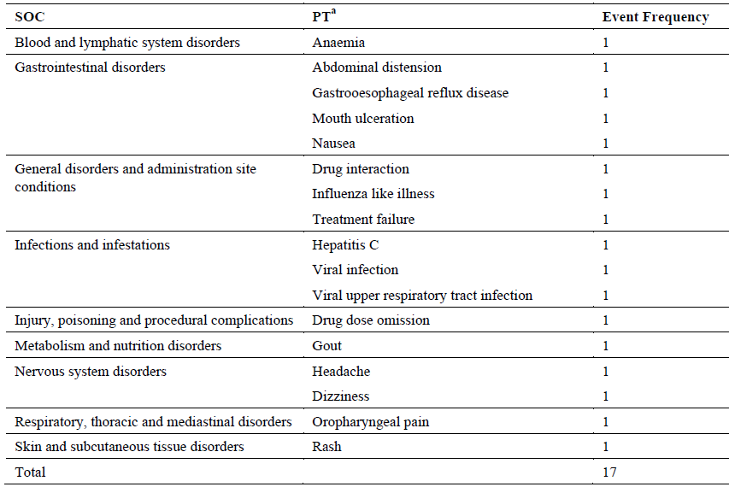
For 7 of the 9 reports, the indication was stated as HCV GT4, and for the remaining two reports, HCV with the GT not provided was given as the indication. Of the 9 reports, only one report had a single event that was considered serious. This case report is presented below:
- One subject experienced treatment failure with ombitasvir/paritaprevir/ritonavir and RBV for HCV GT4. In addition to hepatitis C, the subject had a relevant medical history of cirrhosis. Concomitant medications included Avanza (mirtazapine), for an unspecified indication. Laboratory values included the following: HCV RNA (baseline): 5,484,600 IU/L; HCV RNA (Week 2): 102,700 IU/L; HCV RNA (Week 4): 187,300 IU/L; HCV RNA (Week 8): 2,444,054 IU/L. The drug regimen was stopped after 63 days (9 weeks).
The remaining 8 of the 9 reports from the Australian Patient Named Basis program all involved non-serious events. These 8 non-serious cases are briefly summarised in the table below.
Table 15: AE details for non-serious reports (n = 8).
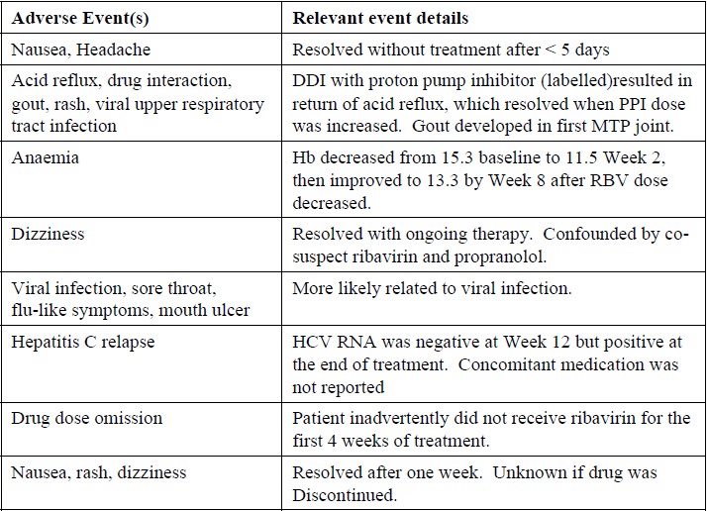

Conclusion
No new safety findings were apparent from review of these AE reports from the Australian Special Access Scheme of patient named basis use.

Specific issue 12
- As requested by email: given the post-marketing exposure for 2-DAA + RBV for GT4 has not been described in detail in this submission or the clinical evaluation, would AbbVie be able to provide an updated number of patients exposed to 2-DAA + RBV for GT4 in clinical trials and if possible an estimated number of post-marketing exposures to 2-DAA + RBV. The summary should capture both efficacy and safety outcomes

AbbVie response

Exposure to the 2-DAA + RBV regimen in patients with HCV GT4 infection in AbbVie clinical trials
There is no change to the number of patients exposed to 2-DAA + RBV in AbbVie clinical trials dedicated to HCV GT4. Summaries of patients exposed to 2-DAA + RBV for GT4 in clinical trials ( M13-393, M11-665 [Part 1] and M14-250) with corresponding safety and efficacy were provided in the original application submitted on 5 November 2015 and AbbVie response to the consolidated Section 31 request submitted on 29 June 2016, respectively. This information is referenced in the Delegate’s Overview. M11-665 Part 2 (2-DAA + RBV for 24 weeks) has enrolled 64 subjects with safety and efficacy evaluation still ongoing.

Post-marketing exposure of the AbbVie 2-DAA + RBV regimen in patients with HCV GT4 infection
Limited data are available regarding utilization of AbbVie’s 2-DAA regimen with RBV. AbbVie’s 2-DAA regimen, in the absence of co-administered dasabuvir, has been distributed worldwide for a total of 43,045 12-week patient treatment courses from 25 November 2014 through 31 July 2016. A DAA utilisation study was performed by IMS for AbbVie using prescription records from the Germany Longitudinal Prescription database (LRx). From 19 December 2014 through 31 May 2016, 264 patients were identified as receiving AbbVie’s 2-DAA regimen, with 92% of those being co-prescribed RBV.
There are no corresponding efficacy and safety data available for this utilisation in Australia for the co-administration of AbbVie’s 2-DAA with RBV.

Advisory Committee considerations
The Advisory Committee on Prescription Medicines (ACPM), taking into account the submitted evidence of efficacy, safety and quality, agreed with the Delegate and considered Technivie FDC tablet containing 75 mg/50 mg/12.5 mg of paritaprevir/ritonavir/ombitasvir to have an overall positive benefit-risk profile for the proposed indication:
Technivie is indicated in combination with RBV for the treatment of adult patients with genotype 4 chronic hepatitis C virus (HCV) infection.
In making this recommendation, ACPM:
- Noted that evidence regarding safety and efficacy for the treatment of HCV GT4 infection was sufficient to support registration.
- Expressed concern regarding multiple DDIs with Technivie.
- The committee advised on the need for prescriber education to ensure that RBV is given with Technivie.

Proposed conditions of registration
ACPM agreed with the Delegate on the proposed conditions of registration.

Proposed PI/CMI amendments
ACPM agreed with the Delegate to the proposed amendments to the Product Information (PI) and Consumer Medicine Information (CMI) and specifically advised on the inclusion of the following:
- A statement in the ‘Interactions’ with other medicines section of the PI and relevant sections of the CMI to include atorvastatin.

Specific advice
ACPM advised the following in response to the Delegate’s specific questions on this submission:
- There is variation in the presentation of production information for Technivie, compared with overseas regulators and compared to Viekira Pak and Viekira Pak RBV. The Australian PI for Technivie is proposed as a stand-alone product information, similar to the US and Canada. Please comment on the presentation of the proposed PI and the potential for market confusion with Viekira Pak and Viekira Pak RBV in Australia.
ACPM considered that Technivie is sufficiently different to Viekira Pak and confusion is unlikely. However, the committee advised that given that prescribers may not necessarily be highly experienced, prescriber education will be required to ensure RBV is not inadvertently omitted.
- Technivie will not be packaged with RBV but is recommended to given with RBV, as per the indication. Please comment of the adequacy of the Technivie PI with respect to information regarding potential risks associated with RBV.
ACPM expressed concern that Technivie will not be packaged with RBV. ACPM also noted that the sponsor has now included the risks associated with RBV combination treatment highlighting pregnancy issues in the updated PI. Information on pregnancy class includes RBV Pregnancy Category X. ACPM advised that prescriber education will be required and information regarding potential risks should be included in CMI.
- The adequacy and clarity of the safety and DDI information of the PI, noting the presentation of overseas PI, and the Viekira Pak RBV PI.
ACPM was of the view that updated version of the Technivie PI was in line with Viekira Pak RBV. The committee advised to include information regarding DDIs with atorvastatin.
- The wording of the indication. The proposed indication is for the treatment of patients with genotype 4 chronic hepatitis C virus (HCV) infection in combination with RBV.
ACPM agreed with the changes in the wording of the indication made by the sponsor, which were suggested in clinical evaluation report:
Technivie is indicated in combination with ribavirin for the treatment of adult patients with genotype 4 chronic hepatitis C virus (HCV) infection.
Data provided from the AGATE-1 and AGATE-2 studies were sufficient to extend the indication to patients with compensated cirrhosis.
ACPM advised that implementation by the sponsor of the recommendations outlined above to the satisfaction of TGA, in addition to the evidence of efficacy and safety provided would support the safe and effective use of this product.

Outcome
Based on a review of quality, safety and efficacy, TGA approved the registration of Technivie blister pack tablets containing paritaprevir/ritonavir/ombitasvir 75 mg/50 mg/12.5 mg, indicated for:
Technivie is indicated in combination with ribavirin for the treatment of adult patients with genotype 4 chronic hepatitis C virus (HCV) infection

Specific conditions of registration applying to these goods
- The Technivie RMP (version 3.1, May 2016, DLP 19 December 2015) with ASA (version 2.1, June 2016), and any subsequent revisions, as agreed with the TGA will be implemented in Australia

Attachment 1. Product Information
The PI approved for Technivie at the time this AusPAR was published is at Attachment 1. For the most recent PI, please refer to the TGA website at <https://www.tga.gov.au/product-information-pi>.

Attachment 2. Extract from the Clinical Evaluation Report

Therapeutic Goods Administration
PO Box 100 Woden ACT 2606 Australia
Email: info@tga.gov.au Phone: 1800 020 653 Fax: 02 6232 8605
https://www.tga.gov.au

European Medicines Agency, “Guideline on clinical evaluation of medicinal products for the treatment of chronic hepatitis C (EMEA/CHMP/51240/2011)”, 20 January 2011.
Routine pharmacovigilance practices involve the following: (a) All suspected adverse reactions that are reported to the personnel of the company are collected and collated in an accessible manner; (b) Reporting to regulatory authorities; (c) Continuous monitoring of the safety profiles of approved products including signal detection and updating of labelling; (d) Submission of Periodic Safety Update Reports (PSURs); and (e) Meeting other local regulatory agency requirements.
Routine risk minimisation activities may be limited to ensuring that suitable warnings are included in the PI or by careful use of labelling and packaging.
Hézode C, et al. Ombitasvir plus paritaprevir plus ritonavir with or without ribavirin in treatment-naive and treatment-experienced patients with genotype 4 chronic hepatitis C virus infection (PEARL-I): a randomised, open-label trial. Lancet 385: 2502-9 (2015).
Pregnancy Category X: Drugs which have such a high risk of causing permanent damage to the foetus that they should not be used in pregnancy or when there is a possibility of pregnancy.

