AusPAR Attachment 2

Extract from the Clinical Evaluation Report for Paritaprevir / Ritonavir / Ombitasvir
  - Proprietary Product Name: Technivie
  - Sponsor: AbbVie Pty Ltd
First round report: February 2016
Second round report: August 2016

About the Therapeutic Goods Administration (TGA)
- The Therapeutic Goods Administration (TGA) is part of the Australian Government Department of Health, and is responsible for regulating medicines and medical devices.
- The TGA administers the Therapeutic Goods Act 1989 (the Act), applying a risk management approach designed to ensure therapeutic goods supplied in Australia meet acceptable standards of quality, safety and efficacy (performance), when necessary.
- The work of the TGA is based on applying scientific and clinical expertise to decision-making, to ensure that the benefits to consumers outweigh any risks associated with the use of medicines and medical devices.
- The TGA relies on the public, healthcare professionals and industry to report problems with medicines or medical devices. TGA investigates reports received by it to determine any necessary regulatory action.
- To report a problem with a medicine or medical device, please see the information on the TGA website <https://www.tga.gov.au>.
About the Extract from the Clinical Evaluation Report
- This document provides a more detailed evaluation of the clinical findings, extracted from the Clinical Evaluation Report (CER) prepared by the TGA. This extract does not include sections from the CER regarding product documentation or post market activities.
- The words [Information redacted], where they appear in this document, indicate that confidential information has been deleted.
- For the most recent Product Information (PI), please refer to the TGA website <https://www.tga.gov.au/product-information-pi>.
Copyright
© Commonwealth of Australia 2017
This work is copyright. You may reproduce the whole or part of this work in unaltered form for your own personal use or, if you are part of an organisation, for internal use within your organisation, but only if you or your organisation do not use the reproduction for any commercial purpose and retain this copyright notice and all disclaimer notices as part of that reproduction. Apart from rights to use as permitted by the Copyright Act 1968 or allowed by this copyright notice, all other rights are reserved and you are not allowed to reproduce the whole or any part of this work in any way (electronic or otherwise) without first being given specific written permission from the Commonwealth to do so. Requests and inquiries concerning reproduction and rights are to be sent to the TGA Copyright Officer, Therapeutic Goods Administration, PO Box 100, Woden ACT 2606 or emailed to <tga.copyright@tga.gov.au>.

Contents
List of abbreviations 5
1. Definition of terms 8
2. Introduction 8
2.1. Drug class and therapeutic indication 8
2.2. Dosage forms and strengths 9
2.3. Dosage and administration 9
3. Clinical rationale 9
4. Contents of the clinical dossier 10
4.1. Scope of the clinical dossier 10
4.2. Paediatric data 10
4.3. Good clinical practice 10
5. Pharmacokinetics 10
5.1. Studies providing pharmacokinetic data 10
5.2. Summary of pharmacokinetics 11
5.3. Evaluator’s overall conclusions on pharmacokinetics 14
6. Pharmacodynamics 14
6.1. Studies providing pharmacodynamic data 14
7. Dosage selection for the pivotal studies 15
8. Clinical efficacy 15
8.1. Indication 15
9. Clinical safety 29
9.1. Studies providing evaluable safety data 29
9.2. Pivotal studies that assessed safety as a primary outcome 29
9.3. Patient exposure 29
9.4. Adverse events 30
9.5. Laboratory tests 34
9.6. Post-marketing experience 38
9.7. Safety issues with the potential for major regulatory impact 38
9.8. Other safety issues 38
9.9. Evaluator’s overall conclusions on clinical safety 38
10. First round benefit-risk assessment 39
10.1. First round assessment of benefits 39
10.2. First round assessment of risks 39
10.3. First round assessment of benefit-risk balance 39
11. First round recommendation regarding authorisation 39
12. Clinical questions 40
13. Second round evaluation of clinical data 40
13.1. Question 1 40
13.2. Question 2 41
13.3. Question 3 41
14. Second round benefit-risk assessment 45
14.1. Second round assessment of benefits 45
14.2. Second round assessment of risks 45
14.3. Second round assessment of benefit-risk balance 45
15. Second round recommendation regarding authorisation 45
16. References 45

List of abbreviations
Abbreviations | Meaning
2-DAA | ABT-450 150 mg plus ritonavir 100 mg plus ABT-267 25 mg
ABT-450 | paritaprevir
ABT-450/r | ABT-450 co-administered with ritonavir
ABT-267 | ombitasvir
ADME | absorption/distribution/metabolism/excretion
AE | adverse event
AFP | alpha foetoprotein
ALT | alanine aminotransferase
ANC | absolute neutrophil count
ANOVA | analysis of variance
AST | aspartate aminotransferase
AUC | area under the curve
BID | twice daily
BMI | body mass index
CTCAE | Common Terminology Criteria for Adverse Events
CYP | cytochrome P450
DAA | direct-acting antiviral agent
ECG | electrocardiogram
EOTR | end-of-treatment response
FDC | fixed dose combination
GCP | Good Clinical Practice
GT1a | genotype 1a
GT1b | genotype 1b
GT4 | genotype 4
HBsAg | hepatitis B surface antigen
HBV | hepatitis B virus
HCC | hepatocellular carcinoma
HCV | hepatitis C virus
HIV | human immunodeficiency virus
ICH | International Conference on Harmonisation
IEC | Independent Ethics Committee
IgG | immunoglobulin G
IgM | immunoglobulin M
IL28B | interleukin 28B
IP-10 | interferon gamma-induced protein 10
IRT | interactive response technology
ITT | intent-to-treat
IU | international units
LCB | lower bound of the 95% confidence interval
LLN | lower limit of normal
LLOD | lower limit of detection
LLOQ | lower limit of quantitation
MedDRA | Medical Dictionary for Regulatory Activities
MEMS | Medication Event Monitoring System
mRNA | messenger RNA
NS3 | non-structural protein 3
NS4A | non-structural protein 4A
NS5A | non-structural protein 5A
NS5B | non-structural protein 5B
PCS | potentially clinically significant
pegIFN | pegylated interferon
PP | per protocol
PT | preferred term
PT | post-treatment
PVF | primary virologic failure
QD | once daily
r | ritonavir
RBV | ribavirin
RNA | ribonucleic acid
RVR | rapid virologic response
SAE | serious adverse event
SAF | safety population
SmPC | summary of product characteristics
SOC | System Organ Class
SVR | sustained virologic response
SVR₄ | sustained virologic response 4 weeks post-dosing
SVR₁₂ | sustained virologic response 12 weeks post-dosing
SVR₂₄ | sustained virologic response 24 weeks post-dosing
ULN | upper limit of normal
VAS | visual analogue scale
WBC | white blood cell

Definition of terms
Plasma HCV RNA levels were measured by a central laboratory using the Roche COBAS Taqman PCR assay. The LLOD is 15 IU/mL with results reported as ‘not detected’. The LLOQ is 25 IU/mL with results reported as ‘<25 IU/mL HCV RNA detected’.
- On-treatment quantifiable HCV RNA: Any two consecutive HCV RNA values ≥LLOQ during treatment, or at the final treatment measurement and the next consecutive post-treatment measurement.
- Post-treatment quantifiable HCV RNA: Any two consecutive post-treatment HCV RNA measurements ≥LLOQ.
- On-treatment virologic failure: Confirmed HCV RNA ≥LLOQ after HCV RNA <LLOQ during treatment, or confirmed increase from nadir in HCV RNA (two consecutive HCV RNA values > 1 log₁₀ IU/mL above nadir) at any time point during treatment or HCV RNA ≥LLOQ persistently during treatment with at least 6 weeks treatment.
- Rebound: Confirmed HCV RNA ≥LLOQ after HCV RNA <LLOQ during treatment, or confirmed increase from nadir in HCV RNA (two consecutive HCV RNA values > 1 log₁₀ IU/mL above nadir) at any time during treatment.
- Relapse: Confirmed HCV RNA ≥LLOQ between the end of treatment and 12 weeks after the last dose of study drugs in patients completing treatment and with HCV RNA <LLOQ at the end of treatment.
- RVR: Rapid virologic response (HCV RNA <LLOQ at the Week 4 measurement).
- EOTR: End of treatment response (HCV RNA <LLOQ at the Week 12 measurement).
- SVR₄: HCV RNA <LLOQ measured 4 weeks after the last actual dose of study drug without any confirmed quantifiable (≥LLOQ) post-treatment value before or during that SVR window.
- SVR₁₂: HCV RNA <LLOQ measured 12 weeks after the last actual dose of study drug without any confirmed quantifiable (≥LLOQ) post-treatment value before or during that SVR window.
- SVR₂₄: HCV RNA <LLOQ measured 24 weeks after the last actual dose of study drug without any confirmed quantifiable (≥LLOQ) post-treatment value before or during that SVR window.

Introduction
This is a submission to extend an indication.

Drug class and therapeutic indication
TECHNIVIE is a fixed dose combination of 2-DAA (paritaprevir and ombitasvir with ritonavir) to be used with ribavirin for the treatment of patients with chronic HCV genotype 4 infection.
TECHNIVIE is a component of the 3-DAA combination VIEKIRA PAK which is approved for the treatment of HCV genotype 1 infection. VIEKIRA PAK is presented as a combination pack containing:
- Two tablets containing paritaprevir/ritonavir/ombitasvir (the fixed dose combination to be marketed as TECHNIVIE for the proposed HCV GT4 indication); and
- Two tablets containing dasabuvir.
The approved indication for VIEKIRA PAK is:
VIEKIRA PAK with or without ribavirin is indicated for the treatment of patients with genotype 1 chronic hepatitis C virus (HCV) infection including those with compensated cirrhosis. VIEKIRA PAK includes ombitasvir, a hepatitis C virus NS5A inhibitor, paritaprevir, a hepatitis C virus NS3/4A protease inhibitor, ritonavir, a CYP3A inhibitor and dasabuvir, a hepatitis C virus non-nucleoside NS5B palm polymerase inhibitor.
The proposed indication for TECHNIVIE is:
TECHNIVIE is indicated in combination with ribavirin for the treatment of patients with genotype 4 chronic hepatitis C virus (HCV) infection.

Dosage forms and strengths
No new dosage forms or strengths are proposed. The following dosage forms and strengths are currently registered as a component of VIEKIRA PAK:
- paritaprevir/ritonavir/ombitasvir 75/50/12.5 mg (ABT-450/r/ABT-267) presented as FDC tablets

Dosage and administration
- TECHNIVIE should be given as two tablets in the morning with food.
- TECHNIVIE should be used in combination with ribavirin. The recommended dose of ribavirin is based on body weight: 1000 mg/day for patients weighing ≤75 kg and 1200 mg/day for those weighing >75 kg, divided and given twice daily with food.

Clinical rationale
It is estimated that 130 to 210 million people worldwide are infected with HCV with 2 to 4 million new infections annually. Approximately 80% of infections are related to IV drug use, with lesser numbers attributed to sexual transmission, blood transfusions and tattoos. Approximately 300,000 Australians were infected with HCV in 2011. Acute infections become chronic in 70% to 90% of cases and this leads commonly to cirrhosis, chronic liver failure, hepatocellular carcinoma, liver transplantation and death. After 20 years of infection, 20-30% of patients will have progressed to cirrhosis, 5-10% will have developed end-stage liver disease and 4-8% will have died of liver-related causes. HCV has six genotypes (GT) and multiple subtypes with genotypes 1 to 3 distributed worldwide. Genotypes 1a and 1b account for 60% of global HCV infections. In Australia, the most common genotypes are 1a and 1b (54% prevalence) and 3a (37% prevalence). The incidence of HCV GT4 infection is low in the US (~1%) and in Europe (~5% on average). However, in North Africa and the Middle East, it has a prevalence of ~50% (up to 90% in Egypt) and it is spreading to Europe and the rest of the world through immigration and IV drug use. Until recently, the standard of care treatment for chronic HCV infection for all genotypes was the combination of pegylated interferon and ribavirin (pegIFN/RBV) for 48 weeks. The response to this treatment varies according to HCV genotype and host IL28B genotypic subtypes (CC, CT and TT). Patients with the IL28b CC genotype are able to mount stronger immune responses to the HCV virus and spontaneous viral clearance rates and responsiveness to antiviral therapy are enhanced. In patients with HCV GT1 infection, sustained viral response (SVR) rates following pegIFN/RBV therapy are only 45% in treatment-naïve patients and significantly lower in prior relapsers and non-responders. Moreover, the side effect profile of pegIFN/RBV is unfavourable with a high incidence of lethargy, fatigue, depression and anaemia.
The NS3/4A protease inhibitors boceprevir, telaprevir, and simeprevir, and the NS5B polymerase inhibitor sofosbuvir used singly in combination with pegIFN/RBV have improved SVR rates in treatment naïve and treatment-experienced patients and shortened treatment duration to 24 weeks in many patients with HCV GT1 infection. The combinations of sofosbuvir and RBV with or without pegIFN and simeprevir and pegINF with RBV, have shown promise in patients with HCV GT4 infection. However, these 1-DAA combinations are associated with increased rates and severity of AEs, including rash in addition to the common side effects of pegIFN/RBV. Simeprevir and sofosbubvir are well tolerated and have the advantage of once daily dosing. However, telaprevir and boceprevir both require TID therapy.
Most recently, VIEKIRA PAK has been approved for the treatment of patients with HCV GT1. It is a combination product of three DAAs with different mechanisms of action and which all have potent activity against HCV GT1. They have non-overlapping viral resistance profiles and they also appear to have non-overlapping toxicity with RBV. Paritaprevir (ABT-450), ombitasvir (ABT-267) and dasabuvir (ABT-333) are potent DAAs; however, resistance develops to each agent when used as monotherapy. The 3-DAA regimen used in VIEKIRA PAK obviates the need for concomitant pegIFN/RBV therapy; increases SVR rates compared with 1-DAA + pegIFN/RBV combination therapy; shortens treatment duration from 24 to 12 weeks; and improves safety and tolerability. Dasabuvir has no activity against HCV GT4 but paritaprevir and ombitasvir have potent activity. For this reason, TECHNIVIE was developed as a fixed dose 2-DAA combination of paritaprevir and ombitasvir plus ritonavir which is otherwise identical to that used in VIEKIRA PAK. It is proposed that this 2-DAA combination may have value for the treatment of patients with HCV GT4 infection.

Contents of the clinical dossier

Scope of the clinical dossier
The submission contains two new clinical studies as follows:
- One clinical pharmacology study M14-229 which provided absolute bioavailability data
- One Phase 2 efficacy and safety study M13-393

Paediatric data
The submission did not include paediatric data.

Good clinical practice
The clinical studies were performed according to the principles of ICH GCP.

Pharmacokinetics

Studies providing pharmacokinetic data
A summary of the single pharmacokinetic study M14-229 is presented.

Summary of pharmacokinetics
The information in the following summary is derived from conventional pharmacokinetic studies.

Physicochemical characteristics of the active substance
TECHNIVIE is a fixed dose combination tablet containing paritaprevir 75 mg, ritonavir 50 mg and ombitasvir 12.5 mg. The chemical structures of the active ingredients are shown in Figure 1.
Figure 1: Chemical structures of active ingredients.
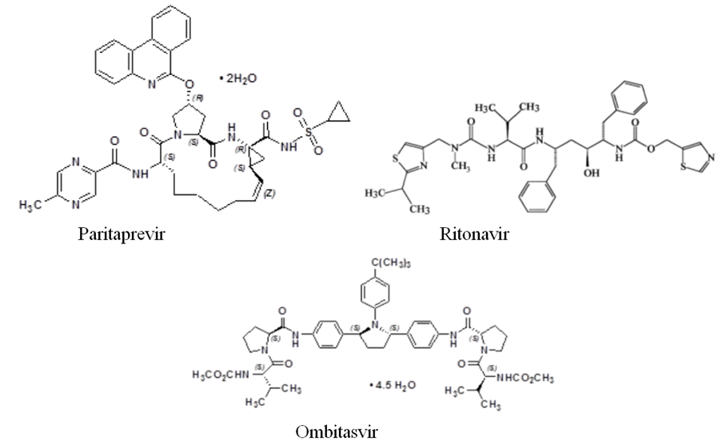
The molecular formula of paritaprevir dihydrate is C₄₀H₄₃N₇O₇S and the molecular weight of the drug substance is 801.91. It is a white to off-white powder with a pKa of 4.6 at 25˚C and it has very low water solubility.
The molecular formula of ritonavir is C₃₇H₄₈ N₆O₅S₂ and the molecular weight of the drug substance is 720.95. It is a white to off-white to light tan powder with a pKa of 2.8 at 25˚C. It is almost insoluble in water but freely soluble in methanol and ethanol.
The molecular formula of ritonavir is C₅₀H₆₇ N₇O₈ and the molecular weight of the drug substance is 975.20. It is a white to light pink powder with a pKa of 2.5 at 25˚C. It is almost insoluble in water but freely soluble in ethanol.

Pharmacokinetics in healthy subjects
An absolute bioavailability study (M14-229) was conducted in 16 healthy subjects. As an oral co-formulated product with ritonavir, the mean geometric bioavailabilities of ABT-450 and ABT-267 under non-fasted conditions were 52.6% and 48.1%, respectively (Table 1).

Table 1: M14-229 Assessment of bioavailability
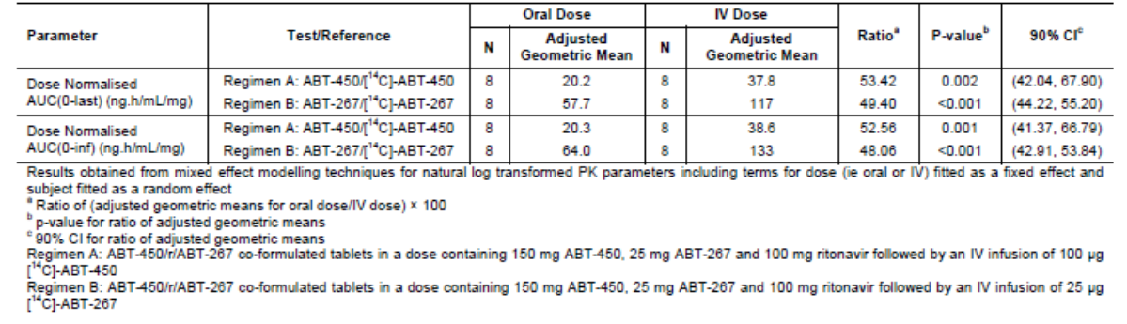

PK in target patient populations
A summary of the acute and steady state PK parameters of the 2-DAA regimen measured in M13-393 is shown in Tables 2-5. At 4 hours after dosing, the concentrations of ABT-450, ritonavir and ABT-267 were lower in non-cirrhotic GT4 patients than in non-cirrhotic GT1b patients. In cirrhotic GT1b patients, the concentration of ABT-450 was higher than in non-cirrhotic patients. However, the concentrations of ritonavir and ABT-267 were lower in cirrhotic GT1b patients. As with the 4 hour concentrations, C_{trough} values were lower in GT4 patients compared with GT1b non-cirrhotic patients. In cirrhotic GT1b patients, ABT-450 values were higher for ABT-450 and ritonavir and lower for ABT-267, compared with non-cirrhotic GT1b patients.
Comment: As discussed, the clinical significance of lower exposure in GT4 patients compared with GT1b patients should not be dismissed (see Clinical Questions).

Table 2: M13-393 Study drug concentrations 4 hours post-dose Day 1 GT4 patients.
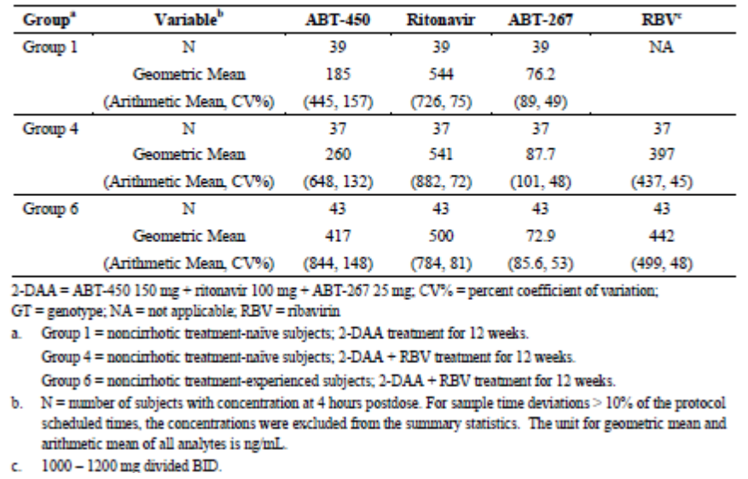

Table 3: M13-393 Study drug concentrations 4 hours post-dose Day 1 GT1b patients.
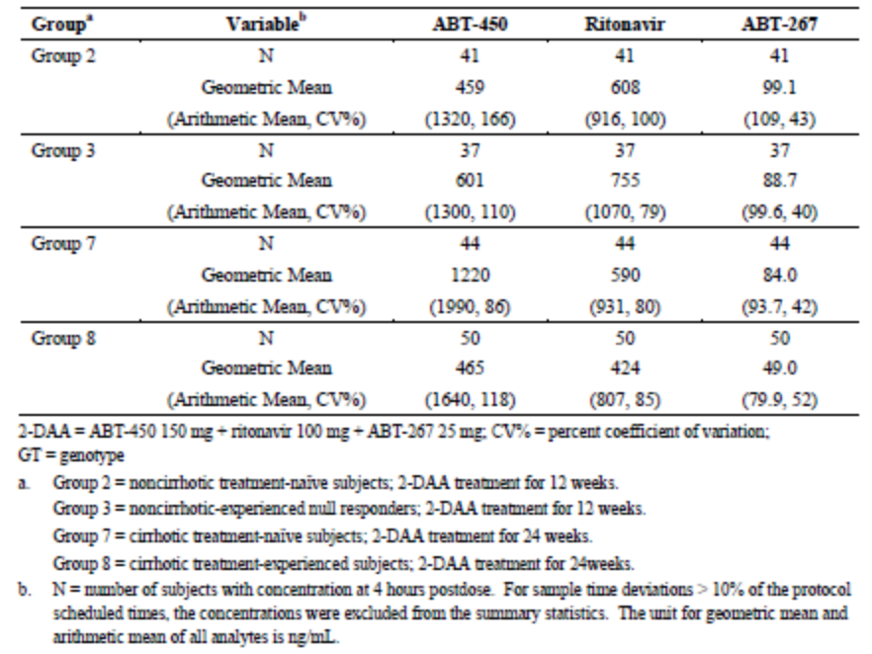

Table 4: M13-393 Study drug trough concentrations in GT4 patients.
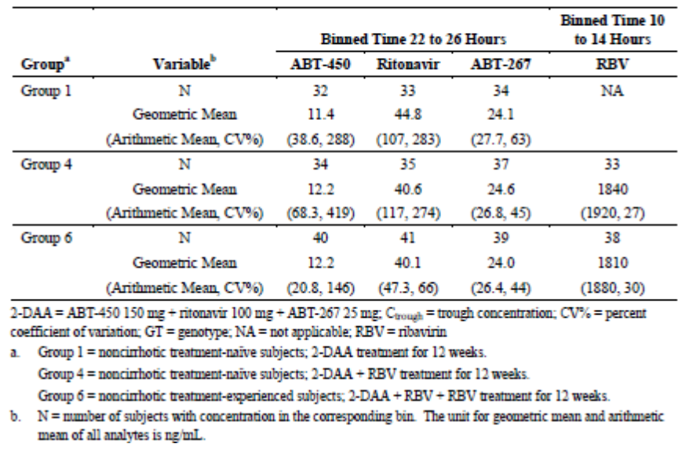

Table 5: M13-393 Study drug trough concentrations in GT1b patients.
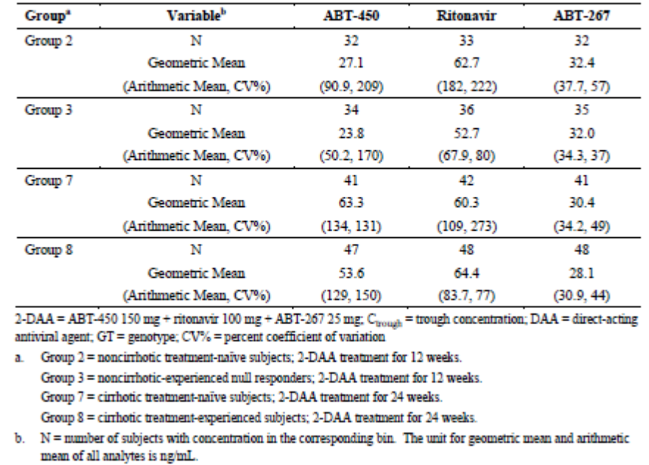

Evaluator’s overall conclusions on pharmacokinetics
The absolute bioavailability of dasabuvir was measured during the Viekira Pak development program, but not the components of the 2-DAA regimen. The absolute bioavailabilities of ABT-450 and ABT-267 estimated in the healthy subject Study M14-229 are acceptable.
In M13-393, the steady state concentrations of ABT-450 were notably lower in patients with GT4 infection compared with those with GT1b infection. The sponsor suggests that this anomaly was probably due to cross study comparisons, as the GT of HCV should not affect the pharmacokinetics of the DAAs.
The sponsor points out that possible PK differences can be discounted as efficacy rates were high in all groups. However, in Group 1 (treatment naïve, non-cirrhotic GT4 patients, 2-DAA without RBV), 9.1% of patients were non-responders; almost twice the 4.8% number observed in the corresponding GT1b patients in Group 2. Moreover, the SVR₂₄ rate was ‘only’ 86.4% in Group 1. With the advent of highly effective combination DAA therapies such as Viekira Pak, SVR₁₂ rates of up to 100% are a realistic therapeutic target. While accepting that 90% efficacy (SVR₂₄ 86.4% ) rates are outstanding, a two-fold difference in non-response rates in GT4 patients compared with GT1b patients should not be dismissed as unimportant.
The sponsor did not conduct drug concentration/response analyses as efficacy was considered adequate in all groups. However, in light of the comments above, it would be useful to compare the PK parameters in responder and non-responder patients in M13-393.

Pharmacodynamics

Studies providing pharmacodynamic data
No new studies have been performed.

Dosage selection for the pivotal studies
Dosage selection was based on similar in vitro data between the GT1b and GT4 subtypes and the optimal dose in patients with GT1 infection. No new dose ranging studies have been performed to support the TECHNIVIE submission.

Clinical efficacy

Indication
Proposed indication: TECHNIVIE is indicated in combination with ribavirin for the treatment of patients with genotype 4 chronic hepatitis C virus (HCV) infection

Pivotal efficacy study

Study M13-393 (PEARL-1)

Study design, objectives, locations and dates
This was an open-label, randomised, Phase 2, efficacy and safety study of the 2-DAA combination treatment (ABT-450/r administered with ABT-267, with and without RBV) in adults with chronic HCV infection. The study was conducted at 46 sites in the US, Puerto Rico, France, Hungary, Italy, Poland, Romania, Spain and Turkey. It started in August 2012 and was completed in February 2015.The study was planned to enrol approximately 320 patients with approximately 40 patients in each of eight treatment groups. The study objectives were to compare the effects of the 2-DAA regimen with and without RBV on SVR₁₂ rates in treatment-naïve and treatment-experienced non-cirrhotic patients with HCV GT4 infection and in patients with and without cirrhosis with HCV GT1b infection. The study schematic is shown below in Figure 2.
Figure 2: Study schematic M13-393.
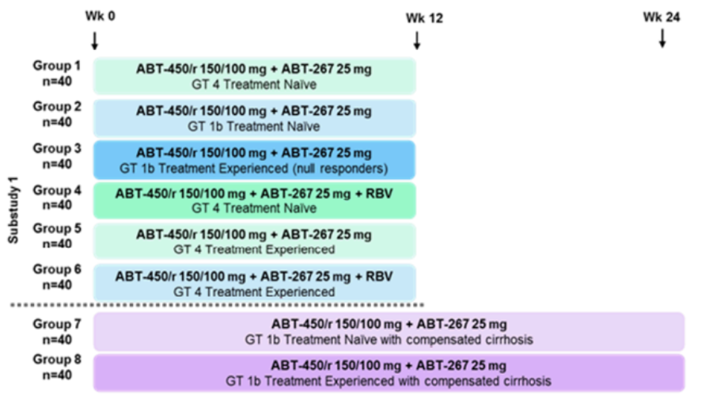
During the treatment periods, patients were given the 2-DAA regimen with or without RBV for 12 or 24 weeks. During the post-treatment period, patients who completed the study or prematurely discontinued during the treatment period were followed for a total of 48 weeks to assess HCV RNA levels and the emergence of viral resistance. The study was divided into two sub-studies in treatment-naïve and treatment-experienced non-cirrhotic patients and patients with compensated cirrhosis. In Sub-study 1, Groups 2 and 3 were initially enrolled in parallel, after which Groups 1 and 4 were enrolled. After assessment of emerging efficacy data, Group 6 was enrolled but Group 5 was cancelled and did not enrol. In Sub-study 2, Groups 7 and 8 commenced after assessment of emerging efficacy data in non-cirrhotic patients.
- Sub-study 1: Non-cirrhotic patients
  - Group 1: treatment-naïve GT4 patients received the 2-DAA regimen for 12 weeks
  - Group 2: treatment-naïve GT1b patients received the 2-DAA regimen for 12 weeks
  - Group 3: null-responder GT1b patients received the 2-DAA regimen for 12 weeks
  - Group 4: treatment-naïve GT4 patients received the 2-DAA regimen + RBV for 12 weeks
  - Group 5: treatment-experienced GT4 patients were planned to receive 2-DAA for 12 weeks.
  - Group 6: treatment-experienced GT4 patients received the 2-DAA regimen + RBV for 12 weeks
- Sub-study 2: Patients with compensated cirrhosis
  - Group 7: treatment-naïve GT1b patients received the 2-DAA regimen for 24 weeks
  - Group 8: treatment-experienced GT1b patients received the 2-DAA regimen for 24 weeks
A screening period was followed by a randomised, variable treatment period with follow-up to Week 48. At the baseline visit on Day 1, all patients received the 2-DAA regimen with additional RBV in Groups 4 and 6. Plasma samples were collected for PK analysis up to 4 hours post-dose. Visits were then scheduled on Day 3 and at Weeks 1, 2, 3, 4, 6, 8, 10 before the final visit at Week 12. During the post-treatment period, visits were scheduled at Weeks 2, 4, 8, 12 and 24 before the final visit at Week 48. At each visit, routine clinical and laboratory monitoring was performed. Compliance was assessed by dosing diaries, tablet counts and MEMS caps which were collected upon completion of study drug. At each visit, plasma samples were collected for pre-dose PK, HCV RNA and HCV resistance.

Inclusion and exclusion criteria
The key inclusion criteria were: male or female patients aged 18 to 70 years inclusive; women who were not sexually active or of non-childbearing potential; treatment-naïve, prior null responders, partial responders, or relapsers (see ABBREVIATIONS for definition of terms); BMI ≥18 to <38 kg/m²; plasma HCV RNA >10,000 IU/mL at screening; chronic HCV GT4 or GT1b using pre-defined criteria for at least 6 months before screening; liver biopsy at screening or in the previous 24 months confirming absence of cirrhosis, or FibroScan <9.6 kPA at screening in the absence of a liver biopsy; cirrhosis confirmed histologically by Metavir score >3 or Ishak score >4, or a positive FibroScan score ≥14.6 kPA within 6 months of screening; compensated cirrhosis defined as Child-Pugh score of ≤6 at screening.
The key exclusion criteria were: significant sensitivity to any drug; use of herbal supplements; pregnant or breast feeding; recent history of drug or alcohol abuse; HBV positive; pre-defined concomitant medications; use of strong inhibitors or inducers of CYP3A within previous 2 weeks; clinically significant physical or laboratory abnormalities; any cause of liver disease other than chronic HCV infection; enrolment in another investigational study; use of colony stimulating factors; co-infection with another HCV genotype or a genotype unable to be characterised; significant QTc abnormalities.
Additional exclusion criteria for patients without cirrhosis were: any current or past clinical evidence of cirrhosis including ascites, oesophageal varices, or prior biopsy; ALT/AST >5xULN; creatinine clearance <60 mL/min (by Cockcroft-Gault method); albumin <ULN; INR >1.5; haemoglobin <LLN; platelets <120,000; ANC <1500 cells/µL; indirect bilirubin >1.5xULN; direct bilirubin >ULN.
Additional exclusion criteria for patients with compensated cirrhosis were: ALT/AST >5xULN; creatinine clearance <60 mL/min (by the Cockcroft-Gault method); albumin <2.8 g/dL; INR >2.3; haemoglobin <LLN; platelets <60,000; ANC <1500 cells/µL; total ≥3.0 mg/dL; serum AFP >100 ng/mL; confirmed presence of HCC.

Study treatments
All patients received the 2-DAA regimen with or without RBV as shown below in Table 6. The study drugs were given as tablets (ABT-450, ABT-267 and RBV) or capsules (ritonavir) and the FDC formulation proposed for marketing was not used.

Table 6: Dosing schematic Study M13-393.
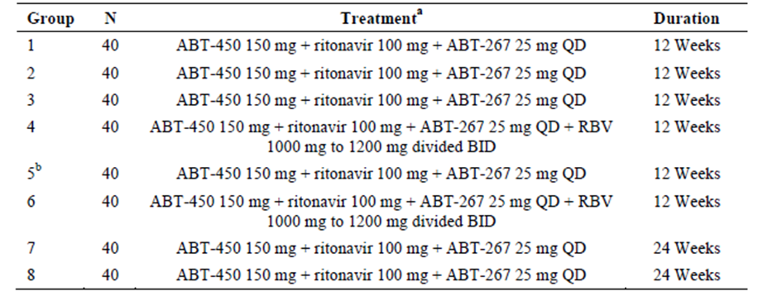
All study drug was administered orally. RBV was to be administered with weight-based dosing 1000 or 2000 mg divided BID per local label. The treatment shown was planned for Group 5, but Group 5 was not dosed.

Efficacy variables and outcomes
The main efficacy variables were:
- viral response assessed by HCV RNA levels from baseline to Week 48
- patients achieving SVR12 and SVR24
- on-treatment virologic failure
- post-treatment relapse
- resistance variables
- PK variables
The primary efficacy outcome was a comparison of the percentage of patients achieving SVR₁₂ after treatment with:
The 2-DAA regimen
- among treatment-naïve and prior pegIFN/RBV null responder HCV GT1b-infected patients without cirrhosis
- among treatment-naïve and pegIFN/RBV treatment-experienced HCVGT1b-infected patients with compensated cirrhosis
The 2-DAA regimen with and without RBV
- among treatment-naïve and pegIFN/RBV treatment-experienced HCV GT4-infected patients
Other efficacy outcomes included:
- the percentage of patients achieving SVR24
- the percentage of patients with on-treatment virologic failure
- the percentage of patients with post-treatment relapse

Randomisation and blinding methods
This was an open-label study. Patients in Groups 1 and 4 were randomly allocated to a treatment group via IRT on Day 1. Patients in other groups were assigned to a group based on their baseline characteristics.

Analysis populations
A total of 316 patients received at least one dose of study medication and were included in the ITT, SAF and PK sets. No patients were excluded from the ITT because of protocol deviations so a PP analysis was not performed.

Sample size
For the primary endpoint of SVR₁₂, the assumed rates were 70% in Group3 and 95% in Group 2. Using Fisher’s exact test with a 2-sided significance level of 0.05, 40 patients in each group had 80% power to detect a difference of 25% between the non-cirrhotic HCV GT1b-infected treatment-naïve patients and prior null responders treated with the 2-DAA regimen for 12 weeks.

Statistical methods
The statistical analysis was performed using SAS. All tests and 95% CIs were 2-sided with an α level of 0.05. The primary endpoint was the percentage of patients achieving SVR₁₂ in each treatment group. Pairwise comparisons between Groups 1 and 4 and between Groups 2 and 3 were made using logistic regression with treatment group, log₁₀ HCV RNA and IL28 genotypes (CC, non-CC) as predictors. Treatment differences were calculated using stratum-adjusted Mantel-Haenszel proportion and continuity-corrected variance, adjusting for IL28 genotype. Secondary endpoints were calculated using the same methodologies. No data were imputed with the exception of SVR and RVR.

Participant flow
- HCV GT4 Groups: A total of 120 patients were planned and 135 patients were randomised in Groups 1, 4 and 6. A total of 130 patients completed the study; one patient discontinued the study during the treatment period and four patients discontinued after the treatment period.
- HCV GT1b Groups: A total of 80 non-cirrhotic patients were planned and 82 patients were randomised in Groups 2 and 3. A total of 79 patients completed the study; one patient discontinued the study during the treatment period and two patients discontinued after the treatment period. A total of 80 patients with compensated cirrhosis were planned and 99 patients were randomised in Groups 7 and 8. A total of 96 patients completed the study and three patients discontinued the study during the treatment period.

Major protocol violations/deviations
A total of 12 patients had protocol deviations relating to inclusion/exclusion criteria; three patients received an incorrect dose of study drug; and one patient received a prohibited concomitant medication. None of the protocol deviations were considered to have affected the outcomes or conclusions of the study.
Compliance was recorded as the percentage of tablets or capsules taken relative to the number expected to be taken with a protocol-defined acceptable range of 80% to 120%. In Groups 4 and 6, all patients (100%) were compliant with ABT-450, ABT-267 and RBV. For ritonavir, all patients (100%) were compliant in Groups 2, 6, 7 and 8. Compliance with ABT-450, ABT-267 and RBV was achieved in 93.0%, 95.0% and 92.9% of Groups 1, 3 and 4, respectively.

Baseline data
- HCV GT4 Groups: The majority of patients were male (65.2%) and White (88.9%) with mean age 48.2 years (range 19 to 70) and mean body weight 75.6 kg. All patients in Groups 1 and 4 were treatment-naïve. In Group 6, all patients had previously received pegIFN/RBV (46.9% were null responders, 34.7% were relapsers and 18.4% were partial responders). Overall, the majority of patients were infected with HCV sub-types 4d or 4a, the IL28B genotype was CC in 21.5% of patients and the mean baseline HCV RNA was 6.17 log10 IU/mL.
- HCV GT1b Groups: In Groups 2 and 3, the majority of patients were female (51.2%) and White (80.5%) with mean age 55.0 years (range 29 to 69) and mean body weight 77.9 kg. In Groups 7 and 8, the majority of patients were male (56.6%) and White (97.0%) with mean age 57.4 years (40 to 70) and mean body weight 76.6 kg. All patients in Group 2 were treatment-naïve. In Group 3, all patients had previously received pegIFN/RBV and were null responders. In Groups 2 and 3 (non-cirrhotic), the IL28B genotype was CC in 18.5% of patients and the mean baseline HCV RNA was 6.42 log10 IU/mL. In Group 7, all patients were treatment-naïve. In Group 8, all patients had previously received pegIFN/RBV (48.1% were null responders, 23.1% were relapsers and 28.8% were partial responders). The IL28B genotype was CC in 13.1% of patients and the mean baseline HCV RNA was 6.38 log10 IU/mL. At screening, the majority of patients had a Child-Pugh score of 5 or 6 (Group 7 97.9%; Group 8 96.2%).

Results for the primary efficacy outcome
The primary efficacy endpoint was the percentage of patients with SVR₁₂ after 12 weeks treatment in Groups 2 and 3 (treatment-naïve versus null responder GT1b patients given 2-DAA for 12 weeks). An additional primary endpoint was a comparison in Groups 1 and 4 (treatment-naïve GT4 patients given 2-DAA with or without RBV for 12 weeks).
- HCV GT4 Groups: SVR₁₂ was achieved in 90.9% (95% CI: 78.3, 97.5) of treatment-naïve patients treated with 2-DAA (Group 1); in 100% (95% CI: 91.6, 100.0) of treatment-naïve patients treated with 2-DAA + RBV (Group 4); and in 100% (95% CI: 92.7, 100) of treatment-experienced patients treated with 2-DAA + RBV (Group 6) (Table 7). The adjusted treatment difference between Groups 1 and 4 was -9.16% (95% CI: -19.61, 1.29) which was not statistically significant (p=0.086). Four patients (all in Group 1) were non-responders.

Table 7: Study M13-393 SVR₁₂ efficacy endpoint in HCV GT4 patient groups.
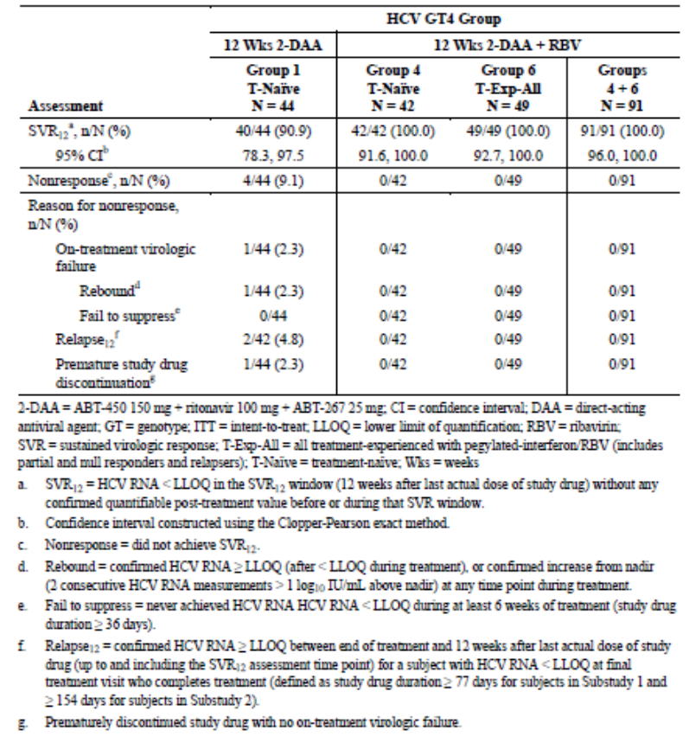
- HCV GT1b Groups: In the primary comparison of Groups 2 and 3, SVR₁₂ was achieved in 95.2% (95% CI: 83.8, 99.4) of treatment-naïve patients, compared with 90% (95% CI: 76.3, 97.2) of treatment-experienced null responders, all treated with 2-DAA for 12 weeks (Table 8). Two patients in Group 2 and four patients in Group 3 were non-responders. The adjusted estimate of the treatment difference between Groups 2 and 3 was 5.53% (95% CI: -8.48, 19.55) which was not statistically significant (p=0.439) (Table 9). In patients with cirrhosis treated with 2-DAA for 24 weeks, SVR₁₂ was achieved in 97.9% (95% CI: 88.7, 99.9) of treatment-naïve patients (Group 7) and 98.1% (95% CI: 89.7, 100) of treatment-experienced patients (Group 8). One patient (1.0%) in each group was a non-responder.
Comment: The study was powered to detect only a 25% difference between groups. Patients with GT1b infection did not receive RBV. However, all non-cirrhotic GT4 patients achieved SVR12 after 12 weeks treatment with 2-DAA + RBV.

Table 8: Study M13-393 SVR₁₂ in HCV GT1b patient groups.
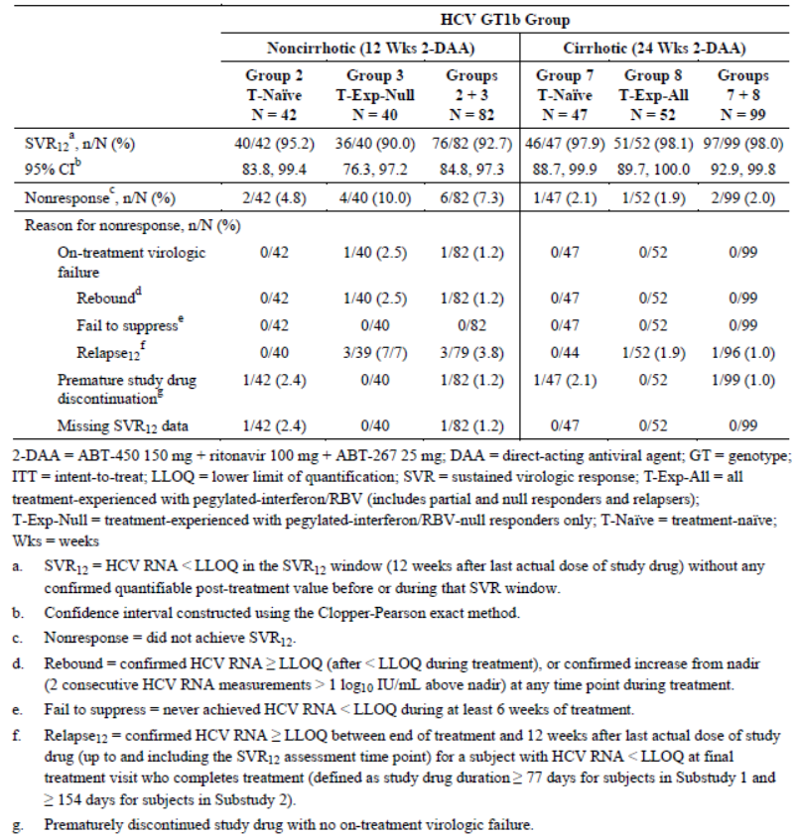

Table 9: Study M13-393 Primary efficacy endpoint comparison.
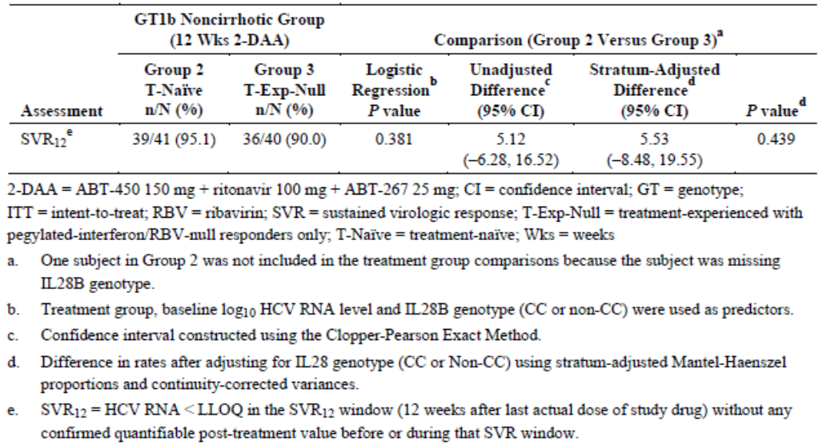

Results for other efficacy outcomes
- HCV GT4 Groups: SVR₂₄ was achieved in 86.4% (95% CI: 72.6, 94.8) of treatment-naïve patients treated with 2-DAA (Group 1); in 100% (95% CI: 91.6, 100.0) of treatment-naïve patients treated with 2-DAA + RBV (Group 4); and in 100% (95% CI: 92.7, 100) of treatment-experienced patients treated with 2-DAA + RBV (Group 6) (Table 10). The adjusted treatment difference between Groups 1 and 4 was -13.74% (95% CI: -2.08, -25.40) which was statistically significant (p=0.021) (Table 11). Six patients (all in Group 1) were non-responders.

Table 10: Study M13-393 Secondary efficacy endpoints.
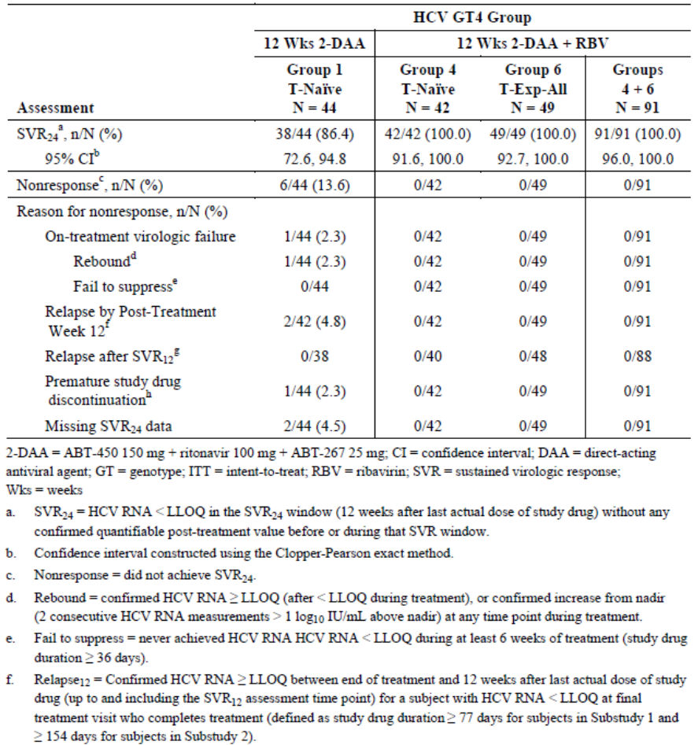

Table 11: Study M13-393 Secondary endpoint comparison Group 1 versus Group 4.
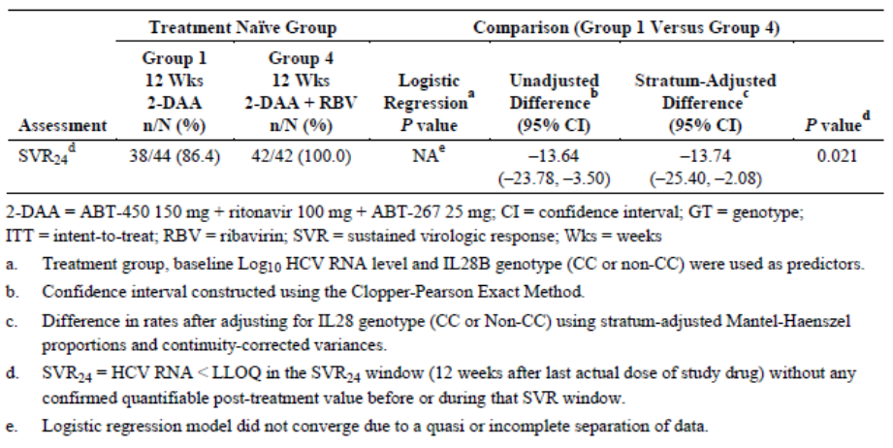
- HCV GT1b Groups: SVR₂₄ was achieved in 92.9% (95% CI: 80.5, 98.5) of treatment-naïve patients (Group 2) and 90.0% (95% CI: 76.3, 97.2) of treatment-experienced null responders (Group 3) (Table 12). There were three and four non-responders in the respective groups. No new relapses were observed after post-treatment Week 12. The adjusted estimate of the treatment difference between Groups 2 and 3 was 4.79% (95% CI: -9.29, 18.86) which was not statistically significant (p=0.505) (Table 13). In patients with cirrhosis treated with 2-DAA for 24 weeks, SVR₂₄ rates were 97.9% (95% CI: 88.7, 99.9) in treatment-naïve patients (Group 7) and 98.1% (95% CI: 89.7, 100) in treatment-experienced patients (Group 8). One patient (1.0%) in each group was a non-responder. No new relapses were observed after post-treatment Week 12.

Table 12: Study M13-393 Secondary efficacy endpoint comparison Group 2 and Group 3.
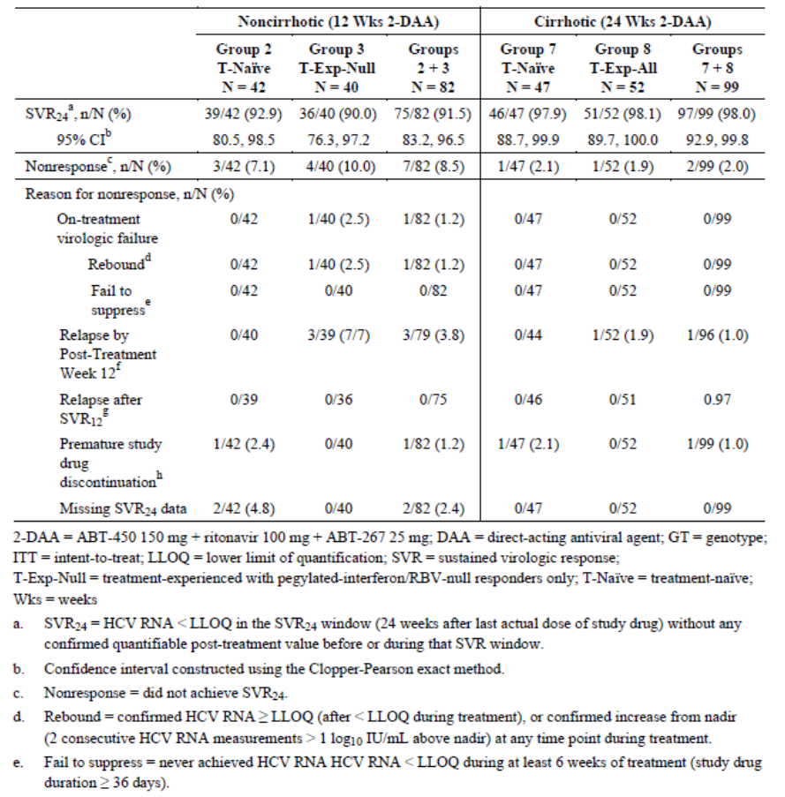

Table 13: Study M13-393 SVR₁₂ for Group 2 versus Group 3.
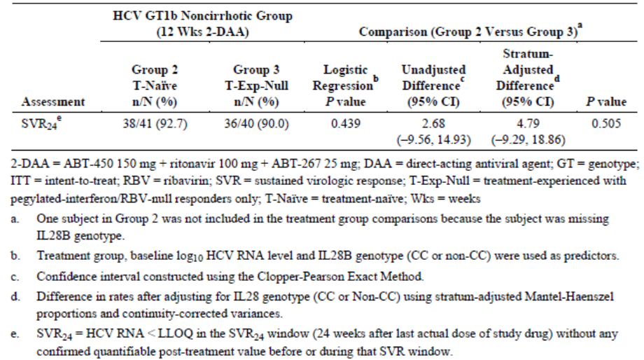

Virologic failure and post-treatment relapse
- HCV GT4 Groups: No virologic failures or relapses during the post-treatment period were observed in GT4 patients treated with 2-DAA + RBV (Groups 4 and 6). In the treatment-naïve patients treated with 2-DAA (Group 1), one patient had on-treatment virologic failure and two patients relapsed within 12 weeks post-treatment (Table 14).

Table 14: Study M13-393 On-treatment virologic failure GT4 Group.
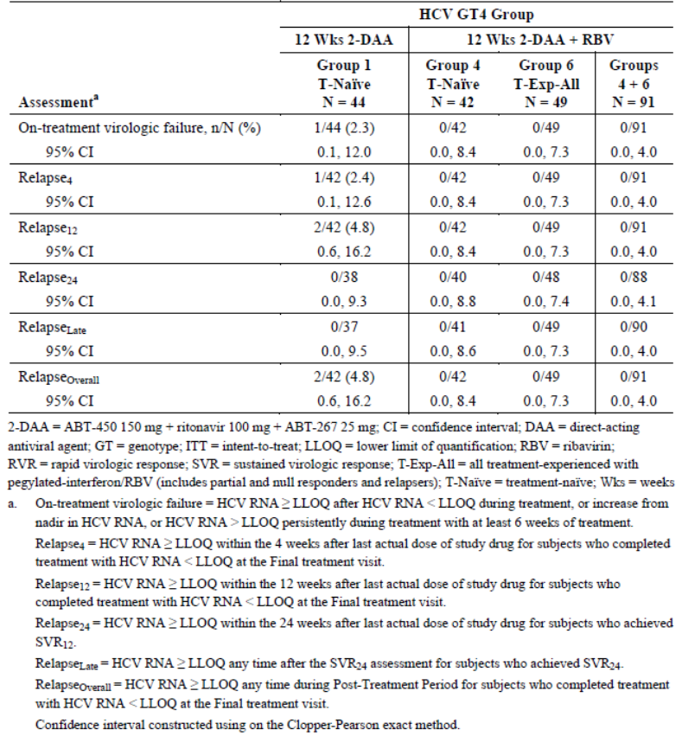
- HCV GT1b Groups: No virologic failures or relapses during the post-treatment period were observed in GT1b non-cirrhotic, treatment-naive patients treated with 2-DAA for 12 weeks (Group 2). In the treatment-experienced null responder patients treated with 2-DAA (Group 3), one patient had on-treatment virologic failure and three patients relapsed within 12 weeks post-treatment. No virologic failures or relapses during the post-treatment period were observed in GT1b cirrhotic, treatment-naive patients treated with 2-DAA for 24 weeks (Group 7). In treatment-experienced patients treated with 2-DAA (Group 8), no patients had on-treatment virologic failure, but one patient relapsed within 12 weeks post-treatment (Table 15).

Table 15: Study M13-393 On-treatment virologic failure in GT1b Groups.
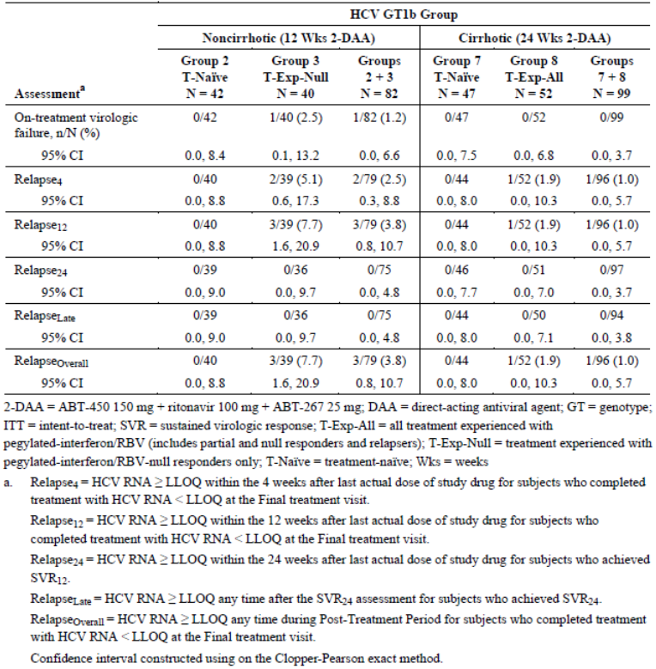

HCV RNA virologic response
- HCV GT4 Groups: RVR after 4 weeks was achieved by 97.7% of treatment-naïve patients given 2-DAA (Group 1), 97.6% of treatment-naïve patients treated with 2-DAA + RBV (Group 4) and in 100% of treatment-experienced patients treated with 2-DAA + RBV (Group 6) (Table 16). In the post-treatment period, SVR₄ was achieved in 93.2% of patients in Group 1 and in 100% of patients in Groups 4 and 6.

Table 16: Study M13-393 On-treatment virologic response GT4 Groups.
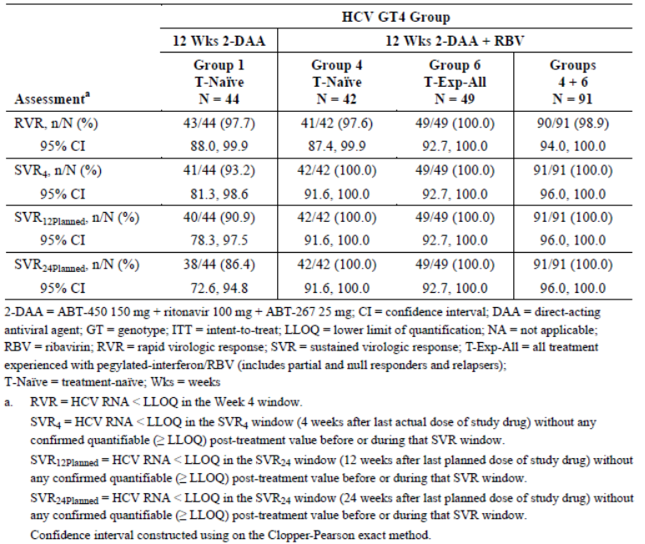
- HCV GT1b Groups: RVR after 4 weeks was achieved by 100% of treatment-naïve patients given 2-DAA (Group 2), 97.5% of treatment-experienced null responders (Group 3). In the post-treatment period, SVR₄ was achieved in 97.6% of patients in Group 2 and in 92.5% of patients in Group 3. RVR after 4 weeks was achieved by 97.9% of treatment-naïve cirrhotic patients given 2-DAA (Group 7) and in 98.1% of treatment-experienced patients (Group 8) (Table 17). In the post-treatment period, SVR₄ was achieved in 100% of patients in Group 7 and in 98.1% of patients in Group 8.

Table 17: Study M13-393 On-treatment virologic response GT1b Groups.
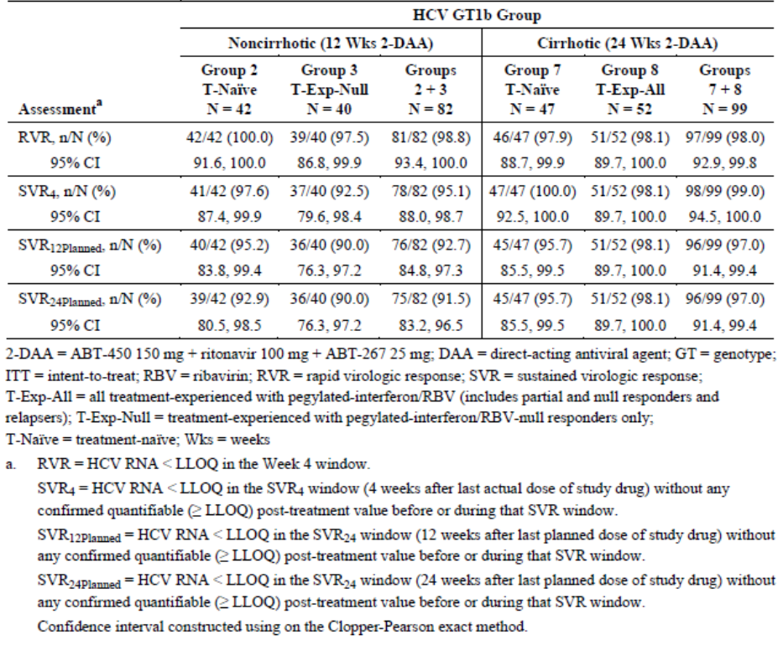

FibroTest scores
In cirrhotic GT1b patients treated with 2-DAA for 24 weeks, there were statistically significant decreases in FibroTest scores from baseline to post-treatment Week 12 in both treatment-naïve and treatment-experienced patients. The score changes were -0.16 in Group 7 and -0.14 in Group 8 (p<0.001 for both comparisons).

Analyses performed across trials (pooled & meta analyses)
No pooled analyses were performed.

Evaluators’ conclusions on clinical efficacy
The 2-DAA regimen with and without RBV has been studied in 135 treatment-naïve and treatment-experienced patients with HCV GT4 infection. The majority of patients carried a non-CC IL28 GT which predicts a lesser response to treatment. In patients with HCV GT4 infection treated with 2-DAA for 12 weeks, the SVR₁₂ rate was 90.9% (95% CI: 78.3, 97.5). In treatment-naïve and treatment-experienced patients treated with 2-DAA + RBV for 12 weeks, the SVR₁₂ rates were 100% (95% CI: 91.6, 100.0) and 100 % (95% CI: 92.7, 100.0), respectively. Response rates in subgroups were not assessed as the overall response was 100%.
The assessment of efficacy is based on a single, randomised, Phase 2 pilot study with approximately 40 patients in each treatment group. The study was appropriately designed and conducted in accordance with the EU guideline for the treatment of HCV. It was necessarily conducted open label but the efficacy endpoints were objective. Although patient numbers were low, the 100% efficacy rate in patients treated with 2-DAA with RBV is sufficient to justify an indication in non-cirrhotic patients with HCV GT4 infection. The efficacy rate in patients treated with 2-DAA without RBV were also impressive and sufficient to justify the use of Technivie in patients who are unable to tolerate RBV. However, reduced exposure for each component of the 2-DAA regimen in GT4 patients may have contributed to the 9.8% SVR₁₂ non-response rate in this group. Dose adjustments (for ABT-450 in particular) might be an alternative to the use of RBV in treatment-naïve patients.
The sponsor offers no discussion or justification to support use in cirrhotic patients. All patients with HCV GT4 infection were non-cirrhotic and there are no data to support the use of Technivie in HCV GT4 patients with compensated cirrhosis. Despite the need for improved treatments in cirrhotic patients with GT4 infection, it is not appropriate to assume comparable efficacy rates in non-cirrhotic and cirrhotic patients; or to extrapolate efficacy rates from studies in cirrhotic patients with GT1b infection who were treated for 24 weeks (even though SVR₄ rates were nearly 100%). Additional studies in GT4 patients with and without cirrhosis commenced in Q4 2014 (M11-655 and M14-250) and these should be evaluated to justify use in cirrhotic patients.

Clinical safety

Studies providing evaluable safety data
The following studies provided evaluable safety data:

Pivotal Phase 2 efficacy study M13-393
In the single efficacy study, the following safety data were collected:
- General adverse events (AEs) were coded using MedDRA and assigned by preferred term (PT) and system organ class (SOC).
- AEs of particular interest including ALT elevations, anaemia and skin reactions.
- Laboratory tests, including routine biochemistry and haematology, were performed at central laboratories.

Dose-response and non-pivotal efficacy studies
No studies were performed.

Other studies evaluable for safety only
No studies were performed.

Clinical pharmacology study
The absolute bioavailability study in healthy subjects (M14-229) has not been included in the overall safety evaluation.

Pivotal studies that assessed safety as a primary outcome
No studies were performed.

Patient exposure
In M13-393, study drug exposures in non-cirrhotic GT4 and GT1b Groups are shown in Table 18 and in cirrhotic GT1b Groups in Table 19. The mean exposure in Groups 1 + 2 + 3 (2-DAA for 12 weeks) was 83.3 days and in Groups 4 + 6 (2-DAA + RBV for 12 weeks) it was 84.4 days. The mean exposure in Groups 7 + 8 (2-DAA for 24 weeks) was 165.0 days.
Table 18: Study M13-393 Study drug exposure non-cirrhotic GT4 and GT1b Groups.
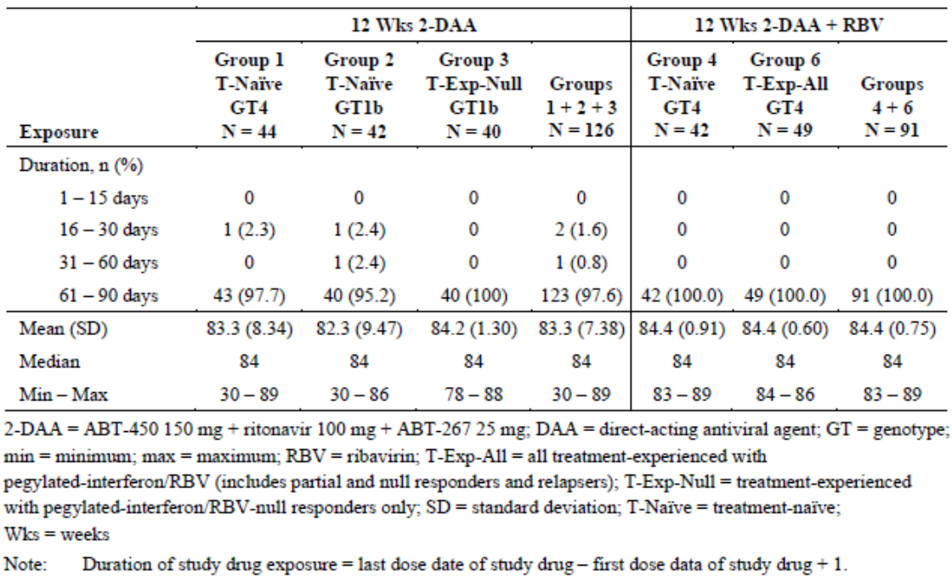
Table 19: Study M13-393 Study drug exposure cirrhotic GT4 and GT1b Groups.
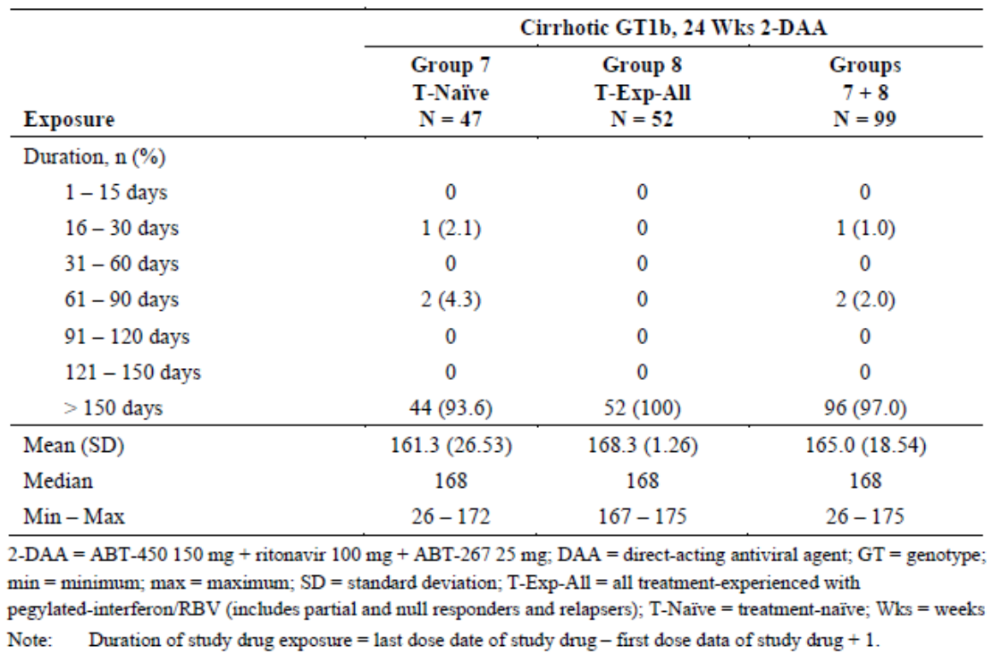

Adverse events

All adverse events (irrespective of relationship to study treatment)

M13-393
- Non-cirrhotic HCV GT4 and GT1b Groups: An overview of AEs reported in the non-cirrhotic GT4 and GT1b Groups is shown in Table 20. AEs were reported in 77.0% of patients treated with 2-DAA for 12 weeks (Groups 1 + 2 + 3) with no notable differences between groups. Most AEs were mild or moderate in severity. Severe AEs and SAEs were reported in 2.4% and 3.2% of patients, respectively. AEs were reported in 86.8% of patients treated with 2-DAA + RBV for 12 weeks (Groups 4 + 6) with no notable differences between the groups. Most AEs were mild or moderate in severity. Severe AEs were reported in 2.2% of patients and there were no SAEs. AEs reported by SOC and PT in ≥10% of patients in non-cirrhotic GT4 and GT1b patients are shown in Table 21. In patients treated for 12 weeks with 2-DAA (Groups 1 + 2 + 3), the most frequently reported AEs by PT were headache (29.4%), asthenia (12.7%), nausea (9.5%), fatigue (7.1%), diarrhoea (6.3%), pruritus (6.3%), urinary tract infection (5.6%) and dry skin (5.6%). In patients treated for 12 weeks with 2-DAA + RBV (Groups 4 + 6), the most frequently reported AEs by PT were headache (30.8%), asthenia (28.6%), , fatigue (15.4%), nausea (14.3%), insomnia (13.2%), diarrhoea (9.9%), irritability (8.8%), nasopharyngitis (8.8%), anxiety (6.6%), back pain (6.6%), cough (6.6%), dyspepsia (6.6%), pruritus (6.6%), exertional dyspnoea (5.5%) and myalgia (5.5%).
Table 20: Study M13-393 Overview of AEs in non-cirrhotic GT4 and GT1b Groups.
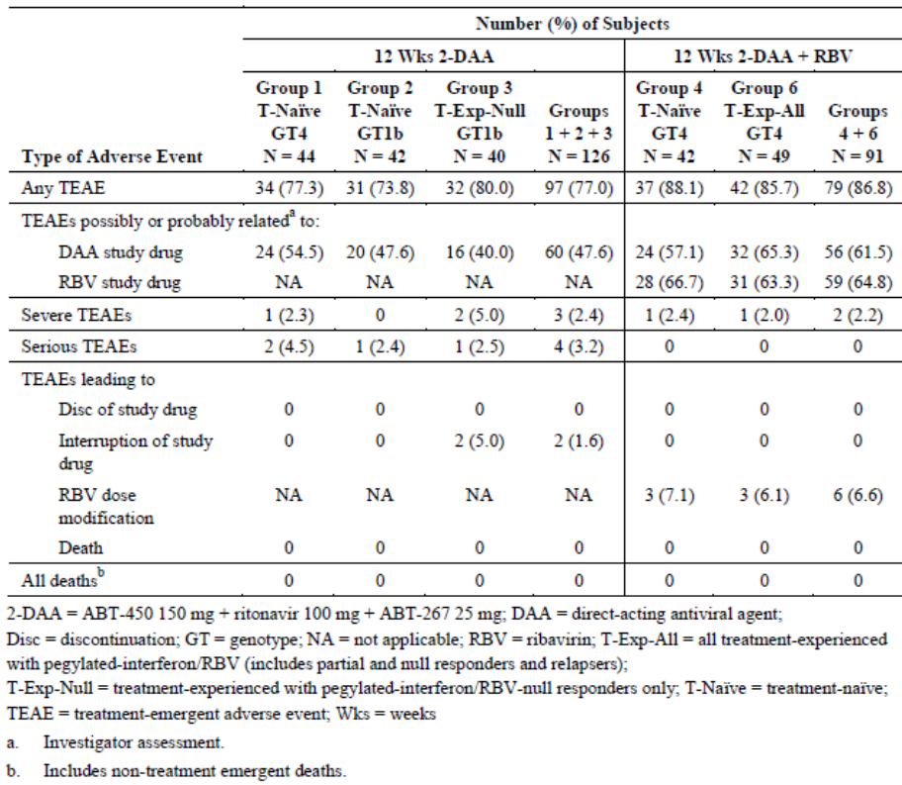
Table 21: Study M13-393 Commonly reported TEAEs by SOC and PT.
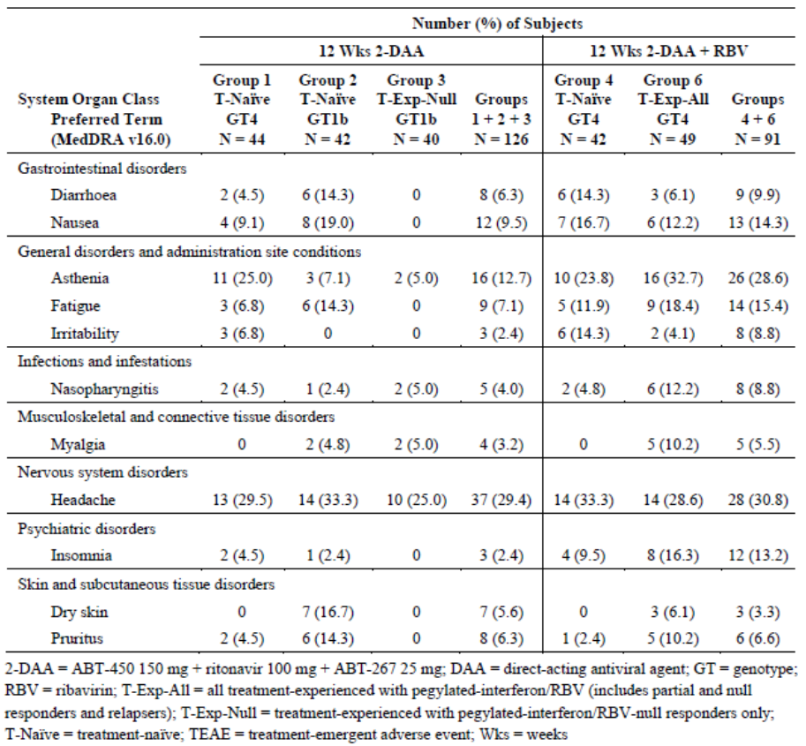
- Cirrhotic GT1b Groups: An overview of AEs reported in the cirrhotic GT1b Groups is shown in Table 22. AEs were reported in 77.8% of patients treated with 2-DAA for 24 weeks (Groups 7 + 8) with no notable differences between groups. Most AEs were mild or moderate in severity. Severe AEs and SAEs were reported in 4.0% and 5.1% of patients, respectively. AEs reported by SOC and PT in ≥10% of patients in the cirrhotic GT1b Groups are shown in Table 23. In patients treated with 2-DAA for 24 weeks (Groups 7 + 8), the most frequently reported AEs by PT were headache (19.2%), asthenia (17.2%), pruritus (17.2%), diarrhoea (14.1%), back pain (11.1%), fatigue (10.1%) and nausea (10.1%).
Table 22: Study M13-393 Overview of AEs in cirrhotic GT1b Groups.
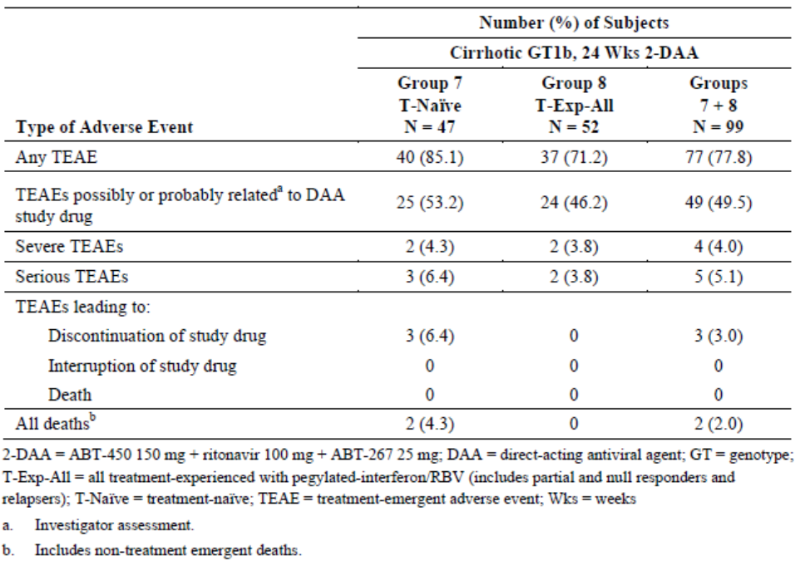
Table 23: Study M13-393 AEs reported in ≥10% of cirrhotic GT1b patients.
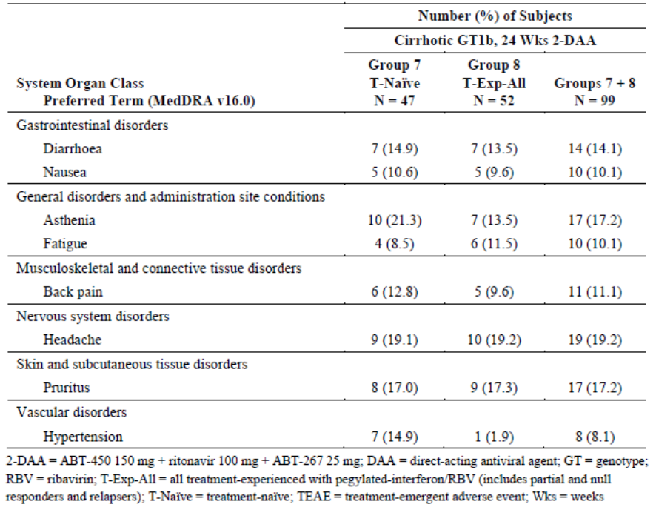

Treatment-related adverse events (adverse drug reactions)

M13-393
AEs considered at least possibly related to treatment were reported in 47.6% of non-cirrhotic patients treated with 2-DAA for 12 weeks (Groups 1 + 2 + 3), 61.5% of non-cirrhotic patients treated with 2-DAA + RBV for 12 weeks (Groups 4 + 6) and 49.5% of cirrhotic patients treated with 2-DAA for 24 weeks (Groups 7 + 8). The most common AEs reported in Groups 1+ 2 + 3 were headache (20.6%), asthenia (11.9%), nausea (7.1%), dry skin (5.6%), and pruritus (5.6%). The most common AEs reported in Groups 4 + 6 were asthenia (23.1%), headache (20.9%), fatigue (12.1%), nausea (9.9%) and insomnia (7.7%). The most common AEs reported in Groups 7 + 8 were pruritus (16.2%), nausea (9.1%), headache (9.1%), diarrhoea (6.1%) and fatigue (5.1%).

Deaths and other serious adverse events

M13-393
No deaths were reported in the non-cirrhotic GT4 and GT1b patient Groups. Two deaths were reported in the treatment-naïve cirrhotic GT1b group but neither was considered drug related. Both deaths were due to complications of cirrhosis and both occurred ≥92 days after the last dose of study medication.
SAEs were reported in 3.2% of patients in Groups 1 + 2 +3, 0% in Groups 4 + 6 and 5.1% in Groups 7 + 8. In non-cirrhotic patients, only one event (atrial fibrillation) in Group 1 was considered possibly related to study drug. In cirrhotic patients, only one event of ALT elevation was considered possibly related to study drug.

Discontinuation due to adverse events

M13-393
No AEs leading to discontinuation were reported in Groups 1 + 2 + 3 (2-DAA for 12 weeks), or in Groups 4 + 6 (2-DAA + RBV for 12 weeks). AEs leading to drug discontinuation were reported in three (6.4%) cirrhotic GT1b patients, all in Group 7. AEs leading to interruption of study drug were reported in two patients, both treated with 2-DAA without RBV in Group 3.

Laboratory tests

Liver function

M13-393
Mean changes in liver function from baseline to the final treatment visit in the SAF are shown in Table 24. There were reductions in mean ALT, AST and GGT in all cirrhotic and non-cirrhotic patient groups, with no notable changes in alkaline phosphatase or bilirubin. The number of patients with PCS values is shown in Table 25. In non-cirrhotic GT4 and GT1b patients treated with 2-DAA for 12 weeks, increased ALT >5 x ULN and ≥2 x baseline was reported in a single patient (0.8%), increased AST >5 x ULN and ≥2 x baseline was reported in two patients (1.6%) and total bilirubin ≥2 x ULN was reported in 2.4% of patients. In non-cirrhotic patients treated with 2-DAA + RBV for 12 weeks, no PCS aminotransferase increases were observed. Increased total bilirubin was reported in 7.7% of patients.
Table 24: Study M13-393 Changes in clinical chemistry from baseline (SAF population).
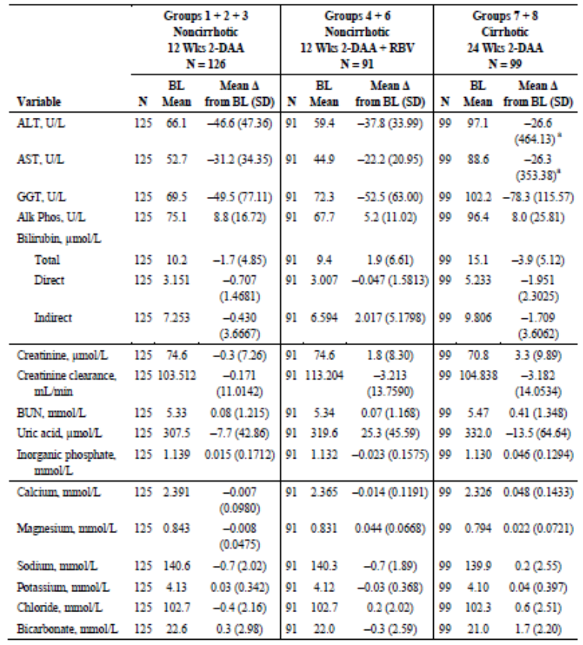
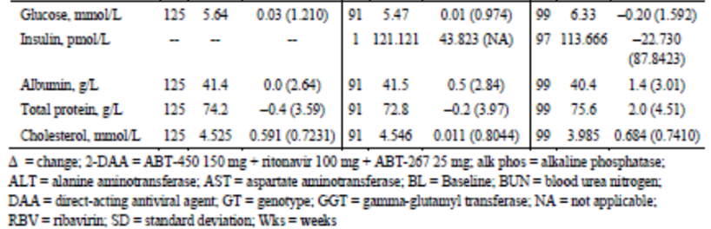
Table 25: Study M13-393 Patients with PCS abnormalities during treatment.
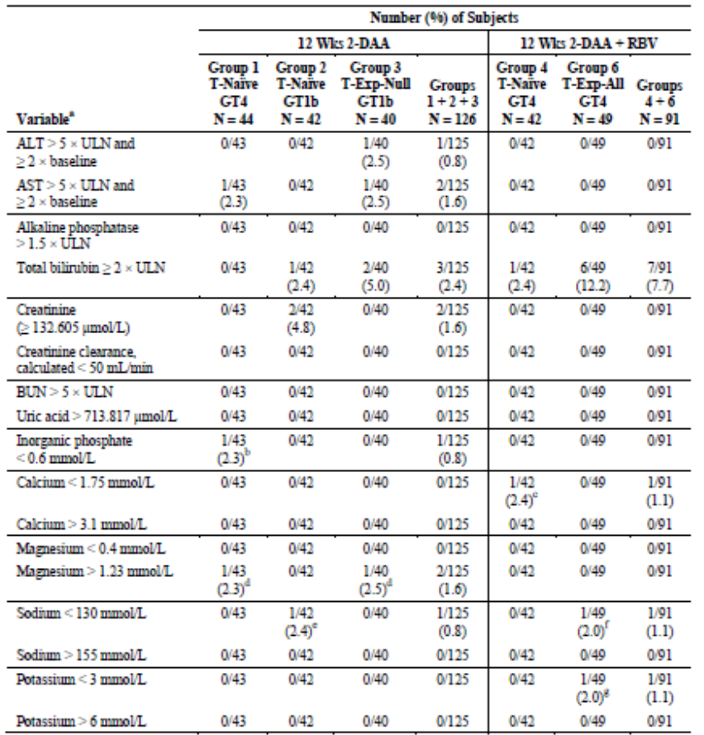
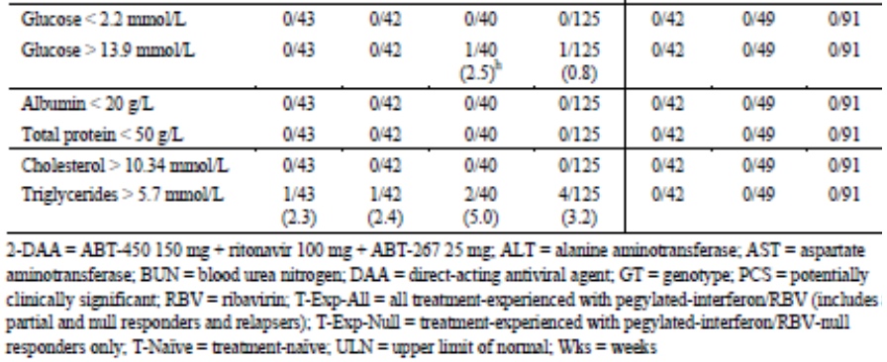

Kidney function

M13-393
There were no meaningful changes from baseline in mean serum creatinine or creatinine clearance in non-cirrhotic or cirrhotic patients. There were two (1.6%) PCS events of increased serum creatinine in the non-cirrhotic patients but no events were reported in cirrhotic patients. No PCS events of creatinine clearance < 50 mL/min were reported in any non-cirrhotic patient group. There was one event (1.0%) in cirrhotic patients. No clinically meaningful changes or trends in urinalysis parameters were observed.

Other clinical chemistry

M13-393
There were no consistent mean changes from baseline or PCS events for any clinical chemistry parameter.

Haematology

M13-393
There were modest reductions in mean haemoglobin, haematocrit and RBCs in patients treated with 2-DAA without RBV. In patients treated with 2-DAA + RBV, there were more pronounced reductions in haemoglobin, haematocrit and RBCs and a rise in reticulocytes in keeping with the known effects of RBV (Figure 3). There were no other consistent changes or trends for any other haematological parameter in non-cirrhotic or cirrhotic patients. In non-cirrhotic patients, there was a single (1.1%) PCS AE of haemoglobin (<80 g/L) in Groups 4 + 6, two (2.2%) PCS events of neutropenia (<1 x 10⁹/L) in Groups 4 + 6 and one (0.8%) PCS event of reduced lymphocytes (<0.5 x 10⁹/L) in Groups 1 + 2 + 3. In cirrhotic patients, there were no PCS events related to reduced haemoglobin. There was a single PCS event of low platelets (<50 x 10⁹/L), a single PCS event of low neutrophils and four (4.0%) events of reduced lymphocytes.
Figure 3: Study M13-393 Mean changes in haemoglobin in non-cirrhotic groups.
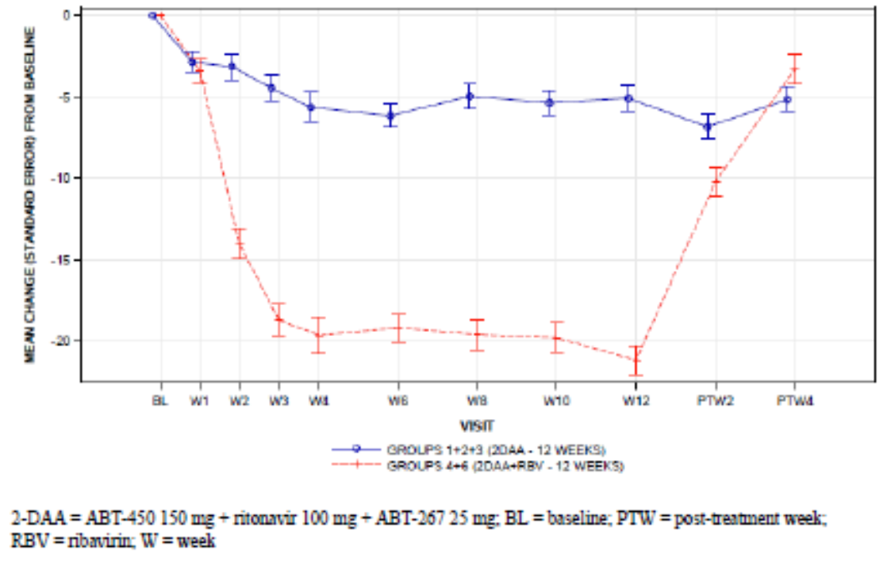

Electrocardiograph

M13-393
ECGs were performed at screening, Day 1, Week 4, Week 12 and the final treatment visit. Only one treatment emergent PCS event was reported (atrial fibrillation).

Vital signs

M13-393
Mean changes from baseline in blood pressure, pulse and body weight were minor and no clinically meaningful trends were observed. Only isolated PCS events were reported.

Post-marketing experience
Not applicable.

Safety issues with the potential for major regulatory impact

Liver toxicity
No new safety signals were observed.

Haematological toxicity
No new safety signals were observed.

Serious skin reactions
No new safety signals were observed.

Cardiovascular safety
No new safety signals were observed.

Unwanted immunological events
Not applicable.

Other safety issues

Safety in special populations
No new data were submitted.

Safety related to drug-drug interactions and other interactions
No new data were submitted.

Evaluator’s overall conclusions on clinical safety
No significant new safety concerns have been identified in the PEARL-I study. The safety of 2-DAA with and without RBV was assessed in 316 patients who received at least one dose of study drug, including 135 non-cirrhotic patients with HCV GT4 infection. Overall, the 2-DAA regimen was well tolerated although, as expected, AEs occurred more commonly in patients given RBV. Most AEs were mild to moderate in severity.
While the patient numbers were low in PEARL-I, more than 2,500 study patients have received 2-DAA as a component of the Viekira Pak 3-DAA regimen, with or without RBV, in patients with HCV GT1 infection. The pattern of AEs in PEARL-I was comparable to that of the 3-DAA regimen and no new safety signals were detected. For this reason, the sponsor has opted not to change the ADR profile of the 3-DAA combination summarised in the current Viekira Pak PI. The 3-DAA regimen contains dasabuvir but the 2-DAA regimen does not. Nonetheless, it is reasonable to retain the larger data set and the following most common ADRs are identified:
- 2-DAA: asthenia (13%), nausea (10%), fatigue (7%), pruritus (6%), skin reactions (3%) and insomnia (2%).
- 2-DAA + RBV: asthenia (29%), fatigue (15%), nausea (14%), insomnia (13%), pruritus (7%) and skin reactions (7%).
Subgroups based on race, age, gender, body weight, renal and hepatic function and prior treatment for HCV were analysed in the 3-DAA program and no unexpected issues were identified in the 2-DAA. Potential DDIs were identified in the 3-DAA program and, with minor differences due to the absence of dasabuvir, dosing precautions remain unchanged. The pattern of laboratory events (anaemia, rash and hepatic events) was comparable in the 2-DAA and 3-DAA studies with few significant treatment emergent ALT elevations.

First round benefit-risk assessment

First round assessment of benefits
The benefits of TECHNIVIE given with RBV in the proposed usage are:
- The potential for 100% SVR rates when given with RBV for 12 weeks in treatment-naïve and treatment-experienced non-cirrhotic patients with chronic HCV GT4 infection.
- The potential for 90% SVR12 (86.4% SVR24) rates when given without RBV for 12 weeks in treatment-naïve non-cirrhotic patients with chronic HCV GT4 infection.
- Well tolerated with mostly mild to moderate ADRs.
- Few dose interruptions or discontinuations.
- More effective with a superior safety profile compared with DAA plus pegIFN therapies.
- The potential for DDIs well understood.
- Contraindications and precautions identical to those identified in the VIEKIRA PAK 3-DAA development program.

First round assessment of risks
The risks of TECHNIVIE given with RBV in the proposed usage are:
- Efficacy rates based on low patient numbers in a single Phase 2 study.
- No data available in patients with compensated cirrhosis.
- Potential for severe ADRs, in particular anaemia and ALT elevations.
- Risks associated with DDIs, in particular systemic oestrogen medications.
- Limited viral resistance data due to high efficacy rates.

First round assessment of benefit-risk balance
The benefit-risk balance of TECHNIVIE is unfavourable given the proposed usage, but would become favourable if the changes recommended are adopted.

First round recommendation regarding authorisation
Authorisation is not recommended for the proposed indication:
Technivie is indicated in combination with ribavirin for the treatment of patients with genotype 4 chronic hepatitis C virus (HCV) infection.
However, authorisation is recommended for the following modified indication:
Technivie is indicated in combination with ribavirin for the treatment of adult patients without cirrhosis with genotype 4 chronic hepatitis C virus (HCV) infection.
There are no data to support the use of Technivie, with or without RBV, in patients with HCV GT4 infection and compensated cirrhosis. Technivie without RBV was effective in patients with HCV GT1b and compensated cirrhosis and it is almost certain to have value in similar patients with HCV GT4 infection. However, the HCV GT1b patients were treated for 24 weeks and it is not appropriate to extrapolate the data to HCV GT4 patients with cirrhosis treated for only 12 weeks (even though SVR4 rates were nearly 100% in the HCV GT1b patients and RBV co-administration is recommended).

Clinical questions

Pharmacokinetics
- Please refer to comments address the following questions and issues:
- Please explain how cross-study comparisons may have contributed to the consistent PK differences observed between groups in a randomised study.
- Are there any known differences in hepatic pathophysiology or drug handling between patients with HCV GT4 and GT1b infections?
- Drug concentration/response analyses were not performed as efficacy was considered adequate in all groups. However, in light of the concerns raised in Section 4.3, please provide a comparison of the PK parameters in responder and non-responder patients in Groups 1 and 2 in study M13-393.

Efficacy
- In the absence of clinical data, please provide a justification for the use of TECHNIVIE with RBV in HCV GT4 patients with compensated cirrhosis. Should patients be treated for 12 or 24 weeks, with or without RBV, and on what evidence is this recommendation based?
- Please provide a status update for ongoing studies (M11-655 and M14-250), including summaries of interim analyses if they are available. Will population PK analyses be available?

Safety
No questions.

Second round evaluation of clinical data

Question 1
- Please explain how cross-study comparisons may have contributed to the consistent PK differences observed between groups in a randomised study.
- Are there any known differences in hepatic pathophysiology or drug handling between patients with HCV GT4 and GT1b infections?
- Drug concentration/response analyses were not performed as efficacy was considered adequate in all groups. However, in light of the concerns raised in Section 4.3, please provide a comparison of the PK parameters in responder and non-responder patients in Groups 1 and 2 in study M13-393.

Sponsor response
The sponsor suggests that differences between studies could have occurred by chance. Even if the changes are real, the reduced expose is small and unlikely to be clinically significant.
- There are no known differences in hepatic pathophysiology or drug handling between patients with HCV GT4 and GT1b infections.
- PK data have been provided which show comparable DAA exposures in responders and non-responders. There was no apparent relationship between virologic response and DAA exposure for treatment-naïve GT4 or GT1b patients in M13-393.

Evaluation of response
The sponsor’s responses are satisfactory.

Question 2
- In the absence of clinical data, please provide a justification for the use of TECHNIVIE with RBV in HCV GT4 patients with compensated cirrhosis. Should patients be treated for 12 or 24 weeks, with or without RBV, and on what evidence is this recommendation based?

Sponsor response
An interim analysis of study M11-665 has been provided to support treatment with 2-DAA + RBV for 12 weeks in GT4 patients with compensated cirrhosis. The study is reviewed in the response to Question 3.

Evaluation of response
The sponsor’s response is satisfactory.

Question 3
- Please provide a status update for ongoing studies (M11-655 and M14-250), including summaries of interim analyses if they are available. Will population PK analyses be available?

Sponsor response
Interim analyses for the requested studies have been provided.

Study M11-655

Methodology
This is an ongoing, open-label, randomised, Phase 3 of 2-DAA +RBV given to HCV GT4 patients with compensated cirrhosis. It is being conducted at 26 sites in the US and Europe. Treatment is given for 12 weeks (Arm A), 16 weeks, (Arm B), or 24 weeks (Arm C). A fourth arm (Arm D) will study 2-DAA + RBV given for 24 weeks to GT4 patients with compensated cirrhosis who have previously failed prior treatment with SOF/pegIFN/RBV or SOF/RBV. In Part 1 (Arms A + B), patients were randomised 1:1 to receive treatment for 12 or 16 weeks. At the database lock, all patients in Part 1 had completed the treatment period of 12 or 16 weeks, and completed the Week 12 follow-up period. The primary objective was the superiority of SVR12 rates in treatment-naïve or treatment-experienced patients who had previously received only IFN/RBV treatment compared with a historical control rate in patients with and without cirrhosis. The clinical threshold would be achieved if the lower bound of the 2-sided 97.5% CI exceeds 67%.

Results
A total of 120 patients were randomised into Arm A (n=59), or Arm B (n=61). Overall, the majority of patients were male (70%), and White (79.2%), with a mean age of 57.4 years. A total of 50% of patients were treatment-experienced (55% null responders, 20% partial responders, and 25% relapsers). The majority of patients (84.2%) had non-CC IL28B infection.
In the ITT population, SVR12 was achieved by 96.6% (97.5% CI: 86.7, 99.2) of patients in Arm A, and by 98.4% (97.5% CI: 89.6, 99.8) of patients in Arm B (Table 26). Two patients (3.4%) in Arm A did not achieve SVR12 (one due to virologic failure, and one due to premature study drug discontinuation). One patient (1.6%) in Arm B completed the treatment period, but missed the 12 week follow-up visit.
Table 26: M11-665 SVR12 in patients given 2-DAA + RBV for 12 or 16 weeks.
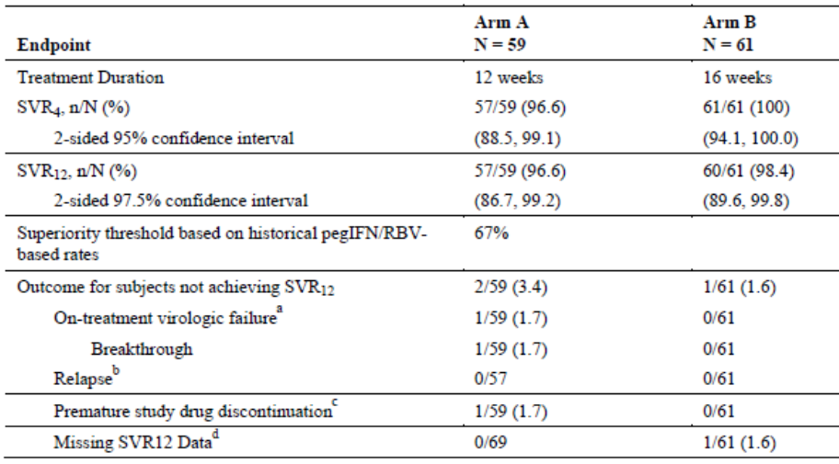
Most patients reported at least one AE (Tables 27-28), but most were mild or moderate and related to RBV. Dose modification of RBV was required by 25.0% and 30.0% of the respective groups. AEs were reported more commonly in Arm B, consistent with the longer treatment duration. However, the pattern of AEs in the two groups was comparable, and similar to the safety profile in the pivotal studies. No deaths were reported. Other SAEs were reported by four patients in each arm but none were considered drug related.
Table 27: M11-665 Treatment emergent AEs in the Part 1 safety population.
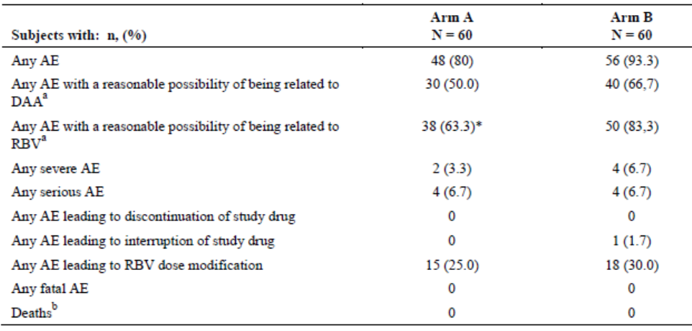
Table 28: M11-665 AEs reported by ≥10% of patients in the Part 1 safety population.
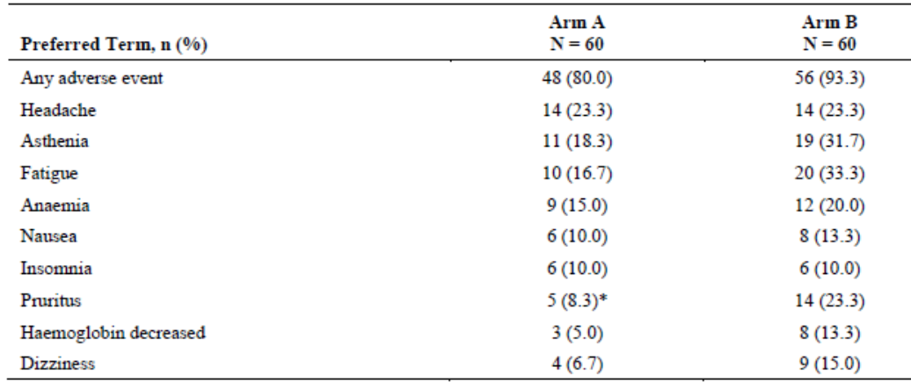
Sparse PK sampling was performed in study M11-665. C_{trough} concentrations of ombitasvir, ritonavir, and RBV were comparable to those in GT1 cirrhotic patients. C_{trough} concentrations of paritaprevir were 32% lower in GT4 patients receiving 2-DAA, compared with GT1 patients receiving 3-DAA (a known effect of the dasabuvir and paritaprevir interaction).

Study M14-250

Methodology
This is an ongoing, open-label, randomised, Phase 3 study of 2-DAA + RBV conducted at five sites in Egypt. The study population is treatment-naïve or treatment-experienced HCV GT4 patients, with or without compensated cirrhosis. Arm A consists of patients without cirrhosis treated with 2-DAA + RBV for 12 weeks. Arms B and C consist of patients with compensated cirrhosis treated with 2-DAA + RBV for 12 and 24 weeks, respectively. The study schematic is shown in Figure 4.
Figure 4: M14-250 Study schematic.
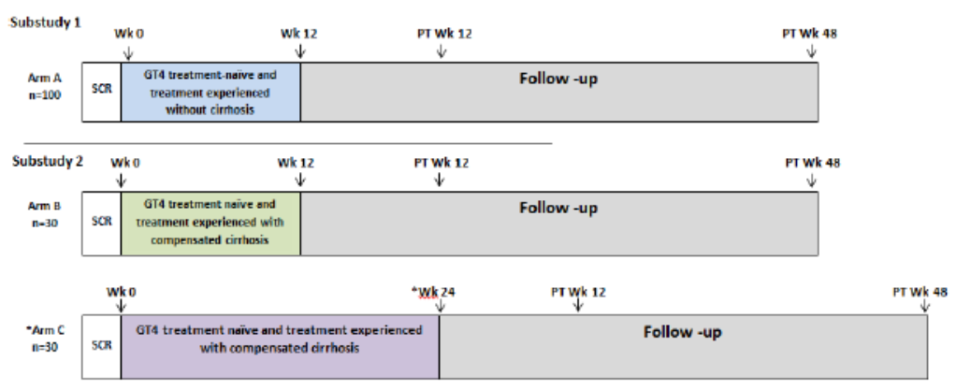
The primary objective is to assess SVR12 rates in patients with and without cirrhosis. PK samples were not collected in M14-250 because of difficulties exporting samples from Egypt.

Results
A total of 160 patients were enrolled in Arm A (n=100), Arm B (n=31), and Arm C (n=29). One patient in each group discontinued study drugs (two withdrew consent, and one had virologic failure). Overall, the majority of patients were male (75.6%), and White (96.9%), with a mean age of 51.6 years. SVR12 was achieved 94.0% (95% CI: 87.5, 97.2), 96.8% (95% CI: 83.8, 99.4), and 93.1% (95% CI: 78.0, 98.1) of patients in Arms A, B, and C, respectively (Table 29). Efficacy rates were comparable in patients without cirrhosis (Arm A), and with cirrhosis (Arm B).
Table 29: M14-250 Key efficacy endpoints.
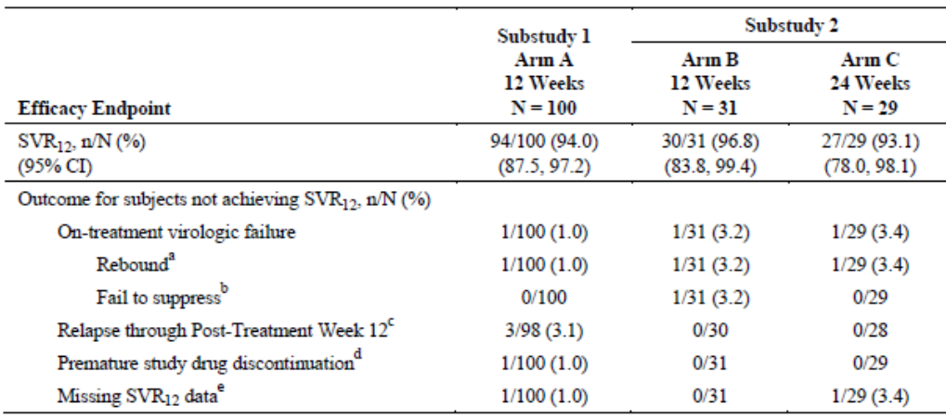
Most patients reported at least one AE (Table 30), but most were mild or moderate, and related to RBV. Dose modification of RBV was required by 11.0%, 12.9%, and 24.1% of the respective groups. Overall, the most commonly reported AEs were headache (37.5%), fatigue (34.4%), pruritus (22.5%), dyspepsia (15.6%), upper abdominal pain (15.0%), cough (11.9%), and insomnia (10.0%). The pattern of AEs was comparable in each treatment group. One death was reported, due to apnoea following a suxamethonium injection. Other SAEs were reported by four patients in the overall population, but only one (deep vein thrombosis) was considered drug related.
Table 30: M14-250 Treatment emergent AEs in the safety population.
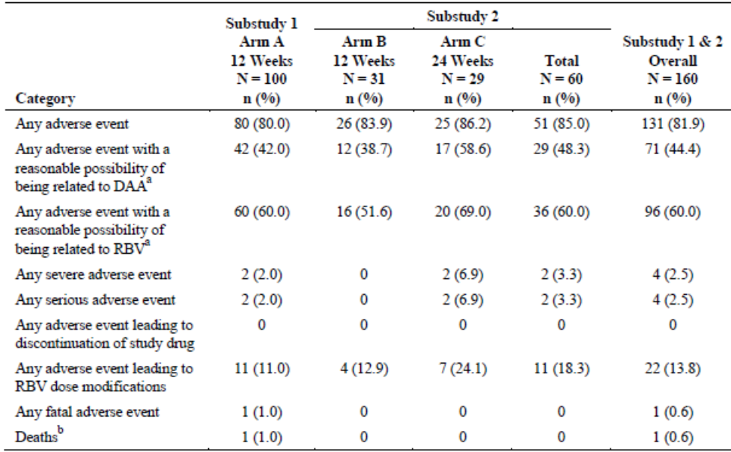

Evaluation of response
The sponsor’s response is satisfactory. SVR12 was achieved by 94.0% of patients without cirrhosis; by 96.6% and 98.4% of patients with compensated cirrhosis treated for 12 and 16 weeks, respectively. The results justify treatment with 2-DAA + RBV given for 12 weeks in HCV GT4 patients with compensated cirrhosis.

Second round benefit-risk assessment

Second round assessment of benefits
No change to the first round assessment.

Second round assessment of risks
No change to the first round assessment.

Second round assessment of benefit-risk balance
No change to the first round assessment.

Second round recommendation regarding authorisation
Authorisation is recommended for the indication:
TECHNIVIE is indicated in combination with ribavirin for the treatment of adult patients with genotype 4 chronic hepatitis C virus (HCV) infection.

References
No additional references.

Therapeutic Goods Administration
PO Box 100 Woden ACT 2606 Australia
Email: info@tga.gov.au Phone: 1800 020 653 Fax: 02 6232 8605
https://www.tga.gov.au

European Medicines Agency, “Guideline on clinical evaluation of medicinal products for the treatment of chronic hepatitis C (EMEA/CHMP/51240/2011)”, 20 January 2011.

