First round report 30 March 2015
Second round report 26 August 2015

AusPAR Attachment 2

Extract from the Clinical Evaluation Report for Panobinostat lactate
  - Proprietary Product Name: Farydak
  - Sponsor: Novartis Pharmaceuticals Australia Pty Ltd

About the Therapeutic Goods Administration (TGA)
- The Therapeutic Goods Administration (TGA) is part of the Australian Government Department of Health, and is responsible for regulating medicines and medical devices.
- The TGA administers the Therapeutic Goods Act 1989 (the Act), applying a risk management approach designed to ensure therapeutic goods supplied in Australia meet acceptable standards of quality, safety and efficacy (performance), when necessary.
- The work of the TGA is based on applying scientific and clinical expertise to decision-making, to ensure that the benefits to consumers outweigh any risks associated with the use of medicines and medical devices.
- The TGA relies on the public, healthcare professionals and industry to report problems with medicines or medical devices. TGA investigates reports received by it to determine any necessary regulatory action.
- To report a problem with a medicine or medical device, please see the information on the TGA website <https://www.tga.gov.au>.
About the Extract from the Clinical Evaluation Report
- This document provides a more detailed evaluation of the clinical findings, extracted from the Clinical Evaluation Report (CER) prepared by the TGA. This extract does not include sections from the CER regarding product documentation or post market activities.
- The words [Information redacted], where they appear in this document, indicate that confidential information has been deleted.
- For the most recent Product Information (PI), please refer to the TGA website <https://www.tga.gov.au/product-information-pi>.
Copyright
© Commonwealth of Australia 2018
This work is copyright. You may reproduce the whole or part of this work in unaltered form for your own personal use or, if you are part of an organisation, for internal use within your organisation, but only if you or your organisation do not use the reproduction for any commercial purpose and retain this copyright notice and all disclaimer notices as part of that reproduction. Apart from rights to use as permitted by the Copyright Act 1968 or allowed by this copyright notice, all other rights are reserved and you are not allowed to reproduce the whole or any part of this work in any way (electronic or otherwise) without first being given specific written permission from the Commonwealth to do so. Requests and inquiries concerning reproduction and rights are to be sent to the TGA Copyright Officer, Therapeutic Goods Administration, PO Box 100, Woden ACT 2606 or emailed to < tga.copyright@tga.gov.au>.

Contents
List of abbreviations 5
1. Introduction 11
1.1. Submission type 11
1.2. Drug class and therapeutic indication 11
1.3. Dosage and administration 11
2. Clinical rationale 15
2.1. Current treatment options and clinical rationale 15
2.2. Formulation development 15
2.3. Overseas regulatory history 15
3. Contents of the clinical dossier 16
3.1. Scope of the clinical dossier 16
3.2. Paediatric data 17
3.3. Good clinical practice 17
4. Pharmacokinetics 17
4.1. Studies providing pharmacokinetic data 17
4.2. Summary of pharmacokinetics 21
4.3. Pharmacokinetics in special patient populations 32
4.4. Pharmacokinetic interactions 39
4.5. Evaluator's overall conclusions on pharmacokinetics 45
5. Pharmacodynamics 50
5.1. Studies with pharmacodynamic data 50
5.2. Exposure-thrombocytopenia relationships 50
5.3. Exposure-QTc relationship 53
5.4. Exposure-efficacy relationship 55
5.5. Evaluator's overall conclusions on pharmacodynamics 55
6. Dosage selection for the pivotal studies 56
7. Clinical efficacy 57
7.1. Overview of the efficacy studies 57
7.2. Pivotal efficacy study; D2308 58
7.3. Other efficacy studies 96
7.4. Evaluator's overall conclusions on clinical efficacy 99
8. Clinical safety 100
8.1. Overview of the safety data 100
8.2. Study D2308; Pivotal study 101
8.3. Post marketing safety experience 117
8.4. Safety issues with the potential for major regulatory impact 117
8.5. Other safety issues 120
8.6. Evaluator's overall conclusion on clinical safety 125
9. First round benefit-risk assessment 127
9.1. First round assessment of benefits 127
9.2. First round assessment of risks 128
9.3. First round assessment of benefit-risk balance 132
10. First round recommendation regarding authorisation 132
11. Clinical questions 133
11.1. Pharmacokinetics 133
11.2. Efficacy 134
11.3. Safety 134
12. Second round evaluation of clinical data submitted in response to questions 134
12.1. Introduction 134
12.2. Amended indication; Subgroup analysis 135
12.3. Sponsor's response to first round recommendation regarding authorisation 152
12.4. Response to first round assessment of benefit-risk balance 167
12.5. Response to clinical evaluator's first round clinical questions 168
13. Second round benefit-risk assessment 182
13.1. Second round assessment of benefit 182
13.2. Second round assessment of risk 183
13.3. Second round assessment of benefit-risk balance 185
14. Second round recommendation regarding authorisation 186
15. References 186

List of abbreviations
Abbreviation | Meaning
ADR | Adverse drug reaction
AE | Adverse event
ASCT | Autologous stem cell transplantation
ALT | Alanine aminotransferase
ANC | Absolute neutrophil count
AU PI | Australian Prescribing Information
AUC | Area under the curve
BCRP | Breast cancer resistance protein
BD | Twice daily
BID | Twice daily
BM | Bone marrow
BTZ | Bortezomib
CER | Clinical evaluation report
CHD | Coronary heart disease
CHF | Congestive heart failure
CHMP | Committee for Medicinal Products for Human Use
CI | Confidence interval
CL/F | Apparent clearance
CLr | Renal clearance
C_{max} | Maximum concentration
CNAE | Clinically notable adverse event
CMI | Consumer medicine information
CNS | Central nervous system
CLcr | Creatinine clearance
CRF | Case report form
CSF | Cerebrospinal fluid
CSR | Clinical study report
CT | Computed tomography
CTC | Common toxicity criteria
CTCAE | Common terminology criteria for adverse events
CV | Coefficient of variation
CVA | Cerebrovascular accident
CYP | 450 Cytochrome P450
DAC | Deacetylase inhibitor
DI | Dose intensity
DILI | Drug-induced liver injury
DOR | Duration of response
DVT | Deep vein thrombosis
EBMT | European Bone Marrow Transplant Organisation
ECG | Electrocardiogram
ECHO | Echocardiogram
ECOG | Eastern Cooperative Oncology Group
eCRF | Electronic case report form
EMA/EMEA | European Medicines Agency
EORTC | European Organization for Research and Treatment of Cancer
EOS | End-of-Study /Study evaluation completion visit
EOT | End-of-Treatment
FACIT | Functional Assessment of Chronic Illness Therapy
FACT/GOG-NTX | Functional Assessment of Cancer Therapy Gynecology Oncology Group Neurotoxicity
FAS | Full Analysis Set
EU | European Union
FDA | Food and Drug Administration
G-CSF | Granulocyte colony-stimulating factor
GCP | Good clinical practice
HLGT | High Level Group Term
HLT | Higher Level Term
HR | Hazard ratio
HRQoL | Health related quality of life
Ig | Immunoglobulin
IHD | Ischaemic heart disease
IMiD | Immunomodulatory drug
IMWG | International Myeloma Working Group
INN | International Nonproprietary Name
INR | International normalised ratio
ISS | International Staging System
ITT | Intent-to-treat
IXRS | Interactive voice response system/interactive web response system
IV | Intravenous
LLN | Lower limit of normal values
LVEF | Left ventricular ejection fraction
MedDRA | Medical Dictionary for Regulatory Activities
mEMBT | Modified European Society for Blood and Bone Marrow Transplant
MI | Myocardial infarction
MM | Multiple myeloma
MR | Minimal Response
MRI | Magnetic resonance imaging
MRP | Multidrug resistance-associated protein
MRR | Minimal response rate
MTD | Maximal tolerated dose
N/A | Not applicable
NC | No change
NCCN | National Comprehensive Cancer Network
NCI | National Cancer Institute
nCR | Near complete response
NEC | Not elsewhere classified
NHL | Non-Hodgkin’s lymphoma
NMSC | Non-melanoma skin cancer
NOS | Not otherwise specified
OAT | Organic anion transporter
OCT | Organic cation transporter
ORR | Overall Response Rate
OS | Overall survival
PAN | Panobinostat
PBO | Placebo
PD | Progressive disease
PE | Pulmonary embolism
PEP | Protein electrophoresis
PFS | Progression-free survival
P-gp | P-glycoprotein
PI | Prescribing information
PK | Pharmacokinetics
PP | Per-protocol
PRO | Patient reported outcome
PS | Performance status
PT | Preferred term
QD | Once daily
QLQ-C30 | Quality of Life Questionnaire - Core Questionnaire
QLQ-MY20 | Quality of Life Questionnaire – Myeloma Module
QLQ | Quality of life questionnaire
QoL | Quality of life
QTc | Corrected QT interval
RBC | Red blood cell
RDI | Relative dose intensity
RMP | Risk Management Plan
RRMM | Relapsed/refractory MM
SAE | Serious adverse event
sCR | Stringent complete response
SD | Standard deviation
SEER | Surveillance, Epidemiology and End Results
SJS | Stevens Johnson Syndrome
SMQ | Standardised MedDRA Query
SOC | System Organ Class
t½ | Half-life
T4 | Free thyroxine
TIW | Three times a week
t_{max} | Time to maximum concentration
TTP | Time to disease progression
UK | United Kingdom
ULN | Upper limit of normal
US/USA | United States/United States of America
VGPR | Very good partial response
VTE | Venous thromboembolism
WHO | World Health Organization

Introduction

Submission type
This is a category 1 application to register a new chemical entity named Farydak (panobinostat).

Drug class and therapeutic indication
The product information (PI) states that panobinostat is a potent Class I/II pan-deacetylase inhibitor (DACi) with anti-tumour activity. Pan-deacetylase inhibitors are a novel class of anticancer agents that target epigenetic changes via gene expression modulation.
The proposed indication is:
Farydak, in combination with bortezomib and dexamethasone, is indicated for the treatment of patients with multiple myeloma, who have received at least 1 prior therapy.
The submission proposes registration of the following dosage forms and strengths: 10 mg hard capsules; 15 mg hard capsules; and 20 mg hard capsules.

Dosage and administration
The recommended dosage and administration instructions are taken from the proposed PI:
Treatment with Farydak should be initiated by a physician experienced in the use of anticancer therapies.
The recommended starting dose of Farydak is 20 mg, taken orally once a day, on Days 1, 3, 5, 8, 10 and 12, of a 21 days cycle. Patients should be treated initially for eight cycles. It is recommended that patients with clinical benefit continue the treatment for eight additional cycles. The total duration of treatment is up to 16 cycles (48 weeks).
The recommended dose of bortezomib is 1.3 mg/m² given as an injection. The recommended dose of dexamethasone is 20 mg taken orally, on a full stomach.
The maximum tolerated dose (MTD) was established at panobinostat 20 mg plus bortezomib 1.3 mg/m² in patients with relapsed or relapsed and refractory multiple myeloma.
Farydak is administered in combination with bortezomib and dexamethasone as shown in Table 1 and Table 2.

Table 1: Recommended posology and dosing schedule of Farydak in combination with bortezomib and dexamethasone (Cycles 1 to 8)
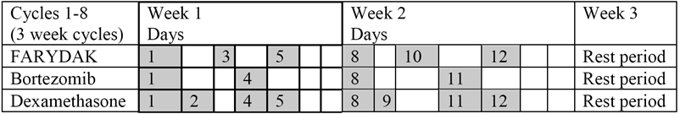

Table 2: Recommended posology and dosing schedule of Farydak in combination with bortezomib and dexamethasone (Cycles 9 to 16)
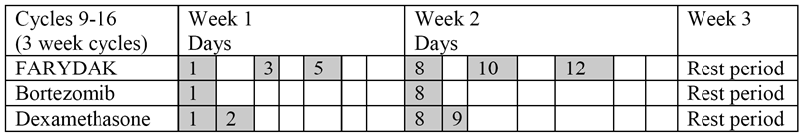

Monitoring recommendations

Blood cell counts
A complete blood cell count must be performed before initiating treatment with Farydak. The baseline platelet count should be ≥ 100 x 10⁹/L and the baseline absolute neutrophil count (ANC) ≥ 1.0 x 10⁹/L. Complete blood counts should be frequently monitored during treatment, especially for thrombocytopenia (see Precautions). Prior to initiating any cycle of therapy with Farydak in combination with bortezomib and dexamethasone, the platelet count should be at least ≥ 100 x 10⁹/L. (see Precautions).

ECG
Farydak may increase the QTc interval (see Precautions). Therefore an ECG should be recorded prior to the start of therapy and repeated periodically before each treatment cycle. QTcF should be < 480 msec prior to initiation of treatment with Farydak (see dose modifications below and Precautions).

Blood electrolytes
Blood electrolytes, especially potassium, magnesium and phosphorus, should be measured at baseline and monitored periodically. Abnormal values should be corrected as clinically indicated (see Precautions).

Dose modifications
Treatment dose and/or schedule modification may be required based on individual tolerability. Clinical judgment on how to continue the treatment should be exercised when a patient experiences adverse drug reactions.
If a dose reduction is required, the dose of Farydak should be reduced by decrements of 5 mg, (that is, from 20 to 15 mg, or from 15 to 10 mg). The dose should not be reduced below 10 mg daily. Keep the same treatment schedule (three week treatment cycle).
Farydak is administered in combination with bortezomib and dexamethasone. The bortezomib and dexamethasone prescribing information should be consulted prior to starting the combination treatment.

Thrombocytopenia
If patients experience thrombocytopenia, Farydak may need to be temporarily withheld and the subsequent dose may need to be reduced. In patients with Common Terminology Criteria for Adverse Events version 3.0 (CTC) Grade 3 (< 50 x 10⁹/L, complicated by bleeding), or Grade 4 (< 25 x 10⁹/L) thrombocytopenia, Farydak therapy should be withheld and resumed at a reduced dose upon recovery to ≤ Grade 2. Platelet transfusions may be required if clinically indicated (see Precautions). Discontinuation of treatment may be considered if thrombocytopenia does not improve despite the treatment modifications described above and/or the patient requires repeated platelet transfusions.

Gastrointestinal toxicity
Gastrointestinal toxicity is very common in patients treated with Farydak. Patients who experience diarrhoea and nausea or vomiting may require temporary dose discontinuation or dose reduction as outlined in Table 3.

Table 3: Recommended dose modifications for GI toxicities
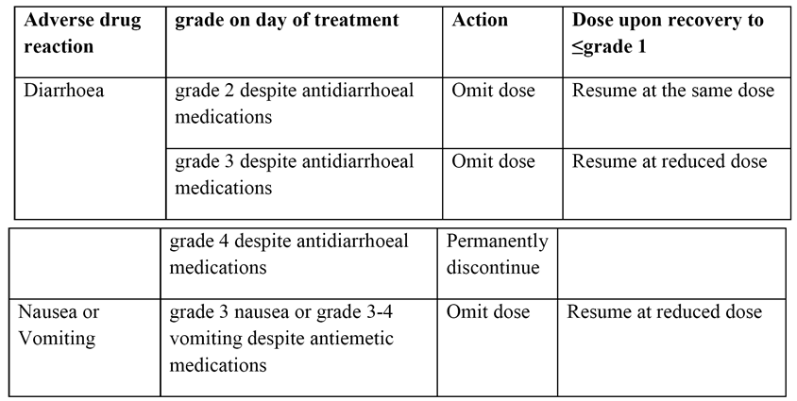
At the first sign of abdominal cramping, loose stools, or onset of diarrhoea, it is recommended that the patient be treated with anti-diarrhoeal medication. Prophylactic anti-emetics should be administered at the discretion of the physician and in accordance with local medical practice (see Precautions).

Neutropenia
Neutropenia may require temporary or permanent dose reduction. Instructions for dose interruptions and reductions for Farydak are outlined in Table 4.

Table 4: Recommended dose modifications for neutropenia
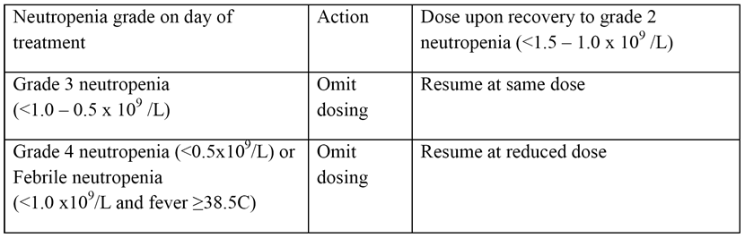
In case of Grade 3 or 4 neutropenia, physicians should consider the use of growth factors (for example G-CSF) according to local guidelines. Discontinuation of treatment may be considered if neutropenia does not improve despite the dose modifications and/or despite the addition of colony stimulating factor therapy according to local medical practice and treatment guidelines, and/or in case of severe secondary infections.

QTc prolongation
In case of long QT interval prior to the start of dosing with Farydak (QTcF ≥ 480 msec at baseline), the start of the treatment should be delayed until the pre-dose average QTcF has returned to < 480 msec. In addition, any abnormal serum potassium, magnesium and phosphorus values should be corrected prior to the start of Farydak therapy (see Precautions). In case of QT prolongation during treatment:
- The dose should be omitted, if QTcF is ≥ 480 msec or above 60 msec from baseline.
- If QT prolongation is resolved within 7 days, resume treatment at prior dose for initial occurrence or at reduced dose if QT prolongation is recurrent.
- If QT prolongation is unresolved within 7 days, treatment should be discontinued.
- •If any QTcF value is above 500 msec, Farydak therapy should be permanently discontinued.

Other adverse drug reactions
For patients experiencing severe adverse drug reactions other than thrombocytopenia, neutropenia, QTc prolongation or gastrointestinal toxicity, the recommendation is the following:
- CTC Grade 2 toxicity recurrences or CTC Grade 3 and 4; omit the dose until recovery to CTC Grade ≤ 1 and resume treatment at a reduced dose.
- CTC Grade 3 or 4 toxicity recurrence, a further dose reduction may be considered once the adverse events have resolved to CTC Grade < 1.

Special populations

Patients with renal impairment
Plasma exposure of panobinostat is not altered in cancer patients with mild to severe renal impairment. Therefore, starting dose adjustments are not necessary. Panobinostat has not been studied in patients with end stage renal disease (ESRD) or patients on dialysis (see Pharmacology and Precautions).

Patients with hepatic impairment
Clinical study in patients with impaired hepatic function has shown that plasma exposure of panobinostat increased by 43% and 105%, in patients with mild and moderate hepatic impairment, respectively. No experience with Farydak is available in patients with severe hepatic impairment. Therefore caution should be exercised in patients with hepatic impairment, with close clinical monitoring for adverse events and dose adjustments may be considered (see Pharmacology and Precautions).

Paediatric patients
No studies have been performed and there is no relevant use of Farydak in paediatric patients below the age of 18 in the indication of multiple myeloma (see Pharmacology).

Geriatric patients (≥ 65 years)
More than 40% of patients in the Phase III clinical study were ≥ 65 years of age, with no evidence suggesting adjustment of the starting dose (see Pharmacology). A consistent benefit was observed, however, patients over 65 years of age had a higher frequency of selected adverse events and of discontinuation of treatment because of adverse events. It is recommended to monitor the patients over 65 years of age more frequently, especially for thrombocytopenia and gastrointestinal toxicities (see Adverse Effects for more details).

Method of administration
Farydak capsules should be administered orally once daily at the same time each day. Capsules should be swallowed whole with water. Farydak can be taken with or without food (see Pharmacology).
Farydak capsules should not be opened, crushed or chewed. If a dose is missed, it can be taken up to 12 hours after the specified dose time. If vomiting occurs the patient should not take an additional dose, but should take the next usual prescribed dose.

Clinical rationale
The submission included a local (Australian) expert statement outlining the management of high risk patients with multiple myeloma (MM) who have not benefited from treatment with currently available agents. The local expert notes that, ‘collectively’, for high risk patients (representing approximately 25% of patients with MM) the median survival is ≤ 2 years. Therefore, the local expert considers that there is a ‘very clear unmet need for alternative classes of anti-MM therapeutics that may potentially improve the outcome for high risk MM patients who have not benefited from the novel agents and build upon the benefit that non-high risk patients have achieved with novel agents and where applicable (autologous stem cell transplantation)’.
Comment: The clinical rationale for the development of panobinostat provided by the local expert is satisfactory. It is noted that the local expert has had a ‘multifaceted’ professional relationship with the sponsor.

Current treatment options and clinical rationale
There are no DACi anticancer agents currently on the Australian Register of Therapeutic Goods (ARTG) for the treatment of MM. However, there are two histone deacetylase (HDAC) inhibitors currently on the ARTG for the treatment of other haematologic malignancies (romidepsin and vorinostat). Romidepsin (Isotodax) is approved for the treatment of peripheral T-cell lymphoma in patients who have received at least one prior systemic therapy. Vorinostat (Zolina) is approved for the treatment of cutaneous manifestations in patients with cutaneous T-cell lymphoma (CTCL) who have progressive, persistent or recurrent disease subsequent to prior systemic therapies.

Formulation development
Panobinostat hard gelatin capsules are an immediate release dosage form for oral administration. Two different crystal forms of panobinostat drug substance were used during the development of the capsules. A crystalline monohydrate form was used in the early preclinical studies and for the development of the Clinical Service Form (CSF) used in early clinical studies. The anhydrous form (Modification A) was used in some preclinical studies and for the development of the Final Market Image (FMI) formulation used in the pivotal clinical studies.

Overseas regulatory history
At the date of submission, panobinostat had not been approved in any overseas jurisdictions. However, as outlined below there have been subsequent developments in the USA relating to the approval of panobinostat in that country. Similar applications to that submitted in Australia have been made in the USA (24 March 2014), the EU (7 May 2014), and Switzerland (6 June 2014). The dossier submitted to the FDA, EMA, Heath Canada and TGA is essentially the same, apart from the differences summarised (in Table, not provided). The sponsor stated that, as of 5 November 2014, no rejections, withdrawals or repeated deferrals had occurred in the USA, EU or Canada.
Comment Round 1: On 23 February 2015, the FDA approved panobinostat in combination with bortezomib and dexamethasone for the ‘treatment of patients with multiple myeloma who have received at least 2 prior treatments, including bortezomib and an immunomodulatory agent’. The indication was approved under accelerated approval procedures based on progression free survival in a pre-specified subgroup analysis of 193 patients who had received prior treatment with both bortezomib and an immunomodulatory agent during the pivotal Phase III trial (PANOMARA-1). The approved indication was more restrictive than that being originally sought. The FDA commented that ‘an improvement in survival or disease-related symptoms has not yet been established for Farydak. The company is now required to conduct confirmatory trials to describe and verify the clinical benefit of Farydak’ (FDA News Release 23 February 2015).

Contents of the clinical dossier

Scope of the clinical dossier
The submission included comprehensive clinical pharmacology and clinical efficacy and safety data provided to support registration of panobinostat in combination with bortezomib and dexamethasone for the proposed indication. The submission was presented in Common Technical Document (eCTD) format. It included a ‘Notes to Reviewers’, dated 3 November 2014, provided as an annex to the Application Letter to facilitate the review of the eCTD. This clinical evaluation report (CER) is based on the data provided on the CD.
The submission contained the following clinical information:
- 12 clinical pharmacology studies including pharmacokinetic and/or pharmacodynamic data.
- 1 population pharmacokinetic study.
- 1 population pharmacokinetic/pharmacodynamic study (exposure/platelet count).
- 1 pivotal Phase III efficacy and safety study.
- 2 supportive, uncontrolled, single arm Phase Ib and Phase II clinical efficacy and safety studies.
- 6 other Phase II clinical efficacy and safety studies assessing various panobinostat dosing regimens for various solid tumour and haematological malignancy indications.
- 4 reports detailing the analytical methods used to measure panobinostat and its metabolites in human plasma and bortezomib in human plasma.
- 14 reports involving human biomaterials aimed at the in vitro identification of enzymes relevant to the hepatic metabolism of panobinostat and protein transporters relevant to potential drug-drug interactions.
- Literature references.
The submission also contained: Clinical Overview, Summary of Biopharmaceutic Studies and Associated Analytical Methods, Summary of Clinical Pharmacology Studies, Summary of Clinical Efficacy in MM, Summary of Clinical Safety in MM, Literature references.

Paediatric data
No paediatric data were included in the submission. The sponsor indicates that it has not submitted paediatric data in the EU or the USA for patients aged < 17 years. The sponsor indicates that it does not have an agreed Paediatric Investigation Plan (PIP) in Europe. The requirement to submit a PIP in Europe was waived because panobinostat is intended to treat multiple myeloma, a condition that occurs only in adults and is included in the ‘class waiver’ list. The sponsor indicates that it does not have an agreed Paediatric Plan under the Paediatric Research Equity Act (PREA) in the USA. Under USA legislation, the sponsor is exempt from assessing the efficacy and safety of panobinostat in a paediatric population as the FDA has designated it to be an orphan drug for the treatment of MM.
Comment: The absence of paediatric and adolescent efficacy and safety data for panobinostat in the regulatory dossier submitted to the TGA is acceptable, given the proposed indication.

Good clinical practice
The dossier indicated that all studies sponsored by Novartis complied with the principles of Good Clinical Practice (GCP).

Pharmacokinetics

Studies providing pharmacokinetic data

Overview
- All pharmacokinetic (PK) data relating to panobinostat were based on patients with advanced cancer. There were no PK data for panobinostat in healthy subjects due to genotoxicity being observed with the drug in nonclinical assays.
- The PK of panobinostat as a single agent have been assessed in 17 Phase I/II clinical studies in approximately 650 patients with solid tumour or haematological malignancies. These 17 studies included, fifteen Phase I/II clinical trials assessing the oral (PO) PK of panobinostat and two Phase I/II clinical studies assessing the intravenous (IV) PK of panobinostat. The main focus in the submission was on the PK data from the 15 PO studies, while the 2 IV studies were primarily included for estimation of absolute bioavailability.
- Characterisation of the PK of single agent panobinostat was primarily based on a pooled PK analysis and a population PK (PPK) analysis. The pooled PK analysis included data from 14 studies, comprising 12 studies with PO administration (B1101, B2101, B2102, B2201, B2202, B2203, B2211, B2109, B2110, B2111, X2101 and X2105) and two studies with IV administration (A2101 and A2102). The PPK analysis was also based on data from 14 studies, including all studies in the pooled PK analysis apart from Studies X2101 and X2105 (that is, the hepatic and renal impairment studies), and 2 studies not included in the pooled analysis (that is, E2214, a Phase II study in Hodgkin's Lymphoma, and B1201, a small study in 4 Japanese subjects with T-cell lymphoma).
- The PK of panobinostat (PAN) in combination with bortezomib (BTZ), with and without dexamethasone (Dex), were investigated in Study B2207, a Phase Ib study in patients with MM, and in Study D2308, a Phase III, placebo controlled study in patients with relapsed or relapsed and refractory MM (that is, the pivotal efficacy and safety study).
- The submission included 14 in vitro human biomaterial studies assessing hepatic pathways relating to the metabolism of panobinostat, and transporter proteins relevant to potential drug-drug interactions (DDI) with the drug. The evaluation of these studies is a matter for the nonclinical evaluator. However, relevant information from these in vitro studies relating to the clinical use of panobinostat has been provided in this CER. The human biomaterial studies were provided.
- The submission included reports detailing the analytical methods used to estimate the concentration of panobinostat in human plasma and urine, the concentration of one of the metabolites of panobinostat in human plasma (BJB432), and the concentration of bortezomib in human plasma. The evaluation of the analytical reports is a matter for the pharmaceutical chemistry evaluator, but clinically relevant information from the studies is summarised below.
- Panobinostat was analysed in human plasma and human urine using specific liquid chromatography with tandem mass spectrometry (LC-MS/MS) methods, with a lower limit of quantification (LLOQ) of 0.500 ng/mL (expressed in base) and a dynamic range of 0.500 to 500 ng/mL using 100 µL of human plasma or human urine. Plasma concentrations of panobinostat and BJB432 were analysed simultaneously in human plasma using a specific LC-MS/MS method with a LLOQ of 0.100 ng/mL (expressed in base), and a dynamic range of 0.100 to 100 ng/mL for each analyte using 100 µL of human plasma. In most studies the human plasma concentration of panobinostat was reported in ng/mL. However, in some studies, molar units were used to express panobinostat concentration, in order to have comparative stoichiometric data with one of its major metabolites, BJB432. The molecular weights of panobinostat (free base) and BJB432 are 349.4 g/mole and 333 g/mole, respectively.
- The approach to evaluating the PK data has been; to broadly review the individual single agent panobinostat studies, the pooled PK analysis and the PPK analysis. The PK characteristics of PAN based on the single agent data are then reviewed, followed by a summary of the PK data for PAN when administered in combination with BTZ and Dex.

Individual PO studies with PK data; single agent panobinostat
- The submission included 17 Phase I/II studies assessing the PK of panobinostat when administered as a single agent in both single dose and multiple-dose regimens to patients with haematological malignancies and solid tumours. Of the 17 studies, 15 assessed the PK of panobinostat following PO administration and 2 assessed the PK of panobinostat following IV administration. Most of the studies were in patients with malignancies other than MM. The PK parameters of panobinostat in the individual studies were calculated using standard non-compartmental methods. In addition, synopses of each of the studies were provided.
- The PK data from 16 of the studies were included in the pooled analysis and/or the PPK analysis. The data from the key mass balance study (Study B2108) was not included in either of the integrated analyses and have been evaluated separately. In addition, PK data from the food effect study (Study B2111), the two intrinsic factor studies (Studies X2101, X2105) and the two extrinsic factor studies (Studies B2109, B2110) have also been evaluated separately. The single agent panobinostat PO and IV doses assessed in the 17 submitted studies with relevant PK data are summarised below in Table 5.

Table 5: Single agent panobinostat doses assessed in the submitted studies with relevant PK data
ID | Patients | PK Data | N | Dosage
B2101 Phase IA | Solid tumours NHL | First PO study  MTD / DLT | 33 | PAN 10 mg to 60 mg; dense PK sampling through to 48 hours Day 1, Day 15 or Day 17; complex dosing schedules.
B2102 Phase IA/II | Haematological malignancy | Dose escalating MTD / DLT | 140 | PAN 20 mg to 80 mg; dense PK sampling through to 48 hours Day 1 and Day 15.
B2108 Phase I | Solid tumours  NHL | Mass balance ADME | 4 | (14C)-PAN 20 mg single dose taken on Day 1; dense PK sampling through to 168h following dosing on Day 1; urine and faecal collection over the same period.
B2111 Phase Ib | Solid tumours | Food effect | 33 | PAN 20 mg taken on Day 1 and Day 4 (fasting, normal meal, high fat meal); dense PK sampling through to 48 hours following dosing on Day 1, Day 8, and Day 15.
X2101 Phase I | Solid tumours | Hepatic impairment | 24 | PAN 30 mg single dose (core phase) with dense PK sampling through to 96 hours.
X2105 Phase I | Solid tumours | Renal impairment | 37 | PAN 30 mg single dose (core-phase) with dense PK sampling through to 96 hours.
B2109 Phase IB | Solid tumours | DDI with CYP2D6 substrate | 16 | DM 60 mg on Day 1 with dense PK sampling through to 48 hours; PAN 20 mg on D3, Day 5, and Day 8; DM + PAN on Day 8 with dense PK sampling for DM through to 48 hours.
B2110 Phase IB | Solid tumours | DDI with CYP3A4 inhibitor | 14 | PAN 20 mg on Day 1 and Day 8 with dense PK sampling through to 48 hours on both days; KZ 400 mg + PAN 20 mg on Day 8.
B1101 Phase I | Solid tumours CTCL | Dose-escalation Japanese | 13 | PAN 10 mg (n = 3), 15 mg (n = 4), 20 mg (n = 6) dose escalation (single dose); dense PK sampling through to 48 hours following each dose (Day 1, Day 8, Day 15).
B1201 Phase II | CTCL  ATC | PK profile Japanese | 4 | PAN 20 mg three times a week; PK sampling through to 24 hours following dosing on Day 1 and Day 8.
B2201 Phase II | CTCL | Efficacy and safety study | 114 | PAN 20 mg on Day 1, D3, and Day 5; PK sampling (limited) through to 24 hours on Day 1 (n = 109) and Day 8 (n = 60).
B2202 Phase II | Ph+ CML-CP resistant | Efficacy and safety study | 19 | PAN 20 mg on Day 1, D3, and Day 5; PK sampling (limited) through to 24 hours on Day 1 and Day 8.
B2203 Phase II | MM refractory | Efficacy and safety study | 30 | PAN 20 mg on Day 1, D3, and Day 5; PK sampling (limited) through to 24 hours on Day 1 (n = 27) and Day 8 (n = 22).
B2211 Phase II | CML accelerated | Efficacy and safety study | 17 | PAN 20 mg on Day 1, D3, and Day 5; PK sampling (limited) through to 24 hours on Day 1 (n = 17) and Day 8 (n = 16).
E2214 Phase II | HL refractory /relapsed | Efficacy and safety study | 14 | PAN 40 mg on Day 1; PK sampling (limited) through 28h on Day 1
A2102 Phase IA/II | Haematological malignancies | MTD and DLT IV | 15 | PK parameters assessed on Day 1 following PAN IV at doses of 4.8, 7.2, 9, 11.5 and 14 mg/m², with trough concentrations on D2, D3, Day 4, Day 5 and D7.
Source: CSR reports. Note: ATC = adult T-cell leukemia/lymphoma; CTCL - cutaneous T-cell lymphoma; D = day; DM = dextromethorphan; h = hours; HL = Hodgkin's lymphoma; KZ = ketoconazole; MM = multiple myeloma ; NHL = non Hodgkin's lymphoma; PAN = panobinostat; Ph+ CML-CP = Philadelphia chromosome positive chronic myelogenous leukemia in chronic phase; TIW - three times a week; MTD = maximum tolerated dose; DLT toxicities

Pooled data - PK of panobinostat as a single agent
- The PK of panobinostat was investigated in pooled data from 14 Phase I/II clinical studies in which panobinostat was administered as a single agent to patients with a variety of haematological malignancies and solid tumours. The results of the pooled analysis were reported in Module 2 (Clinical Pharmacology). The pooled data from the 14 studies included approximately 600 patients. The PO route of administration was used in 12 studies and the IV route was used in 2 studies. The 14 studies contributing PK data to the pooled analysis were identified.
- For the studies with PO administration of panobinostat, either the pilot CSF or the FMI was used. The pilot CSF (monohydrate salt with drug blend formulation) was used in several early Phase I oral studies (B1101, B2108, B2101 and B2102). The pilot CSF formulation was subsequently modified in order to improve the manufacturing process by using wet granulation of an anhydrous salt formulation (FMI). The FMI formulation was used in 11 Phase I/II studies with clinical PK data (Studies 2201, 1202, 2202, 2203, 2211, 2214, 2109, 2110, 589B2111, X2101, X2105), and 3 Phase II/III efficacy clinical efficacy and safety studies in patients with MM (Studies B2207, DUS71 and D2308). The FMI formulation is intended for commercialisation.
- Prior to the results from the formal food effect study (Study B2111) becoming available in late 2009 patients were generally asked to fast for 2 hours before and for 2 hours after panobinostat administration on PK sampling days (Studies B1101, B2101, B2102, B2201, B2202, B2203, B2211). In three studies (B2109, B2110, and B2111), patients were asked to fast for 10 hours overnight prior to panobinostat dosing and for 4 hours after dosing on PK sampling days. In the PK core phase of Studies X2101 and X2105 (the intrinsic factor studies assessing hepatic and renal impairment, respectively), single- dose oral panobinostat was administered following breakfast.
- Four Phase II clinical efficacy and safety studies (Studies B2201, B2202, B2203, and B2211) used a limited sampling strategy through to 24 hours after dosing (for example, ≤ 6 samples per profile). All other oral studies used dense serial sampling (that is, 8 to 12 samples per profile). The sampling interval for panobinostat in the studies with dense serial sampling was generally through to 48 hours after oral dosing or within the dosing interval, with the exception of Studies X2101 and X2105 where sampling was through to 96 hours after oral dosing.

Population pharmacokinetic (PPK) analysis; single agent panobinostat
- A PPK analysis was conducted using data from 14 studies, including eight Phase I studies (B1101, B2102, A2101, A2102, B2101, B2109, B2110 and B2111) and six Phase II studies (B2201, B2202, B2203, B2211, B1201 and E2214). The objectives of the PPK analysis were:
  - to characterise the PK properties of panobinostat following IV and PO doses;
  - to estimate the absolute and relative bioavailability of the CSF and FMI formulations; and
  - to investigate the effects of covariates on the elimination of panobinostat including demographic variables, tumour type (haematological versus solid), clinical variables (baseline liver function and creatinine clearance), and effects of co-medications.
- Nonlinear mixed effects modelling was used to describe the population pharmacokinetics of panobinostat using the compartmental approach. The FOCE method, as implemented in the software program NONMEM extended version VI, was used in model building. Following exploration of several PK structural models, a three compartment model was finally adopted with first-order input and parameterized in terms of clearance (CL), volume of the central compartment (V2), absorption rate constant (ka) and rate constants between the central and two peripheral compartments k23, k32, k24 and k42. The methodology of the PPK was extensively described and complies with the relevant TGA adopted guidelines.^{[1]}
- A total of 581 patients were available from 14 studies: 87 from the IV studies and 494 from the PO studies (n = 106 CSF formulation; n = 388 FMI formulation). A total of 7834 panobinostat concentration values were available for analysis. The median age of the PK population was 61 years (range: 16, 88 years), the median weight was 76.4 kg (range: 4, 196.4 kg), the median height was 170 cm (range: 143, 198 cm), 362 patients were male and 219 female. The majority of the patients were Caucasian (n = 496), with the remainder being Black (n = 34); 27 Asian (n = 27); and ‘Other’ (n = 24). The results of the PPK analysis have been reviewed in the relevant PK sections of the CER.

Summary of pharmacokinetics

Physicochemical characteristics of the active substance
The following information has been adapted from the relevant sponsor’s summaries. The structural formula of panobinostat lactate anhydrous is provided below in Figure 1. The molecular formula of the drug is C21H23N3O2. C3H6O3, and the relative molecular mass is 439.51 (349.43 (free base) + 90.08 (lactic acid). Panobinostat lactate anhydrous does not show polymorphic behaviour. Panobinostat (free base) is not chiral and shows no specific optical rotation.
Figure 1: Structural formula
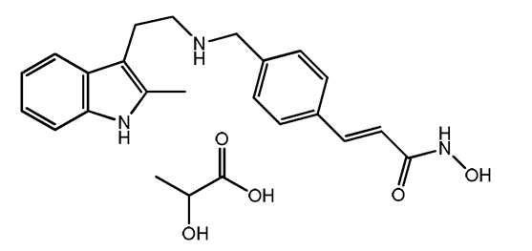
Panobinostat lactate anhydrous is a white to slightly yellowish or brownish powder. The solubility of the compound in water is 4.775 (mg/mL of solution) at 37±0.5 °C (that is, slightly soluble according to USP, Pharm.Eur and JP). The solubility of panobinostat lactate anhydrous is strongly pH dependent (see Table 6). The compound is maximally soluble at pH 4.5, and notably less soluble in simulated gastric fluid (buffer 0.1 N HCl) and in simulated intestinal fluid (buffer pH 6.8). The pH of a 0.1% (m/V) aqueous solution of panobinostat lactate anhydrous at room temperature (21 to 22 °C) is approximately 6.0. The distribution co-efficient of the compound cannot be estimated in n-Octanol/phosphate buffer pH 6.8 due to its low solubility (less than 0.01%) in n-Octanol.

Table 6: Solubility of panobinostat lactate anhydrous batch 0724011 at 37 degrees Celsius
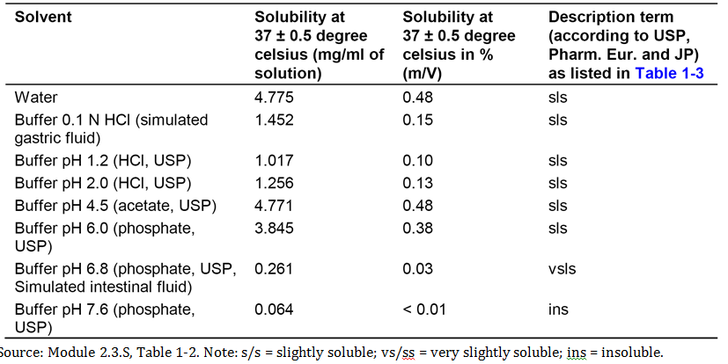
The melting point of panobinostat lactate anhydrous determined is reported to be 175.3 °C. The theoretical and experimental pKa values of panobinostat lactate were 2.0 and below the detection limit for the indole ring, 9.2 and 8.4 for the amine, and 8.8 and 9.0 for hydroxamic acid. Panobinostat is slightly hygroscopic.
Comment: The sponsor converted the solubility of panobinostat lactate anhydrous into the corresponding maximum amount of the drug in mg soluble in 250 mL of solution (see Table 7).

Table 7: Solubility of panobinostat lactate anhydrous, batch 072411 at 37 °C
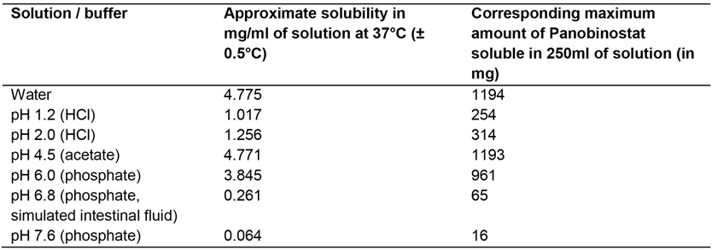
The sponsor states that the results indicate that the highest dose of panobinostat (20 mg) will be completely soluble at all pH levels tested, except at pH 7.6. The sponsor states that decreased solubility at pH 7.6 is ‘not relevant from a physiological perspective’ as the absorption of panobinostat primarily occurs in the upper GI tract where the pH will be lower than 7.6. However, the highest solubility of the drug was reported in buffer pH 4.5 (acetate, USP). In simulated intestinal fluid (pH 6.8), the solubility of the drug is lower than at pH 4.5. This raises the possibility that administration of panobinostat with drugs that lower the pH (for example, protein pump inhibitors (PPI)) might reduce the solubility of panobinostat resulting in decreased bioavailability. This issue was raised at the pre-submission meeting between the TGA and the sponsor. The sponsor stated it has ‘high confidence’ that pH elevating agents should not affect the oral absorption of panobinostat. The sponsor referred to the existence of a simulation report covering various pH ranges which it states ‘will be provided to the TGA’. However, the report could not be located in the submission.

Pharmacokinetics in patients; single agent panobinostat

Absorption

Sites and mechanism of absorption
In the PPK analysis, the disposition of panobinostat following oral administration was best described by a linear three compartment model with first order absorption and parameterized in terms of clearance (CL), volume of central compartment (V2), absorption rate constant (ka) and rate constants between central and two peripheral compartments k23, k32, k24 and k42. The model is presented schematically below in Figure 2.
Figure 2: Schematic representation of the three compartment model for panobinostat
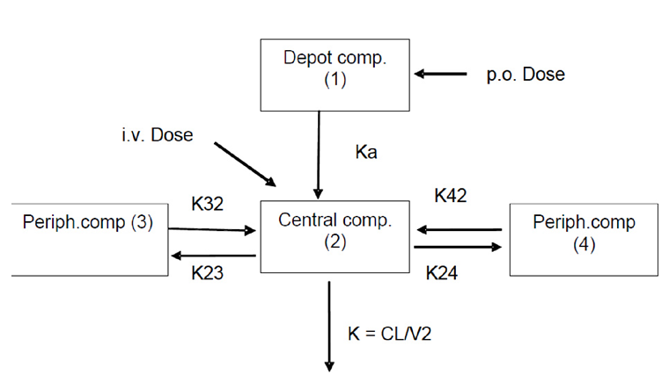
The t_{max} for panobinostat was approximately 2 hours across a number of studies. The mass balance/ADME study (Study B2108) showed that panobinostat was well absorbed following oral administration of a single 20 mg radiolabelled dose, with at least 87% of the total dose being recovered in urine and faeces and less than 3.5% being excreted in the faeces as unchanged drug.
Based on an in vitro human biomaterial study using Caco-2 cells, the sponsor concluded that panobinostat may be categorised as highly permeable drug substance. The in vitro human biomaterial study also reported that panobinostat may be a substrate for the P-glycoprotein (P-gp) efflux transporter.

Absolute bioavailability
There was no formal absolute bioavailability study in the submitted data. However, absolute bioavailability was estimated from both the pooled data and the PPK analysis. Based on the pooled data, the absolute bioavailability was estimated to be 28% (95% CI: 25%, 32%) using AUC_{inf} values calculated by a non-compartmental method from dense serial concentration-time data (at least 12 sampling time points per profile) from all available IV doses (n = 69) and oral doses (n = 196). However, the AUC_{inf} values were inaccurate because PK sampling for up to 48 hours was too short to adequately capture the terminal elimination phase (that is, sampling time was less than three times the estimated terminal elimination half-life of 37 hours from the PPK analysis). In the PPK analysis, additional trough samples between densely sampled profiles were also taken into consideration in the calculation of absolute bioavailability. Based on the PPK analysis, the absolute bioavailability of panobinostat was estimated to be 21.4% (SE = 1.6%), with no statistically significant difference between the CSF and FMI formulations.
Comment: The sponsor provided a justification for not undertaking an absolute bioavailability study, based on the fact that estimates of absolute bioavailability had been obtained from the pooled data and the PPK analysis. While it would have been preferable to have conducted a formal absolute bioavailability study, it is considered that the value of approximately 21% derived from the PPK analysis is an acceptable estimate of the absolute bioavailability of panobinostat. The sponsor also acknowledges that it has not submitted a relative bioavailability study comparing an oral solution with the capsules (any strength), but contends that this is not an applicable requirement as it has submitted absolute bioavailability data. It is considered that there is no requirement in this submission for a relative bioavailability study comparing an oral solution and a capsule formulation proposed for registration.

Bioequivalence of clinical trial and market formulation
The FMI formulation is intended for commercialisation. The FMI formulation was used in the three clinical efficacy and safety studies relevant to the proposed indication (Studies B2207, DUS71, and D2308), and in 11 Phase I/II studies with PK data. The CSF formulation preceded the FMI formulation and was used in 5 early Phase I studies with PK data.
The composition of the CSF and FMI formulations were provided. The sponsor describes the two formulations as being ‘extremely similar’. The sponsor reports that the dissolution profiles of representative batches of the CSF and FMI formulations were found to be comparable, except at pH 6.8, where the FMI formulation was slightly faster on release than the CSF formulation. However, dissolution was reported to be similar and nearly complete (90%) at 80 minutes. Therefore, the sponsor expects no difference in the relative extent of bioavailability between the two formulations in humans.
No formal bioequivalence study was submitted comparing the CSF and FMI formulations. However, the PPK analysis showed that formulation (CSF versus FMI) had an effect on the rate of absorption, but not on bioavailability. The absorption rates for the CSF and FMI formulations were 0.54 h⁻¹ and 0.32 h⁻¹, respectively, while the estimated absolute bioavailability was similar. Simulated plasma panobinostat concentration versus time profiles for the two formulations following oral administration predict that the C_{max} would be approximately 30% lower for the FMI formulation compared to the CSF formulation for a typical patient.
Comment: In the submission the sponsor states that it does ‘not consider that bioequivalence of the market formulation(s) compared with the (different) formulation(s) used in pivotal dose defining and efficacy studies needs to be established because the formulation of the panobinostat capsules (the final market image, FMI formulation) used in the pivotal clinical study (Study D2308) is identical differing only in capsule shell colour, size and fill weight to that proposed for registration in Australia’. This is considered to be acceptable.

Bioequivalence of different dosage forms and strengths
The proposed commercial strengths of panobinostat hard gelatin capsules are 10 mg, 15 mg and 20 mg. There were no clinical studies comparing the bioequivalence of the three different dosage strengths provided for registration. The proposed marketed formulation is compositionally proportional with respect to active and inactive ingredients across strengths and the sponsor states that the proposed marketed formulation is representative of the FMI formulation used in the pivotal Phase III clinical study (Study D2308). In addition, the 20 mg panobinostat hard gelatin capsules are the highest proposed commercial strength and were also used in Study D2308. The compositions of panobinostat hard gelatin capsules for commercialisation were provided.
Comment: The sponsor has addressed the issues relating to the submission of bioequivalence data for the three capsule strengths in the context of the effect of food on the bioavailability of the strengths (Study B2111). Therefore, the matter will be considered below.

Influence of food
The submission included one formal open label, multi-centre, crossover Phase Ib study assessing the effect of food on the PK of panobinostat in adult patients with advanced solid tumours (Study B2111); a synopsis of the study was provided. The primary objective of this study (core phase, Cycle 1) was to determine the rate and extent of panobinostat absorption under fasting conditions, 30 minutes after starting a high fat meal, and 60 minutes after starting a normal meal. Only the PK data from the core phase of this study are evaluated in this CER.
The core phase used a randomised, three period, six sequence crossover design in which panobinostat 20 mg was administered twice a week (Days 1, 4, 8, 11, 15, and 18) on a 21 day treatment cycle. Samples for measurement of plasma panobinostat were obtained on Days 1, 8, and 15, at pre-dose and at 0.5, 1, 1.5, 2, 2.5, 3, 4, 5, 6, 8, 24, and 48 hours post dose. Formal statistical analyses using standard linear mixed effects modelling were performed for C_{max}, AUC_{0-24 hours}, AUC_{inf}, and AUC_{0-last}. The GMR (fed/fasting), with 90% CI were calculated for each of the parameters. Formal sample size calculation was also undertaken.
The final PK analysis set include 36 patients, and evaluable PK profiles were available for 33 fasting patients, 34 patients with a high fat meal, and 31 patients with a normal meal. Most patients (n = 35) had a PK profile for two or three prandial states, while 1 patient had only one PK profile (high fat meal). There were 6 PK profiles excluded from the analysis. The panobinostat plasma concentration; time profiles are summarised below in Figure 3. The key PK parameters are summarised below in Table 8.
Figure 3: B2111; Arithmetic (SD) panobinostat plasma concentration; time profiles with expanded time scales; linear view Panel A and semi-log view Panel B
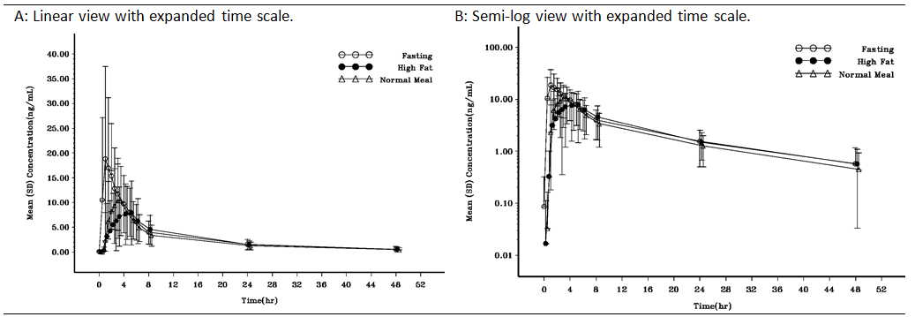

Table 8: B2111; Summary of PK parameters for panobinostat by treatment; PK final analysis set
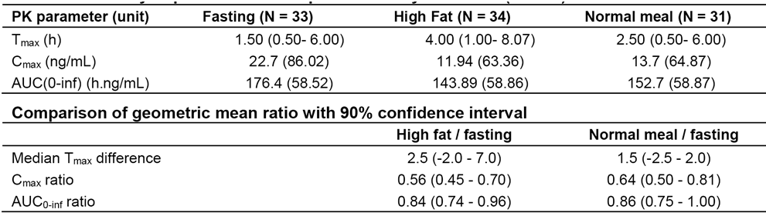
Comment: Relative to fasting administration, the AUC_{inf} was reduced by 16% when panobinostat 20 mg was administered with a high fat meal and 14% when administered with a normal meal. The 90% CI for both AUC_{inf} ratios were outside the standard bioequivalence interval of 0.8 to 1.25. Relative to fasting administration, the C_{max} was reduced by 44% when panobinostat 20 mg was administered with a high fat meal and 36% when administered with a normal meal. The 90% CI for both C_{max} ratios were outside the standard bioequivalence interval of 0.8 to 1.25. The inter subject variability (CV%) remained constant for the AUC_{inf} for each of the three prandial states (approximately 59%), while the inter subject variability in C_{max} in the fasting state was notably higher than in both high fat meal and normal meal fed state (that is, 86% versus 63% to 65%, respectively). t_{max} was prolonged with a high fat meal compared to both a normal meal and fasting (that is, 4.0 versus 2.5 versus 1.5 hours, respectively).
In the core phase, patients experienced more AEs in the fasting state (82.4%) than in the fed state (high fat meal: 72.2%; normal meal 67.6%). Nausea, vomiting and fatigue were the most commonly reported AEs with the three treatments. Nausea and vomiting were reported less frequently in patients in the high fat meal group (13.9% and 8.3%, respectively) compared to patients in both the normal meal group (29.4% and 20.6%, respectively) and in the fasting group (23.5% and 14.7%, respectively). More patients experienced fatigue when panobinostat was administered with a normal meal than with a high fat meal or when fasting (29.4% versus 8.8% versus 16.7%, respectively). More patients developed headache when panobinostat was administered in the fasting state than with a high fat or a normal meal (11.8% versus 5.6% versus 5.9%, respectively). The number of patients with SAEs was small in the three treatment groups. However, SAEs were more frequently reported in the fasted state compared to both the high fat and normal fed states (n = 4, 11.8% versus n = 2, 5.6% versus n = 2, 5.9%, respectively). The SAEs in the 4 patients in the fasting state were vomiting x 2, pneumonia x 1, wound infection x 1, wound haemorrhage x 1, dehydration x 1, prostatitis x 1, and hypotension x 1. The SAEs in the 2 patients in the high fat fed state were dysphagia x 1, fatigue x 1 and dyspnoea x 1, and in the 2 patients in the normal fed state were vomiting x 1, nausea x 1, fatigue x 1 and pyrexia x 1. Only 1 patient (normal fed state) discontinued treatment due to AEs (Grade 3 events of fatigue, nausea and vomiting). There was 1 on treatment death in the core phase (that is, up to 28 days after the last dose) in a subject in the high fat fed state (gastrointestinal stromal tumour). The PI states that panobinostat can be taken at the same time each day with or without food (Dosage and Administration section), but also recommends that it be taken on a full stomach. Taking panobinostat on a full stomach is reasonable advice, given that the frequency of nausea and vomiting was greater when the drug was administered in the fasting state compared to the high fat meal and normal meal fed states.
The food effect study did not included data on the 10 mg and 15 mg doses of panobinostat proposed for registration, and there were no bioequivalence data comparing the 10 mg, 15 mg and 20 mg doses. The sponsor has requested a ‘formal waiver from further bioequivalence studies investigating the effect of food’ on the 10 mg and 15 mg panobinostat capsule strengths. The sponsor's physico-chemical arguments in support of a formal waiver include:
- the complete solubility of the highest panobinostat capsule strength (20 mg) over the physiologically relevant pH range (1 to 6.8);
- the nature of the dosage forms (that is, immediate release, simple scaled formulations); and
- the comparative dissolution profiles of the three strengths over the physiologically relevant pH range (1 to 6.8).
These arguments appear reasonable, but definitive comment should be obtained from the pharmaceutical chemistry evaluator.
In addition, the sponsor considers that the PK properties of panobinostat also support a waiver. In summary, the sponsor identified the following PK factors as justifying a waiver:
  - single dose PK of the drug are probably linear over the dose range 10 mg to 30 mg based on the C_{max} and AUC_{inf};
  - linearity following multiple-dose PK over the dose range 10 mg to 30 mg based on C_{max} and AUC_{0 to 48 hours} cannot be ruled out;
  - the drug is well absorbed following oral administration with 87% of the total administered radioactive dose being recovered in the urine and faeces with less than 3.5% of the dose being excreted in the faeces as changed drug;
  - the large first pass effect (indicated by the estimated absolute bioavailability of 21% to 28% in the context of extensive absorption) has not proven to be a problem in relation to the bioavailability of panobinostat capsules as evidenced by the results obtained in the food-effect study for the bioavailability of the highest strength 20 mg panobinostat capsules; and
  - the human biomaterial studies relating to absorption indicate that panobinostat can be classified as a highly permeable drug.
Overall, the sponsor's arguments based on the PK of panobinostat are adequate.
The sponsor also comments on the clinical consequences of any potential differences in bioavailability between the three capsule strengths. The sponsor states that ‘extensive clinical data .... demonstrate that panobinostat capsules in doses between 10 and 20 mg (taken in combination with bortezomib 1.3 mg/m² injection and dexamethasone 20 mg taken orally) generally constitutes a safe and effective treatment of patients with relapsed multiple myeloma or relapsed and refractory multiple myeloma. Doses of up to 80 mg of panobinostat have been safely administered to elderly patients’. However, arguments based on the safety of panobinostat should be interpreted cautiously due to the inferior safety profile of PAN+BTZ+Dex compared to PBO+BTZ+Dex.

Dose proportionality

Single dose
Dose proportionality for single dose panobinostat over the dose range 10 mg to 80 mg was assessed using pooled data from 301 patients with dense PK sampling from eight studies (B1101, B2101, B2102, B2109, B2110, B2111, X2101 and X2105). The relationships between dose and AUC_{inf} and C_{max} were provided.
The C_{max} for panobinostat generally increased with dose over the range 10 mg to 80 mg, with the slope of the regression line being 1.00 (90% CI: 0.86, 1.14). However, AUC_{inf} increased less than dose proportionally over the dose range 10 mg to 80 mg, with the slope of the regression line being 0.72 (90% CI: 0.58, 0.86). Inter individual variability in panobinostat systemic exposure was marked across the oral doses (CV% of AUC_{inf} = 65.8%).
Over the 10 mg to 30 mg dose range, C_{max} and AUC_{inf} increased approximately dose proportionally, with the slopes of the regression lines being 1.08 (90% CI: 0.71, 1.44) and 0.99 (90% CI: 0.59, 1.39), respectively. However, inter subject variability in both the C_{max} and AUC_{inf} was high, as can be seen by the wide 90% CI for both parameters.

Multiple dose
Three pooled oral studies (Studies B1101, B2101 and B2102) were used to assess dose proportionality following multiple doses of panobinostat. PK assessment was carried out in approximately 100 patients treated with multiple doses three times a week (TIW), every week or every other week. The relationships between dose and AUC_{0 to 48 hours} and C_{max} on Day 15 over the dose range 10 mg to 30 mg following multiple doses TIW are provided below in Figure 4 and Figure 5, respectively.
Figure 4: Scatter plot of panobinostat AUC_{0 to 48 hours} (ng•h/mL) following multiple oral dose TIW on Day 15
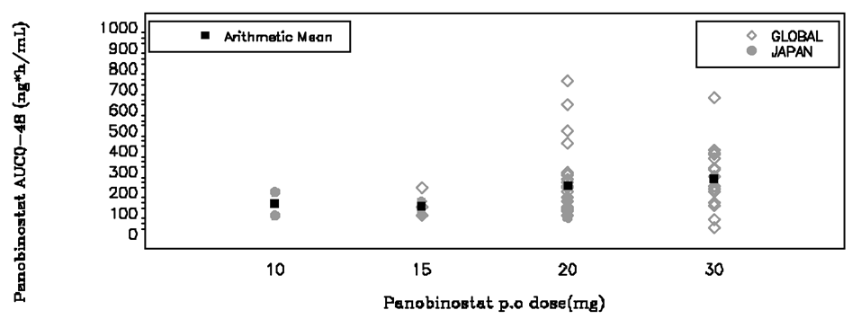
Figure 5: Scatter plot of panobinostat C_{max} (ng/mL) following multiple oral dose TIW on Day 15
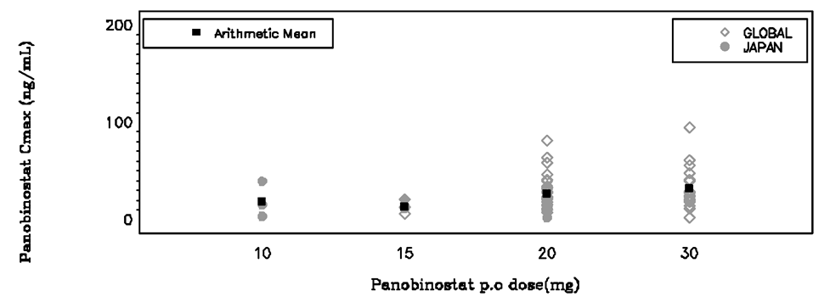
Over the clinically relevant dose range of 10 mg to 30 mg, C_{max} and AUC_{0 to 48 hours} increased less than dose proportionally with the slopes of the regression lines being 0.74 (90% CI: 0.20, 1.28) for C_{max} and 0.62 (90% CI: 0.20, 1.04) for AUC_{0 to 48 hours}.

Bioavailability during multiple dosing
The proposed starting dose of panobinostat for the proposed indication is 20 mg taken orally once a day, on Days 1, 3, 5, 8, 10 and 12, of a 21 day cycle, in combination with bortezomib IV and dexamethasone PO. The sponsor comments that steady state is expected to be reached following the 3rd dose (Day 5), but is not maintained because of the 72 hour (3 day) gap between the 3rd dose (Day 5) and the 4th dose (Day 8).
The PK parameters for panobinostat on Day 15 following multiple-oral doses of single agent panobinostat three times a week, every week, from Studies B1101, B2101 and B2102 are summarised below in Table 9. The GMRs (90% CI) Day 15/Day 1 for AUC_{0 to 48 hours} and C_{max} for panobinostat 20 mg three times a week were 1.64 (90% CI: 1.37, 1.97) and 1.39 (90% CI: 1.14, 1.71), respectively, showing accumulation following multiple doses.

Table 9: Panobinostat PK parameters on Day 15 following multiple doses TIW, every week
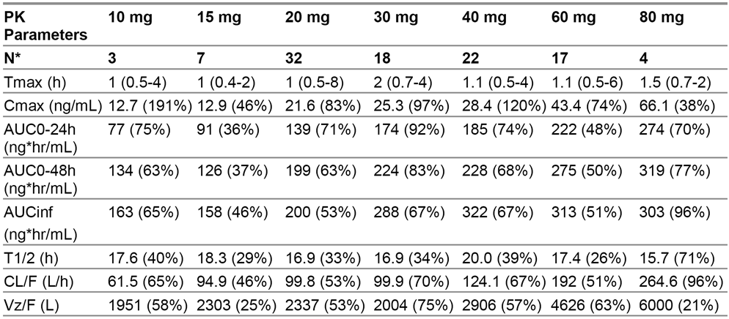
Comment: The terminal elimination half-life of panobinostat estimated from the PPK analysis is 37 hours. Based on this value, the last time point for blood sampling for serum PK estimation of 48 hours following panobinostat dosing for Studies B1101, B2101 and B2102 is too short to adequately characterise the terminal elimination phase of the drug. Therefore, those PK parameters following panobinostat multiple dosing that are calculated from the terminal half-life are likely to be inaccurate (that is, AUC_{inf}, t½, CL/F and Vz/F).

Distribution
- In vitro, panobinostat was reported to be 89.6% bound to plasma proteins, and binding was independent of panobinostat concentrations over the 0.1 to 100 μg/mL range evaluated in human plasma (Study R0200414).
- In vitro, the mean ± SD fraction of panobinostat in erythrocytes was reported to be 0.60 ± 0.041 in humans, and was independent of panobinostat concentration over the evaluated range of 0.1 to 100 µg/mL (Study R0200414). The mean ± SD blood to plasma concentration ratio was reported to be 1.37 ± 0.125 in humans, and was independent of panobinostat concentration over the evaluated range of 0.1 to 100 µg/mL (Study R0200414).
- In the mass balance/ADME study (Study B2108), the apparent volume of distribution was estimated to be 9464 L in 4 patients with advanced cancer with PK sampling through to 168 hours post dose following radio labelled panobinostat 20 mg. In the PPK analysis, the volume of distribution following a 30 minute IV infusion was 950 L (CV% = 55%). The available data indicates that volume of distribution is large, which suggests extensive tissue distribution.

Metabolism

Study B2108; mass balance / ADME
The data from the mass balance/ADME study (Study B2108), in 4 patients with advanced cancer indicates that panobinostat is extensively metabolised. In total, at least 77 distinct metabolites have been identified of which approximately 40 were observed in circulating plasma. The primary metabolic pathways were reported to involve modifications of the hydroxamic acid side chain to form an amide via reduction (M37.8 or BJB432) and three distinct carboxylic acids via hydrolysis (M43.5) and one- (M40.8), and two-carbon chain shortening (M36.9) of the hydroxamic acid side chain. Additionally, it was reported that double bond reduction along with multiple oxygenations and glucuronidations (with and without carbamoylation) occurred both alone and in combination with the modifications of the hydroxamic side chain. The sponsor estimated that 30% to 47% the administered 20 mg dose of radio labelled panobinostat underwent CYP mediated oxidative metabolism based on the identification and amount of metabolites excreted.
Total radioactivity in blood and plasma achieved maximum levels (C_{max}) 1.5 to 3 hours after administration of radio labelled panobinostat. Exposure to panobinostat and its metabolites was evaluated from the AUC_{0 to 48 hours} sample pools. In these samples, panobinostat accounted for 6.2% to 8.8% of the drug related exposure, based on radioactivity. Metabolite T24.0 (glucuronide of M36.9) was the most abundant metabolite, accounting for 13.4% to 19.4% of the drug related exposure. Other metabolites contributing significantly to the drug related exposure included T18b (mono-oxygenation and glucuronidation of panobinostat, approximately 2% to 5% in 3 of 4 patients), M40.8 (approximately 6% to 10%), T33a (carbamoyl glucuronide of panobinostat, approximately 5% to 14%), P38.8 (carbamoyl glucuronide of M37.8, approximately 2% to 7% in 3 of 4 patients), partially co-eluting M43.5 and M44.6 (approximately 3% to 5% combined), partially co-eluting M36.9 and M37.8 (approximately 3% to 9% combined), and T21d (mono-oxygenation of M37.8, approximately 2% to 8%). In vitro, none of the metabolites have been reported to be pharmacologically active for histone deacetylation inhibition activity up to 30 µM in concentration.^{[2]}
The plasma concentration of metabolite BJB432 (M37.8) was measured in a number of the PK studies. Exposure to this metabolite accounts for only a minor fraction of the total drug related material in plasma (< 1.5%). The plasma exposure of BJB432 ranged from approximately 25% to 100% of exposure to parent panobinostat, based on a comparison of AUCs.

In vitro human biomaterial studies
The sponsor reported that, in general, the primary biotransformation reactions observed in vitro in Studies R0101764 and R0101754 were the same as those observed in vivo. However, there were two metabolites (M24.2A and M33.1) observed in vitro that were not observed in vivo. The primary metabolic pathway of panobinostat reported in human liver microsomes from Study R0101764 was formation of the metabolite M24.2 (BJC330; monohydroxylation of panobinostat), minor metabolites included M9 (uncharacterised product), M37.8 (BJB432; reduction of the hydroxamic acid moiety), and M43.5 (AFN835; hydrolysis of the hydroxamic acid moiety). A small amount of a direct glucuronide metabolite, M34.4 (BJB875), was also reported to have been found in the presence of the co-factor for glucuronidation (UDPGA). The direct glucuronide product, M34.4 (BJB875) was found to be formed by human UGT1A1, UGT1A3, UGT1A8, and UGT1A9, while trace levels of this metabolite was formed by UGT1A7 and UGT2B4 (Study R0900595).
Panobinostat was reported to be metabolised by cytochrome P450 enzymes CYP2C19, CYP2D6, and CYP3A4. Of these CYP enzymes, CYP3A4 was found to be the greatest contributor to panobinostat oxidative metabolism. It was reported that kinetic analysis of recombinant human CYP3A4, CYP2C19, and CYP2D6 found that CYP3A4 had the highest efficiency for metabolism of panobinostat with formation of primarily M24.2 (BJC330) and to a lesser extent, M9 and M43.5 (AFN835).
The sponsor reported that in vitro data with selective CYP inhibitors showed CYP3A4 to be the main enzyme involved in the oxidative metabolism of panobinostat in human liver cells (70% to 98%), with possible minor contributions from CYP2D6 and CYP2C19 (3.5 fold and 13 fold lower than the CYP3A4 contribution, respectively). The results indicate that in clinical practice inhibitors of CYP3A4 may affect the hepatic oxidative clearance of panobinostat, but the magnitude of interactions would be dependent on the contributions of other panobinostat clearance pathways. The PK interaction between panobinostat and ketoconazole (a potent inhibitor of CYP3A4) was assessed in a clinical Study (Study B2110) in patients with advanced solid tumours (evaluated below). The results of this study suggest that the contribution of CYP3A4 to the total human clearance of panobinostat clearance is approximately 40%. The effect of rifampin (a clinical CYP3A inducer) on the clearance of panobinostat (20 mg, single dose) was modelled using the Simcyp time based model to predict the induction effect (Study R0600943-01). It was reported that a 67% reduction in panobinostat AUC is predicted when the drug is administered with rifampicin 600 mg QD, based on simulated results using a steady-state model.

Excretion
In the mass balance/ADME study (Study B2108), mass balance was achieved with ≥ 87% of the radioactivity following administration of radio labelled panobinostat 20 mg being recovered in the excreta of all 4 patients after 7 days. Of the administered dose, median recovery in the faeces was 47.8% (range: 44.4%, 77.4%) and median recovery in the urine was 41.3% (range: 28.6%, 51.2%).
The excretion of panobinostat was primarily in the form of metabolites, with unchanged panobinostat accounting for approximately 1.1% to 2.4% of the dose in urine (0 to 48 hours) and 0% to 3.3% of the dose in faeces (0 to 108 hours to 148 hours). The low percentage of the dose recovered as unchanged panobinostat in the faeces suggests that oral absorption was nearly complete. The PK, metabolism and excretion data from Study B2108 were provided.
The urinary metabolite profiles were of similar complexity to the plasma profiles due to the multiple biotransformation pathways of the hydroxamic acid side chain (one and two carbon chaining shortening, amide hydrolysis, hydroxamic acid reduction, and double bond reduction) occurring in combination with numerous oxygenations and glucuronidations. However, the sponsor commented that metabolite profiles of the urine did differ somewhat from that of the plasma with respect to observed oxygenations and glucuronidations. In contrast to the plasma and urine, the metabolite profiles in faeces were considerably less complex. In three of the four patients, metabolites T23.1 (BJB411: hydroxylated M37.8, approximately 3% to 20%) and M37.8 (approximately 14% to 23%) were the major contributors to the percentage of the dose excreted in the faeces. In the fourth patient, metabolites T22f (reduction and monooxygenation of M37.8, 4.1%), T25g (reduction and mono-oxygenation of M43.5, 8.1%), and M44.6 (14.6%) were the major contributors to the percentage of the dose excreted in the faeces.
In Study B2108, the median terminal half-lives of elimination for blood and plasma radioactivity were relatively long, 53.9 hours (range: 49.5, 60.5 hours) and 75.3 hours (range: 54.2, 76.4 hours), respectively. The median panobinostat half-life was 30.7 hours (range: 27.6, 33.2 hours), and the median apparent oral clearance (CL/F) was 209 L/hourour (range: 114 to 248 L/hour). Based on the mean percentage of unchanged panobinostat excreted in the urine of 1.9% (range: 1.1% to 2.4%), it can be estimated that the mean ± SD apparent renal clearance of the drug was 3.57 ± 1.4 L/hour (range: 2.39 to 5.48 L/hour).
In the PPK report, the oral clearance of panobinostat was estimated to be approximately 160 L/hour, with a large inter subject variability on CL of 65%. The apparent oral clearance estimated from the PPK was consistent with the median oral apparent clearance reported in Study B2108.

Intra and inter subject variability of pharmacokinetics
The inter subject variability the PK of panobinostat was high, with the CV% for most parameters being within the range 50% to 100% for most studies. There were no data on the intra subject variability of the PK of panobinostat.

Pharmacokinetics in special patient populations

Pharmacokinetics in patients with impaired hepatic function
The pharmacokinetics of panobinostat in patients (n = 24) with solid tumours and hepatic impairment were assessed in one Phase I study (X2101). Hepatic impairment (HI) was based on NCI-CTEP function groups, and patients were included in one of four groups (see Table 10). The patient numbers were 10 in the normal hepatic function group, 7 in the mild HI group, 6 in the moderate HI group, and 1 in the severe HI group. Patients were treated with a single dose of panobinostat 30 mg and serial serum panobinostat concentrations were measured through to 96 hour after dosing (that is, 2.6 times the terminal half-life of 37 hours estimated from the PPK study). The PK parameters for the treatment groups (unadjusted by baseline BSA and age) are summarised in Table 11, and the panobinostat plasma concentration time profiles are provided in Figure 6.

Table 10: X2101 - NCI-CTEP hepatic function classification groups with the number of evaluable patients planned
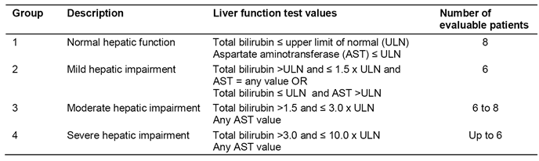

Table 11: X2101; Summary of panobinostat plasma PK parameters by NCI-CTEP hepatic function groups; PK set
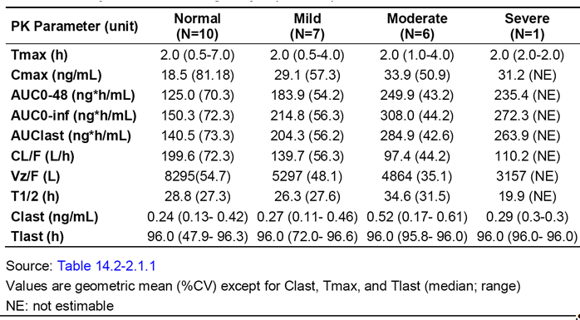
Figure 6: X2101; Arithmetic mean (SD) panobinostat plasma concentration - time profiles following a single 30 mg dose, by NCI-CTEP hepatic function group; semi-logarithmic view in PK set
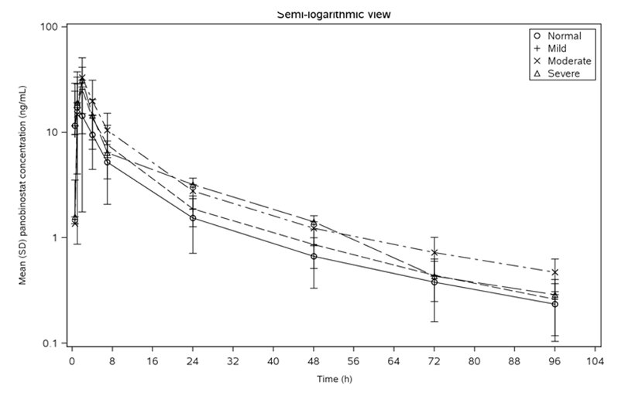
The geometric means of AUC_{inf} in the NF, mild HI, and moderate HI groups were 150.3, 214.8, and 308.0 ng•h/mL, respectively. These results represent increases of 43% and 105% in the mild and moderate HI groups, respectively, compared to the normal group. The CV% associated with the geometric mean of the AUC_{inf} was large, ranging from 44% to 72%. The geometric C_{max} values in the normal, mild HI, and moderate HI groups were 18.5, 29.1, and 33.9 ng/mL, respectively. These results represent increases of 57% and 83% in the mild and moderate HI groups, respectively, compared to the normal group. The CV% associated with the geometric mean of the C_{max} was large, ranging from 51% to 81%.
The median t_{max} remained unchanged at 2 hours across the normal, mild HI, and moderate HI groups. The terminal half-life across the normal, mild HI and moderate HI groups ranged from 26 to 35 hours, and were consistent with the terminal half-life of 37 hours estimated in the PPK study,
Based on the Child-Pugh classification of hepatic impairment, the mild and moderate HI groups had median panobinostat AUC_{0-inf} values approximately 51% and 56%, respectively, above, that of the normal group. Of note the patient with severe hepatic impairment according to NCI-CTEP criteria was categorised as moderate according to Child-Pugh classification.
The study also provided an analysis of the PK of panobinostat following adjustment for baseline age and BSA using a linear mixed model. The adjusted geometric means of the AUC_{0-inf} values were similar to the unadjusted geometric means in the normal and mild HI groups and slightly lower in the moderate HI group (that is, 151.6, 214.6, and 291.8 ng•h/mL, respectively). The results represent a 42% increase in the mild HI group (GMR = 1.42 (90% CI: 0.798, 2.510)), and a 92% increase in the moderate HI group (GMR = 1.92 (90% CI: 0.984, 3.764)) compared to the normal group. The adjusted geometric means of the C_{max} values in the normal, mild HI and moderate HI groups were 16.29, 32.5, and 42.0 ng/mL, respectively. The results represent a 99% increase the mild HI group (GMR = 1.99 (90% CI: 1.119, 3.523)), and a 159% increase in the moderate HI group (GMR = 2.59 (90% CI: 1.324, 5.071) compared to the normal group.
In vitro protein binding in patients with HI were assessed in Study DMPK-R110754. Median protein binding at panobinostat concentrations of 30 ng/mL were 77%, 83% and 84% for the moderate HI, mild HI and normal groups, respectively, and 82%, 86%, and 86%, respectively, at panobinostat concentrations of 100 ng/mL. The concentrations represent the typical (30 ng/mL) and highest (100 ng/mL) C_{max} values achievable in humans after oral administration of panobinostat in the tested dose range of 10 mg to 80 mg. The results suggest that protein binding is not significantly affected by HI, and is independent of concentration.
The study also assessed the PK of the metabolite BJB432. The GMR of the AUC_{inf} for BJB432 over the parent compound was 1.3 in patients with normal hepatic function, and 0.62 and 1.0 in patients with mild and moderate HI, respectively. The results suggest that the formation of BJB432 is not significantly reduced in patients with HI.
Comment: The study showed that exposure to panobinostat increases in patients with mild and moderate HI. The effect of severe HI could not be accurately assessed as the study included only 1 patient with severe HI. Overall, the results suggest that the starting dose of panobinostat should be reduced in patients with mild and moderate hepatic impairment.

Pharmacokinetics in patients with renal impairment
The pharmacokinetics of panobinostat were assessed in patients (n = 36) with solid tumours and renal impairment (RI) in one Phase I study (X2105). There were 4 treatment groups defined by renal function assessed by baseline 24 hour urine CrCL: normal renal function (CrCL ≥ 80 mL/min (n = 11)), mild RI (CrCL ≥ 50 to < 80 mL/min (n = 10)), moderate RI (CrCL ≥ 30 to < 50 mL/min (n = 10)), and severe RI (< 30 mL/min (n = 6)). Patients were treated with a single dose of panobinostat 30 mg and serial serum panobinostat concentrations were measured through to 96 hour after dosing (that is, 2.6 times the terminal half-life of 37 hours estimated from the PPK study). The PK parameters for the treatment groups (unadjusted by baseline BSA and age) are summarised in Table 12, and the plasma concentration time profiles are presented in Figure 7.

Table 12: X2105; Summary of panobinostat plasma PK parameters by renal function; PK set
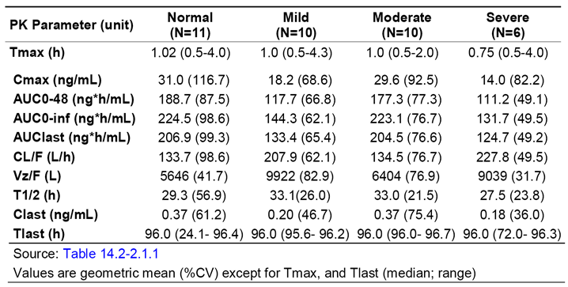
Figure 7: X2105; Arithmetic mean (SD) panobinostat plasma concentration - time profiles following a single 30 mg dose, by renal function groups; semi-logarithmic view in PK set
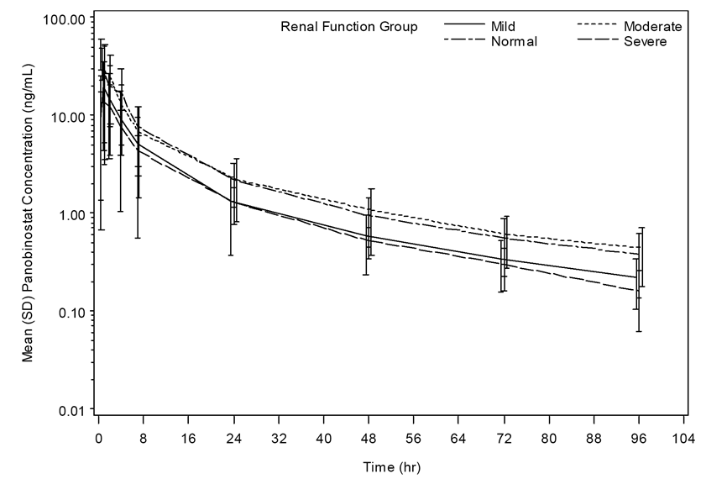
Panobinostat geometric mean of AUC_{0-inf} (CV%) values in the normal renal function (NRF), mild RI, moderate RI and severe RI groups were 224.5 (98.6%), 144.3 (62.1%), 223.1 (76.7%) and 131.7 (49.5%) ng•h/mL, respectively. Geometric mean AUC_{0-inf} exposures in the mild, moderate and severe RI groups were 64%, 99% and 59%, respectively, relative to the normal group. Geometric mean (CV%) C_{max} concentrations were 31.0 (117%), 18.2 (68.6%), 29.6 (92.5%) and 14.0 (82.2%) ng/mL, respectively in the normal, mild, moderate and severe RI groups. Geometric mean C_{max} concentrations in the mild, moderate and severe groups were 59%, 95% and 45%, respectively, relative to the normal group.
Urine samples were collected up to 24 hours post panobinostat administration. Urine volume from 2 patients in the NF group were missing and their urine PK parameters were not calculated. The median fraction excreted as unchanged drug was small in each of the 4 groups (that is, 1.8%, 0.73%, 0.75%, and 0.2% in the normal, mild RI, moderate RI and severe RI groups, respectively). The geometric mean (CV%) renal clearance of panobinostat was similar across the 4 treatment groups, based on the 24 hour collection period (that is, 1.39 mL/hour (13.0%), 1.24 mL/hour (7.9%), 1.32 mL/hour (5.10%) and 1.28 (8.55%) mL/hour, respectively).
After adjusting for baseline age and BSA and using a linear mixed model analysis, the GMR AUC_{inf} ratios were 0.666 (95% CI: 0.386, 1.150) for mild RI/NRF, 1.046 (90% CI: 0.579, 1.891) for moderate RI/NRF, and 0.613 (90% CI: 0.325, 1.158) for severe RI/NRF, while the GMR C_{max} ratios were 0.620 (90% CI: 0.331, 1.160) for mild RI/NRF, 1.108 (90% CI: 0.561, 2.188) for moderate RI/NF, and 0.479 (90% CI: 0.231, 0.995) for severe RI/NRF.
In vitro protein binding in patients with RI was assessed in Study DMPK-R110672. Median protein binding at panobinostat concentrations of 30 ng/mL were 86%, 84%, 82% and 88% for NRF, mild RI, moderate RI, and severe RI groups, respectively, and 90%, 86%, 86%, and 87%, respectively, at panobinostat concentrations of 100 ng/mL. The concentrations represent the typical (30 ng/mL) highest (100 ng/mL) C_{max} values achievable in humans after oral administration of panobinostat in the tested dose range of 10 mg to 80 mg. The results suggest that protein binding is not significantly affected by RI, and is independent of concentration.
The study also assessed the PK of the metabolite BJB432. The GMR of the AUC_{inf} for BJB432 over panobinostat was 0.64 in patients with normal renal function, and 0.81, 1.13 and 1.21 in patients with mild, moderate and severe RI, respectively.
The median t_{max} remained unchanged at approximately 1 hour across the NRF, mild RI, and moderate RI groups, but was shorter in the severe RI group. The terminal half-lives across the NRF, mild RI, moderate RI and severe RI groups ranged from 28 to 33 hours, and these values were consistent with the terminal half-life of 37 hours estimated in the PPK study.
Comment: In this study, exposure to panobinostat in patients with renal impairment was reduced or comparable to exposure in patients with normal renal function, as assessed by the AUC_{inf} and C_{max}. The AUC_{inf} and C_{max} results were similar irrespective of whether or not they were adjusted for baseline age and BSA values. Overall, the results suggest that no dosage adjustment is required in patients with mild, moderate, or severe renal impairment. There were no data in patients with end stage renal disease. It is not known whether panobinostat is dialysable.

Pharmacokinetics according to age
The effect of age on the PK of panobinostat was assessed in the PPK analysis. In the PPK data set, the median age of the 581 patients was 61 years (range: 16, 88 years). Simulations showed that compared to a typical 61 year old patient a typical 31 year old patient would have a 12% lower clearance (CL) and a 25% lower central compartment volume (V2), with the relationships being described mathematically as CL = 33.1*(age/61)^{0.176} and V2 = 24.8**(age/61)^{0.396}. The PPK analysis predicts that patients older than 80 years will have a 5% higher panobinostat CL than patients aged 61 years. In addition, the observed apparent oral clearance (CL/F) of panobinostat based on the single agent studies was comparable in patients aged < 65 years (150.6 L/hour, n = 122) and patients aged ≥ 65 years (171.0 L/hour, n = 86), with large inter subject variability (CV%) in the parameter in both age groups (70.3% versus 62.8%, respectively). The effect of age (< 65 years, ≥ 65 years) on CL and volume of distribution after single dose administration across all dose levels in the clinical studies is summarised in Table 13.

Table 13: Summary of panobinostat clearance (L/h) and volume of distribution (L) after single dose by age (< 65 vs ≥ 65 years) across all dose levels
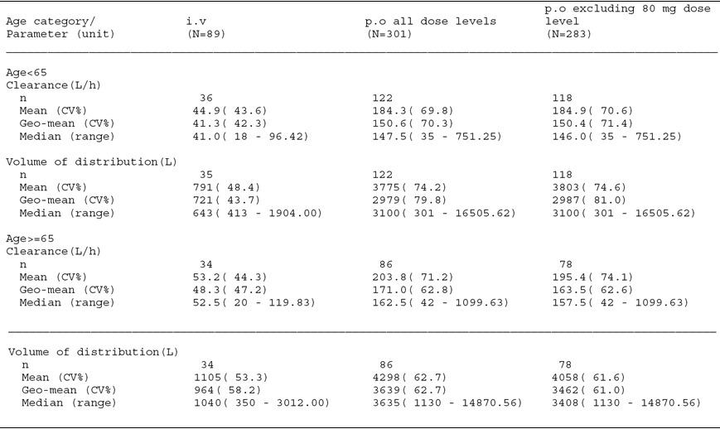

Pharmacokinetics according to gender
The effect of gender on the PK of panobinostat was assessed in the PPK analysis. Of the 581 patients in the PPK data set, 362 were male and 219 were female. The analysis showed no statistically significant effect for gender on the PK of panobinostat (that is, clearance and central volume).

Pharmacokinetics according to race
The effect of race on the PK of panobinostat was assessed in the PPK analysis. Of the 581 in the PPK data set, 496 (85%) were Caucasian, 34 (6%) were black, 27 (5%) were Asian and the remaining 24 (4%) were ‘other’ races. In the PPK analysis, race had a statistically significant effect on clearance and central volume (1% significance level). A typical Asian patient with a BSA of 1.9 m² was predicted to have a 17% higher clearance and 37% higher central volume than a typical Caucasian patient, and the corresponding figures for a typical Asian patients with a BSA of 1.7 m² were 4.7% and 17.7%, respectively. A typical Black patient with a BSA of 1.9 m² was predicted to have a 1% higher clearance and a 24% higher central volume than a Caucasian patient. A typical patient categorised as ‘Other’ (not Caucasian, Asian or Black), was predicted to have a 28% lower clearance and a 13% higher central volume than a typical Caucasian patient. The data from the PPK analysis should be interpreted cautiously, given that 85% of the population was Caucasian.
The Summary of Clinical Pharmacology included a descriptive comparison of the PK of panobinostat following the first dose (15 mg and 20 mg) between patients from Studies B2101, B2102, B2109, B2110 and B2111 who were mostly Caucasian, and patients from Study B1101 who were Japanese. Following panobinostat 20 mg, the C_{max}, AUC_{0-24 hours}, and AUC_{inf} were approximately 60%, 79%, and 76% higher in Caucasian patients compared to Japanese patients, while CL/F and Vz/F were approximately 76% and 64% higher, respectively, in Japanese patients compared to Caucasian patients. However, these results should be interpreted cautiously due to the marked imbalance in patient numbers (that is, 54 to 85 Caucasians and 3 to 6 Japanese).

Pharmacokinetics according to body surface area (BSA)
The effect of BSA on the PK of panobinostat was assessed in the PPK analysis. The PPK analysis showed that BSA had statistically significant effects on the clearance and central volume of panobinostat (1% significance level). The PPK analysis predicted that a typical patient with a BSA of 1.5 m² would have a 21% lower clearance and a 27% lower central volume than a typical patient with a BSA of 1.9 m², and a typical patient with a BSA of 2.5 m² would have a 32% higher clearance and a 45% higher central volume than a typical patient with a BSA of 1.9 m². The relationships are described by the mathematical formulas: CL = 33.1*(BSA/1.9)1.0, V2 = 24.8*(BSA/1.9)1.36.

Pharmacokinetics according to genetic polymorphisms
The main contributor to the hepatic metabolism of panobinostat is expected to be CYP3A4. The sponsor stated that although functional genetic polymorphisms (single nucleotide polymorphs (SNPs)) associated with altered protein expression levels have been reported for CYP3A4, the metabolic activity of CYP3A4 is not known to be affected by the SNPs identified to date. In Study B2110, genotyping for variant CYP3A4/CYP3A5 alleles was performed at baseline as an exploratory analysis. Of the 14 patients participating in the exploratory analysis, all had homozygous wild-type CYP3A4*1A genotype, 11 had homozygous CYP3A5*3, and three had heterozygous CYP3A5*1/*3 genotype. No apparent differences in panobinostat C_{max} or AUC values were found between patients with heterozygous CYP3A5*1/*3 genotype and homozygous CYP3A5*3/*3 genotype. However, data from the exploratory analysis are too limited to draw meaningful conclusion about the effect of genetic variation on CYP3A4/CYP3A5 activity on the metabolism of panobinostat.

Pharmacokinetic interactions

Pharmacokinetic interactions demonstrated in human studies

Study B2109; panobinostat / dextromethorphan (CYP2D6 substrate)
The submission included one Phase Ib study (Study B2109) in patients with advanced solid tumours investigating the PK interaction between panobinostat and dextromethorphan (a CYP2D6 substrate). In this study, patients who were poor CYP2D6 metabolisers were excluded, while patients who were intermediate, extensive and ultra extensive metabolisers were included and considered to be CYP2D6 extensive metabolisers (EM) for the purposes of the study. In the core phase of this study (Days 1 to 10), patients were treated with dextromethorphan 60 mg on Day 1, panobinostat 20 mg on Days 3, 5 and 8, and dextromethorphan 60 mg in combination with panobinostat 20 mg on Day 8. The plasma concentrations of dextromethorphan (and its metabolite dextrorphan) were assessed through to 48 hours following dosing on Day 1 (that is, following dextromethorphan alone) and through to 48 hours following dosing on Day 8 (that is, following dextromethorphan in combination with panobinostat).
The primary focus of the statistical hypothesis was to demonstrate lack of DDI in dextromethorphan (DM) PK parameters in EM patients. Lack of DDI was concluded when the 90% CI for DM AUC and C_{max} ratios ((DM + panobinostat)/ DM alone) were completely contained within the interval of 0.80 to 1.25. The results are summarised below in Table 14, and the PK parameters were provided.

Table 14: B2109; Geometric mean ratio (90% CI) of dextromethorphan primary PK parameters in EMs
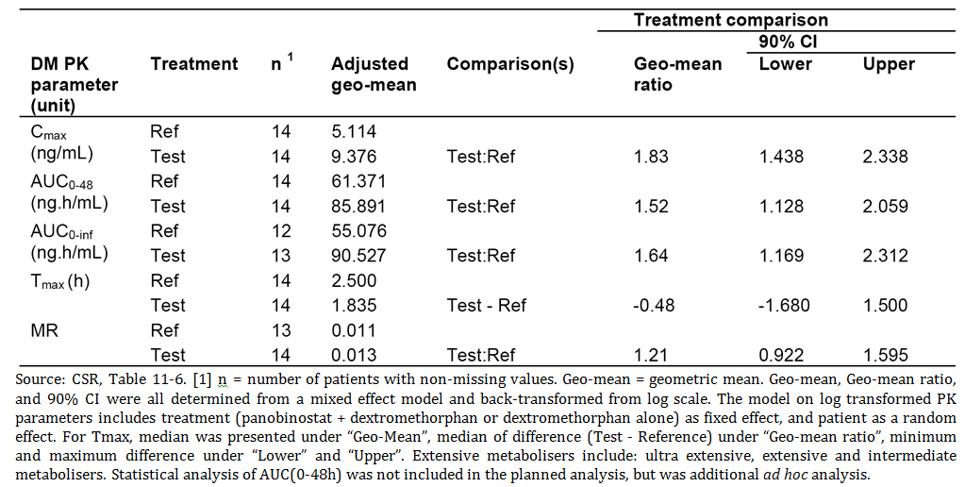
Comment: The data confirm that panobinostat is an inhibitor of CYP2D6. DM C_{max} and AUC_{0 to 48 hours} increased by 83% and 52%, respectively, when DM was administered in combination with panobinostat. The 90% CI for the GMR of both the C_{max} and the AUC_{0 to 48 hours} were outside the pre-specified interval of 0.80 to 1.25, indicating that a PK DDI between DM and panobinostat had been demonstrated. Based on the criteria in the FDA draft guidance document for industry relating to drug interactions, panobinostat can be classified as a weak inhibitor of CYP2D6 (that is, DM AUC increase ≥ 1.25 but < 2 fold for combination DM plus panobinostat compared to DM alone).^{[3]} However, the C_{max} and AUC_{0 to 48 hours} values for DM following administration of dextromethorphan in combination with panobinostat were extremely variable (that is, CV 121% for C_{max} and 153% for AUC_{0 to 48 hours}), which suggests that panobinostat should be administered with caution in combination with drugs which are CYP2D6 substrates. Furthermore, the results suggest that co-administration of panobinostat with sensitive CYP2D6 substrates and CYP2D6 substrates with a narrow therapeutic window should be avoided.

Study B2110; panobinostat / ketoconazole (CYP3A4 inhibitor)
CYP3A4 is expected to be the main contributor to the oxidative metabolism of panobinostat, and is estimated to account for approximately 40% of the total hepatic elimination of the drug. Therefore, agents that inhibit or induce CYP3A4 activity have the potential to affect the bioavailability of panobinostat following oral administration. The submission included one Phase Ib study (Study B2110) in patients with advanced solid tumours investigating the PK interaction between panobinostat and ketoconazole (a potent inhibitor of CYP3A4).
In the core phase of this study, patients received a single dose of panobinostat 20 mg on Day 1, ketoconazole 400 mg QD for 5 doses starting on Day 5, and panobinostat 20 mg in combination with ketoconazole 400 mg on Day 8. Serial plasma concentrations of panobinostat were assessed through to 48 hours following dosing on Day 1 (that is, after panobinostat alone) and through to 48 hours following dosing on Day 8 (that is, after panobinostat in combination with ketoconazole).
A formal statistical analysis was performed for the C_{max}, AUC_{0-24 hours}, and AUC_{inf} of panobinostat with and without ketoconazole. A linear mixed effects model was fitted to the log-transformed PK parameters. Included in the model was treatment (ketoconazole + panobinostat or panobinostat alone) as fixed effects, and patient as a random effect. The point estimate of the treatment difference and the corresponding 90% CIs were calculated and anti-logged to obtain the point estimate and CI on the linear scale for the ratio of geometric means of the test as compared with the reference. The results of the statistical analysis are summarised below in Table 15, and the results of the PK parameters were provided.

Table 15: Study B2110; Geometric mean ratio (90% CI) of panobinostat PK
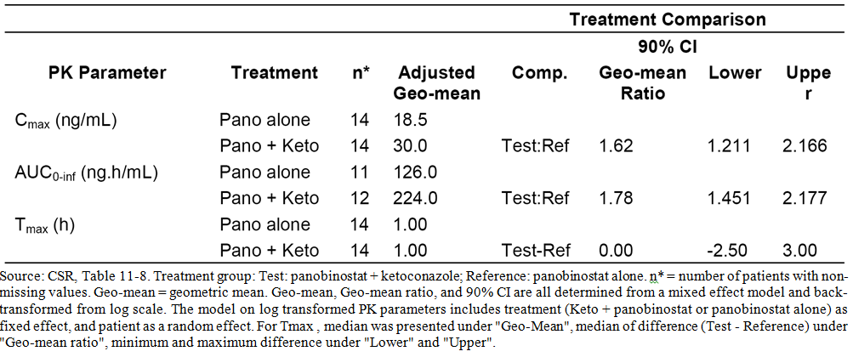
Comment: The data confirm that panobinostat is metabolised by CYP3A4. The C_{max} and the AUC_{inf} of panobinostat increased by 62% and 78%, respectively, when panobinostat was administered in combination with ketoconazole. The 90% CI for the GMR of both the C_{max} and the AUC_{inf} for panobinostat were outside the interval of 0.8 to 1.25, suggesting that there is a significant PK DDI between panobinostat and ketoconazole when co-administered. The C_{max} and AUC_{inf} values for panobinostat when co-administered with ketoconazole were highly variable, with the respective CV% being 80% and 52%. The results suggest that the starting dose of panobinostat should be reduced when co-administered with strong CYP3A4 inhibitors.

Clinical implications of in vitro findings
- The sponsor reports that CYP3A4 was identified as the major enzyme, with minor involvement of CYP2D6 and 2C19 in the oxidative metabolism of panobinostat (Study R0101764). The clinical DDI Study B2110 indicates that exposure to panobinostat significantly increased when it was co-administered with a potent CYP3A4 inhibitor (ketoconazole). There were no clinical DDI studies investigating the effects on panobinostat exposure when co-administered with a CYP3A4 inducer. However, there was an in vitro study (Symcyp) modelling the effect of rifampin (a CYP 3A4 inducer) on panobinostat exposure (Study R0600943-01). Based on the simulated results, the study reported that panobinostat AUC is predicted to decrease by 67% when co-administered with rifampin 600 mg QD. Based on the results of the in vitro study it is recommended that co-administration of panobinostat with strong CYP3A4 inducers be avoided.
- In vitro, panobinostat is a reported to be a competitive inhibitor of CYP2D6 (Study R0201469). This was confirmed in the clinical DDI study investigating the effect of panobinostat on the PK of dextromethorphan (a CYP2D6 substrate) when the two drugs were co-administered (Study B2109).
- Panobinostat was reported to show little or no inhibition of CYP1A2, CYP2C8, CYP2C9, and CYP2E1, when tested in vitro at concentrations of up to 100 μM (Study R0201469). Panobinostat was reported to be a relatively week inhibitor of CYP3A4/5 and CYP2C19 in vitro. However, based on the maximum panobinostat plasma concentration (CV%) of 21.6 (83%) ng/mL (0.062 μM) observed at a therapeutically relevant oral dose of 20 mg, the sponsor states that it is unlikely that panobinostat would act as an inhibitor of CYP1A2, CYP2C8, CYP2C9, CYP2E1, CYP3A4/5, or CYP2C19 by a reversible inhibition mechanism. In vitro, panobinostat was reported not to be an inducer of CYP1A1/2, CYP2B6, CYP2C8/9/19, or CYP3A (Study R0500725).
- In vitro, panobinostat was reported to show no apparent time-dependent inhibition of CYP1A2, CYP2C9, or CYP2D6 and weak time-dependent inhibition of CYP3A4/5 (Study R0700973). The weak CYP3A4/5 in vitro time dependent inhibition properties of panobinostat were modelled to estimate the potential for an actual clinical DDI with sensitive CYP3A substrates (Study R0800469-01). The mathematical modelling reported by the sponsor for the time based Simcyp model predicted a 1.18 fold increase (median) in the AUC of midazolam (sensitive CYP3A4 substrate) when co-administered with panobinostat and a 1.76 fold increase in midazolam AUC for the over-predictive steady state model. The sponsor states that study found ‘little to no DDI potential’ when panobinostat is co-administered with a sensitive CYP3A4 substrate. However, there were no clinical DDI studies investigating the effect of panobinostat on exposure to a sensitive CYP3A4 substrate (for example, midazolam). The sponsor indicates that a clinical trial designed to assess the effect of panobinostat on the PK of a sensitive CYP3A4 substrate midazolam is planned (Study LB589X2103).
- It was reported that panobinostat was not an in vitro inhibitor of the organic anion transporter OAT1, but was and in vitro inhibitor of the organic anion transporter OAT3 (R1200559). It was reported that panobinostat was an in vitro inhibitor of the organic cation transporters OCT1 and OCT2 (Study R1200560), and the organic uptake transporters OATP1B1 and OATP1B3 (Study R1200558) (Study R1200558). The sponsor states that, based upon a 20 mg oral dose (C_{max},_{ss} of 21.6 ng/mL or 0.062 μM) no clinical DDI with respect to OATP1B1/3, OAT3, OCT1, or OCT2 inhibition is expected.
- It was reported that panobinostat was not an in vitro inhibitor of P-gp or breast cancer resistant protein (BCRP) transporters (Studies R500600-01, R1300018). It was reported that panobinostat was a substrate for P-gp mediated efflux, but not for MRP mediated efflux (Study R050048). It was reported that panobinostat does not inhibit P-gp efflux activity in vitro (Study R0500600-01), and that it does not induce the UDP-glucuronosyl transferase transporter (UGT1A1), the P-gp transporter or the multi drug resistance protein 2 (MRP2) transporter in vitro (Study R0500725).

Pharmacokinetics of panobinostat in combination with bortezomib and dexamethasone

Study B2207
Study B2207 was a Phase Ib, multinational (Australia, Germany, Italy, Spain, USA), multicentre, open label, study of panobinostat (PAN) PO and bortezomib (BTZ) IV in 62 patients with multiple myeloma. The primary objective of the study was to determine the maximum tolerated dose (MTD) of PAN and BTZ when administered in combination. The study was undertaken from 18 October 2007 (first patient enrolled) to 10 August 2011 (database cut-off date of expansion phase), and the study report was dated 10 July 2013. The study was conducted in accordance with the ethical principles of the Declaration of Helsinki. The study protocol and all amendments were reviewed by an IRB and/or IEC for each participating centre.
The ‘study drug’ was PAN, while BTZ was administered in parallel with PAN and was considered to be the ‘combination drug’. In the dose escalation phase before Amendment 2 to the protocol, investigators could use their discretion to add Dex to the treatment regimen after the completion of Cycle 1. Dex was not considered to be an investigational nor a control drug, but was considered to be an ‘additional drug’ in the dose escalation phase. In the dose expansion phase, Dex was considered a part of the study treatment (PAN+BTZ+Dex).
In the dose escalation phase, all 47 enrolled patients received at least one dose of study treatment and had at least one valid post-baseline safety assessment. Therefore, these 47 patients were included in the FAS and safety sets. A total of 40 patients with at least one evaluable PK profile for PAN and 34 patients with at least one evaluable PK profile for BTZ were included in PK Set-PAN and PK Set-BTZ, respectively. In the dose expansion phase, all 15 patients were included in the FAS, safety, PK-PAN and PK-BTZ sets.
The study consisted of a single treatment arm where escalating doses of oral PAN (dose escalation component only) were administered in combination with escalating doses of BTZ. Each cohort consisted of a minimum of 6 patients and dose escalation was to end when at least 12 MTD evaluable patients had been enrolled at the recommended dose level. The MTD dose level cohort was to be expanded to a total of 22 patients treated at that level, in order to assess safety and tolerability at MTD. A 10 mg dose of PAN and 1.0 mg/m² of BTZ were considered to be safe and appropriate for the commencement of the dose escalation component. DLT was defined as an AE or abnormal laboratory value assessed as clinically relevant and occurring ≤ 21 days following the first dose of study treatment in Cycle 1.
In the dose escalation phase, PAN was administered TIW, every week and BTZ on Days 1, 4, 8 and 11 during the 21 day cycle. Serial dense blood samples to characterise oral panobinostat PK were collected from 40 patients on Cycle 1, Day 8 and Day 15. Serial blood samples were collected on Cycle 1, Day 8 to characterise BTZ PK. After the MTD was reached for PAN + BTZ and following Amendment 2 to the protocol, a dose expansion cohort was open to explore the recommended dose of 20 mg PAN in a 2 weeks on/1 week off (non continuous schedule) with 1.3 mg/m² BTZ and the addition of 20 mg Dex starting at Cycle 2. Cycle length was 3 weeks, with a 1 week treatment break or all drugs. After 8 cycles of treatment, patients were to discontinue BTZ/Dex, and continue on PAN only, until disease progression).

Pharmacokinetic results - PAN PK parameters
The PK results for the PAN PK parameters on Cycle 1, Day 8 (that is, PAN + BTZ) and on Cycle 2, Day 8 (PAN + BTZ + dex) are summarised below in Figure 8 and Table 16.
Figure 8: Study B2207; Arithmetic mean (SD) PAN plasma concentration time curves Cycle 1, Day 8 (PAN+BTZ) and Cycle 2, Day 8 (PAN+BTZ+Dex) during the expansion phase; PK set; PAN
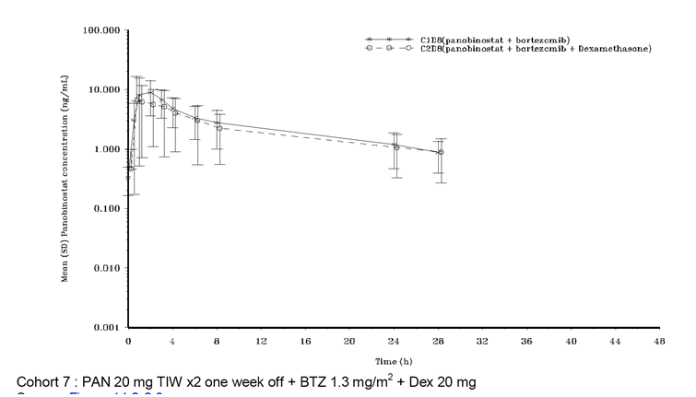

Table 16: Study B2207; PAN PK parameters Cycle 1, Day 8 (PAN+BTZ) and Cycle 2, Day 8 (PAN+BTZ+Dex) in dose expansion phase; PK set; PAN
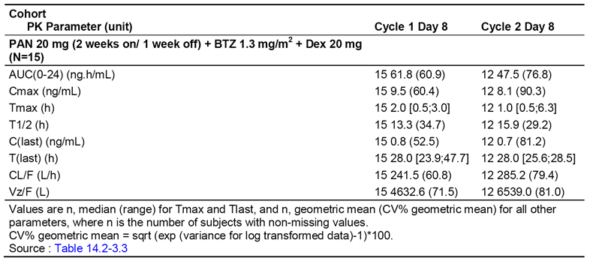
Comment: In the dose expansion phase, PAN exposure (AUC_{0-24 hours} and C_{max}) on Cycle 2, Day 8 (PAN+BTZ+Dex) was approximately 20% lower than on Cycle 1, Day 8 (PAN+BTZ), when Dex (a moderate CYP3A4 inducer) was added to the treatment regimen. In the dose expansion phase, Dex was administered intermittently in combination with BTZ and PAN starting from Cycle 2 (that is, Dex 20 mg was administered from Cycle 2 on Day 1, Day 2, Day 4, Day 5, Day 8, Day 9, Day 11 and Day 12 during a 21 day cycle). Both PAN and BTZ are metabolised by CYP3A4 (approximately 40% and 25%, respectively). The sponsor speculates that reduced exposure to PAN observed on Cycle 2, Day 8 compared to Cycle 1, Day 8 might be due to CYP3A4 induction associated with the addition of Dex to the PAN+BTZ treatment regimen in the expansion phase. The C_{max} for BTZ was reduced by approximately 25% from Cycle 1, Day 8 to Cycle 2, Day 8 (107.9 → 81.4 ng/mL), while the AUC_{0-24 hours} for BTZ was increased by approximately 3% from Cycle 1, Day 8 to Cycle 2, Day 8 (91.7 → 94.3 ng•h/mL).

Study D2308
Study D2308 was the pivotal Phase III study submitted to support the registration of panobinostat for the proposed indication. The study included 768 patients with relapsed or relapsed and refractory MM treated with PAN in combination with BTZ and Dex. In the treatment phase, patients received 20 mg PAN or placebo TIW with a 2 weeks on/1 week off schedule, and 1.3 mg/m² BTZ on Days 1, 4, 8 and 11, and 20 mg Dex on each day of and after BTZ dosing in a 21 day cycle. The study included a secondary objective aimed at evaluating the PK of PAN and BTZ in a subset of Japanese patients (13 patients were included in this analysis). The PK sampling schedule included serial dense blood samples up to 48 hours following dose in order to characterise the PK of PAN (Day 1 and Day 8 of Cycle 1) and BTZ (Day 8 of Cycle 1). The PK parameters for PAN on C1Day 1 and Cycle 1, Day 8 are summarised below in Table 17.

Table 17: Study D2308; Plasma panobinostat PK parameters in combination with bortezomib and dexamethasone on Cycle1, Day 1 and Cycle 1, Day 8 in Japanese patients
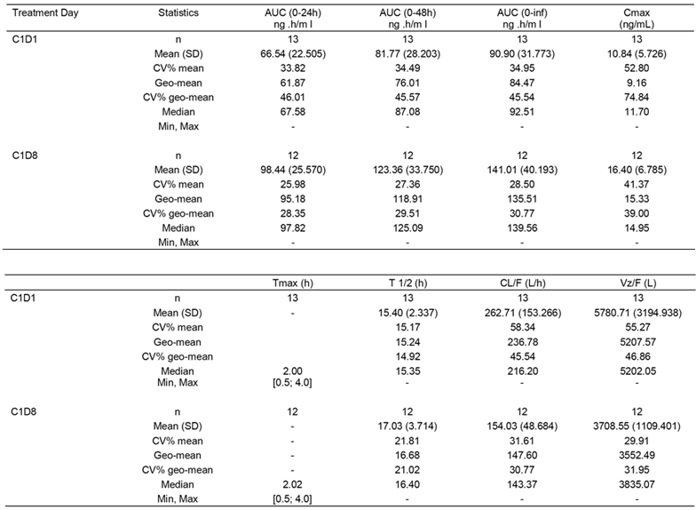
Comment: There was an increase in exposure to PAN on Cycle 1, Day 8 compared to Cycle 1, Day 1 based on both C_{max} and AUC_{0 to 48 hours} (approximately 67% and 56%, respectively). Increased PAN exposure is likely to be due to accumulation of the drug following repeat exposure. On Cycle 1, Day 8, geometric mean (CV%) BTZ plasma exposure was 100.9 (43.4%) ng•h/mL for AUC_{0-24 hours} and 136.6 (54.8%) ng/mL for C_{max} in the active treatment arm (that is, PAN+BTZ+Dex), compared to 76.7 (33.2%) ng•h/mL for AUC_{0-24 hours} and 112.8 (53.8%) ng/mL for C_{max} in the control arm (that is, PBO+BTZ+Dex). The results indicate that exposure to BTZ in the presence of PAN was approximately 32% greater based on the AUC_{0-24 hours} values and approximately 21% greater based on the C_{max} values than exposure to BTZ in the absence of PAN. The sponsor states that ‘while BTZ is known to have time dependent PK and steady state is not reached until Day 11, these results suggest that BTZ exposure was not affected by the addition of panobinostat’. The sponsor's statement that the results suggest that BTZ exposure was ‘not affected’ by the addition of panobinostat appears to be inconsistent with the observed results in which exposure to BTZ was greater in the PAN+BTZ+Dex arm compared to the PBO+BTZ+Dex arm.

Evaluator's overall conclusions on pharmacokinetics
- There were no PK studies in healthy subjects due to the genotoxicity of panobinostat observed in the nonclinical studies. Furthermore, the pharmacokinetics of panobinostat were primarily characterised following single agent administration (rather than in combination with bortezomib and dexamethasone) in patients with solid tumours and haematological malignancies other than MM. There were limited PK data on panobinostat administered in combination with bortezomib and dexamethasone in the target patient population.
- One of the problems with the panobinostat oral PK studies was the inadequate characterisation of the terminal elimination phase due to short sampling times (that is, 48 to 96 hours) relative to the estimated terminal elimination half-life (that is, 37 hours (PPK study)). In order to adequately characterise the terminal elimination phase, sampling should continue to at least 3 times the terminal half-life (that is, to at least 111 hours for panobinostat). Therefore, oral PK parameters estimated from data derived from the terminal elimination phase based on sampling for less than 3 times the terminal half-life are likely to be inaccurate (that is, AUC_{inf}, t½, CL/F, Vz/F). In the current submission, the only study in which PK sampling was greater than 3 times the half-life of panobinostat was the mass balance/ADME study in 4 patients with advanced cancer (Study B2108). In this study, PK sampling was continued through to 168 hours following a single radio labelled dose of panobinostat 20 mg administered as a capsule.
- The human biomaterial data were reported to show than panobinostat can be categorised as a highly permeable drug as regards transport across the intestinal mucosa, and that it may be a substrate for the P-gp efflux transporter. The physicochemical data showed that the aqueous solubility of panobinostat was pH-dependent, but the sponsor states that the drug would be completely soluble at the maximum proposed dose of 20 mg over the physiological pH range in the upper GIT.
- The single agent clinical studies showed that panobinostat was rapidly absorbed following oral administration with the median t_{max} being 2 hours, followed by excretion with a terminal elimination half-life of approximately 37 hours (PPK). The drug was well absorbed following oral administration with ≥ 87% of an administered radio labelled dose of panobinostat 20 mg being recovered in the urine and faeces and < 3.5% of the dose being excreted unchanged in the faeces. There was no formal absolute bioavailability study in the submission, but the absolute bioavailability derived from the PPK analysis was estimated to be approximately 21%.
- The effect of food on the bioavailability of panobinostat 20 mg administered on Days 1, 8, and 15 was assessed in a crossover study (fasting, high fat meal, normal meal) (Study B2111). Relative to fasting administration, the AUC_{inf} was reduced by 16% when panobinostat 20 mg was administered with a high fat meal and by 14% when administered with a normal meal. The 90% CI for the AUC_{inf} ratio (fed relative to fasting) was outside the standard bioequivalence interval of 0.8 to 1.25 for both the high fat and normal meals. Relative to fasting administration, the C_{max} was reduced by 44% when panobinostat 20 mg was administered with a high fat meal and 36% when administered with a normal meal. The 90% CI for the C_{max} ratio (fed relative to fasting) was outside the standard bioequivalence interval of 0.8 to 1.25 for both the high fat and normal meals. The inter subject variability (CV%) remained constant for the AUC_{inf} for each of the three treatments (approximately 59%), while inter subject variability in C_{max} for fasting was notably higher than for both fed treatments (86% (fasting) versus 63% (high fat) to 65% (normal meal)). t_{max} was prolonged with a high fat meal compared to both a normal meal and fasting (4.0 versus 2.5 versus 1.5 hours, respectively). Overall, the PK data suggest that panobinostat can be administered with or without food. However, the AE data indicated that nausea and vomiting occurred more frequently when panobinostat was administered in the fasting state. Therefore, panobinostat should be administered following a mean (that is, on a full stomach).
- There were no clinical data on the effect of food on the two lower doses of panobinostat proposed for registration (that is, 10 mg and 15 mg). The sponsor provided a justification for not submitting a food study with the two the lower doses (and by extension a justification for not submitting a bioequivalence study comparing the three proposed doses). The justification for not submitting food effect studies for the two lower dose capsules is considered to be reasonable, based on the physicochemical and PK properties of panobinostat.
- Pooled data showed that the single dose PK of panobinostat based on the C_{max} and AUC_{inf} were approximately dose proportional over the dose range 10 mg to 30 mg, but that the multiple dose PK of panobinostat based on the C_{max} and AUC_{0 to 48 hours} were less than dose proportional over the dose range 10 mg to 30 mg. The inter subject PK of panobinostat are extremely variable with CV% for most PK parameters ranging from 60% to 100%.
- In vitro, panobinostat was reported to be 89.6% bound to plasma proteins, and binding was independent of panobinostat concentrations over the 0.1 to 100 μg/mL range evaluated in human plasma (Study R0200414). In vitro protein binding was not significantly affected by either renal or hepatic impairment (Studies X2101, X2105). In human plasma the mean fraction of panobinostat in erythrocytes in vitro was reported to be 0.60 and the mean blood to plasma concentration ratio was reported to be 1.4, with the values being independent of panobinostat concentration over the evaluated range of 0.1 to 100 µg/mL (Study R0200414). In the ADME study (Study B2108), the apparent volume of distribution was estimated to be 9464 L in 4 patients with PK sampling through to 168 hours post dose following radio labelled panobinostat 20 mg. The large volume of distribution indicates that panobinostat is extensively distributed to the tissues.
- Panobinostat undergoes extensive hepatic metabolism. A least 77 distinct metabolites have been identified of which approximately 40 were observed in circulating plasma. The primary metabolic pathways involved modifications of the hydroxamic acid side chain to form an amide via reduction (M37.8 or BJB432), three distinct carboxylic acids via hydrolysis (M43.5) and one- (M40.8), and two-carbon chain shortening (M36.9) of the hydroxamic acid side chain. Additionally, double bond reduction along with multiple oxygenations and glucuronidations (with and without carbamoylation) occurred both alone and in combination with the modifications of the hydroxamic side chain. The sponsor estimates that approximately 40% of the total hepatic metabolism of the drug is accounted for by CYP3A4, with minor contributions from CYP2D6 and CYP2C19.
- At least 87% of a single 20 mg oral dose of radio labelled panobinostat was recovered in the urine and faeces within 7 days of administration in all 4 treated patients with advanced cancer (Study B2108). Of the administered dose, median recovery in the faeces was 47.8% and median recovery in the urine was 41.3%. The excretion of panobinostat was primarily in the form of metabolites, with unchanged panobinostat accounting for approximately 1.1% to 2.4% of the dose in urine (0 to 48 hours) and 0% to 3.3% of the dose in faeces (0 to 108 hours to 148 hours). The high total recovery of the administered dose and the low fecal excretion of the unchanged drug suggests that oral absorption is nearly complete. Based on this observation and the estimated absolute bioavailability of 21% it can be concluded that panobinostat undergoes extensive first pass hepatic metabolism.
- In Study B2108, the median apparent oral clearance of panobinostat was 209 L/hour, and the estimated mean renal clearance of the drug was approximately 4 L/hour. In the PPK analysis, the oral clearance of panobinostat was estimated to be approximately 160 L/hour, with a large inter subject variability (CV% = 65%). The large apparent oral clearance estimated from the PPK was consistent with the median oral apparent clearance reported in Study B2108.
- Exposure to panobinostat increased in patients with advanced solid tumours and hepatic impairment (Study X2101). The geometric mean AUC_{inf}, increased by 43% and 105% in patients with mild (n = 7) and moderate hepatic impairment (n = 7), respectively, compared to patients with normal hepatic function (n = 10). The geometric mean C_{max} increased by 57% and 83% in patients with mild and moderate hepatic impairment, respectively, compared to patients with normal hepatic function. There were data on 1 patient with severe hepatic impairment, and the PK parameters in this patient were consistent with the mean PK parameters observed for the patients with moderate hepatic impairment. It is recommended that the starting dose of panobinostat be reduced to 10 mg in subjects with moderate hepatic impairment and 15 mg in patients with mild hepatic impairment. Treatment should be avoided in patients with severe hepatic impairment.
- Exposure to panobinostat either decreased or remained largely unchanged in patients with advanced solid tumours and mild (n = 10), moderate (n = 10), or severe (n = 6) renal impairment relative to patients with normal renal function (n = 6). Geometric mean AUC_{0-inf} values in patients with mild, moderate and severe renal impairment were 64%, 99% and 59%, respectively, of the value in patients with normal renal function. Geometric mean C_{max} concentrations in patients with mild, moderate and severe renal impairment were 59%, 95% and 45%, respectively, of the value in patients with normal renal function. Overall, the data suggest that no dosage modifications are required in patients with impaired renal function. There were no data in patients with ESRD. It is not known whether panobinostat is dialysable.
- Simulations (PPK) showed that panobinostat clearance and central compartment volume increased with age. Simulations showed that compared to a typical 61 year old patient a typical 31 year old patient would have a 12% lower clearance and a 25% lower central compartment volume. The PPK analysis also predicts that patients older than 80 years will have a 5% higher panobinostat clearance than patients aged 61 years. Overall, the data suggest that no dosage adjustments are required based on age.
- The PPK analysis indicates that gender has no significant effect on the clearance or central compartment volume of panobinostat. There was some evidence that Asian patients have a higher clearance and central compartment volume compared to Caucasian patients. However, the data are too limited to recommended dosage adjustments in Asian patients.
- Simulations (PPK) showed that panobinostat clearance and central compartment volume increased with BSA. The simulations predict that a typical patient with a BSA of 1.5 m² would have a 21% lower clearance and a 27% lower central compartment volume compared to a typical patient with a BSA of 1.9 m², while a typical patient with a BSA of 2.5 m² would have a 32% higher clearance and a 45% higher central compartment volume compared to a typical patient with a BSA of 1.9 m². The proposed dosing regimen is not based on BSA.
- The data indicate that approximately 40% of the hepatic clearance of panobinostat is accounted for by CYP3A4. In the clinical DDI study (Study B2110), the geometric mean C_{max} and the AUC_{inf} of panobinostat increased by 62% and 78%, respectively, when panobinostat (20 mg single dose; n = 11 to 14) was administered in combination with ketoconazole (400 mg QD x 5 days; n = 12-14). It is recommended that the panobinostat starting dose be reduced to 10 mg when administered with strong CYP3A4 inhibitors. There were no clinical DDI studies with CYP3A4 inducers. However, on the basis of Symcyp in vitro modelling the AUC of panobinostat is predicted to decrease by 67% when co-administered with rifampin 600 mg QD (a CYP3A4 inducer). Consequently, it is recommended that co-administration of panobinostat and strong CYP3A4 inducers be avoided.
- In vitro human biomaterial studies reported that panobinostat was a competitive inhibitor of CYP2D6. In the clinical DDI study (Study B2109), when the CYP2D6 substrate dextromethorphan (60 mg, single dose; n = 14) was administered in combination with panobinostat (20 mg single dose; n = 12-14) the C_{max} and AUC_{0 to 48 hours} of dextromethorphan increased by 83% and 52%, respectively. Based on FDA criteria relating to drug interactions, panobinostat can be classified as a weak inhibitor of CYP2D6 (that is, dextromethorphan AUC increase ≥ 1.25 but < 2 fold for combination dextromethorphan plus panobinostat compared to dextromethorphan alone). It is recommended that co-administration of panobinostat with sensitive CYP2D6 substrates or with CYP2D6 substrates with a narrow therapeutic index be avoided.
- In vitro Symcyp modelling predicts a median increase in the AUC of midazolam (a sensitive CYP3A4 substrate) of 1.18 fold when co-administered with panobinostat using a time based model and 1.76 fold when using an ‘over-predictive’ steady state model. The clinical significance of these findings are uncertain. Definitive conclusions relating to the potential clinical effects of co-administration of panobinostat and midazolam should await the outcome of the planned clinical study.
- In vitro human biomaterial studies reported that panobinostat was not an inducer of CYP1A1/2, CYP2B6, CYP2C8/9/19, CYP3A, UGT1A1, ABCB1 (P-gp) or ABCC2 (MRP2). In vitro human biomaterial studies reported that panobinostat was not an inhibitor of the organic anion transporter OAT1, but was an inhibitor of the organic anion transporter OAT3. It was reported that panobinostat was an in vitro inhibitor of the organic cation transporters OCT1 and OCT2, and the organic uptake transporters OATP1B1 and OATP1B3. However, the sponsor stated that, based on a 20 mg oral dose (C_{max},ss of 21.6 ng/mL or 0.062 μM) no clinical DDI with respect to OATP1B1/3, OAT3, OCT1, or OCT2 inhibition is expected.
- It was reported in the human biomaterial studies that panobinostat was not an in vitro inhibitor of the P-gp transporter or the breast cancer resistant protein (BCRP) transporter. It was reported that panobinostat was a substrate for P-gp mediated efflux, but not for MRP mediated efflux. It was reported that panobinostat, in vitro, was not an inducer of the UDP-glucuronosyl transferase transporter (UGT1A1), the P-gp transporter or the multi drug resistance protein 2 (MRP2) transporter.
- There was no clinical DDI study in the submission exploring co-administration of panobinostat and drugs that increase gastro-intestinal pH (for example, PPIs). No human biomaterial or simulated (Symcyp) modelling studies investigating potential DDI between panobinostat and drugs that increase gastro-intestinal pH could be identified in the submission. This is considered to be a deficiency in the data, given that the aqueous solubility of panobinostat is pH-dependent.
- In Study B2207 (dose expansion phase) in patients with MM, PAN exposure in the PAN+BTZ+Dex arm was approximately 20% lower than in the PBO+BTZ+Dex arm, based on both the AUC_{0-24 hours} and C_{max}. Both PAN and BTZ are metabolised by CYP3A4 (40% and 25%, respectively). It is likely that reduced exposure to PAN observed in the PAN+BTZ+Dex arm compared to the PBO+BTZ+Dex arm was due to CYP3A4 induction mediated by the addition of Dex to PAN+BTZ. The C_{max} of BTZ decreased by approximately 25% when Dex was added to PAN+BTZ, while the AUC_{0-24 hours} increased by approximately 3%. Overall, the addition of Dex to PAN+BTZ combination is unlikely to result in clinically significant reduced exposure to either PAN or BTZ.
- In the pivotal Phase III Study D2308, exposure to PAN increased by approximately 67% (C_{max}) and 56% (AUC_{0 to 48 hours}) following multiple-dose treatment with PAN+BTZ+Dex compared to single dose administration of this regimen. The results suggest that PAN accumulates following multiple dosing. In this study, exposure to BTZ in the PAN+BTZ+Dex arm was greater than in the PBO+BTZ+Dex arm (AUC_{0-24 hours} approximately 32% greater, C_{max} approximately 21% greater). The increased exposure to BTZ in the presence of PAN might be due to competition between the two drugs for binding sites on CYP3A4 (given that the two drugs are metabolised by this enzyme), resulting in decreased metabolism of BTZ.

Pharmacodynamics

Studies with pharmacodynamic data
The pharmacodynamic (PD) data included three exposure response analyses:
- panobinostat versus thrombocytopenia
- panobinostat versus QTcF
- panobinostat versus efficacy.
The results of these three analyses are discussed below.

Exposure-thrombocytopenia relationships
The submission include a PK/PD report (PPK-TCP) titled; ‘Population pharmacokinetic-pharmacodynamic modelling of platelet count in patients with lymphoma/solid tumour and haematological malignancies following intravenous or oral administration of panobinostat’. The report was dated 3 November 2010 and was undertaken by Novartis. The methodology and results of the PK/PD analysis were comprehensively reported.
The PK/PD report appears to have been prepared specifically for a Hodgkin's lymphoma indication rather than a MM indication. This is evident from the title page of the report and the introduction to the report, which states ‘a dose of 40 mg given orally three times a week every week was identified as the recommended Phase II dose which is currently being evaluated in patients with classical HL in Study CLBH589E221’. Nevertheless, it appears likely that the general conclusions from the report can be reasonably applied to panobinostat for the treatment MM.

The objectives of the PK/PD analysis
The objectives of the PK/PD analysis were:
- to characterise the dose-exposure response relationship for platelet count in a pooled dataset comprising 14 clinical studies in order to support the use of panobinostat in cancer patients
- to determine whether treatment conditions and individual patient characteristics have an impact on platelet production following panobinostat treatment
- to identify an optimal dose/schedule for panobinostat in patients with solid tumour/lymphoma with respect to risk/benefit of the treatment.

The experimental methods
The experimental methods included a combined analysis of 8 Phase I studies (Studies B1101, B2102, A2101, A2102, B2101, B2109, B2110 and B2111) and 6 Phase II studies (Studies B2201, B2202, B2203, B2211, B1201 and E2214). PK and PD data were available following both IV and PO doses. All studies included in the analysis were open label. The Phase I clinical studies were performed to determine the MTD of panobinostat by using the DLT rate over the oral dose range 10 mg to 80 mg. The Phase II studies used an oral dose of 20 mg three times a week, every week, except for Study E2214 where patients were dosed at 40 mg three times a week every week.
Nonlinear mixed effects modelling was used to describe the population pharmacodynamics of panobinostat. The FOCE method, as implemented in the software program NONMEM version VI, was used in model building. A sequential PK/PD approach, where individual PK parameter estimates were fixed from a prior PPK analysis was used to characterise the platelet dynamics of panobinostat. Final (that is, current best) PK and PD models used a three compartment PK model to describe panobinostat plasma concentration data and an indirect response model to describe platelet data. Covariate analysis investigated the effect of tumour group on both baseline platelet counts and the platelet elimination rate (k_{out}). Several structural pharmacodynamic models were explored, and standard model selection criteria (likelihood ratio tests) were used to select appropriate models.

Results
A total of 441 patients with panobinostat PK measurements were included in the population PD analysis, with patients with blood transfusions being excluded from the analysis. In total, there were 349 solid tumour and 92 haematological tumour patients, with an observed overall median baseline platelet value of 239 x 10⁹/L and an overall median post treatment platelet value of 137 x 10⁹/L.
Model selection indicated that an indirect response semi-mechanistic model was the most appropriate to characterise platelet dynamics (that is, the drug concentration in a peripheral compartment inhibits platelet production, resulting in a progressive decline of platelet count from baseline to nadir). The extension and duration of the decline in platelet count were driven by dose, dose schedule and baseline platelet count.
For panobinostat, the population median of the maximum inhibitory effect (I_{max}) was fixed to be unity, the typical population value of IC50 was estimated to be 12.3 ng/mL, the baseline platelet count for patients with solid tumours was estimated to be 266.27 x 10⁹/L, and the elimination rate (k_{out}) for patients with solid tumours was estimated to be 0.005 hour-1. Inter patient variability (CV) was 91.16% for the IC50, 11.4% for the baseline platelet count, and 61.4% for the k_{out}.
Tumour type (haematological versus solid) was included as a covariate in the PD analysis and showed a significant effect (at 1% significance level) on the baseline platelet count and the rate of decline in platelet count following administration of panobinostat. The effects can be summarised as follows:
- A patient with a haematological tumour would have a lower baseline platelet count (137 x 10⁹/L) compared to a patient with a solid tumour (266 x 10⁹/L).
- A patient with a haematological tumour would have a lower platelet elimination rate (0.003 hour⁻¹) compared to a patient with a solid tumour (0.005 hour⁻¹), resulting in a median half-life of approximately 9 days for haematological patients versus median half-life of approximately 5.7 days for solid tumour patients.
Comment: Simulations of platelet dynamics based on the model predictions showed a strong dependence of the response to panobinostat on baseline platelet count, as well as on panobinostat dose and dose regimen. For example, patients on the same treatment regimen but with different baseline platelet count would have different nadir values as well as time to nadir. Tumour type (haematological versus solid) had a significant effect on both baseline platelet count and platelet elimination/production rate, with patients with haematological tumours having lower platelet counts consistent with their disease. In addition, a longer median platelet half-life of approximately 9 days for haematological patients compared to a median platelet half-life of approximately 5.7 days for solid tumour patients was found.
For a typical patient with a solid tumour and a median platelet baseline count of 266.27 x 10⁹/L treated with panobinostat 40 mg three times a week, every week, a median nadir platelet count of 116 x 10⁹/L was predicted. The median time to nadir was predicted to be 26 days, and the return to baseline after treatment withdrawal was predicted to happen, on average, after 31 days.
The sponsor considers that simulations of platelet dynamics based on the model predictions provide guidance on the management of thrombocytopenia (TCP) adverse events. The extent of the platelet nadir and the time course of the nadir for the every week and every other week regimens are summarised in Table 18 and Table 19, respectively. The extent of the nadir is greater with the every week regimen compared to the every other week regimen. The median risk of TCP Grade 3 or 4 adverse events increases with increasing panobinostat dose, provided dose regimen and platelet baseline are fixed (see Table 20).
The sponsor stated that the dose interruption simulation points to the benefit of closely monitoring platelet count and quickly implementing a dose interruption if needed. For example, for a typical patient with a solid tumour and median baseline platelet count of 266 x 10⁹/L being treated with panobinostat 40 mg M/W/F every week, dose interruption in the presence of TCP Grade 3/4 occurring at a median time of 244 days allows for platelet rebound to 75 x 10⁹/L (TCP Grade 1) after a median time of 16 days (range: 4, 30 days).

Table 18: PK/PD Modelling Report; Time course of platelet predicted in a solid tumour patient with a median baseline platelet of 266x10⁹ /L on M/W/F, every week regimen
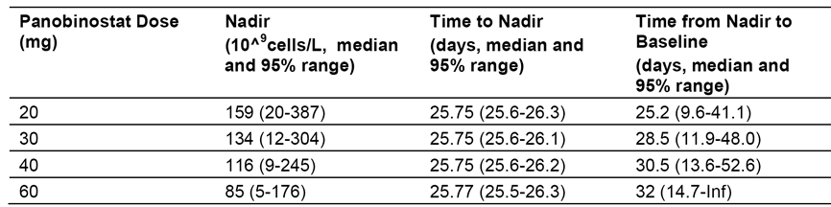

Table 19: PK/PD Modelling Report; Time course of platelet predicted in a solid tumour patient with a median baseline platelet of 266x10⁹ /L on M/W/F, every other week regimen
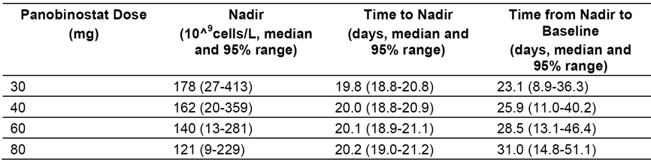

Table 20: PK/PD Modelling Report; Incidence of TCP grade 3 or 4 adverse events and time to events based on simulations in a solid tumour patient with a median baseline platelet of 266x10⁹ /L on M/W/F, every week regimen
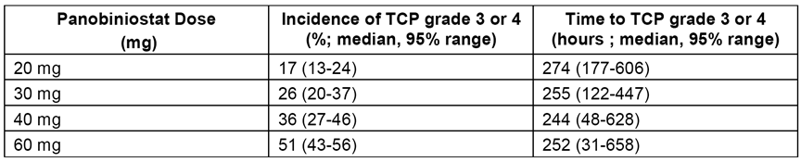

Exposure-QTc relationship
In vitro, panobinostat was reported to inhibit human ether-related á-go-go gene (hERG) potassium channel activity with an IC50 value of 3.5 µM. Given this finding, a clinical ‘Thorough QT/QTc Study’ was indicated (that is, ICH Topic E14 Note for Guidance on Clinical Evaluation of QT/QTc Interval Prolongation and Proarrhythmic Potential for Non-Antiarrhythmic Drugs (CHMP/ICH/2/04)). However, the submission did not include such a study. Of relevance, a ‘Thorough QT/QTc Study’ is intended to be carried out in healthy volunteers and, as mentioned previously, no clinical pharmacology studies were undertaken in healthy subjects with panobinostat due to concerns about potential genotoxic effects associated with the drug.
Although the submission did not include a ‘Thorough QT/QTc Study’, it did include an analysis of the exposure-QTc relationship in patients treated with panobinostat. In this analysis, a linear mixed effect model was used to describe time matched plasma panobinostat concentrations and QTc interval measurements corrected for heart rate in 499 patients treated with panobinostat oral regimens across 12 studies with oral doses between 10 mg and 80 mg. Variables including baseline QTc intervals, panobinostat plasma concentrations, route of administration, and dosing schedule were included in the final model.
Maximum QTcF prolongation was observed on Day 5 after initiation of single agent panobinostat treatment and was not associated with C_{max}. However, in the range of clinically relevant concentrations with 20 mg oral administration three times a week, no apparent relationship between QTcF and plasma concentration was observed in the clinically relevant concentration range between 10 and 60 ng/mL (see Figure 9). The data shows that the observed QTcF changes over baseline have a shallow relationship with panobinostat concentrations for several oral dosing regimens. Most data were scattered around a QTcF change between ± 0 to 30 ms at plasma concentrations < 60 ng/mL. A few data points were above 60 ms in QTcF change values at concentrations < 20 ng/mL.
Figure 9: Change from baseline QTcF (ms) versus panobinostat plasma concentration (ng/mL)
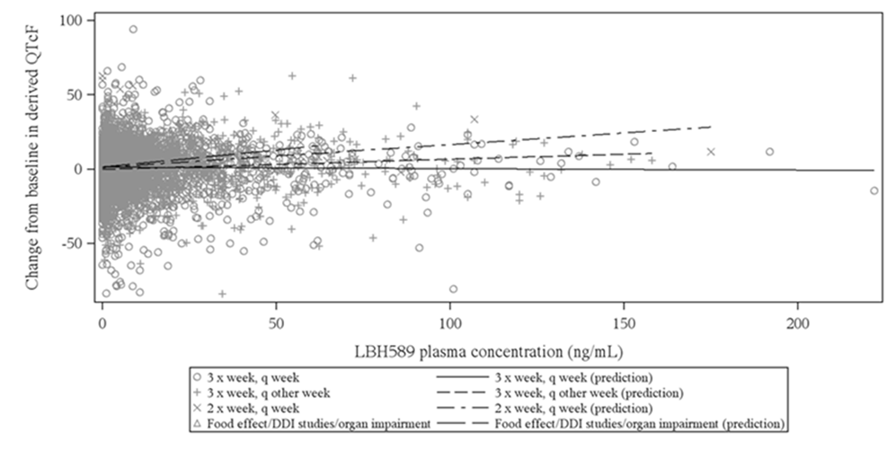
Based on the linear mixed effect model, patients with a baseline QTcF interval of 405 ms (median observed level) can be predicted to have a mean change from baseline in QTcF interval following a three times a week, every week dosing schedule calculated from the following formula (QTcF change = 1.248 -0.0101* concentration). QTcF change from baseline is predicted to decrease by 0.101 ms with every 10 ng/mL panobinostat concentration increase for subjects from global studies. The QTcF change from baseline is predicted to be 7.384 ms lower for Japanese subjects, and 2.1802 ms lower for subjects who have taken QT prolonging co-medications. For subjects on a three times a week, every week dosing schedule QTcF is not predicted to increase by more than 1.2 ms. For subject on a three times a week, every other week dosing schedule QTcF is predicted to increase by 4.2 ms at a concentration of 65 ng/mL.
The contribution of the panobinostat metabolite BJB432 to potential QTc prolongation was also investigated in 140 patients from two studies. BJB432 was investigated as it had been reported that, in vitro, it inhibited hERG potassium channel activity with an IC50 of 1.6 µM, which is similar in magnitude to the IC50 of panobinostat of 3.5 µM. However, with plasma concentrations of < 10 nM typically seen in humans BJB432 represents < 1% of the total drug related material in plasma following a 20 mg dose of panobinostat. In the Nonclinical Overview (CTD 2.4) it is reported that additional metabolites from 4 main metabolic pathways, and the most abundant human circulating metabolite, T24 (the acyl-glucuronide of M36.9) were also assessed in hERG patch-clamp assays and were without significant activity when tested to their limits of solubility
Based on the linear mixed effects model for BJB432, patients with a baseline QTcF of 405 ms (median observed level) and a BSA of 1.9 m² were predicted to have a mean change from baseline with the following formula (QTcF change = 5.633-1.0546*concentration). The QTcF change from baseline is predicted to be 5.4657 ms lower for subjects below 65 years old. The change from baseline in QTcF (ms) versus BJB432 concentration for subjects treated with panobinostat three times a week every week is summarised below in Figure 10. The change from baseline versus BJB432 concentration plot was similar to that for panobinostat, with most data being were scattered around a QTcF change between ± 0 to 20 ms at plasma concentrations <3 ng/mL. One data point, with a 60 ms increased in QTcF at a concentration of 2 ng/mL.
Figure 10: Change from baseline QTcF (ms) versus BJB432 plasma concentration (ng/mL)
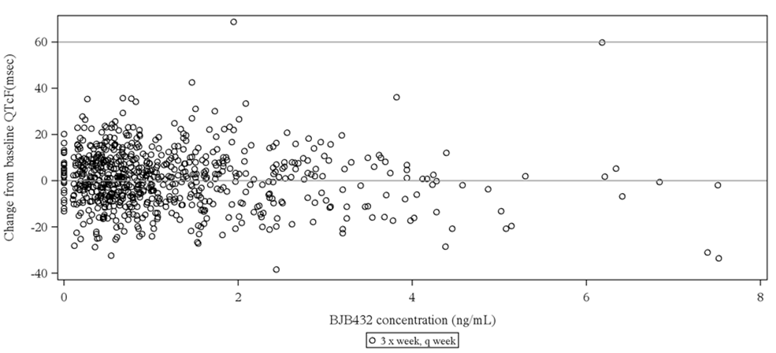
Comment: Overall, the exposure QTc relationship does not signal significant concerns relating to the association between panobinostat and clinically significant QTcF prolongation. However, the absence of a ‘Thorough QT/QTc Study’ for this drug is a deficiency in the submission. The QTcF findings in the clinical studies have been discussed in the Clinical Safety (Section 8) section of this review. Briefly, in the patients pooled from the relevant clinical studies there were no new cases of QTcF > 500 ms (0/451) in patients treated with PAN+BTZ+Dex, while 3/499 (0.7%) patients treated with this regimen had an increase in QTcF from baseline of > 60 ms.
In the Nonclinical Overview, it is reported that a C_{max} of approximately 0.12 µM observed in patients following a 20 mg dose of panobinostat (Study B2101) equates to a maximal free drug concentration of 0.012 µM, after accounting for approximately 90% of the drug being bound to serum proteins. It is further reported that, when compared to the IC50 of panobinostat for hERG (3.5 μM) and the lowest concentration required to rescue SM-hERG trafficking and prolong repolarization (1 μM), this free drug concentration translates into a safety margin of at least 80 fold. For BJB432 at maximum total plasma concentrations only trace amounts (< 10 nM) of this metabolite have been detected in patients. When compared to the IC50 for hERG (1.6 µM) and the lowest concentration required to rescue SM-hERG trafficking and prolong repolarization (1 μM) this translates into a > 100 fold safety margin for BJB432.

Exposure-efficacy relationship
In Study B2207, correlation of clinical response based on International Myeloma Working Group (IMWG) criteria and panobinostat exposure was explored. The results of the exploratory analysis were provided in the SCP. In the dose escalation phase, PAN 10 mg to 30 mg three times a week every week were combined with 1.0 to 1.3 mg/m² BTZ on Days 1, 4, 8 and 11. Best overall response generally increased with increase in panobinostat plasma exposure, with a response rate of 9/17 (53%) at panobinostat exposure of 75.9 ng•hr/mL (AUC_{0-24 hours}) in the maximum tolerated dose (MTD) Cohort (Cohort 3 + 6). When dexamethasone was added to the MTD regimen in the expansion phase (Cohort 7), a reduction in panobinostat exposure was observed on Cycle 2 Day 8. The reduction in panobinostat exposure of approximately 20% in combination with Dex is likely to be due to CYP3A4 induction. However, the best overall response rate was higher at 11/15 (73%), suggesting synergy from the addition of Dex. The results are summarised below in Table 21.

Table 21: Study B2207; Clinical response and exposure by cohort
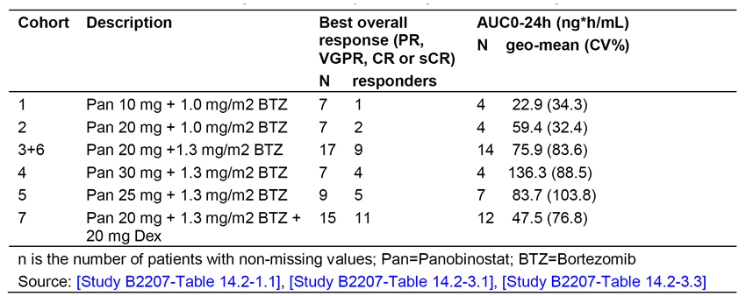

Evaluator's overall conclusions on pharmacodynamics
- The exposure response relationship between panobinostat and thrombocytopenia appears to have been designed to explore a proposed panobinostat dosing regimen for the treatment of patients with classical HL. Therefore, the dosing regimens explored in this analysis are not directly applicable to the treatment of patients with MM. Simulations of platelet dynamics based on the model predictions showed a strong dependence of the response to panobinostat on baseline platelet count, as well as on panobinostat dose and dose regimen. These predictions are likely to be relevant to panobinostat for the treatment of MM.
- The exposure response relationship between panobinostat plasma concentration and QTcF did not provide a signal indicating that treatment with panobinostat is associated with clinically significant prolongation of the QTcF. However, electrocardiogram abnormalities are a known class effect of DACi. In addition, both panobinostat and BJB432 inhibit hERG potassium channel activity at IC50 values of 3.5 µM and 1.6 µM, respectively. Therefore, concomitant administration of panobinostat with drugs known to increase the QTc interval may result in clinically significant prolongation of the QTc due to possible synergistic effects. In addition, patients with baseline QTc prolongation might be at an increased risk of clinically significant QTc prolongation when exposed to panobinostat.
- The exposure - response relationship between panobinostat AUC_{0-24 hours} and efficacy (best overall response) showed a positive relationship for PAN 20 mg + BTZ 1.3 mg/m² and suggested a synergistic effect when Dex 20 mg was added to the regimen.

Dosage selection for the pivotal studies
The panobinostat dose regimen selected for the pivotal Study D2308 was based on the results of the Phase Ib dose escalating study (Study B2207) designed to assess the combination of panobinostat (PAN) with bortezomib (BTZ) in patients with relapsed or relapsed and refractory MM, following at least 1 prior line of therapy. Prior to this study, single agent oral PAN had been tested in patients with advanced haematological malignancies in the Phase IA/II dose escalation Study B2102 and in the Phase II Study B2203 in patients with MM who had received at least 2 lines of previous therapy, which must have included bortezomib or lenalidomide. Based on these results and nonclinical data suggesting a potential synergistic effect for the combination of PAN plus BTZ, the sponsor stated that ‘development of PAN in combination with other anti-myeloma agents was prioritized’.
The primary objective of the dose escalating phase of Study B2207 was to determine the maximum tolerated dose (MTD) of PAN and BTZ when administered in combination to patients with advanced MM. The primary endpoint of the study was the MTD, which was defined as the highest dose level of PAN in combination with BTZ in the specified dosing schedule that met the dose limiting (DLT) criteria. DLT was defined as clinically relevant AEs or abnormal laboratory values occurring ≤ 21 days following the first dose of study treatment in Cycle 1. Each cohort consisted of a minimum of six patients and dose escalation was to end when at least 12 MTD evaluable patients had been enrolled at the recommended dose level. The MTD dose level cohort was then to be expanded to a total of 22 patients treated at that level, in order to assess safety and tolerability of the MTD (Phase II period of the study).
In the dose escalation phase, PAN was initiated at a dose of 10 mg, which was lower than the dose used in the single agent PAN studies (that is, 20 mg). Doses of PAN 10 mg to 30 mg (three times a week, until progression) in combination with BTZ 1.0 or 1.3 mg/m² BTZ IV (on Days 1, 4, 8, and 11) were tested. The addition of Dex to the combination was discretionary in the dose escalation phase for patients who had worsening disease or suboptimal response, but mandatory for all patients in the dose expansion phase starting at Cycle 2. The planned treatment cycle duration throughout the study was 21 days, which was based on the standard cycle duration for BTZ. The dose cohorts for the dose escalation phase of the study are summarised below in Table 22.

Table 22: Study D2307; Dose levels for PAN, BTZ and Dex
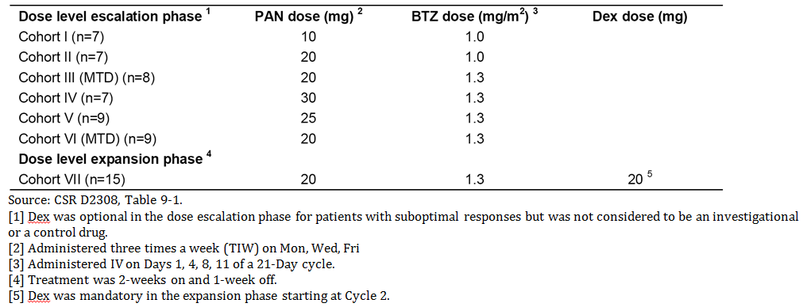
The MTD dose was declared to be PAN 20 mg + BTZ 1.3 mg/m², based on 15 evaluable patients in Cohorts III plus VI. Dose limiting toxicities were reported in 3 out of 15 patients (20%) in the MTD cohort. This was considerably lower than in the cohorts receiving higher doses of PAN. The following DLTs were reported in different dose level cohorts during dose escalation phase:
- In the PAN 30 mg + BTZ 1.3 mg/m² (Cohort IV), DLTs were reported in 4 out of 6 evaluable patients (66.7%). These included thrombocytopenia (2 patients), weakness (2 patients), and anorexia, asthenia and fatigue (all in 1 patient). This led to de-escalation in PAN dose from 30 mg to 25 mg in the next cohort (Cohort V), keeping the BTZ dose at 1.3 mg/m².
- In the PAN 25 mg + BTZ 1.3 mg/m² (Cohort V), DLTs were observed in 2 out of 6 evaluable patients (33.3%), including tumour lysis syndrome (1 patient) and thrombocytopenia (1 patient). This led to de-escalation in PAN dose from 25 mg to 20 mg in the next cohort (Cohort VI) keeping the BTZ dose at 1.3 mg/m², and bringing the dose back to the dose tested in Cohort III.
- In the PAN 20 mg + 1.3 mg/m² (Cohort VII), DLTs were observed in 3 out of 15 (20%) evaluable patients (6 patients from cohort III and 9 patients from cohort VI) and included thrombocytopenia, vomiting and orthostatic hypotension (1 patient each).
Thrombocytopenia as a disease limiting toxicity (DLT ≥ Grade 3) was reported by 6.7% (1 out of 15) of patients in the MTD cohort of PAN 20 mg + BTZ 1.3 mg/m² compared to 25% (3 out of 12) of patients in the cohorts with higher doses of PAN. Based on the results of the dose escalation phase, the MTD of PAN 20 mg + and 1.3 mg/m² BTZ was selected for the Study B2207 expansion phase. The dosing schedule of 2 weeks on / 1 week off (similar to that of BTZ) was introduced into the dose expansion phase of in order to manage thrombocytopenia and to allow for accelerated platelet recovery.
Comment: Based on the results of the dose escalation phase of Study B2207, the PAN 20 mg + BTZ 1.3 mg/m² + Dex 20 mg dose regimen selected for the pivotal efficacy and safety study (Study D2308) is considered to be appropriate.

Clinical efficacy

Overview of the efficacy studies
The submission included three efficacy and safety studies relevant to the proposed dose for the proposed usage (see Table 23). The most important of these studies is the Phase III study (Study D2308) which provides pivotal clinical efficacy data, while the other two studies are considered to provide limited supportive efficacy data. The evaluation of clinical efficacy focuses on the data from the pivotal Phase III study (Study D2308).

Table23: Overview of efficacy studies
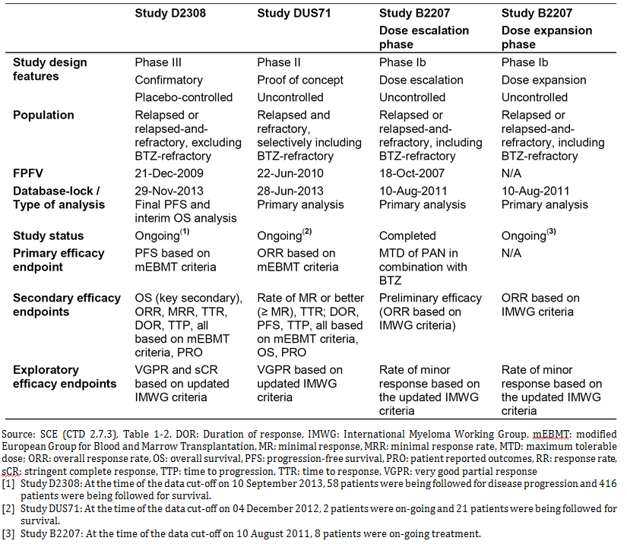

Pivotal efficacy study; D2308

Study design, objectives, locations and dates

Design
Study D2308 was a multinational, multicentre, randomised, double blind, Phase III study of panobinostat (PAN) in combination with bortezomib (BTZ) and dexamethasone (Dex) in patients with relapsed or relapsed and refractory multiple myeloma (MM). The study was undertaken in 34 countries at 194 centres; including 6 centres in Australia. The first patient was enrolled on 29 January 2010 and the last patient completed study treatment on 1 March 2013. The submitted CSR was dated 17 February 2014. As of the data cut-off date of 10 September 2013, 58 patients were still being followed up post treatment for disease progression and 416 patients for overall survival. However, following the database lock of 29 November 2013, disease progression follow-up was stopped, but survival follow-up will continue until 415 survival events have occurred. The study protocol and all amendments were reviewed by an IEC or IRB for each participating centre. The study was conducted in accordance with the ethical principles of the Declaration of Helsinki. The study is also known by the name PANORAMA-1.

Objectives

Primary objective
The primary objective was to compare progression free survival (PFS) in patients treated with panobinostat (PAN) in combination with bortezomib (BTZ) and dexamethasone (Dex) compared to patients treated with placebo (PBO) in combination with BTZ and Dex.

Key secondary objective
The key secondary objective was to compare overall survival (OS) between the two treatment arms.

Additional secondary efficacy objectives:
- To compare ORR (overall response rate) comprising Complete Response (CR), near CR (nCR) and Partial Response (PR)
- To compare nCR plus CR rate
- To compare Minimal Response rate (MRR)
- To compare time to response (TTR)
- To compare time to progression (TTP)
- To assess duration of response (DOR) from the first occurrence of PR or better
- To assess safety of combination therapy
- To assess health related quality of life (QoL) and symptoms of multiple myeloma
- To evaluate the pharmacokinetics (PK) of panobinostat and bortezomib in a subset of Japanese patients
All secondary efficacy endpoints related to objective disease response were based on mEBMT criteria.

Secondary safety objectives
- Adverse events (graded by Common Terminology Criteria for Adverse Events (CTCAE) Version 3.0 and serious AEs)
- ECG parameters (for example QTcF change from baseline, QTcF interval
- Laboratory parameters

Exploratory objectives
- To assess VGPR rate (as per IMWG criteria)
- To assess stringent Complete Response (sCR) rate (as per IMWG criteria

Investigational plan
The study compared treatment with PAN+BTZ+Dex to treatment with PBO+BTZ+Dex in patients with:
- relapsed MM having received 1 to 3 prior lines of therapy; or
- patients with relapsed and refractory MM who were not refractory to prior therapy with BTZ.
- Relapsed MM was defined as recurrent disease in a patient who had responded to a prior therapy by achieving a minimal response (MR) or better, and had not progressed under this therapy or up to 60 days of last dose of this therapy.
- Relapsed-and-refractory MM was defined as relapse to at least one prior line of therapy and being refractory to another line (except bortezomib), by either not achieving a MR, or having progressed while on this therapy or within 60 days of its last dose.
Approximately 762 patients were expected to be randomised, and a total of 768 eligible patients were actually randomized 1:1 to the panobinostat and control arms. Centralised randomisation was stratified by the number of prior lines of anti-myeloma therapy (1 versus 2 or 3), and prior use of bortezomib (Yes versus No). The stratification factors identified patients who would be expected to be more responsive to treatment (that is, one previous line of therapy, no prior use of bortezomib) compared to patients who would be expected to be less responsive to treatment (that is, 2 or 3 prior lines of therapy, prior use of bortezomib).
The maximum duration of the study treatment period was 48 weeks divided into two phases: treatment phase 1 (TP1) consisting of 24 weeks of combined treatment with PAN+BTZ+Dex or PBO+BTZ+Dex (8 cycles of 21 days duration each); and treatment phase 2 (TP2) consisting of 24 weeks of combined treatment with PAN+BTZ+Dex or PBO+BTZ+Dex (4 cycles of 42 days duration each). In TP1, patients were planned to receive study treatment until completion of Week 24 (eight 21 day cycles). Patients with clinical benefit in TP1 (achieving ≥ No Change at Cycle 8 Day 1), as assessed per mEBMT criteria could continue study treatment up to Week 48 unless the patient experienced unacceptable toxicity that precluded further treatment, and/or the investigator determined that further therapy was not in the patient’s best interest, whichever came first.
Disease assessments were performed every 3 weeks or more often if there was a suspicion of disease progression or relapse. Confirmatory assessments of response were obtained after 6 weeks as per mEBMT criteria. Patients were assessed for response following treatment discontinuation until progression/relapse. Patients who experienced disease progression, started a new antineoplastic therapy, or withdrew consent for progression follow-up were followed for survival. Patients who discontinued study treatment at any time for reasons other than documented disease progression continued to have tumour assessments performed every 6 weeks until documented disease progression/relapse or death. No cross-over between treatment arms was allowed. The study design is summarised below in Figure 11. The study evaluation and visit schedule was provided.
Figure 11: Study D2308; Study design and planned conduct
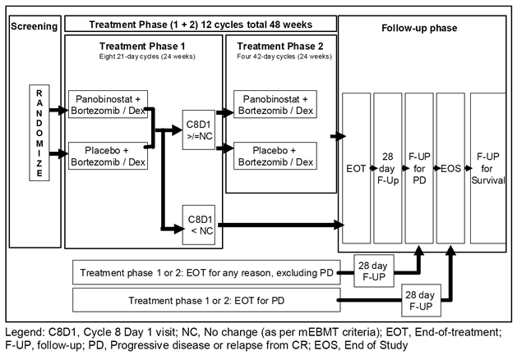
The study included a Study Steering Committee (SSC) consisting of investigators participating in the study. The SSC ensured transparent management of the study per the protocol by recommending and approving modifications as circumstances required, including protocol amendments. The study also included an Independent Data Monitoring Committee (IDMC) of six members, with four medical oncologists/haematologists (none being an investigator for the study), one cardiologist and one statistician, who were external to Novartis. The IDMC was responsible for assessing the safety and efficacy data as defined by the protocol during the study, for monitoring the overall conduct of the study on a periodic basis, and for making recommendations to Novartis.
In addition, an Independent Review Committee (IRC) was instituted after Protocol Amendment 5. The purpose of the IRC was to perform an independent review of disease response data for all randomised patients in a blinded manner and provide response assessments based on modified EBMT criteria as well as dates of response assessments. The IRC response assessment was performed without knowledge of investigator response assessment. As discussed below, the results for the PFS analysis based on mEBMT criteria differed between the investigator assessment and the IRC assessment.
The sponsor states that a high rate of concordance was observed between the IRC and the investigator assessments. However, there were some cases where the process followed by IRC review differed from investigators review. These included:
- The IRC identified some cases of progression earlier than investigators, adjudicating disease deterioration by rising M protein values as progression, although the threshold for progression had not been met.
- In some patients considered to have non-measurable disease as per mEBMT or with missing baseline data, IRC provided responses other than ‘unknown’ or ‘progressive disease’ using post-baseline M-protein values and immuno fixation data. This differs from investigator’s assessment where all patients with non-measurable disease as per mEBMT or with missing baseline data were assessed for ‘unknown’ or ‘progressive disease’ responses only.
- The IRC provided adequate response assessments also in cases where investigators assigned response ‘unknown’ due to missing individual efficacy data. Consequently, censoring due to missing adequate assessments was observed more frequently in the investigator assessment compared to the IRC assessment.
- While assessing near complete response (nCR), the IRC mandated the need for a confirmatory bone marrow biopsy or aspirate.
This is in contrast to the protocol for investigator assessment, which did not require confirmatory bone marrow biopsy or aspirate for assessment of nCR response.
Comment: The sponsor stated that there was a high rate of concordance between the IRC and the investigator assessments for PFS based on mEMBT criteria, but no quantitative analysis of concordance could be identified in the submission. The sponsor is requested to provide the results of the quantitative analysis of concordance between the two assessment methods.

Inclusion and exclusion criteria
The population in this trial comprised adult patients aged ≥ 18 years with relapsed MM having received 1 to 3 prior lines of therapy or with relapsed and refractory MM who had relapsed after at least 1 prior line of therapy and were refractory to another therapy (except BTZ). The sponsor stated that the population in this study has a poor prognosis with current treatment regimens. The inclusion criteria and the exclusion criteria are described below.
Inclusion criteria
- Patient has a previous diagnosis of multiple myeloma, based on IMWG 2003 definitions and all three of the following criteria had been met:
- Monoclonal immunoglobulin (M component) on electrophoresis, and on immunofixation on serum or on total 24 hour urine (or demonstration of M protein in cytoplasm of plasma cell for non-secretory myeloma)
- Bone marrow (clonal) plasma cells ≥ 10% or biopsy proven plasmacytoma
- Related organ or tissue impairment (CRAB [elevated calcium, renal failure, anaemia, bone lesions] symptoms: anaemia, hypercalcemia, lytic bone lesions, renal insufficiency, hyper viscosity, amyloidosis or recurrent infections)
- Patient with 1 to 3 prior lines of therapy who requires re-treatment of myeloma (per IMWG guidelines 2003) for one of the 2 conditions below:
- Relapsed, defined by disease that recurred in a patient that responded to a prior therapy, by reaching a MR or better, and had not progressed under this therapy or up to 60 days of last dose of this therapy. Patients previously treated with BTZ may be eligible.
- Relapsed and refractory to a therapy provided that both of these conditions are met:
  - patient has relapsed to at least one prior line, and
  - patient was refractory to another line (except BTZ), by either not reaching a MR, or progressed while on this therapy or within 60 days of its last dose
- Patient has measurable disease at study screening defined by at least one of the following measurements as per IMWG 2003 criteria (Kyle, et al 2003):
- serum M-protein ≥ 1 g/dL (≥ 10 g/L)
- urine M-protein ≥ 200 mg/24 hours
- Patient treated with local radiotherapy with or without concomitant exposure to steroids for pain control or management of cord/nerve root compression, is eligible. Two weeks must have lapsed since last date of radiotherapy, which is recommended to be a limited field. Patients who require concurrent radiotherapy should have entry to the protocol deferred until the radiotherapy is completed and 2 weeks have passed since the last date of therapy.
- Patient’s age is ≥ 18 years at time of signing the informed consent
- Patient has an Eastern Cooperative Oncology Group (ECOG) performance status (PS) ≤ 2
- Patient has the following laboratory values within 3 weeks before starting study drug (lab tests may be repeated, as clinically indicated, to obtain acceptable values before failure at screening is concluded. Supportive therapies are not to be administered within the week prior to screening tests for absolute neutrophil count (ANC) or platelet count).
- ANC ≥ 1.5 x 10⁹/L
- Platelet count ≥ 100 x 10⁹/L
- Serum potassium, magnesium, phosphorus, within normal limits (WNL) for the institution
- Total calcium (corrected for serum albumin) or ionized calcium greater or equal to lower limit of normal (> LLN) for institution, and not higher than CTCAE grade 1 in the case of an elevated value
- Potassium, calcium, magnesium, and/or phosphorus supplements may be given to correct values that are < LLN.
- Aspartate aminotransferase/glutamic oxaloacetic transaminase (AST/SGOT) and alanine aminotransferase/glutamic pyruvic transaminase (ALT/SGPT) ≤ 2.5 x upper limit of normal (ULN)
- Serum total bilirubin ≤ 1.5 x ULN (or ≤ 3.0 x ULN if patient has Gilbert syndrome)
- Serum creatinine levels ≤ 1.5 x ULN or calculated creatinine clearance ≥ 60 mL/min
- Patient has provided written informed consent prior to any screening procedures.
- Patient is able to swallow capsules.
- Patient must be able to adhere to the study visit schedule and other protocol requirements.
- Women of childbearing potential (WOCBP) must have a negative serum pregnancy test at baseline.
Exclusion criteria
- Patients who have progressed under all prior lines of anti-MM therapy (primary refractory)
- Patients who have been refractory to prior BTZ (i.e. did not achieve at least a MR, or have progressed on it or within 60 days of last dose)
- Allogeneic stem cell transplant recipient presenting with graft versus host disease that is either active or requires immunosuppression
- Patient has shown intolerance to bortezomib or to dexamethasone or components of these drugs or has any contraindication to one or the other drug, following locally applicable prescribing information
- Patient has grade ≥ 2 peripheral neuropathy or grade 1 peripheral neuropathy with pain on clinical examination within 14 days before randomization
- Patient received prior treatment with deacetylase inhibitors including panobinostat
- Patient needing valproic acid for any medical condition during the study or within 5 days prior to first administration of panobinostat/study treatment
- Patient taking any anti-cancer therapy concomitantly (bisphosphonates are permitted only if commenced prior to the start of screening period)
- Patient has secondary primary malignancy < 3 years of first dose of study treatment (except for treated basal or squamous cell carcinoma, or in situ cancer of the cervix)
- Patient who received:
- prior anti-myeloma chemotherapy or medication including immunomodulatory drugs and dexamethasone ≤ 3 weeks prior to start of study
- experimental therapy or biologic immunotherapy including monoclonal antibodies ≤ 4 weeks prior to start of study
- prior radiation therapy ≤ 4 weeks or limited field radiotherapy ≤ 2 weeks prior start of study
- Patient has not recovered from all therapy-related toxicities associated with above listed treatments to <CTCAE Grade 2
- Patient has undergone major surgery ≤ 2 weeks prior to starting study drug or who have not recovered from side effects of such therapy to <CTCAE Grade 2
- Patients with evidence of mucosal or internal bleeding
- Patient has unresolved diarrhoea ≥ CTCAE Grade 2
- Patient has impaired cardiac function, including any one of the following
- left ventricular ejection fraction (LVEF) < LLN of institutional normal, as determined by echocardiogram (ECHO) or multiple uptake gated acquisition scan (MUGA)
- obligate use of a permanent cardiac pacemaker
- congenital long QT syndrome
- history or presence of ventricular tachyarrhythmia
- resting bradycardia defined as < 50 beats per minute
- QTcF >450 ms on screening ECG
- complete left bundle branch block, bifascicular block
- any clinically significant ST segment and/or T-wave abnormalities
- presence of unstable atrial fibrillation (ventricular response rate >100 bpm); patients with stable atrial fibrillation can be enrolled provided they do not meet other cardiac exclusion criteria
- myocardial infarction or unstable angina pectoris ≤ 6 months prior to starting study drug
- symptomatic congestive heart failure (New York Heart Association class III-IV)
- other clinically significant heart and vascular disease (for example uncontrolled hypertension)
- Patient taking medications with relative risk of prolonging the QT interval or inducing Torsades de pointes, if such treatment cannot be discontinued or switched to a different medication prior to starting study drug
- Patient has impairment of gastrointestinal (GI) function or GI disease that may significantly alter the absorption of panobinostat (for example ulcerative disease, uncontrolled nausea, vomiting, malabsorption syndrome, obstruction, or stomach and/or small bowel resection)
- Patient has any other concurrent severe and/or uncontrolled medical conditions (e.g. uncontrolled diabetes, active or uncontrolled infection, chronic obstructive or chronic restrictive pulmonary disease including dyspnoea at rest from any cause, uncontrolled thyroid dysfunction) that could cause unacceptable safety risks or compromise compliance with the protocol
- Patient has a known history of Human Immunodeficiency Virus seropositivity or history of active/treated hepatitis B or C (a test for screening is not required)
- Women who are pregnant or breast feeding or WOCBP not willing to use a double method of contraception during the study and 3 months after the study evaluation completion, of which one must be a barrier method. WOCBP are defined as sexually mature women who have not undergone a hysterectomy or who have not been naturally postmenopausal for at least 12 consecutive months (i.e. patient has had menses at any time in the preceding 12 consecutive months).
- Patient is a male not willing to use a barrier method of contraception (a condom) during the study and for 3 months after the study evaluation completion

Study treatments

Investigational and control arms
Patients were assigned to one of the following 2 treatment arms in a ratio of 1:1:
- PAN + BTZ + Dex (investigational arm); or
- PBO + BTZ + Dex (control arm).
The treatment doses and treatment regimens are summarised below in Table 24.

Table24: Study D2308; Treatment dose and regimens
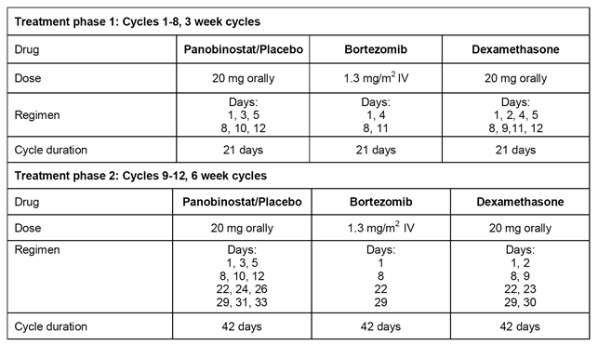
Beginning on Cycle 1 Day 1, all patients received study treatment (oral panobinostat 20 mg or oral placebo) three times per week (TIW), on a 2 weeks on/1 week off schedule. Bortezomib was administered at dose of 1.3 mg/m² as a 3 to 5 second bolus intravenous (IV) injection. Dexamethasone was given as an oral dose of 20 mg/day. The duration of a treatment cycle in treatment phase 1 (TP1) was 21 days. In TP1, a total of eight cycles were administered. The first dose of oral panobinostat/placebo in Cycle 1 defined Day 1 of the treatment cycle.
Treatment Phase 2 (TP2) started with Cycle 9. Only patients who had experienced a No Change (NC) or better and presented no toxicities (CTCAE ≥ Grade 2) could enter TP2. The duration of a treatment cycle in TP2 was 42 days. In TP2, a maximum of 4 cycles was administered. The first dose of panobinostat/placebo in Cycle 9 defined Day 1 of the treatment cycle. In TP2, oral panobinostat was administered for 2 weeks on/1 week off (same as for TP1), but the dosing schedule for both BTZ 1.3 mg/m² IV and Dex 20 mg PO differed compared to TP1.
Patients were instructed to take oral PAN or matching PBO three times a week at the same time on each dosing day, doses were to be separated by a minimum of 30 hours. Each dose of PAN/PBO was to be taken with approximately 240 mL of non-carbonated water. Patients were instructed to swallow the capsules whole and not chew them. If vomiting occurred during the course of treatment, then no re-dosing of the patient was allowed before the next scheduled dose. Patients were instructed to avoid grapefruits, grapefruit juice, Seville (sour) oranges and Seville orange juice throughout the study period.
BTZ was administered in accordance with the prescribing information for that drug. Before each BTZ dose, the following parameters were to be met:
- platelet count ≥ 25 x 10⁹ /L (platelet transfusion support was permitted); and
- ANC ≥ 750/μL (growth factor support was permitted as defined in the protocol).
Dex was administered as a single 20 mg dose on the day of BTZ administration and the day after BTZ administration.
Comment: The combination of BTZ 1.3 mg/m² and Dex 20 mg is considered to be an appropriate control arm. The sponsor states that the combination of BTZ/Dex was chosen not only as a highly active treatment backbone but as a standard of care comparator. The Australian eviQ guidelines identify BTZ in combination with Dex as a recommended salvage treatment for patients with relapsed/refractory MM (that is, BTZ 1.3 mg/m² IV Days 1, 4, 8, 11 and Dex 20 mg PO Days 1, 2, 4, 5, 8, 9, 11, and 12; 4 x 21 day cycles initially to continue for 8 cycles if at least partial response, with a maximum of 11 cycles). The Australian Multiple Myeloma Clinical Practice Guideline (MSAG) comments that there is no one standard treatment for patients with relapsed MM, but notes that BTZ in combination with Dex is an option for salvage treatment option or relapsed/refractory MM.4 In Australia, BTZ in combination with melphalan and prednisone is indicated for the treatment of patients with previously untreated MM who are not candidates for high dose chemotherapy. It is also indicated, as part of combination therapy, for induction therapy prior to high dose chemotherapy with autologous stem cell rescue for patients under 65 years of age with previously untreated MM. In addition (and of direct relevance to the current submission) BTZ is also indicated for the treatment of MM patients who have received at least one prior therapy, and who have progressive disease.
In the Australian PI, the recommended dose of BTZ for the treatment of relapsed/refractory MM is 1.3 mg/m² administered twice weekly for 2 weeks (Days 1, 4, 8, and 11) followed by a 10 day rest period (Days 12 to 21). It is recommended that patients with a confirmed complete response receive 2 additional cycles of BTZ beyond a confirmation. It is also recommended that responding patients who do not achieve a complete remission receive a total of 8 cycles of BTZ therapy. For extended therapy of more than 8 cycles, BTZ may be administered on the standard schedule or on a maintenance schedule of once weekly for 4 weeks (Days 1, 8, 15, and 22) followed by a 13 day rest period (Days 23 to 35).

Permitted dose adjustments and interruptions of study drug treatment
For patients who were unable to tolerate the protocol-specified dosing scheme, dose adjustments and interruptions were permitted in order to keep the patient on study drug. Before each dose the patient was evaluated for possible toxicities that may have occurred after the previous dose. Toxicities were assessed according to the National Cancer Institute Common Terminology Criteria (CTC), Version 3.0.
Patients unable to tolerate the minimum dose level of Dex could continue on the rest of their randomly assigned regimen without Dex. Patients requiring discontinuation of BTZ due to peripheral neuropathy (PN) could continue on PAN/PBO ± Dex. BTZ could be restarted at any time during treatment phases 1 and 2 if clinically indicated and in accordance with the local prescribing instructions for BTZ. Patients requiring permanent discontinuation of BTZ due to any other reason or permanent discontinuation of PAN/PBO were to discontinue study treatment and be followed for progressive disease/relapse and survival.
Patients whose study treatment was interrupted due to an AE or abnormal laboratory value were to be followed at least once a week for 4 weeks, and subsequently at a minimum of every 4 weeks, until resolution or stabilisation of the event, whichever came first. If a patient required a dose delay of > 21 days from the intended day of the next scheduled dose, the patient was to be discontinued from study treatment. All dosages prescribed and dispensed to the patient and all dose changes during the study were recorded on the Dosage Administration Record (CRF).
The PAN/PBO dose reductions and dose re-escalation schedules are summarised in Table 25. Dose levels lower than 10 mg three times a week in combination with a minimum of 0.7 mg/m² BTZ, with or without Dex, were not permitted at any time. If a dose below 10 mg three times a week in combination with the minimum dose of BTZ was required, the patient was to be discontinued from study treatment. Continuation of PAN/PBO dosing without BTZ at any dose was not permitted in TP1 or TP2. Patients receiving a reduced dose level of PAN/PBO due to toxicity could be considered for dose re-escalation if either the study treatment-related AE had reverted in severity to Grade ≤ 1 or baseline level, and at least nine scheduled doses at the reduced level had been administered and tolerated. Criteria for dosing delays, dose reductions, and re-initiation of PAN/PBO due to study drug related (excluding QTcF abnormalities) are provided in Table 26, and for QTcF abnormalities are provided in Table 27. Any decisions concerning dose modifications or permanent discontinuation from study drug due to QTcF prolongation were based on the central ECG assessment and after discussion between the investigator and sponsor. If a patient could not be dosed due to a prolonged QTcF for more than 7 days since last dose, the patient was discontinued from study treatment.

Table 25: D2308; Dose reductions and dose re-escalations for panobinostat/placebo
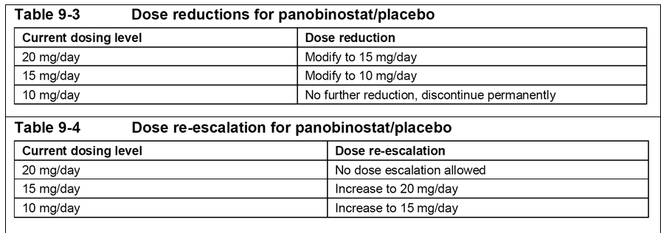

Table 26: D2308; Criteria for panobinostat/placebo dosing delays, dose reductions and re-initiation of treatment due to study drug-related toxicity (excluding QT prolongation)
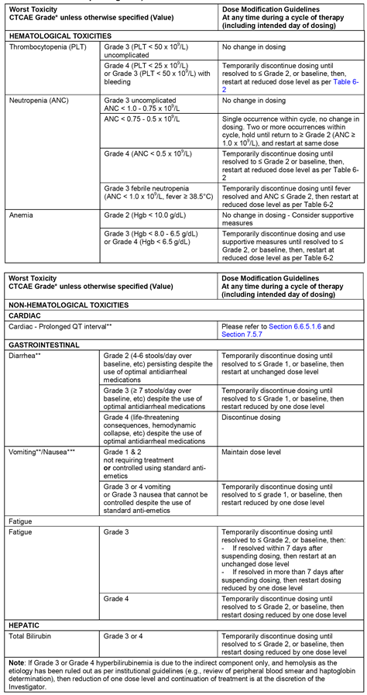

Table 26(continued): D2308; Criteria for panobinostat/placebo dosing delays, dose reductions and re-initiation of treatment due to study drug-related toxicity (excluding QT prolongation)
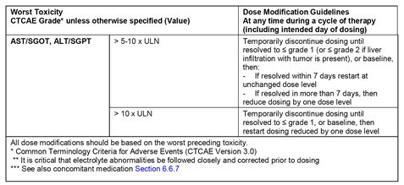

Table 27: D2308; Criteria for panobinostat/placebo dosing delays, dose reductions and re-initiation of treatment due to study drug-related QTcF abnormalities (Cycle 1, Cycles 2-8)
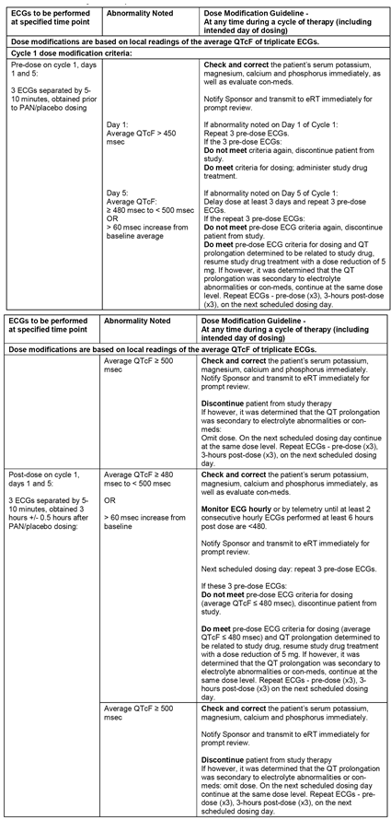

Table 27 (continued): D2308; Criteria for panobinostat/placebo dosing delays, dose reductions and re-initiation of treatment due to study drug-related QTcF abnormalities (Cycle 1, Cycles 2-8)
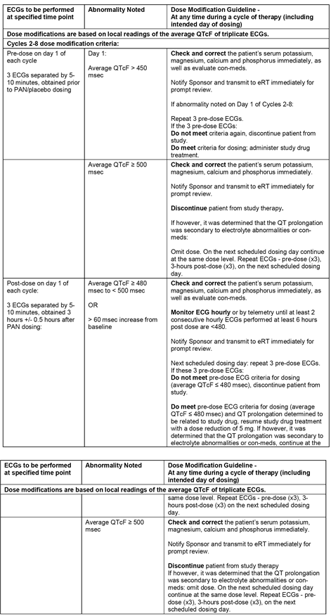
Dose reduction procedures for BTZ are summarised in Table 28. When BTZ related symptoms of toxicity had resolved, BTZ therapy could be reinitiated at a reduced dose. The study included comprehensive drug related adverse event dose modification guidelines, including specific guidelines for neuropathic pain and/or peripheral sensory neuropathy. Dose reduction procedures for Dex are summarised in Table 29. The study included comprehensive dose-modification guidelines relating to dose-related adverse events for Dex.

Table 28: D2308; Dose reductions for bortezomib
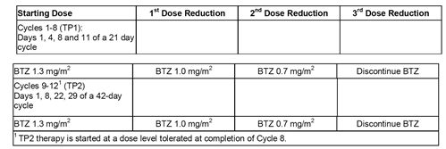

Table 29: D2308; Dose reductions for dexamethasone
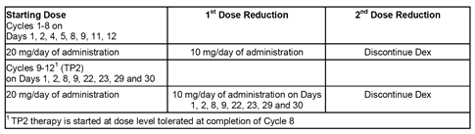

Concomitant treatment
All medications (excluding study treatment components and/or any prior chemotherapy and biologic or immunologic agents) and significant non-drug therapies (including physical therapy and blood or platelet transfusions) administered within 14 days prior to the administration of study treatment through 28 days after the last treatment of study drug, with reasons for use, were recorded. Medications included not only physician prescribed medications, but also all over the counter medications, vitamins, herbals and alternative therapies.
Prohibited treatments included chemo-therapy, biologic therapy or immunologic therapy and/or other investigational agents, as well as deacetylase inhibitors, including valproic acid. Prophylactic anti-emetics could be administered at the discretion of the investigator. However, anti-emetics associated with QT prolongation were prohibited. Co-medications known to prolong the QT interval and/or induce torsades de pointes (TdP) were prohibited unless approved by the sponsor (for example, strong CYP3A4/5 inhibitors or CYP2D6 substrates)
Growth factor support for anaemia and neutropenia was permitted if initiated before study entry. Bisphosphonates were permitted only if treatment had begun prior to the start of Screening. Bisphosphonates were considered primarily as medications to manage bone disease and not as anticancer agents.
It was known from previous studies that PAN therapy, particularly in combination with BTZ, is commonly associated with moderate to severe thrombocytopenia. This may lead to an increase in the risk of bleeding especially with concomitant administration of long acting anticoagulants such as warfarin. It was recommended that patients who required anticoagulation therapy while on PAN use low molecular weight heparins. However, if the use of low molecular weight heparins was not feasible or indicated, patients on vitamin K inhibitors such as warfarin could continue such therapy while on PAN/PBO. For such patients, close and frequent monitoring of coagulation parameters, including prothrombin time/international normalised ratio was to be performed and maintained within the therapeutic range. It was recommended that if the platelet count fell below 50 x 10⁹ /L, consideration should be given to withholding thrombo prophylaxis in order to minimise the risk of bleeding.

Premature withdrawal of patients
The study included standard criteria and procedures for patients prematurely discontinuing study drug treatments and/or prematurely withdrawing from the study.

Emergency unblinding of treatment
The study included standard procedures for the emergency unblinding of treatment.

Study completion
Patients were treated with study drug/treatment until disease progression, unacceptable toxicity, or withdrawal of consent. The maximum treatment period was 48 weeks. All patients were followed for AEs/SAEs for 28 days following the last dose of study treatment. Survival follow-up went beyond study treatment follow-up.

Treatment exposure and compliance
No formal measurement of panobinostat plasma concentrations for the purpose of establishing compliance with treatment was performed. For PAN/PBO, compliance was assessed by the investigator or designee at each visit using pill counts. Drug accountability was performed by the site pharmacist for the number of bottles dispensed and pills returned for PAN/PBO.

Efficacy variables and outcomes

The main efficacy variables
- As specified by the protocol, response criteria were based on modified EBMT (mEBMT) criteria (see Table 30). The mEMBT is standard set of uniform response criteria primarily developed by the European Group for Blood and Bone Marrow Transplant, the International Bone Marrow Transplant Registry and the American Bone Marrow Transplant Registry (EBMT/IBMTR/ ABMTR) to evaluate response in MM. ^{[5,6]}
- For assessment of response or disease progression using mEMBT criteria, the following were performed at baseline and at every scheduled visit post-baseline: protein electrophoresis (PEP) for serum M-protein; PEP for urine M-protein; evaluation of the presence or absence of soft tissue plasmacytoma; serum calcium levels; and bone lesion assessment. Per mEBMT criteria, a patient was considered to have measurable disease if at least one of the following two conditions was present at baseline: serum M-protein by PEP ≥ 1 g/dL or urine M-protein by PEP ≥ 200 mg/24 hours.
- Assessments to determine PD/relapse were dependent on change from nadir, defined as the lowest value of a variable including baseline measurements. Only one of the listed mEMBT criteria was required for a conclusion of PD. Any assessment indicative of a response (CR, nCR, PR or MR) was to be repeated after 6 weeks to confirm the response. If progressive disease by M-protein was suspected, a repeat assessment was required as soon as possible for confirmation. Due to an inconsistency of the protocol wording, evaluation of bone marrow was not considered mandatory for nCR response assessment by the investigator.
- In addition to previously mentioned response criteria (that is, CR, nCR, PR or MR), very good partial response (VGPR) and stringent complete response (sCR) were determined based on the updated standardised International Myeloma Working Group criteria (IMWG) criteria for MM.7 VGPR is defined as all of the following: serum and/or urine M-protein detectable by immunofixation electrophoresis (IFE) but not by PEP or ≥ 90% reduction from baseline in serum AND urine M-protein < 100 mg/24 hours; and if soft tissue plasmacytoma(s) were present at baseline, disappearance of any soft tissue plasmacytomas. sCR is defined as all of the following: all criteria have been met for a CR; a normal free light chain (FLC) ratio has been observed AND there is an absence of phenotypically aberrant plasma cells in bone marrow analysed by multiparametric flow cytometry. According to IMWG criteria, confirmation of response was required (a consecutive assessment at any time was considered sufficient). The IMWG criteria are summarised in Table 31.
- In addition to disease specific assessments of efficacy, patient-reported outcomes focusing on health-related quality of life and symptoms were collected using well known instruments: that is, the European Organization for Research and Treatment of Cancer’s (EORTC) quality of life questionnaire (QLQ-C30, Version 3) and multiple myeloma specific questionnaire (QLQMY20); the Functional Assessment of Cancer Therapy Gynaecology Oncology Group Neurotoxicity scale (FACT/GOG-NTX, Version 4). The EORTC QLQ-C30, EORTC QLQ-MY20, and FACT/GOG-NTX were to be administered before study drug treatment at Screening and on Cycle 1 Day 1 (C1D1) and every 6 weeks thereafter (that is, C3D1, C5D1, C7D1, C9D1, C10D1, C11D1, C12D1) as well as at the study completion visit. The measures were administered sequentially at the beginning of the study visit prior to any interaction with the study physician, including any tests, treatments, or receipt of results from any tests. In addition to these assessments, patient and investigator global assessments were collected to provide an overall assessment of symptom severity and global change over the course of the study. Patients and investigators completed the global severity question at Screening and on Day 1 of Cycle 5 and the global change question on Day 1 of Cycle 3 and Cycle 7 and at study evaluation completion. Patient and investigator global severity and global change questions were used as supportive data for analysis of the EORTC QLQ-C30, EORTC QLQ-MY20, and FACT/GOG-NTX.

Table 30: D2308; Response classification per modified EMBT criteria
Response category | Definition
Complete response(CR) | - Absence of M-protein in serum and urine by immunofixation, maintained ≥ 6 weeks (presence of oligoclonal bands consistent with oligoclonal immune reconstitution does not exclude CR), AND  - < 5% plasma cells in bone marrow. No confirmation on bone marrow plasma cell (additional assessment) is needed to document CR except patients with non-secretory myeloma where the bone marrow examination must be repeated after an interval of at least 6 weeks, AND  - In case of presence of lytic bone lesion(s) at baseline, no increase in size or number of lytic bone lesions (development of a compression fracture does not exclude CR), AND  - In case of presence of soft tissue plasmacytoma(s) at baseline, disappearance of any soft tissue plasmacytoma
Near-complete response (nCR) | All criteria of CR apply except that absence of serum and urine M-protein cannot be confirmed by immunofixation.  Note: This category is not part of the original EBMT criteria (Bladé 1998). It is introduced to enable comparisons to other pivotal clinical trials in MM (i.e., Richardson, et al 2003; Richardson, et al 2005; Orlowski, et al 2007; San Miguel, et al 2008).
Partial response (PR) | - If disease was measurable based on serum M-protein at baseline, then ≥ 50% reduction from baseline in serum M-protein as determined by PEP, maintained for ≥ 6 weeks; otherwise, serum M-protein < 1 g/dL, AND  - reduction in 24h urine M-protein as measured by PEP from baseline either by ≥ 90% or to < 200 mg, maintained ≥ 6 weeks, AND  - ≥ 50% reduction from baseline in the size of soft tissue plasmacytomas (by CT/MRI), AND  - no increase in size or number of lytic bone lesions (development of a compression fracture does not exclude PR)  - for patients with non-secretory myeloma, in addition to the above, ≥ 50% reduction from baseline in plasma cells in a bone marrow aspirate and/or on biopsy (if both available then “and”, otherwise “or”), maintained for ≥ 6 weeks
Minimal response (MR) | - If disease was measurable based on serum M-protein at baseline then 25 to < 50% reduction from baseline in serum M-protein measured by PEP, maintained for ≥ 6 weeks; otherwise serum M-protein < 1 g/dL AND  - 50 to < 90% reduction from baseline in 24h urine M-protein as measured by PEP and absolute value is still ≥ 200 mg/24h, maintained for ≥ 6 weeks, AND  - 25 to < 50% reduction from baseline in the size of soft tissue plasmacytomas (by CT/MRI) AND  - no increase in the size or number of lytic bone lesions (development of a compression fracture does not exclude MR)  - For patients with non-secretory myeloma, in addition to the above, 25 to < 50% reduction from baseline in plasma cells in a bone marrow aspirate and/or on biopsy, maintained for ≥ 6 weeks
No change (NC) | not meeting the criteria of either CR, nCR, PR, MR or PD/relapse
Relapse from CR | - PEP confirmed by ≥ one further investigation and excluding oligoclonal immune reconstitution, OR  - ≥ 5% plasma cells in a bone marrow aspirate or on bone biopsy, OR  - development of new soft tissue plasmacytoma(s),or definite increase in the size of soft tissue plasmacytomas, OR  - development of new lytic bone lesions or increase in the size of lytic bone lesions (development of a compression fracture does not exclude continued response and hence does not indicate PD), OR  - development of hypercalcemia (corrected serum calcium >11.5 mg/dL) not attributable to any other cause. In case of preexisting hypercalcemia at baseline, this criterion applies only in case the corrected serum calcium level was ≤11.5 mg/dL during the course of the study. This criterion does qualify for relapse even if no previous calcium assessment.  There is no given time frame for the confirmation measurement of serum or urine M-protein. A repetition and confirmation at any time qualifies for relapse.
Progressive disease (PD)  (only for patients not being in CR) | - 25% increase from nadir in the serum M-protein as measured by PEP which must also be an absolute increase from nadir of at least 0.5 g/dL and absolute value of serum M-protein ≥ 1.0 g/dL, and confirmed by at least one repeated investigation, OR  - 25% increase from nadir in the 24h urine M-protein as measured by PEP which must also be an absolute increase from nadir of at least 200 mg/24hours and confirmed by at least one repeated investigation, OR  - 25% increase from nadir in plasma cells in a bone marrow aspirate or on biopsy which must also be an absolute increase from nadir of at least 10%, OR  - increase from baseline in size of existing lytic bone lesions, OR  - development of new lytic bone lesion (development of a compression fracture does not exclude continued response and does not indicate PD), OR  - definite increase from nadir in size of existing soft tissue plasmacytomas (Appendix 16.1.1- post-text supplement 2-Section 2.1.4 Assessment of soft tissue plasmacytomas), OR  - development of new soft tissue plasmacytomas, OR  - development of hypercalcemia (corrected serum calcium > 11.5 mg/dL) for patients without hypercalcemia at baseline. In case of pre-existing hypercalcemia at baseline, PD will only be assessed due to the 11.5 mg/dL post-baseline and increased thereafter beyond 11.5.g mg/dL.  There is no given time frame for the confirmation measurement of serum or urine PEP. A repetition and confirmation at any time qualifies for PD.

Table 31: D2308; Response assessment according to IMWG criteria
Response category | Definition* (* if not defined otherwise, all of the criteria apply)
Stringent complete response (sCR) | - CR criteria as defined below AND  - normal FLC ratio AND  - absence of phenotypically aberrant PCs in bone marrow analysed by multiparametric flow cytometry.
Complete response (CR) | - Negative immunofixation of serum and urine AND  - In case of presence of soft tissue plasmacytoma(s) at baseline, disappearance of any soft tissue plasmacytoma(s), AND  - < 5% plasma cells in bone marrow.  - In case the only measurable disease in a patient with CR at baseline is the serum FLC level, a normal FLC ratio of 0.26 to 1.65 is required additionally to qualify for CR.
Very good partial response (VGPR) | - Serum and/or urine M-protein detectable by immunofixation but not on PEP OR ((≥ 90% reduction from baseline in serum) AND (urine M-protein < 100 mg/24h))  AND  - In case of presence of soft tissue plasmacytoma(s) at baseline, disappearance of any soft tissue plasmacytomas  In case the only measurable disease in a patient with VGPR at baseline is the serum FLC level (i.e. no measurable disease in serum and urine PEP), a decrease of > 90% in the difference between involved and uninvolved FLC levels from baseline is required.
Partial response (PR) | - (≥ 50% reduction from baseline in serum M-protein) AND (≥ 90% reduction from baseline in 24h urine M-protein OR urine M-protein < 200 mg/24h)  If the serum and urine M-protein are non-measurable at baseline a ≥ 50% reduction from baseline in the difference between involved and uninvolved FLC levels is required in place of the M-protein criteria.  If serum and urine M-protein are non-measurable, and serum FLC assay is also non-measurable, ≥ 50% reduction from baseline in percent plasma cells in bone marrow is required instead of M-protein measurement, provided baseline percentage in plasma cells in bone marrow was ≥ 30%.  AND  - In case of presence of soft tissue plasmacytoma(s) at baseline, a reduction in the SPD (see Section 2.1.4) by ≥ 50% is required.
Stable disease (SD) | Not meeting the criteria for mCR, sCR, CR, VGPR, PR, PD
Progressive disease (PD) | - Increase of at least 25% from the nadir in at least one of the following criteria:  - serum M-protein (absolute increase must be ≥ 0.5 g/dL and absolute value must be ≥ 1 g/dL)  - urine M-protein (absolute increase must be ≥ 200 mg/24h)  - only in patients with non-measurable serum and urine M-protein levels: difference in involved and uninvolved FLC levels (absolute increase must be > 10 mg/L)  - Bone marrow plasma cell percentage (absolute % must be ≥ 10%)  OR  - development of new lytic bone lesions or increase from baseline in size of lytic bone lesion(s)  OR  - development of new soft tissue plasmacytoma(s) or definite increase from nadir in existing soft tissue plasmacytomas  OR  - development of hypercalcemia (corrected serum calcium > 11.5 mg/dL) for patients without hypercalcemia at baseline. In case of pre-existing hypercalcemia at baseline, PD will only be assessed due to the hypercalcemia criterion in case the corrected serum calcium level was ≤ 11.5 mg/dL post-baseline and increased thereafter beyond 11.5 g mg/dL.
Molecular complete response (mCR) | All criteria of a sCR  AND  negative ASO-PCR, sensitivity 10⁻⁵
Minor response (MR) | - ≥ 25 but < 50% reduction of serum M-protein and (reduction in 24h urine M-protein by 50% to <90% but still ≥ 200 mg/24h)  AND  - In case of soft tissue plasmacytomas at baseline, a reduction in the size of 25% to <50% is required AND  - No definite increase in size or number of lytic bone lesions (development of compression fracture does not exclude response)  Minor response should only be assessed in patients with relapsed or refractory Myeloma

Outcomes (endpoints)

Primary efficacy endpoint
The primary efficacy endpoint was progression free survival (PFS) based on mEMBT criteria as assessed by the investigators. PFS was defined as the time from the date of randomisation to the date of the first documented progressive disease (PD) or relapse or death due to any cause. If a patient had not progressed or was not known to have died by the date of the analysis cut-off or had started another antineoplastic therapy, or had PD/relapse or died after more than two missing adequate assessments, PFS was censored at the date of the last adequate response assessment prior to the cut-off date or start of new antineoplastic therapy.

Secondary efficacy endpoints
The key secondary efficacy endpoint was defined as overall survival (OS) from date of randomisation to the date of death due to any cause. If a patient was not known to have died, survival was censored at the date of the last contact. OS was determined by investigators.
There were a number of additional secondary endpoints:
- Overall response rate (ORR); based on the proportion of patients with complete response (CR), near complete response (nCR) or partial response (PR) per investigator assessment based on mEMBT criteria.
- nCR/CR rate; per investigator assessment based on mEMBT criteria.
- Minimal response rate (MMR); per investigator assessment based on mEMBT criteria.
- Time to response (TTR); time between the date of randomisation until first documented response (CR, nCR, or PR) per investigator assessment based on mEMBT criteria.
- Duration of response (DOR); time from first documented occurrence of response (CR, nCR, PR) until the date of the first documented PD or relapse or death due to MM per investigator assessment based on mEMBT criteria.
- Time to progression or relapse (TTP); time from the date of randomisation to the date of first documented PD or relapse or death due to MM per investigator assessment based on mEMBT criteria.
The exploratory endpoints were the sCR, CR and VGPR derived from the IMWG criteria.

Randomisation and blinding methods
Patients were centrally randomised to treatment using an interactive voice and web response system (abbreviated as IXRS in the CSR). Patients, investigator staff, persons performing the assessments, and data analysts remained blind to the identity of the treatment from the time of randomisation until final database lock, using the following methods:
- randomisation data were kept strictly confidential until the time of un-blinding and were not accessible by anyone else involved in the study with the following exceptions: IXRS company staff and an independent biostatistician external to Novartis who performed the interim analysis; and
- the identity of the treatments was concealed by the use of study drug (panobinostat or placebo) that was identical in packaging, labelling, schedule of administration and appearance.
Un-blinding was only permitted in the case of patient emergencies, at the time of the interim analysis, for regulatory reporting purposes and at the conclusion of the trial. There were three instances, viewed by the sponsor as non-emergencies, where study sites unblinded patients. These were documented as protocol deviations. Four individuals in the sponsor team were accidentally unblinded on three different occasions, but no systematic unblinding occurred.

Analysis populations
- The Full Analysis Set (FAS) comprised all randomised patients. Following the intent-to-treat principle, patients in the FAS were analysed in the treatment arm they were assigned to at randomisation (see Table 32). All efficacy analyses were performed on the FAS.
- The Safety Set consisted of all patients who received at least one dose of any component of study treatment. Patients in the Safety Set were analysed as treated (see Table 32). All safety analyses were performed on the Safety Set.
- The Per Protocol Set (PP Set) comprised all patients from the FAS with no major protocol deviations (see Table 32). Protocol deviations classified as major led to exclusion of a patient from the PP.
- The Pharmacokinetic (PK) Set: The PK Set-PAN consisted of all patients with at least one evaluable PK profile of PAN. The PK Set-BTZ consisted of all patients with at least one evaluable PK profile of BTZ.

Table 32: D2308; Analysis sets
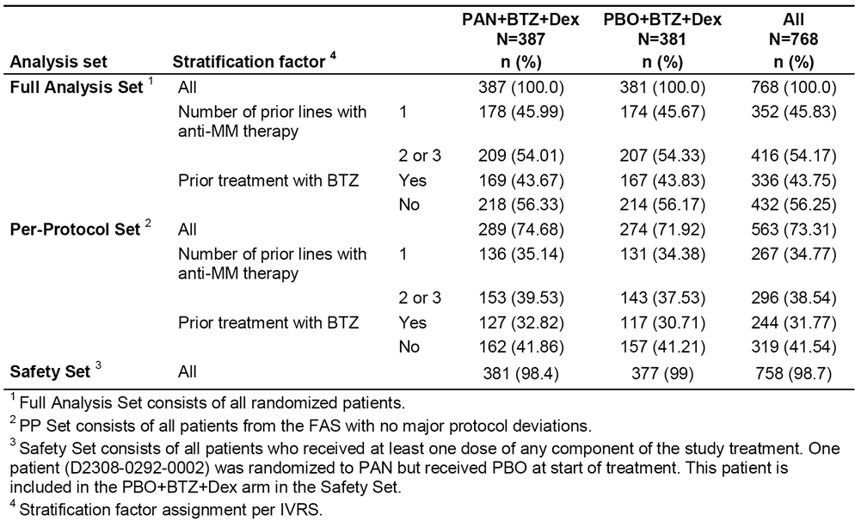

Sample size
In order to calculate sample size, the median PFS of the PBO+BTZ+Dex and PAN+BTZ+Dex arms were assumed to be 7.5 months and 10.2 months, respectively (HR=0.74). A two sided log-rank test with a cumulative type I error of α = 0.05 and a power of 1-β=90% was used for the 3 look group sequential plan. Under the above assumptions and using 1:1 randomisation to the two arms, a total of 460 PFS events were required. The PFS assumptions were based on the APEX study which compared BTZ with high dose Dex in patients with relapsed MM who had received one of three previous therapies.8 In APEX, the median time to progression (TTP) in the BTZ arm was 6.22 months, and data from the study was used as the basis for the assumption that median PFS in the PBO+BTZ+Dex arm would be 7.5 months.
Considering the original assumption of recruitment of 30 patients per month and a final primary PFS analysis after an anticipated duration of approximately 29 months after study start, it was expected that 762 patients would need to be randomised. This number acknowledges the observed rate, as of 22 November 2011, of approximately 20% for patients censored and no longer being followed-up for disease progression. It was specified that the final analysis for PFS was to be performed when approximately 460 events had been observed in the FAS.

Statistical methods

Interim analysis
The study was designed with a 3 look, group sequential design for the primary endpoint of PFS. Two interim analyses were planned after observing 33% and 80% of the required number of approximately 460 events for the final PFS analysis. These analyses allowed stopping for futility at the first interim analysis of PFS and efficacy at the second interim analysis of PFS. A separate 4 look group sequential design was planned for the key secondary endpoint of overall survival. Three interim analyses of OS were planned, two at the time of the two PFS interim analyses and one at the time of the final PFS analysis. The final OS analysis is planned to be undertaken after the final PFS analysis.
The first interim analysis of the PFS was undertaken per protocol when 164 PFS events had been observed (35.6% of the projected total). The analysis did not cross the stopping boundary for futility and the IDMC recommended that the study be continued without change. The planned second interim analysis of the PFS was not performed as a consequence of the implementation of protocol amendment 5 (that is, establishment of an IRC to assess the PFS based on mEMBT criteria). Accordingly, Novartis in agreement with the SSC elected to continue the study until the final number of approximately 460 PFS events had accrued (that is, the final analysis). There was no change in the group sequential design for the final analyses of PFS and OS; alpha was spent at each time point that an interim analysis had been planned. Additionally, 6-monthly interim analyses of safety were performed by the IDMC, and after each review the committee advised Novartis to continue the study with no changes.

Analysis of the primary efficacy endpoint (PFS)
- The primary analysis of PFS was done with a stratified log-rank test considering a cumulative type I error rate of α = 0.05, 2-sided. The hazard ratio (HR) for the treatment effect of PAN+BTZ+Dex over PBO+BTZ+Dex, together with the 95% CI, was estimated. The estimation was based on a proportional hazards model with treatment and the two randomisation strata used as stratification factors. Survivorship functions were estimated using the Kaplan-Meier (KM) product limit method. The 25th, 50th (median) and 75th percentile of time to PFS, together with the 95% CI, were reported for both treatment arms.
- Patients were censored for the following reasons:
- patient is ongoing in the study without PFS event;
- adequate response assessment not available;
- patient lost to follow-up due to withdrawal of consent;
- patient lost to follow up for reasons other than withdrawal of consent;
- patient started new cancer therapy; and (6) patient PFS event documented after ≥ 2 missing adequate response assessments preceding the PFS event.
- There were a number of sensitivity analyses of the PFS which repeated the statistical methods used for the primary analysis, but with alternative censoring rules. The sensitivity analyses and censoring rules for each analysis are summarised in Table 33.
- It was specified that a supportive analysis of the PFS using a multivariate analysis was to be undertaken if the primary of PFS was statistically significant. The following prognostic factors were included in the Cox proportional hazards model: sex (male/female); age (< 65 years/ ≥ 65 years); race (Caucasian/Asian/Other); renal impairment (yes/no); prior stem cell transplantation (yes/no); clinical staging of MM according to ISS (Stage I/Stage II and III); geographic region (Europe/South East Asia/Western Pacific/Africa/Americas/Eastern Mediterranean); prior use of IMiDs, defined as thalidomide or lenalidomide, (yes/no); use of IMiDs and BTZ (yes/no); MM characteristics (relapsed/relapsed and refractory). Several subgroup analyses were done for the listed variables in addition to the cytogenetic risk group. HRs (with 95% CIs) were provided based on the Cox proportional hazards model. This model includes treatment and stratification factors to derive estimates by subgroup. Point estimates of HR (with 95% CI) were provided by subgroup in a forest plot.

Table 33: D2308; Sensitivity analyses of the PFS
Analysis | Rules
Assess impact of missing response assessments (Actual event) | Regardless of the number of preceding missing assessments, the actual event date of progression, relapse or death was used as the PFS event date.
Assess impact of missing response assessments (Backdating event) | In case of a documented PFS event after 1 or more subsequent missing response assessments, PFS was considered to have occurred at the next scheduled response assessment after the date of the last adequate response assessment.
Assess impact of patients who are not followed any longer for disease assessments (Drop-out) | The following were considered as PFS events:  All patients who were censored in the primary analysis due to inadequate or lack of documented disease progression/relapse/death while having progressive disease as the reason for End of Treatment/Study Evaluation Completion were considered as a PFS event.  All patients who stopped disease follow-up due to new anti-cancer therapy. This applied for the following situations: (1) new anticancer therapy started (as documented on ANP CRF): The start date of new anticancer therapy was considered as a PFS event date. (2) Reason for End of Treatment /Study Evaluation Completion is the start of a new ANP: The date of documentation was considered as event date.  All patients whose PFS censoring reason was PFS event after ≥ 2 missing adequate assessments was considered as a PFS event. The date of the PD/ relapse/ death assessment was used as the PFS event date.  In case more than 1 criterion applies, the earliest date was used as the PFS event date.
Assess impact of using IRC  assessment | • Use Independent Review Committee (IRC) assessment instead of Investigator’s evaluation for all patients.  • Use IRC assessment for patients without M-protein assessment by electrophoresis and investigator’s evaluation for patients with Mprotein measurements.
Investigator assessment as Per Protocol Set analysis | Include only the Per Protocol Set in the analysis.
IRC assessment as per protocol set analysis | Include only the Per Protocol Set in the analysis
Assess impact of prognostic factors | Use multivariate Cox regression model including as prognostic factors: sex, age, race, renal impairment, prior stem cell transplantation, clinical staging of MM according to ISS (Stage I/Stage II and III), geographic region, prior use of IMiDs (defined as thalidomide or lenalidomide), prior use of IMiDs and BTZ, MM characteristics (relapsed/relapsed-and-refractory)

Analysis of the key secondary endpoint (OS)
- OS was the key secondary endpoint in a hierarchical testing procedure. OS was only tested if the primary endpoint of PFS was statistically significant. Irrespective of whether OS was tested or not, alpha for OS was spent according to the OS group sequential plan at each PFS analysis. If OS was not significant at the final analysis of PFS, a final OS analysis will be performed when approximately 415 OS events have been observed.
- At OS interim analyses, the information fraction was computed as the ratio of the number of events actually observed relative to the number targeted for the final analysis. The critical value for the final analysis will be calculated using the exact number of observed events at the final cut-off date, and considering the α levels spent at interim analyses, in order to achieve a cumulative type I error smaller than 0.5% for a 2-sided test.
- The HR (with 95% CI) for OS was estimated. The estimation was based on a proportional hazards model with treatment and the two strata used at randomisation as factors. Survivorship functions were estimated using the KM product limit method.

Analysis of the additional secondary efficacy endpoints (ORR, nCR/CR rate, MMR, TTR, DOR, TTP)
- The statistical methods used for the analysis of the additional secondary efficacy endpoints have been examined and are considered to be appropriate. The primary method of assessment was based on investigator determination of response.
- Sensitivity analyses of the ORR, TTR, DOR, and TTP were undertaken using IRC response assessment for all patients.
- Exploratory efficacy analyses of the sCR, CR and VGPR as derived from IMWG criteria were undertaken.

Patient reported outcomes
The FAS was used for all PRO summaries and listings. Descriptive statistics were used to summarise all scored scales/sub scores at each scheduled assessment for each questionnaire. Additionally, changes from baseline in the scales/sub scores at the time of each assessment were analysed using repeated measures model.

Changes in the conduct of the study or planned analyses
The study protocol was amended five times:
- Amendment 1: country specific amendment (Japan) relating to (1) treatment in order to comply with Japanese prescribing information for bortezomib (hospitalisation during first cycle), (2) PK sampling schedule, and (3) addition of commercially available bortezomib.
- Amendment 2: adjustment to sample size from 672 to 762 to compensate for a higher than expected dropout rate due mainly to patients withdrawing consent.
- Amendment 3: the definition or PFS was clarified as an event of progression, relapse or death; additional secondary endpoint added (nCR + CR); changes to the statistical analysis of the second proposed interim analysis to make it more robust.
- Amendment 4: clarification of the method used to calculate serum calcium variables.
- Amendment 5: response assessments to be undertaken by an IRC; and changes to the assessment of M-protein criteria (that is, PEP results without specific measurement of the M-protein spike), and use of measurement methods other than PEP.
The protocol amendments were undertaken prior to study unblinding. The protocol amendments are considered not to have affected the interpretation of the results.
There were a number of amendments to the statistical analysis plan, the majority of which were made prior to the database lock. The amendments to the statistical analysis plan have been examined and are considered not to have affected the analysis provided in the CSR.

Participant flow
Between 29 January 2010 and 12 March 2012, a total 768 patients with relapsed or relapsed/refractory multiple myeloma were randomised 1:1 to PAN+BTZ+Dex (387 patients) or PBO+BTZ+Dex (381 patients). Randomisation was stratified by the number of prior lines of therapy (1 versus 2 or 3) and prior use of bortezomib (yes versus no). The patient disposition is summarised in Table 34.
As of the 10 September 2013 data cut-off, all patients had completed study treatment, and 41 patients (10.7%) continued to be followed-up for post treatment disease outcome in the PAN+BTZ+Dex arm compared to 17 patients (4.5%) in the PBO+BTZ+Dex arm. Disease progression as a primary reason for treatment discontinuation was reported in a higher proportion of patients in the PBO+BTZ+Dex arm (40.2%) compared to the PAN+BTZ+Dex arm (21.2%). AEs as a reason for treatment discontinuation were reported more frequently in the PAN+BTZ+Dex arm (33.6%) compared to the PBO+BTZ+Dex arm (17.3%). Death as the primary reason for the end of treatment was reported in a higher proportion of patients in the PAN+BTZ+Dex arm than in the PBO+BTZ+Dex arm (5.4% versus 4.5%). The proportion of patients in whom treatment duration had been completed per protocol was similar in the PAN+BTZ+Dex and PBO+BTZ+Dex arms (26.4% versus 26.8%, respectively).

Table 34: D2308; Patient disposition; FAS
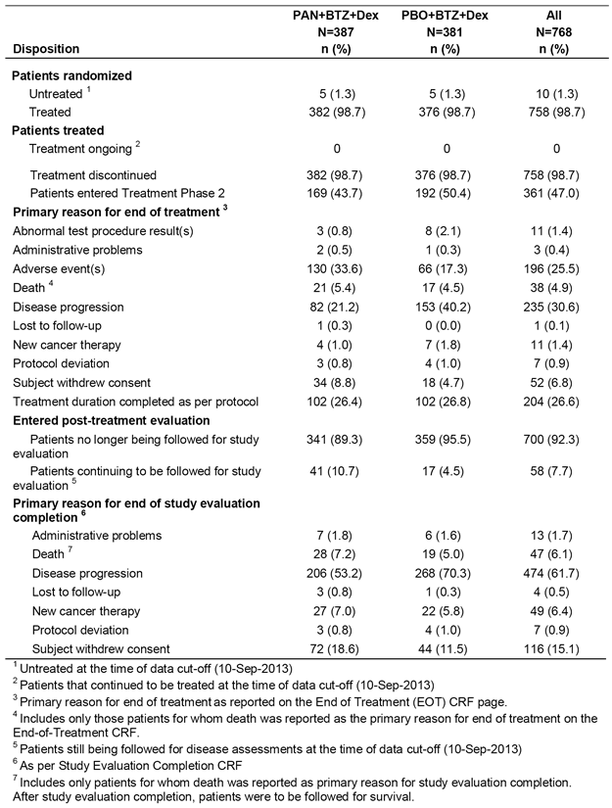

Major protocol violations
The two treatment arms were balanced with regard to the number of major protocol deviations (98 (25.3%) patients in the PAN+BTZ+Dex arm; 107 (28.1%) patients in the PBO+BTZ+Dex arm). The most frequently reported major protocol deviation was missing efficacy baseline assessment (77 (19.9%) patients in the PAN+BTZ+Dex arm; 86 (22.6%) patients in the PBO+BTZ+Dex arm). The missing assessments may have included missing serum M-protein, urine M-protein, soft tissue plasmacytoma, bone lesion, and patients without M-protein measurement as per mEBMT criteria. The major protocol deviations were summarised and provided.
Comment: The high proportion of patients with missing baseline efficacy assessments is a matter of concern as it raises questions about the conduct of the study. The sponsor is requested to comment on the high proportion of patients with major protocol violations due to missing baseline efficacy assessments.

Baseline data

Baseline demographics
The baseline demographics were well balanced between the two treatment arms. The mean age of the total population (n = 768) was 62.1 years (range: 28, 84 years), and 42.1% (n = 323) were aged ≥ 65 years. The sexes were well balanced, 407 males (53.0%) and 361 females (47.0%). The majority of patients were Caucasian (65.0%, n = 499) with most of the remaining being Asian (30.2%, 30.2%), while Black and other racial groups accounted for 2.9% and 2.0% of the population, respectively. The ECOG performance status was ≤ 1 for the majority of patients (93%, n = 714) (that is, status 0 = fully active; status 1 = restricted in physically strenuous activity but ambulatory and able to carry out work of a light or sedentary nature).

Baseline disease characteristics
The baseline disease characteristics were well balanced between the two treatment arms. The median time from diagnosis was 37.1 months in the PAN+BTZ+Dex arm and 38.9 months in the PBO+BTZ+Dex arm. Clinical staging was undertaken using ISS criteria; 40.1% of all patients were ISS Stage I, 25.5% were ISS Stage II, and 21.2% were ISS Stage III.

Baseline treatment histories
The baseline treatment histories for MM were well balanced between the two treatment arms. A total of 439 (57.2%) patients had undergone previous autologous stem cell transplantation (ASCT). A total of 330 patients (43.0%) had been treated with prior lines of bortezomib, 395 (51.4%) patients had been treated with 1 line of prior antineoplastic therapy, and 372 (48.4%) patients had been treated with 2 or more prior lines of antineoplastic therapy. Of the total population, 275 (35.8%) were considered to be relapsed and refractory and 482 (62.8%) patients were considered to be relapsed.

Concomitant medications
Concomitant medications prior to the start of treatment were being taken by 29.9% (n = 114) of patients in the PAN+BTZ+Dex arm and 28.9% (n = 109) of patients in the PBO+BTZ+Dex arm. A wide variety of medications were being taken and the pattern was similar for the two treatment groups.

Results for primary efficacy endpoints

Primary analysis
The results for the primary efficacy analysis of PFS based on investigator assessment using mEMBT are summarised below in Table 35. The median PFS was 12 months in the PAN+BTZ+Dex arm and 8.1 months in the PBO+BTZ+Dex arm: HR = 0.63 (95% CI: 0.52, 0.76); p < 0.0001. The median PFS was 3.9 months longer in the PAN+BTZ+Dex arm than in the PBO+BTZ+Dex arm. The proportion of disease progression events was lower in the PAN+BTZ+Dex arm compared to the PBO+BTZ+Dex arm, while the proportion of both relapse from CR events and deaths was higher in the PAN+BTZ+Dex arm compared to the PBO+BTZ+Dex arm. The KM curves separated at approximately 2 months in favour of the PAN+BTZ+Dex arm compared to the PBO+BTZ+Dex arm, and the separation was maintained over the course of the study.

Table 35: D2308; Analysis of PFS based on investigator assessment using mEMBT; FAS
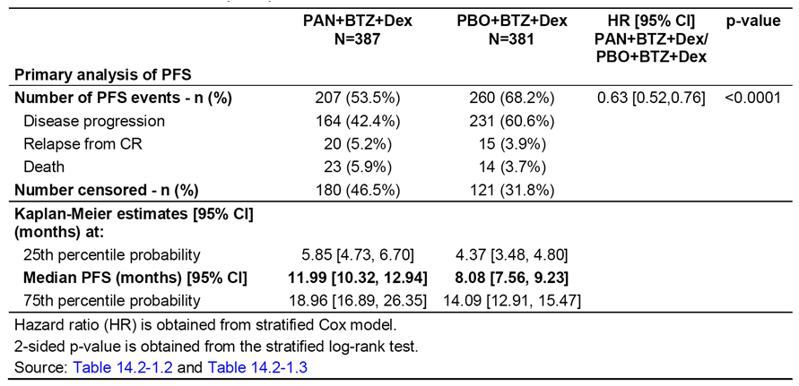

Proportion of patients censored in the primary PFS analysis
The proportion of patients censored was high in both the PAN+BTZ+Dex arm and the PBO+BTZ+Dex arm (46.5%, n = 180 versus 31.8%, n = 121, respectively). The reasons for PFS censoring are summarised below in Table 36.

Table 36: Study D2308; Summary of PFS censoring, investigator assessment based on mEMBT criteria
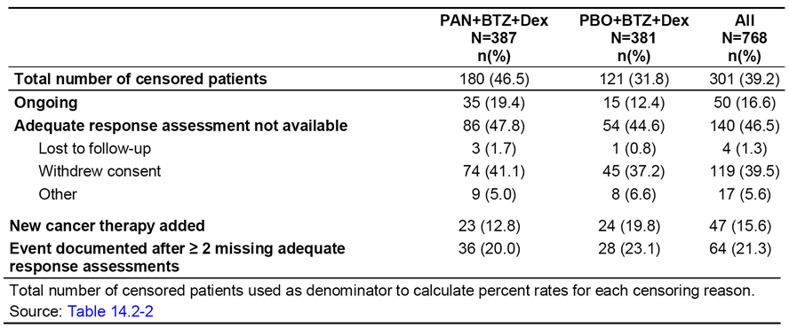
Comment: In this study, censoring was particularly high in non-ongoing patients (that is, dropouts) who contributed no data to the PFS assessment due to the censoring rules (that is, n = 145 (37.5%) in the PAN+BTZ+Dex arm; n = 106 (27.8%) in the PBO+BTZ+Dex). The high dropout rate in both treatment arms has the potential to bias the results of the primary analysis, leading to uncertainty about the accuracy of the observed PFS treatment effect. In addition, the notably higher rate of patients in the total population censored due to withdrawn consent in the PAN+BTZ+Dex arm compared to the PBO+BTZ+Dex arm suggests that the combination was less well tolerated in the ‘PAN’ arm (19.1% (n = 74) versus 11.8% (n = 45)). Censoring due to new cancer therapy being added was reported in a similar proportion of the total number of patients in both treatment arms (that is, n = 23 (5.9%) in the PAN+BTZ+Dex arm and n = 24 (6.3%) in the PBO+BTZ+Dex arm).

Pre-specified sensitivity analysis of PFS
Multiple pre-specified sensitivity analyses of the PFS were undertaken, with the pairwise comparisons consistently statistically significantly favouring the PAN+BTZ+Dex arm compared to the PBO+BTZ+Dex arm, with the HRs ranging from 0.58 to 0.71 (see Table 37).
Comment: While the sensitivity analyses for the PFS all statistically significantly favoured the PAN+BTZ+Dex arm over the PBO+BTZ+Dex arm, the median PFS difference between the two treatments ranged from 4.9 to 1.8 months across the analyses. The variation in the effect size across the sensitivity analyses is a matter of concern as it raises doubts about the accuracy of the effect size observed in the primary analysis. The observed differences in effect size across the sensitivity analyses are particularly problematic as the differences include results that can be categorised as not clinically significant (that is, median difference < 2.7 months).

Table 37: Summary of sensitivity analyses of PFS (mEBMT criteria) (FAS)
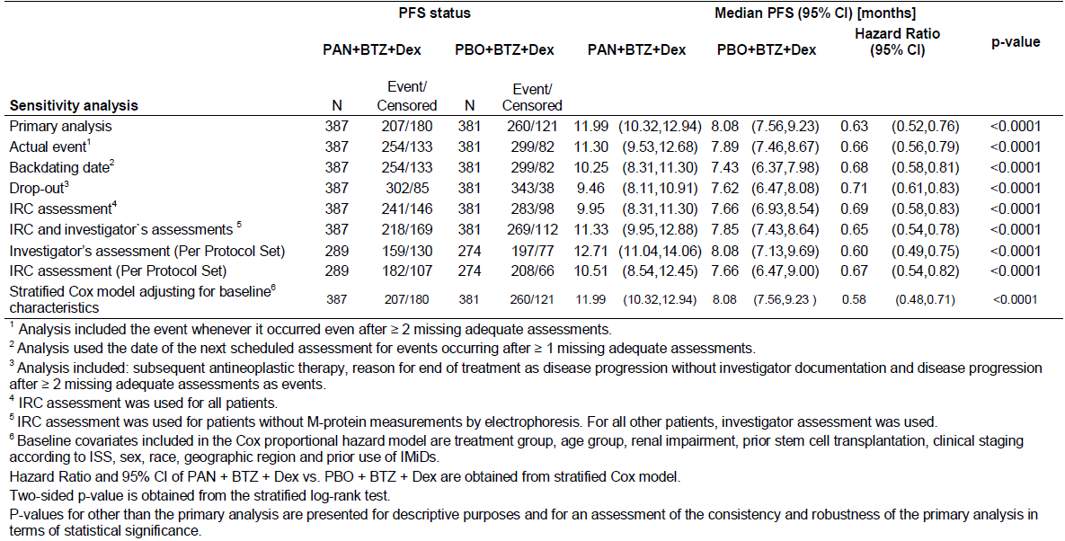

Pre-specified ‘dropout’ sensitivity analysis
The ‘dropout’ sensitivity analysis was designed to assess the impact of missing PFS events from patients who were censored in the primary analysis due to inadequate or lack of documented PFS events, or due to starting new anti-cancer therapy, or with a documented PFS event occurring after ≥ 2 missing adequate assessments. In this sensitivity analysis, ‘progressive disease’ was considered to be the reason for the end of treatment or study completion, or starting new anti-cancer therapy, or any investigator response assessment of progressive disease irrespective of the number of missing adequate response assessments.
In this sensitivity analysis, there were 302 PFS events in 387 patients in the PAN+BTZ+Dex arm (that is, 78.0%) and 343 events in 381 patients in the PBO+BTZ+Dex arm (that is, 90.0%). In the PAN+BTZ+Dex arm, 85 (22%) patients were censored and in the PBO+BTZ+Dex arm 38 (10%) patients were censored. The median PFS was 9.46 months in the PAN+BTZ+Dex arm and 7.62 months in the PBO+BTZ+Dex arm (that is, difference of 1.8 months); HR = 0.71 (95% CI: 0.61, 0.83). The difference in median PFS between the two treatment arms in this sensitivity analysis of 1.8 months was inconsistent with the difference in median PFS of 3.9 months observed in the primary efficacy analysis.

Pre-specified sensitivity analysis by IRC assessment of PFS using mEMBT criteria
Of particular importance, the sensitivity analysis by IRC assessment using mEMBT showed that the difference in median PFS between the two treatment arms was 2.3 months (9.95 months for the PAN+BTZ+Dex arm versus 7.66 months for the PBO+BTZ+Dex arm; HR = 0.69 (95% CI: 0.58, 0.83), p < 0.0001). The difference in median PFS in this sensitivity analysis was numerically inconsistent with the corresponding result for the primary analysis (that is, 2.3 and 3.9 months, respectively). The results for the IRC assessment of PFS using mEMBT criteria are summarised below in Table 38.

Table 38: D2308; Analysis of PFS based on IRC assessment using mEMBT; FAS
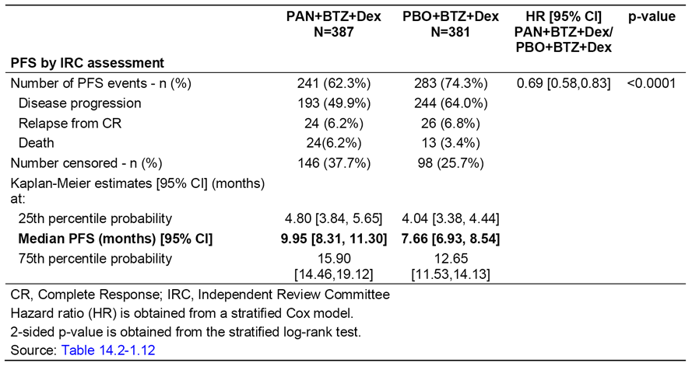

PFS for patients with and without M-protein measurement
For efficacy assessments, the study protocol required measurement of M-protein spikes by PEP in serum and urine as per mEBMT criteria. Sites participating in the study used their local laboratories to perform the M-protein assessments. However, it was discovered that some patients were being monitored using either PEP without specific measurement of the M-protein spike (for example, globulin gamma fraction was used as the indicator for an IgG M-component) or by alternative methods, other than PEP (for example, nephelometric quantification of immunoglobulin levels). Accordingly, protocol amendment 5 (issued 6 May 2013) provided for documentation of PEP results without specific measurement of the M-protein spike, and use of measurement methods other than PEP.
A total of 193 patients (25.1%) had at least one assessment without M-protein measurement as per mEBMT criteria, 95 patients (24.5%) in the PAN+BTZ+Dex arm and 98 (25.7%) patients in the PBO+BTZ+Dex arm. The protocol amendment provided for sensitivity assessment of the PFS using investigator assessment for patients with protocol defined M-protein evaluations using mEMBT criteria, and IRC assessment for patients with unavailable M-protein measurements whose disease was monitored using total globulins and/or nephelometric quantification of immunoglobulin levels. In this analysis, the median PFS was 11.3 months in the PAN+BTZ+Dex arm and 7.9 months in the PBO+BTZ+Dex arm: HR = 0.65 (95% CI: 0.54, 0.78); p < 0.0001. The treatment difference between the two treatment arms was 3.4 months, which is numerically consistent with the results for the primary analysis. The complete results for this sensitivity analysis are summarised in Table 39.

Table 39: D2308; Analysis of PFS based on IRC assessment for patients without protocol defines M-protein evaluations and by investigator evaluation for all other patients; FAS
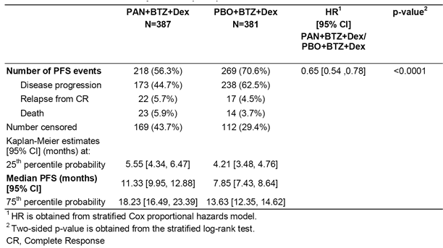

PFS by stratification factor, investigator assessment using mEMBT criteria
Randomisation was stratified based on
- the number of prior lines of anti-myeloma therapy (1 versus 2 or 3) and
- prior use of BTZ (yes versus no).
The results for PFS (investigator's assessment using mEMBT criteria) based on the stratification factors were consistent with the results for the primary efficacy analysis.

Subgroup analysis of PFS, investigator assessment using mEMBT criteria
The subgroup analyses of the PFS, based on investigator assessment using mEBMT criteria, are summarised by forest plot in Figure 12. The results consistently favoured the PAN+BTZ+Dex arm compared to the PBO+BTZ+Dex arm. In the subgroup of patients with prior use of an immunomodulatory agent and BTZ the HR was 0.53 (95% CI: 0.37, 0.76), with 95 patients in the PAN+BTZ+Dex arm (56/39 (events/censored)) and 103 patients in the PBO+BTZ+Dex arm (73/30 (events/censored)).
Figure 12: D2308 - Forest plot of PFS (mEMBT criteria per investigator), hazard ratio by subgroup; FAS
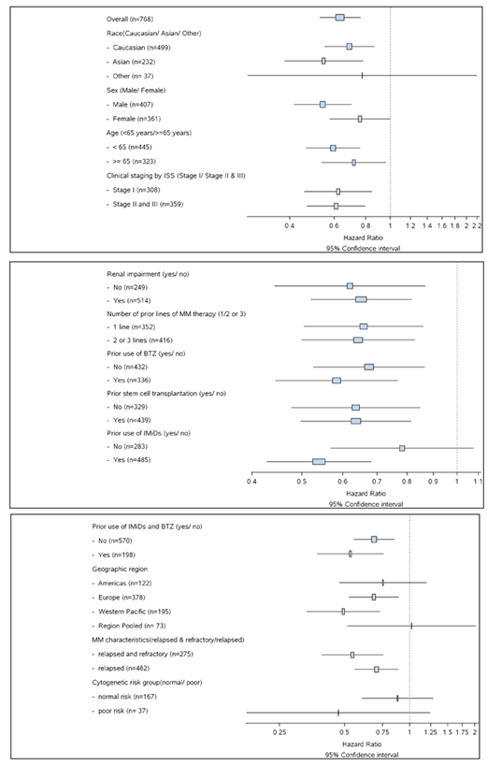

Results for other efficacy outcomes

Key secondary efficacy outcome; Overall Survival (OS)
At the time of data cut-off for Study D2308 (10 September 2015), the OS data were immature with a total of 286 OS events being observed prior to the cut-off date, corresponding to 68.9% of the 415 OS events planned for the final OS analysis. In the interim OS analysis at the time of the data cut-off date, OS was not statistically significantly different between the two treatment arms (log-rank, p value = 0.2586) with an estimated HR of 0.87 (95% CI: 0.69, 1.10). Median OS was 33.6 months for patients in the PAN+BTZ+Dex arm and 30.4 months for patients in the PBO+BTZ+Dex arm. The results are summarised below in Table 40, and the KM curves are presented in Figure 13.

Table 40: Study D2308; Interim analysis of overall survival; FAS
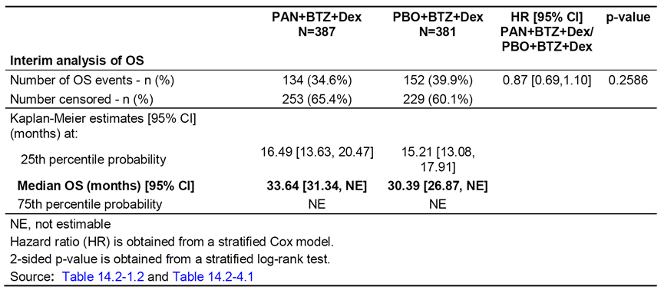
Figure 13: D2308 - Kaplan-Meier curves of OS by treatment group; FAS
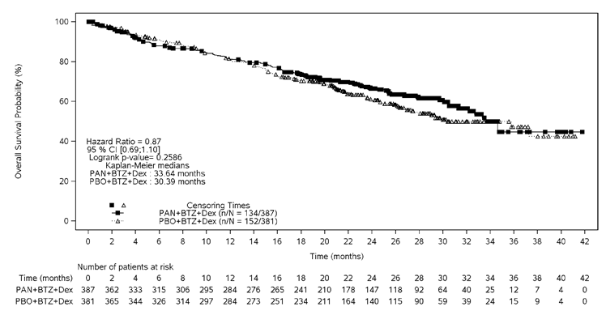

Additional secondary efficacy endpoints
The pre-specified additional secondary endpoints were based on investigator assessment using mEMBT criteria. The results for the pre-specified additional endpoints and the exploratory endpoints are summarised below in Table 41. The complete results for the ORR endpoint analyses based on investigator assessment using mEMBT criteria (primary analysis) and IRC assessment using mEMBT criteria (sensitivity analysis) assessments using mEMBT criteria were provided. The complete results for the TTR, DOR and TTP endpoint analyses based on investigator assessment using mEMBT criteria (primary analysis) and IRC assessment using mEMBT criteria (sensitivity analysis) were provided.

Table 41: D2308; Efficacy results for the additional secondary endpoints and exploratory endpoints; FAS
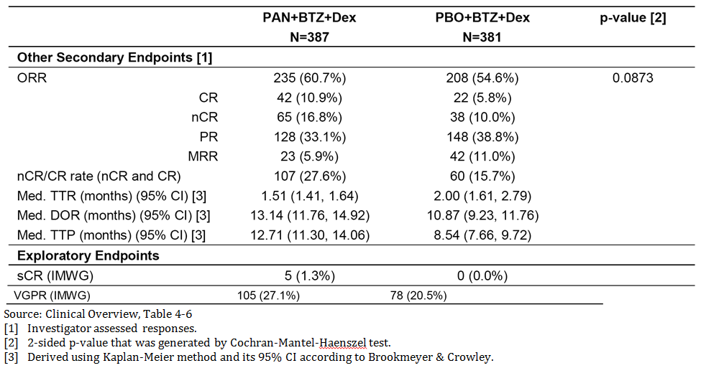

Patient reported outcomes
- Overall compliance rates of patients completing the EORTC QLQ-C30, QLQ-MY20, and FACT/GOG-NTX questionnaires were high for patient’s on-study at the time of assessment for both treatment groups. However, the number of patients on-study at the time of assessment decreased in both treatment arms over the study period in both treatment arms and compliance rates at the study completion visit were poor due to the absence of in-office assessment at this time-point. Missing data from later study assessments may introduce a bias in the patterns observed for PROs with these data. Consequently, the PRO data should be interpreted cautiously.
- The EORTC QLQ-C30 global health status/QoL scores initially worsened in both treatment arms over the study treatment period, before moving back towards baseline levels after Week 18 in both treatment arms (see Figure 14). Mean decrease from baseline scores in global health status/QOL (that is, worsening) exceeded the defined minimum important change threshold for clinical relevance (that is, decrease of more than 5 points) in the PAN+BTZ+Dex arm. The decrease in mean score, indicating worsening, was generally observed in the first 18 weeks and may have been driven by toxicity. The results for each of the functional scales were numerically superior in the PBO+BTZ+Dex arm compared to the PAN+BTZ+Dex arm. The median time to definitive deterioration in the EORTC QLQ-C30 global health status/QOL was 2.33 months (95% CI: 1.97, 2.79) in the PAN+BTZ+Dex arm and 2.83 months (95% CI: 2.76, 3.02) in the PBO+BTZ+Dex arm, with a HR of 1.26 (95% CI: 1.05, 1.50) in favour of the PBO+BTZ+Dex arm. Overall, the results suggest that treatment with PAN+BTZ+Dex was more detrimental to patient wellbeing than treatment with PBO+BTZ+Dex.
Figure 14: D2308; EORTC QLQ-C30 global health status/QoL score, change from baseline by treatment group; FAS
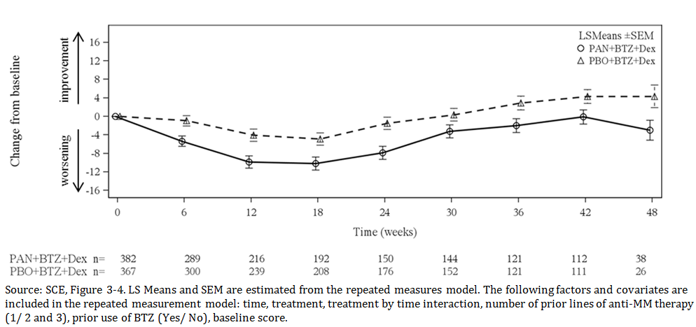
- The EORTC QLQ-MY20 symptom scores showed improvement from baseline over the duration of the study in both treatment arms, with no relevant differences between the two treatment arms (see Figure 15). The median time to definitive deterioration in the disease symptom score was 4.40 months (95% CI: 3.61, 5.55) in the PAN+BTZ+Dex arm and 4.96 months (95% CI: 4.17, 6.97) in the PBO+BTZ+Dex arm; HR=1.18 (95% CI: 0.97, 1.45).
Figure 15: Study D2308; EORTC QLQ-MY20 disease symptom score, change from baseline by treatment group; FAS
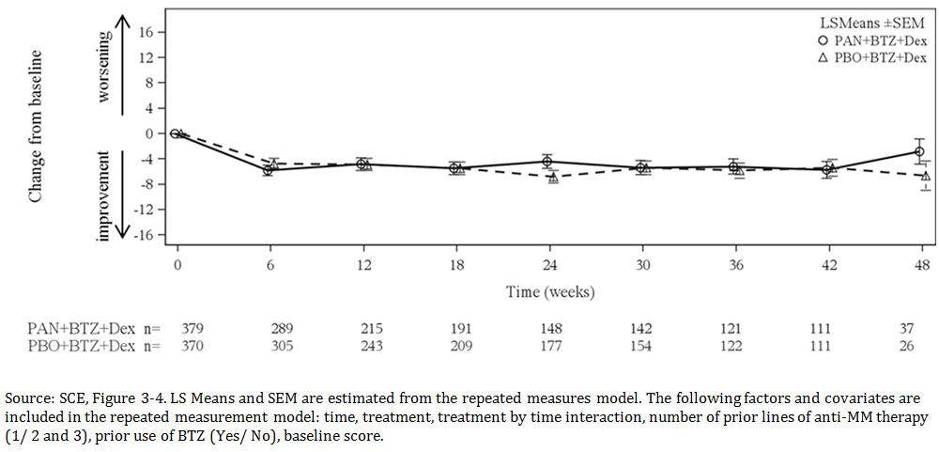
- In the FACT/GOG-NTX neurotoxicity subscale, mean changes from baseline scores indicated initial worsening before stabilising over time in both treatment arms, with no relevant difference in scores between the two treatment arms (see Figure 16). The median time to definitive deterioration in the neurotoxicity subscale was 2.83 months (95% CI: 2.79, 3.29) in the PAN+BTZ+Dex arm and 3.65 months (95% CI: 3.06, 4.21) in the PBO+BTZ+Dex arm; HR=1.19 (95% CI: 0.99, 1.43).
Figure 16: Study D2308; FACT/GOG-NTX neurotoxicity scale, change from baseline by treatment group; FAS
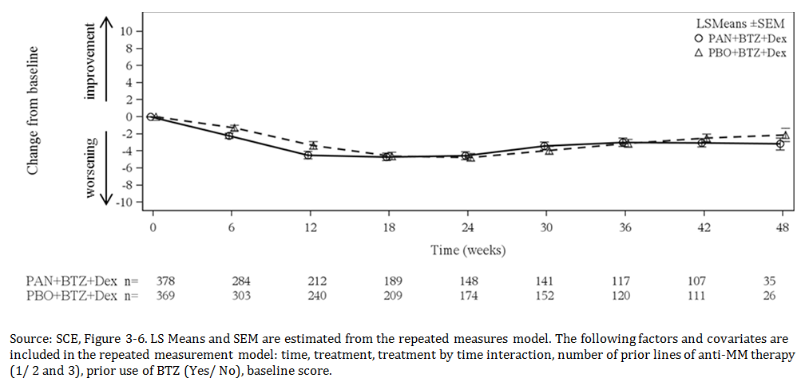
- The results for change from baseline at Week 12 in the patient's global disease severity based on patient reported and investigator reported assessments are summarised below in Table 42. The proportion of patients with ‘No change’ or with disease severity ‘Improved’ at Week 12 was higher in the PBO+BTZ+Dex arm than in the PAN+BTZ+Dex arm. However, these results should be interpreted with caution due to the high number of missing assessments from patients and investigators in both treatment arms.

Table 42: Study D2308: Summary of patient reported and investigator reported global severity questions by treatment group; FAS
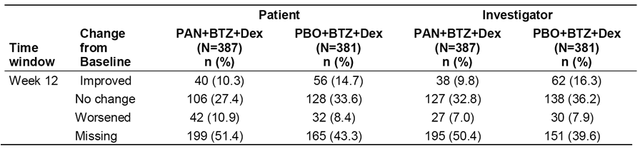

Other efficacy studies

Study DUS71
Study DUS71 was a Phase II, multi-centre (12 sites in the USA), single arm, open label study of PAN+BTZ+Dex in patients with relapsed and BTZ-refractory MM. The primary objective of the study was to evaluate the ORR (CR+nCR+PR) after 8 cycles of therapy as per mEMBT criteria based on investigator assessment. The first patient was enrolled on 22 June 2010 and the cut-off date for the analysis was 4 December 2012. The CSR was dated 12 February 2014. The study protocol and all amendments were reviewed by an IEC or IRB at each participating site, and the study was conducted in accordance with the ethical principles of the Declaration of Helsinki.
The study enrolled subjects with relapsed and refractory MM, which was refractory to BTZ and required treatment for relapsed disease. In addition, patients were required to have been treated with at least 2 prior lines of therapy which included an IMiD (thalidomide or lenalidomide). The inclusion criteria included, but were not limited to, patients with a previous diagnosis of MM based on IMWG criteria. All three of the following criteria must have been met:
- monoclonal immunoglobulin (M component) on electrophoresis and on immunofixation in serum or in total urine;
- bone marrow (clonal) plasma cells ≥ 10% or biopsy proven plasmacytoma; and
- related organ or tissue impairment.
The inclusion and criteria have been examined and are considered to be appropriate. All patients in the study were treated with single arm PAN+BTZ+Dex. The treatment doses were PAN 20 mg, BTZ 1.3 mg/m² and Dex 20 mg. The dosing schedules in the two treatment phases are summarised below in Figure 17.
Figure 17: Study DUS71; Treatment Phases 1 and 2 for panobinostat, bortezomib, and dexamethasone
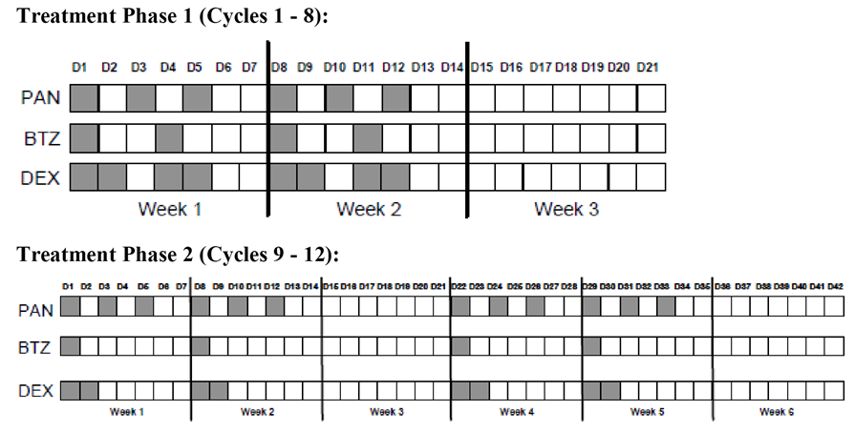
A total of 55 patients were enrolled between 22 June 2010 and 23 August 201, and 2 patients were ongoing at the time of the data cut-off (4 December 2011). The median duration of therapy was 139.0 days (range: 2, 735 days). The primary reasons for discontinuing treatment were disease progression (36 patients, 65.5%), AEs (10 patients, 18.2%), withdrawal of consent (5 patients, 9.1%), death (1 patient, 1.8%), and start of a new cancer therapy (1 patient, 1.8%). A total of 28 patients (50.9%) had died by the cut-off date. Four patients died while on treatment or within 28 days after end of treatment (three deaths due to disease progression/MM and one due to influenza), and 23 after discontinuation of treatment while being followed for survival. There was one additional death during the treatment follow-up period.
The mean age of the study population in the FAS (n = 55) was 61.9 years (range: 41, 88 years), with 38.2% (n = 21) of the population being aged ≥ 65 years. The majority of the population was Caucasian (78.2%, n = 43) and the remainder was Black (21.8%, n = 12). Nearly all patients had a baseline ECOG status of 0 or 1 (92.8%, n = 41). The median time from diagnosis was 54.8 months (range: 7.5, 263.3 months), and ISS staging 1, 2, and 3 was 32.7% (n = 18), 41.8 % (n = 23), and 23.6% (n = 13), respectively. The mean ± SD serum M-protein was 26.0 ± 16 g/L, the mean ± SD urine protein was 1212 ± 2056 mg/24 hours and the mean bone marrow plasma cell count was 35.4 ± 23.9% (range: 0, 88%). Of the total population, 32.7% (n = 18) had received 2 to 3 prior lines of prior antineoplastic medication and 67.3% (n = 37) had received > 3 lines of prior antineoplastic medication. All patients had been previously treated with BTZ, 98.2% (n = 54) with lenalidomide, 69.1% (n = 38) with thalidomide and 43.6% (n = 24) with melphalan. Of the total population, 63.3% (n = 35) had been previously treated with stem cell transplantation and 29 had responded.
The primary endpoint, ORR based on investigator assessment per mEBMT criteria at the end of treatment phase 1 (that is, end of cycle 8 assessment) was achieved by 34.5% (19/55) of patients (95% CI: 22.2%, 46.7%; p < 0.0001). The ORR was statistically significant as the null hypothesis was rejected (that is, response rate ≤ 10%). No patients achieved a CR, 1 (1.8%) patient achieved nCR and 18 patients (32.7%) achieved a PR. The minimal or better response rate was 52.7% (n = 29). The results are summarised below in Table 43.

Table 43: Study DUS71; Summary of overall response rate and ≥ minimal response rate
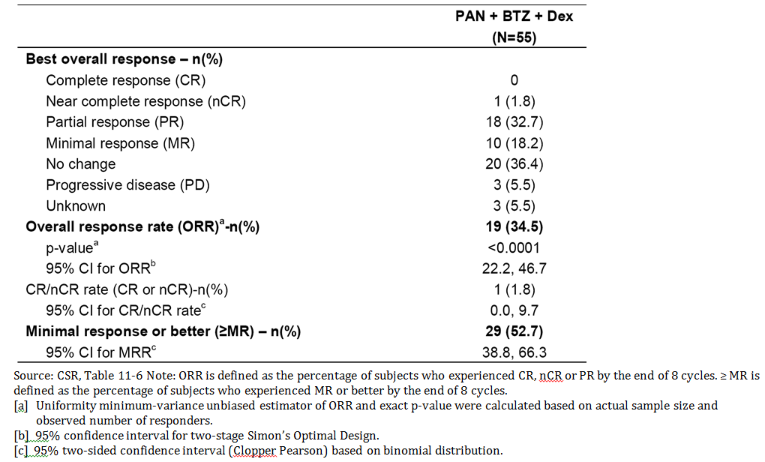
The KM estimate for median PFS (a secondary efficacy endpoint) was 164.0 days (95% CI: 107.0, 204 days) and the number of PFS events was 39 (70.9%). The median follow-up time for PFS was 18 weeks (range: 0.1, 99.1 weeks). PFS was defined as the time from the date of first study treatment to first occurrence of documented PD/relapse or death. Patients who did not have documented PD/relapse/death by the data cut-off date were censored at the date of last adequate response assessment prior to the cut-off date. The KM estimate for median OS (a secondary efficacy endpoint) was 534 days (95% CI: 329, 767 days), and the number of deaths was 28 (50.9%). The median follow-up time for OS was 54.1 weeks (range: 0.6, 109.6 weeks).

Study B2207
The main features of this study consisting of a Phase IA dose escalation phase (Cycle 1) followed by Phase II dose expansion phase (Cycle 2 onwards) have been previously discussed. The study included no primary efficacy endpoints, but the secondary efficacy endpoints included preliminary assessment of efficacy. In the dose expansion phase, 14 patients in the efficacy set were treated with PAN 20 mg + BTZ 1.3 mg/m² + Dex 20 mg with the best overall response (ORR = sCR + CR + VGPR + PR) being 71.4% (95% CI: 41.9%, 91.6%); that is, 10 out of 14 patients included in the ORR analysis (sCR = 0, CR = 0, VGPR = 3, PR = 7). The efficacy set consisted of all patients in the FAS with measurable disease at baseline defined by IMWG criteria. In the dose expansion phase, the mean duration of exposure to the proposed treatment regimen in 16 patients was 178 days (range: 45, 353 days).

Evaluator's overall conclusions on clinical efficacy
The submitted efficacy data for the PAN+BTZ+Dex regimen for the proposed indication was primarily derived from the pivotal efficacy and safety study (Study D2308), and two supportive open label, single arm studies (DUS71, B2207).
In the pivotal study (Study D2308), the primary efficacy analysis was investigator assessment of PFS using mEMBT criteria. This analysis showed a statistically significant 3.9 month increase in median PFS for patients in the PAN+BTZ+Dex arm (n = 387) compared to patients in the PBO+BTZ+Dex arm (n = 381). The median PFS was 12.0 months (95% CI: 10.3, 12.9 months) in the PAN+BTZ+Dex arm (n = 387) and 8.1 months (95% CI: 7.6, 9.2 months) in the PBO+BTZ+Dex arm; HR = 0.63 (95% CI: 0.52, 0.76); p < 0.0001. The study was powered on an assumption that the difference in the median PFS between the two treatment arms would be 2.7 months.
In the primary PFS analysis (disease progression/relapse/death), disease progression was reported more frequently in the PBO+BTZ+Dex arm compared to the PAN+BTZ+Dex arm (60.6% versus 42.4%, respectively), while death was reported more frequently in the PAN+BTZ+Dex arm than in the PBO+BTZ+Dex arm (5.3% versus 3.7%, respectively) as was relapse (5.2% versus 3.9%, respectively).
The major limitation of the primary analysis of the PFS was the significant proportion of the total number of patients in the study who were censored in both, the PAN+BTZ+Dex and the PBO+BTZ+Dex arms (46.5%, n = 180 and 31.8%, n = 121, respectively). Furthermore, censoring was high in non-ongoing patients (that is, dropouts) who contributed no data to the primary analysis of PFS due to the censoring rules (that is, n = 145 (37.5%) in the PAN+BTZ+Dex arm; n = 106 (27.8%) in the PBO+BTZ+Dex). The high dropout rate in both treatment arms due to the censoring rules has the potential to bias the results of the primary analysis of PFS, leading to uncertainty about the accuracy of the observed treatment effect.
In a PFS sensitivity analysis aimed at assessing the impact missing data from non-ongoing censored patients had on the primary analysis, the difference in median PFS between the PAN+BTZ+Dex arm and the PBO+BTZ+Dex arm was 1.8 months (that is, 9.46 months versus 7.62 months, respectively); HR = 0.71 (95% CI: 0.61, 0.83); p < 0.0001. This PFS sensitivity analysis (‘dropout’) reduced the median PFS difference between the two treatment arms by 54% relative to the primary PFS analysis (that is, from 3.9 to 1.8 months). The results of the PFS sensitivity analysis (‘dropout’) suggest that missing data from these patients might have biased the primary analysis towards the PAN+BTZ+Dex arm.
In another key PFS sensitivity analysis based on IRC assessment using mEMBT criteria, the difference in the median PFS between the two treatment arms was 2.3 months (that is, median PFS of 10 months in the PAN+BTZ+Dex arm and 7.7 months in the PBO+BTZ+Dex arm): HR = 0.69 (95% CI: 0.58, 0.83); p < 0.0001. In general, IRC assessment of PFS can be considered to be less prone to bias than investigator assessment due to all assessments being undertaken by the same group of assessors, with less scope for subjective interpretation among site specific investigators.
Although the difference in median PFS between the two treatment arms was statistically significant for both the investigator and IRC assessments using mEMBT criteria, the numerical difference between the two analyses raises uncertainty about the true effect size (that is, 3.9 months versus 2.3 months, respectively). Furthermore, the difference between the two treatment arms in median PFS based on IRC assessment using mEMBT criteria of 2.3 months was less than the pre-specified difference of 2.7 months between the two treatment arms used to power the study. Based on the power calculation assumptions, it is reasonable to infer that a PFS difference of 2.7 months represents the minimum clinically meaningful difference between the two treatment arms for patients with relapsed or relapsed/refractory MM included in the pivotal study. Consequently, the numerical difference in PFS between the two treatment arms of 2.3 months based on IRC assessment using mEMBT criteria is not only inconsistent with the corresponding result observed for the primary analysis, but is also of doubtful clinical significance in the context of the pivotal study.
In addition, it is of concern that censoring for the primary PFS analysis due to withdrawal of consent was reported in a notably higher proportion of patients in the PAN+BTZ+Dex arm compared to the PBO+BTZ+Dex Arm (74 (19.1%) versus 45 (11.8%), respectively). This raises the possibility that treatment with PAN+BTZ+Dex was less well tolerated than treatment with PBO+BTZ+Dex, resulting in more patients withdrawing consent to continued treatment in the ‘PAN’ arm than in the ‘PBO’ arm. In contrast, censoring due to new cancer therapy being added was reported in a similar proportion of the total number of patients in both treatment arms (that is, n = 23 (5.9%) in the PAN+BTZ+Dex arm and n = 24 (6.3%) in the PBO+BTZ+Dex arm).
OS was a key secondary efficacy endpoint in the pivotal study. However, the OS data at the data cutoff date were immature as only 68.9% (n = 286) of the 415 OS events planned for the final analysis had occurred. In the interim analysis, OS based on investigator assessment was not statistically significantly different between the two treatment arms with a median OS of 33.6 months for patients in the PAN+BTZ+Dex arm and 30.4 months for patients in the PBO+BTZ+Dex arm; HR = 0.87 (95% CI: 0.69, 1.10), p = 0.2586.
There were a number of other key secondary efficacy endpoints based on investigator assessment of mEMBT criteria. The analyses of these endpoints consistently showed a numerical advantage for the PAN+BTZ+Dex arm compared to the PBO+BTZ+Dex arm (that is, ORR, nCR/CR rate, median TTR, median DOR, and median TTP). However, there was no statistically significant difference between the ORR based on investigator assessment using mEMBT criteria in the PAN+BTZ+Dex arm compared to the PBO+BTZ+Dex arm (60.7% versus 54.6%; p = 0.0873)
Patient reported outcomes showed no advantage for patients treated with PAN+BTZ+Dex compared to patients treated with PBO+BTZ+Dex (for example, EORTC QLQ-C30, QLQ-MY20, and FACT/GOG-NTX questionnaires).
Limited data from the open label Study DUS71 showed that the ORR (primary efficacy endpoint) was 34.5% (19/55) (95% CI: 22.2%, 46.7%; p < 0.0001) after PAN+BTZ+Dex for 8 treatment cycles, based on investigator assessment per modified EBMT criteria. The ORR was statistically significant for the test of null hypothesis of response rate ≤ 10%. No patients achieved a CR, 1 (1.8%) patient achieved nCR and 18 patients (32.7%) achieved a PR. Limited data from Study B2207 showed that in the dose escalation phase, the ORR (sCR + CR + VGPR + PR) for treatment with PAN+BTZ+Dex was 71.4% (95% CI: 41.9%, 91.6%); that is, 10 out of 14 patients (sCR = 0, CR = 0, VGPR = 3, PR = 7).

Clinical safety

Overview of the safety data
The approach to the evaluation of safety adopted in this CER focuses on the data from the pivotal Study D2308 provided in the CSR, supplemented by additional data from this study provided in the Summary of Clinical Safety (SCS). Study D2308 was the only study in the submission with controlled data (PBO+BTZ+Dex) for the PAN+BTZ+Dex regimen for the proposed indication. In this study, 381 patients were exposed to PAN+BTZ+Dex and 377 patients were exposed to PBO+BTZ+Dex.
The submission also included two single arm studies in patients with relapsed and relapsed and refractory MM treated with the PAN+BTZ+Dex regimen consistent with that proposed for registration. Overall, a total of 451 patients from the pivotal and supportive studies were exposed to PAN+BTZ+Dex at doses relevant to the proposed indication, including 381 (84.4%) patients from the pivotal Study D2308, 55 (12.2%) patients from the supportive Study DUS71, and 15 (3.3%) from the dose expansion phase of supportive Study B2207. The SCS included an integrated safety assessment of the 451 patients in the PAN+BTZ+Dex arm from the pivotal and supportive studies, and separate safety assessments from each of the studies. The integrated safety data for the 451 patients treated with PAN+BTZ+Dex have been examined and are consistent with the safety data for the 381 patients in the pivotal study treated with this combination. This is not unexpected as the pivotal study contributed the majority of the patients (n = 381, 84.4%) to the integrated safety data (n = 451).
The SCS also included an integrated safety assessment of 278 patients treated with single agent panobinostat 20 mg, including 39 patients with MM. The data from the panobinostat 20 mg single agent integrated safety assessment have not been evaluated as it is considered that these data are not directly relevant to the purposes of the submission. Neither the patient population nor the dosage regimen in the single agent integrated analysis was consistent with those being proposed for approval.

Study D2308; Pivotal study

Extent of exposure

Extent of exposure by treatment group
The safety set consisted of all randomised patients who received at least one dose of any component of the study treatment. Of the 768 randomised patients, 758 (98.7%) patients were included in the safety set: 381 patients in the PAN+BTZ+Dex arm and 377 patients in the PBO+BTZ+Dex arm.
The median duration of exposure to study treatment was 5.0 months for patients in the PAN+BTZ+Dex arm (152 days (range: 3, 411 days)) and 6.1 months for patients in the PBO+BTZ+Dex arm (187 days (range: 3, 443 days)). In total, 178 patients (46.7%) were treated with PAN+BTZ+Dex and 202 patients (53.6%) with PBO+BTZ+Dex for ≥ 24 weeks, and 5 (1.3%) and 3 (0.8%) patients, respectively, were treated for ≥ 56 weeks. The exposure data are summarised in Table 44.
The median duration of exposure to PAN and PBO in the combination regimens was 152 days (range: 3, 411 days) and 187 days (range: 3, 443 days), respectively. In total, 178 patients (46.7%) were treated with PAN in the PAN+BTZ+Dex arm and 202 patients (53.6%) with PBO in PBO+BTZ+Dex for ≥ 24 weeks, and 5 (1.3%) and 3 (0.8%) patients, respectively, were treated for ≥ 56 weeks.
The median duration of exposure to BTZ in the PAN+BTZ+Dex arm was 137 days (range: 1, 407 days) and 172 days (range: 1, 439 days) in the PBO+BTZ+Dex arm. In total, 166 patients (43.6%) were treated with BTZ in the PAN+BTZ+Dex arm and 194 patients (51.5%) with BTZ in PBO+BTZ+Dex for ≥ 24 weeks, and 4 (1.0%) and 3 (0.8%) patients, respectively, were treated for ≥ 56 weeks.
The median duration of exposure to Dex in the PAN+BTZ+Dex arm was 139 days (range: 2, 408 days) and 180 days (range: 2, 440 days) in the PBO+BTZ+Dex arm. In total, 171 patients (44.9%) were treated with Dex in the PAN+BTZ+Dex arm and 197 patients (52.3%) with Dex in PBO+BTZ+Dex for ≥ 24 weeks, and 5 (1.3%) and 2 (0.5%) patients, respectively, were treated for ≥ 56 weeks.

Table 44: D2308; Overall duration of exposure to study treatment by treatment group; safety set
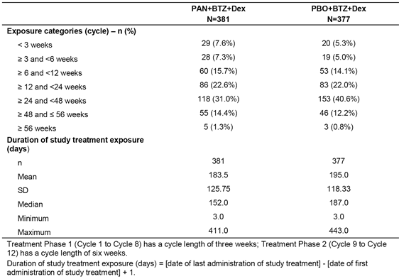

Dose intensity
The median relative dose intensity (RDI) for PAN and PBO in the combination treatment arms was 80.7% (range: 40.6%, 104.2%) and 95.1% (range: 44.7%, 250.0%), respectively. The median RDI for BTZ was higher in the PBO+BTZ+Dex arm, 86.7% (range: 30.8%, 104.7%) than in the PAN+BTZ+Dex arm, 75.7% (range: 30.7%, 105.8%). The median RDI for Dex was 87.5% (range: 35.0%, 106.1%) in the PAN+BTZ+Dex arm and 95.1% (range: 27.0%, 106.3%) in the PBO+BTZ+Dex arm. Dose intensity and RDI are summarised in Table 45.
The RDI of PAN decreased to 78.2% at cycle 3 and remained stable through the remainder of the study. The median cumulative dose, dose intensity and RDI of PAN remained relatively constant in treatment phase 1 (cycle 1 to 6) and treatment phase 2 (cycle 9 to 12): that is, median cumulative dose 600 mg and 645 mg, respectively; median dose intensity 4.7 mg/day and 4.3 mg/day, respectively; and median RDI 80.3% and 75%, respectively.
The median cumulative dose of PAN and PBO in the respective combination treatment arms over the complete study was 660.0 mg (range: 40, 1940 mg) and 960.0 mg (range: 40, 1960 mg), respectively. The median cumulative dose of BTZ in the PAN+BTZ+Dex and PBO+BTZ+Dex arms over the complete study was 24.7 mg/m² (range: 1.3, 63.0 mg/m²) and 32.8 mg/m² (range: 1.3, 63.9 mg/m²), respectively. The median cumulative dose of Dex in the PAN+BTZ+Dex and PBO+BTZ+Dex arms over the complete study was 880 mg (range: 40, 2020 mg) and 1120 mg (range: 40, 2040 mg), respectively.

Table 45: D2308; Dose intensity and relative dose intensity of study treatment component by treatment group; safety set
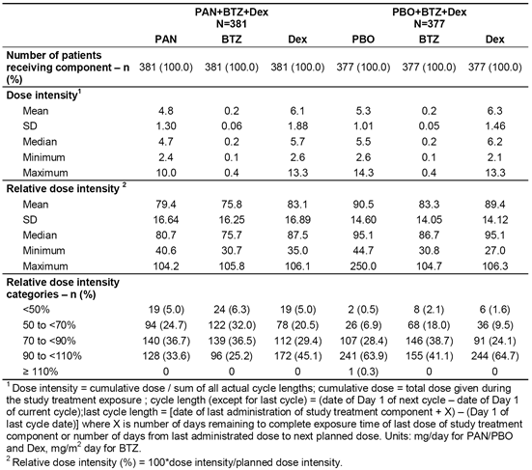

Concomitant medication after initiation of treatment
Nearly all patients in both treatment arms took concomitant medications initiated after the start of the study (99.7% (n = 380) in the PAN+BTZ+Dex arm and 98.7% (n = 372) in the PBO+BTZ+Dex arm). A large range of concomitant medications of varying type were used by patients in both treatment arm, which is not an unexpected finding in patients with relapsed/refractory MM with a mean age of 62 years.
Platelet transfusions were used notably more common in patients in the PAN+BTZ+Dex arm than in the PBO+BTZ+Dex arm (33.3%, n = 127 versus 10.3%, n = 39, respectively), as were red blood cell transfusions (31.5%, n = 120) versus 21.8%, n = 82, respectively). These findings suggest increased myelosuppression characterised by platelet and red blood cell toxicity in the PAN+BTZ+Dex arm compared to PBO+BTZ+Dex arm.
The normalised mean ± SD number of platelet transfusion days per month was 4.9 ± 7.2 days (range: 0, 30) in the PAN+BTZ+Dex arm and 6.0 ± 7.7 days (range: 1, 23) in the PBO+BTZ+Dex arm, while the corresponding figures for packed red blood cell transfusion days per month were 5.3 ± 7.9 days (range: 0, 27) and 7.0 ± 9.5 days (range: 0, 30), respectively. The mean ± SD number of transfusions per patient was similar in the PAN+BTZ+Dex and PBO+BTZ+Dex arms for platelets (2.3 ± 2.1 (range: 1, 14) versus 2.8 ± 2.5 (range: 1, 11), respectively) and for packed red blood cells (2.0 ± 1.4 (range: 1, 8) versus 2.4 ± 2.1 (range: 1, 11), respectively). Granulocyte transfusions were uncommon in both the PAN+BTZ+Dex the PBO+BTZ+Dex treatment arms (0.3%, n = 1 versus 0.3%, n = 1), while plasma transfusion were reported more commonly in the PAN+BTZ+Dex than in the PBO+BTZ+Dex arm (2.6%, n = 10 versus 1.3%, n = 5).
Comparable frequencies of patients in both treatment arms reported using bisphosphonates (PAN+BTZ+Dex, 102 patients, 26.8%; PBO+BTZ+Dex, 111 patients, 29.4%) and zolendronic acid (PAN+BTZ+Dex, 55 patients, 14.4%; PBO+BTZ+Dex, 63 patients, 16.7%).

Adverse events

Overview
In this study, an adverse event (AE) was defined as the appearance of (or worsening of any pre-existing) undesirable sign, symptom, or medical condition occurring after signing the informed consent, irrespective of the relationship with treatment. AEs were assessed according to the Common Toxicity Criteria for Adverse Events (CTCAE) version 3.0. If a CTCAE grading did not exist for an AE, the severity categories of mild, moderate, severe, and life-threatening, or Grades 1 to 4 were used. CTCAE Grade 5 (death) was not used in this study, with information on deaths being collected at the End of Treatment or Study Evaluation Completion assessment. AE monitoring was continued for at least 4 weeks following the last dose of study treatment. AEs were sought by non directive questioning of the patient at each visit during the study, and were also recorded when volunteered by the patient during or between visits or through physical examination, laboratory test, or other assessments. The high level overview of AEs (all categories) reported in this study are summarised below in Table 46.

Table 46: Study D2308; Summary of patients with at least one adverse event in any category; safety set
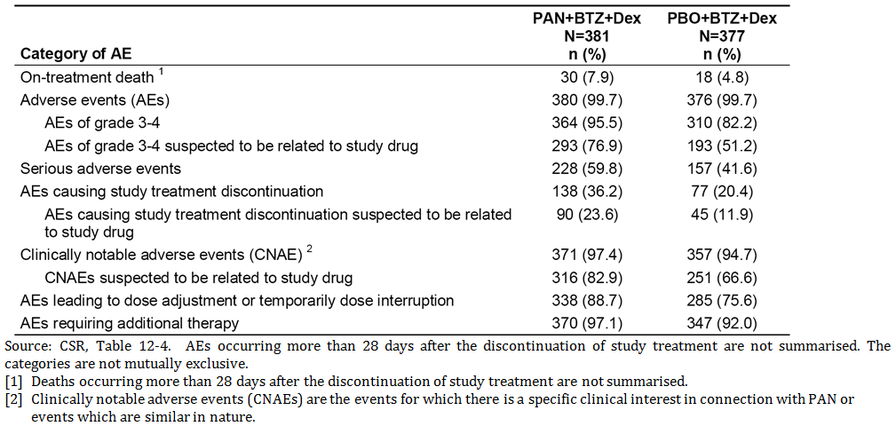
Comment: Nearly all patients in both treatment arms experienced at least one AE within 28 days of the discontinuing study treatment. The overall high level AE profile was notably inferior in the PAN+BTZ+Dex arm than in the PBO+BTZ+Dex arm.

Adverse events by primary system organ class (SOC)
AEs by primary SOC were provided. AEs (all Grades) were reported in nearly all patients in both the PAN+BTZ+Dex and PBO+BTZ+Dex arms (99.7% in both arms), while AEs Grade 3/4 were reported more frequently in the PAN+BTZ+Dex arm than in the PBO+BTZ+Dex arm (95.5% versus 82.2%, respectively). The most frequently reported AEs Grade 3/4 by SOC in the PAN+BTZ+Dex arm (versus the PBO+BTZ+Dex arm) were blood and lymphatic system disorders (69.6% versus 41.4%). Other AEs Grade 3/4 by SOC reported in ≥ 10% of patients in either treatment arm (PAN+BTZ+Dex versus PBO+BTZ+Dex) in descending order of frequency in the ‘PAN’ arm were metabolism and nutrition disorders (37.5% versus 25.2%), GIT disorders (36.7% versus 13.3%), infections and infestations (31.2% versus 23.9%), general disorders and administration site conditions (28.6% versus 16.4%), nervous system disorders (26.2% versus 20.7%), and investigations (21.5% versus 13.8%).

Frequently reported adverse events by preferred term
AEs by preferred term reported in ≥ 10% of patients in either treatment arm are summarised in Table 47. The most frequently reported AEs (all Grades) reported in ≥ 30% of patients in either treatment arm (PAN+BTZ+Dex versus PBO+BTZ+Dex) in descending order of frequency in the ‘PAN’ arm were diarrhoea (68.2% versus 41.6%), thrombocytopenia (64.6% versus 40.8%), anaemia (41.5% versus 33.4%), fatigue (41.2% versus 29.2%), nausea (36.2% versus 20.7%), peripheral neuropathy (30.7% versus 35.3%), and constipation (26.8% versus 32.6%).
The most frequently reported AEs Grade 3/4 reported in ≥ 10% of patients in either treatment arm (PAN+BTZ+Dex versus PBO+BTZ+Dex) in descending order of frequency in the ‘PAN’ arm were thrombocytopenia (57.0% versus 24.9%), diarrhoea (25.5% versus 8.0%), neutropenia (24.1% versus 8.0%), hypokalaemia (19.2% versus 6.4%), fatigue (17.1% versus 8.8%), anaemia (16.5% versus 15.9%), pneumonia (12.6% versus 10.3%), and lymphopenia (12.3% versus 7.4%).

Table 47: D2308; AEs by preferred term and severity, irrespective of causality (with an incidence ≥ 10% in either treatment arm; safety set
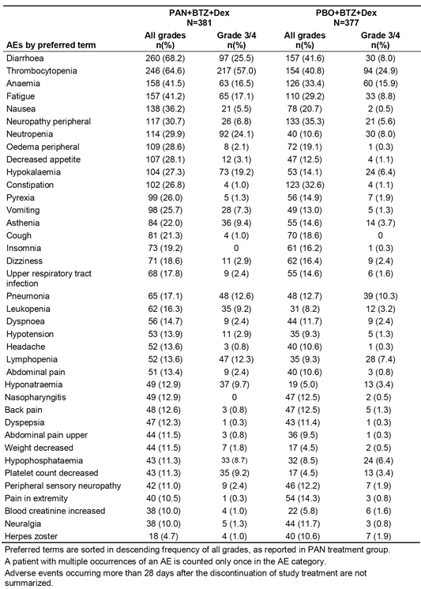

Adverse events suspected to be related to study treatment
The majority of AEs reported in the study were suspected to be related to study treatment. AEs suspected to be related to study treatment and reported in ≥ 10% of patients in either treatment arm are summarised in Table 48. AEs (all Grades) suspected to be related to the study drug (PAN or PBO) were reported more frequently in patients in the PAN+BTZ+Dex arm than in the PBO+BTZ+Dex arm (90.6% versus 75.3%), as were AEs Grade 3/4 (76.9% versus 51.2%).
AEs (all Grades) suspected of being related to the study drug (PAN or PBO) reported in ≥ 10% of patients in either treatment arm (PAN+BTZ+Dex versus PBO+BTZ+Dex) and in descending order of frequency in the ‘PAN’ arm were diarrhoea (50.9% versus 25.2%), thrombocytopenia (50.7% versus 28.6%), fatigue (31.0% versus 21.8%), anaemia (25.5% versus 15.9%), nausea (23.4% versus 12.2%), neutropenia (21.8% versus 7.2%), vomiting (16.3% versus 6.1%), decreased appetite (15.7% versus 6.9%), peripheral neuropathy (13.9% versus 16.2%), asthenia (13.1% versus 6.4%), constipation (12.1% versus 13.8%), hypokalaemia (10.8% versus 2.9%), leukopenia (10.5% versus 5.6%), and lymphopenia (10.0% versus 5.6%). The only AE (all Grades) suspected to be related to the study reported in ≥ 10% of patients in either of the two treatment arms and more commonly in the ‘PBO’ than in the ‘PAN’ arm were peripheral neuropathy and constipation.
AEs (Grade 3/4) suspected to be related to the study drug (PAN or PBO) reported in ≥ 10% of patients in either treatment arm (PAN+BTZ+Dex versus PBO+BTZ+Dex) and in descending order of frequency in the ‘PAN’ arm were thrombocytopenia (43.6% versus 17.8%), diarrhoea (18.9% versus 6.1%), neutropenia (16.5% versus 4.8%), and fatigue (14.7% versus 7.7%).

Table 48: D2308; AEs suspected to be related to study treatment by primary SOC and preferred term with an incidence of ≥ 10% in either treatment group; safety set
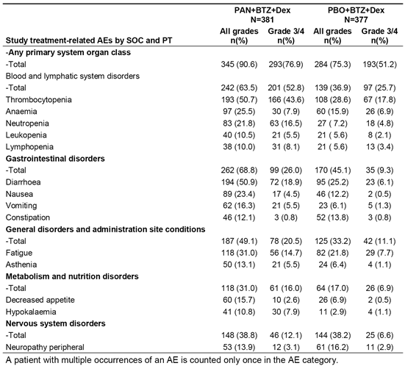

Deaths and other serious adverse events (SAEs)

Deaths

On treatment deaths
On treatment deaths, defined as occurring on treatment and up to 28 days after discontinuation of study treatment, were reported more frequently in the PAN+BTZ+Dex arm than in the PBO+BTZ+Dex arm (7.9%, n = 30 versus 4.8%, n = 18, respectively). Deaths due to disease progression were reported in 4 (1.0%) patients in the PAN+BTZ+Dex arm and 6 (1.6%) patients in the PBO+BTZ+Dex arm, and deaths due to causes other than disease progression were reported in 26 (6.8%) and 12 (3.2%) patients, respectively.
The main causes of on treatment deaths per SOC reported in ≥ 1% of patients in either treatment arm (PAN+BTZ+Dex versus PBO+BTZ+Dex) were infections/infestations (1.8%, n = 7 versus 1.3%, n = 5), respiratory, thoracic and mediastinal disorders (1.6%, n = 6 versus 0.5%, n = 2), and cardiac disorders (1.0%, n = 4 versus 0.8%, n = 3).
Deaths defined by preferred term reported in ≥ 2 patients in either treatment arm (PAN+BTZ+Dex versus PBO+BTZ+Dex) were septic shock (n = 3, 0.8% versus n = 0), myocardial infarction (n = 2, 0.5% versus n = 0), acute renal failure (n = 2, 0.5% versus n = 0), respiratory failure (n = 2, 0.5% versus n = 0), and pneumonia (n = 1, 0.3% versus n = 3, 0.8%).
Overall, 11 (2.9%) of the 30 the on treatment deaths in patients in the PAN+BTZ+Dex arm were suspected to be related to panobinostat per the investigator, and 7 (2.0%) of the 18 on treatment deaths in patients in the PBO+BTZ+Dex arm were suspected to be related to placebo per the investigator.
The sponsor undertook a medical review of the 26 on treatment deaths in patients in the PAN+BTZ+Dex arm associated with AEs (regardless of causality) that had not been classified by investigators as being due to disease progression. The medical review attributed some of the deaths to disease progression. The results of this review are outlined below:
- Infection: 10 (2.6%) patients died due to infection related deaths, and nearly all deaths (9/10) were due to lung infection, with septic shock or respiratory failure reported as associated causes of death in most cases. The only infection related death not due to lung-infection was reported to be due to sepsis associated with urinary tract infection. All patients with infection related deaths had experienced myelosuppression characterised by neutropenia, leukopenia or lymphopenia during the study. Four of the 10 deaths due to infections in the PAN+BTZ+Dex arm occurred in the first 2 treatment cycles (compared to 3 of the 6 deaths due to infections in the PBO+BTZ+Dex arm).
- Haemorrhage: 5 (1.3%) patients died due to events related to haemorrhage, including 2 GI, 2 pulmonary, and 1 cerebral considered to be associated with disease progression (leptomeningeal myelomatosis per MRI). Of the 5 deaths due to haemorrhage, 1 was associated with Grade 4 thrombocytopenia (1 of the pulmonary haemorrhages), 3 with Grade 3 thrombocytopenia (1 cerebral haemorrhage, both GI haemorrhages), and 1 with Grade 1 thrombocytopenia (1 of the pulmonary haemorrhages).
- Myocardial infarction: 3 (0.8%) patients died due to myocardial infarction; all 3 patients had a history of cardiac disease; 1 of the 3 deaths was considered to be related to the study drug (that is, PAN).
- Acute renal failure: 2 (0.5%) patients died due to acute renal failure, both of which were considered to be due to disease progression unrelated to the study drug (that is, PAN)
- Other causes: The remaining 6 (1.6%) patients died to various causes including: intentional overdose with unknown medications in a patient with a history of depression, considered unrelated to the study drug; intestinal ischaemia 2 days following surgery for inguinal hernia, considered unrelated to the study drug; death due to unknown cause, considered unrelated to the study drug; death due to cardiac arrest, considered unrelated to the study drug; death due to pulmonary oedema, considered unrelated to the study drug; and death due to cerebrovascular accident (lacunar infarction), considered unrelated to the study drug (that is, PAN).
In the PBO+BTZ+Dex arm, a total of 12 patients (3.2%) in the PBO+BTZ+Dex group died due to AE that were not attributed to disease progression. The underlying events associated with the deaths, regardless of causality, included infections in 6 (1.6%) patients, cardiac arrest in 2 (0.5%) patients, pulmonary failure in 2 (0.5%) patients, and pulmonary embolism and intracranial haemorrhage in 1 patient each.

Post treatment deaths
deaths (that is, deaths occurring more than 28 days after last exposure to the study drug) were reported 103 (27.0%) patients in the PAN+BTZ+Dex arm and 134 (35.5%) patients in the PBO+BTZ+Dex arm. Deaths reported in ≥ 1% of patients in either treatment arm (PAN+BTZ+Dex versus PBO+BTZ+Dex) grouped by the primary SOC were infections and infestations (3.4%, n = 13 versus 4.5%, n = 17), cardiac disorders (1.0%, n = 4 versus 1.1%, n = 4), and general and administration site conditions (1.0%, n = 4 versus 2.4%, n = 9).

Serious adverse events
SAEs (all Grades) reported more commonly in the PAN+BTZ+Dex arm than in the PBO+BTZ+Dex arm (59.8% versus 41.6%, respectively) as were SAEs (Grade 3/4) (56.2% versus 41.6%). The most frequently occurring SAEs (all Grades) reported in ≥ 5% of patients in either treatment arm (PAN+BTZ+Dex versus PBO+BTZ+Dex) in descending order of frequency in the ‘PAN’ arm were pneumonia (14.7% versus 10.6%), diarrhoea (11.3% versus 2.4%), and thrombocytopenia (7.3% versus 2.1%).
The most frequently occurring SAEs (Grade 3/4) reported in ≥ 2% of patients in either treatment arm (PAN+BTZ+Dex versus PBO+BTZ+Dex) in descending order of frequency in the ‘PAN’ arm were pneumonia (12.3% versus 9.5%), diarrhoea (9.2% versus 2.1%), thrombocytopenia (6.8% versus 2.1%), asthenia (2.9% versus 0.5%), anaemia (2.6% versus 0.5%), vomiting (2.6% versus 0.8%), fatigue (2.6% versus 0.5%), sepsis (2.4% versus 1.6%), septic shock (2.4% versus 0.5%), and orthostatic hypotension (2.4% versus 0.3%).
SAEs (all Grades) suspected to be related to the study drug (that is, PAN or PBO) were reported more frequently in the PAN+BTZ+Dex arm than in the PBO+BTZ+Dex arm (34.9% versus 15.1%), as were SAEs (Grade 3/4) suspected to be related to the study drug (31.8% versus 14.3%). SAEs (all Grades) suspected to be related to the study drug reported in ≥ 5% of patients in either treatment arm (PAN+BTZ+Dex versus PBO+BTZ+Dex) in descending order of frequency in the ‘PAN’ arm were pneumonia (8.1% versus 3.4%), diarrhoea (7.9% versus 1.6%) and thrombocytopenia (5.8% versus 1.6%). SAEs (Grade 3/4) suspected to be related to the study drug reported in ≥ 5% of patients in either treatment arm (PAN+BTZ+Dex versus PBO+BTZ+Dex) in descending order of frequency in the ‘PAN’ arm were pneumonia (7.1% versus 3.2%), diarrhoea (5.8% versus 1.3%), thrombocytopenia (5.2% versus 1.6%), vomiting (2.4% versus 0.8%), and fatigue (2.4% versus 0.3%).
One case of Grade 3 Stevens Johnson Syndrome (SJS) in a patient in the PAN+BTZ+Dex arm was reported as an AE (not a SAE). About five weeks after initiating treatment with panobinostat the patient developed Grade 3 SJS. She received prednisolone while experiencing SJS and recovered within two weeks. The patient continued study treatment for two more months without further episodes of skin events. This event was reported as being unrelated to the study drug. It was noted that the patient was using trimethoprim/sulfamethoxazole and acyclovir around that time of the event. The sponsor considered that the SJS event was likely to be attributable to the anti-infective drugs, as both have SJS listed as ADRs per product information.

Other significant adverse events

Adverse events leading to discontinuation of the study drug
AEs (all Grades) leading to discontinuation of the study drug (that is, PAN or PBO) were reported more commonly in patients in the PAN+BTZ+Dex arm compared to the PBO+BTZ+Dex arm (36.2%, n = 138 versus 20.4%, n = 77, respectively), as were AEs (Grade 3/4) (25.5%, n = 97 versus 13.3%, n = 50, respectively). AEs (all Grades) leading to discontinuation of the study drug in ≥ 1% of patients in either treatment arm (PAN+BTZ+Dex versus PBO+BTZ+Dex) in decreasing order of frequency in the ‘PAN’ arm were, diarrhoea (4.5% versus 1.6%), peripheral neuropathy (3.7% versus 1.9%), asthenia (2.9% versus 0%), fatigue (2.9% versus 2.9%), thrombocytopenia (1.6% versus 0.5%), and pneumonia (1.3% versus 2.1%).

Adverse events requiring dose adjustment or study drug interruption
AEs (all Grades) requiring dose adjustment or study drug interruption irrespective of causality were reported in a higher proportion of patients in the PAN+BTZ+Dex treatment arm (88.7%, n = 338) than in the PBO+BTZ+Dex arm (75.6%, n = 285), as were AEs Grade 3/4 (77.2%, n = 294 versus 52.0%, n = 196, respectively). AEs (all Grades) requiring dose adjustment or temporary dose interruption reported in ≥ 5% of patients in either treatment arm (PAN+BTZ+Dex versus PBO+BTZ+Dex) in decreasing order of frequency in the ‘PAN’ arm were thrombocytopenia (31.0% versus 10.9%), diarrhoea (26.0% versus 9.0%), fatigue (16.3% versus 7.2%), peripheral neuropathy (12.6% versus 14.3%), pneumonia (10.5% versus 7.7%), neutropenia (10.2% versus 2.4%), anaemia (8.1% versus 4.5%), asthenia (8.1% versus 3.2%), pyrexia (7.9% versus 2.9%), neuralgia (7.9% versus 9.3%), upper respiratory tract infection (6.6% versus 4.2%), vomiting (6.0% versus 1.6%), peripheral sensory neuropathy (5.5% versus 5.3%), and herpes zoster (2.6% versus 5.8%).

Clinically notable adverse events (CNAEs)

Overview
CNAEs were categories of risks consisting of AEs that were similar in nature and for which there is a specific clinical interest in connection with panobinostat as a result of signals identified by the sponsor during earlier studies with the drug. The CNAE groupings were based on standardised MedDRA queries and Novartis MedDRA queries.
CNAEs (all Grades) were reported in nearly all patients in both the PAN+BTZ+Dex and PBO+BTZ+Dex arms (97.4%, n = 371 versus 94.7%, n = 357, respectively), while CNAEs Grade 3/4 were reported more frequently in the ‘PAN’ arm than in the ‘PBO’ arm (88.7%, n = 338 versus 67.4%, n = 254).
CNAEs (Grade 3/4) reported in ≥ 5% of patients in either treatment arm (PAN+BTZ+Dex versus PBO+BTZ+Dex) in descending order of frequency in the ‘PAN’ arm were myelosuppression/ thrombocytopenia (63.3% versus 28.1%), myelosuppression/leukopenia (38.6% versus 18.6%), diarrhoea (25.5% versus 8.0%), asthenia/fatigue (23.9% versus 11.9%), myelosuppression/anaemia (18.6% versus 18.6%), peripheral neuropathy (17.6% versus 14.6%), infection/sepsis (6.6% versus 3.7%), QT prolongation (5.2% versus 2.9%), and renal dysfunction (5.0% versus 4.5%).

Clinical impact of thrombocytopenia
The clinical impact of the notably higher CNAE rate of thrombocytopenia in the PAN+BTZ+Dex arm compared to the PBO+BTZ+Dex arm is summarised below in Table 49.

Table 49: Study D2308; Clinical impact of thrombocytopenia (as per CNAE panel); safety set
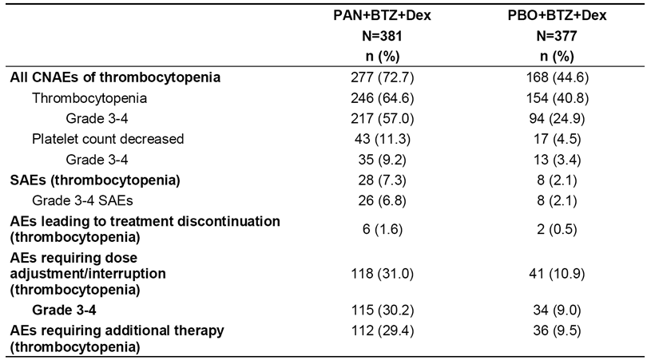
The median time to the first reported Grade 3/4 event of thrombocytopenia (KM estimate) was 1.08 month (95%: 1.05, 1.15 months) in the PAN+BTZ+Dex arm, and was not estimable in the PBO+BTZ+Dex arm due to the notably lower incidence of events in this arm (31.1% (117/377)) compared to the ‘PAN’ arm (67.2% (256/381)). The median time to recovery to CTC Grade 0, 1, or 2 from first reported Grade 3 or 4 thrombocytopenia was 0.39 months (12 days) in both treatment arms (KM estimates). The sponsor comments that the recovery time of 12 days for Grade 3 or 4 thrombocytopenia does not reflect the impact of the clinical management of thrombocytopenia and needs to be interpreted with caution since, as per protocol, Grade 3 thrombocytopenia did not require treatment interruption or dose adjustment. Therefore, the recovery time could be shorter if only Grade 4 thrombocytopenia was taken into account for the estimation.

Second primary malignancy
Only a few patients reported AEs in the SOC of ‘neoplasms’, 5 (1.3%) in the PAN+BTZ+Dex arm and 11 (2.9%) in the PBO+BTZ+Dex arm. One case each of basal cell carcinoma, endometrial cancer, and thyroid neoplasm (benign goitre, Grade 1/2) were reported in the PAN+BTZ+Dex arm with the remaining two cases involving cancer pain and tumour pain. Among the 11 patients in the PBO+BTZ+Dex arm, eight cases of different types of neoplasms were reported including two cases of small cell lung cancer and one case each of lipoma, melanocytic naevus, prostate neoplasm, skin neoplasm, prostate cancer, and rectal cancer.

Laboratory tests

Haematology
The laboratory haematology results are summarised below in Table 50. The results show markedly higher Grade 3/4 events (newly occurring or worsening from baseline) relating to thrombocytopenia, leukopenia, neutropenia and lymphopenia in the PAN+BTZ+Dex arm compared to the PBO+BTZ+Dex arm.

Table 50: Study D2308; Patients with newly occurring or worsening from baseline haematology laboratory abnormalities; safety set
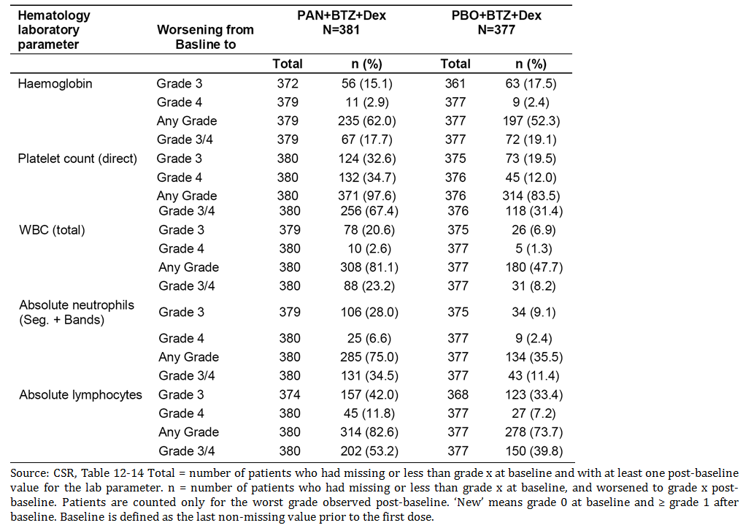

Clinical chemistry
The clinical chemistry laboratory results for patients with newly occurring or worsening from baseline abnormalities are summarised below in Table 51.

Table 51: Study D2308; Patients with clinical chemistry laboratory abnormalities; safety set
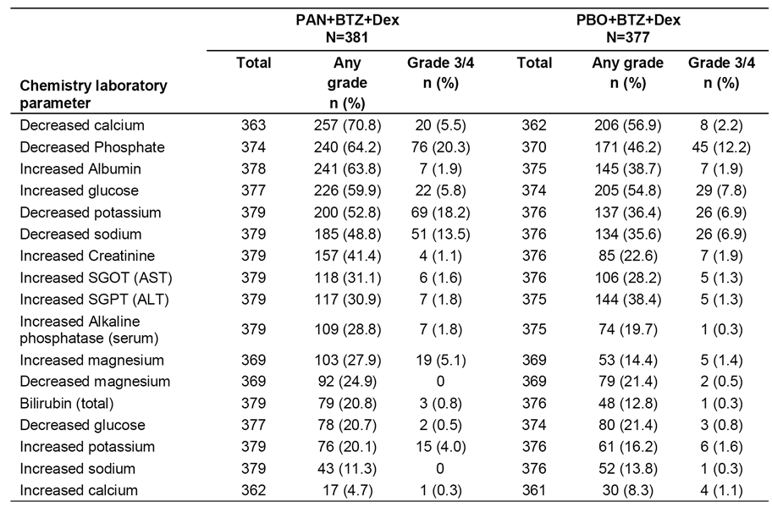
Overall, there was trend towards both higher frequency and greater severity for most biochemical abnormalities in the PAN+BTZ+Dex arm compared to the PBO+BTZ+Dex arm. The only biochemical abnormality of Grade 3/4 severity where a higher proportion of PAN+BTZ+Dex treated patients reported events (and with a ≥ 10% difference relative to PBO+BTZ+Dex) was hypokalemia (18.2% versus. 6.9%, respectively). The number of electrolyte disturbances was high in patients in the PAN+BTZ+Dex arm, but only a minority of these disturbances were considered to be clinically relevant by the investigator (that is, reported as AEs). For example, in the PAN+BTZ+Dex arm, biochemical abnormalities of decreased calcium (70.8%), phosphate (64.2%), potassium (52.8%), and sodium (48.8%) levels were all reported in much lower frequencies as AEs: that is, hypocalcaemia (all Grades 9.4%; Grade 3/4, 3.4%), hypophosphataemia (all Grades, 11.3%; Grade 3/4 8.7%), hypokalaemia (all Grades, 27.3%; Grade 3/4, 19.2%), and hyponatraemia (all Grades, 12.9%; Grade 3/4, 9.7%). In addition, no or only a small proportion of patients required dose adjustment or interruption due to AEs related to these electrolyte disturbances: that is, hypocalcaemia (0.0%), hypophosphataemia (1.3%), hypokalaemia (5.0%), and hyponatraemia (1.0%). The only electrolyte abnormality resulting in treatment discontinuation was hypokalaemia (0.8% of patients). The sponsor comments that, while the incidence of electrolyte disturbances was high in the PAN+BTZ+Dex arm ‘the clinical implication is yet to be determined but appears to be limited. Since electrolyte disturbances were often associated with patients reporting diarrhoea, it is possible that diarrhoea could be one of the factors that may have contributed to the development of this risk’.
Of note, the proportion of patients with increased creatinine levels (all Grades) was approximately 2 fold higher in the PAN+BTZ+Dex arm than in the PBO+BTZ+Dex arm (41.4% versus 22.6%, respectively), with most of these events being categorised as Grade 1/2 in severity. There was no marked difference in the incidence of increased AST or ALT between the two treatment arms, but increased total bilirubin levels (TBLs) were reported more frequently in the PAN+BTZ+Dex arm than in the PBO+BTZ+Dex arm. There was 1 patient in the PAN+BTZ+Dex arm whose liver function tests met the criteria for Hy's law (that is, ALT or AST > 3 x ULN and TBL > 2 x ULN and ALP ≤ 2 x ULN). However, it appears that this patient developed hepatic failure as part of multi-organ failure related to pulmonary tuberculosis, complicated by treatment with anti-TB medications known to be associated with hepatotoxicity.

Vital signs
The study summarised patients with notably abnormal vital signs in the two treatment arms (that is, heart rate, blood pressure, temperature and respiratory rate). Abnormal vital sign findings were relatively infrequent in patients in both treatment arms (≤ 5%) and the observed differences between the two arms are considered to be not clinically meaningful.

Electrocardiograms
ECGs were performed at baseline and were subsequently repeated per study protocol and at the investigator’s discretion if there were signs and symptoms of cardiotoxicity. ECGs were centrally reviewed by an independent reviewer.

QTcF abnormalities
QTcF abnormalities were reported in a higher proportion of patients in the PAN+BTZ+Dex arm than in the PBO+BTZ+Dex arm (see Table 52).

Table 52: Study D2308; Number and percentage of patients with abnormal QTcF interval values; safety set
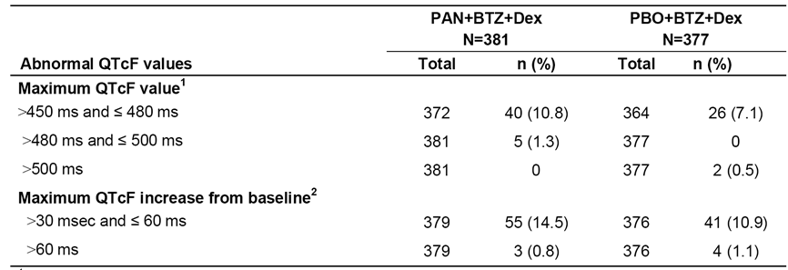

Qualitative ECG abnormalities
Qualitative ECG abnormalities were reported more frequently in patients in the PAN+BTZ+Dex arm compared to the PBO+BTZ+Dex arm (63.5%, n = 242 versus 42.2%, n = 159, respectively) (see Table 53). The sponsor comments that, consistent with cumulative experience from earlier clinical studies with panobinostat, three ECG abnormalities were the most commonly reported with the drug. These three ECG abnormalities are summarised below.

T-wave changes
T-wave changes (including flat, inverted, or biphasic) were reported in 39% of patients in the PAN+BTZ+Dex arm and 8.3% of patients in the PBO+BTZ+Dex arm. No cases of T wave changes were reported as SAEs or resulted in treatment discontinuation. The sponsor commented that no clear correlation was apparent between T wave changes and significant cardiac events. For example, very few patients reported any AEs relevant to ischaemic heart disease, 3.7% for the PAN+BTZ+Dex arm versus 1.3% for the PBO+BTZ+Dex arm. Similarly only 2.1% of patients (same percentage for both arms) reported AEs relevant to cardiac failure. In addition, the sponsor noted the high proportion of patients with a medical history or current medical conditions relating to cardiac disorders that could potentially contribute to ECG abnormalities (that is, 16.8% in the PAN+BTZ+Dex arm and 13.9% in the PBO+BTZ+Dex arm). Overall, the sponsor considers that the clinical implication of the non-specific T wave changes associated with panobinostat is unclear and yet to be determined.

ST-segment depression
ST-segment depression was reported in 21.7% of patients in the PAN+BTZ+Dex arm and 3.6% of patients in the PBO+BTZ+Dex arm. The sponsor notes that the ‘vast majority’ of patients with ST-segment depression in the PAN+BTZ+Dex arm did not show signs of cardiac ischaemia. In the 8 patients who developed cardiac ischaemic events in the study, 5 did not have ST-T changes during ECG monitoring. Overall, the sponsor considers that the clinical implication of ST-segment depression associated with panobinostat is unclear and yet to be determined.

Sinus tachycardia
Sinus tachycardia was reported in 15.5% of patients in the PAN+BTZ+Dex arm and 6.8% of patients in the PBO+BTZ+Dex arm. The sponsor comments that more patients in the PAN+BTZ+Dex arm had underlying cardiac disorders and hypertension at baseline, which may have contributed to the imbalance in the reports of sinus tachycardia between the two treatment arms. Increased heart rate changes from baseline (≥ 120 bpm with increase from baseline ≥ 15 bpm) were observed relatively infrequently in both treatment arms (4.6% in the PAN+BTZ+Dex arm versus 3.0% in the PBO+BTZ+Dex arm).

Table 53: D2308; Summary of newly occurring qualitative ECG abnormalities; safety set
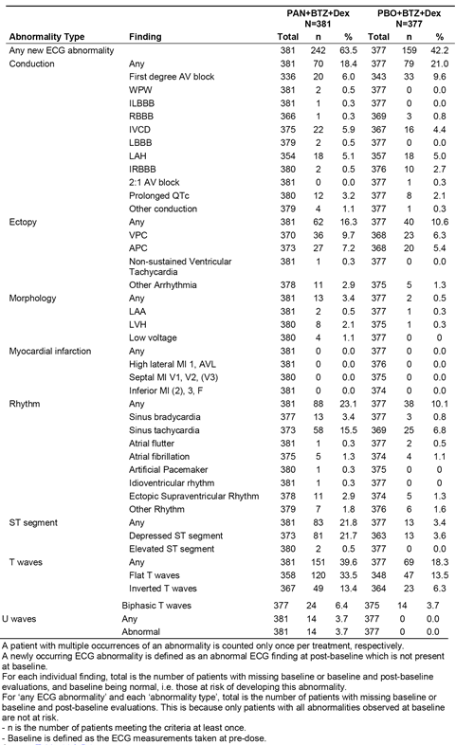

Thyroid function
The sponsor comments that, ‘based on pre-clinical findings, hypothyroidism is a potential safety risk’. Therefore, shifts in thyroid stimulating hormone (TSH) and free thyroxine (T4) values from baseline to extreme post-baselines values were assessed in Study D2308. Overall, the shifts from baseline in TSH and T4 were comparable in the two treatment arms. Mean ± SD change from baseline to end of treatment values for TSH were 0.5 ± 7.5 mU/L (range: -56.3, 91.0 mU/L) in the PAN+BTZ+Dex arm and -0.5 ± 3.3 mU/L (range: -42.2, 9.9 mU/L) in the PBO+BTZ+Dex arm, while the corresponding results for FT4 were 0.2 ± 9.0 pmol/L (range: -126, 66.3 pmol/L) and 0.6 ± 6.2 pmol/L (range: -78.2, 54.8 pmol/L), respectively.

Post marketing safety experience
Not relevant

Safety issues with the potential for major regulatory impact

Liver toxicity
The sponsor comments that based on the cumulative clinical experience to date, hepatic dysfunction has been identified as a safety risk for patients treated with PAN.
In the pivotal Study (Study D2308), CNAEs (all Grades) grouped as hepatic dysfunction were reported more frequently in patients in the PAN+BTZ+Dex arm than in the PBO+BTZ+Dex arm (16.5%, n = 63 versus 12.2%, n = 46), while CNAEs (Grade 3/4) were reported in a similar proportion of patients in the two treatment arms (4.2%, n = 16 versus 3.4%, n = 13, respectively).
In the pivotal Study (Study D2308), newly occurring liver enzyme or TBL abnormalities were reported at least once in 65.0% (193/297) of patients in the PAN+BTZ+Dex arm compared to 57.9% (179/309) of patients in the PBO+BTZ+Dex arm. ALT or AST > 3 x ULN levels were reported in 6.9% (26/378) of patients in the PAN+BTZ+Dex arm and 4.8% (18/376) of patients in the PBO+BTZ+Dex arm; ALP > 2 x ULN levels were reported in 8.5% (32/376) and 4.0% (15/372) of patients, respectively; TBL > 2 x ULN levels were reported in 3.7% (14/378) and 0.5% (2/376) of patients respectively; and ALT or AST > 3 x ULN and TBL > 2 x ULN and ALP ≤ 2 x ULN were reported in 0.3% (1/379) and 0% (0/376) of patients, respectively. As discussed previously, LFT abnormalities meeting Hy's law criteria reported in one patient in the PAN+BTZ+Dex arm are likely to be related to multi-organ failure due to pulmonary TB and anti-TB medications. Newly occurring liver enzyme and TBL abnormalities in the pivotal study and two supportive studies are summarised in Table 54.

Table 54: Newly occurring liver enzyme and total bilirubin level (TBL) abnormalities; pivotal study (D2308) and supportive (single-arm) studies (B2207, DUS71)
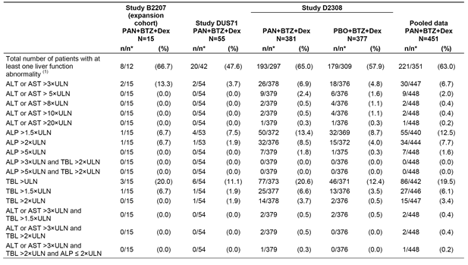

Haematological toxicity
This has been discussed above. Haematological toxicity, particularly thrombocytopenia, is the major safety concern associated with panobinostat treatment. In the pivotal Study (Study D2308) myelosuppression resulting in thrombocytopaenia and leukopenia occurred markedly more frequently in patients in the PAN+BTZ+Dex arm than in the PBO+BTZ+Dex arm.

Serious skin reactions
In the pivotal Study (Study D2308), skin and subcutaneous tissue disorder (SOC) AEs (any Grade) were reported in 28.3% (n = 108) of patients in the PAN+BTZ+DEX arm compared to 24.4% (n = 92) of patients in the PBO+BTZ+Dex arm, and AEs (Grade 3/4) were reported in 3.4% (n = 13) and 0.8% (n = 3) of patients, respectively. The only AE (any) reported in ≥ 5% of patients in either of the two treatment arms was rash (8.7% versus 6.4%). AEs (Grade 3/4) reported in the PAN+BTZ+Dex arm versus the PBO+BTZ+Dex arm were rash (1.0%, n = 4 versus 0%), swelling face (0.5%, n = 2 versus 0%), pruritis (0.3%, n = 1 versus 0%), urticaria (0.3%, n = 1 versus 0), night sweats (0.3%, n = 1 versus 0%), acute febrile neutrophilic dermatosis (n = 1, 0.3% versus 0.3%, n = 1), exfoliative rash (0.3%, n = 1 versus 0.3%, n = 1), hidradenitis (0.3%, n = 1 versus 0%), and SJS (0.3%, n = 1 versus 0%). As mentioned above, the one case of SJS in the PAN+BTZ+Dex arm was confounded by other factors that might have caused the condition.
In the pivotal Study (Study D2308), SAEs (any Grade) skin and subcutaneous tissue disorders (SOC) were reported in 4 (1.0%) patients in the PAN+BTZ+Dex arm (2x rash, 1 x acute febrile neutrophilic dermatosis, 1 x swelling face) and 3 (0.8%) patients in the PBO+BTZ+Dex arm (1 each for rash, acute febrile neutrophilic dermatosis, and allergic dermatitis). AEs leading to discontinuation of the study drug (PAN or PBO) were reported in 1 (0.3%) patient in the PAN+BTZ+Dex arm (1 x acute febrile neutrophilic dermatosis) and 2 (0.5%) patients in the PBO+BTZ+Dex arm (1 x acute febrile neutrophilic dermatosis, 1 x swelling face). AEs causing dose adjustment or temporary dose interruption of the study drug were reported in 13 (3.4%) patients in the PAN+BTZ+Dex arm (primarily rash (x6)) and 7 (1.9%) patients in the PBO+BTZ+Dex arm (primarily rash (x 2)).

Cardiovascular safety

Cardiac disorders
In the pivotal Study (Study D2308), cardiac disorders (SOC) were reported more frequently in the PAN+BTZ+Dex arm than in the PBO+BTZ+Dex arm: AEs (any Grade), 17.6% (n = 67) versus 9.8% (n = 37), respectively, and AEs (Grade 3/4), 5.0% (n = 19) versus 3.2% (n = 12), respectively. AEs (any Grade) reported in ≥ 1% of patients in either of the two treatment arms (PAN+BTZ+Dex versus PBO+BTZ+Dex) in descending order of frequency in the ‘PAN’ arm were atrial fibrillation (2.9%, n = 11 versus 1.3%, n = 5), tachycardia (2.9%, n = 11 versus 1.1%, n = 4), palpitations (2.6%, n = 10 versus 1.3%, n = 5), sinus tachycardia (2.4%, n = 9 versus 1.3%, n = 5), angina pectoris (1.6%, n = 6 versus 1.3%, n = 5), and bradycardia (1.3%, n = 5 versus 0.3%, n = 1). Of note, most of these commonly occurring events were tachyarrhythmias (CNAEs), which were reported in 12.1% of patients in the ‘PAN’ arm and 4.8% of patients in the PBO+BTZ+Dex arm. No AEs (Grade 3/4) were reported in ≥ 1% of patients in either of the two treatment arms.
In the pivotal Study (Study D2308), cardiac disorders (SOC) SAEs (all Grades) were reported in 20 (5.2%) patients in the PAN+BTZ+Dex arm and 11 (2.9%) patients in the PBO+BTZ+Dex arm. The SAEs in the PAN+BTZ+Dex arm versus the PBO+BTZ+Dex arm were atrial fibrillation (1.0%, n = 4 versus 0.5%, n = 2), angina pectoris (0.5%, n = 2 versus 0.5%, n = 2), bradycardia (n = 2, 0.5% versus 0%), cardiac arrest (n = 2, 0.5% versus n = 2, 0.5%), myocardial infarction (n = 2, 0.5% versus 0%), myocardial ischaemia (n = 2, 0.5% versus 0%), tachycardia (n = 2, 0.5% versus 0%), acute coronary syndrome (n = 1, 0.3% versus 0%), acute myocardial infarction (n = 1, 0.3%) versus 0%), cardiac failure (n = 1.0, 0.3% versus n = 1, 0.3%), acute cardiac failure (n = 1, 0.3% versus 0%), sinus tachycardia (n = 1, 0.3% versus 0%), and ventricular tachycardia (n = 1, 0.3% versus 0%).
In the pivotal Study (Study D2308), cardiac disorders (SOC) AEs (all Grades) leading to discontinuation of the study drug were reported in 5 (1.3%) patients in the PAN+BTZ+Dex arm (1 x each LBBB, cardiac arrest, myocardial ischaemia, tachycardia, ventricular tachycardia) and 2 (0.5%) patients in the PBO+BTZ+Dex arm (1 x each cardiac failure, cardiac failure congestive). AEs leading to dose adjustment or temporary dose interruption of the study drug were reported in 12 (3.1%) patients in the PAN+BTZ+Dex arm (3 patients each for angina pectoris and atrial fibrillation, 1 patient each for other events) and 7 (1.9%) patients in the PBO+BTZ+Dex arm (2 patients each for angina pectoris and atrial fibrillation, 1 patient each for other events).
In the pivotal Study (Study D2308), cardiac disorders were reported to have caused 4 (1.0%) on treatment deaths in the PAN+BTZ+Dex arm (2x myocardial infarction, 1 x cardiac arrest, 1 x myocardial ischaemia) and 3 (0.8%) on treatment deaths in the PBO+BTZ+Dex arm (1 x cardiac arrest, 1 x cardio-respiratory arrest, 1 x cardiopulmonary failure).
Comment: Overall, the data suggest an increased risk of cardiac disorders in the pivotal study (Study D2308) for patients in the PAN+BTZ+Dex arm compared to the PBO+BTZ+Dex arm. However, the sponsor states that review of the medical history of patients in this study indicated that 16.8% of patients in the ‘PAN’ arm had underlying cardiac disorders as part of their medical histories compared to 13.9% of patients in the ‘PBO’ arm. Therefore, the sponsor considers that there is insufficient evidence from the pivotal study to suggest that panobinostat may increase cardiac risk, due to the presence of significant confounding factors associated with each patient reporting ischaemic heart disease.

Unwanted immunological events
In the pivotal study (Study D2308), immune system disorder (SOC) AEs (any Grade) were reported in 5 (0.3%) patients in the PAN+BTZ+Dex arm and 4 (1.1%) patients in the PBO+BTZ+Dex arm. In both treatment arms, all AEs were Grade 1/2 in severity. In the 5 patients in the ‘PAN’ arm the AEs were 2 x hypersensitivity, and 1 x each for allergy to arthropod bite, drug hypersensitivity, and hypogammaglobulinaemia. In the 4 patients in the ‘PBO’ arm the events were 2 x seasonal allergy and 1 x each for hypersensitivity and allergy to arthropod bite. There were no discontinuations, dose adjustments, or temporary dose interruptions of the study drug associated with immune disorders. There were no reports of anaphylactic reactions during the study.

Other safety issues

Safety in special populations

Age

Patients aged < 65 versus ≥ 65 years
In the pivotal study (Study D2308), AEs were experienced by all patients in the PAN+BTZ+Dex arm aged < 65 years (n = 221) and all patients aged ≥ 65 years (n = 160). AEs reported in ≥ 5% of patients in either age group in the PAN+BTZ+Dex arm (≥ 65 years versus < 65 years) and ≥ 5% more frequently in the ≥ 65 years group were diarrhoea (75.0% versus 63.3%), thrombocytopenia (72.5% versus 58.8%), anaemia (48.1% versus 36.7%), fatigue (47.5% versus 36.7%), vomiting (29.4% versus 23.1%), hypotension (19.4% versus 10.0%), blood creatinine increased (15.0% versus 6.3%) and dehydration (10.6% versus 5.0%). The only AE reported in ≥ 5% of patients in either age group in the PAN+BTZ+Dex arm (< 65 years versus ≥ 65 years) and ≥ 5% more frequently in the < 65 years group was nausea (38.9% versus 32.5%). In the PBO+BTZ+Dex arm, AEs were also reported notably more frequently in patients aged ≥ 65 years compared to patients aged < 65 years. The results for AEs reported in ≥ 5% of patients in at least one of the relevant age groups by treatment arm are summarised below in Table 55.

Table 55: Study D2308; Adverse events (irrespective of causality) by age and treatment arm
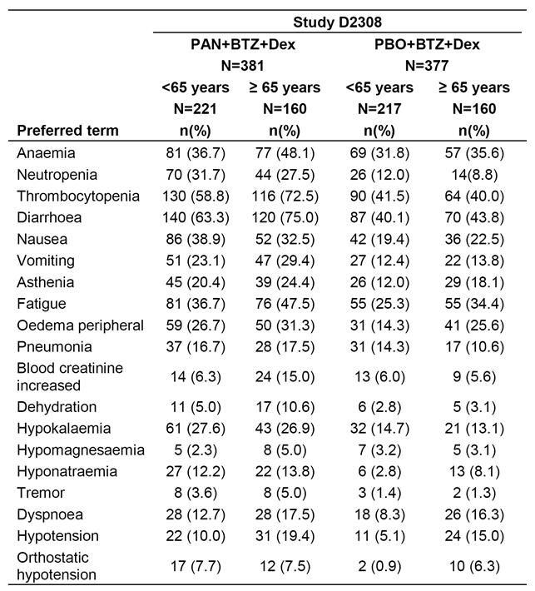
In the pivotal Study (Study D2308) AEs leading to discontinuation and on treatment deaths were reported more frequently in patients aged ≥ 65 years than in patients aged < 65 years in both treatment arms (see Table 56).

Table 56: Study D2308; Adverse events leading to discontinuation and on treatment death by age
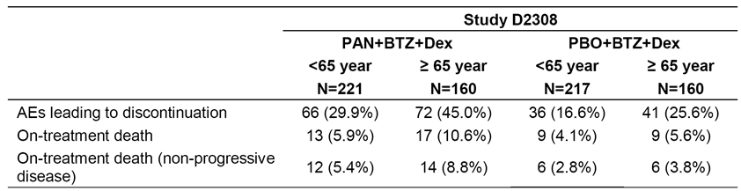
Comment: In both treatment arms, the AE profile in patients aged ≥ 65 years was notably inferior to the safety profile of patients aged < 65 years. However, the AE profile in patients aged ≥ 65 years was notably inferior in the PAN+BTZ+Dex arm compared to the PBO+BTZ+Dex arm.

Patients aged ≥ 65 to < 75 years versus ≥ 75 years
In the pivotal study (Study D2308), in the PAN+BTZ+Dex arm there were 126 patients aged ≥ 65 to < 75 years and 34 patients aged ≥ 75 years. In general, the AE profile in patients aged ≥ 75 years in the PAN+BTZ+Dex arm was inferior to that in patients aged ≥ 65 to < 75 years. Of particular note, thrombocytopaenia and diarrhoea were both reported in > 70% of patients in both age groups. The results for AEs reported in ≥ 5% of patients in at least one of the relevant age groups by treatment arm in the pivotal study and for all patients in the pooled PAN+BTZ+Dex group are summarised in Table 57 and the results for AEs leading to treatment discontinuation and on treatment deaths are summarised in Table 58.

Table 57: Adverse events by age and treatment group; safety set
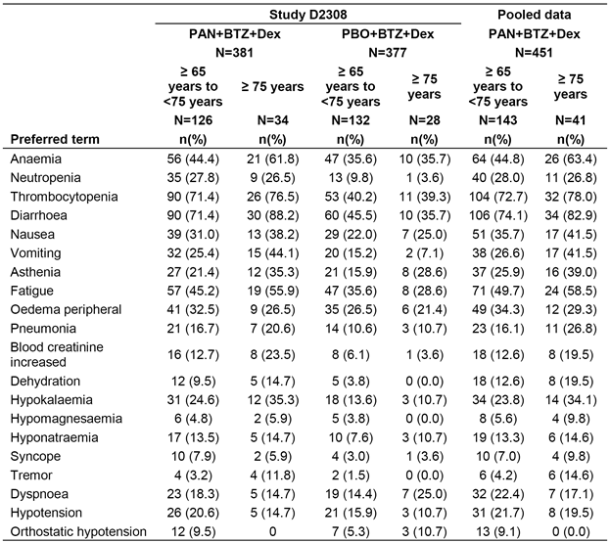

Table 58: Study D2308; Adverse events leading to discontinuation and on-treatment death by age; safety set
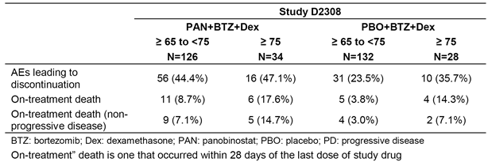

Sex
In the pivotal Study (Study D2308), AEs were experienced by all male (n = 201) and 99.4% (179/180) of female patients in the PAN+BTZ+Dex arm.
AEs reported in ≥ 5% of patients in either age group in the PAN+BTZ+Dex arm and ≥ 5% more frequently in females versus males were thrombocytopaenia (70.0% versus 59.7%), fatigue (44.4% versus 38.3%) nausea (43.3% versus 29.9%), neutropenia (36.1% versus 24.4%), hypokalaemia (34.4% versus 20.9%), vomiting (33.3% versus 18.9%) pyrexia (30.0% versus 22.4%), cough (23.9% versus 18.9%), hypotension (16.7% versus 11.4%), urinary tract infection (12.8% versus 2.5%).
AEs reported in ≥ 5% of patients in either age group in the PAN+BTZ+Dex arm and ≥ 5% more frequently in males versus females were insomnia (23.9% versus 13.9%), pneumonia (23.4% versus 10%), dyspnoea (18.4% versus 10.6%) dysgeusia (12.4% versus 6.1%), and muscle spasms (10.0% versus 1.7%).

Race
In the PAN+BTZ+Dex arm of the pivotal Study D2308 there were 244 Caucasian patients, 127 Asian patients and 10 ‘Other’ race patients, and the AE frequencies were 99.6%, 100%, and 100%, respectively. The number of subjects in the ‘Other’ racial group was too small to make meaningful comparisons between this group and the other two racial groups. In general, Asian patients treated with PAN+BTZ+Dex had a higher frequency of AEs than Caucasian patients. In the pooled PAN+BTZ+Dex arm, 99.3% (299/301) of Caucasian patients had an AE compared to 100% (127/127) of Asian patients. The AE pattern in the two racial groups suggested a numerically greater incidence of haematological and hepatic events in Asian patients compared to Caucasian patients. However, overall the differences in AE profiles between the two racial groups are unlikely to be clinically significant.
In the pooled PAN+BTZ+Dex group, AEs reported in ≥ 5% of patients in either racial group and ≥ 5% more frequently in Asian versus Caucasian patients were thrombocytopenia (70.1% versus 62.5%), hypokalaemia (44.9% versus 18.9%), decreased appetite (43.3% versus 24.9%), vomiting (36.2% versus 21.9%), peripheral neuropathy (33.9% versus 27.9%), pneumonia (26.0% versus 12.6%), platelet count decreased (18.9% versus 6.3%), hypoaesthesia (15.0% versus 5.0%), rash (12.6% versus 7.3%), ALT increased (11.0% versus 4.0%), AST increased (10.2% versus 2.3%), hypoalbuminaemia (9.4% versus 3.7%), herpes zoster (8.7% versus 3.0%), rhinorrhoea (8.7% v 1.7%) and haemoglobin decreased (7.9% versus 2.3%).
In the pooled PAN+BTZ+Dex group, AEs reported in ≥ 5% of patients in either racial group and ≥ 5% more frequently in Caucasian versus Asian patients were fatigue (52.2% versus 26.8%), peripheral oedema (31.9% versus 23.6%), dizziness (23.6% versus 17.3%), dyspnoea (20.3% versus 10.2%), hypotension (18.3% versus 6.3%), lymphopenia (14.6% versus 9.4%), dysgeusia (13.6% versus 7.9%), neuralgia (10.6% versus 5.5%), polyneuropathy (9.3% versus 0%), orthostatic hypotension (9.3% versus 3.9%), muscle spasms (8.3% versus 2.4%), conjunctivitis (8.6% versus 3.1%), paraesthesia (7.6% versus 2.4%) and respiratory tract infection (7.0% versus 0.8%).

Renal impairment
In the pivotal Study (Study D2308), AEs were experienced in all patients in the PAN+BTZ+Dex arm with no renal impairment (118/118) and 99.6% (262/263) of patients with renal impairment (defined as creatinine clearance < 90 mL/min).
AEs (all Grades) reported in ≥ 5% of patients in the renal impairment group and in ≥ 10% more patients than in the no renal impairment group in descending disorder of frequency were diarrhoea (70.0% versus 64.4%), thrombocytopenia (67.7% versus 57.6%), anaemia (44.5% versus 34.7%), decreased appetite (30.8% versus 22.0%), vomiting (28.1% versus 20.3%), and asthenia (25.1% versus 15.3%).
AEs (all Grades) reported in ≥ 10% of patients in the no renal impairment group and in ≥ 5% more patients than in the renal impairment group in descending disorder of frequency were fatigue (44.9% versus 39.5%), insomnia (25.4% versus 16.3%), dizziness (23.7% versus 16.3%), nasopharyngitis (17.8% versus 10.6%), and hyperglycaemia (13.6% versus 5.3%).
The pattern of increased AEs in patients with renal impairment compared to patients with no renal impairment was also observed for less frequently reported AEs: pancytopenia (1.9% versus 0%); atrial fibrillation (4.2% versus 0%); AST increased (5.7% versus 1.7%); blood creatinine increased (12.5% versus 4.2%); and haematuria (1.5% versus. 0%).

Hepatic impairment
There were no specific AE data in patients with hepatic impairment in the pivotal efficacy and safety study (Study D2308).

Pregnancy
There were no AE data in pregnant women. However, studies in animals have demonstrated reproductive and embryo-fetal toxicity.

Breast feeding
It is not known whether panobinostat is excreted in human breast milk.

Women of childbearing potential
Women of child bearing potential should be advised to use a highly effective method of contraception during treatment with panobinostat.

Sexually active men
Sexually active men should be advised to use a highly effective method of contraception during treatment with panobinostat.

Fertility
Nonclinical findings were reported to show that male reproductive effects were observed in the testes, epididymides and prostate in repeated dose oral toxicity studies in dogs. Based on these data, the sponsor concludes that male fertility may be compromised in patients treated with panobinostat.

Overdose
In the 3 clinical trials supporting this indication (n = 451), 3 patients took an overdose of panobinostat, all in the pivotal Study D2308 with cumulative overdose up to 60 mg. The AEs reported included hyponatraemia, thrombocytopenia and pancytopenia, all reported as resolved. Although the clinical experience is limited, the most likely results of overdose would be myelosuppression, gastrointestinal side effects and cardiac events.

Drug abuse
There is no known potential for drug abuse with panobinostat.

Withdrawal and rebound
No studies have been conducted to assess withdrawal or rebound effects of panobinostat.

Effects on ability to drive or operate machinery of impairment of mental ability
No studies have been conducted to assess the effects of panobinostat on the ability to drive or operate machinery.

Safety related to drug-drug interactions and other interactions
No specific safety analyses were conducted to evaluate the use of other drugs, tobacco, or alcohol on the tolerability and safety of panobinostat. The potential for drug-drug interactions based on specific in vitro PK drug-drug interaction studies and in vivo human biomaterial studies has been discussed in the PK section of this CER.

Long term safety data
No specific long term safety studies were conducted in the targeted indication. The recommended total duration of treatment with PAN+BTZ+Dex is up to 48 weeks (that is, up to 16 cycles). In the pivotal study, 170 patients in the PAN+BTZ+Dex arm were exposed to the combination for ≥ 6 months, 108 patients for ≥ 9 months and < 12 months, and 17 patients for ≥ 12 months. Overall, in the pooled data from the pivotal study and the two supportive studies for PAN+BTZ+Dex (n = 451), 195 patients were exposed for ≥ 6 months, 120 patients for ≥ 9 to < 12 months and 21 patients for ≥ 12 months.

Evaluator's overall conclusion on clinical safety
The safety data relating to the proposed dosage regimen for the proposed indication are derived primarily from the pivotal Study D2308. In this study, 381 patients were exposed to PAN+BTZ+Dex for a median duration of 5.0 months and 377 patients were exposed to PBO+BTZ+Dex for a median duration of 6.1 months. In total, 178 patients (46.7%) were treated with PAN+BTZ+Dex and 202 patients (53.6%) with PBO+BTZ+Dex for ≥ 24 weeks, and 5 (1.3%) and 3 (0.8%) patients, respectively, were treated for ≥ 56 weeks.
Overall, it is considered that the data from the pivotal study (Study D2308) indicate that the safety profile of PAN+BTZ+Dex for the proposed indication is notably inferior to the safety profile of PBO+BTZ+Dex. The major safety concerns relating to treatment with PAN+BTZ+Dex are myelosuppression (including severe thrombocytopaenia, neutropenia and anaemia), haemorrhage, severe infections including sepsis, diarrhoea, cardiac disorders (including ischaemic heart disease and tachyarrhythmias), hepatic dysfunction, renal dysfunction, and fatigue.
AEs (all Grades) were reported in 99.7% of patients in both treatment arms. Most AEs in both treatment arms were Grade 3/4 in severity and were reported more frequently in the PAN+BTZ+Dex arm than in the PBO+BTZ+Dex arm (95.5% versus 82.5%). AEs (Grade 3/4) reported in ≥ 10% of patients in either treatment arm (PAN+BTZ+Dex versus PBO+BTZ+Dex) were thrombocytopenia (57.0% versus 24.9%), diarrhoea (25.5% versus 8.0%), neutropenia (24.1% versus 8.0%), hypokalaemia (19.2% versus 6.4%), fatigue (17.1% versus 8.8%), anaemia (16.5% versus 15.9%), pneumonia (12.6% versus 10.3%), and lymphopenia (12.3% versus 7.4%).
AEs leading to discontinuation of the study drug (PAN or PBO) were reported more frequently in the PAN+BTZ+Dex arm than in the PBO+BTZ+Dex arm (36.2% versus 20.4% (all Grades) and 25.5% versus 13.3% (Grade 3/4), respectively). AEs requiring dose interruption or study drug interruption were reported more frequently in the PAN+BTZ+Dex arm than in the PBO+BTZ+Dex arm (88.7% versus 75.6% (all Grades) and 77.2% versus 52.0% (Grade 3/4), respectively). In both treatment arms AEs requiring dose interruption or study drug interruption occurred notably more frequently than AEs leading to discontinuation of the study drug. This suggests that the majority of AEs in this study were manageable without discontinuation of the study drug.
The AEs (all Grades) leading to discontinuation of the study drug reported in ≥ 1% of patients in either treatment arm were (PAN+BTZ+Dex versus PBO+BTZ+Dex) diarrhoea (4.5% versus 1.6%), peripheral neuropathy (3.7% versus 1.9%), asthenia (2.9% versus 0%), fatigue (2.9% versus 2.9%), thrombocytopenia (1.6% versus 0.5%), pneumonia (1.3% versus 2.1%). AEs (all Grades) requiring dose adjustment or study drug interruption reported in ≥ 5% of patients in either treatment arm (PAN+BTZ+Dex versus PBO+BTZ+Dex) were thrombocytopenia (31.0% versus 10.9%), diarrhoea (26.0% versus 9.0%), fatigue (16.3% versus 7.2%), peripheral neuropathy (12.6% versus 14.3%), pneumonia (10.5% versus 7.7%), neutropenia (10.2% versus 2.4%), anaemia (8.1% versus 4.5%), asthenia (8.1% versus 3.2%), pyrexia (7.9% versus 2.9%), neuralgia (7.9% versus 9.3%), upper respiratory tract infection (6.6% versus 4.2%), vomiting (6.0% versus 1.6%), peripheral sensory neuropathy (5.5% versus 5.3%), and herpes zoster (2.6% versus 5.8%).
On treatment deaths were reported more frequently in the PAN+BTZ+Dex arm than in the PBO+BTZ+Dex arm (7.9%, n = 30 versus 4.8%, n = 18, respectively). Furthermore, the incidence of on treatment deaths considered to be not related to disease progression was 6.8% (n = 26) in the PAN+BTZ+Dex arm and 3.2% (n = 12) in patients in the PBO+BTZ+Dex arm. Of the 26 deaths in the PBO+BTZ+Dex considered by investigators not to be related to disease progression, 10 (2.6%) were associated with infections (primarily lung) and occurred in association with neutropenia, leukopenia or lymphopenia, 5 (1.3%) were associated with haemorrhage, 3 (0.8%) were associated with myocardial infarction, 2 (0.5%) were associated with acute renal failure, and the remaining 6 were each due to various causes.
SAEs regardless of the relationship with the study drug were reported more frequently in the PAN+BTZ+Dex arm than in the PBO+BTZ+Dex arm (59.8% versus 41.6% (all Grades) and 56.2% versus 37.4% (Grade 3/4), respectively). SAEs (all Grades) reported in ≥ 5% of patients in either treatment arm (PAN+BTZ+Dex versus PBO+BTZ+Dex) were pneumonia (14.7% versus 10.6%), diarrhoea (11.3% versus 2.4%), and thrombocytopenia (7.3% versus 2.1%). SAEs (Grade 3/4) reported in ≥ 2% of patients in either treatment arm (PAN+BTZ+Dex versus PBO+BTZ+Dex) were pneumonia (12.3% versus 9.5%), diarrhoea (9.2% versus 2.1%), thrombocytopenia (6.8% versus 2.1%), asthenia (2.9% versus 0.5%), anaemia (2.6% versus 0.5%), vomiting (2.6% versus 0.8%), fatigue (2.6% versus 0.5%), sepsis (2.4% versus 1.6%), septic shock (2.4% versus 0.5%), and orthostatic hypotension (2.4% versus 0.3%). Each of the most commonly reported SAEs (all Grades and Grade 3/4) were reported more frequently in the PAN+BTZ+Dex arm than in the PBO+BTZ+Dex arm.
Laboratory results for haematological parameters showed markedly higher Grade 3/4 events (newly occurring or worsening from baseline) relating to thrombocytopenia, leukopenia, neutropenia and lymphopenia in the PAN+BTZ+Dex arm compared to the PBO+BTZ+Dex arm. These results are consistent with the observed AE profiles in the two treatment arms.
Laboratory results for biochemical parameters abnormalities showed a consistent trend towards both higher frequency and greater severity in the PAN+BTZ+Dex arm compared to the PBO+BTZ+Dex arm. The number of electrolyte disturbances was high in patients in the PAN+BTZ+Dex arm, which probably reflects the high incidence of severe diarrhoea in patients in this arm. Newly occurring or worsening increased serum creatinine levels (any Grade) in the PAN+BTZ+Dex arm were approximately 2 fold higher than in the PBO+BTZ+Dex arm (41.4% versus 22.6%), and the majority of these events in both treatment arms were Grade 1/2 in severity. In the PAN+BTZ+Dex arm versus the PBO+BTZ+Dex arm, newly occurring or worsening increased ALT levels (all Grades) were reported in 31.1% versus 29.2% of patients, respectively, and the corresponding results for AST levels (all Grades) were 30.9% versus 38.4%, ALP (all Grades) 28.8% versus 19.7%, and total bilirubin (all Grades) 20.8% versus 12.8%.
Qualitative ECG abnormalities occurred more frequently in the PAN+BTZ+Dex arm compared to the PBO+BTZ+Dex arm (63.5% versus 42.2%). The three abnormalities of note were T wave changes, ST-segment depression, and sinus tachycardia all of which occurred more frequently in the PAN+BTZ+Dex arm than in the PBO+BTZ+Dex arm. Tachyarrhythmias (CNAEs) were reported notably more commonly in the PAN+BTZ+Dex arm than in the PBO+BTZ+Dex arm (12.1% versus 4.8%), and the majority of events were Grade 1/2 in severity. The most frequently occurring tachyarrhythmias (≥ 1%) in the PAN+BTZ+Dex arm versus PBO+BTZ+Dex (respectively) were atrial fibrillation (2.9% versus 1.3%), tachycardia (2.9% versus 1.1%), palpitations (2.6% versus 1.3%) and sinus tachycardia (2.4% versus 0.3%). Ventricular tachycardia was reported in 0.5% of patients in the PAN+BTZ+Dex arm and no patients in the PBO+BTZ+Dex arm .
QTcF prolongation detected by scheduled ECG monitoring, occurred more frequently in patients in the PAN+BTZ+Dex arm than in the PBO+BTZ+Dex arm. However, no patients in the PAN+BTZ+Dex arm reported QTcF increases > 500 ms, while 2 (0.5%) patients in the PBO+BTZ+Dex arm reported QTcF increases > 500 ms. QT prolongation (CNAE) was reported in 10.5% of patients in the PAN+BTZ+Dex arm compared to 6.1% of patients in the PBO+BTZ+Dex arm, but most of these events were syncope (6.0% versus 2.4%, respectively). QT prolongation as an AE was reported in 1.8% of patients in the PAN+BTZ+Dex arm and 1.9% of patients in the PBO+BTZ+Dex arm. The sponsor commented that 30% of patients were reported to have received concomitant medications known to prolong the QTc interval during the study. There have been no reports of torsade de pointes associated with the oral formulation of panobinostat, while one patient treated with the IV formulation on consecutive days experience this life threatening arrhythmia.

First round benefit-risk assessment

First round assessment of benefits
In the pivotal study (Study D2308), the primary efficacy analysis was investigator assessment of PFS using mEMBT criteria. This analysis showed a statistically significant 3.9 month increase in median PFS for patients in the PAN+BTZ+Dex arm (n = 387) compared to patients in the PBO+BTZ+Dex arm (n = 381). The median PFS was 12.0 months (95% CI: 10.3, 12.9 months) in the PAN+BTZ+Dex arm and 8.1 months (95% CI: 7.6, 9.2 months) in the PBO+BTZ+Dex arm: HR = 0.63 (95% CI: 0.52, 0.76); p < 0.0001. The study was powered on an assumption that the difference in the median PFS between the two treatment arms would be 2.7 months.
In the primary analysis of the PFS (disease progression/relapse/death), disease progression was reported more frequently in the PBO+BTZ+Dex arm compared to the PAN+BTZ+Dex arm (60.6% versus 42.4%), while death was reported more frequently in the PAN+BTZ+Dex arm than in the PBO+BTZ+Dex arm (5.3% versus 3.7%, respectively) as was relapse (5.2% versus 3.9%).
There are doubts about the validity of the primary PFS analysis due to the high censoring rate of patients in both arms who were not receiving on-going treatment (that is, ‘dropouts’). In a PFS sensitivity analysis aimed at assessing the impact on the primary PFS analysis of missing data from patients who ‘dropped out’, the difference in median PFS between the PAN+BTZ+Dex arm and the PBO+BTZ+Dex arm was 1.8 months (9.46 months and 7.62 months, respectively); HR = 0.71 (95% CI: 0.61, 0.83); p < 0.0001. The observed PFS difference of 1.8 months in the sensitivity analysis (dropout) is considered to be of doubtful clinical significance, and is inconsistent with the PFS difference of 3.9 months from the primary PFS analysis. The results suggest that the missing data from the patients who ‘dropped-out’ might have biased the results of the primary PFS efficacy analysis towards the PAN+BTZ+Dex arm.
Furthermore, in a sensitivity analysis of PFS based on IRC assessment using mEMBT criteria the difference in median PFS between the PAN+BTZ+Dex arm and the PBO+BTZ+Dex arm was 2.3 months (10.0 months and 7.7 months, respectively); HR = 0.69 (95% CI: 0.58, 0.83); p < 0.0001. The observed PFS difference of 2.3 months is considered to be of doubtful clinical significance, and is inconsistent with the PFS difference of 3.9 months obtained from the primary analysis. In general, centralised IRC assessment of PFS is considered to be a more robust method of evaluation as it is potentially less subject to bias than assessment based on individual site-specific investigator review.
There are no data indicating that treatment with PAN+BTZ+Dex provides an overall survival benefit compared to treatment with PBO+BTZ+Dex. In the interim analysis based on immature data, OS was not statistically significantly different between the two treatment arms (HR = 0.87 (95% CI: 0.69, 1.10); p = 0.2856), with median OS in the PAN+BTZ+Dex and PBO+BTZ+Dex arms being 30.4 months and 33.6 months, respectively. Other key secondary efficacy endpoints assessed by the investigators (protocol specified) showed a numerical advantage for patients in the PAN+BTZ+Dex arm compared to the PBO+BTZ+Dex (that is, ORR, nCR/CR rate, median TTR, median DOR, median TTP). However, there was no statistically significant difference between the two treatment arms in the ORR based on investigator assessment using mEMBT (60.7% (PAN+BTZ+Dex) versus 54.6% (PBO+BTZ+Dex); p = 0.0873). Patient reported outcomes did not demonstrate a quality of life benefit for patients in the PAN+BTZ+Dex arm compared to patients in the PBO+BTZ+Dex arm.
The limited efficacy data from the two uncontrolled, single arm, supportive studies suggest that treatment with PAN+BTZ+Dex might be associated with a treatment benefit (that is, ORR). However, in the absence of a controlled arm little evidentiary weight can be given to the efficacy results from these two studies.
In the USA, the FDA approved panobinostat in combination with bortezomib and dexamethasone for the treatment of patients with MM who have received at least 2 prior regimens, including bortezomib and an immunomodulatory agent. The prescribing information states that the indication is approved ‘under accelerated approval based on progression free survival’ and that continued approval for this indication may be contingent upon verification and description of clinical benefit in confirmatory trials’. The US prescribing information indicates that approval of panobinostat was based on ‘efficacy and safety in a prespecified subgroup analysis of 193 patients who had received prior treatment with both bortezomib and an immunomodulatory agent and a median or 2 prior therapies as the benefit-risk appeared to be greater in this more heavily treated population than in the overall trial population’.
The sponsor is not seeking registration in the current submission of the indication approved by the FDA. Of note, a pre-specified subgroup analysis of PFS in the pivotal Study D2308 in 198 patients who had received prior treatment with IMiDs and BTZ showed that the HR was 0.53 (95% CI: 0.37, 0.76) in favour of PAN+BTZ+Dex over PBO+BTZ+Dex. The promising results in this heavily pre-treated subgroup of patients should be confirmed by an appropriately designed Phase III controlled study if the sponsor wishes to narrow the indication to this subgroup. There were a number of subgroup analysis of PFS in the pivotal study which consistently favoured the PAN+BTZ+Dex arm over the PBO+BTZ+Dex arm. However, it is considered that all subgroup analyses of PFS in the pivotal study are exploratory rather than confirmatory.

First round assessment of risks
- The risks of treatment with PAN+BTZ+Dex for the proposed indication are considered to be notably greater than the risks of treatment with PBO+BTZ+Dex. The major risks of PAN+BTZ+Dex treatment are myelosuppression (including severe thrombocytopaenia, anaemia, and neutropenia), severe diarrhoea, severe infections including sepsis, fatigue, haemorrhage, cardiac disorders (including ischaemic heart disease and tachyarrhythmias), hepatic dysfunction, and renal dysfunction. The following risks discussed for treatment with PAN+BTZ+Dex are based on the data from the pivotal study (Study D2308), unless otherwise stated.
- There were a total of 381 patients exposed to PAN+BTZ+DEX in the pivotal study (Study D2308). Therefore, based on the ‘rule of threes’ it is 95% certain that any AE event not reported in this patient population occurs less often than 3 in 351 patients (that is, with a incidence of less than 0.8%).
- It is of particular concern that patients aged ≥ 65 years had an increased risk of AEs associated with PAN+BTZ+Dex compared to patients aged < 65 years (48.1% versus 36.7%, respectively). Furthermore, AEs leading to treatment discontinuation were reported in 45.0% of patients aged ≥ 65 years in the PAN+BTZ+Dex arm compared to 25.6% of patients in the PBO+BTZ+Dex arm, while on treatment deaths were reported in 10.6% and 5.6% of patients, respectively. The poor safety profile of patients aged ≥ 65 years treated with PAN+BTZ+Dex is particularly significant as the average age of patients diagnosed with multiple myeloma in Australia in 2009 was 69.2 years,9 which is older than the mean age of the patients in the pivotal study (62.1 years (SD = 9.38 years)).
- AEs (all Grades) were reported in 99.7% of all patients in both treatment arms. Most AEs in both treatment arms were Grade 3/4 in severity and were reported more frequently in the PAN+BTZ+Dex arm than in the PBO+BTZ+Dex arm (95.5% versus 82.5%, respectively). AEs (Grade 3/4) reported in ≥ 10% of patients in either treatment arm (PAN+BTZ+Dex versus PBO+BTZ+Dex) were thrombocytopenia (57.0% versus 24.9%), diarrhoea (25.5% versus 8.0%), neutropenia (24.1% versus 8.0%), hypokalaemia (19.2% versus 6.4%), fatigue (17.1% versus 8.8%), anaemia (16.5% versus 15.9%), pneumonia (12.6% versus 10.3%), and lymphopenia (12.3% versus 7.4%). Each of the Grade 3/4 AEs reported in ≥ 10% of patients in either treatment arm occurred more frequently in the PAN+BTZ+Dex arm than in the PBO+BTZ+Dex arm, with differences of ≥ 10% for thrombocytopaenia, neutropenia, lymphopenia, diarrhoea and hypokalaemia.
- The increased severity of thrombocytopaenia in patients in the PAN+BTZ+Dex arm compared to the PBO+BTZ+Dex arm is reflected in the notably higher frequency of patients receiving platelet transfusions in the PAN+BTZ+Dex arm than in the PBO+BTZ+Dex arm (33.3% versus 10.3%, respectively). In addition, based on the proportion of patients requiring red blood cell transfusions it can be inferred that anaemia was more severe in the PAN+BTZ+Dex arm than in the PBO+BTZ+Dex arm (31.5% versus 21.8%, respectively). Furthermore, the higher incidence of infections and infestations (SOC) categorised as Grade 3/4 AEs in the PAN+BTZ+Dex arm compared to the PBO+BTZ+Dex arm (31.2% versus 23.9%, respectively), is likely to be a reflection of the higher incidence of Grade 3/4 neutropenia in the PAN+BTZ+Dex arm than in the PBO+BTZ+Dex arm (21.4% versus 8.0%, respectively). In addition, colony stimulating factors (granulocyte and granulocyte-macrophage) were used in 13.1% and 4.2% of patients in the PAN+BTZ+Dex and PBO+BTZ+Dex arms, respectively.
- AEs leading to discontinuation of the study drug (PAN/PBO) were reported more frequently in the PAN+BTZ+Dex arm than in the PBO+BTZ+Dex arm (36.2% versus 20.4% (all Grades), 25.5% versus 13.3% (Grade 3/4)). AEs requiring dose interruption or temporary study drug interruption were reported more frequently in the PAN+BTZ+Dex arm than in the PBO+BTZ+Dex arm (88.7% versus 75.6% (all Grades) and 77.2% versus 52.0% (Grade 3/4), respectively). In both treatment arms, AEs requiring dose interruption or temporary study drug interruption occurred more frequently than AEs leading to discontinuation of the study drug. This suggests that the majority of AEs were manageable without discontinuation of the study drug.
- AEs (all Grades) leading to discontinuation of the study drug reported in ≥ 1% of patients in either treatment arm (PAN+BTZ+Dex versus PBO+BTZ+Dex, respectively) were diarrhoea (4.5% versus 1.6%), peripheral neuropathy (3.7% versus 1.9%), asthenia (2.9% versus 0%), fatigue (2.9% versus 2.9%), thrombocytopenia (1.6% versus 0.5%), pneumonia (1.3% versus 2.1%). AEs (all Grades) requiring dose adjustment or temporary study drug interruption reported in ≥ 5% of patients in either treatment arm (PAN+BTZ+Dex versus PBO+BTZ+Dex, respectively) were thrombocytopenia (31.0% versus 10.9%), diarrhoea (26.0% versus 9.0%), fatigue (16.3% versus 7.2%), peripheral neuropathy (12.6% versus 14.3%), pneumonia (10.5% versus 7.7%), neutropenia (10.2% versus 2.4%), anaemia (8.1% versus 4.5%), asthenia (8.1% versus 3.2%), pyrexia (7.9% versus 2.9%), neuralgia (7.9% versus 9.3%), upper respiratory tract infection (6.6% versus 4.2%), vomiting (6.0% versus 1.6%), peripheral sensory neuropathy (5.5% versus 5.3%), and herpes zoster (2.6% versus 5.8%).
- On treatment deaths were reported more frequently in the PAN+BTZ+Dex arm than in the PBO+BTZ+Dex arm (7.9%, n = 30 versus 4.8%, n = 18, respectively). Furthermore, the incidence of on treatment deaths considered not to be related to disease progression was 6.8% (n = 26) in the PAN+BTZ+Dex arm and 3.2% (n = 12) in patients in the PBO+BTZ+Dex arm. On treatment deaths considered to be related to the study drug by the investigator were reported in 11 (2.9%) patients in the PAN+BTZ+Dex arm and 7 (2.0%) patients in the PBO+BTZ+Dex arm. Of the 26 deaths in the PAN+BTZ+Dex arm considered to be not related to disease progression, 10 (2.6%) were associated with infections (primarily lung) and occurred in association with neutropenia, leukopenia or lymphopenia, 5 (1.3%) were associated with haemorrhage, 3 (0.8%) were associated with myocardial infarction, 2 (0.5%) were associated with acute renal failure, and the remaining 6 were each due to various causes (1 each for intentional overdose with unknown medicines, intestinal ischaemia, breathing difficulty of unknown cause, cardiac arrest, pulmonary oedema, CVA (lacunar infarction)). Of the 12 deaths in the PBO+BTZ+Dex arm considered to be not related to disease progression, 6 (1.6%) were associated with infections and infestations, 2 (0.5%) with cardiac arrest, 2 (0.5%) with pulmonary failure, and 1 each with pulmonary embolism and intracranial haemorrhage.
- SAEs occurring irrespective of the relationship with the study drug were reported more frequently in the PAN+BTZ+Dex arm than in the PBO+BTZ+Dex arm (59.8% versus 41.6% (all Grades) and 56.2% versus 37.4% (Grade 3/4) events, respectively). Nearly all SAEs in both treatment arms were Grade 3/4 events. SAEs (Grade 3/4) reported in ≥ 2% of patients in either treatment arm (PAN+BTZ+Dex versus PBO+BTZ+Dex) were pneumonia (12.3% versus 9.5%), diarrhoea (9.2% versus 2.1%), thrombocytopenia (6.8% versus 2.1%), asthenia (2.9% versus 0.5%), anaemia (2.6% versus 0.5%), vomiting (2.6% versus 0.8%), fatigue (2.6% versus 0.5%), sepsis (2.4% versus 1.6%), septic shock (2.4% versus 0.5%), and orthostatic hypotension (2.4% versus 0.3%). Each of the most commonly reported SAEs (all Grades and Grade 3/4) were reported more frequently in the PAN+BTZ+Dex arm than in the PBO+BTZ+Dex arm.
- Haemorrhage was reported notably more frequently in the PAN+BTZ+Dex arm than in the PBO+BTZ+Dex arm (all Grades, 20.7% versus 11.7%; Grade 3/4, 4.2% versus 2.4%). Haemorrhagic AEs (all Grades) reported in ≥ 1% of patients either treatment arm (PAN+BTZ+Dex versus PBO+BTZ+Dex, respectively) were epistaxis (5.0% versus 4.0%), haematoma (2.9% versus 1.1%), contusion (2.4% versus 2.6%), conjunctival haemorrhage (2.1% versus 0.5%), gastrointestinal haemorrhage (2.1% versus 1.6%), gingival bleeding (1.0% versus 1.1%), haematochezia (1.3% versus 0.5%), and haematuria (1.0% versus 0%). In the PAN+BTZ+Dex arm, all patients with any Grade haemorrhage also reported thrombocytopenia of any Grade within 30 days preceding the haemorrhage event, with 74.7% of patients reporting Grade 3/4 thrombocytopenia. In the pivotal study, 5 (1.3%) patients died due to haemorrhage in the PAN+BTZ+Dex arm compared to 1 (0.3%) patient in the PBO+BTZ+Dex arm.
- Laboratory results for haematological parameters showed markedly higher Grade 3/4 events (newly occurring or worsening from baseline) for thrombocytopenia, leukopenia, neutropenia and lymphopenia in the PAN+BTZ+Dex arm compared to the PBO+BTZ+Dex arm. These results are consistent with the observed haematological AE profiles in the two treatment arms.
- Laboratory results for abnormal biochemical parameters showed a consistent trend towards higher frequency and greater severity in the PAN+BTZ+Dex arm compared to the PBO+BTZ+Dex arm. The proportion of patients with electrolyte disturbances was high in the PAN+BTZ+Dex arm, which probably reflects the high incidence of severe diarrhoea in patients in this arm.
- Laboratory abnormalities for newly occurring or worsening increased serum creatinine levels (any Grade) in the PAN+BTZ+Dex arm were approximately 2 fold higher than in the PBO+BTZ+Dex arm (41.4% versus 22.6%), with the majority of these events in both treatment arms being Grade 1/2 in severity. The results suggest an increase in renal dysfunction in the PAN+BTZ+Dex arm compared to the PBO+BTZ+Dex arm. However, ‘renal and urinary disorders’ (SOC) categorised as SAEs Grade 3/4 were reported in a similar proportion of patients in the PAN+BTZ+Dex and PBO+BTZ+Dex arms (3.1%, n = 12 versus 3.4%, n = 13, respectively), with acute renal failure (Grade 3/4) being reported in 1.8% (n = 7) and 1.9% (n = 7) of patients, respectively, and renal failure (Grade 3/4) being reported in 0.8% (n = 3) and 1.1% (n = 4) respectively. There were 2 deaths due to acute renal failure in the PAN+BTZ+Dex arm.
- In the PAN+BTZ+Dex arm versus the PBO+BTZ+Dex arm, laboratory results showed that newly occurring or worsening increased ALT levels (all Grades) were reported in 31.1% versus 29.2% of patients, respectively, and the corresponding results for AST levels (all Grades) were 30.9% versus 38.4%. The incidence of increased ALP (all Grades) levels was higher in patients in the PAN+BTZ+Dex arm compared to the PBO+BTZ+Dex arm (28.8% versus 19.7%, respectively), as was the incidence of increased total bilirubin (all Grades) (20.8% versus 12.8%, respectively). The most frequently reported newly occurring liver enzyme abnormalities in the PAN+BTZ+Dex arm versus the PBO+BTZ+Dex arm were ALT or AST > 3 x ULN (6.9% versus 4.8%), ALT or AST > 5 x ULN (2.4% versus 1.6%), ALP > 1.5 x ULN (13.4% versus 8.7%), ALP > 2 x ULN (8.5% versus 4.0%), TBL > 1 x ULN (20.6% versus 12.4%), TBL > 1.5 x ULN (6.6% versus 3.5%), and TBL > 2 x ULN (3.7% versus 0.5%). There was one patient in the PAN+BTZ+Dex arm who met Hy's law criteria for DILI, but the result was confounded by other plausible explanations for the finding. Overall, the results suggest that treatment with PAN+BTZ+Dex is associated with liver dysfunction. However, ‘hepato biliary disorders’ (SOC) categorised as SAEs (Grade 3/4) were reported infrequently in patients in both the PAN+BTZ+Dex and PBO+BTZ+Dex treatment arms (0.3%, n = 3 versus 0.8%, n = 3, respectively), with one case of hepatic failure being reported in the PAN+BTZ+Dex arm.
- Qualitative ECG abnormalities occurred more frequently in the PAN+BTZ+Dex arm than in PBO+BTZ+Dex arm (63.5% versus 42.2%). In particular, T wave changes, ST-segment depression, and sinus tachycardia all occurred notably more frequently in the PAN+BTZ+Dex arm than in the PBO+BTZ+Dex arm. Tachyarrhythmias (CNAEs) were reported notably more commonly in the PAN+BTZ+Dex arm than in the PBO+BTZ+Dex arm (12.1% versus 4.8%), and the majority of events were Grade 1/2 in severity. The most frequently occurring tachyarrhythmias (≥ 1%) in the PAN+BTZ+Dex arm versus the PBO+BTZ+Dex arm were (respectively) atrial fibrillation (2.9% versus 1.3%), tachycardia (2.9% versus 1.1%), palpitations (2.6% versus 1.3%) and sinus tachycardia (2.4% versus 0.3%). Ventricular tachycardia was reported in 0.5% of patients in the PAN+BTZ+Dex arm and no patients in the PBO+BTZ+Dex arm .
- QTcF prolongation detected by protocol specified ECG monitoring, occurred more frequently in patients in the PAN+BTZ+Dex arm than in the PBO+BTZ+Dex arm. However, no patients in the PAN+BTZ+Dex arm reported QTcF increases > 500 ms, while 2 (0.5%) patients in the PBO+BTZ+Dex arm reported QTcF increases > 500 ms. QT prolongation (CNAE) was reported in 10.5% of patients in the PAN+BTZ+Dex arm compared to 6.1% of patients in the PBO+BTZ+Dex arm, but most of these events (identified by broad Standardised MedDRA Query (SMQ) criteria) were syncope (6.0% versus 2.4%, respectively). QT prolongation as an AE was reported in 1.8% of patients in the PAN+BTZ+Dex arm and 1.9% of patients in the PBO+BTZ+Dex arm. The sponsor commented that 30% of patients were reported to have received concomitant medications known to prolong the QTc interval during the study. There have been no reports of torsade de pointes associated with the oral formulation of panobinostat, while one patient treated with the IV formulation at a dose level of 20 mg/m²/day on two consecutive days experienced this life-threatening arrhythmia (Study A2101).

First round assessment of benefit-risk balance
The benefit-risk balance of PAN+BTZ+Dex, given the proposed usage, is unfavourable. It is considered that the efficacy data for PAN+BTZ+Dex has not unequivocally demonstrated a clinically meaningful PFS benefit compared to PBO+BTZ+Dex, while the safety data for PAN+BTZ+Dex showed that the risks of treatment with the combination are notably greater than those for PBO+BTZ+Dex. In addition, there are no data showing that treatment with PAN+BTZ+Dex increases overall survival compared to PBO+BTZ+Dex or is associated with an improvement in the quality of life.

First round recommendation regarding authorisation
It is recommended that the application to register panobinostat in combination with bortezomib and dexamethasone for the treatment of the treatment of patients with multiple myeloma, who have received at least 1 prior therapy be rejected. The reasons for this recommendation are as follows:
- In the pivotal study (Study D2308), treatment with PAN+BTZ+Dex significantly prolonged the median PFS by 3.9 months compared with PBO+BTZ+Dex based on investigator assessment using mEMBT criteria (primary efficacy analysis). However, there are doubts about the validity of the results of this analysis due to the high rate of patient censoring in both treatment arms (46.5% (180/387) in the PAN+BTZ+Dex arm; 31.8% (121/381) in the PBO+BTZ+Dex arm. Of particular concern was the high rate of censoring of non ongoing patients (that is, dropouts) (37.5% (145/387) in the PAN+BTZ+Dex arm and 27.8% (106/381) in the PBO+BTZ+Dex arm). Such high rates of censoring in non ongoing patients raise doubts about the robustness of the primary analysis and the precision of the observed treatment effect.
- In the pivotal Study D2308, PFS events were disease progression, relapse from CR and death. In the pivotal study (Study D2308), the increased median PFS of 3.9 months observed with PAN+BTZ+DEX compared with PBO+BTZ+Dex is being driven by a difference between the two treatment arms in disease progression (42.4% versus 60.6%, respectively). However, deaths contributed more frequently to PFS events in the PAN+BTZ+Dex arm than in the PBO+BTZ+Dex (5.2% versus 3.7%) as did relapse (5.2% versus 3.9%). Therefore, lower rates of disease progression in the PAN+BTZ+Dex arm compared to the PBO+BTZ+Dex arm are off-set by worsening rates of death and disease relapse.
- The results for two key sensitivity PFS analyses for the median difference in the PFS between the two treatment arms were inconsistent with the results for the primary PFS analysis (Study D2308). The difference in median PFS between the two treatment arms was 1.8 months in the ‘dropout’ sensitivity analysis, 2.3 months in the IRC assessment/mEMBT criteria sensitivity analysis and 3.9 months in the primary analysis (investigator/mEMBT criteria). While with the median PFS comparison for both sensitivity analyses statistically significantly favoured the PAN+BTZ+Dex arm relative to the PBO+BTZ+Dex arm, the difference in median PFS between the two treatment arms was less than 2.7 month for both analyses (that is, the difference used to power the pivotal study). Therefore, the PFS results for the two key sensitivity analyses are considered to be of doubtful clinical significance, given that it can be reasonably inferred from the power calculations that a treatment difference of 2.7 months is the minimum clinically meaningful difference applicable to the two treatment arms in the pivotal study.
- There were no confirmatory data in the pivotal study (Study D2308) showing that PAN+BTZ+Dex confers an OS benefit compared to PBO+BTZ+Dex in the proposed patient population. The interim OS data were immature and showed no statistically significant difference between the two treatment arms in median OS survival. In addition, treatment with PAN+BTZ+Dex did not improve the quality of life compared with PBO+BTZ+Dex, based on patient reported outcomes.
- In the pivotal study (Study D2308), the safety profile of the PAN+BTZ+Dex arm was notably inferior to the safety profile of the PBO+BTZ+Dex arm. Furthermore, the risks of treatment with PAN+BTZ+Dex increase with age. AEs leading to treatment discontinuation were reported in 29.9% of patients in the PAN+BTZ+Dex arm aged < 65 years and 45.0% of patients aged ≥ 65 years, with the corresponding results for patients in the PBO+BTZ+Dex arm being 16.6% and 25.6%, respectively. In addition, on treatment deaths were reported in 5.9% of patients in the PAN+BTZ+Dex arm aged < 65 years and 10.6% of patients aged ≥ 65 years, with the corresponding results for patients in the PBO+BTZ+Dex arm being 4.1% and 5.6%, respectively. The mean age of diagnosis of MM in patients in Australia based on 2009 data is 69.2 years. Therefore, it is likely that the majority of patients who would be eligible for treatment with PAN+BTZ+Dex in Australia would be older than 69 years. Consequently, on average Australian patients eligible for treatment with PAN+BTZ+Dex are likely to be at a notably greater risk of AEs, treatment discontinuation due to AEs, and on treatment death than the patients in this treatment arm in the pivotal study (mean age of 61.2 years).

Clinical questions

Pharmacokinetics
- It was reported in the Simcyp modelling Study R0600943-01 that the AUC of panobinostat is predicted to decrease 67% when administered with rifampin 600 mg QD. Does the sponsor intend to undertake a clinical DDI study to assess the effect of rifampicin (a CYP3A4 inducer) on the PK of panobinostat?
- It was reported in the in vitro studies that panobinostat is a substrate for P-gp mediated efflux (Study R050048). Does the sponsor intend to undertake clinical DDI studies with P-gp inhibitors or inducers to assess the effects of these agents on the PK of panobinostat?
- There was no clinical DDI study in the submission exploring co-administration of panobinostat and drugs that can increase gastro-intestinal pH (for example, PPIs). No human biomaterial or simulated (Simcyp) modelling studies investigating potential DDI between panobinostat and drugs that increase gastro-intestinal pH could be identified in the submission. This is considered to be a deficiency in the data, given that the aqueous solubility of panobinostat is pH-dependent. Please comment on this observation.
- In Study D2308, on Day 1, cycle 1, exposure to BTZ in the presence of PAN was approximately 32% greater based on AUC_{0-24 hours} values and approximately 21% greater based on C_{max} values. The sponsor states that ‘while BTZ is known to have time dependent PK and steady state is not reached until Day 11, these results suggest that BTZ exposure was not affected by the addition of panobinostat’. The statement that the results suggest that BTZ exposure was ‘not affected’ by the addition of panobinostat appear to be inconsistent with the observed results. Please comment on this matter.

Efficacy
- Major protocol violations due to missing baseline efficacy assessments were reported frequently in both treatment arms (77 (19.9%) patients in the PAN+BTZ+Dex arm; 86 (22.6%) patients in the PBO+BTZ+Dex arm). The high proportion of subjects with missing baseline efficacy assessments is a matter of concern as it raises questions about the conduct of the study. Please comment on this matter.
- The sponsor stated that there was a high rate of concordance between the IRC and the investigator assessments of PFS based on mEMBT criteria. Please provide the quantitative results for the concordance analysis between the two assessment methods.

Safety
- In the summary table of CNAEs provided in the CSR for the pivotal study (Study D2308) (that is, Table 12-12) no information has been included on ischaemic colitis or interstitial lung disease. Please comment on this apparent oversight.
- In the summary tables of CNAEs provided in Table 2-13 (SCP CTD 2.7.4) and in Table 2-6 (SCP CTD 2.7.4, Appendix 1), data relating to peripheral neuropathy has not been included. Please comment on this apparent oversight.

Second round evaluation of clinical data submitted in response to questions

Introduction
The sponsor’s response included a comprehensive consolidated response to the first round clinical questions. In addition, the sponsor provided detailed responses relating to the ‘first round recommendation regarding authorisation’ and to the ‘first round assessment of benefit-risk balance’. The sponsor also provided responses to selected ‘evaluator comments’ from the body of the CER that the sponsor identified as requiring a specific response.
Of particular importance, the sponsor’s response proposed an amended indication and provided new data from a sub-group analysis from the pivotal Phase III study (Study D2308) supporting the amendment.
The original proposed indication was:
‘Farydak, in combination with bortezomib and dexamethasone, is indicated for the treatment of patients with multiple myeloma, who have received at least 1 prior therapy’.
The amended proposed indication is:
‘Farydak, in combination with bortezomib and dexamethasone, is indicated for the treatment of adult patients with multiple myeloma who have received bortezomib and an immunomodulatory agent’.
The amended proposed indication is narrower than that originally proposed as it requires prior treatment with both bortezomib (BTZ) and an immunomodulatory drug (IMiD) (that is, 2 specified prior agents) rather than at least 1 unspecified prior therapy. The sponsor comments that patients failing both BTZ and IMiDs become more difficult to treat because of increased disease resistance. One current treatment option for these patients is pomalidomide (a thalidomide analogue), which is approved in Australia in combination with dexamethasone, for the treatment of patients with relapsed and refractory multiple myeloma, who have received at least two prior treatment regimens, including both lenalidomide and bortezomib, and have demonstrated disease progression on the last therapy. The pomalidomide PI indicates that PFS (the primary efficacy endpoint) was 16.1 weeks in the pomalidomide + low dose dexamethasone arm and 8.1 weeks in the high dose dexamethasone arm alone HD (p < 0.001). The PI also indicates that median OS from Kaplan-Meier estimates was longer in the pomalidomide + low dose dexamethasone arm than in the high dose dexamethasone arm (55.4 weeks versus 35.1 weeks; p = 0.028).
In the USA, an even narrower indication than that being proposed in Australia was approved by the FDA on 23 February 2015. This narrower indication requires treatment with BTZ and an IMiD plus treatment with a least 2 prior regimens. The amended indication reads:
‘Farydak, a histone deacetylase inhibitor, in combination with bortezomib and dexamethasone, is indicated for the treatment of patients with multiple myeloma who have received at least 2 prior regimens, including bortezomib and an immunomodulatory agent. This indication is approved under accelerated approval based on progression free survival. Continued approval for this indication may be contingent upon verification and description of clinical benefit in confirmatory trials’.
In addition, the narrower indication approved in the USA was recommended for approval in the EU by the CHMP on 26 June 2015, with a final decision by the EMA expected by the end of August or early September 2015. The indication recommended by the CHMP reads as follows:
‘Farydak, in combination with bortezomib and dexamethasone, is indicated for the treatment of adult patients with relapsed and/or refractory multiple myeloma who have received at least 2 prior regimens, including bortezomib and an immunomodulatory agent’.
The approach adopted in this CER to the evaluation of the sponsor’s response has been to, firstly, review and evaluate the new and additional clinical data provided in support of the amended indication based on the pre-specified sub-group analysis, secondly, review and comment on the sponsor's response to the reasons provided in the first round clinical evaluation report for the negative opinion relating to authorisation of Farydak, and thirdly, review and comment on the sponsor's response to the first round clinical questions and comments. The second round Benefit-Risk Assessment centres on the proposed amended indication and the second round comments on the Product Documents focuses on the proposed amended PI provided in the response. The second round Recommendation Regarding Authorisation relates to the amended indication proposed in the response. Minor editing of the sponsor's responses has been undertaking to reduce the length, but the clinical evaluator warrants that the substance of the responses remains unchanged.

Amended indication; Subgroup analysis

Overview of the relevant patient population
The proposed amended indication is:
‘Farydak, in combination with bortezomib and dexamethasone, is indicated for the treatment of adult patients with multiple myeloma who have received bortezomib and an immunomodulatory agent’.
The sponsor considers that a subset of patients identified in the pivotal Phase III study (Study D2308) in patients with relapsed or relapsed and refractory MM has a better benefit-risk profile compared to the overall study population. This subset (Subset 1) was pre-specified in the SAP and included patients with prior treatment with BTZ and IMiDs. It consisted of a total of 193 patients, including 94 patients in the PAN+BTZ+DEX arm and 99 patients in the PBO+BTZ+DEX arm, and represented 25% of the total study population of 768 patients. The patients in the subgroup of interest were identified from information relating to use of prior BTZ and IMiDs captured in the electronic case report form (eCRF). The sponsor states in its s31 Response that its proposal to amend the indication is based on the pre-specified subgroup (that is, Subset 1).
Of the 193 patients in Subset 1, 147 patients referred to as Subset 2 had received both BTZ and an IMiD plus at least 2 lines of prior therapy (n = 73 in PAN+BTZ+Dex arm and n = 74 in PBO+BTZ+Dex arm). Subset 2 included a more heavily pre-treated, non pre-specified, subpopulation of Subset 1, and represented 19% of the total study population of 768 patients. The key baseline disease characteristics of the two subsets and the overall study population are summarised below in Table 59. The baseline demographic characteristics of Subset 1 and 2 were provided.

Table 59: Key baseline characteristics, Study D2308, full analysis set
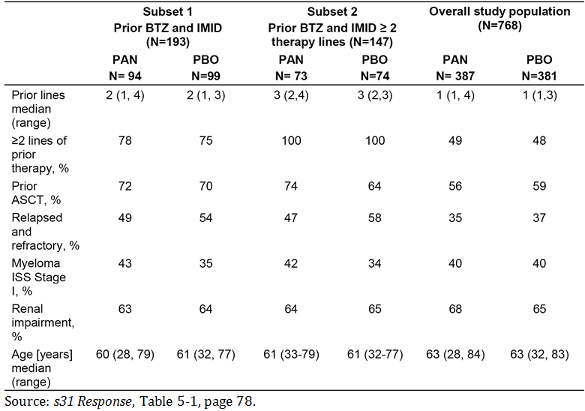
Comment: In general, the key demographic characteristics of patients in Subsets 1 and 2 are well balanced between the two treatment arms. The patients in Subsets 1 and 2 had more advanced disease than patients in the overall study population, as evidenced by the higher median number of prior lines of therapy, the higher proportion of patients with prior ASCT, and the higher proportion of patients with relapsed and refractory MM. In Subset 1, the median number of prior lines of therapy in the two treatment arms was 2, with a range of from 1 to 4 lines in the PAN+BTZ+Dex arm and 1 to 3 lines in the PBO+BTZ+Dex arm. In Subset 2, the median number of prior lines of therapy was 3 in both treatment arms, with a range of from 2 to 4 lines in the PAN+BTZ+Dex arm and 2 to 3 lines in the PBO+BTZ+Dex arm. Patients in Subsets 1 and 2 were younger than patients in the overall study population, with the median age of patients in the two treatment arms in the two subsets being approximately 2 to 3 years younger than patients in the overall study population.

Prior lines of anti-neoplastic therapy
The characteristics of prior lines of anti-neoplastic therapy reported in ≥ 20% of patients for single agents, and for combinations of interest are summarised below in Table 60. Combinations include at least 2 drugs, but combinations with any additions 3rd drug are included in the row.

Table 60: Key baseline characteristics Subsets 1 and 2, Study D2308, full analysis set
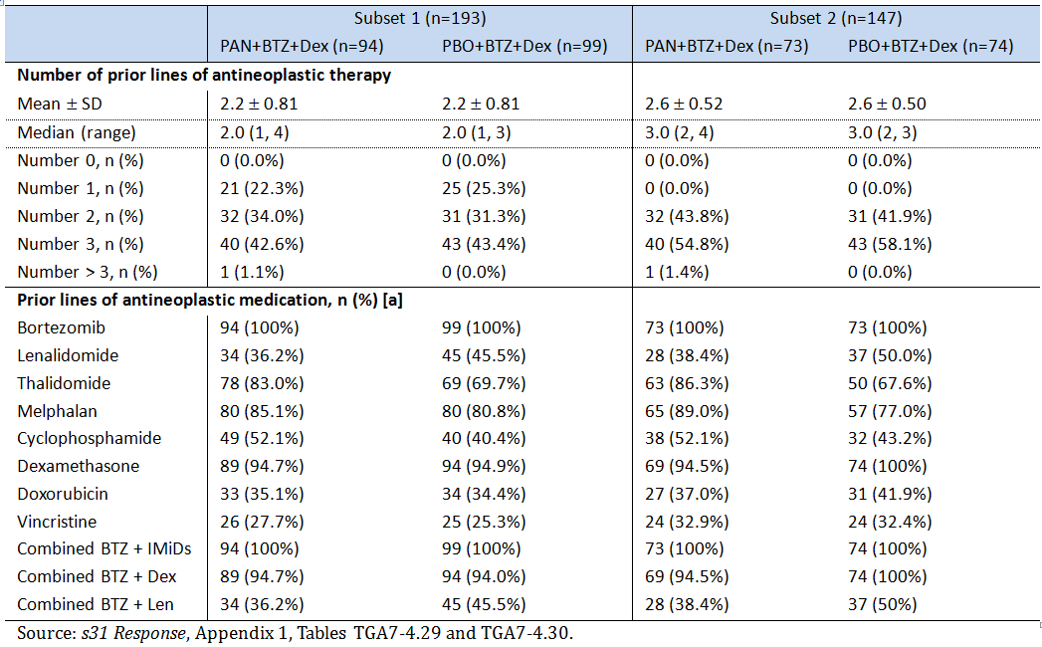
The most commonly reported last prior lines of antineoplastic medication for drugs with ≥ 10% of patients and combinations of interest are summarised below in Table 61. Combinations include at least 2 drugs, but combinations with any additions 3rd drug are included in the row.

Table 61: Key baseline characteristics Subsets 1 and 2, Study D2308, full analysis set
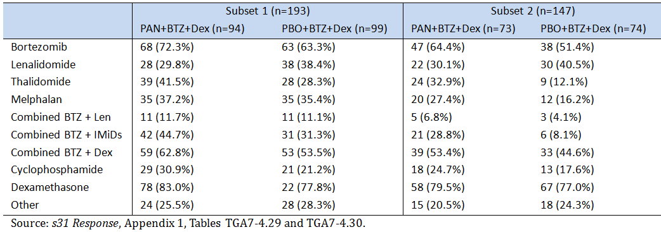

Patient disposition
The disposition of patients was similar in Subset 1 (patients with prior BTZ and IMiD) and Subset 2 (patients with prior BTZ and IMiD and ≥ 2 prior lines of antineoplastic therapy) (see Table 62).

Table 62: Patient disposition Subsets 1 and 2, Study D2308, full analysis set
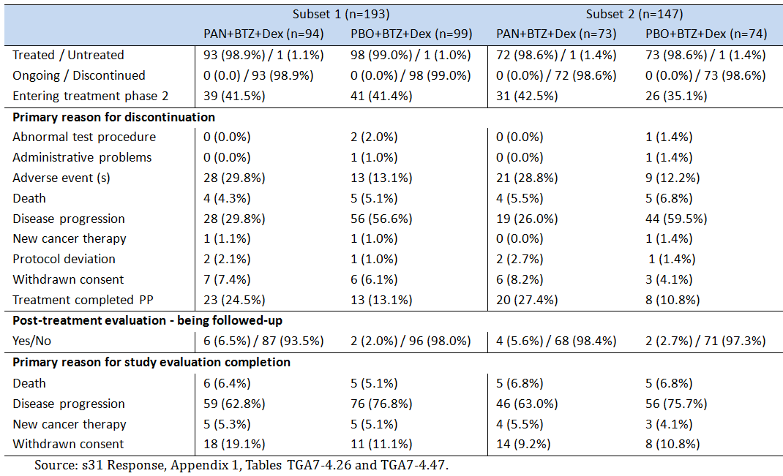
Comment: In both subsets, at the cut-off date for the analysis all randomised and treated patients had discontinued treatment. In both subsets, adverse events were reported as the primary reason for discontinuation in a greater proportion of patients in the PAN+BTZ+Dex treatment arms than in the PBO+BTZ+Dex treatment arms, while disease progression was reported as the primary reason for treatment discontinuation in a greater proportion of patients in the PBO+BTZ+Dex treatment arms than in the PAN+BTZ+Dex treatment arms. In both subsets, nearly all patients in both treatment arms were not being followed-up for post treatment evaluation, primarily due to disease progression.

Efficacy results

Primary efficacy endpoint; Progression Free Survival (PFS)
In the Phase III Study D2308, the primary endpoint was PFS as assessed by the Investigator. The PFS results for Subsets 1 and 2 are summarised below in Table 63, and the Kaplan-Meier curves for the 2 subsets are provided in Figure 18.

Table63: PFS in Subsets 1 and 2; Study D2308, FAS
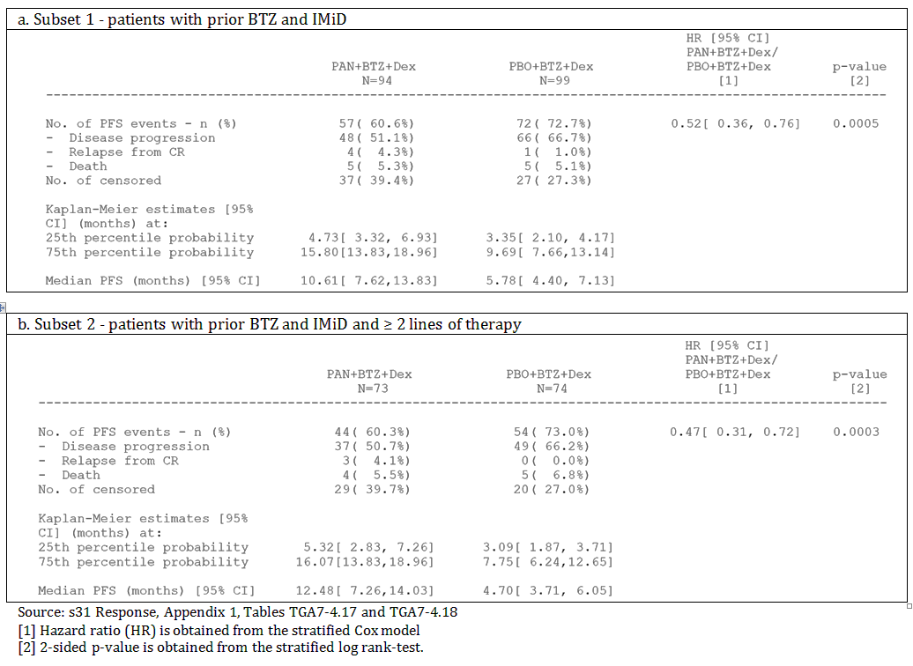
Figure 18: Progression-free survival in the two subsets; study D2308, FAS
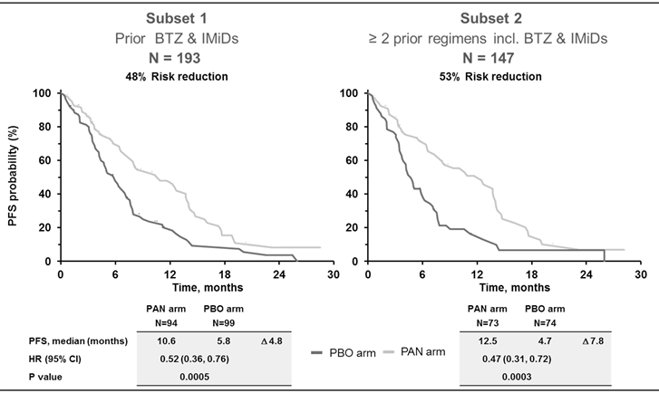
The sponsor also provided an analysis of the ‘treatment-free interval’ (TFI), defined as the time from end of treatment until disease progression or relapse. The TFI was longer in the PAN+BTZ+Dex arm compared to the PBO+BTZ+Dex arm in the overall population and the two subsets (see Figure 19).
Figure 19: Treatment free interval; Study D2308, FAS
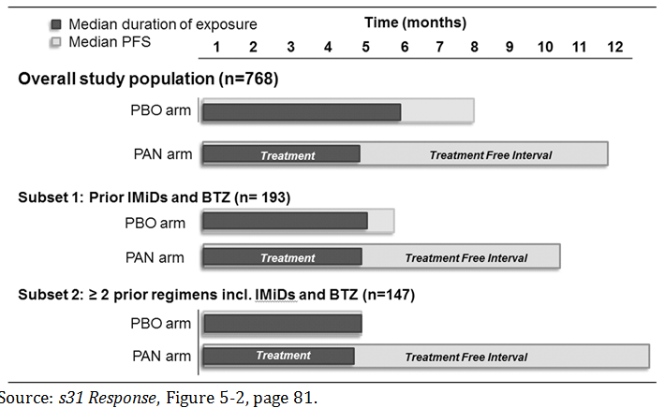
Comment: In Subset 1, the difference in the median PFS between the PAN+BTZ+Dex arm and the PBO+BTZ+Dex arm was 4.8 months (HR: 0.52 (95% CI: 0.36, 0.76), nominal p = 0.0005), and in Subset 2, the corresponding difference was 7.8 months (HR: 0.47 (95% CI: 0.31, 0.72), nominal p = 0.0003). The p-values for both pairwise comparisons in PFS should be considered to be nominal rather than confirmatory, as both analysis are considered to be exploratory rather than confirmatory. The major contributor to PFS events in both treatment arms in both subsets was disease progression. The proportion of patients who were censored was high in the PFS analysis in both subsets, raising concerns about the validity of the analyses. However, the censoring rates in the PFS analyses for the two treatment arms in the two subsets were lower than the censoring rates in the corresponding analysis in the overall population. No sensitivity analyses of PFS were provided for the subset analyses.

Other efficacy endpoint results
Overall survival (OS); 2nd interim analysis
The results of the 2nd interim OS analyses are summarised below in Figure 20. The median duration of OS in both subsets numerically favoured patients in the PAN+BTZ+Dex arm compared to the PBO+BTZ+Dex arm, but the hazard ratios were not statistically significant.
In Subset 1, the number of OS events in the PAN+BTZ+Dex arm was 56.4% (53/94) compared to 58.6% (58/99) in the PBO+BTZ+Dex arm, while in Subset 2 the corresponding values were 58.9% (43/73) and 66.2% (49/74).
Figure 20: Overall survival by treatment group (2nd interim analysis); Study group D2308, FAS
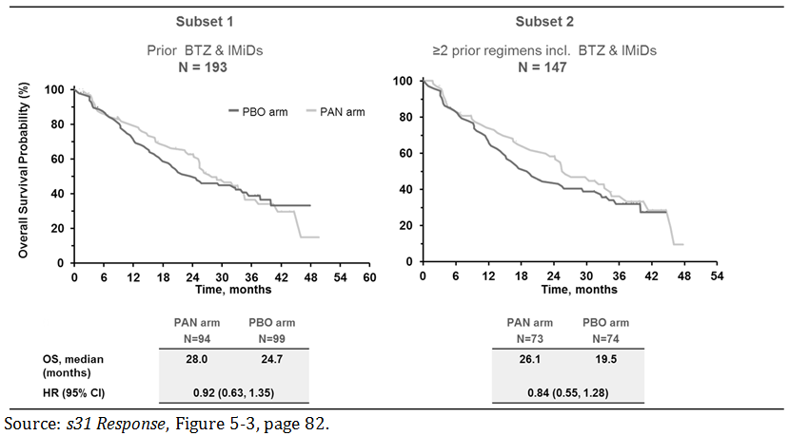
In an OS landmark analysis by response (CR/nCR versus PR) at 6 months for the overall population (n = 205) and patients from Subset 1 (n = 49) included in the PAN+BTZ+Dex treatment arm, OS was superior in patients achieving CR/nCR compared to patients achieving PR (see Figure 21). The median OS at the landmark time point was not estimable in the CR/nCR. The analysis was not undertaken in Subset 2 because of low patient numbers.
Figure 21: OS landmark analysis at 6 months for patients in the PAN+BTZ+Dex arm with CR/nCR compared to PR as best OS; study D2308, FAS
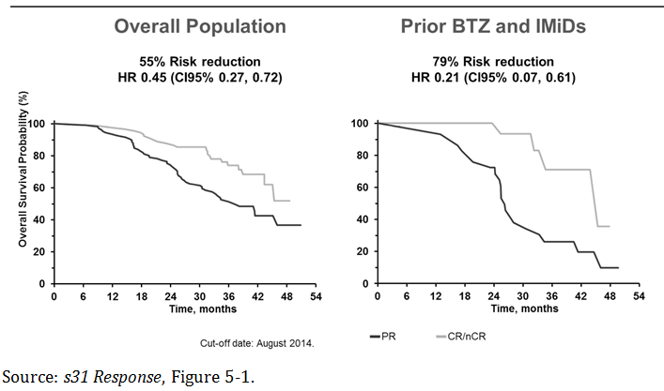
Comment: The OS analysis in Subset 1 and Subset 2 showed increased median OS in the PAN+BTZ+Dex arms compared to the PBO+BTZ+Dex arms, with the difference between both treatment arms in both subsets being not statistically significant (that is, 95% CI of HR includes 1). The sponsor’s response specifically comments that ‘since the key secondary endpoint OS was not statistically significant, the results of these subgroup analyses should be interpreted with caution’. The analyses are likely to be confounded by the high rate of post treatment new MM therapies in both treatment arms, particularly in the PBO+BTZ+Dex arm (see Table 64). The majority of post treatment new MM therapies occurred after documented PD, which would account for the higher rate observed in the PBO+BTZ+Dex arms compared to the PAN+BTZ+Dex arms. New MM therapies with no documented PD were similar in both treatment arms in each of the subset analyses. It is noted that the KM curves for the OS analysis in Subset 1 cross-over at about 32 to 33 months, indicating that the hazard functions are not proportional and violating the assumption that the hazard ratio is consistent over time. Overall, it is considered that it cannot be assumed that PAN+BTZ+Dex provides an OS benefit compared to PBO+BTZ+Dex in patients with advanced MM who have been treated with prior BTZ and IMiDs (that is, Subset 1) due to the HR being not statistically significant, confounding due to high rates of post treatment new MM therapies, and cross-over of the survival curves violating the assumption of proportionality for the hazard functions.

Table 64: New multiple myeloma therapies after end of treatment; study D2308, FAS
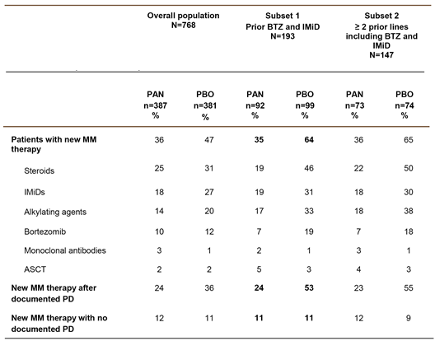
Overall Response Rate (ORR); modified EBMT criteria per investigator assessment
- In Subset 1, the ORR (CR+nCR+PR) was 58.5% (55/94) in the PAN+BTZ+Dex arm and 41.4% (41/99) in the PBO+BTZ+Dex arm; nominal p-value = 0.01893. The nCR+CR rate was 22.3% (21/55) in the PAN+BTZ+Dex arm and 9.1% (9/99) in the PBO+BTZ+Dex arm; nominal p value = 0.01243. The results for the best overall response based on modified EBMT criteria per investigator assessment are summarised in Table 65.
Comment: The ORR was nominally statistically significantly greater in the PAN+BTZ+Dex arm than in the PBO+BTZ+Dex arm, with the majority of responses contributing to the ORR in both treatment arms being partial responses.
- In Subset 2, the ORR (CR+nCR+PR) was 58.9% (43/73) in the PAN+BTZ+Dex arm and 39.2% (29/74) in the PBO+BTZ+Dex arm; nominal p-value = 0.01703. The nCR+CR rate was 21.9% (16/73) in the PAN+BTZ+Dex arm and 8.1% (6/74) in the PBO+BTZ+Dex arm; nominal p-value = 0.02296. The results for the best overall response based on modified EBMT criteria per investigator assessment are summarised in Table 65.
Comment: The ORR was nominally statistically significantly greater in the PAN+BTZ+Dex arm than in the PBO+BTZ+Dex arm, with the majority of responses contributing to the ORR in both treatment arms being partial responses.

Table 65: Best overall response based on modified EBMT criteria per investigator assessment by treatment group in both subsets; D2308, FAS
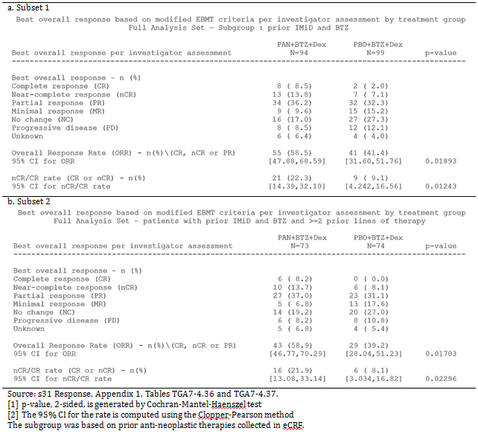

Safety results

Overview of safety data
The sponsor’s response included safety data from Subsets 1 and 2 and the overall study population. In this second round CER the focus is primarily on the safety data from Subset 1 (that is, the pre-specified subgroup analysis in patients treated with prior BTZ and an IMiD). The safety data from Set 2 (that is, non pre-specified subgroup analysis in patients with prior BTZ and an IMiD and ≥ 2 prior lines of therapy) was consistent with that from Subset 1. This is not surprising as the patients in Subset 2 formed a relative large subgroup of patients in Subset 1, with Subset 2 comprising 79% (73/92) of patients in the PAN+BTZ+Dex arm and 75% (74/99) of patients in the PBO+BTZ+Dex arm from Subset 1.

Exposure
- In Subset 1, the median duration of exposure was 142 days (range: 3, 411 days) in the PAN+BTZ+Dex arm and 152 days (range: 5, 443) in the PBO+BTZ+Dex arm. The exposure data are summarised in Table 66.
- In Subset 2, the median duration of exposure was 135.5 days (range: 3, 411 days) in the PAN+BTZ+Dex arm and 145.0 days (range: 5, 443) in the PBO+BTZ+Dex arm. The exposure data are summarised in Table 66.
- In the full study population, the median duration of exposure was 152 days (range: 3, 411 days) in the PAN+BTZ+Dex arm and 187 days (range: 3, 443 days) in the PBO+BTZ+Dex arm.
Comment: Exposure to the treatment was longer in the full study population than in the two subsets, and exposure in both treatment arms was greater in Subset 1 than in Subset 2.

Table 66: Duration of exposure to study treatment by treatment group in both subsets; D2308, safety set
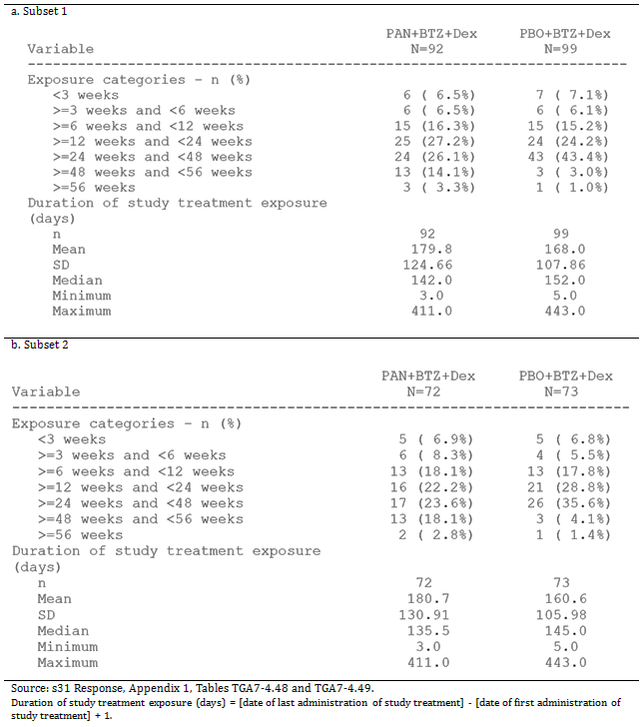

Safety profile; overview of key parameters
The key safety parameters contributing to the safety profiles in the overall population and Subset 1 are summarised below in Table 67, and the corresponding results for Subset 2 are summarised in Table 68.

Table 67: Summary of key safety parameters in the overall population and Subset 1; safety set
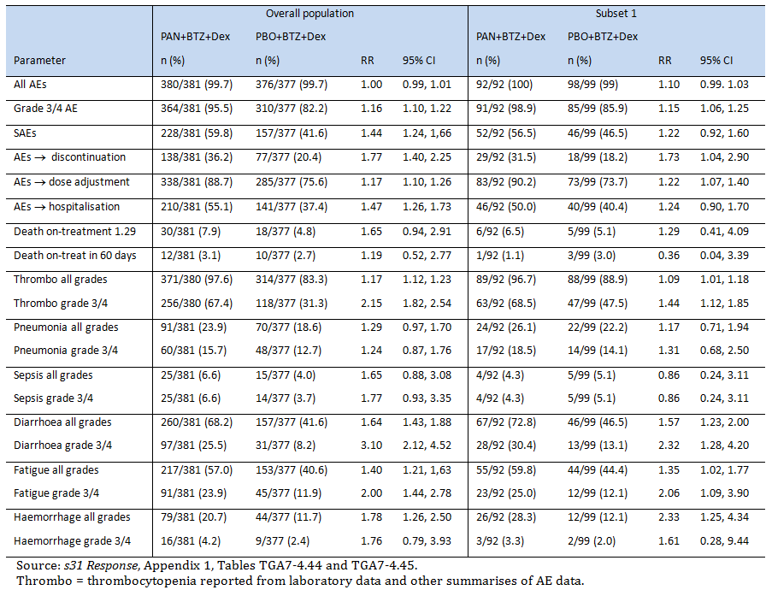

Table 68: Subset 2; High level overview of key safety parameters; study D2308, safety set
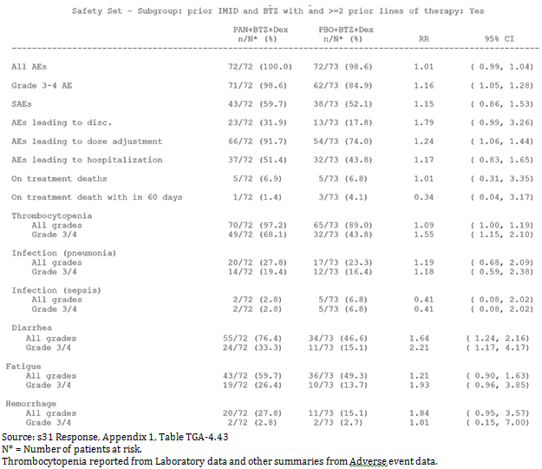
Comment: In general, the safety profiles of patients in the PAN+BTZ+Dex arm were similar in the overall population and in Subset 1, with the main difference being the smaller proportion of patients with on treatment death and on treatment death within 60 days in Subset 1 compared to the overall population.

Clinically notable Grade 3/4 AEs regardless of relationship to study drug
Clinically notable Grade 3 or 4 AEs reported in either treatment arm in Subset 1, by decreasing order of frequency in the PAN+BTZ+Dex arm are summarised below in Table 69. The groupings consist of AEs for which there is a specific clinical interest in connection with PAN or AEs which are similar in nature and can be grouped together. AEs occurring more than 28 days after the discontinuation of study treatment are not summarised in the table. The complete summary of clinically notable AEs (all and Grade 3 or 4) in Subset 1 was provided. The results for Subset 2 were generally consistent with those for Subset 1.

Table 69: Subset 1; clinically notable Grade 3 or 4 adverse events regardless of relationship to study drug reported in in either treatment arm in descending order of frequency in the PAN+BTZ+Dex arm; Study D2308, safety set
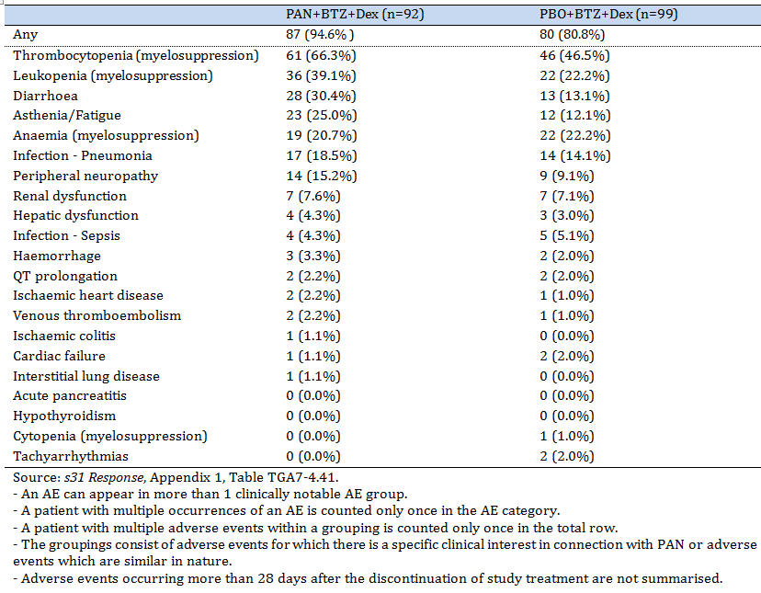

Grade 3/4 AEs (preferred term) suspected to be related to study drug
Adverse events (preferred term) suspected to be related to the study drug and reported in ≥ 5% of patients in either treatment arm in Subset 1, by decreasing order of frequency in the PAN+BTZ+Dex arm are summarised below in Table 70. The results for Subset 2 were generally consistent with those for Subset 1.

Table70: Subset 1; Grade 3 or 4 adverse events (preferred term) suspected to be related to study drug reported in ≥ 5% of patients in either treatment arm and by descending order of frequency in the PAN+BTZ+Dex arm; Study D2308, safety set
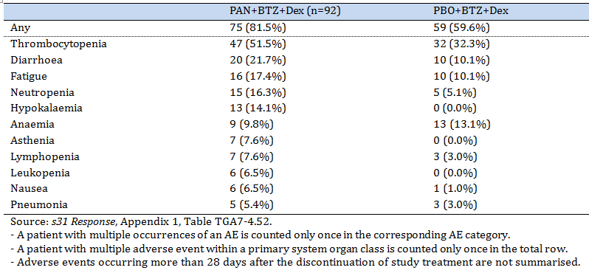

Deaths
In Subset 1, in the on treatment period (that is, deaths occurring during treatment or within 28 days after the last dose of study treatment) there were a total of 6 (6.5%) deaths in the PAN+BTZ+Dex arm and 5 (5.1%) deaths in the PBO+BTZ+Dex arm. The on treatment AEs (preferred term) resulting in death in the PAN+BTZ+Dex arm were one each for myocardial ischaemia, lung infection, septic shock, acute renal failure, pulmonary haemorrhage and death. None of the deaths in the PAN+BTZ+Dex arm were considered to be due to study indication (that is, MM as principal reason for death). The on treatment AEs (preferred term) resulting in death in the PBO+BTZ+Dex arm were one each for cardio-respiratory arrest, necrotising fasciitis, neutropenic sepsis. Two (2) of the 5 deaths in the PBO+BTZ+Dex arm were considered to be due to the study indication.

SAEs (preferred term) regardless of relationship to study drug
In Subset 1, SAEs (all Grades) were reported in 56.5% (52/92) of patients in the PAN+BTZ+Dex arm and 46.5% (46/99) of patients in the PBO+BTZ+Dex arm. SAEs (all Grades) reported in ≥ 2% of patients in either of the two treatment arms are summarised below in Table 71, in descending order of frequency in the PAN+BTZ+Dex arm.

Table 71: Subset 1; SAEs (all Grades) regardless of relationship to study drug reported in ≥ 2% of patients in either treatment arm in descending order of frequency in the PAN+BTZ+Dex arm; Study D2308, safety set
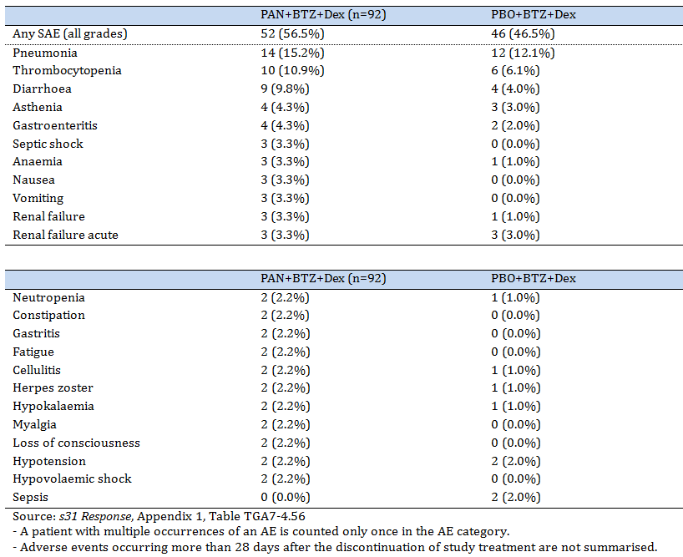

AEs (preferred term) leading to study drug discontinuation regardless of relationship to study drug
In Subset 1, AEs (all Grades) leading to study drug discontinuation, regardless of relationship to study drug, were reported in 31.5% (29/92) of patients in the PAN+BTZ+Dex arm and 18.2% (18/99) of patients in the PBO+BTZ+Dex arm. AEs (all Grades) resulting in treatment discontinuation reported in ≥ 2% of patients in either of the two treatment arms in descending order of frequency in the PAN+BTZ+Dex arm are summarised below in Table 72. A more detailed summary of study drug discontinuations due to AEs was provided.

Table 72: Subset 1; AEs (all Grades) resulting in study drug discontinuation regardless of relationship to study drug reported in ≥ 2% of patients in either treatment arm in descending order of frequency in the PAN+BTZ+Dex arm; Study D2308, safety set
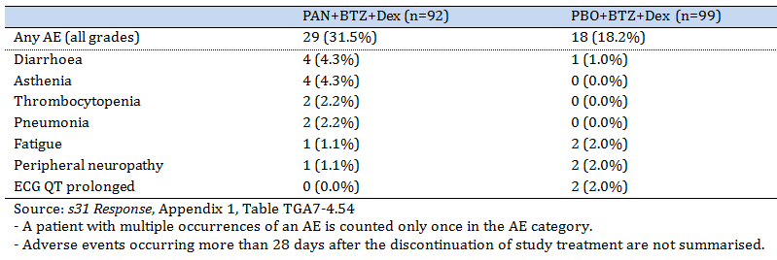

Haematology laboratory results
In Subset 1, newly occurring or worsened laboratory haematology parameters based on CTC by treatment group were provided. The results of this analysis are summarised below:
- Newly occurring or worsening from baseline Grade 3/4 reductions in platelet count (thrombocytopenia) were reported in a greater proportion of patients in the PAN+BTZ+Dex arm than in PBO+BTZ+Dex arm (68.5% (63/92) versus 48.0% (47/98)).
- Newly occurring or worsening from baseline Grade 3/4 reductions in white blood cell count (leukopenia) were reported in a greater proportion of patients in the PAN+BTZ+Dex arm than in PBO+BTZ+Dex arm (19.6% (18/92) versus 12.1% (12/99)).
- Newly occurring or worsening from baseline Grade 3/4 reductions in absolute neutrophil number (neutropenia) were reported in a greater proportion of patients in the PAN+BTZ+Dex arm than in PBO+BTZ+Dex arm (35.9% (33/92) versus 17.2% (17/99)).
- No clinically significant differences were observed between the two treatment arms in the proportion of patients reporting newly occurring or worsening from baseline Grade 3/4 haemoglobin levels, absolute lymphocyte counts, or activated partial thromboplastin time.

Clinical chemistry laboratory results
In Subset 1, newly occurring or worsened clinical chemistry laboratory parameters based on CTC by treatment group were provided. The results of note are summarised below:
- Newly occurring or worsened parameters (any Grade) reported in ≥ 10% more patients in the PAN+BTZ+Dex arm than in the PBO+BTZ+Dex arm were reduced albumin levels (59.8% versus 41.4%), increased serum alkaline phosphatase levels (27.2% versus 12.1%), increased total bilirubin levels (26.1% versus 10.1%), hypocalcaemia (73.9% versus 57.3%), increased creatinine levels (39.1% versus 25.3%), hypermagnesaemia (26.1% versus 14.4%), reduced inorganic phosphorous levels (69.2% versus 52.6%), hypokalaemia (51.1% versus 35.4%), and hyponatraemia (45.7% versus 35.4%)
- Newly occurring or worsened parameters Grade 3/4 reported in ≥ 5% of patients in the PAN+BTZ+Dex arm and more commonly than in the PBO+BTZ+Dex arm were hyperkalaemia (5.4% versus 1.0%), hypokalaemia (18.5% versus 5.1%), and hyponatraemia (13.0% versus 9.1%).

Abnormal QTcF values
Abnormal QTcF values by treatment group are summarised below in Table 73 for patients in Subset 1.

Table 73: Subset 1; Summary of patients with abnormal QTcF values; Study D2308, safety set
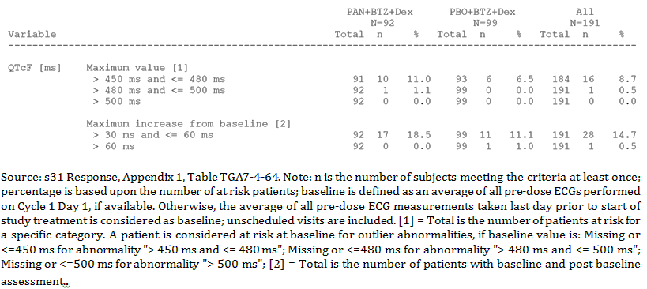

Sponsor's response to first round recommendation regarding authorisation

Reason 1
In the pivotal Study (Study D2308), treatment with PAN+BTZ+Dex significantly prolonged the median PFS by 3.9 months compared with PBO+BTZ+Dex based on investigator assessment using mEBMT criteria (primary efficacy analysis). However, there are doubts about the validity of the results of this analysis due to the high rate of patient censoring in both treatment arms (46.5% (180/387) in the PAN+BTZ+Dex arm; 31.8% (121/381) in the PBO+BTZ+Dex arm. Of particular concern was the high rate of censoring of non-ongoing patients (that is, dropouts) (37.5% (145/387) in the PAN+BTZ+Dex arm and 27.8% (106/381) in the PBO+BTZ+Dex arm). In addition, the notably higher rate of patients in the total population censored due to withdrawn consent in the PAN+BTZ+Dex arm compared to the PBO+BTZ+Dex arm suggests that the combination was less well tolerated in the ‘PAN’ arm (19.1% (n = 74) versus 11.8% (n = 45)). Such high rates of censoring in non-ongoing patients raise doubts about the robustness of the primary analysis and the precision of the observed treatment effect.
Sponsor's Response and clinical comments
- Drop-outs
The reasons for censoring are summarised below in Table 74. As there have been more events in the PBO+BTZ+Dex arm, there are more patients in the PAN arm considered censored (PAN+BTZ+Dex: 46.5% versus PBO+BTZ+Dex: 31.8%). As a consequence, for the assessment of the censoring reasons, the number of censored patients has been used as denominator to address this imbalance.

Table 74: Summary of censoring reasons for PFS (investigator assessment, modified EMBT criteria) by treatment group (Full Analysis Set)
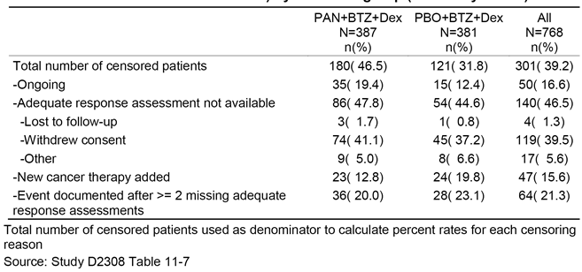
To assess the impact of potential informative censoring, the last adequate assessment for patients who have been censored was analysed. The majority of the patients who were censored due to the start of new antineoplastic therapy in the primary PFS analysis had at least a minimal response (PAN+BTZ+Dex arm: 78.3%; PBO+BTZ+Dex arm: 58.3%) in the last response assessment prior to starting new therapy (see Table 75)). Therefore, the data do not support the assumption that new therapy was started due to disease progression. Hence this analysis is expected to be biased against the PAN+BTZ+Dex arm.

Table 75: Last adequate response assessment of patients who were censored due to start of new therapy (Study D2308, FAS)
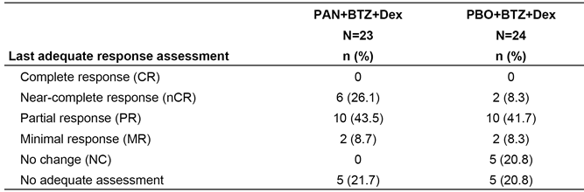
The frequencies of response categories in the last adequate response assessment prior to censoring due to an event after ≥ 2 missing assessments were balanced across the treatment groups (the median time from the last response assessment until the actual event date is similar (see Table 76)). This indicates that there is no informative censoring expected due to missing assessments prior to an event.

Table 76: Last adequate response assessment of patients censored due to event after ≥ 2 missing assessments (FAS)
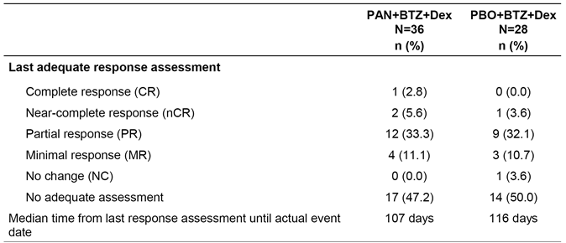
As part of the pre-defined sensitivity analyses, dropouts (defined as any of the following: subsequent antineoplastic therapy, reason for end of treatment as disease progression without investigator documentation, or disease progression after ≥ 2 missing adequate assessments as events) were monitored on an ongoing basis throughout the trial. It became apparent during the early part of the study that the rate was higher than the assumption in the protocol. As a consequence, multiple steps were taken including an increase in the sample size (as implemented in Study D2308 (Amendment 2)), an assessment of the patients who withdrew consent by the Independent Data Monitoring Committee (IDMC), and the addition of a predefined PFS sensitivity analysis to the Statistical Analysis Plan. This analysis considered censored patients with:
- an event after missing assessments
- an event after the start of new therapy; and
- patients who stopped therapy or follow-up due to PD without supportive response assessments as having a PFS event (‘dropout analysis’) performed.
Among these patients, the primary reason for censoring in the PAN+BTZ+Dex treatment arm was withdrawal of consent to further disease follow-up (39 patients (45.9%) as compared to 16 patients (42.1%) in the PBO+BTZ+Dex arm) and, therefore, the ‘dropout analysis’ was able to address the potential impact of informative censoring due to withdrawal of consent. The result of this analysis was consistent with the outcome of the primary analyses (see Table 77).

Table 77: Summary of predefined PFS sensitivity analyses (Study D2308 FAS)
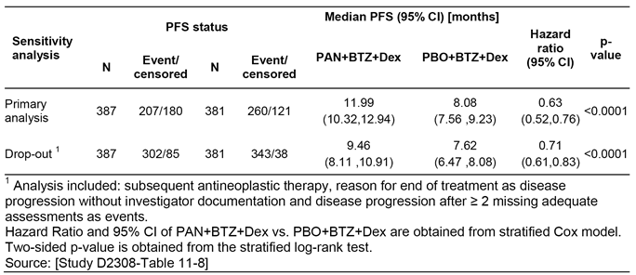
In conclusion, the dropout sensitivity analysis was conducted to investigate the impact of the high proportion of dropouts. This analysis tested a worst-case scenario and provided support that the results of the primary analysis were indeed robust. Informative censoring due to start of new therapy or missing adequate assessments prior to an event, if present, had minimal or no impact on the robustness on the treatment effect of panobinostat.
Comment: The sponsor's comment that the results of the ‘dropout’ sensitivity analysis (see Table 77, above) were consistent with the outcome of the primary analysis is not supported by the data. While it is acknowledged that both analyses were statistically significant, the difference in the median PFS between the two treatment arms was notably different (that is, 3.9 months for the primary analysis and 1.8 months for the ‘dropout’ sensitivity analysis). The difference in median PFS of 1.8 months between the two treatment arms in the ‘dropout’ sensitivity analysis is of doubtful clinical significance, and is considered not to provide robust clinically meaningful support for the primary analysis.
- Withdrawal of consent
Patients, who had not progressed or started new antineoplastic therapy upon stopping study treatment, were asked for agreement to be followed-up for further disease assessments. The reasons for end of treatment in patients who withdrew consent for further disease follow-up and have been censored in the primary progression-free survival (PFS) analysis (74 (19.4%) patients in the PAN+BTZ+Dex arm and 45 (11.9%) patients in the PBO+BTZ+Dex arm) are reported (below in Table 78)

Table 78: Reasons for end of treatment for patients censored due to withdrawal of consent (Study D2308, FAS)
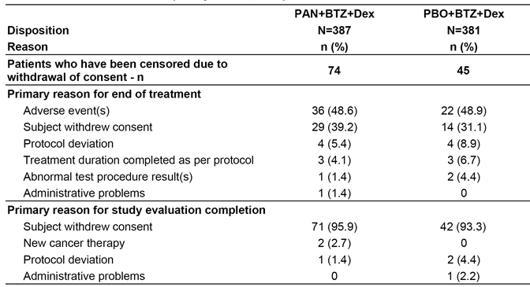
Amongst the patients who withdrew consent for further disease assessments and who have been censored in the primary PFS analysis, approximately half of the patients from each arm stopped treatment due to AEs, while 39.2% and 31.1% of patients from the PAN+BTZ+Dex and PBO+BTZ+Dex arms, respectively, discontinued treatment due to withdrawal of consent. Data were queried for verification if ‘withdrawal of consent’ to treatment was primarily due to an AE, or if ‘withdrawal of consent’ was documented in the patients’ medical notes. Specific reasons for a patient’s decision to ‘withdrawal of consent’ were not questioned or captured in the eCRF. As a result, the underlying reasons for the withdrawal of consent to study treatment and disease follow-up were not reported.
The impact of informative censoring due to withdrawal of consent is considered not to be relevant as supported by the following analyses. Analysis of AEs occurring within the two week period prior to treatment discontinuation has been conducted (see Table 79) and results indicate an overlapping toxicity profile is the same for the whole study. This suggests that there is no evident unblinding by toxicities that could lead to informative censoring.

Table 79: AEs within the two week period prior to treatment discontinuation in patients who withdrew consent (Study D2308, Safety Set)
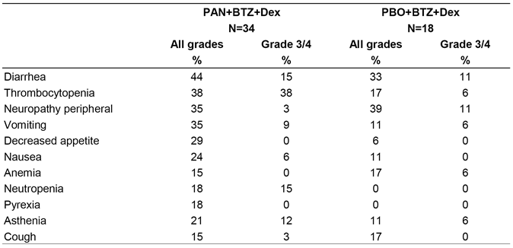
For the patients who have been censored due to withdrawal of consent, 56.8% of the patients in the PAN+BTZ+Dex treatment arm and 48.9% in the PBO+BTZ+Dex arm had an assessment of partial response (PR) or better prior to stopping disease follow-up (see Table 80), and the majority of these patients had at least a minimal response. This indicates that, in general, patients were not in progression at the time of withdrawal of consent and therefore it is unlikely to introduce informative censoring.

Table 80: Last adequate response assessment of patients censored due to withdrawal of consent (Study D2308, FAS)
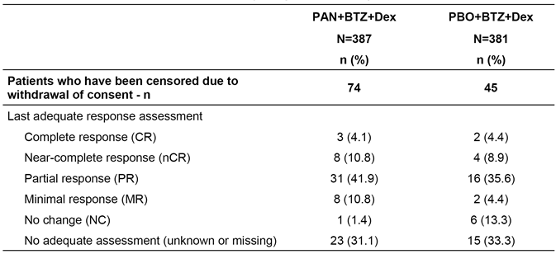
To delineate any potential informative censoring, sensitivity analyses were conducted to mimic worst-case scenarios considering the dropout cases as PFS events. Results of the sensitivity analyses on the primary endpoint of PFS confirmed the robustness and consistency of the primary analysis. A PFS sensitivity analysis was conducted with withdrawal of consent considered as an event. In this analysis, patients were considered to have an event in cases of progression, relapse, death, or withdrawal of consent. Patients who were still ‘ongoing’ or started new therapy were censored. Consistent with the primary analysis, this analysis showed a PFS advantage for the PAN+BTZ+Dex treatment arm, with a hazard ratio (HR) of 0.78 (95% CI: 0.67, 0.92). For the reasons outlined above, this ‘extreme case’ sensitivity analysis is very conservative and its underlying assumption that withdrawal of consent may mask potential PFS events is for a majority of patients not supported by the data as described above. (The sponsor identified Table 81 as the source of the sensitivity analysis. The results of the sensitivity analysis are provided immediately below)

Table 81: Sensitivity analysis of PFS per investigator assessment considering withdrawal of consent as event by treatment group (mEBMT criteria) FAS
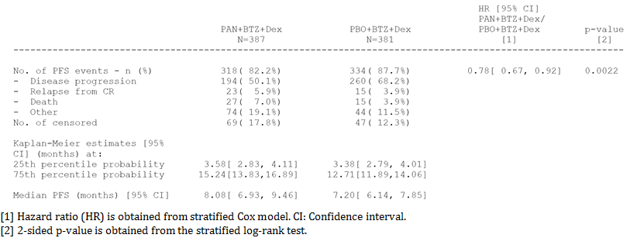
In conclusion, the data suggest that the possibility of informative censoring based on the rate of withdrawal of consent is negligible. In the unlikely presence of informative censoring the impact on the PFS analysis is considered to be minimal with the HR for PFS sensitivity analysis with conservative assumptions still in favour of PAN+BTZ+Dex. The last response assessment prior to withdrawal of consent to disease follow-up indicates that the majority of patients have had at least a minimal response. This was balanced across treatment arms.
Comment: The sponsor's argument that the data suggest that the possibility of informative censoring based on the rate of withdrawal of consent is negligible is not persuasive. The AE data for the two-week period for the two treatment arms summarised above in Table 79 indicates that the safety profile of the PAN+BTZ+Dex arm was notably inferior to that of the PBO+BTZ+Dex arm, particularly as regards diarrhoea, thrombocytopenia, vomiting, decreased appetite, nausea, neutropenia, pyrexia, and asthenia. This raises the possibility that withdrawal of consent in patients in the PAN+BTZ+Dex arm was driven by drug related toxicity in the two-week period immediately prior to withdrawal. In addition, the rate of partial response or better prior to stopping disease follow-up was lower in the PBO+BTZ+Dex arm compared to the PAN+BTZ+Dex arm raising the possibility that disease progression might have resulted in withdrawal of consent in the PBO+BTZ+Dex arm. Furthermore, although the HR was statistically significant for the PFS sensitivity analysis conducted with withdrawal of consent as an event, the difference in median PFS between the two treatment arms was negligible (that is, 0.9 months). Overall, it is considered that possibility of informative censoring based on the rate of withdrawal of consent is not negligible and introduces a significant degree of uncertainty into the interpretation of the primary analysis of the PFS.

Reason 2
In the pivotal Study D2308, PFS events were disease progression, relapse from CR and death. In the pivotal study (Study D2308), the increased median PFS of 3.9 months observed with PAN+BTZ+DEX compared with PBO+BTZ+Dex is being driven by a difference between the two treatment arms in disease progression (42.4% versus 60.6%, respectively). However, deaths contributed more frequently to PFS events in the PAN+BTZ+Dex arm than in the PBO+BTZ+Dex (5.2% versus 3.7%) as did relapse (5.2% versus 3.9%). Therefore, lower rates of disease progression in the PAN+BTZ+Dex arm compared to the PBO+BTZ+Dex arm are off-set by worsening rates of death and disease relapse.
Sponsor's response
Progression free survival is a composite endpoint considering disease progression, relapse or death due to any reason. Relapse, as per mEBMT criteria, requires a confirmed Complete Response (CR) prior to the onset of relapse. Therefore, the population at risk for experiencing relapse depends on the rate of patients with CR. As there are more patients with CR in the PAN+BTZ+Dex arm (10.9% versus. 5.8% in PBO+BTZ+Dex, the probability to experience relapse is therefore higher in the PAN+BTZ+Dex arm as compared to PBO+BTZ+Dex. Out of the 37 patients who have been considered with PFS event due to death, the majority died while on treatment (PAN+BTZ+Dex: n = 21 (91.3%), PBO+BTZ+Dex: n = 11 (78.6%). Considering death at any time, there have been more patients in the PBO+BTZ+Dex (n = 190 (49.9%)) as compared to PAN+BTZ+Dex (n = 169 (43.7%).
Clinical Evaluator's Comment: The sponsor's comments are noted.

Reason 3
The results for two key sensitivity PFS analyses for the median difference in the PFS between the two treatment arms were inconsistent with the results for the primary PFS analysis (Study D2308). The difference in median PFS between the two treatment arms was 1.8 months in the ‘dropout’ sensitivity analysis, 2.3 months in the IRC assessment/mEBMT criteria sensitivity analysis and 3.9 months in the primary analysis (investigator/mEBMT criteria). While with the median PFS comparison for both sensitivity analyses statistically significantly favoured the PAN+BTZ+Dex arm relative to the PBO+BTZ+Dex arm, the difference in median PFS between the two treatment arms was less than 2.7 month for both analyses (that is, the difference used to power the pivotal study). The results of the PFS sensitivity analysis (‘drop‐out’) suggest that missing data from these patients might have biased the primary analysis towards the PAN+BTZ+Dex arm. Therefore, the PFS results for the two key sensitivity analyses are considered to be of doubtful clinical significance, given that it can be reasonably inferred from the power calculations that a treatment difference of 2.7 months is the minimum clinically meaningful difference applicable to the two treatment arms in the pivotal study.
Sponsor's response
Sensitivity analyses are designed/ intended to assess the robustness of the results of the primary analysis and the corresponding estimate of the treatment effect should be interpreted with caution. Each of the sensitivity analyses represents an extreme-case scenario to support the understanding of the robustness of the primary analysis. The median PFS is obtained from the patient with the 50th percentile of the ordered PFS. This single observation does not sufficiently describe the overall distribution of the survival function. The HR provides a more robust estimator as it takes the complete distribution of the survival curves into account. Of note, the HRs across all PFS sensitivity analyses were very consistent to the results of the primary PFS analysis, ranging from 0.58 to 0.71 and achieving statistical significance for each analysis.
IRC sensitivity analysis: Following submission and further to subsequent discussion with the IRC, it was discovered that the IRC did not take into account the need for confirmation of disease progression (PD) for response assessment as required by modified European Society for Blood and Marrow Transplantation (mEBMT) criteria. Based on the corrected IRC analysis, the median PFS was very similar to the primary analysis and the treatment effect was comparable: the HR was 0.63 (95% CI: 0.52, 0.76) for investigator and for 0.63 (95% CI: 0.52, 0.76) for IRC assessment based on confirmed PD. The results of the primary PFS analysis based on investigator assessment are robust as supported by the high concordance of PFS status between investigator and IRC assessment of 85% in the PAN+BTZ+Dex arm and 83% in the PBO+BTZ+Dex arm
Drop-out sensitivity analysis: The dropout analysis considered censored patients with:
- an event after missing response assessments
- an event after the start of new therapy; and
- patients who stopped therapy or follow-up due to disease progression without supportive response assessments as having a PFS event.
To assess the status of the patients who have been censored in the primary analysis and considered PFS event in the dropout analysis, the last adequate response assessment was identified and summarized in Table 82. In total, n = 48 (50.5%) of the patients in the PAN+BTZ+Dex and n = 33 (39.8%) of the patients in the PBO+BTZ+Dex arm have had PR or better at their last response assessment. This indicates that the PAN+BTZ+Dex group is penalized as the majority of patients was not in progression at the time of being considered PFS event in the dropout analysis and therefore it is unlikely to introduce bias due to informative censoring considering the dropout criteria like missing assessments, start of new therapy or disease progression which is not supported by a corresponding response assessment.

Table 82: Last adequate response assessment of patinets who were considered PFS event in the drop out sensitivity analysis and who have been censored in the primary analysis (Study 2308 FAS)
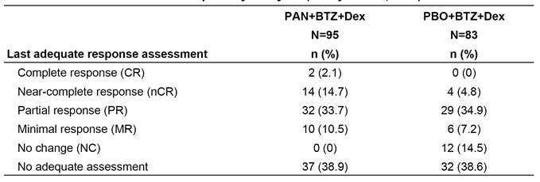
Comment: The sponsor's response is noted.

Reason 4
There were no confirmatory data in the pivotal Study (Study D2308) showing that PAN+BTZ+Dex confers an OS benefit compared to PBO+BTZ+Dex in the proposed patient population. The interim OS data were immature and showed no statistically significant difference between the two treatment arms in median OS survival. In addition, treatment with PAN+BTZ+Dex did not improve the quality of life compared with PBO+BTZ+Dex, based on patient reported outcomes.
Sponsor's response
- Clinical relevance of the overall survival benefit in the PAN arm
The first overall survival (OS) analysis was conducted when 286 events were reached, corresponding to an information fraction of 68.9% per the 415 OS events planned for the final OS analysis. For this first interim analysis, OS was not statistically different between the two treatments (log-rank p value = 0.2586, two-sided) with an HR of 0.87 (95% CI: 0.69, 1.10) The second interim OS analysis was introduced with the D2308 Protocol (Amendment 6) (issued on 21 August 2014) and was not included in the original NCE application submitted in 2014. The second interim OS analysis is now reported in the AU PI. The second interim OS analysis was conducted with a cut-off date of 18 August 2014, at which time 359 (86.5%) OS events had occurred out of the targeted 415 events required for the final OS analysis. At that time, 342 patients were still being followed for survival (179 patients in the PAN+BTZ+Dex arm, and 163 patients in the PBO+BTZ+Dex arm). As reported in Table 83 and Figure 22, OS continued to show a trend towards a benefit for the PAN+BTZ+Dex arm, although it did not reach statistical significance, with a hazard ratio of 0.87 (95% CI: 0.70, 1.07). There were more deaths in the PBO+BTZ+Dex arm, with 169 OS events (43.7%) in the PAN+BTZ+Dex arm and 190 (49.9%) in the PBO+BTZ+Dex arm. The median OS was 38.24 months for the PAN+BTZ+Dex arm and 35.38 months PBO+BTZ+Dex arm. Therefore, the trend observed in the initial interim analysis included in the submission is maintained. The results for the final OS analysis based on 415 deaths are expected in the third quarter of 2015.

Table 83: Analysis of overall survival (2nd interim analysis) by treatment group (FAS)
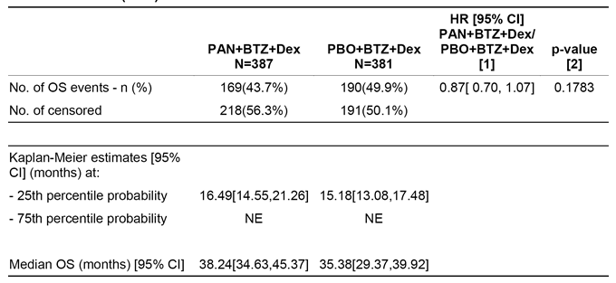
Figure 22: Kaplan-Meier plat of overall survival (2nd interim analysis) by treatment group (FAS)
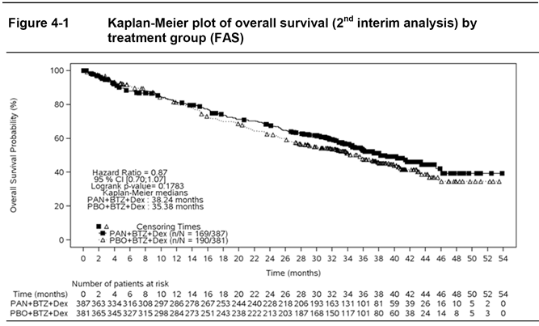
The increase in median OS (2nd interim analysis) is considered clinically relevant and is observed despite a higher rate of post treatment therapies in the placebo arm (see Table 84).

Table 84: New myeloma therapies after end of treatment (Study D2308 FAS)
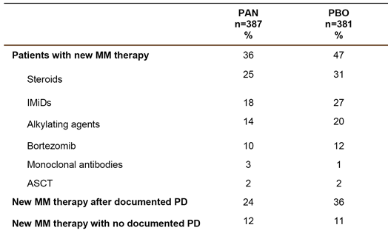
The difference in the number of patients receiving post treatment therapies was observed. This might confound the OS in favour of the PBO+BTZ+Dex arm. The imbalance in the percentage of patients receiving post treatment MM therapies is due to therapies given after progression and is consistent with the observation of more PFS events reported in the placebo arm. On treatment toxicities are unlikely to have influenced the start of a new myeloma therapy, because the discontinuation due to AEs was similar in the PAN+BTZ+Dex arm regardless of whether patients received a post treatment therapy or not (overall population: 39% versus 30%). In addition, the median time from progression to start a new anti-myeloma therapy was short (34 versus 47 days, in PAN arm and PBO arm respectively), pointing to the fact that progressions were generally symptomatic and meeting criteria for immediate treatment, as described in the IMWG guidelines; these guidelines provide the indicators for start of treatment in relapsed MM (that is levels of increase in M-protein values and/or myeloma related end organ dysfunction). Even if the treatment discontinuation rate due to AE was higher in the PAN+BTZ+Dex arm, percentage of patients discontinuing therapy without progression receiving post treatment therapies was similar in both arms (Table 85).

Table 85: Reason for the end of treatment by treatment group. FAS set subgroup of ANP without proceeding progression
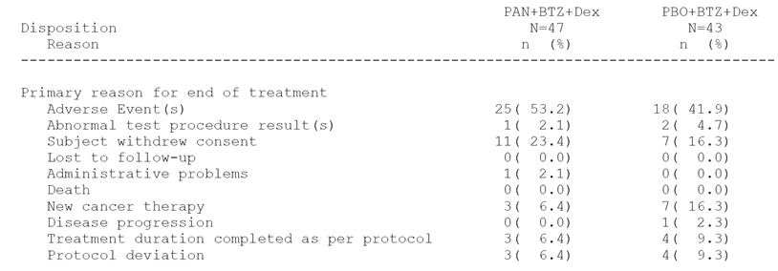
- Impact of achieving a CR or near CR on overall survival
The depth of response was better with the addition of PAN as reflected by the almost doubling rate of nCR/CR in the PAN arm of the overall population of D2308 compared to the PBO arm (28% versus 16%, p = 0.00006). Considering that the achievement of deeper response with a CR/nCR is associated with longer PFS and OS this finding is clinically important. The clinical relevance of achieving a CR or nCR is further demonstrated by the impact on survival, in comparison to patients achieving PR. An OS landmark analysis by response (CR/nCR versus PR) at 6 months for the PAN+BTZ+Dex arm including 205 patients showed a relative risk reduction of 55% in favour of the patients achieving CR or nCR (see Figure 23). The effect of achieving a CR/nCR is highly consistent across all landmark time points analysed in the PAN+BTZ+Dex arm (at 3, 6, 9 and 12 months). Therefore, achieving a CR/nCR is associated with an improved survival, and this finding should be interpreted in the context of a markedly increased rate of CR/nCR with PAN+BTZ+Dex.
Figure 23: Overall survival lasndmark analysis at 6 months for patients with CR/nCR as compared to PR as best overall (Study D2308 FAS, PAN + BTZ + Dex arm)
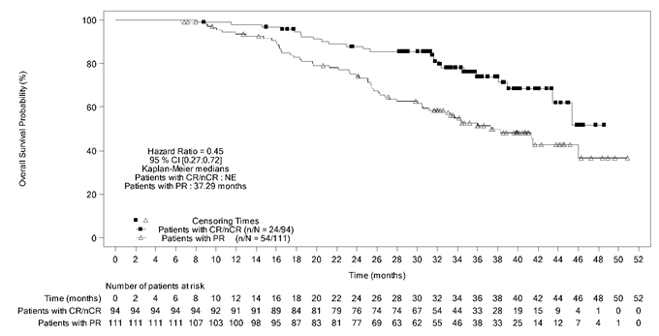
- Interpretation of patient reported outcomes
Based on the historical BTZ registration Phase III trial (APEX), a rapid deterioration of QoL could have been expected in the control arm of Study D2308; however, this was not the case, and the data show stabilization of QoL in both treatment groups. Novartis acknowledges that there was no evident patient reported benefit in terms of QoL, with initial declines in the global health status/QoL mean scores (most likely attributable to diarrhoea and fatigue) prior to values returning to baseline levels in both treatment groups; however, results were favourable relative to the BTZ Phase III trial. For the assessment of QoL, it needs to be considered that the PFS benefit translates into a ‘treatment-free interval’ (TFI) defined as the time from end of treatment until progression or relapse. The TFI was longer in the PAN+BTZ+Dex arm compared to the PBO+BTZ+Dex arm (see Figure 24).
Figure 24: Treatment free interval (Study D2308 FAS)
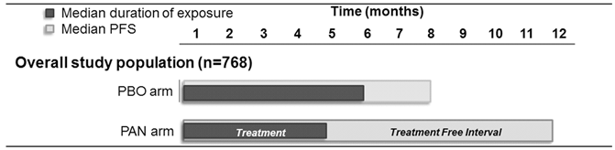
The adverse events and quality-of-life data reported at the end of treatment were reviewed to assess the potential impact of on treatment toxicities on the TFI. The AE profile at the time of treatment discontinuation was similar in the PAN+BTZ+Dex and PBO+BTZ+Dex arms and therefore on treatment toxicities are unlikely to influence the TFI period. The change from baseline to the last EORTC QLQ-C30 global health score after treatment discontinuation, was similar between PAN+BTZ+Dex (-1.00 scores) and PBO+BTZ+Dex (- 0.85 scores). A positive number indicates an improvement. Changes from baseline greater than five points were pre-defined as ‘minimal important difference’ as usually done with this EORTC instrument. Even though the data are limited, post treatment QoL data suggest no residual effect of on treatment toxicity on the post treatment QoL. Therefore, TFI represents an additional important clinical benefit for patients in the PAN+BTZ+Dex arm. This is in line with the results from a cross-sectional survey of 370 patients with multiple myeloma conducted in the UK, which showed that a longer TFI period was significantly associated with a better Health Related QoL as assessed by various scales of the EORTC QLQ-C30, MY20 and EQ-5D (Acaster et al 2013).
Comment: The result of the 2nd interim OS analysis was consistent with the 1st interim OS analysis, and showed a small non-statistically significant increase in OS of 2.86 months in the PAN+BTZ+Dex arm compared to the PBO+BTZ+Dex arm. The improved OS in the subgroup of patients achieving CR/nCR in the PAN+BTZ+Dex arm compared to the PBO+BTZ+Dex arm is noted. The longer TFI for patients in the PAN+BTZ+Dex arm compared to the PBO+BTZ+Dex arm is noted, but was not associated with greater benefits in patient-reported outcomes in the PAN+BTZ+Dex arm compared to the PBO+BTZ+Dex arm.

Reason 5
- In the pivotal Study (Study D2308), the safety profile of the PAN+BTZ+Dex arm was notably inferior to the safety profile of the PBO+BTZ+Dex arm. On‐treatment deaths were reported more frequently in the PAN+BTZ+Dex arm than in the PBO+BTZ+Dex arm (7.9%, n = 30 versus 4.8%, n = 18, respectively). Furthermore, the incidence of on treatment deaths considered not to be related to disease progression was 6.8% (n = 26) in the PAN+BTZ+Dex arm and 3.2% (n = 12) in patients in the PBO+BTZ+Dex arm. On‐ treatment deaths considered to be related to the study drug by the investigator were reported in 11 (2.9%) patients in the PAN+BTZ+Dex arm and 7 (2.0%) patients in the PBO+BTZ+Dex arm.
- Furthermore, the risks of treatment with PAN+BTZ+Dex increase with age. AEs leading to treatment discontinuation were reported in 29.9% of patients in the PAN+BTZ+Dex arm aged < 65 years and 45.0% of patients aged ≥ 65 years, with the corresponding results for patients in the PBO+BTZ+Dex arm being 16.6% and 25.6%, respectively. In addition, on treatment deaths were reported in 5.9% of patients in the PAN+BTZ+Dex arm aged < 65 years and 10.6% of patients aged ≥ 65 years, with the corresponding results for patients in the PBO+BTZ+Dex arm being 4.1% and 5.6%, respectively. The mean age of diagnosis of MM in patients in Australia based on 2009 data is 69.2 years. Therefore, it is likely that the majority of patients who would be eligible for treatment with PAN+BTZ+Dex in Australia would be older than 69 years. Consequently, on average Australian patients eligible for treatment with PAN+BTZ+Dex are likely to be at a notably greater risk of AEs, treatment discontinuation due to AEs, and on treatment death than the patients in this treatment arm in the pivotal study (mean age of 61.2 years).
Sponsor's response:
Reason 5a
In order to further explore the mortality data, the following analysis using the updated data from the Full Analysis Set (FAS) from Study D2308 is summarized using a cut-off date of 18 August 2014. Figure 25 shows an overview of deaths which occurred in the Phase III Study D2308. Overall, 169 patients died on the PAN+BTZ+Dex arm (44%) as compared to 190 patients (50%) on the PBO+BTZ+Dex arm with a data cut-off of August 2014.
Figure 25: Overview of deaths (Study LBH589D2308 FAS)
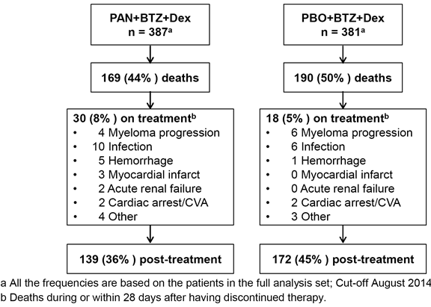
For Study D2308, on treatment deaths were defined by the protocol as those occurring from the first dose of study treatment up to 28 days after the last dose of study treatment. Following this protocol definition, on treatment deaths were reported for 7.8% of patients in the PAN+BTZ+Dex arm versus 4.7% of patients in the PBO+BTZ+Dex arm (see Figure 25, above). While less disease related on treatment deaths were observed in the PAN+BTZ+Dex arm (1.0%) than in the PBO+BTZ+Dex (1.6%) arm, a higher frequency of deaths due to AEs was reported in the PAN+BTZ+Dex arm (6.7%) than in the PBO+BTZ+Dex (3.1%) arm. The primary underlying events associated with deaths in this study were infections and haemorrhage and are consistent with increased risks reported for MM patients, in particular, of infection (mainly pneumonia) and haemorrhage. Importantly, in the supportive Phase II (Study DUS71), in which the same treatment regimen was used but in a population with more advanced multiple myeloma, on treatment death was reported in 4 patients (7.3%) with 3 due to disease progression and only one due to an AE unrelated to treatment (a multi-organ failure associated with sepsis and progressive disease)
On treatment deaths are not uncommon in trials with relapsed or relapsed and refractory MM patients treated with currently approved regimens. From the published literature, on treatment deaths range from 3% reported in a trial of bortezomib plus pegylated liposomal doxorubicin (Orlowski et al 2007) to 9.1% in a study combining lenalidomide and dexamethasone (Dimopoulos et al 2007). While a direct cross study comparison is not appropriate, this information does suggest that other currently approved treatment regimens for multiple myeloma are associated with a similar range of on treatment mortality. Of note, while other studies were performed with one drug or two drug combinations; the panobinostat regimen included a 3 drug combination.
In summary, there is an increased risk of on treatment deaths associated with infection and haemorrhage with this triple combination treatment (PAN+BTZ+Dex); however, the overall rate of death during the study was higher in the control arm with PBO+BTZ+Dex. In the current proposed RMP, the risk of fatality associated with the two key causes of death, infections and haemorrhage, has been appropriately discussed and presented.
Comment: The sponsor's response is noted.
Reason 5b
The safety data from pivotal trial (Study D2308), comparatively by age group are presented in Table 86. No patients older than 84 years of age were enrolled in Study D2308. Of note, in comparison with younger patients, elderly patients had a similar benefit in terms of PFS and responses.

Table 86: Safety summary and clinically notable Adverse Events by age group and treatment arm (Safety set)
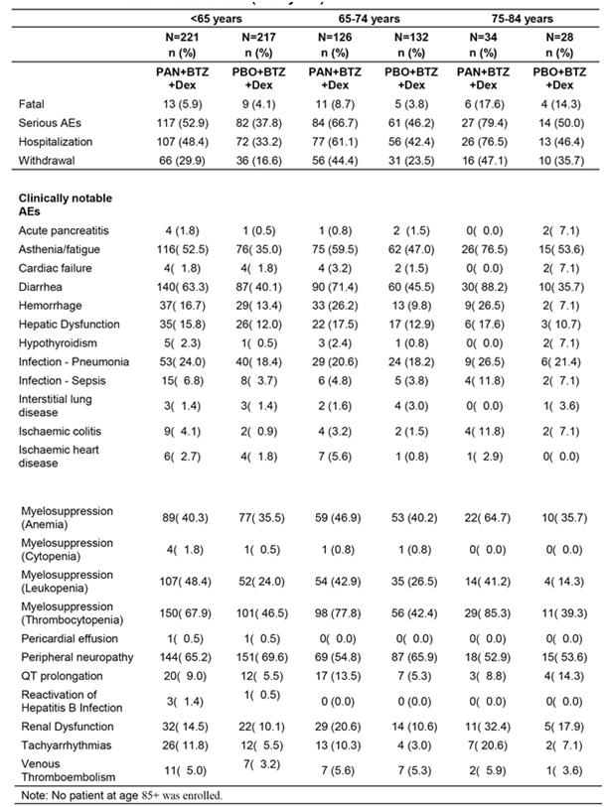
A trend of increasing frequency for elderly patients of age 65 or above was seen for the following events or categories: death, SAEs, hospitalization, withdrawal (discontinuation due to AEs), asthenia/fatigue, diarrhoea, anaemia, and thrombocytopenia. For PBO+BTZ+Dex, an increasing trend of incidence was seen for SAEs, hospitalization, withdrawal, and asthenia/ fatigue. Given the small number of patients in the age group of 75 to 84 years, the data is difficult to interpret. The higher risk of toxicity in elderly patients is acknowledged by Novartis, and the EU RMP is being updated to include ‘Increased toxicity, Use in elderly patients (aged 65 years or above)’ as an important identified risk. The risk could be minimized with individualized assessment of the elderly patients prior to treatment to determine appropriate starting dose of the each drug of the treatment regimen per recommendations. Close monitoring should be instituted with appropriate dose adjustment and prompt supportive care per established guidelines for elderly MM patients.
Comment: The sponsor's response is noted. The response does not alter the evaluator's conclusions provided in the first round CER relating to the negative impact that increased age will have on the safety profile of treatment of MM with the PAN+BTZ+Dex regimen in the Australian patient population.

Response to first round assessment of benefit-risk balance
First round assessment: The benefit‐risk balance of PAN+BTZ+Dex, given the proposed usage, is unfavourable. It is considered that the efficacy data for PAN+BTZ+Dex has not unequivocally demonstrated a clinically meaningful PFS benefit compared to PBO+BTZ+Dex, while the safety data for PAN+BTZ+Dex showed that the risks of treatment with the combination are notably greater than those for PBO+BTZ+Dex. In addition, there are no data showing that treatment with PAN+BTZ+Dex increases overall survival compared to PBO+BTZ+Dex or is associated with an improvement in the quality of life.’
Sponsor's response:
Study D2308 is a positive Phase III study, which met its primary endpoint of PFS improvement. The patients enrolled in the study received 1 to 3 prior therapies according to the inclusion criteria. The results of Study D2308 show that the addition of panobinostat (PAN) to the standard backbone regimen of BTZ and Dex significantly prolongs median progression free survival (PFS) by 4 months, with a hazard ratio of 0.63 (95% CI; 0.52, 0.76, p < 0.0001). Novartis acknowledges the challenges associated with the B/R assessment of the PAN+BTZ+Dex combination in the overall population due to the safety profile of the triple combination and has generated additional analyses from the registration Study D2308 into subsets of patients with a higher medical need and a stronger B/R ratio compared to the overall patient population.
Study D2308: Identification of a patient population with better benefit/risk ratio
The benefit of PAN in combination with BTZ and Dex was observed with a high level of consistency within all the pre-specified subgroups. To identify the proposed patient subset among all the pre-specified subsets, the following criteria were considered:
- Subset clearly defined in medical practice, and associated with a higher level of unmet need in the current treatment landscape.
- Subset formally pre-specified in the statistical plan in order to limit potential selection bias. The proposed subset of patients who have received prior BTZ and IMiDs (Subset 1) was pre-specified subset. The subset of patients (Subset 2) is a more heavily pre-treated non pre-specified sub-population who has received a median of 3 prior therapies and who represents 76% of the pre-specified subset with prior BTZ and IMiDs. Analyses of this subgroup are presented to assess the robustness of the results in Subset 1 in a more advanced population.
Novartis has identified a subset of patients who received BTZ and an IMiD with a better B/R profile as compared to the overall study population.
High unmet medical need
BTZ and IMiDs are the most effective anti-myeloma agents currently available and in Australia these include BTZ, thalidomide and lenalidomide. An Expert Statement provided in the submission (module 1.0.1) details the broad consensus with respect to the treatment algorithm in Australia. Patients failing both BTZ and IMiDs become more difficult to treat regardless of the line of therapy in which they are administered because of increasing disease resistance. However the combination of PAN+BTZ+DEX offers a new therapeutic option that can potentially address disease resistance and delay disease progression. In fact the Expert states it is ‘preferable to exploit the more drug-responsive nature of relatively early disease rather than waiting until the disease is essentially drug refractory’.
At this time patients with advanced MM may be treated with pomalidomide (a 3rd generation IMiD), which was approved mid 2014 in combination with dexamethasone, for the treatment of patients with relapsed and refractory multiple myeloma who have received at least two prior treatment regimens, including both lenalidomide and bortezomib, and have demonstrated disease progression on the last therapy. The registration trial for pomalidomide approval was conducted in a patient population with more advanced and refractory disease, with a median of 5 prior lines of therapy. In this study, the combination of pomalidomide and low-dose Dex was compared to high dose Dex alone; median PFS was 16.0 weeks in the Pom + LD-dex arm and 8.1 weeks in the HD-dex arm (p < 0.001) (Pomalyst AU PI).
Based on preclinical data currently available, histone deacetylase (HDAC) inhibition represents an attractive option to address disease resistance in myeloma. Of note, no HDAC inhibitors are currently approved in any cancer indication in the EU or Australia.
Therefore, for those patients who do not respond to, or who progress on the most active classes of anti-myeloma agents, there is a high need for drugs with a new mechanism of action to address the challenge of disease resistance.
Comment: In addition to the above comments, the sponsor provided the clinical efficacy and safety data relating to the subgroup of patients treated with BTZ and IMiDs. The sponsor considered that this subgroup demonstrates a more favourable benefit-risk assessment for the proposed regimen than the group of patients included in the total patient population. The submitted additional data for this subgroup have been evaluated above and the evaluator's benefit risk assessment for the proposed treatment regimen in this subgroup is presented below.

Response to clinical evaluator's first round clinical questions

Pharmacokinetics

Question 1
It was reported in the SimCYP modelling (Study R0600943 ‐ 01) that the AUC of panobinostat is predicted to decrease 67% when administered with rifampin 600 mg QD. Does the sponsor intend to undertake a clinical DDI study to assess the effect of rifampicin (a CYP3A4 inducer) on the PK of panobinostat?
Sponsor's response: Novartis does not plan to conduct a DDI study to assess the effect of a strong CYP3A4 inducer, such as rifampicin, on the PK of panobinostat. A 20% reduction in panobinostat exposure was observed in Phase I trial B2207 when dexamethasone was added to the combination of panobinostat and bortezomib, likely due to CYP3A4 enzyme induction by dexamethasone (Study B2207). SimCYP simulation further suggests a reduction of 67% in panobinostat exposure when co-administered with rifampicin (Study R0600943-01). Based on these findings, Novartis proposed to avoid the co-administration of strong CYP3A4 inducers with panobinostat in MM patients to prevent the loss of efficacy due to reduced panobinostat exposure.
Clinical evaluator's comment: Acceptable.

Question 2
It was reported in the in vitro studies that panobinostat is a substrate for P‐gp mediated efflux (Study R050048). Does the sponsor intend to undertake clinical DDI studies with P‐gp inhibitors or inducers to assess the effects of these agents on the PK of panobinostat?
Sponsor's response: Novartis does not plan to conduct a DDI study with a P-gp inhibitor or inducer. Panobinostat was highly permeable in Caco-2 cells (Study R0500488). Due to the high permeability of panobinostat and likely saturation of transporters at commonly administered oral doses (20 mg TIW) of panobinostat, it is not expected that transporters would affect absorption of panobinostat from the GI tract, but may affect distribution to tissues that express transporters such as the Pgp. The in vitro data also indicated that panobinostat penetration into human hepatocytes is likely due to a high passive permeation process without modulation by a solute carrier system.
Panobinostat oral absorption is confirmed to be high in the human ADME Study (B2108) with < 3.5% of parent drug excreted in the faeces. The steady state volume of distribution was estimated to be approximately 1,000 L in the population PK analysis (Pop PK report) (based on data from 14 Phase I/II trials where no limitation was imposed with regard to P-gp inhibitors or inducers) suggesting extensive tissue distribution. Consequently, the potential impact of P-gp inhibitors or inducers on the distribution of panobinostat is likely low and of no clinical consequence.
Clinical evaluator's comment: Acceptable.

Question 3
There was no clinical DDI study in the submission exploring co-administration of panobinostat and drugs that can increase gastro‐intestinal pH (for example, PPIs). No human biomaterial or simulated (SimCYP) modelling studies investigating potential DDI between panobinostat and drugs that increase gastro‐intestinal pH could be identified in the submission. The sponsor is requested to provide a clinical DDI study assessing the effects of co‐administration of PPIs on the bioavailability of panobinostat. In addition, the sponsor should provide all other in vivo and/or in vitro data that it holds on the effects on panobinostat bioavailability of co‐administration with drugs that can change gastrointestinal pH.
Sponsor's response: Novartis believes that the interaction between panobinostat and pH-increasing agents is unlikely, and a DDI study is not warranted. The solubility of panobinostat is consistently high in the pH range of 1.2 to 6.8 (see Table 87), which suggests a low risk for drug interaction (Budha et al (2012)).

Table 87: Solubility of LBH589 (Panbiostat) lactate, anhydrous drug substance at 37.0 °C (± 0.5 °C), batch 0724011
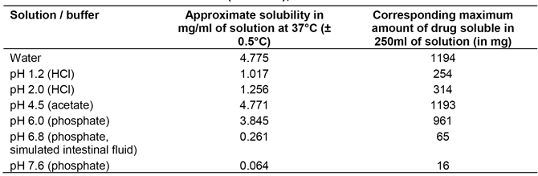
Additionally, a physiologically based ACAT model for panobinostat in humans was developed using GastroPlus (Version 8.5) to assess the effect of pH elevating agents (for example proton pump inhibitors, H2 antagonists, etc.) on the absorption of the panobinostat. This model simulates the observed plasma concentration profiles of 20, 30 and 40 mg panobinostat in patients (Study B2102). Parameter sensitivity analysis suggested that, under the stomach pH ranging from 1 to 8, panobinostat 20 mg can be completely absorbed in vivo. Therefore, it can be concluded that the extent of absorption would not be impacted by pH increasing agents (refer to Report (DMPK R1400363) in the submission dossier).
The above information is captured in the revised AU PI; the following (US PI) text was included under PK, absorption: ‘The aqueous solubility of panobinostat is pH dependent, with higher pH resulting in lower solubility. Co-administration of Farydak with drugs that elevate the gastric pH was not evaluated in vitro or in a clinical trial; however, altered panobinostat absorption was not observed in simulations using physiologically based pharmacokinetic (PBPK) models.’
Clinical evaluator's comment: Acceptable.

Question 4
In Study D2308, on Day 1, cycle 1, exposure to BTZ in the presence of PAN was approximately 32% greater based on AUC(0‐24 hours) values and approximately 21% greater based on C_{max} values. The sponsor states that ‘(w)hile BTZ is known to have time dependent PK and steady state is not reached until Day 11, these results suggest that BTZ exposure was not affected by the addition of panobinostat’. The statement that the results suggest that BTZ exposure was ‘not affected’ by the addition of panobinostat appear to be inconsistent with the observed results. Please comment on this matter.
Sponsor's response: Novartis acknowledges TGA’s observation on the BTZ exposure, however believes that the limitations associated with the PK collection in Study D2308 makes it difficult to derive any definitive conclusions. While, bortezomib AUC (0-24 hours) and C_{max} from 12 Japanese patients in the control arm (PBO+BTZ+Dex) were approximately 32% and 21% lower, respectively, than those in the 12 Japanese patients in the treatment arm (PAN+BTZ+Dex), Novartis does not believe that a definitive conclusion can be drawn on the effect of panobinostat on bortezomib exposure for the following reasons:
- Limited sample size: a 12 patient sample size is considered small, given the variability of approximately 40 to 60% in bortezomib AUC and C_{max} (Study D2308 CSR).
- Nonlinear PK of bortezomib: bortezomib exhibits time dependent pharmacokinetics achieving steady state after 11 days in the approved regimen of twice weekly administration. In Study D2308, plasma samples were collected on Day 8 of Cycle 1, before steady state was achieved; therefore, comparison of bortezomib exposure is deemed suboptimal.
- Data from an earlier Phase I (Study B2207) did not detect a pharmacokinetic interaction between bortezomib and panobinostat. Moreover, SimCYP simulation suggested a lack of effect by panobinostat on the clearance of sensitive CYP3A substrate midazolam (DMPK-R1400354). For bortezomib, the fraction metabolized through the CYP3A4 pathway is only approximately 25%, therefore the likelihood of PK impact by panobinostat through CYP3A pathway is expected to be low.
In addition to pharmacokinetics information, we compared the pooled bortezomib-specific AE, peripheral neuropathy, in Study D2308, which suggested no apparent difference between the treatment arm and the control arm in the small Japanese subset where PK was collected (see Table 88). This finding was also observed in the pooling of peripheral neuropathy in all patients in Study D2308 (total peripheral neuropathy all Grades = 60.6% (PAN+BTZ+Dex) versus 67.1% (PBO+BTZ+Dex) and Grade 3/4 = 17.6% (PAN+BTZ+Dex) versus 14.6% (PBO+BTZ+Dex)). These data are consistent with a lack of clinically relevant difference in bortezomib exposure in the placebo and treatment arms.
In summary, Novartis acknowledges the apparent difference in BTZ exposure in the small group of subjects (Japanese only) in Study D2308 is inconclusive. Novartis believes the totality of evidence including those of Phase I study, SimCYP simulation and peripheral neuropathy AE comparison, does not point to a clinically relevant impact on BTZ exposure by panobinostat.

Table 88: Clinically notable adverse event (CNAE) peripheral neuropathy by preferred term irrespective of causality by treatment group
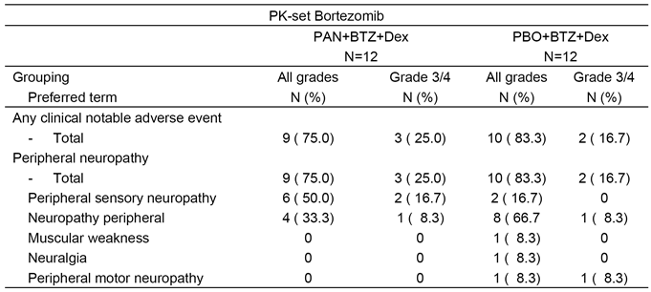
Clinical evaluator's comment: Acceptable.

Pharmacodynamics

TGA evaluator comment (s5.3 pg 48/185 and s5.5 pg 49/185)
Overall, the exposure‐QTc relationship does not signal significant concerns relating to the association between panobinostat and clinically significant QTcF prolongation. However, the absence of a ‘Thorough QT/QTc Study’ for this drug is a deficiency in the submission.
Novartis Response: Novartis would like to correct the CER report regarding a thorough QT/QTc Study. Novartis does not intend to conduct a dedicated QT/QTc study as discussed in the pre-submission meeting and the Notes to Reviewers. Due to the genotoxicity of panobinostat, studies with healthy volunteers were not possible. Extensive monitoring was performed during clinical development and QTcF prolongation and the effect of QT prolonging drug, strong CYP3A4/5 inhibitors and CYP2D6 substrates were investigated. There was monitoring in the early Phase studies throughout (that is within) each cycle (and not only on Day 1 of each cycle as per the latest studies). In the Phase I program, ECGs were conducted on Days 1, 3 and 5 and found slight increased on Day 5. QTc prolongation tends to decrease over time. In the pivotal Phase III study, ECG monitoring took place prior to commencing the combination and before each cycle. While panobinostat may cause QTc prolongation, the frequency appears to be low with mild to moderate severity. The risk of QTc prolongation does not increase over time. Available Phase I clinical data (Study A2101) and (Study A2102) further suggest QTc prolongation to be formulation, dose and schedule dependent. This topic is detailed in the Summary of Clinical Safety (SCS).
Clinical evaluator's comment: The sponsor's response is satisfactory.

Efficacy

Question 1
Major protocol violations due to missing baseline efficacy assessments were reported frequently in both treatment arms (77 (19.9%) patients in the PAN+BTZ+Dex arm; 86 (22.6%) patients in the PBO+BTZ+Dex arm). The high proportion of subjects with missing baseline efficacy assessments is a matter of concern as it raises questions about the conduct of the study. Please comment on this matter.
Sponsor's response: The most frequently reported major protocol deviation leading to exclusion from the PP Set was ‘missing baseline efficacy assessment’, with similar frequency in the two treatment arms in this double blind study (19.9% of patients in the PAN+BTZ+Dex arm and 22.6% in the PBO+BTZ+Dex arm (Study D2308). The major reason for missing baseline assessments have been the use M-protein measurements based on non-protocol defined methods. This was identified as the study was ongoing (and prior to database lock). Corrective actions were put in place to limit the impact via amendments to the protocol and a series of pre-specified sensitivity analyses of progression free survival (PFS) were planned to assess and account for the potential impact on the primary analysis. As discussed below, the outcome of these sensitivity analyses was extremely consistent and, as a conclusion, the results of the primary analysis are considered to be robust. Furthermore, the observation that the outcome for the control arm with PBO+BTZ+Dex was consistent with prior published trials further validates the robustness of these data.
Protocol deviations classified as major led to exclusion of a patient from the PP set. Pre-planned sensitivity analyses to address the impact of major protocol deviations (mainly due to missing baseline assessments) on PFS by Investigator and by IRC in the PP Set demonstrated a PFS benefit with strong statistical significance which confirmed the results of the primary analysis (see Table 89). PFS sensitivity analyses using different censoring rules which addressed the impact of missing adequate response assessments confirmed the results of the primary analysis.

Table 89: PFS sensitivity analyses addressing impact of missing baseline efficacy assessments (mEBMT, Study D2308)
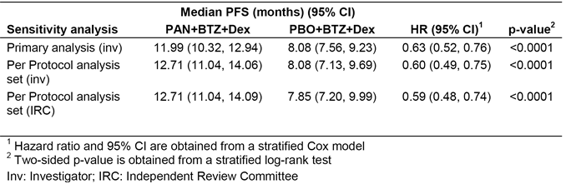
The distribution of censoring reasons was comparable between treatment arms as well as between investigator and IRC in the per-protocol (PP) set (see Table 90). There are more patients censored in the PAN+BTZ+Dex treatment arm relative to the PBO+BTZ+Dex arm due to a higher proportion of patients who are still ongoing in the PAN+BTZ+Dex arm which indicates a better treatment effect in the PAN+BTZ+Dex group.

Table 90: Sensitivity analyses for PFS assessing impact of major protocol deviations: censoring reasons (Study D2308, PP set)
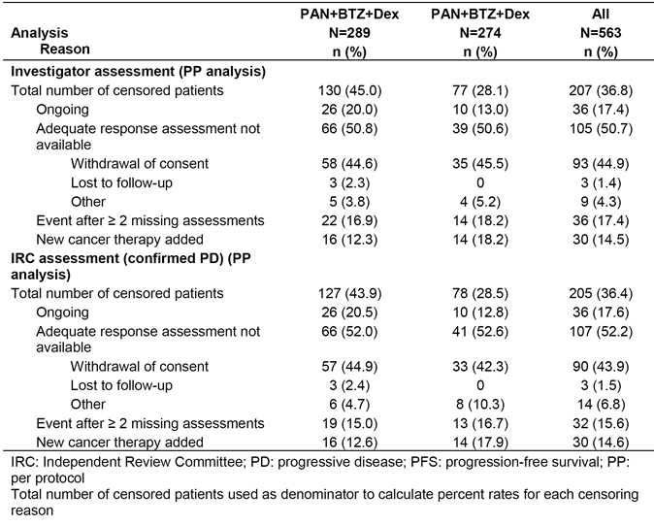
In summary, the following conclusions can be drawn:
- Across all sensitivity analyses after addressing missing response assessments, the PBO+BTZ+Dex treatment arm consistently showed more patients with PFS events, confirming the results of the primary PFS analysis in this double blind trial. Of note, this was confirmed also by the independent assessment by an IRC.
- In general, censoring reasons were balanced between the two treatment arms.
- The rigorous approach taken in designing a number of pre-planned sensitivity analyses indicate that missing data appear to have minimal impact on the validity of the primary analysis and that results across sensitivity analyses are consistent with the primary analysis.
- The consistency of the outcome of the PBO+BTZ+Dex arm in comparison with previously published Phase III trials using a similar BTZ regimen provide further validation of the robustness of the results of Study D2308.
Clinical evaluator's comments: The sponsor's response is acceptable. The high rate of censored patients in both treatment arms for whom an adequate response assessment was not available is noted.

Question 2
The sponsor stated that there was a high rate of concordance between the IRC and the investigator assessments of PFS based on mEMBT criteria. Please provide the quantitative results for the concordance analysis between the two assessment methods.
Sponsor's response: Following submission and further to subsequent discussion with the IRC, it was discovered that the IRC did not take into account the need for confirmation of disease progression (PD) for response assessment as required by modified European Society for Blood and Marrow Transplantation (mEBMT) criteria. The IRC charter required confirmation of progression with 2 repeated assessments based on M protein, similar to what was done for the primary endpoint based on the investigator assessment. However, the IRC assessed response visit by visit and did not include confirmation of progression, when required, after a repeated assessment in their report. Hence, in retrospect, the sensitivity analyses based on the IRC included in the CSR was not an appropriate analysis of PFS because of this methodological artifact of not considering the need to confirm progression clearly required by the mEBMT criteria. A corrected analysis consistent to the mEBMT criteria of the IRC data was performed. This analysis considered a PFS event at the first report of progression with confirmation by at least one repeat assessment if the progression was documented by a rise in M protein, or the first report of progression without confirmation if progression was identified due to a reason other than M protein increase (for example, the occurrence of a new soft tissue plasmacytoma).
Of note, none of the individual IRC response assessments was changed for this analysis. Results from this corrected analysis demonstrated that the median PFS, as determined by the IRC, was 11.99 months (95% CI: 10.51, 13.50) for the PAN+BTZ+Dex treatment arm and 8.31 months (95% CI: 7.62, 9.92) for the PBO+BTZ+Dex arm (HR 0.63; 95% CI: 0.52, 0.76; p < 0.0001); these results are highly consistent with the primary analysis (see Table 91). There was an approximate 4-month improvement in median PFS in favor of the PAN+BTZ+Dex treatment arm relative to PBO+BTZ+Dex for both the corrected IRC analysis and the primary analysis per investigator. In addition, all sensitivity analyses which included IRC assessment were reanalyzed. Of note, all PFS analyses with confirmed progression based on the IRC assessment per mEBMT criteria yielded results similar to those of the primary analysis per investigator assessment.
In alignment with the IRC, Novartis considers that the initial analysis (without PD confirmation) of PFS using the IRC dataset included in the submission was incorrect and that the new analysis is valid and should be used for comparison with the primary analysis per investigator, as both incorporate the confirmation of PD as required by the mEBMT criteria.

Table 91: Revised sensitivity analysis of PFS using the IRC dataset
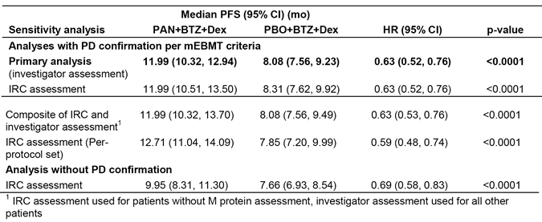
Clinical evaluator's comment: The sponsor's response is satisfactory. The sensitivity analysis (IRC assessment) of PFS with PD confirmation per mEBMT criteria submitted in the sponnsor’s response provides robust statistical support for the primary PFS analysis (investigator assessment). Furthermore, the median PFS values for the two treatment arms were consistent for the amended IRC sensitivity analysis (with PD confirmation) and the primary analysis (investigator assessment), resulting in the median difference in PFS between the two treatment arms for the two analyses being virtually identical. In the original submission, there was a notable difference in the median PFS values for the two treatment arms between the IRC sensitivity analysis (without PD confirmation) and the primary analysis (investigator), resulting in the difference in PFS between the two treatment arms in the IRC sensitivity analysis (without PD confirmation) being of doubtful clinical significance.
Sponsor's response - concordance of PFS events: The results of the primary PFS analysis based on investigator assessment are robust as supported by the high concordance rate of PFS status between investigator and IRC assessment of 85% in the PAN+BTZ+Dex arm and 83% in the PBO+BTZ+Dex arm (see Table 92). The break-down of concordance into PFS event type (PD, relapse from CR, and death) is summarised below in Table 93.

Table 92: Comparison of PFS event/censor between Investigator and IRC assessment with PD confirmation by treatment group (full analysis set)
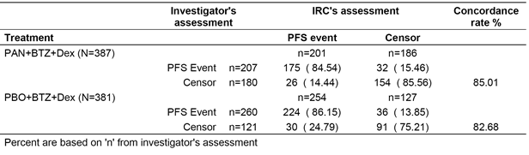

Table 93: Comparison of PFS event type/censor between Investigator and IRC assessment with PD confirmation by treatment group (full analysis set)
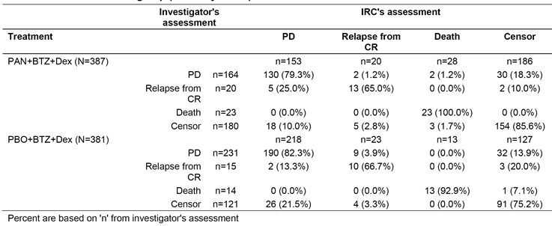
Clinical evaluator's comment: The sponsor's response is satisfactory.

Question 3
Please provide the percentage of patients commencing the second phase of treatment (that is week 9 onwards) in each arm, and the median age of these patients (plus interquartile range) for each arm.
Sponsor's response: In total, 169 patients (43.7%) in the PAN arm and 192 patients (50.4%) in the PBO arm entered treatment Phase 2 (Cycle 9, see Table 94). The median age was similar in both treatment groups (median 61.0 years in PAN and 62.0 years in PBO) which is comparable to the overall population (median 63.0 years in PAN and 63.0 years in PBO).

Table 94: Patients entering treatment phase 2 by treatment group (FAS)
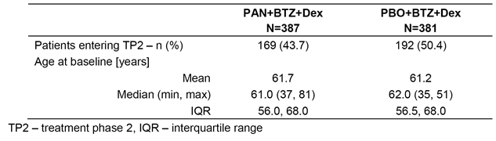

Question 4
Please provide details of the confirmatory clinical trial required as part of the FDA accelerated approval, and any other post-marketing clinical trial requirements.
Sponsor's response:
Planned Randomized Phase II study; The FDA requested the sponsor to conduct the following Phase II study as post-marketing requirement:
Conduct a randomized Phase II clinical trial of panobinostat in combination with subcutaneous bortezomib and dexamethasone to characterize the safety and efficacy of at least two different doses of panobinostat. Eligible patients will include patients with relapsed multiple myeloma who have been previously exposed to immunomodulatory agents. The primary objective is to assess the overall response rate (ORR) in all treatment arms according to International Myeloma Working Group (IMWG) criteria by investigator assessment. The trial should include one interim analysis. The results of this trial will be used to inform the dose selection for the confirmatory Phase III trial. (Ref: Farydak FDA approval letter).
The proposed study is being designed to further optimize the dose and schedule of the PAN+BTZ+Dex regimen, in order to improve the safety and tolerability of this triple combination. This is a multicentre, randomized, open label, Phase II study to characterize the safety and efficacy of different doses of oral panobinostat in combination with subcutaneous (SC) bortezomib and oral dexamethasone in adult patients with relapsed and/or refractory multiple myeloma. Patients previously exposed to an IMiD will be enrolled in this study. This study will also assess the impact of administering BTZ subcutaneously in combination with oral PAN and Dex. The backbone regimen of intravenous (IV) bortezomib was the standard approved regimen used in 2009 when the Study D2308 was initiated. Since the initiation of this study, SC BTZ has been shown to be associated with less GI toxicity and peripheral neuropathy compared to the IV formulation, without compromising efficacy and has become an approved standard of care for bortezomib containing regimens.
In addition, once weekly BTZ administration has been reported to have similar efficacy and a better safety profile than the twice weekly regimen (twice weekly was used in the first treatment phase of Study D2308). Therefore the treatment with SC BTZ and the use of weekly BTZ is expected to further improve the safety profile of the combination without comprising efficacy.
The draft protocol is currently under the review of the FDA and the study is currently planned to start at the end of 2015. The interim analysis read out will be available in 2Q2017 and trial completion is expected in 2Q2018.
Planned Randomized Phase III study; The FDA requested the sponsor to conduct the following Phase III study as post-marketing requirement:
Conduct a multicentre, randomized, placebo controlled Phase III trial comparing panobinostat in combination with subcutaneous bortezomib and dexamethasone with subcutaneous bortezomib and dexamethasone in patients with relapsed multiple myeloma who have been previously exposed to immunomodulatory agents. The panobinostat dose selection will be based upon the interim analysis of the trial described in PMR 2181-1. Eligible patients will have previously treated multiple myeloma, 1-3 prior lines of therapy, prior immunomodulatory agent exposure (either, thalidomide, lenalidomide, or pomalidomide), and measurable disease. The primary objective is to compare the progression free survival (PFS) in both treatment arms by investigator assessment (Ref: Farydak FDA approval letter).
This study is planned to start end 2017/early 2018 with dose selection based upon the interim analysis of the Phase II study described above. The study design of a Phase III will be discussed with FDA once the Phase II data from planned interim analyses becomes available.
Proposed Post-Authorization Safety Surveillance Study; A Post Authorization Safety Surveillance Study (PASS) has been requested by the EMA to collect safety data of panobinostat in combination with bortezomib and dexamethasone under real-world conditions and to evaluate patient’s adherence to the dosing regimen and the frequency and clinical implications of medication errors. The protocol of this multicentre, non-interventional study is not final yet. The protocol is currently under review with the PRAC.
Clinical evaluator's comment: The sponsor's response is noted.

TGA Evaluator Comment (s7.2.13 pg 67/185)
The mean age of the total population in the FAS was 62.1 years which is notably lower than the mean age of the incidence of myeloma in the Australian population (68.6 years).9 Overall, the patients in the FAS with MM appear to be younger than would be expected in a comparable Australian population. This raises concerns about the generalizability of the results from this study to the Australian population.
Sponsor’s response: The mean age in Study D2308 was 62.4 and 61.8 years in the PAN+BTZ+Dex and PBO+BTZ+Dex arm respectively, which is representative of a Phase III trial MM population. Examples of Phase III clinical trials with a comparable median age are presented hereafter. In a Phase III trial evaluating the combination of pomalidomide plus low-dose dexamethasone versus high dose dexamethasone alone in patients with refractory or relapsed and refractory multiple myeloma the median age was 64 years in the pomalidomide/ dexamethasone arm and 65 years in the dexamethasone arm (San Miguel et al, 2013). In another Phase III trial evaluating carfilzomib, lenalidomide and dexamethasone versus lenalidomide and dexamethasone in patients with relapsed multiple myeloma the median age was 64 years in the carfilzomib arm and 65 years in the control arm (Stewart et al, 2015). In Study D2308, subgroup analyses by age have been performed for the primary endpoint PFS. The results in both subgroups (< 65 years and ≥ 65 years) consistently showed a benefit in favour of PAN+BTZ+Dex as compared to PBO+BTZ+Dex.
Clinical evaluator's comment: The mean age of patients in the PAN+BTZ+Dex arm (Study D2308) in patients with advanced MM was approximately 6 years younger than the average age of onset of MM in the Australian population. Furthermore, the mean age of patients in the PAN+BTZ+Dex arm in the subgroup of patients with advanced MM with prior BTZ and IMiD treatment was even younger than in the total patient population. In the subgroup of interest (Subset 1), patients in the PAN+BTZ+Dex arm (n = 94) had a mean ± SD age of 59.3 ± 10.1 years and 29 (30.9%) patients were aged ≥ 65 years, and patients in the PBO+BTZ+Dex arm had a mean ± SD age of 60.6 ± 9.5 years and 38 (38.4%) patients were aged ≥ 65 years. Overall, it is considered that the average age of patients in the Australian population with relapsed and/or refractory MM previously treated with BTZ and IMiDs and eligible for treatment with panobinostat will be notably greater than the average age of patients in the Study D2308 in the subgroup of interest (Subset 1). This is important as the submitted data relating to the overall patient population in Study D2308 indicates that the safety profile of PAN+BTZ+Dex is significantly inferior in patients aged ≥ 65 years compared to patients aged < 65 years.

Safety

Question 1
In the summary table of CNAEs provided in the CSR for the pivotal Study (Study D2308) (that is, Table 12‐12) no information has been included on ischaemic colitis or interstitial lung disease. Please comment on this apparent oversight.
Sponsor's response: The CNAEs which have been analysed in the CSR for the pivotal Study D2308 have been predefined in the statistical analysis plan based on known risk of the drug class and the identified risks which have been known up to that date. When data have become available after the database lock, the risk assessment and consequently the CNAE definitions have been revised and implemented in the Summary of Clinical Safety. This definition is provided in the Appendix 4 to the SCS.
The results of the analysis of the CNAE ischemic colitis (SMQ broad scope) are presented in the SCS. This analysis is based on the pooled dataset which in addition to the events from the Study D2308 is including events from Studies (B2207) and (DUS71). The case identification was performed using the broad scope of the SMQ which retrieved a relatively large number of cases of GI haemorrhage (See Table 95). The cases of colitis appeared to be infections in nature (C. difficile and/or no culture but treated with antibiotics). The report of intestinal ischemia concerned an 81 year old male patient (who) underwent surgery for hernia and subsequently experienced intestinal ischemia.
Interstitial lung disease CNAE analysis based on the pooled data set is presented in the SCS. Based on the higher rates of interstitial lung disease observed in the PBO+BTZ+Dex patients and similar events associated with bortezomib it was concluded that panobinostat is not associated with increased risk of interstitial lung disease when combined with bortezomib and dexamethasone.
The results for ischaemic colitis and interstitial lung disease are provided (below in Table 3-9).

Table 95: Ischaemic colitis and interstitial lung disease events by preferred term (Study D2308, safety set)
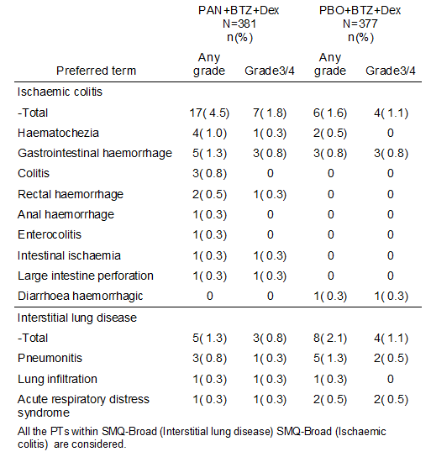
Clinical evaluator's comment: The sponsor's response is satisfactory.

Question 2
In the summary tables of CNAEs provided in Table 2‐13 (SCP CTD 2.7.4) and in Table 2‐ 6 (SCP CTD 2.7.4, Appendix 1), data relating to peripheral neuropathy has not been included. Please comment on this apparent oversight.
Sponsor's response: Peripheral neuropathy was considered as clinically notable event when data were blinded. After database lock and unblinding, peripheral neuropathy was no longer considered to be clinically relevant as the occurrences were comparable between the treatment groups. The results are provided in Table 96. As a consequence, peripheral neuropathy was not part of the CNAE list which was used for the SCS. Peripheral neuropathy is a well-known risk for bortezomib. Very few patients in the single agent panobinostat studies reported peripheral neuropathy (all Grades = 1.4% versus Grade 3/4 = 0.4%). No apparent worsening of peripheral neuropathy was observed with addition of panobinostat to the combination regimen, since the all-Grade and Grade 3/4 frequencies of peripheral neuropathy were comparable between the two arms. Additionally, the rate of Grade 3/4 PN reported in the control arm is comparable to that reported in other trials with BTZ IV (Moreau et al, 2011).

Table 96: Clinically notable adverse events regardless of study drug relationship by treatment group (safety set)
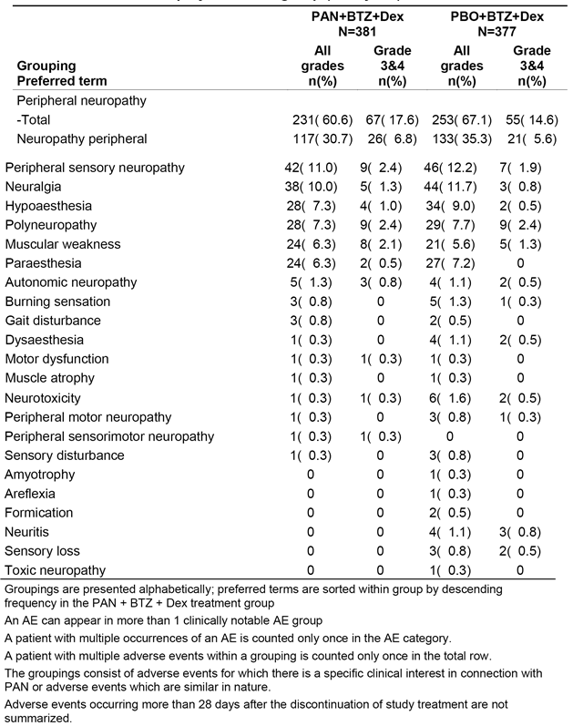
Clinical evaluator's comment: The sponsor's response is satisfactory.

PI and CMI

Question 1
In the Precautions section advice is provided to women of child bearing potential and sexually active men that contraception should be used for 2 weeks after the last dose of panobinostat. However, the US prescribing information indicates that contraception should be used for at least 1 month after the last dose in sexually active females of reproductive age and for 3 months after the last dose in sexually active males. Please comment on the differences in the recommended time intervals in the Australian and US prescribing documents. Does the sponsor have any data on the distribution of panobinostat into the semen of sexually active males?
Sponsor's response: No data are available regarding the concentrations of Farydak in the seminal fluid of male patients. Panobinostat demonstrated mutagenic potential in bacterial cells and endoreduplication effects in eukaryotic cells in vitro that are attributed to the pharmacological mode of action. According to current classification criteria for mutagenicity, panobinostat is classified as a Category 4 substance.
Daily oral administration of panobinostat during gestation was associated with the development of embryo-fetal toxicity, including embryo-fetal lethality and an increased risk of skeletal variation and anomalies at maternally toxic doses ≥ 30 mg/kg/day in the rat; doses ≥ 40 mg/kg/day in the rabbit, which is approximately 0.18 to 0.25 fold the expected clinical exposure based upon AUC for a 20 mg dose. No effects on fertility were observed in male rats when panobinostat was administered orally for 4 weeks at doses of 10, 30 and 100 mg/kg.
However, male reproductive effects were observed in the testes, epididymides and prostate in 4 and 13 week repeated dose oral toxicity studies in the dog (doses of 1.5 mg/kg and 1.5→ 1.0 mg/kg; approximately 0.69- and 0.41 fold the expected clinical exposure based upon AUC for a 20 mg dose).
Drug related radioactivity was widely distributed to many tissues in the rat. At 5 minutes post dose, the highest tissue concentrations were measured in the kidney medulla, cortex, and pelvis. At this early time point, numerous other tissues and organs had radioactivity levels that were at least five times higher than those in blood. At 96 hours post dose, relatively low, but measurable amounts of radioactivity were still observed in most tissues and organs. At this later time point, the highest radioactivity levels were observed in the skin and uveal tract of pigmented animals and the adrenal medulla of all animals, regardless of pigmentation. The skin and uveal tract data suggests that panobinostat and/or its metabolites may bind to melanin. Upon a single dose of 25 mg/kg radioactive panobinostat to male rats, radioactivity is measured in 7 (168hrs) days later (distribution Study DMPK R0500724).
Based on these observation currently proposed period of contraception may be too short to fully eliminate panobinostat from the body. Farydak presents cytostatic and cytotoxic characteristics and it seems to eliminate slowly from the body including reproductive organ. As a cautionary measure it is recommended that the period of contraceptive use for males is of six months and female patients of three months which aligns with the SmPC. The AU PI has been updated.
Clinical evaluator's comment: The sponsor's response is satisfactory.

Question 2
See Comment 14 above. The issue, sponsor's response and clinical evaluator's comment raised in Question 2 (Safety) are the same as those presented above in Comment 14 (First round comments on clinical aspects of the draft PI).

Question 3
In the Dosage and administration section of the PI (special populations ‐ patients with renal impairment) reference is made to patients with end stage renal disease (ESRD). Is this the same population as patients on dialysis? If this is the case, then please justify the separate references to patients with ESRD and patients on dialysis.
Sponsor's response: Dialysis is used primarily as an artificial replacement for lost kidney function in people with kidney failure. Dialysis may be used for patients with an acute disturbance in kidney function (acute kidney injury), or progressive but chronically worsening kidney function (end-stage renal disease). The separate references to patients with ESRD and patients on dialysis were made in order to also include patients on dialysis for other reasons than ESRD such as acute kidney injury.
Clinical evaluator's comment: The sponsor's response is satisfactory.

Second round benefit-risk assessment

Second round assessment of benefit
- The benefit of treatment with panobinostat for the amended proposed indication is based on data from a pre-specified subgroup analysis in patients (n = 193) with relapsed and/or refractory MM previously treated with both BTZ and IMiDs. In this subgroup (Subset 1) all patients had been treated with BTZ and IMiD, and in addition 78% (73/94) of patients in the PAN+BTZ+Dex arm had received ≥ 2 lines of prior treatment compared to 75% (74/99) of patients in the PBO+BTZ+Dex arm.
- In the pre-specified subgroup (Subset 1), 94 patients were treated with PAN+BTZ+Dex and 99 patients were treated with PBO+BTZ+Dex. The primary analysis showed that median PFS (investigator assessed) was 10.6 months in the PAN+BTZ+Dex arm and 5.8 months in the PBO+BTZ+Dex arm (that is, difference of 4.8 months), with a HR of 0.52 (95% CI: 0.36, 0.76), nominal p value = 0.0005. The difference in median PFS of 4.8 months between the two treatment arms is considered to be clinically meaningful.
- In Subset 1, the OS was 28.0 months in the PAN+BTZ+Dex arm and 24.7 months in the PBO+BTZ+Dex arm (that is, difference of 3.3 months), with a HR of 0.92 (95% CI: 0.63, 1.35). However, no weight can be given to the trend towards greater OS in the PAN+BTZ+Dex arm compared to the PBO+BTZ+Dex arm due to
  - the HR being statistically non-significant
  - confounding due to high rates of post treatment new MM therapies in both treatment arms, and
  - cross-over of the survival curves violating the assumption of proportionality for the hazard functions.
However, death events were similar in the PAN+BTZ+Dex and PBO+BTZ+Dex treatment arms (5.3% (5/94) versus 5.1% (5/99)), suggesting that survival in the PAN+BTZ+Dex arm is at least no worse than in the PBO+BTZ+Dex arm.
- The pre-specified subgroup (Subset 1) included a non, pre-specified subgroup (Subset 2) of more heavily pre-treated patients (n = 147) who had received prior treatment with BTZ and IMiD and ≥ 2 lines of therapy (PAN+BTZ+Dex n = 73, PBO+BTZ+Dex n = 74). In Subset 2, PFS (investigator assessed) was longer in the PAN+BTZ+Dex arm than in the PBO+BTZ+Dex arm (12.5 months versus 4.7 months; difference = 7.8 months), with a HR of 0.47 (95% CI: 0.31, 0.72), nominal p-value of 0.0003. The median OS in Subset 2 was 26.1 months in the PAN+BTZ+Dex and and 19.5 months in the PBO+BTZ+Dex (that is, difference of 6.6 months), with a statistically non-significant HR of 0.84 (95% CI: 0.55, 1.28). The sponsor states that the PFS results in Subset 2 support the PFS results in Subset 1.

Second round assessment of risk
- In general, the safety profile of PAN+BTZ+Dex in the subgroup of interest (Subset 1) was consistent with the safety profile of the regimen in the total population. In addition, the safety profiles of PAN+BTZ+Dex in Subsets 1 and 2 were similar. Of note, the risk of on treatment death in patients in the PAN+BTZ+Dex arm was lower in Subset 1 than in the total patient population, while the risk in patients in the PBO+BTZ+Dex arm was similar in the two patient populations. However, in both populations the risk of on treatment death was greater in the PAN+BTZ+Dex arm than in the PBO+BTZ+Dex arm (7.9% versus 4.8% (total population) and 6.5% versus 5.1%, (Subset 1)). In Subset 2, the risk of on treatment death was similar in patients in the PAN+BTZ+Dex arm and the PBO+BTZ+Dex arm (6.9% versus 6.8%, respectively).
- Nearly all patients in the PAN+BTZ+Dex in the total population and in Subsets 1 and 2 experienced at least one Grade 3/4 AE (preferred term regardless of relationship to the study drug), and these events occurred approximately 15% to 16% more commonly in the PAN+BTZ+Dex arm than in the PBO+BTZ+Dex arm in the three patient populations. The majority of Grade 3/4 AEs (preferred term) in both treatment arms in all three patient populations were considered to be related to the study drug.
- Clinically notable Grade 3/4 AEs (regardless of relationship to the study drug) were reported more frequently in the PAN+BTZ+Dex arm than in the PBO+BTZ+Dex arm in Subset 1 (94.6% (87/97) versus 80.8% (80/99)) and Subset 2 (98.6% (71/72) versus 79.5% (58/73)).
- In both subsets, clinically notably Grade 3/4 AEs of greatest concern associated with PAN+BTZ+Dex compared to PBO+BTZ+Dex were thrombocytopenia, leukopenia, diarrhoea and asthenia/fatigue, with all events occurring in ≥ 10% more patients in the PAN+BTZ+Dex arm than in the PBO+BTZ+Dex arm. In Subset 1, the most commonly reported clinically notable Grade 3/4 AEs occurring in ≥ 10% of patients in the PAN+BTZ+Dex arm (versus the PBO+BTZ+Dex arm) were thrombocytopenia (66.3% versus 46.5%), leukopenia (39.1% versus 22.2%), diarrhoea (30.4% versus 13.1%), asthenia/fatigue (25.0% versus 12.1%), anaemia (20.7% versus 22.2%), pneumonia (18.5% versus 14.1%), and peripheral neuropathy (15.2% versus 9.1%). In Subset 2, the most commonly reported clinically notable Grade 3/4 AEs occurring in ≥ 10% of patients in the PAN+BTZ+Dex arm (versus the PBO+BTZ+Dex arm) were thrombocytopenia (66.7% versus 43.8%), leukopenia (44.4% versus 19.2%), diarrhoea (33.3% versus 15.1%), asthenia/fatigue (26.4% versus 13.7%), anaemia (23.6% versus 23.3%), pneumonia (19.4% versus 16.4%), and peripheral neuropathy (16.7% versus 6.8%).
- Two AEs of particular interest are haemorrhage and sepsis. In Subset 1, Grade 3/4 clinically notable AEs of haemorrhage occurred in a similar proportion of patients in the PAN+BTZ+Dex and PBO+BTZ+Dex arms (3.3% versus 2.0%, respectively) as did Grade 3/4 clinically notable AEs of sepsis (4.3% versus 5.1%, respectively). In Subset 2, Grade 3/4 clinically notable AEs of haemorrhage occurred in a similar proportion of patients in the PAN+BTZ+Dex and PBO+BTZ+Dex arms (2.8% versus 2.7%, respectively), respectively), while Grade 3/4 clinically notable AEs of sepsis occurred less frequently in the PAN+BTZ+Dex arm than in PBO+BTZ+Dex arm (2.8% versus 6.8%, respectively).
- Preferred term SAEs (all Grades and regardless of relationship to the study drug) were reported more frequently in the PAN+BTZ+Dex arm than in the PBO+BTZ+Dex arm in the total population (59.8% (228/381) versus 41.6% (157/377)), Subset 1 (56.5% (52/92) versus 46.5% (46/99)), and Subset 2 (59.7% (43/72) versus 52.1% (38/73)). In Subset 1, SAEs reported in ≥ 5% of patients in the PAN+BTZ+Dex arm (versus the PBO+BTZ+Dex arm) were pneumonia (15.2% versus 12.1%), thrombocytopenia (10.9% versus 6.1%), and diarrhoea (9.8% versus 4.0%). In Subset 2, SAEs reported in ≥ 5% of patients in the PAN+BTZ+Dex arm (versus the PBO+BTZ+Dex arm) were pneumonia (13.9% versus 13.7%), thrombocytopenia (6.9% versus 2.7%), and diarrhoea (8.3% versus 5.5%).
- In each of the three patient populations, study drug discontinuation due to AEs was reported more frequently in patients in the PAN+BTZ+Dex treatment arm than in the PBO+BTZ+Dex arm (36.2% versus 20.4% (all patients); 31.5% versus 18.2% (Subset 1); 31.9% versus 17.8% (Subset 2)). Nearly all patients (approximately 90%) in the three patient populations underwent dose adjustments and/or treatment interruptions due to AEs. The results suggest that most AEs associated with PAN+BTZ+Dex can be managed with dose adjustment and/or treatment interruptions rather than treatment discontinuation.
- In both subsets, the most commonly reported AEs resulting in discontinuation of the study drug reported in ≥ 2% of patients in the PAN+BTZ+Dex arm were diarrhoea, asthenia, thrombocytopenia, and pneumonia. In Subset 1, AEs resulting in discontinuing of the study drug reported in ≥ 2% of patients in the PAN+BTZ+Dex arm (versus the PBO+BTZ+Dex arm) were diarrhoea (4.2% versus 1.0%), asthenia (4.3% versus 0%), thrombocytopenia (2.2% versus 0%), and pneumonia (2.2% versus 0%). In Subset 2, AEs resulting in discontinuing of the study drug reported in ≥ 2% of patients in the PAN+BTZ+Dex arm (versus the PBO+BTZ+Dex arm) were diarrhoea (5.6% versus 1.4%), asthenia (4.2% versus 0%), thrombocytopenia (2.8% versus 0%), and pneumonia (2.8% versus 0%).
- The changes in laboratory parameters (haematology and clinical chemistry) in both treatment arms were similar in both Subset 1 and Subset 2, as were the abnormal QTcF profiles.
- There were no safety analyses in special subgroups in Subsets 1 or 2. However, given the similar safety profiles in patients in both subsets and the overall population it can be reasonably inferred that safety in special subgroups will be similar in the three patient populations. Therefore, the conclusions in the first round clinical evaluation report relating to patients in special subgroups in the total safety population are considered to apply to patients in Subsets 1 and 2.
- The main safety concern in special subgroups relate to the increased toxicity of PAN+BTZ+Dex in elderly patients aged ≥ 65 years compared to patients aged < 65 years. AEs leading to treatment discontinuation were reported in 29.9% of patients in the PAN+BTZ+Dex arm aged < 65 years and 45.0% of patients aged ≥ 65 years, with the corresponding results for patients in the PBO+BTZ+Dex arm being 16.6% and 25.6%, respectively. In addition, on treatment deaths were reported in 5.9% of patients in the PAN+BTZ+Dex arm aged < 65 years and 10.6% of patients aged ≥ 65 years, with the corresponding results for patients in the PBO+BTZ+Dex arm being 4.1% and 5.6%, respectively.
- Of particular note, the risks of the following AEs (all Grades) in patients treated with PAN+BTZ+Dex versus PBO+BTZ+Dex significantly increased with age (< 65 versus 65-74 versus 75-84 years): thrombocytopenia (67.9% versus 46.5% versus 77.8% versus 42.4% versus 85.3% versus 39.3%); diarrhoea (63.3% versus 40.1% versus 71.4% versus 45.5% versus 88.2% versus 35.7%); asthenia/fatigue (52.5% versus 35.0% versus 59.5% versus 47.0% versus 76.5% versus 53.6%); anaemia (40.3% versus 35.5% versus 46.9% versus 40.2% versus 64.7% versus 35.7%); and haemorrhage (16.7% versus 13.4% versus 26.2% versus 9.8% versus 26.5% versus 7.1%).
- The sponsor acknowledges the higher risk of toxicity in patients aged ≥ 65 years treated with PAN+BTZ+Dex, and identifies treatment with PAN in these elderly patients as an important risk. The sponsor states that the increased risk could be minimized with individualized assessment of elderly patients prior to treatment to determine an appropriate starting dose of each component of the triplet treatment regimen per recommendations for each drug. In addition, the sponsor states that close monitoring should be instituted with appropriate dose adjustment and prompt supportive care per established guidelines for elderly patients with MM.

Second round assessment of benefit-risk balance
- It is considered that the benefit-risk balance is unfavourable for panobinostat in combination with bortezomib and dexamethasone for the treatment of adult patients with MM who have received bortezomib and an immunomodulatory agent (that is, the proposed indication). Overall, it is considered that the clinically meaningful benefit of improved PFS with PAN+BTZ+Dex in the proposed patient population is outweighed by the significant risks of treatment with the combination regimen, particularly in patients aged ≥ 65 years.
- The benefits of treatment with PAN+BTZ+Dex in the pre-specified subset analysis submitted to support the indication showed that the median PFS was 10.6 months in the PAN+BTZ+ Dex arm and 5.8 months in the PBO+BTZ+Dex arm (that is, difference of 4.8 months), with a HR of 0.52 (95% CI: 0.36, 0.76), nominal p value = 0.0005. However, there was no evidence from the OS analysis that the PAN+BTZ+Dex treatment regimen improved overall survival in the proposed patient population compared to the PBO+BTZ+Dex control regimen. In addition, on treatment deaths were reported more frequently in the PAN+BTZ+Dex arm than in the PBO+BTZ+Dex arm (6.5% versus 5.1%, respectively).
- The risk of experiencing clinically notable Grade 3/4 events was greater in patients in the proposed population (Subset 1) treated with PAN+BTZ+Dex than with PBO+BTZ+Dex (94.6% versus 80.8%, respectively). Clinically notably Grade 3/4 AEs of greatest concern associated with PAN+BTZ+Dex were thrombocytopenia, leukopenia, diarrhoea and asthenia/fatigue, with all of these events occurring in ≥ 10% more patients in the PAN+BTZ+Dex arm than in the PBO+BTZ+Dex arm.
- The risk of discontinuing treatment due to AEs was notably greater in patients in the proposed population (Subset 1) treated with PBO+BTZ+Dex than with PBO+BTZ+Dex (31.5% versus 18.2%). The most commonly reported AEs resulting in discontinuation of the study drug in ≥ 2% of patients in the PAN+BTZ+Dex arm (versus the PBO+BTZ+Dex arm) were diarrhoea (4.2% versus 1.0%), asthenia (4.3% versus 0%), thrombocytopenia (2.2% versus 0%), and pneumonia (2.2% versus 0%). AEs resulting in dose adjustment were reported in 90.2% of patients in the PAN+BTZ+Dex arm compared to 73.7% of patients in the PBO+BTZ+Dex arm in the proposed population (Subset 1), suggesting that the majority of AEs can be managed with dose adjustment and/or interruption rather than treatment discontinuation.
- There are significant risks in elderly patients (aged ≥ 65 years) with MM treated with PAN+BTZ+Dex. There were no specific safety data in the proposed patient population (Subset 1) in patients aged ≥ 65 years. However, it is considered that the safety data in elderly patients from the total patient population are directly relevant to the proposed more heavily pre-treated population (Subset 1). Particular AEs of concern in the elderly population were thrombocytopenia, diarrhoea, asthenia/fatigue, anaemia, and haemorrhage. Furthermore, AEs leading to treatment discontinuation were reported in 29.9% of patients in the PAN+BTZ+Dex arm aged < 65 years and 45.0% of patients aged ≥ 65 years, with the corresponding results for patients in the PBO+BTZ+Dex arm being 16.6% and 25.6%, respectively. In addition, on treatment deaths were reported in 5.9% of patients in the PAN+BTZ+Dex arm aged < 65 years and 10.6% of patients aged ≥ 65 years, with the corresponding results for patients in the PBO+BTZ+Dex arm being 4.1% and 5.6%, respectively.

Second round recommendation regarding authorisation
It is recommended that Farydak, in combination with bortezomib and dexamethasone, not be authorised for the treatment of adult patients with multiple myeloma who have received bortezomib and an immunomodulatory agent. The safety and efficacy of Farydak regimen for the proposed indication have not been established in a confirmatory Phase III study. The safety and efficacy data of the Farydak regimen for the proposed indication were limited to a pre-specified subgroup analysis in Study D2308. It is considered that the benefit-risk balance for the subgroup analysis is unfavourable for the reasons discussed above.

References
- Guideline on Reporting Results of Population Pharmacokinetic Analyses. CHMP/EWP/185990/06; London 21 June 2007.
- Clive S, Woo MM, Nydam T et al. Characterizing the disposition, metabolism and excretion of an orally active pan-deacetylase inhibitor, panobinostat, via trace radiolabeled 14C material in advanced cancer patients. Cancer Chemother Pharmacol 70(4): 513-22, 2012.
- FDA Draft Guidance for Industry: Drug Interaction Studies-Study Design, Data Analysis, and Implications for Dosing and Labeling.
- Multiple Myeloma Clinical Practice Guideline: co-ordinated by Dr H. Quach and Professor M. Prince on behalf of the Medical Scientific Advisory Group (MSAG) to the Myeloma Foundation of Australia (MFA). V.2 December 2012.
- Bladé J, Samson D, Reece D, et al. Criteria for evaluating disease response and progression in patients with multiple myeloma treated by high dose therapy and hematopoietic stem cell transplantation. Br J Haematol; 102(5):1115-23, 1998.
- Richardson PG, Barlogie B, Berenson J, et al. A Phase 2 Study of Bortezomib in Relapsed, Refractory Myeloma. N Engl J Med; 348:2609-17, 2003.
- Rajkumar SV, Harousseau J, Durie B, et al. Consensus recommendations for the uniform reporting of clinical studies: report of the International Myeloma Workshop Consensus Panel 1. Blood; 117: 4691–4695, 2011.
- Richardson PG, Sonneveld P, Schuster MW, et al. Bortezomib or high dose dexamethasone for relapsed multiple myeloma. N Engl J Med; 352(24):2487-98, 2005. Australian Institute of Health and Welfare & Australasian Association of Cancer Registries 2012. Cancer in Australia: an overview, 2012. Cancer series no. 74. Cat. no. CAN 70. Canberra: AIHW.

Therapeutic Goods Administration
PO Box 100 Woden ACT 2606 Australia
Email: info@tga.gov.au Phone: 1800 020 653 Fax: 02 6232 8605
https://www.tga.gov.au

Kyle RA et al 2003 Criteria for the classification of monoclonal gammopathies, multiple myeloma and related disorders: a report of the International Myeloma Working Group. British journal of haematology. 2003; 121:749-757.
Acaster S et al. Impact of the treatment-free interval on health-related quality of life in patients with multiple myeloma: a UK cross-sectional survey. Support Care Cancer 2013; 21: 599-607
Orlowski RZ et al. Randomized phase III study of pegylated liposomal doxorubicin plus bortezomib compared with bortezomib alone in relapsed or refractory multiple myeloma: combination therapy improves time to progression J Clin Oncol 2007; 25: 3892-3901
Dimopoulos M et al Lenalidomide plus dexamethasone for relapsed or refactory multiple myeloma. N Engl J Med 2007; 357: 2123-2132
Budah N et al 2012. Drug Absorption Interactions Between Oral Targeted Anticancer Agents and PPIs: Is pH-Dependent Solubility the Achilles Heel of Targeted Therapy? Clinical Pharmacology & Therapeutics; 2012; 92: 203–213
San Miguel J, et al (2013) Pomalidomide plus low-dose dexamethasone versus high-dose dexamethasone alone for patients with relapsed and refractory multiple myeloma (MM-003): a randomised, open-label, phase 3 study. Lancet Oncol 2013; 14:1055-1066
Stewart AK, (2015) Carfilzomib, lenalidomide, and dexamethasone for relapsed multiple myeloma. N Engl J Med 2015; 372: 142-152
Moreau P, et al (2011) Subcutaneous versus intravenous administration of bortezomib in patients with relapsed multiple myeloma: a randomised, phase 3, non-inferiority study. Lancet Oncol 2011;12: 431-440

