AusPAR Attachment 2

Extract from the Clinical Evaluation Report for Paliperidone (as palmitate)
  - Proprietary Product Names: Invega Trinza and Trevicta
  - Sponsor: Janssen-Cilag Pty Ltd
Date of first round report: 17th November 2015
Date of second round report: 7th June 2016

About the Therapeutic Goods Administration (TGA)
- The Therapeutic Goods Administration (TGA) is part of the Australian Government Department of Health, and is responsible for regulating medicines and medical devices.
- The TGA administers the Therapeutic Goods Act 1989 (the Act), applying a risk management approach designed to ensure therapeutic goods supplied in Australia meet acceptable standards of quality, safety and efficacy (performance), when necessary.
- The work of the TGA is based on applying scientific and clinical expertise to decision-making, to ensure that the benefits to consumers outweigh any risks associated with the use of medicines and medical devices.
- The TGA relies on the public, healthcare professionals and industry to report problems with medicines or medical devices. TGA investigates reports received by it to determine any necessary regulatory action.
- To report a problem with a medicine or medical device, please see the information on the TGA website <https://www.tga.gov.au>.
About the Extract from the Clinical Evaluation Report
- This document provides a more detailed evaluation of the clinical findings, extracted from the Clinical Evaluation Report (CER) prepared by the TGA. This extract does not include sections from the CER regarding product documentation or post market activities.
- The words [Information redacted], where they appear in this document, indicate that confidential information has been deleted.
- For the most recent Product Information (PI), please refer to the TGA website <https://www.tga.gov.au/product-information-pi>.
Copyright
© Commonwealth of Australia 2017
This work is copyright. You may reproduce the whole or part of this work in unaltered form for your own personal use or, if you are part of an organisation, for internal use within your organisation, but only if you or your organisation do not use the reproduction for any commercial purpose and retain this copyright notice and all disclaimer notices as part of that reproduction. Apart from rights to use as permitted by the Copyright Act 1968 or allowed by this copyright notice, all other rights are reserved and you are not allowed to reproduce the whole or any part of this work in any way (electronic or otherwise) without first being given specific written permission from the Commonwealth to do so. Requests and inquiries concerning reproduction and rights are to be sent to the TGA Copyright Officer, Therapeutic Goods Administration, PO Box 100, Woden ACT 2606 or emailed to <tga.copyright@tga.gov.au>.

Contents
List of abbreviations 5
1. Introduction 8
1.1. Drug class and therapeutic indication 8
1.2. Dosage forms and strengths 8
1.3. Dosage and administration 9
1.4. Other proposed changes to the PI 13
2. Clinical rationale 13
3. Contents of the clinical dossier 13
3.1. Scope of the clinical dossier 13
3.2. Paediatric data 14
3.3. Good clinical practice 14
4. Pharmacokinetics 14
4.1. Studies providing pharmacokinetic data 14
4.2. Pivotal studies for other than 3 monthly dosage following initial once a month dosage 30
4.3. Evaluator’s overall conclusions on pharmacokinetics 47
5. Pharmacodynamics 48
5.1. Summary of pharmacodynamics 48
5.2. Evaluator’s overall conclusions on pharmacodynamics 57
6. Dosage selection for the pivotal studies 57
7. Clinical efficacy 58
7.1. Pivotal efficacy studies for 3 monthly dosage following initial once a month dosage 58
8. Clinical safety 80
8.1. Patient exposure 80
8.2. Pivotal studies that assessed safety as a primary outcome 80
8.3. Adverse drug reactions 106
8.4. All adverse events (irrespective of relationship to study treatment) 107
8.5. Other safety issues 108
8.6. Evaluator’s overall conclusions on clinical safety 109
9. First round benefit-risk assessment 111
9.1. First round assessment of benefits 111
9.2. First round assessment of risks 111
9.3. First round assessment of benefit-risk balance 112
10. First round recommendation regarding authorisation 113
11. Clinical questions 113
11.1. Clinical questions 113
12. Second round evaluation of clinical data submitted in response to questions 114
13. Second round benefit-risk assessment 114
13.1. Second round assessment of benefits 114
13.2. Second round assessment of risks 115
13.3. Second round assessment of benefit-risk balance 115
14. Second round recommendation regarding authorisation 115

List of abbreviations
Abbreviations | Meaning
AE | adverse event
ADR | adverse drug reaction
AIMS | Abnormal Involuntary Movement Scale
AUC | area under the curve
BARS | Barnes akathisia rating scale
BMI | body mass index
C_{max} | Maximum plasma concentration
C-SSRS | Columbia-suicide severity rating scale
CGI-S | clinical global impression-severity
CIOMS | Council for International Organizations of Medical Sciences
CPK | creatine phosphokinase
CSR | clinical study report
CYP | cytochrome P450
DB | double blind
DBP | diastolic blood pressure
DSM-IV-TR | Diagnostic and Statistical Manual of Mental Disorders, Fourth Edition, Text revision
ECG | electrocardiogram
EOS | end of study
EPS | extrapyramidal symptom(s)
ER | extended-release
EU | European Union
HDL | high-density lipoprotein
HOMA | homeostatic model assessment
HOMA-IR | normalized measure of insulin resistance
HOMA-%B | normalized measure of beta-cell function
IDMC | Independent Data Monitoring Committee
IR | immediate-release
ITT | intent-to-treat
LAI | long-acting injectable
LDL | low-density lipoprotein
MA | maintenance
MedDRA | Medical Dictionary for Regulatory Activities
mg eq. | milligram equivalents
mITT | Modified intent-to-treat
NMS | neuroleptic malignant syndrome
OL | open-label
P-gp | P-glycoprotein
PANSS | positive and negative syndrome scale
PK | pharmacokinetic(s)
PP1M | paliperidone palmitate 1-month formulation
PP3M | paliperidone palmitate 3-month formulation
QTcLD | linear derived method for calculation of heart rate-corrected QT interval
QTcB | Bazett method for calculation of corrected QT interval
QTcF | Fridericia method for calculation of corrected QT interval
SAE | serious adverse event
SAS | Simpson Angus rating scale
SBP | systolic blood pressure
SCS | summary of clinical safety
SOC | system organ class
SD | standard deviation
TEAE | treatment-emergent adverse event
US | United States
VAS | visual analogue scale

Introduction
This is accepted as a submission to extend the indications and to register new strengths. The excipients have some differences and there is a new needle.
The submission comprises 2 components:
- Evidence of Efficacy and Safety in the (recommended) dosage in the studied (3011 and 30120) population.
- Evidence for use outside the (recommended) dosage used in the studied population. This part of the submission is in PopPK study REP-1-JAN-PAL-PMX-1.
Comment: This submission relates to a new therapeutic good that has a slight difference in one of the excipients, otherwise the differences are physical – particle size and concentration (plus a different needle in the kit). However the PopPK models submitted differ between the existing registered PP1M (Invega Sustenna) and this proposed PP3M good (Invega Trinza) that is they show an in vivo difference in absorption and covariates between the two.

Drug class and therapeutic indication
Paliperidone is a monoaminergic antagonist that exhibits the characteristic effects of antipsychotics on dopamine Type 2 (D2) receptors combined with the predominant serotonin (5 hydroxytryptamine Type 2A) antagonism of second generation antipsychotic drugs.
The approved indication for Invega Sustenna is:
for the acute and maintenance treatment of schizophrenia in adults.
The proposed indication for Invega Trinza is:
Invega Trinza, a 3 month injection, is indicated for the treatment of schizophrenia in adult patients who have been adequately treated with the 1 month paliperidone palmitate injectable product for at least four months.

Dosage forms and strengths
The following dosage forms and strengths are currently registered as outlined in Table 1.

Table 1: Currently registered forms and strengths of Paliperidone (as palmitate)
Invega Sustenna |  | AUST R
Paliperidone (as palmitate) modified release injection pre-filled syringe and 2 safety needles (a 1½ inch 22 gauge safety needle and a 1-inch 23 gauge safety needle). Trade name; Invega Sustenna | 25 mg | 160858
 | 50 mg | 160856
 | 75 mg | 160859
 | 100 mg | 160860
 | 150 mg | 160857
The submission proposes registration of the following kit dosage forms and strengths as shown in Table 2.

Table 2: proposed dosage forms and strengths
Components | Trade name | Strengths
Paliperidone (as palmitate) modified release injection pre-filled syringe and 2 safety needles (a 1½ inch 22 gauge safety needle and a 1-inch 22 gauge safety needle) | Invega Trinza | 175 mg
 | Invega Trinza | 263 mg
 | Invega Trinza | 350 mg
 | Invega Trinza | 525 mg
Paliperidone (as palmitate) modified release injection pre-filled syringe and 2 safety needles (a 1½ inch 22 gauge safety needle and a 1-inch 22 gauge safety needle) | Trevicta | 175 mg
 | Trevicta | 263 mg
 | Trevicta | 350 mg
 | Trevicta | 525 mg

Comment: According to the proposed and existing PIs there are differences between the Kits in one of the needles supplied and in the excipients.

Dosage and administration
The dosage and administration section shows considerable variation from that of Invega Sustenna, as does the Administration Instructions.
The evidence for efficacy and repeat exposure was based on Study 3012 (almost all participants had a single 3 month dose) and Study 3011 (most participants had 4 doses of the 3month formulation).
Invega Trinza is to be used only after the 1 month paliperidone palmitate injectable product has been established as adequate treatment for at least four months. In order to establish a consistent maintenance dose, it is recommended that the last two doses of the 1 month injection be the same dosage strength before starting Invega Trinza.
Initiate Invega Trinza at the time when the next 1 month paliperidone palmitate dose was to be scheduled with an Invega Trinza dose based on the previous 1 month injection dose as shown in Table 3.
Invega Trinza may be administered up to 7 days before or after the monthly time point of the next scheduled paliperidone palmitate 1 month dose.

Table: 3: Conversion from the last paliperidone palmitate 1 month injectable product dose to the paliperidone palmitate 3 month injectable product (Invega Trinza) dose using 3.5 as a multiplier
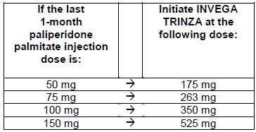
Following the initial Invega Trinza dose, Invega Trinza should be administered every 3 months. If needed, dose adjustment can be made every 3 months in increments within the range of 175 mg to 525 mg based on individual patient tolerability and/or efficacy. Due to the long acting nature of Invega Trinza, the patient’s response to an adjusted dose may not be apparent for several months (see Pharmacokinetics).

Switching from other antipsychotics
Invega Trinza is to be used only after the patient has been adequately treated with the 1 month paliperidone palmitate injectable product for at least 4 months (see indications and dosage and administration).
If Invega Trinza is discontinued, its prolonged release characteristics must be considered. As recommended with other antipsychotic medications, the need for continuing existing extrapyramidal symptoms (EPS) medication should be re-evaluated periodically.
Subsequent recommendations relied on the PopPK report for supporting evidence

Switching from Invega Trinza to the 1 month paliperidone palmitate injectable product
For switching from Invega Trinza to the 1 month paliperidone palmitate injectable product, the 1 month paliperidone palmitate injectable product should be administered at the time the next Invega Trinza dose was to be administered using the equivalent 3.5 fold lower dose as shown in Table 4. The 1 month paliperidone palmitate injectable product should then continue dosed at monthly intervals.

Table 4: Conversion from the last paliperidone palmitate 3 month injectable product (Invega Trinza) dose to the paliperidone palmitate 1 month injectable product dose using 3.5 as a multiplier
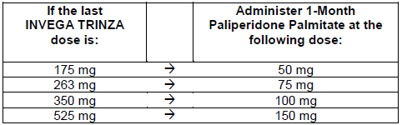
The initiation dosing as described in the prescribing information for the 1 month paliperidone palmitate injectable product is not required

Switching from Invega Trinza to oral paliperidone extended release tablets
For switching from Invega Trinza to oral paliperidone extended release tablets, the daily dosing of the paliperidone extended release tablets should be started 3 months after the last Invega Trinza dose and transitioned over the next several months following the last Invega Trinza dose as described in Table 5. Table 5provides dose conversion regimens to allow patients previously stabilized on different doses of Invega Trinza to attain similar paliperidone exposure with once daily paliperidone extended release tablets.

Table 5: Invega Trinza doses and once-daily paliperidone extended-release conversion regimens needed to attain similar paliperidone exposures
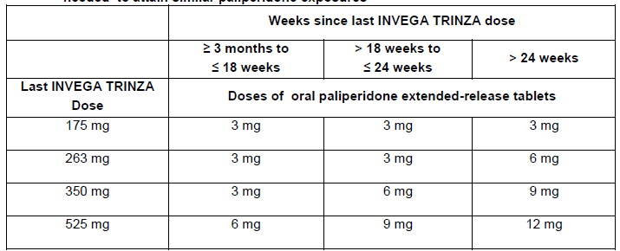

Dosage in special populations

Renal impairment
Invega Trinza has not been systematically studied in patients with renal impairment (see Pharmacokinetics). For patients with mild renal impairment (creatinine clearance ≥ 50 to < 80 mL/min), dose adjustment is done when initiating treatment with the 1 month paliperidone palmitate injectable product; no dose adjustment of Invega Trinza is required. Transition to Invega Trinza is with a dose in a 3.5 to 1 ratio to the previous stabilized 1 month paliperidone palmitate injectable product as described in Dosage above. The maximum recommended dose of Invega Trinza in patients with mild renal impairment is 350 mg.
Invega Trinza is not recommended in patients with moderate or severe renal impairment (creatinine clearance < 50 mL/min).

Hepatic impairment
Invega Trinza has not been studied in patients with hepatic impairment. Based on a study with oral paliperidone, no dose adjustment is required in patients with mild or moderate hepatic impairment. Paliperidone has not been studied in patients with severe hepatic impairment (see Pharmacokinetics).

Paediatric use
Safety and effectiveness of Invega Trinza in patients < 18 years of age have not been studied.

Use in the elderly
In general, recommended dosing of Invega Trinza for elderly patients with normal renal function is the same as for younger adult patients with normal renal function. As elderly patients may have reduced renal function, see renal impairment below for dosing recommendations in patients with renal impairment.

Other populations
No dose adjustment for Invega Trinza is recommended based on gender, race, or smoking status. (For pregnant women and nursing mothers, see Use in Pregnancy)

Missed doses
Dosing Window; missing doses of Invega Trinza should be avoided. However, on exceptional occasions, patients may be given the injection up to 2 weeks before or after the 3 Month time point.

Missed dose > 3½ Months up to 4 Months
If more than 3½ months (up to 4 months) have elapsed since the last injection of Invega Trinza, the previously administered Invega Trinza dose should be administered as soon as possible, then continue with the 3 Month injections following this dose.

Missed Dose > 4 Months up to 9 Months
If more than 4 months (up to 9 months) have elapsed since the last injection of Invega Trinza, do NOT administer the next dose of Invega Trinza. Instead, use the re-initiation regimen shown in Table 6.

Table 6: Re-initiation regimen after missing > 4 months up to 9 months of Invega Trinza
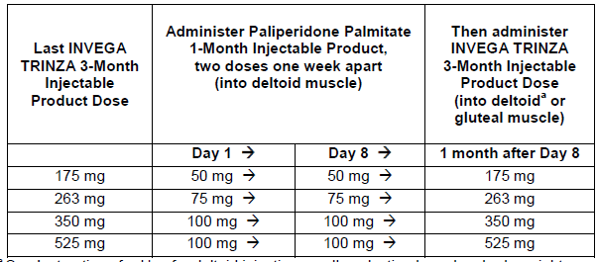
ª See Instructions for Use for deltoid injection needle selection based on body weight.

Missed dose > 9 months
If more than 9 months have elapsed since the last injection of Invega Trinza, re-initiate treatment with the 1 month paliperidone palmitate injectable product as described in the prescribing information for that product. Invega Trinza can then be resumed after the patient has been adequately treated with the 1 month paliperidone palmitate injectable product for at least 4 months.
Comment: The sponsor in Summary of Clinical Efficacy page 69 says: Dosing recommendations were not based on dose response relationships in Study PSY-3011 or Study PSY-3012 because neither study was designed to evaluate efficacy of individual dose levels of PP3M.

Other proposed changes to the PI
This is essentially a new product with changes to the Description, Pharmacology, Clinical trials, Contraindications, Precautions and Adverse Effects sections.

Clinical rationale
Adherence to antipsychotic therapy is essential for the continuous effective drug exposure needed for optimizing therapeutic benefit with respect to preventing or delaying relapse and/or re-hospitalization; however, patients with schizophrenia exhibit various levels of medication compliance behaviour.

Contents of the clinical dossier

Scope of the clinical dossier
The submission contained the following clinical information:
- Evidence proposed to support the Efficacy, Safety and Tolerability of 3 monthly injections of the formulation:
- Clinical pharmacology study R092670-PSY-1005; A Single dose, open label, randomized, parallel group study to assess the pharmacokinetics, safety, and tolerability of Invega Trinza in subjects with schizophrenia.
- PK reports for studies R092670-PSY-3011 and 3012.
- Efficacy/Safety studies:
- R092670-PSY-3011; A randomized, multicentre, double blind, non-inferiority study of paliperidone palmitate 3 month and 1 month formulations for the treatment of subjects with schizophrenia.
- R092670-PSY-3012; A randomized, multicentre, double blind, relapse prevention study of Invega Trinza for the treatment of subjects with schizophrenia.
- Evidence proposed to support the use of 3 monthly injections of the formulation outside the dosage (frequency) used in the clinical trials (3 population analyses):
  - A population PK report REP-1-JAN-PAL-PMX-1.
- Population pharmacokinetic / pharmacodynamic modelling of two intramuscular formulations of paliperidone palmitate in Study R092670-PSY-3011.
- Pharmacokinetic-pharmacodynamic modelling of two intramuscular formulations of paliperidone palmitate in Study R092670-PSY-3012.
- Invega Trinza patient and physician preference surveys summary report.
- Literature summaries 01 January 2014 to16 February 2015.
- Clinical overview, summary of clinical pharmacology studies, summary of clinical efficacy, summary of clinical safety and literature references.
Comment: The sponsor did not initially submit the PK report for study PSY-3011 and addenda.These had to be separately requested.
The sponsors provided a justification for not providing biopharmaceutical studies. They argued: ‘In Study 1005, a comparison of paliperidone exposure, after injection of PP3M versus an injection of immediate release paliperidone formulation showed complete relative bioavailability of PP3M, irrespective of dose and injection site.’
The relevance of the other proposed supporting statements is difficult to follow:
The first points to the similarity of the (PopPK) apparent clearance of Invega Sustenna and of IV paliperidone and states ‘The absolute bioavailability of paliperidone palmitate following Invega Sustenna administration is 100%’.
The last statement points out the result of a study comparing the AUC after oral administration of paliperidone compared to that of IV paliperidone and states The mean dose normalized (to 50 mg equivalent) drug exposure; was in line with the predicted intravenous exposure.

Paediatric data
The submission did not include paediatric data.

Good clinical practice
All studies included in this application were conducted in accordance with the ethical principles originating in the Declaration of Helsinki and in accordance with International Conference on Harmonisation (ICH) Good Clinical Practice guidelines, applicable regulatory requirements, and in compliance with the respective protocols.

Pharmacokinetics

Studies providing pharmacokinetic data

Physicochemical characteristics of the active substance
The following information is derived from the sponsor’s summaries.
‘During development of PP1M, and based on evidence from the literature, -particle size and -injection volume and suspension strength- were presumed to be key determinants of the release rate of paliperidone from the palmitate formulation. The PP3M formulation (F015) differs from the PP1M formulation (F013) in order to ensure a physically and chemically stable 3 Month formulation that is easily re-suspendable and minimizes injection force.’
The sponsor continues:
‘The PP3M formulation contains the same drug substance and excipients as the PP1M formulation (with the minor exception of the removal of disodium hydrogen phosphate)
Paliperidone is a racemic mixture; individual paliperidone enantiomers include R078543(+), R078544(-) and R078543(+)/R078544(-).

Pharmacokinetics in the target population

Study 1005
This was a complex study in that it looked at 4 different sets of patients for varying reasons.
The study was conducted in multiple sites in multiple countries between 29 February 2008 and 14 May 2014.

Objectives
The primary objectives of this study were:
- to evaluate the pharmacokinetics (PK), safety, and tolerability of a 3 Month injection interval formulation of paliperidone palmitate (F015), , at a single dose of 300 mg equivalent administered in the gluteal muscle in subjects with schizophrenia (Panel A)
- to evaluate the PK, safety, and tolerability of single escalating doses of the 3 Month injection interval formulation of paliperidone palmitate administered in the gluteal and deltoid muscle in subjects with schizophrenia (Panels B and D).
The secondary objectives were:
- to evaluate the relative bioavailability of the paliperidone palmitate formulations after deltoid and gluteal injection compared with a 1 mg immediate release (IR) formulation of paliperidone
- to explore the dose-proportionality of paliperidone palmitate after gluteal and deltoid injection
to investigate the effect of the volume of injection, suspension strength[information redacted]This was a multicentre, randomized, open label, parallel group study in 4 panels (A, B, C, and D) to assess the pharmacokinetics, safety, and tolerability of a paliperidone palmitate 3 Month formulation in subjects with schizophrenia.
Each panel comprised of 2 sequential single dose treatment periods (Period 1 [paliperidone immediate release] and Period 2 [paliperidone palmitate 3 month]), separated by a washout period of at least 7 and no more than 21 days.
The study agent injection was followed by a 96 hour observation period in Period 1, and a 364 day observation period in Period 2 (544 days in Panel D and for those who consented to the extension in Panel B).

Primary objectives
For Panel A the primary objective of was to confirm whether formulation of paliperidone palmitate (F015) exhibited an appropriate release profile from a gluteal injection for a 3 Monthly dosing interval as well as an acceptable local tolerability and safety profile that was comparable to the 1 month formulation.
For Panel B the primary objective was to evaluate the single dose PK, safety, and tolerability over the entire expected therapeutic dose range after gluteal administration. The PK and safety profile of paliperidone palmitate after injection in the deltoid muscle was also documented
After Panel B the subjects were asked to participate in an approximately 26 week to better characterise the PK profile.
For Panel D the primary objective was to evaluate the single dose PK, safety and tolerability over the entire expected therapeutic dose range after both gluteal and deltoid administration. This also included an approximately 26 week extension to better characterise the PK profile.

Treatments
The initial 1 mL paliperidone immediate release formulation (F024) injection contained 1 mg paliperidone.
Subsequent single dose of study agent followed after a washout period of at least 7 and no more than 21 days:
- In panel A subjects received in 300 mg equivalent (eq) paliperidone palmitate (1.5 mL of 200 mg/mL paliperidone) of the 3 Month formulation F015
- Panel B subjects received formulation F015 doses of 75, 150, 300, or 450 mg equivalent
- Panel C subjects received 150 mg eq of formulation F016 [information redacted]
- Panel D subjects received formulation F015 doses of 175, 350, or 525 mg equivalent.

Design

Figure 1. [information redacted]Entry criteria
- Age 18 to 65 years with a (DSM-IV) diagnosis of schizophrenia or schizoaffective disorder for at least 1 year before screening.
- Clinically stable with no hospitalizations for schizophrenia exacerbation or change in current antipsychotic medications for 3 months prior to screening.
- Has a total PANSS score of 70 or less at both screening and Day-1 (Period 1); and
- has a score of no more than 16 points on the sum of the conceptual disorganization, suspiciousness/persecution, hallucinatory behaviour, and unusual thought content items of the PANSS; and
- Has scores not greater than 5 on any of the individual items of the PANSS.
Exclusion criteria included:
- Attempted suicide within 12 months before screening or is at imminent risk of suicide or violent behaviour.
- Is in his/her first episode of psychosis.
- Has a history of neuroleptic malignant syndrome.
- Has a diagnosis of tardive dyskinesia at the time of screening.
- Concomitantly uses or used the following medications prior to the start of the study or during the open label treatment period:
  - oral risperidone, paliperidone (Invega), clozapine, ziprasidone, or thioridazine within 3 months of screening visit
  - Risperdal Consta or paliperidone palmitate injection within 100 days of screening visit
  - paliperidone palmitate long-acting injection within 10 months of screening visit
  - long-acting formulations of other neuroleptic drugs within 3 months of screening visit
  - hepatic enzyme inducers within 14 days prior to screening visit to avoid hepatic enzyme induction
  - the following anticonvulsant medications: carbamazepine, oxcarbazepine, felbamate, and phenytoin within 3 months of screening visit.

PK sampling and analysis
Plasma paliperidone was measured after +1h, +6h, +24h, and days 2, 4, 6, 10, 14, 18, 22, 26, 30, 34, 38, 42, 56, 84, 112, 140, 168, 196, 224, 252, 280, 308, 336 and end of study.
Plasma samples were analysed for paliperidone, paliperidone enantiomers and/or paliperidone palmitate concentrations using validated liquid chromatography coupled to tandem mass spectroscopy (LC-MS/MS) methods under the supervision of the sponsor's bioanalytical laboratory. The target lower limit of quantification (LLOQ) for plasma paliperidone was 0.100 ng/mL and for paliperidone palmitate was 0.200 ng/mL. The target (LLOQ) for plasma paliperidone enantiomers was 0.200 ng/mL.

Table 7: Study completion/ early withdrawal information; Safety Analysis Set
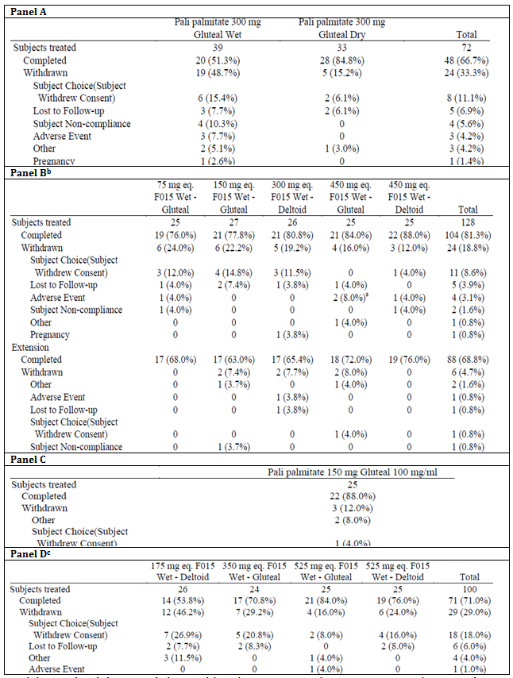
a. Including one subject [information redacted] who was withdrawn due to a non-serious and non-treatment emergent adverse event of myocardial ischaemia on Day -1 of Period 1. b. 120 subjects completed Period 1 of the trial. 94 trial completers entered the optional extension period. c. 98 subjects completed Period 1 of the trial. All Subjects received Pali 1 mg I.R. in Period 1.

PK results paliperidone

Panels A and C
The results in Panels A and C were compromised by incomplete injections due to insufficient shaking prior to injection (Period 2) in some subjects.
After 1 mg paliperidone Immediate Release, the median C_{max} ranged from 7.60 to 10.9 ng/mL, and from 188 to 232 ng.h/mL for AUC∞ in the different treatment groups. The inter-subject variability (%CV) for both C_{max} and AUC∞ in the different treatment groups was similar and ranged between 40.5% and 51.8%. The terminal half-life was approximately 1 day.
After administration of 300 mg equivalent paliperidone palmitate F015 or 150 mg equivalent paliperidone palmitate F016 median T_{max} ranged from 21 days for F016 and 28 to 33 days for F015.
[Information redacted]

Table 8: [information redacted]

Panel B
The median C_{max} after 450 mg equivalent paliperidone palmitate in the deltoid muscle were slightly higher than in the gluteal muscle. Except the 75 mg equivalent gluteal group, quantifiable plasma paliperidone concentrations were seen at 544 days after dosing for the majority of the subjects.
Median values of C_{max} and AUC∞ for paliperidone in Period 2 increased proportionally with dose; except for the 75 mg equivalent gluteal dose group for which median dose normalized C_{max} (but not AUC∞) was higher compared to the other dose groups. The inter-subject %CV for C_{max} ranged between 49.1% and 54.4% in those groups with deltoid muscle injection as compared to those with gluteal muscle injection (range between 59.4% and 99.2%). The inter-subject %CV for AUC∞ across the dose groups and ranged between 22.0% and 31.7%.
In Period 2, median T_{max} ranged from 27.51 to 29.00 days with gluteal muscle injection. For the groups with the deltoid muscle injection, the T_{max} ranged from 23.98 days (450 mg equivalent) to 34.00 days (300 mg equivalent).
The median relative bioavailability estimated as the AUC∞ ratios of Treatment Period 2/Treatment Period 1 (F_{rel},AUC∞) was comparable between the dose groups and ranged between 101.78% after administration of 450 mg equivalent in the deltoid muscle to 117.65% after 75 mg equivalent in the gluteal muscle.

Table 9: Relative bioavailability: summary of the statistical analysis of the PK parameters of paliperidone after administration of paliperidone palmitate treatment groups (Test) compared to 1 mg paliperidone IR (Reference) (Panel B)
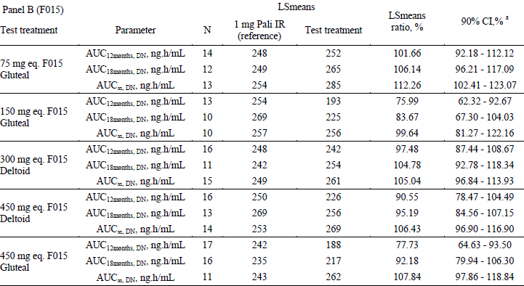
DN=dose normalized to 1 m.

Panel D
Median T_{max} was 24 and 25 days for 175 mg equivalent and 525 mg equivalent doses in the deltoid muscle, respectively; and 31 and 23 days for 350 mg equivalent and 525 mg equivalent in the gluteal muscle, respectively.
The median C_{max} paliperidone after 525 mg equivalent in the deltoid muscle were slightly higher compared to that after administration of 525 mg equivalent paliperidone palmitate in the gluteal muscle. For both 525 mg equivalent dose groups, quantifiable plasma paliperidone concentrations were observed at 544 days after dosing for the majority of the subjects. For the 350 mg equivalent dose group and the 175 mg equivalent dose group, quantifiable plasma paliperidone concentrations were observed at 544 and 364 days, respectively, for the majority of the subjects.
Median values of C_{max} and AUC∞ for paliperidone in Period 2 increased proportionally with dose. The inter-subject %CV for C_{max} was 50.5% and 94.7% for the 175 mg equivalent and 525 mg equivalent deltoid dose groups respectively and 87.5% and 59.7% for the 350 mg equivalent and 525 mg equivalent gluteal dose groups respectively. The inter-subject %CV for AUC∞ was 32.5% and 26.4% for the 175 mg equivalent and 525 mg equivalent deltoid dose groups respectively and 32.3% and 34.8% for the 350 mg equivalent and 525 mg equivalent gluteal dose groups respectively.
Inter-subject variability for C_{max} was 87.5% in the 350 mg equivalent gluteal group and 94.7% in the 525 mg equivalent deltoid group due to some subjects with a relatively high C_{max}, compared to the other subjects in these dose groups.
The median relative bioavailability ranged between 107.41% after administration of 525 mg equivalent in the gluteal muscle to 115.91% after 350 mg equivalent in the gluteal muscle.

Table 10: Relative bioavailability: summary of the statistical analysis of the PK parameters of paliperidone after administration of paliperidone palmitate treatment groups (Test) compared to 1 mg paliperidone IR (Reference) (Panel D)
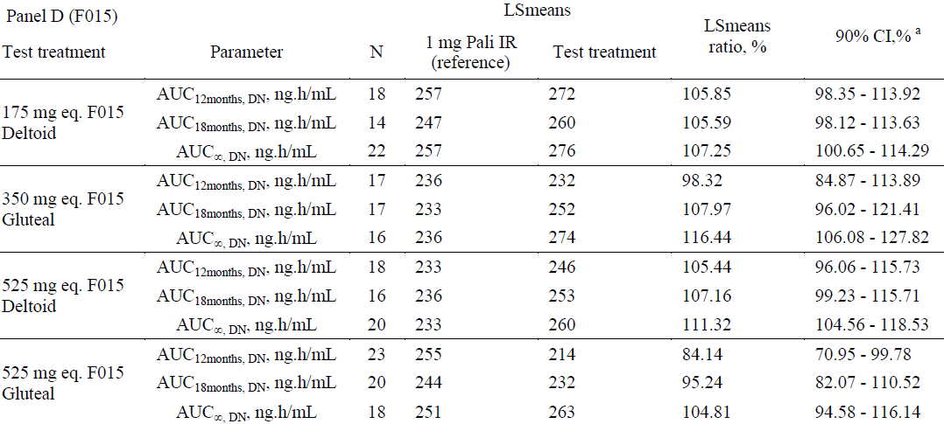
DN=dose normalized to 1 mg

Panels B and D
For dose proportionality, log transformed dose normalized (to the 350 mg equivalent dose) PK parameters (C_{max} and AUC∞) were plotted versus the dose for each injection site separately, as well as combined. A linear regression model with log transformed dose normalized (to the 350 mg equivalent dose) PK parameters versus log transformed dose as a predictor was fitted and used to estimate the corresponding slope with a 95% CI, for each injection site separately.
This failed to show the slopes for AUC∞ were significantly different from zero for both the deltoid (slope -0.004, p = 0.95) and gluteal (slope -0.033, p = 0.52) injection sites as well as the deltoid and gluteal injection sites combined (slope -0.021, p = 0.58). Thus suggesting a proportional increase in AUC∞ with dose (hypothesis was not rejected at the 5% significance level).
Similarly, there was a failure to show for C_{max} the slopes were significantly different from zero for both the deltoid (slope -0.177, p = 0.18) and gluteal (slope -0.081, p = 0.45) injection sites as well as the deltoid and gluteal injection sites combined (slope -0.064, p =0.43). Thus suggests a proportional increase in C_{max} with dose.
Pairwise comparisons of log transformed dose normalized (to 350 mg equivalent) AUC∞ and C_{max} between all dose groups were made for each injection site separately. Estimated ratios of geometric means between all pairs of doses along with associated 90% CI were given.
The dose normalized (to 350 mg equivalent) LS means AUC∞ was estimated to be similar for the 175 mg equivalent and 525 mg equivalent deltoid treatment group and for the 75 mg equivalent gluteal treatment group compared to the reference treatment group (300 mg equivalent for the deltoid treatment group and 350 mg equivalent for the gluteal treatment group). The dose normalized AUC∞ of the 150 mg equivalent, 450 mg equivalent and the 525 mg equivalent gluteal treatment group was decreased with 7%, 12% and 4% respectively. For the 450 mg equivalent deltoid treatment group, AUC∞ increased with 11% compared to the reference treatment group.
The dose normalized (to 350 mg equivalent) LS mean C_{max} of the 175 mg equivalent and 525 mg equivalent deltoid treatment groups and the 75 mg equivalent and 525 mg equivalent gluteal treatment groups were increased with 38%, 30% and 35%, 15% respectively compared to the reference treatment group (300 mg equivalent for the deltoid treatment group and 350 mg equivalent for the gluteal treatment group). A decrease was observed for the 450 mg equivalent deltoid and the 150 mg equivalent and 450 mg equivalent gluteal treatment group of 12% and 27%, 20%, respectively, compared to the reference treatment group.
Based on the LS means AUC∞ and F_{relAUC∞} were similar after injection in the deltoid or gluteal muscle. C_{max} was estimated to be 27% higher after deltoid injection compared to gluteal injection.

Table 11: Summarized statistical results of pharmacokinetic parameters of paliperidone; across Panels B and D, Period 2: IM injection with 75 mg eq, 150 mg eq, 175 mg eq, 300 mg eq, 350 mg eq, 450 mg eq or 525 mg eq paliperidone palmitate F015 injected in the deltoid (test) or gluteal muscle (reference)
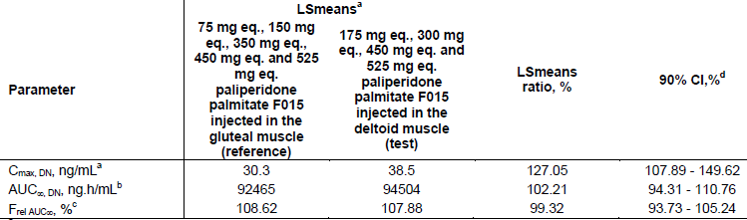
^{a.} N = 107 for reference and N = 91 for test ^{b.} N = 73 for reference and N = 78 for test ^{c.} N = 68 for reference and N = 71 for test ^{d.} 90% confidence intervals

PK results paliperidone palmitate
Very few samples were quantifiable:
- 3 in Panel A
- None in Panels B and C
- 22 samples in 7 subjects in Panel D in the 525 mg equivalent groups and ranged from 0.270 ng/mL to 19.2 ng/mL at between 1 hour and 120 hours.

PK results paliperidone enantiomers
In Panel D the individual paliperidone enantiomers [R078543(+), R078544(-) and R078543(+)/R078544(-)] were quantified in pharmacokinetic samples obtained from a subgroup of 12 subjects in the 525 mg equivalent gluteal and 12 subjects in the 175 mg equivalent deltoid treatment groups who completed the 1st 12 months in Period 2.
The plasma concentrations of the R078543(+) enantiomer were consistently higher than those for the R078544(-) enantiomer. The median ratio of R078543(+)/R078544(-) plasma concentrations was 2.50 and 2.38, two days after IM administration of 175 mg equivalent in the deltoid muscle and 525 mg equivalent in the gluteal muscle respectively, decreasing to approximately a range of 1.72 to 1.94 and 1.49 to 1.82 respectively from 4 days post dosing and onwards, for both injection sites and doses.
The mean and median R078543(+)/R078544(-) PK parameter ratios after IM injections of paliperidone palmitate (F015) are 1.81 and 1.83 and 1.86 and 1.90, for AUC∞ and C_{max}, respectively after injection of 175 mg equivalent in the deltoid muscle. After injection of 525 mg equivalent in the gluteal muscle mean and median ratios were 1.65 and 1.63 and 1.67 and 1.72 for AUC∞ and C_{max}, respectively.

Summary
After a single IM injection of paliperidone palmitate in the gluteal or deltoid muscle, the paliperidone AUC∞ and C_{max} increased approximately dose-proportionally in the 75 to 525 mg equivalent range.
The LS means of C_{max} of paliperidone was higher after injection of paliperidone palmitate in the deltoid muscle compared to the gluteal muscle (27% increase over all dose levels) whereas the AUC∞ was similar between injection sites.
Comments on the Study
[Information redacted] The statistical analysis plan of the data included an interim analysis after at least 20 subjects per treatment group in Panel A (40 subjects in total) had completed their Day 196 assessments in Period 2. This showed a greater than expected inter subject variability and low relative bioavailability compared to that seen with the 1 month formulation. It was hypothesized that the results in ‘Panels A and C were likely compromised by incomplete injections in some subjects at some sites due to inadequate shaking prior to injection which led to significant quantities of medication being left in the syringe due to investigational product not being resuspended prior to injection’.
This also resulted in:
- values for AUC∞, t_{1/2} and λ_{z} not being calculated
- plasma samples outside the 7 day window being excluded on visual inspection of the individual paliperidone plasma concentration time profiles.
There was a large variability in T_{last} values across subjects in Panels B and D, which was caused by drop outs and participation of subjects in the extension period until 544 days so that F_{rel,AUClast} was not calculated for B and D.
‘For some subjects in Panel B (Period 2), the % AUC_{∞,ex} was above 20% of total AUC due to the continued release of paliperidone palmitate up to and beyond the last sampling point (3 out of 21 subjects in the 75 mg equivalent gluteal dose group, 2 out of 14 subjects in the 150 mg equivalent gluteal dose group, 2 out of 21 in the 450 mg equivalent deltoid dose group and 2 out of 15 subjects in the 450 mg equivalent gluteal dose group) requiring exclusion from the descriptive statistics. Therefore descriptive statistics on AUC∞ may be biased downwards.
For a number of subjects (16 subjects across doses) the plasma concentration-time profile of paliperidone did not show a clear decrease. For these subjects, the terminal half-life time could not be accurately determined and therefore it is possible that presented median t_{1/2} and AUC∞ values are underestimated.’

Study 3012
This was a Phase III randomized, double blind, parallel group, placebo controlled, multicentre study to determine the efficacy and safety of Invega Trinza in the prevention of relapse of schizophrenia.
The study consists of 4 phases: a Screening Phase (up to 3 weeks); a 17 week flexible dose open label Transition Phase; a 12 week fixed dose open label Maintenance Phase; and a randomized, double blind, fixed dose, placebo controlled relapse prevention phase during which subjects were randomly assigned, in a 1:1 ratio, to receive either a fixed dose of Invega Trinza or placebo. The double blind phase was of variable duration; subjects could remain in the study for as long as they were clinically stable.
Among the secondary objectives was:
- Assess the pharmacokinetics (PK) of Invega Trinza including its relationship with demographic and dose related variables.
Although adults from 18 to 70 years of age were to be included in this trial, due to data handling decisions, no subjects above 60 were included in the descriptive statistics of the pharmacokinetic parameters.
Paliperidone predose plasma concentrations after administration of Invega Sustenna at 50, 75, 100 or 150 mg equivalent on Day 64 and on Day 92 were comparable dose normalized over all dose groups.

Table 12: Predose plasma concentrations of paliperidone after administration of PP1M/PP3M during the transition, maintenance and double blind phase
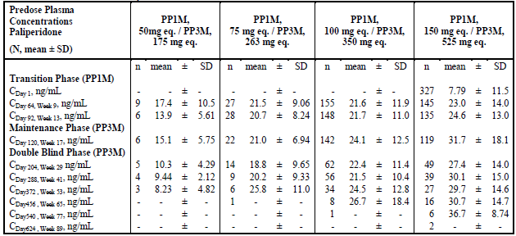
Note: The PK report is internally inconsistent with some of these results (for example Table 2) being labelled as after injection The Study protocol was consulted and it states in its synopsis (Time and events schedule page 22) Venous samples of 4 mL should be obtained prior to dose administration on each PK day.
In the Double Blind Phase C_{max} and AUC_{τ} increased with dose, with mean values of 15.7, 38.5, 41.5 and 45.9 ng/mL for C_{max} and 22635, 60660, 62893 and 70793 ng.h/mL for AUC_{τ} with increasing dose groups of 175, 263, 350 and 525 mg equivalent respectively. Dose proportionality was not able to be conclusively shown.
There were 14 subjects with a C_{max} > 125 ng/mL. Based on the appearance of the concentration curves 3 (63801202, 60017109 and 60400605) suggested the possibility of rapid initial absorption in that the other injections in the same subjects were not associated with similar high rises. The infrequency of sampling precludes further explanation.
Figure 2: Box plot of dose normalized (to 350 mg equivalent) predose plasma concentrations of paliperidone after administration of PP3M at 175 263, 350 or 525 mg equivalent during the maintenance and double blind phase
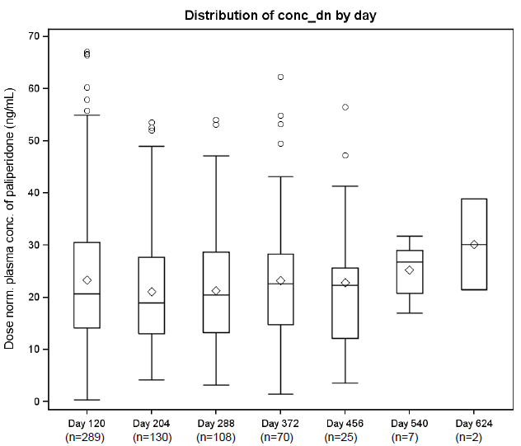

Table 13: Pharmacokinetic results of paliperidone after administration of PP3M on Day 372 (Week 53) at 175, 263, 350, or 525 mg equivalent during the double blind phase
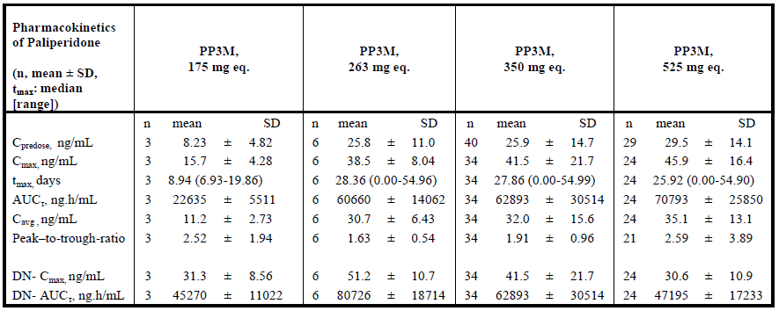

Study 3011
Comment: The CSR for study 3011 page 96 referred to Attachment R092670PSY3011 Clinical Pharmacokinetic Final Report for the PK results of the study. However this could not be found. The report was supplied on request minus Addenda, these were separately requested.
This was a randomized, double blind, parallel group, multicentre non-inferiority study to determine if efficacy of paliperidone palmitate 3 month was non-inferior to the efficacy of 1 month formulation for the treatment of adults with schizophrenia.
The study consisted of 3 phases: Screening/Washout/Tolerability Phase a 17 week flexible dose Open label Stabilization Phase (referred to as the Open label Phase) and a 48-week randomized, fixed dose, Double-blind Controlled Phase (referred to as the Double blind Phase).
Blood samples for determination of paliperidone were collected predose on Day 1, Day 8 and every 4 weeks from Week 5 to Week 61 and post-dose on Day 99, Day 379, Day 386 and Week 65 (Day 456).
Among the secondary variables was:
- Assess the pharmacokinetics of Invega Trinza, including its relationship with demographic and dose related variables
Dose normalized (to 100 mg equivalent for Invega Sustenna and 350 mg equivalent for Invega Trinza) paliperidone predose plasma concentrations after administration of Invega Trinza were 21% lower compared to Invega Sustenna across all dose groups.

Table 14: Predose plasma concentrations of paliperidone after administration of PP1M during the double blind phase, Study 3011
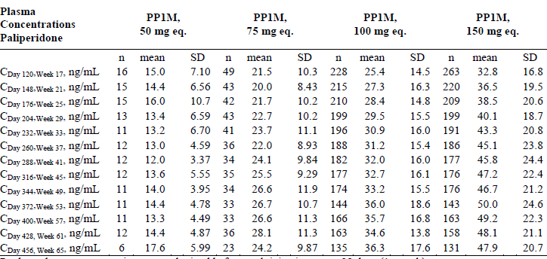
Predose plasma concentrations were obtained before each injection every 28 days (1 month).

Table 15: Predose plasma concentrations of paliperidone after administration of PP3M during the double blind phase, Study 3011
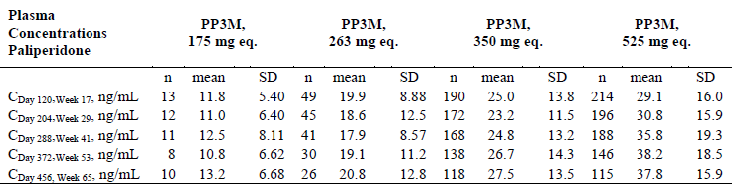
Predose plasma concentrations were obtained before each injection every 84 days (3 months).
With Invega Sustenna C_{max} and AUC_{τ} appeared to be roughly dose proportional over all doses given (50 mg equivalent, 75 mg equivalent, 100 mg equivalent and 150 mg equivalent). After administration of Invega Trinza, C_{max} and AUC_{τ} also appeared to be approximately dose proportional over all doses given (150 mg equivalent, 263 mg equivalent, 350 mg equivalent and 525 mg equivalent).
Figure 3: Box Plots of dose normalized (100 mg equivalent for PP1M and 350 mg equivalent for PP3M) plasma predose concentrations of paliperidone during the double blind phase
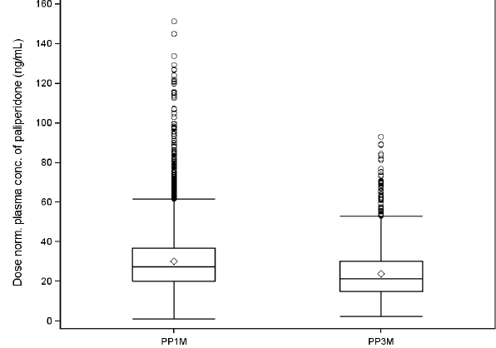
Mean peak-to-trough ratios were higher after administration of Invega Trinza (1.86 to 2.54) than after administration of Invega Sustenna (1.30 to 1.63).
After administration into the deltoid muscle, paliperidone C_{max} and AUC_{τ}, were 1.09 fold and 1.13 fold higher respectively, at steady state for PP1M, and 1.28 fold and 1.30 fold higher, respectively, for PP3M compared to administration into the gluteal muscle. Compared to men, paliperidone C_{max} and AUC_{τ} in women was 1.25 fold and 1.23 fold higher, respectively, after administration of PP1M and 1.06 fold and 1.09 fold higher, respectively, after administration of PP3M. Compared to the < 60 years subgroup, paliperidone C_{max} and AUC_{τ} in the ≥ 60 years subgroup were 1.13 fold and 1.16 fold higher, respectively, for PP1M and 1.18 fold and 1.15 fold higher, respectively, for PP3M. Paliperidone C_{max} and AUC_{τ} increased with decreasing renal function (from normal to moderately impaired renal function) for both PP1M and PP3M. Compared to normal renal function, C_{max} and AUC_{τ} in subjects with mild renal impairment was 1.13 fold and 1.12 fold higher, respectively, for PP1M and 1.43 fold and 1.35 fold higher, respectively, for PP3M.
Figure 4: Box plots of dose normalized (100 mg equivalent for PP1M and 350 mg equivalent for PP3M) C_{max-DN} and AUC_{3months-DN} of paliperidone comparing PP1M versus PP3M; per injection site

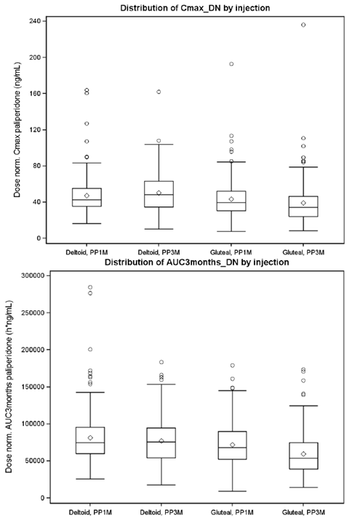
Figure 5: Summary of the key PKs of paliperidone after administration of PP1M during the double blind phase, Study 3011
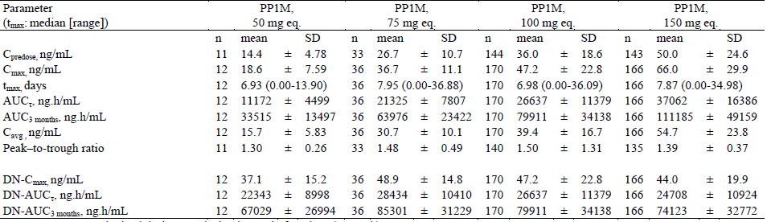
PK parameters were obtained during one dosing interval of 28 days (1 month). DN: dose normalized to 100 mg equivalent
Figure 6: Summary of the key PKs of paliperidone after administration of PP3M during the double blind phase, Study 3011
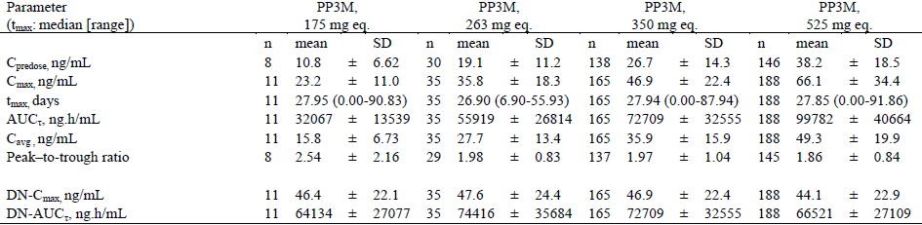
PK parameters were obtained during one dosing interval of 84 days (3 months). DN: dose normalized to 350 mg equivalent
Figure 7: Linear median plasma concentration time profiles of paliperidone after administration of PP1M at 50 mg eq, 75 mg eq, 100 mg eq, or 150 mg eq and PP3M at 175 mg eq, 263 mg eq, 350 mg eq, or 525 mg eq during the double blind phase
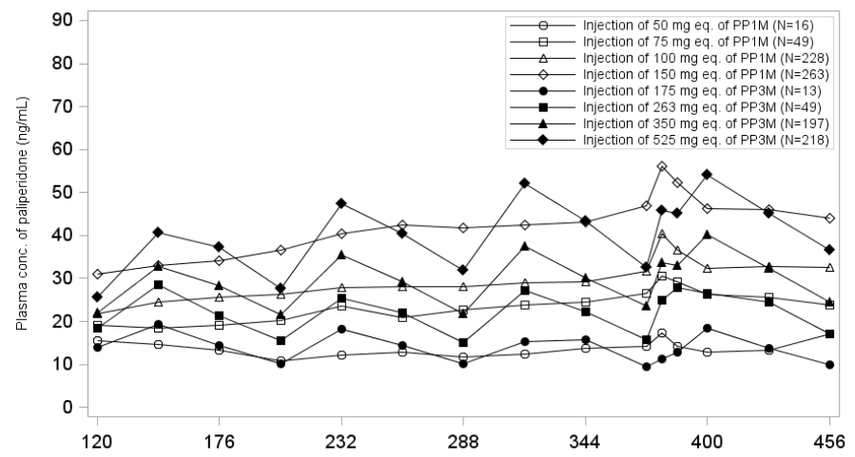

Pivotal studies for other than 3 monthly dosage following initial once a month dosage

Population PK Studies
The original IM paliperidone palmitate population pharmacokinetic model was a one compartment model with 1st order elimination. The covariates effects resulted in the following conclusions: repeated injections into the deltoid muscle (compared with gluteal) resulted in a faster increase in plasma concentrations and enhanced time to achieve steady-state but did not influence overall exposure; higher doses associated with larger injection volumes increased the apparent half-life which increased time to steady-state. Other important variables were needle length and BMI: a slower rise in plasma concentrations was found for obese subjects which can be mitigated by use of a longer needle in heavier subjects. Renal function was also important indicating that renal impairment required a reduced dose.

Table 16: From Submission 2009-00926 final parameter estimates with the index dataset and influence of outliers
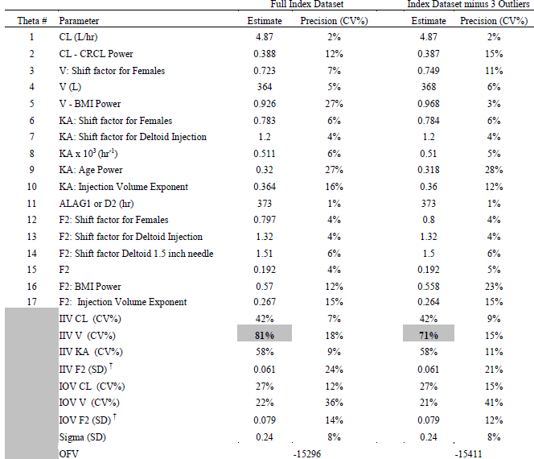
Figure 8: An illustration of the previously developed population PK model following administration of PP1M
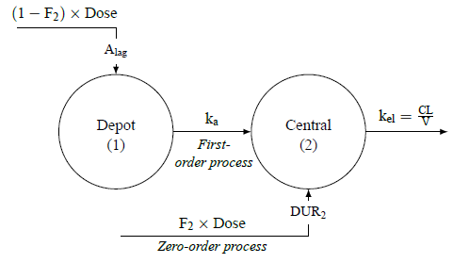
A_{lag} is the lag time, CL is the apparent clearance, DUR2 is the zero-order input duration, F₂ is the fraction of the dose entering the systemic circulation via a zero-order process after administration of PP1M, k_{a} is the first-order absorption rate constant, k_{el} is the first-order elimination rate constant, and V is the apparent volume of distribution.

PopPK Study REP-1-JAN-PAL-PMX-1
This PopPK study was based on data from Study PSY-1005 and Study PSY-3012 (Phase III).
For more information on the single dose Study PSY-1005 see above.
The Study PSY-3012 had:
- a screening phase
- an open label transition/maintenance phase and
- a double blind phase.
Initially subjects received open label treatment with paliperidone palmitate 1 month (PP1M) formulation for a period of 17 weeks during the transition phase. Those subjects who remained clinically stable advanced to the 12 week maintenance phase and received a single fixed dose of paliperidone palmitate 3 month (PP3M) formulation. Finally the subjects then entered the double blind phase and were randomized in a 1:1 fashion to either placebo or Invega Trinza.
The PK sampling schedule was provided.

Objectives
- Describe the PK parameters of paliperidone and their variability following administration of Invega Trinza in Study R092670-PSY-1005 and Study R092670-PSY-3012 based on the previously developed model for Invega Sustenna. If necessary, refine the absorption sub-model.
- Conduct a covariate analysis to identify parameter-covariate relationships of paliperidone when administered as Invega Trinza.
- Evaluate the performance of the Invega Trinza population PK model.
- Perform simulations to address predefined dosing regimen scenarios and elucidate the impact of parameter covariate relationships on the PKs of paliperidone
There were 726 subjects with 11,274 samples of which 10,433 were > LLOQ.
The final model was based on 8990 PK samples from 651 subjects.

Exclusion of potential outliers
PK observations were excluded based on the residual error or on graphical plots.
Comment: Based on the following Table 17, none of the subjects with C_{max} > 125 ng/mL appear to have been excluded except the results of subject 605212 which showed a dramatic rise at the end of the study. That is the model appears to include one patient (605113) who suffered dose dumping and 2 patients with unexplained reduced clearance (60625, 603435).
The following were identified by the modelling process as outliers.

Table 17: PK samples identified as potential outliers (all were from Study 1005)
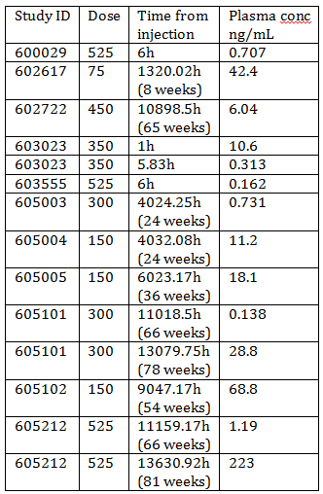
Figure 9: Paliperidone plasma concentrations versus time on a semi logarithmic scale, stratified by subjects with PK samples identified as potential outliers
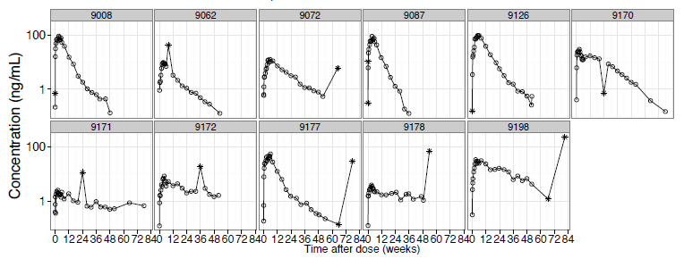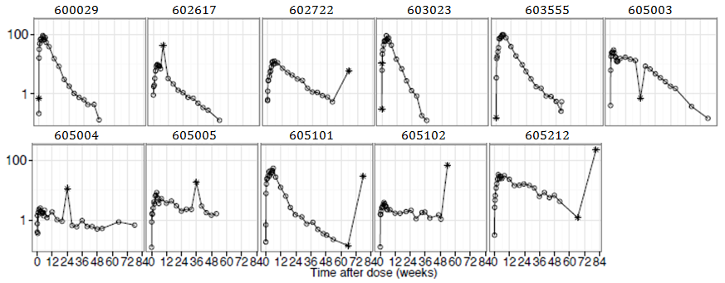
The black lines connect the paliperidone plasma concentrations for a single subject. The symbols indicate samples included in the final model (open circles) or identified as an outlier (asterisk).

Table 18: Subjects with C_{max} > 125 ng/mL
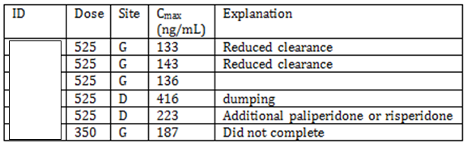
D = deltoid; G = gluteal

Covariates
Covariates tested included: ALT; BMI, injection site (INJS), total bilirubin (TB), age, sex, race, needle length as per the following table.

Table 19: Parameter covariate relationships tested in the stepwise covariate model building procedure
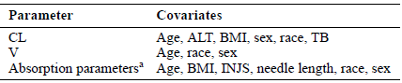
^{a.} k_{a1 max}: maximum absorption rate for the slow absorption process; k_{amt1 50}: amount of paliperidone at the absorption site when half of the maximum absorption rate is achieved for the slow absorption process; k_{amt3 50}: amount of paliperidone at the absorption site when half of the maximum absorption rate is achieved for the rapid absorption process; CL: apparent clearance; F3: fraction of the dose entering the systemic circulation via a rapid and saturable absorption process after administration of paliperidone palmitate 3 Month formulation; V: apparent volume of distribution

Adjustments
Baseline paliperidone concentrations in PSY- 1005 (52 out of 217 subjects) were adjusted.
Samples in Study PSY-3012 with positive risperidone levels were excluded from the analysis. In Study PSY-1005 schizophrenic subjects were allowed only background antipsychotics not interfering with the PKs of paliperidone.
Data were simulated 1,000 times using the doses and covariate data from the subjects that were included in the analysis data set, using the same sampling times. For the Visual predictive checks, the 5th, 50th and 95th percentiles of the observed and simulated dependent variable (DV) versus time profiles were compared graphically.
The existing model failed to adequately describe the Invega Sustenna PK data from Study 3012 so a new model was developed using both the previous and the Study 3012 Invega Sustenna data.
This model then failed to adequately describe the Invega Trinza PK absorption data from Study 1005 so a model with one rapid and one slow saturable absorption process was then adopted.
Covariate analysis was then undertaken. In addition to the covariates (CRCL on CL; BMI on V; IVOL on both the absorption rates), injection site and sex were identified as covariates on k_{a max} of the slow absorption process. That neither BMI nor needle length were identified as covariates for absorption was explained by weight-based needle lengths were employed in both Invega Trinza studies, However this applies only to the deltoid injections not the gluteal injections which had the same size needle regardless of BMI.
As the sponsor said ‘The model provided a reasonable description across all dose groups and key covariates.’

The final model
The final model had a residual error coefficient of variation of 0.306 and a relative standard error of 0.321%.
Invega Trinza showed flip-flop kinetics for paliperidone that is the rate of absorption is slower than the rate of elimination so that the apparent t_{1/2} is dependent on the absorption process. Since the disposition is modified by the slow absorption, the V is not a reflection of paliperidone’s true volume of distribution.
The sponsor postulates that this accounts for the difference in V between Invega Sustenna and Invega Trinza studies which results in the lack of dose proportionality seen in C_{max} between the studies.
Figure 10: An illustration of the structure of the population PK model for paliperidone after administration of PP3M
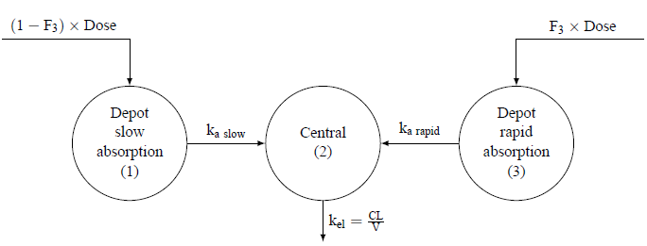
CL is the apparent clearance, F₃ is the fraction of the dose entering the systemic circulation via a rapid and saturable absorption process after administration of PP3M, k_{a rapid} is the absorption rate for the rapid absorption process, k_{a slow} is the absorption rate for the slow absorption process, k_{el} is the first-order elimination rate constant, and V is the apparent volume of distribution.

Table 20: Parameter estimates of the final paliperidone population PK model
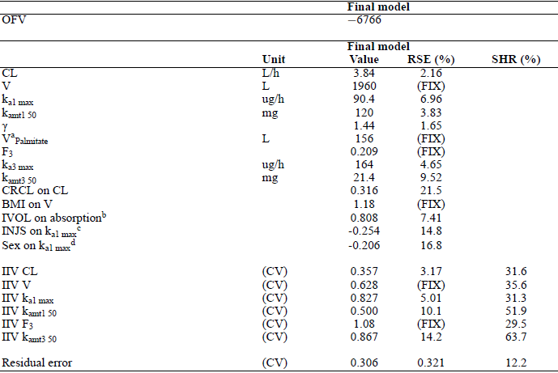
^{a.} V for subjects with paliperidone palmitate in plasma ^{b.} All 4 absorption rate parameters used the same IVOL covariate effect (run 50 compared to runs 52 and 53) ^{c.} Lower k_{a1 max} after gluteal injections ^{d.} Lower k_{a1 max} for women The RSE for IIV parameters and the residual error are reported on the approximate. SD scale (SE/variance estimate)/2 CL: apparent clearance; CRCL: creatinine clearance; CV: coefficient of variation; F₃: fraction of the dose entering the systemic circulation via a rapid and saturable absorption process after administration of PP3M; FIX: value fixed; γ: hill factor; IIV: inter-individual variability; INJS: injection site; IVOL: injection volume; k_{amt1 50}: amount of paliperidone at the absorption site when half of the maximum absorption rate is achieved for the slow absorption process; k_{amt3 50}: amount of paliperidone at the absorption site when half of the maximum absorption rate is achieved for the rapid absorption process; k_{a1 max}: maximum absorption rate for the slow absorption process; k_{a3 max}: maximum absorption rate for the rapid absorption process; OFV: objective function value; PK: pharmacokinetic; RSE: relative standard error; SD: standard deviation; SE: standard error; SHR: shrinkage; V: apparent volume of distribution; V_{Palmitate}: V for subjects with paliperidone palmitate in plasma
Figure 11: Equation used for paliperidone PK model
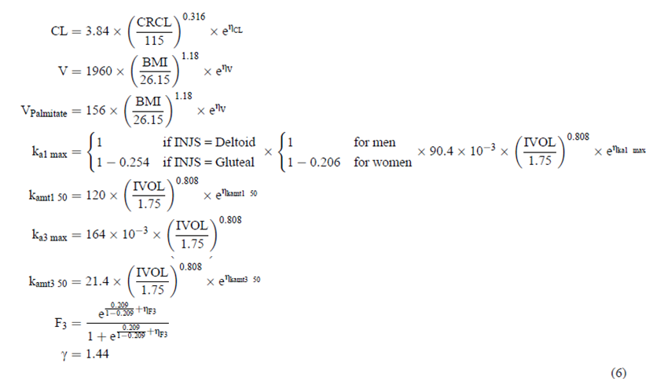
CL is the apparent clearance, CRCL is the creatinine clearance, V is the apparent volume of distribution, V_{Palmitate} is the apparent volume of distribution for subjects with paliperidone palmitate in plasma, IVOL is the injection volume, INJS is the injection site, ka_{1 max} is the maximum absorption rate for the slow absorption process, k_{amt1 50} is the amount of paliperidone at the absorption site when half of the maximum absorption rate is achieved for the slow absorption process, k_{a3 max} is the maximum absorption rate for the rapid absorption process, k_{amt3 50} is the amount of paliperidone at the absorption site when half of the maximum absorption rate is achieved for the rapid absorption process, F₃ is the fraction of the dose entering the systemic circulation via a rapid and saturable absorption process after administration of PP3M, and γ is the hill factor. The denominator is the median covariate in the analysis data set. For simplicity the subscripts j (denoting individuals) have been suppressed. η_{x} is a zero mean individual specific random variable with standard deviation ω_{x} associated with parameter x.

Evaluation of the final model
Comment: The previous model had a residual variability SD of 0.24 (CV 8%), this result was reported in this submission as a residual error CV of 0.222%. the final model in this submission had a residual error coefficient of variation of 0.306.
Figure 12: Prediction corrected visual predictive check of the final model, stratified by study
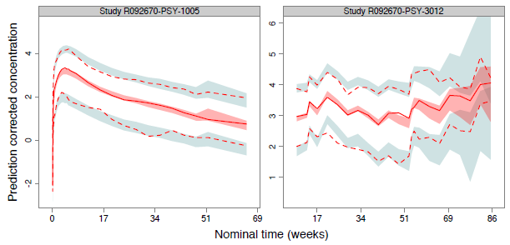
The solid and dashed lines represent the median and 5th and 95th percentiles of the observations; the shaded red and blue areas represent the 95% CI of the median and 5th and 95th percentiles predicted by the model.
Figure 13: Visual predictive check of the final model, stratified by dose in Study 1005
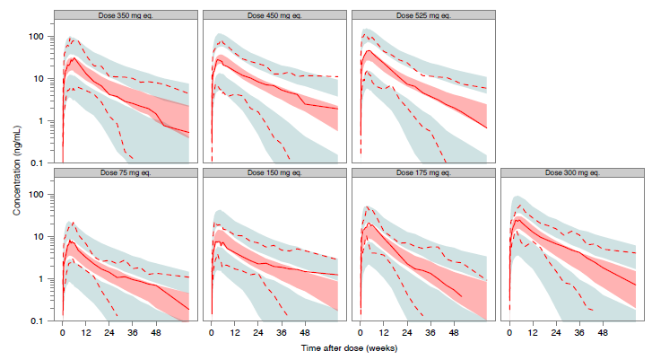
The solid and dashed lines represent the median and 5th and 95th percentiles of the observations; the shaded red and blue areas represent the 95% CI of the median and 5th and 95th percentiles predicted by the model.
Figure 14: Visual predictive check of the final model, stratified by dose and by the randomization arm in the double blind phase in Study 3012
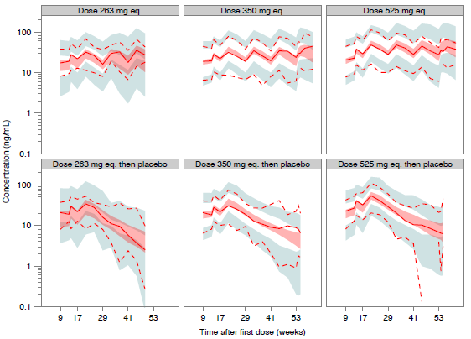
The solid and dashed lines represent the median and 5th and 95th percentiles of the observations; the shaded red and blue areas represent the 95% CI of the median and 5th and 95th percentiles predicted by the model. Note: The 175 mg equivalent dose group is not shown since there were too few PK samples and too few subjects in this dose group. The 263 mg equivalent dose group is shown despite having fewer subjects than the other doses, causing the CIs to overlap. The dashed line (5th percentile) at the bottom of the Right Panel breaks because the observed 5th percentile is below LOQ.
Comment: The sponsor cautioned: The analysis data set contained 1 subject with a CRCL between ≥ 30 and < 50 mL/min, and 54 subjects with a CRCL between ≥50 and <80 mL/min. The BMI ranged from 17.1 to 39.8 kg/m² and the age ranged from 18 to 67 years. Extrapolation of the model outside these boundaries must be done with caution.

Simulations of proposed recommended initiation and maintenance regimens
For this the sponsor used a simulation where treatment was initiated with a Invega Sustenna deltoid injection of 150 mg equivalent on treatment Day 1, a second Invega Sustenna deltoid injection of 100 mg equivalent on Day 8, followed by Invega Sustenna deltoid or gluteal injections at Weeks 5, 9 and 13. The maintenance treatment commenced at Week 17 with deltoid or gluteal Invega Sustenna or Invega Trinza injections every 4 or 12 weeks until Week 65.
Additionally Invega Sustenna injections at Weeks 65, 69 and 73 were simulated to assess whether subjects treated with Invega Trinza could be switched back to Invega Sustenna because of subject-physician preference and/or drug supply shortage.

Simulation C_{max} after Invega Trinza
In total, 3.7% of the subjects had a C_{max} > 125 ng/mL after the fourth PP3M 525 mg equivalent deltoid injection and 2.2% of the subjects had a C_{max} > 125 ng/mL after the fourth PP3M 525 mg equivalent gluteal injection.
Comment: The actual results from study 1005 were 3 out of 25 (12%) subjects getting 525 mg gluteal injections had a C_{max} > 125 ng/mL, while of those getting the same dose as a deltoid injection 1 out of 25 (4%) did. There was an additional subject (1/24or 4%) on 350 mg gluteal injection who exceeded 125 ng/mL but who failed to complete.

Table 21: Comparison of simulation C_{max} with actual results from Study 1005
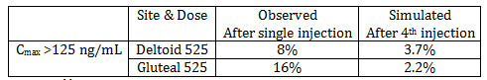

Simulated C_{min} after Invega Sustenna and Invega Trinza
At Week 65 after 525 mg equivalent Invega Trinza injections, the simulated median C_{min} for deltoid injections was 0.35 ng/mL (1.1%) lower and for gluteal injections was 8.4 ng/mL (23%) lower than after 150 mg equivalent Invega Sustenna deltoid injections, and gluteal injections respectively.
At Week 29 after 525 mg equivalent Invega Trinza, the simulated median C_{min} for deltoid injections was 2.5 ng/mL (8.7%) higher and 0.85 ng/mL (2.7%) lower for gluteal injections than after 150 mg equivalent Invega Sustenna deltoid and gluteal injections respectively.
Comment: The figures in the body of the report (12 and 13) are difficult to assess being on a log scale for concentration, however they do show a progressive gradual fall in the lower 90% bound with that for some of the lower doses apparently below 7.5 ng/mL. Actual values were not given. The duration for this level potentially below the therapeutic threshold could not readily be estimated nor the percentages possibly affected.
In Study 3012 the C_{predose} that is 3months after an initial injection of Invega Trinza in the maintenance phase 2 out of 3 subjects on 175 mg equivalent had a C_{predose} < 7.5 ng/mL; 0 on 263 mg equivalent did, on 350 mg equivalent 3 out of 40 (7.5%) did and on 525 mg equivalent 3 out of 29 (10.3%) did.

Table 22: Study 3012; C_{predose} per administered dosage double blind phase: that is 3months after a dose PP3M in the maintenance phase (preceded by PP1M doses in the transition phase)
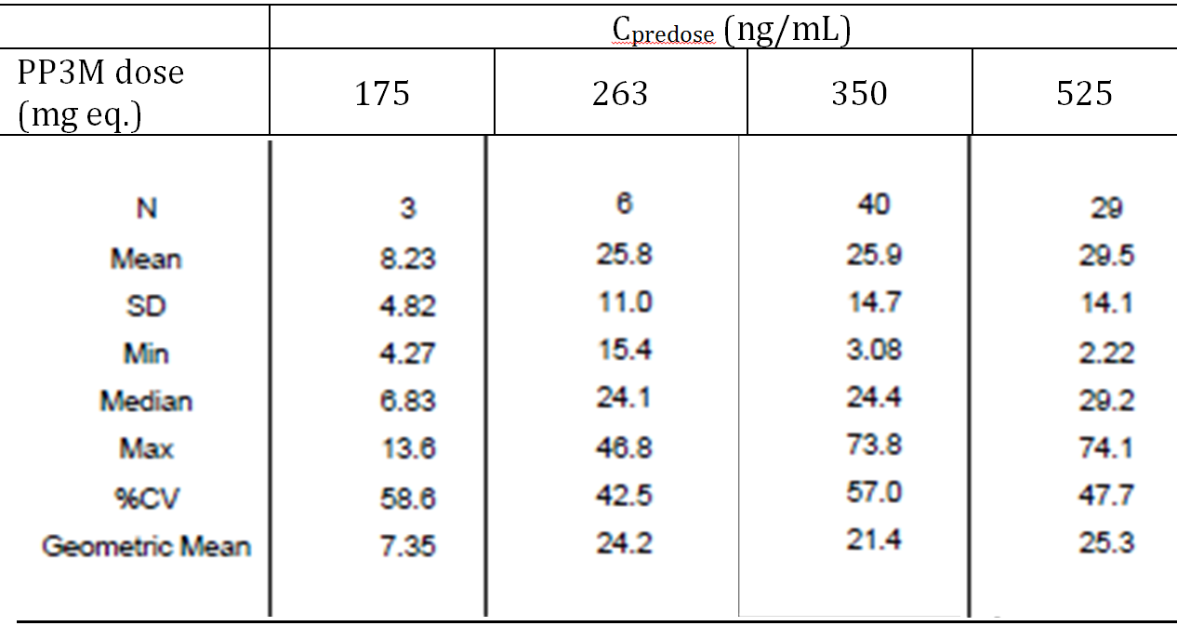

Other simulations
The sponsor conducted several simulations of different timings and cessation of Invega Trinza treatment.
Comment: with these simulations it is unclear whether the previously accepted model for Invega Sustenna was used or the modified model with 10% uncertainties.

Late or early doses
Simulation included:
- Switching from Invega Sustenna to Invega Trinza a week late or early.
- Giving the maintenance Invega Trinza dose up to 3 weeks early or late.

Table 23: Median C_{min} and C_{max} when switching from PP1M to PP3M at Week 17, ± 1 week, and dosing windows around the regularly scheduled 12 week dosing interval, ± 1, ± 2 and ± 3 weeks, after subjects reached apparent steady-state on treatment with PP3M deltoid injections
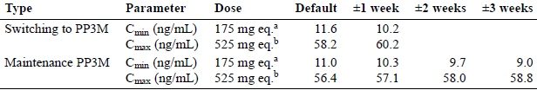
ª. +X week simulations were performed with the lowest PP3M dose strength of 175 mg equivalent to simulate a worst-case scenario (that is, largest % drop in C_{min}) since the lowest dose has the shortest apparent t1/2. ^{b.} -X week simulations were performed with the highest PP3M dose strength of 525 mg equivalent to simulate a worst-case scenario (that is, largest % increase in C_{max}).
Comment: As before the figures in the body of the report are difficult to assess being on a log scale for concentration.
In relation to late Invega Trinza they do show a progressive gradual fall in the lower 90% bound with increase in the duration that the dosing is late, however unlike the table of medians the figures are based on the 525 mg equivalent doses so that the assessment of some of the lower doses for apparently being below 7.5 ng/mL threshold is not possible. The duration for this level potentially below the therapeutic threshold could not readily be estimated nor the percentages possibly affected.

Q12W versus Q13W dosing
Simulations of every 12 weeks with every 13 weeks dosing after subjects reached apparent steady-state. The body of the report contained only a comparison of median C_{min}, in Appendix 17.3 though Figure A17-3 suggests a lower 90%bound apparently below 7.5 ng/mL for 175 mg equivalent.
Figure 15: The simulated paliperidone concentration versus time profiles for Q12W and Q13W dosing with 175 mg equivalent PP3M
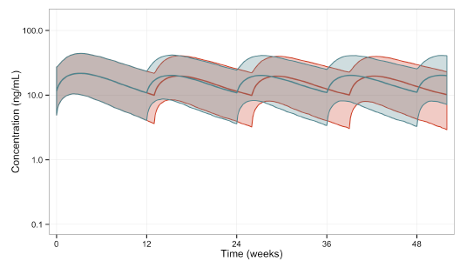
The solid lines and shaded areas represent the median paliperidone concentrations and 90% prediction intervals, respectively, after dosing every 12 weeks (blue) or every 13 weeks (red).
Comment: As before the figures in the appendix of the report are difficult to assess being on a log scale for concentration, however they do show a progressive gradual fall In the lower 90% bound. The duration for this level potentially below the therapeutic threshold could not readily be estimated nor the percentages possibly affected nor the effect of Q12W versus Q13W.

Time to reach 7.5 ng/mL after stopping Invega Trinza
This simulation was incorrectly described repeatedly as time to 60 % D₂ receptor occupancy. The body of the report contained only a statement on the duration of median concentrations ≥ 7.5 ng/mL for 350 and 525 mg equivalent Appendix 17.2 contained Figure A17-2 which showed for 175 mg equivalent a median time of 19.2 weeks, while for 525 mg equivalent the median time was 59 weeks.
Figure 16: Time to median concentration of 7.5 ng/mL after discontinuation with PP3M
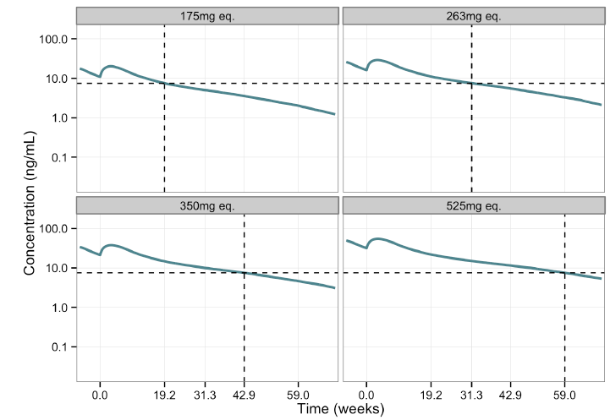
Comment The solid blue lines represent the median paliperidone concentrations. D2: dopamine type 2; PP3M: paliperidone palmitate 3 Month formulation. The lower 90% bounds are not provided.

Transition to oral paliperidone ER after Invega Trinza
The report contained only a simulation relating to ceasing 525 mg equivalent using the protocol 6 mg if the time since the last Invega Trinza dose was ≥ 12 weeks to ≤ 18 weeks; 9 mg if the time since the last Invega Trinza dose was > 18 weeks to ≤ 24 weeks; and 12 mg if the time since the last Invega Trinza dose was > 24 weeks.
Comment: As before the figures in the body of the report (Figure 17) are difficult to assess being on a log scale for concentration. Not included in the submission was the PopPK Analysis Report from which the paliperidone ER modelling was derived.
The upper 90% bound C_{max} for ER dosing as proposed after 525 mg equivalent Invega Trinza appears to progressively exceed that for steady state Invega Trinza.
Figure 17: Transition from PP3M to oral paliperidone ER
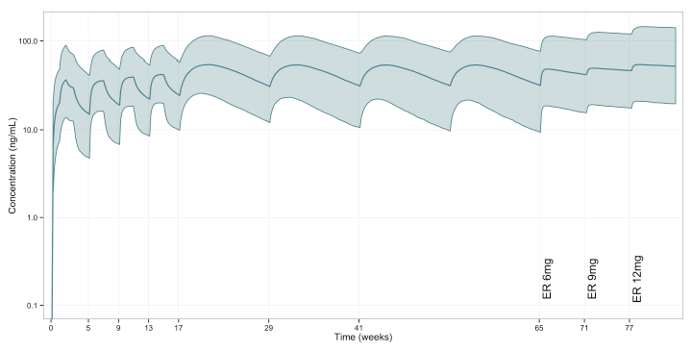
The solid blue lines and shaded areas represent the median paliperidone concentrations and 90% prediction intervals, respectively, after transition from 525 mg equivalent deltoid injections of PP3M to ER 6 mg at Week 65, followed by treatment with ER 9 mg and ER 12 mg at Weeks 71 and 77.

Simulations to give C_{max}, T_{max}, t_{½} and Peak/trough ratios

Table 24: Median values for secondary PK parameters following a single PP3M injection
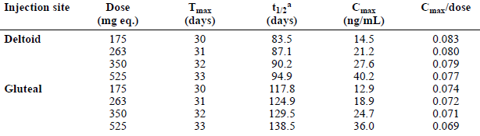
ª The t_{1/2} was not constant over time (multi-exponential profile) due to the saturable components of the absorption sub-model. Therefore, the maximum t_{1/2} was derived during the later part of the multi-exponential profile reflecting the terminal decline phase (about 25 weeks after the injection). All values are medians of simulations based on 5,000 subjects. The simulated median dose normalized C_{max} after single dose administration was 11 to 12% higher with deltoid versus gluteal injections.

Table 25: Median values for secondary PK parameters when on maintenance treatment with PP3M or PP1M
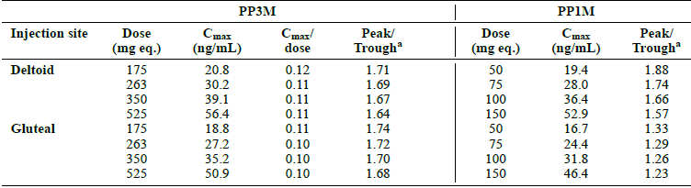
Peak/Trough is computed as a ratio of C_{max} to C_{min} (minimum concentration at the end of a dosing interval) for each subject. All values are medians of simulations based on 5,000 subjects.

Pharmacokinetics in other special populations simulation based

Pharmacokinetics in subjects with impaired hepatic function
Neither the Invega Trinza nor the Invega Sustenna formulation was studied in patients with hepatic impairment.

Pharmacokinetics in subjects with impaired renal function
Only 1 subject with moderate renal impairment and no subjects with severe renal impairment were included in the analysis data set.
CRCL was included as a structural covariate on CL in the population PK model, since 59% of paliperidone is excreted unchanged renally. The C_{max} after the fourth deltoid injection with 525 mg equivalent of Invega Trinza was 55.1 ng/mL in subjects with normal renal function and 64.1 ng/mL in subjects with mild renal impairment.
After deltoid injections of 350 mg equivalent in subjects with normal renal function and 263 mg equivalent in subjects with mild renal impairment (25% dose reduction), the C_{min} was 21.1 and 18.2 ng/mL, respectively Simulations were also conducted to evaluate dose reduction in subjects with mild renal impairment (350 mg equivalent, that is, the penultimate dose) as compared to the highest maintenance dose of 525 mg equivalent for subjects with normal renal function. After deltoid injections of 525 mg equivalent in subjects with normal renal function and 350 mg equivalent in subjects with mild renal impairment, the C_{min} was 31.3 and 24.1 ng/mL, respectively.
Figure 18: The simulated paliperidone concentration versus time profiles for 525 mg eq deltoid PP3M injections for subjects with mild renal impairment
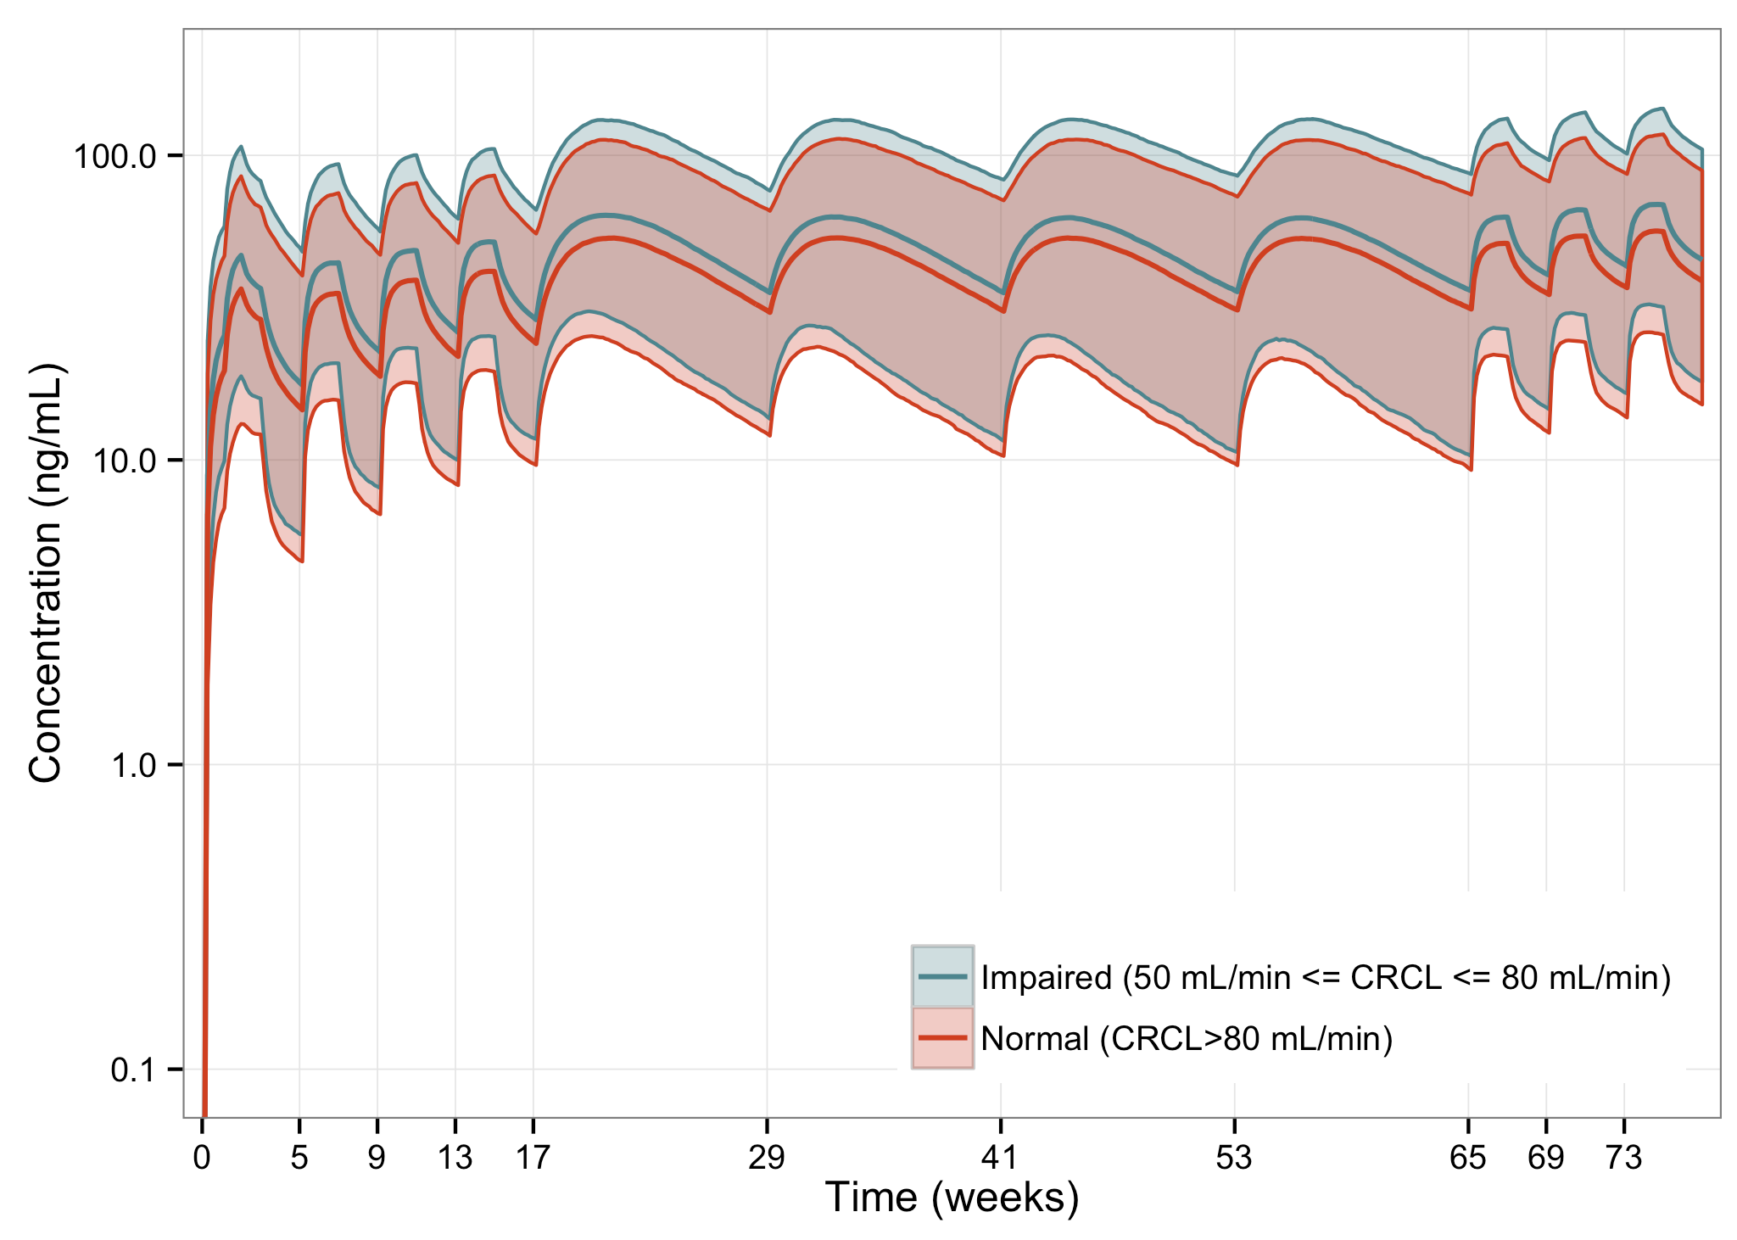
The solid lines and shaded areas represent the median paliperidone concentrations and 90% prediction intervals, respectively, for subjects with mild renal impairment (blue) or with normal renal function (red).

Pharmacokinetics according to age
Age was assessed by comparing subjects aged 18 to ≤ 60 years versus subjects aged > 60 years Simulations with the older population were then repeated, fixing CRCL to the median of the younger age group. The older population showed the expected decline in renal function (that is, CRCL) with increasing age, resulting in a difference in PK profile between the 2 age groups. CRCL and age are 2 highly correlated covariates. In such a situation, the independent influence of age on PK could be determined by keeping CRCL constant while varying age.
After correcting for the decline in renal function, the difference in PK across ages was small.

Pharmacokinetics related to genetic factors
The C_{min} after 350 mg equivalent deltoid injections of Invega Trinza was 21.6 ng/mL and 21.2 ng/mL in men and women, respectively.

Pharmacokinetics related to injection site
After the fourth Invega Trinza dose of 350 mg equivalent, C_{min} was 21.5 ng/mL after injection in the deltoid muscle and 19.3 ng/mL after injection in the gluteal muscle.
Figure 19: The simulated paliperidone concentration versus time profiles for 350 mg eq deltoid or gluteal injections
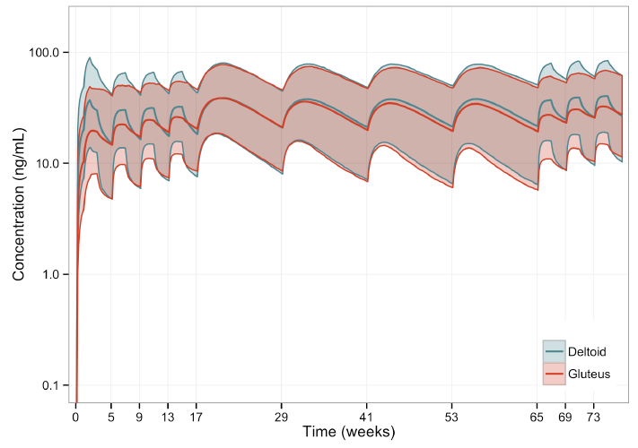
The solid lines and shaded areas represent the median paliperidone concentrations and 90% prediction intervals, respectively, after deltoid (blue) or gluteal (red) injections

Pharmacokinetics related to obesity
A lower C_{max} was observed in subjects with a high BMI. Once at apparent steady state with Invega Trinza, the C_{min} was similar for Invega Trinza among normal, overweight and obese subjects.

Evaluator’s overall conclusions on pharmacokinetics
It is of concern that the PK model used for simulations to justify dosing regimens does not include data from the long term Study 3011 being based on the single dose Study 1005 and Study 3012 where 160 received 2 injections of Invega Trinza only 18 received 3 injections.
Inter-subject variability was high. Some subjects were excluded from the PopPK analysis.
The combined plasma concentration-time profiles of paliperidone show this.
Of concern is the possibility of extended periods of low plasma paliperidone concentrations. The infrequency of the sampling in the 2 clinical studies does not show this.
Study 1005, while showing some individuals had low plasma paliperidone concentrations for periods prior to 90 days after injection, this does not necessarily equate to the steady state situation.
It does however have clinical relevance as this is what would happen clinically after the first 3 month injection.
The sponsor argues that clustering of relapses was not seen at a time when plasma levels would expect to be low. An alternative exploration is to compare the incidence in the first 3 month treatment period with those at steady state.
The possibility of dose dumping is reviewed clinical safety section. In Study 1005, this evaluator believes there is a clear example.
The sponsor it appears has concentrated on the physical characteristics of the new formulation as the sole determinant of absorption from the IM site.
By slowly releasing paliperidone from the injection site, the paliperidone palmitate formulation enables a dosing interval that achieves potentially therapeutic plasma concentrations of paliperidone for 1 month (PP1M) or 3 months (PP3M), depending on [information redacted].
And
[information redacted]
While this may be true in vitro there are other physical factor differences that vary and might affect in vivo uptake from the intramuscular dose; [information redacted]The minimum volume is also greater 0.875 mL Invega Trinza versus 0.25 mL for Invega Sustenna.
These characteristics might contribute to the greater inter-subject variability seen.
Approximate dose proportionality was shown.
The PopPK study was based on data from Study PSY-1005 and Study PSY-3012. None of the subjects with C_{max} > 125 ng/mL appear to have been excluded, that is the model appears to include one patient (605113) who suffered dose dumping and 2 patients with unexplained reduced clearance (60625, 603435). The existing model failed to adequately describe the Invega Sustenna PK data from Study 3012 so a new model was developed using both the previous and the Study 3012 Invega Sustenna data. This model then failed to adequately describe the Invega Trinza PK absorption data from Study 1005 so a model with one rapid and one slow saturable absorption process was then adopted.

Pharmacodynamics

Summary of pharmacodynamics

PK/PD analysis

Study 3012 PK/PD analysis
The PopPK model in this submission was used to develop separate models for PANSS, dropout and relapse. While PANSS score was treated as a continuous variable, dropout and relapse were subject to survival analysis as two separate single time-to-event (TTE) models.
The overall aim of the present PK/PD analysis was to describe the relationship between paliperidone plasma concentrations and time to relapse of symptoms of schizophrenia and/or positive and negative syndrome scale for schizophrenia (PANSS) total scores, while accounting for dropout.
The CSR then separately defines 4 objectives:
- Objective 1: To describe the relationship between plasma concentrations of paliperidone and total PANSS score after administration of paliperidone as Invega Sustenna and Invega Trinza.
- Objective 2: To describe the time to relapse of symptoms of schizophrenia, including the relationships between relapse, paliperidone plasma concentrations and total PANSS score.
- Objective 3: To describe possible study dropout from other causes than relapse of symptoms of schizophrenia.
- Objective 4: To assess the influence of covariates on the relationships between paliperidone plasma concentration, PANSS score, relapse, and dropout.
For study 3012:
The primary objective was to evaluate the efficacy of paliperidone palmitate 3 Month formulation (Invega Trinza) compared with placebo in delaying the time to first occurrence of relapse of the symptoms of schizophrenia.
The primary efficacy end point was the time from randomization to first relapse event in the double blind phase.
Comment: The second objective of this analysis reflects the primary objective of Study 3012.

Table 26: Number of patients and PANSS observations in the PANSS analysis data set
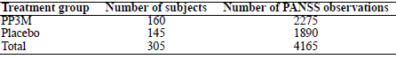

Table 27: Number of patients and relapse/dropout events in the TTE (dropout and relapse) analysis data set
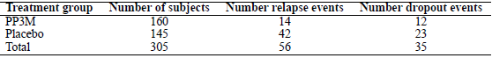

Final model
For relapse, a sigmoidal E_{max} model best described the log-hazard ratio over time. The underlying (baseline) relapse hazard was predicted to be constant over time in the absence of drug (zero concentrations). The baseline hazard was higher for subjects with a higher paliperidone trough plasma concentration at start of the double blind phase and increased with the number of previous hospitalizations.
For dropout, with fewer events than relapse, occurring during the double blind period, a linear model (on log hazard ratio scale) was adequate to describe the concentration-effect relation. A Weibull hazard model, with increasing baseline hazard over time, was significantly better than a constant-hazard model. No significant covariates (except for concentration and time) were found for dropout.
PANSS scores contained little signal of efficacy, beyond the sudden increases in PANSS score at the start of a relapse event. Moreover, in developing the relapse model, different derivations (functions) of PANSS score were tested as predictors of future relapse, and found not to reach the level of significance required for covariates.
Therefore, model development of PANSS was abandoned and no final model is presented.
Time to relapse appears to be based on Confirmatory analysis.
Figure 20: Relapse survival over time since start of double blind phase
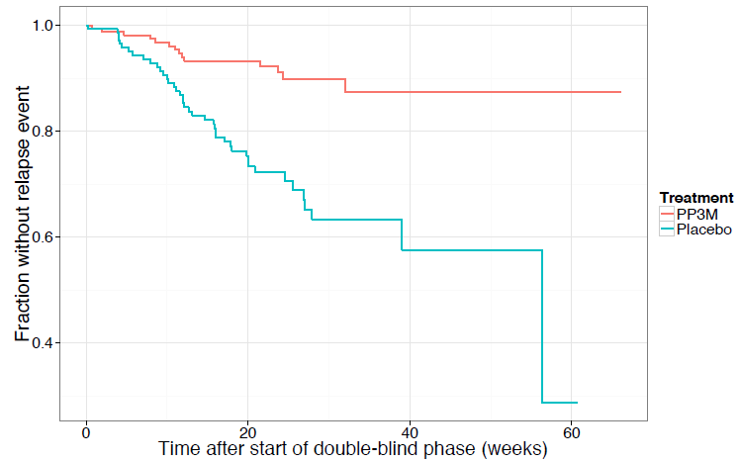
Survival is given as fraction without event, separately for the two treatment arms, and based on the point-estimate from the Kaplan–Meier survival function.
Figure 21: Relapse survival over time since start of double blind phase, stratified on two covariates number of hospitalisations and C_{trough}. Double blind phase
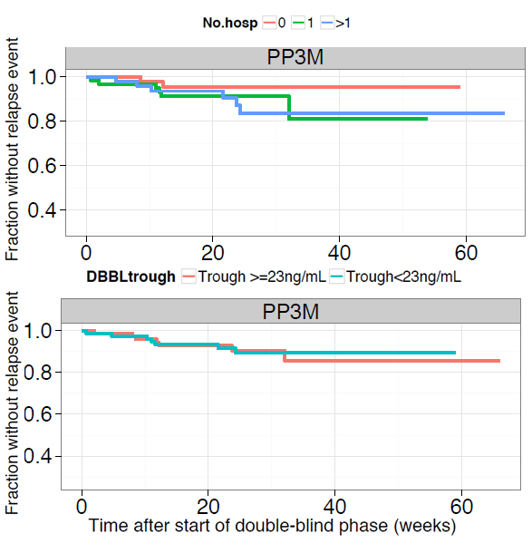
Survival is given as fraction without event, based on the point-estimate from the Kaplan–Meier survival function after stratification on number of hospitalizations (upper panel) and the PP3M trough concentration at the start of the double blind phase (lower panel).
Figure 22: Visual predictive check of the final relapse model, stratified by treatment
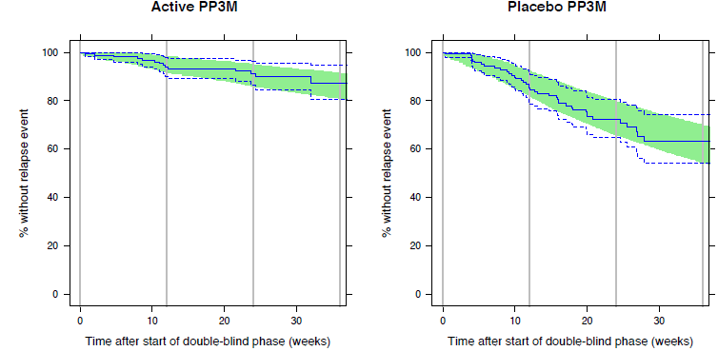
The solid and dashed lines represent the Kaplan–Meier point estimate and 95% CI, based on observed data; the shaded green areas represent the 95% CI of the Kaplan–Meier point estimate, based on 2000 replicate simulations of the study.
Figure 23: Dropout survival over time since start of double blind phase
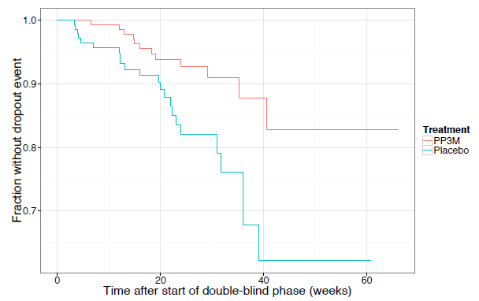
Survival is given as fraction without event, separately for the two treatment arms, and based on the point-estimate from the Kaplan–Meier survival function.
Figure 24: Visual predictive check of the final dropout model, stratified by treatment
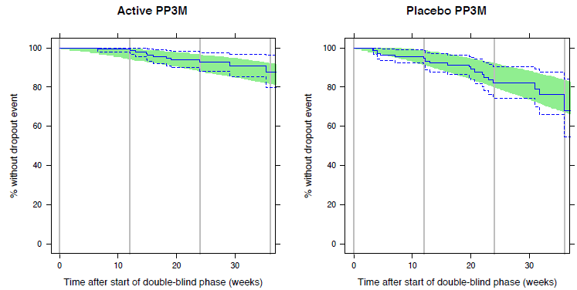
The solid and dashed lines represent the Kaplan–Meier point estimate and 95% CI, based on observed data; the shaded green areas represent the 95% CI of the Kaplan–Meier point estimate, based on 2000 replicate simulations of the study.

Study 3011 PK/PD analysis
In Study 3011, subjects were individually titrated with Invega Sustenna in the open label phase, to ensure a balance between efficacy and tolerability. Only those subjects meeting clinical stability criteria were subsequently randomised to Invega Sustenna or Invega Trinza treatment, in the double blind phase.
The overall aim of the current population PK/PD analysis was to describe the relationship between the time course of paliperidone plasma concentrations, relapse of symptoms of schizophrenia and dropout (that is withdrawal from study for other causes than relapse of symptoms of schizophrenia), following administration of Invega Sustenna and Invega Trinza in Study R092670-PSY-3011, as well as to identify relevant covariates.
The CSR then separately defines 4 objectives:
- PK/PD Objective 1; To describe the time to relapse of symptoms of schizophrenia, including the relationships between relapse and paliperidone plasma concentrations after administration of paliperidone as Invega Sustenna and Invega Trinza.
- PK/PD Objective 2; To describe study dropout for other causes than relapse of symptoms of schizophrenia, as a function of time and paliperidone plasma concentration.
- PK/PD Objective 3; To assess the influence of covariates (in addition to paliperidone plasma concentration) on relapse and dropout.
- PK/PD Objective 4 If deemed of interest, the population PK/PD models were to be used in simulations, for comparing efficacy of relapse prevention, between Invega Trinza and Invega Sustenna. The models may also be used in other simulations.
For study 3011:
- The primary objective was to demonstrate, in subjects stabilized on the paliperidone palmitate 1 month formulation, that paliperidone palmitate 3 month formulation was not less effective than Invega Sustenna in the treatment of symptoms of schizophrenia, based on the Kaplan-Meier 4 -week cumulative estimate of survival (that is percentage of subjects remaining relapse free).
- The primary efficacy endpoint of the study was the percentage of subjects (per protocol) who had not relapsed at the end of the 48 week double blind phase.
Comment: This model is thus studying the obverse of what Study 3011 was designed to show with only the latter (possible) exploratory Objective 4 possibly related.
1016 subjects were randomised, but the PK/PD intention-to-treat double blind (PK/PD ITT (DB)) population consisted of 1013 subjects, since 3 subjects dropped out on the day of randomisation.
The PK/PD ITT(DB) population was further reduced to the PK/PD mITT(DB) population, due to short plunger with Invega Trinza 525 mg equivalent Any data after the occurrence of a short plunger injection were excluded, and time was censored at the (first) occurrence of a short plunger dose. Short plunger occurred in 21 subjects in the PK/PD ITT(DB) population. Due to short plunger at the first double blind injection, 11 subjects were lost entirely from PK/PD mITT(DB) (that is censored at time zero). The other 10 subjects were not entirely lost, but were prematurely censored (that is censored before relapse, dropout, or end of study; 8 subjects out of 10 were lost already at the second Invega Trinza injection), due to short plunger.
The PK/PD mITT(DB) population included 1002 subjects, who were included in the PK/PD analysis data set.

Table 28: Number of patients and relapse/dropout events in the PK/PD analysis data set
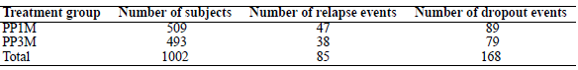

Table 29: Covariate statistics of time-varying covariates, for subjects in Study R092670-PSY-3011 with at least 1 PK observation in the PK analysis data set
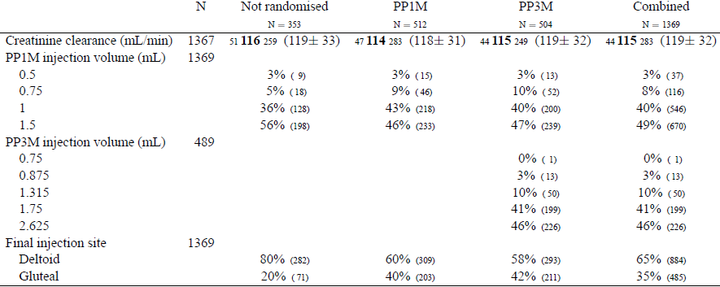
Numbers represent, for CRCL: minimum, median, maximum, (mean ± SD), for other variables: percentages (number of subjects in each category). Statistics concern the value at the last valid PK measurement in each subject.
Figure 25: Relapse survival over time since start of double blind phase
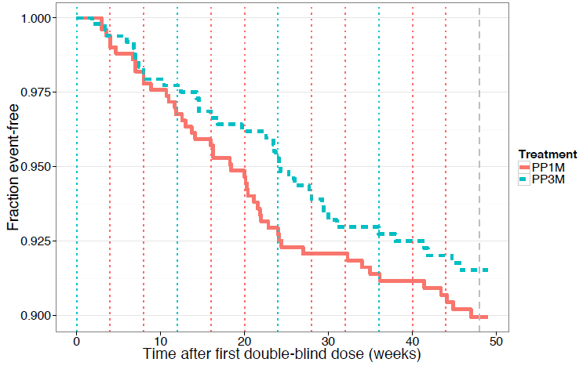
Survival is given as fraction without a relapse event, separately for the two treatment arms, and based on the point-estimate from the Kaplan–Meier survival function. The vertical blue dotted lines mark blinded PP3M/PP1M injections and the vertical red dotted lines mark intermediate PP1M injections. The vertical grey dashed line marks the planned end of study, at week 48. The survival curve is shown for 0-49 weeks post randomisation.
Figure 26: Dropout survival over time since start of double blind phase.
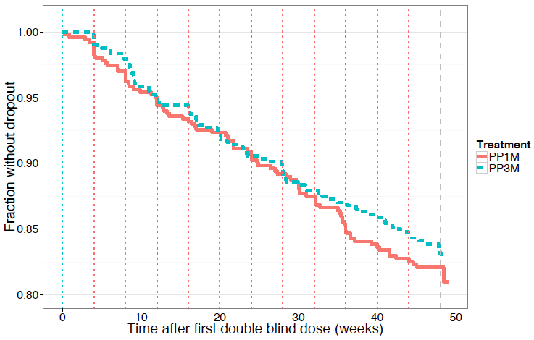
Survival is given as fraction without a dropout event, separately for the two treatment arms, and based on the point-estimate from the Kaplan–Meier survival function. The vertical blue dotted lines mark blinded PP3M/PP1M injections and the vertical red dotted lines mark intermediate PP1M injections. The vertical grey dashed line marks the planned end of study, at week 48. The survival curve is shown for 0-49 weeks post randomisation.
The PK/PD analyses used individual predictions of plasma concentrations of paliperidone, predicted by the population PK model applied to Study R092670-PSY-3011 data.

Table 30: Covariates that were tested as risk factors
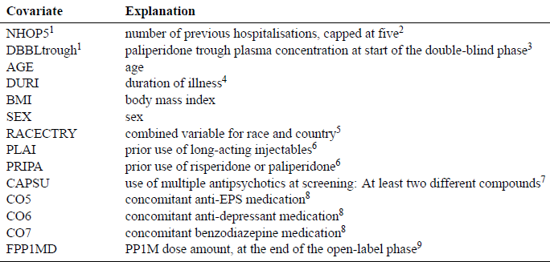
^{1.} These covariates are part of the pre-specified model for relapse, but were tested again in the SCM. ². Few subjects were expected to have counts above five, and the count was capped to avoid very high values. NHOP5 was investigated as a continuous covariate. ^{3.} This covariate is based on the individual prediction of the trough (pre-dose) concentration at the day of randomisation (nominally Day 120). ^{4.} Time since first diagnosis of schizophrenia ^{5.} Each subject was classified based on country (of participating centre) or race, into one of the following categories (groups): a) Black/African American, b) Hispanic- or Latino-White, c) Chinese, d) Japanese.. Remaining subjects who were not associated to any of a-d were in the reference group that included White-non-Hispanic/Latino ^{6.} Prior use captured medical history for a limited time back only. In addition long-acting injectable was not allowed at screening ^{7.} Dichotomous variable on whether subject used more than two unique molecules of antipsychotics before enrolment into the study. ^{8.} Concomitant medications are time-varying covariates, representing the current medication on each day ^{9.} The eventual PP1M dose was maintained before the randomisation visit. FPP1MD was investigated as a continuous covariate.

Final model
The final relapse model was described by a Gompertz baseline hazard model, with decreasing hazard over time. In the available concentration range, log-hazard was adequately described by a linear concentration effect model. After accounting for the individual concentration time profiles, two risk factors were included in the final model for the baseline hazard of relapse: Patients on concomitant benzodiazepine medication (since last visit) had higher hazard (193% higher hazard, 95% confidence interval (CI): 85% - 363%), as compared to when not on this concomitant medication. Patients at Japanese centres had higher hazard (129% higher hazard, 95% CI: 36% - 283%), as compared to patients at non-Japanese centres.
The final dropout model was a constant hazard model (that is exponential model), without influence of paliperidone exposure, or any covariates.
Figure 27: VPC of the final relapse model, stratified by randomised treatment
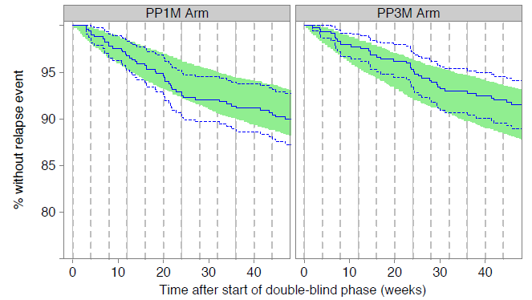
The solid and dashed blue lines represent the Kaplan–Meier point estimate and 95% confidence interval, based on observed data; the shaded green areas represent the 95% confidence interval of the Kaplan–Meier point estimate, based on 1000 replicate simulations. The vertical solid and dashed grey lines mark dosing times for PP3M and PP1M, respectively
Figure 28: VPC; of the final relapse model, stratified by open label PP1M dose. Both PP1M and PP3M arms are included
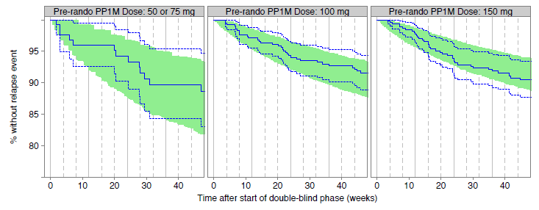
The solid and dashed blue lines represent the Kaplan–Meier point estimate and 95% confidence interval, based on observed data; the shaded green areas represent the 95% confidence interval of the Kaplan–Meier point estimate, based on 1000 replicate simulations. The vertical solid and dashed grey lines mark dosing times for PP3M and PP1M, respectively.
Figure 29: VPC of the final relapse model, stratified by China, Japan or other country*
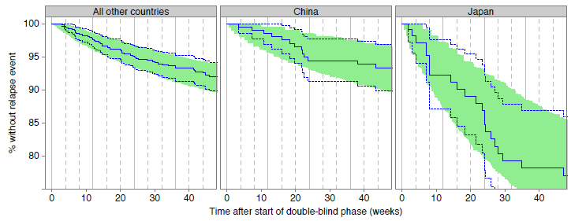
* of the participating centre. The solid and dashed blue lines represent the Kaplan–Meier point estimate and 95% confidence interval, based on observed data; the shaded green areas represent the 95% confidence interval of the Kaplan–Meier point estimate, based on 1000 replicate simulations. The vertical solid and dashed grey lines mark dosing times for PP3M and PP1M, respectively.

Evaluator’s overall conclusions on pharmacodynamics
If one accepts the PopPK results above, then:
The PopPK/PD analysis of Study 3012 could really only produce a model for the time to relapse which was the primary endpoint of study 3012. The primary endpoint in Study 3012 showed statistical significance only. The C_{trough} at the DB start and number of hospitalisations affected the model.
Study 3011 showed non-inferiority of Invega Trinza to Invega Sustenna in the primary efficacy endpoint of the percentage of subjects (per protocol) who had not relapsed at the end of the 48 week double blind phase. The PopPK/PD analysis of study 3011 did not look at this, rather the model is studied the obverse of what Study 3011 was designed to show with only a (possible) exploratory Objective 4 possibly related. Two risk factors were included in the final model for the baseline hazard of relapse: Patients on concomitant benzodiazepine medication (since last visit) had higher hazard as compared to when not on this concomitant medication; Patients at Japanese centres had higher hazard as compared to patients at non-Japanese centres.

Dosage selection for the pivotal studies
The 350 mg equivalent dose was the expected equivalent of the commonly prescribed 100 mg equivalent of the 1 month formulation. The 525 mg equivalent dose was chosen based on the PK and safety results from the preliminary Panel B data and was the planned highest dose to be marketed. The 175 mg equivalent F015 dose was planned to be the lowest dose to be marketed, and a similar dose (150 mg equivalent) was previously tested with gluteal injections (Panel B).

Clinical efficacy

Pivotal efficacy studies for 3 monthly dosage following initial once a month dosage

Study 3012

Study design, objectives, locations and dates
This was a randomized, double blind, parallel group, placebo controlled, multicentre study to determine the efficacy and safety of Invega Trinza in the prevention of relapse of schizophrenia.
Conducted in multiple centres in Colombia (5 sites), Malaysia (3 sites), Mexico (5 sites), Romania (5 sites), South Korea (3 sites), Turkey (2 sites), United States (14 sites), Ukraine (27 sites) from 26 April 2012 to 09 April 2014.
The study consists of 4 phases: a Screening Phase (up to 3 weeks); a 17 week flexible dose open label Transition Phase; a 12 week fixed dose open label Maintenance Phase; and a randomized, double blind, fixed dose, placebo controlled relapse prevention phase during which subjects were randomly assigned, in a 1:1 ratio, to receive either a fixed dose of Invega Trinza or placebo. The double blind phase was of variable duration; subjects could remain in the study for as long as they were clinically stable.
The randomized withdrawal of treatment after symptom stabilization with Invega Sustenna and continuation with Invega Trinza was to see if a difference in the course of the disease occurred.
An interim analysis was planned when 42 relapse events occurred in the Double blind Phase. Otherwise the study was to continue until a total of 70 relapse events were obtained, at which time the study would be terminated and a final analysis performed.
There were 3 protocol amendments after the study started: Amendment INT-2 2 July 2012, Amendment INT-3 13 May 2013, and Amendment INT-4 25 July 2013. The first 2 were considered substantial with the first increasing the percentage of relapse events from 50% to 60% (that is, from 35 to 42 relapse events) of the projected target with a critical p value of 0.0101 at the Interim Analysis.
The primary objective of this study was to evaluate the efficacy of paliperidone palmitate 3 Month formulation (Invega Trinza) compared with placebo in delaying the time to first occurrence of relapse of the symptoms of schizophrenia.
The secondary objectives of the study were to:
- Evaluate the improvement in the symptoms of schizophrenia as measured by the Positive and Negative Syndrome Scale (PANSS) associated with the use of Invega Trinza compared with placebo.
- Assess the change in the severity of illness associated with the use of Invega Trinza as measured by the change in Clinical Global Impression Severity (CGI-S) scale compared with placebo.
- Assess the change in functional status with the use of Invega Trinza as measured by the change in Personal and Social Performance (PSP) scale compared to placebo.
- Assess the safety and tolerability of Invega Trinza compared to placebo.
- Assess the pharmacokinetics (PK) of Invega Trinza including its relationship with demographic and dose related variables.
There were 7 exploratory objectives.

Inclusion criteria
- A valid reason to discontinue current antipsychotic therapy (including insufficient efficacy with current therapy, safety or tolerability issues, or subject preference for injectable medications).
- Subjects who were taking another long-acting injectable antipsychotic (including Invega Sustenna or Risperdal Consta) prior to study entry had to be symptomatically stable.
To enter the Double blind Phase subjects must at Visits 9, 10, and 11 (Weeks 21 through 29) have:
- A score of < 70 in the PANSS total score
- Scores of ≤ 4 for PANSS items P1 (delusions), P2 (conceptual disorganization), P3 (hallucinatory behaviour), P6 suspiciousness/persecution), P7 (hostility), G8 (uncooperativeness) and G14 (poor impulse control).

Exclusion criteria
- A primary, active DSM-IV-TR Axis I diagnosis other than schizophrenia.
- Active substance dependence within 6 months before screening.
- Attempted suicide within 12 months before screening or were at imminent risk of suicide or violent behaviour.
- Relevant history or current presence of any significant or unstable cardiovascular, respiratory, neurological, renal, hepatic, hematologic, endocrine, morbid obesity (BMI > 40 kg/m²), immunologic or other systemic disease, encephalopathic syndrome, mental retardation, risk factors for prolonged QT interval, torsade de pointes or sudden cardiac death.

Study treatments
On entry to the study:
- Subjects without documented exposure to oral or injectable risperidone or paliperidone. An oral tolerability test was conducted with Paliperidone ER 6 mg tablets were administered for 4 to 6 consecutive days during the Screening Phase (the last dose to be taken by Day -1).
- Subjects Who Received Other Depot Antipsychotics Prior to Study Entry - the approach varied depending on the medication.
During the Transition Phase, all subjects received Invega Sustenna injections. All subjects who were not switching from other depot antipsychotics received the first injection of 150 mg equivalent on Day 1 and the second injection of 100 mg equivalent on Day 8, both in the deltoid muscle.
Subjects could be flexibly dosed on Days 36 and 64 with doses of 50, 75, 100, or 150 mg equivalent On Day 92, subjects received the same dose of Invega Sustenna administered on Day 64. The choice of the dose to be administered on Days 36 and 64 was based on the severity of the subject’s symptoms, safety and tolerability issues, and knowledge of previous dose levels of antipsychotic medication needed to keep symptoms under control. After injection of Invega Sustenna in the deltoid on Days 1 and 8, subsequent doses could be administered in either the deltoid or gluteal muscle.
At the start of the 12 week Maintenance Phase (on Day 120), subjects received a single dose of Invega Trinza (into the deltoid or gluteal muscles) that was a 3.5 fold multiple of the final Invega Sustenna dose administered on Day 92 (in the Transition Phase).
During the Double blind Phase, subjects received fixed dose injections of either Invega Trinza (175, 263, 350, or 525 mg equivalent) or placebo (20% Intralipid solution) every 12 weeks into either the deltoid or gluteal muscles alternating between left or right sides. Subjects assigned to Invega Trinza treatment received the same dose of study agent that was administered on Day 120 of the Maintenance Phase. Changing of the dose or supplementation with oral antipsychotics was not allowed. The location of the injection site (deltoid versus gluteal) could be changed at the investigator’s discretion, if needed, to mitigate local tolerability concerns.

Efficacy variables and outcomes
The primary efficacy end point was the time from randomization to first relapse event in the double blind phase.
Relapse was defined as 1 or more of the following predetermined criteria:
- Psychiatric hospitalization (involuntary or voluntary admission to a psychiatric hospital for decompensation of the subject’s schizophrenic symptoms), or
- For PANSS
  - The subject had an increase of 25% in PANSS total score from randomization for 2 consecutive assessments separated by 3 to 7 days if the score at randomization was > 40, or
  - The subject had a 10-point increase in the PANSS total score from randomization for 2 consecutive assessments separated by 3 to 7 days if the score at randomization was ≤ 40, or
  - For PANSS items P1 (delusions), P2 (conceptual disorganization), P3 (hallucinatory behaviour), P6 (suspiciousness/persecution), P7 (hostility), and G8 (uncooperativeness):
    - The subject had a score of ≥ 5 after randomization for 2 consecutive assessments separated by 3 to 7 days on any of the above items if the maximum score for the above PANSS items was ≤ 3 at randomization, or
    - The subject had a score of ≥ 6 after randomization for 2 consecutive assessments separated by 3 to 7 days on any of the above items if the maximum score for the above PANSS items was 4 at randomization.
- The subject inflicted deliberate self-injury or exhibited violent behaviour resulting in suicide, clinically significant injury to him/herself or another person, or significant property damage, or
- The subject had suicidal or homicidal ideation and aggressive behaviour that was clinically significant (in frequency and severity) in the investigator’s judgment.
Secondary efficacy endpoints included the change from baseline to endpoint during the Double blind Phase in PANSS (total and subscales), CGI-S, and PSP.
Treatment comparison between Invega Trinza and placebo for the change from baseline to endpoint of PANSS total score, PSP, and CGI-S during the Double blind Phase was to be performed using an analysis of covariance model with treatment and country as factors and baseline (Double blind Phase) value as a covariate. Least squares estimates of the treatment differences and 95% confidence intervals will be presented. In addition, descriptive statistics of PANSS, CGI-S, and PSP will be summarized for the Transition and Maintenance Phases.

Randomisation and blinding methods
Randomization was based upon a computer-generated schedule, be stratified by study centre to ensure balance of treatment allocation within a centre.

Sample size
It was assumed that the 12-month relapse rates for PP3M and placebo would be 20% and 40%, respectively, resulting in a relative risk of 0.44. Approximately, 196 subjects were expected to be randomized in the Double blind Phase in a 1:1 ratio to either PP3M or placebo in order to obtain 70 relapse events to show that PP3M was significantly different from placebo at the 2-sided significance level of 0.05, with 90% power to detect a relative risk of 0.44 (that is hazard rate of PP3M/ hazard rate of Placebo = 0.44).
Comment: 200 subjects randomised 1:1 at 12 months would give 20 + 40 = 60 relapses.
‘It was assumed that at least 50% of subjects who entered the Transition Phase would discontinue the study or not meet the criteria for randomization in the Double blind Phase. To meet the expected number of 196 subjects (98 per treatment group) to be randomized in the Double blind Phase, a total of at least 392 subjects were expected to be enrolled. The total number of subjects enrolled would depend on the time that it took to obtain 70 relapse events. Blinded surveillance of the total number of events in the Double blind Phase was to be performed during the study to assess the appropriateness of the 50% dropout assumption and the time necessary to obtain 70 relapse events. The total number of subjects enrolled could be increased up to approximately 500.’

Statistical methods
A 2 stage group sequential design with 1 interim analysis was to be implemented to allow for early stopping if there was significant evidence of efficacy based upon the interim analysis after 60% (that is, 42 events) of the projected relapse events had occurred.
If the p value from the log-rank test on time to relapse at the planned interim analysis was less than 0.0101, the null hypothesis of no treatment difference in time to relapse was to be rejected and the IDMC was to recommend that the study be terminated for significant efficacy. Otherwise, the study was to continue until 70 relapse events were observed. No stopping rules for futility were to be incorporated.
The O’Brien-Fleming boundary (corresponding to the Wang and Tsiatis power boundary with shape parameter 0) was to be used for sequential monitoring.
The cumulative distribution function of the time to relapse in the Double blind Phase was estimated by the Kaplan-Meier method, and the treatment groups were compared using 2 sided log-rank test. CIs for the 25th percentile, 50th percentile (median survival), and 75th percentile of time to relapse were also to be provided.
No multiplicity adjustments were to be made.
The PANSS change from Baseline (DB) at each visit, including observed case and LOCF data, during the Double blind Phase and at End Point (DB) were to be analysed using an ANCOVA model with factors for treatment and country and Baseline (DB) score as a covariate. Least-squares estimates of the treatment differences and 95% CIs were to be presented.
The change from Baseline (DB) in PSP score was to be analysed using a mixed model repeated measures (MMRM) ANCOVA model.
The CGI-S change from Baseline (DB) at each visit during the Double blind Phase and at End Point (DB) were to be analysed using an ANCOVA model with factors for treatment and country and Baseline (DB) score as a covariate. Least-squares estimates of the treatment differences and 95% CIs were to be presented.

Participant flow
Figure 30: Study completion and withdrawal information
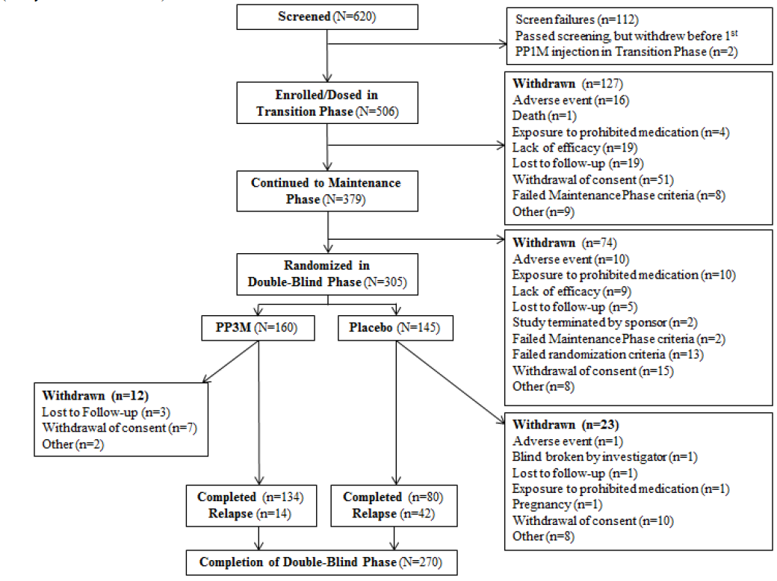
The mean (SD) extent of exposure during the Double-blind phase treatment duration was 150.2 (79.08) days in the Placebo group and 175.1 (90.00) days in the Invega Trinza group. The mean (SD) nominal dose was 400.14 (99.227) mg equivalent in the Placebo group and 402.00 (104.393) mg equivalent in the Invega Trinza group. The dose for the Placebo group was a dummy dose.

Table 31: Number of subjects in each analysis set by study phase
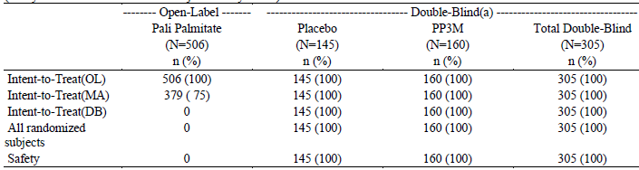
Note: Percentages calculated with the number of subjects in each group as denominator. ^{a.} A permuted block size of 4 was used per site for randomization. With varying number of subjects recruited per site, randomization was not always balanced at each site, leading to imbalance in treatment assignment overall.
Comment: After receiving for the Maintenance Phase the initial dose of Invega Trinza, only 9/(305 + 9) or 2.9% withdrew from lack of efficacy. In the Double Blind Phase of those whose treatment with Invega Trinza continued 14/(134 + 14) or 9.5% withdrew from relapse. While there was a longer exposure (mean 175.1 days) in the Double Blind phase the relapse rate is still greater especially of concern when the PKs results show that exposure gradually increases from the initial dose until steady state is reached that is one would expect more relapses to occur earlier.

Major protocol violations/deviations
19 out of 305 (6%) subjects tested positive for any of the prohibited antipsychotic medications in plasma at any time point during the Double blind Phase. Subjects with clinically relevant concentrations of prohibited antipsychotic medications in plasma at one or more pre-specified time points were withdrawn from the study or were considered to have met criteria for a protocol deviation.
10 placebo subjects (7%) received Risperidone oral 3 during the double blind phase and 3 Invega Trinza subjects (2%).

Table 32: Protocol deviations during the study - ITT (DB) Analysis Set
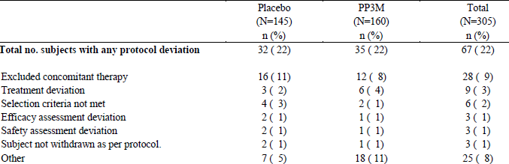
Note: Percentages calculated with the number of subjects in each group as denominator.

Exposure
Comment: It is difficult to assess from the report what doses of Invega Trinza were received as the single injection during the Maintenance phase by those who subsequently received placebo and those who continued on Invega Trinza in the Double blind phase.

Table 33: Number of injections of double blind study drug
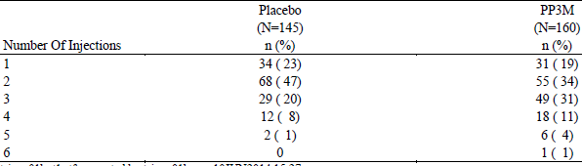
Note: subjects had already had 1 dose of PP3M in Maintenance Phase

Table 34: Cumulative frequency distribution of total drug exposure (Days) during double blind phase
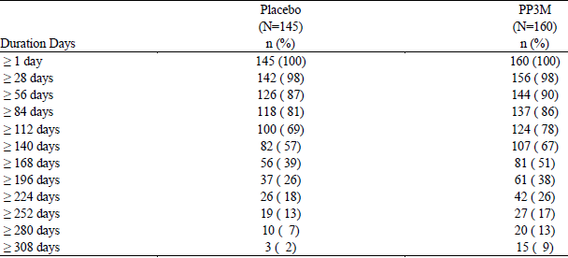
The duration of total exposure is calculated as the total number of days a subject remains in the Double blind Phase of the study. Note: subjects had already had 12 weeks after1 dose of PP3M in Maintenance Phase

Table 35: Dose levels over time and final dose during the double blind phase
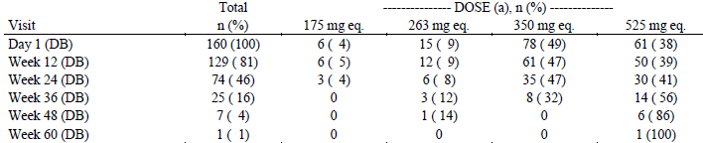
^{a.} Within each dose level, the percentages are based on the number of subjects who had injection administrated at this visit.

Baseline data
At double blind base line M/F were 110/35 on placebo and 118/42 on Invega Trinza mean age 38.5 years and 37.1 years and mean weight 77.13 kg and 78.1 kg in the placebo and Invega Sustenna groups respectively.
Diagnosis and psychiatric history were provided.

Interim analysis
The interim analysis showed positive results for Invega Trinza so the study was stopped. Thus the interim analysis is the primary analysis. The final analysis includes events after the interim analysis data cut-off (24 January 2014) up to study completion (09 April 2014), and is considered confirmatory.
283 subjects (135 subjects randomized to placebo and 148 subjects randomized to Invega Trinza) were included in the interim ITT (DB) analysis set.

Results for the primary efficacy outcome
Of the 42 subjects who experienced a relapse event, 31 subjects (23.0%) were in the Placebo group and 11 subjects (7.4%) were in Invega Trinza group, the difference being statistically significant (p < 0.001 based on the log-rank test).
The instantaneous risk of relapse of schizophrenia symptoms was 3.45 (95% CI: 1.73, 6.88) times higher for a subject switching to placebo than for a subject continuing to receive Invega Trinza in the interim analysis indicating that there was a 71% decrease in relapse risk with continued Invega Trinza treatment.
Comment: The sample size was based on 0.44 as a Hazard Ratio (hazard rate of Invega Trinza/ hazard rate of Placebo that is the inverse of this ratio is used to describe the efficacy result). Inverting 0.44 gives 2.27 that is greater than the 1.73 lower bound of the 95% CI of the ratio used to describe the efficacy result.
The sensitivity (final) analysis using the final results also showed a ratio of the hazard of relapse of schizophrenia symptoms was 3.81 (95% CI: 2.08, 6.99 that is a lower bound still less than 2.27) times higher for a subject switching to placebo than for a subject continuing to receive Invega Trinza.
The minutes of the Independent Data Monitoring Committee show:
IDMC members agreed that the difference between treatment groups in relapse rates was highly statistically significant and met criteria for early study termination.
Based on the review of the interim analysis of the primary efficacy data, the IDMC members voted unanimously, including also Rene Kahn’s vote, to discontinue the study due to established efficacy within the pre-specified significance level.
Based on these positive results in favour of PP3M, the study was stopped for efficacy in accordance with the recommendation of the IDMC.
The minutes do not show that clinical relevance of the difference was discussed.
After receiving the initial dose of Invega Trinza for the Maintenance Phase mean (SD) duration was 80.9 (15.18) days), only 9/(305 + 9) or 2.9% withdrew from lack of efficacy. In the Double Blind Phase of those whose treatment with Invega Trinza continued 14/(134 + 14) or 9.5% withdrew from relapse. While there was a longer exposure (mean 175.1 days) in the Double Blind phase the relapse rate is still greater, especially of concern when the PKs results show that exposure gradually increases from the initial dose until steady state is reached that is one would expect more relapses to occur earlier.

Results for secondary efficacy outcomes
No multiplicity adjustments were to be made.
- PANSS (total) at End point (double blind) mean (SD) change from Baseline was placebo 6.7 (14.40), Invega Trinza -0.5 (8.36).
- CGI-S Score at End point (double blind) mean (SD) change from Baseline was placebo 0.4 (0.87), Invega Trinza 0.1 (0.60).
- PSP (total) at End point (double blind) mean (SD) change from Baseline was placebo -4.2 (9.70), Invega Trinza-0.5 (6.63).
Figure 31: Kaplan-Meier plot of time to relapse; double blind phase; interim analysis
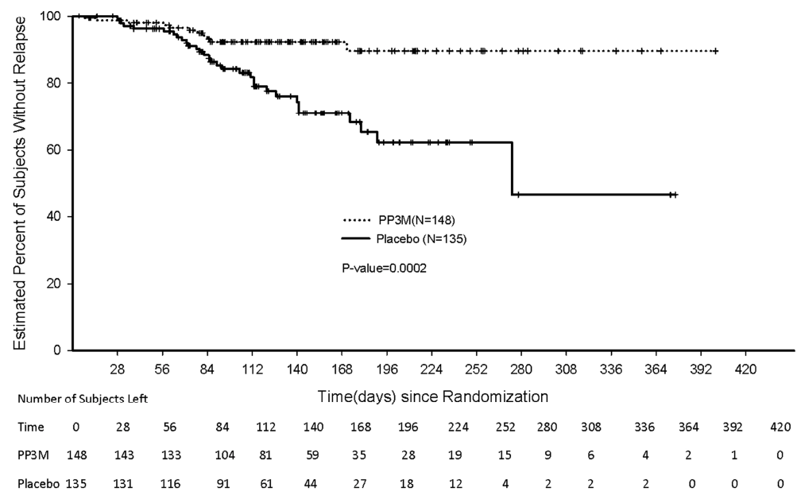
Figure 32: Kaplan-Meier plot of time to relapse; double blind phase; final (confirmatory) analysis
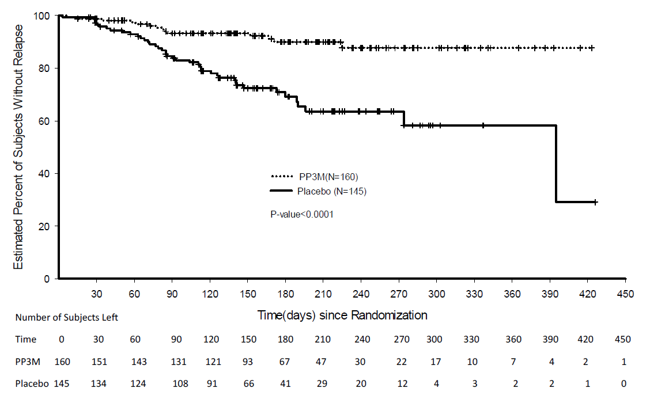

Table 36: Frequency distribution of relapse types and reasons during the double blind phase; interim analysis
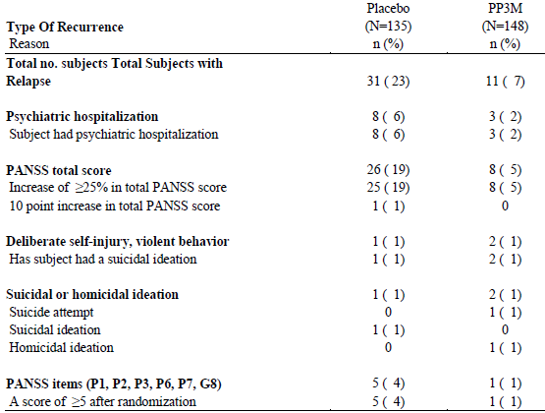
Note: Percentages calculated with the number of subjects in each group as denominator.

Study 3011

Study design, objectives, locations and dates
This was a randomized, double blind, parallel group, multicentre non-inferiority study to determine if efficacy of paliperidone palmitate 3 month was non-inferior to the efficacy of 1 month formulation for the treatment of adults with schizophrenia.
The study consisted of 3 phases: Screening/Washout/Tolerability Phase a 17 week flexible dose Open label Stabilization Phase (referred to as the Open label Phase) and a 48 week randomized, fixed dose, Double blind Controlled Phase (referred to as the Double blind Phase).
After completion of the Screening Phase (up to 21 days), in the subsequent Open label Phase, all subjects received (with flexible dosing at Weeks 5 and 9) paliperidone palmitate 1 month injection for 17 weeks (120 days).
In the Double blind Phase at Week 17 subjects were randomly assigned 1:1 to receive fixed doses of Invega Trinza or Invega Sustenna. Injections occurred every 4 weeks and subjects assigned to Invega Trinza received placebo injections (2 out of 3) to maintain the blind.
Conducted in multiple centres in Argentina (5 sites), Australia (2 sites), Austria (1 site), Belgium (7 sites), Brazil (1 site), Bulgaria (4 sites), Canada (5 sites), China (15 sites), Czech Republic (7 sites), France (4 sites), Germany (5 sites), Greece (3 sites), Hungary (6 sites), Japan (44 sites), Mexico (4 sites), Poland (8 sites), Portugal (5 sites), Republic of Korea (4 sites), Romania (2 sites), Russia (19 sites), Slovakia (4 sites), Spain (10 sites), Sweden (1 site), Taiwan (4 sites), Ukraine (8 sites), and USA (24 sites) between 26 April 2012 and 02 March 2015.
The primary objective was to demonstrate, in subjects stabilized on the paliperidone palmitate 1 month formulation, that paliperidone palmitate 3 month formulation was not less effective than Invega Sustenna in the treatment of symptoms of schizophrenia, based on the Kaplan-Meier 48 week cumulative estimate of survival (that is percentage of subjects remaining relapse free).
The secondary objectives were to:
- Evaluate the change from baseline (double blind phase) in the positive and negative symptoms of schizophrenia associated with the use of Invega Trinza compared with Invega Sustenna, as measured by the Positive and Negative Syndrome Scale for Schizophrenia (PANSS) total score and subscales.
- Assess the change in the severity of illness associated with the use of Invega Trinza compared with Invega Sustenna as measured by the change in Clinical Global Impression Severity (CGI-S) scale.
- Assess the change in functional status with the use of Invega Trinza compared to Invega Sustenna as measured by the change in personal and social performance scale (PSP).
- Assess symptomatic remission achieved during treatment with Invega Trinza compared to Invega Sustenna.
- Assess the safety and tolerability of Invega Trinza and Invega Sustenna.
- Assess the pharmacokinetics of Invega Trinza, including its relationship with demographic and dose related variables.
There were 5 exploratory objectives.

Inclusion criteria
- 18 to 70 years of age (inclusive).
- A diagnosis of schizophrenia for at least1 year before screening.
- A total PANSS score between 70 and 120; and whose symptoms were worsening.
- Had a valid reason to discontinue current antipsychotic therapy (including insufficient efficacy with current therapy, safety or tolerability issues, or subject preference for injectable medications).
To enter double blind phase:
- A score of < 70 in the PANSS total score at Visits 7 and 8 (Weeks 14 and 17).
- Scores of ≤ 4 for PANSS items P1 (delusions), P2 (conceptual disorganization), P3 (hallucinatory behaviour), P6 suspiciousness/persecution), P7 (hostility), G8 (uncooperativeness) and G14 (poor impulse control) at Visits 7 and 8 (Weeks 14 and 17).
- Reduction in CGI-S score from open label baseline of ≥ 1 at Visits 7 and 8 (Weeks 14 and 17).

Exclusion criteria
- A primary, active Axis I diagnosis other than schizophrenia.
- Attempted suicide within 12 months before screening or were at imminent risk of suicide or violent behaviour.
- A diagnosis of dementia related psychosis.
- Relevant history or current presence of any significant or unstable cardiovascular, respiratory, neurological, renal, hepatic, hematologic, endocrine, immunologic, morbid obesity (BMI > 40 kg/m²), or other systemic disease, encephalopathic syndrome, mental retardation, risk factors for prolonged QT interval, torsade de pointes or sudden death.
- History of treatment resistance as defined by failure to respond to 2 adequate trials with adequate doses of different antipsychotic medications.
- Known or suspected hypersensitivity or intolerance to risperidone, paliperidone, 20% Intralipid, or any of their excipients.
- History of no response to risperidone or paliperidone when psychotic or acutely psychotic.

Study treatments
On entry to the study:
- Subjects without documented exposure to oral or injectable risperidone or paliperidone. An oral tolerability test was conducted with Paliperidone ER 6 mg tablets were administered for 4 to 6 consecutive days during the Screening Phase (the last dose to be taken by Day -1)
- Subjects Who Received Other Depot Antipsychotics Prior to Study Entry - the approach varied depending on the medication.
During the Open Label Phase, all subjects received Invega Sustenna injections. All subjects who were not switching from other depot antipsychotics received the first injection of 150 mg equivalent on Day 1 and the second injection of 100 mg equivalent on Day 8, both in the deltoid muscle.
The injections at Week 5 (Day 36) and Week 9 (Day 64) were flexibly dosed (50, 75, 100, or 150 mg equivalent). At Week 13 (Day 92) subjects received the same dose of Invega Sustenna that was administered at Week 9.
During the Double blind Phase, subjects received fixed dose injections of either Invega Trinza (175, 263, 350, or 525 mg equivalent) or Invega Sustenna (50, 75, 100, or 150 mg equivalent). The injection site was the same as that selected at the end of the Open label Phase (that is, at Week 13).
Subjects in the Invega Trinza treatment group received a fixed dose at Weeks 17, 29, 41, and 53 that was a 3.5 fold multiple of the Invega Sustenna dose administered at Week 9. Subjects received active medication every 3 months and received matched placebo injections (20% Intralipid) monthly when they did not receive active medication in order to maintain the blind.
Subjects in the Invega Sustenna treatment group received active medication every month at the dose that was administered at Week 9.

Efficacy variables and outcomes
The primary efficacy endpoint of the study was the percentage of subjects (per protocol) who had not relapsed at the end of the 48 week Double blind Phase. This was determined based on the Kaplan-Meier 48 week cumulative estimate of survival (that is, percentage of subjects remaining relapse free). The predefined non-inferiority margin proposed for the study was 15%.
Relapse was defined as in Study 3012.
The date of the relapse was the date of the first assessment for symptoms of relapse (not the date of confirmation).

Secondary endpoints
No multiplicity adjustments were made.
Secondary efficacy endpoints included the changes from baseline (Double blind Phase) for PANSS total score, PANSS subscale/factor scores, CGI, and PSP during the Double blind Phase.
Additionally, the proportion of subjects who meet criteria for symptomatic remission (defined as the proportion of subjects with a simultaneous score of mild or less on all selected PANSS items (P1, P2, P3, N1, N4, N6, G5, and G9) maintained from Visit 14 (Week 41) to the end of the Double blind Phase (Week 65) were to be summarized.

Randomisation and blinding methods
The randomization was balanced by using randomly permuted blocks and was stratified by centre.
There was a potential for the study drug administrator to become unblinded to the subject’s treatment assignment due to differences in some of the syringe sizes used between Invega Sustenna and Invega Trinza. The study drug administrator was allowed to perform only the administration of injections, contacting interactive web response system, receiving subject medication kit numbers, and keeping drug administration and accountability information. The subject and study staff, other than the study drug administrator, was not allowed to view the syringe or needle or observe the injection.

Analysis populations
The Intent-To-Treat Open Label (ITT (OL)) analysis set included all subjects who had received at least 1 dose of open label study drug.
The All Randomized Analysis Set included all subjects who were randomly assigned to treatment during the Double blind Phase.
The Per-Protocol Analysis Set included subjects who were randomly assigned to treatment during the Double blind Phase and received at least 1 dose of double blind study drug and without major protocol deviations that could impact efficacy for example violations of eligibility criteria for subject enrolment and randomization, errors in treatment assignment, or use of excluded medication.
The Modified Intent-to-Treat Double Blind Analysis Set, (mITT (DB)), included all subjects who were randomly assigned to treatment during the Double blind Phase, received at least 1 dose of double blind study drug, and had no errors in the delivery of active treatment due to the manufacturing of the investigational product.
Modified Intent-to-Treat (DB) Sensitivity Analysis Set -subjects who were excluded from the mITT (DB) analysis set due to the short plunger manufacturing issue had been randomized to the Invega Trinza group only. The mITT (DB) sensitivity analysis set was defined by further excluding a matched sample of subjects who had been randomized to the Invega Sustenna group at the same site, country, or region, with randomization dates that were closest to those of the 21 subjects excluded from the mITT (DB) analysis set due to the short plunger manufacturing issues.

Sample size
Assuming that:
- the expected survival (percentage of subjects remaining relapse-free) rate in PP1M was 70%
- a true difference in survival between PP1M and Invega Trinza of 4% in favour of PP1M
- a 1-sided significance level of 2.5%, 380 subjects per treatment group were required to demonstrate with 90% power that PP3M was no worse than PP1M by a non-inferiority margin of 15% for the percentage of subjects remaining relapse free.
It was expected that approximately 950 to 1,000 subjects were needed to be randomized (approximately 475 to 500 per treatment group) to provide 380 subjects per treatment group who were evaluable for the primary efficacy analysis. Furthermore, it was expected that only 74% of subjects enrolled would be randomized after the 17 week Open label Phase. Hence, a maximum of 1,388 subjects were planned to be enrolled in the study. Additional subjects (n = 100 increasing approximate enrolment from 1,288 to 1,388) were added to the planned number of subjects in the Open label Phase after a product quality issue due to short syringe plungers was identified with one lot of study drug supply that resulted in some subjects (estimated to be between 16 and 30 subjects and in the end was 21 subjects) receiving an incomplete dose on one or more occasions during the Double blind Phase to ensure that there were sufficient number of subjects in the per-protocol analysis set and the study was statistically powered as originally planned.

Non-inferiority margin
The non-inferiority margin of 15% was selected based on the following evidence and expert advice. In a relapse prevention study (3,001 in submission 2009-00926) with PP1M, the percentage of subjects who remained relapse free at the end of the study was 82.4% in the PP1M group and 52.2% in the placebo group. The estimated benefit of PP1M over placebo (with 95% CI) was 30.2% (21.6%, 38.8%).
Based on the outcome of the expert panel consultation as well as the fact that any non-inferiority margin under 20% would be less than the lower bound of the 95% CI for the treatment effect, a margin of 15% was chosen.
Comment: Comment in relation to the source of the non-inferiority margin. Study 3001 was terminated early because the double blind phase ended when superiority of Invega Sustenna over placebo was demonstrated in the interim analysis following 68 relapse events.
The interim analysis was considered the primary analysis. The results used above in justifying the non-inferiority margin were from the final data set which was considered confirmatory per protocol.
The primary efficacy variable was the time to the first recurrence event during the double blind relapse prevention phase. The number of relapses was not an endpoint. Some subjects (1/156 placebo and 0/156 Invega Sustenna) had 12 of the monthly injections (including the initial one). At the time of the interim analysis only 24% of subjects in the placebo group and 37% of subjects in the Invega Sustenna group had received at least 5 injections (4 months of injections).
At the time of the interim analysis, there were 156 subjects on placebo and 156 subjects on Invega Sustenna with 204 (65%) ongoing, 40 (13%) discontinued and 68 (22%) relapsed. 53 [34%] in the placebo group had a relapse and 15 [10%] in the Invega Sustenna group. This leaves 103 (66%) in the placebo group and 141 (90.4%) in the Invega Sustenna group who remained relapse free in the primary analysis, a benefit of 24.4%. The 95% CI for the benefit in the primary analysis were not found.
In the Final Analysis only 46% of those in the Invega Sustenna group had received at least 7 injections (6months) and 1% had received 13 injections (12 months).the figures used in deriving the non-inferiority margin are based on the confirmatory Final Analysis.
In additional justification, a meta-analysis of placebo controlled relapse studies showed that the overall drug effect over placebo was 29.2% [95% CI: 25.6%, 32.9%]. However the meta-analysis was exploratory and did not include trials of paliperidone vs placebo or risperidone versus placebo.

Statistical methods

Primary endpoint
The primary endpoint analysis used the per-protocol population with a pre-specified non-inferiority margin of 15%. The hypotheses was to be tested using a one-sided α = 0.025. The Kaplan-Meier method was to be used to estimate the 48 week cumulative estimate of survival (that is, percentage of subjects remaining relapse-free). SE estimates were to be based upon Greenwood’s formula.
Non-inferiority of Invega Trinza to Invega Sustenna would be concluded if the lower limit of the 2-sided 95% CI of the difference in relapse-free rates between Invega Trinza and Invega Sustenna exceeded –15%.

Secondary endpoints
No multiplicity adjustments were made.
For the Double blind Phase, changes in the secondary efficacy endpoints (PANSS [total and subscale scores], CGI, and PSP) from randomization to each visit and to the end point were to be analysed using an ANCOVA model using both LOCF and observed cases in the mITT analysis set. The model was to include treatment and country as factors and score at randomization as a covariate. Treatment effects were to be estimated based upon least square means and the accompanying 95% CIs presented.

Participant flow

Table 37: Number of subjects in each analysis set by study phase
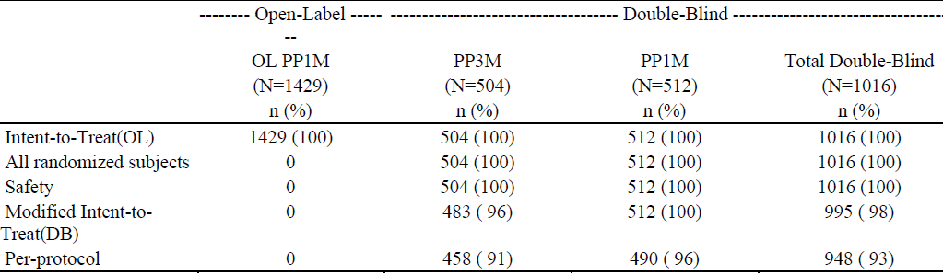
Percentages calculated with the number of subjects in each group as denominator. All enrolled subjects were included in the Intent-to-Treat (OL) analysis set.
Figure 33: Study completion and withdrawal information
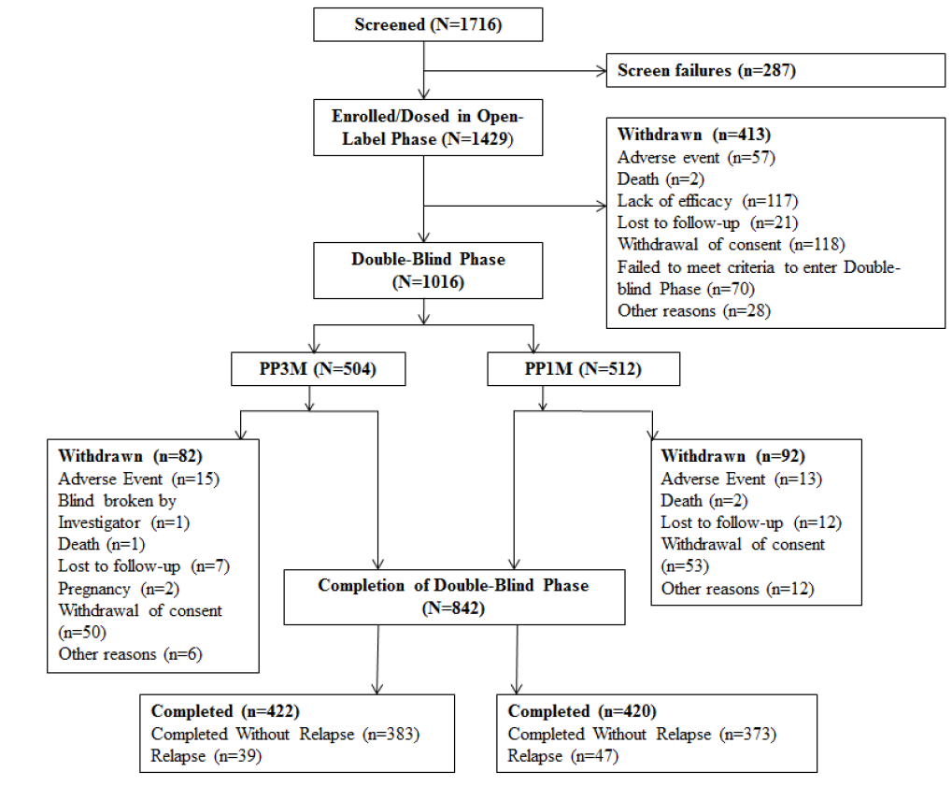

Major protocol violations/deviations
For the safety analysis set, 1 or more relevant protocol deviations were recorded for 164 subjects (16%) of the total 1016 subjects. The most common deviations (and ≥ 5%) were noted in the categories of treatment deviation (74 subjects [7%]) and deviations due to other reasons (63 subjects [6%]).

Table 38: Major protocol deviations during the study
Note: Percentages calculated with the number of subjects in each group as denominator. Major protocol deviations occurred in the Open label and Double blind Phases of the study.

Table 39: Major protocol violations (that is, major protocol deviations that led to exclusion from per- protocol analysis set) during the study
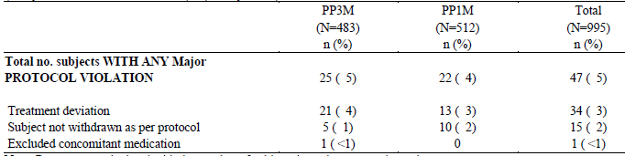
Note: Percentages calculated with the number of subjects in each group as denominator.

Exposure double blind phase

Table 40: Number of active injections of double blind study drug
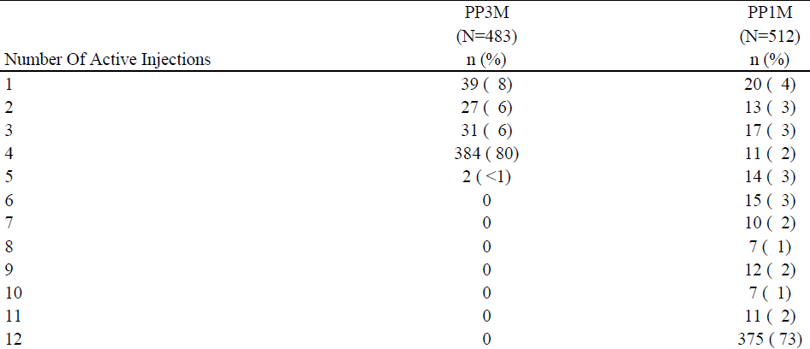
Note: During the Double blind Phase, in the PP3M group, 4 subjects received placebo when supposed to receive PP3M, 4 subjects received PP3M when supposed to receive placebo, 1 subject received PP1M when supposed to receive placebo; in the PP1M group, 1 subject received PP3M when supposed to receive PP1M, 3 subjects received placebo when supposed to receive PP1M, and 2 subjects received wrong dose of PP1M.

Table 41: Dose levels over time during the double blind phase (PP3M Group)
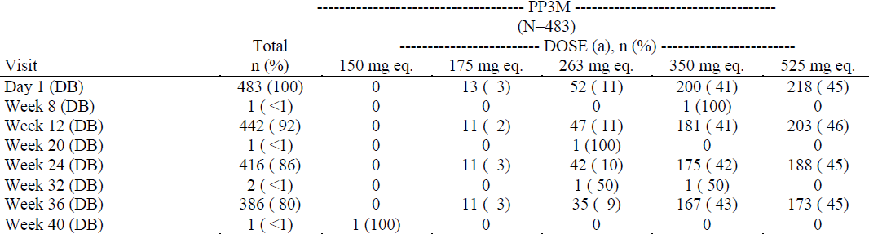
^{a.} Within each dose level, the percentages are based on the number of subjects who had injection administrated at this visit. Some subjects received an incorrect medication kit at various time points during the study. In the PP3M group, 4 subjects received placebo when supposed to receive PP3M, 4 subjects received PP3M when supposed to receive placebo, 1 subject received PP1M when supposed to receive placebo.

Table 42: Dose levels over time during the double blind phase (PP1M Group)
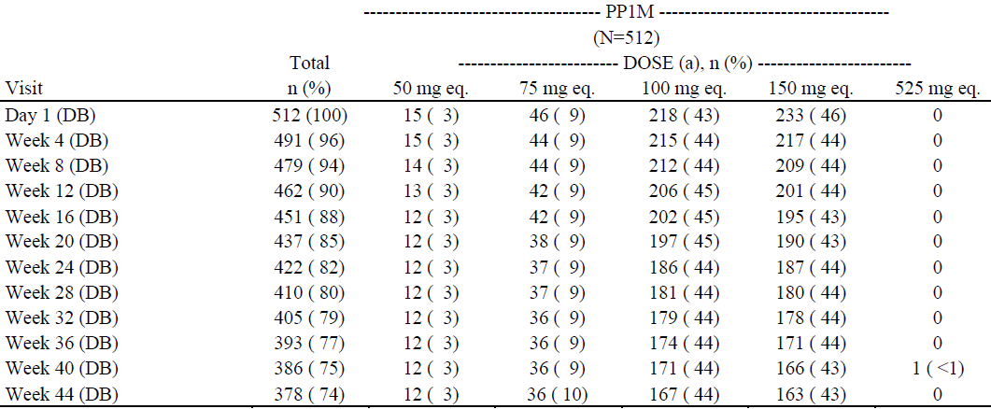
^{a.} Within each dose level, the percentages are based on the number of subjects who had injection administrated at this visit. Some subjects received an incorrect medication kit at various time points during the study. In the PP1M group, 1 subject received PP3M when supposed to receive PP1M, 3 subjects received placebo when supposed to receive PP1M, and 2 subjects received wrong dose of PP1M.

Baseline data
The demographics and baseline data of the primary analysis group the Per-Protocol Analysis Set were not submitted.

Table 43: Demographic and baseline (OL) characteristics for ITT (OL) and mITT (DB) Sets
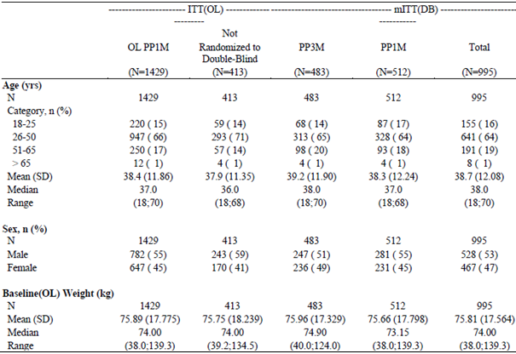

Results for the primary efficacy outcome
37 subjects (8.1%) in the Invega Trinza group and 45 subjects (9.2%) subjects in Invega Sustenna group had a relapse event during the Double blind Phase. The difference (95% CI) between the treatment groups (Invega Trinza-Invega Sustenna) in the percentages of subjects who remained relapse free was 1.2% (-2.7%, 5.1%). The lower bound of the 95% CI was not outside the pre-specified non-inferiority margin of -15%, that is Invega Trinza was non-inferior to Invega Sustenna. This was confirmed by the results of the Modified Intent-to-Treat (DB) Sensitivity Analysis result for the difference of 1.5% (-2.3%, 5.3%).
Comment: The significance of the result rests on a difference of 1.2% from 9.2% relapses on Invega Sustenna at week 48.
The population size calculations to show with 90% power that PP3M was no worse than PP1M were based on an expected survival (percentage of subjects remaining relapse-free) rate in PP1M of 70%. Whereas Study 3001 showed a 10% relapse rate on Invega Sustenna at the time of the Interim (primary) Analysis when only 37% of subjects in the Invega Sustenna group had received at least 5 injections (4 months of injections).
The only summary results available were contained within the Clinical Study Report. Efficacy data in the Addenda was confined to listing of individual results.

Table 44: Time to relapse during the double blind phase and number (%) of subjects that remained relapse free
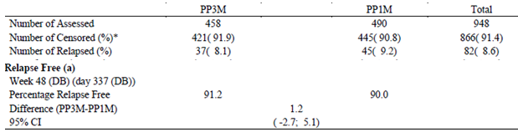
^{a.} Based on Kaplan-Meier product limit estimates. * Censored include subjects who completed the Double blind Phase without relapses and subjects who withdrew early during the Double blind Phase.
Figure 34: Kaplan-Meier plot of time to relapse during the double blind phase
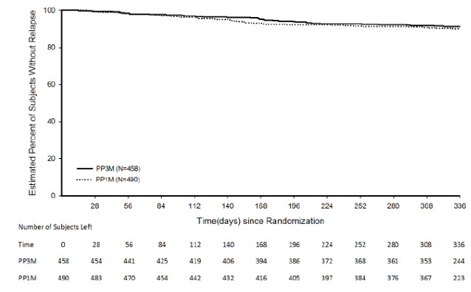

Table 45: Frequency distribution of relapse types and reasons during double blind phase PP
Percentages calculated with the number of subjects in each group as denominator.

Results for other efficacy outcomes
The sample size population was based only on the primary endpoint. No multiplicity adjustments were made, p values were not given.
The study was not powered for the subgroup analyses to demonstrate non-inferiority.

Table 46: Change from baseline (DB) at endpoint Positive and Negative Syndrome Scale (PANSS) Total Score Clinical Global Impression Severity (CGI-S) Score Personal and Social Performance Scale (PSP) (LOCF)
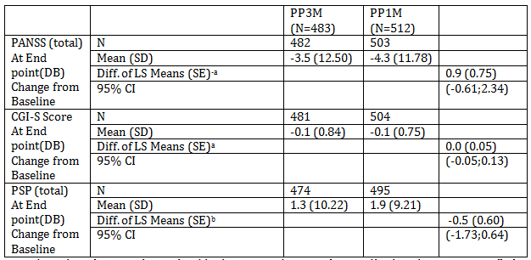
^{a.} Based on analysis of covariance (ANCOVA) model with treatment and country as factors, and baseline value as a covariate. Diff is for Change from Baseline, PP3M - PP1M ^{b.} Based on analysis of covariance (ANCOVA) model with treatment (PP1M vs PP3M) and country as factors, and baseline value as a covariate. Diff is for Change from Baseline, PP3M - PP1M

Evaluator’s conclusions on clinical efficacy

Guidance

CPMP/EWP/482/99 Points to consider on switching between superiority and non-inferiority
Whether the observed difference is indeed clinically relevant is a matter of judgment. In contrast to an equivalence or non-inferiority trial where clinical relevance is addressed through the pre-study choice of 8 (see II.2 and Il.3), in a superiority trial clinical relevance requires separate consideration: a statistically significant difference may not be clinically relevant. The difference taken as the basis of the power calculation in a superiority trial cannot be assumed to provide a suitable value.

EMEA/CPMP/EWP/2158/99 Guideline on the choice of the non-inferiority margin

Demonstrating efficacy
When data from trials designed to show superiority of a test product over placebo are being interpreted, an informal two-stage procedure is employed involving the consideration of both statistical significance and clinical relevance.
In a superiority trial, it would first be expected that the test product demonstrated a statistically significant advantage over placebo. This relates to the ‘statistical reasoning’ stage of the ICH E10 combination of ‘both statistical reasoning and clinical judgement’. Statistical significance is generally assessed using the two-sided 0.05 level of significance (or one-sided 0.025). An alternative way of stating this requirement is that the lower bound of the two-sided 95% confidence interval (or one-sided 97.5% interval) for the difference between active and placebo should be above zero.
The next step in interpreting a superiority trial is to consider whether the difference from placebo is clinically relevant. This is the ‘clinical judgement’ stage of the ICH E10 combination of ‘both statistical reasoning and clinical judgement’.
Establishing a clinically relevant benefit over placebo is accomplished by considering the point estimate of the difference between the test product and placebo and assessing its clinical relevance, either using the original scale or by considering responder rates. This is a not primarily a statistical issue, but does require an intelligent combination of clinical thinking and data comprehension.
Statistical significance has already been demonstrated, so the existence of an effect is considered to be established. A judgement must be made regarding whether the difference seen is clinically useful. This judgement is usually made in the context of the safety profile via an assessment of benefit/risk.

Evaluation
Statistical significance was shown in the superiority of Invega Trinza over placebo for primary endpoint for Study 3012.
The Independent Data Monitoring Committee (IDMC) charter has under 7.2.1.1 Interim Efficacy Analysis:
If the p value from the log-rank test on time to relapse at the planned interim analysis was less than 0.0101, the null hypothesis of no treatment difference in time to relapse was to be rejected and the IDMC was to recommend that the study be terminated for significant efficacy. Otherwise, the study was to continue until 70 relapse events were observed. No stopping rules for futility were to be incorporated.
The minutes of the Independent Data Monitoring Committee show:
IDMC members agreed that the difference between treatment groups in relapse rates was highly statistically significant and met criteria for early study termination.
Based on the review of the interim analysis of the primary efficacy data, the IDMC members voted unanimously, including also Rene Kahn’s vote, to discontinue the study due to established efficacy within the pre-specified significance level.
The minutes do not show that clinical relevance of the difference was discussed.
The sponsor has claimed a clinically significant difference without giving reasons for so claiming.
After receiving for the Maintenance Phase the initial dose of Invega Trinza, only 9/(305 + 9) or 2.9% withdrew from lack of efficacy. In the Double Blind Phase of those whose treatment with Invega Trinza continued 14/(134 + 14) or 9.5% withdrew from relapse. While there was a longer exposure (mean 175.1 days versus 80.9 days) in the Double Blind phase the relapse rate is still greater which is especially of concern when the PKs results show that exposure tends to increase (C_{min} increases Table 12) from the initial dose until steady state is reached that is one would expect more relapses to occur earlier.
Of the 42 subjects who experienced a relapse event, 31 subjects (23.0%) were in the Placebo group and 11 subjects (7.4%) were in Invega Trinza group, the difference being statistically significant (p < 0.001 based on the log-rank test).
The instantaneous risk of relapse of schizophrenia symptoms was 3.45 (95% CI: 1.73, 6.88) times higher for a subject switching to placebo than for a subject continuing to receive Invega Trinza in the interim analysis.
The sample size was based on 0.44 as a Hazard Ratio (hazard rate of Invega Trinza/ hazard rate of Placebo that is, the inverse of this ratio is used to describe the efficacy result). Inverting 0.44 gives 2.27 that is, greater than the 1.73 lower bound of the 95%CI of the ratio used to describe the efficacy result.
The secondary endpoints in Study 3012 were:
- PANSS (total) at End point (double blind) mean (SD) change from Baseline was placebo 6.7 (14.40), Invega Trinza -0.5 (8.36). That is a difference of 7.2 (4%) from placebo in a 180 point scale.
- CGI-S Score at End point (double blind) mean (SD) change from Baseline was placebo 0.4 (0.87), Invega Trinza 0.1 (0.60). That is a difference of 0.3 (4%) from placebo in a 7.0 point scale.
- PSP (total) at End point (double blind) mean (SD) change from Baseline was placebo -4.2 (9.70), Invega Trinza-0.5 (6.63). That is a difference of 3.7(4%) from placebo in a 100 point scale.
No multiplicity adjustments were to be made.
Based on 95% CIs non inferiority was shown for the primary endpoint of Invega Trinza compared to Invega Sustenna in Study 3011. However the percentage of relapses for Invega Sustenna at Week 48 was the similar to that seen at interim (primary) analysis in Study 3001 when only 37% of subjects in the Invega Sustenna group had received at least 5 injections (4 months of injections).
Comment: In the absence of a placebo control, equivalence and non-inferiority trials rely on certain assumptions:
- Superior efficacy of the standard treatment over placebo has been convincingly proven for a given indication in previous trials.
- Efficacy of the standard treatment will be preserved under the conditions of the equivalence or non-inferiority trial.
- If the new treatment is shown to have equivalent or non-inferior efficacy, then it too would exhibit superior efficacy to placebo if a placebo controlled trial were to be performed.
These assumptions, and the rationale for equivalence or non-inferiority margins, cannot be validated explicitly. Although new and standard treatments may be shown to be equivalent, they could both be ineffective.

Clinical safety
The sponsor proposes:
Considering that PP3M shares the same active moiety as well as the same route of administration and formulation characteristics with the commercially-available PP1M product, the Company believes that the overall extent of exposure (total number of subjects exposed) and the well documented safety profile of PP1M are particularly relevant for PP3M.

Patient exposure
The combined exposure to Invega Trinza in the 3 studies included in this submission was 567.6 patient-years, based on 1,191 subjects (308 from PSY-1005, 379 from PSY-3012 and 504 from PSY-3011) who received at least 1 dose of Invega Trinza with 319 subjects (291 from PSY-3011 and 28 from PSY-3012) having at least 48 weeks of Invega Trinza.

Pivotal studies that assessed safety as a primary outcome
The studies’ safety results were not combined in summary of clinical safety. Some safety results were combined in the clinical overview.
Safety data from these 3 studies were not pooled due to differences in study design and objectives.
The design of these Phase III studies was not intended to support a formal evaluation of the dose response of PP3M for specific safety findings (for example EPS-related AEs, weight gain) or tolerability. Subjects were not randomly assigned to distinct dose levels of PP3M upon entering the Double blind Phase.
Any conclusion about a differential effect of PP3M dose on the incidence of adverse events in the Double blind Phase is confounded by the clinical response and tolerability of PP1M for individual subjects in the Open label Phase.

Study PSY-1005 (PK study)
This study involved 308 patients with various doses from 125 mg to 525 mg of the 3 month preparation.
Subjects remaining on antipsychotic medications other than risperidone/paliperidone during the study, and the investigators could change the underlying psychotropic medication at their discretion.

Dose dumping
The primary objectives of the study included safety and tolerability. Of concern is the possibility of dose dumping or excessive exposure from delayed excretion. The sponsor appeared to have decided that this was represented by paliperidone concentrations ≥ 125 ng/mL. There were 6 patients with plasma concentrations of paliperidone greater or equal to 125 ng/mL. However when one reviews the individual plasma concentrations (see Figure 35 and Figure 36), there are clearly some other individuals on less than the maximum 525 mg in which increased Cmax appears to occur but a C_{max} of 125 ng/mL is not reached.
Figure 35: Combined plasma concentration-time profiles of paliperidone
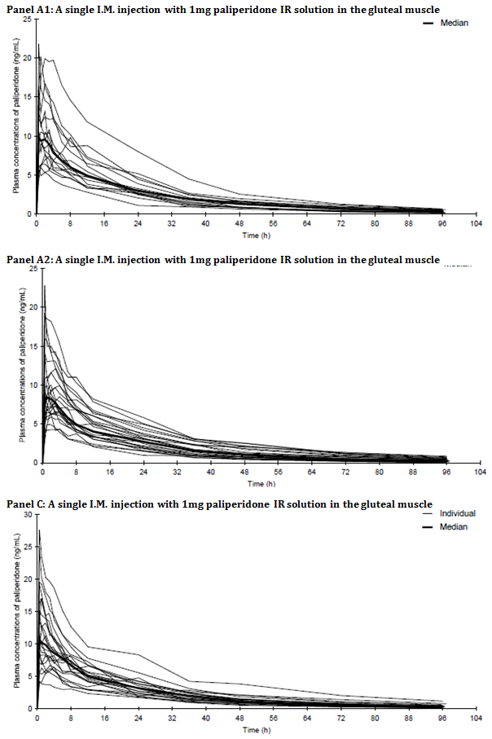
Figure 36: Individual and median plasma concentration-time profiles of paliperidone
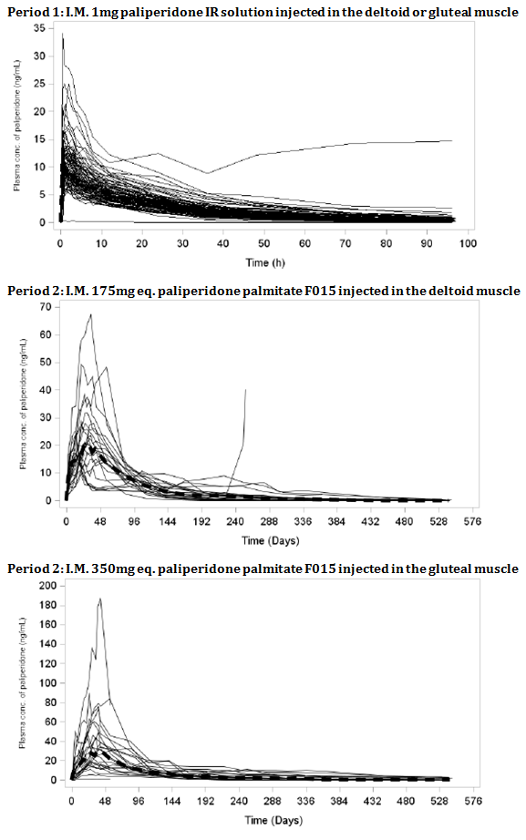

Table 47: Summary table of subjects with C_{max} > 125 ng/mL
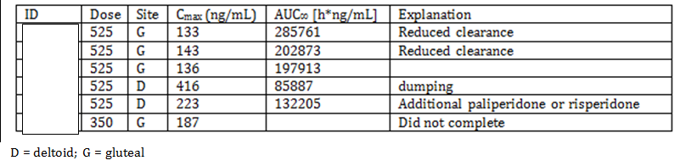
To put the resulting AUC∞ in perspective:
- For 525 mg gluteal Geometric mean AUC∞ was 138191h. ng/mL (median 142201)
- For 525 mg deltoid Geometric mean AUC∞ was 139949h.ng/mL (median 128969)
The sponsor claims:
There is no undesired, unexpected increase in initial paliperidone plasma concentrations following dosing.
Patient [information redacted] (wt. 56.1 kg) in Panel D received 525 mg equivalent On Days 1 (6 hours post dose), 2, 4, 6, and 10 of Period 2, she had measured paliperidone concentrations of 153, 416, 243, 195, and 125 ng/mL, respectively. For Panel D mean C_{max} deltoid 525 mg. equivalent was 80 ng/mL (median 57.9).
She had a SAS total score of 1 each at baseline and Day 6 of Period 2 (mild tremor), and 2 each on Days 14 and 26 of Period 2 (mild tremor and increased eye blink to glabellar tap). The subject had similar scores at Days 56 and 140 of Period 2 and had a tremor at all other times. She had an increased QTcB on Day 1 of Period 2 (454 ms); the QTcB and QTcF values were below 450 ms at all other time points in the study.
Figure 37: Patient [information redacted] with Paliperidone ≥ 125 ng/mL plasma concentration versus time
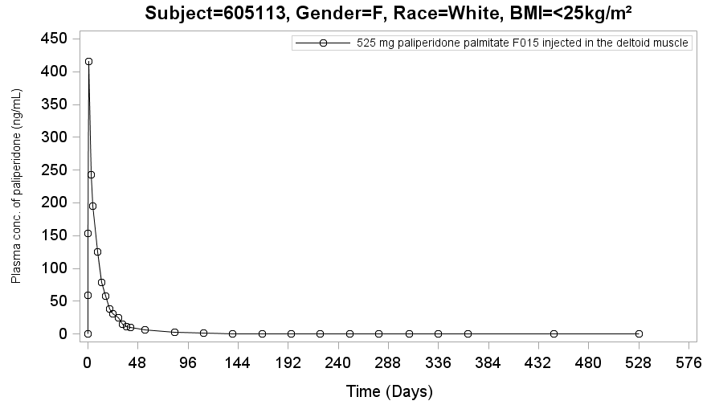
Note: The height of the plasma concentration in subsequent figures has been roughly adjusted from the original to reflect the scale height used above. This is to enable an easier visual comparison

Excessive exposure
Patient [information redacted] (wt. 86.5 kg) in Panel D received 525 mg equivalent On Days 10, 14, and 18 of Period 2, his measured paliperidone concentrations were at 137 ng/mL, 126 ng/mL, and 143 ng/mL. The higher level of paliperidone may have been due to reduced clearance in this subjects as evidenced by a larger AUC during Period 1. On Day -1 of Period 1, he had a non-serious event of blood creatine phosphokinase increased.
Figure 38: Patient [information redacted] with Paliperidone ≥ 125 ng/mL plasma concentration versus time
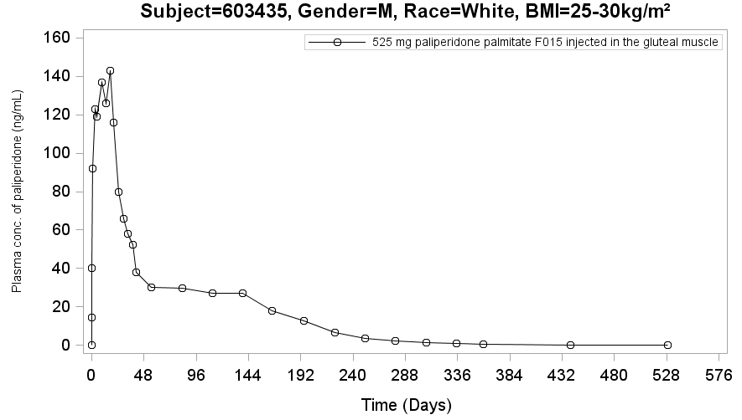
Patient [information redacted] (wt. 54.1 kg) in Panel D received 525 mg equivalent On Day 14 of Period 2, she had a measured paliperidone concentration of 133 ng/mL. She had a BARS total score of 1 on the same day (mild inner sense of restlessness). This subject may have had higher levels of paliperidone due to an overall slower rate of clearance as seen in Period 1 with the subject having a larger AUC (AUC = 519).
She also had Period 2, Day 76 mild glossodynia and pain in extremity (leg). On day 308 a mild maculo-papular rash.
Figure 39: Patient [information redacted] with Paliperidone ≥ 125 ng/mL plasma concentration versus time
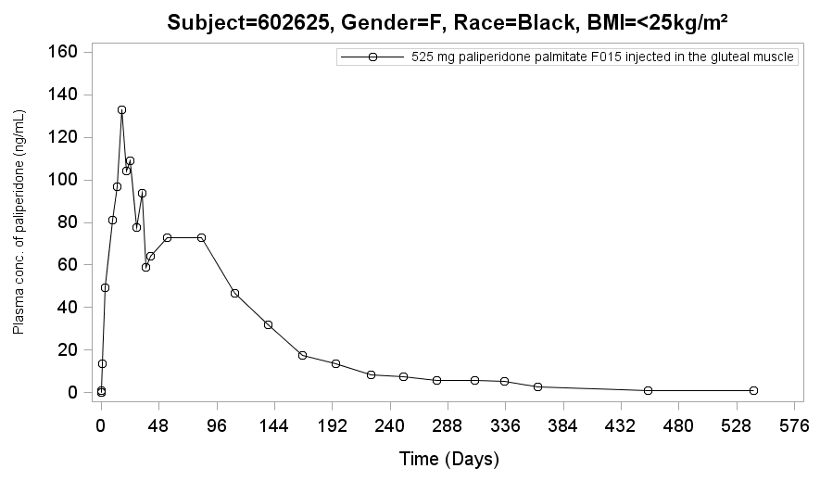
Patient [information redacted] (wt. 57 kg) in Panel D received 350 mg equivalent On Days 30, 34, 38, and 42 of Period 2, she had measured paliperidone concentrations of 136, 125, 179, and 187 ng/mL, respectively. She had an AIMS score of 3 at baseline of Period 2. This score fluctuated between 4 and 5 for the rest of the study. The ratings were for minimal abnormal movements, may be the extreme of normal, for various groups throughout Period 2. She had a SAS score of 2 at baseline of Period 2. After Invega Trinza was given, she had a score of 0 at Days 26 and 56 of Period 2, 1 (increased blinking to glabellar tap) at Days 6 and 14 of Period 2, and 3 (increased blinking to glabellar tap, stiffness in arm, diminished arm swing on walking) at Day 34 of Period 2. No further movement disorder scales were done. On Day 119 of Period 2, the subject withdrew consent from the study.
Figure 40: Patient [information redacted] with Paliperidone ≥ 125 ng/mL plasma concentration versus time
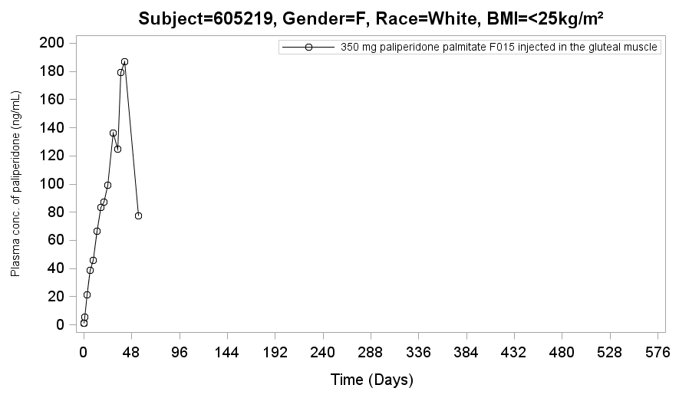
Patient [information redacted] (wt. 96 kg) in Panel D received 525 mg equivalent On Day 544, after receiving Invega Trinza, she had a measured paliperidone concentration of 223 ng/mL. The high level at the end of the study was likely related to subject taking non-study related paliperidone or risperidone.
Figure 41: Patient [information redacted] with Paliperidone ≥ 125 ng/mL plasma concentration versus time
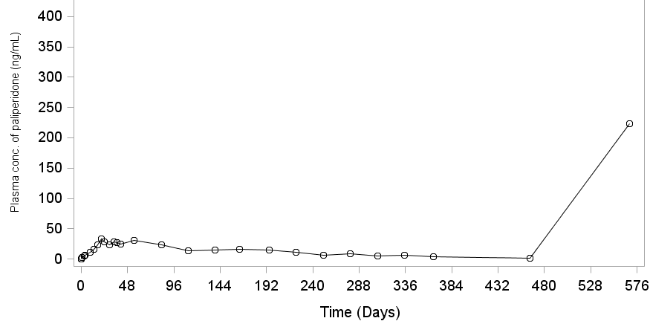
Patient [information redacted] (wt. 91.2 kg) in Panel D received 525 mg equivalent On Days 26, 30, and 42 of Period 2, he had measured paliperidone concentration of 132, 136, and 132 ng/mL, respectively. He had a SAS score of 1 (tremor) on Days -1, 6, 14, 34, 140; score of 2 (tremor, slight wrist stiffness) on Days 56 and 224 and 0 at other time points in Period 2 including Day 26.
Figure 42: Patient [information redacted] with Paliperidone ≥ 125 ng/ml plasma concentration versus time
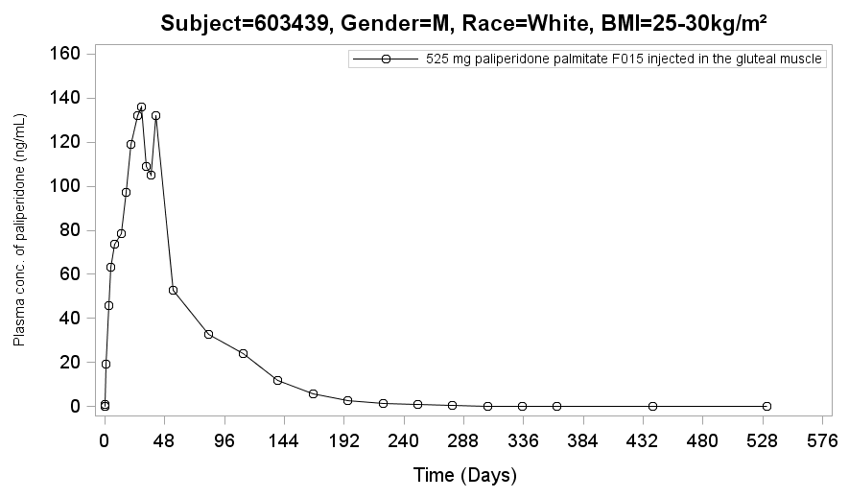

TEAEs
The most commonly reported TEAEs:
- In Panel A were headache and insomnia (each reported in 5.6% subjects) in Period 1; and headache and nasopharyngitis (each reported in 13.6% subjects), and toothache (6.1%) in Period 2.
- In Panel B were headache (4.7%), anxiety and constipation (each reported in 3.1% subjects) in Period 1; nasopharyngitis (12.5%); headache (11.7%); anxiety (10.0%); insomnia, diarrhoea, toothache, and weight increased (each reported in 7.5% subjects), abdominal pain and back pain (each reported in 6.7% subjects), weight decreased and tachycardia (each reported in 5.8% subjects), and depression, psychotic disorder, and schizophrenia in Period 2 (each reported in 5% subjects).
- In Panel C was headache (8.0%) in Period 1; and upper respiratory tract infection (25.0%), headache (16.7%), constipation (12.5%), vomiting, dystonia, injection site warmth, back pain, and diabetes mellitus (each reported in 8.3% subjects) in Period 2.
- In Panel D was insomnia and anxiety (each 3.0%) in Period 1; and nasopharyngitis (10.2%), headache (7.1%), back pain (6.1%); dizziness, and weight increased (each reported in 5.1% subjects) in Period 2.

Discontinuations due to AEs
In Panel A two discontinued the study agent due to the TEAEs of anxiety and suicidal ideation, (considered to be doubtfully related), and 1 subject discontinued due to a TEAE of hypertension, which was considered by the investigator to be possibly related to the study agent.
Panel B three discontinued the study agent due to TEAEs of myocardial ischaemia, psychotic disorder, and metastatic malignant melanoma (each reported in 1 subject, and which were considered not related to the study agent). The TEAEs of muscle spasticity and dysphemia (each reported in 1 subject) were considered by the investigator to be very likely related to the study agent.
Panel C had no subjects discontinued.
Panel D had one discontinued due to the TEAE of psychotic disorder, which was considered by the investigator to be not related to the study agent.

Serious adverse events
In Panel A, all treatment emergent SAEs were considered not related or doubtfully related to the study agent. In Panel B dystonia (1 subject) was considered possibly related to the study agent and an ectopic pregnancy was considered doubtfully related to the study agent otherwise most treatment emergent SAEs were considered not related to the study agent. In Panel C the only treatment emergent SAE was considered by the investigator to be not related to the study agent. In Panel D all treatment emergent SAEs were considered by the investigator to be not related to the study agent.
The only death was in panel B; malignant melanoma.

Treatment related AEs
The TEAEs considered by the investigator to be very likely related to the study agent were:

Panel A:
During Period 1: dry mouth (1 subject).
During Period 2:
- in the 300 mg equivalentgroup – sinus bradycardia, injection site irritation, and injection site pain (each reported in 1 subject)
- in the 300 mg equivalent group - injection site pain (1 subject).

Panel B
- During Period 1: tremor (2 subjects); vertigo, abdominal pain, diarrhoea, injection site pain, dysphemia, muscle spasticity, and hypoaesthesia (each reported in 1 subject).
During Period 2:
- In the 75 mg equivalent gluteal group; nausea, dizziness postural, headache, somnolence, insomnia, and hot flush (each reported in 1 subject).
- In the 150 mg equivalent gluteal group; weight increased (reported in 1 subject).
- In the 300 mg equivalent deltoid group; constipation, injection site erythema, injection site induration, injection site pain, and sedation (each reported in 1 subject).
- In the 450 mg equivalent gluteal group; weight increased (1 subject).
- In the 450 mg equivalent deltoid group; injection site induration (2 subjects); injection site mass, injection site pruritus, injection site swelling, weight increased, ejaculation disorder, and erectile dysfunction (each reported in 1 subject).

Panel C
- During Period 2 in the 150 mg equivalent group injection site: warmth (1 subject).

Panel D
During Period 2:
- In the 175 mg equivalent deltoid group; injection site induration, injection site nodule, and injection site pain (each reported in 1 subject).
- In the 525 mg equivalent deltoid group; injection site induration (reported in 2 subjects), injection site erythema, injection site pain, injection site swelling, and restlessness (each reported in 1 subject).

Severe AEs
Most AEs were moderate or mild. The following TEAEs were reported as severe:

Panel A
Period 2:
- In the 300 mg equivalent gluteal group; depression and suicidal ideation (each reported in 3 subjects), diabetic ketoacidosis, type 2 diabetes mellitus, agitation, drug abuser, paranoia, and schizophrenia (each reported in 1 subject).
- In the 300 mg equivalent gluteal group, - upper limb fracture, akathesia, and psychotic disorder (each reported in 1 subject).

Panel B
Period 2:
- In the 75 mg equivalent gluteal group; metastatic malignant melanoma, psychomotor hyperactivity, delusion, major depression, psychotic disorder, and schizophrenia (each reported in 1 subject).
- In the 150 mg equivalent gluteal group; erectile dysfunction and pleurisy (each reported in 1 subject).
- In the 300 mg equivalent deltoid group; ectopic pregnancy.
- In the 450 mg equivalent deltoid group; weight increased and ejaculation disorder (each reported in 1 subject).

Panel C
- During Period 2, in the 150 mg equivalent gluteal group; suicide attempt (1 subject).

Panel D
Period 2:
- In the 175 mg equivalent deltoid group; diarrhoea and depression (each reported in 1 subject).
- In the 350 mg equivalent gluteal group; gastric ulcer haemorrhage, acute psychosis and schizophrenia (each reported in 1 subject).
- In the 525 mg equivalent gluteal group; psychotic disorder (reported in 1 subject).

Laboratory evaluation
Overall, there were no clinically relevant changes in any of the haematology, chemistry, and urinalysis parameters evaluated in Panels A, B, C, and D.
Mean increases in creatine kinase levels were seen in most groups but not considered clinically meaningful.
One subject in the 300 mg equivalent F015 wet paliperidone palmitate in the deltoid region treatment group reported a treatment emergent SAE of hyponatremia of mild severity, which was considered by the investigator to be not related to the study agent.

Orthostatic hypotension
At some point during the study the following had had treatment emergent orthostatic hypotension:
Panel A
- 4 subjects in the 300 mg equivalent luteal group.
- 2 subjects in the 300 mg equivalent gluteal group.
Panel B
- 4 subjects in the 75 mg equivalent gluteal group.
- 5 subjects in the 150 mg equivalent gluteal group.
- 1 subject in the 300 mg equivalent deltoid group.
- 3 subjects in the 450 mg equivalent gluteal group.
- 4 subjects in the 450 mg equivalent deltoid group.
Panel C
- 8 subjects in the 150 mg equivalent gluteal group.
Panel D
- 1 subject in the 175 mg equivalent deltoid group.
- 3 subjects in the 350 mg equivalent gluteal group.
- 3 subjects in the 525 mg equivalent gluteal group.
- 4 subjects in the 525 mg equivalent deltoid group.

Electrocardiograms

Panel A
- During Period 2, 2 subjects in the 300 mg equivalent wet gluteal group had a change from baseline in QTcB interval of > 60 msec at the end of study visit.

Panel B
At one or more post baseline assessments during Period 2:
- 3 subjects in the 300 mg equivalent deltoid group had a QTcB of > 480 msec of which 1 subject had a QTcB and QTcF > 500 msec (occurring at Day 140 and below 450 msec at the next assessment on Day 224).
- 2 subjects in the 450 mg equivalent deltoid group (both on Day 140) had a QTcB > 480 msec and < 500 msec 1 subject in the 75 mg equivalent gluteal group had a QTcB > 480 msec and < 500 msec (on Day 56 and Day 140).
- One subject in the 300 mg equivalent deltoid group had a change in QTcB > 60 msec from baseline (on Day 140).

Panel C
- One subject had QTcB value > 480 msec and < 500 msec at Day 308 and Day 364 (EOS visit) during Period 2.

Panel D
During Period 2
- 1 subject in the 525 mg equivalent gluteal group had a QTcB > 500 msec and a QTcF > 480 msec and < 500 msec on Day 224, which was > 450 msec at the Day 308 assessment.
- 2 additional subjects in the 525 mg equivalent gluteal group had a post baseline QTcB > 480 msec and < 500 msec (Day 224 for one subject, EOS visit for other subject).
- 1 subject in the 350 mg equivalent gluteal group had a change of > 60 ms in QTcB and QTcF from baseline (on Day 224).

Injection site reactions
None of them were severe in intensity or SAEs or AEs resulting in discontinuation except in 1 Panel D subject who reported severe pain in the 175 mg eq deltoid group on Day 1 of Period 2.

Panel A
- 1 subject in the 1 mg group.
- 2 subjects in the 300 mg equivalent gluteal group.
- 3 subjects in the 300 mg equivalent gluteal group.
- Had TEAEs related to injection site reactions (pain, irritation, or rash).

Panel B
- 1 subject in the 1 mg group.
- 3 subjects in the 300 mg equivalent deltoid group.
- 5 subjects in the 450 mg equivalent deltoid group.
- Had TEAEs related to injection site reactions (mass, pruritus, pain, induration, illness, erythema, or swelling).

Panel C
- 2 subjects had TEAEs related to injection site reactions (warmth).

Panel D
- 5 subjects in the 175 mg equivalent deltoid group.
- 5 subjects in the 525 mg equivalent deltoid group.
had TEAEs related to injection site reactions (pain, nodule, erythema, swelling, induration).

Maximum pain in period 2
While mean pain scores were low, some patients had considerable pain.

Panel A
- 52/100 Day 6 300 mg gluteal
- 63/100 Day 2 300 mg gluteal

Panel B
- 88/100 6 H Post-dose 75 mg equivalent Gluteal.
- 45/100 6 H Post-dose 150 mg equivalent Gluteal.
- 48/100 6 H Post-dose 300 mg equivalent Deltoid.
- 86/100 6 H Post-dose 450 mg equivalent Gluteal.
- 80/100 6 H Post-dose 450 mg equivalent Deltoid.

Panel C
- 33/100 Day 2 150 mg gluteal 100 mg/mL.

Panel D
- 80/100 6 H Post-dose 175 mg equivalent Deltoid.
- 44/100 6 H Post-dose 350 mg equivalent Gluteal.
- 21/100 6 H Post-dose 525 mg equivalent Gluteal.
- 94/100 6 H Post-dose 525 mg equivalent Deltoid.
Comment: In some instances the maximum pain predose was greater than post dose values suggesting considerable anxiety overlay.

Study 3012
This was a Phase III randomized, double blind, parallel group, placebo controlled, multicentre study to determine the efficacy and safety of Invega Trinza in the prevention of relapse of schizophrenia.
The study consists of 4 phases: a Screening Phase (up to 3 weeks); a 17 week flexible dose open label Transition Phase; a 12 week fixed dose open label Maintenance Phase; and a randomized, double blind, fixed dose, placebo controlled relapse prevention phase during which subjects were randomly assigned, in a 1:1 ratio, to receive either a fixed dose of Invega Trinza or placebo. The Double blind Phase was of variable duration; subjects could remain in the study for as long as they were clinically stable.

Dose dumping
There were 14 subjects with a C_{max} > 125 ng/mL. Based on the appearance of the concentration curves 3 subjects (63801202, 60017109 and 60400605) with high concentrations suggested the possibility of rapid initial absorption after an injection in that the other injections in the same subjects were not associated with similar high rises (see Figure 43). The infrequency of sampling precludes more definite explanation.
Figure 43: Individual concentration curves with high C_{max} for 1 injection
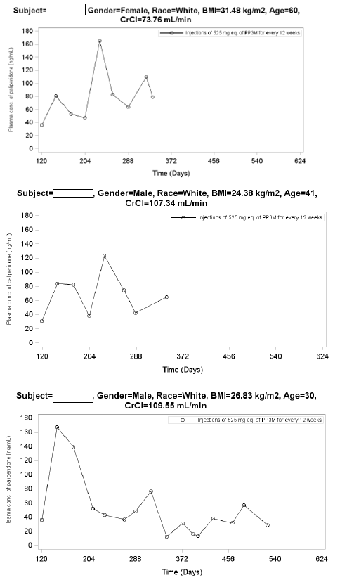
12 week maintenance phase at Day 120: single injection of 525 mg equivalent PP3M followed by a double blind phase at Day 204: single injection of 525 mg equivalent PP3M every 12 weeks.

Adverse events
While the number of subjects having an AE were similar URTI and nasopharyngitis were 9.4% for Invega Trinza versus 3.5% for placebo in the DB phase, weight increase was 8.8% versus 3.4%, headache was 8.8% versus 4.1% and akathesia 4.4% versus 0.7%.

Table 48: Overall summary of treatment emergent adverse events; open label and double blind phases
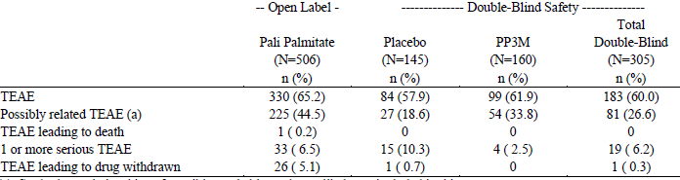
Study drug relationships of possible, probable, and very likely are included in this category. Note: Incidence is based on the number of subjects experiencing at least one adverse event, not the number of events.

Table 49: Treatment emergent adverse events in at least 2% of subjects in either treatment group by MedDRA system organ class and preferred term during the double blind phase
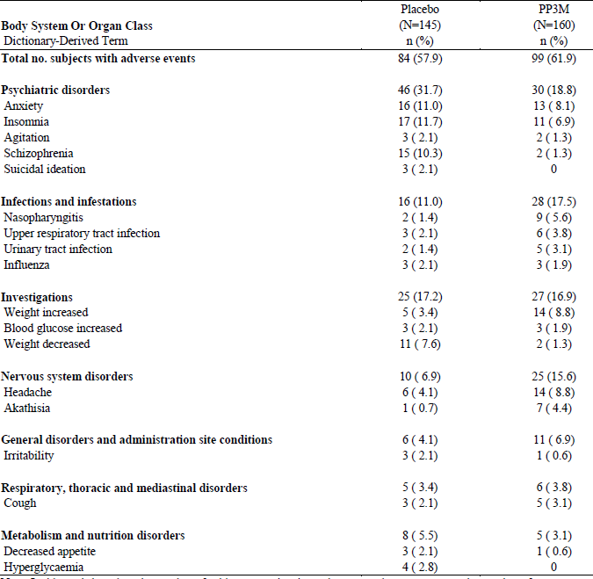
Note: Incidence is based on the number of subjects experiencing at least one adverse event, not the number of events.

Table 50: Subjects with plasma concentrations > 125 ng/mL AEs near the high concentration
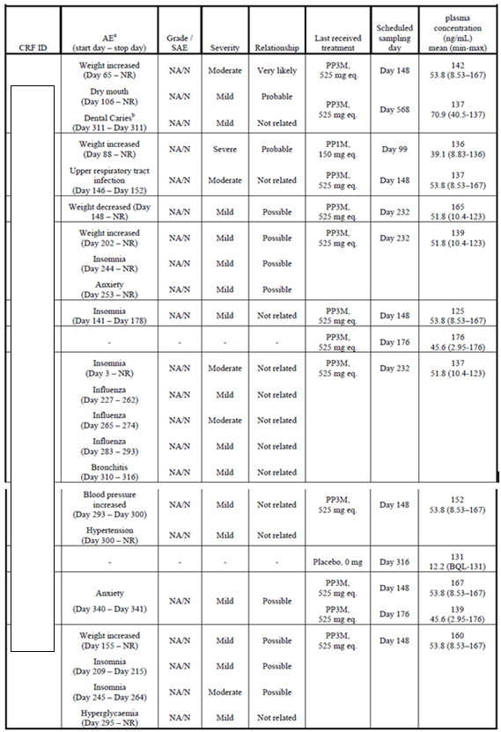
a. AEs occurring after first occurrence of paliperidone plasma concentration ≥ 125 ng/mL, or AEs occurring before first occurrence of paliperidone plasma concentration ≥ 125 ng/mL and resolving thereafter or any unresolved AEs. b. This AE was resolved before the scheduled sampling day 568. NA = Not available, NR = Not recovered.

Study 3011
This was a randomized, double blind, parallel group, multicentre non-inferiority study to determine if efficacy of paliperidone palmitate 3 month was non-inferior to the efficacy of 1 month formulation for the treatment of adults with schizophrenia.
The study consisted of 3 phases: Screening/Washout/Tolerability Phase a 17 week flexible dose Open label Stabilization Phase (referred to as the Open label Phase) and a 48 week randomized, fixed dose, Double blind Controlled Phase (referred to as the Double blind Phase).

Dose dumping
There were 19 subjects whose C_{max} suggested the possibility of rapid initial absorption after an injection in that other injections in the same subjects were not associated with similar high rises (see Figure 44 Individual concentration curves with high C_{max} for 1 (or some) injections). The infrequency of sampling precludes more definite explanation.
Figure 44: Individual concentration curves with high C_{max} for 1 (or some) injections (given at days 120, 204, 288, 372 ± 7days)
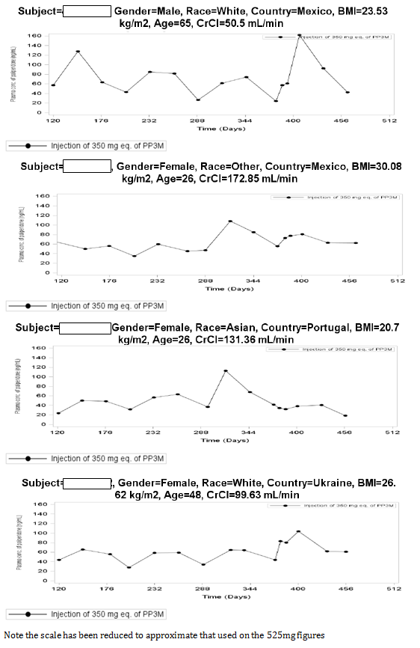
Figure 44 (continued): Individual concentration curves with high C_{max} for 1 (or some) injections (given at days 120, 204, 288, 372 ± 7days)
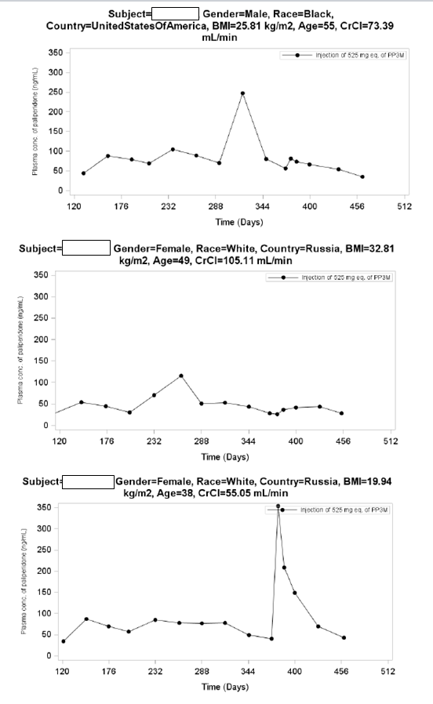
Figure 44 (continued): Individual concentration curves with high C_{max} for 1 (or some) injections (given at days 120, 204, 288, 372 ± 7days)
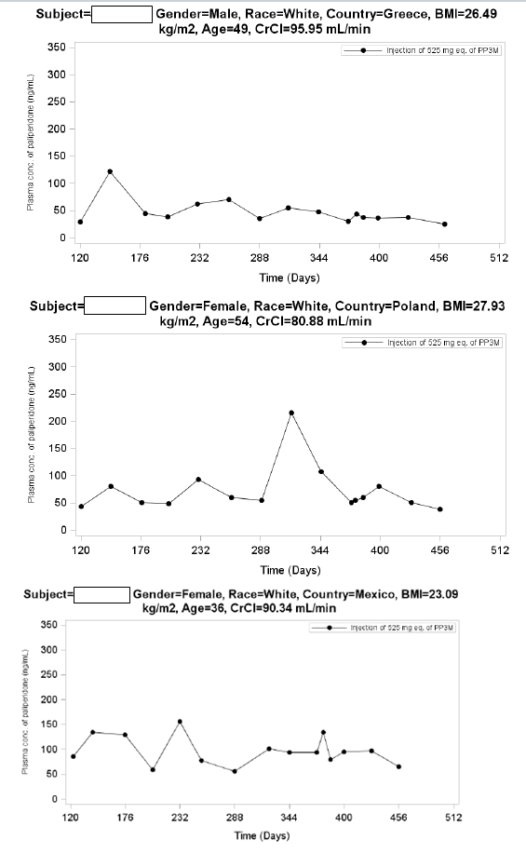
Figure 44 (continued): Individual concentration curves with high C_{max} for 1 (or some) injections (given at days 120, 204, 288, 372 ± 7days)
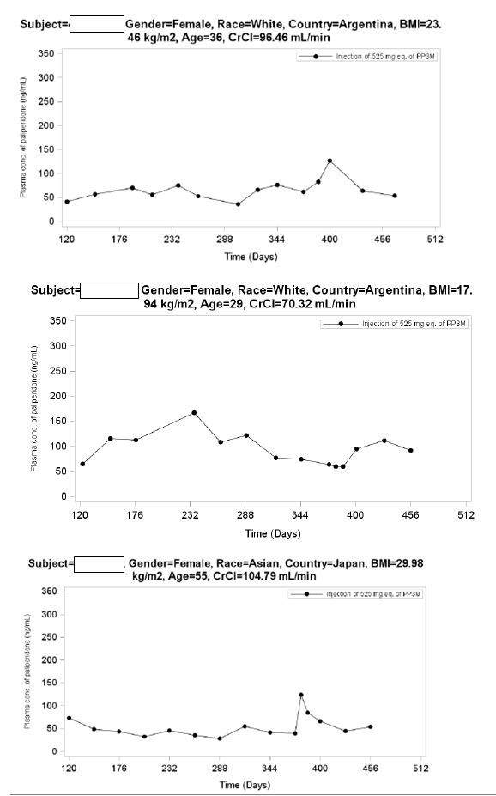
Figure 44 (continued): Individual concentration curves with high C_{max} for 1 (or some) injections (given at days 120, 204, 288, 372 ± 7days)
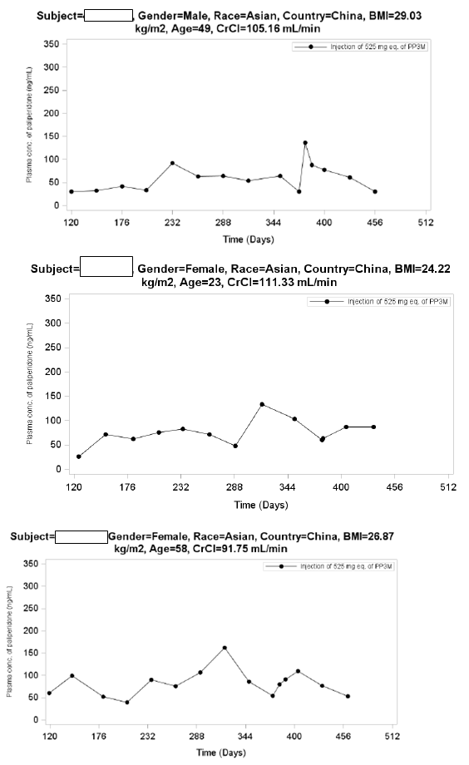
Figure 44 (continued): Individual concentration curves with high C_{max} for 1 (or some) injections (given at days 120, 204, 288, 372 ± 7days)
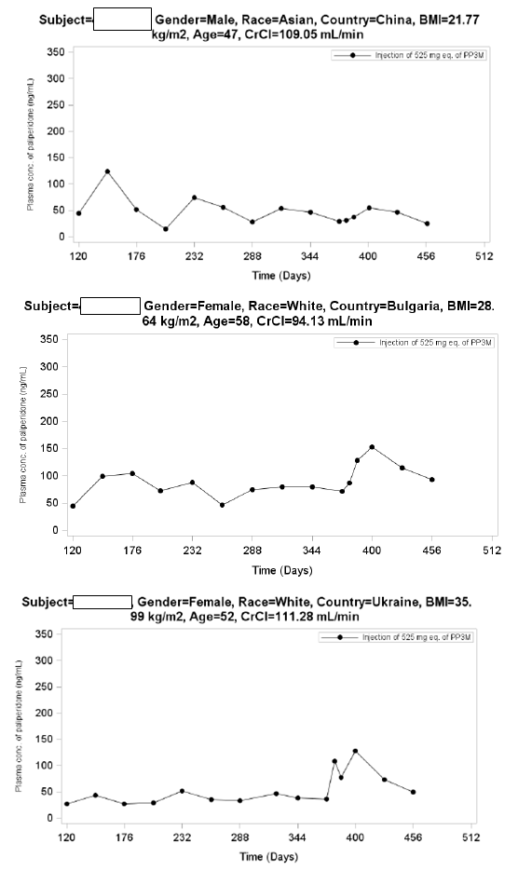

Adverse events
The 2 open label phase deaths were considered of doubtful relationship to the study drug, one was a sudden cardiac arrest in a 34y old female on Day 8. The 1 death on Invega Trinza was due to hepatocellular carcinoma on Day 316.

Table 50: Overall summary of treatment emergent adverse events; open label and double blind phases (ITT (OL) analysis set)
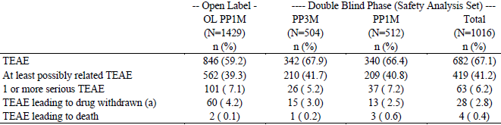
a. An adverse event that started in the Open label Phase and resulted in study drug being discontinued in the Double blind Phase is counted as treatment emergent in the Open label Phase.

Table 51: Treatment emergent extrapyramidal symptom (EPS)-related adverse events during the double blind phase (safety analysis set)
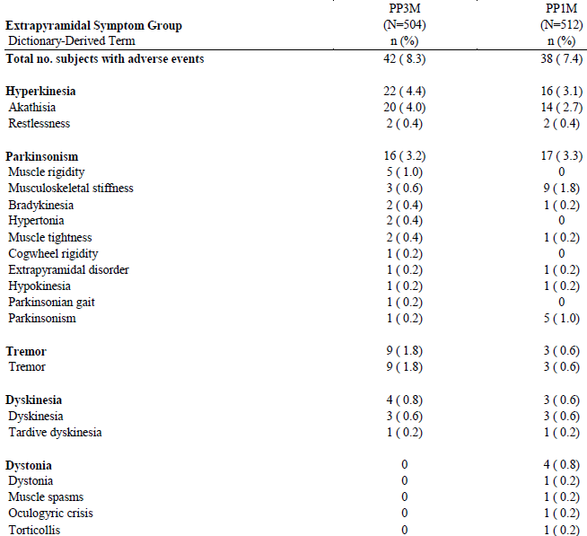
Incidence is based on the number of subjects experiencing at least one adverse event, not the number of events.

Table 52: Treatment emergent adverse events leading to study drug discontinuation during the double blind phase (safety analysis set)
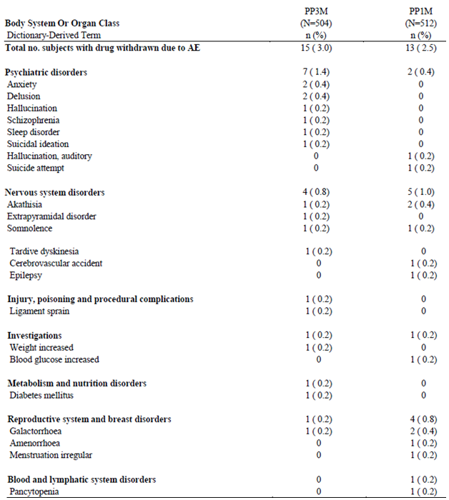
Incidence is based on the number of subjects experiencing at least one adverse event, not the number of events. An adverse event that started in the Open label Phase and resulted in study drug being discontinued in the Double blind Phase is counted as treatment emergent in the Open label Phase.

Table 53: Treatment emergent potentially prolactin-related adverse events by MedDRA preferred term and sex during the double blind phase (safety analysis set)
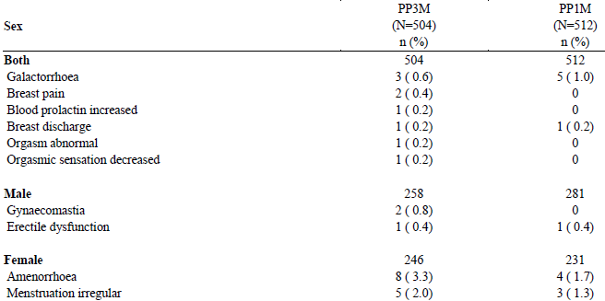
Incidence is based on the number of subjects experiencing at least one adverse event, not the number of events.
Glucose related AEs occurred at a higher frequency in the Invega Sustenna group compared with the Invega Trinza group (25 subjects [4.9%] versus 13 subjects [2.6%]).

Table 54: Treatment emergent adverse events related to injection site during the double blind phase (safety analysis set)
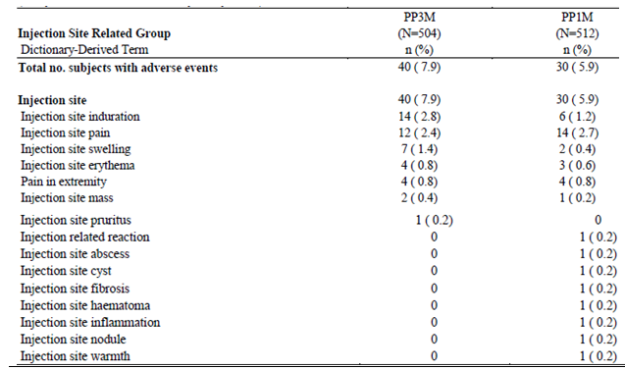
Incidence is based on the number of subjects experiencing at least one adverse event, not the number of events.

Adverse drug reactions
Two separate ADR analyses were conducted. The first analysis was conducted based on data from the placebo controlled, Phase III Study PSY-3012 and the Phase I study PSY-1005, while the second analysis was conducted based on data from the Phase III, active-controlled Study PSY-3011. Those ADRs identified from the first analysis were considered as ADRs in the second analysis.

Table 55: ADRs identified for PP3M summarized by MedDRA SOC
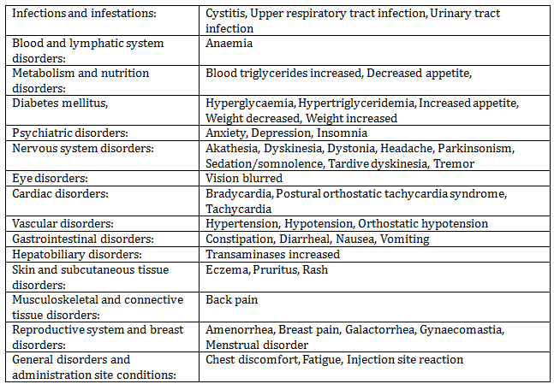
Individual preferred terms belonging to the same medical concept were grouped together and are indicated in underlined text

All adverse events (irrespective of relationship to study treatment)
Overall, the types and rates of clinically significant AEs of special interest in subjects treated with PP3M were consistent with the safety profile of PP1M.

Laboratory tests

Prolactin levels
Increases in mean prolactin concentrations from open label baseline were seen during the Open label Phase of Study 3011 on Invega Sustenna and Study 3012 on Invega Sustenna/Invega Trinza. The mean increases from open label baseline in prolactin were greater in female compared with male subjects who received Invega Trinza.
After randomization to Invega Trinza or Invega Sustenna in Study 3011, mean values in both treatment groups remained generally stable in both genders, with the mean change in serum prolactin from DB baseline to DB end point in the Invega Trinza group of -1.28 ng/mL for males and -3.37 ng/mL for females.
During the DB Phase of Study 3012, median prolactin concentrations stabilized or continued to rise for subjects who remained on Invega Trinza treatment, but declined in subjects randomized to placebo.
In the Invega Trinza group, the mean changes in prolactin concentrations from DB baseline to DB end point were 2.90 and 7.48 ng/mL in male and female subjects, respectively.

Weight
The proportion of subjects with an increase of ≥ 7% occurred at similar rates for the Invega Trinza and Invega Sustenna groups from DB baseline to end point (15% and 16%, respectively) in Study 3011. In Study 3012, a weight gain of ≥ 7% from DB baseline to end point was noted for 10% of subjects in the Invega Trinza group compared with 1% of subjects receiving placebo. The percentages of subjects who experienced a weight decrease of ≥7% from DB baseline to end point were 7% and 4% for the Invega Trinza and Invega Sustenna groups, respectively, in Study PSY-3011 and 1% and 8% in the Invega Trinza and placebo groups, respectively, in Study 3012.

Other safety issues

Cardiovascular safety
AEs related to QT prolongation during the DB Phases of study 3011was 0.4% each in Invega Trinza and Invega Sustenna groups; with none in 3012: DB Phase. All reported events related to QT prolongation in the DB Phase were non-serious.
Rates of tachycardia related AEs during the DB Phase for Invega Trinza and Invega Sustenna were 2.0% and 1.8%, respectively in study 3011, and for Invega Trinza and placebo (1 subject each, < 1%) in study 3012 DB phase.
During the DB Phase of study 3011, AEs related to orthostatic hypotension were 0.4% in the Invega Trinza group compared with 1.4% in the Invega Sustenna group. There were no AE reports of orthostatic hypotension in the Invega Trinza group during the DB Phase of Study 3012.

Electrocardiograph
In Studies 3011 and 3012, the incidence of abnormal ECG parameters (PR, QRS, and QT intervals) was ≤ 3% during the DB Phases in the Invega Trinza groups. In addition, abnormal increases in heart rate occurred at the same rate (6%) during DB treatment for the Invega Trinza and Invega Sustenna groups of Study 3011, and at a lower rate during the DB Phase in the Invega Trinza group (2%) compared to placebo (7%) in Study 3012. In both studies, abnormal decreases in heart rate occurred at similar rates in both DB treatment groups.
No subject in the Invega Trinza groups for either Phase III study had a QTcLD value above 480 msec.
In Study 3011, 1 subject each in the Invega Trinza and Invega Sustenna groups had a change in the QTcLD value of > 60 msec during the DB Phase relative to the average predose value. In the Invega Trinza subject, the absolute QTcLD value at the time of the increase was < 480 msec, and all QTc interval values were normal at the next study visit.
In Study 3012, no subject had a change in the QTcLD value of > 60 msec during the DB Phase relative to the average predose value. During the open label phase of this study (on Invega Sustenna/Invega Trinza), no subject had a QTcLD value > 480 msec, but 1 subject had increases in QTcLD interval of > 60 msec. This subject had a history of mitral valve prolapse and incomplete right bundle branch block, and the elevated QTcLD values did not recur in subsequent visits during the DB Phase where the subject received Invega Trinza.

Suicidality
There were no completed suicides in Invega Trinza treated subjects in the completed clinical studies, 3011, 3012, or 1005. There was 1 death due to suicide attempt (overdose of clozapine) during the DB Phase of Study PSY-3011 in the Invega Sustenna group; a second death in the Invega Sustenna group in this study was a possible suicide attempt (that is, toxicity to ingestion of various agents).
During the DB Phases, suicidality-related TEAEs were reported for 1.8% of subjects each (n = 9 each) in the Invega Trinza and Invega Sustenna groups in Study 3011, and for 1.3% (n = 2) and 2.1% (n = 3) of subjects in the Invega Trinza and placebo groups, respectively, in Study 3012. Most of these events consisted of suicidal ideation. Suicidality-related events led to study drug discontinuation for 1 subject each in the Invega Trinza and Invega Sustenna groups in 3011.

Extrapyramidal symptoms
In Study PSY-3011, the overall frequency of Extrapyramidal symptoms related TEAEs during the DB Phase was similar for PP3M and PP1M, and differences between the 2 treatment groups in the rates for specific Extrapyramidal symptoms related events were all < 2%. There was a single report of new-onset tardive dyskinesia with PP3M across the completed studies which resolved after discontinuation of study drug.
The rates of reported Extrapyramidal symptoms-related TEAEs were consistent with the findings based on Extrapyramidal symptoms rating scales, and there was no discernible increase in the use of anticholinergic medications relative to pre-study levels during treatment with PP3M in either Phase III study.

Evaluator’s overall conclusions on clinical safety
The possibility of dose dumping is of concern. Of the 48 patients receiving 525 mg, the 24 receiving it in the deltoid showed a C_{max} mean of 12.0 ng/mL (median 11.6 ng/mL). Patient 605113 on Days 1 (6 hours post dose), 2, 4, 6, and 10 of Period 2, had measured paliperidone concentrations of 153, 416, 243, 195, and 125 ng/mL respectively.
Based the appearance of the concentration curves for the 160 subjects receiving Invega Trinza in Study 3012 3 subjects (63801202, 60017109 and 60400605) with high concentrations suggested the possibility of rapid initial absorption after an injection in that the other injections in the same subjects were not associated with similar high rises. Similar events were seen in 19 of the 446 subjects receiving Invega Trinza in Study 3011.
Also of concern is the possibility of extended periods of low plasma paliperidone concentrations. The sponsor argues that clustering of relapses was not seen at a time when plasma levels would expect to be low. An alternative exploration is to compare the incidence in the first 3 month treatment period with those at steady state. (see also Figure 45).
Any conclusion about a differential effect of PP3M dose on the incidence of adverse events in the Double blind Phase is confounded by the clinical response and tolerability of PP1M for individual subjects in the open label phase.
Figure 45: Paliperidone Concentration-Time Profiles for subjects with < 7.5ng/mL
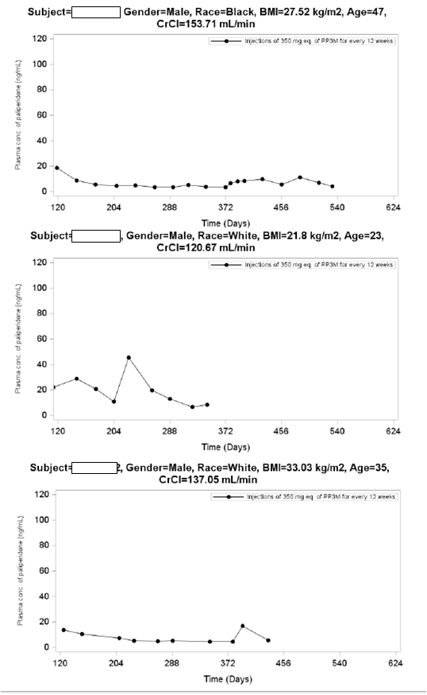

First round benefit-risk assessment

First round assessment of benefits
Efficacy of the currently registered one monthly formulation was based on conventional efficacy studies, with subsequent amendments to the Dosage based on PopPK studies.
This submission included a PopPK study of the plasma paliperidone levels resulting from Invega Sustenna treatment which found that the model used previously (to support amended dosage) only fitted the current data if 10% uncertainties were assigned to the parameters.
The existing model did not fit the Invega Trinza absorption data and a two compartment model rather than a one compartment model was necessary.
That is based on the PopPK analyses the new formulation behaves differently from the existing Invega Sustenna formulation.
Evidence for efficacy rests on 2 studies:
- 3012 was a placebo controlled study that was stopped at the interim analysis because it showed statistical significance of Invega Trinza over placebo.
- 3011 was a non-inferiority study of the new formulation against the currently registered active Invega Sustenna formulation. The study did not have a placebo control. It showed non-inferiority in the primary variable. But, based on the sample size, was not powered for the secondary variables and their p values were not given.
Clinical significance was claimed compared to placebo in Study 3012. However it was not discussed. The Lower bound of the 95% CI for the primary variable was less than the Hazard Ratio used to determine the sample size. The secondary variables all showed a 4% difference from placebo.
The benefits the sponsor claims in the proposed usage are:
- The PP3M formulation is expected to have advantages in terms of medication adherence and ease of use
- These benefits are likely to be particularly valuable for patients who prefer less frequent injections, those with limited access to healthcare, those who live in an underserved rural or inner city setting, and those who cannot coordinate bi-weekly or once monthly transportation for injection visits
- PP3M reduces the time needed for monitoring and follow-up of patients for medication adherence, potentially providing health care providers with additional time for implementing or monitoring psychosocial programs.
- PP3M is supplied in prefilled syringes that do not require reconstitution or refrigeration, further enhancing the ease of use of this LAI antipsychotic, especially in remote areas with limited healthcare provisions.

First round assessment of risks
It is of concern that the PK model used for simulations to justify dosing regimens does not include data from the long term Study 3011 being based on the single dose Study 1005 and Study 3012 where 160 received 2 injections of Invega Trinza only 18 received 3 injections.
The possibility of dose dumping is also of concern. In study 1005 one of the 48 patients receiving 525 mg equivalent had this occur. In study 3012 in the 160 subjects receiving Invega Trinza a further 3 possible events were seen and in Study 3011 similar events were seen in 19 of the 446 subjects receiving Invega Trinza; the infrequency of paliperidone measurement precluded clearer evaluation.
The PopPK studies did show the possibility of below therapeutic levels occurring in some patients with some dosage regimens, and some subjects did show this.
The sponsor argues that clustering of relapses was not seen at a time when plasma levels would expect to be low.
‘Any conclusion about a differential effect of PP3M dose on the incidence of adverse events in the double blind phase is confounded by the clinical response and tolerability of PP1M for individual subjects in the open label phase.’
The sponsor proposes:
‘PP3M shares the same active moiety as well as the same route of administration and formulation characteristics with the commercially-available PP1M product, the Company believes that the overall extent of exposure (total number of subjects exposed) and the well documented safety profile of PP1M are particularly relevant for PP3M.’
However the PopPK models submitted differ between the existing registered Invega Sustenna and this proposed good (Invega Trinza) that is they show an in vivo difference in absorption and covariates between the two.
Most of the comparisons for Safety the sponsor makes are between Invega Sustenna and Invega Trinza rather than with placebo.
In study 3012 (Placebo 145 subjects, Invega Trinza 160), while the overall number of subjects having an AE were similar, URTI and nasopharyngitis were 9.4% for Invega Trinza versus 3.5% for placebo in the DB phase, weight increase was 8.8% versus 3.4%, headache was 8.8% versus 4.1% and akathesia 4.4% versus 0.7%. The psychiatric events relevant to schizophrenia were higher in the placebo group.

First round assessment of benefit-risk balance

From CPMP/EWP/49/01
Long-acting parenteral antipsychotic medications have several advantages over short-acting oral or intra-muscular agents when administered for the treatment of chronic schizophrenia. The major advantage is the assurance of compliance leading to fewer relapses and re-hospitalisations.
As the efficacy and safety of the immediate formulation is accepted, in line with the modified release guideline, a bridging program should be performed to support the indication.
The purpose of the development is:
- to establish the full pharmacokinetics of the novel formulation including the relevant release properties and thus to show that the formulation is a depot
- to compare bioavailability of the active ingredient from the depot versus the oral formulation, to assess the duration of an acceptable level of the active ingredient
- to compare the efficacy versus the oral formulation in stabilised patients
- to address switching from oral to the depot formulation
- to assess safety issues specific to the depot formulation.
It has been discussed whether these points could be addressed by pharmacokinetic studies and safety data alone. For this the relation between PK and effect should be known.
Most of these dot points have been fulfilled.
- To compare the efficacy versus the oral (in this case 1month versus 3month) formulation in stabilised patients. This was conducted in Study 3011. To quote the guideline ‘Placebo, as an additional arm would ensure assay sensitivity.’ 37 subjects (8.1%) in the Invega Trinza group and 45 subjects (9.2%) subjects in Invega Sustenna group had a relapse event during the Double blind Phase. In interpreting the non- inferiority result the population size calculations to show with 90% power that PP3M was no worse than PP1M were based on an expected survival (percentage of subjects remaining relapse-free) rate in PP1M of 70%. Whereas Study 3001 showed a 10% relapse rate (90% survival) on Invega Sustenna at the time of the Interim (primary) Analysis when only 37% of subjects in the Invega Sustenna group had received at least 5 injections (4 months of injections).
- To assess safety issues specific to the depot formulation. The sponsor undertook adequate length of exposure showing there exists an approximate 2% risk of dose dumping (high initial levels of paliperidone). The sponsor has generally reviewed the risk of increased AEs against those of the existing approved formulation.
Against these deficiencies the sponsor has the results of a physicians’ survey that showed a willingness by physicians to accept a decrease in efficacy for patients with a history of poor adherence to dosing.
This evaluator finds the benefit-risk balance of Invega Trinza, given the proposed usage, and based on the guideline is favourable but with some reservations in relation to the approximately2% incidence of dose dumping.

First round recommendation regarding authorisation
It is recommended that authorisation of registration occur, but with the proviso that the PI carry a warning on dose dumping.

Clinical questions

Clinical questions

Pharmacokinetics
- Submission 2014-03466 relied on simulations performed using the then accepted PopPK model. The following tables are based on simulations using that model. Please update the following tables using the final model achieved for this submission (as in REP-1-JAN-PAL-PMX-1).

Table 56: Percentages of patients will have levels below 7.5 ng/mL predose (that is potentially sub-therapeutic concentrations) early in treatment in those patients who have ceased taking medication that is with no recent prior medication
Second injection | Predose Day 8 | Predose Day10 | Predose Day 12
On Day 8 | 16
On Day 10 |  | 15
On Day 12 |  |  | 13

Table 57: Percentages of patients will have levels below 7.5 ng/mL predose (that is potentially sub-therapeutic concentrations) late in the first treatment cycle in those patients who have ceased taking medication that is with no recent prior medication
Second injection | Day 22 | Day 29 | Day 36
Day 4 | 8 | 13 | 16
Day 6 | 7 | 12 | 15
Day 8 | 4 | 11 | 15

Table 58: Maximum exposure (C_{max}) in patients on oral paliperidone PR 6 mg for 5days (that is as per PI for patients not previously exposed) using the upper 90% limit for plasma concentration as pre dose level at initial injection
Second injection | C_{max} ng/mL
On Day 4 | 49.34
On Day 6 | 47.95
on Day 8 | 46.22
Prev max from 150/150ª | 49.34
From Study R092670-PSY-1008 and -3006 150/150 mg eq on Day 1/Day 8

Second round evaluation of clinical data submitted in response to questions
Sponsor response:
The PP1M population PK model, as published by Samtani et al. and described in the submitted PP1M population PK report should then be considered the representative description of paliperidone PK after PP1M administration. Therefore, the PK simulations performed using that model, including those mentioned by the evaluator should be still considered valid.
Evaluation of the response:
The sponsor’s response was satisfactory.

Second round benefit-risk assessment

Second round assessment of benefits
No new clinical information was submitted in response to questions. Accordingly, the risks are unchanged from those identified in the first round assessment of benefits.

Second round assessment of risks
No new clinical information was submitted in response to questions. Accordingly, the risks are unchanged from those identified in the first round assessment of risks.

Second round assessment of benefit-risk balance
The benefit-risk balance is thus considered unchanged.

Second round recommendation regarding authorisation
In commenting on this evaluator’s recommendations concerning the proposed PI the sponsor objected to the use of the term ‘dose dumping. The recommendation regarding authorisation is recommended accordingly.
It is recommended that authorisation of registration occur, but with the proviso that the PI carry a warning of the possibility of early rapid absorption.

Therapeutic Goods Administration
PO Box 100 Woden ACT 2606 Australia
Email: info@tga.gov.au Phone: 1800 020 653 Fax: 02 6232 8605
https://www.tga.gov.au

This departure from proposed recommended dosage timing is based on PopPK study
REP-1-JAN-PAL-PMX-1
The Positive and Negative Syndrome Scale (PANSS) was used to assess neuropsychiatric symptoms of schizophrenia. It has a 30-item scale that provides a total score (sum of the scores of all 30 items; 30-210) and scores for 3 subscales, the positive subscale (7 items), the negative subscale (7 items), and the general psychopathology subscale (16 items). Each scale was rated 1 (absent) to 7 (extreme). This gives a range of 180 points (30 to 210).
stated in the protocol as to be excluded
Comment: Invega Trinza is both a greater volume and a higher concentration than Invega Sustenna
Absolute conditional weighted residuals > 5.
The model was refitted with no more than 10% uncertainty in the model parameters.
Table 4 POP-PK Report PSY-3007 1Oct2008
Table 4 REP-1-JAN-PAL-PMX-1
Table 6 REP-1-JAN-PAL-PMX-1
There was a second such case but this evaluator considered it to be dose-dumping.
below the therapeutic threshold see also submissions 2009-00926 and 2014-03466
A 17 week transition phase: 150mg eq. PP1M on Day 1, 100mg eq. PP1M on Day 8, flexible dose on Day 36 and Day 64 (50, 75, 100, or 150mg eq.), dose of Day 92 is the same as Day 64, followed by a 12 week maintenance phase: single injection of a fixed dose of PP3M (175, 263, 350 or 525mg eq.), followed by a double blind phase: single injection of a fixed dose of PP3M (175, 263, 350 or 525mg eq.) or placebo.
below the therapeutic threshold see also submissions 2009-00926 and 2014-03466
Below the therapeutic threshold see also submissions 2009-00926 and 2014-03466.
According to the submission this level (7.5ng/mL) is thought to represent 60% D₂ receptor occupancy but it was the level rather than the occupancy that was assessed.
Clarification PSY-1005, is a single dose study in which patients had not been treated with PP1M prior to the PP3M injection. This is different than the clinical situation since all patients will be at or near steady state with PP1M before PP3M is initiated. This allows PP3M to achieve near steady state levels. If PP3M is started without this initial PP1M treatment, it would take several cycles to achieve steady state.
except the results of subject [information redacted] which showed a dramatic rise at the end of the study.
the model was refitted with no more than 10% uncertainty in the model parameters.
The relatively higher relapse rates observed in Japanese centres may be explained by a variety of factors, including differences in medical practice with regards to polypharmacy, differences in clinical judgment and determination of relapse events (possibly associated to cultural factors)
These were not mentioned in the body of the Clinical Study Report
The Clinical Global Impression-Severity (CGI-S) rating scale was used to rate the severity of a subject’s overall clinical condition on a 7-point scale ranging from 1 (not ill) to 7 (extremely severe).
The Personal and Social Performance Scale (PSP scale) assessed the degree of difficulty a subject exhibits over a 7-day period within 4 domains of behaviour (1) socially useful activities, (2) personal and social relationships, (3) self-care, and (4) disturbing and aggressive behaviour. The results are totalled in a 100 point scale.
This would appear to be the Hazard Ratio – Interpreting risks and ratios in therapy trials Scott Australian Prescriber 31:1 Feb 2008 and Hazard Ratio in Clinical Trials Spruance et al Antimicrobial Agents and Chemotherapy Aug 2004 p2787
Only 18 or 11% received a second PP3M injection in that phase
18 or 11% received a second PP3M injection in that phase
CSR R10/33865
Leucht S, et al. Recurrence prevention in schizophrenia with new-generation antipsychotics: a systematic review and exploratory meta-analysis of randomized, controlled trials. Am J Psychiatry 2003; 160: 1209-1222.
Kaplan-Meier estimate
18 or 11% received a second PP3M injection in that phase
Clarification; some of the difference might be accounted for by the less rigid investigator’s opinion criteria used in the Maintenance Phase.
Non-inferiority trials: determining whether alternative treatments are good enough Ian A Scott Med J Aust 2009; 190 : 326-330.
(1) to evaluate the pharmacokinetics (PK), safety, and tolerability of a 3-month injection interval formulation of paliperidone palmitate (F015), manufactured using a wet and dry milling technique, at a single dose of 300mg eq. administered in the gluteal muscle in subjects with schizophrenia (Panel A); (2) to evaluate the PK, safety, and tolerability of single escalating doses of the 3-month injection interval formulation of paliperidone palmitate administered in the gluteal and deltoid muscle in subjects with schizophrenia (Panels B and D).
The scales for concentration differ between figures
93/100 predose
79/100 predose
57/100 predose
On the FDA website the following was found: “The term “dose dumping” is frequently used and often indiscriminately: Describes accelerated drug release from modified release formulations (MRF) The term is non-quantitative and implies actual clinical importance Based historically on PK data; for most CNS drugs PK is highly variable and there is a poor correlation of PK and PD”

