First round evaluation: 9 October 2015
Second round evaluation 27 February 2016

AusPAR Attachment 2

Extract from the Clinical Evaluation Report for Oxycodone / Naloxone
  - Proprietary Product Name: Targin
  - Sponsor: Mundipharma Pty Ltd

About the Therapeutic Goods Administration (TGA)
- The Therapeutic Goods Administration (TGA) is part of the Australian Government Department of Health, and is responsible for regulating medicines and medical devices.
- The TGA administers the Therapeutic Goods Act 1989 (the Act), applying a risk management approach designed to ensure therapeutic goods supplied in Australia meet acceptable standards of quality, safety and efficacy (performance), when necessary.
- The work of the TGA is based on applying scientific and clinical expertise to decision-making, to ensure that the benefits to consumers outweigh any risks associated with the use of medicines and medical devices.
- The TGA relies on the public, healthcare professionals and industry to report problems with medicines or medical devices. TGA investigates reports received by it to determine any necessary regulatory action.
- To report a problem with a medicine or medical device, please see the information on the TGA website <https://www.tga.gov.au>.
About the Extract from the Clinical Evaluation Report
- This document provides a more detailed evaluation of the clinical findings, extracted from the Clinical Evaluation Report (CER) prepared by the TGA. This extract does not include sections from the CER regarding product documentation or post market activities.
- The words [Information redacted], where they appear in this document, indicate that confidential information has been deleted.
- For the most recent Product Information (PI), please refer to the TGA website <https://www.tga.gov.au/product-information-pi>.
Copyright
© Commonwealth of Australia 2017
This work is copyright. You may reproduce the whole or part of this work in unaltered form for your own personal use or, if you are part of an organisation, for internal use within your organisation, but only if you or your organisation do not use the reproduction for any commercial purpose and retain this copyright notice and all disclaimer notices as part of that reproduction. Apart from rights to use as permitted by the Copyright Act 1968 or allowed by this copyright notice, all other rights are reserved and you are not allowed to reproduce the whole or any part of this work in any way (electronic or otherwise) without first being given specific written permission from the Commonwealth to do so. Requests and inquiries concerning reproduction and rights are to be sent to the TGA Copyright Officer, Therapeutic Goods Administration, PO Box 100, Woden ACT 2606 or emailed to <tga.copyright@tga.gov.au>.

Contents
List of abbreviations 5
1. Introduction 9
2. Clinical rationale 9
2.1. Clinical rationale for existing indications 9
2.2. Clinical rationale for proposed treatment of restless legs syndrome 9
2.3. Clinical rationale for increase in maximum dose 10
2.4. Clinical rationale for discussion of abuse potential in PI 11
3. Contents of the clinical dossier 11
3.1. Scope of the clinical dossier 11
3.2. Paediatric data 12
3.3. Good clinical practice 12
4. Pharmacokinetics 12
4.1. Studies providing pharmacokinetic data 12
4.2. Summary of pharmacokinetic data 13
4.3. Physicochemical characteristics of the active substance 13
4.4. Pharmacokinetics in healthy subjects 13
4.5. Pharmacokinetics in the target population 17
4.6. Pharmacokinetics in other special populations 18
4.7. Pharmacokinetic interactions 18
4.8. Evaluator’s overall conclusions on pharmacokinetics 19
5. Pharmacodynamics 19
5.1. Studies providing pharmacodynamic data 19
5.2. Summary of new pharmacodynamic data 20
5.3. Evaluator’s overall conclusions on pharmacodynamics 23
6. Dosage selection for the pivotal studies 24
7. Clinical efficacy 24
7.1. Efficacy studies in restless leg syndrome 24
7.2. Analyses performed across trials (pooled analyses and meta-analyses) 97
7.3. Evaluator’s conclusions on clinical efficacy 99
8. Clinical safety 102
8.1. Studies providing evaluable safety data 102
8.2. Patient exposure 103
8.3. Adverse events 107
8.4. Laboratory tests 123
8.5. Post-marketing experience 131
8.6. Safety issues with the potential for major regulatory impact 131
8.7. Other safety issues 132
8.8. Safety related to drug-drug interactions and other interactions 132
8.9. Evaluator’s overall conclusions on clinical safety 134
9. First round benefit-risk assessment 136
9.1. Benefit-risk assessment in RLS 136
9.2. Benefit-risk assessment of higher maximum dose in chronic pain 136
9.3. First round recommendation regarding authorisation 141
10. Clinical questions 141
10.1. Pharmacokinetics 141
10.2. Pharmacodynamics 141
10.3. Efficacy 141
11. Second round evaluation of clinical data submitted in response to questions 144
11.1. Clinical questions 145
11.2. Discussion of abuse potential 149
12. Second round benefit-risk assessment 158
13. Second round recommendation regarding authorisation 158
13.1. Recommendation regarding RLS 158
13.2. Recommendation regarding higher maximum dose 158
13.3. Recommendation regarding proposed discussion of abuse potential in PI 158
14. References 158

List of abbreviations
Abbreviation | Meaning
AE | Adverse Event
ALT | Alanine Transaminase
ANCOVA | Analysis of Covariance
ASRS | Augmentation Severity Rating Scale
BFI | Bowel Function Index
BMI | Body Mass Index
BPI-SF | Brief Pain Inventory-Short-Form
BSFS | Bristol Stool Form Scale
CI | Confidence Interval
COWS | Clinic Opiate Withdrawal Scale
CSBM | Complete Spontaneous Bowel Movements
CSR | Clinical Study Report
DA | Dopamine Agonist
ECG | Electrocardiogram
EORTC QLQ-C30 | European Organisation for Research and Treatment of Cancer – Quality of Life Questionnaire – core 30
EU | European Union
EURLSSG | European Restless Legs Syndrome Study Group
EuroQol EQ-5D | European Quality of Life Questionnaire – 5 Dimensions
EWP | Efficacy Working Party
FA | Full Analysis
FRA | Flexor Reflex Afferents
GGT | Gamma glutamyl transferase
GI | Gastrointestinal
ICH | International Conference on Harmonisation
IRLS | International Restless Legs Syndrome Study Group Rating Scale
IRLSSG | International Restless Legs Syndrome Study Group
IN | Intranasal
IR | Immediate Release
ITT | Intent to Treat
IV | Intravenous
LDH | Lactate dehydrogenase
LOCF | Last Observation Carried Forward
LSM | Least Squares Mean
MedDRA | Medical Dictionary for Regulatory Activities
mg | Milligram
MMRM | Mixed Model Repeated Measures
MOS | Medical Outcome Study (Sleep scale)
MPI | (in the context of RLS studies) Max-Planck Institute
MPI | (in the context pain studies) Multidimensional Pain Inventory
NAS | Numeric Analogue Scale
NRS | Numeric Rating Scale
OXN PR | Oxycodone/Naloxone Prolonged Release Combination Tablet
Oxy API | Oxycodone Active Pharmaceutical Ingredient
Oxy IR | Oxycodone Immediate-Release Formulation
OxyPR | Oxycodone Prolonged-Release Formulation
PAC-SYM(b) | Patient Assessment of Constipation
PD | Pharmacodynamic
PI | Product information Sheet
PK | Pharmacokinetics
PLMS | Periodic Limb Movements in Sleep
PP | Per Protocol
PR | Prolonged Release
PSG | Polysomnography
PSUR | Periodic Safety Update Report
PT | Preferred Term
q12h | Every 12 hours
QoL – RLS | Quality of Life Restless Legs Syndrome Questionnaire
QTc QT | Interval Corrected for Heart Rate
R | Randomisation
RCT | Randomised Controlled Trial
RLS | Restless Legs Syndrome
RLS-DI | Restless Legs Syndrome Diagnostic Index
SAE | Serious Adverse Event
SD | Standard Deviation
SmPC | Summary of Product Characteristics
SOC | System Organ Class
SOWS | Subjective Opiate Withdrawal Scales
TEAE | Treatment-emergent Adverse Event
V | Visit
VAS | Visual Analogue Scale
Vs | Versus
WASM | World Association of Sleep Medicine
WHO | World Health Organisation
WOMAC | Western Ontario and McMaster Universities Index for Osteoarthritis

Introduction
This is a Category 1 application to vary the registration of Targin (oxycodone/naloxone prolonged-release tablets). The sponsor seeks approval for three major variations:
- Major Variation Type C –Extension of indications to include Restless Legs Syndrome;
- Major Variation Type F – Registration of a new maximum daily dose (160 mg/80 mg) and higher strength tablets (60 mg/30 mg and 80 mg/40 mg);
- Major Variation Type J - Changes to the Product Information, discussing the abuse-deterrent characteristics of Targin when diverted to the intranasal or intravenous routes.

Clinical rationale

Clinical rationale for existing indications
According to the approved PI, oxycodone ‘is a full opioid receptor agonist whose principal therapeutic action is analgesia. It has an affinity for endogenous mu, kappa and delta opiate receptors in the brain, spinal cord and peripheral organs (for example, intestine). Binding of oxycodone to endogenous opioid receptors in the central nervous system (CNS) results in pain relief. Oxycodone is similar to morphine in its action. Other pharmacological actions of oxycodone are in the CNS (respiratory depression, antitussive, anxiolytic, sedative and miosis), smooth muscle (constipation, reduced gastric, biliary and pancreatic secretions, sphincter of Oddi spasm and transient elevations in serum amylase), and cardiovascular system via histamine release and peripheral vasodilation (pruritus, flushing, red eyes, sweating and orthostatic hypotension).’
When used to treat chronic pain, Targin has two potential advantages over other oral narcotic preparations: the prolonged-release formulation provides a more even pharmacokinetic profile with extended analgesic benefit, compared to immediate-release preparations; and the inclusion of naloxone minimises constipation, one of the major complications of chronic narcotic use.

Clinical rationale for proposed treatment of restless legs syndrome
Restless legs syndrome (RLS) is a common neurological condition characterised by subjective discomfort in the legs associated with an unpleasant urge to move the legs in an attempt to relieve the discomfort. It is sometimes subdivided into primary RLS, for which the cause is unknown, and secondary RLS, which is usually due to neurogenic discomfort in the legs in the setting of peripheral neuropathy or radiculopathy. There is evidence that primary RLS is a movement disorder that is in part produced by dysfunction of the basal ganglia and other dopaminergic systems in the brain: for instance, treatment with the dopamine precursor, levodopa, or with dopamine agonists such as pramipexole has been shown to lessen the symptoms of RLS.
RLS has been shown to impair quality of life. Subjects with RLS may find it intolerable to sit still for prolonged periods, making it difficult for them to travel and to attend social functions. RLS symptoms at night may interfere with sleep, leading to subsequent daytime somnolence and mood disorders. RLS may also be painful.
Most treatment guidelines for RLS suggest that initial treatment should be with levodopa or dopamine agonists, but many patients fail to respond adequately. Some subjects respond initially but eventually experience loss of efficacy with dopaminergic agents, or paradoxical worsening (augmentation) of symptoms with continued treatment. Many experts (Trenkwalder, 2008b; Vignatelli et al., 2006; Walters et al., 1993, Garcia-Borrequero et al., 2007b) suggest that narcotic analgesics may be useful for refractory cases, and there are widespread anecdotal reports that narcotic analgesics (including paracetamol-codeine combinations) have been adopted by patients to replace or to supplement dopaminergic agents when the response to dopaminergic agents has been unsatisfactory. In part, this treatment was based on the simple logic that opioids may relieve pain and discomfort, and RLS involves an element of leg discomfort. The benefits may involve mechanisms beyond those related to analgesia, however, and it is believed that opioids may have favourable effects on the dopaminergic system in this condition.
The proposed PI states: ‘Opioids have their impact on Restless Legs Syndrome (RLS) symptoms by modulating the dopamine system.’ The Clinical Study Report (CSR) for OXN3502 provides a much more extensive rationale for the use of opioids in RLS. Until now, however, there has been no adequate trial data supporting this practice, although it is recommended by many experts. As the sponsor states in the CSR: ‘According to expert opinion, oxycodone seems to be the best described opioid in RLS [Trenkwalder, 2008b; Vignatelli et al., 2006; Walters et al., 1993].’
The sponsor has performed a single pivotal study for this indication, along with an open-label extension phase, in subjects with inadequate control of RLS following treatment with dopaminergic agents or levodopa.

Clinical rationale for increase in maximum dose
Patients with chronic severe pain may develop tolerance to opioids, requiring dose escalation, or they may have an inadequate response to low doses when these are first used. Usual clinical practice is to cautiously increase the opioid dose as needed. For oxycodone, prolonged-release naloxone-free preparations (OxyContin) have already been approved at doses up to 80 mg twice daily. Targin is currently only approved to doses up to 40/20 mg twice daily, and clinical experience suggests that this dose is inadequate for some patients.
The sponsor makes the following observations about the need for higher doses:
‘The approved dose range of OXN PR is up to OXN80/40 mg PR per day, which is sufficient to manage a significant segment of the population of patients with severe pain. However, market research conducted in Germany in 2011 (IMS Heath Disease analyser; period Sep 2010 to Aug 2011) revealed that 32.2 % of prescriptions were > 80 mg oxycodone per day and 11.2 % >160 mg oxycodone or equivalent per day for 18051 non-malignant pain patients under the care of 420 General Practioners [sic] (GPs). This emphasizes that there is a considerable amount of patients requiring doses >80 mg oxycodone per day. Therefore, it is evident that there is a need for OXN PR daily doses higher than 80/40 mg.’
Current recommended practice for patients who are on Targin and require higher oxycodone doses is to combine the maximum approved dose of Targin (40/20 mg twice daily) with top-up doses of OxyContin, up to a total oxycodone dose of 80 mg twice daily, using the two formulations combined. This combination is logistically awkward, requiring multiple prescriptions, and it leads to use of a lower proportion of naloxone, relative to the oxycodone component, than is used at standard Targin doses. (For instance, at the maximum combination dose, subjects would receive oxycodone 80 mg twice daily and naloxone 20 mg twice daily, a 4:1 ratio instead of the standard 2:1 ratio). There is no evidence that a low proportion of naloxone is more appropriate than the standard proportion, and the current awkward situation largely reflects that adequate studies of higher dose Targin had not been performed at the time Targin was registered. If it could be proven that higher doses of Targin were safe and effective, there would be an obvious clinical role for such doses.

Clinical rationale for discussion of abuse potential in PI
Oral narcotics prescribed for treatment of pain can be diverted to recreational use and administered via the intravenous (IV) or intranasal (IN) routes – these routes may be preferred by recreational users because they are associated with a relatively rapid rise in narcotic levels, which produces a likeable effect or ‘high’.
When administered orally, naloxone has minimal systemic effects because of extensive first-pass metabolism, but diversion to other routes (IV, IN) could increase the bioavailability of naloxone and this would be expected to antagonise the opioid component of Targin, producing a less satisfying high than other oral agents diverted to the IV or IN routes. Bioavailability of naloxone via the intravenous route is essentially complete, and the sponsor points out that ‘The high bioavailability of IN naloxone is supported by studies demonstrating reversal of opioid effects in overdose patients and in animal PK studies (Hussain et al. 1984; Kerr et al. 2009; Robertson et al. 2009).’ [Study report for ONU003]. Thus, compared to opioid monotherapy preparations, Targin might be a less attractive agent for opioid abusers to divert.
The sponsor has performed a number of studies broadly confirming these pharmacological principles, and would like to include this data in the new PI. Unfortunately, as will be discussed, the sponsor’s proposed description of these studies does not present a balanced summary of the evidence. In particular, the submitted evidence suggests that it is possible for users of Targin to produce a ‘high’ by chewing the tablet and some of the benefits proposed by the sponsor appear to be seen only in subjects receiving concurrent methadone.

Contents of the clinical dossier

Scope of the clinical dossier
The submission consisted of three disconnected parts, each with its own clinical overview and efficacy and safety summaries corresponding to each of the three proposed variations.
In support of the RLS indication, the submission contained the following clinical information:
- One pivotal efficacy and safety study (OXN3502).
- One open-label extension study (OXN3502S).
In support of the higher dose, the submission contained the following clinical information:
- Three pharmacokinetic studies (OXN1506, OXN1505, and OXN1507).
- One pivotal efficacy and safety study (OXN3506).
- Four supportive efficacy studies (OXN2001S, OXN3503, OXN3505, 038-002).
- Pooled efficacy and safety analysis of data from those studies and supportive studies that have been submitted previously (OXN2001, OXN3001, OXN3006, OXN3401, OXN3001S, OXN3006S, OXN3401S).
In support of the abuse-potential discussion proposed for inclusion in the PI, the submission contained the following:
- Two bioequivalence studies (ONU1001, ONU1002), comparing UK and US manufacturing
- A bioavailability study (ONU1009), which assessed the relative bioavailability of oral oxycodone in Targin 20/10 mg compared with a marketed product containing oxycodone (oral OxyContin modified release tablet, 20 mg), and the relative bioavailability of naloxone compared with two marketed products containing naloxone.
- Four safety/pharmacodynamic/pharmacokinetic (Safety/PD/PK) studies (ONU1003, ONU1004, ONU1007, ONU1008), which assessed the abuse potential of Targin versus an active comparator (oxycodone in solution) and placebo.

Paediatric data
The submission did not include paediatric data.

Good clinical practice
The submitted studies included statements of compliance with Good Clinical practice (GCP) and appeared to have been conducted in accordance with the principles of GCP.

Pharmacokinetics

Studies providing pharmacokinetic data
The PK of Targin has already been well characterised, but the current submission includes 6 PK studies (two of which have been submitted previously).
Three biopharmaceutical studies (OXN1506, OXN1505, and OXN1507; Table 1) were submitted in support of the higher-strength tablets and the increased maximum dose.
- The food-effect and relative bioavailability study (OXN1505) had already been submitted to the TGA to register Targin at strengths of 2.5/1.25 mg, 15/7.5 mg and 30/15 mg. This study assessed the effect of a standardised high fat meal on the bioavailability of Targin 80/40 mg and the relative bioavailability of Targin 80/40 mg compared to an oral solution containing oxycodone 20 mg and naloxone 10 mg.
- The dose-proportionality study (OXN1506) had also been previously submitted to the TGA to register Targin at strengths of 2.5/1.25 mg, 15/7.5 mg and 30/15 mg. This study assessed the PK dose-proportionality of Targin in the dose range of 2.5/1.25 mg to 80/40 mg.
- A new multiple-dose study (OXN1507) was submitted. This study assessed the PK of oxycodone and naloxone from Targin 80/40 mg and 40/20 mg tablets at steady state, demonstrating dose-adjusted bioequivalence.

Table 1: PK Studies Submitted for New Dose Strengths
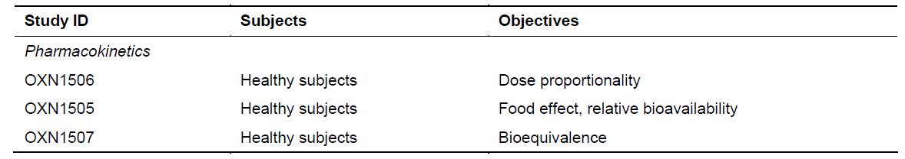
In reference to the proposed new discussion in the PI of the abuse potential of Targin, the sponsor submitted the following three PK studies:
- Two bioequivalence studies (ONU1001, ONU1002) compared UK and US manufacturing.
- One bioavailability study (ONU1009) assessed the relative bioavailability of oral oxycodone in Targin 20/10 mg compared with oral OxyContin 20 mg, and the relative bioavailability of naloxone in Targin compared with two marketed naloxone products.
Table 2 shows the studies relating to each pharmacokinetic topic and the location of each study summary.

Table 2: Submitted Pharmacokinetic Studies.
PK topic | Subtopic | Study ID | *
PK in healthy adults | General PK - Single dose | OXN1506 | *
PK in healthy adults | General PK - Single dose | OXN1505
PK in healthy adults | - Multi-dose | OXN1507 | *
PK in healthy adults | Bioequivalence† - Single dose | OXN1505
PK in healthy adults | Bioequivalence† - Single dose | ONU1001  ONU1002  ONU1009 | *  *  *
PK in healthy adults | - Multi-dose | OXN1507
PK in healthy adults | Food effect | OXN1505 | *
* Indicates the primary aim of the study.
† Bioequivalence of different formulations.
None of the pharmacokinetic studies had deficiencies that excluded their results from consideration.

Summary of pharmacokinetic data
The sponsor did not submit a complete reassessment of the PK of Targin, which has already been well characterised. The information in the following summary focuses on new information provided in the submission.

Physicochemical characteristics of the active substance
No new data related to the physicochemical characteristics of oxycodone or naloxone were submitted.

Pharmacokinetics in healthy subjects

Absorption
No new data related to the absorption of Targin were submitted.

Bioavailability

Absolute bioavailability
The bioavailability of Targin components relative to intravenous agents was not reassessed in this submission.

Bioavailability relative to an oral solution or micronised suspension
Bioavailability relative to an oral solution was assessed in Study OXN1505, which had already been submitted to the TGA. This study assessed the relative bioavailability of Targin 80/40 mg (OXN PR) compared to an oral solution containing oxycodone 20 mg and naloxone 10 mg.
For oxycodone, in the fasted state, OXN PR 80/40 had similar dose-adjusted bioavailability as oral solutions of oxycodone, but in the fed state the OXN PR had significantly greater bioavailability than both OXN PR in the fed state and the equivalent oral solutions. The oxycodone C_{max} of an oral solution was higher than with OXN PR, as expected, reflecting more raid absorption compared to a slow release tablet.
For naloxone, the AUC was not affected by food, but in both the fed and fasted states the AUC was significantly increased in the slow-release tablet compared to an oral solution.

Bioequivalence of clinical trial and market formulations
No studies explicitly compared clinical trial and market formulations. It is implied by the Clinical Study Reports that the formulation used in the clinical studies was the same as the market formulation. Two studies (ONU1001, ONU1002) compared tablets manufactured in the UK with those manufactured in the US, finding that the tablets were bioequivalent.

Bioequivalence of different dosage forms and strengths
Apart from variations in tablet strength, Targin is not provided in different dosage forms. Dose-proportionality across a range of dosage strengths (2.5/1.25 mg to 80/40 mg) was confirmed in Study OXN1506.

Bioequivalence to relevant registered products
Bioequivalence of Targin to OxyContin (for the oxycodone component) was assessed in Study ONU1009, which confirmed the bioequivalence of oral oxycodone in Targin 20/10 mg compared with oral OxyContin 20 mg. The relative bioavailability of naloxone in Targin was also compared with two marketed naloxone products, administered sublingually (Suboxone, single SL dose, 1 x 2 mg buprenorphine/0.5 mg naloxone SL film) or intravenously (IV naloxone, single IV dose, 0.4 mg in 1 mL, preloaded Carpuject® syringe). Naloxone in Targin was confirmed in this study to have very poor oral bioavailability, relative to sublingual or IV administration, which has already been established previously and is one of the major rationales for including it in Targin – the low bioavailability allows it to prevent gut side effects of oxycodone without compromising analgesic efficacy.

Influence of food
The influence of a fatty meal was assessed in the bioavailability Study OXN1505. A standardised high fat meal significantly increased the bioavailability of Targin 80/40 mg, as reflected in the AUC. For the naloxone component of Targin, the AUC was not affected by food.

Dose proportionality
Dose proportionality had already been assessed in previously submitted PK studies, but these studies were resubmitted in view of the proposed increase in the maximum daily dose. Study OXN1506 assessed the PK dose proportionality of Targin in the dose range of 2.5/1.25 mg to 80/40 mg, and found that there was equivalent dose-adjusted exposure to both oxycodone and naloxone for each of the tablets strengths, as summarised in the tables below, and as shown in the mean plasma concentration-time curves for each dose.

Table 3: Statistical Results for Oxycodone Bioequivalence, Study OXN1506
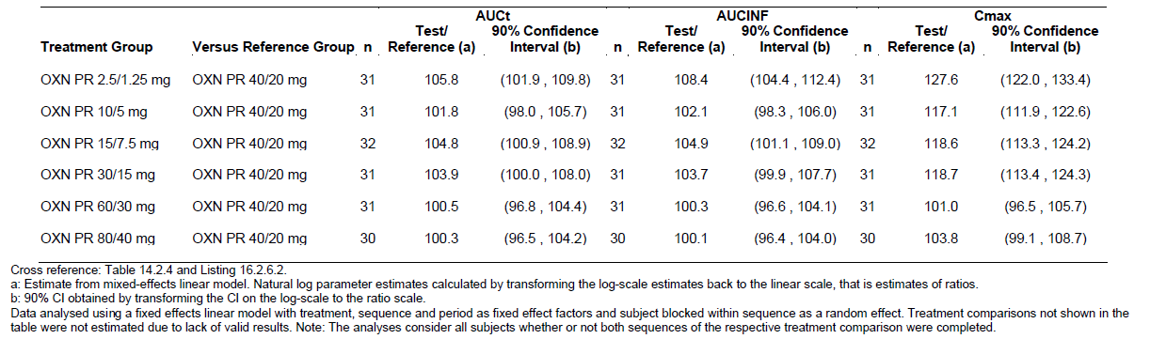

Table 4: Statistical Results for Naloxone Bioequivalence, Study OXN1506, Using Surrogate Analyte Naloxone-3-Gucuronide
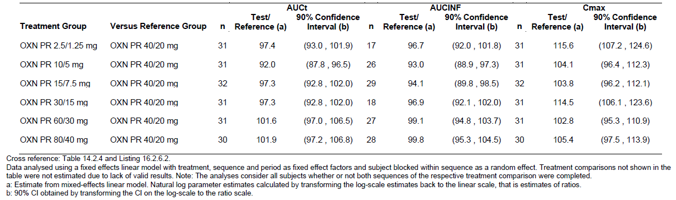
Figure 1: Mean Plasma Concentration versus Time, Oxycodone, Study OXN1506
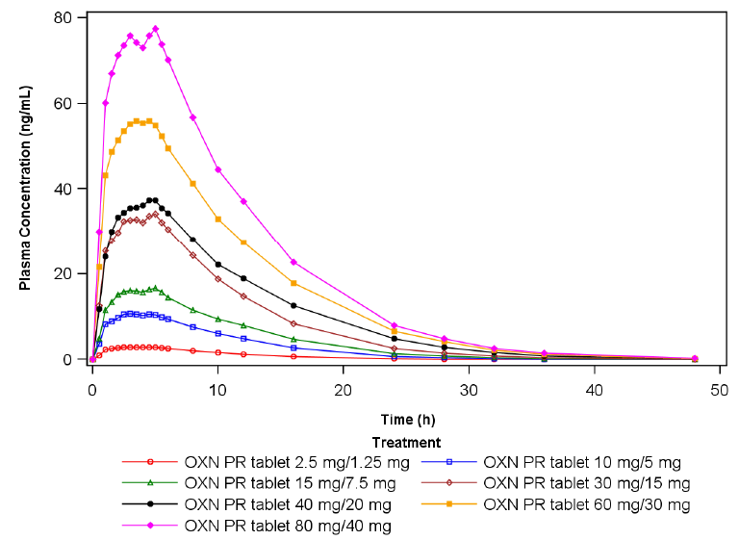
Figure 2: Mean Plasma Concentration versus Time, Naloxone-3-Glucuronide, Study OXN1506
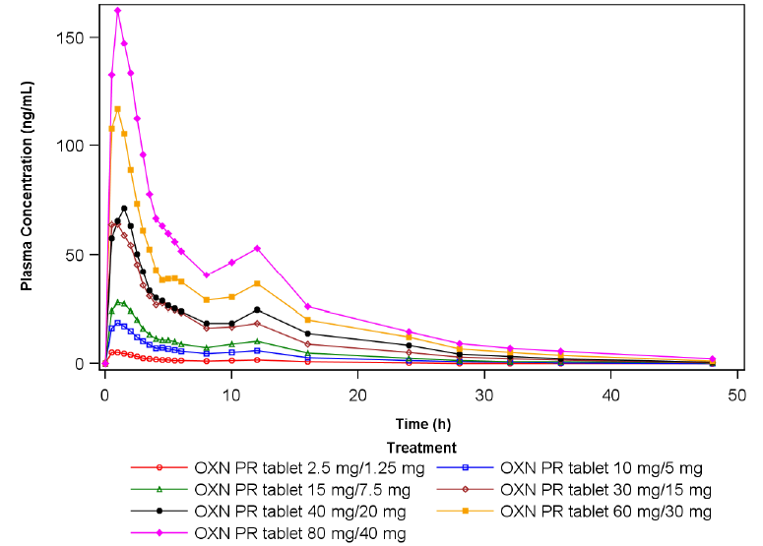

Bioavailability during multiple-dosing
A new multiple-dose study (OXN1507) was submitted, which assessed the PK of oxycodone and naloxone from Targin 80/40 mg and 40/20 mg tablets at steady state, demonstrating dose-adjusted bioequivalence. The study suggested that steady state is achieved within approximately 4 days of dosing with OXN PR at doses of 40/20 mg or 80/40 mg, and that substantial accumulation of drug does not occur with repeat dosing. As shown in the figures below, trough levels (measured at times -36h, -24h, -12h, 0h and +12h) were similar over the course of the study, for both oxycodone (Figure) and naloxone (Figure).
Figure 3: Mean Oxycodone Plasma Concentration versus Time, Study OXN1507
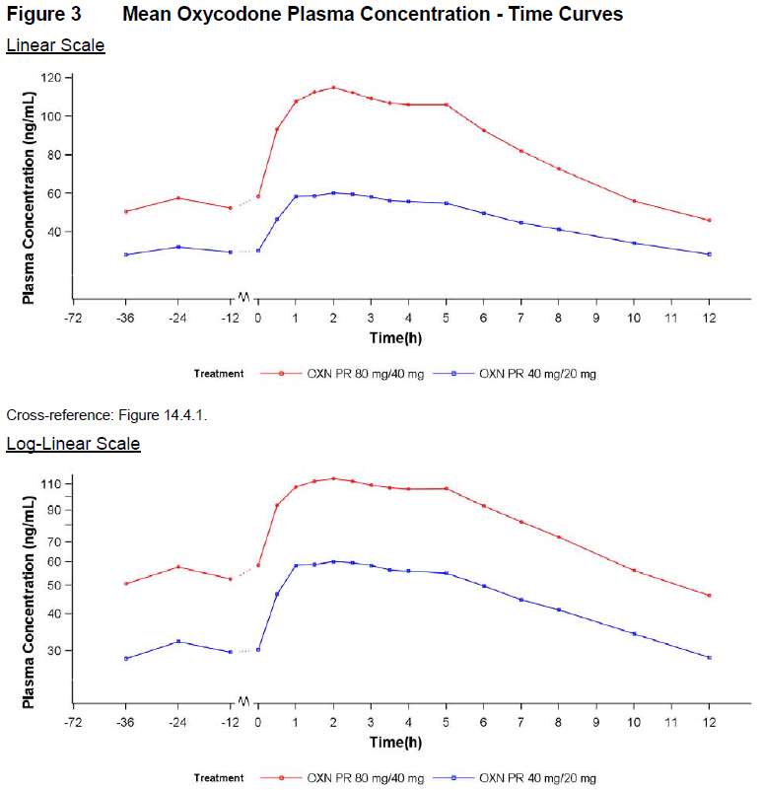
Figure 4: Mean Naloxone Plasma Concentration-Time Curves, Study OXN1507
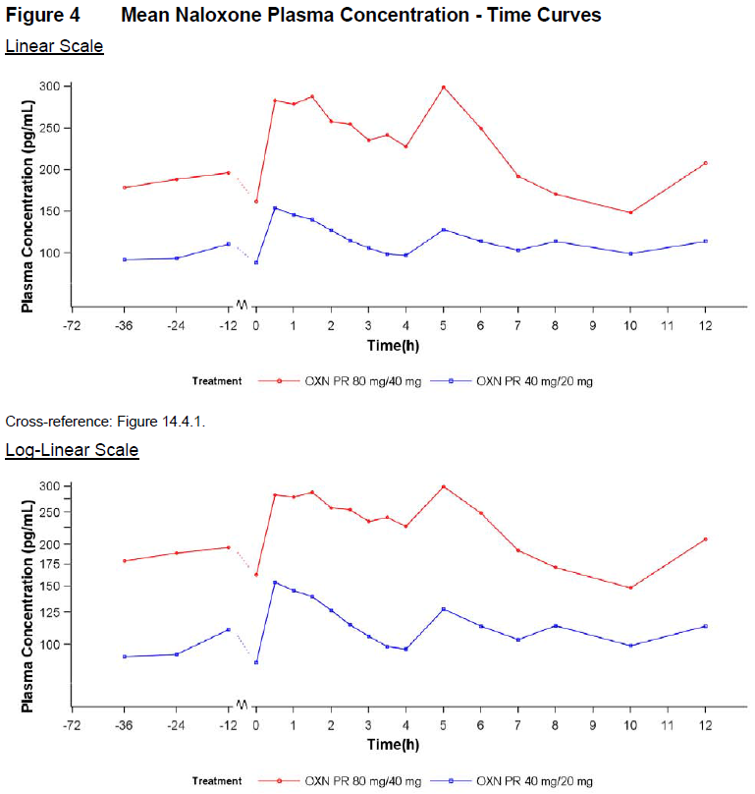

Effect of administration timing
Apart from the assessment of the food effect, no studies assessed the effect of the timing of administration. Given that Targin is a prolonged-release tablet, it is not expected that the timing of administration would have a large effect.

Distribution, metabolism and excretion
No new information was provided about the distribution and metabolism of oxycodone and naloxone.

Intra- and inter-individual variability of pharmacokinetics
No new information was provided on the intra- and inter-individual variability of the pharmaco-kinetics of oxycodone and naloxone. An estimate of the variability across subjects can be made by studying the standard deviation of the major PK parameters in Study OXN1506. For AUCt, the standard deviation was approximately one quarter of the mean, for a range of doses. Coupled with a high degree of pharmacodynamic variability in subjects’ responses to oxycodone, this means that doses must be titrated carefully for each individual patient, as is the case for any opioid.

Pharmacokinetics in the target population
No new studies specifically addressed the PK of Targin in the target population of subjects with chronic pain. For the new proposed indication of RLS, no specific PK data exists. Given that RLS is not usually associated with significant impairments in hepatic or renal function, or in other major organ systems, this is not a significant omission. Many patients with RLS are elderly, but Targin has already been widely used in the elderly because of the prevalence of chronic pain in this population. The PI already contains appropriate warnings about the need to reduce doses in elderly debilitated patients (see below).

Pharmacokinetics in other special populations

Pharmacokinetics in subjects with impaired hepatic function
No new studies were submitted characterising the PK of Targin in subjects with hepatic impairment. The approved PI already contains a statement as follows: ‘A study has shown that plasma concentrations of both oxycodone and naloxone are elevated in patients with hepatic impairment. Naloxone plasma concentrations were affected to a greater extent than oxycodone. The clinical relevance of a relatively high naloxone exposure in hepatically impaired patients is not yet known. Caution must be exercised in administering TARGIN modified release tablets to patients with mild hepatic impairment. TARGIN modified release tablets are contraindicated in patients with moderate to severe hepatic impairment.’

Pharmacokinetics in subjects with impaired renal function
No new studies were submitted in relation to the PK of Targin in the setting of renal impairment. The PI already contains the following warning. ‘A study has shown that plasma concentrations of both oxycodone and naloxone are elevated in patients with renal impairment. Naloxone plasma concentrations were affected to a greater extent than oxycodone. The clinical relevance of a relatively high naloxone exposure in renally impaired patients is not yet known. Caution should be exercised when administering TARGIN modified release tablets to patients with renal impairment.’

Pharmacokinetics according to age
No new studies were submitted that specifically addressed the PK of Targin according to age. In the absence of significant hepatic or renal disease, age by itself does not appear to have a major impact on the PK of Targin – pharmacodynamic susceptibility to the side effects of Targin in the elderly is a more important issue, as with any opioid analgesic. The PI already contains appropriate warnings about the need to adjust the dose in elderly debilitated patients. The PI draws a distinction between elderly patients without substantial comorbidities and ‘elderly debilitated’ patents:
Use in the elderly
The plasma concentrations of oxycodone are only nominally affected by age, being approximately 18% greater in elderly as compared with young subjects. There were no differences in adverse event reporting between young and elderly subjects. The dosage should be adjusted to the intensity of the pain and the sensitivity of the individual patient.
Use in elderly, debilitated patients
As with other opioid initiation and titration, doses in elderly patients who are infirm or debilitated should be reduced to ⅓ to ½ of the usual doses.

Pharmacokinetics related to genetic factors
No information related to genetic factors was submitted. The proposed PI does not contain any discussion about genetic susceptibility to oxycodone or naloxone.

Pharmacokinetic interactions
No new PK data was submitted assessing potential interactions between oxycodone, naloxone and other agents. The approved PI already contains a substantial discussion of the potential for drug interactions, including both pharmacokinetic and pharmacodynamic interactions.

Evaluator’s overall conclusions on pharmacokinetics
The pharmacokinetics of Targin have already been well characterised, and the submitted data did not raise any substantive new PK issues. The proposed higher doses can be expected to produce a dose-proportional increase in exposure to oxycodone, as summarised in the table below. The naloxone component undergoes rapid and extensive first-pass metabolism.

Table 5: Summary Statistics for PK of Oxycodone
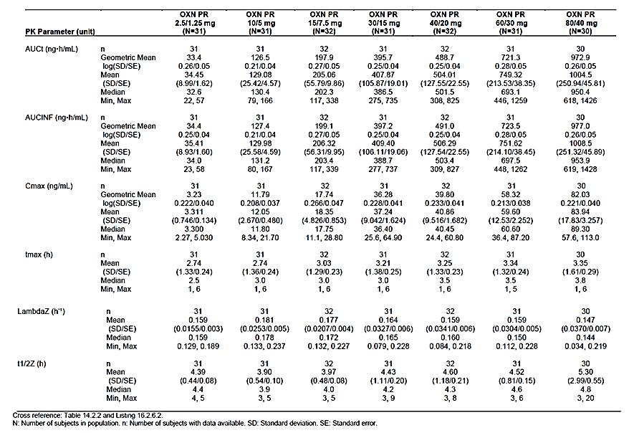

Pharmacodynamics

Studies providing pharmacodynamic data
The sponsor did not perform any reassessment of the primary PD of Targin. The analgesic studies submitted in support of the new maximum dose assessed multiple doses, but doses were titrated to individual needs and dose groups were not directly compared, so it is not possible to infer how the analgesic effect varies with dose. Similarly, in the RLS study, doses were titrated according to symptoms, so the efficacy of different doses in treating RLS symptoms cannot be directly compared.
Four PD studies were submitted in support of the proposed changes to the PI regarding the abuse-potential of Targin. These were single-dose PK/PD studies, summarised by the sponsor as follows:
‘The studies were all single dose. […] The studies of abuse potential were all randomised, double-blind, crossover studies, two in recreational opioid users (ONU1003, ONU1007), and two in or methadone-treated opioid-dependent subjects (ONU1004, ONU1008). In Study ONU1003, the abuse potential of Targin was assessed for three different routes of administration (oral, IN and IV) compared with oxycodone API and placebo. In ONU1004 the abuse potential of chewed Targin (strengths 30/15 mg and 60/30 mg) was compared with oxycodone API and placebo. In ONU1007 the abuse potential of chewed versus intact Targin was compared with oxycodone API. In ONU1008, the abuse potential of chewed versus intact Targin was compared with oxycodone API and placebo.’
The major conclusions from these studies are summarised below.

Summary of new pharmacodynamic data
The submitted PD studies demonstrated that the abuse potential of oxycodone, in terms of its ‘likeability’ during off-label use, depends on a number of factors, including:
- whether it is co-administered with naloxone, as in Targin, or administered as monotherapy
- the route of administration
- whether the tablet has been crushed or chewed to circumvent the slow-release properties of the standard formulation
- whether the user is concurrently receiving maintenance methadone treatment.
As will be discussed, the results in methadone users were substantially different from those observed in recreational users not on methadone. Concurrent long-term treatment with opioids apart from methadone was not studied., and no behavioural evidence or analysis was submitted to clarify whether the different results observed in methadone-treated subjects primarily reflected addiction or primarily reflected the fact that naloxone antagonises methadone.
In Study ONU1003, non-dependent, intermittent (‘recreational’) opioid users received Targin or naloxone-free oxycodone, as a standard tablet or as a chewed tablet, or they received an equivalent intranasal solution or intravenous solution:
- Group 1 (oral, chewed): Targin tablet 40/20, chewed/placebo solution, oxycodone oral solution 40 mg/placebo tablet, chewed, and placebo solution/placebo tablet, chewed;
- Group 2 (IN): Targin tablet 40/20 mg, finely crushed, oxycodone powder 40 mg, and placebo (lactose powder);
- Group 3 (IV): oxycodone 0.07 mg/kg/naloxone placebo, oxycodone 0.07 mg/kg/naloxone 0.035 mg/kg, and oxycodone placebo/naloxone placebo.
The PD results suggested that oxycodone/naloxone combinations had significantly reduced abuse potential, compared to oxycodone monotherapy, when taken by the intranasal or intravenous routes. The oxycodone was more rapidly absorbed by these routes, but the presence of naloxone appeared to antagonise its effects, leading to low scores on the ‘likeability’ scale. In keeping with the poor oral bioavailability of naloxone, however, the presence of naloxone in a chewed Targin tablet did not substantially modify the likeability of the medication, compared to oral oxycodone solution. Furthermore, the PK part of this study suggested that, when chewed, the prolonged-release properties of Targin were largely circumvented, with a median T_{max} for oxycodone concentration of 0.60 hours, which was similar to that seen with oxycodone solution (0.57 h). This study therefore suggests that intermittent opioid abusers not on methadone will be able to get a likeable high from Targin if they chew it, circumventing its slow-release properties and subjecting the naloxone to first-pass metabolism, but not if they try to administer it intranasally or intravenously.
In Study ONU1004, opioid-dependent subjects on methadone received chewed Targin or naloxone-free oxycodone, in a crossover design:
Block 1 (Low-dose session): Subjects received the following study drugs, separated by approximately 24 hours:
- chewed 30/15 mg ONU + placebo solution,
- 30 mg oxycodone in solution (Oxy API ) + chewed placebo;
- placebo solution + chewed placebo.
Block 2 (High-dose session): Subjects received the following study drugs:
- chewed 60/30 mg ONU + placebo solution;
- 60 mg Oxy API in solution + chewed placebo;
- placebo solution + chewed placebo.
Subjects also received their daily methadone (20 to 40 mg/day).
The drug likeability results suggested that oxycodone monotherapy produced a likeable high, but Targin was not liked by these opioid-dependent, methadone-treated drug users (probably because enough naloxone was absorbed to produce unwelcome systemic opioid antagonism of co-administered methadone). Overall, especially at the higher doses, these subjects had a greater liking for placebo, as shown in the figure below. The study suggests that, in this population, Targin has low abuse potential compared to comparable doses of naloxone-free oxycodone. These results cannot be generalised to other addicts, however, because this study only assessed subjects on methadone.
Figure 5: Mean ‘At This Moment’ Drug Liking VAS, Study ONU1004
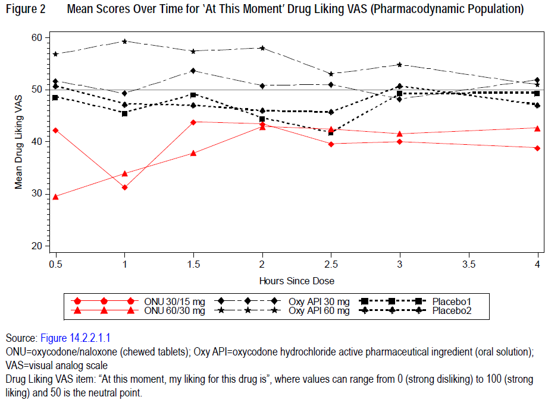
In Study ONU1007, single doses of Targin or oxycodone solution were administered in a 4-way crossover design to intermittent (‘recreational’) opioid users not on methadone:
- ONU 40/20 mg tablet, intact + ONU PBO tablet, chewed + PBO oral solution;
- ONU PBO tablet, intact + ONU 40/20 mg tablet, chewed + PBO oral solution;
- ONU PBO tablet, intact + ONU PBO tablet, chewed + oxycodone oral solution;
- ONU PBO tablet, intact + ONU PBO tablet, chewed + PBO oral solution.
Consistent with Study ONU1003, this study showed that chewing Targin circumvents the prolonged-release characteristics of the drug, giving it similar likeability and other positive psychotropic effects to oxycodone solution. The study suggest that, if Targin is chewed by subjects not on methadone, it will have a similar abuse potential to immediate-release oxycodone, but the likeability effect is lower with Targin than immediate-release oxycodone preparations if the Targin tablet is appropriately administered. This could reduce the chronic abuse potential of Targin, compared to immediate-release oxycodone, but further study would be needed to see if these results in recreational opioid abusers translate to benefit in users taking the drug for pain.
In Study ONU1008, subjects with chronic opioid addiction on regular maintenance methadone received each of the following treatments as a single-dose treatment on separate visits, separated by at least 48 hours:
- Treatment A: ONU 60/30 mg intact
- Treatment B: ONU 60/30 mg chewed
- Treatment C: Oxy API 60 mg, in oral solution
- Treatment D: PBO
Subjects also continued their usual methadone dose.
The results were consistent with Study ONU1004. These methadone-treated subjects reported a likeable effect with oxycodone solution, but they did not prefer Targin over placebo, even when it was chewed, and they did not report an inclination to take the drug again. Results for the feeling of getting ‘High’ on each treatment are shown in the figure below.
Figure 6: Mean Scores for ‘High’ VAS, Study ONU1008
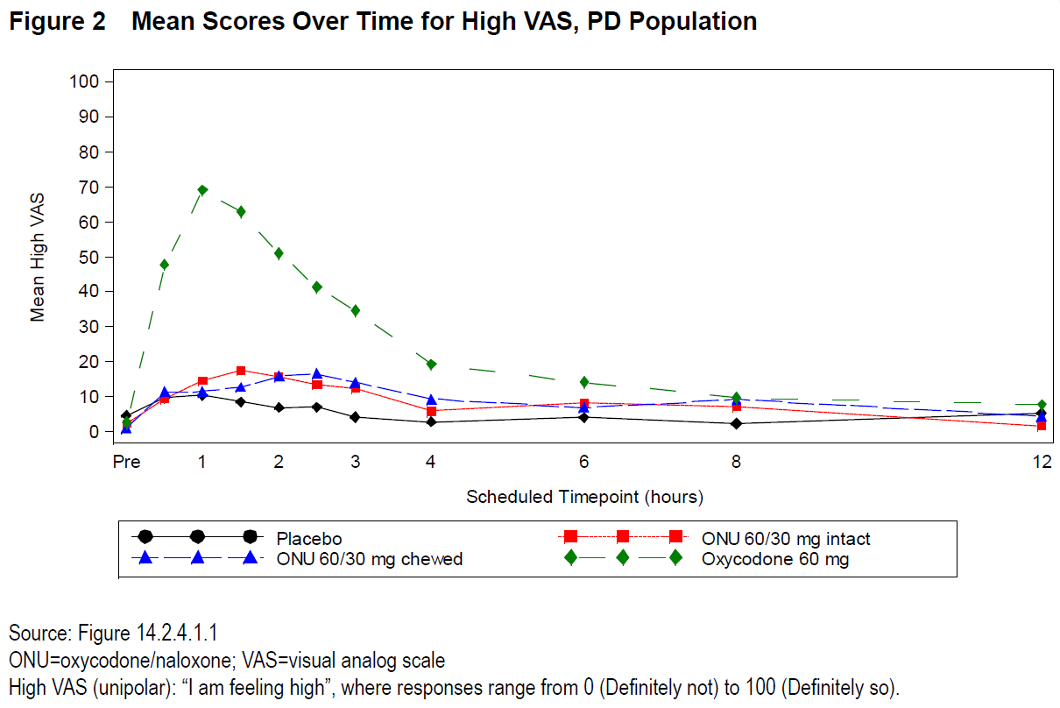
The overall findings can be summarised as follows: Essentially, when taken as intended (as an oral, slow-release tablet), Targin produces minimal pleasant opioid effects in recreational drug users, and is less likeable than opioids taken by more rapid routes. Absorption of slow-release oxycodone can be hastened by chewing the tablet, or by administering it via the intranasal or intravenous routes, and this produces a likeable high for naloxone-free formulations. The presence of naloxone in Targin makes the intranasal and intravenous routes undesirable for recreational users seeking to circumvent the slow-release properties of the tablet; the naloxone bypasses the usual first-pass metabolism and antagonises the pleasant effects of the oxycodone. For the chewed oral approach, however, the naloxone undergoes first-pass metabolism and has minimal effects in blunting the likeability of oxycodone, so by this route in intermittent recreational drug users, Targin offers no substantial differences in abuse potential compared to other slow-release oxycodone preparations, and instead resembles immediate-release oxycodone.
For subjects receiving chronic methadone, by contrast, Targin did not produce pharmacodynamic indicators of abuse potential or likeability. This could indicate that the opioid antagonism caused by naloxone was sufficient to produce an overall negative experience even when the subjects administered the drug by chewing it, probably because the low levels of naloxone escaping first-pass metabolism were sufficient to antagonise the effects of methadone as well as the oxycodone in the Targin, and there was not enough oxycodone present to offset this in these subjects used to higher levels of opioid exposure. It remains unclear whether there are similar abuse-deterrent benefits in long-term addicts not on methadone. If the lack of likeability depends on methadone antagonism, as seems likely, then there is no reason to suspect that chewed Targin will lack abuse potential in addicts not on methadone.

Evaluator’s overall conclusions on pharmacodynamics
The primary PD of Targin was not reassessed in this submission, but studies of abuse potential clarified the abuse-related properties of Targin relative to other opioids, in the context of potential abuse and diversion to other routes by opioid abusers. The overall impact of these pharmacological properties on the abuse potential of Targin is difficult to estimate, in part because no data was submitted relating to how oral opioids are actually abused or diverted to other routes in the community. Intravenous and intranasal diversion of Targin appears to be an unattractive option for intermittent opioid users seeking to obtain a high, but chewed Targin probably offers the same abuse potential as chewed OxyContin in intermittent users – both agents, once chewed, are rapidly absorbed and appear likely to produce similar effects as immediate-release oxycodone (Endone). In this respect, the benefits of Targin appear modest, although chewing an opioid agent is in many ways more benign than injecting it, particularly in relation to the risks of needle-borne infections.
For regular methadone users, Targin did not produce likeable effects, and it appears to offer relatively little abuse potential in this population. It is unknown whether this primarily reflects antagonism of methadone by naloxone, or some other mechanism. It is also unclear whether this result is likely to be replicated in addicts not on regular methadone, because the sponsor did not study addicts not on methadone. If the main reason for the poor likeability of Targin in methadone users was related to methadone antagonism, one would not expect non-methadone-treated addicts to report poor likeability of Targin, but this subject group has not been assessed and no conclusions about this important patient group can be drawn.
These conclusions are broadly consistent with the sponsor’s proposed addition to the PI, which describes each PD study and then concludes:
‘The clinical abuse potential studies indicate that TARGIN modified release tablets have pharmacologic properties that are expected to result in a meaningful reduction in abuse via the intranasal and intravenous routes of administration, although abuse and diversion by these and other routes is still possible.’
Clinicians concerned about diversion could find this information useful and the inclusion of such information in the PI could provide clinicians with additional reasons to choose Targin over its competitors. For balance, though, the PI should also mention that the submitted studies showed that chewing Targin produces a likeable high in intermittent recreational opioid users not on methadone. Furthermore, the sponsor should avoid claims that the benefits seen in methadone-treated subjects can be generalised to other opioid addicts. More appropriate wording for the PI summary is recommended.

Dosage selection for the pivotal studies
For the RLS indication, no dose-ranging studies were performed. The sponsor selected a low-to-intermediate dose for the pivotal RLS study (OXN3502), based on previous clinical experience with the analgesia indication, and anecdotal reports on the use of oxycodone and other narcotics for RLS. Initial doses were low (OXN 5/2.5 mg twice daily), but up-titration to higher dose levels was permitted if needed (10/5, 20/10, 30/15 or 40/20 mg OXN PR twice daily). Given that these doses have been well studied for the chronic pain indication, this approach was reasonable. RLS is a chronic condition that is not life-threatening, so a slow, cautious dose titration is appropriate.
For studies assessing the chronic pain indication, dose selection was individualised for each patient, and patients were already receiving oxycodone doses in the standard clinical range prior to study entry. The pivotal study (OXN3506) allowed clinicians to titrate the oxycodone dose during a run-in phase, and then randomised subjects to blinded naloxone add-on (Targin) or to continued oxycodone monotherapy. The oxycodone dose was therefore determined by clinical analgesic need, and the naloxone dose was determined by the default 2:1 oxycodone: naloxone ratio, which has already been approved for lower doses. No specific rationale was provided for this ratio in the current submission, and no other oxycodone: naloxone ratios were assessed. The current PI for Targin already recommends that higher oxycodone requirements (beyond the maximum approved Targin dose) should be met with a mixture of OxyContin and Targin, effectively lowering the naloxone dose in proportion to the oxycodone dose. The proposed new maximum dose of Targin therefore represents an attempt to unify the oxycodone: naloxone ratios across the range of opioid doses used. Although this appears attractive on the basis of simplicity and convenience, no specific evidence was provided to support the assumption that the same ratio is appropriate across the entire dose range.

Clinical efficacy

Efficacy studies in restless leg syndrome
The sponsor’s application to register Targin for treatment of RLS rests on a single study and its open-label extension (OXN3502 and OXN3502S).

Pivotal study in RLS (OXN3502)
‘A randomised, double-blind, placebo-controlled, parallel-group, multicenter study to demonstrate improvement of symptoms of RLS in subjects with moderate to severe idiopathic RLS with daytime symptoms who take oxycodone/naloxone prolonged release (OXN PR) compared to subjects taking placebo (PLA).’

Study design, objectives, locations and dates
This Phase III study employed a randomised, placebo-controlled design to assess the efficacy of Targin (oxycodone/naloxone prolonged release, OXN PR) up to 40/20 mg twice daily, over 12-13 weeks in subjects with moderate to severe RLS, who reported an inadequate response to dopaminergic treatment. It was a medium-sized study (completing subjects: OXN n=107; placebo n=97; total n=204) that nonetheless achieved strong statistical results.
The study consisted of a Pre-randomisation Phase of up to 24 days, in which eligibility was confirmed, baseline assessments were completed, and subjects underwent a Wash-out Period of 7 to 10 days. Following Randomisation, subjects underwent a Double-blind Treatment Phase of 12-13 weeks. Dose titration was permitted for up to 6 weeks after Randomisation, followed by a stable-dose Maintenance Phase of 6 weeks. This was followed by a brief down-titration and then an open-label Extension Phase of 40 weeks, in which all subjects received active treatment regardless of their previous randomised treatment assignment; this is described as a separate study (OXN3502S).
Figure 7: Study Design, OXN3502
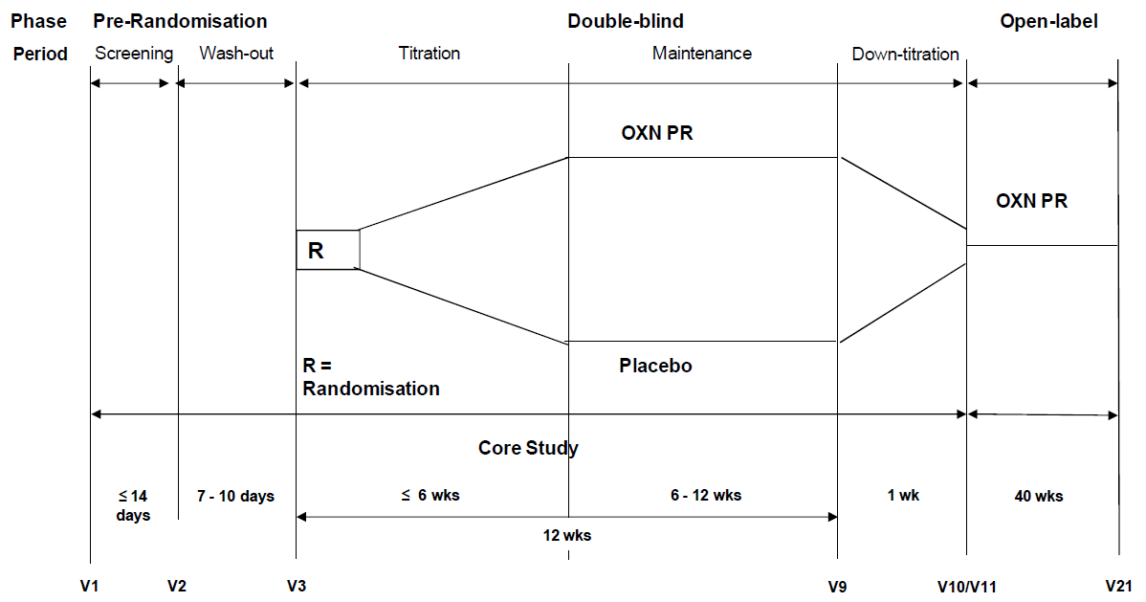
The primary objective was declared as follows: ‘To demonstrate superior efficacy of OXN PR compared to placebo in the improvement of symptom severity of RLS as measured by the International Restless Legs Syndrome Study Group Rating Scale (IRLS scale).’
Additional objectives were to assess efficacy with a number of other measures, including other RLS scales, clinical global impression, sleep and pain scales and quality of life (as detailed below).
The study was performed in four countries: Germany (58 centres), Spain (five centres), Austria (3 centres) and Sweden (3 centres), from 15 April, 2010, to 9 June, 2011.

Inclusion and exclusion criteria
The key entry requirement was that subjects had moderate-to-severe primary RLS daytime symptoms despite attempts to use dopaminergic agents.
Specific inclusion criteria were as follows:
- Male or female subjects aged ≥ 18 years.
- Females had to be non-pregnant and using adequate contraception.
- Diagnosis of RLS according to the ‘Restless Legs Syndrome Diagnostic Index’ (RLS-DI). In addition, to ensure a diagnosis of primary RLS, subjects had to have at least one of the following criteria: ‘positive family history of RLS’, ‘positive response to dopaminergic treatment’ or ‘objective findings of periodic limb movements in PSG or actigraphy’, or they had to have a normal neurological examination (Benes and Kohnen, 2009).
- Subjects had to be dissatisfied with any current or previous drug treatment for RLS, and to be thought likely to benefit from an alternative treatment option with OXN PR.
- Presence of RLS symptoms for at least 6 months.
- IRLS score at screening visit (Visit 1) of ≥ 15.
- Onset of RLS symptoms during the day (before 18:00) on at least 4 days per week.
- Subjects were not to have received regular opioid-containing medication for the treatment of RLS and other disorders (including pain) at any time before enrolment. Occasional use for treatment of cough/cold, pain etc. was acceptable if the last intake was ≥ 1 month before.
- Subjects willing and able to participate.
- Subjects taking pre-study, non-opioid analgesics at stable doses were eligible.
Exclusion criteria were aimed at excluding subjects with disorders likely to confound the assessment of efficacy or compromise the safety of treatment. They were listed as follows:
- Secondary RLS (due to iron deficiency anaemia, renal insufficiency, rheumatoid arthritis).
- RLS thought to be due to previous or concomitant therapy with dopamine D2 receptor antagonists, butyrophenones, metoclopramide, atypical antipsychotics (for example, olanzapine), tri- and tetracyclic antidepressants, mianserine, lithium or H2-blockers, or due to withdrawal from drugs such as anticonvulsants, benzodiazepines, barbiturates, and other hypnotics.
- History or presence of sleep disturbances caused by sleep apnoea syndrome, narcolepsy or myoclonus epilepsy.
- Any disorder whose symptoms could overlap those of RLS.
- Subjects with acute, clinical ‘augmentation’ of RLS.
- Dementia or other major progressive neurological disorders.
- History or presence of hallucinating or psychotic episodes.
- Prohibited concomitant or prior medication, including drugs likely to influence sleep architecture or motor manifestations during sleep. These included levodopa, dopamine agonists, catechol-O-methyl-transferase (COMT) inhibitors, neuroleptics, hypnotics, anxiolytic drugs, benzodiazepines, antidepressants, psychostimulatory drugs and anticonvulsants. Inclusion was possible if subjects were on stable therapy for depression or anxiety disorders for at least 6 months.
- Subjects who were taking, or had taken naloxone or naltrexone within 30 days of study entry.
- Subjects with any contraindication or any history of hypersensitivity to oxycodone, naloxone or related products.
- Evidence of clinically significant cardiovascular, renal, hepatic, or psychiatric disease.
- Evidence of significantly impaired liver or kidney function.
- Active alcohol or drug abuse and/or history of opioid abuse.
- Positive urine drug test at Visit 1.
- Subjects who had received a new chemical entity or an experimental drug within 30 days of study entry.
- Serum ferritin below 30 μg/L at Visit 1.
- Shift-work or other disruptive lifestyle factors.
- Subjects who were taking or had taken monoamine oxidase inhibitors (MAOI) ≤ 2 weeks prior to the start of the study.

Study treatments
Subjects randomised to the OXN PR commenced Double-blind treatment with OXN 5/2.5 mg twice daily. Up-titration to higher dose levels (10/5, 20/10, 30/15 or 40/20 mg OXN PR twice daily) could be performed on a weekly basis during the first 6 weeks of the Double-blind Phase, at clinic visits. The actual doses reached through titration are shown in the table below.

Table 6: Distribution of Daily Dose, End of DB Phase, Study OXN3502
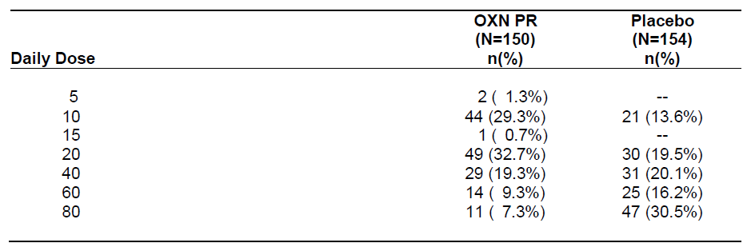
Subjects randomised to placebo received matching tablets, and were ostensibly treated with the same dosing pattern including up-titration.
Standard treatments for RLS, such as levodopa and dopamine agonists, were not allowed during the study, as summarised in the study synopsis: ‘Use of drugs likely to influence sleep architecture or motor manifestations during sleep or other central nervous system (CNS) depressants were not permitted from the last week before the randomisation visit onwards. These included levodopa, dopamine agonists, catechol-O-methyl-transferase (COMT) inhibitors, neuroleptics, hypnotics, anxiolytic drugs, benzodiazepines, antidepressants psychostimulatory drugs and anticonvulsants.’

Efficacy variables and outcomes
Primary and secondary efficacy variables were listed as follows:

Primary efficacy endpoint
- Change in severity of RLS as measured by the IRLS scale sum score.

Secondary efficacy endpoints
- Clinical Global Impression (CGI severity item).
- Clinical Global Impression (CGI change of condition).
- Change in severity of RLS during the day at rest (RLS-6-Rating Scale).
- Change in the further RLS-6-Rating Scales.
- Change in Numeric Rating Scale (NRS) for RLS pain.
- Responder Rates according to IRLS and CGI.
- Remitter Rates according to IRLS.
- Change in disease-specific quality of life (QoL-RLS-Scale).
- Change in sleep behaviour measured by the MOS sleep scale.
- Augmentation assessed by the screening tool for augmentation during study, and, if appropriate, by the Max-Planck Institute (MPI) criteria checklist during study and clinical expert interview.
- Severity of augmentation (Augmentation Severity Rating Scale, ASRS).
The primary end-point, change in IRLS Sum Score, is an appropriate endpoint using an internationally accepted and validated rating scale designed for RLS trials (Walters et al, 2014).

Randomisation and blinding methods
Randomisation was performed with an automated system that assigned treatments to randomisation codes in a 1:1 ratio. The codes were unavailable to patients and clinicians for the course of the study. Blinding was attempted by using identical-appearing tablets in the active and placebo arms, but it is possible that some degree of unblinding occurred because of tell-tale opioid side effects including sedation. A significant flaw in the study is that no attempt was made to quantify the extent of unblinding by asking subjects and clinicians to guess the randomly assigned treatment.

Analysis populations
The sponsor defined the following analysis populations:
- Enrolled: All subjects who provided informed consent.
- Full-Analysis: Subjects who were randomised and received at least one dose of study medication during the Double-blind Phase and who had at least a 1 week double-blind assessment of the primary efficacy variable.
- Per-Protocol: Subjects who received at least 9 weeks of double-blind treatment and who sufficiently complied with the study protocol. This population was defined in the Statistical Analysis Plan before the unblinding of treatment assignments.
- Screening/Wash-out Period Safety: Subjects who had at least one safety assessment during the Screening/Wash-out Period.
- Double-Blind Safety: Subjects who received at least one dose of double blind study medication and had at least one safety assessment after that dose.
The primary analysis population was the Full Analysis (FA) population, which is similar to an Intent-to-Treat (ITT) population but with the additional requirement that at least some drug was consumed and some efficacy data was available. (For the Visit 9/Early Discontinuation analysis, a true ITT approach was not employed, because the early discontinuation data was partially censored as described below.) The sponsor also excluded subjects with major protocol violations from the FA population.

Statistical methods

Primary efficacy analysis
The primary endpoint, change in IRLS scale sum score, was compared by mixed model repeated measures (MMRM) analysis of covariance (ANCOVA) with an unstructured block diagonal covariance matrix, using the FA population. The model included a fixed-factor treatment per visit, baseline IRLS as a fixed covariate and subject as random-effect variable.
All early discontinuation data were excluded from the Visit 9/early discontinuation analysis, except for discontinuations due to lack of therapeutic efficacy or augmentation.
To express the difference between active treatment and placebo, 95% confidence intervals (CIs) for changes in IRLS (OXN PR - placebo) from baseline to Visits 5, 6, 7, 8 and 9 were calculated. No missing-value imputation was used. In order to find the earliest time point in which a significant treatment effect emerged, the hypothesis tests were carried out separately for each of the Maintenance Period assessments beyond Visit 4 in descending order from Visit 10, as long as the null hypothesis was rejected for all subsequent Maintenance Period assessments. This was performed as an intersection-union test across the various visit outcomes, so that the overall analysis kept a multiple 5% significance level.
The primary analysis was repeated using the Per-Protocol population as a robustness assessment, and was also repeated using ANCOVA without MMRM, and with a Wilcoxon Rank sum test on change from baseline data.

Secondary efficacy analyses
Secondary parameters were analysed in an exploratory manner, using the FA population. Most secondary variables (CGI, RLS-6-Rating Scale, Pain-NRS and the QoL measures) were analysed using the same ANCOVA analysis used for the primary efficacy analysis, with the Wilcoxon Rank sum test performed as a sensitivity assessment. Visit 8 served as the end of Maintenance Period for these endpoints.
Binary endpoints were analysed using Fisher’s exact test for 2x2 contingency tables, including:
- Number of subjects who dropped out from the study.
- Number of subjects with 50% improvement in the IRLS sum score.
- Number of subjects with ratings of ‘very much’ or ‘much’ improved in the CGI scale item 2 (change of condition).
- Number of IRLS remitters.

Sample size
Sample-size estimations were based on an anticipated within-subject standard deviation of 10 in the IRLS, derived from the RLS literature (Trenkwalder et al., 2008c). The study was designed to have an overall power of ≥ 90% for the IRLS score, with a two-sided type I error probability of 5%. A larger improvement under OXN of 4 IRLS units compared to placebo was considered to be a clinically relevant difference. Under these assumptions, it was estimated that the study would need 266 evaluable subjects, or 133 evaluable subjects per arm. Allowing for drop-outs, it was planned to randomise approximately 300 subjects.
Although recruitment achieved 304 treated subjects, the final number of subjects who completed the study was less than anticipated: OXN 107 (71.3%), OxyPR 97 (63.0%), total 204 (67.1%). Despite this, the study achieved a positive statistical result indicating that it was adequately powered.

Participant flow
Patient disposition is summarised in the table and figure below. The completion rate was only 67% overall, which somewhat compromises the validity of the study. The discontinuation rate was higher in the placebo group, with lack of efficacy being the dominant cause for discontinuation amongst placebo recipients. There was an excess of withdrawals due to Adverse Events (AEs) in the active group, with twice as many withdrawals of this nature (13.3% versus 6.5%), which could have produced a withdrawal bias.
Although it might be expected that the greater number of withdrawals in the placebo group could offset this potential bias, the sponsor’s analysis of Visit 9/Early Discontinuation was not a true ITT analysis: it included subjects discontinuing because of poor efficacy, but excluded subjects withdrawing because of AEs, so it was particularly susceptible to withdrawal bias compared to analysis of other time points. If some subjects withdrew from the active group because of a combination of AEs and poor efficacy, the remaining population would be enriched for better efficacy. This enrichment would not be expected to occur to the same extent in the placebo group, where subjects with poor efficacy might stay in the study because at least they did not have side effects.

Table 7: Subject Disposition: Double-blind Safety Population, Study OXN3502
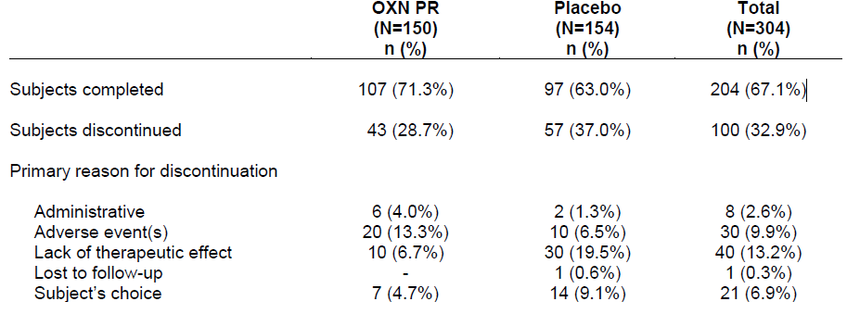
Figure 8: Subject Disposition, Study OXN3502
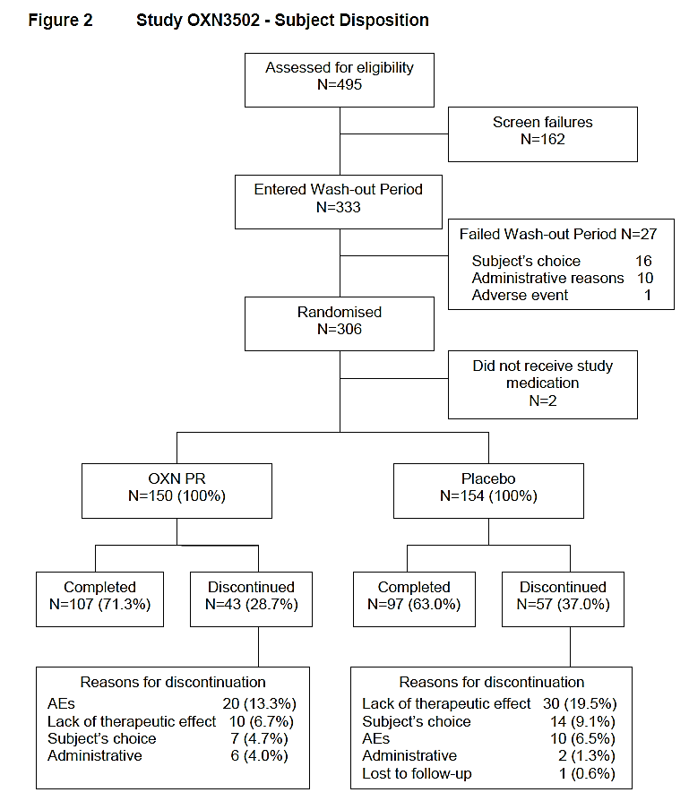

Major protocol violations/deviations
A large number of protocol deviations occurred, with 43% of subjects being excluded from the Per-Protocol Population, as shown in the table below. Most of the exclusions could be accounted for by early termination (duration of double-blind treatment <63 days), which is not generally considered a major protocol deviation.
The total number of major protocol violations appears to have been 22. According to the sponsor: ‘A total of 30 subjects were excluded from the Full Analysis population; 22 of these subjects were excluded due to major protocol violations and 13 subjects were excluded because they had no primary efficacy measure after more than 7 days (five subjects met both these reasons for exclusion).’
Apart from problems related to potential withdrawal bias, already noted, protocol deviations are unlikely to have introduced any major biases or compromised the overall validity of the study.

Table 8: Reasons for Exclusion from Per-Protocol Population, Study OXN3502
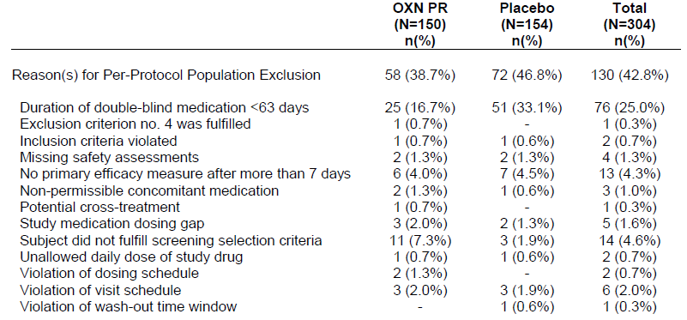

Baseline data
Baseline demographics are summarised in the table below. The placebo group had a higher proportion of younger subjects, but otherwise the groups were well-matched.
Baseline disease characteristics are shown in the subsequent table, as captured by the RLS Diagnostic Index (RLS-DI). Only minor differences between the two groups were noted for individual questions of the RLS-DI, and the overall scores were similar in the two groups (OXN 16.54 ± 1.85; OxyPR 16.47 ±1.99).
Consistent with the requirement that subjects had failed previous treatments for RLS, the duration of RLS prior to study entry was > 10 years, on average, and only 5% of the patients had RLS symptoms for < 1 year.

Table 9: Subject Demographics, Double-blind Safety Population Study OXN3502
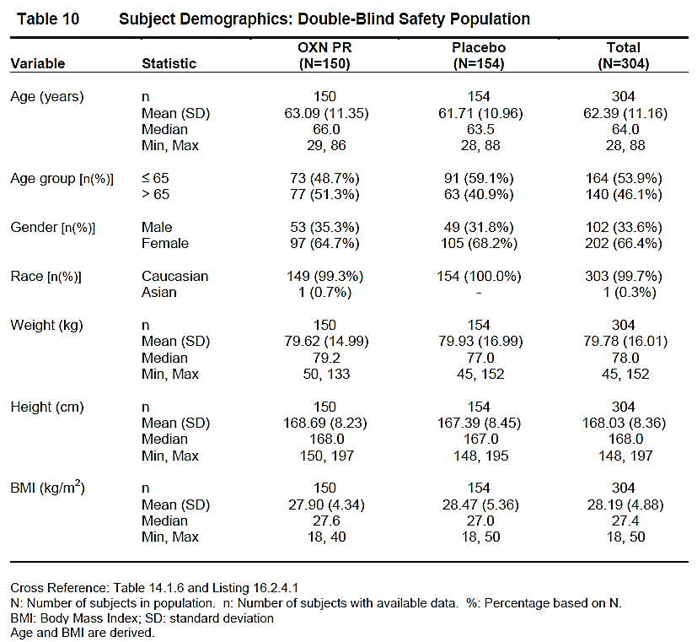

Table 10: Restless Legs Syndrome Diagnosis Index (RLS-DI) Full Analysis Population Study OXN3506
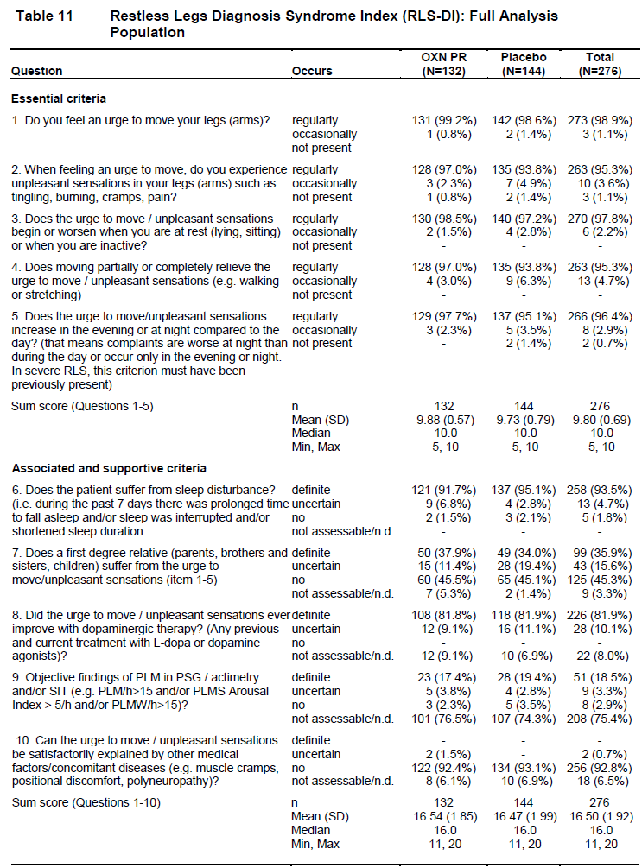

Results for the primary efficacy outcome
Changes in IRLS over the course of the study are shown in the figure below. Even in the placebo group, a gradual improvement in scores was noted. This could represent a combination of regression to the mean, a psychologically-mediated placebo response and progressive withdrawal of subjects with poor control of their symptoms.
For Visits 1 to 8, the FA population data is shown for subjects who attended that visit, and some degree of improvement in both groups is likely to be due to the withdrawal of poorly responding patients. For Visit 9, scores recorded immediately prior to Early Discontinuations (ED) have been pooled with scores obtained at Visit 9, but only for those subjects whose early discontinuation was attributed to poor efficacy. Discontinuations due to AEs, which were more common in the active group, have not been included in the Visit 9 results. The fact that Visit 9/ED scores are lower, on average, than Visit 8 scores confirms that these discontinuing subjects had inferior control of their RLS symptoms, which is not surprising. The overall pattern of improvement in both groups raises the possibility of withdrawal bias, but the superiority of active treatment was apparent early in the Double-blind Treatment Phase, before many withdrawals had occurred, and the separation of the mean scores in each group remained similar in magnitude throughout the study. Also, there was a clear and significant excess of subjects who discontinued from the placebo group, for all causes combined and for poor efficacy in particular. Therefore, on balance, withdrawal bias is not likely to have biased the study significantly in favour of active treatment.
Figure 9: IRLS Change from Baseline, Full Analysis Population, Study OXN3502
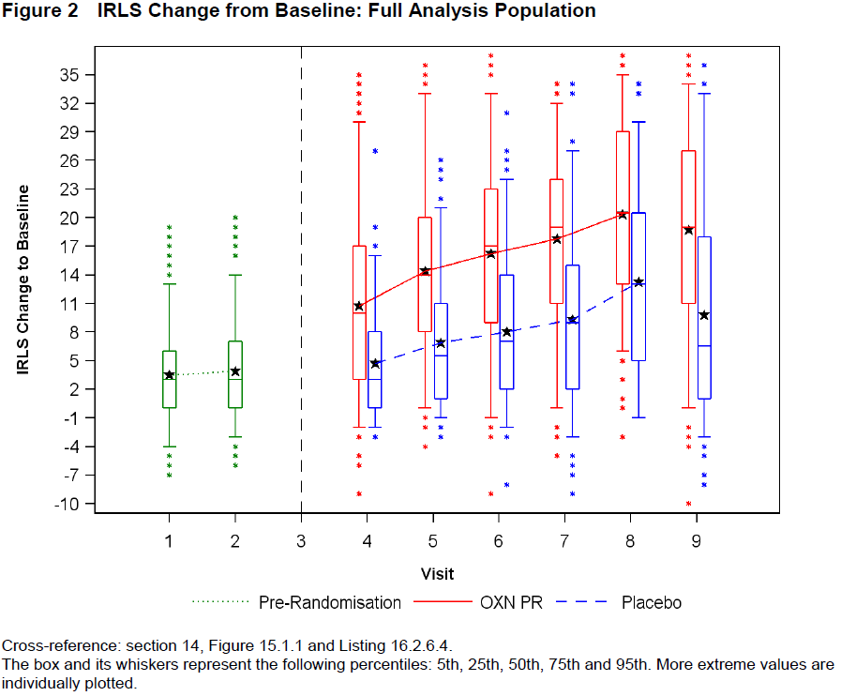
The figure below displays a similar pair of curves, with the mean IRLS scores in each group through the study, but it is restricted to subjects who completed the study. Although this type of analysis prevents the progressive enrichment of the cohort over the course of the study, it does not entirely eliminate withdrawal bias because the cohort displayed is a non-random selection of the original population, consisting of subjects who decided to remain on blinded treatment. The presence of AEs, which were more common in the active group, could have contributed to the decision of poorly controlled subjects to discontinue.
Figure 10: IRLS Mean Values – Subjects Completing All Visits in Double-Blind Phase, Full Analysis Population, Study OXN3502
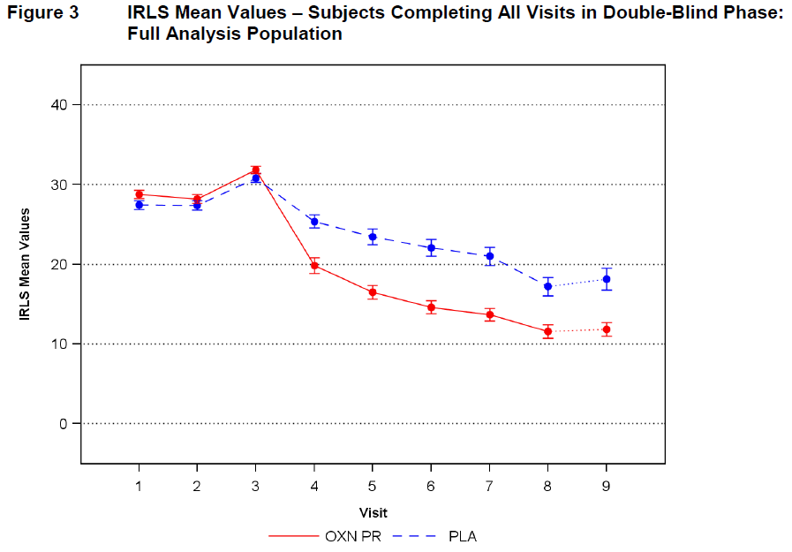
The table below shows the statistical significance of the treatment effect by visit (p<0.001 from Visit 5 onwards) and the subsequent table provides numerical estimates of the mean IRLS scores over the course of the study in each treatment group. At all visits, the IRLS improvement, relative to baseline, was better in the OXN group by about 7-8 points, about a quarter of the original IRLS scores, and about half of the overall placebo improvement. This represents a substantially better treatment effect than the 4 points considered clinically meaningful in the power analysis, and it is likely to be considered a clinically meaningful improvement by patients and clinicians if sustained in a non-trial environment. Even the lower bound of the 95%CI exceeded 4 points from Visit 5 onwards, which is a statistically strong result.

Table 11: Primary Mixed Model IRLS Analysis, Full Analysis Population, Study OXN3502
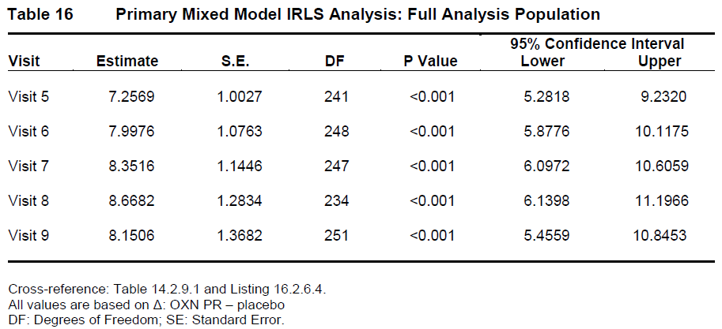

Table 12: IRLS Sum Score by Visit, Full Analysis Population, Study OXN3502
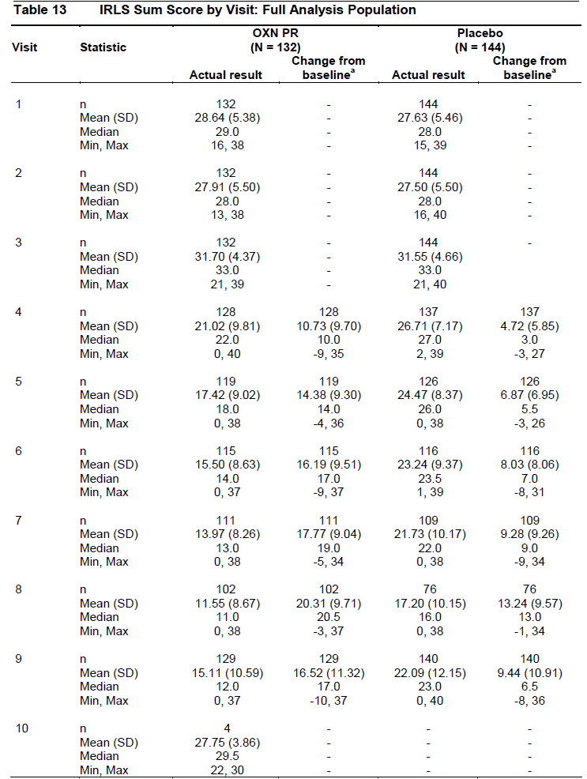
The sponsor also performed a post hoc subgroup analysis of the IRLS change from baseline to Visit 9 based on prior RLS therapy and on gender, finding a broadly similar result in each subgroup and a consistent superiority of OXN over placebo (see the table below).
The sponsor did not perform a subgroup analysis based on age, which could have been of interest given that the treatment groups were not well matched for age distribution.

Table 13: Change from Baseline to Visit 9 in IRLS Sum Score by Prior RLS Therapy and Gender, Full Analysis Population, Study OXN3502
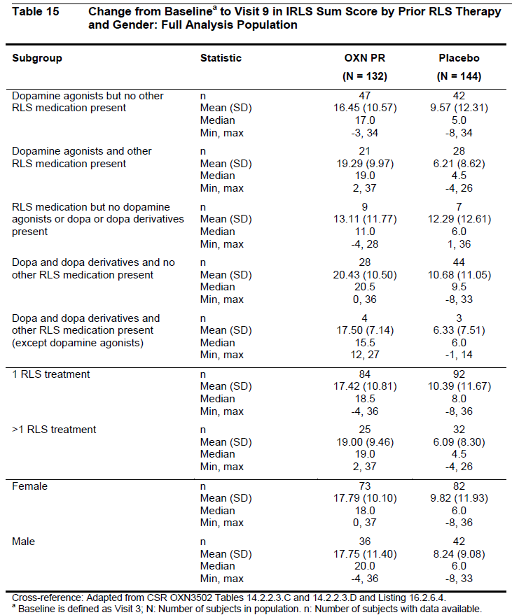

Results for other efficacy outcomes
A range of secondary endpoints confirmed the basic findings of the primary analysis, showing a significant treatment effect. These included IRLS responder rates (p<0.001), Clinical Global Impression (p<0.001), RLS Pain Intensity (p<0.001), most Quality-of-Life measures (p<0.001, except for side effects), and a range of sleep measures (p<0.001). These results are discussed in more detail below. The drop-out rate was also significantly lower (p=0.004) in the active group (22.7% versus 34.0%, p=0.004, Fisher’s Exact test), which provides a surrogate measure of the overall balance between efficacy and tolerability. The discontinuation rate specifically due to lack of efficacy was also lower: 6.7% in the OXN group and 19.5% in the placebo group.

Responder rate
Responders were defined as subjects with ≥ 50% improvement in the IRLS from Visit 3 (baseline) to Visit 9 (Week 12) or a rating of ‘very much’ or ‘much’ improved in CGI Item 2 (‘change of condition’). The proportion of responders was significantly higher in the OXN group (47.0%) than the placebo group (22.9%, p<0.001, Fisher’s Exact test). Remitters were defined as ‘subjects with an IRLS sum score 0 (at any stage) or a final IRLS sum score ≤ 10’, and were also more common in the OXN group (74.2% versus 26.4%, p<0.001, Fisher’s Exact test).

Clinical Global Impression (CGI)
CGI Items 1, 2 and 3 all showed significantly greater improvement in the OXN group. The treatment difference for Item 1 (‘severity of illness’) at Visit 9 was -1.0720 (95% CIs: -1.4631, -0.6808, p<0.001, ANCOVA); the treatment difference for Item 2 (‘change of condition’) at Visit 9 was -0.9304 (95% CIs: -1.2864, -0.5744, p<0.001, ANCOVA), and for Item 3 (‘therapeutic effect’) it was -1.0514 (95% CIs: -1.3566, -0.7461, p<0.001, ANCOVA). The number of subjects with ratings of ‘very much’ or ‘much’ improved in CGI Item 2 was significantly greater for the OXN group (88 subjects [66.7%]) than the placebo group (50 subjects [34.7%]) (p<0.001, Fisher’s Exact test).

Table 14: Clinical Global Impression at Visit 9, Full Analysis Population, Study OXN3502
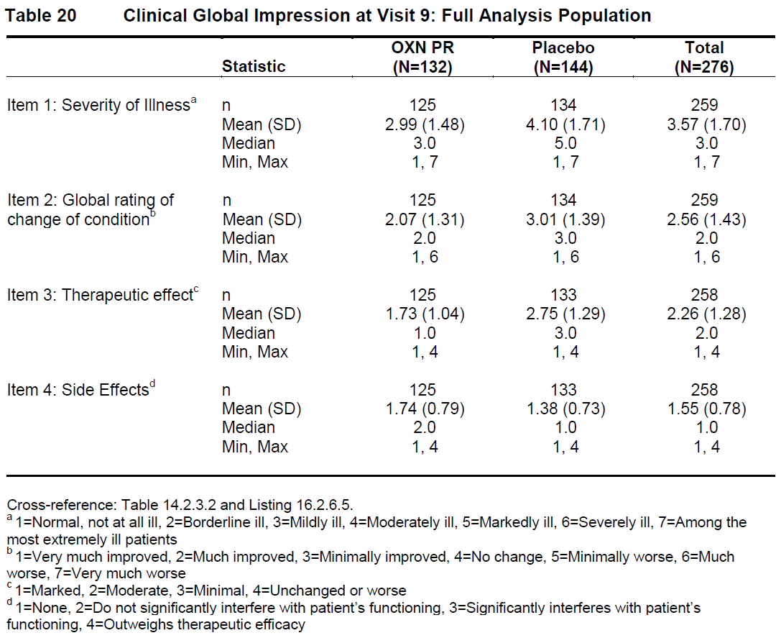

RLS-6-Rating scale
The RLS-6-Rating scale showed a significant improvement in RLS symptom severity in the OXN group compared with the placebo group, as shown in the tables below. Visit 9 scores were more improved in the OXN group for severity of RLS during the day, severity at bedtime, sleep satisfaction and daytime tiredness (p<0.001 for all treatment differences, not shown in the tables below but claimed in the study report).

Table 15: Severity of RLS During the Day at Rest (RLS-6 Rating Scale) by Visit, Full Analysis Population, Study OXN3502
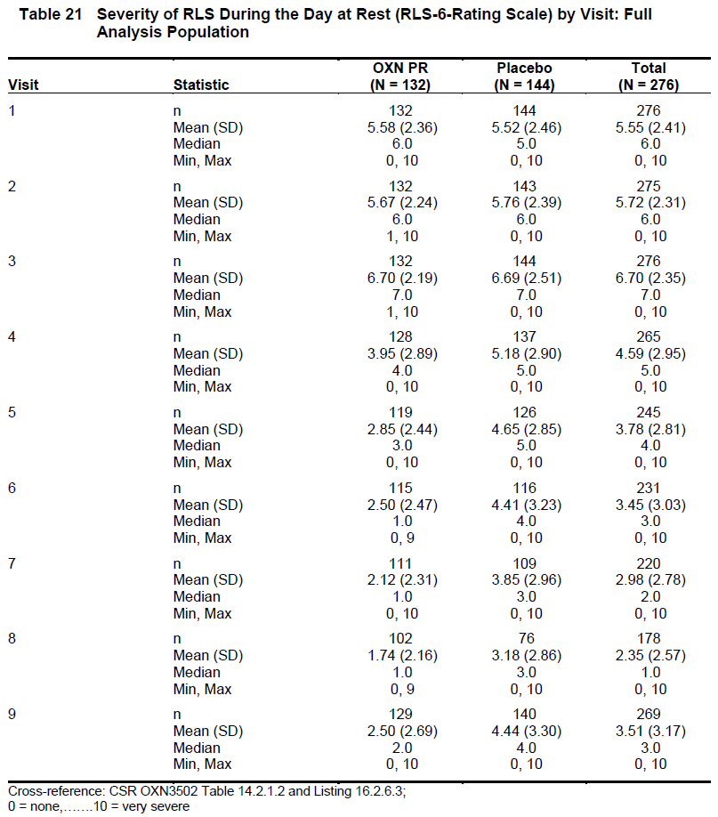

Table 16: RLS-6-Rating Scale Severity at Falling Asleep, During the Night, and During the Day When Not At Rest, Full Analysis Population, Study OXN3502
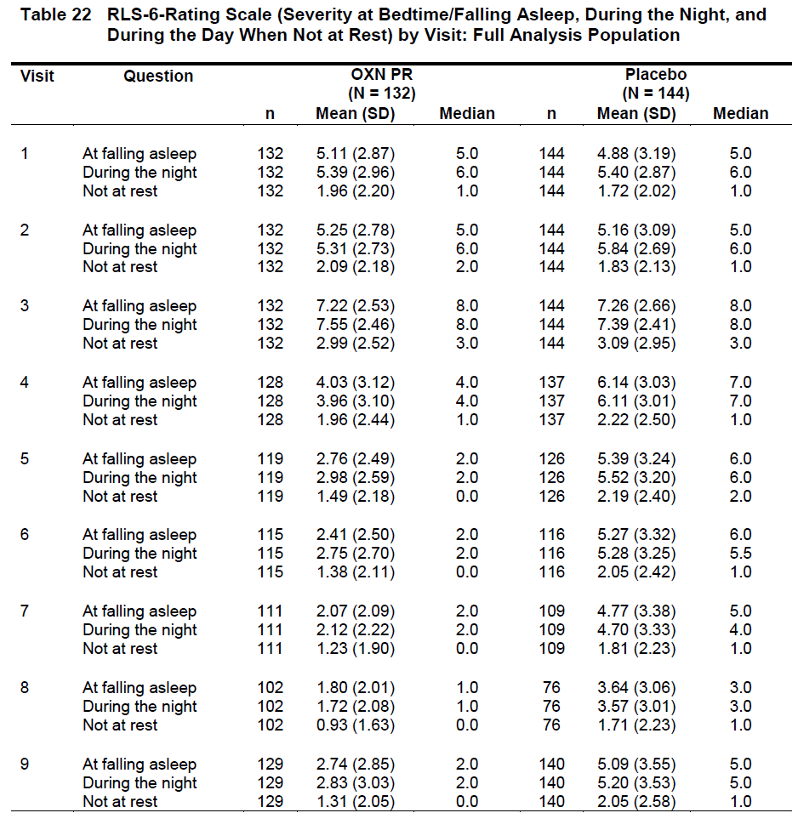

Table 17: RLS-6-Rating Scale (Sleep Satisfaction) During the Last 7 Nights by Visit, Full Analysis Population, Study OXN3502
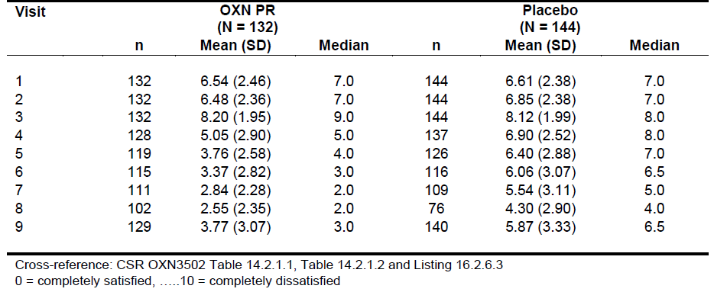

Table 18: RLS-6-Rating Scale (Daytime Tiredness) by Visit, Full Analysis Population, Study OXN3502
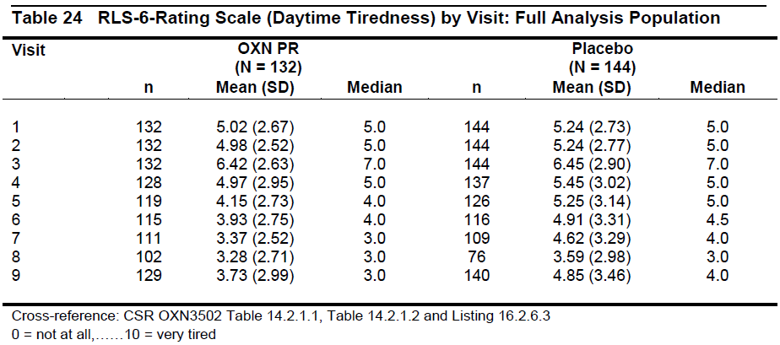

RLS Pain Intensity
RLS Pain Intensity (PI) improved more in the OXN group than the placebo group at all post-baseline visits. The mean PI score decreased from 6.55 (SD: 2.66) at Visit 3 (baseline) to 1.94 (SD: 2.11) in the OXN group and 3.42 (SD: 2.91) for the placebo group at Visit 8 (Week 8). The treatment difference PI was statistically significant (95% CIs below zero and p<0.001, ANCOVA) at all post-baseline visits analysed (Visits 4, 5, 6, 7 and 8).

Table 19: RLS Pain Intensity Scale Average Pain in Legs or Arms Over Last 24 Hours, Full Analysis Population, Study OXN3502
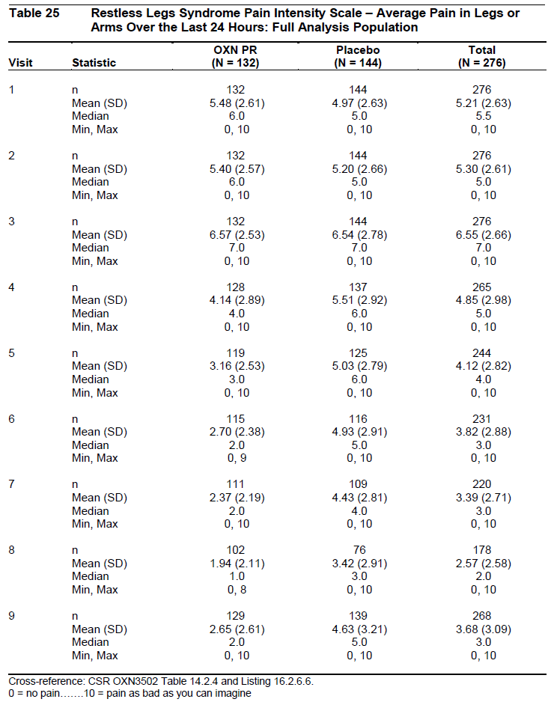

QoL-RLS
The QoL-RLS questionnaire recorded a greater improvement in subjects’ quality of life in the OXN group than the placebo group. A beneficial treatment effect with OXN was seen at Visit 7 (Week 4) across all five topics of the QoL-RLS, including:
- effects of the RLS symptoms;
- effects of disturbed sleep;
- how subjects felt they handled RLS symptoms;
- the effect of pain caused by RLS; and
- overall QoL.
The treatment effect was significant (95% CIs below zero and p<0.001 by ANCOVA) for all questions except Question 7, which related to side-effects of treatment compared to previous treatments. On average, subjects in the OXN group did not feel any more or less affected by their study medication than with their previous medication for RLS.
Visit 9 (Week 12) results were not subject to analysis, however mean and median values for the OXN PR group were similar at Visit 7 and Visit 9.

Augmentation
The phenomenon of augmentation, which can complicate dopaminergic therapy of RLS, was evaluated by Investigators throughout the study. Subjects were initially assessed using the Screening Tool for Augmentation, and then further assessed using the Max-Planck Institute (MPI) criteria checklist if potential augmentation was suspected, with final verification by Local Augmentation Experts and an Independent Augmentation Expert. There were no confirmed cases of augmentation in either treatment group during the study.

MOS sleep scale
Sleep quality, as measured by the MOS sleep scale, was improved in the OXN group compared to the placebo group. Subjects in the OXN PR group fell asleep more quickly, slept for longer, experienced less sleep disturbance and reported greater sleep adequacy than subjects in the placebo group.
The treatment effect for Sleep Disturbance Scale, Optimal Sleep Scale, Sleep Quantity, Sleep Adequacy and Sleep Problems Index I and II at Visit 7 was statistically significant (p<0.001, ANCOVA), but results for Daytime Somnolence, Waking with Shortness of Breath/Headache and Snoring merely showed favourable trends.

Conclusions
This Phase III pivotal study was only of modest size (completing subjects: OXN n= 107; placebo n= 97; total n=204) and duration (12 weeks double-blind treatment), but it achieved strong efficacy results for its primary endpoint (p<0.001) and all major secondary endpoints (p<0.001 for nearly all endpoints). The magnitude of the treatment effect, about 7-8 points on the IRLS, from a baseline of approximately30 points, exceeded the benefit considered to be clinically significant during power calculation (4 points). The clinical relevance of the primary RLS results was supported by positive results for the Clinical Global Impression, sleep quality assessed by a couple of different scales, and quality of life using an instrument specific for RLS issues. Responders and remitters were significantly more common in the OXN PR group (responders, 47.0% versus 22.9%, p<0.001; remitters 4.2% versus 26.4%, p<0.001). The relatively high proportion of responders and remitters suggest that a majority of subjects are likely to have a clinically meaningful response to OXN (with the exact proportions heavily dependent on the definition of response).
The study could have suffered from minor withdrawal bias, because side effects were more common in the active group, but overall withdrawals were more common in the placebo group, particularly those due to lack of efficacy. Some degree of unblinding could also have occurred, but the robust nature of the results and the consistency of multiple endpoints suggests that the observed treatment effect was genuine.
The sponsor did not provide an analysis of efficacy by dose, and doses were not randomised, so no Targin dose-response curve is available for this indication. Given that the PI recommends starting with a low dose and titrating cautiously upwards, and that most clinicians are familiar with this drug from its extensive use in analgesia, the lack of an explicit dose-response curve does not necessarily represent a major barrier to registration.

Extension study in RLS (OXN3502S)

Design
Subjects completing the pivotal Study OXN3502 were eligible to enter this long-term open-label extension study, which had the objective of assessing the long-term efficacy and safety of Targin, and the incidence of RLS augmentation, at doses of 5/2.5 mg twice daily to 40/20 mg twice daily.
The last phase of the pivotal study consisted of a down-titration period in which all subjects were titrated downwards to a notional dose of 5/2.5 mg twice daily All subjects entering the Extension Phase started on OXN 5/2.5 mg PR twice daily, with the first dose taken approximately 12 hours after the last dose of double-blind study medication. (For placebo subjects this represented commencement of active treatment, whereas for those on active treatment it was a continuation of the same active dose they had reached at the end of down-titration.)
Dose titration (upwards or downwards) was permitted during the Extension Phase on a daily basis, up to a maximum dose of OXN40/20 mg twice daily.
The Extension Phase lasted for up to 40 weeks (until 52 weeks after the start of the Double-blind period in the pivotal study), so that subjects randomised to active treatment in the pivotal study had up to a year of follow-up over the combined study period.
The number of subjects entering the Extension Phase was 197, (71% of FAP), including 101 subjects previously randomised to OXN during the Double-blind Phase. Of these, 157 (79.7%) completed the Extension Phase and 40 (20.3%) discontinued. The cause of discontinuation was AEs in 21 subjects (10.7%), subject’s choice in 11 (5.6%) and lack of therapeutic effect in 6 (3.0%). One subject (0.5%) discontinued for administrative reasons, and one other (0.5%) was lost to follow-up.
All of the major efficacy variables described for the pivotal study were monitored during the Extension Phase and the primary variable of interest was the IRLS sum scale score. Because there was no control group, analysis was restricted to the presentation of descriptive statistics.

Results
IRLS Sum Scores are shown in the figure and table below. The scores worsened in the OXN group during down-titration, then improved again as dose-titration was allowed during the first 4 weeks of open-label follow-up. Subjects previously treated with placebo showed a milder worsening with down-titration that could be due to the psychological effect of reducing the ostensible dose. The greater deterioration in recipients of active therapy is suggestive of a genuine treatment effect.
During the early part of the extension phase, previous recipients of active therapy improved back to their previous level of symptoms, with a median difference of 0 from the IRLS scores at the end of the pivotal study. The mean scores suggested a further mild improvement overall. In previous recipients of placebo, a pronounced improvement in IRLS sum scores was noted during the first 4 weeks of active treatment, comparable to that seen in the active group of the pivotal study.
Figure 11: Changes in Mean IRLS Sum Score during Extension Phase (± SE), Study OXN3502S
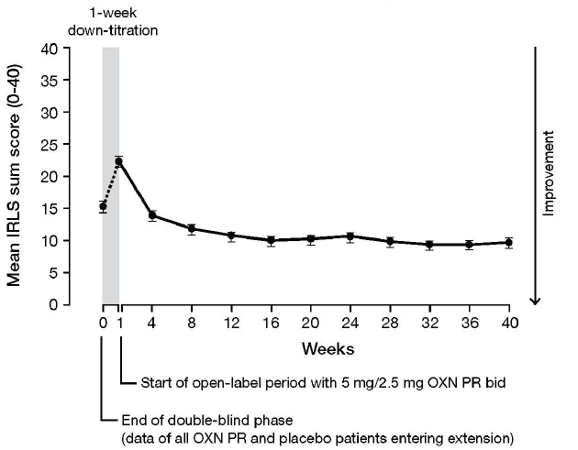
Across the whole study population, the overall mean (SD) IRLS sum score at the end of the Double-blind Maintenance Period was 15.39 (11.18), but this increased to 22.40 (10.49) by Week 1. Following the simultaneous reintroduction and primary introduction of OXN, there was a decline in the mean (SD) IRLS sum score of the total Extension Population to 13.96 (9.06). By Week 40 of the Extension Phase the mean score for the total population had decreased further to 9.72 (7.77) – this is consistent with mild RLS, whereas subjects initially had to have moderate-to-severe RLS to be eligible for the pivotal study.
In subjects treated with OXN during the pivotal study, the mean (SD) IRLS sum score was 12.35 (8.99) at the end of Double-blind treatment, and this further declined to 10.65 (8.33) at Week 40 of the Extension Phase, a relatively minor improvement that could be due in part to withdrawal bias.
By contrast, in subjects treated with placebo during the pivotal study, the mean (SD) overall IRLS sum score was 18.58 (12.35) at the end of Double-blind Treatment, and this declined to less than half the initial score, 8.63 (6.95), by Week 40 of the Extension Phase.
Although it is not possible to draw strong conclusions in the absence of a control group, these open-label results are supportive of the long-term efficacy of Targin in RLS. The response to down-titration and reintroduction in the original active group suggests that their initial response was genuine, and the initial placebo recipients showed a substantial response to open-label Targin that was consistent with the original pivotal study results. Furthermore, there was no evidence of gradual loss of efficacy with continued treatment, with the mean scores instead suggesting a minor further improvement. This improvement should be interpreted with caution, however, given that the cohort remaining in the study is likely to have been progressively enriched with satisfied and responsive patients.

Table 20: IRLS Sum Score, Extension Population, Study OXN3502S
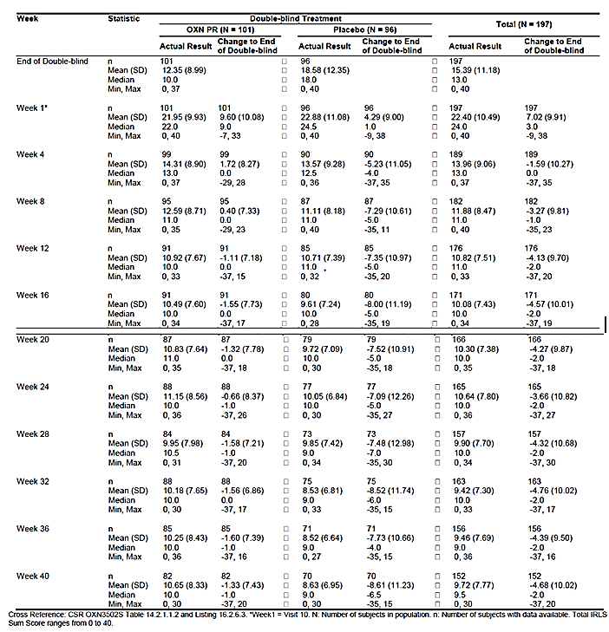
An analysis of responders and remitters (using definitions as discussed for the main double-blind phase) suggested that the placebo group showed a substantial response to the introduction of active treatment. A total of 27 subjects (28.1%) from the double-blind placebo group had a 50% improvement during the Extension Phase, over and above the placebo response that had occurred during double-blind treatment. At the end of the Extension Phase, 85 (43.1%) subjects overall were classed as IRLS remitters, including 43 (44.8%) who had received placebo and 42 (41.6%) who had been treated with OXN during the pivotal study.
The Clinical Global Impression also suggested that most subjects were considered to have improved by the end of the Extension Phase, with a final mean score of 1.56 for Item 2 (‘Change in Condition’), which is between ‘very much improved’ and ‘much improved’.
Other secondary efficacy measures, including RLS Pain Intensity, sleep scales, and quality-of-life measures, showed persistence of benefit in subjects initially treated with OXN, and the appearance of a benefit in subjects previously treated with placebo. The results for RLS Pain Intensity are shown in the tables below the CGI results, and the RLS-6 results are shown in a subsequent figure. The QOL-RLS results were not presented in a convenient format, but also showed stable or improving QOL in the group as a whole.
Dose titration up to 40/20 mg twice daily was allowed during the extension phase, and some patients reached a higher dose than in the original DB phase, but most subjects continued to use oxycodone doses in the range of 5-20 mg twice daily (10-40 mg daily). The changes in dose do not suggest that tolerance was a major problem during long term treatment, but it remains possible that some up-titration occurred in response to (and potentially masked) a gradual waning of efficacy.

Table 21: Dose at End of Extension Phase, Study OXN3502S
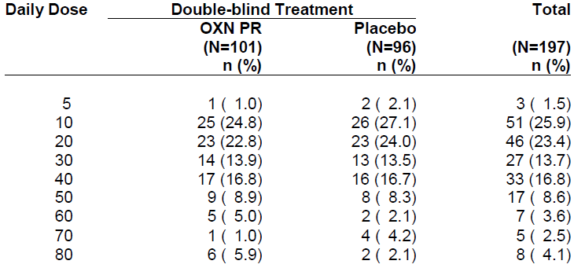

Table 22: Clinical Global Impressions, Extension Population, Study OXN3502S
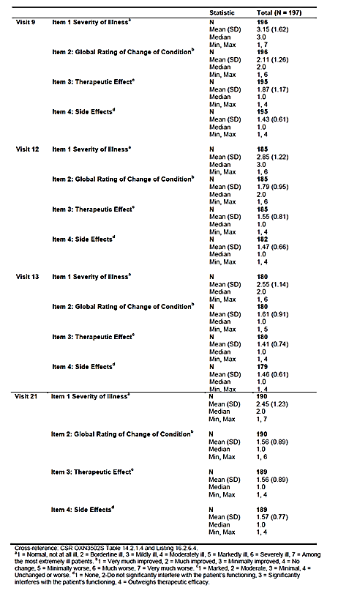

Table 23: RLS Pain, Extension Population, Study OXN3502S
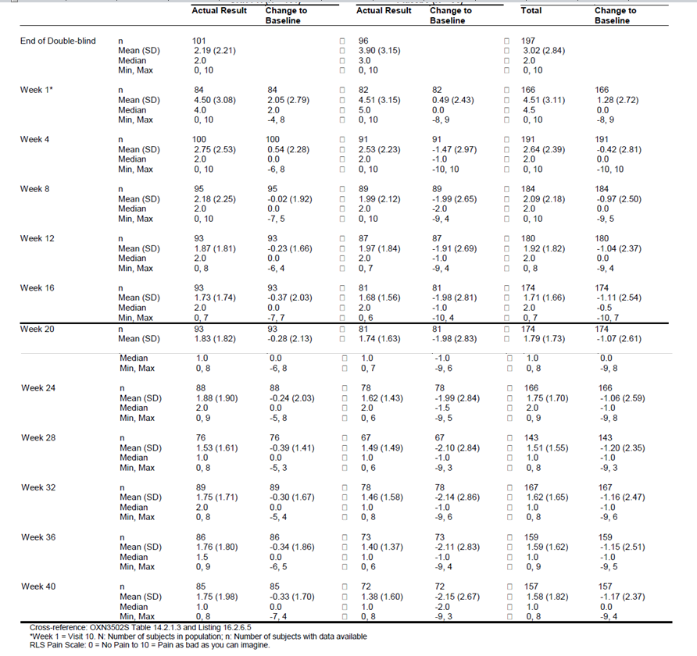
Figure 12: RLS-6 During the Day at Rest, Change from End of Double-blind to End of Extension Phase by Double-blind Treatment, Extension Population Study OXN3502S
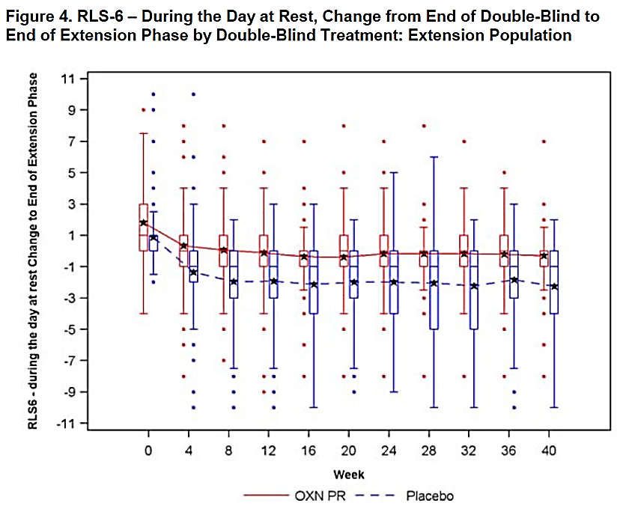

Conclusions
It is not possible to draw strong conclusions from an open-label, uncontrolled study, but this extension study showed no evidence of a decline in efficacy with continued use of Targin for up to one year. The response of patients who had previously received placebo was consistent with the results of the initial pivotal study.

Efficacy studies in chronic pain (submitted in support of increased maximum dose)
The sponsor has submitted one pivotal efficacy study and four supportive efficacy studies relevant to the proposed increase in the maximum dose (Major Variation F), as summarised in the table below. All of the studies were performed in subjects with chronic pain, but the primary efficacy endpoints also included an assessment of constipation. Overall the aim of the studies was to demonstrate superiority of Targin relative to oxycodone monotherapy in terms of constipation, while showing non-inferiority in terms of analgesic efficacy.

Table 24: Efficacy Studies for Major Variation F (Increased Maximum Dose)
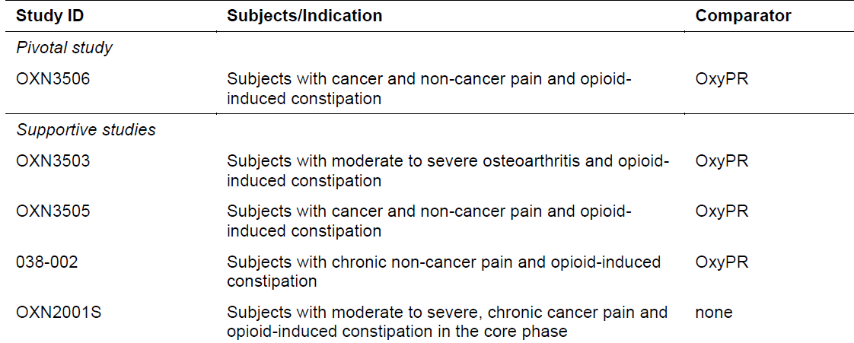
The sponsor indicates that some other studies may be supportive of a higher dose, but these studies were not available for evaluation. The sponsor comments ‘With the exception of studies OXN3503, OXN3505, 038-002 and OXN2001S, all other studies have previously been submitted and are not included in this dossier.’
A major problem with the submission was that the number of patients receiving the proposed maximum dose was both low and poorly defined. None of the studies specifically assessed the maximum proposed dose, and in most cases the need to investigate higher Targin doses was not even mentioned in the study objectives or the summary of the study supplied in the Summary of Clinical Efficacy. Inclusion of higher doses seemed largely incidental and unrelated to the main aims of the studies.
In the pivotal Study OXN3506, described below, only 31 subjects received the new maximum dose proposed for registration, and this subgroup was not specifically examined in any efficacy or safety analysis.
Study OXN3503 had a notional maximum dose of 120/60 mg/day, which is below the proposed new maximum, but it seems likely that no subjects were titrated to 120/60 mg/day anyway; only three subjects were exposed to 100/50 mg/day and all other subjects received doses that are already approved.
Study OXN3505 allowed doses up to 160/80 mg/day, but the number receiving the maximum dose was not well described. The sponsor concedes ‘Only 22/225 (9.8%) patients received >80 mg/day oxycodone,’ but a detailed description of exposure was lacking in most descriptions of this study. In the safety section of the individual study report, a dose-shift table reveals that the number exposed to 160/80 mg/day was one patient.
Study 038-002 was previously submitted as a pivotal study but for this submission it was demoted to a supportive study. The previous Clinical Evaluator noted that the Study Report did not clearly state how many subjects received each dose in this study. The Summary of Clinical Safety supplied with the new submission states that, of the 59 patients randomised in Study 038-002: ‘Of these 59 patients, 27 (45.8%) received 60/30 mg q12h dose and 32 patients (54.2%) received the 80/40 mg q12h dose.’. Elsewhere in the Summary of Clinical Safety, different numbers are cited: ‘Of the 52 patients who received OXN PR, 33 received the 60/30 mg q12h [120/60 mg/d] dose for a mean of 32.0 ± 7.2 days, and 19 patients received the 80/40 mg q12h [160/80 mg/d] dose for a mean of 32.0 ± 9.7 days.’ The discrepancy between the figures may reflect the fact that not all randomised patients received treatment, but the sponsor should clarify this. The more detailed exposure description in the second italicised sentence suggests that just 19 subjects received the proposed maximum dose. No specific efficacy analysis was performed in this small subgroup.
Study OXN2001S only allowed dosing up to 120/60 mg/day, below the proposed new maximum, and this study had no control group so it is of limited value.
In a pooled analysis of multiple supportive studies (OXN3401, OXN3001, OXN3006, OXN3503, OXN3505, OXN2001), the sponsor states that 47 subjects received ‘high doses’, defined as doses above 80/40 mg/day, but this threshold dose is only half of the maximum proposed dose (160/80 mg/day), and it is unclear how many of the 47 subjects had significant exposure to 160/80 mg/day.

Pivotal efficacy study in chronic pain (OXN3506, n=243)

Study design, objectives, locations and dates
Study OXN3506 was presented as a multicentre, multiple-dose, randomised, double-blind, double-dummy, active-controlled, parallel-group study, in male and female subjects with non-malignant or malignant pain requiring opioids, who exhibited constipation. The primary objective was to assess analgesic efficacy and symptoms of constipation secondary to opioid treatment with Targin (prolonged-release oxycodone/naloxone tablets) 50/25 – 80/40 mg twice daily (OXN PR, n=123) in comparison to OxyContin (prolonged release oxycodone tablets) 50 - 80 mg twice daily (OxyPR, n=120). Subjects were randomised to two treatment groups and were treated with OXN PR or OxyPR for up to 5 weeks, after an initial titration phase using OxyPR.
Given that both treatment arms used the same analgesic agent, oxycodone, and that Targin and OxyContin have similar pharmacokinetic profiles, there was no active control for the main therapeutic component of Targin, and the study could therefore be re-conceptualised as a placebo-controlled naloxone add-on study, in which subjects received continued prolonged-release oxycodone with or without the addition of naloxone.
The sponsor aimed to demonstrate superiority of Targin (naloxone add-on) relative to OxyContin in terms of bowel symptoms, while showing non-inferiority in terms of analgesic efficacy. The primary efficacy measures for each of these objectives were, respectively, the Bowel Function Index (BFI) for constipation and the subject’s ‘Average Pain over the last 24 Hours’ assessed at each Double-blind Phase visit with a Pain Intensity Scale.
The study consisted of three phases: a Pre-randomisation Phase, a Double-blind Phase and an Extension Phase. The Pre-randomisation Phase contained two periods: a screening period (up to 14 days) and a run-in period (7-28 days). During the run-in period, the dose of OxyPR was titrated to analgesic effect, and subjects were assessed for eligibility for the Double-blind Phase – in particular, the presence of opioid-induced constipation was confirmed. The Double-blind Phase (5 weeks, plus one-week of follow-up) was designed to demonstrate improvement in constipation and non-inferiority in analgesic efficacy in subjects taking OXN PR compared to subjects taking OxyPR tablets alone. The Extension Phase was designed to assess the long-term safety and efficacy of OXN PR up to a maximum dose of OXN90/45 mg PR twice daily over a period of 6 months.
For a pivotal study, 5 weeks is a rather brief period of double-blind treatment.
Figure 13: Study Design, OXN3506
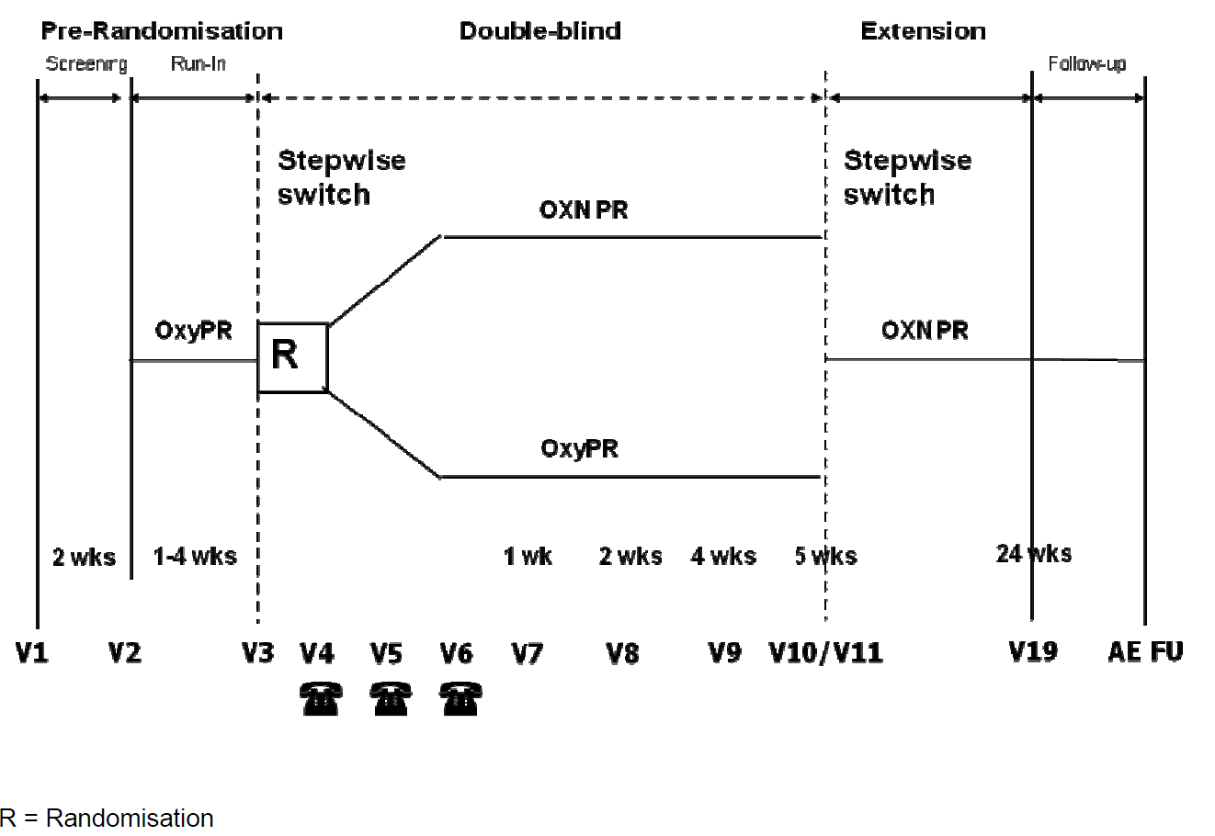
The study was conducted at a total of 66 sites in 11 countries (3 sites in Australia, 10 in the Czech Republic, 2 in Denmark, 1 in Finland, 4 in France, 16 in Germany, 1 in Israel, 9 in Poland, 8 in Romania, 3 in South Korea and 9 in the United Kingdom).
In addition, 33 international sites were initiated but did not recruit subjects.
The study ran from 26 September, 2011, to 10 February, 2014.

Inclusion and exclusion criteria
Entry criteria were listed separately for the screening period and the run-in stage.
Screening Inclusion criteria were listed as follows:
- Male or female subjects at least 18 years, non-pregnant and using appropriate contraception.
- Subjects who were receiving WHO step III opioid analgesic medication for the treatment of non-malignant or malignant pain.
- Documented history of non-malignant or malignant pain that required around-the-clock opioid therapy (100 - 160 mg oxycodone PR per day for a minimum of 5 weeks).
- Subjects with constipation caused or aggravated by opioids, and needing regular laxatives to have at least 3 bowel evacuations per week, or having less than 3 bowel evacuations when not taking a laxative.
- Subjects had to be willing to discontinue their current opioid analgesic routine and to comply with the use of opioid study medication.
- Subjects had to be willing to discontinue their current laxative regimen and to comply with the use of oral bisacodyl as laxative rescue medication.
- Subjects taking daily fibre supplementation or bulking agents were eligible if they could be maintained on a stable dose and were willing and able to maintain adequate hydration.
- Subjects had to be willing and able to participate in all aspects of the study and to provide written, informed consent.
- In the investigator’s opinion the subject’s non-analgesic concomitant medications, including anti-depressants were expected to be stable throughout the Double-blind Phase.
- In the investigator’s opinion, the non-opioid analgesic medication dose was expected to be stable during the Double-blind Phase.
- Subjects had to be dissatisfied (because of lack of efficacy or unacceptable tolerability) with their current WHO step III opioid analgesic medication.

Screening exclusion:
- History of hypersensitivity to oxycodone, naloxone, related products or other ingredients of the study medication.
- Any contraindication to oxycodone, naloxone, bisacodyl or other ingredients of the study medication.
- Active alcohol or drug abuse or a history of opioid abuse.
- Subjects with a positive urine drug test, indicating unreported illicit drug use or unreported use of a concomitant medication.
- Clinically significant cardiovascular, renal, hepatic, gastrointestinal, or psychiatric disease.
- Chronic or intermittent pain resulting from fibromyalgia or rheumatoid arthritis.
- Subjects receiving hypnotics or other central nervous system (CNS) depressants that, in the investigator’s opinion, may have posed a risk of additional CNS depression with opioid study medication.
- Subjects with uncontrolled seizures or convulsive disorder.
- Surgery within 2 months prior to the start of the Screening Period, or planned surgery during the 5-week Double-blind Phase that may have affected GI motility or pain.
- Subjects taking naloxone ≤ 30 days prior to the start of the Screening Period or at Screening.
- Subjects suffering from diarrhoea.
- Subjects with any contraindication to opioids (for example, severe respiratory depression with hypoxia and/or hypercapnia, severe chronic obstructive lung disease, paralytic ileus).
- Significantly abnormal liver function tests.
- Subjects who had taken monoamine oxidase inhibitors (MAOI) ≤ 2 weeks prior to the start of the Screening Period.
- Subjects who participated in a clinical research study involving a new chemical entity or an experimental drug within 30 days of study entry.
- Subjects with known or suspected unstable brain metastases or spinal cord compression that may have required changes in steroid treatment.
- Cyclic chemotherapy in the two weeks before the screening visit or planned during the study that has shown in the past to significantly influence bowel function.
- Radiotherapy that, in the investigators opinion, would influence bowel function or pain during the study.
- Subjects with an expected life expectancy of <6 months.

Additional criteria for entry into the run-in period:
- Subjects should have been on a stable dose of 50, 60, 70 or 80 mg oxycodone PR twice daily on at least 4 consecutive days prior to randomisation.
- Subjects had to rate their pain (Average Pain over last 24 Hours) as ≤ 4 on 0-10 scale with ≤ 2 doses of Oxycodone immediate-release (OxyIR) analgesic rescue medication per day for either the last three consecutive days or four of the last seven days.
- Subjects had to have confirmed opioid related constipation, which was defined as having less than 3 Complete Spontaneous Bowel Movements non-straining (CSBM-NS) during the last 7 days of the Run-in Period.
- Subjects demonstrated compliance with the use of rescue medication (OxyIR, oral bisacodyl), taking open-label OxyPR, and completing daily diaries.
In summary, eligible subjects had on-going requirements for analgesia, were already taking opioid analgesics, but were dissatisfied with them because of poor efficacy or side effects. Subjects with poorly controlled pain or significant confounding conditions were excluded.

Study treatments
The study compared Targin tablets 50/25 – 80/40 mg twice daily (OXN PR, n=123) with OxyContin tablets 50 - 80 mg twice daily (OxyPR, n=120).
All subjects commenced treatment with OxyContin (prolonged-release oxycodone monotherapy), and were titrated as needed up to a maximum dose of 80 mg twice daily.
Following randomisation, subjects randomised to Targin continued an equivalent blinded dose of oxycodone, but with naloxone added at a standard oxycodone: naloxone ratio of 2:1. Naloxone was introduced in a stepwise manner over 4 days.
If needed, further dose titration up to 80 mg oxycodone PR twice daily (total 160 mg oxycodone per day) was allowed during the Double-blind Phase, but only 31 subjects were exposed to the maximum dose of OXN proposed in the current submission.

Table 25: Number of Patients Receiving ≥ 100 mg/day by Treatment Group, Study OXN3506
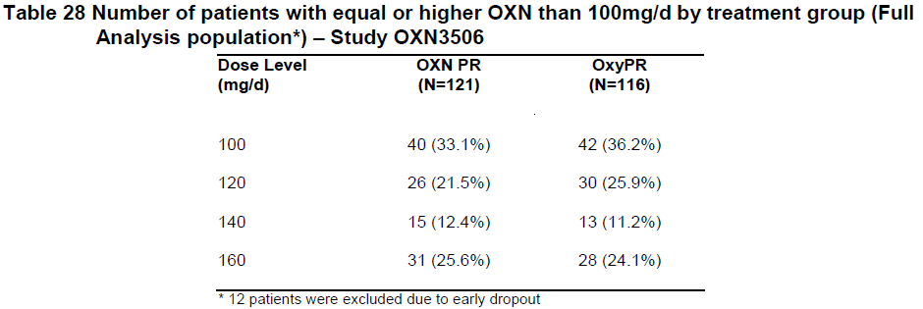
For Targin, the different dose levels assessed were OXN50/25 mg, OXN60/30 mg, OXN70/35 mg and OXN80/40 mg twice daily (oxycodone 100, 120, 140 or 160 mg/d), with equivalent oxycodone doses in the OxyPR group.
In the open-label extension phase, further dose increases to OXN90/45 mg twice daily (180 mg/d) were allowed.
Immediate-release oxycodone (OxyIR) was the only allowed analgesic rescue medication. Subjects were permitted to take stable doses of non-opioid analgesics.
During the Double-blind Phase, subjects were also permitted to take oral bisacodyl 10 mg/day as laxative rescue medication for constipation, and the need for this rescue agent was considered as a secondary efficacy measure.

Efficacy variables and outcomes
The study had two distinct objectives: the demonstration of superiority of Targin (naloxone add-on to oxycodone) in terms of bowel symptoms, and the demonstration of non-inferiority in terms of analgesic efficacy, relative to OxyContin (continued oxycodone monotherapy). The study therefore used two different primary efficacy variables and endpoints.
The primary efficacy variables were:
- Bowel Function Index (BFI), for bowel symptoms.
- ‘Average Pain over last 24 Hours’, as assessed at each double blind visit with a numerical Pain Intensity Scale (PIS), potentially ranging from 0 – 10.
The BFI was defined as the mean of three items:
- Ease of defaecation (numerical analogue scale [NAS], 0=easy/no difficulty; 100=severe difficulty); Feeling of incomplete bowel evacuation (NAS, 0=not at all;100=very strong);
- Personal judgment of constipation (NAS, 0=not at all; 100=very strong).
The secondary efficacy endpoints were ‘Average Pain over last 24 Hours’ (Pain Intensity Scale) assessed in daily diaries, the use of analgesic rescue medication and laxative rescue medication, number of Complete Spontaneous Bowel Movements (CSBMs) and quality of life scores using standard instruments (EuroQol EQ-5D).

Randomisation and blinding methods
Randomisation was achieved with an automated system that assigned treatments to randomisation numbers. The randomisation process was reviewed centrally and locked before commencement of the trial, and treatment assignments were unknown to clinicians and patients.
Blinding was maintained using a double-dummy approach with placebos for Targin and placebos for OxyContin, which appeared identical to their active counterparts. Blinding to oxycodone dose was not attempted, and all subjects knew they were receiving active oxycodone. A minor flaw in the study is that no attempt was made to assess unblinding by asking patients or clinicians to guess the treatment assignment. Because of the limited systemic bioavailability of naloxone, it is relatively unlikely that tell-tale naloxone side effects led to unblinding apart from subjects who noted improved bowel function after being randomised to naloxone. Unblinding due to superior efficacy is unavoidable in a study of this nature, and it is not a major methodological concern. Tell-tale oxycodone side effects do not pose a blinding concern because all subjects received oxycodone.

Analysis populations
The sponsor defined the following populations:
- Enrolled: ‘All subjects who provided informed consent.’
- Full-Analysis (FA): ‘Subjects who were randomised and received at least one dose of study medication during the Double-blind Phase and who had at least a one week Double-blind assessment of the primary efficacy variable, the BFI.’
- Per-Protocol (PP): ‘Subjects who received at least 4 weeks study medication during the Double-blind Phase and who sufficiently complied with the study protocol.’
- Run-in Period Safety: ‘Subjects who received at least one dose of study medication in the Run-in Period, and had at least one safety assessment after the first dose of study medication.’
- Double-Blind Safety: Subjects who received at least one dose of double-blind study medication and had at least one safety assessment after that dose.
The primary population for the bowel-symptoms superiority (BFI) analysis was the FA set, which is equivalent to an intent-to-treat (ITT) population but excludes subjects without meaningful efficacy data. The primary population for the analgesic non-inferiority (Pain Intensity) analysis was the PP set, which is appropriate for a non-inferiority comparison because a PP analysis usually increases the possibility of finding a treatment difference. For each of these endpoints, sensitivity analyses were also performed in the non-primary population, and the results were very similar.

Statistical methods
For the primary bowel function efficacy endpoint (BFI), a mixed-model repeated measures (MMRM) analysis of covariance (ANCOVA) was carried out for Visits 7, 8, 9 and Visit 10 (but only with completers). No missing-data imputation was performed. The MMRM analysis included fixed-effect terms for treatment and time, random centre effect, and pre-randomisation value at the end of the Baseline Period. The assessment population was the FA set.
For the Pain Intensity Scale (‘Average Pain over last 24 Hours’), the same MMRM approach was used as for the BFI, but the assessment population was the PP set.
Both hypothesis tests applied a 2.5% one-sided significance level. Non-inferiority was inferred when ‘the one-sided 97.5% t-type confidence interval of the population mean difference in PIS between both treatment groups was completely above a non-inferiority bound of 20%’; . The sponsor did not provide a clear statement of what the ‘20%’ is based on. One possibility is that it was calibrated against the entire pain scale another possibility is that it was based on the mean pain scores for the treatment group, and a third possibility is that it was based on the magnitude of the treatment effect. It is important to clarify what is meant, because it is possible that the sponsor considered increases in pain of up to 20% of the entire pain scale as non-inferior. For instance, if an analgesic agent reduced pain from 5/10 to 4/10, so that the analgesic effect was 1/10, a 20% increase in pain on switching to Targin could amount to a final pain score of:
- 6/10 (20% is 2 points out of 10 possible points);
- 4.8 (20% is one fifth of the mean score of 4);
- 4.2/10 (20% is one fifth of the treatment effect of 1 point).
In the first interpretation, an agent that would be considered clinically inferior would still satisfy the sponsor’s definition of non-inferior. It appears likely that the second interpretation was used (that is, the upper confidence interval for pain scores in one group were allowed to be up to 120% of the mean pain scores in the other group), but the sponsor should be asked to clarify this point.
The analysis of analgesic rescue medication intake per week, laxative rescue medication intake per week and CSBMs per visit was reported with nonparametric 95% confidence intervals (Hollander et al., 1973a) and with p-values derived from a nonparametric rank sum test (Hollander at al., 1973b). Both treatments were compared with a two-sided 0.05 level of significance.
For the Diary Pain Intensity Scale (DPIS) the average of the last seven days before each visit was analysed with descriptive statistics.
All secondary efficacy analyses were performed using the FA population. For analgesic rescue medication intake, an additional sensitivity analysis was performed on the PP population.
The EuroQol EQ-5D was only assessed with descriptive statistics.
Overall, these statistical methods were appropriate and the statistical results for each major endpoint were sufficiently robust that it did not appear that the interpretation hinged on the choice of a specific statistical test.

Sample size
Sample size estimation was based on the previous analgesic studies, OXN9001 and OXN2001, and assumed a within-subject SD of 27 and a true difference of 12 in the BFI, and an expected mean value of 3.7 with an SD of 1.85 in the averaged Pain Intensity, with no difference between the compared groups.
It was estimated that 121 evaluable subjects per treatment group for the superiority test on BFI (α=0.025 one-sided) and 87 subjects per treatment group (PP) for the non-inferiority test on pain (α =0.025 one-sided and a non-inferiority bound of 20%) would provide a test power of 93% with the superiority test in the BFI and of 87% with the non-inferiority test in pain.
Furthermore, assuming both parameters were approximately independent of each other, the power of a union intersection test applied on both (with testing average pain first) exceeded 80%.
Allowing for 10% early drop-outs and 25% subjects not being eligible for the PP non-inferiority analysis, it was intended that 135 subjects per treatment group would need to be randomised.
Subject numbers fell slightly short of this target (OXN PR, n=123; OxyPR, n=120), potentially compromising the power of the study, but, despite this, the non-inferiority analysis achieved statistically robust results (p<0.001 for rejection of the null hypothesis that the ratio of PIS between OXN PR and OxyPR was ≥120%).
No power considerations considered the number of subjects treated in different dose levels.

Participant flow
Overall, 209 subjects (86.0%) completed the study, which is an acceptable completion rate for a study of this nature. The completion rates were similar in the two treatment groups (OXN 86.7%, OxyPR 85.4%), making it relatively unlikely that withdrawal bias significantly affected the outcome.
Figure 14: Patient Disposition, Study OXN3506
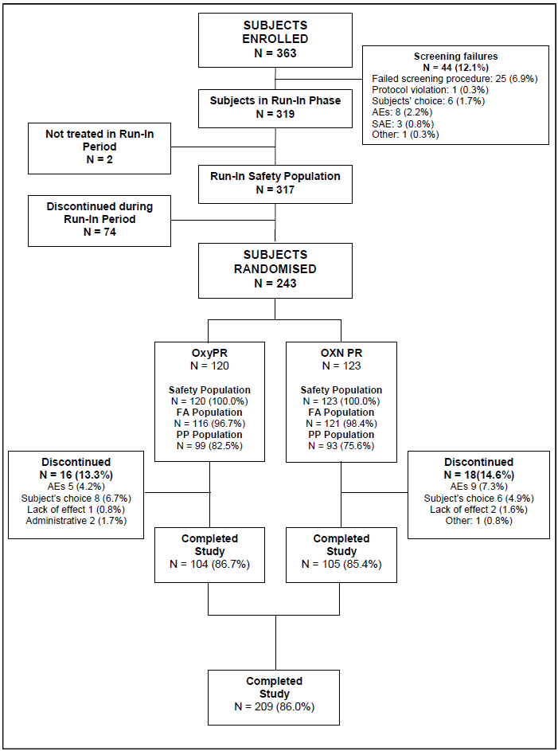

Major protocol violations/deviations
The sponsor did not provide a detailed listing of major protocol deviations, but made the following claim:
‘Although a number of deviations from the protocol (for example, missed visits) occurred, these deviations were not considered to have affected the evaluation of efficacy or safety, particularly since the primary efficacy analysis was based on the full analysis population and the safety evaluation was based on all available safety results. None of the subjects received the incorrect treatment, and no treatment codes were broken prior to database lock.’
The table below indicates that 21% of subjects were excluded from the PP population. The most common reasons were unspecified errors in the duration of treatment (12.3%), and missing values for a primary efficacy parameter (also 12.3%). It is unclear if all of these deviations should be considered major.

Table 26: Reasons for Exclusion from Per-Protocol Population, Study OXN3506
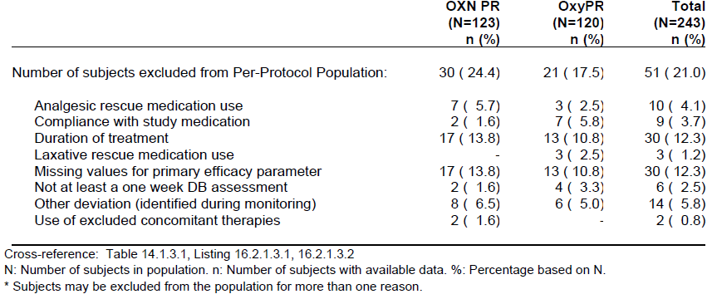
Overall, the number of protocol deviations appeared to be acceptable for a study of this nature.

Baseline data
The subjects’ baseline demographics are summarised in the table below. Unfortunately, baseline disease characteristics were not presented in a convenient format, but were instead listed in a multipage table not suitable for inclusion in this report. Incidences of major conditions appeared similar in the two treatment groups.
Most of the subjects (74.9%) had musculoskeletal and connective tissue disorders as the cause of their pain, and the condition most frequently reported was back pain, which was present in 129 (53.1%) subjects, followed by spinal osteoarthritis in 20.6% subjects, osteoarthritis with 14.0% subjects and intervertebral disc protrusion with 10.3% subjects. A total of 50 subjects (20.6%) reported ongoing malignant conditions at screening, but only 37 subjects (15.2%) had an underlying neoplasm as the cause of their pain. The most common neoplasms were breast cancer and lung cancer. Overall, the distribution of the underlying pain-causing conditions appeared broadly balanced between treatment groups.
All but one subject (242/243 subjects, 99.6%) reported constipation at baseline, consistent with the entry requirements of the study.
Other common baseline conditions were summarised by the sponsor as follows: ‘hypertension (39.5% subjects), depression (23.5%), hypercholesterolaemia (14.8% subjects), obesity (11.5%), menopause or post-menopause (together 10.7%), insomnia (9.1%), type 2 diabetes (7.0%), dyspepsia (6.6% subjects), post laminectomy syndrome (6.6% subjects), myocardial ischaemia (5.3% subjects), and pain (5.3% subjects)’.

Table 27: Demography, Randomised Population, Study OXN3506
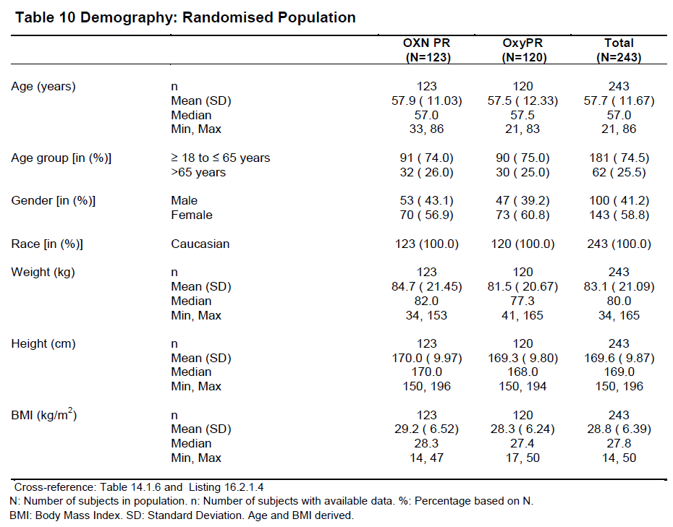

Results for the primary efficacy outcomes

Bowel Function (BFI)
The group randomised to naloxone add-on (OXN) had a clear improvement in their BFI scores, with a statistically significant superiority relative to the BFI scores in the OxyPR group. From similar mean BFI scores at baseline of approximately67 (OXN 68.1; OxyPR 66.7; median 70 in both groups), the OXN group improved by approximately 30 points by Week 5, compared to an improvement of approximately10 points in the OxyPR group, as shown in the figure below.
The adjusted differences were apparent in the primary FA set (LS mean difference (SE): -16.05 (3.14); p<0.001, 95% CI: -22.23.19, -9.86) as well as in the PP population (LS mean difference (SE): -18.17 (3.34); p<0.001, CI: -24.75, -11.59). In a sensitivity analysis with LOCF imputation, the results were similar (LS mean difference (SE): -14.50 (3.095); p<0.001, CI: -20.60, -8.40).
Subgroup analyses were performed based on gender and on age (≤ 65, > 65 years). Broadly similar results were obtained in each of these groups.

Table 28: Summary of Bowel Function Index by Time point, Observed Values, Full Analysis Population Study OXN3506
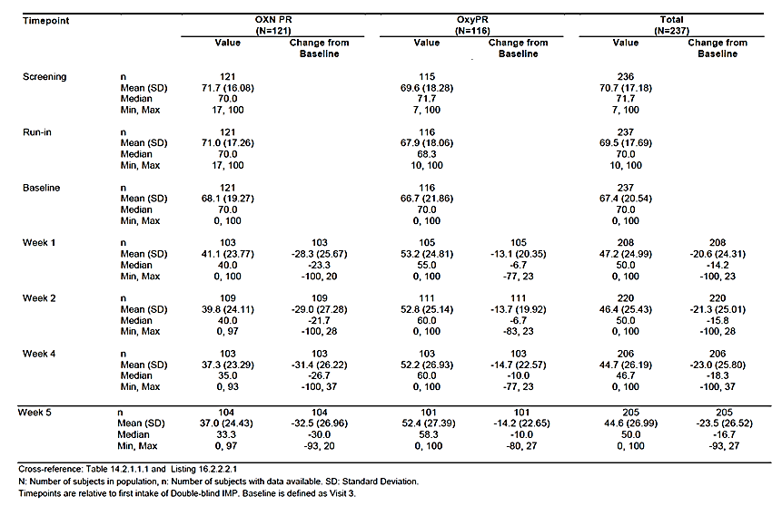
Figure 15: Bowel Function Index, Observed Values, Full Analysis Population Study OXN3506
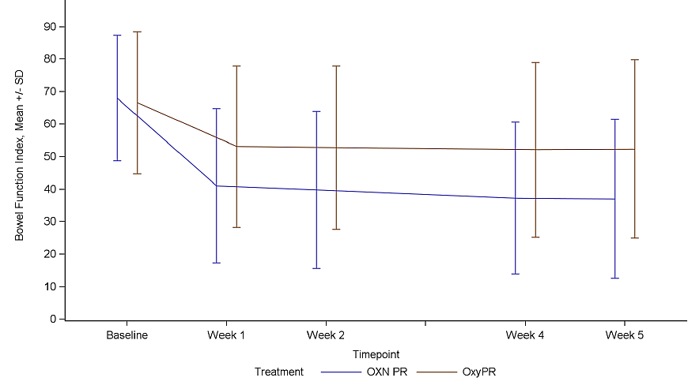

Table 29: Primary Statistical MMRM Analysis of BFI, Full Analysis Population, Study OXN3506
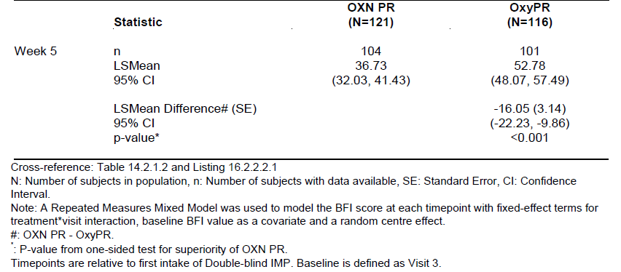

Table 30: Robustness MMRM Analysis of BFI, Per-Protocol Population, Study OXN3506
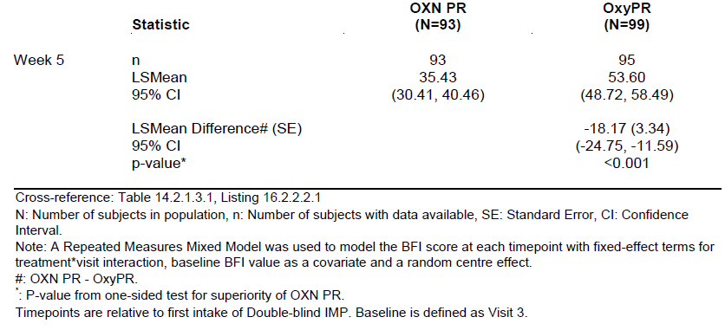

Analgesia (PIS)
Pain scores (PIS) did not change substantially during the Double-blind Treatment Phase, consistent with the fact that doses were titrated prior to randomisation and subjects with poorly controlled pain were excluded. As shown in the table below, median changes from baseline were zero in both treatment groups at all the time points, and mean PIS scores remained between 3 and 4, with only small mean changes from baseline (0.0 to 0.4). Mean pain scores were marginally higher in the OXN group, but differences between groups and variations over time were minor compared to the spread within the treatment groups.
Non-inferiority of OXN PR to OxyPR was confirmed within the limits of the study; the null hypothesis that the ratio of ‘average pain over the last 24 hours’ between OXN PR and OxyPR was ≥ 120% was rejected with p<0.001 in the primary PP population. Sensitivity analyses using the FAS set and with LOCF imputation also rejected the null hypothesis with p<0.001 (tables below the figure).
It should be noted that the sponsor’s definition of non-inferiority was potentially very broad, and the sponsor regarded an increase in pain of up to 20% as non-inferior. In other words, the upper limit of the confidence intervals could be consistent with an increase in pain of up 19% on switching to Targin, and this would still have been considered non-inferior, even though such an increase would be of clinical relevance. Fortunately, the observed differences were relatively minor compared to the 20% threshold, so that the results suggest that there is no clinically important difference in efficacy.

Table 31: Pain Intensity Scale – ‘Average Pain over the Last 24 Hours’ – Observed Values, PP Population, Study OXN3506
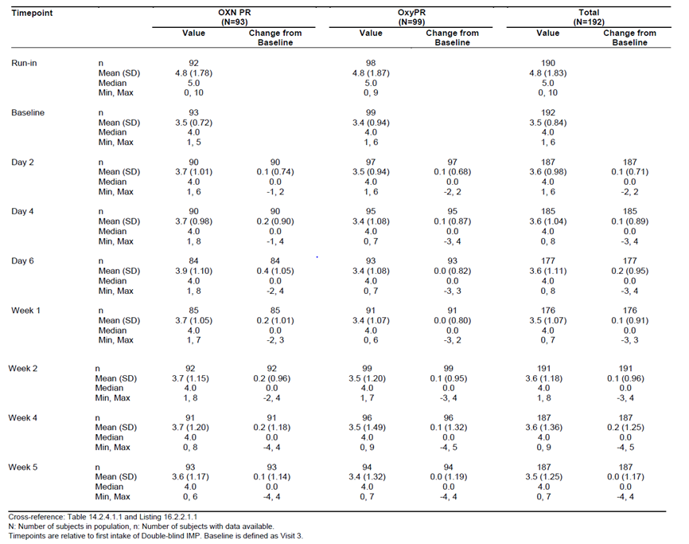
Figure 16: ‘Average Pain Over the Last 24 Hours’ – Observed Values, PP Population, Study OXN3506
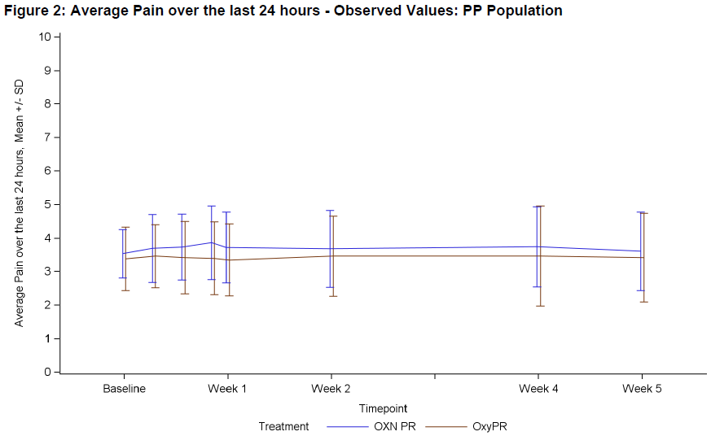

Table 32: Pain Intensity Scale – ‘Average Pain Over the Last 24 Hours’, Observed Values, Full Analysis Population, Study OXN3506
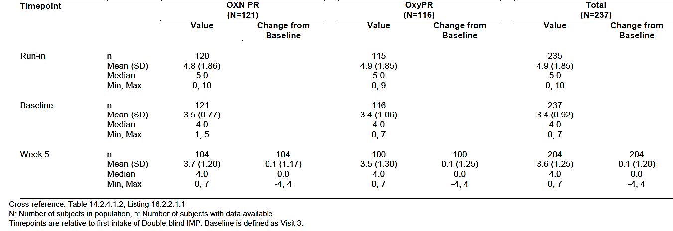

Table 33: Pain Intensity Scale – ‘Average Pain Over the Last 24 Hours’, LOCF, Full Analysis Population, Study OXN3506
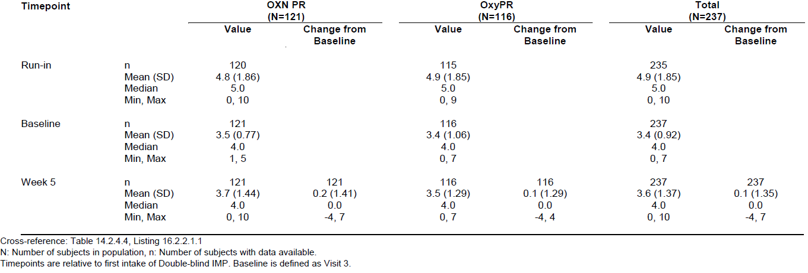
The 95%CIs for the difference in treatment effect for PIS were not clearly reported in the body of the CSR, but these were included in a subsequent table. As shown below, the 95%CIs included the possibility that OxyPR is associated with about one unit of pain (95%CI -0.99 to -0.30) less than observed with OXN, which is a large difference compared to the mean pain scores (approximately 3/5 to 4 throughout the study). The 95%CI did not include zero, suggesting that the two treatments were significantly different, but this difference was not mentioned in the study report.

Table 34: Primary MMRM Analysis of the Pain Intensity Scale – ‘Average Pain over the Last 24 Hours’, by Visit (Baseline Adjusted)
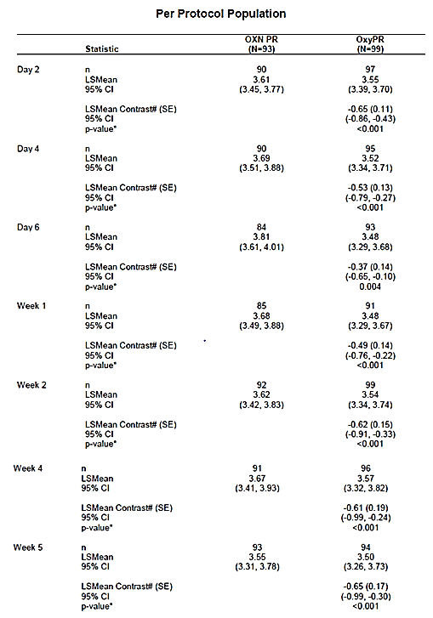
A subgroup analysis based on dose showed similar results in subjects titrated to 100-120 mg/day as observed in those titrated to 140-160 mg/day, with median changes from baseline of 0.0 and mean changes of 0.0 to 0.2 points, with no relevant differences between treatment groups (see the table below), but this analysis was post hoc and almost certainly underpowered.

Table 35: Pain Intensity Scale – ‘Average Pain over the Last 24 Hours’, Observed Values, PP Population, Dose Level 100-120 mg/day Study OXN3506
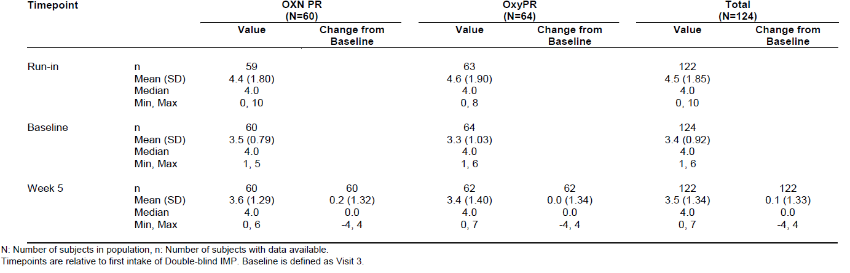

Table 36: Pain Intensity Scale – ‘Average Pain over the Last 24 Hours’, Observed Values, PP Population, Dose Level 140-160 mg/day Study OXN3506
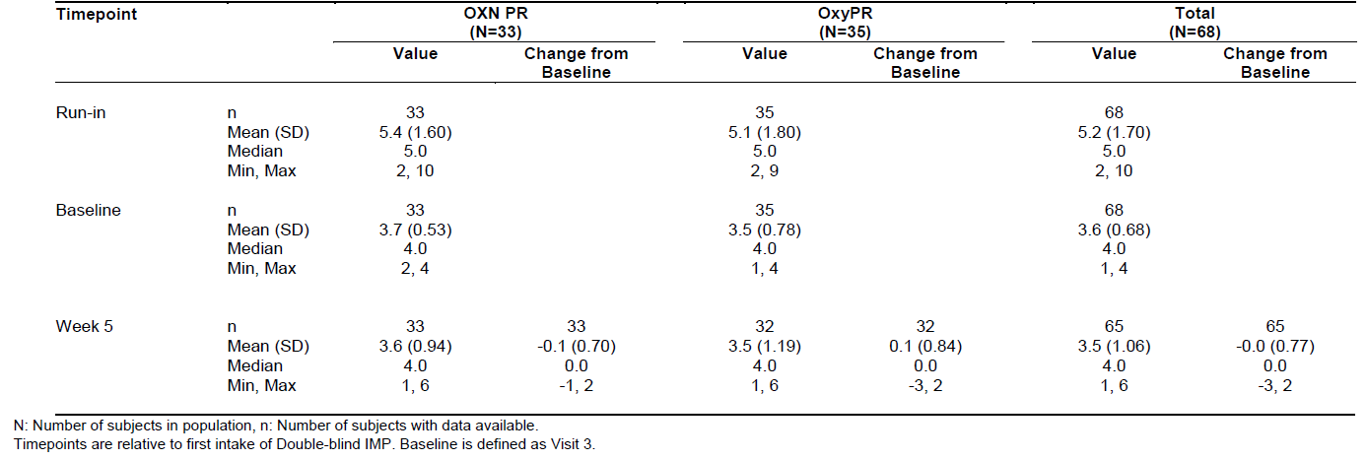

Results for other efficacy outcomes
Use of rescue laxatives was monitored as an indirect measure of bowel function, and the tables below show that laxatives were not needed as often in OXN recipients as in OxyPR recipients, regardless of whether this was expressed in terms of mg of bisacodyl per day (p=0.0042 for the DB period), or number of treatments per day (p=0.0027 for the DB period).

Table 37: Laxative Rescue Use (Mean Daily Dose in mg), Full Analysis Population Study OXN3506
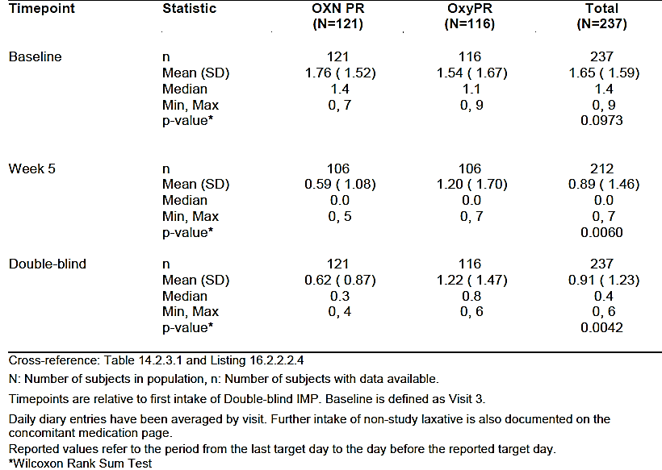

Table 38: Laxative Rescue Use (Number of Tablets per Week), Full Analysis Population Study OXN3506
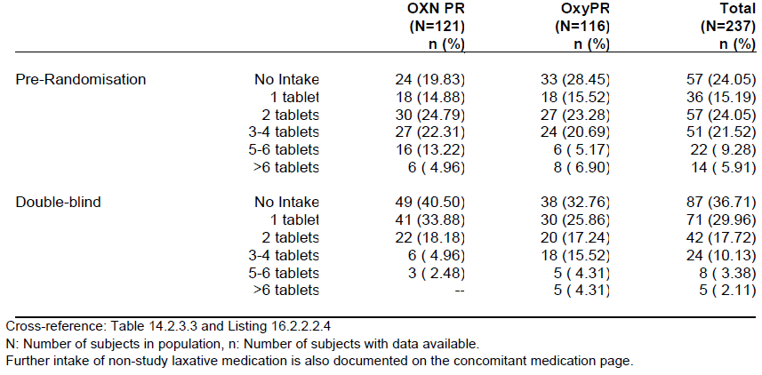
The total number of bowel movements in the 7 days prior to each visit was similar in the two groups (with a trend in favour of OXN for more bowel movements), as shown in the table below, but there was a marked difference between the two groups for bowel movements that were spontaneous and complete (CSBM), as shown in the subsequent table. OxyPR recipients only had a median of 0 or 1 CSBM per week, whereas OXN recipients had medians of 2 to 4.5 across the different visits, with median totals for the entire 5-week DB period being 3 CSBMs for the OxyPR group and 10 for the OXN group (p<0.0001 b Wilcoxon Rank Sum Test).

Table 39: Number of Bowel Movements in Last 7 Days, Full Analysis Population Study OXN3506
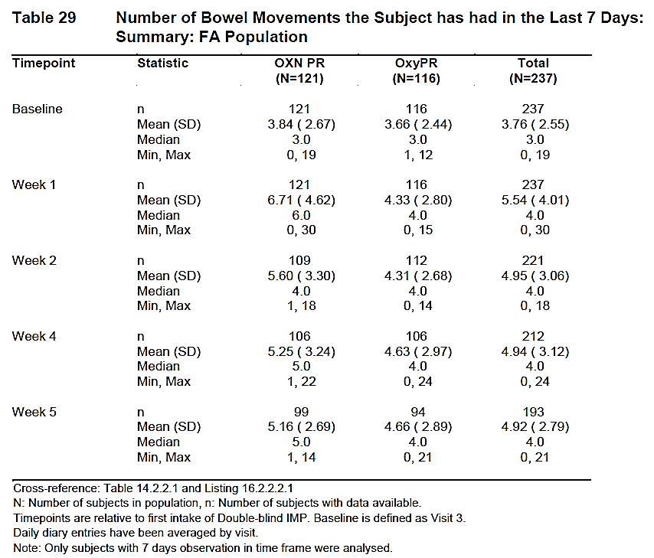

Table 40: Complete Spontaneous Bowel Movements (CSBMs), Full Analysis Population, Study OXN3506
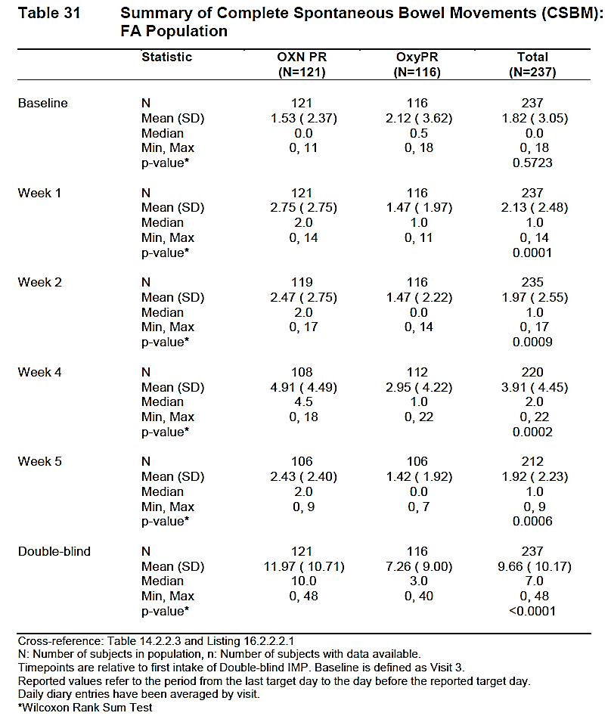
Secondary endpoints based on pain included Diary PIS (reflecting overall pain between visits, not just the average pain in the 24 hrs prior to a visit), and use of rescue analgesics. No clinically important differences were observed between groups. Rescue analgesics were used frequently (0.68 times per day, on average), but the frequency was very similar between the groups (OXN 0.69 and OxyPR 0.68 for the DB period). The mean daily dose of rescue analgesia was also similar (13.6 and 13.8mg in the OXN and OxyPR groups, respectively).

Table 41: Pain Intensity Scale – ‘Average Pain over the Last 24 hours’ – Mean Diary Scores, Per-Protocol Population Study OXN3506
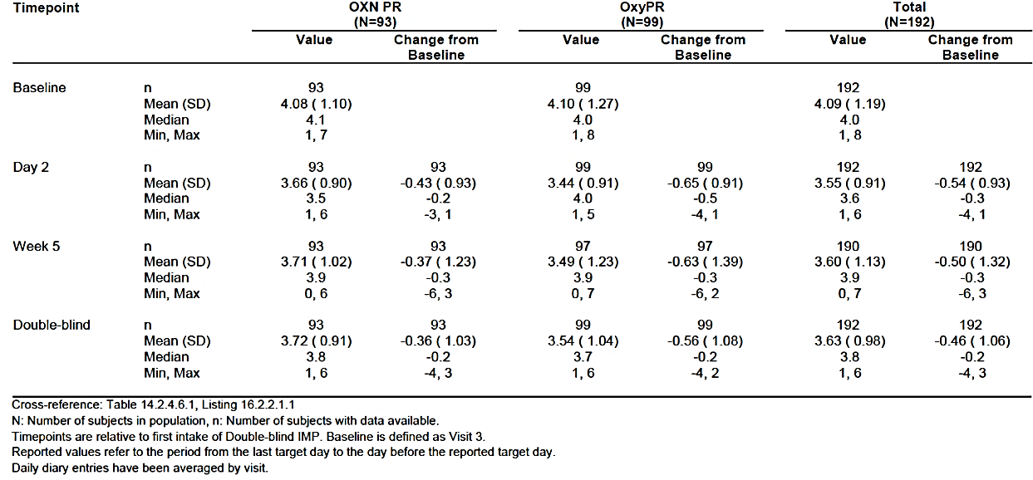

Table 42: Analgesic Rescue Medication (Frequency of Intake), Per-Protocol Population Study OXN3506
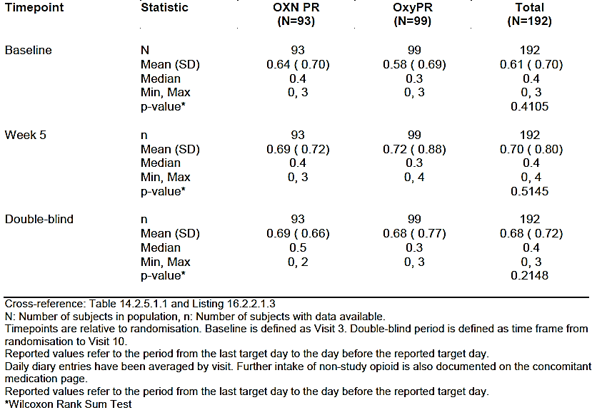

Table 43: Analgesic Rescue Medication (Mean Daily Dose in mg), Per Protocol Population Study OXN3506
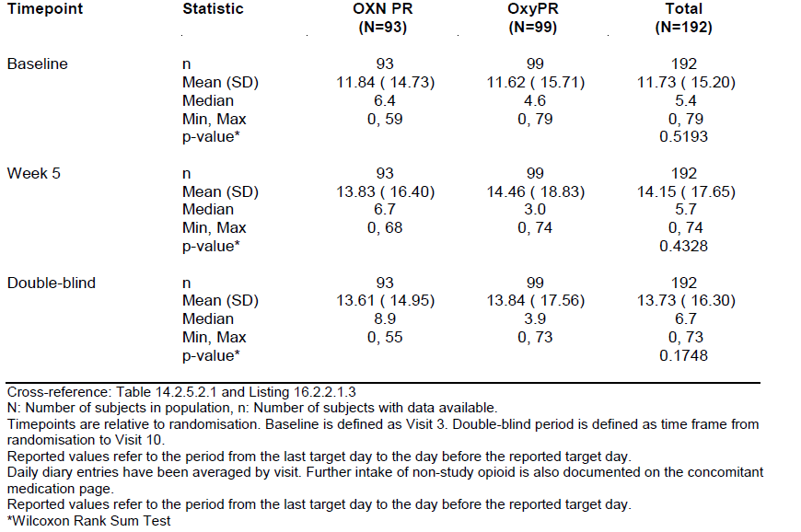
The EQ-5D was used as a measure of quality of life, and this showed no substantial between-group differences, as shown in the table below. Overall, there was a slight improvement in EQ-5D scores, possibly due to commencement of prolonged-release analgesic medication. Spontaneous improvements, regression to the mean or other factors could also have contributed to the improvement. The EQ-5D scores do not suggest that improvements in constipation translated to major improvements in quality of life.

Table 44: EQ-5D Index, Full Analysis Population, Study OXN3506
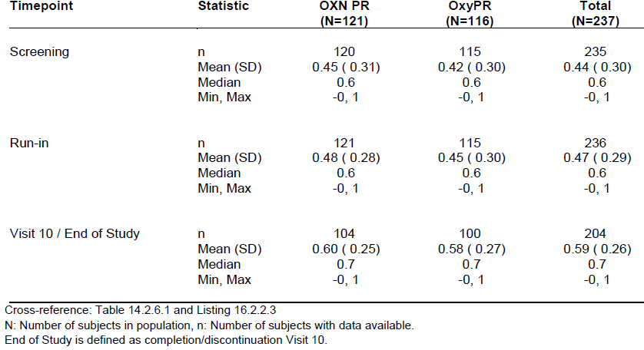

Post hoc dose comparison
Although Study OXN3506 was submitted as the pivotal study in support of the proposed increase in maximum Targin dose an analysis of the results by dose was not a key part of the prospective design. Instead, the sponsor performed a post hoc analysis of the pain scores, based on dose, but the value of this analysis is limited by the non-random nature of dose assignment.
The sponsor claims: ‘[The table below] presents the pain results (average pain over 24 hours) separately for the lower dose level of 100-120 mg oxycodone per day and the higher dose level of 140-160 mg per day. In both analyses, there was no difference between baseline value and the value at week 5. Moreover, the values were nearly identical between the OXN PR and OxyPR group, which clearly demonstrate, that high doses of naloxone up to 80 mg daily in an oxycodone/naloxone ratio of 2:1 does not antagonise the analgesic effect of oxycodone.’
The tables show that median pain scores at Week 5 were 4.0 in all four groups: high- and low-dose OXN, and high- and low-dose OxyPR. In recipients of higher doses, the mean pain scores decreased slightly in the OXN group (-0.1) but increased slightly in the OxyPR group (+0.1). These results provide some reassurance that higher doses of naloxone do not have a major adverse effect on the analgesic efficacy of oxycodone, but fall short of a clear demonstration that naloxone ‘does not antagonise the analgesic effect of oxycodone.’ For a start, currently approved doses of Targin were not part of the analysis. Also, this study was not specifically powered for such an analysis, and post hoc results should always be interpreted with caution. The sponsor’s own PD studies suggested that some systemic antagonism occurred leading opioid-dependent users to find Targin less likeable than placebo, so some small degree of antagonism of analgesic effect seems likely. To conclude that naloxone had no effect on analgesic efficacy would require an adequately powered study in which this hypothesis was tested prospectively.

Table 45: Pain Intensity Scale – ‘Average Pain Over 24 Hours’ – Observed Values, Per Protocol Population, Analysed by Dose Level, Study OXN3506
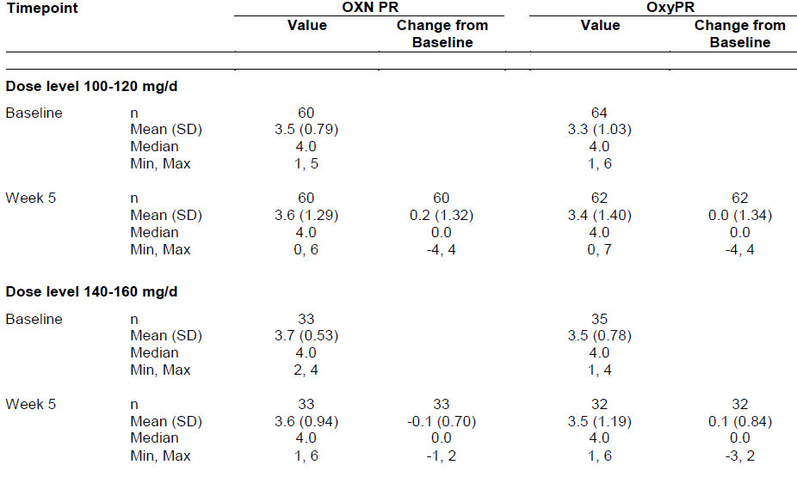
A similar analysis for BFI score by dose was not provided.

Conclusions
Ostensibly, OXN3506 met both of its primary objectives, demonstrating an improvement in symptoms of constipation as measured by the BFI in subjects taking OXN PR compared to subjects taking OxyPR, and demonstrating non-inferiority of OXN PR compared to OxyPR with respect to analgesic efficacy. The demonstration of analgesic non-inferiority was not robust, however, particularly when considering the proposed maximum dose.
The benefit of OXN for bowel symptoms was demonstrated in all major analyses, including the BFI in the FA population (LS mean difference (SE): -16.05 (3.14); p<0.001, CI: -1822.23.19, -7.169.86) as well as the PP population (p<0.001). The primary result was supported by positive results for the bowel-related secondary efficacy analyses. The number of complete spontaneous bowel movements increased significantly in the OXN PR group compared to the OxyPR group (p<0.0001 over the complete Double-blind Phase and p=0.0006 at Week 5), and rescue laxatives were needed less often.
Subjects in both treatment groups showed reduced pain in the Run-in Phase, when they commenced OxyPR and pain scores remained reasonably constant throughout the Double-blind Phase. It is unclear if there was a statistically significant difference in pain scores in the two groups, because this was not explicitly discussed by the sponsor, but the 95%CIs for the difference at Week 5 did not include zero, suggesting a significant difference in efficacy (albeit a difference that was not as large as the sponsor’s preferred definition of non-inferiority).
In the primary PP analysis of the Pain Intensity Scores, the null hypothesis that the ratio of ‘average pain over the last 24 hours’ between OXN PR and OxyPR was ≥ 120% was rejected with p<0.001, but it could be argued that an increase in pain of 20% would be clinically significant, so this equivalence threshold was not sufficiently reassuring. (The threshold of 120% appears to have been scaled against the residual pain in the comparator group, not the treatment effect itself, but this should be confirmed by the sponsor.)
The actual baseline-adjusted treatment difference in mean pain scores at Week 5 was about 0.65 units (from a potential pain score of 10 and a mean score of approximately 3.5 to 4), and the 95%CI did not include zero, consistent significant inferiority of Targin.
Given that, in usual clinical practice, doses can be titrated against the analgesic result, minor differences in analgesic potency between Targin and OxyContin do not raise substantial clinical concerns. For many patients, the benefits in bowel symptoms justify a minor loss in potency, particularly if this could be overcome with further titration.
Of more concern, it should be noted that the pivotal analgesia study was not specifically powered to test the highest proposed Targin dose (80/40 mg twice daily), which was only administered to 31 subjects. The possibility of a clinically significant difference in analgesic efficacy has not been disproved.
Secondary analgesic endpoints were broadly consistent with the co-primary analgesic endpoint. Diary-based pain scores were comparable to those measured at the assessment visits, and there was no significant difference in analgesic rescue medication intake between the treatment groups (p=0.5145 for frequency and p=0.4328 for dose at week 5 in the PP population; p=0.3999 for frequency and p=0.3141 for dose at week 5 in the FA population).
Quality of life, as assessed by the EuroQol EQ-5D questionnaire, improved slightly throughout the study in both treatment groups, with no differences noted between groups.
This study therefore supports the claim that when subjects require high doses of prolonged-release oxycodone (≥ 100 mg/d), a benefit in terms of bowel symptoms can be obtained by adding naloxone at a ratio of 2:1 (oxycodone: naloxone). It is not yet clear if this can be achieved without compromising analgesic efficacy.
Even if the study had clearly demonstrated analgesic equivalence of Targin and OxyContin at the proposed higher doses, this would only have been indirectly supportive of the proposed increase in the maximum Targin dose. Firstly, the study did not attempt to demonstrate analgesic superiority of the higher oxycodone doses, relative to lower doses, and titration of the oxycodone dose was unblinded and largely performed in the pre-randomisation phase. A requirement for high doses of oxycodone (100-180 mg/day, higher than currently approved for Targin) was in fact a prerequisite for entry into the randomised phase of the study. Secondly, the study design was not capable of addressing the question of whether higher naloxone doses were more effective than lower doses, or of finding the optimal oxycodone: naloxone ratio at high doses. Instead, it was assumed that some patients require higher oxycodone doses for pain relief (a reasonable assumption based on previous experience with OxyContin, which is already approved at higher doses), and it was also assumed that the oxycodone: naloxone ratio of 2:1 (already approved for lower Targin doses) remained appropriate for higher doses. These assumptions appear broadly reasonable but they were not directly tested.
Given that current recommended practice for patients with high oxycodone dose requirements is to treat them with the maximum approved dose of Targin (80/40 mg per day) and then top-up the oxycodone dose with OxyContin, the real question is whether use of the proposed higher-dose Targin (80/0 mg twice daily, equivalent to 160/80 mg per day) would offer any benefits over current practice. A study design directly addressing this question would have compared high-dose Targin (up to 160/80 mg per day) with a combination of currently approved Targin (80/40 mg per day) and top-up OxyContin (giving a total of 160/40 mg). It is likely that the treatment benefits of the additional 40 mg daily of naloxone would have been modest and that a larger study would therefore have been required to demonstrate benefit, so it is perhaps understandable that the sponsor chose a naloxone-free comparator for this study. Nonetheless, what they have demonstrated is that some naloxone is useful in reducing constipation when high doses of oxycodone are used; they have not actually demonstrated that the new proposed dose of naloxone is necessary. (The new proposed dose of prolonged-release oxycodone is not at issue, because it is already approved in the monotherapy context.)
A more substantial limitation of the study was that the number of subjects exposed to the proposed maximum dose was low, consisting of just 31 subjects. Although there is already extensive experience of high-dose oxycodone (which is already available as OxyContin), there is currently minimal experience of high-dose naloxone and the pivotal study has not substantially expanded that experience.

Supportive study in chronic pain (OXN3503)

Study design, objectives, locations and dates
Like the pivotal study, this study took subjects who were already receiving prolonged-release oxycodone with constipation as a side effect and randomised them to Targin (OXN, naloxone add-on) or to continued treatment with oxycodone monotherapy (OxyPR, no add-on), using a double-blind, double-dummy, parallel-group design. A total of 209 subjects were randomised (OXN n=101; OxyPR n= 108).
Oxycodone doses were established by titration in a Pre-randomisation Phase of up to 42 days, and then maintained during a blinded, randomised, stepwise introduction of naloxone in the form of Targin. Importantly, the study was not primarily designed to assess high doses: the main oxycodone doses assessed were in the range 20-80 mg/day. Up-titration to 100 or 120 mg/day was permitted during the Double-blind Phase, but up-titration was rare (probably performed in only 3 OXN recipients; see below). Double-blind treatment was continued for up to 12 weeks.
The objective of the study was to demonstrate that the addition of naloxone improved constipation symptoms without compromising the analgesic efficacy of oxycodone. It differed from the pivotal study in that it exclusively recruited subjects with pain due to osteoarthritis of the knee and/or hip, and it aimed to show non-inferiority for locomotor function as well as pain.
Figure 17: Study Design, OXN3503
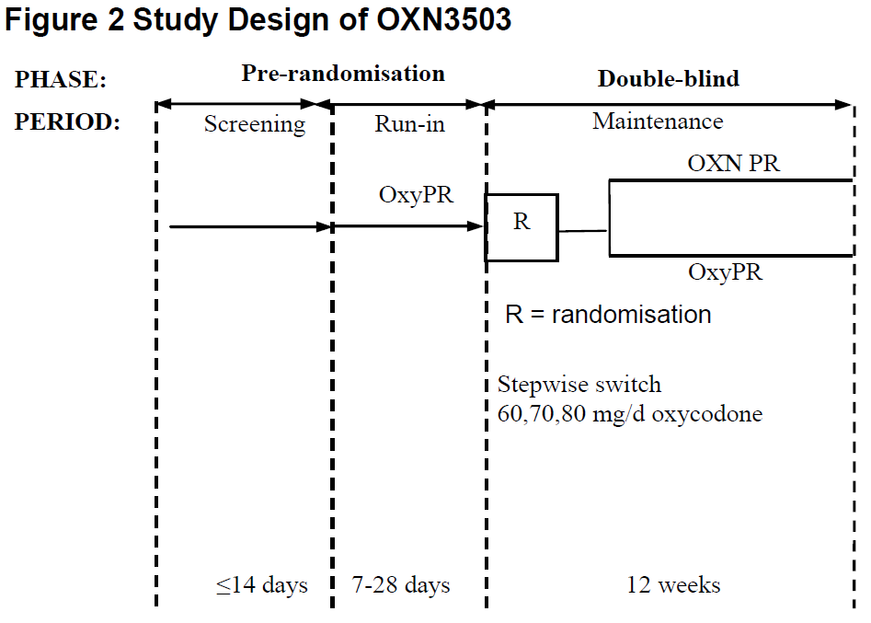

Inclusion and exclusion criteria
Inclusion criteria included:
- male or female subjects of at least 18 years of age;
- moderate to severe chronic non-malignant osteoarthritis (OA) pain;
- primary pain site was the hip and/or knee;
- required around-the-clock opioid therapy;
- receiving opioids with oxycodone equivalent of 20-80 mg/day;
- required continuation of daily opioid treatment;
- likely to benefit from WHO step III opioid therapy for the duration of the study.
Exclusion criteria included:
- subjects with secondary OA (for example, fracture, septic, acromegaly);
- subjects with a replacement of the most painful joint;
- subjects with evidence of significant structural abnormalities of the gastrointestinal tract;
- any diseases/conditions that affect bowel transit (for example, ileus, hypothyroidism);
- subjects with chronic disease of the joints of a relapsing/remitting nature;
- any other chronic condition causing pain likely to warrant the persistent use of escape analgesics (for example, gout, Rheumatoid Arthritis (RA)).
Criteria for inclusion into the Double-blind Phase included:
- subjects continued to satisfy screening criteria;
- taking OxyPR 20-80 mg/day;
- rated their pain (‘average pain over the last 24 hours’) as ≤4 on 0-10 scale with less than or equal to two doses of oxycodone immediate release (OxyIR) rescue medication per day for either the last three consecutive days or four of the last seven days
- confirmed opioid related constipation, which was defined as having less than 3 CSBM-NS (CSBM-Non Straining) during the last 7 days before randomisation.

Study treatments
Subjects received OxyPR in the dose range 20 – 80 mg/day, during the run-in period, as clinicians sought to establish a stable, effective analgesic dose. Oxycodone IR 5 mg was allowed for rescue analgesia.
At the start of Double-blind treatment, subjects received their stable effective dose of oxycodone in the form of oxycodone PR or underwent a blinded, stepwise introduction of Targin, keeping the oxycodone dose constant. If a subject was consistently taking more than two OxyIR rescue doses/day for break-through pain, during the Double-blind Phase, then the oxycodone prolonged release medication could be up-titrated to a maximum of 120 mg/day (to a dose of 100 or 120 mg/d). The number of subjects undergoing up-titration was not clearly stated, but a figure provided by the sponsor (copied below) suggests that no subjects received the maximum study dose of 120/60 mg, and only 3 subjects were exposed to Targin at a dose of 100/50 mg.
Figure 18: Exposure to Study Medication in the Double-Blind Phase, Study OXN3503
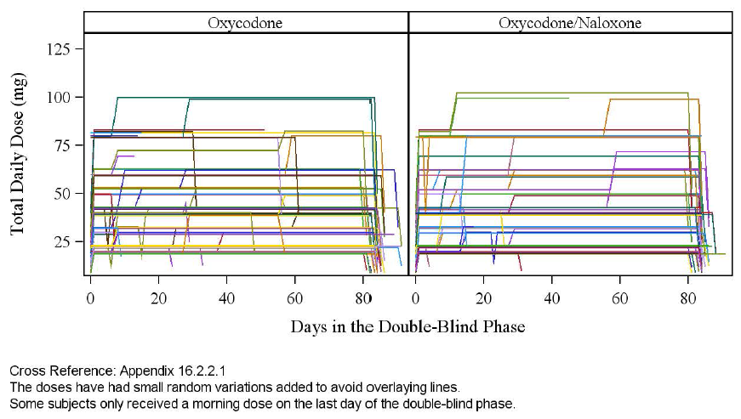
Rescue laxative therapy with bisacodyl was allowed, and was monitored as a secondary efficacy endpoint, as in the pivotal study.

Efficacy variables and outcomes
The primary objectives of the study were to demonstrate that the treatment with OXN tablets was non-inferior to the treatment with OxyPR with regards to analgesic efficacy and locomotor function and superior in terms of constipation symptoms.
The primary efficacy variables were:
- ‘Patient assessment of pain and locomotor function by the Western Ontario and McMaster Universities Osteoarthritis Composite Index (WOMAC VA3.1, visual analogue scale)’, for the non-inferiority objective;
- the Bowel Function Index (BFI) for the superiority objective.
How the WOMAC scale was applied to the primary endpoint was unclear. Parts of the study report implied that a single numerical figure was obtained, and the endpoint as declared by the sponsor implied that a single visual analogue scale would be used, generating a single numerical result. In the Results section, however, three different sub-sections of the WOMAC were reported: A, Pain; B, Stiffness; and C, Difficulty Performing Daily Activities. How each of these three subscales related to the primary efficacy measure was not clearly stated. It was also not stated whether the ‘3.1’ in ‘WOMAC VA3.1’ (cited above) referred to a visual analogue scale in Section 3.1 of the WOMAC, or to version 3.1 of the WOMAC. The sponsor’s sample-size discussion referred to a paper by Itoh et al., 2008, and the score was said to have been described and validated by Bellamy (1998), but these references were omitted from the sponsor’s collection of provided references.
Secondary efficacy variables were:
- Pain Intensity Scale – ‘Average Pain over the last 24 hours’ assessed at each double-blind study visit.
- PAC-SYM (Frank et al, 1999), a validated constipation questionnaire, which measures the severity of twelve symptoms of constipation over the past 7 days. It includes three subscales: stool symptoms, rectal symptoms and abdominal symptoms. Severity is rated on a 5-point scale, where 0 = absent, 1 = mild, 2 = moderate, 3 = severe, and 4 = very severe.
- PAC-SYM(b) an adaptation of the PAC-SYM questionnaire, which includes an additional measure of the ’bothersomeness’ of each of the symptoms of constipation, rated from 0 = not at all to 4 = extremely, and an additional measure in which subjects were asked how bothered they were about the frequency of their bowel actions, where 0 = not at all and 4 = extremely bothered.
Additional exploratory efficacy variables were listed as follows:
- CSBMs – mean number per week during the first 4 weeks of the Double-blind Phase.
- Frequency of laxative use.
- Modified Brief Pain Inventory- Short Form (BPI-SF), a questionnaire consisting of 12 items assessing the severity of subjects’ pain and the impact of pain on daily functions.
- Frequency of analgesic rescue medication use.
- The SF-36 v2 health survey.

Randomisation and blinding methods
Randomisation was achieved using an automated algorithm that assigned treatments to randomisation codes, which were kept confidential. Blinding to treatment group was achieved with a double-dummy design using placebo tablets identical in appearance to Targin or oxycodone PR tablets. Unblinding was not assessed by asking patients or clinicians to guess their assigned treatment.

Analysis populations
Analysis populations were as defined in the pivotal study, and consisted of the Enrolled, Full-Analysis, Per-Protocol, Run-In Period Safety, and Double-blind Safety populations.

Statistical methods
The primary analysis was said to be based on an ‘intersection-union test’ that combined a non-inferiority hypothesis test in the WOMAC visual analogue scale score (showing that the efficacy of OXN is at least 80% that of OxyPR) with a superiority test in the BFI (showing that OXN is superior to OxyPR with respect to the BFI). The intersection-union test was carried out separately for each double-blind visit (4-8) as long as all subsequent visits also rejected their null-hypothesis.
Details of which statistical tool was applied to each component of this combined test were not clearly stated.
Secondary endpoints were examined with mixed model repeated measures (MMRM) analysis of covariance (ANCOVA).

Sample size
The sponsor intended a sequential approach to hypothesis testing: a non-inferiority test on the WOMAC score with an 80% non-inferiority bound was to be followed (if and only if statistically significant) by a superiority test on the BFI score.
It was assumed that the WOMAC score's coefficient of variation was < 48% (based on Itoh et al., 2008) and that the BFI score had a SD of not more than 26 (based on protocol OXN2401). Both tests were to be carried out at a local 5% significance level (one-sided). A sample size of 82 subjects per group was calculated to produce an overall power for both endpoints of 80%. Allowing for dropouts, 100 subjects were to be randomised for each group, and this target was achieved.
No power considerations considered the number of subjects treated in different dose levels, and this study was clearly underpowered for the assessment of high Targin doses.

Participant flow
Patient disposition is summarised in the figure and table below. The proportion of dropouts was broadly similar in the two treatment groups, and the overall completion rate (84%) was acceptable for a study of this nature. A slightly higher number of OxyPR subjects discontinued, with adverse events accounting for some of the excess.
Figure 19: Patient Disposition, Study OXN3503
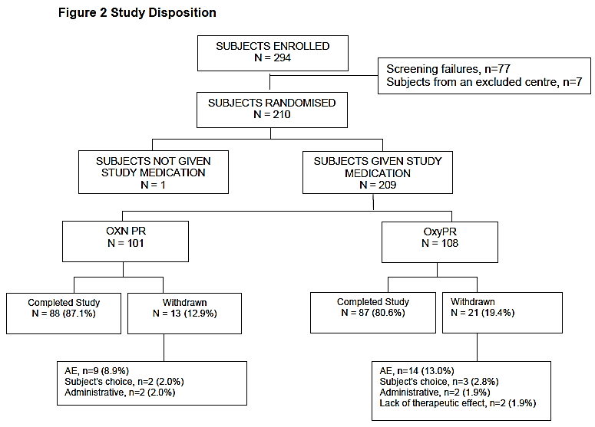

Table 46: Patient Disposition: Double-Blind Safety Population, Study OXN3503
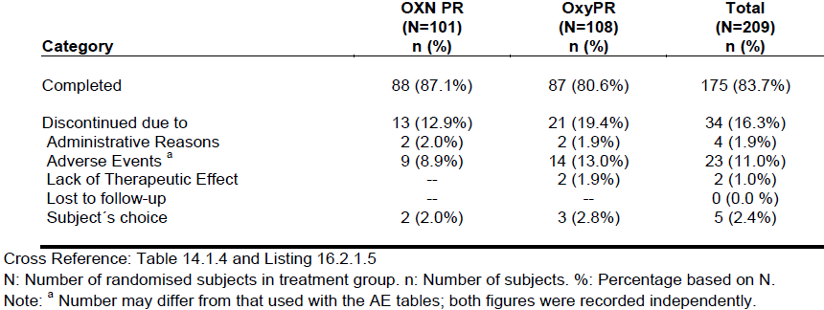

Major protocol violations/deviations
A convenient summary of major protocol deviations was not provided. The sponsor made the following claims: ‘Although a number of deviations from the protocol occurred, and these subjects were excluded from the Per-protocol Population, these deviations were not considered to have affected the evaluation of efficacy or safety since the primary efficacy analysis was based on the Full Analysis Population and the safety evaluation was based on all available safety results.’
The Per Protocol population consisted of 76% of the total randomised population, implying that about 24% of subjects had a major protocol deviation. The seriousness of the deviations is unclear.

Table 47: Number and Percentage of Subjects in Analysis Populations, Study OXN3503
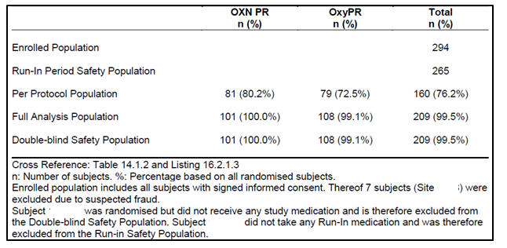

Baseline data
Baseline demographic data are summarised in the table below. Unfortunately, as in the pivotal study, baseline disease characteristics were not summarised in a convenient format but were instead listed in a multipage table. There did not appear to be any important differences between the groups at baseline.

Table 48: Subject Demographics: Double-Blind Safety Population
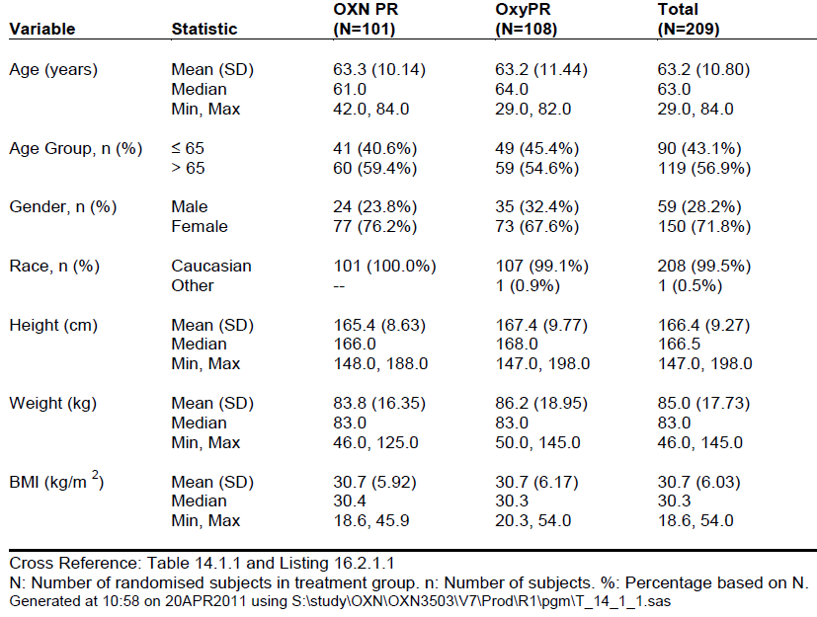

Results for the primary efficacy outcomes

WOMAC scores
The WOMAC scores for pain, stiffness and difficulty performing daily activities improved (decreased) in both treatment groups during the study. The scores for each sub-section (A, pain; B, stiffness; C, difficulty performing daily activities) decreased by similar amounts, as shown in the table below. There was a slight mismatch between groups for ‘difficulty performing daily activities’ at the start of the Double-blind period (Visit 3), with a lower score in the OXN PR group, but the difference was maintained through the study, with a similar change observed in both groups.

Table 49: WOMAC Osteoarthritis Index across Visits, Study OXN3503
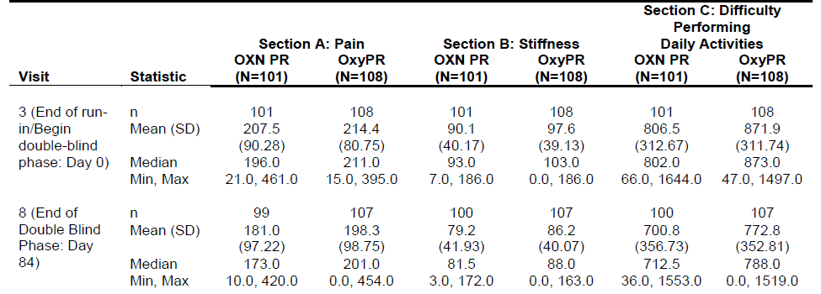
Considering the change from baseline in each treatment group (change from Visit 3 to Visit 8), the Pain section of the WOMAC shows a reduction in means from 207.5 to 181.0 (a reduction of 26.5) with OXN, and a reduction in means from 214.4 to 198.3 (a reduction of 16.1) with OxyPR, which is in favour of OXN.
For the Stiffness section, the reductions were 90.1 to 79.2 (-10.9) with OXN and 97.6 to 86.2 (-11.4) with OxyPR, with both groups showing very similar reductions.
For Difficulty Performing Daily Activities, the corresponding reductions were 806.5 to 700.8 (-105.7) for OXN and 871.9 to 772.8 (-99.1) for OxyPR, with very slight superiority of OXN.
Statistical analysis of the WOMAC OA visual analogue scale was said to show that OXN PR was non-inferior to OxyPR at the 80% level, but the details were not adequately reported. The table below, provided by the sponsor, suggests a treatment difference in the WOMAC index of ‘72.92’ for the overall between-group comparison at Visit 8, but it was not clearly stated how this value compares with the sub-scores cited in the table above, how it compares to the mean WOMAC visual analogue scores at baseline, what adjustments have been performed on the raw figures, or even whether the observed difference favoured OXN or OxyPR.
The 95% confidence interval shown in the table below does not include zero difference, indicating that there was a significant difference between treatments, so the sponsor’s declaration of non-inferiority either requires that OXN was superior, or that OXN was minimally inferior, with the lower efficacy bound not reaching below 80% of the ‘efficacy’ of OxyPR. A major problem in interpreting this result is that the ‘efficacy’ for each treatment is not clearly defined: there was no placebo group, and subjects showed minimal overall change from randomisation, so the magnitude of the treatment effect is unclear. Ideally, an efficacy of ‘at least 80%’ should mean that at least 80% of the treatment effect (the placebo-subtracted improvement in pain or disability scores) is observed with the non-inferior treatment, but this does not appear to be what the sponsor is claiming, because the treatment effect is undefined.
If the ‘80%’ figure refers directly to WOMAC scores, rather than to changes in WOMAC scores, then the lack of a difference could simply reflect the dynamics of that measure, rather than the relative efficacy of the treatments. If a large contribution to the WOMAC score comes from aspects of OA that cannot be fixed by analgesics, for instance, then even an ineffective treatment might not produce sufficiently modified scores to cause a 20% shift relative to an effective treatment. The sponsor should therefore clarify which parameter is at least 80% of which other parameter, so that their non-inferiority claims can be interpreted in some clinical context. If the 95% confidence intervals actually favoured OXN over OxyPR, showing greater improvements with OXN, the sponsor should clearly state this, as it would substantially lessen concerns about the lack of clinical context for the 80% inferiority threshold.

Table 50: Statistical Analysis of the WOMAC VA3.1 and BFI: at End of Double-Blind Phase
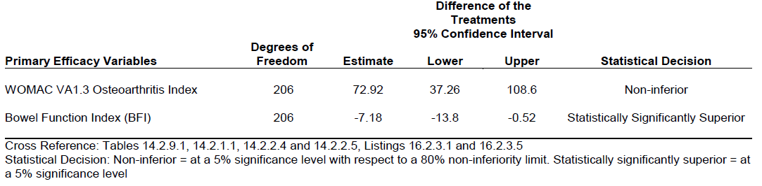

Bowel Function Index (BFI)
Mean BFI scores improved in both treatment groups, as shown in the table below, which is likely to reflect some spontaneous improvement in bowel function and regression to the mean. From a baseline of approximately56-58 points, the scores improved to 30 points in the OXN group and to 38 in the OxyPR group. This difference narrowly achieved statistical significance, with the 95%CI excluding zero (95% CI: -13.8, -0.52).

Table 51: Bowel Function Index by Visit: Full Analysis Population, Study OXN3503
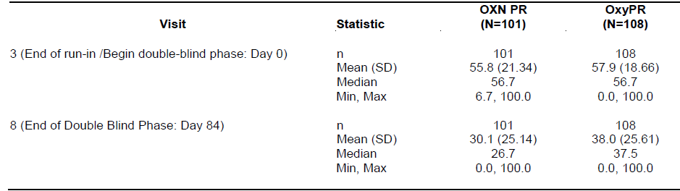

Results for other efficacy outcomes
Mean Pain Intensity Scores (PIS) were very similar in the two groups throughout the Double-blind Phase, but at some visits the mean PIS in the OxyPR group was marginally higher than that observed in the OXN group. Overall, this is consistent with broad equivalence in efficacy for the two treatments. A statistical comparison of the two groups showed a 95%CI broadly spread around zero difference (estimate for treatment difference at Visit 8 was -0.11, with 95% CI -0.42, 0.21), presumably in favour of OXN, because the mean reduction in pain was greater in this group, but the sign of the treatment difference was not explained.

Table 52: Pain Intensity Scale, ‘Average Pain over the Last 24 Hours,’ Study OXN3503
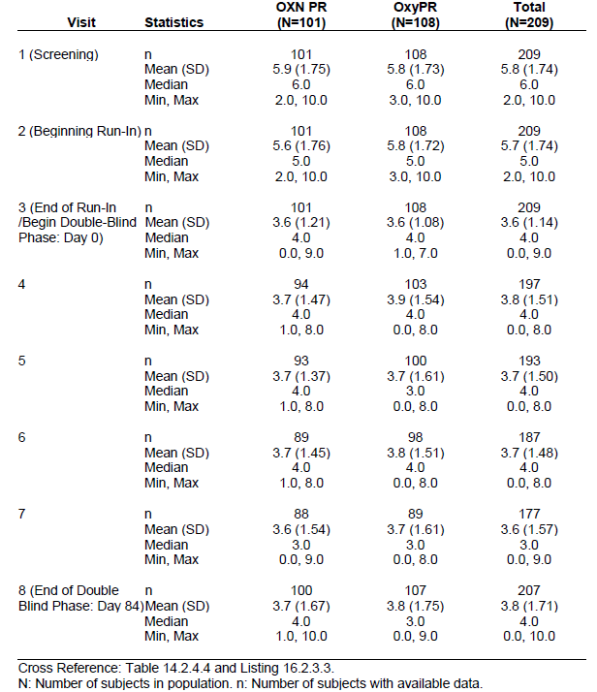
The PAC-SYM(b) questionnaire, which seeks to rate the severity and ‘’bothersomeness’ of constipation, showed higher (inferior) scores in the OxyPR group, consistent with the BFI results, but the differences were numerically small. For the mean symptom score at the end of the DB phase, OXN recipients rated their constipation at 8.8, compared to 10.0 in the OxyPR group; for ‘bothersomeness’ the corresponding scores were 8.9 and 9.7. The frequency column refers to how distressed subjects were by the frequency of their bowel actions, where 0 = not at all and 4 = extremely; the difference between groups (OXN 2.3, OxyPR 2.9) amounted to 0.6 of the available 4 points, and was in favour of OXN. For scores related to Symptoms and Bothersomeness, the 95%CI showed significant superiority of OXN, as shown in the second table below. For the Frequency scores, the trend was favourable but the 95%CI narrowly reached zero difference, showing no statistically significant superiority of OXN.

Table 53: PAC-SYM(b) Questionnaire, Sum of Scores, Study OXN3503
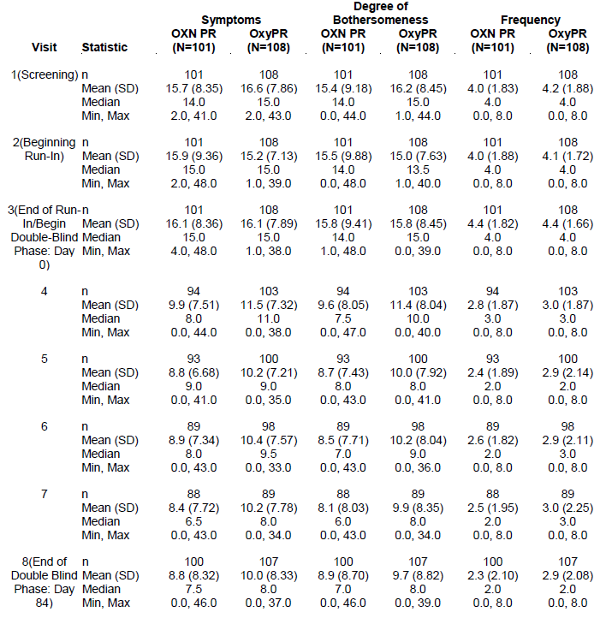

Table 54: Secondary Efficacy Analyses, Visit 8, End of Double-Blind Phase, Study OXN3503
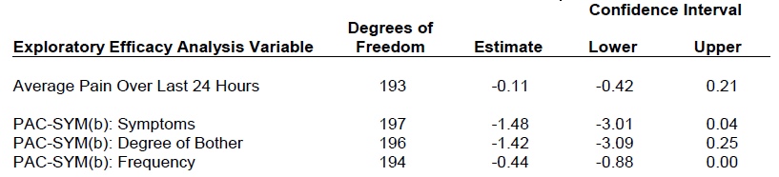
Exploratory endpoints were broadly consistent with the primary and secondary endpoints.

BPI pain severity sub score (BPIPSS)
BPI scores showed little change over the course of Double-blind treatment. At Visit 3, the BPIPSS was (mean (SD)) 14.2 (4.81) for OXN PR and 13.4 (4.29) for OxyPR; at Visit 8 the BPIPSS was 13.8 (6.30) for OXN PR and 14.4 (6.67) for OxyPR, respectively, consistent with a minor reduction with OXN and a minor increase with OxyPR.

Rescue medication for pain
The use of rescue analgesia was low overall. The mean (SD) number of intakes per day was 0.4 (0.61) on Visit 3 and 0.3 (0.48) on Visit 8, with similar intakes in the two treatment groups.

SF-36 health survey
Mean scores improved slightly with treatment but there was no notable difference between the groups (not shown).

Laxative intake
Rescue laxative intake was slightly lower from Visit 3 to Visit 8 in the OXN PR group compared to the OxyPR group. The difference was greatest by Visit 8, where the number of subjects who had laxative intake was 39 (38.6%) in the OXN PR group and 56 (51.9%) in the OxyPR group, but the groups were not well matched for this measure at Visit 3, where rescue laxatives were used by 56 (55.4%) in the OXN PR group and 69 (63.9%) in the OxyPR group.

CSBMs
No consistent differences were observed between the treatment groups. At Visit 3, the number of CSBMs per day over the previous 7 days was mean (SD) 0.6 (0.39) for OXN PR and 0.6 (0.48) for OxyPR and at Visit 6 was 0.8 (0.45) for OXN PR and 0.7 (0.40) for OxyPR.

Conclusions
The study achieved its primary objectives, showing that OXN PR is statistically non-inferior to OxyPR in the management of pain and locomotor function in subjects with moderate to severe pain due to OA, but the definition of non-inferiority was not reported clearly and the sponsor should provide some clinical context for this result.
The WOMAC scores for pain, stiffness and difficulty performing daily tasks, along with a number of secondary pain measures including BPI scores and the low use of rescue medication, support this finding of non-inferiority.
OXN PR treatment was significantly superior to OxyPR in relation to improvement in the symptoms of constipation, as measured by the BFI.
As in the pivotal study, these findings suggest that the addition of naloxone to oxycodone improves bowel symptoms without impairing efficacy, consistent with the previous registration of Targin for this indication. The study does not clarify the optimal dose of naloxone needed to achieve this, nor does it demonstrate the value of increasing the maximum recommended dose of Targin. The number of subjects exposed to doses above currently approved Targin dose was not clearly stated, but a figure provided by the sponsor suggests that no subjects received the maximum proposed dose of 160/80 mg/day, and only 3 subjects were exposed to Targin at a dose of 100/50 mg/day, making this study largely irrelevant to the current submission. The sponsor should be asked to confirm the number of patients exposed to high doses and to justify their consideration of this study as supportive of the new maximum dose.

Supportive study in chronic pain (OXN3505)

Study design, objectives, locations and dates
Study OXN3505 was a randomised, controlled, double-blind, double-dummy, parallel group study that compared the efficacy of OXN PR (n=111) to OxyPR (n=114) for reduction of the intensity of opioid-induced constipation symptoms in patients treated for malignant or non-malignant pain.
The primary objective of this study was: ‘To study the efficacy of OXN PR, compared to OXY PR, for the reduction of the intensity of opioid-induced constipation symptoms in patients treated for cancer or non-cancer pain.’ Demonstrating non-inferiority in analgesic efficacy was a secondary objective.
As in the previously described studies, subjects were randomised to Targin (OXN, naloxone add-on) or to prolonged-release oxycodone without naloxone. The daily dose ranged from 20/10 mg to 160/80 mg OXN PR or 20 mg to 160 mg OxyPR, with the dose chosen at the discretion of the Investigator. Only a small proportion of subjects were exposed to doses above those already registered for Targin, so the study has very limited relevance to the current submission.
It was a relatively short study, with no run-in phase and a Double-blind Treatment Period of 28 days.
Patients were stratified according to whether their pain was due to cancer or not.
Figure 20: Study Design, OXN3505
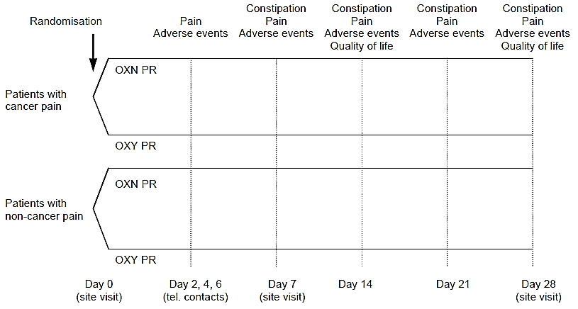
The study was performed in 82 centres in France and ran from 11 February, 2010, to 1 February, 2013.

Inclusion and exclusion criteria
The core entry criteria were:
- male or female adult patients with documented cancer or non-cancer pain;
- currently receiving a WHO step II opioid and requiring the initiation of a WHO step III opioid (due to a lack of efficacy of the step II opioid) expected to last 28 days or more; or
- currently receiving a WHO step III opioid expected to last further 28 days or more, and having opioid-related constipation defined by either a Knowles Eccersley Scott Symptom (KESS) score ≥9 or the current use of laxatives (≥ 3 times per week).
Exclusion criteria based on serious concomitant illnesses were similar to those described for the other analgesic efficacy studies.
This study differs from the pivotal study and the supportive Study OXN3503 in that it did not require subjects to have opioid-induced constipation for entry, and this may partially explain its negative outcomes.

Study treatments
Subjects did not undergo a dose-titration phase, but were randomised on study entry to OXN or OxyPR, with the daily oxycodone dose chosen at the discretion of the Investigator, ranging from 20/10 mg to 160/80 mg oxycodone/naloxone (20, 30, 40, 60, 80, 100, 120, 140 and 160 mg oxycodone) or equivalent doses of naloxone-free oxycodone (20, 30, 40, 60, 80, 100, 120, 140 and 160 mg). Subjects and clinician were blinded to the presence (OXN) or absence (OxyPR) of naloxone.
Assessment of high doses was not one of the stated objectives of the study, and the issue received very little attention in the study report. The number of subjects exposed to high doses of Targin was not even mentioned in the study synopsis, or in the Efficacy section of the main study report. Exposure was clarified in the Safety section of the study report, as shown in the tables below: a total of 6 subjects received OXN doses higher than the currently approved maximum for Targin at baseline, and only 13 (that is, 7 more subjects) reached a high dose (≥ 100 mg/d) during the blinded treatment phase. Of these 13 subjects, only one subject received the maximum proposed dose of 160 mg. High-dose exposure (≥100 mg/d) was therefore seen in only 12% (13/111) of the total OXN group, and results in the overall efficacy analysis cannot be extrapolated to this small minority.

Table 55: Initial Dose and Maximum Dose Level Reached, OXN PR, Safety Population, Study OXN3505
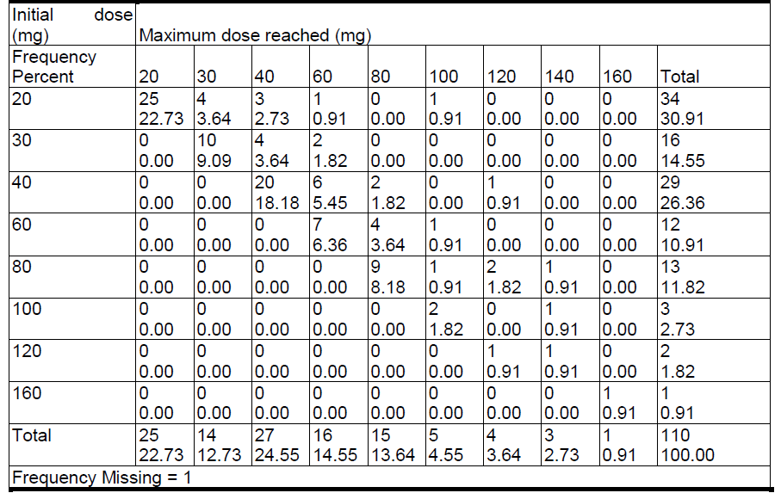

Table 56: Initial Dose and Maximum Dose Level Reached, OXY PR, Safety Population, Study OXN3505
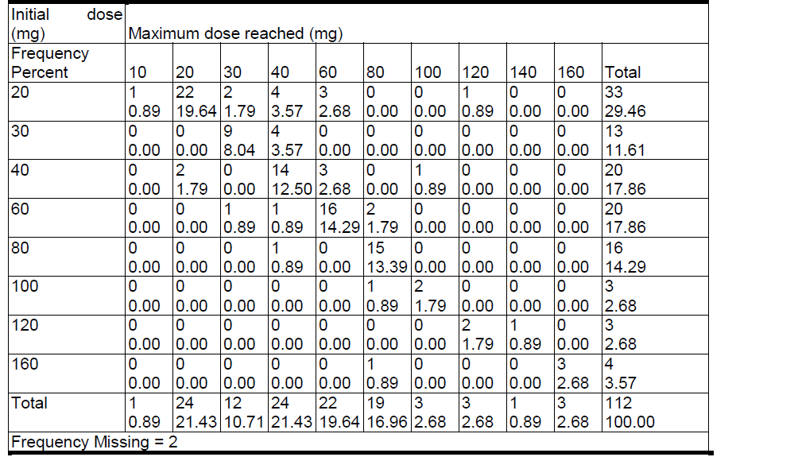
Subjects were permitted to use rescue analgesic therapy (oxycodone immediate release, Oxy IR, 5 mg capsules q4-6h) and rescue laxative medication (bisacodyl, 5 mg tablets).

Efficacy variables and outcomes
The primary efficacy variable for was similar to the pivotal analgesic study, OXN3506, and consisted in the change in the BFI from baseline to the end of blinded treatment. A number of secondary efficacy measures assessed constipation symptoms, and others assessed analgesic efficacy. As in other studies, the assessment of analgesia was intended to show non-inferiority of OXN relative to Oxy PR.

Primary efficacy criterion
Change of intensity of constipation symptoms, as assessed by the Bowel Function Index (BFI) from baseline to Day 28.

Secondary efficacy criteria
- Change of Bowel Function Index (BFI) from baseline to Days 7, 14 and 21.
- Change of Patient Assessment of Constipation Symptoms (PAC-SYM) score from baseline to Days 7, 14, 21 and 28.
- Change of Knowles Eccersley Scott Symptom (KESS) constipation score from baseline to Days 7, 14, 21 and 28.
- Frequency of laxative medication use between Day 0 and Day 28.
- Change of pain as assessed by the Brief Pain Inventory-Short Form (BPI-SF) score from baseline to Days 7, 14, 21 and 28.
- Frequency of rescue medication use between Day 0 and Day 28.
- Persistence with the assigned treatment on Day 28.
- Number of prescribed doses missed between Day 0 and Day 28.
- Change of Gastrointestinal Quality of Life Index (GIQLI) score from baseline to Days 14 and 28.
The KESS constipation score, used as a secondary efficacy variable, includes 11 items, which each consist of a 4- or 5-point score. A total score of 0 indicates no constipation, while 39 indicates total constipation; significant constipation is considered to be present if the total score ≥ 9 . For most items, the patient is asked to consider constipation symptoms in the previous 7 days. The score was validated by its creators, Knowles et al, 2002.
The GIQLI is a validated Quality of Life measure that includes 36-items about symptoms, physical status, emotions, social issues, and the effect of medications. The sponsor’s comments about this score are contradictory: ‘The score ranges from 0 to 144, a higher score corresponding to a better quality of life. Validation of the French version has shown a score of 96 for healthy volunteers, 126 in average for patients.’ This implies that healthy volunteers have a lower quality of life than patients, which seems unlikely. The reference cited by the sponsor in relation to the French validation study was not provided in their collection of references.

Randomisation and blinding methods
Randomisation was performed with a 1:1 ratio to each treatment group; the methods of randomisation were not described in detail. Blinding with respect to naloxone use was maintained by using a double-dummy design, and subjects and clinicians were ostensibly unaware of treatment assignment. The extent of accidental unblinding was not assessed.

Analysis populations
The sponsor described three analysis populations:
- Intent-to-treat (ITT) population: all randomised patients with at least one efficacy assessment (BFI data on Day 0 and BFI data at another visit).
- Per protocol (PP) population: all patients having received at least one dose of the study medication, with no major violation of the study protocol. Violations were defined during a final review of the study data, before unblinding.
- Safety population: all patients having received at least one dose of study medication.
The ITT population was considered the primary population for efficacy analyses. The BFI and BPI analyses were performed in both the ITT and PP populations; all other analyses were performed in the ITT population.

Statistical methods
For the primary efficacy analysis of BFI, the groups were compared for the mean change in BFI from baseline to Day 28; the intent was to use Student’s t-test if data were normally distributed or Wilcoxon test if the data were not normally distributed. (The sponsor did not clearly state which of these was actually used). The analysis was stratified on pain type (malignant or non-malignant). Sensitivity analyses were also performed on the ITT and PP, using the mixed-effects model for repeated measures (MMRM), with baseline BFI score as a covariate, and visit, treatment groups and treatment visit interaction as factors.
For the secondary objective of demonstrating non-inferiority of OXN PR relative to OXYPR for pain control, the BPI-SF score was assessed by computing the one-sided 95% confidence interval (CI) of the BPI-SF score (pain subscale score and pain on the average score) on Days 14 and 28.
Additional analyses included a comparison of the GIQLI scores on Days 14 and 28 and for the mean change of GIQLI scores from baseline to Day 14 and Day 28, using the Student’s t-test or Wilcoxon test.

Sample size
The study was underpowered. Individual tests in each pain-type strata were performed at the α=0.05 significance threshold with a power (1–β) ≥0.95; for the primary efficacy analysis in both strata, power was intended to be 0.9025.
It was assumed that the standard deviation of the change in BFI would be ≤ 28, and that the minimal clinically relevant difference in BFI was 12. Under these assumptions, the sponsor estimated that the required number of patients was 142 in each treatment group. Allowing for dropouts, 312 patients (2 x 156) were required in each pain type stratum and 624 patients were required overall.
After 15 months, the recruitment rate was poor and the sponsor decided to stop the recruitment prematurely. In total, 225 subjects were randomised, 111 to the OXN PR group and 114 to the OxyPR group. Thus, the study was not powered to show non-inferiority, and its non-inferiority endpoints should be rejected. It also failed to show a benefit for its superiority objectives based on the BFI. Ultimately, this renders the study of little value in demonstrating the efficacy Targin.
No power analysis was performed that specifically considered the number of subjects exposed to high Targin doses. Given the very low exposure of subjects to the maximum proposed Targin dose (a single subject), the study should be considered grossly underpowered for high doses and largely irrelevant in the context of the current submission.

Participant flow
Patient disposition is summarised in the figure below. Completion rates were acceptable for a nature of this study, and were similar in the two treatment groups (OXN 78.9%, OxyPR 82%).
Figure 21: Patient Disposition, Study OXN3505
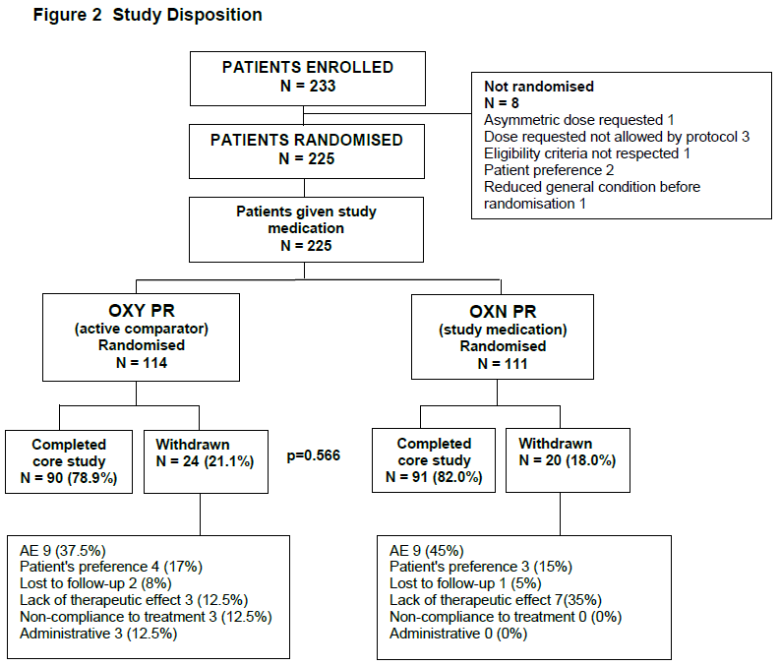

Table 57: Patient Disposition, Study OXN3505
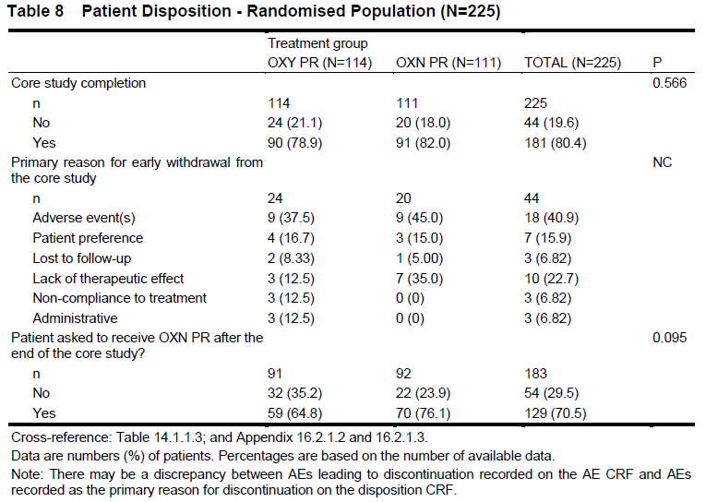

Major protocol violations/deviations
About a quarter of the subjects had a major protocol deviation that led to their exclusion from the PP population, and the most common deviation was a failure to provide BFI scores on the final visit, as shown in the table below. The next most common deviation was the use of prohibited concomitant treatments. These deviations potentially compromised the study, but are of minor importance given that the study was negative. Deviations were broadly balanced across the treatment groups, and so no major bias is likely to have been introduced.

Table 58: Protocol Deviations that Led to Exclusion from the Per-Protocol Population, Study OXN3505
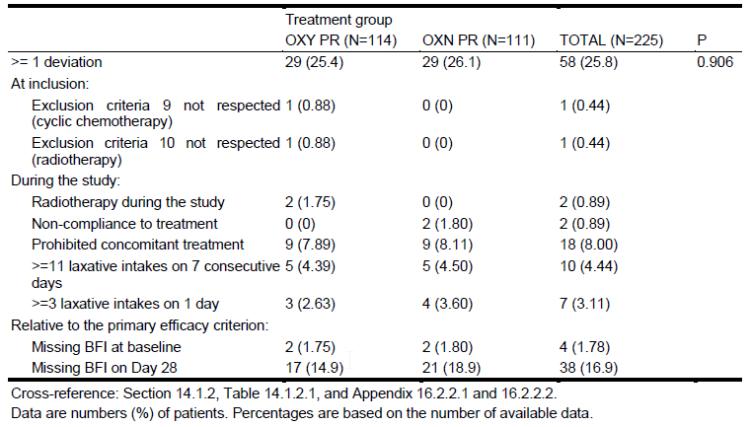

Baseline data
Baseline demographic data is shown in the table below, and important disease characteristics, including measures assessed for efficacy, are shown in the table below that. The two treatment groups were significantly mismatched for gender (p=0.002), with male subjects accounting for 49% of the OxyPR group but only 28% of the OXN group. There was also a significant difference (p=0.049) in the distribution of responses to question about how often the subjects had difficulty evacuating their bowels, with an excess of ‘Never’ responses in the Oxy-PR group. This substantial mismatch could have been sufficient to compromise the study, and the less frequent bowel dysfunction (by this measure) in the OxyPR group could have contributed to the overall negative results of the study. (Other measures, such as the BFI, showed slightly greater dysfunction in the OxyPR group). Although statistically significant, this baseline mismatch is of little importance, though, given that the study was a minor supportive study of marginal relevance anyway.

Table 59: Demography, ITT Population, Study OXN3505
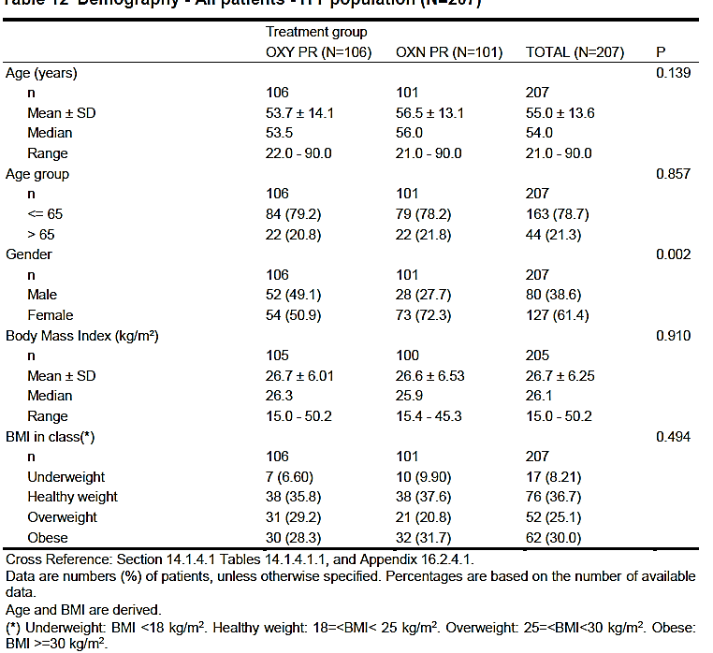

Table 60. Baseline frequency of Bowel movements, difficulty evacuating, use of laxatives and neuropathic pain, Study OXN3505
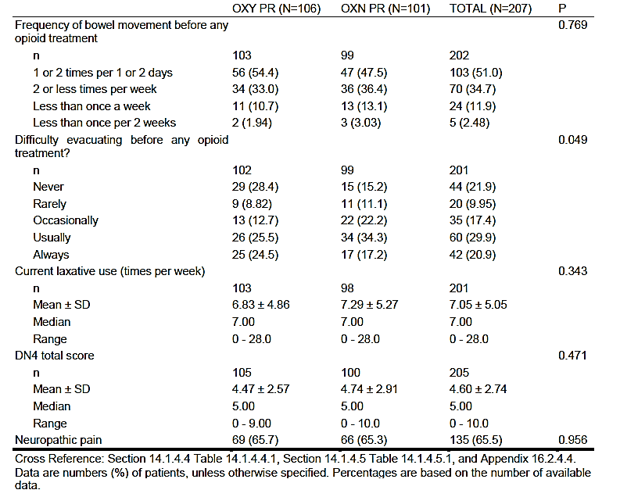

Table 63: Efficacy Criteria at Baseline, ITT Population, Study OXN3505
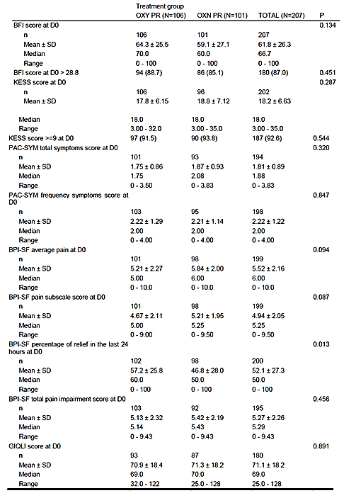

Results for the primary efficacy outcome

Bowel Function Index (BFI)
The progression of BFI scores over the course of the study is depicted in the figure below, showing that mean BFI scores improved during the first week in both groups, and then remained fairly constant, with no relevant differences noted between the groups. The final scores were significantly lower in the OXN group (p=0.032), but the change from baseline was not significantly different in the two groups.
Figure 22: Mean BFI over Time – ITT Population, Study OXN3505
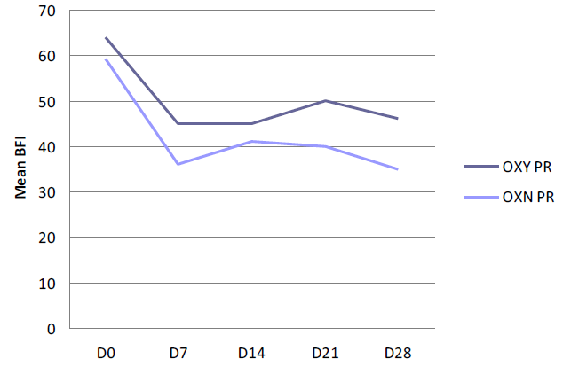
For the primary endpoint, change in BFI from baseline to Day 28, the analysis showed a weak trend in favour of OXN, but no statistically significant differences between the OxyPR and OXN PR groups. The mean change of BFI from baseline to Day 28 was -23.2 (median -26.7) in the OXN PR group and -18.2 (median -15.0) in the OxyPR group (p=0.341, primary efficacy criterion. The sponsor did not clearly state which statistical tool produced this p-value).
The proportion of patients with clinically meaningful improvement in the BFI (improvement ≥12 points) was 65.2% in the OXN PR group and 52.1% in the OxyPR group, a relative difference of 25.1% in favour of OXN, but this was not significant (p=0.071).
Other BFI parameters are summarised in the table below.
The sponsor also presented several comparisons of BFI results in subjects on OxyPR who took laxatives versus subjects on OXN who did not take laxatives, finding that the OXN/no-laxatives group had significantly better bowel function than the OxyPR-laxatives group. Given that laxatives were taken because of constipation, these findings were not surprising, and provide little insight into the efficacy of Targin.

Table 62: Bowel Function Index – ITT Population, Study OXN3505
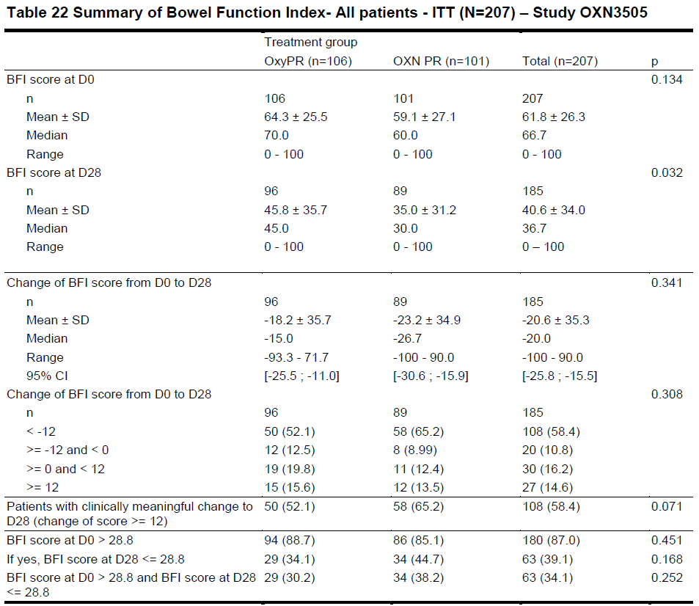

Results for other efficacy outcomes
An assessment of pain scores showed no consistent differences between the treatment groups in terms of change in pain (BPI-SF) from baseline, but the study was underpowered for this comparison. Pain scores are summarised in the table below. For reasons that are unclear, this table did not include changes from baseline to Day 28. The sponsor claimed that non-inferiority was demonstrated at Day 28, but not at Day 14: ‘Non inferiority analyses showed that OXN PR was non-inferior to OXYPR at Day 28 (estimate difference: -0.97, 95% CI: -1.55 to -0.38, p=0.001), but not at Day 14 (estimate difference: 0.74, 95% CI: 0.10 to 1.38, p=0.025).’ This claim is somewhat unclear given that it does not explicitly refer to changes in BPI-SF from baseline, but consideration of the table below shows that mean pain scores in the OXN group were higher than those in the OxyPR group at baseline, and the difference was smaller by Day 28, indicating a slightly greater fall in pain in the OXN group. Overall, these findings suggest that the analgesic efficacy of Targin is satisfactory, but the results should be interpreted with caution given the poor recruitment in this study.
Minor endpoints for bowel function and pain were broadly consistent with the BFI and BPI-SF scores, respectively. There were no consistent differences between the groups for the KESS and PAC-SYM scores, or for the GIQLI scores. Sub scores within the BPI-SF and percentage pain reduction estimates showed no consistent differences between groups (data not shown).

Table 63: BPI-SF Pain on Days 0, 7, 14, 21 and 28 – ITT Population, Study OXN3505
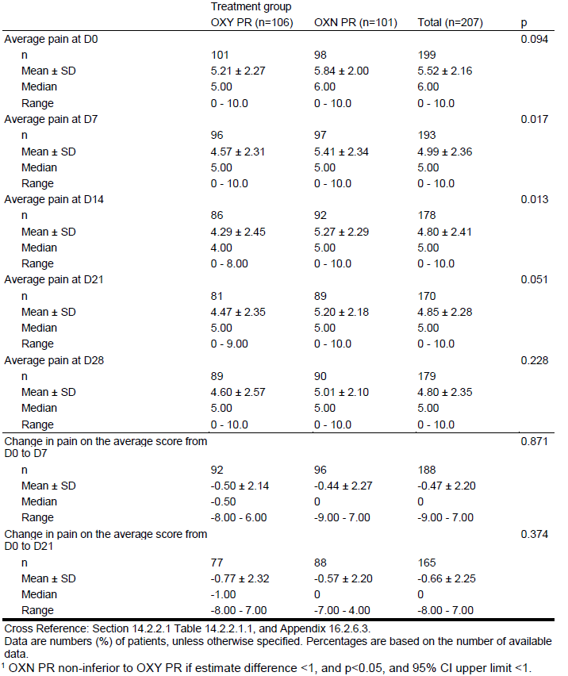

Conclusions
No firm conclusions can be drawn from this study. Superiority for OXN with respect to bowel symptoms was not demonstrated, but this could reflect poor matching of groups at baseline, better-than-expected improvements in the Oxy OPR subgroup, poor statistical power because of poor recruitment, and inclusion of subjects without opioid-induced constipation. Analgesic efficacy appeared broadly similar in the two groups, but this should be interpreted with caution given that the study did not reach its recruitment targets and was not adequately powered, particularly at high doses.
The biggest problem with this study, in the context of the current submission, is that it did not specifically assess the proposed maximum Targin dose and only one subject was assigned the maximum dose of 160/80 mg.

Supportive study in chronic pain (038-002)
This study was evaluated in the context of a previous submission. The study consisted of a 2-week Run-in Period (RP) and a 10-week DB Period (DBP), during which subjects underwent a crossover of OXN PR and OxyPR treatments. No washout period was used between phases, andthe previous evaluator noted a sequence effect indicating carryover effects that markedly compromised the study. At the end of the DBP, eligible subjects entered an Open-label period, contributing some safety data, but this phase provided poor data for the assessment of efficacy, because it lacked a control group.

Study design, objectives, locations and dates
The design of the study is summarised in the figure below.
Figure 23: Study Design, 038-002

Inclusion and exclusion criteria
Eligible subjects were adult males and females, with chronic non-cancer pain of at least moderate intensity, for a minimum of 3 months. Patients were included if they were dose optimised at 60 to 80 mg twice-daily of oxycodone at the end of the Run-in Period (defined as moderate pain while requiring no more than 2 rescue OxyIR doses per day) and had < 3 complete spontaneous bowel movements (CSBM) in the 7 days preceding randomisation. That is, they experienced constipation on oxycodone monotherapy when it was used at doses currently approved for OxyContin.

Study treatments
Subjects were stabilised on oxycodone prolonged release, then randomised to continued oxycodone monotherapy or OXN. Only patients whose CR oxycodone dose was optimised at either 60 or 80 mg twice daily were randomised. Patients continued to receive a total oxycodone dose of either 60 or 80 mg twice-daily, made up from a combination of active and placebo OXN, and active and placebo CR oxycodone. The total daily dose of active oxycodone remained broadly stable throughout the DBP, but OXN recipients had the naloxone component introduced in a stepwise manner.
Rescue therapy with immediate-release oxycodone (OxyIR) was used to treat breakthrough pain.
During evaluation of the previous submission of this study, the clinical evaluator commented that it was unclear how many subjects were exposed to each dose:
Comment: While the ITT population were exposed to comparable days of OXN and CR oxycodone treatments during the DBP no information is provided in this submission to document subject exposure in terms of milligrams of OXN or CR oxycodone received during the DBP. Furthermore, no information is provided that details how many subjects stabilised on CR oxycodone 60 mg q12h during the RP had their dose increased or decreased in DBP or how many subjects on CR oxycodone 80 mg q12h during the RP had a dose increase or reduction during the DBP.
The Summary of Clinical Safety supplied with the new submission and the Safety section of the Study Report both state that: ‘Of the 52 patients who received OXN PR, 33 received the 60/30 mg q12h dose for a mean of 32.0 ± 7.2 days, and 19 patients received the 80/40 mg q12h dose for a mean of 32.0 ± 9.7 days.’
Therefore, in terms of assessing the safety and efficacy of the proposed maximum dose, this study only contributed 19 exposed subjects, and interpretation of results in those subjects is clouded by the fact that the same subjects also received oxycodone without naloxone in a crossover design, with inadequate washout between treatment phases. Furthermore, a dose comparison was not one of the objectives of the study and no dose-based subgroup analysis was presented.

Efficacy variables and outcomes
The primary efficacy endpoint was the number of subjects having at least 3 CSBM in the last week of each treatment phase (that is, Week 5).
Secondary endpoints assessed bowel function, pain control and quality of life and was described in more detail by the previous evaluator.

Design details
This was detailed in the previous clinical evaluation report.

Results for the primary efficacy outcome

CSBM – Daily diary data
In the Double-blind Period, during Week 5 of treatment, significantly more subjects on OXN PR had 3 or more CSBMs than was reported in subjects on OxyPR (29.5 % versus 15.6%, p<0.0001, ITT). The mean number of CSBMs in Week 5 of the DBP was also significantly higher in the OXN PR group (2. 4 ± 3.1 versus 1.4 ± 2.4, p<0.0001, ITT). Results were similar in the PP population.

Results for other efficacy outcomes
Results for secondary and minor endpoints were assessed by the previous Clinical Evaluator. As noted in the evaluation of the original submission, the demonstration of non-inferiority was severely compromised by the crossover design and a probable carryover effect.

Conclusions
The previous clinical evaluator drew the following conclusions about Study 038-002:
- The efficacy results obtained from the crossover design used in the [then pivotal] efficacy study, 038-002, are considered exploratory rather than confirmatory. The concurrent use of two active oxycodone preparations in the OXN treatment arm in each phase in Study 038-002 is likely to limit the meaningfulness and generalisability of the results.
- While the primary efficacy analysis demonstrated that a significantly higher proportion of OXN subjects had 3 or more CSBMs at Week 5 of treatment than subjects who received CR oxycodone (29.5 % versus 15.6%, p < 0.0001), there was a marked unexplained reduction in numbers of CSBM for both active treatments between Weeks 4 and 5 (17.2% and 10.4% for OXN and CR oxycodone, respectively). The latter effect may reflect lack of efficacy or a degree of opioid tolerance. Generally, secondary efficacy endpoints supported the primary efficacy analysis. However, Study 038-002 was small and the duration of assessment quite brief for the assessment of differences in bowel motion frequency. The use of similar overall quantities of laxatives in the two treatment groups makes it difficult to determine the effect of the Targin over oxycodone CR on bowel movement frequency.
- A significant sequence effect was noted in the analysis of the key secondary efficacy analysis that is, pain intensity (p = 0.0066). This may be indicative of a carry-over effect, which is not unexpected due to absence of a washout period between treatment phases and the use of concomitant active treatments.
On balance, this study was broadly consistent with the other submitted studies, and suggests that the addition of naloxone to prolonged-release oxycodone may reduce opioid-induced constipation without compromising analgesic efficacy. The findings were not robust, because of the methodological flaws previously noted, but they were at least consistent with the other studies.
What the study fails to demonstrate is that any particular naloxone dose is optimal in reducing constipation, or that the proposed higher Targin dose is more effective than current practice, in which Targin at the current maximum dose (40/20 mg BD) is topped up with naloxone-free OxyContin if further analgesia is required.
Of further concern, the number of patients exposed to the proposed maximum Targin dose in this study was only 19, and interpretation of the response to the higher dose is clouded by potential carryover effects.

Supportive study in chronic pain (OXN2001S)

Design
Study OXN2001S (n=128) was an uncontrolled, open-label extension study in subjects with moderate to severe, chronic cancer pain who completed the Double-blind Phase of the OXN2001 core study or who discontinued due to constipation. The parent study, OXN2001, was not submitted for evaluation as part of the current submission, but it did contribute some patients to a small meta-analysis described in the Analyses performed across trials (pooled analyses and meta-analyses) section.
The design of the extension study is illustrated below. In total, 128 patients entered the open-label Extension Phase.
Figure 24: Study Design, OXN2001S
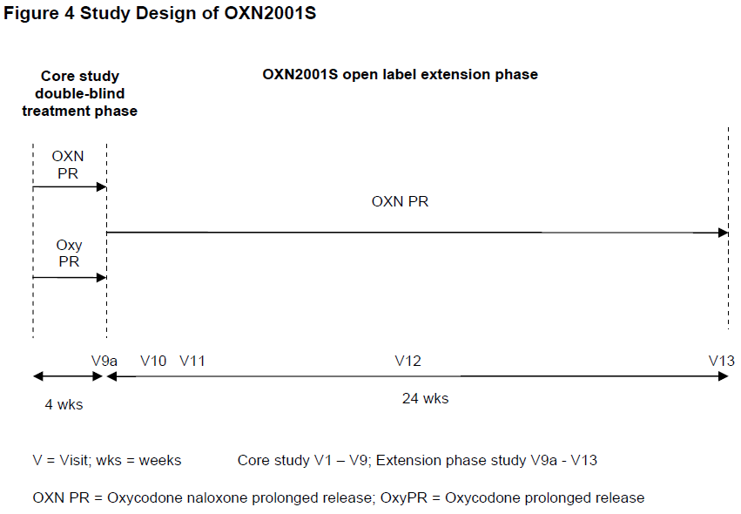
During the extension study, all subjects received open-label OXN PR. Subjects who entered the study on a dose up to and including 80 mg/day OxyPR/OXN PR were switched directly to OXN PR. Subjects on 90, 100, 110 or 120 mg/day OxyPR/OXN PR were switched to OXN PR in a stepwise manner, while continuing to receive the same dose of oxycodone they had been receiving at the end of their involvement in the core study.
Dose titration was permitted at the discretion of the Investigator up to a notional maximum of 120/60 mg/day. The number of subjects actually treated at 120/60 mg was not clearly reported in the Summary of Clinical Efficacy provided by the sponsor, but inspection of the Safety Section of the Study Report shows that only 12 subjects had a final oxycodone dose of >100 mg/d; another 14 subjects may have had a final dose of 100 mg, but the provided table is unclear.

Table 64: Sift Table of Initial and Final Oxycodone Doses, Safety Population, Study OXN2001S
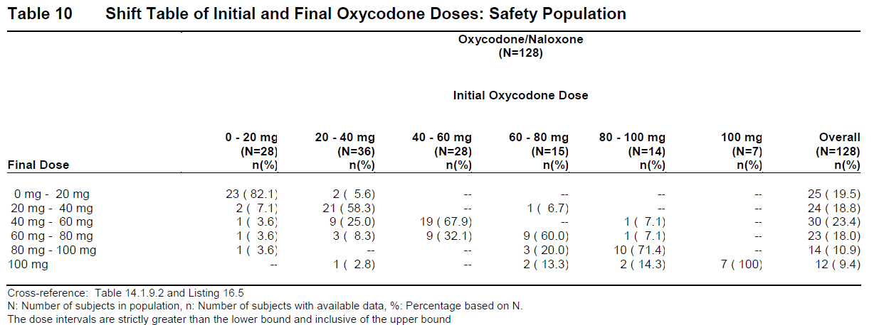
The study lacked a primary endpoint, but the primary objective for the extension phase OXN2001S study was to evaluate the long-term safety and efficacy of OXN PR and quality of life in subjects with moderate to severe cancer pain.
Efficacy assessments were based on the BFI, BPI-SF, rescue medication use, laxative use, quality-of-life measures (EuroQol EQ-5D, EORTC QLQ-C30), PAC-SYM and PAC-SYM (b), and number of bowel movements. The BFI appears to have been the main efficacy measure.
In the absence of a control group, none of these measures provides a robust assessment of efficacy.

Results

Bowel function index (BFI)
At the beginning of the extension phase, subjects had a mean (SD) BFI score of 42.21 (27.12). The sponsor claims that the improvement in mean BFI score observed in the OXN PR group in the core study was maintained over the duration of the extension phase, but the details of the improvement in that earlier study were not clear, and that data was not included in the current submission. The mean (SD) BFI scores in the extension phase was 38.90 (27.47) at 6 months, which is very similar to that observed in the OXN PR treatment group at the end of the core study, 38.08 (26.94). This suggests that constipation does not flare up with continued treatment, but it is impossible to draw any strong conclusions without a control group.

Pain (BPI-SF)
At the beginning of the extension phase, the mean (SD) ‘average pain’ score value was 3.52 (1.90), from a possible score of 10. The mean score remained low throughout the 24-week study, with a similar score at the end of the study 3.63 (2.19) as observed at the start of the extension phase. These scores compare favourably to the ‘average pain’ score recorded before the start of study treatment in the core study 4.35 (1.94) for the OxyPR group and 4.28 (1.88) for the OXN PR group.

Table 65: Brief Pain Inventory Short-Form (BPI-SF), ‘Average Pain’ Score by Visit (LOCF). Safety Population, Study OXN2001S
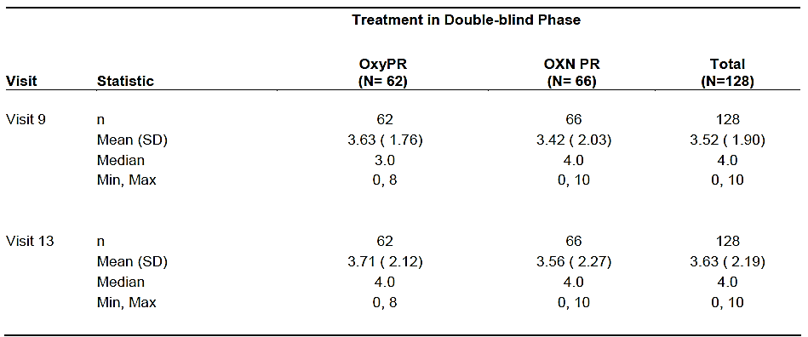
The mean (SD) BPI-SF pain impairment score value was also stable from the beginning of the extension phase (26.92 (16.24)) to the end of the study (29.22 (18.25)).
Other endpoints were broadly concordant with these findings, showing no major changes in number of bowel movements, laxative use, or the PAC-SYM and PAC-SYM (b) questionnaires, which assess constipation. The use of rescue analgesia was also similar from the start to the end of the extension phase. Given that there was no control group, and that subjects are likely to have entered the study because they found the treatment acceptable, the basic stability of these efficacy measures on treatment does not provide robust evidence of sustained efficacy of OXN.
The EuroQol EQ-5D showed no major changes in the Overall Index Score or Health State Today Score from the start of the Extension Phase (Visit 9) to the end (Visit 13).

Table 66: EuroQol EQ-5D: Overall Index Score and Health State Today, Safety Population, Study OXN2001S
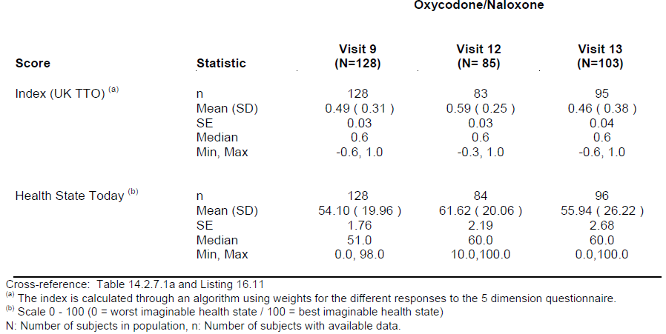

Conclusions
Overall, the study was broadly consistent with continued efficacy of OXN over the course of 6 months, but it was open-label and uncontrolled, so no firm conclusions can be drawn. Bowel function and pain scores were generally stable over the course of the study, showing no improvement or deterioration.
Without a control group, it is unclear whether OXN offered greater efficacy than alternative treatments, and whether stable scores could reflect the natural history of the underlying conditions rather than a treatment effect. Furthermore, the study did not specifically address the need for high-dose Targin, and the number of subjects exposed to the high end of the dose range was low, with 12 subjects likely to have been exposed to 120/60 mg/day and none exposed to 140/70 mg/day or to the maximum proposed dose of 160/80 mg/day.
The study adds some weak support to the notion that Targin has continued efficacy over several months, but it does not provide evidence that higher doses of naloxone are needed compared to those that are currently registered.

Analyses performed across trials (pooled analyses and meta-analyses)
As noted in the description of the individual studies above, the number of subjects exposed to high doses of Targin has been low. The sponsor gathered data from a number of minor analgesia studies and pooled them as shown in the table below. The pool included Studies OXN3503 and OXN3505, described above, as well as a number of other studies that were not submitted for detailed review (OXN2001, OXN3001, OXN3006 and OXN3401). The inclusion of studies that were not available for a critical evaluation greatly reduces the value of this exercise.
The data were presented with descriptive statistics, grouping subjects into those who received a ‘High Dose’, defined as any dose greater than the currently approved maximum of 80/40 mg, and ‘Low Dose’, consisting of doses within the currently approved range (≤ 80/40 mg). Dosing was not randomised, but titrated to effect, so the two groups cannot be considered comparable in terms of their underlying pain; the High Dose group were selected on the basis of poor analgesic response to lower doses. Subjects may also have avoided higher opioid doses because they had dose-related bowel symptoms or were concerned about such symptoms, so the underlying bowel function in the two groups cannot be considered to have been matched.
Even with multiple studies contributing to the data pool, the number of subjects in the High Dose range was only 47, and only a few of these are likely to have been exposed to the maximum recommended dose – the sponsor did not provide a detailed breakdown of exposure, and the original contributing studies were not included in the submission, so precise patient numbers are unknown.
As shown in the table below, bowel symptoms as measured by the BFI were slightly more severe in the High Dose group than in the Low Dose group, at the End of Study time-point, but the clinical significance of this is uncertain. In particular, it is completely untested whether higher or lower doses of naloxone would have produced similar results. Compared to the pooled baseline BFI scores, the End of Study BFI scores were lower, consistent with a favourable effect of naloxone compared to the naloxone-free treatments that subjects received prior to randomisation, and this effect was similar in the two pooled dose groups. This suggests that, even with higher doses of oxycodone, naloxone is capable of improving bowel symptoms, but it does not address the issue of how much naloxone is needed to produce this effect.

Table 67: Summary of BFI by visit (LOCF) across Studies OXN2001, OXN3001, OXN3006, OXN3401, OXN3503 and OXN3505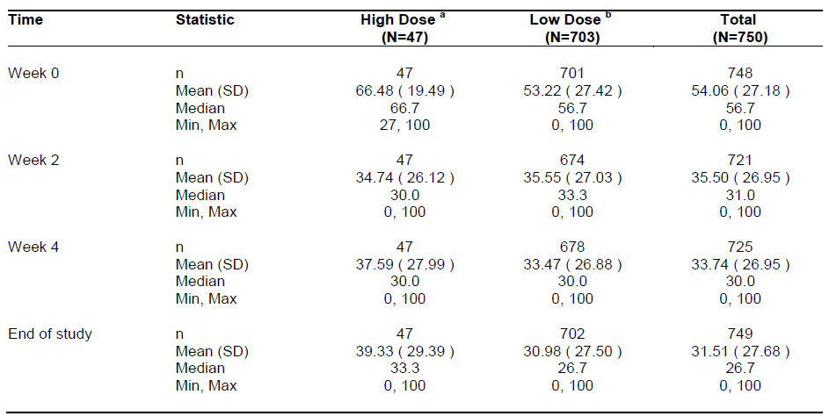
‘High-dose’ refers to doses > OXN80/40 mg PR per day
Pain scores are shown in the table below. Mean pain scores were slightly higher in the High Dose group, which is likely to reflect the fact that doses were increased in response to greater pain levels. These results do not directly clarify whether titration to higher doses was more effective than leaving patients on lower doses.

Table 68: ‘Average Pain over last 24 Hours’ (LOCF), Studies OXN2001, OXN3001, OXN3006, OXN3401, OXN3503, OXN3505
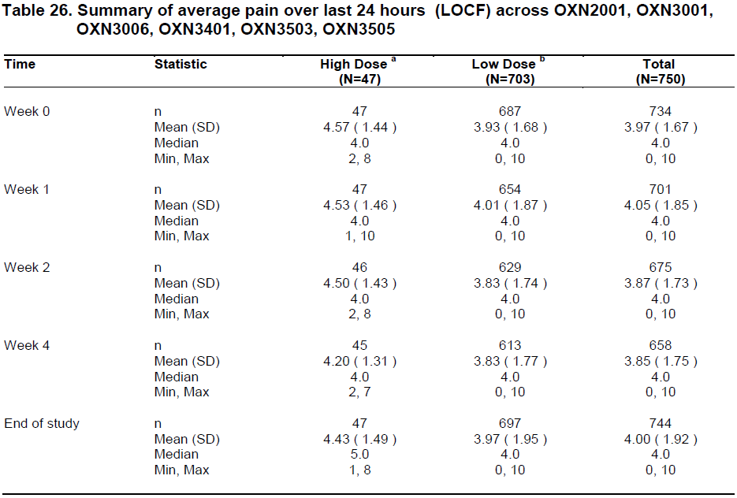
‘High-dose’ refers to doses > OXN80/40 mg PR per day
The sponsor performed a similar pooled analysis of longer-term follow-up data in extension studies, as shown below. Further up-titration was permitted in these studies, and the final exposure to higher doses was increased to 107 subjects, but the numbers exposed to the maximum proposed dose were not stated.
The pooled results of these studies suggest that mean pain scores change little during follow-up, consistent with sustained efficacy of Targin, but the evidence is not conclusive because these studies were unblinded and lacked a control group. The need for higher doses of oxycodone and higher doses of naloxone, and the optimal ratio of these two agents, was not addressed in any of the extension studies.

Table 69: ‘Average Pain over Last 24 Hours’ (LOCF), Studies OXN2001S, OXN3001S, OXN3006S, OXN3401S
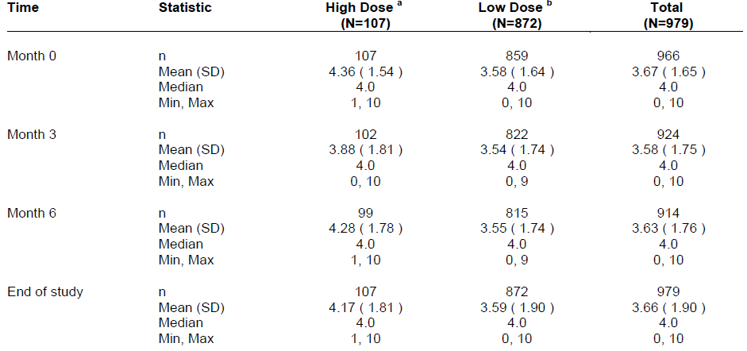

Evaluator’s conclusions on clinical efficacy

Conclusions on efficacy in RLS
Only one randomised controlled study (OXN3502) was submitted in support of the proposed indication for RLS, so it needs to be judged with a substantial measure of caution. This Phase III pivotal study was only of modest size (completing subjects: OXN n= 107; placebo n= 97; total n=204) and duration (12 weeks double-blind treatment), but it achieved strong efficacy results for its primary endpoint (p<0.001) and for all major secondary endpoints (p<0.001 for nearly all endpoints). The magnitude of the treatment effect, about 7-8 points on the IRLS, from a baseline of approximately30 points, exceeded the benefit considered to be clinically significant during power calculations (4 points).
The clinical relevance of the reduction in RLS symptoms is further supported by positive results for the Clinical Global Impression, sleep quality assessed by a couple of different scales, and quality of life using an instrument specific for RLS issues.
One of the main deficiencies of the study was its relatively short duration of treatment (12 weeks). This is offset to some extent by extension of the study into an open-label phase. There are no clear guidelines mandating any particular study duration in the investigation of treatments for RLS. In the European Medicines Agency (EMEA) guidelines in relation to insomnia studies (where RLS is listed as a potential cause of insomnia), it is recommended that treatments intended for long-term use should be studied for at least six months:
‘In principle, a long-term study is needed unless there are compelling safety reasons not to conduct such trials. In this situation, the indication would be ‘short-term treatment’. This might be done by a double-blind placebo-controlled extension study or, preferably, by a randomised withdrawal design. In the randomised withdrawal design, responders to the investigational treatment of sufficient duration are randomised to continue the investigational drug or switch to placebo. This is done in two time periods. In the first open and uncontrolled period the stabilised responders continue with the test treatment for 2 to 4 weeks, thereafter they are randomised and followed for at least 6 months depending on the mechanism of action of the studied medicinal product. The alternative, a double-blind placebo-controlled extension study, should equally last for at least 6 months. Those subjects not coming into the maintenance phase should have their medication withdrawn under placebo control to detect any possible dependence.’
Overall, considering the strength of the results in the pivotal RLS study, and the lack of apparent loss of efficacy during the open-label extension study for up to 52 weeks in total, the Evaluator believes that the evidence for long-term efficacy of Targin in RLS is adequate. Given that subjects will be in a position to judge their responses to treatment, a gradual decline in efficacy or the development of tolerance would be likely to be noted, and a dose adjustment or withdrawal of therapy could be undertaken.
The other main deficiency in the submitted RLS study program is that there was no study of the efficacy of Targin as add-on therapy, in subjects receiving dopaminergic therapy. The indication being sought is: ‘Symptomatic treatment of patients with moderate to severe idiopathic Restless Legs Syndrome (RLS) insufficiently treated with dopaminergic therapy.’ In many cases, this will lead to use of Targin as an add-on agent, but no study has specifically addressed whether Targin has efficacy when used in this manner.
Given that clinicians will be free to phase out dopaminergic agents if they appear not to be contributing to efficacy, leading to Targin monotherapy (which this study suggests is more effective than placebo), the lack of add-on efficacy data is not considered to be a barrier to registration. Also, it should be noted that RLS is a subjective symptom, which patients are in a good position to observe; if Targin lacked efficacy in an individual patient when added to dopaminergic therapy, the patient could note the lack of response and withdraw the ineffective agent.
On balance, despite the fact that only one controlled study was submitted and it did not explore the efficacy of Targin as an add-on agent, the submitted evidence narrowly provides adequate support for the sponsor’s claims of efficacy for Targin in RLS.
It should be noted that a similar conclusion has been drawn by the EMEA, who have approved Targin for this indication. It could also be argued that a new indication should not be approved without a dose-response study.

Conclusions on efficacy of higher doses in chronic pain
The pivotal analgesia study and the supporting studies provide evidence that Targin, titrated over a range of doses including those already approved, is less constipating than equivalent doses of oxycodone monotherapy but reasonably similar in terms of analgesia. The pivotal study, OXN3506, met both of its primary objectives, demonstrating an improvement in symptoms of constipation (measured by the BFI) and non-inferiority in pain scores (PIS visual analogue scale) in subjects taking OXN PR compared to subjects taking OxyPR. The evidence of non-inferiority was not robust, however, because there appeared to be a significant difference in analgesic efficacy between Targin and OxyContin, in favour of OxyContin, and the study was not powered for specific doses.
The benefit of OXN for bowel symptoms was demonstrated in all major analyses of the pivotal study, including the primary endpoint in the full analysis population (LS mean difference (SE): -16.05 (3.14); p<0.001, CI: -1822.23.19, -7.169.86, p<0.001), as well as bowel-related secondary efficacy analyses. Supportive studies produced similar results.
Broadly similar analgesic efficacy of OXN and OxyPR at intermediate oxycodone doses appears likely. Subjects in both treatment groups of the pivotal study showed reduced pain in the Run-in Phase, when they commenced OxyPR, and pain scores remained reasonably constant throughout the Double-blind treatment period. The sponsor’s statistical analysis of this result was not particularly convincing. In the primary PP analysis, the sponsor’s null hypothesis was that the ratio of ‘average pain over the last 24 hours’ between OXN PR and OxyPR was ≥ 120%. This hypothesis was rejected with p<0.001, but it should be noted that that lesser increases of pain (such as a 19% increase in pain) could be considered clinically significant. Pain scores were quite similar in the two active groups, so it appears very likely that, in clinical practice, any analgesic difference between the two treatments would fall well short of the sponsor’s 120% threshold, but the provided analyses do not clarify this likelihood. The 95%CIs for the treatment differences in the pivotal study were not reported clearly in the text of the study report, but were included in a subsequent table, and this analysis suggested that pain scores could be almost up to one unit higher with OXN (treatment difference in favour of OxyPR, -0.65; 95%CI -0.99 to -0.3), which is a large difference relative to the mean pain scores of about 3.5 to 4. Also, the 95% CI excluded zero, apparently indicating a significant difference, but the sponsor did not comment on this anywhere in their submission. Given that the maximum-dose subgroup was relatively small, broader 95%CIs would be expected for a dose-specific analysis of this endpoint, and the 95%CIs would be expected to include differences that could be considered clinically significant.
A more substantial issue is that the submitted studies did not specifically assess the efficacy of doses above those already approved, relative to approved doses. Furthermore, exposure to the maximum proposed dose only occurred in a minority of patients in the pivotal study, which was not powered to allow assessment of efficacy at specific doses. Only 31 subjects received the highest proposed dose of Targin (160/80 mg/d) in the pivotal study, only 19 subjects received the maximum dose in the major supportive crossover study 038-002, and in a pooled analysis of several minor studies, only 47 subjects received Targin at doses above those already approved (>80/40 mg/d). The pooled analysis of minor studies did not specifically assess the maximum proposed dose, but it seems very likely that very few patients (and possibly only one patient) received the maximum dose across all of the minor studies.
In particular, the following issues remain poorly characterised:
- The analgesic efficacy of the higher, proposed oxycodone doses (>40 mg BD, up to 80 mg BD) compared to lower, approved oxycodone doses (≤40 mg BD) has not been assessed in any study in the current submission. In all studies, oxycodone doses were non-random and titrated to effect; the parallel treatment groups had equivalent oxycodone dosing and only differed in terms of naloxone treatment, so an oxycodone dose comparison across treatment groups is not possible. Subgroup analysis by oxycodone dose was performed to some extent, but this is of limited utility given the non-random, unblinded allocation of doses and the small numbers exposed to the highest doses.
- The efficacy of high-dose naloxone (>20 mg BD, up to 40 mg BD) in preventing constipation due to the proposed higher oxycodone doses has not been directly assessed in an adequately powered study. Although some subjects in the Targin group of the pivotal study received high-dose naloxone, and their results can be compared with subjects who received equivalent doses of oxycodone without naloxone, the study was not adequately powered for such a subgroup analysis.
- Whether or not high-dose naloxone might antagonise oxycodone and compromise the analgesic efficacy of oxycodone has not been directly assessed in an adequately powered study. Pain scores in subjects using higher doses of Targin in the pivotal study were compared with subjects using equivalent doses of oxycodone without naloxone, but only descriptive statistics were presented (see table below), and no study was adequately powered for such a comparison. The lack of statistical power in the upper end of the proposed dose range is particularly important given that the sponsor sought to demonstrate non-inferiority of Targin relative to naloxone-free oxycodone.
- An oxycodone: naloxone ratio of 2:1 has been proposed for the new, higher Targin doses. This ratio is based on consistency with the ratio already used in lower, approved doses, but no clinical study directly assessed the suitability of this ratio at high doses, in comparison to alternative ratios. In every analgesic study submitted, individual naloxone doses in the Targin group were based directly on the titrated oxycodone dose, at a fixed 2:1 ratio.
- No study compared the proposed higher doses of Targin with the current recommended practice of combining Targin and OxyContin to reach higher total oxycodone doses.

Table 70: Pain Intensity Scale – ‘Average Pain Over 24 Hours’ – Observed Values, Per Protocol Population, Study OXN3506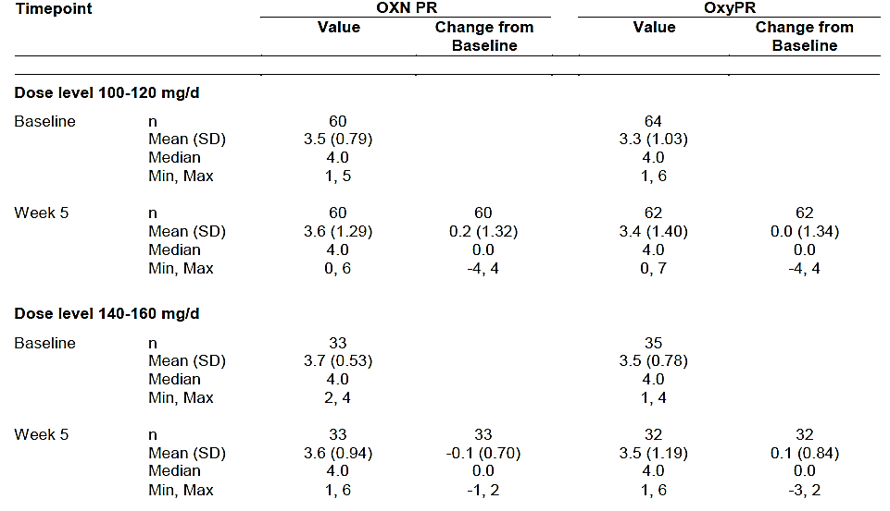

Clinical safety

Studies providing evaluable safety data
The sponsor submitted three different Summaries of Clinical Safety (SCS), one for each of the proposed variations (the RLS indication, the higher maximum dose, and the PI revision mentioning new abuse-potential studies). Of these, the most important was the SCS dealing with the proposed increase in the maximum dose. The Targin doses proposed for use in RLS have already been widely used in the treatment of pain, and the safety profile of Targin (OXN) in that dose range is well known, so the RLS studies did not add substantially to existing knowledge of the safety profile of Targin. The studies submitted in support of the abuse-potential claims in the proposed PI were all small, single-dose studies, which did little to characterise the safety of Targin outside the narrow context of the pharmacology of abuse.
All clinical efficacy studies used a similar approach to safety monitoring. AEs were collected at scheduled visits and unscheduled hospital admissions, graded by severity, and classified using standard definitions. Investigators recorded their opinion on whether they felt the AE was likely to have been causally related to the study medication. Laboratory monitoring, including examination of full blood counts, electrolytes and liver function, were assessed at baseline and at regular intervals throughout the study. For the major studies, ECGs were also performed at baseline and at regular intervals throughout the studies.

Pivotal studies
Two efficacy studies can be considered pivotal in terms of the safety analysis. Study OXN3506 was the pivotal analgesic study, and assessed Targin at doses above those currently registered for this indication, up to the proposed new maximum dose of 80/40 mg twice daily. OxyContin (prolonged-release oxycodone without naloxone) served as the active comparator, and was titrated to doses equivalent to those used in the OXN group, so differences in exposure were only present for naloxone; this study does not provide any comparative data relevant to the oxycodone component of high-dose OXN.
Study OXN3502 was the pivotal RLS study, and assessed the use of OXN at lower doses, within the currently approved range, starting at 5/2.5 mg twice daily but titrating as needed to a maximum of 40/20 mg OXN PR twice daily. The comparator was placebo, so this study provides the major source of placebo-controlled safety data in the submission, albeit at low doses that have already been well studied in the context of analgesia. The study design does not allow the safety of oxycodone and naloxone to be assessed independently, because all recipients of active treatment received both active components at a fixed 2:1 ratio, but the low systemic bioavailability of naloxone means that most AEs are likely to have been due to the oxycodone component.
The pivotal RLS study had a long-term, open-label extension phase, which provided further safety data, but it is not possible to draw strong conclusions from the incidence of AEs in the long-term extensions, because of their open-label design and lack of any control data.
The pivotal analgesia study did not have a long-term extension, and long-term exposure to high doses of Targin in the treatment of pain is very limited.

Pivotal studies that assessed safety as a primary outcome
No pivotal studies assessed safety as their primary outcome.

Other studies
All of the submitted studies assessed the incidence of AEs, but the clinical pharmacology studies had low patient numbers, limiting the value of this data. Also, the PK studies used naltrexone, an oral opioid antagonist, to limit opioid-induced side effects, so the incidence of AEs was artificially reduced. Conversely, the healthy volunteers in these studies had not undergone gradual titration towards the tested dose, so they did not have the tolerance to opioids that might be expected in usual clinical contexts. The studies of abuse potential involved atypical routes of administration, and in some cases involved co-administration of methadone in patients with chronic opioid addiction. Overall, this means the safety data from the clinical pharmacology studies was of limited relevance to standard clinical settings. No specific safety concerns were raised by any of these studies, and the synopsis for each PK or PD study should be consulted for further details.
The supportive analgesia studies provide some additional safety data, which is summarised in the relevant sections below. Study 038-002, which was previously submitted and evaluated studied OXN and OxyPR at doses above those currently registered, but it employed a crossover design with inadequate washout, limiting its value for safety comparisons. The supportive studies OXN3503 and OXN3505 provided active-controlled safety data in a parallel-group design, but the numbers exposed to high doses was very low. The long-term extension Study OXN2001S provides some long-term data that included exposure to high doses, but its utility is reduced by the unblinded nature of the assessments and the lack of a control group.
The sponsor also pooled several minor analgesia studies, in view of the low numbers of patients exposed to high doses in each individual study. This pooled analysis allows a comparison of ‘High-dose’ treatment (≥100/50 mg/d) with ‘Low-dose’ treatment (≤ 80/40 mg/d). Despite this pooling, only 47 patients contributed data to the ‘High-dose’ pool; the number receiving the highest proposed dose (160/80 mg/d) was not clearly reported, but is likely to have been very low.

Patient exposure
For currently approved doses, there has already been extensive exposure to Targin in previously reported studies, as shown in the following table.

Table 71: Duration of Exposure to Oxycodone/Naloxone (all subjects from completed studies)
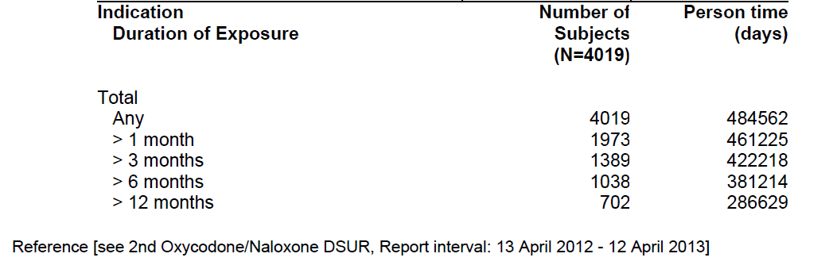
By contrast, exposure to the proposed high doses (above 80/40 mg/d) has been very limited, as discussed below.

Exposure to high doses in analgesia studies
In the pivotal analgesia study, OXN3506, 123 subjects were exposed to OXN, for a mean duration of 32 days, but only 15 subjects were exposed to 140/70 mg/day and only 31 subjects were exposed to the proposed maximum dose of 160/80 mg/day (based on the highest dose to which subjects were exposed for at least 7 days, as shown in the second table below). Considering the highest dose alone, these patient numbers would normally be considered more typical of a Phase 1 study rather than a Phase III pivotal study. Most of the subjects exposed to the highest dose were already on this dose at the commencement of the Double-blind phase, as shown in the third table below, but some only reached the highest dose during the study. (The tables disagree on the number of subjects exposed to 160/80 mg/day, possibly because subjects with exposure <7 days are not counted in the second table below).

Table 72: Exposure to Study Medication, Study OXN3506
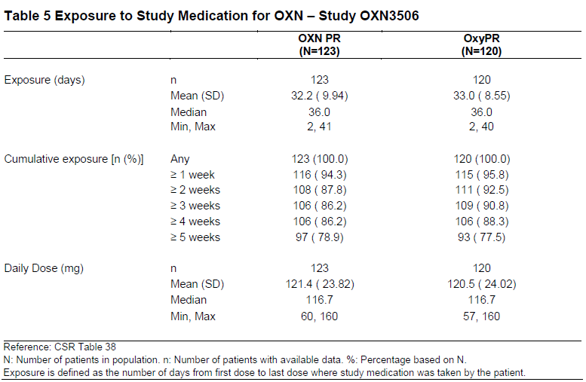

Table 73: Dose Levels in Double-blind Phase, FA Population Study OXN3506
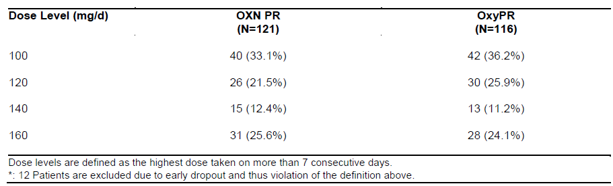

Table 74: Shift of Dose from Baseline to End of Study, OXN3506
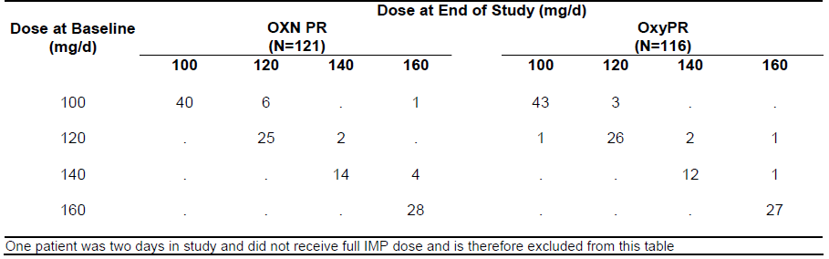
The supportive analgesic study, 038-002, was a cross-over study using Targin (designated OXN or OXN PR in the provided tables) at doses of 120/60 or 160/80 mg/day, in two divided doses, and equivalent doses of prolonged-release oxycodone (OxyPR) without naloxone. Patients received OXN for a mean 32.0 ± 8.1 days and OxyPR for a mean of 32.8 ± 7.6 days. Of the 52 patients who received OXN, 33 (63%) received the 120/60 mg/day dose, and 19 received the proposed maximum 160/80 mg/day dose. (Of 54 patients exposed to OxyPR, 36 received 120/60 mg/day and 18 received 160/80 mg/day.)
In the open-label period, 34 patients were exposed to OXN for a mean of 124.8 ± 69.9 days. Of those, 16 patients were exposed to120/60 mg/day and 18 were exposed to 160/80 mg/day.
Exposure in the minor supportive studies is summarised below. The mean daily dose in Studies OXN3503, OXN3505 and OXN2001S was well below the currently approved maximum of 80/40 mg/day. The number of subjects exposed to the maximum proposed dose in these studies was not clearly reported in the Summary of Clinical Safety, but appears to have been one in total: none from OXN3503, one from OXN3505, and none from OXN2001S.

Table 75: Exposure to Study Medication for OXN PR across Supportive Clinical Trials
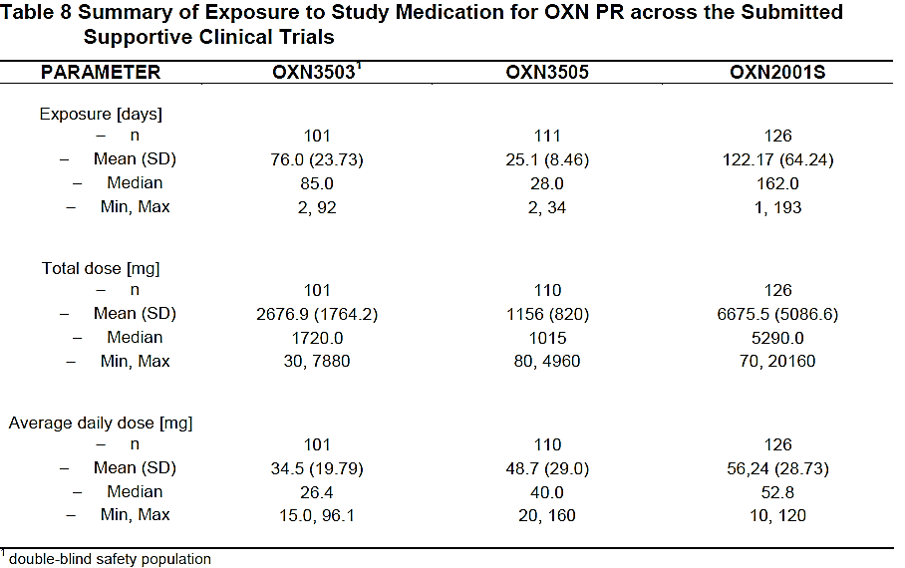
Study OXN3503 had a notional maximum dose of 120/60 mg/day, which is below the proposed new maximum, but it seems likely that no subjects were titrated to 120/60 mg/day anyway; only three subjects were exposed to 100/50 mg/day and all other subjects received doses that are already approved.
Study OXN3505 allowed doses up to 160/80 mg/day, but only one patient received this dose, as shown below, and only 12 patients received doses in the range 100/50 to 140/70 mg/day.

Table 76: Initial Dose and Maximum Dose reached, OXN PR, Safety Population, Study OXN3505
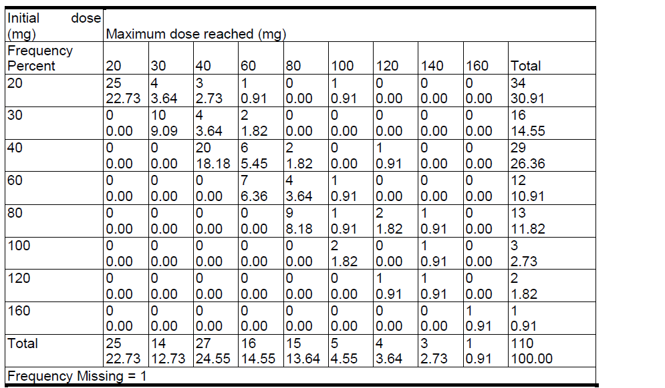
Study OXN2001S only allowed dosing up to 120/60 mg/day, below the proposed new maximum, and this study had no control group so it is of limited value.

Exposure in RLS studies
Exposure to Targin in the context of treating RLS was limited to a single pivotal study (OXN3502) and its open-label extension (OXN3502S). In the Double-blind Phase of the pivotal study, the intended duration of treatment was 12 weeks (84 days), and this was generally achieved in the active group, which had a median duration of exposure of 91.0 days. The placebo group had a shorter median exposure (68 days), reflecting the higher discontinuation rate in the placebo group. Overall, 69.3% of the OXN group and 49.4% of the placebo group received study medication for ≥ 84 days.
The average daily dose of oxycodone in the OXN group was approximately 22 mg, with a notional average daily dose in the placebo group of approximately 35 mg.
In the Open-label Extension Phase, the median duration of exposure was 281 days (range: 4 to 297 days). The protocol-planned duration of treatment was 40 weeks (280 days) and in total 156 (79.2%) subjects received study medication for 271 days or more, in the Extension Phase, resulting in an overall exposure of one year across the two studies.
The mean dose of oxycodone in the Extension Phase was approximately 18 mg daily.

Exposure in PK/PD studies
Exposure in the PK and PD studies was largely restricted to single doses per crossover phase, with the exception of one multi-dose PK study (OXN1507). Three of the studies (OXN1505, OXN1506 and OXN1507) were submitted in support of the proposed increased maximum dose (80/40 mg twice daily) and directly tested individual doses of 80/40 mg.
In Study OXN1506, 40 subjects completed the study and were randomly administered 5 of the 7 doses of study medication over 5 study periods. The test treatments were OXN tablets at 5 different strengths (2.5/1.25 mg, 15/7.5 mg, 30/15 mg, 60/30 mg and 80/40 mg), and the reference treatments were previously well-characterised doses of OXN PR (10/5 mg and 40/20 mg).
In Study OXN1505, 23 subjects completed the study and received all 3 treatments over 3 study periods (OXN80/40 mg in a fed and fasted state and oxycodone/naloxone liquid in a fasted state), 1 subject received two study treatments (oxycodone/naloxone liquid in a fasted state and OXN80/40 mg PR in a fed state), and 4 subjects received one study treatment (1 subject: OXN80/40 mg PR in a fed state, 3 subjects: OXN80/40 mg PR in a fasted state).
In Study OXN1507, 20 randomised subjects received twice-daily doses of 80/40 mg or 40/20 mg over two different crossover sessions of 3 ½ days each. All subjects received at least one dose of OXN 80/40 mg, but 2 subjects discontinued from the study without receiving any OXN40/20 mg PR.
In Study ONU1001, 50 subjects were treated on two separate occasions with single doses of oxycodone/naloxone 10/5 mg.
In Study ONU1002, 55 subjects were treated on two separate occasions with single doses of oxycodone/naloxone 40/20 mg.
In Study ONU1009, 30 subjects were treated with single doses of oxycodone/naloxone 20/10 mg in one of the crossover stages.
In Study ONU1003, 16 subjects were in Group 1 (oral, chewed, 40/20); 27 were in Group 2 (IN, 40/20 mg); and 24 in Group 3 (IV, oxycodone 0.07 mg/kg/naloxone placebo, oxycodone 0.07 mg/kg/naloxone 0.035 mg/kg, or oxycodone placebo/naloxone placebo).
In Study ONU1004, 18 subjects completed treatment session 1 (OXN 30/15 mg) and 16 subjects completed treatment session 2 (OXN 60/30 mg).
In Study ONU1007, 37 subjects were treated with single doses of OXN 40/20 mg.
In Study ONU1008, 33 subjects were treated with OXN 60/30 mg.

Adverse events

All adverse events (irrespective of relationship to study treatment)

AEs in analgesia studies
In the pivotal analgesic study, OXN3506, a total of 67 subjects (54.5%) in the OXN group reported at least one Adverse Event (AE), compared to a slightly lower total of 57 subjects (47.5%) in the OxyPR group. The incidence of AEs was increased at higher doses (140-160 mg oxycodone per day) in both the OXN and OxyPR treatment groups, compared to lower doses (100-120 mg/d), as shown in the second and third tables below. For subjects receiving OXN, the proportion of subjects reporting AEs was 47.0% and 60.9% in the lower and higher dose subgroups, respectively, and for OxyPR recipients the proportions were 40.3% and 53.7%, respectively. Doses were not randomised, so a higher proportion of AEs might not simply reflect a dose-related increase in side effects, but could also be a marker of more severe underlying problems necessitating higher analgesic doses.
The proportion of AEs at the highest dose level, oxycodone 160 mg/day, was not specifically reported, but is obviously of interest given the sponsor’s proposal to increase the maximum dose to this level. This information should be provided.

Table 77: Summary of Adverse Events: Safety Population, Study OXN3506
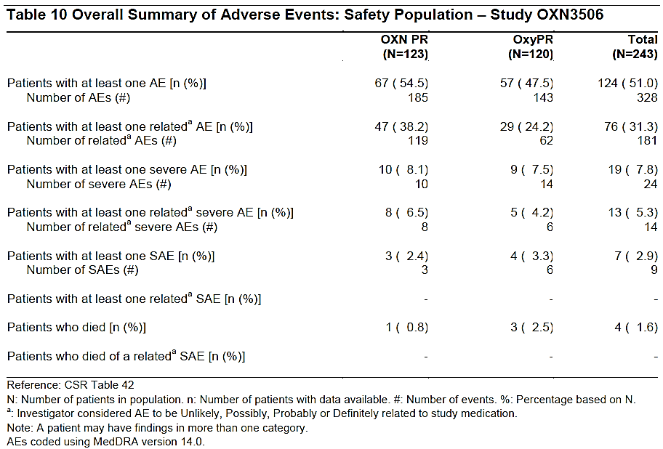

Table 78: Summary of Adverse Events: Double-Blind Safety Population. Subgroup, Dose 100-120 mg/day Study OXN3506
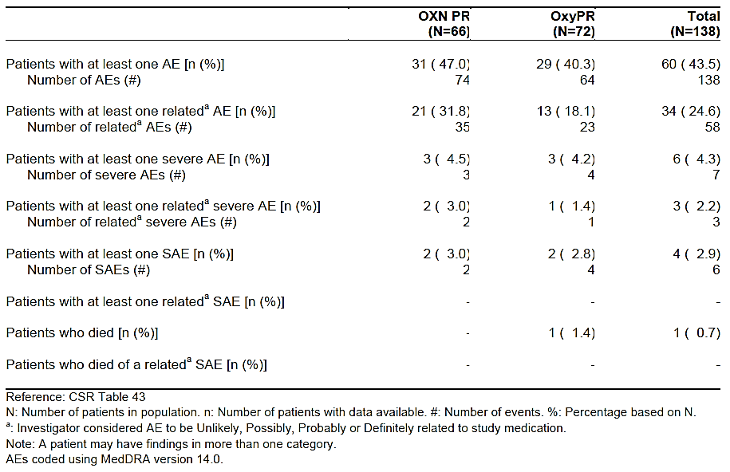

Table 79: Summary of Adverse Events: Double-Blind Safety Population. Subgroup, Dose 140-160 mg/day Study OXN3506
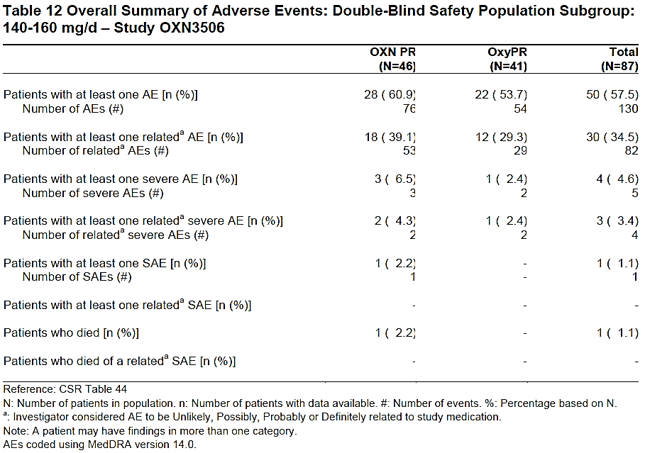
The types of AEs observed were typical of the known side-effect profile of opioids, as shown in the table below, which ranks individual AEs according to their incidence in the combined study population (OXN and OxyPR groups combined). The most common AEs in the OXN group were nausea (reported in 9.8%), hyperhidrosis (6.5%), diarrhoea (4.9%), abdominal pain (4.1%) and ‘pain’ (4.1%). (The significance of unspecified pain, as an AE, in a study that required chronic pain as an entry criterion, is doubtful; many more subjects are likely to have experienced pain but not reported it as an AE). For most AEs, the distribution was similar in the OXN and OxyPR groups, but there was an excess of nausea (9.8% versus 5.0%), hyperhidrosis (6.5% versus 2.5%) and drug withdrawal syndrome (3.3% versus 0.8%) in the OXN group. The excess of withdrawal symptoms in the OXN group suggests some systemic opioid antagonism from naloxone, despite its low bioavailability. Drug withdrawal symptoms were also monitored by specific rating scales, which are discussed separately in Withdrawal syndrome section.

Table 80: Most Frequent Adverse Events, Incidence ≥ 1% in Any Treatment Group, Safety Population, Study OXN3506
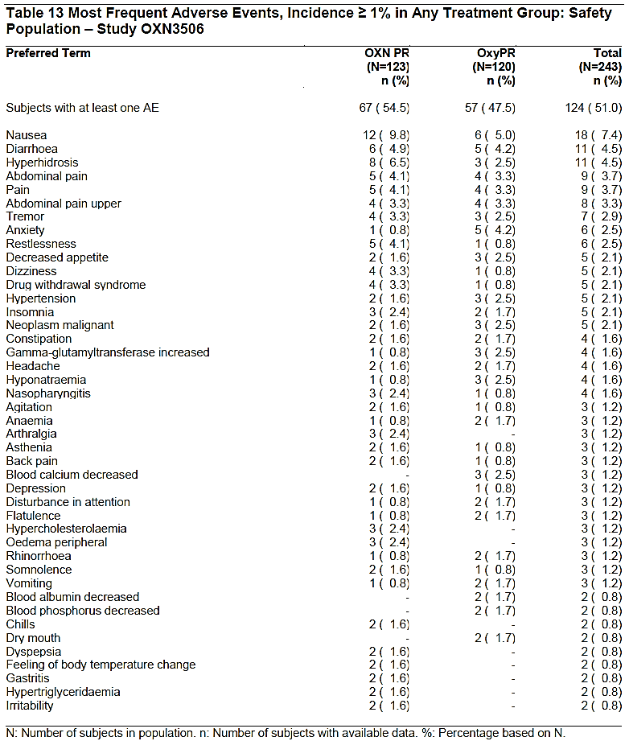
In the crossover study, 038-002, the incidence of AEs was slightly higher, as shown in the table below. (The table presents the data in a confusing way: the numbers 73 and 95 refer to the number of individual AEs reported in each group, and amount to a reporting rate of >100% - that is, more than one AE per subject – but this has been cropped at 100%. Also, ‘<2%’ in the footnote should read ‘≥2%’).
Because of inadequate washout between treatments, it is not possible to draw strong conclusions about the overall tendency of each treatment to produce side effects. Diarrhoea was notably more common during treatment with OXN, but other AEs occurred with similar frequency during each treatment. Given that OxyPR was associated with a higher incidence and severity of constipation, and that opioids slow gut motility, an effect antagonised by naloxone, it is not surprising that diarrhoea was more common while subjects received OXN, but it remains unclear to what extent OXN caused diarrhoea, because there was no placebo group. (Diarrhoea was also more common in the OXN group of the pivotal analgesic study, as shown above, but it was not a major feature in the pivotal RLS study, discussed below.).

Table 81: Incidence of Most Common Adverse Events, Double-Blind Period, Study 038-002
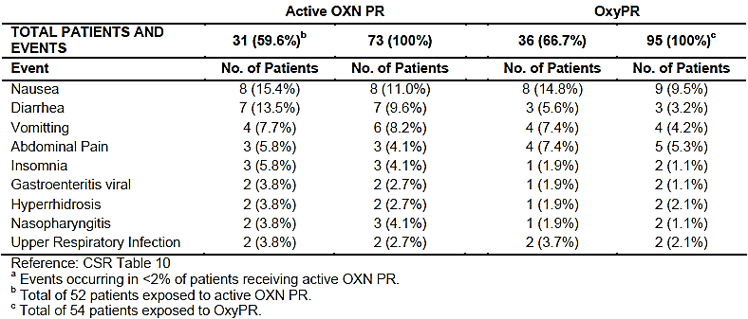
In the pooled analysis of the minor analgesia studies, the overall distribution of AEs was similar to those observed in the pivotal analgesia study and the crossover study 038-002. In the core phases of the pooled studies (see the table below), the most common AEs were in the gastrointestinal system (30.8%), followed by general disorders and administration site conditions (16.3%) and nervous system disorders (16.1%). The most frequent individual AEs were nausea (8.1%), headache (5.9%), hyperhidrosis (4.4%), constipation (4.1%), abdominal pain (3.7%), fatigue (3.7%) and diarrhoea (3.6%).
In the High dose subgroup, the most frequent individual AEs (reported in ≥ 2 patients) were nausea, fatigue, pain, anorexia (each reported in 3 patients, 6.4%), constipation, vomiting, cancer pain, depression, hyperhidrosis, headache, and hot flushes (each reported in 2 patients, 4.3%).

Table 82: Adverse Events in Pooled Analysis, Studies OXN2001, OXN3001, OXN3006, OXN3401, OXN3503, OXN3505

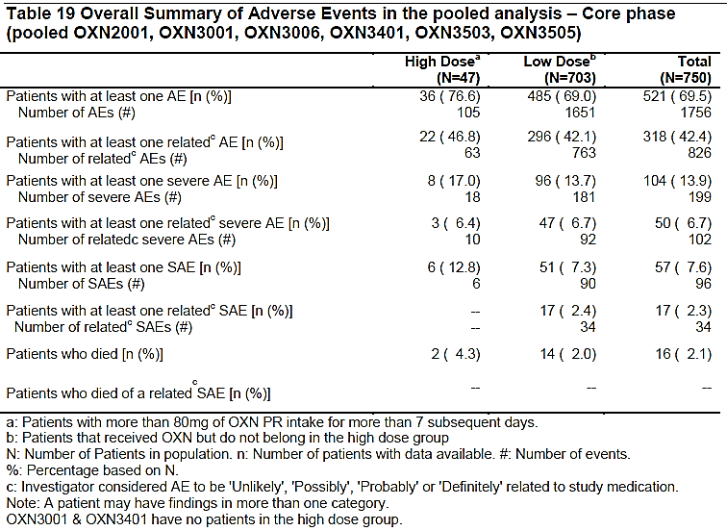
In the extension phases of the pooled studies, the pattern was broadly similar with the most common organ system involved being the gastrointestinal system (32.8%), followed by the musculoskeletal system and connective tissue (29.6%), and then infections and infestations (26.8%).
The most frequent individual AEs in the pooled extension phases were constipation (8.7%), hyperhidrosis (5.5%), nausea (5.9%), depression (4.8%), headache (4.3%) and nasopharyngitis (3.7%). In the ‘High-dose’ subgroup, the most frequently reported AEs (reported in ≥ 5 patients) were constipation (12 patients, 11.2%), nausea (10 patients, 9.3%), malignant neoplasm progression (9 patients, 8.4%), hyperhidrosis (9 patients, 8.4%), back pain (8 patients, 7.5%), drug withdrawal syndrome (7 patients, 6.5%), pain (7 patients, 6.5%), headache (5 patients, 4.7%). In many cases, such as progression of malignancy, these complaints appear to be due to the underlying conditions that led to the patient entering the study. Without a control group, it is not possible to draw any conclusions about the extent to which these AEs were caused by Targin.

Table 83: Adverse Events in Pooled Analysis, Extension Phase, Studies OXN2001S, OXN3001S, OXN3006S, OXN3401S
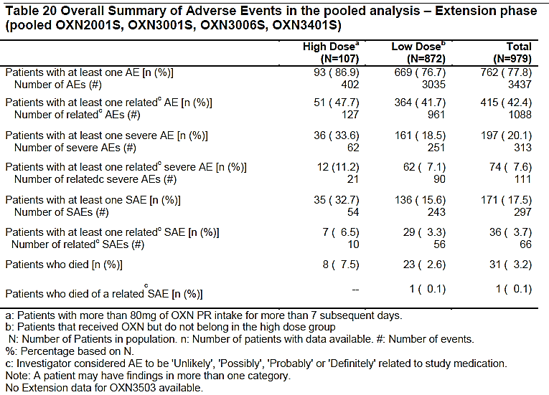
AEs in the individual analgesia studies OXN3503, OXN3505 and OXN2001S are summarised in the tables below. In general, the overall incidence of AEs was similar in the OXN and OxyPR groups, and a review of the individual types of AEs (not shown in this report) did not raise any new safety concerns. It should be recalled that very few patients received doses towards the upper end of the proposed dose range, so this data is of limited value.

Table 84: Adverse Events: Double-Blind Safety Population, Study OXN3503
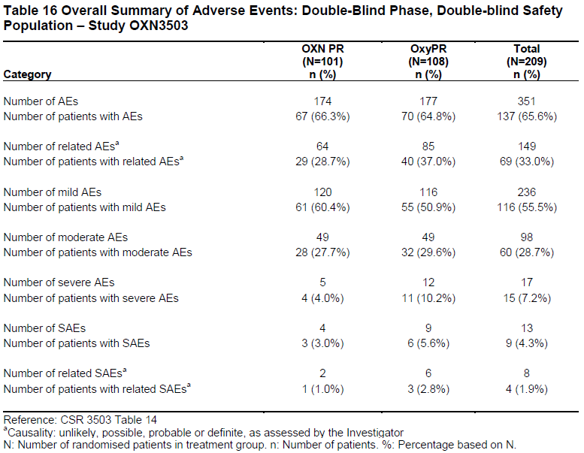

Table 85: Adverse Events, Safety Population, Study OXN3505
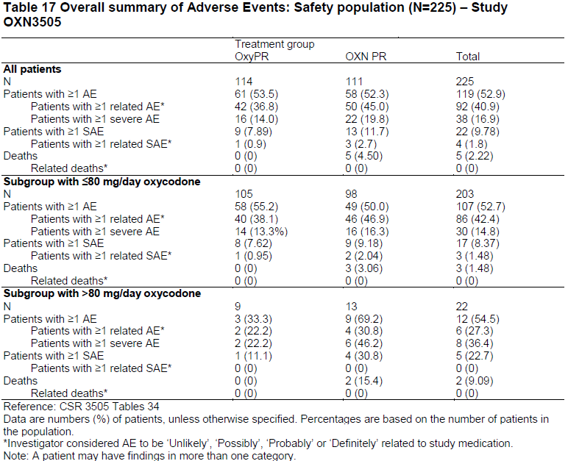

Table 86: Adverse Events: Safety Population, Study OXN2001S
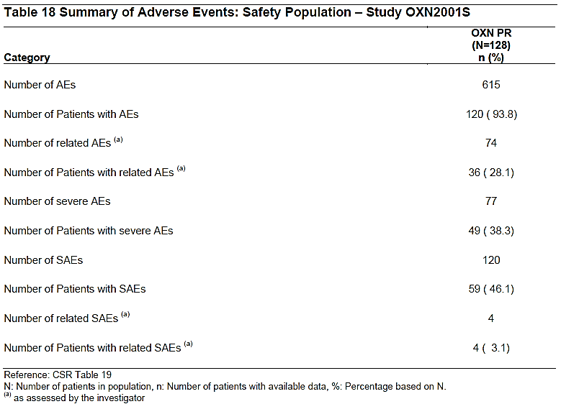

AEs in RLS study
In the pivotal RLS study, OXN3502, the incidence of AEs was high, even in the placebo group. AEs were reported by 84% of OXN recipients, and 68.8% of placebo recipients, an absolute excess of 15.2%. In other words, in the OXN group, of the 31.2% of subjects who would not have been expected to have had an AE, based on the placebo incidence of AEs, about half (15.2%/31.2%) had an AE.

Table 87: Adverse Events: Double-Blind Phase, Study OXN3502
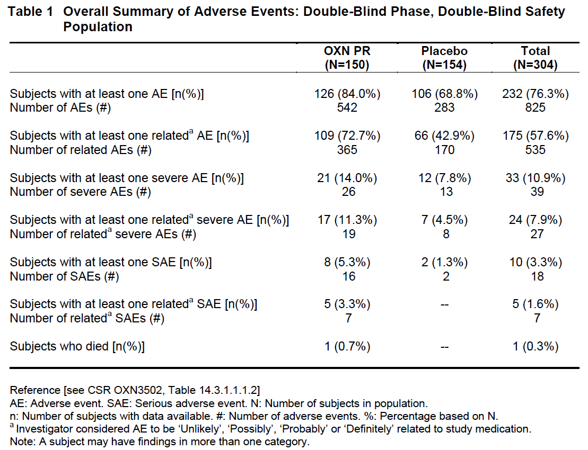
The incidence of AEs was also assessed by total daily dose, up to the maximum dose of 40/20 mg twice daily (80 mg oxycodone per day). No consistent dose trend was observed, with all dose groups showing a higher incidence of AEs than the placebo group, and the highest and lowest dose groups showing a similar incidence of AEs.

Table 88: Adverse Events by Dose at End of Maintenance: Study OXN3502
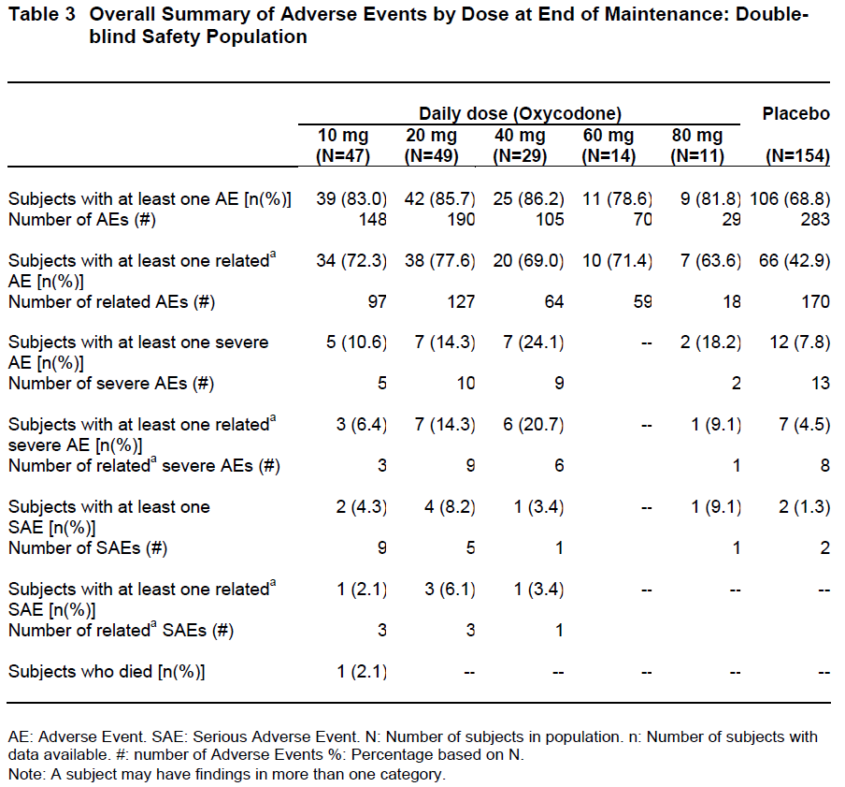
In the extension phase, 76% of subjects reported an AE. The incidences was similar in those previously exposed to OXN and in those previously exposed to placebo (see the table below).

Table 89: Adverse Events by Double-Blind Treatment: Extension Phase, Study OXN3502
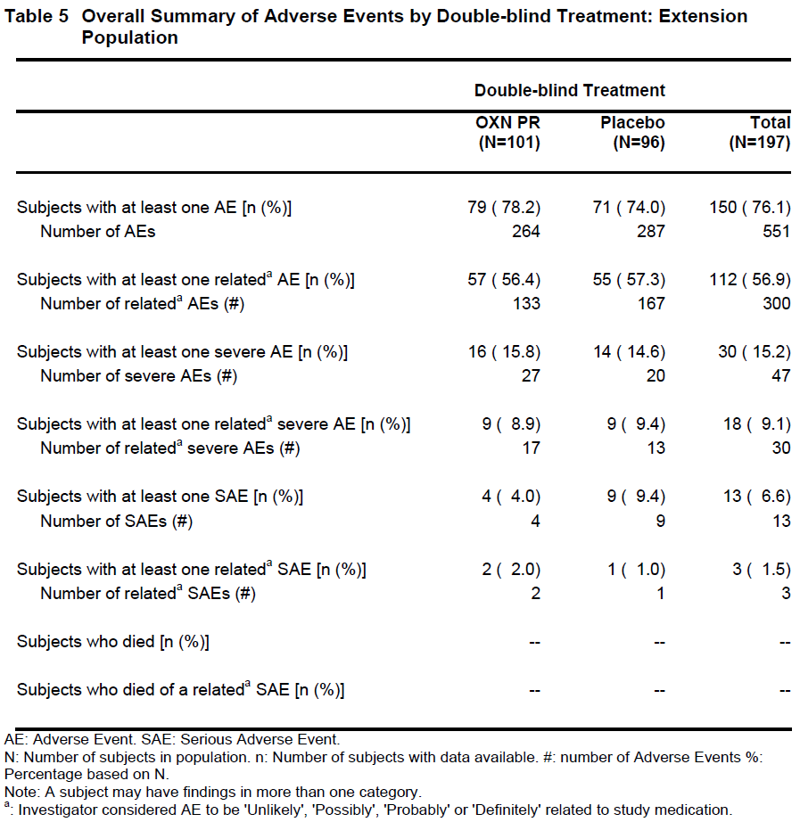
Considering the organ categories involved and the individual types of AEs reported, gastrointestinal side effects were substantially more common in OXN recipients than placebo recipients, including constipation and nausea. Sedative side effects, including somnolence, and other central nervous system effects consistent with opioid effects, such as dizziness, were also more common with active treatment. The excess of constipation in the active group was substantial (21.3% versus 4.5%), despite the known benefits of including naloxone to antagonise opioid effects on the gut. Hyperhidrosis was more common with active treatment, as had also been observed in the analgesia studies; this is a known side effect of opioids. Pruritus was also more common in the active group.
The distribution of AEs in the Extension Phase (second table below) was similar to that observed in the active group during the Double-Blind phase, with a high incidence of constipation, nausea, nervous system disorders in general, and on-going issues with hyperhidrosis in a small proportion of patients. Without a control group, it is difficult to know how many of these AEs are likely to have had a causal relation to treatment, but it appears that the long-term tolerability of OXN in this population is similar to that observed in the pivotal study, and is consistent with the known side effects of opioids.

Table 90: Adverse Events, Incidence ≥ 5% in either Treatment Group: Double-Blind Phase, Double-Blind Safety Population, Study OXN3502
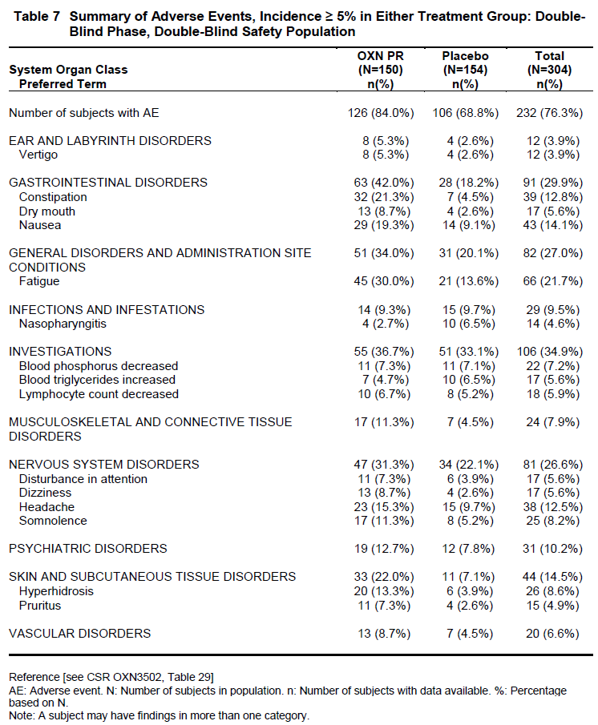

Table 91: Gastrointestinal Adverse Events, Double-Blind Phase, Double-Blind Safety Population, Study OXN3502
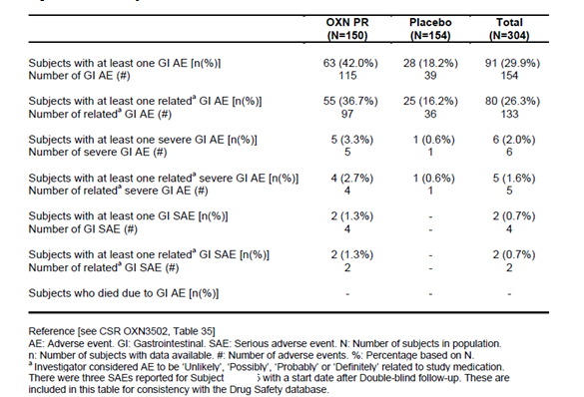

Table 92: Adverse Events, Incidence ≥ 5% of Subjects, Extension Phase, Study OXN3502S
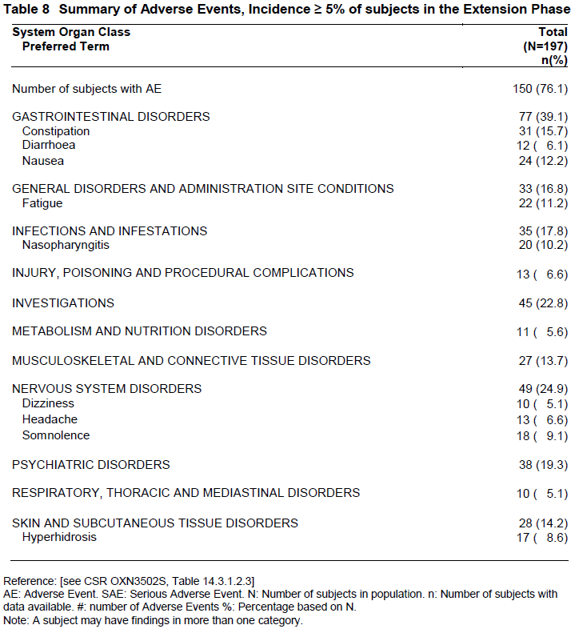

AEs in other studies
AEs in the PK and PD studies were similar to those reported in the efficacy studies.

Treatment-related adverse events (adverse drug reactions)

Treatment-related AES in analgesia studies
For each reported AE, clinicians were required to indicate whether they believed it to be related to study medication. This is an unreliable process, and may be biased by clinicians’ expectations of the AE profile of the drugs being studied. Nonetheless, the clinician is in a position to observe the temporal relation between drug ingestion and reported AEs, which may give clues of a causal link.
In the pivotal analgesia study, AEs thought to have a causal relation to treatment were more common in the active group (38.2%) than the placebo group (24.2%). The most common AEs thought to be related to treatment were generally those that were more common with active treatment, or known to be caused by opioids. These included nausea and hyperhidrosis as the two most common treatment-related AEs. In 10 of the 12 patients in the OXN group and 5 of the 6 patients of the OxyPR group who reported nausea, it was assessed as having a positive causal relationship to study medication, indicating that clinician were likely to attribute any nausea to study drug, even in the placebo group.

Table 93: Most Frequent AEs Related to Study Medication: ≥ 1% in Any Treatment Group, Study OXN3506
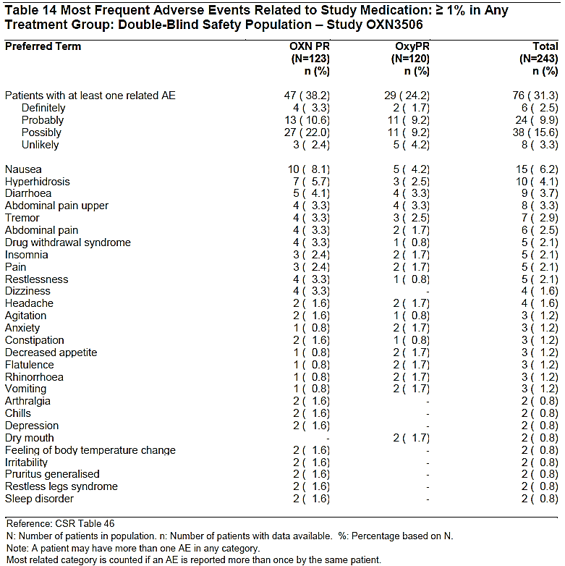
TRAEs in minor supportive studies were similar (not shown).

Treatment-related AES in RLS study
In the pivotal RLS study, treatment-related AEs were more common with active treatment, and the most common types of AEs were consistent with the pattern already observed in a listing of all AEs. The most common issues were gastrointestinal side effects, nervous system disorders (dizziness, headache and somnolence), hyperhidrosis and pruritus.

Table 94: Treatment Related Adverse Events, Incidence ≥ 5% in Either Treatment Group: Double-Blind Phase and Open Label Extension Phase, Study OXN3502
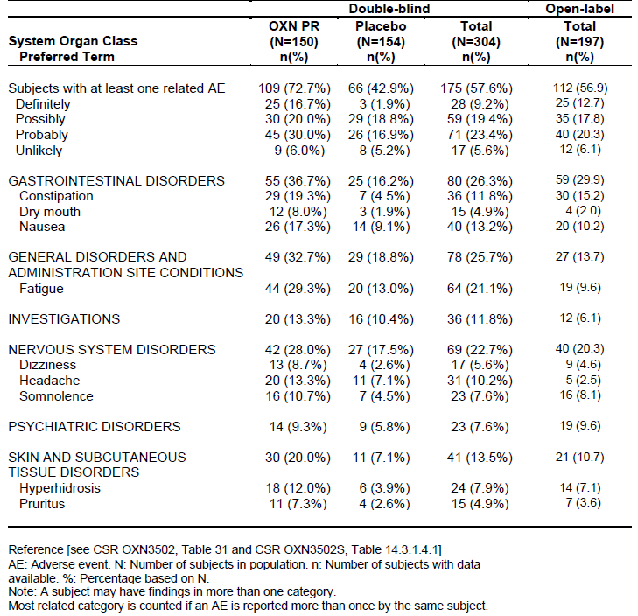

Treatment-related AES in other studies
The incidence of treatment-related AEs in minor analgesia studies and PK or PD studies was broadly consistent with the overall distribution of AEs in those studies, and was consistent with the known side effect profile of opioids. The incidence of treatment-related AEs is shown in the summary tables in All adverse events section above.

Serious adverse events (SAEs)

SAEs in analgesia studies
In the pivotal pain study, there were a few SAEs with no apparent pattern or likely relation to study drug. Apart from four deaths, which are discussed later, there was:
- one case of an allergic reaction to fluconazole in the OXN group;
- a bone abscess in the OxyPR group;
- one case of cancer progression in the OXN group;
- one patient who died of cancer progression, and also experienced the SAEs of dehydration and hypokalaemia.
SAEs in the extension phase were not clearly summarised, but a listing of all SAEs in the enrolled population showed a broad range of SAEs, most of which appeared to be consistent with the wide range of comorbidities in the population being treated. These included cases of cancer progression, for instance. In the absence of a control group, it is not possible to draw any strong conclusions from this data. No individual SAEs raised new safety concerns.

Table 95: Summary of Deaths, SAEs and Other Significant Events, Double-blind Safety Population, Study OXN 3506
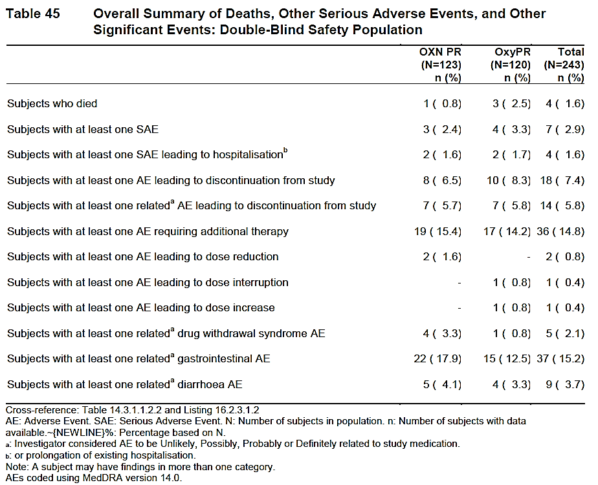
In the supportive crossover Study 038-002, no SAEs occurred during the double-blind period of the study, but 6 SAEs occurred in 5 patients during the open-label phase. These included 3 SAEs reported by 3 patients who had received OXN PR followed by OxyPR during the double-blind period, and 3 SAEs reported by 2 patients who had received OxyPR followed by OXN PR during the double-blind period. The distribution of AEs was not suggestive of any specific causal relation to treatment, with the possible exception of one case of drowsiness (the SAEs described were pneumonia, arthroscopy, complete heart block in a subject already waiting for a pace make, depression and drowsiness, exacerbation of chronic obstructive pulmonary disease).
In the pooled analysis of minor analgesia studies (OXN2001, OXN3001, OXN3006, OXN3401, OXN3503, OXN3505), a total of 6 (12.8%) patients in the ‘High-dose’ group and 51 (7.3%) patients in the ‘Low-dose’ group experienced SAEs during the Double-blind Treatment Phases. In the Extension Phases, 35 (32.7%) patients in the ‘High-dose’ group and 136 (15.6%) patients in the ‘Low-dose’ group experienced SAEs. A review of the types of SAEs observed raised no new safety concerns.

SAEs in RLS study
In the Double-blind Phase of the pivotal RLS study, SAEs were more common in the OXN group but there was no consistent pattern to the events. In the OXN group, 8 subjects (5.3%) experienced 16 SAEs, and 7 of these were classified as potentially treatment-related (pleural effusion, vomiting and duodenal ulcer all in one subject, liver metastases, constipation, cholelithiasis and flank pain for different subjects). The remaining SAEs were not thought to be treatment-related (pancreatitis and arrhythmia for one subject, pancreatic carcinoma, road traffic accident with fractures, polymyalgia rheumatica and basal cell carcinoma for different subjects).
In the placebo group, two subjects (1.3%) experienced a total of two SAEs, an arthropod sting and a wrist fracture.
In the Extension Phase, 13 (6.6%) subjects experienced 13 SAEs, and 3 were considered to be possibly related to treatment: peripheral arterial occlusive disease, ileus and subileus.
All of the SAEs resolved without sequelae except for worsening of peripheral arterial occlusive disease, a case of foot deformity which was ongoing at the end of the Extension Phase but subsequently resolved, and a serious case of coprostasis seven days after the end of the study, which was probably related to post-study treatment with oxycodone.

SAEs in other studies
No SAEs occurred in the PK studies submitted in support of the new maximum dose (OXN1505, OXN1506 and OXN1507).
For the abuse-potential studies, there were very few SAEs, and no concerning overall pattern.
There were no SAEs in studies ONU1001, ONU1008 or ONU1009.
In ONU1002, there was a severe SAE of pericarditis that was considered unrelated to study drug and in Study ONU1003, a total of 2 SAEs were reported during the intravenous treatment phase: 1 for placebo (ventricular tachycardia), and 1 for oxycodone/naloxone 0.07/0.035 mg/kg (drug withdrawal).
In Study ONU1004, there were no SAEs, but 1 subject discontinued due to an unrelated AE (thrombocytopenia).
In Study ONU1007, there were no SAEs during the treatment phase, and no subjects discontinued from the treatment phase due to a TEAE. One subject experienced an SAE (ventricular tachycardia) during the Qualification Phase.

Deaths

Deaths in analgesia studies
In the pivotal analgesia study, OXN3506, a total of 4 patients died in the Double-blind Phase, 1 in the OXN group and 3 in the OxyPR group. All 4 deaths were caused by cancer progression and appear unlikely to be related to treatment. Another patient died of an ischaemic stroke, which occurred 9 days after the patient’s last dose of study medication; this was considered not to be related to study medication.
In the supportive crossover study, 038-002, no deaths were reported in the DB or OL periods.
In the pooled analysis of minor analgesic studies (OXN2001, OXN3001, OXN3006, OXN3401, OXN3503, OXN3505), 2 patients (4.3%) died in the ‘High-dose’ group, and 14 patients (2.0%) died in the ‘Low-dose’ group. In the extension phases of these studies, 8 patients (7.5%) died in the ‘High-dose’ group, and 23 (2.6%) died in the ‘Low-dose’ group. A listing of the causes of death was not provided, and the sponsor should be asked to provide this information, but the relatively high mortality rate is likely to reflect the serious underlying medical problems of the patient population.

Deaths in RLS study
One death was reported during the pivotal RLS study, in a subject who received OXN. This subject died after the follow-up period, due to a cardiac arrhythmia that was not considered to be related to study medication by the Investigator or Sponsor. The arrhythmia occurred on Day 34, which was 25 days after the subject’s last dose of study medication, at which stage it is extremely unlikely that study drug could have played a direct role. An indirect role cannot be totally excluded: the death was included in the database because it occurred while the subject was still hospitalised for other SAEs that began during the study.
No deaths occurred during the Open-label Extension Phase.

Deaths in other studies
There were no deaths in the clinical pharmacology studies.

Discontinuation due to adverse events

Discontinuations due to AEs in analgesia studies
In the Double-blind Phase of the pivotal analgesia study, OXN3506, a total of 18 (7.4%) patients discontinued due to AEs. Of these, 8 were in the OXN group (6.5%) and 10 in the OxyPR group (8.3%). The AE most commonly leading to discontinuation was diarrhoea, which caused 3 discontinuations in the OXN group and 2 discontinuations in the OxyPR group. The next most common AE leading to discontinuation was the occurrence of drug-withdrawal symptoms, which caused the discontinuations of 4 (1.6%) patients, of whom 3 were in OXN group and 1 was in the OxyPR group. Other individual AEs leading to discontinuation occurred only once per treatment group.
In the supportive crossover Study, 038-002, a total of 3 patients (5.8%) had AEs while receiving OXN PR that led to medication discontinuation. These 3 patients reported 5 events (2 diarrhoea, 2 nausea and 1 insomnia). There were another 3 patients (5.6%) who had AEs while receiving OxyPR that led to medication discontinuation. These 3 patients reported 7 events (1 tachycardia, 1vertigo, 2 epigastric discomfort, 1 fatigue, 1 muscle twitching and 1 abdominal pain).
During the open-label period, 1 patient (2.9%) experienced an AE (asthenia) that led to discontinuation of OXN PR within the first week of the open-label period. This patient had received OXN PR followed by OxyPR during the double-blind period.
Discontinuations in the pooled Core Phases of the minor analgesic studies are summarised in the table below; with 43/703 (6.1%) ‘Low-dose’ subjects having AEs leading to discontinuation with none of the 47 ‘High-dose’ subjects having AEs leading to discontinuation.

Table 96: Significant Adverse Events in Core Phase: Pooled Analysis of OXN2001, OXN3001, OXN3006, OXN3401, OXN3503, OXN3505
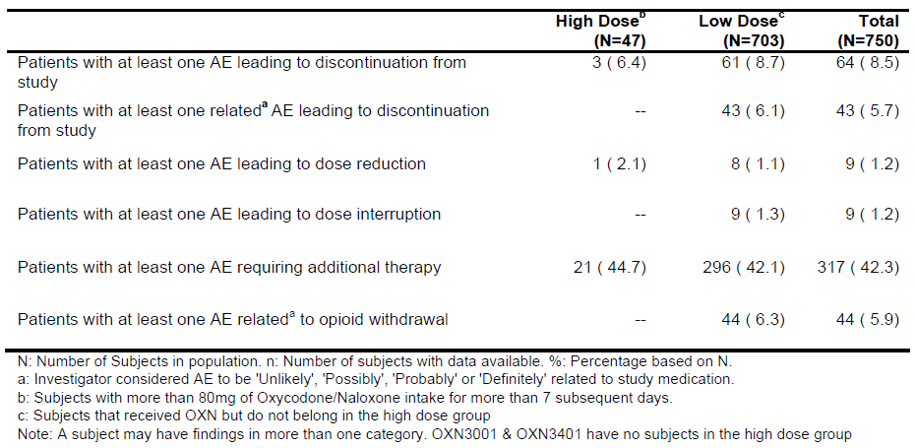
In the Extension Phases of these minor studies, discontinuations were similar overall, but the incidence of discontinuing AEs was higher in the ‘high-dose’ group. Most of these were not thought to be related to treatment. Doses were not randomised, so use of a higher dose may itself be a marker of on-going morbidities causing pain and requiring dose escalation, and comparison between dose groups is therefore an unreliable indicator of the relative tolerability of each dose level.

Table 97: Significant Adverse Events in Extension Phase: Pooled Analysis of OXN2001S, OXN3001S, OXN3006S, OXN3401S
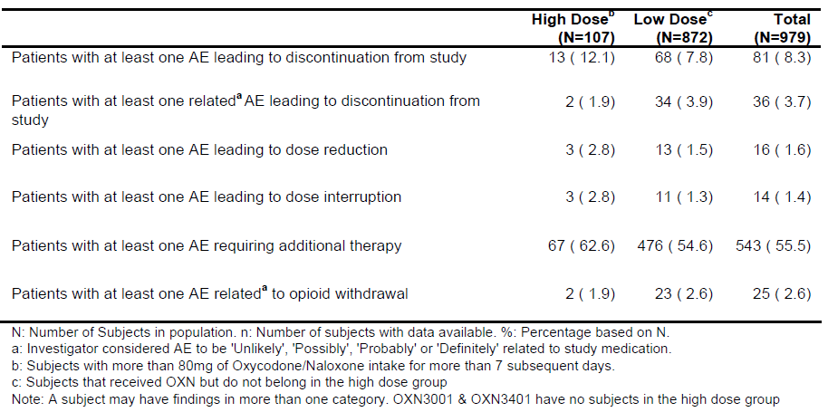

Discontinuations due to AEs in the RLS study
In the Double-blind Phase of the pivotal RLS study, 22 subjects (14.7%) discontinued due to AEs in the OXN group, and 10 subjects (6.5%) discontinued due to AEs in the placebo group. The most common individual AEs leading to discontinuation in the OXN group were nausea (4 subjects), vomiting (3 subjects), fatigue (3 subjects), vertigo (3 subjects), blood creatinine increased (3 subjects), ALT increased (2 subjects) and GGT increased (2 subjects). In the placebo group, the only AE leading to discontinuation for more than one subject was nausea (5 subjects).
Most AEs leading to discontinuation in the OXN group were considered to be potentially treatment-related, but no causal relation was thought to be present for the laboratory test abnormalities, a case of pancreatic carcinoma reported and an episode of gastroenteritis.
In the Extension Phase of the RLS study, 21 (10.7%) subjects discontinued treatment because of AEs. The AEs leading to discontinuation in more than one subject were nausea (4 subjects), constipation (3 subjects), fatigue (3 subjects), and GGT increased (2 subjects).
Overall, the discontinuations in this study were consistent with the known side effect profile of opioids and did not raise any new safety concerns.

Discontinuations due to AEs in other studies
Discontinuations in the PK and PD studies were reported within the individual study reports, but they were not pooled or summarised. No new safety concerns were raised.

Laboratory tests
Only the pivotal analgesia study and the pivotal RLS study had sufficient pooled, comparator-controlled data to allow a meaningful assessment of the incidence of laboratory abnormalities occurring during OXN treatment.
In the case of the pivotal analgesia study, OXN3506, the main weakness in this data is the low number of subjects receiving the maximum proposed dose. Also, because the active comparator contained oxycodone, the study design was not capable of assessing the laboratory effects of oxycodone relative to no oxycodone.
With respect to the pivotal analgesia study, the sponsor makes the following claim: ‘In Study OXN3506, there were no clinically important changes in any of the laboratory parameters from baseline to the end of study for any treatment group, and there were no notable differences in changes of any laboratory parameter between patients in the OXN PR and patients in the OxyPR group. There were also no trends for increases or decreases of laboratory parameters over the duration of the study.’
A review of the incidence of laboratory abnormalities and shift tables, as discussed in more detail below, suggests that this claim is reasonable. Although several abnormalities were observed, particularly in terms of haematological parameters, they were consistent with the underlying medical conditions of the patients treated, including malignancy. A number of patients were known to have renal impairment at baseline or had a history of renal disease. Furthermore, there was no evidence that any particular types of laboratory abnormalities were more common in the OXN group; for most disturbances, the incidence was higher in the OxyPR group. The lymphocyte count was an exception, with a slightly higher incidence of abnormalities in the OXN group, but the overall pattern does not suggest that OXN causes haematological abnormalities.
For the pivotal RLS study, OXN3502, laboratory monitoring merely added to the existing database within the currently approved dose range, and these results did not raise any new safety concerns. A similar number of subjects in each treatment group experienced AEs related to laboratory results (OXN PR: 55 subjects [36.7%]; placebo: 51 subjects [33.1%]). The sponsor concluded that, in most cases, mean changes in laboratory parameters and the incidence of shifts did not suggest OXN produced significantly different results to placebo, and a review of the evidence, discussed below, supports this. For liver function tests, there was a slight excess of patients with markedly abnormal LFTs, and the sponsor drew the conclusion: ‘Though increases of hepatic enzymes might be caused by various reasons a causal association to use of OXN PR cannot be excluded.’ This is appropriate.
The existing PI contains appropriate warnings about the risk of abnormal liver function tests.

Liver function
For the pivotal analgesia study (OXN3506), liver function test results (LFTs) were not supplied in a convenient summary table, but individual analytes were each presented in tables of their own. The tables below only show the results for bilirubin and ALT (mean changes, then the incidence of shifts relative to the normal range), but the results for other LFTs were similar. No substantial difference was observed between the treatment groups.

Table 98: Liver Function Tests (Alanine Aminotransferase) for OXN PR, Mean Changes from Baseline to End of Study
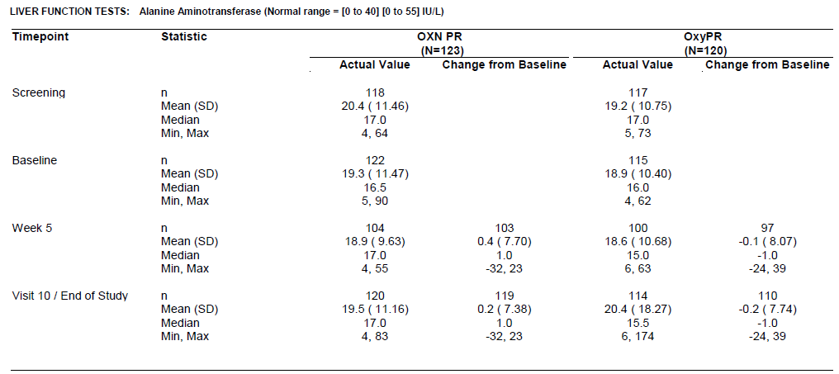

Table 99: Liver Function Tests (Alanine Aminotransferase): Shifts in Category, Baseline to End of Study, Double-Blind Safety Population
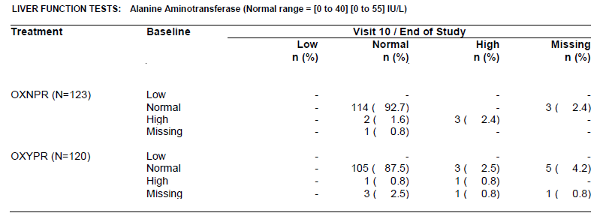

Table 100: Liver Function Tests (Bilirubin): Mean Change from Baseline
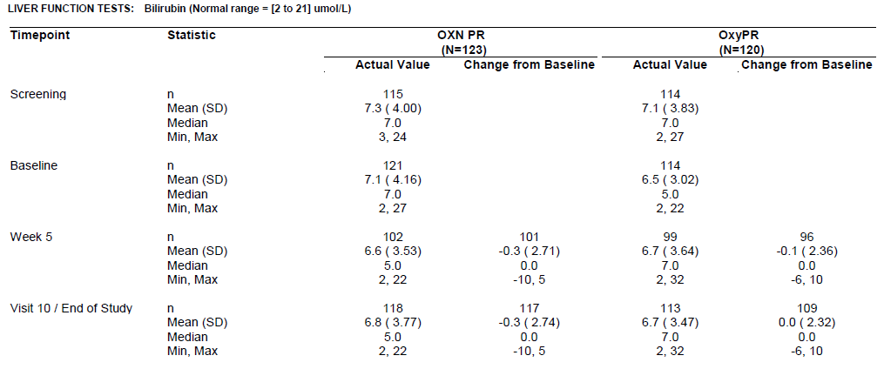

Table 101: Liver Function tests (Bilirubin): Shifts by End of Study
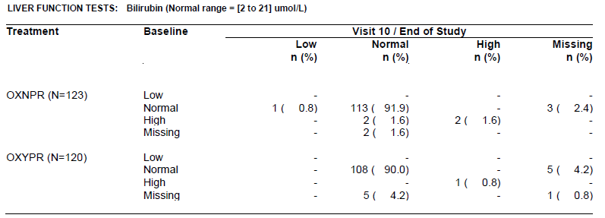
In the pivotal RLS study, OXN3502, the incidence of markedly abnormal LFTs (>2x Upper Limit of Normal, ULN) was higher in the active group (3 patients) than the placebo group (1 patient), but the patient numbers are low and this is of unknown significance.

Table 102: Liver Function Tests, SGOT and SGPT: Markedly Abnormal Results
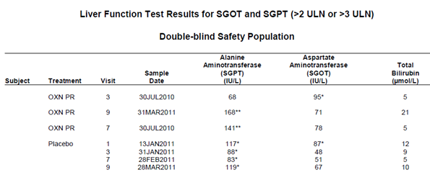

Kidney function
For the pivotal analgesia study (OXN3506), there were no important trends in urea or creatinine. Abnormalities were relatively common at baseline, but did not increase in frequency during the study. The tables below show the mean changes in creatinine in each treatment group, followed by the incidence of shifts relative to the normal range.

Table 103: Renal Function: Change in Creatinine from Baseline to End of Study, OXN3506
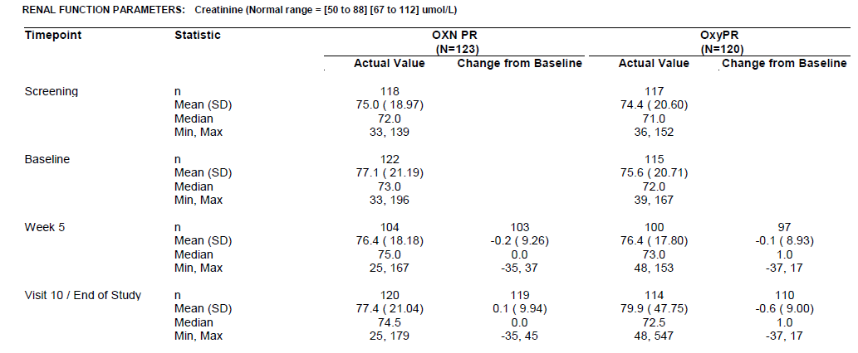

Table 104: Renal Function: Incidence of Shifts in Creatinine, Study OXN3506
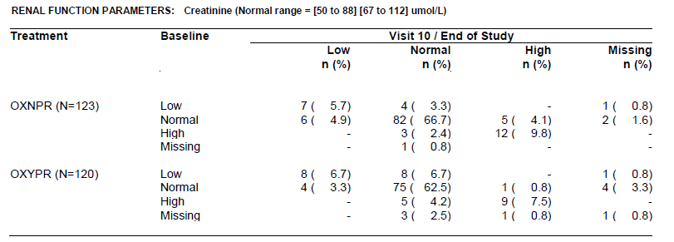
A single patient receiving OXN PR in the RLS study had a markedly high creatinine. There was no evidence of a causal relation to treatment.

Other clinical chemistry
An overall summary of abnormal laboratory results in the pivotal analgesia study is shown in the table below, and a similar list of abnormal results for the pivotal RLS study is shown in the subsequent table. (In the case of the RLS study, haematology results are also included). No concerning safety signals were observed.

Table 105: Markedly Abnormal Blood Chemistry Results, Safety Population, Study OXN3506
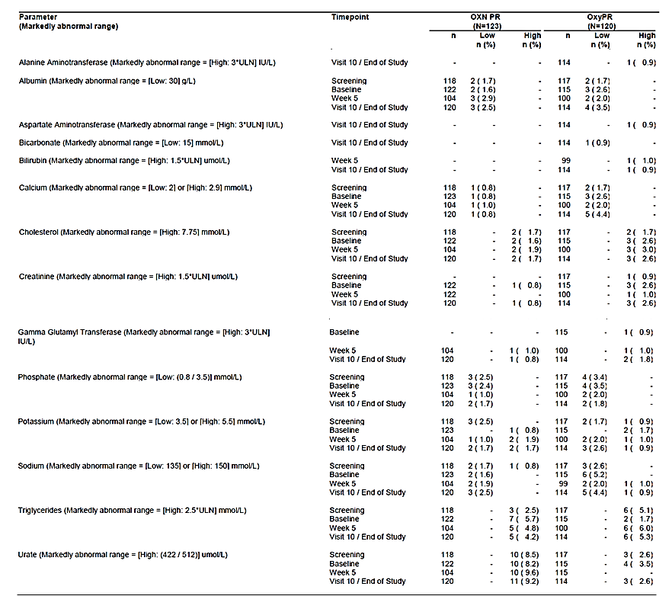

Table 106: Incidence of Markedly Abnormal Laboratory Values, Double-blind Safety Population Study OXN3502
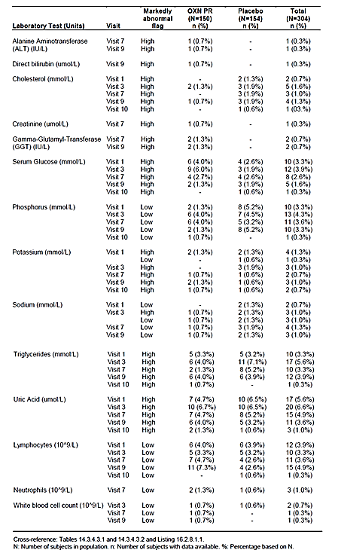

Haematology
No evidence of haematological toxicity was observed in the pivotal studies. In the pivotal analgesia study, the overall incidence of markedly abnormal haematology results was consistent with the population being treated, which included oncology patients with pain due to malignancy. The abnormalities observed were similar in the OXN PR and OxyPR groups, as shown in the table below. For most individual parameters, abnormal results were slightly more common in the OxyPR group. Markedly low lymphocytes were more common in the OXN PR group (10% of subjects at Visit 10, compared to 3.5% in the OxyPR group), but for this parameter the groups already had an imbalance at baseline (7.6% versus 4.3%).
A review of mean changes in lymphocyte counts in Study OXN3506 (subsequent table) shows no substantial group differences or concerning trends.

Table 107: Markedly Abnormal Haematology Results, Safety Population, Study OXN3506
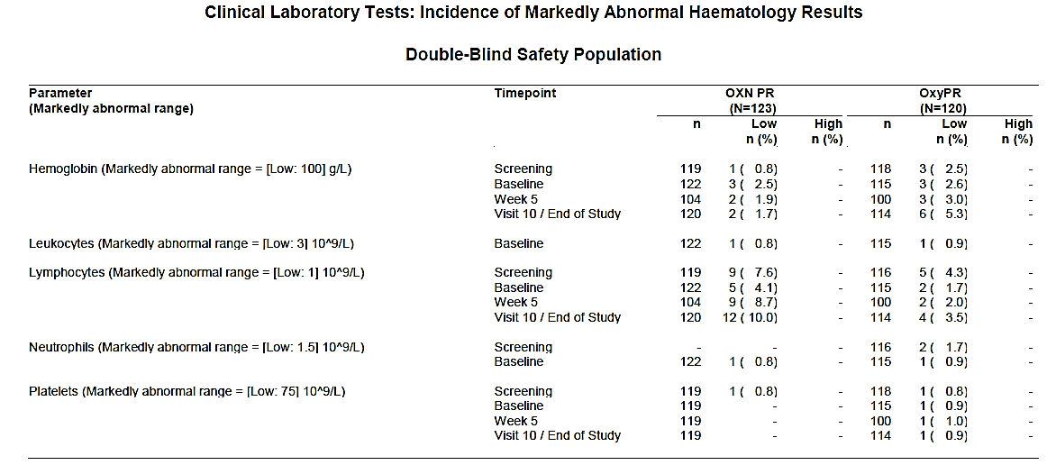

Table 108: Markedly Abnormal Haematology, Safety Population, Study OXN3506
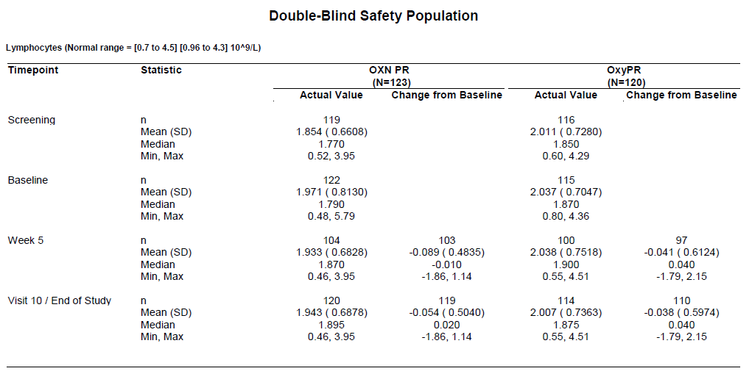
For the pivotal RLS study, the incidence of abnormal haematology parameters was included in the summary table above. Abnormally low lymphocyte counts were more common in the OXN group than the placebo group at Visit 9 (7.3% versus 2.6%), but not at Visit 10/End of Study (0% versus 0.6%). Overall, there was no substantial difference between the groups and no evidence of haematological toxicity.

Electrocardiograph
In the pivotal analgesia study, the incidence of clinically significant findings on ECG was slightly higher in the OXN group at baseline (4.1% versus 2.5%), but there was no increase in abnormalities during the study, as shown in the table below.

Table 109: ECG, Clinically Significant Results, Double-blind Safety Population, Study OXN3506
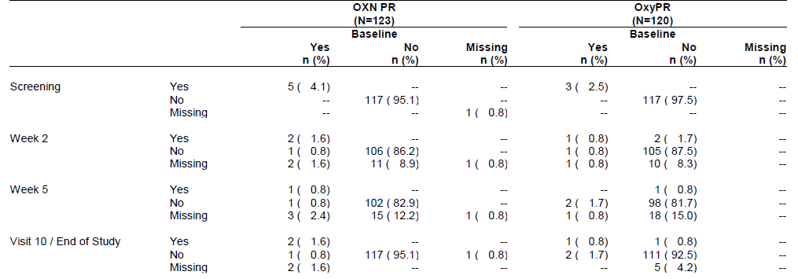
For the pivotal RLS study, a low number of patients had ECG abnormalities, and these were seen at a similar incidence in both treatment groups. Given that RLS is more common in elderly subjects, it is not surprising that some cases of atrial fibrillation occurred. Overall, no concerning patterns were observed.

Table 109: ECG, Clinically Significant Results, Double-blind Safety Population, Study OXN3502
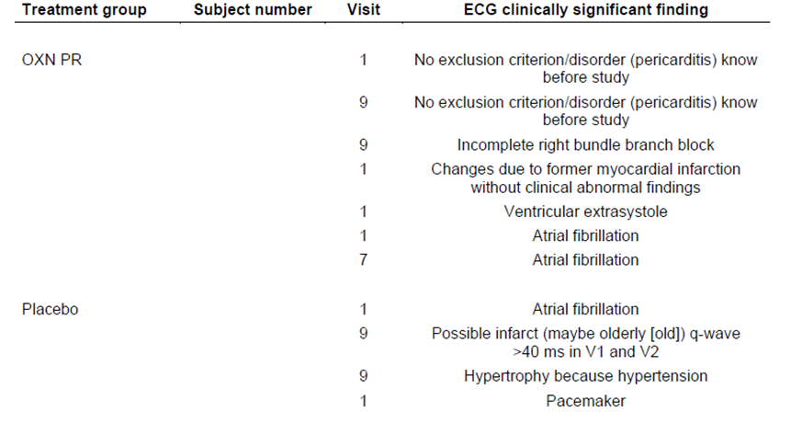

Vital signs
In the pivotal analgesia study, major abnormalities in vital signs were uncommon in both treatment groups, despite the fact that this population had a broad range of comorbidities.

Table 111: Clinically Notable Abnormal Vital Signs, Safety Population, Study OXN3506
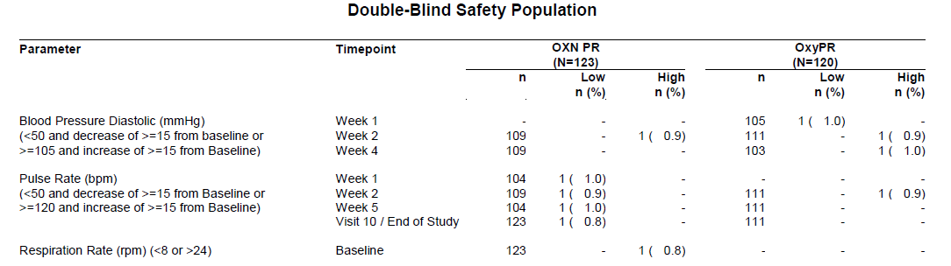
In the pivotal RLS study, nine subjects in the OXN PR group and six subjects in the placebo group had AEs reflecting abnormalities of vital signs; only one of the events in the OXN PR group (mild hypotension) was considered possibly related to treatment.

Post-marketing experience
Post-marketing exposure to Targin has been extensive, but the data only covers currently approved doses. In the Summary of Clinical Safety directed at the registration of higher doses, the sponsor writes: ‘No postmarketing data are available for daily doses up to OXN160/80 mg PR.’
In the Summary of Clinical Safety written in support of the RLS indication, the sponsor estimates that exposure since first launch in 2006, up to March 2013, amounts to 264,006,510 patient days, corresponding to 8,800,217 patient months. The vast majority of this exposure has been in subjects using Targin for analgesia, and there is no published post-marketing experience of Targin in the context of RLS treatment. Targin and other opioids have been used off-label for this indication, but this usage has not been comprehensively reported.
The sponsor did not provide an in-depth analysis of all of the safety issues arising from the post-marketing experience with Targin, but instead wrote: ‘Comprehensive safety reviews of OXN PR have been performed in regular PSURs. The results of both the clinical trial and the post-marketing safety data are adequately reflected in the product’s SmPC.’
A review of the PSURs is beyond the scope of this report, but the risks and side effects of opioids are well known, and in this respect Targin is broadly similar to other opioids. Because the oxycodone in Targin is used in combination with an opioid antagonist, it would be expected that Targin could cause an increase in opioid withdrawal symptoms when given to subjects who are habitual opioid users (see Safety in relation to substance-abuse and PK studies). Apart from this, no other safety signals of concern have arisen that suggest Targin poses new or unexpected risks compared to other opioids.

Safety issues with the potential for major regulatory impact
For each of the safety categories below, it should be noted that very few patients have been exposed to the maximum recommended dose of 80/40 mg twice daily, so uncommon reactions to high doses have not been excluded. Also, the pivotal analgesia study only involved five weeks of blinded exposure, so chronic reactions to high-dose naloxone could have been missed by the study program.

Liver toxicity
Targin does not appear to pose a significant risk of causing liver toxicity.

Haematological toxicity
There is no evidence in the submitted data of significant haematological toxicity.

Serious skin reactions
Opioids may cause pruritus, which was reported in the pivotal analgesia and RLS studies, and is discussed with other AEs above. More significant skin reactions were not reported.

Cardiovascular safety
Opioids may cause hypotension, and the use of higher doses could increase the risk of this, but Targin should be titrated cautiously like any other opioid. Oxycodone is already registered for use as monotherapy (OxyContin) at doses equivalent to the new proposed maximum dose of Targin, so the proposed maximum Targin dose does not pose substantial new cardiovascular risks on the basis of its oxycodone component. There is no evidence that oral naloxone poses a significant cardiovascular risk, but exposure to the proposed new doses has been very limited.

Unwanted immunological events
There is no evidence that Targin is likely to cause unwanted immunological events.

Other safety issues

Safety in special populations
Opioids must be used with caution in children and the elderly, using a low starting dose and cautious titration. The proposed new maximum dose does not substantially change this situation, because the proposed doses of oxycodone are already available in the form of OxyContin, or as a mixture of Targin and OxyContin.
Caution is also necessary in the setting of hepatic impairment or renal impairment. The current PI already recommends that doses be reduced in the setting of renal impairment and mild hepatic impairment, and that Targin should be avoided in the setting of moderate or severe hepatic impairment:
‘Therefore, initiation of dosing in patients with mild hepatic impairment or patients with renal impairment (CrCl < 60 mL/min) should be reduced to ⅓ to ½ of the usual dose with cautious titration and careful medical monitoring.
Because of the observed increase in naloxone plasma concentrations, and until the clinical relevance of this is established, TARGIN modified release tablets are contraindicated in patients with moderate to severe hepatic impairment.’
For each of these special populations, the precautions recommended in the PI are acceptable.

Safety related to drug-drug interactions and other interactions
The naloxone component of Targin can produce drug-interactions with opioids, with some degree of systemic antagonism, as discussed in Withdrawal syndrome section below.
All opioids are capable of producing additive or synergistic sedation and respiratory depression when combined with other sedative agents, including benzodiazepines, a variety of analgesics, and anticonvulsants. In this respect, Targin does not pose any new or unexpected risks compared to other opioids. The risk of such interactions is likely to be increased at the new, higher maximum dose, but it is proposed that the maximum dose be approached using cautious titration, according to subjects’ pain and side effects. Given that the proposed maximum oxycodone doses are already available in the form of OxyContin, the proposed increased dose does not raise substantial new concerns about such interactions.
When Targin is used to treat RLS, there is a potential for it to produce synergistic central nervous system (CNS) side effects when used in combination with levodopa or dopamine agonists, because these agents are already known to pose a risk of causing confusion, especially in the elderly. In the submitted pivotal RLS study, dizziness, somnolence and psychiatric disorders were more commonly observed in the OXN group than the placebo group. Co-administration with levodopa and dopamine agonists was not allowed, according to the study protocol, so the potential for an even greater excess of CNS side effects during combination therapy was not explored. Stopping such agents before commencing treatment with Targin would probably not be advisable, as it could lead to a flare in RLS symptoms that could compromise the efficacy of Targin and potentially lead to a need for higher doses of opioids, but there is currently no trial evidence on which to make firm recommendations about the benefit-risk balance of such co-administration.
Ideally, the PI should recommend caution when combining Targin with levodopa and dopamine agonists. Currently, the proposed PI only refers to levodopa and dopamine agonists in the context of PK interactions, stating: ‘In vitro data also suggest that the dopamine agonists, ropinirole, (S) pramipexol [sic] and levodopa had little or no effect on either oxycodone or naloxone major metabolic pathways while rotigotin [sic] inhibited naloxone glucuronidation, which may result in an increase in naloxone plasma concentrations.’ These comments should be extended to warn of the risk of pharmacodynamic interactions.

Withdrawal syndrome
The naloxone component of Targin primarily antagonises the oxycodone component in the gut, and systemic exposure is limited by first-pass metabolism. Despite this, some degree of systemic exposure and opioid antagonism nonetheless occurs. This was evident in the sponsor’s PD studies, where regular methadone users reported a dislike for Targin and described symptoms consistent with a withdrawal syndrome (See Summary of new pharmacodynamic data section).
The pivotal analgesia study showed a mild excess of withdrawal symptoms in the OXN group compared to the OxyPR group: 4 patients in the OXN group and 1 in the OxyPR group experienced drug withdrawal syndrome. The affected patients did not suffer any major sequelae.
The pivotal analgesia study also used two specific rating scales to monitor withdrawal symptoms: the COWS and SOWS (Clinic Opiate Withdrawal Scale and Subjective Opiate Withdrawal Scale). These have been previously described and validated in the published literature, and were described by the sponsor as follows:
The SOWS (Handelsman et al., 1987) consists of 16 items that reflect the common motor, autonomic, gastrointestinal, musculoskeletal, and psychic symptoms of opiate withdrawal. The Modified SOWS excludes the SOWS item number 16, ’I feel like shooting up today’, since it does not apply to the target subject population. The COWS is a clinician administered, instrument that rates eleven common opiate withdrawal signs or symptoms. The summed score of the eleven items can be used to assess a patient's level of opiate withdrawal and to make inferences about their level of physical dependence on opioids. The score for each item reflects the severity of the sign or symptom, and the total scores are grouped as ‘mild (5 to 12 points),’ ‘moderate (13 to 24),’ ‘moderately severe (25 to 36), and ‘severe (more than 36)’ (Wesson et al., 2003).
Slightly higher SOWS and COWS scores were recorded at week 1 in the OXN PR group, compared to the OxyPR group. The total COWS score increased in week 1 in the OXN group (from mean 1.53 to 2.12), and decreased in the OxyPR group (from 1.75 to 1.56). These scores are well below the range considered to represent mild withdrawal symptoms (5 to 12 points), and the between-group difference is small.
At the end of the double-blind phase, the mean total COWS scores had decreased to 1.16 in the OXN PR group and to 1.34 in the OxyPR group.
These results suggest that there could be an increased risk of drug withdrawal symptoms when switching from OxyPR (used in the pre-randomisation phase) to OXN, but the effects appeared to be mild and could be overcome with appropriate dose titration. The existing evidence does not reveal an increased risk of withdrawal symptoms for the higher proposed dose of OXN PR, but it is not possible to make any firm conclusions on this risk given the low number of patients exposed to the maximum proposed naloxone dose.
In Study 038-002, there was no evidence of a clear increase in withdrawal symptoms, but this study had a crossover design and used an inadequate washout between treatment phases, so no firm conclusions can be drawn.
Other analgesic studies were generally too small to clarify this issue, and had very few patients exposed to high Targin doses (across the minor studies, only one subject received the maximum proposed dose).
In the RLS Study, a single subject in the OXN PR group experienced drug withdrawal syndrome during down-titration from 40 mg/day oxycodone to 20 mg/day oxycodone. Titration was continued and no serious sequelae were noted. Opioid withdrawal symptoms were also reported in two (1.0%) subjects at the end of the Extension Phase. Given that this study involved initiation of OXN treatment, rather than switching from oxycodone without naloxone to OXN, it was not structured to clarify the risk of naloxone inducing a withdrawal syndrome in subjects already accustomed to oxycodone. Instead, it demonstrates that withdrawal symptoms may occur during down-titration, which highlights the need to approach this cautiously and to avoid sudden cessation of Targin, as with any opioid.
Overall, despite some evidence that Targin may increase the risk of drug withdrawal symptoms, the problem appears mild and manageable with appropriate dose titration, at least at the doses for which there is adequate experience. The PI carries appropriate warnings about the need to avoid sudden cessation of Targin, and also warns of the risk of withdrawal symptoms when switching to Targin:
In patients undergoing long-term opioid treatment with higher doses of opioids, the switch to TARGIN modified release tablets can initially provoke withdrawal symptoms or diarrhoea. These patients require specific attention.

Evaluator’s overall conclusions on clinical safety

Safety in relation to RLS syndrome
The safety profile of Targin in subjects treated for RLS was consistent with the known safety profile of this drug when used for analgesia. The doses used in the RLS study were generally low (the average daily dose of oxycodone in the OXN group was approximately 22 mg), and provided no data relevant to the proposed new maximum analgesia dose, so this study added little to what is already known about the safety profile of Targin.
One deficiency in the available safety data is the lack of controlled data exploring the risks of combining Targin with levodopa and dopamine antagonists, which are the currently approved agents for RLS. Given that Targin will be used as a second-line agent, it will often be combined with first-line agents, so the safety of this combination is of interest. (The proposed additional indication is: ‘Symptomatic treatment of patients with moderate to severe idiopathic Restless Legs Syndrome (RLS) insufficiently treated with dopaminergic therapy’; the PI does not suggest ceasing the dopaminergic therapy on commencement of Targin). Some degree of synergistic CNS effects in susceptible individuals, particularly elderly subjects, seems likely, but there are no data available to quantify this risk. This issue should be explored further during post-marketing surveillance.

Safety in relation to proposed new maximum dose
The submitted safety data only partially characterises the safety profile of high-dose Targin. In the pivotal study, the Targin group and the comparator group received similar doses of oxycodone, so the safety of high-dose oxycodone was not assessed in a comparative manner. Furthermore, subjects were titrated to high doses on the basis of need and tolerance, so tolerance and safety in the small proportion reaching the highest dose is not at all representative of the likely safety profile of this dose in a broader population. (This is not necessarily a design flaw, because it was appropriate to individualise doses and to titrate cautiously, but it does mean that unselected subjects suddenly exposed to the maximum dose would be expected to have a much worse safety profile than shown in the pivotal study; indeed, this would be very dangerous.)
The design of the pivotal analgesia study therefore means that it only allows inferences to be made on the safety profile of high-dose naloxone, not of high-dose oxycodone. Given that the proposed oxycodone doses are already registered as OxyContin, this is reasonable. Unfortunately, very few subjects were exposed to the new maximum dose (31 in the pivotal study, 19 in the previously submitted crossover studywhich had inadequate washout between phases, and very few patients in other studies), so the safety of high-dose naloxone has not been adequately explored.
With these important caveats in mind, considering the very limited evidence available, the overall safety of Targin when used at higher doses appears broadly similar to what would be expected from experience with lower doses. Compared to OxyContin at equivalent doses, Targin in the submitted analgesia studies did not appear to raise substantial new safety concerns, but some AEs were observed at a higher frequency in the Targin (OXN) group than the OxyContin (OxyPR) group: there was an excess of nausea (9.8% versus 5.0%), hyperhidrosis (6.5% versus 2.5%) and drug withdrawal syndrome (3.3% versus 0.8%) in the OXN group. This is likely to reflect some degree of systemic opioid antagonism. There was also an excess of diarrhoea, despite the requirement that subjects had constipation at study entry. (This is likely to reflect the resolution of constipation and a subsequent adjustment phase in diet and bowel physiology, and could be less of a problem in subjects titrated directly onto Targin, but there is no direct evidence to clarify this.)
A review of deaths and serious adverse events did not raise any new concerns about the safety of high-dose Targin relative to high-dose oxycodone monotherapy, but no firm conclusions can be drawn given that exposure to the maximum proposed dose was very limited.

Safety in relation to substance-abuse and PK studies
The substance abuse studies did not produce reliable safety data, because low numbers of patients were exposed to single doses, and systemic naltrexone was given in most PK studies to limit opioid side effects. The few AEs observed were consistent with the known safety profile of opioids.
The PK/PD results confirmed that chewed tablets lead to a more rapid absorption of oxycodone, which could lead to substantial toxicity if patients deliberately or accidentally chewed the tablets, circumventing the slow-release properties of the tablet. The PI already contains appropriate warnings about this potential risk. The studies also showed that, in subjects accustomed to opioids, in particular those receiving regular methadone, the systemic absorption of naloxone may lead to withdrawal symptoms. On balance, this is a favourable pharmacological feature of Targin, making the drug less desirable for recreational opioid abusers, but this effect could lead to adverse effects (withdrawal symptoms) in subjects misusing the product. The PI contains an appropriate discussion of these issues.

First round benefit-risk assessment

Benefit-risk assessment in RLS

First round assessment of benefits in RLS
The benefits of Targin in the treatment of RLS are:
- A clinically meaningful reduction in the severity of RLS symptoms in subjects who have failed to respond adequately to dopaminergic therapy
- Improved sleep

First round assessment of risks in RLS
The risks of Targin in RLS are:
- An increased incidence of constipation
- An increased incidence of CNS side effects
- Opioid dependence
- Exacerbation of sleep apnoea
The risks of constipation, sedation and other opioid side effects are already familiar to clinicians, and patients will usually be in a good position to decide whether these side effects are present and whether they represent an acceptable price to pay for improved control of RLS. The doses required to produce benefit are generally in the lower range of Targin doses, and the evidence from the analgesia studies provides good grounds to expect that constipation will be reduced in this context by the co-administration of naloxone, compared to other opioids. The risk of CNS side effects when used in combination with dopaminergic agents is not well defined, but this is likely to be a manageable risk with appropriately cautious titration.
The risk of producing opioid dependence in the context of RLS treatment is poorly characterised, but it did not emerge as an apparent problem during the pivotal RLS study and its open-label extension. Subjects resorting to second-line treatment of refractory RLS are likely to be motivated to continue any successful treatment, and the condition is usually chronic, so the question of whether they also have opioid dependence as an additional motivation to continue treatment would be difficult to gauge. On balance, given the impact of RLS on quality of life, this is a risk that many clinicians and patients will find acceptable.
Exacerbation of sleep apnoea can occur with any sedative medication, including opioids, and sleep apnoea is more common in patients with RLS. The proposed PI includes an appropriate warning about this risk.
Sleep apnoea is more common in patients with restless legs syndrome and caution is advised in treating such patients with TARGIN tablets due to the additive risk of respiratory depression.

First round assessment of benefit-risk balance in LS
The benefit-risk balance of Targin for RLS, given the proposed usage, is favourable.

Benefit-risk assessment of higher maximum dose in chronic pain

First round assessment of benefits of higher doses
The benefits of Targin over naloxone-free oxycodone and other opioid treatments for chronic pain have already been well established. The benefits include:
- a significantly reduced incidence of constipation
- broadly similar analgesic efficacy as naloxone-free oxycodone
- a sustained analgesic effect due to the prolonged-release formulation (a benefit also present in other prolonged-release formulations, such as OxyContin).
Given that Targin is already registered for use in chronic pain, the important question is what benefits could be expected from increasing the maximum dose from the currently approved maximum of 40/20 mg twice daily to 80/40 mg twice daily.
The sponsor claims the following benefits:
For patients in need of higher oxycodone doses, the increase of the daily maximum dose of OXN PR up to 160/80 mg would have the following advantages:
    - Maintaining analgesia whilst improving opioid induced constipation (OIC) with a naloxone component in doses up to 160/80 mg/d
    - Simplification of therapy and facilitation of the prescription process by administering only fixed combination tablets (OXN PR) instead of combining OXN PR with oxycodone (OxyPR).
The first of these proposed benefits has only been partially demonstrated in the submitted studies, as discussed below; the second proposed benefit is accepted.
On the basis of experience with other opioids, and with naloxone-free oxycodone in the form of OxyContin, it seems very likely that higher doses of Targin could provide analgesic benefit in some subjects who have failed to respond to lower doses, but this assumption was not directly tested in any submitted study. No dose-response studies were submitted. The parallel treatments in the pivotal study only differed in terms of the naloxone component, and the oxycodone doses in each group were equivalent. A perceived requirement for higher doses was a prerequisite for entry into the pivotal study, so the need for higher doses was built in as an assumption in the study design, and therefore could not be confirmed or refuted by any subsequent results. Even within the dose range explored (50/25 mg twice daily to 80/40 mg twice daily), dose titration largely occurred before randomisation, and it is unclear if the higher doses used actually increased analgesic efficacy relative to what patients would have experienced at currently approved doses.
The lack of any dose-response study directly justifying an increase in dose would normally be considered a major deficiency in a study program aimed at increasing the approved dose of an analgesic agent, but the oxycodone doses tested in the pivotal study have already been approved in the form of OxyContin, so at least the assumption that higher oxycodone doses are needed in some patients has been confirmed in a different context. Unfortunately, even if one accepts that higher oxycodone doses are needed in some patients (up to 80 mg twice daily), this does not necessarily mean that the same benefit can be obtained during co-administration with naloxone, which is known to produce at least some systemic opioid antagonism.
Also, it should be noted that increasing the maximum approved Targin dose would not actually change the maximum approved oxycodone dose available to clinicians. For patients where the maximum Targin dose is not thought to be adequate, current recommended practice is to combine maximum-dose Targin (40/20 mg twice daily) with top-up OxyContin (to a total of 80 mg twice daily oxycodone), so all the assumed analgesic benefits of higher Targin doses are already available with current practice. Unfortunately, the submitted studies have not compared this practice with the proposed alternative strategy of using higher Targin doses without OxyContin. Current practice with combination therapy was not actually assessed in any study - instead, high-dose Targin was compared to naloxone-free oxycodone.
The sponsor’s first claimed benefit for an increased Targin dose was ‘Maintaining analgesia whilst improving opioid induced constipation (OIC) with a naloxone component in doses up to 160/80 mg/d’. This has two components: analgesia equivalence and improved constipation, relative to OxyContin.
No study was adequately powered to assess whether maximum-dose naloxone compromises the analgesic efficacy of maximum-dose oxycodone. The number of subjects exposed to the proposed new maximum dose was low (31 subjects in the pivotal study, 19 subjects in a crossover study that had inadequate washout, and probably one other patient in minor supportive studies). Power calculations in the pivotal study were based on pooled results across multiple doses, and the comparison between treatments at specific doses was not adequately powered for the demonstration of non-inferiority. The results actually suggested that Targin was significantly inferior to OxyContin, based on 95%CIs for the treatment difference, a point not discussed or acknowledged by the sponsor. (Of additional concern, the sponsor’s definition of non-inferiority was overly inclusive, with the 120% equivalence threshold suggesting that moderate increases in pain were not considered significant.)
Also, while it is possible that a high-dose combination of Targin and OxyContin (current recommended practice) does not contain enough naloxone to produce the same constipation benefits seen at lower Targin doses, and that a higher maximum dose of Targin would therefore be beneficial, this hypothesis has not been directly assessed in any study.
Relative to current practice, then, the only clear benefits of increasing the maximum Targin dose would be:
- simplifying dosing decisions;
- reducing the number of scripts and different medications that patients require to achieve the necessary daily oxycodone dose (potentially improving compliance and minimising dosing errors).
These are not trivial benefits, because dosing errors are likely to be reduced with simpler regimens, and the current recommended practice of combining two different slow-release oxycodone preparations is complex and counter-intuitive, but they are not benefits that justify any substantive risks.

First round assessment of risks of higher doses
The risks of using higher doses of Targin (up to 80/40 mg twice daily) for chronic severe pain include those already inherent in the use of high-dose oxycodone:
- respiratory depression, which can be fatal;
- hypotension;
- severe CNS depression;
- opioid dependence;
- constipation (but this is less with Targin than naloxone-free oxycodone);
- other well-defined opioid side effects (hyperhidrosis, etc).
The risks of severe opioid side effects, including death, would be increased if high-dose Targin tablets were inappropriately chewed, or if subjects were commenced on high doses without a cautious titration phase.
These risks are already inherent in naloxone-free preparations, such as OxyContin, and the proposed new maximum dose of Targin (80/40 mg twice daily) does not increase these risks compared to OxyContin which is already approved at equivalent doses (up to 80 mg twice daily).
Compared to current recommended practice (combination therapy with Targin and OxyContin), or naloxone-free oxycodone preparations (OxyContin monotherapy), the proposed new maximum dose of Targin poses the following new risks:
- an increased incidence of opioid withdrawal symptoms when switching to Targin from naloxone-free preparations, due to systemic opioid antagonism by naloxone;
- an increased incidence of diarrhoea;
- a (probably small, but poorly defined) potential for reduced analgesic efficacy and a subsequent increase in pain when switching from equivalent doses of naloxone-free oxycodone;
- an unknown potential for new, unexpected side effects related to use of high-dose naloxone, with which there is currently minimal published experience.
The incidence of withdrawal symptoms appears to be low and manageable, but it is poorly defined at the proposed doses because of limited exposure. Diarrhoea is an acceptable risk for someone in severe pain, and could possibly be reduced with cautious, gradual switching. Reduced analgesic efficacy and increased pain was probably shown in the submitted studies, but appears to be minor in magnitude. No analgesic study was adequately powered to address this issue at the upper end of the dose range of interest.
Major new side effects from naloxone are likely to be limited by its extensive first-pass metabolism and low bioavailability (about 3%), but the current safety database is very limited in the dose range of interest. In the pivotal analgesic study, approximately one third of patients (40 OXN recipients) received 50/25 mg twice daily, which is only slightly above the current maximum dose, another third (41 OXN recipients) received intermediate doses and only a quarter of patients (31 OXN recipients) received the maximum proposed dose. Furthermore, very few subjects were exposed to the maximum dose in supportive studies (19 subjects in a crossover study with inadequate washout between phases, and probably only one subject in the pooled double-blind phase of the submitted minor studies).

Table 112: Number of Patients Receiving ≥ 100 mg/day by Treatment Group, Study OXN3506
There are no formal TGA guidelines on the minimum exposure needed to establish safety of a new proposed dose. The online document, titled ‘Population Exposure: The Extent of Population Exposure to Assess Clinical Safety’, was produced by the European Medicines Agency (EMA), and it discusses the general need for adequate exposure in clinical trials. Although the document does not anticipate the specific situation of increasing the approved dose of a currently registered agent, two sections give broad indicators of the exposure needed ‘at dosage levels intended for clinical use’:
Available information suggests that most [Adverse Drug Events] ADEs first occur, and are most frequent, within the first few months of drug treatment. The number of patients treated for 6 months at dosage levels intended for clinical use, should be adequate to characterise the pattern of ADEs over time. To achieve this objective the cohort of exposed subjects should be large enough to observe whether more frequently occurring events increase or decrease over time as well as to observe delayed events of reasonable frequency (for example,, in the general range of 0.5%-5%). Usually 300-600 patients should be adequate.
There is concern that, although they are likely to be uncommon, some ADEs may increase in frequency or severity with time or that some serious ADEs may occur only after drug treatment for more than 6 months. Therefore, some patients should be treated with the drug for 12 months. In the absence of more information about the relationship of ADEs to treatment duration, selection of a specific number of patients to be followed for 1 year is to a large extent a judgement based on the probability of detecting a given ADE frequency level and practical considerations. 100 patients exposed for a minimum of one-year is considered to be acceptable to include as part of the safety data base. The data should come from prospective studies appropriately designed to provide at least one year exposure at dosage levels intended for clinical use. When no serious ADE is observed in a one-year exposure period this number of patients can provide reasonable assurance that the true cumulative one year incidence is no greater than 3%. [emphasis added by evaluator].
Exposure to the maximum proposed dose in the submitted studies clearly falls well short of these targets. In addition to low patient numbers at the highest proposed dose, the pivotal study was also very short, with only 5 weeks of double-blind treatment. The supportive crossover Study 038-002, included a long-term extension phase, but only 18 of 34 long-term subjects received the highest proposed dose in that study, and the crossover design interferes with safety assessments. Although some minor supportive analgesic studies also included longer follow-up, much of this was open-label and uncontrolled, and the maximum proposed dose was either disallowed by the study protocols or usually not taken up as a titration option, such that only one patient appears to have received the maximum proposed dose in the minor supportive analgesia studies.
The extensive experience with currently approved doses makes it unlikely that major new toxicities will emerge at the lower end of the proposed new doses (that is, 50/25 mg twice daily, which is only slightly above the approved maximum of 40/20 mg twice daily), but the previous experience does not provide adequate reassurance about the upper end of the proposed new dose range (such as 80/40 mg twice daily), which is double the dose for which there is adequate exposure.
The risk of high-dose Targin is therefore inadequately defined.

First round assessment of benefit-risk balance of higher doses
The benefit-risk balance of the proposed new maximum dose of Targin has not been adequately defined.
The main issues are:
- The study program relies heavily on the assumption that higher oxycodone doses are necessary and effective in some patients, as previously demonstrated for OxyContin, but this assumption was not directly tested for Targin. The fact that naloxone produces some systemic opioid antagonism means that the dose-response experience with OxyContin cannot be taken as directly representative of the dose-response properties of Targin.
- The submitted studies were underpowered for dose-specific analysis, particularly at the maximum dose, where only 31 subjects were exposed in the pivotal study.
- Too few patients have been studied at the proposed maximum dose to assess the analgesic efficacy of high-dose Targin, compared to naloxone-free oxycodone or the current practice of combining Targin and OxyContin.
- The only clear benefit of the proposed higher doses, compared to the current recommended practice of combining Targin with OxyContin, is convenience, so it is particularly important to establish the safety of the proposed doses.
- Too few patients have been exposed to high-dose naloxone to characterise the safety profile of naloxone at the proposed doses.
- The pivotal analgesic study was too brief to allow the assessment of safety in an agent intended for chronic use.

First round recommendation regarding authorisation

Recommendation regarding RLS
The sponsor’s application to register Targin for the treatment of RLS that has not responded adequately to dopaminergic therapy should be approved.

Recommendation regarding higher maximum dose
The sponsor’s application to register Targin at the proposed maximum dose of 80/40 mg twice daily should be rejected (for the reasons listed in Section 9.2.3, above).

Recommendation regarding proposed discussion of abuse potential in PI
The sponsor’s application to modify the PI to include discussion of abuse potential should be approved, but the PI should be further modified recommended.

Clinical questions

Pharmacokinetics
No questions.

Pharmacodynamics
No questions.

Efficacy

Question 1

How many subjects received each dose in Study 038-002?
The Summary of Clinical Safety appears to contain two different, contradictory estimates of exposure for Study 038-002. In one place, it is stated that, of the 59 patients randomised in Study 038-002: ‘Of these 59 patients, 27 (45.8%) received 60/30 mg q12h dose and 32 patients (54.2%) received the 80/40 mg q12h dose’. Elsewhere in the Summary of Clinical Safety, different numbers are cited: ‘Of the 52 patients who received OXN PR, 33 received the 60/30 mg q12h [120/60 mg/d] dose for a mean of 32.0 ± 7.2 days, and 19 patients received the 80/40 mg q12h [160/80 mg/d] dose for a mean of 32.0 ± 9.7 days.’ Please account for this discrepancy.

Question 1

To what does ‘20%’ actually refer in the definition of analgesic non-inferiority?
The definition of analgesic non-inferiority in the pivotal analgesia study refers to a non-inferiority bound of 20%, but it is not quite clear what this means in practice. In particular, non-inferiority was said to be inferred when ‘the one-sided 97.5% t-type confidence interval of the population mean difference in PIS between both treatment groups was completely above a non-inferiority bound of 20%’. The sponsor did not provide a clear statement of what the ‘20%’ is based on. One possibility is that it was calibrated against the entire pain scale, another possibility is that it was based on the mean pain scores for the comparator group, and a third possibility is that it was based on the magnitude of the treatment effect. It is important to clarify what is meant, because it is possible that the sponsor considered increases in pain of up to 20% as non-inferior. For instance, if an analgesic agent reduced pain from 5/10 to 4/10, so that the analgesic effect was 1/10, a 20% increase in pain on switching to Targin could amount to a final pain score of:
- 6/10 (20% is 2 points out of 10 possible points);
- 4.8/10 (20% is one fifth of the mean score of 4);
- 4.2/10 (20% is one fifth of the treatment effect of 1 point).
In the first interpretation, an agent that would be considered clinically inferior would still satisfy the sponsor’s definition of non-inferior. It appears likely that the sponsor has adopted the second interpretation, but the sponsor should be asked to clarify this point by explaining the value of 20% in terms of its numerator and denominator.

Question 2

The table below appears to indicate that there was a significant difference in pain scores between the two treatment groups in the pivotal analgesia study, because the 95%CI for the treatment contrast at Week 5 does not include zero. Does the sponsor concede that this is the case? If not, why not?

Table 114: Primary MMRM Analysis of the Pain Intensity Scale – ‘Average Pain over the Last 24 Hours’, by Visit (Baseline Adjusted)
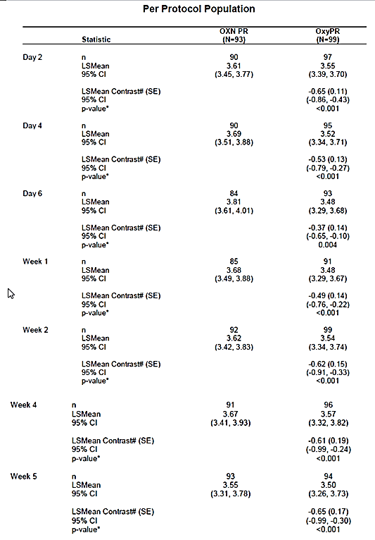

Question 3

In Study OXN3503, which statistical tools were applied to the non-inferiority hypothesis based on the WOMAC score, and to the superiority test based on the BFI?
The primary analysis was said to be based on an ‘intersection-union test’ that combined a non-inferiority hypothesis test in the WOMAC visual analogue scale score (showing that the efficacy of OXN is at least 80% that of OxyPR) with a superiority test in the BFI (showing that OXN is superior to OxyPR with respect to the BFI). The intersection-union test was carried out separately for each double-blind visit (4-8) as long as all subsequent visits also rejected their null-hypothesis.
This appears to be a method of testing two statistical hypotheses simultaneously, but details of which statistical tool was applied to each component of this combined test were not clearly stated.

Question 4

Please explain how the WOMAC score was used to derive a single primary endpoint for non-inferiority analysis in Study OXN3503.
In Study OXN3503, the use of the WOMAC scores as a primary endpoint was not reported clearly. Results were reported for three different components of the WOMAC score, and none of these was designated as primary. Also, the study used non-inferiority bounds of 80%, but what this actually meant was not explained, in terms of which sub score or combination of scores was being measured, and what parameter had to be at least 80% of what other parameter to satisfy the definition of non-inferiority.

Question 5
In Study OXN3503, the estimate for treatment difference in Pain Intensity Scale at Visit 8 was reported to be -0.11, with 95% CI -0.42, 0.21. Was this small difference in favour of OXN? (that is, please explain the sign of these results; do negative scores indicate a greater treatment effect with OXN?

Question 6

In Study OXN3505, which statistical tool was used to compare the BFI scores between treatment groups?
The sponsor reports: ‘… the change from baseline was -23.2 in the OXN PR group and -18.2 in the OXY PR group, the difference between treatment groups was not statistically significant (p=0.341, primary efficacy criterion).’ Which statistical test produced the p-value of 0.341?

Second round evaluation of clinical data submitted in response to questions
The sponsor has submitted a detailed response to Clinical Questions raised in the First Round Clinical Evaluation Report (CER1). Mostly, the responses consisted of useful clarifications of issues that were unclear in the original submission, or provided useful data relating to the small group of subjects exposed to the highest proposed dose of OXN.
As will be discussed below, the sponsor disagreed with the Evaluator about the overall balance of evidence in relation to the abuse-potential of OXN. In most cases, the disagreement was not based on objective data contained in the original submission, but on relatively subjective interpretations of the nature and extent of opioid abuse and the motivations of drug abusers.
Two recurrent issues of contention were:
- the sponsor’s assumption that studies performed in subjects on methadone can be generalised to all opioid addicts, an assumption that the evaluator rejects; and
- the sponsor’s strong emphasis on the evidence that Targin has reduced abuse potential via the IV and intra-nasal routes, without a corresponding emphasis on evidence that Targin retains substantial abuse potential via the chewed oral route in non-methadone-treated subjects.
In some of the sponsor’s discussion of abuse potential, the sponsor has appealed to published literature on opioid abuse, and in doing so has gone beyond the scope of what was originally submitted for evaluation. This material is not extensively evaluated in this Second Round CER, but a couple of the studies the sponsor cited did not appear to support the conclusions they wished to draw. The onus of proof is on the sponsor to demonstrate that their proposed changes to the PI are fair, balanced, and accurately reflect the evidence, so if the sponsor wishes to appeal to the literature on drug abuse, rather than confining the discussion to submitted material, it would be appropriate to obtain an independent Expert Report from someone familiar with that vast literature. These issues are addressed in more detail in Discussion of abuse potential below). For further background to each of the clinical questions discussed below.

Clinical questions

Response 1
The sponsor’s response begins by implying that the question itself is based on confusion: ‘The sponsor acknowledges that the number of patients being treated with OXN or Controlled-release (CR) oxycodone might be confusing due to the cross-over character of the study.’
The rest of the response clarifies the matter by stating that 59 patients were randomised to OXN at the doses listed, but only 52 actually received the drug. The underlined sentence above, which explicitly refers to 59 subjects receiving the OXN, therefore appears to be incorrect.
The sponsor also concedes that other exposure details reported for this study are incorrect, including the durations of exposure, and proposes a revised summary of exposure as follows:
‘During the Double-blind Period of the study, there were 52 subjects exposed to active OXN and 54 patients exposed to active CR oxycodone. Subjects received active OXN for a mean 32.0 ± 8.1 days and active CR oxycodone for a mean of 32.8 ± 7.6 days (ST 7-10).Of the 52 subjects who received active OXN, 23 received the 60/30 mg q12h dose for a mean of 33.0 ± 5.4 days, and 29 subjects received the 80/40 mg q12h dose for a mean of 31.3 ± 9.8 days (ST 7-10a). There were 54 subjects exposed to active CR oxycodone for a mean of 32.8 ± 7.6 days (ST 7-10). Of these, 25 received the 60/30 mg q12h dose for a mean of 32.4 ± 8.5 days and 29 received the 80/40 mg q12h dose for a mean of 33.0 ± 6.8 days (ST 7-10a). Exposure data for the PP population is presented in Tables ST 7-11 and 7-11a.’
Overall, this response is reasonable.

Response 2
The sponsor clarifies this issue by indicating that ‘20%’ refers to 20% of the expected pain score at the time of analysis, based on least square means, rather than alternative interpretations such as 20% of the total pain scale, or 20% of the treatment effect.
The 20% non-inferiority margin was based on the expected pain score of OxyPR derived from the least square means of the ‘average pain over last 24 hours’ at the analysed time point (Week 5 for the primary analysis).
The sponsor’s response also provides an explicit definition of the numerator and denominator in the calculation:
The numerator is the estimated average pain value in OXN PR group and the denominator is the estimated average pain values from the OxyPR group.
The sponsor provides further discussion claiming that 20% represents about half a standard deviation (½ SD) in the distribution of pain scores, and cites literature suggesting that ½ SD correlates with what patients identify as a clinically relevant difference. The sponsor also refers to previous attempts to define a clinically relevant difference in pain scores.
In line with that a further literature review, expert panel and workshop during the ‘VIII International Forum on Primary Care Research on Low Back Pain’ (Amsterdam, June 2006) was conducted to establish a practical guidance regarding the definition for minimal important change (MIC) on frequently used measures of pain and functional status for low back pain. Based on this a change of 2 unit on a pain scale (NR 0 – 10) was defined as a clinically relevant change (MIC). When the baseline score is taken into account, a 30% improvement was considered a useful threshold for identifying clinically meaningful improvement on each of these measures (Ostelo et al., 2008).
A major weakness of the sponsor’s discussion is that the sponsor does not distinguish between what might be a clinically meaningful reduction in pain, relative to placebo, and what might be considered an acceptable deterioration in pain on switching between active agents.
Regulatory agencies understandably take a conservative approach to introducing new agents, which will lead them to prefer larger numerical thresholds for considering a difference to be worthwhile for superiority trials. Insisting on a pain reduction of 2 points as being the minimum necessary analgesic effect to consider an agent as producing a clinically relevant difference is appropriate in the context of a superiority study. This does not mean that this is an appropriate value to use for a non-inferiority margin. If, for instance, an agent reduced mean pain scores from 6/10 to 4/10, relative to placebo, this would satisfy the above definition of minimum important change (2 points) but a quantitatively identical 2-point deterioration on switching to a different analgesic agent would be an inappropriate non-inferiority margin. Based on these hypothetical figures, reintroduction of placebo would be expected to produce mean pain scores of 6/10, a 2-point increase, but no one would thereby conclude placebo was close to being non-inferior.
Non-inferiority analyses are often put into perspective by comparing the non-inferiority margin with the size of the treatment effect. In the context of the submitted studies, the size of the treatment effect was usually unclear, because subjects had already been stabilised on the most effective regimen prior to randomisation. It is therefore difficult to put the sponsor’s proposed 20% threshold into perspective. If we take 30% of baseline pain as a rough estimate of a useful clinical analgesic effect (Ostelo et al, 2008, as cited above by the sponsor), then allowing scores to deteriorate by 20% before considering that to be a clinically meaningful deterioration would be to allow a substantial proportion of the original clinical benefit to be undone.
The sponsor actually concedes that a significant proportion of the treatment effect could be reversed during switching, and yet still be compatible with a conclusion of non-inferiority, but appeals to FDA recommendations on this issue:
In addition to establish a non-inferiority margin the FDA recommends to determine in the first instance the margin for the treatment effect of the active comparator compared to placebo (M1) and then calculating the margin for the test intervention (M2) by taking a percentage (for example,, 50 percent of M1) (Guidance for Industry, Non-Inferiority Clinical Trials). During the clinical development program of OXN PR and based on available literature (Sunshine et al., 1996; Watson et al., 2003) an improvement in pain scores of 3.0 units (NRS 0 - 10) due to oxycodone was established. A treatment effect of 2.0 difference (NRS pain 0 – 10) due to oxycodone was demonstrated in a randomized, placebo controlled trial to assess the efficacy and safety in the treatment of postherpetic neuralgia (Watson et al., 1998). Taking into account those difference of oxycodone compared to placebo a difference of 1.0 up to 1.5 (NRS 0 – 10) units representing M2 (M1/2) in pain score can be regarded as non-inferior margin to establish efficacy and safety of an analgesic.
Other regulatory authorities, such as the EMA, explicitly reject the idea that a certain percentage of the treatment effect (such as 50%) is a reasonable basis for defining a non-inferiority margin. The CHMP has produced a document entitled ‘Guideline on the choice of the non-inferiority margin’ (January 2006), which discussed the principles underling the choice of a non-inferiority margin. The key points of the document were that an acceptable non-inferiority margin is one that ensures the new treatment is at least more effective than placebo and the least favourable estimate of the difference with the standard treatment is consistent with a difference so small that it is clinically unimportant (or actually favours the new treatment). The magnitude of the difference between the two active treatments, as a proportion of the size of the standard treatment effect compared to placebo, is explicitly rejected as a means for choosing an appropriate non-inferiority margin:
If the only objective is to show indirect superiority over placebo, this should be stated and delta can then be chosen using [appropriate methods outlined earlier].
Alternatively, the aim may be to provide data to show that there is no important loss of efficacy if the test product is used instead of the reference. This is probably the most common aim of non-inferiority trials. The choice of delta for such an objective cannot be obtained by only looking at past trials of the comparator against placebo. Ideas such as choosing delta to be a percentage of the expected difference between active and placebo have been advocated, but this is not considered an acceptable justification for the choice. […] To adequately choose delta an informed decision must be taken, supported by evidence of what is considered an unimportant difference in the particular disease area. [Emphasis added by the evaluator.]
If the benefit on introducing an analgesic agent were a reduction in pain of 2 points on a 10-point scale, and switching to a different active agent predictably led to an increase in pain of 1 point (that is, loss of 50% of the original treatment effect), then most clinicians would not consider that to be an unimportant clinical difference, and would indeed be surprised at claims that a 50% loss of efficacy was being presented as a claim of non-inferiority.
On balance, then, the evaluator considers the sponsor’s response to be a useful clarification of how the inferiority margin was defined, but an unsatisfactory justification of why that margin chosen.
Despite these concerns, given the overall weight of evidence suggesting that the treatment difference between OXN and OxyPR was small, and given the ability of clinicians to titrate the dose of OXN to the desired effect, this does not represent a barrier to registration.

Response 3
The sponsor has clarified this issue by referring to a footnote not included in the original submission:
The applicant acknowledges that the tables provided with the submission dossier did not contain the footnotes (see below) from the original tables. These footnotes explain that the provided confidence intervals are based on the shifted hypothesis 1.0*OXN PR –1.2*OxyPR (also refer to response to question 2) and therefore should not include 0 (below 120%) as 0 represents 120%. Furthermore the provided significant p-values refer to a test for non-inferiority but not for superiority and thus confirming non-inferiority of both treatments.
.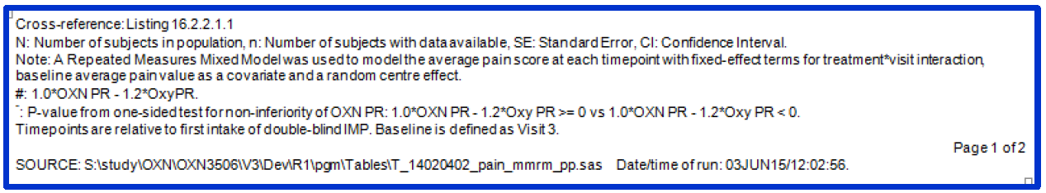
This response adequately clarifies the original table, but the evaluator believes that it was inappropriate to represent hypothesis-shifted values in the first place.
The evaluator also maintains that p-values referring to non-inferiority analyses should always be highlighted as such, along with an explicit reference to the non-inferiority margin being employed.

Response 4
The sponsor’s response adequately clarifies this matter, as shown below.
The statistical analyses were carried out separately for each parameter (BFI & WOMAC index) and visit by means of Analysis of Covariance (ANCOVA) model with fixed regression term for the baseline value at Visit 3 and fixed treatment effect. A gatekeeping approach (for example, sequential hierarchical testing) was used to control for multiplicity of testing.

Response 5
The sponsor’s response adequately clarifies this matter, as shown below, and an appropriate footnote has been added to the description of the study.
The WOMAC Index score was defined as the arithmetic mean value of the three WOMAC section subscores A,B, and C.
    - Section A ‘Pain’ = Section consists of 5 questions
    - Section B ‘Stiffness’ = Section consists of 2 questions
    - Section C ‘Difficulty performing daily activities’ = Section consists of 6 questions
Therefore 80% refers to the arithmetic mean of the three subscores.
The non-inferiority test was performed for the WOMAC Index similar to the average pain analysis as explained in the response to question 2.

Response 6
Correct, the small difference was in favor of OXN PR, as the model estimates the contrast for OXN PR –OxyPR. Therefore, negative values are in favor of OXN PR while positive values are in favor of OxyPR. This result is supported by the descriptive statistics of ‘average pain over last 24 hours’ shown in the table below with a mean value of 3.8 for the OxyPR and 3.7 for the OXN PR group which leads to a difference of 0.1 in favor of OXN.
However, the sponsor would like to emphasis, that a difference in pain scores of 0.1 is not considered to represent a clinically meaningful difference but rather demonstrate the similarity of the analgesic effect of the two treatment arms.
This response is adequate. The evaluator agrees that a difference of 0.11 is clinically minor. The fact that it was weakly in favour of OXN provides some further minor reassurance, and puts the upper limit of the 95%CI (consistent with a 0.21 point increase in pain with OXN) into context.

Response 7
The sponsor’s response, below, was clear and appropriate.
The provided p-value of 0.341 was derived from a 2 sample t-test for the change of BFI from baseline to Day 28.

Response 8
The sponsor has answered this question adequately, providing the incidences separately for the core studies and also for extension studies, as reproduced below:
The data from the core studies can be summarized as follows:
    - Forty five (45) versus 44 patients received study medication for a mean period of 38.2 versus 34.1 days, respectively (oxycodone naloxone [OXN] versus oxycodone single active substance). The mean dose amounted to an average of approximately 161/162 mg per day and was comparable in both groups.
    - Twenty one (21) subjects in the OXN group versus 14 patients in the CR oxycodone group experienced at least one AE (46.7% versus 31.8 %, respectively). In comparison, the number of patients with at least one AE across core pain studies amounted to 70.6 % of 832 OXN patients (versus 65.9 % of 993 comparator patients - source: Integrated Safety Summary).
The data from the extension studies can be summarized as follows:
    - One hundred nine (109) patients received OXN study medication for a mean period of 127.5 days. The mean dose amounted to an average of 163.6 mg per day.
    - Sixty nine (69) patients experienced at least one AE (63.3%). In comparison, the number of patients with at least one AE across extension pain studies amounted to 76.3 % of 903 OXN patients (source: Integrated Safety Summary).
The sponsor also provided some additional discussion, not directly relevant to the question asked, but relating to the issue of whether the upper range of the proposed doses has been adequately explored. The patient numbers assessed at the higher end of the dose range remain very low. As described by the sponsor, only 33 patients received doses in the range 140 to 160 mg in the pivotal analgesia study, OXN3506: ‘During the double-blind of Study OXN3506 in total 68 patients of the per protocol population did receive daily dose of 140 – 160 mg oxycodone PR, of those 33 patients did receive OXN PR and 35 patients did receive oxycodone PR.’ These patient numbers are too low to allow meaningful assessment of the efficacy and safety of OXN in this dose range, and the number of patients exposed to 160 mg were even lower. Within the limitations of the data, though, there was no obvious loss of efficacy at the higher end of the dose range, as described by the sponsor.
Subgroup analyses by dose level showed that subject receiving 100-120 mg oxycodone per day started with a mean pain score of 4.4 in the OXN PR group and 4.6 in the OxyPR group in the Run-in Phase), which was almost 1 score lower than in subjects receiving 140-160 mg/day, who had mean pain scores of 5.4 in the OXN PR group and 5.1 in the OxyPR group. However pain scores at the beginning of the Double-blind Phase (baseline) and at week 5 were comparable in the subgroups, which points to a greater level of pain relief in higher dose subgroup. There was also no notable difference in the change to baseline, which was 0.0 median in all dose groups and treatment groups, and between 0.2 and -0.1 in the means.
This additional analysis is of limited value because of the low patient numbers involved. The evaluator accepts that there is a high likelihood that OXN maintains efficacy at higher doses, although this has not been demonstrated with statistical confidence.
The main concern behind this Clinical question was that the low exposure of patients to the highest proposed dose means that safety has not been adequately assessed for this dose. The sponsor’s response shows that, within this limited dataset, there is an adverse trend showing a 50% higher incidence of AEs with OXN than with OxyPR: Twenty one (21) subjects in the OXN group versus 14 patients in the CR oxycodone group experienced at least one AE (46.7% versus 31.8 %, respectively).’ No firm conclusions can be drawn from these results, because of low patient numbers, but the fact that the trend is adverse provides further support to the idea that the safety of Targin at very high doses needs further characterisation.

Discussion of abuse potential
The sponsor’s response to the First Round CER includes a number of sections in which they object to the evaluator’s description and interpretation of the submitted Drug Abuse studies.
A comprehensive discussion of the abuse potential of Targin is beyond the scope of this report. For instance, this report does not attempt a complete analysis of the full psychosocial and criminal context in which drug abuse occurs, partly because the original submission failed to include any substantial psychosocial or criminological analysis of drug abuse. If the sponsor believes that their few PK/PD studies on drug abuse allow broad conclusions to be drawn about the abuse potential of Targin, then their claims need to be tested by submitting the existing data to an expert on drug abuse familiar with all of the complex literature relevant to this subject.
As discussed in detail below, the sponsor lists 8 items where the sponsor objects to the wording used in the First Round CER. In all cases, the areas of disagreement do not constitute errors of fact in the First Round CER. Instead, the items concern areas where subjective interpretation is not only possible, but necessary because of the incomplete nature of the sponsor’s study program, and the alleged ‘errors’ merely represent sections where the sponsor would prefer a different subjective emphasis.
A consistent theme across many of these 8 items relates to different results obtained in ‘recreational’ users of opioids in comparison to ‘addicts’. Two important subject variables need to be considered in this discussion: 1) the frequency and chronicity of abuse in the study subjects (which, to some extent, may also reflect motivations behind the abuse, allowing ‘recreational’ users to be distinguished from ‘addicts’); and 2), the pharmacological context in which the study took place – specifically, whether subjects received maintenance methadone, or not. (In turn, the difference between a ‘recreational’ user and an ‘addict’ clearly has several dimensions, including psychological, sociological and physical, but an exploration of these issues was not part of the sponsor’s submission and is well beyond the scope of this report.)
The manner in which different studies addressed these two subject variables is shown below:

Table 115: Abuse Potential Studies by Subject Type
 | Not on methadone | On methadone
‘Recreational Users’ | Study ONU1003,  Study ONU1007 | No studies
‘Addicts’ | No studies | Study ONU1004  Study ONU1008
As shown in the table, every study in ‘addicts’ was also a study performed within the pharmacological setting of long-term methadone use, and every study in ‘recreational users’ was also a study in subjects not on methadone. This means that the study program did not provide any basis on which these two subject variables could be separated. Admittedly, it would have been potentially unethical to put intermittent, recreational opioid uses on methadone, but it would have been quite feasible to study addicts not on methadone. The sponsor chose not to explore that option.
Whether Studies ONU1004 and ONU1008 are best referred to as studies of subjects on methadone, or as studies of ‘addicts’ is partly a matter of personal preference. The evaluator has adopted the practice of referring to these primarily as studies of subjects on methadone for a number of reasons, including:
- The description is objective. Whether all the subjects in Studies ONU1004 and ONU1008 were still addicts or not and whether the recreational groups in Studies ONU1003 and ONU1007 included any addicts is open to debate, but the use or non-use of methadone in those studies is not subjective.
- The results of ONU1004 and ONU1008 make pharmacological sense when interpreted as reflecting the antagonism of methadone by naloxone.
- The sponsor provided no psychosocial, behavioural or criminological analysis relating the PD findings in these different groups to the behavioural labels of ‘addicts’ versus ‘recreational users’, and there is accordingly no basis on which pharmacodynamic inferences can be drawn specifically in relation to those behavioural labels.
The sponsor’s request to rephrase sections of the First Round CER to adopt their preferred label for this subject group (‘addicts’), in place of the original wording (‘subjects on methadone’) is therefore not founded on any factual basis, and does not properly belong in a document labelled ‘Errors of Fact/Omission’. Instead, it represents a request to insert the sponsor’s own subjective opinions into an independent Evaluation Report.
With that in mind, the 8 individual items listed as ‘Errors of Fact/Omission’ are considered below.
Item 1
Item | Location | Error of Fact OR Material Omission | Sponsor’s Correction / Comment
1 | Clinical Evaluation Report, Summary of pharmacodynamic data section | The fourth dot point in the opening section states “whether the user is concurrently receiving other opioids, such as methadone.” | This statement could be considered inaccurate as the patient population were opioid addicts, not just subjects taking “other opioids”. The dot point would read more accurately if it stated “whether the user is currently addicted to opioids”
The section being challenged initially read as follows:
The submitted PD studies demonstrated that the abuse potential of oxycodone, in terms of its ‘likeability’ in recreational drug users, depends on a number of factors, including:
- whether it is co-administered with naloxone, as in Targin, or administered as monotherapy
- the route of administration
- whether the tablet has been crushed or chewed to circumvent the slow-release properties of the standard formulation
- whether the user is concurrently receiving other opioids, such as methadone.
The term ‘recreational drug users’ in this paragraph was intended to distinguish off-label use, taken with the intent of achieving a ‘high’, with prescribed use in the treatment of pain. The term ‘recreational drug use’ is often used by clinicians to highlight this distinction, and in that setting no judgement is implied about whether the subject is also addicted, either psychologically or physiologically.
The sponsor’s proposed wording is rejected, for the reasons outlined above. In particular, there is no evidence that the results obtained in Studies ONU1004 and ONU1008 reflected the behavioural state of addiction, and it would be misleading to omit mention of their concurrent methadone use.
On the other hand, given that the sponsor has consistently used the term ‘recreational’ to mean ‘intermittent use outside the context of addiction’, the evaluator concedes that the original wording of this section is potentially confusing. Also, the submitted studies did not assess other chronic opioids apart from methadone, so the original reference to ‘other opioids’ implies a more comprehensive study program than was actually submitted. (There is no reason to suspect that the effects demonstrated are restricted to methadone, but there is also no direct confirmation that the results can be generalised to other long term opioids.)
As a result of reviewing this section, the wording has been changed to the following:
The submitted PD studies demonstrated that the abuse potential of oxycodone, in terms of its ‘likeability’ during off-label use, depends on a number of factors, including:
- whether it is co-administered with naloxone, as in Targin, or administered as monotherapy
- the route of administration
- whether the tablet has been crushed or chewed to circumvent the slow-release properties of the standard formulation
- whether the user is concurrently receiving maintenance methadone treatment.
As will be discussed, the results in methadone users were substantially different from those observed in recreational users not on methadone. Concurrent long-term treatment with opioids apart from methadone was not studied., and no behavioural evidence or analysis was submitted to clarify whether the different results observed in methadone-treated subjects primarily reflected addiction or primarily reflected the fact that naloxone antagonises methadone.
Item 2
2 | Clinical Evaluation Report, Summary of pharmacodynamic data section | The third paragraph discusses the results of Study ONU1003, which was conducted in recreational opioid abusers. As this subject group has a different response to that of subjects who are opioid addicts, the concluding sentence should be amended. | The final sentence of this paragraph would more accurately reflect the results with the following amendment:  “This study therefore suggests that recreational opioid abusers will be able to…..”
The original paragraph concluded as follows:
This study therefore suggests that opioid abusers will be able to get a likeable high from Targin if they chew it, circumventing its slow-release properties and subjecting the naloxone to first-pass metabolism, but not if they try to administer it intranasally or intravenously.
The sponsor is correct in proposing that these results are unlikely to be replicated in subjects on long term methadone, a point that was not emphasised in this sentence in the original CER because the very next paragraph discussed the divergent results in such subjects, and the start of the paragraph under contention already made it clear that the study being discussed dealt with recreational users.
The sponsor’s proposed addition of ‘recreational’ has been accepted, to reduce the risk that this single sentence will be considered out of context, and the words ‘intermittent’ and ‘not on methadone’ have also been added to give a more complete picture of the group being discussed.
Item 3
3 | Clinical Evaluation Report, Summary of pharmacodynamic data section | Similarly to item 2 above, the second paragraph describing study ONU1007 should specify that the patient group was recreational opioid abusers. | The second sentence of the second paragraph describing the results of ONU1007 could more accurately be worded as follows:
In context, the sentence under contention originally read as follows (emphasis added):
The study suggest that, if Targin is chewed, it will have a similar abuse potential to immediate-release oxycodone, but the likeability effect is lower with Targin than immediate-release oxycodone preparations if the Targin tablet is appropriately administered. This could reduce the chronic abuse potential of Targin, compared to immediate-release oxycodone, but further study would be needed to see if these results in recreational opioid abusers translate to benefit in users taking the drug for pain.
As for the previous item, the sponsor is proposing that a single sentence, taken in isolation, should provide the full context that is already provided elsewhere, including the sentence immediately following it. In this case, however, the recreational nature of the drug use pattern was not emphasised earlier within the same paragraph, and it was merely implied that the study was similar to ONU1003. Accordingly, this paragraph has been revised and the study population has been more explicitly described, using similar changes as described for the previous item.
Item 4
4 | Clinical Evaluation Report, Summary of pharmacodynamic data section | Similarly to item 1 above, the patient group in study ONU1004 are opioid addicts and there is benefit in expanding the description of these patients in the final paragraph on page 35 to stipulate this. | It is suggested that the first sentence in the final paragraph on page 35 be amended to read:  “For opioid addicts receiving chronic methadone……”
As discussed previously, there is no evidence at all that the state of being addicted played a primary role in the results of this study. Indeed, it seems plausible (if not likely) that, had these subjects been forced to omit their methadone for one or two days prior to receiving Targin, they would have found that chewed Targin could have at least partially satisfied their opioid cravings, producing greater likeability than placebo. It also seems plausible that the low likeability of Targin observed in these methadone-treated subjects reflects naloxone antagonism of methadone. Although these considerations are currently speculative, it is also speculative to propose that the subjects’ status as ‘addicts’ played a major role. Until the sponsor performs further studies aimed at exploring which patient variables are important in the PD responses of long-term, opioid-dependent, methadone-treated subjects, there will be room for differing interpretations of the limited evidence provided by Studies ONU1004 and ONU1008. It is not appropriate to emphasize their status as addicts when a simple pharmacological explanation appears plausible, and when addicts not on methadone have not been studied.
The sponsor’s proposed change is therefore rejected.
Item 5
5 | Clinical Evaluation Report, Evaluator’s conclusions on pharmacodynamics section | A number of statements in the first paragraph are not representative of the results of the 4 submitted abuse studies and misrepresent the abuse potential benefits of the formulation.  The third sentence implies that the intravenous and intranasal abuse potential benefit is confined to opioid addicts. This disregards the results of study ONU1001 where the positive impact on abuse via the intravenous and intranasal routes in recreational abusers was specifically demonstrated.  The sentence then describes the absence of a benefit in recreational abusers when the tablets are chewed. While this final phrase is correct, it is followed by the statement “In this respect the benefits of Targin appear modest”, which provides an unbalanced conclusion to the overall data set. The 4 studies provided indicate that in opioid addicts, all measured routes of administration can be expected to have abuse deterrent properties. Furthermore, in recreational opioid abusers, the intravenous and intranasal routes also display significant abuse deterrence attributes. Only oral administration of chewed tablets in recreational abusers was unable to show an abuse improvement over oxycodone alone. | Consideration should be given to either deleting these 2 sentences or the first paragraph in this section be amended to read along the lines of:  “The primary PD of Targin was not reassessed in this submission, but studies of abuse potential clarified the abuse‐related properties of Targin relative to other opioids, in the context of potential abuse and diversion to other routes by opioid abusers. The overall impact of these pharmacological properties on the abuse potential of Targin is difficult to estimate, in part because no data was submitted relating to how oral opioids are actually abused or diverted to other routes in the community. For abusers addicted to opiates, Targin did not produce likeable effects via any studied route of administration (i.e. i.v., i.n. or oral) and appears to offer relatively little abuse potential in this population. In recreational opioid abusers seeking to obtain a high, intravenous or intranasal diversion of Targin appear to be an unattractive option but chewed Targin probably offers the same abuse potential as chewed Oxycontin  – both agents, once chewed, are rapidly absorbed and appear likely to produce similar effects as immediate-release oxycodone (Endone). “
This item provides a clear indicator of where the sponsor and evaluator disagree on what the evidence shows. There are two main points of contention:
- The sponsor would like to emphasise that the results obtained in Studies ONU1004 and ONU1008 were obtained in ‘addicts’, and would like to minimise mention of the fact that those results were obtained in subjects on methadone. The Evaluator, by contrast, does not accept that results obtained in methadone-treated subjects can be generalised to non-methadone-treated ‘addicts’.
- The sponsor claims that, for intermittent users, reducing abuse potential via two routes of administration while leaving a third open for abuse represents a major benefit of Targin, whereas the Eealuator believes this is better described as a modest achievement.
The first of these points of contention has been discussed earlier in this section. The sponsor’s attempt to generalise the results of ONU1004 and ONU1008 to all opioid addicts is not justifiable and is rejected, along with their proposed revised wording.
The second point of contention relates to subjective estimates of the value of closing two potential routes of abuse while leaving a third open. In their response, the sponsor asserts that diversion to the IV and nasal routes of abuse is very important and prevalent for oral opioids, and the sponsor cites some literature that they claim is in support of this position. A full assessment of these claims is well beyond the scope of this report, but even if it is conceded that all of these routes are important, the fact that a route of abuse remains open leads the evaluator to consider the overall evidence of abuse deterrence to be modest.
A major problem, not adequately acknowledged by the sponsor, is that potential opioid abusers are likely to avoid the two routes that do not produce a likeable ‘high’ in favour of the third route that does. Closing two of three potential routes of abuse in intermittent opioid users is a bit like placing high-security locks on two of three windows and leaving a flimsy lock on the third, or closing two of three smuggling routes and leaving the third unpatrolled. If subjects wanting to abuse oxycodone can obtain Targin and chew it, obtaining a ‘high’, the fact that two other routes will not produce the ‘high’ they seek is a modest benefit. It is not a trivial benefit, because there are other hazards associated with the intravenous route, and some subjects may find that absorption via the oral route is too slow to produce the rapid ‘high’ that they would prefer. Closing two of three routes or abuse is substantially better than closing none, but substantially worse than closing three, and can therefore be reasonably described as modest.
Although all three routes (oral, IN, IV) appear to offer poor likeability in addicts on long-term methadone treatment, this is also considered to be a modest benefit because, to reach this subject group, subjects have to become addicted to opioids and then be placed on methadone, by which stage opioids are likely to have had a marked deleterious effect on their quality of life. Even if it were known that the results in methadone-treated subjects could be generalised to other addicts, the fact that subjects had to become addicts before all routes of abuse were closed would lead the evaluator to conclude that the abuse-deterrent benefits of Targin were modest.
The sponsor’s proposed rewriting of this section is therefore rejected, but some minor editing of this section has been performed to make it clear which subject groups are being discussed.
Item 6
6 | Clinical Evaluation Report, Evaluator’s conclusions on pharmacodynamics section | As excepts of the report are anticipated to be included in the AUSPAR, which will be publicly accessible along with the Product Information, the inclusion of the sentence “…..chewing Targin produces a likeable high…….” could be potentially construed as highlighting the “benefits” of chewing Targin to the general public (i.e. including potential drug abusers). | A suggested rewording of this final sentence is as follows:  “….the PI should probably mention that in the submitted studies in recreational opioid abusers, chewed Targin has no additional abuse deterrence properties over other oxycodone prolonged release preparations.”
The evaluator shares some of the sponsor’s concern about potential abusers reading the PI and discovering that chewing Targin produces a ‘high’, but rejects the idea that the PI should try to hide this fact.
In practice, many drug abusers have an efficient social network for disseminating tips and tricks, so it seems unlikely that the abuse potential of chewed Targin is likely to remain secret. (Additionally, it should be noted that this concern is completely consistent with the evaluator’s characterisation of the abuse benefits of Targin as modest; if the benefits were more marked then the need to discuss redacting the PI to hide the truth from abusers would not arise.)
Also, the PI must contain indicators that the slow-release properties of Targin can be circumvented by chewing, because it is important for subjects with no intention of abusing Targin to know that this practice is unsafe, putting them at risk of overdose. If rapid narcotic effects on chewing Targin are mentioned in the Safety section of the PI, it is almost inevitable that at least some potential abusers will realise that the same logic applies to other narcotic effects. Censoring the PI would therefore appear to be a somewhat futile exercise.
The main problem is that the sponsor has argued for the inclusion of some favourable PD results, hinting at low abuse potential for Targin, but wants to censor PD results that reveal significant residual abuse potential by one easily accessible route. The result is that the proposed PI does not represent a balanced view of the evidence and is likely to mislead doctors into thinking that Targin offers more benefits than it really does.
The sponsor’s proposed wording in the item above, which suggests that ‘in recreational opioid abusers, chewed Targin has no additional abuse deterrence properties over other oxycodone prolonged release preparations’ is misleading, because it implies at least some abuse deterrence of chewed Targin in recreational users, but in this context Targin provides practically no abuse deterrence properties.
The evaluator proposes that the sponsor has a choice. Either the PI should not include a major discussion of the new PD data on abuse deterrence, and this material should be left for medical journals rather than the PI, or the evidence should be fully described so that doctors prescribing Targin know its true potential for abuse.
Items 7 and 8
7 | Clinical Evaluation Report, First round comments on clinical aspects of the draft PI section | The final dot point represents an unbalanced assessment of the results of the submitted data. This paragraph dismisses the strong abuse deterrence results for any route of administration of Targin in opioid addicts and via the intravenous and intranasal routes of administration in recreational abusers. | Consideration should be given to this paragraph being deleted entirely or edited to better reflect the overall results of the studies.
8 | Clinical Evaluation Report, First round comments on clinical aspects of the draft PI | Similarly to item 7 above, the first paragraph fails to accurately reflect the results of the submitted abuse-deterrence studies. Furthermore, the statements regarding the circumstances where the benefits of Targin may be of interest to clinicians (i.e. the benefit is only in the rare circumstance where the legitimate recipient has a cohabiting family member with an opioid addiction) are not reflective of the most recent data regarding illicit access to prescription opioids. | As per item 7 above, this paragraph should be reworded to better reflect the results or should be deleted.
These items relate to the issues already discussed above, especially the sponsor’s desire to generalise results obtained in methadone-treated subjects to all ‘addicts’. In this Second Round CER, some minor editing of this section has been performed, but mostly to emphasise that such a generalisation is not justified.
The sponsor’s summary of the evidence under Item 7 is of interest:
‘…the strong abuse deterrence results for any route of administration of Targin in opioid addicts and via the intravenous and intranasal routes of administration in recreational abusers.’
In effect, the sponsor is pointing out that, in 5 of 6 situations, Targin shows abuse deterrence benefits: 2 of 3 routes in recreational users, and 3 of 3 routes in addicts. Unfortunately, closing 2 of 3 routes in intermittent users is a modest achievement for reasons already discussed, and to some extent may merely encourage use of the one remaining route. Also, the sponsor’s formulation conflates all addicts with the more limited subgroup of methadone-treated subjects, and disregards the fact that abuse is already a problem for such subjects, necessarily limiting the potential beneficial impact of Targin.
The claim in Item 8 that the example of within-household diversion was provided as the only situation in which Targin might be an attractive choice for clinicians seems odd, because it was simply provided as one example where the benefits of Targin would be relatively apparent. The section discussed did not attempt to provide an exhaustive list of all the situations in which some abuse-deterrence benefit might arise, and such a list would be well beyond the scope of this report because the sponsor provided no sociological evidence of the extent and nature of oxycodone diversion, much less a clear analysis of how Targin would impact on that diversion. Nonetheless, in view of the sponsor’s concerns, this section has been reworded to make it even clearer that the suggested example of within-household diversion is no more than an example.

Second round benefit-risk assessment
The extra material provided by the sponsor does not materially alter any of the conclusions listed in the First Round CER.
The evaluator concedes that the reduced abuse potential of Targin via the IV and intranasal routes is of value, but remains of the opinion that this benefit must be balanced against the residual risk of abuse via the oral chewed route in subjects not on methadone.
The evaluator remains concerned that exposure to the highest proposed dose of Targin has been very limited, falling well short of the recommended exposure required for adequate demonstration of efficacy and safety.

Second round recommendation regarding authorisation

Recommendation regarding RLS
The sponsor’s application to register Targin for the treatment of RLS that has not responded adequately to dopaminergic therapy should be approved.

Recommendation regarding higher maximum dose
The sponsor’s application to register Targin at the proposed maximum dose of 80/40 mg twice daily should be rejected (for the reasons listed above).

Recommendation regarding proposed discussion of abuse potential in PI
The sponsor’s application to modify the PI to include discussion of abuse potential should be approved, but the PI should be further modified.

References
References Related to Restless Legs Syndrome
Allen RP, Picchietti D, Hening WA, Trenkwalder C, Walters AS, Montplaisir J. Restless legs syndrome: diagnostic criteria, special considerations, and epidemiology - A report from the restless legs syndrome diagnosis and epidemiology workshop at the National Institutes of Health. Sleep Med 2003; 4: 101-119.
Allen RP. Dopamine and iron in the pathophysiology of restless legs syndrome. Sleep Med 2004; 5: 385–391.
Berger K, Luedemann J, Trenkwalder C, John U, Kessler C. Sex and the risk of restless legs syndrome in the general population. Arch Intern Med 2004; 164: 196-202.
Benes H, Kohnen R. Validation of an algorithm for the diagnosis of Restless Legs Syndrome: The Restless Legs Syndrome-Diagnostic Index (RLS-DI). Sleep Med 2009; 10: 524-530.
The European Agency for the Evaluation of Medicinal Products CPMP/EWP/612/00. Note for guidance on clinical investigation of medicinal products for treatment of nociceptive pain. 21 November 2002.
The European Agency for the Evaluation of Medicinal Products CPMP/EWP/2863/99. Points to Consider on Adjustment for Baseline Covariates. 22 May 2003.
The European Agency for the Evaluation of Medicinal Products CPMP/EWP/908/99. Points to Consider on Multiplicity Issues in Clinical Trials. 19 September 2002.
Earley CJ, Allen RP. Restless legs syndrome augmentation associated with tramadol. Sleep Med 2006; 7: 592-593.
Ferini-Strambi L, Oldani A, Castronovo V, Zucconi M: RLS augmentation and pramipexole longterm treatment. Neurology 2001; 56 (Suppl 3): A20.Freye E. Opioide in der Medizin. Springer Verlag, Berlin, 2001.
Garcia-Borreguero D, Högl B, Gschliesser V, et al. Augmentation during Long-Term Treatment with L-DOPA in Restless Legs Syndrome: results of a Multicentric Study in Europe. Sleep 2005; 28: A272.
Garcia-Borreguero D, Allen RP, Kohnen R, Högl B, Trenkwalder C, Oertel W et al. Diagnostic standards for dopaminergic augmentation of restless legs syndrome: report from a World Association of Sleep Medicine – International Restless Legs Syndrome Study Group consensus conference at the Max Planck Institute. Sleep Med 2007a; 8: 520–530.
Garcia-Borrequero D, Allen RP, Benes H, Earley C, Happe S, Högl B et al. Augmentation as a treatment complication of restless legs syndrome: concept and management. Mov Disord 2007b; 22 (Suppl.18): S476-S484.
Garcia-Borreguero D, Kohnen R, Högl B, Ferini-Strambi L, Hadjigeorgiou GM, Hornyak M et al. Validation of the Augmentation Severity Rating Scale (ASRS); a multicentric prospective study with levodopa on restless legs syndrome. Sleep Med 2007c; 8: 455–463.
Happe S, Reese JP, Stiasny-Kolster K, Peglau I, Mayer G, Klotsche J et al. Assessing health related quality of life in patents with restless legs syndrome. Sleep Med 2009; 10: 295-305.
Kenward MG and Roger JH. Small sample inference for fixed effects from restricted maximum likelihood. Biometrics 1997; 53: 983-997.
Kim SW, Shin IS, Kim JM, Park KH, Youn T, Yoon JS. Factors potentiating the risk of mirtazapine-associated restless legs syndrome. Hum Psychopharmacol 2008; 23: 615-20.
Kohnen R, Benes, Heinrich CR, Kurella B. Development of the disease-specific Restless Legs Syndrome Quality of Life (RLS QoL) questionnaire. Mov Disord 2002; 17: 743.
Kohnen R, Oertel WH, Stiasny-Kolster K, Benes H, Trenkwalder C. Severity rating of restless legs syndrome: review of ten years experience with the RLS-6 scales in clinical trials. Sleep 2003; 26: A342.
Kohnen R, Oertel WH, Stiasny-Kolster K, Benes H, trenkwalder C. Severity rating of restless legs syndrome: validation of the RLS-6 scales. Sleep 2004; 27: A304.
Kurz A, Sessler D. Opioid-induced bowel dysfunction: pathophysiology and potential new therapies. Drugs 2003; 63: 649–671.
Lauerma H, Markkula J. Treatment of restless legs syndrome with tramadol: an open study. J Clin Psychiatry 1999; 60: 241-244.
Lee KA, Zaffke ME, Baratte-Beebe K. Restless legs syndrome and sleep disturbance during pregnancy: the role of folate and iron. J Womens Health Gend Based Med 2001; 10: 335–341.
Leslie J, Bell T, Annunziata K, Freedman D. Opioid-induced constipation compromises pain management and impacts patient quality of life. Anesthesiology 2006; 105: A1490.
Meissner W, Hopp M, Leyendecker P, Ruckes C, Duerr H, Grothe B, et al. Analgesic efficacy and safety of oxycodone in combination with naloxone as prolonged release (PR) tablets in patients with moderate to severe chronic pain. Poster presented at: Annual Scientific Meeting (ASM) of the British Pain Society 2008: April 15 - 18; Liverpool, UK.
Meissner W, Leyendecker P, Mueller-Lissner S, Nadstawek J, Hopp M, Ruckes C, et al. A randomised controlled trial with prolonged-release oral oxycodone and naloxone to prevent and reverse opioid-induced constipation. Eur J Pain 2009; 13: 56-64.
Müller-Lissner S, Leyendecker P, Hopp M, Ruckes C, Fleischer W, Reimer K. Prolonged release oxycodone/naloxone combination reduces opioid-induced constipation in patients with severe chronic pain. Poster presented at: Second International Congress on Neuropathic Pain; 2007, June 7 – 10; Berlin, Germany.
Oertel WH, Trenkwalder C, Zucconi M, Benes H, Borreguero DG, Bassetti C, et al. State of the art in restless legs syndrome therapy: practice recommendations for treating restless legs syndrome. Mov Disord 2007; 22 Suppl 18: S466-75.
Ondo WG. Methadone for refractory restless legs syndrome. Mov Disord 2005a; 20: 345–348.
Ondo WG. Restless legs syndrome. Curr Neurol Neurosci Rep 2005b; 5: 266-274.
Pappagallo M. Incidence, prevalence and management of opioid bowel dysfunction. Am J Surg 2001; 182: 11S-18S.
Picchietti D, Winkelman JW. Restless legs syndrome, periodic limb movements in sleep, and depression. Sleep 2005; 28: 891–898.
Paulus W, Trenkwalder C. Less is more: pathophysiology of dopaminergic-therapy-related augmentation in restless legs syndrome. Lancet Neurol 2006; 5: 878-886.
Paulus W, Schomburg ED. Dopamine and the spinal cord in restless legs syndrome: does spinal cord physiology reveal a basis for augmentation? Sleep Med Rev 2006; 10: 185-96.
Reimer K, Hopp M, Zenz M, Maier C, Holzer P, Mikus G, et al. Meeting the challenges of opioidinduced constipation in chronic pain management – a novel approach. Pharmacology 2009; 83: 10–17.
Schomburg ED. Enkephalinergic and monoaminergic control of segmental pathways from reflex afferents (FRA). In: Ferrell WR, Proske U (eds) Neural Control of Movement. Plenum Press, New York 1995, pp103-108.
SmPC L-Polamidon, DE MA-Nr 45583.00.00, July 2008.
Spritzer KL and Hays RD (2003, November). MOS Sleep Scale: A Manual for Use and Scoring, Version 1.0. Los Angeles, CA.
Stiasny-Kolster K, Oertel WH. Low dose pramipexole in the management of restless legs syndrome. An open label trial. Neuropsychobiology 2004; 50: 65-70.
Tings T, Trenkwalder C. Wann L-Dopa-Präparate, Dopaminantagonisten oder Opioide? Therapie des Restless-legs-Syndroms [When L-Dopa preparations, dopamine agonists or opioids? Therapy of restless legs syndrome]. MMW Fortschr Med 2003; 6: 48-9.
Trenkwalder C, Paulus W, Walters AS. The restless legs syndrome. Lancet Neurol 2005; 4: 465-475.
Trenkwalder C, Paulus W. Restless legs syndrome: pathophysiology, clinical presentation and management. Nat Rev Neurol 2010; 6: 337-46.
Trenkwalder C, Högl B, Benes H, Kohnen R. Augmentation in restless legs syndrome is associated with low ferritin. Sleep Med 2008a; 9: 572-574.
Trenkwalder C, Hening WA, Montagna P, Oertel WH, Allen RP, Walters AS, et al. Treatment of restless legs syndrome: an evidence-based review and implications for clinical practice. Mov Disord 2008b; 23: 2267-2302.
Trenkwalder C, Benes H, Poewe W, Oertel WH, Garcia-Borreguero D, de Weerd AW, et al. Efficacy of rotigotine for treatment of moderate-to-severe restless legs syndrome: a randomised, double-blind, placebo-controlled trial. Lancet Neurol 2008c; 7: 595-604.
Vetrungo R, La Morgia C, D’Angelo R, Loi D, Provini F, Plazzi G, et al. Augmentation of restless legs syndrome with long-term tramadol treatment. Mov Disord 2007; 15: 424-427.
Vignatelli L, Billiard M, Clarenbach P, Garcia-Borreguero D, Kaynak D, Liesiene V, et al. EFNS guidelines on management of restless legs syndrome and periodic limb movement disorder in sleep. Eur J Neurol 2006; 13: 1049-1065.
Vondrackova D, Leyendecker P, Meissner W, Hopp M, Szombati I, Hermanns K, et al. Analgesic efficacy and safety of oxycodone in combination with naloxone as prolonged release tablets in patients with moderate to severe chronic pain. J Pain 2008; 9: 1144-1154.
Walters AS, Wagner ML, Hening WA, Grasing K, Mills R, Chokroverty S, et al. Successful treatment of the idiopathic restless legs syndrome in a randomized double-blind trial of oxycodone versus placebo. Sleep 1993; 16: 327-332.
Walters AS, Winkelmann J, Trenkwalder C, Fry JM, Kataria V, Wagner M, et al. Long-term follow-up on restless legs syndrome patients treated with opioids. Mov Disord 2001; 16: 1105-1109.
Walters AS, Ondo WG, Zhu W, Le W. Does the endogenous opiate system play a role in the Restless Legs Syndrome? A pilot post-mortem study. J Neurol Sci 2009; 279: 62-65.
Wetter TC, Eisensehr I, Trenkwalder C. Functional neuroimaging studies in restless legs syndrome. Sleep Med 2004; 5: 401–406.
Winkelmann JW, Stautner A, Samtleben W, Trenkwalder C. Long-term course of restless legs syndrome in dialysis patients after kidney transplantation. Mov Disord 2002; 17: 1072–1076.
Winkelmann JW, Johnston L. Augmentation and tolerance with long term pramipexole treatment of restless legs syndrome. Sleep Med 2004; 5: 9-14.
References Related to Analgesia Studies, and Other References
A2-3759, Validation of the Bowel Function Index., UBC, 2005
Ahmedzai S, Nauck F, Bar-Sela G, Bosse B, Leyendecker P, Hopp M A randomized, double-blind, active-controlled, double-dummy, parallel-group study to determine the safety and efficacy of oxycodone/naloxone prolonged-release tablets in patients with moderate/severe, chronic cancer pain. Palliat Med. 2012; 26(1):50-60.
Drossman DA, Corazziari E, Talley NJ, Thompson WG, Whitehead WE. Rome II Multinational orking Teams. Rome II: The Functional Gastrointestinal Disorders. 2nd ed. McLean, VA: Degnon Associates; 2000.
European Agency for the Evaluation of Medicinal Products (EMEA), CPMP (2003): Point to Consider on Adjustment for Baseline Covariates;
Handelsman L, Cochrane KJ, Aronson MJ, Ness R, Rubinstein K, Kanof PD Two new rating scales for opiate withdrawal. Am J Drug Alcohol Abuse 1987; 13: 293-308.
Hollander M, Wolfe DA Nonparametric Statistical Methods. Wiley series in probability and mathematical statistics; John Wiley and Sons, (1973a) New York;
Hollander M, Wolfe DA Nonparametric Statistical Methods. Wiley series in probability and mathematical statistics; John Wiley and Sons, (1973b) New York; pp.68-69.
Kenward, M. G. and Roger, J. H. (1997), ‘Small Sample Inference for Fixed Effects from Restricted Maximum Likelihood,’ Biometrics, 53, 983–997.
Latasch L, Zimmermann M, Eberhardt B, et al. Treatment of morphine-induced constipation with oral naloxone. Anaesthesist 1997;46: 191-4.
Lewis SJ, Heaton KW Stool form scale as a useful guide to intestinal transit time Scand. J. Gastroenterol.(1997) 32 (9): 920–4.
Löwenstein O, Leyendecker P, Hopp M, Schutter U, Rogers PD, Uhl R, Bond S, Kremers W, Nichols T, Krain B, Reimer K Combined prolonged-release oxycodone and naloxone improves bowel function in patients receiving opioids for moderate-to-severe non-malignant chronic pain: a randomised controlled trial. Expert Opin. Pharmacother (2009); 10 (4): 531 - 543.
Meissner W, Schmidt U, Hartmann M, Kath R, Reinhartet K Oral naloxone reverses opioid-associated constipation. Pain 2000; 84:105-9.
Meissner W, Hopp M, Leyendecker P, Ruckes C, Duerr H, Grothe B, Fleischer W, Reimer K. Analgesic efficacy and safety of oxycodone in combination with naloxone as prolonged release (PR) tablets in patients with moderate to severe chronic pain. Poster presented at: Annual Scientific Meeting (ASM) of the British Pain Society; 2008 Apr 15 -18; Liverpool, UK.
Meissner W, Leyendecker P, Müller-Lissner S, Nadstawek J, Hopp M, Ruckes C, Wirz S, Fleischer W, Reimer K A randomised controlled trial with prolonged-release oral oxycodone and naloxone to prevent and reverse opioid-induced constipation. Eur J Pain 2009; 13: 56 – 64.
Müller-Lissner S, Leyendecker P, Hopp M, Ruckes C, Fleischer W, Reimer K. Prolonged release oxycodone/naloxone combination reduces opioid-induced constipation in patients with severe chronic pain. Poster presented at: Second International Congress on Neuropathic Pain; 2007, Jun 7 – 10; Berlin, Germany.
Note for Guidance on Good Clinical Practice. ICH E6 (CPMP/ICH/135/95). Post Step Errata July 2002.
Note for Guidance on Clinical Investigation of Medicinal Products for Treatment of Nociceptive Pain. (CPMP/EWP/612/00) Adopted November 2002.
OXN1019 Reimer K, Hopp M, Zenz M, Maier C, Holzer P, Mikus G, Bosse B, Smith K, Buschmann-Kramm C, Leyendecker P. Meeting the Challenges of Opioid-Induced Constipation in Chronic Pain Management – A Novel Approach Pharmacology 2009; 83: 10–17.
Rentz AM, Yu R, Müller-Lissner S, Leyendecker P Validation of the Bowel Function Index to detect clinically meaningful changes in opioid-induced Constipation. Journal of Medical Economics 2009; 12(4): 371–383.
Simpson K, Leyendecker P, Hopp M, Müller-Lissner S, Löwenstein O, De Andres J, Troy Ferrarons J, Bosse B, Krain B, Nichols T, Kremers W, Reimer K. Fixed-ratio combination oxycodone/naloxone compared with oxycodone alone for the relief of opioid-induced constipation in moderate to-severe noncancer pain. Curr Med Res Opin 2008; 24 (12): 3503–3512.
Ueberall MA , Müller-Lissner S , Buschmann-Kramm C , Bosse B The Bowel Function Index for Evaluating Constipation in Pain Patients: Definition of a Reference Range for a Non-constipated Population of Pain Patients. J Int Med Res. 2011; 39(1):41-50.
Vondrackowa D, Leyendecker P, Meissner W, Hopp M, Szombati I, Hermanns K, Ruckes C, Weber S, Grothe B, Fleischer W, Reimer K Analgesic Efficacy and Safety of Oxycodone in Combination With Naloxone as Prolonged Release Tablets in Patients With Moderate to Severe Chronic Pain. The Journal of Pain 2008; 9 (12): 1144-1154.
Wesson DR, Ling W The Clinical Opiate Withdrawal Scale (COWS) Journal of Psychoactive 2003; 253, 35 (2): 252 – 259.
References Cited in the sponsor’s Section 31 Response
Butler SF, Black RA, Cassidy TA, Dailey TM, Budman SH. Abuse risks and routes of administration of different prescription opioid compounds and formulations. Harm Reduct J. 2011 Oct 19;8:29. doi: 10.1186/1477-7517-8-29.
Degenhardt L, Bruno R, Ali R, Lintzeris N, Farrell M, Larance B. The introduction of a potentially abuse deterrent oxycodone formulation: Early findings from the Australian National Opioid Medications Abuse Deterrence (NOMAD) study. Drug Alcohol Depend. 2015 Jun 1;151:56-67. doi: 10.1016/j.drugalcdep.2015.02.038. Epub 2015 Mar 16.
Butler SF, Cassidy TA, Chilcoat H, Black RA, Landau C, Budman SH, Coplan PM. Abuse rates and routes of administration of reformulated extended-release oxycodone: initial findings from a sentinel surveillance sample of individuals assessed for substance abuse treatment. J Pain. 2013 Apr;14(4):351-8. doi: 10.1016/j.jpain.2012.08.008.
Jones CM, Paulozzi LJ, Mack KA. Sources of prescription opioid pain relievers by frequency of past-year nonmedical use United States, 2008-2011. JAMA Intern Med. 2014 May;174(5):802-3.
Jones CM, Paulozzi LJ, Mack KA. Sources of prescription opioid pain relievers by frequency of past-year nonmedical use United States, 2008-2011. JAMA Intern Med. 2014 May;174(5):802-3.
Larance, B., et al., The characteristics of a cohort who tamper with prescribed and diverted opioid medications., Journal of Substance Abuse Treatment (2015)

Therapeutic Goods Administration
PO Box 100 Woden ACT 2606 Australia
Email: info@tga.gov.au Phone: 1800 020 653 Fax: 02 6232 8605
https://www.tga.gov.au

Review of Severity Rating Scales for Restless Legs Syndrome: Critique and Recommendations MDS/MDS Journals/Clinical Practice E-Journal/Movement Disorders-Clinical Practice Volume 1 Issue 4/Review of Severity Rating Scales for Restless Legs Syndrome: Critique and Recommendations, 30 SEP 2014 Arthur S. Walters MD, Birgit Frauscher MD, Richard Allen PhD, Heike Benes MD, K. Ray Chaudhuri MD, Diego Garcia-Borreguero MD, Hochang B. Lee MD, Daniel L. Picchietti MD, Claudia Trenkwalder MD, Pablo Martinez-Martin MD, PhD, Anette Schrag MD and Glenn Stebbins PhD
Responders were defined as subjects with ≥ 50% improvement in the IRLS sum score from baseline to Visit 9 or rating of ‘very much’ or ‘much’ improved in CGI Item 2 [change of condition]). Remitters were defined as subjects with an IRLS score of zero at any stage or ≤10 at the end of treatment (compared to ≥15 at baseline).
The sponsor has clarified exposure in this study in their Section 31 response: 59 patients were randomised to OXN but only 52 received it.
The sponsor reported the minor increase in EQ-5Dscore as an improvement, implying that higher scores are more favourable, but they provided no explanation of the information about the metrics of the score.
The sponsor has since clarified the issue by explaining that the endpoint was based on the geometric mean of the A, B and C components of the WOMAC scale.
Knowles CH, Scott SM, Legg PE, Allison ME, Lunniss PJ. Level of classification performance of KESS (symptom scoring system for constipation) validated in a prospective series of 105 patients. Dis Colon Rectum. 2002;45:842-3.
Slim K, Bousquet J, Kwiatkowski F, Lescure G, Pezet D, Chipponi J. [First validation of the French version of the Gastrointestinal Quality of Life Index (GIQLI)]. Gastroenterol Clin Biol. 1999; 23:25-31.
For brevity, discontinuations are not considered and the patient numbers for each minor study refer to those randomised.
Please see ‘Overall benefit-Risk analysis’ and ‘Outcome’ in the AusPAR.
Please see also Overall Benefit-Risk analysis and Outcome in the AusPAR.

