February 2021

Australian Public Assessment Report for Opicapone
  - Proprietary Product Name: Ongentys
  - Sponsor: Maxx Pharma Pty Ltd

About the Therapeutic Goods Administration (TGA)
- The Therapeutic Goods Administration (TGA) is part of the Australian Government Department of Health and is responsible for regulating medicines and medical devices.
- The TGA administers the Therapeutic Goods Act 1989 (the Act), applying a risk management approach designed to ensure therapeutic goods supplied in Australia meet acceptable standards of quality, safety and efficacy (performance) when necessary.
- The work of the TGA is based on applying scientific and clinical expertise to decision-making, to ensure that the benefits to consumers outweigh any risks associated with the use of medicines and medical devices.
- The TGA relies on the public, healthcare professionals and industry to report problems with medicines or medical devices. TGA investigates reports received by it to determine any necessary regulatory action.
- To report a problem with a medicine or medical device, please see the information on the TGA website <https://www.tga.gov.au>.

About AusPARs
- An Australian Public Assessment Report (AusPAR) provides information about the evaluation of a prescription medicine and the considerations that led the TGA to approve or not approve a prescription medicine submission.
- AusPARs are prepared and published by the TGA.
- An AusPAR is prepared for submissions that relate to new chemical entities, generic medicines, major variations and extensions of indications.
- An AusPAR is a static document; it provides information that relates to a submission at a particular point in time.
- A new AusPAR will be developed to reflect changes to indications and/or major variations to a prescription medicine subject to evaluation by the TGA.

Copyright
© Commonwealth of Australia 2021
This work is copyright. You may reproduce the whole or part of this work in unaltered form for your own personal use or, if you are part of an organisation, for internal use within your organisation, but only if you or your organisation do not use the reproduction for any commercial purpose and retain this copyright notice and all disclaimer notices as part of that reproduction. Apart from rights to use as permitted by the Copyright Act 1968 or allowed by this copyright notice, all other rights are reserved and you are not allowed to reproduce the whole or any part of this work in any way (electronic or otherwise) without first being given specific written permission from the Commonwealth to do so. Requests and inquiries concerning reproduction and rights are to be sent to the TGA Copyright Officer, Therapeutic Goods Administration, PO Box 100, Woden ACT 2606 or emailed to <tga.copyright@tga.gov.au>.

Contents
Abbreviations 4
I. Introduction to product submission 6
Submission details 6
Product background 7
Regulatory status 8
Product Information 10
II. Registration timeline 10
III. Submission overview and risk/benefit assessment 11
Quality 11
Nonclinical 12
Clinical 12
Risk management plan 25
Risk-benefit analysis 26
Outcome 30
Attachment 1. Product Information 30

Abbreviations
Abbreviation | Meaning
3-OMD | 3-O-methyldopa
ACM | Advisory Committee on Medicines
AE | Adverse event
ANCOVA | Analysis of covariance
API | Active pharmaceutical ingredient
ARTG | Australian Register of Therapeutic Goods
ASA | Australian specific Annex
AUC | Area under the concentration time curve
AUC0-24 | Area under the concentration-time curve from time 0 to 24 hours
AUC_{0-inf} | Area under theconcentration time curve from time zero extrapolated to infinity
AUC_{0-t} | Area under the concentration time curve from time zero to last measurable concentration
C_{max} | Maximum concentration
CMI | Consumer Medicines Information
CNS | Central nervous system
COMT | Catechol-o-methyltransferase
CPK | Creatine phosphokinase
CR | Controlled release
CYP2C8 | Cytochrome P450 family 2 subfamily C member 8
DDCI | Dopa decarboxylase inhibitors
DLP | Data lock point
ED₅₀ | Median effective dose
EU | European Union
FAS | Full analysis set
FDC | Fixed dose combination
GVP | Good Pharmacovigilance Practices
IR | Immediate-release
Ki | Inhibition constant
LS | Least square
MAO | Monoamine oxidase
NMSC | Non-melanoma skin cancer
OATP1B1 | Solute carrier organic anion transporter family member 1B1
PD | Parkinson’s disease
PDQ-39 | Parkinson’s Disease Quality of Life Questionnaire
PDSS | Parkinson’s Disease Sleep Scale
PE | Plasma exposure
PI | Product Information
PK | Pharmacokinetic (s)
PP | Per protocol
PSUR | Periodic safety update report
QD | Once per day, Latin: quaque die
RCT | Randomised controlled trial
RMP | Risk management plan
SMQ | Standardised MedDRA Query
TBM | To be marketed
TEAE | Treatment emergent adverse event
T_{max} | Time take to reach maximum concentration
UK | United Kingdom
UPDRS | Unified Parkinson's Disease Rating Scale
USA | United States (of America)

I. Introduction to product submission

Submission details
Type of submission: | New chemical entity
Product name: | Ongentys
Active ingredient: | Opicapone
Decision: | Approved
Date of decision: | 19 September 2020
Date of entry onto ARTG: | 23 September 2020
ARTG number: | 321017
Black Triangle Scheme: | Yes  This product will remain in the scheme for 5 years, starting on the date the product is first supplied in Australia
Sponsor’s name and address: | Maxx Pharma Pty Ltd  Level 11, 500 Collins Street  Melbourne, VIC, 3000
Dose form: | Hard capsule
Strength: | 50 mg
Container: | Blister pack
Pack sizes: | 10, 30, 90 capsules
Approved therapeutic use: | Ongentys is indicated as adjunctive therapy to preparations of levodopa/ DOPA decarboxylase inhibitors (DDCI) in adult patients with Parkinson’s disease and end-of-dose motor fluctuations who cannot be stabilised on those combinations
Route of administration: | Oral
Dosage: | The recommended dose is 50 mg.  Ongentys should be taken once daily at bedtime, preferably without food, at least one hour before or after levodopa combinations.  For further information regarding dosage, refer to the Product Information (PI).
Pregnancy category: | B2  Drugs which have been taken by only a limited number of pregnant women and women of childbearing age, without an increase in the frequency of malformation or other direct or indirect harmful effects on the human fetus having been observed.  Studies in animals are inadequate or may be lacking, but available data show no evidence of an increased occurrence of fetal damage.  The use of any medicine during pregnancy requires careful consideration of both risks and benefits by the treating health professional. This must not be used as the sole basis of decision making in the use of medicines during pregnancy. The TGA does not provide advice on the use of medicines in pregnancy for specific cases. More information is available from obstetric drug information services in your State or Territory.

Product background
This AusPAR describes the application by Maxx Pharma Pty Ltd (the sponsor) to register Ongentys (opicapone) 50 mg hard capsules for the following proposed indication:
Ongentys is indicated as adjunctive therapy to preparations of levodopa/ DOPA decarboxylase inhibitors (DDCI) in adult patients with Parkinson’s disease and end-of-dose motor fluctuations who cannot be stabilised on those combinations
Parkinson’s disease currently affects about 40,000 Australians. Approximately one to two people per 1,000 are estimated to have the disorder, with the incidence increasing to one in 100 of people over the age of 60. It is slightly more common in men than in women. Parkinsonism is a clinical syndrome presenting with any combination of bradykinesia, rest tremor, rigidity, and postural instability. The most common form of parkinsonism is Parkinson’s disease , a chronic, progressive disorder caused by degenerative loss of dopaminergic neurons in the brain and characterised clinically by asymmetric parkinsonism and a clear benefit from dopaminergic therapy.
Levodopa (L-DOPA) continues to be the most efficacious therapeutic drug for the treatment of PD. L-DOPA is rapidly metabolised by peripheral aromatic L-amino acid decarboxylase and catechol-o-methyl transferase (COMT). Hence, only 1% of an oral dose of L-DOPA actually reaches the brain. COMT usually converts about 90% of L-DOPA to 3-O-methyl-levodopa (3-OMD), which competes with L-DOPA at the level of the blood-brain barrier for transport. Thus, COMT inhibitors are usually used to peripherally inhibit L-dopa metabolism by reducing levels of 3-OMD and increasing the delivery of L-DOPA to the brain. Opicapone is a COMT inhibitor. Other COMT inhibitors are entacapone and tolcapone.
Figure 1: Metabolic pathways of levodopa
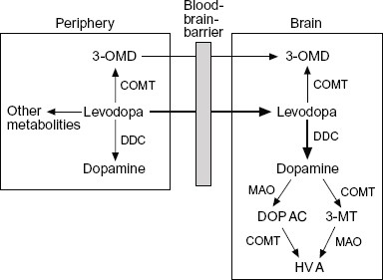
3-MT = 3-methoxytyramine; 3-OMD = 3-O-methyldopa; COMT = catechol-O-methyltransferase; DDC = dopa-decarboxylase; DOPAC = 3,4-dihydroxyphenylacetic acid; HVA = homovanillic acid; MAO = monoamine oxidase.
The long-term use of L-DOPA is limited by the development of motor complications that affect the large majority of PD patients, particularly those with young-onset PD. These most often consist of the ‘wearing-off’ effect (shortening of the duration of the motor response after a dose of levodopa) and dyskinesias (involuntary movements primarily consisting of choreiform or dystonic movements).4 In the extreme, patients can cycle between ‘on’ periods, when they respond to levodopa but experience disabling dyskinesias, and ‘off’ periods, when they suffer severe parkinsonism. COMT inhibitors are currently used as add-on therapy to L-DOPA for the betterment of end-of-dose motor fluctuations, as they inhibit peripheral L-DOPA metabolism and increase the delivery of L-dopa to the brain.4,

Regulatory status
This product is considered a new chemical entity for Australian regulatory purposes.
At the time the TGA considered this application, similar applications had been approved in the European Union (EU) on 24 June 2016, Switzerland on 26 April 2018, United States of America (USA) on 24 April 2020, Japan on 29 June 2020 and South Korea on 26 November 2019.
Table 1, shown below, summarises these applications along with their approved indications.
Table 1: International regulatory history for Ongentys
Region | Submission date | Status | Approved indications
European Union centralised | 25 November 2014 | Approved on 24 June 2016 | Ongentys is indicated as adjunctive therapy to preparations of levodopa/ DOPA decarboxylase inhibitors (DDCI) in adult patients with Parkinson’s disease and end-of-dose motor fluctuations who cannot be stabilised on those combinations.
Switzerland | 28 October 2016 | Approved on 26 April 2018 | Ongentys is indicated as adjunctive therapy to preparations of levodopa/ DOPA decarboxylase inhibitors (DDCI) in adult patients with Parkinson’s disease and end-of-dose motor fluctuations who cannot be stabilised on those combinations.
United States of America | 26 April 2019 | Approved on 24 April 2020 | Ongentys is a catechol-O-methyltransferase (COMT) inhibitor indicated as adjunctive treatment to levodopa/carbidopa in patients with Parkinson’s disease (PD) experiencing ‘off’ episodes
Japan | 27 February 2019 | Approved on 29 June 2020 | Improvement of the end-of-dose motor fluctuations (wearing-off phenomenon) of Parkinson's disease in combination with levodopa–carbidopa or levodopa–benserazide hydrochloride.
South Korea | 1 August 2018 | Approved on 26 November 2019 | Ongentys is indicated as adjunctive therapy to preparations of levodopa/ DOPA decarboxylase inhibitors (DDCI) in adult patients with Parkinson’s disease and end-of-dose motor fluctuations who cannot be stabilised on those combinations.

Product Information
The Product Information approved with the submission which is described in this AusPAR can be found as Attachment 1. For the most recent PI, please refer to the TGA website at <https://www.tga.gov.au/product-information-pi>.

II. Registration timeline
The following table captures the key steps and dates for this application and which are detailed and discussed in this AusPAR.
Table 2: Timeline for Submission PM-2019-03218-1-1
Description | Date
Submission dossier accepted and first round evaluation commenced | 10 September 2019
First round evaluation completed | 23 March 2020
Sponsor provides responses on questions raised in first round evaluation | 11 May 2020
Second round evaluation completed | 18 June 2020
Delegate’s Overall benefit-risk assessment and request for Advisory Committee advice | 2 July 2020
Sponsor’s pre-Advisory Committee response | 23 July 2020
Advisory Committee meeting | 6 and 7 August 2020
Registration decision (Outcome) | 18 September 2020
Completion of administrative activities and registration on the ARTG | 23 September 2020
Number of working days from submission dossier acceptance to registration decision* | 222
*Statutory timeframe for standard applications is 255 working days

III. Submission overview and risk/benefit assessment
The submission was summarised in the following Delegate’s overview and recommendations.

Quality
Approval was recommended for registration from a pharmaceutical chemistry perspective.
The chemical structure of opicapone is shown in Figure 2, below.
Figure 2: Chemical structure of opicapone
Opicapone is manufactured by chemical synthesis using either i) the standard process (used in pivotal clinical batches of opicapone 50 mg capsule) or ii) the optimised process (used in registration batches of opicapone 50 mg capsule).
The difference between the standard process and optimised process relates to process parameters. The reagents and solvents used in both processes were the same. The qualities of opicapone obtained by both processes were comparable (including similar particle size distribution).
Opicapone manufactured by the optimised process will only be used in the finished product proposed for registration in Australia.
The Phase III formulation and the proposed formulation for marketing were demonstrated to be bioequivalent.

Nonclinical
There were no nonclinical objections to registration.
There are no outstanding PI changes from a nonclinical perspective.
- Opicapone binds to human COMT with sub-picomolar affinity. Inhibition constant (Ki)) values determined experimentally for human recombinant S-COMT were within the expected clinical plasma concentration range. In vivo, opicapone had a comparatively lower median effective dose (ED₅₀) of 0.9 mg/kg in rat liver COMT, longer recovery time of COMT activity, 48 h for hepatic COMT and 24 h for erythrocytes after single dosing than other approved COMT inhibitors.
- Based on in-vitro studies, opicapone is a clinically relevant inhibitor of cytochrome P450; family 2 subfamily C member 8 (CYP2C8) and solute carrier organic anion transporter family member 1B1 (OATP1B1).
- No adverse effects on central nervous system (CNS), respiratory, cardiovascular, gastrointestinal and renal systems were observed in the conducted safety pharmacology studies.
- The non-clinical studies predicted no effects on fertility and embryo-foetal toxicity in rats and rabbits. However, Pregnancy Category B2; was recommended as the rabbit study was not suitable for risk assessment due to higher sensitivity of maternal rabbits to low opicapone dosages.

Clinical
The clinical dossier consisted of:
- twenty eight Phase I studies;
- two Phase II studies; and
- three Phase III studies, including Study BIA-91067-301 and Study BIA- 91067-302, hereafter referred to as Study 301 and Study 302.

Pharmacology

Mechanism of action
L-DOPA undergoes rapid metabolism by peripheral L-amino acid decarboxylase and COMT, and only 1% of an oral dose of L-DOPA actually reaches the brain. COMT usually converts about 90% of L-DOPA to 3-OMD, which competes with L-DOPA at the level of the blood-brain barrier for transport. Thus, COMT inhibitors are usually used to peripherally inhibit L-DOPA metabolism by reducing levels of 3-OMD and increasing the delivery of L-DOPA to the brain.

Absorption
The micronised formulation used in the Phase III study was shown to have approximately twice the exposure of the non-micronised drug used in the vast majority of the Phase I and in the Phase II study programme. Food was shown to have a large impact on the non-micronised formulation with a 68%, 53% and 51% decrease in maximum concentration (C_{max}), area under the concentration time curve up to the last measurable concentration (AUC_{0-t}) and the area under the concentration time curve extrapolated to infinity (AUC_{0-∞}), respectively, however there is no significant impact on efficacy.
A high and a moderate fat and calorie meal had a profound effect on the absorption of opicapone. Following administration of the capsule with non-micronised material 30 minutes after a high fat and calorie meal, the median the time taken to reach maximum concentration (T_{max}) was prolonged from 1.5 hours to 4 hours. After administration in a fed state, the opicapone C_{max} was reduced by about 68% and the area under the concentration time curve (AUC) by about 50%.

Bioavailability
The absolute bioavailability of opicapone has not been determined. After administrating it in a fasted state, the bioavailability of the non-micronised formulation was approximately 50% (C_{max} 44%, AUC_{0-∞} 57%) compared to the micronised Phase III formulation.
For the micronised formulation, the T_{max} was prolonged from 2 hours to 6 hours after administration in a fed state, C_{max} and AUC_{0-t} decreased by 62% and 31% respectively, while the area under the concentration time curve up to 24 hours AUC_{0-24h} remained unchanged.
Dose proportionality was demonstrated for 25 and 50 mg micronised formulations.

Distribution
The plasma protein binding of opicapone is high (99.9%, range of 0.3 to 30 µM) and independent of concentration. There was no protein binding displacement between warfarin, diazepam, digoxin, and tolbutamide.

Elimination
The terminal half-life of opicapone ranged from 1 hour to 1.4 hours. The active metabolite BIA 9-1079 represented 20% of systemic exposure of opicapone and hence was not considered as a major determinant of pharmacokinetic (PK) characteristics.
Opicapone is predominantly eliminated as metabolites in faeces.
There were two studies conducted to examine the PK of opicapone in patients with Parkinson's disease. The proposed dose (50 mg) for marketing was examined in Study 201. The rate and extent of opicapone exposure was comparable between patients with Parkinson's disease and healthy adults (Study 101).
Of note, compared to healthy volunteers, administration of a single 50 mg dose of opicapone in subjects with moderate hepatic impairment (Child Pugh B) resulted in an increase in C_{max} and AUC by 89% and 87% respectively. Opicapone plasma protein binding was unchanged in subjects with moderate hepatic impairment. The plasma concentrations of the active metabolite BIA9-1079 were not measurable in the subjects with impaired liver function.
There was no study of opicapone in renal impairment.
The AUC of levodopa increased with increasing opicapone dose in all three PK studies. Concentrations of the levodopa metabolite 3-OMD decreased as a function of opicapone concentration. In Study 107, there was an additional marked increase in benserazide exposure in response to opicapone concentration, while carbidopa exposure was unchanged in Study 108 in the presence of opicapone.
The increase in rate and extent of systemic levels of levodopa was comparable when opicapone was administered with levodopa/carbidopa and levodopa/benserazide combinations.
Two studies (Studies 109 and 110) were conducted for levodopa sustained release formulations. An opicapone concentration-dependent reduction in levodopa C_{max} and an increase in AUC occurred.
The Delegate comments that the data after multiple dosing and/or delayed administration is missing. In the absence of clinical data for levodopa sustained release formulations, this should be clarified in the PI.
The AUC of levodopa increased with increasing opicapone dose. The AUC of levodopa increased by 76% after administration of 50 mg opicapone once per day (QD) compared to placebo.

Drug interactions
Opicapone and its metabolites inhibit CYP2C8 and the two transporters in vitro.⁹ It was noted that these inhibitions required very high concentrations of opicapone (supra-therapeutic doses). Concomitant administration of repaglinide (an oral antidiabetic drug) and opicapone resulted in an increase in the repaglinide C_{max} and AUC by 31% and 10%, respectively.
Opicapone appears to have effects on pathways responsible for the metabolism of catecholamines. These effects are attributed to its mechanism of action. Concomitant administration of opicapone with monoamine oxidase (MAO) inhibitors could result in inhibition of the majority of the pathways responsible for the metabolism of catecholamines. Hence, concomitant use of opicapone with MAO inhibitors (for example. phenelzine, tranylcypromine, linezolide, and moclobemide) other than those for the treatment of Parkinson’s disease is contraindicated and it is described in the PI.
A reduction of 13.7% and 14.8% of the AUCs of warfarin S- and R- enantiomers (respectively) were observed in the presence of opicapone. The C_{max} of warfarin was unaffected by the presence of opicapone.

Pharmacodynamics
Opicapone exerts a concentration-dependent inhibition of COMT activity in erythrocytes in healthy subjects. After administration of 50 mg once daily (micronised formulation), full inhibition was achieved after the first dose. The duration of opicapone related COMT inhibition is determined by the (slow) dissociation of the enzyme/drug complex and not by the pharmacokinetic half-life of opicapone. As a result, COMT inhibition continues even after the disappearance of opicapone from the plasma and allows once daily dosing. This phenomenon will be important to consider when administering opicapone along with medicines that are metabolised via COMT pathway.
Study 124 findings with the micronised formulation of opicapone suggests that opicapone at steady-state conditions significantly increased the mean levodopa AUC₀₋₂₄ up to 53% with 50 mg opicapone compared to placebo in healthy adults. In this study, the systemic levels of levodopa was assessed following multiple oral administration of immediate release 100 mg/25 mg levodopa/carbidopa thrice daily, administered 10 hours after the opicapone evening dose.

Dose selection for pivotal study
In the single dose Study 201, an inhibition of COMT of 67%, 87% and 80% was observed for 25 mg, 50 mg and 100 mg, respectively. In this study, opicaponewas co-administered with either immediate release 100 mg/25 mg levodopa/carbidopa or 100 mg/25 mg levodopa/benserazide fixed dose combinations (FDC).

Efficacy

Study 301
Study BIA 9-1067-301 hereafter referred to as Study 301 was a double blind, placebo- and active-controlled, parallel group randomised controlled trial (RCT).
The screening period was two weeks of duration. Eligible patients were randomised in a 1:1:1:1:1 ratio in to opicapone 5 mg, 25 mg, 50 mg, entacapone 200 mg and placebo groups. The treatment period was 14 to 15 weeks.
An open label treatment period of one year followed the double blind phase of the study. Patients were treated with 5 mg, 25 mg and 50 mg of opicapone during the open label phase, based on treatment response.
Figure 3: Study 301 design
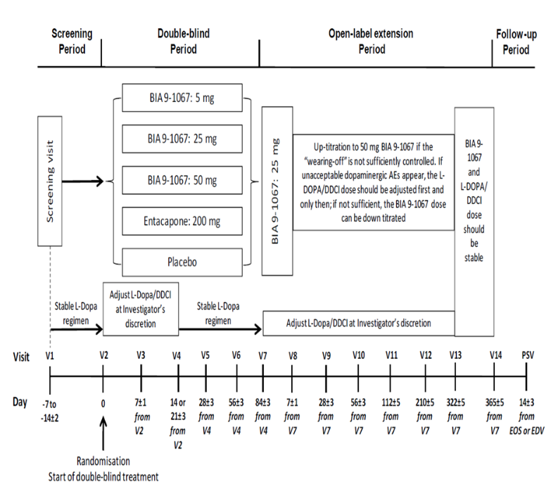
Primary objective: To investigate the efficacy of three doses of opicapone (5 mg, 25 mg, and 50 mg) administered once daily, compared with placebo or 200 mg of entacapone. These treatments were administered as adjunctive therapy to the existing treatment of levodopa plus a DDCI.
The study was designed to assess whether treatment with opicapone as an adjuvant to L-dopa/DDCI is superior to treatment with L-DOPA/DDCI combination alone and non-inferior to entacapone as an adjuvant therapy to L-DOPA/DDCI combination.

Key inclusion criteria
- diagnosed with idiopathic Parkinson’s disease according to the United Kingdom (UK) Parkinson’s Disease Society Brain Bank Diagnostic Criteria for at least three years.
- modified Hoehn and Yahr staging disease severity Stages I to III; at ‘on’ period.
- treated with three to eight daily doses of L-DOPA/DDCI, which could have included a slow release formulation.
- signs of ‘wearing-off’ phenomenon (end-of-dose deterioration) for a minimum of four weeks before screening.

Key exclusion criteria
- dyskinesia disability score > 3 in the Unified Parkinson's Disease Rating Scale (UPDRS).
- severe and/or unpredictable ‘off’ periods
- previous use of entacapone

Study treatments
The existing treatment of L-DOPA/DDCI was continued during the double blind period of the study which also had 5 treatment arms:
- 3 opicapone groups, each receiving one of three different doses (5 mg, 25 mg, or 50 mg);
- an active comparator group receiving 200 mg of entacapone; and
- a placebo group.
In the first two to three weeks (V2 to V4) of the double-blind study phase, the investigator was able to reduce the dose of levodopa/DDCI after the patient responded to the treatment, while the number of doses per day had to remain the same. In the double-blind study phase from V4 onwards, the dose of levodopa/DDCI had to be maintained.
The primary efficacy endpoint was the change in absolute off time from Baseline.
Key secondary endpoints in this study:
- Off time responders: 1 hour or more reduction in absolute off time from Baseline to endpoint.
- On time responders: 1 hour or more increase in absolute on time from Baseline to endpoint.

Baseline demographics
In the opicapone 50 mg group, the mean age was around 63 years. Majority of the patients (69.7%) were < 70 years of age and 60% of patients were males. Around 44% of patients had dyskinesia. Mean absolute off and on times were 6.2 and 9.9 hours respectively. The mean on time with troublesome dyskinesia was around 20 to 30 minutes and with non-troublesome dyskinesia was 1 hour. Mean modified Hoehn and Yahr staging disease severity score;¹² during on time was around 2.4.
Around 97% and 30% of patients were using the immediate-release (IR) and controlled release (CR) formulations of L-DOPA respectively.
The baseline demographics were comparable across treatment groups.

Statistical methods
Multiple 1-sided tests based on an analysis of covariance (ANCOVA) were used to test superiority verse. placebo in the full analysis set (FAS) and non-inferiority verse entacapone in the per protocol (PP) set. In order to control for multiplicity, a sequential gatekeeping procedure was used. The family-wise error rate (joint level of significance of all tests) was 0.025 (corresponding to 0.05 for 2-sided tests). A Bonferroni-adjustment was used to adjust the levels of significance for the three tests to ensure that the family-wise error rate and all comparisons versus placebo were treated equally. For each dose of opicapone, non-inferiority versus entacapone was tested only if the efficacy of opicapone verse. placebo had been established. The non-inferiority margin was chosen as 30 minutes.

Results
A total of 600 patients were randomised: 121 to placebo, 122 to entacapone, 122 to opicapone 5 mg, 119 to opicapone 25 mg, and 116 to opicapone 50 mg.
The completion rate was high and comparable across all treatment groups: 90.9% for placebo, 87.7% for entacapone, and between 90.2% and 92.2% for the three opicapone doses.
The most common reason for discontinuation was adverse events (AE) and was lowest in opicapone 50 mg group: 6.6% for placebo, 6.6% for entacapone, 5.7% for opicapone 5 mg, 6.7% for opicapone 25 mg, and 4.3% for opicapone 50 mg.

Primary endpoint
The estimated mean reduction (least square means) from Baseline in absolute off time at Endpoint was largest in the opicapone 50 mg group (- 116.8 minutes), followed by entacapone (- 96.3 minutes)
Opicapone was superior to placebo and non-inferior to entacapone, in terms of mean change in off time from Baseline. The non-inferiority was concluded based on the non-inferiority margin of 30 minutes that was chosen by the sponsor.
The Delegate comments that regarding the handling of missing data, different methods of imputation as sensitivity analyses on the primary endpoint were undertaken and resulted in comparable primary results.
Table 3: Study 301 Primary endpoint, change from Baseline to Endpoint in absolute off time (minutes)
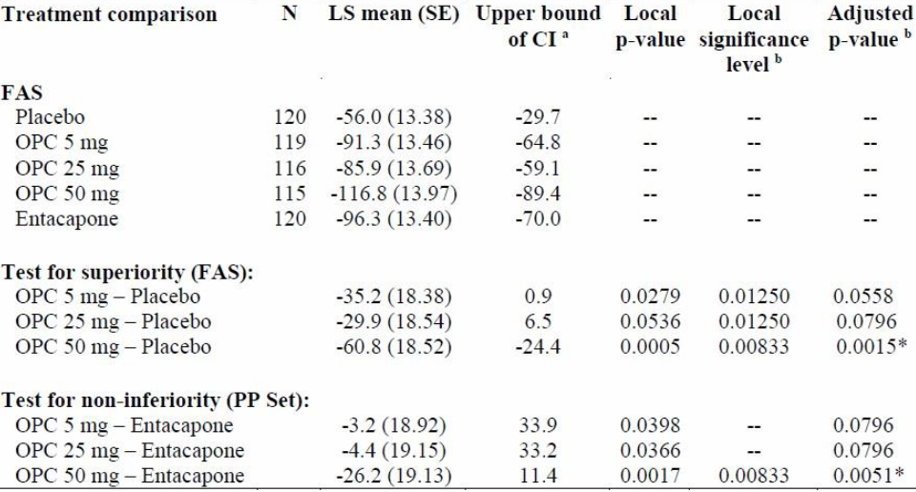
N = number of subjects; LS = least squares; SE = standard effor; CI = confidence interval; FAS = full analysis set population; PP set = per protocol set population; OPC = opicapone.
Note: p-values are 1-sided and based on Type III sums of squares.
a) upper bound of the 2-sided unadjusted 95% confidence interval.
b) calculated using Graph Based Multiple Comparison procedure (gMCP; CRAN)

Secondary endpoints
Responder rates for on and off times: Off time and on time responders were defined as follows:
- An off time responder was defined as a subject who had a reduction of at least 1 hour in absolute off time from Baseline to Endpoint.
- An on time responder was defined as a subject who had an increase of at least 1 hour in absolute total on time.
Table 4: Study 301 Secondary endpoint, proportion of off-time and on-time responders
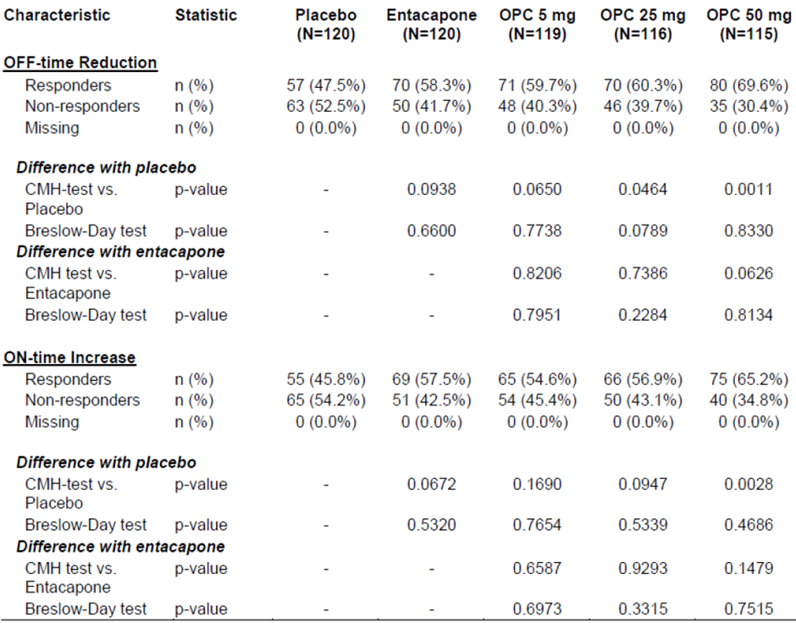
N = number of subjects; OPC = opicapone; CMH = Cochrane-Mantel-Haenszel test, stratified by region.
The proportion of off time responders in the FAS was significantly higher in the opicapone 25 mg group (60.3%, p = 0.0464) and the opicapone 50 mg group (69.6%, p = 0.0011), compared to placebo (47.5%).
The proportion of on time responders was significantly higher in the opicapone 50 mg group than in the placebo group (65.2% versus 45.8%, p = 0.0028).
The opicapone 50 mg group had a higher proportion of off time responders (69.6% versus 58.3%, p = 0.0626) and on time responders (65.2% versus 57.5%, p = 0.1479) compared to the entacapone group. The differences in the proportion of responders were not statistically significant.
Least square (LS) mean change in total on time was not significantly different between opicapone and entacapone.
In the opicapone groups, the change from Baseline to Endpoint in LS mean on time without troublesome dyskinesia ranged from 84.7 minutes in the 25 mg group to 109.1 minutes in the 50 mg group, compared to 93 minutes in entacapone group.
The overall reduction in percentage off time was comparable between opicapone 50 mg group (-12.1%) and entacapone group (-10.3%). Both groups had significant reduction in off time, when compared to placebo.

Total Unified Parkinson's Disease Rating Scale (UPDRS)
The mean reduction in total UPDRS;¹³ from Baseline were similar across all treatment groups. The LS mean change was - 5.4 for placebo, - 6.1 for entacapone, - 7.3 for opicapone 5 mg, - 7.0 for opicapone 25 mg, and - 6.1 for opicapone 50 mg.
None of the differences between the active groups and placebo were statistically significant.

Parkinson’s Disease Sleep Scale
The post-baseline Parkinson’s Disease Sleep Scale (PDSS) total scores improved across all treatment groups. The magnitude of changes observed for the opicapone (2.89 in the 50 mg, 5.51 in the 25 mg, and 5.19 in the 5 mg groups) and entacapone groups (2.86) were greater than placebo (1.04). There were no statistically significant differences between any of the groups.

Parkinson’s Disease Quality of Life Questionnaire
The post-baseline Parkinson’s Disease Quality of Life Questionnaire (PDQ-39) total scores decreased in all groups. At endpoint, LS mean changes from Baseline were -4.1 for the opicapone 5 mg treatment group, -2.5 for opicapone 25 mg, -2.8 for opicapone 50 mg, and -4.0 for entacapone, and -2.6 for placebo. No significant differences between treatment groups were observed.

Non-Motor Symptoms Scale
The LS mean changes from Baseline for Non-Motor Symtoms Scale (NMSS) scores were -5.6 for the opicapone 5 mg treatment group, -4.2 for opicapone 25 mg, -2.0 for opicapone 50 mg, -4.7 for entacapone, and -5.7 for placebo. No significant differences between treatment groups were observed.
The efficacy results were comparable across sub groups, based on disease duration, UPDRS score and levodopa daily dose.

Study 302
Study BIA 9-1067-302, hereafter referred to as Study 302 had an identical study design as Study 301 (described above). The key difference being the three treatment groups (randomised to opicapone 25 mg, 50 mg, or placebo) instead of five treatment groups in Study 301.
The primary efficacy variable was the change from Baseline in absolute off time at the end of the double blind period.

Statistical methods
Efficacy analysis between treatment groups was performed with an ANCOVA model. A hierarchical approach to statistical analysis of secondary endpoints was carried out to avoid inflation of type-1 errors due to multiple endpoints testing.
The baseline characteristics and anti-Parkinson’s disease medications were comparable to Study 301.

Primary endpoint
The opicapone 50 mg achieved a greater reduction in absolute off time, compared to opicapone 25 mg group. The treatment difference was statistically significant. The magnitude of reduction in absolute off time was comparable to Study 301. Results for the full analysis set are shown in Table 5, below. Similar results were reported for the PP population set.
Table 5: Study 302 Primary endpoint change from Baseline to Endpoint in absolute off time (minutes)
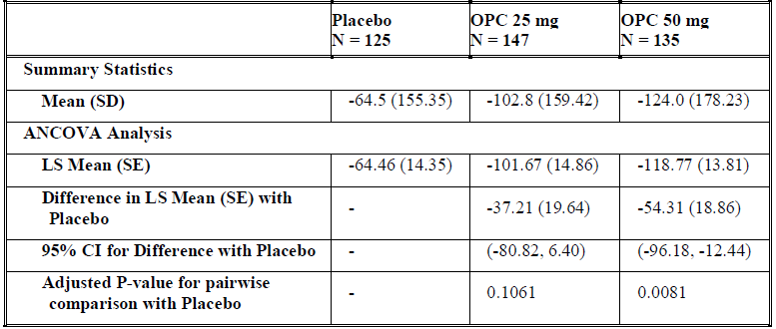
N = number of subjects; OPC = opicapone; SD = standard deviation; ANCOVA = analysis of covariance; LS = least squares; SE = standard error; CI = confidence interval.

Key secondary endpoint
The proportion of off time responders were 50.4% in the placebo group, 62.4% in the opicapone 25 mg group, and 66.0% in the opicapone 50 mg group, while the proportion of on time responders were 45.2%, 63.2%, and 61.9%, respectively. The treatment differences between opicapone and placebo groups were statistically significant. Results for the key secondary endpoint are shown below in Table 6.
Table 6: Study 302 Secondary endpoint, proportion of off-time and on-time responders
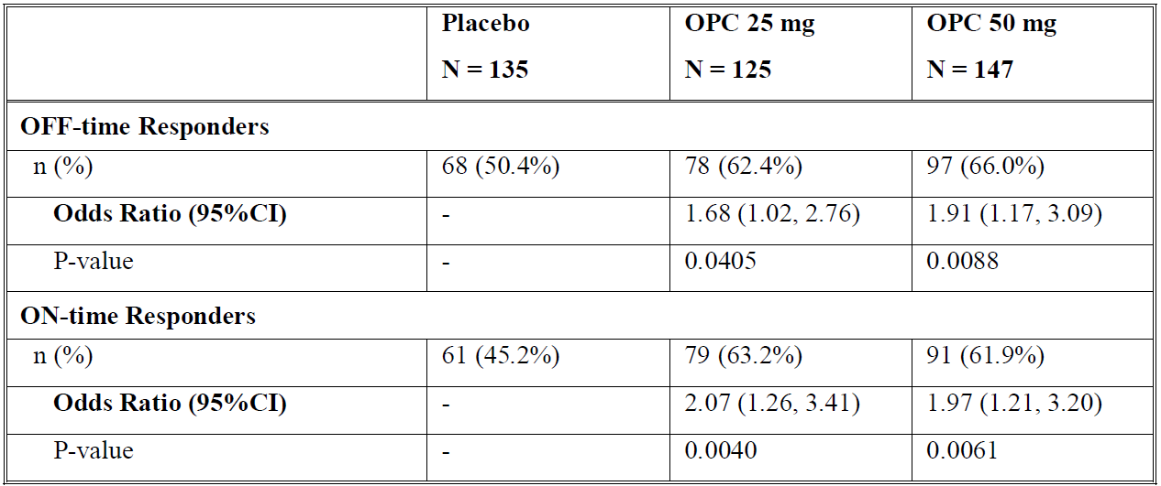
N = number of subjects; CI = confidence intervals.

Change from Baseline in absolute on-time
The LS mean changes for total on time were 58.57 minutes for the placebo group,104.09 minutes for the opicapone 25 mg group and 111.26 minutes for the opicapone 50 mg group. The treatment difference between the opicapone 25 mg and placebo groups were 45.42 minutes and 52.59 minutes between the opicapone 50 mg and placebo groups. The treatment difference was statistically significant.
For the on time with non-troublesome dyskinesia, the LS mean changes were -2.24 minutes for the placebo group, 37.31 minutes for the opicapone 25 mg group and 38.60 minutes for opicapone 50 mg group. The treatment difference was statistically significant.

Change from Baseline in absolute off time
The LS means were - 6.67% for the placebo group, and - 10.97% for the opicapone 25 mg group and - 12.12% for the opicapone 50 mg group. The treatment difference was statistically significant.
The changes from Baseline to V7 in UPDRS Part III were minimal and similar across all three treatment groups, LS means for change from Baseline were -2.12 for placebo, -2.94 for opicapone 25 mg and -1.95 for opicapone 50 mg. The p-values were > 0.05 for the comparisons between the opicapone groups and placebo.

Study 301 and 302 open-label phase results
Both Phase III studies were followed by a 52 weeks open label treatment period. 495 patients were randomised in Study 301 open label phase and 427 patients in Study 302.
Overall, at the end of the 52 weeks treatment period, off time had decreased by -126.9 minutes relative to double blind baseline and by an additional 33.8 minutes relative to open-label baseline. There was an increase in total on time by 119.7 minutes relative to double blind baseline and 32.0 minutes relative to open-label baseline. There was an improvement of 3.6 minutes in the on time with non-troublesome dyskinesia and -0.3 minutes in troublesome dyskinesia.
Greater improvements were observed with patients switching from placebo and entacapone to opicapone. Patients who were treated with opicapone during double blind phase were reported to maintain their treatment benefit during the open label phase.

Study 302 open label study results
Overall, the results were comparable to Study 301 open label phase.
At 52 weeks of treatment period, the reduction in off time reduction relative to the double blind baseline was -126.2 minutes. The improvement in on time without troublesome dyskinesia from double blind baseline was 109.6 minutes. The proportion of off and on time responders (relative to double blind baseline) was 68.4% and 65.8%, respectively.

Safety
Patient exposure: 1651 patients received at least one dose of opicapone (859 healthy subjects and 792 patients with Parkinson's disease) in the clinical trials. 631 patients received up to 50 mg of opicapone daily in pivotal Studies 301 and 302 for 14 to 15 weeks.

Adverse event
Dyskinesia had a higher incidence in opicapone 50 mg group (15.7%), compared to entacapone (8.2%) and placebo (4.1%) an AE. A higher incidence for treatment-related dyskinesia was also reported in opicapone 50 mg group, compared to other groups. These events were mild-moderate in severity.

Serious adverse events
Serious adverse events were reported less frequently in the pivotal studies with opicapone (3.5%) than with placebo (4.3%) and entacapone (6.6%). Study discontinuations due to AEs occurred more often under 50 mg opicapone (8.7%) in Phase III studies than under 25 mg (5.3%) and placebo (7%). Dyskinesia and vomiting were the most common causes of AE-based discontinuations.
Higher incidence for depressive and self-injurious behaviour were noted under opicapone in Study 301. Impulse control disorders were more common under entacapone (8.2%) and opicapone (6.2%) compared to placebo (4.1%). Higher rates of ischaemic heart disease were observed under opicapone, 5.3% with 50 mg, 2.9% with 25 mg and 2.3% with placebo. In the EU evaluation procedure, these cases (n = 21 under opicapone) were analysed and then attributed to underlying diseases.
In both Study 301 and 302, most of treatment-emergent dyskinesia reported occurred in subjects already experiencing dyskinesia at Baseline.
The results for the integrated population matched those of the individual studies. The incidence for dyskinesia was 18.3% in total opicapone verse 6.2% in the placebo group. In the active treatment groups the incidence increased with increasing dose (16.0% at 25 mg and 20.4% at 50 mg).
In the integrated results, incidence of psychosis and psychotic disorders at the SMQ level ‘Psychosis and psychotic disorders’ were higher in the opicapone groups (5.7% in 25 mg and 5.3% in 50 mg) compared to the placebo group (1.2%).
In the combined Phase III study analysis among the safety set population, the incidence of treatment emergent adverse events (TEAE) of depression and suicide/self-injury in the total opicapone group was 3.3% compared to placebo 2.3%. No dose relationship was observed.
Dyskinesia (12.4% verse. 4.1%), insomnia (4.5% verse. 0.8%), and dizziness (3.1% verse. 0.8%) were the TEAEs that had a higher frequency in the opicapone groups compared to the placebo group.
Compared to entacapone, dyskinesia was more common in opicapone (12.4% verse. 8.2%), while nausea and falls were slightly more common with entacapone (nausea: 6.6% verse. 2.2%; falls: 4.1% verse. 2.0%). There was no apparent dose-relationship for the majority of TEAEs with opicapone.
Shifts in haemoglobin to below the normal range were more frequent with opicapone compared to the placebo. These shifts were also seen in the open extension phases. Lower haemoglobin levels and haematocrit were observed under opicapone, this is classified as a class effect (known for entacapone).
Ischaemic heart disease was higher in the total opicapone group (4.1%) compared to placebo (2.3%), and in the active treatment groups the incidence increased with dose (2.9% for 25 mg opicapone, 5.3% for 50 mg opicapone). Out of the 21 subjects identified as having ischaemic heart disease in the SMQs searched, 20 patients had an increase in creatine phosphokinase (CPK) levels and one had coronary artery disease. These events of increased CPK levels were thought to be related to other causes (for example, muscular lesions due to falls or accidents, dyskinesia, or Parkinson’s disease in general) and are not necessarily a reflection of heart disease.
The Delegate comments that ischaemic heart disease is included as a potential risk in the risk management plan (RMP) because insufficient patients were included to properly assess this risk.

Post market data
A periodic safety update report (PSUR) from 25 December 2016 to 24 June 2017 reviewed the incidence of skin cancer among patients treated with opicapone.
A review from 26 March 2015 to 25 June 2015 identified six clinical study cases of skin cancer, including seven non-serious events considered possibly related to opicapone by the investigator or the sponsor.
Cumulative up to 21 January 2016, 24 clinical study cases were medically reviewed; 22 cases corresponded to patients treated with opicapone and 2 cases to patients treated with placebo. The signal evaluation was finalised on 23 February 2016.
Most of the patients were ≥ 60 years, (19 of 22 opicapone exposed cases). For most of the cases, basal cell carcinoma was reported (13 of 22 opicapone exposed cases). Five (suspected) melanoma cases were identified. Other diagnoses comprised Bowen’s disease (three cases), and 1 case each of squamous cell carcinoma, and not further specified skin cancer.
If cases with short duration of exposure to opicapone treatment (< 4 months) and cases with predisposing lesions were excluded, 5 cases remained for which a causal or contributory role of opicapone cannot be excluded. Detailed review of these cases revealed that for one case the type of skin cancer was unspecified; the diagnosis of the other four cases refers to non-melanoma skin cancer (NMSC) with three events of basal cell carcinoma and two events of Bowen’s disease. No histopathology reports are available for these five cases, three case reports are from patients living in countries with intense ultraviolet radiation (two from Australia; one from South Africa). The highest worldwide incidence of NMSC is in Australia. Four case reports refer to patients who are at least 65 years old (cumulative exposure to risk factors).
Considering these confounding factors and the increasing incidence of this cancer, the evaluator concluded that a relationship of NMSC with opicapone treatment as not suspected at this time.

Risk management plan
The sponsor submitted EU-RMP version 3.0 (dated 15 October 2015; data lock point (DLP) 30 April 2015) and Australian-specific Annex (ASA) version 1.0 (dated 30 July 2019) in the initial submission. The sponsor has provided an updated ASA version 2.0 (dated 6 May 2020) only. In response to the two recommendations in the second round RMP evaluation report, the sponsor provided amended proposed PI and Consumer Medicines Information (CMI). No further updates to the EU-RMP or ASA were submitted. In response to the round 2 clinical evaluation report, the sponsor has updated the ASA to ASA version 3.0 and amended the draft PI and CMI. These documents have been submitted for evaluation.
The summary of safety concerns and their associated risk monitoring and mitigation strategies are summarised in Table 7.
Table 7: Summary of safety concerns and their associated risk monitoring and mitigation strategies
Summary of safety concerns |  | Pharmacovigilance |  | Risk Minimisation
 |  | Routine | Additional | Routine | Additional
Important identified risks | Dyskinesia | ¹ | – |  | –
Important identified risks | Hallucinations | ¹ | – |  | –
Important potential risks | Ischaemic heart disease | ¹ | – | – | –
Important potential risks | Neuroleptic malignant syndrome | ¹ | – |  | –
Important potential risks | Impulse control disorders and other related behaviours | ¹ | – |  | –
Important potential risks | Drug-related hepatic injury | ¹ | – |  | –
Important potential risks | Interactions with drugs metabolised by CYP2C8 (for example. hypoglycaemia risk with repaglinide) | ¹ | – |  | –
Missing information | Use in patients with moderate/severe hepatic impairment | ¹ | – |  | –
Missing information | Use in pregnancy and lactation | ² | – |  | –
Missing information | Long-term safety | ¹ | – | – | –
Missing information | *Very elderly population (> 75 years) | ¹ | – |  | –
*The highlighted section of this safety concern is Australia-specific. ¹Standard adverse event targeted follow-up questionnaire. ²Pregnancy targeted follow-up questionnaire
The pharmacovigilance plan was considered satisfactory, which included targeted follow-up questionnaires, for all safety concerns. There are no outstanding issues from RMP perspective.

Risk-benefit analysis

Delegate’s considerations
Clinical efficacy of opicapone was evaluated in two Phase III studies for up to 15 weeks of double blind, placebo-controlled and partially actively controlled treatment and 52 weeks of open-label treatment period. Across studies, patients treated with opicapone 50 mg achieved maximal reduction in off time from Baseline. This outcome was also associated with increased on time without troublesome dyskinesia. The results showed statistical superiority of the 50 mg/dose over placebo in both studies, while in the actively controlled Study 301 non-inferiority over the comparator entacapone was shown (based on 30 minutes as the non-inferiority margin) in terms of reduction of the absolute off time from Baseline.
A significantly greater proportion of patients in opicapone 50 mg group were responders, when compared to placebo in both Studies 301 and 302 and numerically greater than entacapone group in Study 301 (did not achieve statistical significance). There was no significant difference between opicapone 50 mg and entacapone groups in terms of total on time and reduction in off time. The on time without troublesome dyskinesia was marginally higher for opicapone 50 mg group (16 minutes greater than entacapone and 25 minutes greater than 25 mg opicapone group), compared to other treatment groups. The clinical significance this treatment difference is marginal.
Patients treated with 50 mg opicapone did not achieve significant treatment benefit in terms of quality of life measures and non-motor symptom scale, compared to those in entacapone and placebo groups. The significant improvement in on time and reduction in troublesome dyskinesia for the opicapone 50 mg group does not appear to have resulted in a significant treatment difference in quality of life measures and improvement in non-motor symptoms of Parkinson's disease, when compared to other treatment groups, including placebo.
The results of long term open label treatment phase indicates a sustained treatment benefit for patients treated with opicapone 50 mg.
The Delegate considers that the clinical utility of opicapone in the treatment paradigm of Parkinson's disease is unclear. The proposed indication is to treat all patients who are still experiencing end-of-motor fluctuations in spite of being treated with levodopa/DDCI therapy. Patients requiring opicapone as a COMT inhibitor in addition to levodopa and DDCI to achieve adequate control over motor functions are more likely to have moderate to severe motor disability.^{4,8} However, patients at the severe end on motor dysfunction (as per Stage IV of modified Hoehn and Yahr staging)¹² were not included in the Study 301. Around 65% of patients did not experience dyskinesia at Baseline. Hence, the utility of opicapone in patients with moderate to severe motor dysfunction has not been demonstrated.
Patients who were previously treated with entacapone were excluded from Study 301. Around 20% of patients with Parkinson's disease are considered to be refractory to treatment with entacapone. The potential utility of opicapone as a treatment option in those patients is unknown. The once daily dose of opicapone could contribute towards improving treatment compliance. However, the Delegate considers that it could also restrict the ability to titrate the dose of both COMT inhibitor and levodopa to achieve optimal treatment outcomes. The Delegate's conclusion is based on the fact that the objective of adding a COMT inhibitor is to achieve optimal symptom control at the lowest feasible dose of levodopa; rather than solely to reduce the dose of levodopa.⁸
Overall, the safety events were known class effects of COMT inhibitors.8 The Delegate has noted the higher incidence for treatment-related dyskinesia in the opicapone group, compared to other groups. These events were mild to moderate in severity and most of these patients had dyskinesia at Baseline. A greater improvement in on time without troublesome dyskinesia was also reported in opicapone group, compared to other groups. No hepatotoxic effects were reported.
The clinical evaluator recommended approval conditional to PI changes by the sponsor. Those recommended changes have now been addressed by the sponsor.
In conclusion, the evidence based on the clinical data in the dossier suggest that adjunctive treatment with opicapone with levodopa/DDCI was associated with significantly reduced off time and on time without troublesome dyskinesia in patients with Parkinson's disease, when compared to treatment with levodopa/DDCI. This finding was not associated with a significant improvement in quality of life measures and non-motor symptoms. The overall treatment benefit with opicapone was comparable to entacapone. Safety events were largely previously known class effects. No new safety signals were noted.

Proposed action
The Delegate have no reason to say, at this time, that the application for Ongentys (opicapone) should not be approved for registration.

Questions for sponsor
- Please clarify whether the food effect was evaluated for the formulation that is proposed for marketing. If so, what were the findings? What is the rationale for the recommendation to take opicapone?
Two food effect studies were conducted: a single-dose Study, BIA-91067-104, conducted to explore the food effect on opicapone’s PK using opicapone 50 mg non-micronised active pharmaceutical ingredient (API); and a second Study, BIA-91067-128, conducted to overcome the limitations of the previous study, and therefore following a multiple-dose administration of opicapone 50 mg micronised API to explore the food effect on both opicapone’s PK and its pharmacodynamic efficacy through its surrogate marker (COMT inhibition). This second study was not directly conducted using the opicapone formulation that was proposed for marketing (to be market (TBM) formulation). Nonetheless, the formulation used was the same of pivotal Phase III clinical studies, which was shown to be bioequivalent to the TBM formulation (Study BIA-91067-119).
The main findings of these food effect studies are that food was found to have a relevant effect on opicapone ´s PK by decreasing the peak plasma exposure (PE) of opicapone. Yet, in Study BIA-91067-128, no significant impact was found on the total plasma exposure of opicapone nor on COMT inhibition itself. Specifically, the minimum threshold of pharmacodynamic efficacy, minimum inhibitory effect on the COMT activity over the 24 hours dosing interval, was sustained. Considering that COMT inhibition is a pharmacodynamic efficacy surrogate marker, for example. the efficacy of opicapone directly depends on this, no impact on the clinical efficacy profile is expected.
- The proposed PI (Section 4.2) instructs to take opicapone 1 hour before or after levodopa combinations. In the pivotal study, opicapone was taken 1 hour after the levodopa combination. What is the rationale for the recommendation in the PI?
The rationale behind the posology proposed in the product information is related with the therapeutic goal of the opicapone treatment in pharmacodynamics patients, which is to optimise the PK profile and the dosing regimens of levodopa by inhibiting its COMT-mediated metabolism.
In human pharmacology single-dose studies conducted with concomitant administration between opicapone and levodopa/DDCI (either immediate release or controlled release), a potential absorption-related interaction was found. In Study BIA-91067-117, when levodopa/carbidopa was administered 1 hour before opicapone, this potential absorption-related interaction was minimized. Furthermore, median levodopa T_{max} is normally below or equal to 1 hour (administered alone/with placebo), meaning that when opicapone is administered 1 hour after the administration of levodopa/DDCI, most of levodopa is already absorbed. Thus, although this scheme of administration has not been specifically evaluated in a dedicated PK study (no plasma concentrations available), it should decrease the potential of the absorption of levodopa to be affected by opicapone.
In Study BIA-91067-301, due to its double-blind nature and presence of entacapone and levodopa possible regimen between three to eight daily intakes, a 1 hour before approach would have been an impracticable operational scheme to implement. As such, a pragmatical 1 hour after the levodopa combination was implemented. Study BIA-91067-302 followed the same approach to allow data integration from both studies.
Therefore, the 1 hour separation is recommended either before or after levodopa combinations to overcome the potential absorption-related interaction.

Advisory Committee considerations
The Advisory Committee on Medicines (ACM), having considered the evaluations and the Delegate’s overview, as well as the sponsor’s response to these documents, advised the following:
- What are the ACM's view on opicapone as an alternative to entacapone as adjuvant to L-Dopa/DDCI in the treatment of patients with Parkinson's Disease?
The ACM advised that the overall treatment benefit with opicapone was comparable to entacapone.

- Please comment on the clinical relevance of 30 minutes as the non-inferiority margin for comparison between opicapone and entacapone in Study 301.
The ACM advised that the minimal clinically important difference is around 60 minutes, but that 30 minutes was relevant for many patients. In this aspect, the 30 minutes as non-inferiority margin was considered as acceptable.
- From a clinical perspective, which group of patients with Parkinson's disease will benefit the most from treatment with opicapone?
The ACM advised that long-term use of L-DOPA is limited by the development of motor complications that affect the large majority of Parkinson's disease patients, particularly those with young-onset Parkinson's disease. They stated that these most often consist of the ‘wearing-off’ effect (shortening of the duration of the motor response after a dose of levodopa) and dyskinesias (involuntary movements primarily consisting of choreiform or dystonic movements). In the extreme, patients can cycle between ‘on’ periods, when they respond to levodopa but experience disabling dyskinesias, and ‘off’ periods, when they suffer severe parkinsonism. It was of the opinion of the ACM that the patients who will most benefit from the medicine are those who are ‘wearing off’.
- From a safety perspective, please comment on the adequacy of the section on drug-drug interactions in the PI.
The ACM discussed some potential for drug interactions, however noted that these are outlined in the PI. The ACM did, however, recommend the relevant patient groups utilise non-hormonal contraceptives and that this should be included within the PI.
- Opicapone is presented as a capsule, in contrast to entacapone and most of the L-DOPA products that are tablets. Does the ACM consider this as an issue that could affect treatment compliance in patients with Parkinson's disease, particularly in the elderly age group?
The ACM advised that they do not foresee an issue with the capsule formation, however they raised concerns as to adherence due to separation in timing and absence of co-formulated presentation.
- The committee is (also) requested to provide advice on any other issues that it thinks may be relevant to a decision on whether or not to approve this application.
The ACM advised that a high and a moderate fat and calorie meal had a profound effect on the absorption of opicapone. The ACM recommended this be included in the PI.

Outcome
Based on a review of quality, safety and efficacy, the TGA approved the registration of Ongentys (opicapone) for 50 mg hard capsule, indicated for:
Ongentys is indicated as adjunctive therapy to preparations of levodopa/ DOPA decarboxylase inhibitors (DDCI) in adult patients with Parkinson’s disease and end-of-dose motor fluctuations who cannot be stabilised on those combinations.

Specific conditions of registration applying to these goods
- Ongentys (opicapone) is to be included in the Black Triangle Scheme. The PI and CMI for Ongentys must include the black triangle symbol and mandatory accompanying text for five years, which starts from the date that the sponsor notifies the TGA of supply of the product.
- The Ongentys EU- RMP (version 3.0, dated 15 October 2015, DLP 30 April 2015), with ASA (version 3.0, dated 29 June 2020), included with submission PM-2019-03218-1-1, and any subsequent revisions, as agreed with the TGA will be implemented in Australia.
An obligatory component of risk management plans is routine pharmacovigilance. Routine pharmacovigilance includes the submission of PSURs.
Reports are to be provided in line with the current published list of EU reference dates and frequency of submission of PSURs until the period covered by such reports is not less than three years from the date of this approval letter.
The reports are to at least meet the requirements for PSURs as described in the European Medicines Agency’s Guideline on good pharmacovigilance practices (GVP) Module VII-periodic safety update report (Rev 1), Part VII.B Structures and processes. Note that submission of a PSUR does not constitute an application to vary the registration.

Attachment 1. Product Information
The PI for Ongentys approved with the submission which is described in this AusPAR is at Attachment 1. For the most recent PI, please refer to the TGA website at <https://www.tga.gov.au/product-information-pi>.

Therapeutic Goods Administration
PO Box 100 Woden ACT 2606 Australia
Email: info@tga.gov.au Phone: 1800 020 653 Fax: 02 6232 8605
https://www.tga.gov.au

The Black Triangle Scheme provides a simple means for practitioners and patients to identify certain types of new prescription medicines, including those being used in new ways and to encourage the reporting of adverse events associated with their use. The Black Triangle does not denote that there are known safety problems, just that the TGA is encouraging adverse event reporting to help us build up the full picture of a medicine's safety profile.
Parkinson’s Disease The Brain Foundation Access via brainfoundation.org.au
Cacabelos, R., Parkinson's Disease: From Pathogenesis to Pharmacogenomics. Int J Mol Sci, 2017. 18(3).
Armstrong, M.J. and M.S. Okun, Diagnosis and Treatment of Parkinson Disease: A Review. Jama, 2020. 323(6): p. 548-560.
Kaakkola, S., Clinical pharmacology, therapeutic use and potential of COMT inhibitors in Parkinson's disease. Drugs, 2000. 59(6): p. 1233-50.
Fabbri, M., et al., Opicapone for the treatment of Parkinson's disease: A review of a new licensed medicine. Mov Disord, 2018. 33(10): p. 1528-1539.
Jankovic, J. and M. Stacy, Medical management of levodopa-associated motor complications in patients with Parkinson's disease. CNS Drugs, 2007. 21(8): p. 677-92.
Olanow, C.W. and F. Stocchi, COMT inhibitors in Parkinson's disease: can they prevent and/or reverse levodopa-induced motor complications? Neurology, 2004. 62(1 Suppl 1): p. S72-81.
Cytochrome P450 (CYP) enzymes: CYPs are the major enzymes involved in drug metabolism, accounting for large part of the total metabolism. Most drugs undergo deactivation by CYPs, either directly or by facilitated excretion from the body. Also, many substances are bioactivated by CYPs to form their active compounds. Many drugs may increase or decrease the activity of various CYP isozymes either by inducing the biosynthesis of an isozyme (enzyme induction) or by directly inhibiting the activity of the CYP (enzyme inhibition). This is a major source of adverse drug interactions, since changes in CYP enzyme activity may affect the metabolism and clearance of various drugs. Such drug interactions are especially important to take into account when using drugs of vital importance to the patient, drugs with important side-effects and drugs with small therapeutic windows, but any drug may be subject to an altered plasma concentration due to altered drug metabolism.
Pregnancy Category B2: Drugs which have been taken by only a limited number of pregnant women and women of childbearing age, without an increase in the frequency of malformation or other direct or indirect harmful effects on the human fetus having been observed. Studies in animals are inadequate or may be lacking, but available data show no evidence of an increased occurrence of fetal damage.
The Child-Pugh score is a system for assessing the prognosis of hepatic impairment, including the required strength of treatment and necessity of liver transplant of chronic liver disease, primarily cirrhosis. It provides a forecast of the increasing severity of liver disease and expected survival rate. The Pugh-Child score is determined by scoring five clinical measures of liver disease. A score of 1, 2, or 3 is given to each measure, with 3 being the most severe. Class B is between 7 to 9 points, indicative of moderately severe liver disease and one to five year survival rate of 75%.
Modified Hoehn and Yahr Scale is used to describe the symptom progression of Parkinson disease. It was designed to be a descriptive staging scale to evaluate both disability and impairment related to clinical disease progression. Stage 1: Unilateral involvement only; Stage 1.5: Unilateral and axial involvement; Stage 2: Bilaternal involvement without impairment of balance; Stage 2.5: Mild bilateral disease with recovery on pull test; Stage 3: Mild to moderate bilateral disease; some postural instability; physically independent; Stage 4: Severe disability; still able to walk or stand unassisted; Stage 5: Wheelchair bound or bedridden unless aided.
Unified Parkinson's Disease Rating Scale is a comprehensive 50 question assessment of both motor and non-motor symptoms associated with Parkinson's.
V2 = randomisation/start of double blind phase (Day 0); V4 = Day 14 or 21 +/- 3 days.
The Parkinson's Disease Sleep Scale (PDSS) allows health and social care professionals and people with Parkinson's to self-rate and quantify the level of sleep disruption being experienced in order to target treatment appropriately. The PDSS is patient reported outcome measure comprised of a 15-item visual analogue scale that asks a patient (or caregiver, by proxy) to rate 15 common aspects of sleep disruption in Parkinson’s disease on a 10 cm scale from 0 (worst possible score) to 10 (excellent/never experienced).
The Parkinson’s Disease Quality of Life Questionnaire (PDQ-39) assesses how often people affected by Parkinson's experience difficulties across 8 dimensions of daily living, including relationships, social situations and communication. It also assesses the impact of Parkinson's on specific dimensions of functioning and wellbeing. Each dimension has a set of items scored with its own discrete scale. Each item is scored on a 5-option Likert scale of 0 = never, to 4 = always or cannot do at all. Dimension scores are calculated the sum of all dimension item scores, divided by the maximum possible score for those items, multiplied by 100. Total PDQ-39 scores can range from 0 to 800, calculated by the sum of all dimension scores, and can be summarised into the PDQ-39 summary index score, with scores ranging from 0 to 100. Lower scores are indicative of better health related quality of life.
The Non-Motor Symptoms Scale (NMSS) is a 30-item clinician rated scale to assess a range of non-motor symptoms in patients with Parkinson's disease over 9 domains. The NMSS measures the severity and frequency of non-motor symptoms across nine dimensions over the previous month. Each item is scored according to severity (0 to 3) and frequency (1 to 4). Total score is calculated by multiplying the severity and frequency score for each item, and adding each item score together. Total NMSS scores range from 0 to 360, with higher scores indicative of a greater health burden of non-motor symptoms.
V7 = end of double-blind period, 84 days +/- 3 days from V4. V4 = Day 14 or 21 +/- 3 days from randomisation/start of double-blind treatment.
UPDRS Part III = Unified Parkinson's Disease Rating Scale, MotorExaminationn.
SMQ = Standardised MedDRA Query; MedDRA = Medical Dictionary for Regulatory Activities.
Routine risk minimisation activities may be limited to ensuring that suitable warnings are included in the product information or by careful use of labelling and packaging. Routine pharmacovigilance practices involve the following activities: - All suspected adverse reactions that are reported to the personnel of the company are collected and collated in an accessible manner; - Reporting to regulatory authorities; - Continuous monitoring of the safety profiles of approved products including signal detection and updating of labelling; - Submission of PSURs; - Meeting other local regulatory agency requirements.
The ACM provides independent medical and scientific advice to the Minister for Health and the Therapeutic Goods Administration (TGA) on issues relating to the safety, quality and efficacy of medicines supplied in Australia including issues relating to pre-market and post-market functions for medicines. The Committee is established under Regulation 35 of the Therapeutic Goods Regulations 1990. Members are appointed by the Minister. The ACM was established in January 2017 replacing Advisory Committee on Prescription Medicines (ACPM) which was formed in January 2010. ACM encompass pre and post-market advice for medicines, following the consolidation of the previous functions of the Advisory Committee on Prescription Medicines (ACPM), the Advisory Committee on the Safety of Medicines (ACSOM) and the Advisory Committee on Non-Prescription Medicines (ACNM). Membership comprises of professionals with specific scientific, medical or clinical expertise, as well as appropriate consumer health issues relating to medicines.

