April 2021

Australian Public Assessment Report for Onasemnogene abeparvovec
  - Proprietary Product Name: Zolgensma
  - Sponsor: Novartis Pharmaceuticals Australia Pty Ltd

About the Therapeutic Goods Administration (TGA)
- The Therapeutic Goods Administration (TGA) is part of the Australian Government Department of Health and is responsible for regulating medicines and medical devices.
- The TGA administers the Therapeutic Goods Act 1989 (the Act), applying a risk management approach designed to ensure therapeutic goods supplied in Australia meet acceptable standards of quality, safety and efficacy (performance) when necessary.
- The work of the TGA is based on applying scientific and clinical expertise to decision-making, to ensure that the benefits to consumers outweigh any risks associated with the use of medicines and medical devices.
- The TGA relies on the public, healthcare professionals and industry to report problems with medicines or medical devices. TGA investigates reports received by it to determine any necessary regulatory action.
- To report a problem with a medicine or medical device, please see the information on the TGA website <https://www.tga.gov.au>.

About AusPARs
- An Australian Public Assessment Report (AusPAR) provides information about the evaluation of a prescription medicine and the considerations that led the TGA to approve or not approve a prescription medicine submission.
- AusPARs are prepared and published by the TGA.
- An AusPAR is prepared for submissions that relate to new chemical entities, generic medicines, major variations and extensions of indications.
- An AusPAR is a static document; it provides information that relates to a submission at a particular point in time.
- A new AusPAR will be developed to reflect changes to indications and/or major variations to a prescription medicine subject to evaluation by the TGA.

Copyright
© Commonwealth of Australia 2021
This work is copyright. You may reproduce the whole or part of this work in unaltered form for your own personal use or, if you are part of an organisation, for internal use within your organisation, but only if you or your organisation do not use the reproduction for any commercial purpose and retain this copyright notice and all disclaimer notices as part of that reproduction. Apart from rights to use as permitted by the Copyright Act 1968 or allowed by this copyright notice, all other rights are reserved and you are not allowed to reproduce the whole or any part of this work in any way (electronic or otherwise) without first being given specific written permission from the Commonwealth to do so. Requests and inquiries concerning reproduction and rights are to be sent to the TGA Copyright Officer, Therapeutic Goods Administration, PO Box 100, Woden ACT 2606 or emailed to <tga.copyright@tga.gov.au>.

Contents
List of abbreviations 4
I. Introduction to product submission 7
Submission details 7
Product background 9
Regulatory status 10
Product Information 13
II. Registration timeline 13
III. Submission overview and risk/benefit assessment 14
Quality 14
Nonclinical 16
Clinical 17
Risk management plan 41
Risk-benefit analysis 42
Outcome 53
Attachment 1. Product Information 54

List of abbreviations
Abbreviation | Meaning
5q SMA | Spinal muscular atrophy involving mutations to the survival motor neuron 1 gene located on chromosome 5q13
AAV | Adeno-associated virus
AAV9 | Adeno-associated viral vector serotype 9
ACM | Advisory Committee on Medicines
AESI | Adverse event of special interest
ALT | Alanine aminotransferase
anti-hSMN | Anti-human survival motor neuron
ARGPM | Australian Regulatory Guidelines for Prescription Medicines
ARTG | Australian Register of Therapeutic Goods
ASA | Australian specific Annex
AST | Aspartate transaminase
AVXS-101 | The drug development code for onasemnogene abeparvovec
BiPAP | Bi-level positive airway pressure
BLA | Biologics License Application (Food and Drug Administration, United States)
CAT | Committee for Advanced Therapies (European Medicines Agency, European Union)
cDNA | Complementary deoxyribonucleic acid
CHMP | Committee for the Medicinal Products for Human Use (European Medicines Agency, European Union)
CHOP INTEND | Children’s Hospital of Philadelphia Infant Test of Neuromuscular Disorders
CMI | Consumer Medicines Information
CNS | Central nervous system
CPD | Certified Product Details
CPMP | Committee for Proprietary Medicinal Products (European Medicines Agency, European Union)
CTCAE | Common Terminology Criteria for Adverse Events
DLP | Data lock point
DNIR | Dealings Not Involving an Intentional Release (of genetically modified organisms into the environment licence)
DRG | Dorsal root ganglia
ECG | Electrocardiogram
ELISA | Enzyme linked immunosorbent assay
ELISpot | Enzyme-linked immunospot
EMA | European Medicines Agency (European Union)
EPAR | European Public Assessment Report (European Medicines Agency, European Union)
EU | European Union
FDA | Food and Drug Administration (United States)
GGT | Gamma-glutamyl transferase
GLP | Good Laboratory Practice
GMO | Genetically modified organism
GVP | Good Pharmacovigilance Practice(s)
IgG | Immunoglobulin G
IT | Intrathecal(ly)
ITT | Intent to treat
IV | Intravenous(ly)
MAP | Managed Access Program
MedDRA | Medical Dictionary for Regulatory Activities
NSQHS | National Safety and Quality Health Service
OGTR | Office of the Gene Technology Regulator
PI | Product Information
PNCR | Paediatric Neuromuscular Clinical Research
RMP | Risk management plan
RSV | Respiratory syncytial virus
SAE | Serious adverse event
SMA | Spinal muscular atrophy
SMN | Survival motor neuron
SMN1 | Survival motor neuron 1
SMN2 | Survival motor neuron 2
SmPC | Summary of product characteristics
TEAE | Treatment emergent adverse event
ULN | Upper limit of normal
US | United States
vg | Vector genomes
vg/kg | Vector genomes per kilogram of body weight
WHO | World Health Organization

I. Introduction to product submission

Submission details
Type of submission: | New biological entity
Product name: | Zolgensma
Active ingredient: | Onasemnogene abeparvovec
Decision: | Approved
Date of decision: | 24 February 2021
Date of entry onto ARTG: | 4 March 2021
ARTG number: | 327905, 327906, 327907
Black Triangle Scheme: | Yes  This product will remain in the scheme for 5 years, starting on the date the product is first supplied in Australia
Sponsor’s name and address: | Novartis Pharmaceuticals Australia Pty Ltd  54 Waterloo Road,  Macquarie Park NSW 2113
Dose form: | Injection for intravenous infusion
Strength: | 2 x 10¹³ vector genomes/mL
Container: | Vial (two fill volumes: 5.5 mL or 8.3 mL)
Pack sizes: | The dose of Zolgensma and exact number of vials required for each patient is calculated according to the patient’s weight (refer to the Product Information for further information). The pack sizes are:  - packs consisting of two to nine of the 8.3 mL vials, and  - a composite pack consisting of various combinations of the 5.5 mL and 8.3 mL vials (refer to the Product Information for further information).  Note: the 5.5 mL vial is not supplied on its own.
Approved therapeutic use: | Zolgensma (onasemnogene abeparvovec) is indicated for the treatment of paediatric patients less than 9 months of age with symptomatic or pre-symptomatic spinal muscular atrophy with bi-allelic mutations in the survival motor neuron 1 (SMN1) gene and 1 to 3 copies of the SMN2 gene.
Route of administration: | Intravenous infusion
Dosage: | For single-dose intravenous infusion only.  Treatment with Zolgensma should be supervised by a physician experienced in the management of patients with spinal muscular atrophy (SMA).  In order to improve the traceability of biological medicinal products, the name and the batch number of the administered product should be clearly recorded.  An immune response to the adeno-associated viral vector serotype 9 (AAV9) capsid will occur after infusion of Zolgensma, thus patients should not be re-dosed with Zolgensma.  Zolgensma is for a single treatment only.  The recommended dose of Zolgensma is 1.1 × 10¹⁴ vector genomes per kilogram (vg/kg) of body weight (see Table 1 in the Product Information).  For further information on dosage, refer to the Product Information.
Pregnancy category: | B2  Drugs which have been taken by only a limited number of pregnant women and women of childbearing age, without an increase in the frequency of malformation or other direct or indirect harmful effects on the human fetus having been observed.  Studies in animals are inadequate or may be lacking, but available data show no evidence of an increased occurrence of fetal damage.  The use of any medicine during pregnancy requires careful consideration of both risks and benefits by the treating health professional. This must not be used as the sole basis of decision making in the use of medicines during pregnancy. The TGA does not provide advice on the use of medicines in pregnancy for specific cases. More information is available from obstetric drug information services in your State or Territory.

Product background
This AusPAR describes the application by Novartis Pharmaceuticals Australia Pty Limited (the sponsor) to register Zolgensma (onasemnogene abeparvovec) 2 x 10¹³ vector genomes (vg)/mL injection for intravenous (IV) infusion vial (5.5 mL, 8.3 mL fill volume) for the following proposed indication:
Zolgensma (onasemnogene abeparvovec) is indicated for the treatment of paediatrics patients less than 2 years of age with spinal muscular atrophy (SMA) with bi-allelic mutations in the survival motor neuron 1 (SMN1) gene.
Spinal muscular atrophy (SMA) is an autosomal recessive disease of motor neurons caused by a deficiency of the survival motor neuron (SMN) protein. It is a rare disorder, with a prevalence of about 2 per 100,000 people. The majority of cases of SMA result from bi-allelic mutations to the survival motor neuron 1 (SMN1) gene located on chromosome 5q13 (5q SMA), with 95% involving bi-allelic deletions of the SMN1 gene and 5% involving deletion of SMN1 on one allele and a point mutation on the second allele. Bi-allelic deletions or mutations of the SMN1 gene result in decreased expression of SMN protein, leading to degeneration and death of motor neurons, and progressive weakness of limb muscles, respiratory muscles, and muscles involved in eating and swallowing.
There is substantial phenotypic variability of SMA, influenced largely by the survival motor neuron 2 (SMN2) gene. The SMN2 gene encodes for SMN protein, but only about 15% of the protein encoded by SMN2 is functional. In patients with SMA, the number of copies of the SMN2 gene correlates inversely with disease severity (see Table 1).
Table 1: Spinal muscular atrophy classification
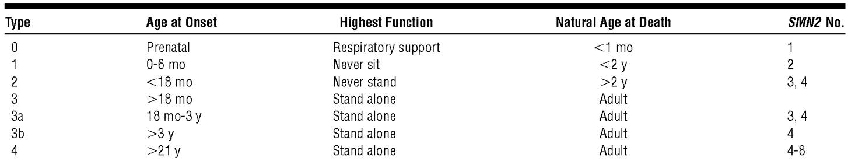
SMN2 No. = number of copies of survival motor neuron 2 (SMN2) gene present; mo = months; y = years.
Source: Kolb (2011)
SMA is conventionally classified into four phenotypes (types 1 to 4, see Table 1) based on the age of symptom onset and highest motor function achieved, with an additional phenotype (type 0) describing the rare pre-natal form. Type 1 is the most common phenotype, and without treatment, is characterised by the onset of symptoms prior to 6 months of age, failure to achieve independent sitting, and death before the age of 2 years.
Advances in ventilatory and nutritional support, and the emergence of disease-modifying therapy, are contributing to improvements in survival, but treatment options are limited as only one medicine, Spinraza (nusinersen), was registered in Australia for the treatment of SMA. Spinraza is an antisense oligonucleotide drug designed to increase the production of the SMN protein by modulating the splicing of the SMN2 gene. It is administered intrathecally (IT), with an induction phase followed by long-term maintenance doses.
Zolgensma is a recombinant adeno-associated virus serotype 9 (AAV9) vector-based gene therapy designed to deliver a normal copy of the gene encoding the SMN protein. The SMN gene in Zolgensma is designed to reside as a DNA episome in the nucleus of transduced cells, rather than being integrated into the chromosome. The clinical rationale is to increase the expression level of the SMN protein in motor neurons prior to the onset of irreversible motor neuron loss, thereby modifying the course of the disease and prolonging survival.
Zolgensma is the second in vivo gene therapy for which registration has been sought in Australia, and the first involving IV administration.
The product contains a genetically modified organism (GMO).On 26 May 2020, the Office of the Gene Technology Regulator (OGTR) issued a Dealings Not Involving an Intentional Release (DNIR) of GMOs into the environment licence to the sponsor under DNIR-621 for the supply of Zolgensma for the treatment of patients with SMA.

Regulatory status
This product is considered a new biological entity for Australian regulatory purposes.
At the time the TGA considered this application, a similar application had been approved in the United States (US), European Union (EU), Japan, Canada and Brazil (see Table 2), and was under consideration in Israel (submitted 1 July 2019), Taiwan (submitted 26 December 2019), Argentina (submitted 20 January 2020), South Korea (submitted 30 January 2020) and Russia (submitted 16 July 2020).
Table 2: International regulatory approvals as of February 2021
Region | Submission date | Status | Approved indications
US | 1 October 2018 | Approved on 24 May 2019 | Zolgensma (onasemnogene abeparvovec-xioi) is an adeno-associated virus vector-based gene therapy indicated for the treatment of pediatric patients less than 2 years of age with spinal muscular atrophy (SMA) with bi-allelic mutations in the survival motor neuron 1 (SMN1) gene.  Limitation of Use:  - The safety and effectiveness of repeat administration of Zolgensma have not been evaluated.  - The use of Zolgensma in patients with advanced SMA (e.g., complete paralysis of limbs, permanent ventilator dependence) has not been evaluated.
EU (Centralised procedure) | 11 October 2018 | Conditionally approved on 18 May 2020 | Zolgensma is indicated for the treatment of:  - patients with 5q spinal muscular atrophy (SMA) with a bi-allelic mutation in the SMN1 gene and a clinical diagnosis of SMA Type 1, or  - patients with 5q SMA with a bi-allelic mutation in the SMN1 gene and up to 3copies of the SMN2 gene.
Japan | 1 November 2018 | Approved on 19 March 2020 | Spinal muscular atrophy (including those who do not develop clinical findings but are predicted to develop spinal muscular atrophy by genetic testing), but only patients with anti AAV9 antibodies negative.  Precautions-related to Indications (refer to country product information for full text)  - Zolgensma should be administered to patients with biallelic deletions or mutations in SMN1 gene.  - Zolgensma should be administered to patients less than 2 years of age  - Efficacy and safety of Zolgensma in patients with advanced spinal muscular atrophy (e.g., permanent ventilator-dependence) have not been established. Therefore, the risks and benefits of the administration should be fully considered when Zolgensma is administered to these patients.  - Zolgensma should be administered to patients whose anti-AAV9 Ab is confirmed as negative by approved in-vitro diagnostics.
Canada | 21 May 2020 | Approved on 15 December 2020 | Zolgensma (onasemnogene abeparvovec) is indicated for the treatment of pediatric patients with 5q spinal muscular atrophy (SMA) with bi-allelic mutations in the survival motor neuron 1 (SMN1) gene and:  - 3 or fewer copies of SMN2 gene; or  - infantile-onset SMA.  The efficacy and safety data supporting the use of Zolgensma in treating pediatric patients with SMA are derived from completed and ongoing open-label, single-arm, clinical trials in patients with:  - infantile-onset SMA and 2 copies of SMN2 gene; and  - presymptomatic genetically diagnosed SMA and 2 or 3 copies of SMN2 gene (see 14 Clinical Trials).  Zolgensma is an adeno-associated virus (AAV) vector-based gene therapy. Knowledge of the disease natural history and the use of management strategies that assist the patient in coping with the manifestations of SMA, which can include decline in motor function, serious respiratory complications, and feeding difficulties, remain necessary for the overall management of the disease. Administration of Zolgensma should only be performed by healthcare professionals who are experienced in the screening, diagnosis, and management of SMA and trained in the delivery of gene therapy.
Brazil | 15 January 2020 | Approved on 17 August 2020 | Zolgensma is a gene therapy based on an adeno-associated viral vector, indicated for the treatment of pediatric patients under 2 years of age with spinal muscular atrophy (SMA), with:  - Bi-allelic mutations in the survival motor neuron 1 (SMN1) gene and a clinical diagnosis of SMA Type 1, or  - Bi-allelic mutations in the SMN1 gene and up to 3 copies of the SMN2 gene

Product Information
The Product Information (PI) approved with the submission which is described in this AusPAR can be found as Attachment 1. For the most recent PI, please refer to the TGA website at <https://www.tga.gov.au/product-information-pi>.

II. Registration timeline
The following table captures the key steps and dates for this application and which are detailed and discussed in this AusPAR.
Table 3: Timeline for Submission PM-2019-05979-1-3
Description | Date
Designation (Orphan) | 13 November 2019
Submission dossier accepted and first round evaluation commenced | 29 January 2020
First round evaluation completed | 30 June 2020
Sponsor provides responses on questions raised in first round evaluation | 31 August 2020
Second round evaluation completed | 19 October 2020
Delegate’s Overall benefit-risk assessment and request for Advisory Committee advice | 29 October 2020
Sponsor’s pre-Advisory Committee response | 11 November 2020
Advisory Committee meeting | 3 and 4 December 2020 4 and 5 February 2021
Registration decision (Outcome) | 24 February 2021
Completion of administrative activities and registration on the ARTG | 4 March 2021
Number of working days from submission dossier acceptance to registration decision* | 199
*Statutory timeframe for standard applications is 255 working days

III. Submission overview and risk/benefit assessment
The submission was summarised in the following Delegate’s overview and recommendations.
The Delegate referred to the following guidance documents:
- European Medicines Agency (EMA), Committee for Proprietary Medicinal Products (CPMP), Note for Guidance on the Quality, Preclinical and Clinical Aspects of Gene Transfer Medicinal Products, CPMP/BWP/3088/99, 24 April 2001.
- EMA, Committee for Advanced Therapies (CAT), Guideline on the quality, non-clinical and clinical aspects of gene therapy medicinal products. EMA/CAT/80183/2014, 22 March 2018.
- EMA, Committee for the Medicinal Products for Human Use (CHMP), Reflection paper on quality, non-clinical and clinical issues related to the development of recombinant adeno‑associated viral vectors. EMEA/CHMP/GTWP/587488/2007, 24 June 2010.
- EMA, Gene Therapy Product Quality Aspects in the Production of Vectors and Genetically Modified Somatic Cells, 3AB6A, 31 December 1994.
- EMA, CHMP, Guideline on Non-Clinical Testing for Inadvertent Germline Transmission of Gene Transfer Vectors, EMEA/273974/2005, 16 November 2006.
- EMA, CHMP, Guideline on Clinical Trials in Small Populations, CHMP/EWP/83561/2005, 27 July 2006.

Quality
Zolgensma (onasemnogene abeparvovec, AVXS-101) is a non-replicating recombinant AAV9 vector containing the complementary deoxyribonucleic acid (cDNA) of the human SMN gene under the control of the cytomegalovirus enhancer/chicken-β-actin-hybrid promoter. AVXS-101 is produced by co-transfection of human embryonic kidney 293 (HEK293) cells with three plasmids:
- Vector plasmid (pSMN).
- AAV plasmid (pAAV2/9) containing the AAV REP2 and CAP9 wild-type genes.
- Adenovirus helper plasmid (pHELP).
All manufacturing steps and analytical procedures are validated. There are no outstanding issues pertaining to specifications.
Zolgensma is formulated at 2 x 10¹³ vg/mL and is supplied in vials with two fill volumes: 5.5 mL and 8.3 mL. Three ARTG entries are required: one for the 5.5 mL vial, one for the 8.3 mL vial, and one for the composite pack comprising combinations of the 5.5 mL and 8.3 mL vials (see Table 4).
Table 4: Proposed presentations of Zolgensma
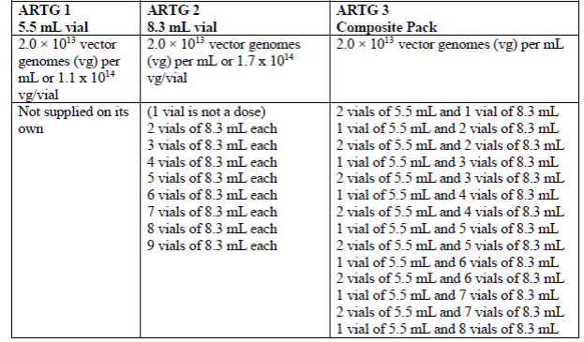
The recommended dose of Zolgensma is a single intravenous infusion of 1.1 x 10¹⁴ vector genomes per kilogram of body weight (vg/kg). The number of vials of each fill volume supplied to a patient is customised according to the patient’s bodyweight. A variable print label will be applied to the carton detailing the number and strength of vials within the carton, the batch number and expiry of the products and a machine-readable code (see Figure 1). The sponsor has satisfactorily addressed the evaluator’s concerns relating to labelling.
Figure 1: Variable print label for Zolgensma
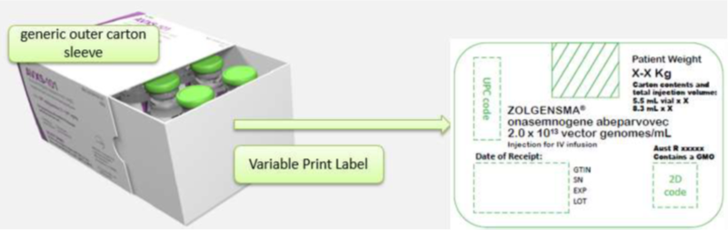
The PI, Consumer Medicines Information (CMI) and labels are acceptable from a quality perspective. The proposed labels do not conform to the requirements of the Therapeutic Goods Order No. 91 - Standard for labels of prescription and related medicines, so the sponsor has requested consent under Sections 14 and 14A of the Therapeutic Goods Act 1989 to the import and supply of therapeutic goods that do not conform to a standard. This request is being assessed in parallel to the application for registration.
Overall, sufficient evidence has been provided to demonstrate that the risks related to the manufacturing quality of Zolgensma have been controlled to an acceptable level. There are no objections to the registration of Zolgensma from sterility, endotoxin, container safety, and viral safety related aspects.

Proposed quality conditions of registration
- Laboratory testing and compliance with Certified Product Details (CPD)
  - All batches of Zolgensma supplied in Australia must comply with the product details and specifications approved during evaluation and detailed in the Certified Product Details (CPD).
  - When requested by the TGA, the sponsor should be prepared to provide product samples, specified reference materials and documentary evidence to enable the TGA to conduct laboratory testing on the Product. Outcomes of laboratory testing are published biannually in the TGA Database of Laboratory Testing Results http://www.tga.gov.au/ws-labs-index and periodically in testing reports on the TGA website.
- Certified Product Details
The Certified Product Details (CPD), as described in Guidance 7: Certified Product Details of the Australian Regulatory Guidelines for Prescription Medicines (ARGPM) (http://www.tga.gov.au/industry/pm-argpm-guidance-7.htm), in PDF format, for the above products should be provided upon registration of these therapeutic goods. In addition, an updated CPD should be provided when changes to finished product specifications and test methods are approved in a Category 3 application or notified through a self-assessable change.

Nonclinical
Onasemnogene abeparvovec is a non-integrating, non-replicating viral vector expressing the human SMN transcript. In a murine model of severe SMA, onasemnogene abeparvovec increased survival, restored neuromuscular transmission and locomotor function, and improved cardiac function. The animal data indicated dosing at early stages of the disease is necessary for efficacy. A minimum efficacious dose was not determined. The safety and efficacy of repeated doses of onasemnogene abeparvovec have not been assessed.
Biodistribution studies demonstrated high levels of vector DNA in the heart, lung, liver, central nervous system (CNS) and skeletal muscle. Relative levels in the heart of non-human primates and humans appears to be lower than that in mice.
Studies in animals revealed the following findings of potential clinical relevance:
- neurotoxicity (inflammation of the dorsal root ganglia (DRG) and axonal degeneration),
- cardiotoxicity, with secondary effects on electrocardiogram (ECG) parameters,
- hepatotoxicity,
- disseminated intravascular coagulation,
- innate and adaptive immune responses.
The 6 week interim euthanasia of an ongoing, Good Laboratory Practice (GLP)-compliant, non-human primate study of IT-administered onasemnogene abeparvovec showed the CNS (brain and spinal cord) as a target organ of toxicity for onasemnogene abeparvovec. Findings included minimal, multifocal and clinically silent dorsal root ganglion degeneration with mononuclear inflammation, consistent with previous findings from the preliminary non-GLP non-human primate study. Histopathological findings in the brain included minimal neuronal degeneration/satellitosis in the cerebellar nuclei, minimal or slight multifocal gliosis in the cerebrum, cerebellum and brain stem, and/or slight axonal degeneration in the cerebellar white matter. Other spinal cord findings in the dorsal funiculus, or ascending white matter tract of the spinal cord were observed in this study and were considered secondary to microscopic findings in the DRG. These findings indicate a risk of neuronal effects with IT-administered onasemnogene abeparvovec. The risk of neuronal effects with IV-administered onasemnogene abeparvovec, where CNS levels of the drug will be lower, is considered lower but still possible. Age-appropriate neurological assessments are included in ongoing clinical trial protocols.
No genotoxicity or carcinogenicity studies have been conducted with onasemnogene abeparvovec. The vector has been designed to remove the site-specific integration feature. The integration and oncogenic potential of onasemnogene abeparvovec is not certain, but the risk of an integration event for onasemnogene abeparvovec in non-human primates and humans appears low, and if an integration event is to occur, it is anticipated to have a low risk for carcinogenicity. Based on the low risk for integration and carcinogenicity, the nonclinical evaluator supports the nonclinical safety specification of the risk management plan, which includes long-term follow-up studies that specifically include the occurrence of new malignancies and tumours.
No reproductive or developmental studies were submitted. There was limited distribution and persistence of vector DNA in the gonads of treated mice. Given the age of the intended patient group (< 2 years), the risk of germline transmission is considered extremely low. Therefore, the absence of reproductive and developmental toxicity studies is considered acceptable.
Due to a steep toxicity curve, the accuracy of viral titres is important. The specifications for viral titres should be as tight as possible.
There are no objections to the proposed registration of Zolgensma for the proposed indication, provided:
- the specifications for the viral titres are as tight as possible and the analytical method for viral titres is sufficiently reliable; and
- there is adequate clinical monitoring and management available for the identified potential adverse effects identified above.
The PI is considered acceptable from a nonclinical perspective.

Clinical
Clinical studies presented in the clinical portion of the dossier include:
- One completed Phase I study (Study AVXS-101-CL-101).
- One completed Phase III study (Study AVXS-101-CL-303).
- Five ongoing studies:
  - One long-term extension (Study AVXS-101-LT-001) of the completed Phase I study.
  - One Phase III intravenous study in patients with SMA type 1 (Study AVXS-101-CL-302, enrolment completed).
  - One Phase III intravenous study in pre-symptomatic newborn patients expected to develop SMA type 1 or 2 (Study AVXS-101-CL-304, enrolment completed).
  - One Phase III intravenous study in patients in Japan, Taiwan, and South Korea with SMA type 1 (Study AVXS-101-CL-306, enrolment ongoing). The summary of clinical efficacy (31 December 2019) reported interim results for a single patient.
  - One Phase I study of IT administered AVXS-101 in patients with SMA type 2 (Study AVXS-101-CL-102). This study does not inform efficacy in the proposed use (IV), so this study is primarily included for safety analysis.
Table 5: Summary of clinical studies
Study ID  Phase  Location | Study design/ control; route and duration of treatment | Number of subjects planned  Healthy or diagnosed subjects  Intent to treat population | SMA type (SMN2 Copy No.) | Study status Data included in submission (Yes/No)
AVXS-101-CL-101  Phase I  United States | Open label single centre; IV, single dose | 15  Patients with SMA type 1  All patients had a clinical diagnosis of SMA type 1 before 6 months of age, confirmed SMN1 bi-allelic gene mutations (deletion or point mutation). and 2 copies of SMN2 with no known genetic modifier mutation | 1 (2) | Completed  Yes
AVXS-101-CL-303  Phase III  United States | Open label single arm multicentre; IV, single dose | Up to 20  Patients with SMA type 1 with 1 or 2 copies of SMN2 < 6 months of age at the time of gene replacement therapy.  Patients with a clinical diagnosis of SMA type 1 before 6 months of age. SMN1 bi-allelic gene deletion and 2 copies of SMN2 with no known genetic modifier mutation | 1 (1, 2) | Completed  Yes
AVXS-101-CL-304 Phase III Australia, Belgium, Canada, Germany, Israel, Italy, Japan, Netherlands, South Korea, Spain, Taiwan, United Kingdom, United States | Open label single arm, multicentre; IV, single dose | ≥27: ≥ 15 with 2 copies of SMN2, ≥ 12 with 3 copies of SMN2  Pre-symptomatic patients with SMA type 1 or 2, with 2 or 3 copies of SMN2. ≤ 6 weeks of age at the time of gene replacement therapy  Patients with bi-allelic SMN1 deletion and 2 or 3 copies of SMN2 with no known genetic modifier | 1, 2 (2, 3) | Ongoing  Enrolment completed 8 November 2019  Yes*
AVXS-101-CL-302  Phase III  Europe | Open label single arm, multicentre; IV, single dose | Up to 30  Patients with SMA type 1 with 1 or 2 copies of SMN2 < 6 months of age at the time of gene replacement therapy.  Patients with a clinical diagnosis of SMA type 1 before 6 months of age. SMN1 bi-allelic gene deletion and 2 copies of SMN2 with no known genetic modifier | 1 (1, 2) | Ongoing  Enrolment completed on 21 May 2019  Yes*
AVXS-101-CL-306 Phase III Japan, Taiwan, and South Korea | Open label multicentre; IV, single dose | 6  Patients with SMA type 1  Patients with a clinical diagnosis of SMA type 1 before 6 months of age. SMN1 bi-allelic gene deletion and 2 copies of SMN2 with no known genetic modifier. | 1 (2) | Ongoing  Yes*
AVXS-101-LT-001 Long-term follow-up  United States | Observational; Not applicable, Patients will be followed for up to 15 years | Up to 15  Patients treated with AVXS-101 in Study CL- 101  Not applicable | 1 (2) | Ongoing  Yes*
AVXS-101-CL-102 Phase I United States | Open label dose comparison safety study of 3 potential therapeutic doses, multicentre; IT, single-dose | Up to 51  Patients with SMA type 2 or 3 with 2 copies of SMN2 aged 6 to 60 months  Infants and children with a genetic diagnosis consistent with SMA. bi-allelic deletion of SMN1 and 3 copies of SMN2 without the genetic modifier who can sit but cannot stand or walk at the time of study entry | 2, 3 (3) | Ongoing  Yes*
AVXS-101-LT-002 Long-term follow-up  United States and Asia | Observational; Not applicable, Patients will be followed for up to 15 years | TBD  Patients treated with AVXS-101 in prior efficacy/safety studies  Not applicable | 1, 2, 3 (1, 2, 3, and 4) | Ongoing  No
AVXS-101-CL-305 Phase III TBD | Open label, multicentre; IT, single-dose | 73  Patients with genetically diagnosed SMA type 1. 2. or 3, to be enrolled in 4 cohorts.  All enrolled patients who receive the AVXS-101-IT injection in each cohort. | 1, 2, 3 (2, 3, 4) | Planned  No
IT = intrathecal; IV= intravenous; SMA = spinal muscular atrophy; SMN1 = survival motor neuron gene 1; SMN2 = survival motor neuron gene 2; TBD = to be determined.
* Partial data; all available data as of 31 December 2019.

Pharmacology

Pharmacokinetics
Conventional clinical pharmacokinetics studies were not submitted as they are not applicable to a viral vector-based gene therapy. The sponsor assessed clearance of AVXS-101 by measuring viral vector shedding in Studies AVXS-101-CL-101 and AVXS-101-CL-303. Biodistribution of AVXS-101 was assessed in two patients in clinical studies who died, one from Study AVXS-101-CL-303 and one from Study AVXS-101-CL-302.

Viral vector shedding
Five patients from Study AVXS-101-CL-101 (study details in the ‘Efficacy’ section, below) were included in the viral vector shedding sub-study, all of whom received the dose proposed for registration. Following IV administration of AVXS-101, samples of saliva, urine, and stool were collected at weekly time points through Day 30 and then monthly time points through Month 12 and every 3 months thereafter. Vector DNA was identified in stool, saliva and urine after infusion of AVXS-101, with substantially higher concentrations in stool than in saliva or urine. Vector DNA was detectable in stool at Day 1 post infusion. The concentration of vector DNA in stool declined substantially by Day 30, and was below the limit of quantitation for all patients by Day 60. Concentrations of vector DNA in urine and saliva were much lower than in stool. Assessment of shedding in Study AVXS-101-CL-303 showed a similar pattern, with viral vector being shed predominantly in stool, and declining to very low levels by Day 30.

Biodistribution
Biodistribution of AVXS-101 was assessed in human tissues following the death of two patients, one in Study AVXS-101-CL-303 and one in Study AVXS-101-CL-302. For both patients, AVXS-101 vector genomes and RNA transcripts were detected in the CNS and in peripheral organs and tissues, including the liver, heart, and skeletal muscle. SMN protein expression in motor neurons was detected in all regions of the spinal cord and in all regions of the brain that were evaluated. A low level of vector genome and expression was noted in the testis and ovary.

Pharmacodynamics
There were no primary pharmacodynamic studies. The sponsor commented on the challenges in measuring SMN expression in motor neurons (the therapeutic target). Exploratory pharmacodynamic measures (compound motor action potentials, and motor unit number estimation) in Study AVXS-101-CL-101 were favourable compared to expected outcomes in untreated patients, supporting the major clinical endpoints of this study.

Immunogenicity
All subjects in the clinical studies were required to have anti-AAV9 titre of ≤ 1:50 prior to AVXS-101 administration. All subjects except the first subject in Study AVXS-101-CL-101 were pre-treated with prednisolone (1 mg/kg/day) to reduce the risk of immune-mediated liver toxicity. Serological tests included enzyme linked immunosorbent assay (ELISA) for anti-human survival motor neuron (anti-hSMN) and anti-AAV9 immunoglobulin G (IgG) antibodies. T cell-mediated immunity to AAV9 and SMN was monitored by enzyme-linked immunospot (ELISpot).
High anti-AAV9 antibody titres occurred following infusion of AVXS-101 in all subjects. No antibody or T-cell immune response against the SMN protein was observed.

Efficacy
The application included two completed efficacy studies, the Phase I Study AVXS-101-CL-101 and the Phase III Study AVXS-101-CL-303. Neither study included a direct comparator arm, but the natural history of the study population has been well-defined in recent observational studies, allowing meaningful assessment of the key efficacy endpoints in the absence of a randomised controlled design. The Pediatric Neuromuscular Clinical Research (PNCR) dataset, reported by Finkel et al. (2014);3, and the NeuroNext dataset, reported by Kolb et al. (2017),, provided natural history control data for efficacy comparisons.

Study AVXS-101-CL-101
Study AVXS-101-CL-101 was a Phase I, single centre, open label, single infusion, ascending dose study of the safety and efficacy of intravenous AVXS-101 in 15 patients with type 1 SMA.
The primary objective was to assess the safety of AVXS-101. Efficacy objectives were secondary.
Key inclusion criteria included:
- type 1 SMA with bi-allelic SMN1 mutations (deletion or point mutation) and 2 copies of SMN2; and
- age ≤ 6 months with clinical evidence of disease onset up to 6 months of age (an earlier version of the study protocol allowed patients aged ≤ 9 months).
Key exclusion criteria included:
- invasive ventilatory support (tracheotomy with positive pressure) or pulse oximetry < 95% at screening (non-invasive ventilatory support for < 16 hours/day was permitted at the discretion of the treating physician);
- anti-AAV9 antibody titre > 1:50;
- abnormal laboratory values considered to be clinically significant (gamma-glutamyl transferase (GGT) > 3 x the upper limit of normal (ULN), bilirubin ≥ 3.0 mg/dL, creatinine ≥ 1.8 mg/dL, haemoglobin < 8 or > 18 g/dL, white blood cell count > 20,000 per mm³); and
- c.859G > C modification in exon 7 (associated with a more favourable prognosis).
Treatment involved a single IV infusion of AVXS-101. The study had an ascending dose design: 3 patients received the ‘low’ dose (6.7 x 10¹³ vg/kg; known as Cohort 1) and 12 patients received the ‘intermediate’ dose (2.0 x 10¹⁴ vg/kg; known as Cohort 2). Progression to the ‘high’ dose (3.3 x 10¹⁴ vg/kg) did not proceed based on the efficacy achieved with the intermediate dose and concern regarding potential safety risks with the higher dose. Following refinement of the assay for estimating the number of vector genome copies, the ‘intermediate’ dose used in this study was reassessed as 1.1 x 10¹⁴ vg/kg, which is the dose proposed for registration.
In response to abnormal liver function tests in the first patient treated, a protocol amendment resulted in all subsequent patients receiving prednisolone at approximately 1 mg/kg/day starting 24 hours prior to infusion to dampen the immune response to the viral vector therapy.
All 15 enrolled patients received treatment with AVXS-101, 3 at the lower dose and 12 at the intermediate dose (the proposed dose), and all 15 completed the study (final review was 24 months post-treatment).
All patients had bi-allelic deletions of SMN1 and 2 copies of SMN2, and none had the c.859G > C mutation. All patients had symptom onset by 3 months of age. The mean age of the patients on the day of AVXS-101 administration was greater in Cohort 1 (6.3 months, range 5.9 to 7.2 months) than Cohort 2 (3.4 months, range 0.9 to 7.9 months).
Demographic and baseline characteristics of subjects and historical controls are shown in Table 6. The earlier age of clinical onset in subjects in Study AVXS-101-CL-101 compared to the PNCR control group would potentially bias against the treatment.
The primary efficacy endpoint was survival without permanent ventilation (defined as ≥ 16 hour respiratory assistance per day continuously for ≥ 2 weeks in the absence of an acute reversible illness, excluding perioperative ventilation). Analyses were performed at 13.6 months of age, 20 months of age, and at 24 months post-treatment (end of study), and the outcomes were compared against historical controls from the PNCR;3 and NeuroNext datasets.2 Data cut-off dates for the efficacy analyses at 13.6 months, 20 months and end of study were 20 January 2017, 7 August 2017 and 14 December 2017, respectively.
Secondary efficacy endpoints included the change from baseline in CHOP INTEND score, and the achievement of major motor milestones, including the ability to sit alone and roll over unassisted.
Table 6: Study AVXS-101-CL-101 (Cohort 2) Demographic and baseline characteristics and historical comparators
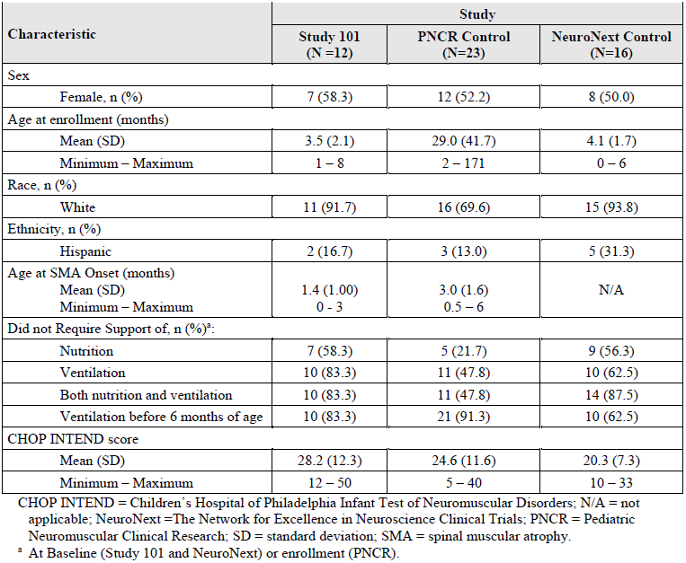
The primary efficacy endpoint was strongly positive relative to historical controls. At 13.6 months of age, all 15 patients (100%) in Study AVXS-101-CL-101 survived without permanent ventilation, which compares favourably to 25% event-free survival for historical controls from the PNCR dataset. At 20 months of age, all 15 patients (100%) in Study AVXS-101-CL-101 survived event-free, compared to 8% event-free survival for the PNCR historical controls. At the final review 24 months post-treatment, 14 patients (93%) in Study AVXS-101-CL-101 (including all 12 patients in Cohort 2) survived event-free, compared to < 8% event-free survival for the PNCR historical controls. One patient in Cohort 1 required ventilatory assistance which met the event criteria at 28 months of age in the lead up to surgery on the salivary glands, after which the need for ventilatory support decreased back below the event threshold. Figure 2 shows a Kaplan-Meier estimate of survival (time to event) for the study population (Cohort 2), compared with historical comparators (the PNCR and NeuroNext cohorts).
Figure 2: Study AVXS-101-CL-101 (Cohort 2) Kaplan-Meier estimate of survival (time to event) for the study population and historical comparators
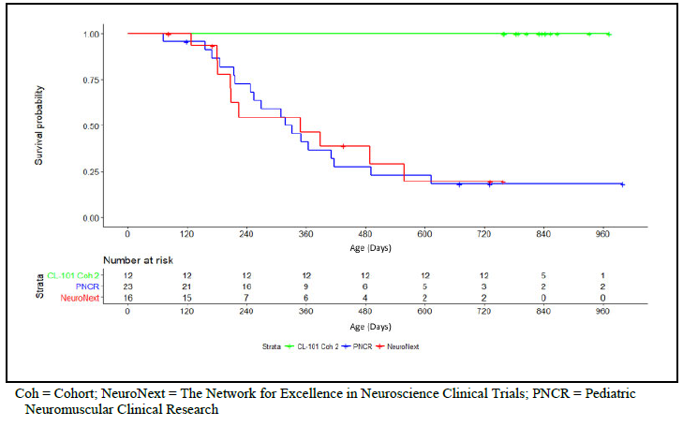
Motor function as assessed by CHOP INTEND scores improved from baseline in both cohorts (see Figure 3, Cohort 1 blue line, Cohort 2 red line), though the improvement was notably greater in cohort 2. At the end of the study, 11 of 12 (91.7%) Cohort 2 patients achieved a CHOP INTEND score ≥ 50. In contrast, in the PNCR historical dataset, CHOP INTEND scores overall declined progressively over time and no patient achieved a score > 40 beyond 12 months of age. The NeuroNext cohort also showed progressive decline in CHOP INTEND scores over time.
None of the patients in Cohort 1 achieved any motor milestones, but patients in Cohort 2 achieved motor milestones that would not be expected based on the natural history of SMA type 1 with disease onset before 3 months of age (see Table 7 and Table 8).
Figure 3: Study AVXS-101-CL-101, CHOP INTEND change from Baseline by patient and cohort 24 months after AVXS-101 infusion (full analysis set)
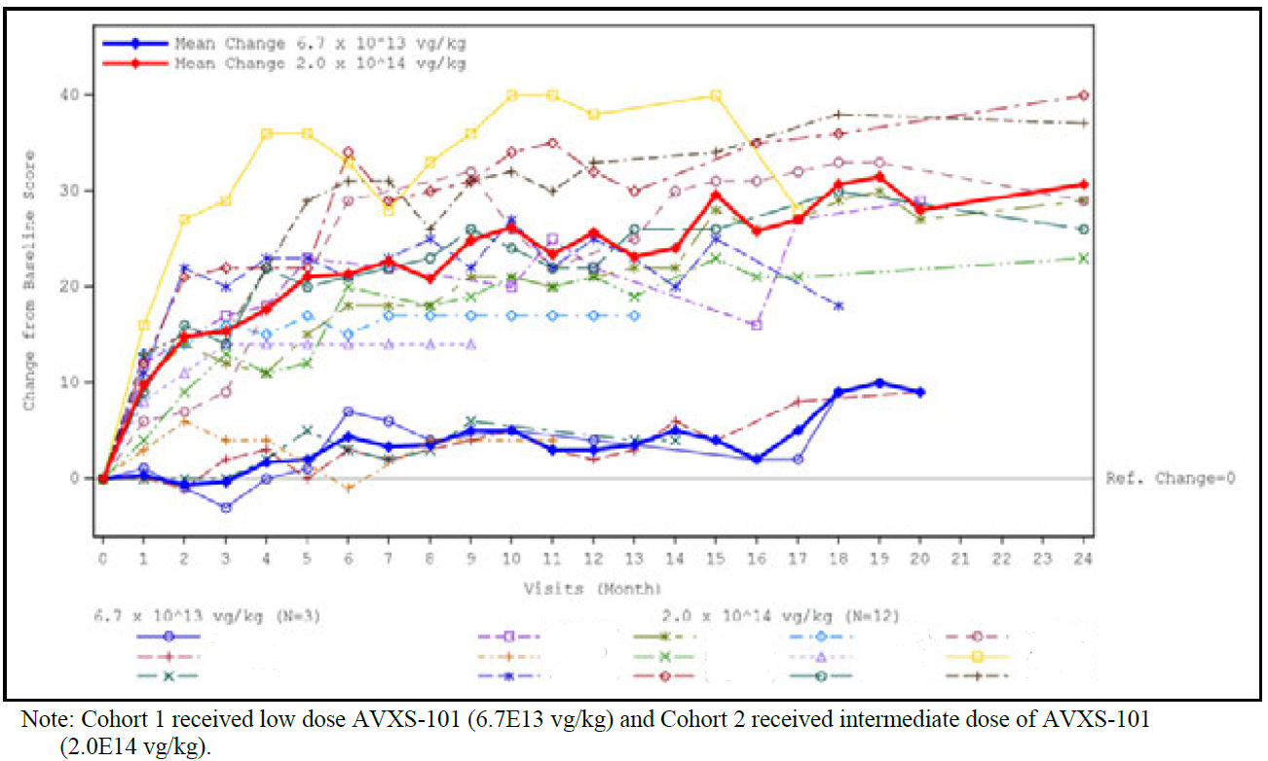
Each line represents an individual patient. Patient IDs have been redacted.
Table 7: Study AVXS-101-CL-101 Patients who achieved significant motor function milestones at 13.6 months based on independent central review (full analysis set)
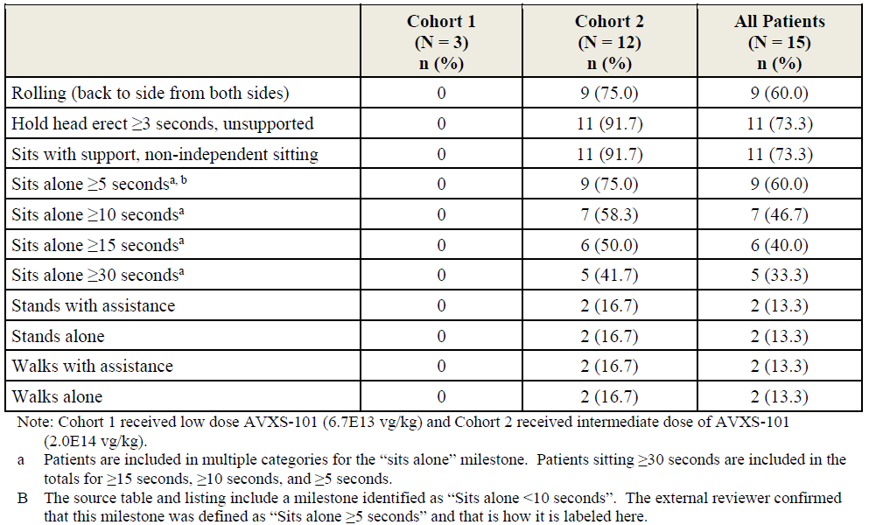
Table 8: Study AVXS-101-CL-101 Patients who achieved significant motor function milestones at 24 months based on independent central review (full analysis set)
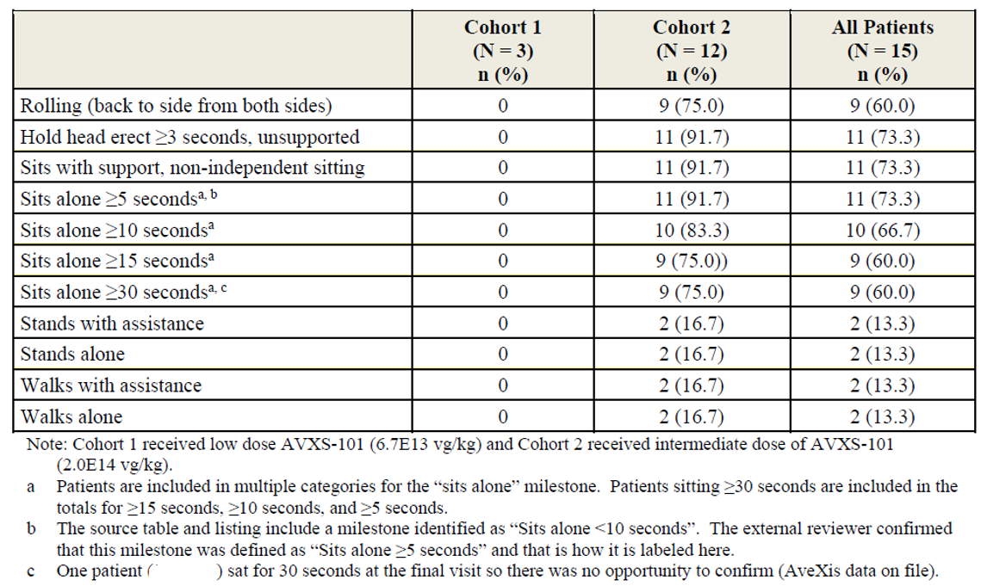

Study AVXS-101-CL-303
Study AVXS-101-CL-303 was a Phase III, open label, single arm, single dose study of intravenous AVXS-101 in patients with SMA type 1 with bi-allelic SMN1 mutations (deletions or point mutations) and 1 or 2 copies of the SMN2 gene. Patients had to be aged < 6 months at the time of the infusion.
Intent to treat (ITT) criteria were developed to enable direct comparison between the ITT population in Study AVXS-101-CL-303 and Cohort 2 from Study AVXS-101-CL-101. To be included in the ITT population, patients had to be symptomatic for SMA before 6 months of age and have bi-allelic SMN1 deletions and only 2 copies of SMN2, without the c.859G > C mutation.
Although the study design allowed the recruitment of a broader spectrum of patients than were evaluated in Study AVXS-101-CL-101, including pre-symptomatic patients, patients with 1 copy of SMN2, and patients with the c.859G > C mutation, ultimately all 22 patients enrolled in Study AVXS-101-CL-303 met the ITT criteria.
Exclusion criteria included:
- tracheostomy, or requiring non-invasive ventilatory support ≥ 6 hours/day;
- anti-AAV9 antibody titre > 1:50;
- abnormal laboratory values considered to be clinically significant (GGT, alanine aminotransferase (ALT), aspartate transaminase (AST) > 3 × ULN, creatinine ≥ 1.0 mg/dL, haemoglobin < 8 or > 18 g/dL, white blood cell count > 20,000 per mm³); and
- prior treatment with nusinersen or other therapies intended to treat SMA.
The study was conducted in 12 centres in the USA. The first patient was enrolled on 24 October 2017 and the last patient visit was on 12 November 2019.
The co-primary objectives were:
- to determine the efficacy of AVXS-101 by demonstrating achievement of functional independent sitting for ≥ 30 seconds at 18 months of age; and
- to determine the efficacy of AVXS-101 based on survival without permanent ventilation at 14 months of age.
Secondary objectives were:
- to determine the effect of AVXS-101 on the ability to thrive; and
- to determine the effect of AVXS-101 on the ability to remain independent of ventilatory support.
All 22 patients received a single IV infusion of AVXS-101 at a dose of 1.1 × 10¹⁴ vg/kg, which is the dose proposed for registration. All patients received prednisolone at approximately 1 mg/kg/day, beginning 24 hours prior to infusion and continuing until at least 30 days post-infusion, after which the dose could be tapered based on liver function tests and T cell response.
The mean age at AVXS-101 administration was 3.7 months (range 0.5 to 5.9 months). No patients required feeding or ventilatory support at Baseline, in contrast to Study AVXS 101-CL-101 where 5 patients (33.3%) required at least some ventilatory support at Baseline.
Nineteen patients completed the study. Three patients discontinued from the study (one due to an adverse event (AE), one death, one withdrawal). All efficacy analyses were performed on the ITT population, which included all 22 patients.
The co-primary efficacy endpoints were:
- the proportion of patients that achieved functional independent sitting for ≥ 30 seconds at 18 months of age; and
- survival without permanent ventilation at 14 months of age.
The co-secondary efficacy endpoints were:
- The proportion of patients maintaining the ability to thrive at 18 months of age, defined as achieving all of the following:
  - does not receive nutrition through mechanical support (for example, feeding tube) or other non-oral method;
  - ability to tolerate thin liquids as demonstrated through a formal swallowing test; and
  - maintains weight (> third percentile for age and gender).
- The proportion of patients who were independent of ventilatory support at 18 months of age, defined as requiring no daily ventilator support/usage, excluding acute reversible illness and peri-operative ventilation.
Exploratory efficacy endpoints included motor milestones, CHOP INTEND scores and Bayley Scales.
For the first co-primary endpoint, 13 of 22 patients (59.1%) were able to sit independently for ≥ 30 seconds at 18 months of age; one additional patient achieved it at an earlier age point, but not at 18 months. The mean age when this milestone was first demonstrated was 12.91 months (range 9.2 to 18.6 months). This represents a significant improvement compared to PNCR historical controls, none of whom were able to achieve independent sitting.
For the second co-primary endpoint, 20 of 22 patients (90.9%) survived without permanent ventilation at 14 months. This represents a significant improvement compared to the 25% event-free survival at this age in the PNCR historical cohort (p < 0.0001). The same 20 patients (90.9%) survived event-free at 18 months of age. The two patients who discontinued prior to 13.6 months of age included one who died at age 7.8 months due to respiratory failure and another who discontinued (withdrew consent) at 11.9 months of age, having met permanent ventilation criteria prior to withdrawal of consent. Figure 4 shows a Kaplan-Meier plot for event free survival for the study cohort and the historical comparator (PNCR cohort).
Figure 4: Study AVXS-101-CL-303 Kaplan-Meier plot for event-free survival
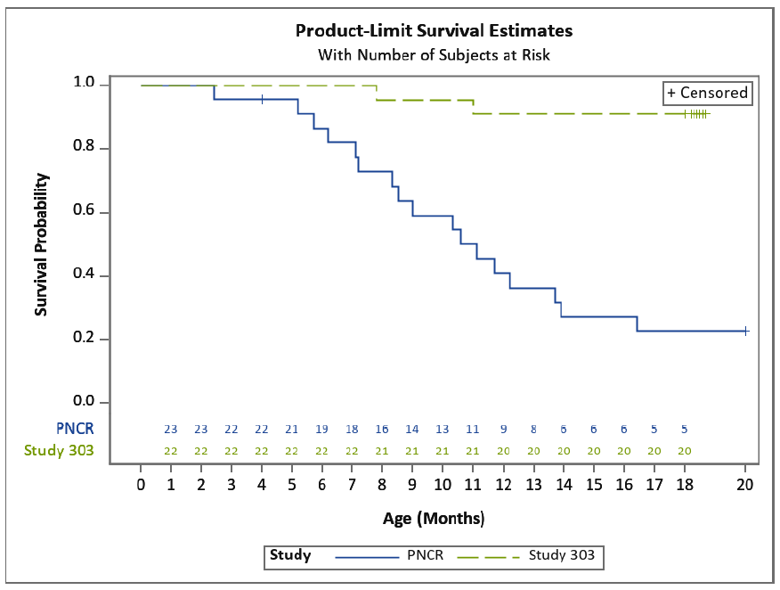
For the first co-secondary endpoint, 9 of 22 patients (40.9%) met all three criteria for ability to thrive at 18 months, compared to an expected value of zero in the PNCR cohort.
For the second co-secondary endpoint, 18 of 22 patients (81.8%) remained independent of ventilatory support at 18 months of age. Two patients used a bi-level positive airway pressure (BiPAP) device, and 2 patients had withdrawn from the study prior to 18 months of age. From historical data, virtually all untreated patients would be expected to require permanent ventilatory support by 18 months of age.
Other video-confirmed motor milestones included:
- 17 patients achieved head control;
- 13 patients achieved rolling from back to side;
- 14 patients achieved sitting without support for at least 30 seconds;
- 1 patient achieved the motor milestones of crawling, pulling to stand, standing with assistance, walking with assistance, standing alone, and walking alone, as defined by the Bayley gross motor scale.
The mean increases in CHOP INTEND scores from Baseline to Month 1, Month 3, Month 6, Month 12 and Month 14 were 6.9, 11.7, 14.6, 16.4, and 23.5 points, respectively. 21 patients (95.5%) achieved a CHOP INTEND score ≥ 40, 14 (63.6%) achieved a score ≥ 50, and 5 (22.7%) achieved a score ≥ 60, from a maximum possible score of 64. For most patients, individual CHOP INTEND scores improved over the duration of the study (Figure 5).
Figure 5: Study AVXS-101-CL-303 CHOP INTEND score by age (intent to treat population)
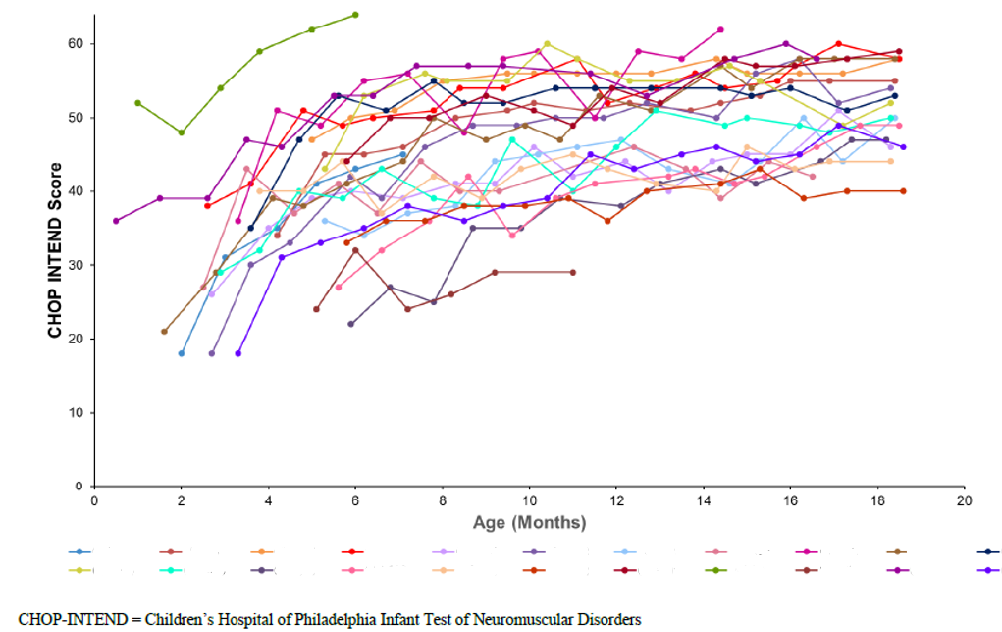
Note: Each line represents an individual patient. Patient IDs have been redacted.

Study AVXS-101-LT-001
Study AVXS-101-LT-001 is an ongoing, observational, long-term follow-up study of patients who completed Study AVXS-101-CL-101, with an intended follow-up for safety monitoring for up to 15 years. This study consists of an initial 5 year phase, during which patients are assessed annually for evaluation of long-term safety and durability of efficacy, followed by a 10 year observational phase.
The primary objective is to collect long-term safety data, but the study is also intended to determine whether the highest achieved milestone in Study AVXS-101-CL-101 is maintained or surpassed.
The submission included the study protocol and interim summaries of efficacy and safety data up to 31 December 2019. The clinical study report is approximately due in the fourth quarter of 2033 as part of additional pharmacovigilance commitments.
13 patients have been enrolled in Study AVXS-101-LT-001, 3 from Cohort 1 and 10 from Cohort 2. As at the 31 December 2019 data cut-off (2 years after the data cut-off date for the end of study analyses for Study AVXS-101-CL-101), all 13 patients were alive without permanent ventilation. All patients from Cohort 2 either maintained all previously attained milestones or gained new milestones (see Table 9), though it is noted that 7 patients (3 from Cohort 1 and 4 from Cohort 2) were receiving ongoing treatment with nusinersen.
Table 9: Studies AVXS-101-CL-101 and AVXS-101-LT-001 Highest development milestone achievement and nusinersen usage (data cut-off 31 December, 2019)
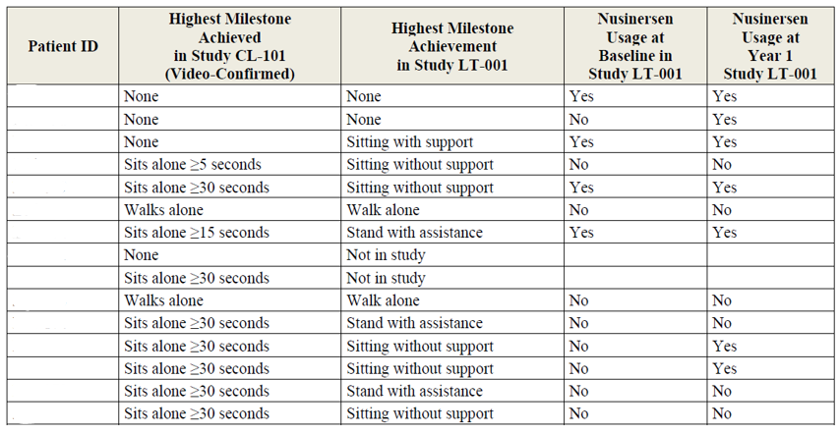
Note: each row represents an individual patient. Patient IDs have been redacted.

Study AVXS-101-CL-302
Study AVXS-101-CL-302 is an ongoing Phase III, multi centre, open label, single arm, single-dose study being conducted in Europe to assess the efficacy and safety of IV AVXS-101 (1.1 x 10¹⁴ vg/kg) administered prior to 6 months of age to patients with symptomatic SMA type 1 with 1 or 2 copies of the SMN2 gene. The primary objective is to determine efficacy by demonstrating achievement of the developmental milestone of sitting without support for at least 10 seconds at any study visit up to 18 months of age. The secondary objective is to determine efficacy based on survival without permanent ventilation at 14 months of age. The submission included the study protocol and interim summaries of efficacy and safety data up to 31 December 2019. The clinical study report is approximately due in the second quarter of 2021.
Enrolment of 33 patients was completed on 21 May 2019. 32 patients met the ITT criteria (symptomatic patients with bi-allelic SMN1 deletions and 2 copies of SMN2 without the c.859G > C gene modifier mutation who receive an infusion of AVXS-101 at less than 180 days of age), which were similar to the ITT criteria in Study AVXS-101-CL-303. One patient was dosed at 181 days of age, so was not included in the ITT population.
The mean age at infusion was 4.1 months (range 1.8 to 6.0 months). At Baseline, 39% of patients needed feeding support and 17% needed ventilatory support.
The primary efficacy endpoint of the study is the proportion of patients who achieve the developmental milestone of sitting without support for at least 10 seconds (by the World Health Organization (WHO) definition) at any study visit up to 18 months of age. The secondary efficacy endpoint is survival without permanent ventilation at 14 months of age.
As at 31 December 2019 data cut-off, 6 of 33 patients (18.8%) had achieved the primary endpoint of sitting without support for at least 10 seconds by the WHO definition. 32 of 33 patients (97.0%) were alive without permanent ventilation. One patient (3.0%) discontinued from the study at the age of 6.9 months due a treatment emergent adverse event (TEAE) of respiratory distress and hypoxic-ischemic encephalopathy and subsequently died.
Figure 6 shows a timeline of event free survival for each study patient.
Figure 6: Study AVXS-101-CL-302 Event-free survival (safety population, 31 December 2019 cut-off)
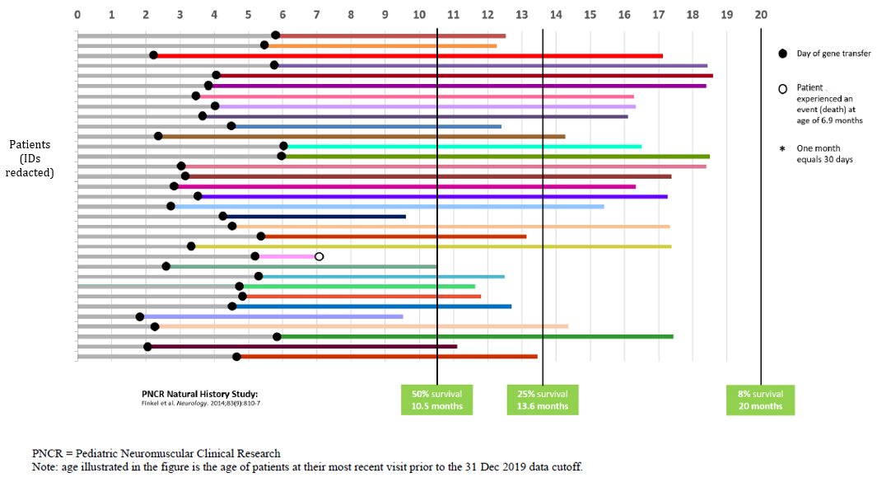
Each bar represents an individual patient. Patient IDs have been redacted.

Study AVXS-101-CL-304
Study AVXS-101-CL-304 is an ongoing Phase III, multi centre, open label, single arm, single dose study to assess the efficacy and safety of IV AVXS-101 (1.1 x 10¹⁴ vg/kg) administered prior to 6 weeks of age in genetically diagnosed and pre-symptomatic patients who are expected to develop SMA type 1 or 2, and who have bi-allelic deletions of SMN1 and 2 or 3 copies of SMN2.
The submission included the study protocol and interim summaries of efficacy and safety data up to 31 December 2019. The clinical study report is approximately due in the first quarter 2022 as part of additional pharmacovigilance commitments.
Enrolment was completed on 8 November 2019 with 30 patients, 14 having 2 copies of SMN2 (Cohort 1) and 15 having 3 copies of SMN2 (Cohort 2). One patient initially enrolled in Cohort 2 was later found to have 4 copies of SMN2, so is not accounted as a participant of Cohort 2 and is not part of the ITT population, but is included in the safety population. Efficacy will be assessed independently for the each cohort. The two cohorts have different underlying genetics, so different endpoints have been selected for each cohort.
The primary efficacy endpoint for Cohort 1 is the proportion of patients achieving the development milestone of functional independent sitting for at least 30 seconds at any visit up to 18 months of age. The first secondary efficacy endpoint for Cohort 1 is survival without permanent ventilation at 14 months of age. The primary efficacy endpoint in Cohort 2 is the proportion of patients achieving the development milestone of the ability to stand without support for at least 3 seconds at any visit up to the age of 24 months. The secondary efficacy endpoint for Cohort 2 is the proportion of patients demonstrating the ability to take at least 5 steps independently displaying coordination and balance at any visit up to the age of 24 months.
Efficacy data were immature at the 31 December 2019 data cut-off date. Patients in Cohort 1 (2 copies of SMN2) were between 6 and 18.6 months of age, and patients in Cohort 2 (3 copies of SMN2) were between 3.3 and 15.1 months of age at their most recent visit. As at 31 December 2019, all patients were alive and free of permanent ventilation. No patients required ventilatory support of any kind.
In Cohort 1, 8 of 14 patients (57.1%) had achieved the primary efficacy endpoint of sitting without support for 30 seconds. The 6 patients who had not achieved this endpoint by the cut-off date were all younger than 9.2 months of age (the 99th percentile for sitting without support) at their last visit prior to the cut-off.
In Cohort 2, 4 of 15 patients (26.7%) had achieved the primary efficacy endpoint of standing without support (at ages of 9.5 months, 12.0 months, 12.2 months and 12.4 months). All 15 patients were less than 16.9 months of age (the 99th percentile for development of standing alone). 2 patients in Cohort 2 had also achieved the secondary efficacy endpoint of walking alone for at least 5 steps (at ages of 12.2 months and 15.1 months).
Figure 7 shows the event free survival for Cohorts 1 and 2.
Figure 7: Study AVXS-101-CL-304 Event-free survival in Cohort 1 (2 copies of SMN2) and Cohort 2 (3 copies of SMN2), safety population (31 December 2019 data cut-off)
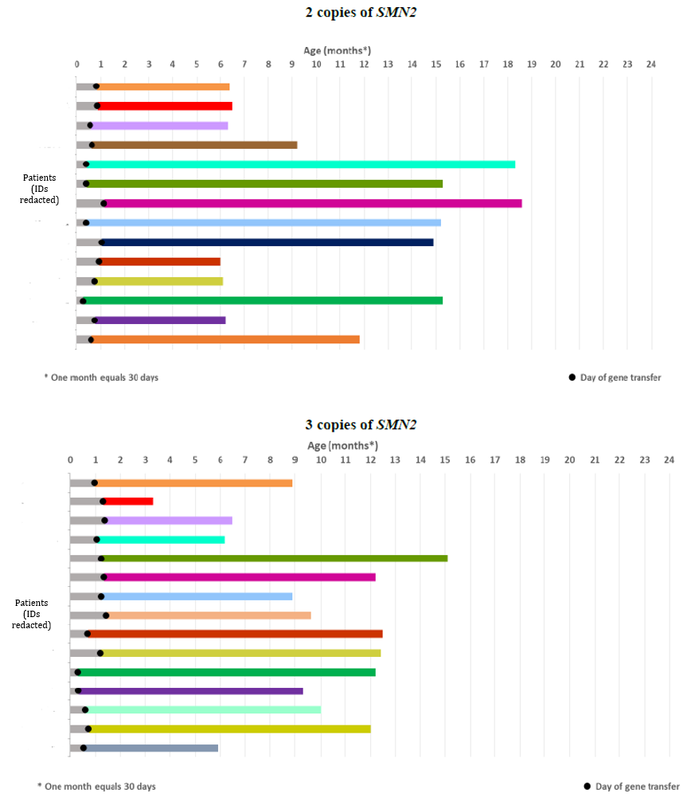
Each bar represents an individual patient. Patients IDs have been redacted.
CHOP INTEND results for Cohort 1 are shown in Figure 8. CHOP INTEND was not assessed in Cohort 2, as per the study protocol. The mean Baseline CHOP INTEND score was 46.1. The mean increases from Baseline to Month 1 (n = 14), Month 3 (n = 9), and Month 6 (n = 7) after dosing were 3.9, 12.1, and 16.3 points, respectively. All 14 patients in Cohort 1 achieved a CHOP INTEND score ≥ 50 by 6 months of age, and 12 patients (85.7%) achieved CHOP INTEND scores ≥ 60 by the 31 December 2019 cut-off. These results are preliminary and have not yet been subjected to formal analysis, but they compare favourably to the maximal score of 33 in untreated SMA patients reported by Kolb et al. (2017) as shown in Figure 9.11
Figure 8: Study AVXS-101-CL-304 CHOP INTEND response in patients with 2 copies of SMN2
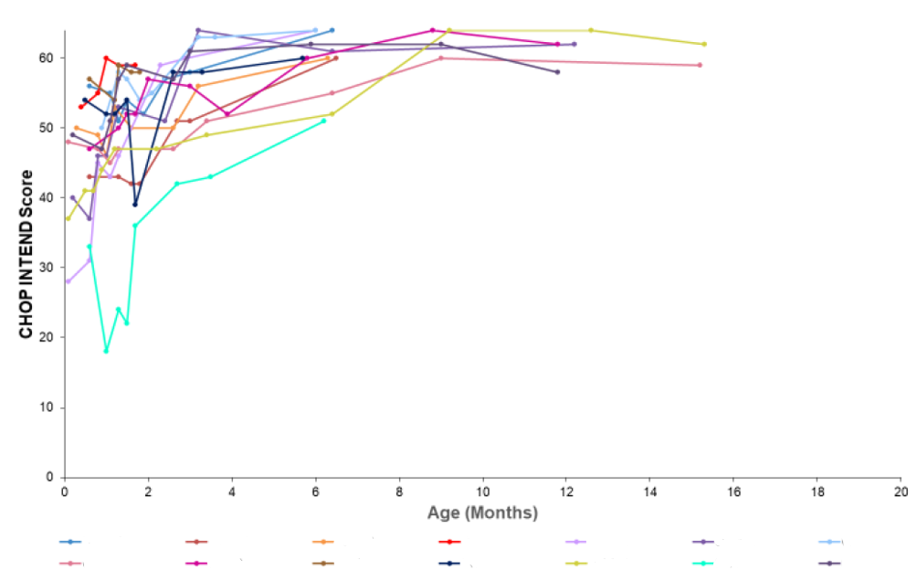
Each line represents an individual patient. Patient IDs have been redacted.
Figure 9: Kolb et al. (2017) CHOP INTEND scores in untreated spinal muscular atrophy
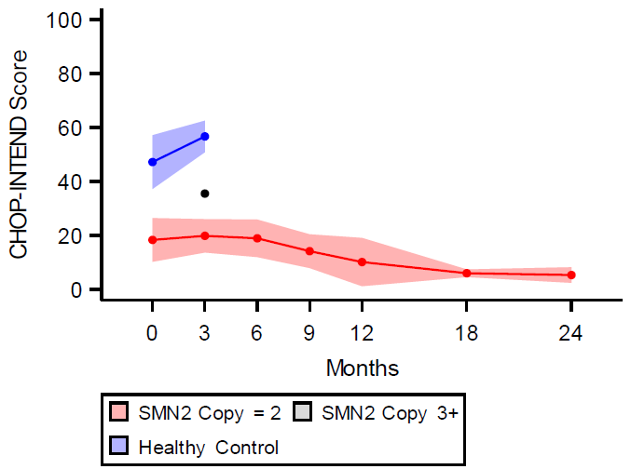
Source: Kolb et al. (2017).11

Safety
Clinical studies contributing to the safety dataset include the two completed studies (Studies AVXS-101-CL-101 and AVXS-101-CL-303), the ongoing IV studies (Studies AVXS-101-CL-302, AVXS-101-CL-304 and AVXS-101-CL-306), the ongoing long-term observational study (Study AVXS-101-LT-001), and the ongoing IT Study AVXS-101-CL-102. The submission also included post-marketing safety data, and non-trial safety data from the US Managed Access Program (MAP).
As at 31 December 2019, the total number of patients exposed to AVXS-101 was 133. 101 received a single dose by IV infusion and 32 received a single dose by IT injection. 98 subjects who received IV AVXS-101 received the proposed dose (1.1 x 10¹⁴ vg/kg). This includes one subject from Study AVXS-101-CL-306 which had enrolled only a single patient at the time of data cut-off.
37 patients were in the completed studies (15 from Study AVXS-101-CL-101 and 22 from Study AVXS-101-CL-303). 96 patients are in ongoing studies, so safety data for these subjects is incomplete. 13 patients from Study AVXS-101-CL-101 were enrolled in Study AVXS-101-LT-001 and followed for up to 68.6 months from dosing (median 57.0 months). Study AVXS-101-LT-001 is collecting data for serious adverse events (SAEs) and adverse events of special interest (AESIs), but not treatment emergent adverse events (TEAEs).
TEAEs for the pooled dataset from the IV Studies AVXS-101-CL-101, AVXS-101-CL-303, AVXS-101-CL-302 and AVXS-101-CL-304 are summarised in Table 10. The most frequently reported TEAEs (> 20%) in the pooled dataset at the proposed IV dose were pyrexia (48.5%), upper respiratory tract infection (37.1%), vomiting (24.7%), constipation (22.7%) and cough (20.6%).
Table 10: Pooled dataset (intravenous route studies) Treatment emergent adverse events (safety analysis set)
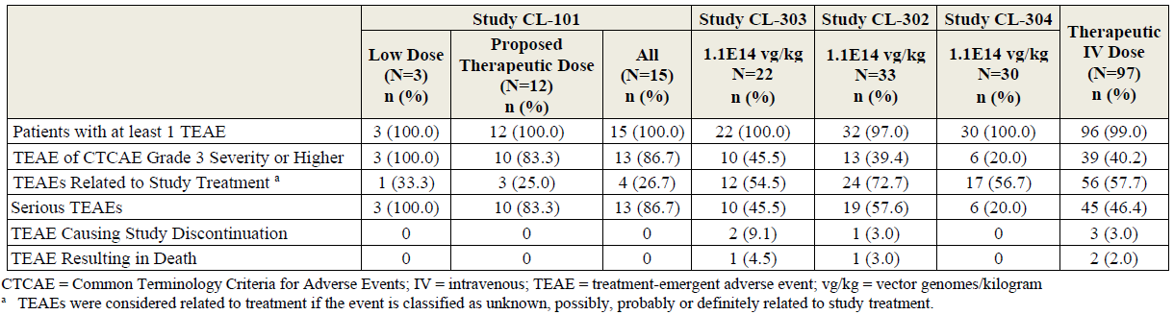
Pooled dataset comprises of the following intravenous route of administration studies: Studies AVXS-101-CL-101, AVXS-101-CL-303, AVXS-101-CL-304, and AVXS-101-CL-302.
Treatment-related TEAEs were reported in 57.7% of patients who received the proposed IV dose. The most frequently reported treatment-related TEAEs (> 5%) were transaminases increased (12.4%), AST increased (9.3%), ALT increased (8.2%), hypertransaminasaemia (8.2%), and vomiting (8.2%).
In Study AVXS-101-CL-303, treatment-related TEAEs reported in > 5% of patients included AST increased (27.3%), ALT increased (22.7%), transaminases increased (9.1%), GGT increased (9.1%), thrombocytopaenia (9.1%), lymphocyte count decreased (9.1%), and diastolic hypertension (9.1%).
SAEs were reported in 46.4% of patients in the IV studies who received the proposed dose. The incidence of SAEs was highest in Study AVXS-101-CL-101 (83.3% in Cohort 2, 86.7% overall) and lowest in Study AVXS-101-CL-304 (20%) which recruited pre-symptomatic patients. The most common SAEs (> 3%) by Preferred Term for the pooled dataset were pneumonia (13.4%), respiratory distress (7.2%), upper respiratory tract infection (6.2%), respiratory syncytial virus (RSV) bronchiolitis (4.1%), rhinovirus infection (4.1%), respiratory tract infection (3.1%), pneumonia aspiration (3.1%), respiratory failure (3.1%), transaminases increased (3.1%), and gastroenteritis (3.1%).
In Study AVXS-101-CL-303, a total of 38 SAEs were reported in 10 of 22 patients (45.5%). The most frequent SAEs, reported in ≥ 2 patients, were respiratory distress (18.2%), bronchiolitis (9.1%), pneumonia (9.1%), RSV bronchiolitis (9.1%), and acute respiratory failure (9.1%). In Study AVXS-101-CL-101, a total of 60 SAEs were reported in 13 of 15 patients (86.7%). The most frequent SAEs, reported in ≥ 3 patients (≥ 20.0%), were pneumonia (46.7%), parainfluenza virus infection (20.0%), pneumonia respiratory syncytial viral (20.0%), RSV bronchiolitis (20.0%), and upper respiratory tract infection (20.0%). In Study AVXS-101-LT-001, a total of 39 SAEs were reported in 8 of 13 patients (61.5%), and all were assessed as unrelated to treatment.
In Study AVXS-101-CL-303, TEAEs by maximum severity are summarised in Table 11. Grade 3 and 4 TEAEs occurring in > 5% of patients in Study AVXS-101-CL-303 were respiratory distress (13.6%), respiratory syncytial virus bronchiolitis (13.6%), respiratory failure (9.1%), and transaminases increased (9.1%).
Table 11: Study AVXS-101-CL-303 summary of treatment-emergent adverse events by maximum severity (safety analysis set)
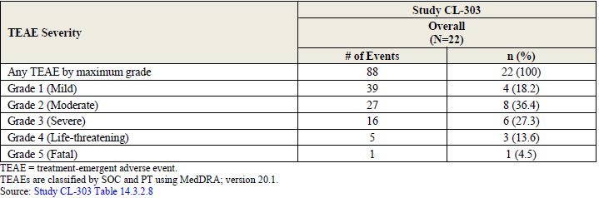
As at 31 December 2019, there had been two deaths in the clinical study program, one in Study AVXS-101-CL-303 due to a TEAE of respiratory arrest and one in Study AVXS-101-CL-302 due a TEAE of respiratory distress and hypoxic-ischemic encephalopathy. Both deaths were assessed as unrelated to AVXS-101. Survival was a primary efficacy endpoint in both of the completed studies, and both studies showed a strong survival benefit relative to untreated subjects from natural history studies.
One death was reported in a 15 month old child 3 days after treatment via an Early Access Program. This case was complex with multiple medical co-morbidities in a child at an advanced stage of SMA type 1. The notification reported unexpected, AEs of myocarditis, decreased cardiac function and death. There were confounding factors and the death is suspected to be due to cardiac arrest and systemic hypoperfusion in the setting of sepsis, but the possibility of AVXS-101 being a contributory factor in the death cannot be definitively excluded.
In Study AVXS-101-CL-101, AESIs were defined as elevated liver enzymes (Table 12). A protocol amendment requiring all patients to receive prophylactic treatment with prednisolone was implemented in Study AVXS-101-CL-101 after the first patient developed elevated transaminases > 20 x ULN following treatment with AVXS-101. In Study AVXS-101-CL-101, clinically significant elevations of transaminases were seen in 3 patients (20.0%), and one (6.7%) had an elevated bilirubin. In two patients, the abnormal liver function tests were considered SAEs and met criteria for Grade 4 toxicity.
In Study AVXS-101-CL-303, AESIs included events related to hepatotoxicity, thrombocytopaenia, cardiac adverse events, and sensory symptoms suggestive of ganglionopathy (Table 13). In Study AVXS-101-CL-303, clinically significant elevations of ALT and AST were reported in 4 (18.2%) and 5 (22.7%) patients, respectively. Similar findings were reported in Studies AVXS-101-CL-302 and AVXS-101-CL-204.
Table 12: Study AVXS-101-CL-101 Treatment emergent adverse events of special interest (elevated liver enzymes only)
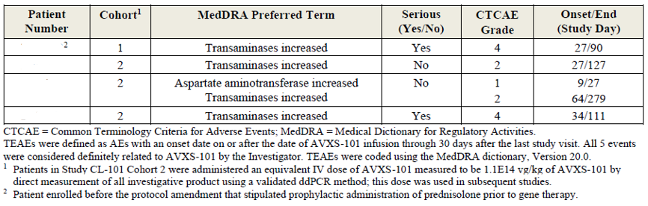
Each row represents an individual patient. Patient IDs have been redacted.
Table 13: Study AVXS-101-CL-303 Treatment emergent adverse events of special interest by Preferred Term (safety analysis set)
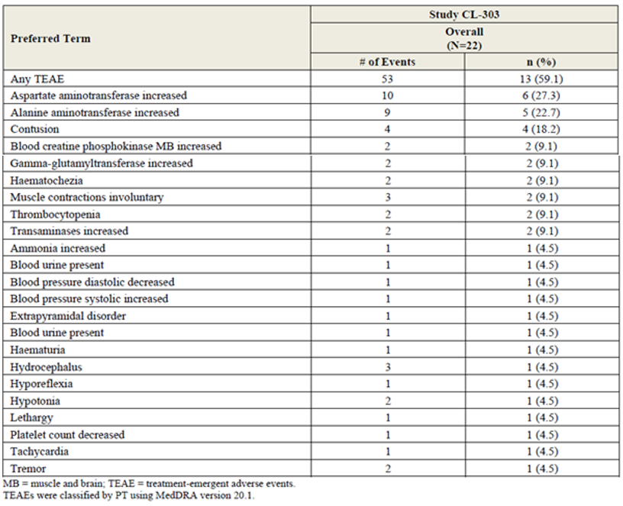
Across the pooled data, including 97 patients who received AVXS-101 at the proposed dose in clinical trials, 87 patients (89.7%) experienced elevation of at least 1 liver function parameter (AST, ALT, or bilirubin). Of these, 33 patients (34%) had liver-associated TEAEs. No cases of Hy’s law have been reported in Studies AVXS-101-CL-303, AVXS-101-CL-101, and the ongoing studies.
Hepatic abnormalities were one of the most common TEAEs reported in a MAP in the USA: increased ALT and increased AST were each reported in 10 of 43 patients (23%), and liver function test increased was reported in 5 (11.6%) patients.
Two cases of severe hepatotoxicity were reported in patients treated with AVXS-101 through a MAP in the USA. Both cases met the biochemical criteria of Hy’s law. These cases were described in a recently published article by Feldman et al. (2020). The authors reported two cases of subacute liver failure diagnosed approximately 7 weeks after treatment with IV AVXS-101 through a MAP. The sponsor disputes the diagnoses of subacute liver failure, but both cases involved severe acute liver injury. Both patients had received prophylactic prednisolone. One patient had abnormal baseline liver function, and the other had normal baseline liver function. In both cases, the liver abnormalities responded to treatment with high-dose corticosteroids, with subsequent normalisation of liver function tests within 4 months.
Transient decreases in platelet counts were observed in the clinical studies, with 4 (4.1%) patients experiencing a TEAE for thrombocytopaenia.
The available clinical data show no evidence of significant renal toxicity from AVXS-101.
Elevated creatinine kinase was observed in most patients with symptomatic SMA, but this can be an expected finding in this condition. Limited data are available for cardiac troponin. Troponin was assessed in Study AVXS-101-CL-101 but not in Study AVXS-101-CL-303. The other Phase III studies did not initially include troponin testing, but this was added in protocol amendments based on findings in mouse toxicology studies. In Study AVXS-101-CL-101, 8 of 15 patients (53.3%) had elevations in cardiac troponin levels that met the pre-specified criterion for potential clinical significance (> 0.05 μg/L). Of these, 2 patients had elevated troponin levels prior to administration of AVXS-101.

Immunogenicity
The clinical studies measured antibody and T cell responses to AAV9 and SMN. All patients in the clinical studies were required to have AAV9 antibody titre ≤ 1:50 prior to AVXS-101 administration. High anti-AAV9 antibody titres occurred following infusion of AVXS-101 in all patients and T cell responses to the AAV9 vector were also observed.
Patients did not develop an antibody response or T cell response to SMN protein. SMN protein is an endogenous human protein and patients with SMA are already exposed to this protein to a limited extent from the SMN2 gene.

Other potential risks relating to gene therapy
The submission addressed other potential risks relating to gene vector technology, including accidental self-inoculation, vector shedding, tumourigenicity due to chromosomal integration, and the risk of germ-line transmission. The clinical evaluator concluded that these risks cannot be inferred from the limited exposure reported in the submitted clinical studies, but agreed that the sponsor’s assessment that these risks are minimal is plausible. The clinical evaluator recommended further advice on these risks from experts in virology and genetics (see ‘Advisory Committee considerations’ section, below).

Intrathecal studies
Study AVXS-101-CL-102 is an ongoing, Phase I, open label, single dose study of IT AVXS-101 in infants and children with a genetic diagnosis consistent with SMA, bi-allelic deletion of SMN1 and 3 copies of SMN2, who are able to sit but cannot stand or walk at the time of study entry. The summary of safety as at 31 December 2019 is shown in Table 14.
Table 14: Study CL-102 (intrathecal) treatment emergent adverse events (safety analysis set)
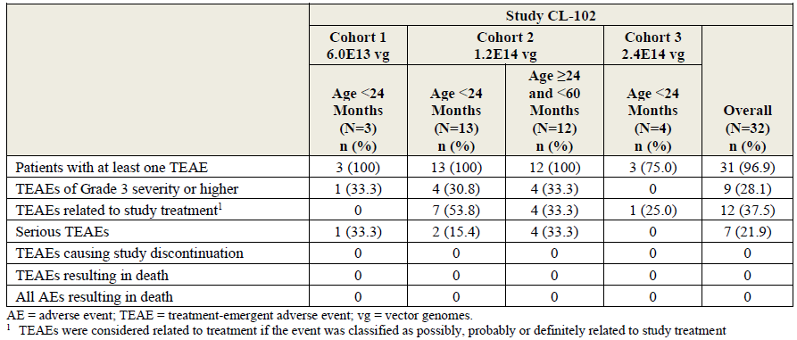
This study was placed on partial clinical hold on 29 October 2019 in response to an urgent safety measure notification relating to DRG findings following IT administration of AVXS-101 in a non-human primate study. The partial clinical hold prevented screening or treatment of further patients in intrathecal studies until further notice. The partial clinical hold did not apply to the IV clinical studies. At that time, the clinical trial sponsor, AveXis, updated protocols of ongoing clinical studies with the nonclinical safety information, and emphasised the importance of age-appropriate sensory testing and monitoring of symptoms of pain, numbness or paraesthesia.
On 22 July 2020, AveXis notified all investigators involved in AVXS-101 studies of new CNS findings from the interim analysis of the ongoing GLP-compliant IT non-human primate study (see ‘Nonclinical’ section, above), and advised that Study AVXS-101-CL-102 continues to be on partial clinical hold. AveXis provided the following assessment of the clinical implications of the nonclinical findings:
‘These CNS findings are considered likely AVXS-101 related, lack a dose response, have no neurologic or clinical observation correlates and generally were of low incidence and severity affecting only a few neurons. It remains unclear if these non-human primate findings will translate to patients administered AVXS-101.
To evaluate the clinical data with regards to the new interim findings of this pre-clinical study, a specific search of the Novartis global safety database was conducted to include available safety data from all sources (including clinical studies with either intravenous or IT administrations, open access programs and post-marketing spontaneous reports) in over 600 patients dosed with AVXS-101. No new safety signals were identified based on the acute onset of the findings (within 6 weeks post dose) for the development of the CNS findings relative to the duration of available patient follow-up (months to years) for the completed and ongoing clinical studies. AveXis has assessed that there are no new immediate clinical implications for patients treated with AVXS-101 in the past or those currently being treated in ongoing trials.
Although the clinical relevance of these non-human primate findings is unknown, we would like to reinforce importance of conducting a careful neurological exam at each visit in all ongoing clinical trials. Protocol required neurological assessments are considered sufficient to detect clinical abnormalities related to these findings. AveXis has conducted a careful assessment based on all available information and concludes the overall benefit-risk profile for AVXS-101 clinical trial patients remains favorable.’

Post-market safety
In the post-marketing data base, 488 AEs were reported in 192 cases, with the most common events being pyrexia (50 cases), vomiting (42), hepatic enzyme increased (24), aspartate aminotransferase increased (23), alanine aminotransferase increased (19), liver function test increased (17), platelet decreased (16), troponin increased (7), thrombocytopenia (7), cough (7), nasopharyngitis (7), and weight decreased (6).
Three cases of thrombotic microangiopathy, characterised by thrombocytopaenia, microangiopathic haemolytic anaemia and acute renal injury, have been reported in the post-market setting. These cases occurred approximately one week after Zolgensma infusion. The sponsor concluded that a causal association cannot be ruled out, and a precaution has been added to the PI.

Clinical evaluator’s recommendation and proposed clinical conditions of registration
The clinical evaluator recommended that the application was approvable.
The following indication wording was recommended by the clinical evaluator:
Zolgensma (onasemnogene abeparvovec) is indicated for the treatment of paediatric patients less than 2 years of age with spinal muscular atrophy (SMA) with bi-allelic mutations in the survival motor neuron 1 (SMN1) gene and up to 3 copies of the SMN2 gene.
The clinical evaluator advised that it could be argued that the treatment should be limited to subjects with only 2 copies of the SMN2 gene, but the balance of evidence suggests that subjects with 3 copies are very likely to receive major benefit, and it would be inappropriate to deny such subjects access to the treatment while awaiting better evidence. The benefit-risk balance in such subjects will need to be re-evaluated as soon as the ongoing studies in 3 copy patients have been completed, including Study AVXS-101-CL-304.
The clinical evaluator recommended the following conditions of registration:
- A guarantee from the sponsor that the currently ongoing studies will be submitted for evaluation when they have been completed.
- A guarantee from the sponsor that a new integrated safety analysis will be submitted for a comprehensive safety evaluation upon completion of the major on-going studies, including Study AVXS-101-CL-302 and Study AVXS-101-CL-304.
- A guarantee from the sponsor that, wherever possible, all treated patients will be closely monitored for new safety signals, including clarification of hepatic and cardiac risk.
- A guarantee that all reporting and monitoring activities performed as a part of the current conditional approval in Europe will also be shared with the TGA, including (but not limited to) periodic safety update reports (PSURs) and provision of results in ongoing studies.
In response to the clinical evaluator’s comments regarding conditions of registration, the sponsor explained that TGA conditions of registration will include implementation of the EU risk management plan (RMP) and Australian specific Annex (ASA), and submission of PSURs (see ‘Risk management plan’ section, below). AE reporting and signal detection are part of routine pharmacovigilance activities. Hepatotoxicity is an important identified risk and cardiac adverse events are an important potential risk. Targeted follow-up questionnaires for elevated liver enzymes, transient thrombocytopenia, peripheral neuropathy and cardiac AEs are required as per RMP version 0.7. The final clinical study reports for the ongoing Studies AVXS-101-CL-304, AVXS-101-LT-001 and AVXS-101-RG-001 will be submitted to TGA as part of the risk management commitments.

Risk management plan
The sponsor has submitted EU-RMP version 0.3 (date 2 October 2019; data lock point (DLP) 8 March 2019) and ASA version 1.0 (date 26 November 2019) in support of this application. With the response to TGA questions, the sponsor provided an updated EU-RMP version 0.7 (date 19 March 2020; DLP 31 December 2019) and an updated ASA version 1.1 (date 17 August 2020).
The summary of safety concerns and their associated risk monitoring and mitigation strategies are summarised in Table 15.
Table 15: Summary of safety concerns
Summary of safety concerns |  | Pharmacovigilance |  | Risk minimisation
 |  | Routine | Additional | Routine | Additional
Important identified risks | Hepatotoxicity | * | ‡¶ |  | –
Important identified risks | Transient thrombocytopenia | * | ‡¶ |  | –
Important potential risks | Cardiac adverse events | * | ‡¶ |  | –
Important potential risks | Use in patients with anti-AAV9 antibody titres > 1:50 and higher vector loads required |  | ‡¶ |  | –
Important potential risks | Dorsal root ganglia cell inflammation |  | ‡¶ |  | –
Missing information | Long-term effect of onasemnogene abeparvovec therapy |  | ‡¶ | – | –
Missing information | Risks related to off-label use for patients with > 3 SMN2 copies that is, higher prevalence of anti-AAV9 antibodies and higher vector loads required |  | ‡¶ |  | –
*Targeted follow-up questionnaires, ‡Clinical trials, ¶ Prospective long-term registry – data from Australian patients will be included.
Ongoing and planned studies included in additional pharmacovigilance are Studies AVXS-101-LT-001 (final study report due in the fourth quarter of 2033), AVXS-101-CL-304 (final study report due in the first quarter of 2022), AVXS-101-CL-302 (final study report due in the second quarter of 2021), AVXS-101-RG-001 (final study report due in 2038, and AVXS-101-LT-002 (final study report due in the second quarter of 2035). Data from Australian patients will be included in the multinational long-term patient registry study, Study AVXS-101-RG-001. The sponsor is requested to clarify why the final study report for Study AVXS-101-LT-002 is not proposed to be submitted to TGA (see ‘Questions for the sponsor’ section, below).
The sponsor has agreed to implement a patient alert card in Australia as an additional risk minimisation activity. The patient alert card will be an Australian-specific requirement, and will provide details of the patient name, treating physician name and contact details, and date of treatment. The sponsor will provide the patient alert card to identified prescribers in the treatment of SMA.

Proposed risk management conditions of registration
- Zolgensma (onasemnogene abeparvovec) is to be included in the Black Triangle Scheme. The PI and CMI for Zolgensma must include the black triangle symbol and mandatory accompanying text for five years, which starts from the date that the sponsor notifies the TGA of supply of the product.
- The Zolgensma EU-RMP, (version 0.7, dated 19 March 2020; DLP 31 December 2019) with ASA (version 1.1, dated 17 August 2020), included with submission PM-2019-05979-1-3, and any subsequent revisions, as agreed with the TGA will be implemented in Australia.
An obligatory component of risk management plans is routine pharmacovigilance. Routine pharmacovigilance includes the submission of PSURs.
Reports are to be provided in line with the current published list of EU reference dates and frequency of submission of PSURs until the period covered by such reports is not less than three years from the date of the approval letter.
The reports are to at least meet the requirements for PSURs as described in the European Medicines Agency’s Guideline on Good Pharmacovigilance Practices (GVP) Module VII-periodic safety update report (Rev 1), Part VII.B Structures and processes. Note that submission of a PSUR does not constitute an application to vary the registration.

Risk-benefit analysis

Delegate’s considerations

Efficacy
The completed Phase III Study AVXS-101-CL-303 and the completed Phase I Study AVXS-101-CL-101 demonstrated substantial efficacy benefits following a single IV dose of Zolgensma compared to the natural history of type 1 SMA. Both studies demonstrated marked improvements in survival without permanent ventilation, and achievement of motor milestones, relative to untreated historical controls. In addition, motor scores generally showed steady improvement following treatment, in contrast to the progressive decline seen in historical controls.
The patients in these studies had a severe form of SMA with a very poor prognosis and a high likelihood of ventilator dependence and/or death during the course of the study. The natural history of this study population has been well-defined in recent observational studies, allowing clinically meaningful assessment of the efficacy outcomes observed in these single arm studies. The event-free survival and motor milestones achieved in these studies represent substantial improvements on the outcomes that would be expected in the untreated target population.
All patients in these studies had genetically confirmed bi-allelic mutations (deletions) of SMN1, 2 copies of SMN2, absence of the c.859G > C mutation, and onset of clinical symptoms of SMA before 6 months of age. In Study AVXS-101-CL-303, all patients were treated prior to 6 months of age, and in Study AVXS-101-CL-101, all patients were treated prior to 8 months of age. Both studies involved a single dose of Zolgensma administered by intravenous infusion. All 22 patients in Study AVXS-101-CL-303 and 12 of 15 patients in Study AVXS-101-CL-101 received the dose proposed for registration.
All 12 patients (100%) in Cohort 2 of Study AVXS-101-CL-101 survived without permanent ventilation to 24 months post-treatment, and 20 of 22 (90.9%) patients in Study AVXS-101-CL-303 survived without permanent ventilation to 18 months of age. This represents a substantial improvement on the 8% event-free survival reported for historical controls at 18 months of age in the PNCR dataset.
Many subjects achieved motor milestones that are seldom or never achieved in untreated historical control subjects with the same genetic profile. No untreated patients with this genetic profile would be expected to sit independently. No patients in Cohort 1 of Study AVXS-101-CL-101 achieved motor milestones, but 9 of 12 patients (75%) in Cohort 2 achieved independent sitting, and in Study AVXS-101-CL-303, 13 of 22 patients (59.1%) were able to sit independently for 30 seconds at 18 months.
All patients had clinical evidence of disease onset prior to treatment, but patients with more advanced disease requiring invasive or permanent ventilatory support (or non-invasive ventilatory support ≥ 6 hours/day for Study AVXS-101-CL-303) were excluded. The efficacy of Zolgensma in patients with advanced disease, particularly those requiring invasive or permanent ventilation, has not been assessed.
In Study AVXS-101-LT-001, the long-term extension study of Study AVXS-101-CL-101, all 13 patients survived without permanent ventilation at the 31 December 2019 data cut-off, and motor milestones for patients who received the proposed dose were maintained, or in some cases improved. Seven patients were receiving treatment with nusinersen in this study, so there is some uncertainty regarding the relative contributions of each treatment to ongoing efficacy.
The ongoing Phase III Study AVXS-101-CL-304 is assessing efficacy and safety of the proposed dose administered prior to 6 weeks of age in pre-symptomatic patients with bi-allelic deletions of SMN1 and 2 or 3 copies of SMN2. Preliminary data up to 31 December 2019 have been presented. The early data for Cohort 1 (2 copies of SMN2) appear favourable. Assessment of clinical benefit in Cohort 2 (3 copies of SMN2) is uncertain because of the immaturity of the data and the heterogeneity in the natural history of the disease.
There are no studies which directly compare the efficacy of Zolgensma to nusinersen.

Safety
As at 31 December 2019, 101 patients have been treated with IV Zolgensma in clinical studies. All of the clinical studies are single arm studies, and only 2 of the studies (37 patients) are complete. Long-term follow-up is limited. The limitations of the safety dataset are understandable in the context of this rare disease with severe morbidity and mortality. The limitations of the safety dataset mean that the safety profile of Zolgensma may not be fully characterised. It is possible that uncommon and rare adverse events, or later onset toxicities, have not yet been characterised.
Hepatotoxicity has been identified as an important safety concern in the clinical development program, as well as in MAPs and post-market use. In some cases, the hepatotoxicity has been severe. There have been several case reports of subacute liver failure following treatment with Zolgensma. The hepatotoxicity is considered likely to be related to an AAV vector-induced immune response, and is typically responsive to systemic corticosteroids. The risk of hepatotoxicity and clinical guidance for monitoring and treatment are described in detail in the Product Information: Boxed Warning, Section 4.2 Dose and method of administration, Section 4.4 Special warnings and precautions for use, and Section 4.8 Adverse effects (undesirable effects).
The risk factors for developing severe hepatotoxicity following treatment with Zolgensma are not fully delineated at this stage. Patients with abnormal baseline liver function may be at higher risk, but patients with clinically significant abnormalities of liver function were excluded from the clinical studies. The cases of subacute liver failure reported by Feldman et al. (2020) involved one child with abnormal baseline liver function prior to treatment with Zolgensma, and one child with normal baseline liver function.18
Prophylactic corticosteroids are recommended for all patients, starting before and continuing after infusion of Zolgensma. Cases of hepatotoxicity have been reported in clinical studies and in MAPs despite prophylactic treatment with systemic corticosteroids, so there remains some uncertainty regarding the optimal dose and duration of corticosteroid treatment.
Thrombocytopaenia has been observed in clinical studies. Other significant haematological toxicity appears unlikely. The PI has a warning regarding thrombocytopaenia. A warning for thrombotic microangiopathy has also been added to the PI following 3 case reports occurring approximately 1 week post-infusion.
Cardiac toxicity was observed in animal studies and increases in troponin levels have been observed in clinical studies. The PI contains a precaution regarding monitoring of troponin levels before and after treatment. The clinical studies have not identified concerns with clinically significant cardiac adverse events, but the studied population is small and the disease itself is associated with cardiac and ECG abnormalities. There was one death from a cardiac event 3 days after treatment in an Early Access Program. This patient had advanced SMA and multiple medical co-morbidities. The sponsor assessed this death as not related to Zolgensma, but a contributory role from Zolgensma cannot be fully excluded.
The clinical relevance of CNS toxicities reported in a non-human primate IT study is unknown. Clinically evident CNS toxicity has not been identified in clinical studies involving IV or IT administration.

Immunogenicity
All subjects in the clinical studies were required to have AAV9 antibody titre ≤ 1:50 prior to Zolgensma administration. Efficacy and safety have not been established in patients with AAV9 antibody titre > 1:50.
High anti-AAV9 antibody titres occurred following infusion of Zolgensma in all subjects. The efficacy and safety of repeat administration of Zolgensma have not been established. The proposed registration is for single treatment only.
AAV9 antibody testing is required prior to treatment with Zolgensma. This test is not performed in Australia. In response to TGA questions, the sponsor advised ‘At this time, the anti-AAV9 antibody test has not been transferred to an Australian laboratory. Viroclinics, Netherlands will continue to provide this service for both clinical and commercial sites. The laboratory accreditation certificate was provided in [the dossier].[information redacted] are using Viroclinics’ The turnaround time for the test result from ViroClinics is now 3 days after sending the specimen.

Vector shedding
Following intravenous infusion of Zolgensma, viral vector is shed primarily in faeces (and to a lesser extent in urine and saliva) and is largely cleared within 30 days of treatment. The sponsor’s guidance regarding handling of bodily waste was developed based on the US Centers for Disease Control biosafety level 1 criteria for organisms not expected to contribute to human disease and that present minimal risk to individuals or to the environment. The guidance in the proposed PI recommends good hand hygiene when coming into direct contact with patient bodily waste for a minimum of 1 month after treatment. Disposable nappies should be sealed in plastic bags and can be disposed of in household waste.

Other potential risks associated with vector-based gene therapies
The submission addressed other potential risks associated with vector-based gene therapies, including accidental self-inoculation, chromosomal integration, tumourigenicity, and germline (vertical) transmission.
The viral vector is replication-deficient, and AAVs are not known to cause disease in humans. There is no known toxicity associated with overexpression of the SMN protein. Accidental exposure is estimated to result in very limited local exposure. The PI provides guidance on handling and preparation of Zolgensma and management of accidental exposure. This guidance should be supplemented with advice that Zolgensma should be prepared using a Class II biological safety cabinet.
The integration and oncogenic potential of onasemnogene abeparvovec was evaluated primarily in the nonclinical evaluation. No genotoxicity or carcinogenicity studies have been conducted with Zolgensma. The risk of chromosomal integration in humans is assessed to be low, and the risk of carcinogenicity is anticipated to be low. Residual uncertainty regarding oncogenic potential is addressed in the RMP, which includes long-term follow-up studies that will specifically assess the occurrence of new malignancies or tumours.
The risk of germline transmission was evaluated primarily in the nonclinical evaluation, and was also assessed in the clinical evaluation. The non-integrating and non-replicating features of the vector minimise the potential for vertical transmission. A risk of vertical transmission cannot be excluded with certainty, but given the age of the intended patient group and the low risk of integration, the risk of vertical transmission is considered to be extremely low.

Uncertainties and limitations of the data
As of 31 December 2019, 101 patients have been enrolled in studies assessing IV AVXS-101 (Studies AVXS-101-CL-101, AVXS-101-CL-303, AVXS-101-CL-302, AVXS-101-CL-304 and AVXS-101-CL-306), including 37 enrolled in the two completed studies. Long-term efficacy and safety data are limited. These limitations of the clinical dataset are being addressed through post-marketing commitments to the US Food and Drug Administration (FDA) and EMA, including clinical studies monitoring efficacy and safety for 15 years post-treatment for patients treated in Zolgensma clinical studies (Studies AVXS-101-LT-001 and AVXS-101-LT-002), and a prospective, multi centre, multinational, observational long-term registry of patients with a diagnosis of SMA (Study AVXS-101-RG-001). This voluntary registry study will assess effectiveness of treatments for SMA, the long-term safety of patients treated with Zolgensma, and the overall survival of patients with SMA. The registry will enrol at least 500 patients and follow-up will be for 15 years or until death, whichever is sooner.
The use of Zolgensma in patients with advanced SMA (for example, complete paralysis of limbs, permanent ventilator dependence) has not been evaluated in the clinical studies. Benefits are expected to be limited in patients with advanced disease, based on the mechanism of action and findings from nonclinical studies. This is addressed in the proposed PI.
All subjects in Studies AVXS-101-CL-101 and AVXS-101-CL-303 had 2 copies of SMN2. There are no data in patients with 1 copy of SMN2. It is not known whether Zolgensma would provide a meaningful clinical benefit to patients with 1 copy of SMN2 prior to irreversible motor neuron loss. Data for patients with 3 copies of SMN2 are limited, as Study AVXS-101-CL-304 is ongoing and only preliminary results were presented in this submission. The benefit-risk in patients with 3 copies of SMN2 is uncertain because the data are immature and there is heterogeneity in the natural history of the disease. The clinical evaluator’s assessment is that treatment of patients with 3 copies of SMN2 is likely to have a net positive benefit-risk balance because such subjects usually have profoundly impaired quality of life, but this has not yet been confirmed in a clinical study. The benefit-risk in patients with 4 or more copies of SMN2 has not been established, as patients with this genetic profile have not been assessed in clinical studies (other than one patient enrolled in the 3 copy cohort of Study AVXS-101-CL-304 but subsequently confirmed as having 4 copies of SMN2). These limitations in the clinical dataset need to be described in the PI.
All subjects in the clinical studies were required to have anti-AAV9 antibody titre ≤ 1:50 prior to Zolgensma administration, so efficacy and safety have not been established in patients with anti-AAV9 titres > 1:50. The efficacy and safety of repeat administration of Zolgensma have not been assessed. These issues have been addressed in the proposed PI.
Risk factors for developing acute severe liver injury following treatment with Zolgensma have not been fully delineated. Patients with significant abnormalities of baseline liver function were excluded from the clinical studies. The two cases of subacute liver failure described by Feldman et al. (2020) involved one child with abnormal baseline liver function prior to treatment with Zolgensma, and one with normal baseline liver function.18 The PI contains detailed warnings regarding the risk of acute serious liver injury and clinical guidance on monitoring and treatment (Boxed Warning; Section 4.2 Dosage and method of administration; Section 4.4 Special warnings and precautions for use; Section 4.8 Adverse effects (undesirable effects)).
The clinical relevance of CNS toxicities reported in the non-human primate IT study is unknown. Clinically evident CNS toxicity has not been reported in clinical studies involving IV or IT administration.
There are no studies directly comparing Zolgensma to nusinersen. Prior treatment with nusinersen was an exclusion criterion in Study AVXS-101-CL-303. Some patients are being treated with nusinersen in Study AVXS-101-LT-001 after treatment with AVXS-101 in Study AVXS-101-CL-101, but data on sequential treatment are very limited.

Treatment sites
The sponsor advised that, at the time of the response to first round TGA questions, two sites are prepared to administer Zolgensma in Australia. The sponsor is requested to comment on whether other treatment sites are planned in Australia (see ‘Questions for the sponsor’ section, below).
Table [information redacted].

Proposed indication
The proposed indication is:
Zolgensma (onasemnogene abeparvovec) is indicated for the treatment of paediatric patients less than 2 years of age with spinal muscular atrophy (SMA) with bi-allelic mutations in the survival motor neuron 1 (SMN1) gene.
The clinical evaluator has recommended the following indication:
Zolgensma (onasemnogene abeparvovec) is indicated for the treatment of paediatric patients less than 2 years of age with spinal muscular atrophy (SMA) with bi-allelic mutations in the survival motor neuron 1 (SMN1) gene and up to 3 copies of the SMN2 gene.
The treatment population in the proposed indication is broader than the populations assessed in Studies AVXS-101-CL-303 and AVXS-101-CL-101. The upper limit of the proposed age range is greater than the age at which treatment was given in the clinical studies, and the proposed indication is silent with regard to onset of clinical symptoms, SMA type, and number of copies of SMN2.
All patients in Studies AVXS-101-CL-303 and AVXS-101-CL-101 had bi-allelic mutations (deletions) of SMN1, two copies of SMN2, absence of the c.859G > C mutation, and clinical onset prior to 6 months of age. In the Phase III Study AVXS-101-CL-303, all patients were treated prior to 6 months of age. In Study AVXS-101-CL-101, all patients were treated prior to 8 months of age, as an earlier protocol allowed enrolment of patients up to 9 months of age. Although Study AVXS-101-CL-303 was designed to allow inclusion of pre-symptomatic patients, patients with 1 copy of SMN2, and patients with the c.859G > C mutation, ultimately no patients with these characteristics were enrolled in the study.
Studies AVXS-101-CL-303 and AVXS-101-CL-101 did not include patients with 3 copies of SMN2. Study AVXS-101-CL-304 has enrolled pre-symptomatic patients expected to develop SMA type 1 or 2 and who have 2 or 3 copies of the SMN2 gene. This study is ongoing and only preliminary results are currently available. The early data in Cohort 1 (2 copies of SMN2) appear favourable. The clinical benefit in patients with 3 copies of SMN2 is less certain because the data are immature and there is heterogeneity in the natural history of the disease.
The treatment population can be defined by various clinical and genetic criteria, including age, SMN1 gene mutations, SMA type, number of copies of SMN2, and clinical onset of disease. Internationally, regulators have adopted different criteria to define the treatment population (see ‘Regulatory status’ section, above).
The clinical evaluator has recommended the addition of ‘and up to 3 copies of the SMN2 gene’ to the proposed indication, however, the Delegate is concerned that the data in patients with 3 copies of SMN2 are immature. The Delegate notes that this wording is included in the European indication, but that is a conditional marketing authorisation (broadly equivalent to provisional registration in Australia). The sponsor did not apply for provisional registration in Australia.
The Delegate is considering whether the indication should be restricted to a population more closely aligned to the populations assessed in Studies AVXS-101-CL-303 and AVXS-101-CL-101. The Delegate is also considering whether the proposed indication could be acceptable if the PI contained detailed descriptions of the limitations of the clinical dataset. The Delegate would like to consider advice from clinical experts before formalising their position on the indication. The Delegate is particularly interested in the perspective of the clinical experts with regard to whether:
- the indication should be restricted to patients with SMA type 1;
- the indication should be restricted to patients with evidence of clinical onset of SMA;
- the proposed age range is appropriate;
- the indication should specify the number of copies of SMN2.

Proposed conditions of registration
- Risk management conditions as outlined in ‘Proposed risk management conditions of registration’ section, above.
- Preparation and administration of Zolgensma is restricted to clinical facilities accredited to the National Safety and Quality Health Service (NSQHS) Standards.
- Quality conditions as outlined in ‘Proposed quality conditions of registration’ section, above.

Conclusions
The efficacy of a single intravenous infusion of Zolgensma at the proposed dose has been demonstrated in patients with SMA type 1 in the Phase III Study AVXS-101-CL-303 and the Phase I Study AVXS-101-CL-101. All patients in the completed studies had bi-allelic deletions of SMN1, two copies of SMN2, and clinical onset prior to 6 months of age. Both studies showed marked improvements in survival without permanent ventilation compared to untreated subjects from natural history studies, and achievement of motor milestones that would not be expected based on the natural history of the disease.
The safety evaluation has identified hepatoxicity as an important safety concern, with a risk of severe liver injury. This risk is expected to be manageable with close monitoring, prophylactic treatment with oral corticosteroids, and treatment with more intensive systemic corticosteroids when clinically required. Overall, the safety dataset is limited, so there is a risk that the full extent of toxicities may not yet have been identified.
Although there are notable risks and uncertainties associated with the proposed treatment, the benefit-risk is favourable given the marked benefits in survival and motor development demonstrated in infants with this devastating disease, for which treatment options are very limited. The Delegate would like to consider advice from clinical experts before formalising their position on the wording of the indication.
The limitations in the efficacy and safety datasets are being managed through long-term follow-up studies. Data from Australian patients will be included in the multinational registry study monitoring long-term efficacy and safety.

Proposed action
The Delegate has no reason to say, at this time, that the application for Zolgensma should not be approved for registration.

Questions for the sponsor
The sponsor provided the following response to questions from the Delegate.
- Please outline the regulatory history of the proposed indication, addressing the selection of the age range ‘less than 2 years of age’.
Novartis (formerly AveXis, Inc.) submitted to FDA the Biologics License Application (BLA) for Zolgensma on 1 October 2018 and obtained approval on 24 May 2019 for the treatment of paediatric patients less than 2 years of age with SMA with bi-allelic mutations in the SMN1 gene. At the time of approval, the 2 year age limit in the indication reflected the limited experience with Zolgensma in the paediatric population.
It was noted that during the consultative review of the BLA, the Division of Neurology Products (31 January 2019) indicated that the decision to provide the treatment to older patients should be left to the clinical judgement of the treating physician in consultation with the patient and did not need to be specified in the labelling. In the telephone conversation between FDA and AveXis (13 March 2019) and the late cycle meeting (29 March 2019), the discussions included options to provide flexibility to the physician treating SMA patients. AveXis proposed the option of including the limit of 2 years of age. Novartis Australia adopted the approved US indication for filing as the Zolgensma application was under evaluation in the EU.
An expert panel of scientific advisors and patient representatives of the EMA met in September 2019 (Scientific Advisory Group Neurology meeting 2019) and acknowledged that ‘age should not be a factor restricting the treatment with Zolgensma’. It was noted that data from other SMA-targeted therapy demonstrated that older patients continue to benefit. The recommendation was the ‘preferable approach’ would be to leave it to the clinician to discuss with carers/family ‘to determine the need for treatment, based on the motor, respiratory and general condition of the child.’ Experts similarly agreed that applying a weight limit would result in an unnecessary restriction. Subsequently, an indication in the summary of product characteristics (SmPC) with no defined age or weight limit was endorsed by the EMA.
Broader experience with Zolgensma leaves the current age limit of 2 years hard to justify from both clinical and scientific perspectives. With the evolving disease and treatment landscape as well as the rapidly accumulating evidence from real-world use of Zolgensma, the current age limitation of 2 years now represents an unnecessary barrier to patients that are likely to benefit from gene therapy.
- Please comment on any additional treatment sites planned in Australia, other than the two sites described in Table [information redacted].
Table [information redacted] indicated which sites have provided NATA accreditation of the pathology laboratory service in use for confirmatory diagnostic testing for the SMN1 deletion. The following are planned Zolgensma treatment sites: Sydney Children's Hospital (Randwick), The Children’s Hospital at Westmead, The Royal Children's Hospital (Parkville), Women’s and Children's Hospital (Adelaide), Perth Children's Hospital and Queensland Children's Hospital.
- The [response to first round TGA questions] indicated that the ‘AVXS-101-RG-001 final study report will be available in 2038 and will be submitted to the TGA. In the meantime, the submitted PSURs will contain safety updates.’ Please comment on the efficacy measures that will be assessed in this study, and a proposed schedule for submitting interim analyses of efficacy.
The following efficacy assessments will be collected; pulmonary exam, ventilatory support (tracheostomy and other ventilatory support), nutritional assessment, motor milestones assessment (CHOP-INTEND, HINE-2, HFMSE). A full list can be found in the protocol for Study AVXS-101-RG-001 [not included in this AusPAR]. Annual reports will be provided to EMA however to reduce the number of Category 1 applications, the sponsor proposes to provide the most recent annual report as part of any planned clinical update (Category 1) or at least one report every three years.
- Why does the ASA indicate that the final study report for AVXS-101-LT-002 will not be submitted to TGA, when this study is specified as additional pharmacovigilance in the EU RMP?
The sponsor mistook the study to be US only however we have confirmed it is an international study. The final report for Study AVXS-101-LT-002 will be provided to the TGA, this report is expected in 2035. The ASA will be updated to reflect this at the next regulatory opportunity.

Advisory committee considerations
The Advisory Committee on Medicines (ACM), having considered the evaluations and the Delegate’s overview, as well as the sponsor’s response to these documents, advised the following at the December 2020 meeting.

Specific advice to the delegate
The ACM advised the following in response to the Delegate’s specific request for advice.
- What is the committee’s advice regarding the wording of the indication? In providing this advice, please comment specifically on whether:
  - The indication should be restricted to patients with SMA type 1.
The ACM was of the view that the indication should be agnostic to the type of SMA. Although the pivotal evidence was in patients with type 1 SMA, the ACM considered that including ‘type 1’ in the indication would be problematic for treatment of pre-symptomatic patients, because that classification is based on symptom onset.
  - The indication should be restricted to patients with evidence of clinical onset of SMA.
The ACM advised that the indication should not be restricted to patients with evidence of clinical onset of SMA. Based on the trial data, early treatment is important, therefore the ACM was of the view that pre-symptomatic children should also be included in the indication.
The ACM noted that the efficacy of Zolgensma in patients with advanced disease, particularly those requiring invasive or permanent ventilation, has not been assessed, and that best outcomes appear to be achieved the earlier that treatment is administered. Thus, the ACM advised that either the indication, or wording in the PI should exclude children who are on permanent or long-term ventilator support, as treatment is unlikely to be effective in this cohort. The ACM advised that a description of ‘permanent ventilator support’, for example, more than 16 hours a day for more than 2 weeks, could be included in the PI.
  - The proposed age range is appropriate.
The ACM advised that the trial data supports an indication for patients less than 9 months of age. Efficacy data suggests that treatment is most effective the earlier it is administered (3 months of age appears optimal), however the ACM agreed that an indication up to 9 months would allow some flexibility for babies born in states that do not have newborn screening.
The ACM agreed that an indication up to 2 years of age was not supported due to a lack of clinical trial data, and increased risk of gene therapy toxicities in older or larger children.
  - The indication should specify the number of copies of SMN2.
The ACM advised that the indication should specify 1 to 3 copies of SMN2, as this reflects the experience from the trials.
- What is the committee’s view on the hepatotoxicity risk, and the management of this risk in the Product Information?
The ACM noted that hepatoxicity has been identified as an important safety concern, with a risk of acute, severe liver injury. The ACM was of the view that this risk is expected to be manageable with close monitoring, prophylactic treatment with oral corticosteroids, and treatment with more intensive systemic corticosteroids when clinically required.
The ACM discussed limiting the indication to patients with AAV9 viral titres < 1:50 to reduce the risk of hepatotoxicity and other toxicities, and advised that describing this in the PI was sufficient.
The ACM was of the view that children who have significant hepatic dysfunction should not receive Zolgensma, and advised that this was adequately described in the PI.
- What is the committee’s opinion regarding potential risks of chromosomal integration, carcinogenicity and germ-line transmission?
The ACM agreed that the risk of an integration event in non-human primates and humans appears low, and if an integration event is to occur, it is anticipated to have a low risk for carcinogenicity. The ACM emphasised the importance of long-term follow-up studies to that specifically include the occurrence of new malignancies and tumours, to monitor this risk.
- The committee is also requested to provide advice on any other issues that it thinks may be relevant to a decision on whether or not to approve this application.
The ACM was of the view that the risk of thrombotic microangiopathy is a concern and that there is a lack of long term data on this.
The ACM advised that a statement should be included in the PI that Zolgensma has not been studied in conjunction with other therapies for SMA, and that use of multiple therapies might carry additional risks.
The ACM advised that the following recommendation could be included in the PI: ‘Treatment with Zolgensma should be given in a designated gene therapy treatment centre’, so that patients can be managed in a centre that is familiar with the toxicities that are associated with gene therapy.’

Conclusion
The ACM considered this product to have an overall positive benefit-risk profile for the indication:
Zolgensma (onasemnogene abeparvovec) is indicated for the treatment of paediatric patients less than 9 months of age with symptomatic or pre-symptomatic spinal muscular atrophy (SMA) with bi-allelic mutations in the survival motor neuron 1 (SMN1) gene and 1 to 3 copies of SMN2.
The ACM also proposed including clear criteria within the PI regarding permanent and/or long term ventilatory support.

Addendum to Advisory Committee considerations
Following the December 2020 ACM meeting, the sponsor proposed to the Delegate a revised indication and various amendments to the PI.
The sponsor’s new proposed indication was:
Zolgensma (onasemnogene abeparvovec) is indicated for the treatment of paediatric patients with symptomatic or pre-symptomatic spinal muscular atrophy with bi-allelic mutations in the survival motor neuron 1 (SMN1) gene and 1 to 3 copies of the SMN2 gene.
Note to indication:
- Treatment with Zolgensma requires a risk-benefit assessment for each individual patient in the context of the available evidence (see 5.1 Clinical Trials and 4.4 Special Warnings and Precautions for use)
- The use of Zolgensma in patients with advanced SMA (e.g., complete paralysis of limbs, permanent ventilator dependence) has not been evaluated (see 4.4 Special Warnings and Precautions for use; Advanced SMA).
The changes to the indication include the removal of ‘less than 9 months of age’ and the addition of two notes to the indication. The proposed changes to the indication are supported by additional information in Sections 4.2, 4.4, 4.8 and 5.1 of the PI detailing the limitations of the clinical trial dataset, particularly with regard to age and weight [details of these proposed PI changes are beyond the scope of this AusPAR].
The proposed approach of removing age from the indication has been adopted by some overseas regulators, including the EMA and Health Canada (see ‘Regulatory status’ section, above. With this approach, the limitations of the clinical trial dataset, particularly with regard to the age and weight of patients, are addressed in other sections of the PI. This allows clinical discretion with regard to patient age, taking into consideration the efficacy and safety data from the clinical trials and the individual circumstances of the patient.
The proposed approach would allow some flexibility with regard to patient age, whilst addressing the uncertainty in the benefit-risk for older patients through precautions and other guidance in the PI describing the limitations of the clinical trial dataset. The Delegate is mindful that the proposed approach differs from the position adopted by ACM in December 2020, so would like to consider ACM’s perspective on the proposed changes.

Addendum to Advisory Committee advice (at the February 2021 meeting)
The Delegate sought further clarification from the ACM at the February 2021 meeting, primarily regarding the inclusion of an age range within the indication.
The ACM reaffirmed their original view and indication that was proposed at the December 2020 meeting, being:
Zolgensma (onasemnogene abeparvovec) is indicated for the treatment of paediatric patients less than 9 months of age with symptomatic or pre-symptomatic spinal muscular atrophy with bi-allelic mutations in the survival motor neuron 1 (SMN1) gene and 1 to 3 copies of SMN2.
The ACM advised that the age range should be included in the indication to emphasise the importance of treating patients in the age range where efficacy has been demonstrated.
The ACM stated the rationale for this position remains the same; that an indication in children over 9 months of age was not supported due to a lack of clinical trial data for this age range, and increased risk of gene therapy toxicities in older or larger children. The ACM expressed concern with the proposal to remove age from the indication and rely on age range information elsewhere in the PI, considering the current efficacy and safety data.
The ACM noted that an application to broaden the age range in the indication could be submitted if additional data becomes available to support this.

Outcome
Based on a review of quality, safety and efficacy, the TGA approved the registration of Zolgensma (onasemnogene abeparvovec) 2 x 10¹³ vg/mL injection for IV infusion vials (5.5 mL, 8.3 mL fill volume), indicated for:
Zolgensma (onasemnogene abeparvovec) is indicated for the treatment of paediatric patients less than 9 months of age with symptomatic or pre-symptomatic spinal muscular atrophy with bi-allelic mutations in the survival motor neuron 1 (SMN1) gene and 1 to 3 copies of the SMN2 gene.

Specific conditions of registration applying to these goods
- Zolgensma (onasemnogene abeparvovec) is to be included in the Black Triangle Scheme. The PI and CMI for Zolgensma must include the black triangle symbol and mandatory accompanying text for five years, which starts from the date that the sponsor notifies the TGA of supply of the product.
- The Zolgensma EU-RMP, (version 0.7, dated 19 March 2020; DLP 31 December 2019) with ASA (version 1.1, dated 17 August 2020), included with submission PM-2019-05979-1-3, and any subsequent revisions, as agreed with the TGA will be implemented in Australia.
An obligatory component of risk management plans is routine pharmacovigilance. Routine pharmacovigilance includes the submission of PSURs.
Reports are to be provided in line with the current published list of EU reference dates and frequency of submission of PSURs until the period covered by such reports is not less than three years from the date of the approval letter.
The reports are to at least meet the requirements for PSURs as described in the European Medicines Agency’s Guideline on GVP Module VII-periodic safety update report (Rev 1), Part VII.B Structures and processes. Note that submission of a PSUR does not constitute an application to vary the registration.
- Preparation and administration of Zolgensma is restricted to clinical facilities accredited to the National Safety and Quality Health Service (NSQHS) Standards.
- Laboratory testing and compliance with Certified Product Details (CPD)
  - All batches of Zolgensma supplied in Australia must comply with the product details and specifications approved during evaluation and detailed in the Certified Product Details (CPD).
  - When requested by the TGA, the sponsor should be prepared to provide product samples, specified reference materials and documentary evidence to enable the TGA to conduct laboratory testing on the Product. Outcomes of laboratory testing are published biannually in the TGA Database of Laboratory Testing Results http://www.tga.gov.au/ws-labs-index and periodically in testing reports on the TGA website.
- Certified Product Details
The Certified Product Details (CPD), as described in Guidance 7: Certified Product Details of the Australian Regulatory Guidelines for Prescription Medicines (ARGPM) (http://www.tga.gov.au/industry/pm-argpm-guidance-7.htm), in PDF format, for the above products should be provided upon registration of these therapeutic goods. In addition, an updated CPD should be provided when changes to finished product specifications and test methods are approved in a Category 3 application or notified through a self-assessable change.
- For all injectable products the Product Information must be included with the product as a package insert.

Attachment 1. Product Information
The PI for Zolgensma approved with the submission which is described in this AusPAR is at Attachment 1. For the most recent PI, please refer to the TGA website at <https://www.tga.gov.au/product-information-pi>.

Therapeutic Goods Administration
PO Box 100 Woden ACT 2606 Australia
Email: info@tga.gov.au Phone: 1800 020 653 Fax: 02 6232 8605
https://www.tga.gov.au

The Black Triangle Scheme provides a simple means for practitioners and patients to identify certain types of new prescription medicines, including those being used in new ways and to encourage the reporting of adverse events associated with their use. The Black Triangle does not denote that there are known safety problems, just that the TGA is encouraging adverse event reporting to help us build up the full picture of a medicine's safety profile.
Kolb SJ, Kissel JT. Spinal muscular atrophy: a timely review. Arch Neurol. 2011; 68(8): 979-984.
Finkel RS, et al. Observational study of spinal muscular atrophy type I and implications for clinical trials. Neurology. 2014; 83(9): 810-817.
Spinraza (nusinersen) 12 mg/5 mL solution for injection vial was first registered on 3 November 2017 (AUST R 282522), and is indicated for the treatment of 5q SMA. For further information, see the AusPAR available at https://www.tga.gov.au/auspar/auspar-nusinersen-heptadecasodium.
Luxturna (voretigene neparvovec) was registered on 5 August 2020 (AUST R 318929) for use by subretinal injection for the treatment of patients with inherited retinal dystrophy caused by pathological biallelic RPE65 mutations and who have sufficient viable retinal cells as determined by the treating physician. For further information, see the AusPAR at https://www.tga.gov.au/auspar/auspar-voretigene-neparvovec.
For lists of DNIR applications, refer to the OGTR website at http://www.ogtr.gov.au/internet/ogtr/publishing.nsf/Content/contained-1.
Orphan drugs are often developed to treat small and very specific patient populations who suffer from rare diseases and conditions. In order to facilitate orphan drug access to the Australian marketplace and help offset orphan drug development costs the TGA waives application and evaluation fees for prescription medicine registration applications if a related orphan designation is in force. A medicine may be eligible for orphan drug designation if all orphan criteria set by the TGA are met. The orphan designation application precedes the registration application and the designation is specific to the sponsor, orphan indication for which designation was granted and dosage form of the medicine.
AVXS-101 is the drug development code for onasemnogene abeparvovec.
Medicines and other therapeutic goods must comply with applicable standards to be supplied in Australia. Under the Therapeutic Goods Act 1989 prior consent must be given under Sections 14 and 14A of the Act to the import, export or supply of therapeutic goods that do not comply with an applicable standard. The Secretary can impose conditions on the consent under Section 15 of the Act. Section 14 consent decisions are listed on the TGA website at https://www.tga.gov.au/ws-s14-index.
The Pediatric Neuromuscular Clinical Research Network (PNCR) is a team of SMA clinical experts in the Northeast United States, founded by the SMA foundation with clinical sites at Columbia University Medical Center, Boston Children's Hospital (BCH), Children's Hospital of Philadelphia (CHOP), Stanford Health Care, and Nemours Children's Health System and a data coordinating centre at the University of Rochester. These clinics integrate clinical research, education, and care to build a patient base and a pool of SMA families families interested in participating in clinical studies with the goal of achieving the best possible health outcomes and preparing for upcoming clinical trials.
The NeuroNEXT Network, or Network for Excellence in Neuroscience Clinical Trials consists of a clinical coordinating centre at Massachusetts General Hospital, a data coordinating centre at the University of Iowa, and 25 clinical sites throughout the United States, and is funded by the National Institute of Neurological Disorders and Stroke (NINDS).
Kolb, S.J. et al. Natural history of infantile-onset spinal muscular atrophy. Ann Neurol. 2017; 82(6): 883-891.
The Children’s Hospital of Philadelphia Infant Test of Neuromuscular Disorders (CHOP INTEND) is a test designed to assess motor function in patients with SMA Type 1. It provides a scoring system for subjects’ head control, righting reactions, and trunk movements in supported-sitting, supine, and prone positions, as well as anti-gravity movements in assisted rolling, ventral suspension, and supported standing. Glanzman, A.M. et al, The Children's Hospital of Philadelphia Infant Test of Neuromuscular Disorders (CHOP INTEND): test development and reliability. Neuromuscul Disord. 2010; 20(3): 155-161.
Randomised clinical trials analysed by the intent to treat (ITT) approach provide unbiased comparisons among the treatment groups. In the ITT population, none of the subjects are excluded, regardless of treatment compliance or attrition due to dropout or crossover, and the subjects are analysed according to the randomisation scheme.
The Bayley Scales of Infant and Toddler Development Third Edition are administered by a physical therapist and provide a standardised, norm-referenced infant assessment of developmental functioning across 5 domains: cognitive, language, motor, social-emotional, and adaptive behaviour. Bayley N. Bayley scales of infant and toddler development: Bayley-III: HarcoAssessment, Psych. Corporation; 2006.
Wijnhoven TM, et al. Assessment of gross motor development in the WHO Multicentre Growth Reference Study. Food Nutr Bull. 2004; 25(1 Suppl): S37-45.
Hy’s Law: Evidence of hepatocellular injury with a rise in alanine aminotransferase (ALT) and/or aspartate aminotransferase (AST) > 3 x the upper limit of normal (ULN) and total bilirubin > 2 x ULN, and no other reason to explain rise in aminotransferases and total bilirubin. Hy's law is a rule of thumb that a patient is at high risk of a fatal drug-induced liver injury if given a medication that causes hepatocellular injury with jaundice.
Feldman, A.G, et al. Subacute Liver Failure Following Gene Replacement Therapy for Spinal Muscular Atrophy Type I, The Journal of Pediatrics 2020; 225 :252-258.
Routine risk minimisation activities may be limited to ensuring that suitable warnings are included in the product information or by careful use of labelling and packaging. Routine pharmacovigilance practices involve the following activities: - All suspected adverse reactions that are reported to the personnel of the company are collected and collated in an accessible manner; - Reporting to regulatory authorities; - Continuous monitoring of the safety profiles of approved products including signal detection and updating of labelling; - Submission of PSURs; - Meeting other local regulatory agency requirements.
As part of the provisional approval pathway, the provisional registration process will allow certain medicines to be provisionally registered in the Australian Register of Therapeutic Goods (ARTG) for a limited duration. These medicines are registered on the basis of preliminary clinical data, where there is the potential for a substantial benefit to Australian patients. The TGA will re-assess risks related to the absence of evidence through data provided at a later stage, as part of the confirmatory data. Confirmatory data should confirm the relationship between outcomes predicted by the surrogate endpoint, or other preliminary data, and the clinical benefit as demonstrated by direct clinical outcomes. The sponsor may apply to transition to full registration at any time up until the provisional registration lapse date, once they have completed the obligations outlined for the provisional registration period and complete confirmatory data on safety and efficacy are available.
Approval history, letters, reviews, and related documents (including summaries of telephone conversations and meetings) for the approval of Zolgensma by the FDA can be downloaded from the FDA website at https://www.fda.gov/vaccines-blood-biologics/zolgensma (content current as of 25 February 2020).
EMA, European Public Assessment Report (EPAR), Zolgensma (onasemnogene abeparvovec, EMA/200482/2020, 26 March 2020. Available from the EMA website.
The ACM provides independent medical and scientific advice to the Minister for Health and the Therapeutic Goods Administration (TGA) on issues relating to the safety, quality and efficacy of medicines supplied in Australia including issues relating to pre-market and post-market functions for medicines. The Committee is established under Regulation 35 of the Therapeutic Goods Regulations 1990. Members are appointed by the Minister. The ACM was established in January 2017 replacing Advisory Committee on Prescription Medicines (ACPM) which was formed in January 2010. ACM encompass pre and post-market advice for medicines, following the consolidation of the previous functions of the Advisory Committee on Prescription Medicines (ACPM), the Advisory Committee on the Safety of Medicines (ACSOM) and the Advisory Committee on Non-Prescription Medicines (ACNM). Membership comprises of professionals with specific scientific, medical or clinical expertise, as well as appropriate consumer health issues relating to medicines.
The Health Canada indication includes a subsection describing the limited dataset in the paediatric population.

