June 2016

Australian Public Assessment Report for Omalizumab (rch)
  - Proprietary Product Name: Xolair
  - Sponsor: Novartis Pharmaceuticals Australia Pty Ltd

About the Therapeutic Goods Administration (TGA)
- The Therapeutic Goods Administration (TGA) is part of the Australian Government Department of Health and is responsible for regulating medicines and medical devices.
- The TGA administers the Therapeutic Goods Act 1989 (the Act), applying a risk management approach designed to ensure therapeutic goods supplied in Australia meet acceptable standards of quality, safety and efficacy (performance) when necessary.
- The work of the TGA is based on applying scientific and clinical expertise to decision-making, to ensure that the benefits to consumers outweigh any risks associated with the use of medicines and medical devices.
- The TGA relies on the public, healthcare professionals and industry to report problems with medicines or medical devices. TGA investigates reports received by it to determine any necessary regulatory action.
- To report a problem with a medicine or medical device, please see the information on the TGA website <https://www.tga.gov.au>.
About AusPARs
- An Australian Public Assessment Report (AusPAR) provides information about the evaluation of a prescription medicine and the considerations that led the TGA to approve or not approve a prescription medicine submission.
- AusPARs are prepared and published by the TGA.
- An AusPAR is prepared for submissions that relate to new chemical entities, generic medicines, major variations and extensions of indications.
- An AusPAR is a static document; it provides information that relates to a submission at a particular point in time.
- A new AusPAR will be developed to reflect changes to indications and/or major variations to a prescription medicine subject to evaluation by the TGA.
Copyright
© Commonwealth of Australia 2016
This work is copyright. You may reproduce the whole or part of this work in unaltered form for your own personal use or, if you are part of an organisation, for internal use within your organisation, but only if you or your organisation do not use the reproduction for any commercial purpose and retain this copyright notice and all disclaimer notices as part of that reproduction. Apart from rights to use as permitted by the Copyright Act 1968 or allowed by this copyright notice, all other rights are reserved and you are not allowed to reproduce the whole or any part of this work in any way (electronic or otherwise) without first being given specific written permission from the Commonwealth to do so. Requests and inquiries concerning reproduction and rights are to be sent to the TGA Copyright Officer, Therapeutic Goods Administration, PO Box 100, Woden ACT 2606 or emailed to <tga.copyright@tga.gov.au>.

Contents
Common abbreviations 5
I. Introduction to product submission 8
Submission details 8
Product background 9
Regulatory status 10
Product Information 12
II. Quality findings 12
III. Nonclinical findings 12
Introduction 12
Toxicology 14
Nonclinical summary and conclusions 15
IV. Clinical findings 15
Introduction 15
Pharmacokinetics 16
Pharmacodynamics 17
Dosage selection for the pivotal studies 17
Efficacy 18
Safety 20
First round benefit-risk assessment 25
Clinical questions 27
Second round evaluation of clinical data submitted in response to questions 27
Second round benefit-risk assessment 30
Second round recommendation regarding authorisation 30
V. Pharmacovigilance findings 30
Risk management plan 30
VI. Overall conclusion and risk/benefit assessment 35
Quality 35
Nonclinical 35
Clinical 36
Risk management plan 46
Risk-benefit analysis 47
Outcome 57
Attachment 1. Product Information 57
Attachment 2. Extract from the Clinical Evaluation Report 57

Common abbreviations
Abbreviation | Meaning
AA | Allergic asthma
AAO | Allergic asthma, open-label controlled and uncontrolled study population
AAP | Allergic asthma double-blind, placebo controlled < 12 years population
AE | Adverse event
AEE | Asthma exacerbation episode
ALT | Alanine aminotransferase/glutamic pyruvic transaminase/GPT
AST | Aspartate aminotransferase/glutamic oxaloacetic transaminase/GOT
BDP | Beclomethasone diproprionate
BMI | Body mass index
CI | Confidence interval
CL | Clearance
CLX | Clearance of omalizumab (rch) (Xolair)
CLX/F | Clearance of omalizumab (rch) (Xolair) divided by the fraction absorbed
CLE | Clearance of IgE
CLC | Clearance of the omalizumab (rch)-IgE complex
CV | Coefficient of variation
DPI | Dry powder inhaler
DSMB | Data safety monitoring board
eCRF | Electronic case report/record form
ECG | Electrocardiogram
ETA, η | Unexplained random interpatient variability; for an individual, their ETA value
Fcε | Fraction crystalline portion of the IgE molecule
FEF25-75% | Forced expiratory flow (average rate between 25-75% level of observed FVC)
FEV1 | Forced expiratory flow in one second
FO | First order, an estimation method on NONMEM
FVC | Forced vital capacity
GCP | Good clinical practice
GEE | Generalized estimating equation
GINA | Global Initiative for Asthma
ICS | Inhaled corticosteroid
IgE | Immunoglobulin E
IgE0 | Baseline level of IgE at time zero, that is, before omalizumab (rch) is given
ITT | Intent to treat (population)
IU | International unit
IV | Intravenous(ly)
IVRS | Interactive voice response system
ka | Absorption rate constant
Kd | Equilibrium dissociation constant for reversible binding between two entities.
LABA | Long acting beta-2 agonist
LOCF | Last observation carried forward
LSM | Least squares mean
mAb | Monoclonal antibody
MDI | Metered dose inhaler
MITT | Modified intent to treat (population)
NAEPP | National Asthma Education and Prevention Program
NHLBI | National Heart, Lung and Blood Institute
NONMEM | Nonlinear Mixed Effects Modelling software
NSAID | Non-steroidal anti-inflammatory drug
PAQLQ | Pediatric Asthma Quality of Life Questionnaire
PD | Pharmacodynamics
PEF | Peak expiratory flow
PEFR | Peak expiratory flow rate
PK | Pharmacokinetics
PP | Per-protocol (population)
RAST | Radioallergosorbent test
RE | Rate of production (expression) of IgE by the body
SABA | Short-acting beta-2 agonist
SAE | Serious adverse event
SD | Standard deviation
SQ | Subcutaneous
t½ | Elimination half-life
URTI | Upper respiratory tract infection
V | Volume of distribution
VX | Volume of distribution for omalizumab (rch) (Xolair)
VX/F | Volume of distribution for omalizumab (rch) (Xolair) divided by the fraction absorbed
VE | Volume of distribution for IgE
VC | Volume of distribution for the omalizumab (rch)-IgE complex
WBC | White blood cell
WHO | World health organization

I. Introduction to product submission

Submission details
Type of submission: | Extension of indications
Decision: | Approved
Date of decision: | 28 January 2016
Date of entry onto ARTG | 2 February 2016
Active ingredient(s): | Omalizumab (rch)
Product name(s): | Xolair
Sponsor’s name and address: | Novartis Pharmaceuticals Australia Pty Ltd  PO Box 101, Macquarie Park NSW 1670
Dose form(s): | One vial of Xolair 75 mg powder for solution contains 75 mg of omalizumab (rch). A reconstituted single use vial delivers 75 mg omalizumab (rch) per 0.6 mL (125 mg/mL).  One vial of Xolair 150 mg contains 150 mg of omalizumab (rch). A reconstituted single-use vial delivers 150 mg omalizumab (rch) per 1.2 mL (125 mg/mL).  Each pre-filled syringe of 0.5 mL contains 75 mg of omalizumab (rch).  Each pre-filled syringe of 1 mL contains 150 mg of omalizumab (rch).
Strength(s): | 75, 150 mg,
Container(s): | Glass vial with ampoule  Glass pre filled syringe
Pack size(s): | Syringes: 1, 4 and 10s  Active vial and diluent ampoule: 1s
Approved therapeutic use: | Children 6 to < 12 years of age: In children aged 6 to <12 years, Xolair is indicated as add-on therapy to improve asthma control in patients with severe allergic asthma who have documented exacerbations despite daily high dose inhaled corticosteroids, and who have immunoglobulin E levels corresponding to the recommended dose range (see Table 10 under ‘Dosage and Administration’).’
Route(s) of administration: | Subcutaneous (SC)
Dosage: | 75 to 375 mg of Xolair is administered subcutaneously every two or four weeks. Doses (mg) and dosing frequency are determined by baseline serum total IgE level (IU/mL), measured before the start of treatment, and body weight (kg). See the dose determination chart below (Table 10). [in PI Attachment 1].
ARTG number (s): | 201124, 82744 201126 and 115399

Product background
This AusPAR describes the application by the sponsor, Novartis Pharmaceuticals Australia Pty Ltd, to extend the indications for the anti-asthma treatment Xolair (containing the monoclonal antibody omalizumab (rch) as the active ingredient) to include patients 6 to 12 years old (compared to ≥ 12 years currently). In addition, changes to the dose regimen are proposed for some adult/adolescent patients to allow dosing at 4 weekly intervals rather than 2 weekly intervals (for example, a change from 300 mg every 2 weeks to 600 mg every 4 weeks).
Omalizumab (rch) is a monoclonal antibody that selectively binds to the human immunoglobulin E (IgE) molecule. IgE is involved in the sensitization of mast cells in specific allergic disorders. Omalizumab (rch) is produced by recombinant deoxyribonucleic acid (DNA) technology in a Chinese hamster ovary (CHO) cell line.
The currently approved indications are:
‘Xolair is indicated for the management of adult and adolescent patients with moderate to severe allergic asthma, who are already being treated with inhaled steroids, and who have serum immunoglobulin E levels corresponding to the recommended dose range.’
‘Xolair is indicated for adults and adolescents (12 years of age and above) with chronic idiopathic urticaria who remain symptomatic despite H1 antihistamine treatment.’
The proposed additional indication for children aged 6 to < 12 years is:
‘Xolair is indicated as add-on therapy to improve asthma control in patients with severe persistent allergic asthma who have frequent daytime symptoms or night-time awakenings, have had documented asthma exacerbations despite daily high-dose inhaled corticosteroids, and who have serum immunoglobulin E levels corresponding to the recommended dose range.’
The following dosage forms and strengths are currently registered:
- Lyophilised powder for injection (single use vial), together with an ampoule of water for injection to be used as a diluent; 75 mg and 150 mg vials; and
- Solution for injection in a pre-filled syringe: 75 mg in 0.5 mL and 150 mg in 1.0 mL.
No new dosage forms or strengths are proposed in the current submission.
For the treatment of allergic asthma, dosage is individualised based on baseline IgE level and body weight. A detailed table setting out recommended dose is included in the PI. For adults and adolescents the currently approved dosage range (per 4 week period) is 150 to 750 mg. Doses of ≤ 300 mg are given as a single dose every 4 weeks. Larger doses are given in two divided doses at 2 weekly intervals.
In the current submission it is not proposed to change the recommended dosage range for adults and adolescents. However, the sponsor is proposing to change the recommended dosage interval from 2 weekly to 4 weekly for a proportion of patients. The proposed changes to the dosing table are shown in Table 1. The current dosing table is shown in Table 2.
Table 1: Proposed: Xolair doses for patients 6 years and older with allergic asthma
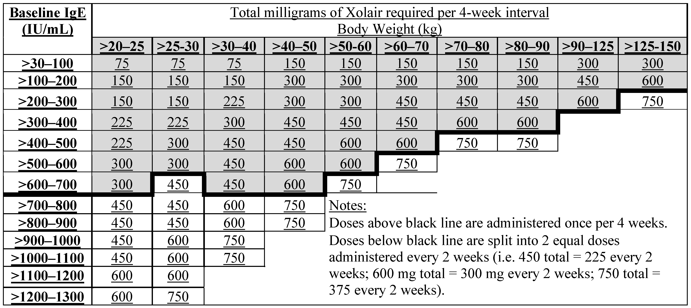
Table 2: Current: Xolair doses for adults and adolescents (12 years of age and older) with allergic asthma
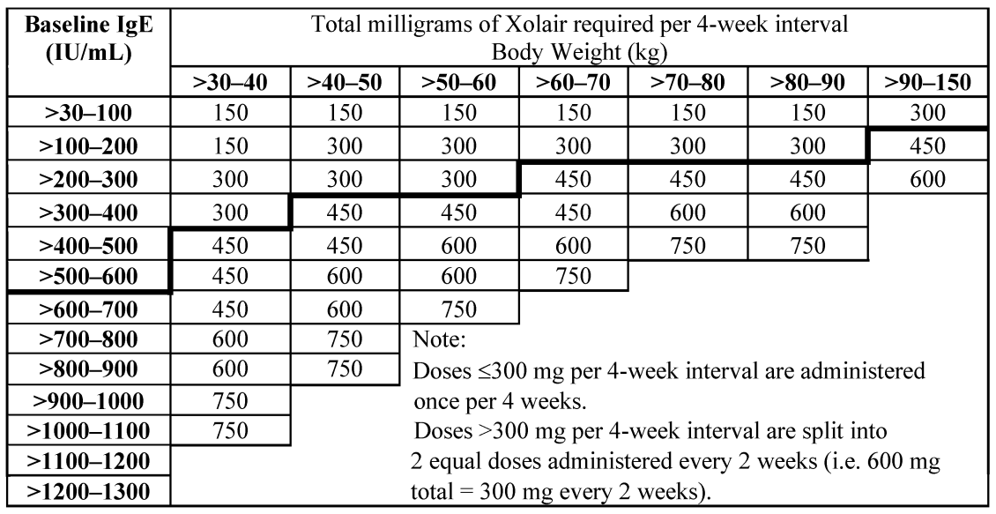
For use in children the proposed dosage range (per 4 week period) is 75 to 750 mg. Lower doses (75 to 300 mg) are to be given as a single dose at 4 weekly intervals and higher doses (450 to 750 mg) as two doses at 2 weekly intervals.
There are no other proposed changes to the PI.
A previous application to extend the use of omalizumab (rch) to include children 6 to 11 years with moderate to severe asthma on inhaled steroids was lodged in 2009. The clinical evaluator and the Delegate raised a number of issues (see Table 25) and the sponsor withdrew the application in 2010. The indications in this application differ in that they are more limited (for use in for patients with severe asthma on high dose corticosteroid). The sponsor has addressed most of these issues raised at the time of the last submission.

Regulatory status
Omalizumab (rch) was first registered for use in Australia in 2002.
Approval for use of omalizumab (rch) in children aged 6 to 11 years has been granted in the European Union (2005), New Zealand (2009) and Switzerland (2010) (Table 3). Paediatric submissions were also lodged in the USA (2008). The sponsor did not state the reasons for withdrawal. However, based on information available on its website, the FDA had concerns regarding marginal efficacy benefits and a need for further safety data (relating to malignancy, anaphylaxis and the need for long term data relating to immune complexes).
Table 3: International regulatory status
Country | Decision Date | Approved Indications | Reason for withdrawal
EU | Approved 27 Jul 2009 | Paediatric: ‘Xolair is indicated as add-on therapy to improve asthma control in patients with severe persistent allergic asthma who have a positive skin test or in vitro reactivity a perennial aeroallergen and frequent daytime symptoms or night-time awakenings and who have had multiple documented severe asthma exacerbations despite daily high-dose inhaled corticosteroids, plus a long-acting inhaled beta2-agonist’.
New Zealand | Approved 27 Aug 2009 | Paediatric: ‘Xolair (omalizumab (rch)) is indicated for the reduction of asthma exacerbations and control of asthma symptoms when given as add-on therapy for adult and adolescent patients, 6 years and older, with severe persistent allergic asthma who have IgE ≥ 30 IU/mL, a positive skin test or in vitro reactivity to a perennial aeroallergen and whose symptoms are inadequately controlled with inhaled corticosteroids’.
Switzerland | Approved 22 Nov 2010 | Paediatric: ‘Xolair is indicated for use in combination with other asthma therapies to improve asthma control in adults and children (6 years of age and above) with severe persistent allergic asthma (positive skin test or in vitro reactivity to a perennial aeroallergen) who have both reduced lung function (FEV1 <80%) and frequent daytime symptoms or night-time awakenings, and who have had asthma exacerbations despite daily high-dose inhaled corticosteroids and a long-acting beta2-agonist’.
In Saudi Arabia the inclusion of paediatrics was assessed and approved in June 2015

Product Information
The approved Product Information (PI) current at the time this AusPAR was prepared can be found as Attachment 1. For the most recent PI, please refer to the TGA website at <https://www.tga.gov.au/product-information-pi>.

II. Quality findings
There was no requirement for a quality evaluation in a submission of this type.

III. Nonclinical findings

Introduction

Revised dosage instructions
Doses and dosing frequency for allergic asthma are determined by baseline serum total IgE level and body weight. The sponsor’s draft PI document features a revised dose determination chart (Table 1). The existing dosage determination chart is shown in Table 2. Administration is by SC injection once every 2 or 4 weeks.
On an mg/kg basis, the maximum dose per injection will be increased across all body weight groups under the new dose scheme (see Table 4 below). Across the patient population, the highest administered dose increases from 12.5 mg/kg to 15 mg/kg (encountered in the four lowest weight groups). Maximum doses per 4 week interval are mostly unchanged in the existing body weight groups but newly included 20 and 25 kg subjects will receive up to 30 mg/kg over 4 weeks compared to an existing maximum approved dose of 25 mg/kg per 4 week interval.
Table 4: Dose per injection (mg/kg) Current versus proposed
Baseline IgE (IU/mL) | Dose per injection (mg/kg): current → proposed
Baseline IgE (IU/mL) | Lower body weight limit (kg)
Baseline IgE (IU/mL) | 20 | 25 | 30 | 40 | 50 | 60 | 70 | 80 | 90 | 125
>30–100 | NA →3.75 ^{①} | NA →3.0 ^{①} | 5.0 ^{①}→ 2.5 ^{①} | 3.75 ^{①} | 3.0 ^{①} | 2.5 ^{①} | 2.14 ^{①} | 1.88 ^{①} | 3.33 ^{①} | 2.4 ^{①}
>100–200 | NA →7.5 ^{①} | NA →6.0 ^{①} | 5.0 ^{①} | 7.5 ^{①} | 6.0 ^{①} | 5.0 ^{①} | 4.29 ^{①} | 3.75 ^{①} | 2.5 ^{②}→ 5.0 ^{①} | 1.8 ^{②}→ 4.8 ^{①}
>200–300 | NA →7.5 ^{①} | NA →6.0 ^{①} | 10.0 ^{①}→ 7.5 ^{①} | 7.5 ^{①} | 6.0 ^{①} | 3.75 ^{②}→ 7.5 ^{①} | 3.21 ^{②}→ 6.43 ^{①} | 2.81 ^{②}→ 5.63 ^{①} | 3.33 ^{②}→ 6.67 ^{①} | 2.4 ^{②}→ 3.0 ^{②}
>300–400 | NA →11.25 ^{①} | NA →9.0 ^{①} | 10.0 ^{①} | 5.63 ^{②} → 11.25 ^{①} | 4.5 ^{②}→ 9.0 ^{①} | 3.75 ^{②}→ 7.5 ^{①} | 4.29 ^{②}→ 8.57 ^{①} | 3.75 ^{②}→ 7.5 ^{①}
>400–500 | NA →11.25 ^{①} | NA →12.0 ^{①} | 7.5 ^{②}→ 15.0 ^{①} | 5.63 ^{②} → 11.25 ^{①} | 6.0 ^{②}→ 12.0 ^{①} | 5.0 ^{②}→ 10.0 ^{①} | 5.36 ^{②} | 4.69 ^{②}
>500–600 | NA →15.0 ^{①} | NA →12.0 ^{①} | 7.5 ^{②}→ 15.0 ^{①} | 7.5 ^{②}→ 15.0 ^{①} | 6.0 ^{②}→ 12.0 ^{①} | 6.25 ^{②}
>600–700 | NA →15.0 ^{①} | NA →9.0 ^{②} | 7.5 ^{②}→ 15.0 ^{①} | 7.5 ^{②}→ 15.0 ^{①} | 7.5 ^{②}
>700–800 | NA →11.25 ^{②} | NA →9.0 ^{②} | 10.0 ^{②} | 9.38 ^{②}
>800–900 | NA →11.25 ^{②} | NA →9.0 ^{②} | 10.0 ^{②} | 9.38 ^{②}
>900–1000 | NA →11.25 ^{②} | NA →12.0 ^{②} | 12.5 ^{②}
>1000–1100 | NA →11.25 ^{②} | NA →12.0 ^{②} | 12.5 ^{②}
>1100–1200 | NA →15.0 ^{②} | NA →12.0 ^{②}
>1200–1300 | NA →15.0 ^{②} | NA →15.0 ^{②}
^{①} = one injection per 4 week interval; ^{②} = two injections per 4 week interval

Scope of nonclinical data
Studies relevant to the current application were evaluated in the original application to register omalizumab (rch) as a new chemical entity and are discussed below. No further nonclinical studies were submitted with the current submission, which comprised one literature reference not of specific relevance to the current application.

Toxicology

Paediatric use
Previously evaluated studies established that omalizumab (rch):
- has a low order of acute toxicity with no toxic effects noted in cynomolgus monkeys following single dose administration at up to 50 mg/kg SC and 200 mg/kg IV
- does not target developing systems based on findings in cynomolgus monkeys in a 6 month general toxicity study conducted in young adult animals and involving treatment at up to 5 mg/kg IV or SC three times per week; a repeat-dose study in juvenile animals (8 to 10 months old) treated at up to 250 mg/kg/week SC for 6 months (with animal age over the treatment period roughly equivalent to 3 to 6 years of age for a human); and there being no apparent adverse effects on embryofetal or peri/postnatal development with maternal treatment at doses up to 75 mg/kg/week SC in the species
- may cause marked reductions in platelet counts in non-human primates, with juvenile animals more sensitive than adults.
The finding of decreased platelet count in omalizumab (rch)-treated non-human primates was seen to be mediated through a low affinity interaction between the drug and the platelet surface, with binding of the antibody promoting elimination of platelets via the reticuloendothelial system (rather than, for example, a mechanism involving direct lysis or inhibition of platelet production).
This effect of omalizumab (rch) varied across primate species, with platelet counts being consistently and statistically significantly reduced in cynomolgus monkeys and chimpanzees but not in rhesus and African green monkeys. In the most sensitive species (cynomolgus), the serum concentration of omalizumab (rch) that caused a 50% decrease in circulating platelet levels was 400 μg/mL in juvenile animals and 800 μg/mL in adult animals. Pharmacokinetic data described in the sponsor’s Clinical Overview and Summary of Clinical Pharmacology Studies indicate that some paediatric patients with high baseline IgE levels may experience serum omalizumab (rch) concentrations that exceed the 400 μg/mL threshold for an extended time. The higher mg/kg doses and resultant exposure levels in paediatric patients compared to adults coupled with the greater sensitivity seen for juvenile animals, increases concern for potential thrombocytopenia in the new patient population compared to the existing one. The current and proposed revised PI documents contain precautionary statements with regard to thrombocytopenia.

Local tolerance
Previously evaluated studies showed omalizumab (rch) to be well tolerated locally by the SC route in rabbits following single injection at up to 150 mg. Assuming an animal body weight of 3 kg, this dose is equivalent to more than 3 times the maximum clinical dose on an mg/kg basis. Repeated SC administration at up to 40 mg/day for 14 days in rabbits produced only minor and transient signs of local irritation and there was evidence for slight local irritation at SC injection sites in cynomolgus monkeys treated for 6 months (mainly with treatment at 1 and 5 mg/kg three times weekly). Injection site reactions are noted in the existing PI document as a common adverse drug reactions observed in clinical trial subjects. While the nonclinical data support the absence of severe injection site reactions, given that the proposed revised dosing regimen favours administration of a higher, single dose per 4 week interval over smaller, divided doses given 2 weeks apart, injection site reactions can be expected to be encountered with increased frequency.

Nonclinical summary and conclusions
- An extension of the indications for the anti-asthma treatment Xolair to include patients 6 to 12 years old (compared to ≥ 12 years currently) and changes to the dose regimen are proposed.
- When considered on an mg/kg basis, these changes give rise to an increase in the maximum dose per 4 week interval (from 25 mg/kg currently to 30 mg/kg; specifically in the new paediatric patient group) and the maximum administered dose per injection (from 12.5 mg/kg to 15 mg/kg; in children and adolescents). Administration as a higher, single dose per 4 week interval rather than smaller, divided doses two weeks apart is also promoted (across the patient population).
- No relevant new nonclinical data were submitted. Previously evaluated nonclinical studies established that omalizumab (rch) has a low order of acute toxicity and does not target developing systems. Slight local irritation was observed with repeat dosing by the SC route in animals. Omalizumab (rch) was found to cause marked reductions in platelet counts in cynomolgus monkeys and chimpanzees, with juvenile monkeys more sensitive to this effect than adult animals. This occurred at serum concentrations that may be encountered in some paediatric patients.
- The nonclinical data identify thrombocytopenia and injection site reactions as particular concerns that should be taken into account in considering the benefit-risk balance associated with the application. Provided these concerns are adequately addressed from the clinical dataset, there are no nonclinical objections to the proposed extension of indication and revised dosing regimen for Xolair.
- Changes proposed by the sponsor to the Effects on fertility and Use in pregnancy statements in the existing approved PI document were opposed in the first round nonclinical evaluation. A revised version of the PI was provided for the second round nonclinical evaluation and is now considered to be acceptable from a nonclinical perspective pending some further minor corrections.

IV. Clinical findings
A summary of the clinical findings is presented in this section. Further details of these clinical findings can be found in Attachment 2.

Introduction

Clinical rationale
Immunoglobulin E (IgE) is involved in the sensitisation of mast cells to specific allergens in allergic disorders and elevated IgE levels are a common feature of such conditions. The rationale behind omalizumab (rch) is that an agent directed against IgE should lead to clinical improvement in patients with allergic asthma. As allergic asthma is common in children, extension of its use to this population may be appropriate.
The rationale for the revised dosing table is to improve convenience for patients, to possibly aid with compliance and to reduce use of health care resources.

Contents of the clinical dossier

Scope of the clinical dossier
To support use in children the sponsor submitted:
- Two Phase III randomised, double blind, placebo-controlled trials (IA05 and 010) examining efficacy and safety. These two studies also provided limited pharmacokinetic (PK) and pharmacodynamic (PD) data in children. The studies were included in the previous TGA submission seeking approval in children.
- Seven open-label studies (1 comparative and 6 single arm studies) which each provided some data on children aged 6 to < 12, for a supportive pooled analysis of safety (Studies Q2143g, Q2195g, Q2461g, 010E, 010E1, B1301 and B1301E). Several of these studies have previously been evaluated by the TGA.
To support the proposed changes to the dosing table, the submission included:
- 1 population PK/PD analysis (Report: Population PK/PD 2013).
The clinical submission also included study reports for a number of other trials that have previously been evaluated by the TGA. Some paediatric patients from some of these trials were included in other pooled safety analyses in the submission. Other studies were conducted in adults and adolescents and provided data that were used in comparative analyses contained in the submission and in the population PK/PD analysis. The full study reports for these trials have not been reviewed in this evaluation. The submission also included a report of a large post-marketing observational study (Study Q2948g or EXCELS). This study enrolled subjects aged 12 or over only and has previously been evaluated by the TGA. It has therefore not been reviewed in this report.
The clinical submission also contained literature references.

Paediatric data
Data were submitted to support use in children aged 6 to <12.
No data were submitted for children < 6 years. The sponsor has a waiver from the European medicines Agency (EMA) for this subgroup on the grounds that the product ‘does not represent a significant therapeutic benefit over existing treatments’. The sponsor also has a waiver from the FDA for development in subjects aged < 6 years on the grounds that ‘evidence strongly suggests that the product would be unsafe in this paediatric subpopulation.’ The reasoning behind the granting of these waivers was not discussed.

Good clinical practice
The study reports for the clinical trials contained in this submission included assurances that the trials were conducted in accordance with Good Clinical Practice (GCP) guidelines.

Pharmacokinetics

Studies providing pharmacokinetic data
Table 5 shows the studies relating to each pharmacokinetic topic.
Table 5: Submitted pharmacokinetic studies
PK topic | Subtopic | Study ID
PK in children | General PK- Single and multiple dose - Multiple dose | Study 010  Studies IA05 and 010
Population PK analyses | Revised dosage table in asthma | Population PK/PD 2013
None of the pharmacokinetic studies had deficiencies that excluded their results from consideration.

Evaluator’s overall conclusions on pharmacokinetics
The submitted PK data were acceptable.

Pharmacodynamics

Studies providing pharmacodynamic data
Table 6 shows the studies relating to each pharmacodynamic topic and the location of each study summary.
Table 6: Submitted pharmacodynamic studies
PD Topic | Subtopic | Study ID
Primary Pharmacology | Effect on free IgE and total IgE | Study 010  Studies IA05 and 010
Population PK/PD analysis | Effect on free IgE and total IgE | Population PK/PD 2013

Evaluator’s overall conclusions on pharmacodynamics
The submitted PK data are acceptable. The effects of omalizumab (rch) on free IgE and total IgE levels in children are consistent with those observed in adults and adolescents.

Dosage selection for the pivotal studies
No dose-ranging studies were performed in children. The dosing schemes for children used in the clinical trials aimed to estimate the amount of drug needed for each patient in order to suppress IgE levels below 50 ng/mL and to keep within reasonable safety margins as determined by toxicology studies. To achieve IgE levels below 50 ng/mL an average reduction of 25 ng/mL was targeted.

Efficacy

Studies providing efficacy data
Two Phase III randomised, double blind, placebo-controlled trials (IA05 and 010) examining efficacy and safety were submitted.

Evaluator’s conclusions on clinical efficacy
The indication sought by the sponsor for subjects aged 6 to <12 years with allergic asthma is limited to patients with all of the following:
- Severe persistent disease (with frequent daytime symptoms or night time awakenings);
- A history of exacerbations;
- Current treatment with high dose inhaled corticosteroids (ICS).
A high dose of ICS is defined in the current Australian Asthma Handbook (Table 7).
Table 7: Australian Asthma Handbook; Definitions of ICS dose in children
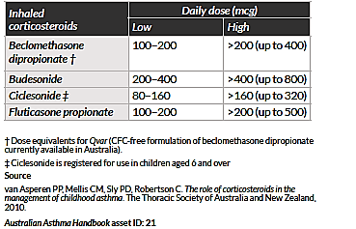
For children without good control of symptoms who are currently already receiving high dose ICS, the current Handbook recommends referral for specialist management (Figure 11). Possible treatments for this population would include the addition of long-acting beta agonists (LABAs) or montelukast. The submission did not contain any studies that compared omalizumab (rch) with these treatment options in the proposed population. Omalizumab (rch) was only compared with placebo.
Figure 1: Australian Asthma Handbook. Treatment steps in children. Stepped approach to adjusting asthma medication in children.
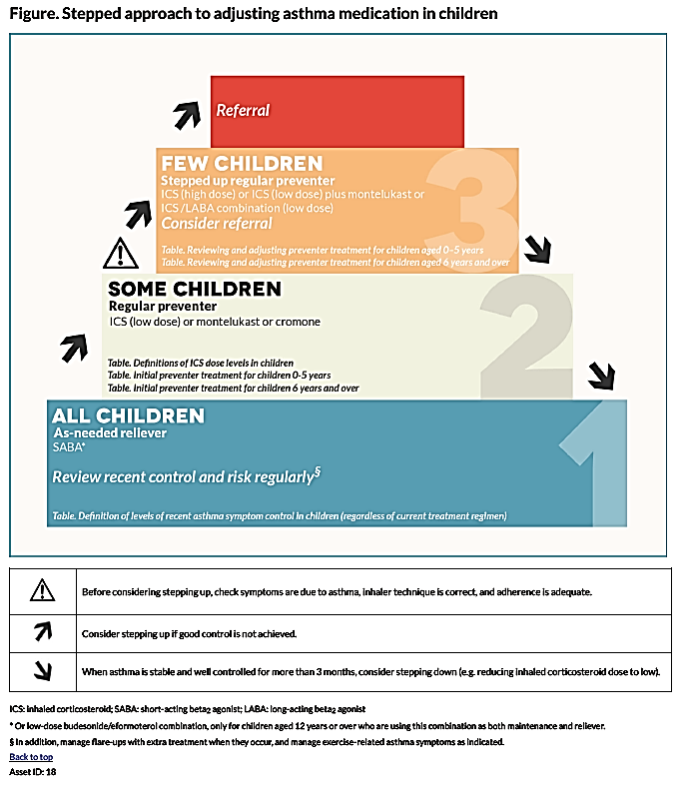
Two randomised, placebo controlled trials were submitted. These studies were well designed and well executed and generally complied with relevant EMA guidelines adopted by the TGA.,
The pivotal study for the submission was IA05. In this study 64% of subjects had severe persistent asthma. Mean daily ICS dose was > 500 µg fluticasone, consistent with subjects being treated with high dose ICS. The study demonstrated a significant efficacy benefit in terms of a reduction in the frequency of clinically significant exacerbations. In the overall study population, there was a 31% reduction in the number of exacerbations after 24 weeks and a 43% reduction after 52 weeks. Very similar reductions were observed in the subpopulation of subjects classified as having severe disease.
In the overall study population there were no significant benefits in terms of asthma symptoms, reduction in rescue medication or ICS use, or quality of life. The reduced number of exacerbations did not translate into a reduction in hospitalisations, emergency department visits or unscheduled doctor visits.
Study 010 is considered less relevant to the proposed indication. Only 8% of subjects were considered to have severe asthma and the population was being treated with low doses of ICS. The study also used a different dosage regimen to that being proposed in the submission. The study showed that in the enrolled population a significantly greater reduction in ICS dose could be achieved with omalizumab (rch) than with placebo. This finding is probably not relevant to the proposed indication, as Study IA05 failed to demonstrate a reduction in ICS dose with omalizumab (rch) in subjects with more severe disease.
The published ICATA study demonstrated benefits for omalizumab (rch) in terms of reduced symptoms, reduced frequency of exacerbations and reduced ICS dose. However this study was conducted in subjects aged 6 to 20 years old and with varying disease severity. Retrospective subgroup analyses suggested that the efficacy benefits were maintained in children aged 5 to 11 and in subjects with more severe disease. However, details of subpopulation of interest were very limited.
Overall therefore assessment of efficacy must rely on the findings of IA05. This study has shown a modest efficacy benefit for omalizumab (rch) over placebo, limited to a reduction in the frequency of exacerbations. This benefit was demonstrated for the whole study population and for the subpopulation with severe disease.
The submission also presented analyses of efficacy for another subpopulation in IA05; the European Union (EU) modified Intent-to-Treat (mITT) subpopulation, defined as those patients requiring high dose ICS plus LABA at baseline. This is the patient population that has been approved in Europe but is not the indication currently being sought in Australia. The efficacy benefits observed in the EU mITT population were comparable to those observed for the whole population in IA05.

Safety

Studies providing safety data
In the sponsor’s Summary of Clinical Safety, the sponsor presented pooled analyses of safety for children aged 6 to < 12 years. Analyses of various pooled populations were presented. The two analysis populations that are considered the most relevant to the current evaluation were:
- The allergic asthma placebo controlled (AAP) population, which included subjects aged 6 to < 12 who received treatment in one of the two double blind placebo controlled studies (IA05 or 010);
- The allergic asthma open label (AAO) population, which included subjects aged 6 to < 12 who received treatment in one of seven open-label or uncontrolled trials. These trials are listed in Table 8. One of these (Q2143g or ALTO) was a large Phase III comparison of omalizumab (rch) against current best practice asthma treatment. It enrolled over 11,000 subjects but included only 128 subjects aged 6 to < 12 years. The other studies were uncontrolled. Studies 010E, Q2143g, Q2195g and Q2461g have previously been evaluated by the TGA.
Table 8: Studies included in the AAO safety population
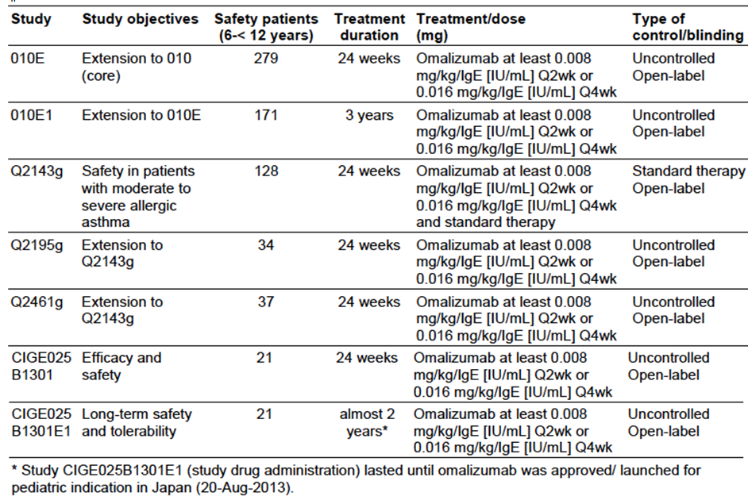

Placebo controlled studies
In the two placebo controlled efficacy studies, the following safety data were collected:
- General adverse events (AEs) were assessed at each study visit. AEs could be volunteered by the patient or discovered by the investigator on general questioning, physical examination or by laboratory testing. AEs were graded as mild, moderate or severe. AEs were coded using Medical Dictionary for Regulatory Affairs (MedDRA) terminology.
- AEs of special interest were:
  - Serum sickness syndrome;
  - Skin rash and urticaria;
  - Hypersensitivity reactions
  - Anaphylaxis;
  - Bleeding related disorders;
  - Malignancies;
  - Injection site reactions.
- Vital signs were measured at regular intervals
- Physical examination was conducted at regular intervals
- Laboratory tests, including the following, were performed at regular intervals:
  - Full blood count (haemoglobin, haematocrit, red blood cell (RBC), white blood cell (WBC) with differential, platelet count);
  - Biochemistry (serum sodium, serum potassium, serum glucose, creatinine, blood urea nitrogen (BUN), uric acid, protein, albumin, calcium, total bilirubin, aspartate aminotransferase (AST), alanine aminotransferase (ALT), alkaline phosphatase);
  - Urinalysis.

Open label studies
Safety monitoring in the open label studies was generally similar to that undertaken in the placebo controlled studies.

Pivotal studies that assessed safety as a primary outcome
The primary outcome variables for Study 010 were related to safety and tolerability. The safety findings from this study are described as part of the pooled AAP population.

Patient exposure
In the AAP population, 624 subjects were treated with omalizumab (rch) and 302 with placebo. In the AAO population 407 subjects received omalizumab (rch).
Duration of exposure for the AAP population is summarised in Table 9. Duration was comparable in the omalizumab (rch) and placebo arms, with a mean of approximately 42 weeks. Duration of exposure for the AAO population is summarised in Table 10. Mean exposure to omalizumab (rch) was 104 weeks, reflecting the fact that many of the studies were long-term extension studies.
Table 9: Duration of exposure AAP population
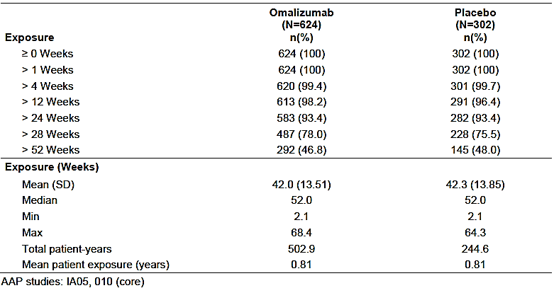
Table 10: Duration of exposure AAO population
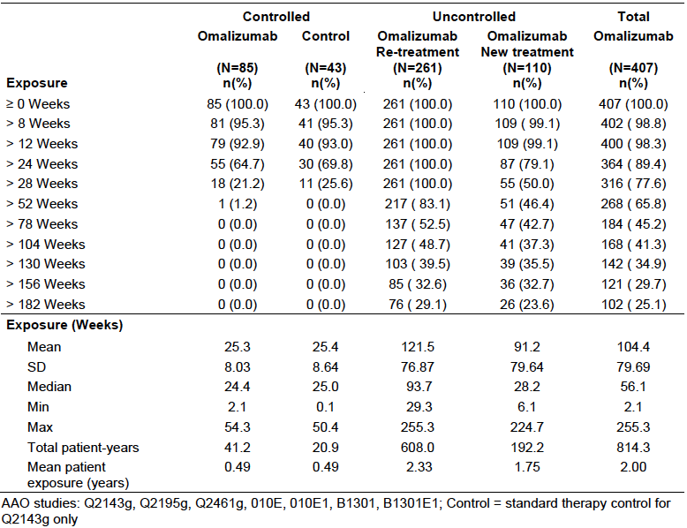

Safety issues with the potential for major regulatory impact

Liver toxicity
Liver function testing in the placebo controlled studies did not suggest an increased risk of hepatotoxicity with omalizumab (rch) in children.

Haematological toxicity
As described in the current product information, omalizumab (rch) has been associated with the development of thrombocytopaenia non-human primate species, with the risk increased in juvenile animals. In the AAP population, there was a slightly higher incidence of clinically notable thrombocytopaenia with omalizumab (rch) (0.6% versus 0.3%; Table 11). However, cases in the omalizumab (rch) group were all transient and not associated with bleeding events.
There was one case of severe pancytopaenia reported with omalizumab (rch) in Study IA05. The sponsor should be asked to provide further details of this case.
Table 11: Abnormalities in haematology parameters AAP population
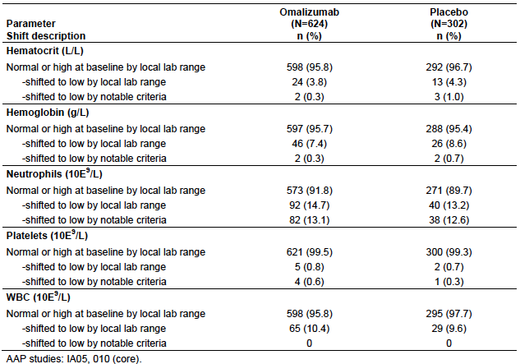

Serious skin reactions
None of the serious AEs reported in the AAP or AAO populations were dermatological in nature.

Cardiovascular safety
In the AAP population there was no notable increase in the incidence of cardiovascular AEs in the omalizumab (rch) group.

Unwanted immunological events
Omalizumab (rch) is known to be associated with adverse immunological events (including anaphylaxis and serum sickness). In the placebo controlled studies in this submission, the incidence of such events was not increased with omalizumab (rch).

Postmarketing data
One periodic safety update report (PSUR) was submitted. This report covered the 6 month period from 1 January 2014 and to 30 June 2014. This period was after approval for use in children and approval for the revised dosage table in Europe, New Zealand and Switzerland. Overall it was concluded that no new safety signals were identified during the period.
For the 3 month period of January to March 2014, the estimated exposure in children aged 6 to 11 years was 952 subjects. The cumulative exposure in children aged 6 to 11 years between June 2011 and March 2014 was 9,157 subjects for asthma and 2,512 subjects for other indications. The most common events reported in children aged 6 to < 12 years during the period are summarised in Table 12.
Table 12: Periodic Safety Update: Common reported AEs
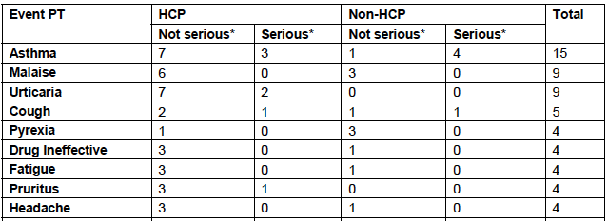
HCP = Health care professional; PT = preferred term;
Of all the events reported, 27 were reported as serious. Thirteen of these cases were not assessable due to insufficient information. The remaining 14 included the following:
- One report of thrombocytopaenia (7 x 10⁹/L) in a 10 year old female who had received omalizumab (rch) for 10 months. The patient had positive serology for parvovirus B19 and a normal bone marrow. Omalizumab (rch) was ceased and the patient was treated with immunoglobulins, with improvement in platelet count to 57 x 10⁹/L. Six months later the patient had a relapse (to 5 x 109/L) despite not receiving further omalizumab (rch). The sponsor considered an alternative aetiology, such as Idiopathic thrombocytopenic purpura (ITP), was the more likely explanation for this event.
- Three reports suggestive of allergic reactions ( such as rash, urticaria, erythema and pruritus);
- Two reports of injection site reactions;
- One report of allergic bronchopulmonary aspergillosis;
- Two reports of dengue fever;
- Five reports of asthma exacerbations.
There were no reports of anaphylaxis or malignancies in children aged 6 to < 12 years.

Evaluator’s conclusions on safety
In the submitted placebo controlled studies the safety profile of omalizumab (rch) appeared comparable to that of placebo. No new safety issues were identified in children.
Other paediatric studies and post-marketing data included in the submission did not identify any new safety issues when omalizumab (rch) was administered to children aged 6 to < 12 years.
PK/PD modelling suggests that the revised dosing regimen will result in modest increases in omalizumab (rch) peak plasma concentration (C_{max}). Changes in overall systemic exposure would not be expected. It is therefore considered unlikely that the revised dosage regimen would be associated with any significant safety concerns. Limited clinical trial and post-marketing data on the safety of doses ≥ 600 mg do not suggest any novel safety issues.

First round benefit-risk assessment

First round assessment of benefits
The benefits of omalizumab (rch) in children aged 6 to < 12 years are:
- A reduction in the rate of clinically significant asthma exacerbations. The rate was reduced by approximately 31% after 24 weeks and 43% after 52 weeks. Similar reductions were observed in the subgroup of patients with serve asthma, the population being proposed by the sponsor.
The benefits of the proposed changes to the dosing regimen for adolescents and adults are:
- Improved convenience and possibly compliance in patients, and reduced use of health care resources. No improvements in efficacy are expected.

First round assessment of risks
The risks of omalizumab (rch) in children aged 6 to < 12 years are:
- Risks similar to those associated with its use in adults and adolescents (including allergic reactions).
The submitted data suggest that there are no significant additional risks associated with the proposed changes to the dosing regimen for adolescents and adults

First round assessment of benefit-risk balance

Use in children aged 6 to < 12 years
The demonstrated efficacy benefits associated with omalizumab (rch) are limited to its effect on exacerbations. The benefits are modest, with a reduction in the rate of asthma exacerbations from 0.64 to 0.45 episodes per 24 week treatment period. In general, the submitted safety data do not suggest any new safety issues associated with use of omalizumab (rch) in subjects aged between 6 and <12 years. However, the drug is known to be associated with several adverse effects that are likely to occur in the paediatric population such as allergic reactions. Overall, the benefit-risk balance could be considered marginal.
In contrast to the original application in 2009, the sponsor is proposing to limit the approved population to children with severe asthma who are uncontrolled on high dose ICS. The approved population in Europe is limited even further, to those subjects with severe asthma who are uncontrolled on high dose ICS and LABA. Given the limited evidence of efficacy it would be appropriate to restrict the indication to subjects with severe disease who are uncontrolled on optimal available therapy. Subgroup analyses of the pivotal study indicate that similar efficacy is likely to be obtained in such subjects. Unlike the one in Europe, the sponsor’s proposed indication for Australia does not require that subjects should have been treated with LABAs prior to commencing omalizumab (rch). LABAs have been associated with adverse outcomes in children., Neither the current Australian Asthma Handbook nor the international GINA guidelines recommend routine introduction of LABAs in children who are not controlled on high dose ICS. Given the safety concerns associated with LABAs, it may be more appropriate for some patients to be commenced on omalizumab (rch). Therefore, if the application is to be approved, the indication proposed by the sponsor is considered acceptable.
Overall, the benefit-risk balance of omalizumab (rch) for the proposed paediatric population is considered favourable. This assessment takes into account the fact that the proposed population (severe disease and already on high dose ICS) is one with limited available treatment options.

Changes to the dosing regimen for adolescents and adults
Based on the PK/PD model developed by the sponsor, the overall benefit-risk balance for omalizumab (rch) will not be significantly altered and therefore remains favourable.

First round recommendation regarding authorisation
It is recommended that the application be approved.

Clinical questions

Safety
- In the AAO safety population there were two cases of clinically notable reductions in platelet count; 1 in the re-treatment group and 1 in the new treatment group. Please provide summaries of these cases, including results of all platelet counts.
- One case of severe pancytopaenia was reported (IA05). Please provide a summary of this case.

Second round evaluation of clinical data submitted in response to questions

Errors of fact and omissions
The evaluators has noted and amended this version of the evaluation report with the sponsor’s comments on the first round evaluation. These changes have no effect on the outcome of the first round evaluation.

Response to clinical questions

Clinical question I. evaluator comments on the sponsor’s response
The sponsor’s response is satisfactory. It is unlikely that these patient’s low platelet counts were related to omalizumab (rch). Possible causes include artefactually low readings from clumping in the laboratory, viral illness or concomitant medications.

Clinical question II. evaluator comments on the sponsor’s response
The sponsor’s response is satisfactory. The abnormal haematology results were unlikely to be due to the study medication.

Additional safety related changes requested by the sponsor
The sponsor has proposed additional safety related changes to the PI following the results of a study (EXPAND) that characterised the risk factors for anaphylaxis following Xolair administration to asthma patients. This information became available during the review period of PSUR 20 from January 1 2014 to December 31 2014.
The following information is from the response:

Background
The incidence of anaphylaxis in severe asthma patients is reported to be 65.35 cases per 100 000 patient years. Because Xolair is a protein, there is a possibility of immediate hypersensitivity reactions such as anaphylactoid reactions. Anaphylaxis and anaphylactoid reactions were rare in the clinical development program and balanced between Xolair and placebo arms. Cases of anaphylaxis and anaphylactoid reactions have been reported in the post market setting.
X-PAND (Q4458g) was a case control study using clinical data and serum repository of subjects who experienced anaphylaxis associated with omalizumab (rch) (cases) compared to subjects treated with omalizumab (rch) who did not experience anaphylaxis (controls). Potential cases of anaphylaxis or anaphylactoid reactions were adjudicated on the basis of Sampson Criteria. If a positive adjudication was made, the health care providers who reported cases were asked to enrol each anaphylaxis patient in the repository study and identify up to 4 suitable controls. Patients who had discontinued treatment for more than 16 weeks but less than 18 months were eligible to be tested for anti-therapeutic antibody assay and a skin test.
There were 30 cases identified. These were matched to 88 controls. A previous history of anaphylaxis was noted in 56.7% of anaphylaxis cases and 22.7% of control subjects. Exploratory analysis using a multivariate logistic regression model found that prior anaphylaxis was a risk factor for adjudicated anaphylaxis. Approximately 40% of patients with anaphylaxis experienced a reaction in the first 3 doses. All patients (n=31, 21 cases and 10 controls) that were tested for anti-treatment antibodies were negative for IgG and IgE isotypes to omalizumab (rch).

Postmarketing safety data
A cumulative search of the safety database retrieved a total of 2873 evaluable cases. The majority of anaphylactoid reactions occurred after the first dose. Based on an estimated exposure of 566 923 patient years, the reporting rate of anaphylaxis was 0.16%.

Evaluator’s comment
The sponsor has noted a number of limitations of the X-PAND study and post marketing data. Despite this, the safety related changes are acceptable.

Sponsors response to further questions from the Delegate

Delegate’s question 1
In relation to the dosing: Is there any role in monitoring patients free IgE level and adjusting the dose of omalizumab (rch) to achieve a level < 50 (or 25) IU/mL?

Sponsor’s response
Two commercial free IgE assays have been compared to the Genentech assay used in the sponsor’s drug development program. Both of these assays were found to over report IgE levels. If patients are treated as per the dosing table provided by the sponsor, free IgE levels are expected to be less than 50ng/mL in > 95% of patients.

Evaluator comment
The response is acceptable and helpful.

Delegate’s question 2
Based on the clinical trials, it appears that omalizumab (rch) is less efficacious in children than in adults. This may be because the clinical trials in children were smaller and underpowered to detect a significant difference and the patients had less severe asthma than in the adult trials. Could the sponsor please provide some more background information about the heterogeneity and natural history of moderate and severe asthma in children?
Although there have been more clinical trials in adults than in children, the clinical response in children is comparable or in some ways superior to in adults. For example, in the 5 placebo controlled randomised clinical trial (RCT) in adults and adolescents, Xolair reduced asthma exacerbations by 35% (95% confidence interval (CI) 23 to 45%), compared with study IA05 where the relative rate reduction in asthma exacerbations was 30.7%. Patients with more severe asthma had greater benefits.
The sponsor acknowledges that benefits in secondary end points were not apparent in Study IA05 and explains this on the basis of a number of studies that have demonstrated that children and their families are unable to perceive differences in asthma control.
Epidemiological studies have shown that in around 50% of children, symptoms improve by adolescences. Those with more severe asthma are less likely to improve. Atopy is also a risk factor for persistent asthma. Poorly controlled asthma can lead to loss of lung function.

Sponsor’s response
In Busse et al 2007, the mean benefit on corticosteroid bursts was 35% in 5 placebo-controlled randomized trials. The duration of active treatment in each of these trials was 28, 28, 52, 52, and 32 weeks. In Study IA05, the benefit on clinically significant exacerbations in the mITT population was 31% over 24 weeks and 43% over 52 weeks; in the EU mITT population (Step 4 treatment as background) the benefit was 34% over 24 weeks and 50% over 52 weeks.
In the adult trial in severe asthma in this analysis (INNOVATE), in which all recruited patients were receiving Step 4 treatment as background therapy, the benefit on exacerbations over 52 weeks was 26% (versus a 50% benefit in the equivalent population over the same time interval in Study IA05). Therefore, the sponsor maintains that the benefit on exacerbations in children is at least as good as that in adults and the benefit on exacerbations among patients on high dose ICS/LABA background controller therapy is numerically greater in children than in adults.

Evaluator’s comment
Although the poor ability of children and their families to accurate describe symptoms of control may contribute to bias towards no treatment difference in the reports of symptom score or quality of life, it does not explain the discrepancy between reduction in exacerbations but not difference seen in ICS, use of asthma rescue medications or emergency department (ED) presentations with asthma. The secondary outcomes also demonstrated an improvement in forced vital capacity (FVC) but not forced expiratory volume (FEV1).
There was also some inconsistency in findings between trials. For example in Study IA05 there was no reduction in ICS dose, where as in IA010 patients were able to reduce the dose of ICS.

Delegate’s question 3
For patients who respond to omalizumab (rch), is ongoing treatment recommended, or is finite period better? What has been the experience with long term treatment in children and adults? Does the response wane over time?

Sponsor’s response
Few studies have evaluated long term efficacy of asthma therapies. The XPORT study evaluated the persistence of response in patients continuing or withdrawing from omalizumab (rch) therapy after > 5 years of therapy with omalizumab (rch).
The XPORT study was a randomised, double blind, placebo controlled 52 week withdrawal study. Patients were enrolled in the study if they had received ≥ 5 years of omalizumab (rch). The primary objective was to determine the persistence of response to omalizumab (rch) in patients with moderate to severe persistent allergic asthma who discontinued omalizumab (rch) after long term treatment. The study enrolled 176 adult patients, 88 who were randomised to treatment with omalizumab (rch) and 88 to placebo. A significantly greater number of patients showed persistency in the prevention of an asthma exacerbation in the omalizumab (rch) continuation group (n=59, 67%) versus placebo (n=42, 47.7%). There was a 40.1% relative difference in the proportion of patients with exacerbations. Time to fist protocol defined exacerbation was longer and symptom control was better in the omalizumab (rch) group. The incidence of adverse events was similar. However the authors also found that for some patients, cessation of therapy results in an increased likelihood of asthma exacerbations

Evaluators comment
The response is acceptable. Further studies comparing omalizumab (rch) to other preventative therapies for long term control would be helpful. Information about discontinuation should be added to the PI.

Delegate’s question 4
Does the use of omalizumab (rch) interfere with patch testing? For patients with allergies who are on omalizumab (rch) where clinicians may use serum IgE or patch testing to assess ongoing sensitization, how would clinicians judge whether it is safe to expose a patient to potential allergens?

Sponsors response
Omalizumab (rch) does appear to increase the likelihood of false negative to skin prick and perhaps also patch testing.

Evaluators comment
The response is acceptable. It would be helpful to add a comment in the PI in relation to the interpretation of serum IgE levels and skin prick and patch testing while patients are being treated with omalizumab (rch).

Second round benefit-risk assessment
The benefits and risks associated with the use of omalizumab (rch) in children aged 6 to 12 years with allergic asthma are unchanged as a result of the additional information presented.

Second round recommendation regarding authorisation
The clinical evaluator recommends approval.

V. Pharmacovigilance findings

Risk management plan
The sponsor submitted a Risk Management Plan (Core RMP Version 9.0 (dated 21 July 2013); EU-RMP Version 9.0 (dated 24 June 2013); and an Australian Specific Annex (ASA) Version 1.0 (dated 28 October 2013)) which were reviewed by the RMP evaluator.

Safety specification
The sponsor provided a summary of ongoing safety concerns which are shown at Table 13.
Table 13: Summary of ongoing safety concerns
Information | Safety concern
Important identified risks | Anaphylaxis/anaphylactoid reactions  Malignant neoplasm (in adults and adolescent patients ≥ 12 years old)  Serum sickness syndrome (SSS)/Serum sickness like disease (SSLD)  Antibody formation to omalizumab (rch)  Churg Strauss Syndrome/Hypereosinophilic syndrome  Thrombocytopenia
Important potential risks | Arterial thromboembolic events (ATEs)  Malignant neoplasms (in paediatric patients 6 to < 12 years old)  Off label use
Important missing information | Pregnancy outcomes
The sponsor proposes routine pharmacovigilance activities to monitor all the specified ongoing safety concerns, including the use of a targeted follow-up questionnaire/checklist for the important identified risks: ‘Anaphylaxis/anaphylactoid reactions’ and ‘Malignant neoplasms in adults and adolescents ≥ 12 years of age’ and the important potential risk: ‘Arterial Thromboembolic Events (ATEs)’. Copies of these questionnaire/checklists have been provided as an attachment to the ASA.
For all the specified important identified risks and for all the specified important potential risks, except for ‘Off-label use’, an ongoing extension study will assess the long term safety and tolerability of omalizumab (rch) as an add-on therapy in Japanese paediatric patients (6 to 15 years of age) with inadequately controlled allergic asthma despite current recommended treatment by providing continued treatment with omalizumab (rch) to patients who have previously completed the core study. A final protocol for ‘An extension study to CIGE025B1301 to evaluate the long-term safety, tolerability and efficacy of omalizumab (rch) in Japanese children (6 to 15 years) with inadequately controlled allergic asthma despite current recommended treatment (CIGE025B1301E1)’ was provided in the sponsor’s correspondence dated 11 December 2013. The ASA states that the planned date for submission of the final report to the EU is May 2014.

Risk minimisation activities
The sponsor has concluded that routine risk minimisation activities for all the specified ongoing safety concerns are sufficient.
The ASA states: ‘Section 10 of the Core Safety RMP for Xolair outlines the Risk Minimisation Plan that Novartis will be implementing globally’ and ‘Novartis Pharmaceuticals Australia will be implementing ‘routine’ risk minimisation activities in Australia through the provision of the TGA approved Product Information (PI) and Consumer Medicine Information (CMI)’ and ‘There are no additional risk minimisation activities planned for Xolair’.
The sponsor’s conclusion remains similar to what was previously accepted for Xolair, and at this time continues to be acceptable.

Reconciliation of issues outlined in the RMP report
Table 14 summarises the TGA’s first round evaluation of the RMP, the sponsor’s responses to issues raised by the evaluator and the evaluator’s comments of the sponsor’s responses.
Table 14: Reconciliation of issues outlined in the RMP Evaluation Report
Recommendation in RMP evaluation report | Sponsor’s response | Evaluator’s comment
The sponsor should provide a concise summary of the context of the withdrawn paediatric application in the US. | [Information redacted] | This is acceptable.
The sponsor should provide an update on the status of Study CIGE025B1301E1, as the planned date for the submission of the final report has passed. | The sponsor has advised that Study CIGE025B1301E1 has been completed and is part of the data package submitted in the current application to the TGA. | The status of Study CIGE025B1301E1 has been revised in the updated EU-RMP. This is acceptable.
For the important potential risk: ‘Malignant neoplasms (children 6 to less than 12 years old)’, the ‘Pharmacovigilance activity’ column of Section 10.2 - Table 2: ‘Summary of safety specification, pharmacovigilance plan and planned risk minimisation measures in Australia’ of the ASA should be amended to be consistent with Part III - Table 10-8 of the EU-RMP. | The sponsor states: ‘Novartis acknowledges the RMP evaluator’s request and Table 2 (Summary of safety specification, pharmacovigilance plan and planned risk minimization measures in Australia) in attachment 1 of the updated ASA version 5.0 has been amended’. | This is acceptable.
In regard to the proposed routine risk minimisation activities for the important identified risk: ‘Churg Strauss Syndrome (CSS)/Hypereosinophilic Syndrome’, it is recommended to the Delegate that the related wording in the current EU SmPC be included in the Precautions section of the proposed Australian PI to enhance safe use of this medicine. | The sponsor has advised that the wording in the Precaution section of the draft Australian PI is the same as that in the current EU SmPC. | This is acceptable, although Table 1: ‘Details by safety concern of information included in the Australia Product Information and EU SmPC and justification for any differences’ and Table 2: ‘Summary of safety specification, pharmacovigilance plan and planned risk minimisation measures in Australia’ of the ASA only state: ‘Adverse effects, Post-marketing observations Respiratory, thoracic and mediastinal disorders: Allergic granulomatous angiitis (that is, Churg Strauss syndrome) is listed as a post-marketing observation’. Consequently these tables of the ASA should be updated with this information, preferably before this application is approved. In addition the ASA states that the release date for the EU-RMP (Version: 10) is 8 July 2015, while the document itself states the date for final sign-off is 5 March 2015. The sponsor should clarify this discrepancy and amend the ASA if required.
In regard to the proposed routine risk minimisation activities, it is recommended to the Delegate that the draft consumer medicine information document be revised to adequately reflect any changes made to the Australian PI as a result of the above recommendations. | The sponsor states: ‘None of the above recommendations are actually warranting any changes to the draft consumer medicine information’. | This is acceptable.

Summary of recommendations
It is considered that the sponsor’s response to the TGA has adequately addressed all of the issues identified in the RMP evaluation report. Nevertheless an updated ASA should be submitted to the TGA, preferably before this application is approved.

Outstanding issues

Issues in relation to the RMP
In regard to the proposed routine risk minimisation activities for the important identified risk: ‘Churg Strauss Syndrome (CSS) / Hypereosinophilic Syndrome’, the sponsor has advised that the wording in the Precaution section of the draft Australian PI is the same as that in the current EU SmPC. This is acceptable, although Table 1: ‘Details by safety concern of information included in the Australia Product Information and EU SmPC and justification for any differences’ and Table 2: ‘Summary of safety specification, pharmacovigilance plan and planned risk minimisation measures in Australia’ of the ASA only state: ‘Adverse effects, Post-marketing observations Respiratory, thoracic and mediastinal disorders: Allergic granulomatous angiitis (i.e. Churg Strauss syndrome) is listed as a post-marketing observation’. Consequently these tables of the ASA should be updated with this information, preferably before this application is approved. In addition the ASA states that the release date for the EU-RMP (Version: 10) is 8 July 2015, while the document itself states the date for final sign-off is 5 March 2015. The sponsor should clarify this discrepancy and amend the ASA if required.

Advice from the Advisory Committee on the Safety of Medicines (ACSOM)
ACSOM advice was not sought for this submission.

Key changes to the updated RMP
In their response to the TGA the sponsor provided an updated EU-RMP (Version 10.0, dated 5 March 2015) with an updated ASA (Version 5.0, dated 13 August 2015). Key changes from the versions evaluated in the first round are summarised below in Table 15.
Table 15: Key changes to the RMP and ASA
Document | Key Change
EU-RMP | Addition of a new important potential risk: ‘Hypersensitivity reactions in latex-sensitive individuals treated with PFS’ to be monitored by routine PhV and addressed by routine risk minimisation.  Study CIGE025B1301E1: ‘An extension study to CIGE025B1301 to evaluate the long-term safety, tolerability and efficacy of omalizumab (rch) in Japanese children (6 to 15 years) with inadequately controlled allergic asthma despite current recommended treatment’ to further characterise all the specified important identified risks and for all the specified important potential risks, except for ‘Off-label use’, has been completed and therefore removed from the PhV Plan.
ASA | Addition of a new important potential risk: ‘Hypersensitivity reactions in latex-sensitive individuals treated with PFS’ to be monitored by routine PhV and addressed by routine risk minimisation.  Section 3.3: ‘Risk Management Plan Status’ updated to describe ASA alignment with EU-RMP v10  Updated contact person for RMP

Suggested wording for conditions of registration

RMP
Any changes to which the sponsor agreed become part of the risk management system, whether they are included in the currently available version of the RMP document, or not included, inadvertently or otherwise.
- At this time no wording can be provided, as it is recommended that an acceptably revised ASA be submitted before this application is approved.

VI. Overall conclusion and risk/benefit assessment
The submission was summarised in the following Delegate’s overview and recommendations:

Quality
There was no requirement for a quality evaluation in a submission of this type.

Nonclinical

New indication
No new nonclinical data was submitted. Previously evaluated nonclinical studies established that omalizumab (rch) has a low order of acute toxicity and does not target developing systems. Omalizumab (rch) was found to cause marked reduction in platelet counts in cynomolgus monkeys and chimpanzees, with juvenile monkeys more sensitive to this effect than adult monkeys. This was mediated through a low affinity interaction between the drug and the platelet surface, with binding of the antibody promoting elimination of platelets via the reticuloendothelial system. The nonclinical evaluator had no objections to the extension of indications to paediatric use provided the potential risks of thrombocytopenia were addressed.

Changes to the use in pregnancy and effects on fertility statements
The sponsor proposed to change the description of weekly doses given to cynomolgus monkeys in pregnancy from a ratio of exposure (area under the concentration versus time curve (AUC)) to a ratio of dose in mg/kg. The nonclinical evaluator opposed these changes as it provided a less accurate estimation of the true exposure the monkeys received and was not calculated correctly.

Clinical

Pharmacology
PK and PD results for children were based on serum drug concentrations, free and total IgE levels performed at randomisation and in Weeks 25, 49, 61 and 69 of Studies IA05 and IA10.
The serum omalizumab (rch) levels tended to be lower than adults but free and total IgE similar. Body weight and baseline IgE (but not age) have the greatest effects of PK and PD. Children < 12 years had a statistically significant higher binding constant compared to adults, suggestive of less efficient binding. Age did not have a significant effect on clearance or volume of distribution.
Table 16: Steady-state observed trough concentrations of omalizumab (rch), total and free IgE in paediatric and adult patients.
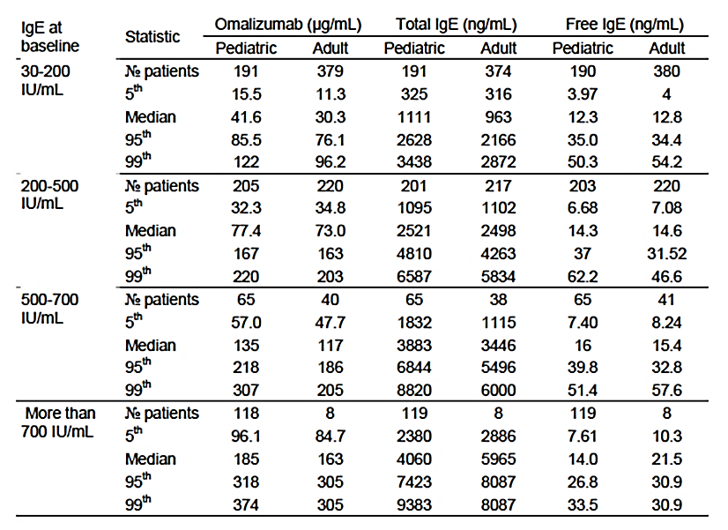
Summarised for trough sample drawn 84 days or more after commencing treatment with active omalizumab (rch) in the moderate to severe allergic asthma Studies 10, IA05, 8, 9 and 11. Paediatric patients are those less than 12 years of age.
Efficacy correlates with dose. In the clinical trials, the doses were calculated to aim for a mean trough free IgE of 25ng/ml.

Change in dosage table
The aim of revising Xolair dosing table was to reduce the dosing frequency from every 2 weeks to every 4 weeks to the portion of the dosing table between 225- 300 mg ever 2 weeks; doubling the dose and increasing the dose interval to every 4 weeks. A detailed analysis of this was obtained from the report for the EU.
The evidence for this change was obtained by modelling and simulation using PK/PD and clinical trial data from previous studies in allergic asthma. This same mechanism based mathematical model was used to expand the dosing table to include patients with baseline IgE up to 1500 IU/mL. The submission also included post-marketing safety data for patients exposed to high doses (600 mg or above).
An investigation of potential safety liabilities and efficacy concerns was carried out by:
- Platelet concentration effect relationship from non-human primates with clinical data from human clinical studies
- Simulations from a previously submitted PK/PD model built from data from 6 Phase III and 3 clinical pharmacology studies.
The mechanism-based mathematical model describes the relation between omalizumab (rch) exposure and IgE response (binding of omalizumab (rch) to and thereby suppression of the concentration of free IgE). The model was found to give a reasonable prediction of omalizumab (rch) exposure and PD response in terms of free IgE suppression in plasma.
The model covers a range of body weight and baseline IgE that underlies the dosage of Omalizumab (rch); although some combinations of body weight and baseline IgE are less well explored in the clinical studies.
Simulations show that while receiving Xolair, the molar excess of omalizumab (rch) over IgE is such that the free and total drug concentrations are the same. The only point at which the free and total drug concentrations diverge is during the elimination phase. Simulations indicate that the fluctuations in free IgE levels were small and the median level of IgE at omalizumab (rch) trough seems to be contained within the 10 to 20 ng/mL for all dose groups in the revised table regarding the every 2 or every 4 weekly administration. As there is a delayed onset of treatment effect and a slow turnover of biosystem components, this change is unlikely to cause fluctuations in free IgE levels. With the new dosing regime, a proportion of subjects may have higher peak plasma concentrations of Xolair (due to an increase in C_{max} of 15%). There was concern using the modelling of data pooled across species at the risk of thrombocytopenia in primates may not be the same as in humans.
Additional safety data from clinical trials and post marketing experience showed that although the number of subjects exposed to high doses of Xolair was low, the distribution of AE was consistent with lower doses of Xolair, type of AE were known and already included in the label and RMP, or symptoms or signs of asthma. The proposed changes are unlikely to affect the efficacy.
The sponsor was asked if measuring serum IgE levels would assist with dose titration. The sponsor responded that because of the variability in IgE measured in commercial laboratories, this would not be helpful.

Efficacy
EMA Guidelines for asthma:
- 6 months trials are recommended.
Recommended primary and secondary endpoints:
- Both FEV1 and PEFR reflect airway obstruction and are accepted as spirometric evaluations of the effect of anti-asthma drugs. Accepted symptom based clinical endpoints include symptom scores and the use of reliever medication. Exacerbation rates may be useful to assess controller treatment in more severe asthma. There is no universal definition of exacerbation rate, but the most useful parameters are symptom scores, the need for rescue medication and an objective worsening or airway obstruction. For moderate and persistent asthma, symptom based endpoints are particularly important. These may include the frequency of exacerbations and an assessment of asthma control.

Study IA05
The details and results of this study are summarised in Tables 17 and 18 below.
Table 17: Summary of Study IA05
 | Details
Design | Randomised, double blind, placebo control, parallel groups
Duration | Run in phase 8 weeks to optimise treatment  Double blind 52 weeks – fixed inhaled corticosteroid 24 weeks then adjustable dose ICS
Population | Inclusion  Age 6-<12 years  Total serum IgE ≥ 30-≤ 1300 IU/ml  Diagnosis of allergic asthma of moderate-severe severity  Positive skin prick test (diameter of wheal > 3mm) to at least one perennial allergen within the last 2 years  > 12% increase in FEV1 within 30 minutes of salbutamol  While receiving fluticasone DPI>200ug/day or equivalent ex-valve dose  2 independent exacerbations in the previous 12 months requiring treatment with systemic corticosteroids and/or doubling maintenance inhaled corticosteroid for at least 3 days OR  3 independent exacerbations over the past 24 months; one of these exacerbations must have occurred in the previous 12 months (same treatment as above) OR  Admitted to ED or hospital within last 12 months for an asthma exacerbation  Exclusion  Treated with systemic corticosteroids within 4 weeks  Taking oral β agonists; methotrexate, gold, cyclosporin or other immunosuppressant; taking oral or inhaled anticholinergics  History of food or drug induced anaphylaxis, allergy to antibiotics,  Aspirin or non-steroidal anti-inflammatory (NSAID) related asthma  Active lung disease other than asthma  Elevated IgE for reasons other than asthma eg parasitic infection, hyperimmunoglobulin E, Wiskott-Aldrich Syndrome or clinical bronchopulmonary aspergillosis  Uncontrolled systemic disease or cancer
Intervention | As per current dosing chart
Comparator | Placebo
Efficacy outcomes | Primary Outcome:  Reduction in asthma exacerbations*  Secondary outcomes  Reductions in BDP dose  Asthma symptoms  Spirometry parameters;  Use of rescue medication;  Quality of life.
Statistics | The power calculations were based on an estimated reduction in exacerbations of 41%, power 85%, 2 sided t test at alpha=0.05. It was estimated that 570 subjects would be required (380 omalizumab (rch))
Baseline characteristics. | 1433 patients were screened, 627 were randomised.  Average age 9 years, range 6-11 years  Average severity of asthma; 2/3 were classified as severe persistent asthma, mean FEV₁ 86.4 (SD 18); mean serum IgE 469.7 IU/mL (SD 338).  Concomitant meds: inhaled long acting β agonist 67.4%; anti-leukotriene 36.6%, maintenance oral steroid 1.3%, short acting β agonist 87.4%.
Outcomes | There was a significant reduction in the rate of clinically significant exacerbations, 0.45 versus 0.64; ratio 0.69 (95% CI 0.53 to 0.90) over the initial per 24 week period. The rate of clinically significant exacerbations over the entire 52 week treatment period was 0.78 versus 1.36; ratio 0.57 (95% CI 0.45 to 0.73).  There was a trend towards a reduction (which did not reach statistical significance) in the proportion of patients who were free of clinically significant exacerbations (64.3% versus 58.3%)  There was no significant difference in the treatment arms in the rate of nocturnal symptoms (-0.63 versus -0.50), asthma rescue medications (-1.3 versus -1.0) or quality of life.  There was a numerical but not statistically significant difference in the percent change of ICS dose (-3.6% in the omalizumab (rch) group versus 1.8% in the placebo group).  There was a 44 to 50% reduction in the rate of severe exacerbations but not in ED presentations or admissions.  There was an improvement in FVC with omalizumab (rch) but no significant change in FEV₁, percent change in FEV₁ or FEF 25-75%.
*A clinically significant exacerbation was defined as a worsening of asthma symptoms as judged clinically by the investigator, requiring a doubling of the baseline inhaled corticosteroid dose and/or treatment with rescue systemic corticosteroids for at least 3 days AND either 1) PEF or FEV1 < 60% of personal best or PEF or FEV1 60-80% of personal best following B agonist 2) a fall in PEF of > 20% on at least 2 of any 3 consecutive days 3) a > 50% increase in 24 hour rescue medication use on at least 2 of any 3 consecutive days 4) at least 2 night-time awakenings due to asthma symptoms requiring rescue medication within the previous 7 days.
Table 18: Study IA05 – Clinically significant exacerbations over 24 weeks (MITT population)
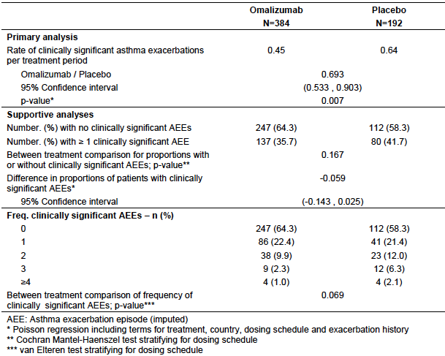

Study IA 010
The details and results of this study are summarised in Tables 19-22 below.
Table 19: Summary of Study IA010
 | Details
Design | Randomised, double blind, placebo control, parallel groups
Duration | Run in phase 4 to 6 weeks to optimise treatment with inhaled beclomethasone diproprionate 168-420 µg/dose  Double blind 28 week; first 16 weeks BPD dose unchanged, next 12 weeks BDP dose weaned, then open label extension.
Population | Inclusion Age 6 to 12 years  Total serum IgE ≥ 30  Diagnosis of allergic asthma (ATS) of moderate-severe severity  Positive skin prick test (diameter of wheal > 3 mm) to at least one of the following allergens: dermatophagoides farina, dermatophagiodes pteronyssinus, cockroaches, dog or cat  > 12% increase in FEV₁ within 30 minutes of salbutamol  Asthma well controlled with minimal effective dose of inhaled corticosteroids at doses of > 168 to 420 µg/day of beclomethasone (NB this equates to MILD asthma by Australian standards)  Exclusion  Treated with systemic corticosteroids within 4 weeks  Taking oral β agonists; methotrexate, gold, cyclosporin or other immunosuppressant; taking oral or inhaled anticholinergics  Taking antihistamines, leukotriene receptor inhibitors  History of food or drug induced anaphylaxis, allergy to antibiotics,  Aspirin or NSAID related asthma  Active lung disease other than asthma  Elevated IgE for reasons other than asthma, for example parasitic infection, hyperimmunoglobulin E, Wiskott-Aldrich Syndrome or clinical bronchopulmonary aspergillosis  Uncontrolled systemic disease or cancer
Intervention | Omalizumab (rch) in a slightly different dose
Efficacy outcomes | Safety and tolerability  Effect on inhaled corticosteroid dose  Effect on QoL  PK and PD
Statistics | Sample size based on convenience
Baseline characteristics. | Total 334 subjects  Mean age 9.4 years, range 5 to 12 years.  Mean duration of asthma 6.1 years (range 1 to 12 years). 8.1% severe  Mean BBP dose 278 µg/day (range 168 to 672)  Mean serum IgE IU/ml 340 (20 to 1269)
Outcomes | There was a greater reduction in BPD dose in the omalizumab (rch) group (see Table 20).  There was no difference in exacerbation rate in the dose stabilisation phase (Table 21).  There was a reduction in exacerbation in the weaning ICS phase (Table 22).  There was no difference in asthma free days, PEFR, spirometry or symptoms scores. Quality of life was similar between the 2 groups at week 16 but better for omalizumab (rch) at the end of the dose reduction phase.
Table 20: Study 010 Percent reduction in BDP dose (ITT population)
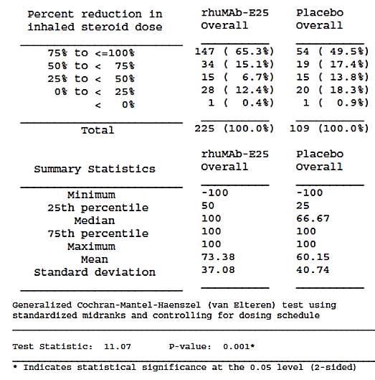
Table 21: Study 010 Asthma exacerbations in steroid reduction period (ITT population)
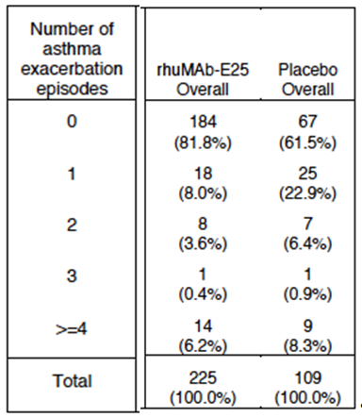
Table 22: Study 010 Clinically significant exacerbations over 28 weeks (Paediatric ITT population)
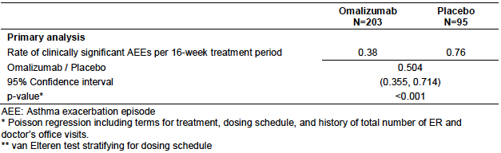

Study B1301
This was a single arm, open label study of omalizumab (rch) in Japanese children. The primary endpoint was safety whereas efficacy was a secondary objective.
Subjects included children between the age of 6 and 15 years with inadequately controlled asthma symptoms despite high dose ICS and two or more controller medications. The dose of omalizumab (rch) was the same as for Study IA05. The duration of the trial was 24 weeks.
A total of 38 children were enrolled, 19 (55%) were less than 12 years. Treatment with omalizumab (rch) resulted in an improvement in symptom score, PEFR and a reduction in the rate of exacerbations (Table 23).
Table 23: Efficacy Outcomes from Study B1301
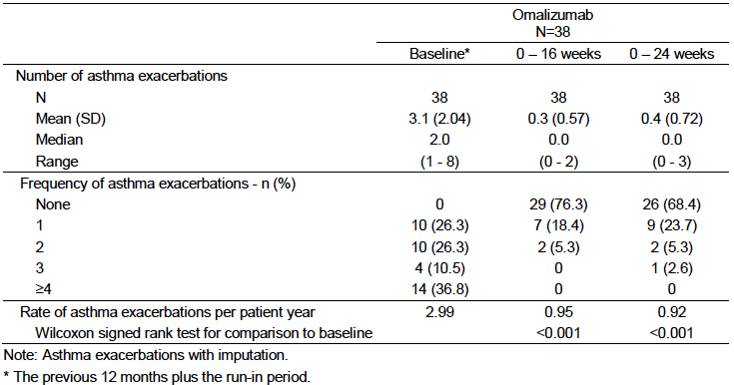

ICATA Study (not conducted by sponsor)
The Inner-City Anti IgE Therapy for Asthma study was a randomised, double blind, placebo controlled trial with two parallel groups (omalizumab (rch) versus placebo) conducted in 8 centres in the USA between November 2006 and April 2008.
The study recruited inner city children, adolescents and young adults (aged 6 to 20 years). Subjects were required to have a history of asthma for at least 12 months, a positive skin test for a perennial allergen and uncontrolled disease. The dosage was the same for study IA05. Treatment was continued for 60 weeks. Ongoing treatment adjustments of ICS/LABA/montelukast were made to achieve good asthma control.
A total of 419 subjects were randomised (208 to omalizumab (rch) and 211 to placebo). 60% of subjects were in the 6 to 11 years age group and 73% had moderate to severe disease. The primary end point was the number of days in the preceding 2 weeks that the patient had asthma symptoms. Omalizumab (rch) treatment was associated with significantly fewer days with asthma symptoms in the preceding 2 weeks (mean: 1.48 versus 1.96; p<0.001) (Table 24). It was also associated with a lower proportion of patients experiencing an exacerbation (30.3% versus 48.8%; p<0.001) and with significantly lower doses of ICS (663 versus 771 µg budesonide or equivalent/day; p<0.001).
Table 24: Efficacy outcomes from the ICATA Study
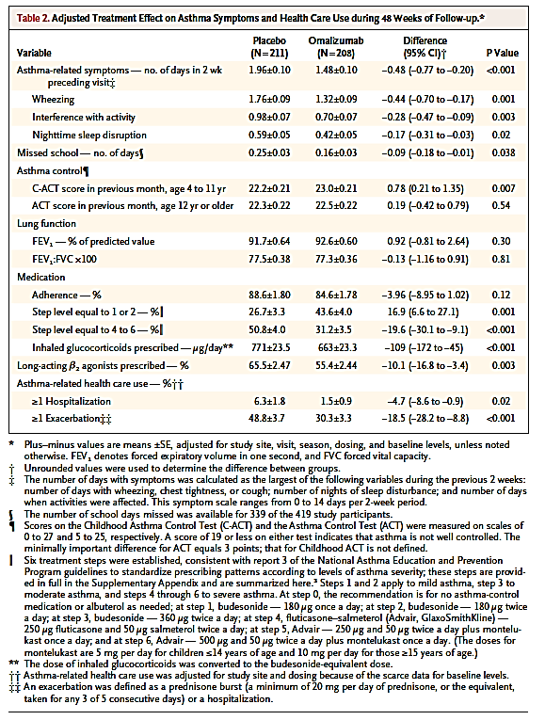

Safety
The sponsor pooled safety data for children aged 6 to 12 years. The data was presented separately for placebo controlled trials (AAP) and open labelled studies (AAO).
In the AAP population, there were 624 subjects treated with omalizumab (rch) and 302 with placebo. The mean duration of exposure was 42 weeks. In the AAO population, 407 subjects received omalizumab (rch). The mean duration of exposure was 104 weeks.
Overall, adverse events were commonly reported in both omalizumab (rch) and placebo groups. There was a higher incidence of pyrexia (15.1% versus 11.3%) and viral gastroenteritis (3.8 versus 2.3%) in the AAP population, and headache (17.6 versus 7%) in the AAO population.
Most AE were mild or moderate. Treatment-emergent AEs (TEAEs) occurred with similar frequency in omalizumab (rch) and control groups
AE of special interest (skin rash, urticarial, hypersensitivity, injection site reactions) occurred similarly between omalizumab (rch) and control groups. No patients had serum sickness. One child in the placebo arm developed a malignancy.
The sponsor submitted extra data after the first round evaluation evaluating a clinical trial and the sponsor’s safety database in relation to anaphylaxis. The rate of anaphylaxis was estimated to be 0.2%. Previous anaphylaxis was recognised as a risk factor. This information was included into the PI.
One subject developed antibodies to omalizumab (rch). No adverse reactions were observed.

Post-market data
The dossier included a PSUR from 1 January 2014 to 30 June 2014. This period was after approval for use in children and with the new dosing table in Europe, New Zealand and Switzerland.
For the 3 month period of January to March 2014, the estimated exposure in children aged 6 to -11 years was 952 subjects. The cumulative exposure in children aged 6 to 11 years between June 2011 and March 2014 was 9,157 subjects for asthma and 2,512 subjects for other indications. The most common events reported in children aged 6 to < 12 years during the period were asthma (15), malaise (9), urticaria (9), cough (5), pyrexia (4), drug ineffective (4), fatigue (4), pruritus (4) and headache (4).
Of all the events reported, 27 were reported as serious. Thirteen of these cases were not assessable due to insufficient information. The remaining 14 included the following:
- One report of thrombocytopenia (7 x 10⁹/L), probable ITP, which recurred after omalizumab (rch), was stopped.
- Three reports suggestive of allergic reactions (rash, urticaria, erythema, pruritus);
- Two reports of injection site reactions;
- One report of allergic bronchopulmonary aspergillosis;
- Two reports of dengue fever;
- Five reports of asthma exacerbations.

Clinical evaluator’s recommendation
The clinical evaluator recommends approval.

Risk management plan
The sponsor has amended the PI based on concerns by the pharmacovigilance branch about the wording of the precautions section on Churg-Strauss Syndrome and Hypereosinophilic Syndrome. The wording is now in line with the EU SmPC.
The summary of safety concerns includes the known and potential safety signals (Table 13). Routine pharmacovigilance activities are recommended. No additional pharmacovigilance activities are required.

Risk-benefit analysis

Delegate’s considerations
The sponsor has adequately addressed most of the issued raised by the previous Delegate and clinical evaluator (See Table 25). There is adequate information in the PI and RMP in relation to the safety issues (thrombocytopenia, malignancy and arterial thromboembolism (ATE)). The sponsor has also submitted data from a clinical trial reporting a low risk of anaphylaxis (0.2%). Post market data has not identified any new safety signals.
Overall, the clinical trials in children suggest that omalizumab (rch) reduces the number of exacerbations of children with asthma and may enable the dose of inhaled corticosteroids to be weaned. However there is some inconsistency with reported outcomes in the clinical trials. Of particular concern was in the pivotal Study IA050, there was a reduction in exacerbation rate but no change in rescue medication use, ED presentations. The sponsor has explained some of this to be due to inaccuracies in children and families ability to describe asthma control. The sponsor has submitted a number of journal articles describing how children and parents under estimate asthma severity using symptoms scores and the FEV₁ is a very blunt predictor of asthma symptoms.

Clinical need
The overall prevalence of asthma in children is around 8.7%; of these around 4.6% have severe asthma. Approximately 50% of childhood asthma improves by adolescents. Elevated IgE is a risk factor for persistent asthma. Children with poorly controlled asthma can have reduced lung function that deteriorates with age.
For patients with severe asthma, the mainstay of treatment has been high dose inhaled or oral corticosteroids. Omalizumab (rch) has potential advantageous in being able to reduce the dose of inhaled steroids (and side effects from this). It also targets a different mechanism of action than other asthma treatments, such as theophylline, long acting β agonists (the use of which has been associated with increased hospital admissions) and leukotriene antagonists.
The TGA has had only two special access scheme requests for omalizumab (rch) in children since January 2015; however it is possible that it has been prescribed to children by private prescription.
In the Global Initiative for Asthma report, omalizumab (rch) is recommended as step 5 in the treatment algorithm for children aged 6-11 years.
Omalizumab (rch) is not mentioned in the Australian Therapeutic Guidelines for asthma or the Australian Asthma Handbook in children or adults.

Unresolved issues
- There is still limited experience in the long term use of omalizumab (rch) and when/how to wean the dose. The XPORT study examined the risk of relapse after treatment with omalizumab (rch) or placebo was stopped. On average patients who took omalizumab (rch) had less exacerbations than those treated with placebo. However a subgroup of patients had more exacerbations. It is unknown how omalizumab (rch) compares to other asthma treatments after they are discontinued.
- Most participants in the clinical trials had very high IgE levels. In adults, the greatest benefit was shown with IgE levels > 75 IU/mL. In the EU SmPC it states ‘prescribing physicians should ensure that children (6-12 years of age) with IgE levels < 200 IU/mL have unequivocal in vitro reactivity (RAST) to a perennial allergen before starting therapy (however the evidence for this is not clear). Should an IgE level be specified in the indications or include a statement such as in the EU SmPC in the Australian PI?

Outstanding issues for the delegates
- Awaiting a reply from the sponsor regarding the progress of the application with the FDA.
- Conditions of registration
‘The European Risk management Plan for XOLAIR (version 10.0, dated 5 March 2015), as qualified by the Australian Specific Annex (version 6.0, dated 22 October 2015), must be implemented’ – provided there are no further comments from the ACPM.
Summary of issues
- This medicine has been approved in Europe but not in the USA or Canada for use in children age 6 to 11 years.
- Efficacy has been established for a reduction in exacerbations and reduction in ICS dose but not spirometry
- There is limited but accumulating long term safety data in children.

Proposed action
The Delegate had no reason to say, at this time, that the application for Xolair should not be approved for registration.

Request for ACPM advice
- Please comment on the discrepant results for exacerbations, ICS dose reductions, ED presentations, symptom scores and use of rescue medications in the clinical trials? What are the most important outcomes in children?
- Should the indications specify an IgE level (for example, over 30 IU/mL or 75 IU/mL)?
- Is there a clinical need for this medication?
- Where would omalizumab (rch) be positioned in a treatment algorithm? Are further studies needed comparing it to these agents needed before it is registered?
- Should prescription be limited to physicians or paediatricians?
- The committee is (also) requested to provide advice on any other issues that it thinks may be relevant to a decision on whether or not to approve this application.

Previous application and how issues have been addressed
Summary of issues raised by the previous clinical evaluator and Delegate (and how these have been addressed by the sponsor are shown in Table 25.
Table 25: Summary of the TGA’s issues with the previous application and how these have been addressed in the current application
Issue | How it has been addressed
Efficacy  Would it be better to compare the number of exacerbations per treatment arm or number of subjects with exacerbations rather than the rate  Relevance of secondary endpoints when the clinical significance of the primary endpoint was open to interpretation | The sponsor has explained the rationale of using exacerbation rate as in line with the efficacy outcome in adults.  The sponsor has argued that a 50% reduction in asthma admissions is clinically significant.
Indication | The sponsor has narrowed the proposed indications to include only children with severe asthma
Safety  Has anaphylaxis been adequately addressed; should previous anaphylaxis be included as a contraindication | The sponsor has submitted additional information in relation to anaphylaxis. The sponsor considers listing previous anaphylaxis as a contraindication to be unnecessary due to the infrequent nature of this condition.
Safety. Malignancy | This has been addressed in a previous submission.
Safety. Cardiovascular/cerebrovascular events | Final results from EXCELS revealed an increased  Arterial Thromboembolism rate in the omalizumab (rch) cohort HR 1.32 (95% CI: 0.91, 1.91) when adjusted for confounders and risks factors. Although there was no consistent evidence of an association between omalizumab (rch) use and risk of ATEs, the confidence intervals were wide and could not definitively exclude an elevated risk. Similar results were found when the results of clinical trials were pooled.  The EXCELS trial did not enrol children. There have been no reports of ATE in children.
Dosing rationale | The dosing schemes proposed are the same as those used in clinical Studies IA050 and B1301.  Measured concentrations of omalizumab (rch), free and total IgE as well as PK/IgE-PD modelling results demonstrated that in both paediatric and adult patients, the main determinants of free IgE are weight and serum IgE.
An application to remove the warnings about malignancy. The concerns about malignancy originated at the time of registration in the USA when malignant neoplasms were observed in 0.5% (20/4127) omalizumab (rch) patients versus 0.2% (5/2236) placebo patients. A large 5 year observational study and a meta-analysis of primary malignancies across all Xolair clinical trials of greater than 8 weeks duration did not find an increased risk of malignancy associated with Xolair.

Response from sponsor
Novartis welcomes the Delegate’s recommendation to approve for the extension of the indications of omalizumab (rch) (Xolair) for use in asthma to include children aged 6 to 12 years and to amend the dosage table for some adult/adolescent patients. Where appropriate, the sponsor’s comments have been cross-referenced to the Delegate’s overview (DO), the Clinical Evaluation Report (CER) or our submission for marketing authorisation (MA).
In the first section of this response, the sponsor addresses the Delegate’s ‘Summary of Issues’. In the second section, the sponsor takes the opportunity to provide comments on the specific advice sought by the Delegate from the Committee. Novartis proposes an alternative wording from our original MA, which was presented in the response to the CER:
Xolair is indicated as add on therapy to improve asthma control in patients 6 to <12 years of age with severe persistent allergic asthma despite high dose inhaled corticosteroids and who have serum immunoglobulin E levels corresponding to the recommended dose range (see ‘Dosage and Administration’).
This wording is based on the Delegate’s recommendation with the exception of the inclusion of a specific IgE level. The sponsor’s justification for this is below. In the third section, the sponsor responds to the two ‘Unresolved Issues’ described by the Delegate. Finally, in the fourth section, Novartis comments on further changes proposed to the PI including but not limited to the additional precaution proposed by the Delegate.

Response to the delegate’s ‘summary of issues’

This medicine has been approved in Europe but not in the USA for use in children age 6-11 years.
Omalizumab (rch) was approved in the EU for use in children 6 to <12 years of age with severe allergic asthma in 2009.

Efficacy has been established for a reduction in exacerbations and reduction in ICS dose but not spirometry.
Novartis acknowledges the inconsistencies between some of the reported outcomes in the clinical trials, although this is not the case for all endpoints (for example, severe asthma exacerbations and Patient’s and Investigator’s global evaluation of treatment effectiveness). The Delegate has noted our explanation that these inconsistencies can partly be ascribed to the well documented inaccuracies in children and families ability to describe asthma control, plus the fact FEV1 is an insensitive predictor of asthma symptoms.
In Study IA05, the lack of perception of asthma severity and control might explain both the high baseline scores, despite being an uncontrolled asthma population, and the minimal apparent change in asthma symptoms and quality of life. Novartis would also like to underscore some of the difficulties that have been encountered in studying asthmatic children who are uncontrolled despite being on the highest treatment step recommended in the GINA guidelines. Expectations of improvement in this patient population need to be balanced against the realisation that measurement of patient-reported outcomes in severe asthmatic children who remain uncontrolled despite treatment with maximal dose ICS/LABA is problematic, as noted by the Delegate. Despite this, patients’ quality of life (as assessed by the PAQLQ) was shown to be significantly improved in Study 010. The improvement of 0.42 on the PAQLQ in omalizumab (rch) treated patients (Table 26) is equivalent to the minimal important difference of the instrument, which was established without a placebo group comparison.
Table 26: Change from baseline in overall quality of life score at the end of the 28 week double—blind treatment period (Study 010 Paediatric ITT population).
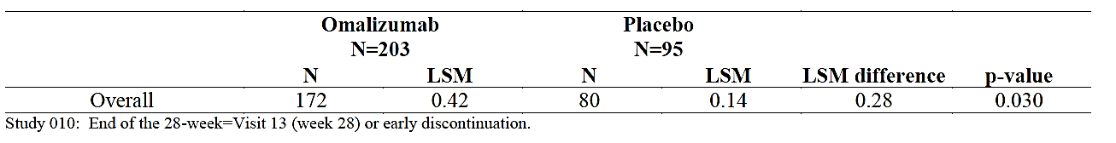
Regarding spirometry, the baseline lung function in the patients recruited to Studies IA05 and 010 was high (mean % predicted FEV1 of 85.4 and 84.2, respectively), typical of even severe asthmatics in this age group and improvement in lung function was not necessarily expected.
An endpoint such as presentations to the emergency department is clinically meaningful but occurs infrequently especially in the intensively managed setting of a clinical trial and therefore lacks sensitivity they were rare in Studies IA05 and 010, even in placebo treated patients. The benefit of omalizumab (rch) on health care utilisation is best appreciated in a ‘real world setting’ in which patients with a greater burden of disease are treated with omalizumab (rch). A ‘real-world’ study was conducted in 104 children who received omalizumab (rch) and were followed in paediatric pulmonary tertiary care centres in France. Exacerbations decreased from a mean (95% CI) of 4.4 (3.7 to 5.2) per patient during the previous year to 1.25 (0.55 to 1.95) during the year of treatment (p<0.0001), representing a reduction of 72%. In addition, the percentage of children requiring hospitalisation decreased from 44% in the past year to 6.7%, representing an 88.5% relative decrease, with none necessitating a stay in the intensive care unit during the year on treatment (p<0.001). Among children < 12 years of age in the study, none (0/47) demonstrated ‘good control’ at Visit 0 whereas 22/41 (53.5%) achieved ‘good control’ at 52 weeks. In addition, among children < 12 years of age in the study, 40/47 (85%) demonstrated ‘poor control’ at Visit 0 whereas 4/41 (10%) demonstrated ‘poor control’ at 52 weeks. It was concluded that actual clinical use of omalizumab (rch) in asthmatic children with a high burden of disease in France was associated with highly significant clinical benefits.
Asthma exacerbations are among the most clinically relevant aspects of asthma for many children. Studies in children demonstrate that severe asthma exacerbations are associated with a more rapid decline in lung function, suggesting that a more effective approach to treating young asthmatics experiencing recurrent exacerbations may be warranted. Omalizumab (rch) reduces seasonal exacerbations in children, which is correlated with reversal of deficits in innate immunity to rhinovirus due to elevated IgE. Together with the association of rhinovirus infection and worsening asthma symptoms in children in Australia, these results emphasise the fundamental role of IgE in the pathogenesis of childhood asthma and the potential importance of IgE as a therapeutic target in this at-risk population.

There is limited but accumulating long term safety data in children.
Since the withdrawal of the original omalizumab (rch) paediatric indication application in Australia in September 2010, additional post-marketing safety data in children has been accumulated together with data from additional observational safety studies (EXCELS (Q2948G), X-PAND (Q4458G)) and a pooled analyses of clinical trial data. Novartis believes that the totality of these data address the safety concerns (that is, malignancy, cardiovascular/cerebrovascular adverse events, anaphylaxis) raised by the TGA in the review of the previous application and indicates a favourable safety profile for omalizumab (rch) in children, without the need for additional safety studies.
A total of 945 children < 12 years of age (approximately 1,108.8 patient-years exposure) were exposed to omalizumab (rch) in clinical trials in allergic asthma and there has been approximately 10,503 patient-years of post-marketing exposure in all children 6 to < 12 years old (approximately 9,637 in those with allergic asthma). The adverse event profile observed in omalizumab (rch)-treated children ages 6 to < 12 in double-blind randomised clinical trials was very similar to that of placebo, including the small number of serious adverse events (SAEs) seen. Cumulative review of post-marketing AE reports in children until 31 December 2014 did not reveal any specific concern related to use in paediatric patients and is consistent with the known safety profile of omalizumab (rch) in adult patients.
There is no evidence of an increased risk of malignancy, arterial thrombotic events, or drug-related hypersensitivity, including evidence of immune complex mediated disease in omalizumab (rch) paediatric clinical trial or post-marketing safety data. In addition, the TGA approved the removal of the malignancy precaution from the current Australian PI based on the results of the EXCELS study in adolescents and adults, plus the results of a pooled analysis of phase I to IV omalizumab (rch) clinical trials. The EXCELS study showed a statistically non-significant increase in the rate of cardiovascular/cerebrovascular SAE in omalizumab (rch)-treated patients over control patients, although a pooled analysis of omalizumab (rch) clinical trial data, subsequently requested by FDA, did not demonstrate notable imbalances in theses SAEs. As cardiovascular risk could not be definitely excluded in the EXCELS study, ATEs are classified as an important potential risk, monitored in the RMP and included in the Australian PI.
There are no imbalances in anaphylactic events among children treated with omalizumab (rch) in the clinical trial database. Post-marketing cases of anaphylaxis in children have been consistent with findings in the adolescent and adult populations. An exploratory analysis from a case-control study to assess the risk of anaphylaxis (X-PAND) suggested that a prior history of anaphylaxis to foods, medications or unknown causes may be a risk for anaphylaxis associated with omalizumab (rch) administration. Although these events are rare, anaphylaxis is a recognised risk associated with omalizumab (rch) use. Anaphylaxis remains an identified risk associated with use of omalizumab (rch) in all age groups.

Novartis’ comments on the advice sought by the delegate from the committee

Please comment on the discrepant results for exacerbations, ICS dose reductions, ED presentations, symptom scores and use of rescue medications in the clinical trials? What are the most important outcomes for children?
The sponsor’s comments above directly address this first point raised by the Delegate in relation to the apparent discrepancies between the results from IA05 and the sponsor directs the Committee to that section in response to this particular point.

Should the indications specify an IgE level (for example, over 30 IU/mL or 75 IU/mL)
Novartis does not believe that the indication should specify an IgE level. Subgroup analyses in Study IA05 indicate that children in the modified ITT (mITT) population with severe persistent asthma have a numerically greater response to omalizumab (rch) than those with moderate persistent asthma; for the EU mITT population, children with an FEV1 of 60 to <80% predicted had a numerically greater response than patients with an FEV1 of ≥80% predicted. Although Study IA05 was not powered for assessing exacerbation reduction among patients with different baseline factors in addition to baseline IgE (for example, IgE <75 IU/mL and different FEV1 cut-offs), presumably children with FEV1 in the 60 to 80% predicted range despite low IgE would derive clinically meaningful benefits from omalizumab (rch).
Restricting the indication to subgroups of baseline IgE may result in fewer children receiving omalizumab (rch) who might otherwise derive considerable clinical benefits; in children who remain uncontrolled despite high dose ICS plus additional controllers, the only other recourse is systemic corticosteroids. The adverse effects of oral corticosteroids in patients, especially the very young, are well documented and guidelines consistently advise against their long-term use., Novartis strongly recommends not to exclude the use of omalizumab (rch) in severe allergic asthma paediatric patients with a baseline IgE <75 IU/mL.
To address this issue, Novartis proposes to amend the indication to cross-reference the ‘Dosage and Administration’ section of the PI.

Is there a clinical need for this medication in Australia?
The TGA Delegate acknowledges that despite the range of currently available therapies, there is a significant unmet medical need in Australia for children aged 6 to <12 years of age with poorly controlled asthma. Severe persistent asthma in children is an uncommon, but serious condition. These children suffer considerable co-morbidities: hospital admissions, frequent outpatient attendances, time off school and impaired quality of life for both the patient and close family members. Omalizumab (rch) demonstrates significant corticosteroid-sparing effects, resulting in improvements in asthma control and quality of life.
The Delegate states that only two special access scheme (SAS) requests have been received by the TGA this year; however, the sponsor do not believe this provides an accurate indication of the medical need for this medication in Australian paediatric patients. While there may be some private off-label use in hospitals, the sponsor considers it is important for the Australian PI to reflect the availability of new evidence of the safety and efficacy of omalizumab (rch) in paediatric patients as presented in our application, as well as changes in Australian clinical practice. At present there are no effective treatment options for children suffering from severe, persistent allergic asthma. Given the reduction of exacerbation rate and ICS use observed with omalizumab (rch) in the clinical trials (and the reduction in oral corticosteroids use in real-world studies), Novartis believes that omalizumab (rch) will be a useful drug for paediatric patients with severe, persistent allergic asthma.
Contrary to the Delegate’s statement that omalizumab (rch) is not mentioned in the Australian Asthma Handbook (AAH), Novartis would like to clarify that omalizumab (rch) is in fact recommended in the more complete version of the AAH for difficult to treat patients with severe allergic asthma. The Delegate has only referred and provided a link to AAH ‘Quick Reference Guide’.

Where would omalizumab (rch) be positioned in a treatment algorithm? Are further studies needed comparing it to these agents needed before it is registered?
Similar to the adolescent and adult populations, omalizumab (rch) is intended as a treatment option for some children with ‘difficult to treat asthma’ or ‘severe asthma’. The World Health Organisation Consultation on Severe Asthma proposed a global definition of severe asthma as uncontrolled asthma which can result in risk of frequent severe exacerbations (or death) and/or adverse reactions to medications and/or chronic morbidity (including impaired lung function or reduced lung growth in children).
Novartis is of the view that the risk/benefit balance in this difficult to treat patient population has been adequately demonstrated and for this reason no further studies are needed before it is registered. The body of evidence including the results of IA05 and real-world studies indicate that children with severe persistent allergic asthma derive clinically meaningful benefit from omalizumab (rch). Moreover, the safety profile in children is consistent with the known safety profile in older patients.

Should prescription be limited to physicians or paediatricians?
In clinical practice, children and adolescent patients with severe allergic asthma are often presenting routinely to a paediatrician, respiratory physician, clinical immunologist or allergist. Paediatricians will usually refer children with severe life threatening respiratory diseases to paediatric respiratory physicians for expert management. Prescribing for asthma is unlikely to change with the extension of indication proposed within this application hence restricting prescription to paediatricians would potentially create barriers to the Australian clinical practice.

Novartis’ response to ‘unresolved issues’

There is still limited experience in the long term use of omalizumab (rch) and when/how to wean the dose. The XPORT study examined the risk of relapse after treatment with omalizumab (rch) or placebo was stopped. On average patients who took omalizumab (rch) had less exacerbations than those treated with placebo. However a subgroup of patients had more exacerbations. It is unknown how omalizumab (rch) compares to other asthma treatments after they are discontinued.
The results of XPORT, conducted in patients with asthma aged 17 to 70 years, demonstrated that time to first protocol-defined exacerbation was longer in the omalizumab (rch) continuation group versus the placebo group (hazard ratio 0.49 [95% confidence interval: 0.28, 0.86]. The difference in exacerbation rates between the two groups was apparent even after 4 weeks after randomisation. A relevant question is what happens to asthma control after discontinuation of other controllers; there is evidence that loss of control ensues when asthmatics treated with ICS and a LABA undergo ‘step-down’ to ICS alone. However, this question has not been extensively addressed, particularly in children. Of note is that the clinical program of omalizumab (rch) in asthmatic children did not demonstrate any evidence of withdrawal or rebound following discontinuation of omalizumab (rch) (Study IA05 follow-up).
In conclusion, the increased risk of exacerbations among adults whose omalizumab (rch) is discontinued after having received long-term treatment is consistent with a benefit on exacerbations that omalizumab (rch) provides in such patients. Whether similar results would be obtained in children receiving long-term treatment with omalizumab (rch) is unknown. Clinicians are advised to base individual treatment decisions regarding stopping omalizumab (rch) based on their knowledge of the patient and clinical judgment.

Most participants in the trials had very high IgE levels. In adults the greatest benefit was shown with IgE levels >75 IU/mL. In the EU SmPC it states ‘prescribing physicians should ensure that children (6-12 years of age) with IgE levels <200 IU/mL have unequivocal in vitro reactivity (RAST) to a perennial allergen before starting therapy (however the evidence for this is not clear). Should an IgE level be specified in the indications or include a statement such as in the EU SmPC in the AU PI?
Given the alternative wording of the indication proposed above, Novartis suggests to include in the ‘Dosage and Administration’ section of the PI a statement similar to the one already included in the EU. Prescribing physicians should ensure that children (6 to < 12 years of age) with IgE levels <200 IU/mL have unequivocal in vitro reactivity (RAST) to a perennial allergen before starting therapy.

Comments on additional changes to proposed PI
Novartis notes the Delegate’s review of the Australian PI. The sponsor has provided comments on the indication previously in the response. With respect to the changes to the ‘Precautions’ section, Novartis agrees to include a statement as proposed by the Delegate. Novartis believes it is important to balance this against the needs of patient with lower IgE levels who may derive considerable clinical benefits from omalizumab (rch). Novartis proposes to include the following statement in ‘Dosage and Administration’ section:
Patients with IgE levels below these thresholds may still benefit from treatment. Physicians are urged to use caution in interpreting such tests in patients receiving Xolair (See PRECAUTIONS Interpretation of serum IgE levels, skin patch and skin prick testing).

Concluding remarks
It is well recognised that there is an unmet clinical need for an effective treatment in children with severe persistent asthma who experience exacerbations despite the use of available controller medications. Currently paediatric patients tend to be treated with multiple medications, including high dose ICS plus a LABA. It is recognised that complete control of severe persistent asthma may not be possible with existing treatments. Leaving these patients poorly controlled on current standard therapies is associated with risks of asthma exacerbations, and the associated morbidity, as well as the major effects of the disease on the quality of life of the parents and families of the patients. Existing treatments are also associated with significant toxicities and side effects. Omalizumab (rch) has been shown to reduce exacerbation rates and has the added advantage of reducing the use of ICS in children. Novartis welcomes the Delegate’s proposal to approve this application. Restricting the indication to subgroups of baseline IgE may result in fewer children receiving omalizumab (rch) who might otherwise derive considerable clinical benefits.

Advisory committee considerations
The Advisory Committee on Prescription Medicines (ACPM), having considered the evaluations and the Delegate’s overview, as well as the sponsor’s response to these documents, advised the following:
The ACPM resolved to recommend to the TGA delegate of the Minister and Secretary that:
The ACPM, taking into account the submitted evidence of efficacy, safety and quality, agreed with the Delegate and considered Xolair solution for injection containing 75 mg and 150 mg of omalizumab (rch) to have an overall positive benefit–risk profile for the Delegate’s amended indication:
In children aged 6 to 12 years: Xolair is indicated as add on therapy to improve asthma control in patients with severe persistent allergic asthma despite high dose inhaled corticosteroids.
Proposed conditions of registration
The ACPM agreed with the Delegate on the proposed conditions of registration.
Proposed Product Information (PI)/Consumer Medicine Information (CMI) amendments
The ACPM agreed with the Delegate to the proposed amendments to the Product Information (PI) and Consumer Medicine Information (CMI) and specifically advised on the inclusion of the following:
- Inclusion of the full data from Study IA05 but data from Study IA 010, which only looked at mild asthma, should be deleted.
- Inclusion of the IgE levels above which treatment may be initiated in the Dosage and Administration section rather than the indication.

Specific advice
The ACPM advised the following in response to the specific Delegate’s questions on this submission:
- Please comment on the discrepant results for exacerbations, ICS dose reductions, ED presentations, symptom scores and use of rescue medications in the clinical trials? What are the most important outcomes in children?
The ACPM considered that the discrepancies in exacerbation frequency may have arisen from the designs of the studies which included children with mild and moderate asthma. The ACPM advised that the most significant benefit of Xolair is in the reduction of clinically significant exacerbations and concomitant corticosteroid reduction.
- Should the indications specify an IgE level (eg over 30 IU/mL or 75 IU/mL)?
The ACPM advised that Xolair is suitable only for atopic patients with IgE > 30 IU/mL and that this should be reflected in the dosing and administration section of the PI rather than inclusion in the indication.
- Is there a clinical need for this medication?
The ACPM noted that there is no other biological medicine available for the treatment of asthma which remains a life-threatening and lung-damaging chronic condition. The ACPM advised that Xolair has a role in preventing exacerbations in selected patients with severe asthma.
- Where would omalizumab (rch) be positioned in a treatment algorithm? Are further studies needed comparing it to these agents needed before it is registered?
The ACPM was of the view omalizumab (rch) should only be used in patients with severe asthma. More data from the use of Xolair in the target group (children with severe asthma) would be useful however there is sufficient experience in older patients to allow it to be registered for use in children.
- Should prescription be limited to physicians or paediatricians?
The ACPM was of the view that Xolair should be available to experienced asthma specialists to limit exposure to inhaled and systemic steroids and prevent exacerbations.
The ACPM advised that the implementation by the sponsor of the recommendations outlined above to the satisfaction of the TGA, in addition to the evidence of efficacy and safety provided would support the safe and effective use of these products.

Outcome
Based on a review of quality, safety and efficacy, TGA approved the registration of Xolair omalizumab (rch) 75mg powder for injection vial with diluent ampoule AUST R 115399; Xolair omalizumab (rch) 150mg powder for injection vial with diluent ampoule AUST R 82744; Xolair omalizumab (rch) 75 mg solution for injection pre-filled syringe AUST R 201124; Xolair omalizumab (rch) 150 mg solution for injection pre-filled syringe AUST R 201126, for the new indication:
Children 6 to < 12 years of age
In children aged 6 to <12 years, Xolair is indicated as add-on therapy to improve asthma control in patients with severe allergic asthma who have documented exacerbations despite daily high dose inhaled corticosteroids, and who have immunoglobulin E levels corresponding to the recommended dose range (see Table 10 under ‘Dosage and Administration’).’

Specific conditions of registration applying to these goods
- The omalizumab (rch) Xolair EU Risk Management Plan (RMP), (version 10.0, dated 5 March 2015), included with submission PM-2014-03868-1-5) revised as specified by the Australian Specific Annex (version 6.0, dated 22 October 2015) and any subsequent revisions, as agreed with the TGA will be implemented in Australia.

Attachment 1. Product Information
The PI approved for Xolair with the application described in this AusPAR is at Attachment 1. For the most recent PI, please refer to the TGA website at <https://www.tga.gov.au/product-information-pi>.

Attachment 2. Extract from the Clinical Evaluation Report

Therapeutic Goods Administration
PO Box 100 Woden ACT 2606 Australia
Email: info@tga.gov.au Phone: 1800 020 653 Fax: 02 6232 8605
https://www.tga.gov.au

Turner (1998) cited in the Nonclinical Overview as background information on the placental transfer of IgG class immunoglobulins across the placenta.
European Medicines Agency. Note for Guidance on the Clinical Investigation of Medicinal Products in the Treatment of Asthma (CPMP/EWP/2922/01). 2002. Available from: https://www.tga.gov.au/clinical-efficacy-and-safety-guidelines#respiratory
European Medicines Agency. Note for Guidance on Clinical Investigation of Medicinal Products in the Paediatric Population (CPMP/ICH/2711/99). 2001. Available from: https://www.tga.gov.au/clinical-efficacy-and-safety-guidelines
Van Asperen P. Deaths from childhood asthma, 2004–2013: what lessons can we learn? Med Journal of Australia 2015; 202 (3): 125-127
Xia Y, Kelton CML, Xue L et al. Safety of long-acting beta agonists and inhaled corticosteroids in children and adolescents with asthma. Ther Adv Drug Saf 2013; 4(6): 254– 263
National Asthma Council of Australia. Australian Asthma Handbook. 2015. Available from: http://www.asthmahandbook.org.au/
From the Global Strategy for Asthma Management and Prevention, Global Initiative for Asthma (GINA) 2015. Available from: http://www.ginasthma.org/
PEFR=peak expiratory flow rate
http://www.ginasthma.org/local/uploads/files/GINA_Report_2015_Aug11.pdf
http://www.asthmahandbook.org.au/uploads/555143d72c3e3.pdf
Juniper EF, Guyatt GH, Feeny DH, et al (1996) Measuring quality of life in the parents of children with asthma. Qual Life Res; 5(1): 27-34.
Bacharier LB, Strunk RC, Mauger D, et al (2004) Classifying asthma severity in children: mismatch between symptoms, medication use, and lung function. Am J Respir Crit Care Med; 170(4):426-32.
Deschildre , Marguet C, Salleron J,et al (2013) Add-on omalizumab in children with severe allergic asthma: a 1-year real life survey. Eur Respir J; 42: 1224–123.
O’Brian AL, Lemanske RF, Evans MD, et al (2012) Recurrent severe exacerbations in early life and reduced lung function at school age. J Allergy Clin Immunol; 129(4): 1162-1164.
Teach S, Gill MA, Togias A, et al (2015) Pre-seasonal treatment with either omalizumab or inhaled corticosteroid boost to prevent fall asthma exacerbations. J Allergy Clin Immunol. In press
Tovey ER, Stelzer-Braid S, Toelle BG, et al (2015) Rhinoviruses significantly affect day-to-day respiratory symptoms of children with asthma. J Allery Clin Immunol; 135(3): 663-9.
Busse W, Buhl R, Canvin J, et al (2012) Omalizumab and the risk of malignancy: results from a pooled analysis. J Allery Clin Immunol; 129:983-9
Tai A, Tran H, Roberts M, et al (2014) The association between childhood asthma and adult chronic obstructive pulmonary disease. Thorax; 69:805–810.
Van Asperen PP, Mellis CM, Sly P, Robertson C, (2010) The Role of Corticosteroids in the Management of Childhood Asthma. The Thoracic Society of Australia and New Zealand, Available From http://www.thoracic.org.au/professional-information/position-papers-guidelines/asthma/
Brodlie M, McKean MC, Moss S, et al (2012) The oral corticosteroid-sparing effect of omalizumab in children with severe asthma. Arch Dis Child; 97(7):604
http://www.asthmahandbook.org.au/management/children/6-years-and-over/further-review
Bousquet J, Mantzouranis E, Cruz AA, et al. Uniform definition of asthma severity, control, and exacerbations: document presented for the World Health Organization Consultation on Severe Asthma. J Allergy Clin Immunol. 2010; 126: 926-38.
Busse W, Trzaskoma B, Omachi TA (2014) Evaluating Xolair persistency of response after long-term therapy (xport) Am J Respir Crit Care Med; 189:A6576
Thomas A, Lemanske R.F, Jackson D.J (2011) Approaches to stepping up and stepping down care in asthmatic patients. J Allergy Clin Immunol;128:915-24.
Kew KM, Beggs S, Ahmad S (2015) Stopping long-acting beta2-agonists (LABA) for children with asthma well controlled on LABA and inhaled corticosteroids. Cochrane Database Symp; May 21;5:CD011316.

