Date of first round report: 30 April 2015
Date of second round report: 25 August 2015
Updated 21 September 2015

AusPAR Attachment 2

Extract from the Clinical Evaluation Report for Omalizumab (rch)
  - Proprietary Product Name: Xolair
  - Sponsor: Novartis Australia Pty Ltd

About the Therapeutic Goods Administration (TGA)
- The Therapeutic Goods Administration (TGA) is part of the Australian Government Department of Health, and is responsible for regulating medicines and medical devices.
- The TGA administers the Therapeutic Goods Act 1989 (the Act), applying a risk management approach designed to ensure therapeutic goods supplied in Australia meet acceptable standards of quality, safety and efficacy (performance), when necessary.
- The work of the TGA is based on applying scientific and clinical expertise to decision-making, to ensure that the benefits to consumers outweigh any risks associated with the use of medicines and medical devices.
- The TGA relies on the public, healthcare professionals and industry to report problems with medicines or medical devices. TGA investigates reports received by it to determine any necessary regulatory action.
- To report a problem with a medicine or medical device, please see the information on the TGA website <https://www.tga.gov.au>.
About the Extract from the Clinical Evaluation Report
- This document provides a more detailed evaluation of the clinical findings, extracted from the Clinical Evaluation Report (CER) prepared by the TGA. This extract does not include sections from the CER regarding product documentation or post market activities.
- The words [Information redacted], where they appear in this document, indicate that confidential information has been deleted.
- For the most recent Product Information (PI), please refer to the TGA website <https://www.tga.gov.au/product-information-pi>.
Copyright
© Commonwealth of Australia 2016
This work is copyright. You may reproduce the whole or part of this work in unaltered form for your own personal use or, if you are part of an organisation, for internal use within your organisation, but only if you or your organisation do not use the reproduction for any commercial purpose and retain this copyright notice and all disclaimer notices as part of that reproduction. Apart from rights to use as permitted by the Copyright Act 1968 or allowed by this copyright notice, all other rights are reserved and you are not allowed to reproduce the whole or any part of this work in any way (electronic or otherwise) without first being given specific written permission from the Commonwealth to do so. Requests and inquiries concerning reproduction and rights are to be sent to the TGA Copyright Officer, Therapeutic Goods Administration, PO Box 100, Woden ACT 2606 or emailed to <tga.copyright@tga.gov.au>.

Contents
Common abbreviations 5
1. Introduction 8
2. Clinical rationale 9
3. Contents of the clinical dossier 10
3.1. Scope of the clinical dossier 10
3.2. Paediatric data 10
3.3. Good clinical practice 10
4. Pharmacokinetics 10
4.1. Studies providing pharmacokinetic data 10
4.2. Summary of pharmacokinetics 11
4.3. Evaluator’s overall conclusions on pharmacokinetics 12
5. Pharmacodynamics 12
5.1. Studies providing pharmacodynamic data 12
5.2. Summary of pharmacodynamics 13
6. Dosage selection for the pivotal studies 13
7. Clinical efficacy 13
7.1. Pivotal efficacy studies 13
7.1.2. Study 010 30
7.2. Other efficacy studies 41
7.3. ICATA study 42
7.4. Analyses performed across trials (pooled analyses and meta-analyses) 43
7.5. Evaluator’s conclusions on clinical efficacy 43
8. Clinical safety 45
8.1. Studies providing evaluable safety data 45
8.2. Pivotal studies that assessed safety as a primary outcome 47
8.3. Patient exposure 47
8.4. Adverse events 47
8.4.1. All adverse events (irrespective of relationship to study treatment) 48
8.4.2. Treatment-related adverse events (adverse drug reactions) 50
8.5. Laboratory tests 52
8.6. Post-marketing experience 54
8.7. Safety issues with the potential for major regulatory impact 55
8.8. Other safety issues 56
8.9. Evaluator’s overall conclusions on clinical safety 57
9. First round benefit-risk assessment 57
9.1. First round assessment of benefits 57
9.2. First round assessment of risks 57
9.3. First round assessment of benefit-risk balance 57
10. First round recommendation regarding authorisation 58
11. Clinical questions 58
11.1. Pharmacokinetics 58
11.2. Pharmacodynamics 58
11.3. Efficacy 58
11.4. Safety 58
12. Second round evaluation of clinical data submitted in response to questions 59
12.1. Errors of fact and omissions 59
12.2. Response to clinical questions 59
12.3. Changes to the PI 60
12.4. Additional safety related changes requested by the sponsor 60
12.5. Sponsors response to further questions from the delegate 61
13. Second round benefit-risk assessment 63
14. Second round recommendation regarding authorisation 63
15. References 63

Common abbreviations
Abbreviation | Meaning
AA | Allergic asthma
AAO | Allergic asthma, open-label controlled and uncontrolled study population
AAP | Allergic asthma double-blind, placebo controlled < 12 years population
AE | Adverse event
AEE | Asthma exacerbation episode
ALT | Alanine aminotransferase/glutamic pyruvic transaminase/GPT
AST | Aspartate aminotransferase/glutamic oxaloacetic transaminase/GOT
BDP | Beclomethasone diproprionate
BMI | Body mass index
CI | Confidence interval
CL | Clearance
CLX | Clearance of omalizumab (Xolair)
CLX/F | Clearance of omalizumab (Xolair) divided by the fraction absorbed
CLE | Clearance of IgE
CLC | Clearance of the omalizumab-IgE complex
CV | Coefficient of variation
DPI | Dry powder inhaler
DSMB | Data safety monitoring board
eCRF | Electronic case report/record form
ECG | Electrocardiogram
ETA, η | Unexplained random interpatient variability; for an individual, their ETA value
Fcε | Fraction crystalline portion of the IgE molecule
FEF25-75% | Forced expiratory flow (average rate between 25-75% level of observed FVC)
FEV1 | Forced expiratory flow in one second
FO | First order, an estimation method on NONMEM
FVC | Forced vital capacity
GCP | Good clinical practice
GEE | Generalized estimating equation
GINA | Global Initiative for Asthma
ICS | Inhaled corticosteroid
IgE | Immunoglobulin E
IgE0 | Baseline level of IgE at time zero, that is, before omalizumab is given
ITT | Intent to treat (population)
IU | International unit
IV | Intravenous(ly)
IVRS | Interactive voice response system
ka | Absorption rate constant
Kd | Equilibrium dissociation constant for reversible binding between two entities loess locally weighted regression, a routine in R & S-Plus for creating trend lines
LABA | Long acting beta-2 agonist
LOCF | Last observation carried forward
LSM | Least squares mean
mAb | Monoclonal antibody
MDI | Metered dose inhaler
MITT | Modified intent to treat (population)
NAEPP | National Asthma Education and Prevention Program
NHLBI | National Heart, Lung and Blood Institute
NONMEM | Nonlinear Mixed Effects Modelling software
NSAID | Non-steroidal anti-inflammatory drug
PAQLQ | Pediatric Asthma Quality of Life Questionnaire
PD | Pharmacodynamics
PEF | Peak expiratory flow
PEFR | Peak expiratory flow rate
PK | Pharmacokinetics
PP | Per-protocol (population)
RAST | Radioallergosorbent test
RE | Rate of production (expression) of IgE by the body
SABA | Short-acting beta-2 agonist
SAE | Serious adverse event
SD | Standard deviation
SQ | Subcutaneous
t½ | Elimination half-life
URTI | Upper respiratory tract infection
V | Volume of distribution
VX | Volume of distribution for omalizumab (Xolair)
VX/F | Volume of distribution for omalizumab (Xolair) divided by the fraction absorbed
VE | Volume of distribution for IgE
VC | Volume of distribution for the omalizumab-IgE complex
WBC | White blood cell
WHO | World Health Organization

Introduction
Omalizumab is a monoclonal antibody that selectively binds to the human immunoglobulin E (IgE) molecule. It is produced by recombinant DNA technology in a Chinese hamster ovary cell line.
This is an abridged submission to:
- Extend the patient population that is approved for use in asthma to include children aged from 6 to < 12 years. The product is currently approved for use in adult and adolescent (≥ 12 years) asthma patients.
- Revise the recommended dosage regimen for some adult/adolescent patients to allow dosing at 4 weekly intervals rather than 2 weekly intervals (for example, a change from 300 mg every 2 weeks to 600 mg every 4 weeks).
The currently approved indications are:
‘Xolair is indicated for the management of adult and adolescent patients with moderate to severe allergic asthma, who are already being treated with inhaled steroids, and who have serum immunoglobulin E levels corresponding to the recommended dose range.’
‘Xolair is indicated for adults and adolescents (12 years of age and above) with chronic idiopathic urticaria who remain symptomatic despite H1 antihistamine treatment.’
The proposed additional indication for children aged 6 to < 12 years is:
‘Xolair is indicated as add-on therapy to improve asthma control in patients with severe persistent allergic asthma who have frequent daytime symptoms or night-time awakenings, have had documented asthma exacerbations despite daily high-dose inhaled corticosteroids, and who have serum immunoglobulin E levels corresponding to the recommended dose range.’
The following dosage forms and strengths are currently registered:
- Lyophilised powder for injection (single use vial), together with an ampoule of water for injection to be used as a diluent – 75 mg and 150 mg vials; and
- Solution for injection in a pre-filled syringe – 75 mg in 0.5 mL and 150 mg in 1.0mL.
No new dosage forms or strengths are proposed in the current submission.
For the treatment of allergic asthma, dosage is individualised based on baseline IgE level and body weight. A detailed table setting out recommended dose is included in the product information. For adults and adolescents the currently approved dosage range (per 4 week period) is 150 to 750 mg. Doses of ≤ 300 mg are given as a single dose every 4 weeks. Larger doses are given in two divided doses at 2 weekly intervals.
In the current submission it is not proposed to change the recommended dosage range for adults and adolescents. However, the sponsor is proposing to change the recommended dosage interval from 2 weekly to 4 weekly for a proportion of patients. The proposed changes to the dosing table are shown in Table 1.

Table 1: Proposed changes to the dosing table
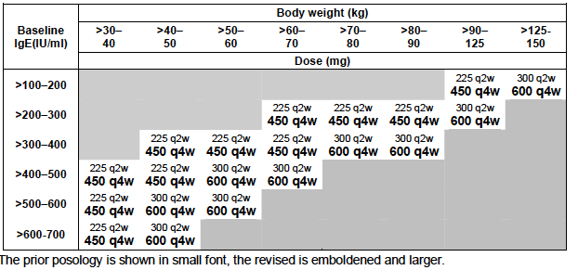
For use in children the proposed dosage range (per 4 week period) is 75 to 750 mg. Lower doses (75 to 300 mg) are to be given as a single dose at 4 weekly intervals and higher doses (450 to 750 mg) as two doses at 2 weekly intervals.

Clinical rationale
Immunoglobulin E (IgE) is involved in the sensitisation of mast cells to specific allergens in allergic disorders and elevated IgE levels are a common feature of such conditions. The rationale behind omalizumab is that an agent directed against IgE should lead to clinical improvement in patients with allergic asthma. As allergic asthma is common in children, extension of its use to this population may be appropriate.
The rationale for the revised dosing table is to improve convenience for patients to possibly aid with compliance and to reduce use of health care resources.

Related submissions
Omalizumab has been the subject of the following previous submissions to the TGA:
- An initial application to register the product was lodged in 2000. This application was approved in 2002. The indication approved was for moderate allergic asthma in adults and adolescents;
- An application to extend the approved indication to include severe allergic asthma in adults and adolescents was lodged in 2004 and approved in 2005;
- A previous application to extend the indications to include children aged 6-11 was lodged in 2009. The clinical evaluator and the Delegate raised a number of issues and the sponsor withdrew the application in 2010;
- An application to remove a precautionary statement from the PI regarding the development of malignancies with the drug was approved in 2014;
- An application extend the indications to include the treatment of chronic idiopathic urticaria was approved in 2014.
Comment: In the previous application for use of omalizumab in children, the indication sought was the same as that approved for adults and adolescents (moderate to severe asthma, currently being treated with inhaled steroids). In this application, the sponsor has sought approval for a more limited indication in children (severe asthma only, with a history of exacerbations, currently being treated with high dose inhaled steroids).

Contents of the clinical dossier

Scope of the clinical dossier
To support use in children the sponsor submitted:
- Two Phase III randomised, double blind, placebo controlled trials (IA05 and 010) examining efficacy and safety. These two studies also provided limited pharmacokinetic (PK) and pharmacodynamic (PD) data in children. The studies were included in the previous TGA submission seeking approval in children.
- Seven open-label studies (1 comparative and 6 single-arm studies) which each provided some data on children aged 6 to < 12, for a supportive pooled analysis of safety (Studies, Q2143g, Q2195g, Q2461g, 010E, 010E1, B1301 and B1301E). Several of these studies have previously been evaluated by the TGA.
To support the proposed changes to the dosing table, the submission included:
- 1 population PK/PD analysis (Report: Population PK/PD 2013).
The clinical submission also included study reports for a number of other trials that have previously been evaluated by the TGA. Some paediatric patients from some of these trials were included in other pooled safety analyses in the submission. Other studies were conducted in adults and adolescents and provided data that were used in comparative analyses contained in the submission and in the population PK/PD analysis. The full study reports for these trials have not been reviewed in this evaluation. The submission also included a report of a large post-marketing observational study (Study Q2948g or EXCELS). The study only enrolled subjects aged 12 or over and has previously been evaluated by the TGA. It has therefore not been reviewed in this report.
The clinical submission also contained literature references.

Paediatric data
Data were submitted to support use in children aged 6 to <12.
No data were submitted for children < 6 years. The sponsor has a waiver from the EMA for this subgroup on the grounds that the product ‘does not represent a significant therapeutic benefit over existing treatments’. The sponsor also has a waiver from the FDA for development in subjects aged < 6 years on the grounds that ‘evidence strongly suggests that the product would be unsafe in this paediatric subpopulation.’ The reasoning behind the granting of these waivers was not discussed.

Good clinical practice
The study reports for the clinical trials contained in this submission included assurances that the trials were conducted in accordance with good clinical practice guidelines.

Pharmacokinetics

Studies providing pharmacokinetic data
Table 2 shows the studies relating to each pharmacokinetic topic and the location of each study summary.

Table 2: Submitted pharmacokinetic studies
PK topic | Subtopic | Study ID | *
PK in children | General PK - Single and multiple dose  - Multiple dose | Study 010  Studies IA05 and 010
Population PK analyses | Revised dosage table in asthma | Population PK/PD 2013
* Indicates the primary aim of the study.
None of the pharmacokinetic studies had deficiencies that excluded their results from consideration.

Summary of pharmacokinetics
The information in the following summary is derived from conventional pharmacokinetic studies unless otherwise stated.

Pharmacokinetics in children aged 6 to < 12 years of age
PK findings from the paediatric studies included the following:
- Trough concentrations in children are modestly elevated compared to those in adults, although resulting free IgE levels are comparable (Table 3);
- The PK of omalizumab are approximately linear in children after single and multiple doses;
- Steady state is reached after 24 weeks of dosing;
- In children, mean half-life at steady state ranged from 18.1 to 37.9 days;
- At steady state, accumulation ratios ranged from 1.56 to 2.99;
- In a population PK analysis, age as a covariate (<12 versus ≥ 12 years) did not have a significant effect on omalizumab PK.
- The sponsor presented a table of pooled results from the paediatric studies IA05 and 010, and pooled results from three studies in adults and adolescents (008, 009 and 011). The table suggests that omalizumab concentrations may be higher in children, but that resulting levels of free IgE are comparable.

Table 3: Steady-state observed trough concentrations of omalizumab, total and free IgE in paediatric and adult patients.
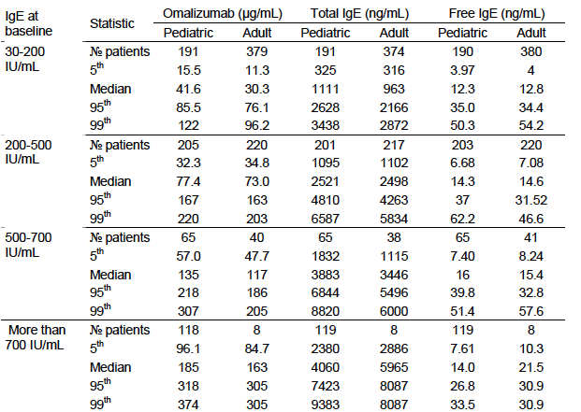
Omalizumab PK and IgE concentrations are summarised for trough samples drawn 84 days or more after commencing treatment with active omalizumab in the moderate to severe allergic asthma Studies 10, IA05, 8, 9 and 11. Paediatric patients are those less than 12 years of age.

Revision of existing dosing table
Simulations conducted with a population PK/PD model indicated that the proposed changes to the existing dosage table would result in a modest increase in C_{max} (8-15%) and decrease in C_{min}. As the total dose administered is not changed, and omalizumab has linear pharmacokinetics, other PK parameters such as AUC and average concentration would not be altered.

Evaluator’s overall conclusions on pharmacokinetics
The submitted PK data were acceptable.

Pharmacodynamics

Studies providing pharmacodynamic data
Table 4 shows the studies relating to each pharmacodynamic topic and the location of each study summary.

Table 4: Submitted pharmacodynamic studies
PD Topic | Subtopic | Study ID
Primary Pharmacology | Effect on free IgE and total IgE | Study 010 Studies IA05 and 010
Population PK/PD analysis | Effect on free IgE and total IgE | Population PK/PD 2013

Summary of pharmacodynamics
The information in the following summary is derived from conventional pharmacodynamic studies in humans unless otherwise stated.

Primary pharmacodynamic effects in children
In Study 010 administration of omalizumab in children was associated with marked reduction in serum free IgE levels and a subsequent rise in total IgE levels (free IgE + IgE-drug complexes). Resulting free IgE levels in children were comparable to those seen in adults and adolescents receiving omalizumab (Table 3).

Revision of existing dosing table
Simulations conducted with a population PK/PD model indicated that the proposed changes to the existing dosage table would not result in free IgE levels likely to be associated with reduced efficacy.

Evaluator’s overall conclusions on pharmacodynamics
The submitted PK data are acceptable. The effects of omalizumab on free IgE and total IgE levels in children are consistent with those observed in adults and adolescents.

Dosage selection for the pivotal studies
No dose-ranging studies were performed in children. The dosing schemes for children used in the clinical trials aimed to estimate the amount of drug needed for each patient in order to suppress IgE levels below 50 ng/mL and to keep within reasonable safety margins as determined by toxicology studies. To achieve IgE levels below 50 ng/mL an average reduction of 25 ng/mL was targeted.

Clinical efficacy

Pivotal efficacy studies

Study IA05

Study design, objectives, locations and dates
This study was a randomised (2:1), double blind, placebo controlled trial with two parallel groups. It consisted of:
- A screening phase of 1 week;
- A run-in phase of 8 weeks, in which a subject’s asthma care was optimised and baseline measures of asthma control were established;
- A double-blind treatment phase of 52 weeks, with a subject’s inhaled corticosteroid (ICS) dose being fixed for the first 24 weeks and adjustable in the following 28 weeks; and
- A follow-up phase of 16 weeks, in which no study drug was administered.
A summary of the study design is shown in Figure 1.
Figure 1: Study IA05 Study details
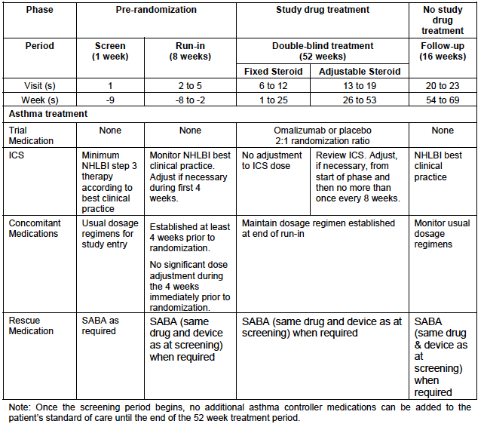
The study had two primary objectives:
- The primary safety objective was to confirm the safety of omalizumab during the 52 week double-blind treatment period and the 16-week follow-up period;
- The primary efficacy objective was to demonstrate the effect of omalizumab on the rate of clinically significant asthma exacerbations during the 24 week double blind period of fixed steroid treatment.
There were also four secondary objectives and nine exploratory objectives that related to the effect of omalizumab on other efficacy endpoints, omalizumab pharmacokinetics, pharmacodynamics, immunogenicity and pharmacoeconomics.
The study was conducted at 87 centers in 7 countries: the United States (58), Argentina (8), Canada (6), Poland (6), Colombia (5), Brazil (3) and South Africa (1). It was conducted between April 2004 and January 2008. The study report was dated 4 June 2008.

Inclusion and exclusion criteria
Inclusion criteria are listed in Table 5 and exclusion criteria in Table 6.

Table 5: Study IA05 inclusion criteria
Inclusion criteria:
Patients were included who met the following criteria:
- Parent or legal guardian was informed of the study procedures and medications and gave written informed consent.
Demographics:
- Outpatient males or females of any race who were aged 6 - <12 years on study entry, with body weight between 20 and 150 kg (suitable weight for dosing).
- Total serum IgE level ≥30 to ≤1300 IU (suitable serum total IgE level for dosing).
Disease definitions/medications
- Patients were required to:
  - have a diagnosis of allergic asthma ≥ 1 year duration according to American Thoracic Society (ATS) criteria (ATS committee on Diagnostic Standards for Nontuberculous Respiratory Diseases 1962) and at screening a history consistent with clinical features of moderate or severe persistent asthma according to NHLBI Guidelines.
  - have a positive prick skin test (diameter of wheal ≥ 3 mm) to at least one perennial allergen (dust mite, cat/dog dander, cockroaches), documented within the past 2 years or taken at Visit 1, to which the patient was exposed on a regular basis (most days) for the duration of the study. A RAST test could be performed for patients with a borderline skin prick test result, only after consultation with Novartis Clinical personnel. Mould allergies are a potential risk factor for severe exacerbations so a mould prick skin test (aspergillus, alternaria, penicillium and cladosporium) was also performed on each patient, but the results were used as an indicator and could not be used to determine positivity for study entry. Skin prick test procedures were includedin the Protocol Appendix 6.
  - demonstrate ≥ 12% increase in FEV1 over starting value within 30 minutes of taking up to 4 puffs (4x100 µg) salbutamol (albuterol) or nebulized salbutamol up to 5 mg (or equivalent of alternative β2-agonist) documented within the past year, at screening, during the run-in period or prior to randomization at Visit 6. Patients were not to take their long acting β2-agonist (LABA) medication within 12 hours of reversibility testing.
- While receiving fluticasone DPI ≥ 200 μg/day or equivalent ex-valve dose patients were required to have at least one of the following:
  - two independent exacerbations in the previous 12 months requiring treatment with systemic (oral or IV) corticosteroids and/or a doubling of the maintenance inhaled corticosteroid dose for at least 3 days, or
  - three independent exacerbations in the previous 24 months; one of these exacerbations must have occurred in the previous 12 months (same treatment as above), or
  - who have been admitted to hospital (including intensive care unit) or received emergency room (including urgent care centres) treatment in the past 12 months for an asthma exacerbation, which in accordance with the GINA 2002 guidelines met all of the following criteria for a severe exacerbation:
    - PEF or FEV1< 60% of predicted/personal best, or patient is too breathless to provide PEF.
    - No improvement after initial treatment and therefore requiring repeated treatment with inhaled β2-agonist (high dose, spacer or nebulized).
    - Requiring treatment with systemic (oral or IV) corticosteroids
All qualifying exacerbations should have occurred while receiving NHLBI Step 3 or 4 therapy according to best clinical practice.
- Patients were to demonstrate evidence of inadequate asthma symptom control consistent with clinical features of moderate or severe persistent asthma during the last 4 weeks of the run-in period prior to randomization despite ICS (equivalent dosage of fluticasone DPI ≥ 200 µg/day total daily ex-valve dose) with or without controller asthma medications. Asthma symptoms were defined as inadequately controlled when at least one of the following criteria is met:
  - daytime asthma symptoms reported on patient diary cards as:
a score of 1 or more on at least 20 out of the last 28 days (missing data to be treated as a day with no symptoms) and a mean symptom score over this period (last 28 days) of ≥ 1.5 (mean was calculated based only on data supplied; missing values were not considered), and/or
  - night-time awakening due to asthma symptoms requiring rescue medication use on each event (more than 4 times in the last 4 weeks of run-in, on average, more than once a week)
- Patients were to have been receiving an ICS dose equivalent to fluticasone DPI ≥ 200μ g/day for:
    - the 12 weeks prior to the screening visit
    - the last 4 weeks of the run-in period and at randomisation
- If the patient was receiving regular long-acting β2-agonist as part of the asthma treatment regimen it must have been taken for at least 3 months prior to screening.
- If the patient was receiving stable doses of oral corticosteroids as asthma maintenance therapy it was to have been taken for at least 3 months prior to screening. Patients included in the trial receiving oral corticosteroids must have had at least one of their qualifying exacerbations while on oral steroid therapy (see inclusion Criteria #5).

Table 6: Study IA05 Exclusion criteria
Patients excluded from the study were those:
Other therapies/medication
  - who received systemic (oral or IV) corticosteroids for reasons other than asthma within 4 weeks of Visit 1 or during the double-blind treatment period.
  - who were taking β-adrenergic antagonist medication by any route (e.g. propranolol) or anticipated their use during the study.
  - who took methotrexate, gold salts, cyclosporin, troleandomycin or other immunosuppressants not approved for an asthma indication within 3 months of Visit 1 (or anticipated their use during the study).
  - who were receiving desensitization therapy with less than 3 months of stable maintenance doses prior to Visit 1.
  - who were taking oral or inhaled anticholinergics within 24 hours of Visit 1.
  - with a history of food or drug related severe anaphylactoid or anaphylactic reaction(s).
  - with a history of allergy to antibiotics. Patients could have been included if the antibiotics to which they are allergic to were avoided for the entire duration of the study.
  - with aspirin or other non-steroidal anti-inflammatory drug (NSAID) related asthma diagnosed from the patients history. Patients could have been included if use of NSAIDs to which they are allergic to were avoided for the entire duration of the study.
Medication washouts
  - who did not adhere to the following antihistamine washout prior to the skin prick tests at Visit 1 (short and medium acting antihistamines could have been used during the study, but a wash out was required prior to the skin prick testing):
  - short acting antihistamines (e.g. chlorpheniramine, promethazine, diphenhydramine, terfenadine) within 3 days of Visit 1.
  - medium acting antihistamines (e.g. loratadine, cetirizine) within 5 days of Visit 1.
  - who did not adhere to a washout of LABA medication of at least 12 hours prior to the scheduled visits for spirometric assessment.
  - who did not adhere to the washout of leukotrienes on the morning of dosing.
Concurrent diseases/conditions and history of other diseases/conditions
  - who were being treated for an asthma exacerbation during the 4 weeks immediately prior to randomization
  - with an active lung disease other than allergic asthma (e.g. cystic fibrosis, bronchiestasis).
  - with elevated serum IgE levels for reasons other than allergy (e.g. parasite infections, hyperimmunoglobulin E syndrome, Wiskott-Aldrich Syndrome or clinical allergic bronchopulmonary aspergillosis).
  - with clinically significant uncontrolled systemic disease or a history of such disease (e.g. infection, haematological disease, renal, hepatic, coronary heart disease or other cardiovascular disease, endocrinologic or gastrointestinal disease) within the previous 3 months.
  - who had diagnosed cancer, were currently being investigated for possible cancer or who had any history of cancer
  - with acute sinusitis or chest infection within 1 month of Visit 1 (eg: history of viral upper respiratory infection symptoms which did not resolve after 7-10 days or required treatment with antibiotics within 1 month of Visit 1).
  - with clinically significant abnormality on a 12-lead ECG within one month prior to or at Visit 1.
  - with clinically significant laboratory abnormalities (not associated with the study indication) at Visit 1.
  - with platelet levels ≤ 100 x 10⁹/L at Visit 1.
Investigational drug/therapy use
  - who had previously been randomized into this or any other omalizumab study.
  - who had used omalizumab as a marketed product (Xolair).
  - who had been treated with investigational drugs 30 days prior to entry or during the course of the trial.
Ingredient hypersensitivity
  - with known hypersensitivity to any ingredients, including excipients (sucrose, histidine, polysorbate 20) of the study medication or drugs related to omalizumab (eg: monoclonal antibodies, polyclonal gamma globulin).
  - with hypersensitivity to the trial’s asthma rescue medication (eg: salbutamol/terbutaline) or related drugs.
Compliance, reliability and investigator judgment
  - patients and or parents/legal guardians who were considered potentially unreliable or where it was envisaged the patient may not consistently attend scheduled study visits
  - with evidence or history of drug or alcohol abuse
  - who were unable either alone or with their caretaker to perform spirometry and peak flow measurements or complete the patient diary.
  - with any other condition or prior/current treatment, which in the opinion of the investigator rendered the patient ineligible for the study schedule.
  - were involved in disease related litigation.
Comment: The study sought to test omalizumab against placebo in children aged 6 to <12, who had allergic asthma with a history of exacerbations in the preceding 1-2 years, and who had ongoing symptoms despite treatment with moderate to high doses of ICS (fluticasone ≥ 200 µg/day or equivalent). The study enrolled subjects with moderate to severe persistent asthma, whereas the indication proposed by the sponsor is limited to severe disease.

Study treatments
Subjects were randomised (2:1) at the beginning of the double blind treatment phase (Visit 6) to receive either omalizumab or matching placebo. The lyophilised powder presentation of omalizumab was used.
The dose regimen of study drug was dependent upon the subject’s weight and baseline IgE level. The dosing table used in the study is shown in Table 7. The minimum dose per 4 week period was 75 mg (as a single dose every 4 weeks). The maximum dose per 4 week period was 750 mg (given as 375 mg every 2 weeks).
Comment: For subjects > 30 kg, the dosages recommended in the table are essentially the same as those currently registered in Australia for adults/adolescents. There are some minor variations at the extremes of body weight/IgE level. The doses in the table for subjects weighing 20-30 kg are not currently registered.

Table 7: Study IA05 Dosing table ages 6 to < 12 years old (mg omalizumab per dose)
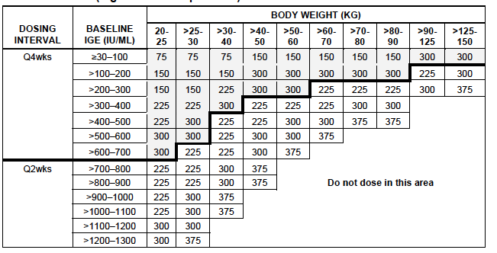
Study drug was administered subcutaneously in the deltoid region of the arm or in the thigh if the deltoid region was not appropriate. Doses exceeding 150 mg were divided among more than one injection site (see Table 8) to limit injections to not more than one 150 mg injection per site.

Table 8: Study IA05 Number of injections per dose
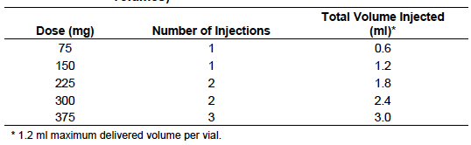
Subjects could continue to use short-acting beta agonists throughout the study. No changes to the subject’s asthma maintenance therapy were permitted during the double-blind phase of the study apart from changes to the ICS dose in the latter part.

Efficacy variables and outcomes
The main efficacy variables were:
- The frequency of asthma exacerbations;
- Asthma symptom scores. The scoring system used in the study is shown in Table 9. The combined symptom score ranged from 0 to 9 and nocturnal score ranged from 0 to 4.
- Usage of short-acting beta agonist recue medication;
- Quality of life

Table 9: Study IA05 – Clinical symptom scores
Clinical symptom scores (nocturnal, morning, daytime)
At Visits 6, 9, 13, 16, 19 and 23 the severity of the disease will be evaluated using combined clinical symptom scores (nocturnal, morning and daytime asthma symptoms) in order to obtain a total symptom score.
A. Nocturnal asthma score
Each morning, upon awakening, the patient is asked to answer and record on the Patient Diary
Record the answer to the following question. How did you sleep last night?
  - 0= I did not wake up because of any breathing problems.
  - 1= I awoke once because of my breathing problems but did not use my rescue medication.
  - 2= I awoke once because of my breathing problems, but my rescue medication controlled my symptoms.
  - 3= I awoke more than once because of my breathing problems, but my rescue medication controlled my symptoms.
  - 4= I had difficulty sleeping because of my breathing problems even though I used my rescue medication.
B. Morning asthma symptoms
Each morning, upon awakening, the patient records the answer to the following question: Did you have asthma symptoms upon arising in the morning?
  - 0= No
  - 1= Yes
C. Daytime asthma symptom score
Each evening, prior to bedtime, the patient performs an evaluation on his/her asthma symptoms over the preceding 24 hour period. This evaluation includes an overall assessment of the following symptoms: shortness of breath (breathlessness), chest discomfort (tightness), wheezing, and cough. The following scale is used to record these combined symptoms:
  - 0= No symptoms at all; unrestricted activity.
  - 1= Symptoms caused little or no discomfort; unrestricted activity.
  - 2= Symptoms caused some discomfort, at times limiting strenuous activity.
  - 3= Symptoms caused moderate discomfort and sometimes limited routine activity.
  - 4= Symptoms occurred at rest, caused marked discomfort, and usually limited routine activity.
Total symptom score is obtained by adding the scores for nocturnal asthma, morning asthma symptoms and daytime asthma symptoms (A, B and C, respectively; maximum score = 9).
The primary efficacy outcome was the rate of clinically significant asthma exacerbations in the 24 week fixed steroid period of the double blind treatment phase. A clinically significant asthma exacerbation was defined as a worsening of asthma symptoms, as judged clinically by the investigator, requiring doubling of the baseline inhaled corticosteroid dose and/or treatment with rescue systemic (oral or IV) corticosteroids for at least 3 days.
There were four secondary efficacy outcomes:
- Change in nocturnal clinical symptom score from baseline to the end (last four weeks) of the 24 week double blind fixed steroid treatment period;
- The rate of clinically significant asthma exacerbations in the entire 52 week double blind treatment phase;
- Change in beta-agonist rescue medication use from baseline to the end (last four weeks) of the 24 week double blind fixed steroid treatment period;
- Change in overall quality of life score from baseline to the end (last visit) of the 24 week double blind fixed steroid treatment period. The quality of life instrument used was the Paediatric Asthma Quality of Life Questionnaire (Standardized version) or PAQLQ (S). This is a validated instrument for measuring problems that children experience as a result of asthma. It contains 23 items across three domains (symptoms, activity limitations and emotional function. Each item requires a response on a 7-point scale with low score indicating a worse QoL (for example, for coughing, 1=extremely bothered, 7=not bothered). The total score averages the results across all 23 items and therefore ranges from 1 to 7. A minimally important difference is approximately 0.5 points on the 7-point scale.
Exploratory efficacy outcomes included:
- Time to asthma exacerbations;
- Total clinical symptom score;
- Lung function (FEV1, PEF);
- Concomitant asthma medication use;
- Per cent reduction of inhaled corticosteroids;
- Absolute inhaled corticosteroid reduction;
- Investigator and patient global evaluations.
Exacerbations were recorded at each study visit. Patients were provided with diaries in which they recorded morning and evening PEF, daily asthma symptom scores (nocturnal, morning and daytime scores) and use of rescue medication. Diaries were to be completed twice daily for the duration of the study, with a parent or guardian ensuring accuracy. Spirometry was performed and the PAQLQ questionnaire was completed at Weeks 1, 13, 25, 29, 41 and 53 of the double blind phase. Global evaluation was performed at the end of the double-blind treatment phase only.

Randomisation and blinding methods
The sponsor produced a randomisation list using a validated, automated system. Randomisation was not stratified by any baseline factors. A 2:1 randomization scheme was used ‘for ethical reasons in order to provide treatment to as many patients in this younger aged population as possible’.
Patients and investigator and sponsor personnel were all blinded to treatment allocation from time of randomisation until database lock.

Analysis populations
The intent-to-treat (Full ITT) population included all patients who were randomized. Analysis was conducted according to the treatment subjects were randomized to. The Modified ITT (MITT) population included all patients in the Full ITT but excluded patients from two study sites. These two sites had issues with GCP compliance. Patients affected in these two sites were replaced at other sites so that the study was still adequately powered to use the Modified ITT population for the primary analysis. The per-protocol (PP) population included all Modified ITT patients who complete the study without any major deviations from protocol procedures. The Safety Population included all patients who received any study drug and had at least one post-baseline safety assessment.
The primary efficacy analysis was based on the Modified ITT population, with sensitivity analyses using the Full ITT and Per-protocol populations. Other efficacy analyses were based on the Modified ITT population.
Comment: The submission described results in a subpopulation of patients referred to as the ‘European Union mITT population’ (EU mITT or EUP). An analysis of this subgroup for the primary endpoint was apparently pre-specified. However, further analyses using this subpopulation were apparently performed at the request of the EMA, prior to the lodgement of this submission in Europe. The EU mITT population was defined as those patients requiring high dose ICS plus LABA at baseline. A high dose of ICS was classified as ≥ 500 μg of fluticasone or equivalent per day. Results of most of the analyses on this subgroup were only presented in the Summary of the submission, and not in the study report in the clinical submission.

Sample size
Based on a subpopulation of patients in a previous study (Study 010) it was estimated that the reduction in the number of clinically significant exacerbations in the omalizumab group would be 41% compared to the placebo group. To achieve a power of 85%, using a 2-sided test at α=0.05, it was estimated that a total of 570 subjects would be required (380 on omalizumab and 190 on placebo).

Statistical methods
The number of clinically significant asthma exacerbations was analysed using generalised Poisson regression, with terms for treatment, dosing schedule (2 weekly or 4 weekly), country and exacerbation history. A Cochran Mantel-Haenszel test stratified by dosing schedule was also used to analyse the number of patients with 0 or ≥1 clinically significant exacerbations. The number of exacerbations was also compared using the van Elteren test stratified by dosing schedule.
Change from baseline in symptom scores and change from baseline in SABA use, were compared between treatments using the van Elteren test stratified by dosing schedule. The rate of clinically significant asthma exacerbations over the entire 52 week double blind treatment phase was analysed using similar methods to those in the primary analysis. The change (from baseline to the last visit of the fixed steroid treatment period) in overall PAQLQ(S) score was compared between treatments using an analysis of covariance model with country, baseline value and dosing schedule (2 weekly or 4 weekly) as factors and covariates.
A hierarchical testing procedure was implemented for the primary and secondary endpoints to maintain an overall type one error rate of 5%.

Participant flow
A total of 1433 patients were screened for enrolment and 627 were randomised. Analysis populations are summarised in Table 10. The EU mITT population consisted of 235 subjects; 159 in the omalizumab arm and 76 in the placebo arm. Subject disposition for the full study population is shown in Table 11 and for the EU mITT population in Table 12.

Table 10: Study IA05 Analysis populations
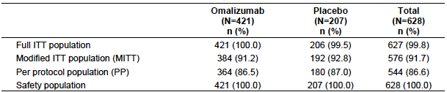

Table 11: Study IA05 Subject disposition (Full ITT population)
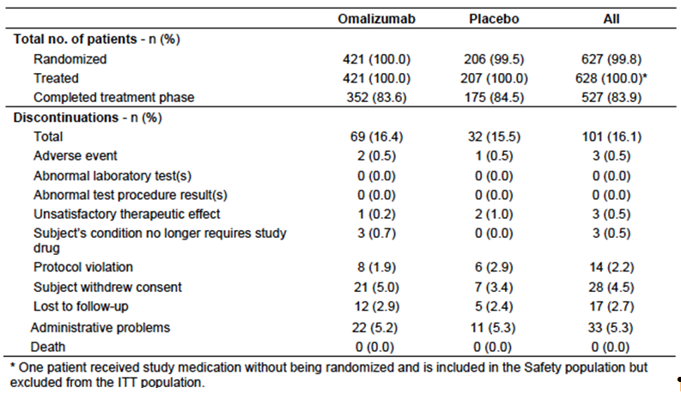

Table 12: Study IA05 Subject disposition (EU mITT population)
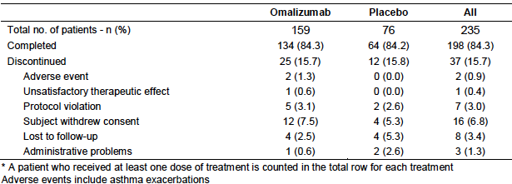

Major protocol violations/deviations
Major protocol violations, which led to patients being excluded from the per-protocol population, are summarised in Table 13. A total of 51 subjects were from the 2 study centres excluded due to GCP issues. A further 18 patients were excluded for less serious GCP issues. Other major protocol violations generally related to failure to meet inclusion and exclusion criteria. The most common inclusion criteria violation was failure to meet the symptom score criteria. This was more common in the placebo arm - 8 versus 6 subjects (3.9% versus 1.4%).
Comment: The major protocol deviations would be unlikely to have affected the outcome of the study.

Table 13: Study IA05 Major protocol violations Patients excluded from the per protocol population (Safety population)
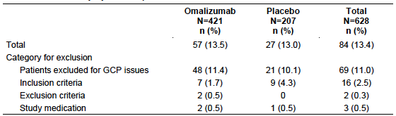

Baseline data
Baseline demographic and disease characteristics are shown in Table 14, history of exacerbations in Table 15 and baseline asthma symptoms in Table 16. Approximately two thirds of patients were classified as having severe persistent asthma (Table 17).
Comment: The two treatment groups were reasonably well balanced with respect to baseline characteristics. Data presented in the Summary of the submission also indicated that baseline demographics and disease characteristics were reasonably well balanced in the two treatment arms for the EU mITT population.
Table 14: Study IA05 Baseline demographic and disease characteristics (Safety population)
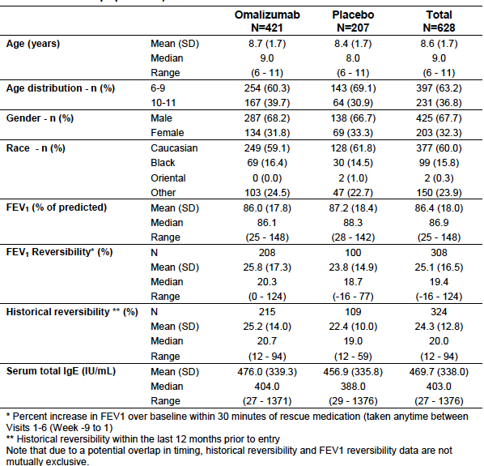
Table 15: Study IA05 Exacerbation history (Safety population)
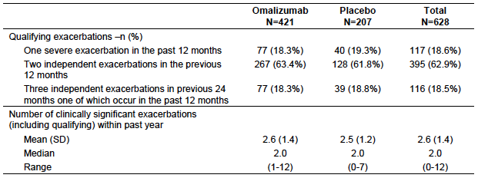
Table 16: Study IA05 Asthma symptoms at baseline (Safety population)
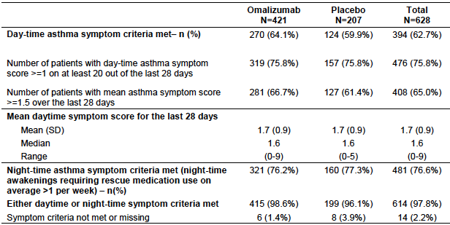
Table17: Study IA05 Asthma severity at baseline
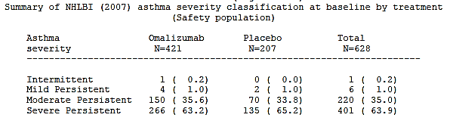
Baseline asthma medication use is shown in Table 18 for the entire study population and Table 19 for the EU mITT population.
Table 18: Study IA05 Baseline asthma medication (Safety population)
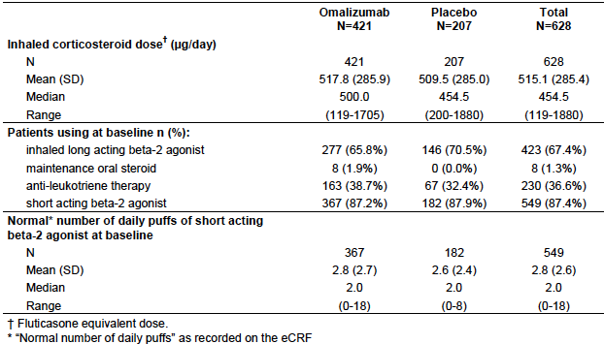
Table 19: Study IA05 Baseline asthma medication (EU mITT population)
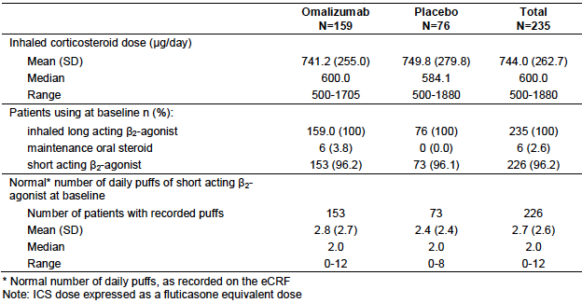
Comment: The two treatment groups were again well balanced. There were more patients in the omalizumab arm on maintenance oral steroids. Approximately two thirds of subjects in the MITT population were receiving LABAs at baseline.

Results for the primary efficacy outcome
Results for the primary efficacy endpoint are shown in table 20. With omalizumab treatment there was a statistically significant reduction in the rate of clinically significant exacerbations (0.45 versus 0.64 per 24 week treatment period; ratio 0.693 [95% CI: 0.533 – 0.903]; p=0.007).
There was no significant difference in the proportion of patients who were free of clinically significant exacerbations (64.3% versus 58.3%; p=0.167) or on between-treatment comparison of the frequency distribution of exacerbations.
Results for exacerbation rate in the EU mITT population were similar.

Table 20: Study IA05 Clinically significant exacerbations over 24 weeks (MITT population)
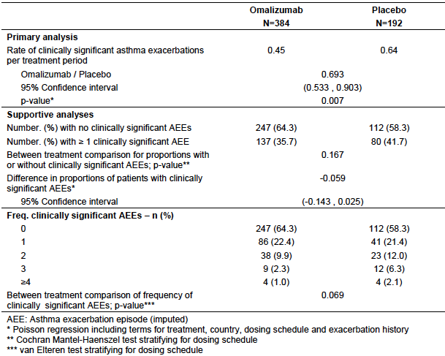

Table 21: Study IA05 Clinically significant exacerbations over 24 weeks (EU mITT population)
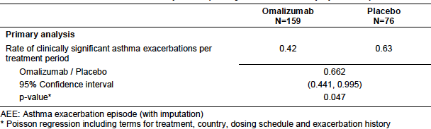

Results for secondary efficacy outcomes

Nocturnal symptoms
There was no significant difference between treatment arms in the change from baseline in mean nocturnal symptom score at the end of the 24 week fixed steroid treatment period in either the MITT population or the EU mITT population.

Clinically significant exacerbations over the 52 week period
In the omalizumab treatment group, in both the MITT and EU mITT populations, there were statistically significant reductions in the rate of clinically significant exacerbations over the whole 52 week double-blind treatment phase (Table 22 and Table 23). In the EU mITT subpopulation, exacerbations were reduced by approximately 50% (0.73 versus 1.44 exacerbations per 52 weeks).

Table 22: Study IA05 Clinically significant exacerbations over 52 weeks (MITT population)
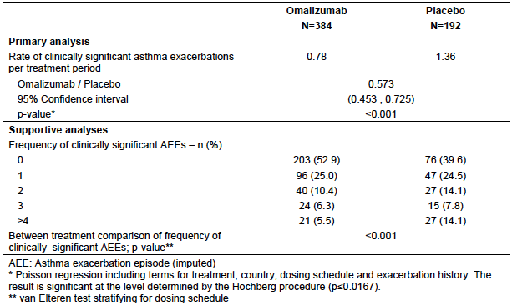

Table 23: Study IA05 Clinically significant exacerbations over 52 weeks (EU mITT population)
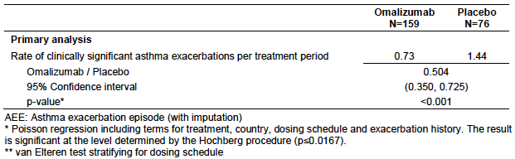

Number of puffs of asthma rescue medication
There was no significant difference between treatment arms in the change from baseline in mean number of puffs of asthma rescue medication at the end of the 24 week fixed steroid treatment period in either the MITT population or the EU mITT population.

Quality of life
For the MITT population there were no significant differences between treatments in PAQLQ (S) overall score at any time point. Results for overall and domain scores at 24 weeks were shown. QoL was not analysed for the EU mITT population.

Results for exploratory efficacy outcomes
Results of a number of exploratory endpoints were presented. Notable findings in the MITT population included the following:
- Time to first clinically significant asthma exacerbation was prolonged in the omalizumab arm (Figure 2);
- No statistically significant differences between treatment arms were observed for asthma symptom scores (nocturnal, morning, daytime or total) at any time point;
Figure 2: Study IA05 – Time to first clinically significant asthma exacerbation (MITT population) – Kaplan-Meier plot.
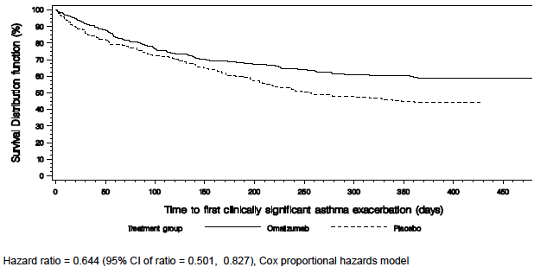
- Omalizumab treatment was associated with a consistent increase in FVC compared to placebo. For example, at Week 24, LS mean values for change in FVC were +177.7 mL with omalizumab and +117.2 mL for placebo (p=0.017). The differences were not statistically significant in the EU mITT subpopulation.
- There were no consistent statistically significant benefits with omalizumab treatment for change in FEV₁, change in per cent predicted FEV₁, or change in FEF 25-75%. Findings were similar in the EU mITT subpopulation.
- There were no consistent statistically significant benefits with omalizumab treatment for change in mean morning PEF or mean evening PEF. Findings were similar in the EU mITT subpopulation.
- There was no significant difference between treatment groups in the per cent change (from baseline to the end of the 52 week double-blind phase) in ICS dose. Changes in both groups were small (-3.6% with omalizumab, +1.8% with placebo; p=0.053). The difference was also not significant in the EU mITT population.
- Omalizumab was superior to placebo according to the global assessment of treatment effectiveness made by both patients and investigators. Similar results were observed in the EU mITT subpopulation.
- There were no significant differences between treatments in rates of hospital admission, visits to the emergency department and unscheduled visits to the doctor (Table 24). This was also the case for the EU mITT subpopulation.
- Omalizumab treatment was associated with a reduction in the rate of severe asthma exacerbations (Table 24). A severe exacerbation was defined as an exacerbation where the PEF or FEV₁ was < 60% of the patient’s personal best. The difference was not significant for the EU mITT subpopulation.

Table 24: Study IA05 – Resource utilisation / severe exacerbations (MITT population)
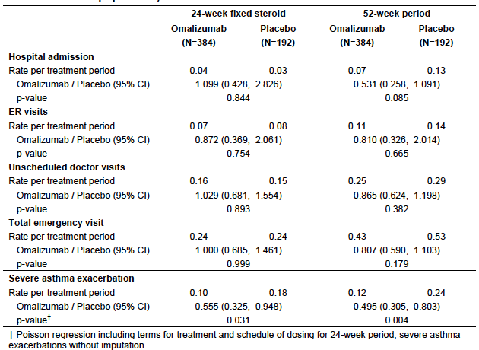
Comment: Although some of these outcomes (in the MITT) favoured omalizumab over placebo, they were only investigated as exploratory endpoints, and no adjustment was made for multiple statistical comparisons. The results should therefore be interpreted with caution.

Subgroup analyses of primary efficacy outcome
A number of subgroup analyses were presented for the primary efficacy outcome of clinically significant exacerbations. According to the study report these analyses were pre-specified, however they do not appear to have been proposed in the study protocol.
- Exacerbation rate over 52 weeks was reduced in the omalizumab arm for both moderate and severe asthma (defined according to NHLBI 2007 criteria). There was no significant effect for moderate asthma after 24 weeks (Table 25);
- A reduction in exacerbations was also shown in the group of subjects already receiving high dose ICS (defined as either fluticasone ≥ or 400 or 500 µg daily) and LABA (Table 26). The group of subjects on fluticasone ≥ 500 µg is the same as the EU mITT subpopulation;
- A reduction in exacerbations with omalizumab was demonstrated for both LABA users and LABA non-users at 52 weeks. At 24 weeks, a benefit was only demonstrated for LABA non-users (Table 27);
- At 52 weeks, a reduction in exacerbations with omalizumab was demonstrated for subjects with baseline predicted > 80% or 60 to 80%. The number of subjects with predicted FEV₁ of < 60% was very small. At 24 weeks, a benefit was only demonstrated for those with predicted FEV₁’s of 60-80% (Table 28). Similar effects were observed in the EU mITT subpopulation.
- Reductions in exacerbation rate appeared greater in subjects with higher baseline IgE levels (Table 29).

Table 25: Study IA05 – Subgroup analysis by baseline asthma severity
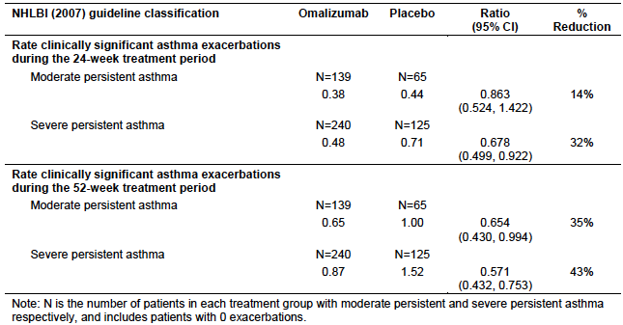

Table 26: Study IA05 – Subgroup analysis – subjects on high dose ICS and LABA
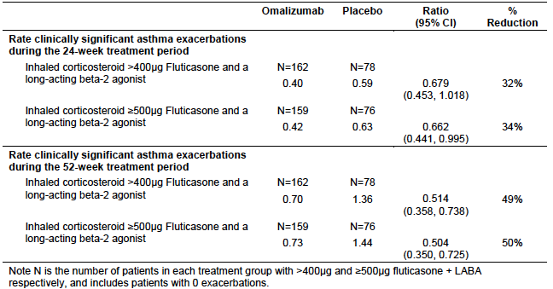

Table 27: Study IA05 – Subgroup analysis by LABA use
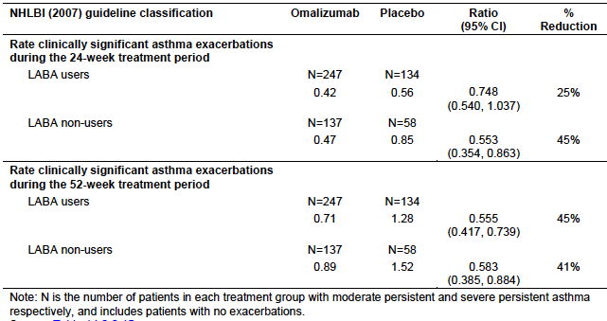

Table 28: Study IA05 – Subgroup analysis by baseline percent predicted FEV1
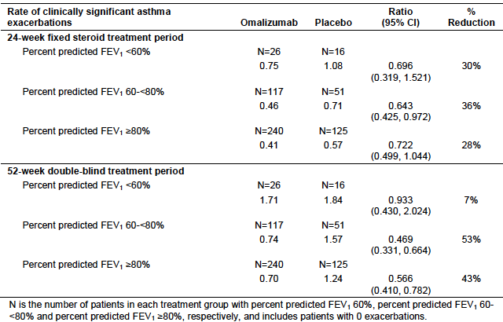

Table 29: Study IA05 - Subgroup analysis by baseline IgE level
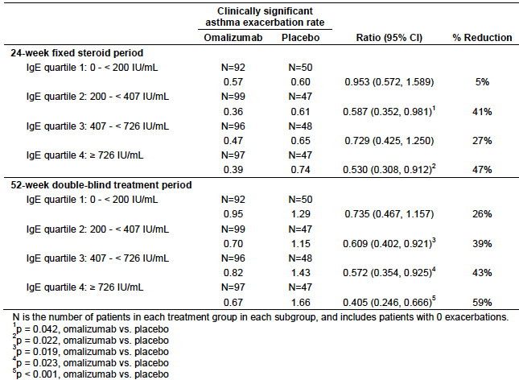

Study 010

Study design, objectives, locations and dates
This was a randomised, double blind, placebo controlled trial with two parallel groups. The study had the following phases:
- An initial screening phase;
- A run-in phase of 4 to 6 weeks in which subjects were switched to and then established on the optimal lowest effective dose of inhaled beclomethasone diproprionate (BDP) in the range of 168 to 420 µg/day (using an inhaler that delivered 42 µg/puff). Subjects were maintained on this dose for the final 4 weeks of the run-in phase;
- A randomised (omalizumab versus placebo) double blind phase lasting 28 weeks (7 months). In the first 16 weeks of this phase the BDP dose was not changed. In the second 12 weeks of this phase, BDP dose was reduced by approximately 25 % every 2 weeks until total elimination or the development of uncontrolled asthma. Steroid reduction was attempted over the first 6 to 8 weeks and a stable BDP dose was maintained for at least the final 4 weeks;
- An open-label extension phase lasting 24 weeks (5 months). In this phase all subjects were treated with omalizumab.
A study schematic is shown in Table 30.
Table 30: Study 010 Study Schematic
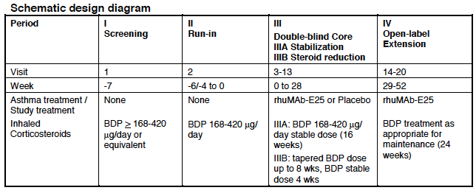
The primary objectives of the study were:
- To evaluate the 7 month safety and tolerability of SC omalizumab compared to placebo for treatment of paediatric allergic asthma;
- To evaluate the 12 month safety and tolerability of SC omalizumab compared to placebo for treatment of paediatric allergic asthma.
The secondary objectives of the study were to evaluate:
- The effects of omalizumab treatment compared to placebo on inhaled corticosteroid dose-reduction;
- The pharmacodynamic effects of omalizumab compared to placebo;
- The pharmacokinetics of omalizumab;
- The effects of omalizumab treatment on Quality of Life (QOL) compared to placebo;
- The pharmacoeconomic resource utilization in omalizumab-treated patients compared to placebo.
Comment: Demonstration of efficacy was only a secondary objective of this trial and the only stated efficacy objective related to use of omalizumab as a steroid-sparing agent.
The study was conducted at 27 centres in the United States. It commenced in February 1998 and the double-blind phase was completed in April 1999.

Inclusion and exclusion criteria
Inclusion criteria are listed in Table 31 and exclusion criteria in Table 32.
Comment: The study enrolled subjects who were well controlled on BDP doses between 168 – 420 µg/day. This refers to the ‘ex-actuator’ dose. In Australian terminology this equates to 200 to 500 µg/day (‘ex-valve’ dose). The formulation of BDP was not stated but the study commenced in 1998 and hence it is likely that the old CFC-containing, suspension formulation was used. The only BDP inhaler product currently registered in Australia is ‘Qvar’, which is a non-CFC-containing solution formulation. The Qvar solution formulation has greater lung deposition than the old suspension formulation and hence lower doses (about half) are administered to achieve the same therapeutic effect. Therefore, in terms of modern day doses of BDP, subjects in this trial were receiving the equivalent of approximately 100 to 250 µg/day of BDP solution. Doses of 100-200 µg/day BDP solution are considered to be low doses (see Table 33). It is also noted that subjects receiving LABAs, or those who had taken systemic steroids in the previous month, were excluded. The study report described the intended population as having ‘moderate to severe’ allergic asthma. However, the inclusion and exclusion criteria suggest that patients with mild or moderate asthma could be enrolled. The proposed indication sought by the sponsor is restricted to severe disease.
Table 31: Study 010 Inclusion criteria
Patients included in the study were those:
- Male or premenarche female patients aged 6-12 years, whose parent, or legal representative was willing to sign the written Informed Consent prior to initiation of any study procedures.
- Patients with the diagnosis of allergic asthma > 1 year duration who, in addition to the standards of the American Thoracic Society (1), met the following criteria:
  - A positive prick skin test (e.g. +3 reaction) to at least one of the following allergens: Dermatophagoides farinae, Dermatophagoides pteronyssinus, cockroaches (whole body), dog or cat
  - Total serum IgE level ≥ 30 to ≤ 1300 IU/mL and body weight < 90 kg (suitable weight and serum total IgE level for dosing as provided in the dosing table presented earlier in this report)
  - Demonstration of ≥ 12% increase in FEV-1 over baseline value within 30 minutes of taking one or two puffs of albuterol (90 µg/puff) within 1 year of visit 1
  - Baseline FEV-1 ≥ 60% of the predicted normal value for the patient
  - Asthma well-controlled with minimum effective dose of inhaled corticosteroids at doses equivalent of ≥168 to 420 µg/day of beclomethasone dipropionate (BDP) for ≥ 3 months prior to randomization, and as needed, or regular use of bronchodilator therapy.
In general, asthma is considered well-controlled if the following criteria are met:
    - Minimal asthma symptoms during the day.
    - Night-time awakening due to asthma symptoms < 1 time a week.
    - Minimal limitations on normal activities and exercise.
    - Beta-agonist requirement, on average, not exceeding 4 puffs of albuterol (90 µg/puff) or its equivalent.
    - PEFR variability (difference between PM and AM value) < 20 %.
    - Minimal or no side effects from medication.
- Patient’s asthma must be “stable” (e.g., no significant change in the regular asthma medication, no acute asthma exacerbation requiring corticosteroid rescue) for at least 4 weeks prior to run-in period (Visit 2.1).
- Patients must meet pretrial eligibility requirements for trial enrolment (acceptable medical history and physical examination results and acceptable laboratory test results).
- Patients must be able to use the Mini-Wright peak flow meter for the measurement of peak flow, and a metered-dose inhaler (MDI) for administration of albuterol rescue medication. Instructions for proper use of peak flow meters and MDI are referenced in the NHLBI guidelines (copy provided by sponsor) and instructions are provided to the patients.
Also patients must have the ability to reliably complete the daily diary cards (if necessary with parent or legal guardian’s help) during the trial.
Table 32: Study 010 Exclusion criteria
Patients excluded were those:
  - Pregnant females, nursing mothers or females of childbearing potential, who did not use a reliable contraceptive method or any patient becoming pregnant during the course of the study. Any female with the onset of menstruation after randomization into the study was not excluded, if agreeing to abstinence or use of an acceptable contraceptive. Any patient becoming pregnant during the trial must be discontinued from the trial.
  - Patients previously treated with rhuMAb-E25
  - Patients with known hypersensitivity to any ingredient, including excipients (sucrose, histamine, polysorbate 20) of rhuMAb-E25, or related drugs (e.g. monoclonal antibody, polyclonal gamma globulin)
  - Patients with hypersensitivity to trial rescue medication (albuterol) or related drugs
  - Patients with a history of acute infectious sinusitis or respiratory tract infection within 1 month prior to Visit 1,
  - Patients with active lung disease other than allergic asthma (e.g. chronic bronchitis)
  - Patients with elevated serum IgE levels for reasons other than atopia
  - Patients taking allergy vaccination therapy with less than 3 months of stable maintenance doses prior to Visit 1
  - Patients using the long-acting antihistamine (e.g. astemizole) within 3 months of Visit 1
  - Patients using short-acting antihistamines (e.g. chlorpheniramine, promethazine, tripelennamine, diphenhydramine, terfenadine, fexofenadine, etc.) within 3 days of Visit 1
  - Patients using medium-acting antihistamines (e.g. loratadine and cetirizine) within 5 days of Visit 1
  - Patients using zafirlukast (Accolate) or other leukotriene receptor inhibitors and zileuton (Zyflo) or other 5-lipoxygenase enzyme inhibitors within 72 hours of Visit 1
  - Patients taking cromolyn sodium or nedocromil sodium within 1 month of Visit 1
  - Patients taking oral or inhaled anticholinergics within 24 hours of Visit 1
  - Patients taking the following theophylline regimens:
    - Once daily within 72 hours of Visit 1
    - Twice daily within 48 hours of Visit 1
    - Short acting within 24 hours of Visit 1
  - Patients taking β2-agonists as follows:
    - Oral within 72 hours of Visit 1
    - Long-acting inhaled (e.g. salmeterol) within 72 hours of Visit 1
    - Short-acting inhaled within 8 hours of Visit 1
Corticosteroids:
  - Patients whose dose of inhaled corticosteroids has undergone significant change (e.g. 50% change) in daily dose or dosing schedule within one month of Visit 1
  - Patients taking oral or parenteral corticosteroids within one month of Visit 1
  - Patients taking β-adrenergic antagonist medications (e.g., propranolol)
  - Patients who have smoked within 2 years of Visit 1 or who have a history of smoking ≥ 1 pack/day
  - Patients with clinically significant abnormalities on 12-lead ECG at Visit 1
  - Patients with abnormal chest X-ray (excluding changes consistent with asthma) within the last 12 months of Visit 1
  - Patients with significant systemic disease, or a history of such disease (e.g., cancer, infection, haematological, renal, hepatic, coronary heart disease or other cardiovascular diseases, endocrinologic, or gastrointestinal disease) within the previous 3 months of Visit 1
  - Patients with clinically significant laboratory abnormalities and evaluations at Visit 1
  - Patients previously randomized into the study
  - Patients treated with an experimental, non-approved drug or investigational drugs within the past 30 days or during the study
Patient/parent/or legal guardian with a history of noncompliance to medical regimens or who were considered potentially unreliable.
Table 33: Australian Asthma Handbook: Definitions of ICS dose levels in children
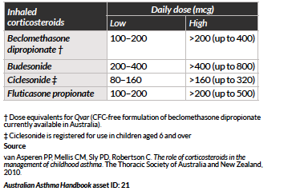

Study treatments
Subjects were randomised (2:1) to receive omalizumab or placebo during the double-blind phase. Doses were dependent upon body weight and baseline IgE levels. The dosage table used in this study is shown Table 34. The minimum dose per 4 week period was 150 mg (as a single dose every 4 weeks). The maximum dose per 4 week period was 750 mg (given as 375 mg every 2 weeks).

Table 34: Study 010 Dosing table
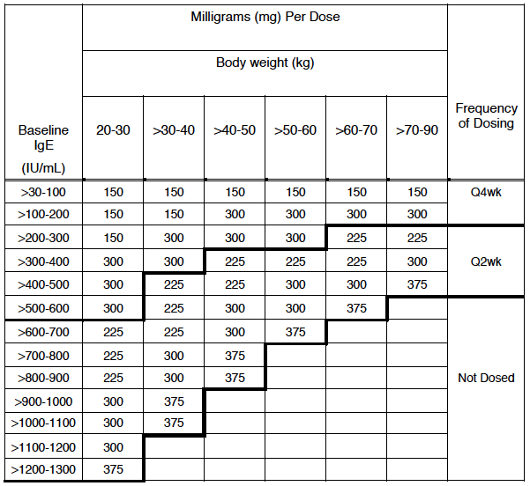
Comment: The dosing table in this study was different to that used in the pivotal study and therefore different to that being proposed for registration. Overall, the differences were small. However, in general terms, the table used in this study allowed for higher doses at lower body weights (20 to 40 kg) and did not permit dosing in heavier subjects (>90 kg).
Study drug was administered subcutaneously in the deltoid region of the arm or in the thigh if the deltoid region was not appropriate. Between 1 and 3 injection sites were used.
Subjects could continue to use a short-acting beta agonist (salbutamol) throughout the study. No changes to the subject’s asthma maintenance therapy were permitted during the double-blind phase of the study, apart from decreased doses of BDP in the second part.

Efficacy variables and outcomes
Investigation of efficacy was a secondary objective of the study. The main efficacy variables were:
The ‘principle’ efficacy outcomes of the study were:
- The percent reduction in the dose of BDP (in the dose reduction period); and
- The proportion of patients with reduction in the dose of BDP (in the dose reduction period).
A number of ‘exploratory’ efficacy outcomes were also listed. These are shown in Table 35. In addition, QoL was assessed using the PAQLQ questionnaire.

Table 35: Study 010 – Exploratory efficacy outcomes
Exploratory efficacy variables during double-blind steroid reduction period
  - Number of asthma exacerbation episodes experienced per patient. The initiation of treatment with oral or IV corticosteroids or doubling of patient’s baseline BDP marked the start of an exacerbation episode, and stopping the additional corticosteroid medication marked the end of an episode.
  - Number of patients experiencing at least one asthma exacerbation. An asthma exacerbation was defined as an exacerbation requiring treatment with oral or IV corticosteroids or doubling of patient’s baseline BDP. This information was obtained from the asthma exacerbation CRF.
  - Patient’s and Investigator’s global evaluation of treatment effectiveness.
Exploratory efficacy variables during double-blind stabilization period
  - Number of patients experiencing at least one asthma exacerbation (as defined above)
  - Number of asthma exacerbation episodes experienced per patient (as defined above)
  - Asthma-free days
An asthma-free day was defined as the treatment day when all of the following criteria were met:
    - AM PEFR = > 90% of baseline (mean last 14 days prior to randomization)
    - Daytime asthma score = ≤ 1
    - Night time asthma score = 0
    - Rescue medication use = ≤ 2 puffs
For the definition of asthma free day, the protocol specified an AM PEFR ≥ 80%.
However, based on conversations with the FDA, it was felt that an AM PEFR ≥ 90% would be more appropriate.
  - Morning PEFR
  - FEV-1
  - FVC
  - FEF 25-75%
  - Nocturnal asthma symptom score
  - Presence/absence of morning asthma score
  - Daytime asthma symptom score
Number of puffs of rescue medication taken daily
Asthma exacerbations were recorded at 4 weekly intervals during the stable BDP dose part of the double blind phase and 2 weekly intervals during the steroid reduction part. Patients were required to complete a diary twice daily to record asthma symptoms, PEFR (morning and evening) and use of rescue medication. The method of scoring asthma symptoms was the same as that used in the pivotal study (see Table 9). Diary cards were reviewed at each study visit. Spirometry was also performed at each study visit. Global evaluations were performed at the end of the double-blind phase. QoL questionnaires (the PAQLQ) were administered at randomisation and at Weeks 16 and 28 of the double blind phase.

Randomisation and blinding methods
Subjects were to be randomised 2:1 to omalizumab or placebo. A computer-generated randomisation scheme was used. Randomisation was stratified by dosing schedule (2 weekly or 4 weekly).
Patients and investigator and sponsor personnel were all blinded to treatment allocation through the use of a matching placebo injection. Procedures were implemented to ensure that staff preparing the injections did not reveal the identity of the product to other study personnel.

Analysis populations
The safety population consisted of all patients who were randomised and received at least one dose of double-blind medication. The intent-to-treat population consisted of subjects who were randomised.
Subjects aged 12 years were eligible for randomisation in this study. In the Summary of the submission, the sponsor has presented analyses that exclude these subjects (that is, analyses that are limited to subjects aged 6-11 years at randomisation). The sponsor refers to this subpopulation as the ‘Paediatric ITT population’. The analysis methods applied to the Study 010 Paediatric ITT population were the same as those used in study IA05, to allow for direct comparison of data between the two studies. However, it should be noted that this subpopulation was not defined in the protocol, and these analyses are retrospective in nature.

Sample size
The sample size was not based on statistical considerations. The sponsor aimed to have a total of 120 subjects treated with omalizumab for 1 year. Based on anticipated dropout rates of 30% for the first 7 months and 20% for the last 5 months of the open label extension arm, approximately 216 were planned to be randomised to omalizumab. Given the 2:1 randomisation, a total of 324 were to be randomised.

Statistical methods
Between-group differences in BDP dose reductions were analysed using the generalised Cochran-Mantel-Haenszel (van Elteren) test stratified by treatment schedule. Similar methods were used to analyse the exploratory outcomes of number of asthma exacerbations and global assessments. The other exploratory outcomes were not subject to statistical analysis.

Participant flow
A total of 501 subjects were screened for the study. Of these, 334 were randomised (225 to omalizumab and 109 to placebo). For the 167 who were not randomised, the most common reasons were the baseline IgE being out of range (n=61), failure to demonstrate reversibility (25) and negative skin test (23).
All subjects who were randomised received at least one dose of study medication. The ITT and safety populations were therefore identical.
In the Paediatric ITT population there were 298 subjects (203 in the omalizumab arm and 95 in the placebo arm).
The disposition of all randomised subjects is shown in Table 36. 306/334 subjects (91.6%) completed the double blind phase.
Table 36: Study 010 – Subject disposition (ITT population)
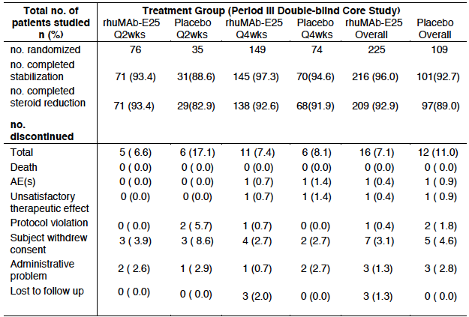

Major protocol violations/deviations
There were a total of 113 protocol violations in the omalizumab arm and 47 in the placebo arm. The most commonly occurring violations are shown in Table 37.
Comment: Individual violations occurred with similar frequency in the two arms. The violations that occurred would not have resulted in a bias in favour of one treatment. None of the violations resulted in exclusion of a subject from the efficacy analyses.
Table 37: Study 010 – Common protocol violations (ITT population)
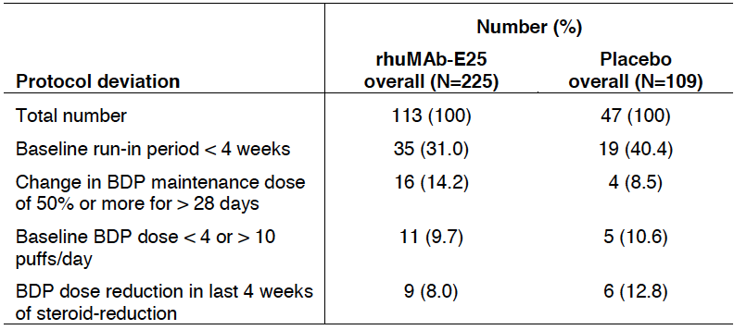

Baseline data
Baseline demographic and disease characteristics are summarised in Table 38.
Comment: Only a minority of subjects (8.1%) were considered to have severe asthma. Mean BDP dose at baseline was 278 µg/day (ex-actuator dose, BDP suspension formulation), which is approximately equivalent to 165 µg/day (ex-valve) of the Qvar formulation marketed in Australia. Hence the enrolled subjects were on average receiving a fairly low dose of inhaled corticosteroids.
The two treatment groups were reasonably well balanced with respect to baseline factors. Data presented in the Summary of the submission also indicated that treatment groups were well balanced with respect to baseline factors in the Paediatric ITT population.

Table 38: Study 010 – Baseline demographic and disease characteristics (ITT population)
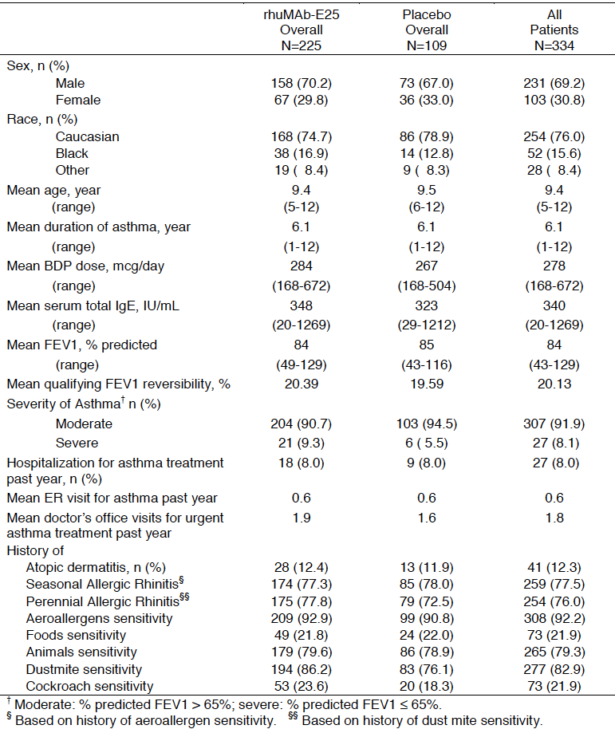

Results for the principle efficacy outcomes
With respect to percent reduction in BDP dose, omalizumab was associated with a greater reduction. Mean reduction was 73.38% in the omalizumab arm and 60.15% in the placebo arm. Median reductions were 100% versus 66.67% respectively. The difference in dose reduction was statistically significant (p = 0.001).
The proportion of patients achieving dose reduction was also significant (p=0.002). In the omalizumab arm, 65.3% of subjects achieved a dose reduction of between 75 and 100%, compared to 49.5% in the placebo arm.
For both endpoints, the difference between treatments was also statistically significant in the Paediatric ITT population.

Results for exploratory efficacy outcomes

Exacerbations
- In the stabilisation period of the double blind phase, there was no significant difference between treatments in the number of exacerbations per patient.
- In the omalizumab arm, 15.6% of subjects experienced at least 1 exacerbation in the steroid reduction period, compared to 22.9% in the placebo arm. The difference was not significant.
- In the steroid reduction period of the double blind phase, there were fewer asthma exacerbations per patient in the omalizumab arm (Table 39). The difference was statistically significant (p<0.001).
- In the omalizumab arm, 18.2% of subjects experienced at least 1 exacerbation in the steroid reduction period, compared to 38.5% in the placebo arm (p<0.001).

Table 39: Study 010 – Asthma exacerbations in steroid reduction period (ITT population)
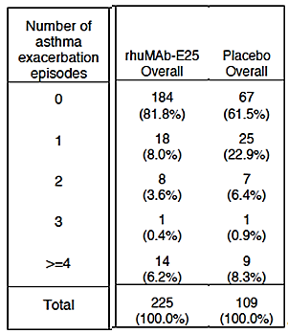

Global assessments
- Global assessments of treatment effectiveness favoured the omalizumab arm (p<0.001 for both patients and investigators).

Other exploratory outcomes
There were no notable differences between treatment arms for the other exploratory endpoints (asthma-free days, PEFR, spirometry parameters, symptom scores).

Quality of life
There were no significant differences between treatments in PAQLQ scores at week 16 (that is, at the end of the stable ICS dose period). At the end of the ICS dose reduction period (Week 28), PAQLQ scores for the symptoms domain and overall score indicated better QoL in the omalizumab arm.

Results for the paediatric ITT population
The Summary of Clinical Efficacy presented various analyses of the Paediatric ITT subpopulation. Results included the following:
- The rate of clinically significant asthma exacerbations, over the entire 28 week double blind phase, was decreased in the omalizumab arm (Table 40).

Table 40: Study 010 Clinically significant exacerbations over 28 weeks (Paediatric ITT population)
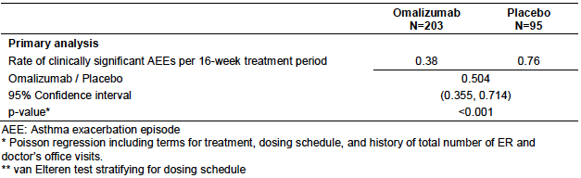
- There were no significant differences between treatments for the change from baseline in number of puffs of rescue medication;
- In the omalizumab arm there was a greater percent reduction in BDP dose from baseline to week 28 (Table 41). The difference in the proportion of patients who achieved a reduction was also statistically significant in favour of omalizumab (p=0.017);

Table 41: Study 010 Percent change from baseline to week 28 in BDP dose (Paediatric ITT population)
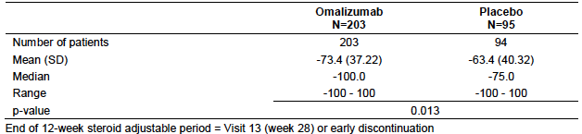
- Global assessments of treatment effectiveness favoured the omalizumab arm (p<0.001 for both patients and investigators).
- There were no significant differences in PAQLQ scores at Week 16. However, at Week 28, omalizumab treatment was associated with greater mean improvement in QoL compared to placebo, on total score and on the emotions and symptoms domains. However, the difference in mean improvement was small and there was no significant difference in the proportion of patients who achieved a clinically significant improvement in total score.

Other efficacy studies

Study B1301
This study was a single arm, open trial of omalizumab in Japanese children. It was conducted at 17 centres in Japan between 2010 and 2012. Investigation of efficacy was only a secondary objective.
Subjects enrolled were aged between 6 and 15 years. They were required to have inadequately controlled symptoms despite being on high dose ICS (> 200 µg per day of fluticasone or equivalent) and two or more other controller medications. A history of exacerbations was also required. The dose of omalizumab used was the same as that used in Study IA05. Treatment duration was 24 weeks. ICS dose was fixed for the first 16 weeks and could be adjusted downwards in the next 4 weeks. ICS dose was to be kept stable for the final 4 weeks.
A total of 38 Japanese children were treated in the study. 17/38 (45%) were aged 12 or over. Efficacy variables generally showed an improvement from baseline (PEFR, asthma symptom scores, etc.). There was a reduction in the rate of exacerbations per patient per year (Table 42).

Table 42: Study B1301 Asthma exacerbations
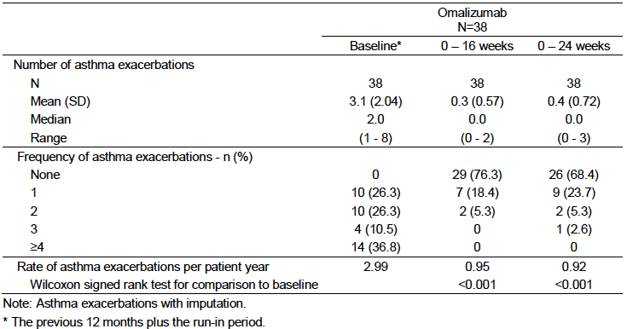
Comment: In the absence of a control arm, it is not possible to assess whether any of the observed improvements were attributable to omalizumab. In the two placebo controlled studies, improvements in efficacy outcomes were noted with placebo treatment. In addition 45% of subjects in this study were aged 12 to 15. Overall it is considered that this study contributes no useful additional efficacy data.

ICATA study
The Inner-City Anti-IgE Therapy for Asthma (ICATA) study was a randomised, double blind, placebo controlled trial with two parallel groups (omalizumab versus placebo). It was conducted at eight centres in the United States, with recruitment occurring between November 2006 and April 2008. The sponsor did not conduct the study and results of the trial have been included in the submission in the form of published papers.,
The study recruited inner-city children, adolescents and young adults (aged 6 to 20 years). Subjects were required to have a history of asthma for at least 12 months, a positive skin test for a perennial allergen, and uncontrolled disease as indicated by hospitalisation or urgent unscheduled treatment in the 12 months prior to enrolment.
Subjects initially underwent a 4 week run-in phase during which asthma treatment was optimised to obtain disease control, using a standardised stepwise treatment algorithm. Subjects were then randomised to receive omalizumab or placebo. The dosage regimen for omalizumab was the same as that used in the pivotal study of this submission (IA05). Treatment was continued for 60 weeks. Ongoing treatment adjustments (of ICS/LABA/montelukast) were made to achieve good asthma control, using a standardised set of six treatment steps.
A total of 419 subjects were randomised (208 to omalizumab and 211 to placebo). 60% of subjects were in the age range of 6 to 11 years and 73% of subjects had moderate or severe disease. The treatment groups were well balanced at baseline. The primary endpoint of the study was the number of days in the preceding 2 weeks that the patient had asthma symptoms. A number of secondary endpoints were also studied.
Results are summarised in Table 43, taken from the main published paper.¹ Omalizumab treatment was associated with significantly fewer days with asthma symptoms in the preceding 2 weeks (mean: 1.48 versus1.96; p<0.001). It was also associated with a lower proportion of patients experiencing an exacerbation (30.3% versus 48.8%; p<0.001) and with significantly lower doses of ICS (663 versus 771 µg budesonide or equivalent/day; p<0.001).

Table 43: ICATA study – Efficacy results
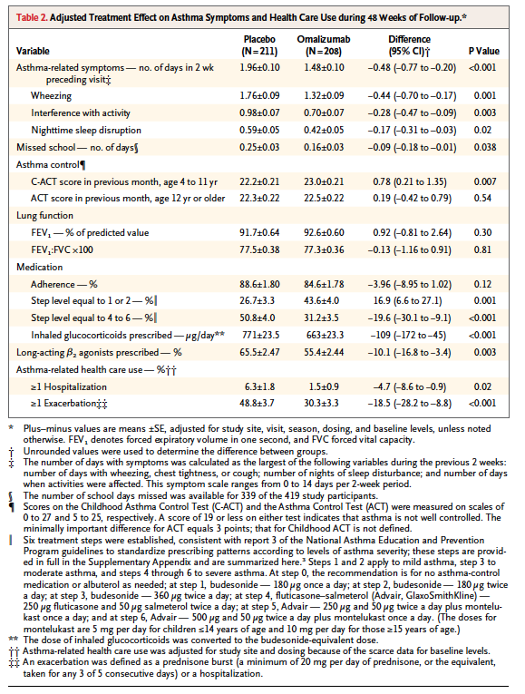
A follow-up publication² presented the results of various post hoc subgroup analyses of the trial. These indicated that the beneficial effects of omalizumab over placebo were significant in the subgroup of subjects aged 6 to 11, for symptom days, ICS dose and exacerbations. The effects were also significant in a subgroup of patients with severe disease (that is, those on high dose fluticasone and salmeterol and montelukast).
Comment: The published papers provided limited information on the subgroup of subjects aged 6 to 11 years, and the subgroup analysis of this population was conducted retrospectively. The study therefore only provides limited supportive evidence for the sponsor’s application.

Analyses performed across trials (pooled analyses and meta-analyses)
There were no pooled analyses or meta-analyses of the submitted efficacy data.

Evaluator’s conclusions on clinical efficacy
The indication sought by the sponsor for subjects aged 6 to <12 years with allergic asthma is limited to patients with all of the following:
Severe persistent disease (with frequent daytime symptoms or night time awakenings);
A history of exacerbations;
Current treatment with high dose inhaled corticosteroids (ICS).
A high dose of ICS is defined in the current Australian Asthma Handbook (Table 33 above).
For children without good control of symptoms who are currently already receiving high dose ICS, the current Handbook recommends referral for specialist management (Figure 3). Possible treatments for this population would include the addition of long-acting beta agonists (LABAs) or montelukast. The submission did not contain any studies that compared omalizumab with these treatment options in the proposed population. Omalizumab was only compared with placebo.
Figure 3: Australian Asthma Handbook. Treatment steps in children. Stepped approach to adjusting asthma medication in children
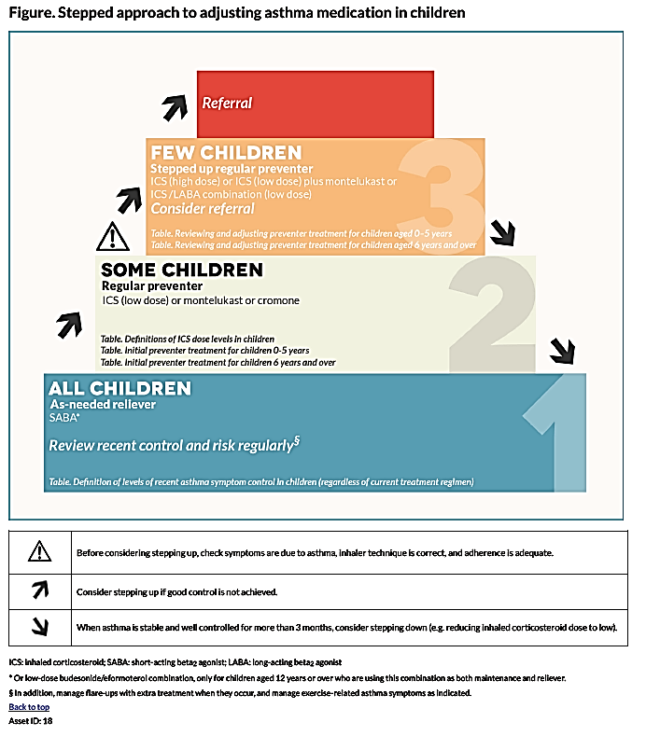
Two randomised, placebo controlled trials were submitted. These studies were well designed and well executed and generally complied with relevant EMA guidelines adopted by the TGA.,
The pivotal study for the submission was IA05. In this study 64% of subjects had severe persistent asthma. Mean daily ICS dose was > 500 µg fluticasone, consistent with subjects being treated with high dose ICS. The study demonstrated a significant efficacy benefit in terms of a reduction in the frequency of clinically significant exacerbations. In the overall study population, there was a 31% reduction in the number of exacerbations after 24 weeks and a 43% reduction after 52 weeks. Very similar reductions were observed in the subpopulation of subjects classified as having severe disease.
In the overall study population there were no significant benefits in terms of asthma symptoms, reduction in rescue medication or ICS use, or quality of life. The reduced number of exacerbations did not translate into a reduction in hospitalisations, emergency department visits or unscheduled doctor visits.
Study 010 is considered less relevant to the proposed indication. Only 8% of subjects were considered to have severe asthma and the population was being treated with low doses of ICS. The study also used a different dosage regimen to that being proposed in the submission. The study showed that in the enrolled population a significantly greater reduction in ICS dose could be achieved with omalizumab than with placebo. This finding is probably not relevant to the proposed indication, as Study IA05 failed to demonstrate a reduction in ICS dose with omalizumab in subjects with more severe disease.
The published ICATA study demonstrated benefits for omalizumab in terms of reduced symptoms, reduced frequency of exacerbations and reduced ICS dose. However this study was conducted in subjects aged 6 to 20 years old and with varying disease severity. Retrospective subgroup analyses suggested that the efficacy benefits were maintained in children aged 5 to 11 and in subjects with more severe disease. However, details of subpopulation of interest were very limited.
Overall therefore assessment of efficacy must rely on the findings of IA05. This study has shown a modest efficacy benefit for omalizumab over placebo, limited to a reduction in the frequency of exacerbations. This benefit was demonstrated for the whole study population and for the subpopulation with severe disease.
The submission also presented analyses of efficacy for another subpopulation in IA05; the European Union (EU) modified Intent-to-Treat (mITT) subpopulation, defined as those patients requiring high dose ICS plus LABA at baseline. This is the patient population that has been approved in Europe but is not the indication currently being sought in Australia. The efficacy benefits observed in the EU mITT population were comparable to those observed for the whole population in IA05.

Clinical safety

Studies providing evaluable safety data
In the Summary of Clinical Safety, the sponsor presented pooled analyses of safety for children aged 6 to < 12 years. Analyses of various pooled populations were presented. The two analysis populations that are considered the most relevant to the current evaluation were:
- The allergic asthma placebo controlled (AAP) population, which included subjects aged 6 to < 12 who received treatment in one of the two double blind placebo controlled studies (IA05 or 010);
- The allergic asthma open-label (AAO) population, which included subjects aged 6 to < 12 who received treatment in one of seven open-label or uncontrolled trials. These trials are listed in Table 44. One of these (Q2143g or ALTO) was a large Phase III comparison of omalizumab against current best practice asthma treatment. It enrolled over 11,000 subjects but included only 128 subjects aged 6 to < 12 years. The other studies were uncontrolled. Studies 010E, Q2143g, Q2195g and Q2461g have previously been evaluated by the TGA.
Table 44: Studies included in the AAO safety population
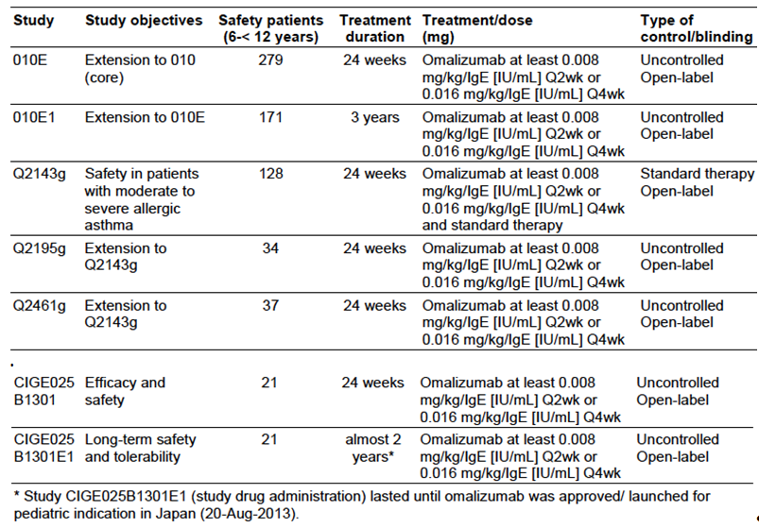

Placebo-controlled studies
In the two placebo controlled efficacy studies, the following safety data were collected:
- General adverse events (AEs) were assessed at each study visit. AEs could be volunteered by the patient or discovered by the investigator on general questioning, physical examination or by laboratory testing. AEs were graded as mild, moderate or severe. AEs were coded using Medical Dictionary for Regulatory Affairs (MedDRA) terminology.
- AEs of special interest were:
  - Serum sickness syndrome;
  - Skin rash and urticaria;
  - Hypersensitivity reactions
  - Anaphylaxis;
  - Bleeding related disorders;
  - Malignancies;
  - Injection site reactions.
- Vital signs were measured at regular intervals;
- Physical examination was conducted at regular intervals.
- Laboratory tests, including the following, were performed at regular intervals:
  - Full blood count (haemoglobin, haematocrit, RBC, WBC with differential, platelet count);
  - Biochemistry (serum sodium, serum potassium, serum glucose, creatinine, BUN, uric acid, protein, albumin, calcium, total bilirubin, AST, ALT, alkaline phosphatase);
  - Urinalysis.

Open-label studies
Safety monitoring in the open-label studies was generally similar to that undertaken in the placebo controlled studies.

Pivotal studies that assessed safety as a primary outcome
The primary outcome variables for Study 010 were related to safety and tolerability. The safety findings from this study are described as part of the pooled AAP population.

Patient exposure
In the AAP population, 624 subjects were treated with omalizumab and 302 with placebo. In the AAO population 407 subjects received omalizumab.
Duration of exposure for the AAP population is summarised in Table 45. Duration was comparable in the omalizumab and placebo arms, with a mean of approximately 42 weeks. Duration of exposure for the AAO population is summarised in Table 46. Mean exposure to omalizumab was 104 weeks, reflecting the fact that many of the studies were long-term extension studies.
Table 45: Duration of exposure – AAP population
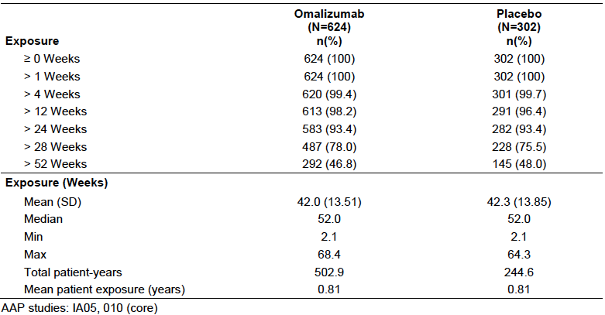
Table 46: Duration of exposure – AAO population
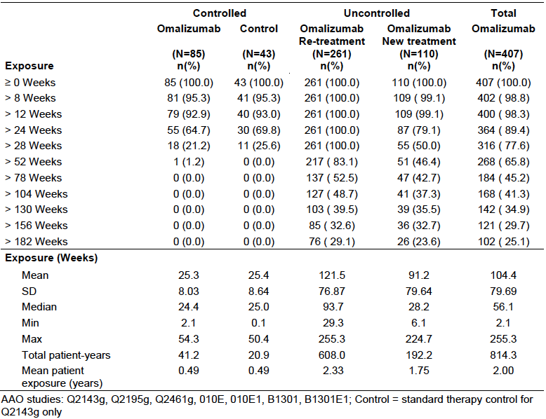

Adverse events
An adverse event was defined as any undesirable sign, symptom or medical condition occurring after patients started study drug, even if the event was assessed as being unrelated to the study drug.

All adverse events (irrespective of relationship to study treatment)

AAP population
The overall incidence of AEs was 89.7% with omalizumab and 91.7% with placebo. Common AEs (those with an incidence of at least 3%) are shown in Table 47. Generally the incidence of individual AE terms was similar in the two groups. Omalizumab was associated with a higher incidence of pyrexia (15.1% versus 11.3%), viral gastroenteritis (3.8% versus 2.3%), upper abdominal pain (6.3% versus 5.0%) and headache (20.7% versus 19.5%).
Table 47: Common AEs (incidence ≥ 3%) – AAP population
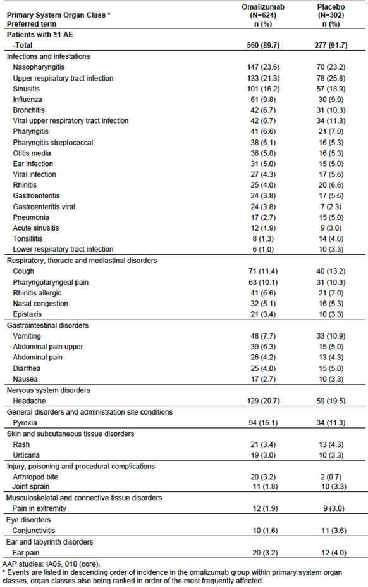

AAO population
Common AEs in the AAO population are summarised in Table 48. In the one controlled study in the AAO population, the incidence of AEs was higher in the omalizumab arm than in the control arm (74.1% versus 60.5%). Headache was notably more common (17.6% versus 7.0%).
In the total AAO population the incidence of AEs (84.8%), and the incidence of individual AE terms, were increased compared to the AAP population, reflecting the longer duration of treatment. However, the pattern of individual AE terms was similar.
Table 48: Common AEs (incidence ≥ 3%) – AAO population
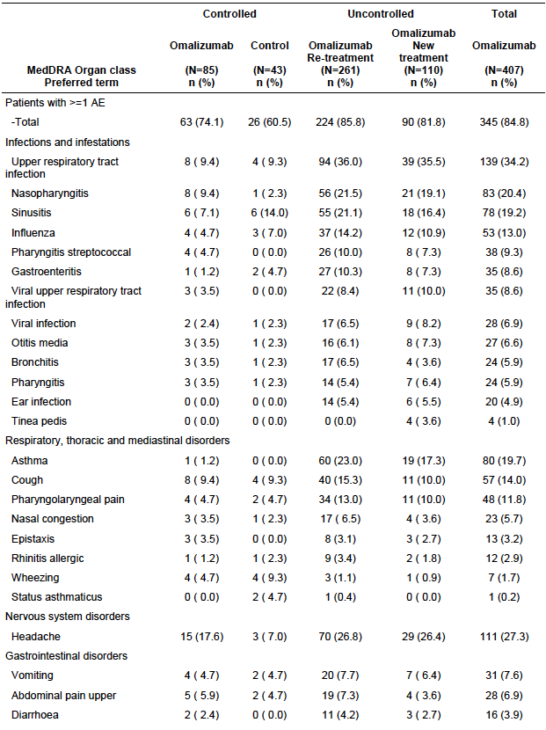

Incidence of AEs over time
Analyses of the incidence of AEs over time for both the AAP population and the AAO population did not suggest that the incidence of AEs increases with increasing duration of treatment. In the AAP population, the incidence of AEs occurring on the day of injection was 6.1% with omalizumab and 7.0% with placebo.

Severity of AEs
In the AAP population most AEs were rated as mild or moderate (Table 49). The incidence of severe AEs was not increased with omalizumab. In the AAO population (Table 50) there was a small excess of severe AEs with omalizumab in the controlled trial; 7.1% (n=6) versus 4.7% (n=2).
Table 49: Severity of AEs – AAP population
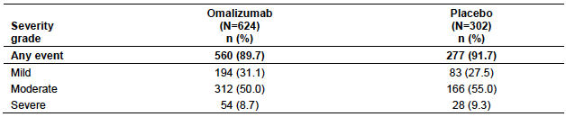
Table 50: Severity of AEs – AAO population
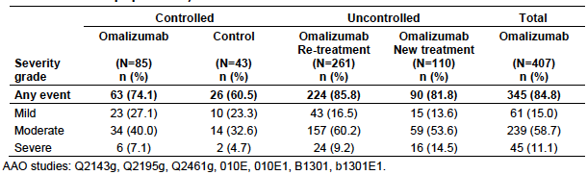

Treatment-related adverse events (adverse drug reactions)
Common drug-related AEs (those with an incidence of at least 1%) in the AAP and AAO populations were summarised.

AAP population
The incidence of drug-related AEs was 6.6% with omalizumab and 5.0% with placebo. The only individual AE term that was notably more frequent with omalizumab was urticaria (1.0% versus 0.3%).

AAO population
The overall incidence of drug-related AEs in the AAO population was 8.8%. The pattern of individual AE terms was consistent with that observed in the AAP population.

Deaths and other serious adverse events
There were no deaths in any of the paediatric studies.
A serious adverse event (SAE) was defined as an event that was fatal or life threatening, required or prolonged hospitalisation, resulted in persistent or significant disability or incapacity, constituted a congenital anomaly or a birth defect, or was medically significant in that it may have jeopardized the subject and could have required medical or surgical intervention to prevent one of the listed outcomes.

AAP population
The overall incidence of SAEs was lower among omalizumab-treated children than among those treated with placebo (3.4% versus 6.6%). The only SAE event that was notably more common with omalizumab was appendicitis (0.6% versus 0.3%).

AAO population
The overall incidence of SAEs was 5.4%. The only SAEs that occurred in more than one subject were ‘asthma’ (2.7%), appendicitis (0.5%) and pneumonia (0.5%).

Discontinuation due to adverse events

AAP population
Discontinuation due to an AE was uncommon and occurred with comparable frequency in the omalizumab and placebo groups (0.5% versus 0.3%).

AAO population
The overall incidence of discontinuation due to AEs was 0.7%.

AEs of special interest

Skin rash, urticaria, hypersensitivity reactions and bleeding related disorders
In the AAP population, the incidence of these events was comparable with omalizumab and placebo treatment (Table 51). In the controlled study in the AAO population, skin rash and bleeding disorders occurred more frequently with omalizumab (Table 52). The bleeding disorders (epistaxis and haemoptysis) were all mild in severity.
Table 51: AEs of special interest - AAP population
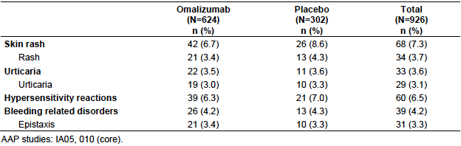
Table 52: AEs of special interest - AAO population
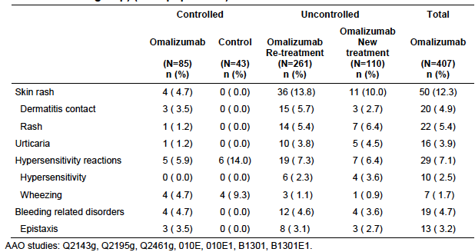

Serum sickness syndrome
Serum sickness syndrome was not reported as an AE in either the AAP or AAO populations. The sponsor also identified a cluster of adverse event terms that could potentially relate to serum sickness (for example, angioedema, arthralgia, myalgia etc.). In the AAP population these terms occurred with comparable frequency in the two treatment groups (4.0% versus 3.0%).

Anaphylaxis
In the AAP population, two subjects had an anaphylactic reaction reported as an AE:
- A 10 year old male randomised to omalizumab developed a rash after an injection of pethidine. The last dose of omalizumab had been given 17 days earlier. The rash resolved with antihistamine treatment after 1 day. The patient continued omalizumab treatment without any further episodes;
- An 8 year old male randomised to placebo developed swelling after ingesting nuts. The last dose of omalizumab had been given 10 days earlier. The swelling resolved with antihistamine treatment after 1 day. The patient continued placebo treatment without any further episodes.
In the AAO population, no cases of anaphylaxis were reported.

Injection site reactions
Data on injection site reactions were not reported for the AAP and AAO populations. Instead, results from 4 studies (IA05, 010, Q2143g and D01) were provided. Study D01 was a randomised, placebo controlled trial in children with seasonal allergic rhinitis. A full study report for D01 was not included in the current submission. Studies 010 and D01 had a specific page in the case report form for these AEs, whereas Studies IA05 and Study Q2143g did not. The two pairs of studies were therefore summarised separately, as shown in Table 53. The incidence of injection site reactions was comparable in omalizumab treated and placebo treated subjects.
Table 53: Injection site reactions
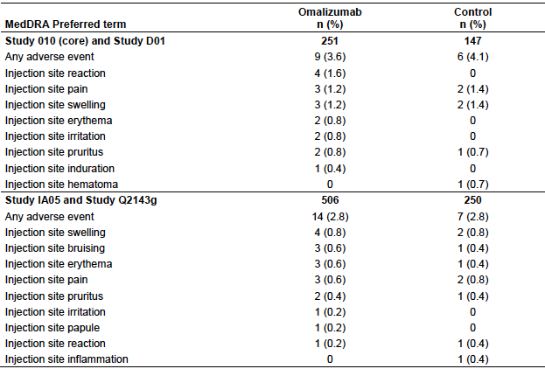

Malignancy
One child (aged 7, male) who received placebo treatment in Study IA05 developed medulloblastoma. No other cases of malignancy were reported.

Laboratory tests
The sponsor defined a ‘clinically notable’ laboratory abnormality as shown in Table 54.
Table 54: Criteria for clinically notable laboratory abnormalities
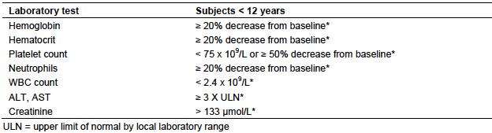

Liver function
In the AAP population, abnormalities of AST and ALT occurred with comparable frequency in the omalizumab and placebo groups. Clinically notable changes were uncommon in both groups. The frequencies of AST and ALT abnormalities in the AAO population are shown in Table 55.
Table 55: Abnormalities in LFTs and creatinine - AAO population
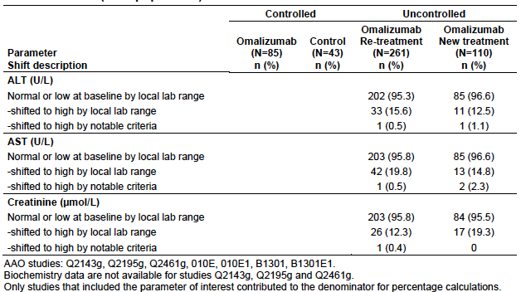

Kidney function
In the AAP population, abnormal elevations of serum creatinine occurred with comparable frequency in the omalizumab and placebo groups. There were no clinically notable elevations. The frequency of creatinine elevations in the AAO population is shown in Table 55.

Other clinical chemistry
Analyses of other biochemistry parameters were not reported for the AAP and AAO populations. In the study report for IA05, results for bilirubin were summarised and abnormalities occurred with comparable frequency in the omalizumab and placebo groups. Analyses of other biochemistry parameters were not reported.

Haematology
In the AAP population, abnormalities of haematology parameters occurred with comparable frequency in the omalizumab and placebo groups. Four omalizumab treated subjects developed clinically notable reductions in platelet count. In all four cases, the platelet count had returned to normal on a follow-up sample. Nadir values were 77, 135, 111 and 31 x 10⁹/L. The frequency of haematology abnormalities in the AAO population is shown in Table 56. Two cases of clinically notable thrombocytopaenia occurred. However, no details were provided. These should be requested from the sponsor.
Table 56: Abnormalities in haematology parameters - AAO population
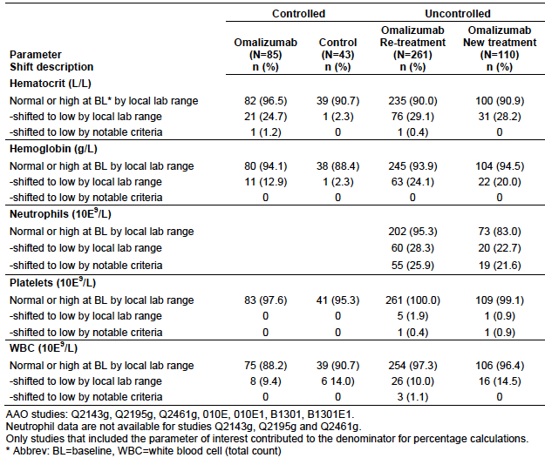

Anti-omalizumab antibodies
Only one subject in the paediatric studies developed confirmed ant-omalizumab antibodies. This was a 10 year old boy in Study IA05. No notable adverse events were observed in this subject.

Urinalysis
In the AAP population there were no notable differences between omalizumab and placebo groups in the incidence of abnormalities on dipstick testing (glucose, protein, red blood cells or white blood cells).

Vital signs
In the AAP population notable abnormalities in blood pressure and pulse occurred with a similar frequency in the omalizumab and placebo groups.

Post-marketing experience
The clinical part of the submission included one periodic safety update report (PSUR). This report covered the 6 month period from 1 January 2014 and to 30 June 2014. This period was after approval for use in children and approval for the revised dosage table in Europe, New Zealand and Switzerland. Overall it was concluded that no new safety signals were identified during the period.
For the 3 month period of January to March 2014, the estimated exposure in children aged 6 to 11 years was 952 subjects. The cumulative exposure in children aged 6 11 years between June 2011 and March 2014 was 9,157 subjects for asthma and 2,512 subjects for other indications. The most common events reported in children aged 6 to < 12 years during the period are summarised in Table 57.
Table 57: Periodic Safety Update – Common reported AEs
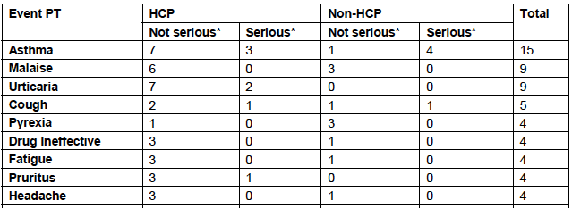
HCP = Health care professional; PT = preferred term;
Of all the events reported, 27 were reported as serious. Thirteen of these cases were not assessable due to insufficient information. The remaining 14 included the following:
- One report of thrombocytopaenia (7 x 10⁹/L) in a 10 year old female who had received omalizumab for 10 months. The patient had positive serology for parvovirus B19 and a normal bone marrow. Omalizumab was ceased and the patient was treated with immunoglobulins, with improvement in platelet count to 57 x 10⁹/L. Six months later the patient had a relapse (to 5 x 10⁹/L) despite not receiving further omalizumab. The sponsor considered an alternative aetiology, such as ITP, was the more likely explanation for this event.
- Three reports suggestive of allergic reactions (for example, rash, urticaria, erythema, pruritus);
- Two reports of injection site reactions;
- One report of allergic bronchopulmonary aspergillosis;
- Two reports of dengue fever;
- Five reports of asthma exacerbations.
There were no reports of anaphylaxis or malignancies in children aged 6 to < 12 years.

Safety issues with the potential for major regulatory impact

Liver toxicity
Liver function testing in the placebo controlled studies did not suggest an increased risk of hepatotoxicity with omalizumab in children.

Haematological toxicity
As described in the current product information, omalizumab has been associated with the development of thrombocytopaenia non-human primate species, with the risk increased in juvenile animals. In the AAP population, there was a slightly higher incidence of clinically notable thrombocytopaenia with omalizumab (0.6% versus 0.3%). However, cases in the omalizumab group were all transient and not associated with bleeding events.
There was one case of severe pancytopaenia reported with omalizumab in Study IA05. The sponsor should be asked to provide further details of this case.

Serious skin reactions
None of the serious AEs reported in the AAP or AAO populations were dermatological in nature.

Cardiovascular safety
In the AAP population there was no notable increase in the incidence of cardiovascular AEs in the omalizumab group.

Unwanted immunological events
Omalizumab is known to be associated with adverse immunological events (including anaphylaxis and serum sickness). In the placebo controlled studies in this submission, the incidence of such events was not increased with omalizumab.

Other safety issues

Safety in special populations
Analysis by the sponsor of AEs according to age group (6 to 9 years versus 10 to 11 years), gender or race (Caucasian versus Black versus Other) did not reveal any notable differences.

Safety of revised dosage regimen
To support the safety of the revised dosage table the sponsor provided two additional analyses.

Doses of ≥600 mg in clinical trials
The sponsor identified all studies in which patients had received at least one dose of ≥ 600 mg of omalizumab (SC or IV). These studies were pooled, and within this pool patients receiving at least 600mg were compared to all other treated patients. A total of 5 such studies were identified. In these, a total of 87 subjects received doses ≥ 600 mg, and 317 subjects received lower doses. The overall incidence of AEs was comparable in the two groups (86.2% at ≥ 600 mg versus 89.6%).
The incidence of individual AE terms was also generally comparable between the two groups. Events more common in the ≥ 600 mg group and for which the difference in incidence was at least 3%, are shown in Table 58. There were several individual AE terms that were less common in the ≥ 600 mg group, with a difference of at least 3% (for example, URTI, sinusitis, influenza, back pain, muscle spasms and dizziness).
Table 58: Safety of doses > 600 mg – Adverse events
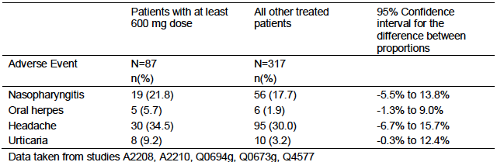
Comment: These data are difficult to interpret due to the small sample size. However they do not raise any significant new safety concerns.

Post-marketing reports where dose ≥900 mg per month
A review was conducted of adverse event reports that identified the dose as being ≥ 900 mg per month. The pattern of reported AEs was consistent with the previously documented safety profile of omalizumab.

Evaluator’s overall conclusions on clinical safety
In the submitted placebo controlled studies the safety profile of omalizumab appeared comparable to that of placebo. No new safety issues were identified in children.
Other paediatric studies and post-marketing data included in the submission did not identify any new safety issues when omalizumab was administered to children aged 6 to < 12 years.
PK/PD modelling suggests that the revised dosing regimen will result in modest increases in omalizumab C_{max}. Changes in overall systemic exposure would not be expected. It is therefore considered unlikely that the revised dosage regimen would be associated with any significant safety concerns. Limited clinical trial and post-marketing data on the safety of doses ≥ 600 mg do not suggest any novel safety issues.

First round benefit-risk assessment

First round assessment of benefits
The benefits of omalizumab in children aged 6 to < 12 years are:
- A reduction in the rate of clinically significant asthma exacerbations. The rate was reduced by approximately 31% after 24 weeks and 43% after 52 weeks. Similar reductions were observed in the subgroup of patients with serve asthma, the population being proposed by the sponsor.
The benefits of the proposed changes to the dosing regimen for adolescents and adults are:
- Improved convenience and possibly compliance in patients, and reduced use of health care resources. No improvements in efficacy are expected.

First round assessment of risks
The risks of omalizumab in children aged 6 to < 12 years are:
- Risks similar to those associated with its use in adults and adolescents (for example, allergic reactions).
The submitted data suggest that there are no significant additional risks associated with the proposed changes to the dosing regimen for adolescents and adults

First round assessment of benefit-risk balance

Use in children aged 6 to < 12 years
The demonstrated efficacy benefits associated with omalizumab are limited to its effect on exacerbations. The benefits are modest, with a reduction in the rate of asthma exacerbations from 0.64 to 0.45 episodes per 24 week treatment period. In general, the submitted safety data do not suggest any new safety issues associated with use of omalizumab in subjects aged between 6 and <12 years. However, the drug is known to be associated with several adverse effects that are likely to occur in the paediatric population such as allergic reactions. Overall, the benefit-risk balance could be considered marginal.
In contrast to the original application in 2009, the sponsor is proposing to limit the approved population to children with severe asthma, who are uncontrolled on high dose ICS. The approved population in Europe is limited even further, to those subjects with severe asthma who are uncontrolled on high dose ICS and LABA. Given the limited evidence of efficacy it would be appropriate to restrict the indication to subjects with severe disease who are uncontrolled on optimal available therapy. Subgroup analyses of the pivotal study indicate that similar efficacy is likely to be obtained in such subjects. Unlike in Europe, the sponsor’s proposed indication for Australia does not require that subjects should have been treated with LABAs prior to commencing omalizumab. LABAs have been associated with adverse outcomes in children., Neither the current Australian Asthma Handbook nor the international GINA guidelines recommend routine introduction of LABAs in children who are not controlled on high dose ICS. Given the safety concerns associated with LABAs, it may be more appropriate for some patients to be commenced on omalizumab. Therefore, if the application is to be approved, the indication proposed by the sponsor is considered acceptable.
Overall, the benefit-risk balance of omalizumab for the proposed paediatric population is considered favourable. This assessment takes into account the fact that the proposed population (severe disease, already on high dose ICS) is one with limited available treatment options.

Changes to the dosing regimen for adolescents and adults
Based on the PK/PD model developed by the sponsor, the overall benefit-risk balance for omalizumab will not be significantly altered, and therefore remains favourable.

First round recommendation regarding authorisation
It is recommended that the application be approved.

Clinical questions

Pharmacokinetics
Nil.

Pharmacodynamics
Nil.

Efficacy
Nil.

Safety
- In the AAO safety population there were two cases of clinically notable reductions in platelet count - 1 in the re-treatment group and 1 in the new treatment group. Please provide summaries of these cases, including results of all platelet counts.
- One case of severe pancytopaenia was reported (IA05 ARG/00002/00002). Please provide a summary of this case.

Second round evaluation of clinical data submitted in response to questions

Errors of fact and omissions
The evaluators has noted and amended this version of the evaluation report with comments noted by the sponsor. These changes have no effect on the outcome of the first round evaluation.

Response to clinical questions

Question 1
In the AAO safety population there were two cases of clinically notable reductions in platelet count, 1 in the re-treatment group and 1 in the new treatment group. Please provide summaries of these cases, including results of all platelet counts.

Novartis Response:
[Information redacted] was an 11 year old Caucasian male. He received placebo during the core study period from [information redacted], then received omalizumab during the extension period from [information redacted] and subsequently in a 3 year open label extension. The patient had a history of allergic asthma and allergic rhinitis. He was on treatment with beclomethasone dipropionate. The patient developed an URTI between [information redacted]. He was treated with amoxicillin [information redacted]. A low platelet count of 92 x 10⁹/L was noted on the [information redacted]. Omalizumab was continued. Platelet counts before and after this was in the normal range. The patient was also noted to have intermittent low WBC and neutrophil counts.
[Information redacted] was a 6 year old Caucasian boy. He was on treatment with omalizumab during the core study period [information redacted], then omalizumab during extension studies from [information redacted] and [information redacted]. His medical history included allergic asthma for which he was treated with beclomethasone diproprionate. This patient also experienced intermittent allergic rhinitis and headaches for which he took ibuprofen for. A low platelet count of 22 x 10⁹/L was noted on the [information redacted]. Omalizumab was continued. Subsequent platelet counts were normal. The patient was also noted to have a low WBC at the time.

Evaluator comment
The sponsor’s response is satisfactory. It is unlikely that these patient’s low platelet counts were related to omalizumab. Possible causes include artefactually low readings from clumping in the laboratory, viral illness, or concomitant medications.

Question 2
One case of severe pancytopenia was reported (IA05 ARG/00002/00002). Please provide a summary of this case.

Novartis response
This was a 7 year old male receiving omalizumab 225mg every 2 weeks. His first dose was on the [information redacted]. His medical history included allergic asthma and allergic rhinitis. Pancytopenia was noted on bloods performed at the central laboratory on [information redacted]. On one of these occasions, the samples were received later than 2 days after being taken. On [information redacted] his WBC was 3.5 x 10⁹/L, neutrophil count 1.5 x 10⁹/L, platelet count not provided due to clumps, and haemoglobin 74g/dL. The patient had his blood count repeated at a local laboratory, all parameters were normal.

Evaluator response
The sponsor’s response is satisfactory. The abnormal haematology results were unlikely to be due to the study medication.

Changes to the PI

Suggested in the first round evaluation report

Evaluator’s recommendations
- For Study IA05 the results presented are from a subgroup analysis of subjects with baseline FEV1 > 80%. This is not the subgroup of patients that is the subject of this application, and the information should be deleted. The results for the entire population should be given, followed by the results obtained in the subgroup of patients with severe disease at baseline. Inclusion of the subgroup analysis by baseline LABA use is acceptable.
- It is recommended that the text describing Study 010 should be deleted. Only 8% of subjects were considered to have severe asthma and the population was being treated with fairly low doses of ICS. The study also used a different dosage regimen to that being proposed in the submission. The finding of a reduction in ICS dose with omalizumab is probably not relevant to the proposed indication of severe asthma, as no reduction in ICS dose was achieved in Study IA05.

Novartis response
The results of the entire population of Study IA05 are described. Information from Study 010 has been deleted.

Evaluator response
The sponsor’s response is satisfactory

Additional safety related changes requested by the sponsor
The sponsor has proposed additional safety related changes to the PI following the results of a study (EXPAND) that characterised the risk factors for anaphylaxis following Xolair administration to asthma patients. This information became available during the review period of PSUR 20 from January 1 2014 to December 31 2014.
The following information is from the response

Background
The incidence of anaphylaxis in severe asthma patients is reported to be 65.35 cases per 100 000 patient years. Because Xolair is a protein, there is a possibility of immediate hypersensitivity reactions such as anaphylactoid reactions. Anaphylaxis and anaphylactoid reactions were rare in the clinical development program and balanced between Xolair and placebo arms. Cases of anaphylaxis and anaphylactoid reactions have been reported in the post market setting.
X-PAND (Q4458g) was a case control study using clinical data and serum repository of subjects who experienced anaphylaxis associated with omalizumab (cases) compared to subjects treated with omalizumab who did not experience anaphylaxis (controls). Potential cases of anaphylaxis or anaphylactoid reactions were adjudicated on the basis of Sampson Criteria. If a positive adjudication was made, the health care providers who reported cases were asked to enrol each anaphylaxis patient in the repository study and identify up to 4 suitable controls. Patients who had discontinued treatment for more than 16 weeks but less than 18 months were eligible to be tested for anti-therapeutic antibody assay and a skin test.
There were 30 cases identified. These were matched to 88 controls. A previous history of anaphylaxis was noted in 56.7% of anaphylaxis cases and 22.7% of control subjects. Exploratory analysis using a multivariate logistic regression model found that prior anaphylaxis was a risk factor for adjudicated anaphylaxis. Approximately 40% of patients with anaphylaxis experienced a reaction in the first 3 doses. All patients (n=31, 21 cases and 10 controls) that were tested for anti-treatment antibodies were negative for IgG and IgE isotypes to omalizumab.

Postmarketing safety data
A cumulative search of the safety database retrieved a total of 2873 evaluable cases. The majority of anaphylactoid reactions occurred after the first dose. Based on an estimated exposure of 566 923 patient years, the reporting rate of anaphylaxis was 0.16%.

Proposed changes to the PI
The sponsor proposed the following changes to the PI based on the information from the X-PAND study and post marketing data:
In post-marketing reports, the frequency of anaphylaxis in patients exposed to Xolair use was estimated to be 0.2% based on the total number of anaphylactic reactions observed from an estimated exposure of over 500,000 patient years.
A history of anaphylaxis unrelated to omalizumab may be a risk factor for anaphylaxis following Xolair administration.

Evaluator’s comments
The sponsor has noted a number of limitations of the X-PAND study and post marketing data. Despite this, the safety related changes are acceptable.

Sponsors response to further questions from the delegate

Question 1
In relation to the dosing: Is there any role in monitoring patients free IgE level and adjusting the dose of omalizumab to achieve a level < 50 (or 25) IU/mL?

Sponsor’s response
Two commercial free IgE assays have been compared to the Genentech assay used in the sponsor’s drug development program. Both of these assays were found to over report IgE levels. If patients are treated as per the dosing table provided by the sponsor, free IgE levels are expected to be less than 50ng/ml in > 95% of patients.

Evaluator comments
The response is acceptable and helpful.

Question 2
Based on the clinical trials, it appears that omalizumab is less efficacious in children than in adults. This may be because the clinical trials in children were smaller and underpowered to detect a significant difference, and the patients had less severe asthma than in the adult trials. Could the sponsor please provide some more background information about the heterogeneity and natural history of moderate and severe asthma in children?

Sponsor’s response
Although there have been more clinical trials in adults than in children, the clinical response in children is comparable or in some ways superior to in adults. For example, in the 5 placebo controlled RCT in adults and adolescents, Xolair reduced asthma exacerbations by 35% (95% CI 23-45%), compared with study IA05 where the relative rate reduction in asthma exacerbations was 30.7%. Patients with more severe asthma had greater benefits.
The sponsor acknowledges that benefits in secondary end points were not apparent in Study IA05 and explains this on the basis of a number of studies that have demonstrated that children and their families are unable to perceive differences in asthma control.
Epidemiological studies have shown that in around 50% of children, symptoms improve by adolescences. Those with more severe asthma are less likely to improve. Atopy is also a risk factor for persistent asthma. Poorly controlled asthma can lead to loss of lung function.

Evaluator’s comment
Although the poor ability of children and their families to accurate describe symptoms of control may contribute to bias towards no treatment difference in the reports of symptom score or quality of life, it does not explain the discrepancy between reduction in exacerbations but not difference seen in ICS, use of asthma rescue medications or ED presentations with asthma. The secondary outcomes also demonstrated an improvement in FVC but not FEV1.
There was also some inconsistency in findings between trials. For example in Study IA05 there was no reduction in ICS dose, whereas in IA010 patients were able to reduce the dose of ICS.

Question 3
For patients who respond to omalizumab, is ongoing treatment recommended, or is finite period better? What has been the experience with long term treatment in children and adults? Does the response wane over time?

Sponsor’s response
Few studies have evaluated long term efficacy of asthma therapies. The XPORT study evaluated the persistence of response in patients continuing or withdrawing from omalizumab therapy after > 5 years of therapy with omalizumab.
The XPORT study was a randomised, double blind, placebo controlled 52 week withdrawal study. Patients were enrolled in the study if they had received ≥ 5 years of omalizumab. The primary objective was to determine the persistence of response to omalizumab in patients with moderate to severe persistent allergic asthma who discontinued omalizumab after long term treatment. The study enrolled 176 adult patients, 88 who were randomised to treatment with omalizumab and 88 to placebo. A significantly greater number of patients showed persistency in the prevention of an asthma exacerbation in the omalizumab continuation group (n=59, 67%) versus placebo (n=42, 47.7%). There was a 40.1% relative difference in the proportion of patients with exacerbations. Time to fist protocol defined exacerbation was longer and symptom control was better in the omalizumab group. The incidence of adverse events was similar. However the authors also found that for some patients, cessation of therapy results in an increased likelihood of asthma exacerbations

Evaluators response
The response is acceptable. Further studies comparing omalizumab to other preventative therapies for long term control would be helpful. Information about discontinuation should be added to the PI.

Question 4
Does the use of omalizumab interfere with patch testing? For patients with allergies who are on omalizumab where clinicians may use serum IgE or patch testing to assess ongoing sensitization, how would clinicians judge whether it is safe to expose a patient to potential allergens?

Sponsors response
Omalizumab does appear to increase the likelihood of false negative to skin prick and perhaps also patch testing.

Evaluators comment
The response is acceptable. It would be helpful to add a comment in the PI in relation to the interpretation of serum IgE levels and skin prick and patch testing while patients are being treated with omalizumab.

Second round benefit-risk assessment
The benefits and risks associated with the use of omalizumab in children aged 6 to 12 years with allergic asthma are unchanged as a result of the additional information presented.

Second round recommendation regarding authorisation
The clinical evaluator recommends approval.

References
European Medicines Agency. Note for Guidance on the Clinical Investigation of Medicinal Products in the Treatment of Asthma (CPMP/EWP/2922/01). 2002. Available from: https://www.tga.gov.au/clinical-efficacy-and-safety-guidelines#respiratory
European Medicines Agency. Note for Guidance on Clinical Investigation of Medicinal Products in the Paediatric Population (CPMP/ICH/2711/99). 2001. Available from: https://www.tga.gov.au/clinical-efficacy-and-safety-guidelines
Food and Drug Administration. Summary Minutes of the Pulmonary-Allergy Drugs Advisory Committee (PADAC) November 18, 2009. Available from: http://www.fda.gov/downloads/AdvisoryCommittees/CommitteesMeetingMaterials/Drugs/Pulmonary-AllergyDrugsAdvisoryCommittee/UCM199392.pdf
Busse WW, Morgan WJ, Gergen PJ, et al. Randomized trial of omalizumab (anti-IgE) for asthma in inner-city children. N Engl J Med 2011; 364:1005-15.
Sorkness CA, Wildfire JJ, Calatroni A et al. Reassessment of omalizumab-dosing strategies and pharmacodynamics in inner-city children and adolescents. J Allergy Clin Immunol: In Practice 2013; 163-71.
Van Asperen P. Deaths from childhood asthma, 2004–2013: what lessons can we learn? Med Journal of Australia 2015; 202 (3): 125-127
Xia Y, Kelton CML, Xue L et al. Safety of long-acting beta agonists and inhaled corticosteroids in children and adolescents with asthma. Ther Adv Drug Saf 2013; 4(6): 254– 263.
National Asthma Council of Australia. Australian Asthma Handbook. 2015. Available from: http://www.asthmahandbook.org.au/
From the Global Strategy for Asthma Management and Prevention, Global Initiative for Asthma (GINA) 2015. Available from: http://www.ginasthma.org/

Therapeutic Goods Administration
PO Box 100 Woden ACT 2606 Australia
Email: info@tga.gov.au Phone: 1800 020 653 Fax: 02 6232 8605
https://www.tga.gov.au

Busse WW, Morgan WJ, Gergen PJ, et al. Randomized trial of omalizumab (anti-IgE) for asthma in inner-city children. N Engl J Med 2011; 364:1005-15.
Sorkness CA, Wildfire JJ, Calatroni A et al. Reassessment of omalizumab-dosing strategies and pharmacodynamics in inner-city children and adolescents. J Allergy Clin Immunol: In Practice 2013; 163-71
European Medicines Agency. Note for Guidance on the Clinical Investigation of Medicinal Products in the Treatment of Asthma (CPMP/EWP/2922/01). 2002. Available from: https://www.tga.gov.au/clinical-efficacy-and-safety-guidelines#respiratory
European Medicines Agency. Note for Guidance on Clinical Investigation of Medicinal Products in the Paediatric Population (CPMP/ICH/2711/99). 2001. Available from: https://www.tga.gov.au/clinical-efficacy-and-safety-guidelines
Van Asperen P. Deaths from childhood asthma, 2004–2013: what lessons can we learn? Med Journal of Australia 2015; 202 (3): 125-127
Xia Y, Kelton CML, Xue L et al. Safety of long-acting beta agonists and inhaled corticosteroids in children and adolescents with asthma. Ther Adv Drug Saf 2013; 4(6): 254– 263.
National Asthma Council of Australia. Australian Asthma Handbook. 2015. Available from: http://www.asthmahandbook.org.au/
From the Global Strategy for Asthma Management and Prevention, Global Initiative for Asthma (GINA) 2015. Available from: http://www.ginasthma.org/

