July 2015

Australian Public Assessment Report for Omalizumab (rch)
  - Proprietary Product Name: Xolair
  - Sponsor: Novartis Pharmaceuticals Pty Ltd

About the Therapeutic Goods Administration (TGA)
- The Therapeutic Goods Administration (TGA) is part of the Australian Government Department of Health and is responsible for regulating medicines and medical devices.
- The TGA administers the Therapeutic Goods Act 1989 (the Act), applying a risk management approach designed to ensure therapeutic goods supplied in Australia meet acceptable standards of quality, safety and efficacy (performance), when necessary.
- The work of the TGA is based on applying scientific and clinical expertise to decision-making, to ensure that the benefits to consumers outweigh any risks associated with the use of medicines and medical devices.
- The TGA relies on the public, healthcare professionals and industry to report problems with medicines or medical devices. TGA investigates reports received by it to determine any necessary regulatory action.
- To report a problem with a medicine or medical device, please see the information on the TGA website <https://www.tga.gov.au>.
About AusPARs
- An Australian Public Assessment Record (AusPAR) provides information about the evaluation of a prescription medicine and the considerations that led the TGA to approve or not approve a prescription medicine submission.
- AusPARs are prepared and published by the TGA.
- An AusPAR is prepared for submissions that relate to new chemical entities, generic medicines, major variations, and extensions of indications.
- An AusPAR is a static document, in that it will provide information that relates to a submission at a particular point in time.
- A new AusPAR will be developed to reflect changes to indications and/or major variations to a prescription medicine subject to evaluation by the TGA.
Copyright
© Commonwealth of Australia 2015
This work is copyright. You may reproduce the whole or part of this work in unaltered form for your own personal use or, if you are part of an organisation, for internal use within your organisation, but only if you or your organisation do not use the reproduction for any commercial purpose and retain this copyright notice and all disclaimer notices as part of that reproduction. Apart from rights to use as permitted by the Copyright Act 1968 or allowed by this copyright notice, all other rights are reserved and you are not allowed to reproduce the whole or any part of this work in any way (electronic or otherwise) without first being given specific written permission from the Commonwealth to do so. Requests and inquiries concerning reproduction and rights are to be sent to the TGA Copyright Officer, Therapeutic Goods Administration, PO Box 100, Woden ACT 2606 or emailed to <tga.copyright@tga.gov.au>.

Contents
List of the most common abbreviations used in this AusPAR 4
I. Introduction to product submission 6
Submission details 6
Product background 6
Regulatory status 7
Product information 8
II. Quality findings 8
III. Nonclinical findings 8
IV. Clinical findings 9
Introduction 9
Pharmacokinetics 10
Pharmacodynamics 12
Dosage selection for the pivotal studies 13
Efficacy 13
Safety 17
First round benefit-risk assessment 19
First round recommendation regarding authorisation 19
Clinical questions 19
Second round evaluation of clinical data submitted in response to questions 20
V. Pharmacovigilance findings 20
Risk management plan 20
VI. Overall conclusion and risk/benefit assessment 25
Quality 25
Nonclinical 25
Clinical 26
Risk management plan 33
Delegate’s considerations 33
Outcome 42
Attachment 1. Product Information 42
Attachment 2. Extract from the Clinical Evaluation Report 42

List of the most common abbreviations used in this AusPAR
Abbreviation | Meaning
ACPM | Advisory Committee for Prescription Medicines
AE | Adverse Event
ARTG | Australian Register of Therapeutic Goods
AUC | Area under the curve
BMI | Body Mass Index
CIU | Chronic idiopathic urticaria
C_{max} | Maximum concentration
DLQI | Dermatology Life Quality Index
DNA | Deoxyribonucleic acid
EMA | European Medicines Agency
FcεRI | The high affinity IgE receptor located on mast cell/basophil cell membranes
FDA | Food and Drug Administration
GCP | Good Clinical Practice
H1 | H1 histamine receptor
H2 | H2 histamine receptor
HRQoL | Health Related Quality of Life
ICH | International Conference on Harmonisation
IgE | Immunoglobulin E
LoQ | Limit of quantification
LTRA | Leukotriene Receptor Antagonist
MID | Minimally Important Difference
mITT | Modified Intention to Treat
PD | Pharmacodynamics
PI | Product Information
PK | Pharmacokinetics
PSUR | Product Safety Update Report
SAE | Serious Adverse Event
SC | Subcutaneous
SD | Standard Deviation
TGA | Therapeutic Goods Administration
T_{max} | The time after administration of a drug when the maximum plasma concentration is reached
UAS | Urticaria Activity Score
UAS7 | Weekly Urticaria Activity Score

I. Introduction to product submission

Submission details
Type of submission: | Major variation (extension of indication)
Decision: | Approved
Date of decision: | 6 November 2014
Active ingredient: | Omalizumab (rch)
Product name: | Xolair
Sponsor’s name and address: | Novartis Pharmaceuticals Australia Pty Ltd  PO Box 101  North Ryde NSW 1670
Dose forms: | Powder for injection with diluent;  Solution for injection
Strengths: | 75 mg and 150 mg
Containers: | Vial (with diluent ampoule);  Prefilled syringe
Pack sizes: | 1 active vial with 1 diluent ampoule; 1 prefilled syringe, 4 prefilled syringes, 10 prefilled syringes.
Approved therapeutic use: | Xolair (Omalizumab) is indicated for adults and adolescents (12 years of age and above) with chromic idiopathic urticarial who remain symptomatic despite H1 antihistamine treatment.
Route of administration: | Subcutaneous (SC)
Dosage: | For the chronic idiopathic urticaria indication, the proposed Product Information (PI) states: ‘the recommended dose is 300 mg by subcutaneous injection every four weeks. Some patients may achieve control of their symptoms with a dose of 150 mg every four weeks.’ The PI states regarding duration of use that prescribers are advised to periodically reassess the need for continued therapy. Please see Product Information for full Dosage and Administration
ARTG numbers: | 82744, 115399, 201126 and 201124

Product background
‘This AusPAR describes the application by Novartis Pharmaceuticals Australia Pty Ltd to extend the indications for Xolair (Omalizumab) as follows;
Xolair (Omalizumab) is indicated for adults and adolescents (12 years of age and above) with chromic idiopathic urticarial who remain symptomatic despite H1 antihistamine treatment.’
At the time of this submission Xolair was currently approved for the indication:
Xolair is indicated for the management of adult and adolescent patients with moderate to severe allergic asthma, who are already being treated with inhaled steroids, and who have serum immunoglobulin E levels corresponding to the recommended dose range (see table 9 under ‘Dosage and Administration’).
Urticaria is a disorder of the skin characterised by oedema of the dermis. It appears as raised, well demarcated, papules or wheals that are either erythematous or pale with an erythematous border. Individual lesions appear and disappear rapidly, vary in size and are intensely itchy. Urticaria is often associated with angioedema, which is due to oedema in subcutaneous tissues. Urticaria is caused by the release of vasoactive mediators, principally histamine, from mast cells and basophils which cause an increase in vascular permeability, vasodilation and itch.
Chronic urticaria is arbitrarily defined as urticaria lasting longer than six weeks. Physical stimuli may be a cause in some subjects. However, unlike acute urticaria, an immunoglobulin E (IgE) mediated response to a foreign antigen is not thought to be a causative mechanism for chronic urticaria. In a significant proportion of patients, chronic urticaria is thought to be due to auto-immunity, with autoantibodies directed against the high affinity IgE receptor located on mast cell/basophil cell membranes (FcεR1 (receptor)) or IgE on the mast cell/basophil cell membrane, resulting in the release of vasoactive mediators.¹, In another significant proportion no cause can be identified.
Omolizumab (rch) is a recombinant deoxyribonucleic acid (DNA) derived humanised monoclonal antibody produced in Chinese hamster ovary cells that selectively binds to IgE. It binds to IgE at the same site as the high affinity FcεR1 receptor, thereby reducing the amount of free IgE that is available to bind that receptor.
Possible mechanisms of action for omalizumab in chronic idiopathic urticaria (CIU) are
- the drug lowers systemic IgE levels, resulting in down regulation of a large percentage of surface FcεR1, thereby decreasing downstream signalling
- the lowering of circulating IgE leads to non-specific desensitisation of cutaneous mast cells.
The indication sought by the sponsor in this submission is for ‘chronic idiopathic urticaria’ (CIU). The sponsor indicates that this term includes not only patients with truly idiopathic disease, but also those who have the autoimmune form. In Europe the sponsor has used the term ‘chronic spontaneous urticaria’ to cover these two patient groups, which is consistent with a current European clinical practice guideline.,

Regulatory status
The product received initial registration on the Australian Register of Therapeutic Goods (ARTG) in June2002 for use in moderate allergic asthma. It was registered for use in severe allergic asthma in 2005. A new strength was registered in January 2006 and a new presentation was included in August 2013.
At the time the TGA considered this application, a similar application had been approved in EU (28 February 2014), USA (21 March 2014), Canada (26 August 2014) and Switzerland (14 August 2014) and was under consideration in Singapore.

Overseas status
The FDA has approved use of omalizumab as follows (as of 24.6.2014):
Xolair is an anti-IgE antibody indicated for:
  - Moderate to severe persistent asthma in patients with a positive skin test or in vitro reactivity to a perennial aeroallergen and symptoms that are inadequately controlled with inhaled corticosteroids
  - Chronic idiopathic urticaria in adults and adolescents (12 years of age and above) who remain symptomatic despite H1 antihistamine treatment
Important Limitations of use:
  - Not indicated for other allergic conditions or other forms of urticaria.
  - Not indicated for acute bronchospasm or status asthmaticus.
  - Not indicated for pediatric patients less than 12 years of age.
Dosing in the US is as follows:
Chronic Idiopathic Urticaria: Xolair 150 or 300 mg subcutaneous (SC) every 4 weeks. Dosing in CIU is not dependent on serum IgE level or body weight. The appropriate duration of therapy for CIU has not been evaluated. Periodically reassess the need for continued therapy.
Xolair is approved in the EU as follows (as of 30.6.2014):
Allergic asthma (details not copied here; use is indicated in adults and children ≥6 years)
Chronic spontaneous urticaria (CSU) (approved 28.2.2014)
Xolair is indicated as add-on therapy for the treatment of chronic spontaneous urticaria in adult and adolescent (12 years and above) patients with inadequate response to H1 antihistamine treatment.
The recommended dose in Europe is: 300 mg by subcutaneous injection every 4 weeks (with advice for prescribers to periodically reassess the need for therapy and a caveat that clinical trial experience beyond 6 months in this indication is limited).
Omalizumab has not been designated by the TGA as an orphan drug.

Product information
The approved Product Information (PI) current at the time this AusPAR was prepared can be found as Attachment 1. For the most recent Product Information please refer to the TGA website at <https://www.tga.gov.au/product-information-pi>.

II. Quality findings
There was no requirement for a quality evaluation in a submission of this type.

III. Nonclinical findings
There was no requirement for a nonclinical evaluation in a submission of this type.

IV. Clinical findings
A summary of the clinical findings is presented in this section. Further details of these clinical findings can be found in Attachment 2.

Introduction
This is an abbreviated submission to extend the approved indications of omalizumab to include the treatment of chronic idiopathic urticaria.
The following dosage forms and strengths are currently registered:
- Lyophilised powder for injection (single use vial), together with an ampoule of water for injection to be used as a diluent; 75 mg and 150 mg vials; and
- Solution for injection in a pre-filled syringe; 75 mg in 0.5 mL and 150 mg in 1.0mL.
Only the 150 mg powder for injection presentation is currently marketed in Australia. No new dosage forms or strengths are proposed in the current submission.
The proposed dosage for the new indication, as stated in the draft product information, is:
‘The recommended dose is 300 mg by subcutaneous injection every four weeks. Some patients may achieve control of their symptoms with a dose of 150 mg every four weeks.’
Comment: The proposed dosage regimen differs from that currently approved for allergic asthma, in which dosage is individualised according to the patient’s body weight and serum IgE level. In allergic asthma, dose in a 4 week interval may vary between 150 and 750 mg.

Clinical rationale
Prior to the sponsor’s clinical development program, some investigator initiated studies had shown benefit for omalizumab in CIU.,,
There is a consensus clinical practice guideline on urticaria published in 2009 and used by Australian clinical immunologists.⁴ The document ‘Support for TGA Submission for use of Omalizumab for Chronic Idiopathic Urticaria/Angioedema’ by Katelaris et al (an attachment to the sponsor’s application cover letter) provides some Australian context for treatment of CIU.
The clinical studies contained in this submission were conducted with the approved lyophilized powder formulation of omalizumab.

Guidance
There are currently no specific regulatory guidelines adopted by the TGA for drugs proposed for the treatment of urticaria.
The sponsor’s submission cited a consensus clinical practice guideline on urticaria, which was published in 2009^{3, 4}. It was produced by the European Academy of Allergology and Clinical Immunology (EAACI), the Global Allergy and Asthma European Network (GA²LEN), the European Dermatology Forum (EDF) and the World Allergy Organisation (WAO). In this AusPAR this document will be referred to as the 2009 consensus guideline.
As part of its covering letter for this submission, the sponsor has included a statement written by an advisory board made up of Australian clinical immunologists. The statement endorses the 2009 consensus guideline as the predominant current guideline for the management of urticaria.

Contents of the clinical dossier
The submission contained the following clinical information:
- 1 initial small Phase IIIb ‘proof of concept’ study (ADE05) conducted in subjects with chronic urticaria
- 1 Phase II single-dose, dose-ranging study (4577g) in subjects with CIU
- 2 pivotal Phase III efficacy/safety studies (4881g and 4882g) in subjects with CIU
- 1 supportive Phase III efficacy/safety study (4883g) in subjects with CIU
- 1 population pharmacokinetics (PK) analysis and 2 population PK/efficacy analyses
- Literature references.

Paediatric data
The submission included paediatric efficacy and safety data on subjects aged 12 years and older only. The sponsor has received a waiver for paediatric data from the EMA on the grounds that ‘the specific medicinal product does not represent a significant therapeutic benefit as clinical studies(s) are not feasible’. The reasoning behind this waiver was not provided.

Good clinical practice
The study reports for all the submitted clinical trials included assurances that the studies were conducted in accordance with the International Conference on Harmonisation (ICH) Guidelines for Good Clinical Practice (GCP), with applicable local regulations, and with the ethical principles laid down in the Declaration of Helsinki.

Pharmacokinetics
There were no studies in the current submission designed primarily to examine pharmacokinetic (PK) parameters. Intensive sampling PK data were collected in the dose-ranging Phase II study (4577g). In this study only a single dose of omalizumab or placebo was administered. Pharmacokinetic sampling was also conducted in the three Phase III studies but only at limited time points. The PK data from these 4 studies were analysed in a population PK analysis. Two population PK/efficacy analyses were also included in the submission. Table 1 shows the studies submitted for each pharmacokinetic topic.
Table 1. Submitted pharmacokinetic studies.
PK topic | Subtopic | Study ID
PK in CIU subjects | General PK - Single dose | 4577g
Population PK and PK/efficacy analyses | Population PK | Report 13-6027
Population PK and PK/efficacy analyses | Population PK/efficacy & safety | Report 13-6028
Population PK and PK/efficacy analyses | Population PK/efficacy time course | -
None of these pharmacokinetic studies had deficiencies that excluded their results from evaluation.

Summary of pharmacokinetics in CIU patients
The information in the following summary is derived from conventional pharmacokinetic studies unless otherwise stated.

Absorption

Time of maximum concentration (T_{max})
Following single SC doses in CIU patients over the range of 75 to 600 mg, mean time after administration of a drug when the maximum plasma concentration is reached (T_{max}) was in the range of 6.24 to 8.01 days. The currently approved PI states that in asthma patients, peak concentrations occur after 6 to 10 days.

Dose proportionality
Following single SC doses in CIU patients over the range of 75 to 600 mg, maximum concentration (C_{max}) and area under the plasma concentration versus time curve (AUC) increased in an approximately dose proportional manner.

Distribution

Volume of distribution
In the population PK analysis, the apparent volume of distribution was estimated to be 8.92 L for a typical CIU patient weighing 80 kg (112 mL/kg). The currently approved PI states that in asthma patients, distribution volumes were 110 ± 14 mL/kg.

Metabolism

Clearance
In the population PK analysis, the apparent clearance was estimated to be 0.259 L/day for a typical 80 kg patient (3.2 mL/kg/day). Clearance at steady state, predicted by simulations with the population PK model developed for CIU patients, was estimated to be 0.244 L/day (3.0 mL/kg/day). The currently approved PI states that in asthma patients, clearance is expected to be 2.27 to 4.12 mL/kg/day.

Half-life
Following single SC doses in CIU patients over the range of 75 to 600 mg, the half-life for omalizumab was in the range of 18.2 to 22.5 days. Half-life at steady state, predicted by simulations with the population PK model developed for CIU patients, was estimated to be 24.3 days. The currently approved PI states that in asthma patients, mean half-life is 22 ± 8.2 days.

Pharmacokinetics in special populations
In the population PK analysis, both body weight and body mass index (BMI) were found to significantly affect omalizumab clearance. Body weight was also found to affect omalizumab volume of distribution. However, in a population PK/efficacy analysis, adjusting dosage according to weight did not improve efficacy in a clinically significant manner compared to a flat dosing regimen. The effects of other covariates (age, race, sex, presence of anti-FcεR1 antibodies, use of H2 histamine receptor (H2) antihistamines) were not clinically significant.

Evaluator’s overall conclusions on pharmacokinetics
The PK of omalizumab in CIU patients is similar to that in allergic asthma patients.

Pharmacodynamics
There were no studies in the current submission designed primarily to examine pharmacodynamic parameters. The three Phase III studies measured levels of free IgE and total IgE (free IgE, plus omalizumab bound IgE) at limited time points.

Effects on serum free IgE and total IgE

Study 4881g
The results for Study 4881g are shown in Table 2. Total IgE levels at baseline can be considered to be the same as for those for free IgE at baseline, since omalizumab IgE complexes would not have formed prior to study drug administration.
Free IgE levels fell in all omalizumab treatment groups. In the 300 mg group mean free IgE fell from 153 IU/mL at baseline to 9.01 IU/mL at week 12 and 8.11 IU/mL at Week 24. There appeared to be dose response effect with the 300 mg dose producing the lowest free IgE levels at Weeks 12 and 24. Total IgE levels increased with omalizumab treatment, reflecting the formation of complexes of IgE and omalizumab. Levels returned to baseline values by Week 40 (20 weeks after last dose).
Table 2. Study 4881g – Effects on IgE – mean (standard deviation (SD)).
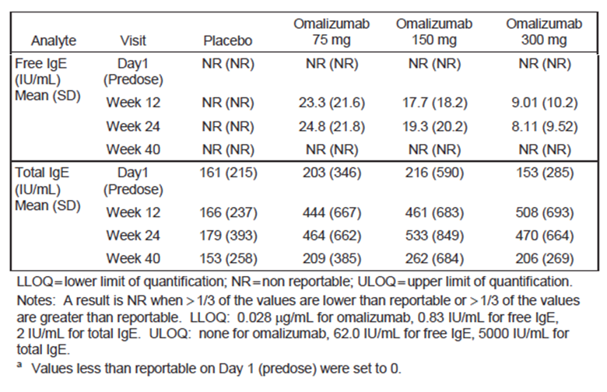

Study 4882g
The results for Study 4882g were provided. A similar pattern was observed with decreases in free IgE and increases in total IgE after 12 weeks of treatment. Levels returned to baseline values by Week 28 (20 weeks after last dose).

Study 4883g
Results for Study 4883g were provided. The findings were similar to those in 4881g and 4882g.

Study 4577g
This was a Phase II dose ranging study in which patients received single doses of omalizumab or placebo. As in the Phase III studies, omalizumab administration resulted in a reduction in free IgE and an increase in total IgE.

Evaluator’s overall conclusions on pharmacodynamics
Omalizumab administration in patients with CIU resulted in deceases in free IgE and increases in total IgE (complexes of omalizumab and IgE). These findings are consistent with the known mechanism of action of omalizumab.

Dosage selection for the pivotal studies
The sponsor elected to study flat dosage regimens for the CIU trials (as opposed to the regimen based on weight and IgE levels used in allergic asthma). The rationale for this approach was that that there was little information supporting a relationship between serum IgE levels and CIU, and serum IgE levels in the CIU population are low compared with the allergic asthma population.
An initial single dose, dose ranging study was conducted (Study 4577g). This study evaluated doses of 75, 300 and 600 mg given SC every 4 weeks. It found that the 600 mg dose was no more efficacious than the 300 mg dose, and therefore 300 mg every 4 weeks was chosen as the maximum dose to be examined in the pivotal studies. The pivotal studies themselves also examined the use of two lower doses, 75 and 150 mg every 4 weeks. The 4 week dosage interval was chosen for Study 4577g on the basis of early investigator initiated studies that showed duration of effect lasting several weeks.
After completion of the pivotal studies, the sponsor conducted various analyses to further justify the use of a flat dose regimen in preference to a regimen based on weight and serum IgE levels.

Efficacy

Studies providing efficacy data

Pivotal efficacy studies
- Study 4881g (also called ASTERIA I)
- Study 4882g (also called ASTERIA II)

Other efficacy studies
- Study 4883g (also called GLACIAL)
- Study ADE05 (also called X-QUISITE)
- Study 4577g (‘also called MYSTIQUE)
Detailed description of these studies and their results can be found in the CER extract (Attachment 2).

Efficacy variables
The main efficacy variables were:

Itch severity score
Itch severity is recorded twice daily (morning and evening) in the patients’ eDiaries, on a scale of 0 (none) to 3 (severe). A daily itch severity score is calculated as the average of the morning and evening scores. A weekly itch severity score is calculated as the sum of the seven daily itch severity scores. Possible scores range between 0 and 21.
A ‘minimally important difference (MID) response’ was defined as reduction from baseline in weekly itch score of a least 5 points.

Hives score
The number of wheals (hives) is measured twice daily (morning and evening), on a scale of 0 (none) to 3 (> 12 hives). The daily hives score is the average of the morning and evening scores, and the weekly hives score is the sum of the daily hives scores over 7 days. Possible scores range between 0 and 21.

Urticaria Activity Score (UAS)
The UAS is a composite score combining the above scores for a) itch and b) number of wheals (hives) as per the following table (Table 3).
Table 3 Urticaria Activity Score.
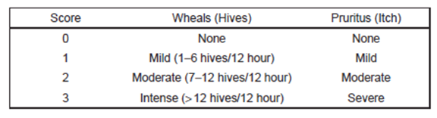
The scores for each are measured twice daily and daily UAS is the average of the morning and evening scores and has a possible range of 0 to 6. The weekly urticaria activity score (UAS7) is the sum of the seven daily UAS scores with a possible range of 0 to 42.

The largest hive score
The largest hive score is measured twice daily, on a scale of 0 (none) to 3 (> 2.5 cm). The daily largest hive score is the average of the morning and evening scores, and the weekly largest hive score is the sum of the daily scores over 7 days. Possible scores range between 0 and 21.

The dermatology life quality index (DLQI)
The DLQI is a validated and widely used quality of life instrument specific to dermatological disorders. In consists of 10 items covering six domains (symptoms and feelings, daily activities, leisure activities, work or school, personal relationships and treatment). Subjects are asked to rate the degree to which the skin condition has affected each item over the preceding week, from ‘not at all’ (0) to ‘very much’ (3). The range of possible scores is 0 to 30, with higher scores indicating a poorer quality of life. The minimally important difference (MID) in patients with CIU has been estimated to be in the range of 2.24 to 3.10 points (9). The DLQI was administered at clinic visits at weeks 0, 4, 12, 24 and 40.

Analyses performed across trials (pooled analyses and meta-analyses)
In the Summary of Clinical Efficacy, the sponsor presented analyses of pooled efficacy data from the two pivotal Studies 4881g and 4882g. The results for the primary endpoint of change in weekly itch severity score at Week 12 are shown in Table 4.
Table 4. Pooled efficacy data (studies 4881g and 4882g). Change in weekly itch severity score at week 12.
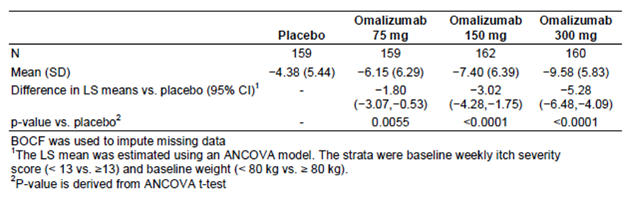

Evaluator’s conclusions on efficacy
The two pivotal studies have demonstrated that omalizumab treatment produces improvements in disease activity that is statistically significantly greater than those produced with placebo. Superior efficacy compared to placebo was also demonstrated in three supportive studies.
The demonstrated efficacy benefits are considered clinically significant.
Based on Study 4577g, the MID in weekly itch improvement score was estimated to be in the range of 4.5 to 5.0 points. For the 300 mg dose, the (placebo corrected) improvements in Studies 4881g and 4882g were 5.8 and 4.8 points respectively (see Table 5 and Table 6).
Table 5. Study 4881g Change in weekly itch severity score at week 12 (Primary endpoint).
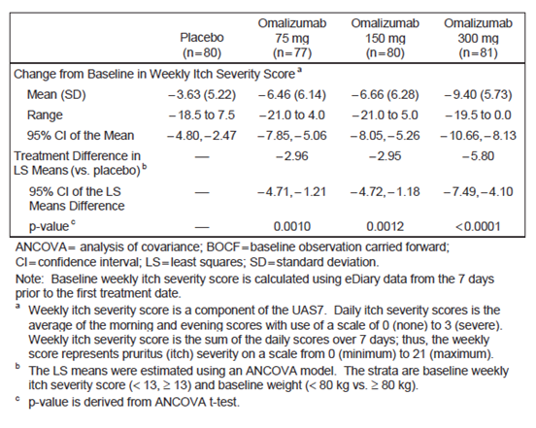
Table 6. Study 4882g. Change in weekly itch severity score at week 12 (Primary endpoint).
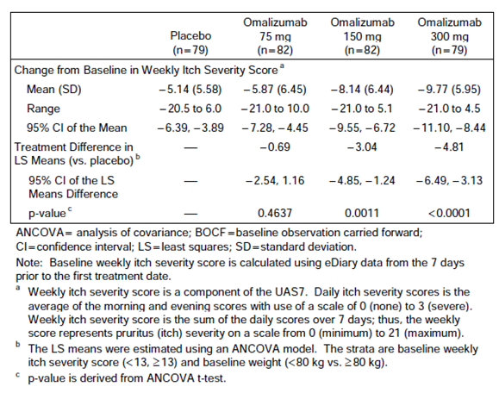
For UAS7, the MID was estimated to be in the range of 9.5 to 10.5 points.⁹ For the 300 mg dose, the (placebo corrected) improvements in UAS7 in Studies 4881g and 4882g were 12.8 and 12.4 points respectively. Similarly, the placebo corrected improvement in DLQI exceeded the MID of 2.24 to 3.10 points in Study 4881g (see section 7.1.1.14 in Attachment 2) and was within this range in Study 4882g.
In Study 4881g the (placebo corrected) proportion of patients who achieved complete resolution of itch and hives (that is, UAS7 = 0) at Week 12 was 27%. This figure rose to 35.6% at Week 24. In the supportive Study 4883g, the proportion was 28.9% at Week 12 and 38.9% at Week 24. Complete resolution of itch and hives is a clinically significant outcome, and these data suggest that it can be achieved in a substantial proportion of patients.
The recommended dose of 300 mg every 4 weeks is adequately supported by the submitted data. Results obtained with the 300 mg dose were consistently numerically superior to those obtained with the 150 mg dose. Onset of benefit was more rapid with the 300 mg dose and a statistically significant benefit was maintained out to 24 weeks with the 300 mg dose, but not with the 150 mg dose (as shown in Table 12 of Attachment 2). It is noted that the draft PI indicates that the 150 mg dose may be effective in some patients. Results with the 75 mg dose were inconsistent and generally not clinically significant.
Retrospective analysis suggested that a dosing regimen based on baseline IgE levels and weight (as per the currently approved asthma regimen) would result in greater variability in efficacy than the proposed flat-dose regimen (see Figures 12 and13 in Attachment 2). Although a weight-based regimen would result in some decrease in variability in efficacy, the difference was not considered clinical significant. Another retrospective analysis (see Figure 14 in Attachment 2) suggested that extending the dosage interval to 5 or 6 weeks would be associated with a greater proportion of patients losing disease control.
Overall the evidence submitted to support the efficacy of omalizumab in CIU is considered adequate.

Safety
Omalizumab has previously been associated with hypersensitivity reactions, including anaphylaxis and serum sickness, and precautionary statements on these issues are included in the current PI.
The drug has also been associated with thrombocytopaenia in animal studies but not in human clinical trials. However, the current PI lists ‘idiopathic severe thrombocytopaenia’ as an adverse reaction identified through spontaneous post market reporting.
In the clinical trials submitted to support registration in asthma, there were an excess number of cases of malignancy with omalizumab compared to placebo (0.5% versus 0.2%). A precautionary statement on this issue is included in the current PI. A subsequent published analysis of a larger number of randomised placebo controlled trials found no significant increase in the risk of malignancy.
In 2009 the FDA announced that it was conducting a safety review of omalizumab. An interim analysis of a large ongoing non randomised study in asthma patients (the EXCELS study) had suggested an increased incidence of serious cardiovascular adverse events. However, no action appears to have been taken by the FDA on this issue since that time.

Studies providing safety data
The following studies provided evaluable safety data:

Phase III studies (4881g, 4882g and 4883g)
In the three Phase III studies, the following safety data were collected:

Pivotal studies that assessed safety as a primary outcome
The primary objective of Study 4883g was to examine the safety of omalizumab compared to placebo. However, the safety findings from this study are reviewed as part of the pooled safety analysis.

Dose response and non pivotal efficacy studies
In Study ADE05 data on adverse events (AEs) were collected at each study visit (that is, every 4 weeks) over the 24 week period of the study. Central laboratory testing (haematology and biochemistry) was only conducted at screening and at Week 24.
In Study 4577g data on AEs were collected weekly for the first 4 weeks after the single dose of treatment and then every 4 weeks until Week 16. Haematology was tested at the same times. Blood biochemistry and urinalysis were only conducted at baseline. Vital signs were measured at 4 weekly intervals.

Patient exposure
The five clinical studies in the submission, included at total of 1114 subjects. Of these, 829 received omalizumab and 285 received placebo.
Table 7. Exposure to Omalizumab and placebo in clinical studies.
Study | Placebo | Omalizumab |  |  |  |  | Total
Study | Placebo | 75 mg | 150 mg | 300 mg | Other | Total | Total
ADE05* | 22 |  |  |  | 27* | 27 | 49
4577g | 21 | 23 |  | 25 | 21* | 69 | 90
Phase III studies | 242 | 146 | 175 | 412 |  | 733 | 975
Totals | 285 | 169 | 175 | 437 | 48 | 829 | 1114
*In ADE05 27 subjects were treated with a dosage regimen adjusted for weight and baseline IgE level. In 4577g 21 subjects were treated with a 600 mg dose.
In the pooled safety database from the three Phase III studies, 733 subjects received omalizumab and 242 received placebo. Duration of exposure in these studies is summarised in Table 19 of the CER (see Attachment 2). The maximum planned duration of treatment with omalizumab in the studies was 24 weeks. The mean (± standard deviation (SD)) duration of treatment for patients who received the proposed 300 mg dose was 20.3 (± 6.0) weeks.

Safety issues with the potential for major regulatory impact

Unwanted immunological events
Omalizumab is known to be associated with hypersensitivity events (for example; anaphylaxis) and the current PI contains precautionary statements along these lines. In the pooled safety analysis there was a slight excess of hypersensitivity events in the 300 mg group compared to the placebo group.
There were no cases of antibody development to omalizumab.

Postmarketing data
No post-marketing data were included in the clinical submission.

Evaluator’s conclusions on safety
Compared to placebo, omalizumab was associated with a modest increase in the incidence of AEs. Specific AEs that may be increased by omalizumab administration include headache, arthralgia and injection site reactions. However compared to placebo, there was no increased risk of severe AEs, serious AEs or discontinuations due to AEs. No new safety issues have arisen in the new patient population.
The overall safety profile of omalizumab in CIU is considered acceptable.

First round benefit-risk assessment

First round assessment of benefits
The benefits of omalizumab in the treatment of CIU are:
- A significant reduction in the degree of itch and the number of hives present. The magnitude of these effects is considered clinically significant and in a proportion of subjects complete resolution of itch and hives occurs
- A modest reduction in the number of days that angioedema is present
- A modest improvement in quality of life

First round assessment of risks
The risks of omalizumab in the treatment of CIU are:
- An increased risk of some AEs such as headache, arthralgia and injection reactions. These AEs are not severe or serious
- An increased risk of hypersensitivity reactions. An increased risk of severe reactions, such as anaphylaxis, was not seen in the submitted studies but has been documented with the drug previously.

First round assessment of benefit-risk balance
The benefit-risk balance of omalizumab, given the proposed usage, is favourable.

First round recommendation regarding authorisation
It is recommended that the application be approved.

Clinical questions
There are no clinical questions for the sponsor.

Second round evaluation of clinical data submitted in response to questions
A second round evaluation was not required.

V. Pharmacovigilance findings

Risk management plan
The sponsor submitted a Risk Management Plan; Core RMP Version 9.0 (dated 21 July 2013); EU-RMP Version 9.0 (dated 24 June 2013); and an Australian Specific Annex (ASA) Version 1.0 (dated 28 October 2013), which was reviewed by the TGA’s Post Market Surveillance Branch (PMSB).

Safety specification
The sponsor provided a summary of ongoing safety concerns which are shown at Table 8.
Table 8. Ongoing safety concerns.
Ongoing safety concerns
Important identified risks | Anaphylaxis/ anaphylactoid reactions  Malignant neoplasms (in adult and adolescent patients ≥ 12 years old)  Serum Sickness Syndrome (SSS)/ Serum Sickness Like Disease (SSLD)  Antibody formation to omalizumab  Churg Strauss Syndrome /Hypereosinophilic Syndrome  Throbocytopenia
Important potential risks | Aterial Thrombotic Events (ATEs)  Malignant neoplasms (in paediatric patients 6 to 12 years old)  Off label use
Important missing information | Pregnancy outcomes

Pharmacovigilance plan
The sponsor proposes routine pharmacovigilance activities to monitor all the specified ongoing safety concerns, including the use of a targeted follow up questionnaire/checklist for the important identified risks: ‘Anaphylaxis/anaphylactoid reactions’ and ‘Malignant neoplasms in adults and adolescents ≥ 12 years of age’ and the important potential risk: ‘Arterial Thromboembolic Events (ATEs)’.

Risk minimisation activities
The sponsor proposes that routine risk minimisation activities for all the specified ongoing safety concerns are sufficient.

Reconciliation of issues outlined in the RMP report
Table 9 summarises the PMSB’s first round evaluation of the RMP, the sponsor’s responses to issues raised by the PSMB and the PSMB’s evaluation of the sponsor’s responses.
Table 9. Reconciliation of issues outlined in the RMP report
Recommendation in RMP evaluation report | Sponsor’s response | PSMB evaluator’s comment
1. Safety considerations may be raised by the clinical evaluator through the TGA’s consolidated request for information and/or the CER respectively. It is important to ensure that the information provided in response to these include a consideration of the relevance for the RMP, and any specific information needed to address this issue in the RMP. For any safety considerations so raised, the sponsor should provide information that is relevant and necessary to address the issue in the RMP. | The sponsor makes no specific response to this recommendation, but states: ‘The ASA, has been updated to incorporate the RMP evaluator’s recommendations.’ | The clinical evaluator did not raise any additional safety considerations.
2. The ongoing studies are not considered to be part of the planned clinical studies in the pharmacovigilance plan. Therefore the related study protocols have not been reviewed. Nevertheless these studies will either generate safety data that will simply support the known safety profile of the medicine or generate data that will provoke applications to amend the Australian registration details. Consequently the table in Section 5.2.1 of the ASA should be amended to state the anticipated dates for their submission in Australia, rather than in the EU. | The sponsor makes no specific response to this recommendation, but states: ‘The ASA, has been updated to incorporate the RMP evaluator’s recommendations.’ However, the sponsor has only amended this table by stating for each study: ‘No submission planned to TGA. Final report available upon request.’ | This response is considered unsatisfactory, as it is expected that submission of these studies in Australia would be closely aligned to the planned date for submission of the final report in the EU whether it is referred to in a Product Safety Update Report (PSUR) or submitted in an application to amend the Australian registration details. Therefore this issue remains outstanding and should be adequately addressed, including any updating of the anticipated dates, before this application is approved.
3. The sponsor’s conclusion that routine risk minimisation activities for all the specified ongoing safety concerns are sufficient remains similar to what was previously accepted for Xolair and at this time continues to be acceptable. | The sponsor makes no specific response to this recommendation. | n/a
4. At this time the sponsor’s handling of the potential for medication errors with Xolair using routine pharmacovigilance and risk minimisation activities continues to remain acceptable. | The sponsor makes no specific response to this recommendation. | n/a
5. As per the (RMP) Questions and Answers (Version 1.3, October 2012) as found on the TGA website, when an existing European Union (EU) RMP is available, the TGA strongly recommends submission of the EU-RMP with an ASA. These guidelines also state: ‘The ASA should identify any differences between the EU-RMP and the local implementation of risk management activities, for example: any differences between the risk minimisation activities undertaken as reflected in the content of the EU Summary of Product Characteristics (SmPC) and the proposed Australian PI, and the reasons for the difference.’ Consequently the ASA should be revised to reference the EU-RMP, not the Core RMP. This revision should include identifying and providing reasons for any differences between the EU-RMP and the local implementation of risk management activities in the ASA, for example: any differences between the risk minimisation activities undertaken as reflected in the content of the EU SmPC and the proposed Australian PI. | The sponsor makes no specific response to this recommendation, but states: ‘The ASA, has been updated to incorporate the RMP evaluator’s recommendations.’ | No tabular comparison identifying and providing reasons for any differences between the content and wording of the EU SmPC and the proposed Australian PI for all of the specified ongoing safety concerns has been provided in the updated ASA. Therefore this issue remains outstanding and should be adequately addressed before this application is approved.
6. To this end the sponsor should also provide a table summarising the pharmacovigilance plan and risk minimisation plan proposed for Australia in the ASA. Wording pertaining to all the specified ongoing safety concerns in the proposed Australian PI and CMI should be included in the table, as well as the foreshadowed routine risk minimisation for the important potential risk: ‘Arterial Thromboembolic Events (ATEs)’. Upon receipt of such information recommendations to the Delegate in regard to the proposed routine risk minimisation activities can then be made. | The sponsor makes no specific response to this recommendation, but states: ‘The Australian Specific Annex, has been updated to incorporate the RMP evaluator’s recommendations.’ | No tabular summary of the pharmacovigilance and risk minimisation activities proposed for Australia encompassing all of the specified ongoing safety concerns has been provided in the updated ASA. Therefore this issue remains outstanding and should be adequately addressed before this application is approved.

Summary of recommendations

Outstanding issues
The sponsor’s response has not addressed each recommendation specified in the RMP Evaluation Report (see Table 9 above). It appears this oversight has contributed to the sponsor’s inadequate response.
The sponsor was advised that the ongoing studies were not considered to be part of the planned clinical studies in the pharmacovigilance plan. Therefore the related study protocols had not been reviewed. Nevertheless these studies will either generate safety data that will simply support the known safety profile of the medicine or generate data that will provoke applications to amend the Australian registration details. Consequently it was requested that the table in Section 5.2.1 of the ASA should be amended to state the anticipated dates for their submission in Australia, rather than in the EU. However, the sponsor has only amended this table by stating for each study: ‘No submission planned to TGA. Final report available upon request.’ This response is considered unsatisfactory, as it is expected that submission of these studies in Australia would be closely aligned to the planned date for submission of the final report in the EU whether it is referred to in a product safety update report (PSUR) or submitted in an application to amend the Australian registration details. Therefore this issue remains outstanding and should be adequately addressed, including any updating of the anticipated dates, before this application is approved.
The sponsor was asked to revise the ASA to reference the EU-RMP, not the core RMP and that this revision should include identifying and providing reasons for any differences between the EU-RMP and the local implementation of risk management activities in the ASA, for example: any differences between the risk minimisation activities undertaken as reflected in the content and wording of the EU Summary of Product Characteristics (SmPC) and the proposed Australian PI. No such tabular comparison encompassing all of the specified ongoing safety concerns has been provided in the updated ASA. Therefore this issue remains outstanding and should be adequately addressed before this application is approved.
The sponsor was also asked to provide a table summarising the pharmacovigilance and risk minimisation activities proposed for Australia in the ASA. No such tabular summary encompassing all of the specified ongoing safety concerns has been provided in the updated ASA. Therefore this issue remains outstanding and should be adequately addressed before this application is approved.

Advice from the Advisory Committee on the Safety of Medicines (ACSOM)
ACSOM advice was not sought for this submission.

Key changes to the updated RMP
In their response to the TGA consolidated request for information the sponsor provided an updated EU-RMP (Version 9.2, dated 16 January 2014) with an updated ASA (Version 2.0, dated 3 June 2014). Key changes from the versions evaluated in the first round are summarised below (Table 10).

Table 10. Key changes to the RMP and ASA.
RMP Updates
EU-RMP | Identified risk ‘Malignant neoplasms in adults and adolescents ≥ 12 years of age’ downgraded to potential risk.
ASA | Section 1- Updated with reference to EU RMP v9.2 from Core RMP v9.0.  Section 2 - Updated with changes from previous version.  Section 3 - Addition of Section 3.2.1 ‘Differences in indications between the EU and Australia’ and updated with reference to EU RMP v9.2 and administrative changes.  Section 4 - Minor administrative change  Section 5 - Updated with reference to EU RMP v9.2.  Section 5.1 - Removed reference to targeted questionnaires/checklists within the ASA. Targeted questionnaires/checklists are included in EU RMP.  Section 5.2 - Updated the submission status of all studies to ‘No submission planned to TGA. Final report available upon request’.  Section 6 - Updated with reference to EU RMP v9.2.  Section 6.2 - Added routine risk minimisation activities (ie PI statements) for Arterial Thromboembolic events (ATEs) and for safety concern ‘Malignant neoplasms – adults and adolescents 12 years old or older’ removed reference to malignancy in precautions section following approval by TGA of PM-2013-02423-1-5.  Section 10 - Removed targeted questionnaires/checklists. Targeted questionnaires/checklists are included in EU RMP.

Suggested conditions of registration
- Implement the he European Risk Management Plan (Version 9.2, dated 16 January 2014), with an Australian Specific Annex (Version 2.0, dated 3 June 2014) amended as agreed by the TGA.
- Any commitments made by the sponsor in their response to the TGA request for information regarding RMP issues have to be implemented as agreed with the TGA.

VI. Overall conclusion and risk/benefit assessment
The submission was summarised in the following Delegate’s overview and recommendations:

Quality
There was no requirement for a quality evaluation in a submission of this type.

Nonclinical
There was no requirement for a nonclinical evaluation in a submission of this type.

Clinical

Background

Chronic idiopathic urticaria
Chronic idiopathic urticaria is described in the extract from the CER (see Attachment 2) and Product background above. In many patients, chronic urticaria is considered to be auto immune, with antibodies directed against FcεR1 or IgE on the mast cell or basophil. The sponsor specifies that ‘chronic idiopathic urticaria’ is taken to include this autoimmune subset.
There is a consensus clinical practice guideline on urticaria, published in 2009, and used by Australian clinical immunologists (Zuberbier et al.).^{3, 4}
The document ‘Support for TGA Submission for use of Omalizumab for Chronic Idiopathic Urticaria/Angioedema’ by Katelaris et al (an attachment to the sponsor’s application cover letter) provides some Australian context for treatment of CIU.

Targets and mechanism of action
Omalizumab is a monoclonal antibody against human IgE. The sponsor proposes several possible mechanisms of action in chronic idiopathic urticaria:
- The drug lowers systemic IgE levels, resulting in down regulation of a large percentage of surface FcεR1, thereby decreasing downstream signalling.
- Lowering of circulating IgE leads to non-specific desensitisation of cutaneous mast cells.

Overview of data
There were two pivotal efficacy studies in CIU: 4881g and 4882g.
The following studies and reports were supportive:
- a small Phase IIIb ‘proof of concept’ study (ADE05) in chronic urticaria
- a Phase II, single dose, dose-ranging study (4577g) in CIU
- a supportive Phase III study (4883g)
- a population PK analysis and two population PK efficacy analyses
The sponsor summarises the large Phase III studies as shown in Figure 1 below (arrows indicate dose of omalizumab):
Figure 1. Summary of dosage regimen for the large Phase III studies.
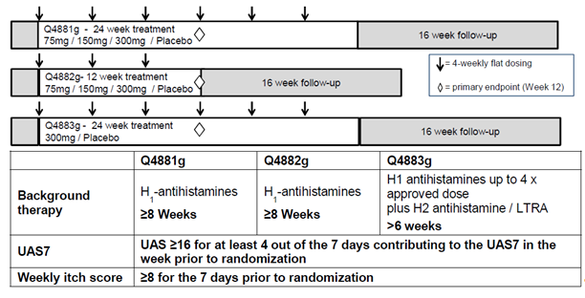

Pharmacokinetics
The pharmacokinetics of omalizumab in CIU were similar to PK in allergic asthma. In population PK analysis, both body weight and BMI affected omalizumab clearance; body weight also affected volume of distribution. A population PK efficacy analysis found that adjusting dose according to weight did not improve efficacy relative to a flat dose.

Pharmacodynamics
Effects of omalizumab on total and free serum IgE were studied in 4881g, 4882g, 4883g and 4577g. Free IgE fell from baseline levels (for example, from 153 IU/mL at baseline in 4881g to 9.01 IU/mL at Week 12). Total IgE increased (total IgE includes IgE complexed to omalizumab). Levels fell in 4881g to baseline values by 20 weeks after the last dose.

Dose regimen
Flat dosage regimens were studied in CIU, since the relationship between CIU and serum IgE is unclear and also because serum IgE levels in CIU are low compared with the allergic asthma population.
Study 4577g evaluated doses of 75, 300 and 600 mg. The 600 mg dose was no more efficacious than the 300 mg, so the 300 mg dose was chosen as the maximum dose in pivotal trials. In the pivotal trials, 75 mg, 150 mg and 300 mg doses were studied.
The 4 week interval between doses was chosen for 4577g on the basis of early investigator led studies that showed duration of effect lasting several weeks.
Population PK efficacy studies (conducted after the pivotal studies) supported a flat dose.

Efficacy

Study 4881g (ASTERIA I)
Study 4881g was a randomised, placebo controlled, double blind study. Patients, 12 to 75 years old, had CIU refractory to approved doses of H1 antihistamines and were receiving concomitant H1 antihistamine therapy.
Patients with defined underlying aetiologies for urticaria (for example, acute, solar, cholinergic, heat, cold, aquagenic, delayed pressure or contact urticarias) were excluded, as were patients with diseases that can manifest with urticaria. Patients with skin diseases that can cause itch were excluded and routine use of topical corticosteroids and systemic immunosuppressants was an exclusion factor. Recent use of H2 antihistamines, leukotriene receptor antagonists or doxepin were also reasons for exclusion.
Patients were randomised into one of four arms: omalizumab 75 mg, 150 mg and 300 mg groups (all SC every 4 weeks); and placebo. There were 6 administrations: at 0, 4, 8, 12, 16 and 20 weeks. Placebo contained the same ingredients as the omalizumab formulation, except for omalizumab. Patients remained on a stable H1 antihistamine throughout the study period; 3/8 (specified antihistamines are not on the ARTG (ebastine, rupatadine, bilastine)). Diphenhydramine was used as required for itch (up to three times daily).
The primary endpoint was change from baseline in the Week 12 ‘weekly itch severity score’. Missing Week 12 scores were imputed by carrying forward baseline scores.
Some 318 patients were treated. Baseline characteristics are presented in Table 10 of the CER extract (see Attachment 2). The median age was 41; 5.7% were 12 to 17 years old and 4.7% were 65+ years old and 73% were female. The mean BMI was 29.3 kg/m², the median duration of CIU was 3.7 years and the median number of prior treatments for CIU was 4. 25.2% had antibodies against FceR1. Some 48% of subjects had angioedema at baseline.
Median baseline weekly itch severity score (based on data collected in the weeks before randomisation) was 14/21 in all arms. The mean baseline score was 14.3.
At Week 12, mean changes in weekly itch severity score were - 3.6 (placebo), - 6.5 (75 mg), - 6.7 (150 mg) and - 9.4 (300 mg). A minimally important difference was considered to be a 5 point improvement. This was attained at Week 12 in 36% (placebo), 56% (75 mg), 56% (150 mg) and 75% (300 mg). As shown in Figure 2, the onset of effects was quick and so was relapse after the final injection.
Figure 2. Graphs of efficacy (weekly itch severity score, change from baseline, BOCF method) over time in pivotal studies.
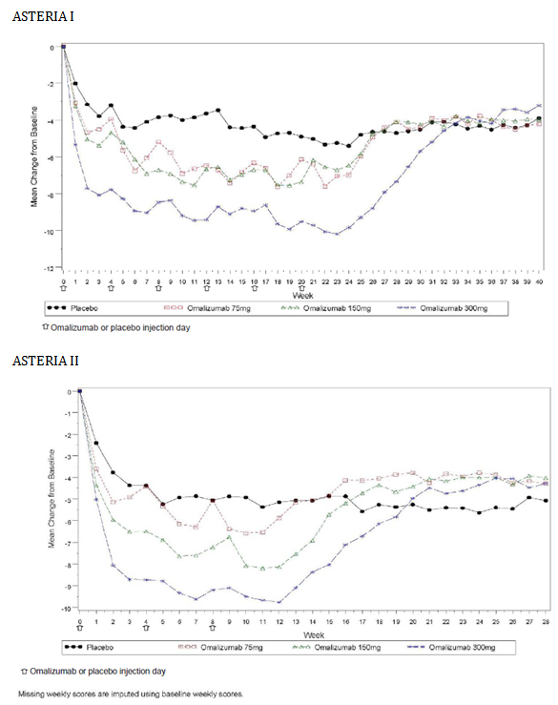
Secondary endpoint results supported better efficacy for 300 mg omalizumab. UAS7 of zero (no itch, no hives) was achieved in 36% in the 300 mg arm and 9% in the placebo arm. In subgroup analysis (300 mg versus placebo arms) robust evidence for or against efficacy in 12 to 17 year olds was lacking.

Study 4882g (ASTERIA II)
Study 4882g. There were 3 administrations (at 0, 4 and 8 weeks) but otherwise design was the same as for 4881g. In this study, 322 patients were treated. Baseline characteristics were broadly similar to those for 4881g; mean and median age in the 75 mg group was slightly lower than in other groups.
An effect in the placebo arm was more pronounced than in 4881g, with a mean change from baseline in weekly itch severity score of - 5.1 (placebo), - 5.9 (75 mg), - 8.1 (150 mg) and - 9.8 (300 mg). Compared with placebo, only the 150 mg and 300 mg arms showed statistically significant improvements; the treatment difference in least squares means, against placebo, was - 3.0 for 150 mg and - 4.8 for 300 mg arms. The clinical evaluator also saw evidence of a rebound effect as illustrated in Figure 2 but the conclusion was that the rebound effect was unlikely to be important (however see below for further discussion of rebound effect).
Secondary endpoints (including quality of life assessment) supported better efficacy of the 300 mg dose and no efficacy of the 75 mg dose. In subgroup analysis, sample size precluded drawing conclusions on efficacy in children and subjects 65 + years of age. The subgroup analysis is presented in Figure 6 of the CER extract (Attachment 2) and again does not raise concerns that efficacy varies by subgroup. Less favourable point estimates of effect in those with a baseline UAS below the median were not replicated in 4881g sub group analysis.

Study 4883g (GLACIAL)
Study 4883g was primarily a safety study and the patient population differed from Studies 4881g and 4882g by including patients also using H2 blockers and leukotriene receptor antagonists for CIU. Patients were required to have failed H1 histamine receptor (H1) blockers at high doses and one of an H2 blocker or a leukotriene receptor antagonist. Thus, patients were more treatment resistant than in 4881g and 4882g.
Patients were randomised 3:1 to receive 300 mg omalizumab or placebo SC every 4 weeks for 6 administrations. Efficacy results were supportive of those in Studies 4881g and 4882g for 300 mg omalizumab. Mean weekly itch severity score at Week 12 (relative to baseline) was - 4.0 in the placebo arm, - 8.6 in the omalizumab arm; the treatment difference in LS means was - 4.5 (comparable to figures of - 5.8 and - 4.8 in 4881g and 4882g respectively).

Delegate’s comments regarding rebound effect in Studies 4881g, 4882g and 4883g
The following comment was made with regard to the rebound effect noted in Studies 4881g, 4882g and 4883g.
The sponsor’s summary of clinical safety (Table 11 below) analyses the large Phase III studies and finds a rise in CIU related severe AEs after last omalizumab dose (versus last placebo dose). The Delegate agreed this could be related to the deeper suppression of CIU by omalizumab but it is also consistent with a rebound effect in some patients that weekly itch > 150% of baseline was observed in 5.4% (placebo) versus 7 to 13% (omalizumab). Similar analysis of hives and urticaria was less concerning but overall a rebound effect has not been ruled out.
Table 11. Worsening of CSU symptoms after last study drug dose – Studies 4881g, 4882g and 4883g (core safety analysis set).
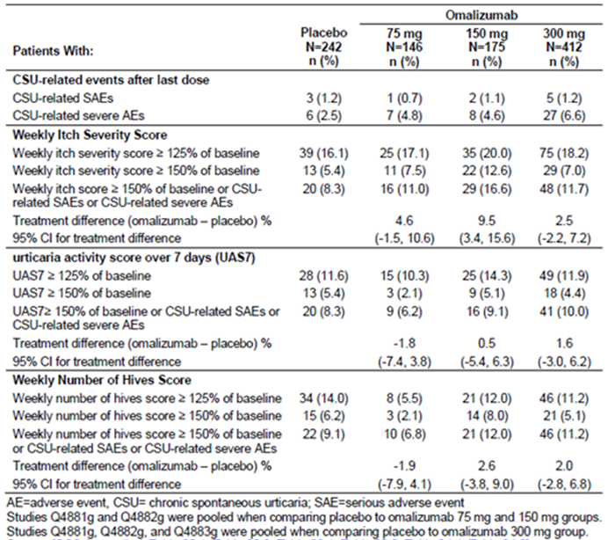

Study ADE05 (X-QUISITE)
Study ADE05 was less relevant in terms of type of patient, sample size and dosing.

Study 4577g (MYSTIQUE)
Study 4577g was a Phase II study in patients receiving H1 antihistamines. Only a single dose was administered (randomisation was to placebo or 75, 300 or 600 mg omalizumab, SC). The best efficacy was seen with 300 mg as shown in Figure 3 below.
Figure 3. Study 4577g – Weekly mean change in UAS7 from baseline.
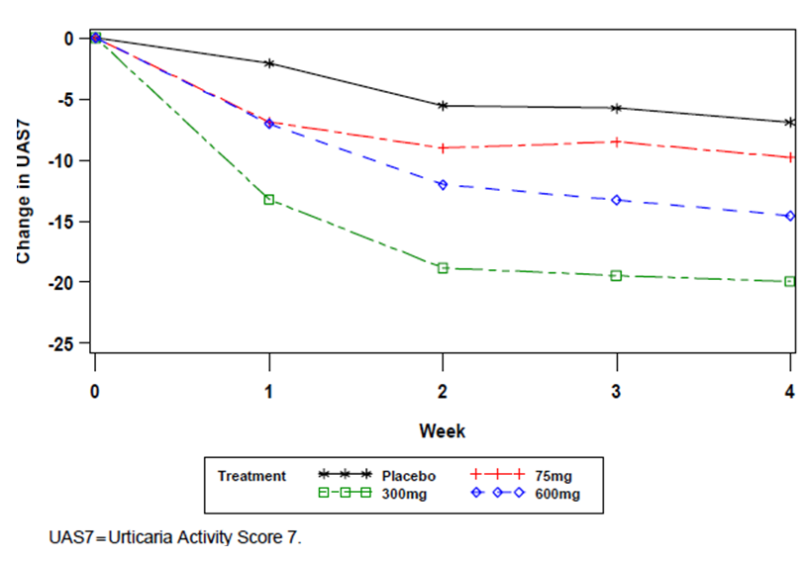

Safety
In the clinical program, 829 subjects received omalizumab and 285 received placebo. Extent of exposure is presented in Table 17 the CER extract (see Attachment 2); very few patients were exposed to omalizumab for more than 24 weeks at any dose level. The extent of exposure for at least 12 months, did not conform with the suggestion in the TGA-adopted guideline where it is stated that for safety assessment a large and representative group of patients should be exposed to the substance for at least 12 months. However, this is offset by the experience with this product in allergic asthma.
While for some broad categories of AE the frequency of that type of AE rose across dose levels (75, 150, 300 mg), the frequency at 300 mg omalizumab was not particularly high relative to placebo (for example, see CER extract Attachment 2 Table 19).
Differences in AEs were not marked across arms, including the placebo arm. Analysis of severe AEs, serious AEs and discontinuations due to AEs revealed a benign safety profile. There was some evidence of dose related increases in incidence of arthralgia, headache, asthma and injection site reactions, based on pooled analysis (see Attachment 2 section 8.3.1.). Elevated blood glucose was reported in two subjects (7.4%) on omalizumab versus none on placebo in Study ADE05; biochemistry was not monitored in other studies. Across Phase III subjects the only serious AEs of type 2 diabetes mellitus and hyperglycaemia were in the placebo arms.
A case of idiopathic thrombocytopaenic purpura developed in a patient with baseline platelet level of 158 x10⁹/mL.
No new safety issues arose in the CIU study population.

Clinical evaluator’s recommendation
The clinical evaluator has recommended approval of the new use. The response to issues raised in the consolidated TGA request for further information from the sponsor was considered in writing this overview.

Risk management plan
The RMP proposed by the sponsor was considered defective in some administrative aspects by the TGA’s PMSB (see Pharmacovigilance findings above).
The proposed wording for a condition of registration for the RMP is:
The European Risk Management Plan (Version 9.2, dated 16 January 2014), with an Australian Specific Annex (Version 2.0, dated 3 June 2014) to be amended as agreed by the TGA, must be implemented.

Delegate’s considerations

Risk-benefit analysis

Efficacy
Clinically and statistically significant efficacy advantages over placebo in the studied population have been reliably demonstrated in this clinical study program.
The Delegate accepts the minimally important difference of 5/21 for the primary endpoint of weekly itch severity score, though the Delegate notes that the cited paper was co-written by a Genentech employee based on results from Study 4577g. Less controvertible is the placebo corrected proportion of patients achieving complete resolution of itches and hives (CER extract pages 43-45– see Attachment 2).
Omalizumab does not cure or permanently modify underlying disease, as symptoms return on treatment cessation. In the three dose 4882g study there was evidence of a slight rebound effect (see above Delegate’s comments regarding rebound effect in Studies 4881g, 4882g and 4883g).
The proposed PI countenances use of 150 mg dosing and there is reasonable efficacy at this dose level though more consistent results were obtained in 300 mg arms. Only simulations were offered to inform decision making about up or down dose titration. Since dosing is limited to 150 mg at any one site of SC injection and since SC injection may be an obstacle to effective use of 300 mg dosing in some patients, the Delegate comments that it is reasonable that the PI recommends the option of 150 mg dosing.

Safety
Safety in CIU is good to 6 months (given the relatively small increase in AEs versus placebo).
Safety data are very limited for longer term use, so absence of positive signals for some previously flagged rare but serious AEs (for example, malignancy; cardiovascular disease) cannot provide reassurance that these issues will not emerge after marketing in CIU.

Indication – severe, refractory nature of disease
In the pivotal studies, subjects had severe, refractory disease. The sponsor’s Clinical Overview states:
‘To ensure the population had severe refractory CSU in the pivotal efficacy studies Q4881g and Q4882g, patients were required to have had a CSU diagnosis for ≥ 6 months, and significant symptoms despite treatment with approved-dose H1 antihistamines for ≥ 8 weeks. Symptoms of itch and hives had to be present for ≥ 8 consecutive weeks at any time prior to enrolment, and a UAS7 score of ≥ 16 and itch component of UAS7 ≥ 8 during the 7 days prior to randomization. Study Q4883g required a CSU diagnosis for ≥ 6 months and to be refractory to treatment with a combination of H1 antihistamines up to four times the approved dose, and one or both of H2 antihistamines, and/or Leukotriene Receptor Antagonists (LTRAs) (all received for > 6 weeks). Symptoms of itch and hives had to be present for > 6 consecutive weeks at any time prior to enrolment as well as fulfilling the above UAS criteria. Patients with associated angioedema were enrolled in all 3 studies.
It should be noted that the actual clinical severity of the patient population recruited into the program significantly exceeded the CSU severity entry criteria cited here.’
Given the severity of CIU studied in the omalizumab program, the proposed wording of the indication might invite use in patients with less severe disease, where benefit/risk has not been studied. The Delegate considered that inclusion of the requirement for ‘failure of H1 antihistamines’ offsets this risk sufficiently and it signals that the treatment is not appropriate as a first line therapy in CIU. Also, there was no particular safety signal in the studied population, making the consequences of extrapolation of use to CIU subjects with less severe disease less concerning.
On reading the proposed indication, it is open to interpretation as to whether patients should fail on high dose H1 antihistamines before trialling omalizumab. Regarding key trials, the sponsor writes:
‘To enter Studies Q4881g and Q4882g, patients had to be refractory to treatment with H1 antihistamines at currently approved doses, but most of the patients had previously failed at least 4 other CSU therapies. The patients in Study Q4883g were refractory to treatment with a combination of H1 antihistamines at up to 4 fold licensed doses, H2 blockers, and/or LTRAs.’
About 16% of patients had failed H1 antihistamines at 4 times the licensed doses in Q4883g; about 37% had failed standard doses. Across Phase III studies, this suggests omalizumab has mostly been assessed in patients failing standard doses of antihistamines. It is not clear that there is a much increased response to H1 antihistamines with use of the non-standard (higher) doses. The sponsor’s proposed wording is acceptable in this regard, especially since it might be problematic to propose use only after failure of off label high doses of H1 antihistamines.

Indication; terminology
The sponsor’s Clinical Overview states:
The proposed indication uses the term CSU (as opposed to chronic idiopathic urticaria or CIU) in accordance with recent guidelines published by the European Academy of Allergology and Clinical Immunology (EAACI)^{3,4} . The term chronic idiopathic urticaria (CIU) was originally essentially synonymous with CSU, but is now reserved for patients with truly idiopathic aetiology. The term CSU is broader and includes patients with a known auto antibody or prior infection-related chronic urticaria who are not now considered ‘idiopathic’, as they do have a known trigger. Thus, in this new classification, CSU covers all non inducible chronic urticaria with CIU (of unknown trigger) being a subset of it. As the population studied in the omalizumab clinical studies included patients with auto antibodies (all were tested at baseline), the term CSU most accurately reflects the study population and intended use.
The Australian sponsor proposes to use the term chronic idiopathic urticaria and this is acceptable.

Summary of issues
There is limited information about use beyond 6 months in CIU, despite likely longer term use.
It is unclear when patients should be advised to trial the 150 mg once every 4 weeks dose regimen.
The proposed indication might endorse use in patients with generally less severe disease than was studied in the Phase III program.

Proposed action
The Delegate had no reason to say, at this time, that the application for Xolair omalizumab in chronic idiopathic urticaria should not be approved for registration.

Request for Advisory Committee for Prescription Medicines (ACPM) advice
The committee is requested to provide advice on the following specific issues:
- How should the absence of clinical data about use beyond 6 months in CIU be managed?
- When is it appropriate to advise use of 150 mg once every 4 weeks (q4wk)?
- Does omalizumab have a positive benefit / risk balance in adults and adolescents with CIU who remain symptomatic despite H1 antihistamine treatment, or in any other CIU population?
The committee is also requested to provide advice on any other issues that it thinks may be relevant to a decision on whether or not to approve this application.

Response from sponsor
The Delegate and clinical evaluator, both recommend approval for use of Xolair in
‘adults and adolescents (12 years of age and above) with chronic idiopathic urticaria who remain symptomatic despite H1 antihistamine treatment.’
Novartis welcomes the Delegate’s and clinical evaluator’s recommendations for approval and the endorsement of our proposed indication. The Delegate has mainly sought the advice of the ACPM on the following issues:
- The lack of controlled clinical trial data beyond 6 months
- The circumstances under which the 150 mg every 4 weeks dosage regimen should be used and
- The wording of the indication that is, whether the proposed indication might endorse use in patients with generally less severe disease than was studied in the Phase III program.
The sponsor has addressed these issues in the sections below. In addition, the sponsor discussed certain other matters raised including the Delegate’s concern over a possible rebound effect upon cessation of treatment; the Delegate’s recommended changes to the PI and administrative changes to the RMP.

1. Managing the absence of clinical data beyond 6 months
The sponsor acknowledges that the controlled efficacy and safety data in CIU are limited to the 6 month duration of the pivotal trials. However, pooled safety data from all three Phase III trials over 6 months were consistent across treatment groups. Importantly, there was no increased risk of severe AEs compared to placebo and no identifiable pattern of AEs attributable to omalizumab. In addition, the evidence in the Phase III trials did not suggest an induction of tolerance or tachyphylaxis that would limit treatment duration. These studies evaluated patients with CIU disease duration of 6 months to 66 years, on average 6 years. Due to the chronic nature of the disease, at least 6 months treatment is recommended to allow for disease stabilisation and maximum suppression of symptoms, in particular for patients with refractory, long-standing disease.,
The Delegate states that the good safety profile in CIU over 6 months would not necessarily rule out positive signals for some previously flagged rare but serious AEs in allergic asthma patients (for example, malignancy, cardiovascular disease) from emerging after marketing for CIU. There is considerable long term experience in allergic asthma patients from clinical trials and postmarketing setting. To date, approximately 14,209 patients have been enrolled into omalizumab clinical programs, of which approximately 9,547 subjects received omalizumab since the start of the clinical development program. The postauthorisation (not in clinical trial) exposure that is, the cumulative patient exposure since the first worldwide launch in 2003 is estimated to be approximately 515,841 patient years (PSUR 01 January 2013 to 31 December 2013 and PSUR 01 January 2014 to 30 June 2014). The clinical evaluator refers to an interim analysis from the EXCELS trial in asthma patients. Briefly, the data from EXCELS suggests that omalizumab therapy is not associated with an increased risk of malignancy. The data on cardiovascular and cerebrovascular safety are limited and difficult to interpret, as in separate reviews of omalizumab preclinical and clinical trials; there have been no indications of increased risk of cardiovascular or cerebrovascular events. There is no reason to expect the long term safety on omalizumab in patients with CIU to be any different than in patients with severe allergic asthma. In addition, the considerable long-term experience in allergic asthma patients from clinical trials and post marketing setting offsets the relatively shorter exposure in CIU patients [Delegate’s review of safety]. Finally, it should be noted however that final data from this trials and two meta analyses on malignancies and arterio-thrombolic events across all omalizumab controlled trials is now complete and information is included in the currently approved PI (at the time of writing this response) based on the TGA’s evaluation (approved 17 April 2014).
In order to provide further reassurance of the good safety profile seen for 6 months in the pivotal trials, the sponsor would like to call attention to relevant information from two recent publications on longer term treatment with omalizumab in CIU with up to a maximum of 37 months and up to 24 months, respectively. In these observational case series no loss of efficacy or unexpected safety issues was observed.
The Delegate proposes to include a precaution that there are no efficacy or safety data in CIU beyond 6 months of treatment. The Precautions section of the PI is generally intended to describe clinical circumstances where caution is advised. Whilst the sponsor agrees that an explicit statement on the limitations of clinical data in the PI would address this issue, a precaution is not considered warranted as this section of the PI should be restricted to addressing known or anticipated safety risks of the drug and/or risks pertaining to specific populations. No such risks are known nor anticipated with Xolair in the CIU patient populations. The sponsor considers it more appropriate to include such a statement in the Clinical Trial section and the Dosage and Administration section of the PI. There is no evidence from the clinical trials in CIU to warrant particular precaution beyond 6 months. Moreover, CIU can typically take a few years before it goes into remission; the pivotal studies included patients with CIU disease duration of on average 6 years. For these reasons, the sponsor considers it more apt to include this information in these sections of the PI.

2. Dosing – Advice on use of 150 mg dose
The Delegate agrees the 150 mg dose should be included in the PI and has sought the advice of the ACPM on the 150 mg every 4 weeks dose regimen. Novartis was specifically invited to comment on this matter. The sponsor agrees that there are circumstances where the 150 mg dose regimen could be considered. The proposal of 300 mg as recommended dose is supported by the results from the pivotal trials which showed that this dose had a consistently higher treatment effect compared with the 150 mg dose. Onset of benefit was more rapid with the 300 mg dose and statistically significant results were maintained over the duration of the trial (4881g), but not with the 150 mg dose. More consistent efficacy was observed with the 300 mg dose regimen that consistently met statistical significance in all endpoints in the pivotal studies and is therefore considered the optimal dose. This is also supported by a group of Australian specialist clinicians with experience in the management of CIU.⁸
The Delegate has proposed some specific situations where the 150 mg dose regimen may be preferred; for instance, in patients unable to tolerate two separate SC injections or when efficacy has been shown at the proposed 300 mg dose regimen. Novartis believes that the current wording in the draft PI adequately addresses routine clinical practice and possible treatment scenarios by allowing physician sufficient flexibility to use either dose when clinically warranted based on a regular assessment of patients’ symptoms:
‘The recommended dose is 300 mg by subcutaneous injection every four weeks. Some patients may achieve control of their symptoms with a dose of 150 mg every four weeks’.
This wording reflects the clinical trial results, showing statistically significant efficacy of omalizumab over placebo in treatment of CIU for both the 150 mg and the 300 mg dose in the primary efficacy consistently higher treatment effect across all endpoints is obtained with the higher dose while maintaining the same safety profile, as also noted by the Delegate.
In an attempt to identify patient groups which would benefit from the 150 mg dose, subgroup analyses for itch severity score were conducted. Subgroups were defined according to demographic characteristics, disease characteristics and according to prior CIU treatments. No clear demographic or disease differentiator for using the 150 mg dose was identified and it is not possible to predict which patient group will benefit from the lower dose. As stated by the Delegate, only simulation data are available with respect to possible down titration of the dose. Time course pharmacokinetic efficacy simulations were used to anticipate the outcome for dose reduction from 300 mg to 150 mg when achieving complete symptom control (UAS7 = 0) with 300 mg. The simulations predict that about a third of all patients would be well controlled with a 150 mg dose. Based on the subgroup analyses it is not possible to predict which patient group would benefit from the 150 mg dose, and similarly it is not predictable for which patient group complete control of urticaria symptoms with the 300 mg dose could be maintained following dose reduction from 300 mg to 150 mg every 4 weeks. However, flexibility should be provided to patients and physicians and it should be left to their clinical judgment when symptom control may be achieved or maintained with 150 mg.

3. Proposed wording of the indication
The proposed CIU indication is targeting patients who are refractory to H1 antihistamines. The wording concisely describes the patient population in which a positive benefit-risk profile was demonstrated in the pivotal clinical trials that support our application. Nevertheless, the Delegate notes that some patients recruited into the clinical trial program exceeded the disease severity entry criteria and considers the possibility that the wording may invite use in patients with less severe disease. The Delegate concludes though that the restriction to patients who fail H1 antihistamines ‘offsets this risk sufficiently’ and that the absence of any safety signal in the studied patient population makes the potential consequences of use in less severe patients less of a concern. Moreover, all patients across the trial program had failed approved doses of H1 antihistamines. Novartis agrees with the conclusions drawn by the Delegate; that the proposed wording is appropriate as it explicitly confines the use of Xolair to patients who remain symptomatic despite H1 antihistamine treatment.
As per the treatment guidelines, patients are diagnosed with CIU when the urticaria persists for at least 6 weeks. The first step of CIU therapy is treatment with H1 antihistamines at approved doses for two weeks and with up to 4 times the approved doses for about one to 4 weeks, if symptoms persist. Only after a total of 9 to 12 weeks of refractory urticaria despite H1 antihistamines at increasing doses up to 4 times the recommended doses, the treatment algorithm suggests the use of for example Xolair as add on to H1 antihistamines.¹⁷ Considering that this international treatment guideline is based on long standing clinical practice and the easy treatment with increased doses of H1 antihistamines without the need of injections it seems unlikely that physicians will treat patients with short disease duration or milder symptoms immediately with Xolair without trying to use increased doses of H1 antihistamines. As also noted by the Delegate, while a recommendation for increased doses of H1 antihistamines can be made in a treatment guideline, it is not possible to recommend off label use/dose of H1 antihistamines in the proposed indication for Xolair. While the proposed indication wording does not give advice on the dose of H1 antihistamines, patients require to have failed prior to starting treatment with Xolair. It clearly states that patients need to remain symptomatic despite H1 antihistamine treatment. Based on this clear positioning of Xolair and the fact that no particular safety signals were observed in the clinical program, the proposed indication is considered acceptable by the Delegate.
Finally, it was noted by the Delegate that the term ‘chronic idiopathic urticaria’ (CIU) has been proposed in Australia in contrast to ‘chronic spontaneous urticaria’ (CSU) which is used in Europe. The term CIU was recommended by an expert advisory group of Australian physicians who specialise in the treatment of the condition.⁸ Both the clinical evaluator and the Delegate consider use of term CIU to be acceptable. It is worth noting that the term CIU is also used in the approved US Prescribing Information and the Canadian Product Monograph.

4. Other issues

Rebound effect
The Delegate notes that, the weekly itch score over 150% of baseline in some patients was consistent with a rebound effect in 4882g. This was also mentioned by the clinical evaluator; who later concluded that the possible rebound effect was unlikely to be important.
The Delegate accepts, that the rise in CIU related severe AEs could be related to the deeper suppression of CIU symptoms by omalizumab, although the Delegate suspects it could also be due to a possible rebound effect. The results need to be interpreted with caution considering especially the recall bias. This is a known phenomenon for patients that were discontinued from active treatment following symptom improvement. Therefore, when assessing the symptom scores, particularly the relatively subjective itch score, the recall bias needs to be considered as well. While patients on placebo were without active treatment for at least 12 weeks with no expected change in the perception of itch, patients discontinuing from active treatment experience a higher awareness, which is reflected particularly in a subjective score such as the itch severity score. This was further corroborated by the fact that other symptom scores (that is, UAS7 and hives score) had similar or even lower levels compared to placebo.
The more objective measure of symptoms is the weekly number of hives. No imbalances were observed in the weekly number of hives over 150% of baseline, UAS7 (composite of the itch and hives scores) over 150% of baseline and the CIU related serious adverse events (SAEs), which suggests that the recall bias leads to the imbalances seen in the weekly itch score over 150% baseline. In addition, patients exhibited baseline itch and hive score in the 13 to 16 range (maximal value is 21), hence, the use of a 50% rise criterion (that is, over150% of baseline) reflects increments in the 6 to 8 points range which is certainly within the range of patient perception of worsening. Furthermore, as seen in Table 11, there was no clear dose relationship among any of the over 150% symptom scores.
To further determine whether patients are simply experiencing re-emerging of CIU symptoms to baseline level or worsening of symptoms beyond baseline after treatment cessation, Novartis has assessed the CIU symptom profiles of all patients (pooled pivotal trials) that experienced CIU related AEs during follow up. CIU symptom profiles (A to E) were defined in advance, against which a given patient profile for itch severity score and weekly number of hives following cessation of treatment was compared.
While profiles A and C would correspond to the natural course of the disease, profiles B and D would potentially represent worsening of symptoms compared to baseline (compared with Table 12 below).
Table 12: Number of patients (%) classified according to their post-treatment CIU profile as measured by itch severity score and weekly no of hives.
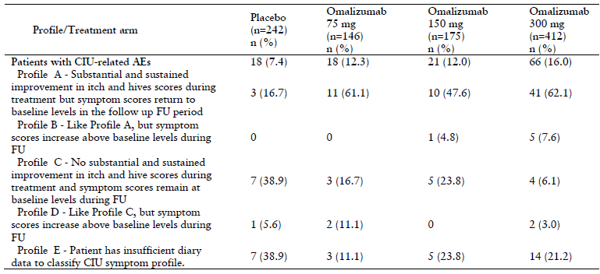
The rate of CIU related AEs after cessation of treatment was greater in patients receiving omalizumab compared to placebo. However, the CIU related AEs of the majority patients on active treatment did not return to levels above baseline (Profile A). It is therefore concluded that the observed effect post treatment does indeed reflect a re occurrence of symptoms close to baseline rather than a rebound effect.
In summary there was neither a relevant imbalance nor a dose dependent increase in the incidence of the weekly CIU signs and symptom scores over 150%. Furthermore, the return of CIU symptom scores close to baseline levels upon cessation of omalizumab treatment is most likely due to the deeper suppression of CIU symptoms by omalizumab, followed by a loss of that effect after treatment cessation. Therefore the data do not provide any evidence justifying a change in the clinical trials section of the PI on a possible rebound effect.

Concluding remarks
There is a high unmet medical need for CIU patients who fail to respond to H1 antihistamines as there are no medicines approved for refractory CIU patients and many of the drugs commonly used off label have substantial toxicities. The use of Xolair in adults and adolescents (12 years of age and above) with CIU who remain symptomatic despite H1 antihistamine treatment is supported by two pivotal randomised controlled trials in the target patient population. The Phase III program has demonstrated that omalizumab produced statistically and clinically significant improvements in the symptoms and signs of CIU in patients who had remained symptomatic despite the use of approved doses of H1 antihistamines.
The recommended dose of 300 mg every 4 weeks is well supported by the trial results. Pooled efficacy data from the two pivotal trials are consistent with the results from the individual studies with a larger difference to placebo in the 300 mg omalizumab group than the 150 mg group. Still, it was shown that 150 mg every 4 weeks resulted in a significant improvement in most of the endpoints and therefore some patients may achieve control of their symptoms with a dose of 150 mg. Even though it is not possible to predict which patient group would benefit from the 150 mg dose, treatment flexibility should be provided to patients and physicians.
In addition, the safety and tolerability profile of omalizumab in CIU was favourable for any dose with no new safety issues in the new patient population, over the trial period of 6 months. Based on the extensive clinical trial and post marketing data in the asthma population no changes to the safety profile are anticipated in CIU patients beyond 6 months. In addition, there is no evidence of an induction of tolerance or tachyphylaxis that would limit treatment duration and treatment guidelines recommend at least 6 months treatment of CIU. The PI, in line with Australian clinical practice and guidelines, recommends periodic reassessment of symptoms in order to ensure the most appropriate treatment option is considered by the physician to meet the patients’ needs. While mean weekly itch severity score and mean UAS7 increased after the end of treatment, they did not return to baseline levels in any treatment group (including placebo), suggesting that there was no rebound effect.

Advisory committee considerations
The Advisory Committee on Prescription Medicines (ACPM), having considered the evaluations and the Delegate’s overview, as well as the sponsor’s response to these documents, advised the following:
The ACPM, taking into account the submitted evidence of efficacy, safety and quality, agreed with the Delegate and considered Xolair, lyophilised powder for injection, containing 75 mg and 150 mg of omalizumab, and solution for injection in a pre-filled syringe containing omalizumab 75 mg in 0.5 mL and 150 mg in 1 mL to have an overall positive benefit–risk profile for the indication:
…for adults and adolescents (12 years of age and above) with chronic idiopathic urticaria who remain symptomatic despite H1 antihistamine treatment.

Specific advice
The ACPM advised the following in response to the delegate’s specific questions on this submission:
- How should the absence of clinical data about use beyond 6 months in CIU be managed?
The ACPM advised that continued clinical effect is appropriate to guide long term use. In addition, the RMP could be used to gather information regarding long term omalizumab use in urticaria.
- When is it appropriate to advise use of 150 mg q4wk?
The ACPM agreed that currently there was nothing to base different dosage advice on and that the current dosing in the PI should remain which allows maximum flexibility for the prescriber. However, the ACPM advised that the RMP should include a condition to gather further detailed information on the appropriate use and circumstance of each dosage.
The ACPM agreed that the data presented were not particularly helpful in informing physicians on appropriate dose and schedule, as more patients responded to the 300 mg dose but some responded to 150 mg. The ACPM considered the data showed that 300 mg was an effective dose. The ACPM noted, however, that for some patients an appropriate starting dose might be 150 mg. The ACPM also noted there were more side effects with the higher dosage. However the trials presented to the ACPM did not explore alternate dosing strategies, such as:
- commencing with 150 mg and, in the event of lack of response, switching to 300 mg after, say, 2 to 3 doses.) or
- to initiate therapy with the 300 mg dosage and using a step down approach, after stabilisation, some patients may find the lower 150 mg dosage adequate to maintain clinical effect.
- Does omalizumab have a positive benefit-risk balance in adults and adolescents with CIU who remain symptomatic despite H1 antihistamine treatment, or in any other CIU population?
The ACPM advised that on the basis of the data presented that omalizumab has a positive benefit-risk balance for the proposed indication and dosing regimen.
The ACPM advised that the implementation by the sponsor of the recommendations outlined above to the satisfaction of the TGA, in addition to the evidence of efficacy and safety provided would support the safe and effective use of these products.

Outcome
Based on a review of quality, safety and efficacy, TGA approved the registration of
- Xolair omalizumab (rch) 150 mg powder for injection vial with diluent ampoule
- Xolair omalizumab (rch) 75 mg powder for injection vial with diluent ampoule
- Xolair omalizumab (rch) 150 mg solution for injection pre filled syringe
- Xolair omalizumab (rch) 75 mg solution for injection pre filled syringe
indicated for:
Chronic idiopathic urticaria (CIU)
for adults and adolescents (12 years of age and above) with chromic idiopathic urticaria who remain symptomatic despite antihistamine treatment.

Specific conditions of registration applying to these goods
The European Risk Management Plan (Version 9.2, dated 16 January 2014), with an Australian Specific Annex (Version 2.0, dated 3Iune 2014), to be amended as agreed by the TGA, must be implemented.

Attachment 1. Product Information
The Product Information approved for Xolair at the time this AusPAR was published is at Attachment 1. For the most recent Product Information please refer to the TGA website at <https://www.tga.gov.au/product-information-pi>.

Attachment 2. Extract from the Clinical Evaluation Report

Therapeutic Goods Administration
PO Box 100 Woden ACT 2606 Australia
Email: info@tga.gov.au Phone: 1800 020 653 Fax: 02 6232 8605
https://www.tga.gov.au

Kaplan AP and Greaves M. Pathogenesis of chronic urticaria. Clin Exp Allergy 2009; 39: 777-787.
Greaves MW. Chronic idiopathic urticaria. Curr Opin Allergy Clin Immunol 2003; 3: 363-368.
Zuberbier T. et al. EAACI/GA²LEN/EDF/WAO guideline: definition, classification and diagnosis of urticaria. Allergy 2009; 64: 1417-1426.
Zuberbier T, t al. EAACI/GA²LEN/EDF/WAO guideline: management of urticaria. Allergy 2009; 64: 1427-1443
Spector SL and Tan RA. Effect of omalizumab on patients with chronic urticaria. Ann Allergy Asthma Immunol 2007; 99: 190-3.
Gober LM et al. Effect of anti-IgE (omalizumab) in chronic idiopathic urticaria (CIU) patients. J Allergy Clin Immunol 2008; 121 (2): S147.
Kaplan AP, Joseph K, Maykut RJ et al. Treatment of chronic autoimmune urticaria with omalizumab. J Allergy Clin Immunol. 2008; 122: 569-73.
Module 1.0.1 Katerlaris et al. Support for TGA Submission for use of omalizumab for chromic idiapthic uriticaria/angioedema (2013).
Mathias S et al. Evaluating the minimally important difference of the urticaria activity score and other measures of disease activity in patients with chronic idiopathic urticaria. Ann Allergy Asthma Immunol 2012; 108: 20-24.
Busse W et al. Omalizumab and the risk of malignancy: results from a pooled analysis. J Allergy Clin Immunol 2012; 129: 983-989.
Food and Drug Administration. Early Communication about an Ongoing Safety Review of Omalizumab (marketed as Xolair). 2009. Available from: http://www.fda.gov/Drugs/DrugSafety/PostmarketDrugSafetyInformationforPatientsandProviders/ DrugSafetyInformationforHeathcareProfessionals/ucm172218.htm
On the 5 September 2014 the sponsor provided the TGA a satisfactory response to outstanding RMP issues, including an ASA version 3.
Pg.127-132 of Rules 1998 (3C) – 3CC6a –‘Clinical Investigation of Medicinal Products for Long-term Use’
Mathias S, et al. Evaluating the minimally important difference of the urticaria activity score and other measures of disease activity in patients with chronic idiopathic urticaria. Ann Allergy Asthma Immunol 2012; 108: 20-24
Maurer M et al., Unmet clinical needs in chronic spontaneous urticaria. A GA2LEN task force report. Allergy 2011a; 66:317–330.
Powell et al. BSACI guidelines for the management of chronic urticaria and angio-oedema. Clinical and Experimental Allergy 2007; 37: 631-650.
Zuberbier et al. The EAACI/GA2LEN/EDF/WAO Guideline for the definition, classification, diagnosis, and management of urticaria: the 2013 revision and update. Allergy 2014; DOI: 10.1111/all.12313.
Lefevre et al A Long Term Case Series Study of the Effect of Omalizumab on Chronic Spontaneous Urticaria Ann Dermatol 2013; 25: 242-245.
Song C H et al. Long term efficacy of fixed dose omalizumab for patients with severe chromic spontaneous urticaria. Ann Allergy Asthma Immunol 2013; 110: 113-117
E Hassan. Recall Bias can be a Threat to Retrospective and Prospective Research Designs. The Internet Journal of Epidemiology. 2005: 3.

