First Round CER 3 March 2014

AusPAR Attachment 2

Extract from the Clinical Evaluation Report for Omalizumab
  - Proprietary Product Name: Xolair
  - Sponsor: Novartis Pharmaceuticals Australia Pty Ltd

About the Therapeutic Goods Administration (TGA)
- The Therapeutic Goods Administration (TGA) is part of the Australian Government Department of Health, and is responsible for regulating medicines and medical devices.
- The TGA administers the Therapeutic Goods Act 1989 (the Act), applying a risk management approach designed to ensure therapeutic goods supplied in Australia meet acceptable standards of quality, safety and efficacy (performance), when necessary.
- The work of the TGA is based on applying scientific and clinical expertise to decision-making, to ensure that the benefits to consumers outweigh any risks associated with the use of medicines and medical devices.
- The TGA relies on the public, healthcare professionals and industry to report problems with medicines or medical devices. TGA investigates reports received by it to determine any necessary regulatory action.
- To report a problem with a medicine or medical device, please see the information on the TGA website <https://www.tga.gov.au>.
About the extract from the clinical evaluation report
- This document provides a more detailed evaluation of the clinical findings, extracted from the Clinical Evaluation Report (CER) prepared by the TGA. This extract does not include sections from the CER regarding product documentation or post market activities.
- The words [Information redacted], where they appear in this document, indicate that confidential information has been deleted.
- For the most recent Product Information (PI), please refer to the TGA website <https://www.tga.gov.au/product-information-pi>.
Copyright
© Commonwealth of Australia 2014
This work is copyright. You may reproduce the whole or part of this work in unaltered form for your own personal use or, if you are part of an organisation, for internal use within your organisation, but only if you or your organisation do not use the reproduction for any commercial purpose and retain this copyright notice and all disclaimer notices as part of that reproduction. Apart from rights to use as permitted by the Copyright Act 1968 or allowed by this copyright notice, all other rights are reserved and you are not allowed to reproduce the whole or any part of this work in any way (electronic or otherwise) without first being given specific written permission from the Commonwealth to do so. Requests and inquiries concerning reproduction and rights are to be sent to the TGA Copyright Officer, Therapeutic Goods Administration, PO Box 100, Woden ACT 2606 or emailed to <tga.copyright@tga.gov.au>.

Contents
List of abbreviations 5
1. Introduction 7
2. Clinical rationale 7
2.1. Guidance 8
3. Contents of the clinical dossier 8
3.1. Scope of the clinical dossier 8
3.2. Paediatric data 8
3.3. Good clinical practice 9
4. Pharmacokinetics 9
4.1. Studies providing pharmacokinetic data 9
4.2. Summary of pharmacokinetics in CIU patients 9
4.3. Evaluator’s overall conclusions on pharmacokinetics 10
5. Pharmacodynamics 10
5.1. Studies providing pharmacodynamic data 10
5.2. Effects on serum free IgE and total IgE 10
5.3. Evaluator’s overall conclusions on pharmacodynamics 11
6. Dosage selection for the pivotal studies 11
7. Clinical efficacy 12
7.1. Pivotal efficacy studies 12
7.2. Other efficacy studies 35
7.3. Analyses performed across trials (pooled analyses and meta-analyses) 45
7.4. Evaluator’s conclusions on clinical efficacy for CIU 45
8. Clinical safety 48
8.1. Studies providing evaluable safety data 48
8.2. Patient exposure 49
8.3. Adverse events (AEs) 51
8.4. Laboratory tests 57
8.5. Post-marketing experience 59
8.6. Safety issues with the potential for major regulatory impact 59
8.7. Evaluator’s overall conclusions on clinical safety 59
9. First round benefit-risk assessment 59
9.1. First round assessment of benefits 59
9.2. First round assessment of risks 60
9.3. First round assessment of benefit-risk balance 60
10. First round recommendation regarding authorisation 60
11. Clinical questions 60
12. Second round evaluation of clinical data submitted in response to questions 60
13. Second round benefit-risk assessment 60
14. Second round recommendation regarding authorisation 60
15. References 60

List of abbreviations
Abbreviation | Meaning
AE | Adverse Event
ALT | Alanine Transaminase
AST | Aspartate Transaminase
ARTG | Australian Register of Therapeutic Goods
AUC | Area under the curve
BD | Twice daily
BMI | Body Mass Index
CIU | Chronic idiopathic urticaria
Cmax | Maximum concentration
DLQI | Dermatology Life Quality Index
DNA | Deoxyribonucleic acid
ELISA | Enzyme-linked immunosorbent assay
EMA | European Medicines Agency
FcεRI | The high affinity IgE receptor located on mast cell/basophil cell membranes
FDA | Food and Drug Administration
GCP | Good Clinical Practice
GORD | Gastro-Oesophageal Reflux Disease
H1 | H1 histamine receptor
H2 | H2 histamine receptor
HRQoL | Health Related Quality of Life
ICH | International Conference on Harmonisation
IgE | Immunoglobulin E
LDH | Lactate Dehydrogenase
LoQ | Limit of quantification
LSM | Least Square Means
LTRA | Leukotriene Receptor Antagonist
MID | Minimally Important Difference
mITT | Modified Intention to Treat
PD | Pharmacodynamics
PI | Product Information
PK | Pharmacokinetics
QD | Once daily
QID | Four times daily
SAE | Serious Adverse Event
SC | Subcutaneous
SD | Standard Deviation
TGA | Therapeutic Goods Administration
T_{max} | Time of maximum concentration
UAS | Urticaria Activity Score

Introduction
This is a Category 1 type submission, major variation to extend the approved indications of omalizumab to include the treatment of chronic idiopathic urticaria.
Omalizumab is a monoclonal antibody that selectively binds to the human immunoglobulin E (IgE) molecule. It is produced by recombinant DNA technology in a Chinese hamster ovary cell line.
The currently approved indication is:
‘for the management of adult and adolescent patients with moderate to severe allergic asthma, who are already being treated with inhaled steroids, and who have serum immunoglobulin E levels corresponding to the recommended dose range.’
The proposed additional indication is:
‘for adults and adolescents (12 years of age and above) with chronic idiopathic urticaria who remain symptomatic despite H1 antihistamine treatment.’

Clinical rationale
Urticaria is a disorder of the skin characterized by oedema of the dermis. It appears as raised, well demarcated, papules or wheals that are either erythematous or pale with an erythematous border. Individual lesions appear and disappear rapidly, vary in size and are intensely itchy. Urticaria is often associated with angioedema, which is due to oedema in subcutaneous tissues.
Urticaria is caused by the release of vasoactive mediators, principally histamine, from mast cells and basophils. These mediators cause an increase in vascular permeability, vasodilation and itch. The release of histamine and other mediators from mast cells can be caused by a variety of stimuli. Immunoglobulin E (IgE) is bound to the surface of mast cells and basophils via a high affinity IgE receptor (FcεR1). Cross-linking of these membrane-bound IgE molecules by antigens or anti-IgE antibodies, results in release of the mediators. Non-IgE-mediated release can be triggered by a variety of stimuli including physical stimuli (for example; cold, heat, pressure), drugs (for example; opiates) and food chemicals (tartrazine, preservatives).⁽¹⁾
Chronic urticaria is arbitrarily defined as urticaria lasting longer than six weeks. Physical stimuli may be a cause in some subjects. However, unlike acute urticaria, an IgE-mediated response to a foreign antigen is not thought to be a causative mechanism for chronic urticaria. ⁽²⁾ In a significant proportion of patients, chronic urticaria is thought to be due to auto-immunity, with autoantibodies directed against the FcεR1 receptor or IgE on the mast cell/basophil cell membrane, resulting in the release of vasoactive mediators. ^{(2, 3)} In another significant proportion no cause can be identified.
The indication sought by the sponsor in this submission is for ‘chronic idiopathic urticaria’ (CIU). The sponsor indicates that this term includes not only patients with truly idiopathic disease, but also those who have the autoimmune form. In Europe the sponsor has used the term ‘chronic spontaneous urticaria’ to cover these two patient groups, which is consistent with a current European clinical practice guideline.^{(4, 5)}
The possible mechanisms of action for omalizumab in CIU proposed by the sponsor were:
- The drug lowers systemic IgE levels, which results in down-regulation of a large percentage of surface FcεR1 receptors, thereby decreasing downstream signalling via the FcεRI pathway
- Lowering of circulating IgE leads to a nonspecific desensitization of cutaneous mast cells.
Prior to the sponsor’s clinical development program, some investigator-initiated studies had shown benefit for omalizumab in CIU. ⁽⁶⁻⁸⁾

Guidance
There are currently no specific regulatory guidelines adopted by the TGA for drugs proposed for the treatment of urticaria.
The sponsor’s submission cited a consensus clinical practice guideline on urticaria, which was published in 2009 ^{(4, 5)}. It was produced by the European Academy of Allergology and Clinical Immunology (EAACI), the Global Allergy and Asthma European Network (GA²LEN), the European Dermatology Forum (EDF) and the World Allergy Organisation (WAO). In this report it will be referred to as the 2009 consensus guideline.
As part of its covering letter for this submission, the sponsor has included a statement written by an advisory board made up of Australian clinical immunologists. The statement endorses the 2009 consensus guideline as the predominant current guideline for the management of urticaria.

Contents of the clinical dossier

Scope of the clinical dossier
The application letter contained an assurance that the paper dossier was identical to the electronic dossier. This reviewer used the electronic dossier. The submission contained the following clinical information:
Module 5
- 1 initial small Phase IIIb ‘proof of concept’ study (ADE05) conducted in subjects with chronic urticaria
- 1 Phase II single-dose, dose-ranging study (4577g) in subjects with CIU
- 2 pivotal Phase III efficacy/safety studies (4881g and 4882g) in subjects with CIU
- 1 supportive Phase III efficacy/safety study (4883g) in subjects with CIU
- 1 population PK analysis and 2 population PK/efficacy analyses
- Literature references
Module 1
- Application letter, application form, draft Australian PI and CMI, Risk Management Plan and various other documents of an administrative nature
Module 2
- Clinical Overview, Summary of Biopharmaceutic Studies, Summary of Clinical Pharmacology, Summary of Clinical Efficacy, and Summary of Clinical Safety

Paediatric data
The submission included paediatric efficacy and safety data on subjects aged 12 years and older only. The sponsor has received a waiver for paediatric data from the EMA on the grounds that ‘the specific medicinal product does not represent a significant therapeutic benefit as clinical studies(s) are not feasible’. The reasoning behind this waiver was not provided.

Good clinical practice
The study reports for all the submitted clinical trials included assurances that the studies were conducted in accordance with the ICH Guidelines for Good Clinical Practice, with applicable local regulations, and with the ethical principles laid down in the Declaration of Helsinki.

Pharmacokinetics

Studies providing pharmacokinetic data
There were no studies in the current submission designed primarily to examine pharmacokinetic parameters. Intensive sampling PK data were collected in the dose-ranging Phase II study (4577g). In this study only a single dose of omalizumab or placebo was administered. PK sampling was also conducted in the three Phase III studies but only at limited time points. The PK data from these 4 studies were analysed in a population PK analysis. Two population PK/efficacy analyses were also included in the submission. Table 1 shows the summaries of each pharmacokinetic study.

Table 1 - Submitted pharmacokinetic studies.
PK topic | Subtopic | Study ID
PK in CIU subjects | General PK - Single dose | 4577g
Population PK and PK/efficacy analyses | Population PK | Report 13-6027
Population PK and PK/efficacy analyses | Population PK/efficacy & safety | Report 13-6028
Population PK and PK/efficacy analyses | Population PK/efficacy time course | -
None of these pharmacokinetic studies had deficiencies that excluded their results from evaluation.

Summary of pharmacokinetics in CIU patients
The information in the following summary is derived from conventional pharmacokinetic studies unless otherwise stated.

Absorption

Time of maximum concentration (T_{max})
Following single SC doses in CIU patients over the range of 75 to 600 mg, mean T_{max} was in the range of 6.24 to 8.01 days. The currently approved PI states that in asthma patients, peak concentrations occur after 6 to 10 days.

Dose proportionality
Following single SC doses in CIU patients over the range of 75 to 600 mg, C_{max} and AUC increased in an approximately dose-proportional manner.

Distribution

Volume of distribution
In the population PK analysis, the apparent volume of distribution was estimated to be 8.92 L for a typical CIU patient weighing 80 kg (112 mL/kg). The currently approved PI states that in asthma patients, distribution volumes were 110 ± 14 mL/kg.

Metabolism

Clearance
In the population PK analysis, the apparent clearance was estimated to be 0.259 L/day for a typical 80 kg patient (3.2 mL/kg/day). Clearance at steady state, predicted by simulations with the population PK model developed for CIU patients, was estimated to be 0.244 L/day (3.0 mL/kg/day). The currently approved PI states that in asthma patients, clearance is expected to be 2.27 to 4.12 mL/kg/day.

Half-life
Following single SC doses in CIU patients over the range of 75 to 600 mg, the half-life for omalizumab was in the range of 18.2 to 22.5 days. Half-life at steady state, predicted by simulations with the population PK model developed for CIU patients, was estimated to be 24.3 days. The currently approved PI states that in asthma patients, mean half-life is 22 ± 8.2 days.

Pharmacokinetics in special populations
In the population PK analysis, both body weight and body mass index (BMI) were found to significantly affect omalizumab clearance. Body weight was also found to affect omalizumab volume of distribution. However, in a population PK/efficacy analysis, adjusting dosage according to weight did not improve efficacy in a clinically significant manner compared to a flat dosing regimen. The effects of other covariates (age, race, sex, presence of anti-FcεR1 antibodies, and use of H2 antihistamines) were not clinically significant.
Comment: The study design, conduct and analysis were satisfactory.

Evaluator’s overall conclusions on pharmacokinetics
The PK of omalizumab in CIU patients is similar to that in allergic asthma patients.

Pharmacodynamics

Studies providing pharmacodynamic data
There were no studies in the current submission designed primarily to examine pharmacodynamic parameters. The three Phase III studies measured levels of free IgE and total IgE (free IgE plus omalizumab-bound IgE) at limited time points.

Effects on serum free IgE and total IgE

Study 4881g
The results for Study 4881g are shown in Table 2. Total IgE levels at baseline can be considered to be the same as for those for free IgE at baseline, since omalizumab-IgE complexes would not have formed prior to study drug administration.
Free IgE levels fell in all omalizumab treatment groups. In the 300 mg group mean free IgE fell from 153 IU/mL at baseline to 9.01 IU/mL at Week 12 and 8.11 IU/mL at Week 24. There appeared to be dose-response effect with the 300 mg dose producing the lowest free IgE levels at weeks 12 and 24. Total IgE levels increased with omalizumab treatment, reflecting the formation of complexes of IgE and omalizumab. Levels returned to baseline values by Week 40 (20 weeks after last dose).

Table 2 - Study 4881g - Effects on IgE – mean (SD).
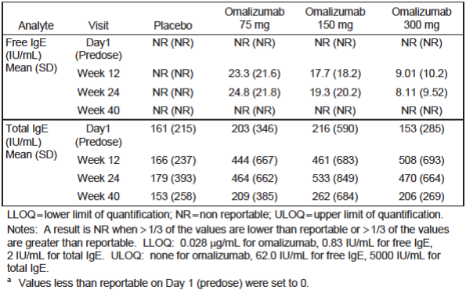

Study 4882g
The results for Study 4881g were provided. A similar pattern was observed with decreases in free IgE and increases in total IgE after 12 weeks of treatment. Levels returned to baseline values by Week 28 (20 weeks after last dose).

Study 4883g
Results for Study 4883g were provided. The findings were similar to those in 4881g and 4882g.

Study 4577g
This was a Phase II dose-ranging study in which patients received single doses of omalizumab or placebo. As in the Phase III studies, omalizumab administration resulted in a reduction in free IgE and an increase in total IgE.

Evaluator’s overall conclusions on pharmacodynamics
Omalizumab administration in patients with CIU resulted in deceases in free IgE and increases in total IgE (complexes of omalizumab and IgE). These findings are consistent with the known mechanism of action of omalizumab.

Dosage selection for the pivotal studies
The sponsor elected to study flat dosage regimens for the CIU trials (as opposed to the regimen based on weight and IgE levels used in allergic asthma). The rationale for this approach was that that there was little information supporting a relationship between serum IgE levels and CIU, and serum IgE levels in the CIU population are low compared with the allergic asthma population.
An initial single-dose, dose-ranging study was conducted (Study 4577g). This study evaluated doses of 75, 300 and 600 mg given SC every 4 weeks. It found that the 600 mg dose was no more efficacious than the 300 mg dose, and therefore 300 mg every 4 weeks was chosen as the maximum dose to be examined in the pivotal studies. The pivotal studies themselves also examined the use of two lower doses, 75 and 150 mg every 4 weeks. The 4 week dosage interval was chosen for Study 4577g on the basis of early investigator-initiated studies that showed duration of effect lasting several weeks.
After completion of the pivotal studies, the sponsor conducted various analyses to further justify the use of a flat dose regimen in preference to a regimen based on weight and serum IgE levels.

Clinical efficacy

Pivotal efficacy studies

Study 4881g (‘ASTERIA I’)

Study design, objectives, locations and dates
This study was a randomised, double blind, placebo controlled, dose ranging trial with four parallel groups. An overall study schema for the trial is shown in Figure 1. Patients attended the study clinic on days - 14 and - 7 during screening and then every 4 weeks during the treatment and follow up periods.
Figure 1 - Study 4881g – Study schema.
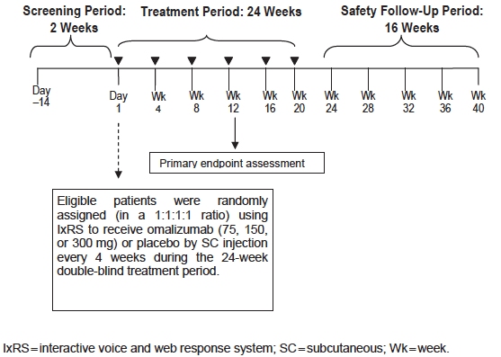
The primary objective of the study was to evaluate the efficacy of omalizumab compared with placebo in patients with refractory CIU receiving concomitant H1 antihistamine therapy.
The secondary objectives were:
- To evaluate the safety of omalizumab therapy in patients with refractory CIU
- To evaluate onset of clinical effect of omalizumab therapy in CIU
- To evaluate the dose of omalizumab therapy in patients with refractory CIU
- To evaluate duration of response after withdrawal of omalizumab in patients with refractory CIU
- To evaluate the quality of life benefit of omalizumab therapy in patients with refractory CIU.
The study was conducted in 53 centres in 8 countries: the United States (35 centres), Germany (5), Poland (4), France (3), Spain (2), Denmark (2), Italy (1), and Turkey (1).
The first patient was enrolled on 16 February 2011, and the last patient visit was on 17 October 2012. The study report was dated June 2013. The study does not appear to have been published other than in conference abstract form.

Inclusion and exclusion criteria
The inclusion criteria for the study are listed in Table 3, and the exclusion criteria in Table 4.

Table 3 - Study 4881g - Inclusion criteria.
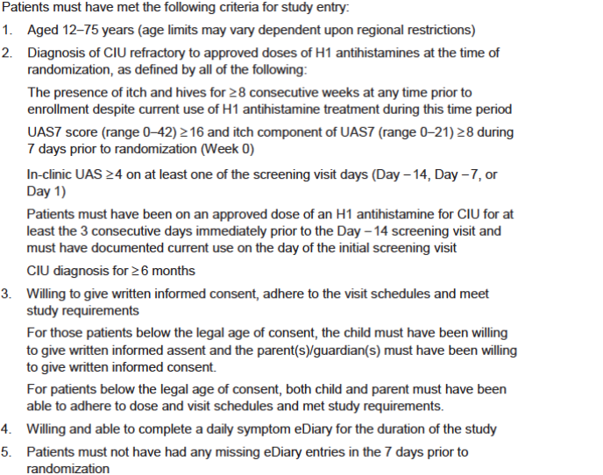

Table 4 - Study 4881g - Exclusion criteria.
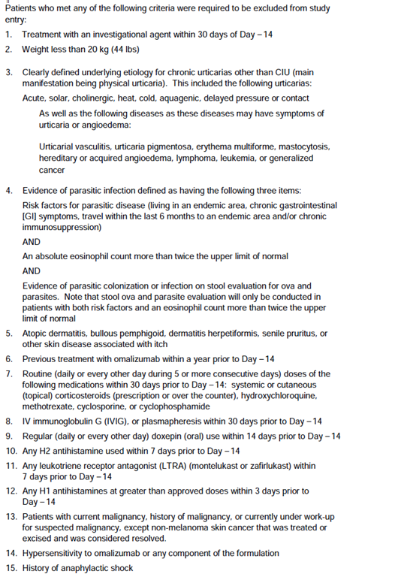

Table 4 (continued) - Study 4881g - Exclusion criteria

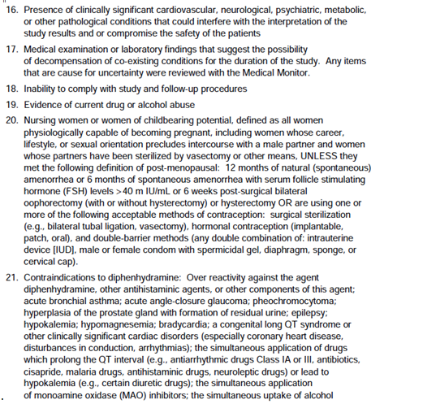

Study treatments
Subjects were randomised (1:1:1:1) to receive one of the following four treatments:
- Omalizumab 75 mg SC every 4 weeks
- Omalizumab 150 mg SC every 4 weeks
- Omalizumab 300 mg SC every 4 weeks
- Placebo.
Placebo contained the same ingredients as the omalizumab formulation, excluding omalizumab.
Treatment was continued for a total of 24 weeks (that is, six administrations). Patients received two injections at each treatment visit, as injections were limited to no more than 150 mg per injection site. SC injections were administered into the deltoid region, or into the thigh if there were medical reasons that precluded use of the deltoid.
Patients were required to remain on a stable H1 antihistamine treatment regimen throughout the study period. Permitted H1 antihistamine regimens were as follows:
- Cetirizine 5 or 10 mg once per day (QD)
- Levocetirizine dihydrochloride 2.5 or 5 mg QD
- Fexofenadine 60 mg twice per day or 180 mg QD
- Loratadine 10 mg QD
- Desloratadine 5 mg QD
- Ebastine 10 mg and 20 mg QD
- Rupatadine 10 mg QD
- Bilastine 20 mg QD
Patients were also provided diphenhydramine (25 mg) for itch relief on an as needed basis (up to a maximum of three doses in 24 hours).
As shown in Table 4, subjects who were receiving any of several medications (corticosteroids, immunosuppressants etc.) were excluded from the study. Subjects who received any of these therapies after randomisation were discontinued from study treatment. Subjects taking H2 antihistamines or LTRAs for another condition (for example; GORD or asthma) were permitted to continue their use during the study.

Efficacy variables and outcomes
Most efficacy data were collected via use of an electronic patient diary (eDiary). The variables recorded in the diary are summarised in Table 5.

Table 5 - Study 4881g - Data collected in patient daily diary
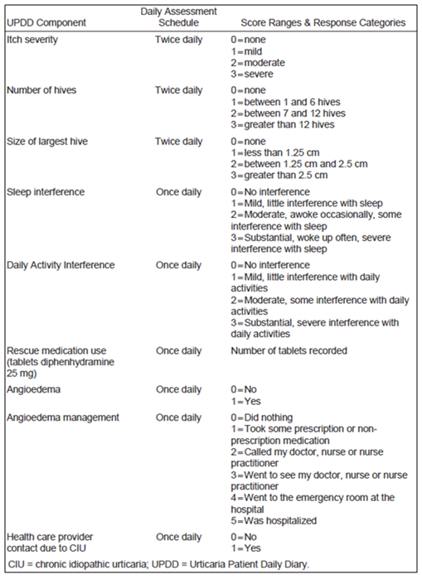
The main efficacy variables were:
- Itch severity score. Itch severity is recorded twice daily (morning and evening) in the patients’ eDiaries, on a scale of 0 (none) to 3 (severe). A daily itch severity score is calculated as the average of the morning and evening scores. A weekly itch severity score is calculated as the sum of the seven daily itch severity scores. Possible scores range between 0 and 21.
A ‘minimally important difference (MID) response’ was defined as reduction from baseline in weekly itch score of a least 5 points.
- Hives score. The number of wheals (hives) is measured twice daily (morning and evening), on a scale of 0 (none) to 3 (> 12 hives). The daily hives score is the average of the morning and evening scores, and the weekly hives score is the sum of the daily hives scores over 7 days. Possible scores range between 0 and 21.
- Urticaria Activity Score (UAS). The UAS is a composite score combining the above scores for a) itch and b) number of wheals (hives) as per the following table (Table 6):

Table 6. Urticaria activity score basis.
Score | Wheals (Hives) | Puritis (Itch)
0 | None | None
1 | Mild (1 – 6 hives/ 12 hour) | Mild
2 | Moderate (7 – 12 hives/ 12 hour) | Moderate
3 | Intense (> 12 hives/ 12 hour) | Severe
The scores for each are measured twice daily and daily UAS is the average of the morning and evening scores and has a possible range of 0 to 6. The weekly UAS (UAS7) is the sum of the seven daily UAS scores with a possible range of 0 to 42.
- The largest hive score. The largest hive score is measured twice daily, on a scale of 0 (none) to 3 (> 2.5 cm). The daily largest hive score is the average of the morning and evening scores, and the weekly largest hive score is the sum of the daily scores over 7 days. Possible scores range between 0 and 21.
- The Dermatology Life Quality Index (DLQI). The DLQI is a validated and widely used quality-of-life instrument specific to dermatological disorders. In consists of 10 items covering six domains (symptoms and feelings, daily activities, leisure activities, work or school, personal relationships and treatment). Subjects are asked to rate the degree to which the skin condition has affected each item over the preceding week, from ‘not at all’ (0) to ‘very much’ (3). The range of possible scores is 0 to 30, with higher scores indicating a poorer quality of life. The minimally important difference (MID) in patients with CIU has been estimated to be in the range of 2.24 to 3.10 points ⁽⁹⁾. The DLQI was administered at clinic visits at weeks 0, 4, 12, 24 and 40.
The primary efficacy endpoint was the change from baseline in the weekly itch severity score at Week 12; defined as the Week 12 weekly itch severity score minus the baseline weekly itch severity score.
Secondary efficacy endpoints were:
- The change from baseline in UAS7 at Week 12
- The change from baseline in weekly hives score at Week 12
- Time (in weeks) to a MID response in weekly itch severity score
- The proportion of subjects with a UAS7 of ≤ 6 at Week 12
- The proportion of subjects with a MID response in weekly itch severity score at Week 12
- The change from baseline in the weekly largest hive score at Week 12
- Change from baseline in health-related quality-of-life as measured by the DLQI at Week 12
- The proportion of angioedema-free days from Week 4 to Week 12 of therapy
- The proportion of subjects with a UAS7 = 0 (complete responders) at Week 12.
The study protocol and statistical analysis plan listed another 22 exploratory efficacy endpoints. These included several of the above efficacy variables at Week 24 (as opposed to Week 12), time to relapse in Week 24 responders and a number of other patient reported outcomes (EQ-5D QoL score, Medical Outcomes Study [MOS] Sleep Score, Chronic Urticaria QoL Questionnaire [CU-Q2oL]). The sponsor is proposing to include some of the 24-week results in the PI and these results will therefore be reviewed in this report. The other exploratory endpoints will not be considered.
Comment: The 2009 consensus guideline recommends the UAS as a validated measure of assessing disease severity. The decision to use the itch component of the UAS as the primary efficacy endpoint was made following discussions with the FDA and EMA.

Randomisation and blinding methods
Patients were randomised in a 1:1:1:1 ratio to one of the four treatment groups using a hierarchical dynamic randomization scheme and an Interactive Voice and Web Response System. Randomisation was stratified by baseline weekly itch severity score (< 13 versus ≥ 13), baseline weight (< 80 kg versus ≥ 80 kg), and study site.
Blinding was achieved through the use of a placebo that was identical to the active apart from the presence of omalizumab. The sponsor, all patients, study personnel and evaluating physicians were blinded to treatment assignment.

Analysis populations
The randomized population included all randomized patients regardless of whether they received any study drug. Treatment groups for this population were defined according to the treatment assigned at randomization.
The modified intention to treat (mITT) population included all patients randomized in the study who received at least one dose of study drug. The treatment group for this population was defined according to the treatment assigned at randomization. This population was to be used for efficacy analysis.
The safety population included patients who received at least one dose of study drug. Treatment groups for this population were defined according to the actual treatment received during the treatment period.
A PK evaluable population was also defined as including all randomized patients who received at least one dose of study drug and provided at least one serum sample for determination of omalizumab concentration. The PK data collected in this study contributed to a population PK analysis.
Comment: The study design, conduct and analysis were satisfactory.

Sample size
Based on earlier studies, it was assumed that the mean change from baseline in the weekly itch severity score at Week 12 would be 9 points for the omalizumab groups and 3.5 points for the placebo group, with a standard deviation of 6 points for both. Also based on earlier studies it was assumed that there would be a 15% rate of discontinuation at Week 12.
It was calculated that a total of 300 patients (randomised 1:1:1:1 with 75 patients in each treatment group) would yield approximately 98% power to detect a difference in treatment effect in the primary endpoint at the 0.05 level for any omalizumab group.

Statistical methods
The primary analysis was planned to take place when all patients had completed their Week 40 visit. The null hypothesis was that there was no difference between placebo and each omalizumab group.
For the primary endpoint (weekly itch severity score at Week 12) treatment comparisons between each of the omalizumab groups and the placebo group were undertaken using analysis of covariance (ANCOVA), controlling for baseline weekly itch severity score (< 1 3 versus ≥ 13), and baseline weight (< 80 kg versus ≥ 80 kg).
A separate analysis was undertaken for each omalizumab dose group versus placebo. The least squares means (LSM) and the corresponding 95% confidence intervals (CIs) of the differences between each of the omalizumab groups and the placebo group were presented along with the p-values for treatment differences resulting from the ANCOVA model.
In order to maintain an overall type I error rate of 0.05 (two sided) across the three omalizumab dose levels, the testing of the primary endpoint was conducted in the following hierarchical order:
- Stage 1: Omalizumab 300 mg group versus placebo. If no statistically significant difference was found between the omalizumab 300 mg group and the placebo group at the significance level of 0.05, then the test for the next stage would not be considered statistically significant regardless of the p-value.
- Stage 2: Omalizumab 150 mg group versus placebo. If there was no statistically significant difference found between the omalizumab 150 mg group and the placebo group at the significance level of 0.05, then the test for the next stage would not be considered statistically significant regardless of the p-value.
- Stage 3: Omalizumab 75 mg group versus placebo. The statistical test will be conducted at a significance level of 0.05.
Missing Week 12 weekly itch severity scores were imputed by carrying forward the baseline weekly itch severity score.
The statistical methods used for the analysis of the secondary endpoints are summarised in Table 7. The analysis of the secondary endpoints was also conducted in a hierarchical order (the order shown in Table 7), to maintain an overall type I error rate of 0.05 (two sided). There were nine stages to the analysis, with the nine stages corresponding to the nine secondary endpoints. A p-value that was less than 0.05 could only be claimed as statistically significant if statistical significance had been demonstrated at the previous stage.

Table 7 – Study 4881g – Statistical methods for secondary endpoints
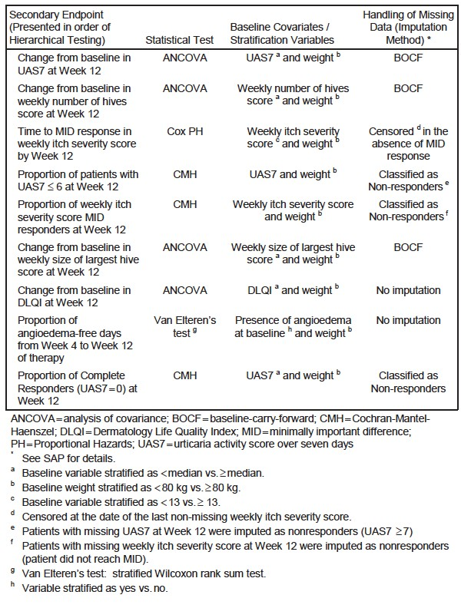

Participant flow
A total of 483 subjects were screened for inclusion in the study, 319 were enrolled and 318 were treated. The most frequent reasons for screening failures were:
- Patient unwilling to give written informed consent, adhere to the visit schedules and meet study requirements (14.0%)
- Patient not diagnosed as having CIU refractory to H1 antihistamines at the time of randomization (10.5%) and
- Other - not defined (27.5%).
Of the 319 subjects randomised, 265 (83.1%) completed the 24 weeks of treatment and 262 (82.1%) completed the entire 40 weeks of the study. The reasons for withdrawal from the study (that is, prior to Week 40) were provided. Reasons for withdrawal of treatment (that is, prior to Week 24) were provided. The analysis populations are shown in Table 8.

Table 8. - Study 4881g - Analysis populations.
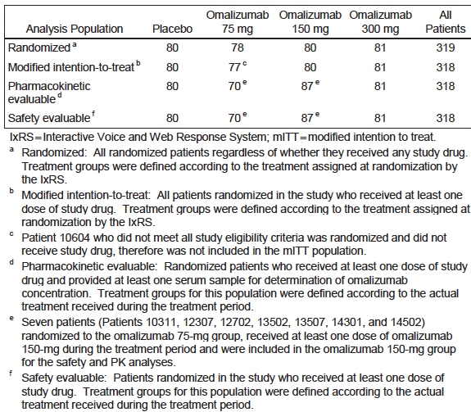

Major protocol violations/deviations
Major protocol violations were defined as those that:
- Increased the risk or decreased the benefits of the study
- Affected the validity of the data or information resulting from the completion of the approved protocol
- Affected the scientific soundness of the investigational plan or protocol and/or
- Affected the patient’s rights, safety or welfare.
A major protocol violation included violations of informed consent and eligibility criteria, as well as violations that occur during the course of the study.
The types of major protocol violations that occurred are summarised in Table 9. Only one protocol violator was excluded from the mITT and safety analyses. This patient had been randomised but did not receive study drug.
Comment: Although the frequency of major deviations was high they were distributed evenly across the four treatment groups. It is unlikely that the deviations would bias the results of the study.

Table 9. - Study 4881g - Major protocol violations.
 | Placebo (n=80) | Omalizumab  75 mg (n=78) | Omalizumab  150 mg (n=80) | Omalizumab  300 mg (n=81) | All Patients (n=319)
Any deviations | 20 (25.0%) | 16 (20.5%) | 16 (20.0%) | 21 (25.9%) | 73 (22.9%)
Concomitant Medication Criteria | 18 (22.5%) | 11 (14.1%) | 11 (13.8%) | 15 (18.5%) | 55 (17.2%)
Eligibility and Entry Criteria | 2 (2.5%) | 6 (7.7%) | 5 (6.3%) | 5 (6.2%) | 18 (5.6%)
Investigational Product Compliance | (0.0%) | 1 (1.3%) | 1 (1.3%) | 1 (1.2%) | 3 (0.9%)
Informed Consent | 1 (1.3%) | (0.0%) | (0.0%) | 1 (1.2%) | 2 (0.6%)
Study Procedures Criteria | (0.0%) | (0.0%) | 1 (1.3%) | (0.0%) | 1 (0.3%)

Baseline data
Baseline demographic characteristics and baseline disease characteristics are shown in Table 10 below.

Table 10. Study 4881g Baseline demographic characteristics (mITT population).
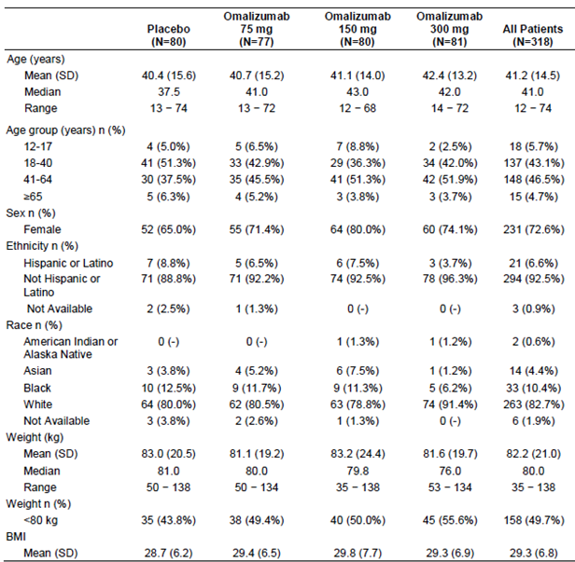

Table 10 continued
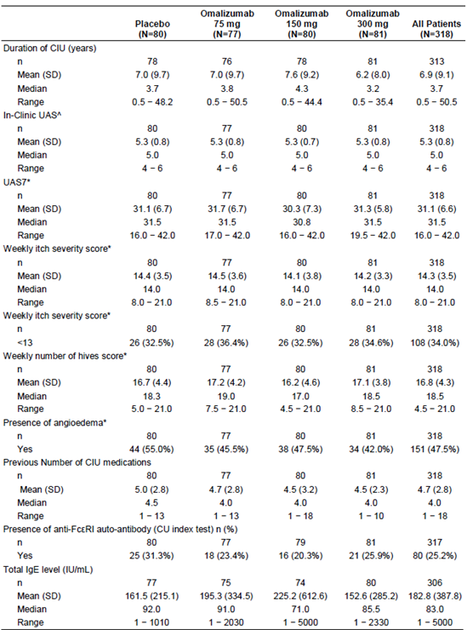
mITT: All patients randomised in the study who received at least one dose of study drug.
^Baseline in-clinic UAS is defined as the largest value among the Day -14 screening visit, Day -7 screening visit and Day 1 visit. * Based on data collected in patient daily eDiary in the week before randomisation.
Comment: The four treatment groups were reasonably well balanced with respect to baseline characteristics. The population was predominantly female (72.6%) with a median age of 41.0 years. Median duration of CIU was 3.7 years, and the median number of previous medications used was 4.0, suggesting that the population had long standing, treatment resistant disease. Baseline median UAS7 was 31.5 (out of a possible 42) and baseline median weekly itch severity score was 14.0 (out of a possible 21), suggesting moderate to severe disease. Angioedema was present at baseline in 47.5% of subjects.
The study report included tabulations of concurrent diseases and previous treatments. These were similar across the four treatment groups.

Results for the primary efficacy outcome
The results for the primary efficacy endpoint (change from baseline in weekly itch severity score at Week 12) are summarised in Table 11. All three doses of omalizumab were associated with statistically significant improvements compared to placebo.
Comment: Weekly score at baseline was approximately 14.0. Placebo corrected improvements in 75 and 150 mg omalizumab were modest (- 2.96 and - 2.95 points respectively). The placebo corrected improvement in the 300 mg omalizumab group was notably better (- 5.80 points).
The change in weekly itch severity score over the course of the study is illustrated in Figure 2.

Table 11. - Study 4881g – Change in weekly itch severity score at Week 12 (Primary endpoint).
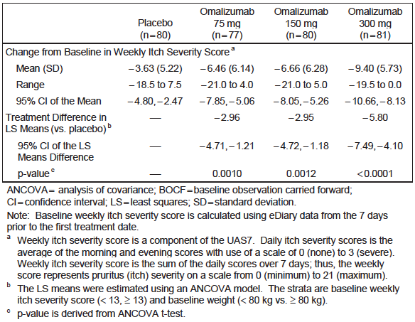

Figure 2. - Study 4881g - Mean Change from Baseline in Weekly Itch Severity Score (by Study Week).
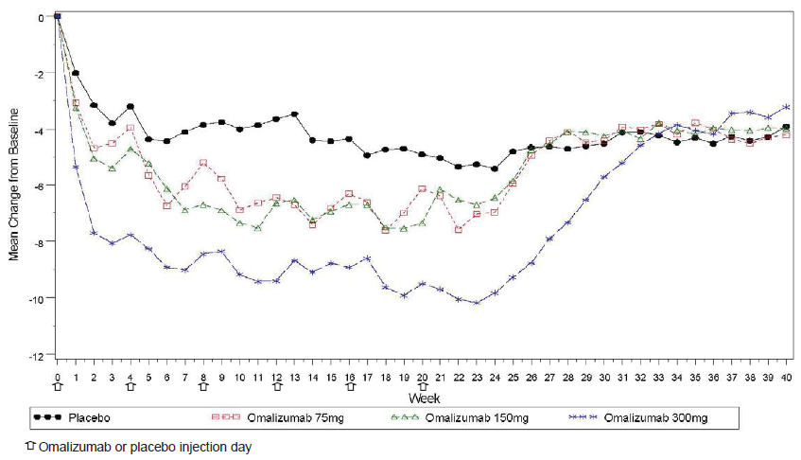

Results for secondary efficacy outcomes
Results for the secondary endpoints were provided. A statistically significant benefit compared to placebo was demonstrated on all nine secondary endpoints for the omalizumab 300 mg group, for 6/9 endpoints for the omalizumab 150 mg group, and only 2/9 endpoints for the omalizumab 75 mg group. Notable findings from the secondary endpoints included the following:
- Although differences between active arms were not subjected to statistical analysis, the magnitude of the benefit obtained was generally greater in the 300 mg group compared to the other two active arms.
- The time to a MID response in itch score was shorter in the 300 mg group (median = 1.0 week) compared to the 150 mg (2.0 weeks) and 75 mg (3.0 weeks) suggesting a more rapid onset of action with the higher dose.
- Baseline mean DLQI scores were in the range of 12.8 to 14.0 (out of a possible 30). The 75 and 150 mg omalizumab groups did not have a significant improvement in DLQI compared to placebo at Week 12. The (placebo-corrected) improvement in DLQI in the 300 mg group was approximately 4 points, which is greater than the minimally important difference (2.24 to 3.10 points).
- A complete response (UAS7 = 0, that is, no hives, no itch) was obtained in 35.8% of subjects in the 300 mg group, compared to 8.8% in the placebo group.

Results for exploratory efficacy outcomes
The study included a large number of exploratory endpoints. Several of these looked at efficacy at Week 24, as opposed to Week 12. A selection of these were summarised and provided in Table 12.
Comment: It should be noted that no adjustment for multiple comparisons was made for the exploratory endpoints. However, the results suggest that significant efficacy is maintained out to 24 weeks with the 300 mg dose, but not with lower doses. The sponsor is proposing to include some of these data in the product information.

Table 12. Study 4881g. Exploratory endpoints (at week 24).
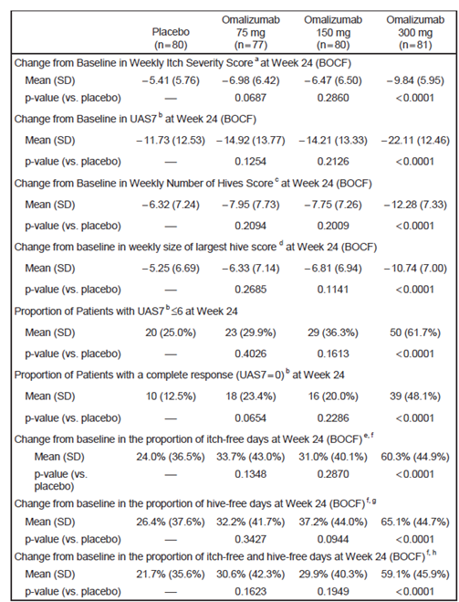
BOCF – baseline carried forward. MOS – Medical Outcomes Study. UAS7 – urticarial activity score over 7 days.
^{a.} Weekly itch severity score is a component of the UAS7. Daily itch severity scores is the average of the morning and evening scores with use of a scale of o (none) to 3 (severe). Weekly itch severity score is the sum of the daily scores over 7 days; thus the weekly score represents puritis (itch) severity on a scale of 0 (minimum) to 21 (maximum).
^{b.} The UAS is a composite of recorded score with numeric severity intensity ratings on a scale of 0 to 3 (0 = none to 3 = intense/severe) for 1) the number of wheals (hives): and 2) the intensity of the itch, measured twice daily (morning and evening). Daily UAS is the average of morning and evening scores (range 0 to 6 points/day) and the UAS7 is the sum of the daily UAS scores over 7 days (range 0 to 42).
^{c.} Number of hives is measured twice daily (morning and evening) on a scale from 0 (none) to 3 (> 12 hivers per 12 hours). Daily hives score is the average of morning and evening scores, and the weekly hives score is the sum of the daily hives scores over 7 days (range 0 to 21).
^{d.} Measured twice daily, on a scale of 0 (none) to 3 (>2.5 cm). Daily larges hive score is the average of the morning and evening scores, and the weekly larges hive score is the sum of the daily scores over 7 days (range 0 to 21).
^{e.} The proportion of itch free days is defined by the number of days a patient has a daily itch score of 0 over the number of days in Week 12.

Other analyses
Subgroup analyses were conducted for the primary endpoint. The results for the comparison of the 300 mg versus placebo were provided. The drug appeared to be effective in all subgroups analysed, as the point estimate for the LSM difference between omalizumab and placebo was consistently less than zero. Similar results were seen in subgroup analyses of the 150 and 75 mg omalizumab groups.
The study report also presented data on the completion of the patient daily diary. Compliance was high with the mean proportion of days a patient recorded at least one diary entry was > 96% for each treatment group during the first 12 weeks of the treatment period and > 95% during the entire 24 week treatment period.

Study 4882g (‘ASTERIA II’)

Study design, objectives, locations and dates
The study design was identical to that of Study 4881g, except that the duration of treatment was 12 weeks instead of 24 weeks. An overall study schema for the trial is shown in Figure 3. Patients attended the study clinic on Days - 14 and - 7 during screening and then every 4 weeks during the treatment and follow-up periods.
Figure 3. Study 4882g. Study schema.
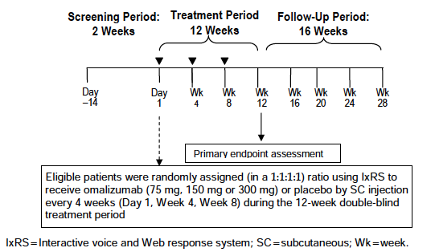
The objectives of the study were identical to those of Study 4881g.
The study was conducted in 55 centres in 8 countries: the United States (34 centres), Germany (5), Poland (5), Turkey (4), France (2), Denmark (2), Italy (2), and Spain (1).
The first patient was randomised on 10 March 2011, and the last patient visit was on 27 June 2012. The study report was dated June 2013. The study has been published. ⁽¹⁰⁾

Inclusion and exclusion criteria
The inclusion and exclusion criteria were identical to those used in Study 4881g (see Table 4 and Table 5).

Study treatments
Study treatments were identical to those used in study 4881g except that treatment was continued for only 12 weeks (3 administrations).

Efficacy variables and outcomes
The primary efficacy endpoint was the same as that used in Study 4881g (change from baseline in the weekly itch severity score at Week 12).
The secondary efficacy endpoints were identical to those used in Study 4881g, except that the proportion of subjects with a UAS7 equal to zero (complete responders) at Week 12 was not used as an endpoint. This study therefore only had eight secondary endpoints instead of nine.

Randomisation and blinding methods
Randomisation and blinding methods were identical to those used in Study 4881g.

Analysis populations
The analysis populations defined were identical to those in Study 4881g.

Sample size
The sample size calculations were identical to those used in Study 4881g. A sample size of 300 subjects was planned with 75 in each treatment group.

Statistical methods
The statistical methods used were identical to those used in Study 4881g. The primary analysis was planned to take place when all patients had completed their Week 28 visit.

Participant flow
A total of 466 subjects were screened for inclusion in the study, and 323 were randomised and 322 were treated. The most frequent reasons for screening failures were:
- Evidence of current drug or alcohol abuse (14.4%)
- Contraindications to diphenhydramine (12.3%) and
- Other (not specified) (32.2%).
Of the 323 subjects randomised, 304 (94.1%) completed the 12 weeks of treatment and 290 (89.8%) completed the entire 28 weeks of the study. The reasons for withdrawal from the study (that is, prior to Week 28) are shown in Figure 4. Reasons for withdrawal of treatment (that is, prior to Week 12were provided. The analysis population was described.

Figure 4. Study 4882g. Participant flow.
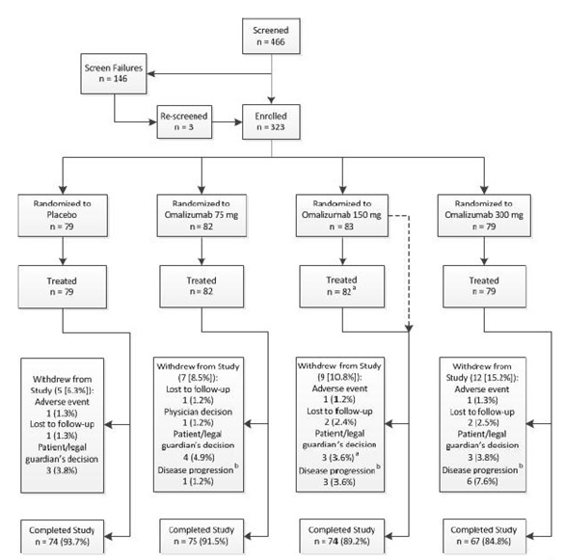
Note: Percentages are based on the number of randomised patients.
a. One patient (randomised to omalizumab 150 mg) did not receive study drug as a result of patient’s decision to withdraw, and was therefore not included in the mITT population.
b. Defined as either worsening of or no improvement of the patient’s disease.

Major protocol violations/deviations
The definition of a major protocol violation was identical to that used for Study 4881g. The types of major protocol violations that occurred in Study 4882g were provided. None of the violations led to exclusion of patients from the mITT population or the safety population.
Comment: Major protocol violations occurred more commonly in the 75 mg dose group (18.3%) compared to the other groups (5.1 to 9.6%).

Baseline data
Baseline demographic characteristics and baseline disease characteristics were provided.
Comment: The four treatment groups were reasonably well balanced with respect to baseline characteristics, although the 75 mg group was younger (median age 36.0) than the other groups (median age 43.0) and had a higher proportion of Black subjects (14.6% versus 5.1 to 8.9%). As in Study 4881g, the population was predominantly female (75.8%). Median age was 42.0 years.
Baseline disease characteristics were also very similar to those observed in Study 4881g, with median duration of CIU was 3.3 years, and the median number of previous medications used was 4.0. Baseline median UAS7 was 31.0 (out of a possible 42) and baseline median weekly itch severity score was 13.5 (out of a possible 21), suggesting moderate to severe disease. Angioedema was present at baseline in 40.7% of subjects.
The study report included tabulations of concurrent diseases and previous treatments. These were similar across the four treatment groups. In terms of concomitant medications used during the study there was a higher incidence of change in antihistamine treatment in the 75 mg dose group. Otherwise use of concomitant medications was evenly balanced across the treatment groups.

Results for the primary efficacy outcome
The results for the primary endpoint are shown in Table 13. In this study, the 75 mg dose did not demonstrate superiority over placebo. The 150 and 300 mg doses both produced a statistically significant reduction in itch. The change in weekly itch severity score over the course of the study is illustrated in Figure 5.
Comment: The magnitude of the difference between active and placebo for the 150 and 300 mg dose groups was comparable to that seen in Study 4881g, despite the treatment duration being shorter. Figure 5 shows that after omalizumab withdrawal, the itch scores return to a level above that seen in the placebo group, suggesting the possibility of a rebound effect.

Table 13. Study 4882g. Change in weekly itch severity score at Week 12 (Primary endpoint).
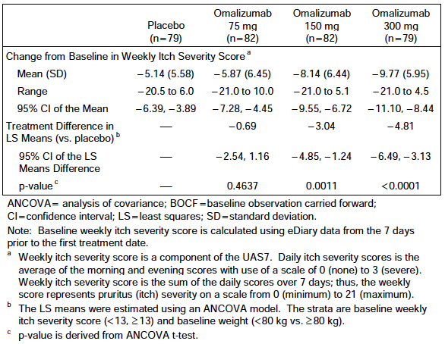

Figure 5. Study 4882g. Mean Change from Baseline in Weekly Itch Severity Score (by Study Week).
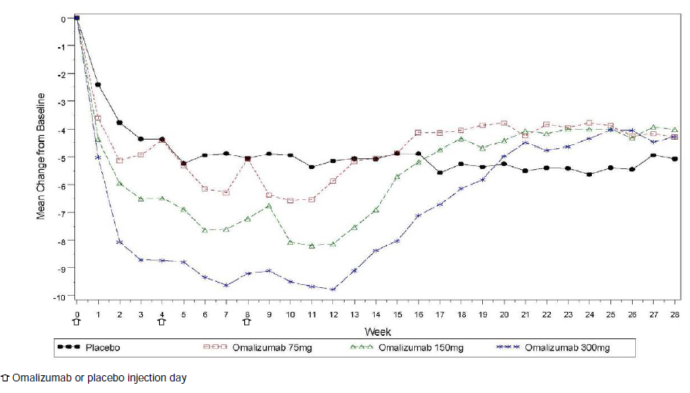

Results for secondary efficacy outcomes
The results for the secondary endpoints are summarised Table 14. A statistically significant benefit was demonstrated on all eight endpoints for the 300 mg dose, and on 7/8 endpoints for the 150 mg dose. A significant benefit was not demonstrated on any endpoint for the 75 mg dose. Notable findings from the secondary endpoints included the following:
- Although differences between active arms were not subjected to statistical analysis, the magnitude of the benefit obtained was generally greater in the 300 mg group compared to the 150 mg group.
- The time to a MID response in itch score was shorter in the 300 mg group (median = 1.0 week) compared to the 150 mg (2.0 weeks) suggesting a more rapid onset of action with the higher dose.
- Baseline mean DLQI scores were in the range of 12.6 to 13.0 (out of a possible 30). The (placebo-corrected) improvement in DLQI in the 300 mg group was approximately 3.8 points, which is greater than the minimally important difference (2.24 to 3.10 points). The (placebo- corrected) improvement in DLQI in the 150 mg group was approximately 2.5 points.

Table 14. Study 4882g. Results for secondary endpoints.
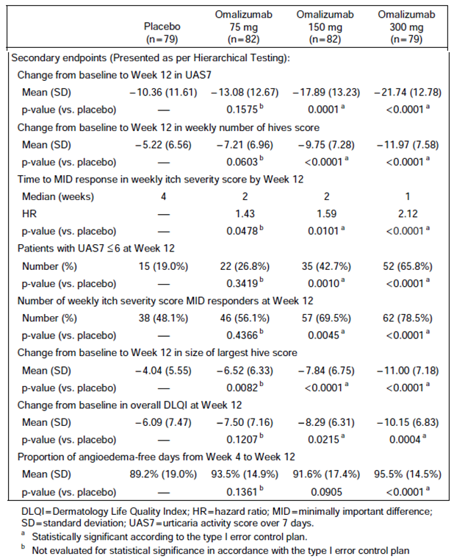

Results for exploratory efficacy outcomes
One of the exploratory endpoints used in this study was the proportion of patients with a UAS7 ≤ 6 at Week 28 (that is, in the follow-up period). The results were provided. Although the proportion of patients with a UAS7 ≤ 6 at Week 28 was numerically higher in the placebo arm, the differences with the omalizumab arms were not statistically significant. This suggests that any rebound effect seen in this study was unlikely to be important. Weekly itch severity score at Week 28 was not a study endpoint.

Other analyses
Subgroup analyses were conducted for the primary endpoint. The results for the comparison of the 300 mg dose versus placebo are shown in Figure 6. The drug appeared to be effective in most subgroups analysed, as the point estimate for the LSM difference between omalizumab and placebo was generally less than zero. Point estimates were greater than zero for patients aged > 65 years and Black patients, however the numbers in these subgroups were very small. Similar results were seen in subgroup analyses of the 150 mg omalizumab group.
Figure 6. Study 4882g. Subgroup analysis of change from baseline in weekly itch severity score at Week 12 (BOCF Method) omalizumab 300 mg versus placebo, mITT patients.
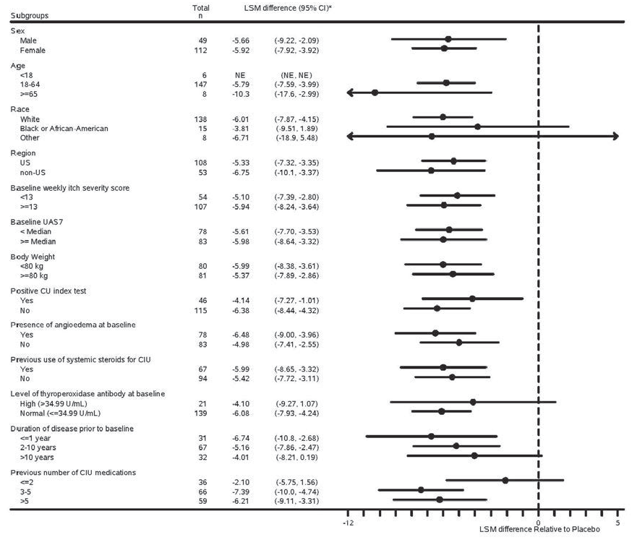
Data were presented on the completion of the patient daily diary. The mean proportion of days a patient recorded at least one diary entry was > 97% for each treatment group during the 12-Week treatment period.

Other efficacy studies

Study 4883g (‘GLACIAL’)

Study design, objectives, locations and dates
Study 4883g was a Phase III, randomised, double blind, and placebo controlled trial with two parallel groups. A study schema is shown in Figure 7. Patients attended the study clinic on Days - 14 and - 7 during screening and then every 4 weeks during the treatment and follow-up periods.
The primary objective of the study was to evaluate the safety of omalizumab compared with placebo in patients with refractory CIU receiving concomitant therapy including H1 antihistamines at increased doses (up to four times the approved dose), and/or H2 blockers and/or LTRAs.
The secondary objectives for this study were:
- To evaluate the efficacy of omalizumab compared with placebo in these patients
- To evaluate onset of clinical effect of omalizumab therapy in these patients
- To evaluate the quality-of-life benefits of omalizumab therapy in these patients.
The study was conducted in 65 centres in 7 countries - the United States (39 centres), Germany (9), Australia (5), Great Britain (4), Poland (3), New Zealand (3), and Singapore (2).
The first patient was randomised on 21 February 2011 and the last patient visit was on 22 November 2012. The study report was dated June 2013. The study has been published. ⁽¹¹⁾
Comment: Although this study was a well-designed, Phase III, randomised, double blind, placebo- controlled trial, the evaluation of efficacy was only a secondary objective. Also, the patient population enrolled in this study was different to that being proposed for registration in that subjects were not been treated with H1 antihistamines alone. It is therefore considered to be a supportive trial, rather than a pivotal one.
Figure 7. Study 4883g. Study schema.
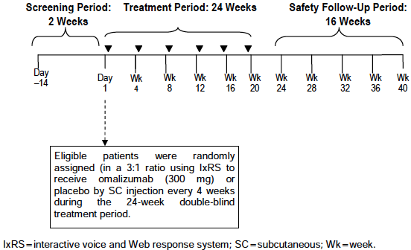

Inclusion and exclusion criteria
The inclusion criteria for the study were provided.
Comment: The inclusion criteria are similar to those used in the pivotal studies. However, this study enrolled a more treatment-resistant CIU population in that all patients were require to have failed treatment with H1 antihistamines and at least one of the following – a H2 antihistamine (for example; famotidine, ranitidine) or a leukotriene receptor antagonist (for example; montelukast or zafirlukast). None of these agents are registered for the treatment of chronic urticaria in Australia.
The exclusion criteria were identical to those used in the pivotal studies, except that recent use of H2 antihistamines, LTRAs or greater than approved doses of H1 antihistamines were not reasons for exclusion.

Study treatments
Subjects were randomised (3:1) to receive one of the following four treatments:
- Omalizumab 300 mg SC every 4 weeks
- Placebo.
Placebo contained the same ingredients as the omalizumab formulation, excluding omalizumab.
Treatment was continued for a total of 24 weeks (that is, six administrations). Patients received two injections at each treatment visit, as injections were limited to no more than 150 mg per injection site. SC injections were administered into the deltoid region or into the thigh if there were medical reasons that precluded use of the deltoid.
Patients were required to remain on a stable regimen of H1 antihistamine and either a H2 antihistamine or an LTRA throughout the study. Patients could also receive all three classes of drug concomitantly.
H1 antihistamines that were permitted during the study were as follows:
- Cetirizine 5 or 10 mg once per day (QD)
- Levocetirizine dihydrochloride 2.5 or 5 mg QD
- Fexofenadine 60 mg twice per day or 180 mg QD
- Loratadine 10 mg QD
- Desloratadine 5 mg QD
- Ebastine 10 mg and 20 mg QD
- Rupatadine 10 mg QD
- Bilastine 20 mg QD.
The above doses were the approved dosage regimens for these drugs. In this study, subjects were permitted to use up to four times the approved dose.
Permitted H2 antihistamine regimens during the study were as follows:
- Cimetidine 800 mg BD or 400 mg QID
- Famotidine 40 mg QD or 20 mg QD or BD
- Nizatidine 150 mg QD
- Ranitidine 150 mg BD.
Permitted LTRA regimens during the study were as follows:
- Montelukast 10 mg QD
- Zafirlukast 20 mg BD.
Patients were also provided diphenhydramine (25 mg) for itch relief on an as needed basis (up to a maximum of three doses in 24 hours).
Subjects who were receiving any of several medications (corticosteroids, immunosuppressants etc.) were excluded from the study. Subjects who received any of these therapies after randomisation were discontinued from study treatment.

Efficacy variables and outcomes
Efficacy data were collected using the same patient daily diary used in the pivotal studies. The efficacy endpoints used were the same as the 1 primary and 9 secondary endpoints used in Study 4881g. However, in this study there was no designated primary endpoint. Weekly itch severity score at Week 12 (the primary endpoint in the pivotal studies) was referred to as a ‘key’ efficacy endpoint.
A further 14 exploratory endpoints were defined in the statistical analysis plan.

Randomisation and blinding methods
Patients were randomised in a 3:1 ratio to omalizumab or placebo. As in the pivotal studies, a hierarchical dynamic randomization scheme and an Interactive Voice and Web Response System was used and randomisation was stratified by baseline weekly itch severity score (< 13 versus ≥ 13), baseline weight (< 80 kg versus ≥ 80 kg), and study site.
Blinding methods were identical to those used in the pivotal studies.

Analysis populations
The analysis populations were identical to those defined for the pivotal studies.

Sample size
The sample size was based on safety considerations, and not on efficacy criteria.
Approximately 320 patients were planned for randomization to either the omalizumab (300 mg) or placebo treatment groups in a 3:1 ratio. With this sample size, the probability of observing one or more instances of an adverse event over the period of this study, assuming a background rate of 2% or 3%, was above 0.99 in the omalizumab group, and 0.80 and 0.91 in the placebo group, respectively.

Statistical methods
The statistical methods used to analyse the 10 efficacy endpoints were identical to those used in Study 4881g. All statistical tests were to be conducted at a 0.05 significance level. The analysis of the efficacy endpoints was conducted in a hierarchical order, to maintain an overall type I error rate of 0.05 (two-sided). A p-value that was less than 0.05 would only be claimed statistically significant if statistical significance has been demonstrated for the previous endpoint in the hierarchy.

Participant flow
A total of 480 subjects were screened for inclusion in the study, 336 were randomised and 335 were treated. The most frequent reasons for screening failures were:
- Missing eDiary entries in the 7 days prior to randomisation (15.3%)
- Not diagnosed as having CIU refractory to H1 antihistamines, and/or H2 blockers and/or LTRAs at the time of randomization (7.6%)
- Other (not defined) (36.8%).
Of the 336 subjects randomised, 284 (84.5%) completed the 12 weeks of treatment and 290 (86.3%) completed the 40 weeks of the study. The reasons for withdrawal from the study (that is, prior to Week 40) are shown in Figure 8. Reasons for withdrawal of treatment (that is, prior to Week 24) and description of the analysis populations were provided.

Figure 8. Study 4883g. Participant flow.
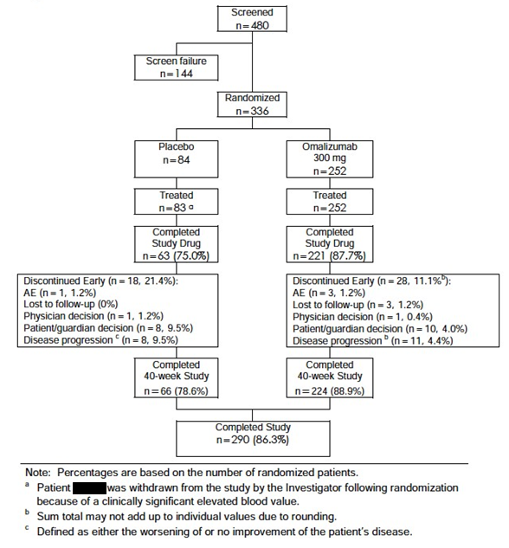

Major protocol violations/deviations
A major protocol violation was defined in the same manner as in the pivotal studies. The types of violations that occurred were provided.
Comment: The various types of protocol violation occurred at comparable frequencies in the two treatment groups. It is unlikely that they would have caused any significant bias in the interpretation of the study.

Baseline data
Baseline demographics were summarised and provided, and baseline disease characteristics were provided.
Comment: The two treatment groups were well balanced with respect to baseline characteristics. Subjects in this study had tried a larger number of CIU medications (median = 6.0) compared to subjects enrolled in the pivotal studies (median = 4.0). Otherwise the baseline characteristics were very similar across the three studies.
Concurrent and previous treatments and previous diseases were similar in the two treatment groups.

Results for the efficacy outcomes
Results for the efficacy outcomes are summarised in Table 15. Omalizumab treatment was associated with a statistically significant benefit on all ten efficacy endpoints tested. Results for the ‘key’ efficacy endpoint of weekly itch severity score at Week 12 (the primary endpoint in the pivotal studies) were provided in detail. The results for weekly itch severity score over the entire course of the study are shown in Figure 9.
Comment: The efficacy findings in this study were consistent with those observed for the 300 mg dose of omalizumab in the two pivotal studies.

Table 15. Study 4883g. Results for efficacy endpoints.
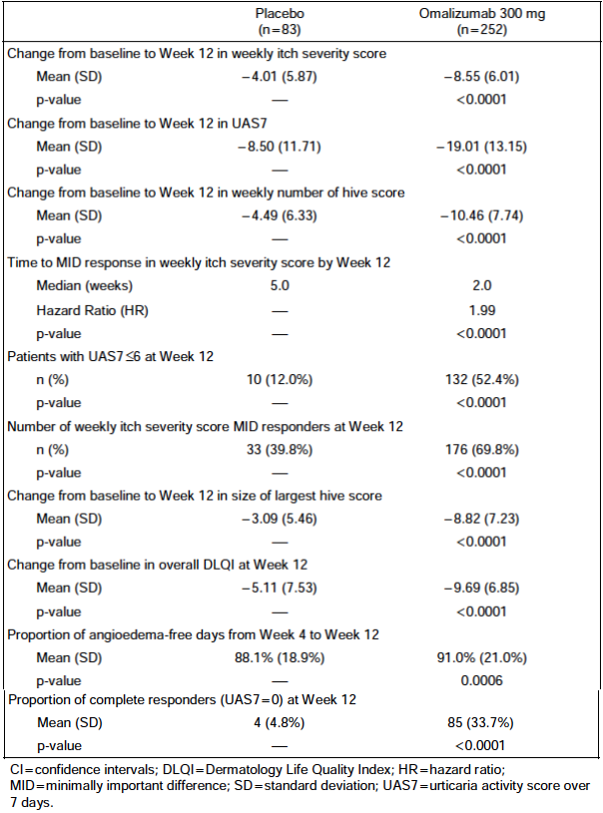

Figure 9. Study 4883g. Mean change from baseline in weekly itch severity score by Study Week.
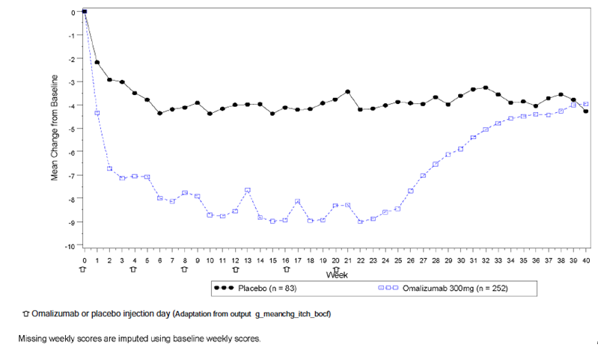

Results for exploratory efficacy outcomes
The study included a large number of exploratory endpoints. Several of these looked at efficacy at Week 24, as opposed to Week 12. A selection of these are summarised in Table 16.
Comment: As with the pivotal studies, no adjustment for multiple comparisons was made for the exploratory endpoints. However, the results suggest that significant efficacy is maintained out to 24 weeks with the 300 mg dose. The sponsor is proposing to include some of the 24-week data in the product information.

Table 16. Study 4883g. Exploratory endpoints (at Week 24).
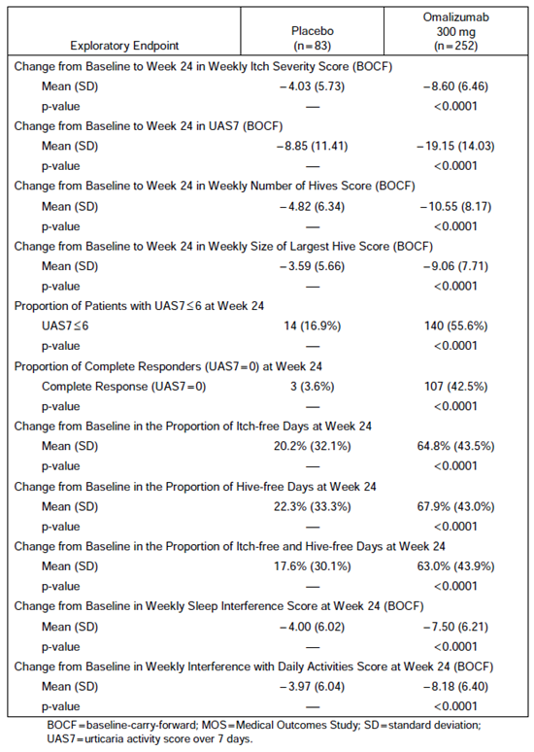

Study ADE05 (‘X-QUISITE’)
Study ADE05 was the earliest study of omalizumab conducted by the sponsor in patients with chronic urticaria. It was conducted between May 2007 and April 2009 in 16 centres in Germany. It was a small Phase IIIb, randomised, double blind, and placebo-controlled trial with two parallel groups. The study report stated that it was a proof-of-concept trial. The study has been published. ⁽¹²⁾
Patients included were aged 18 to 70 years, with a diagnosis of moderate to severe chronic urticaria that was unresponsive to the approved dose of a marketed antihistamine given for at least two weeks. Subjects were required to have a total serum IgE level of ≥ 30 IU/mL and ≤ 700 IU/mL at baseline. They were also required to have a specific IgE directed against thyroperoxidsae (TPO) at a serum level of ≥ 8.0 IU/mL.
Comment: Thyroperoxidase (TPO) is an enzyme expressed by the thyroid gland. Anti-TPO antibodies are commonly found in patients with autoimmune thyroid disease, such as Hashimoto’s thyroiditis. Thyroid disease and chronic urticaria are frequently associated. (3) By requiring subjects to have anti-TPO antibodies, the trial may have selected subjects that were more likely to have an autoimmune basis for their urticaria. Patients with physical urticaria were not explicitly excluded from the trial.
Subjects were randomised to receive omalizumab or placebo. Dosage was dependent on the patient’s weight and IgE level, similar to the currently approved regimen for allergic asthma. Treatment was continued for 24 weeks.
Comment: The dosage regimen is different to that being proposed for registration for CIU in Australia. In this study the dose administered could be as high as 750 mg per 4 week period, whereas the maximum proposed dose for CIU is 300 mg per 4 week period.
The primary endpoint for the study was the change from baseline to Week 24 (visit 8) in UAS7. A variety of secondary endpoints were also studied.
A total of 49 subjects were randomised, 27 to omalizumab and 22 to placebo. A total of 42 subjects (85.7%) completed the trial. Baseline demographics and disease severity were similar in the two groups. In the omalizumab group 11/27 subjects (41%) received an average monthly dose that was > 300 mg.
Results for the primary endpoint were provided. Omalizumab treatment was associated with a statistically significant greater improvement in UAS7 at Week 24 compared to placebo (p = 0.0089). For the secondary endpoints, differences between omalizumab and placebo were not analysed for statistical significance. The daily UAS score over the course of the study is shown in Figure 10.
Figure 10. Study ADE05. Daily UAS score over time.
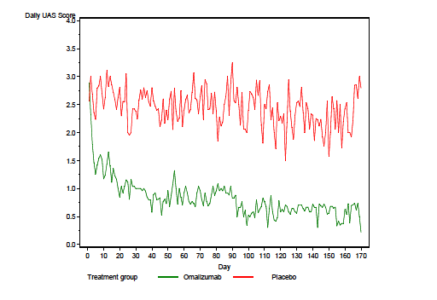

Study 4577g (‘MYSTIQUE’)
Study 4577g was a Phase II, randomised, double blind, placebo controlled, dose ranging study with four parallel groups. It was the second study in chronic urticaria conducted by the sponsor, taking place between March 2009 and January 2010 in a total of 26 centres, 22 in the USA and 4 in Germany. The study has been published.⁽¹³⁾
The primary objective of the study was to examine efficacy of the drug in CIU patients already receiving H1 antihistamines. Secondary objectives were to evaluate the safety and efficacy of different doses, to evaluate effects on quality of life and to evaluate the PK and PD of omalizumab in CIU patients. The PK data from this study were provided.
Included patients were aged 12to75, with a diagnosis of moderate to severe CIU despite treatment with a H1 antihistamine and a CIU diagnosis for at least 3 months. Patients with physical urticaria were not eligible for enrolment.
Comment: The study design, conduct and analysis were satisfactory.
Patients were randomised (1:1:1:1) to receive a single dose of one of the following four treatments:
- Placebo
- Omalizumab 75 mg SC
- Omalizumab 300 mg SC
- Omalizumab 600 mg SC
Randomisation was stratified by weight (< 80 kg versus ≥ 80 kg).
The sponsor justified the use of flat doses (as opposed to the regimen based on weight and IgE levels used in allergic asthma) on the grounds that there was little information supporting a relationship between serum IgE levels and CIU, and serum IgE levels in the CIU population are low compared with the allergic asthma population.
Subjects were required to continue treatment with the approved dose of a marketed H1 antihistamine for the duration of the study. Subjects were reviewed in the clinic on a weekly basis for the first 4 weeks after treatment, and then at 4 weekly intervals until the end of the study (Week 16).
The primary efficacy endpoint was change in the UAS7 from baseline to Week 4 (Days 21 to 27). Secondary efficacy endpoints were: the changes from baseline to Week 4 in: the weekly pruritus score, the weekly score for number of hives, a weekly score for sleep interference and in the amount of rescue medication (diphenhydramine 25 mg). The weekly scores for pruritus, number of hives and sleep disturbance were calculated by rating each of these daily on a scale of 0 to 3, and then summing the 7 daily scores. For each of these endpoints possible scores ranged between 0 and 21.
A total of 90 patients were randomised in the study; 21 to placebo, 23 to 75 mg, 25 to 300 mg and 21 to 600 mg. The four groups were reasonably well balanced with respect to baseline demographics and disease severity.
Results for the primary efficacy endpoint were provided. The change in UAS7 over the first 4 weeks after treatment is shown in Figure 11. Results for the secondary endpoints were provided.
Comment: For the primary endpoint of UAS7, and the secondary endpoints examining itch and number of hives, the 300 mg dose produced an efficacy benefit that was consistently significantly superior to placebo. The differences between the 600 mg dose and placebo were of borderline statistical significance and the efficacy results with the 300 mg dose were numerically superior to those obtained with the 600 mg dose. As there did not appear to be an added benefit with the 600 mg dose compared to the 300 mg dose, the 300 mg dose was chosen as the maximum dose for the subsequent Phase III studies.

Figure 11. Study 4577g. Weekly mean change in UAS7 from baseline.
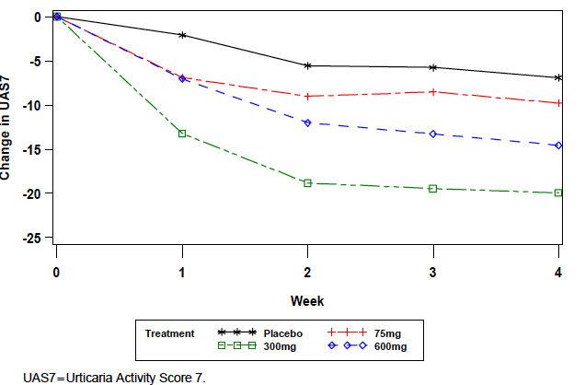

Analyses performed across trials (pooled analyses and meta-analyses)
In the Summary of Clinical Efficacy, the sponsor presented analyses of pooled efficacy data from the two pivotal studies 4881g and 4882g. The results for the primary endpoint of change in weekly itch severity score at Week 12 are shown in Table 17.
Comment: The results from the pooled efficacy analysis are consistent with the results of the individual studies. In the pooled analysis the 75 mg dose produced a statistically significant benefit compared to placebo, whereas the results for this dose in the individual studies were conflicting.
Analyses of the secondary endpoints using the pooled data were also presented, and similar results were obtained. No adjustments for multiple comparisons were made for these analyses. Subgroup analyses based on the pooled data also gave results consistent with the individual studies.

Table 17. Pooled efficacy data (Studies 4881g and 4882g). Change in weekly itch severity score at week 12.
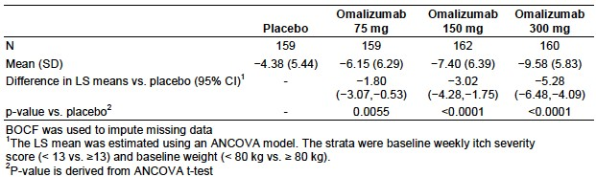

Evaluator’s conclusions on clinical efficacy for CIU
The two pivotal studies have demonstrated that omalizumab treatment produces improvements in disease activity that is statistically significantly greater than those produced with placebo. Superior efficacy compared to placebo was also demonstrated in three supportive studies.
The demonstrated efficacy benefits are considered clinically significant.
- Based on Study 4577g, the minimally important difference (MID) in weekly itch improvement score was estimated to be in the range of 4.5 to 5.0 points. ⁽¹⁴⁾ For the 300 mg dose, the (placebo-corrected) improvements in studies 4881g and 4882g were 5.8 and 4.8 points respectively).
- For UAS7, the MID was estimated to be in the range of 9.5 to 10.5 points. ⁽¹⁴⁾ For the 300 mg dose, the (placebo-corrected) improvements in UAS7 in studies 4881g and 4882g were 12.8 and 12.4 points respectively.
- Similarly, the placebo-corrected improvement in DLQI exceeded the MID of 2.24 to 3.10 points in Study 4881g and was within this range in Study 4882g.
- In Study 4881g the (placebo-corrected) proportion of patients who achieved complete resolution of itch and hives (that is, UAS7 = 0) at Week 12 was 27%. This figure rose to 35.6% at Week 24. In the supportive Study 4883g, the proportion was 28.9% at Week 12 and 38.9% at Week 24. Complete resolution of itch and hives is a clinically significant outcome, and these data suggest that it can be achieved in a substantial proportion of patients.
The recommended dose of 300 mg every 4 weeks is adequately supported by the submitted data. Results obtained with the 300 mg dose were consistently numerically superior to those obtained with the 150 mg dose. Onset of benefit was more rapid with the 300 mg dose and a statistically significant benefit was maintained out to 24 weeks with the 300 mg dose, but not with the 150 mg dose. It is noted that the draft PI indicates that the 150 mg dose may be effective in some patients. Results with the 75 mg dose were inconsistent and generally not clinically significant.
Retrospective analysis suggested that a dosing regimen based on baseline IgE levels and weight (as per the currently approved asthma regimen) would result in greater variability in efficacy than the proposed flat-dose regimen (Figure 12 and 13). Although a weight-based regimen would result in some decrease in variability in efficacy, the difference was not considered clinical significant. Another retrospective analysis (Figure 14) suggested that extending the dosage interval to 5 or 6 weeks would be associated with a greater proportion of patients losing disease control.
Overall the evidence submitted to support the efficacy of omalizumab in CIU is considered adequate.

Figure 12. Simulated mean itch improvement at week 12, for subject quartiles in weight, BMI and baseline IgE, for three different dosing regimens.
An E_{max} model was constructed for the relationship between itch improvement and omalizumab concentration at week 12. The model adequately predicted the observed data from the third study, Q4883g. Using this model, itch improvements were estimated using two alternate dosage regimens (weight-adjusted or weight and baseline IgE-adjusted). A weight-based regimen was found to reduce the variability in itch improvement, compared to the proposed flat dosing regimen. However, the reduction in variability was small (less than 1 point on a scale of 0-21) and was not considered clinically relevant. A regimen adjusted for both weight and baseline IgE resulted in increased variability in itch improvement, with subjects with lower baseline IgE levels achieving less itch improvement (as shown below).
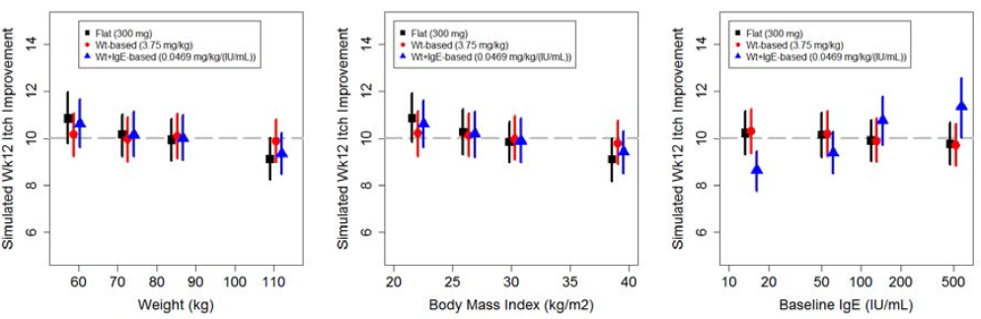
Points in the panels represent the simulated mean itch improvement at Week 12 for 300 mg-equivalent q4w regimens (flat, weight-based or weight- and IgE-based) stratified by weight (left), BMI (middle), or baseline IgE (right) quartile. Points are offset on the abscissa for clarity. Vertical lines are 95% confidence intervals representing model uncertainty. The horizontal dashed line represents the simulated mean itch improvement of the overall population for the 300 mg flat dose.
Figure 13. Simulated complete UAS7 responder percentage at Week 12, for subject quartiles in weight, BMI and baseline IgE, for three different dosing regimens.
Another E_{max} model was constructed for the relationship between UAS7 complete response (i.e. UAS7=0) and omalizumab concentration at week 12. In this model a weight-based regimen and a regimen adjusted for both weight and baseline IgE both resulted in increased variability in UAS7 complete response, compared to the proposed flat dosing regimen (as shown below).
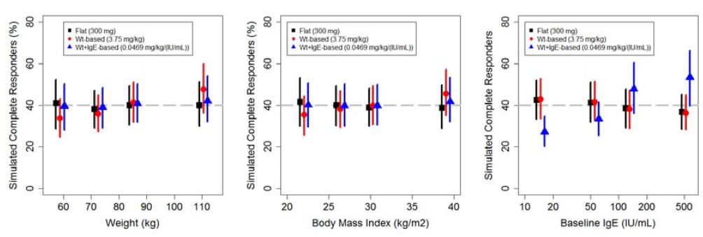
Points in the panels represent the simulated complete responder percentages at Week 12 for 300 mg equivalent q4w regimens (flat, weight-based or weight- and IgE-based) stratified by weight (left), BMI (middle), or baseline IgE (right) quartile. Points are offset on the abscissa for clarity. Vertical lines are 95% confidence intervals representing model uncertainty. The horizontal dashed line represents the simulated responder percentage of the overall population for the 300 mg flat dose.

Figure 14. Population PK/Efficacy time course analysis: Summary – effect of extending the dose interval –simulation of responder rates for different 300 mg dosing frequencies.
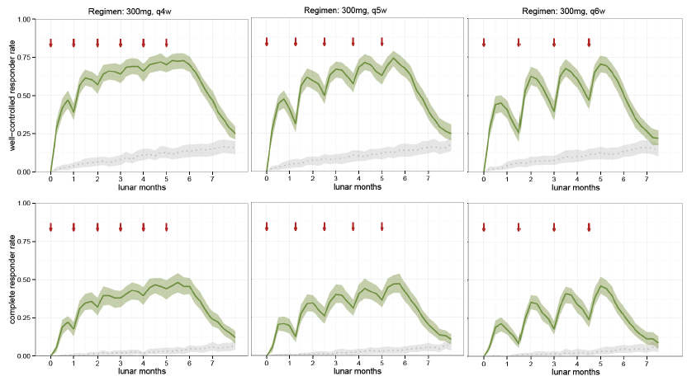
Red arrows indicate injection of 300 mg omalizumab. The line and band indicate the medians and 95% intervals for the predictions based on 200 randomly sampled groups of 200 patients drawn from the 632 (treated patients from studies Q4881g, Q4882g and Q4883g). The anticipated responder rates due to the placebo effect only are shown in grey with a dotted line for the median. Well-controlled and complete responses are defined as UAS7 ≤ 6 and UAS < 1 for the simulations. Lunar months are 4 week intervals.

Clinical safety
Omalizumab has previously been associated with hypersensitivity reactions, including anaphylaxis and serum sickness, and precautionary statements on these issues are included in the current PI.
The drug has also been associated with thrombocytopaenia in animal studies, but not in human clinical trials. However, the current PI lists ‘idiopathic severe thrombocytopaenia’ as an adverse reaction identified through spontaneous post-market reporting.
In the clinical trials submitted to support registration in asthma, there were an excess number of cases of malignancy with omalizumab compared to placebo (0.5% versus 0.2%). A precautionary statement on this issue is included in the current PI. A subsequent published analysis of a larger number of randomised placebo-controlled trials found no significant increase in the risk of malignancy. ⁽¹⁵⁾
In 2009 the FDA announced that it was conducting a safety review of omalizumab ⁽¹⁶⁾. An interim analysis of a large ongoing non-randomised study in asthma patients (the EXCELS study) had suggested an increased incidence of serious cardiovascular adverse events. However, no action has been taken by the FDA on this issue since that time.

Studies providing evaluable safety data
The following studies provided evaluable safety data:
Phase III studies (4881g, 4882g and 4883g).
In the three Phase III studies, the following safety data were collected:
- General adverse events (AEs) were assessed at each clinic visit and were coded using MEDRA terminology. The following were nominated as AEs of special interest:
  - Anaphylaxis
  - Churg-Strauss syndrome
  - Hypersensitivity
  - Injection-site reactions
  - Malignancy
  - Serum sickness syndrome
  - Skin rash
  - Thrombocytopenia and bleeding-related disorders
  - Hematopoietic cytopaenias
  - Arterial thrombotic events
  - Asthma/bronchospasm
  - Liver-related investigations, signs or symptoms.
- Haematology tests were conducted every 4 weeks during the treatment period and every 8 weeks during the follow up period. Tests done were: haemoglobin, haematocrit, platelet count, RBC count, WBC count, per cent, and absolute differential count (neutrophils, bands, eosinophils, lymphocytes, monocytes, basophils, other cells).
Blood biochemistry and urinalysis were only conducted at baseline.
The Summary of Clinical Safety in Module 2 of the submission included an analysis of safety based on pooled data from the three Phase III studies. This analysis forms the main basis of the review of safety in this evaluation report.

Pivotal studies that assessed safety as a primary outcome
The primary objective of Study 4883g was to examine the safety of omalizumab compared to placebo. However, the safety findings from this study are reviewed as part of the pooled safety analysis.

Dose-response and non-pivotal efficacy studies
In Study ADE05 data on AEs were collected at each study visit (that is, every 4 weeks) over the 24 week period of the study. Central laboratory testing (haematology and biochemistry) was only conducted at screening and at Week 24.
In Study 4577g data on AEs were collected weekly for the first 4 weeks after the single dose of treatment and then every 4 weeks until Week 16. Haematology was tested at the same times. Blood biochemistry and urinalysis were only conducted at baseline. Vital signs were measured at 4 weekly intervals.

Patient exposure
The five clinical studies in the submission, included at total of 1114 subjects. Of these, 829 received omalizumab and 285 received placebo. This is summarised in Table 18.

Table 18. Exposure to Omalizumab and placebo in clinical studies.
Study | Placebo | Omalizumab |  |  |  |  | Total
 |  | 75 mg | 150 mg | 300 mg | Other | Total
ADE05 | 22 | - | - | - | 27* | 27 | 49
4577g | 21 | 23 | - | 25 | 21* | 69 | 90
Phase III studies | 242 | 146 | 175 | 412 | - | 733 | 975
Totals | 285 | 169 | 175 | 437 | 48 | 829 | 1114
*In ADE05 27 subjects were treated with a dosage regimen adjusted for weight and baseline IgE level. In 4577g 21 subjects were treated with a 600 mg dose.
In the pooled safety database from the three Phase III studies, 733 subjects received omalizumab and 242 received placebo. Duration of exposure in these studies is summarised in Table 19. The maximum planned duration of treatment with omalizumab in the studies was 24 weeks. The mean (± SD) duration of treatment for patients who received the proposed 300 mg dose was 20.3 (± 6.0) weeks.

Table 19. Pooled safety data – Extent of exposure.
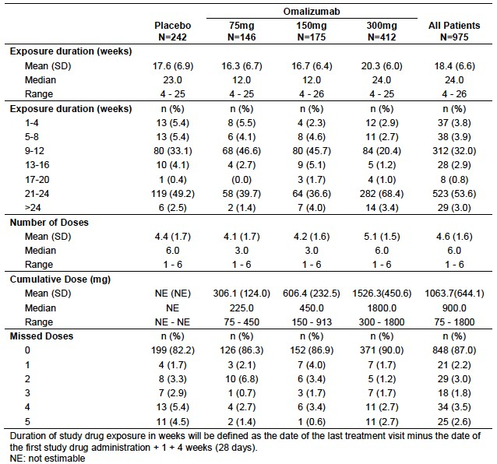

Adverse events (AEs)
The overall AE profile in the pooled safety database is summarised in Table 20.

Table 20. Pooled safety data – Overall AE profile.
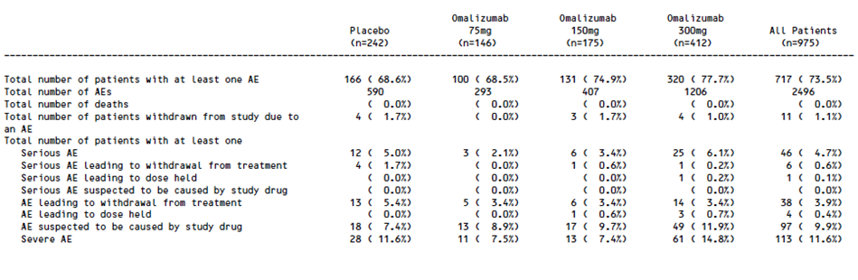

All adverse events (irrespective of relationship to study treatment)

Pooled safety database
For the pooled safety data, the sponsor presented various analyses. The ‘core’ safety analysis was of AEs occurring from Day 1 to Week 12, as all three Phase III studies were of at least this duration.
The sponsor also presented an ‘extended’ safety analysis of AEs occurring from Day 1 to Week 24 in Studies 4881g and 4883g.
Up to Week 12, the overall incidence of any AE in the four treatment groups was: 42.6% (placebo), 42.5% (75 mg), 54.3% (150 mg) and 50.2% (300 mg). Individual AEs that occurred with a frequency of at least 1% (in any of the treatment groups) are summarised in Table 21.
Comment: For most of the individual AE terms, the differences in incidence between the placebo and omalizumab groups were small, and there was no evidence of increasing incidence with increasing omalizumab dose. AEs that did show some evidence of being related to dose were:
- Arthralgia 0.4% (placebo) versus 0.7% (75 mg) versus 2.9% (150 mg) versus 2.9% (300 mg)
- Headache 2.9% versus 2.7% versus 12.0% versus 6.1%
- Asthma 0.4% versus 0.0% versus 0.6% versus 1.2%
- Injection site reactions: 0.4% versus 0.0% versus 0.6% versus 1.9%
In the extended analysis (up to Week 24 in 4881g and 4883g), the overall incidence of any AE in the four treatment groups was: 57.7% (placebo), 58.6% (75 mg), 69.0% (150 mg) and 63.1% (300 mg). The pattern of individual AE terms was similar to the 12 week analysis.

Table 21. Pooled safety data. AEs occurring in > 1% of subjects in any group
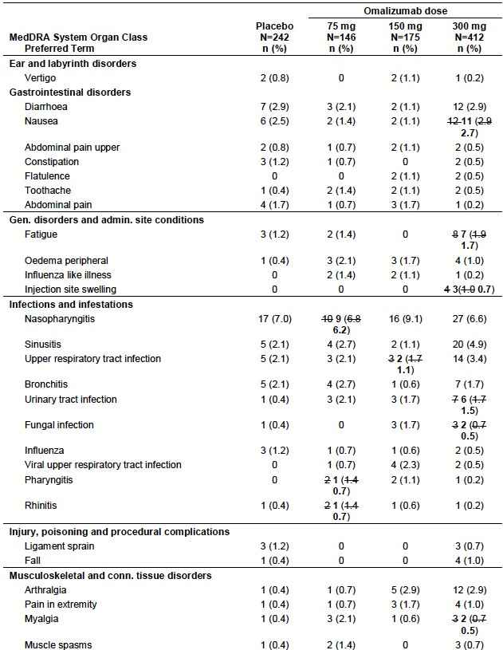

Table 21(continued). Pooled safety data. AEs occurring in > 1% of subjects in any group

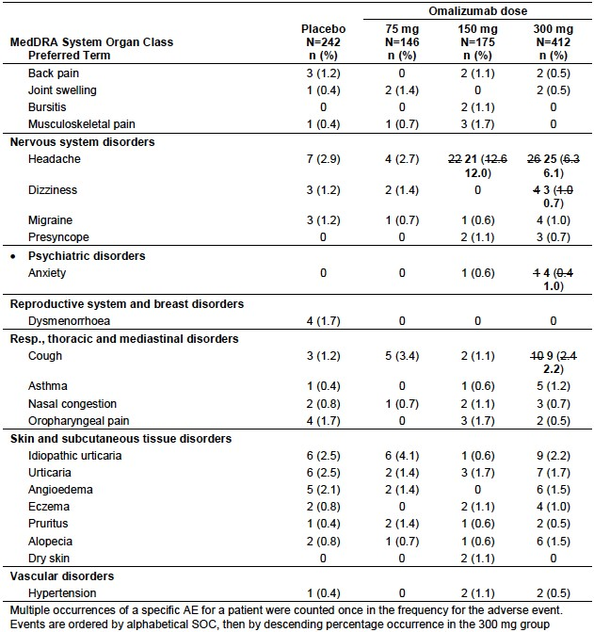

Other studies
In Study ADE05, the incidence of AEs was comparable in the two treatment groups, 81.5% in the omalizumab arm versus 86.4% in the placebo arm. AEs that occurred in at least 2 subjects in the omalizumab arm and which occurred more commonly than in the placebo arm, are shown in Table 22.

Table 22. Study ADE05. Incidence of adverse events (% of patients).
 | Omalizumab (n=27) | Placebo (n=22)
Any adverse event | 81.5% | 86.4%
Total no. of AEs | 76 | 67
Headache | 37.0% | 27.3%
Diarrhoea | 14.8% | 9.1%
GIT infection | 11.1% | 9.1%
Sinusitis | 11.1% | 0.0%
Arthralgia | 11.1% | 4.5%
Insomnia | 7.4% | 0.0%
Cough | 7.4% | 0.0%
In Study 4577g, the overall incidence of adverse events was comparable in the placebo (47.6%) and omalizumab (34.8 to 48.0%) groups. AEs that occurred in at least 5% of subjects in any group were provided. There was no identifiable pattern of AEs attributable to omalizumab.

Severe adverse events

Pooled safety database
In the 12 week analysis the incidence of severe AEs was higher in the placebo group (6.2%) than in the omalizumab groups (1.7 to 5.3%, see Table 23). This was also true of the extended analysis (9.2% versus 5.7 to 8.4%).

Table 23. Pooled safety data. Severe AEs (up to Week 12).
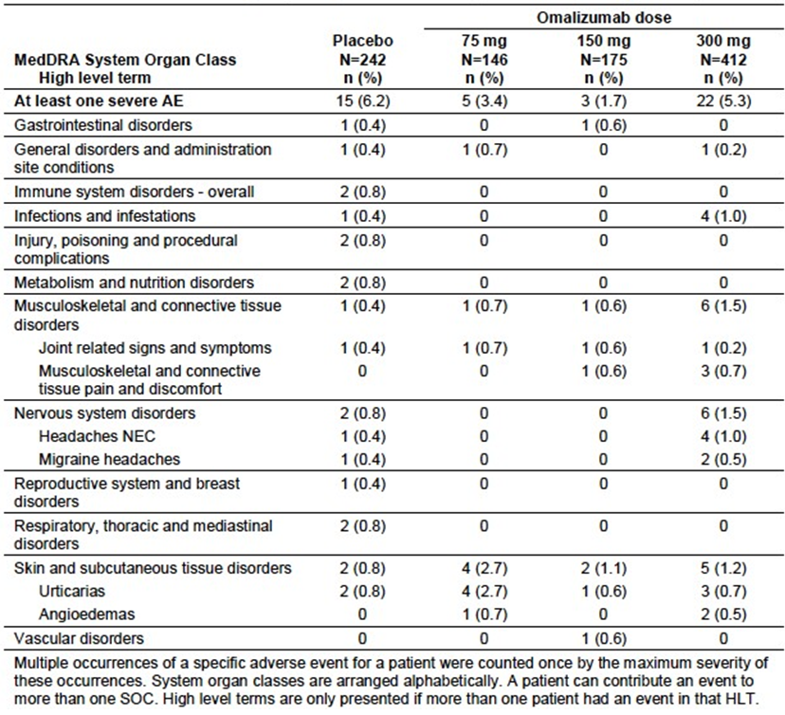

Other studies
In Study ADE05, no patient in the omalizumab group experienced a severe AE, whereas two subjects treated with placebo did.
In Study 4577g, severe AEs were reported in one patient each in the omalizumab 75 mg (pregnancy), omalizumab 300 mg (dry mouth), and omalizumab 600 mg (headache) groups. There were no severe adverse events in the placebo group.

Treatment related adverse events (adverse drug reactions)

Pooled safety database
The overall incidence of treatment related AEs up to Week 12 in the four treatment groups was: 5.8% (placebo), 7.5% (75 mg), 8.6% (150 mg) and 9.0% (300 mg). Individual treatment-related AEs are summarised in Table 24.

Table 24. Pooled safety data. Treatment-related AEs (up to Week 12).
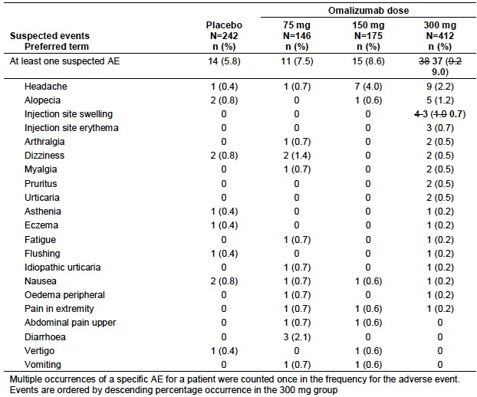
In the extended analysis, the overall incidence of any AE in the four treatment groups was: 8.6% (placebo), 7.1% (75 mg), 9.2% (150 mg) and 11.7% (300 mg). The pattern of individual AE terms was similar to the 12 week analysis.
The Summary of Clinical Safety also presented an analysis of ‘Adverse Reaction (AR) candidates’. AR candidates were those AEs that: a) occurred in at least 1% of subjects and b) occurred at a ≥ 2% higher rate in either the 150 mg or 300 mg groups than in the placebo group. The AR candidates observed in the 12 week analysis are shown in Table 25, and those observed in the extended analysis are shown in Table 26. The sponsor did not consider that toothache, fungal infection or anxiety could be adverse reactions to omalizumab. The other candidate ARs are included in the draft PI as adverse reactions to the drug.

Table 25. Pooled safety data. ‘Candidate’ adverse reactions (up to Week 12).
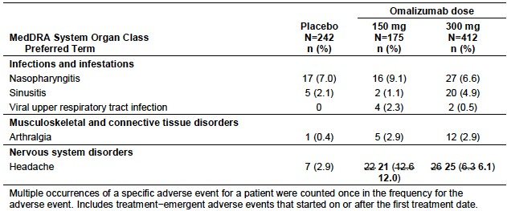

Table 26. Pooled safety data. ‘Candidate’ adverse reactions (up to Week 24).
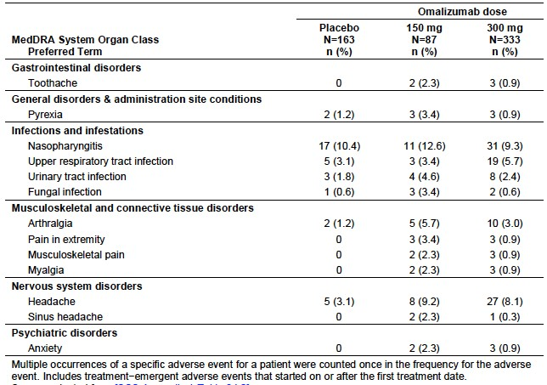

Other studies
In Study ADE05, the incidence of treatment related AEs was 22.2% in the omalizumab arm and 22.7% in the placebo arm. There were no notable differences in the incidence of individual AE terms.
In Study 4577g, treatment related AEs occurred in 3 subjects in the placebo arm (14.3%), one subject (4.3%) in the 75 mg arm (flatulence) and 1 subject (4.3%) in the 300 mg arm (chest pain).

Deaths and other serious adverse events

Pooled safety database
There were no deaths in the Phase III studies. In the 12-week analysis the incidence of serious AEs was higher in the placebo group (3.3%) than in the omalizumab groups (0.6 to 1.2%). This was also true of the extended analysis (4.3% versus 2.1 to 3.4%). The pattern of individual AE terms was similar in both analyses.

Other studies
There were no deaths in Study ADE05. There were no serious AEs in the omalizumab arm and two (9.1%) in the placebo arm.
There were no deaths in Study 4577g. There was only 1 serious AE, a case of chest pain occurring in 39 year old female hospitalised on day 101 after receiving a single dose of 300 mg of omalizumab. ECG and cardiac enzymes were normal. The discharge diagnosis was musculoskeletal pain.

Discontinuation due to adverse events

Pooled safety database
A total of 38 subjects had an AE leading to permanent withdrawal of treatment. The incidence of discontinuation was highest in the placebo group: 5.4% (placebo), 3.4%% (75 mg), 3.4% (150 mg) and 3.4%% (300 mg). Individual AEs leading to discontinuation in more than 1 subject were provided. Urticaria was an AE that led to discontinuation in 20 of the 38 subjects. In the omalizumab groups, small numbers of patients were discontinued due to arthralgia, joint problems and headache, whereas there were no discontinuations for these events in the placebo group.

Other studies
In Study ADE05, there were no discontinuations due to AEs in the omalizumab arm and one (4.5%) in the placebo arm.
In Study 4577g, three subjects in the 75 mg arm withdrew from the study due to pregnancy, asthma and pruritus respectively. One subject withdrew from the 600 mg group due to urticaria.

Adverse events of special interest
AEs of special interest occurring in the pooled safety database were provided. In summary:
- There were no cases of anaphylaxis or serum sickness. Other hypersensitivity events were slightly more frequent in the 300 mg arm than in the placebo arm. Hypersensitivity reactions are known to occur with omalizumab
- There were no cases of Churg-Strauss syndrome
- Injection site reactions, which are known to be associated with omalizumab, were slightly increased in the 300 mg group compared to the placebo group
- There was no increase in the incidence of thrombocytopaenia. One subject in the 300 mg group who had a baseline platelet count of 158 x 10⁹/L developed thrombocytopaenia (89 x 10⁹/L) at Week 4 and was discontinued. The thrombocytopaenia persisted and worsened after withdrawal and the subject was diagnosed with idiopathic thrombocytopaenic purpure
- Other cytopaenias were slightly increased in the 150 and 300 mg groups compared to placebo. However most of these abnormalities were mild and resolved without treatment. There was no pattern that suggested a relationship with omalizumab
- There was no increase in the incidence of malignancy or arterial thrombotic events compared to placebo
- For skin rash, the most commonly reported terms were pruritus, erythema and rash. Although more common with omalizumab than with placebo, there was no relationship with omalizumab dose
- The incidence of asthma as an AE was comparable across the four treatment groups. All subjects had a prior history of asthma. There were no severe asthma AEs reported
- One subject in the 300 mg group developed moderate elevation of transaminases and hepatic steatosis 108 days after the last dose of omalizumab. These were not considered to be related to study drug

Laboratory tests

Liver function

Pooled safety database
LFTs were not monitored in the Phase III studies.

Other studies
In Study ADE05 there were no subjects with notable changes in LFTs after 24 weeks treatment. LFTs were not monitored in Study 4577g.

Kidney function

Pooled safety database
Renal function tests were not monitored in the Phase III studies.

Other studies
In Study ADE05 there were no cases of significant elevation of creatinine after 24 weeks treatment. Renal function tests were not monitored in Study 4577g.

Other clinical chemistry

Pooled safety database
Blood biochemistry tests were not monitored in the Phase III studies.

Other studies
In Study ADE05 elevated glucose was observed in two subjects (7.4%) in the omalizumab arm and none in the placebo arm. There were no other remarkable changes in biochemistry parameters.
Blood biochemistry was not monitored in Study 4577g.

Haematology

Pooled safety database
There were no notable differences in the incidence of abnormal haematology values between the four treatment groups.
A clinically significant decrease in platelet count was defined as being < 75×10⁹/L, or a ≥ 50% decrease from baseline. The incidence of such decreases was comparable across treatment arms: Placebo - 2/242 (0.8%), 75 mg - 1/146 patients (0.6%), 150 mg - 1/175 patients (0.6%), and omalizumab 300 mg - 3/412 (0.7%).
9

Other studies
The incidence of ‘notable’ changes in haematology parameters noted at Week 24 in Study ADE05 was provided. Elevated haemoglobin/haematocrit values were more frequent in the omalizumab group.
In Study 4577g, there was no discernible pattern in the incidence of abnormal haematology values to suggest an adverse effect of omalizumab. In particular the incidence of platelet count reductions did not increase with increasing dose.

Anti-omalizumab antibodies
Subjects were tested for the presence of anti omalizumab antibodies at baseline and at study completion in all the submitted studies. No cases of antibody development were detected.

Vital signs

Pooled safety database
There were no significant changes in average values for systolic or diastolic blood pressure or pulse rate.

Other studies
For Study ADE05 the study report stated that there were no clinically relevant differences in vital signs between the treatment groups.
In Study 4577g, the incidences of abnormal values for blood pressure and pulse were comparable across the four treatment groups.

Post-marketing experience
No post-marketing data were included in Module 5 of the submission.

Safety issues with the potential for major regulatory impact

Liver toxicity
Liver function tests were generally not monitored in the submitted studies. Omalizumab has not previously been associated with liver toxicity.

Haematological toxicity
There was no evidence of any clinically relevant effect of omalizumab on haematology parameters in the submitted studies.

Serious skin reactions
There were no reports of serious skin toxicity (for example; Stevens-Johnson Syndrome or Toxic Epidermal Necrolysis) in the submitted studies.

Cardiovascular safety
In the submitted studies, there was no evidence of any increase in cardiovascular toxicity compared to placebo.

Unwanted immunological events
Omalizumab is known to be associated with hypersensitivity events (for example; anaphylaxis) and the current PI contains precautionary statements along these lines. In the pooled safety analysis there was a slight excess of hypersensitivity events in the 300 mg group compared to the placebo group.
There were no cases of antibody development to omalizumab.

Evaluator’s overall conclusions on clinical safety
Compared to placebo, omalizumab was associated with a modest increase in the incidence of AEs. Specific AEs that may be increased by omalizumab administration include headache, arthralgia and injection site reactions. However, compared to placebo, there was no increased risk of severe AEs, serious AEs or discontinuations due to AEs. No new safety issues have arisen in the new patient population.
The overall safety profile of omalizumab in CIU is considered acceptable.

First round benefit-risk assessment

First round assessment of benefits
The benefits of omalizumab in the treatment of CIU are:
- A significant reduction in the degree of itch and the number of hives present. The magnitude of these effects is considered clinically significant, and in a proportion of subjects, complete resolution of itch and hives occurs
- A modest reduction in the number of days that angioedema is present
- A modest improvement in quality of life

First round assessment of risks
The risks of omalizumab in the treatment of CIU are:
- An increased risk of some AEs such as headache, arthralgia and injection reactions. These AEs are not severe or serious
- An increased risk of hypersensitivity reactions. An increased risk of severe reactions, such as anaphylaxis, was not seen in the submitted studies but has been documented with the drug previously

First round assessment of benefit-risk balance
The benefit-risk balance of omalizumab, given the proposed usage, is favourable.

First round recommendation regarding authorisation
It is recommended that the application be approved.

Clinical questions
There are no clinical questions for the sponsor.

Second round evaluation of clinical data submitted in response to questions
Not applicable due to no second round evaluation.

Second round benefit-risk assessment
Not applicable due to no second round evaluation.

Second round recommendation regarding authorisation
Not applicable due to no second round evaluation.

References
- Kupa A. Recurrent urticaria and angioedema. In: Bradley J and McCluskey J (eds). Clinical Immunology.1st ed. Oxford: Oxford University Press, 1997, pp 123-137.
- Kaplan AP and Greaves M. Pathogenesis of chronic urticaria. Clin Exp Allergy; 2009; 39 (6): 777-787.
- Greaves MW. Chronic idiopathic urticaria. Curr Opin Allergy Clin Immunol; 2003; 3: 363-368.
- Zuberbier T, Asero R, Bindslev-Jensen C et al. EAACI/GA²LEN/EDF/WAO guideline: definition, classification and diagnosis of urticaria. Allergy; 2009; 64: 1417–1426.
2
- Zuberbier T, et al. EAACI/GA²LEN/EDF/WAO guideline: management of urticaria. Allergy; 2009: 64: 1427-43.
2
- Spector SL and Tan RA. Effect of omalizumab on patients with chronic urticaria. Ann Allergy Asthma Immunol; 2007; 99(2): 190-3.
- Gober LM, Sterba PM, Eckman JA, et al. Effect of anti-IgE (omalizumab) in chronic idiopathic urticaria (CIU) patients. J Allergy Clin Immunol; 2008; 121 (2): S147.
- Kaplan AP, Joseph K, Maykut RJ et al. Treatment of chronic autoimmune urticaria with omalizumab. J Allergy Clin Immunol. 2008; 122: 569-73.
- Shikiar R, Harding G, Leahy M, et al. Minimal Important Difference (MID) of the Dermatology Life Quality Index (DLQI): Results from patients with chronic idiopathic urticaria. Health Qual Life Outcomes; 2005; 3:36-41.
- Maurer M, Rosen K, Hsieh HJ et al. Omalizumab for the treatment of chronic idiopathic or spontaneous urticaria. N Engl J Med; 2013; 368(10): 924-935.
- Kaplan A, Ledford D, Ashby M et al. Omalizumab in patients with symptomatic chronic idiopathic/spontaneous urticaria despite standard combination therapy. J Allergy Clin Immunol; 2013; 132 (1):101-9.
- Maurer M, Altrichter S, Bieber T et al. Efficacy and safety of omalizumab in patients with chronic urticaria who exhibit IgE against thyroperoxidase. J Allergy Clin Immunol; 2011 128(1): 202-209.
- Saini S, Rosen KE, Hsieh HJ et al. A randomized, placebo-controlled, dose ranging study of single-dose omalizumab in patients with H1-antihistamine-refractory chronic idiopathic urticaria. J Allergy Clin Immunol; 2011: 128(3): 567-573.
- Mathias S, Crosby R, Zazzali J, et al. Evaluating the minimally important difference of the urticaria activity score and other measures of disease activity in patients with chronic idiopathic urticaria. Ann Allergy Asthma Immunol; 2012: 108: 20-24.
- Busse W, Buhl R, Fernandez Vidaurre C et al. Omalizumab and the risk of malignancy: results from a pooled analysis. J Allergy Clin Immunol; 2012: 129(4): 983-989.
- Food and Drug Administration. Early Communication about an Ongoing Safety Review of Omalizumab (marketed as Xolair). 2009. Available from: http://www.fda.gov/Drugs/DrugSafety/PostmarketDrugSafetyInformationforPatientsandProviders/ DrugSafetyInformationforHeathcareProfessionals/ucm172218.htm

Therapeutic Goods Administration
PO Box 100 Woden ACT 2606 Australia
Email: info@tga.gov.au Phone: 1800 020 653 Fax: 02 6232 8605
https://www.tga.gov.au

