April 2021

Australian Public Assessment Report for Omalizumab
  - Proprietary Product Name: Xolair
  - Sponsor: Novartis Pharmaceuticals Australia Pty Ltd

About the Therapeutic Goods Administration (TGA)
- The Therapeutic Goods Administration (TGA) is part of the Australian Government Department of Health and is responsible for regulating medicines and medical devices.
- The TGA administers the Therapeutic Goods Act 1989 (the Act), applying a risk management approach designed to ensure therapeutic goods supplied in Australia meet acceptable standards of quality, safety and efficacy (performance) when necessary.
- The work of the TGA is based on applying scientific and clinical expertise to decision-making, to ensure that the benefits to consumers outweigh any risks associated with the use of medicines and medical devices.
- The TGA relies on the public, healthcare professionals and industry to report problems with medicines or medical devices. TGA investigates reports received by it to determine any necessary regulatory action.
- To report a problem with a medicine or medical device, please see the information on the TGA website <https://www.tga.gov.au>.

About AusPARs
- An Australian Public Assessment Report (AusPAR) provides information about the evaluation of a prescription medicine and the considerations that led the TGA to approve or not approve a prescription medicine submission.
- AusPARs are prepared and published by the TGA.
- An AusPAR is prepared for submissions that relate to new chemical entities, generic medicines, major variations and extensions of indications.
- An AusPAR is a static document; it provides information that relates to a submission at a particular point in time.
- A new AusPAR will be developed to reflect changes to indications and/or major variations to a prescription medicine subject to evaluation by the TGA.

Copyright
© Commonwealth of Australia 2021
This work is copyright. You may reproduce the whole or part of this work in unaltered form for your own personal use or, if you are part of an organisation, for internal use within your organisation, but only if you or your organisation do not use the reproduction for any commercial purpose and retain this copyright notice and all disclaimer notices as part of that reproduction. Apart from rights to use as permitted by the Copyright Act 1968 or allowed by this copyright notice, all other rights are reserved and you are not allowed to reproduce the whole or any part of this work in any way (electronic or otherwise) without first being given specific written permission from the Commonwealth to do so. Requests and inquiries concerning reproduction and rights are to be sent to the TGA Copyright Officer, Therapeutic Goods Administration, PO Box 100, Woden ACT 2606 or emailed to <tga.copyright@tga.gov.au>.

Contents
List of abbreviations 4
I. Introduction to product submission 6
Submission details 6
Product background 7
Regulatory status 9
Product Information 11
II. Registration timeline 11
III. Submission overview and risk/benefit assessment 12
Quality 12
Nonclinical 12
Clinical 13
Risk management plan 19
Risk-benefit analysis 19
Outcome 29
Attachment 1. Product Information 30

List of abbreviations
Abbreviation | Meaning
ACM | Advisory Committee on Medicines
AE | Adverse event
AERD | Aspirin exacerbated respiratory disease
ARS | Anterior rhinorrhoea
ARTG | Australian Register of Therapeutic Goods
AusPAR | Australian Public Assessment Report
CI | Confidence interval
CRS | Chronic rhinosinusitis
CRSsNP | Chronic rhinosinusitis without nasal polyps
CRSwNP | Chronic rhinosinusitis with nasal polyps
CSU | Chronic spontaneous urticaria
CT | Computerised tomography
EMA | European Medicines Agency (European Union)
FcεRI | High-affinity Fc region of immunoglobulin E receptor
FDA | Food and Drug Administration (United States of America)
IgE | Immunoglobulin E
IL | Interleukin
NCS | Nasal Congestion Score
NPS | Nasal Polyp Score
PD | Pharmacodynamic(s)
PI | Product Information
PK | Pharmacokinetic(s)
PSUR | Periodic Safety Update Report
Q2W | Every 2 weeks
Q4W | Every 4 weeks
QOL | Quality of life
SAE | Serious adverse event
SD | Standard deviation
SFU | Safety follow up
SNOT-22 | Sino-Nasal Outcome Test-22
SSS | Sense of Smell Score
TGA | Therapeutic Goods Administration
TNSS | Total Nasal Symptom Score
UPSIT | University of Pennsylvania Smell Identification Test

I. Introduction to product submission

Submission details
Type of submission: | Extension of indication
Product name: | Xolair
Active ingredient: | Omalizumab
Decision: | Approved
Date of decision: | 12 March 2021
Date of entry onto ARTG: | 18 March 2021
ARTG numbers: | 115399, 201124, 82744, 201126
Black Triangle Scheme: | No
Sponsor’s name and address: | Novartis Pharmaceuticals Australia Pty Limited  54 Waterloo Road  Macquarie Park NSW 2113
Dose forms: | Solution for injection in pre-filled syringe and powder for injection vial with diluent
Strengths: | 75 mg and 150 mg
Containers: | Pre-filled syringe and vial
Pack sizes: | Pre-filled syringe: 1, 4 and 10  Powder for injection: 1 active vial and 1 diluent ampoule
Approved therapeutic use: | Chronic rhinosinusitis with nasal polyps (CRSwNP)  Xolair is indicated as add‐on treatment in adult patients (18 years of age and above) for the treatment of severe CRSwNP with inadequate response to intranasal corticosteroids. Recommended dosing is determined by serum immunoglobulin E levels and body weight corresponding to the recommended dose range in the Product Information (see Section 4.2 dose and method of administration).
Route of administration: | Subcutaneous
Dosage: | Xolair treatment for chronic rhinosinusitis with nasal polyps (CRSwNP) should be initiated by specialists experienced in the diagnosis and treatment of CRSwNP.  Dosing for asthma and CRSwNP follows the same dosing principles. The appropriate dose and dosing frequency of Xolair for these conditions is determined by baseline immunoglobulin E (IgE) (IU/mL), measured before the start of treatment, and body weight (kg). Prior to initial dosing, patients should have their IgE level determined by any commercial serum total IgE assay for their dose assignment.  Based on these measurements 75 to 600 mg of Xolair in 1 to 4 injections may be needed for each administration. See Table 1 for dose determination in allergic asthma and CRSwNP and Tables 2 and 3 for dose conversion charts in the Product Information.  For further information regarding dosage, refer to the Product Information.
Pregnancy category: | B1  Drugs which have been taken by only a limited number of pregnant women and women of childbearing age, without an increase in the frequency of malformation or other direct or indirect harmful effects on the human fetus having been observed.  Studies in animals have not shown evidence of an increased occurrence of fetal damage.  The use of any medicine during pregnancy requires careful consideration of both risks and benefits by the treating health professional. This must not be used as the sole basis of decision making in the use of medicines during pregnancy. The TGA does not provide advice on the use of medicines in pregnancy for specific cases. More information is available from obstetric drug information services in your State or Territory.

Product background
This AusPAR describes the application by Novartis Pharmaceuticals Australia Pty Ltd (the sponsor) to register Xolair (omalizumab) 75 mg, 150 mg, solution for injection in pre-filled syringe and powder for injection vial with diluent for the following extension of indications:
Nasal Polyps
Xolair is indicated for adults (18 years of age and above) for the treatment of nasal polyps with inadequate response to intranasal corticosteroids.
Nasal polyps develop as outgrowths of the nasal and paranasal sinus mucosa., They are known to be associated with conditions such as asthma, infection, bronchiectasis, cystic fibrosis, granulomatous diseases, vasculitides, immunodeficiency, ciliary dysfunction and aspirin sensitivity.3 Malignancies of the nasal mucosa and congenital abnormalities may also present as ‘polyps’. There is a higher prevalence of nasal polyps in some subsets of patients: approximately 45% in patients with adult-onset asthma and approximately 30% in patients with chronic rhinosinusitis. Presentation usually occurs in adults older than 20 years. They are uncommon in children under 10 years old but may be the presenting feature of cystic fibrosis.
Nasal polyps, regardless of cause, may cause a range of symptoms including watery rhinorrhoea, post-nasal drip, loss of sense of smell, nasal obstruction and sleep disorder. Their presence is confirmed by anterior and posterior rhinoscopy at which single or multiple polypoid masses, arising most frequently from the middle meatus and prolapsing into the nasal cavity, may be seen. Computerised tomography (CT) scanning of the nasal cavities and paranasal sinuses may be performed to determine the extent of the disease. Differential diagnoses include congenital anomalies, benign or malignant tumours, and polyps associated with underlying conditions as listed above.

Chronic rhinosinusitis with nasal polyps
Figure 1: Definition of chronic rhinosinusitis
Term: Chronic rhinosinusitis
Definition:
Twelve weeks or longer of two or more of the following signs and symptoms:
- mucopurulent drainage (anterior. posterior, or both),
- nasal obstruction (congestion);
- facial pain-pressure-fullness; or
- decreased sense of smell.
and inflammation is documented by one or more of the following findings:
- purulent (not clear) mucus or edema in the middle meatus or anterior ethmoid region;
- polyps in nasal cavity or the middle meatus, and/or
- radiographic imaging showing inflammation of the paranasal sinuses.
Chronic rhinosinusitis has been defined as the presence of both subjective and objective evidence of sinonasal inflammation that lasts for greater than 12 weeks duration. Symptoms include anterior or posterior rhinorrhoea, nasal congestion, hyposmia and/or facial pressure or pain. Approximately 30% of patients with chronic rhinosinusitis are found to have nasal polyps, with these described as ‘inflammatory lesions that project into the nasal airway, are typically bilateral, and originate from the ethmoid sinus’. Patients with nasal polyps may have more severe symptoms than those without nasal polyps, although there is considerable overlap.,
Patients with chronic rhinosinusitis with nasal polyps usually present in middle age, with the age at diagnosis ranging from 40 to 60 years. The condition is more common in males. There is a recognised association between chronic rhinosinusitis with nasal polyps and asthma, with an asthma prevalence of 26 to 48% in these patients. Although there is an association between chronic rhinosinusitis and allergic rhinitis (with prevalence of 40% to 84% in adults with chronic rhinosinusitis) this does not appear to hold for patients with chronic rhinosinusitis with nasal polyps. Approximately 10% of patients with chronic rhinosinusitis with nasal polyps and asthma also have aspirin-exacerbated respiratory disease (AERD).
Chronic rhinosinusitis, with or without nasal polyps, is considered a chronic inflammatory condition with an unclear aetiology. According to the 2016 review article by Stevens et al., current theories as to aetiology hypothesise that ‘an impaired sinonasal epithelial barrier could lead to increased exposures to inhaled pathogens, antigens and particulates that, in the setting of a dysregulated host immune response, could promote chronic inflammation’. Patients with chronic rhinosinusitis may be considered as having two phenotypes according to whether nasal polyps are present and the type of inflammation. Chronic rhinosinusitis without nasal polyps (CRSsNP) is characterised by type I inflammation, and chronic rhinosinusitis with nasal polyps (CRSwNP), in Western countries, is characterised by type II (or immunoglobulin E (IgE)-mediated) inflammation and tissue eosinophilia. A number of studies have found increased levels of a wide variety of inflammatory mediators and immune system cells in the tissues of patients with chronic rhinosinusitis with nasal polyps. The initiating event(s) and sustaining processes are unclear. Possible triggers may be allergens associated with fungi or bacteria, especially Staphylococcus aureus enterotoxins, viruses, and environmental factors. This division of phenotypes does not, however, hold for patients with chronic rhinosinusitis with nasap polyps in Asia as these patients tend to have a mixed inflammatory picture without increased tissue eosinophilia.
Intranasal and systemic/oral corticosteroids remain the mainstay of treatment of chronic rhinosinusitis with nasap polyps, but many patients fail to achieve complete therapeutic benefit with these medications and resort to functional endoscopic sinus surgery and other complex sinus surgery. Although surgery and intranasal and oral corticosteroids are useful and often effective in reducing the size of nasal polyps and associated symptoms, many patients do not respond sufficiently and/or polyps return rapidly after medication withdrawal or within months or years following surgery.
Omalizumab is a recombinant DNA-derived humanised monoclonal antibody that selectively binds to human IgE. The antibody is a humanised immunoglobulin G1 kappa monoclonal antibody that contains human framework regions with the complementary-determining regions of a humanised murine antibody that binds to IgE. Omalizumab selectively binds to human IgE at the same site as the high affinity IgE receptor (FcεRI), thereby reducing surface IgE on basophils and mast cells and reducing basophil and mast cell triggered type II inflammation.

Regulatory status
The product received initial registration on the Australian Register of Therapeutic Goods (ARTG) on 13 June2002 for use in moderate allergic asthma. It was registered for use in severe allergic asthma in 2005, and extended to be used in the paediatric population in 2016 as follows:
Allergic Asthma
Children 6 to < 12 years of age
In children aged 6 to < 12 years, Xolair is indicated as add‐on therapy to improve asthma control in patients with severe allergic asthma who have documented exacerbations despite daily high dose inhaled corticosteroids, and who have immunoglobulin E levels corresponding to the recommended dose range (see Table 1 in Section 4.2 dose and method of administration).
Adults and adolescents ≥ 12 years of age
Xolair is indicated for the management of adult and adolescent patients with moderate to severe allergic asthma, who are already being treated with inhaled steroids, and who have serum immunoglobulin E levels corresponding to the recommended dose range (see Table 1 in Section 4.2 dose and method of administration)
A new strength was registered in 10 January 2006 and a new presentation was included on 19 August 2013.
The TGA approved an extension of indication for Xolair on 6 November 2014, for the following indication:
Chronic Spontaneous Urticaria (CSU)
Xolair is indicated for adults and adolescents (12 years of age and above) with chronic spontaneous urticaria who remain symptomatic despite H1 antihistamine treatment.
At the time the TGA considered this application, similar applications had been approved in the European Union on 31 July 2020, the United States of America (USA) on 30 November 2020 and in Singapore on 15 December 2020. A similar application was also under consideration in Canada (submitted in August 2020).
Table 1: Foreign regulatory status of chronic rhinosinusitis with nasal polyps indication
Region | Submission date | Status | Approved indications
European Union (via Centralised Procedure) | November 2019 | Approved on 31 July 2020 | Chronic rhinosinusitis with nasal polyps (CRSwNP)  Xolair is indicated as an add-on therapy with intranasal corticosteroids (INC) for the treatment of adults (18 years and above) with severe CRSwNP for whom therapy with INC does not provide adequate disease control.
United States of America | September 2019 | Approved on 30 November 2020 | Xolair is indicated for add-on maintenance treatment of nasal polyps in adult patients 18 years of age and older with inadequate response to nasal corticosteroids.
Singapore | January 2020 | Approved on 15 December 2020 | Chronic rhinosinusitis with nasal polyps (CRSwNP)  Xolair is indicated as an add-on therapy to intranasal corticosteroids for the treatment of CRSwNP in adults (18 years of age and above) with inadequate response to intranasal corticosteroids.
Canada | August 2020 | Under consideration | Under consideration

Product Information
The Product Information (PI) approved with the submission which is described in this AusPAR can be found as Attachment 1. For the most recent PI, please refer to the TGA website at <https://www.tga.gov.au/product-information-pi>.

II. Registration timeline
The following table captures the key steps and dates for this application and which are detailed and discussed in this AusPAR.
Table 2: Timeline for Submission PM-2019-05980-1-5
Description | Date
Submission dossier accepted and first round evaluation commenced | 31 January 2020
First round evaluation completed | 30 June 2020
Sponsor provides responses on questions raised in first round evaluation | 2 November 2020
Second round evaluation completed | 25 November 2020
Delegate’s Overall benefit-risk assessment and request for Advisory Committee advice | 4 January 2021
Sponsor’s pre-Advisory Committee response | 19 January 2021
Advisory Committee meeting | 4 and 5 February 2021
Registration decision (Outcome) | 12 March 2021
Completion of administrative activities and registration on the ARTG | 18 March 2021
Number of working days from submission dossier acceptance to registration decision* | 187
*Statutory timeframe for standard applications is 255 working days

III. Submission overview and risk/benefit assessment
The submission was summarised in the following Delegate’s overview and recommendations.

Quality
There was no requirement for a quality evaluation in a submission of this type.

Nonclinical
During the evaluation, in response to recommendations made by the clinical evaluator, the wording of the proposed indication was revised to the following:
Xolair is indicated as add-on treatment in adult patients (18 years of age and above) for the treatment of CRSwNP [Chronic rhinosinusitis with nasal polyps] with inadequate response to intranasal corticosteroids and who have serum immunoglobulin E levels corresponding to the recommended dose range (see Dosage and Administration)
A separate set of dosing instructions for the chronic rhinosinusitis with nasal polyps indication was removed from the proposed PI document so that dose levels now match those approved for allergic asthma.
With the maximum recommended clinical dose now unchanged, the revised nonclinical risk assessment is no longer required. No nonclinical data specifically relating to efficacy in the proposed new indication were submitted (in the current application or previous ones). This is acceptable; the efficacy assessment for the new indication will rely on clinical data only.

Clinical
The clinical dossier consisted of:
- two pivotal Phase III studies, Study GA39688 and Study GA39855;
- safety data from an interim analysis of a Phase III open label extension study, Study WA40169;
- an exposure-response and free-IgE response analysis of omalizumab in nasal polyps; and
- a prospective observational study of the use of omalizumab in pregnant women, the EXPECT trial, for the PI update.

Pharmacology

Pharmacokinetics
There are limited pharmacokinetics (PK) investigations of the use of omalizumab in the treatment of patients with chronic rhinosinusitis with nasal polyps. Although exposure-response analyses were conducted in the Phase III studies, there were uncertainties about the appropriate posology for the newly proposed indication.
Overall, the PK and pharmacodynamics (PD) effect of omalizumab appears to be adequately characterised and does not appear to be different in subjects with nasal polyps compared to subjects with allergic asthma (this has been adequately reflected in the PI).

Pharmacodynamics
The PD data from the two clinical studies demonstrate that omalizumab dosing according to the dosing table using baseline IgE level and body weight was effective in reducing free IgE serum concentration during treatment. Using the proposed posology (based on weight and baseline IgE), free IgE suppression at 24 weeks was achieved in 93.0% of the subjects on active. Slight positive trend between omalizumab concentration and Nasal Polyp Score (NPS) response is observed with the lowest concentration tertile group, however, a clear trend between the Week 24 omalizumab concentration, or free IgE, and the change from Baseline in efficacy endpoints is not observed.

Efficacy
The clinical development plan for the proposed indication of the treatment of patients with chronic rhinosinusitis with nasal polyps did not include dose finding studies. Only one dosing regimen (the regimen approved by the European Medicines Agency (EMA) for use in severe asthma) was used in the two clinical studies. Since the Phase III studies were to be conducted in adult patients and nasal polyps rarely occurs in patients less than 18 years of age, the posology of omalizumab used in these two nasal polyp studies was adopted from the allergic asthma dosing table by excluding cells of which the bodyweight is less than 30 kg.

Study GA39688 and Study 39855
Studies GA39688 and GA39855 were replicate Phase III, randomised, multicentre, double-blind, placebo-controlled, clinical studies that were conducted in parallel with identical study designs (as shown in Figure 2, below). They were conducted concurrently across different sites in 15 countries across Europe and North America. Each study was designed to enrol approximately 120 adult patients with nasal polyps who had an inadequate response to standard of care treatments (daily treatment with intranasal corticosteroid therapy).
Figure 2: Studies GA39688 and GA39855 study design
1°EP = co-primary end point; Q2W = every 2 weeks; Q4W = every 4 weeks; SFU = safety follow-up; wk = week. Note: All patients were treated during the entire study with intranasal corticosteroids (mometasone nasal spray) as background therapy.
The co-primary efficacy endpoints were:
- the change from Baseline at Week 24 in Nasal Polyp Score (NPS); and
- the change from Baseline at Week 24 in average daily Nasal Congestion Score (NCS), averaged over the prior 7 days.
The Nasal Polyp Score is performed with intranasal endoscopy, and the right and left nostrils are assessed separately on a scale from 0 to 4 (total maximum 8).
The nasal congestion score (0 to 3) is based on daily patient reports using the mean value of the last 7 days.
The secondary efficacy endpoints included:
- change from Baseline to Week 24 in the:
  - average daily Total Nasal Symptom Score (TNSS);
  - average daily sense of smell;
  - average daily posterior and anterior rhinorrhoea score;
  - health related quality of lifeaccording to the Sino-Nasal Outcome Test-22 (SNOT-22);
  - Asthma Quality of Life Questionnaire (AQLQ, in patients with asthma co-morbidity); and
  - University of Pennsylvania Smell Identification Test (UPSIT).
- change from Baseline to Week 16 in the co-primary end-points;
- reduction in need for surgery; and
- requirement for rescue treatments
A planned total of 120 patients were to be enrolled. The sample size of 120 patients (102 patients divided by 0.85 assuming a 15% early withdrawal rate) provided at least 85% power to independently detect both a 0.56-point difference between treatment groups in change from Baseline at Week 24 in the average daily Nasal Congestion Score (assuming standard deviation (SD) = 0.75) and a 1.50-point difference between treatment groups in change from Baseline at Week 24 in Nasal Polyp Score (assuming SD = 2.0).
As the changes from Baseline to Week 24 in Nasal Polyp Score and the average daily Nasal Congestion Sscore were co-primary endpoints, both null hypotheses for these endpoints had to be rejected, with parameter estimates showing a significant benefit of omalizumab over placebo, for the study to be deemed positive.
Figure 3: Studies GA39688 and GA39855 Patient disposition flowchart of individual studies (full analysis set population), and combined studies (pooled full analysis set population)
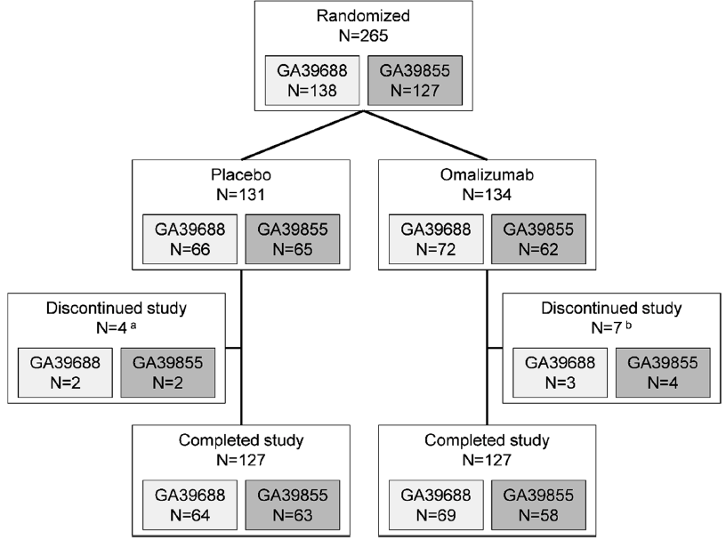
a All discontinued as per patient’s wish.
b All discontinued as per patient’s wish, except for 1 patient in Study GA39688 who was withdrawn by the physician
Demographics at Baseline were generally similar between Studies GA39688 and GA39855, and between treatment arms within each study.
Table 3: Studies GA39688 and GA39855 Baseline disease characteristics for the individual studies (full analysis set population), and combined studies (pooled full analysis set population)
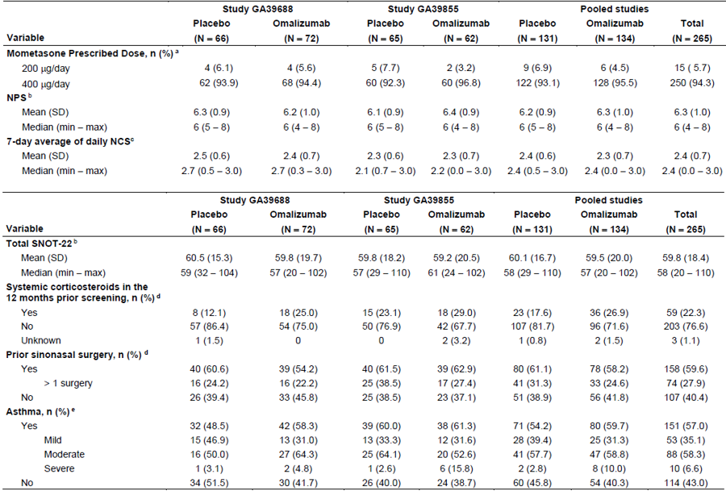
ARS = anterior rhinorrhoea score; NCS = Nasal Congestion Score; NPS = Nasal Polyp Score; PRS = posterior rhinorrhoea score; SNOT-22 = Sino-Nasal Outcome Test 22; SSS = Sense of Smell Score; TNSS = Total Nasal Symptom Score; UPSIT = University of Pennsylvania Smell Identification Test.
a) at or relative to randomisation.
b) the last assessment on or before the date of randomisation.
c) Baseline was defined as the average of the daily values recorded during the 7-day interval ending on the latest day prior to randomisation such that the prior 7-day interval includes a recorded value on at least 4 of the 7 days of that interval.
d) relative to first study visit (Day-35). No patients used systemic corticosteroids or had nasal surgery between the first study visit and randomisation.
e) a history of asthma at screening and having used medication for asthma or with a prescription for asthma medication in the last 12 months.
Percentages for asthma severity are based on the number of patients with asthma

Results

Co-primary endpoints
In both of the pivotal, Phase III Studies GA39688 and GA39855, the co-primary endpoints of the changes from Baseline at Week 24 in Nasal Polyp Score and the average daily Nasal Congestion Score were met. For each of the co-primary endpoints, the between-treatment difference in the adjusted mean changes at Week 24 was statistically significant in favour of omalizumab.
Table 4: Studies GA39688 and GA39855 Absolute change from Baseline at Week 24 in the Nasal Polyp Score (co-primary endpoint) for the individual studies(full analysis set populations), and combined studies (pooled full analysis set population)
Adj = adjusted; CI = confidence interval; SE = standard error
Table 5: Studies GA39688 and GA39855 Absolute change from Baseline at Week 24 in average daily Nasal Congestion Score (co-primary endpoint) for the individual studies (full analysis set populations), and combined studies (pooled full analysis set population)
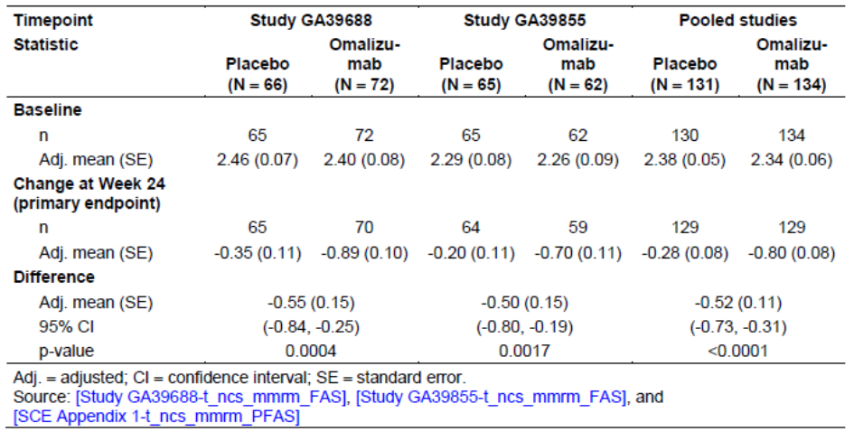
Adj = adjusted; CI = confidence interval; SE = standard error
There are no established limits for clinically relevant effect for these endpoints, but the sponsor used a 0.56-point difference for the Nasal Congestion Score and 1.50 for the Nasal Polyp Score as the basis for their samples size calculations. These differences were not achieved. However, omalizumab was statistically significantly better than placebo in both pivotal studies and both co-primary endpoints. The sponsor presented literature data from relevant published studies, describing the use of intranasal corticosteroids (placebo as comparator in the majority of studies) or biologics (placebo as comparator) where these endpoints were applied. Although results should be interpreted with caution as there are differences in study designs and included populations, the effect as recorded by Nasal Polyp Score and Nasal Congestion Score appears to be of similar magnitude as in publications describing patients responding to intranasal corticosteroids which is deemed clinically relevant. Comparison to other biologics is more difficult due to the smaller number of studies and heterogeneity of publications. Furthermore, biologics acts through different pathways in the inflammatory cascade.

Secondary efficacy outcomes
There were two separate and distinct sets of secondary endpoints with different Type I error control testing hierarchy to accommodate different prioritisations of secondary endpoints for the EMA and US Food and Drug Administration (FDA). Some pooled data for specific end-points was included in these analyses.
Table 6: Secondary end-points analysis for the United States Food and Drug Administration and European Medicines Agency requirements
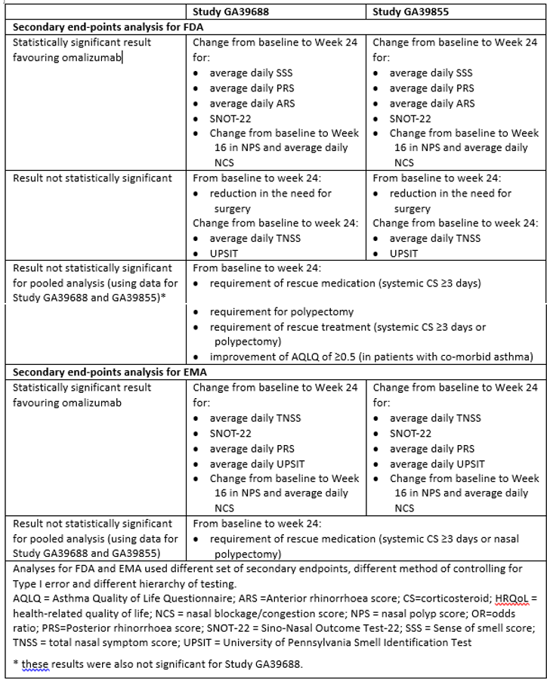
Nasal Polyp Score and Nasal Congestion Sscore: There were no significant differences in the treatment effect between any pre-specified subgroup and its complementary group, as indicated by overlapping 95% CIs for respective estimated between-treatment difference within subgroups. The results for the subgroups is consistent with the result for all patients.

Safety
The safety database for the new indication consists of data from the two pivotal clinical trials, Studies GA39688 and GA39855. Both studies had identical inclusion and exclusion criteria, study assessments, and safety endpoints; therefore, pooling of safety data is considered acceptable. Supportive data from an interim analysis of the ongoing, open label extension Study WA40169, are also included.
In the two pivotal studies, a total of 135 patients received omalizumab, and 130 patients received placebo. A total of 249 patients from the completed pivotal studies enrolled into the open label extension Study WA40169 and started open label omalizumab treatment (parent study drug treatment received: omalizumab 124, placebo 125). The safety database presented with this application is considered to be relatively small. Considering the relative similarity between the patient population with nasal polyps and the patient population with allergic asthma, it is considered acceptable to extrapolate the safety from the existing safety database (pre and post-approval).
In the two parent studies, adverse event (AE) rates were overall similar in the placebo and omalizumab arm with the majority of AEs having mild or moderate intensity. Those AEs that were reported in numerically greater numbers in the omalizumab arm (headache, injection site reaction, arthralgia, dizziness, and upper abdominal pain) are consistent with the known safety profile of omalizumab. Treatment with omalizumab was not associated with any increase risk compared to placebo of severe AEs, serious adverse events (SAE) and adverse events of special interest. No patient died in these two studies and there were no clinically relevant changes in clinical laboratory evaluations or vital signs in either treatment arm.
Safety results as reported in the interim analysis from the open label extension study were consistent with the results reported for the parent studies.

Clinical evaluator’s recommendation
The clinical evaluator has recommended approval of Xolair (omalizumab) for the proposed indication and dosage regimens.

Risk management plan
There was no requirement for a risk management plan evaluation for a submission of this type.

Risk-benefit analysis

Delegate’s considerations
The Delegate makes a decision under the therapeutic goods act in relation to quality, safety and efficacy.
In relation to quality:
The nonclinical evaluator has confirmed that there are no other outstanding issues. The proposed PI document is acceptable.
In relation to efficacy:
In support of this new indication application, the sponsor conducted two identical pivotal Phase III, randomised, multicentre, double-blind, placebo-controlled clinical studies to assess the efficacy and safety of omalizumab in patients with nasal polyps (Studies GA39688 and GA39855). The studies length was 24 weeks, with a 5-week run-in period and a 4-week safety follow-up period. Nevertheless, the sponsor has conducted the polyp studies for 24 weeks and has initiated an open-label extension Study WA40169, with safety as primary objective.
Although exposure response analyses were conducted in the Phase III studies, there were uncertainties about the appropriate posology for the newly proposed indication. Overall, the PK and PD effect of omalizumab has been adequately characterised and does not appear to be different in subjects with nasal polyps compared to subjects with allergic asthma. Based on the current knowledge about the pathophysiology of chronic rhinosinusitis with nasal polyps and its similarity to allergic asthma, and similar mechanism of action of omalizumab, it appears reasonable that the same dosing regimen can be chosen for both allergic asthma and chronic rhinosinusitis with nasal polyps. The description of mechanism of action in the new indication in section 5.1 as well as the dosing regimen proposed in section 4.2 of the PI.
There were two co-primary endpoints; that is, change in Nasal Polyp Score and change in 7-day average of daily Nasal Congestion Score at Week 24. This approach appears reasonable as change in nasal polyp size on its own is not considered sufficient but adding an endpoint evaluating the impact of symptoms is of importance in measuring outcomes in nasal polyposis.
Both studies met their primary objectives and demonstrated that omalizumab was statistically more effective in the treatment of nasal polyps compared with placebo in patients with inadequate response to intranasal corticosteroids and who were on background intranasal mometasone therapy. Subgroup analyses showed no relevant differences in the co-primary endpoints.
There appears to be no consistently applied definition of disease severity in chronic rhinosinusitis with nasal polyps. Severe disease may be defined by the treatment interventions required such as prior polyp surgery or systemic steroid treatment or it may be defined by scoring systems such as the Nasal Polyp Score and the Sino-Nasal Outcome Test-22 or by the presence of comorbid allergic asthma. The studies investigating the use of biologics in the treatment of chronic rhinosinusitis with nasal polyps have sought to investigate patients with severe disease but have used different definitions.
Although results should be interpreted with caution as there are differences in study designs and included populations, comparison of the baseline disease characteristics tables in the published studies show that, on the basis of prior surgery and systemic corticosteroid use, populations with more severe disease were investigated in the mepolizumab and dupilumab studies. However, the mean Nasal Polyp Score and Sino-Nasal Outcome-22 scores indicate similar disease severity across the studies.
Table 7: Baseline disease characteristics of patients enrolled in randomised controlled trial investigating the use of biologics in severe chronic rhinosinusitis with nasal polyps
 | Omalizumab | Mepolizumab | Dupilumab
Mean Nasal Poly Score | ~ 6 | ~6 | ~6
Mean Sino-Nasal Outcome Test-22 score | ~ 60 | ~50 | ~ 50
Previous systemic corticosteroids (%) | 12-30% | NR | 64-80%
Previous polyp surgery (%) | ~ 60 | 100 | 50-60
Comorbid asthma (%) | 48-61 | 75-80 | 57-63
Numbers represent ranges or approximation of numbers as extracted by the evaluator from the baseline disease characteristics tables in the related publications
On review of the applicant’s materials and other literature, the Delegate thinks that those patients with chronic rhinosinusitis with nasal polyps who enrolled in the replicate omalizumab studies should be considered as having ‘severe’ disease based on baseline severity scores.
For the secondary endpoints, Total Nasal Symptom Score, Sino-Nasal Outcome Test-22 score, and University of Philadelphia Smell Identification Test scores, omalizumab showed improvement compared to placebo (p-value of < 0.05 in both studies).
In relation to safety:
The overall safety profile as recorded from the two pivotal Studies GA39688 and GA39855 supports the known safety profile of Xolair in its currently approved indications. The longer-term safety data will be available from the ongoing open label extension study.

Proposed action
Chronic rhinosinusitis with nasal polyps is a heterogeneous disease characterised by inflammation of the nose and paranasal sinuses, tissue oedema, nasal obstruction, and increased mucus production causing symptoms including nasal congestion/obstruction, loss of sense of smell, and rhinorrhoea. Nasal polyposis is not a potential fatal condition, but severe polyposis can contribute to symptoms and conditions associated with a substantial impact on quality of life and health.
Although exposure response analyses were conducted in the Phase III studies, there were uncertainties about the appropriate posology for the newly proposed indication. Overall, the pharmacokinetics and pharmacodynamics effect of omalizumab has been adequately characterised and does not appear to be different in subjects with nasal polyps compared to subjects with allergic asthma (this has been adequately reflected in the PI). Based on the current knowledge about the pathophysiology of chronic rhinosinusitis with nasal polyps and its similarity to allergic asthma, and similar mechanism of action of omalizumab, it appears reasonable that the same dosing regimen can be chosen for both allergic asthma and chronic rhinosinusitis with nasal polyps, although advice is sought from the committee regarding this issues.
Therapeutic indication proposed (Post TGA questions):
Chronic rhinosinusitis with nasal polyps (CRSwNP): Xolair is indicated as add-on treatment in adult patients (18 years of age and above) for the treatment of CRSwNP with inadequate response to intranasal corticosteroids and who have serum immunoglobulin E levels corresponding to the recommended dose range
The Delegate thinks that those patients with chronic rhinosinusitis with nasal polyps who enrolled in the replicated omalizumab studies should be considered as having ‘severe’ disease based on baseline severity scores and this should be reflected in the indication, ‘…for the treatment of severe CRSwNP…’- although advice is sought from the committee regarding the wording of the indication.
Based on the above points, the Delegate considers the benefit-risk of Xolair in the proposed indication, for the treatment of severe CRSwNP (indication wording to be finalised post Advisory Committee on Medicines(ACM)), as favourable although advice is sought from the committee regarding the specific issues raised above.

Questions for the sponsor
The sponsor provided the following response to questions from the Delegate.
- The Clinical Development Plan for the proposed indication of the treatment of patients with chronic rhinosinusitis with nasal polyps did not include dose finding studies. Only one dosing regimen (the regimen approved by the European Medicines Agency for use in severe asthma) was used in the 2 clinical studies based on current knowledge about the pathophysiology of nasal chronic rhinosinusitis with nasal polyps and its similarity to allergic asthma, and similar mechanism of action of omalizumab.
As previously discussed in our application and acknowledged by the TGA clinical evaluator, the pathophysiology of chronic rhinosinusitis with nasal polyps and allergic asthma intersects and thus the proposed ‘use of the dosing tables for the treatment of severe allergic asthma in the studies investigating omalizumab in the treatment of CRSwNP is not unreasonable’. Patients with chronic rhinosinusitis with nasal polyps and most patients with asthma share a common IgE-associated type II inflammatory response, characterised by elevated levels of interleukins (IL) IL-4, -IL-5, and IL--13; eosinophils; T-helper 2 cells, and type II innate lymphoid cells. In fact, approximately 20% to 30% of patients with asthma have nasal polyps, particularly those patients with severe asthma or aspirin-exacerbated respiratory disease.
Apart from the overlapping disease pathophysiology and shared type II inflammation pathway between asthma and nasal polyposis, the following considerations support the adoption of the asthma dosing table for chronic rhinosinusitis with nasal polyps :
- A series of proof-of-concept studies for nasal polyps successfully used the baseline IgE and body weight-based posology (see Table 8, below).
- The observed PK and PD profiles of omalizumab in patients with nasal polyps were adequately predicted using the established population PK/PD model that was used for asthma patients. More importantly, omalizumab demonstrated comparatively effective free IgE suppression in patients with nasal polyps. By following the baseline IgE and body weight-based posology used in asthma patients, omalizumab showed consistent free IgE inhibition across the entire nasal polyp patient population. Disease demographics had no meaningful impact on the PK/PD of omalizumab.
- Analyses of exposure/IgE-clinical efficacy response relationships as well as the covariate effect on these relationship curves provided general support to the use of the baseline IgE and body weight based posology. There was no clear or consistent trend between the omalizumab or free IgE levels and the clinical response with most of the clinical endpoints at Week 24. These results support the benefit of using an individualised dosing algorithm, which accounted for the effect of covariate factors (baseline IgE and body weight) into the adjustment of the omalizumab dosage for each patient. This posology is further supported by the fact that covariates of different demographics had no clear impact on the clinical response of the drug.
Table 8: Baseline IgE and omalizumab posologies in independent investigator studies of patients with nasal polyps
In summary, the similarities in disease pathophysiology between asthma and chronic rhinosinusitis with nasal polyps including high co-morbidity, the use of dosing table in chronic rhinosinusitis with nasal polyps proof-of-concept studies, the clinical characteristics of omalizumab PK/PD together with the favorable benefit/risk profile in chronic rhinosinusitis with nasal polyps, strongly support the adoption of the IgE-based dosing table for omalizumab for the treatment of chronic rhinosinusitis with nasal polyps.
- There appears to be no consistently applied definition of disease severity in chronic rhinosinusitis with nasal polyps. However, the patients with chronic rhinosinusitis with nasal polyps who enrolled in the replicated omalizumab studies appear to have ‘severe’ disease based on baseline severity scores. This is not reflected in the Product Information.
The sponsor agrees with the Delegate that there is no consistently applied definition of disease severity amongst prescribers for chronic rhinosinusitis with nasal polyps and also acknowledges that the patient population included in the pivotal replicate studies were significantly affected by the condition as determined by their baseline disease characteristics. These baseline characteristics are already described in the clinical trials section of the PI and thus should aid prescribers to identify patients who might benefit from omalizumab treatment.
In Australia, some physicians define severe chronic rhinosinusitis with nasal polyps as patients with inadequate response to prior surgery or prior use of systemic corticosteroids, whilst others assess severity on baseline Nasal Polyps Score, Lund-Mackay Score, Nasal Congestion Score,, Sino-Nasal Outcome Test results or lack of responsiveness to standard therapies. To exemplify the heterogeneity of views amongst the local omalizumab prescribing community, please see Table 9 (shown below), which provides a sample of feedback from various local prescribers. Physicians who assess severity based solely on recurrent nasal polyposis following polypectomy would fail to capture a subset of patients who are in need of a biologic treatment to treat their chronic rhinosinusitis with nasal polyps. It is important to note that prior surgery or prior use of systemic corticosteroids were not actual inclusion criteria for the pivotal trials.
Availability of a safe, efficacious biological treatment is important for Australian chronic rhinosinusitis with nasal polyps patients as it provides an alternative to endoscopic sinus surgery and systemic corticosteroid therapies. The former is an invasive option and often results in reoccurrence of the nasal polyps and the latter is troubled with adverse effects after long-term treatment. For those local prescriber’s who consider omalizumab should be used post-surgery and/or post systemic corticosteroid use, this belief is actually not supported by the evidence provided in our application. Subgroup analysis was performed using the pooled data from the pivotal studies for the co-primary endpoints of change from Baseline at Week 24 in Nasal Polyp Score and change from Baseline at Week 24 in average daily Nasal Congestion Score. The subgroup analysis looked at the baseline disease factors such as prior sinonasal surgery or use of systemic corticosteroids within the prior 12 months. Importantly, there was no notable difference in the treatment effect between patients with or without prior sinonasal surgery as well as patients with or without prior use of systemic corticosteroids as indicated by the overlapping 95% CIs. Whilst it is acknowledged that prior surgery and/or prior use of systemic corticosteroids were potentially predictive for NCS outcomes, there was no clear suggestion of these factors predicting response for the NPS outcome. Furthermore, it is important to note that the between-treatment differences at Week 24 favoured omalizumab in all the subgroups. Overall, the results of the subgroup analyses presented are consistent with those seen in the overall population.
Table 9: Australian omalizumab prescriber feedback
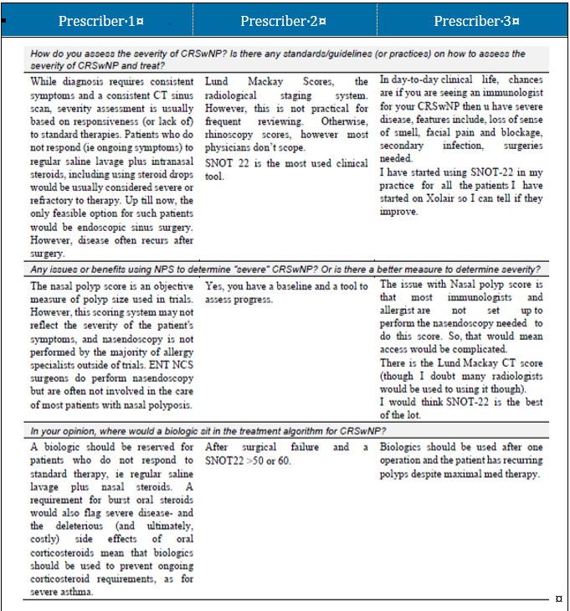
Lastly, it is important to note that while differences in trial design preclude direct comparisons across the dupilumab and omalizumab Phase III trials there are key differences among the patient populations studied including that patients were not required to have prior sino-nasal surgery or prior systemic corticosteroid usage for inclusion in the omalizumab Phase III trials. The reported use of systemic corticosteroids in the preceding two years was 74% in the overall dupilumab population; and 22% in the overall omalizumab population in the previous year. In addition, despite similar levels of asthma comorbidity, there were potentially higher levels of asthma severity among the Phase III dupilumab trials. Overall, this suggests that dupilumab enrolled patients may display a more severe form of the disease compared to omalizumab enrolled patients. These relative differences should also translate into the wording of the indications keeping the omalizumab indication naive of the word ‘severe’.
In conclusion, the sponsor believes that its proposed indication which specifies ‘patients with inadequate response to intranasal corticosteroids’ already appropriately captures the patient population, as defined by patients who are unresponsive to conventional topical therapies. This is less confusing, reflects trial conditions and focuses on a stepwise approach to therapy in line with the current Australian clinical practice.
- There are no established limits for clinically relevant effect for the co-primary endpoints of Nasal Polyp Score and Nasal Congestion Sscore. However, omalizumab was statistically significantly better than placebo in both pivotal studies and both co-primary endpoints.
The sponsor acknowledges that no thresholds of meaningful change (between-groups difference or individual-patient responder definitions) have been established to date for the co-primary endpoints Nasal Polyp Score and Nasal Congestion Score.
As pointed out by the Delegate a 0.56-point difference for Nasal Congestion Score and 1.50 for Nasal Polyp Score was used as basis for the samples size calculations. While it is acknowledged that the observed results in the pivotal Phase III studies were comparatively smaller than those chosen for the sample size calculation, it should be noted that these estimates were used solely to determine sample size and power calculations; and not because they were deemed to be thresholds of clinical relevance or the expected effect in the Phase III studies. Most importantly, the observed treatment effects were all statistically significant at 5% significance level.
It is worth noting that, unlike the Phase II proof of concept study, omalizumab efficacy in the Phase III studies was shown on top of daily background therapy with intranasal corticosteroids and that asthma comorbidity (a condition associated with nasal polyp severity) was only reported by 57% of the patients.
In order to establish meaningful change thresholds for Nasal Polyp Score and Nasal Congestion Score and provide context to the results of the two nasal polyp pivotal studies, a post-hoc analysis was conducted to determine the meaningful change thresholds and minimal important difference for the co-primary endpoints Nasal Polyp Score and Nasal Congestion Score with the support of the data from the secondary endpoint, the Sino-Nasal Outcome Ttest-22, a validated disease-specific health related quality of life instrument, where omalizumab led to significant and substantial improvements in quality of life in both studies. The SSino-Nasal Outcome Test-22 has a commonly accepted minimal important difference of 8.9 points. The full post-hoc analysis report was provided in our response to the clinical evaluation report [not shown here]. A summary of the results is provided below for convenience.
Anchor-based methods were used to define the meaningful change thresholds and minimal important differences. Correlations were calculated between the Nasal Polyp Score and Nasal Congestion Score and the following variables to determine the most appropriate anchors: the Sino-Nasal Outcome Test-22.
Total score, and Sino-Nasal Symptoms Subscale (SNOT-22 SNSS) score (proposed based on prior published exploratory analysis. To determine the anchor-based meaningful change, patients were grouped by change in disease severity on the identified anchors. Patients were classified into response groups depending on their level of change over the course of the study (improvement, no change/worsening based on previously identified meaningful change thresholds and minimal important differences associated with the anchor). For the Nasal Polyp Score, the ‘much improved’ group provided the best separation between the curves, according to both the SNOT- 22 and SNOT-22 SNSS, for each study separately and combined. For the Nasal Congestion Score, there was sufficient separation between the ‘improved’ group and ‘no change’ groups, particularly in Study GA39855, for both SNOT-22 and SNOT-22 SNSS. These groups were thus used to estimate the mean Nasal Polyp Score and Nasal Congestion Score change scores associated with meaningful improvement (to estimate the meaningful change thresholds), and to estimate the mean difference between patients that improved and those that did not (to estimate the minimal important differences).
For the Nasal Polyps Score, a within-patient meaningful change threshold was identified to be -1.0, meaning that a change in one category of the Nasal Polyps Score (0 to 8 rating scale) (an 11% change) is meaningful for an individual patient. This is consistent with the mean change of the ‘much improved’ groups for both SNOT-22 and SNOT-22 SNSS, in each study separately and combined. The between-groups minimal important difference was estimated to be -0.5. This is consistent with the differences in mean group change between the ‘improved vs no change’ groups in each study separately and combined,and is larger than/the same as the distribution-based estimates (range 0.47 to 0.50 for each study separately and combined).
For the Nasal Congestion Score, a within-patient meaningful change threshold was identified to be -0.5, meaning that a change of -0.5 in the weekly average Nasal Congestion Score (0 to 3 rating scale) (a 12.5% change) is deemed meaningful for an individual patient. This is consistent with the mean change of the ‘improved’ groups for both the SNOT-22 and SNOT-22 SNSS, in each study separately and combined. The between-groups minimal important difference was estimated to be -0.35 (Table 10). This is consistent with the differences in mean group change between the ‘improved versus no change’ in each study separately and combined (range -0.1 to -0.5), and larger than/the same as the distribution-based estimates (range 0.32 to 0.35 for each study separately and combined).
Table 10: Final estimates of meaningful change threshold and minimal important difference for the Nasal Polyps Score and Nasal Congestion Score (pooled data)
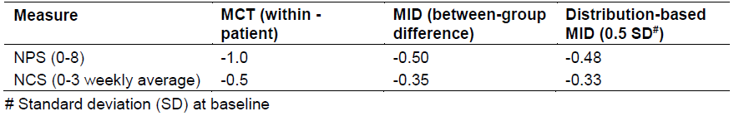
The estimates of meaningful change threshold were used in unblinded responder analyses to compare the proportions of patients in each study group achieving a meaningful improvement on both the Nasal Polyps Score and Nasal Congestion Score. These results are presented in Table 11. Overall, around twice as many patients achieved a meaningful change in the Nasal Polyps Score in the omalizumab group as in the placebo group, with highly statistically significant differences between the treatment groups. The cumulative distribution function plots for the pooled studies are displayed in Figure 4. Similarly, around twice as many patients achieved a meaningful change in the Nasal Congestion Score in the omalizumab group as in the placebo group, with highly statistically significant differences between the treatment groups. The cumulative distribution function plots for the pooled studies are displayed in Figure 5.
Table 11: Proportion of patients achieving minimal important difference for the Nasal Polyps Score and Nasal Congestion Score (pooled data)
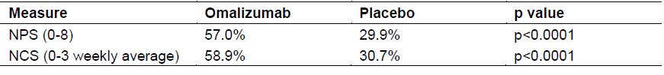
Summary - Post-hoc analysis: meaningful change threshold and minimal important difference for Nasal Congestion Score and Nasal Polyps Score
The estimated meaningful change thresholds and minimal important differences were consistent across the pivotal studies and across different methodological approaches. The use of a nasal polyp-specific measure (the SNOT-22 or SNOT-22 SNSS) supports the relevance of the estimated thresholds. In both studies, around twice as many patients in the omalizumab arm as in the placebo arm achieved a change that would have been perceived as meaningful.
In summary, the totality of the evidence based on the post-hoc analysis for meaningful change threshold and minimal important difference for Nasal Congestion Score and Nasal Polyps Score showed a meaningful change (improvement for the patient) and statistical significance between treatment groups and these results are considered clinically meaningful.
Figure 4: Cumulative distribution functions of Nasal Polyps Score improvement by treatment group (pooled data)
Figure 5: Cumulative distribution functions of Nasal Congestion Score improvement by treatment group (pooled data)

Advisory Committee considerations
The Advisory Committee on Medicines (ACM), having considered the evaluations and the Delegate’s overview, as well as the sponsor’s response to these documents, advised the following.

Specific advice to the delegate
- Is the change in the co-primary endpoints of Nasal Polyps Score and Nasal Congestion Score considered clinically significant?
The ACM was of view that the change in the co-primary endpoints of Nasal Polyps Score and Nasal Congestion Score are of clinical significance.
- Is the proposed dosing regimen for chronic rhinosinusitis with nasal polyps (the same as in severe asthma) appropriate?
The ACM was of view that the proposed dosing regimen is appropriate.
- Should the studied population be considered to represent patients with severe disease based on baseline severity scores and the indication restricted to treatment of severe chronic rhinosinusitis with nasal polyps?
The ACM was of the view that the studied population represented patients with severe disease based on baseline severity score and to restrict the indication to treatment of severe chronic rhinosinusitis with nasal polyps.
- Is the wording of the proposed indication appropriate?
The ACM recommended the following indication:
Chronic rhinosinusitis with nasal polyps (CRSwNP):
Xolair is indicated as add-on treatment in adult patients (18 years of age and above) for the treatment of severe CRSwNP with inadequate response to intranasal corticosteroids. Recommended dosing is determined by IgE levels and body weight corresponding to the recommended dose range in the PI.

Conclusion
The ACM considered this product to have an overall positive benefit-risk profile for the indication:
Chronic rhinosinusitis with nasal polyps (CRSwNP):
Xolair is indicated as add-on treatment in adult patients (18 years of age and above) for the treatment of severe CRSwNP with inadequate response to intranasal corticosteroids. Recommended dosing is determined by IgE levels and body weight corresponding to the recommended dose range in the PI.

Outcome
Based on a review of quality, safety and efficacy, the TGA approved the registration of Xolair (omalizumab) 75 mg, 150 mg, solution for injection in pre-filled syringe and powder for injection vial with diluent, for the following extension of indications:
Chronic rhinosinusitis with nasal polyps (CRSwNP)
Xolair is indicated as add‐on treatment in adult patients (18 years of age and above) for the treatment of severe CRSwNP with inadequate response to intranasal corticosteroids.
Recommended dosing is determined by serum immunoglobulin E levels and body weight corresponding to the recommended dose range in the Product Information (see Section 4.2 dose and method of administration).
As such, the full indications at this time were:
Allergic Asthma
Children 6 to < 12 years of age
In children aged 6 to < 12 years, Xolair is indicated as add‐on therapy to improve asthma control in patients with severe allergic asthma who have documented exacerbations despite daily high dose inhaled corticosteroids, and who have immunoglobulin E levels corresponding to the recommended dose range (see Table 1 in Section 4.2 dose and method of administration).
Adults and adolescents ≥ 12 years of age
Xolair is indicated for the management of adult and adolescent patients with moderate to severe allergic asthma, who are already being treated with inhaled steroids, and who have serum immunoglobulin E levels corresponding to the recommended dose range (see Table 1 in Section 4.2 dose and method of administration)
Chronic rhinosinusitis with nasal polyps (CRSwNP)
Xolair is indicated as add‐on treatment in adult patients (18 years of age and above) for the treatment of severe CRSwNP with inadequate response to intranasal corticosteroids.
Recommended dosing is determined by serum immunoglobulin E levels and body weight corresponding to the recommended dose range in the Product Information (see Section 4.2 dose and method of administration).
Chronic Spontaneous Urticaria (CSU)
Xolair is indicated for adults and adolescents (12 years of age and above) with chronic spontaneous urticaria who remain symptomatic despite H1 antihistamine treatment.

Specific conditions of registration applying to these goods
- This approval does not impose any requirement for the submission of Periodic Safety Update reports (PSUR). The sponsor should note that it is a requirement that all existing requirements for the submission of PSURs as a consequence of the initial registration or subsequent changes must be completed.
- For all injectable products the Product Information must be included with the product as a package insert.

Attachment 1. Product Information
The PI for Xolair approved with the submission which is described in this AusPAR is at Attachment 1. For the most recent PI, please refer to the TGA website at <https://www.tga.gov.au/product-information-pi>.

Therapeutic Goods Administration
PO Box 100 Woden ACT 2606 Australia
Email: info@tga.gov.au Phone: 1800 020 653 Fax: 02 6232 8605
https://www.tga.gov.au

The Black Triangle Scheme provides a simple means for practitioners and patients to identify certain types of new prescription medicines, including those being used in new ways and to encourage the reporting of adverse events associated with their use. The Black Triangle does not denote that there are known safety problems, just that the TGA is encouraging adverse event reporting to help us build up the full picture of a medicine's safety profile.
Newton JR, Ah-See KW. A review of nasal polyposis. Ther Clin Risk Manag. 2008 Apr;4(2):507-12.
Sedaghat A. Chronic rhinosinusitis. Am Fam Physician. 2017 Oct 15;96(8):500-506.
Passali, Desiderio, et al. Consensus Conference on Nasal Polyposis. Acta otorhinolaryngologica Italica : organo ufficiale della Società italiana di otorinolaringologia e chirurgia cervico-facciale.2004, 24. 3-61.
Stevens WW, et al. Chronic Rhinosinusitis with Nasal Polyps. J Allergy Clin Immunol Pract. 2016;4(4):565–572.
Rosenfeld, R. M, et al.. Clinical Practice Guideline (Update): Adult Sinusitis. Otolaryngology–Head and Neck Surgery, 2015,152(2_suppl), S1–S39.
Stevens WW, Schleimer RP, Kern RC. Chronic Rhinosinusitis with Nasal Polyps. J Allergy Clin Immunol Pract. 2016;4(4):565-572.
Kato A. Immunopathology of chronic rhinosinusitis. Allergol Int; 64:121-30. Copy provided by the Applicant.
Chaaban MR, Walsh EM, Woodworth BA. Epidemiology and differential diagnosis of nasal polyps. Am J Rhinol Allergy. 2013;27(6):473–478. doi:10.2500/ajra.2013.27.3981.
The sponsor must still comply with routine product vigilance and risk minimisation requirements.
Gevaert P, et al. Efficacy and Safety of omalizumab in nasal polyposis: 2 randomized Phase 3 trials. J Allergy Clin Immunol; 2020, 146:595-605 (published report of Studies GA39688 and GA39855)
Bachert C, et al. Reduced need for surgery in severe nasal polyposis with mepolizumab: Randomized trial. J Allergy Clin Immunol; 2017,140 (4):1024-1031.e14.
Bachert C, et al. Efficacy and safety of dupilumab in patients with severe chronic rhinosinusitis with nasal polyps (LIBERTY NP SINUS-24 and LIBERTY NP SINUS-52): results from two multicentre, randomised, double-blind, placebo-controlled, parallel-group phase 3 trials. Lancet; 2019, 394 (10209):1638-1650.
The ACM provides independent medical and scientific advice to the Minister for Health and the Therapeutic Goods Administration (TGA) on issues relating to the safety, quality and efficacy of medicines supplied in Australia including issues relating to pre-market and post-market functions for medicines. The Committee is established under Regulation 35 of the Therapeutic Goods Regulations 1990. Members are appointed by the Minister. The ACM was established in January 2017 replacing Advisory Committee on Prescription Medicines (ACPM) which was formed in January 2010. ACM encompass pre and post-market advice for medicines, following the consolidation of the previous functions of the Advisory Committee on Prescription Medicines (ACPM), the Advisory Committee on the Safety of Medicines (ACSOM) and the Advisory Committee on Non-Prescription Medicines (ACNM). Membership comprises of professionals with specific scientific, medical or clinical expertise, as well as appropriate consumer health issues relating to medicines.

