February 2013

Australian Public Assessment Report for olmesartan medoxomil
  - Proprietary Product Name: Olmetec
  - Sponsor: Merck Sharp & Dohme (Australia) Pty Ltd
About the Therapeutic Goods Administration (TGA)
- The Therapeutic Goods Administration (TGA) is part of the Australian Government Department of Health and Ageing, and is responsible for regulating medicines and medical devices.
- The TGA administers the Therapeutic Goods Act 1989 (the Act), applying a risk management approach designed to ensure therapeutic goods supplied in Australia meet acceptable standards of quality, safety and efficacy (performance), when necessary.
- The work of the TGA is based on applying scientific and clinical expertise to decision-making, to ensure that the benefits to consumers outweigh any risks associated with the use of medicines and medical devices.
- The TGA relies on the public, healthcare professionals and industry to report problems with medicines or medical devices. TGA investigates reports received by it to determine any necessary regulatory action.
- To report a problem with a medicine or medical device, please see the information on the TGA website <www.tga.gov.au>.
About AusPARs
- An Australian Public Assessment Record (AusPAR) provides information about the evaluation of a prescription medicine and the considerations that led the TGA to approve or not approve a prescription medicine submission.
- AusPARs are prepared and published by the TGA.
- An AusPAR is prepared for submissions that relate to new chemical entities, generic medicines, major variations, and extensions of indications.
- An AusPAR is a static document, in that it will provide information that relates to a submission at a particular point in time.
- A new AusPAR will be developed to reflect changes to indications and/or major variations to a prescription medicine subject to evaluation by the TGA.
Copyright
© Commonwealth of Australia 2013
This work is copyright. You may reproduce the whole or part of this work in unaltered form for your own personal use or, if you are part of an organisation, for internal use within your organisation, but only if you or your organisation do not use the reproduction for any commercial purpose and retain this copyright notice and all disclaimer notices as part of that reproduction. Apart from rights to use as permitted by the Copyright Act 1968 or allowed by this copyright notice, all other rights are reserved and you are not allowed to reproduce the whole or any part of this work in any way (electronic or otherwise) without first being given specific written permission from the Commonwealth to do so. Requests and inquiries concerning reproduction and rights are to be sent to the TGA Copyright Officer, Therapeutic Goods Administration, PO Box 100, Woden ACT 2606 or emailed to <tga.copyright@tga.gov.au>.

Contents
I. Introduction to product submission 4
Submission details 4
Product background 4
Regulatory status 7
Product Information 8
List of abbreviations 8
II. Quality findings 10
Drug substance (active ingredient) 10
Biopharmaceutics 10
Advisory committee considerations 11
III. Nonclinical findings 11
IV. Clinical findings 11
Introduction 11
Pharmacokinetics 12
Pharmacodynamics 20
Efficacy 21
Safety 35
List of questions 43
Clinical summary and conclusions 44
V. Pharmacovigilance findings 55
Risk management plan 55
VI. Overall conclusion and risk/benefit assessment 58
Quality 58
Nonclinical 59
Clinical 59
Risk management plan 64
Risk-benefit analysis 64
Outcome 71
Attachment 1. Product Information 71

I. Introduction to product submission

Submission details
Type of Submission: | Major Variation (New Dosage Form, Increase in Patient Group)
Decision: | Approved
Date of Decision: | 7 September 2012
Active ingredient: | Olmesartan medoxomil
Product Name | Olmetec
Sponsor’s Name and Address: | Merck Sharp & Dohme (Australia) Pty Ltd  Level 4, 66 Waterloo Road  North Ryde NSW 2113
Dose form: | Tablet
Strengths: | 10 mg, 20 mg and 40 mg
Container: | Blister pack
Approved Therapeutic use: | New paediatric dosing instructions in the ‘Dosage and Administration’ section of the Product Information for the approved indication (“for the treatment of hypertension”).
Route of administration: | Oral
Dosage: | Age ranges: 1-5 years (maximum 20 mg per day) and 6-18 years (maximum 20 mg or 40 mg per day depending on weight).
ARTG Numbers: | AUST R 102134, AUST R 102138, AUST R 102139

Product background
This AusPAR describes an application by the sponsor, Merck Sharp & Dohme (Australia) Pty Ltd, to alter the ‘Dosage and Administration’ section of the Product Information (PI) for olmesartan medoxomil (Olmetec) to extend the patient population of registered Olmetec 10 mg, 20 mg and 40 mg tablets to include paediatric patients. The submission also proposes to amend the PI to allow the currently registered Olmetec 20 mg olmesartan medoxomil tablets to be used extemporaneously by compounding pharmacists in the preparation of an oral suspension to allow for weight based dosing in children aged 1-5 years, or for children who cannot swallow tablets. This oral suspension would be used by paediatric patients with hypertension.
There are no changes proposed for the Indications, which remain:
“Olmetec is indicated for the treatment of hypertension.”
In the section ‘Dosage and Administration’, there is a new heading ‘Paediatric Use’ which begins with the advice that dosing must be individualised. The recommended starting doses and dose ranges of Olmetec are based on age and/or weight and are summarised in the Dosing Recommendation Table (Table 1).
Table 1: Dosing Recommendation Table for Olmetec.
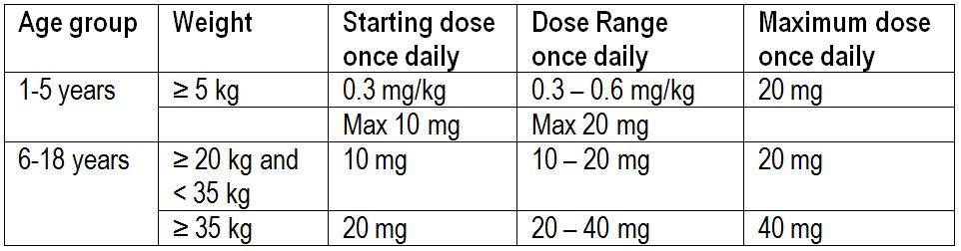
For children who cannot swallow tablets, the equivalent dose may be given as an extemporaneous suspension. There follows advice on the preparation of a suspension (200 mL of a 2 mg/mL suspension).
Olmesartan tablets are available in three dosage strengths: 10 mg, 20 mg and 40 mg. It has been on the Australian Register of Therapeutic Goods since Feb 2007 (originally sponsored by Schering-Plough Pty Ltd) and is also available as fixed dose combination tablets of olmesartan and hydrochlorothiazide (Olmetec Plus) and of olmesartan and amlodipine (Sevikar).

Hypertension in children
It has become clear that hypertension (HTN) begins in childhood and adolescence and that it contributes to the early development of cardiovascular disease (CVD). The supporting data include clinical studies that demonstrate cardiovascular structural and functional changes in children with HTN and autopsy studies that have shown an association of BP with atherosclerotic changes in the aorta and heart in children and young adults.
In hypertensive adults, multiple randomised trials have shown that reduction of blood pressure (BP) by antihypertensive therapy reduces cardiovascular morbidity and mortality. The magnitude of the benefit increases with the severity of the HTN.
Based upon these observations, identifying children with HTN and successfully treating their HTN should have an important impact on long term outcomes of CVD.
In children, definitions based upon the 2004 National High Blood Pressure Education Program Working Group (NHBPEP) are used to classify BP measurements in the United States. BP percentiles are based upon gender, age, and height. The systolic and diastolic BP (SBP and DBP, respectively) are of equal importance; if there is a disparity between the two, the higher value determines the BP category. The age and height specific BP percentiles may be determined using calculators for boys or for girls.
- Normal BP: both SBP and DBP <90th percentile.
- Prehypertension: SBP and/or DBP ≥90th percentile but <95th percentile or if BP exceeds 120/80 mmHg (even if <90th percentile for age, gender, and height).
- Hypertension: Hypertension is defined as either SBP and/or DBP ≥95th percentile measured upon three or more separate occasions. The degree of hypertension is further delineated by the two following stages:
  - Stage 1 hypertension: SBP and/or DBP between the 95th percentile and 5 mmHg above the 99th percentile.
  - Stage 2 hypertension: SBP and/or DBP ≥99th percentile plus 5 mmHg.
The diagnosis of persistent childhood HTN is made when repeat BP values on three separate visits are greater than the 95th percentile for the age, gender and height of the patient. However, in the symptomatic child with Stage 2 hypertension, evaluation and treatment should be initiated without further BP measurements.
The diagnosis of HTN is dependent upon routine accurate measurements of BP throughout childhood using a standardised procedure and equipment.
There are no published Australian prevalence data for paediatric hypertension. However an estimated global prevalence has been reported to be around 2 to 5%. Assuming a conservative estimated prevalence of 2% in Australia:
- at least 27,838 children aged 1-5 years will be hypertensive; and
- at least 67,390 children aged 6-18 years will be hypertensive.
The need for regulatory guidance on the clinical development of anti hypertensive agents in this population was raised by the European Medicines Agency (EMA). A concept paper by EMA commented that:
- the prevalence and rate of diagnosis of hypertension in children and adolescents appears to be increasing;
- under diagnosis and treatment of hypertension in children is a matter of concern; and
- new medicinal products suitable for use in paediatric patients are needed.
There are limited numbers of anti hypertensive agents approved for use in the paediatric population in suitable formulations.

Treatment recommendations for paediatric patients
The aim of treatment is to reduce the BP for gender and height for age to be:
- below the 95th percentile; or
- below the 90th percentile (for patients with chronic renal disease, diabetes, target organ damage).
When lifestyle modifications fail to control BP, pharmacologic therapy is often required. Initiation of therapy is recommended in the following patient groups:
- Stage 1 hypertension (95th to the 99th percentile plus 5 mmHg) with:
    - symptomatic hypertension
    - secondary hypertension
    - hypertensive target organ damage
    - diabetes (type 1 and 2)
    - persistent hypertension despite non pharmacologic measures
- Stage 2 hypertension (>99th percentile plus 5 mmHg)

Use of anti hypertensive agents for paediatric patients in Australia
A limited number of agents are approved in Australia for the treatment of hypertension in paediatric patients. These include:
- captopril (angiotensin converting enzyme inhibitor)
- hydrochlorothiazide (diuretic)
- verapamil (calcium channel blocker)

Angiotensin II receptor antagonists
Olmesartan medoxomil is an orally active angiotensin II receptor (type AT1) antagonist. Olmesartan medoxomil is a pro drug and is rapidly converted to the pharmacologically active metabolite, olmesartan, by esterases in the gut mucosa and in portal blood during absorption from the gastrointestinal tract.
In the USA, the angiotensin II receptor blockers olmesartan, valsartan and losartan are approved for use in children and adolescents aged 6 to 16 years while candesartan is approved for use in children aged 1 to 16 years. For olmesartan, the dosage recommendations for children aged 1 to 5 years were not approved by the US Food and Drug Administration (FDA) as data from the efficacy study for children in this age range showed efficacy to be numerically but not statistically different in the placebo withdrawal phase due to the small sample size. Approved formulations include extemporaneous suspensions.
In Europe, losartan and valsartan are approved for use in children aged 6 to 18 years. Dosing recommendations are for tablet use only. There is a submission for olmesartan use in children still under evaluation in the European Union.
There is currently no angiotensin II receptor blockers indicated for use in paediatric patients in Australia. Dosing recommendations are provided for hydrochlorothiazide and verapamil for use in paediatric patients. However, no information is provided of the use or preparation of these agents in dosage forms (that is, solution/drops, emulsion/suspension) suitable for paediatric use. Therefore, the availability of an anti hypertensive agent in suitable dosage forms exists as an unmet clinical need in Australia for paediatric hypertensive patients.

Regulatory status
Olmetec (olmesartan medoxomil) is approved for the treatment of hypertension in 85 countries/territories worldwide, and was first approved in 2002. Table 2 lists the filings/approvals for the paediatric population applications worldwide at the time of dossier submission in Australia.
Table 2: Summary of international regulatory status of Olmetec (olmesartan medoxomil) for paediatric populations.
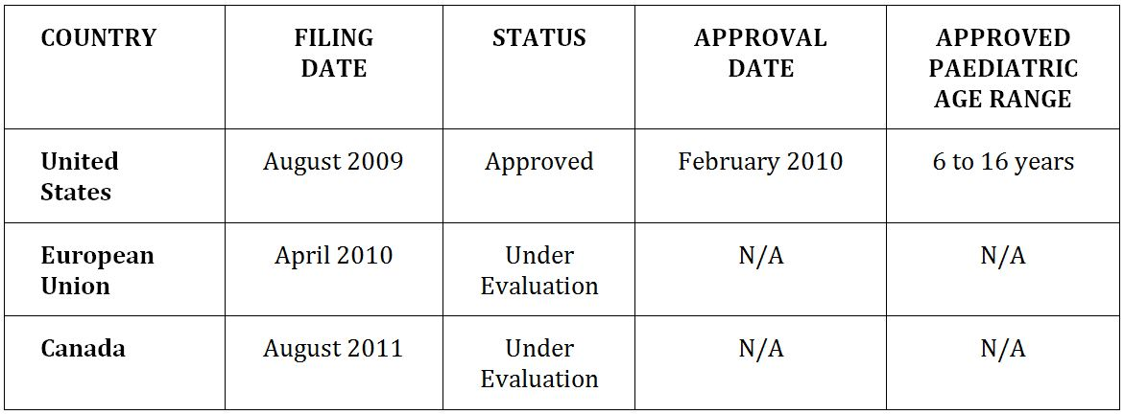
Olmetec is not registered in New Zealand, and so this submission has not been submitted.

Product Information
The approved PI current at the time this AusPAR was prepared can be found as Attachment 1.

List of abbreviations
AII angiotensin II
ACE angiotensin II converting enzyme
Ae the total amount of olmesartan excreted in urine over all collection periods
AE adverse event
AESOP Assessment of Efficacy and Safety of Olmesartan Medoxomil in Paediatric Hypertension
Aet amount of the compound excreted in urine during each collection interval
ALT alanine aminotransaminase
ALT (SGPT) alanine aminotransferase
ANCOVA analysis of covariates
ANOVA analysis of variance
ARB angiotensin receptor blocker
AST aspartate aminotransaminase
AST (SGOT) aspartate aminotransferase
AUC Area Under the Concentration Curve
AUC_{0-∞} area under the concentration-time curve from the time of the dose to infinity
AUC_{0-t} area under the concentration-time curve from time 0 to the time of last quantifiable concentration
AUC_{ss} area under the concentration-time curve at steady state
BMI body mass index
BP blood pressure
BPM beats per minute
BUN blood urea nitrogen
CCB calcium channel blocker
CFR Code of Federal Regulations
CI confidence interval
CK creatine phosphokinase
CL/F apparent oral clearance
CL_{R} renal clearance of the drug from plasma
C_{max} maximum plasma concentration over the entire sampling phase
CMI Consumer Medicine Information
CPK creatine phosphokinase
CRF case report form
CRO clinical research organisation
CVD cardiovascular disease
DBP diastolic blood pressure
DSPD Daiichi Sankyo Pharma Development
ECG electrocardiogram
EMA European Medicines Agency
FDA Food and Drug Administration (US)
GCP Good Clinical Practice
GFR glomerular filtration rate
GM geometric mean
Hb haemoglobin
Hct hematocrit
HDPE high density polyethylene
HTN hypertension
ICF Informed Consent Form
ICH International Conference on Harmonisation
IEC Independent Ethics Committee
IRB Institutional Review Board
ITT Intention To Treat
IVRS Interactive Voice Recognition System
k_{el} elimination rate constant
LOCF last observation carried forward
MCH mean corpuscular haemoglobin
MedDRA Medical Dictionary for Regulatory Activities
OM olmesartan medoxomil
PD pharmacodynamic(s)
PET polyethylene terephthalate
PI Product Information
PK pharmacokinetic(s)
RBC red blood cell
RDW red blood cell distribution width
RMP risk management plan
SAE serious adverse event
SAP Statistical Analysis Plan
SBP systolic blood pressure
SD standard deviation
SeDBP seated diastolic blood pressure
SeSBP seated systolic blood pressure
SLE systemic lupus erythematosus
TEAE treatment emergent adverse event
t_{1/2} elimination half life
T_{max} time of maximum plasma concentration
V_{z}/F apparent oral volume of distribution
WBC white blood cell
Xu the percent of dose recovered as olmesartan in urine

II. Quality findings

Drug substance (active ingredient)
Olmetec (olmesartan medoxomil), a prodrug, is hydrolysed to olmesartan during absorption from the gastrointestinal tract (Figure 1). Olmesartan is a selective AT1 subtype angiotensin II receptor antagonist.
Figure 1: Olmetec chemical structure.
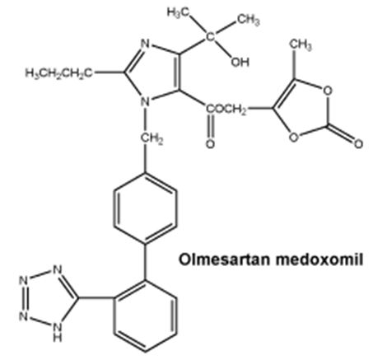

Biopharmaceutics

Chemistry and quality control
Data were provided to demonstrate that:
- The proposed compounding mixtures (Ora Sweet and Ora Plus) are of suitable quality.
- The resulting suspension is chemically and physically stable when stored at 2-8°C for at least 28 days (the maximum time proposed) in amber PET bottles with child resistant caps. The PI stipulates that the oral suspension should be stored at “2-8°C (Refrigerate. Do not freeze)” and this is supported by the data provided.
- The sterility of the suspension over the storage period of 28 days is under evaluation by the microbiology section.
- A suitably accurate device (syringe or measuring cup) can be used to dispense the suspension. A 10 mg dose would require 5 mL of the 2 mg/1 mL suspension and this volume can be adequately measured using standard devices.

Bioavailability
A bioequivalence study comparing the oral suspension (4 mg/1 mL) prepared from 20 mg tablets against 40 mg tablets has been provided. An adequate justification for not providing a study involving an oral solution prepared as proposed in the PI (that is, 2 mg/1 mL) has been provided. An adequate justification for the use of 40 mg tablets instead of 20 mg tablets has also been provided.
The bioequivalence study was conducted on 24 adult subjects (20 men and 4 women completed both arms of the study). Demographic details have been provided. No particular issues were identified with respect to the reported AEs, protocol deviations or concomitant medication. These issues are brought to the attention of the clinical section.
- The test method used to determine olmesartan levels in plasma samples was suitable and the study design was suitable to determine bioequivalence.
- The olmesartan responses from the tablet and the suspension were bioequivalent in relation to both extent and rate of absorption (90% CIs for AUC_{0-t} = 97.7-113.3 and for C_{max} = 97.8 116.3 with no change in T_{max}).
- The variability of the response from the oral suspension was no higher than that from the tablets.

Advisory committee considerations
Approval of this submission cannot be recommended until outstanding issues raised with respect to the PI have been satisfactorily addressed.
The advice of the Advisory Committee on Prescription Medicines (ACPM) and Clinical Evaluation Unit in relation to the Pharmaceutical Chemistry aspects of the PI is sought.

III. Nonclinical findings
There was no requirement for a nonclinical evaluation in a submission of this type.

IV. Clinical findings

Introduction
The sponsor submitted 12 volumes including 9 volumes of clinical data in support of their proposed indication in the common technical document format.
The clinical dossier included two PK studies and one clinical study as well as a combined PK analysis using population PK methodology. The sponsor also included their responses to a series of pre evaluation questions asked by the TGA.
The dossier presentation was clear, the pages were legible and tables were well presented. All of the studies were stated to comply with GCP. The dossier was similar to those submitted in the USA and Europe. It should be noted that the US branded olmesartan medoxomil is Benicar.

Pharmacokinetics

Introduction
The dossier included two PK studies in support of their application.

Study CS0866-A-U101
Study CS0866-A-U101 was a comparative, randomised, single dose, two way crossover bioavailability study of a compounded 4 mg/ml olmesartan medoxomil suspension (total dose 40 mg) and 40 mg olmesartan medoxomil tablets (Benicar) in healthy adult volunteers. The study was open label, two way crossover bioequivalence study conducted under fasting conditions at a single centre in the US. During each dosing period, subjects were confined to the clinical pharmacology unit from ∼24 h prior to the first dose up to the last blood draw on Day 3. There was a washout period of 7 days between doses. Subjects were randomly assigned to receive one of the following two formulations on two different occasions:
- Treatment A: olmesartan medoxomil 4 mg/mL suspension (10 mL, for a total dose of 40 mg) administered orally with 240 mL of water,
- Treatment B: olmesartan medoxomil tablets (Benicar, 1 x 40 mg tablets) administered orally with 240 mL of water.

Test product
Olmesartan medoxomil (Benicar 20 mg tablets), Ora Plus and Ora Sweet were supplied in commercially labelled containers. The suspension formulation was prepared by Merck Sharp & Dohme Pharma Services Pharmacy staff at the clinical site following standard procedures. The suspension was to be prepared in an 8 oz (240 mL) amber PET prescription bottle with child resistant closure. At the time of compounding, labelling identifying the study, contents (identity, concentration, and volume), date/time prepared, compounder's initials, and use by date/time was prepared and applied to the bottle. Appropriate auxiliary labels (“Shake well” and “Store in Refrigerator”) were also applied.

Demographics
The study enrolled 26 subjects (22 males and 4 females), of whom 24 completed the study. Two subjects, both randomised to Treatment Sequence “BA” (Benicar tablet followed by olmesartan medoxomil suspension), were discontinued from the study at Period 2 check in. The Investigator dropped one subject due to a positive urine drug test, while a second subject failed to return for Period 2.

Pharmacokinetics
PK parameters were calculated from the individual plasma concentrations of olmesartan using non compartmental methods with the software package WinNonlin Version 4. The calculated PK parameters included AUC_{0-t}, AUC_{inf}, AUC/AUC_{inf}, C_{max}, T_{max}, t_{1/2} and k_{el}. All descriptive and inferential statistics were calculated in SAS Version 8.2. In order to determine bioequivalence, the 90% CI of the ratios of geometric means for AUC_{0-t}, AUC_{inf}, and C_{max} of the test to reference formulation were to be within 80 to 125%. The PK parameters are summarised in Table 3 and the concentration time plots are shown in Figure 2.
Table 3: Summary of Olmesartan PK Parameters (Study CS0866-A-U101).
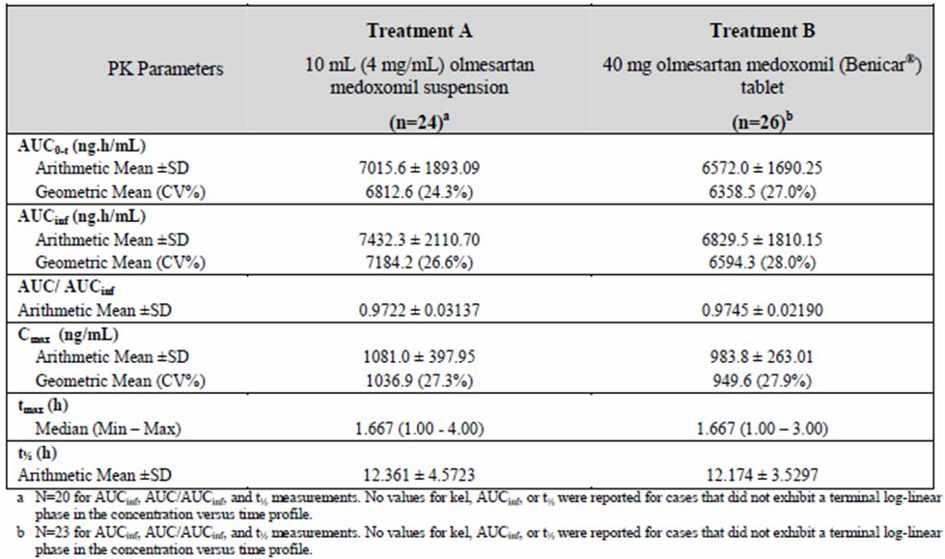
Figure 2: Olmesartan Plasma Concentration Profiles (Study CS0866-A-U101).
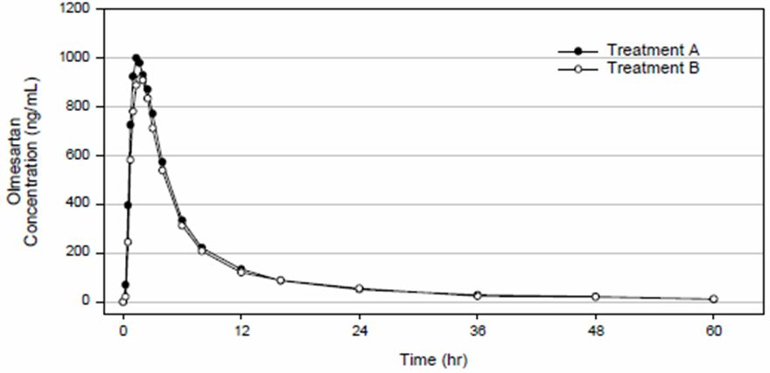
The sponsor supplied two analyses of the 90% CI for assessment of bioequivalence (SAS PROC MIXED procedure and SAS GLM procedure) (Tables 4-5). The PROC MIXED procedure included all subjects while and the GLM procedure only included subjects who completed both sequences. Both analyses demonstrated that the two formulations were bioequivalent (that is, demonstrated bioequivalence for both AUC and C_{max}).
Table 4: Results from the ANOVA performed using the SAS PROC MIXED Procedure (Study CS0866-A-U101).
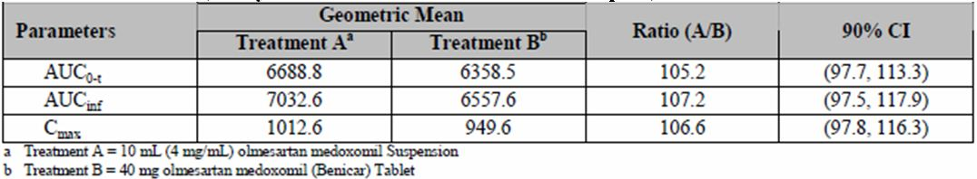
Table 5: Results from the ANOVA performed using the SAS GLM Procedure (Study CS0866-A-U101).
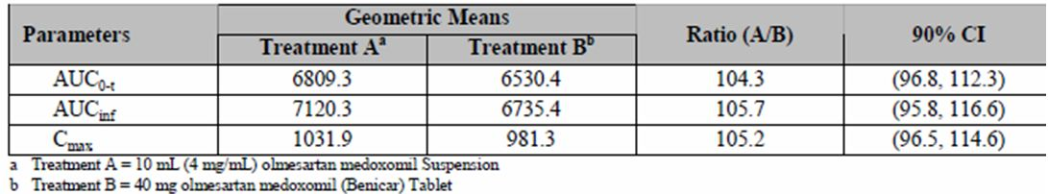

Deficiencies
The main deficiency was that two subjects did not complete both study sequences, but not due to any fault in the study design. However, a total of 24 subjects were included in the analysis and the number of subjects was adequate to demonstrate the bioequivalence of the two formulations.

Summary
In summary, Study CS0866-A-U101 demonstrated that a compounded 4 mg/mL olmesartan medoxomil suspension (total dose 40 mg) was bioequivalent to 40 mg olmesartan medoxomil tablets (Benicar) in healthy adult volunteers. The compounding formulation was different to the one proposed in the Australian PI (which was 2 mg/mL prepared with a 20 mg tablet).

Study CS0866-A-U102
Study CS0866-A-U102 was an open label study of the single dose PK of olmesartan medoxomil in paediatric patients with hypertension conducted in six centres in the US. The primary objective of this study was to determine the single dose PK of olmesartan medoxomil in paediatric patients with hypertension between the ages of 12 months to 16 years. Subjects who met the screening criteria were stratified into four groups by age: 12-23 months, 2-5 years, 6-12 years, and 13-16 years. On Day 1, patients were given a single dose of olmesartan medoxomil at least 1 h following a light breakfast. Children 6 years of age and older received olmesartan medoxomil 40 mg (≥35 kg) or 20 mg (<35 kg); children younger than 6 years received olmesartan medoxomil in suspension form at a dose of 0.3 mg/kg body weight, not exceeding 20 mg. Blood samples for determination of olmesartan blood concentration were obtained before dosing and at 1, 2, 4, 8, 12, 24, and 48 h after dosing. All voided urine was collected from each patient during the intervals 0-6, 6-12, and 12-24 h after dosing when possible.
The study planned to include 40 patients but only 33 were screened and 24 were enrolled and completed the study. The sponsor stated that based on the FDA’s correspondence from 18 January 2008, the 2-5 year age cohort was reduced to 4 patients from 10 patients and the 12-23 months cohort was terminated.

Demographics
The study enrolled 24 of the 33 screened patients. No patients were enrolled in the youngest age group, 12-23 months (Group 1). The majority of patients were in the two oldest cohorts; 6-12 year age group and 13-16 year age group as these cohorts completed full enrolment of 10 patients per group (Figure 3). The patient demographics are summarised in Table 6.
Figure 3: Disposition of Subjects (Study CS0866-A-U102).
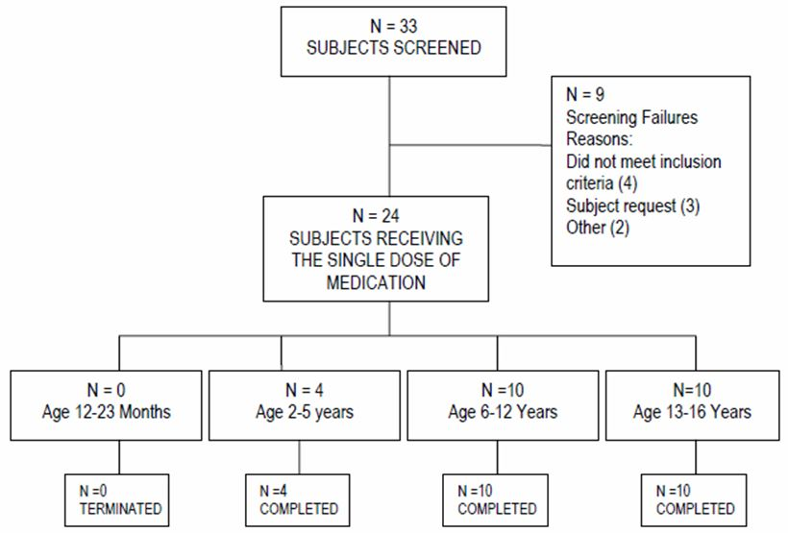
Table 6: Baseline Demographics and Characteristics (All Enrolled Subjects) (Study CS0866-A-U102).
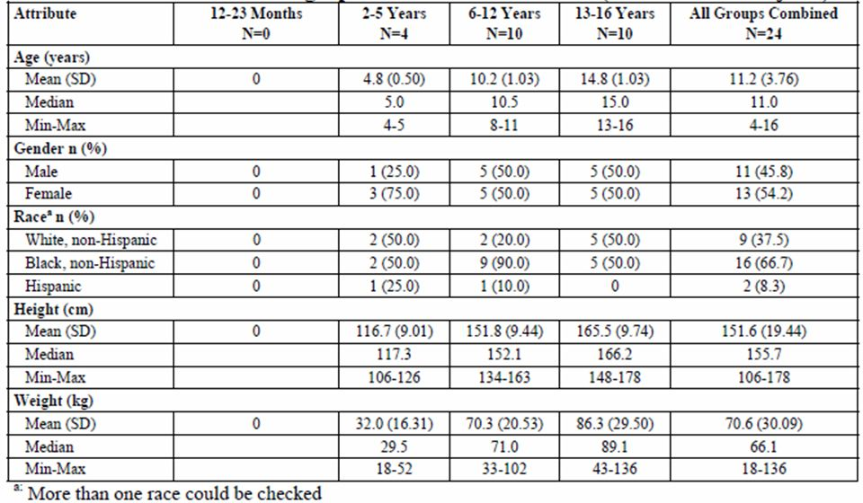

Pharmacokinetics
Blood samples for PK analysis were collected in tubes containing sodium heparin.
Collections occurred at the following time points: pre dose, 1, 2, 4, 8, 12, 24, and 48 h post dose. Where practical, all voided urine was collected from each patient during the intervals of 0-6, 6-12, and 12-24 h after dosing.
PK variables for serum concentrations of olmesartan were calculated from plasma using WinNonlin 5.2 via a non compartmental analysis:
- AUC_{0-t} (ng·hr/mL)
- AUC_{0-∞} (ng·hr/mL)
- Cmax (ng/mL)
- Tmax (h)
- t_{1/2} (h)
- CL/F
- V_{z}/F
The following PK parameters were calculated from the olmesartan concentration in urine:
- Aet
- Ae
- Fe
- CL_{R}
In the 2-5 year age group, patients received 5, 6, 12, and 16 mg olmesartan medoxomil based on their respective body weights. In the 6-12 year age group, 9 of 10 patients received 40 mg olmesartan medoxomil and one patient received 20 mg olmesartan medoxomil. All patients in the 13 to 16 year age group received 40 mg olmesartan medoxomil. The geometric means of AUC and C_{max} of the 6-12 year age group were one third higher than those of the 13-16 year age group. Correspondingly, the CL/F and V_{z}/F of the 6-12 year age group were roughly two thirds of those of the 13-16 year age group. These relationships correspond to the roughly proportional relationships of CL/F and V_{z}/F with body weight. Because of the limited sample size for the 2-5 year age group, the sponsor did not calculate statistics for this age group (individual results are presented in Table 7). The summary results are presented in Tables 8-9. Mean serum concentrations are shown in Figure 4.
Table 7: Plasma concentrations (ng/mL) of olmesartan in 2-5 year old patients (PK analysis for Study CS866-A-U102).
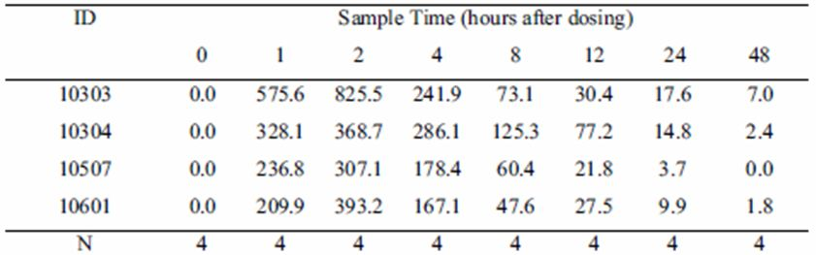
Table 8: Mean plasma PK parameters of olmesartan (PK population) (Study CS0866-A-U102).
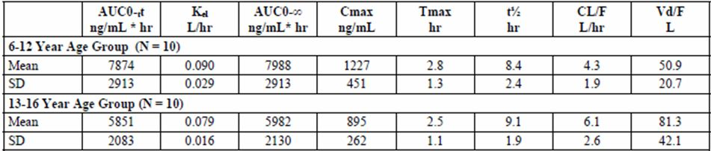
Table 9: Statistical analysis of mean plasma PK parameters of olmesartan (PK population) (Study CS0866-A-U102).
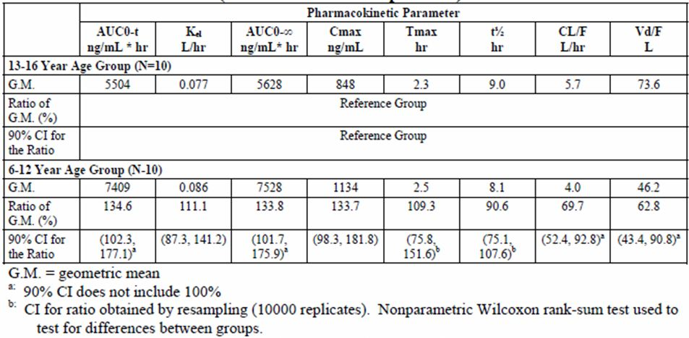
Figure 4: Mean plasma concentrations (ng/mL) of olmesartan by age group (PK analysis for Study CS866-A-U102).
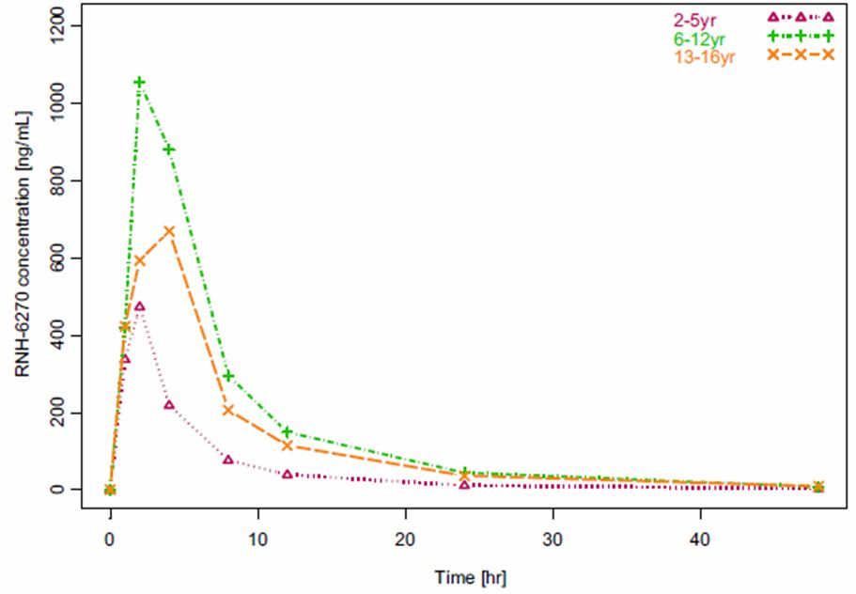

Relationship between PK and size
The PK analysis found that both clearance and volume correlated with the patient’s size as seen in Figure 5 (CL/F) and Figure 6 (V_{z}/F). As expected, t_{1/2} and T_{max} were independent of patient size (Figures 7-8).
Figure 5: CL/F plotted versus body weight (PK analysis for Study CS866-A-U102).
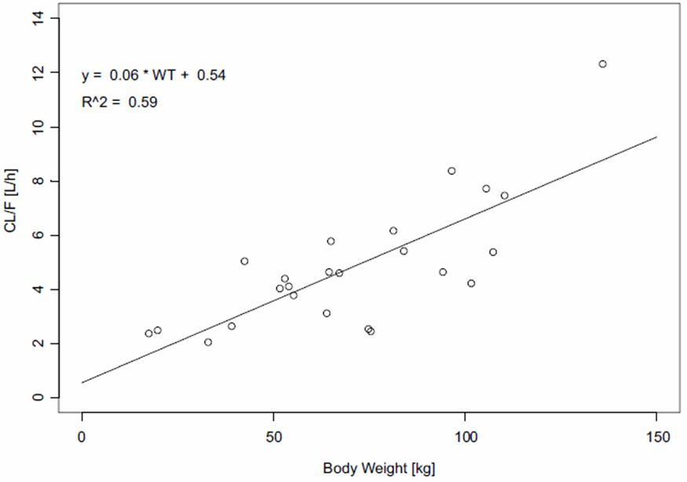
Figure 6: Vz/F plotted versus body weight (PK analysis for Study CS866-A-U102).
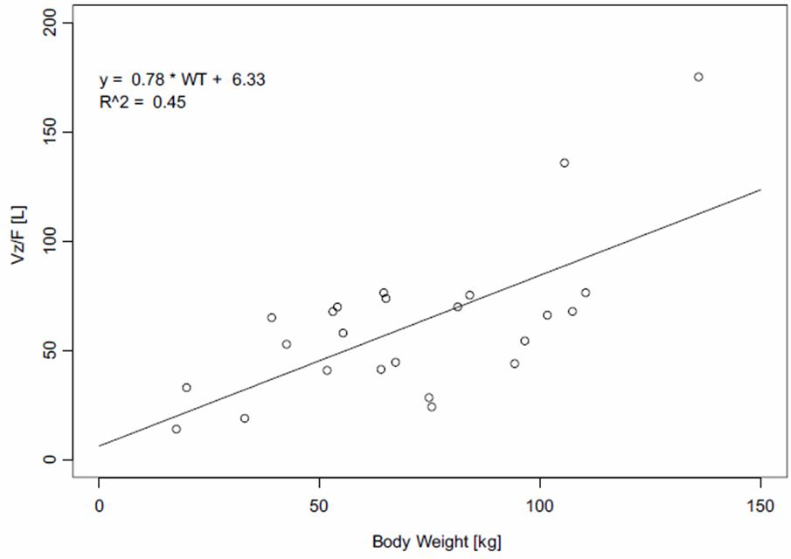
Figure 7: Half life plotted versus body weight (PK analysis for Study CS866-A-U102).
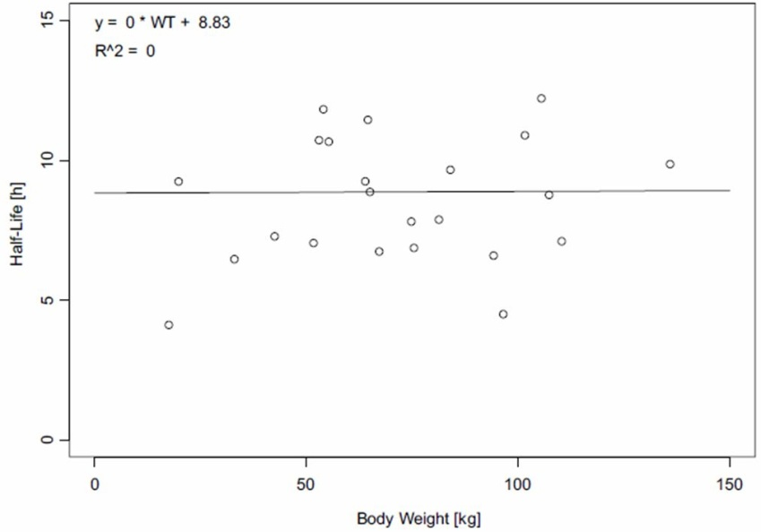
Figure 8: T_{max} plotted versus body weight (PK analysis for Study CS866-A-U102).
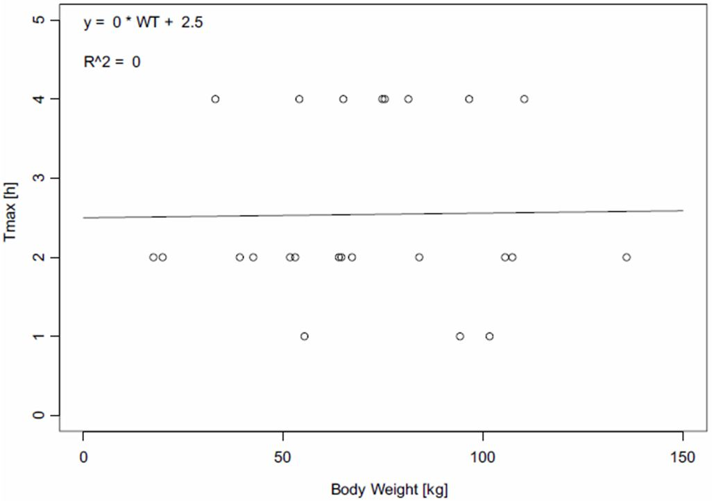

Urine PK
The study found that 3% to 15% of the administered drug was recovered in the urine. One patient in the 6-12 year age group, who was also receiving hydrochlorothiazide, had a urine recovery of 48% of administered drug.
Renal clearance was correlated with body weight (Figure 9). One patient in the 6-12 year age group who was receiving hydrochlorothiazide had a urine recovery of 48% of administered drug. This patient had no relevant renal medical history and no out of range laboratory values to account for any difference in elimination. No differences among groups in urine PK parameters were observed.
Figure 9: CL_{R} plotted versus body weight (PK Analysis for Study CS866-A-U102).
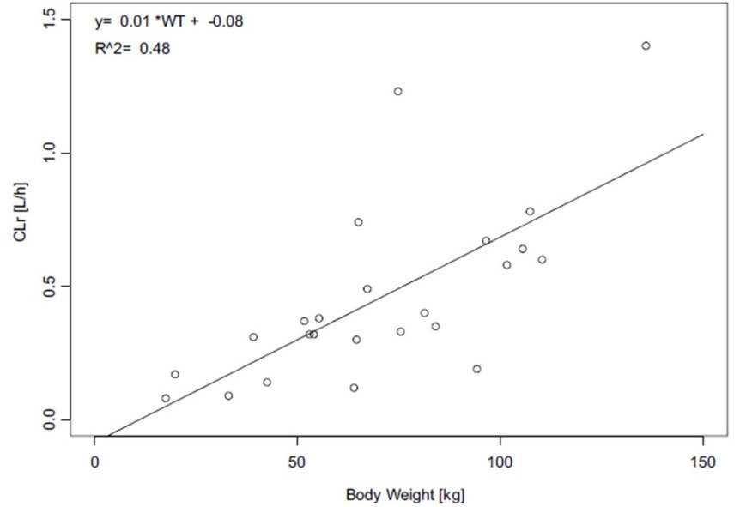

Deficiencies

Protocol deviations
There were 21 protocol deviations documented during the study. Nine of the deviations were related to late drawing of blood samples (1 h post dose sample collected 6 minutes late), and nine were related to laboratory evaluations not having been done. The sponsor concluded that none of the protocol deviations were clinically relevant and they did not affect the study outcome.

Sample size
The sample size of four patients was insufficient to support calculation of summary statistics for the 2-5 age group and statistical significance of the PK results in 2-5 age group compared to the other age groups could not be calculated. No patients were enrolled in the 12-23 month age group.

Absorption
The dossier did not specifically report on the absorption of olmesartan. However, mean T_{max} in children was 2.8 h in the 6-12 years group and 2.7 h in the 13-16 years group. This is similar to adults where the reported T_{max} is ∼2 h.

Distribution
The clinical data did not present any new data on drug distribution.

Elimination
The elimination of olmesartan is well characterised in adults, Total plasma clearance was typically 1.3 L/h (CV, 19%) and ∼30-50% of the systemically absorbed drug is excreted in the urine whilst the remainder is excreted in faeces (via the bile).
Renal clearance was approximately 0.5-0.7 L/h and was independent of dose.
Children had a similar rate of clearance (weight adjusted) to adults.

Dose proportionality and time dependency
Only single dose data were presented and so there was no evidence about dose proportionality or time dependency in children in the dossier.

Intra and inter individual variability
There is some evidence about intra and inter individual variability from the population modelling.

PK in target population
The PK studies included children between the ages of 2 and 16 years. There are, however, limited data in children less than 6 years of age.

Special populations
Other than children, no special populations were included in this dossier.

Interactions
No data on interactions were presented in the clinical dossier.

Pharmacodynamics
No PD studies were submitted in this dossier.

Efficacy

Introduction
The dossier included one clinical study in support of their application.

Dose response studies and main clinical studies

Study CS0866-A-U301
Study CS0866-A-U301, the pivotal study, was a randomised, multicentre, double blind, parallel group, prospective dose ranging study in patients 1 to 16 years of age with primary or secondary hypertension. The study was completed by DSPD and conducted by 65 investigators at 25 clinical sites in the US, 14 in South America, 17 in Africa, and 9 in India.
Subjects were enrolled into 1 of 3 cohorts based on age and race. Subjects aged 6-16 years were enrolled into Cohort A. Subjects enrolled into Cohort A were stratified by age with approximately half aged 6-12 years and the remainder aged 13-16 years. Because of the North American focus of the study, there was an emphasis on the enrolment of black patients as this comprises a significant proportion of their paediatric hypertension population. Approximately 15% of the patients in Cohort A were to be of Black or African descent. When a minimum of 28 Black patients were randomised into Cohort A, enrolment in Cohort B was started. Black patients only, 6-16 years of age, were enrolled into Cohort B. Subjects 1 to 5 years of age were enrolled into Cohort C regardless of race. Approximately 340 patients were planned for the study with 180 in Cohort A, 100 in Cohort B, and 60 in Cohort C.
The study comprised four periods. Period 1 was a wash out period from Week -1 to randomisation. Subjects were randomised to treatment sequences carried through the remainder of the study. Period 2 was a double blind, dose ranging period for Cohorts A and B, where patients received either low dose or high dose olmesartan medoxomil once daily. In Cohort C, all patients received 0.3 mg/kg olmesartan per day. Period 3 was a placebo controlled withdrawal period beginning at Week 4 and ending after 1 or 2 weeks, depending on the BP measurement at each weekly study visit. Subjects either continued their Period 2 olmesartan regimen or switched to placebo based on the initial randomisation scheme. Period 4 was a 46 week open label extension period (Figures 10-11).
Figure 10: Design for Cohorts A and B (subjects 6-16 years old) (Study CS0866-A-U301).
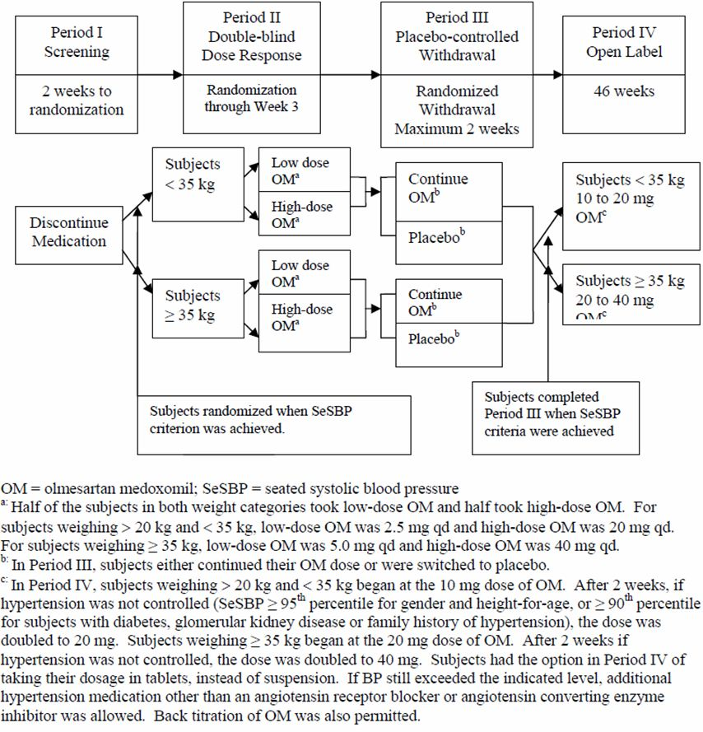
Figure 11: Design for Cohort C (subjects 1-5 years old) (Study CS0866-A-U301).
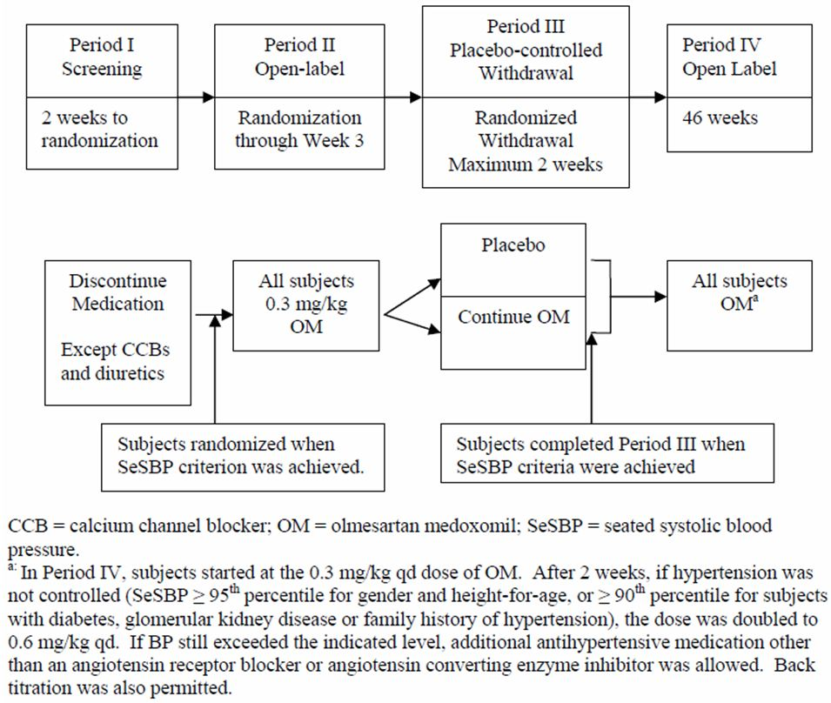
In Cohort A, 282 patients were screened, 190 were randomised and received medication in Period 2. A total of 182 patients received medication in Period 3, 179 patients in Period 4, and 149 patients completed the study (Figure 12).
Figure 12: Disposition of patients in Cohort A (Study CS0866-A-U301).
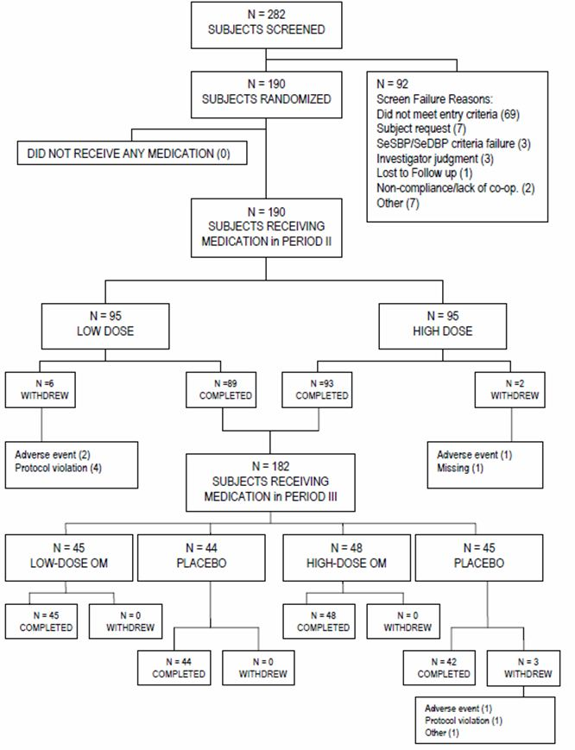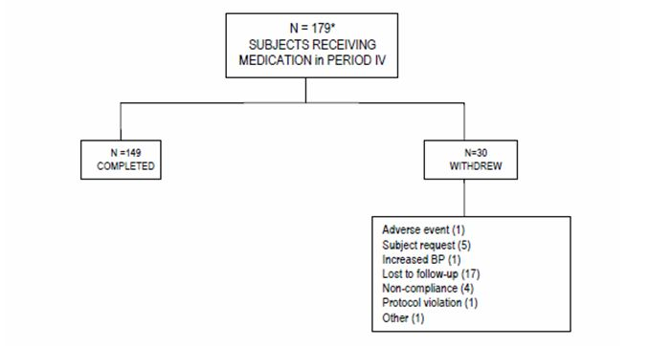
In Cohort B, of 140 patients who were screened, 112 were randomised and received medication in Period 2. A total of 107 patients received medication in Period 3, 104 patients in Period 4 and 83 patients completed the study (Figure 13).
Figure 13: Disposition of patients in Cohort B (Study CS0866-A-U301).
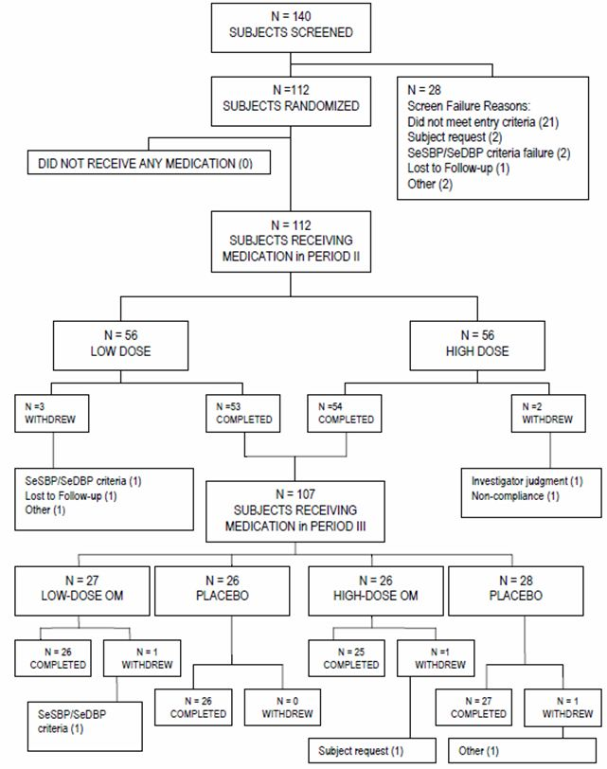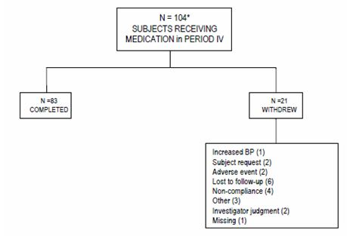
In Cohort C of 80 patients who were screened, 60 were randomised and 59 received medication in Period 2. A total of 58 patients received medication in Period 3, 57 patients in Period 4 and all of these completed the study (Figure 14).
Figure 14: Disposition of patients in Cohort C (Study CS0866-A-U301).
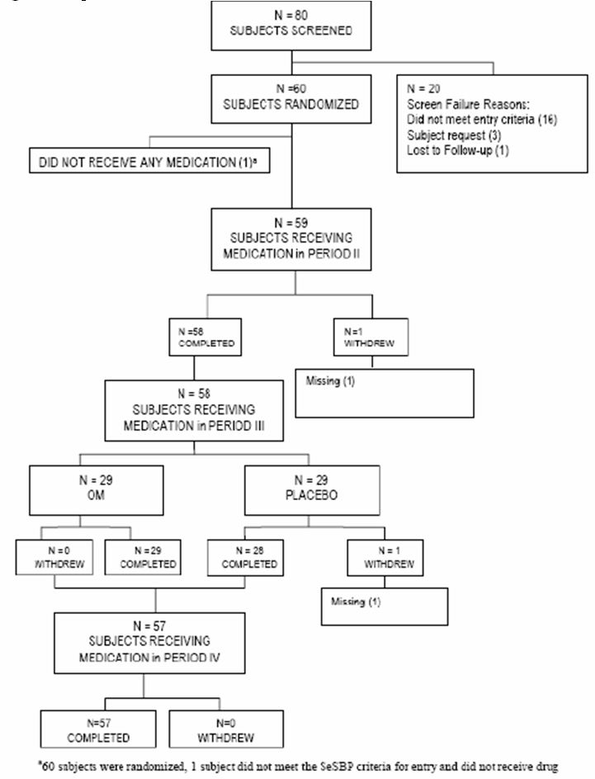

Demographics and dose
Dose was determined by weight band in Cohorts A and B, and by weight in Cohort C (Table 11). In Cohorts A and B, there were high and low dose ranges with matching placebo while all patients in Cohort C received 0.3 mg/kg or placebo.
Table 11: Dosing for all cohorts (Study CS0866-A-U301).
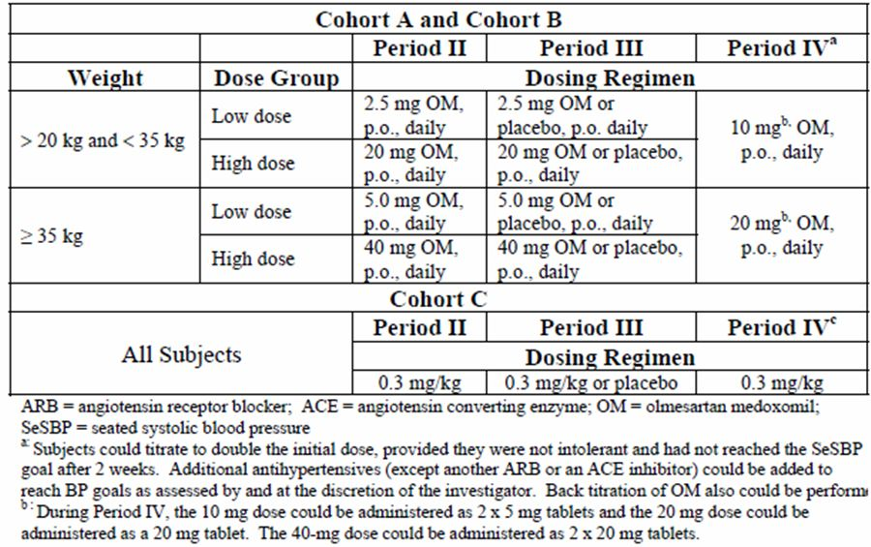
In Cohort A, 47.4% of patients were ≤12 years old and 52.6% were > 12 years old. In Cohort B, 41.1% of patients were ≤12 years old and 58.9% were > 12 years old. Mean age and age distribution was similar in the low olmesartan medoxomil and high olmesartan medoxomil dose groups for both cohorts. The race distribution met the protocol specifications in Cohorts A and B. The various races were equally represented in the high and low olmesartan medoxomil dose groups in Cohort A.
In Cohort A, there were more males than females (64.2% versus 35.8%). In Cohort B, there was an approximately equal distribution of males and females (50.9% and 49.1%, respectively). Distribution of males and females was comparable in the low and high olmesartan medoxomil dose groups in Cohort A. In Cohort B, there were more males than females in the low dose olmesartan medoxomil group (64.3% versus 35.7%), while there were more females than males in the high dose olmesartan medoxomil group (62.5% versus 37.5%).
Mean SBP was comparable in Cohorts A and B at baseline (129.3 and 131.2 mm Hg, respectively) as was mean DBP (77.2 and 79.3 mm Hg, respectively). A greater percentage of patients in Cohort B had primary hypertension and a family history of hypertension (86.6% and 67.9%, respectively) compared with Cohort A (67.4% and 58.9%, respectively).
Mean weight at baseline was only slightly greater in Cohort A compared with Cohort B (73.4 kg versus 67.2 kg).
White (45.0%) and Asian (35.0%) were the primary races in Cohort C, and there were more males (56.7%) than females (43.3%). In contrast to Cohorts A and B, approximately two thirds of patients in Cohort C did not have primary hypertension, and the majority (71.7%) did not have a family history of hypertension. Genitourinary abnormalities such as nephrotic syndrome were present in 59.3% of patients in Cohort C.

Outcome measures
The primary efficacy variables were SBP and DBP at the end of Period 2. BP measurements were obtained after the patient was in a seated position for at least five minutes. Three BP measurements were obtained at least one minute apart and the three results were averaged.
Some patients had peak and trough olmesartan levels taken during Period 2 at a pre selected time interval (2 to 4, 6 to 8, or 8 to 10 hours post-dose) determined by a PK randomization schedule. At Week 3 (Visit 2.3), patients had a trough sample pre dose and a peak sample one to three hours post-dose. Results were analysed by ITT.
In the following analyses, the sponsor has included linear regression techniques to explore the dose effect relationship between drug exposure and change in BP (SBP and DBP) from baseline. The intercept represents the change from baseline extrapolated back to 0 mg dose. The slope of the line indicates the relationship between increasing dose and change in BP. For example, it can be seen in Figure 14 that the extrapolated change in SBP at the end of study from baseline is -6.24 mmHg at 0 mg/kg/dose exposure as indicated by the intercept. As the dose increases to 1.1 mg/kg/dose, the change in SBP changes by approximately -15 mmHg, the slope (-8.36 mmHg/mg/kg/dose) indicating the nature of this relationship.
Figure 14: Linear regression analysis of weight adjusted olmesartan medoxomil dose on change from study baseline in SBP (mm Hg) at end of study with and last observation carried forward (LOCF) (Study CS0866-A-U301).
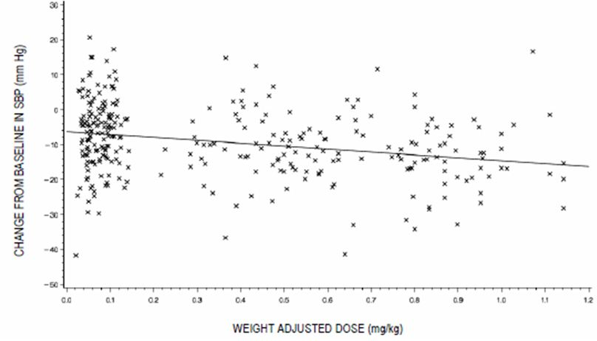

Systolic Blood Pressure (SBP) – Period 2: Cohort A and B
A dose dependant decrease in SBP was observed in the study (Table 12). The dose response remained statistically significant when the analysis adjusted the olmesartan dose for baseline body weight (Tables 13-14 and Figure 15).
Table 12: Effect of olmesartan medoxomil dose on change from study baseline in SBP (mm Hg) with and without last observation carried forward (LOCF) (Study CS0866-A-U301).
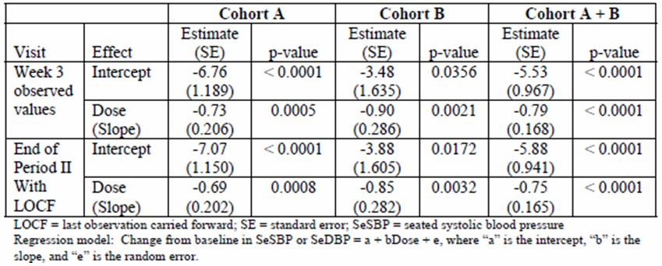
Table 13: Effect of weight adjusted olmesartan medoxomil dose on change from study baseline in SBP (mm Hg) with and without last observation carried forward (LOCF) (Study CS0866-A-U301).
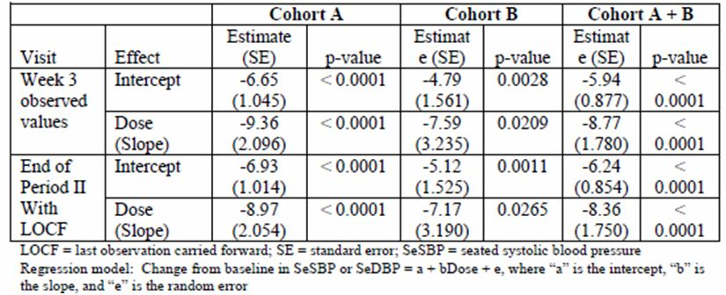
Table 14: Change from study baseline in SBP (mm Hg) for Period 2 (Study CS0866-A-U301).
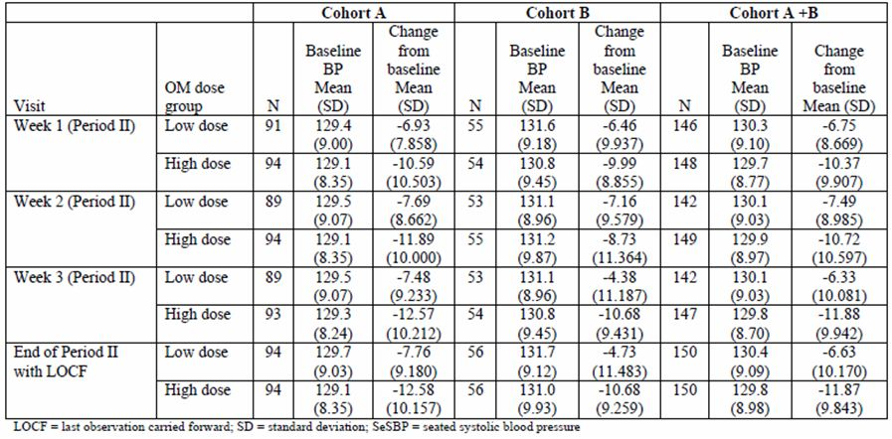

Diastolic Blood Pressure (DBP) – Period 2: Cohort A and B
A dose dependant decrease in DBP was observed in the study (Tables 15-16). The dose response remained statistically significant when the analysis adjusted the olmesartan dose for baseline body weight (Table 17 and Figure 15)
Table 15: Effect of olmesartan medoxomil dose on change from study baseline in DBP (mm Hg) with and without last observation carried forward (LOCF) (Study CS0866-A-U301.
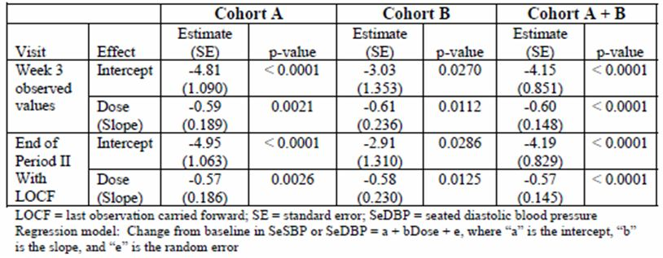
Table 16: Change from study baseline in DBP (mm Hg) for Period 2 (Study CS0866-A-U301.
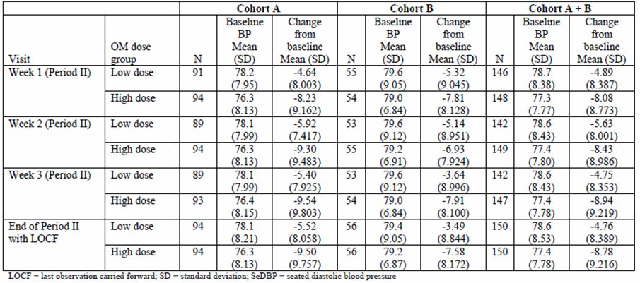
Table 17: Effect of weight adjusted olmesartan medoxomil dose on change from study baseline in DBP (mm Hg) with and without last observation carried forward (LOCF) (Study CS0866-A-U301).
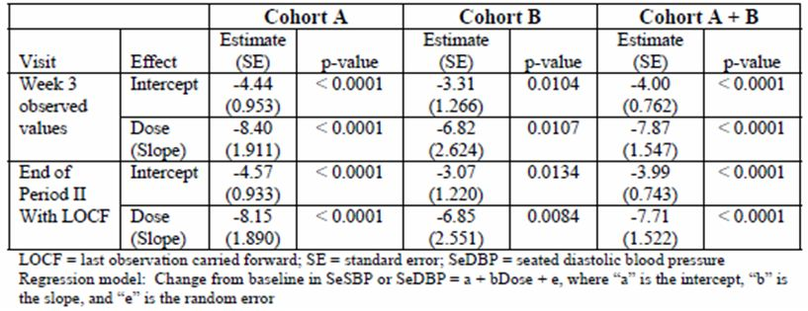
Figure 15: Linear regression analysis of weight adjusted olmesartan medoxomil dose on change from study baseline in DBP (mm Hg) at end of study with and last observation carried forward (LOCF) (Study CS0866-A-U301).
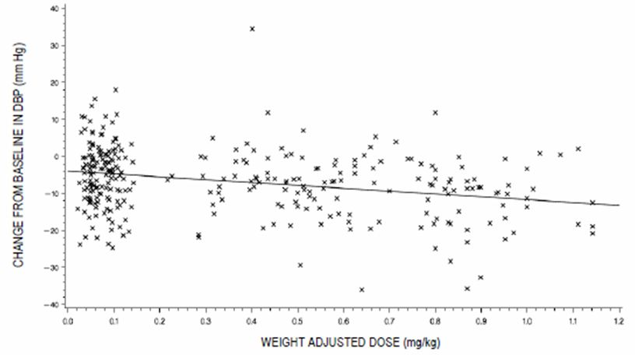

Withdrawal – Period 3: Cohort A+B
During Period 3, analyses of Cohort A and the combined Cohort A+B showed that patients continuing on olmesartan medoxomil (low dose or high dose) maintained the lower mean SBP and DBP values achieved at the end of Period 2 whereas patients switched to placebo did not. For Cohort A and Cohort A+B, there were no clinically relevant or statistically significant changes in mean SBP and DBP during Period 3 in the olmesartan medoxomil group. In contrast, mean SBP increased by 4.93 mmHg and 4.50 mmHg for placebo withdrawal patients in Cohort A and Cohort A+B, respectively. Mean DBP increased by 4.43 mmHg and 3.99 mmHg for placebo withdrawal patients in Cohort A and Cohort A+B, respectively.
During Period 3, the treatment effect of olmesartan medoxomil was not maintained for Cohort B. Increases in mean SBP values were noted in both patients continuing olmesartan medoxomil (1.37 mmHg) and those on placebo withdrawal (3.79 mmHg); the difference in SBP between olmesartan medoxomil and placebo was not statistically significant. Increases in mean DBP values were also noted in both patients continuing olmesartan medoxomil (1.94 mmHg) and those on placebo withdrawal (3.25 mmHg); the difference in DBP between olmesartan medoxomil and placebo was not statistically significant.

Withdrawal – Period 4: Cohort A and B
In Period 4, mean SBP and DBP were reduced relative to study baseline (Tables 18-19). The mean reduction from study baseline in SBP for Period 4 in Cohort A and Cohort A+B was consistently ≥10 mm Hg at all visits during the 46 week treatment period, and ranged from 11.1 to 12.7 mm Hg for Cohort A and from 10.2 to 12.9 mm Hg for Cohort A+B. In Cohort B, the mean reduction from study baseline ranged from 7.5 mm Hg to 13.1 mm Hg.
The mean reduction from study baseline in DBP in Cohort A was similar to that observed for Cohort A+B in Period 4. At Period 4 visits, Cohort A reductions in DBP ranged from 7.3 mm Hg to 9.8 mm Hg and in the combined Cohort A+B, and reductions in DBP were between 6.6 mm Hg and 9.2 mm Hg. As noted for SBP, the magnitude of mean reductions from study baseline was smaller in Cohort B.
Table 18: Change from study baseline in SBP (mm Hg) for Period 4 (Study CS0866-A-U301).
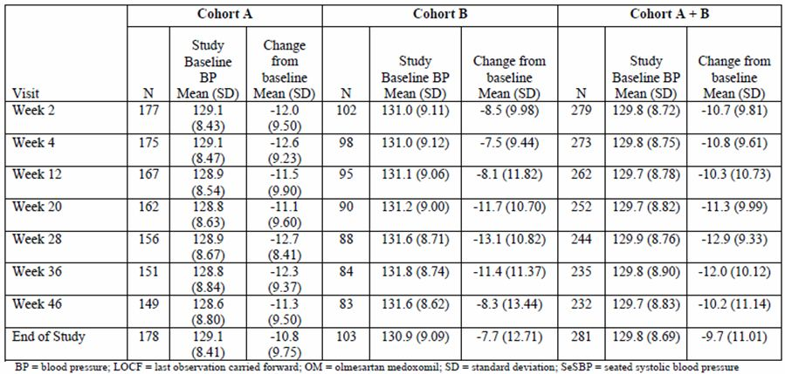
Table 19: Mean change from study baseline in SeDBP (mm Hg) by visit and treatment group during Period 4 for Cohorts A, B, and A+B (Study CS0866-A-U301).
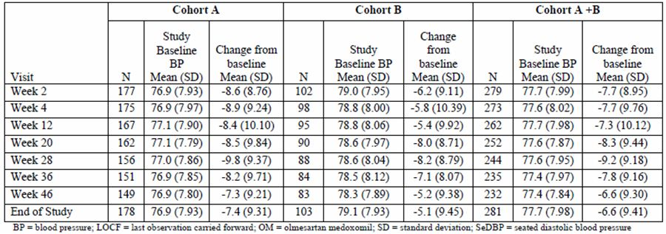

Efficacy – Period 2: Cohort C
The mean reduction from study baseline Cohort C at the end of Period 2 with the last observation carried forward was -13.31 mmHg for SBP and -10.42 mmHg for DBP. This was a statistically significant change from baseline (Table 20).
Table 20: Cohort C change from study baseline in BP (mmHg) for Period 3 (Study CS0866-A-U301).
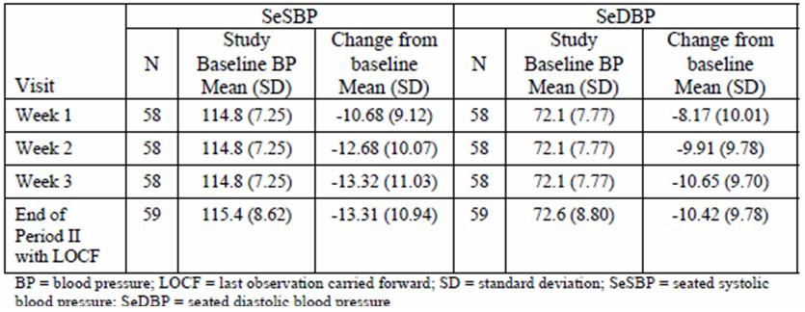

Withdrawal – Period 3: Cohort C
From Period 3 baseline to the end of the period, mean increases in SBP were noted for patients continuing on olmesartan medoxomil (1.36 mm Hg) and patients on placebo (4.95 mmHg). Mean DBP values also increased for patients continuing on olmesartan medoxomil (0.31 mmHg) or placebo (3.77 mm Hg).
The mean increases in BP were numerically larger for the placebo withdrawal patients compared with the patients continuing on olmesartan medoxomil. However, the differences in the means were not statistically significant, as numbers were small.

Continuing therapy - Period 4: Cohort C
Mean BP values during this period were reduced relative to study baseline (Table 21). The mean reduction from study baseline in SBP ranged between 13.6 and 16.4 mm Hg. The mean reduction from study baseline in DBP ranged between 11.0 and 14.0 mmHg.
Table 21: Cohort C Change from Study Baseline in BP (mmHg) for Period 4 (Study CS0866-A-U301).
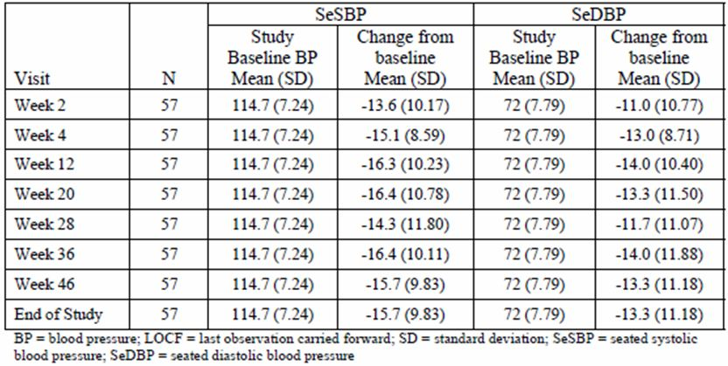

Compliance
In Cohort A, compliance was ≥94% for both dose groups (olmesartan medoxomil low and high dose) at all visits in Period 2. At visits in Period 3, compliance in the low dose olmesartan medoxomil group ranged from 80.0% to 98.0%; compliance in the corresponding placebo group ranged from 70.4% to 100.0%.
In Cohort B, compliance was ≥85% for both dose groups (olmesartan medoxomil low and high) in Period 2. At visits in Period 3, compliance in the low dose group ranged from 55.6% to 100.0%; compliance in the corresponding placebo group ranged from 53.8% to 96.2%.
Compliance for Cohort C ranged from 94.8% to 100% for Period 2 and 93.0% to 100.0% for Period 4 of the study. During Period 3, compliance for patients in the olmesartan medoxomil group ranged from 86.2% to 100.0%, while compliance for patients in the placebo group ranged from 75.0% to 100.0%.

Summary
For Cohorts A (mixed race) and B (Black), who were patients aged 6-16 years, olmesartan demonstrated a dose dependant reduction in both SBP and DBP compared with placebo over the initial study period (Period 2) of 3 weeks. During the 2 week withdrawal period (Period 3), both cohorts showed an increase in BP with a greater increase in BP in those who switched to placebo. During the 46 week open label treatment (Period 4), SBP and DBP were reduced relative to study baseline. The reductions in BP were numerically greater for Cohort A than Cohort B.
For Cohort C, who were patients aged 1-5 years, olmesartan decreased SBP by 13.31 mm Hg and DBP by 10.42 mm Hg, but while this was numerically different to the placebo group, this was not statistically different. The withdrawal phase did indicate an increase in BP in those switched to placebo but the small numbers limit the interpretation of this result.
During open label treatment (Period 4), SBP and DBP were reduced relative to study baseline. The reduction in SBP ranged from 13.6 to 16.4 mmHg while the reduction in DBP ranged from 11.0 to 14.0 mmHg.
The main deficiency of this study is the limited data of olmesartan in children less than 6 years. The evaluator notes that the FDA chose not to register olmesartan in children less than 6 years of age. In this age group, the reduction in BP in the olmesartan was not statistically different to placebo due to small numbers.

Clinical studies in special populations
No other studies in special populations other than those described above are included in the dossier.

Analysis performed across trials (pooled analyses and meta-analysis)
Summary analyses of a pooled PK and exposure-response analysis are presented in the dossier. While the full study reports were not presented, the information was adequate for the clinical evaluation.

PK analysis
A pooled PK and exposure response analysis was performed across two studies (Studies CS0866-A-U102 and CS0866-A-U301). In total, 113 paediatric patients from Study CS0866-A-U102 and CS0866-AU301 were used in the PK analysis, and 89 paediatric patients from Study CS0866-A-U301 were used in the exposure-response analysis. The details of these studies are described above.
The analysis used a previously developed population PK model in 472 adult olmesartan subjects. The study found that olmesartan PK was best described by a two compartment PK model with first order absorption with absorption lag and first order elimination.
The PK modelling was conducted with NONMEM V, Level 1.1, with method FOCE-Interaction (Globomax, LLC). Based upon the adult model, the analysis performed a stepwise covariate search, informed by biological plausibility. In developing the model, an alpha level of 0.01 (chi squared distribution: 6.63 points of log likelihood in NONMEM objective function) was used as the level of required statistical significance.

Results
The population PK analysis found weight to have a larger impact than age in the covariate selection process; weight influenced clearance and central volume of distribution in the final model. Parameters for the final model are shown in Table 22. The median weight of 48 kg was used to scale the estimates for the purpose of weight in the covariate evaluation. In the final model, clearance was scaled to weight to the 0.803 power, similar to the allometric value of 0.75 and central volume of distribution was related to weight to the 1.17 power, again similar to the allometric value of 1. No other covariates were statistically significant, and no impact of formulation (oral suspension versus tablet) was found, similar to the results observed in a bioequivalence study.
When paediatric clearances were weight normalised to 73 kg based on to the clearance-weight relationship of the final model, the adult/paediatric ratio for clearance was 0.95 [0.92, 0.97], indicating that when adjusted for weight, paediatric clearance is similar to that of adults.
Table 22: Population PK parameters of final paediatric model (PK Analysis).
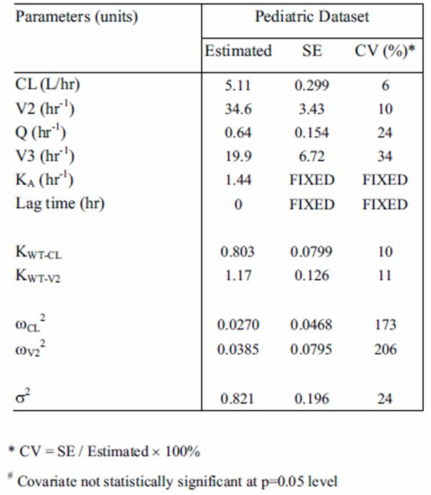
A simulation of steady state AUC (as Dose/Clearance) for paediatric patients 6 years and old is shown in Figure 16, with AUCss shown on the Y axis and weight of paediatric patients shown on the X axis. In this simulation, patients less than 35 kg have been administered 10 mg, and those equal to/greater than 35 kg have been administered 20 mg. Figure 17 shows a similar simulation for children under 6, who are administered olmesartan as an oral suspension at 0.3 mg/kg. The adult reference lines for 20 mg and 40 mg in adults are again shown, indicating that the 0.3 mg/kg dosing results in lower AUCss than 20 mg in adults. As a sensitivity analysis, 0.6 mg/kg is also plotted; this dose results in paediatric exposures similar to adult exposures obtained between 20 mg and 40 mg in adults.
Figure 16: Simulation of dosing in children 6 years and older.
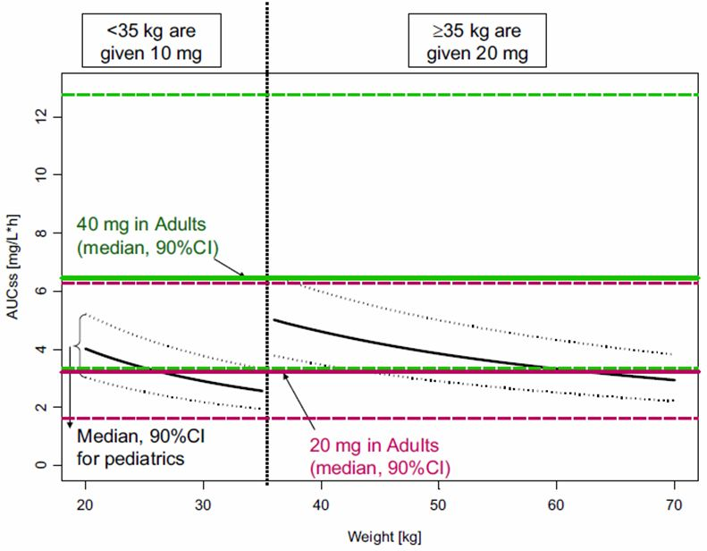
Figure 17: Simulation of dosing in children less than 6 years.
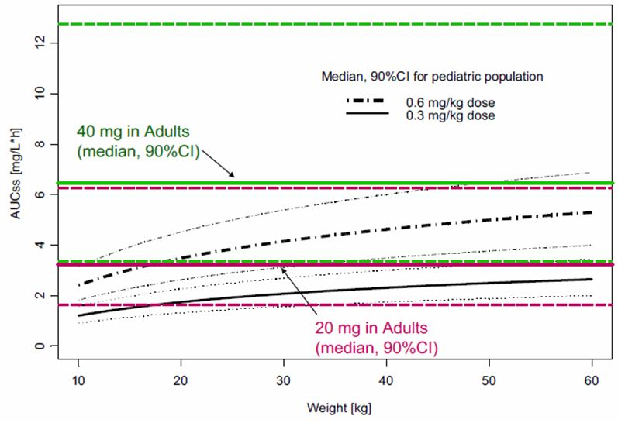

Exposure-response analysis of BP
The triplicate seated trough BP readings at each visit were averaged for each patient. Per protocol, baseline was defined as the average of the randomisation visit and the previous visit (either Visit 1.1 or 1.2, depending on whether the SBP criterion was met at Visit 1.1). “On drug” was the trough seated BP at Visit 2.3 (Week 3) at the end of Period 2. Drug exposure was represented by AUC, where AUC was calculated as dose divided by the individual post hoc clearances of the population PK analysis using the final model. The relationships between changes from baseline and drug exposure (both as AUC and dose per body weight) were investigated using linear regression for both SBP and DBP. All steps were conducted in S-PLUS 8.0.

Results
The AUC analysis (Figure 18) showed a p value for the SBP slope was 0.025, while the p value for the DBP slope was 0.01. Intercepts were -5.7 mmHg for DBP and -7.65 mmHg for SBP. Slopes were -0.00083 for DBP and -0.00092 for SBP [mmHg per ng/mL*h of AUC].
In an exploratory analysis, Black race was found to be a significant modifier of the intercepts, but not the slopes, for each of BP readings in both the AUC and dose per weight analyses. Across all of these regressions, Black patients showed intercepts of about half of the estimates of non Black patients.
Figure 18: Relationship of change in BP to drug exposure (AUC) (PK analysis).
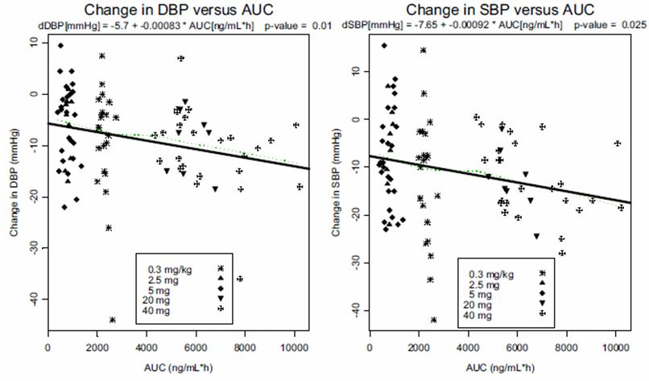

Summary
The population PK analysis was performed with standard methodology. The only minor deficiency is that the modelling did not assume an allometric model for children but rather modelled an estimate. That is, for example in modelling Cl rather than use Cl=θ₁*Wt ^{¾}, the model used was Cl=θ₁*Wt^{θ2} and estimated θ₂=0.803. A similar argument could be made for modelling V_{z}/F. Otherwise, the PK study supports the proposed dosing regimen for children. The data supporting a dose for children under 6 years of age is limited by the small number of patients enrolled in the two studies. There were only 4 patients enrolled in the PK study (CS0866-A-U102) and 60 enrolled in the clinical study (Study CS0866-A-U301).
The exposure-response analysis of BP is consistent with the clinical study; indicating a dose response relationship between olmesartan dose and degree of BP reduction. The analysis also is consistent with the clinical data in that the black patients (Cohort B) may have a different response to the mixed patient group (Cohort A).

Supportive studies
No studies, other than those in adults which have previously been submitted for evaluation were supplied.

Safety

Introduction
The dossier included two clinical studies which were assessable for safety data in children (Studies CS0866-A-U102 and CS0866-A-U301) and one clinical bioequivalence study in adults (Study CS0866-A-U101). The study design and patient demographics have been described above. AEs were coded using MedDRA. For Study CS0866-A-U101, MedDRA version 7.1 was used; for Studies CS0866-A-U102 and CS0866-A-U301, MedDRA version 8.1 was used.

Patient exposure
Study CS0866-A-U101 was conducted in 26 healthy adults. The exposure was two single doses in 24 subjects while the two excluded subjects only received a single dose.
Study CS0866-A-U102 was a single dose PK study in which 24 children with hypertension aged between 2 years and 16 years received a single dose of olmesartan, the dose of which was determined by their age and weight.
Study CS0866-A-U301 was an efficacy and safety study in children, with hypertension, aged 1-17 years. The extent of exposure is shown in Table 23. In Cohort A and Cohort B, mean extents of exposure to the low and high olmesartan medoxomil doses were similar in Period 3. During Period 4, mean extents of exposure to olmesartan medoxomil 10 mg once a day (qd), 20 mg qd, and 40 mg qd were 254.2, 202.6, and 234.8 days, respectively, for Cohort A, and mean extents of exposure to olmesartan medoxomil 10 mg qd, 20 mg qd, and 40 mg qd were 212.5, 176.3, and 280.9 days, respectively for Cohort B. In Cohort C, mean extents of exposure to olmesartan medoxomil 0.3 mg/kg were comparable to that of placebo during Period 3. Mean exposures to olmesartan medoxomil 0.3 mg/kg and 0.6 mg/kg were similar in Period 4.
Table 23: Extent of exposure (days): safety population (Study CS0866-A-U301).
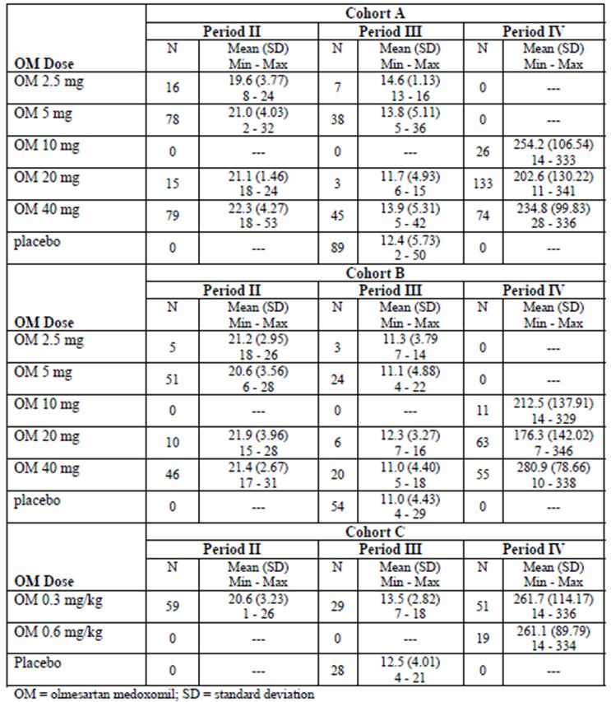

Adverse events (AEs)
AEs were recorded for all patients enrolled in the clinical studies.

PK studies
There were seven TEAEs reported by four (15.4%) subjects and one laboratory TEAE in Study CS0866-A-U101 (Table 24). There were six TEAEs reported by four (16.7%) patients in Study CS0866-A-U102 (Table 25) and the common TEAEs are shown in Table 26. In Study CS0866-A-U102, all TEAEs were considered mild in intensity, unrelated to study drug. All patients recovered from all events. In total, four (16.7%) of the 24 patients experienced six TEAEs.
Table 24: Overview of TEAEs for Studies CS0866-A-U101 and CS0866-A-U102.
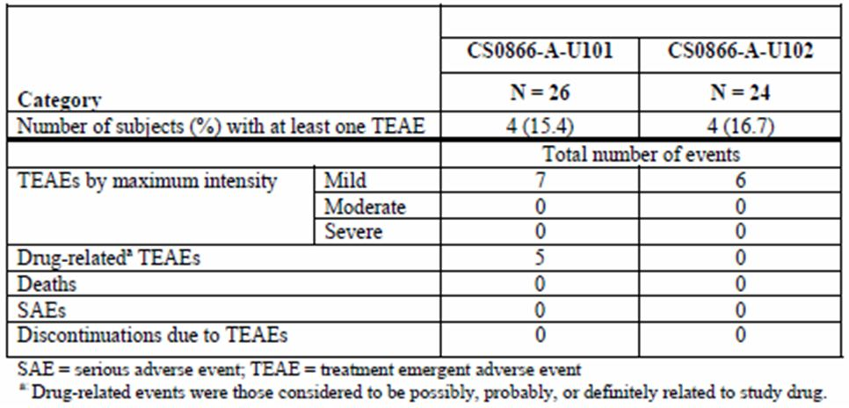
Table 25: Overview of TEAEs for Study CS0866-A-U102.
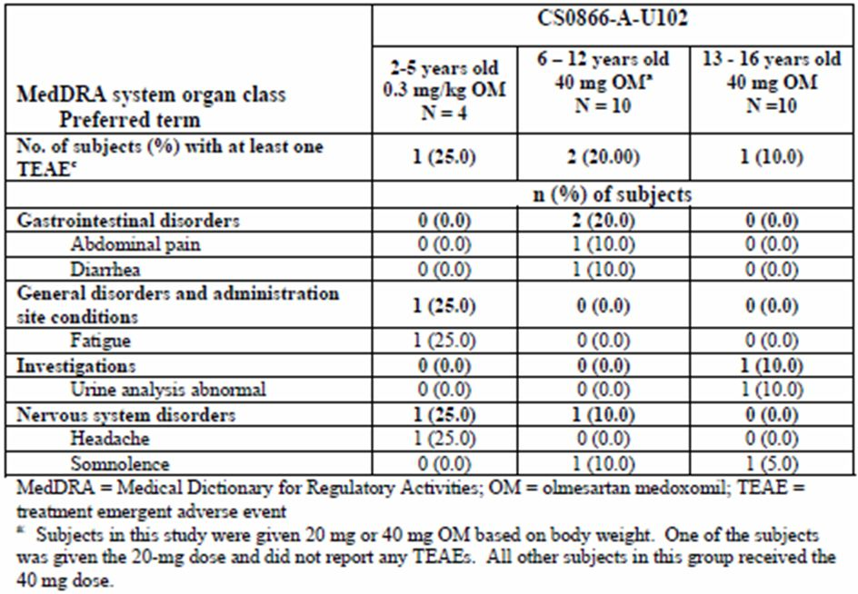
One patient in the 2-5 year age group experienced headache and fatigue. In the 6-12 year age group, TEAEs included somnolence and diarrhoea (one patient) and abdominal pain (one patient). In the 13-16 year age group one patient had a high urine white blood cell count (WBC).

Efficacy study CS0866-A-U301
In the dose ranging period of the study (Period 2), the incidence of TEAEs was greater in Cohort A (45.3%) than in Cohort B (31.3%) or Cohort C (30.5%). Overall during the study in all cohorts, the majority of TEAEs were mild or moderate in intensity and considered unrelated or unlikely related to study drug.

Period 2
The incidence of TEAEs was 43.2% and 47.4% for the Cohort A patients taking low and high olmesartan medoxomil doses, respectively (Table 26). The incidence of TEAEs was 33.9% and 28.6% for the Cohort B patients taking low and high olmesartan medoxomil doses, respectively. Headache was the predominant TEAE during Period 2 in both Cohort A and Cohort B. The incidence of headache was greater for patients taking the high olmesartan medoxomil dose than for patients taking the low olmesartan medoxomil dose (14.7% and 7.4%, respectively for Cohort A and 8.9 % and 5.4%, respectively for Cohort B).
Table 26: TEAEs reported by ≥2% of subjects in Cohorts A, B, or C during Period 2 (Study CS0866-A-U301).
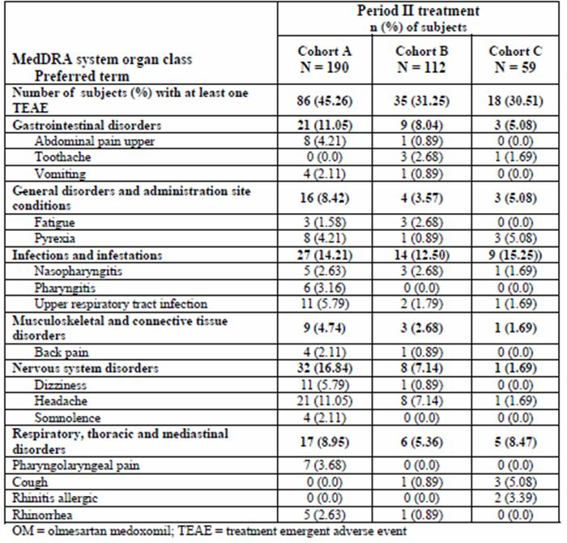
The incidence of TEAEs in Cohort C (30.5%) during Period 2 was comparable to that of Cohort B (31.3%) but not Cohort A (45.3%). Headache occurred in one (1.7%) patient only in Cohort C during Period 2.

Period 3
During the placebo withdrawal period of the study (Period 3), the incidence of TEAEs was greater in Cohort A (33.0%) than in Cohort B (14.0%) and greatest in patients taking the high olmesartan medoxomil dose within each cohort. The incidence of TEAEs in patients taking the low olmesartan medoxomil dose was not different from that for patients taking placebo in either cohort. Headache was the predominant TEAE and occurred in more than 5% of olmesartan medoxomil treated patients in both Cohort A and Cohort B with the highest incidence rates for patients taking the high olmesartan medoxomil dose. In Cohort C, patients treated with placebo had a greater incidence of TEAEs compared with olmesartan medoxomil treated patients (28.6% and 17.2%, respectively).

Period 4
During the open label period of the study (Period 4), the TEAE incidence was highest in Cohort C (80.7%) compared with Cohort A (71.9%) and Cohort B (54.4%). This is not surprising considering the pre existing co morbidities in Cohort C patients. In addition, this is the longest period of the study, lasting up to 46 weeks, and the incidence of TEAEs was highest during this period for all cohorts. The dominant system organ class of TEAEs was infections and infestations in all cohorts in Period 4. This was not unexpected in a paediatric population followed for 1 year. However, headache remained the most frequently reported TEAE for Cohorts A and B.

Growth and development
Study CS0866-A-U301contained assessments of growth and development over the 48 week trial. No clinically significant effects were identified.

Serious adverse events and deaths

Deaths
No deaths were reported during the studies.

SAEs
There were no SAEs in either Studies CS0866-A-U101 or CS0866-A-U102.
In Study CS0866-A-U301 (Table 27), Cohort A, 12 patients had a total of 23 SAEs; none of which were considered related to the study drug. In Cohort B, four patients had a total of eight SAEs. One of these SAEs, relapse of SLE was severe, considered possibly related to study drug, and resulted in the patient discontinuing study drug. The SAE was ongoing at the time of discontinuation. In a post study follow up 33 months after the patient discontinued (February 2009), the patient’s SLE was in remission but still required treatment. No other SAEs for patients in Cohort B were considered related to study drug. In Cohort C, five patients had a total of six SAEs, none of which was considered related to study drug.
Table 27: SAEs in Study CS0866-A-U301.
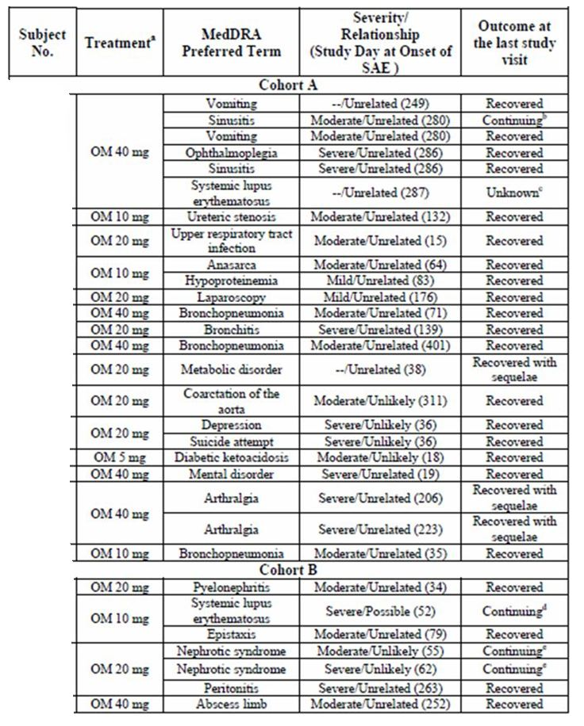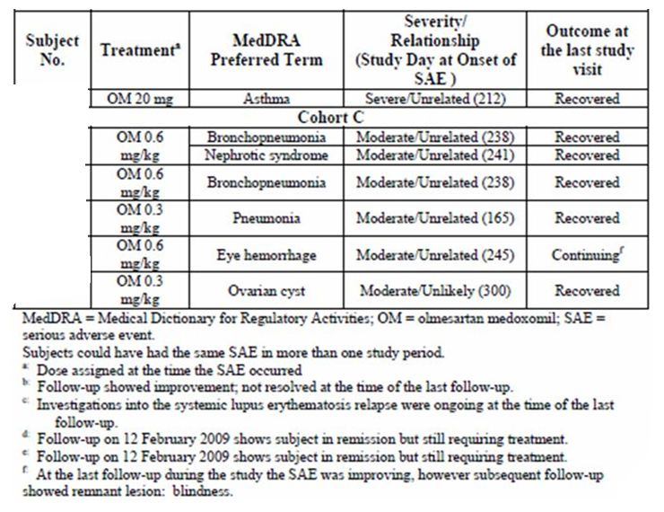

Laboratory findings

Study CS0866-A-U101
One laboratory TEAE (increased CPK) was reported in this study. The patient had a CPK at screening of 282 U/L (normal range, 0-215 U/L). At the post study assessment, the CPK had increased to 1,059 U/L. At follow up 2.5 months later, the CPK was 13,647 U/L reportedly due to moving heavy furniture the previous day. The TEAE was resolved at the subsequent follow up, 3 months post study, at which time the CPK was 230 U/L. The event was mild and considered unlikely to be related to study drug.

Study CS0866-A-U102
One laboratory TEAE (increased WBC) was reported in this study. The patient had slightly increased WBCs in the urine. No laboratory assessment was done at screening; therefore, there is no comparison with baseline. The AE was mild and assessed as unrelated to study drug.

Study CS0866-A-U301
In this study, <10% of patients had shifts from normal at the beginning of the study to low at the end of the study in Hb and Hct in Cohort A (7.1% for both) and Cohort B (8.4% and 7.5% for Hb and Hct, respectively). No haematological shifts were seen in Cohort C. As expected, there were shifts in serum potassium from normal at study baseline to high at the end of the study in Cohort A (5.0%), Cohort B (7.9%), and Cohort C (8.9%). TEAEs of hyperkalaemia were reported five times for four patients in Cohort A. There were a total of four reports of pseudohyperkalaemia in four patients (Cohort A, n = 3; Cohort C, n = 1). The increase in potassium for the patients with hyperkalaemia and those with pseudohyperkalaemia was similar (0.4-1.1 mmol/L and 0.1-1.0 mmol/L above the upper limit of the normal range of 5.0 mmol/L, respectively). There were no TEAEs of increased potassium in Cohort B. No specific trends or dose relationship was seen. Laboratory values for some serum chemistry such as CPK and ALT were elevated during the study for some patients. None of these changes were considered clinically relevant. No causative factor was readily identifiable for either the CPK or ALT abnormalities.

Safety in special populations
No special populations, other than children, were included in this application.

Safety related to drug interactions and other interactions
No significant drug-drug interactions were identified during the clinical trials.

Discontinuation due to AEs
No patients discontinued due to TEAEs in either Study CS0866-A-U101 or CS0866-A-U102.
In Study CS0866-A-U301, four patients discontinued due to TEAEs in Cohort A and one patient discontinued due to a TEAE in Cohort B. There were no discontinuations due to TEAEs in Cohort C. These are summarised in Table 28.
Table 28: Study CS0866-A-U301 discontinuations.
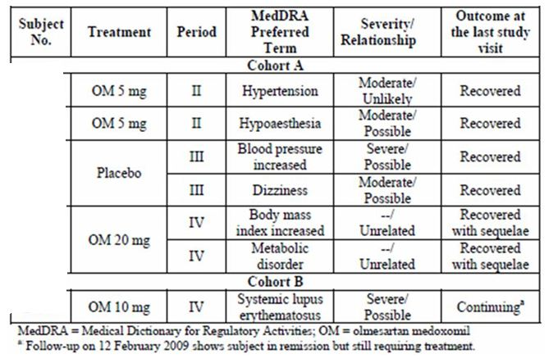

Post marketing experience

Post marketing periodic safety report (26 April 2008 through 25 April 2009).
The dossier included one post marketing periodic safety report (April 26, 2008 through April 25, 2009). The report stated that it was the fourth Annual Periodic Adverse Drug Experience Report for Benicar (olmesartan medoxomil) and covers the period of 26 April 2008 through 25 April 2009. There were 7,566,758 prescriptions written in the US (a one month supply is assumed) during the current reporting period, compared with 7,202,278 prescriptions written during the previous time period. This represents an increase of 5.06% in the number of prescriptions written. There were 420 cases received during the current reporting period from the US, compared with 483 cases received during the previous time period.
During the time period covered in this report, DSPD received a total of 624 post marketing cases reporting AEs associated with the administration of olmesartan. Of these, Benicar was listed as the primary suspect drug in 611 cases , 246 cases reported at least one serious and unlabelled event, submitted as initial 15 day alert reports (122 cases), both initial and follow up 15 day alert reports (97 cases), or follow up 15 day alert reports (27 cases). Fourteen cases reported at least one serious, labelled event. Of the 351 non serious cases, 203 (200 initial and 3 follow up) cases reported at least one unlabelled event and 148 initial cases reported only labelled events. The majority of the 611 cases (420) originated from the US; the remaining cases originated from other countries.
The most frequently reported serious, unlabelled events among these 248 cases were: Hypotension 20 (5%), Hypoglycaemia 9 (2%), BP decreased 8 (2%), and Dyspnoea 8 (2%) (Table 29). The evaluator was unable to identify any reports pertaining to children in the report; probably because they were not included within the label during this reporting period.
Table 29: Serious, unlabelled reported AEs.
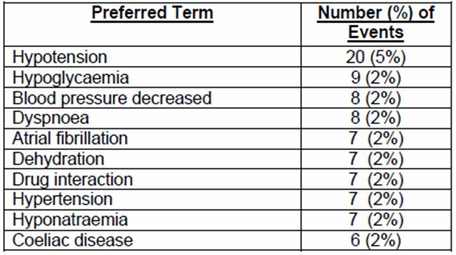

Post marketing experience in children
With 31 December 2008 as the cut off date, DSPD’s global safety database was searched for post marketing cases involving olmesartan medoxomil (including olmesartan, olmesartan/hydrochlorothiazide, and olmesartan/amlodipine) in patients ≤18 years of age. A total of six post marketing cases were identified; three of these cases reported accidental exposure with no AEs, and the other three cases reported non SAEs.

List of questions
Many of the outstanding issues were addressed by the sponsor’s responses to the TGA questions. The questions below should be considered in addition to those responses.

PK
- Could the sponsor please provide a full detailed report of the population PK analysis including demographic details of the included patients and the number and timing of samples for each of these?
- Could the sponsor please provide details of the intra and inter subject variability for the population PK analysis?
- Could the sponsor please provide details of the exact contribution that children less than 6 years made to the population PK analysis? How many data points were contributed to the analysis by each of these children and what was their influence on the model?

PD
- No further questions.

Efficacy
- No further questions.

Safety
- Could the sponsor please provide an update on any post marketing safety data in children?

First round evaluation of the sponsor's responses to the questions/requests for information

PK
- The sponsor has provided full details of the population PK data.
- The sponsor has provided full details of the population PK analysis.
- The sponsor has provided full details of the children less than 6 years made to the population PK analysis.

PD
No questions were asked.

Efficacy
No questions were asked.

Safety
- The sponsor has provided an update of the post marketing safety data in children.

Clinical summary and conclusions

Clinical aspects
The sponsor has presented a small dossier in support of their application for the extension for the use of olmesartan medoxomil in children aged greater than 1 year and to support instructions for preparation of an extemporaneous liquid formulation for children who are unable to swallow tablets.
The dossier included three studies and a multi study population PK analysis.
The bioequivalence study (CS0866-A-U101) demonstrates bioequivalence between the olmesartan medoxomil 40 mg tablet and an olmesartan medoxomil 4 mg/mL suspension prepared from the tablet.
The PK study (Study CS0866-A-U102) aimed to investigate the PK profile of olmesartan in children between 2-16 years. There were, however, only 4 children less than 6 years and no children less than 2 years of age were included.
The efficacy and safety study (Study CS0866-A-U301) was a randomised, double blind, placebo controlled dose ranging and efficacy study in patients aged 1-16 years with hypertension. A total of 359 patients were evaluable in the intention to treat analysis and were subdivided into three cohorts.

Pharmacokinetics
Study CS0866-A-U101 demonstrated that a compounded 4 mg/ml olmesartan medoxomil suspension (total dose 40 mg) was bioequivalent to 40 mg olmesartan medoxomil tablets (Benicar) in healthy adult volunteers. Graphically, the two PK curves are almost superimposed (Figure 19) and the key bioequivalence PK parameters (AUC and T_{max}) were well within the accepted confidence interval.
Figure 19: Olmesartan plasma concentration profiles (Study CS0866-A-U101).
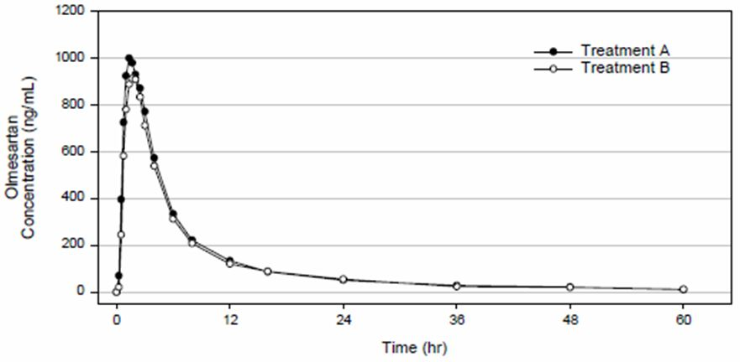
Study CS0866-A-U102 was an open label study of the single dose PK of olmesartan medoxomil in paediatric patients with hypertension between the ages of 12 months to 16 years. Subjects who met the screening criteria were stratified into four groups by age: 12-23 months, 2-5 years, 6-12 years, and 13-16 years. Children 6 years of age and older received olmesartan medoxomil 40 mg (≥35 kg) or 20 mg (<35 kg); children younger than 6 years received olmesartan medoxomil in suspension form at a dose of 0.3 mg/kg body weight, not exceeding 20 mg. The PK parameters were calculated using non compartmental analysis and are shown in Table 30.
Table 30: Mean plasma PK parameters of olmesartan (PK population) (Study CS0866-A-U102).
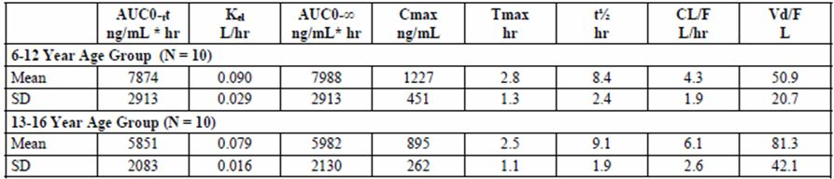
The Pooled PK Analysis combined data from the PK and efficacy studies to develop a populations PK model for children. This was only presented in summary form. The resulting model only incorporated weight as a significant covariate for both CL and V_{z}/F.
Based on simulation from these data, there were simulations of paediatric olmesartan exposure compared to that in adults, justifying the recommended dosing in children (Figures 16-17).

PD
No PD data were presented in the clinical dossier. The exposure-response analysis did however explore the relationship between drug exposure and AUC (Figure 18). This supported a dose response relationship between olmesartan medoxomil dose and BP effect.

Clinical efficacy
Study CS0866-A-U301 was the only efficacy study; a randomised, multicentre, double blind, parallel group, prospective dose ranging study in patients 1-16 years of age with primary or secondary hypertension. A total of 359 children with hypertension were analysed by ITT in one of three cohorts (Table 31). Cohorts A and B included children 6-16 years of age while Cohort C included children aged 1-5 years. Cohorts A and C included children of any race while Cohort B only included Black children. The study was divided into 4 periods: washout, dose ranging (Cohorts A and B), placebo controlled withdrawal and finally a 46 week open label extension period. The primary outcome measures were SBP and DBP change from baseline.
Table 31: Study CS0866-A-U301 data analysis set.
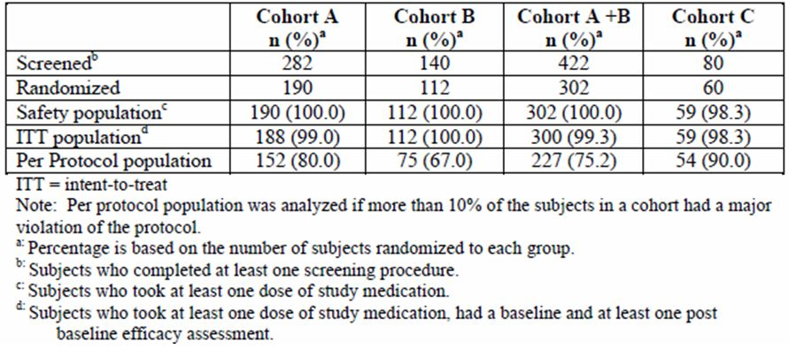
For Cohorts A (mixed race) and B (Black), who were patients aged 6-16 years, olmesartan demonstrated a dose dependant reduction in both SBP and DBP compared with placebo over the initial study period (Period 2) of 3 weeks. During the 2 week withdrawal period (Period 3), both cohorts showed an increase in BP with a greater increase in BP in those who switched to placebo. During the 46 week of open label treatment (Period 4) SBP and DBP were reduced relative to study baseline. The reductions in BP were numerically greater for Cohort A than Cohort B.
For Cohort C, who were patients aged 1-5 years, olmesartan medoxomil decreased SBP by 13.31 mm Hg and DBP by 10.42 mm Hg, but while this was numerically different to the placebo group, this was not statistically different. The withdrawal phase did indicate an increase in BP in those switched to placebo but the small numbers limit the interpretation of this result.
During open label treatment (Period 4), SBP and DBP were reduced relative to study baseline. The reduction in SBP ranged from 13.6 to 16.4 mmHg while the reduction in DBP ranged from 11.0 to 14.0 mmHg.

TGA efficacy questions
The TGA asked three efficacy questions of the sponsor prior to the evaluation. The answers could not be independently verified by the evaluator from the dossier, but the methodology described in the answers appears to be appropriate to address the questions.
1. Please provide the number of children who were naïve to any pervious anti hypertensive medication.
The sponsor responded that:
“Cohort A = 59%, Cohort B = 80%, Cohort A+B = 67% and Cohort C = 63%. It appeared that relatively fewer subjects in Cohort B (the all Black subjects cohort) were reportedly in need of anti hypertension therapy prior to randomisation.”
The sponsor’s explanation the Cohort B was less likely to be diagnosed with hypertension prior to the trail is plausible and the evaluator believes that the response adequately addresses the question.
2. Please provide the number of children not on anti-hypertensive medication as a concomitant medication during the study.
The sponsor responded that:
“Cohort A = 96%, Cohort B = 95%, Cohort A+B = 96%, Cohort C = 100%.”
The evaluator believes that the sponsor’s response is adequate. The results indicate that there was a high rate of patient compliance with the protocol within the study and that the anti hypertensive effect seen is unlikely to be due to concomitant antihypertensive medication use.
3. Please provide the proportion of children that were responders to target.
The sponsor responded that:
“The overall responder status by cohort is as follows: Cohort A = 62%, Cohort B = 50%, Cohort A+B = 58% and Cohort C = 72%.”
The results for the individual cohorts were tabulated. The evaluator believes that the sponsor’s response is adequate. The number of patients who achieved target BP is adequate to support the registration of olmesartan medoxomil for hypertension in children. It should be noted that the trial was not designed to treat to target and a higher percent of children may have achieved the target BP had the design been different.

Analysis performed across trials (pooled analyses and meta analysis)
The pooled PK analysis is described.

Supportive studies
No other studies relevant to this application were supplied.

Clinical safety
The dossier included two clinical studies that were assessable for safety data in children (Studies CS0866-A-U102 and CS0866-A-U301) and one clinical bioequivalence study in adults (Study CS0866-A-U101).

Evaluator’s overall conclusions on clinical safety
The safety data set is adequate in size and quality for children aged between 6 and 16 years. There were no deaths or drug related SAEs reported. The type and incidents of TEAEs were generally within the range expected for a drug such as olmesartan medoxomil. The concern was the high incidence of TEAEs in Cohort A in Study CS0866-A-U301. This concern was raised by the TGA and has been addressed by the sponsor (see Appendix 3). In summary the sponsor stated that:
For Period 3 of Study CS0866-A-U301, as shown in the paediatric AE table in the proposed PI, the AEs occurring at a higher incidence with olmesartan medoxomil were random, driven by small numbers. These AEs are unlikely to be truly related to olmesartan medoxomil, given the mechanism of action for this drug.
There is still, however, the possibility that some children are at greater risk of AEs with olmesartan medoxomil and this should be closely assessed by any post marketing surveillance.

Patient exposure
Study CS0866-A-U101 was conducted in 26 healthy adults. The exposure was two single doses in 24 subjects while the two excluded subjects only received a single dose.
Study CS0866-A-U102 was a single dose PK study in which 24 children, with hypertension, aged between 2 years and 16 years received a single dose of olmesartan, the dose of which was determined by their age and weight.
Study CS0866-A-U301 was an efficacy and safety study in children, with hypertension, aged 1 year to 17 years. The extent of exposure is shown in Table 32.
Table 32: Study CS0866-A-U301 Extent of Exposure (days) in the Safety Population.
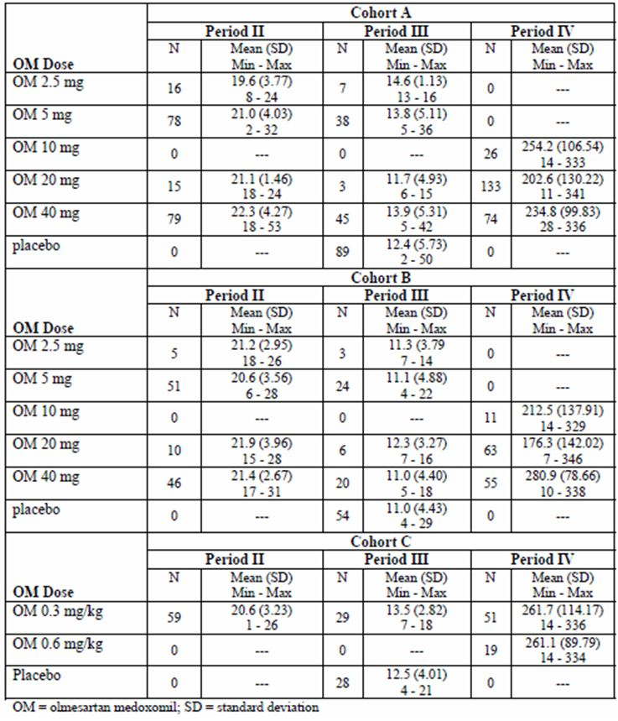

Adverse events

PK studies
There were seven TEAEs reported by four (15.4%) subjects and one laboratory TEAE in Study CS0866-A-U101. There were six TEAEs reported by four (16.7%) patients in Study CS0866-A-U102.
In Study CS0866-A-U102, all TEAEs were considered mild in intensity, unrelated to study drug. All patients recovered from all events. In total, four (16.7%) of the 24 patients experienced six TEAEs. One patient in the 2 to 5 year age group experienced headache and fatigue. In the 6 to 12 year age group, TEAEs included somnolence and diarrhoea (one patient) and abdominal pain (one patient). In the 13 to 16 year age group one patient had a high white blood cell count (WBC) in the urine.

Efficacy study
Overall the incidence of TEAEs was greater in Cohort A than in Cohort B or C. This is concerning a subject to the pre-evaluation inquiry by the TGA. However, overall during the study in all cohorts, the majority of TEAEs were mild or moderate in intensity and considered unrelated or unlikely related to study drug.

Period 2
The incidence of TEAEs was 43.2% and 47.4% for the Cohort A patients taking low and high olmesartan medoxomil doses, respectively while of TEAEs was for the Cohort B the comparable rates were 33.9% and 28.6%. The incidence of TEAEs in Cohort C was 30.5%.

Period 3
During the placebo withdrawal period, the incidence of TEAEs was greater in Cohort A (33.0%) than in Cohort B (14.0%) and greatest in patients taking the high olmesartan medoxomil dose within each cohort. In Cohort C, patients treated with placebo had a greater incidence of TEAEs compared with olmesartan medoxomil treated patients (28.6% and 17.2%, respectively).

Period 4
During the open label period of the study, lasting up to 46 weeks, the TEAE incidence was highest in Cohort C (80.7%) compared with Cohort A (71.9%) and Cohort B (54.4%). The sponsor stated that his was not surprising considering the pre-existing comorbidities in Cohort C patients.

Serious adverse events and deaths

Deaths
No deaths were reported during the studies.

SAEs
There were no SAEs in either Study CS0866-A-U101 or Study CS0866-A-U102.
In Study CS0866-A-U301, Cohort A, 12 patients had a total of 23 SAEs, none of which was considered related to study drug. In Cohort B, four patients had a total of eight SAEs. One of these SAEs, relapse of systemic lupus erythematosus (SLE) was severe, considered possibly related to study drug, and resulted in the patient discontinuing study drug. The SAE was ongoing at the time of discontinuation. In a post study follow-up 33 months after the patient discontinued (February 2009), the patient’s SLE was in remission but still required treatment. No other SAEs for patients in Cohort B were considered related to study drug. In Cohort C, five patients had a total of six SAEs, none of which was considered related to study drug.

Laboratory findings
In Study CS0866-A-U301, there were shifts in serum potassium from normal at study baseline to high at the end of the study in Cohort A (5.0%), Cohort B (7.9%), and Cohort C (8.9%). No specific trends or dose relationship was seen. Laboratory values for some serum chemistry such as CPK and alanine aminotransferase (ALT) were elevated during the study for some patients. None of these changes were considered clinically relevant. No causative factor was readily identifiable for either the CPK or ALT abnormalities.
In Study CS0866-A-U201, one patient had slightly increased WBCs in the urine was mild and considered unrelated to study drug.

Safety in special populations
No special populations, other than children, were reported in this dossier.

Benefit risk assessment

Benefits
Patients treated with olmesartan medoxomil show a dose dependent decrease in both SBP and DBP when compared with placebo; this was demonstrated to a statistically significant degree in children between 6 and 16 years. However, in children less than 6 years while there was a numerical decrease in SBP and DBP, this failed to reach statistical significance. Patients were followed in an open label follow-up study for up to 48 weeks; where continued decreases in both SBP and DBP compared to baseline occurred.
There were no long-term clinical outcomes included in the dossier.

Risks
The main risks, associated with the use of olmesartan medoxomil, are that of unexpected or SAEs. Overall, the rate of TEAEs was consistent with the known AE profile of olmesartan medoxomil. The RMP stated that there are no new findings indicating identified or potential risks requiring special monitoring. The plan did identify a range of other risks and addressed these. In brief, these include:
- Foetal and neonatal morbidity and death
- Hypotension (especially in volume depleted patients)
- Renal impairment
- Hyperkalaemia
The sponsor asserted that these risks were unlikely to be of special concern in paediatric patients (when compared with adults) and no special precautions were required.
The evaluator identified three other areas of concern that continue to be a risk:
- The paucity of PK data in children less than 6 years of age
- The increased incidence of TEAEs in Cohort B from study
- The difference between the studied extemporaneous preparations and that in the proposed PI:
  - Study CS0866-A-U201: 4 mg/mL made with 40 mg tablets
  - Study CS0866-A-U301: 0.5 mg/mL and 4 mg/mL (20 mg tablets used)
  - Proposed Preparation: 2 mg/mL made with 20 mg tablets
The evaluator thinks that it is likely that the proposed extemporaneous preparation will have similar properties to that used in the clinical trials; however the expert opinion on the dissolution data should be sought on this point.

Safety specification
The AE profile identified in the Summary of Clinical Safety was found to be consistent with the clinical trial data as evaluated.

Balance
On balance, the risk/benefit of olmesartan favours registration for children. There is good data for the treatment of children 6 years and older. The data for children aged 1 to 5 years is limited but the available data available should be included in the PI.

Conditions of registration
Registration should be conditional on the sponsor addressing the concerns raised in this evaluation as well as satisfactorily addressing the questions asked by the TGA to their satisfaction.

Conclusions
There are adequate data to support the inclusion of dose recommendations for olmesartan medoxomil for the treatment of hypertension in children although the data for children aged 1-5 years are very limited.
The clinical evaluator recommends the inclusion of dose recommendations for olmesartan medoxomil for the treatment of hypertension in children aged 6-18 years. The evaluator recommends against specific dosage recommendations in children aged 1-5 years but does recommend the inclusion of efficacy and safety data for olmesartan medoxomil in the treatment of hypertension for this age group.

Recommended conditions for registration
The data are adequate to recommend the registration of Olmetec for the treatment of children with hypertension.
A condition of registration is that the sponsor commit to the ongoing monitoring of the safety and efficacy in children treated with Olmetec. This could be in the form of any ongoing efficacy and safety post marketing study or alternatively the creation and support of a patient treatment registry. This should be in addition to the normal regulatory safety monitoring.

Second round evaluation of the sponsor's responses to the questions/requests for information

Question:
Please provide an update on the regulatory status of the similar applications in the EU and Brazil, including approval dates as applicable.

Sponsor’s response:
An update on the regulatory status of the similar applications is shown in Table 33.
Table 33: Update on regulatory status of similar Olmetec applications.
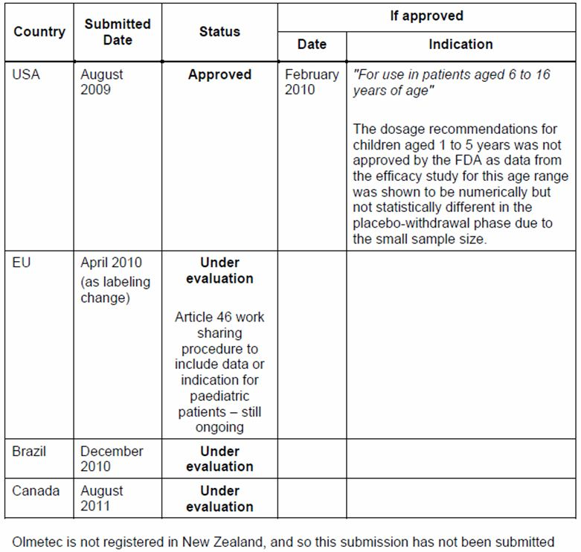

Evaluator’s comment:
The evaluator accepts the submitted update of the current regulatory status.

Question:
The sponsor is requested to provide a full detailed report of the population PK analysis including demographic details of the included patients and the number and timing of samples for each of these patients.

Sponsor’s response:
The Sponsor provided details of the population PK modelling and a summary of the model building process (Table 34).
Table 34: Summary of population PK model building process.
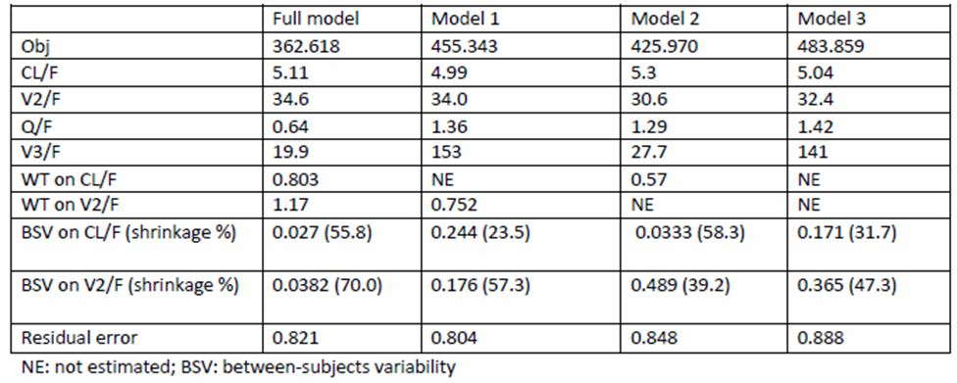

Evaluator’s comment:
The evaluator is satisfied with the data provided and that it supports the conclusions provided in the original submission.

Question:
The sponsor is requested to provide details of the intra and inter subject variability for the population PK analysis.

Sponsor’s response:
The Sponsor provided details of the population PK modelling and a summary of the model building process (Table 35).
Table 35: Population PK parameters of final paediatric model.
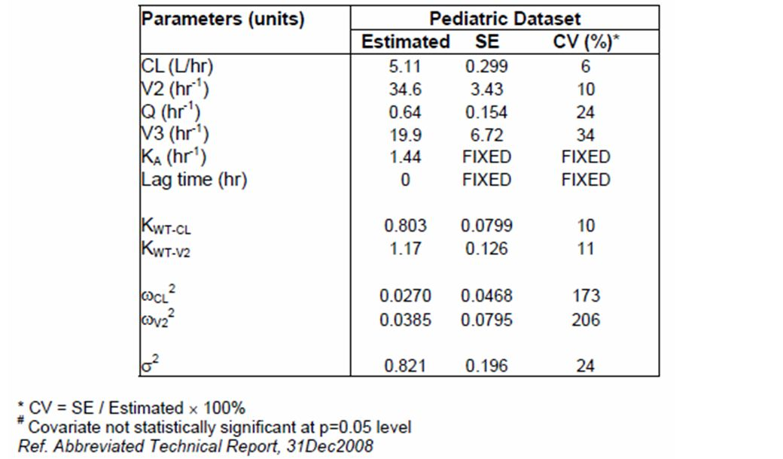

Evaluator’s comment:
The evaluator is satisfied with the data provided and that it supports the conclusions provided in the original submission.

Question:
The sponsor is requested to provide details of the exact contribution that children aged less than 6 years made to the population PK analysis.
How many data points were contributed to the analysis by each of these children and what was their precise influence on the model?

Sponsor’s response:
Table 36 summarises the data points by study (CS0866-A-U102 and CS0866-A-U301) and age groups (12-24 month, 2-5, 6-12 years and over 12 years). As shown, the distribution of PK sampling points was similar among age groups.
Table 36: Summary of the number of data points per subject by age group.
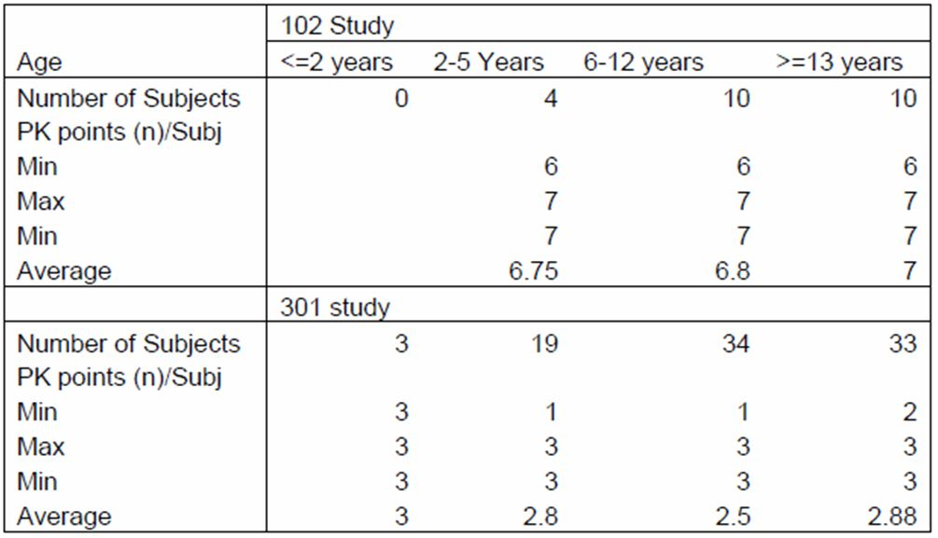
Bodyweight and age are highly correlated as shown in Figure 20. The effects of age and bodyweight were tested individually on CL and V_{z}/F, and the covariate that provided a greater reduction in objective function was retained. Weight had a greater impact than age in the covariate selection process, influencing both CL and V_{z}/F in the final model. Due to high correlation between age and weight, only weight was retained in the final model.
Figure 20: The relationship between age and weight of PK subjects in Studies CS866-A-U102 and CS866-A-U301.
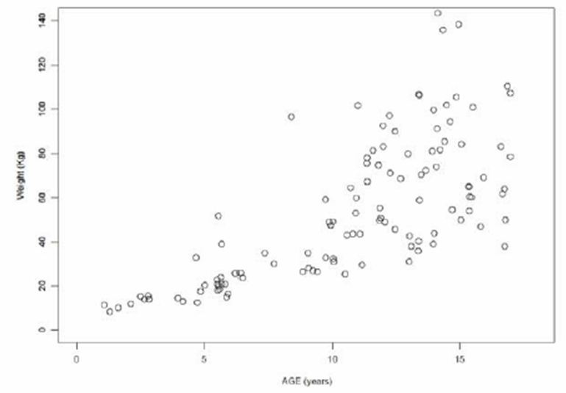

Evaluator’s comment:
The evaluator is satisfied with the data provided and that it supports the conclusions provided in the original submission.

Question:
The sponsor is requested to provide the most recent update available on any post marketing safety data in children.

Sponsor’s response:
An update to the 23 February 2011 search was performed on 28 March 2012 by DSPD for olmesartan post marketing AEs experienced by persons age ≤18 years old. Data from the 23 February 2011 search were provided.
The sponsor also provided both recent safety reviews (23 February 2011 and 23 March 2012) were provided and concluded that
“[t]hese spontaneous AEs and literature reports do not alter the safety profile of olmesartan in the intended paediatric population.”

Evaluator’s comment:
The evaluator is satisfied that all available data were provided in the original submission and that the recent reports do not alter the safety profile of olmesartan.

Question:
For any safety considerations raised in the clinical or nonclinical requests for information, please provide information that is relevant and necessary to address the issue in the RMP.

Sponsor’s response:
No change of the scope in the RMP submitted with this application, based upon the results of the response to question above. In addition, the sponsor commented upon four additional studies that were requested by the FDA relating to olmesartan. These studies were not in the proposed population (that is, paediatric population); however, an update regarding the status of these studies was provided.

Evaluator’s comment:
The evaluator is satisfied that that the recent reports do not alter the safety profile of olmesartan and the submission of a revised RMP was not necessary.

Second round benefit-risk assessment

Second round assessment of benefits
After consideration of the responses to clinical questions, the benefits of olmesartan in the proposed usage are unchanged from those above.

Second round assessment of risks
After consideration of the responses to clinical questions, the benefits of olmesartan in the proposed usage are unchanged from those above.

Second round assessment of benefit-risk balance
The evaluator reiterates that there are adequate data to support the registration of olmesartan medoxomil for the treatment of hypertension in children.
The clinical evaluator again recommends approval of olmesartan medoxomil for the treatment of hypertension in children aged 6-16 years and the inclusion of efficacy and safety data for children aged 1-5 years.
Second round recommendation regarding authorisation
The sponsor has answered the clinical questions raised in this evaluation and these do not change the recommendation of the original evaluation report:
The clinical evaluator recommends approval of olmesartan medoxomil for the treatment of hypertension in children aged 6-16 years. The clinical evaluator recommends inclusion of efficacy and safety data for olmesartan medoxomil in the treatment of hypertension in children aged 1-5 years.

V. Pharmacovigilance findings

Risk management plan
The sponsor submitted a RMP that was reviewed by the TGA’s Office of Product Review (OPR).

Safety specification
The sponsor provided a summary of Ongoing Safety Concerns, which are shown at Table 37.
Table 37: Ongoing Safety Concerns for Olmetec.
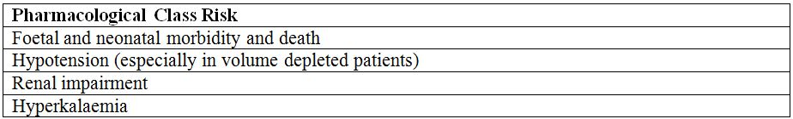
Pre existing nonclinical studies and paediatric clinical studies with olmesartan medoxomil therapy did not identify any new risks compared with the known safety profile of olmesartan medoxomil in the adult population.
There are no new findings indicating identified or potential risks requiring special monitoring. Information is missing for certain special populations (for example, pregnant females) for olmesartan medoxomil. However, treatment with olmesartan medoxomil is not indicated for these populations.

OPR reviewer comment:
It is recommended that the above summary of the Ongoing Safety Concerns is considered acceptable.

Pharmacovigilance plan
Routine pharmacovigilance is proposed by the sponsor to monitor the ongoing safety concerns associated with Olmetec.
The sponsor states in the Summary of Safety Concerns and Planned Pharmacovigilance Actions section of the RMP:
“No new safety concerns have been observed during the nonclinical and clinical development of the olmesartan medoxomil oral suspension formulation for paediatric population. The safety profile of the paediatric population is as expected from an antihypertensive agent (hypotension) or an angiotensin receptor blocker (ARB) (foetal/neonatal morbidity, hypotension, renal impairment, hyperkalaemia). The paediatric safety profile is consistent with the well known ARB safety profile in adult patients. Therefore no action beyond routine pharmacovigilance is planned.”

OPR reviewer’s summary in regard to the pharmacovigilance plan and appropriateness of milestones
The clinical evaluator has commented that the sponsor commit to
“ongoing monitoring of the safety and efficacy in children...This should be in addition to the normal regulatory safety monitoring”.
In support of the clinical evaluators comments it is recommended that the sponsor commit to additional pharmacovigilance activities for Olmetec, specifically in children 1-5 years were data is limited.

Risk minimisation activities

Sponsor’s conclusion in regard to the need for risk minimisation activities
Routine risk minimisation activities, via the PI, are proposed. The sponsor states in the Need for Risk Minimisation Activities section of the RMP:
“Each safety concern is expected for an antihypertensive or ARB and does not represent a new public health risk requiring additional risk minimisation activities.”

OPR reviewer comment:
Routine risk minimisation activities are considered appropriate to mitigate the risks associated with Olmetec.

Potential for medication errors
The sponsor states in the Potential for Medication Errors section of the RMP:
Preparation, presentation and labelling of the extemporaneous suspension
Preparation: The extemporaneous suspension will be prepared by the hospital/compounding pharmacist as per instructions given within the Australian Olmetec PI. For all extemporaneous products, the pharmacist must comply with the Pharmaceutical Society of Australia (PSA) "Professional Practice Standards". These standards, state that all steps of the preparation, packaging and labelling of the extemporaneous product is verified by another pharmacist.
Packaging: The suspension is prepared in an amber PET bottle with child resistant cap.
Labelling: By the pharmacist will need to be in line with PSA Professional Standard of Practice on labelling.
Labelling will include:
- Product Name (and active);
- Recommendation of dose required (based on age and weight- information is provided in the PI);
- Storage conditions (store 2-8°C) and expiry date (28 days after date of preparation); and
- Oral suspension storage in amber PET bottle with a child resistant closure advice that it should be kept out of reach of children.

OPR reviewer comment:
This is considered acceptable.

Toxicity in overdose
The sponsor states in the Potential for overdose section of the RMP:
“There is no experience of overdose with olmesartan medoxomil during clinical development for the paediatric population. The potential for toxicity with overdose of olmesartan medoxomil is considered to be low since single doses of up to 320 mg (8 times the maximum therapeutic dose) were well tolerated in healthy adult volunteer studies. The most likely effects of olmesartan medoxomil overdosage are hypotension and tachycardia; bradycardia could be encountered if parasympathetic (vagal) stimulation occurred. Clinically significant hypotension due to an overdose of olmesartan medoxomil requires active support of the cardiovascular system, including close monitoring of heart and lung function, elevation of the extremities, and attention to circulating fluid volume and urine output. A vasoconstrictor may be helpful in restoring vascular tone and BP, provided that there is no contraindication to its use.”

OPR reviewer comment:
This is considered acceptable. Over dosage is also covered in PI and CMI documents including a contact number for the Poisons Information Centre.

Summary of recommendations
It is recommended that the Delegate:
- Implement RMP Version 1.0, dated 6 September 2011, including the sponsor’s response to the Section 31 request for information/documents and any future updates as a condition of registration.
It is recommended to the Delegate that the sponsor:
- In support of the Clinical Evaluator’s comments, commit to additional pharmacovigilance activities for Olmetec, specifically in children 1-5 years where data is limited.

VI. Overall conclusion and risk/benefit assessment
The submission was summarised in the following Delegate’s overview and recommendations:

Quality
With regard to chemistry and quality control, data were provided to demonstrate that:
- The proposed compounding mixtures (Ora Sweet and Ora Plus) are of suitable quality.
- The resulting suspension is chemically and physically stable when stored at 2-8°C for at least 28 days (the maximum time proposed) in amber PET bottles with child resistant caps.
- The sterility of the suspension over the storage period of 28 days was evaluated by the microbiology section. There were no unresolved issues and there were no microbiological objections to the suspension.
- A suitably accurate device (syringe or measuring cup) can be used to dispense the suspension. A 10 mg dose would require 5 mL of the 2 mg/mL suspension and this volume can be measured adequately using standard devices.
With regard to bioavailability, the pharmaceutical chemistry section evaluated the bioequivalence study comparing the oral suspension (4 mg/mL suspension prepared from 20 mg tablets) with 40 mg tablets. There were adequate justifications for not providing a study using a suspension prepared according to the PI, namely a suspension of 2 mg/mL and for the use of 40 mg tablets instead of 20 mg tablets. Both the test method used to determine olmesartan levels in plasma samples and the study design to determine bioequivalence were suitable. The olmesartan tablet and suspension were bioequivalent in relation to both the extent and rate of absorption (90% CI for AUC_{0-t} = [97.7, 113.3] and 90% CI for C_{max} = [97.8, 116.3]) with no change in T_{max}.
The pharmaceutical chemistry section is now of the opinion that the submission is approvable from a pharmaceutical chemistry perspective. A number of recommendations for amendments to the PI were endorsed strongly by the clinical Delegate. The most important of these are that there should be a statement that the stability of the suspension in larger bottles has not been established, that there should be a statement that any unused suspension must be discarded after 28 days from the date of preparation, that there is an unqualified, stand alone phrase ‘Dosing of 10 mg use suspension’ which should be clarified and that the PI must explicitly state that the oral suspension should be prepared by pharmacists only. Again, the Delegate strongly agrees with all these recommendations. The ACPM is asked for its views on these matters.
The pharmaceutical chemistry section also made the suggestion that the directions for preparing a 2 mg/mL suspension may be rewritten so that any of the registered strength tablets may be used, that is, 10 mg, 20 mg or 40 mg. The Delegate understands that the motivation for this suggestion arises from the possibility that there may be a cost savings incentive for the preparer of the suspension to use the 40 mg tablets as only half the number of tablets will be required to produce the same volume of suspension compared with the number of 20 mg tablets. In an e-mail response to the second round evaluation reports, the sponsor does not agree with this proposition as the current text in the PI is based on the stability data in the dossier, the latter being only available for the 20 mg strength. The Delegate is prepared to accept the sponsor’s argument provided that the wording in the PI is strengthened to make it very clear that only the 20 mg tablets and no other strength tablets are to be used in the preparation of the suspension. The ACPM is also asked to indicate its opinion on this matter.

Nonclinical
There was no requirement for a nonclinical evaluation in a submission of this type.

Clinical
The clinical evaluator has provided a report on the submitted data, which included two PK studies and one clinical study as well as a combined PK analysis using population PK methodology. The sponsor also included responses to a series of pre submission questions asked by the TGA. The evaluator came to the conclusion that dosage instructions for the use of olmesartan medoxomil in the treatment of hypertension in children aged 6-16 years could be approved. However, for children aged 1-5 years, while he did not recommend approval of the insertion of dosage instructions, the evaluator recommended approval for the inclusion of efficacy and safety data.

Pharmacology

Pharmacokinetics
Study CS0866-A-U101 was a comparative, randomised, single dose, two way crossover bioavailability study of a compounded 4 mg/mL olmesartan medoxomil suspension (10 mL of suspension, that is, with 40 mg olmesartan medoxomil) versus a 40 mg olmesartan medoxomil tablet, each administered with 240 mL of water. The study enrolled 26 healthy adult volunteers of whom 24 completed the study. The results demonstrated that the suspension and the tablet were bioequivalent.
Study CS0866-A-U102 was an open label study of the single dose PK of olmesartan medoxomil in paediatric patients with hypertension conducted in six centres in the US. It was planned that the study should include 40 patients but only 33 were screened and of these latter 24 were enrolled and completed the study. It had been planned that there should be 10 subjects in each of the following age groups: 12-23 months, 2-5 years, 6-12 years and 13-16 years. As it turned out the number of completers in each of these age groups was: 0 for the 12-23 months, 4 for the 2-5 years, 10 for the 6-12 years, and 10 for the 13-16 years. Thus the data were of limited value in children less than 6 years of age. Mean T_{max} was 2.8 h in the 6-12 years group and 2.7 h in the 13-16 years group, similar to the reported T_{max} of 2 h in adults. There were no new data on drug distribution. Children (at least those aged at least 6 years) had a similar rate of clearance (weight adjusted) to that in adults.

PD
There were no specific PD studies in the submission. However, the clinical evaluator did briefly mention an exposure-response analysis done as part of the pivotal efficacy/safety study. This analysis explored the relationship between drug exposure and AUC and supported a relationship between olmesartan medoxomil dose and effect on BP.

Efficacy
Study CS0866-A-U301, the pivotal study, was a randomized, multicentre, double blind, parallel group, prospective, dose ranging study in patients 1-16 years of age with primary or secondary hypertension. There were 25 clinical sites in the US, 14 in South America, 17 in Africa, and 9 in India.
Subjects were enrolled into 1 of 3 Cohorts, A, B or C, based on age and ethnicity. Subjects 6-16 years of age were enrolled into Cohort A with approximately half aged 6-12 years and the remainder 13-16 years. Approximately 15% of the patients in Cohort A were to be of Black or African descent. When a minimum of 28 black patients were randomised into Cohort A, enrolment in Cohort B was commenced. Only Black patients aged 6-16 years of age were enrolled into Cohort B. Subjects aged 1-5 years were enrolled into Cohort C regardless of colour/ethnicity. Approximately 340 patients were planned with 180 in Cohort A, 100 in Cohort B, and 60 in Cohort C.
The study comprised four periods:
- Period 1/Screening from 2 weeks before randomisation to randomisation;
- Period 2/Dose Response (high dose versus low dose; double blind) in Cohorts A and B and open label 0.3 mg/kg in Cohort C with Period 2 lasting from the time of randomisation through Week 3;
- Period 3/Placebo controlled withdrawal consisting of a randomised withdrawal over a maximum of 2 weeks
- Period 4/Open Label over 46 weeks.
Study designs are displayed in Figures 10-11.
In Cohort A, 282 patients were screened, 190 were randomised and received medication in Period 2 and of these 149 completed the study (Figure 12). In Cohort B, 140 patients were screened, 112 were randomised and received medication in Period 2 and of these 83 completed the study (Figure 13). In Cohort C, 80 patients were screened, 60 were randomised and 59 received medication in Period 2 and of these 57 completed the study (Figure 14). Dose was determined by weight band in Cohorts A and B (weight between 20 and 35 kg and weight above 35 kg) and by the formula 0.3 mg/kg in Cohort C.
In Cohort B, 86.6% of patients had primary hypertension, and in Cohort A 67.4% had primary hypertension. In contrast to Cohorts A and B, only about a third of patients in Cohort C had primary hypertension. Genitourinary abnormalities such as nephritic syndrome were present in 59.3% of patients in Cohort C.

Results of pivotal Study CS0866-A-U301
The primary efficacy variables were SBP and DBP at the end of Period 2.

Cohorts A and B (6-16 years)
For Period 2 in Cohorts A and B (6-16 years), dose dependent decreases in SBP and DBP were observed in the study. These dose responses remained statistically significant with the olmesartan dose adjusted for baseline body weight. For the low dose group at the end of Period 2, the mean changes from study baseline in SBP were -7.76 mm Hg in Cohort A and -4.73 mm Hg in Cohort B. The corresponding changes in high dose group were -12.58 mm Hg in Cohort A and -10.68 mm Hg in Cohort B. For the low dose group at the end of Period 2, the mean changes from study baseline in DBP were -5.52 mm Hg in Cohort A and -3.49 mm Hg in Cohort B. The corresponding changes in the high dose group were -9.50 mm Hg in Cohort A and -7.58 mm Hg in Cohort B. The other tables and figures in this section which deal with the graphical concepts of intercept and slope are not so easy to interpret and the sponsor is asked to clarify their meaning in the pre ACPM response.
For Period 3, the period of placebo controlled withdrawal, in Cohort A and the combined Cohort A+B, patients continuing on olmesartan medoxomil maintained the lower mean SBP and DBP values achieved at the end of Period 2 whereas patients switched to placebo did not. In Cohort B, increases in mean SBP values were noted in both patients continuing on olmesartan medoxomil (1.37 mm Hg) and those on placebo withdrawal (3.79 mm Hg), the difference not being statistically significant. Increases in mean DBP values were also noted in both patients continuing on olmesartan medoxomil (1.94 mm Hg) and those on placebo withdrawal (3.25 mm Hg), the difference once again not being statistically significant.
For Period 4, the open label period, mean SBP and DBP were reduced relative to study baseline. The mean reduction from study baseline in SBP in Cohort A and the combined Cohort A+B was consistently at least 10 mm Hg at all visits during the 46 week treatment period. In Cohort B, the mean reduction from study baseline ranged between 7.5 mm Hg and 13.1 mm Hg. Similar reductions but of slightly smaller magnitude were observed for DBP. Once again, the magnitude of mean reductions from study baseline was smaller in Cohort B.

Cohort C (1-5 years)
For Period 2 in Cohort C (1-5 years), the mean reductions from study baseline were -13.31 mm Hg for SBP and -10.42 mm Hg for DBP. These changes were statistically significant.
For Period 3, the period of placebo controlled withdrawal, in Cohort C, mean increases in SBP were noted for patients continuing on olmesartan medoxomil (1.36 mm Hg) and patients on placebo (4.95 mm Hg). Mean DBP values also increased for patients continuing on olmesartan medoxomil (0.31 mm Hg) or placebo (3.77 mm Hg). The differences in each case were not statistically significant.
For Period 4 in Cohort C, mean BP values were reduced relative to study baseline. The mean reduction from study baseline in SBP ranged between 13.6 and 16.4 mm Hg while that for DBP ranged between 11.0 and 14.0 mm Hg.
Compliance with the taking of medication was generally good being very good for Cohort C, the latter perhaps being a reflection of the greater supervision inherently required and applied when administering medication to young children.

Analyses performed across trials
Pooled PK and exposure-response analyses were performed across two studies, Studies CS0866-A-U102 and CS0866-A-U301. In total, the results of 113 paediatric patients from these two studies were used in the PK analysis and the results of 89 paediatric patients from the pivotal Study CS0866-A-U301, were used in the exposure-response analysis. The analyses used a previously developed population PK model in 472 adult subjects.
The pooled PK analysis found weight to have a larger impact than age in the covariate selection process. Weight influenced clearance and central volume of distribution in the final model. No other covariates were statistically significant. When paediatric clearances were weight normalised to 73 kg in the final model, the adult/paediatric ratio for clearance was 0.95 [0.92, 0.97], indicating that, when adjusted for weight, paediatric clearance is similar to that of adults. It must be remembered that the data supporting a dose for children under 6 years of age is limited.
In the exposure-response analysis, the relationships between changes from baseline in BP and drug exposure (the latter both as AUC and dose per body weight) were investigated using linear regression for both SBP and DBP. The results of this analysis were consistent with the results of the clinical study, confirming a dose response relationship between olmesartan dose and the degree of BP reduction.

Summary of efficacy
Study CS0866-A-U301 was the only efficacy study.
For Cohorts A (mixed ethnicity) and B (Black), which enrolled patients aged 6-16 years, olmesartan demonstrated a dose dependent reduction in both SBP and DBP compared with placebo over the initial study period (Period 2) of 3 weeks which was the primary efficacy outcome. During the 2 week withdrawal period (Period 3), both cohorts showed an increase in BP with a greater increase in those switched to placebo. During the 46 weeks of open label treatment (Period 4), both SBP and DBP were reduced relative to study baseline. The reductions in BP were numerically greater for Cohort A than for Cohort B.
For Cohort C with patients aged 1-5 years, olmesartan decreased SBP by a mean 13.31 mm Hg and DBP by a mean 10.42 mm Hg. In his summary of efficacy, the evaluator states that while this was numerically different from the result in the placebo group, it was not statistically significantly different. The Delegate seeks clarification from the sponsor on this point. It is the Delegate’s understanding these changes occurred in Period 2 where there was no placebo group and the change was that from baseline, that is, the comparator value was the patient’s own baseline value. In his original reporting of the efficacy in Period 2 in Cohort C of the clinical evaluation report, the clinical evaluator states that the change from baseline was statistically significant. Again, the sponsor is asked for clarification. The withdrawal phase, Period 3, did indicate an increase in BP in those switched to placebo but small numbers limited interpretation of this result according to the evaluator. The sponsor is asked to clarify the actual numbers. The number available for analysis in Period 2 in Cohort C was 59 and that in Period 4 was 57. So the number available for analysis in Period would appear to have been at least 57. During Period 4 in Cohort C, both SBP and DBP were reduced relative to study baseline.

TGA efficacy related questions asked prior to the submission of the dossier
The TGA asked three efficacy related questions of the sponsor in the pre submission phase.
The sponsor was first asked to provide data on the number of children naive to any previous anti hypertensive medication. The data indicated that relatively fewer subjects in Cohort B (19.6%) were on anti hypertensive medication prior to randomisation compared to subjects in Cohort A (41.1%) and Cohort C (36.7%). The sponsor’s explanation that subjects in Cohort B were less likely to be diagnosed with hypertension prior to the trial is plausible both to the clinical evaluator and the Delegate.
The sponsor was next asked to provide data on the number of children on anti hypertensive medication as a concomitant medication during the study. Only small numbers of patients were on concomitant anti hypertensive medication, 3.7% in Cohort A, 5.4% in Cohort B, and 0% in Cohort C. These data plus the generally high rates of compliance with taking olmesartan in the study provide strong reassurance that the anti hypertensive effects observed were due to the olmesartan and not to any concomitant anti hypertensive medication.
Finally, the sponsor was asked to provide data on the proportions of children who were responders to target. The overall responder rates by Cohort were as follows: 62.2% for Cohort A, 50.0% for Cohort B, and 72.4% for Cohort C. In Cohorts A and B, there was a dose response observable in the responder rate in moving from the low to high olmesartan doses, a dose response not as marked in Cohort B. As the trial was not designed to treat to target, the percentages stated may be under estimates of the true responder rates. The Delegate finds these data reassuring.

Safety
There would appear to have been adequate long term exposure to olmesartan in Cohorts A and B, generally over 200 days. The sponsor is requested to provide a summary of the long term exposure in Period 4 for subjects in Cohort C.
In the paediatric PK Study CS0866-A-U102, 4/24 (16.7%) patients experienced 6 TEAEs. All 6 TEAEs were considered mild in intensity, unrelated to study and all patients recovered from all events. One patient in the 2-5 year age group experienced headache and fatigue. In the 6-12 age group, TEAEs included somnolence and diarrhoea (1 patient) and abdominal pain (1 patient). In the 13-16 age group, 1 patient had a high urinary WBC.
In the dose ranging period, Period 2, of the pivotal efficacy/safety Study CS0866-A-U301, the incidence of TEAEs was greater in Cohort A (45.3%) than in Cohort B (31.3%) or Cohort C (30.5%). Headache was the predominant TEAE during Period 2 in both Cohort A and Cohort B with the incidence approximately doubled in the group taking high dose olmesartan compared with the group taking the low dose. Notable differences in the rates of TEAEs between Cohort A and Cohort B were observed for upper abdominal pain (4.21% versus 0.89%, respectively), pyrexia (4.21% versus 0.89%, respectively), pharyngitis (3.16% versus 0.0%, respectively), upper respiratory tract infections (5.79% versus 1.79%, respectively), dizziness (5.79% versus 0.89%, respectively), headache (11.05% versus 7.14%, respectively) and pharyngolaryngeal pain (3.68% versus 0.0%, respectively). The sponsor is asked to comment on these observed differences. Generally for Cohort C, there were low rates of these various TEAEs with the exception of pyrexia (3/59 or 5.08%) and cough (3/59 or 5.08%).
In Period 3, the placebo withdrawal period of the pivotal study, the incidence of TEAEs was again greater in Cohort A (33.0%) than in Cohort B (14.0%) and greater in the patients taking the high olmesartan dose compared with the low olmesartan dose in each cohort. Again, headache was the predominant TEAE. In Cohort C, patients treated with placebo had a greater incidence of TEAEs (28.6%) compared with the olmesartan treated patients (17.2%).
During the longest period of the pivotal study, the open label period lasting up to 46 weeks, Period 4, the TEAE incidence was highest in Cohort C (80.7%) compared with Cohort A (71.9%) and Cohort B (54.4%). Given the pre existing co morbidities in Cohort C patients, this is not surprising. Nor is it surprising that the dominant system organ class of TEAEs was that of infections and infestations in all cohorts in Period 4. Headache remained the most frequently reported single TEAE for Cohorts A and B.
No clinically significant effects on growth or development were observed over the 48 week trial.
There were no deaths reported during any of the studies. There were no SAEs in the paediatric PK study. In the pivotal study, 12 patients in Cohort A had a total of 23 SAEs, none of which was considered related to the study drug; 4 patients in Cohort B had a total of 8 SAEs, one of which, a relapse of SLE, was judged severe and possibly related to the study drug. No other SAEs for patients in Cohort B were considered related to the study drug. The sponsor is asked to comment on the case of SLE. In Cohort C, 5 patients had a total of 6 SAEs, none of which was considered related to the study drug.
As expected, there were shifts in serum potassium from normal at study baseline to high at the end of the study in Cohort A (5.0%), Cohort B (7.9%) and Cohort C (8.9%). There were no other significant trends in either haematological or clinical chemistry shifts.
No patients discontinued in the paediatric PK study. In the pivotal study, 4 patients discontinued due to TEAEs in Cohort A and 1 patient discontinued due to a TEAE in Cohort B (the patient with SLE). In Cohort A, the TEAEs regarded as possibly causally related were hypoaesthesia, BP increased and dizziness and for each of these events, the patient recovered.
In patients less than 18 years of age, a total of 6 post marketing cases were identified, 3 involving accidental exposure with no AEs and the other 3 reporting non serious AEs.

Summary of safety
The Delegate would agree with the clinical evaluator that the safety data set is adequate for children aged between 6 and 16 years. Although there were smaller numbers of children in Cohort C (1-5 years), what data there is suggests lower rates of AEs, both non serious and serious in the younger age group. There were no new signals or trends in the safety data. The higher incidence of TEAEs in Cohort A compared with Cohort B is of some concern and the sponsor is asked to comment on this. Prior to the submission of the dossier, the sponsor was asked to explain, if possible, the higher SAE rate in Cohort A compared to other cohorts. Apart from the subjective interpretation that black subjects may tolerate AEs better than Caucasians, the Delegate was more swayed by the possibility of differences in regional practices for the assigning of SAEs and by the fact many of the cited SAEs appeared to stem from chronic conditions which had a low probability of originating during the treatment period.
The clinical evaluator was of the opinion that the safety specifications outlined in the proposed RMP were consistent with the AE profile observed in the clinical trial data.

Second round evaluation of the sponsor’s response to the Section 31 questions
The sponsor provided an update on the international regulatory status of the submission. The sponsor provided details of the population PK modelling that included details of the intra and inter subject variability and a summary of the model building process all of which were acceptable to the clinical evaluator. Updates to post marketing data did not alter the safety profile of olmesartan. The clinical evaluator concluded that a revised RMP was not necessary.

Risk management plan
An RMP was evaluated by the RMP evaluator in the Office of Product Review.
The RMP evaluator recommended that the Delegate implement RMP Version 1.0, dated 6 September 2011, including the sponsor’s response to the Section 31 request for information/documents and any future updates as a condition of registration.
The RMP evaluator recommended to the Delegate that the sponsor commit to additional pharmacovigilance activities for Olmetec, specifically in children aged 1-5 years where data is limited. The RMP evaluator noted that this was in support of the clinical evaluator’s comments in relation to this issue. The sponsor is requested to indicate what specific additional pharmacovigilance activities for Olmetec are feasible, especially in children aged 1-5 years.

Risk-benefit analysis

Delegate considerations

PK/Efficacy
There is a paucity of PK data in children aged less than 6 years and this will have to be acknowledged explicitly and in detail in the proposed PI. There must be full, comprehensive reporting of the Study CS0866-A-U102 (Study 102), the PK study in hypertensive children aged 1-16 years and any population PK modelling used on top of the results of that study. What evidence there is suggests that the clearance of olmesartan in paediatric patients is similar to that in adult patients when adjusted by body weight.
The clinical evaluator observed that a statistically significant dose dependent decrease in both SBP and DBP, when compared with placebo, was demonstrated in children aged 6-16 years. He also observed that for children aged 1-5 years there were also dose dependent decreases in both SBP and DBP demonstrated but for this age group they were not statistically significant. As already noted, the Delegate is seeking clarification from the sponsor, in its pre ACPM response, regarding this issue. In the pivotal trial the only placebo controlled comparisons available were those made during Period 3, the period beginning at Week 4 and ending after 1 or 2 weeks. However, the primary efficacy variables were SBP and DBP at the end of Period 2 and in particular the mean change from baseline in these parameters to the end of Period 2. It would appear to the Delegate that in both groups, that is, in the younger aged 1-5 years and in the older aged 6-16 years, the primary efficacy endpoint was achieved with statistical significance. It would also appear to the Delegate that the failure to achieve statistical significance in the younger age group was in relation to the parameters studied in Period 3, the period of placebo controlled withdrawal.
In relation to the Period 3 findings for the younger age group or Cohort C, it was observed that from Period 3 baseline to the end of Period 3, mean increases in SBP were noted for patients continuing on olmesartan medoxomil (1.36 mm Hg) and patients on placebo (4.95 mm Hg). Mean DBP values also increased for patients continuing on olmesartan medoxomil (0.31 mm Hg) or placebo (3.77 mm Hg). Clearly the mean increases in BP were numerically larger for the placebo withdrawal patients compared with the patients continuing on olmesartan medoxomil. However, the differences were not statistically significant. In the Delegate’s opinion, this is not surprising. Not only was the study probably not powered for subgroup analyses but Period 3 was only a short period of 1-2 weeks. It is almost certain that if it had been longer, that is, as long as the preceding treatment period, Period 2, then both the SBP and DBP would have increased further in the placebo group compared with the subjects who had not been withdrawn from the active olmesartan. The sponsor is asked to comment on this.
Unfortunately, there is no discussion of the statistical analysis plan in the clinical evaluation report. The Delegate assumes that the study would have powered to examine changes in BP in the entire population, that is, in the population aged 1-16 years but not necessarily powered to examine the same changes in the various subgroups or cohorts. The sponsor is requested to clarify this issue in detail in its pre ACPM response.
It was also clear to the Delegate that the BP responses were maintained in each of the cohorts in the open label period of treatment, that is, in Period 4 which lasted up to 46 weeks. Also post hoc analyses of the rates of responding to target were reassuring. There were no long term clinical outcomes studied.

Safety and RMP
The safety data overall did not show any evidence any new signals with regard to the nature of the AEs or the frequency of the known AEs associated with olmesartan treatment. The AE profile from the clinical trial data in children was consistent with the safety specifications of the RMP. The RMP identified the most important risks as being:
- Foetal and neonatal morbidity and death (there has been a long standing precaution in the PIs of all ACE inhibitors and angiotensin receptor blockers, a precaution which states that drugs that act directly on the rennin angiotensin system can cause foetal and neonatal morbidity and death when administered to pregnant women);
- Hypotension (especially in volume depleted patients);
- Renal impairment; and
- Hyperkalaemia.
The Delegate agrees with the sponsor that these risks are unlikely to be of special or extra concern in the paediatric population when compared with the adult population.
Interestingly, the AE profile in the younger cohort, that is, Cohort C, appeared to show that olmesartan was better tolerated in this age group than in the older age group, at least for Periods 2 and 3. No doubt some of this would be associated with the greater difficulty in obtaining a history from a younger child. However, the sponsor is invited to comment on this observation. The young children in Cohort C had the highest rate of TEAEs (80.7%) in Period 4 which was the longest period of the study at 46 weeks. However, this was also the group with the highest rates of secondary hypertension and therefore associated co morbidities.
In view of the fact that only relatively small numbers of younger children were studied, the sponsor has been asked to detail possible or feasible pharmacovigilance activities in the post marketing setting which could be directed to elucidating and clarifying further the precise AE profile of olmesartan in the younger age group, that is, the group aged 1-5 years.

Indication
There are no changes proposed to the Indications.

Summary
From the evidence presented, the Delegate is presently inclined to the opinion that there were real, positive changes observed with regard to BP response in all the age groups treated, both younger and older. There are no significant signals of any new concerns regarding the AE profile of olmesartan in the paediatric population.
Provided that the sponsor can satisfactorily address all the issues raised above by the Delegate in its pre ACPM response, the Delegate is of the view that dosage instructions for both age groups should be permitted in the PI. The ACPM should note that although the studies only enrolled paediatric subjects between the ages of 1-16 years, the usual definition of paediatric (including adolescent) extends to 18 years. It would be perverse to exclude the group of 17 and 18 year olds from the dosage instructions and so the Delegate would support the sponsor’s request for dosage instructions to cover the range 1-18 years.

Recommendation
I propose to approve this submission by Merck Sharp & Dohme (Australia) Pty Ltd to register new dosage instructions for children aged 1-18 years, based on the safety and efficacy of the product having been satisfactorily established for the indication below, for the reasons stated above in the Risk/Benefit Discussion.
“Olmetec is indicated for the treatment of hypertension.”
The Delegate intends to impose one condition of registration, namely the implementation of the RMP version 1.0, dated 6 September 2011 and any future updates. The sponsor is requested to clarify any commitments made to amend the RMP since 6 September 2011, for example, as part of the response to the consolidated list of Section 31 questions and to confirm the version number and date of the current RMP.
The sponsor should address the following issues in the pre ACPM response:
- An update to the registration status (with dates) for this submission of Olmetec (olmesartan medoxomil) in the US, Europe/UK, Switzerland, Canada and New Zealand including any withdrawals, rejections or deferrals.
- The sponsor is requested to explain briefly the analysis displayed in Tables 12-17 and Figures 14-15 of the clinical evaluation report, that is, the analysis employing the graphical concepts of intercept and slope.
- The Delegate has asked the sponsor to clarify precisely the primary efficacy outcomes in Cohort C, the age group 1-5 years. There appears to be some confusion in the reporting of these results in the clinical evaluation report.
- The sponsor is requested to provide a summary of the long term exposure in Period 4 for subjects in Cohort C.
- The sponsor is asked to comment on the observed differences in the rates of certain TEAEs between Cohorts A and B.
- The sponsor is asked to comment on the case of SLE.
- The sponsor is requested to indicate what specific additional pharmacovigilance activities for Olmetec are feasible and/or possible, especially in children aged 1-5 years.
- The sponsor is asked for a comment on the likelihood of further increases in the BP of subjects on placebo in Period 3 if the latter had been somewhat longer.
- The sponsor is requested to clarify precisely the statistical power of the study, particularly in relation to subgroup analyses.
- The sponsor is requested to comment on the apparently lower rates of TEAEs in Cohort C as compared with either Cohorts A or B, at least for Periods 2 and 3.
- See paragraph above for the question about RMP version control.

Response from sponsor
Merck Sharp & Dohme concurs with the Delegate’s proposed action to approve the application to register new dosage instructions for Olmetec for children aged 1-18 years for the following indication:
Olmetec is indicated for the treatment of hypertension
The recommended starting doses of Olmetec are based on age and/or weight and are summarised in Table 1.

Pharmacokinetics and bioequivalence
Using three studies:
- one study in healthy adults CS0866-A-U101 bioequivalence between the tablets and the proposed extemporaneous suspension; and
- two studies in hypertensive children aged 1-16 years:
  - PK in Study CS0866-A-U102 and
  - sparse sampling from Study CS0866-A-U301, a randomised, multicentre, double blinded, parallel group, prospective dose ranging study,
the proposed dose form was bioequivalent, and the PK parameters of 6-16 year old subjects were similar to those estimated in prior studies with adults, that is, total body clearance and volume of distribution were proportional to body weight. The time of peak blood level and the plasma half lives were similar across all age groups, though only very small numbers of younger children were included in the studies.

Efficacy and safety
The design of Study CS0866-A-U301 (randomised, multicentre, double blinded, parallel group, prospective dose ranging), in the efficacy and safety study in paediatric population aged 1 to 16 years is shown below. The study comprised of four periods (Figures 21-22) and subjects were divided into three groups (cohorts) based on age and ethnicity:
A: 6-16 years "All races"
B: 6-16 years "All Blacks"
C: 1-5 years "All races"
Figure 21: Study design Cohort C (aged 1-5 years of age).
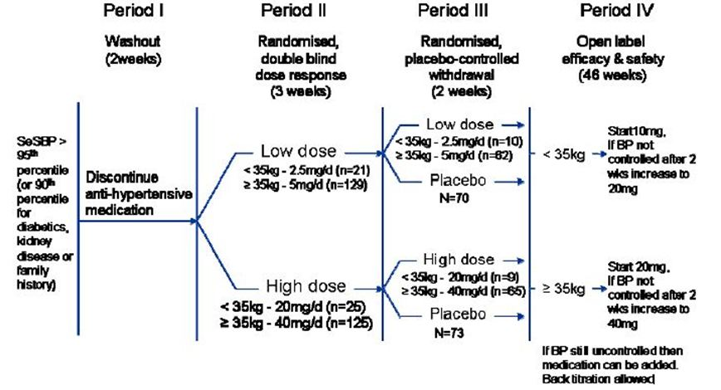
Figure 22: Study design Cohorts A and B (aged 6-16 years of age).
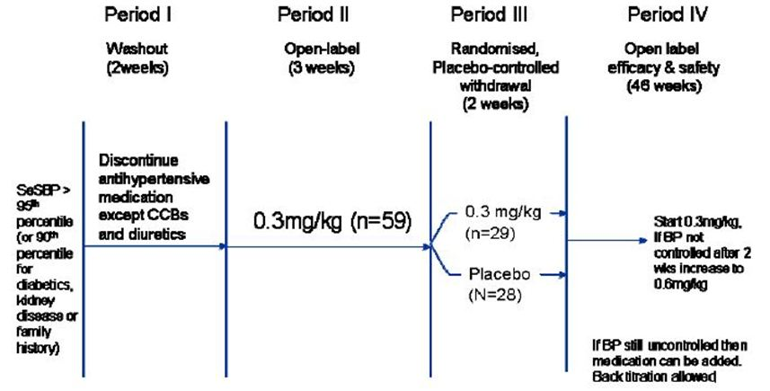
The efficacy variables were SeSBP and SeDBP. A BP reduction of 3 mm Hg or greater was considered clinically meaningful. After a written request from the FDA, the primary endpoint was:
- dose response in SeSBP and SeDBP for subjects 6 to 16 years of age at the end of Period 2 and
- evaluation of withdrawal effect in Period 3.
Additional analyses for this study were requested by the TGA on subjects who reached to target and were on prior medications. The percentages between cohorts were balanced for subjects not taking concomitant anti hypertensive medications. Relatively fewer subjects in Cohort B were treated with anti hypertensive therapy prior to randomisation. The percentage of subjects naïve to prior anti hypertensive treatment was balanced between the low versus high dose groups within Cohort A and B.

Efficacy

a. Period 2 (randomised, double blind dose response – 3 weeks)
Across all age groups, olmesartan medoxomil significantly reduced both SeSBP and SeDBP (p < 0.0001). In subjects aged 6-16 years, a statistically significant dose response (low dose versus high dose) was observed for both SeSBP and SeDBP (p < 0.0001). Subjects aged 1-5 years received only one dose (0.3 mg/kg) and therefore no dose response data were evaluated.

b. Period 3 (randomised, placebo-controlled, withdrawal response – 2 weeks)
Subjects who continued on olmesartan medoxomil had smaller increases in SeSBP and SeDBP compared to those switched to placebo. The differences in the mean change of SeSBP or SeDBP by olmesartan medoxomil compared to placebo were clinically meaningful (greater than 3 mmHg). These differences were statistically significant in subjects aged 6-16 years.

Safety
Due to the small subject numbers, safety data are presented by all cohorts and study period (Period 2, 3 and 4). Overall, the majority of TEAEs were mild or moderate in intensity and considered unrelated or unlikely related to study medication. Headache was the most frequently reported TEAE in Cohorts A and B. Dizziness was greater in Cohort A than in Cohort B. Reports of dizziness and headache appear to be dose related. There was only one possibly related SAE (SLE relapse) in Cohort B. Overall, these spontaneous AEs and literature reports do not alter the safety profile of olmesartan medoxomil in the intended paediatric population. Within the proposed dosing regimen, there is an acceptable risk/benefit profile for paediatric patients, similar to that seen in the adult population.
The three studies conducted for the paediatric population showed a safe and effective profile in subjects 1-16 years of age.
Due to the lack of food effects, and the minimal risk of drug to drug interaction, olmesartan is a good drug to treat hypertension in children and adolescents.
Overall based on the study results, the risks to the paediatric population are assumed to be no different than what has been documented in the adult population profiled in the product information.

Comments on the PI
In general, Merck Sharp & Dohme agree with the Delegate, the clinical evaluator, and the chemistry evaluator; however, there are some points with which the sponsor does not concur:
- Use in children statement: the sponsor disagrees with the change recommended by the clinical evaluator, given that nonclinical information is available showing effects on developing renal systems.
- Full description of PK Study CS0866-A-U102: the sponsor disagrees to include a more detailed description, in line with similar text surrounding this section.
- Baseline/demographic characteristics in clinical trials section: the sponsor does not concur to include these details in the PI.

Delegate's requests for information
The Delegate has raised a number of questions in the Delegate's Overview. It was not possible to provide answers to all of these within Sponsor's Comments on Evaluations, and so answers have been provided in Additional Questions raised by the Delegate.

Implementation of RMP
The sponsor notes that the Delegate intends to impose one condition of registration, that is, the implementation of the RMP. The sponsor confirms that the current version of the RMP is Version 1.0 dated 6 September 2011.
In addition, MSD is investigating the feasibility of further pharmacovigilance activities, particularly in the 1-5 year age group, as described in Additional Questions raised by the Delegate.

Conclusion
In conclusion, Merck Sharp & Dohme agrees with the Delegate's proposed action to recommend the approval of the expanded dosage instructions for children aged 1 to 18 years to treat hypertension with Olmetec.

Advisory Committee Considerations
The ACPM, taking into account the submitted evidence of efficacy, safety and quality, agreed with the Delegate and considered these products to have an overall positive benefit-risk profile for the:
Inclusion of dosing instructions for the paediatric population for the currently registered indication (The treatment of hypertension).
In making this recommendation, the ACPM agreed with the Delegate with the proposed 1-18 year old age group, and that the limitations in current data for the age 1-5 years can be appropriately addressed in the PI and CMI. However, the ACPM expressed concern that the sponsor had not fully addressed the issues set out by the Delegate, particularly in regard to the inclusion of clinical trial information in the PI.
The ACPM agreed with the Delegate to the proposed amendments to the PI and CMI and specifically advised on the inclusion of the following:
- a statement in the Dosage and Administration and Precautions sections to more accurately reflect the evidence for use in children aged over 1 year and up to age 18 years; and the requirement to only use the 20 mg tablets in the preparation of the oral suspension dosage forms.
- a statement in the Clinical Trials and Precautions sections of the PI to ensure the complete and accurate inclusion of details from the clinical studies, and specifically the PK Study CS0866-A-U102 and baseline demographic characteristics, as requested by the Delegate.
- a statement in the Precautions section, to ensure consistency, that an estimated GFR of less than 25 mL/min/1.73 m² in paediatric renal patient defines renal impairment.
The ACPM agreed with the Delegate on the proposed conditions of registration requiring the implementation of the RMP.
The ACPM advised that the implementation by the sponsor of the recommendations outlined above to the satisfaction of the TGA, in addition to the evidence of efficacy and safety provided would support the safe and effective use of these products.

Outcome
Based on a review of quality, safety and efficacy, TGA approved the registration of Olmetec (containing olmesartan medoxomil) with the new paediatric dosing instructions in the Dosage and Administration section of the PI.
Specific conditions of registration applying to these therapeutic goods:
- Details of the distribution of the drug including quantities and forms of products distributed and related batch numbers should be supplied on request while the drug remains on the ARTG.
- The sponsor is to implement in full the RMP, version 1.0, dated 6 September 2011 and any subsequent updated versions as agreed with the Office of Product Review.
- The sponsor is to submit to the Office of Product Review of the TGA a report on the sponsor’s investigations into the feasibility of further pharmacovigilance activities, particularly with regard to the 1-5 year age group. The lodgement of this report will be required within 6 months of the date of the approval letter for this submission.

Attachment 1. Product Information
The following Product Information was approved at the time this AusPAR was published. For the current Product Information please refer to the TGA website at <http://www.tga.gov.au/hp/information-medicines-pi.htm>.

National High Blood Pressure Education Program Working Group on High Blood Pressure in Children and Adolescents (2004) The fourth report on the diagnosis, evaluation, and treatment of high blood pressure in children and adolescents. Pediatrics 114 (2 Suppl 4th Report): 555-576.
Sponsor comment: "Following evaluation, the Delegate stated that there were no unresolved issues and there were no microbiological objections to the suspension.”
Sponsor comment: “The sponsor agreed with most of the proposed changes and provided an updated PI pre ACPM.”
The proposed shelf-life is in accordance with the PSA expiry date of 28 days for all extemporaneous products.
In an e-mail response of 3 July 2012, the sponsor has addressed this issue.
Sponsor comment: “The sponsor provided responses to these questions in the pre ACPM response.”
Sponsor comment: “The sponsor provided an revised PI which was considered acceptable by the Delegate”.

