Australian PRODUCT INFORMATION

LYNPARZA®
Olaparib Tablets

Name of the medicine
Olaparib

Qualitative and quantitative composition
LYNPARZA tablets consist of either 100 mg or 150 mg olaparib drug substance and the following inactive ingredients; copovidone, colloidal anhydrous silica, mannitol, sodium stearylfumarate hypromellose, macrogol 400, titanium dioxide and iron oxide yellow. LYNPARZA 150 mg tablets also contain iron oxide black.

Pharmaceutical form
LYNPARZA 150 mg tablets are a green to green/grey, oval, bi-convex tablet debossed with ‘OP150’ on one side and plain on the reverse.
LYNPARZA 100 mg tablets are a yellow to dark yellow, oval, bi-convex tablet debossed with ‘OP100’ on one side and plain on the reverse.

Clinical particulars

Therapeutic indications

Ovarian Cancer
LYNPARZA is indicated as monotherapy for the:
- maintenance treatment of adult patients with advanced BRCA-mutated (germline or somatic) high-grade epithelial ovarian, fallopian tube or primary peritoneal cancer who are in response (complete response or partial response) to first-line platinum-based chemotherapy. BRCA mutation status should be determined by an experienced laboratory using a validated test method.
- maintenance treatment of adult patients with platinum-sensitive relapsed high grade epithelial ovarian, fallopian tube or primary peritoneal cancer who are in response (complete response or partial response) after platinum-based chemotherapy. Prior treatment must have included at least 2 courses of platinum-based regimens.
Lynparza in combination with bevacizumab is indicated for the:
- maintenance treatment of adult patients with advanced epithelial ovarian, fallopian tube or primary peritoneal cancer who are in complete or partial response to first-line platinum-based chemotherapy and whose cancer is associated with homologous recombination deficiency (HRD)-positive status defined by either:
  - a deleterious or suspected deleterious BRCA mutation (germline or somatic), and/or
  - genomic instability
HRD status should be determined by an experienced laboratory using a validated test method.

Breast Cancer
LYNPARZA is indicated as monotherapy for the:
- treatment of adult patients with germline BRCA-mutated HER2-negative metastatic breast cancer who have previously been treated with chemotherapy in the neoadjuvant, adjuvant or metastatic setting. Germline BRCA mutation (gBRCAm) status should be determined by an experienced laboratory using a validated test method.

Adenocarcinoma of the pancreas
Lynparza is indicated as monotherapy for the:
- maintenance treatment of adult patients with deleterious or suspected deleterious gBRCAm metastatic pancreatic adenocarcinoma whose disease has not progressed on at least 16 weeks of a first-line platinum-based chemotherapy regimen. Germline BRCA mutation (gBRCAm) status should be determined by an experienced laboratory using a validated test method.

Dose and method of administration
Treatment with LYNPARZA should be initiated and supervised by a physician experienced in the use of anticancer medicinal products.

Important Administration Information
LYNPARZA is also available as a 50 mg capsule. DO NOT substitute LYNPARZA tablets (100 mg and 150 mg) with LYNPARZA capsules (50 mg) on a milligram-to-milligram basis due to differences in the dosing and bioavailability of each formulation. Refer to the full prescribing information for LYNPARZA capsules for specific capsule dosing.
Detection of BRCA mutations

BRCA mutation status should be determined by an experienced laboratory using a validated test method.

Monotherapy maintenance treatment of newly diagnosed advanced BRCA-mutated ovarian cancer:
Patients must have confirmation of a deleterious or suspected deleterious breast cancer susceptibility gene (BRCA) mutation (identified by either germline or tumour testing) before LYNPARZA treatment is initiated.

Metastatic HER2-negative breast cancer:
Patients must have confirmation of a deleterious or suspected deleterious BRCA mutation (identified by germline testing) before LYNPARZA treatment is initiated.

Maintenance following first-line treatment of metastatic adenocarcinoma of the pancreas:
Patients must have confirmation of a deleterious or suspected deleterious BRCA mutation (identified by germline testing) before Lynparza treatment is initiated.

Maintenance treatment of newly diagnosed advanced ovarian cancer in combination with bevacizumab:
Select patients for the treatment based on the presence of deleterious or suspected deleterious BRCA-mutations (germline or somatic) or tumour genomic instability as measured by a HRD assay.

Method of administration
For oral use. Patients should be instructed to take LYNPARZA tablets at approximately the same times each day. LYNPARZA tablets should be swallowed whole and not chewed, crushed, dissolved or divided. LYNPARZA tablets can be taken with or without food.

Dosage in adults
LYNPARZA is available as 100 mg and 150 mg tablets.
The recommended dose of LYNPARZA is 300 mg (two 150 mg tablets) taken twice daily, equivalent to a total daily dose of 600 mg. The 100 mg tablet is available for dose reductions only.

Duration of Treatment
Monotherapy maintenance treatment of newly diagnosed advanced BRCA-mutated ovarian cancer: Patients can continue treatment for 2 years or until disease progression. Patients with a complete response (no radiological evidence of disease) at 2 years should stop treatment. Patients with evidence of disease at 2 years, who in the opinion of the treating physician can derive further benefit from continuous treatment, can be treated beyond 2 years.
Platinum-sensitive relapsed ovarian cancer: For patients with platinum-sensitive relapsed high-grade epithelial ovarian, fallopian tube or primary peritoneal cancer, it is recommended that treatment be continued until progression of the underlying disease. There are no trial data to support retreatment with olaparib as maintenance following subsequent relapse.
Maintenance treatment of newly diagnosed advanced ovarian cancer in combination with bevacizumab: patients can continue treatment for 2 years or until disease progression. Patients with a complete response (no radiological evidence of disease) at 2 years should stop treatment. Patients with evidence of disease at 2 years, who in the opinion of the treating physician can derive further benefit from continuous Lynparza treatment, can be treated beyond 2 years. When Lynparza is used in combination with bevacizumab, refer to the Product Information for bevacizumab for recommended dosing information (see section 5.1).
Metastatic HER2-negative breast cancer: For patients with germline BRCA-mutated HER2-negative metastatic breast cancer, it is recommended that treatment be continued until progression of the underlying disease.
Maintenance following first-line treatment of metastatic adenocarcinoma of the pancreas: it is recommended that treatment be continued until progression of the underlying disease.

Missing dose
If a patient misses a dose of LYNPARZA, they should take their next normal dose at its scheduled time.

Dose adjustments
Treatment may be interrupted to manage adverse reactions such as nausea, vomiting, diarrhoea, and anaemia and dose reduction can be considered.
Gastrointestinal toxicities are frequently reported with olaparib therapy (see Section 4.8 - Adverse effects) and are generally low grade (CTCAE grade 1 or 2) and intermittent. In addition to dose interruption or reduction, concomitant medicinal products (e.g. antiemetic therapy) may also be considered. Antiemetic prophylaxis is not required. Refer to Table 1 below for recommended dose adjustments to manage adverse reactions.
Table 1. Recommended dose adjustments to manage adverse reactions
Dose Level | Dose
Starting Dose | 300 mg (two 150 mg tablets) taken twice daily, equivalent to 600 mg daily
First dose reduction | 250 mg (one 150 mg tablet and one 100 mg tablet) twice daily, equivalent to 500 mg daily
Second dose reduction | 200 mg (two 100 mg tablets) twice daily, equivalent to 400 mg daily

Co-administration with CYP3A inhibitors
Concomitant use of strong or moderate CYP3A inhibitors is not recommended and alternative agents should be considered. If a strong CYP3A inhibitor must be co-administered, the recommended LYNPARZA dose reduction is to 100 mg (one 100 mg tablet) taken twice daily (equivalent to a total daily dose of 200 mg). If a moderate CYP3A inhibitor must be co-administered, the recommended LYNPARZA dose reduction is to 150 mg (one 150 mg tablet) taken twice daily (equivalent to a total daily dose of 300 mg). The patient should be carefully monitored for adverse events. (see Section 4.5 - Interactions with other medicines and other forms of interactions).

Special patient populations

Children or Adolescents
LYNPARZA is not indicated for use in paediatric patients, as safety and efficacy of LYNPARZA in children and adolescents have not been established.

Elderly (>65 years)
No adjustment in starting dose is required for elderly patients. There are limited clinical data in patients aged 75 years and over.

Renal impairment
For patients with moderate renal impairment (creatinine clearance 31-50 mL/min) the recommended dose of LYNPARZA is 200 mg (two 100 mg tablets) twice daily (equivalent to a total daily dose of 400 mg). LYNPARZA is not recommended for patients with severe renal impairment or end-stage renal disease (creatinine clearance ≤30 mL/min) as safety and pharmacokinetics have not been studied in these patients. LYNPARZA can be administered to patients with mild renal impairment (creatinine clearance 51-80 mL/min) with no dose adjustment. Patients should be monitored closely for renal function and adverse events.

Hepatic impairment
LYNPARZA can be administered to patients with mild or moderate hepatic impairment (Child-Pugh classification A or B) with no dose adjustment however, patients should be monitored closely for hepatic function and adverse events (see Section 5.2- Pharmacokinetic properties). LYNPARZA is not recommended for use in patients with severe hepatic impairment (Child-Pugh classification C), as safety and pharmacokinetics have not been studied in these patients.

Women of childbearing potential
Women of child-bearing potential must use effective contraception during therapy and for 1 month after receiving the last dose of LYNPARZA (see Section 4.6 -Fertility, pregnancy and lactation).

Non-Caucasian patients
There are limited clinical data available in non-Caucasian patients. However, no dose adjustment is required on the basis of ethnicity (see Section 5.2- Pharmacokinetic properties).

Patients with performance status 2 to 4
There are very limited clinical data available in patients with performance status 2 to 4.

Contraindications
Hypersensitivity to the active substance (olaparib) or to any of the excipients.

Special warnings and precautions for use

Haematological toxicity
Haematological toxicity occurs commonly in patients treated with olaparib. While the majority were generally mild or moderate (CTCAE Grade 1 or 2), Grade 3 or higher events of anaemia (decrease in haemoglobin) occurred in 7.4% of patients in Study 19, and one patient died from a haemorrhagic stroke associated with thrombocytopenia. Patients should not start treatment with LYNPARZA until they have recovered from haematological toxicity caused by previous anti-cancer therapy (haemoglobin, platelet, and neutrophil levels should be ≤CTCAE grade 1). Baseline testing, followed by monthly monitoring, of complete blood counts is recommended for the first 12 months of treatment and periodically after this time to monitor for clinically significant changes in any parameter during treatment (see Section 4.8 – Adverse effects).
If a patient develops severe haematological toxicity or blood transfusion dependence, treatment with LYNPARZA should be interrupted and appropriate haematological testing should be initiated. If the blood parameters remain clinically abnormal after 4 weeks of LYNPARZA dose interruption, bone marrow analysis and/or blood cytogenetic analysis are recommended.

Myelodysplastic syndrome/Acute Myeloid Leukaemia
The incidence of MDS/AML in patients treated in clinical trials with LYNPARZA monotherapy, including long-term survival follow up, was <1.5% and the majority of events had a fatal outcome. The reports were typical of secondary MDS/cancer therapy-related AML. The duration of therapy with olaparib in patients who developed secondary MDS/AML varied from <6 months to >2 years. All patients had potential contributing factors for the development of MDS/AML, having received previous chemotherapy with platinum agents. Many had also received other DNA damaging treatments. The majority of reports were in germline BRCA mutation (gBRCAm) carriers and some of the patients had a history of previous more than one primary malignancy or of bone marrow dysplasia. If MDS and/or AML are confirmed while on treatment with LYNPARZA, it is recommended that LYNPARZA should be discontinued and the patient be treated appropriately.

Pneumonitis
Pneumonitis has been reported in <1.0% patients treated with LYNPARZA monotherapy in clinical studies. Reports of pneumonitis had no consistent clinical pattern and were confounded by a number of pre-disposing factors (cancer and/or metastases in lungs, underlying pulmonary disease, smoking history, and/or previous chemotherapy and radiotherapy). When LYNPARZA was used in clinical studies in combination with other therapies there have been events with a fatal outcome. If patients present with new or worsening respiratory symptoms such as dyspnoea, cough and fever, or an abnormal chest radiologic finding is observed, LYNPARZA treatment should be interrupted and prompt investigation initiated. If pneumonitis is confirmed, LYNPARZA treatment should be discontinued and the patient treated appropriately.

Use in hepatic impairment
Exposure is increased in hepatic impairment (see Section 5.2 - Pharmacokinetic properties and Section 4.2 - Dose and method of administration).

Use in renal impairment
Exposure is increased in renal impairment (see Section 5.2 - Pharmacokinetic properties and Section 4.2 - Dose and method of administration).

Use in the elderly
There are limited clinical data in patients aged 75 years and over (see Section 4.2- Dose and method of administration).

Paediatric use
The safety and efficacy of LYNPARZA in children and adolescents have not been established.

Effects on laboratory tests
No data available.

Interactions with other medicinal products
Olaparib co-administration with strong or moderate CYP3A inhibitors is not recommended (see Section 4.5 - Interactions with other medicines and other forms of interactions). If a strong or moderate CYP3A inhibitor must be co-administered, the dose of olaparib should be reduced (see Section 4.2 - Dose and method of administration).
Olaparib co-administration with strong or moderate CYP3A inducers is not recommended (see Section 4.5 - Interactions with other medicines and other forms of interactions). In the event that a patient already receiving olaparib requires treatment with a strong or moderate CYP3A inducer, the prescriber should be aware that the efficacy of olaparib may be substantially reduced (see Section 4.2 - Dose and method of administration.).

Interactions with other medicines and other forms of interactions
Clinical studies of olaparib in combination with other anticancer agents, including DNA damaging agents, indicate a potentiation and prolongation of myelosuppressive toxicity. The recommended LYNPARZA monotherapy dose is not suitable for combination with other myelosuppressive anticancer agents.

Effect of other drugs on olaparib

Strong and moderate CYP3A inhibitors
CYP3A4/5 are the isozymes predominantly responsible for the metabolic clearance of olaparib. Co-administration of olaparib with a strong CYP3A inhibitor (itraconazole) increased olaparib Cmax by 42% (90% CI: 33% to 52%) and mean AUC by 170% (90% CI: 144% to 197%). It is therefore recommended that known strong inhibitors of these isozymes are not co-administered with LYNPARZA. These include but are not limited to inhibitors such as itraconazole, clarithromycin, boosted protease inhibitors with ritonavir or cobicistat, indinavir, saquinavir and boceprevir (see Section 4.4 - Special warnings and precautions for use).
Physiologically-based pharmacokinetic modelling has suggested that moderate CYP3A inhibitors will alter the clearance of olaparib and therefore concomitant use of moderate CYP3A inhibitors such as, but not limited to ciprofloxacin, erythromycin, diltiazem, fluconazole and verapamil is not recommended with LYNPARZA (see Section 4.4 - Special warnings and precautions for use).
If a strong or moderate CYP3A inhibitor must be co-administered, the dose of LYNPARZA should be reduced (see Section 4.2 - Dose and method of administration.).
Patients should avoid star fruit, grapefruit and Seville oranges because these foods are known to inhibit CYP3A enzymes.

Strong and moderate CYP3A inducers
A clinical study to evaluate the impact of rifampicin, a known CYP3A inducer has shown that co-administration with olaparib decreased olaparib C_{max} by 71% (90% CI: 76% to 67%) and mean AUC by 87% (90% CI: 89% to 84%). It is therefore possible that CYP3A inducers could substantially diminish the clinical efficacy of LYNPARZA and as such, concomitant use of strong inducers such as, but not limited to phenytoin, rifabutin, rifampicin, carbamazepine, nevirapine, phenobarbital and St John's Wort (Hypericum perforatum) is not recommended with LYNPARZA.
Physiologically-based pharmacokinetic modelling has suggested that moderate CYP3A inducers will decrease olaparib AUC by approximately 60% and therefore concomitant use of moderate CYP3A inducers such as, but not limited to, bosentan, efavirenz, etravirine and modafinil is not recommended with LYNPARZA. If a moderate CYP3A inducer must be co-administered, the prescriber should be aware of a potential for decreased efficacy of LYNPARZA (see Section 4.4 - Special warnings and precautions for use).

Effect of olaparib on other drugs

CYP interactions
Both induction and inhibition of CYP3A4 has been shown in vitro, however, physiologically based pharmacokinetic modelling simulations and clinical data suggest that the net effect of olaparib in vivo is weak inhibition of CYP3A. Therefore, caution should be exercised when sensitive CYP3A substrates or substrates with a narrow therapeutic margin (e.g. simvastatin, ciclosporin, midazolam ergot alkaloids, sirolimus, fentanyl, tacrolimus and quetiapine) are combined with LYNPARZA. Appropriate clinical monitoring is recommended for patients receiving CYP3A substrates with a narrow therapeutic margin concomitantly with LYNPARZA.
Induction of CYP1A2 and 2B6 has been shown in vitro. Therefore, LYNPARZA upon co-administration may reduce the exposure to substrates of these metabolic enzymes.
Olaparib produced little/no direct inhibition in vitro of UGT2B7 or CYPs 1A2, 2A6, 2B6, 2C8, 2C9, 2C19, 2D6 or 2E1. Olaparib was not a time dependent inhibitor of CYPs 1A2, 2A6, 2B6, 2C8, 2C9, 2D6 or 2E1. Olaparib inhibited UGT1A1 in vitro. Based on evaluation using enzyme activity, olaparib was not an inducer of CYP2C9 or 2C19.

Drug transporter interactions
In vitro, olaparib inhibits the efflux transporter P-gp (IC50=76 μM). Therefore, it cannot be excluded that LYNPARZA may cause clinically relevant drug interactions with substrates of P-gp (e.g. simvastatin, pravastatin, dabigatran, digoxin, colchicine). Appropriate clinical monitoring is recommended for patients receiving this type of medication concomitantly. The potential for olaparib to induce P-gp has not been evaluated.
Olaparib has also been shown to be an in vitro inhibitor of OATP1B1, OCT1, OCT2, OAT3, MATE1 and MATE2K. The clinical relevance of these findings is unknown, however, it cannot be excluded that LYNPARZA may increase the exposure to substrates of OATP1B1 (e.g. bosentan, glibenclamide, repaglinide, statins, and valsartan), OCT1 (e.g. metformin), OCT2 (e.g. serum creatinine), OAT3 (e.g. furosemide and methotrexate), MATE1 (e.g. metformin and cisplatin) and MATE2K (e.g. metformin). In particular, caution should be exercised if LYNPARZA is administered in combination with any statin.
In vitro data also show that olaparib is not a substrate for OATP1B1, OATP1B3, OCT1, BCRP or MRP2, is a weak inhibitor of BCRP and not an inhibitor of OATP1B3, OAT1 or MRP2.

Fertility, pregnancy and lactation

Effects on fertility
Olaparib had no effect on fertility in male rats. In a female fertility study in rats, extended oestrus was observed in some animals although mating performance and fertility was not affected. Embryofoetal survival was reduced in this study. Exposures achieved in these studies were subclinical and the full effects on fertility may not have been revealed.

Use in pregnancy – Category D
Based on its mechanism of action (PARP inhibition), LYNPARZA could cause foetal harm when administered to a pregnant woman. Studies in rats have shown that olaparib causes embryofoetal lethality and induces major foetal malformations (major eye and vertebral/rib malformations) at exposures below those expected at the recommended human dose of 300 mg twice daily.
LYNPARZA should not be used during pregnancy due to the teratogenic and genotoxic potential of olaparib. Female partners of male patients taking LYNPARZA should also avoid pregnancy. No studies have been conducted in pregnant women.
If a female patient or female partner of a male patient receiving LYNPARZA becomes pregnant, she should be informed of the potential hazard to the foetus or potential risk of loss of the pregnancy.
Women of child-bearing potential must use effective contraception during therapy and for 1 month after receiving the last dose of LYNPARZA. A pregnancy test should be performed on all women of child bearing potential prior to treatment, and pregnancy tests should be performed at regular intervals during treatment and at one month after receiving the last dose.
Male patients and their female partners of childbearing potential should be advised that they must use effective contraception during LYNPARZA treatment and for 3 months after receiving the last dose of LYNPARZA.
It is not known whether olaparib or its metabolites are found in seminal fluid. Male patients must use a condom during therapy and for 3 months after receiving the last dose of LYNPARZA when having sexual intercourse with a pregnant woman or with a woman of childbearing potential. Female partners of male patients must also use effective contraception if they are of childbearing potential. Male patients should not donate sperm during therapy and for 3 months after receiving the last dose of LYNPARZA.

Use in lactation
There are no data on the use of LYNPARZA in breast-feeding women. The excretion of olaparib in milk has not been studied in animals or in breast-feeding mothers. A risk to the newborn breast-feeding child cannot be excluded. Breast-feeding mothers are advised not to breast-feed during treatment with LYNPARZA and for one month after receiving the last dose.

Effects on ability to drive and use machines
No studies to establish the effects of olaparib on the ability to drive and use machinery have been conducted. However, during treatment with LYNPARZA, asthenia, fatigue and dizziness have been reported and those patients who experience these symptoms should observe caution when driving or using machines.

Adverse effects (Undesirable effects)

Overall Summary of Adverse Drug Reactions
LYNPARZA has been associated with laboratory findings and/or clinical diagnoses generally of mild or moderate severity (CTCAE grade 1 or 2) and generally not requiring treatment discontinuation.

Adverse Drug Reactions during Clinical Trials
The safety profile is based on pooled data from 2351 patients with solid tumours treated with LYNPARZA monotherapy and 535 patients treated with Lynparza in combination with bevacizumab in clinical trials at the recommended dose.
When Lynparza is used in combination with bevacizumab the safety profile is generally consistent with that of the individual therapies.
Adverse events led to dose interruption and/ or reduction of olaparib in 57.4% of patients when used in combination with bevacizumab and led to permanent discontinuation of treatment with olaparib/bevacizumab and placebo/bevacizumab in 20.4% and 5.6% of patients, respectively. The adverse reactions that most commonly led to dose interruption and/or reduction were anaemia (20.6%) and nausea (7.5%). The adverse reactions that most commonly led to permanent discontinuation were anaemia (3.6%), nausea (3.4%) and fatigue/asthenia (1.5%).
The following adverse reactions have been identified in clinical studies with patients receiving LYNPARZA monotherapy where patient exposure is known. Adverse Drug Reactions are organised by MedDRA System Organ Class (SOC) and then by MedDRA preferred term in Table 2. Within each SOC, preferred terms are arranged by decreasing frequency and then by decreasing seriousness. Frequencies of occurrence of adverse reactions are defined as: very common (≥1/10); common (≥1/100 to <1/10); uncommon (≥1/1,000 to <1/100); rare (≥1/10,000
to <1/1000); very rare (<1/10,000) including isolated reports.
Table 2 Adverse Drug Reactions reported in Clinical Trials with LYNPARZA monotherapy
MedDRA SOC | MedDRA Term | CIOMS descriptor/ Overall Frequency  (All CTCAE grades) | Frequency of CTCAE grade 3 and above
Blood and lymphatic system disorders | Anaemiaª | Very common | Very common
Blood and lymphatic system disorders | Neutropeniaª | Very common | Common
Blood and lymphatic system disorders | Leukopeniaª | Very common | Common
Blood and lymphatic system disorders | Thrombocytopeniaª | Very Common | Common
Blood and lymphatic system disorders | Lymphopenia | Common | Uncommon
Immune system disorders | Hypersensitivityª | Uncommon | Rare
Metabolism and nutrition disorders | Decreased appetite | Very common | Uncommon
Nervous system disorders | Dizziness | Very common | Uncommon
Nervous system disorders | Headache | Very common | Uncommon
Nervous system disorders | Dysgeusia | Very common | -
Respiratory, thoracic and mediastinal disorders | Coughª | Very common | Uncommon
Respiratory, thoracic and mediastinal disorders | Dyspnoeaª | Very common | Common
Gastrointestinal disorders | Vomiting | Very common | Common
Gastrointestinal disorders | Diarrhoea | Very common | Common
Gastrointestinal disorders | Nausea | Very common | Common
Gastrointestinal disorders | Dyspepsia | Very common | -
Gastrointestinal disorders | Stomatitisª | Common | Uncommon
Gastrointestinal disorders | Upper abdominal  pain | Common | Uncommon
Skin and subcutaneous tissue disorders | Rashª  Dermatitisª  Erythema nodosum | Common  Uncommon  Rare | Rare  -  -
General disorders | Fatigue (including asthenia) | Very common | Common
Investigations | Blood creatinine increased | Common | Uncommon
Investigations | Mean cell volume increased | Uncommon | -
- Anaemia includes preferred terms (PTs) of anaemia, anaemia macrocytic, erythropenia, haematocrit decreased, haemoglobin decreased, normochromic anaemia, normochromic normocytic anaemia, normocytic anaemia and red blood cell count decreased; Neutropenia includes PTs of agranulocytosis, febrile neutropenia, granulocyte count decreased, granulocytopenia, idiopathic neutropenia, neutropenia, neutropenic infection, neutropenic sepsis and neutrophil count decreased; Thrombocytopenia includes PTs of platelet count decreased, platelet production decreased, plateletcrit decreased and thrombocytopenia, ; Leukopenia includes PTs of leukopenia and white blood cell count decreased; Lymphopenia includes PTs of B-lymphocyte count decreased, lymphocyte count decreased, lymphopenia and T-lymphocyte count decreased; Cough includes PTs of cough and productive cough; Rash includes PTs of exfoliative rash, generalised erythema rash, rash erythematous, rash generalised, rash macular, rash maculo-papular, rash papular, and rash pruritic; Hypersensitivity includes PTs of drug hypersensitivity and hypersensitivity; Dermatitis includes PTs of dermatitis, dermatitis allergic and dermatitis exfoliative; Dyspnoea includes PTs of dyspnoea and dyspnoea exertional; Stomatitis includes PTs of aphthous ulcer, mouth ulceration and stomatitis.

Description of selected adverse reactions

Haematological toxicity
Anaemia and other haematological toxicities are generally low grade (CTCAE grade 1 or 2), however, there are reports of CTCAE grade 3 and higher events. Anaemia was the most common CTCAE grade ≥3 adverse reaction reported in clinical studies with first onset generally reported in the first 3 months of treatment. An exposure-response relationship between olaparib and decreases in haemoglobin has been demonstrated. In clinical studies with LYNPARZA monotherapy the incidence of CTCAE grade ≥2 shifts (decreases) from baseline in haemoglobin was 23%, absolute neutrophils 19%, platelets 6%, lymphocytes 29% and leucocytes 20% (all % approximate).
The incidence of elevations in mean corpuscular volume from low or normal at baseline to above the upper limit of normal was approximately 58%. Levels appeared to return to normal after treatment discontinuation and did not appear to have any clinical consequences.
Baseline testing, followed by monthly monitoring, of complete blood counts is recommended for the first 12 months of treatment, and periodically after this time, to monitor for clinically significant changes in any parameter during treatment which may require dose interruption or reduction and/or further treatment (see Section 4.4 - Special warnings and precautions for use and Section 4.2 - Dose and method of administration.)

Other laboratory findings
In clinical studies with LYNPARZA monotherapy the incidence of CTCAE grade ≥2 shifts (elevations) from baseline in blood creatinine was approximately 11%. Data from a double-blind placebo-controlled study showed median increase up to 23% from baseline remaining consistent over time and returning to baseline after treatment discontinuation, with no apparent clinical sequelae. 90% of patients had creatinine values of CTCAE grade 0 at baseline and 10% were CTCAE grade 1 at baseline.

Nausea and vomiting
Nausea was generally reported very early, with first onset within the first month of LYNPARZA treatment in the majority of patients. Vomiting was reported early, with first onset within the first two months of LYNPARZA treatment in the majority of patients. Both nausea and vomiting were reported to be intermittent for the majority of patients.

Reporting suspected adverse effects
Reporting suspected adverse reactions after registration of the medicinal product is important.
It allows continued monitoring of the benefit-risk balance of the medicinal product. Healthcare professionals are asked to report any suspected adverse reactions at www.tga.gov.au/reporting-problems.

Overdose
Symptoms of overdose are not established and there is no specific treatment in the event of LYNPARZA overdose. In the event of an overdose, physicians should follow general supportive measures and should treat the patient symptomatically.
For information on the management of overdose, contact the Poison Information Centre on 131126 (Australia).

Pharmacological properties

Pharmacodynamic properties

Mechanism of action
Olaparib is an orally active inhibitor of human poly (ADP-ribose) polymerase enzymes (PARP-1, PARP-2, and PARP-3), and has been shown to inhibit the growth of selected tumour cell lines in vitro and tumour growth in mice either as a standalone treatment or in combination with established chemotherapies.
PARP enzymes are required for the efficient repair of DNA single strand breaks and an important aspect of PARP-induced repair requires that after chromatin modification, PARP auto-modifies itself and dissociates from the DNA to facilitate access for base excision repair (BER) enzymes. When olaparib is bound to the active site of DNA-associated PARP it prevents the dissociation of PARP and traps it on the DNA, thus blocking repair. In replicating cells this leads to DNA double strand breaks (DSBs) when replication forks meet the PARP-DNA adducts. In normal cells, homologous recombination repair (HRR) pathway is effective at repairing these DNA double-strand breaks. In cancers that lack functional components of HRR, such as BRCA1 or 2, DNA DSBs cannot be repaired accurately or effectively. Instead, alternative and error-prone pathways are activated, such as the non-homologous end joining (NHEJ) pathway, leading to increased genomic instability. After a number of rounds of replication, genomic instability can reach insupportable levels and result in cancer cell death, as cancer cells already have a high DNA damage load relative to normal cells. In the absence of BRCA1 or BRCA2 mutations, HRR pathway may be compromised by other mechanisms, although the causative aberrancy and penetrance are not fully elucidated. Absence of fully functional HRR pathway is one of the key determinants of platinum sensitivity in ovarian and other cancers.
In BRCA-deficient animal models, olaparib given after platinum treatment resulted in a delay in tumour progression and an increase in overall survival compared to platinum treatment alone.
There was no correlation between the dose and degree of PARP-1 inhibition observed in the pharmacodynamic studies, with maximal inhibition achieved at relatively low doses. Therefore, the dose selection was based upon the higher clinical response rates observed at higher doses.

Clinical trials

First-line Maintenance Treatment of BRCA-Mutated Advanced Ovarian CancerSOLO1
SOLO1 was a Phase III randomised, double-blind, placebo-controlled, multicentre trial that compared the efficacy of LYNPARZA maintenance treatment (300 mg [2 x 150 mg tablets] twice daily) with placebo in advanced (FIGO Stage III-IV) high-grade serous or endometrioid BRCA-mutated (BRCAm) ovarian cancer. The study randomised 391 patients (2:1 randomisation: 260 olaparib and 131 placebo) who were in response (CR [complete response] or PR [partial response]) following completion of first-line platinum-containing chemotherapy. Patients were stratified by response to first-line platinum chemotherapy (CR or PR). Treatment was continued for 2 years or until progression of the underlying disease. For patients who remained in complete clinical response (i.e. no radiological evidence of disease), the maximum duration of treatment was 2 years; however, patients who had evidence of disease that remained stable (i.e. no evidence of disease progression) could continue to receive LYNPARZA beyond 2 years.
Patients with deleterious or suspected deleterious BRCA mutations were identified either from germline testing in blood via a local test or central test (i.e. Myriad Integrated BRACAnalysis® test, Myriad BRACAnalysis CDx®, China BGI test) or from testing a tumour sample using a local test. The BRCAm status of all patients was confirmed where possible using the Myriad Integrated BRACAnalysis® test, the Myriad BRACAnalysis CDx® or the Foundation Medicine FoundationOne CDxTM Clinical Trial Assay.
There were 389 patients who were germline BRCAm and 2 who were somatic BRCAm in SOLO1.
Demographic and baseline characteristics were generally well balanced between the olaparib and placebo treatment arms. Median age was 53 years in both arms. Ovarian cancer was the primary tumour in 85% of the patients. The most common histological type was serous (96%), endometrioid histology was reported in 2% of the patients. Most patients were ECOG performance status 0 (78%). All patients had received first-line platinum-based therapy; response to prior platinum chemotherapy was complete in 82% and partial in 18% of the patients. Ninety three percent (93%) of patients were randomised within 8 weeks of their last dose of platinum-based chemotherapy.
The primary endpoint was progression-free survival (PFS), defined as time from randomisation to progression determined by investigator assessment using modified Response Evaluation Criteria in Solid Tumors (RECIST) 1.1, or death. Secondary efficacy endpoints included time from randomisation to second progression or death (PFS2), overall survival (OS), time from randomisation to first subsequent anti-cancer therapy or death (TFST) and health related quality of life (HRQoL). Patients had tumour assessments at baseline and every 12 weeks for 3 years, and then every 24 weeks relative to the date of randomisation, until objective radiological disease progression.
The study demonstrated a clinically relevant and statistically significant improvement in investigator assessed PFS for olaparib compared to placebo, with a hazard ratio (HR) of 0.30 (95% CI 0.23–0.41; p<0.0001; the median was not reached for olaparib versus 13.8 months for placebo). Based on Kaplan -Meier estimates, the proportion of patients that were progression free at 12, 24 and 36 months were 88%, 74%, and 60% for olaparib versus 51%, 35% and 27% for placebo; the median follow-up time was 41 months for both the olaparib and placebo treatment arms. The investigator assessment of PFS was supported with a blinded independent central radiological (BICR) review of PFS (HR 0.28; 95% CI 0.20-0.39; p<0.0001; median not reached for olaparib vs. 14.1 months for placebo). A clinically meaningful and statistically significant improvement in PFS2 was also observed with a HR of 0.50 (95% CI 0.35-0.72; p=0.0002; median not reached for olaparib vs. 41.9 months for placebo) indicating that the benefit observed with olaparib continued to be evident even with the use of subsequent therapies (see Table 3).
At the time of PFS analysis, interim OS data were immature with events in 82/391 (21%) patients (HR 0.95; 95% CI 0.60-1.53; p=0.8903; medians not reached).
Table 3 Summary of key efficacy findings for newly diagnosed patients with BRCA-mutated advanced ovarian cancer in SOLO1
 | LYNPARZA tablet  300 mg bd | Placebo
PFS (51% maturity)
Number of events: Total number of patients (%) | 102:260 (39) | 96:131 (73)
Median time (months) | NR | 13.8
Progression-free at 12 months (%)ª | 88 | 51
Progression-free at 24 months (%)ª | 74 | 35
Progression-free at 36 months (%)ª | 60 | 27
HR (95% CI) ^{b} | 0.30 (0.23-0.41)
P value (2-sided) | p<0.0001
PFS2 (31% maturity)
Number of events: Total number of patients (%) | 69:260 (27) | 52:131 (40)
Median time (months) | NR | 41.9
HR (95% CI) ^{b} | 0.50 (0.35-0.72)
P value (2-sided) | p=0.0002

Interim OS (21% maturity)
Number of events: Total number of patients (%) | 55:260 (21) | 27:131 (21) ^{c}
Median time (months) | NR | NR
HR (95% CI) ^{b} | 0.95 (0.60-1.53)
P value (2-sided) | p=0.8903
TFST
Number of events: Total number of patients (%) | 99:260 (38) | 94:131 (72)
Median time (months) | 51.8 | 15.1
HR (95% CI) ^{b} | 0.30 (0.22-0.40)
P value* (2-sided) | p<0.0001
a Kaplan-Meier estimates.
b A value <1 favours olaparib. The analysis was performed using a Cox proportional hazards model including response to previous platinum chemotherapy (CR or PR) as a covariate
c Of the 94 patients on the placebo arm who received subsequent therapy, 49 (52%) received a PARP inhibitor.
* Not controlled for multiplicity.
bd Twice daily; NR not reached; CI Confidence interval

Figure 1 SOLO1: Kaplan-Meier plot of PFS for newly diagnosed patients with BRCAm advanced ovarian cancer (51% maturity - investigator assessment)
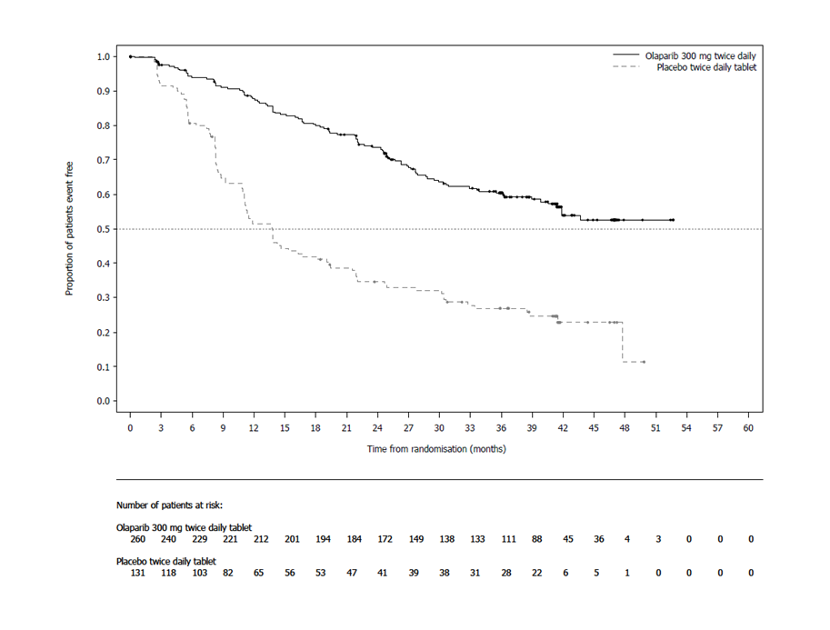
There was no clinically significant decrease in HRQoL from baseline for olaparib-treated patients over the 24-month treatment period and no clinically relevant differences in HRQoL compared with placebo-treated patients as assessed by the change from baseline in the Trial Outcome Index (TOI) of the Functional Assessment of Cancer Therapy – Ovarian (FACT-O).

Platinum-sensitive relapsed (PSR) ovarian cancer
The efficacy of LYNPARZA in the maintenance treatment setting in platinum-sensitive relapsed (PSR) ovarian, fallopian tube or primary peritoneal cancer is supported by two randomised, double-blind, placebo-controlled trials in patients with PSR and BRCA-mutated disease (SOLO2) and in patients with PSR disease (Study 19). In both studies, PSR patients who were in response following completion of platinum-based chemotherapy and whose disease had recurred >6 months after completion of penultimate platinum-based chemotherapy were enrolled. Patients could not have received prior olaparib or other PARP inhibitor treatment. Patients could have received prior bevacizumab, except in the regimen immediately prior to randomisation. Patients with BRCA mutations were identified either from germline testing in blood via a local test or the Myriad CLIA Integrated BRACAnalysis® test or from testing a tumour sample using a local test or a test performed by Foundation Medicine.

SOLO2 Study in PSR patients with a BRCA mutation
The study compared the efficacy of LYNPARZA maintenance treatment (300 mg [2 x 150 mg tablets] twice daily) taken to progression with placebo treatment in 295 patients with high-grade serous or endometrioid PSR ovarian cancer (2:1 randomisation: 196 olaparib and 99 placebo) who were in response (CR or PR) following completion of platinum-containing chemotherapy. All patients had evidence of germline BRCA mutation (gBRCAm) at baseline.
The primary endpoint was PFS determined by investigator assessment using RECIST 1.1. Secondary efficacy endpoints included time from randomisation to PFS2; OS, time from randomisation to discontinuation of treatment or death (TDT), TFST, time from randomisation to start of second subsequent anti-cancer therapy or death (TSST); and HRQoL.
The study met its primary objective demonstrating a clinically meaningful and statistically significant improvement in investigator assessed PFS for olaparib compared with placebo with a HR of 0.30 (95% CI 0.22-0.41; p<0.0001; median 19.1 months for olaparib vs. 5.5 months for placebo). The investigator assessment of PFS was supported with a blinded independent central radiological review of PFS (HR 0.25; 95% CI 0.18-0.35; p<0.0001; median 30.2 months for olaparib vs. 5.5 months for placebo). At 2 years, 43% olaparib treated patients remained progression-free compared with only 15% placebo-treated patients. A clinically meaningful and statistically significant improvement in PFS2 was also observed with a HR of 0.50 (95% CI 0.34-0.72; p=0.0002; median not reached for olaparib vs. 18.4 months for placebo) indicating that the benefit observed with olaparib continued to be evident even with the use of subsequent therapies. Interim OS was immature with events in only 24% patients (HR 0.80; 95% CI 0.50-1.31; p=0.4267; medians not reached). Clinically meaningful and statistically significant improvements in TDT, TFST and TSST were also observed for olaparib-treated patients (Table 4).
A summary of key efficacy findings for patients with gBRCAm PSR ovarian cancer in SOLO2 is presented in Table 4.

Table 4 Summary of key efficacy findings for patients with gBRCAm PSR ovarian cancer in SOLO2
 | LYNPARZA tablet  300 mg bd | Placebo
PFS (63% maturity)
Number of events: Total number of patients (%) | 107:196 (55) | 80:99 (81)
Median time (months) | 19.1 | 5.5
HR (95% CI) ª | 0.30 (0.22-0.41)
P value (2-sided) | p<0.0001
PFS2 (~40% maturity)
Number of events: Total number of patients (%) | 70:196 (36) | 49:99 (50)
Median time (months) | NR | 18.4
HR (95% CI) ª | 0.50 (0.34-0.72)
P value (2-sided) | p=0.0002
Interim OS (24% maturity)
Number of events: Total number of patients (%) | 45:196 (23) | 27:99 (27)^{b}
Median time (months) | NR | NR
HR (95% CI) ª | 0.80 (0.50-1.31)
P value (2-sided) | p=0.4267
TFST
Number of events: Total number of patients (%) | 92:196 (47) | 79:99 (80)
Median time (months) | 27.9 | 7.1
HR (95% CI) ª | 0.28 (0.21-0.38)
P value* (2-sided) | p<0.0001
TDT
Number of events: Total number of patients (%) | 112:196 (57) | 86:99 (87)
Median time (months) | 19.4 | 5.6
HR (95% CI) ª | 0.31 (0.23-0.42)
P value* (2-sided) | p<0.0001
TSST
Number of events: Total number of patients (%) | 68:196 (35) | 60:99 (61)
Median time (months) | NR | 18.2
HR (95% CI) ª | 0.37 (0.26-0.53)
P value* (2-sided) | p<0.0001
* Not controlled for multiplicity
ª A value <1 favours olaparib. The analysis was performed using a Cox proportional hazard model including response to previous platinum chemotherapy (CR or PR), and time to disease progression (>6-12 months and >12 months) in the penultimate platinum-based chemotherapy as covariates.
^{b} Approximately a third of placebo-treated patients (28/99; 28.3%) received a subsequent PARP inhibitor.
HR Hazard Ratio; bd Twice daily; NR Not reached; OS Overall survival; PFS Progression-free survival; CI Confidence interval; TDT Time from randomisation to discontinuation of treatment or death; TFST Time from randomisation to start of first subsequent therapy or death; PFS2 Time from randomisation to second progression; TSST Time from randomisation to start of second subsequent therapy or death.
Figure 2 SOLO2: Kaplan-Meier plot of PFS in patients with gBRCAm PSR ovarian cancer (63% maturity - investigator assessment)
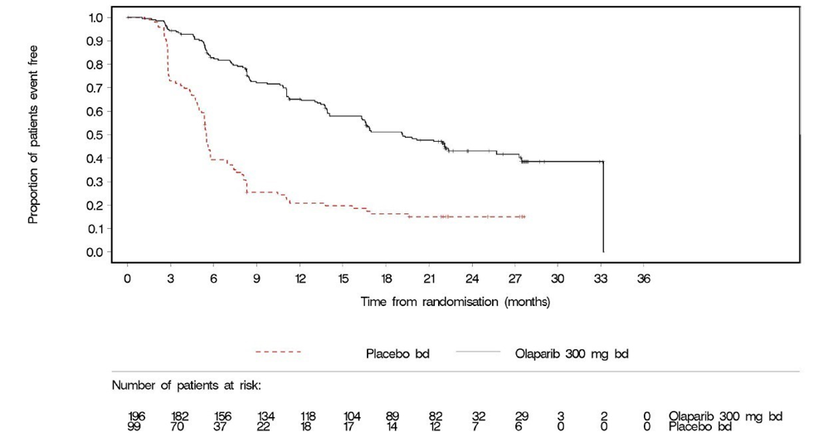
bd Twice daily; PFS Progression-free survival
There was no difference between olaparib and placebo treatment groups in HRQoL as assessed by the change from baseline in the Trial Outcome Index (TOI) of the Functional Assessment of Cancer Therapy – Ovarian (FACT-O) over 12 months (estimated difference - 0.03; 95% CI: -2.191, 2.2126; p=0.9765).

Study 19 in PSR patients
The study compared the efficacy of LYNPARZA capsule maintenance treatment (400 mg [8 x 50 mg capsules] twice daily) taken to progression with placebo in 265 (136 LYNPARZA and 129 placebo) PSR patients who were in response (CR [complete response] or PR [partial response]) following completion of platinum containing chemotherapy. The primary endpoint was PFS based on investigator assessment using RECIST 1.0. Secondary efficacy endpoints included OS (overall survival), DCR (disease control rate) defined as confirmed CR/PR + SD (stable disease), HRQoL (health related quality of life), and disease related symptoms.
The study met its primary objective demonstrating a statistically significant and clinically relevant improvement in PFS for olaparib compared with placebo with a HR 0.35 (95% CI 0.25-0.49; p<0.00001; median 8.4 months for LYNPARZA vs. 4.8 months for placebo). At the final analysis (data cut off (DCO) 9 May 2016) for OS at 79% maturity, the hazard ratio comparing olaparib with placebo was 0.73 (95% CI 0.55-0.95; p=0.02138 (did not meet prespecified significance level of <0.0095); median 29.8 months for olaparib vs. 27.8 months for placebo).
BRCA mutation status was confirmed retrospectively and a preplanned subgroup analysis identified patients with BRCA-mutated (germline and somatic) ovarian cancer (n=136, 51.3%) as the subgroup that derived the greatest clinical benefit from LYNPARZA maintenance monotherapy. There were no multiplicity strategies in place for the sub-group analyses. In BRCAm patients the HR for PFS improvement was 0.18 (95% CI 0.10-0.31; p<0.00001; median 11.2 months for olaparib vs 4.3 months for placebo). For the secondary endpoint of OS the HR for olaparib vs. placebo was 0.62; 95% CI 0.42- 0.93; p=0.02140; median 34.9 months for olaparib versus 30.2 months for placebo). In the olaparib-treated group, 28.4% of patients remained on treatment for
≥2 years and 14.9% for ≥5 years. In the placebo-treated group, 8.1% of patients remained on treatment for ≥2 years and 1.6% for ≥5 years. A PFS benefit of olaparib over placebo was also seen in patients without a deleterious BRCA mutation [HR 0.54 (95% CI: 0.34, 0.85; p<0.0075).
Within the overall population, the DCR at 24 weeks was 53% and 25% for patients in the olaparib and placebo groups, respectively and in the BRCA-mutated population the disease control rate at 24 weeks was 57% and 24% for patients in the LYNPARZA and placebo groups, respectively.
No statistically significant differences were observed between treatment groups in patient reported symptoms or HRQoL.
A summary of efficacy findings for patients with BRCAm PSR ovarian cancer in Study 19 is presented in Table 5.
Table 5 Summary of key efficacy findings for all patients and patients with BRCAm PSR ovarian cancer in Study 19
 | All patients |  | BRCA-mutated
 | LYNPARZA 400 mg capsule bid | Placebo | LYNPARZA 400 mg capsule bid | Placebo
PFS – DCO 30 June 2010
Number of events: Total number of patients (%) | 60:136 (44%) | 94:129 (73%) | 26:74 (35%) | 46:62 (74%)
Median time (months) | 8.4 | 4.8 | 11.2 | 4.3
HR (95% CI) ª | 0.35 (0.25-0.49) |  | 0.18 (95% CI 0.10–0.31)
P value* (2-sided) | p<0.00001 |  | p<0.00001
OS - DCO 09 May 2016
Number of events: Total number of patients (%) | 98:136 (72%) | 112:129 (87%)^{b} | 112:129 (66%) | 50:62 (81%)^{b}
Median time (months) | 29.8 | 27.8 | 34.9 | 30.2
HR (95% CI) ª | 0.73 (95% CI 0.55–95) |  | 0.62 (95% CI 0.42-0.93)
P value* (2-sided) | p=0.02138 |  | p=0.02140
* There were no multiplicity strategies in place for the sub-group analyses or for the all patients,
ª HR=Hazard Ratio. A value <1 favours LYNPARZA. A value <1 favours olaparib. The analysis was performed using a Cox proportional hazards model with factors for treatment, ethnic descent, platinum sensitivity and response to final platinum therapy.
^{b} Approximately a quarter of placebo-treated patients in the BRCA-mutated subgroup (14/62; 22.6%) received a subsequent PARP inhibitor.
OS Overall survival; PFS Progression-free survival; CI Confidence interval

First-line Maintenance Treatment of HRD-positive Advanced Ovarian CancerPAOLA-1 (NCT02477644) was a Phase III randomised, double-blind, placebo-controlled, multi-centre trial that compared the efficacy of Lynparza in combination with bevacizumab versus placebo/ bevacizumab for the maintenance treatment of advanced high-grade epithelial ovarian cancer, fallopian tube or primary peritoneal cancer following first-line platinum-based chemotherapy and bevacizumab. Randomisation was stratified by first-line treatment outcome (timing and outcome of cytoreductive surgery and response to platinum-based chemotherapy) and tBRCAm status, determined by prospective local testing. All available clinical samples were retrospectively tested with Myriad myChoice® CDx. Patients were required to have no evidence of disease (NED) due to complete surgical resection, or who were in complete response (CR), or partial response (PR) following completion of first-line platinum-containing chemotherapy and bevacizumab. Patients were randomized (2:1) to receive Lynparza tablets 300 mg orally twice daily in combination with bevacizumab (n=537) 15 mg/kg every three weeks or placebo/bevacizumab (n=269) Patients continued bevacizumab in the maintenance setting and started treatment with Lynparza after a minimum of 3 weeks and up to a maximum of 9 weeks following completion of their last dose of chemotherapy. Lynparza treatment was continued for up to 2 years or until progression of the underlying disease or unacceptable toxicity. Patients who in the opinion of the treating physician could derive further benefit from continuous treatment could be treated beyond 2 years. Treatment with bevacizumab was for a total of up to 15 months, including the period given with chemotherapy and given as maintenance.
The major efficacy outcome measure was investigator-assessed PFS evaluated according to RECIST, version 1.1. An additional efficacy endpoint was overall survival (OS).
The median age of patients in both arms was 61 years overall (range 26 to 87). Ovarian cancer was the primary tumour type in 86% of patients in both arms. Ninety six percent (96%) were serous histological type. The ECOG performance score was 0 in 70% of patients and 1 in 28% of patients, overall. All patients had received first-line platinum-based therapy and bevacizumab. First-line treatment outcomes at screening indicated that patients had no evidence of disease with complete macroscopic resection at initial debulking surgery (32%, both arms), no evidence of disease/ CR with complete macroscopic resection at interval debulking surgery (31%, both arms), no evidence of disease/ CR in patients who had either incomplete resection (at initial or interval debulking surgery) or no debulking surgery (15%, both arms) and patients with a partial response (22%, both arms). Thirty percent (30%) of patients in both arms had a deleterious BRCA mutation. Patients were not restricted by the surgical outcome with 65% having complete cytoreduction at initial or interval debulking surgery and 35% having residual macroscopic disease. Demographics and baseline disease characteristics were balanced and comparable between the study and placebo arms in the Intention to Treat (ITT) population and also in the HRD-positive subgroup.
The study met its primary end-point in the ITT population demonstrating a statistically significant improvement in investigator assessed PFS for olaparib/bevacizumab compared to placebo/ bevacizumab (HR 0.59, 95% CI 0.49-0.72, p<0.0001 with a median of 22.1 months for olaparib/bevacizumab vs 16.6 months for placebo/bevacizumab). This was consistent with a BICR analysis of PFS.
Efficacy was not demonstrated in patients with HRD negative status.
Efficacy results from a biomarker subgroup analysis of 387 patients with HRD-positive tumours (including BRCA mutation), identified post-randomization using the Myriad myChoice® HRD
Plus tumour test, who received Lynparza/bevacizumab (n=255) or placebo/bevacizumab (n=132), are summarized in Table 6 and Figure 3. Results from a blinded independent review of PFS were consistent. Overall survival data in this subpopulation were immature with 16% deaths.
Table 6 Efficacy Results – PAOLA-1 (HRD-positive status*, Investigator Assessment)
 | Olaparib/ bevacizumab  (n=255) | Placebo/ bevacizumab  (n=132)
Progression-Free Survival
Number of events (%) | 87 (34%) | 92 (70%)
Median, months | 37.2 | 17.7
Hazard Ratioª (95% CI) | 0.33 (0.25, 0.45)
* Median follow-up of 27.4 months in Lynparza/bevacizumab arm and 27.5 months in placebo/bevacizumab arm.
ª The analysis was performed using an unstratified Cox proportional hazards model.
CI Confidence interval
Figure 3 Kaplan-Meier Curves of Investigator-Assessed Progression-Free Survival –PAOLA-1 (HRD-positive status)
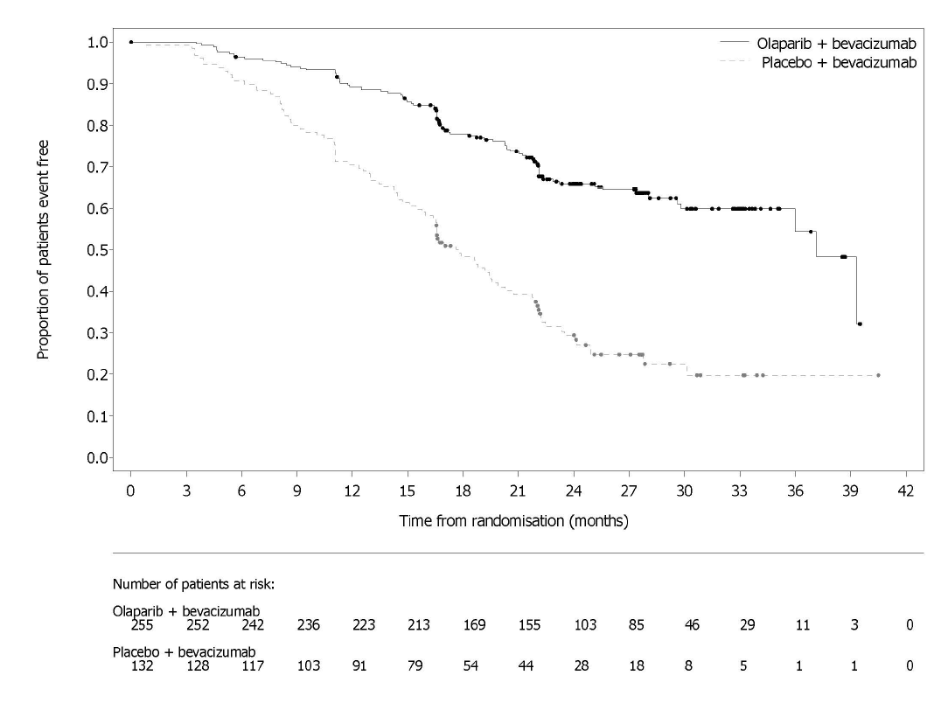

Germline BRCA-mutated HER2-negative metastatic breast cancer

OlympiAD in HER2-negative metastatic breast cancer patients with a gBRCA mutation
The study was a Phase 3 randomised, open-label, controlled trial that compared the efficacy of olaparib (300 mg [2 x 150 mg tablets] twice daily) taken to progression with a comparator arm of physician’s choice of chemotherapy (capecitabine, eribulin, or vinorelbine). In the study 302 patients with gBRCAm HER2-negative metastatic breast cancer who had previously received up to two lines of chemotherapy for the treatment of metastatic disease were randomised (2:1 randomisation: 205 olaparib and 97 comparator). Patients were stratified based on: receipt of prior chemotherapy regimens for metastatic breast cancer, oestrogen receptor (ER) and / or progesterone receptor (PgR) positive vs ER and PgR negative, prior platinum for breast cancer. The primary endpoint was PFS assessed by blinded independent central review (BICR) using RECIST 1.1. Secondary endpoints included PFS2, OS, objective response rate (ORR) and HRQoL.
All patients had received prior treatment with anthracycline (unless contraindicated) and a taxane in either the neoadjuvant, adjuvant or metastatic setting. Prior therapy with platinum for metastatic breast cancer was allowed provided there had been no evidence of disease progression during platinum treatment. Prior therapy with platinum in the (neo)adjuvant setting was allowed provided the last dose was received at least 12 months prior to randomisation. Patients could not have received prior olaparib or other PARP inhibitor treatment. Patients with ER and/or PgR-positive disease must have received and progressed on at least one endocrine therapy (adjuvant or metastatic) or had disease that the treating physician believed to be inappropriate for endocrine therapy. Patients had tumour assessments at baseline and every 6 weeks for the first 24 weeks, and then every 12 weeks relative to date of randomisation, until objective radiological disease progression.
The study met its primary objective demonstrating a statistically significant and clinically meaningful improvement in PFS for olaparib-treated patients compared with those in the comparator arm with a HR of 0.58 (95% CI 0.43-0.80; p=0.0009; median 7.0 months for olaparib vs. 4.2 months for comparator) (Table 7 and Figure 4).
A clinically meaningful and statistically significant improvement in PFS2 was also observed with a HR of 0.57 (95% CI 0.40-0.83; p=0.0033; median 13.2 months for olaparib vs 9.3 months for comparator) indicating that the benefit observed with olaparib continued to be evident even with the use of subsequent therapies. In the measurable disease patient population (77%), ORR in olaparib-treated patients was 60% (95% CI 52.0-67.4) and in patients who received comparator was 29% (95% CI 18.3-41.3). The median time to onset of response was 47 days for olaparib vs 45 days for comparator. The median duration of response was 6.4 months for olaparib vs 7.1 months for comparator. Overall survival was 64% mature at the time of the final OS analysis (DCO 25 September 2017). The OS HR comparing olaparib with comparator was 0.90 (95% CI 0.66-1.23; p=0.5131; median 19.3 months for olaparib vs. 17.1 months for comparator). The median follow-up time in censored patients was 25.3 months for olaparib vs 26.3 months for comparator.
Consistent results were observed across patient subgroups.
Table 7 Summary of key efficacy findings for patients with gBRCAm HER2-negative metastatic breast cancer in OlympiAD
 | Olaparib 300 mg bd | Physician’s choice chemotherapyª
PFS (77% maturity) – DCO 9 December 2016
Number of events: Total number of patients (%) | 163:205  (80) | 71:97  (73)
Median time (months) | 7.0 | 4.2
HR (95% CI) | 0.58 (0.43-0.80)
P value (2-sided) | p=0.0009
PFS2 (52% maturity) – DCO 9 December 2016
Number of events: Total number of patients (%) | 104:205  (51) | 53:97  (55)
Median time (months) | 13.2 | 9.3
HR (95% CI) | 0.57 (0.40-0.83)
P value (2-sided) | p=0.0033
OS (64% maturity) – DCO 25 September 2017
Number of events: Total number of patients (%) | 130:205  (63) | 62:97  (64)^{b}
Median time (months) | 19.3 | 17.1
HR (95% CI) | 0.90 (0.66-1.23)
P value (2-sided) | p=0.5131
ORR – DCO 9 December 2016
Number of objective responders: Total number of patients with measurable disease (%) | 100:167  (60) | 19:66  (29)
95% CI | 52.0 to 67.4 | 18.3 to 41.3
Complete response (%) | 15:67 (9) | 1:66 (2)
Partial response (%) | 85:167 (51) | 18:66 (27)
a Physician’s choice of chemotherapy consisting of either capecitabine, eribulin or vinorelbine.
b Approximately a tenth of patients in the physician’s choice group (8/97; 8.2%) received a subsequent PARP inhibitor
bd Twice daily; CI Confidence interval; DCO Data cut off; HR Hazard ratio; ORR Objective response rate; OS Overall survival; PFS Progression-free survival; PFS2 Time to second progression or death.

Figure 4 OlympiAD: Kaplan-Meier plot of PFS in patients with gBRCAm HER2-negative metastatic breast cancer (77% maturity)
A significant difference in global health status/QoL (assessed using the EORTC QLQ-C30 questionnaire which uses a 0-100 point scale) in favour of olaparib was observed (adjusted mean difference in change from baseline score was 7.5 points [95% CI: 2.48-12.44; p=0.0035]). Time to deterioration (≥10 points decrease from baseline) in global health status/QoL score was statistically significantly longer on the olaparib arm (HR 0.44; 95% CI: 0.25-0.77; p=0.0043; median not reached for olaparib vs. 15.3 months for comparator arm). Over the treatment period, the proportion of patients with clinically significant improvement (≥10 points increase from baseline) in global health status/QoL score was 33.7% (n=69) in the olaparib arm and 13.4% (n=13) in the comparator arm.

Maintenance following first-line treatment of germline BRCA-mutated metastatic adenocarcinoma of the pancreas
POLO was a Phase III, randomised, double-blind, placebo-controlled, multi-centre trial that compared the efficacy of Lynparza maintenance treatment (300 mg [2 x 150 mg tablets] twice daily) with placebo in gBRCA-mutated metastatic adenocarcinoma of the pancreas. The study randomised 154 patients (3:2 randomisation: 92 olaparib and 62 placebo) whose disease had not progressed following at least 16 weeks of first-line platinum-based chemotherapy. There was no upper limit to the duration of chemotherapy received. After 16 weeks of continuous platinum-based chemotherapy, the platinum could be discontinued at any time for toxicity and the other agents continued; the patients were eligible for randomisation as long as there was no evidence of progression at any time during chemotherapy treatment. All toxicities from previous anti-cancer therapy must have been resolved to CTCAE grade 1, except for alopecia, grade 3 peripheral neuropathy and Hgb ≥ 9 g/dL. Lynparza treatment was continued until progression of the underlying disease.
Patients with germline BRCA mutations were identified from prior local testing results or by central testing using the Myriad BRACAnalysis® or Myriad BRACAnalysis CDx® test. The BRCAm status of all patients identified using prior local testing results was confirmed, where sent, using the Myriad BRACAnalysis® or Myriad BRACAnalysis CDx® test.
Demographic and baseline characteristics were generally well balanced between the olaparib and placebo arms. Median age was 57 years in both arms; 30% of patients in the olaparib arm were ≥ 65 years compared to 21% in the placebo arm. Fifty-eight per-cent (58%) of patients were male. Most patients were ECOG performance status 0 (67%). Ninety-six per-cent (96%) of patients were randomised within 8 weeks of their last dose of platinum-based chemotherapy. The median time from initiation of first-line platinum-based chemotherapy to randomisation was 5.8 months (range 3.4 to 33.4 months) and 49% of patients were in complete or partial response to their most recent platinum-based regimen.
The primary endpoint was progression-free survival (PFS), defined as time from randomisation to progression determined by BICR using modified Response Evaluation Criteria in Solid Tumors (RECIST) 1.1, or death. Secondary efficacy endpoints included overall survival (OS), time from randomisation to second progression or death (PFS2), time from randomisation to first subsequent anti-cancer therapy or death (TFST), time from randomisation to discontinuation of treatment or death (TDT), objective response rate (ORR), duration of response (DoR), response rate, time to response and health related quality of life (HRQoL). Patients had tumour assessments at baseline and every 8 weeks for 40 weeks, and then every 12 weeks relative to the date of randomisation, until objective radiological disease progression. For PFS, the median follow-up time for censored patients was 9.1 months in the olaparib arm and 3.8 months in the placebo arm. For OS, the median follow-up time for censored patients was 13.4 months in the olaparib arm and 12.5 months in the placebo arm.
The study demonstrated a clinically meaningful and statistically significant improvement in PFS for olaparib compared to placebo, with a HR of 0.53 (95% CI 0.35 – 0.82; p=0.0038; the median was 7.4 months for olaparib vs 3.8 months for placebo). The sensitivity analysis of PFS by investigator assessment (HR 0.51; 95% CI 0.34 to 0.78; p=0.0017; median 6.3 months vs 3.7 months for olaparib vs placebo, respectively) was consistent with the PFS analysis by BICR. Based on Kaplan–Meier estimates, the proportion of patients that were alive and progression-free at 12, 24 and 36 months were 34%, 28% and 22% for olaparib vs 15%, 10% and 10% for placebo.
A clinically meaningful positive trend in PFS2 was observed with a HR of 0.76 (p=0.2597 [nominal]; median PFS2 was 13.2 months for olaparib vs 9.2 months for placebo) indicating that the benefit observed with olaparib continued to be evident even with the use of subsequent therapies. A clinically meaningful and statistically significant improvement in TFST and TDT was observed for olaparib-treated patients (see Table 8). The median DoR was longer in the olaparib arm (24.9 months) compared to the placebo arm (3.7 months), with a longer median time to onset of response (5.4 months for olaparib vs 3.6 months for placebo). At the interim analysis of OS (46% maturity) the HR was 0.91 (95% CI 0.56 – 1.46; p=0.6833; median 18.9 months for olaparib vs 18.1 months for placebo).
Table 8 Summary of key efficacy findings for patients with gBRCAm metastatic adenocarcinoma of the pancreas in POLO
 | Olaparib 300 mg bd | Placebo
PFS (68% maturity)
Number of events: Total number of patients (%) | 60:92 (65) | 44:62 (71)
Median time (months) | 7.4 | 3.8
HR (95% CI)^{a,b} | 0.53 (0.35-0.82)
P value (2-sided) | p=0.0038
Interim OS (46% maturity)
Number of events: Total number of patients (%) | 41:92 (45) | 30:62 (48)^{c}
Median time (months) | 18.9 | 18.1
HR (95% CI)^{b,c} | 0.91 (0.56-1.46)
P value (2-sided) | p=0.6833
PFS2 (46% maturity)
Number of events: Total number of patients (%) | 41:92 (45) | 30:62 (48)
Median time (months) | 13.2 | 9.2
HR (95% CI)^{a,b} | 0.76 (0.46-1.23)
P value* (2-sided) | p=0.2597
TFST (68% maturity)
Number of events: Total number of patients (%) | 58:92 (63) | 46:62 (76)
Median time (months) | 8.6 | 5.8
HR (95% CI)^{b,c} | 0.50 (0.33-0.76)
P value* (2-sided) | p=0.0013
TDT (73% maturity)
Number of events: Total number of patients (%) | 60:92 (65) | 53:62 (86)
Median time (months) | 7.2 | 3.8
HR (95% CI)^{b} | 0.45 (0.30-0.67)
P value* (2-sided) | p=0.0001
ORR
Number of objective responders: total number of patients with measurable disease at baseline (%) | 18:78 (23.1) | 6:52 (11.5)
Complete response (%) | 2 (2.6) | 0
Partial response (%) | 16 (20.5) | 6 (11.5)
Odds ratio (95% CI) | 2.30 (0.89, 6.76)
P value* (2-sided) | p=0.1028
DoR
Median time (months) (95% CI) | 24.9 (14.75, NC) | 3.7 (2.10, NC)
ª A value <1 favours olaparib.
^{b} The analysis was performed using a log-rank test.
^{c} One patient (1%) from the olaparib arm received subsequent PARP inhibitor; 15% of patients on the placebo arm received a PARP inhibitor in any subsequent line.
* Not controlled for multiplicity.
bd Twice daily; CI Confidence interval; HR Hazard Ratio; NC Not calculable; ORR Objective Response Rate; OS Overall survival;
PFS Progression-free survival; PFS2 Time to second progression or death; TDT Time from randomisation to discontinuation of
treatment or death; TFST Time from randomisation to start of first subsequent therapy or death.

Figure 5 POLO: Kaplan-Meier plot of PFS for patients with gBRCAm metastatic adenocarcinoma of the pancreas (68% maturity – BICR)
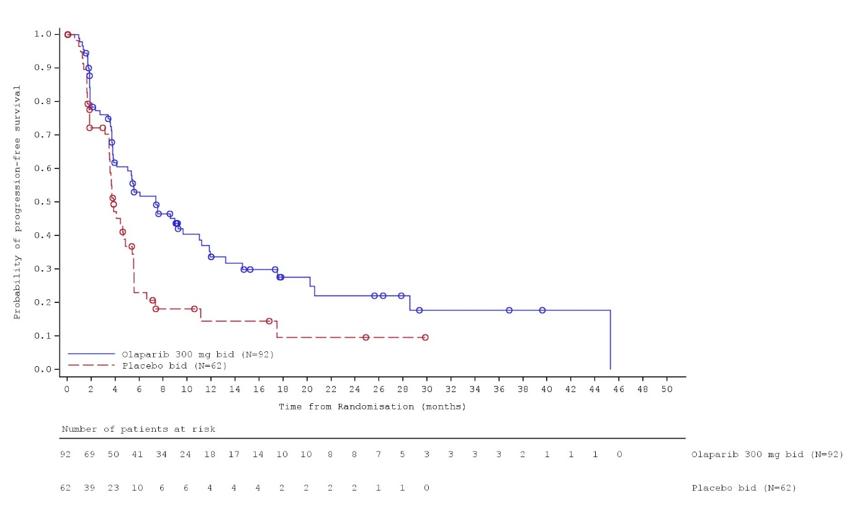
Patient-reported HRQoL was assessed using the EORTC QLQ-C30 and its pancreatic cancer module (EORTC QLQ-PAN26). A 10-point change was pre-defined as clinically meaningful on a 0-100 points global HRQoL scale. The adjusted mean change from baseline in global HRQoL score across all timepoints up to 6 months was -1.20 ± 1.42 in the olaparib group (n=84) and 1.27 ± 1.95 in the placebo group (n=54), with a corresponding estimated difference of −2.47 points (95% CI, −7.27 to 2.38), demonstrating no worsening in olaparib treated patients and no clinically meaningful differences in global HRQoL over the treatment period between arms. Median time to clinically meaningful deterioration (≥10 points decrease from baseline sustained at the next timepoint) in global HRQoL score was numerically longer in the olaparib arm compared to placebo (HR 0.72; 95% CI: 0.41-1.27; medians: 21.2 months olaparib vs. 6.0 months placebo). Over the treatment period, the proportion of patients with clinically significant improvement (≥10 points increase from baseline) in global HRQoL score was 29.2% in the olaparib arm and 22.4% in the placebo arm.

Effect on the QT interval
There is no clinically relevant effect of olaparib on cardiac repolarisation (as evaluated by an effect on the QT interval) following 300 mg twice daily multiple dosing of olaparib.

Retreatment on relapse
There are no data to support retreatment with olaparib as maintenance following subsequent relapse.

Pharmacokinetic properties
Olaparib displays high inter-patient variability in PK parameters, including C_{max}, AUC, Vd and CL/F.
The pharmacokinetics of olaparib at the 300 mg tablet dose are characterised by an apparent plasma clearance of ~7 L/h, an apparent volume of distribution of ~158 L and a terminal half-life of 15 hours after dosing. On multiple dosing, an AUC accumulation ratio of 1.8 was observed and PK appeared to be time-dependent to a small extent.

Absorption
Following oral administration of olaparib via the tablet formulation (2x150 mg), absorption is rapid with peak plasma concentrations typically achieved between 1.5 hours after dosing.
Co-administration with food slowed the rate (t_{max} delayed by 2.5 hours and C_{max} reduced by approximately 21%) but did not significantly affect the extent of absorption of olaparib (AUC treatment ratio: 1.08; 90% CI: 1.01, 1.16). Consequently, patients may take LYNPARZA without regard to food (see Section 4.2 - Dose and method of administration).

Distribution
In vitro, human plasma protein binding of olaparib was dose-dependent; the fraction bound was approximately 91% at 1 μg/mL, reducing to 82% at 10 μg/mL and to 70% at 40 μg/mL. In solutions of purified proteins, the olaparib fraction bound to albumin was approximately 56%, which was independent of olaparib concentrations. Using the same assay, the fraction bound to alpha-1 acid glycoprotein was 29% at 10 μg/mL with a trend of decreased binding at higher concentrations.

Metabolism
In vitro, CYP3A4/5 were shown to be the enzymes primarily responsible for the metabolism of olaparib.
Following oral dosing of ¹⁴C-olaparib to female patients, unchanged olaparib accounted for the majority of the circulating radioactivity in plasma (70%) and was the major component found in both urine and faeces (15% and 6% of the dose respectively). The metabolism of olaparib is extensive with the main site of metabolism being the piperazine and fluorobenzyl ring structures. The majority of the metabolism was attributable to oxidation reactions with a number of the components produced undergoing subsequent glucuronide or sulphate conjugation. Up to 20, 37 and 20 metabolites were detected in plasma, urine and faeces respectively, the majority of them representing <1% of the dosed material. A ring-open piperazin-3-ol moiety, and two mono-oxygenated metabolites (each ~10%) were the major circulating components, with one of the mono-oxygenated metabolites also being the major metabolite in the excreta (6% and 5% of the urinary and faecal radioactivity respectively).

Excretion
Following a single dose of ¹⁴C-olaparib, ~86% of the dosed radioactivity was recovered within a 7 day collection period, ~44% via the urine and ~42% via the faeces. The majority of the material was excreted as metabolites.

Special populations

Renal impairment
Following a single oral 300 mg dose of olaparib to patients with mild renal impairment (creatinine clearance: 51 to 80 mL/min), AUC increased by 24% (90% CI: 6% to 47%) and C_{max} by 15% (90% CI: 4% to 27%) compared with patients with normal renal function. No LYNPARZA dose adjustment is required for patients with mild renal impairment, however, patients should be monitored closely for renal function and adverse events (see Section 4.2 - Dose and method of administration).
Following a single oral 300 mg dose of olaparib to patients with moderate renal impairment (creatinine clearance: 31 to 50 mL/min), AUC increased by 44% (90% CI: 10% to 89%) and C_{max} by 26% (90% CI: 6% to 48%) compared with patients with normal renal function. LYNPARZA dose adjustment is recommended for patients with moderate renal impairment and patients should be monitored closely for renal function and adverse events (see Section 4.2 - Dose and method of administration). Renal clearance of olaparib was lower in patients with mild and moderate renal impairment compared to patients with normal renal function (1.48 L/h). For patients with mild or moderate renal impairment, arithmetic mean CLR was 59% (0.614 L/h) and 80% (0.299 L/h) lower, respectively, than that observed in patients with normal renal function.
Olaparib has not been studied in patients with severe renal impairment or end-stage renal disease (creatinine clearance ≤30 mL/min).

Hepatic impairment
Following a single oral 300 mg dose of olaparib to patients with mild hepatic impairment (Child-Pugh classification A) AUC increased by 15% (90% CI: -23% to 28%) and C_{max} by 13% (90% CI: -18% to 55%) and to patients with moderate hepatic impairment (Child-Pugh classification B) AUC increased by 8% (90% CI: 0.66, 1.74) and C_{max} decreased by 13% (90% CI: 0.63, 1.22) compared with patients with normal hepatic function. No LYNPARZA dose adjustment is required in patients with mild or moderate hepatic impairment, however, patients should be monitored closely for hepatic function and adverse events (see Section 4.2 - Dose and method of administration.).
Olaparib has not been studied in patients with severe hepatic impairment (Child-Pugh classification C).

Race
In population based PK analyses, patient age, bodyweight or race (including White and Japanese patients) were not significant covariates.

Preclinical safety data

Genotoxicity
Olaparib showed no mutagenic potential in bacterial cells, but was clastogenic in mammalian cells in vitro. When dosed orally to rats, olaparib induced micronuclei in bone marrow. This clastogenicity is consistent with the primary pharmacology of olaparib and indicates potential for genotoxicity in man.

Carcinogenicity
Carcinogenicity studies have not been conducted with olaparib.

Pharmaceutical particulars

List of excipients
Refer to Section 2 - Qualitative and quantitative composition.

Incompatibilities
Incompatibilities were either not assessed or not identified as part of the registration of this medicine.

Shelf life
In Australia, information on the shelf life can be found on the public summary of the Australian Register of Therapeutic Goods (ARTG). The expiry date can be found on the packaging.

Special precautions for storage
Store below 30°C. Store in original container to protect from moisture.

Nature and contents of container
LYNPARZA is supplied in cartons containing 56 tablets in aluminium/aluminium blister platforms.

Special precautions for disposal
In Australia, any unused medicine or waste material should be disposed of by taking to your local pharmacy.

Physicochemical properties
Olaparib is a white to pale yellow crystalline powder, which is very slightly soluble in aqueous solutions (0.10 - 0.13 mg/mL at 37°C), slightly soluble in ethanol (5.5 mg/mL at 37°C) and has a pKa of 12.07.

Chemical structure
The chemical name for olaparib is: 4-[[3-[[4-(cyclopropylcarbonyl)-1-piperazinyl]carbonyl]-4-fluorophenyl]methyl]-1(2H)-phthalazinone.
The chemical structure of olaparib is:
Molecular formula: C₂₄H₂₃FN₄O₃
Molecular weight: 434.46

CAS number
CAS number: 763113-22-0

Medicine schedule (Poisons Standard)
Schedule 4 – Prescription Only Medicine

Sponsor
AstraZeneca Pty Ltd
ABN 54 009 682 311
66 Talavera Road
MACQUARIE PARK NSW 2113
Telephone: 1800 805 342

Date of first approval
23 May 2018

Date of revision

Summary table of changes
Section changed | Summary of new information
4.1 | Addition of indication in combination with bevacizumab in ovarian cancer (Paola-1) and adenocarcinoma of the pancreas (POLO)
4.2 | Information regarding duration of treatment for Paola-1 and POLO indication
4.8 | Updates from safety pool
4.8 | Erythema nodosum added, changed location for rash and dermatitis
5.1 | Addition of Paola-1 and POLO study data

LYNPARZA is a trade mark of the AstraZeneca group of companies.
© AstraZeneca 2020
Doc ID-004211611 v7.0

