AusPAR Attachment 1

Extract from the Clinical Evaluation Report for ofatumumab
  - Proprietary Product Name: Arzerra
  - Sponsor: Novartis Pharmaceuticals Australia Pty Ltd
Date of report: May 2016

About the Therapeutic Goods Administration (TGA)
- The Therapeutic Goods Administration (TGA) is part of the Australian Government Department of Health, and is responsible for regulating medicines and medical devices.
- The TGA administers the Therapeutic Goods Act 1989 (the Act), applying a risk management approach designed to ensure therapeutic goods supplied in Australia meet acceptable standards of quality, safety and efficacy (performance), when necessary.
- The work of the TGA is based on applying scientific and clinical expertise to decision-making, to ensure that the benefits to consumers outweigh any risks associated with the use of medicines and medical devices.
- The TGA relies on the public, healthcare professionals and industry to report problems with medicines or medical devices. TGA investigates reports received by it to determine any necessary regulatory action.
- To report a problem with a medicine or medical device, please see the information on the TGA website <https://www.tga.gov.au>.
About the Extract from the Clinical Evaluation Report
- This document provides a more detailed evaluation of the clinical findings, extracted from the Clinical Evaluation Report (CER) prepared by the TGA. This extract does not include sections from the CER regarding product documentation or post market activities.
- The words [Information redacted], where they appear in this document, indicate that confidential information has been deleted.
- For the most recent Product Information (PI), please refer to the TGA website <https://www.tga.gov.au/product-information-pi>.
Copyright
© Commonwealth of Australia 2018
This work is copyright. You may reproduce the whole or part of this work in unaltered form for your own personal use or, if you are part of an organisation, for internal use within your organisation, but only if you or your organisation do not use the reproduction for any commercial purpose and retain this copyright notice and all disclaimer notices as part of that reproduction. Apart from rights to use as permitted by the Copyright Act 1968 or allowed by this copyright notice, all other rights are reserved and you are not allowed to reproduce the whole or any part of this work in any way (electronic or otherwise) without first being given specific written permission from the Commonwealth to do so. Requests and inquiries concerning reproduction and rights are to be sent to the TGA Copyright Officer, Therapeutic Goods Administration, PO Box 100, Woden ACT 2606 or emailed to <tga.copyright@tga.gov.au>.

Contents
1. Introduction 8
1.1. Drug class and therapeutic indication 8
1.2. Dosage forms and strengths 8
1.3. Dosage and administration 8
2. Clinical rationale 8
3. Contents of the clinical dossier 9
3.1. Scope of the clinical dossier 9
3.2. Paediatric data 10
3.3. Good clinical practice 10
4. Pharmacokinetics 10
4.1. Studies providing pharmacokinetic data 10
4.2. Evaluator’s overall conclusions on pharmacokinetics 15
5. Pharmacodynamics 15
5.1. Clinical studies with pharmacodynamics data 15
5.2. Evaluator’s overall conclusions on pharmacodynamics 16
6. Dosage selection for the pivotal studies 16
7. Clinical efficacy 17
7.1. Pivotal efficacy study (OMB112517 [PROLONG]) 17
7.2. Other efficacy studies 42
8. Clinical safety 61
8.1. OFA maintenance treatment – study OMB112517 61
8.2. Other safety data 100
8.3. Evaluators comments on safety 103
9. First round benefit-risk assessment 108
9.1. First round assessment of benefits 108
9.2. First round assessment of risks 109
9.3. First round assessment of benefit-risk balance 112
10. First round recommendation regarding authorisation 112
11. Clinical questions 112
11.1. Efficacy 112
11.2. Safety 113
12. References 114

List of abbreviations
Abbreviations | Meaning
ADA | Anti-drug antibody
ADCC | Antibody-dependent cellular cytotoxicity
AE | Adverse Event
AUC | Area under the curve
AUC(0-inf) | Area under the curve from time zero extrapolated to infinity
AUC(0-t) | Area under the curve from time zero throughout the dosing
BFR | Bulky fludarabine-refractory; refractory to fludarabine and
BR | Bendamustine and rituximab
BSA | Body surface area
CI | Confidence interval
CL | Clearance
CLcr | Creatinine clearance
CLL | Chronic lymphocytic leukemia
Cmax | Maximum observed concentration
CMI | Consumer Medicines Information
CR | Complete response
CSR | Clinical study report
CT | Computed tomography
Ctrough | Minimum concentration observed prior to next dose
CV% | Co-efficient of variation
CYP | Cytochrome
DLBCL | Diffuse large B-cell lymphoma
DR | Double-refractory; refractory to both fludarabine and
ECL | Electrochemiluminescence
ECOG | Eastern Cooperative Oncology Group
eCRF | Electronic case report form
ELISA | Enzyme-linked immunosorbent assay FL Follicular lymphoma
EMAP | Emerging Markets and Asia Pacific
F/U | Follow-up
FCR | Fludarabine, cyclophosphamide, rituximab
FISH | Fluorescent in-situ hybridization
FL | Follicular lymphoma
FR | Fludarabine and rituximab
G-CSF | Granulocyte colony-stimulating growth factor
GSK | GlaxoSmithKline
h | Hours
HAHA | Human anti-human antibody
HR | Hazard ratio
IDMC | Independent Data Monitoring Committee
Ig | Immunoglobulin
IGHV | Immunoglobulin heavy chain variable region
IRC | Independent Review Committee
ITT | Intent-to-treat
IV | Intravenous
IVIG | Intravenous gamma immunoglobulin
IWCLL | International Workshop for Chronic Lymphocytic Leukemia MRD Minimal residual disease
mAb | Monoclonal antibody
MS | Multiple sclerosis
NCI-WG | National Cancer Institute-sponsored
NONMEM | Nonlinear mixed-effects modeling approach
Obs | Observation
OFA | Ofatumumab
OS | Overall survival
PD | Pharmacodynamic
PD | Progressive disease
PFS | Progression-free survival
PI | Product Information
PI3 kinase | Phosphatidylinositol-3-kinase Pharmacokinetic
PML | Progressive multifocal leukoencephalopathy
PP | Per protocol
PR | Partial response
PRO | Patient-reported outcome
QTc | Corrected QT interval
RA | Rheumatoid arthritis
RAP | Reporting and analysis plan
R-CVP | Rituximab, cyclophosphamide, vincristine, and prednisolone
SCE | Summary of Clinical Efficacy
SAE | Serious adverse event
SCID | Severe combined immunodeficiency
SCT | Stem cell transplantation
SD | Stable disease
SOC | System organ class
TKI | Tyrosine kinase inhibitors
ULN | Upper limit of normal
Vss | Volume of distribution at steady rate

Introduction
This is a submission to extend the indications of Arzerra (ofatumumab).

Drug class and therapeutic indication
Ofatumumab is a human monoclonal antibody (IgG1_{K}) produced in a recombinant murine cell line (NSO).
The approved indications are:
- Previously untreated chronic lymphocytic leukaemia (CLL) - Arzerra (ofatumumab) is indicated in combination with chlorambucil or bendamustine for the treatment of patients with CLL who have not received prior therapy and are inappropriate for fludarabine-based therapy; and
- Refractory CLL - Arzerra (ofatumumab) as a single agent is indicated for the treatment of patients with CLL refractory to fludarabine and alemtuzumab.
The proposed additional indication is:
- Maintenance therapy in CLL - Arzerra (ofatumumab) is indicated as maintenance treatment for patients with CLL who are in complete or partial response after at least two lines of induction therapy.

Dosage forms and strengths
The following dosage forms and strengths are currently registered: Arzerra (ofatumumab rmc) 100 mg/5 mL and 1000 mg/5mL injection concentrate vials. No new dosage forms or strengths are proposed.

Dosage and administration
The proposed dosage and schedule for maintenance therapy of CLL with Arzerra (ofatumumab) is 300 mg on day 1 followed 1 week later by 1,000 mg on day 8 (cycle 1), followed by 1,000 mg on day 1 of subsequent cycles every 8 weeks for up to a maximum of 2 years.

Clinical rationale
The sponsor’s letter of application outlines the clinical rationale for the application to extend the indications of Arzerra (ofatumumab). The sponsor notes that there is no approved maintenance therapy for CLL. The sponsor comments that “a strategy to improve survival outcomes is to improve response durability through maintenance therapy, which is a treatment given to prolong or maintain remission in a patient who has responded to induction therapy for active disease”. The sponsor comments that maintenance treatment may provide greater clinical benefit for patients after treatment for relapsed CLL than observation alone.
Comment: The sponsor’s clinical rationale is acceptable. However, it is unclear why the then sponsor (GSK) decided to investigate ofatumumab maintenance treatment in patients with CLL in response following at least 2 lines of therapy rather than at least 1 line of therapy. This matter has been raised in Questions.

Contents of the clinical dossier

Scope of the clinical dossier
The submission contained the following clinical information:
- Clinical pharmacology data, including pharmacokinetic (PK) and pharmacodynamic (PD) data, were provided in 3 clinical efficacy and safety studies [OMB112517; OMB111827/GEN416; and OMB112758].
- 1 pivotal efficacy/safety study [OMB112517] supporting the proposed indication.
- 1 other efficacy/safety study [OMB114242] not directly relevant to the proposed extension of indication.
- 1 Post-Marketing Experience Report; 1 Review of immunogenicity; data source summary table (1 page) for the updated population pharmacokinetic report; data source tables (126 pages) requested by the European Union (CHMP) summarising safety data in side by side comparisons for all ofatumumab monotherapy versus combination studies (including previously evaluated studies).
- 8 in vitro studies reporting analytical methods for ofatumumab plasma concentrations for the human clinical studies.
- Literature references.
Comment: The submission included one pivotal Phase III study supporting the proposed extension of indication (OMB112517). This study also included PK and PD data updating the related information in the currently approved PI. The data in this study has been fully evaluated. No relevant supportive clinical efficacy and safety studies were submitted relating to the proposed extension of indication. The submission also included PK and PD data from Study OMB111827/GEN416 (a single arm clinical efficacy and safety study in re-treated subjects whose disease progressed after response or stable disease in study Hx-CD20-406) and Study OMB112758 (a small, single-arm study in Japanese and South Korean patients with previously treated CLL). Only the clinical pharmacology data have been reviewed from Studies OMB111827/GEN416 and OMB112758.
The submission included 1 “other study” located (Study OMB114242). The primary purpose of this study was to evaluate PFS with ofatumumab (OFA) monotherapy when compared to physicians’ choice of treatment (PC) in subjects with CLL with bulky lymphadenopathy who were refractory to fludarabine. The study was conducted to meet a specific obligation related to the Conditional Marketing Authorisation in the EU of Arzerra for the treatment of CLL refractory to fludarabine and alemtuzumab. The currently approved European SmPC includes a brief reference to the efficacy data from this study, which supplements the efficacy data from a subset of patients with CLL with bulky lymphadenopathy who were refractory to fludarabine from study HX-CD20-406 and referred to in the SmPC. The Australian PI includes no reference to the efficacy data from study HX-CD20-406 in the subset of patients with CLL with bulky lymphadenopathy refractory to fludarabine, although the PI does include other efficacy data from this study. The Australian PI summarises the safety data from study Hx-CD20-406, and includes safety data from the subset of patients with CLL with bulky lymphadenopathy refractory to fludarabine.
The annotated Australian PI included with the current submission proposes no additions to the PI based on either the efficacy or safety data from Study OMB114242. Study OMB114242 was not referred to in the sponsor’s covering letter provided for the submission, nor was the data summarised in the Clinical Overview, Summary of Clinical Efficacy or Summary of Clinical Safety. However, the safety data from the OFA and OFA salvage arms of the study were included in a tabulated summary included in the submission of the safety findings relating to OFA from all OFA monotherapy and combination studies. It is considered that Study OMB114242 is not related to the current submission to extend the indications of ofatumumab to include maintenance therapy. Nevertheless, for completeness, Study OMB114242 has been evaluated and the results included and discussed in the Efficacy and Safety sections of the clinical evaluation report.

Paediatric data
The sponsor stated that the submission did not include paediatric data as CLL affects mostly elderly patients. The sponsor commented that the median age of patients with CLL at presentation is 71 years, with 11% of patients being under the age of 55 years at diagnosis. In Australia, almost 80% of all new CLL cases are diagnosed in patients over 60 years of age. CLL is rare in patients under 40 years of age. This is particularly the case in paediatric practice, where acute lymphoblastic leukaemia (ALL) is the most common type of leukaemia in children 0 to 14 years of age. In the European Union, the applicability of the Paediatric Investigation Plan Class Waiver for ofatumumab for all treatment indications for CLL was confirmed in July 2008. In the USA, the use of ofatumumab in CLL has an orphan drug designation and is therefore exempt from paediatric assessment.
Comment: The absence of paediatric data in the submission is acceptable.

Good clinical practice
The sponsor stated that the submitted studies were performed in compliance with Good Clinical Practice.

Pharmacokinetics

Studies providing pharmacokinetic data
The submission included PK data from three clinical studies, outlined below:
- Study OMB112517, the pivotal Phase III, randomised, controlled trial of ofatumumab (OFA) maintenance treatment versus no further treatment (i.e., observation) in subjects with relapsed CLL who are in complete or partial response after at least 2 prior lines of induction therapy. OFA was administered as a two-dose first cycle (300 mg at Week 1 and 1000 mg at Week 2), followed by 1000 mg on Day 1 of subsequent eight-week cycles for up to a total of 13 cycles. The study included a total of 474 patients, including 238 randomised to the OFA arm and 236 randomised to the Obs arm. OFA plasma concentrations were collected from 224 subjects, and the PK dataset included 2,192 observations.
- Study OMB111827/GEN416 is a single-arm study that re-treated subjects with fludarabine-refractory CLL whose disease had progressed after response or stable disease in study OMB111773/Hx-CD20-406. Subjects who responded in the re-treatment phase were continued on maintenance therapy. OFA was administered during the re-treatment phase as weekly infusions for 8 weeks (initial dose of 300 mg, then 2000 mg for 7 infusions), followed by maintenance treatment consisting of 2000 mg infusions every four weeks for up to 24 months. This study was previously submitted based on the interim results, and the end-of-study results were included in the submission.
- Study OMB112758 is a Phase I/II, single-arm study in Japanese and South Korean subjects with previously treated CLL. OFA was administered as an IV infusion of 300 mg followed by infusions of 2000 mg weekly for seven consecutive weeks, then five weeks later by infusions of 2000 mg every four weeks for four infusions.

Study OMB112517 – Pharmacokinetic data

Overview
In study OMB112517, OFA was administered by IV infusion as a two-dose, first cycle (300 mg at Week 1 and 1000 mg at Week 2), followed by 1000 mg on Day 1 of subsequent 8-week cycles for up to 2 years for a maximum of 13 cycles. Blood samples for the determination of OFA plasma concentrations were collected using a sparse approach during treatment and for six months after the last dose. OFA concentration-time data were analysed using a previously developed population pharmacokinetic (PPK) model to obtain the empirical Bayes (post hoc) estimates of the model PK parameters and to derive additional PK parameter estimates for the patients in the current study. A nonlinear mixed-effects model describing the PK of OFA previously developed by GSK was used in the analysis of data from OMB112517. It consisted of a linear two-compartment model with first-order elimination and a nonlinear target-mediated clearance component.
NONMEM 7.2.0 was used for the analysis within the Predictive Modelling Environment (PME), and the statistical package R version 2.15.2 was used for all data formatting and diagnostic plots. The PPK model had been previously developed and revised based on studies in refractory CLL (study OMB111773/Hx-CD20-406), rheumatoid arthritis (study Hx-CD20-403), relapsed/refractory follicular lymphoma (study Hx-CD20-001), and relapsed/refractory CLL (study Hx-CD20-402). The model was applied to the data in the present study to determine the post hoc estimates of individual PK parameters.

Pharmacokinetic results
Ofatumumab plasma concentrations were quantified from 2,192 blood samples collected from 224 patients in the OFA maintenance arm. The median age of the population was 64 years (range: 33, 86 years), the median body surface area was 1.94 m² (range: 1.45, 3.11 m²), the median baseline creatinine clearance was 90.5 mL/min (range: 30.6, 228.8 mL/min), the median baseline IgG concentration was 6.85 g/L (range: 1.22, 27.9 g/L), and the median baseline CD19+ B-cell count was 44 cells/mm³ (range: 0, 25020 cells/mm³). OFA plasma concentrations were determined using a validated analytical method based on an enzyme-linked immunosorbent assay (ELISA) assay. The mean OFA concentration-time profiles are presented below in Figure 1, and the geometric mean values of the individual post hoc parameter estimates are summarised below in Table 1.

Figure 1: Mean OFA concentration-time profiles; PK population.
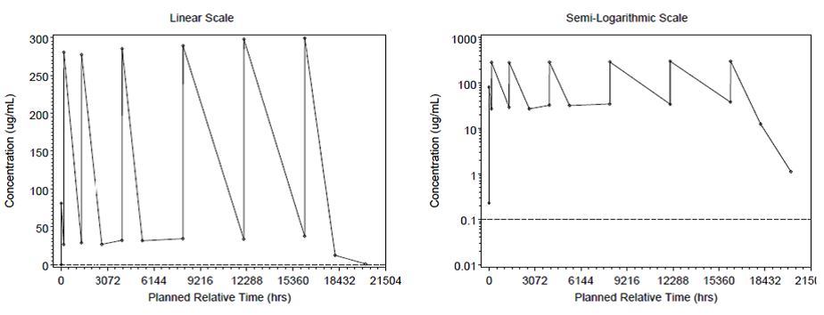

Table 1: OMB112517 - Summary of individual post hoc parameter estimates; PK population.
Abbreviations: CL = linear clearance; V1 = central volume; V2 = peripheral volume; BIN = B-cell input rate; CI = confidence interval; %CVb = between-subject coefficient or variations.
The observed OFA concentrations included in the PPK dataset (2192 observation/224 subjects) were consistent with the individual predicted OFA concentrations, but with a minor deviation from unity (see Figure 2, below). A numerical predictive check confirmed that the estimated variability of the final model was acceptable, with 7.1% of the observations being outside the 95% prediction interval based on 1000 simulations (6.7% below and 0.4% above the 95% prediction interval).
Figure 2: Observed OFA concentrations against individually predicted OFA concentrations; PK population.
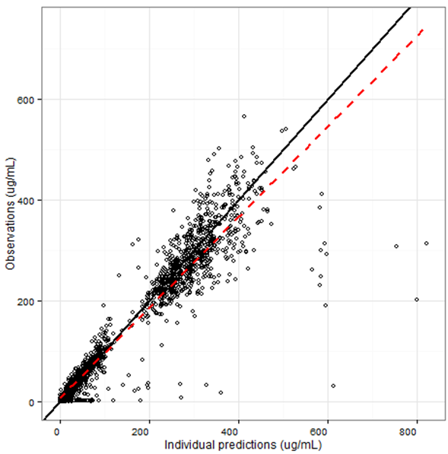
The previously developed PPK model adequately described the OFA concentration data obtained in study OMB112517. Based on the population PK parameter estimates and variability from the previously developed PPK model, selected PK parameters were calculated and are summarised below in Table 2.

Table 2: OMB112517 – Summary of selected PK parameter values.
Abbreviations: %CVb = between-subject coefficient of variation; Cmax = maximum observed concentration; Ctrough = plasma concentration prior to the next infusion; AUC(0-τ) = area under the concentration-time curve over the dosing interval; tmax = time at which maximum concentration is observed; CLtot = total clearance; Vss = volume of distribution at steady state, t1⁄2 = terminal half-life; a. AUC(0-τ) = AUC(0-168) for Cycle 1 Week 1, AUC(0-1176) for Cycle 1 Week 2, and AUC(0-1344) for Cycle 4; b. Reported as median (minimum-maximum); c. Vss calculated as V1+V2 for each subject overall and reported under Cycle 4 in the table.

Study OMB111827/GEN416 – Pharmacokinetic data

Overview
Title - GEN 416: A single-arm, international, multi-center trial investigating the efficacy and safety of ofatumumab retreatment and maintenance treatment in patients with B-cell chronic lymphocytic leukemia who progressed following response or stable disease after ofatumumab treatment in Hx-CD20-406
Eligible subjects from Study OMB111773/Hx-CD20-406 entered a re-treatment phase consisting of OFA infusions once weekly for 8 weeks (initial dose of 300 mg, then 2000 mg for 7 infusions). Following evaluation of response one week after the last re-treatment infusion, subjects who responded or had stable disease (SD) continued in the maintenance treatment phase of once monthly OFA infusions (2000 mg) for up to 24 months. Blood samples for the quantification of OFA serum concentrations were collected pre-dose and at the end of the infusion for up to 26 months after the first infusion, then every three months after the last dose. Cmax and Ctrough values were determined directly from the concentration-time data.

Pharmacokinetic results
PK data were available for 28 of the 29 subjects enrolled in the study. The median Cmax and Ctrough levels over time are provided below. The highest observed Cmax and Ctrough values occurred at Week 4 (fifth dose), during the weekly dosing phase of the study. At Week 4, Month 4, and Month 6, geometric mean Cmax values were 884, 565, and 651 µg/mL, and geometric mean Ctrough values were 323, 88.3, and 48.5 µg/mL.

Figure 3: GEN416 – OFA Cmax (panel a) and Ctrough (panel b) values over time.
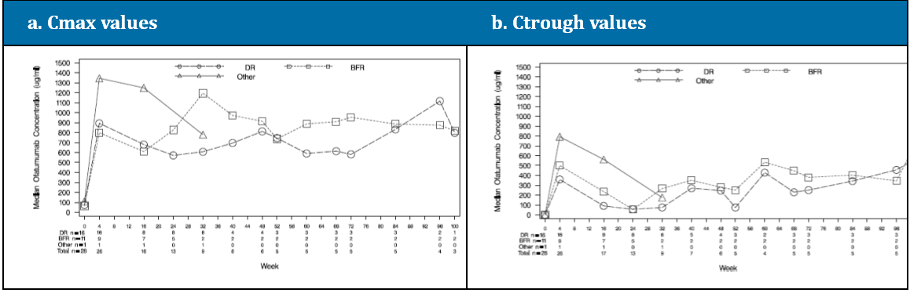
Abbreviations: DR = Double Refractory Group (i.e., fludarabine and alemtuzumab group); BFR = Bulky Refractory Group; Other = Refractory subjects who did not meet the criteria in the DR or BFR groups.

Study OMB112578

Overview
Title - A phase I/II, a single arm, open-label study of ofatumumab (GSK1841157) in patients with previously treated chronic lymphocytic leukemia.
This study was an open-label, uncontrolled Phase I/II study to evaluate the tolerability, efficacy, and PK profile of OFA in Japanese or Korean subjects with relapsed or refractory CLL. Ten (10) subjects were enrolled in this study, 9 from Japan and 1 from South Korea. OFA was administered as an IV infusion of 300 mg followed by weekly infusions of 2000 mg for seven consecutive weeks, then five weeks later by infusions of 2000 mg every four weeks for four infusions. Serial blood samples were collected from 8 subjects after the first, eighth, and twelfth infusions and for up to 12 months after the first infusion for the determination of plasma concentrations of ofatumumab. PK analyses used non-compartmental methods.

Pharmacokinetic Results
The mean OFA plasma concentration-time curves are provided, and the OFA plasma PK parameters after the first, eighth and twelfth infusions are summarised below.
Figure 4: OMB112578 – Mean±SD OFA plasma concentration-time plots, linear and semi-logarithmic scales.
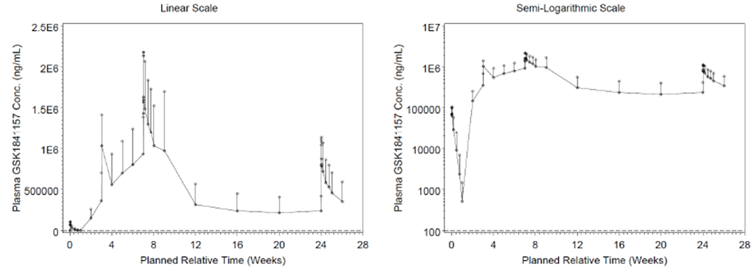

Table 3: OMB112578- PK parameters following the first, eighth, and twelfth OFA infusions in Japanese and Korea patients with CLL.
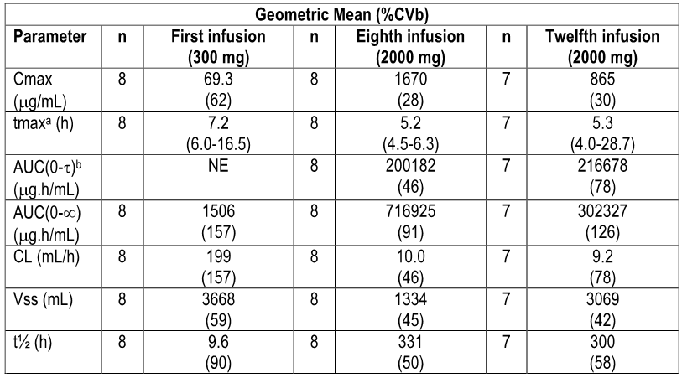
NE = not estimated. a. Median (range). b. τ=168 hours at Dose 8 and 672 hours at Dose 12.
Comment: The sponsor comments that the pharmacokinetics of OFA in Japanese and Korean patients were consistent with those observed in Western patients. Cross-checking with the relevant values in the approved PI indicates that the values in Japanese and Korean patients are consistent with the PI values. In Japanese and Korean patients, the volume of distribution was small, while clearance was lower and half-life was higher after repeated administration than after single-infusion. These finding were consistent with those observed in Western patients.

Evaluator’s overall conclusions on pharmacokinetics
The submitted PK data supplement the known data for OFA. The new PK data for the proposed OFA maintenance regimen from the pivotal study OMB112517 established that the pharmacokinetics of this regimen were consistent with the pharmacokinetics of the regimens for the approved indications. No unexpected findings relating to the pharmacokinetics of the proposed OFA maintenance regimen were identified. The limited PK data in Japanese and Korean patients from study OMB112578 were consistent with the PK data in Western patients.

Pharmacodynamics

Clinical studies with pharmacodynamics data
Studies OMB112517, OMB111827/GEN416 and OMB112758 contained pharmacodynamic data on the effects of ofatumumab administration on CD5⁺CD19⁺ cell counts.

B cell counts
- In study OMB112517, in patients with CLL receiving ofatumumab maintenance treatment after response to induction therapy the median decreases in CD5⁺CD19⁺ cell counts after the first cycle and prior to the sixth (8-week) cycle were 61% and 80%, respectively. In the observation arm, the median changes in CD5⁺CD19⁺ cell counts at the same time points were increases of 32% and 1328%, respectively.
- In study OMB111827/GEN416, in the total group the median percent reduction in peripheral blood CD5⁺CD19⁺ cells was 91% one week after the eighth weekly infusion (Week 8) and 90% before the second monthly infusion (Month 4). In the double refractory group, the median percent reduction was 97% and 94% at Week 8 and Month 4, respectively, while, in the bulky fludarabine-refractory group, the median percent reduction was 67% and 73% at the same time-points.
- In study OMB112758, rapid and sustained depletion of malignant and normal B cells was observed in all subjects during the study. CD5⁺CD19⁺cell counts remained low until the end of the study.

Evaluator’s overall conclusions on pharmacodynamics
The data on B-cell counts in the pivotal study OMB112517 were consistent with the data from the previously evaluated studies. Following ofatumumab administration there was a rapid and sustained reduction in CD5⁺CD19⁺ counts.

Dosage selection for the pivotal studies
The single pivotal Phase III study in the submission is OMB112517. The recommended dose for maintenance treatment of patients with CLL who are in complete or partial response after at least two lines of induction therapy is 300 mg on day 1 followed 1 week later by 1000 mg on day 8 (cycle 1), followed by 1000 mg on day 1 of subsequent cycles every 8 weeks after the first visit for up to a maximum of 2 years.
The sponsor stated that the proposed OFA dose and schedule for the pivotal study were selected based on preclinical data with OFA, clinical PPK modelling and simulation data, prior clinical experience with rituximab, and prior clinical experience with OFA.
The sponsor reported that preclinical data suggested that OFA plasma concentrations > 10 µg/mL were sufficient to suppress peripheral B cell recovery in cynomolgus monkeys as well as suppress tumour cell growth in Daudi tumour bearing SCID mice. OFA concentrations above 50 µg/mL were sufficient for complete B cell depletion. Recovery of CD20+ cells in peripheral blood and lymph nodes occurred when plasma OFA concentrations dropped below 5-10 µg/mL. Thus, a potential clinical target in developing OFA dosing regimens was prolonged maintenance of plasma concentrations > 10 µg/mL.
Pharmacokinetic data from the Phase I study in 33 subjects with relapsed or refractory CLL (study Hx-CD20-402) were analysed by the sponsor using a 2 compartment, nonlinear mixed-effects model (NONMEM). Assuming that the pharmacokinetics OFA with maintenance administration in subjects with CLL who have responded to their most recent therapy is similar to that observed with repeated weekly OFA administration, the resulting model was used to simulate concentration-time data for 500 subjects receiving OFA at 300 mg at Week 1 and 1000 mg at Week 2, followed by 1000 mg every 8 weeks for 2 years. Based on these simulations, the probability of maintaining plasma OFA target concentrations > 10 µg/mL was approximately 75% after the third 1000 mg dose at Week 17, increasing over time to approximately 90% during continued maintenance dosing and for 8 weeks after the last dose. Therefore, a dosing schedule with the first infusion of 300 mg at Week 1 and subsequent infusions of 1000 mg at Week 2 and thereafter at 8 week intervals starting with Week 9, is expected to achieve prolonged maintenance of target plasma concentrations >10 µg/mL in a high proportion of patients with CLL.
The sponsor stated that prior clinical experience with rituximab suggests that prolonged administration schedules enhance response duration in patients with non-Hodgkin lymphoma (NHL). Two Phase II studies in patients with CLL have examined maintenance therapy with rituximab, 1 study examined 4 weekly infusions of 375 mg/m² every 6 months for up to 2 years in patients with objective response or stable disease after initial rituximab treatment, and 1 study examined 4 monthly infusions of 375 mg/m² followed by 12 monthly infusions of 150 mg/m² in patients with CR or PR positive for minimal residual disease (MRD) after fludarabine/rituximab treatment. The sponsor stated that these studies suggest that prolonged administration schedules enhance response duration in patients with CLL. The existing clinical experience with maintenance rituximab suggests that administration of an anti-CD20 monoclonal antibody should be tolerable for up to 2 years.
Prior clinical experience in a Phase I/II trial of OFA in subjects with relapsed or refractory CLL (Study Hx-CD20-402) suggested that a total dose of 6500 mg (weekly doses of 500, 2000, 2000, and 2000 mg) was effective and well tolerated. In the pivotal trial in subjects with refractory CLL (Study Hx-CD20-406), OFA was given as an initial infusion of 300 mg, followed by seven 2000 mg infusions at weekly intervals, followed 5 weeks later by 2000 mg infusions every 4 weeks for 4 doses. This initial high dose intense regimen followed by monthly high dose infusions was tolerated, suggesting that 1000 mg OFA every 2 months for 2 years should be tolerated. As AEs in previous trials had been primarily infusion related events on the day of the first infusion, the prolonged treatment schedule in Study OMB112517 was not expected to affect the overall safety profile.
Comment: The sponsor’s rationale for the selected dose and dosing schedule is considered to be acceptable.

Clinical efficacy

Pivotal efficacy study (OMB112517 [PROLONG])

Study design, objectives, locations and dates

Study title, location and dates
Title – A phase III, open-label, randomized multicentre trial of ofatumumab maintenance treatment versus no further treatment in subjects with relapsed chronic lymphocytic leukemia who have responded to induction therapy.
The title PROLONG is derived from the following letters (capitalised, bolded, underlined) included in the study title – “Phase III Trial in Relapsed CLL Of a MonocLonal Antibody Ofatumumab mainteNance therapy to delay proGression vs observation”.
The study was undertaken by GSK (the then sponsor of Arzerra) in collaboration with the Dutch-Belgian Cooperative Trial Group for Haematology-Oncology (HOVON) and the Nordic CLL Study Group. The study was initiated at 201 centres with 130 principal investigators in 24 countries. The 24 countries were located in North America, South America, Europe and Asia. There were 5 Australian centres. The study was initiated on 6 May 2010 and the data cut-off date for the submitted Clinical Study Report (CSR) was 19 June 2014.
Comment: The pivotal study has been recently published in Lancet Oncology, and is accompanied by an editorial.

Objectives
The primary efficacy objective of the study was to evaluate progression-free survival (PFS) in patients treated with ofatumumab (OFA) maintenance treatment compared to no further treatment after remission induction in patients with relapsed chronic CLL.
The secondary efficacy objectives of the study were:
- To evaluate the improvement in response, time to next CLL treatment and overall survival; and
- To evaluate PFS after next-line therapy and time to progression after next-line therapy.
Other secondary objectives of the study were:
- To evaluate safety and tolerability;
- To evaluate health related quality of life (Patient Reported Outcomes [PROs]);
- To evaluate prognostic marker correlation with clinical response (biomarkers); and
- To evaluate PK parameters.

Design and investigational plan
Study OMB112517 is a Phase III, open-label, randomised, 2-arm, multinational, multicentre study of ofatumumab (OFA) maintenance treatment compared to no further treatment (i.e., observation only [Obs]) in subjects who had a complete response (CR) or a partial response (PR) after 1 to 2 treatments for relapsed CLL. Eligible subjects were stratified at randomisation based on:
- Response to the most recent prior CLL treatment (CR or PR);
- Number of previous induction treatments; and
- Type of the most recent prior treatment.
The study consisted of a screening phase (up to 14 days prior to randomisation), a treatment (OFA)/Observation (Obs) phase (up to 2 years), and a follow-up phase (up to 5 years). Disease status assessments to determine subject response or progression were performed during the treatment (OFA)/observation (Obs) phase at approximately every 8 weeks for up to 2 years according to the Guidelines for Diagnosis and Treatment of Chronic Lymphocytic Leukemia: A Report from the International Workshop on Chronic Leukaemia (IWCLL) updating the National Cancer Institute-Working Group 1996 Guidelines.⁹ Disease status assessments included physical examination (lymph nodes, spleen, liver, constitutional symptoms) and peripheral blood examination. The response criteria are summarised. Monitoring and treatment of potential tumour lysis syndrome during the first cycle were performed as per oncology standard of care. Patient Reported Outcome (PRO) measures were administered at baseline, each treatment visit beginning at Visit 3, at last visit, and at follow-up visits. A Health Change Questionnaire was administered at all post-baseline visits. During the follow-up phase, survival and disease status assessments were assessed post-treatment every 3 months for 5 years after the last treatment. The study design is provided schematically below.
Figure 5: OMB112517 – Study design schematic.
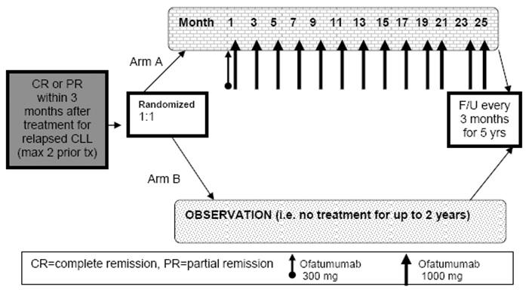
Comment: The study is open-label and is therefore subject to the well-known biases associated with studies of this design. The sponsor indicated that the comparison was between OFA maintenance infusions and standard of care current at the time of the study design (i.e., observation) for patients who had responded to treatment. The sponsor commented that at the time the study was designed there were no approved maintenance therapies for the treatment of CLL. However, since then two kinase inhibitors (ibrutinib and idelasib) have been approved in a number of countries (including Australia) for the treatment of CLL using prolonged maintenance treatment regimens with treatment continuing until disease progression or unacceptable toxicity occurs. The approved indications of ibrutinib (Bruton’s tyrosine kinase inhibitor) include patients with CLL/small lymphocytic lymphoma (SLL) who have received at least one prior therapy or as first line therapy in patients with CLL with 17p deletion. The approved indications for idelasib (PI3Kδ kinase inhibitor) include (in combination with rituximab) the treatment of patients with CLL/SLL for whom chemotherapy is not considered suitable, either on relapse after at least one prior therapy of as first line treatment in the presence of 17p deletion or TP53 mutation.
The Clinical Overview notes the studies relating to ibrutinib and idelasib for the treatment of CLL and the recent regulatory approvals of these agents. The overview comments that “it is unclear how durable responses to [the kinase inhibitors] may be with finite [or capped] dosing” and that this is being “explored”. It goes on to state, “therefore, prolonging remission with other agents also may be a benefit for these patients as well. Additionally, resistance to ibrutinib has already been reported, primarily due to mutation of the cysteine residue that binds ibrutinib. Given that the incidence of ibrutinib resistance may increase with longer follow-up of the patients who are dosed until progression, it remains prudent to study other agents and other mechanisms of action that can prolong PFS”.

Protocol amendments
The original protocol was finalised on 14 July 2009, and was amended 5 times (see below). None of the amendments were implemented for safety concerns and recruitment was not held between amendments. The sponsor states that none of the amendments had a relevant impact on the results described in the CSR.

Table 4: OMB112517 – Summary of protocol amendments.
This version was not sent to study sites and was republished prior to sending to study sites.

Inclusion and exclusion criteria

Inclusion criteria
Subjects eligible for enrolment were required to meet all of the following inclusion criteria:
- Adults with documented diagnosis of CLL based on the modified IWCLL updated 2008 NCI-WG 1996 guidelines.⁹
- At least PR according to the revised 2008 NCI-WG CLL criteria within 3 months of the response assessment after the last dose of 2nd/3rd line treatment.
- The anti-leukemic treatment before study entry should have been for at least 3 months or 3 cycles.
- ECOG Performance Status of 0-2.
- Signed written informed consent prior to performing any study-specific procedures.

Exclusion criteria
Subjects meeting any of the exclusion criteria were not to be enrolled in the study. The key exclusion criteria are summarised below:
- Known primary or secondary fludarabine-refractory subjects, defined as treatment failure (failure to achieve a CR or PR) or disease progression within 6 months.⁹
- Prior maintenance therapy.
- Known transformation of CLL (e.g., Richter’s transformation), prolymphocytic leukemia, or central nervous system involvement of CLL.
- Active autoimmune haemolytic anaemia (AIHA) requiring treatment except if in the opinion of the investigator it were thought not to affect the subject’s safety, the conduct of the study or the interpretation of the data.
- Previous autologous or allogeneic stem cell transplantation.
- Chronic or current active infectious disease that required systemic treatment.
- Active Hepatitis B or C.

Removal of patients from assessment
Patients could withdraw consent to treatment at any time and for any reason. In addition, if judged necessary by the investigator treatment could be discontinued at any time for medical reasons including disease progression and pregnancy. If possible, withdrawn patients were to be evaluated for disease status and survival per the follow-up visit schedule. For data collection purposes, patients were considered to have completed the study if they had died during the treatment or follow-up phases, or were lost to follow-up, or had withdrawn consent.

Study treatments (i.e., ofatumumab)
Ofatumumab was infused IV on day 1 (300 mg) and day 8 (1000 mg) in the first cycle followed by 1000 mg every 8 weeks for up to 2 years. Dose reductions or modifications of OFA were not permitted, except if initiated for safety reasons due to adverse events (AEs) considered to be infusion-reactions. If a dose delay was required due to, but not limited to AEs, OFA dosing may have resumed at the physician’s discretion if the subject was still considered to be in remission. Patients received protocol-specified pre-medication within 30 minutes to 2 hours prior to the start of each OFA infusion.

Table 5: OMB112517 – Pre-medication requirements prior to ofatumumab infusions.
The first infusion of OFA (300 mg; 0.3 mg/mL) was to be 12 mL/hour. If no infusion reactions occurred then the infusion rate was increased every 30 minutes to a maximum of 400 mL/hour according to the schedule summarised below. If this schedule was followed then the duration of the infusion was approximately 4.5 hours.

Table 6: OMB112517 – Infusion rate at first ofatumumab (300 mg) infusion.
If the first infusion had been completed without Grade ≥ 3 infusion-associated AEs then subsequent infusion of OFA 1000 mg (1 mg/mL) could start at a rate of 25 mL/hour and be doubled every 30 minutes up to a maximum of 400 mL/hour (see Table 7, below). If this schedule was followed then the duration of the infusion was approximately 4 hours. If the previous infusion had been completed with Grade ≥ 3 infusion-associated AEs, then subsequent infusion were to start at the lower rate of 12 mL/hour.

Table 7: OMB112517 – Infusion rate at subsequent ofatumumab (1000 mg) infusion.
If the investigator judged that an AE of mild or moderate intensity (Grade 1 and 2) was related to the infusion, then the infusion may have been temporarily slowed or interrupted. When the patient’s condition was stable, the infusion could be restarted according to the judgment of the investigator. On restart, the infusion rate was to be half that at the time the infusion was paused. If, however, the infusion rate was 12 mL/hour before the pause, then the infusion was to be restarted at 12 mL/hour. Thereafter, the infusion rate could be increased according to the investigator’s judgment based on Tables 6 and 7.
If the investigator judged an AE of grade ≥ 3 intensity to be related to the infusion, the infusion was to be interrupted and the appropriate clinical intervention administered. When the AE decreased to < Grade 3, the investigator could restart the infusion. On restarting the infusion, the infusion rate was to be 12 mL/hour for the first infusion or 25 mL/hour for subsequent infusions, with increases according to the investigator’s judgment based on Tables 6 and 7. If the severity of the AE did not resolve to < Grade 3 despite adequate clinical intervention, or the same AE increased to ≥ Grade 3 on three occasions during one infusion, then the patient was to be withdrawn from treatment.
Any medication other than OFA was considered concomitant medication (apart from protocol-specified pre-medication given prior to OFA infusions). Intravenous gamma globulin, prophylactic antibiotics, and granulocyte colony-stimulating growth factor (G-CSF) were permitted per local standard of care, at the physician’s discretion. The following medications and non-drug therapies were prohibited:
- Anti-cancer medication not part of the protocol treatment; and
- Any non-marketed drug substance or experimental therapy. Glucocorticoids given for indications other than treatment of CLL, such as exacerbations of asthma or as pre-medication for OFA infusions, were allowed.

Efficacy variables and outcomes

Primary efficacy endpoint – Progression free survival (PFS)
The primary efficacy variable was PFS as assessed by the investigator. The date of disease progression (PD) was defined as the first occurrence of death or disease progression. The duration of PFS was calculated from the date of randomisation to the date of death or PD, which ever occurred first. Disease status assessments to determine subject response or progression were performed for patients in both treatment arms during the treatment phase at approximately every 8 weeks for up to 2 years according to the IWCLL 2008 update to the NCI-WG 1996 guidelines.⁹ Disease status assessments included physical examination (lymph nodes, spleen, liver, constitutional symptoms) and peripheral blood examination. The response criteria are summarised in Table 65, page 113. Events of disease progression determined by CT scan were excluded from the primary analysis of PFS, but were included in pre-specified PFS sensitivity analyses.
In addition to PD being assessed by site investigators (primary efficacy analysis), an Independent Review Committee (IRC) also assessed PD. The IRC included two members, comprising a haematologist/oncologist and a radiologist, who undertook an independent review of the imaging and clinical data according to the principles adapted from the IWCLL 2008 update to the NCI-WG 1996 guidelines⁹. The IRC acted in accordance with an Independent Review Charter, which stated, “all clinical efficacy data for reads will be presented to a single oncologist for independent review. A single independent radiologist will also read each case at pre-specified time-points after which the results of the radiology review will be presented to the oncologist reviewer for sensitivity analysis”. The IRC used the eCRF data for assessment of constitutional symptoms, results of investigator’s physical examination (lymph nodes, spleen, liver), use of concomitant blood products, and central laboratory data of blood counts and bone marrow analysis.
Comment: The relevant TGA adopted guideline relating to the clinical evaluation of anticancer medicines states that PFS is an acceptable primary endpoint for Phase III confirmatory trials.10 Assessment of PFS by the investigator rather than an independent reviewer has the potential to result in bias leading to incorrect treatment comparisons. This is a particular problem for studies, such as the pivotal study, where treatment is open-label and the comparator arm is standard of care (i.e., observation). However, the study included pre-specified PFS sensitivity analyses based on IRC assessment. Therefore, the use of sensitivity analyses based on independent review of disease progression mitigated bias associated with subjective assessment of this outcome based on site investigator assessments.

Secondary efficacy endpoints
- Improvement in response, measured as change from PR at baseline to CR following treatment and by minimal residual disease (MRD).
- Overall survival (OS), defined as the interval in months between the first randomisation date and the data of death due to any cause. Subjects who had not died were censored at the date of last contact. The OS is an acceptable secondary endpoint, based on PFS being defined as the primary endpoint.10
- Time to next therapy for CLL, defined as time from the first randomisation until next line treatment.
- PFS after next-line CLL therapy.
- Time to progression after next line CLL therapy.

Other and exploratory efficacy endpoints
Other efficacy endpoints included subgroup analyses of PFS performed by demographics, baseline characteristics, and prognostic factors. Exploratory efficacy endpoints included: B symptoms; minimal residual disease (MRD); B-cell monitoring by flow cytometry of blood; and biological and prognostic factors associated with clinical response (i.e., IGHV mutational status; VH3-21 usage; cytogenetics by fluorescent in-situ hybridization [FISH] 6q-, 11q-, +12q, 17p-, 13q-; β2 microglobulin).

Health Outcome Measures
- European Organisation for Research and Treatment of Cancer Quality of Life Questionnaire Core 30 (EORTC QLQ-C30).
- European Organisation for Research and Treatment of Cancer Quality of Life Questionnaire Chronic Lymphocytic Leukaemia 16 item module (EORTC QLQ-CLL 16).
- EuroQoL Five-Dimension (EQ-5D).
- Health Change Questionnaire (HCQ).
- Patient Reported Constitutional Symptoms (‘B-symptoms’) score (derived from the EORTC QLQ-C30 and QLQ-CLL16)
Patient questionnaires (EORTC QLQ-C30, EORTC QLQ-CLL16, and EQ-5D) were completed by subjects at baseline, periodically throughout the Treatment/Obs Phase and during follow-up in all subjects who had not progressed. The HCQ was completed at all visits other than baseline. During the Treatment/Obs Phase, data were collected starting at Week 2, and then every 8 weeks until Week 97. Follow-up data were collected every 3 months.
The specified patient reported outcomes (PRO) were the Global Health Status/Health Related Quality of Life (GHS/HRQoL) domain from the QLQ-C30 (items 29 and 30) and the B-symptom Index which was composed of questions across the QLQ-C30 and QLQ-CLL16, namely, need to rest (C30 item 10), felt weak (C30 item 12), tired (C30 item 18), weight loss (CLL item 31), temperature changes (CLL item 35), night sweats (CLL item 36), and skin problems such as itching (CLL item 37), lethargic (CLL item 39), or slowed down (CLL item 40). Other domains from these questionnaires were considered supportive.
For the EORTC QLQ-C30 and the QLQ-CLL16, each domain was scored on a scale of 0 to 100. For symptom domains including the B-symptom Index, a score of 0 represented no reported symptoms and a score of 100 was worst possible symptoms. Conversely, in the GHS/HRQoL domain and function domains (physical, role, emotional, cognitive and social), which was scored on a scale of 0 to 100, 0 represented the worst possible score and 100 represented the best possible score.
Clinically meaningful changes or minimally important differences (MIDs) have been previously established for the GHS/HRQoL score and categorised as “small” if the mean change in scores is 5-10 points, “moderate” if the mean change is 10-20 points, and “large” if the mean change is >20 points. No MID has been formally established for the EORTC QLQ-CLL16, but the sponsor stated that the MID will be explored in future analysis using the HCQ as an anchor to determine clinically important changes.

Randomisation and blinding methods
Patients in this open-label study were centrally randomised by the sponsor 1:1 to treatment arm A (OFA) or treatment arm B (Obs) using a randomisation number generated by an electronic Registration and Medication Ordering System (RAMOS). Randomisation was stratified based on the following factors:
- CR or PR at study entry;
- Number of previous treatments (2 vs 3); and
- Type of prior therapy (chemoimmunotherapy, only alkylating monotherapy, or other treatment).

Analysis populations
- The Intent-to-Treat (ITT) population was the primary population used for the evaluation of efficacy, and for the PRO analyses. In the ITT analyses, patients were analysed based on the groups in to which they had been randomised rather than actual treatments received. The ITT population included 474 patients (OFA, n=238; Obs, n=236).
- The safety population was used for evaluation of all safety assessments. In the safety population, patients were grouped based on actual treatment received regardless of randomisation group. The safety population included 474 patients (OFA, n=237; Obs, n=237).
- The Per-Protocol (PP) population excluded patients in the ITT population with major protocol deviations that impacted on the efficacy outcome. The PP population was to be used in the primary endpoint analysis to check the robustness of the result for the ITT population, but only if the size of the PP and ITT populations differed by at least 10%. The PP population included 461 patients (OFA, n=233; Obs, n=228). No sensitivity analyses were undertaken in the PP population as the number of patients in the PP and the ITT populations differed by < 10%.
- The pharmacokinetic (PK) population included all patients in the ITT population for whom a PK sample was obtained and analysed. The PK population included 225 subjects (all in the OFA arm).

Sample size
The sample size calculation was based on the primary endpoint (PFS) using the following assumptions:
- Exponential survival curves where the ratio of the hazard rates is constant over time;
- Median PFS for the Obs arm is 28 months;
- Median PFS for the OFA maintenance arm is 39.2 months (40% improvement over the Obs arm);
- A 1:1 stratified randomisation scheme;
- 5% two-sided risk of erroneously claiming a difference in the presence of no true underlying difference (alpha level);
- 80% chance of successfully declaring a difference in the presence of a true underlying difference (power);
- Accrual rate of 12 subjects per month; and
- Stratified log-rank test for hypothesis testing.
Using the above assumptions, approximately 280 total events from both arms were needed for the study to attain 80% power. With a total sample size of 478 evaluable subjects, the total duration of the study was estimated to be approximately 63.5 months in order to obtain the 280 events. Assuming a dropout rate of 10%, the total sample size for both arms combined was planned to be about 532 subjects and the total duration of the study was planned to be approximately 68 months.
Comment: The sponsor assumed that the median PFS for the Obs arm would be 28 months. However, the provided reference to the REACH study indicates that the median PFS in the FCR induction arm was 30.6 months rather than 28 months. The sponsor is requested to comment on the decision to use a median PFS of 28 months in the Obs arm for sample size calculation rather than 30.6 months.

Statistical methods

Statistical hypotheses and treatment comparisons
The primary endpoint was investigator-assessed PFS, using well-known pre-specified clinical criteria. The null and alternative hypotheses were designed to demonstrate the superiority of OFA maintenance treatment over Obs, after induction of remission in patients with relapsed CLL with at least two prior treatment regimens. The following hypotheses were evaluated:
- H0 (null hypothesis): Distribution of PFS events for the OFA maintenance treatment arm and for the Obs arms are the same (Hazard ratio [HR] is equal to 1).
- H1 (alternative hypothesis): Distribution of PFS events for the OFA maintenance treatment arm and for the Obs arms are not the same (Hazard ratio [HR] is not equal to 1).
The primary efficacy endpoint was intended to serve as a gatekeeper for the interpretation of treatment comparisons for the “inferential” secondary endpoints. If the null hypothesis was rejected at the 0.001 significance level at the planned interim analysis or at the 0.0498 significance level at the final analysis, the conclusion will be that there was a treatment difference between the OFA maintenance arm and the Obs arm, and the p-values for the “inferential” secondary endpoints may be interpreted and tested at the 0.05 significance level for the final analysis. If the null hypothesis was not rejected at the interim or final analysis, the conclusion would be that there was no difference between the OFA maintenance arm and the Obs arm, and all other p-values will be used for descriptive and exploratory purposes only.
The inferential secondary endpoints were time to next CLL therapy and OS, and were to be formally tested only if the primary efficacy endpoint of PFS as assessed by the investigator was statistically significant. For the primary efficacy endpoint and the two inferential secondary efficacy endpoints, statistically significant p-values for the pairwise comparison between the two study arms were defined as being inferentially significant for confirmatory purposes. Other pairwise comparisons between the two study arms for the other non-inferential efficacy endpoints were undertaken using an alpha level of 0.05. No multiplicity adjustment for the non-inferential efficacy endpoints was undertaken. For the non-inferential efficacy endpoints, all p-values ≤ 0.05 are considered to be nominally significant rather than confirmatory.

Interim analyses (two planned) and final analysis (end of 5-year follow-up)
Two interim analyses were planned. The first interim analysis was planned to assess safety endpoints. The second interim analysis was planned to assess efficacy based on the primary endpoint and also to evaluate safety. An independent data monitoring committee (IDMC) was used to review data from the two planned interim analyses.
At the first interim analysis, the IDMC assessed safety data from 100 subjects in the OFA maintenance arm who had received treatment for at least 6 months. At the second interim analysis, the IDMC reviewed the primary efficacy endpoint (PFS) when at least 2/3rds of the total number of events had occurred (i.e., 187 of 280 events). The next analysis will be performed when the total number of planned PFS events is reached (i.e., 280 events). The final analysis will be performed at the end of the 5-year follow-up.
The submitted CSR was based on the results of the second interim analysis of PFS undertaken by the IDMC. This interim analysis of PFS used a conservative significance level of 0.001 and also evaluated safety. The original protocol planned to randomise approximately 532 subjects to obtain 478 evaluable subjects (assuming 10% drop out rate). However, on advice from the IDMC that the significance level had been met for the interim analysis of PFS and the required number of evaluable subjects had been enrolled, GSK in consultation with the HOVON group decided that further enrolment should be discontinued.
Comment: It is noted that there appears to have been no recommendation from the IDMC to stop enrolment, unblind the study, and switch patients in the observation arm to OFA maintenance, based on the results of the second interim analysis.

Primary efficacy analysis
The survival distributions for PFS were estimated using Kaplan-Meier (KM) survival curves and compared study arms with a stratified log-rank test using pre-specified stratification factors. The Pike estimator of the treatment hazard ratio (HR) and 95% confidence intervals (CI) for the HR were also provided. KM plots, and median times to PFS as well as first and third quartiles were presented, along with 95% CIs. The HR expressed the risk of experiencing a PFS event for the OFA arm relative to the reference Obs arm. The details on censoring for the PFS analysis are summarised.
In addition to the stratified log-rank test based on the KM procedure, a Cox regression model using a stepwise procedure was undertaken to compare the two study arms. This model included covariates for treatment, stratification factors and other baseline data deemed appropriate such as age, Binet stage and baseline cytogenetic data. Treatment remained in the model, while an entry/removal significance level of 0.05 was used when deciding to include other covariates. The analytical results for the model included the estimated HRs along with 95% CIs and associated probabilities for the effect of treatment, stratification factors, and the covariates.
Three PFS sensitivity analyses were performed:
- Sensitivity Analysis 1: The first sensitivity analysis of PFS included both PD determined by the investigator via palpation of lymph nodes and organs and PD determined by the independent radiologist [IRC] via CT scan measurements of lymph nodes and organs. If a patient had PD determined by both sources, the earlier data were used. Integration of PD from both sources was by statistical programming.
- Sensitivity Analysis 2: The second sensitivity analysis of PFS was undertaken by the independent oncologist who reviewed the pre-specified clinical data including, investigator assessment of lymph nodes and organs by palpation, and provided a global assessment (PD, yes or no) for each patient Although the independent radiologist assessed lymph node and organ measurements using the CT results, the radiologist’s findings were not considered by the oncologist for Sensitivity Analysis 2.
- Sensitivity Analysis 3: The third sensitivity analysis of PFS was undertaken by the independent oncologist using the independent radiologist’s CT assessment of lymph node and organ measurements to replace the physical assessment of lymph nodes and organs based on palpation by the investigators. The independent oncologist then provided a global assessment (PD, yes or no) according to pre-specified criteria.
The CSR also included subgroup analyses of investigator-assessed PFS conducted using a log-rank test. The subgroups included in the analyses are summarised.

Secondary efficacy analyses
- Improvement in response was assessed by calculating the percentage of patients who changed from PR at baseline to CR during the study. Improvement in response was also assessed by the frequency and percentage of patients with negative and positive MRD.
- OS was defined as time (in months) from the randomisation date to the date of death due to any cause. For subjects who did not die, time of death was censored at the date of last contact. Survival distributions were estimated using the KM method, and survival curves were compared using a stratified log-rank test. The same analysis was conducted as described for the primary endpoint (PFS) analysis.
- Time to next therapy for CLL was defined as the time (in months) from the first randomisation until next-line treatment.
- PFS after next-line CLL therapy was defined as the time (in months) from randomisation until progression or death following next-line therapy and counted as events deaths prior to next-line therapy. The analysis included only subjects who progressed and were included in the primary analysis of PFS.
- Time to progression after next-line therapy was defined as time (in months) from progression following randomisation until progression or death following next-line therapy and counted as events deaths prior to next-line therapy.

Other efficacy analyses
- A descriptive summary of concordance between investigator and IRC assessments of progression was provided for the total population, and both treatment arms.
- The number and percentage of patients with progression (based on investigator assessment) during the treatment period and also during follow-up were summarised for both arms.
Other secondary endpoint analyses included:
- B-symptoms (no night sweats, no weight loss, no fever and no extreme fatigue) summarised at each time point along with the proportion of patients with at least 1 B-symptom for each arm;
- The proportion of patients with positive and negative MRD was provided at each time point;
- Changes in CD5⁺CD19⁺and CD5⁻CD19⁺ B-cell parameters were assessed descriptively; and
- A Cox regression model using a stepwise procedure was undertaken to assess the relationship between investigator-assessed PFS and prognostic markers correlating with clinical response.

Changes in conduct of study or planned analyses
There were no changes to the study design, treatment, assessments, or follow-up procedures. The interim analysis of the primary endpoint (PFS) was conducted as described in the Reporting and Analysis Plan (RAP), and details of the interim analysis were also provided in the IDMC Charter. There were a number of changes to the planned statistical analyses outlined in the RAP, which were stated to have been mainly due to discussions with regulators. The CSR included a list of these changes. These changes have been examined and are considered not to have affected the validity of the pre-specified primary and secondary efficacy endpoint analyses.

Participant flow
There were 479 patients enrolled at 130 centres in 24 countries, including 238 patients in the OFA arm and 236 patients in the Obs arm. The data presented in the CSR were collected from 06 May 2010 through the data cut-off date of 19 June 2014. At the time of the data cut-off, 59% (n=278) of patients had completed the OFA Treatment/Obs Phase per protocol. The most common reason for premature discontinuation in the OFA Treatment/Obs Phase was AEs (OFA, n=20 [8%]; Obs, n=3 [1%]). Other reasons for treatment discontinuation occurred in a similar proportion of patients in both study arms. At the time of the data cut-off date, the majority of patients (78% [n=371]) were ongoing in the Treatment/Obs Phase, follow-up phase or the survival follow-up phase; 14% (n=66) of patients had died, while 8% (n=37) of patients had withdrawn from the study. Withdrawn consent was the most common reason for withdrawal from the study. The median duration of follow-up was 19.1 months (range: 0.07, 47.18 months), including 19.4 months in the OFA maintenance arm and 18.7 months in the Obs arm. The study is ongoing with the next analysis planned when 280 events have been observed. Patient disposition (ITT population) is summarised below.
Table 8: OMB112517 – Subject disposition; ITT population
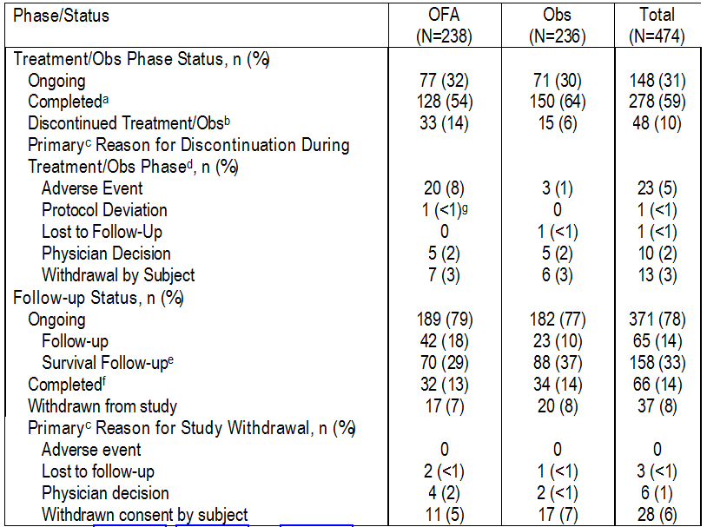
a. Subjects who completed treatment and entered follow-up phase, or subjects with PD/death; b. Subjects discontinued prior to completing 24 months in the Treatment/Obs Phase; c. Subjects may have only 1 primary reason for study withdrawal and treatment discontinuation; d. No subjects discontinued treatment due to disease progression as the primary reason; e. Survival follow-up for subjects after disease progression or after start of subsequent CLL therapy; f. All subjects in the “completed” category had died; g. Subject [information redacted] had a protocol deviation of not meeting inclusion criterion of at least PR within 3 months of the response assessment after the last dose of 2nd/3rd line treatment.

Major protocol violations/deviations
The majority of patients (77% [n=367]) had at least 1 protocol deviation, and protocol deviations were reported more frequently in the OFA arm than in the Obs arm (81% [n=192] vs 73% [n=174], respectively). The most commonly reported protocol deviations in the total population were related to assessments and/or procedures (71% [n=337]), and were reported in a similar proportion of patients in the OFA and Obs arms (74% [n=176] vs 68% [n=161], respectively). Protocol deviations that could potentially compromise the outcome of the primary efficacy endpoint occurred in 3% (n=13) of all patients. Subjects with major protocol deviations were excluded from the PP population. The protocol deviations in the ITT population are summarised below.
Table 9: OMB112517 – Protocol deviations; ITT population
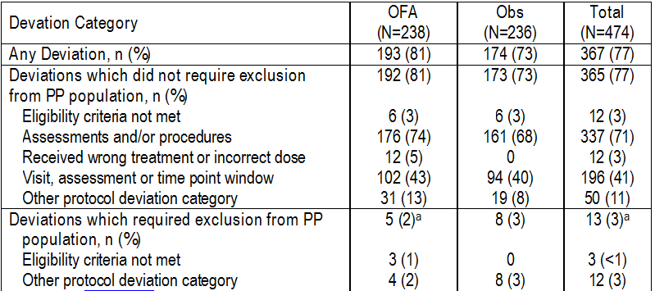
Note: Subjects with multiple protocol deviations were counted in more than one row. a. Some subjects had >1 PP deviation and are listed in more than one category.
Comment: The reported protocol deviations are unlikely to have invalidated the efficacy or safety assessments reported for the pivotal study.

Baseline data

Demographic characteristics
The demographic characteristics (ITT) population were well balanced between the two study arms. The median age of the total population was 64.5 years (range: 33, 87 years), and the majority of the population were aged < 70 years (70% [n=330]) and were male (68% [n=320]). Nearly all of the total population were categorised as “White” (96% [n=435]). Of the total number of enrolled patients, 68% were from Europe.
Comment: The baseline demographic characteristics of the total population are consistent with the characteristics of patients in Australia with CLL who might potentially be offered treatment with ofatumumab if the medicine is approved. The aged-standardised incidence rates for CLL in Australia in 2011 were 6.2/100,000 for males and 3.4/100,000 for females. The mean age at onset was 68.6 years for males and 72.1 for females, with the mean age at onset for the total population being 70.0 years. In Australia, almost 80% of all new cases of CLL are diagnosed in people over that age of 60 years, and the disease is rare in people under that age of 40 years.

Stratification factors
The baseline stratification factors were similar for the two treatment arms (see below).
Table 10: OMB112517 – Stratification factors; ITT population
Abbreviations: CR=complete response; PR=partial response. One subject in the Obs arm did not have data available for all of the covariates. Subjects who had received 1, 4, or 5 prior induction treatments met criteria for major protocol deviations.

Prior anti-cancer therapy
The types of prior anti-cancer therapies were similar for the two study arms. More than half of the patients in both arms (OFA, 52%; Obs, 56%) had received fludarabine combination therapy as previous anti-cancer treatment. Other common prior anti-cancer therapies included bendamustine-based therapies (OFA, 20%; Obs, 21%), and alkylator-based therapies (OFA, 21%; Obs, 17%). The types of prior chemoimmunotherapies were similar for the two study arms. In all patients who had received chemoimmunotherapy as the most recent prior therapy, 53% had received combination fludarabine, cyclophosphamide and rituximab (FCR), with similar proportions in the two study arms (OFA, 52%; Obs, 54%). The proportion of patients treated with combination bendamustine and rituximab was also similar for the two study arms (OFA, 24%; Obs, 25%).

Baseline disease characteristics
The baseline disease characteristics were generally well balanced between the two study arms. Most patients had disease classified by Modified Rai Stage as low risk (32%) or intermediate stage (32%) or by Binet staging criteria as Stage A (54%) or Stage B (19%). The sponsor commented that it “should be noted that the determination of Rai/Binet stage at the time of study entry may have been difficult to assess, because patients in remission can have no measurable disease”. Consequently, a relatively large proportion of patients in both study arms (approximately 10% to 20%) had Rai or Binet stage reported as unknown or missing at screening. Median time from initial CLL diagnosis to study entry was 6 years in the OFA arm and 5 years in the Obs arm.
Comment: One of the limitations of the pivotal study is the absence of data relating to patients who were in remission but were not selected by investigators for enrolment. It might be that these patients were healthier, were lower risk and had a better quality of life than patients selected for enrolment. If so, then there might have been reluctance on the part of investigators to enrol these patients in the study and/or reluctance of these patients to participate, given that there was a 50% chance of being randomised to the OFA maintenance arm and the known risks associated with this medicine. Therefore, it is possible that the study might be subject to selection bias, limiting the generalisability of the results. The sponsor is requested to comment on this matter (see Questions).

Baseline prognostic markers
The baseline prognostic factors were similar for the two study arms for almost all factors, with the exception of cytogenetics. A higher proportion of patients in the OFA maintenance arm had genetic variations associated with a favorable or neutral prognosis (i.e., 6q deletion, 12q trisomy or 13q deletion) compared to the Obs arm (14% vs 5%, respectively). Fifty percent (50%) of the total patient population had unmutated IGHV, which is associated with a poorer clinical prognosis than mutated IGVH.
Comment: The number of patients with the high-risk 17p deletion was very small in both treatment arms (n=7, 3%, OFA and n=4, 2%, Obs). Therefore, there are significant doubts about whether the results of the study can be extrapolated to patients in the general population of patients with CLL with this high-risk genetic variation.

Past medical conditions and concomitant medical conditions
The majority (65% [n=65%]) of patients had 1 or more past medical conditions at screening, including 67% (n=159) in the OFA maintenance arm and 62% (n=147) in the Obs arm. Past medical conditions reported in ≥ 10% of the total population were: surgical and medical procedures (23% [25% OFA; 22% Obs]); infections and infestations (21% [23% OFA; 19% Obs]); gastrointestinal disorders (14% [12% OFA; 15% Obs]; and neoplasms benign, malignant and unspecified (including cysts and polyps) (13% [12% OFA; 14% Obs]).
Most patients in the total patient population had 1 or more current medical conditions at screening (85%, n=405), including 89% (n=211) in the OFA maintenance arm and 82% (n=194) in the Obs arm. Conditions reported in ≥ 10% of patients in the total population were: vascular disorders (37%); metabolism and nutrition disorders (31%); musculoskeletal and connective tissue disorders (21%); gastrointestinal disorders (18%); cardiac disorders (16%); respiratory, thoracic, and mediastinal disorders (15%); psychiatric disorders (13%); reproductive and breast disorders (13%); blood and lymphatic system disorders (12%); immune system disorders (12%); infections and infestations (11%); renal and urinary disorders (11%); nervous system disorders (11%); neoplasms benign, malignant and unspecified (including cysts and polyps (10%); and skin and subcutaneous tissue disorders (10%).

Concomitant medications
The majority of patients (89% [n=421]) used concomitant medications during the study, including 92% (n=218) in the OFA maintenance arm and 86% (n=203) in the Obs arm. The most commonly reported (≥ 10%) concomitant medications in the total patient group not a component of the infusion-premedication regimen or anti-infectives for systemic use were (OFA vs Obs, respectively): paracetamol (29% vs 23%); acetylsalicylic acid (19% vs 15%); omeprazole (18% vs 14%); metformin (8% vs 12%); and allopurinol (9% vs 12%).
Overall, anti-infectives were used in 72% (n=171) of patients in the OFA maintenance arm and 60% (n=141) of patients in the Obs arm, with the most commonly reported medications reported in ≥ 10% of the total population being (OFA vs Obs) trimethoprim/sulfamethoxazole (29% vs 27%), amoxicillin (27% vs 18%), acyclovir (26% vs 25%), clavulanic acid (23% vs 14%), valaciclovir (13% vs 12%), and ciprofloxacin (13% vs 6%). Patients in both study arms used various cardiac, hypolipidaemic, and anti-diabetic medications, as well as steroids. Overall, the pattern of concomitant medication use was consistent with that expected in an elderly patient population with multiple co-morbidities. In general, concomitant medication use was similar in the two study arms, with the exception of higher use of anti-infectives and higher use of blood and blood products in the OFA maintenance arm than in the Obs arm.
After randomisation, blood products and blood supportive care products were administered to 31% of patients in the OFA maintenance arm and 19% of patients in the Obs arm after (see Table 11, below). A higher proportion of patients in the OFA maintenance arm received products to prevent neutropenia compared to patients in the Obs arm. The most common therapies used to stimulate neutrophil production were G-CSFs. Erythropoietin was used in < 1% of subjects in either arm. Higher use of G-CSFs and anti-infective medication in the OFA arm was consistent with the higher incidence of neutropenia and infection in the OFA arm compared to the Obs arm.

Table 11: OMB112517 – Blood products and blood supportive care products; ITT population
 | Ofatumumab (n=237) | Observation (n=237)
Any blood or blood supportive care product | 73 (31%) | 44 (19%)
Other blood or blood supportive care product | 43 (18%) | 27 (11%)
Neupogen (Filgrastim) | 19 (8%) | 6 (3%)
G-CSF | 9 (4%) | 4 (2%)
Red blood cells | 8 (3%) | 15 (6%)
Pegfilgrastim | 7 (3%) | 3 (1%)
Treatment G-CSF | 4 (2%) | 2 (<1%)
Granulocyte (Lenograstim) | 3 (1%) | 2 (<1%)
Platelets | 2 (<1%) | 7 (3%)
Erythropoietin | 2 (<1%) | 2 (<1%)
Plasma – FFP | 0 | 2 (<1%)

Post-treatment anti-cancer therapy
At the time of the data cut-off, 220 (46%) patients had entered the survival follow-up phase and were eligible to receive post-treatment anti-cancer therapy, including 99 (42%) patients in the OFA maintenance arm and 121 (51%) patients in the Obs arm. In the total population, anti-cancer treatments in the survival follow-up phase were received by 142 (30%) patients, including 61 (26%) in the OFA maintenance arm and 81 (34%) in the Obs arm (see Table 12, below). The most commonly used anti-cancer medicine reported in ≥ 10% of the total population in the follow-up phase were rituximab (19% [n=45] OFA; 21% [n=49] Obs), followed by cyclophosphamide (13% [n=30] OFA; 14% [n=32] Obs) and bendamustine (11% [n=25] OFA; 9% [n=22] Obs). Ofatumumab was not offered as part of a crossover or extension study, but was administered to 3% (n=15) of all patients as part of local standard of care treatment, and more frequently in the Obs maintenance arm than in the OFA arm (6% [n=15] vs <1% [n=1], respectively).

Table 12: OMB112517 – Follow-up anti-cancer therapy; ITT population
 | Ofatumumab ( n=238) | Observation (n=236)
Any anti-cancer therapy - Yes | 61 (26%) | 81 (34%)
Any anti-cancer therapy - No | 177 (74%) | 155 (66%)
Type of anticancer therapy
Biologic therapy | 38 (16%) | 57 (24%)
Chemotherapy | 55 (23%) | 66 (28%)
Hormonal therapy | 8 (3%) | 10 (4%)
Immunotherapy | 14 (6%) | 7 (3%)
Small molecule targeted therapy | 7 (3%) | 7 (3%)
Unknown | 5 (2%) | 12 (5%)
Time from study treatment discontinuation to start of subsequent anti-cancer therapy (days)
N | 58 | 80
Minimum – Maximum | 5 – 534 | 1 – 596
Median | 142.5 | 68.5
1st – 3rd Quartile | 91.0 – 195.0 | 16.5 – 156.5

Treatment compliance
The majority of patients (86% [n=205]) in the OFA arm received 100% of the expected total dose of assigned study treatment, with only 8 (3%) patients receiving < 80% of the expected total dose. Nearly all patients (>96% [n=229]) in the OFA arm received ≥ 80% of the total expected dose.

Results for the primary efficacy outcome (PFS)
The PFS (primary efficacy outcome) was based on the investigator’s assessment of PD, using IWCLL updated 2008 NCI-WG 1996 Guidelines in the ITT population. The primary efficacy analysis excluded CT measurements of lymph, spleen and liver. At time of the data cut-off, the median follow-up in the total population was 19.1 months (range: 0.07, 47.18 months), with the median follow-up being 19.4 months in the OFA maintenance arm (n=238) and 18.7 months in the Obs arm (n=236). A statistically significant and clinically meaningful improvement in investigator-assessed PFS was observed in the OFA maintenance arm compared to the Obs arm: HR (OFA/Obs) = 0.50 (95% CI: 0.38, 0.66); p<0.0001. The median time to an event (progression or death) was 29.4 months in the OFA maintenance arm and 15.2 months in the Obs arm, with the events in both study arms being predominantly disease progression rather than death. The results for the investigator assessed PFS are summarised below.

Table 13: OMB112517 – Investigator assessed PFS; ITT population
Parameter | Ofatumumab (n=238) | Observation (n=236)
Progressed or died | 78 (33%) | 120 (51%)
Death | 4 (2%) | 4 (2%)
Progression | 74 (31%) | 116 (49%)
Censored, last adequate assessment (LAA) ª | 140 (59%) | 109 (46%)
Censored, LAA before or on anti-cancer therapy ^{b} | 18 (8%) | 4 (2%)
Censored, LAA before progression ^{c} | 1 (<1%) | 0
Censored, randomisation ^{d} | 1 (<1%) | 3 (1%)
Estimates for PFS (months) ^{e}
1st Quartile (95% CI) | 15.24 (10.91, 22.11) | 5.98 (4.37, 7.66)
Median (95% CI) | 29.44 (26.18, 34.17) | 15.24 (11.79, 18.76)
3rd Quartile (95% CI) | 38.03 (34.17, NE) | 31.47 (27.86, NE)
Adjusted Hazard Ratio Estimate ^{f} (95% CI)  Stratified log-rank test p-value | 0.50 (0.38, 0.66)  p < 0.0001
Abbreviations: LAA=last adequate assessment; CI=confidence interval; NE=not estimable; a. Subjects alive and progression-free, censored at LAA; b. Subjects took alternative therapy prior to documented progression, censored at LAA; c. Event (PD or death) occurred after 2 or more missed visits, censored at LAA; d. No disease assessment after randomisation.; e. Confidence Intervals estimated using the Brookmeyer Crowley method; f. Hazard ratios obtained using the Pike estimator. HR <1 indicates a lower risk with OFA maintenance compared to Obs.
Figure 6: OMB112517 – Kaplan-Meier plots for PFS in the OFA and Obs arms; ITT population
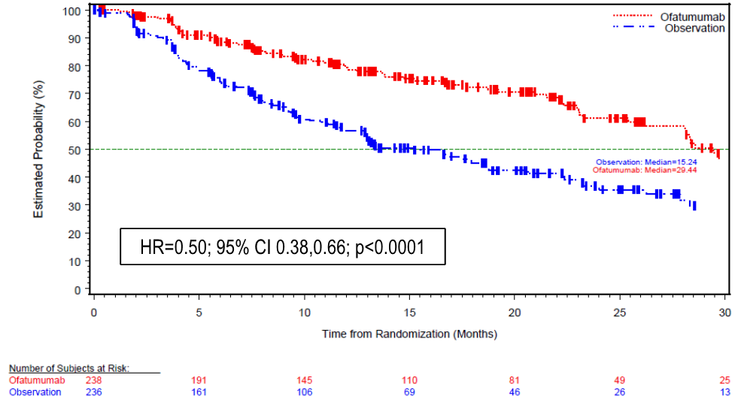

PFS sensitivity analyses
The results for the three pre-specified sensitivity analyses of PFS were consistent with the primary analysis of PFS, demonstrating the robustness of the primary analysis.
For Sensitivity Analysis 1 (undertaken considering both investigator assessed PD as determined by palpation of lymph nodes and organs and independent radiologist [IRC] assessed PD as determined by CT scan measurement of lymph nodes and organs), the median PFS was 24.54 months in the OFA arm and 12.98 months in the Obs arm, with a HR of 0.582 (95% CI: 0.45, 0.75), p < 0.0001.
For Sensitivity Analysis 2 (determined by the independent oncologist’s [IRC] assessment of PD based on palpation of lymph nodes and organs by investigators and excluding assessment of PD based on CT scan measurement of lymph nodes and organs by independent radiologist [IRC]), the median PFS was 30.36 in the OFA arm and 14.75 months in the Obs arm, with a HR of 0.55 (95% CI: 0.42, 0.72), p<0.0001. The KM-plots Sensitivity Analysis 2 are summarised. The approach to the assessment of PFS undertaken in Sensitivity Analysis 2 based on the independent oncologist’s determination of PD is similar to the assessment of PFS based on the determination of investigators (i.e., the primary analysis). In general, the IRC and investigator were in agreement on whether a subject had an event of progression or death (OFA maintenance 36% vs 33%; Obs 50% vs 51%, respectively, although differences in the timing of progression were noted.
For Sensitivity Analysis 3 (determined by the independent oncologist [IRC] based on the assessment of PD using CT scan measurements of lymph nodes and organs by the independent radiologist [IRC]), the median PFS was 23.69 months in the OFA arm and 13.54 months in the Obs arm, with a HR of 0.66 (95% CI: 0.50, 0.87), p=0.0021.
The results for the three pre-specified sensitivity analyses are summarised below.
Figure 7: OMB112517 – Forest plot of hazard ratios and 95% CIs for PFS sensitivity analyses; ITT population.
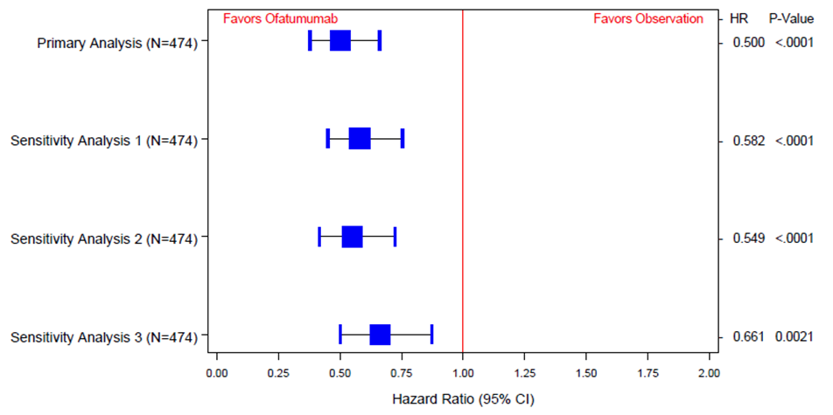

Investigator assessed PFS subgroup analyses
The results for the pre-specified investigator-assessed PFS subgroup analyses should be considered to be exploratory as they were not powered to detect a statistically significant difference between the two treatment arms, and no statistical adjustment was made for multiple testing. The results for the subgroup analyses for investigator-assessed PFS by baseline demographic factors are summarised. The results for each of the subgroups numerically favoured the OFA maintenance arm compared to the Obs arm, and the HR values were generally consistent with the primary analysis of PFS in the overall population. The results for the subgroup analyses for investigator-assessed PFS by baseline prognostic factors are summarised. In general, the results for each of the subgroups numerically favoured the OFA maintenance arm compared to the Obs arm. However, the results for the cytogenetic subgroups del 11q and del 17p need to be interpreted cautiously given the small patient numbers in the two subgroups. The results for the investigator-assessed PFS subgroup analyses by stratification factors are summarised. Median PFS was numerically longer in the OFA arm compared to the Obs arm for most relevant stratification factors, and the HR values were generally consistent with the investigator-assessed PFS for the primary analysis in the total study population.
The results of the exploratory Cox proportional Hazards regression model for relationship between investigator assessed PFS and covariates (prognostic markers) at screening showed that patients treated with prior chemoimmunotherapy had a lower risk of experiencing a PFS event during the study, as did low risk patients based on both RAI and Binet staging, patients negative for MRD, patients without 17p or 11q deletion genetic abnormalities, patients with low beta2-microglobulin levels, and patients with mutated IGVH status. These results were not unexpected.

PFS during follow-up
At the time of the data cut-off, 99 patients had completed 2 years of OFA maintenance /Obs and the proportion of patients that had progression at that time was similar in the two study arms (OFA, 32% [n=19]; Obs, 35% [n=14]). The median PFS was 37.5 months in both the OFA maintenance and the Obs arms, with a HR (OFA/Obs) of 0.86 (95% CI: 0.42, 1.72); p=0.0652. Two patients had only 1 year of dosing, therefore, comparison of PFS with subjects completing the protocol-defined 2 years of dosing is not meaningful.

Results for other efficacy outcomes

Inferential secondary efficacy endpoints

Overall survival (OS)
As of the cut-off date, the median follow-up was 19.1 months in the total population with 32 (13.4%) deaths reported in the OFA maintenance arm and 34 (14.4%) deaths reported in the Obs arm. The median OS had not yet been reached in either of the study arms. The sponsor states that the lack of effect of OFA on OS is not unexpected, given the relatively short median follow-up of 19.1 months for survival in patients with CLL and the availability of effective salvage treatments for CLL on relapse. The KM plots are provided below.
Figure 8: OMB112517 – Kaplan-Meier plots for overall survival; ITT population.
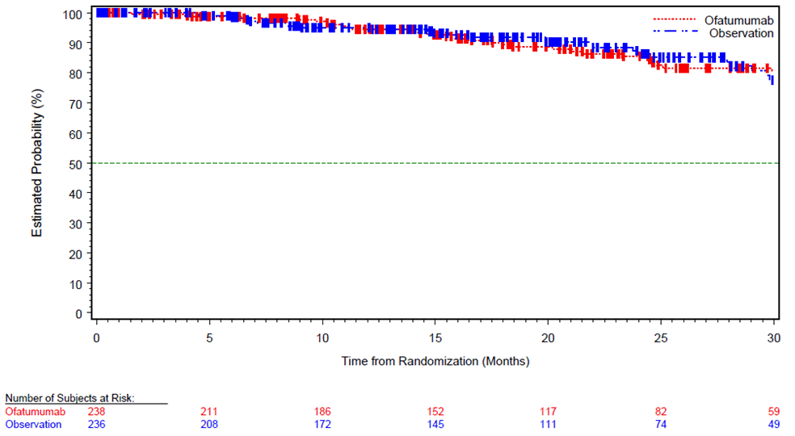

Time to next-line therapy for CLL
Time to next-line therapy for CLL was defined as the time from randomisation until the next-line of treatment. The median time to next-line therapy was 37.98 months in the OFA maintenance arm and 31.11 months in the Obs arm: HR=0.66 (95% CI 0.47, 0.92], p=0.0108). At the time of the data cut-off, 190 patients had disease progression and 142 of these patients had received subsequent CLL therapy (OFA, 83% [62/74]; Obs, 69% [80/116 patients]).

Other (non-inferential) secondary efficacy endpoints

Improvement in response
As all subjects were in remission at study entry improvement in response could only occur in those patients who were in PR at baseline (i.e., OFA, 193 patients [81%]; Obs, 189 patients [80%]). Bone marrow biopsy after screening was obtained in 7% of the subjects. At the time of the data cut-off, only a small proportion of subjects in either arm had achieved an improvement in response from PR to CR from baseline (OFA, 6% [n=11]; Obs, 1% [n=2]). The sponsor comments that more subjects might have achieved a CR, but the lack of bone marrow biopsy results did not allow for confirmation of CR.

PFS after next line of therapy in patients who had progressed
In those patients in the two study arms who had progressed at the time of the initial PFS analysis, there was no difference in the proportion of patients in the two study arms with an investigator assessed PFS event after next-line therapy (OFA, 19% [14/74], consisting of 11 deaths, 3 PD; Obs, 17% [15/88]), consisting of 15 deaths, no PD); HR = 1.00 (95% CI: 0.48, 2.07), p=0.9977, stratified log-rank test. The median duration of PFS from randomisation to next-line therapy had not been reached in either of the two study arms.
Comment: This analysis of PFS was undertaken in patients who progressed and then continued with next-line therapy (i.e., a subset of patients in the ITT population). The results suggest that there is no clinically meaningful difference in efficacy between the two study arms as regards the proportion of PFS events in patients who progressed and were then treated with next-line therapy. The limited data suggest that PFS following next-line treatment in patients in the OFA maintenance arm who had progressed did not appear to have been detrimentally affected relative to patients in the Obs.
It is noted that the time from progression to next-line of therapy in those patients who had progressed (i.e., time from randomisation to next-line of therapy minus time from randomisation to PFS) was notably longer in patients in the Obs arm than in the OFA maintenance arm (i.e., 16.3 month vs 5.6 months). This observation is discussed in the published study report (PROLONG) and the authors comment that, “remarkably, the interval between progression and next treatment in our trial seems to be longer in the observation group than in the ofatumumab maintenance group”. The authors postulate, “because time to next treatment is sensitive to subjectivity, investigators in consultation with their patients could possibly have had a lower threshold for treatment of progression during or after maintenance treatment than for progression after a period of observation. However, we do not have data to support or reject this interpretation”. The results suggest that patients in the observation arm who were in remission at baseline preferred to continue on observation rather than re-commence further treatment, even though their disease had progressed. The quality of life in patients in both treatment groups (assessed by PRO) remained unchanged throughout the study, which may have been a factor influencing patients in the observation group to delay re-commencing treatment after disease progression.
Following a request from the TGA during the course of the evaluation the sponsor provided an assessment of PFS2 (PFS after next line of therapy) using the ITT population. The median PFS2 was not estimable in both arms with 93.9% (445/474) of patients censored, with a HR (OFA/Obs) of 0.85 (95% CI: 0.41, 1.76, p-value=0.6618. The number of patients in both treatment arms with a PFS event was small, with 14 (6%) patients in the OFA maintenance arm and 15 (6%) patients in the Obs arm experiencing events. The sponsor stated that, although the data for the PFS after next line of therapy assessed in both the ITT population and the population who progressed and then continued with next-line therapy are still immature with high censoring rates, the data “seem to indicate that efficacy of next line treatment was not impaired by prior OFA maintenance treatment”. However, another way of interpreting the data is that OFA maintenance treatment has no clinically meaningful effect on PFS2 in either the ITT population or patients who progressed and then continued treatment for MM. In any event, meaningful interpretation of the PFS2 data in the two populations is limited due to the immaturity of the data and the high censoring rates.

Exploratory efficacy endpoints

B-symptoms
The majority of patients had no B-symptoms at baseline (94% both treatment arms), presumably because patients were required to be in remission at study entry. Most patients in both treatment arms continued to have no B-symptoms during the course of the study.

Minimal Residual Disease (MRD) status
Overall, 316 patients were assessed for MRD at baseline (56 of 91 in CR and 260 of 382 in PR). Of the 28 patients in CR randomised to the OFA maintenance arm with a baseline MRD sample, 39% (n=11) were MRD negative at baseline and 42% (n=13) were MRD negative at any visit. Of the 28 subjects in CR randomised to the Obs arm with a baseline MRD, 54% (n=15 subjects) were MRD negative at baseline and 38% (n=12 subjects) were negative at any visit. Overall, the limited data indicates that the subject in CR on OFA maintenance were able to maintain their MRD status, but the results should be interpreted with caution due to the small number of patients who were MRD-negative.

B-cell monitoring
At baseline, the proportion of patients with complete CD5⁺CD19⁺and CD5⁻CD19⁺ B-cell depletion was similar in the two treatment arms (OFA maintenance, 7% [15/222]; Obs, 5% [11/219]). The proportion of patients who achieved complete CD5⁺CD19⁺ and CD5⁻CD19⁺ B cell-depletion at any time during the study was higher in the OFA maintenance arm (26% [60/233]) than in the Obs arm (11% [25/234]). At baseline, the proportion of patients with near complete CD5⁺CD19⁺and CD5⁻CD19⁺ B-cell depletion was higher in the Obs arm (34% [74/219]) than in the OFA maintenance arm (28% [63/222]). However, the proportion of patients who achieved near complete CD5⁺CD19⁺ and CD5⁻CD19⁺ B-cell depletion at any time during the study was higher in the OFA maintenance arm (53% [123/233]) than in the Obs arm (40% [93/234]). The sponsor stated that the final evaluation of B cell counts over time and percent changes from baseline will be provided in the “end of study” report after all subjects have completed the study.

Patient reported outcomes

Global health status/Health related quality of life scores (GHS/HRQoL)
The GHS/HRQoL scores are measured on a scale of from 0 to 100, with higher scores representing better HRQoL. The mean±SD baseline GHS/HRQoL score was almost identical in the OFA maintenance arm and the Obs arm (i.e., 74.8±18.8 and 74.2±18.9, respectively), and suggests that quality of life was relatively good in patients in both study arms at baseline. The completion rate for the relevant questionnaires was higher in the OFA maintenance arm than in the Obs arm, as patients only completed questionnaires if they remained on treatment. The minimally important difference (MID) in the HRQoL score was defined as 5 points. When comparing the HRQoL scores between the arms, the only time when this difference exceeded the MID was at Week 2 (8.4 point difference; OFA arm had a mean improved score from baseline by 5.1 points and Obs arm had a mean decreased score of 3.3 points). In the follow-up period, the decreasing sample size makes it difficult to draw meaningful conclusions, but the results appear broadly consistent with the on-treatment results. Considering all time points, there was no statistically significant difference between the two study arms (p=0.15), with mean decline in HRQoL from baseline of 0.2 points in the OFA maintenance arm compared to a mean decline from baseline of 1.9 points in the Obs arm. The mean change from baseline at all time periods in both study arms is summarised below. Overall, it is considered that there were no clinically significant changes in quality of life over the course of the study in either study arm, and that the observed differences between the two arms are not clinically meaningful.
Figure 9: OMB112517 – Mean change from baseline of EORTC QLC-CLL 30 with 95% CI (C30 Global Health Status/HRQoL); ITT population

B-symptom index scores
The B-symptoms index included relevant questions from EORTC QLQ-30 and EORTC QLQ-CLL16 relating to fatigue, night sweats, temperature changes, and weight loss. The index is rated on a scale of 0 to 100, with higher scores indicating more severe B-symptoms. The baseline B-symptom index scores for both study arms were similar (i.e., OFA [n=237], 9.8±10.3; Obs [n=233], 10.1±11.1), and suggest that B-symptoms were not problematic at baseline for patients in either of the two arms. This is not unexpected, given that patients were in either CR or PR at baseline. The completion rate for the B-symptoms questionnaire was higher in the OFA maintenance arm than in the Obs arm, as patients only completed questionnaires if they remained on treatment.
A MID has not been formally determined for the B-symptom score. Therefore, the sponsor made an assumption that a MID was equal to 50% of the standard deviation documented at baseline. The standard deviation was 11.1 in the Obs arm and 10.2 in the OFA maintenance arm. Consequently, using the larger, more conservative of these two values, a MID of 5.6 points was adopted. During the Treatment/Obs Phase, there was no time when the B-symptom scores in either the OFA maintenance arm or the Obs arm changed from baseline in a clinically relevant manner (i.e., > 5.6 points). Although the sample size was small in the follow-up period, the results appear consistent with the treatment period. When assessed using a repeated measures analysis, differences between the OFA maintenance arm and the Obs arm were statistically significant (p=0.002), with patients in the OFA maintenance arm experiencing no mean change in symptoms (0.0) and patients in the Obs arm showing a worsening in symptoms of 2.8 points. The sponsor states that “additional analysis needs to done in order to confirm the MID and understand whether the [observed differenced between the two treatment groups] are clinically relevant. Based on these initial results, the change in magnitude might not be sufficient to meet the threshold of being clinically relevant”. Overall, the exploratory data suggest that the differences between the two study arms in B-symptom scores are unlikely to be clinically meaningful. The mean changes from baseline over the course of the study in B-symptom scores are presented below.
Figure 10: OMB112517 – Mean change from baseline of patient reported B-symptoms with 95% CI by domain (B-symptoms score)
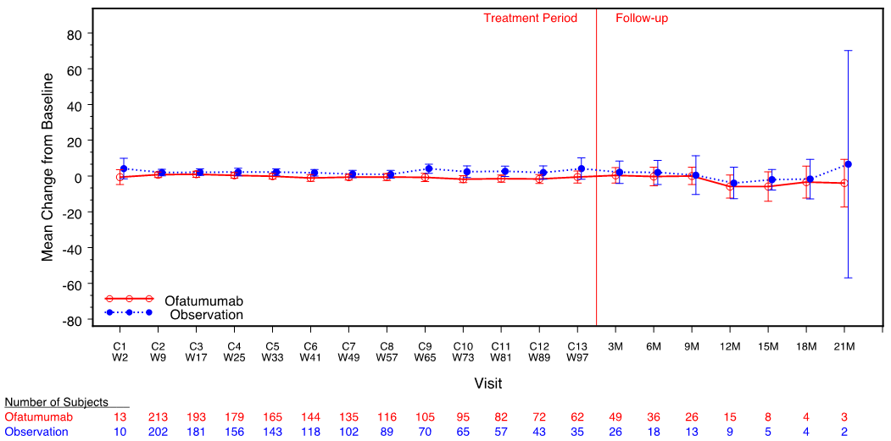

Other domains – QLQ-C30 and QLQ-CLL16
All other functional domains/symptom scales of EORTC QLQ-C30 and EORTC QLQ-CLL16 showed:
- Numerical change of less than 5 points from baseline in all domains in both study arms, with the exception of increased financial difficulties in the Obs arm (5.9 points change);
- Decreased role functioning in both treatment arms (6.9 and 10.5 point change in the OFA and Obs arms, respectively);
- Decreased social functioning in the Obs arm (7.8 point change);
- Less worry about future health in both arms (OFA 8.7 point improvement; Obs 5.1 point improvement); and
- Increased social problems in both study arms (OFA 5.7 point decrease; Obs 10.0 point decrease).

EQ-5D
The EQ-5D was collected to inform the economic analysis. The sponsor stated that the full results will be presented within a separate report. The OFA maintenance arm showed a minor decline in utility scores (0.02 out of 1.00) compared to a slightly greater decline in the Obs arm (0.05 out of 1.00). Although this difference was statistically significant (p=0.01), it failed to be clinically meaningful based on mean MID estimates in EQ-5D UK-utility scores (ranging from 0.10 to 0.12) and US-utility scores (ranging from 0.07 to 0.09) for patients with cancer.

Other efficacy studies

Study OMB114242 – Bulky fludarabine refractory (BFR) CLL

An Open Label, Multicenter Study Investigating the Safety and Efficacy of Ofatumumab Therapy versus Physicians’ Choice in Patients with Bulky Fludarabine-Refractory Chronic Lymphocytic Leukaemia (CLL).

Background
The primary purpose of study OMB114242 was to evaluate the effect on PFS of treatment with OFA monotherapy compared to physicians’ choice of treatment (PC) in patients with CLL with bulky lymphadenopathy with at least 1 lymph node > 5 cm who were refractory to fludarabine. The study was conducted to meet a specific obligation for the Conditional Marketing Authorisation of OFA for the treatment of CLL refractory to fludarabine and alemtuzumab in the European Union (EU). Conditional marketing authorisation is granted by the EU to a “medicinal product that fulfils an unmet medical need when the benefit to public health of immediate availability outweighs the risk inherent in the fact that additional data are still required.”
The European Medicine Agency (EMA) conditionally approved OFA for the treatment of CLL in patients who are refractory to fludarabine and alemtuzumab on the basis of one, open-label, single arm study Hx-CD20-406.¹⁹ The TGA has also approved OFA as a single agent for the treatment of CLL refractory to fludarabine and alemtuzumab presumably on the basis of study Hx-CD20-406. The Australian PI and the European SmPC indicate that in study Hx-CD20-406, OFA was given to patients who were refractory to fludarabine and alemtuzumab (n=95), and the ORR in this group was 49% (95.3% CI: 39, 60). The European SmPC, but not the Australian PI, states that OFA was also given to a group of patients (n=112) from Hx-CD20-406 with bulky lymphadenopathy (defined as at least one lymph node > 5 cm) who were also refractory to fludarabine, and that the ORR in this group was 43% (95.3% CI: 33, 53). The median PFS in the BFR group treated with OFA in Hx-CD20-406 was 5.5 months.
In addition, the current European SmPC includes the following statement based on the results of study OMB114242, “an open-label, two arm, randomised study (OMB114242) was conducted in patients with bulky fludarabine refractory CLL who had failed at least 2 prior therapies (n=122) comparing Arzerra monotherapy (n=79) to physicians’ choice (PC) of therapy (n=43). There was no statistically significant difference in the primary endpoint of IRC assessed PFS (5.4 vs. 3.6 months, HR=0.79, p=0.27). The PFS in the monotherapy Arzerra arm was comparable to the results seen with Arzerra monotherapy in study Hx-CD20-406”. The inclusion of this statement in the European SmPC suggests that study OMB114242 has been evaluated by the EMA.
Comment: The Australian sponsor made no reference to study OMB114242 in the covering letter to the TGA relating to the current submission. It is assumed that this is because the currently approved Australian PI includes no reference to the ORR and PFS results in patients with bulky fludarabine refractory CLL from study Hx-CD20-406. The annotated Australian PI provided with the current submission does not include any proposed additions to the PI relating to the efficacy outcomes in patients with bulky fludarabine refractory CLL from either study Hx-CD20-406 or OMB114242. It is noted that Table 6 in the currently approved Australian PI, which summarises the incidence of adverse reactions from study Hx-CD20-406, includes data from the subset of patients with bulky fludarabine refractory CLL.

Study design, objectives, locations, and dates

Objectives
The primary objective of study OMB114242 was to compare the effect of OFA treatment to physicians’ choice treatment on PFS in patients with bulky, fludarabine-refractory (BFR) CLL who had received at least 2 prior therapies for the disease. Disease progression was determined by an Independent Review Committee (IRC) using the 2008 International Workshop on CLL Update of the National Cancer Institute-sponsored Working Group CLL 1996 Guidelines for Response (IWCLL updated [2008] NCI-WG 1996 guidelines)^{.9} The IRC included one independent haematologist/oncologist and one independent radiologist, and assessments by the IRC were conducted in accordance with an Independent Review Charter.
The secondary objectives of the study were:
- To evaluate ORR, defined as the percentage of subjects achieving either a confirmed CR or a PR;
- To evaluate OS, defined as the time from randomisation to death due to any cause;
- To evaluate the safety and tolerability in subjects with CLL receiving OFA compared to PC during the treatment period; and
- To evaluate health-related quality of life (HRQoL) in subjects with CLL receiving OFA compared to PC, as assessed by changes in patient reported outcome (PRO) measures relative to baseline. The study also included pharmacogenetic research objectives.

Design
OMB114242 was a Phase III, open-label, randomised study of OFA vs PC in patients with BFR CLL. Patients with active disease requiring CLL therapy who had at least 2 prior therapies for the disease were screened for eligibility. It was planned that approximately 120 patients were to be randomised in a 2:1 ratio to receive either OFA or PC for up to 24 weeks (6 months). Randomisation was stratified by presence or absence of the 17p deletion, ECOG performance status, and fludarabine-refractory status. The design is summarised below.
Figure 11: OMB114242 – Study design
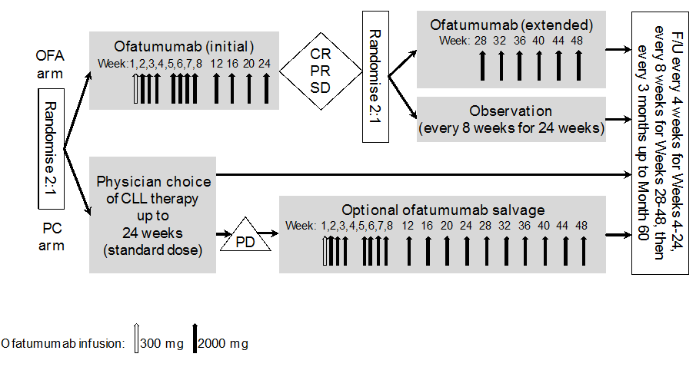
After 24 weeks of OFA treatment, patients who achieved at least stable disease or better, and whom the investigator deemed appropriate to continue therapy, underwent a second randomisation (2:1) to either an additional 24 weeks of treatment with OFA or no further therapy (i.e., observation only). The second randomisation was stratified using the same factors as used for the primary randomisation. After 24 weeks of PC treatment, all patients in the control arm with PD had the option to receive optional OFA salvage treatment for 48 weeks.
In both study arms, disease status assessments to determine response or disease progression were to be performed by site investigators at weeks 5, 9, and 12 and then every 4 weeks from week 16 to week 24, at weeks 36 and 44, and then every 3 months up to Month 60.
In both study arms, survival and disease status assessments were to be performed by site investigators in the follow-up period every 4 weeks for months 1 to 6, every 8 weeks for months 7 to 12, and every 3 months up to month 60.
All patients who discontinued study-drug (OFA or PC) were evaluated for disease status and survival as per the follow-up schedule, and had safety assessments performed at the time of discontinuation and during post-study drug follow-up. All patients who permanently discontinued study-drug (OFA or PC) without PD were followed for progression according to the protocol schedule until PD or death was documented. Also, all patients who permanently discontinued study-drug (OFA or PC) were followed for survival and new anti-cancer therapy. Survival follow-up continued until each subject had been followed for 5 years.
For all patients, a bone marrow examination had to be performed ≤ 6 months before randomisation, and a computed tomography (CT) scan had to be obtained within 8 weeks before randomisation. The bone marrow sample was assessed by flow cytometry for CLL cells. In addition to standard clinical laboratory assessments, the following prognostic factors were assessed: immunoglobulin heavy chain variable region (IGHV) mutational status, VH3-21 usage, cytogenetics, and beta 2-microglobulin.
The study distinguished between withdrawal from the study-drug (i.e., discontinuation of OFA or PC)) and withdrawal from the study. Reasons for discontinuation of study-drug (OFA or PC) included PD, death or unacceptable AE, including protocol defined stopping criteria for liver chemistry abnormalities, haematologic and non-haematologic toxicities. In addition, the study-drug (OFA or PC) could be permanently discontinued for deviations from the protocol, subject decision (or decision of legal representative), investigator decision, or pregnancy. Patients could withdraw consent for participation in the study at any time for any reason. Reasons for withdrawal from study participation were documented on the eCRF.
Comment: The study was planned and designed to meet a specific obligation for the Conditional Marketing Authorisation of OFA for the treatment of fludarabine- and alemtuzumab-refractory CLL in the EU. The CHMP approved the OMB114242 protocol. The sponsor stated that the randomised study was open-label, because blinding study treatment was not possible due to the difference between infusion-reactions observed for OFA and PC, and to differences in the administration regimens of the various therapies in the PC arm. Given the lack of an agreed standard of care treatment for patients with BFR CLL, PC was agreed with the CHMP as the comparator. PC included approved CLL therapies or well-established CLL treatment options. Since the purpose of the study was to evaluate the clinical benefit of OFA in the context of existing treatments, experimental therapies such as investigational agents and any doses beyond the approved/standard of care range were not allowed.

Locations and dates
Patients were centrally randomised at 41 sites in 14 countries. The first patient was enrolled on 14 April 2011, and the data cut-off for the CSR was on 18 March 2014. The study is ongoing for survival and the planned completion date is 18 June 2018. The sponsor stated that the study is being performed in compliance with GCP and GSK Standard Operating Procedures.

Inclusion and exclusion criteria
The study included patients aged ≥ 18 years with CLL based on the IWCLL updated 2008 NCI-WG 1996 guidelines and with bulky lymphadenopathy, defined as at least 1 lymph node > 5 cm. Patients were also required to have active disease requiring CLL therapy, to have received at least 2 prior therapies for CLL, and to be refractory to fludarabine. Patients were defined as being refractory to fludarabine if they had no response to at least 2 cycles of a fludarabine-containing regimen or had achieved a PR or better after at least 2 cycles of a fludarabine-containing regimen for a duration of less than 6 months. In addition, patients were required to have ECOG performance status of 0-2. The inclusion criteria and the key exclusion criteria are provided.
Comment: Eligibility criteria were set to obtain a BFR population similar to the comparable population defined for study Hx-CD20-406.

Study treatments

OFA treatment
Patients assigned to OFA treatment at the first randomisation received an initial IV dose of 300 mg, followed by the first infusion of 2000 mg OFA 1 week later. The 300 mg initial dose was implemented to reduce the incidence and severity of infusion reactions. Patients received 7 weekly 2000 mg infusions, followed by 4 additional infusions of 2000 mg every 4 weeks for a total of 12 infusions over 24 weeks. Patients who did not have PD at Week 24 underwent a second randomisation to additional OFA or observation. Patients who were randomised to OFA at the second randomisation continued to receive 2000 mg OFA every 4 weeks for up to an additional 24 weeks. Prior to the start of each OFA infusion, patients were to receive paracetamol, antihistamine, and glucocorticoid for premedication as detailed in protocol. No dose reductions were allowed for any of the scheduled infusions. Patients received OFA infusions at the study site. Adherence to the planned OFA dosage was high, with 96% of patients treated with OFA receiving 100% of the planned dose.
Patients who were assigned to the PC arm at the first randomisation and started OFA salvage therapy after disease progression received an initial dose of 300 mg, followed 1 week later by the first infusion of 2000 mg OFA. Subjects received 7, 2000 mg infusions administered weekly, followed by 2000 mg infusions every 4 weeks until Week 48, for the maximum treatment duration of 48 weeks (12 months).
Comment: The OFA dosage regimen used in study OMB114242 was adopted from Study Hx-CD20-406, where this dose and schedule had been chosen to support the marketing application for refractory CLL. The OFA dosage regimen used in study OMB114242 is the same as that approved by the TGA and the EMA for the treatment of patients with CLL refractory to fludarabine and alemtuzumab.

PC treatment
Patients assigned to the PC arm received therapies other than OFA that were approved for CLL and were established standards of care for CLL. These therapies were sourced locally from commercial suppliers. PC therapies were administered at the standard dose and route as directed in the prescribing information or according to local standard practice for the individual agent. Dose adjustments or interruptions due to toxicity also had to be followed in accordance with the prescribing information. Patients received PC infusions at the study site. Compliance data for the PC arm are not available due to the variability of the different treatment regimens administered in this arm.
Treatment regimens in the PC arm were classified using a hierarchical order shown below in Table 14 (for example, regimens containing fludarabine and alemtuzumab were classified as alemtuzumab-based therapy rather than fludarabine-based therapy). The most common treatment regimens in the PC arm were classified alkylator-based based therapy (28%) followed by alemtuzumab-based therapy (26%). The most commonly administered agents in the PC arm were cyclophosphamide, rituximab, and prednisone, followed by vincristine and alemtuzumab. Of the 43 patients in the PC arm, 34 (79%) were treated with IV infusions.

Table 14: OMB114242 – Treatment regimens in the PC arm
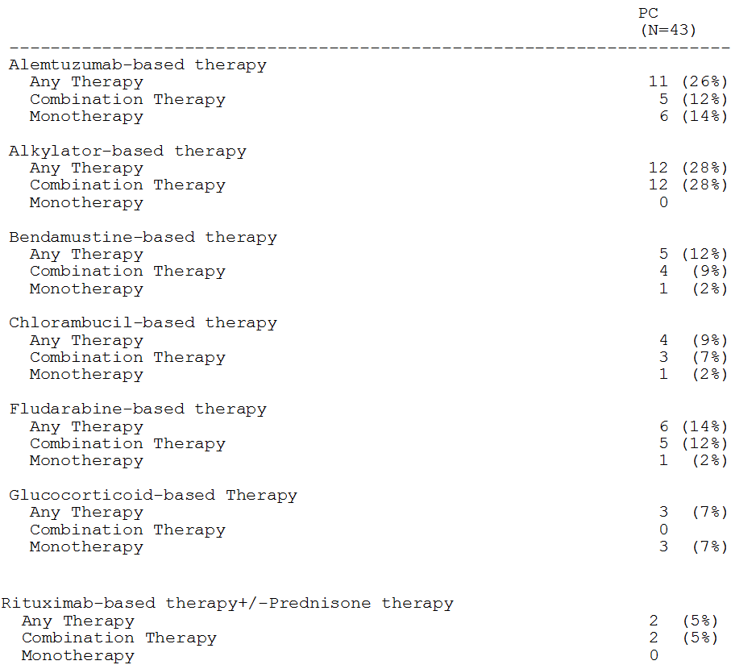

Prior and concomitant medications
The following medications and non-drug therapies were prohibited:
- Anti-cancer medication not part of treatment on protocol;
- Glucocorticoids given at anti-neoplastic doses that were not part of the PC treatment;
- Any unapproved drug substance or experimental therapy; and
- Paracetamol for patients with acute viral hepatitis.

Efficacy variables and outcomes

Primary efficacy endpoints – progression free survival (PFS)
The primary efficacy endpoint was PFS as assessed by the independent review committee (IRC) using pre-specified guidelines. The date of PD was defined as the first occurrence of any criteria of progression (i.e., death; PD). The length of the PFS interval was calculated from the date of the first randomisation to the date of death or PD, whichever occurred first.
Disease progression was determined by an IRC. The committee assessed the best overall response with date (date of confirmation of response), onset date of CR, CRi, nPR or PR, and PD (yes/no, and PD date, if applicable). A sensitivity analysis was also implemented using CT scan results in place of physical examination of lymph node, liver, and spleen size. The sponsor stated that the use of imaging for the assessment of progression is not considered to improve PFS assessment, but assessment by palpation can be imprecise as well as subject to assessment bias. Response after OFA salvage therapy was not assessed by the IRC.
The investigator assessed disease status and response at Weeks 5 and 9; every 4 weeks from Weeks 12 to 24; at Weeks 28, 36, and 44; and then every 3 months up to Month 60. If required, assessment could also occur at any unscheduled visit. Assessment results and visit responses were documented on the eCRF and used to make clinical decisions about clinical care. After completion of treatment, the investigator evaluated the best overall response achieved over the entire treatment and follow-up period, based on the pre-specified guidelines.⁹ Bone marrow results for evaluating best overall response of CR was at the discretion of the investigator. The CT scan results could be used for assessment of CR and PR if clinically indicated (e.g., if abnormal prior to therapy). The best overall response, together with the date of response was first observed, were documented on the eCRF, as was the date of PD.

Secondary efficacy endpoints
Secondary efficacy endpoints were:
- ORR, defined as the percentage of subjects who achieved a best overall response of CR, CRi, nPR, or PR; and
- OS, defined as the interval (in months) between the first randomisation date and date of death due to any cause. Patients who had not died were censored at the date of last contact.

Other and exploratory efficacy endpoints
The study included a number of other and secondary efficacy endpoints. The study also assessed biological markers including, B-cell monitoring, B-symptoms, minimal residual disease, and prognostic markers. In addition, cytogenetics, IGHV mutational status, VH3-21 usage, and Beta-2-microglobulins were also assessed.

Patient reported outcomes
HRQoL using the EORTC QLQ-CLL16 and the EQ-5D was assessed at the following time points: Screening; Week 12 (Week 4 of Cycle 3), Week 24 (Week 4 of Cycle 6), Week 36 (Week 4 of Cycle 9), Week 48 (Week 4 of Cycle 13); during follow-up which was every Month for Months 1 to 6, every 8 weeks for Months 7 to 12 and every 3 months up to Month 60; and then at PD. The Health Change Questionnaire (HCQ) was administered at all post-screening assessments.

Randomisation and blinding methods
Patients were assigned to study treatment in accordance with the randomisation schedule. The randomisation codes were created using the GSK RandAll system and were provided to the Registration and Medication Ordering System (Oracle’s Interactive Response Technology system [IRT]). The IRT system assigned a unique randomisation number for each patient.
During the first randomisation, patients were randomised in a 2:1 ratio to receive either OFA or PC treatment in accordance with the randomisation schedule. Patients whose disease did not progress during the initial 24 weeks of OFA treatment (i.e., SD or better) underwent a second 2:1 randomisation to an additional 24 weeks of OFA or no treatment (observation). Both randomisations were stratified based on the following criteria:
- 17p deletion status (presence vs absence);
- ECOG performance status (0-1 vs 2); and
- fludarabine-refractory status (no response vs < 6 months response).
Blinding of patients and investigators to treatment assignment was not applicable as the study was open-label. However, the primary analysis of disease progression and response was determined for each patient by the IRC blinded to study treatment and AE history.

Analysis populations
The ITT population included all patients who were randomised to receive OFA or PC at the first randomisation. This was the primary population used for all efficacy assessments (including PRO analyses), and assessments were based on the randomised groups rather than actual treatment received.
The safety population included patients who received at least 1 dose of a study drug. This population was used for all safety assessments and was based on the actual treatment received.
The PP population excluded subjects with major protocol deviations that impacted on the efficacy outcome. The PP population was to be used in the primary endpoint analysis to check the robustness of the result for the ITT population, if the size of both populations differed by at least 10%.

Sample size
A total of 120 patients were planned to be enrolled to observe 95 PFS events of PD or death within 44 months. Approximately 95 events were needed to achieve at least 90% power to demonstrate a clinically meaningful treatment arm difference in median PFS of 3 months in the primary comparison (OFA vs PC arm) at a two-sided alpha level of 5%.
The sample size calculation was based on the following considerations. For patients with BFR CLL, median PFS on standard therapies was 2 to 3 months. In Study Hx-CD20-406, OFA as monotherapy given over 6 months to BFR CLL patients achieved an ORR of 43% and a median PFS of approximately 6 months. Based on these data, the following assumptions were made for study OMB114242:
- Median PFS of 3 months for patients receiving PC, median PFS of 6 months for patients receiving OFA for up to 24 weeks, median PFS of 10 months for patients receiving OFA for up to 48 weeks;
- 50% of patients starting OFA to achieve CR, CRi, nPR, PR, or stable disease (SD) after 24 weeks of therapy and thus eligible for the second 2:1 randomisation to either OFA extended treatment or observation.
Assuming an accrual rate of approximately 3 patients per months, 108 evaluable patients were needed to obtain 95 events of PD or death within approximately 40 months for the primary comparison (OFA vs PC). Assuming a 10% dropout rate, the total sample size was 120 patients, and the duration until 95 PFS events were reached increased to 44 months.

Statistical methods
The primary efficacy endpoint was PFS in the ITT population, assessed by the IRC and estimated by the KM method. The PFS curves were compared between treatment arms using the stratified log-rank tests adjusted for the pooled stratum and interval.
Four treatment arm comparisons comprised the primary analysis (OFA vs PC, OFA extended vs PC, observation vs PC, OFA extended vs observation). The HRs and corresponding 95% confidence intervals (CIs) were provided for each of the 4 treatment arm comparisons. KM plots, and median times to PFS as well as first and third quartiles were presented, along with 95% CIs. Percentages of patients who progressed after 2 and 3 years were also summarised. Median PFS (including 95% CIs) was also provided for patients starting OFA salvage therapy after PD, and was defined as time from the first dose of OFA salvage therapy to PD or death after the start of OFA salvage therapy.
With a primary endpoint of PFS, 4 different null and alternative hypotheses (H0, H1) had been designed initially to establish superiority of OFA over PC for subjects with BFR CLL, using 4 different treatment arm comparisons:
- H0: There is no difference in PFS between treatment arms (hazard ratio [HR] = 1).
- H1: There is a difference in PFS between treatment arms (HR ≠ 1).
- Primary analysis to provide evidence to support or reject H0 in favour of H1 for the following treatment arm comparisons:
  - Subjects receiving OFA vs subjects receiving PC.
  - Subjects receiving OFA for 48 weeks (OFA extended) vs subjects receiving PC.
  - Subjects receiving OFA for 24 weeks (observation) vs subjects receiving PC.
  - Subjects receiving OFA for 48 weeks (OFA extended) vs subjects receiving OFA for 24 weeks (observation).
The primary comparison, Comparison #1, was tested first as gatekeeper, and if the result was significant, Comparisons #2, #3, and #4 were then to be tested simultaneously at an alpha level of 0.05, generating a closed testing procedure that controlled the type 1 error rate. However, because the primary gatekeeper comparison (OFA vs PC) was not statistically significant, Comparisons #2 to #4 were descriptive and for exploratory purposes only.
PFS assessed by the IRC was also examined in subgroups and by prognostic factors. A number of PFA sensitivity analyses in the ITT population were undertaken to assess the result of the primary PFS analysis. The sensitivity analysis based on the PP population was not conducted since the PP and ITT population differed by less than 10%. The results for concordance testing between IRC and investigator assessments were provided.
For investigator-assessed PFS, the comparison between the OFA extended arm and the observation arm (Comparison #4) was performed both with time counted from the date of the first randomisation, and, post-hoc, from the date of the second randomisation. The post-hoc analysis enabled a direct comparison of PFS between subjects who received an additional 24 weeks of OFA treatment (OFA extended) and subjects who received no further treatment (observation).
The comparisons describes for PFS were also used for all secondary efficacy endpoints (e.g., ORR and OS). The statistical methods used to analyse the secondary efficacy endpoints have been examined and are considered to be appropriate.

Participant flow
The disposition of all patients is summarised below in Table 15. During the first randomisation, 122 patients were randomised to receive OFA (n=79) or PC (n=43). Of the 79 patients who were randomised to the initial 24 weeks of OFA treatment, 78 received at least 1 dose of study drug. Of these 78 patients, 42 did not undergo the second randomisation at the conclusion of the 24-week period. The remaining 37 patients underwent the second randomisation to receive OFA for up to 24 additional weeks (OFA extended; n=24) or to observation only (Obs; n=13). Overall, 93 of the 122 patients (76%) completed treatment (i.e., completed treatment and either entered follow-up for progression, or experienced PD or death). The proportion of patients who withdrew from study drug was similar in the OFA and PC treatment arms (OFA 24%, PC 23%), and the primary reason discontinuation of the study drug in the two treatment arms was AEs (OFA 13%, PC 12%).
Table 15: OMB114242 – Patient disposition; ITT population
a. OFA arm includes subjects from OFA extended, observation, and OFA (first randomisation only) arms; b. Total includes subjects from OFA extended, observation, OFA (first randomisation only), and PC arms; c. Subjects who completed treatment and entered follow-up for progression, or subjects with PD or death; d. Subjects who withdrew from study drugs with reasons other than PD, death, or consent withdrawal; e. Subjects who completed follow-up phase, or with PD, death, or other anti-cancer therapy during follow-up; f. Subjects who withdrew consent, were lost to follow up, or discontinued due to investigator discretion; g. Subjects who had PD or took other anti-cancer therapies during treatment or follow-up phase; h. Subjects who completed the survival follow-up phase per protocol, or subjects who died during survival follow-up phase; i. Subjects who withdrew consent, were lost to follow up, or investigator discretion; j. Excludes Subject [information redacted] who was documented as “protocol completed” and withdrew consent due to disease progression.

Major protocol violations/deviations
In total, 48% of patients had at least 1 protocol deviation. Only 9 patients (7%) had major protocol deviations that led to exclusion from the PP population, including 6 patients for using a prohibited medication or device and 3 patients for not meeting the eligibility criteria. In total, the proportion of patients with major protocol deviations was higher in the OFA arm than in the Obs arm (51% vs 42%, respectively).

Table 16: OMB114242 – Protocol deviations
a. OFA: includes subjects from OFA (first randomisation only), OFA extended, and observation arms. Data for the OFA (first randomisation only) arm are presented in the data source tables; b. OFA ext: subjects randomised to OFA at the first randomisation and randomised to OFA extended treatment at the second randomisation; c. Obs: subjects randomised to OFA at the first randomisation and randomised to observation at the second randomisation.

Baseline data
Baseline demographic characteristics in the total population were similar in the two study arms. The median age of patients in the total population was 62 years (range: 40, 82 years), with 57% being aged < 65 years and 43% being aged ≥ 65 years (26% ≥ 70 years, 10% ≥ 75 years). The total population comprised 62% male and 33% female patients, and nearly all patients were White/Caucasian/European (97%).
Baseline disease characteristics in the total population were comparable between the two treatment arms. Overall, prognostic markers and percent CD20+ cells at screening in the total population were comparable between the two study arms. In the total population, no response to fludarabine was reported in 62% of patients in the OFA arm compared to 53% of patients in the PC arm, with the corresponding proportions for patients with a response of < 6 months being 38% and 47%, respectively.
Concomitant medical conditions in the total population were reported in 75% of patients in the OFA arm and 88% of patients in the PC arm, with 75% and 86% of patients in the two arms having ≥ 2 co-morbidities (unique SOC terms), respectively. The most commonly reported concomitant medical conditions by SOC reported by ≥ 20% of patients in either treatment arm (OFA vs PC, respectively) by decreasing frequency in the total population were “gastrointestinal disorders” (23% in both arms), “blood and lymphatic disorders” (20% vs 26%), “cardiac disorders” (19% vs 26%), “respiratory, thoracic and mediastinal disorders” (16% vs 30%), “renal and urinary disorders” (24% vs 12%), “musculoskeletal and connective tissue disorders” (15% vs 26%), and “infections and infestations” (16% vs 21%).
All patients had been previously treated with fludarabine, as required by the inclusion criteria. Other prior anti-cancer therapies (OFA vs PC, respectively) included alkylator-based therapy (56% v 44%), bendamustine based therapy (30% vs 42%), alemtuzumab based therapy (15% vs 16%), rituximab based therapy (10% vs 26%), glucocorticoid based therapy (3% vs 2%), and other agents (51% vs 49%). Most patients (OFA 96%, PC 98%) had received more than 1 previous chemotherapy regimen, and 34% of patients in the OFA arm and 33% of patients in the PC arm had received > 4 prior regimens. Overall, the median number of prior anti-cancer therapies was 4.0 in the OFA arm and 3.0 in the PC arm. In addition to prior chemotherapy, 68% of patients in the OFA arm and 74% of patients in the PC arm had received biologic therapy, and hormonal therapy had been received by 47% and 42% of patients, respectively.
In the total population, the response rate to the most recent prior anti-cancer therapy was 32% in the OFA arm (all partial response) and 23% in the PC arm (5% complete, 19% partial).

Concomitant medications
The majority of patients (95%) received concomitant medications during the study. The overall pattern of concomitant medication use was consistent with an elderly patient population with frequent co-morbidities. The most common concomitant medications in the total population were allopurinol (66%), acyclovir (48%), and antibiotics (trimethoprim 47%, sulfamethoxazole 44%).
In the total population, prophylactic antibiotics/antivirals were administered to 66% of patients (OFA 61%; PC 74%). Medications received by ≥ 40% of patients in the total population (OFA vs PC, respectively) were acyclovir (42% vs 49%), trimethoprim (37% vs 53%), and sulfamethoxazole (37% vs 47%).
In the total population, granulocyte colony stimulating factor (G-CSF) was administered to 29% of patients in the OFA arm and 37% of patients in the PC arm. Granulocyte macrophage colony stimulating factor was not administered, while erythropoietin was only given to 3 patients in the OFA arm and 4 patients in the PC arm. The median time to first dose of growth factors was 22.0 days in the OFA arm and 8.0 days in the PC arm, with the difference being most likely due to the use of combination chemotherapy in the PC arm.

Post-treatment anti-cancer treatment
Post-treatment anti-cancer therapy (other than OFA salvage therapy in the PC arm) after PD was at the discretion of the treating investigator per local standard of care and was recorded on the eCRF. In the total population, a higher proportion of patients received post-treatment anti-cancer therapy in the OFA arm (48%) compared to the PC arm (14%; excluding OFA salvage). The sponsor states that this difference can be explained because the OFA salvage therapy given to 22 subjects in the PC arm was not counted as “post-treatment anti-cancer therapy”. The overall median time from study treatment discontinuation to start of subsequent anti-cancer therapy (excluding OFA salvage therapy) was approximately 3 months (88.0 days) and was similar across all groups. The median time to OFA salvage therapy for subjects in the PC arm was 81.5 days (range: 26, 338 days).

Results for primary efficacy outcome – PFS (IRC assessed)
The study failed to meet its primary endpoint of demonstrating a statistically significant increase in IRC-assessed PFS in the OFA arm compared to the PC arm in patients with bulky fludarabine refractory CLL. The K-M PFS estimates are summarised below, and the K-M curves are provided below.

Table 17: OMB11242 – Kaplan-Meier estimates of PFS (IRC assessed); ITT population
a. Confidence intervals were obtained using the Brookmeyer-Crowley method; b. Hazard ratios were obtained using the Pike estimator. A hazard ratio <1 indicates a lower risk with OFA compared to PC. The p-value from the stratified log-rank test was adjusted for ‘interval’ and pooled stratum.
Figure 12: OMB11242 – Kaplan-Meier estimates of PFS (IRC assessed); ITT population
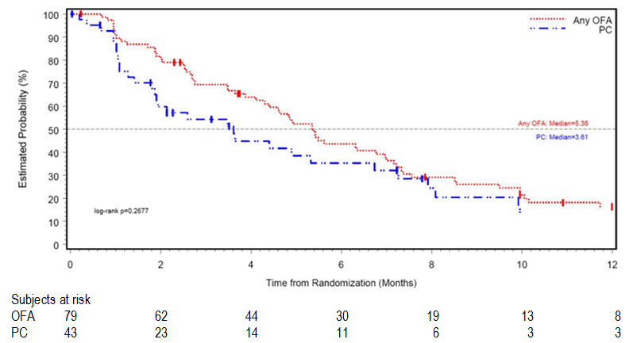
The sensitivity analysis of investigator-assessed PFS demonstrated prolonged PFS in the OFA arm (7.0 months) compared to the PC arm (4.5 months) (HR = 0.56 [95%CI 0.35, 0.87]; nominal p=0.003. There was discordance between IRC-assessed and investigator-assessed PFS. In both treatment arms, with investigator-assessed PFS being numerically longer than IRC-assessed PFS. The sponsor states that the discordance was driven, at least in part, by investigators exercising prospective “clinical judgment” resulting in delayed assessment of progression in some cases, while the IRC strictly adhered to the pre-specified guidelines when assessing progression retrospectively. Investigator-assessed median PFS was longer than IRC-assessed median PFS in both treatment arms, so the open-label nature of the study may not have contributed significantly to the discordance. The p-values for the three other sensitivity analyses of PFS were all ≥ 0.05, and the 95% CI of the HRs all included 1.
Comment: The primary endpoint of PFS as determined by the IRC was numerically prolonged in the OFA arm (median PFS 5.4 months) compared to the PC arm (median PFS 3.6 months), with an HR of 0.79 (95%CI: 0.50, 1.24). However, the difference of 1.8 months between the two treatment arms was not statistically significant (p=0.268). Furthermore, a 1.8 months difference between the two treatment arms in favour of OFA is considered to be not clinically significant, based on the assumptions to calculate the sample size, which nominated a clinically meaningful difference of 3 months in PFS between the two arms in the primary comparison of OFA vs PC. The median duration of PFS in the OFA arm in this study was comparable to the median duration of PFS in the OFA arm in the subset of patients (n=112) with bulky fludarabine refractory CLL in study Hx-CD20-406 (5.4 months [95% CI: 4.3, 7.0] vs 5.5 months [95% CI: 4.6, 6.4], respectively. In both study OMB114241 and study Hx-CD20-406, PFS was assessed by an IRC using the same criteria.

Results for other efficacy outcomes

Secondary efficacy endpoints
The two key secondary endpoints (OFA vs PC) were the ORR and OS. However, as the primary efficacy analysis of PFS (OFA vs PFS) (i.e., gatekeeper analysis) was not statistically significant, the pairwise comparisons for the ORR and OS were descriptive and for exploratory purposes only.
The ORR, as assessed by the IRC, was numerically higher in the OFA arm compared to the PC arm (38% vs 16%, respectively; odds ratio 2.94, nominal p=0.022). All IRC-assessed responses were PR, and there were no responses categorised as CR or nPR. The results are summarised below in Table 18.

Table 18: OMB11242 – Best overall response as assessed by IRC, investigator and IRC with CT scan; ITT population
a. Responders include CR, nPR, and PR; b. Cochran-Mantel-Haenszel test, adjusting for pooled stratum and interval for OFA vs PC; c. Odds ratios and p-value are based on conditional logistic regression, with interval and pooled stratum included in the strata statement.
Median OS was numerically longer in the OFA arm (19.2 months) than in the PC arm (14.5 months), with a HR of 0.68 (95%CI: 0.41, 1.15; nominal p=0.130). The proportion of patients who had died at the time of the analysis was 46% in the OFA arm and 63% in the PC arm. The K-M estimates of OS are summarised below.

Table 19: OMB11242 – Kaplan-Meier estimates of OS; ITT population
a. Confidence intervals were obtained using the Brookmeyer-Crowley method; b. Hazard ratios were obtained using the Pike estimator. A hazard ratio <1 indicates a lower risk with OFA compared to PC. The p-value from the stratified log-rank test was adjusted for “interval” and pooled stratum.
Figure 13: OMB11242 – Kaplan-Meier estimates of OS; ITT population

Other efficacy endpoints of clinical interest
- All results for the other efficacy endpoints are descriptive and exploratory.
- IRC-assessed time-to-progression (TTP) was numerically longer in the OFA arm than in the PC arm (median 6.3 vs 5.3 months, HR 0.91 [95% CI: 0.55, 1.49], nominal p=0.689).
- Median time to next therapy (TNT) was longer in the OFA arm than in the PC arm (11.5 vs 6.5 months, HR 0.45 (95%CI 0.26, 0.77); nominal p=0.0004).
- Median IRC-assessed time-to response (TTR) was numerically longer in the PC arm than in the OFA arm (2.6 vs 1.2 months; HR 1.69 [95%CI: 0.83, 3.46]; nominal p=0.149)
- Median IRC-assessed duration of first response (responders only) was 6.2 months in the OFA arm and 7.0 months in the PC arm.

Efficacy results for OFA extended therapy vs Obs (second randomisation)
The efficacy evaluations following second round randomisation compared patients in the OFA extended therapy arm (n=24) to patients in the observation arm (n=13). All efficacy evaluations comparing the two study arms were descriptive and exploratory. Median PFS counted from the first randomisation as assessed by the IRC (primary endpoint) was numerically prolonged in the OFA extended treatment arm (10.1 months) compared to the observation arm (7.2 months), with a HR of 0.54 (95% CI 0.19, 1.53; nominal p=0.084). The absolute median difference between the two treatment arms was 2.9 months, which is of doubtful clinical significance. No further data from this exploratory analysis has been included in this CER.

Patient Reported Outcomes (PROs)
Health outcome assessments (EORTC QLQ-CLL 16 and EQ-5D) were performed at baseline, every 3 months throughout active therapy, during follow-up, and after progression. The health outcome questionnaires were administered at all post-baseline assessments. For the EORTC QLQ-CLL16, a higher score for the multi-item scales and single-items is equivalent to worsening of symptoms/problems. For the EQ-5D, answers reflect subjects’ perceived level of the problem, and a positive change in the levels of health index or visual analogue scale (VAS) score indicate improved health status. For HCQ, a score of 3 or less indicates improvement from baseline. All health outcome assessments were descriptive and exploratory.

Active Therapy Phase
In the active therapy phase, the Fatigue, Treatment Side Effects (TSE), and Disease Side Effects (DSE) scales of the EORTC QLQ-CLL16 were pre-specified as the principal PRO measures. Since the number of patients reporting HRQoL data in the OFA extended arm was low, the analysis presented was limited to 24 weeks. For the Fatigue scale, fatigue levels numerically decreased in subjects of the OFA arm, with mean decreases of 4 to 6 points from baseline at Weeks 12 and 24, while mean fatigue levels increased by 2 to 13 points at Weeks 12 and 24 in the PC arm. For the DSE scales, subjects in both the OFA and PC arms had numerical improvements (reduced scores) from baseline, but the improvements in the PC arm were numerically smaller than those reported in the OFA arm. Furthermore, subjects in the PC arm only demonstrated an improvement in TSE scale at Week 12 which was numerically smaller than that observed in the OFA arm. At Week 24, PC arm subjects reported a worsening of TSE scores compared to baseline, while patients in the OFA arm maintained their improvement. Change from baseline in the Fatigue, TSE, and DSE scores are summarised below.

Table 20: OMB114242 – Change from baseline in EORTC QLQ-CLL16 Fatigue, TSE and DSE scores
N=number of patients in the treatment arms. N=number of patients with data. Mean [SD] baseline scores (OFA [n=78] vs Obs [n=42]); DSE scale (30.8 [17.68] vs 26.7 [19.88]); TSE scale (16.9 [15.60] vs 17.3 [16.71]); Fatigue (27.4 [23.87] vs 30.6 [22.37]).
The remaining scale and single items of EORTC QLQ-CLL16 showed numerical improvements in the OFA arm, except for the Infection scale at Week 12. The subjects in the PC arm reported a numerical decline in their Infection scale and Social Problems domain indicating worsening of symptoms, and improvement only in the Future Health domain.
A mixed-model of repeated measures (MMRM) analysis for change from baseline significantly favoured the Fatigue scale of the EORTC QLQ-CLL16 for the OFA vs the PC arm (p<0.05). Among the remaining EORTC QLQ-CLL16 subscales, the Social Problems item also favoured the OFA arm (p<0.05). No significant differences between the OFA and PC arm were identified for any of the other EORTC QLQ-CLL16 domains (i.e., TSE, DSE, Future Health, Infection).
There were no significant differences in EQ-5D utility and VAS scores between the OFA and PC arms.

Follow-up Phase:
The number of subjects reporting PROs in the OFA and PC arms was too low (n ≤ 10) at all time-points during the follow-up period. As a result, no conclusions relating to PROs can be drawn in the follow-up phase.

Post-progression Phase:
Analysis of pre- and post-progression scores of EORTC QLQ-CLL16 pre-specified scales of Fatigue, TSE, and DSE showed deterioration in HRQoL in both treatment arms once subjects progressed.

Analyses performed across trials (pooled analyses and meta-analyses)
Not applicable. The submission included only one pivotal study directly relevant to the proposed extension of indication.

Evaluator’s conclusions on efficacy

Efficacy for the proposed extension of indication – study OMB112517
The submission to extend the indications of ofatumumab (OFA) to include maintenance treatment of patients with CLL is based on data from one pivotal Phase III study (OMB112517). This multi-national, multi-centre, randomised, open-label study compared OFA maintenance treatment to Obs (standard of care at the time of study design) in patients with CLL who were in remission (CR or PR) following at least 2 previous induction treatments. OFA was administered IV on day 1 (300 mg), day 8 (1000 mg) and then every 8 weeks (1000 mg) for up to 2 years. The primary efficacy endpoint was investigator-assessed PFS, and the two inferential secondary efficacy endpoints were OS and time from randomisation to the next-line therapy. The ITT population (n=474) was the primary population for analysis of the efficacy endpoints (OFA, n=238; Obs, n=236]).
The primary efficacy endpoint was PFS as assessed by the investigator in the ITT population, calculated from the date of randomisation to the date of death from any cause or disease progression. The assessments to determine patient response or progression were performed in both study arms at approximately every 8 weeks for up to 2 years according to the pre-specified guidelines.⁹ The assessments included physical examination of lymph nodes and organs undertaken by the investigator, and excluded assessment based on CT scan measurements.
The median follow-up in the total population was 19.1 months, and was similar in both study arms (OFA, 19.4 months; Obs, 18.7 months). The median PFS was 14.2 months longer in the OFA maintenance arm than in the Obs arm (29.4 vs 15.2 months, respectively, p<0.0001 stratified log-rank test), with a HR of 0.50 (95% CI: 0.38, 0.66). The statistically significant median difference of 14.2 months between the two study arms is considered to be clinically meaningful (i.e., median PFS is approximately 2-fold longer in the OFA arm compared to the Obs arm).
The main PFS event reported in both treatment arms was disease progression rather than death (i.e., 78 [33%] patients with PFS events in the OFA arm, including 4 [2%] deaths and 74 [31%] disease progression events; 120 [51%] patients with PFS events in the Obs arm, including 4 [2%] deaths and 116 [49%] disease progression events).
The median PFS in the OFA and Obs arms were notably shorter than the assumptions used to calculate the sample size. It was assumed that median PFS for the Obs arm would be 28 months, based on induction treatment with fludarabine, cyclophosphamide, rituximab [FCR] observed in the REACH study,¹¹ and that median PFS for the OFA arm would be 39.2 months (i.e., 40% improvement over the Obs arm). The sponsor comments that, unlike study OMB112517, patients with relapsed CLL in the REACH study received only one prior therapy consisting mostly of alkylators, and were rituximab naïve. It was also assumed that all subjects in study OMB112517 would receive re-induction therapy with FCR, the “gold” standard of care at the time, and consequently would have an estimated median PFS of 28 months. However, while most patients (80%) in study OMB112517 received prior treatment with chemoimmunotherapy, the sponsor stated that treatment standards had changed, resulting in 53% of patients in the pivotal study receiving FCR, which has an estimated median PFS of 28 months, and 24% of patients receiving bendamustine and rituximab (BR), which has a shorter estimated median PFS of 14.7 months.²¹ Therefore, the duration of PFS estimated with maintenance treatment in study OMB112517 would have been affected by the different induction therapies used to achieve response.
Three pre-specified PFS sensitivity analyses were conducted and all were consistent with the primary PFS analysis, demonstrating the robustness of the primary analysis. The p-values for Sensitivity Analyses 1 and 2 were < 0.0001, while the p-value for Sensitivity Analysis 3 was 0.0021, which did not meet the pre-specified interim analysis statistical criteria for PFS (p<0.001). Sensitivity Analysis 3 was based on PD assessment undertaken by an independent oncologist (IRC) using measurements from CT scan measurements of lymph nodes and organs to determine response rather than results from palpation of lymph nodes and organs by investigators. Nevertheless, the results for Sensitivity Analysis 3 are considered to be clinically meaningful, with the median duration of PFS being 10.2 months longer in the OFA maintenance arm than in the Obs arm (23.7 months vs 13.5 months, respectively; HR = 0.66 [95% CI: 0.50, 0.87], p=0.0021).
Of particular note, Sensitivity Analysis 2, which was based on the independent oncologist’s (IRC) assessment of PD using the lymph nodes and organ data from investigator palpation and excluding CT scan measurements was consistent with the primary PFS analysis (i.e., site investigator’s assessment of response and progression using palpation of lymph nodes and organs and excluding CT measurements). In Sensitivity Analysis 2, the median PFS in the OFA maintenance arm was 15.6 months longer than in the Obs arm (30.4 months vs 14.8 months, respectively; HR = 0.55 [95% CI: 0.42, 0.72], p<0.0001. The results of Sensitivity Analysis 2 mitigate the concern relating to possible observer bias associated with the subjective nature of individual investigator assessments of disease response and progression.
In general, the subgroup analyses of investigator-assessed PFS based on baseline demographic factors, prognostic factors and stratification factors supported the results of the primary analysis of PFS. The subgroup analyses of PFS based on baseline demographic factors consistently numerically favoured the OFA maintenance arm compared to the Obs arm (i.e., gender, age, race, Binet stage). The subgroup analyses of PFS based on prognostic factors generally numerically favoured the OFA maintenance arm compared to the Obs arm (e.g., cytogenetic abnormalities, IGHV mutational status). However, the results for PFS analyses based on high-risk del 17p and del 11q cytogenetic variations are considered to be unreliable due to the small number of patients in these subgroups. Of note, the proportion of patients with cytogenetic abnormalities was low, and IGHV mutational status was not detectable in about 25% of patients. The subgroup analyses of PFS based on stratification factors consistently numerically favoured the OFA maintenance arm compared to the Obs arm (i.e., response status at study entry, number of previous therapies, type of prior therapy).
Time from randomisation to next-line therapy in the ITT population was an inferential secondary efficacy endpoint. The median time from randomisation to next-line therapy was statistically significantly longer in the OFA maintenance arm than in the Obs arm (38.0 months vs 31.1 months, respectively), with a HR of 0.66 (95% CI: 0.47, 0.92); p=0.0108. At the time of the data cut-off, disease progression had occurred in 190 patients and 142 of these patients had received subsequent CLL therapy (OFA, 83% [62/74]; Obs, 69% [80/116]).
OS was an inferential secondary efficacy endpoint. At the time of the data cut-off, deaths had occurred in 32 (13.4%) patients in the OFA maintenance arm and 34 (14.4%) patients in the Obs arm. The median OS had not been reached in either of the two study arms at the time of the data cut-off. The currently available data show that OFA maintenance treatment does not result in either an OS benefit or detriment compared to Obs. It might be difficult to interpret the final analysis of the OS data, given that patients in both treatment arms who have progressed can receive next-line therapy with other anti-cancer agents. It is unknown whether there is a correlation between PFS and OS as regards maintenance treatment of CLL with ofatumumab.

Limitations of the efficacy data
The efficacy data in the pivotal study was based on data reviewed by the IDMC relating to PFS at the second of the two pre-specified interim analyses. The second interim analysis was triggered when at least 2/3^{rds} of the total number of planned PFS events had occurred (i.e., 187 of 280 events). The second interim analysis used a pre-specified conservative significance level of p<0.001 for the primary analysis of PFS between the two treatment arms. The pre-specified significance level for the PFS was met at the second interim analysis and the pre-specified number of 478 evaluable patients had been enrolled at the time of this analysis. Therefore, given that the pre-specified number of evaluable patients had been enrolled and the observed magnitude of the PFS effect seen with OFA maintenance treatment, GSK (the then sponsor) in consultation with the HOVON group, decided that further enrolment into the study be discontinued. The sponsor states that the final analysis of the study will occur when 280 PFS events have occurred.
On the basis of the efficacy results at the second interim analysis, the IDMC appears not to have recommended that the study be discontinued and all patients in the Obs arm be switched to OFA maintenance. It is noted that the relevant TGA adopted EMA guideline relating to the clinical evaluation of anticancer medicinal products (EMA/CHMP/205/95/Rev.4) states, “in general, interim analyses based on PFS data other than for futility are not encouraged”. However, the results of the primary analysis of the PFS were statistically significant and clinically meaningful, as was one of the two inferential secondary efficacy endpoints (time to next-line therapy). In addition, the numerous exploratory subgroup analyses of PFS consistently favoured the OFA maintenance arm relative to the Obs arm. In addition, the observed number of events (187) represents a reasonable proportion (67%) of the planned number of events (280). On balance, it is considered that a meaningful clinical assessment of the efficacy of OFA maintenance compared to Obs can be made based on the interim primary analysis of the PFS and the analyses of the inferential secondary endpoints (i.e., time to next-line treatment and OS).
One of the limitations of the study is the absence of data relating to patients who were in remission, but were not selected by investigators for enrolment. It might be that the non-selected patients were healthier, were lower risk and had a better quality of life than patients selected for enrolment. If so, then there might have been reluctance on the part of investigators to enrol patients in remission who were doing well and/or reluctance of these patients to participate in the study, given that there was a 50% chance of being randomised to the OFA maintenance arm and the known risks associated with this medicine. Therefore, it is possible that the study might have been subject to selection bias, with healthier patients being excluded from the study population.
The data on high-risk patients with cytogenetic abnormalities (17p deletion; 11q deletion; 6q deletion, 12q trisomy or 13q deletion) is limited. This raises doubts about the generalisability of the results from the general population to patients with high-risk cytogenetic abnormalities.
The submission to extend the indications of OFA is supported by one pivotal Phase III study. The relevant TGA adopted EU guidelines relating to the submission of applications with of one pivotal Phase III study state, “there is no formal requirement to include two or more pivotal studies in the Phase III program”, but “in the exceptional event of a submission with only one pivotal study, this has to be particularly compelling with respect to internal and external validity, clinical relevance, statistical significance, data quality, and internal consistency” [CPMP/EWP/2330/99]. It is at least arguable that the pivotal study OMB112517 meets these criteria, based on the clinically meaningful and statistically significant difference in median PFS of 14.2 months in favour of the OFA maintenance arm compared to the OFA arm. In any event, OFA as monotherapy is currently approved as monotherapy for the treatment of patients with CLL refractory to fludarabine and alemtuzumab, from which it can be reasonably inferred that OFA has demonstrated efficacy in a particularly difficult group of patients. Overall, despite the identified limitations of the submitted efficacy data it is considered that the efficacy of OFA for the proposed usage had been adequately established in the single pivotal study.

Efficacy for bulky fludarabine-refractory CLL – study OMB114242
Study OMB114242 failed to meet its primary efficacy endpoint of demonstrating statistically significant superiority of OFA (n=78) over PC (n=43) for PFS assessed by the IRC in patients with BFR CLL (ITT population) who have received at least 2 prior treatments. Therefore, because the primary (gatekeeper) comparison between OFA and PC was not statistically significant all other efficacy comparisons between the two treatment arms were descriptive and exploratory.
The median PFS as assessed by the IRC was numerically longer in the OFA arm than in the PC arm (5.4 vs 3.6 months), with an HR of 0.79 (95% CI: 0.50, 1.24). However, the difference in median PFS between the two treatment arms was not statistically significant (p=0.268). Furthermore, the median difference of 1.8 months between the two treatment arms in favour of OFA is considered to be not clinically meaningful, based on the assumption used to calculate the sample size that a clinically meaningful difference in PFS between the two arms (OFA vs PC) in the primary analysis would be 3 months. The PFS as assessed by the IRC in study OMB114242 was similar to the PFS as assessed by the PFS in study Hx-CD20-406 for bulky fludarabine refractory CLL (5.4 months vs 5.5 months, respectively).
The two pre-specified secondary efficacy endpoints were the ORR (CR+PR) assessed by the IRC and OS. As the primary efficacy endpoint was not met, the two secondary efficacy endpoints are protocol defined as being descriptive and exploratory.
The ORR assessed by the IRC was 38% (n=30) in the OFA arm (CR, n=0; PR, n=30) and 16% (n=7) in the PC arm (CR, n=0; PR, n=7), nominal p=0.0190. The odds ratio was 2.94 (95% CI: 1.17, 7.42), nominal p=0.022. The results showed a numerically higher ORR assessed by the IRC in the OFA arm compared to the PC arm, but no patients in either of the two treatment arms achieved a CR. The ORR assessed by the IRC in OMB114242 in patients treated with OFA was consistent with the ORR assessed by the IRC in patients with bulky fludarabine refractory CLL treated with OFA who had received prior rituximab therapy in Hx-CD20-406 (ORR = 38% in both studies).
The median OS was 4.7 months longer in the OFA arm compared to the PC arm (19.2 vs 14.5 months), with a HR of 0.68 (95% CI: 0.41, 1.15); nominal p=0.130. At the time of the analysis, 46% (n=36) of patients had died in the OFA arm compared to 63% (n=27) of patients in the PC arm. The median OS in study OMB114242 in the OFA arm was similar to the median OS in study Hx-CD20-406 in patients with bulky fludarabine refractory CLL treated with OFA (19.2 months vs 17.4 months, respectively).
Overall, the benefits of OFA for the treatment of patients with BFR CLL were not statistically significantly superior to the benefits of PC in this patient group. In general, the efficacy endpoints in the OFA arm were numerically greater than in the PC arm, but the differences between the two arms are of doubtful clinical significance.
The PFS results from study OMB114242 supports the following statement found in the current European SmPC:
An open-label, two arm, randomised study (OMB114242) was conducted in patients with bulky fludarabine refractory CLL who had failed at least 2 prior therapies (n=122) comparing Arzerra monotherapy (n=79) to physicians’ choice (PC) of therapy (n=43). There was no statistically significant difference in the primary endpoint of IRC assessed PFS (5.4 vs. 3.6 months, HR=0.79, p=0.27). The PFS in the monotherapy Arzerra arm was comparable to the results seen with Arzerra monotherapy in study Hx-CD20-406.
The sponsor is not proposing to include the above statement in the Australian PI. Based on the currently approved Australian PI, there is no compelling reason to add the above statement referring to the results of study OMB114242 to the PI. Study Hx-CD20-406 has been previously evaluated by the TGA, and the currently approved PI does not refer to efficacy in the subset of patients with bulky fludarabine refractory CLL treated with Arzerra in this study.

Clinical safety

OFA maintenance treatment – study OMB112517

Studies providing evaluable data
The safety data for OFA maintenance treatment for the proposed extension of indication were provided by the pivotal Phase III study (OMB112517). The safety data for the proposed extension of indication reviewed in this CER are from the pivotal study.
The protocol specified that adverse events (AEs) and serious adverse events (SAEs) were to be collected from the first dose of study treatment for patients in the OFA maintenance arm), or from the first visit (Visit 1) for patients in the Obs arm, until 60 days after the last dose for patients in the OFA maintenance arm, or 60 days after last visit (up to Visit 14) for patients in the Obs arm. In addition, all SAEs were collected from 60 days after last dose or last visit to the end of the follow-up period (up to 60 months after last visit).
Both “lack of efficacy” or “failure of expected pharmacological action” were not reported as AEs or SAEs. However, signs and symptoms and/or clinical outcomes resulting from lack of efficacy were reported if they fulfilled the definition of an AE or SAE. Events that did not meet the definition of an AE included: (a) any clinically significant abnormal laboratory finding or other abnormal safety assessment that were associated with the underlying disease, unless judged by the investigator to be more severe than expected for the patient’s condition; (b) the disease/disorder being studied, or expected progression, signs, or symptoms of the disease/disorder being studied, unless more severe than expected for the patient’s condition; (c) medical or surgical procedure (e.g., endoscopy, appendectomy), but the condition leading to the procedure was an AE; (d) situations where an untoward medical occurrence did not occur (e.g., social and/or convenience admission to a hospital); (e) anticipated day-to-day fluctuations of pre-existing diseases or conditions present or detected at the start of the study that did not worsen; and (f) B-cell depletion and hypogammaglobulinemia due to OFA treatment.
Haematologic toxicity (platelets, haemoglobin and neutrophils) was evaluated according to an adaptation of the IWCLL Grading Scale for Hematological Toxicity in CLL Studies.
Abnormal laboratory test results (haematology, clinical chemistry or urinalysis), or other safety assessments (e.g., ECGs, vital signs measurements) including those that worsened from baseline, and events that were considered to be clinically significant in the judgment of the investigator were to be recorded as an AE or SAE, in accordance with the definitions provided in the protocol.
An event that was part of the natural course of the disease under study (i.e., disease progression) did not need to be reported as an SAE. However, if the progression of the underlying disease was greater than normally expected, or if the investigator considered that there was a causal relationship between treatment with investigational product or protocol design/procedures and disease progression, then the event was reported as an SAE.
Comment: The CSR, Clinical Overview, and Clinical Summary of Safety all focused on AEs and SAEs reported during the treatment/observation phase (i.e., from the first dose of treatment [OFA maintenance arm] or from the first visit [Obs arm] for up to 2 years), rather than on the protocol specified collection period (i.e., from the first dose [OFA maintenance arm], or from the first visit [Obs arm], until 60 days after the last dose [OFA maintenance arm], or 60 days after last visit [Obs arm]). In this CER, the approach to the review of AEs and SAEs has been to follow the approach presented in the sponsor’s documents (i.e., primary focus on AEs and SAEs collected in the treatment/observation phase). The sponsor is requested to comment on why the documents focused on AEs and SAEs reported in the treatment/observation phase rather than from the protocol defined collection period (see Question 12 of this CER). The reporting of AEs and SAEs collected during the treatment/observation phase was not specified in the study and appears to be a post hoc dataset. There was no marked difference between the proportions of patients with AEs reported in the treatment/observation and in the protocol specified period, while SAEs were reported more frequently in the treatment/observation phase than in the protocol specified period.

Patient exposure
The safety population (n=474) comprised 237 patients in each of the two study arms and included all randomised patients based on actual treatment received. One patient was randomised to the OFA maintenance arm, but did not receive any study drug and was included in the Obs arm for the safety analyses.
At the time of data cut-off, the median treatment duration for patients in the OFA maintenance arm was 382 days (range: 1, 834 days). Of all patients in the OFA maintenance arm, 49% (n=116) received at least 8 cycles of treatment, and 25% (n=59) received all 14 infusions (i.e., from Cycle 1 through to and including Cycle 13). The percent of patients in the OFA maintenance arm receiving OFA infusions during the course of treatment at each Cycle/Week is summarised below.
Figure 14: OMB112517 – Percent of patients in the ofatumumab treatment arm receiving ofatumumab infusions during the course of the study; safety population
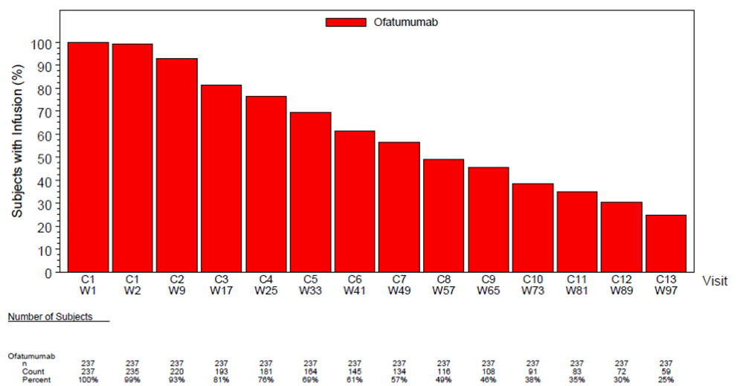
The median cumulative dose of OFA received by patients in the OFA maintenance arm during the course of the study was 7,300 mg (range: 300 to 13,300 mg), with the median duration of an infusion being 4.25 hours (range: 0.8 to 8.6 hours).
Over the duration of treatment, 2038 OFA infusions were administered to 237 patients and 22% (n=51) of these patients had a total of 77 infusion interruptions or stops. The following number of interruptions or stops were experienced by the following number of patients: 1 by 38 [16%] patients; 2 by 7 (3%) patients; 3 by 2 (<1%) patients; 4 by 2 (<1%) patients; 5 by 1 (<1%) patient; and 6 by 1 (<1%) patient. The primary reason for patients interrupting or stopping OFA infusions was adverse events (86% [44 of 51 patients]).

Adverse events

Overview of AEs reported during the treatment/observation phase
AEs were reported during the treatment/observation phase more frequently in patients in the OFA maintenance arm than in the Obs arm (87% vs 75%, respectively), while a similar proportion of patients in the two study arms had SAEs (33% vs 30%, respectively). AEs Grade ≥ 3 were reported in the treatment/observation phase more frequently in patients in the OFA maintenance arm than in the Obs arm (51% vs 36%, respectively). The overview is summarised below.

Table 21: OMB112517 – Overview of AEs and SAEs in the treatment/observation phase; safety population
Abbreviations: AE= adverse event; NA=not applicable; SAE=serious adverse event. a. One subject died after the data cut-off date and was not included in the count of fatal SAEs (Subject [information redacted]: cause of death T-cell lymphoma and liver failure).
The overview of AEs and SAEs reported in the protocol specified collection period from first treatment (OFA)/first visit (OBS) up to 60 days after the last treatment (OFA)/last visit up to Week 14 (Obs) is summarised below. The AE profile in the protocol specified collection period (Table 22) is similar to the AE profile in the treatment/observation collection period (Table 21). However, the number of SAEs in the protocol specified collection period is lower than the number of SAEs in the treatment/observation phase.

Table 22: OMB112517 – Overview AEs and SAEs reported up to 60 days after last treatment (OFA)/last visit up to week 14 (Obs); safety population
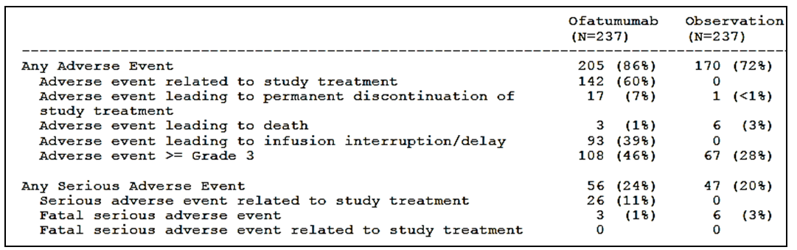

AEs irrespective of causality during the treatment/observation phase

Commonly reported AEs in the treatment/observation phase

AEs by system organ class (SOC)
AEs by SOC, irrespective of causality, reported during the treatment/observation phase in the two study arms are summarised. The most frequently occurring SOCs occurring in ≥ 30% of patients in either of the two study arms (OFA vs Obs) were: “infections and infestations” (65% vs 51%); “general disorders and administration site conditions” (32% vs 25%); “blood and lymphatic system disorders” (32% vs 19%); “respiratory, thoracic and mediastinal disorders” (32% vs 22%); and “gastrointestinal disorders” (30% vs 17%). A higher proportion of patients in the OFA maintenance arm had AEs in the majority of SOCs compared to the Obs arm.

AEs by preferred term
AEs irrespective of causality by preferred term reported in ≥ 1% of patients in the OFA maintenance arm during the treatment/observation phase are summarised. AEs reported in ≥ 10% of patients in either of the two study arms (OFA vs Obs, respectively) were: neutropenia (24% vs 10%); cough (21% vs 9%); upper respiratory tract infection (19% vs 10%); infusion-related reaction (16% vs 0%); pyrexia (16% vs 11%); diarrhoea (14% vs 4%); fatigue (11% vs 7%); pneumonia (11% vs 8%); and rash (10% vs 4%). Each of the AEs reported in ≥ 10% of patients in either of the two study arms occurred more frequently in the OFA maintenance arm than in the Obs arm.

Severity of AEs in the treatment/observation phase
AEs ≥ Grade 3, irrespective of causality, reported during the treatment/observation phase in ≥ 1% of patients in the OFA maintenance arm are summarised below. A higher proportion of patients in the OFA maintenance arm than in the Obs arm had AEs Grade ≥ 3 (51% vs 36%, respectively). The most commonly reported Grade ≥ 3 AE in the OFA maintenance arm was neutropenia, which occurred notably more frequently than in the Obs arm (22% vs 9%, respectively). Of the 51 patients in the ofatumumab maintenance arm with neutropenia ≥ Grade 3, 29 (i.e., 12% of total population) had a Grade 3 event, 22 (i.e., 9% of total population) had a Grade 4 event and none had a Grade 5 (fatal) event.

Table 23: OMB112517 – AEs with grade ≥ 3 severity reported in the treatment/observation phase for the two study arms in ≥ 1% of patients in the OFA maintenance arm; safety population
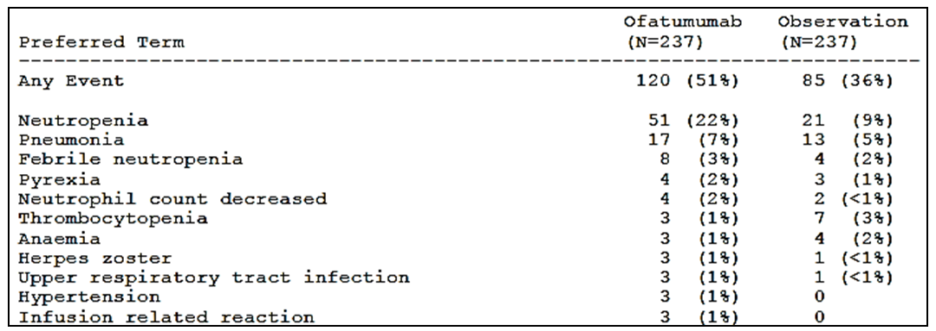
AEs with a maximum severity of 3, 4 or 5 reported in the treatment/observation phase are summarised below. Fatal AEs (Grade 5) were reported in 4% of patients in the OFA maintenance arm (including 1 patient who died after the data cut-off date) and 8% of patients in the Obs arm. None of the fatal AEs were considered treatment-related.

Table 24: OMB112517 – AEs with a maximum intensity of Grade 3 or higher reported during the study; safety population
 | Ofatumumab (n=237) |  |  | Observation (n=237)
 | Grade 3 | Grade 4 | Grade 5 | Grade 3 | Grade 4 | Grade 5
AEs, n (%) | 71 (30%) | 40 (17%) | 9 (4%) ª | 53 (22%) | 13 (5%) | 19 (8%)
Treatment related AEs, n (%) | 41 (17%) | 25 (11%) | 0 | NA | NA | NA
a. Subject [information redacted] died after the clinical study report (CSR) data cut-off date but was included in the count for Grade 5 events.

Treatment-related AEs in the treatment/observation phase
AEs by preferred term considered to be treatment-related reported in the treatment/observation phase in ≥ 1% of patients in the OFA maintenance arm are summarised in. Treatment-related AEs were adjudicated only for the OFA maintenance arm as no study drug-treatment was administered to patients in the Obs arm. AEs considered to be treatment-related were reported in 62% (n=147) of patients in the OFA maintenance arm. Treatment-related AEs reported in ≥ 5% of patients in the OFA maintenance arm were neutropenia (19% [n=44]), infusion related reactions (16% [n=39]) and upper respiratory tract infection (5% [n=13]).
In the treatment/observation phase, treatment-related AEs of Grade ≥ 3 severity were reported in 28% (n=66) of patients in the OFA maintenance arm, comprising Grade 3, 4, or 5 events in 17% (n=41), 11% (n=35) and 0% of patients, respectively. Treatment-related AEs Grade ≥ 3 in severity reported in ≥ 1% of patients in the OFA maintenance arm were neutropenia (17% [n=41]), pneumonia (3% [n=7]), febrile neutropenia (2% [n=4]), herpes zoster (1% [n=3]), and infusion related reactions (1% [n=3]).

Deaths and other serious adverse events (SAEs)

Deaths
Deaths reported during the study occurred in a similar proportion of patients in both study arms (OFA, 32 patients [14%]; Obs, 34 patients [14%]). Per protocol, not all deaths were required to be reported as SAEs (e.g., events due to the natural course of the disease under study were not reported as SAEs). Therefore, there were more deaths than fatal SAEs.

Table 25: OMB112517 – Deaths reported during the study; safety population
a. Other primary causes of death were: general deterioration, heart failure, multiorgan failure, pneumonitis, pneumonia/flu, respiratory insufficiency with pneumonia, right leg soft tissue infection, SAE possibly related to study medication (AE eCRF for Subject [information redacted] noted “SAE possibly related to study medication” however, per the SAE Report the subject had a fatal SAE of pulmonary sepsis 280 days after the last which was considered not related to treatment. This discrepancy was noted at the time of this interim analysis and is being further investigated), septic shock, septicaemia, small bowel obstruction, unrecovering condition following allogeneic transplantation, bilateral pneumonia, cardiac arrest, cardiac arrest due to pneumonia, complications from a fall and myelodysplastic syndrome/acute myeloid leukemia, disease under study and pulmonary infection, diffuse large B-cell lymphoma, dyspnoea and hypoxia, fever and gastric pain, heart failure due to heart muscle hypertrophy, immunosuppression and respiratory infection which caused ARDS, prostate cancer, Pseudomonas aeruginosa pneumonia, unspecified SAE not related to study medication, cerebrovascular accident and ventricular fibrillation, skin melanoma, small cell lung carcinoma, subdural hematoma in setting of supratherapeutic INR and sepsis, transformed disease: plasmablastic lymphoma, urothelial cell cancer of urinary bladder, worsening of general conditions and unknown cause. b. “On-treatment” for OFA was defined as the time from treatment initiation until the date of last dose +30 days. On treatment for Obs was defined as the time from randomisation until the date of entry into the follow-up period +30 days. c. Time to death for <60 days after last treatment is based on date of death. d. Data for “Fatal SAEs up to 60 days after last treatment/visit” is based on the SAE start date, not the date of death. e. One subject died after the CSR cut-off date and is not included in the count of fatal SAEs (Subject [information redacted]: cause of death was T-cell lymphoma and liver failure).
“On-treatment” for OFA maintenance was defined as the time from treatment initiation until the date of last dose +30 days, and “on-treatment” for Obs was defined as the time from randomisation until the date of entry into the follow-up period +30 days. No patient in the OFA maintenance arm died while “on-treatment”, while 3 (1%) patients in the Obs arm died while “on treatment”. The 3 deaths “on-treatment” in the Obs arm were cardiac arrest (1 patient), disease under study (1 patient), and 1 subdural haematoma in the setting of supratherapeutic INR and sepsis (1 patient).
There were 2 deaths (unrelated to treatment) in the OFA maintenance arm occurring within 60 days of the last dose: septicaemia 36 days after the last dose in 1 patient; and small bowel obstruction 54 days after the last dose in 1 patient. There were 5 deaths (unrelated) in the Obs arm occurring up to 60 days after the last visit: cardiac arrest (1 patient); complications from a fall and MDS/AML (1 patient); disease under study not reported as a SAE (1 patient); fever and gastric pain (1 patient); and subdural haematoma in setting of supratherapeutic INR and sepsis (1 patient).

SAEs reported in the treatment/observation phase

Fatal SAEs
Fatal SAEs occurring in the treatment/observation phase were reported in 3% (n=8) of patients in the OFA maintenance arm and 8% (n=19) of patients in the Obs arm. None of the fatal SAEs were considered to be treatment related. The fatal SAEs reported in the 8 patients in the OFA maintenance arm included 1 each for pneumonia, sepsis, cardiac failure, general physical health deterioration, pulmonary sepsis, septic shock, small intestinal obstruction, and soft tissue infection. There was also 1 death due to liver failure and T-cell lymphoma reported after the CSR cut-off date. The fatal SAEs reported in the 19 patients in the Obs arm included 3 x pneumonia, 2 x cardiac arrest, 2 x subdural haematoma, 1 x each for sepsis, respiratory tract infection, lung infection, pyrexia, dyspnoea, upper abdominal pain, general physical health deterioration, bladder cancer, brain oedema, cerebrovascular accident, diffuse large B-cell lymphoma, hypoxia, malignant melanoma, pseudomonal pneumonia, prostate cancer, small cell lung cancer, and ventricular fibrillation.

Other SAEs reported during the study
Approximately one-third of patients had SAEs during the study (OFA, 33% [n=28]; Obs, 30% [n=70]). In the OFA maintenance arm, 14% (n=33) of SAEs reported during the study were considered to be treatment-related.

Table 26: OMB112517 – SAEs occurring in ≥ 1% of patients in either of the two treatment arms in the treatment/observation phase; safety population

AEs leading to treatment discontinuation or dose interruptions

AEs leading to permanent treatment discontinuation
AEs leading to permanent treatment discontinuing were reported in 8% (n=20) of patients in the OFA maintenance arm and < 1% (n=1) of patients in the Obs arm. AEs leading to permanent treatment discontinuation and reported by more than 1 patient in the OFA maintenance arm were neutropenia (1% [n=3]), hypersensitivity (<1% [n=2]), and pneumonia (<1% [n=2]). The AE leading to permanent treatment discontinuation in the Obs arm was autoimmune haemolytic anaemia (<1% [n=1]).
Of the 20 patients in the OFA maintenance arm with an AE leading to permanent treatment discontinuation, 17 had treatment-related AEs and 13 had SAEs. There were 8 patients with AEs that were both serious and considered treatment-related: 1 x stress cardiomyopathy (28 days after last dose); 1 x unstable angina (2 days after last dose); neutropenia (22 days after last dose); 1 x hepatitis B virus reactivation and increased ALT (53 and 57 days after last dose); 1 x immune thrombocytopenic purpura (56 days after last dose); 1 x pneumocystitis jirovecii pneumonia (8 days after last dose); 1 x pneumonia (124 days after last dose); and 1 x pneumonia (30 days after last dose).

AEs leading to dose interruptions and/or delays
AEs leading to dose interruptions/delays in ≥ 2 patients in the OFA maintenance arm are summarised. AEs leading to dose interruptions and/or delays were reported in 40% (n=95) of patients in the OFA maintenance arm. AEs reported in ≥ 1% of patients in the OFA maintenance arm were: infusion-related reactions (15%); neutropenia (8%); bronchitis (2%); pyrexia (2%); herpes zoster (2%); pneumonia (2%); hypersensitivity (1%); influenza (1%); pharyngitis (1%); and upper respiratory tract infection (1%). Although OFA dose reductions were not allowed, it was reported that 3 subjects had AEs leading to dose reductions (1 x infusion related reaction, 1 x hypersensitivity, 1 x pruritus). However, the sponsor comments that, although dose reductions were noted, the patients received their planned dosage on the day of the reported event and continued to receive their planned dose at subsequent cycles. No AEs leading to dose interruptions and/or delays were reported in the Obs arm as no study drug treatment was administered to patients in this arm.

Other significant adverse events

Secondary malignancies
Secondary malignancies were reported during treatment/observation phase more frequently in the OFA maintenance arm than in the Obs arm (12% [n=29] vs 7% [n=17]), due primarily to an increase in benign and malignant skin-related lesions.

Table 27: OMB112517 – AEs for neoplasms occurring in 2 or more patients during the study; safety population
a. AE terms are MedDRA preferred terms based on verbatim text from the AE eCRF.
The proportion of patients with neoplasms reported as SAEs was similar in the 2 study arms: OFA, 6% [n=15]; Obs, 4% [n=10]). None of the neoplasms reported in the OFA maintenance arm were fatal, but 5 neoplasms in the Obs arm were reported as fatal (single cases of bladder cancer, diffuse large B-cell lymphoma, malignant melanoma, prostate cancer and small cell lung cancer). Secondary neoplasms (SAEs) are summarised.

Liver events
Per protocol, stopping criteria relating to liver function chemistry abnormalities were defined for patients in both study arms as meeting one or more of the following conditions while on treatment:
- Hy’s Law criteria of alanine aminotransferase (ALT) > 3 x upper limit of normal (ULN), and bilirubin ≥ 2 x ULN (> 35% direct bilirubin; bilirubin fractionation required);
- ALT > 8 x ULN; or
- ALT ≥ 5 x ULN for more than 2 weeks. Two patients in the OFA maintenance arm had liver chemistry elevations during the study meeting the stopping criteria, including 1 patient with ALT > 8 x ULN and 1 patient with ALT > 3 x ULN and bilirubin ≥ 2 x ULN (i.e., Hy’s Law).
The 1 patient with Hy’s Law criteria was 66 years old, and the abnormalities occurred 64 days after the last dose of OFA, and were considered to be unrelated to treatment with OFA. The subject had elevated liver enzymes of ALT=849 U/L, AST=742 U/L and bilirubin=64 μmol/L. Investigations revealed gallstones and the subject subsequently underwent a cholecystectomy. The events were noted as ongoing at the time of the data cut-off. The abnormalities can be explained by hepatobiliary disease unrelated to treatment with OFA rather than by drug induced liver injury.
The patient with ALT > 8 x ULN was 77 years old, and the event occurred approximately 18 months after initiating treatment with OFA and approximately 50 days after the last dose of OFA. The event was considered possibly related to OFA treatment. The patient had elevated liver enzymes of ALT=605 U/L (reported as SAE), AST=264 U/L, and bilirubin=20 μmol/L. The elevated enzymes were in the setting of hepatitis B virus reactivation, which was treated with lamivudine. Diagnostic imaging tests of the liver or hepatobiliary system were not performed, and no liver biopsies were performed. OFA was discontinued. The event remained ongoing (approximately 4 months duration) at the time of data cut-off.

Adverse events of special interest

Introduction
The sponsor commented that specific AEs of special interest were expected in patients with CLL due to the disease and CLL treatments (including anti-CD20 monoclonal antibodies such as OFA). The AEs of special interest were cytopenias including autoimmune haematologic complications, infusion reactions, infections, mucocutaneous reactions, tumour lysis syndrome, cardiovascular events, and small bowel/intestinal obstruction. Progressive multifocal leukoencephalopathy (PML) and hepatitis B virus infection and re-activation of hepatitis B were also included as events of clinical significance. The data reviewed below relate to events reported during the study and follows the approach adopted in the text of the CSR.

Cytopenias

Overview
Haematology assessments were performed prior to each visit. Due to the variability in reporting of AEs across regions for neutropenia, anemia, and thrombocytopenia, haematologic AEs were analysed by a comprehensive defined set of preferred terms relating to decreased blood counts.

AEs associated with decreased neutrophil count
The proportion of patients with a decreased neutrophil count in the treatment/observation phase was higher in the OFA maintenance arm than in the Obs arm (28% [n=67] vs 12% [n=29], respectively). Neutropenia was reported more frequently in the OFA maintenance arm than in the Obs arm (24% vs 10%, respectively), with febrile neutropenia being reported in 5% of patients in the OFA maintenance arm and 2% of patients in the Obs arm, and neutropenic sepsis being reported in 0% and <1% of patients, respectively, in the two arms. SAEs associated with decreased neutrophil count were reported in a similar proportion of patients in the two arms (OFA, 5%; Obs, 3%). AEs associated with decreased neutrophil count are summarised below in Table 28, and AEs associated with decreased neutrophil counts up to 60 days after last treatment/last visit are summarised.

Table 28: OMB112517 – Adverse events associated with decreased neutrophil count; safety population
a. Counts may not equal total as subjects may have had multiple AEs.
The proportion of patients with Grade ≥ 3 neutropenia was higher in the OFA maintenance arm (24%) than in the Obs arm (11%). The majority of AEs associated with decreased neutrophil counts were Grade 3 or 4 events. None of the AEs associated with decreased neutrophil count resulted in a fatal outcome. AEs associated with decreased haemoglobin levels up to 60 days after last treatment/last visit are summarised.

Table 29: OMB112517 – Grade ≥ 3 adverse events associated with decreased neutrophil counts
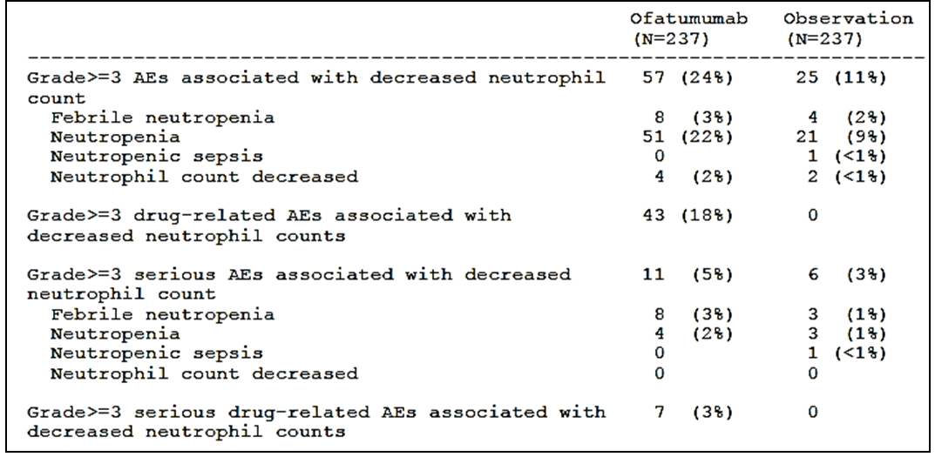

Table 30: OMB112517 – Adverse events associated with decreased neutrophil count by maximum toxicity and preferred term; safety population
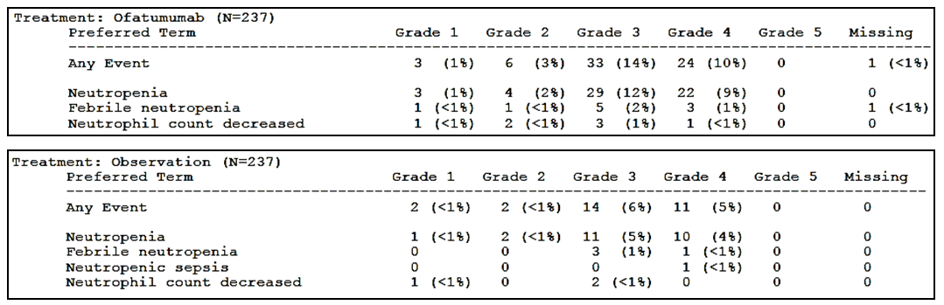

AEs associated with decreased haemoglobin levels
The proportion of patients with decreased haemoglobin level AEs and SAEs in the treatment/observation phase was similar in both arms. None of the AEs associated with decreased haemoglobin levels were treatment-related or resulted in a fatal outcome. AEs associated with decreased haemoglobin level by maximum Grade are summarised below.

Table 31: OMB112517 – Adverse events associated with decreased haemoglobin levels; safety population
a. Counts may not equal total as subjects may have had multiple AEs.

Table 32: OMB112517 – Adverse events associated with decreased haemoglobin levels by maximum Grade and preferred term; safety population
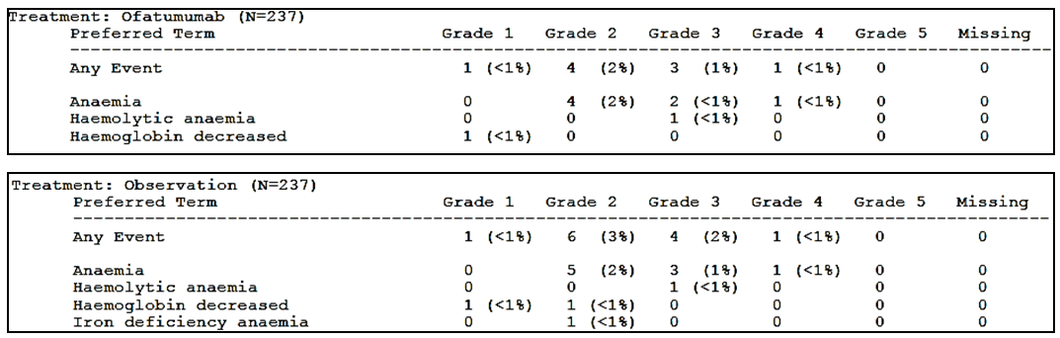

AEs associated with decreased platelet counts
The proportion of patients with decreased platelet count AEs and SAEs in the treatment/observation phase was similar in both arms. None of the AEs associated with decreased platelet count resulted in a fatal outcome.

Table 33: OMB112517 – Adverse events associated with decreased platelet counts; safety population
a. Counts may not equal total as subjects may have had multiple AEs.
AEs associated with decreased platelet counts by maximum toxicity are summarised below.

Table 34: OMB112517 – Adverse events associated with decreased platelet counts by maximum Grade and preferred term; safety population
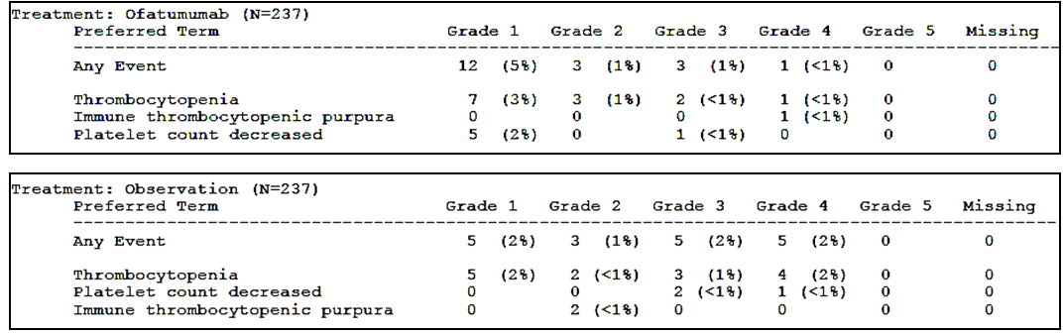

Other cytopenias
The results for other cytopenias in the treatment/observation phase are summarised below. The results showed no clinically meaningful difference between the two study arms. AEs of Grade ≥ 3 severity associated with other cytopenias are summarised below. AEs associated with other cytopenias and other cytopenias Grade ≥ 3 up to 60 days after last treatment/visit are summarised.
Table 35: OMB112517 – Adverse events associated with other cytopenias; safety population
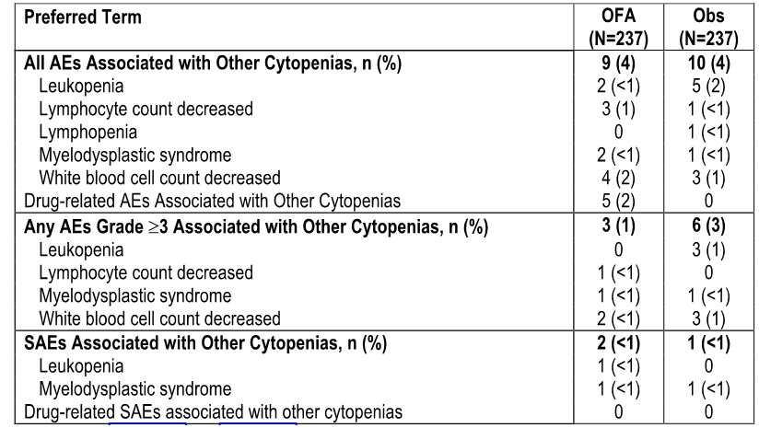

Table 36: OMB112517 – Grade ≥ 3 adverse events associated with other cytopenias
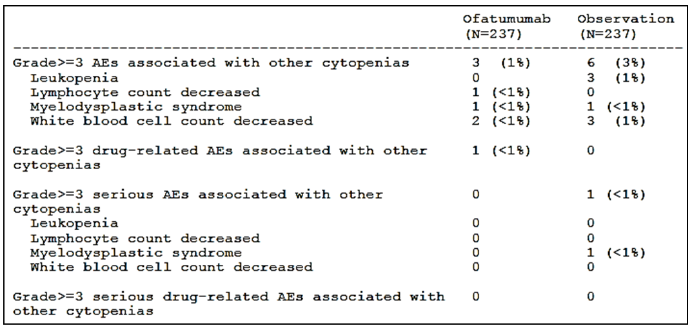

Autoimmune haematologic complications
Overall, 5 patients experienced autoimmune haematologic complications in the treatment/observation phase, including 1 (<1%) patient in the OFA maintenance arm (1 event of haemolytic anaemia) and 4 (2%) patients in the Obs arm (4 [2%] events described as autoimmune haemolytic anaemia [AIHA] and 1 event described as haemolytic anaemia). One patient in the OFA maintenance arm had a Grade 3 AE of haemolytic anaemia occurring 214 days after the last dose of OFA (resolving after 13 days) and considered by the investigator to be not treatment-related.
Autoimmune haematologic complications up to 60 days after the last treatment/visit were reported in 4 patients in the Obs arm (vs no patients in the OFA maintenance arm), including 4 events described as AIHA and 1 event of haemolytic anaemia. Serious autoimmune haematologic complications (AIHA) up to 60 days after the last treatment/visit were reported in 2 patients in the Obs arm (vs no patients in the OFA maintenance arm. There were no fatal autoimmune haematologic complications in either of the two study arms.

Infusion reactions
Infusion reactions included pre-defined events relating to an infusion starting after the beginning of the infusion and occurring within 24 hours following the end of an infusion, and resulting in a temporary interruption or prolongation of infusion time or treatment withdrawal. Preferred terms meeting the pre-defined criteria for infusion-reactions were selected by the sponsor based on clinical review of the AE database and known class effects.
In the OFA maintenance arm, premedication with steroids was administered to all patients at the initial OFA infusion and to 87% of patients at Week 97. However, infusion-reactions occurred in 46% of patients in the OFA maintenance arm and included 1 serious infusion-reaction (considered by the investigator to be unrelated to treatment). There were 2 patients with infusion-related AEs leading to permanent discontinuation of study treatment. Infusion-reactions in the OFA maintenance arm are summarised below.

Table 37: OMB112517 – Infusion-related adverse events in the OFA maintenance arm; safety population
a. Infusion reactions included pre-defined events relating to an infusion, which started after the beginning of the infusion and within 24 hours following the end of an infusion.
Twenty-five percent of patients had infusion-reactions on the first day of infusion, with 2% of patients experiencing Grade ≥ 3 AEs. In subsequent cycles, the incidence of patients with infusion-reactions was reduced (approximately 2% to 10%) compared to Cycle 1, and the proportion of patients with Grade ≥ 3 infusion-reactions in any cycle (after Cycle 1) was low (see below).
Figure 15: OMB112517 – Percentage of patients receiving OFA infusions during the course of treatment and the percentage of patients having infusion-related reactions (IRRs)
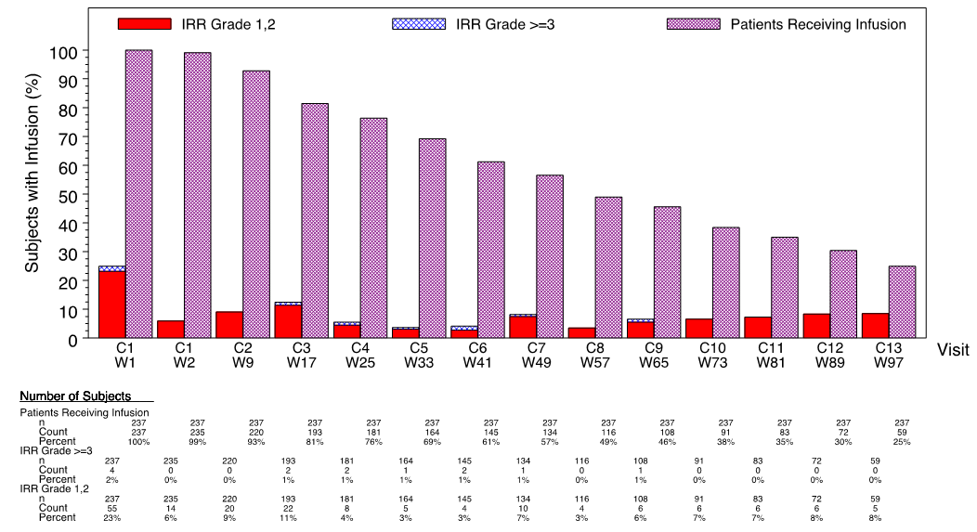
The most commonly reported infusion-reactions reported in ≥ 5% of patients were infusion-related infusion-reaction (16%) and cough (11%). One patient had a non-fatal, non-treatment-related SAE infusion-related reaction (fever/pyrexia of Grade 3 severity on the day after the first infusion).

Table 38: OMB112517 – Infusion-related AEs in ≥ 2% of subjects in the OFA arm; safety population
a. Infusion reactions included pre-defined events relating to an infusion starting after the beginning of the infusion and occurring within 24 hours following the end of an infusion; b. Infusion-related reaction was reported as the verbatim term with or without associated symptoms.

Infections
The proportion of patients with infections reported as AEs in the treatment/observation phase was higher in the OFA maintenance arm (65%) than in the Obs arm (51%), while Grade ≥ 3 AEs occurred in a similar proportion of patients in the two study arms (OFA, 20%; Obs, 16%), as did serious infections (OFA, 20%; Obs, 18%). Infections leading to permanent treatment discontinuation in the OFA maintenance arm were reported in 14% of patients (compared to no patients in the Obs arm), and infections leading to interruption/delay of infusions were reported in 14% of patients in the OFA maintenance arm (compared to no patients in the Obs arm). Fatal serious infections were reported in 2% of patients in the OFA maintenance arm and 3% of patients in the Obs arm. The results for infections reported as AEs are summarised below.

Table 39: OMB112517 – Infections reported as adverse events; safety population
Infections reported as AEs are summarised below. The most commonly reported infections were “other”, and these infections were reported more frequently in the OFA maintenance arm than in the Obs arm (39% vs 25%, respectively). “Other infections” comprised a variety of infections including, but not limited to, influenza, cellulitis, herpes zoster, herpes simplex, and urinary tract infections. Upper respiratory tract infections were reported more frequently in the OFA arm than in the Obs arm (38% vs 24%, respectively), as were lower respiratory tract infections (26% vs 21%, respectively).

Table 40: OMB112517 – Infections ª reported as AEs; safety population
a. Modified Preferred Terms are presented in this table (i.e., multiple terms comprise the term “upper respiratory tract infection” including, but not limited to, laryngitis, pharyngitis, rhinopharyngitis, sinusitis, tracheitis, common cold, cough/sore throat, ear, nose and throat infection, and head cold); b. “Other infections” comprised a variety of infections including, but not limited to, influenza, cellulitis, herpes zoster, herpes simplex, and urinary tract infections.
Serious infections occurring in the two study arms and reported as SAEs are summarised below. The proportion of patients with infections reported as SAEs during the study was similar in the two arms (OFA, 20%; Obs, 18%). The most commonly reported SAE infections were lower respiratory tract infections (OFA, 10%; Obs, 9%) and “other” infections (OFA, 8%; Obs, 7%). Of the 8 patients in the OFA maintenance arm with opportunistic infections, all events occurred on OFA maintenance treatment and prior to initiating a new therapy. Of the 7 patients in the Obs arm who had serious opportunistic infections, 2 patients had infections during the observation phase and the remaining 5 patients developed an infection after beginning active treatment for CLL. There were 21 (9%) patients with serious infections (SAEs) considered to be treatment-related. There were no cases of PML reported in the study. There was 1 case of hepatitis B re-activation reported in 1 patient in the OFA maintenance arm.

Table 41: OMB112517 – Serious infections reported as AEs; safety population
An overview of infections reported as AEs infections by type and infections by Grade ≥ 3 AE up to 60 days after the last treatment/visit are summarised.

Mucocutaneous reactions
Mucocutaneous reactions included a broadly defined set of events relating to or affecting mucous membranes and skin, many of which overlapped with infusion-reactions. A higher proportion of patients in the OFA maintenance arm than in the Obs arm had mucocutaneous reactions in the treatment/observation phase (29% vs 15%, respectively). Of the 68 patients in the OFA maintenance arm with a mucocutaneous reaction, 12 had events that were also classified as infusion-related reactions (i.e., 5% of 237 patients in the safety population). These overlapping events were pruritus (5 patients, 2%), rash (4 patients, 2%), erythema (2 patients, <1%), eye pruritus (1 patients, <1%), and urticaria (1 patient, <1%).

Table 42: OMB112517 – Mucocutaneous reactions reported as adverse events; safety population
The most commonly occurring mucocutaneous reactions (AEs) reported in the treatment/observation phase in ≥ 2% of patients in either of the two study arms (OFA vs Obs) were: rash (10% vs 4%); pruritus (9% vs 3%); mouth ulceration (2% vs 0%); erythema (2% vs <1%); skin lesion (2% vs <1%); cellulitis (2% vs <1%); gingivitis (2% vs <1%); urticaria (1% vs 2%); and conjunctivitis (<1% vs 2%). No cases of Stevens-Johnson Syndrome (SJS) or toxic epidermal necrolysis (TEN) were reported in either of the two study arms. One patient in the OFA maintenance arm had a treatment-related mucocutaneous reaction resulting in permanent treatment discontinuation (i.e., non-serious Grade 2 allergic dermatitis in a 59 year old patient reported 63 days after the last dose). All mucocutaneous reactions are summarised.
There were 5 patients with serious mucocutaneous reactions in the treatment/observation phase (OFA, n=2; Obs, n=3). The SAEs in the 2 patients in the OFA maintenance arm were one each of cellulitis and stomatitis, and the SAEs in the 3 patients in the Obs arm were one each of cellulitis, blister, and erythema multiforme.

Tumour lysis syndrome
There were no cases of tumour lysis syndrome in either of the two study arms.

Cardiovascular events
Cardiac AEs in the treatment/observation phase were reported in 6% of patients in both the OFA maintenance arm and the Obs arm, while cardiac SAEs occurring during the study were reported in 3% of patients in both study arms (see below).

Table 43: OMB112517 – Cardiovascular events; safety population
There were three fatal cardiac SAEs, 1 in the OFA maintenance arm considered by the investigator to be unrelated to treatment and 3 in the Obs arm. The patient in the OFA maintenance arm was aged 79 years and death was due to heart failure reported 316 days after the last OFA dose. Relevant medical history included diabetes mellitus, cerebrovascular accident, pulmonary hypertension, atrial septal defect, left atrial dilatation, hypertension, venous thrombosis, and venous insufficiency. The 3 patients in the Obs group with fatal cardiovascular events included: 1 patient aged 66 years with a medical history of hypertension who died due to cardiac arrest 884 days after the first visit (1 day after hospitalisation for pneumonia); 1 patient aged 66 with a cardiac arrest 206 days after the first visit; and 1 patient with a cerebrovascular accident 89 days after the first visit.
Cardiac disorders reported as AEs during the study are summarised. AEs reported in ≥ 2 patients in either of the two study arms (OFA vs Obs, respectively) were: atrial fibrillation (n=3, 1% vs n=3, 1%); angina pectoris (n=2, <1% vs n=1, <1%); cardiac failure (n=2, <1% vs n=1, <1%); palpitations (n=2, <1% vs n=2, <1%); and cardiac arrest (0% vs 2, <1%). Cardiac disorders reported as SAEs in the treatment/observation phase are summarised. SAEs reported in ≥ 2 patients in either of the two study arms (OFA vs Obs, respectively) were: cardiac failure (n=2, <1% vs 0%); atrial fibrillation (n=1, <1% vs n=2, <1%); and cardiac arrest (0% vs n=2, <1%).

Small bowel obstruction
Small bowel obstruction was reported in the treatment/observation phase in 1 (<1%) patient in the OFA maintenance arm and 2 (<1%) patients in the Obs arm, and the events in all 3 patients were categorised as SAEs. One 76 year old patient in the OFA maintenance arm had a fatal SAE (small bowel obstruction) that occurred 54 days after the last dose and was classified as not related to treatment.

Laboratory tests

Haematology

Neutrophils
Median neutrophil counts at baseline were similar in the two arms. After study entry, neutrophil counts increased but remained closer to the baseline values for subjects in the OFA maintenance arm compared to the Obs arm. While neutrophil counts increased above baseline values to higher levels in the Obs arm compared to the OFA maintenance, the levels remained within the normal range.
Figure 16: OMB112517 – Median neutrophil counts over time
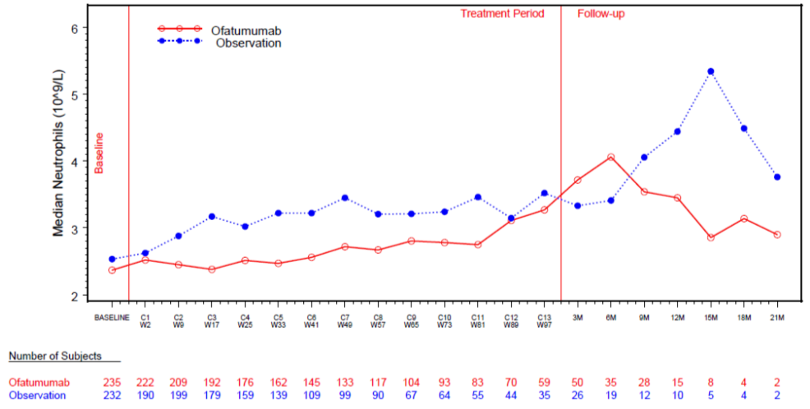
Prolonged severe neutropenia (≥ 1 week) has been reported with OFA treatment. In study OMB112517, this event was analysed using the pre-specified definition of “Grade 3 or 4 neutropenia that occurred during the treatment period and was not resolved at least 42 days post the last dosing date”. Prolonged severe neutropenia occurred in 5% (n=13) of patients in the OFA maintenance arm and 2% (n=5) of patients in the Obs arm. The median time to prolonged neutropenia was 173 days (range: 8 to 610 days) in the OFA maintenance arm and 157 days (range: 13 to 393 days) in the Obs arm. One patient in the OFA maintenance arm had prolonged neutropenia and febrile neutropenia. The AE of febrile neutropenia resulted in hospitalisation, and was considered to be unrelated to treatment. Febrile neutropenia resolved and the patient continued treatment with OFA. None of the patients in the Obs arm with prolonged neutropenia had febrile neutropenia. No patients with prolonged neutropenia in either study arm had neutropenic sepsis. Patients with prolonged neutropenia and any AE associated with infection occurring during the study are summarised.
Late onset neutropenia has been reported with OFA treatment. In study OMB112517, this event was analysed using the pre-specified definition of “Grade 3 or 4 neutropenia starting at least 42 days after the last treatment dose”. Late-onset neutropenia occurred in < 1% of patients in both study arms (OFA, 2 patients; Obs, 1 patient). The median time to first late-onset neutropenia was 60 days (range: 57 to 63 days) in the OFA maintenance arm, while in the 1 patient in the Obs arm the time to first late-onset neutropenia was 158 days. No AEs associated with infection, including febrile neutropenia or neutropenic sepsis, occurred after the start of late-onset neutropenia in either arm.

Haemoglobin
Median hemoglobin levels (described as counts in the CSR) were similar in the two arms at baseline and over the duration of the study. Median levels were within normal limits.
Figure 17: OMB112517 Median haemoglobin counts over time; safety population
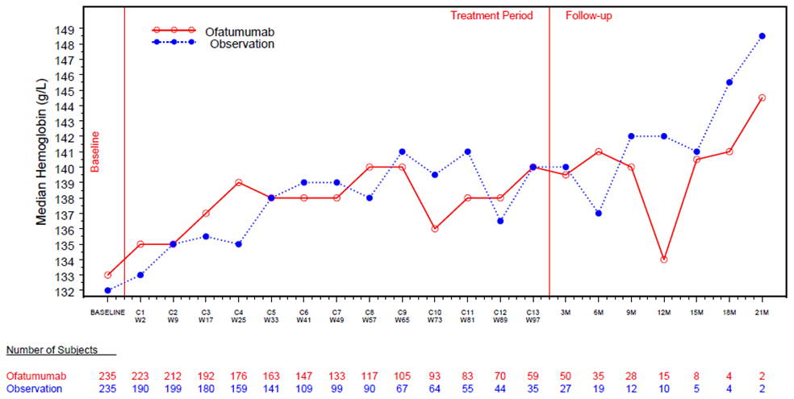

Platelets
Median platelet counts were similar between the two arms at baseline and over the duration of the study (see below).

Figure 18: OMB112517 – Median platelet counts over time
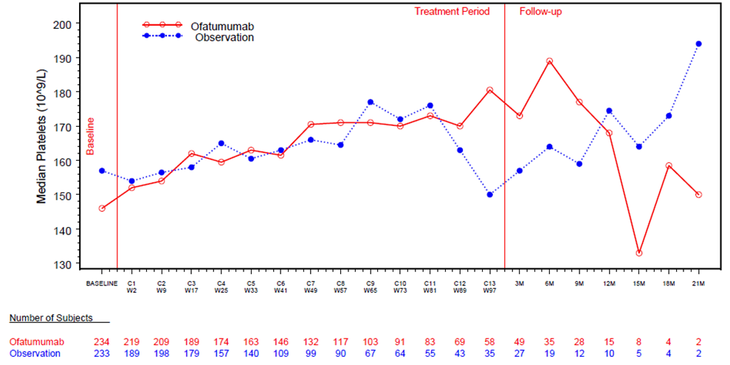

Clinical chemistry

Liver function
Liver function tests were assessed at baseline, over the course of therapy, and in the follow-up phase. The majority of patients in both study arms had similar grades of liver function tests at baseline as well as worst grades on study. Two patients (<1%) in the OFA maintenance arm had a worst AE grade of 3 for liver chemistry parameters (ALT, AST and bilirubin), including 1 with an SAE of hepatitis B virus re-activation and 1 with gallstones. One patient (<1%) in the Obs maintenance arm had a worst AE grade of 3 for bilirubin.

Renal function
Patients in both study arms had similar baseline serum creatinine levels. There was no difference in the worst grade creatinine during the study between the two study arms. No patients in either of the two study arms had worst grade serum creatinine levels rated as ≥ Grade 3 AEs.

Other clinical chemistry
The results for serum albumin, calcium, glucose, potassium and sodium levels are summarised. Patients in both study arms had similar grades of electrolytes at baseline as well as worst grades on study. Patients in both arms had similar worst grade high serum glucose levels, which were predominantly Grade 1 and 2 AEs.

Immunoglobulins
Median immunoglobulin levels at time points with a sufficiently representative number of patients are summarised below. Median baseline levels were below the reference range for IgM in both study arms, and for IgA in the OFA maintenance arm. Median serum levels of IgA remained below the reference range for the OFA maintenance arm. Median values for most other time points, including follow-up, were within the reference range.

Table 44: OMB112517 – IgG, IgA and IgM over time; safety population
Abbreviations: FU=follow-up. Reference Ranges: IgA = 0.70, 4.00 g/L; IgM=0.40, 2.30 g/L; IgG= 5.65, 17.65 g/L

Immunogenicity
At baseline (Cycle 1, Week 1), 228 of the 237 patients (96%) in the safety population had human anti-human antibody (HAHA) data pre-OFA treatment, and 225 of these 228 patients (98.7%) were negative for HAHA. The sponsor states that, overall, 221 patients can be considered to be conclusively HAHA negative at baseline (OFA concentration < 200 μg/mL), based on availability of OFA concentration results at the time of data cut-off. One patient (information redacted) was confirmed positive at baseline (titre = 32), while samples at all other time points for this patient were negative.
At the time of data cut-off, post-ofatumumab HAHA data were available for 205 of 237 (86%) patients. In the 205 patients with post-ofatumumab results, 185 (90%) had negative post-ofatumumab HAHA results with at least one ofatumumab plasma concentration low enough for the negative HAHA results to be considered conclusive (< 200 µg/mL), and 1 (information redacted) tested positive for HAHA after ofatumumab administration. This patient (information redacted) tested HAHA positive at the 6-month follow-up visit (titre = 16), while samples at all other time-points were negative. Patient [information redacted] had received prior treatment with ofatumumab, and it is not known whether prior exposure to ofatumumab may have increased the immunogenicity risk for this patient.
The positive HAHA results in patients [information redacted] had no observed impact on the safety profile, pharmacokinetics, or pharmacodynamics of ofatumumab. The HAHA are summarised below.

Table 45: OMB1124517 – Human anti-human antibodies (HAHA); safety population
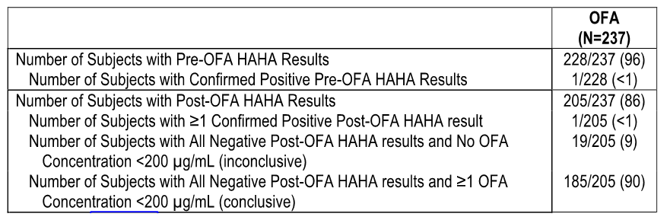

Other safety evaluations

Vital signs
Vital signs (systolic and diastolic blood pressure, pulse, temperature) varied throughout the study both within the study arms and between the study arms, but showed no apparent trends or patterns in change from baseline. Most patients had unchanged post-baseline vital signs at the majority of assessments. The results for worst case increases from baseline in systolic and diastolic blood pressure in the two arms are summarised. Hypertension as an AE up to 60 days after last treatment was reported in 10 (4%) patients in the OFA maintenance arm, and 5 (2%) patients in the Obs arm, while essential hypertension was reported in 1 (<1%) patient and no patients, respectively. Worst-case shifts from baseline in heart rate are summarised.

Electrocardiograph
At screening, of the patients in the two treatment arms with ECG data normal readings were reported in 63% (149/236) of patients in the OFA maintenance arm and 65% (149/230) of patients in the Obs arm, clinical significant abnormalities in 0% (0/236) and 3% (6/230) of patients, respectively, and clinically non-significant abnormalities in 37% (87/236) and 33% (75/230) of patients, respectively. There were no data relating to ECG changes in the two arms over the course of the study.

ECOG performance status
Most patients had an ECOG performance status of 0 at baseline and baseline ECOG scores were balanced between the arms: OFA arm vs Obs arm, respectively, 0 score (71% vs 71%), 1 score (27% vs 27%), 2 score (2% vs 2%), 3 to 5 scores (0% vs 0%). The majority of patients had an ECOG performance status of 0 or 1 at baseline and did not shift during the study: no change (72%, OFA; 71% Obs); deteriorated (27%, both arms) or improved (1%, OFA; 2%, Obs).

Organ examinations
Most patients had normal liver and spleen assessments at screening and throughout the study. One subject in each arm had an AE of splenomegaly (both Grade 1). The low proportion of subjects who had an enlarged liver or spleen at screening further declined in both arms starting at Cycle 2 and continued throughout the remainder of the study, including follow-up.
The percentage of patients with enlarged liver size at screening was 6% (15/233) in the OFA maintenance arm and 3% (7/235) in the Obs arm, and at Cycle 13/Week 97 normal liver size was reported in 100% of patients in both treatment arms (n=47, OFA; n=30, Obs). The percentage of patients with enlarged spleen size at screening was 6% (14/232) in the OFA maintenance arm and 6% (14/233) in the Obs arm, and at Cycle 13/Week 97 unequivocal progression in spleen sized was reported in no (0/47) patients in the OFA arm and 1 (1/30) patient in the Obs arm.

Pregnancy
There were no pregnancies reported in the study.

Safety in special groups

Age
Overall, the incidence of AEs in younger patients (<65 years) was higher in the OFA maintenance arm than in the Obs arm (88% [106/120] vs 68% [80/117], respectively), while the incidence of AEs was similar in older patients (≥ 65 years) in the two arms (OFA, 85% [100/117]; Obs, 81% [97/120]). In the OFA arm, the following commonly occurring AEs reported in ≥ 10% of patients occurred in ≥ 5% more younger patients (<65 years) compared to older patients (aged ≥ 65 years): upper respiratory tract infection (25% vs 13%); pyrexia (22% vs 10%); headache (13% vs 6%); and sinusitis (11% vs 5%). Infusion-reactions (verbatim term) was reported notably more frequently in older patients than in younger patients in the OFA maintenance arm (19% vs 14%, respectively). Neutropenia was reported in a similar proportion of patients in younger and older patients in the OFA maintenance arm. AEs reported in at least 10% of patients by age are summarised.

Gender
Overall, the incidence of AEs by gender was similar in the OFA maintenance arm (males, 85% [136/18]; females, 91% [70/77]), and in the Obs arm (males, 74% [119/160]; females, 75% [58/77]). In the OFA maintenance arm, neutropenia was reported more frequently in females than in males (31% vs 21%, respectively), while in the Obs arm neutropenia was reported more frequently in males than in females (12% vs 6%, respectively). The incidence of neutropenia in females was approximately 5-fold higher in the OFA maintenance arm than in the Obs arm, while the incidence in males was approximately 2-fold higher in the Obs arm than in the OFA maintenance arm. Overall, in the OFA arm females reported a greater incidence (≥ 5% difference compared to males) of neutropenia, bronchitis, arthralgia, and sinusitis. Conversely, a higher proportion of males in the OFA arm reported pruritus compared to females.

Race
The patients in the pivotal study were predominantly White (96% [n=453]). Consequently, no meaningful comparisons of AEs can be made across the different racial groups.

Body weight
Based on median body weight at screening (80 kg [range: 42 to 196 kg]), the AE profiles in the OFA maintenance arm and the Obs arm were similar. In the OFA maintenance arm, the proportion of patients with body weight less than the median weight of 80 kg with AEs or SAEs was 87% (103/118) and 32% (38/118), respectively, compared to 86% (99/115) and 31% (36/115) of patients with body weight greater or equal to the median weight of 80 kg. In the Obs arm, the proportion of patients with body weight less than the median weight of 80 kg with AEs or SAEs was 78% (90/115) and 37% (43/115), respectively, compared to 71% (84/119) and 23% (27/119) of patients with body weight greater or equal to the median weight of 80 kg.

Treatment response at entry
AEs in patients with CR or PR at study entry were similar, and safety results in both subgroups were consistent with the overall safety population.

Prior therapies
AE profiles by subgroups defined by the type of prior treatment were similar for patients who received “chemoimmunotherapy” or “other prior treatment” compared to the overall safety population. Patients who received “only alkylating monotherapy” had a higher number of AEs in the OFA maintenance arm (100% [14/14]) compared to the overall safety population, but the number of patients who had received this prior therapy was small (i.e., OFA, n=14; Obs, n=9). Similar to the overall safety population, neutropenia was the most commonly reported AE in patients treated with prior “chemoimmunotherapy” (29% [55/190]) or “other prior treatment” (30% [10/33]). However, for patients treated with “only alkylating monotherapy”, the most common AE was infusion-related reaction (64% [9/14]). Of note, the most frequent type of prior therapy received by most patients was “chemoimmunotherapy” (OFA, n=190; Obs, n=190), with much smaller patient numbers in the “only alkylating” (OFA, n=14; Obs, n=9) and “other prior treatment” groups (OFA, n=33; Obs, n=38). Therefore, due to the small patient number of patients treated with “only alkylating” or “other prior treatment” therapies the safety data in these two subgroups should be interpreted cautiously. An overview of key safety AEs by type of most recent prior treatment is presented.
The safety profile of OFA was similar in subgroups based on the number of prior induction therapies received (i.e., 2 or 3 previous induction therapies). AEs in each of these subgroups were also consistent with the overall safety population.

Renal or Hepatic impairment
No safety analyses have been undertaken in patients with renal or hepatic impairment.

Patients with bulky fludarabine-refractory CLL – study OMB114242

Overview of safety data
In study OMB114242, the safety data were summarised using three separate datasets:
- OFA (n=78) vs PC (n=43): This dataset compared safety in the two main treatment arms. The OFA arm included safety data from the time of the first dose following first randomisation, and included safety data after the second randomisation in OFA treated patients who were randomised to either the OFA extended arm or observation arm. The PC arm included safety data reported in patients occurring prior to OFA salvage therapy, and excluded safety data occurring in the OFA salvage arm. As discussed below, the median duration of observation for the safety population in the OFA arm was approximately 2.4-fold longer than for the safety population in the PC arm (i.e., 362 vs 149 days, respectively). In this CER, the focus of the safety evaluation is on the OFA (n=78) vs PC (n=43) data set.
- OFA extended (n=24) vs Observation (n=13): The safety results in this dataset were from the first randomisation, that is, from the start of the initial 24 weeks of OFA treatment rather than from the start of OFA extended treatment or observation. Overall, there were no unexpected safety findings during extended OFA treatment in the 24 patients from the initial OFA arm who underwent the second randomisation and received up to 24 additional weeks of OFA treatment. However, the sponsor comments that comparisons between the OFA extended and observation arms should be regarded with caution due to the small number of subjects in both treatment arms. Separate evaluation of the safety findings from the OFA extended arm vs observation dataset has not been undertaken in this CER. However, it should be noted that safety data from the total number of patients in this dataset (n=37) were included in the OFA arm (n=78) described in the above paragraph.
- OFA salvage arm (n=22): The OFA salvage dataset included safety data for the 22 subjects randomised to PC treatment who started OFA salvage therapy after disease progression. The safety data in the OFA salvage arm were reported starting from the first dose of OFA salvage therapy. The safety findings from the OFA salvage arm (n=22) have not been separately evaluated in this CER. However, perusal of the data identified no unexpected safety findings during OFA salvage treatment.

Exposure
Overall, 78 of the 79 patients in the OFA arm and all 43 patients in the PC arm received at least 1 dose of study treatment. The median initial OFA dose was 300 mg (mean dose 296.5 mg, due to infusion reactions after 30 mg OFA in one patient). The median OFA dose for all subsequent cycles was 2000 mg (mean dose reduced to 1977 mg in Cycle 5, due to AEs of bronchospasm and allergic rhinitis in one patient after receiving 854 mg OFA).
An OFA treatment cycle was defined as 4 weeks, irrespective of the number of OFA doses during the 4-week cycle, while a PC treatment cycle was variable and was defined according to the different treatment schedules. Patients in the OFA arm (n=78) received a median of 6 treatment cycles (12 infusions) in the initial treatment phase, and patients randomised to the OFA extended arm (n=24) in the subsequent treatment phase received a median of 12 cycles (18 infusions). The median duration of OFA infusions was 4.7 hours for the initial dose, and 4.1 hours for all subsequent doses. Patients in the PC arm (n=43) received a median of 3 cycles in the treatment phase. Exposure by study treatment is summarised below.

Table 46: OMB114242 – Exposure to study treatment
a. OFA: includes all subjects treated (Safety population) from OFA (first randomisation only), OFA extended, and observation arms. Data for the OFA (first randomisation only) arm are presented in the data source tables; b. OFA ext: subjects randomised to OFA at the first randomisation and randomised to OFA extended treatment at the second randomisation; c. Obs: subjects randomised to OFA at the first randomisation and randomised to observation at the second randomisation.
OFA dose reductions were not allowed per protocol, while dose reductions for PC treatment were not recorded. However, 2 subjects (3%) in the OFA arm and 1 subject (2%) in the PC arm had AEs leading to reduction of infusion. In the initial treatment phase, a total of 27 interruptions or stops of OFA infusions occurred in 21 patients (27%), mainly due to AEs (19 patients). Of the 21 patients in the OFA arm with interruptions or stops, 16 patients had 1 episode, 4 patients had 2 episodes, and 1 patient had 1 episode. Most of the interruptions or stops occurred during Cycle 1, during the first week (14 patients [18%]). Therefore, the additional 24 weeks of therapy in patients who received extended OFA treatment did not result in additional dose interruptions or stops.
In the initial treatment phase, dose delays occurred in 69% (n=54) of patients in the OFA arm (total of 112 delays) compared to 74% (n=32) of patients in the PC arm (total of 52 delays). The median delay time was 2 days in the OFA arm (range: 1, 41 days) and 17 days in the PC arm (range: 1, 48 days), and the majority of patients in the two arms had 1 to 2 dose delays (OFA 49%; PC 66%).

Adverse events

General comments
In this CER, the focus is on the comparison of AEs between the two treatment arms assigned at the time of the first randomisation (OFA = 78 patients in the safety population; PC = 43 patients in the safety population), including AEs that occurred after the second randomisation of patients initially randomised to OFA and re-randomised to either OFA extended treatment or observation. For the 22 patients in the PC arm who received OFA salvage therapy, AEs were included in the PC arm only if the AE started before OFA salvage therapy. AEs that started during or after OFA salvage therapy in patients who were initially randomised to PC were presented separately in the CSR, and have not been examined in this CER.
Numerical comparisons of the AE frequencies between the OFA and PC should be interpreted with caution, since the duration of exposure was different in the two treatment arms due to the study design. The median duration of safety observation was 362 days in the OFA arm and 149 days in the PC arm. This difference was largely due to the potential for extended OFA treatment in the OFA arm, and due to safety observations being stopped at the time of initiation of OFA salvage therapy in the PC arm following disease progression.
The protocol specified that all SAEs and AEs regardless of relationship to treatment were to be collected from the first dose of treatment to 60 days after the last dose of treatment. Only SAEs were to be reported from 60 days after the last dose of treatment to the end of the follow-up period. All SAEs regardless of causality were to be collected until the end of the follow-up period, or until initiation of subsequent, non-study related anti- cancer therapy.
Comment: The CSR focused on the AEs and SAEs reported in all treated patients assigned to OFA at the first randomisation and all treated patients assigned to PC at the first randomisation occurring prior to commencement of OFA salvage therapy. This AE and SAE dataset was not specifically defined in the protocol. However, this CER focuses on the AEs and SAEs from this dataset rather than from the dataset including AEs and SAEs reported from the first dose of treatment to 60 days after the last dose of dose of treatment.

Overview of adverse events
The majority of patients in both treatment arms had 1 or more AEs during the study (OFA 91%; PC 86%). AEs irrespective of causality, AEs the investigator considered to be related to study treatment, and AEs ≥ Grade 3 were all reported more frequently in the OFA arm than in the PC arm. This may have been partly due to the prolonged exposure or longer follow-up for patients in the OFA arm who underwent the second randomisation, as well as the higher incidence of infusion-reactions in the OFA arm. AEs leading to withdrawal, SAEs, and fatal SAEs were reported with similar frequencies in the two study arms. The overview of AEs and SAEs is provided below. The overall safety profile for AEs and SAEs occurring up to 60 days after last dosing was similar to the overall safety profile for AEs and SAEs occurring during the study.
Table 47: Study OMB114242 – Overview of AEs
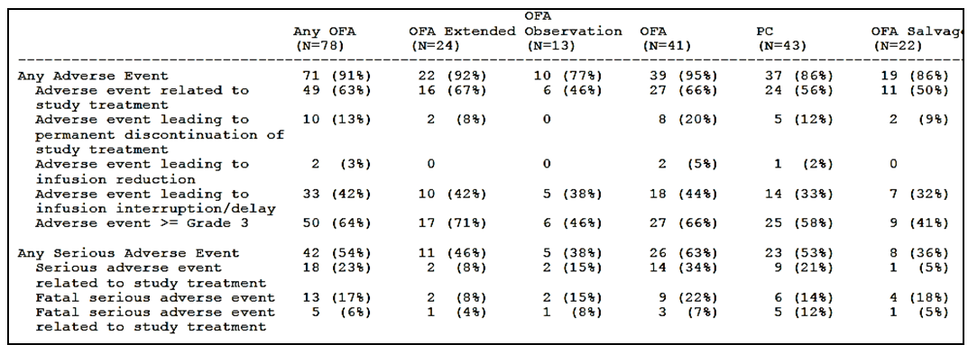
Comment: The any OFA arm (n=78) included all treated subjects (safety population) assigned to OFA at the first randomisation. Of the 78 patients in the any OFA arm (safety population), AE data consisted of information from 24 patients in the OFA extended group (i.e., received OFA in the initial 24 week treatment phase and assigned to OFA treatment in the extension phase following the second randomisation), 13 patients in the observation group (i.e., received OFA in the initial 24 week treatment phase and assigned to observation following the second randomisation), and 41 patients who received OFA in the initial 24 week treatment phase only). The PC arm (n=43) included all treated subjects (safety population) assigned to PC at the first randomisation. For the 22 subjects in the PC arm who received OFA salvage therapy (OFA salvage arm), AEs were included in the PC arm only if the AE started before OFA salvage therapy. The primary comparison of interest in this CER is between the any OFA arm (OFA extended + observation + OFA) and the PC arm. As discussed above, the median duration of exposure of the safety population in the any OFA arm was approximately 2.4-fold greater than in the PC arm, due to the inclusion of OFA extended and observation patients in the any OFA arm. Given the marked difference in exposure between the two arms it is considered that the AEs should have been adjusted for duration of exposure. This would have assisted interpretation of the pairwise safety comparisons. In the CSR (and this CER) the any OFA arm is referred to as the OFA arm.

Common AEs irrespective of causality

AEs by system, organ, class (SOC)
AEs by SOC reported in ≥ 20% of patients in either treatment arm (OFA [n=78] vs PC [n=43]) during the study were: “infections and infestations” (59% vs 56%); “blood and lymphatic system disorders” (36% vs 42%); “respiratory, thoracic and mediastinal disorders” (35% vs 16%), “general disorders and administrative site conditions” (35% vs 16%); “gastrointestinal conditions” (28% vs 28%); “investigations” (23% vs 14%); “metabolism and nutrition disorders” (18% vs 26%); and “skin and subcutaneous tissue disorders” (22% vs 12%).
Differences between treatment arms (≥ 10% of patients) for the OFA vs PC arm, respectively, were observed for “respiratory, thoracic and mediastinal disorders” (35% vs 16%), “skin and subcutaneous tissue disorders” (22% vs 12%), “cardiac disorders” (17% vs 7%), “vascular disorders” (19% vs 2%), and “nervous system disorders” (14% vs 2%).

AEs by preferred terms
AEs by preferred terms reported in ≥ 5% of patients in either treatment arm during the study are summarised in Table 119, page 151. The most commonly reported AEs (≥ 10% of patients in either treatment arm) in the OFA arm (n=78) vs the PC arm (n=43), respectively, were: neutropenia (28% vs 30%); pneumonia (18% vs 21%); cough (14% vs 2%); chills (13% vs 2%); pyrexia (13% vs 12%); thrombocytopenia (13% vs 12%); nausea (10% vs 12%); anaemia (10% vs 21%); and upper respiratory tract infection (8% vs 12%).
AEs reported in ≥ 5% of patients in the OFA arm and in ≥ 2% more patients than in the PC arm were (OFA vs PC, respectively): cough (14% vs 2%); chills (13% vs 2%); bronchitis (9% vs 7%); cardiac failure (6% vs 2%); hypertension (6% vs 0%); nasopharyngitis (6% vs 2%); ALT increased (5% vs 2%); back pain (5% vs 2%); hyperkalaemia (5% vs 0%); hypotension (5% vs 2%); and local swelling (5% vs 2%).
AEs reported in ≥ 5% of patients in the PC arm and in ≥ 2% more patients than in the OFA arm were (PC vs OFA, respectively): neutropenia (30% vs 28%); pneumonia (21% vs 18%); anaemia (21% vs 10%); sepsis (14% vs 1%); nausea (12% vs 10%); upper respiratory tract infection (12% vs 8%); diarrhoea (9% vs 6%); fatigue (9% vs 4%); cytomegalovirus infection (9% vs 0%); vomiting (7% vs 5%); peripheral oedema (7% vs 4%); viral infection (7% vs 1%); leukopenia (5% vs 3%); rhinitis (5% vs 3%); anxiety (5% vs 1%); hypogammaglobulinaemia (5% vs 1%); weight decreased (5% vs 1%); autoimmune haemolytic anaemia (5% vs 0%); electrolyte imbalance (5% vs 0%); hyperglycaemia (5% vs 0%); hypocalcaema (5% vs 0%); and infection (5% vs 0%).

AEs by severity (Grade ≥ 3)
AEs Grade ≥ 3 are summarised below. AEs Grade ≥ 3 were reported more commonly in patients in the OFA arm than in the PC arm (64% vs 58%, respectively). AEs Grade ≥ 3 reported in ≥ 5% of patients in either of the two treatment arms (OFA vs PC, respectively) were, neutropenia (24% vs 28%), pneumonia (14% vs 12%), anaemia (8% vs 16%), thrombocytopenia (8% vs 9%), sepsis (1% vs 14%), leukopenia (1% vs 5%), autoimmune haemolytic anaemia (0% vs 5%), and hyperglycaemia (5% vs 0%).
No AEs ≥Grade 3 occurred in ≥ 5% more patients in the OFA arm than in the PC arm. However, AEs ≥Grade 3 of anaemia, autoimmune haemolytic anaemia, hyperglycaemia, and sepsis were all reported in ≥ 5% more patients in the PC arm than in the OFA arm. Cardiac and vascular-related ≥Grade 3 AEs of arrhythmia, cardiac arrest, and hypotension were reported in 2 patients (3%) in the OFA arm, while no patients in PC experienced these events.

Table 48: OMB114242 – Grade ≥ 3 AEs reported in more than 1 patient in either treatment arm by preferred term
Note: The following terms have been grouped based on several preferred terms: anaemia, cardiac failure, hypercalcaemia, neutropenia, pneumonia, sepsis, thrombocytopenia, and upper respiratory tract infection.

AEs by causality (drug-related)

Drug-related AEs by SOC
Drug-related AEs by SOC reported in ≥ 20% of patients in either treatment arm (OFA [n=78] vs PC [n=43], respectively) during the study were “blood and lymphatic system disorders” (26% vs 26%) and “general disorders and administrative site conditions” (23% vs 16%). There were no SOCs in which the difference between the two treatment arms was ≥ 10% of patients.

Drug-related AEs by preferred term
Drug-related AEs were reported in 63% (n=49) of patients in the OFA arm and 56% (n=24) of patients during the PC arm. The most commonly reported AEs (≥ 10% of patients in either treatment arm) in the OFA arm (n=78) vs PC arm (n=43), respectively, were: neutropenia (22% vs 23%); chills (12% vs 2%); and anaemia (5% vs 12%);
Drug-related AEs reported in ≥ 5% of patients in the OFA arm and in ≥ 2% more patients than in the PC arm were (OFA vs PC, respectively): chills (12% vs 2%); pyrexia (9% vs 5%); cough (5% vs 0%); and pruritus (5% vs 2%).
Drug-related AEs reported in ≥ 5% of patients in the PC arm and in ≥ 2% more patients than in the OFA arm were (PC vs OFA, respectively); anaemia (12% vs 5%); nausea (7% vs 5%); sepsis (9% vs 1%); rash (5% vs 1%); and bronchitis (5% vs 1%).

Drug-related AEs by severity (Grade ≥ 3)
Drug-related AEs Grade ≥ 3 occurred in a similar proportion of patients in both treatment arms (37% both arms). Drug-related AEs Grade ≥ 3 reported in ≥ 5% of patients in either of the two treatment arms (OFA vs PC, respectively) were: neutropenia (18% vs 21%); anaemia (5% vs 7%); pneumonia (5% vs 5%); thrombocytopenia (4% vs 7%); and sepsis (1% vs 9%)

Death and serious adverse events (SAEs)

Death
A total of 63 deaths were reported in the study, including 36 (46%) deaths in the OFA arm and 27 (63%) deaths in the PC arm, including OFA salvage therapy. Of the 36 deaths in the OFA arm, 8 occurred during or after OFA extended treatment, and 4 occurred during observation. Of the 27 deaths in the PC arm, 13 occurred in patients who did not receive OFA salvage therapy and 14 occurred in patients after the start of OFA salvage therapy. The incidence of deaths in the PC arm was similar in patients who did not receive OFA salvage therapy (62%, 13/21) and in patients who did receive OFA salvage therapy (64%, 14/22).
Deaths in the OFA and PC treatment arms are summarised below. The majority of deaths in both treatment arms were considered by investigators to be due to the disease under study. The listing of all deaths on treatment or during follow-up are summarised.

Table 49: OMB114242 – Summary of deaths in the OFA and PC treatment arms.
a. Includes deaths during OFA extended treatment and observation; b. Excludes deaths of any subject in the PC arm subject who received OFA salvage therapy; c. Other reported causes of death included: pneumonia, sepsis, pulmonary embolism, myocardial infarction, sudden cardiac arrest, acute heart insufficiency, lung cancer, myelodysplastic syndrome, SAE considered by the investigator to be possibly related to study treatment, disease progression and unknown cause; d. On treatment defined as the time from treatment initiation to stop of last dosing plus 30 days.

Fatal SAEs
All fatal SAEs reported during the study are summarised, along with fatal SAEs occurring in the OFA and OC treatment arms.
Table 50: OMB114242 – Fatal SAEs by preferred term in the OFA and PC treatment arms
Note: The following terms have been grouped based on several preferred terms: cardiac failure, neutropenia, pneumonia, and sepsis.
Fatal SAEs were reported in 13 (17%) patients in the OFA arm (including 2 on extended OFA treatment and 2 on observation), and 10 (23%) patients in the PC arm (including 6 not on OFA salvage treatment and 4 on or after OFA salvage treatment). In addition to the 23 fatal SAEs, there was 1 death due to sepsis (OFA salvage therapy) and 1 death from myelodysplastic syndrome (PC) not reported as fatal SAE.
Fatal SAEs occurring in more than 1 patient in all treatment arms combined included: pneumonia (OFA x 3, none treatment-related; PC x 1, considered by the investigator to be treatment-related; OFA salvage x 1, not treatment-related); cardiac SAEs (OFA x 4, 1 considered by the investigator to be treatment-related; PC x 1, not treatment-related; OFA salvage x 1, not treatment-related); sepsis (OFA x 0; PC x 2, both considered by the investigator to be treatment-related; OFA salvage x 1 with sepsis reported as cause of death); and multi-organ failure (OFA x 1, PC x 1; both considered by the investigator to be treatment-related).
Overall, treatment-related fatal SAEs were reported in 10 patients in the study (8%, 10/121), including 5 patients in the OFA arm (6%, 5/78) and 5 patients in the PC arm (12%, 5/43).
In the OFA arm, treatment-related fatal SAEs were reported in 5 (6%) patients, including: 1x cardiac failure and 1x renal failure in patients who died before the second randomisation; 1 x multiorgan failure in a patient treated with extended OFA after the second randomisation; and 1 x PML in a patient initially treated with OFA and then randomised to Obs after the second randomisation.
In the PC arm, treatment-related fatal SAEs were reported in 5 (12%) patients, including: 1 x tumour lysis syndrome, 1 x multi-organ failure, 1 x neutropenic sepsis, and 1 x pneumonia in patients excluding OFA salvage therapy; and 1 x toxic hepatitis in 1 patient during OFA salvage therapy. In addition, in the PC arm (excluding OFA salvage arm) 1 patient had death reported to be due to pulmonary embolism caused by cancer but also had a fatal SAE of cardiac failure, and 1 patient had death reported to be due to disease under study but also had a fatal SAE of neutropenic sepsis.

SAEs
The proportion of patients with SAEs was similar in the OFA and the PC arms (54% and 53%, respectively). In both arms, the majority of SAEs were classified as “infections and infestations” (SOC), including 32% (25/78) in the OFA arm and 28% (12/43) in the PC arm. Of note, 7 (9%) patients in the OFA arm and 2 (5%) patients in the PC arm had SAEs classified as “cardiac disorders” (SOC). The “cardiac disorders” (SOC) in the 7 patients in the OFA arm were 2 x atrial fibrillation; 2 x cardiac failure; 2 x cardiac arrest; 1 x cardiovascular insufficiency; 1 x myocardial infarction; 1 x supraventricular tachycardia; and 1 x ventricular tachycardia. The “cardiac disorders” (SOC) in the 2 patients in the PC arm were 1 each for atrial fibrillation and cardiac failure. Five of the 7 patients in the OFA arm had cardiac SAEs during the first or second cycle of OFA treatment. SAEs by preferred term reported in ≥ 5% of patients in either of the two treatment arms (OFA vs PC, respectively) were pneumonia (13% vs 19%), neutropenia (9% in both arms), pyrexia (5% vs 7%), anaemia (3% vs 9%), sepsis (1% vs 14%), and autoimmune haemolytic anaemia (0% vs 5%). SAEs reported in more than 1 patient in each treatment arm are summarised below.

Table 51: OMB114242 – SAEs reported in more than 1 subject in either treatment arm by preferred term
Note: The following terms have been grouped based on several preferred terms: anaemia, cardiac failure, neutropenia, sepsis, and upper respiratory tract infection.

AEs leading to permanent treatment discontinuation or dose delay or interruption

AEs leading to permanent treatment discontinuation
AEs leading to permanent treatment discontinuation were reported in 13% (n=10) of patients in the OFA arm and 12% (n=5) of patients in the PC arm. In the 10 patients in the OFA arm, the AEs leading to permanent treatment discontinuation were: 2 x pneumonia and 1 x each for hepatitis B, atrial fibrillation, cardiac arrest, cardiac failure, chorea, chorioretinal atrophy, hypotension, aseptic meningitis, multi-organ failure, myocardial infarction, pulmonary oedema and renal failure. In the 5 patients in the PC arm the AEs leading to permanent treatment discontinuation were: 1 each for bronchopneumonia, myelodysplastic syndrome, neutropenic sepsis, pleural effusion, and tumour lysis syndrome.

AEs leading to dose delays or interruptions
AEs leading to dose delays or interruptions were reported more frequently in the OFA arm than in the PC arm (42% [n=33] vs 33% [n=14], respectively). AEs leading to dose delays or interruptions reported in at least 2 patients in either of the two treatment arms (OFA vs PC, respectively) were: pneumonia (n=4, 5% vs n=2, 5%), chills (n=4, 5% vs n=1, 2%), febrile neutropenia (n=3, 4% vs 0%), anaemia (n=2, 4% vs 0%), dyspnoea (n=2, 3% vs 0%), flushing (n=2, 3% vs 0%), hypotension (n=2, 3% vs 0%), pleural effusion (n=2, 3% vs 0%), urticaria (n=2, 3% vs 0%), pyrexia (n=1, 1% vs n=3, 7%), neutropenia (n=1, 1% vs n=3, 7%), and bronchitis (0% vs n=2, 5%).

Other significant AEs

Neoplasms
Secondary malignancies were reported in 2 (3%) patients in the OFA arm (1 x BCC; 1 x skin papilloma), and 2 (5%) patients in the PC arm (1 each for melanocytic naevus, myelodysplastic syndrome, seborrhoeic keratosis). The only other secondary malignancy reported during the study was large cell lung cancer reported in 1 (5%) patient in the OFA salvage arm.

Liver events
Per protocol, liver stopping criteria were defined for patients in either treatment arm as meeting 1 or more of the following conditions while on treatment:
- ALT > 3 times ULN, and bilirubin ≥ 2 times ULN (> 35% direct bilirubin; bilirubin fractionation required);
- ALT > 8 times ULN; or
- ALT ≥ 5 times ULN for more than 2 weeks. Five patients had liver chemistry elevations meeting the stopping criteria; 2 (3%) in the OFA arm, 2 (5%) in the PC arm, and 1 (5%) during OFA salvage therapy (below).

Table 52: OMB114242 – Patients with liver chemistry stopping criteria for dosing
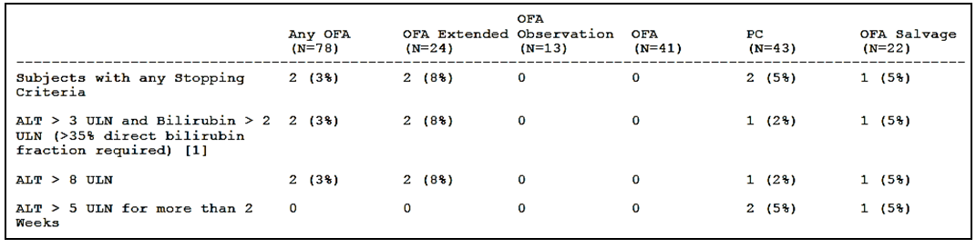

AEs of special interest

Cytopenias
Haematology assessments were performed at each treatment cycle. Due to the variability in reporting of AEs across regions for neutropenia, anaemia, and thrombocytopenia, the haematologic AEs were analysed by a comprehensive defined set of preferred terms pertaining to decreased blood counts.

Neutrophils – decreased counts
AEs associated with decreased neutrophil counts occurred in 29% of patients in the OFA arm and 35% of patients in the PC arm, and SAEs were reported in 10% of patients in the OFA arm and 14% of patients in the PC arm. In the OFA arm, 1 patient had a treatment-related fatal SAE of febrile neutropenia associated with prolonged neutropenia and in the PC arm, 2 patients had treatment-related fatal SAEs of neutropenic sepsis. The sponsor comments that the higher proportion of patients with AEs/SAEs in the PC arm may be explained by the intensity of the chemotherapeutic regimens in this arm. The results are summarised below.

Table 53: OMB114242 - AEs of special interest associated with decreased neutrophil count
a. Counts do not equal total as patients may have multiple AEs.

Haemoglobin - decreased concentrations
AEs associated with decreased haemoglobin concentrations occurred in 12% of patients in the OFA arm and 21% of patients in the PC arm, and SAEs were reported in 4% of patients in the OFA arm and 9% of patients in the PC arm. There were no patients with fatal SAEs associated with decreased haemoglobin concentrations in either of the two treatment arms. The results are summarised below.

Table 54: OMB114242 - AEs of special interest associated with decreased haemoglobin concentration

Platelets – decreased counts
The proportion of patients with AEs associated with decreased platelet counts was similar in the OFA and PC treatment arms, with 2 non-fatal SAE cases (1 in each treatment arm). The results are summarised below.
Table 55: OMB114242 - AEs of special interest associated with decreased platelet counts

Other cytopenias
“Other” cytopenias reported as AEs included 4 cases of leukopenia, and single cases of lymphopenia and myelodysplastic syndrome. In the OFA arm, 2 cases of non-serious leukopenia were the only “other” cytopenias reported (1 Grade 3, 1 Grade 2). In the PC arm, 4 patients had “other” cytopenias: 1 SAE of Grade 4 leukopenia requiring treatment interruption; 1 non-serious Grade 4 myelodysplastic syndrome leading to treatment discontinuation and reported as a cause of death; 1 non-serious leukopenia (maximum Grade 4); and 1 non-serious Grade 2 lymphopenia.

Autoimmune haematologic complications
Three cases of autoimmune haematologic complications were reported (OFA x 1 patient; PC x 2 patients). All 3 cases were considered by the investigator to be associated with the patient’s underlying CLL and not related to study treatment.

Infusion-reactions
Infusion-reactions included pre-defined events relating to infusions that started after the beginning of the infusion and within 24 hours following the end of an infusion. The preferred terms that met the pre-defined criteria for infusion-reactions were selected based on clinical review of the AE database, and the prescribing information of other monoclonal antibodies in-class. In the OFA am, 99% of patients received the required pre-medication with steroids before the 2 initial OFA infusions, and these percentages decreased over time to 76% at Week 24. Nevertheless, despite pre-medication with steroids, infusion-reactions occurred in 42% of patients in the OFA arm compared to 26% of patients in the PC arm. The results are summarised below.

Table 56: OMB114242 – Infusion reactions
Infusion-reactions in the OFA arm primarily occurred on the day of the first infusion (28% of all patients). The most commonly reported infusion-reactions in patients in the OFA arm (vs the PC arm) were chills/rigors (10% [n=8] vs 2% [n=1]) and fever/pyrexia (8% [n=6] vs 5% [n=2]). Infusion-reactions Grade ≥ 3 were observed in 4 (5%) patients in the OFA arm and included chills/rigors, cough, pyrexia, hypertension, and hypotension. The non-fatal SAE infusion-reactions reported in 3 patients in the OFA arm were considered treatment-related, and included pyrexia in 1 patient, hypotension in 1 patient, and chills and pyrexia in 1 patient.

Infections
The proportion of patients with infections was similar in the OFA and PC arms (OFA, 59%; PC, 56%) as was the proportion of patients receiving antimicrobial treatment (OFA, 76%; PC, 79%). SAEs of infections occurred in 32% of patients in the OFA arm and in 28% of patients in the PC arm. Fatal SAEs of infections occurred in 5% of patients in the OFA arm and in 7% of patients in the PC arm. Infections are summarised below.

Table 57: OMB114242 – Infections
Respiratory tract infections were the most commonly reported infections in patients in both treatment arms, and these were mainly upper respiratory tract infections (OFA, 23% [n=18]; PC, 26% [n=11]), and pneumonia (OFA, 18% [n=14]; PC, 21% [n=9]). Lower respiratory tract infections (grouped preferred terms including pneumonia) were reported in 28% (n=22) of patients in the OFA arm and 28% (n=12) of patients in the PC arm.
Lower respiratory tract infections (grouped preferred terms including pneumonia) reported as SAEs occurred in 15% (n=12) of patients in the OFA arm and 19% (n=8) of patients in the PC arm, with pneumonia accounting for the majority of these infections (OFA, 13% [n=10]; PC, 19%, [n=8]). Upper respiratory tract infections reported as SAES occurred in 5% (n=4) of patients in the OFA arm and no patients in the PC arm.
There were 4 (5%) patients in the OFA arm with fatal SAEs associated with infection, including 1 case of treatment-related PML and 3 cases of pneumonia unrelated to treatment. One additional patient in the OFA arm had treatment-related HBV re-activation during OFA extended treatment and died approximately 12 weeks later from multi-organ failure. There were 3 (7%) patients in the PC arm with treatment-related fatal SAEs of infection, including 2 cases of neutropenic sepsis and 1 case of pneumonia.

Progressive multifocal leukoencephalopathy
One patient in the OFA arm had a fatal treatment-related SAE of PML.

Hepatitis B re-activation
One patient in the OFA arm had a treatment related SAE of HBV re-activation during OFA extended treatment. The patient had a past medical history of chronic hepatitis B, herpes simplex hepatitis, and EBV infectious mononucleosis.

Mucocutaneous reactions
Mucocutaneous reactions included a broadly defined set of events pertaining to or affecting mucous membranes and skin, many of which overlapped with infusion-reactions. A higher proportion of patients in the OFA arm (26%) had mucocutaneous reactions compared to patients in the PC arm (9%), which may have been partly due to the higher number of infusions per patient in the OFA arm due to extended treatment in this arm (median number of treatment visits were 12 in the OFA arm and 3 in the PC arm). Events considered as both infusion-related reactions and mucocutaneous reactions were reported in 12% (n=9) of patients in the OFA arm and in 9% (n=4) of patients in the PC arm. In the OFA arm, approximately 50% (9/20) of the mucocutaneous reactions were considered to be infusion-reactions, while in the PC arm all (4/4) mucocutaneous reactions were considered to be infusion-reactions. Not all patients in the PC arm received infusions as part of their treatment regimen. There were no SAEs of mucocutaneous reactions considered to be infusion-reactions in either of the two treatment arms. In the OFA arms, there were 2 SAEs considered to be mucocutaneous reactions (Grade 3 cellulitis), neither was considered related to OFA treatment, and neither was fatal. There were no reports of SJS of TEN in either treatment arm. The results for mucocutaneous reactions are summarised below.

Table 58: OMB114242 – Mucocutaneous reactions
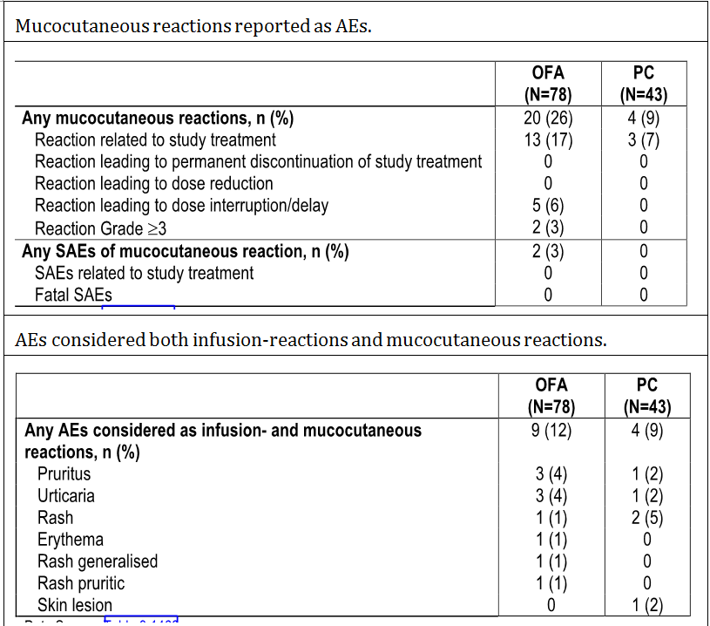

Tumour lysis syndrome (TLS)
One patient in the OFA arm had a treatment-related, non-serious AE of TLS. One patient in the PC arm had a treatment-related, fatal SAE of TLS.

Cardiac disorders
A higher proportion of patients in the OFA arm (17%) had cardiac disorders compared to patients in the PC arm (7%). Cardiac disorders included 10 SAEs in 7 (9%) patients in the OFA arm and 2 SAEs in 2 (5%) patients in the PC arm. Four (6%) patients in the OFA arm died due to SAEs related to cardiac disorders (2 x sudden cardiac arrest, 1 x cardiac failure, 1 x myocardial infarction), and 1 (2%) patient in the PC arm died due to a SAE related to cardiac disorders (1 x cardiac failure). One (1%) of the fatal SAEs in a patient in the OFA arm was treatment-related (cardiac failure associated with Grade 4 pneumonia), while none of the other fatal SAEs in either treatment arm were treatment-related. All fatal SAEs related to cardiac disorders in the OFA arm occurred during the initial 24 weeks of OFA treatment. The results are summarised below.

Table 59: OMB114242 – AEs and SAEs related to cardiac disorders

Small bowel obstruction
No events of small bowel obstruction were reported during the study.

Clinical laboratory evaluations

Haematology
Based on laboratory data, 58% (45/78) of patients in the OFA arm and 30% (13/43) of patients in the PC arm had at least one Grade 3/4 AE of myelosuppression, including neutropenia, anaemia, or thrombocytopenia. The higher rates of Grade 3 and 4 myelosuppression in the OFA arm may have been at least partly due to the longer treatment duration in patients in the OFA arm. The most frequently reported worst-case shifts from baseline Grade to post-baseline Grade 3 and Grade 4 myelosuppression were reported for neutrophils in both treatment arms. Worst-case shifts from baseline grade for the haematology laboratory parameters of interest are summarised below.

Table 60: OMB114242 – Worst-case haematologic Grade shifts from baseline Grade
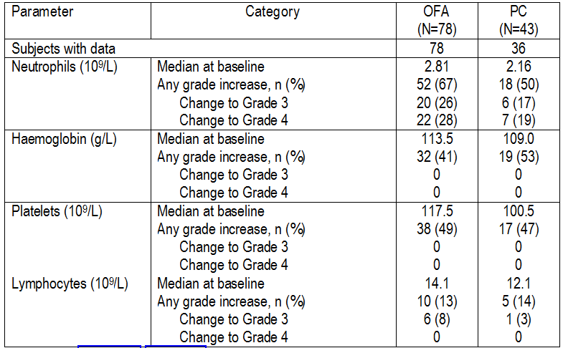
Overall, 50% (n=39) of patients in the OFA arm and 72% (n=31) of patients in the PC arm required transfusions of blood products or blood supportive care products during the study, most commonly red blood cells (OFA, 24% [n=19]; PC, 42% [n=18]) and platelets (OFA, 13% [n=10]; PC, 16% [n=7]). In addition, 29% (n=23) of patients in the OFA arm and 37% (n=16) of patients in the PC arm received G-CSF treatment.
Prolonged neutropenia was defined as a Grade 3 or 4 neutropenia that occurred while the patient was on study treatment and was not resolved within 42 days after the last dose of study treatment. In total, 5 (6%) patients in the OFA arm and 4 (9%) patients in the PC arm had prolonged neutropenia. These included 1 fatal SAE and 1 non-fatal SAE of febrile neutropenia related to study treatment in the OFA arm, and 1 non-fatal SAE of febrile neutropenia in the PC arm related to study treatment. The median time to onset of prolonged neutropenia was 75 days (range: 15, 107 days) in the OFA arm and 42 days (range: 27, 134 days) in the PC arm. The duration of prolonged neutropenia ranged from 39 to 192 days for the 5 patients in the OFA arm, and from 1 to 134 days for the 4 patients in the PC arm (counted from Day 43 onwards). None of the 5 patients with prolonged neutropenia in the OFA arm had normal neutrophil counts at baseline, while all 4 patients in the PC arm had normal neutrophil counts at baseline
Late onset neutropenia defined as neutropenia starting > 42 days after the last dose of study treatment, was reported in 2 patients in the OFA arm (neutropenia lasted 22 and 23 days), and in 1 patient in the PC arm (neutropenia lasted 6 days).

Biochemistry
The majority of patients in both treatment arms had no clinically relevant abnormalities in the assessed serum chemistry parameters. The worst-case liver chemistry shifts from baseline Grade to post-baseline Grade 3 or 4 are summarised below.
Table 61: OMB114242 – Worst-case liver chemistry Grade shifts from baseline Grade.

Immunoglobulins
Median IgG, IgA, and IgM levels remained within the same range in the OFA and PC treatment arms throughout the treatment period.

Immunogenicity
No confirmed OFA-induced HAHAs were detected in the study either pre-dose or post-dose. At the time of data cut-off, post-OFA HAHA data were available for 69 of 78 patients (88%) in the OFA arm, and additionally for 18 of 22 patients (82%) in the PC arm who received OFA salvage therapy.

Other safety evaluations

Vital signs
Vital signs parameters (systolic and diastolic blood pressure, pulse, temperature) varied for patients within and between the OFA and PC treatment arms throughout the study, but showed no apparent trends in change from baseline. Most patients had unchanged post-baseline vital signs at the majority of assessments. Shifts to increased systolic blood pressure were observed in some patients in the OFA arm, but these were generally observed at single assessments only.

ECOG performance status
The majority of patients in both treatment arms had an ECOG performance status of 0 or 1 throughout the study. Most patients did not show a shift in ECOG status during the study. For those patients who did show a shift, the shift was typically from baseline status of 0 or 1 to post-baseline status of 1 or 2.

Electrocardiograms
Only 1 patient had ECG findings at screening that were read as abnormal/clinically significant. This patient, who was in the OFA arm, had a fatal SAE of myocardial infarction during the study. There were no summary data on shifts in ECG findings from screening over the course of the study.

Organ examination
At screening, 47% (n=35) of patients in the OFA arm and 59% (n=24) of patients in the PC arm had enlarged spleen sizes. In both arms, the proportion of patients with enlarged spleens declined over time, starting from Cycle 2, and down to 20% (n=12) at Cycle 3 (Week 12) and 15% (n=6) at Cycle 6 (Week 24) in the OFA arm, and down to 22% (n=5) at Cycle 3 (Week 12) and 36% (n=5) at Cycle 6 (Week 24) in the PC arm. Decreases were maintained during follow-up.
Approximately one third of patients in both treatment arms (OFA, 33% [n=25]; PC, 38% [n=15]) had an enlarged liver size at screening. In the OFA arm, the proportion of patients with enlarged liver size declined over time, starting from Cycle 2, and down to 16% (n=10) at Cycle 3 (Week 12) and 15% (n=6) at Cycle 6 (Week 24). Decreases were maintained during follow-up. This decline was not be observed in the PC arm, with 38% (n=9) and 36% (n=5) of patients still having enlarged livers at Cycle 3 (Week 12) and 6, respectively.

Pregnancy
There were no pregnancies during the study.

Adverse events in special groups
In general, the analysis of AEs in subgroups defined by age (< 65 and ≥ 65 years), sex, study drug exposure (number of cycles) and geographical region (emerging markets and Asia Pacific [EMAP] vs EU) showed similar types of AEs or proportion of subjects with AEs for these strata when compared with the total safety population. Nearly all patients in the OFA arm were White/Caucasian (77 out of 78), and all patients in the PC arm had this racial background (43 out of 43).

Other safety data

Immunogenicity Report
The submission included an immunogenicity report titled: “A Review of the Immunogenicity Assays and Immunogenicity Data from Preclinical and Clinical Studies of Ofatumumab Amendment 3”, dated 19 June 2015.
The report included clinical immunogenicity data on anti-ofatumumab antibody testing from 24 clinical studies in patients with cancer, rheumatoid arthritis, and multiple sclerosis. In total, 2258 patients have been treated with ofatumumab in the clinical studies, including 2000 treated with IV infusions and 258 with SC injections.
Post-ofatumumab samples for the detection of HAHA were available from 1968 patients, and there were 1670 patient with evaluable post-ofatumumab samples. Of the 1670 patients with evaluable post-ofatumumab samples, there were 13 with positive HAHA results across the clinical development program (i.e., 0.8% of patients). Using electrochemiluminescence (ECL) immunogenicity assay methods, there has been 1 patient out 551 with CLL with a positive HAHA result after receiving ofatumumab (0.2%). No unexpected safety, pharmacokinetic, or pharmacodynamic findings have been identified in HAHA positive patients.

Post-marketing experience

Overview
Post-marketing data were provided in the Summary of Clinical Safety. Ofatumumab was first approved for marketing in the USA on 26 October 2009 for the treatment of patients with CLL refractory to fludarabine and alemtuzumab. Ofatumumab has since been approved in several countries for the treatment of patients with CLL who have not received prior therapy. Based on the latest data available from Intercontinental Medical Statistics (IMS) Health, estimated cumulative post-marketing exposure to ofatumumab through 30 September 2014 was approximately 7269 patients. This is assuming each patient received a full approved treatment course (i.e., 300 mg initial infusion followed by 6.78 doses of 2000 mg [13,860 mg], equivalent to 693 mL). The submitted post-marketing experience represents data from spontaneous reports and cases from post-marketing surveillance (PMS) activities, including the Named Patient Program, Temporary Access for Use, Market Research, an epidemiological study, and a Regulatory Authority’s registry. The reported post-marketing safety data were consistent with the known safety profile of ofatumumab.

Total number of events
As of 21 December 2014, there were a total of 825 spontaneous and post-marketing adverse event reports from 29 countries. The majority of reports were from spontaneous sources (670 reports), and the remaining 155 reports were received from post-marketing surveillance (PMS) activities. Within these 825 reports, there were a total of 2206 AEs (serious and non-serious). The 10 most frequently reported AEs from spontaneous and post-marketing cases are summarised below.
Table 62: The 10 most-frequently reported adverse events from spontaneous and post-marketing surveillance reports
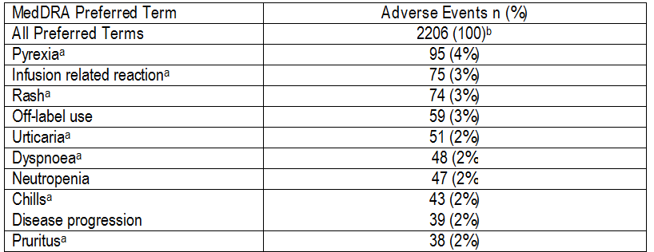
a. AEs associated with infusion reactions and described in the ofatumumab CSI; b. These 2006 AEs were contained in the total 825 spontaneous and PMS reports in-scope for the submitted post-marketing evaluation at the time of the data lock point.

Fatal events
Of the 825 spontaneous and post-marketing reports, 118 (14%) were fatal. The System Organ Classes (SOCs) with the highest percentage of fatal AEs were “general disorders and administration site conditions” (21%) and “infections and infestations” (18%). Of note, “general disorders and administration site conditions” SOC includes preferred terms such as “death” and “disease progression”.

Table 63: Distribution of fatal events per SOC (5% cut-off)
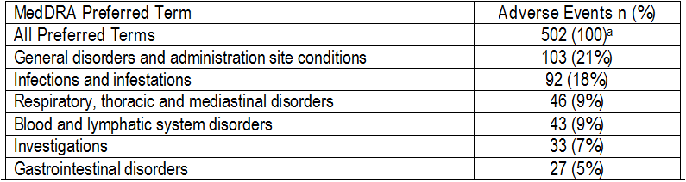
a. These 502 AEs were contained in the total 118 spontaneous and PMS reports with a fatal-outcome, which are in-scope for the submitted post-marketing evaluation at the time of the data lock point.

Infusion-reactions
Of the 825 reports, 72 (9%) events contained the preferred term “infusion-reaction”. However, many reports describing infusion-reactions did not use the specific preferred term. Of note, there was 1 report of a fatal infusion-reaction in a patient who died the day after their first cycle of ofatumumab. Concurrent medical conditions included multiple sclerosis diagnosed in 1980. The patient did not have a history of cardiac disease. The patient’s CLL was diagnosed in 2007 and he had received prior treatments. Prior to the ofatumumab infusion, the baseline lymphocyte count was 164 x 10⁹/L and blood pressure measured 132/63 mmHg with a heart rate of 118 beats/min. The patient described chest pain and dyspnoea 150 minutes after initiation of therapy with 300 mg ofatumumab. At that time, the speed of the infusion was 200 mL/h. The patient was hypertensive (182/85 mmHg) and had tachycardia (heart rate = 137 beats/min); treatment was stopped and the patient was transferred to the emergency department. Twenty minutes after transfer, the patient became hypotensive (80/45 mmHg) and went into cardiac arrest. Resuscitation efforts were unsuccessful.
The sponsor stated that the fatal case described above resulted in an update to the “Warnings and Precautions” section of the ofatumumab label to warn that infusion reactions have the potential to be fatal. The sponsor comments that infusion reactions, including cytokine release syndrome, are well characterised with ofatumumab. Overall, the sponsor commented that the nature and severity of reports describing infusion reactions remains consistent with the known safety profile of ofatumumab.

Cardiac events
Of 825 reports, 52 events were categorised as “cardiac disorders” (SOC). Many of these events were temporally related to recent ofatumumab infusions and were consistent with an infusion-related reaction. Others occurred in patients with known cardiac risk factors or co-morbidities, such as older age, coronary artery disease, hypertension, hypercholesterolemia, cardiac arrhythmias (that is, atrial fibrillation), congestive heart failure, or prior history of cerebrovascular accident or thromboembolic events.
There was 1 report of QT prolongation up to 630 milliseconds in duration occurring 7 h into an ofatumumab infusion in a child patient with acute lymphocytic leukaemia and Epstein-Barr virus lymphoproliferative disorder. Baseline QTc values over the previous 6-9 months had been 400-440 milliseconds. The event was significantly confounded by hypokalaemia, hypothyroidism and hypothermia. The event resolved.
There was one report of suspected “torsade de pointes” (TdP) in an elderly patient, who also experienced several other cardiac events. The medical history of this patient included paroxysmal atrial fibrillation. The patient was being treated with flecainide, a drug known to be associated with prolongation of the QT interval, and acenocoumarol. The relevant regulatory agency (France) indicated that TdP was not confirmed, but was a hypothesis.

Small bowel obstruction
Two reports of small bowl obstruction have been received from post-marketing reports.

Tumour Lysis Syndrome (TLS)
Seven reports of TLS in association with ofatumumab administration have been received from post-marketing sources.

Infections
Of the 825 reports, 200 events were categorised as “infections and infestations” (SOC). The sponsor maintains that, in general, ofatumumab does not increase the risk of infection, with the exception of HBV re-activation.

Progressive Multifocal Leukoencephalopathy
Six cases of PML in association with ofatumumab have been reported from spontaneous of PMS activities. Two of the six reports confirmed the diagnosis of PML through diagnostic testing, which included MRI and John Cunningham (JC) virus DNA in the central nervous system. Four of the spontaneously reported PML cases were not assessable as they contained inadequate documentation.

Hepatitis B Virus (HBV)
Four spontaneous reports of HBV infection and/or re-activation in association with ofatumumab have been received. No reports have been received from PMS activities.

Cytopenias
Of the 825 reports, 162 events were categorised as “blood and lymphatic system disorders” (SOC). Reports of cytopenias, most commonly neutropenia and, to a lesser degree, leukopenia, anaemia and thrombocytopenia have all been received in the post-marketing setting.

Severe mucocutaneous reactions
There has been one case of SJS reported in the post-marketing setting in a 70 year old man with no history of allergic drug reactions.

Regulatory areas of interest
There have been no spontaneous reports or PMS activity reports of drug interactions or pregnancy associated with ofatumumab. There were 22 spontaneous reports of drug overdose, including 7 serious and 15 non-serious cases. There were 2 poorly documented fatal cases of drug overdose associated with ofatumumab. There were 6 cases of drug abuse, 1 of which was fatal and was also documented as a fatal overdose.

Evaluators comments on safety

Proposed extension of indication – study OMB112517 – pivotal data
In the pivotal study (OMB112517), the safety profile of patients in the OFA maintenance arm was compared to patients in the Obs arm, with 237 patients being included in the safety population in each of the two study arms. At the time of data cut-off, the median treatment duration for patients in the OFA maintenance arm was 382 days (range: 1-834 days). Almost half (49% [n=116]) of all patients in the OFA maintenance arm received at least 8 cycles of treatment (i.e., through to Week 57), and 25% (n=59) of patients received all 14 planned infusions (i.e., from Cycle 1 through to and including Cycle 13 [Week 97]). Based on the “rule of threes”, a population of 237 patients treated with OFA for a median duration of 382 days is large enough to reliably identify AEs occurring with an incidence of ≥ 1% with the drug.
AEs reported in the treatment/observation phase were reported more frequently in the OFA maintenance arm than in the Obs arm (87% [n=206] vs 75% [n=177], respectively). In addition, Grade ≥ 3 AEs were reported notably more frequently in this phase in the OFA maintenance arm than in the Obs arm (51% [n=120] vs 36% [n=84], respectively). AEs leading to infusion interruption and/or delay occurred frequently in the OFA maintenance arm (40% [n=95]), and more commonly than permanent treatment discontinuation due to AEs (8% [n=20]). Discontinuations due to AEs in the Obs arm were reported in 1 (<1%) patient, while AEs leading to treatment interruption and/or delays were not applicable to patients in this study arm. SAEs were reported during the treatment/observation phase in a similar proportion of patients in the two treatment arms (OFA, 33%, [n=78]; Obs, 30%, [n=70]), while fatal SAEs in this phase were reported more frequently in the Obs arm than in the OFA arm (8% [n=19] vs 3% [n=8], respectively).
Significant AEs examined during the study included liver events and secondary malignancies. Two patients in the OFA maintenance arm had liver enzyme elevations meeting the study stopping criteria, including 1 patient with Hy’s law criteria associated with gallstones considered to be un-related to treatment and 1 patient with elevated liver enzymes related to hepatitis B reactivation considered to be related to treatment. Secondary malignancies were reported in the treatment/observation phase more frequently in the OFA maintenance arm than in the Obs arm (12% [n=19] vs 7% [n=17], with none being fatal in the OFA arm and 5 being fatal in the Obs arm. The increased incidence of secondary malignancies in the OFA maintenance arm compared to the Obs arm was accounted for by the higher incidence of skin and subcutaneous tissue malignancies. It is likely that further secondary malignancies will arise as the follow-up phase continues.
AEs of special interest during the study included cytopenias, infections, infusion reactions, mucocutaneous reactions, cardiac events, small bowel obstruction, and tumour lysis syndrome. Neutropenia occurred notably more commonly in the OFA maintenance arm than in the Obs arm, while anaemia and thrombocytopenia occurred in a similar proportion of patients in both study arms. There was a higher incidence of Grade ≥ 3 neutropenia and prolonged severe neutropenia (Grade 3 or 4) in the OFA maintenance arm than in the Obs arm, which is likely to have contributed to the higher incidence of infections (AEs) in the OFA maintenance arm compared to the Obs arm in the treatment/observation phase (65% [n=164] vs 51% [n=120]). No cases of PML were reported in the study.
Infections reported as AEs during the treatment/maintenance phase occurred in 65% (n=154) of patients in the OFA maintenance arm and 51% (n=120) of patients in the Obs arm, while SAEs in this phase occurred in 20% (n=47) and 18% (n=42) of patients, respectively.
Infusion-related AEs occurred in 46% [n=109] of patients in the OFA maintenance arm, and most of these reactions were Grade 1 or 2 in severity. In the OFA maintenance arm, there were 9 (4%) patients with Grade ≥ 3 infusion-related AEs, and 1 (<1%) patient with an infusion-related SAE. Mucocutaneous reactions occurred more frequently in the OFA maintenance arm than in the Obs arm (29% [n=68] vs 15% [n=36], respectively). Of the 68 patients in the OFA maintenance arm with AEs considered to be mucocutaneous reactions, 12 (18%) had events that were also classified as infusion-reactions. This could explain why more mucocutaneous reactions were reported in the OFA maintenance arm than in the Obs arm, as infusion-reactions were not reported in the Obs arm. Serious mucocutaneous reactions were rare in both study arms (OFA, <1%; Obs, 1%). No cases of SJS of TEN were reported in the pivotal study.
A similar proportion of cardiac AEs and SAEs occurred in the two study arms in the treatment/observation phase (AEs 6% and SAEs 3% in each arm), suggesting no increased risk of cardiovascular events associated with OFA maintenance treatment. Small bowel obstruction occurred in 1 patient in the OFA maintenance arm (fatal SAE) and 2 patients in the Obs arm (non- serious AEs). No cases of tumour lysis syndrome were reported in the study.
There were no marked differences in vital signs between the two study arms. Subgroup analyses of AEs by age, gender, body weight, and number and type of prior therapy did not suggest any meaningful differences compared to the total safety population.
Ongoing post-marketing safety surveillance through 21 December 2014 revealed no significant new safety findings associated with the use of OFA for marketed indications.
Overall, the safety profile of OFA in study OMB112517 for the maintenance treatment of patients with CLL who were in CR or PR after at least 2 prior lines of induction therapy was consistent with the established safety profile of OFA for the approved indications. There were no unexpected AEs associated with OFA reported in the pivotal study, although long-term safety data are limited. Not unexpectedly, AEs occurred more commonly with OFA maintenance treatment than with observation and consisted predominantly of neutropenia, infections, and infusion reactions. In general, AEs associated with OFA maintenance were manageable by dose interruptions and/or delays rather than by permanent treatment discontinuation.

Bulky-Fludarabine Refractory CLL – OMB114242
The safety profile of OFA in patients with BFR CLL was consistent with the known safety profile of the drug in patients with refractory CLL. In particular, the safety profile of OFA in patients with BFR CLL in study OMB114242 was consistent with the safety profile of OFA in the subset of patients with BFR CLL in study Hx-CD20-406. No unexpected safety findings associated with OFA emerged from the data in patients with BFR CLL. There were some differences in the safety profiles of the OFA and PC treatment arms in study OMB114242, but the safety data from both arms is considered to be acceptable in patients with BFR CLL.
Numerical comparisons of the frequency of the safety parameters between the OFA arm (n=78) and the PC arm (n=43) should be interpreted cautiously, due to the longer duration of both time on treatment and safety follow-up in the OFA safety population compared to the PC safety population (i.e., median time on treatment 161 vs 64 days, median safety follow-up 362 vs 149 days).
The study design partly accounted for these differences in exposure and follow-up between the two treatment arms. Patients in the OFA arm who had no disease progression at Week 24 underwent a second 2:1 randomisation to the OFA extended arm or the observation arm, and patients in the OFA extended arm could be exposed to 24 additional weeks of OFA treatment. In addition, for the safety analyses, patients in the PC arm who received OFA salvage therapy at disease progression were separately grouped in the “OFA salvage” arm and not included in the PC arm, which contributed to the large difference in follow-up time for safety.
In both the OFA arm (n=78) and the PC arm (n=43), most patients experienced at least one AE (91% vs 86%, respectively). AEs occurring in ≥ 10% of patients in either treatment arm (OFA vs PC, respectively) were, neutropenia (28% vs 30%), pneumonia (18% vs 21%), cough (14% vs 2%), chills (13% vs 2%), pyrexia (13% vs 12%), thrombocytopenia (13% vs 12%), nausea (10% vs 12%), anaemia (10% vs 21%), and upper respiratory tract infection (8% vs 12%).
In the OFA arm, Grade ≥ 3 AEs were reported in more frequently than in the PC arm (64% vs 58%, respectively). AEs Grade ≥ 3 reported in ≥ 5% of patients in either of the two treatment arms (OFA vs PC, respectively) were, neutropenia (24% vs 28%), pneumonia (14% vs 12%), anaemia (8% vs 16%), thrombocytopenia (8% vs 9%), sepsis (1% vs 14%), leukopenia (1% vs 5%), autoimmune haemolytic anaemia (0% vs 5%), and hyperglycaemia (0% vs 5%). No AEs  Grade 3 occurred in ≥ 5% more patients in the OFA arm than in the PC arm. However, AEs  Grade 3 of anaemia, autoimmune haemolytic anaemia, sepsis and hyperglycaemia were all reported in ≥ 5% more patients in the PC arm than in the OFA arm.
AEs leading to permanent treatment discontinuation were reported in a similar proportion of patients in the two treatment arms (OFA, 13% [n=10]; PC, 12% [n=5]). The AEs leading to permanent treatment discontinuation in the 10 patients in the OFA arm were pneumonia in 2 patients and 1 patient each for hepatitis B, atrial fibrillation, cardiac arrest, cardiac failure, chorea, chorioretinal atrophy, hypotension, aseptic meningitis, multi-organ failure, myocardial infarction, pulmonary oedema and renal failure. The AEs leading to permanent treatment discontinuation in the 5 patients in the PC arm were 1 patient each with bronchopneumonia, myelodysplastic syndrome, neutropenic sepsis, pleural effusion, and tumour lysis syndrome.
AEs leading to dose delays or interruptions were reported more frequently in the OFA arm than in the PC arm (42% [n=33] vs 33% [n=14], respectively). AEs leading to dose delays or interruptions reported in at least 2 patients in either of the two treatment arms (OFA vs PC, respectively) were pneumonia (n=4, 5% vs n=2, 5%), chills (n=4, 5% vs n=1, 2%), febrile neutropenia (n=3, 4% vs 0%), anaemia (n=2, 4% vs 0%), dyspnoea (n=2, 3% vs 0%), flushing (n=2, 3% vs 0%), hypotension (n=2, 3% vs 0%), pleural effusion (n=2, 3% vs 0%), urticaria (n=2, 3% vs 0%), pyrexia (n=1, 1% vs n=3, 7%), neutropenia (n=1, 1% vs n=3, 7%), and bronchitis (0% vs n=2, 5%).
Other significant AEs assessed in the study included secondary malignancies, and liver chemistry abnormalities triggering pre-defined study stopping criteria. No clinically meaningful differences between the two treatment arms occurred with regards to secondary malignancies (OFA, 3% [n=2]; PC, 5% [n=2]). Similarly, no clinically meaningful differences between the two treatment arms occurred with regards to liver chemistry stopping criteria (OFA, 3% [n=2]; PC, 5% [n=2]).
AEs of special interest, identified based on data from previous OFA studies and events observed with other anti-CD20 monoclonal antibodies with enhanced complement-dependent cytotoxicity, included cytopenias, infusion-reactions, mucocutaneous reactions, infections, cardiac events, TLS, and small bowel obstruction.
The incidence of AEs associated with cytopenias, including neutropenia, anaemia, and thrombocytopenia, was high in patients in both treatment arms. However, higher proportions of patients in the PC arm compared to the OFA arm had AEs associated with decreased neutrophil counts (35% vs 29%, respectively) and decreased haemoglobin concentrations (21% vs 12%, respectively), while the incidence of AEs associated with decreased platelet counts was similar in both treatment arms (13% vs 12%, respectively). The higher incidence of AEs related to both decreased neutrophil counts and decreased haemoglobin concentrations in the PC arm than in the OFA arm may have been due to the cytotoxic chemotherapy treatment regimens used in the PC arm. However, based on clinical laboratory evaluations, Grade 3 and 4 myelosuppression (neutropenia, anaemia, or thrombocytopenia) was more frequent in the OFA arm than in the PC arm (58% vs 30%), which may have been due to the longer treatment duration in the OFA arm compared to the PC arm. Fatal SAEs related to cytopenias included 1 case of treatment-related febrile neutropenia (OFA arm) and 2 cases of treatment-related neutropenic sepsis (PC arm). Other haematologic AEs of special interest included 3 patients with treatment-unrelated autoimmune haemolytic anaemia (OFA x 1 patient; PC x 2 patients).
Infusion-reactions were reported notably more frequently in the OFA arm than in the PC arm (42% vs 26%, respectively), while Grade ≥ 3 infusion-reactions were infrequent in both treatment arms (4% vs 0%, respectively). The higher incidence of infusion-reactions in patients in the OFA arm might be accounted for, at least in part, by the fact that not all patients in the PC arm received therapy administered by infusions (i.e., 21% of patients did not receive infusions). Infusion-reactions in the OFA arm occurred primarily on the day of the first infusion. There were no fatal infusion-reactions reported during the study.
Mucocutaneous reactions reported as AEs occurred notably more frequently in patients in the OFA arm than in the PC arm (26% vs 9%, respectively), while Grade ≥ 3 mucocutaneous AEs were infrequent in both treatment arms (3% vs 0%, respectively). Approximately 50% (9/20) of all mucocutaneous reactions reported in the OFA arm were considered to be infusion-reactions, while all (4/4) mucocutaneous reactions reported in the PC arm were considered to be infusion-reactions. No cases of SJS or TEN were reported in the study. There were no fatal mucocutaneous reactions reported in the study.
The incidence of infections was similar in patients in the two treatment arms (OFA, 59% vs PV, 56%), while Grade ≥ 3 infections occurred more frequently in the OFA arm than in the PC arm (29% vs 21%, respectively) as did SAE infections (32% vs 28%, respectively). Respiratory tract infections were the most commonly reported infections in patients in both treatment arms, and these were mainly upper respiratory tract infections (OFA, 23%; PC, 26%) and pneumonia (OFA, 18%; PC, 21%). Lower respiratory tract infections (grouped preferred terms including pneumonia) were reported in 28% of patients in both treatment arms. Fatal SAEs associated with infection were reported in 4 (5%) patients in the OFA arm, including 1 case of treatment-related PML and 3 cases of treatment-unrelated pneumonia. One additional patient in the OFA arm had treatment-related HBV re-activation during OFA extended treatment and died approximately 12 weeks later from multi-organ failure. No other cases of HBV re-activation occurred in the study. There were 3 (7%) patients in the PC arm with treatment-related fatal SAEs of infection, including 2 cases of neutropenic sepsis and 1 case of pneumonia. There was 1 patient in the OFA arm with a fatal treatment-related SAE of PML.
Cardiac disorder AEs were reported notably more frequently in patients in the OFA arm than in the PC arm (17% vs 7%, respectively), as were SAEs (9% vs 5%, respectively). Cardiac disorder SAEs reported in ≥ 2 patients in the OFA arm (vs PC arm) were cardiac failure (2 patients [3%] vs 1 patient [2%]), atrial fibrillation (2 patients [3%] vs 1 patient [2%]), and cardiac arrest (2 patients [3%] vs no patients). All other cardiac disorder SAEs were reported in 1 patient each in the OFA arm (cardiovascular insufficiency, myocardial infarction, supraventricular tachycardia, and ventricular tachycardia) and no patients in the PC arm. Four (6%) patients in the OFA arm and 1 (2%) patient in the PC arm had fatal cardiac disorder SAEs. The 4 fatal SAEs in the OFA arm were sudden cardiac arrest (2 patients), cardiac failure (1 patient) and myocardial infarction (1 patient). The 1 fatal SAE in the PC arm was cardiac failure. None of these events were considered related to treatment, except for the fatal SAE of cardiac failure in the OFA arm (associated with Grade 4 pneumonia).
One non-serious AE of TLS in the OFA arm and 1 fatal treatment-related SAE of TLS in the PC arm were reported. No small bowel obstructions were reported in the study.
There were no confirmed OFA-induced HAHAs detected in the study in 69 of the 78 patients with data in the OFA arm, or in 18 of the 22 patients in the OFA salvage arm. Median IgG, IgA, and IgM levels remained within the same range in the OFA and PC treatment arms throughout the treatment period. “Immune system disorders” (SOC) were reported in 1 (1%) patient in the OFA arm (1 x cytokine release syndrome) and 3 (7%) patients in the PC arm (1 x each for cytokine release syndrome, anaphylactic reaction, and hypogammaglobulinaemia). One (5%) patient in the OFA salvage arm experienced a hypersensitivity reaction.
There were a total of 63 deaths reported in the study, including 36 (46%) in the OFA arm and 27 (63%) in the PC arm. Of the 36 deaths in the OFA arm, 8 occurred during or after OFA extended treatment, and 4 occurred during observation. Of the 27 deaths in the PC arm, 13 occurred in patients who did not receive OFA salvage therapy and 14 occurred in patients after the start of OFA salvage therapy. The incidence of deaths in the PC arm was similar in patients who did not receive OFA salvage therapy (62%, 13/21) and in patients who did receive OFA salvage therapy (64%, 14/22).
Fatal SAEs were reported in 17% (13/78) of patients in the OFA arm (including 2 on extended OFA treatment and 2 on observation), and 23% (14/43) of patients in the PC arm (including 6 not on OFA salvage treatment and 4 on or after OFA salvage treatment). In addition to the 23 fatal SAEs, there was 1 death due to sepsis (OFA salvage therapy) and 1 death from myelodysplastic syndrome (PC arm) not reported as fatal SAEs.
In the OFA arm, treatment-related fatal SAEs were reported in 5 (6%) patients, including: 1x cardiac failure and 1x renal failure in patients who died before the second randomisation; 1 x multiorgan failure in a patient treated with extended OFA after the second randomisation; and 1 x PML in a patient initially treated with OFA and then randomised to observation after the second randomisation.
In the PC arm, treatment-related fatal SAEs were reported in 5 (12%) patients, including: 1 x tumour lysis syndrome, 1 x multi-organ failure, 1 x neutropenic sepsis, and 1 x pneumonia in patients excluding OFA salvage therapy; and 1 x toxic hepatitis in 1 patient during OFA salvage therapy. In addition, in the PC arm (excluding OFA salvage arm) 1 patient died due to pulmonary embolism caused by cancer and had a fatal SAE of cardiac failure, and 1 patient died due to the disease under study and had a fatal SAE of neutropenic sepsis.
The differences in the numerical risks of treatment between the OFA and the PC treatment arms are difficult to interpret, due to the longer duration of time on treatment and longer safety follow-up in the OFA safety population compared to the PC safety population. Nevertheless, the safety profile of OFA in study OMB114242 is consistent with the known safety profile of the drug. No new or unexpected safety findings associated with OFA were observed in patients with BFR CLL. Overall, the safety of OFA for the treatment of patients with BFR CLL is considered to be acceptable. The safety findings do not give rise to concerns relating to the continued approval of OFA, as a single agent, for the treatment of patients with CLL refractory to fludarabine and alemtuzumab.

First round benefit-risk assessment

First round assessment of benefits
In patients with CLL in remission (CR or PR) following at least two lines of induction therapy the main benefit of maintenance treatment with OFA compared to Obs was a clinically meaningful and statistically significant improvement in investigator-assessed median PFS of 14.2 months (that is, 29.4 versus 15.2 months, respectively; p<0.0001). The HR was 0.50 (95% CI: 0.38, 0.66), which reflects a 50% reduction in the risk of experiencing a PFS event in the OFA maintenance arm relative to the Obs arm. At the time of the data cut-off, the median follow-up was 19.1 months (OFA, 19.4 months; Obs, 18.7 months).
The proportion of patients experiencing an investigator-assessed PFS was 33% (n = 78) in the OFA maintenance arm (4 deaths [2%]; 74 disease progression [31%]) and 51% (n = 120) in the Obs arm (4 deaths [2%]; 116 disease progression [49%]). OFA maintenance reduced the absolute risk of experiencing disease progression (excluding death) by 18% compared to Obs (that is, number needed to treat [NNT] = 6 patients). Over a median follow-up of 19.4 months in the OFA maintenance arm, for every 100 patients receiving OFA maintenance treatment the disease progressed in approximately 18 fewer patients compared to Obs. However, there was no difference between the two treatment arms in the number of deaths defined as PFS events at the time of data cut-off.
The OS data were immature at the time of the analysis. Median OS (an inferential secondary endpoint) had not been reached at the time of data cut-off in either of the two study arms. There was no clinically meaningful difference in the total number of deaths between the two treatment arms at the time of data cut-off (that is, OFA, 32 [13.4%]; Obs, 34 [14.4%]).
The median time from randomisation to the next-line of therapy (an inferential secondary efficacy endpoint) was 6.9 months longer in the OFA maintenance arm than in the Obs arm (37.98 months versus 31.11, respectively; p = 0.018); HR = 0.66 (95% CI: 0.47, 0.92). At the time of the data cut-off, 190 patients had disease progression and 142 of these patients had received subsequent CLL therapy (OFA, 83% [62/74]; Obs, 69% [80/116]). The results indicate that, in patients whose disease has progressed, fewer patients in the Obs arm than in the OFA arm received next-line therapy. This is consistent with the finding that the time from disease progression to next-line therapy was notably longer in patients in the Obs arm than in patients in the OFA arm.
The results of the subgroup analyses of investigator-assessed PFS based on baseline demographic factors consistently favoured the OFA maintenance arm compared to the Obs arm. The results indicate that the benefits of OFA maintenance treatment compared to Obs relating to improvement in PFS observed in the total population (primary analysis), were also seen regardless of age (<70 and ≥ 70), gender, and Binet staging at screening. The majority of patients were white (n = 453), with non-white patients accounting for only 20 patients. Therefore, the marked imbalance in patient numbers between whites and non-whites precludes meaningful assessment of the safety differences between the two subgroups.
The results of the subgroup analyses of investigator assessed PFS based on prognostic factors generally favoured the OFA maintenance treatment arm compared to the Obs arm. However, total patient numbers in the high risk cytogenetic groups were too small to meaningfully interpret the differences in PFS between the two study arms.
The results of the subgroup analyses of investigator-assessed PFS based on randomisation stratification factors consistently favoured the OFA maintenance treatment arm compared to the Obs arm, and were comparable to the result of the primary analysis in the total population. The randomisation stratification factors were response at study entry (CR versus PR), number of previous induction therapies (2 versus 3), and type of previous induction therapy (chemoimmunotherapy, only alkylating monotherapy versus other treatments).

First round assessment of risks
The most frequently reported risks associated with OFA maintenance treatment in the pivotal study (OMB112517) were neutropenia, infusion-related reactions, and infections. The majority of AEs reported in the OFA maintenance arm were manageable by dose interruptions or stops rather than treatment discontinuation.
The majority of patients in both treatment arms had AEs during the treatment/observation phase, and a higher proportion of patients in the OFA maintenance arm had at least one AE compared to patients in the Obs arm (87% [n = 206] versus 75% [n = 177], respectively). AEs reported in ≥ 10% of patients in either of the two study arms (OFA versus Obs, respectively) during the treatment/observation phase were: neutropenia (24% versus 10%); cough (21% versus 9%); upper respiratory tract infection (19% versus 10%); infusion related reaction (16% versus 0%); pyrexia (16% versus 11%); diarrhoea (14% versus 4%); fatigue (11% versus 7%); pneumonia (11% versus 8%); and rash (10% versus 4%). Each of the AEs reported in ≥ 10% of patients in either of the two study arms occurred more frequently in the OFA maintenance arm than in the Obs arm.
Grade ≥ 3 AEs were reported during the treatment/observation phase more frequently in the OFA maintenance arm than in the Obs arm (51% [n=120] versus 36% [n=85], respectively). The most commonly reported Grade ≥ 3 AE in both study arms during the treatment/observation phase was neutropenia, and this event was reported notably more frequently in the OFA maintenance arm than in the Obs arm (22% versus 9%). Apart from neutropenia, the only other Grade ≥ 3 AEs reported in ≥ 2% of patients in either of the two study arms (OFA versus Obs, respectively) during the treatment observation phase were pneumonia (7% versus 5%), febrile neutropenia (3% versus 2%), pyrexia (2% versus 1%) neutrophil count decreased (2% versus <1%), thrombocytopenia (1% versus 3%), and anaemia (1% versus 2%).
In the period between the first dose (OFA)/first visit (Obs) through to 60 days after the last treatment (OFA)/last visit (Obs), Grade ≥ 3 neutropenia was reported in a significantly greater proportion of patients in the OFA maintenance arm compared to the Obs arm (22% [n = 51] versus 8% [n = 19], respectively; p<0.0001), and Grade ≥ 3 infections were reported non-statistically significantly more frequently in patients in the OFA maintenance arm compared to the Obs arm (13% [n = 31] versus 8% [n = 20], respectively, p=0.1112). Protocol defined severe neutropenia occurred in 5% (n = 13) of patients in the OFA maintenance arm and 2% (n = 5) of patients in the Obs arm. Protocol defined late onset neutropenia occurred in < 1% of patients in both study arms (OFA, 2 patients; Obs, 1 patient).
Deaths were reported during the study in a similar proportion of patients in the two treatment arms (OFA, 14% [n = 32]; Obs, 14% [n = 34]). There were 2 deaths in the OFA maintenance arm (unrelated to treatment) and 5 deaths in the Obs arm (unrelated to treatment) reported up to 60 days after the last treatment (OFA)/last visit (Obs). The 2 deaths in the OFA maintenance arm were septicaemia 36 days after the last dose in 1 patient and small bowel obstruction 54 days after the last dose in 1 patient. The 5 deaths in the Obs arm were cardiac arrest (1 patient), complications from a fall and MDS/AML (1 patient), disease under study not reported as a SAE (1 patient), fever and gastric pain (1 patient), and subdural haematoma in setting of supratherapeutic INR and sepsis (1 patient).
SAEs were reported during the study in a similar proportion of patients in the two arms (OFA, 33% [n = 78]; Obs, 30% [n = 70]). SAEs reported during the study in ≥ 2% of patients in either of the two arms (OFA versus Obs, respectively) were pneumonia (8% versus 6%), pyrexia (5% versus 3%), febrile neutropenia (4% versus 1%), neutropenia (2% versus 1%), and anaemia (<1% versus 2%).
AEs leading to permanent treatment discontinuing were reported more frequently in patients in the OFA maintenance arm than in the Obs arm (8% [n = 20] versus < 1% [n = 1], respectively). AEs leading to permanent treatment discontinuation and reported in more than 1 patient in the OFA maintenance arm were neutropenia (1% [n = 3]), hypersensitivity (<1% [n = 2]), and pneumonia (<1% [n = 2]). The AE leading to permanent treatment discontinuation in the Obs arm was autoimmune haemolytic anaemia (<1% [n = 1]). AEs leading to dose interruptions and/or delays were reported in 40% (n = 95) of patients in the OFA maintenance arm. AEs leading to dose interruptions/delays reported in ≥ 1% of patients in the OFA maintenance arm were infusion-related reaction (15%), neutropenia (8%), bronchitis (2%), pyrexia (2%), herpes zoster (2%), pneumonia (2%), hypersensitivity (1%), influenza (1%), pharyngitis (1%), and upper respiratory tract infection (1%).
Secondary malignancies were reported during the study more frequently in patients in the OFA maintenance arm than in patients in the Obs arm (12% [n = 29] versus 7% [n = 17]), due primarily to an increase in benign and malignant skin related lesions. The proportion of patients with neoplasms reported as SAEs was similar in the 2 study arms (OFA, 6% [n = 15] versus Obs, 4% [n = 10]). None of the neoplasms reported in the OFA maintenance arm were fatal, but 5 neoplasms in the Obs arm were reported as fatal (single cases of bladder cancer, diffuse large B cell lymphoma, malignant melanoma, prostate cancer and small cell lung cancer).
Two patients in the OFA maintenance arm had liver enzyme abnormalities during the study meeting protocol stopping criteria, including 1 patient with ALT > 8 x ULN due to hepatitis B re-activation considered to be possibly due to OFA maintenance treatment, and 1 patient with ALT > 3 x ULN and bilirubin ≥ 2 x ULN (that is, Hy’s law) due to gallstones. There were no meaningful differences between the two study arms relating to other chemistry laboratory abnormalities. There was no evidence of clinically meaningful differences in vital signs between the two study arms.
The pivotal study reported on AEs of special interest during the study. These events were cytopenias including autoimmune hematologic complications, infusion-reactions, infections, mucocutaneous reactions, tumour lysis syndrome, cardiovascular events, and small bowel/intestinal obstruction. PML and hepatitis B virus infection and reactivation were also included as events of clinical significance.
The most frequently reported cytopenic AEs in the observation/treatment phase were associated with decreased neutrophil count, which occurred more commonly in patients in the OFA maintenance arm than in the Obs arm (28% [n = 67] versus 12% [n = 29], respectively). SAEs associated with decreased neutrophil count occurred in a similar proportion of patients in the two study arms (OFA, 5% [n = 12] versus Obs. 3% [n = 6], respectively). The were no meaningful differences between the two study arms in all AEs associated with decreased haemoglobin levels or decreased platelet counts reported during the treatment/observation phase. AEs associated with decreased haemoglobin levels were reported in a similar proportion of patients in the two study arms during the treatment/observation phase (OFA maintenance, 4% [n = 9]; Obs, 5% [n = 12]), and were primarily identified as anaemia (OFA maintenance, 3% [n = 7]; Obs, 4% [n = 9]). AEs associated with decreased platelet count were reported in a similar proportion of patients in the two study arms during the treatment/observation phase (OFA, 8% [n = 19]; Obs, 8% [n = 18]), and were primarily thrombocytopenia (OFA maintenance, 5% [n = 13]; Obs, 6% [n = 14]). Autoimmune haemolytic AEs occurring during the treatment/observation phase were reported in 1 (<1%) patient in the OFA maintenance arm and 4 (2%) patients in the Obs arm.
Infusion-reactions included pre-defined infusion-related events starting after the beginning of the infusion and occurring within 24 hours following the end of an infusion and resulting in a temporary interruption or prolongation of infusion time or treatment withdrawal. Infusion related AEs were reported in 46% (n = 109) of patients in the OFA maintenance arm, and Grade ≥ 3 infusion-reactions were reported in 4% (n=9) of patients in the OFA maintenance arm. Infusion-related AEs associated with the first infusion were reported in 25% (n = 59) of patients, and the incidence of infusion-related AEs decreased with subsequent infusions (2% to 10%). Infusion-related AEs leading to interruption/delay of the infusion were reported in 18% (n = 42) of patients in the OFA arm, while infusion-related AEs leading to permanent discontinuation of study treatment were reported in 2 (<1%) patients. The sponsor comments that the incidence of infusion related AEs associated with OFA maintenance treatment in the pivotal study (46%) was less than that seen in previous CLL studies (approximately 70%). The sponsor states that this could possibly be attributed to the decreased number of circulating B-cells in subjects in the pivotal study due to their remission status at enrolment.
Infections were reported as AEs during the treatment/observation phase in 65% (n=154) of patients in the OFA maintenance arm and 51% (n = 120) of patients in the Obs arm, with Grade ≥ 3 infections being reported in 20% (n = 47) and 16% (n = 39) of patients in the two arms, respectively. Serious infections were reported in 20% (n = 47) of patients in the OFA arm and 18% (n = 42) of patients in the Obs arm, with fatal serious infections being reported in 2% (n = 5) and 3% (n = 7) of patients in the two arms, respectively. Overall, while all infections occurred notably more frequently in the OFA maintenance arm compared to the Obs arm, the incidence of Grade ≥ 3 infections was similar in the two treatment arms as was the incidence of serious infections.
Mucocutaneous reactions during the treatment/observation phase were reported in 29% (n = 68) of patients in the OFA maintenance arm and 15% (n = 36) of patients in the Obs arm, with Grade ≥ 3 infections being reported in 3% (n = 7) and 1% (n = 7) of patients, respectively. Of the 68 patients in the OFA maintenance arm with mucocutaneous reactions, 12 (18%) patients also had events that were classified as infusion reactions. Serious mucocutaneous reactions were reported in 2 (<1%) patients in the OFA arm and 3 (1%) patients in the Obs arm, with no reactions in either of the 2 arms leading to death. There were no patients with SJS or TEN reported in the pivotal study.
The proportion of patients in the OFA maintenance and Obs arms with cardiac AEs during the treatment/observation phase was similar in the two study arms (6% [n = 14], each arm), as was the proportion of patients with cardiac SAEs (3% [n = 6], each arm). Fatal cardiac SAEs were reported in 1 (<1%) patient in the OFA arm (considered by the investigator to be unrelated to treatment) and 3 (1%) patients in the Obs arm. Small bowel instruction was reported during the study in 1 (<1%) patient in the OFA maintenance arm and 2 (<1%) patients in the Obs arm.
In the OFA maintenance arm there was 1 (<1%) patient with ≥ 1 confirmed positive post-OFA HAHA result out of 205 patients with data. In the OFA maintenance arm, immunoglobulin levels in both study arms were slightly decreased at study entry and did not change significantly during maintenance treatment. In contrast, in the Obs arm serum immunoglobulin levels increased over time, possibly indicating a more pronounced recovery of B cells after induction therapy. In the OFA arm, the lower immunoglobulin levels combined with the presence of higher grades of neutropenia potentially contributed to an increased risk of infection and may have accounted for the difference in the rate of infection in the 2 treatment groups. Peripheral blood B cells started to recover 3 months after the end of OFA maintenance treatment.

First round assessment of benefit-risk balance
The benefit-risk balance of ofatumumab, given the proposed usage, is favourable.

First round recommendation regarding authorisation
It is recommended that the indications of ofatumumab be extended to include maintenance treatment for patients with CLL who are in complete or partial response after at least two lines of induction therapy.

Clinical questions

Efficacy
1. In study OMB112517, why was ofatumumab maintenance treatment investigated in patients in response following 2 previous lines of therapy rather than patients in response following 1 previous line of therapy?
2. In study OMB112517, the median PFS assumptions for the sample size calculations were based on the initial results of the REACH study. Therefore, it was assumed that the median PFS for the Obs arm would be 28 months. However, the provided reference indicates that the median PFS in the FCR induction arm in REACH was 30.6 months rather than 28 months. Please comment on the decision to use a median PFS of 28 months in the Obs arm for sample size calculation rather than 30.6 months.
3. One of the limitations of the pivotal study (OMB112517) relates to the absence of data relating to patients who were in remission but were not selected by investigators for enrolment. It might be that these patients were healthier, were at lower risk and had a better quality of life than patients selected for enrolment. If so, then there might have been reluctance on the part of investigators to enrol these patients in the study and/or reluctance of these patients to participate, given that there was a 50% chance of being randomised to the OFA maintenance arm and the known risks associated with this medicine. Therefore, it is possible that the study might have been subject to selection bias by excluding healthier patients who might have been more likely to benefit from continued observation than the patients enrolled in the study. The sponsor is requested to comment on this matter.

Safety
4. Study OMB112517: Please explain why the CSR, the Clinical Overview, and the Summary of Clinical Safety focus on the AE and SAE results from the treatment/observation phase of study OMB112517, which appears to be a non-protocol specified post-hoc data set, rather than on the AE and SAE results from the protocol specified period from the first dose until 60 days after the last dose of OFA for the OFA maintenance arm and from Visit 1 until 60 days after the last visit (up to visit 14) for the Obs arm. The explanation should included comment on the comparative strengths and weaknesses of the two AE/SAE datasets (that is, treatment/observation versus protocol specified collection periods).
5. Study OMB112517: In Section 7.2.1 (Deaths) it is stated that “no subject in the OFA maintenance arm died while in the Treatment/Obs Phase compared with 3 subjects in the Obs arm during the same Obs Phase”, and reference is given to the data in Table 33. However, the data in Table 33 identifies these deaths as occurring “on treatment” rather than in the Treatment/Obs phase. Please explain this apparent discrepancy. It appears from Table 22 that Fatal SAEs in the Treatment/Obs phase was reported in 8 patients in the OFA maintenance arm and 19 patients in the Obs arm.
6. In Study OMB114242, reporting of the AEs and SAEs in the CSR was similar to that outlined above in Safety Question 1 for Study OMB112517. Please explain why this approach was adopted in the CSR, and comment on the comparative strengths and weaknesses of the two AE/SAE datasets.
7. In Study OMB11424, the statement is made in the CSR that numerical comparisons of the AE frequencies between the OFA (n = 78) and PC (n = 43) arms presented in the CSR should be interpreted with caution, since the duration of exposure was different in the two treatment arms due to the study design. The median duration of safety observation was 362 days in the OFA arm and 149 days in the PC arm, largely due to the potential for extended treatment in the OFA arm, and due to safety observations being discontinued in the PC arm at the time of initiation of OFA salvage therapy. Therefore, given the marked difference in exposure between the two treatment arms why were the comparative AE data not adjusted for duration of exposure?
8. In Study OMB114242, cough (irrespective of causality) was reported more frequently in the OFA arm (n = 78) than in the PC arm (n = 43) (14% versus 2%, respectively). The numerical difference between the two arms did not appear to be accounted for by a difference in respiratory tract infections between the two arms. Please comment on the difference in the incidence of cough between the two treatment arms. Is there a possible causal relationship between cough and OFA treatment?
9. Please compare the safety profiles of OFA in patients with BFR CLL from Study Hx-CD20-406 (n = 112) and from Study OMB114242 (n = 78). Please identify any clinically meaningful differences between the two safety profiles.

References
- Collins-Burow B, Santos ES. Rituximab and its role as maintenance therapy in non-Hodgkin lymphoma. Expert Rev of Anticancer Ther.2007;7:257-273.
- van Oers MH. Rituximab maintenance in indolent lymphoma: indications and controversies. Curr Oncol Rep.2007;9:378-383.
- Hainsworth JD, Litchy S, Barton JH, et al. Single-agent rituximab as first-line and maintenance treatment for patients with chronic lymphocytic leukemia or small lymphocytic lymphoma: A phase II trial of the Minne Pearl Cancer Research Network. JCO. 2003;21:1746-1751.
- Del Poeta G, Del Principe MI, Buccisano F, et al. Consolidation and maintenance immunotherapy with rituximab improve clinical outcome in patients with B-cell chronic lymphocytic leukemia. Cancer.2008;112:119-128.
- Coiffier B, et al. Safety and efficacy of ofatumumab, a fully human monoclonal anti-CD20 antibody, in patients with relapsed or refractory B-cell chronic lymphocytic leukemia: a phase 1-2 study. Blood 2008:111:1094-1100.
- Wierda WG, O’Brien, S, Wang, X, et al. Characteristics Associated With Important Clinical End Points in Patients With Chronic Lymphocytic Leukemia at Initial Treatment. J Clin Oncol.2009;27:1637-1643.
- Van Oers MHJ, Kuliczkowski K, Smolej K et al. Ofatumumab maintenance versus observation in relapsed lymphocytic leukaemia (PROLONG): an open-label multicentre, randomized phase 3 study. Lancet Oncol 2015; 16:1370-1379.
- Wiestner A. Editorial: PROLONGing remission in patients with CLL. Lancet Oncol 2015; 16:1282-1284.
- Hallek MH, Cheson BC, Catovsky DC, et al. Guidelines for the Diagnosis and Treatment of Chronic Lymphocytic Leukemia: A Report from the International Workshop on Chronic Lymphocytic Leukemia (IWCLL) updating the National Cancer Institute-Working Group (NCI-WG) 1996 Guidelines. Blood 2008;11: 5446-5456.
- Guideline on the evaluation of anticancer medicinal products in man. EMA/CHMP/205/95/Rev.4.
- Robak T, Dmoszynska A, Solal-Celigny P, et al. Rituximab, Fludarabine, and Cyclophosphamide (R-FC) prolongs progression free survival in relapsed or refractory chronic lymphocytic leukemia (CLL) compared with FC alone: Final results from the international randomized phase III REACH trial [abstract]. Blood 2008;112.
- AIHW 2014. Cancer in Australia: an overview 2014. Cancer series no. 90. Cat. no. CAN 88. Canberra: AIHW.
- Leukaemia Foundation of Australia.
- Eichhorst BF, Fischer K, Fink AM, et al. Limited clinical relevance of imaging techniques in the follow-up of patients with advanced chronic lymphocytic leukemia: results of a meta-analysis. Blood.2011;117:1817-1821.
- Pickard AS, Neary MP, Cella D. Estimation of minimally important differences in EQ- 5D Utility and VAS Scores in Cancer. Health Qual Life Outcomes.2007;5:70.
- EMA/CHMP/21426/2010.
- CHMP Assessment Report for Arzerra, EMA/CHMP/195135/2010.
- EMA/487948/2010.
- Blum KA, Young D, Broering S, et al. Computed tomography scans do not improve the predictive power of 1996 National Cancer Institute Sponsored Working Group Chronic Lymphocytic Leukemia Response Criteria. J Clin Oncol. 2007;25:5624-5629.
- Tam CS, O’Brien S, Lerner S, et al. The natural history of fludarabine-refractory chronic lymphocytic leukemia patients who fail alemtuzumab or have bulky lymphadenopathy. Leuk Lymphoma. 2007;48:1931-1939
- Fischer K, Cramer P, Rusch R, et al. Bendamustine combined with rituximab in patients with relapsed and/or refractory chronic lymphocytic leukemia: A multicenter Phase II trial of the German Chronic Lymphocytic Leukemia Study Group. J Clin Oncol.2011;29: 3559-3566.

Therapeutic Goods Administration
PO Box 100 Woden ACT 2606 Australia
Email: info@tga.gov.au Phone: 1800 020 653 Fax: 02 6232 8605
https://www.tga.gov.au

This was a single arm clinical efficacy and safety study in re-treated subjects whose disease progressed after response or stable disease in Study Hx-CD20-406.
This was a small, single-arm study in Japanese and South Korean patients with previously treated CLL.
This study has since been peer reviewed and published, and also included PK and PD data updating the related information in the PI.
This study was included as supportive evidence for the Safety Results Across Ofatumumab Monotherapy Studies in CLL, which were conducted at higher dosages.
Collins-Burow B, Santos ES. Rituximab and its role as maintenance therapy in non-Hodgkin lymphoma. Expert Rev of Anticancer Ther. 7: 257-273 (2007); van Oers MH. Rituximab maintenance in indolent lymphoma: indications and controversies. Curr Oncol Rep. 9: 378-383 (2007).
Hainsworth JD, et al. Single-agent rituximab as first-line and maintenance treatment for patients with chronic lymphocytic leukemia or small lymphocytic lymphoma: A phase II trial of the Minne Pearl Cancer Research Network. JCO 21: 1746-1751 (2003).
Del Poeta G, et al. Consolidation and maintenance immunotherapy with rituximab improve clinical outcome in patients with B-cell chronic lymphocytic leukemia. Cancer 112: 119-128 (2008).
Coiffier B, et al. Safety and efficacy of ofatumumab, a fully human monoclonal anti-CD20 antibody, in patients with relapsed or refractory B-cell chronic lymphocytic leukemia: a phase 1-2 study. Blood 111:1094-1100 (2008).
Wierda WG, et al. Characteristics Associated With Important Clinical End Points in Patients With Chronic Lymphocytic Leukemia at Initial Treatment. J Clin Oncol. 27: 1637-1643 (2009).
Van Oers MHJ, et al. Ofatumumab maintenance versus observation in relapsed lymphocytic leukaemia (PROLONG): an open-label multicentre, randomized phase 3 study. Lancet Oncol. 16: 1370-1379 (2015).
Wiestner A. Editorial: PROLONGing remission in patients with CLL. Lancet Oncol. 16: 1282-1284 (2015).
Robak T, et al. Rituximab plus fludarabine and cyclophosphamide prolongs progression-free survival compared with fludarabine and cyclophosphamide alone in previously treated chronic lymphocytic leukemia. J Clin Oncol. 2010 28: 1756-65 (2010).

