April 2019

Australian Public Assessment Report for Octocog alfa (bhk)
  - Proprietary Product Name: Kovaltry
  - Sponsor: Bayer Australia Pty Ltd

About the Therapeutic Goods Administration (TGA)
- The Therapeutic Goods Administration (TGA) is part of the Australian Government Department of Health and is responsible for regulating medicines and medical devices.
- The TGA administers the Therapeutic Goods Act 1989 (the Act), applying a risk management approach designed to ensure therapeutic goods supplied in Australia meet acceptable standards of quality, safety and efficacy (performance) when necessary.
- The work of the TGA is based on applying scientific and clinical expertise to decision-making, to ensure that the benefits to consumers outweigh any risks associated with the use of medicines and medical devices.
- The TGA relies on the public, healthcare professionals and industry to report problems with medicines or medical devices. TGA investigates reports received by it to determine any necessary regulatory action.
- To report a problem with a medicine or medical device, please see the information on the TGA website < https://www.tga.gov.au>.
About AusPARs
- An Australian Public Assessment Report (AusPAR) provides information about the evaluation of a prescription medicine and the considerations that led the TGA to approve or not approve a prescription medicine submission.
- AusPARs are prepared and published by the TGA.
- An AusPAR is prepared for submissions that relate to new chemical entities, generic medicines, major variations and extensions of indications.
- An AusPAR is a static document; it provides information that relates to a submission at a particular point in time.
- A new AusPAR will be developed to reflect changes to indications and/or major variations to a prescription medicine subject to evaluation by the TGA.
Copyright
© Commonwealth of Australia 2019
This work is copyright. You may reproduce the whole or part of this work in unaltered form for your own personal use or, if you are part of an organisation, for internal use within your organisation, but only if you or your organisation do not use the reproduction for any commercial purpose and retain this copyright notice and all disclaimer notices as part of that reproduction. Apart from rights to use as permitted by the Copyright Act 1968 or allowed by this copyright notice, all other rights are reserved and you are not allowed to reproduce the whole or any part of this work in any way (electronic or otherwise) without first being given specific written permission from the Commonwealth to do so. Requests and inquiries concerning reproduction and rights are to be sent to the TGA Copyright Officer, Therapeutic Goods Administration, PO Box 100, Woden ACT 2606 or emailed to < tga.copyright@tga.gov.au>.

Contents
Common abbreviations 5
I. Introduction to product submission 8
Submission details 8
Product background 9
Regulatory status 10
Product Information 11
II. Registration time line 11
III. Quality findings 12
Drug substance (active ingredient) 12
Drug product 13
Biopharmaceutics 14
Quality summary and conclusions 14
IV. Nonclinical findings 15
Introduction 15
Pharmacology 15
Pharmacokinetics 16
Toxicology 16
Nonclinical summary and conclusions 19
Conclusions and recommendation 20
V. Clinical findings 20
Introduction 21
Pharmacokinetics 23
Pharmacodynamics 27
Dosage selection for the pivotal studies 27
Efficacy 27
Safety 40
First round benefit-risk assessment 53
First round recommendation regarding authorisation 60
Second round evaluation of clinical data submitted in response to clinical questions 60
Second round benefit-risk assessment 68
VI. Pharmacovigilance findings 68
Risk management plan 68
VII. Overall conclusion and risk/benefit assessment 76
Quality 76
Nonclinical 76
Clinical 77
Risk management plan 81
Risk-benefit analysis 81
Outcome 85
Attachment 1. Product Information 86

Common abbreviations
Abbreviation | Meaning
ABR | Annualised bleeding rate
AE | Adverse event
ALT | Alanine aminotransferase
ANOVA | Analysis of variance
Anti-BHK | Antibody towards baby hamster kidney cells
AST | Aspartate aminotransferase
AUC | Area under the curve (from baseline to infinity)
AUC_{norm} | Area under the curve normalised to the dose administered
BAY 81-8973 | Development code name for Kovaltry octocog alfa (bhk)
BHK | Baby hamster kidney
BMI | Body mass index
BU | Bethesda unit
CCDS | Core company data sheet
CER | Clinical evaluation report
CHMP | Committee for Medicinal Products for Human Use
CHR | Chromogenic
CI | Confidence interval
CL | Clearance
C_{max} | Maximum plasma concentration
C_{max, norm} | Maximum plasma concentration normalised to the dose administered (that is, C_{max} divided by dose per body weight)
CRF | Case record form
CS/EP | Chromogenic substrate assay according to European Pharmacopoeia
CS/ADJ | Chromogenic substrate adjusted to one-stage potency by pre-defined factor
CVAD | Central venous access device
ED(s) | Exposure day(s)
ELISA | Enzyme-linked immunosorbent assay
EMA | European Medicines Agency
FDA | Food and Drug Administration
FFP | Fresh frozen plasma
Factor VIII | Coagulation Factor VIII
Factor VIII:C | Factor VIII coagulant activity
HAV | Hepatitis A virus
HBV | Hepatitis B virus
HCP | Host cell protein
HCV | Hepatitis C virus
HEK | Human embryonic kidney
HIV | Human immunodeficiency virus
HJHS | Haemophilia joint health score
HSP70 | Human shock protein 70
ICH | International Conference on Harmonisation
IDMC | Independent Data Monitoring Committee
IgG | Immunoglobulin G
IQR | Interquartile range
ITT | Intention-to-treat
IU | International units
IVR | In vivo recovery; incremental recovery
MedDRA | Medical dictionary for regulatory activities
MRT | Mean residence time
MTP | Minimally treated subject
N/A | Not available
OLSS | Office of Laboratories and Scientific Services
OS | One-stage
PCR | Polymerase chain reaction
pdFactor VIII | Plasma-derived coagulation Factor VIII
PIP | Paediatric investigational plan
PK | Pharmacokinetic(s)
PP | Per-protocol
PTP | Previously treated subject
PUP | Previously untreated subject
rFVIII | Recombinant coagulation Factor VIII
SAE | Serious adverse event
SD | Standard deviation
SmPC | Summary of Product Characteristics
SOC | System Organ Class
T_{1/2} | Half-life
TEAE | Treatment emergent adverse event
T_{max} | Time to maximum plasma concentration
V_{ss} | Volume of distribution at steady state
VWD | Von Willebrand disease
VWF | Von Willebrand factor

I. Introduction to product submission

Submission details
Type of submission: | New Biological Entity
Decision: | Approved
Date of decision: | 23 March 2016
Date of entry onto ARTG: | 1 April 2016
ARTG numbers: | 246796, 246795, 246794 246793 and 236280
Black Triangle Scheme | No
Active ingredient: | Octocog alfa (bhk)
Product name: | Kovaltry
Sponsor’s name and address: | Bayer Australia Ltd  PO Box 182, Gordon NSW 2072 Australia
Dose form: | Powder for injection with diluent
Strengths: | 250 IU, 500 IU, 1000 IU, 2000 IU or 3000 IU
Containers: | Two package configurations (with separate Product Information for each):  Configuration A: vial with powder for injection supplied with BIO-SET needleless reconstitution set as a self-contained system Configuration B: vial with powder for injection supplied with vial adapter for needleless reconstitution.  A pre-filled syringe with water for injection (for reconstitution) with separate plunger rod as well as an administration (venepuncture) set is included in both presentations.
Pack size: | 1
Approved therapeutic use: | Treatment and prophylaxis of bleeding in patients with haemophilia A (congenital Factor Vlll deficiency). Kovaltry can be used for all age groups. (See Clinical Trials section)  Kovaltry does not contain van Willebrand factor and is not indicated in van Willebrand disease.
Route of administration: | Intravenous (IV)
Dosage: | Dosing regimen is dependent on clinical need. For prophylaxis, the dosing regimen is 20 to 40 U/kg given 2 to 3 times weekly in patients aged ≥ 12 years of age, or 20 to 50 U/kg given 3 times weekly or every other days in children < 12 years of age. For the treatment of bleeding the dose is determined by the degree of haemorrhage or type of surgery and required Factor VIII level.

Product background
This AusPAR describes the application by the sponsor to register a new biological entity octocog alfa (as Kovaltry), a recombinant human Factor VIII (rhFactor VIII), for the treatment and prophylaxis of bleeding in haemophilia A in all age groups as follows:
Kovaltry is indicated for the treatment and prophylaxis of bleeding in subjects with haemophilia A (congenital Factor VIII deficiency). Kovaltry can be used for all age groups. (See Clinical Trials section).
Kovaltry does not contain von Willebrand factor and is not indicated in von Willebrand disease.
The active ingredient octocog alfa is a full length recombinant human coagulation Factor VIII (recombinant deoxyribonucleic acid (rDNA)), formulated with sucrose, and produced by baby hamster kidney cells (bhk) into which the human Factor VIII gene has been introduced. The sponsor states that Kovaltry ‘reflects the conformation and glycan structure of the native human Factor VIII protein’.
The Kovaltry formulation is essentially identical to the currently marketed product Kogenate FS (referred to as Kogenate in this AusPAR), but the recombinant human coagulation factor eight (rhFactor VIII) is expressed in a different cell bank that also expresses human heat shock protein 70 (HSP70). The manufacturing process of Kovaltry was developed based on the current commercial Kogenate FS manufacturing process. The sponsor states that the manufacturing process includes a number of changes and improvements in drug substance manufacture of Kovaltry compared to Kogenate FS, while the drug product manufacturing process for the two products is reported as being essentially the same. The sponsor has developed a new manufacturing technology aimed at removing all human and animal derived raw materials from the cell culture fermentation and purification process in the manufacture of Kovaltry.
Recombinant human coagulation Factor VIII (rFVIII) is a mainstay in the prevention and treatment of bleeding in patients with haemophilia A. The sponsor has produced two rFVIII products, Kogenate and its successor Kogenate FS (AUST R 77689, 77688, 77690, 153830 and 173675) previously. Other Factor VIII replacement products for the treatment of haemophilia A which are currently registered and supplied in Australia are: Biostate (plasma derived Factor VIII and von Willebrand factor), Advate (octocog alfa, rFVIII), Recombinate (octocog alfa, rFVIII) and Xyntha (moroctocog alfa, rFVIII). Additionally, Feiba NF is registered and supplied in Australia for prophylaxis and treatment of bleeding episodes in haemophilia A or B with inhibitors.
The sponsor has proposed the following dosage of Kovaltry:
Dosing regimen is dependent on clinical need. For prophylaxis, the dosing regimen is 20 to 40 U/kg given 2 to 3 times weekly in patients aged ≥ 12 years of age, or 20 to 50 U/kg given 3 times weekly or every other days in children < 12 years of age. For the treatment of bleeding the dose is determined by the degree of haemorrhage or type of surgery and required Factor VIII level.
The submission proposes registration of the following 5 dosage forms and strengths:
- 250 IU, 500 IU, 1000 IU, 2000 IU, and 3000 IU, powder for injection with water for injection (reconstitution).
The two different package configurations contain the following:
- Configuration A: vial with powder for injection supplied with BIO-SET needleless reconstitution set as a self-contained system.
- Configuration B: vial with powder for injection supplied with vial adapter for needleless reconstitution.
A pre-filled syringe with water for injection (for reconstitution) with separate plunger rod as well as an administration (venepuncture) set is included in both presentations.
The sponsor states that a device procedure pack application will be lodged in due course.
Two PI documents were submitted, one for each configuration (see A and B above). The only differences between the two PI documents relate to the Reconstitution and administration and Presentations sections. The following information is from the Dosage and Administration section of the proposed Kovaltry PI:
The dosage and duration of the substitution therapy to achieve haemostasis must be individualised according to the subject's needs (weight, severity of disorder of the haemostatic function, the site and extent/severity of the bleeding, the titre of inhibitors, and the Factor VIII level desired).
The clinical effect of Factor VIII is the most important element in evaluating the effectiveness of treatment. It may be necessary to administer more Kovaltry than would be estimated in order to attain satisfactory clinical results. If the calculated dose fails to attain the expected Factor VIII levels or if bleeding is not controlled after administration of the calculated dosage, the presence of a circulating inhibitor in the subject should be suspected. Its presence should be substantiated and the inhibitor level quantitated by appropriate laboratory test. When an inhibitor is present, the dosage requirement for Kovaltry is extremely variable and the dosage can be determined only by the clinical response.
Please see Delegate’s Overview below and PI (Attachment 1) for more information.

Regulatory status
This is an application for registration of a new biological entity in Australia.
Octocog alfa is currently marketed in Australia as Advate, Kogenate FS (hereafter referred to as Kogenate) and Recombinate. Kovaltry contains the same recombinant human Factor VIII (rhFactor VIII) as Kogenate, in the same formulation. However, Kovaltry is produced in a different cell bank which also expresses the human heat shock protein (HSP) 70 gene. The studies submitted included comparative studies with Kogenate.
Other recombinant Factor VIII products registered currently in Australia include: moroctocog alfa (Xyntha), efmoroctocog (Eloctate), turoctocog alfa (Novoeight), and simoctocog alfa (Nuwiq).
Kovaltry has been approved in the European Union (EU), United States of America (USA) and Canada as follows (see Table 1 below):
- International regulatory status
Country/region | Approval date | Approved indication
EU centralised procedure  Rapporteur: MPA, Sweden  Co-Rapporteur: MHRA, UK | 18 February 2016 | Treatment and prophylaxis of bleeding in patients with haemophilia A (congenital Factor VIII deficiency). Kovaltry can be used for all age groups.
US FDA | 16 March 2016 | Kovaltry, Antihemophilic Factor (Recombinant), is a recombinant, human DNA sequence derived, full length Factor VIII concentrate indicated for use in adults and children with hemophilia A (congenital Factor VIII deficiency) for:  - On-demand treatment and control of bleeding episodes  - Perioperative management of bleeding  - Routine prophylaxis to reduce the frequency of bleeding episodes
Health Canada | 27 January 2016 | Kovaltry (Antihemophilic Factor (Recombinant)) is indicated for use in adults and children with hemophilia A for:  - Routine prophylactic treatment to prevent or reduce the frequency of bleeding episodes  - Control and prevention of episodic bleeding  - Peri-operative management (surgical prophylaxis)  Kovaltry does not contain von Willebrand factor and is not indicated for the treatment of von Willebrand disease.
A decision for the submission in Switzerland was pending at the time of this summary.

Product Information
The Product Information (PI) approved with the submission which is described in this AusPAR can be found as Attachment 1. For the most recent PI, please refer to the TGA website at < https://www.tga.gov.au/product-information-pi>.

II. Registration time line
The following table captures the key steps and dates for this application and which are detailed and discussed in this AusPAR.
- Registration timeline for PM-2015-00368-1-4
Description | Date
Submission dossier accepted and first round evaluation commenced | 30 April 2015
First round evaluation completed | 30 September 2015
Sponsor provides responses on questions raised in first round evaluation | 30 November 2015
Second round evaluation completed | 21 January 2016
Delegate’s Overall benefit-risk assessment and request for Advisory Committee advice | 23 March 2016
Sponsor’s pre-Advisory Committee response | Not applicable
Advisory Committee meeting | Not applicable
Registration decision (Outcome) | 23 March 2016
Completion of administrative activities and registration on ARTG | 1 April 2016
Number of working days from submission dossier acceptance to registration decision* | 185
*Statutory timeframe for standard applications is 255 working days
Evaluations included under Quality findings and Nonclinical findings incorporate both the first and second round evaluations.

III. Quality findings

Drug substance (active ingredient)
The octocog alfa (BAY 81-8973; development code for Kovaltry octocog alfa (bhk)) glycoprotein is synthesised as a single chain 330 kilo Dalton (kD) precursor with a domain structure of A1-A2-B-A3-C1-C2 subunits. Proteolytic processing at the B-A3 (between Arg 1648 and Glu 1649) junction yields A1-A2-B heavy chain and A3-C1-C2 light chains to form a large heterodimeric structure linked by a divalent cation bridge. Figure 1 shows the domain structure. Multiple N-linked and O-linked glycans are present on the structure, predominantly within the B-domain. The A1 and A3-C1-C2 domains each have two occupied N-linked sites. Additionally, there are six highly occupied tyrosine sulfation sites and one site in the A2 domain with very low occupancy.
- Structure of Octocog alfa (BAY 81-8973)
After removing the signal peptide, the protein backbone molecular formula for the heavy chain is C₈₂₄₁H₁₂₉₀₈N₂₂₆₄O₂₅₂₈S₅₀ and C₃₅₅₃H₅₄₀₈N₉₅₆O₁₀₂₆S₃₃ for the light chain. This gives a combined monoisotopic molecular weight of 264,558 with an average molecular weight of 264,723. Glycosylation of the molecule increases the molecular weight to 330,000 to 360,000.
BAY 81-8973 is a water soluble glycosylated protein that is unstable in final form in the absence of excipients. In final form the protein is stabilised in solution with excipients and lyophilised.

Drug product
The submission proposes registration of 250 IU, 500 IU, 1000 IU, 2000 IU and 3000 IU octocog alfa (bhk) powder for injection with water for injection (reconstitution).
Each package of Kovaltry (either Configuration A or B) contains:
- Configuration A vial with powder for injection supplied with BIO-SET needleless reconstitution set as a self-contained system; or
- Configuration B vial with powder for injection supplied with vial adapter for needleless reconstitution.
A pre-filled syringe with water for injection (for reconstitution) with separate plunger rod as well as an administration (venepuncture) set is included in both presentations.
There are two fill sizes of the final sterile filtered bulk drug product, 2.5 mL and 5 mL. The 2.5 mL nominal fill size produces vials of 250, 500 and 1000 IU nominal potencies, with a target fill weight of final sterile filtered bulk drug product of 2.73 g/vial. The 5 mL nominal fill size produces vials of 2000 and 3000 IU nominal potencies with a target fill weight final sterile filtered bulk drug product of 5.25 g/vial.
The following information is adapted from the sponsor’s Quality Overall Summary and Summary of Biopharmaceutics and Associated Analytical Methods.
The rFVIII protein concentration and the composition of the excipients for Kovaltry are stated to be the same as for Kogenate FS. The two products are reported to have identical Factor VIII amino acid sequences, molecular formulas and proteolytic processing, and similar post translational modifications (glycosylation and sulfation). Compared to Kogenate FS, Kovaltry is produced with a new cell bank, which includes the gene for HPS70 reported to improve Factor VIII productivity. The sponsor states that all animal and human derived additives have been eliminated from the cell culture and purification processes, and that a virus filtration step has been introduced to improve non-enveloped viral clearance robustness. In addition, the sponsor states that the manufacturing process includes steps to inactivate and remove small viruses, and remove potential protein aggregates.

Stability and approved shelf life
Stability data have been generated under stressed and real time conditions to characterise the stability profile of the product.
Photostability data suggests the product is not photostable.
In-use stability data have also been submitted.
The sponsor is proposing the following storage conditions:
- 2 to 8°C for up to 30 months from the date of manufacture.
- 12 months at a temperature up to 25°C.
- 6 months at a temperature up to 30°C.
- Do not freeze.
- Protect from exposure to direct sunlight until use.
- To be used within 4 hours post-reconstitution.
Stability studies have been conducted in accordance with relevant International Conference on Harmonisation (ICH) guidelines and support the proposed shelf life.
Thermal challenge cycling and thermal conditioning stability studies were also performed to further evaluate the effect of short term excursions at higher or lower than the proposed storage conditions on product quality. The sponsor was asked via email whether they would like to include excursion conditions on the ARTG based on the thermal challenge cycling and conditioning studies provided as per the published guideline. The sponsor declined stating they would submit a Category 3 application prior to product launch on the Australian market. The sponsor was warned that any excursions for product imported into Australia prior to the Category 3 approval would render the product unsuitable for supply.
The most relevant stability indicating tests are:
- Chromogenic potency IU/vial (IU/mL)
- High performance liquid chromatography size exclusion chromatography (HPLC-SEC)
- Support medium and sodium dodecyl sulfate (SDS-PAGE)
The potency assay utilises the Chromogenix Coatest Factor VIII kit. An in-house reference standard is used which has been assigned against the World Health Organization (WHO) International Standard (IS) for Factor VIII concentrates.
This chromogenic assay method is performed by a robotic liquid handling platform. The robotic system performs dilutions, places the materials into a 96 well test plate and performs a series of reagent additions and incubations to achieve the chromogenic reaction. The completed reaction is then read by a plate reader and results are uploaded to a validated data analysis system that calculates the samples' Factor VIII potency (IU/mL).

Biopharmaceutics
Bioavailability/bioequivalence data were not required.

Quality summary and conclusions
There are no objections on quality grounds to the approval of Kovaltry octocog alfa (bhk), powder for injection vial with diluent syringe.

Proposed conditions of registration
The following condition of registration is recommended:
- Batch release testing and compliance with certified product details (CPD)
It is a condition of registration that at least the first five independent batches of Kovaltry octocog alfa (bhk), powder for injection vial with diluent syringe imported into Australia is not released for sale until samples and the manufacturer’s release data have been assessed and endorsed for release by the TGA Laboratories Branch.
The sponsor must supply:
- Certificates of Analysis of all active ingredient (drug substance) and final product.
- Information on the number of doses to be released in Australia with accompanying expiry dates for the product and diluents (if included).
- Evidence of the maintenance of registered storage conditions during transport to Australia.
- 3 containers of each batch for testing by the TGA Laboratories Branch together with any necessary standards, impurities and active pharmaceutical ingredients (with their Certificates of Analysis) required for method development and validation
- A single, fully packaged and labelled sample from the first batch to be released, for label compliance assessment.
This batch release condition will be reviewed and may be modified on the basis of actual batch quality and consistency. This condition remains in place until you are notified in writing of any variation.
- Certified Product Details
The Certified Product Details (CPD), as described in Guidance 7: Certified Product Details of the Australian Regulatory Guidelines for Prescription Medicines (ARGPM) [http://www.tga.gov.au/industry/pm-argpm-guidance-7.htm], in PDF format, for the above products should be provided upon registration of these therapeutic goods. In addition, an updated CPD should be provided when changes to finished product specifications and test methods are approved in a Category 3 application or notified through a self-assessable change.

IV. Nonclinical findings

Introduction
The nonclinical data submitted was in accordance with the relevant ICH guideline for the nonclinical assessment of biological medicines. Pivotal safety related studies were Good Laboratory Practice (GLP) compliant and included comparative studies with Kogenate.

Pharmacology

Primary pharmacology
Primary pharmacology studies were conducted in haemophilia A (Factor VIII null) mice, with the effects of Kovaltry compared to Kogenate.
Acute doses of Kovaltry and Kogenate (12 or 40 IU/kg) reduced blood loss in haemophilia A mice following tail transection. At the higher dose, median blood loss in the majority of haemophilia A mice (90%) was reduced to a level comparable to wildtype mice. There was no significant difference in efficacy between Kovaltry and Kogenate at either dose.
The prophylactic effects were investigated in haemophilia A mice that received 40 or 120 IU/kg Kovaltry or Kogenate 24 h prior to tail transection. Median blood loss was markedly reduced at the high dose in one study but the efficacy was less clear in a subsequent study. However, in both studies there was no significant difference in the effects of Kovaltry compared to Kogenate on median blood loss following prophylactic treatment.

Secondary pharmacodynamics and safety pharmacology
No secondary pharmacology studies were submitted. Safety pharmacology studies investigated the effects of Kovaltry on the cardiovascular system in dogs and the respiratory system in rats. There was no significant effect of a single dose of 120 or 400 IU/kg Kovaltry on electrocardiogram (ECG) parameters, haemodynamics, blood gases or blood electrolytes in anaesthetised beagle dogs. The peak plasma concentration (C_{max}) in dogs at the high dose was approximately 5 to 8 times the mean C_{max} in adult and paediatric patients. A small and transient increase in respiratory rate and minute volume was observed in Sprague-Dawley (SD) rats that received 400 IU/kg Kovaltry. No other respiratory parameters were affected. Peak plasma levels of Kovaltry in rats were approximately 6 and 10 times the mean C_{max} in adult and paediatric patients, respectively.

Pharmacokinetics
Pharmacokinetics (PK) of Kovaltry was studied in mice, rats, rabbits and dogs. Exposure was approximately dose-proportional in all species at the dose range studied (40 to 120 IU/mL in mice, 40 to 400 IU/kg in rats and rabbits, and 120-400 IU/kg in dogs). The elimination half-life ranged from approximately 4.5 h in rats to 7 to 10 in mice and rabbits, compared to approximately 13 h in humans. As expected, the volume of distribution indicated that Kovaltry was retained in the plasma compartment. The pharmacokinetic profile of Kovaltry was compared to Kogenate in mice, rats and rabbits. Compared to Kogenate, systemic exposure to Kovaltry (as area under the plasma concentration versus time curve (AUC)) was higher in all animal species (1.2 to 1.4 times in mice, 1.4 times in rats, and 1.6 times in rabbits, that of humans), despite similar plasma half-lives. In rats and rabbits, Kovaltry was associated with a modestly lower clearance and volume of distribution (both by approximately 30 to 40%). Metabolism and excretion studies were not performed, but are generally accepted to involve catabolism to smaller peptides and amino acids with subsequent recycling. Overall, the pharmacokinetic data indicated similar profiles in rats, rabbits and humans.

Toxicology

Acute toxicity
The effects of a single dose of 400 or 4000 IU/kg Kovaltry intravenous (IV) were assessed in rats and rabbits. There was no mortality in either species up to 14 to 15 days post-dose. The only adverse finding was a modest decrease in weight gain in rats that received 4000 IU/kg. These studies indicated a low order of acute toxicity, with the maximum tolerated dose 40 times higher than the maximum recommended human dose (based on IU/kg).

Repeat-dose toxicity
Two repeat dose toxicity studies were conducted in male rats and rabbits using the clinical route (IV). The use of only male animals is acceptable given the target population is > 99% male. Kovaltry was administered daily for 5 days with a 28 day recovery period. The dosing frequency is similar to that indicated for on demand treatment, and higher than that for prophylactic use. The study duration is considerably shorter than that generally required for a chronic indication. However, neutralising antibodies are known to develop following repeated dosing of rhFactor VIII products. Therefore, the short duration is not considered a deficiency. Overall, the conduct of repeat dose toxicity studies was consistent with the requirements of ICH S6 (R1).

Relative exposure
Exposure ratios have been calculated based on animal: human plasma C_{max} and AUC from time 0 to last time point (AUC_{0-t}).Values after a single dose of Kovaltry were used as there was little effect of repeated dosing on exposure, and pharmacokinetic data were only available after a single dose in children. In animals and children aged < 12 years, AUC from time 0 to 24 h after dosing (AUC_{0‒24h}) values were reported, whereas in patients aged over 12 years AUC from time 0 to 48 h after dosing (AUC_{0‒48h}) values were reported. Human reference values are from Clinical Study Reports A62366 (Leopold I) and PH-38067 (Leopold Kids) and have been converted from IU/dL to IU/mL. At the highest doses used, exposure ratios were moderate to high based on peak plasma concentration (at the first sampling time) and AUC. However, given the variability in dosing regimens based on clinical need it should be noted that the relative exposure estimates may vary. For example they are anticipated to be higher for prophylactic dosing (lower doses, lower frequency) and lower for on demand treatment (higher doses, higher frequency).
- Relative exposure in repeat-dose toxicity studies
Species | Study duration [Study no.] | Dose IU/kg/day | C_{max} IU/mL | AUC_{0–t} IU∙h/mL | Exposure ratio#
 |  |  |  |  | C_{max} |  |  | AUC
 |  |  |  |  | Adult |  | Paed. | Adult | Paed.
Rat (SD) | 5 days [Study PH-35733] | 40 | 1.1 | 5.8^ | 0.8 |  | 1.4 | 0.3 | 0.4
Rat (SD) | 5 days [Study PH-35733] | 120 | 2.7 | 16^ | 2.0 |  | 3.3 | 0.9 | 1.2
Rat (SD) | 5 days [Study PH-35733] | 400 | 7.7 | 44^ | 5.8 |  | 9.5 | 2.4 | 3.2
Rabbit (NZW) | 5 days [Study PH-35732] | 40 | 1.1 | 12^ | 0.8 |  | 1.4 | 0.7 | 0.9
Rabbit (NZW) | 5 days [Study PH-35732] | 120 | 4.2 | 47^ | 3.2 |  | 5.2 | 2.5 | 3.4
Rabbit (NZW) | 5 days [Study PH-35732] | 400 | 12 | 112^ | 8.6 |  | 14 | 6.0 | 8.2
Human (Haemophilia A patients)
0 to < 6 y old | Single dose [Report PH-38067] | 50 | 0.79 | 9.8^ | – | – |  | – | –
6 to 12 y old | Single dose [Report PH-38067] | 50 | 0.82 | 8.9^ | – | – |  | – | –
12 to 17 y old | Single dose [Report A62366] | 50 | 1.33 | 13.5* | – | – |  | – | –
≥ 18 y old | Single dose [Report A62366] | 50 | 1.33 | 18.6* | – | – |  | – | –
^AUC_{0‒24h}; *AUC_{0‒48h}; # = animal: human plasma C_{max} or AUC_{0–24 h} based on adult (≥ 18 years of age) and paediatric (based on 0–6 year age group) exposure in humans.

Major toxicities
No major target organs for toxicity were identified for Kovaltry. An increased weight of adrenal glands was observed in rabbits at all doses (40 to 400 IU/kg/day IV) for 5 days, with increased spleen, kidneys and testes weights also seen in the high dose group. However, there were no histological correlates and similar effects did not occur in rats.
Anti-rhFactor VIII antibodies were not measured in rats. In rabbits, both binding and neutralising antibodies were detected from Day 12 (7 days after the last dose of Kovaltry) in all dose groups. Neutralising antibodies were detected in all animals on Day 19.
The No observable adverse effect level (NOAEL) was 400 IU/kg/day in both rats and rabbits (relative exposures of 2 to 3 fold and 6 to 8 fold that in humans, respectively). The short study duration is justified by the rapid development of neutralising antibodies, but does limit the predictive value of the studies conducted. However, given the extensive clinical experience with rhFactor VIII and similarity to Kogenate there are no toxicological concerns.

Genotoxicity and carcinogenicity
One study was submitted which was intended to assess the genotoxic potential of HSP70 which is expressed in the cell bank used for Kovaltry. The mouse lymphoma assay was performed with up to 25% of cell culture media replaced by reconstituted Kovaltry. The assay was negative, and although it was appropriately validated it is considered unlikely that any genotoxic potential could be identified for HSP70 using this method.
HSP70 can inhibit apoptosis and alter signalling pathways involved in cell survival, which indicates a potential for modulating tumour growth. These effects are unlikely to involve a mutagenic mechanism and would therefore not be detected by the mouse lymphoma assay. Carcinogenicity studies were not conducted which is acceptable given the immunogenicity of the product in rodents.⁴
HSP70 has not been detected in Kovaltry, even prior to purification. If present at the limit of detection in reconstituted product, the amount of HSP70 that a patient would receive would be well below the threshold of toxicological concern (TTC) of 1.5 μg. In addition, this protein is also present in normal human plasma at reported concentrations up to 19 μg/mL. Therefore, there is no toxicological concern regarding the potential genotoxicity and carcinogenicity of Kovaltry.

Reproductive toxicity
No reproductive toxicity studies were conducted, which is acceptable for the drug class. Recombinant Factor VIII products have been used in haemophilia A patients for years and there is no evidence of adverse effects on fertility or embryofetal development.

Pregnancy classification
The sponsor has proposed Pregnancy Category B2; which is appropriate as there are no studies in animals. This category is consistent with other recombinant Factor VIII products.

Local tolerance
Local tolerance was assessed in the single and repeat dose toxicity studies which used the clinical formulation of Kovaltry. There were no clear treatment related effects at the injection site following single or repeated dosing with Kovaltry. When injection site reactions were observed the incidence and severity of findings was similar between Kovaltry and vehicle control.

Immunogenicity
The immunogenicity of Kovaltry was compared to Kogenate in haemophilia A mice. Anti-rhFactor VIII antibodies were observed in half the mice that received Kovaltry and the majority of mice that received Kogenate (5 weekly doses of 40 or 200 IU/kg). Neutralising antibodies were present in all mice with anti-rhFactor VIII antibodies. There was no significant difference in the frequency of antibody development or antibody titre between mice that received Kovaltry and Kogenate, despite a trend for higher antibody titres in mice that received high doses of Kogenate. Similarly, in the repeat dose toxicity study in rabbits, neutralising antibodies were observed in all animals within 3 weeks of the initiation of dosing with 40 to 400 IU/kg/day Kovaltry.
Together, the nonclinical data indicate the immunogenic profile was similar between Kovaltry and Kogenate. However, it is noted that the development of neutralising antibodies in animals is not predictive of immunogenicity in humans.⁴

Paediatric use
Juvenile studies of Kovaltry were not submitted which is acceptable given the clinical experience with this drug class in paediatric populations.

Nonclinical summary and conclusions
- The nonclinical data submitted was in accordance with the relevant ICH guideline for the nonclinical assessment of biological medicines. Pivotal safety related studies were GLP compliant.
- Kovaltry and Kogenate showed similar efficacy in reducing bleeding in haemophilia A (Factor VIII null) mice following acute dosing with clinically relevant doses (12 and 40 IU/kg). The efficacy of both products was less clear after prophylactic dosing with 40 and 120 IU/kg.
- Safety pharmacology studies assessed effects on the cardiovascular and respiratory systems. No adverse effects were seen on cardiovascular function in dogs. A transient increase in respiratory rate and minute volume was observed in rats after a single dose of 400 IU/kg Kovaltry (relative exposure 6 times that of humans based on C_{max} in adult patients).
- Overall, the pharmacokinetic profile in animals was qualitatively similar to that of humans, with retention in the plasma compartment and plasma half-lives shorter than in humans. Exposure was approximately dose-proportional in animal species. Compared to Kogenate, systemic exposure to Kovaltry (as AUC) was higher in mice, rats and rabbits (by approximately 50%).
- Kovaltry had a low order of acute oral toxicity in rats and rabbits.
- Repeat-dose toxicity studies by the intravenous route were conducted in male rats and male rabbits (5 days duration; restricted by development of neutralising antibodies). Maximum exposures (AUC) were low in rats (2 to 3 times that of humans) while slightly higher exposures were achieved in rabbits (6 to 8 times that of humans). No target organs were identified for toxicity, which is consistent with other Factor VIII products. There was no evidence of exaggerated local toxicity in the repeat dose toxicity studies.
- Genotoxicity and carcinogenicity studies are generally not required for biotechnology derived products. One genotoxicity study was conducted which was negative (mouse lymphoma assay), but this is of limited predictive value due to the low maximum feasible concentration used. The potential genotoxicity and/or carcinogenicity of residual HSP70 is not considered to be of toxicological concern due to the very low potential levels.
- No reproductive toxicity studies were submitted which is acceptable.
- Immunogenicity, including the development of neutralising antibodies, was demonstrated in haemophilia A mice and shown to be similar to Kogenate. Neutralising antibodies were also observed in the rabbit repeat-dose toxicity study.

Conclusions and recommendation
- The submitted nonclinical dossier was adequate to assess the toxicity profile of Kovaltry.
- Primary pharmacology studies demonstrated similar in vivo efficacy between Kovaltry and Kogenate, supporting the proposed clinical use.
- No clinically relevant hazards were identified following repeated dosing with Kovaltry for 5 days in male rats and rabbits.
- Kovaltry is not considered to pose a genotoxic or carcinogenic risk.
- Kovaltry was immunogenic in mice and rabbits, and showed a similar immunogenic potential to Kogenate. The development of neutralising antibodies to a human protein in animals is not predictive of immunogenicity in humans.
There are no nonclinical objections to the registration of Kovaltry for the proposed indication. The nonclinical evaluator recommended amendments to the draft Product Information but the details of these are beyond the scope of this AusPAR.

V. Clinical findings
A summary of the clinical findings is presented in this section.

Introduction

Clinical rationale
The following product rationale has been adapted from the sponsor's Note to Evaluator provided with the application letter:
Recombinant human Factor VIII is a mainstay in the treatment of subjects with haemophilia A. The sponsor has produced two rFVIII products, Kogenate and its successor Kogenate FS. Both have a favourable safety and efficacy profile as demonstrated in clinical trials and in the normal clinical setting. In over 25 years, since clinical testing of the sponsor's rFVIII products began, more than 20 billion IU have been administered. For BAY 81-8973, the sponsor has developed a new manufacturing technology aimed at removing all human and animal derived raw materials from the cell culture fermentation and purification process. A new higher producing cell bank, new isolation technology, an optimised and simplified purification process and a robust viral filtration step were introduced. With BAY 81-8973, an rFVIII product was achieved, which reflects the conformation and glycan structure of the native human Factor VIII protein.
The clinical rationale for the submission to register Kovaltry is considered acceptable.

Potency (dose) assignment in the clinical studies
In the clinical studies, potency (dose) assignment was based on two methods referred to in the dossier as the chromogenic substrate assay according to the European Pharmacopeia (CS/EU), and the chromogenic substrate assay adjusted to one-stage potency using a pre-defined factor (CS/ADJ). In the Leopold I (Parts A, C, and extension) and Leopold Kids clinical trials, potency (dose) assignments were based on CS/EP only, while in the Leopold I (Part B) and Leopold II trials, subjects received treatment with both CS/EP and CS/ADJ using a cross-over design.
For the determination of the factor to be used for the one-stage adjusted potency, the amount of active Factor VIII in 3 lots of Kogenate FS and 4 lots of Kovaltry was measured using the chromogenic substrate assay and using the one-stage clotting assay for comparison. The results revealed an average ratio between the chromogenic assay and the one-stage assay in the amount of active Factor VIII detected by each of the assays of 1.23. The reciprocal value of the ratio (that is, 0.813) is the ratio between the one-stage assay and the chromogenic assay, indicating that the amount of active Factor VIII determined with the one-stage assay was approximately 19% lower than determined with the chromogenic assay. Using this average ratio, the CS/ADJ result was calculated and printed on the labels of the drug vials (for example, 813 IU for the 1000 IU vial).
All study medication was released based on the chromogenic assay. For all studies except the PK study in Leopold I (Part A), only nominal potency was printed on the label (250 IU, 500 IU, 1000 IU and 2000 IU for the CS/EP period and 203 IU, 406 IU, 813 IU and 1626 IU for the CS/ADJ period). The vials for the PK study in Leopold I (Part A) were labelled with the actual amount based on the chromogenic assay. Since subjects were dosed according to the same nominal dose in both periods during the Phase III studies, subjects received approximately 20% to 25% more of the dose during the CS/ADJ period compared to the CS/EP period. For example, a subject receiving a nominal dose of 2000 IU / vial per prophylaxis would receive 2000 IU/1 vial in the CS/EP period (actual amount at release of 2078 IU /vial), and 1 vial of 1626 IU + 1 vial of 406 IU (total of 2032 IU) due to rounding up of vials to give 2000 IU in the CS/ADJ period (actual amount at release of 2078 IU + 520 IU totalling 2598 IU). Therefore, the subject would receive approximately 25% (2598/2078) more Kovaltry in the CS/ADJ period than in the CS/EP period.

Guidance
The sponsor indicates that no pre-submission advice was sought from the TGA.
In the sponsor’s Clinical Overview it is stated that the clinical development program for Kovaltry followed the EU guidance:
- Note for Guidance on the Clinical Investigation of Recombinant Factor VIII and IX Products (CPMP/BPWG/1561/99; 19 October 2000)
This was valid at the time of planning and conduct of the clinical studies.
In addition, it was stated that consideration was given to the revised procedures for rFVIII products published in the following:
- Draft Guideline on the Clinical Investigation of Recombinant and Human Plasma-derived Factor VIII Products (EMA/CHMP/BPWP/144533/2009; 23 July 2009); and
- ICH Topic E 11 guidelines relating to the Clinical Investigation of Medicinal Products in the Pediatric Population (ICH 2000).
The TGA Website has the relevant currently adopted TGA guidance document:
- Guideline on the clinical investigation of recombinant and human plasma-derived Factor VIII products (EMA/CHMP/BPWP/144533/2009; 21 July 2011).
This document has been effective in Australia since 1 June 2014 and replaced the Note for Guidance on the Clinical Investigation of Recombinant Factor VIII and IX Products (CPMP/BPWG/1561/99; 19 October 2000) adopted by the TGA on 19 April 2001, and the Note for Guidance on the Clinical Investigation of Human Plasma Derived Factor VIII and IX (CPMP/BPWG/198/95 rev 1) adopted by the TGA on 17 September 2004.

Contents of the clinical dossier

Scope of the clinical dossier
The clinical development program for Kovaltry for the proposed indication included pharmacokinetic, efficacy and safety data from three clinical trials (Leopold I, Leopold II, and Leopold Kids); Leopold is the short title name for Long term Efficacy Open-label Program in Severe Hemophilia A Disease. The submitted data provided comprehensive clinical information relating to treatment with Kovaltry for the proposed indication in previously treated subjects (PTPs) with severe haemophilia A (Factor VIII < 1%) from Leopold I (Parts A, B, C and Extension), Leopold II, Leopold I+II (pooled efficacy) and Leopold Kids (Part A). However, only preliminary efficacy and safety data were provided on the treatment of previously untreated patients in a limited number of paediatric subjects from an ongoing study (Leopold Kids Part B). In addition, only preliminary data were provided on children, including both PTPs and, from an ongoing extension study (Leopold Kids Extension).
The relevant clinical information provided in the dossier is summarised below:
- 1 comparative bioavailability/PK study (Protocol 15495).
- 1 Phase I/II/III (completed) open label PK and efficacy and safety study in PTPs aged ≥ 12 years (Leopold I trial, Protocol 12954), including Part A (PK), Part B (prophylaxis), Part C (major surgery), and Extension.
- 1 Phase II/III (completed) open-label efficacy and safety study in PTPs aged ≥ 12 years (Leopold II trial, Protocol 14319).
- 1 pooled efficacy study (Leopold I+2 trials).
- 1 Phase III open-label PK, efficacy and safety study in children aged 0 to 12 years (Leopold Kids trial, Protocol 13400), including completed Part A (PTPs with optional PK), ongoing Part B with interim efficacy data, and interim safety data for subjects from Parts A and B included in the optional extension study.
- In vitro bioanalytical reports relating to the Leopold trials.
- Literature references.

Paediatric data
The submission included a dedicated clinical study in children aged 0 to 12 years with severe haemophilia (Factor VIII < 1%) (Leopold Kids trial). In addition, the submission included clinical data on adolescents aged 12 to 17 years from Leopold I and II. The sponsor indicated that the paediatric data submitted to the TGA were provided to support the use of Kovaltry in four paediatric age groups: that is, adolescents (12 to 17 years); children (2 to 11 years); infants and toddlers (28 days to 23 months); and pre term newborn infants (less than 28 days). The sponsor indicated that it has an agreed Paediatric Investigation Plan (PIP) in Europe for the four paediatric age groups, apart from pre term new born infants. The sponsor indicated that it has submitted data to the US FDA for the same paediatric age groups, apart from pre term new born infants.

Good clinical practice
The sponsor states that ‘all clinical studies performed in the framework of this submission were or are being conducted in accordance with the ICH Good Clinical Practice (GCP), the principles of the Declaration of Helsinki, and all applicable national regulations valid at the time the studies were performed. The protocols and protocol amendments were reviewed and approved by Independent Ethics Committees or Institutional Review Boards.’

Pharmacokinetics

Studies providing pharmacokinetic data
Pharmacokinetic data on subjects treated with Kovaltry were provided in the three Leopold clinical studies. In addition, population pharmacokinetic (PopPK) data were provided from subjects who participated in the three Leopold studies. Bioavailability and PK data on two different strengths of Kogenate FS (2000 and 3000 IU) were also provided in Study 15495. This study was submitted as part of the sponsor's justification for not submitting PK data on the highest strength of Kovaltry proposed for registration (3000 IU). There were no PK studies in healthy subjects. The sponsor referred to the Factor VIII guidelines, which do not require studies in healthy volunteers.
In this clinical report, the approach to evaluating the PK data has been, firstly, to evaluate the PK data in each of the three Leopold studies and the PopPK analysis, secondly, to summarise the PK characteristics of Kovaltry, and thirdly, to provide overall conclusions on the submitted PK data.

Evaluator’s conclusions on pharmacokinetics
- The key PK characteristics of Kovaltry have been satisfactorily characterised in the submitted studies in PTPs aged ≥ 12 years to 61 years with severe haemophilia (Factor VIII < 1%). In addition, despite the limitations of the PK data submitted in children aged < 12 years it is considered that the PK of Kovaltry have been adequately characterised in PTPS aged 2 to < 12 years. The key PK parameters for new Factor VIII products in PTPs (adults and children) with severe haemophilia A (Factor VIII < 1.0%) identified in the currently approved Factor VIII guidelines are incremental recovery, half-life, AUC and clearance. Each of these parameters was characterised in children and adults, with the pivotal results for incremental recovery being presented with the efficacy data in the three Leopold studies. In addition, in PTPs (adults) the guidelines indicate that the PK characteristics should be re-tested after 3 to 6 months (including Factor VIII inhibitor assay). Repeat PK data were presented in 19 patients aged ≥ 12 years from Leopold I, Part A and B, after 6 or 12 months of prophylaxis treatment based on CS/EP potency assignment.
- Overall, the PK of Kovaltry have been investigated in three clinical studies in 45 PTPs with severe haemophilia A (Factor VIII < 1%) aged between 2 and 61 years (Leopold I, Leopold II, and Leopold Kids). In all studies, Kovaltry was administered at a dose of 50 IU/Kg (exact dose in Leopold I (Part A); nominal doses in Leopold II and Leopold Kids). The three studies included PK data on 30 male subjects aged ≥ 12 years and 15 male subjects aged < 12 years (n = 5 aged 0 to < 6 years; n = 10 aged 6 to 11 years). The youngest subject studied was aged 2 years (Leopold Kids), and there were no data in children aged 0 to 2 years. None of the subjects had Factor VIII inhibitors at baseline. There were no PK data in previously untreated subjects (PUPs). There were no specific PK studies in adolescent subjects aged ≥ 12 to < 17 years, but data for this age group were presented in a sub-group analysis of subjects aged ≥ 12 to 65 years. There were no PK data in subjects aged ≥ 65 years.
- In Leopold I (Part A), single dose (exactly 50 IU/kg based on CS/EP) PK data from 26 male subjects with severe haemophilia A aged ≥ 12 years (range 12 to 61 years) were obtained following administration of Kovaltry and Kogenate FS using an intra-individual cross-over design. The primary objective of the PK analysis was to demonstrate PK non-inferiority of Kovaltry compared to Kogenate FS using bioequivalence criteria. Based on the chromogenic assay, the geometric least squares (LS) mean ratios (Kovaltry/Kogenate FS) were 1.19 (90% confidence interval (CI): 1.11, 1.28) for AUC_{inf} and 0.96 (90% CI: 0.86, 1.06) for C_{max}. The 90% CI for the geometric LS mean ratio for the AUC_{inf} was marginally outside the bioequivalence interval of 0.80 to 1.25, while the 90% CI for the geometric LS mean ration for the C_{max} was enclosed entirely within the bioequivalence interval of 0.80 to 1.25. The 90% CIs for the geometric LS mean AUC_{inf} and C_{max} ratios for the two products, based on the one-stage clotting assay, were both enclosed within the bioequivalence interval of 0.80 to 1.25. Overall, the AUC_{inf} data are considered to show that the bioavailability of Kovaltry was at least non-inferior to Kogenate FS in subjects aged ≥ 12 years.
- In Leopold I (Part A), based on the chromogenic assay, the geometric mean CL of Kovaltry was approximately 16% lower than that of Kogenate FS (0.026 (covariance (CV) = 36.1%) dL/h/kg versus 0.032 (CV = 39.9%) dL/h/kg, respectively; exploratory p = 0.0003), while the half-life of Kovaltry was approximately 15% longer than that of Kogenate FS (13.8 (CV = 28.0%) h versus 12.0 (CV = 28.2%) h, respectively; exploratory p = 0.0016). Based on the chromogenic assay, geometric mean steady state volume of distribution (Vss) values for both Kovaltry and Kogenate FS were similar (0.51 (CV = 31.0%) dL/kg versus 0.52 (32.0%) dL/kg, respectively; exploratory p = 0.6661).
- In Leopold I (Part A), mean in vivo recovery as measured by the maximum plasma concentration normalised to the dose administered (C_{max.norm}) was a gating decision determining whether or not the clinical program was to continue in Part B. Discontinuation or revision would have been considered for a low mean in vivo recovery for Kovaltry of ≤ 1.7 kg/dL. However, the study continued as the mean in vivo recovery for Kovaltry using both the one-stage and the chromogenic assays was higher than the pre-specified threshold.
- In Leopold I, Factor VIII PK parameters following Kovaltry 50 IU/kg in Part A (initial) and Part B (repeated following 6 to 12 months prophylaxis) were similar, indicating no relevant changes in the PK of Kovaltry after repeat administration.
- Overall, it is considered that the numerical differences in the observed single dose PK parameters between Kovaltry and Kogenate FS in subjects aged ≥ 12 years (median age 28.5 years (range: 12 to 61 years)) with severe haemophilia A (Factor VIII < 1%) in Leopold I (Part A) are unlikely to result in clinically significant differences in the efficacy and general safety of the two products.
- In subjects aged ≥ 12 years, the PK results for Factor VIII in Leopold II for Kovaltry following limited plasma sampling over 48 h (4 samples) in 4 Japanese subjects were consistent with the PK results for Factor VIII in Leopold I (Part A) for Kovaltry following extensive plasma sampling over 48 h (10 samples) in 26 predominantly Caucasian subjects (n = 18 White; n = 6 Asian; n = 1 Black; n = 1 Hispanic). The limited data suggests that the PK of Kovaltry is similar in Japanese (Leopold II) and Caucasian (Leopold I) subjects.
- The submission included one study in male children (PTPs) aged < 12 years with severe haemophilia A (Factor VIII < 1%) (Leopold Kids). In this study, the PK of Kovaltry was investigated following nominal doses of 50 IU/kg. No data were provided comparing the PK and Kovaltry and Kogenate FS in children aged < 12 years.
- The geometric mean AUC_{inf} (based on the chromogenic assay) for Kovaltry in Leopold Kids was 36% lower in subjects aged 0 to 11 years (n = 15) than in subjects (n = 26) aged ≥ 12 to 61 years in Leopold I (Part A) (that is, 1203.9 (CV = 32.8%) IU*h/dL versus 1889.2 (CV = 36.1%) IU*h/dL, respectively), the geometric mean half-life was 14% shorter (11.9 (CV = 18.9%) h versus 13.8 (CV = 28.0%) h, respectively), and the CL was 58% higher (0.041 (CV = 32.2%) dL/h/kg versus 0.026 (CV = 36.1%) dL/h/kg, respectively). The higher clearance for Kovaltry observed in children compared to adults can be accounted for by the lower lean body weight (LBW) in children. The PK data suggest that higher doses of Kovaltry will be required to obtain the same treatment effect in children compared to adults. The observed PK differences between children and adults were not unexpected and have been observed with other rFVIII products.
- Incremental recovery, calculated as (post-injection Factor VIII – pre-injection Factor VIII) * weight (kg) / dose (IU)), was higher in Leopold I (Part A) than in Leopold Kids. This is consistent with the higher Factor VIII clearance levels in children compared to adults. Based on the chromogenic assay, the mean ± SD incremental recovery for Kovaltry was 2.4 ± 0.6 kg/dL for subjects aged ≥ 12 years (n = 26) (Leopold I (Part A)) and 1.69 ± 0.37 kg/dL for subjects aged 0 to 12 years (n = 50) (Leopold Kids). In Leopold Kids, mean ± SD incremental recovery of Kovaltry was lower in younger children aged 0 to 6 years than in older children aged 6 to 12 years (1.63 ± 0.31 kg/dL versus 1.76 ± 0.42 kg/dL, respectively).
- The currently approved Factor VIII guideline; indicates that the PK of recombinant Factor VIII products (that is, incremental recovery, in vivo half-life, AUC and clearance) should be assessed in 12 subjects in each age cohort (that is, 0 to < 6 and 6 to 11 years). Leopold Kids included a smaller number of subjects aged < 12 years than stipulated in the current Factor VIII guideline: that is, 5 children aged 0 to < 6 years versus 12 stipulated in the guidelines; 10 children aged 6 to 11 years versus 12 stipulated in the guidelines. In addition, in Leopold Kids post-infusion sampling times were undertaken at 20 to 30 minutes, 4 h and 24 h rather than at 1, 10, 24, and 48 h as stipulated in the currently approved Factor VIII guideline. Therefore, the duration of PK sampling was shorter in Leopold Kids than stipulated in the current Factor VIII guidelines, with the last sampling time at 24 h rather than 48 h.
- The sponsor stated that the Factor VIII guideline (from 2000), which was valid at the time of protocol development did not require investigation of PK in children under the age of 12 years. However, the sponsor stated that the draft Factor VIII guideline (from 2009) available at the time of protocol development for Leopold Kids stipulated that PK evaluations in paediatric studies should include ‘13 subjects of each age cohort (that is, < 6 years and 6 to 12 years of age), as well as documented historical PK data’.
- Overall, the limited PK data on Kovaltry in children aged < 12 years are considered to be adequate, although less than ideal. The absence of PK data on Kovaltry can be largely offset by the clinical efficacy and safety data showing that the benefit-risk balance for the product for the treatment of PTPs aged 0 to 12 years is favourable. The major deficiency with the PK data in children is considered to be the absence of a bioequivalence study comparing Kovaltry with Kogenate FS. The sponsor considers that the comparability of Kovaltry and Kogenate FS in subjects aged ≥ 12 years can be reasonably extrapolated to children. Consequently, the sponsor considers collection of additional data in children below the age of 12 years would not ‘justifiably’ add meaningful information. However, extrapolation of the Kovaltry and Kogenate FS comparability data in subjects aged ≥ 12 years to subjects aged < 12 years is considered to be problematic, given the difference in the PK of Kovaltry between the two age groups. Nevertheless, it is considered that the absence of a comparability study should not preclude registration of Kovaltry for the treatment of children (PTPs) with severe haemophilia.
- The PopPK analysis showed that the PK of Kovaltry was best explained by a 2-compartment disposition model described in terms of central volume of distribution (Vc), peripheral volume of distribution (Vp), clearance (CL), and inter-compartmental clearance (CLp). Covariates assessed in the PopPK analysis were baseline age, height, weight, body mass index (BMI), LBW and race. LBW was identified to strongly influence the CL and Vc of Kovaltry. The relationship between LBW and Vc was close to linear, with an estimated exponent of 0.950 (95% CI: 0.890, 1.02), while a nonlinear positive relationship described by an exponent of 0.610 (95% CI: 0.450, 0.750) defined the effect of LBW on CL. No other covariates were found to significantly influence CL or Vc.
- The sponsor proposes registration of five dose strengths of Kovaltry (250, 500, 1000, 2000, and 3000 IU). The currently approved rFVIII guideline¹⁰ states that the PK of the highest and lowest strengths of products proposed for marketing should be investigated unless otherwise justified. The sponsor states that, in the PK assessment of Kovaltry in subjects aged ≥ 12 years in Leopold I (Part A), 3 vial strengths were used (250 IU/ 2.5 mL, 500 IU/ 2.5 mL and 1000 IU/2.5 mL in 2.5 mL). However, the study did not include the highest strength of 3000 IU in 5 mL. The sponsor states that the PK of the highest strength was not tested because testing of highest and lowest strengths was not included in the draft EU guideline (from 2009) at the time the study was started. The sponsor provided a new PK study with Kogenate FS that demonstrated bioequivalence of the 2000 IU vial in 5 mL and the 3000 IU vial in 5 mL (Study 15495). Based on the results of this study and the results from Leopold I showing that the bioavailability of Kovaltry is non-inferior to Kogenate KS the sponsor argued that PK assessment of the 3000 IU strength of Kovaltry is not required. The sponsor's justification for not submitting a PK study using the 3000 IU strength of Kovaltry is considered to be acceptable.
- There were no PK studies for Kovaltry in humans relating to metabolism, excretion, hepatic impairment, renal impairment or drug-drug interactions. However, Factor VIII is a well characterised coagulation factor and a normal constituent of human plasma. Consequently, it can be reasonably inferred that the metabolism, excretion, PK in hepatic impairment, PK in renal impairment and PK drug-drug interactions of Kovaltry are unlikely to differ from endogenous Factor VIII.

Pharmacodynamics
There were no specific pharmacodynamic data.

Dosage selection for the pivotal studies
The dosage for Kovaltry for the three Leopold studies was based on the recommended dosage for Kogenate FS. In the three Leopold studies included in the submission, the dosage of Kovaltry was consistent with TGA approved dosage recommendations for Kogenate FS found in the Australian PI for this product.

Efficacy

Studies providing efficacy data
The Kovaltry clinical development program for the treatment of severe haemophilia A (Factor VIII < 1%) included efficacy data from three studies: the Leopold I, Leopold II, and Leopold Kids clinical trials (see Table 4 below). Each of the three Leopold studies investigated Kovaltry for prophylactic treatment, treatment of breakthrough bleeding while on prophylaxis and for haemostasis in the perioperative period (major and minor surgeries).
- Comparative data from Joint Outcomes Study (JOS) (Kogenate FS) and Leopold Kids trial, Part A (Kovaltry)
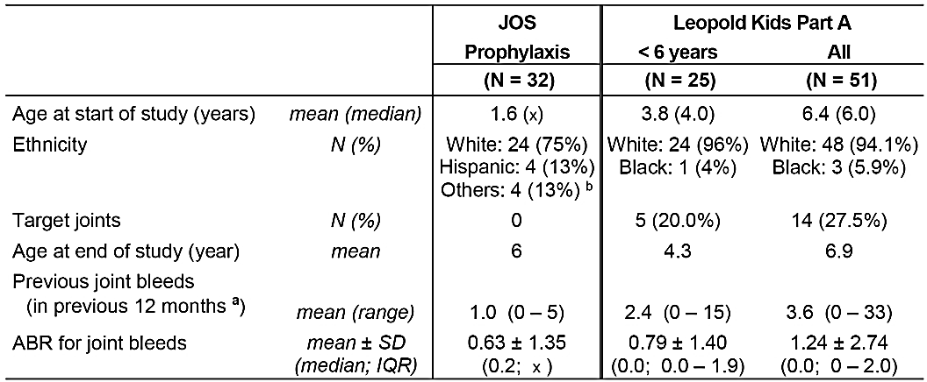
Abbreviations: ABR = annualised bleeding rate; IQR = interquartile range; JOS = Joint Outcomes Study; n/a = not applicable; x = ‘unknown’. a:Data description was more specific in the more recent Leopold Kids study (first subject in 2011) than in JOS (conducted in early 2000). b: Including: Asian/Pacific Islander: 1 subject, American Indian/Eskimo/Aleut: 1 subject, Others: 2 subjects.
In addition, Leopold II included a comparison of the efficacy of Kovaltry administered for prophylaxis and on-demand bleeding. Leopold I and II are considered to be the pivotal studies in PTPs aged ≥ 12 years, and Leopold Kids is considered to be the pivotal study in children aged < 12 years.
The three Leopold studies were open label, and there were no efficacy data in the submission comparing Kovaltry with other Factor VIII products. The sponsor stated that the current Factor VIII guideline¹⁰ does not require controlled studies for the clinical investigation of rFVIII products. The decision not to include a comparator arm using other Factor VIII products is considered to be acceptable.
Leopold I and Leopold II included PTPs aged ≥ 12 years, while Leopold Kids included PTPs aged 0 to < 12 years. Leopold I, Leopold II, and Leopold Kids (Part A) have been completed. Leopold Kids (Part B) investigating Kovaltry in previously untreated subjects (PUPs) and Leopold Kids extension including both PTPs and PUPs are ongoing and scheduled for completion in 2018. Preliminary efficacy data from the Leopold Kids (Part B) study in PUPs were provided, as were preliminary safety data from the Leopold Kids extension study.
The submitted studies were identified by short names (Leopold), protocol numbers, and report numbers. The term ‘BAY-81-8973’ was used throughout the dossier as an alternative name for Kovaltry. The identification details of the relevant completed clinical studies with efficacy data and their location in the sponsor's dossier are summarised in the table below (Table 5 below).
- Identification details of studies with relevant efficacy data
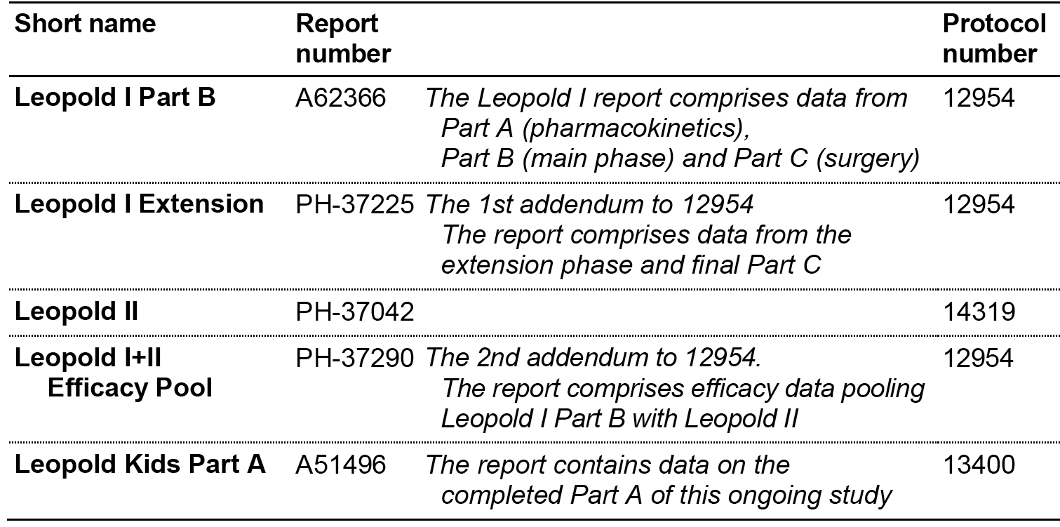

Terminology ‘total bleeds’ and ‘all bleeds’
It should be noted that in the individual Leopold study reports and the sponsor’s efficacy summaries, the definitions used to describe the efficacy outcomes relating to bleeding events (that is, ‘total bleeds’ and ‘all bleeds’) were inconsistent. In this clinical report, the terminology used to describe bleeding events in the individual study reports has been maintained. The differences in terminology found in the studies are briefly outlined below.
In Leopold I (Part B), the primary efficacy variable related to ‘total bleeds’, which included spontaneous bleeds, trauma bleeds, untreated bleeds and bleeds with missing reason. The term ‘all bleeds’ was also used to describe outcomes, and these included ‘total bleeds’ plus injections given for reasons described as ‘other’ (such as additional prophylaxis injection when a bleed was expected because of increased physical activity). In Leopold I, the total number of ‘all bleeds’ was 241, which was 5 greater than the number of ‘total bleeds’ (n = 236), due to the addition of injections given for ‘other reasons’ (n = 5). It is not clear from the submitted data whether the 5 additional injections contributing to ‘all bleeds’ were actually given for bleeding events.
In Leopold I Extension, the primary efficacy variable related to ‘all bleeds’ (that is, spontaneous, trauma, untreated bleeds and bleeds with missing reason, including injections given with reason ‘other’).
In Leopold II, the primary efficacy variable related to all ‘all bleeds’, which were categorised identically to ‘total bleeds’ in Leopold I Part A (that is, spontaneous, trauma, untreated bleeds, and bleeds with missing reason excluding injections for reason ‘other’).
In Leopold I+II (efficacy pool), the primary efficacy variable related to ‘total bleeds’, which was identical to the category of ‘total bleeds’ in Leopold I (Part B) and the category of ‘all bleeds’ in Leopold II.
In Leopold Kids, the primary efficacy related to ‘total bleeds’ within 48 h of the previous prophylactic injection (that is, sum of spontaneous bleeds, trauma bleeds, untreated bleeds and injections with reason ‘other’), which differed from the category of ‘total bleeds’ in Leopold I as it appeared to exclude missing bleeds while including injections for reasons give as ‘other’.
In the Summary of Clinical Efficacy, the sponsor stated that ‘for simplicity’ only the term ‘all bleeds’ was used in the document. In the Summary of Clinical Efficacy, ‘all bleeds’ referred to: (a) spontaneous, trauma, untreated bleeds and bleeds with missing reason, excluding injections given with reason ‘other’ for Leopold I Part B, Leopold I Extension and Leopold I+II (efficacy pool); (b) spontaneous, trauma, untreated bleeds and bleeds with missing reason, excluding injections given with reason ‘other’ in the prophylaxis group, and including ‘other’ for the on-demand group in Leopold II; and spontaneous, trauma, untreated bleeds and bleeds with missing reason, including injections given with reason ‘other’, within 48 h of the previous prophylactic injection, in Leopold Kids. The terminology relating to bleeding events used in the Summary of Clinical Efficacy was also used in the Clinical Overview.

Terminology ‘in vivo recovery’ and ‘incremental recovery’
The term in vivo recovery was used in the dossier. The sponsor stated that, while the term ‘in vivo recovery’ is commonly used, the current Factor VIII guidelines¹⁰ introduced the term ‘incremental recovery’. Both terms were used in the studies (that is, ‘in vivo recovery’ in Leopold I and Leopold II, and ‘incremental recovery’ in Leopold Kids). The terms are synonymous and both terms have been used in the clinical report.
In Leopold I Part (A), in vivo recovery was measured as the C_{max}._{norm}, while in Leopold I (Part B), Leopold II and Leopold Kids in vivo recovery was calculated from the pre-injection Factor VIII concentration and the post-injection Factor VIII concentration at pre-specified time-points in the first h following injection. This method was also used In Leopold I (Part A) in addition to the primary method which measured in vivo recovery as the C_{max}.norm. In vivo recovery was not assessed in Leopold I (Extension).
In the current Factor VIII guidelines¹⁰, incremental recovery is described as ‘the peak level recorded in the first h after infusion and reported as (IU/ml)/(IU/kg)’. However, the study reports expressed recovery as kg/dL rather than (IU/ml)/(IU/kg), with the former differing from the latter by a factor of 10⁻² (that is, 2.50 kg/dL = 0.025 (IU/ml)/(IU/kg)). In this report, the units kg/dL used in the study reports have been maintained.

Evaluator’s conclusions on efficacy

Overview
- The efficacy of prophylactic treatment with Kovaltry for the prevention of bleeds in previously treated children, adolescents, and adults with severe haemophilia (Factor VIII < 1%) has been satisfactorily established. In addition, the efficacy of Kovaltry for haemostasis in the perioperative period (major and minor surgery) in PTPs with severe haemophilia (Factor VIII < 1%) has also been satisfactorily established.
- In general, the individual studies used the intent-to-treat (ITT) population for the primary analyses of efficacy, while analyses using the per protocol (PP) population were supportive. In total, efficacy data based on the ITT population were available for 193 PTPs (122 adults, 20 adolescents and 51 children) (see Table 6 below). Leopold I Part B included 62 subjects aged ≥ 12 years, 55 of whom continued treatment in Leopold I Extension; Leopold II included 80 subjects aged ≥ 12 years (59 prophylaxis, 21 on-demand); and Leopold Kids included 51 subjects aged 0 to 12 years.
- Extent of exposure by age and ethnic subgroups
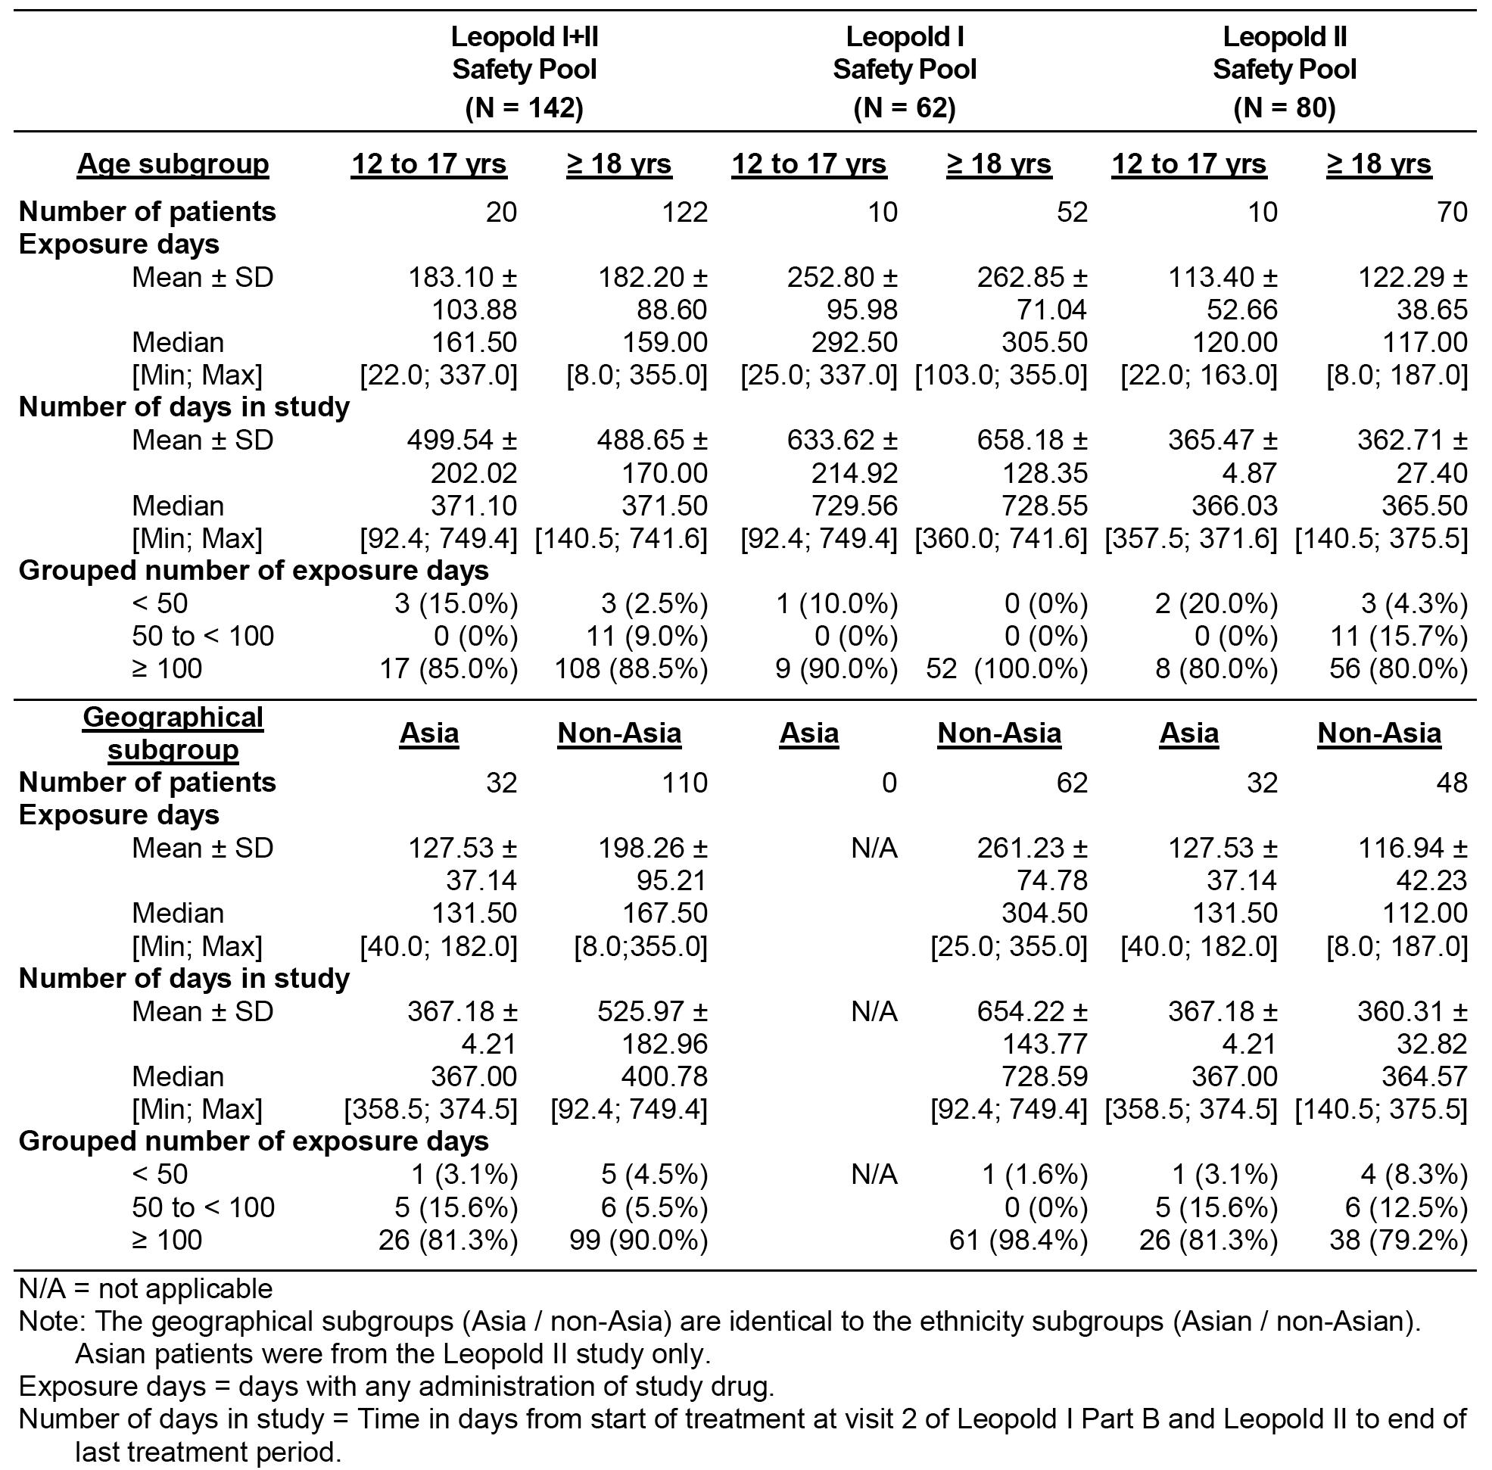
- The mean age of the 121 PTPs who were treated with prophylactic Kovaltry in Leopold I or Leopold II was 30.3 ± 12 years (range: 12, 61 years), and the mean age of the 51 PTPs treated with prophylactic Kovaltry in Leopold Kids was 6.4 ± 3.0 years (range: 1, 11 years). There were no data on PTPs aged < 1 year or > 61 years. However, it is considered that the submitted efficacy data in PTPs are robust enough to allow extrapolation to these age groups. The majority of PTPs were categorised as White (76.0% (92/121) of subjects aged ≥ 12 years; 94.1% (48/51) of subjects aged < 12 years). The demographic characteristics for the ITT populations in the studies are summarised in the table below (Table 7 below).
- Demographic characteristics
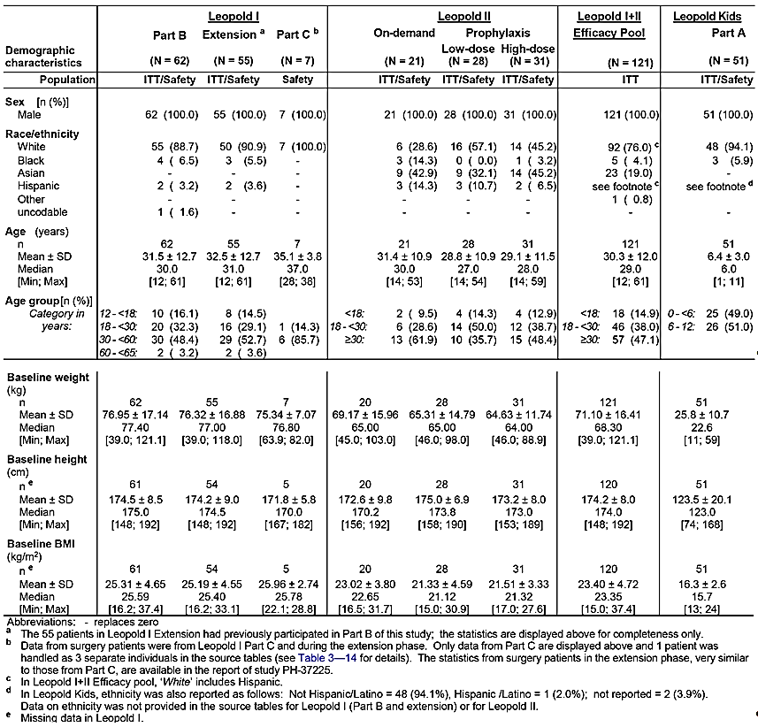
- The submission also included data on the use of Kovaltry in the peri-operative period for PTPs undergoing surgery (major and minor procedures). In PTPs aged ≥ 12 years, data were available from Leopold I and II on a total of 40 surgical subjects (13 major surgeries, and 32 minor surgeries); the total number of surgeries is greater than the total number of surgical subjects as subjects could undergo more than 1 surgical procedure. In Leopold Kids, 1 subject underwent major surgery and no subjects underwent minor surgery.
- The submission included limited preliminary data on prophylactic treatment with Kovaltry for the prevention of bleeds in PUPs (9 subjects).

Leopold I (Part B); subjects aged ≥ 18 years prophylaxis treatment
- The primary efficacy variable in Leopold (Part B) (Annualised bleeding rate (ABR)) related to the total bleeds, defined as the sum of spontaneous bleeds, trauma bleeds, untreated bleeds and bleeds with missing reason but excluding injections given with a reason of ‘other’. In the summary provided below, unless otherwise stated, all subject numbers refer to the ITT population, all mean values include the SD and all doses are nominal.
- In Part B, prophylactic treatment with Kovaltry was provided for up to 1 year at a dose range of 20 to 50 mg IU/kg, 2 times/week or 3 times/week. The mean ABR for total bleeds (primary efficacy variable) was 3.79 ± 5.21 bleeds/year (median = 1.03 bleeds/year; IQR = 0.00, 5.09; range = 0.00, 26.1) in the 62 subjects in the ITT population. During the treatment period, a total of 236 ‘total bleeds’ were experienced by the 62 subjects. Of the 236 bleeds, 153 (68.4%) were trauma bleeds, 79 (33.5%) were spontaneous bleeds, and 4 (1.7%) were untreated bleeds. The majority of total bleeds were mild in severity (52.1% (123/236)), with most of the remaining bleeds being moderate in severity (39.0% (92/236)). Severe bleeds accounted for 11.0% (26/236) of the total number of bleeds.
- The majority of total bleeds occurred in joints (80.9% (191/236), while the number of muscle and skin/mucosa bleeds each accounted for a relatively small percentage of bleeds 8.1% (19/236) and 6.8% (16/236), respectively. The highest number of joint bleeds (n = 191 in total) occurred in knees (n = 64, 33.5%), followed by ankles (n = 57, 29.8%) and elbows (n = 54, 28.3%). Other joints were involved in single cases only. Of the 44 subjects with target joint involvement at baseline, 117 joint bleeds occurred during the study and 81 (69.2%) of these bleeds involved the target joints.
- There were 484 injections administered for the treatment of 241 ‘all bleeds’ (that is, total bleeds (n = 236) plus bleeds for which the reason was given as other (n = 5)). Of the 241 ‘all bleeds’, the majority were treated with 1 injection (70.1% (169/241)) or 2 injections (14.5% (35/241)). Only 18 of the 241 ‘all bleeds’ (7.5%) required more than 2 injections. Of the 241 ‘all bleeds’, 4 (1.7%) were not treated.
- A total of 8480 Kovaltry prophylactic injections were administered to the 62 subjects in the ITT population during Part B of the study, which translates into a mean of 136.8 ± 26.5 injections per subject (range: 25, 163). The mean dose of Kovaltry per prophylactic injection in the 62 subjects in the ITT population was 32.85 ± 6.09 kg/IU (range: 25, 163).
- A total of 479 Kovaltry injections were administered for the treatment of 273 breakthrough bleeds in 44 subjects in the ITT population, which translates into a mean of 10.9 ± 13.1 injections per subject (range: 1, 62). The mean dose of Kovaltry administered per injection for the treatment of breakthrough bleeds in the 44 subjects was 31.3 ± 9.30 IU/kg (range: 12.9, 54.3).
- The total number of Kovaltry injections in the 62 subjects in the ITT population was 8975, which translates into a mean (± SD) of 144.8 ± 28.8 injections per subject (range: 25, 207 injections per subject). The mean total Kovaltry dose per year for all injections in the 62 subjects in the ITT population was 4785.97 ± 1201.64 IU/kg (range: 2199.1, 7785.6).
- Information on the response to treatment of bleeds was available from subjects in the ITT population for 235 bleeds. In these 235 bleeds, the response was assessed as excellent for 23.0% (n = 54) and good for 57.9% (n = 136), while responses of moderate or poor were reported for 16.2% (n = 38) and 3.0% (n = 7) of bleeds, respectively.
- In the ITT total population, there was no significant change in quality of life over the 12 months of prophylactic treatment with Kovaltry.

Leopold I Extension; subjects aged ≥ 12 years
- Subjects in Leopold I who had completed 12 months treatment with Kovaltry prophylaxis in Part B could elect to continue prophylaxis with the drug for a further 12 months in the extension period. During the extension period, subjects continued Kovaltry treatment with the CS/EP potency assignment and the dosing schedule followed during the CS/EP Part B treatment period. A one-time dose adjustment was allowed at the start of the extension period, but the total weekly dose received in Part B was not to be exceeded. Unless otherwise stated, all subject numbers referred to below refer to the ITT population, all mean values include the SD and all doses are nominal.
- The primary efficacy variable for the extension study was the annualised number of ‘all bleeds’, including spontaneous and trauma bleeds, untreated bleeds, as well as injections given for ‘other’ reasons.
- During the whole treatment period (Part B and the extension period combined), 46 of the 55 subjects experienced a total of 386 ‘all bleeds’ (232 in Part B and 154 during the extension period). The mean ABR in the whole ITT population (n = 55) for the combined Part B and extension period was 3.76 ± 4.61 bleeds/year, and the mean ABR was higher in Part B than in the extension period (4.21 ± 5.42 versus 3.71 ± 4.98 bleeds/year, respectively). The results for the ABR demonstrate that the efficacy of Kovaltry for prophylactic treatment can be maintained over at least 2 years of treatment.

Leopold II subjects aged ≥ 12 years; prophylaxis treatment versus on-demand treatment
- The primary objective of Leopold II was to demonstrate the superiority of Kovaltry prophylaxis treatment (25, 25, 30 IU/kg 2 times/week (low-dose group) combined with 30, 35, 40 IU/kg 3 times week (high-dose group)) compared to Kovaltry for on-demand treatment of bleeds, as measured by the number of ‘all bleeds’ reported during the 12 months treatment period. The mean ABR (‘all bleeds’) in the on-demand group was approximately 12 fold higher than in the prophylaxis group, and the difference between the two groups was statistically significant (p < 0.001, Analysis of Variance (ANOVA)). The results for the prophylaxis group summarised below refer to the combined high and low dose groups, unless otherwise stated. In addition, unless otherwise stated, all subject numbers refer to the ITT population, all mean values include the SD and all doses are nominal.
- The primary efficacy variable (ABR) in Leopold II related to all bleeds, and the definition of ‘all bleeds’ in Leopold II was identical to the definition of ‘total bleeds’ in Leopold I. There were 1497 ‘all bleeds’ reported in the ITT population (1204 in the 21 subjects in the on-demand group and 293 in the 59 subjects in the prophylaxis group). The mean ABR (‘all bleeds’) in the prophylaxis group (n = 59) were 4.94 ± 6.81 bleeds/year (median: 1.98; IQR: 0.00, 7.03). The mean ABR (all bleeds) in the on-demand group (n = 21) were 57.96 ± 24.56 bleeds/year (median: 59.96; IQR: 41.74, 76.32).
- In the on-demand group, of the 1202 of the 1204 ‘all bleeds’ for which information was available, 78.5% (n = 943) were categorised as spontaneous bleeds and 21.5% (n = 258) as trauma bleeds. In the prophylaxis group, of the 283 of the 293 ‘all bleeds’ for which information was available, 73.9% (n = 209) were categorised as spontaneous bleeds (n = 209) and 26.1% (n = 74) as trauma bleeds.
- The most commonly reported bleeding site was joints. For the bleeding sites for which information was available, joint bleeds accounted for 77.2% (924/1197) of bleeds in the on-demand group and for 87.0% (255/293) of bleeds in the prophylaxis group.
- For bleeds with information on severity, in the on-demand group (1196 bleeds) and the prophylaxis group (293 bleeds) mild bleeds accounted for 30.7% and 41.0%, moderate bleeds for 60.6% and 47.8%, and severe bleeds for 8.7% and 11.3%, respectively.
- In the on-demand group, information on subject response to treatment of bleeds was available for 1196 bleeds, and the majority of responses were excellent or good (69.7%), with a poor response being reported for 1.3% of bleeds. In the prophylaxis group, information on subject response was available for 279 bleeds, and the majority of responses were excellent or good (61.6%), with a poor response being reported for 4.3% bleeds.
- In the on-demand group, a total of 1607 Kovaltry injections were administered to treat a total of 1204 bleeds, with a mean of 1.3 ± 1.0 injections/bleed (range: 0, 20). Of the 1204 bleeds in the on-demand group, 95.3% were treated with ≤ 2 injections. In the prophylaxis group, a total of 352 Kovaltry injections were administered to treat a total of 293 bleeds, with a mean of 1.2 ± 0.7 injections/bleed. Of the 293 bleeds in the prophylaxis group, 96.2% (n = 282) were treated with ≤ 2 injections.
- The study included a comparison of prophylaxis treatment with high-dose Kovaltry (n = 28) and low-dose Kovaltry (n = 31). The mean ABR (‘all bleeds’) values were higher in the low-dose group than in the high-dose group (5.70 ± 7.17 versus 4.26 ± 6.51 bleeds/year, respectively), as were the median ABR (‘all bleeds’) values (4.02 versus 1.97 bleeds/year, respectively)

Prophylaxis group (combined high and low dose groups), Factor VIII consumption
- Factor VIII consumption prophylaxis: In the prophylaxis group, a total of 7714 Kovaltry injections were given for prophylaxis to 59 subjects (mean: 130.7 ± 26.6; range: 86, 162). The mean dose per prophylaxis injection was 32.63 ± 5.66 IU/kg (range: 20.7, 42.3).
- Factor VIII consumption bleeds: In the prophylaxis group, 43 subjects received 352 Kovaltry injections for breakthrough bleeds (mean: 8.2 ± 8.4; range: 1, 35), and the mean dose per injection was 29.64 ± 6.86 IU/kg (range: 18.7, 49.4). The mean dose per breakthrough bleed per year was 229.03 ± 214.72 IU/kg (range 18.6, 801.3).
- Total Factor VIII consumption all injections: In the prophylaxis group, 59 subjects received a total of 8224 injections (mean: 139.4 ± 25.9; range: 103, 187), and the mean total dose per year was 4621.4 ± 1420.6 IU/kg (range: 2305, 6738).

High dose and low dose prophylaxis groups, separate Factor VIII consumption
- In the low-dose prophylaxis group, 2892 Kovaltry injections were given for prophylaxis to 28 subjects (mean: 103.3 ± 4.4; range 86 to 108). In the high dose group, 4822 Kovaltry injections were given for prophylaxis to 31 subjects (mean: 155.5 ± 3.5; range 145, 162). The mean Kovaltry dose per prophylaxis injection in the low-dose group was 28.72 ± 3.81 IU/kg (range: 20.7, 33.6), and 36.4 ± 4.45 IU/kg (range: 29.6, 42.1) in the high-dose group.
- In the low dose prophylaxis group, 20 subjects received 198 Kovaltry injections for treatment of breakthrough bleeds (mean: 9.9 ± 8.6; range: 1, 35), and the mean dose per injection was 27.77 ± 5.42 IU/kg (range: 18.7, 38.5). In the high dose group prophylaxis group, 23 subjects received 154 Kovaltry injections for treatment of breakthrough bleeds (mean: 6.7 ± 8.0; range: 1, 30), and the mean dose per injection was 31.26 ± 8.6 IU/kg (range: 18.7, 38.5).
- In the low-dose prophylaxis group, 28 subjects received a total of 3218 injections (mean: 114.9 ± 13.1; range: 103, 154), and the mean total dose per year was 3278.7 ± 589.3 IU/kg (range: 2305, 4349). In the high dose prophylaxis group, 31 subjects received a total of 5006 injections (mean: 161.5 ± 9.1; range: 147, 187), and the mean total dose per year was 5834.1 ± 622.0 IU/kg (range: 4620, 6738).

On-demand group Factor VIII consumption
- In the on-demand group, 21 subjects received 1607 Kovaltry injections for the treatment of bleeds, and the mean Kovaltry dose per injection was 23.90 ± 6.84 IU/kg (range: 10.8, 34.6). The 21 subjects in the on-demand group received a total of 1657 injections (mean: 78.9 ± 40.7; range: 8, 164), and the mean total dose per year was 1780.8 ± 851.69 IU/kg (range: 597.4, 3529).

Leopold I+II (efficacy pool) subjects aged ≥ 12 years
- The sponsor states that the data in the Leopold I+II efficacy pool includes the most updated clinical information on prophylaxis treatment with Kovaltry. The total number of subjects in the Leopold I+II efficacy pool includes 121 subjects (62 from Leopold I (Part B + extension) treated for up to 2 years and 59 from Leopold II treated for up to 1 year).
- The primary efficacy analysis in this study was the assessment of the non-inferiority of CS/EP compared to CS/ADJ, based on the ABR (‘total bleeds’) for all patients in the PP who had bleeding data in both dosing periods (n = 118). The analysis showed that CS/EP was non-inferior to CS/ADJ as the lower boundary of the 95% CI for the median difference between the two treatments was -1.038 bleeds/year which was above the pre-defined non-inferiority margin of -1.5 bleeds/year. The non-inferiority analysis was based on pooled data from Leopold I Part B and Leopold II, as dosing in Leopold Extension was based on CS/EP potency assignment only.
- In Leopold I+II, other efficacy data in the prophylaxis group were presented based on various parameters relating to bleeding events in the pooled data from Leopold I Part B and Leopold II, including and excluding Leopold I Extension. Unless otherwise stated, all subject numbers referred to below refer to the ITT population, all mean values include the SD and all doses are nominal. The ‘efficacy pool’ refers to (Leopold I (Part A + Extension) + Leopold II), unless otherwise stated.
- In the ‘efficacy pool’ (n = 121), the mean ABR (‘total bleeds’) was 4.16 ± 5.73 bleeds/year (median 1.98; range = 0.0, 33.1). The mean ABR in Leopold I Part B (n = 62) was 3.41 ± 4.41 bleeds/year (median: 1.98; range: 0.0, 20.6), and in Leopold II (n = 59) was 4.94 ± 6.81 bleeds/year (median: 1.98; range: 0.0, 33.1). The mean ABR in Leopold I Extension for the updated data in 62 subjects was consistent with that reported in Leopold I Extension (PH-37255) in 55 subjects (that is, 3.41±4.41 versus 3.71 ± 4.98 bleeds/year, respectively).
- In the ‘efficacy pool’, there were a total of 687 bleeds comprising 441 (64.2%) spontaneous bleeds, 223 (32.5%) trauma bleeds, 5 (0.7%) injections given for ‘other’ reasons and 18 (2.6%) missing. Of the 687 bleeds, joint bleeds accounted for 82.4% (n = 566), muscle bleeds for 8.4% (n = 58), skin/mucosa bleeds for 5.1% (n = 35), internal bleeds for 0.4% (n = 3), and ‘other’ for 3.6% (n = 25). Of the 686 bleeds with relevant data, 45.2% (n = 310) were categorised as mild, 42.9% (n = 294) as moderate, and 12.0% (n = 92) as severe.
- In the ‘efficacy pool’, the mean number of injections per bleed was 1.68 ± 2.98 (median: 1.00; range: 0.0, 48.0). The majority of bleeds were treated with 1 or 2 injections (75.3% (517/687) and 13.4% (92/687), respectively), while 5.2% (36/687) were treated with > 3 injections. No injections were required for 2.3% (16/687) of bleeds.
- In the ‘efficacy pool’, subject response to treatment of the bleed was reported as excellent for 21.0% (139/662), good for 49.7% (329/662), moderate for 25.2% (167/662), and poor for 4.1% (27/662).
- In the ‘efficacy pool’ (n = 121), 91 (75.2%) subjects treated at least 1 bleed with Kovaltry. The 91 subjects received a total of 1149 Kovaltry injections administered for breakthrough bleeds, which translates into a mean of 12.6 ± 15.2 injections/bleed (median: 6.0; range: 1, 83). The mean Kovaltry dose per injection for breakthrough bleed was 32.06 ± 9.37 IU/kg (median: 30.8; range: 13.5, 67.4).
- In the ‘efficacy pool’, a total of 23101 Kovaltry injections were administered for prophylaxis to 121 subjects, which translates into a mean of 190.9 ± 79.8 injections per subject (median 158.0; range: 25, 315). The mean Kovaltry dose per prophylaxis injection was 32.66 ± 5.88 IU/kg (median 31.23; range: 19.1, 44.0).
- In the ‘efficacy pool’, a total of 24660 Kovaltry injections were administered to 121 subjects, which translates into a mean of 203.8 ± 86.0 injections/subject (median: 164.9; range: 25, 424). The mean Kovaltry dose per injection was 32.69 ± 5.87 IU/kg (median: 31.19; range: 19.2, 31.9).

Leopold kids subjects aged 0 to < 12 years prophylaxis treatment
- In Leopold Kids (Part A), the primary efficacy variable was the annualized number of ‘total bleeds’ during prophylaxis treatment occurring within 48 h of the previous prophylactic injection. Secondary efficacy variables included the annualised number of ‘total bleeds’ during the 6 month prophylaxis period. In this study, only CS/EP based potency was used for Kovaltry dosage labelling.
- In Leopold Kids, ‘total bleeds’ were defined as the sum of spontaneous bleeds, trauma bleeds, untreated bleeds and injections given for ‘other’ reasons. This definition of ‘total bleeds’ differs from that in Leopold I and Leopold II, but corresponds to the definition of ‘all bleeds’ used in the two studies. Unless otherwise stated, all subject numbers referred to below relate to the ITT population, all mean values include the SD, and all doses are nominal.

Subjects aged 0 to12 years (n = 51)
- The ITT population (0-12 years) included 51 subjects and 23 (45.1%) of these subjects experienced a total of 53 bleeds within 48 h of the previous prophylactic injection during the observation period. The mean number of bleeds within 48 h of the previous prophylactic injection in 51 subjects was 1.04 ± 1.48 bleeds (median: 0.00; interquartile range (IQR): 0.00, 2.00), and the mean ABR was 2.04 ± 2.91 bleeds/year (median 0; IQR: 0.00, 3.95).
- In subjects aged 0-12 years, 60% (32/53) of bleeds occurring within 48 h of the previous prophylactic injection were trauma bleeds and 17% (9/53) were spontaneous bleeds. Of the 53 bleeds occurring within 48 h of the previous injection, 17 (32.1%) were joint bleeds. There were 46 (90.2%) subjects who experienced no spontaneous bleeds within 48 h of the previous prophylactic injection, and 40 (78.4%) subjects who experienced no joint bleeds within 48 h of the previous prophylactic injection.
- In subjects aged 0-12 years (N = 51), 28 (54.9%) experienced 97 total bleeds during the study (mean: 1.90 ± 2.51; median 1.00; IQR: 0.00, 3.00). The mean ABR was 3.75 ± 4.98 bleeds/year (median 1.9; IQR = 0.00, 6.02). The characteristics of the bleeds reported in the total treatment period were trauma bleeds (61% (59/97)), spontaneous bleeds (21% (20/97)), and joint bleeds (33% (32/97)).
- A total of 134 Kovaltry injections were administered to treat 97 bleeds reported during the study, with a mean of 1.4 ± 1.7 injections/bleed (median: 1.0; range: 0, 9)). The majority of bleeds required only 1 injection (67% (65/97)), and only 7 (7.2%) required > 3 injections. There were 16.5% (16/97) untreated bleeds. The subject's/caregiver's response to treatment of the bleed was ‘excellent or good’ for 90% (73/81) of the bleeds with data, while poor response was reported for only 1 (1.2%) bleed.
- The total number of Kovaltry injections reported during the study in 51 subjects aged 0 to 12 years was 3669, with a mean of 71.9 ± 17.3 (median: 77.0; range: 37, 112). The mean total dose of Kovaltry per injection in 51 subjects was 35.2 ± 9.9 IU/kg (median: 34.0; range: 21, 61).
- The total number of Kovaltry injections for prophylaxis reported during the study in 51 subjects aged 0 to 12 years was 3529, with a mean of 69.2 ± 16.9 (median: 73.0; range: 37, 100). The mean Kovaltry dose per prophylactic injection in 51 subjects was 35.1 ± 9.8 IU/kg (median: 33.8; range: 21, 58).
- The total number of Kovaltry injections for ‘breakthrough bleeds’ reported during study in 26 subjects was 134, with a mean of 5.15 ± 4.04 (median: 4.0; range: 1, 17). The mean Kovaltry dose per injection for ‘breakthrough bleeds’ in 26 subjects was 38.60 ± 12.95 IU/kg (median: 36.94; range: 20.8, 71.6).
- In subjects aged 0 to 12 years, 98.0% (50/51) were exposed to Kovaltry for 50 ≥ exposure days (EDs) during the study. At the end of the study, 43.1% (22/51) were being treated with 3times/week prophylaxis, 39.2% (20/51) with 2 times/week prophylaxis, 15.7% (8/51) with prophylaxis every other day, and 2.0% (1/51) with another regimen (not stated).

Subgroup subjects aged 0 to < 6 years (n = 25)
- The ITT population (0 to < 6 years) included 25 subjects, of whom 13 (52.0%) experienced a total of 28 bleeds within 48 h of the previous prophylactic injection during the observation period. The mean number of bleeds with 48 h of the previous injection in the 25 subjects was 1.12 ± 1.39 bleeds (median: 1.00; IQR: 0.00, 2.00), and the mean ABR was 2.23 ± 2.77 bleeds/year (median 1.88; IQR: 0.00, 3.97).
- In subjects aged 0 to < 6years, of the total number of bleeds occurring within 48 h (28 bleeds), 18 (64.3%) were trauma bleeds, 7 (25.0%) were spontaneous bleeds, and 6 (21.4%) were joint bleeds. There were 21 (84%) subjects who experienced no spontaneous bleeds within 48 h of the previous prophylactic injection, and 20 (80%) subjects who experienced no joint bleeds within 48 h of the previous prophylaxis injections.
- In subjects aged 0 to < 6 years, 15 (60.0%) experienced 52 bleeds during the study (mean: 2.08 ± 2.50; median 1.00; IQR: 0.00, 3.00), and the mean ABR was 4.16 ± 5.02 bleeds/year (median 2.03; IQR = 0.0, 6.02). The characteristics of the 52 bleeds reported during the study were trauma (69% (36/52)), spontaneous (15% (8/52)), and joint (19% (10/52)).
- In subjects aged 0 to < 6 years, a total of 52 Kovaltry injections were administered during the study to treat 70 bleeds, with a mean of 1.3 ± 1.8 injections/bleed (median: 1.0; range: 0, 9]). The majority of bleeds required only 1 injection (71.2% (37/52), while only 3 bleeds (5.8%) required > 3 injections. There were 15.4 (8/52) untreated bleeds. In subjects aged 0 to < 6 years, the subject's/caregiver's response to treatment of the bleed was ‘excellent or good’ for 98% (43/44) of the bleeds, while ‘poor’ response was reported for only 1 bleed (2.3%).
- The total number of injections in 25 subjects aged 0 to < 6 years during the study was 1840, with a mean of 73.6 ± 19.2 (median: 78.0; range: 37, 112). The mean total Kovaltry dose per injection in 25 subjects 37.2 ± 11.3 IU/kg (median: 36.4; range: 21, 61).
- The total number of Kovaltry injections for prophylaxis in 25 subjects aged 0 to < 6 years during the study was 1770, with a mean of 70.8 ± 18.0 (median: 77.0; range: 37, 100). The mean Kovaltry dose per prophylactic injection in 25 subjects was 37.0 ± 10.9 IU/kg (median: 36.4; range: 21, 58).
- The total number of Kovaltry injections for ‘breakthrough bleeds’ in 15 subjects aged 0 to < 6 years during the study was 70 with a mean of 4.67 ± 4.55 (median: 4.0; range:1, 17). The mean Kovaltry dose per injection for ‘breakthrough bleeds’ in 15 subjects was 41.93 ± 14.89 IU/kg (median: 38.70; range: 20.8, 71.6).
- In subjects aged 0-< 6 years, 96.0% (24/25) had been exposed to Kovaltry for 50 ≥ EDs. At the end of the study, 52.0% (13/25) were being treated with 3 times/week prophylaxis, 32.0% (8/25) with 2times/week prophylaxis, 12.0% (3/25) with prophylaxis every other day, and 4.0% (1/25) with another regimen (not stated).

Subgroup subjects aged 6 to 12 years
- The ITT population (6 to 12 years) included 26 subjects of whom 10 (38.5%) experienced a total of 25 bleeds within 48 h of the previous prophylactic injection. The mean number of bleeds with 48 h of the previous prophylactic injection in the 26 subjects was 0.96 ± 1.59 bleeds (median: 0.00; IQR: 0.00, 1.00), and the mean ABR was 1.86 ± 3.08 bleeds/year (median 0.00; IQR: 0.00, 1.96).
- In subjects aged 6 to 12 years, 56% (14/25) of bleeds occurring within 48 h of the previous prophylactic injection were trauma bleeds, 8% (2/25) were spontaneous bleeds, and 44% (11/25) were joint bleeds. There were 25 (96.2%) subjects who experienced no spontaneous bleeds within 48 h of the previous prophylactic injection, and 20 (76.9%) subjects who experienced no joint bleeds within 48 h of the previous prophylactic injection.
- The incidence of trauma bleeds within 48 h of the previous prophylactic injection was approximately 2.5 fold higher in older children compared to younger children, while the incidence of joint bleeds within 48 h of the previous prophylactic injection was approximately 2.1 fold higher in older children compared to younger children,
- In subjects aged 6 to 12 years, 13 (50%) experienced 45 bleeds during the study (mean: 1.73 ± 2.55; median 0.50; IQR: 0.00, 3.00), and the mean ABR was 3.37 ± 5.01 bleeds/year (median 0.93; IQR = 0.00, 5.77). The characteristics of the 45 bleeds reported during the study were trauma (51% (23/45)), spontaneous (27% (12/45)), and joint (49% (22/45)).
- A total of 64 Kovaltry injections were administered during the study to treat 45 bleeds, with a mean of 1.4 ± 1.7 injections/bleed (median: 1.0; range: 0, 8). The majority of bleeds required only 1 injection (62.2% (28/45)), while only 4 bleeds (8.9%) required > 3 injections. There were 8 (17.8%) untreated bleeds. The subject's/caregiver's response to treatment of the bleed was ‘excellent or good’ for 81% (30/37) of the bleeds with response data, while a ‘poor’ response was reported for no treatments for a bleed.
- The total number of Kovaltry injections in 26 subjects aged 6 to 12 years during the study was 1829, with a mean of 70.3 ± 15.5 (median: 65.5; range: 52, 98). The mean Kovaltry dose per injections in 26 subjects was 33.4 ± 8.2 (median: 31.6; range: 22, 50).
- The total number of Kovaltry injections for prophylaxis during the study in 26 subjects aged 6 to 12 years was 1759, with a mean of 67.7 ± 15.9 (median: 59.5; range: 48, 93). The mean Kovaltry dose per prophylaxis injection in 26 subjects was 33.3 ± 8.3 IU/kg (median: 31.8; range: 22, 50).
- The total number of Kovaltry injections for ‘breakthrough bleeds’ in 11 subjects aged 6 to 12 years during the study was 64, with a mean of 5.82 ± 3.31 (median: 7.0; range: 1, 10). The mean Kovaltry dose per injection for ‘breakthrough bleeds’ in 11 subjects was 34.07 ± 8.35 IU/kg (median: 32.40; range: 21.7, 50.0).
- In subjects aged 6 to 12 years, 100% (26/26) had been exposed to Kovaltry for 50 ≥ EDs. At the end of the study, 34.6% (9/26) were being treated with 3 times/week prophylaxis, 46.2% (12/26) with 2 times/week prophylaxis, and 19.2% (5/26) with prophylaxis every other day.

Incremental recovery
- In Leopold I Part B, the mean incremental recovery determined by the chromogenic assay in the CS/EP period was 2.42 ± 0.68 kg/dL at the start of treatment (n = 59) and 2.40 ± 0.77 kg/dL at the mid/end of treatment (n = 41). In Leopold II, the mean incremental recovery determined by the chromogenic assay in the CS/EP period was 2.07 ± 0.50 kg/dL at the start of treatment (n = 56) and 2.16 ± 0.74 kg/dL at the end of treatment (n = 54). In both studies, incremental recovery remained stable over the course of prophylactic treatment.
- In Leopold Kids, the mean incremental recovery (mean of 4 time-points) based on the chromogenic assay was 1.69 ± 0.37 kg/dL in the 0-12 years group (n = 50), 1.63 ± 0.31 kg/dL in the 0 to < 6 years group (n = 25), and 1.76 ± 0.42 kg/dL in the 6 to 12 years group (n = 25).

Major surgery
- In the pooled data from Leopold I+II, information was provided on 13 major surgeries, 12 from Leopold I and 1 from Leopold II in subjects aged ≥ 12 years. Of the 13 major surgeries, 7 (54%) were orthopaedic surgeries. Of the 13 major surgeries, haemostasis was assessed as excellent in 3 (23.1%) and good in 10 (76.9%).
- In Leopold I+II, there were 370 Kovaltry injections administered for the 13 major surgeries (mean: 28.5 ± 17.6; median 25.0; range: 1, 54). The mean nominal dose for all injections given for the 13 major surgeries was 988.47 ± 760.98 IU/kg (median: 801.13; range: 62.5, 420.0).
- In Leopold I+II, there were 31 Kovaltry injections administered on the day of surgery for the 13 major surgeries (mean: 2.4 ± 0.9; median: 2.0; range: 1, 4). The mean nominal dose for all injections given on the day of surgery for the 13 major surgeries was 114.25 ± 49.70 IU/kg (median: 107.50; range: 59.5, 207.3).
- In Leopold Kids, there was 1 major surgery (tooth extraction) in 1 subject aged 6. This subject received 2 injections of Kovaltry on the day of surgery with a total dose of 108.7 IU/kg. Haemostasis was assessed as ‘good’.

Minor surgery
- In Leopold I and Leopold II combined, there were 46 minor surgeries (26 minor surgeries in 18 subjects in Leopold I and 20 minor surgeries in 14 subjects in Leopold II). Of the 46 minor surgeries, 28 (60.9%) were dental procedures. For 3 of the minor surgeries, no Kovaltry injections in addition to the regular prophylactic injections were documented. The initial dose of Kovaltry for all other 43 minor surgical procedures ranged between 1500 IU and 5000 IU. Follow-up injections were not required for 15 of the 46 minor surgeries. For subjects receiving follow-up injections, the number of injections ranged between 1 and 14 for all subjects, apart from 1 subject who appears to have been given 91 injections. For all 43 minor surgeries treated with Kovaltry, haemostasis was assessed as excellent (53.5% (23/43)) or good (46.5% (20/43)). No subjects undergoing minor surgery required blood transfusions.
- In the pooled data for Leopold I and Leopold II, a total of 310 Kovaltry injections were given for 46 minor surgical procedures, with a mean of 6.7 ± 10.5 injections per procedure (median: 1.5; range 0 to 62). The mean total dose of Kovaltry given for all injections was 257.91 ± 514.66 IU/kg, with a median of 102.67 IU/kg and a range of 0 to 3412.5 IU/kg.
- On the day of surgery, a total of 64 Kovaltry injections were given for 46 minor surgical procedures, with a mean of 1.4 ± 0.8 injections per procedure (median: 1.0; range: 0, 3). The mean dose of Kovaltry given on the day of surgery was 53.53 IU/kg, with a median of 47.72 IU/kg and a range of 0 to 162.5 IU/kg.
- No subjects in Leopold Kids underwent minor surgery.

PUPs in children aged 0-12 years Leopold Kids
Leopold Kids (Part B), included 9 PUPs with severe haemophilia A (Factor VIII < 1%). The submission included preliminary data from an interim efficacy analysis in these 9 subjects. The preliminary data indicate that the efficacy of Kovaltry in PUPs was similar to the efficacy of the product in PTPs. However, the sponsor acknowledges that the limited data should be interpreted with caution. Leopold Kids (Part B) plans to enrol a total of 25 PUPs and was ongoing at the date of the submission. PUPs completing Part B of the study will be offered participation in the extension phase of the study.

Safety

Studies providing safety data
Comprehensive safety data were available from Leopold I, Leopold II, and Leopold (pooled) 1+2 trials in PTPs aged ≥ 12 years, and from Leopold Kids in PTPs aged 0 to 12 years. The submission included an integrated analysis of the safety data from Leopold I and II, which was supported by a Statistical Analysis Plan (SAP). The integrated summary of safety for Leopold I and II was included and extensive additional summary tables for the integrated analysis were presented in the clinical submission.
The following Leopold I and II safety pools in subjects aged ≥ 12 years were presented in the integrated analysis:
- Leopold I: This pool included data from Leopold Part B (prophylaxis) and Leopold Extension (prophylaxis), while data from Part A (pharmacokinetics) and Part C (surgery) were not included in the pool. Subjects in Part A received only a single dose of Kovaltry or Kogenate FS for PK analysis, while subjects in Part B and the Extension received multiple dose of Kovaltry for prophylaxis. In Part C, subjects were treated with Kovaltry for major surgery and had an adverse event (AE) profile determined mainly by the surgery rather than the drug.
- Leopold II: This pool included data grouped on whether treatment with Kovaltry was administered for prophylaxis or on-demand.
- Leopold I+II: The data were pooled for Leopold I (prophylaxis) and Leopold II (prophylaxis and on-demand).
The safety data from Leopold Kids was not pooled with the safety data from Leopold I and II, due to the age differences between subjects in the two safety populations. Therefore, the safety data in children from Leopold Kids were presented separately from the pooled data in adolescents and adults from Leopold I and II. However, listing of adverse drug reactions (ADRs) in the sponsor's core company data sheet (CCDS) for Kovaltry combine the safety data from all 193 subjects in the safety set (that is, Leopold I (n = 62), Leopold II (n = 80), and Leopold Kids (n = 51)). The sponsor provided a Justification Document for adopting this approach in this submission. The provided daft prescribing documents indicate that the sponsor intends to follow this approach in various regulatory jurisdictions, including Australia, the EU, the USA and Canada. However, in the USA and Canadian prescribing documents the data are presented using actual percentages for each ADR, while in the Australian and European prescribing documents the ADRs are grouped according to the Council of International Organizations of Medical Sciences (CIOMS) qualitative ADR definitions based on frequency (for example, very common ≥ 1/10).
In this clinical report, the approach to the safety evaluation has been to review the integrated safety analysis provided for data from Leopold I, Leopold II and Leopold I+II, and separately review the safety data from Leopold Kids. This approach follows that provided by the sponsor in the Summary of Clinical Safety (SCS). Where there are no pooled data for the Leopold I and II studies (for example, laboratory tests), then the original study reports have been reviewed. It is considered that the integrated safety analysis based on Leopold I and Leopold II accurately reflects the safety data presented in the separate clinical reports for these two studies.

Patient exposure

Subject exposure

Safety analysis sets
The safety analysis sets included all subjects who were randomised and received at least one dose of the study drug. The disposition of the PTPs in the safety analysis sets are summarised below in Table 8.
- Disposition of subjects in the safety sets
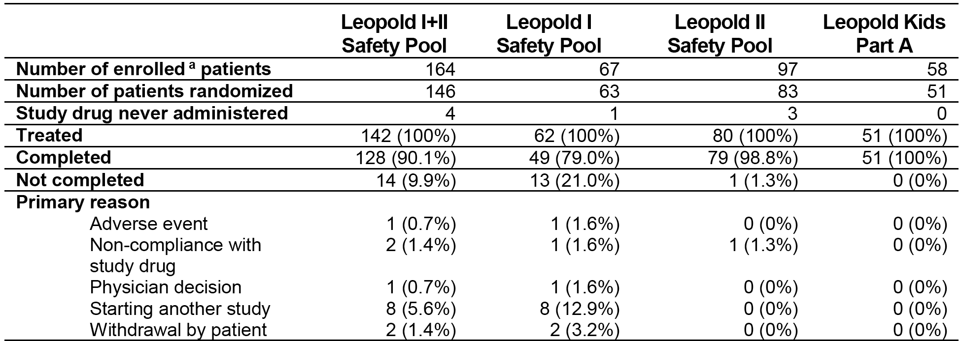
a = Number of subjects enrolled is the number who signed the consent form.

Extent of exposure
The extent of exposure as number of EDs and number of days in the study is summarised below in Table 9. EDs were days with any administration of the study drug. The number of days in the study was the time from start of the treatment phase to end of the treatment phase. Of the total number of PTPs in the clinical studies, all 193 (100%) have been exposed for ≥ 3 months, 179 (92.8%) for ≥ 6 months, 129 (66.8%) for ≥ 12 months and 39 (20.2%) for ≥ 24 month. Of the 193 PTPs, 172 (89%) were treated with Kovaltry for prophylaxis, and 21 (11%) were treated with Kovaltry on-demand.
- Exposure safety analysis sets
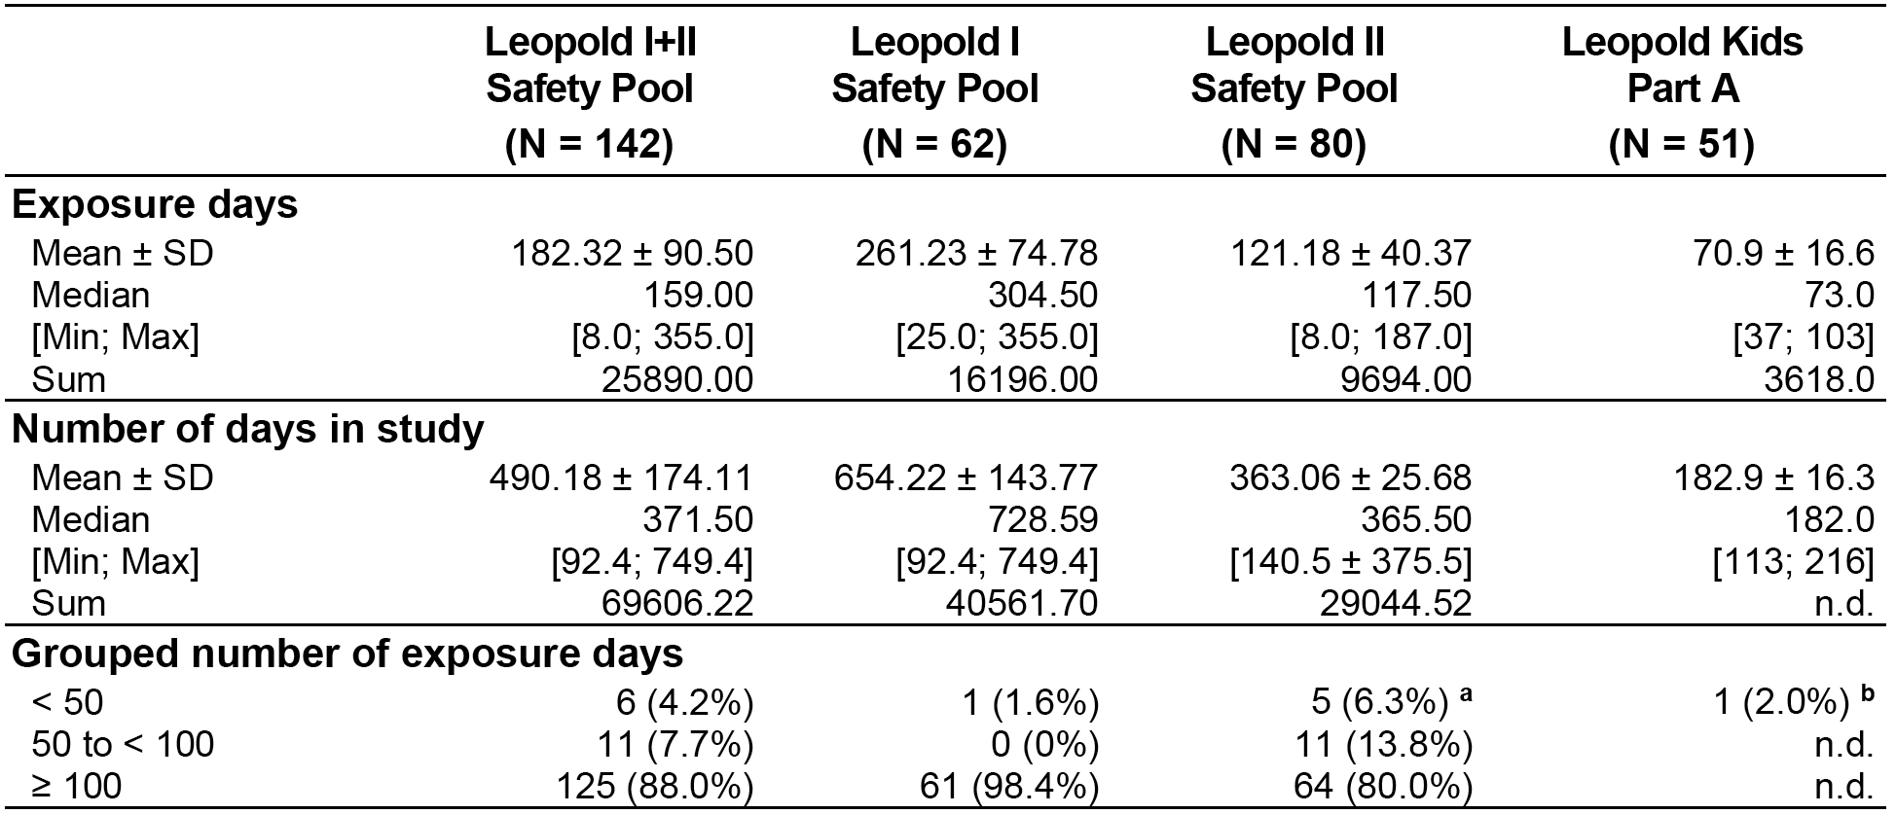
a =These subjects were in the on-demand treatment group. b =The remaining 50 subjects had more than 50 EDs.
- Exposure days in the Leopold I, 2, and I+II safety analysis sets were also analysed by age (12-17 (adolescent) years, ≥ 18 years (adult)) and racial group (Asian, non-Asian). In the Leopold I+II safety analysis sets, the extent of exposure was similar in adolescent and adult subjects, while the extent of exposure in Asian subjects was shorter than in non-Asian subjects. The results of the analyses are summarised in the table ‘Extent of exposure by age and ethnic subgroups’ above (Table 6 above).

Factor VIII consumption
Factor VIII consumption data (CS/EP + CS/ADJ period; based on nominal dose) for the subjects in the safety analysis sets are summarised below in Table 10. The total number of injections in Leopold I (safety pool) was greater than in Leopold II (safety pool), due to the longer duration of exposure. The mean and median Kovaltry dose (IU/kg) per injection was higher in children (0 to 12 years) than in subjects aged ≥ 12 years.
- Factor VIII consumption; summary of treatment administration per patient; Safety analysis sets
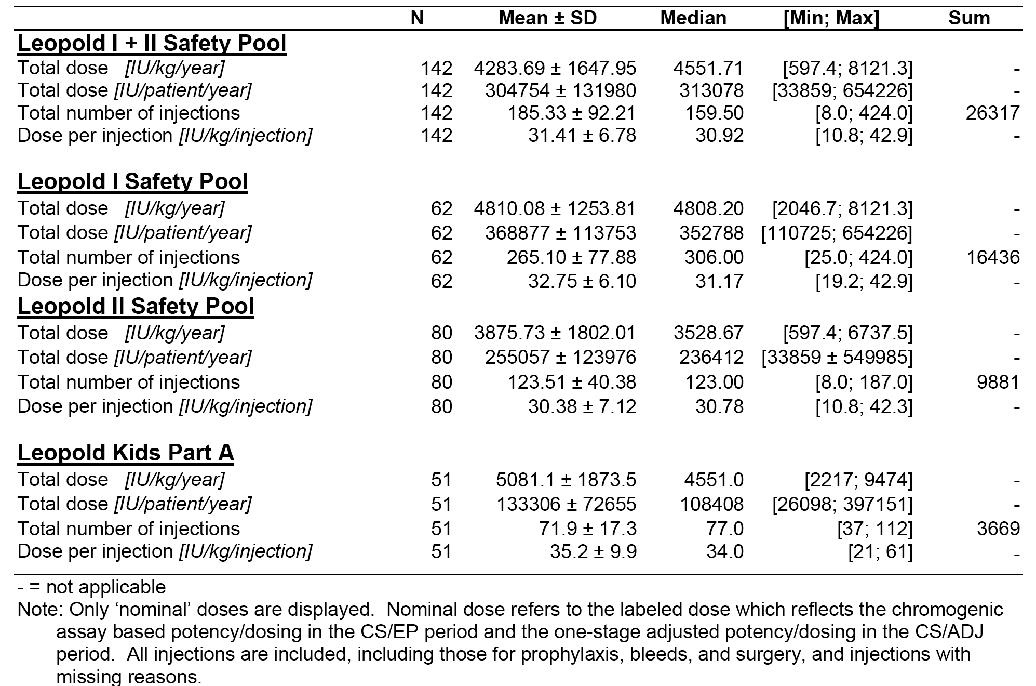
Factor VIII consumption in the Leopold I, 2, and I+II safety analysis sets was also analysed by age (12 to 17 (adolescent) years, ≥ 18 years (adult)) and racial group (Asian, non-Asian). The results are summarised in Table 11 below. In the Leopold I+II safety analysis set, the mean and median dose (IU/kg) per injection were similar in adolescents (12 to 17 years) and adults (≥ 18 years), and in Asian and non-Asian subjects.
- FVIII consumption by age and ethnic subgroups
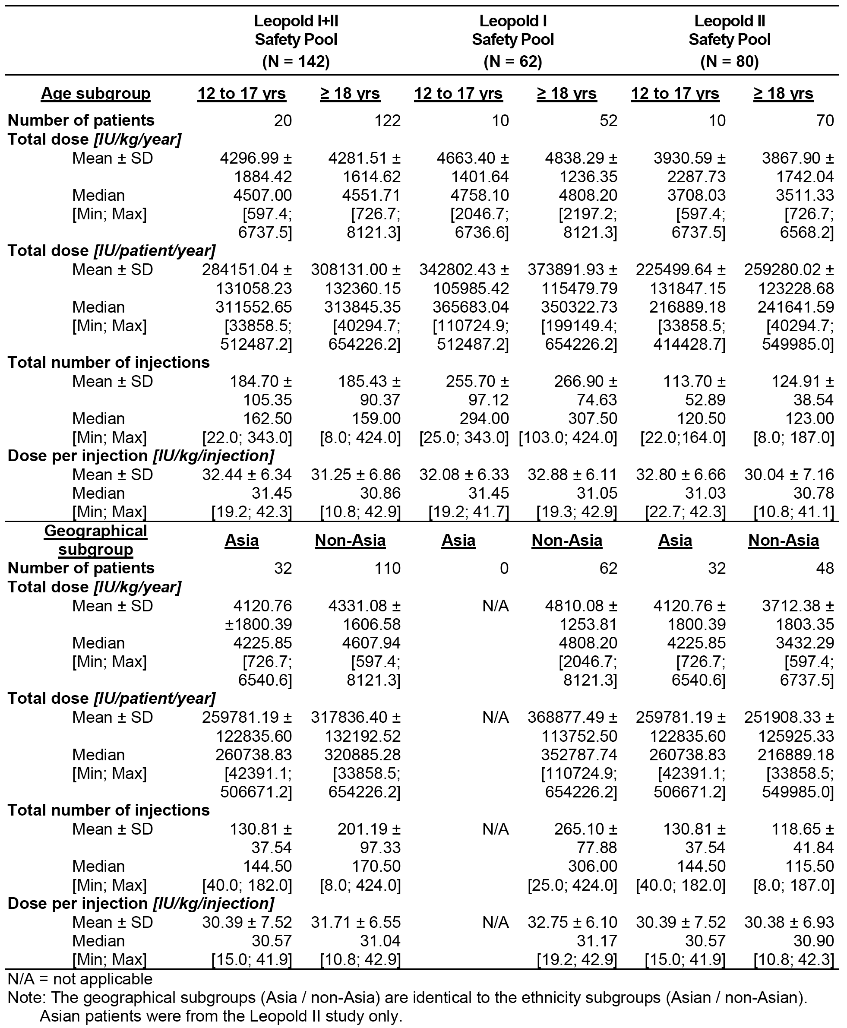

Safety issues with the potential for major regulatory impact

Immunogenicity

Anti-Factor VIII antibodies
Subjects were monitored for the development of inhibitory antibodies to Factor VIII (the primary safety variable) by clinical observations and the results of the Nijmegen modified Bethesda assay, which was performed at each clinical visit (every 3 to 4 months or at the time of any clinical suspicion). Inhibitor formation to Factor VIII was to be reported as a serious adverse event (SAE). Subjects who developed inhibitory antibody levels of ≥ 0.6 Bethesda units (BU) (including a confirmatory sample) were to be categorised as having inhibitory responses.
In Leopold I, Leopold I Extension, Leopold II and Leopold Kids Part A, no PTPS had a positive Factor VIII inhibitor level during the studies (that is, ≥ 0.6 BU/mL; Nijmegen modified Bethesda assay). However, in Leopold Kids Part B, 2 of 9 PUPs developed anti-Factor VIII antibodies, and both events were classified as serious and treatment related. An 11 month old boy with a total of 51 EDs had transient low titre antibodies above the cut-off level for positivity (≥ 0.6 BU) with a maximum of 1.8 BUs. This subject continued treatment without any change in dose and the anti-Factor VIII antibody values were reported to be negative at the last measurement (< 0.2 BU). Another 9 month old boy was withdrawn from treatment due to anti-Factor VIII antibody development. After 6 EDs this subject developed a high titre inhibitor (50 BU). After approximately 10 months without any Kovaltry treatment, the titre decreased to less than 20 BU.

Anti-HSP70 antibodies
Anti-HSP70 antibody levels were measured at regular time points by an enzyme-linked immunosorbent assay (ELISA) technique with a commercial kit. The concentration measured was indicative for the titre of the response. The cut-off value for antibody negativity or normal levels was determined based on the analysis of 50 individual blank samples of normal controls with a 95% CI, resulting in 5% false positive samples. The cut-off value for anti-HSP70 antibody negativity/normal levels was 239 ng/mL and had a lower limit of quantification of 25 or 50 ng/mL. The dilution factor of study samples used was 1:1000.
In Leopold I+II, the majority of subjects had detectable levels of anti-HSP70 antibodies at screening with a mean (median) value of 86 and 88 ng/mL (67 and 74 ng/ml), respectively. However, the levels were below the cut-off level for positivity in the majority of subjects at baseline/screening (that is, 97.9% (139/142) in Leopold I+II).
In total, in Leopold I and II there were 13 subjects with values above the cut-off level for positivity at any time (screening/baseline or during the study): (a) 2 subjects entered the studies with positive levels and became negative during the study (1 in Leopold I, 1 in Leopold II); (b) 1 subject entered the studies positive and remained positive (1 in Leopold II); (c) 5 subjects entered the studies negative and became transiently positive during the studies (all in Leopold II); and (d) 5 subjects entered the studies negative and became and remained positive during the studies (2 in Leopold I, 3 in Leopold II).
In Leopold Kids Part A, there was 1 subject with 1 result above the cut-off value before the start of the study with levels which decreased to below the threshold for positivity during study. At the final visit, the result for this subject was negative.

Anti-BHK/HCP antibodies
In Leopold I+II, 96.5% (137/142) of subjects were negative at baseline/screening and remained negative throughout the studies. There were 5 (3.5%) subjects who were positive at baseline/screening (2 in Leopold I, 3 in Leopold II). Of these 5 subjects, 4 had at least one positive result during treatment (2 in Leopold I, 2 in Leopold II), and 1 had only negative tests during treatment (1 in Leopold II). In Leopold Kids, no anti-BHK/host cell protein (HCP) antibody tests were performed.

Unwanted immunological events
No cases of anaphylactic reactions were reported in the Kovaltry development program.
Hypersensitivity reactions were analysed based on MedDRA single PTs that could be distantly related to hypersensitivity reactions with Kovaltry. Using this broad approach, hypersensitivity reactions were reported in 20.4% (29/132) of subjects in Leopold I+II and 37.3% (19/51) of subjects in Leopold Kids Part A. The majority of reactions were each reported in 1 subject only (see Table 12 below).
- Number of subjects with TEAEs possibly related to hypersensitivity reactions by preferred term (regardless of causality); safety analysis sets
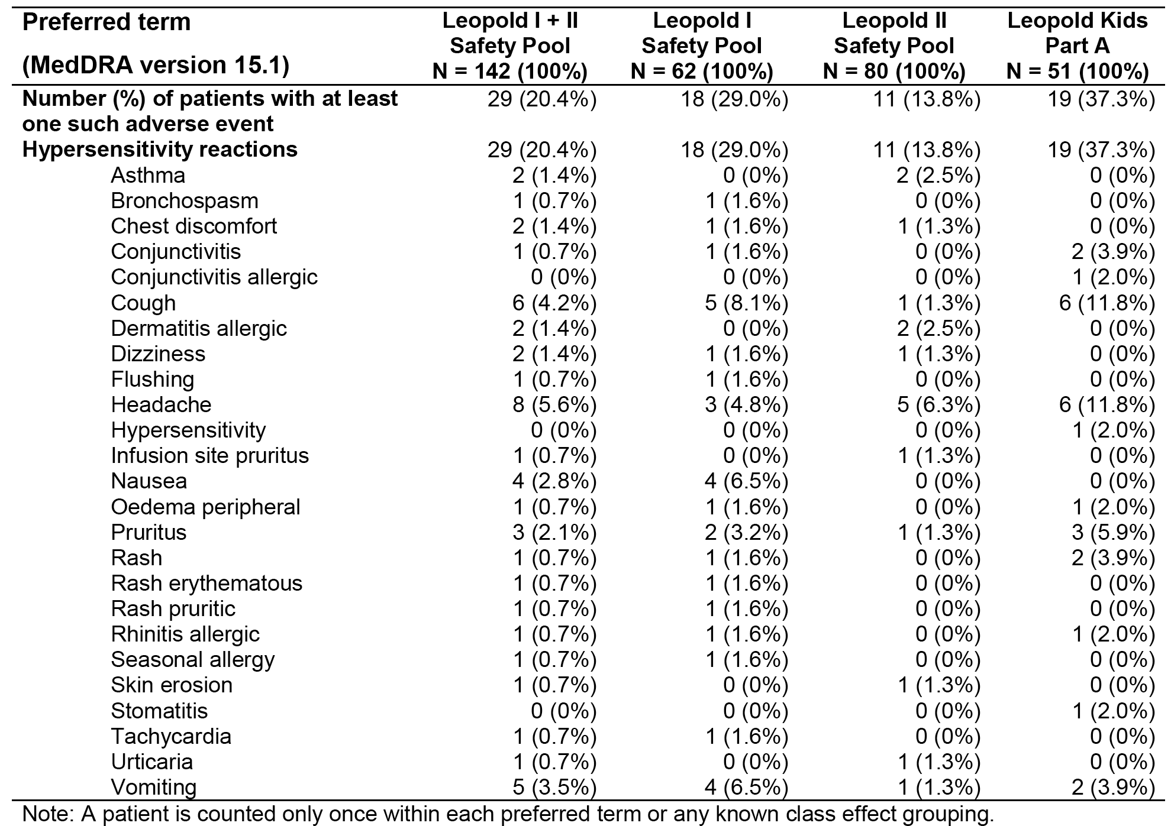
In Leopold I+II, hypersensitivity reactions reported in ≥ 2 subjects, in descending order of frequency were, headache (5.6%, n = 8), cough (4.2%, n = 6), vomiting (3.5%, n = 5), nausea (2.8%, n = 4), pruritus (2.1%, n = 3), allergic dermatitis (1.4%, n = 2), dizziness (1.4%, n = 2), asthma (1.4%, n = 2) and chest discomfort (1.4%, n = 2).
In Leopold Kids Part A, hypersensitivity reactions reported in ≥ 2 subjects, in descending order of frequency, were headache (11.8%, n = 6), cough (11.8%, n = 6), pruritus (5.9%, n = 3), conjunctivitis (3.9%, n = 2), rash (3.9%, n = 2) and vomiting (3.9%, n = 2).
Of the Treatment emergent adverse event (TEAEs) categorised as hypersensitivity reactions, 6 subjects in Leopold I+II experienced 7 events considered to be drug related (allergic dermatitis, flushing, headache, infusion site pruritus, nausea, pruritus, and seasonal allergy) and 1 subject in Leopold Kids Part A experienced 1 event (pruritus). All of these drug related events were classified as being possibly related to hypersensitivity reactions.

Cardiovascular safety
In Leopold I+II, 7 (4.9%) subjects reported at least 1 cardiovascular disorder (see Table 13, below), and no subjects in Leopold Kids Part A reported a cardiovascular disorder. The most frequently reported cardiovascular AE in the Leopold I+II safety set was hypertension (3.5%, n = 5). The 1 myocardial infarction event was classified as an SAE and was reported as drug related. The 1 flushing event was classified as drug related.
- MedDRA primary SOCs Cardiac disorders and Vascular disorders TEAEs by PT; safety analysis sets
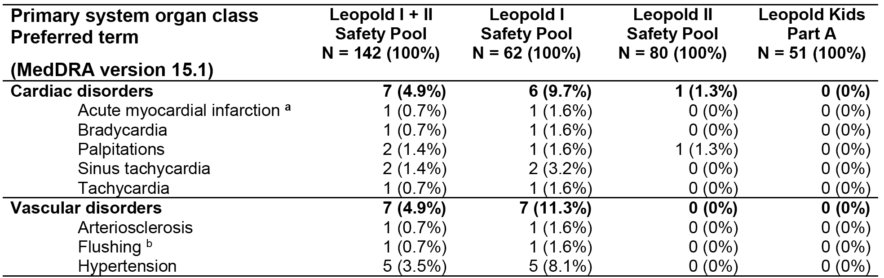
a = The case of myocardial infarction was classified as serious and drug related. b = The case of flushing was classified as drug related. MedDRA = Medical Dictionary for Regulatory Affairs; SOC = System Organ Class.

Hepatic toxicity
Hepatobiliary disorders were reported in 4 (2.8%) subjects in Leopold I+II (2 cholelithiasis, 1 biliary colic and 1 hyperbilirubinaemia). Alanine aminotransferase (ALT) and aspartate aminotransferase (AST) increased (TEAEs) were each reported in 1 subject. There were no hepatobiliary disorders reported in Leopold Kids Part A.

Renal toxicity
Renal and urinary disorders were reported in 5 (3.5%) subjects in Leopold I+II (2 nephrolithiasis, 1 haematuria, 1 hyperoxaliuria, 1 proteinuria). Blood creatinine increased (TEAE) was reported in 1 subject. There were no renal and urinary disorders reported in Leopold Kids Part A.

Haematological toxicity
Blood and lymphatic disorders were reported in 2 (1.4%) subjects in Leopold I+II (2 lymphadenopathy). In Leopold Kids Part A, blood and lymphatic disorders were reported in 2 subjects (1 anaemia, 1 haemorrhagic anaemia), and TEAEs relating to relevant investigations were reported in 1 subjects (1 haemoglobin decreased, 1 neutrophil count increased, 1 white blood cell increased).

Serious skin and subcutaneous disorders
No serious skin and subcutaneous disorders were reported in Leopold I+II or Leopold Kids Part A.

Paediatric prophylaxis and joint damage risk reduction
The sponsor proposes to include a statement in the Kovaltry PI taken from the Kogenate FS PI relating to paediatric prophylaxis and joint damage reduction in young boys. The statement in the Kogenate FS is based on the JOS, which showed that routine prophylactic treatment in boys aged 0 to 2.5 years with no pre-existing joint damage was more effective in reducing spontaneous joint bleeding and the risk of joint damage compared to an enhanced episodic treatment regimen.
The sponsor’s Clinical Overview included a justification for the proposed action which noted that the data from Leopold Kids Part A showed that treatment with Kovaltry was as effective as Kogenate FS in preventing bleeds into joints. This was the case despite subjects in Leopold Kids Part A being older than in the JOS population. Therefore, the justification states that, since the prevention of joint bleeds is necessary to prevent joint damage, it follows that the comparable efficacy observed for Kovaltry in Leopold Kids Part A and Kogenate FS in JOS can be extrapolated to a population with pre-existing joint disease. Consequently, the justification concludes that the comparative data support the claim that Kovaltry can prevent joint damage in a population of children without pre-existing joint disease. The relevant comparative data are summarised below in Table 14.
- Comparative data from JOS (Kogenate FS) and Leopold Kids Part A (Kovaltry)
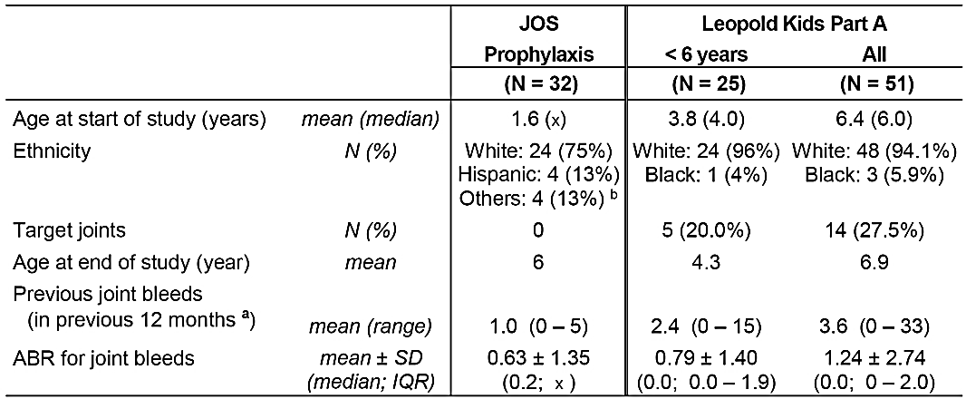
Abbreviations: ABR = annualised bleeding rate; IQR = interquartile range; JOS = Joint Outcomes Study; n/a = not applicable; x = ‘unknown’. A: Data description was more specific in the more recent Leopold Kids study (first subject in 2011) than in JOS (conducted in early 2000). B: Including: Asian/Pacific Islander: 1 subject, American Indian/Eskimo/Aleut: 1 subject, Others: 2 subjects.
The sponsor’s justification for including Kogenate FS PI data relating to paediatric prophylaxis and joint damage risk reduction in the Kovaltry PI is acceptable.

Other safety issues

Safety in PUPs Leopold Kids Part B
Leopold Kids Part B (ongoing study) included preliminary safety data on 9 PUPs (children aged < 12 years). The data were presented in an Interim Safety Update of Previously Untreated Patients in Part B and Extension Studies. The study plans to include at least 25 PUPs and subjects are to continue in the study until achieving 50 EDs, after which they have the option to continue in an extension phase. The median age of the population was 0.92 years (range: 0.1, 1.0 year). One (1) subject was younger than 1 month of age, 5 subjects were aged 1 month to < 1 year, and 3 were aged 1 to < 6 years. All PUPs were White.
Four (4) subjects had accumulated ≤ 20 EDs to Kovaltry, 2 patients had > 20 EDs and < 50 EDs, and 3 had ≥ 50 EDs. The mean ± SD number of total EDs in the 9 PUPs was 27.1 ± 24.2 (range: 1, 55) and the median number of total EDs was 38 EDs.
Of the 9 PUPs, 5 (55.6%) have experienced at least 1 AE, and 2 (22.2%) have experienced 2 drug related AEs (2 Factor VIII antibodies). AEs possibly related to hypersensitivity reactions (conjunctivitis and cough) were reported in 2 of the 9 PUPs. No deaths have been reported. SAEs have been reported in 2 (22.1%) PUPs; with both events being development of anti-Factor VIII antibodies. One (1) PUP experienced a non-treatment-emergent SAE associated with central venous catheterisation. Treatment discontinuation due to AEs was reported in 1 PUP due to anti-Factor VIII antibodies. Of the 9 PUPs, 3 have completed the study and have continued into the extension phase. The overall summary of treatment-emergent AEs in PUPs in the interim analysis is provided in Table 15 and SAEs are provided in Table 16 below.
- Leopold Kids Extension Interim safety data; Overall summary of treatment-emergent AEs in PUPs and (Part B) and in PTPs/PUPs in the extension phase
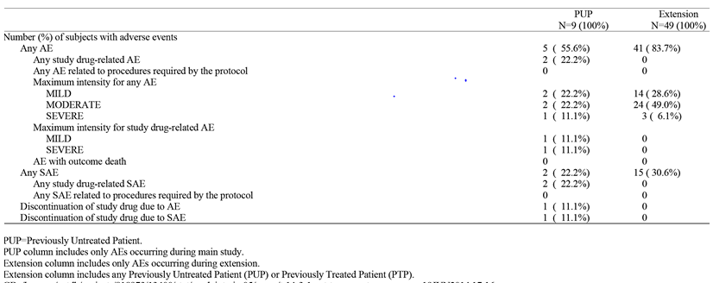
- Leopold Kids Extension Interim safety data; Overall summary of treatment-emergent SAEs in PUPs and (Part B) and in PTPs/PUPs in the extension phase
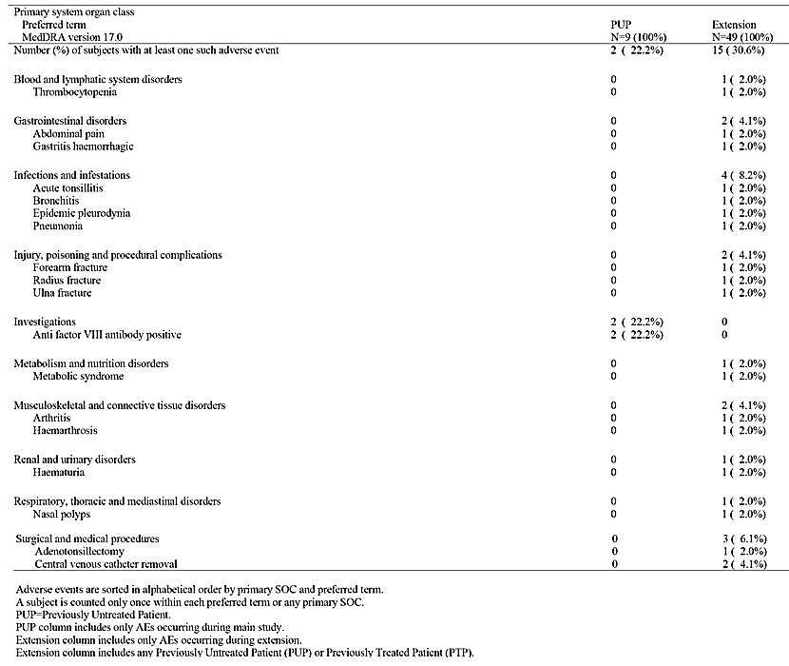
Anti-Factor VIII antibodies have been reported in 2 (22.2%) of the 9 PUPs treated with Kovaltry. In one of these subjects, Kovaltry appears to have been continued without incidence and the titre was reported to by negative in the latest available measurement. In the other subject, Kovaltry was withdrawn due to high anti-Factor VIII antibody titres. The frequency of anti-Factor VIII antibodies observed in the small number of PUPs in the interim safety analysis is consistent with the frequency of anti-Factor VIII antibodies in PUPs with severe disease (Factor VIII < 2%) treated with Kogenate FS (26.7% (15/56), Australian PI). However, only 9 PUPs have been exposed to Kovaltry, and this number of subjects is considered too small to adequately characterise the immunogenicity of Kovaltry in PUPs, given that the median number of exposure days is < 50 with only 3 subjects being exposed for ≥ 50 days. Overall, the safety data are too limited in PUPs to adequately characterise the safety profile of Kovaltry for prophylactic treatment in this patient population.
Of note, the exposure data in the summary tables for the interim safety update of PUPs differed from the exposure data in summary tables for the interim efficacy data of PUPs (for example, mean ± SD exposure days 27.11 ± 24.23, median exposure days 38.0, range of EDs 1.0, 55.0 in the interim safety update, and mean ± SD exposure days 63.4 ± 79.3, median exposure days 37.0, range of EDs 1.0, 220 in the interim efficacy data). It is assumed that the interim efficacy data includes exposure in the Leopold Kids extension phase for the 3 PUPs who completed Part B plus exposure data for the 6 subjects yet to complete Part B, while the interim safety data includes exposure for the 9 subjects limited to Part B of the study only. The sponsor is requested to clarify the difference in exposure data in the interim safety and efficacy analyses (see Second round evaluation and Clinical questions below).

Safety in leopold kids extension phase
The submission included an interim safety update for children from Leopold Kids who had completed Part A (PTPs) or Part B (PUPs) and had continued in the extension phase. The cut-off data for the interim safety data was 2 June 2014. The interim safety update included data on 49 subjects who have entered the extension phase (46 PTPs and 3 PUPs). Of the 49 subjects, 7 have completed the study, 41 are ongoing and 1 was withdrawn (von Willebrand disease). The mean (± SD) age of the subject population was 6.24 ± 3.20 years (range: 0.9, 11 years); 2 subjects were aged 1 month to < 1 year, 23 were aged 1 to < 6 years, and 24 were aged 6 to 12 years of age. The majority (93.9%) of the subjects were White (93.9%, n = 46), and 3 were Black or African American.
All 49 subjects have been exposed to Kovaltry for ≥ 50 days, and 45 (81.8%) have been exposed for ≥ 100 days. The majority of subjects have been treated with prophylactic Kovaltry 2 times/week (36.7%, n = 21) or 3times/week (42.9%, n = 21), while 16.3% (n = 8) have received prophylactic treatment every other day.
Of the 49 subjects, 41 (83.7%) have experienced at least 1 treatment-emergent AE, and none of the AEs have been categorised as drug related. No deaths have been reported in subjects treated in the extension phase. SAEs have been reported in 15 (30.6%) subjects. There have been no discontinuations due to AEs. The overall summary of treatment-emergent AEs is presented in Table 16 Leopold Kids Extension Interim safety data - Overall summary of treatment-emergent AEs in PUPs and (Part B) and in PTPs/PUPs in the extension phase.
Treatment-emergent AEs (PTs) reported in ≥ 3 (≥ 5%) subjects were nasopharyngitis (16.3%, n = 8), acute tonsillitis (14.3%, n = 7), cough (14.3%, n = 12), headache (n = 6, 12.2%), pyrexia (n = 6, 12.2%), limb injury (10.2%, n = 5), abdominal pain (8.2%, n = 4), oropharyngeal pain (8.2%, n = 4), nausea (6.1%, n = 3), vomiting (6.1%, n = 3), bronchitis (6.1%, n = 3), ear infection (6.1%, n = 3), pneumonia (6.1%, n = 3), respiratory tract infection (6.1%, n = 3), rhinitis (6.1%, n = 3), upper respiratory tract infection (6.1%, n = 3), arthralgia (6.1%, n = 3) and allergic rhinitis (6.1%, n = 3).
The only SAEs reported in ≥ 2 subjects were associated with removal of a central venous catheter (involving hospitalisation). The majority of SAEs were categorised as ‘infections and infestations’ (1 each for acute tonsillitis, bronchitis, epidemic pleurodynia, and pneumonia). None of the SAEs were categorised as treatment related. No subjects have developed anti-Factor VIII antibodies during the extension phase. The treatment-emergent SAEs are summarised in Table 16 Leopold Kids Extension Interim safety data Overall summary of treatment-emergent SAEs in PUPs and (Part B) and in PTPs/PUPs in the extension phase.
The interim safety data in the extension phase raise no concerns about the long term treatment of severe haemophilia A (Factor VIII < 1%). However, it should be noted that the population consisted primarily of PTPs (46/49), with only 3 subjects being PUPs.

Safety in surgery

Major surgery
Limited safety data were submitted for subjects undergoing major surgery in Leopold I, Part C. The sponsor stated that the AE profile in these subjects was primarily determined by the surgery itself. In Leopold I, Kovaltry was used for haemostatic control in 12 major surgeries (5 in the extension part and 7 in Part C). Safety results from other subjects with major surgical procedures who participated in the extension phase of Leopold I were included in the description of TEAEs for Leopold Extension and were included in the Leopold I safety pool.
At least one TEAE during treatment with Kovaltry was reported for the 5 subjects who underwent 7 major surgical procedures in Leopold I, Part C. Except for diarrhoea and pyrexia (2 reports each), all other events were each reported once (anaemia, anuria, ascites, contact dermatitis, device related infection, dyspepsia, nausea, pleural effusion, pulmonary artery dilatation, thymus disorder). In 3 subjects the events were described as mild in severity, while in 2 subjects the events were described as moderate in severity. None of the AEs were rated as drug related or resulted in discontinuation of treatment with Kovaltry. Post-surgery ascites in a subject with hepatic cirrhosis was the only treatment emergent SAE in Leopold I Part C.

Minor surgery
No formal reporting of AEs associated with Kovaltry treatment for minor surgery could be identified in the submission. In Leopold I and Leopold II it was stated that the safety of Kovaltry in the surgical setting was evaluated throughout the trial by the Data Monitoring Committee (DMC). In Leopold Kids Part A, one uncomplicated major surgical procedure was reported and haemostasis was reported as good. No information on AEs associated with this surgical procedure could be identified in the submission.

Other safety issues in PTPs

Safety in special populations

Age
In the Leopold I+II safety pool, AEs were separately analysed in adolescents aged 12 to 17 years (n = 20) and adults aged ≥ 18 years (n = 120). No significant differences were observed in the safety profiles of the two age groups, but conclusions should be interpreted cautiously because of the imbalance in subject numbers between the two groups. In Leopold Kids, no significant safety issues were identified in children aged 0 to < 6 years and 6 to 12 years. Overall, the safety profile in children (0 to 12 years) (Leopold Kids) was similar to the safety profile in adolescents and adults (Leopold I+II). In the safety analysis sets, the youngest subject was aged 1 year (Leopold Kids), with a total of 2 subjects being aged 0 to < 2 years, and the oldest subject was aged 61 years (Leopold I+II). However, it is considered that the submitted safety supports treatment with Kovaltry in PTPs of all ages.

Race
Of the total number of PTPs in the total safety pool, 149 (77%) were White, 11 (6%) were Black or African American, 32 (17%) were Asian and 1 (< 1%) was ‘other’. In the Leopold I+II safety pool, AEs were analysed in Asian (n = 32) and non-Asian subjects (n = 110). The safety profile was marginally inferior in Asian subjects compared to non-Asian subjects, but the difference should be interpreted cautiously due to the imbalance in numbers between the two groups. There is no comparative safety data between racial groups in children as 94.1% (48/51) of the population in Leopold Kids were children.

Subjects with hepatic impairment
There were no data on treatment with Kovaltry in subjects with hepatic impairment. However, Kovaltry does not undergo hepatic metabolism. Therefore, it is reasonable to infer that subjects with hepatic impairment will not be at a higher risk of adverse events than subjects without hepatic impairment when treated with Kovaltry. Of note, 30.3% (43/142) of subjects the Leopold I+II safety pool had a baseline history of chronic hepatitis C, 29.6% (42/142) of hepatitis C, and 26.8% (38/142) of hepatitis B. No children in Leopold Kids Part A had a baseline history of chronic hepatitis C, hepatitis C, or hepatitis B. In Leopold I+II, 9 (6.3%) subjects had a history of hepatobiliary disease at baseline (most commonly hepatic steatosis (2.1%, n = 3)).

Subjects with renal impairment
There were no data on treatment with Kovaltry in subjects with renal impairment. However, Kovaltry does not undergo renal excretion. Therefore, it is reasonable to infer that subjects with renal impairment will not be at a higher risk of adverse events than subjects without renal impairment when treated with Kovaltry.

Overdose
No cases of over dose with Kovaltry were reported in the clinical development program.

Abuse
There are no data on the misuse or abuse potential of Kovaltry. However, the drug appears to have no potential for misuse of abuse.

Withdrawal or rebound
There were no studies examining the effect of withdrawal or rebound. However, it can be predicted that stopping prophylaxis treatment with Kovaltry will return the risk of bleeding to pre-treatment levels.

Effects on ability to drive or operate machinery
No studies on the effects on the ability to drive and use machines have been performed. However, Kovaltry is unlikely to have a detrimental effect on these activities.

Females
There were no safety data in females with severe haemophilia A (Factor VIII < 1%). However, the disease occurs almost exclusively in males. There is no reason to conclude that the effectiveness of Kovaltry for the treatment of severe haemophilia A (Factor VIII < 1%) would differ in males and females. There are no data on the use of Kovaltry in pregnancy or lactation.

Safety related to drug-drug interactions
There were no formal studies investigating safety related to drug-drug interactions between Kovaltry and other drugs. In the clinical studies (Leopold I, Leopold II and Leopold Kids Part A) medications of various classes appear to have been safety used in combination with Kovaltry.

Post-marketing data
There is no post-marketing experience for Kovaltry as this is a new biological entity.

Evaluator’s conclusions on safety
The safety of Kovaltry for the treatment of PTPs (n = 193) in children (n = 51), adolescents (n = 20), and adults (n = 122) with severe haemophilia A (Factor VIII < 1%) has been satisfactorily established. There are preliminary safety data in PUPs with severe haemophilia A (Factor VIII < 1%), but the data are too limited to confirm the safety of Kovaltry in this population. It is considered that definitive conclusions relating to the safety of Kovaltry in PUPs is dependent on evaluation of the final data in this population.
The primary safety variable in the clinical program was the development of inhibitory antibodies to Factor VIII. In Leopold I, Leopold II and Leopold Kids, no PTPs developed inhibitory Factor VIII antibodies (that is, levels ≥ 0.6 BU (Nijmegen-modified Bethesda assay)). The current Factor VIII product guidelines;¹⁰ state that immunogenicity should be studied in PTPs with > 150 EDs. In Leopold I+II, 88.0% (125/142) of subjects had ≥ 100 EDs, while in Leopold Kids, no subjects had ≥ 100 EDs and 98.0% (50/51) of subjects had ≥ 50 EDs. It is noted that EDs for all children in Leopold Kids were notably less than 150 EDs, which raises the question of whether exposure to Kovaltry in children is sufficient to adequately characterise the immunogenicity of the product in this population.
In PUPs, 2 (22.2%) out of 9 children developed anti-Factor VIII antibodies. One subject, with a total of 51 EDs, had transient low titres (maximum 1.8 BU) and continued in treatment with titres being reported as < 0.2 BU at the last known measurement. One subject developed a high titre of 50 BU after 6 EDs and was withdrawn from the study. Data from the literature indicates that the risk of inhibitor development is highest during the first 20 EDs in PUPs and decreases to a low risk after 150 days. In Leopold Part B, the interim safety update for PUPs showed that only 3 have ≥ 50 EDs and none have ≥ 150 EDs. The submitted data are considered too limited to adequately characterise the immunogenicity of Kovaltry in PUPs.
Data on anti-HSP70 antibodies were also submitted. In Leopold I+II, 139 (97.9% (139/142)) PTPs were negative for anti-HSP70 antibodies at baseline/screening and 10 (7.2% (10/139)) of these subjects had at least 1 positive anti-HSP70 antibody result during the studies. In Leopold Kids, there was 1 PTP with a positive anti-HSP70 titre at baseline and a negative titre at the final visit.
Data on anti-BHK/HCP antibodies were also submitted. In Leopold I+II, 137 (95.5% (137/142)) PTPs were negative for anti-BHK/HCP antibodies at baseline, and all 137 subjects remained negative for these antibodies throughout the study. No anti-BHK/HCP tests were performed in Leopold Kids.
No specific patterns in the changes in anti-HSP70 or anti-BHK/HCP antibodies were observed. The highest anti-HSP70 levels in both adults and children were observed at baseline, prior to treatment with Kovaltry. The sponsor states that the anti-HSP70 antibody levels observed in the relatively young safety population in adults might have been due to acute concomitant infections, as elevated levels have been observed in these conditions. However, no data were submitted to support this hypothesis.
Overall, TEAEs were reported in 69.0% (n = 98) of PTPs in Leopold I+II and 68.8% (n = 35) of subjects in Leopold Kids. The majority of TEAEs were categorised as mild or moderate in severity. Drug related TEAEs were reported in 6.3% (n = 9) of subjects in Leopold I+II and 1 (2.0%) subject in Leopold Kids. The incidence of TEAEs in the Leopold I safety pool was higher than in the Leopold II safety pool (87.1% (54/62) versus 55.0% (44/80)), reflecting the longer median duration of treatment in Leopold I compared to Leopold II (728.59 versus 365.50 days, respectively).
In the total safety population (n = 193) in children, adolescents, and adults ADRs reported in ≥ 2% of PTPs, in descending order of frequency, were, headache (7.3%), pyrexia (4.1%), pruritus (3.1%), injection site reactions (2.6%), insomnia (2.6%), rash (2.6%), abdominal pain (2.1%), and dyspepsia (2.1%). The sponsor stated that the majority of reported ADRs were related to hypersensitivity reactions, including headache (7.3%), pyrexia (4.1%), pruritus (3.1%), rash (2.6%), sinus tachycardia (1.0%), dizziness (1.0%), allergic dermatitis (1.0%), chest discomfort (1.0%), urticaria (0.5%), hypersensitivity (0.5%), and flushing (0.5%). No anaphylactic reactions were reported in the studies.
No deaths were reported in the studies, while other SAEs were reported in 9.9% (n = 14) of subjects in Leopold I+II and 9.8% (n = 5) of subjects in Leopold Kids. The only SAE reported in more than 1 subject in Leopold I+II was chest pain (n = 2), while suicidal ideation was reported twice in the same subject. No SAEs were reported in more than 1 subject in Leopold Kids. Drug related SAEs were reported in only 1 subject in Leopold I+II (acute myocardial infarction in a >60 years old man with several risk factors for cardiovascular disease).
Treatment discontinuation due to AEs was reported in 1 (0.7%) subject in Leopold I+II (> 60 years old man with SAE of myocardial infarction) and 1 (2.0%) subject in Leopold Kids (< 6 year old boy with an AE of central venous catheter infection).
No clinically meaningful changes were observed in laboratory tests (haematology, clinical chemistry and urinalysis) or vital signs in the clinical program. There were no data on ECG changes. There was no evidence in the submitted data that treatment with Kovaltry is associated with cardiovascular, haematological, hepatic, renal or dermatological toxicity.
There are limited safety data relating to the use of Kovaltry in the perioperative period in PTPs. The submitted safety data relating to 12 major surgeries from Leopold I (Part C and Extension) surgery do not raise concerns. No separate safety data on other surgeries undertaken in the clinical program could be identified in the submission.

First round benefit-risk assessment

First round assessment of benefits

Overview
The benefits of prophylaxis with Kovaltry administered 2 to 3 times a week to prevent bleeding in PTPs with severe haemophilia (Factor VIII < 1%) are considered to be favourable in children, adolescents and adults. The benefits of prophylaxis with Kovaltry in PTPs have been demonstrated in Leopold I Part A, Leopold I Extension, Leopold II and Leopold I+II.
The benefits of Kovaltry for use in the peri-operative period for major and minor surgeries has been demonstrated in Leopold I and II in PTPs aged ≥ 12 years with severe haemophilia (Factor VIII < 1%). There were limited data in the submission on the use of Kovaltry in the peri-operative period for major and minor surgeries in PTPs aged 0 to 12 years. In Leopold Kids, only 1 subject aged 6 in the total population (n = 51) underwent major surgery, with no subjects undergoing minor surgery. However, based on the totality of the data for Kovaltry in the submission relating to the treatment of PTPs it is considered reasonable to infer that treatment with the drug in the peri-operative period (major and minor surgeries) will be effective in PTPs aged ≤ 12 years.

Benefits of treatment with kovaltry in PTPs aged ≥ 12 years

Leopold I (Part B)
In Leopold I (Part B), the dose regimen for prophylaxis treatment with Kovaltry was determined by the investigator and ranged between 21 IU/kg and 43 IU/kg administered 2 or 3 times a week. Of the 62 subjects in the ITT population receiving prophylaxis, 46 (74.2%) experienced at least 1 breakthrough bleed and 16 (25.8%) experienced no bleeds.
Of the 46 subjects who experienced at least 1 breakthrough bleed while on prophylaxis, 44 treated the bleed with Kovaltry (total of 273 bleeds and 479 injections). The mean (± SD) number of Kovaltry injections for the treatment of breakthrough bleeds in the 44 subjects during the study was 10.9 ± 13.1 injections per subject (median: 5.0 injections per subject), and the mean (± SD) dose per injection for bleeds in these 44 subjects was 31.3 ± 9.3 IU/kg (median: 28.6 IU/kg).
The mean (±SD) ABR (‘total bleeds’) in the whole ITT population (n = 62) was 3.8 ± 5.2 bleeds/year (median: 1.03 bleeds/year; IQR: 0.00, 5.09 bleeds/year). The ABR compares favourably with the mean (± SD) and median number of bleeds in the 12 months immediately prior to enrolment in the study, which were 11.5 ± 15.1 bleeds (median: 5.5 bleeds) in the total ITT population and 6.9 ± 8.6 bleeds (median: 4.0 bleeds) in subjects who had been on prophylaxis treatment.
A total of 484 Kovaltry injections were administered for the treatment of 241 ‘all bleeds’, which translates into a mean (± SD) of 2.0 ± 4.1 injections/bleed (median of 1.0 injection/bleed). The most common reason for the first injection was spontaneous bleed in 63.5% of ‘all bleeds’, with first injection for trauma bleeds accounting for 36.0% of ‘all bleeds’. The most common site for ‘all bleeds’ was ‘joint bleed’ which occurred in 79.3% of ‘all bleeds’. Of the 191 joint bleeds, 33.5% occurred in the knee, followed by the ankle (29.8%) and the elbow (28.3%).
The majority of ‘all bleeds’ were treated with 1 injection (70.1% (169/241)), with most of the remaining bleeds being treated with 2 injections (14.5% (35/241)). Of the 241 ‘all bleeds’, 51.0% were reported as being mild in severity, 38.2% as being moderate in severity, and 10.8% were reported as being severe bleeds. Of the 235 bleeds with relevant data, the subject's response to treatment was reported as excellent for 23.0% of the bleeds, good for 57.9%, moderate for 16.2%, and poor for 3.0%.
Prophylaxis treatment with Kovaltry had no effect on health related quality of life assessments. This may be explained by the fact 80% of the subjects were already on prophylaxis before enrolment. No subgroup analysis of health related quality of life was undertaken comparing subjects who were receiving prophylaxis prior to enrolment with subjects who were receiving on-demand treatment.

Leopold II
In Leopold II, the benefits of prophylaxis treatment with Kovaltry at dose range of between 20 and 50 IU/kg administered 2 or 3 times a week for the prevention of breakthrough bleeds in PTPs with severe haemophilia A was demonstrated to be superior to on-demand treatment with Kovaltry. There were 1497 ‘all bleeds’ reported in the total ITT population (1204 in the 21 subjects in the on-demand group and 293 in the 59 subjects in the prophylaxis group). None of the 21 subjects in the on-demand group remained bleed free during the study, while 16 (27.1%) of the 59 subjects in the combined prophylaxis group remained bleed free.
The mean ABR (‘all bleeds’) was 4.94 ± 6.81 bleeds/year (median: 1.98) in the combined (high and low dose) prophylaxis group (n = 59), and 57.96 ± 24.56 bleeds/year (median: 59.96) in the on-demand group (n = 21). The difference in the ABR between the two Kovaltry treatment groups in favour of prophylaxis compared to on-demand was statistically significant (p< 0.001).
The 43 subjects in the combined prophylaxis group who experienced at least 1 breakthrough bleed while on prophylaxis reported a total of 352 Kovaltry injections to treat a total of 293 bleeds during the study. The mean (± SD) number of Kovaltry injections for the treatment of breakthrough bleeds in the 43 subjects during the study was 8.2 ± 8.4 injections per subject (median: 5.0 injections per subject), and the mean (± SD) dose per injection for bleeds in these 43 subjects was 29.64 ± 6.86 IU/kg (median: 29.41 IU/kg). These results are consistent with those observed in Leopold I (Part B).
In the combined prophylaxis group, there were 283 bleeds with data on the reason for the first injection. For these 283 bleeds, the most common reason for first injection was spontaneous bleed (73.9%) followed by trauma bleed (26.1%). The most common site for ‘all bleeds’ (n = 293) was joint bleed, which occurred in 87.0% of ‘all bleeds’. Of the 255 joint bleeds, 39.6% occurred in the knee, followed by the ankle (29.8%) and the elbow (25.5%). These results are consistent with those observed in Leopold I (Part B)
The majority of ‘all bleeds’ in the combined prophylaxis group were treated with 1 injection (81.9% (240/293)), with most of the remaining bleeds being treated with 2 injections (11.6% (34/293)). Of ‘all bleeds’, 96.2% were treated with ≤ 2 injections (that is, 0, 1, or 2 injections). Of the 293 ‘all bleeds’, 41.0% were reported as being mild in severity, 47.8.% as being moderate in severity, and 11.3% were reported as being severe bleeds. Of the 279 bleeds with relevant data, the subject's response to treatment was reported as excellent for 17.2% of the bleeds, good for 44.4%, moderate for 34.1%, and poor for 4.3%. These results are consistent with those for Leopold I (Part B).
Neither prophylactic treatment nor on-demand treatment was associated with significant changes in health related quality of life assessments. In Leopold II, on-demand treatment with Factor VIII was required prior to enrolment, rather than prophylactic treatment.

Leopold I Extension long term prophylactic treatment with Kovaltry
The benefits of long term (up to 2 years) prophylactic treatment with Kovaltry were demonstrated in Leopold I Extension. Of the 61 subjects who completed Leopold Part B, 55 entered Leopold I Extension (ITT population). In Leopold I Extension (Year 2), the mean (± SD) ABR (‘all bleeds’) in the 55 patients in the ITT population was 3.71 ± 4.98 bleeds/year (median: 1.97; range: 0.00, 5.21). In Leopold I Part B (Year 1), the mean (± SD) ABR (‘all bleeds’) in the 55 patients in the ITT population was 4.21 ± 5.42 bleeds/year (median: 2.01; range: 0.98, 6.09). The extension data show that the benefits of prophylactic Kovaltry (based on the ABR) observed after 12 months of treatment can be maintained for at least an additional 12 months of treatment. In Leopold I Extension, the mean (± SD) ABR (‘all bleeds’) in the 55 subjects in the ITT population for the combined Year 1+2 data was 3.76 ± 4.61 bleeds/year (median: 1.99; range: 0.50, 5.48).
The total number of bleeds reported in the 55 subjects over 2 year treatment period was 382 (229 (59.9%) during Part B (Year 1) and 153 (40.1%) during the extension period (Year 2)). Of the total number of bleeds during 2 years treatment, 227 (58.8%) were spontaneous bleeds, 147 (38.1%) were trauma bleeds, 8 (2.1%) were untreated bleeds (that is, bleeds that did not require additional injections besides the scheduled regular prophylaxis injections which were due), and 4 were injections given for ‘other’ reasons. Of note, ‘other’ reason’ for first injection was not necessarily attributable to a bleeding event, but also included additional prophylaxis injections for expected bleeds (for example, due to increased physical activity).
Overall, for all efficacy parameters the benefits of treatment with prophylactic Kovaltry were numerically greater in the second 12 months of treatment compared to the first 12 months of treatment. The data indicate that bleeding was less frequent in the second 12 months of treatment compared to the first 12 months of treatment.

Haemostasis in surgery Leopold I+II
In the combined data from Leopold I and II (‘efficacy pool’), 32 subjects underwent a total of 46 minor surgeries, with haemostatic control with Kovaltry during surgery being assessed as excellent (53.5%) or good (46.5%) by investigators/surgeons in all cases. No subjects undergoing minor surgery required blood transfusions. Eleven (11) subjects underwent a total of 13 major surgeries, with haemostatic control with Kovaltry during surgery being assessed as excellent (23.1%) or good (76.9%) by investigators/surgeons in all cases. Of the 13 major surgeries, 7 were orthopaedic surgeries. Blood transfusions were needed in 3 major surgical procedures: 1 subject for 2 procedures (both extirpation of pseudo-tumour) and 1 subject for knee prosthesis. No complications relating to bleeding were reported in subjects undergoing minor or major surgeries.

Benefits of treatment with Kovaltry in PTPs aged 0 to 12 years
In the ITT population, 45.1% (23/51) of subjects in combined group aged 0-12 years experienced a total of 53 bleeds within 48 h of the previous prophylactic injection, while 52.0% (13/25) of subjects in the younger age group (0 to < 6 years) experienced 28 bleeds and 38.5% (10/26) of subjects in the older age group (6 to 12) experienced 25 bleeds.
The mean (±SD) ABR for all bleeds within 48 h of the previous prophylactic injection was 2.04 ± 2.91 bleeds/year (median: 0.00; IQR: 0.00, 3.95) in the combined group (n = 51), and mean (±SD) ABR was higher in the younger age group (n = 25) compared to the older age (n = 26) (2.23 ± 2.77 bleeds/year (median: 1.98; IQR: 0.00, 3.97) versus 1.86 ± 3.08 bleeds/year (median: 0.00; IQR: 0.00, 1.96) bleeds/year, respectively).
The majority of bleeds reported within 48 h of the previous prophylactic injection were trauma bleeds, accounting for 60.4% (32/53), 64.3% (18/28), and 56.0% (14/25) of bleeds in the combined, younger and older age groups, respectively. Spontaneous bleeds occurring within 48 h of the previous prophylactic injection accounted for 17.0% (9/53), 25.0% (7/28) and 8.0% (2/25) of bleeds in the combined, younger and older age groups, respectively. Joint bleeds within 48 h of the previous prophylactic injection accounted for 32.1% (17/53) in the combined group, and were reported 2 fold more frequently in the older age group compared to the younger age group (44.0% (11/25) versus 21.4% (6/28), respectively).
During the study, at least 1 bleed was reported in 54.9% (28/51) of subjects in the combined group, 60.0% (15/25) of subjects in the younger age group and 50.0% (13/26) of subjects in the older age group. The mean (±SD) ABR during the study was 3.75 ± 4.98 bleeds/year (median: 1.90; IQR: 0.00, 6.02) in the combined group, and higher in the younger age group (4.16 ± 5.02 bleeds/year (median: 2.03; IQR: 0.00, 6.02)) compared to the older age group (3.37 ± 5.01 bleeds/year (median: 0.93; IQR: 0.00, 5.77)).
During the study, 83.5% (81/97) of all bleeds in the combined group were treated bleeds, with the corresponding percentage being 84.6% (44/52) in the younger age group and 82.2% (37/45) in the older age group. Of the total number of treated bleeds, the reasons for the first injection for the bleed in the combined group were spontaneous in 24.7% (20/81), trauma in 72.8% (59/81) and other in 2.5% (2/81), while the reasons in the younger versus older age groups, respectively, were spontaneous 18.2% (8/44) versus 32.4% (12/17), trauma 81.8% (36/44) versus 62.2% (23/37), and other 0% (0/44) versus 5.4% (2/37). The majority of treated bleeds in children were due to trauma, which differs from subjects aged ≥ 12 years where the majority of treated bleeds were spontaneous.
Joint bleeds reported during the study accounted for 33.0% (32/97) of the total number of bleeds in the combined group, and were reported 2.5-fold more frequently in the older age group compared to the younger age group (48.9% (22/45) versus 19.2% (10/52), respectively). The most frequent site for bleeds in the combined group was skin/mucosa (46.4% (45/97)).
In the combined group, 67.0% (65/97) of bleeds were treated with 1 injection, 6.2% (6/97) with 2 injections, 3.1% (3/97) with 3 injections, 7.2% (7/97) with ≥ 3 injections, and 16.5% (16/97) were untreated. Overall, 89.7% of bleeds were treated with ≤ 2 injections (that is, untreated, 1, or 2 injections). In the younger age group, 71.2% (37/52) of bleeds were treated with 1 injection, 5.8% (3/52) with 2 injections, 1.9% (1/52) with 3 injections, 5.8% (3/52) with ≥ 3 injections, and 15.4% (8/52) were untreated. In the older age group, 62.2% (28/45) of bleeds were treated with 1 injection, 6.7% (3/45) with 2 injections, 4.4% (2/45) with 3 injections, 8.9% (4/45) with ≥ 3 injections, and 17.8% (8/45) were untreated.
Nearly all bleeds reported in the study were categorised as mild or moderate in severity (that is, 96.9% (94/97), 96.2% (50/52), and 97.8% (44/45) in the combined, younger and older groups, respectively. The majority of the subject/caregivers responses to treatment of bleeds reported during the study were excellent or good (that is, 90.1% (73/81), 97.8% (43/44), and 81.0% (30/37) in the combined, younger and older groups, respectively). Excellent or good responses were reported more frequently in the older compared to the younger age group.
During the study, the total number of injections given for prophylaxis in the combined, younger and older groups was 3529, 1770 and 1759, respectively. The mean (± SD) number of injections for prophylaxis per subject was 69.2 ± 16.9 (median: 73.0; range: 37, 100) in the combined group, 70.8 ± 18.0 (median: 77.0; range: 37, 100) in the younger group, and 67.7 ± 15.9 (median: 59.5; range: 48, 93) in the older group. The mean (± SD) dose per injection for prophylaxis was 35.1 ± 9.8 kg/IU (median: 33.8; range: 21, 58) in the combined group, and was higher in younger compared to older group (37.0 ± 10.9 (median: 36.4; range: 21, 58) versus 33.3 ± 8.3 (median: 31.8; range: 21, 58) IU/kg, respectively).
During the study, the total number of injections given for bleeds in the combined, younger and older groups was 134, 70 and 64, respectively. The mean (± SD) total number of injections administered for the treatment of bleeds was 5.15 ± 4.04 (median: 4.00; range: 1, 17) in 26 subjects in the combined group, 4.67 ± 4.55 (median: 4.00; range: 1, 17) in 15 subjects in the younger group, and 5.82 ± 3.31 (median: 7.00; range: 1, 10) in 11 subjects in the older group. The mean (± SD) dose per injection for bleeds was 38.60 ± 12.95 kg/IU (median: 36.94; range: 20.8, 71.6) in the combined group, and was notably higher in the younger group than in older group (41.93 ± 14.89 IU/kg (median: 38.70; range: 20.8, 71.6) versus 34.07 ± 8.35 IU/kg (median: 32.40; range: 21.7, 50.0), respectively).
At the end of the study, the majority of subjects in all groups were receiving 2 times/week or 3 times/week infusions (that is, 82.3%, 84.0%, and 80.8% in in the combined, younger and older groups, respectively), while the percentages of subjects receiving regular prophylaxis every other day were notably lower (that is, 15.7%, 12.0%, and 19.2% in the combined, younger and older groups, respectively).
Only 1 subject aged 6 underwent major surgery (tooth extraction), and no subjects underwent minor surgery. In the subject undergoing major surgery, Kovaltry was administered twice on the day of surgery with a total dose of 108.7 IU/kg, and haemostasis was assessed as ‘good’.

First round assessment of risks
It is considered that the risks of Kovaltry for the prophylactic treatment of PTPs (children, adolescents, adults) are favourable. However, it is considered that the preliminary safety data included in the submission in PUPs are too limited to adequately assess the risks of prophylactic treatment with Kovaltry in this population.
In Leopold I+II, TEAEs were reported in 69.0% (98/142) of PTPs aged ≥ 65 years and in Leopold Kids, TEAEs were reported in 68.8% (35/51) of PTPs aged 0 to 12 years. The majority of TEAEs in PTPs were categorised as mild or moderate in severity. Drug related TEAEs were reported in 6.3% (n = 9) of subjects in Leopold I+II and 2.0% (n = 1) of subjects in Leopold Kids.
In the total safety population in children, adolescents, and adults (n = 193), ADRs reported in ≥ 2% of PTPs, in descending order of frequency, were, headache (7.3%), pyrexia (4.1%), pruritus (3.1%), injection site reactions (2.6%), insomnia (2.6%), rash (2.6%), abdominal pain (2.1%), and dyspepsia (2.1%). The sponsor stated that majority of reported ADRs were related to hypersensitivity reactions, including headache (7.3%), pyrexia (4.1%), pruritus (3.1%), rash (2.6%), sinus tachycardia (1.0%), dizziness (1.0%), allergic dermatitis (1.0%), chest discomfort (1.0%), urticaria (0.5%), hypersensitivity (0.5%), and flushing (0.5%). No anaphylactic reactions were reported in PTPs.
No deaths were reported in PTPS, while other SAEs were reported in 9.9% (n = 14) of subjects in Leopold I+II (1 subject with a drug related SAE) and 9.8% (n = 5) of subjects in Leopold Kids (no subjects with drug related SAEs). The only SAE reported in more than 1 subject in Leopold I+II was chest pain (n = 2), while suicidal ideation was reported twice in one subject. No SAEs were reported in more than 1 subject in Leopold Kids. Drug related SAEs were reported in 1 subject in Leopold I+II (acute myocardial infarction in a 62 year old man with several risk factors for cardiovascular disease). Treatment discontinuation due to AEs were reported in 1 (0.7%) subject in Leopold I+II (> 60 year old man with SAE of myocardial infarction) and 1 subject (2.0%) in Leopold Kids (< 6 year old boy with AE of central venous catheter infection).
No PTPs (n = 193) in the clinical program developed inhibitory antibodies to Factor VIII. In Leopold I+II, the majority of patients had detectable anti-HSP70 levels below the cut-off value for positivity at baseline (97.9% (139/142)). In total, there were 13 subjects with values above the cut-off value for positivity at any time, including 2 who entered the study positive and became negative, 1 who entered the study positive and remained positive, 5 who entered the study negative and became transiently positive, and 5 who entered the study negative, and became and remained positive with decreasing levels. In Leopold Kids, there was 1 PTP with a positive anti-HSP70 titre at baseline and this subject was reported to have titre below the positivity level at the final visit.
In Leopold I+II, the majority of PTPs were negative for anti-BHK/HCP antibodies at baseline (96.5% (137/142)), and all of these subjects remained negative throughout the study. Two (2) subjects in Leopold I tested positive before the study and at most visits during the study, but were negative at Month 12 of the extension phase. Three (3) subjects from Leopold II were ‘possibly positive’ before the study, and 2 of these were transiently negative during the study (Month 3 and Month 9), while 1 only had negative results during the study. No anti-BHK/HCP assessments were performed in Leopold Kids.
No clinically meaningful changes were observed during the study in laboratory tests (haematology, clinical chemistry and urinalysis) or vital signs in PTPs. There were no data on ECG changes during the study. There was no evidence in the submitted data that treatment with Kovaltry is associated with cardiovascular, haematological, hepatic, renal or dermatological toxicity. There no data on the use of Kovaltry in subjects with pre-existing Factor VIII inhibitors.
There are limited safety data relating to the use of Kovaltry in the perioperative period in PTPs. However, the submitted safety data relating to 12 major surgeries from Leopold I (Part C and Extension) surgery do not raise concerns. No separate safety data on other surgeries undertaken in the clinical program could be identified in the submission.
The safety data in PUPs is limited to 9 subjects treated with Kovaltry for prophylaxis in Leopold Kids, Part B. Anti-Factor VIII antibodies have developed in 2 (22.2%) subjects, both categorised as SAEs. In 1 of the subjects the development of anti-Factor VIII antibodies resulted in treatment discontinuation, while in the other subject treatment continued in the presence of anti-Factor VIII antibodies. In Leopold Kids, Part B, only 3 PUPs have been treated with Kovaltry for ≥ 50 EDs. It is considered that the preliminary data in PUPs is too limited to adequately characterise the safety of Kovaltry in this patient population.

First round assessment of benefit-risk balance
The benefit-risk balance for Kovaltry for the treatment of PTPs with severe haemophilia A (Factor VIII < 100%) is considered to be favourable. The risk-benefit balance for the treatment of breakthrough bleeds in PTPs receiving Kovaltry for prophylaxis has been satisfactorily established. The risk-benefit balance for perioperative treatment (major and minor surgery) with Kovaltry in PTPs has been satisfactorily established. The benefits of perioperative treatment with Kovaltry for major surgery are satisfactory (that is, surgeon/investigator responses; blood loss; requirement for blood transfusion) and while data on the risks of Kovaltry for surgery are limited the totality of the safety data in PTPs for non-surgical treatment is considered to support the use of the drug for surgery.
The benefit-risk balance for Kovaltry for the treatment of PUPs with severe haemophilia A (Factor VIII < 1%) cannot be adequately determined due to the limited efficacy and safety data in this population. In particular, the safety data are limited to a total of 9 subjects from the ongoing study (Leopold Kids, Part B), with a median of 38 EDs (range: 1, 55) and including only 3 subjects with ≥ 50 EDs. The absence of a favourable benefit-risk benefit in PUPs raises the question of whether the indication for Kovaltry should be limited to PTPs. It is noted that, in the context of novel rFVIII products, the TGA adopted guidance document on the clinical investigation of Factor VIII products;¹⁰ states that ‘PUPs are excluded from the indication until data from 50 PUPs investigated for efficacy and safety for at least 50 EDs each are available’. Therefore, the issue is whether Kovaltry is a novel rFVIII product for the purposes of the Factor VIII guidance document.
The sponsor states that Kovaltry is ‘essentially identical to the currently marketed product Kogenate FS’, with the two products having the same rFVIII protein concentration and excipient compositions. In addition, the sponsor states that the two products have an identical Factor VIII amino acid sequence, the same molecular formula and proteolytic processing, and similar post translational modification distribution (glycosylation and sulfation). Compared to Kogenate FS, Kovaltry is produced with a new cell bank, which includes the gene for HPS70, stated to improve Factor VIII productivity, and other improvements to the production processes. In addition, all animal-derived and human-derived additives have been eliminated from the cell culture and purification processes and a virus filtration step has been introduced for improved non-enveloped viral clearance robustness. Clinical data provided in the submission show that the bioavailability of Kovaltry is non-inferior to the bioavailability of Kogenate FS in adult subjects (PTPs). In addition, the clinical data from the Leopold studies suggest that the efficacy and safety of Kovaltry for the treatment of severe haemophilia (Factor VIII < 1%) in children and adults is similar to that of Kogenate FS. Overall, it is considered that the similarities between Kovaltry and Kogenate FS make the product not ‘novel’ for the purposes of the Factor VIII guidance document. Therefore, the indication of Kovaltry should not be limited to PTPs.

First round recommendation regarding authorisation
It is recommended that Kovaltry be authorised for the:
Treatment and prophylaxis of bleeding in patients with haemophilia A (congenital Factor VIII deficiency). Kovaltry can be used for all age groups. (See Clinical Trials section). Kovaltry does not contain von Willebrand factor and is not indicated in von Willebrand disease.
The underlining refers to the recommended amendment to the proposed indication. It is recommended that Kovaltry not be authorised for treatment of PUPs with severe haemophilia A (Factor VIII < 1%). The efficacy and safety data relating to the treatment of PUPs with Kovaltry are preliminary and too limited to allow the benefit-risk balance of the drug to be adequately characterised in this population. It is noted that for novel rFVIII products.

Second round evaluation of clinical data submitted in response to clinical questions

Pharmacokinetics

Question 1
Please comment on the relationship between the Kovaltry formulation used in the clinical development program and the Kovaltry formulation proposed for marketing in Australia.

Sponsor response
The sponsor confirms there have been no changes between the Kovaltry formulation used in the clinical development program and the Kovaltry formulation proposed for marketing in Australia.

Evaluator comment
The absence of a difference in formulation is noted.

Question 2
The baseline demographic and haemophilia A disease characteristics for all 15 subjects (PTPs) included in the PK analysis could not be identified in the submission. The sponsor is requested to provide this information.

Sponsor response
The baseline demographic and haemophilia A disease characteristics for 15 subjects (PTPs) included in the PK analysis are provided with this response.

Evaluator comment
The baseline demographic data and description of baseline disease characteristics are satisfactory. All fifteen patients fulfilled the trial entry criteria of having severe haemophilia A with an absence of inhibitor.

Efficacy

Question 3
In Leopold I (Part B), it is noted that the difference between ‘all bleeds’ (n = 241) and ‘total bleeds’ (n = 236) relates to 5 additional events classified as ‘other’. The nature of these ‘other’ events (that is, other reasons for injection) could not be identified in the study report. The worst case scenario would be that they were all given for bleeds, while the best case scenario would be that they were all additional prophylaxis injections given for reasons unrelated to bleeds. Does the sponsor have any information on the reasons these 5 ‘other’ injections were administered?

Sponsor response
The reason for injections was documented by the patients and only limited information is available on these injections for some patients by entry of a comment into the electronic patient diary.
Based on these comments by the patients, 2 injections could be related to haemorrhages due to trauma. None of the injections was related to a spontaneous bleed.
Reasons for injections stated as ‘other’ for 5 subjects in Leopold I study:
- For prevention, no bleed
- Knees hurt from ankle immobility (interpretation could be trauma bleed)
- Synovectomy of left elbow
- Blows to head and haematomas on arms (trauma)
- Great physical challenge today; prophylactiv treatment
Nevertheless, the worst case scenario that these injections were administered for bleeds was included in the statistical analysis for ‘all bleeds’.

Evaluator comment
The evaluator accepts that inclusion of these events do not materially affect the trial outcomes.

Question 4
Why was the same definition of ‘bleeds’ not used to define the primary outcome in the three Leopold studies?

Sponsor response
In the individual studies, there is some discrepancy in the term to describe the primary variable (‘all bleeds’ as opposed to ‘total bleeds’) and its precise definition (the inclusion or the exclusion of events for which an injection of BAY 81-8973 was given for reason documented as ‘other’).
The option ‘other’ for documentation in the electronic patient diary was foreseen for recovery injections or preventative injections, not related to bleeds or usual prophylaxis. Only a few events with reason for injection documented as ‘other’ were reported.
According to the definition in the individual Statistical Analysis Plans of the studies, events with ‘other’ reasons for injection were excluded from the primary variable in Leopold I Part B and Leopold I+II Efficacy Pool, but included in Leopold I Extension, Leopold II and Leopold Kids.
In Leopold Kids Part A, inclusion of ‘other’ injections was chosen as a more conservative approach for this younger population.
In the sponsor’s Summary of clinical efficacy across all studies, only the term ‘all bleeds’ is used for reason of simplicity. It is emphasised that the term ‘all bleeds’ in the summary is not necessarily identical with the definition used in the individual studies. In the Summary of clinical efficacy, ‘all bleeds’ is defined as the sum of spontaneous bleeds, trauma bleeds, untreated 1 bleeds, and bleeds with missing reason excluding events for which an injection of BAY 81-8973 was given for reason documented as ‘other’. The omission of the small number of events classified as ‘other’ reasons results in minimal differences between analyses with/without these events.
Hence, the numbers in the study reports may deviate slightly from those shown in the Summary of clinical efficacy.
In conclusion, the sponsor acknowledges that different definitions were used for bleeds in the individual studies. However, a consistent terminology (‘all bleeds’) is used in the Summary of clinical efficacy to facilitate the review of the efficacy data across the studies. The use of the different definitions does not have any impact on the conclusions for the primary outcome.

Evaluator comment
The evaluator acknowledges the description of the differences in terminology used and the primary outcome would not be expected to be materially affected.

Question 5
In the long term efficacy extension study (Leopold I), 2 subjects are identified as undergoing major surgery for extirpation of pseudo-tumour. What was the exact nature of these pseudo-tumours?

Sponsor response
Both extirpation of pseudo-tumours were performed at different time points in the same subject who entered the trial for two different surgeries with assigned subject IDs [information redacted] respectively at different time points more than 6 months apart. This is 37 year old man with severe haemophilia who started treatment at the age of 4 years and had received on-demand Factor VIII (Factor VIII) therapy for most of his life.
The case is described by the surgeon in a recent publication. Both pseudo-tumours were located in the pelvic area. The pseudo-tumour resections had durations of almost 7 and 10 h, respectively, and a documented blood loss of 1000 mL. The haemostasis was assessed as good for both surgeries.
For further details, see publication Pennekamp et al., (2015);¹¹:
‘In 2004, when the patient was aged 30 years, pelvic pseudotumours associated with complete destruction of the right ilium and partial destruction of the left ilium were diagnosed. Both pseudotumours likely originated from inadequately treated iliopsoas muscle bleeding episodes.
In 2011, a large pseudotumour (approximately 75-cm circumference) in the right pelvic area with retroperitoneal spread reaching the diaphragm and a smaller pseudotumour (approximately 60-cm circumference) on the left side with retroperitoneal extension to the pelvic vessels, were observed.’

Evaluator comment
The aetiology of the pseudo-tumours as a result of previous intramuscular haemorrhage is noted. There is no apparent temporal or causal association with Kovaltry use in either patient.

Question 6
The exposure data in the summary tables for the interim safety update of PUPs differed from the exposure data in summary tables for the interim efficacy data of PUPs (for example, EDs in the interim safety update - mean ± SD = 27.11 ± 24.23, median = 38.0, range = 1.0, 55.0; EDs in the interim efficacy data - mean ± SD = 63.4 ± 79.3, median = 37.0, range = 1.0, 220). Please clarify the difference in exposure data (EDs and number of days in study) in the interim safety and efficacy analyses.

Sponsor response
The interim safety update and the interim efficacy update of the ongoing Leopold Kids study Part B (PUP) were performed at different cut-off dates. The interim safety data were derived from Part B only, while the interim efficacy data derived from Part B and extension.
Thus, the number of exposure days is different in the interim safety and efficacy analyses since 3 subjects entered the extension.

Evaluator comment
The explanation for the differences in exposure between time-points is satisfactory.

Safety

Question 7
In adolescent subjects in Leopold I+II, two (2) cases of transient blindness were reported in 20 subjects. No other cases of transient blindness could be identified in the safety sets. The sponsor is requested to comment on the two cases of transient blindness in adolescents. Is there any data suggesting that the two cases could be related to an immune response to Kovaltry?

Sponsor response
Background: Transient visual disturbance is more common in adults than in children and the etiologic profile in adults differs from that in children. In adults, transient visual loss is a frequently encountered complaint that, in most cases, has an identifiable cause. The loss of vision may be monocular or bilateral and may last from seconds to hours. Episodes are usually ischemic in origin. Causes of ischemic transient visual loss include giant cell arteritis, cerebrovascular ischemia, retinal arteriolar emboli and amaurosis fugax syndrome.
Children with transient visual loss are less likely to have an ischemic cause for their symptoms and are more likely to have a benign disorder. Causes of transient visual loss in children include migraine and epileptic seizure., Migraine is probably the most common cause of transient visual loss in children.,, Trauma or infection is also a possible cause.
Post-traumatic transient cortical blindness is thought to be due to transient hypoxia or cerebral dysfunction., Neurological disorders that may present with acute visual loss range from demyelinating diseases, infectious or inflammatory conditions, or autoimmune disorders, and occasionally the etiology is uncertain and the treatment is symptomatic with no defined diagnosis. Transient visual loss is also recognised in association with optic disc drusen and colobomas.,
Occasionally, transient visual loss is familial. Multiple episodes of transient visual loss have been described in children with elicited repetitive daily blindness. This rare condition is associated with childhood epilepsy and familial hemiplegic migraine.
Sometimes, despite investigations, the cause of the visual loss cannot be determined. Medically unexplained visual loss has been defined as an apparent afferent or efferent dysfunction that is not associated with an identifiable lesion in the visual pathway.
In addition, psychogenic origin or non-organic visual loss is quite common in school age children, however, it should be considered only after other causes have been excluded.,,
Cases: Two cases of transient blindness have been reported for Leopold I and II.
- Subject [information redacted] (Leopold II study Protocol no. 14319)
This [information redacted; teenage] male Turkish patient on prophylactic treatment three times per week developed a mild single occurrence of transient visual loss and pain in the right eye approximately three months after start of treatment with Kovaltry. The events were mild and not severe and assessed by the investigator as not related to study drug. The events disappeared without remedial therapy and did not re-occur. His medical history included chronical synovitis. Other adverse event (AE) documented during the study was mild arthralgia rated as not related to study drug. The investigator assumed the events to be psychogenic origin or due to a mild ordinary trauma.
Neither the laboratory workup, nor the blood pressure or other vital signs showed any deviations from standard values. The patient had no detectable anti-HSP70 antibody titre, nor inhibitors. No additional symptoms such as fever, loss of weight, myalgia or other symptoms suggesting a systemic illness were present.
Based on the information provided, the sponsor agreed with the investigators assessment, that this single occurrence of blindness is not related to study drug.
- Subject [information redacted] (Leopold I study Protocol no. 12954)
This [information redacted; teenage] male patient from the United States who received prophylaxis treatment three times per week, developed a moderate intermittent loss of vision approximately seven months after start of treatment with Kovaltry. No remedial therapy has been given. The event did not reoccur throughout study participation. His medical history included keratosis pilaris, skin graft, burns third degree, seasonal allergy, eczema, haemophilic arthropathy, abdominal discomfort.
Approximately two to three months before, the patient suffered from a head trauma and a mild dehydration. Further AEs documented during the study were abdominal discomfort, an additional occasion of head injury, loss of consciousness, soft tissue injury, and vomiting. None of the AEs were assessed as drug related. The patient saw an ophthalmologist and was diagnosed with ‘ophthalmic migraines’. The patient attributed this to being a lifeguard at the time and breathing in chlorine at the indoor pool where he worked. After stopping the lifeguard job, the patient did not have any further symptoms.
Neither the laboratory workup, nor the blood pressure or any other vital sign showed any deviations from standard values, although the patient´s blood pressure seems to be at a lower range. The patient had no detectable anti-HSP70 antibody titre or other immunological reactions such as inhibitors. No additional symptoms such as fever, loss of weight, myalgia or other symptoms suggesting a systemic illness were present. Based on the information provided, the sponsor does not assess this event as study drug related.
Discussion and conclusion: Both cases presented with transient visual loss, which has been reported as single occurrence. In none of the cases a remedial therapy has been initiated. The patients´ conditions improved under ongoing Kovaltry therapy three times per week, the re-challenge was negative. None of the patient showed any additional symptoms suggestive of a systemic illness. The assumption, the blindness could be related to an immune response to Kovaltry, could be excluded. None of the patient developed a positive HSP70 antibody titre at any time during the study or an inhibitor.
Furthermore, heat shock proteins (mitochondrial HSP70) are discussed in the scientific literature to have beneficial effects in retinal degeneration, as new therapeutic approach in patients with optic neuritis and multiple sclerosis, or as gene therapy in experimental autoimmune encephalomyelitis.
Patient [information redacted] saw an ophthalmologist and was diagnosed with ‘ophthalmic migraines’, a plausible alternative explanation for the event. For patient [information redacted] the investigator assumed either a psychogenic origin or a mild ordinary trauma as possible cause for the reported events. But as described in the scientific literature, sometimes, despite investigations, the cause of the visual loss cannot be determined.
Overall, the sponsor believes, and confirms the investigator´s assessment, that both events are not related to study drug, as they occurred only once and did not reoccur under ongoing therapy with Kovaltry.

Evaluator comment
Given the description of the events of transient vision loss in each patient, there appears to be no causal association between the events and Kovaltry exposure.

Question 8
AEs tabulated separately for subjects undergoing major surgery could only be identified for Leopold I Part C. Does the sponsor have any other specific AE data on subjects undergoing surgery (major or minor) in Leopold I (Part B, Extension), Leopold II or Leopold Kids? If so, please provide the data.

Sponsor response
An overview of TEAEs during the study in the subset of 13 patients with a major surgery in the Leopold I and 2 studies is presented in this submission package.
It should be noted that, the time period of observation for patients in Part C included only up to 3 weeks; whereas the time period of observation for subjects who underwent a surgery during the extension included the total time in extension which was up to one year.
In summary, 13 patients underwent major surgeries (5 during Leopold I Extension, 7 during Leopold I Part C, and 1 during Leopold II). A total of 9 (69.2%) patients presented any AE and 4 of them were SAEs. No AE/SAE was drug related or resulted in a discontinuation. Several patients (6 = 46.2%) presented a gastrointestinal disorder, including diarrhoea, nausea, abdominal pain, ascites, dental caries, dyspepsia, or toothache. No AE occurred in more than 2 subjects.
Four patients presented SAEs (ascites after surgery, arthralgia, compartment syndrome, joint motion decreased and peripheral sensory neuropathy).

Evaluator comment
The description of AEs and SAEs does not yield any additional risks over and above those already reported.

Question 9
The sponsor speculates that anti-HSP70 antibodies observed in Leopold I+II might have been due to acute concomitant infections. Does the sponsor have any data from the studies supporting this theory? If so, please provide the data.

Sponsor response
In the Leopold I (N = 62), Leopold II (N = 80), and Leopold Kids (N = 51) trials, all of which enrolled patients previously treated with a Factor VIII product, the majority of patients had detectable anti-HSP70 antibody levels before the first exposure to BAY 81-8973 (pre-treatment), but were below the defined assay cut-off for positivity (Leopold I, mean ± SD, 88.4±46.9 ng/mL (range, 25.0 to 244.0 ng/mL); Leopold II, mean ± SD, 86.2±99.0 ng/mL (range, 25.0 to 861.0 ng/mL)).
Four of the 193 patients (2.1%) had anti-HSP70 antibody levels above the cut-off level pre-treatment. The highest value (861 ng/mL in subject [information redacted] in the Leopold II study) in adolescents/adults was observed prior to BAY 81-8973 treatment in one patient who was notable for having significant amount of haemophilic arthropathy and chronic hepatitis C virus (HCV) infection; anti-HSP70 antibody levels in this patient were below the cut-off level at all subsequent visits during treatment with BAY 81-8973. All patients with any positive anti-HSP70 antibody level had a diagnosis of haemophilic arthropathy and/or chronic synovitis, and 4 patients presented a chronic HCV infection. Several additional pathologies that may be indicative of inflammatory reactions and/or infections were observed at the time of increased anti-HSP70 antibody levels, such as upper respiratory tract infections, common cold, increased liver enzymes, caries, high neutrophil count and joint pain symptoms. In the Leopold Kids study, 1 patient (subject [information redacted]) had positive anti-HSP70 antibody levels (1865 ng/mL) pre-treatment which represented the highest value measured during the development program; all subsequent anti-HSP70 values were negative in this patient. Clinical history is notable in this patient as the pre-treatment sample was collected approximately 2 to 3 weeks after the patient was treated for a central venous access device infection and a replacement of the device, thus suggesting that the antibodies were present as a part of an inflammatory response against bacterial infection.
Anti-HSP70 antibodies have been described in several inflammatory diseases and in normal population.

Evaluator comment
The sponsor reports that most patients had detectable anti-HSP70 antibodies pre-treatment. No data is presented to determine an association with prior, or concurrent, infection for the whole population enrolled.

Further information provided by the sponsor in emailed correspondence to the Delegate of 10 November 2015
‘Bayer Australia would like to inform you on the outcome and current status of the GCP inspections conducted by the European Medicines Agency (EMA) and the United States Food and Drug Administration (FDA) in the course of the ongoing review of the Marketing Authorization Application (MAA) and the Biologic License Application (BLA) for Kovaltry (BAY 81-8973).
The EMA conducted a routine GCP inspection for Leopold II study (14319) at one investigator site (Site 37001) in South Africa and two investigator sites (Site 54001 and Site 54005) in China. These inspections resulted in findings related to monitoring, sponsor oversight and quality control.
The FDA performed the bioresearch monitoring inspections for Leopold II study (14319) and Leopold I study (12954). In the inspections for Leopold II at two investigator sites (Site 82001 and Site 82002) in Romania, the FDA concluded that the sites were operating in a state of control. The inspection for Leopold I at one investigator site (Site 14006) in the United States resulted in findings related to deviations from the investigational plan, ethics committee reporting and source documentation.
Bayer had conducted an extensive monitoring and auditing program. Bayer is of the position that its oversight and monitoring procedures were adequate to ensure that subjects in the clinical trials were protected, GCP observed and that the data is of sufficient quality to support the efficacy and safety analysis and the risk/benefit profile. The findings identified in the inspections are not generalizable to overall Leopold I and Leopold II studies.
Bayer has provided the responses to the findings to both the EMA and the FDA which Bayer believes provide important clarifications in several cases and the reviews at the agencies are ongoing. According to the current schedules an EMA CHMP opinion is expected by end of December. In order to thoroughly review the additional data submitted by Bayer in the responses to the inspection findings, the FDA has expanded the review time by 3 months and a decision is expected for March 2016.
Bayer Australia will keep you informed on the outcome of the reviews’.

Evaluator comment
The evaluator notes the positive opinion by the CHMP regarding registration of Kovaltry. The evaluator cannot recommend approval for registration of Kovaltry until the sponsor presents the review decision of the FDA, as described above.

Second round benefit-risk assessment

Second round recommendation regarding authorisation
Pending the decisions of the FDA regarding the adverse GCP inspection findings, authorisation for registration is not currently recommended.
If the sponsor presents the outcome of the GCP review, and registration decision of the FDA recommending registration, then the submission could be considered approvable for the indication:
Kovaltry is indicated for the treatment and prophylaxis of bleeding in patients with haemophilia A (congenital Factor VIII deficiency). Kovaltry can be used for all age groups. (See Clinical Trials section). Kovaltry does not contain von Willebrand factor and is not indicated in von Willebrand disease.

VI. Pharmacovigilance findings

Risk management plan
The sponsor submitted the following risk management plans and Australian specific annexes (ASA) to the TGA for evaluation:
- EU-RMP Version 1.1 (dated 16 October 2014, data lock point (DLP) 2 June 2014) and ASA Version 1.0 (dated April 2015).
- EU-RMP Version 1.2 (dated 7 July 2015, DLP 31 December 2014) and ASA Version 1.1 (dated November 2015).

Summary of safety concerns
The following table compares the Safety Concerns and Missing Information in EU-RMP Versions 1.1 and 1.2.
- Summary of ongoing safety concerns
EU-RMP Version 1.1
Important identified risks | Development of factor VIII inhibitors
Important identified risks | Hypersensitivity and allergic reactions
Important potential risks | Cardiovascular events
Missing information | There is no product specific missing information in addition to the above mentioned missing information valid for all products of this class.
EU-RMP Version 1.2
Important identified risks | Development of factor VIII inhibitors
Important identified risks | Hypersensitivity and allergic reactions
Important potential risks | Cardiovascular/ thrombogenic events
Important potential risks | Medication error/ product strength confusion
Missing information | Risks in women, including pregnant and breastfeeding women
Missing information | Risks in patients with severe hepatic impairment
Missing information | Risks in previously untreated patients
Missing information | Risks in elderly patients > 65 years of age

Summary of RMP evaluation
The following is the RMP evaluator’s second round evaluation and reconciliation of issues outlined in the first round RMP Evaluation Report.
Recommendation in RMP evaluation report | Sponsor’s response (or summary of the response) | RMP evaluator’s comment
- Safety considerations may be raised by the nonclinical and clinical evaluators through the TGA’s consolidated request for further information and/or the Nonclinical and Clinical Evaluation Reports respectively. It is important to ensure that the information provided in response to these includes a consideration of the relevance for the Risk Management Plan, and any specific information needed to address this issue in the RMP. For any safety considerations so raised, please provide information that is relevant and necessary to address the issue in the RMP. | The sponsor acknowledges the need to review and if necessary revise the RMP to include information that is relevant and necessary in relation to safety considerations raised during regulatory authority review.  For the present Kovaltry submission, no safety considerations were raised in the first round evaluation that would necessitate additional information to address the issue in the RMP. | The sponsor’s response has been noted.
- Any ASA updates should be provided in the current ASA format. | Please refer to the updated ASA version 1.1 provided which is based upon the TGA’s ASA template. | The sponsor’s response has been noted.
- ‘Lack of effect’ should be added as Important Potential Risk (as recognised by the sponsor as a risk in a follow-up questionnaire). | The sponsor believes it would not be appropriate to add ‘lack of effect’ as an Important Potential Risk in the Australian Risk Management Plan. There is no risk of lack of drug effect (LODE) per se with Kovaltry. LODE has been added to the ‘Inhibitor/Lack of drug effect’ follow –up questionnaire to facilitate data collection in case a physician or a patient reports LODE/bleeding in the context of Kovaltry administration. The purpose of the questionnaire is to rule out inhibitor development, as the clinical signs and symptoms of these events can be identical and misleading.  Kovaltry does not trigger bleeding reactions; however, patients with haemophilia A may develop neutralising antibodies (inhibitors) to Factor VIII (Factor VIII). If such inhibitors occur, the condition will manifest itself as an insufficient clinical response as it puts patients back to their ‘natural’ risk of bleeding. The development of inhibitor itself does not cause symptoms. The clinical consequence is the recurrence of the individually underlying haemophilia and thus a potentially increased risk for clinically significant bleeding. In clinical practice, the presence of inhibitors may be suspected when there is inadequate response to therapeutic administration of Factor VIII for a bleeding event, shortened half-life of administered Factor VIII, or low recovery of administered Factor VIII.  The sponsor believes that ‘development of Factor VIII inhibitors’ is sufficiently reflected in the RMP as an identified risk. | This is acceptable in the context of this application.
- ‘Use in patients over 65 years’ should be added as Missing Information (as this population has not been studied). | The sponsor wishes to inform the TGA that this request has already been addressed in the updated EU-RMP version 1.2 and it has been reflected in the updated ASA version 1.1. | This is acceptable in the context of this application.
- ‘Use in patients with renal impairment’ should be added as Missing Information (as this population has not been studied). | The sponsor wishes to inform the TGA that this request has already been addressed in the updated EU-RMP version 1.2 and it has been reflected in the updated ASA version 1.1 | This is acceptable in the context of this application.
- ‘Use for immune tolerance induction’ should be added as Missing Information (as this population has not been studied). | The sponsor believes it would not be appropriate to add ‘use for immune tolerance induction (ITI)’ as Missing Information in the Australian Risk Management Plan. The Missing Information table is used to reflect limitations in respect to populations typically underrepresented in clinical trial development programmes for example, risks in previously untreated patients. ITI was not under investigation during the Leopold program that is, it was not part of the clinical evaluation and it is not foreseen as an indication, therefore we believe that it should not be added to the missing information section.  ITI is a potential treatment for inhibitor patients. As described in the RMP, data on ITI have been collected in haemophilia A patients who had developed inhibitors to Factor VIII. These data were derived from an international prospective randomised investigator initiated ITI study which recruited and treated 115 ITI patients including 39 who received Kogenate FS and also a non-interventional retrospective study of 40 patients who had received Kogenate FS for ITI treatment.  Data showed that Kogenate FS has been used to induce immune tolerance. In patients where immune tolerance was achieved the bleedings could be prevented or controlled with the medicine again, and the patients could continue with prophylactic treatment as maintenance therapy.  Based on the essential similarity of Kogenate FS and Kovaltry, with bioequivalent pharmacokinetics and similar clinical efficacy and safety with the same dose range for both products, it is expected that Kovaltry can also be used for ITI in the same way as Kogenate FS.  The use for ITI is sufficiently described in the RMP under ‘Potential for off-label use’. | This is acceptable in the context of this application.
- The sponsor should provide the known information on antibodies against mouse or hamster protein. | The sponsor wishes to inform the TGA that antibodies against mouse protein were not measured in the clinical trials conducted with Kovaltry. The results on anti-baby hamster kidney (BHK) antibodies are reported in the clinical study reports (CSRs) of Leo I and II as well as in the Clinical Overview and the Clinical Summary of Safety. No patient developed antibodies against BHK protein. | The sponsor’s response has been noted.
- For each study without a currently available protocol or protocol synopsis (Studies 16817 14149, 15689) the sponsor should submit the protocol or protocol synopsis as soon as it becomes available. | The sponsor commits to submitting the protocol for Study 16817 as soon as it becomes available and the protocol synopsis for the investigator sponsored registries 14149 and 15689 as soon as the sponsor received the consent from the investigator. | The sponsor’s response has been noted.
- The sponsor should commit to all studies conducted by the sponsor to be reported in Periodic Safety Update Reports (PSURs) and to inform future updates of the risk management plan. | The sponsor hereby provides an assurance that the safety information arising from the pharmacovigilance studies conducted by the sponsor (as referenced in Part III, Table 5 of EU-RMP version 1.2) will be reported to the TGA via PSURs/PBRERs commitments and that we will inform the TGA of future updates of the risk management plan. | This is acceptable in the context of this application.
- The sponsor should commit to the use of targeted follow-up questionnaires for the development of inhibitors/lack of effect (EU-RMP Annex 7.1) and hypersensitivity reactions (EU-RMP Annex 7.2) in Australia. | The sponsor wishes to inform the TGA that the wording from the ASA version 1.0: ‘The sponsor intends to utilise the targeted questionnaires for the following important identified safety concerns: hypersensitivity and development of Factor VIII inhibitors, as referenced in annex 7, Part VII, of the EU-RMP v 1.1.’, has been updated to the following wording in ASA version 1.1  ‘‘The sponsor commits to utilise the targeted questionnaires for the following important identified safety concerns: hypersensitivity and development of Factor VIII inhibitors, as referenced in annex 7, Part VII, of the EU-RMP v 1.2.’ | This is acceptable in the context of this application.
- The sponsor should state which of the proposed product strengths is intended for continuous infusion (in particular whether the higher product strengths are intended for continuous infusion), and further recommendations may be made at the second round evaluation stage. | The sponsor wishes to inform the TGA that continuous infusion is not foreseen for Kovaltry and that the sponsor did not test the required in-use stability for this indication.  As per PI, the recommended method of administration for Kovaltry is to be given as an IV injection. In addition, the administration instructions proposed in the CMI (which will be part of the package insert); mention that the solution should be injected slowly over several minutes (from 1-2 mL per minute). The rate of administration should be adapted to the response of the individual patient, but administration of the entire dose in 5 to 10 minutes or less is well tolerated. | This is acceptable in the context of this application, if the PI is updated to state that Kovaltry is not intended for continuous infusion.  In the ‘Dosage and Administration’ section, the PI should state that Kovaltry is not intended for continuous infusion.
- In the ‘Precautions’ section, under the ‘Inhibitor formation’ heading, PI should contain the risk factors for inhibitor development:  - Factor VIII gene mutation;  - Family history;  - Non-Caucasian ethnicity;  - Polymorphisms in TNF-α or IL-10;  - Intensive high dose treatments; and  - Surgery. | The sponsor acknowledges the findings from the RMP evaluator and will await the advice from the Delegate in relation to the recommendation. | The recommendation to the Delegate remains.
- In the ‘Precautions’ section, under the ‘Use in females’ heading, the PI should include a summary of the safety data available for this age group, and if no data is available, a statement that no data is available (or a statement to that effect). | The sponsor acknowledges the findings from the RMP evaluator and will await the advice from the Delegate in relation to the recommendation. | The recommendation to the Delegate remains.
- In the ‘Dosage and Administration’ section, the PI should contain a statement that treatment should be initiated under the supervision of a physician experienced in the management of haemophilia (or a statement to that effect). | The sponsor acknowledges the findings from the RMP evaluator and will await the advice from the Delegate in relation to the recommendation. | The recommendation to the Delegate remains.
- In regard to the proposed routine risk minimisation activities, it is recommended to the Delegate that the draft consumer medicines information (CMI) document be revised to accommodate the changes made to the PI document. | The sponsor acknowledges the findings from the RMP evaluator and will await the advice from the Delegate in relation to the recommendation. | The recommendation to the Delegate remains.

New and outstanding recommendations from second round evaluation
There are no outstanding issues following the second round evaluation.

Outstanding PI/CMI recommendations to the delegate
- In the ‘Dosage and Administration’ section, the PI should state that Kovaltry is not intended for continuous infusion.
- In the ‘Precautions’ section, under the ‘Inhibitor formation’ heading, PI should contain the risk factors for inhibitor development:
  - Factor VIII gene mutation;
  - Family history;x
  - Non-Caucasian ethnicity;
  - Polymorphisms in TNF-α or IL-10;
  - Intensive high dose treatments; and
  - Surgery.
- In the ‘Precautions’ section, under the ‘Use in females’ heading, the PI should include a summary of the safety data available for this group, and if no data is available, a statement that no data is available (or a statement to that effect).
- In the ‘Dosage and Administration’ section, the PI should contain a statement that treatment should be initiated under the supervision of a physician experienced in the management of haemophilia (or a statement to that effect).

Advice from the Advisory Committee on the Safety of Medicines (ACSOM)
Not applicable.

Comments on the safety specification of the RMP

Clinical evaluation report
The clinical evaluator made the following first round comment in regard to safety specifications in the draft RMP:
The Safety Specification in the draft Risk Management Plan is satisfactory. The sponsor provided an EU Risk Management Plan (No. 1.1) dated 16 October 2014 and a document relating the proposed Pharmacovigilance System planned for Australia.
The clinical evaluator made no second round comment in regard to safety specifications in the draft RMP.

Nonclinical evaluation report
The nonclinical evaluator made the following comment in regard to safety specifications in the draft RMP:
Results and conclusions drawn from the nonclinical program for Kovaltry detailed in the sponsor’s draft Risk Management Plan (Part II SII) are in general concordance with those of the nonclinical evaluator.

Key changes to the updated RMP
EU-RMP Version 1.1 (dated 16 October 2014, DLP 2 June 2014) and Australian-specific annex (ASA) Version 1.0 (dated April 2015) has been superseded by:
EU-RMP Version 1.2 (dated 7 July 2015, DLP 31 December 2014) and Australian-specific annex (ASA) Version 1.1 (dated November 2015).
The following table summarises the key changes between the two versions of the EU-RMP submitted.
- Summary of key changes between EU-RMP Version 1.1 and EU-RMP Version 1.2
 |  | Key changes
Safety specification | Renaming of identified risk:  ‘Hypersensitivity’ changed to ‘hypersensitivity and allergic reactions’  Renaming of potential risk:  ‘Cardiovascular risk’ changed to ‘Cardiovascular/ thrombogenic events’  Addition of potential risk:  Medication error/ product strength confusion  Addition of missing information:  Risks in women, including pregnant and breast-feeding women  Risks in patients with severe hepatic impairment  Risks in previously untreated patients  Risks in elderly patients > 65 years of age
Pharmacovigilance activities | Updates to accommodate changes to Safety Concerns/Missing Information.
Risk minimisation activities | - Updates to accommodate changes to Safety Concerns/Missing Information.
ASA | - Updates to accommodate changes to Safety Concerns/Missing Information.  - Changes to accommodate the current ASA format.

Proposed wording for conditions of registration

RMP
Any changes to which the sponsor agreed become part of the risk management system, whether they are included in the currently available version of the RMP document, or not included, inadvertently or otherwise.
The suggested wording is:
Implement EU-RMP Version 1.2 (dated 7 July 2015, DLP 31 December 2014) and Australian-specific annex (ASA) Version 1.1 (dated November 2015) and any future updates as a condition of registration.

VII. Overall conclusion and risk/benefit assessment
The submission was summarised in the following Delegate’s overview and recommendations:

Quality
The biological science evaluation was satisfactorily completed with no outstanding issues at the time of this overview.
The infectious disease safety assessor concluded ‘Sufficient evidence has been provided to demonstrate that the risks related to the adventitious presence of infectious viral, prion and mycoplasma agents in the manufacturing of Octocog alfa have been controlled to an acceptable level.’
The evaluation of container safety was satisfactory.

Nonclinical
The nonclinical evaluator had no objections to the registration of Kovaltry.
The following is a summary of nonclinical findings:
The rhFactor VIII in Kovaltry, and its formulation, are the same as Kogenate FS, but the rhFactor VIII is expressed in a different cell bank that also expresses HSP70.
The submitted nonclinical dossier was in accordance with the relevant ICH guideline for the nonclinical assessment of biological medicines.¹⁰ Pivotal safety related studies were GLP compliant.
Kovaltry and Kogenate FS showed similar efficacy in reducing bleeding in haemophilia A (Factor VIII null) mice following acute dosing with clinically relevant doses (12 and 40 IU/kg). The efficacy of both products was less clear after prophylactic dosing with 40 and 120 IU/kg.
Safety pharmacology studies assessed effects on the cardiovascular and respiratory systems. No adverse effects were seen on cardiovascular function in dogs. A transient increase in respiratory rate and minute volume was observed in rats after a single dose of 400 IU/kg Kovaltry (relative exposure 6 times based on C_{max} in adult patients).
Overall, the pharmacokinetic profile in animals was qualitatively similar to that of humans, with retention in the plasma compartment and plasma half-lives shorter than in humans. Exposure was approximately dose proportional in animal species. Compared to Kogenate FS, systemic exposure to Kovaltry (as AUC) was higher in mice, rats and rabbits (by approximately 50%).
Kovaltry had a low order of acute oral toxicity in rats and rabbits.
Repeat-dose toxicity studies by the IV route were conducted in male rats and male rabbits (5 days duration; restricted by development of neutralising antibodies). Maximum exposures (AUC) were low in rats (2 to 3 times) while slightly higher exposures were achieved in rabbits (6 to 8 times). No target organs were identified for toxicity, which is consistent with other Factor VIII products. There was no evidence of exaggerated local toxicity in the repeat dose toxicity studies.
Genotoxicity and carcinogenicity studies are generally not required for biotechnology derived products. One genotoxicity study was conducted which was negative (mouse lymphoma assay), but this is of limited predictive value due to the low maximum feasible concentration used. The potential genotoxicity and/or carcinogenicity of residual HSP70 is not considered to be of toxicological concern due to the very low potential levels.
No reproductive toxicity studies were submitted which is acceptable.
Immunogenicity, including the development of neutralising antibodies, was demonstrated in haemophilia A mice, and shown to be similar to Kogenate FS. Neutralising antibodies were also observed in the rabbit repeat-dose toxicity study.

Clinical

Pharmacology
Appropriately, no pharmacokinetic studies were performed in healthy volunteers.
Participants in three studies of clinical efficacy and safety were evaluated for pharmacokinetic assessments and provided the data for a population pharmacokinetic analysis.
The time course of Factor VIII concentration depletion was non-inferior when comparing patients receiving a single dose of 50 IU Kovaltry or Kogenate.
The comparison of PK parameters for these patients demonstrates C_{max} to be bioequivalent, but the 90% CI for the ratio of AUC was outside the upper boundary of 120%, exposure being higher for Kovaltry; a finding similar to the description in pre-clinical studies (Table 19, below). The time to haemostatic effect was not different when comparing the two products however.
- Leopold I (Part A) One stage clotting assay: comparison of PK parameters for Kovaltry (Bay 81-8973) and Kogenate KS PK analysis population
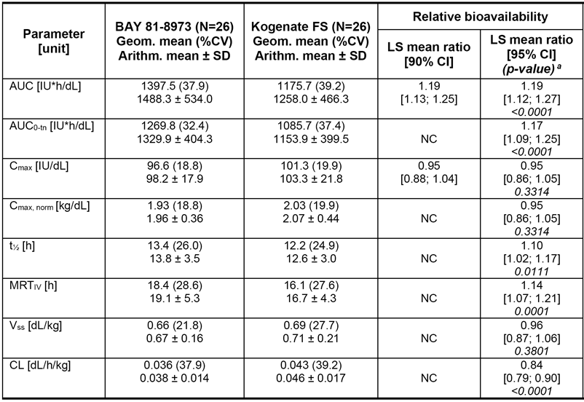
The volume of distribution approximated to that for plasma volume.
Metabolism of Kovaltry was not formally assessed but given is expected to be via endogenous proteolysis.
Clearance was observed, and modelled, to be higher in children aged 0 to 12 years as compared to children > 12 years and adults.
The evaluation of the pharmacokinetic comparison of Kovaltry and Kogenate FS between Caucasian and Asian patients is limited owing to the small number of Asian patients studied (n = 6), with worse disease severity among them.
Very small numbers of patients comprised the comparative PK analysis between patients aged 12 to 17 years and those aged ≥ 18 years, yielding no meaningful conclusions.

Efficacy evaluation
The clinical development program comprised of three studies, consistent with the requirements in EMA regulatory guidance adopted by the TGA.

Pivotal study
Leopold I was a two part, randomised, cross over, open label trial to evaluate the pharmacokinetics, efficacy, and safety profile of Kovaltry in PTPs aged ≥ 12 years with severe haemophilia A (Factor VIII < 1.0%). The study comprised four parts:
- Part A (Phase I) assessed the single-dose PK and bioequivalence of Kovaltry and Kogenate FS and has been evaluated in the Pharmacokinetics section of the clinical evaluation report.
- Part B (Phase II/III) assessed the safety, tolerability, and efficacy of 1 year prophylaxis treatment with Kovaltry in subjects with severe haemophilia A. The potency (dose) of Kovaltry in Part B was determined by the CS/EP and the CS/ADJ, and subjects were treated with both potency assignments for a period of 6 months in each period in a cross over design. In this part, Kovaltry was administered as prophylaxis treatment, for breakthrough bleeds and for surgical procedures (major and minor) following the treatment recommendations for Kogenate FS. Part B was considered to be the main part of the study.
- Part C (major surgeries) investigated the haemostatic effects of Kovaltry (CS/EP potency assignment only) in subjects undergoing major surgery.
- Leopold I Extension, an optional 1-year extension period of prophylactic treatment with Kovaltry (CS/EP potency assignment) was offered to subjects who completed the 1-year Part B study period.
All patients in part B met the criterion for severe disease severity, with none having a history of inhibitors. The mean ABR for total bleeds (primary efficacy variable) was 3.79 ± 5.21 bleeds/year (median = 1.03 bleeds/year; IQR = 0.00, 5.09; range = 0.00, 26.1) in the 62 subjects in the ITT population. The mean dose of Kovaltry per prophylactic injection in the 62 subjects in the ITT population was 32.85 ± 6.09 kg/IU (range: 25, 163).
Seven subjects were included in Part C, and 55 in the extension period of prophylaxis.

Supportive study
Leopold II was a phase II/III, randomized, cross over, open label trial to demonstrate superiority of prophylaxis over on-demand therapy in PTPs aged ≥ 12 years with severe haemophilia (Factor VIII < 1%). The primary objective was to demonstrate the superiority of prophylaxis over on-demand therapy by showing a clinically significant decrease in bleeding rate following 12 months treatment with Kovaltry.
There were 1497 ‘all bleeds’ reported in the ITT population (1204 in the 21 subjects in the on-demand group and 293 in the 59 subjects in the prophylaxis group). The mean ABR (‘all bleeds’) in the prophylaxis group (n = 59) was 4.94 ± 6.81 bleeds per year (median: 1.98; IQR: 0.00, 7.03). The mean ABR (all bleeds) in the on-demand group (n = 21) was 57.96 ± 24.56 bleeds per year (median: 59.96; IQR: 41.74, 76.32).
In the on-demand group, of the 1202 of the 1204 ‘all bleeds’ for which information was available, 78.5% (n = 943) were categorised as spontaneous bleeds and 21.5% (n = 258) as trauma bleeds. In the prophylaxis group, of the 283 of the 293 ‘all bleeds’ for which information was available, 73.9% (n = 209) were categorised as spontaneous bleeds (n = 209) and 26.1% (n = 74) as trauma bleeds.
In the prophylaxis group, information on subject response was available for 279 bleeds, and the majority of responses were excellent or good (61.6%), with a poor response being reported for 4.3% bleeds.

Supportive study
Leopold Kids was a multi-centre Phase III uncontrolled open label trial to evaluate safety and efficacy of Kovaltry in children aged 0 to 12 years with severe haemophilia A (Factor VIII < 1%). The primary objective was to demonstrate the safety and efficacy of treatment with Kovaltry for prophylaxis and breakthrough bleeds in children with severe haemophilia A.
In subjects aged 0-12 years (N = 51), 28 (54.9%) experienced 97 total bleeds during the study (mean: 1.90 ± 2.51; median 1.00; IQR: 0.00, 3.00). The mean ABR was 3.75 ± 4.98 bleeds/year (median 1.9; IQR = 0.00, 6.02). The characteristics of the bleeds reported in the total treatment period were trauma bleeds (61% (59/97)), spontaneous bleeds (21% (20/97)), and joint bleeds (33% (32/97)). The total number of Kovaltry injections for prophylaxis reported during the study in 51 subjects aged 0 to 12 years was 3529, with a mean of 69.2 ± 16.9 (median: 73.0; range: 37, 100). The mean Kovaltry dose per prophylactic injection in 51 subjects was 35.1 ± 9.8 IU/kg (median: 33.8; range: 21, 58).

Safety evaluation
Among the PTPs in the clinical studies, all 193 (100%) were exposed for ≥ 3 months, 179 (92.8%) for ≥ 6 months, 129 (66.8%) for ≥ 12 months and 39 (20.2%) for ≥ 24 month. Of the 193 PTPs, 172 (89%) were treated with Kovaltry for prophylaxis, and 21 (11%) were treated with Kovaltry on-demand.
Use of Factor VIII across the clinical studies is reported in the table Factor VIII consumption; summary of treatment administration per patient; safety analysis sets above.

Adverse events
The most commonly reported TEAEs in subjects (≥ 3 subjects in any safety pool) are summarised by MedDRA (V15.1) and preferred term (PT) in the table below:
The clinical evaluator states ‘In Leopold I+II, the number of adolescent subjects (n = 20) was notably lower than the number of adult subjects (n = 122), and no meaningful conclusions about the difference between the two groups in the pattern of TEAEs (PTs) could be made’.
Furthermore, in regard to the Asian patients studied in In Leopold I+II, and noting the inability of the studies to determine firm efficacy conclusions, no meaningful conclusions about the difference between the two groups in the pattern of TEAEs (PTs) could be made either.
Treatment related AEs were reported for 6.3% of subjects in Leopold I + II and in 2.0% of the children studied in Leopold Kids. In Leopold I+II, drug related TEAEs reported in 1 subject each were, lymphadenopathy, acute myocardial infarction, nausea, infusion site pain, infusion site pruritus, seasonal allergy, myalgia, dysgeusia, headache, nasal congestion, rhinorrhoea, allergic dermatitis, pruritus, and flushing. In Leopold Kids, the only reported drug related TEAE was pruritus.
No deaths were reported among any of the patients exposed to Kovaltry in the clinical development program. Overall, SAEs occurred in 9.9% of subjects in Leopold I+II and 9.8% (5/51) of subjects in Leopold Kids (none of the events in Leopold Kids were reported in more than one patient).
Treatment discontinuation due to AEs was reported in 1 (0.7%) subject in Leopold I+II (62 year old man with SAE of myocardial infarction) and 1 (2.0%) subject in Leopold Kids (4 year old boy with an AE of central venous catheter infection).
Clinical chemistry and haematology change of note in Leopold II were treatment-emergent high values reported in ≥ 10% of subjects of prothrombin time (21.7% (5/23)), basophils (18.9% (14/74)), lymphocytes (11.5%, (9/78)), and monocytes (10.7% (8/75)); one event each of increased neutrophil count and white blood cell count were reported among the Leopold Kids patients.
Among the participants in studies Leopold I, Leopold I Extension, Leopold II and Leopold Kids Part A, none were observed to have developed anti-Factor VIII antibodies while on-study.
However, in Leopold Kids Part B, 2 of 9 PUPs developed anti-Factor VIII antibodies, and both events were classified as serious and treatment related.
There was no occurrence of anaphylaxis during the clinical development program. However, hypersensitivity reactions were reported in 20.4% (29/132) of subjects in Leopold I+II and 37.3% (19/51) of subjects in Leopold Kids Part A. These events included symptoms of headache, cough, vomiting, nausea, pruritis, allergic dermatitis, flushing, dizziness, asthma and chest discomfort.
There remains limited safety data for peri-operative use of Kovaltry from 12 episodes of major surgery

Risk management plan
After the second round of RMP evaluation, there were outstanding issues for the Delegate to consider:
- In the ‘Dosage and Administration’ section, the PI should state that Kovaltry is not intended for continuous infusion.
The Delegate commented that the PI has been amended subsequently to state that Kovaltry is not intended for continuous infusion.
- In the ‘Precautions’ section, under the ‘Inhibitor formation’ heading, PI should contain the risk factors for inhibitor development:
  - Factor VIII gene mutation;
  - Family history;
  - Non-Caucasian ethnicity;
  - Polymorphisms in TNF-α or IL-10;
  - Intensive high dose treatments; and
  - Surgery.
The Delegate commented that these risks for inhibitor formation are reported in the PI for alternative Factor VIII products. The same information has been included in the PI for Kovaltry.
- In the ‘Precautions’ section, under the ‘Use in females’ heading, the PI should include a summary of the safety data available for this group, and if no data is available, a statement that no data is available (or a statement to that effect).
The Delegate commented that there is no such wording in the PI of other Factor VIII products and is considered unnecessary.
- In the ‘Dosage and Administration’ section, the PI should contain a statement that treatment should be initiated under the supervision of a physician experienced in the management of haemophilia (or a statement to that effect).
The Delegate commented that such a statement has been included in the PI.

Risk-benefit analysis

Delegate’s considerations

Efficacy
The clinical development program satisfactorily demonstrated the efficacy of prophylactic treatment, and peri-operative treatment, with Kovaltry for the prevention of bleeds in previously treated children, adolescents, and adults with severe haemophilia (Factor VIII < 1%).
In total, efficacy data based on the ITT population were available for 193 PTPs (122 adults, 20 adolescents and 51 children).
The increase in exposure of Kovaltry, in comparison to the same dose of Kogenate FS is likely to be only of concern from (the unlikely event of) patients transitioning from Kovaltry to Kogenate FS. Patients transitioning from Kogenate FS to Kovaltry would plausibly be expected to have a more than sufficient Factor VIII plasma concentration and haemostatic effect.
The effect of lower clearance in children aged 0 to 12 years, as compared to patients aged > 2 years, is expected to be managed by the individualisation of dosing in children in the younger group. Appropriate dosing advice is contained in the PI in order to minimise the effect of a potential reduction in exposure in children aged 0 to 12 years.

Safety
The clinical development program has yielded sufficient safety data to permit registration of Kovaltry.
The safety profile seen in adults and children were considered by the clinical evaluator to be sufficiently similar to permit amalgamation within the PI- the Delegate concurs with this approach.
The development of Factor VIII inhibitor formation was only seen among a small number of previously untreated patients which requires ongoing surveillance in the wider population. There was a difference in the AEs described among children participating in the extension study as compared the events reported in the first phase of Leopold Kids.

Dose
The dosage regimen is satisfactorily described in the PI, as follows:

On demand treatment
The calculation of the required dose of Factor VIII is based on the empirical finding that 1 International Unit (IU) Factor VIII per kg body weight raises the plasma Factor VIII activity by 1.5% to 2.5% of normal activity.
The required dose is determined using the following formulae:
Required units = body weight (kg) x desired Factor VIII rise (% or IU/dL) x reciprocal of observed recovery (that is 0.5 for recovery of 2.0%).
The amount to be administered and the frequency of administration should always be targeted to the clinical effectiveness required in the individual case. The usual single dose is 10 to 30 IU/kg body weight. Higher dosages are recommended for life threatening or major haemorrhages. Under certain circumstances, larger amounts than those calculated may be required, especially in the case of the initial dose.
In the case of the following haemorrhagic events, the Factor VIII activity should not fall below the given level (in % of normal) in the corresponding period. The following table (Table 20) can be used to guide dosing during bleeding episodes and in surgery.
- Guide for dosing during bleeding episodes and in surgery

Prophylaxis
For long term prophylaxis against bleeding in patients with severe haemophilia A, the usual doses for adolescents (> 12 years age) and adult patients are 20 to 40 IU of Kovaltry per kg body weight two to three times per week.
In some cases, especially in younger patients, shorter dose intervals or higher doses may be necessary.

Paediatric population
Kovaltry is appropriate for use in paediatric patients. Safety and efficacy studies have been performed in children in 0-12 years. The recommended prophylaxis doses are 20 to 50 IU/kg twice weekly, three times weekly or every other day according to individual requirements. For paediatric patients above the age of 12 the dose recommendations are the same as for adults.

Indication
The wording of the proposed indication is supported by the data.

Deficiencies of the data
There were no dedicated studies to obtain PK data on dose proportionality or following multiple dosing. The management of the response to Factor VIII replacement is individualised, pragmatically, all patients will have their dosing amended to their response, and the absence of formal studies is permissible.
There was no assessment of the bioequivalence of Kovaltry and Kogenate FS in PTPs (children) between the ages of 0 and < 12 years. The response to Kovaltry in children transitioning from Kogenate FS will be managed on an individual basis and thus the absence of formal data is considered permissible.
No data was presented for patients aged < 1 year. Such patients would typically be expected to be treated by experienced paediatric haematologists in Australia, and as such would be diligently managed.
Bioequivalence was only tested between Kovaltry and Kogenate FS. No data was presented to determine the bioequivalence of other registered products and Kovaltry. For patients transitioning to, or cycling between, Factor VIII products other than Kogenate FS, there may be a difference in haemostatic effect despite receiving the same dose, but as above, their response to treatment will be assessed contemporaneously by experienced staff.

Conditions of registration
- As per the RMP evaluation:
‘Implement EU-RMP Version 1.2 (dated 7 July 2015, DLP 31 December 2014) and Australian-specific annex (ASA) Version 1.1 (dated November 2015) and any future updates as a condition of registration.’
- As per the Biological Science evaluation:
‘Conditions of Registration: Batch Release Testing by OLSS It is a condition of registration that, as a minimum, the first five independent batches of
  - Kovaltry octocog alfa (bhk) 250 IU, powder for injection vial with diluent syringe
  - Kovaltry octocog alfa (bhk) 500 IU, powder for injection vial with diluent syringe
  - Kovaltry octocog alfa (bhk) 1000 IU, powder for injection vial with diluent syringe
  - Kovaltry octocog alfa (bhk) 2000 IU, powder for injection vial with diluent syringe
  - Kovaltry octocog alfa (bhk) 3000 IU, powder for injection vial with diluent syringe
imported into/manufactured in Australia are not released for sale until samples and/or the manufacturer’s release data have been assessed and endorsed for release by the TGA Office of Laboratories and Scientific Services (OLSS).
The sponsor should supply:
- Certificates of Analysis of all active ingredient (drug substance) and final product.
- Information on the number of doses to be released in Australia with accompanying expiry dates for the product and diluents (if included).
- Evidence of the maintenance of registered storage conditions during transport to Australia.
- 5 vials of each batch for testing by the Therapeutic Goods Administration OLSS together with any necessary standards, impurities and active pharmaceutical ingredients (with their Certificates of Analysis) required for method development and validation.
- A single, fully packaged and labelled sample from the first batch to be released, for label compliance assessment.
This batch release condition will be reviewed and may be modified on the basis of actual batch quality and consistency. This condition remains in place until you are notified in writing of any variation.’

Certified product details
The Certified Product Details (CPD), as described in Guidance 7: Certified Product Details of the Australian Regulatory Guidelines for Prescription Medicines (ARGPM) [http://www.tga.gov.au/industry/pm-argpm-guidance-7.htm], in PDF format, for the above products should be provided upon registration of these therapeutic goods. In addition, an updated CPD should be provided when changes to finished product specifications and test methods are approved in a Category 3 application or notified through a self-assessable change.

Proposed action
The Delegate proposed that Kovaltry should be approved for registration.

Request for ACM advice
The Delegate did not seek advice from the Advisory Committee on Medicines (ACM) on this occasion.

Outstanding issues
The decision of the FDA to register Kovaltry is pending at the time of this overview. Approval for registration by the FDA will be taken as proxy confirmation that there were no substantial effects on the clinical trial outcomes deriving from the adverse GCP assessment findings described above.

Pre ACM response from sponsor
Not applicable.

Advisory Committee Considerations
The Delegate did not refer this application to the Advisory Committee onMedicines (ACM) for advice.

Outcome
Based on a review of quality, safety and efficacy, TGA approved the registration of Kovaltry (octocog alfa (bhk)) 250 IU, 500 IU, l000 IU, 2000 IU and 3000 IU powder for injection with diluent syringe, indicated for:
Treatment and prophylaxis of bleeding in patients with haemophilia A (congenital factor Vlll deficiency). Kovaltry can be used for all age groups. (See Clinical Trials section) Kava/try does not contain van Willebrand factor and is not indicated in van Willebrand disease.

Specific conditions of registration applying to these goods
- The Kovaltry EU-RMP, version 1.2 (dated 7 July 2015, DLP 31 December 2014) and Australian-specific annex (ASA) Version 1.1 (dated November 2015), and any subsequent revisions, as agreed with the TGA will be implemented in Australia.
- It is a condition of registration that, as a minimum, the first five independent batches of Kovaltry octocog alfa (bhk) 250 IU, powder for injection vial with diluent syringe Kovaltry octocog alfa (bhk) 500 IU, powder for injection vial with diluent syringe Kovaltry octocog alfa (bhk) 1000IU, powder for injection vial with diluent syringe Kovaltry octocog alfa (bhk) 2000 IU, powder for injection vial with diluent syringe Kovaltry octocog alfa (bhk) 3000 IU, powder for injection vial with diluent syringe imported into/manufactured in Australia are not released for sale until samples and/or the manufacturer's release data have been assessed and endorsed for release by the TGA Office of Laboratories and Scientific Services (OLSS).

Attachment 1. Product Information
The PI for Kovaltry approved with the submission which is described in this AusPAR is at Attachment 1. For the most recent PI, please refer to the TGA website at < https://www.tga.gov.au/product-information-pi>.

Therapeutic Goods Administration
PO Box 100 Woden ACT 2606 Australia
Email: info@tga.gov.au Phone: 1800 020 653 Fax: 02 6232 8605
https://www.tga.gov.au

https://www.tga.gov.au/temperature-excursions-biological-medicines
Based on a C_{max} of 6.4 IU/mL in dogs that received 400 IU/kg and C_{max} values of ~0.8 and ~1.3 in IU/mL in paediatric and adult patients in the Leopold Kids Part A and Leopold I Part A and B studies, respectively.
C_{max} in rats based on pharmacokinetic data collected on day 1 of the repeat dose study in rats (7.7 IU/mL; Study PH-35733).
ICH S6(R1) Preclinical Safety Evaluation of Biotechnology-Derived Pharmaceuticals
Beere, HM. Death versus survival: functional interaction between the apoptotic and stress-inducible heat shock protein pathways. J Clin Invest. 2005: 115; 2633–2639
The limit of detection for Hsp70 is 1.5 ng/mL. The theoretical maximum concentration in reconstituted Kovaltry is estimated to be 2.5–15 ng/1000 IU (depending on the vial reconstituted). For long term prophylactic treatment, the MRHD in adults is 40 IU/kg given 2–3 x per week. For a 70 kg adult the dose per treatment day is 2800 IU which would give ≤ 42 ng per dose.
Pockley, AG et al. Detection of heat shock protein 70 (Hsp70) and anti-Hsp70 antibodies in the serum of normal individuals. Immunol Invest. 1998: 27; 367-377
Category B2: Drugs which have been taken by only a limited number of pregnant women and women of childbearing age, without an increase in the frequency of malformation or other direct or indirect harmful effects on the human fetus having been observed. Studies in animals are inadequate or may be lacking, but available data show no evidence of an increased occurrence of fetal damage.
EMA guideline EMEA/CHMP/SWP/169215/2005 Guideline on the need for non-clinical testing in juvenile animals of pharmaceuticals for paediatric indications
EMA, 21 July 2011
EMA/CHMP/BPWP/144552/2009 Guideline on clinical investigation of recombinant and human plasma-derived factor IX products 2011
Pennekamp et al. Giant haemophilic pseudotumour of the pelvis: case report and literature review. Haemophilia. 2015; 21 :484-486
Burde RM. Amaurosis fugax. An overview. J Clin Neuroophthalmol. 1989; 9: 185-189.
Lepore FE. Visual obscurations: evanescent and elementary. Semin Neurol. 1986; 6: 167-175.
Amick A, Caplan LR. Transient monocular visual loss. Compr Ophthalmol Update. 2007; 8: 91-98; discussion 99-100.
Doummar D, et al. Management of acute visual loss in children. Arch Pediatr. 2004; 11: 1384-1388.
Amick A, Caplan LR. Transient monocular visual loss. Compr Ophthalmol Update. 2007; 8: 91-98; discussion 99-100
Abu-Arefeh I, Russell G. Prevalence of headache and migraine in schoolchildren. BMJ. 1994; 309:765-769.
Kaye EM, Herskowitz J. Transient post-traumatic cortical blindness: brief v prolonged syndromes in childhood. J Child Neurol. 1986; 1: 206-210.
Rodriguez A, et al. Post-traumatic transient cortical blindness. Int Ophthalmol. 1993; 17: 277-283.
Prasad S, et al. Clinical reasoning: a 42-year-old man with sequential monocular visual loss. Neurology 2008; 71: 43–49.
Meyer E, Gdal-On M, Zonis S. Transient monocular blindness in a case of drusen of the optic disc. Ophthalmologica. 1973; 166: 321-326.
Brodsky MC. Contractile morning glory disc causing transient monocular blindness in a child. Arch Ophthalmol. 2006; 124: 1199-1201.
Le Fort D et al. Elisscited repetitive daily blindness: a new familial disorder related to migraine and epilepsy. Neurology. 2004; 63: 348-350.
Griffiths PG, Eddyshaw D. Medically unexplained visual loss in adult patients. Eye. 2004; 18: 917-922.
Taich A, et al. Prevalence of psychosocial disturbances in children with nonorganic visual loss. J AAPOS. 2004; 8: 457-461.
Mayou R, Farmer A. ABC of psychological medicine: Functional somatic symptoms and syndromes. BMJ. 2002; 325: 265-268.
Bain KE, Beatty S, Lloyd C. Non-organic visual loss in children. Eye. 2000; 14 Pt 5: 770-772.
Furukawa A, Koriyama Y. A role of Heat Shock Protein 70 in Photoreceptor Cell Death:Potential as a Novel Therapeutic Target in Retinal Degeneration.CNS Neurosci Ther. 2015 Oct 28.
Adamus G. Mitochondrial heat shock protein 70: new target for optic neuritis therapy. Invest Ophthalmol Vis Sci. 2014; 55: 5227.
Talla V, et al. Gene therapy with mitochondrial heat shock protein 70 suppresses visual loss and optic atrophy in experimental autoimmune encephalomyelitis.; Invest Ophthalmol Vis Sci. 2014; 55: 5214-5226.
Rea IM, McNerlan S, Pockley AG. Serum heat shock protein and anti-heat shock protein antibody levels in aging. Exp Gerontol. 200; 36: 341-352.
Routine risk minimisation activities may be limited to ensuring that suitable warnings are included in the product information or by careful use of labelling and packaging. Routine pharmacovigilance practices involve the following activities: - All suspected adverse reactions that are reported to the personnel of the company are collected and collated in an accessible manner; - Reporting to regulatory authorities; - Continuous monitoring of the safety profiles of approved products including signal detection and updating of labeling; - Submission of PSURs; - Meeting other local regulatory agency requirements.
The ACM provides independent medical and scientific advice to the Minister for Health and the Therapeutic Goods Administration (TGA) on issues relating to the safety, quality and efficacy of medicines supplied in Australia including issues relating to pre-market and post-market functions for medicines. The Committee is established under Regulation 35 of the Therapeutic Goods Regulations 1990. Members are appointed by the Minister. The ACM was established in January 2017 replacing Advisory Committee on Prescription Medicines (ACPM) which was formed in January 2010. ACM encompass pre and post-market advice for medicines, following the consolidation of the previous functions of the Advisory Committee on Prescription Medicines (ACPM), the Advisory Committee on the Safety of Medicines (ACSOM) and the Advisory Committee on Non-Prescription Medicines (ACNM). Membership comprises of professionals with specific scientific, medical or clinical expertise, as well as appropriate consumer health issues relating to medicines.

