PRODUCT INFORMATION

JETREA® (ocriplasmin 0.5 mg/0.2 mL)

Concentrated Solution for Intravitreal Injection after Dilution

NAME OF THE MEDICINE
JETREA solution for injection
The chemical structure of ocriplasmin (ryp) is:

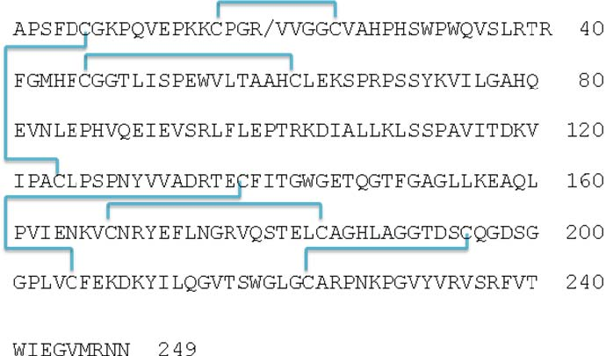
Molecular weight: 27.2 kDa

Chemical name: microplasmin; recombinant truncated human plasmin
CAS Number: 1048016-09-6

DESCRIPTION
Ocriplasmin (ryp) is a recombinant truncated form of human plasmin with a molecular weight of 27.2 kDa produced by recombinant DNA technology in a Pichia pastoris expression system.
JETREA is a sterile, clear and colourless solution with no preservatives in a single-use glass vial containing 0.5 mg ocriplasmin in 0.2 mL fill product. JETREA drug product solution is to be diluted with an equal volume of 0.9% (w/v) sodium chloride prior to use. After dilution with 0.2 mL of 0.9% sodium chloride (preservative-free), 0.1 mL of the diluted solution contains 0.125 mg ocriplasmin.
Each vial contains 0.5 mg ocriplasmin and 0.21 mg citric acid, 0.75 mg mannitol, sodium hydroxide (for pH adjustment) and water for injections with a pH of 3.1.

PHARMACOLOGY
Pharmacodynamics
Mechanism of action
Ocriplasmin has a proteolytic activity against protein components of the vitreous body and the vitreoretinal interface (VRI) (e.g. laminin, fibronectin and collagen), and aims to dissolve the protein matrix responsible for the abnormal vitreomacular adhesion (VMA). The tight binding of the protein components within the macular area of the VRI contribute to vitreomacular traction (VMT), leading to visual impairment and/or macular holes.

Pharmacokinetics
Ocriplasmin levels in the vitreous decrease rapidly after intravitreal administration. In a clinical study in patients scheduled for vitrectomy receiving 0.125 mg JETREA (corresponding to a theoretical start concentration of 29 µg/mL vitreous), mean ocriplasmin activity was 9% of theoretical start concentration 2-4 hours after injection and below the lower level of quantification at 7 days.
When administered intravenously, ocriplasmin enters the endogenous protein catabolism pathway through which it is rapidly inactivated via its interactions with protease inhibitor α2-antiplasmin or α2-macroglobulin. The inactive ocriplasmin/α2-antiplasmin complex is cleared from the circulation with a half-life (t½) of several hours.
The intravitreal pharmacokinetics of ocriplasmin were determined in a clinical study in patients (n=38) scheduled for vitrectomy where 0.125 mg ocriplasmin (corresponding to an average concentration of 29 µg ocriplasmin per mL vitreous volume) was administered as a single intravitreal dose at different time points prior to vitrectomy. As expected from preclinical data, the mean ocriplasmin activity levels decreased with time from injection to time of sampling as illustrated in Table 1, according to a second-order kinetic process. At 24 hours post-injection the levels of ocriplasmin in the vitreous were below 3% of the theoretical concentration reached immediately after injection.

Table 1: Mean Ocriplasmin Activity Levels in Vitreous Samples after Injection
of 0.125 mg JETREA
Time post-injection | 5-30  min | 31-60  min | 2-4  hours | 24  hours | 7  days
Ocriplasmin  level | 12  µg/mL | 8.1  µg/mL | 2.6  µg/mL | 0.49  µg/mL | <0.27  µg/mL
^{a)} 2 subjects below lower limit of detection, other 2 subjects at 0.88 and 0.57 µg/mL
^{b)} Lower limit of detection
Because of the small dose administered (0.125 mg), detectable levels of ocriplasmin in the systemic circulation are not expected after intravitreal injection.
The systemic pharmacokinetics of ocriplasmin were evaluated in 2 clinical studies (TG-MV- 001 and TG-MV-004, n=40 & 24 respectively) with intravenous administration.
Ocriplasmin enters the endogenous protein catabolism pathway through which it is rapidly inactivated via its interactions with protease inhibitor α2-antiplasmin or α2-macroglobulin. The inactive ocriplasmin/α2-antiplasmin complex is cleared from the circulation with a half-life (t½) of several hours. At doses far exceeding the dose for intravitreal use, and large enough to deplete circulating α2-antiplasmin, the remaining ocriplasmin is cleared with a t½ of approximately 1 hour.
Renal impairment
No studies have been conducted to examine the pharmacokinetics of ocriplasmin in patients with renal impairment since the systemic exposure is expected to be very low after intravitreal administration.
Hepatic impairment
No studies have been conducted to examine the pharmacokinetics of ocriplasmin in patients with hepatic impairment since the systemic exposure is expected to be very low after intravitreal administration.
Absorption, Distribution, Metabolism & Excretion
No studies beyond those previously described have been conducted with ocriplasmin as it is expected that ocriplasmin enters the endogenous protein catabolism pathway through which it is rapidly inactivated via its interactions with protease inhibitor α2-antiplasmin or α2- macroglobulin.

CLINICAL TRIALS
The efficacy of JETREA was demonstrated in 2 multicentre, randomised, double-masked, placebo-controlled, 6-month studies in patients with VMT. A total of 652 patients (JETREA; 464, placebo; 188) were randomised in these two studies (TG-MV-006 and TG-MV-007).
The diagnostic criteria used were as follows:
Patients with symptomatic focal VMA i.e. central vitreal adhesion within 6 mm Optical Coherence Tomography field surrounded by elevation of the posterior vitreous cortex, that, in the opinion of the investigator, is related to decreased visual function such as metamorphopsia, decreased visual acuity or other visual complaint.
In both pivotal studies, the proportion of patients who achieved VMA resolution at Day 28 (primary endpoint) was significantly (p≤0.003) higher in the ocriplasmin group compared with the placebo group. The difference continued to be statistically significant through Month 6 in each study (p≤0.024).
In the integrated data, 26.5% in the ocriplasmin group compared with 10.1% in the placebo group achieved VMA resolution at Day 28, (p<0.001). The difference was maintained from Day 7 through Month 6 (Figure 1).
Patients with no ERM at baseline were more likely to achieve VMA resolution at Day 28 compared with those who had ERM at baseline. In the integrated data, the VMA resolution rate at Day 28 was higher in patients treated with JETREA compared to placebo in both the subgroup without ERM (37.4% vs 14.3%, p<0.001) and with ERM (8.7% vs 1.5%, p=0.046).
Patients with a smaller VMA diameter at baseline (≤ 1,500 microns) were more likely to achieve VMA resolution at Day 28 compared with those who had a diameter > 1,500 microns. In the integrated data, the VMA resolution rate at Day 28 was higher in patients treated with JETREA compared to placebo in both the subgroup with VMA ≤ 1,500 microns at baseline (34.7% vs 14.6%, p<0.001) and with VMA > 1,500 microns at baseline (5.9% vs 0%, p=0.113).

Figure 1: Proportion of patients with VMA resolution up to Day 180 (Month 6) (TG-MV-006, TG-MV-007 and integrated data)

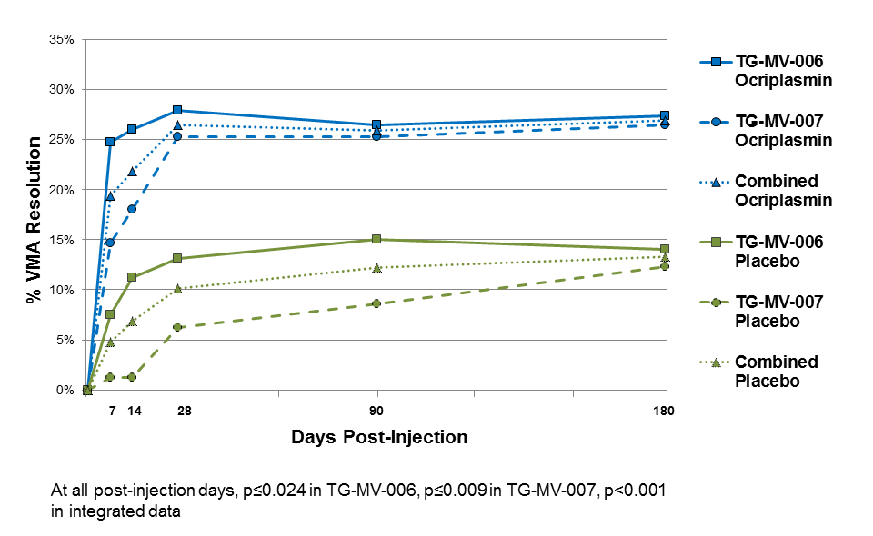
In the integrated data, 106 (22.8%) and 47 (25%) in the JETREA and placebo groups respectively had full thickness macular hole (FTMH) at baseline. Of these, the proportion of patients who achieved FTMH closure without vitrectomy at Day 28 was higher in the JETREA group than the placebo group (40.6% vs 10.6%, respectively; p<0.001). A difference was maintained through the end of the studies (Month 6).
A significantly higher percentage of JETREA treated patients experienced total PVD at Day 28 compared to placebo treated patients (integrated data: 13.4% vs. 3.7%, respectively; p<0.001).
During the studies, if the underlying condition did not improve, i.e. VMA was not resolved by Day 28, vitrectomy could be performed at the discretion of the Investigator. JETREA treated patients were less likely to have had a vitrectomy by the end of the study (Month 6) compared with placebo treated patients (integrated data: 17.7% vs. 26.6%, respectively; p=0.016).
A higher proportion of JETREA treated patients gained ≥ 2 or ≥ 3 lines in BCVA (irrespective of vitrectomy) at Month 6 (28.0% and 12.3%, respectively) compared with patients treated with placebo (17.1% and 6.4%) (p=0.003 and p=0.024, respectively). Also, the proportion of patients gaining ≥ 2 or ≥ 3 lines in BCVA without vitrectomy favoured JETREA at Month 6 (23.7% vs 11.2%, p<0.001 for a gain ≥ 2 lines and 9.7% vs 3.7%, p=0.008 for a gain ≥ 3 lines).
In the integrated analysis of the National Eye Institute Visual Function Questionaire-25 (VFQ-25), a numerical favour of JETREA over placebo was shown in each sub-scale score, as well as the composite score. The difference for improvement in the general vision sub- scale score was statistically significant (6.1 JETREA vs 2.1 placebo, p=0.024).

Paediatric population
The safety and efficacy of ocriplasmin in paediatric subjects scheduled for vitrectomy was investigated in study TG-MV-009. A single intravitreal injection of 0.175 mg ocriplasmin, or placebo, was injected in the mid-vitreous of 24 eyes of children aged 0 to 16 years, 30 to 60 minutes prior to the planned start of vitrectomy. The main reasons for vitrectomy were retinal detachment and retinopathy of prematurity. Treatment with ocriplasmin did not demonstrate an effect on posterior vitreous detachment rate, vitreous liquefaction grade, immediate postoperative retinal reattachment rate, development of proliferative vitreoretinopathy, or stage of retinopathy of prematurity. Based on the results of this study, the use of JETREA as an adjunct to vitrectomy in children, to facilitate vitreous separation and removal, is not recommended.

INDICATIONS
JETREA is indicated in adults for the treatment of vitreomacular traction (VMT), including when associated with macular hole of diameter less than or equal to 400 microns.

CONTRAINDICATIONS
Patients with active or suspected ocular or periocular infections.
Patients with known hypersensitivity to ocriplasmin or to any of the excipients of JETREA.

PRECAUTIONS
Decreased vision
A decrease of greater than or equal to 3 lines of best corrected visual acuity (BCVA) was experienced by 5.6% of patients treated with JETREA and 3.2% of patients treated with vehicle, after 6 months, in the controlled trials. The majority of these decreases in vision were due to progression of vitreomacular traction and many patients required vitrectomy. (see CLINICAL TRIALS).
There is a risk of significant, but transient, loss of visual acuity during the first week after treatment. Patients should be monitored appropriately.
Uncommonly (i.e., incidence between 1-in-100 and 1-in-1000), patients can experience longer term reduced visual acuity, associated with ERG changes; but not associated with progression of vitreomacular traction. Based on the currently available data, there is no way to predict which patients will experience such longer term reduced visual acuity.
Panretinal disease
Treatment is not recommended in patients with any panretinal disease that has been associated with abnormal ERG findings (e.g., retinitis pigmentosa, choroideraemia). (Visual loss associated with ERG changes has been observed with JETREA; see ADVERSE EFFECTS).
Intravitreal injection procedure associated events
JETREA is administered by intravitreal injection only. Intravitreal injections have been associated with intraocular inflammation/infection, intraocular haemorrhage and increased intraocular pressure (IOP). Proper aseptic injection techniques must always be used.
In the controlled trials, intraocular inflammation occurred in 7.1% of patients injected with JETREA versus 3.7% of patients injected with vehicle. Most of the post-injection inflammation events were mild and transient. Intraocular haemorrhage occurred in 2.4% versus 3.7% of patients with JETREA versus vehicle. The percentages for increased intraocular pressure were 4.1% versus 5.3%.
Following the intravitreal injection, patients should be monitored for any side effects such as (but not limited to) intraocular inflammation/infection and elevation in IOP. Transient increases in IOP including transient blindness and non-perfusion of the optic nerve have been seen within 60 minutes of injection of JETREA. Monitoring for increases in IOP may consist of a check for perfusion of the optic nerve head immediately after the injection and tonometry within 30 minutes following the injection.
Intraocular inflammation/infection and intraocular pressure may be assessed using biomicroscopy between 2 and 7 days following the injection. Patients should be instructed to report symptoms suggestive of intraocular inflammation/infection or any other visual or ocular symptoms without delay. If any of the above events occur, the patient should be treated according to standard medical practice.
Potential for lens subluxation
One case of lens subluxation was reported in a patient who received an intravitreal injection of 0.175 mg (1.4 times higher than the recommended dose). Lens subluxation was observed in three animal species (monkey, rabbit, minipig) following a single intravitreal injection that achieved vitreous concentrations of ocriplasmin 1.4 times higher than achieved with the recommended treatment dose. A second intravitreal dose in monkeys, 28 days apart, produced lens subluxation in 100% of the treated eyes.
Dyschromatopsia
Dyschromatopsia (generally described as yellowish vision) was reported in 2% of all patients injected with JETREA. In about half of these cases there were also electroretinographic changes (a- and b-wave amplitude decrease).
Administration to both eyes currently
The safety and efficacy of JETREA administered to both eyes concurrently has not been studied. Administration to both eyes concurrently is not recommended.
Repeated administration to the same eye
Repeated administration of JETREA to the same eye has not been adequately studied and is not recommended.
Administration of other therapeutic products in the same eye
JETREA is a proteolytic enzyme with serine protease activity, which could be present in the eye for several days after intravitreal injection. Administration in close temporal association with other therapeutic products in the same eye may affect the activity of both products and is not recommended.
There are no clinical data on the concomitant administration of JETREA with VEGF-inhibitors.
Patient groups in whom JETREA has not been studied
JETREA has not been studied in patients with large diameter macular holes (> 400 μm), high myopia (> 8 dioptre spherical correction or axial length > 28 mm), aphakia, history of rhegmatogenous retinal detachment, lens zonule instability, recent ocular surgery or intraocular injection (including laser therapy), proliferative diabetic retinopathy, ischaemic retinopathies, retinal vein occlusions, exudative age-related macular degeneration (AMD) and vitreous haemorrhage. Treatment is not recommended in such patients.
Patient groups in whom there is limited experience with JETREA
There is limited experience in patients with non-proliferative diabetic retinopathy or history of uveitis (including active severe inflammation) or significant eye trauma. Caution should be exercised when treating such patients.
Experience is limited in groups other than Caucasians.

New or enlarged macular holes
Due to a potential increase in tractional forces, there is a risk of occurrence of new or enlarged macular holes.
Reduced efficacy in patients with epiretinal membrane or large area of vitreomacular adhesion
The effect of JETREA (particularly in inducing resolution of vitreomacular adhesion or causing total Posterior Vitreous Detachment (PVD)) is reduced in subjects with an epiretinal membrane (ERM) or a diameter of vitreomacular adhesions (VMA) > 1,500 µm.

Effects on Fertility
There are no data on the effect of ocriplasmin on fertility.

Use in pregnancy – Pregnancy category B2
There are no data for the use of ocriplasmin in pregnant women. No reproductive toxicology studies have been performed. The systemic exposure of ocriplasmin is expected to be very low after intravitreal injection. JETREA should be used during pregnancy only if the clinical benefit outweighs the potential risks.

Use in lactation
It is unknown whether ocriplasmin is excreted in human milk. JETREA should be used during breastfeeding only if the clinical benefit outweighs the potential risks.

Paediatric use
Use in children is not recommended. (See CLINICAL TRIALS.)

Use in the elderly
The mean age of the patients in the two phase III studies was 72.0 years and 70.7 years for the JETREA and placebo groups respectively. In the pivotal studies, 384 and 145 patients were ≥ 65 years and of these 192 and 73 patients were ≥ 75 years in the JETREA and placebo groups respectively.

Genotoxicity
No genotoxicity data are available.

Carcinogenicity
No carcinogenicity data are available.

Effects on ability to drive and use machines
The JETREA treatment procedure may induce a significant, but transient, loss of visual acuity and visual disturbances, which may affect the ability to drive or use machines. This is most likely to occur during the first 7 days after the injection due to the release of vitreomacular traction. Patients who experience these signs must not drive or use machines until these temporary visual disturbances subside.

INTERACTIONS WITH OTHER MEDICINES
No formal interaction studies have been performed.
No systemic interactions are anticipated.
Administration in close temporal association with other therapeutic products in the same eye may affect the activity of both products and is not recommended (see PRECAUTIONS).

ADVERSE EFFECTS
Summary of the safety profile
Over 800 patients have been treated with an intravitreal injection of JETREA, with over 570 patients treated with the recommended dose of 0.125 mg.
All adverse reactions were ocular. The most commonly reported were vitreous floaters, eye pain and photopsia, as well as conjunctival haemorrhage resulting from the injection procedure. Most of the adverse reactions occurred within the first week after the injection. The majority of these reactions were non-serious, mild in intensity and resolved within 2 to 3 weeks.
The incidence of serious adverse reactions that occurred in all clinical studies was 2.2% in JETREA treated patients and 2.4 % in control patients.

Tabulated list of adverse reactions
The following table summarises the adverse reactions that occurred in clinical studies with a reasonable possibility of causality to the injection procedure or JETREA.
The adverse reactions are listed by MedDRA system organ class and frequency using the following convention: very common (≥1/10); common (≥1/100 to <1/10); uncommon (≥1/1,000 to <1/100); rare (≥1/10,000 to <1/1,000); very rare (<1/10,000) and not known (cannot be estimated from the available data). Within each frequency grouping, adverse reactions are presented in the order of decreasing clinical importance.

Eye disorders | Very common  Vitreous floaters, eye pain, conjunctival haemorrhage
Common
Visual acuity reduced, visual impairment, vision blurred, retinal haemorrhage, vitreous haemorrhage, retinal tear, retinal detachment, intraocular pressure increased, macular hole, macular degeneration, retinal degeneration, macular oedema, retinal oedema, retinal pigment epitheliopathy, metamorphopsia, vitreous adhesions, conjunctival oedema, eyelid oedema, vitritis, anterior chamber cell, anterior chamber flare, iritis, photopsia, conjunctival hyperaemia, ocular hyperaemia, vitreous detachment, retinogram abnormal, eye irritation, dry eye, foreign body sensation in eyes, eye pruritus, ocular discomfort, photophobia, chromatopsia.
Uncommon
Transient blindness, longer-term reduced visual acuity, lens subluxation, scotoma, visual field defect, diplopia, hyphaema, miosis, pupils unequal, corneal abrasion, anterior chamber inflammation, eye inflammation, conjunctival irritation

Tabulated adverse events very common and common
 | ADRs with Onset 0-7 Days Post-Injection |  | Cumulative Post-Injection ADRs
Adverse Reactions | Placebo  (n=187)  (%) | Ocriplasmin  0.125 mg  (n=465)  (%) | Placebo  (n=187)  (%) | Ocriplasmin  0.125 mg  (n=465)  (%)
Vitreous floaters | 2.7 | 12.9 | 7.5 | 16.8
Eye pain | 3.2 | 10.5 | 5.9 | 13.1
Photopsia | 1.1 | 10.1 | 2.7 | 11.8
Vision blurred | 0.5 | 6.5 | 3.2 | 8.4
Visual acuity reduced | 0 | 4.1 | 4.3 | 6.2
Visual impairment | 0 | 3.2 | 1.1 | 5.4
Subretinal fluid | 0 | 3.7 | 1.1 | 5.4
Macular oedema | 0 | 0.6 | 1.6 | 4.1
Photophobia | 0 | 3.2 | 0 | 3.7
Anterior chamber cell | 0.5 | 2.6 | 2.7 | 3.7
Ocular discomfort | 1.1 | 1.7 | 1.1 | 2.8
Iritis | 0 | 1.9 | 0 | 2.6
Vitreous detachment | 0 | 1.5 | 1.1 | 2.6
Dry eye | 0.5 | 0.9 | 1.1 | 2.4
Metamorphopsia | 0 | 1.5 | 0.5 | 2.2

Description of selected adverse reactions
Visual acuity reduced
In the placebo-controlled, pivotal phase III studies, 7.7% of JETREA patients and 1.6% of placebo patients had acute transient ≥ 2-line (≥ 10 ETDRS letters) loss in best corrected visual acuity (BCVA) during the first week after injection with no alternative explanation for the change. Visual acuity decreases were generally reversible within 2 weeks without intervention.
Serious and/or severe acute impairment was reported in 0.7% of all patients injected with JETREA (in some cases down to hand motion) and there have been uncommon post-market reports of longer term reduced visual acuity (see PRECAUTIONS).
Chromatopsia
Dyschromatopsia (generally described as yellowish vision) has been reported as a common adverse reaction in patients injected with JETREA. The majority of events were non-serious, mild and generally resolved spontaneously. The median time to resolution was 3 months.
Retinogram abnormal
Electroretinographic (ERG) changes (a- and b-wave amplitude decrease) have been reported as a common adverse reaction in patients injected with JETREA; in the majority of cases dyschromatopsia was also reported. In approximately half of the cases, the ERG changes had resolved at the time of the last follow-up. The median time to resolution was 6 months. ERG changes were not predictive of negative outcomes in terms of visual acuity.
Retinal break, retinal detachment
In the placebo-controlled, pivotal phase III studies, retinal breaks (tears and detachment) were reported in 1.9% of patients injected with JETREA vs. 4.3% injected with placebo. Most of these events occurred during or after vitrectomy in both groups. The incidence of retinal detachment that occurred pre-vitrectomy was 0.4% in the JETREA group and none in the placebo group while the incidence of retinal tears (without detachment) that occurred pre- vitrectomy was 0.2% in the JETREA group and 0.5% in the placebo group.
Macular hole
In the placebo-controlled, pivotal phase III studies, cases of new onset or worsening of - macular hole were reported for 6.7% of all patients injected with JETREA vs. 9.6% injected with placebo. Although in placebo-controlled, pivotal phase III studies, JETREA has shown benefit in inducing closure of macular holes associated with vitreomacular traction, in some instances increased traction with subsequent progression or development of a new macular hole has been observed. Development of these events is a part of natural disease progression; however, a contribution of ocriplasmin in some cases appears plausible based on its mechanism of action.
Vitreous adhesion
In the placebo-controlled, pivotal phase III studies, cases of worsening of vitreomacular adhesion/vitreomacular traction were reported for 1.5% of all patients injected with JETREA vs. 1.1% injected with placebo. Development of these events is a part of natural disease progression; however, a contribution of ocriplasmin in some cases appears plausible based on its mechanism of action.
Lens subluxation/phacodonesis
One case of lens subluxation/phacodonesis was reported in clinical studies in adults and appears to have been possibly related to treatment with JETREA.
Based on the proteolytic activity of ocriplasmin, preclinical and clinical findings, the potential for lens subluxation or phacodonesis cannot be ruled out. If this event occurs, it should be treated according to standard medical practice (also see PRECAUTIONS).

DOSAGE AND ADMINISTRATION
The diagnosis of vitreomacular traction (VMT) should comprise of a complete clinical picture, including patient history, clinical examination and investigation using currently accepted diagnostic tools, such as optical coherence tomography (OCT).
JETREA must be prepared and administered by a qualified ophthalmologist experienced in intravitreal injections. Single use vial is for intravitreal use only.
The recommended dose is 0.125 mg (0.1 mL of the diluted solution) administered by intravitreal injection to the affected eye once as a single dose.
Each vial should only be used once and for the treatment of a single eye. Administration to both eyes concurrently is not recommended. Repeated administration is not recommended.

Dosage adjustment in:
Renal insufficiency
No formal studies have been conducted with ocriplasmin in patients with renal impairment. No dose adjustment or special considerations are anticipated for patients with renal impairment.
Hepatic insufficiency
No formal studies have been conducted with ocriplasmin in patients with hepatic impairment. No dose adjustment or special considerations are anticipated for patients with hepatic impairment.

Preparation for Administration
To prepare JETREA for intravitreal injection, adhere to the following instructions:
- Remove the vial from the freezer and allow to thaw at room temperature (takes about 2 minutes).
- Once completely thawed, remove the protective polypropylene flip-off cap from the vial

(Figure 1).
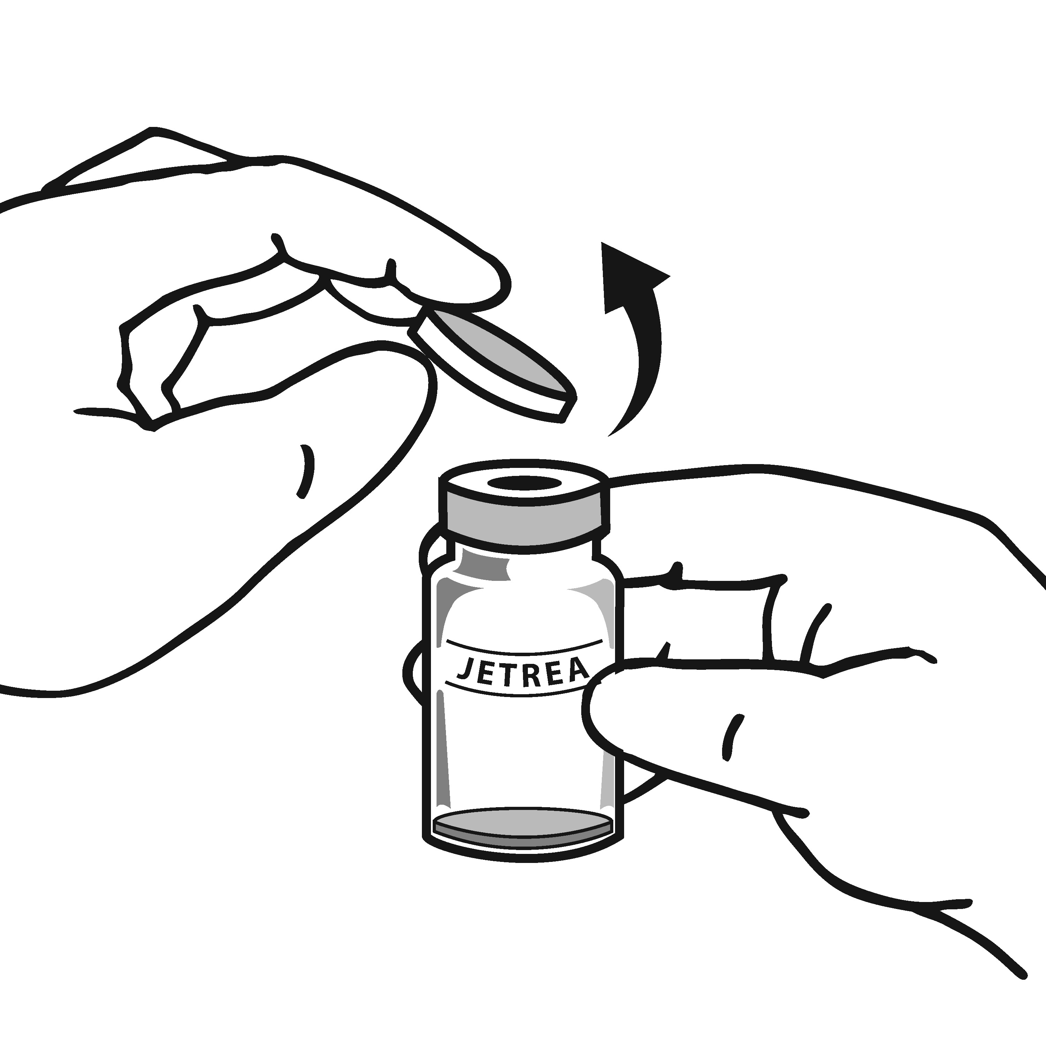
Figure 1

3. Disinfect the top of the vial with an alcohol wipe (Figure 2).

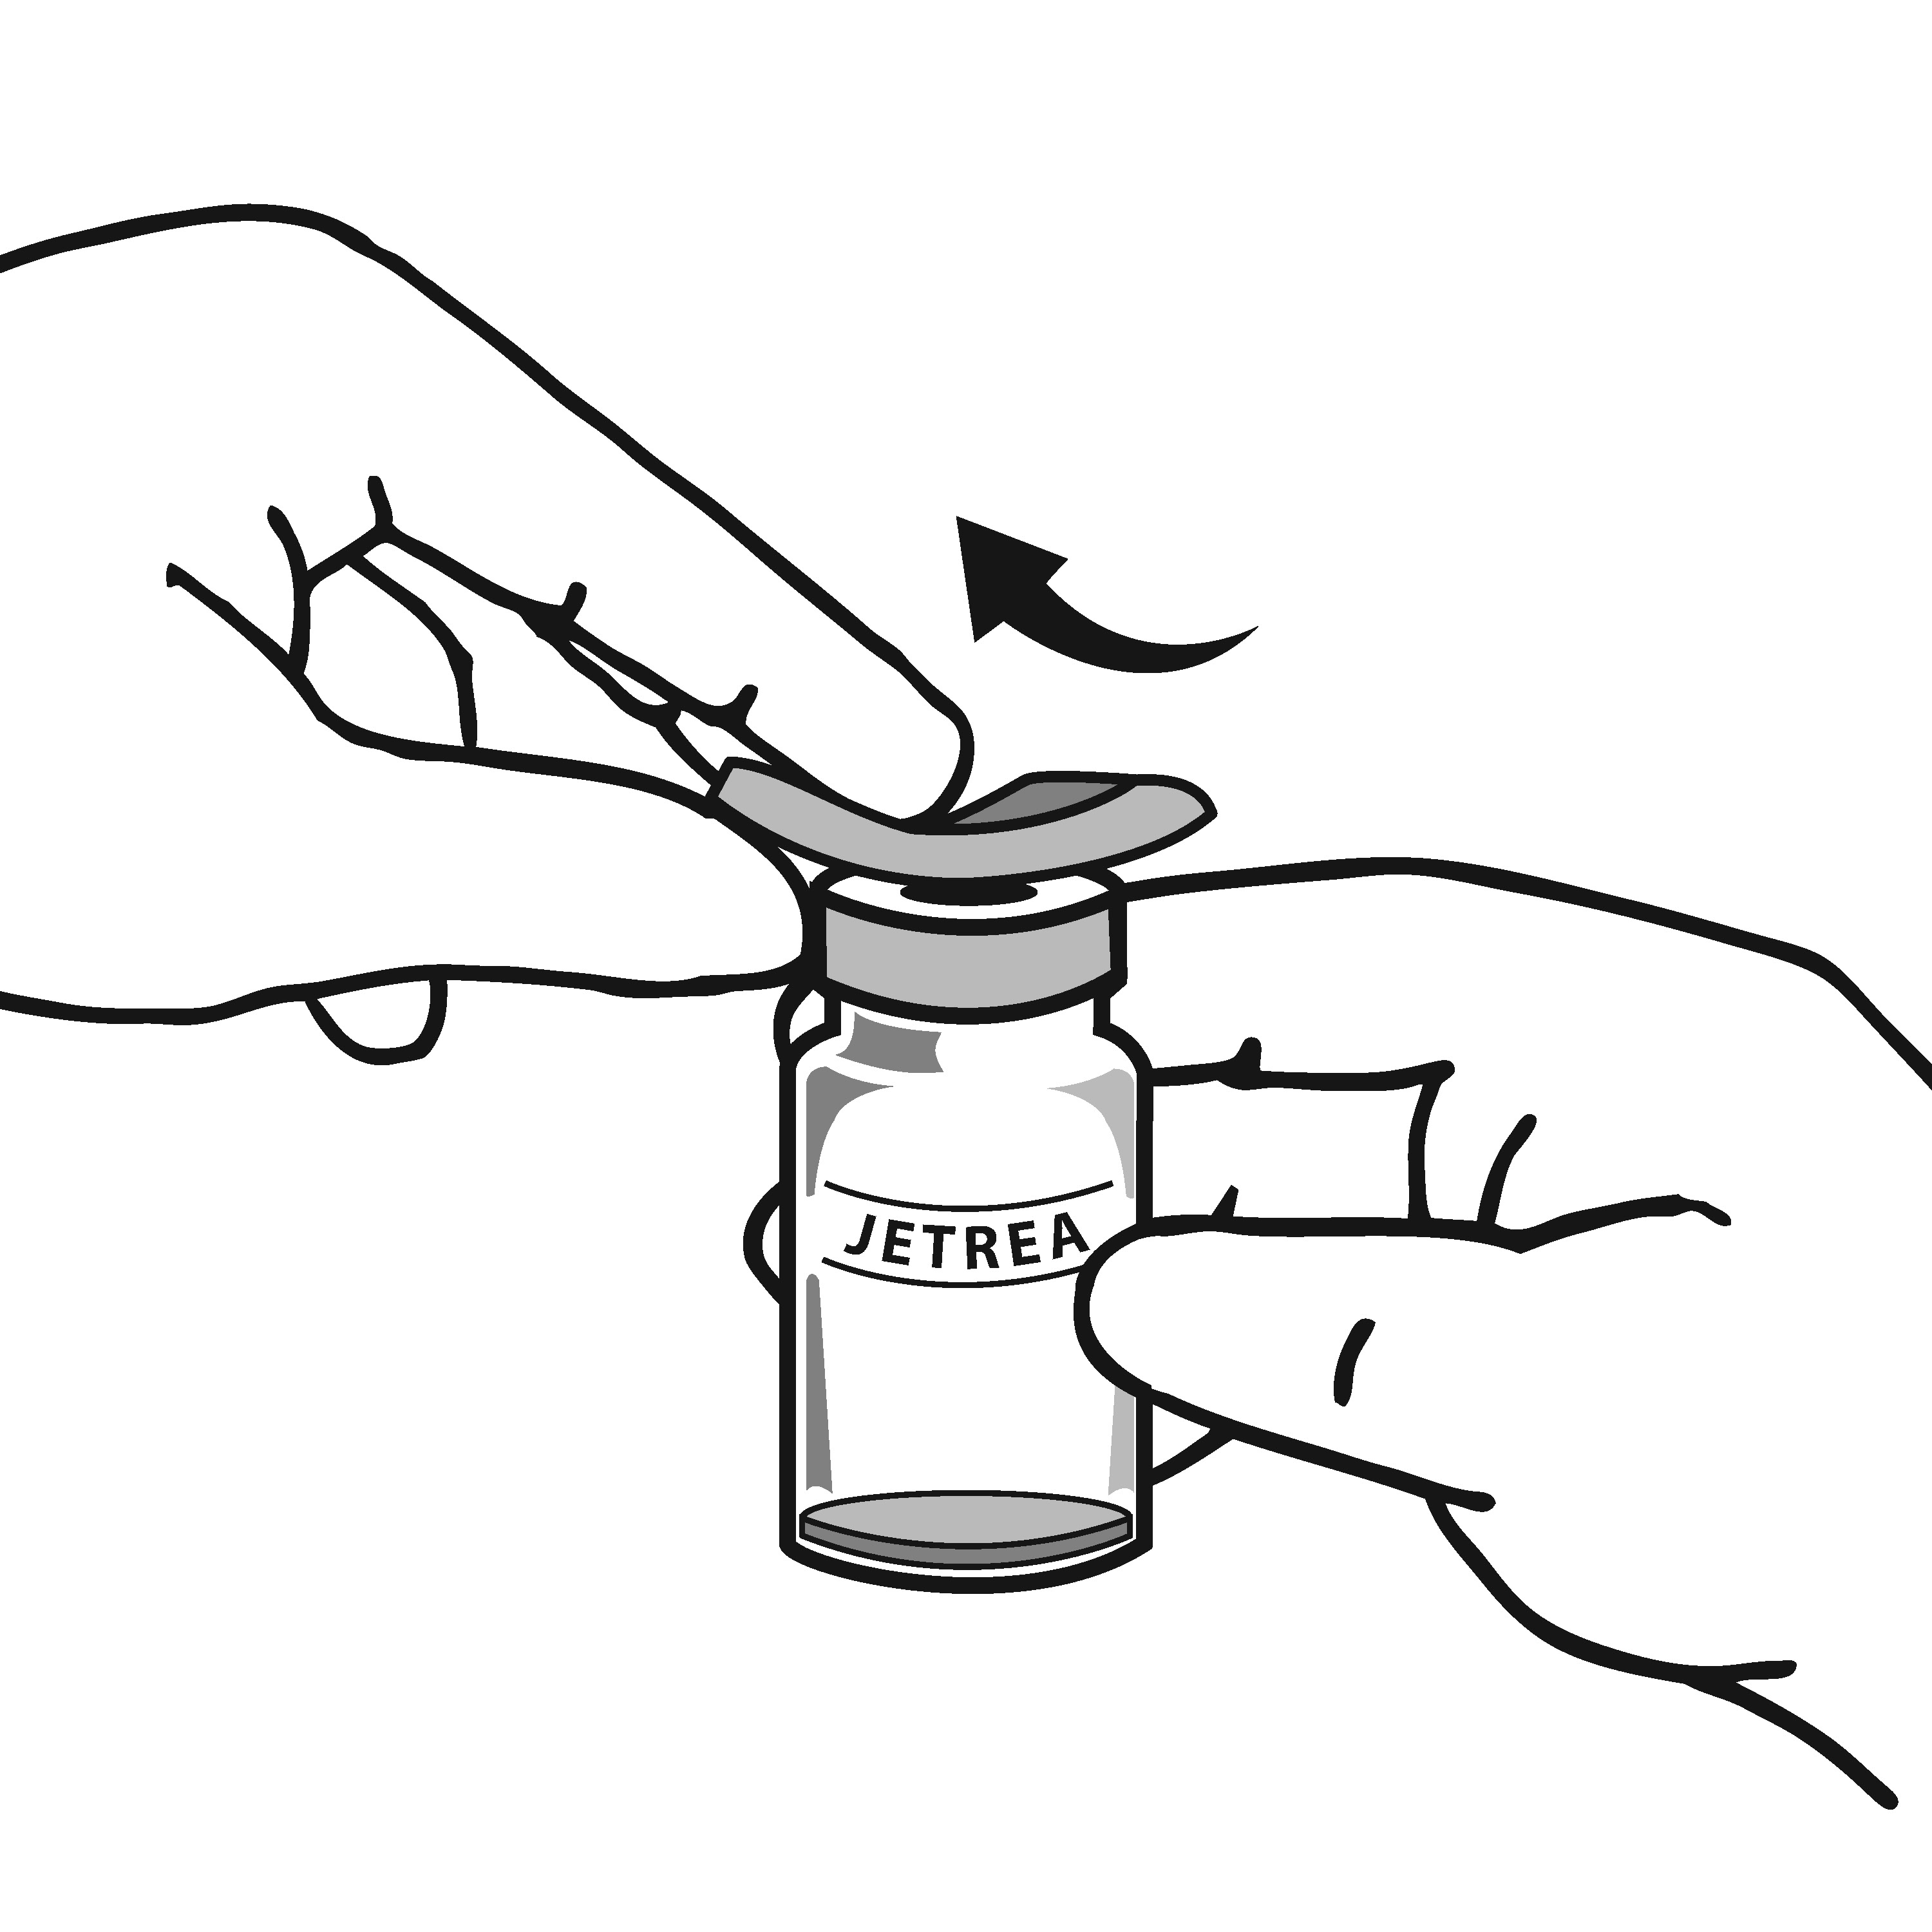

Figure 2

4. Using aseptic technique, dilute by adding 0.2 mL of sodium chloride 9 mg/mL (0.9%) solution for injection (sterile, preservative-free, non-buffered) into the JETREA vial (Figure 3).

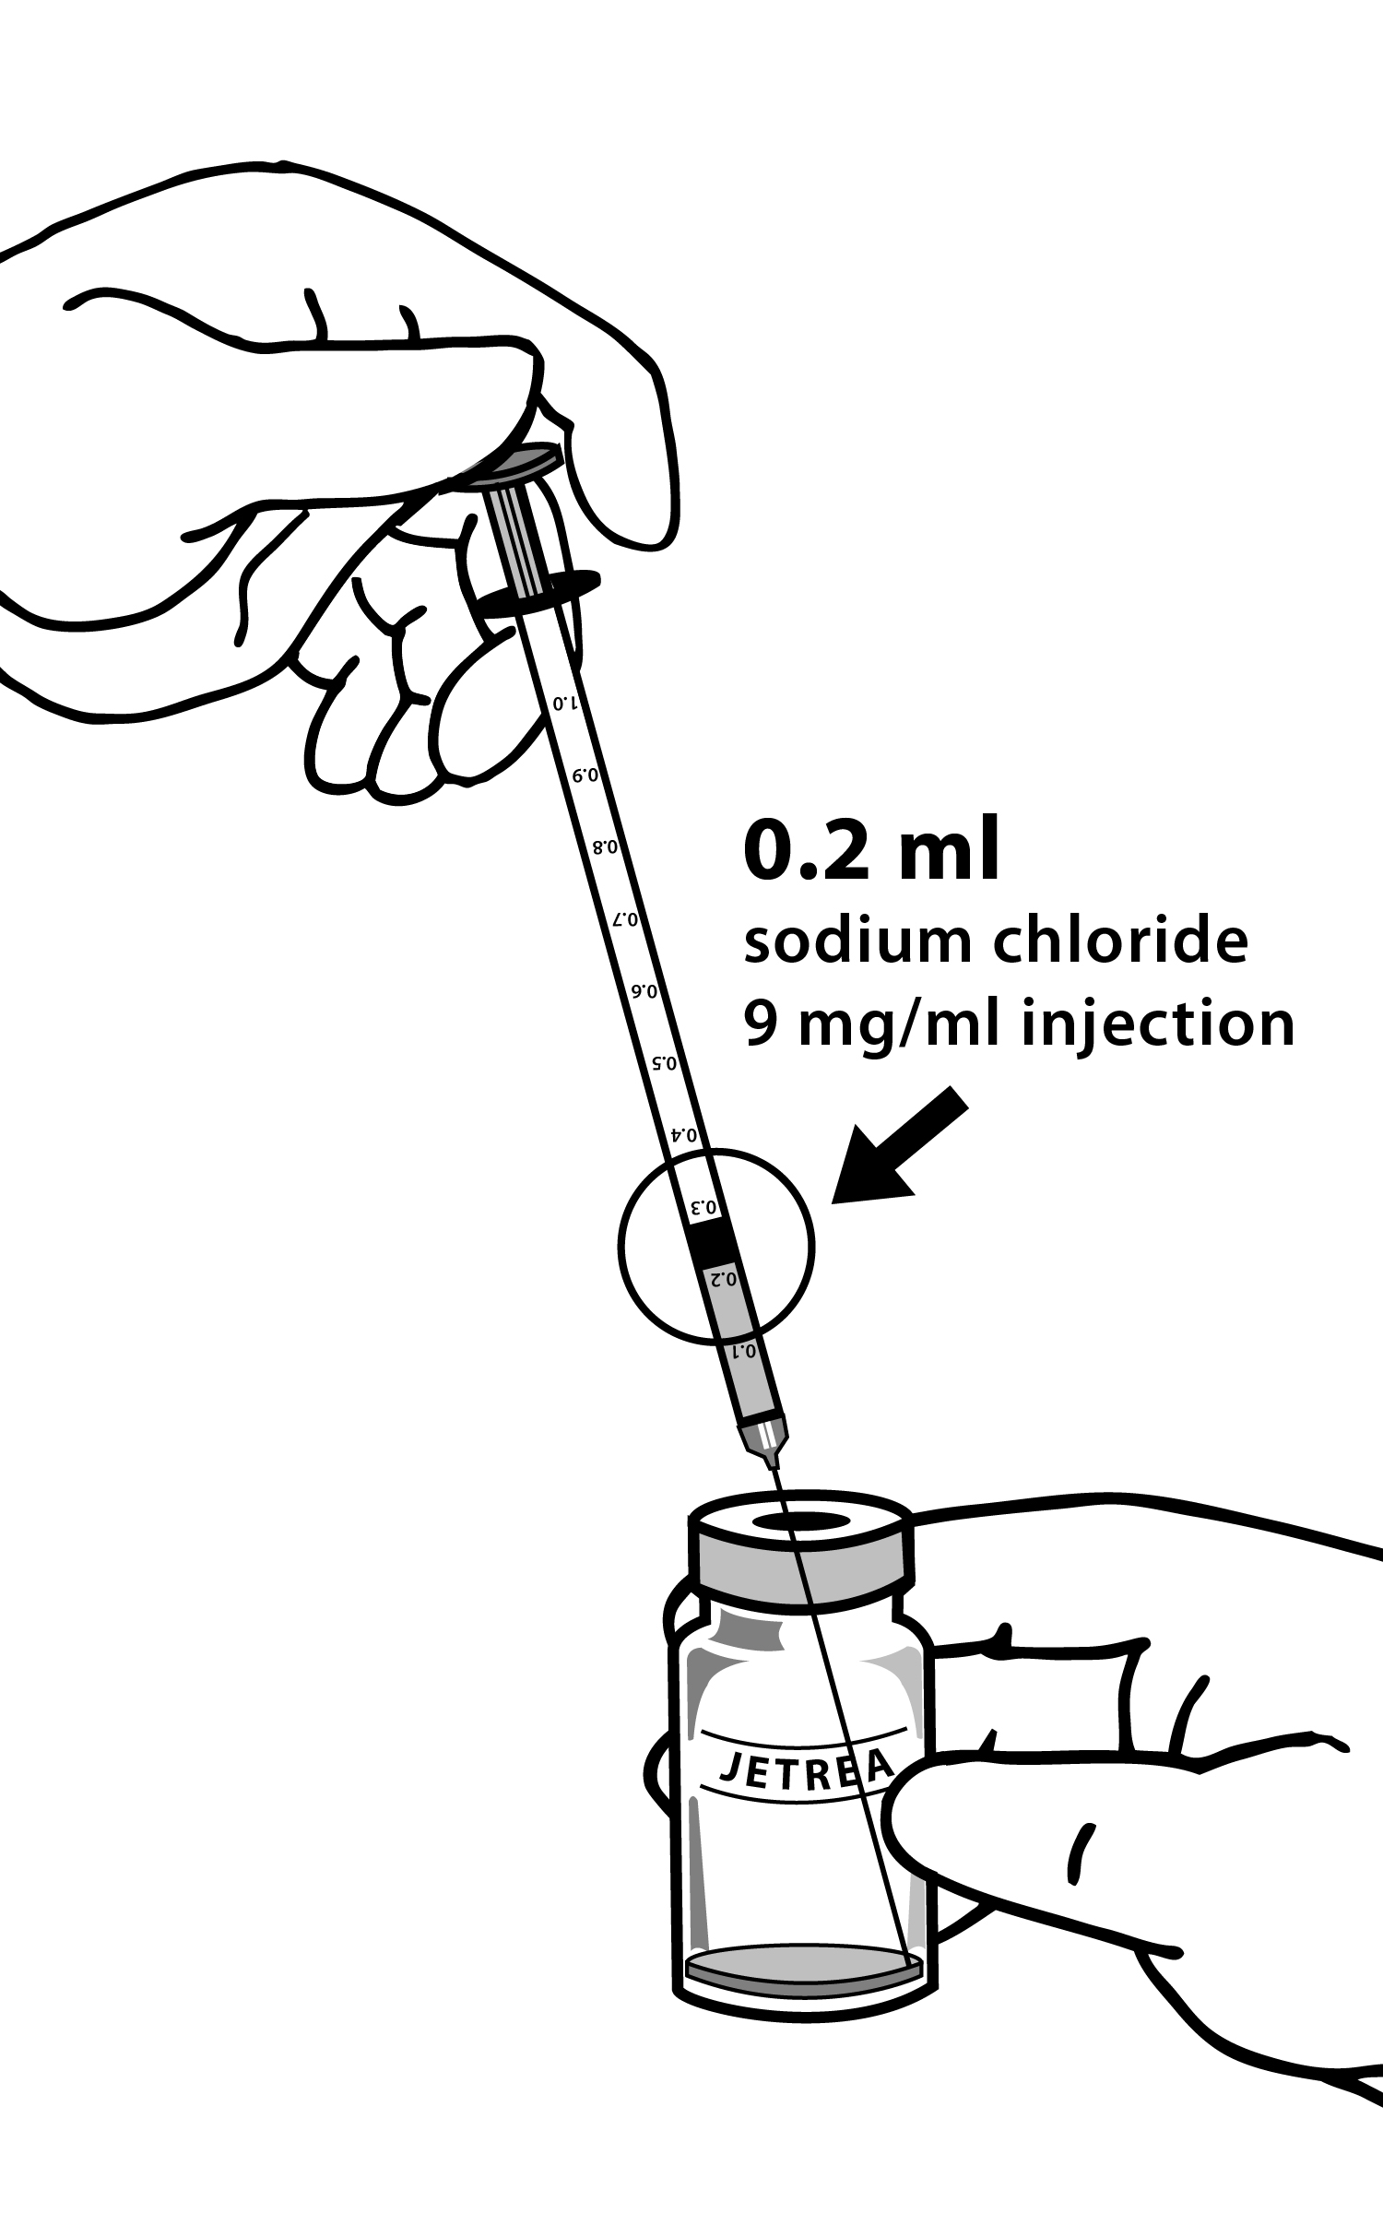

Figure 3

and gently swirl the vial until the solutions are mixed (Figure 4).

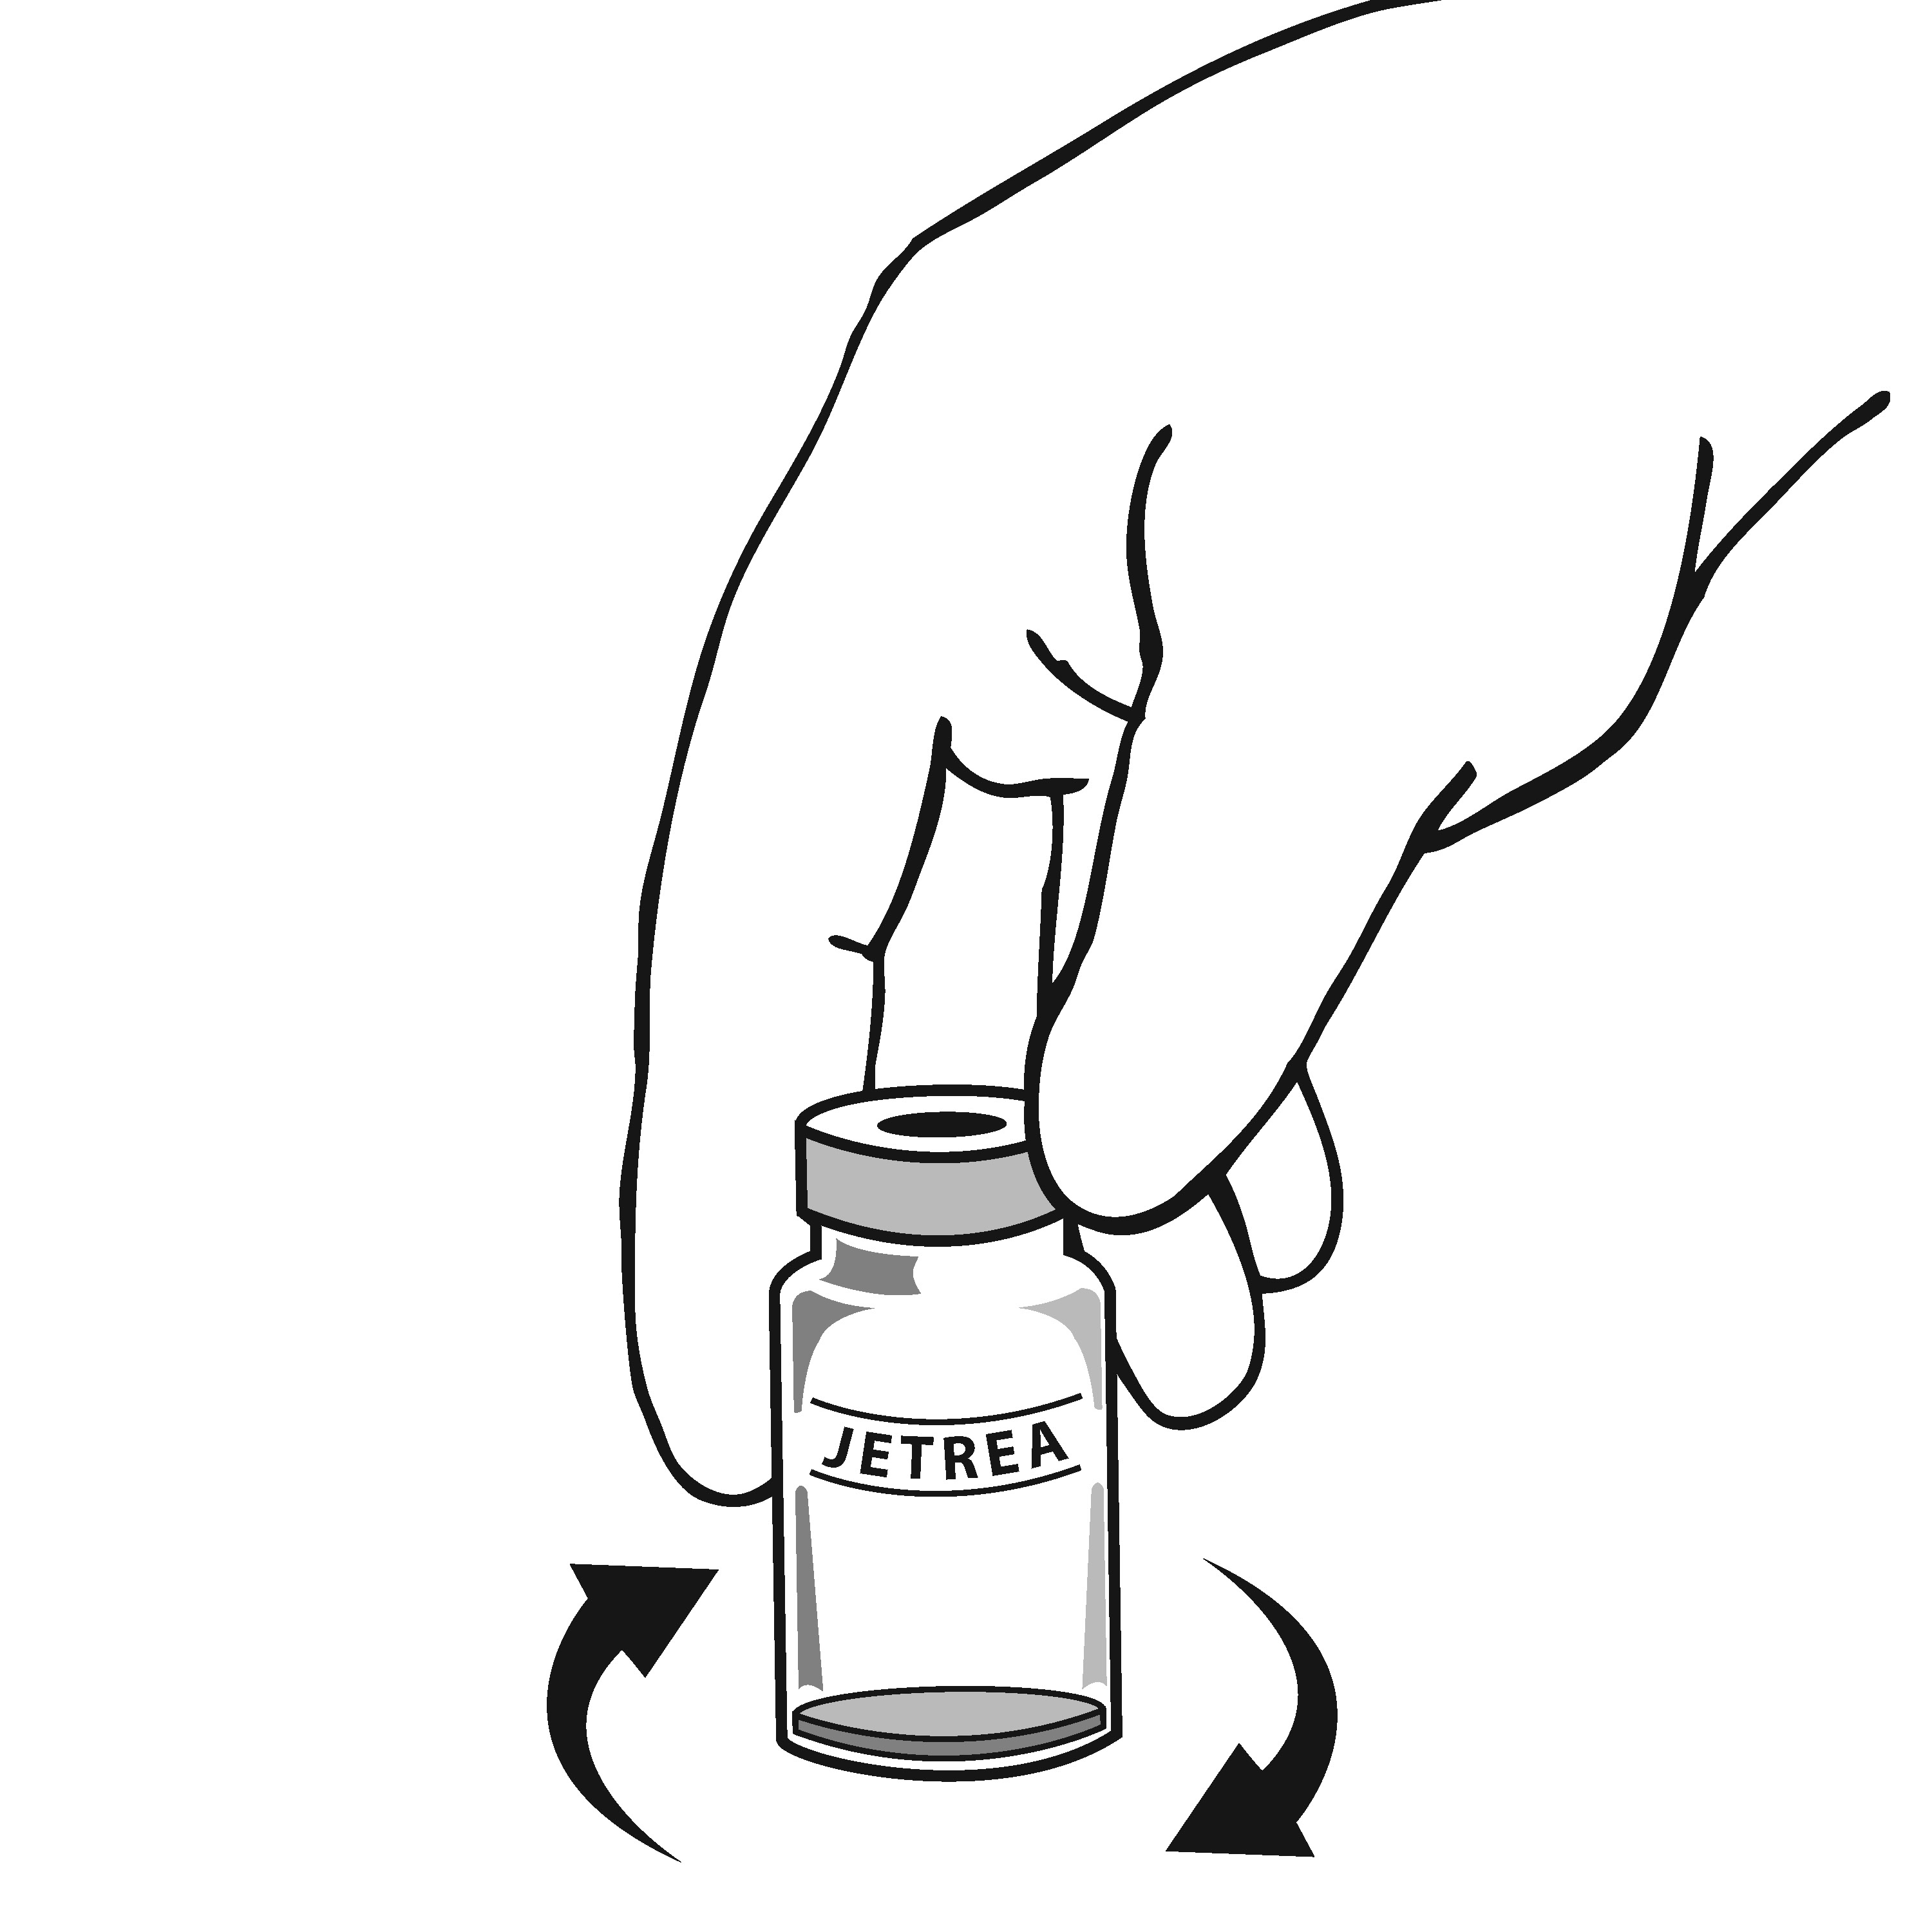

Figure 4

The diluent should be withdrawn from an unopened container which should be used only once. The remaining sodium chloride 9 mg/mL (0.9%) solution for injection should be discarded. The diluted solution should be used immediately as it contains no preservatives.
- Visually inspect the vial for particulate matter. Only a clear, colourless solution without visible particles should be used.
- Using aseptic technique, withdraw all of the diluted solution using an appropriate sterile needle (slightly incline the vial to ease withdrawal) (Figure 5) and discard the needle after withdrawal of the vial contents. Do not use this needle for the intravitreal injection.

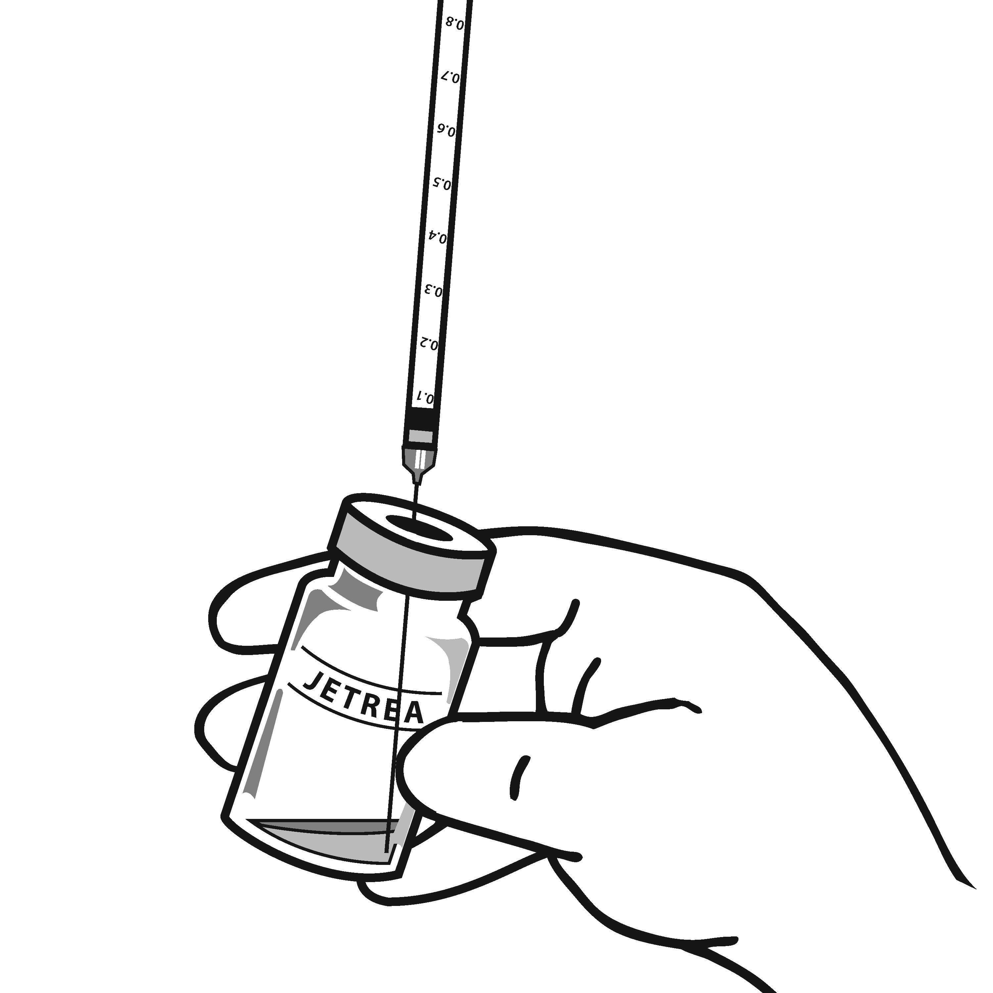

Figure 5

- Replace the needle with an appropriate sterile needle, carefully expel the air from the syringe and adjust the dose to the 0.1 mL mark on the syringe (corresponding to 0.125 mg ocriplasmin) (Figure 6).
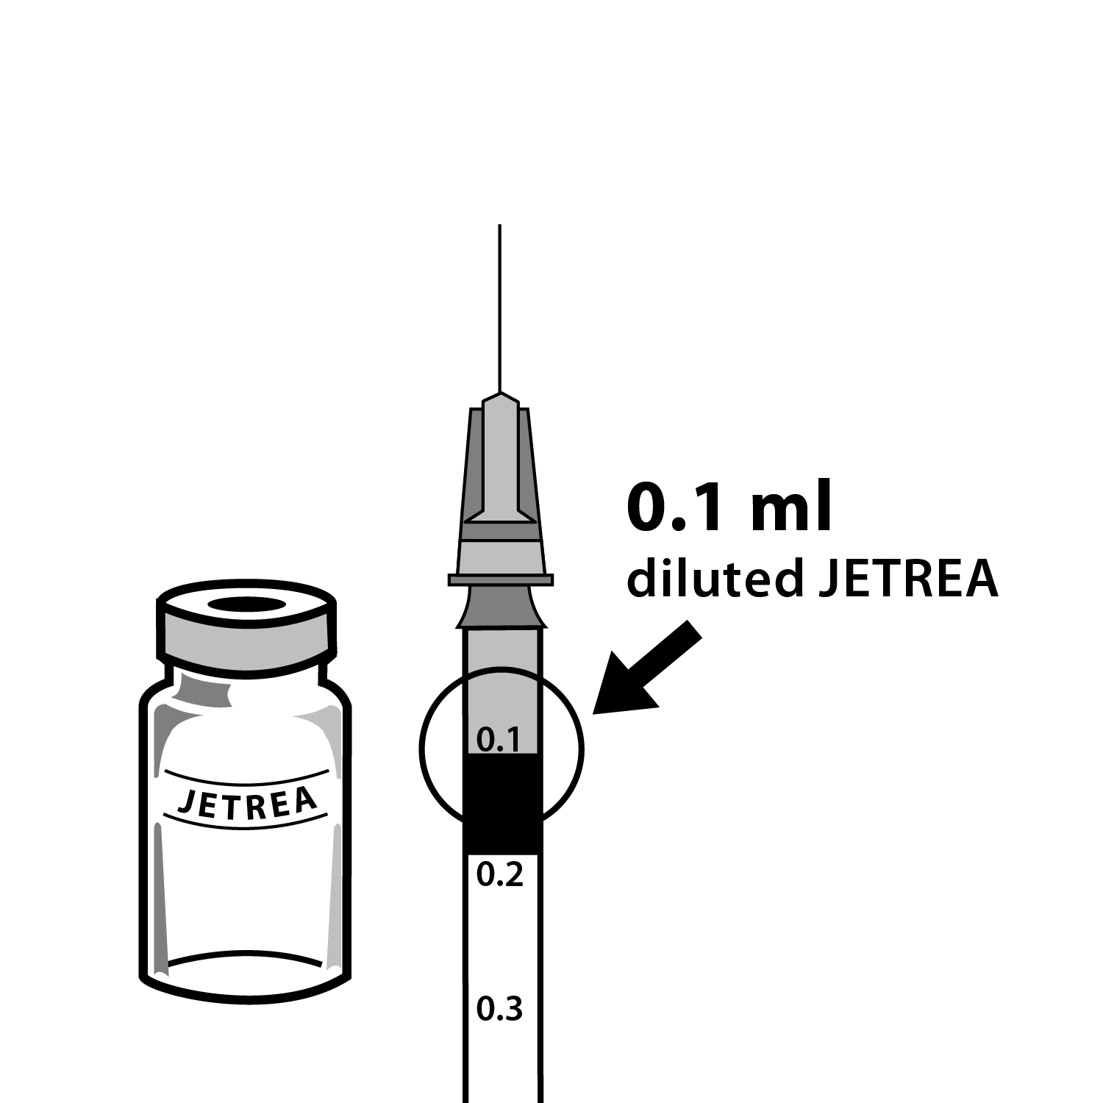
Figure 6

- Inject 0.1 mL of the diluted solution without delay into the mid-vitreous as it contains no preservatives.
- Discard the vial and any unused portion of the diluted solution after single use.
Any unused medicinal product or waste material should be disposed of in accordance with local requirements.

Administration
The intravitreal injection procedure should be carried out under controlled aseptic conditions, which include the use of surgical hand disinfection, sterile gloves, a sterile drape, a sterile eyelid speculum (or equivalent) and the availability of sterile paracentesis (if required). The periocular skin, eyelid and ocular surface should be disinfected and adequate anaesthesia and a broad spectrum topical microbiocide should be administered according to standard medical practice.
The injection needle should be inserted 3.5-4.0 mm posterior to the limbus aiming towards the centre of the vitreous cavity, avoiding the horizontal meridian. The injection volume of 0.1 mL is then delivered into the mid-vitreous.

OVERDOSAGE
For information on the management of overdosage, contact the Poison Information Centre on 13 11 26 (Australia) or 0800 POISON or 0800 764 766 (New Zealand).

Symptoms, signs and recommended treatment of overdosage or accidental poisoning

The clinical data on the effects of ocriplasmin overdose are limited. One case of accidental intravitreal overdose of 0.250 mg ocriplasmin (twice the recommended dose) has been reported. The patient had a decrease in best corrected visual acuity (BCVA) of 21 letters as measured on the Early Treatment of Diabetic Retinopathy Study chart (ETDRS) from baseline that returned to within 9 letters of baseline at the end of the study. The patient also had mild conjunctival hyperaemia, eye inflammation and miosis which resolved with corticosteroid eye drops.
If an overdose occurs, close monitoring is recommended, in particular, the monitoring of intraocular pressure. If an adverse reaction occurs, it should be treated according to standard medical practice.

PRESENTATION AND STORAGE CONDITIONS

.JETREA is supplied as 0.2 mL concentrated solution for injection in 2 mL Type 1 glass vials with latex free chlorobutyl rubber stopper. Each carton contains 1 vial. Each vial contains 0.5 mg of ocriplasmin (ryp) in 0.2 mL citric-buffered solution.

Following 1:1 dilution with 0.9% w/v Sodium Chloride Injection, USP (sterile, preservative-free), 0.1 mL of the diluted solution should be used for intravitreal injection. VIAL IS FOR SINGLE USE ONLY.

If the product is exposed to higher temperatures (above -20ºC ± 5ºC) during storage, the vial should be discarded.

After dilution, the product cannot be stored and must be used immediately.

Storage
Store in a deep freeze at -20ºC ± 5ºC. Protect from light by storing in the original package until time of use.

NAME AND ADDRESS OF SPONSOR

Alcon Laboratories (Australia)

Pty Ltd ABN 88 000 740 830

25 Frenchs Forest Road East

FRENCHS FOREST NSW 2086

Australia

POISON SCHEDULE OF THE MEDICINE
Schedule 4, PRESCRIPTION ONLY MEDICINE

DATE OF FIRST INCLUSION IN THE AUSTRALIAN REGISTER OF THERAPEUTIC GOODS (the ARTG)
09 October 2014

