Date of first round CER: 24 June 2013
Date of second round CER: 28 October 2013

AusPAR Attachment 2

Extract from the Clinical Evaluation Report for ocriplasmin
  - Proprietary Product Name: Jetrea
  - Sponsor: Alcon Laboratories Australia Pty Ltd

About the Therapeutic Goods Administration (TGA)
- The Therapeutic Goods Administration (TGA) is part of the Australian Government Department of Health, and is responsible for regulating medicines and medical devices.
- The TGA administers the Therapeutic Goods Act 1989 (the Act), applying a risk management approach designed to ensure therapeutic goods supplied in Australia meet acceptable standards of quality, safety and efficacy (performance), when necessary.
- The work of the TGA is based on applying scientific and clinical expertise to decision-making, to ensure that the benefits to consumers outweigh any risks associated with the use of medicines and medical devices.
- The TGA relies on the public, healthcare professionals and industry to report problems with medicines or medical devices. TGA investigates reports received by it to determine any necessary regulatory action.
- To report a problem with a medicine or medical device, please see the information on the TGA website <http://www.tga.gov.au>.
About the Extract from the Clinical Evaluation Report
- This document provides a more detailed evaluation of the clinical findings, extracted from the Clinical Evaluation Report (CER) prepared by the TGA. This extract does not include sections from the CER regarding product documentation or post market activities.
- The words [Information redacted], where they appear in this document, indicate that confidential information has been deleted.
- For the most recent Product Information (PI), please refer to the TGA website <http://www.tga.gov.au/hp/information-medicines-pi.htm>.
Copyright
© Commonwealth of Australia 2014
This work is copyright. You may reproduce the whole or part of this work in unaltered form for your own personal use or, if you are part of an organisation, for internal use within your organisation, but only if you or your organisation do not use the reproduction for any commercial purpose and retain this copyright notice and all disclaimer notices as part of that reproduction. Apart from rights to use as permitted by the Copyright Act 1968 or allowed by this copyright notice, all other rights are reserved and you are not allowed to reproduce the whole or any part of this work in any way (electronic or otherwise) without first being given specific written permission from the Commonwealth to do so. Requests and inquiries concerning reproduction and rights are to be sent to the TGA Copyright Officer, Therapeutic Goods Administration, PO Box 100, Woden ACT 2606 or emailed to <tga.copyright@tga.gov.au>.

Contents
List of abbreviations 5
1. Clinical rationale 8
2. Contents of the clinical dossier 9
2.1. Scope of the clinical dossier 9
2.2. Paediatric data 10
2.3. Good clinical practice 10
3. Pharmacokinetics 10
3.1. Studies providing pharmacokinetic data 10
3.2. Summary of pharmacokinetics 12
3.3. Clinical evaluator’s overall conclusions on pharmacokinetics 19
4. Pharmacodynamics 20
4.1. Study TG-M-001 20
4.2. Clinical evaluator’s overall conclusions on pharmacodynamics 21
5. Dosage selection for the pivotal studies 21
5.1. Overview 21
5.2. Pivotal dose-ranging studies 22
6. Clinical efficacy 30
6.1. Overview 30
6.2. Pivotal efficacy safety studies 31
6.3. Analyses across studies 42
6.4. Evaluator’s overall conclusions on clinical efficacy 53
7. Clinical safety 55
7.1. Exposure 55
7.2. Patient disposition 56
7.3. Adverse events 57
7.4. Suspected adverse drug reactions – SCS review 60
7.5. Death and serious adverse events 63
7.6. Withdrawal from the study due to adverse events 65
7.7. Ocular adverse events of special interest in the study eye 66
7.8. Clinical laboratory tests 74
7.9. Vital signs 74
7.10. Ocular assessments 74
7.11. Safety in special subgroups 76
7.12. Post-marketing experience 77
7.13. Evaluator’s overall conclusions on clinical safety 77
8. First round benefit-risk assessment 80
8.1. First round assessment of benefits 80
8.2. First round assessment of risks 81
8.3. First-round assessment of benefit-risk balance 83
8.4. First round recommendation regarding authorisation 83
9. Clinical questions 84
9.1. Efficacy 84
10. Second round evaluation of clinical data submitted in response to questions 84
10.1. Sponsor's response 84
10.2. Clinical evaluator's comment 85
11. Second round benefit-risk assessment 86
11.1. Second round assessment of benefits 86
11.2. Second round assessment of risks 87
11.3. Second round assessment of benefit-risk balance 87
11.4. Second round recommendation regarding authorisation 87
12. References 87

List of abbreviations
Abbreviation | Meaning
ACPM | Advisory Committee on Prescription Medicines
ACSOM | Advisory Committee on the Safety Of Medicines
ADR | Adverse Drug Reaction
AE | Adverse Event
AMD | Age-related Macular Degeneration
ARTG | Australian Register of Therapeutic Goods
BCVA | Best Corrected Visual Acuity
BMI | Body Mass Index
BSA | Body Surface Area
CER | Clinical Evaluation Report
CI | Confidence interval
C_{max} | Maximum concentration
CNS | Central Nervous System
DBP | Diastolic Blood Pressure
DLP | Data Lock Point
DSUR | Developmental Safety Update Report
EEA | European Economic Area
EMA | European Medicines Agency
EOS | End Of Study
ERG | ElectroRetinoGraphy or electroretinogram
ERM | Epiretinal Membrane
ES | Erosion Score
ETDRS | Early Treatment Diabetic Retinopathy Study
EU | European Union
FAS | Full Analysis Set
FDA | United States Food and Drug Agency
ffERG | full-field electroretinography
FTMH | Full Thickness Macular Hole
GCP | Good Clinical Practice
IB | Investigator Brochure
ICH | International Conference on Harmonisation
ILM | Internal Limiting Membrane
INN | International Non-proprietary Names
IOP | Intraocular Pressure
ISCEV | International Society for Clinical Electrophysiology of Vision
IV | Intravenous
MAA | Marketing Authorisation Application
MedDRA | Medical Dictionary for Regulatory Activities
mfERG | multifocal electroretinography
MH | Macular Hole
NOAEL | No observable adverse effect level
NOEL | No observable effect level
NRS | Numerical Rating Scale
PD | Pharmacodynamic
PDR | Proliferative Diabetic Retinopathy
Ph. Eur. | European Pharmacopoeia
PK | Pharmacokinetic
PPS | Per Protocol Set
PSUR | Periodic Safety Update Report
PT | Preferred Term
PVD | Posterior Vitreous Detachment
PVR | Proliferative Vitreoretinopathy
R{E | Retinal Pigment Epithelium
RMP | Risk Management Plan
SAE | Serious Adverse Event
SBP | Systolic Blood Pressure
SD | Standard Deviation
SmPC | Summary of Product Characteristics
SOC | System Organ Class
sVMA | Symptomatic vitreomacular adhesion
TGA | Therapeutic Goods Administration
ULN | Upper Limit of Normal
US | United States
USP | United States Pharmacopeia
VMA | Vitreomacular Adhesion
VMT | Vitreomacular traction
w/v | Weight per volume

Clinical rationale
Vitreomacular adhesion (VMA) is now considered to be a distinct clinical entity and an ICD-9 code has recently been assigned to the condition (ICD-9-CM Diagnosis Code 379.27). The following brief outline of VMA, and the rationale for ocriplasmin as a pharmacological treatment for the proposed indication are primarily derived from the sponsor’s letter of application and Module 2 documentation (Clinical Overview), supported by relevant information from recent reviews and publications.¹⁻⁴
In the ageing eye, liquefaction and collapse of the vitreous can result in the formation of VMA when complete separation of the vitreous from the posterior retina fails to occur.^{1,5,6,7} Persisting VMA can result in vitreomacular traction (VMT), leading to tractional damage to the macular and symptoms such as decreased visual acuity, metamorphopsia (distorted vison), and central visual field defects. Furthermore, idiopathic lamellar and full thickness macular hole (FTMH), tractional cystoid macular oedema and the vitreomacular traction syndrome are caused directly by the tractional effects of early stage (perifoveal) posterior vitreous detachment (PVD) with VMA.³
Compared with other retinal conditions, limited epidemiological data exist for the natural history of VMA despite the condition being first identified and histologically confirmed more than 40 years ago.⁸ However, due to the advent of advanced imaging technology, most notably optical coherence tomography (OCT), the recognition of this condition and its progressive sight-threatening complications such as FTMH have increased in recent years. While many cases of VMT do not require treatment and maintain good visual acuity with minimal visual disturbance, vision in untreated VMT generally deteriorates over time and spontaneous separation of VMA with release of traction occurs infrequently. In a retrospective series of 53 consecutive patients (53 eyes) with VMT followed without treatment for a median of 60 months (range: 6, 110 months), complete spontaneous posterior vitreous detachment PVD (that is, spontaneous release of VMT) occurred in only 11% of patients, while decreased visual acuity of 2 or more Snellen lines occurred in 64% of patients.⁹
Unresolved VMA can lead to FTHM, which can result in central blindness. It has been estimated that FTMH has a prevalence of 1/3300, and usually occurs in the 6th and 7th decades of life.¹⁰ In the Eye Disease Case Control Group study of idiopathic FTMH (that is, due to VMT) in 198 patients, FTMH was more common in patients aged greater than or equal to 55 years than in patients aged 45 to 54 years (97% versus 3%), and in women compared with men (72% versus 28%).¹¹ Studies investigating the natural history of FTHM, undertaken before vitrectomy became the standard of care show that the rate of spontaneous closure of FTHM is low and the size of the hole increases over time.^{12,13,14,15} In Chew et al., 1999, ¹⁵ 198 patients were examined at baseline and 122 had follow-up examinations. Of all eyes with macular holes, 34.4% had an increase in hole size, and 45% had a decrease in VA of 2 lines, 27.8% had a decrease in VA of greater than or equal to 3 lines, and VA remained stable in 40.9%. Spontaneous regression of the macular hole occurred in 3 (8.6%) of 35 patients with a follow-up interval of 6 or more years, whereas no regression occurred in patients with a shorter follow-up. In Kim et al., 1996,¹⁴ the majority of eyes with of Stage 2 FTHM (71%; 15/21 eyes) randomly assigned to observation progressed to Stage 3 or 4 FTMH after 12 months, compared with 20% (3/15) of eyes randomized to vitrectomy. In addition, macular holes of greater than or equal to 2 years duration may be more difficult to close successfully with surgery than more recent macular holes, and visual improvement appears to be less favourable.¹⁶
The current treatment of choice for many cases of symptomatic VMA is vitrectomy, particularly for those cases associated with poor visual acuity and progressive macular traction.¹⁻⁴ Improvement in visual acuity has been reported in 44% to 78% of cases of VMT syndrome treated with surgery.² However, vitrectomy surgery carries intra-operative risks such as iatrogenic retinal breaks (15%), including retinal detachment (1.2% to 6.6%), and intraocular haemorrhage.¹⁷⁻¹⁹ In addition, post-operative risks include low intraocular pressure, infection, choridal detachment, macular oedema and vitreous haemorrhage,²¹⁻²⁵ while the development of cataract is a long-term risk of vitrectomy.²⁶ In addition, the sponsor states that post vitrectomy patients may require 7-14 days in the ‘head-down’ position to enhance the success rate of the surgical procedure, and may be unable to return to work for 4-6 weeks. The prolonged ‘head-down’ position may be particularly difficult for elderly patients to tolerate. Therefore, in general, surgery is only used when patients have severe visual disturbance and/or central blindness or are at risk of developing these conditions. Consequently, ‘watchful waiting’ is adopted for many patients with surgery being undertaken if the condition deteriorates.
In view of the inherent limitations of vitrectomy for the treatment of VMT, there has been long standing interest in developing pharmacological methods for the nonsurgical treatment of the condition.³ A recent editorial in the American Journal of Ophthalmology states that, theoretically, pharmacological vitreolysis represents an attractive alternative to surgery for the induction of clean and complete PVD.³ Furthermore, the editorial comments that the advantages of pharmacological vitreolysis compared with surgery (that is , safer, easier, cheaper, possibly more effective as regards faster visual rehabilitation with optimal stable outcomes) ‘could well allow earlier intervention in disease progression, before visual function has dropped to the level that would justify surgical risk’.³ The sponsor states that ocriplasmin offers the first pharmacological option for the treatment of symptomatic VMA and provides a treatment option for both those who are eligible for surgery and for those who are not candidates for surgery.
Comment: The sponsor’s rationale for the submission is considered to be acceptable.

Contents of the clinical dossier

Scope of the clinical dossier
The clinical dossier documented a clinical development program for ocriplasmin administered by IVT injection for the treatment of sVMA consisting of limited clinical pharmacology data, clinical dose-finding studies and pivotal clinical efficacy and safety studies. The clinical dossier is considered adequate for evaluation of the submission for the proposed indication. The sponsor states that ocriplasmin was initially developed as an intravenous thrombolytic agent for the treatment of acute ischaemic stroke. The sponsor goes on to state that development of the product for this indication was terminated for commercial reasons unrelated to safety.
The submission contained the following clinical information:
- 3 reports of bioanalytical and analytical methods for human studies.
- 2 clinical pharmacology studies, both including pharmacokinetic data and 1 including pharmacodynamic data.
- 2 pivotal Phase III efficacy and safety studies.
- 3 dose-ranging studies.
- 2 other efficacy and safety studies.
- 10 other reports of planned studies, on-going studies, or studies for indications other than that proposed.
- integrated summary of efficacy, integrated summary of safety, integrated summary of clinical retinal findings, integrate summary of immunogenicity, 120-Day Safety Update Report, statistical plan for summary of clinical efficacy, statistical plan for summary of clinical safety, literature references.
- The sponsors quality overall summary, nonclinical overview, clinical overview, clinical summaries including, biopharmaceutic studies and associated bioanalytical methods, clinical pharmacology studies, clinical efficacy studies for the treatment of vitreomacular adhesion (VMA), and clinical safety, literature references, and synopses of individual studies.

Paediatric data
The sponsor provided a justification for not providing a paediatric program for Jetrea based on the fact that VMA with macular holes is primarily a disease of adults. The justification is considered to be acceptable.

Good clinical practice
All of the sponsor’s studies were conducted in accordance with the ethical principles of Good Clinical Practice according to the ICH Harmonized Tripartite Guideline (Topic E6).

Pharmacokinetics

Studies providing pharmacokinetic data
There were no studies exploring the pharmacokinetics (PKs) of ocriplasmin following IVT injection in healthy subjects, as such studies were considered unethical. The submission included two complete clinical study reports (CSRs) investigating the in vivo PKs of ocriplasmin in humans (Table 1). Study TG-M-001 was the ‘first-in-human’ Phase I trial and formed part of the development program for ocriplasmin as an IV thrombolytic agent for the treatment of acute ischaemic stroke. The study investigated the systemic PKs of ocriplasmin in healthy males in an IV infusion dose-escalation trial investigating doses much higher than that being proposed for IVT injection. Study TG-MV-010 was a Phase II trial of the IVT PKs of ocriplasmin in patients scheduled to undergo pars plana vitrectomy (PPV) who had received a single IVT dose of ocriplasmin 125 µg at various times prior to planned surgery. The IVT injection study in patients is considered to provide pivotal ocriplasmin PK data for the proposed indication, while the IV infusion study in healthy males is considered to provide supportive ocriplasmin PK data only.
Table 1: Clinical PK studies.
Study | Design | Objective | Dose | Subjects | PK Parameters
TG-M-001 [Phase I]  IV study in healthy males | Randomized, placebo-controlled, double-blind, dose-escalation, first-in-humans (hmv). | Safety/tolerability; and PK and PD assessment. | - Part 1: sd F iv – 0.1, 0.5, 1.0, 1.5, 2.0 mg/kg (GP 1, 2, 3, 4).  - Part 2: sd F iv 1.0 mg/kg, followed by sd S iv – 1.0, 2.0, 3.0, 4.0 mg/kg (GP 5, 6, 7, 8, 9).  - Part 3: sd F iv – 1.0 mg/kg followed by sd S 1.0 mg/kg in elderly subjects (GP 10). | 60 hmv: 6 per GP – 4 OP and 2 PB; 39 with OP PK data; and 56 completed PP. | Cmax (obs); Tmax (obs); AUC(0-t);  AUC (0-inf); T1/2el;  CL (plasma).
TG-MV-010  [Phase II]  IVT study in patients | Open-label, ascending exposure time, single-centre IVT injection study in patients. | PK of single 125 µg dose via IVT injection. prior to planned PPV. | Six groups (G), n = planned;  - G1 = PPV 5-30 min after OP IVT (n=8).  - G2 = PPV 31-60 min after OP IVT (n=8).  - G3 = PPV 2-4 hours after OP IVT (n=8).  - G4 = PPV 24±2 hours after OP IVT (n=4).  - G5 = PPV 7±1 days after OP IVT (n=4).  - G6 = PPV no OP (i.e., control arm, n=4). | 38 enrolled (36 planned) patients with planned PPV; 7 week study with max of 6 visits | OP activity in vitreous at start of vitrectomy.
Note: IV = intravenous infusion; IVT = intravitreal injection; PPV = pars plana vitrectomy; F = fast (15 minutes) IV infusion; S = slow (60 minutes) IV infusion; hmv = healthy male volunteers; GP = group; OP = ocriplasmin; PB = placebo; PK = pharmacokinetic; PP = per protocol; PPV = pars planned vitrectomy; min = minutes.

Summary of pharmacokinetics

Physicochemical properties of the active substance
Ocriplasmin drug product is an aqueous solution for IVT administration presented at a concentration of 2.5 mg/mL. The drug product bulk solution is buffered at pH 3.1plus/minus 0.1 using a 5 mM citric acid solution. Ocriplasmin drug product is hypotonic with an osmolality of about 32 mOsmol/kg. Ocriplasmin drug product is administered by IVT injection after 1:1 dilution with a 0.9% w/v sodium chloride solution. The osmolality of the diluted ocriplasmin drug product solution is about 156 mOsmol/kg. The ocriplasmin drug product vial contains a proteolytic activity equivalent to 22.9 μmole peptide bond/min/vial measured with the synthetic peptide substrate S-2403 at +37°C and pH 7.4. Each vial contains 0.2 mL sterile solution for IVT administration.

Pharmacokinetics in healthy subjects

Study TG-M-001

Design
TG-M-001 was a Phase I, first-in-humans, ascending, single-dose, placebo-controlled, double-blind study in healthy male volunteers providing preliminary systemic pharmacokinetic (PK) and pharmacodynamic (PD) assessment of ocriplasmin following IV administration. The study was carried out in a single-centre ([information redacted]), from 15 August 2002 to 12 March 2003, and the report was dated 9 September 2004. The study was sponsored by [information redacted] and met all ethical requirements.
Comment: At the time of the study ocriplasmin was being investigated as a thrombolytic agent with neuroprotectant properties for the treatment of acute stroke. This would account for the study being conducted more than 10 years ago.

Objectives
The objective of the study was to determine the safety and tolerability of a range of doses of ocriplasmin in healthy male volunteers. A secondary objective was to measure the PK and PD properties of ocriplasmin.

Methods
TG-M-001 was a randomized, double-blind, placebo-controlled, sequential ascending dose study in healthy male volunteers (aged 18 to 45 years in Parts 1 and 2, and aged 55 to 75 years in Part 3). The study included 10 treatment groups of 6 subjects each (4 randomized to ocriplasmin and 2 randomized to placebo). The 60 subjects in the 10 treatment groups were included in the safety analysis. All subjects who received ocriplasmin (n = 40) were included in the PK analysis, except 1 whose IV infusion was discontinued because of an adverse event (pain at infusion site considered by the investigator to be probably related to the study drug). Of the 60 subjects, 56 completed the study according to the protocol.
There 3 parts to the study were:
- Part 1 (single-dose fast IV infusion): Ocriplasmin was administered as a fast IV infusion (over 15 minutes) with dose escalation. The doses were 0.1, 0.5, 1.0, 1.5 and 2.0 mg/kg (Groups 1, 2, 3, 4 and 5, respectively). Dose escalations depended on satisfactory safety and coagulation data for the previous group.
- Part 2 (two single-doses, fast followed by slow IV infusion): Ocriplasmin was administered as a fast IV infusion (over 15 minutes) at a dose of 1.0 mg/kg followed by a slow IV infusion (over 60 minutes) with dose escalation 1.0, 2.0, 3.0 and 4.0 mg/kg (Groups 6, 7, 8 and 9, respectively). Dose escalations depended on satisfactory safety and coagulation data for the previous group. The dose for the fast IV infusion (1.0 mg/kg) was determined following review of the Part 1 safety data.
- Part 3 (two single-doses, fast followed by slow IV infusion): Ocriplasmin was administered as a fast IV infusion (over 15 minutes) at a dose of 1.0 mg/kg followed by a slow IV infusion (over 60 minutes) at a dose of 1.0 mg/kg. This part of the study included elderly subjects (Group 10). The doses for the fast and slow IV infusions were determined following review of the Part 2 safety data.
Subjects remained in the study centre from Day -1 until the morning of Day 2, with dosing taking place on the morning of Day 1. Subjects returned for post-study visits on Day 4, Day 10 (Part 2 only) and Day 21.
Blood samples were collected during the course of the study at the following times: Part 1 immediately before dosing and then at after dosing at, 15, 20, 25, 30, 45 min, 1h15 min, 2h15 min, 3h15 min, 4h15 min, 6h15 min, 8h, 12h and 24h; and for Parts 2 and 3 immediately before dosing and then after dosing at, 15 min, 45 min, 1 h15 min, 1 h20 min, 1 h25 min, 1 h30 min, 1h45 min, 2 h15 min, 3 h15 min, 4 h15min, 5 h15min, 7 h15min, 9 h, 12 h, and 24 h. The start of dosing was defined as the start of the fast IV infusion.

Assay method
The protocol specified that Inveresk would analyze plasma samples for direct ocriplasmin. However, the assay validated by Inveresk was an antibody capture assay that detects both direct ocriplasmin and ocriplasmin/2-antiplasmin complex. Consequently Inveresk measured samples for direct ocriplasmin and ocriplasmin/2-antiplasmin complex, and the results were referred to as ocriplasmin concentrations in the provided study report. The sponsor commented that rapid formation of the ocriplasmin/2-antiplasmin complex in plasma is well documented, and considered that is was reasonable to assume that the PK properties of ocriplasmin were satisfactorily assessed using ocriplasmin concentrations derived from the direct ocriplasmin and ocriplasmin/2-antiplasmin assay.
The ocriplasmin concentration after IV administration was measured using ELISA methodology, and the method was validated in accordance with the OECD Principles of Good Laboratory Practice (GLP). Two validation reports (260634, 769133) for studies conducted by [information redacted] were included. The level of detection (LOD) for human plasma was 0.625 ng/mL and the lower level of quantitation (LLOQ) for human plasma was 2.5 ng/mL.

Pharmacokinetic parameters and statistical methods
No formal sample size calculation was undertaken. A sample size of 6 subjects per group was considered appropriate for a study of this type. PK parameters for ocriplasmin were calculated wherever possible for each subject, summarized for all 3 parts of the study, and analyzed statistically for study Parts 1 and 2 separately. The PK parameters were estimated using standard non-compartmental methods. Drug concentration versus time curves were summarized using standard methods, and dose proportionality was assessed using a power model.
The estimated PK parameters were:
- Cmax(obs) determined by direct inspection of the plasma concentration versus time data point values;
- Tmax (obs) determined by direct inspection of the plasma concentration versus time data point values;
- AUC(0-T) the area under the plasma drug concentration versus time curve from time zero to ‘t’ h (where ‘t’ = the time point for the last sample on the PK profile in which quantifiable drug was detected) calculated using the linear or log/linear trapezoidal method;
- AUC(0-inf) the area under the plasma drug concentration versus time curve from time zero to infinity, calculated by extrapolation of the elimination slope from the last plasma concentration to infinity;
- The terminal elimination half-life, estimated by regression analysis of the terminal elimination slope; and
- CL plasma clearance calculated as CL = dose/AUC(0-in)

Pharmacokinetic results part one
- The estimate of dose proportionality for Cmax(obs) for ocriplasmin was 0.82 (90% CI: 0.63, 1.01), and 1.39 (90% CI: 1.15, 1.64) for AUC(0-t). The 90% CIs for the dose proportionality estimates were not entirely enclosed within the acceptance range of 0.84 to 1.16 (based on the ratio of 4 between the highest and lowest administered total dose included in the statistical analysis). Therefore, dose proportionality for both parameters was not established.
- Cmax(obs) increased in a less than dose proportional manner, while AUC(0-t) increased in a greater than dose proportional manner.
- Tmax(obs) mean and median estimates were consistent across dose groups in Part 1, with the median values being 0.25, 0.39, 0.33, 0.36 and 0.25 hours for the F 0.1, F 0.5, F 1.0, F 1.5 and F 2.0 mg/kg dose groups, respectively.
- Estimates of t_{1/2} were similar across dose groups in Part 1, with mean estimates of 6.08, 3.69, 7.73 and 5.43 hours for the F 0.5, 1.0, 1.5 and 2.0 mg/kg dose groups, respectively.
- CL was consistent across all dose groups, with mean estimates of 6.636, 7.165, 7.883 and 7.449 mL/h/kg for the F 0.5, 1.0, 1.5 and 2.0 mg/kg dose groups, respectively.

Pharmacokinetic results part two
- Dose proportionality was calculated as the nominal total dose of ocriplasmin (mg/kg) from the fast and slow IV infusions. The estimates of dose proportionality were 0.89 (90% CI: 0.64, 1.15) for Cmax(obs), 1.18 (90% CI: 0.75, 1.61) for AUC(0-t), and 1.30 (90% CI: 0.81, 1.79) for AUC(0-inf). The 90% CIs for the dose proportionality estimates were not entirely enclosed within the acceptance range for dose proportionality of 0.76 to 1.24 (based on a ratio of 2.5 between the highest and lowest administered total dose included in the statistical analysis). Therefore, dose proportionality for the three parameters was not established.
- Cmax(obs) increased in a less than dose proportional manner, while AUC(0-t) and AUC(0-inf) increased in a greater than dose proportional manner.
- Tmax(obs) in Part 2 were longer than in Part 1. Tmax(obs) median values in Part 2 were 1.25, 1.42, 1.29 and 0.75 h in the Fast/Slow 1.0/1.0, 1.0/2.0, 1.0/3.0 and 1.0/4.0 mg/kg dose groups, respectively.
- Estimates of terminal elimination half life (t_{1/2}) were similar across dose groups with means of 3.48, 6.88, 6.54 and 11.23 hours in the Fast/Slow 1.0/1.0, 1.0/2.0, 1.0/3.0 and 1.0/4.0 mg/kg dose groups, respectively. There was an apparent increase in t_{1/2} at the highest dose level (F/S 1.0/4.0 mg/kg), but only 2 subjects contributed data to this mean calculation.
- Estimates of CL were 11.34, 9.534, 10.41 and 7.753 mL/h/kg in the Fast/Slow 1.0/1.0, 1.0/2.0, 1.0/3.0 and 1.0/4.0 mg/kg dose groups, respectively.
- In the highest dose group in Part 1 and the lowest dose group in Part 2, the same total dose of ocriplasmin was administered (2.0 mg/kg). Comparison of AUC(0-t) estimates from these two groups indicates that administration as a single fast IV infusion resulted in greater systemic exposure compared with a 50% fast IV infusion plus 50% slow IV infusion (214,100 versus 135,000 ng/h•mL, respectively).

Effect of age on PK parameters
Table 2: Effect of age on PK parameters of ocriplasmin; Part 2 mean age 31.4 years (range: 23, 37 years) and Part 3 mean age mean age 62.0 years (range: 55, 70 years) after single-dose fast (iv) infusion (15 minutes) of 1 mg/kg followed by single-dose slow (S) iv infusion (60 minutes) of 1 mg/kg.
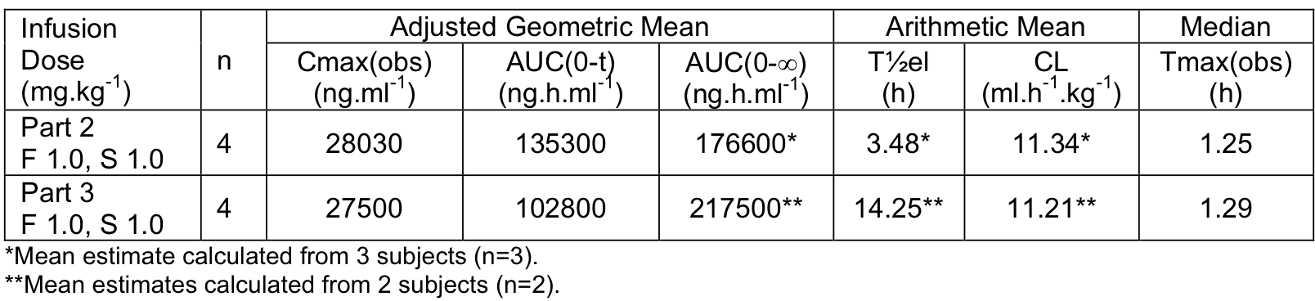
The data indicate that PK parameter estimates following the same dose regimens of ocriplasmin (fast IV infusion of 1.0 mg/kg followed by slow IV infusion of 1.0 mg/kg) were similar in a small number of younger subjects from Part 1 (n = 4), with a mean age of 31.4 years (range: 27, 37), and in a small number of older subjects from Part 3 (n = 4), with a mean age of 62.0 years (range: 55, 70 years). Estimates of t_{1/2} were approximately 4-fold longer in older subjects. However, the mean of 14.25 hours was calculated from only 2 subjects, where one estimate was 2.97 hours (consistent with estimates from the rest of the study) while the other estimate was 25.53 hours (inconsistent with estimates from the rest of the study).

Saturation of ocriplasmin at greater total systemic exposures
The AUC parameters increased in a greater than dose proportional manner in both Part 1 and Part 2, suggesting saturation of ocriplasmin elimination at high plasma concentrations.

Pharmacokinetics in patients

Study TG-MV-010

Design
TG-MV-010 was a Phase II, single-centre, open-label, study of a single IVT injection of ocriplasmin 125 µg in patients with eye disease for which a primary vitrectomy (PPV) was indicated. The study was carried out a single-centre in Belgium, from 15 July 2010 to 30 November 2010, and the CSR (final version) was dated 26 July 2011. The study was sponsored by [information redacted] and met all ethical requirements.

Objective
The objective of this study was to evaluate the PK properties of IVT ocriplasmin 125 μg when administered at different time points prior to planned primary pars plana vitrectomy (PPV). The primary outcome endpoint (PK) of this study was ocriplasmin activity levels in vitreous samples obtained at the beginning of vitrectomy (5-30 minutes, 31-60 minutes, 2 to 4 hours, 1 day, or 7 days after ocriplasmin injection).
The efficacy endpoint of this study was the time necessary to remove the vitreous from the eye, measured from first start of vitrectomy cutter till end of core vitrectomy phase. The safety endpoints of this study were post-injection complications (including worsening visual acuity, change in vision, worsening macular oedema, vitreous haemorrhage, retinal tear or detachments, ocular inflammation and intraocular pressure alterations) and adverse events.

Methods
The planned sample size was 36 male or female subjects aged greater than or equal to 18 years; 32 subjects (active arm) assigned to receive a single ocriplasmin 125 µg IVT injection prior to vitrectomy and 4 subjects (control arm) assigned not to receive an ocriplasmin IVT injection prior to vitrectomy. Subjects were allocated to one of the following groups in a sequential manner until a group was full, starting with Group 1 and ending with Group 6:
- Group 1: PPV 5-30 minutes after ocriplasmin injection (planned: 8 subjects).
- Group 2: PPV 31-60 minutes after ocriplasmin injection (planned: 8 subjects).
- Group 3: PPV 2-4 hours after ocriplasmin injection (planned: 8 subjects).
- Group 4: PPV 24 hours (plus/minus 2 hours) after ocriplasmin injection (planned: 4 subjects).
- Group 5: PPV 7 days (plus/minus 1 day) after ocriplasmin injection (planned: 4 subjects).
- Group 6: PPV without prior ocriplasmin injection (control arm) (planned: 4 subjects).
The duration of the study was 7-weeks with a maximum of 6 visits. It consisted of baseline evaluations performed prior to IVT injection, and post-surgery evaluations at days 1, 14 plus/minus 2 and 42 plus/minus 3. At the beginning of the vitrectomy, a vitreous sample (0.5 mL) was obtained. The duration of each subject’s participation in the study was up to 49 plus/minus 3 days post-injection. The end of the study was defined as the last visit of the last subject.

Assay method
The IVT PK profile of ocriplasmin was determined after IVT administration by measuring ocriplasmin activity in vitreous fluid. When ocriplasmin is incubated at +37°C with a chromogenic substrate the chromogenic p-nitroaniline (pNA) moiety of the substrate is released. The rate of pNA chromogen formation (that is , the increase in absorbance per second at 405 nm) is proportional to the enzymatic activity of ocriplasmin and is measured with a spectrophotometer. The concentration of active ocriplasmin in the vitreous fluid is calculated from the calibration curve parameters. The vitreous samples were processed and analyzed, according to a validated method by the central laboratory (Quality Assistance Study Number B001596, 4 January 2011). The method was validated in terms of specificity, standard curve accuracy and precision accuracy, precision (repeatability and intermediate precision), limits of quantitation, sample dilution and ocriplasmin stability. The practical range of quantification of the assay was defined to be between 10 nM and 80 nM (equivalent to 0.272 µg/mL and 2.176 µg/mL), after a 2-fold dilution of the vitreous fluid with a NaCl 100 mM citrate buffer at pH 3.1. There was no evidence of a relevant loss of activity after storage for 4 hours in ice bath, for 3 months at less than or equal to -20°C or after 3 freeze/thaw cycles were performed.

Statistical methodology (primary PK outcome)
The primary PK outcome of ocriplasmin activity levels in the vitreous samples was evaluated using the safety set (all subjects who received at least one dose of ocriplasmin or placebo), and summarized using descriptive statistics. In addition, the individual data were plotted as the activity decrease over time after semi-logarithmic (log10) transformation of the x-axis (time). A second plot was generated with the group means (plus/minus standard error of the mean [SEM]) of both the activity levels and group sampling times with a semi-logarithmic (log10) transformation of the x-axis. No statistical testing was performed. There was no formal sample size calculation. A total of 36 subjects (32 receiving ocriplasmin and 4 receiving placebo) were considered sufficient to meet the objectives of the study.

Characteristics of the patient population
A total of 38 subjects were enrolled, rather than 36 as planned, due to vitreous samples from 2 of the original subjects being excluded from the analysis: (1x sample contaminated with intraocular irrigation fluid; 1 x patient violated exclusion criteria relating to previous vitrectomy and retinal detachment. Of the 38 enrolled subjects, 37 (97.4%) completed the study and 1 withdrew consent (Group 2; ocriplasmin).
In subjects treated with ocriplasmin (that is , Groups 1-5), the underlying conditions/reasons for vitrectomy were floaters (32.4%), macular hole (26.5%), macular pucker (17.6%), VMA (5.9%) and other (17.6%). For subjects in Group 6 (control), the underlying conditions/reasons for vitrectomy were diabetic retinopathy (50.0%), macular hole (25.0%) and macular pucker (25.0%). Although the underlying condition/reason for vitrectomy was diabetic retinopathy in 2/4 subjects (50.0%) in Group 6 (control), this was not considered to be proliferative diabetic retinopathy (exclusion criterion number 1).

Primary outcome for the PK endpoint
Ocriplasmin activity levels in the safety set are summarized below in Table 6. The mean ocriplasmin activity level was 11,597.7 ng/mL in vitreous samples collected 5-30 minutes post-injection (Group 1). As expected, mean ocriplasmin activity levels decreased with time from injection to sample (that is, 8,108.7 ng/mL [Group 2]; 2,610.6 ng/mL [Group 3]; and 496.5 ng/mL [Group 4]). All subjects in Groups 5 and 6 had an ocriplasmin activity level below the LLOQ (< 272.37 ng/mL) indicating that ocriplasmin activity levels in vitreous samples collected 7 days post-injection were comparable to the control group (that is , no ocriplasmin injection). In addition, 2 out of 4 subjects (50.0%) in Group 4 for which vitreous samples were collected 24 hours post-injection also had ocriplasmin activity levels < 272.37ng/mL.
Table 3: TG-MV-010 - Summary of ocriplasmin activity levels (ng/mL); safety set.
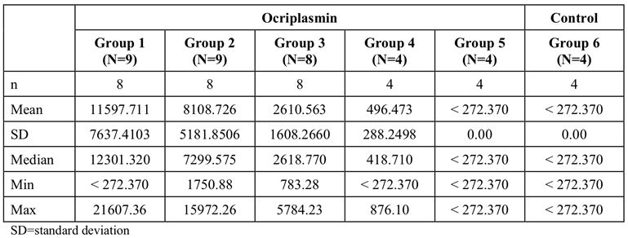

Absorption
Absorption studies are not required as ocriplasmin for the treatment of sVMA is administered by IVT injection directly to the site of the pathology. The concentration of ocriplasmin in the vitreous immediately following IVT injection is likely to be consistent with the concentration observed in the vitreous taken 5-30 minutes after ocriplasmin 125 µg IVT injection. In Study TG-MV-010, vitreous activity levels diminished over time with the mean level 24 hours after dosing being approximately 4% that at 5-30 minutes after dosing. In humans, the vitreous body occupies a volume of approximately 4.4 mL. Consequently, following an intravitreal injection ocriplasmin of 125 µg the concentration of ocriplasmin in the vitreous is approximately 28 µg/mL.

Absolute bioavailability
No absolute bioavailability study was submitted. However, no absolute bioavailability studies are required given that ocriplasmin is injected directly into the vitreous.

Bioequivalence studies
There were no studies in humans assessing the bioequivalence of the drug product administered in the pivotal clinical trials and the drug product proposed for commercial use. The sponsor states that studies have been performed demonstrating the comparability of the two drug products. However, the sponsor stated that no PK data establishing the bioequivalence of the two drug products were submitted because the focus of formulation development was on the in vitro biological activity of the dug.
Comment: It is assumed that the Quality evaluator will comment on the in vitro comparability studies of the drug products.

Distribution
There were no data on volume of distribution in humans. The sponsor stated that no systemic bio-distribution studies after IVT injection were conducted due to the very low likelihood of systemic availability of ocriplasmin after single dose administration.
Comment: The sponsor’s justification for not submitting bio-distribution studies following single-dose IVT injection in humans is acceptable.

Metabolism
There were no metabolism or mass-balance studies in humans following IVT administration of ocriplasmin. The sponsor states that ocriplasmin is expected to enter the endogenous protein catabolism pathway, where it will be rapidly inactivated (in seconds) via interaction with the protease inhibitor α2-antiplasmin or binding to α2-macroglobulin.
The sponsor refers to published data indicating that the normal plasma concentration of the protease inhibitor α2-antiplasmin in blood donors is 1000 nM, or 1 nmol per mL plasma. An average individual with 80 kg body mass with a normal blood volume of 72 mL/kg has approximately 3600 mL plasma. The sponsor calculates that a single-dose of ocriplasmin 125 µg administered by IVT injection corresponds to 4.6 nmol of active substance. Consequently, there is sufficient α2-antiplasmin present in as small a volume as 4.6 mL plasma to neutralize all ocriplasmin entering the plasma from the vitreous even if the systemic bioavailability of the IVT dose was 100%.
The kinetics of inactivation of ocriplasmin in homogenized human vitreous fluid collected during vitrectomy were investigated in an in vitro study (Study SR 10/mPl16/ItP). Pooled fresh human vitreous fluid from 13 subjects was used to prepare samples for 2 independent assessments (5 hour and 72 hour incubations), and ocriplasmin (125 µg/mL) was added resulting in final ocriplasmin concentration of 40.3 µg/mL of vitreous. Actual concentrations of active ocriplasmin at the start of the incubation period were between 94% and 105% of the nominal concentrations. After a 5-hour incubation period, approximately 16% of the initial actual concentrations were left, and at the end of the incubation period (72 hours) < 0.6% of the initial actual concentrations were left. The inactivation of ocriplasmin in pooled human vitreous fluid followed a second order process characterized by a rate constant of 195 M⁻¹s⁻¹ (n = 2).
Figure 1: Study SR 10/mPl16/ItP - Inactivation of ocriplasmin in pooled human vitreous fluid (3 mL) following the addition of 125 μg ocriplasmin and incubation at +37°C.; meanplus/minus SD, n = 2.
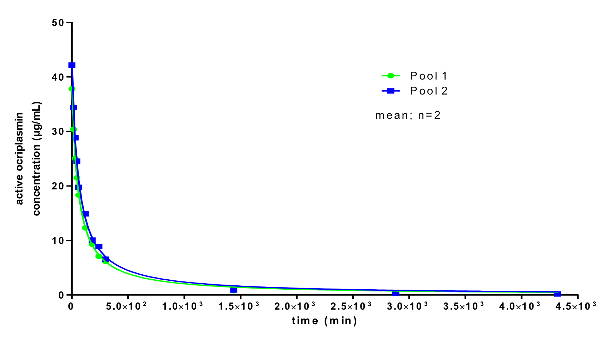

Clearance
In healthy male volunteers administered ocriplasmin (0.5 to 2.0 mg/kg) as single IV doses, ocriplasmin was detected as a complex with antiplasmin with mean elimination half-life ranging from about 3.5 to 8 hours and mean plasma clearance ranging from 6.5 to 8 hours. There were no data on the clearance site in humans.

Pharmacokinetics in special populations
- There were no PK studies in patients with hepatic or renal impairment following IVT injection of ocriplasmin.
- There were no PK studies in paediatric or adolescent patients. However, ocriplasmin is intended for the treatment of adults, and sVMA is unlikely to occur in children or adolescents.
- There were no separate PK studies in males and females following IVT injection of ocriplasmin.
- There were no PK data for patients with sVMA of different races following IVT injection. The PK data from Study TGM-MV-010 were exclusively from ‘white’ patients.

Pharmacokinetic interactions
There were no clinical IVT or systemic drug-drug PK interaction studies. However, due to the rapid inactivation of ocriplasmin after IVT injection, systemic drug-drug PK interactions are not expected. Concomitant IVT injection of ocriplasmin and other drugs should be avoided.

Clinical evaluator’s overall conclusions on pharmacokinetics
There was one pivotal clinical PK study in humans investigating the IVT PKs of single-dose ocriplasmin (125 µg) administered by injection to patients with eye disease at varying times prior to planned PPV, and one supportive PK study investigating the IV PKs of ocriplasmin administered to healthy male volunteers in various dosing regimens.
In the IVT PK study (TG-MV-010), the mean ocriplasmin activity level was 11,597.7 ng/mL in vitreous samples (n = 8) collected 5-30 minutes post-injection. As expected, mean ocriplasmin activity levels decreased with increasing time from injection to sample (8,108.7 ng/mL [31-60 minutes]; 2,610.6 ng/mL [2-4 hours]; and 496.5 ng/mL [24plus/minus 2 hours]). In samples taken 7plus/minus 1 days after the IVT injection (n = 4), ocriplasmin levels were below the LLOQ (< 272.37 ng/mL), and were comparable with the level in the control group. The mean ocriplasmin activity level in samples taken 2-4 hours after injection was 22.5% of the injected dose. This level is consistent that in the in vivo study (SR 10/mPl16/ItP) involving human vitreous fluid (that is , 16% of the initial actual concentrations of ocriplasmin at 5 hours following spiking with 125 µg).
In the IV PK study in healthy male volunteers (TG-M-001), Cmax(obs) increased in a less than dose proportional manner, while AUC(0-t) increased in a greater than dose proportional manner. The results suggested saturation of ocriplasmin elimination at high systemic plasma concentrations. The mean terminal half-life varied from 3.5 to 8 hours, while the mean plasma clearance varied from 6.6 to 8.0 mL/h/kg.
There were no studies investigating distribution, metabolism, or elimination of ocriplasmin following IVT injection. However, it is likely that any ocriplasmin moving from the vitreous to the systemic circulation following IVT injection will enter the endogenous protein catabolism pathway, where it will be rapidly inactivated via the protease inhibitor α2-antiplasmin or binding to α2-macroglobulin.
There were no IVT PK studies involving ocriplasmin in patients with renal or hepatic impairment, nor were there IVT PK studies in other special populations (for example, gender, race, paediatrics/adolescents). There were no IVT or systemic drug-drug PK interaction studies involving ocriplasmin.
Overall, the limited PK data are considered to be adequate for ocriplasmin 125 µg administered as a single-dose IVT injection proposed for the treatment of sVMA.

Pharmacodynamics

Study TG-M-001
The ‘first-in-human’ Phase I Study TG-M-001 in healthy males following IV infusion of various doses of ocriplasmin included PD data on α2-antiplasmin activity (AAP) inhibition, prothrombin time (PT), partial thromboplastin time (APTT), fibrinogen, plasminogen, and fibrin/fibrinogen degradation products (FDP). The PD data from this IV infusion study in healthy males are considered not to be directly relevant to single-dose IVT injection in patients with sVMA. However, the PD data from Study TG-M-01 Part 1 (single IV infusion) and Part 3 (older subjects) have been briefly summarized below. In Part 1, subjects received a single dose of ocriplasmin (0.1, 0.5, 1.0, 1.5, or 2.0 mg/kg) or placebo by fast IV infusion (15 minutes). In Part 3, older subjects received ocriplasmin administered at a total dose of 2.0 mg/kg (1.0 mg/kg fast IV infusion followed by 1.0 mg/kg slow IV infusion) or placebo.
- AAP inhibition: In Part 1, there was a clear dose-dependent increased in mean AAP inhibition, ranging from 11.8% at the lowest dose (0.1 mg/kg) to 84.0% at the highest dose (2.0 mg/kg). After 24-hours, mean AAP levels were similar to pre-dose levels for all doses, with the exception of the 2.0 mg/kg dose (approximately 12% higher at 24-hours than baseline). There were no notable differences in AAP inhibition between younger and older subjects (Part 3).
- PT: In Part 1, there was very slight, dose-dependent, transient prolongation in PT, with the maximal mean prolongation (2.5 seconds at the +6h15 min time-point) being observed with the highest dose (2.0 mg/kg). The maximal observed PT was not greater than 2 seconds above the upper limit of the reference range. None of the changes in PT was considered to be of clinical significance by the investigator. There were no clear differences in PT between younger and older subjects (Part 3).
- APTT: In Part 1, there was a slight, dose dependent, transient prolongation in APTT, with the maximal mean prolongation (5.0 seconds at the +1h15 min time-point) being observed with the highest dose (2.0 mg/kg). At the highest dose, all individual APTT values were within the reference range. There were no notable differences in APTT between younger and older subjects (Part 3).
- Fibrinogen: In Part 1, there were no notable differences between subjects receiving ocriplasmin and subjects receiving placebo, with all dose groups exhibiting a mean decrease from pre-dose plasma fibrinogen values. None of the changes in fibrinogen was considered to be of clinical significance by the investigator. Mean decreases in fibrinogen were slightly greater for older subjects than those observed for younger subjects (Part 3).
- Plasminogen: In Part 1, there was a very slight increase in mean plasminogen activity with increased dose. The maximal mean increase was observed with the 1.0 mg/kg dose (22.5% at +15 min). At the higher dose levels (1.5 and 2.0 mg/kg), mean increases were of a similar magnitude, but individual values were all within the reference range. There were no notable differences in plasminogen between younger and older subjects (Part 3).
- FDP: In Part 1, there was no notable difference in FDP values between ocriplasmin and placebo. There were no notable differences in FDP between younger and older subjects (Part 3).

Clinical evaluator’s overall conclusions on pharmacodynamics
There were limited data on the PDs of ocriplasmin in humans. The data from Study TG-M-001 in healthy male volunteers following IV infusion demonstrated that there was a dose dependent effect of ocriplasmin on AAP inhibition. As the dose of ocriplasmin increased, mean maximum AAP inhibition increased and the duration of AAP inhibition increased. Slight dose dependent prolongation of PT and APTT was observed. There were no notable differences in PD parameters between older and younger subjects following a total dose of 2.0 mg/kg, with the exception of a slightly greater decrease in mean fibrinogen concentrations in older compared with younger subjects.

Dosage selection for the pivotal studies

Overview

Pivotal dose-ranging studies
The ocriplasmin dose used in the two pivotal studies was 125 µg administered as a single IVT injection (TG-MV-006 and TG-MV-007). Information provided in the two pivotal studies indicates that single-dose ocriplasmin 125 µg was selected based on prior preclinical and clinical results with an optimal effect being observed at that dose. Specifically, the sponsor states that in two Phase II studies (TG-MV-003 and TG-MV-004) the 125 μg dose was well tolerated and associated with optimal efficacy. The dose-ranging data from both studies have been reviewed below in Sections 6.2.1 (TG-MV-003) and 6.2.2 (TG-MV-004).

Other dose-ranging studies
In addition to the two, dose-ranging studies Phase II studies identified above, the submission also included a Phase II dose-escalation study of intravitreal microplasmin in patients undergoing surgical vitrectomy for vitreomacular traction maculopathy (TG-MV-001), and a Phase II dose-ranging study for induction of PVD in patients with diabetic macular oedema (TG-MV-002). It is considered that Studies TG-MV-001 and TG-MV-002, both sponsored by ThromboGenics, did not provide pivotal dose-ranging information. However, both studies have been briefly outlined in this section of the CER.
Study TG-MV-001 was the first study reporting the effects of IVT ocriplasmin in humans. The study was not included in the sponsor’s summary of Clinical Efficacy (SCE) because it was stated to be an ‘uncontrolled safety study’. The objective of the study was to evaluate the safety and preliminary efficacy of four doses and several exposure times of ocriplasmin in patients with VMT maculopathy for whom pars plana vitrectomy (PPV) was indicated. Ocriplasmin was administered in ascending dose/exposure times in 6 sequential cohorts. In each cohort, the specified dose of ocriplasmin was administered by IVT injection at the specified time prior to PPV: cohort 1 – 25 µg/1 hour; cohort 2 – 25 µg/24 hours; cohort 3 - 25 µg/7 days; cohort 4 - 50 µg/24 hours; cohort 5 – 75 µg/24 hours; and cohort 6 – 125 µg/24 hours. In total, 60 patients were treated, including 10 patients in cohorts 1 to 4, 11 patients cohort 5, and 9 patients in cohort 6.
The efficacy endpoints in Study TG-MV-001 were: grade of posterior vitreous detachment (PVD) preoperatively and release of VMT; ease of induction of PVD; extent and speed of resolution of macular edema; and post-operative best corrected visual acuity (BCVA) at 1, 2 and 4 weeks and 3 and 6 months. The statistical analysis was restricted to an overall comparison between cohorts, and a subgroup analysis of short versus long exposure at a dose of 25 µg ocriplasmin. Release of VMA was reported in cohort 3 with the longest exposure time (25 μg microplasmin/ 7 days) and in cohorts 5 and 6 with the highest doses (75 μg and 125 μg microplasmin/ 24 hours). However, the exploratory analysis did not show a significant difference between the cohorts. The baseline characteristics of the 6 cohorts notable differed with respect to index condition (that is , proportion of patients with VMT syndrome, proportion of patients with diabetic macular oedema) and related baseline characteristics (that is , macular thickness in the operative eye; time since first maculopathy; duration of decreased vision). The results of this exploratory study do not allow any meaningful conclusions to be drawn regarding a dose-response relationship between ocriplasmin and the efficacy outcomes. The sponsor concluded that formal randomised studies were necessary to further evaluate and quantify the effect of IVT ocriplasmin.
Study TG-MV-002 was an exploratory, Phase II dose-range-finding trial of ocriplasmin IVT for non-surgical PVD induction for the treatment of diabetic macular oedema (DME). The trial investigated three doses of ocriplasmin (25, 75 and 125 μg ) in three successive cohorts. Patients in each cohort were randomized to masked active treatment or sham injection in a 3:1 ratio (15 patients to receive active treatment and 5 patients to receive sham injection in each cohort). The planned sample size for the trial was approximately 60 patients. The primary efficacy variable was the proportion of patients with total PVD (that is , vitreous detachment to the equator) as determined by masked Central Reading Center (CRC) evaluation at day 14 visit imaging (4-quadrant US and OCT). Patients treated with ocriplasmin had a total PVD rate on Day 14 of 13.2% (5 of 38 patients) compared to a PVD rate of 30.8% (4 of 13 patients) in patients who received a sham injection. The total PVD rates on Day 14 for each individual microplasmin dose group (FAS) were 0% (N = 8), 20.0% (N = 15), and 13.3% (N = 15) following injection of 25, 75, and 125 µg, respectively. No statistically significant difference (Fisher’s exact test) was observed for the pairwise comparisons between sham and each of the ocriplasmin dose groups and the total ocriplasmin group.

Pivotal dose-ranging studies

Study TG-MV-003

Design, objective and inclusion/exclusion criteria
Study TG-MV-003 (sponsored by ThromboGenics) was a Phase IIb, multicentre (19 centres in the US), randomized, placebo-controlled, double-masked, parallel-group, dose-ranging clinical trial of IVT ocriplasmin in patients with non-proliferative vitreoretinal disease undergoing surgical vitrectomy. The total study period for each patient was 180 days. The study was initiated on 29 March 2009 and completed on 2 October 2008. The final version of the CSR was dated 25 March 2010.

Objective
The objective was to evaluate the safety and efficacy of three single doses of IVT ocriplasmin (25, 75, and 125 µg) compared with placebo when administered 7 plus/minus 1 days prior to pars plana vitrectomy (PPV) for treatment of non-proliferative vitreoretinal disease in order to facilitate total posterior vitreous detachment (PVD).

Inclusion and exclusion criteria
The main inclusion criteria were male or female patients aged greater than or equal to 18 years with non-proliferative vitreoretinal disease without evidence of a complete macular PVD in the study eye on biomicroscopy, OCT, or B-scan. In addition, patients were required to be suitable candidates for conventional 2-port or 3-port PPV, and to have best corrected visual acuity (BCVA) of 20/400 or better in the non-study eye. Patients with complicated eye disease were excluded from the study.

Study treatments
A total of 125 patients were randomized to one of four treatment arms: placebo (n = 30); ocriplasmin 25 µg (n = 29); ocriplasmin 75 µg (n = 33); and ocriplasmin 125 µg (n = 32). Treatments were administered as single IVT injections 7plus/minus 1 days prior to planned PPV surgery. The study population included patients with non-proliferative vitreoretinal disease without evidence of a PVD over the macula, and in whom vitrectomy was indicated. The doses of ocriplasmin selected for testing were based on prior preclinical and clinical results showing at least partial effect with doses in the range 25 to 125 µg and optimal effect at 125 micrograms.
Patients were given a full ophthalmologic assessment (vision with ETDRS chart, automated refraction, eye pressure, slit lamp examination and dilated fundus examination) prior to study drug treatment, in addition to optical coherence tomography (OCT), ultrasound (A and B-scan), fundus photography, and fluorescein angiography. The total study period was 180 days, and all or some of the identified study assessments were repeated 7 days post-injection, and on post-operative days 1, 7, 28, 90, and 180.

Efficacy endpoints
The primary efficacy endpoint was the proportion of patients achieving total PVD without creation of an anatomical defect (that is, retinal hole, retinal detachment) based on surgeon visualization at the beginning of vitrectomy prior to suction or any other mechanical intervention. In cases in which vitrectomy was not performed due to resolution of the underlying pathology for which vitrectomy was originally indicated (for example, macular hole closure or vitreomacular traction release), the PVD assessment at the beginning of vitrectomy was not possible. Therefore, in these cases, PVD status for purposes of the primary endpoint was to be based on the surgeon’s assessment during the Day 7 clinic visit.
There were numerous exploratory secondary efficacy endpoints including: proportion of patients achieving total PVD based on surgeon visualization at the beginning of vitrectomy; total PVD induction pre-operatively (as determined by masked CRC); PVD score determined by the investigator at the beginning of vitrectomy; maximum suction pressure; duration of suction; duration of operation; proportion of patients with vitreomacular traction present at baseline but resolved (without vitrectomy); proportion of patients with macular hole at baseline who achieved closure of the hole (without vitrectomy); resolution of index condition without vitrectomy; progression of PVD as determined by masked CRC evaluation of imaging (4-quadrant US); progression of PVD as determined by investigator; proportion of patients with achievement of at least 1, 2, and 3 lines of improvement in BCVA; and proportion of patients with achievement of at least 1, 2, and 3 lines of improvement in BCVA without vitrectomy.
Safety was based on post-injection and post-operative adverse events (AEs). These included worsening of visual acuity, worsening of macular edema, vitreous hemorrhage, retinal tear or detachments, other reasons for re-operation, inflammation, intraocular pressure alterations, and cataract formation. In addition, fluorescein angiography was used to assess leakage from vessels.

Randomization and blinding
Consecutive, eligible patients who met the inclusion/exclusion criteria were randomized on a double-masked basis to one of the four treatment arms. Randomization was centralized through telephone interaction with the IVRS. Patients, investigator, study site personnel, study monitors, and data managers were masked to the study treatment.

Sample size and statistical methods
The sample size of 30 patients per treatment group (that is, total sample size 120 patients) was selected to achieve adequate power for dose selection for subsequent Phase III clinical development. Assuming a placebo primary endpoint rate of 15% compared with 60% for an optimal dose of ocriplasmin (and no effect for the lower ocriplasmin doses), the power to detect this difference (at two-sided α level of 0.025, assuming only the high dose is effective) with 30 patients per group was 88% (based on Fleiss methods with continuity correction).
The primary statistical analysis of efficacy was performed on the Full Analysis Set (all randomized patients who received double-masked study drug and who provided efficacy data from at least one post-injection visit). The analysis of the primary efficacy endpoint was performed using logistic regression, using a regression model with centre and treatment as categorical fixed effects. Results were supported by Fisher’s exact tests. The test results were also supported by odds ratios and the 95% two-sided confidence interval (CI). The primary efficacy endpoint was adjusted for multiplicity using a step-wise procedure of statistical hypothesis testing (modification of the Hochberg method). For the confirmatory statistical analysis of the primary efficacy parameter, the α was 5% two-sided. The analyses of the secondary efficacy endpoints were considered to be exploratory with a nominal α of 5% (two-sided). No adjustments were made for multiple testing of secondary efficacy endpoints. Consequently, any significant results were to be viewed with caution due to their status as exploratory rather than confirmatory analyses.

Subjects
The total number of patients actually enrolled and treated was 125 (40 [32.0%] male and 85 [68.0%] female). The majority of patients were White (n = 110, 88.0%), with the remaining patients being Black (n = 8, 6.4%), Asian (n = 5, 4.0%) or Other (n = 2, 1.6%). The mean (SD) age at baseline was 66.9 (10.16) years, and ranged from 20 to 86 years. The baseline diagnosis was VMT in 75.2% (n = 94) of patients and VMT without macular hole in 38.4% (n = 48) of patients. Macular hole at baseline was present in 55.2% (n = 69) of patients, and the most frequent grading of macular hole was Stage 3 (n = 39, 31.2%). Diabetic macular oedema was reported in 12.8% (n = 16) of patients. There were 4 (3.2%) patients with other conditions (that is, not VMT, macular hole or macular oedema).
Of the 125 patients enrolled and treated, 117 (93.6%) completed the study and 8 (6.4%) discontinued (4 withdrew consent; 1 each for AE, lost-to-follow-up, death, transport issues resulting in missed 180 day visit). No patients in the ocriplasmin 125 µg group (n = 32) discontinued.

Primary efficacy endpoint results
Comment: The highest proportion of patients with total PVD without anatomical defects at the beginning at vitrectomy was observed in the ocriplasmin 125 µg group (31.3%). However, there was no statistically significant difference between placebo and any of the three ocriplasmin treatment groups based on the primary analysis (Wald chi-square test from a logistic regression model with study centre and treatment as categorical treatment effects), or from the supportive analyses.

Secondary efficacy endpoints
The secondary efficacy endpoint results should be interpreted cautiously as all secondary efficacy endpoints were exploratory and all p-values were nominal rather than confirmatory.

Study TG-MV-004

Design
Study TG-MV-004 (sponsored by [information redacted]) was a Phase II, multicentre (Belgium [3 sites]; Germany [1 site]), randomized, sham-injection controlled, double-masked, ascending-dose, dose-ranging-finding trial of ocriplasmin IVT injection for non-surgical induction of VMT. The first subject of cohort 1 was enrolled on 2 March 2007 and the last subject of cohort 4 was enrolled on 14 May 2008. The last subject completed the study on 8 January 2009. Version 1.1.1 of the CSR was dated March 2011. The study has been published.²⁷

Objectives
The objectives of this exploratory study were to evaluate the safety and preliminary efficacy of three doses of ocriplasmin (75, 125 and 175 µg), in four successive cohorts (the fourth cohort evaluated 125 µg with up to two repeat injections at monthly intervals in non-responders) administered by IVT injection in patients with VMT.

Investigational plan
Prior to study drug administration, patients meeting all inclusion criteria and none of the exclusion criteria received full ophthalmologic assessment and additional ocular assessments (same as for TG-MV-003). A selection of these assessments was repeated at 3, 7, 14 and 28 days and 3 and 6 months post-study drug injection. The primary efficacy endpoint was induction of PVD at the first day 14 post-injection visit as assessed by the masked CRC based on B-scan ultrasound and OCT.
The trial studied 3 doses of ocriplasmin in 4 successive cohorts. Patients in cohorts 1, 2 and 3 received a single injection of ocriplasmin 75, 125 of 175 μg , respectively, while patients in cohort 4 received ocriplasmin 125 µg with up to two repeat injections at monthly intervals in non-responders (sham and active subjects). In each cohort 15 subjects were randomized to active treatment or sham injection in a 4:1 ratio (that is, 12 subjects to receive active treatment and 3 subjects to receive sham injection in each cohort). The patients allocated to sham injection in each cohort were pooled to form one sham injection group for the purposes of the analysis.

Inclusion and exclusion criteria
The patients were required to fulfil all the following inclusion criteria:
- male or female subjects aged greater than or equal to 18 years;
- subjects with a partial central PVD, but with vitreous still attached on the foveal area (documented on OCT and/or ultrasound) causing secondary macular edema (greater than or equal to 250 µm in either the central subfield on OCT or measured on one of the individual radial scans of the macular area);
- no evidence in the study eye of complete macular PVD;
- BCVA of 20/40 or worse in study eye;
- BCVA of 20/400 or better in the non study eye; and
- written informed consent obtained from the subject prior to inclusion in the study.

Treatments
Study treatments were single, mid-vitreous injections in the study eye of ocriplasmin or sham injection (cohort 1 [75 µg], 2 [125 µg], 3 [175 µg]), with up to 2 repeat injections of ocriplasmin 125 µg in the study eye of non-responders (sham and active patients) of cohort 4. The post-injection evaluations were scheduled at study visits occurring on day 3 (plus/minus 1 day), day 7 (plus/minus 2 days), day 14 (plus/minus 3 days) and day 28 (plus/minus 3 days) and 3 months (plus/minus 1 week) and 6 months (plus/minus 2 weeks). The primary analysis was performed after the day 28 visit of the last subject, with subsequent analysis at the 6 month follow-up visit. Patients in cohort 4 had potentially up to two additional injections with post-injection visits at Day 3, 7, 14 and 28.
The CSR stated that, based on prior published experiments with plasmin in post-mortem human eyes, the expected effective dose for ocriplasmin was calculated to be approximately 125 µg. In addition, the CSR stated that a range of pre-clinical studies demonstrated consistent induction of PVD at this dose. In the current study, the sponsor stated that dosing was initiated at 75 µg to allow for a thorough safety evaluation. The original protocol included 2 cohorts receiving 75 µg and 125 µg, and the sponsor indicated that review of the safety data for the first 2 cohorts confirmed that the drug was well-tolerated at both doses. Therefore, in order to fully evaluate the dose response the protocol was amended to include an additional cohort (cohort 3) of identical size to cohorts 1 and 2 (that is , 15 patents, including 12 randomized to ocriplasmin 175 µg IVT injection and 3 randomized to sham injection).
As no clear difference in efficacy was observed between single administration of 125 µg and 175 µg the sponsor considered that that a plateau in efficacy may have been reached. Therefore, in order to fully evaluate the relationship between frequency of dosing and response the protocol was amended to include an additional cohort (cohort 4) of identical size to the prior cohorts (that is , 15 patients, including 12 randomized to ocriplasmin 125 µg IVT injection and 3 randomized to sham injection). In cohort 4, patients who did not achieve resolution of VMT (that is , non-responders) by the day 28 visit were given an open-label injection of microplasmin 125 µg. Patients who still did not achieve resolution of VMT by the day 56 visit were given another open-label injection of ocriplasmin 125 µg. The 28 day injection cycle was chosen for cohort 4 to provide adequate duration after prior injection(s) to observe for intended effect.

Efficacy and safety endpoints
The primary efficacy variable was the proportion of patients with total PVD (that is, vitreous detachment to the equator) as determined by masked CRC evaluation of B-scan ultrasound imaging at the day 14 post-injection visit.
The secondary efficacy variables were: resolution of vitreomacular traction (investigator’s assessment); resolution of the index condition (investigator’s assessment); induction of total PVD (CRC and investigator’s assessment); any progression of PVD (CRC and investigator’s assessment); progression of PVD (CRC and investigator’s assessment); need for vitrectomy; resolution of Macular Edema (CRC assessment of macular thickness and macular volume); change in membrane formation (CRC assessment); change in BCVA; BCVA 5, 10 and 15 letter improvement; and visual functioning questionnaire (VFQ)-25.
The safety variables were: post-injection complications; ophthalmic and other AEs; ocular interventions; BCVA 15 and 30 letter decrease; ophthalmologic variables including lens opacities classification system (LOCS) III grading, fundus photography, fluorescein angiography and OCT.

Randomization and blinding
Enrolled patients were assigned to one of four cohorts in a sequential manner (15 per cohort) and randomized in a 4:1 ratio to active treatment or sham injection through a telephone-based IVRS. To maintain masking for patients randomized to sham injection, a syringe identical to that used in patients randomized to study drug injection was used, but with a blunt needle, obscured from the patient’s view. The blunt needle was pressed against the sclera/conjunctiva to mimic the study drug injection procedure. Follow-up assessments were performed by a masked investigator. Masked assessments were undertaken by the CRC.

Sample size and statistical methods
For this is exploratory trial, a total of 60 patients (48 receiving one of four ocriplasmin dose regimens and 12 receiving sham) was considered sufficient to assess the objectives of the study. A sample size of 12 patients for each dose has at least 90% power at the one-sided 0.05 significance level to contradict the proportion meeting the primary endpoint being less than 0.10 when its actual value is at least 0.50. For the pooled doses, such power is at least 95% at the one-sided 0.025 significance level.
For the primary efficacy endpoint analysis, overall group differences were evaluated using a Chi-square test. Pairwise comparisons between each dose and placebo were performed with Fisher’s exact test. In order to account for multiple comparisons, the primary efficacy variable a step-wise procedure of statistical hypothesis testing comparing the treatment groups by means of the Hochberg Method was pre-specified.
Exploratory analyses for all secondary efficacy variables were undertaken using the FAS. For quantitative variables overall differences between the groups were evaluated using a Kruskal-Wallis test. Subsequently, pairwise comparisons between groups were tested using a Wilcoxon two-sample test for skewed distributed variables. For qualitative variables, overall group and between differences were evaluated using a Chi-square test. For variables measured repeatedly over time a repeated measurements ANOVA model using percentage change adjusted for baseline was planned. However, this additional analysis was not considered appropriate for any of the endpoints. No adjustments for multiple testing were specified. Consequently, any significant results should be viewed with due caution in light of their status as exploratory rather than confirmatory analyses.
In the FAS, all subjects in all cohorts had a similar follow-up schedule to the day 28 post-injection visit. After day 28, non-responders in cohort 4 received up to 2 repeated injections and thus had a different study follow-up schedule than all other subjects. Where all other subjects underwent post-injection Day 3, 7, 14 and 28 follow-up visits once, the subjects who received repeated injections had three injections with three sets of subsequent follow-up visits. Also, the data of the post (last) injection days 90 and 180 of cohort 4 is not comparable to the data of the post- injection visit days 90 and 180 of the subjects from cohorts 1, 2 or 3. Consequently, analysis of efficacy was performed as follows:
- In analysis 1 the data of all four cohorts (across the four treatment groups: sham, 75 μg , 125 μg and 175 μg ocriplasmin) was evaluated up to post first injection day 28. The data for patients of cohort 2 and cohort 4 treated with 125 μg ocriplasmin were pooled.
- In analysis 2 the data of cohorts 1,2 and 3 (across the four treatment groups: sham, 75 μg , 125 μg and 175 μg ocriplasmin) was evaluated up to post last injection Day 180.
- In analysis 3 the data of cohort 4 (sham and 125 μg ocriplasmin) was evaluated up to post last) injection day 180, excluding the repeat injection cycles.
- In analysis 4, the data of cohort 4 (sham and 125 μg ocriplasmin) was evaluated for the repeat injection cycles.
Comment: As the study was exploratory and not powered to detect a statistical difference between the treatment groups, no definitive conclusions can be drawn about the presence or absence of a treatment effect of ocriplasmin.

Subject disposition and baseline demographics
There were 61 patients randomized to the four treatment cohorts, including 15 in cohorts 1, 2, and 3 and 16 in cohort 4. Overall, there were 49 patients in the ocriplasmin treatment arms and 12 patients in the sham injection arm. Of the 61 randomized patients, 60 completed the study and 1 in cohort 3 (175 µg) was withdrawn prior to treatment due to visual acuity being too high and an additional patient was included to replace the one withdrawn. One (1) patient randomized to cohort 3 to receive 175 μg was given 129 µg, and was analyzed as part of cohort 2 (that is, 125 µg patients).
Of the patients enrolled in cohort 4, 7 of the 12 patients randomized to masked single-dose ocriplasmin 125 μg also received 2 open-label injections of 125 μg for a total of 3 injections each. In addition, 2 of the 3 patients in cohort 4 who were randomized to masked single-dose sham injection also received 2 open-label injections of ocriplasmin 125 μg . The remaining 6 patients in cohort 4 (5 randomized to ocriplasmin and 1 randomized to sham injection) received no open-label ocriplasmin injections.
The total efficacy and safety population includes 60 subjects (27 male and 33 female) with an average age of 70 years, ranging from 44 to 83 years.

Primary efficacy endpoint results
The primary efficacy variable was the proportion of subjects with total PVD (grade 3) at post-injection day 14 as assessed by the CRC (masked to treatment allocation).
Comment: There was no dose response relationship between ocriplasmin and the proportion of subjects with total PVD at post injection Day 14 (CRC assessment) in either of the two data sets. The results for the three ocriplasmin dose groups in both data sets suggest a flat dose response. None of the pairwise comparisons were statistically significant. No statistically significant difference between the sham and total PVD pooled groups at Day 14 (CRC assessment) was observed in either of the two patients data sets. In order to take into account of multiple comparisons, it was planned that the primary efficacy endpoint undergo a step-wise procedure of statistical hypothesis testing comparing the treatment groups by means of the Hochberg Method. However, since none of the tests gave a significant p-value, this stepwise testing was not applicable. No statistical analysis of dose response was pre-specified.

Secondary efficacy endpoints
The CSR identified key secondary efficacy endpoints as total PVD at any visit, resolution of VMT, and resolution of index condition. The relevant data were analysed for the four cohorts up to the first 28 day post-injection (analysis 1) and on the data for cohorts 1, 2, and 3 up to post-injection day 180 (analysis 2). The data from cohort 4 after the first 28 day post injection visit was not included in the pooled analysis due to the potential repeat injections for non-responding patients in this cohort after this time-point. The results for the key secondary efficacy endpoints (CRC assessment) are summarized below, as are the results of other secondary endpoints of interest (that is , need for vitrectomy, closure of MH).

Patients with total PVD through to post-injection day 180 (CRC masked)
Comment: In the ocriplasmin 125 µg group (cohort 2) the response remained relatively constant from Day 3 through Day 180. The response was greater in the ocriplasmin 125 µg group (cohort 2) compared with the ocriplasmin 175 µg group (cohort 3) at all time-points apart from Day 14. In line with the post-injection Day 14 results, the proportion of patients with total PVD was greater at all times in the ocriplasmin groups than in the sham group from Day 7 onwards. Total PVD was not observed in the sham group at any time-point. None of the pairwise comparisons were statistically significant in either of the two data sets.

Patients with total PVD through to post-injection day 180 (investigator, masked)
Comment: Investigator grading of PVD on Day 90 showed a significantly higher proportion of subjects achieving total PVD in the ocriplasmin 125 μg group (cohort 2) compared with the sham group (46.2% versus 0%; p = 0.046). None of the other pairwise comparisons were statistically significant. The ocriplasmin 125 µg and 175 μg groups had higher rates of total PVD than the sham and ocriplasmin 75 μg groups throughout the study. In comparison with the CRC assessment, investigator assessment showed different rates of total PVD throughout the study. The differences were most marked in the ocriplasmin 125 μg group (cohort 2) where the investigator reported notably higher proportions of patients achieving total PVD at post-injection days 90 and 180 than reported in the CRC assessment.

Resolution of VMT evaluated by the investigator; FAS
Resolution of VMT was evaluated by the investigator using OCT at all post-injection visits. Resolution of VMT was defined as a change from baseline status of Yes to post-injection status of No. Patients undergoing vitrectomy had their last observation prior to vitrectomy carried forward.
In cohort 4, 1 out of 3 patients in the sham group (33.3%) and 5 out of 12 patients in the ocriplasmin 125 µg group (41.7%) achieved resolution of VMT at Day 28 after the first injection. The non-responders (2 sham and 7 active treated subjects) received up to two repeat injections with ocriplasmin 125 µg microplasmin. None of the subjects in the either of the two treatment groups achieved resolution of VMT at Day 28 after the first injection of ocriplasmin 125 µg, while 2 patients (28.6%) in the ocriplasmin 125 µg group achieved resolution of VMT after the second repeat injection of ocriplasmin 125 µg.
Comment: The observed rates of resolution of VMT were higher in the ocriplasmin treated groups compared with sham at all time points, with the highest rates being observed in the 125 µg groups. The proportion of patients with resolution of VMT increased over time in all treatment groups. None of the pairwise comparisons between treatment groups were statistically significant. The results for repeated injections of ocriplasmin 125 µg after Day 28 in non-responders suggest no marked increase in response as assessed by total PVD (CRC assessment) compared with subjects who responded to a single ocriplasmin injection within the first 28 days.

Resolution of the index condition
Resolution of the index condition was evaluated by the investigator at post-injection Days 28 and 180. Resolution of the index condition was defined as: closure of macular hole in subjects with index condition macular hole; release of VMT in subjects with index condition VMTS; or release of VMT in subjects with index condition DME with VMT.
In the non-responders to single-dose ocriplasmin 125 µg or sham, 2 of the ocriplasmin treated non-responders achieved resolution of the index condition after the second repeat injection compared with neither of the 2 sham non-responders after repeat injections.
Comment: The resolution of the index condition at both Day 28 and Day 180 were notably greater in the ocriplasmin 125 µg treatment groups that in each of the other treatment groups. However, none of the pairwise comparisons between the treatment groups were statistically significant.

Need for vitrectomy
The numbers of patients that underwent a vitrectomy was analyzed at post-injection Days 28 and 180. The protocol allowed vitrectomy up to post-injection Day 28 if the underlying condition worsened or the subject’s visual acuity deteriorated with more than 2 lines (BCVA), and allowed vitrectomy after Day 28 in the investigator considered that this was required. No vitrectomies were performed up to post-injection Day 28. In the period between post-injection Days 28 and 180, 1 (8.3%) patient in the 75 µg treatment group, 1 (7.7%) patient in the 125 µg, 3 (27.3%) patients in the 175 µg treatment group and 3 patients (33.3%) in the sham group had a vitrectomy. In cohort 4, 2 responders in the 125 µg treatment group had a vitrectomy between Day 28 and day 180, while no sham patients and no non-responders had a vitrectomy during the study.

Closure of macular hole (MH)
A total of 19 patients had a MH as the index condition. Three (3) patients had a stage 1b macular hole and 16 patients had a stage 2 macular hole. Of the total of 19 patients with MH, 5 received sham treatment and 14 patients received ocriplasmin (3, 8 and 3 patients received 75, 125 and 175 µg, respectively).

Clinical evaluator’s overall conclusions on dose-ranging studies
The submission included two, small, Phase II dose-ranging studies (TG-MV-003 and TG-MV-004) identified by the sponsor as supporting the choice of single-dose ocriplasmin 125 µg used in the pivotal Phase III studies. The two dose-ranging studies are considered to provide limited evidence supporting the selection of ocriplasmin 125 µg for the pivotal Phase III studies. In addition, the submission also included two exploratory Phase II dose-ranging studies that are considered to provide no meaningful dose-ranging data as regards the proposed indication (TG-MV-001 and TG-MV-002).
In Study TG-MV-003, the proportion of patients with non-proliferative vitreoretinal disease achieving total PVD at the beginning of vitrectomy (primary efficacy endpoint) was higher in the pooled ocriplasmin group than in the placebo group following single IVT injections 7 days prior to planned PPV (21.3%, 20/94 versus 10.0%, 3/30, respectively; p = 0.279). The proportion of patients achieving total PVD following single IVT injections 7 days prior to planned PPV was higher in the ocriplasmin 125 µg group (31.3%, 10/32) than in the 25 µg group (13.8%, 4/29) and the 75 µg group (18.2%, 6/33). None of the pairwise comparisons between placebo and the ocriplasmin groups were statistically significant. There were numerous secondary efficacy endpoints, and the results for the majority of these endpoints favoured ocriplasmin 125 µg over ocriplasmin 25 µg and 75 µg. In a secondary efficacy endpoint analysis of patients achieving either total PVD (using the primary endpoint definition) or prevention of need for vitrectomy through Day 180, the proportion of patients achieving the endpoint was statistically significantly higher in the ocriplasmin 125 µg group compared with placebo for all patients and for several subgroups (for example, patients with baseline VMT with or without MH; patient with baseline MH). However, all statistical pairwise comparisons for the secondary efficacy endpoints should be considered nominal rather than confirmatory due to no adjustments being made to account for multiple tests.
In Study TG-MV-004, the primary efficacy endpoint analysis failed to show a statistically significant difference between single-dose pooled ocriplasmin (all doses) and sham in the proportion of patients with VMT achieving total PVD at Day 14 as assessed by the CRC (12.7%, 7/55 versus 0%, 0/11, respectively). Furthermore, there was no dose response for total PVD at Day 14, as assessed by the CRC with the proportion of patients achieving the endpoint being 18.2% (2/11), 13.6% (3/22), and 18.2% (2/11) for ocriplasmin 75 µg, 125 µg and 175 µg, respectively. There were a number of secondary endpoint analyses in which outcomes through to Day 28 were nominally higher in the ocriplasmin 125 µg treatment group (pooled cohort 2 and 4) compared with the ocriplasmin 75 µg and 175 µg treatment groups (for example, total PVD, investigator assessment; resolution of VMT; resolution of index condition). The effect of repeated injection of ocriplasmin 125 mg on resolution of VMT was studied in a small number of patients who had not responded to single injections of ocriplasmin 125 µg or sham at Day 28. The data did not show a clear benefit of repeat-dose ocriplasmin compared with single-dose ocriplasmin, but patient numbers in the repeat-dose analysis were small. Overall, it is considered that no definite conclusions can be drawn from this exploratory study about the efficacy of ocriplasmin or the optimal dose. The study was not powered to detect statistically significant difference between treatment groups.

Clinical efficacy

Overview

Two pivotal phase III efficacy and safety studies
The submission included two, pivotal, Phase III studies of similar design, both sponsored by [information redacted].

Integrated efficacy and safety analyses of the two pivotal Phase III studies
In addition to separate analyses of the two pivotal Phase III studies, the submission included pre-specified integrated efficacy and safety analyses of the pooled data from the two pivotal Phase III studies. Separate Statistical Analysis Plans (SAPs) were provided for each of the integrated analyses.

Ongoing studies
Three exploratory clinical studies sponsored by [information redacted] (TG-MV-005, TG-MV-008 and TG-MV-009), and two investigator-initiated studies (JSEI-TG-AMD-001 and 10-EI-0186) were ongoing as of the data cut-off date of 31 March 2011. The three ongoing studies sponsored by [information redacted] are: Study TG-MV-005, an open-label clinical trial of ocriplasmin administered by IV infusion for the treatment of acute ilio-femoral deep vein thrombosis; Study TG-MV-008, an open-label, single-centre trial of ocriplasmin 125 µg administered by IVT injection for the non-surgical treatment of focal VMA; and Study TG-MV-009, a randomized, placebo-controlled, double-masked, clinical trial of ocriplasmin (175 µg) administered by IVT injection in approximately 24 infants and children scheduled for vitrectomy. The two ongoing investigator-initiated ocriplasmin IVT injection studies are a study investigating VMA adhesion associated with neovascular age-related macular degeneration (JSEI-TG-AMD-001), and a study investigating the safety and efficacy of ocriplasmin for the treatment of uveitic macular oedema (10-EI-0186).
In addition to the five on-going studies listed above, two Phase IIIb clinical studies sponsored by ThromboGenics and planned at the time of the data cut-off are also ongoing. TG-MV-012 is a long-term follow-up safety study involving approximately 20 patients (maximum of 40) who were previously treated with ocriplasmin 125 µg and enrolled in the Phase III studies (TG-MV-006 or TG-MV-007) by the 2 highest enrolling centres, and who remain masked to treatment allocation. TG-MV-014 is a randomized, double-masked, multicentre trial (approximately 25 sites in the US) planned to include 125 patients comparing ocriplasmin (125 µg) and sham injection for treatment of symptomatic VMA, including those associated with macular hole, for up to 12 months.

Pivotal efficacy safety studies

Pivotal study – TG-MV-006

Design, objectives, location, and dates
Study TG-MV-006 was a pivotal, Phase III, multicentre (42 centres in the US), randomized, placebo-controlled, double-masked clinical trial of a single IVT injection of ocriplasmin 125 µg for the treatment of focal vitreomacular adhesion (VMA). The first subject was enrolled on 23 December 2008, the last subject completed on 4 March 2010, and the CSR was released on 27 June 2011.
The objective of the study was to evaluate the safety and efficacy of a single IVT injection of ocriplasmin 125 μg in subjects with symptomatic VMA (that is, focal VMA leading to symptoms).
The duration of the study was 6 months with up to 7 visits: Baseline, defined as the last scheduled assessment prior to dosing; injection day (Day 0); post-injection Day 7; post-Injection Day 14; post-injection Day 28; post-injection Month 3; and post-injection month 6. The Baseline visit had to be performed within 2 weeks of the Injection Day visit.
At Baseline, both eyes were examined and if both met the inclusion criteria the eye with the worst BCVA was chosen as the study eye. Baseline and/or post-injection assessments included: medical/ophthalmic history; concomitant medications; AEs (study eye and non-study eye); pregnancy testing; B-scan ultrasounds; IOP; slit-lamp examinations; VA; manifest refraction; dilated ophthalmoscopy; fluorescein angiography; fundus photography; OCT; anterior chamber and vitreous inflammation grading; and visual function questionnaire (VFQ-25). A Data Monitoring Committee (DMC) was established for this study for the purposes of reviewing safety data.
Comment: The study was randomized and double-masked, which would mitigate potential bias. The sponsor and the US Food and Drug Evaluation (FDA) agreed on specific aspects of the study design including: (a) a placebo IVT injection of 0.1 mL of vehicle was chosen over a sham injection so the study treatment procedures were identical; (b) the original treatment ocriplasmin to placebo allocation ratio of 3:1 was modified to 2:1 by Protocol Amendment 1; and (c) the 6 month follow-up was considered appropriate for evaluating the single injection regimen. The use of a placebo IVT injection of vehicle as placebo rather than sham injection is of concern. There are inherent risks associated with IVT injections and it may have been preferable to have used a masked sham injection methodology. Sham injections are more likely to mimic the natural history of sVMA than placebo IVT injections. Furthermore, it is possible that placebo IVT injection might result in mechanical separation of the VMA, which would be unlikely to occur with sham injection.

Inclusion and exclusion criteria
Patients were required to fulfil all the following inclusion criteria:
- Male or female subjects aged greater than or equal to18 years;
- Presence of symptomatic focal VMA (that is , central vitreal adhesion within 6 mm OCT field surrounded by elevation of the posterior vitreous cortex) that in the opinion of the Investigator was related to decreased visual function (such as metamorphopsia, decreased VA, or other visual complaint);
- BCVA of 20/25 or worse in study eye;
- BCVA of 20/800 or better in the non-study eye; and
- Written informed consent obtained from the subject prior to inclusion in the study.
The exclusion criteria were extensive and included patients with complicated eye disease.
Each subject was free to withdraw from the clinical study at any time, for any reason, without jeopardy or prejudice or compromising his or her clinical care. The Investigator also had the right to withdraw subjects from the study in the event of intercurrent illness, adverse event (AE), protocol violation, administrative reasons or other reason. If a subject withdrew from the study, the principal reason for withdrawal was recorded in the electronic Case Report Form (eCRF). If termination was a result of an AE or serious adverse event (SAE) that resulted in death, an AE Form was also completed. Subjects who withdrew after the treatment were followed until the time of their withdrawal. Subjects who withdrew from the study after receiving the study drug were not replaced.

Study treatments
On Day 0, eligible subjects randomized to ocriplasmin received a single IVT injection of 125 µg in the study eye using either a 30G or 27G size needle. The study drug was diluted with 0.75 mL normal saline, and 0.1 mL was injected into the mid-vitreous. The same dilution process was undertaken for subjects randomized to placebo injection. Ocriplasmin and placebo were identical in appearance.
If at any point after 4 weeks from time of study drug injection, the underlying condition did not improve (that is, the adhesion was not relieved), the investigator could proceed to vitrectomy at his/her discretion. Additionally, if before this time, the BCVA in the study eye worsened by greater than 2 lines, or the underlying condition worsened, the investigator could proceed to vitrectomy at his/her discretion.

Efficacy variables and outcomes

Primary efficacy endpoint
The primary efficacy endpoint was the proportion of subjects with VMA resolution at Day 28, as determined by masked Central Reading Center (CRC) optical coherence tomography (OCT) evaluation. Any subjects who had creation of an anatomical defect (that is , retinal hole, retinal detachment) that resulted in loss of vision or that required additional intervention were not counted as successes for this primary endpoint.
Comment: The sponsor states that, based on discussions with the FDA it was agreed that ‘this endpoint was clinically meaningful and an appropriate endpoint for demonstration of efficacy’. It is arguable that total PVD at Day 28 should have been a co-primary efficacy endpoint.

Secondary efficacy endpoints
- Proportion of subjects with total PVD at Day 28, as determined by masked Investigator assessment of B-scan ultrasound.
- Proportion of subjects not requiring vitrectomy.
- Proportion of full thickness macular holes (FTMHs) that closed without vitrectomy as determined by CRC.
- Achievement of greater than or equal to 2 and greater than or equal to 3 lines improvement in best corrected visual acuity (BCVA) without need for vitrectomy.
- Improvement in BCVA.
- Improvement in the National Eye Institute (NEI) 25-Item Visual Function Questionnaire (VFQ-25).

Efficacy measurements

Optical coherence tomography (OCT)
OCT was performed in both eyes at Baseline and in the study eye only at all other visits. If the baseline examination was performed greater than 48 hours prior to injection of study drug, the examination had to be repeated in the study eye prior to treatment on the day of injection. The use of the Stratus OCT (Zeiss Meditec) to assess OCT was mandatory for this study. Spectral domain OCT (SD-OCT) machines (Cirrus or Spectralis) were used at selected investigative sites, in addition to the Stratus OCT.
CRC assessment of VMA was based on Stratus OCT. However, at sites where SD-OCT was done in addition to Stratus OCT, subjects could be enrolled if VMA was clearly seen on SD-OCT but not on Stratus OCT. In these cases, the follow-up assessment was also performed using SD-OCT and success/failure of the primary endpoint was based on this assessment.
OCT measurements were made by a certified assessor, after dilation of the subject’s pupil. All OCT scans were assessed by the CRC (Duke Reading Center).
VMA status was categorized by the CRC using 1 of 7 categories:
- No visible vitreous separation.
- Vitreous attached from fovea to optic nerve (ON); separated elsewhere.
- Vitreous attached at fovea and ON and separated between; may be separated outside.
- Vitreous attached only at ON or at ON and elsewhere, but not attached at fovea.
- Vitreous attached only at fovea.
- Vitreous visible with complete separation and no attachment.
- Vitreous separation visible somewhere but unable to determine state of separation.
- Unable to determine state of separation.
Comment: There are no TGA adopted guidelines for assessing ‘resolution of VMA’. The categories for assessing VMA status and the progression categories appear to have been developed primarily by the sponsor. The categories for assessing ‘resolution of VMA’ are considered to be satisfactory.

B-scan ultrasound and PVD assessment
B-scan ultrasounds were performed in both eyes at Baseline and in the study eye only at all other visits. If the Baseline scan was performed greater than 48 hours prior to injection of study drug, the scan had to be repeated in the study eye prior to treatment on the day of injection. Scans at post-injection Day 28, Month 3, and Month 6 were to be performed only if total PVD was not present at the prior 2 consecutive visits.
B-scan ultrasounds were performed by a certified echographer after administration of anaesthetic drops. The examination was performed directly on the conjunctiva. Transverse (cross-sectional) scans were taken in all quadrants; longitudinal (radial section) scans were taken to evaluate the fundus from the posterior pole to the limbus.
Ultrasound images were used to assess the presence and grade of PVD, and were documented on the following scale:
- Grade 0: No PVD.
- Grade 1: Partial PVD with attachment at the optic disc and elsewhere in the posterior pole.
- Grade 2: Partial PVD with attachment at either the optic disc or elsewhere in the posterior pole.
- Grade 3: Total PVD without disc attachment.
Comment: There are no TGA adopted guidelines for assessing PVD. The categories adopted in this study for assessing PVD are considered to be satisfactory.

Visual acuity (VA) and manifest refraction
VA was evaluated in both eyes at Baseline and in the study eye only at all other visits. Distance VA was measured using Precision Vision’s (or equivalent) backlit Early Treatment Diabetic Retinopathy Study (ETDRS) charts set at 4 metres from the subject. A phoropter set at a 12 mm vertex distance was used to obtain manifest refraction measurements. Any subject unable to read 20 or more letters on the ETDRS chart at 4 metres was retested at 1 metre. BCVA was reported as the number of letters read correctly by the subject on the ETDRS chart.
Comment: The ETDRS has been used in other studies evaluated by the TGA to assess BCVA following IVT injections of medicines to treat eye disease. It is a standard clinical trial and epidemiological method for assessing the effects of treatment or disease on BCVA.

Vision function questionnaire (VFQ)
Visual function was assessed by National Eye Institute (NEI) 25-Item Visual Function Questionnaire (VFQ-25). This questionnaire measures dimensions of self-reported vision-targeted health status that are most important to persons with eye disease.²⁸ The VFQ consist has 25 items which are grouped into 12 subscales: general health, general vision, ocular pain, near activities, distance activities, social functioning, mental health, role difficulties, dependency, driving, colour vision, and peripheral vision. Subscale responses were converted to a number on a 0-100 scale (0 = worst possible score, 100 = best possible score). The VFQ-25 was evaluated by the change from baseline to post-injection Month 6 in the subscale and composite scores.
Comment: The VFQ-25 is a commonly used instrument for assessing the effect of treatment on functional outcome in clinical trials of drugs used to treat eye conditions. However, the instrument has not been validated in patients with sVMA.

Randomization and blinding methods
Subjects were randomized centrally through a telephone-based interactive voice response system (IVRS) to either ocriplasmin or placebo. The original ocriplasmin to placebo randomization ratio was 3:1, but this ratio was modified to 2:1 by Protocol Amendment 1 following a request from the FDA. The change to the randomization ratio was made when 55 patients had already been randomized using the initial 3:1 ratio.
The investigator, study site personnel, representatives of the sponsor, monitors, data managers, and other aspects of the study were masked to study drug throughout the study. Randomized treatment for individual subjects was masked until after the final database lock. After all subjects completed or were withdrawn from the study, a masked medical review meeting was held to evaluate protocol violations and agree on the analysis populations. Subsequently, the database was locked, and unmasking was authorized. No unmasking occurred during the study.

Analysis populations
- Full analysis set (FAS): The FAS included all randomized subjects who received treatment with the study drug. Data were analyzed according to randomized treatment group, regardless of the treatment actually received. The FAS was the primary population for all analyses of Baseline/demographic and efficacy data. The FAS included 326 subjects (107, placebo; 219, ocriplasmin).
- FAS in subjects with focal VMA: This was a modified FAS population with secondary priority for assessment of the primary endpoint. It consisted of randomized subjects who received treatment with study drug and had symptomatic focal VMA at Baseline as determined by masked CRC OCT evaluation (that is , the FAS with exclusion of subjects with either no or undetermined focal VMA status at Baseline). The FAS with focal VMA at Baseline included 306 subjects (99, placebo; 207, ocriplasmin).
- Per-Protocol (PP) set: The PP set excluded subjects in the FAS with a protocol deviation of sufficient concern to warrant exclusion. Selected Baseline efficacy analyses were repeated in the PP set. Decisions regarding data exclusion of subjects from the PP set were taken prior to unmasking. The PP set included 283 subjects (94, placebo; 189, ocriplasmin).
- Safety set: The safety set consisted of all subjects who received treatment with ocriplasmin or placebo, based on actual treatment received. The safety set was the primary population for all safety analyses. The safety set included 326 subjects (106, placebo; 220, ocriplasmin).

Sample size
Assuming a primary endpoint event rate of 27.5% in the ocriplasmin 125 μg dose group and 10% in the placebo group, a sample size of 320 subjects achieved over 90% power with a 2-sided alpha of 0.05. This specification applied to the original randomization ratio of 3:1. Following Protocol Amendment 1, the randomization ratio was changed to 2:1, but the total planned sample size was not amended.

Statistical methods

Primary endpoint analysis
The primary endpoint (proportion of subjects with VMA resolution at Day 28 determined by masked CRC OCT) in the two treatment groups were compared in the FAS using Fisher’s exact test. The two-sided 95% CIs for the difference between the 2 groups and the exact odds ratio were also calculated.
In the event that statistical significance with p < 0.05 was achieved for the primary endpoint for the FAS, the second priority was to determine the resolution of focal VMA in all randomized subjects who received treatment with study drug and had focal VMA at Baseline as determined by masked CRC OCT evaluation. The methods for this primary analysis with second priority were to be the same as those for the primary analysis of the primary endpoint for the FAS.
Supportive analyses for the primary endpoint were adjusted for the randomization ratio as 3:1 or 2:1 through conditional logistic regression (with randomization ratio as the factor for stratification) and Cochran-Mantel-Haenszel tests. This method was applied to the primary endpoint for both the FAS and the subset of the FAS with confirmed VMA at Baseline.
Comment: The statistical methodology adopted for the analysis of the primary efficacy endpoint is considered to be satisfactory. In this CER, the emphasis on reporting of the primary efficacy outcome results has been on the proportion of patients in the two treatment groups achieving the endpoint, and the absolute difference with 95% CIs between the two treatment group rather than the odds ratio with 95% CIs for the two treatment groups.

Secondary endpoint analyses
The proportion of subjects with total PVD at Day 28, as determined by masked investigator assessment of B-scan ultrasound, was specified by the sponsor as the key secondary efficacy endpoint. The treatment groups were compared using Fisher’s exact test. The two-sided 95% CI for the difference between the two groups and the exact odds ratio were also calculated. The analysis was performed with subjects with total PVD at Baseline included as failures (no total PVD) and repeated excluding subjects with total PVD at Baseline. Similar analyses were performed using the observed case (OC) and worst case approaches for handling missing data. Subjects with missing data for Day 28 who had total PVD at Days 7 and 14 were considered as a success in the OC and worst case analyses. Formal statistical testing of the key secondary efficacy endpoint was to be evaluated if statistical significance (p < 0.05) was achieved in the analysis of the primary efficacy endpoint for the entire FAS and the subset of the FAS with VMA at Baseline.
The proportion of subjects not requiring vitrectomy, both through Day 28 and at any time during the study, were tabulated by treatment group. This analysis was also performed separately for the subgroup of subjects where the need for vitrectomy was indicated at Baseline by the investigator.
FTMHC was evaluated during the masked CRC review of the OCTs. The proportion of subjects with FTMHC without vitrectomy was tabulated by treatment group. The analysis was also performed by examining all FTMH that closed regardless of vitrectomy status.
The proportion of subjects with achievement of greater than or equal to1, greater than or equal to 2 and greater than or equal to 3 lines (greater than or equal to5 , greater than or equal to 10 and greater than or equal to 15 letters) improvement in BCVA, without need for vitrectomy as well as overall, were tabulated by treatment group and visit. This analysis was repeated by Baseline BCVA subgroup (greater than 65 letters versus less than or equal to 65 letters). Other cut offs were used to define additional Baseline BCVA subgroups for the BCVA summaries (for example 60, 70, 75 letters read). In addition to BCVA improvement based on the categorical change from Baseline in lines/letters read, the decrease in BCVA was summarized by treatment and study visit. Specifically, the proportion of subjects with a decrease of at least 3 lines (-15 letters) and 6 lines (-30 letters) from Baseline were summarized. This analysis was repeated by Baseline BCVA subgroup. The improvement in BCVA was evaluated using the change from Baseline in number of correct letters read overall as well as without the need for vitrectomy. The results were presented by treatment group and visit. Treatment groups were compared using the Wilcoxon rank-sum test. This analysis was repeated by Baseline BCVA subgroup.

Additional supportive efficacy endpoint analyses
Additional supportive analyses of the primary and key secondary efficacy endpoints were evaluated using the FAS, FAS with focal VMA at Baseline, and the Per-Protocol Set with the OC approach with missing data excluded. Additionally, the worst case approach was used with the FAS for selected endpoints. For each endpoint, the proportion of subjects meeting the endpoint were tabulated by randomized treatment group, and the treatment groups were compared using Fisher’s exact test. The two-sided 95% CI for the difference between the 2 groups and the exact odds ratio were also calculated.
The proportion of subjects with VMA resolution at Day 28, as determined by masked CRC OCT evaluation was also evaluated counting all cases as successes (not excluding subjects with retinal defects as specified in the analysis of the primary efficacy endpoint). The analysis was performed as specified for the primary analysis above.

Handling of multiplicity
No adjustments were made for multiple comparisons or multiple endpoints for the additional secondary endpoints (other than the key secondary endpoint). Statistical comparisons for the additional secondary efficacy endpoints were of a supportive nature only and the Statistical Analysis Plan) specified that they were to be interpreted as such. The results were evaluated at the two-sided 5% level of significance, but this is nominal rather than confirmatory significance level as no adjustments were made for multiplicity of testing.

Subgroup analyses
There were numerous subgroups involving the primary efficacy endpoint, the key secondary endpoint, and nonsurgical FTMH closure) in order to assess differences in treatment effects based on Baseline demographic and ocular characteristics. The SAP stated that the objective of the subgroup analyses was ‘to explore potential differences in treatment effect in different subgroups of patients that may allow for more formal, prospective hypothesis testing in future clinical trials. As such, any statistical significance testing performed will be exploratory in nature’.

Changes in the planned analysis
Numerous post hoc analyses not prospectively planned in the final SAP were performed after the study was unmasked. The majority these analyses were based on existing data outputs, but explored other subgroups, populations, or methods of handling of missing data. The sponsor stated that these post hoc analyses allowed for a deeper understanding of the data and for how different subgroups of subjects responded to treatment. However, these post hoc analyses are considered to be exploratory and have not been evaluated.

Patient disposition
A total of 326 patients were randomized (107, placebo; 219, ocriplasmin), and 298 (91.4%) completed the study (98, placebo; 200, ocriplasmin). Discontinuations from the study were reported in 9 (8.4%) patients in the placebo group and 19 (8.7%) patients in the ocriplasmin group. The most common reasons for discontinuation were ‘withdrew consent’ (3.7%, placebo; 3.7%, ocriplasmin) and ‘lost to follow-up’ (2.8%, placebo; 2.7%, ocriplasmin).

Protocol deviations
The PP set was based on a masked medical review of protocol deviations prior to database lock. Patients were excluded from the PP set if the protocol deviations were considered significant enough to interfere with appropriate evaluation of the patients in the context of the objectives of this study.
Protocol violations resulting in exclusion from the PP set included: no VMA at Baseline as determined by CRC evaluation (that is , excluded from the FAS with focal VMA at Baseline and also from the PP set); study eye with proliferative disease including PDR, wet AMD or other proliferative vitreoretinopathy; prior macular laser in the study eye; baseline MH diameter greater than 400 μm according to CRC; and no dual side separation on Baseline OCT scan according to the CRC (that is , vitreous separation from the retina not observed on both sides of the adhesion).
A total of 43 randomized patients (30 [13.7%] ocriplasmin and 13 [12.1%] placebo) had protocol violations that warranted exclusion from the PP set. The most common reason for exclusion from the PP set was lack of VMA at Baseline as determined by CRC evaluation (8 subjects, placebo; 12 subjects, ocriplasmin).

Baseline data
The majority of the 326 patients in the FAS were female (n = 207, 63.5%), and most of the total population were white (n = 292, 89.6%). The mean age of the total FAS population was 71.3 years (range: 18, 96 years). CRC evaluation determined that 27.3% (n = 89) of the total FAS population had FTMH at baseline, with the remainder (n = 237, 72.7%) categorised as VMT only. Baseline ocular characteristics included epiretinal membrane (n = 121, 37.1%) and pseudophakia (n = 120, 36.8%). When asked prior to randomization, ‘If no improvement is observed in the subject’s condition, do you think you would proceed to vitrectomy?’ the investigator responded ‘Yes’ in most cases (n = 259, 79.4%). Of the total FAS population, there was only 1 (0.3%) patient with a total PVD at baseline (ocriplasmin group) and all other patients (n = 325, 99.7%) did not have total PVD at Baseline.
The baseline characteristics of the two treatment groups were well balanced, apart from lower percentage of female patients (n = 59, 55.1%) in the placebo group compared with the ocriplasmin group (n = 147, 67.6%), and a greater incidence of pseudophakia in the ocriplasmin group (n = 91, 41.6%) compared with the placebo group (n = 29, 27.1%). The demographics and baseline characteristics for the FAS with focal VMA at baseline population (99, placebo; 207, ocriplasmin) were similar those of the FAS population.

Primary efficacy outcome – results
The primary endpoint was the proportion of subjects in the FAS with VMA resolution in the study eye at Day 28, as determined by masked CRC OCT evaluation. All subjects who had creation of an anatomical defect (that is , retinal hole, retinal detachment) that resulted in decrease of vision or required additional intervention were counted as treatment failures for the primary endpoint.
In the FAS (LOCF), the percentage of subjects who achieved VMA resolution without creation of an anatomical defect resulting in loss of vision or requiring intervention was significantly higher in the ocriplasmin group compared with the placebo group at each post-injection visit (that is, Day 7, 14, 28, Month 3 and Month 6). The difference between the two treatment groups ranged from a low of 11.5% (Month 3) to a high of 17.2% (Day 7).
The switch from an initial randomization ratio of 3:1 to 2:1 had no notable effect on the odds ratio for VMA resolution in the study eye at Day 28, based on the comparison between the exact odds ratio (no stratification for randomization ratio) and the conditional exact odds ratio (stratification for randomization allocation ratio). In the FAS (LOCF), the exact odds ratio (95% CI) for VMA resolution in the study eye at Day 28 without creation of an anatomical defect was 2.558 (95% CI: 1.324, 5.236), obtained from logistic regression with a factor for randomized treatment. In the FAS (LOCF), the conditional exact odds ratio (95% CI) was 2.523 (95% CI: 1.305, 5.167), obtained from stratified conditional logistic regression with a factor for randomized treatment and the randomization allocation ratio (either 3:1 or 2:1) as the stratification factor. Similarly, there was no significant difference between the exact odds ratio and the conditional odds ratio, stratified for the randomization allocation ratio, for VMA resolution in the study eye in the FAS with focal VMA at Baseline.
Comment: In the FAS, the percentage of subjects who achieved VMA resolution at Day 28 without creation of an anatomical defect was significantly (p = 0.003) higher in the ocriplasmin group (27.9%) compared with the placebo group (13.1%), with an absolute difference of 14.8% (95% CI: 6.0, 23.5). The difference between treatments in the proportion of subjects who achieved VMA resolution was significant as early as post-injection Day 7 and remained significant through to post-injection Month 6. The results for the Day 28 analyses were similar in the FAS (LOCF), the FAS for subjects with focal VMA at Baseline (LOCF) and the PP set. The results for the FAS and FAS with focal VMA at baseline using the worst-case approach to impute missing data were similar to the results described above using the LOCF approach to impute missing data. The switch from a 3:1 to a 2:1 had no notable effect on the odds ratio for VMA resolution at Day 28 in the study eye in either the FAS or the FAS with focal VMA at Baseline.

Key secondary efficacy endpoint
The key secondary endpoint of this study was the proportion of subjects with total PVD at Day 28, as determined by masked investigator assessment of B-scan ultrasound.
Comment: The proportion of subjects in the FAS with total PVD at Day 28, including subjects with total PVD at baseline as failures, was significantly (p = 0.014) higher in the ocriplasmin group (16.4%) compared with the placebo group (6.5%), with an absolute difference of 9.9% (95% CI: 3.1%, 16.7%). The results were similar in the FAS (LOCF), FAS for subjects with focal VMA at Baseline (LOCF), and in the PP set. Overall, there was only one patient in the population with a total PVD at baseline (ocriplasmin group). Consequently, the results for the analyses in the three populations excluding the patient with total PVD at baseline were similar to the analyses when this patient was included and counted as a failure. The results for the FAS and FAS with focal VMA at baseline using the worst case approach to impute missing data were similar to the results described above using the LOCF approach to impute missing data.

Other secondary efficacy endpoints
All other secondary efficacy endpoints for Study TG-MV-007 are discussed later in this report in the section reviewing the results of the integrated efficacy analysis in the pooled efficacy dataset.

Pivotal phase III study – TG-MV-007

Design, objectives, locations, and dates
TG-MV-007 was a pivotal, Phase III, multinational (Belgium, Czech Republic, Germany, Poland, Spain, UK, and USA) multicentre (48 centres enrolled patients), randomized, placebo-controlled, double-masked clinical trial of a single IVT injection of ocriplasmin 125 µg for the treatment of focal vitreomacular adhesion (VMA). The first subject was enrolled on 22 December 2008, the last subject completed on 15 June 2010, and the CSR was released on 27 June 2011. The objective of Study TG-MV-007 was identical to that for Study TG-MV-006, as were the duration of the study and the visit schedule.

Inclusion and exclusion criteria
The inclusion and exclusion criteria were identical to those in Study TG-MV-006, as were the criteria for the removal of patients from therapy or assessment.

Study treatments
Study treatments were identical to those for Study TG-MV-006.

Efficacy variables and outcome measures
The primary and secondary efficacy endpoints were identical to those for Study TG-MV-006, as were the methods used to measure efficacy.

Randomization and blinding methods
Patients were randomized centrally through a telephone-based interactive voice response system (IVRS) to either ocriplasmin or placebo in a 3:1 ratio. The randomization ratio differs from that in TG-MV-006 where it was 3:1 initially (55 patients randomized) and changed to 2:1 following Protocol Amendment 1. The masking methods for this study were consistent with those for Study TG-MV-006. There were no reports of unmasking of patients or study site personnel in the study.

Analysis populations
- The Full Analysis Set (FAS) was defined as for Study TG-MV-006. The FAS included 326 patients (81, placebo; 245, ocriplasmin).
- The FAS in subjects with focal VMA at Baseline was defined as for Study TG-MV-006. The FAS in patients with focal VMA at Baseline was 310 (77, placebo; 233, ocriplasmin).
- The Per-Protocol (PP) Set was defined as for Study TG-MV-006. The PP Set included 285 patients (71, placebo; 214, ocriplasmin).
- The Safety Set was defined as for Study TG-MB-006. The Safety Set included 326 patients (81, placebo; 245, ocriplasmin).

Sample size
The power calculations based on sample size were the same as that for Study TG-MV-006.

Statistical methods
The statistical methods were the same as those for Study TG-MV-006. There were some minor retrospective changes to the planned analysis that are considered not to have influenced the interpretation of the study results.

Patient disposition
A total of 326 patients were randomized (81, placebo; 245, ocriplasmin) across Europe (n = 179, 54.9%) and the USA (n = 147, 45.1%). Of the 326 randomized patients, 309 (94.8%) completed the study (74, 91.4%, placebo; 235, 95.9%, ocriplasmin). The most common reasons for discontinuation were withdrawn consent (4, 4.9%, placebo; 5, 2.0%, ocriplasmin), and loss to follow-up (2, 2.5%, placebo; 2, 0.8%, ocriplasmin). Two (2) patients in the ocriplasmin group were discontinued due to an adverse event (AE), and 1 patient in the ocriplasmin group died before completing the study.

Protocol deviations
The approach to protocol deviations was similar to that used in Study TG-MV-006. In addition to the protocol deviations resulting in exclusion from the PP set in Study TG-MV-006, vitrectomy prior to day 28 despite no change in disease status and no post Baseline OCT or other assessments were included in Study TG-MV-007. In TG-MV-007, 1 patient was injected with undiluted ocriplasmin and was excluded from the PP set after unmasking as planned.
In Study TG-MV-007, a total of 41 randomized patients (31, 12.7%, ocriplasmin; 10, 12.4%, placebo) had protocol violations that warranted exclusion from the PP set. The most common reason for exclusion from the PP set was no VMA at Baseline as determined by the CRC (4 , placebo; 12, ocriplasmin).

Baseline data
The majority of the 326 patients in the FAS were female (n = 222, 68.1%), and most subjects in the total FAS population were white (n = 310, 95.1%). The mean age of the total FAS population was 72.0 years (range: 23, 97 years). CRC evaluation determined that 19.6% (n = 64) of the total FAS population had FTMH at baseline, with the remainder (n = 262, 80.4%) categorised as VMT only. Baseline ocular characteristics included epiretinal membrane (n = 131, 40.2%) and pseudophakia (n = 105, 32.2%). When asked prior to randomization, ‘If no improvement is observed in the subject’s condition, do you think you would proceed to vitrectomy?’ the investigator responded ‘Yes’ in most cases (n = 289, 88.7%). Of the total FAS population, none of the patients had total PVD at Baseline. Overall, the baseline characteristics of the two treatment groups were well balanced. The demographics and baseline characteristics for the FAS subjects with focal VMA at Baseline were similar those of the FAS population.

Primary efficacy endpoint – results
The primary efficacy endpoint was the proportion of subjects in the FAS with VMA resolution in the study eye at Day 28, as determined by masked CRC OCT evaluation. All subjects who had creation of an anatomical defect (that is, retinal hole, retinal detachment) that resulted in decrease of vision or required additional intervention were counted as treatment failures for the primary endpoint. The results for VMA resolution in the study eye at Day 28 for the FAS (LOCF) are presented below, as are the results for the FAS with focal VMA at baseline (LOCF) and for the PP population.
In the FAS (LOCF), the percentage of subjects who achieved VMA resolution without creation of an anatomical defect was significantly higher in the ocriplasmin group compared with the placebo group at each post-injection visit (that is, Day 7, 14, 28, Month 3 and Month 6). The difference between the two treatment groups ranged from a low of 13.5% at Day 7 to a high of 19.1% at Day 28.
Comment: In the FAS (LOCF), the percentage of subjects who achieved VMA resolution at Day 28 without creation of an anatomical defect (that is , achieved success on the primary endpoint) was significantly (p<0.001) higher in the ocriplasmin group (25.3%) compared with the placebo group (6.2%%), with an absolute difference of 19.1% (95% CI: 11.6, 26.7). The difference between treatments in the proportion of subjects in the FAS who achieved VMA resolution was significant as early as post-injection Day 7 and remained significant through to post-injection Month 6. The results for the primary efficacy endpoint were similar in the FAS (LOCF), the FAS (LOCF) for patients with focal VMA at Baseline, and the PP set. The results for the primary efficacy endpoint in the FAS and the FAS with focal VMA at Baseline using the worst-case approach to impute missing data were identical to the results using the LOCF approach to impute missing data.

Key secondary efficacy endpoint – results
The key secondary endpoint was the proportion of subjects with total PVD at Day 28, as determined by masked investigator assessment of B-scan ultrasound. The results for total PVD in the study eye at Day 28 (LOCF) including patients with total PVD at baseline as failures for the FAS (LOCF) are presented below in Table 4, as are the results for the FAS with focal VMA at baseline (LOCF) and for the PP set.
Table 4: TG-MV-007 - Proportion of subjects with total PVD in the study eye at Day 28 including subjects with total PVD at baseline considered as failures, n (%): FAS (LOCF); FAS for subjects with focal VMA at baseline (LOCF); and PP set.
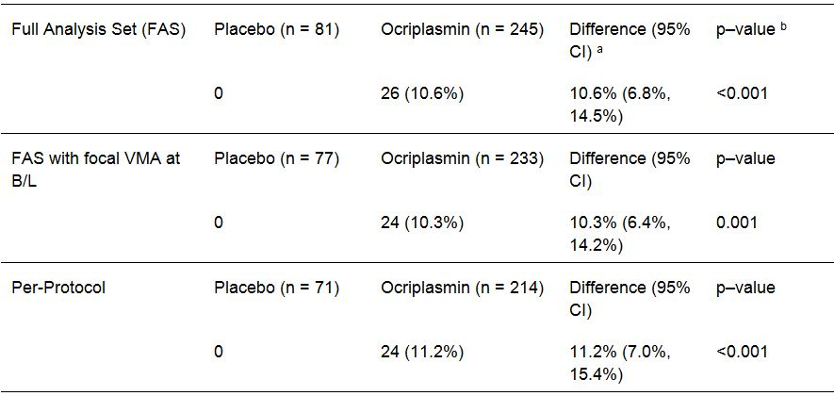
CI = confidence interval; VMA = vitreomacular adhesion. a The (absolute) difference and CIs between treatment groups are based on the percentage of successes. b p-value is from Fisher’s exact test, comparing placebo and ocriplasmin.
Comment: The difference between ocriplasmin and placebo for the proportion of subjects with total PVD at Day 28 was similar in the FAS (LOCF), FAS (LOCF) for patients with focal VMA at Baseline and the PP set. The results for total PVD at Day 28 in the FAS and the FAS with focal VMA at Baseline using the worst-case approach to impute missing data were identical to the results using the LOCF approach to impute missing data.

Other secondary efficacy endpoints
All other secondary efficacy endpoints for Study TG-MV-007 are discussed later in this report in the section reviewing the results of the integrated efficacy analysis in the pooled efficacy dataset.

Analyses across studies

Integrated efficacy analysis – TG-MV-006 and TG-MV-007

Objective
The efficacy data from the two Phase III efficacy and safety studies (TG-MV-006; TG-MV-007) were pooled and a pre-specified integrated efficacy analysis (IEA) was undertaken. The objective of the IEA was to characterize the efficacy profile of IVT ocriplasmin and to present an integrated analysis of selected efficacy outcomes.

Patient disposition
The IEA included 652 randomized patients (188, placebo; 464 ocriplasmin).
The four analysis populations were defined as for the two pivotal Phase III studies. The FAS included 652 patients (188, placebo; 464, ocriplasmin); the FAS with focal VMA at Baseline included 616 patients (176, placebo; 440, ocriplasmin); the PP set included 568 patients (165, placebo; 403, ocriplasmin); and the Safety Set included 652 patients (187, placebo; 465, ocriplasmin).

Inclusion and exclusion criteria
The inclusion and exclusion criteria for the IEA were those for the two pivotal Phase III studies. Patients with large diameter macular holes (greater than 400 μm), high myopia (greater than 8 dioptre spherical correction or axial length greater than 28 mm), history of retinal detachment, lens instability, previous laser therapy, proliferative diabetic retinopathy, ischemic retinopathies, retinal vein occlusions, exudative age-related macular degeneration and vitreous hemorrhage were excluded from the study because the sponsor considered that these patients were unlikely to benefit from treatment (based on clinical experience or literature), or were theoretically at a higher risk of complications due to the IVT injection procedure or the intended effect of ocriplasmin.

Efficacy endpoints and statistical methods

Primary efficacy endpoint (specified in the SAP for the SCE)
The primary endpoint for the IEA was identical to that for the two pivotal Phase III studies: that is , the proportion of patients with non-surgical resolution of focal vitreomacular adhesion at Day 28, as determined by masked CRC OCT evaluation. All patients who had creation of an anatomical defect (that is , retinal hole, retinal detachment) that resulted in loss of vision or that required additional intervention were counted as treatment failures for this primary endpoint.

Secondary efficacy endpoints (specified in the SAP for the SCE)
The key secondary endpoints for the IEA were:
- the proportion of patients with total PVD at Day 28, as determined by masked investigator assessment of B-scan ultrasound (identical to the two pivotal Phase III studies); and
- the proportion of macular holes that close without vitrectomy as determined by CRC (defined as an additional rather than key secondary efficacy endpoint in the two pivotal Phase III studies).
Other secondary endpoints consistent with those in the two pivotal studies were:
- the proportion of patients not requiring vitrectomy;
- achievement of greater than or equal to 2 and greater than or equal to 3 lines improvement in BCVA without need for vitrectomy;
- achievement of greater than or equal to 2 and greater than or equal to 3 lines improvement in BCVA irrespective of vitrectomy;
- mean change in BCVA; and mean change in VFQ-25 subscale and composite scores.

Evaluator’s comment on the efficacy endpoints
In this evaluation of the IEA the review of the efficacy endpoints will focus on the primary efficacy endpoint, the two key secondary efficacy endpoints and the additional secondary efficacy endpoints listed above. This approach is consistent with that adopted in the Clinical Overview, and is considered to capture those efficacy endpoints that are directly relevant to the recommendation to approve or reject the submission to register ocriplasmin for the proposed indication.

Sample size and statistical methods
A sample size of 320 patients for each pivotal study was expected to achieve over 90% power with a 2-sided alpha of 0.05, assuming a primary endpoint event rate of 27.5% in the 125 μg dose group and 10% in the placebo group.
The pivotal Phase III studies were analyzed both individually and as an integrated dataset. Pooling was planned and documented prior to unmasking based on the similarity in design and data collection of the 2 studies (except for randomization ratio [2:1 for TG-MV-007; 3:1 for TG-MV-006] and region). Homogeneity between the studies was established using the Breslow-Day test and the overlapping of 95% CIs. For all of the efficacy analyses, the similarity in results between TG-MV-006 and TG-MV-007 was confirmed by non-significant p-values of the Breslow-Day homogeneity test.
The primary endpoint was primarily evaluated using the FAS, with missing data imputed using the LOCF method. In order to control for differences between the studies, the Cochran-Mantel-Haenszel (CMH) test, stratified by study, was used to compare the treatment groups in the pooled analysis. The 95% CIs for the difference between the two groups and the exact odds ratio were also calculated. The primary efficacy endpoint was also summarized separately for numerous subgroups. The key secondary endpoints were primarily evaluated using the FAS, with missing data imputed using the LOCF method.
Supportive analyses for the primary endpoint had adjustment for covariates through logistic regression. For the pooled analysis, the logistic regression model included treatment and study (TG-MV-006 or TG-MV-007). Additional covariates including age group (greater than or equal to 65 versus <65 Years; greater than or equal to75 versus <75 Years), gender, presence/absence baseline epiretinal membrane (ERM), fVMA diameter (less than or equal to or greater than 1500 μm diameter), FTMH presence/absence, lens status (phakic/pseudophakic), diabetic retinopathy (DR) presence/absence, expected need for vitrectomy at baseline, and geographic region (US or Europe) were also explored. The first step of covariate evaluation was performed in a univariate manner by adding the covariates individually to the model that contains treatment and study. If the covariate was not significant at the 0.05 level in the univariate analysis it was not included in the final multivariate model.
The alpha adjustment for multiple pairwise endpoint analyses in the integrated analysis was performed in the same way as for the individual studies. The primary endpoint comparison was performed with an alpha level of 0.05 as treatment efficacy was characterized by a single primary efficacy endpoint between 2 treatment groups. Formal statistical testing of the key secondary efficacy endpoint (total PVD) was to be evaluated only if statistical significance (p < 0.05) was achieved in the analysis of the primary efficacy endpoint for 2 of the 3 predefined study populations (that is, FAS and Modified FAS including patients with VMA at Baseline). Analyses of the remaining secondary endpoints were considered supportive or exploratory. The results of those endpoints were described with nominal 95% CIs and nominal p-values without any statistical significance statements.
The SCE included numerous post-hoc analyses that were unspecified in the final SAP. These unplanned post-hoc analyses were performed after the studies were unmasked. The sponsor stated that ‘majority of the outputs were based on existing outputs but explored other subgroups or methods of handling missing data. These post hoc analyses allowed a deeper understanding of the data and how different subgroups of patients responded to treatment’. However, these post-hoc analyses are not considered to be directly relevant to the decision to approve or reject the application to approve ocriplasmin for the proposed indication. Consequently, the numerous post-hoc analyses have not been evaluated.

Demographics and baseline characteristics
The mean (SD) age of the total population was 71.7 (9.39) years, and ranged from 18 to 97 years. The majority of patients in the total population were female (n = 429, 65.8%), and ‘white’ (n = 602, 92.3%). Overall, the characteristics of the ocriplasmin and placebo groups in the total population were comparable, apart from a notably greater proportion of pseudophakic patients in the ocriplasmin group compared with placebo (n = 172, 37.1% versus n = 53, 28.2%, respectively). FTMH at Baseline was reported in 23.5% (n = 153) of patients in the total population (n = 47, 25.0%, placebo; n = 106, 22.8%, ocriplasmin), and VMT (including diabetic retinopathy) was reported in 76.5% (n = 499) of patients in the total population (n = 141, 75.0%, placebo; n = 358, 77.2%, ocriplasmin). The OTC findings at Baseline for the pooled patient groups in the IEA are summarized below in Table 5, and show that almost all patients (98.9%) had at least one objectively defined had more than 1 pathological finding.
Table 5: IEA – OCT findings at baseline.
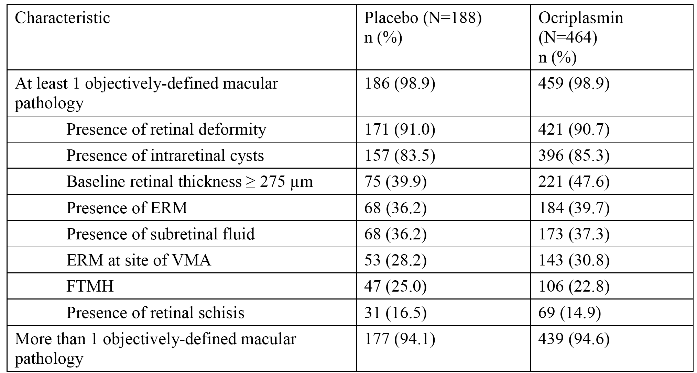
The demographics and ocular baseline characteristics observed in patients in the Modified FAS and the PP set were similar to those observed in the FAS. In the Modified FAS (integrated studies), the majority of patients (70.9%) had a focal VMA diameter less than or equal to 1500 μm at Baseline (based on review of pre-treatment OCT).
The ocular medical history for study eye conditions reported for greater than or equal to 10% of patients treated with ocriplasmin in the pivotal Phase III studies (pooled safety set) is summarized below in Table 6. The results for the pooled data set were consistent with the results for the individual pivotal Phase III studies. In the placebo group, the percentage of patients with baseline vitreous adhesions was 97.9% compared with 99.4% in the ocriplasmin group.
Table 6: Pooled pivotal Phase III data – Ocular medical history, study eye conditions reported for greater than or equal to 10% of patients treated with ocriplasmin in the pivotal Phase III studies; safety set.
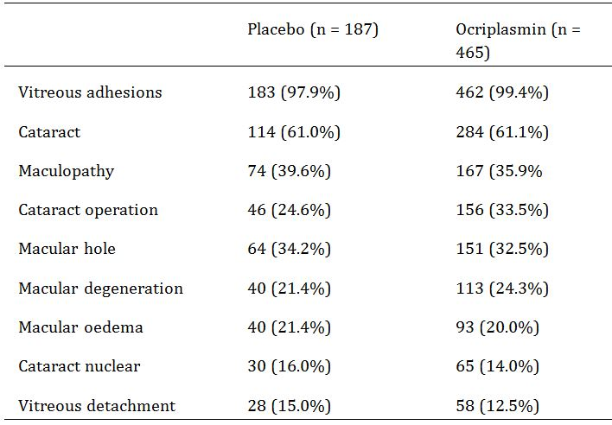
Review of the non-ocular medical history of patients in the pooled safety set for conditions reported for greater than or equal to 10% of patients treated with ocriplasmin in the pivotal Phase III studies showed no notable differences between the two treatment groups. The most commonly reported conditions were hypertension, hypercholesterolaemia and diabetes mellitus type 2. In general, the non-ocular medical conditions reported in the patient population were consistent with those expected in an elderly population.
Review of the study eye ocular medications taken by greater than or equal to 3% of patients in the pivotal Phase III studies showed no clinically significant differences between the two treatments groups. Review of the non-ocular medications taken by greater than or equal to 10% of patients in the pivotal Phase III studies showed no clinically significant differences between the two treatments groups, and the medications were consistent with those expected in an elderly population with pre-existing medical conditions.

Primary efficacy endpoint (resolution of VMA Day 28) – result
The results from the primary endpoint of VMA resolution at Day 28, without creation of an anatomical defect, are summarized below in Table 7 (FAS, LOCF). This endpoint was defined as the primary efficacy endpoint in both the pivotal studies and the IEA. The results for the primary efficacy endpoint in the secondary analyses populations (FAS with Baseline VMA, LOCF; and PP set), were similar to those in the primary analysis population (FAS, LOCF). The IEA results for the FAS with Baseline VMA, LOCF and the PP set were post-hoc analyses.
Table 7: Proportion of patients with VMA resolution in the study eye at Day 28 without creation of an anatomical defect, n (%): FAS (LOCF).
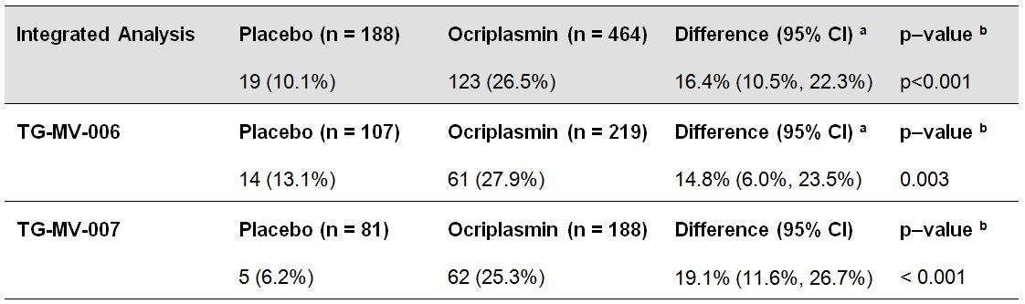
CI = confidence interval. a The (absolute) difference and CIs between treatment groups are based on the percentage of successes. b p-value is from Fisher’s exact test, comparing placebo and ocriplasmin. For pooled studies, p-value is from Cochran-Mantel-Haenszel test, stratified by study.
In the IEA, the proportion of patients in the ocriplasmin group achieving VMA resolution at each post injection time-point (Day 7, 14, 28, Month 3, 6) was significantly greater (p<0.001) than in the placebo arm. Overall, the response in the ocriplasmin arm remained relatively constant from Day 28 through to Month 6. The proportion of patients achieving VMA resolution at each of the post-injection time points in the IEA and both pivotal Phase III studies are summarized below in Figure 2.
Figure 2: Proportion of patients with VMA resolution over time in the study eye; FAS (LOCF).
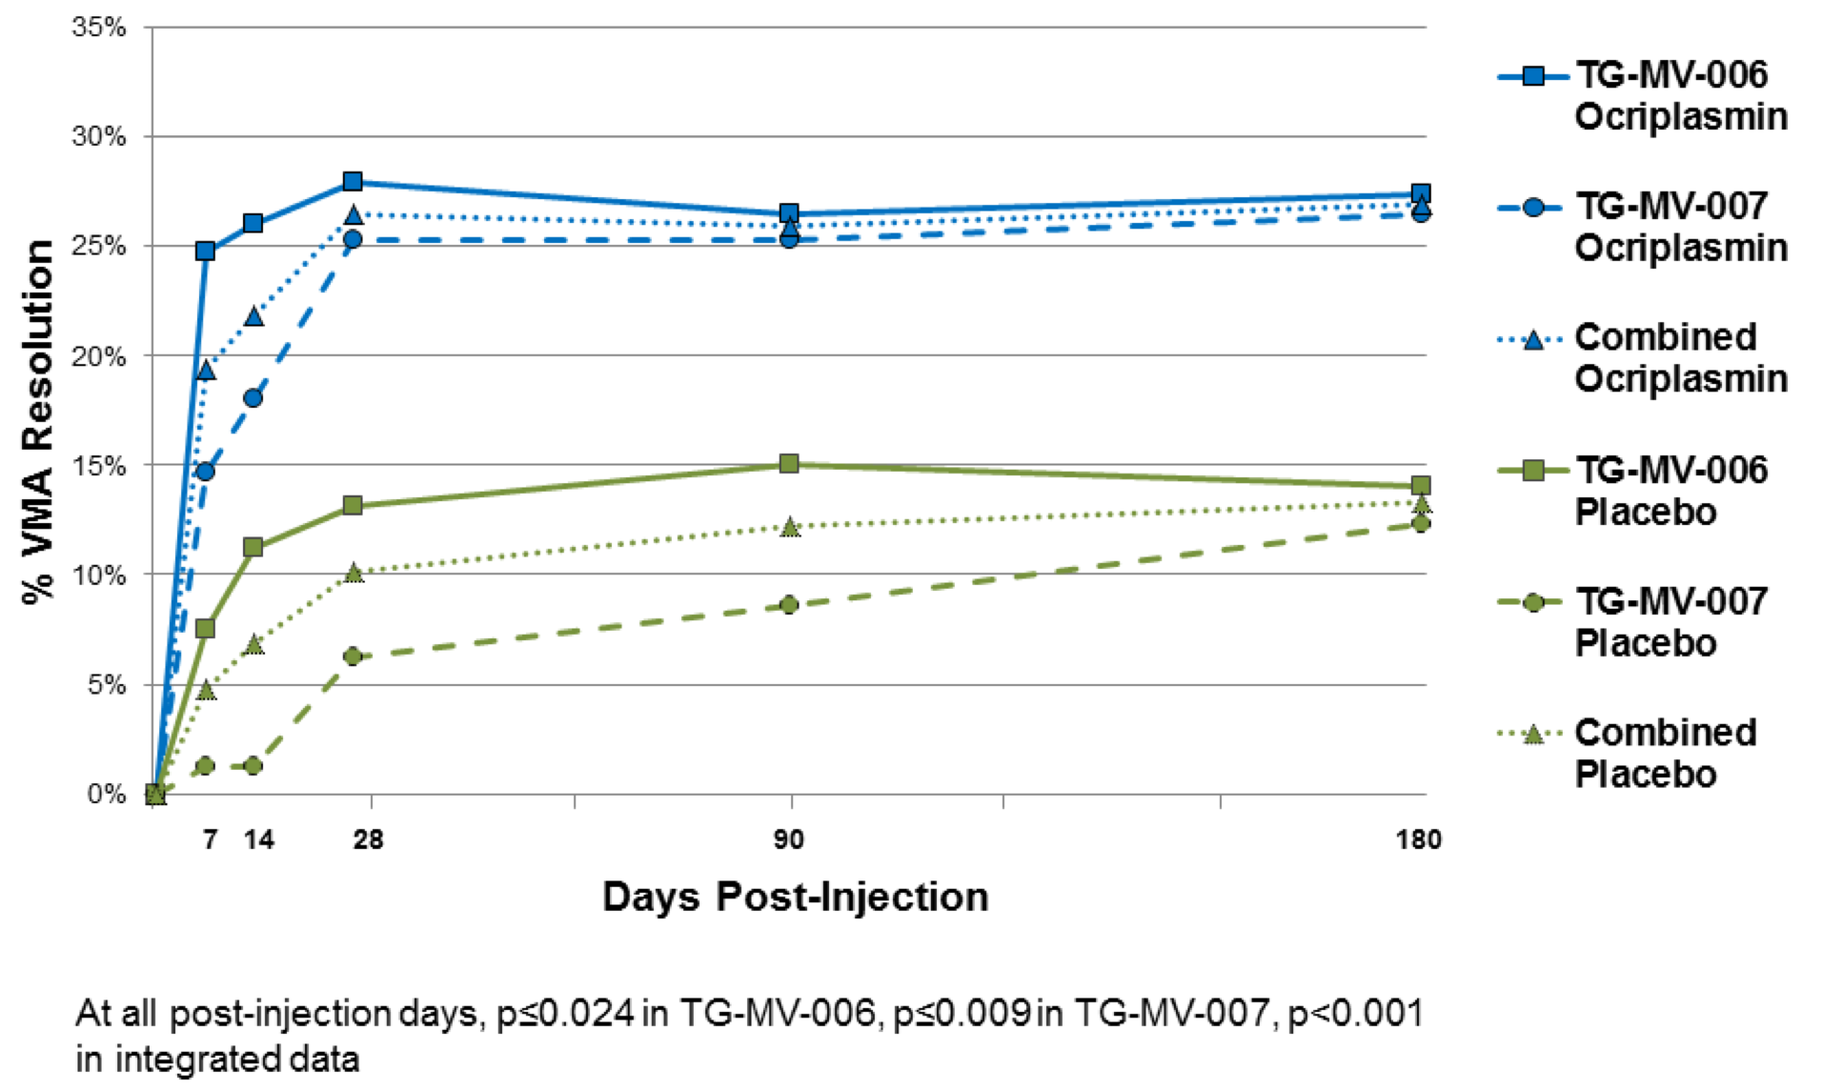
Comment: In the IEA, the difference in VMA resolution at Day 28 (FAS, LOCF) between the two treatment arms significantly favoured ocriplasmin compared with placebo (p<0.001). The statistically significant difference between the two treatment arms was observed as early as Day 7 and was maintained through to Month 6, ranging from 13.6% to 14.9% across the five time-points. The majority of patients in the ocriplasmin group who achieved success on the primary efficacy endpoint did so by Day 7, and this proportion was notably greater in the ocriplasmin group than in the placebo group (90/125, 72.0% versus 9/25, 36.0%, respectively).
The significance of the treatment effect for non-surgical resolution of VMA without creation of anatomical defect observed at Month 6 in the integrated analysis was confirmed using multivariate logistic regression analysis adjusted for baseline covariates (p<0.001; OR = 3.211 [95% CI: 1.874, 5.502]).
In both pivotal studies, the proportion of patients who achieved VMA resolution at Day 28 was statistically significantly (p less than or equal to 0.003) higher in the ocriplasmin group compared with the placebo group (FAS, LOCF). The difference between the two treatment arms continued to statistically significantly favour ocriplasmin compared with placebo through to Month 6 in each study (p less than or equal to 0.024).
The proportion of patients in the placebo group with VMA resolution at Day 28 in Study TG-MV-006 was approximately twice that in Study TG-MV-007 (13.1% versus 6.2%, respectively). The sponsor speculates that baseline differences in the placebo groups of the two pivotal Phase III studies may have contributed to increased VMA resolution in the placebo group in Study TG-MV-006 compared with Study TG-MV-007. The relevant baseline differences in the placebo groups included: a greater proportion of patients with macular holes in TG-MV-006 compared with TG-MV-007 (29.9% versus 18.5%, respectively); a lower proportion of patients with epiretinal membrane (ERM) in TG-MV-006 compared with TG-MV-007 (32.7% versus 40.7%, respectively); and a higher proportion of patients with a VMA diameter less than or equal to 1500 μm at baseline in TG-MV-006 compared with TG-MV-007 (74.7% versus 63.6%, respectively).

Key secondary efficacy endpoints

Total PVD at day 28
The results for Total PVD at Day 28 in the FAS (LOCF) with Total PVD at Baseline considered failures are summarised below in Table 8. This endpoint was defined as a key secondary efficacy endpoint for both pivotal studies and the IEA. The results for Total PVD at Day 28 in the FAS with focal VMA at Baseline (LOCF) and the PP set (LOCF) were similar to the results for the FAS (LOCF). The IEA results for Total PVD at Day 28 for the FAS with focal VMA at Baseline and the PP set were post hoc-analyses.
Table 8: Proportion of patients with total PVD in the study eye at Day 28, n (%): FAS (LOCF).
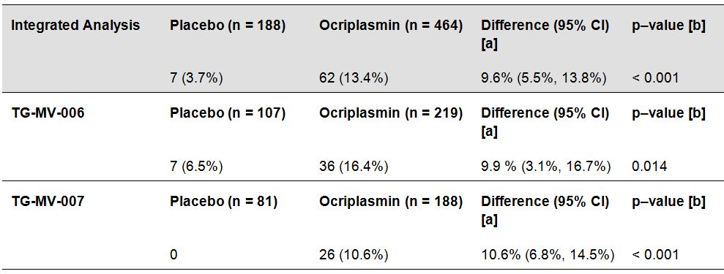
CI = confidence interval. [a] The (absolute) difference and CIs between treatment groups are based on the percentage of successes. [b] For individual studies, p-value is from Fisher’s exact test, comparing placebo and ocriplasmin. For pooled studies, p-value is from Cochran-Mantel-Haenszel test, stratified by study.
The treatment effect observed in the IEA at Day 28 for the FAS was confirmed using multivariate logistic regression analysis. In the multivariate model adjusted for baseline covariates, study treatment had a significant effect on the proportion of patients in the integrated FAS who achieved total PVD at Day 28 (p < 0.001; OR = 5.406 [95% CI: 2.174, 13.446].
Comment: In both pivotal studies, total PVD at Day 28 was defined as a key secondary efficacy endpoint. The difference between the two treatment groups statistically significantly favoured ocriplasmin compared with placebo in both pivotal Phase III studies (FAS, LOCF), and these results were supported by corresponding result in the IEA (FAS, LOCF).

FTMHC without vitrectomy in patients with sVMA and FTMH at Baseline
The results for full thickness macular hole closure (FTMHC) without vitrectomy in patients with sVMA and FTMH at Baseline was defined as an additional secondary endpoint in both pivotal studies, but as a key secondary efficacy endpoint in the IEA. The results in the primary analysis population (FAS, LOCF) are summarised below in Table 9.
Table 9: Proportion of patients with total PVD in the study eye at Day 28, n (%): FAS (LOCF).
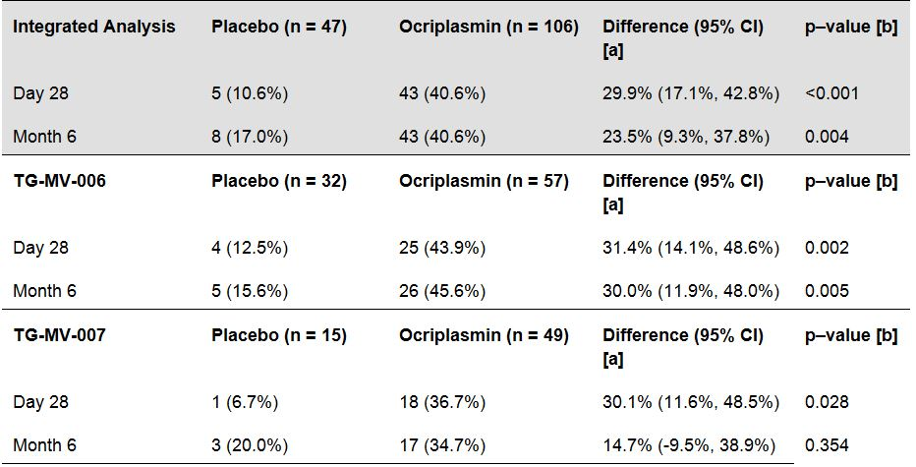
CI = confidence interval; Shadowed = integrated analysis. [a] The (absolute) difference and CIs between treatment groups are based on the percentage of patients with FTMHC. [b] For individual studies, p-value is from Fisher’s exact test, comparing placebo and ocriplasmin. For pooled studies, p-value is from Cochran-Mantel-Haenszel test, stratified by study.
In the IEA, 43 (40.6%) patients with sVMA and FTMH at Baseline patients achieved FTMHC without vitrectomy at Month 6, and 30 (28.3%) patients achieved FTMHC closure at Day 7. In the IEA placebo group, 8 (17.0%) patients with FTMH at Baseline achieved FTMHC without vitrectomy at Month 6 compared with no patients at Day 7.
The treatment effect observed in the IEA at Day 28 and Month 6 was confirmed using multivariate logistic regression analysis. In the multivariate model adjusted for baseline covariates, study treatment had a notable effect on the proportion of patients who achieved non-surgical FTMHC by Day 28 (p<0.001, OR = 8.416 [95% CI: 2.848, 24.864], and Month 6 (p = 0.002; OR = 4.267 [95% CI: 1.714, 10.623]).
Comment: In both pivotal studies and the IEA, p-values for the pairwise comparisons between the treatment groups were nominal rather than confirmatory for FTMHC in patients with sVMA and FTMH at baseline. In Study TG-MV-006, there was a total of 89 patients in the FAS (LOCF) with a FTMH at Baseline (n = 32, placebo versus n = 57, ocriplasmin). In Study TG-MV-007, there was a total of 64 patients with a FTMH at Baseline (n = 15, placebo versus n = 49, ocriplasmin). Of the total population (n = 652), 154 (23.5%) had a FTMH at Baseline, including 47 (25.0%) in the placebo group and 106 (22.8%) in the ocriplasmin group. In both pivotal studies and the IEA, the proportion of patients with sVMA and FTMH at Baseline achieving FTMHC without vitrectomy at Day 28 or Month 6 was numerically greater in the ocriplasmin group compared with placebo.
In the IEA, in patients with sVMA and FTMH at Baseline, FTMHC without vitrectomy at Month 6 was achieved in 40.6% (n = 43) of patients in the ocriplasmin group and 17.0% (n = 8) of patients in the placebo group, with the difference between treatment groups being 23.5% (95% CI: 9.3, 37.8), p = 0.004. The sponsor refers to a published literature review of the natural history of closure of macular holes reporting that spontaneous closure of FTMH (stage 2 or 3) is relatively rare occurring in < 10% of cases.29 The difference between the two treatment groups in the IEA appears to be clinically meaningful, but the p-value is nominal and there are no confirmatory data.

Other secondary efficacy endpoints of significance

Proportion of patients not requiring vitrectomy (FAS)
In Study TG-MV-006, the proportion of patients who underwent vitrectomy by Month 6 was 29.0% (n = 31) in the placebo group and 20.5% (n = 45) in the ocriplasmin group; difference -8.4% (95% CI: -18.5, 1.7), p = 0.096. In Study TG-MV-007, the proportion of patients who underwent vitrectomy by Month 6 was 23.5% (n = 19) in the placebo group and 15.1% (n = 37) in the ocriplasmin group; difference -8.4% (95% CI: -18.6, 1.9), p = 0.091. In the IEA, the proportion of patients who underwent vitrectomy by Month 6 was 26.6% (n = 50) in the placebo group and 17.7% (n = 82) in the ocriplasmin group; difference -8.9% (95% CI: -16.1, -1.7), p = 0.016.
Comment: In both pivotal studies and the IEA, the proportion of patients not requiring vitrectomy was an additional secondary efficacy end point, and p-values were nominal rather than confirmatory. In both pivotal studies and the IEA, the proportion of patients who not requiring vitrectomy by Month 6 was numerically greater in the ocriplasmin group than in the placebo group.

Achievement of greater than or equal to 2 and greater than or equal to 3 lines improvement in BCVA without need for vitrectomy vitrectomy (FAS; LOCF)
The comparison between treatment groups for categorical improvement in non-surgical BCVA (that is, without need for vitrectomy) at Month 6 avoids the potential confounding effect of vitrectomy on BCVA in those patients undergoing the surgical procedure before Month 6. In each pivotal study and the IEA, the proportion of patients who showed a greater than or equal to 2-line (greater than or equal to 10 letter) improvement in BCVA from Baseline at Month 6 without vitrectomy was numerically higher in the ocriplasmin group compared with the placebo group: TG-MV-006 (25.6% versus 11.2%; p = 0.002); TG-MV-007 (22.0% versus 11.1%; p = 0.035); and IEA (23.7% versus 11.2%; p <0.001). The proportion of patients who showed a greater than or equal to 3-line (greater than or equal to 15 letter) improvement in BCVA from Baseline at Month 6 without vitrectomy was also numerically higher in the ocriplasmin group compared with the placebo group in each pivotal study and the IEA: TG-MV-006 (10.5% versus 6.5%; p = 0.310); TG-MV-007 (9.0% versus 0%; p = 0.002); and IEA (9.7% versus 3.7%; p = 0.008).
Comment: In both pivotal studies and the IEA, the proportion of patients with improvements in BCVA without need for vitrectomy from baseline to Month 6 of greater than or equal to 2 lines (greater than or equal to 10 letters) or greater than or equal to 3 lines (greater than or equal to 15 letters) were additional secondary efficacy endpoints, and p-values were nominal rather than confirmatory. There are no confirmatory pairwise statistical comparisons for the two treatment groups in the pivotal studies or the IEA. Although the proportion of patients achieving improvement in BCVA of greater than or equal to 2 and greater than or equal to 3 lines from Baseline to Month 6 without vitrectomy favours the ocriplasmin group.
Although improvements in the proportion of patients with BCVA of greater than or equal to 2 and greater than or equal to 3 lines from Baseline to Month 6 were observed in the ocriplasmin group compared with the placebo group in the IEA, worsening in BCVA of greater than or equal to 2 and greater than or equal to 3 letters from Baseline to Month 6 was numerically greater in the ocriplasmin group compared with the placebo group in this data set. In the IEA, the proportion of patients with a decrease of greater than or equal to 2 lines from Baseline to Month 6 was 4.7% compared with 2.7% % in the placebo group (p = 0.208), and the proportion of patients with a decrease of greater than or equal to 3 lines from Baseline to Month 6 was 3.0% in the ocriplasmin group compared with 1.6% in the placebo group (p = 0.310). Of note, the proportion of patients with decrease in BCVA greater than or equal to 2 lines and greater than or equal to 3 lines from Baseline to Day 7 was notably numerically greater in the ocriplasmin group compared with the placebo group, and the difference between the two treatment groups was nominally statistically significant for both outcomes in the IEA. The greater decrease in visual acuity in the first 7-days post-injection in the ocriplasmin group compared with the placebo group is a safety issue and has been discussed later in this CER.

Achievement of greater than or equal to 2 and greater than or equal to 3 lines improvement in BCVA irrespective of vitrectomy vitrectomy (FAS; LOCF)
In each pivotal study and the IEA, the proportion of patients who showed a greater than or equal to 2-line (greater than or equal to 10 letter) improvement in BCVA from Baseline at Month 6 irrespective of vitrectomy was higher in the ocriplasmin group compared with the placebo group: TG-MV-006 (30.1% versus 16.8%; p = 0.010); TG-MV-007 (26.1% versus 17.5%; p = 0.133); and IEA (28.0% versus 17.1%; p = 0.003). The proportion of patients who showed a greater than or equal to 3-line (greater than or equal to 15 letter) improvement in BCVA from Baseline at Month 6 irrespective of vitrectomy was also higher in the ocriplasmin group compared with the placebo group: TG-MV-006 (12.8% versus 8.4%; p = 0.270); TG-MV-007 (11.8% versus 3.8%; p = 0.049); and IEA (12.3% versus 6.4%; p = 0.024).
Comment: The results for improvements in BCVA greater than or equal to 2 and greater than or equal to 3 from Baseline to Month 6 irrespective of vitrectomy were consistent were consistent with those without need of vitrectomy. Similarly, the results for decrease in BCVA greater than or equal to 2 and greater than or equal to 3 lines from Baseline to Month 6 were also consistent in the two data sets.

Mean increases from baseline in BCVA (FAS, LOCF) – irrespective of vitrectomy
In each of the three study groups, the mean increase in BCVA letter score was numerically greater in the ocriplasmin 125 µg group compared with the placebo group at Month 3 and Month 6. In Study TG-MV-006, the maximum mean increase from Baseline was 3.8 letters at Month 3 in the ocriplasmin group (versus 1.6 letters in the placebo group at this time-point; p = 0.111). In Study TG-MV-007, the maximum mean increase from baseline was 3.6 letters at Month 6 (versus 2.1 letters in the placebo group at this time-point; p = 0.218). In the IEA, the maximum mean increase from Baseline was 3.6 letters in the ocriplasmin group at both Month 3 (versus 1.9 letters in the placebo group at this time-point; p = 0.048) and Month 6 (versus 2.5 letters in the placebo group at this time-point; p = 0.303).
Comment: In both pivotal studies and the IEA, changes in mean visual acuity (ETDRS scores) were additional secondary efficacy endpoints, and all p-values for pairwise comparisons between the two treatment groups were nominal rather than confirmatory. Overall, the data showed changes in mean visual acuity (ETDRS scores) of less than or equal to 3.8 letters from Baseline at each time point through to Month 6 in both the placebo and ocriplasmin groups. The observed changes in mean visual acuity (ETDRS scores) were generally comparable for the two treatment groups, and the observed differences both within and between groups are considered to be clinically insignificant.

Improvement in Visual Function Questionnaire (VFQ-25)
In this CER, the analysis of VFQ-25 focuses on the mean change from baseline to Month 6 using the observed cases approach in the IEA for the 12 subscale scores and the composite score. In VFQ-25, responses are converted to a number on a 0-100 scale (0 = worst possible score, 100 = best possible score). The composite score is calculated as the average of the 11 vision-targeted subscale scores, excluding the general health-rating question.
In the IEA, mean increases from baseline were observed in the placebo group for 7 of the 12 sub-scale scores and the composite score at Month 6, while in the ocriplasmin group mean increases from baseline to Month 6 were observed in all 12-subscale scores and the composite score. Improvements in all scores were numerically higher in the ocriplasmin group compared with the placebo group. The only statistically significant (nominal) between scores for the two treatment groups was observed for improvement in the general vision sub-scale score (2.1 placebo versus 6.1 ocriplasmin, p = 0.024, ANOVA adjusted for baseline VFQ score).
Comment: In both pivotal studies and the IEA, changes from Baseline to Month 6 in mean VFQ-25 scores were additional secondary efficacy endpoints, and all p-values for pairwise comparisons between the two treatment groups were nominal rather than confirmatory. Overall, in the IEA there was trend towards greater improvement from baseline to Month 6 in VFQ-25 subscale and composite scores in the ocriplasmin group compared with the placebo group. However, mean increases in both treatment groups were relatively small suggesting that within group and between group changes were of doubtful clinical significance. There are published data suggesting that a 5-point difference in subscale and/or composite scores are likely to be clinically significant.^{31,32}

Sub-group analyses

Overview
The IEA included univariate and multivariate logistic regression analyses to evaluate covariate effects on categorical endpoints. The demographic covariates included 1 or more of the following: age; gender; race; BMI; and geographic region. The baseline disease characteristic covariates included 1 or more of the following: ERM status; type (diameter) of focal VMA; ERM status and type (diameter) of focal VMA; FTMH status; lens status; DR status; expected need for vitrectomy; and BVCA. For the endpoint of FTMHC, additional variables included: baseline MH diameter at the retinal pigment epithelium (RPE) level (less than or equal to 600 μm versus greater than 600 μm); baseline MH width (less than or equal to 250 μm versus greater than 250 μm); and VMA at edge of MH at Baseline (present versus absent).
Covariate evaluations were performed in a univariate manner by adding the covariates individually to the model that contained treatment and study. If the covariate was not significant at the 0.05 level, it was not included in the final multivariate model. For the covariate of age, multiple cut offs were examined. If significant, the group with 3 categories (< 65 years, 65 to 75 years and greater than 75 years) was included in the multivariate model. The variables of treatment and study were always included in the multivariate model. Multifactorial ANOVA was used to evaluate covariate effects on the continuous efficacy endpoint of change from Baseline in BCVA.
The approach adopted to the presentation of the sub-group analyses has been to consider the outcomes for the primary efficacy endpoint (VMA resolution) and the exploratory secondary efficacy endpoint (FTMHC) as these two endpoints are considered to be directly relevant to the proposed indication. The sub-group analyses are considered to be exploratory in nature.

VMA resolution at day 28 – subgroup analyses
In the supportive multivariate logistic regression model adjusted for baseline covariates, study treatment had a significant effect on the proportion of patients who achieved VMA resolution by Day 28 in the integrated analysis data set, FAS/LOCF (p<0.001; OR = 6.008 [95% CI: 3.158, 11.433]). Several baseline covariates were identified as independent predictors for achieving VMA resolution including age, ERM status, FTMH status, lens status, and type (diameter) of focal VMA. Treatment differences in favour of ocriplasmin were observed in each subgroup for these independent predictors of response in the IEA (FAS, LOCF). Of note, odds ratios were not statistically significant for the comparisons between females and males (OR = 1.465 [95% CI: 0.832, 2.578]), or between age groups 65-75 years and greater than 75 years (OR = 1.810 [95% CI: 1.000, 3.274]).
Table 10: IEA - Proportion of patients with VMA resolution at Day 28 by independent predictors; FAS and Modified FAS (for focal VMA size at baseline).
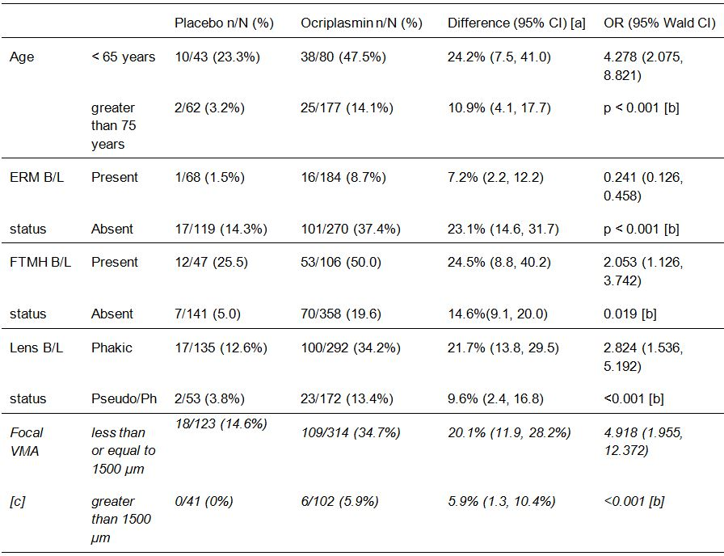
[a] The absolute difference and 95% CI between treatment groups are based on the proportion of successes. [b] P-value is from the analysis of effects from multivariate logistic regression[c] The analysis is in the modified FAS (that is, FAS with patients with focal VMA at baseline).

Non-surgical FTMHC at month 6 – subgroup analyses in the integrated analysis set
In the supportive multivariate logistic regression model adjusted for baseline covariates in the integrated analysis set (FAS, LOCF), study treatment had a significant effect on the proportion of patients with sVMA and FTMH at Baseline who achieved non-surgical FTMH closure by Month 6 (FAS/LOCF) population, (p = 0.002; OR = 4.267 [95% CI: 1.714, 10.623]). Baseline FTMH width less than or equal to 250 µm (versus greater than 250 µm) was identified as significant (p = 0.013) independent predictor of achieving non-surgical FTMHC (see Table 11, below). Consistent with these findings, a probit graph of the IEA dataset showed that the probability of non-surgical FTMHC is dependent on the size of the FTMH at Baseline, with greater probability of closure associated with smaller hole width. Although not significant in the multivariate model (p = 0.099; OR = 1.952 [95% CI: 0.882, 4.317]), the proportion of patients in the ocriplasmin group who achieved non-surgical FTMHC by Month 6 was numerically higher among patients with a maximum baseline FTMH width less than or equal to 600 versus greater than 600 μm (55.1% [27/49] versus 27.3% [15/55], respectively).
Table 11: IEA - Proportion of patients with non-surgical FTMHC at Month 6 by Baseline FTMH width; FAS.
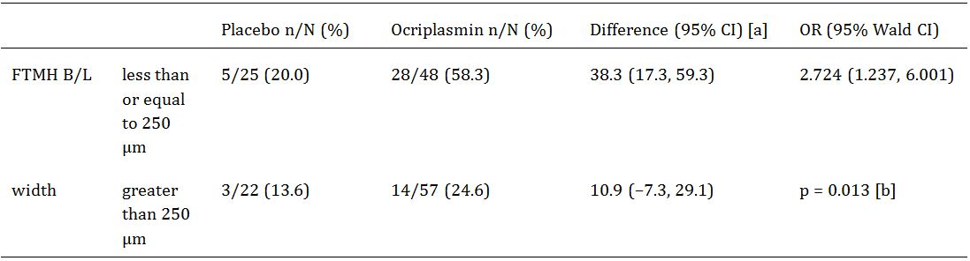
[a] The absolute difference and 95% CI between treatment groups are based on the proportion of successes. [b] P-value is from the analysis of effects from multivariate logistic regression.

Evaluator’s overall conclusions on clinical efficacy
The submission included two, pivotal Phase III efficacy and safety studies (Study TG-MV-006; Study TG-MV-007). In addition, the submission included a pre-specified integrated efficacy analysis (IEA) of the pooled efficacy data from the two pivotal Phase III studies. The total number of patients included in the efficacy analyses in the two pivotal Phase III studies was 652 (188, placebo; 464, ocriplasmin). The mean (SD) age of the total population was 71.7 (9.39) years (range: 18, 97), and 92.3% were ‘White’ with most of the other patients being ‘Black’ (4.4%). The total population included a greater proportion of females than males (65.8% and 34.2%, respectively).
In addition to symptomatic VMA at baseline, almost all patients in both treatment groups had at least 1 objectively defined macular pathologic finding identified by OCT (98.9% in both treatment groups), and more than 1 objectively defined pathologic finding was defined in 94.1% of patients in the placebo group and 94.6% of patients in the ocriplasmin group had. The most common objectively defined macular pathologies were retinal deformity (91.0%, placebo; 90.7%, ocriplasmin 125 µg) and intraretinal cysts (83.5%, placebo; 85.3%, ocriplasmin 125 µg). In the total population, only 1 patient did not have total PVD (ocriplasmin 125 µg group). FTMH at baseline was reported in 23.5% of patients in the total population (25.0%, placebo; 22.8%, ocriplasmin 125 µg), and VMT (including diabetic retinopathy) was reported in 76.5% of patients in the total population (75.0%, placebo; 77.2% ocriplasmin).
It is considered that the submitted data adequately confirm the efficacy of ocriplasmin for the treatment of symptomatic vitreous macular adhesions (sVMA), as regards anatomical outcomes of resolution of VMA at Day 28 (primary efficacy endpoint) and total PVD at Day 28 (key secondary efficacy endpoint).
The primary efficacy endpoint in both pivotal Phase III studies was the proportion of patients achieving non-surgical VMA resolution at Day 28, without creation of an anatomical defect, as determined by masked CRC evaluation of OTC scans (FAS, LOCF). The proportion of patients meeting the primary efficacy endpoint was at least 2-fold higher in the ocriplasmin group than in the placebo group in both pivotal studies, and the difference between the two treatment groups in both studies statistically significant favoured ocriplasmin compared with placebo (p less than or equal to 0.003). In both pivotal studies, the results of the secondary analyses in the FAS with VMA at Baseline (LOCF) and in the PP set were consistent with the results for the primary analysis in the FAS (LOCF). The results for the IEA were consistent with those from the two pivotal, Phase III studies.
In both pivotal Phase III studies, the proportion of patients achieving VMA resolution was significantly greater in the ocriplasmin group compared with the placebo group at all post-injection time-points (Day 7, 14, 28, Month 3, 6). The difference between the two groups occurred as early as Day 7 (the first-time point), peaked at Day 28 and remained relatively constant from Day 28 through to Month 6. The results in the IEA were consistent with those from both pivotal studies.
In both pivotal Phase III studies, the key secondary efficacy endpoint was the proportion of patients achieving total PVD at Day 28, as determined by masked investigator assessment of B-scan ultrasound (FAS, LOCF). In both pivotal studies, the proportion of patients meeting the key secondary efficacy endpoint was statistically significantly higher in the ocriplasmin group compared with the placebo group (p less than or equal to 0.104). The results for the primary analysis in the FAS (LOCF) from both pivotal studies were consistent with the results for the secondary analysis in the FAS with VMA at Baseline (LOCF), but only the results for Study TG-MV-007 were significant for the secondary analysis in the PP set. The results from the IEA (FAS, LOCF) were consistent with those from both pivotal studies, and the results from the IEA for the secondary analyses in the FAS with VMA at Baseline and in the ‘PP’ set were consistent with the primary analysis in the FAS (LOCF).
All other efficacy secondary endpoints in both pivotal Phase III studies were evaluated at the two-sided 5% level of significance, but as no adjustments were made for multiplicity all p-values were considered to be nominal rather than confirmatory. The Statistical Analysis Plans (SAPs) for both pivotal studies stated that the ‘results for the additional secondary endpoints will be of a supportive nature only and will be interpreted as such.’ The SAP for the IEA stated that ‘no adjustments’ will be made for multiple comparisons as there is only one primary efficacy endpoint. All other analyses are secondary analyses or subset analyses’. Based on the statements in the SAPs, it is considered that the results for the additional secondary efficacy endpoints are supportive and not confirmatory.
In both pivotal, Phase III studies, non-surgical FTMHC in patients with sVMA and baseline FTMH (additional secondary efficacy endpoint) at Day 28 and Month 6 occurred in a numerically greater proportion of patients in the ocriplasmin group compared with placebo. However, the results for the two pivotal studies were inconsistent. In Study TG-MV-006, the difference between the ocriplasmin and placebo groups in the proportion of patients achieving FTMHC was similar at Day 28 and Month 6 (p-value nominally significant at both time-points), but in Study TG-MV-007 the difference between the ocriplasmin and placebo groups at Month 6 (p-value nominally non-significant) was 50% smaller than at Day 28 (p-value nominally significant). In the IEA, the difference between the ocriplasmin and placebo groups in the proportion of patients achieving FTMHC was similar at Day 28 and Month 6 (p-value nominally significant at both time points).
In both pivotal Phase III studies, there was a numerically greater proportion of patients requiring vitrectomy by Month 6 (secondary efficacy endpoint) in the placebo group compared with ocriplasmin group, and the p-value was nominally insignificant for the difference between the two groups in both studies. In the IEA, there was a numerically greater proportion of patients requiring vitrectomy by Month 6 in the placebo group compared with the ocriplasmin group, and the p-value was nominally significant for the difference between the groups.
In both, pivotal Phase III studies, there was a numerically greater proportion of patients in the ocriplasmin group compared with the placebo group with non-surgical improvements of greater than or equal to 2 lines and greater than or equal to 3 lines from baseline to Month 6. In Study TG-MV-006, the p-value was nominally significant for the difference between the two groups for improvement greater than or equal to 2 lines, but not for improvement greater than or equal to 3 lines. In Study TG-MV-007, the p-value was nominally non-significant for the difference between the two groups for improvement greater than or equal to 2 lines, but nominally significant for improvement greater than or equal to 3 lines. In IEA, the p-value was nominally significant for the difference between the two treatment groups for both improvement greater than or equal to 2 lines and greater than or equal to 3 lines.
In Study TG-MV-006, there was a numerically greater proportion of patients in the ocriplasmin group compared with the placebo group with non-surgical declines of greater than or equal to 2 lines and greater than or equal to 3 lines from baseline to Month 6, with all p-values being nominally non-significant for the differences between the two groups. In Study TG-MV-007, there was a numerically identical proportion of patients with non-surgical declines of greater than or equal to 2 lines in the two treatment groups and a numerically greater proportion of patients with non-surgical declines of greater than or equal to 3 lines in placebo group compared with the ocriplasmin group, with all p-values being nominally non-significant for the differences between the two groups. In the IEA, there was a numerically greater proportion of patients in the ocriplasmin group compared with the placebo with non-surgical declines of greater than or equal to 2 lines and greater than or equal to 3 lines from baseline to Month 6, with all p-values being nominally non-significant for the differences between the two groups. In the IEA, the greatest difference between the two treatment groups was the numerically greater proportion of patients with non-surgical declines of greater than or equal to 2 lines and greater than or equal to 3 lines from baseline to Day 7 in the ocriplasmin group compared with the placebo group, with all p-values being nominally non-significant for the differences between the two treatment groups. The initial rapid decline in BCVA following ocriplasmin is a safety issue.
In both pivotal Phase III studies and the IEA, improvements in BCVA mean letter scores (additional secondary efficacy endpoint) from baseline through to Month 6 were small and are considered to be of doubtful clinical significance. The differences between the two treatments groups were nominally non-significant for the change from baseline to Month 6 in both pivotal studies and the IEA.
In general, mean VFQ-25 scores from baseline to Month 6 (additional secondary efficacy endpoint) in the IEA were numerically greater in the ocriplasmin group compared with the placebo group, but the differences were small and of doubtful clinical significance. The p-values were nominally non-significant for most of the differences between the two treatment groups.

Clinical safety

Exposure
The submitted safety data included a Summary of Clinical Safety (SCS) providing pooled safety data from the two pivotal Phase III studies, and integrated safety data from 7 completed clinical studies as of 31 March 2011. In addition, the submitted safety data included a 120-Day Safety Update Report for the period 1 April 2011 to 31 May 2012. The 120-Day Safety Report Update included information on deaths and serious adverse events that occurred over the period covered by the report.
The 120-Day Safety Update Report indicates that, as of 31 May 2012, 758 patients had been exposed to ocriplasmin by IVT injection in 8 completed clinical studies, and 243 patients had received control (placebo or sham). Furthermore, it was estimated that 215 patients had received ocriplasmin and 94 had received control (placebo or sham) in 5 clinical studies that were on-going during the reporting period 1 April 2011 to 31 May 2012, while 3 patients received ocriplasmin on a compassionate use basis, and 4 control patients did not receive any treatment. Overall, as of the 31 May 2012 it is estimated that total exposure from completed and on-going studies to ocriplasmin and control is 976 and 341 patients, respectively.
Of the 758 patients exposed to ocriplasmin as of 31 May 2012, 599 (79.0%) have been exposed to the proposed dose of 125 µg. Of the 758 patients exposed to ocriplasmin, 465 (61.3%) have been exposed to one single IVT 125 µg dose of ocriplasmin in the two pivotal Phase III studies (number 6 and number 7). The exposure data for the 8 completed clinical trials as of 31 May 2012 are summarized below in Table 12.
Table 12: Number of patients by treatment received in 8 completed studies up to 31 May 2012; number = TG-MV.
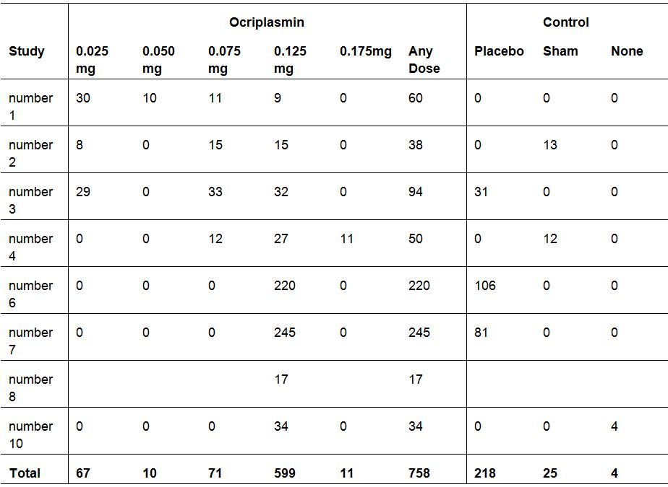
In this CER, relevant safety information has been provided from both the SCS and the 120-Day Safety Update Report. The SCS included safety data from 7 completed studies (741 patients treated with ocriplasmin; 243 treated with placebo or sham). The only difference between the 7 completed studies reported in the SCS and the 8 completed studies reported in the 120-Day Safety Update Report relates to 17 additional patients treated with ocriplasmin 125 µg from study number 8.
In this CER, the evaluation focuses primarily on the data from the pooled safety set from the two pivotal Phase III studies provided in the SCS. The safety data for ocriplasmin from these two studies are considered to be pivotal as regards the proposed indication. The safety data from the individual CSRs of the two pivotal Phase III studies have also been examined.
Comment: Based on the ‘rule of three’, 976 patients exposed to ocriplasmin (all doses) from the completed and ongoing studies up to 31 May 2012 provides a database of sufficient size to support detection of AEs occurring with an upper 95% CI of greater than or equal to 0.31%.3 Single IVT injection of ocriplasmin limits the chance of systemic AEs occurring following administration due to negligible systemic exposure of the drug. In addition to the IVT clinical program, 97 patients received IV doses of ocriplasmin ranging from 0.1 mg/kg to 5 mg/kg in the clinical program investigating the use of the drug as thrombolytic agent for the treatment of acute stroke due to cerebral thrombosis. The ocriplasmin data from the IV studies are considered to be of limited relevance to the safety of ocriplasmin for the proposed indication, given the markedly higher doses, the different routes of administration and the different patient populations.

Patient disposition
Patient disposition in the pooled safety set of the two pivotal Phase III studies is summarized in Table 13.
Table 13: Patient disposition – pooled data from the two pivotal Phase III studies.
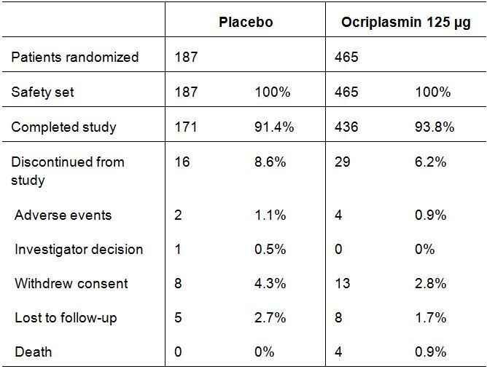
Notes: Safety Set = all patients who received study treatment, patients analyzed on treatment received. In Study TG-MV-007, one patient treated with ocriplasmin withdrew from the study due to an AE and died after withdrawal, and was counted under AEs. In Study TG-MV-006, one patient who was to receive planned placebo received ocriplasmin instead and was counted in this group.
Comment: Subject disposition in the ocriplasmin 125 µg groups in the two pivotal Phase III studies is similar to subject disposition in the ocriplasmin all doses group in the 7 completed studies combined.

Adverse events

Background
In the SCS, adverse events (AEs) that occurred from the time of injection up to an including the last study visit were considered to be treatment-emergent adverse events (TEAEs). AEs were categorized as ‘drug-related’ if the investigator considered that the events were possibly or probably related to the study drug. If the investigator considered the relationship between the study drug and the AE to be unlikely or remote then the event was considered to be unrelated to the drug. In addition to determining whether or not an AE was ‘drug-related’, the investigator was also responsible for assigning standard severity categories to the TEAEs. AEs were generally described using the MedDRA preferred term unless, otherwise identified as being the verbatim term used by the investigator in reporting the AE.
In the two pivotal Phase III studies, patients in both treatment groups received the same volume of fluid (100 μL) injected IVT, and had ocular and non-ocular safety data collected over a period of 6 months following injection. Ocriplasmin administered by IVT injection is likely to be inactivated within several days and, consequently, for most of the 6-month follow-up the concentration of ocriplasmin in the eye is likely to be negligible. Furthermore, any ocriplasmin absorbed systemically is likely to be rapidly inactivated within seconds in the circulation by α2-antiplasmin and the clearance from the circulation of the inactive ocriplasmin/α2-antiplasmin complex has a half-life (t_{1/2}) of several hours.
In the two pivotal Phase IIII studies, of the patients undergoing vitrectomy in the study eye by Month 6 in the placebo and ocriplasmin groups (n = 50 versus n = 82; respectively), 48 patients in the placebo group underwent vitrectomy after Day 28 (that is, 25.5% of the total population of 188) compared with 79 patients in the ocriplasmin group (that is, 17.0% of the total population of 464). Consequently, as there are known risks associated with vitrectomy, interpretation of the safety data after Day 28 might be confounded by patients who underwent vitrectomy after that time-point.

Overview of adverse events
An overview of AEs reported in the two pivotal Phase III studies is in Table 14. In addition, summaries of the AEs of from the individual CSRs of the two pivotal studies are provided.
Table 14: Pivotal Phase III studies, overview of adverse events; safety set.
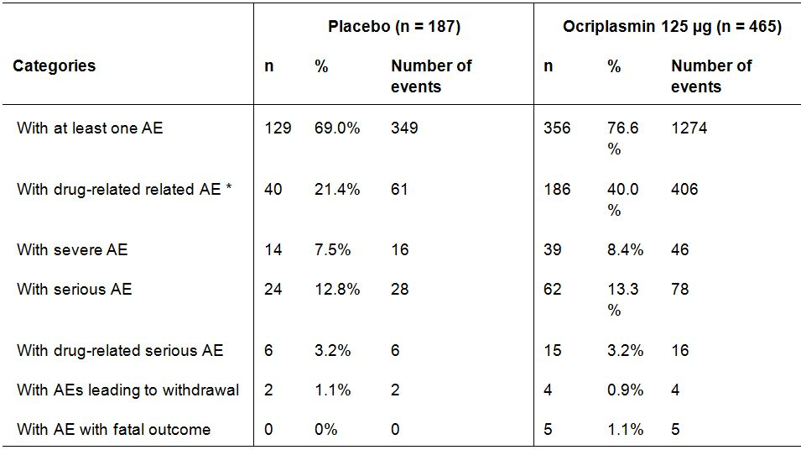
* AEs considered by the investigator to be possibly or probably related to the drug.
Comment: The proportion of patients with at least one AE (any) was higher in the ocriplasmin group than in the placebo group. In particular, the proportion of patients with investigator defined drug-related AEs was approximately 2-fold greater in the ocriplasmin group compared with placebo (40.0% versus 21.4%, respectively). However, the proportion of patients with serious AEs (both irrespective of treatment and drug-related) was similar in the two treatment groups. The number of patients with AEs leading to withdrawal from the study studies was small in both treatment groups, and the incidence was similar in the two groups. No deaths were reported in the placebo group, while 5 deaths (1.1%) were reported in the ocriplasmin 125 µg group. The AE profile for ocriplasmin 125 µg in the two pivotal studies was similar to that for ocriplasmin all doses in the 7 completed studies combined.
The overall AE profile was similar in the two pivotal Phase III studies reported separately, but AEs in both treatment groups occurred more commonly in Study TG-MV-006 than in Study TG-MV-007. In Study TG-MV-006, AEs (any) were reported in 72.6% of patients in the placebo group and 82.7% of patients in the ocriplasmin 125 µg group, and the corresponding figures for Study TG-MV-007 were 64.2% and 71.8%. In Study TG-MV-006, ocular AEs (any) in the study eye were reported in 61.3% of patients in the placebo group and 74.1% of patients in the ocriplasmin group, and the corresponding figures for Study TG-MV-007 were 51.9% and 66.1%. The reason for the imbalance in the incidence of AEs between the two studies is unknown. It may relate to the fact that Study TG-MV-006 was undertaken in the USA while Study TG-MV-007 was undertaken in Europe. However, differences in medical practice between the two geographical regions should not have contributed to the differences, given that the protocols for the two studies were identical.

Adverse events regardless of relationship to the study drug

Overview in the two pivotal Phase III studies
AEs reported in a least 2% of patients treated with ocriplasmin 125 µg are in Table 15, and the corresponding results for the 7 completed studies combined are presented.
Table 15: Pivotal Phase III studies, overview of adverse events reported for at least 2% of patients treated with ocriplasmin 125 µg; safety set.
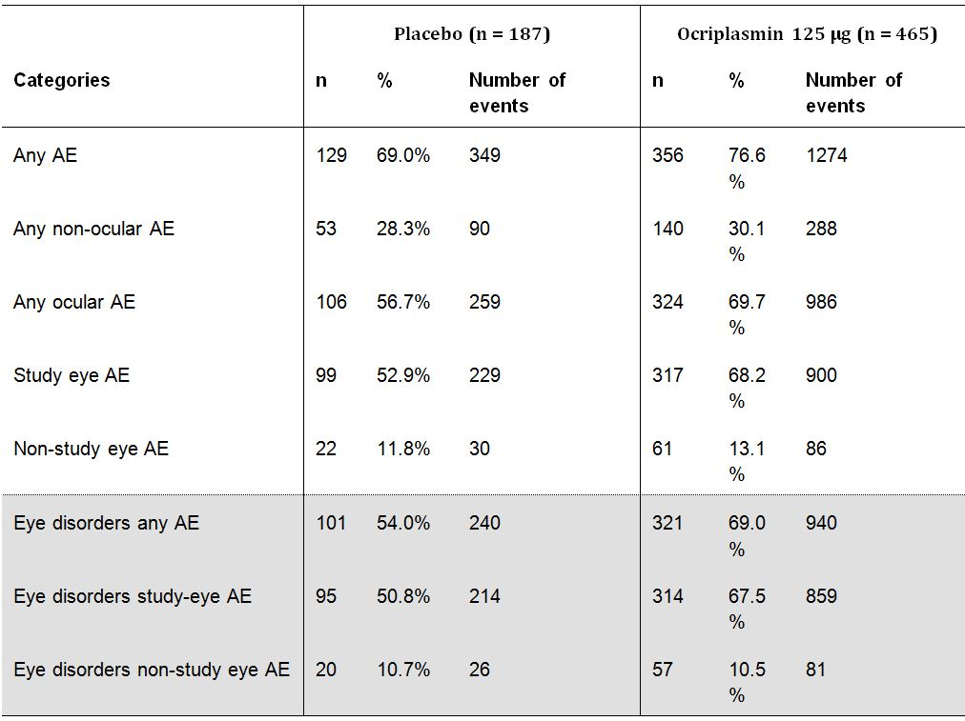
Comment: In the pivotal Phase III studies, AEs (any) occurred notably more frequently in patients in the ocriplasmin 125 µg group than in the placebo group, as did ocular AEs (any), AEs in the study eye, eye disorders (any) and eye disorders in the study eye. However, non-ocular AEs (any), non-study eye AEs, and eye disorders in the non-study eye occurred in a similar proportion of patients in the two treatment groups. The overall pattern of AEs was similar in the pivotal Phase III studies and in 7 completed studies combined.

Ocular adverse events in the study eye in the pivotal phase III studies
In the pivotal Phase III studies, ocular AEs in the study eye reported in greater than or equal to 5% of patients in the ocriplasmin 125 µg group (versus placebo) were: vitreous floaters (16.8% versus 7.5%); conjunctival haemorrhage (14.6% versus 12.8%); eye pain (13.1% versus 5.9%); photopsia (11.8% versus 2.7%); vision blurred (8.4% versus 3.2%); macular hole (6.7% versus 9.6%); visual acuity reduced (6.2% versus 4.3%); retinal oedema (5.4% versus 1.1%); and visual impairment (5.6% versus 1.6%). All ocular AEs occurring in greater than or equal to 5% of patients in the ocriplasmin 125 µg group were ‘system organ class’ (SOC) events categorized as ‘eye disorders’. All ocular AEs occurring in greater than or equal to 5% of patients in the ocriplasmin 125 µg group were reported more commonly in this group than in the placebo group, apart from macular hole.
In the pivotal Phase III studies, ocular AEs in the study eye reported in < 5% and greater than or equal to 2% of patients in the ocriplasmin 125 µg group and greater than or equal to 1% more commonly than in the placebo group were: macular oedema (4.1% versus 1.6%); anterior chamber cells (3.7% versus 2.7%); photophobia (3.7% versus 0%); ocular discomfort (2.8% versus 1.1%); vitreous detachment (2.6% versus 1.1%); iritis (2.6% versus 0%); dry eye (2.4% versus 1.1%); and metamorphopsia (2.2% versus 0.5%). Ocular AEs in the study eye reported in < 5% and greater than or equal to 2% of patients in the ocriplasmin 125 µg group and greater than or equal to 1% less commonly than in the placebo group were intraocular pressure increased (3.8% versus 5.3%) and cataract (2.4% versus 4.3%).
Ocular AEs in the study eye reported in greater than or equal to 2% of patients treated with ocriplasmin 125 µg in the pivotal Phase III studies and all 7 completed studies combined are summarized. The pattern of ocular AEs in the study eye in the 7 completed studies combined is generally similar to that in the pivotal studies.
The pattern of ocular AEs reported irrespective of study eye was similar to that reported for ocular AEs reported in the study eye, and shows that most of the ocular AEs were reported in the study eye rather than the non-study eye. In the pivotal Phase III studies, there were 986 ocular AEs in the ocriplasmin 125 µg group, 900 (91.3%) in the study eye and 86 (8.7%) in the non-study eye.

Non-ocular adverse events
In the pivotal Phase III studies, 288 non-ocular AEs were reported in 30.1% (n = 140) of patients in the ocriplasmin group compared with 90 events in 28.3% of patients (n = 53) in the placebo group. In the pivotal Phase III studies, non-ocular AEs occurring in greater than or equal to 2% of patients in the ocriplasmin 125 µg group (versus placebo) were: bronchitis (2.8% [n = 13] versus 1.6% [n = 3]); nausea (2.6% [n = 12] versus 0.5% [ = 1]); and headache (2.6% [n = 12] versus 2.1% [n = 4]). Of note, each of the three events was reported more commonly in the ocriplasmin 125 µg group than in the placebo group. In the 7 completed studies combined, non-ocular AEs occurred in a similar proportion of patients in the ocriplasmin all doses and control groups (34.4% versus 32.2%, respectively). There were a total of 490 non-ocular AEs reported in the all ocriplasmin dose group in the 7 completed studies combined and these included 288 (58.8%) in the ocriplasmin 125 µg group from the pivotal Phase III studies.
Non-ocular AEs of general regulatory interest in the pivotal Phase III studies are summarized below:
- Hepatobiliary disorders: no AEs in either treatment group.
- Renal and urinary disorder: 1 (0.5%) patient in the placebo group (1 event of bladder disorder) versus 4 (0.9%) patients in the ocriplasmin 125 µg group (6 events – 4 x acute renal failure, 1 renal disorder, 1 x renal failure chronic).
- Blood and lymphatic disorders: 2 (1.1%) patients in the placebo group (2 events – 1 each for anaemia and iron deficiency anaemia) versus 2 (0.4%) patients in the ocriplasmin 125 µg group (2 events – 1 each for anaemia and iron deficiency anaemia).
- Cardiac disorders: 1 (0.5%) patient in the placebo group (1 event of angina pectoris) versus 6 (1.3%) patients in the ocriplasmin group (10 events – 3 x angina pectoris, 2 x sick sinus syndrome, 1 each for unstable angina, arrhythmia, arteriosclerosis coronary artery, atrial fibrillation, cardiac failure congestive).
- Vascular disorders: 2 (1.1%) patients in the placebo group (2 events – 1 each of arteriosclerosis, hypertension) versus 4 (0.9%) patients (5 events – 3 x hypertension, 1 each for femoral arterial stenosis and hypotension).
- Skin and subcutaneous tissue disorders: 5 (2.6%) patients in the placebo group (6 events - 1 each for cutis laxa [study eye], cutis laxa [non-study eye], ecchymosis [study eye], pemphigoid, skin disorder, skin hyperpigmentation) versus 9 (1.9%) patients (9 events – 2 x photosensitivity [study eye], 2 x rash, 1 each for skin irritation, dermatitis, dermatitis allergic, pain of skin, pruritus).

Suspected adverse drug reactions – SCS review

Overview
The SCS included a review of AEs considered to be suspected adverse drug reactions (ADRs), based on a reasonable possibility that the events were treatment-related, by applying the following 2-part criteria. Part 1 criteria were – (a) the incidence of study eye AEs was greater than or equal to 0.5 % (greater than or equal to 3 patients) in the ocriplasmin group in the pivotal Phase III studies and was at least 2 times the incidence in the placebo group. The incidence for non-ocular events was greater than or equal to 1% and at least 2 times the incidence in the placebo group; OR (b) the incidence in the ocriplasmin group was < 2 times the incidence in the placebo group but a relationship to ocriplasmin could not be ruled out based on clinical judgment. The Part 2 criteria were - AEs that met the part 1 criteria were then evaluated to determine if the event had 1 or more of the following characteristics suggesting a causal relationship to treatment: occurred within 0-7 days of the injection; occurred pre-vitrectomy; considered treatment-related as judged by the investigator; and/or considered biologically plausible.

Suspected ocular adverse drug reactions (ADRs) in the study eye
In the pivotal Phase III studies, suspected ocular ADRs in the study eye occurring in greater than or equal to 5% of patients in the ocriplasmin 125 µg group (versus placebo) were: vitreous floaters (16.8% versus 7.5%); eye pain (13.1% versus 5.9%); photopsia (11.8% versus 2.7%); vision blurred (8.4% versus 3.2%); visual acuity reduced (6.2% versus 4.3%); visual impairment (5.4% versus 1.1%); and retinal oedema (5.4% versus 1.1%). All suspected ADRs in the study eye occurring in greater than or equal to 5% of patients in the ocriplasmin 125 µg group were reported more frequently in the active treatment group than in the placebo group.
In the pivotal Phase III studies, suspected ocular ADRs in the study eye occurring in < 5% and greater than or equal to 1% of patients in the ocriplasmin group and greater than or equal to 1% more frequently than in the placebo group were: macular oedema (4.1% versus 1.6%); anterior chamber cells (3.7% versus 2.7%); photophobia (3.7% versus 0%); ocular discomfort (2.8% versus 1.1%); vitreous detachment (2.6% versus 1.1%); iritis (2.6% versus 0%); dry eye (2.4% versus 1.1%); metamorphopsia (2.2% versus 0.5%); retinal degeneration (1.7% versus 0.5%); eyelid oedema (1.5% versus 0%); retinal pigment epitheliopathy (1.5% versus 0%); macular degeneration (1.3% versus 0.5%); miosis (1.1% versus 0%); scotomata (1.1% versus 0%); and corneal abrasion (1.1% versus 0%). There were no suspected ocular ADRs in the study eye occurring in < 5% and greater than or equal to 1% of patients in the ocriplasmin group occurring greater than or equal to 1% less frequently than in the placebo group.
The incidence of nausea, back pain, dyspnoea, conjunctivitis and conjunctivitis allergic in the pivotal Phase III studies met Part 1 criteria, but these events were not considered by the sponsor to be suspected ADRs.
The profiles of suspected ADRs reported in the pivotal Phase III study was consistent with that reported in all 7 completed studies combined.
Comment: All suspected ADRs were ocular events occurring in the study eye. In the pivotal Phase III studies nearly all suspected ADRs occurred more commonly in patients in the ocriplasmin 125 µg group than in the placebo group. The sponsor states that the most common suspected ADRs were consistent with pharmacologic vitreolysis (that is , PVD-induction related events, such as vitreous floaters, photopsia), or were due to inflammation/irritation resulting from either the injection procedure and/or the drug. Anatomic and functional retinal findings such as vision-related AEs and retinal oedema were also considered to be events potentially related to the mechanism of action of ocriplasmin. The majority of suspected ADRs in the study eye were categorized as mild or moderate in intensity, while severe suspected ADRs occurred infrequently.

Suspected ADRs by dose in the combined safety set
Suspected ADRs in the study eye were compared by ocriplasmin dose in various safety sets. The small number of patients in the 50 µg and 175 µg groups limits interpretation of the dose response data. In the 7 completed studies combined, the numbers of patients (n) in the ocriplasmin dose groups were 25 µg (n = 67), 50 µg (n = 10), 75 µg (n = 71), 125 µg (n = 582), and 175 µg (n = 11). Suspected serious ADRs for which there was a dose-response relationship for the three doses with reasonable subject numbers (that is , 25 versus 75 versus 125 µg) in the combined safety set (7 completed studies) were: vitreous floaters (4.4% versus 15.5% versus 17.4%); visual acuity reduced (1.5% versus 2.8% versus 6.4%); visual impairment (0% versus 1.4% versus 4.5%); retinal oedema (1.5% versus 2.8% versus 5.0%); vitreous detachment (0% versus 1.4% versus 2.1%); and dry eye (0% versus 1.4% versus 2.2%).

Suspected ADRs in the study eye - time to onset
Suspected ADRs in the study eye occurring during the first 7 days after injection and from Day 8 to the end of study (EOS) visit are summarized. The incidence of ADRs occurring in the first 7 days after injection (0-7 days) is considered to be a more reliable estimate of the acute risks associated with IVT injection of ocriplasmin 125 µg administered as a single dose. In the pivotal Phase III studies, when compared with the incidence for the entire study period more than half of the events reported in the ocriplasmin 125 μg group occurred during the first 7 days after injection for most of the suspected ADRs. However, no suspected ADRs occurred within the first 7 days after injection for retinal degeneration, retinal pigment epitheliopathy, macular degeneration and diplopia. Less than half of the total number of events occurred during the first 7 days after injection for macular oedema, dry eye and scotoma. In the pivotal Phase III studies placebo group, at least half of the total number of events occurred during the first 7 days after injection for eye pain, ocular discomfort, dry eye and ocular hyperaemia. The results for the 7 completed studies combined were consistent with the results for the pivotal Phase III studies.

Suspected ADRs in the study eye – time to resolution
In the pivotal Phase III studies, at least one ocular AE in the study eye was reported in 99 patients in the placebo group and 317 patients in the ocriplasmin 125 µg group. Resolution of the AEs was reported in 53 (53.5%) patients in the placebo group and 152 (47.9%) patients in the ocriplasmin 125 µg group, and the respective figures for the two treatments for AEs resolving with sequelae were 2 (2.0%) patients and 2 (6.3%) patients, and for ongoing AEs were 44 (44.4%) and 163 (51.4%).
The outcomes for suspected ADRs in the study eye in the two treatment groups in the pivotal Phase III studies for reactions reported in greater than or equal to 5% of patients in the ocriplasmin 125 µg group are summarized below in Table 16.
Table 16: Pivotal Phase III studies, suspected ADRs in the study eye outcomes for ADRs occurring in greater than or equal to 5% of patients in the ocriplasmin 125 µg group.
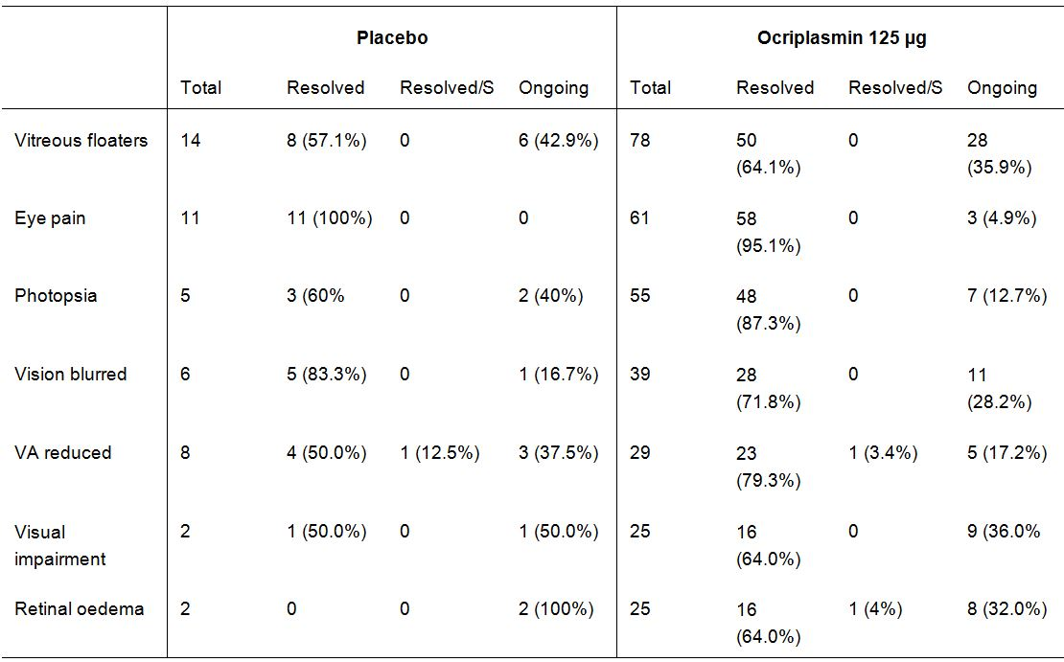
Notes: VA = visual acuity; Resolved/S = resolved with sequelae.
Comment: The majority of suspected ADRs reported in the ocriplasmin 125 µg group in the pivotal Phase III studies resolved without sequelae.

Suspected ADRs in the study eye considered to be drug-related AEs by the investigator
In the pivotal Phase III studies, suspected ADRs in the study eye considered to be drug-related AEs by the investigator occurred in 21.4% (40/187) of patients in the placebo group and 40.0% (186/465) of patients in the ocriplasmin 125 µg group. In these studies, suspected ADRs in the study eye considered to be drug-related AEs by the investigator occurring in greater than or equal to 5% of patients in the ocriplasmin group (versus placebo) were: vitreous floaters (13.8% versus 4.8%); photopsia (9.0% versus 1.6%); and vision blurred (5.2% versus 0.5%).
In the pivotal Phase III studies, suspected ADRs in the study eye considered to be drug-related AEs by the investigator occurring in < 5% and greater than or equal to 2% of patients in the ocriplasmin group and greater than or equal to 1% more frequently than in the placebo group were: eye pain (4.5% versus 1.6%); visual acuity reduced (4.3% versus 0.5%); visual impairment (3.7% versus 0%); retinal oedema (3.7% versus 1.1%); anterior chamber cell (2.4% versus 1.1%); photophobia (2.6% versus 0%); and vitreous detachment (2.2% versus 0.5%).
The pattern of suspected ADRs in the study eye considered to be drug-related AEs by the investigator in the 7 completed studies combined was similar to that for the pivotal Phase III studies. The results for the two data sets are summarized.
Comment: The assessment of suspected ADRs using the two criteria applied in the SCS provided a more conservative assessment of AEs considered to be drug-related than the assessment of suspected ADRs in the study eye considered to be drug-related AEs by the investigator. However, the individual AEs considered to be drug-related were similar for the two assessments.

Death and serious adverse events

Death
The SCS listed 8 deaths reported from all IVT injection studies completed or on-going as of 31 March 2011 (2 occurring with sham injection and 6 with ocriplasmin). These 8 deaths are listed below in Table 17.
Table 17: Deaths reported in the SCS up to data cut-off date as of 31 March 2011.
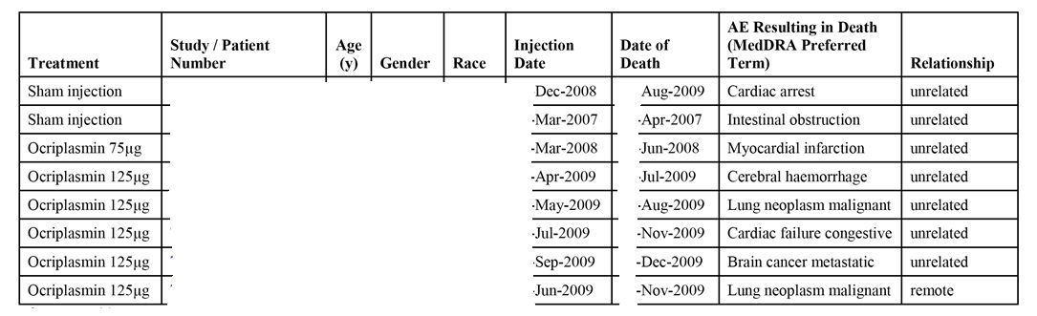
Study/patient Number, age, gender and race have been redacted from the table
The 120-Day Safety Update Report included two additional deaths reported in clinical studies with ocriplasmin/sham covered by the period of the report from 1 April 2011 to 31 May 2012. One death occurred in a [information redacted] infant with significant ongoing medical conditions, including grade 4 bilateral ventricular bleed at birth, and a medical history consistent with a complicated course in an extremely low birth weight premature infant. The infant died 93 days after the injection date. The second case involved a [information redacted] patient with a medical history of high blood pressure, who died following had a myocardial infarction 222 days after the injection date. The study medication in both studies was identified as ocriplasmin or sham (presumably the blind has not yet been broken as both studies are ongoing), and both deaths were considered unrelated to study medication.
Comment: In the two pivotal Phase III studies, 5 deaths (1.1%) have been reported in 465 patients in the ocriplasmin 125 µg group, and no deaths have been reported in 187 patients in the placebo group. The 5 deaths in the ocriplasmin 125 µg group were reported in women aged greater than or equal to 76 years. Four (4) of the 5 deaths were considered unrelated to treatment, while in 1 of the deaths (malignant lung neoplasm) the relationship between treatment was described as ‘remote’. Of the completed and ongoing IVT injection studies (database cut-off 31 May 2012) there have been a total of 10 deaths (6 in the ocriplasmin group, 2 in the sham group and 2 with treatment still masked). If it assumed that the masked treatment is ocriplasmin (worst case scenario), based on 976 patients in the ocriplasmin group in the database the incidence of death with the drug 0.8% (8/976), and based on 341 patients in the control (placebo/sham) group the incidence of death is 0.6% (2/341) with control.

Other serious adverse events (SAEs)

Summary of Clinical Safety (SCS)
The reported incidence of SAEs (any) was similar for patients in the ocriplasmin and placebo/control groups in the pivotal Phase III studies (13.3%, n = 62 versus 12.8%, n = 24; respectively), and in the 7 completed studies combined (13.5%, n = 100 versus 13.8%, n = 34; respectively).
The majority of SAEs were ocular events in the study eye, and these events were reported more frequently in patients in the placebo/control group than in the ocriplasmin group in both the pivotal Phase III studies (10.7%, n = 20 versus 7.7%, n = 36, respectively), and the 7 completed studies combined (8.9%, n = 22 versus 7.7%, n = 57, respectively). SAEs in the study eye for the pivotal Phase III and 7 combined completed studies are summarized. The most commonly reported SAE in the study eye was macular hole (includes progression of macular hole), which had a higher incidence in patients in the placebo/control group than in the ocriplasmin group in both the pivotal Phase III studies (8.6%, n = 16 versus 5.2%, n = 24, respectively), and the combined studies (6.5%, n = 16 versus 4.7%, n = 35, respectively). In the pivotal Phase III studies, the only other ocular SAEs occurring in greater than or equal to 1% of patients in either treatment group were vitreous adhesions (1.1%, n = 5, ocriplasmin versus 0.5%, n = 1, placebo), and retinal detachment (0.4%, n = 2, ocriplasmin versus 1.6%, n = 3, placebo). In the combined studies, macular hole (including progression of macular hole) was the only ocular SAE occurring in greater than or equal to 1% of patients in either treatment group.
In the pivotal Phase III studies, the majority of the SAEs (any) in both treatment groups were considered to be unrelated to the study drug. All SAEs considered to be drug-related were ocular events in the study eye and reported in the same proportion of patients in both the ocriplasmin and placebo groups (3.2%, n = 15 versus 3.2%, n = 6, respectively). The 16 drug-related SAEs in the 15 patients in the ocriplasmin 125 µg group were macular hole (x9), retinal detachments (x2), vitreous adhesion (x2), visual acuity reduced (x2), and posterior capsule opacification (x1). The 6 drug-related SAEs in the 6 patients in the placebo group were macular holes (x4), macular oedema (x1) and vitreous adhesions (x1).
As of the cut-off date of 31 March 2011, 79 patients in the on-going clinical trials were estimated to have received ocriplasmin and 22 were estimated to have received placebo or sham. SAEs were reported in 12 patients in these on-going studies, and in 5 of these patients the SAEs were considered to be possibly or probably related to treatment and unmasking showed that the study drug was ocriplasmin in each patient. Treatment-related SAEs in the 5 patients treated with ocriplasmin were: visual acuity reduced/retinal detachment in the study eye in 2 patients; transient blindness in the study eye in 1 patient; visual acuity reduced in the study eye in 1 patient; and lens dislocation in 1 patient.

120-day safety update report
The 120-Day Safety Update Report included information on 39 SAEs reported in 30 patients in on-going studies for the period 1 April 2011 to 31 May 2012. The most commonly reported SAEs were progression of pre-existing macular hole (6 events), intraocular pressure increased (3 events), retinal detachment (3 events), visual acuity reduced (3 events) and vitreous adhesions (3 events). Of note, protocol procedures in [information redacted] sponsored clinical studies required reporting of progression of macular hole and worsening of macular traction resulting in vitrectomy as SAEs, which increased the reporting frequency for these events.
Fourteen (14) of the SAES from 10 patients were considered to be treatment-related by the study investigator and/or [information redacted]. These events were visual acuity reduced (3 events), macular hole and intraocular pressure increased (2 events each), and 1 event each of blindness transient (in a patient with increased intraocular pressure), lens dislocation, pupillary reflex impaired, retinal detachment, retinal toxicity, retinal vasculitis and vitreous adhesions.

Withdrawal from the study due to adverse events

Summary of clinical safety (SCS)
Since the majority of patients only received a single dose treatment, withdrawal refers to withdrawal from the study rather than withdrawal (discontinuation) of treatment. In the pivotal Phase III studies, withdrawal from the study due to AEs was reported in a similar proportion of patients in the ocriplasmin and placebo groups (0.9%, n = 4 versus 1.1%, n = 2; respectively). In the placebo group, 1 of the withdrawals was considered by the investigator to be possibly treatment related (subcapsular cataract). Withdrawals due to AEs from the 7 completed studies are summarized below in Table 18.
Table 18: SCS – Patients with adverse events leading to study withdrawal; safety set.
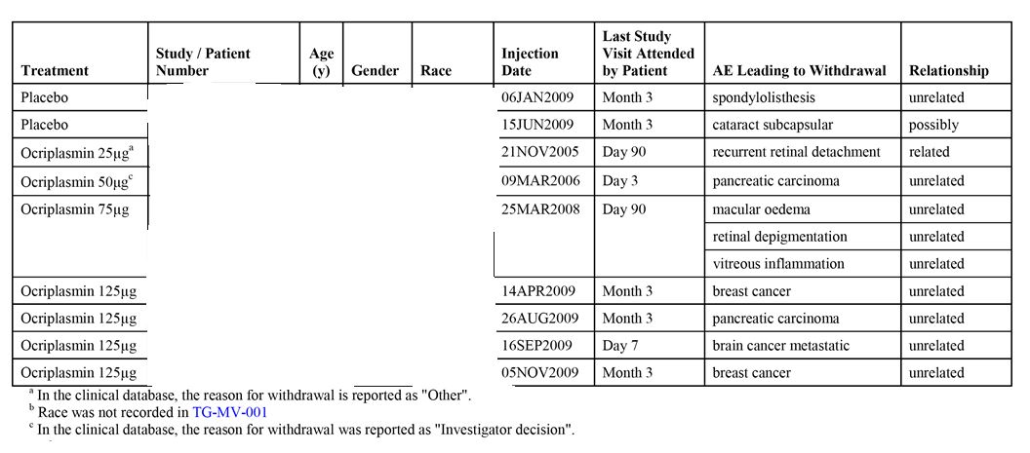
Study/patient Number, age, gender and race have been redacted from the table.

120-day safety update report
The 120-Day Safety Update Report included information on 3 patients in on-going studies who discontinued due to adverse events: 1 subject (79 years, male) in the ocriplasmin 125 µg/sham group (study number 005) withdrew due to brain cancer metastatic; 1 subject (88 years, female) in the ocriplasmin 125 µg/sham group (study number 005) withdrew due to myocardial infarction; 1 subject (6 months of age, male) in the ocriplasmin 175 µg group (number 009) withdrew due to ventriculoperitoneal shunt malfunction resulting in encephalopathy.

Ocular adverse events of special interest in the study eye

Functional retinal findings

Vision alteration
Vision Alteration events consisted of the following grouped vision-related AEs: metamorphopsia, scotoma, vision blurred, visual acuity reduced, visual acuity reduced transiently, visual field defect, visual impairment, blindness, halo vision, loss of visual contrast sensitivity, and visual brightness.
In both the pivotal Phase III studies, and the 7 completed studies combined the proportion of patients in the ocriplasmin groups with vision alteration was approximately 2.7-fold greater than in the placebo/control groups, with the difference between the two treatment groups being driven primarily by events occurring within the first 7 days of injection.
In the pivotal Phase III studies, vision alteration was reported in 7.5% (n = 14) of patients in the placebo group (0.5%, 0-7 days; 7.0%, 8 days to EOS) and 20.2% (n = 94) of patients in the ocriplasmin 125 µg group (13.8%, 0-7 days; 6.5%, 8 days to EOS). Individual ‘vision alteration’ terms reported in greater than or equal to 5% of patients in the ocriplasmin group (versus placebo) were: vision blurred (8.4%, n = 39 versus 3.2%, n = 6); visual acuity reduced (6.2%, n = 29 versus 4.3%, n = 8); and visual impairment (5.4%, n = 25 versus 1.1%, n = 2). The results ‘vision alteration’ in the pivotal Phase III studies are summarized below in Table 19. In all 7 completed studies combined, vision alteration occurred in 6.1% (n = 15) of patients in the control group (0.4%, 0-7 days; 5.7%, 8 days-EOS), and 16.1% (n = 119) of patients in the ocriplasmin all dose group (10.3%, 0-7 days; 5.8%, 8 days-EOS).
Table 19: Pivotal Phase III studies, visual alteration; safety set.
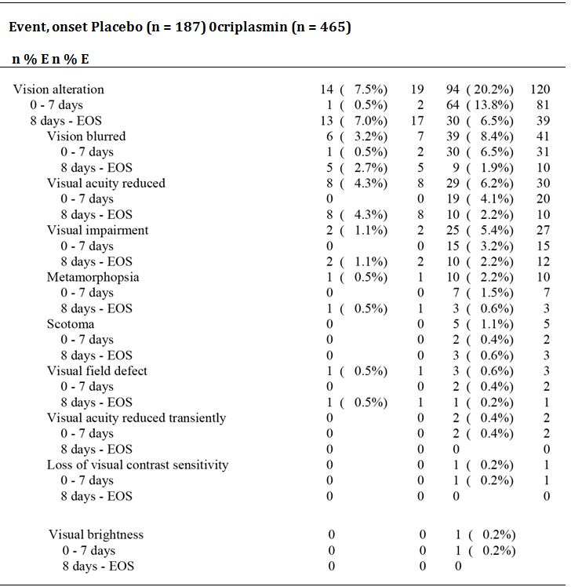
Notes: n = number of patients; E = number of events; EOS = end of study.
In the pivotal placebo-controlled studies, the majority of all vision alteration AEs in the ocriplasmin 125 μg group were considered drug-related by the investigator (14.6%, related; 5.6% unrelated), while most vision alteration AEs in the placebo group were considered unrelated to treatment (2.2%, related; 5.3%, unrelated).

Colour vision and/or ERG abnormalities

Pivotal phase III studies
Colour vision alteration/ERG abnormalities in the pivotal Phase III studies were reported in no patients in the placebo group and 3 (0.6%) patients in the ocriplasmin 125 µg group (chromatopsia x2; xanthopsia x1).

120-day safety update report
The 120-Day Safety Update Report provided a review of colour vision/ERG abnormalities in the ocriplasmin studies up to 31 March 2011. ERGs were prospectively obtained in two early Phase II studies (TG-MV-001 and TG-MV-002).
In TG-MV-001, an open-label, dose ranging study, ocriplasmin was administered to patients before planned vitrectomy for VMT, diabetic macular oedema, and macular hole. ERGs were obtained at baseline, on post-injection Day 7 (Cohort 3 only, n = 9) and on post-operative Day 28. At post-injection day 7 (cohort 3 only, n = 9), 7 patients had a repeated normal status, and 1 patient had a normal to abnormal status. One patient had an abnormal ERG at baseline, and this patient still had an abnormal ERG 7 days post-injection. With regard to the post-operative changes in ERG status at day 28 (all 6 cohorts), 41 patients had a normal baseline with no change at day 28 (73%), 6 patients had a normal baseline with a change at day 28 (11%). Of 9 patients with an abnormal baseline, a change was reported in 1 patient (2%).
In TG-MV-002, a randomized, sham-injection controlled, double-masked, ascending dose study in patients with diabetic macular oedema, ERGs were obtained at baseline and 1 month after ocriplasmin injection. In the 25 µg group (n = 8), normal ERG findings at baseline were observed in 7 patients and abnormal findings in 1 patient, with all 8 patients reporting normal findings at Day 28. In the 75 µg group (n = 15), normal ERG findings at baseline were observed in 12 patients and abnormal findings in 3 patients, and at Day 28 normal findings were reported in 11 patients, abnormal findings in 3 patients, and data missing in 1 patient. In the 125 µg group (n = 15), normal ERG findings at baseline were observed in 10 patients and abnormal findings in 5 patients, and at Day 28 normal findings were reported in 8 patients, abnormal findings in 6 patients, and data missing in 1 patient. In the sham group (n = 13), normal ERG findings at baseline were observed in 8 patients and abnormal findings in 5 patients, and at Day 28 normal findings were reported in 7 patients, abnormal findings in 5 patients, and no information for 1 patient.
Because no signals related to ERG findings were identified in the two early Phase II studies, routine ERGs were not obtained in the two pivotal Phase III studies (TG-MV-006 and TG-MV-007). However, following the two pivotal Phase III studies, signals emerged in two, single-centre, open-label Phase II studies (TG-MV-008 and TG-MV-010), conducted at the same site, with dyschromatopsia (both studies) and ERG abnormalities (TG-MV- 008 only) being reported. After dyschromatopsia was reported in Study TG-MV-008, the investigator obtained ERGs for patients reporting dyschromatopsia. The TG-MV-008 protocol was subsequently amended specifying baseline ERGs measurements for all patients. No ERGs were obtained in Study TG-MV-010. Once a signal for dyschromatopsia and/or ERG abnormalities was identified in studies of ocriplasmin, the sponsor included colour vision testing for all patients and an ERG sub-study in the ongoing masked TG-MV-014 study.
Based on the data cut-off date of 31 March 2011, there were a total of 16 out of 820 patients (2.0%) with dyschromatopsia, and 8 of these 16 patients had both dyschromatopsia and ERG abnormalities. All of the 16 dyschromatopsia cases (generally described as yellowish vision) were reported as mild in intensity, and 14 of the 16 cases (87.5%) were reported as resolved. Of the remaining 2 cases, 1 patient died 18 months post-injection, and 1 patient was lost to follow-up (last assessment 5.5 months after treatment). Most cases occurred on the day of injection, and median time to resolution was 3 months (range: 1, 28 months). For those cases where resolution information is not available, there was no apparent adverse correlation between the presence of dyschromatopsia and adverse functional outcome at the end of the study since all patients had BCVA values at the end of the study or at follow-up that were within 5 letters or better than baseline.
There were 10 of 820 patients (1.2%) with ERG abnormalities (a- and b-wave amplitude decrease); TG-MV-007, n = 1; TG-MV-008, n = 9. Eight (8) of the 10 patients with ERG abnormalities also had dyschromatopsia. Five (5) patients with abnormal ERGs had no ERGs at baseline, and it was conservatively assumed that these patients had normal baseline ERGs. Only 1 of the 10 abnormal ERG cases was reported as an AE by the investigator (Study TG-MV-008). The median time to onset of abnormal ERGs was 1 week (range 1 week, 1 month), but in most patients time to onset was determined by the predefined time-points for scheduled visits in the study protocol. In 6 of the 10 patients (60%), ERG abnormalities were reported as resolved, and the median time to resolution was 6 months (range: 3, 6 months). For the 4 patients with no resolution information, there was no apparent correlation between the presence of ERG abnormalities and adverse functional outcome at the end of the study since all patients had BCVA values that were within 5 letters or better than baseline.
Overall, there were 18 of 820 patients (2.2%) from the completed and ongoing studies who experienced dyschromatopsia and/or ERG changes. VMA status was measured in 14 of these 18 patients, and VMA resolution was documented in 10 of the 14 patients with data. Of the 18 patients with dyschromatopsia and/or ERG changes, 13 reported vitreous floaters and 6 reported photopsia. These findings were similar to the vision-related AEs and are consistent with a potential mechanical aetiology associated with PVD.
As of 31 May 2012, 177 patients have been treated in the ongoing masked Study TG-MV-014. Of these 177 patients, it was estimated that 118 have received ocriplasmin and 59 sham. Of the 177 patients (still masked), dyschromatopsia has been reported in 34 (19.2%), 11 (6.2%) have had clinically significant ERG abnormalities reported, and 4 (2.6%) have had both dyschromatopsia and clinically significant ERG abnormalities reported. The frequency of dyschromatopsia and ERG abnormalities from TG-MV-014 in the ocriplasmin and sham groups cannot be accurately determined at this time since the study is ongoing and masked.
There has been one serious case of ‘photoreceptor toxicity’ reported in Study TG-MV-014, but visual acuity was within 2 letters of baseline values and follow-up information indicates the ERG abnormalities and colour-vision related findings are improving. Visual acuity for the other patients with dyschromatopsia and/or ERG changes in this study was within 5 letters or better than baseline, except for 3 patients who had a BCVA decrease of 7-9 letters from baseline. The sponsor notes that, in contrast to previous studies, the protocol for Study TG-MV-014 asks for systematic recording and reporting of ERG and colour vision tests as part of the study procedures which may be factors accounting for the increased frequency of these reports in the study. A DSMC is being convened to further monitor the safety in patients participating in this ongoing study.
In addition to the ERG abnormalities in TG-MV-014, there has been 1 patient with serious acute transient vision decrease from the ongoing masked exudative (wet) AMD Study (TG-MV-005) and ERG abnormality. In this patient, an ERG obtained the day after injection was reported as showing abnormalities, but no pre-treatment ERG had been obtained for comparison. This patient is being followed-up and the last BCVA obtained was within 5 letters of baseline.

Serious and/or severe transient vision decrease
Serious and/or severe acute (that is, within 7 days of injection) transient vision decreases with no alternative explanation were reported in 0.9% patients (9 of estimated 976) who received ocriplasmin in completed and ongoing studies.
The submission included an ‘Integrated Summary of Clinical Retinal Findings’ (ISCRF) based on data as of 31 March 2011. The ISCRF identified 6 (0.7%) patients out of an estimated 820 who developed temporary, but significant (serious or severe) visual impairment within 24 hours of injection without an alternative explanation on full ophthalmologic examination. Visual acuity ranged from 20/200 to hand motions only, and was associated with transient visual field constriction in 3 of the 6 patients. In addition, 7 patients treated with uncontrolled, open-label ocriplasmin in a single-centre (Study TG-MV-008), developed dyschromatopsia (described as ‘yellowish vision’) and ERG changes (decreased a- and b-wave amplitude), and 2 more patients from this study had ERG changes but no symptoms of dyschromatopsia. In a separate, single-centre, uncontrolled open-label study (TG-MV-010) conducted at the same centre as TG-MV-008, 4 additional cases of dyschromatopsia were reported.
These findings prompted a detailed retrospective analysis of all the clinical retina-related data collected throughout the ocriplasmin development program. This analysis began with an independent review of the OCT scans of all patients with serious/severe acute visual impairment, and spectral domain OCT (SD-OCT) scans from Studies TG-MV-008 and TG-MV-010. ERGs from Study TG-MV-008 were also reviewed. The review was performed in a masked fashion by 3 independent assessors with extensive experience in OCT scan interpretation. The findings of this review were presented at a Data Monitoring Committee (DMC) of Retina Specialists on 8 March 2011.
The independent review (a copy of which was provided in the submission) concluded that the ‘vast majority of patients with evidence of photoreceptor dysfunction demonstrated spectral domain OCT evidence of photoreceptor regeneration and recovery of excellent visual function with resolution of their anatomic and electrophysiological abnormalities associated with visual loss and also had resolution of their baseline vitreo-macular adhesion’. The review observed that ‘large zones of bare RPE [retinal pigment epithelium] as measured by OCT prior to injection seems to be the single-greatest risk factor for the post-injection visual function changes. The development of subretinal fluid following ocriplasmin injection was associated with the decrease in visual acuity observed at day 7’. The risk profile for ocriplasmin visual function changes summarized in the review.
The minutes of the DMC of 08 March 2011 (a copy of which was provided in the submission) indicated that ‘the DMC members were unanimously in favor of moving ahead with the ocriplasmin submissions and were confident in the risk benefit profile. However, patients should be informed that in rare cases a temporary decrease in vision may occur, even if the macular hole closes or the vitreomacular traction is released.’

Changes in BCVA
The SCS included an assessment of patients with a BCVA decrease of greater than or equal to 10 letters from baseline within 7 days of treatment, with no alternative explanation for the change and irrespective of whether or not a vision-related AE was reported. The search identified 44/820 (5.4%) ocriplasmin patients and 3/269 (1.1%) placebo patients from completed and ongoing studies. BCVA returned to within 1 line (5 letters) of baseline values during the study for all patients, except in 6/820 (0.7%) ocriplasmin patients and 1/269 (0.4%) placebo patient. The most commonly reported AEs occurring within 7 days of injection in the ocriplasmin patients included vitreous floaters (12/44, 27.3%) and photopsia (8/44, 18.2%), while subretinal fluid was noted in 6 (13.6%) patients. None of these events was reported in the 3 placebo patients. These associated findings suggest a mechanical effect of ocriplasmin consistent with pharmacologic vitreolysis/PVD.
A comprehensive review by three retinal specialists, including review of OCTs, was performed for 25 of 49 ocriplasmin-treated patients who experienced an unexplained greater than or equal to 3-line loss in BCVA at any time during the pivotal Phase III studies. The majority of vision losses were considered to be due to vitreomacular traction and/or macular hole progression. It is postulated that ocriplasmin treatment may lead to additional traction resulting from incomplete enzymatic cleavage of the adhesion between the posterior vitreous cortex and the internal limiting membrane. In some cases, this may lead to enlargement or development of new macular holes.

Anatomic retinal changes
Anatomic retinal findings were based on AEs and the results of OCT scans. With the exception of macular hole, a higher incidence of retinal-related AEs was seen in the ocriplasmin group compared with placebo/control. Anatomic retinal changes of interest were retinal oedema and macular oedema, macular hole and retinal pigment changes.
In the pivotal Phase III studies, retinal/macular oedema was reported notably more frequently in patients in the ocriplasmin 125 µg group compared with the placebo group (9.5%, n = 44, versus 2.7%, n = 5). In the ocriplasmin 125 µg group, retinal oedema was reported in 5.4% (n = 25) of patients compared with 1.1% (n = 2) in the placebo group, while for macular oedema the figures were 4.1% (n = 19) and 1.6% (n = 2), respectively. Retinal pigment epitheliopathy was reported in no patients in the placebo group and 1.5% (n = 7) of patients in ocriplasmin group.
In the pivotal Phase III studies, macular hole was reported as an AE more frequently in patients in the placebo group than in the ocriplasmin 125 µg group (9.6%, n = 18 versus 6.7%, n = 31 respectively), and this difference was also seen in the 7 completed studies combined (7.7%, n = 19, control versus 6.7%, n = 50, ocriplasmin all doses).

Retinal breaks
Retinal breaks included the preferred terms retinal tears and retinal detachments. In the pivotal Phase III studies, retinal breaks occurred more frequently in patients in the placebo group than in the ocriplasmin group (4.3%, n = 8 versus 1.9%, n = 9), while in the 7 completed studies combined the proportion of patients with retinal breaks was the same in both the placebo (4.5%, n = 11) and ocriplasmin (4.5%, n = 33) groups (see Table 20).
Table 20: Summary of retinal breaks in the study eye; safety set.
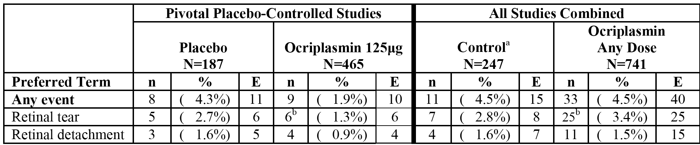
[a] Patients allocated to placebo, sham injection or no treatment. [b] The convention used in the setting of retinal detachment was to report the overriding retinal detachment as an AE and not report the associated retinal tear separately. In 1 ocriplasmin patient in the pivotal placebo-controlled studies and in 3 ocriplasmin patients in all studies combined (including the patient from the pivotal placebo-controlled studies), the associated retinal tear was also reported as an AE along with the AE of retinal detachment. Therefore, the percent of patients in the ocriplasmin group with retinal tear without detachment is 1.1% and 3.0% in the pivotal placebo-controlled studies and in all studies combined, respectively.
In the pivotal Phase III studies, most retinal breaks in both groups occurred during or after vitrectomy and were considered by the investigator to be unrelated to study drug. The incidence of retinal tears and retinal detachment that occurred pre-vitrectomy in the ocriplasmin group was 0.2% (n = 1) and 0.4% (n = 2), respectively, in the ocriplasmin 125 µg group, and 0.5% (n = 1) and 0% (n = 0), respectively, in the placebo group. The 2 (0.4%) retinal detachments in the ocriplasmin group and the 1 (0.5%) retinal tear in the placebo group occurring pre-vitrectomy were the only retinal breaks considered by the investigator to be drug-related. Most of the AEs occurred during the time interval of Day 8 to EOS, and in each treatment group the AE was ongoing at the last study visit for 1 patient. The investigators considered retinal detachment to be a SAE for 2 (0.4%) patients in the ocriplasmin 125 μg group and 3 (1.6%) patients in the placebo group. All retinal tears were considered by the investigator to be non-serious AEs.

Cataracts
Cataracts included the preferred terms cataract, cataract cortical, cataract nuclear, lenticular opacities, posterior capsule opacification and cataract subcapsular. In the pivotal Phase III studies, cataract (any event) occurred more frequently in phakic patients treated with placebo than with ocriplasmin 125 µg (11.9%, versus 8.2%). The results are summarized below in Table 21.
Table 21: Summary of cataract adverse events in the study eye in phakic patients; safety set.
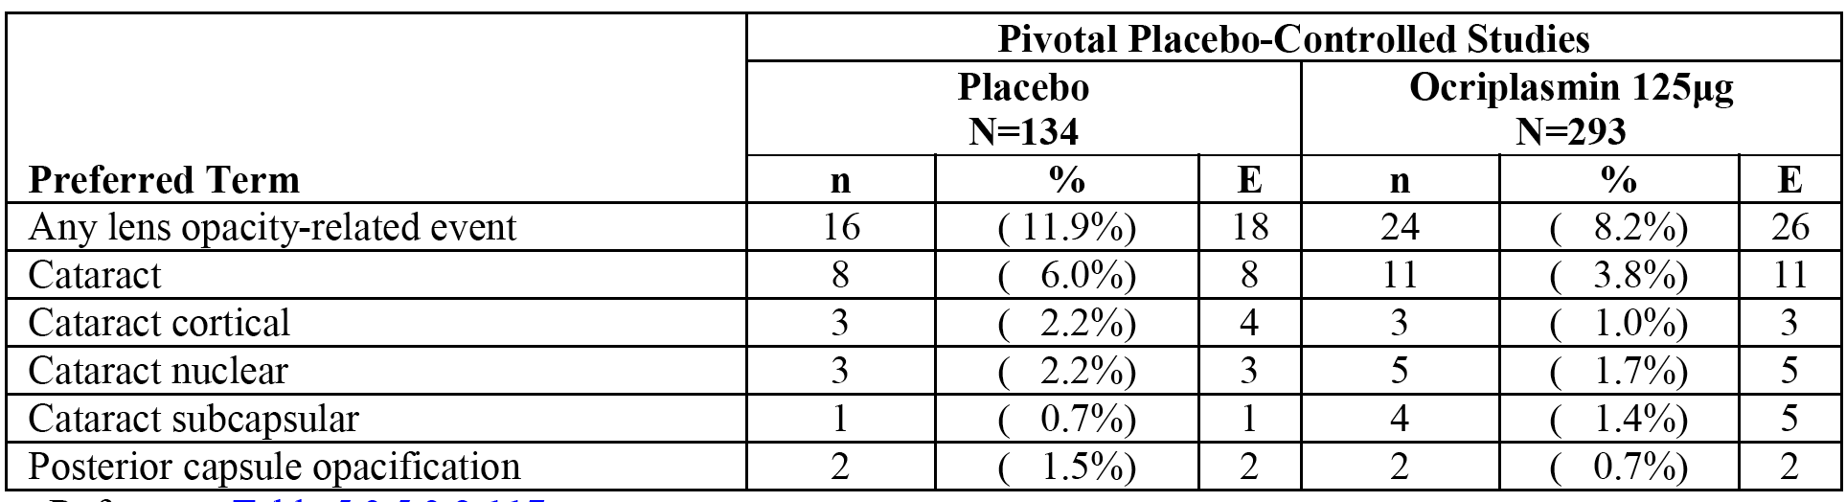
In both treatment groups in the pivotal Phase III studies the incidence of cataract-related AEs reported in phakic patients before vitrectomy/no vitrectomy was lower (5.2%, [7/134], placebo versus 4.8%, [14/293], ocriplasmin 125 µg) compared with patients who had vitrectomy (22.0%, [9/41], placebo versus 18.2%, [10/50], ocriplasmin 125 µg).

Adverse events known to be associated with IVT injection procedures

Increased intraocular pressure
In the pivotal Phase III studies, the incidence of increased IOP was marginally higher in the placebo group than in the ocriplasmin 125 µg group (5.3%, n = 10 versus 4.1%, n = 19). In both the placebo and ocriplasmin 125 µg groups, increased IOP occurred more commonly in the 8 day to EOS period (4.3%, n = 8 versus 2.6%, n = 12; respectively) than in the 0-7 days period (1.1%, n = 2 versus 1.5%, n = 7; respectively). All events were of mild or moderate intensity, and 6 (1.3%) patients in the ocriplasmin 125 µg group and no patients in the placebo group had an AE considered by the investigator to be drug-related. Increased IOP resolved by the last study visit for all except 3 (0.6%) patients in the ocriplasmin 125 µg group and 1 (0.5%) patient in the placebo group. In the 7 completed studies combined, the incidence of increased IOP was higher in the ocriplasmin group (all doses) than in the control group (9.2%, n = 68 versus 6.9%, n = 17).

Intraocular haemorrhage
In the pivotal Phase III studies, the incidence of intraocular haemorrhage AEs was marginally higher in patients in the placebo group compared with the ocriplasmin 125 µg group (3.7%, n = 7 versus 2.4%, n = 11), and the majority of intraocular haemorrhages in both groups occurred in the 8 day to EOS period (3.2%, n = 6 versus 2.2%, n = 10). All events were of mild or moderate intensity. SAEs were reported for 2 (0.4%) patients in the ocriplasmin group and no patients in the placebo group. At the last study visit, events had not resolved for 0.9% of patients in the ocriplasmin 125 µg group and 0.5% of patients in the placebo group. Intraocular haemorrhage results for the pivotal Phase III studies and the 7 completed studies combined are summarized below in Table 22.
Table 22: Intraocular haemorrhage; safety sets.
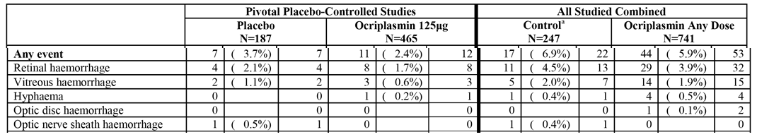

Intraocular inflammation
In the pivotal Phase III studies, the incidence of ocular inflammation was higher in patients in the ocriplasmin 125 µg group compared with the placebo group (7.1%, n = 33 versus 3.7%, n = 7), and all individual events contributing to the category were higher in the ocriplasmin 125 µg group than in the placebo group. The majority of intraocular inflammation events occurred in the 0-7 day period in patients in the ocriplasmin 125 µg group (4.9%, n = 23), while the majority of these events occurred in the 8 day to EOS period in patients in the placebo (2.7%, n = 5). The incidence of drug-related AEs was 4.5% in the ocriplasmin 125 µg group and 1.6% placebo groups. None of the events considered by the investigators to be drug-related were categorized as serious, with most being considered to be mild. The majority of intraocular inflammatory events had resolved by the last study visit, while ongoing events at the last study visit were reported for 3 (0.6%) patients in the ocriplasmin 125 µg group and 2 (1.1%) patients in the placebo group. There were no cases of intraocular infections including endophthalmitis reported in any patient treated with ocriplasmin. Intraocular inflammation results for the pivotal Phase III studies and 7 completed studies combined are summarized below in Table 23.
Table 23: Intraocular inflammation; safety sets.
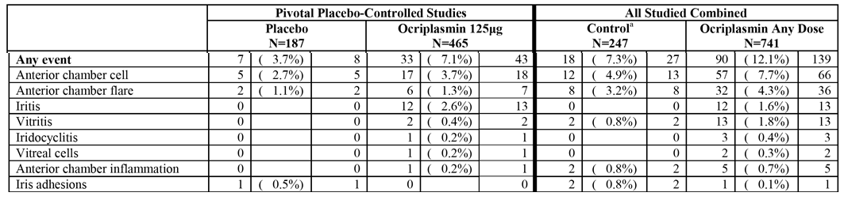

Other non-specific events
Non-specific events that can be related to the injection procedure are summarized. In the pivotal Phase III studies, the differences between the events in patients in the placebo and ocriplasmin 125 µg groups are considered to be not clinically significant.

Glaucoma
In the pivotal Phase III studies, glaucoma (any event) was reported in 3 (0.6%) patients in the ocriplasmin 125 µg group and no patients in the placebo group. The 3 events reported in the ocriplasmin 125 group consisted of one patient each with borderline glaucoma, open angle glaucoma, and optic nerve cup/disc ratio increased. All events were non-serious and of mild intensity, with onset during day 8-EOS. None was considered by the investigator to be drug-related. The outcome was ongoing at the last study visit for 2 (0.4%) patients. In the 7 competed studies combined, glaucoma (any) was reported in 5 (0.7%) patients in the ocriplasmin any dose group and 1 (0.4%) patient in the control group.

Lens subluxation
In the all completed and ongoing clinical studies as of the data cut-off date of 31 May 2012 (120-Day Safety Update Report), subluxation of the lens or lens instability have been reported in 3 patients. One (1) event was in a 4-month old premature infant treated with single IVT injection of ocriplasmin 175 µg 61 minutes before vitrectomy for retinopathy of prematurity (study number 009); 1 SAE of lens instability in pivotal Phase III Study TG-MV-007 occurred during vitrectomy 323 days after the patient had been treated with ocriplasmin, with no clinical signs noted before vitrectomy; and 1 event involved dislocation of a lens implant 1 day after a combined procedure (phacoemulsification/IOL and vitrectomy) undertaken 3 hours after ocriplasmin injection (study number 010). The sponsor concludes that based on the proteolytic activity of ocriplasmin and non-clinical and clinical findings, the potential for subluxation of the lens cannot be ruled out, but the risk in adults is considered to be low.

Immunogenicity potential
The submission included an ‘Integrated Summary of Immunogenicity’ providing an assessment of the potential immunogenicity risk associated with ocriplasmin injection. The finished ocriplasmin drug product contains three substances that may be of potential immunogenic concern: the ocriplasmin protein itself, and the process-related impurities; Pichia pastoris-derived host cell protein (HCP); and staphylokinase (SK). The determination the immunogenic risk was based on product-related risks (including the intrinsic immunogenicity of ocriplasmin), the quality of the product (process-related impurities), and nonclinical and clinical findings.
Ocriplasmin has 100% homology to the amino acid sequence of its homologue in human plasmin/plasminogen. It is also considered to be highly similar to the human protein at the secondary and tertiary structure level. Due to its structure, low molecular weight, solubility, and route of administration, dose and frequency of administration the risk of a clinically significant immune response associated with ocriplasmin is considered low in patients treated with the drug for VMA.
Clinical assessment was based on safety findings from both IVT and IV studies. During the vascular clinical program, 4 patients treated with high IV doses of ocriplasmin developed pseudo-allergic reactions during infusion. However, because of the high doses involved in these studies the sponsor deemed these events not relevant to IVT administration of low dose ocriplasmin. During the vascular program, ocriplasmin and SK immunoglobulin G antibody measurements were reported in Studies TG-M-001 and TG-M-004. In Study TG-M-001 (IV infusion study in healthy volunteers), at Day 21 increases from pre-dose in ocriplasmin antibody assay were observed in 3 patients (7.5%, [3/40]) dosed with ocriplasmin and 1 patient (5.0%, [1/20]) dosed with placebo. There was no evidence of a dose-related trend in immunogenicity and none of the antibody increases were considered to be of clinical significance. Since the specificity of the human anti-ocriplasmin antibody assay was not confirmed, the sponsor considered that it was possible that the observed signals were directed to other elements in the matrix. In Study TG-M-004 (IV infusion study in patients with acute ischaemic stroke), no apparent difference between placebo and ocriplasmin treatment groups was observed for either anti-ocriplasmin or anti-SK antibody titres. However, no results for the incidence of antibody titres in the two treatment groups could be identified in the submitted data.
No systemic antibody assays were undertaken during the development program for ophthalmic indications for ocriplasmin. This sponsor states that was justified in view of single-dose, localized IVT administration of relatively small amounts of ocriplasmin, and the low immunogenic potential for ocriplasmin detected in the IV program. In the IVT program, there were no differences among ocriplasmin treated patients and controls in the incidence of systemic or ocular allergy-type reactions. The sponsor states that the most relevant clinical effect for potential immunogenicity was intraocular inflammation and notes that, in the 7 completed studies combined, these events occurred more commonly in ocriplasmin treated patients (12.1%) than in controls (7.3%). The sponsor comments that these events were non-serious, mild or moderate in intensity and most resolved spontaneously. No cases of endophthalmitis have been reported.

Clinical laboratory tests
Clinical laboratory tests were performed at baseline and on post-injection day 28 for one Phase II study investigating the IVT effects of ocriplasmin in patients with eye disease (TG-MV-001). Although not pre-specified in other IVT studies, clinically indicated laboratory tests could be ordered at the investigator’s discretion and clinically significant abnormalities were to be reported as AEs. In the pivotal Phase III studies, clinically significant abnormalities in laboratory test reported as AEs were uncommon in both the ocriplasmin 125 µg and placebo groups, and no obvious patterns in clinical laboratory abnormalities were observed.
Study TG-MV-001 was designed as a pilot, open-label, ascending dose/exposure time clinical trial to assess four doses of ocriplasmin administered by IVT injection at varying times prior to PPV in patients with VMT maculopathy, including VTMS, DME with VMT or a stage II or III MH. Routine laboratory analyses were done at baseline and at post-operative day 28 (which was also post-injection day 28). In most cases of clinically significant out of range laboratory values at day 28 (18 out of 26), the value was already clinically significant out of range at baseline and either normal or still clinically significant out of range at post-operative day 28. In 8 cases (5 patients), the value was normal at baseline, but significantly out of range at postoperative day 28. In 3 of these cases (3 patients) fasting glucose was above normal range due to poor diabetes control. In addition, one of these patients had elevated bilirubin levels throughout the study due to Dubin-Johnson Syndrome. In 1 case, leucocyte level was clinically significant elevated at post-operative day 28, but not at baseline. This event was reported as non-serious AE of ‘Non-symptomatic leucocytosis’. The other 4 cases were elevated levels of AST, ALT, bilirubin and alkaline phosphatase in 1 patient due to pre-existing osteomyelofibrosis.
Comment: The available data suggests that clinically significant abnormalities in laboratory tests are unlikely following a single IVT dose of ocriplasmin (125 µg) for the treatment of VMA.

Vital signs
Vital sign and ECG assessments were not required in the IVT injection studies. No clinically significant abnormalities in these parameters were reported as AEs.

Ocular assessments

Intra-ocular pressure (IOP)
In the pivotal Phase III studies, mean IOP at baseline was less than or equal to 21 mmHg in 97.3% (182.187) of patients in the placebo group and 98.7% (458/464) of patients in the ocriplasmin 125 µg group. Shifts to IOP greater than or equal to 21 mmHg at Day 7 were observed in 3.3% (6/183) of patients in the placebo group and 2.7% (12/457) of patients in the ocriplasmin 125 µg group, and at end-of-study visit shifts meeting this criterion were observed in 4.3% (8/186) and 2.6% (12/464) of patients, respectively During the entire study period, 7 (1.5%) patients in the ocriplasmin group had 10 IOP measurements that were greater than or equal to 25 mmHg with an increase from baseline greater than or equal to 5 mmHg, and 8 (4.3%) patients in the placebo group had 9 IOP measurements meeting these criteria.
Comment: Data from the pivotal Phase III studies raise no concerns relating to increased IOP following IVT injection of single-dose ocriplasmin 125 µg.

Retinal breaks
In the pivotal Phase III studies, retinal examinations at baseline detected no retinal breaks in patients in the placebo group (0/187), and 1 patient in the ocriplasmin 125 µg group (0.5% [1/183]). By Day 28, 2 of the patients (1.1%, [2/186]) in the placebo group without baseline retinal breaks had developed a retinal break compared with no patients (0/459) in the placebo group. By EOS, 2 patients (1.1% [2/186]) in the placebo group without baseline retinal breaks had developed a retinal break compared with no patients (0/465) in the ocriplasmin 125 µg group.
In the pivotal Phase III studies, retinal examinations at baseline detected retinal detachment in 1 patient in the placebo group (0.5%, 1/187), and 3 patients in the ocriplasmin 125 µg group (0.6%, 3/465). By Day 28, 1 patient (0.5%, 1/183) in the placebo group without retinal detachment at baseline had developed a retinal detachment compared with 2 patients (0.4%, 2/459) in the ocriplasmin 125 µg group. By EOS, 2 patients (1.1%, 2/183) in the placebo group without retinal detachment at baseline had developed retinal detachment compared with 4 patients (0.9%, 4/465) in the ocriplasmin 125 µg group.
Comment: The incidence of post-injection retinal tears/detachments in patients with no retinal tears/detachments at baseline was low to absent at most visits in both treatment groups. At the EOS visit, the incidence of retinal tears (0.4%) and retinal detachments (1.1%) in the ocriplasmin 125 µg group was slightly less than the incidence seen in the placebo group for retinal tears (1.1%) and retinal detachment (1.6%). These finding are consistent with the lower AE incidence of these events observed in patients in the ocriplasmin 125 µg group compared with the placebo group. The sponsor notes that there is a theoretical risk of retinal tear or retinal detachment after treatment with ocriplasmin given that naturally occurring PVD is associated with retinal tear/detachment risk and pharmacologically induced PVD may also cause such events.

Retinal findings
Shifts from baseline findings (normal or clinically significant abnormality) in the macula, peripheral retina, and optic nerve at Day 7, Day 28, and EOS for the two treatment groups in the pivotal Phase III studies are summarized.
Comments: Retinal examination showed no notable differences between the placebo and ocriplasmin 125 µg group for shifts from baseline findings at Day 7, Day 28 and EOS in the macula, peripheral retinal and optic nerve.

Lens findings
Shifts from baseline findings for lens, cortical opacity, nuclear sclerosis and posterior subcapsular opacity in phakic patients at Day 7, Day 28, and EOS for the two treatment groups in the pivotal Phase III studies are summarized.
Comment: The percentages of patients at EOS with any categorical increase from baseline (except for posterior subcapsular opacity) were lower in the ocriplasmin 125 µg group compared with placebo. This is consistent with a lower incidence in the ocriplasmin 125 µg group (11.9%) compared with placebo (8.3%) of lens-related AEs (any) in phakic patients, and also consistent with the lower incidence of vitrectomy in the ocriplasmin group (17.7%) compared with the placebo group (20.5%).

Intraocular inflammation
Shifts from baseline in findings associated with intraocular inflammation (anterior chamber cells, anterior chamber flare, and vitreous inflammation quantification) at Day 7, Day 28, and EOS for the two treatment groups in the pivotal Phase III studies are summarized.
Comment: Shifts from baseline in intraocular inflammation parameters were marginally higher in the ocriplasmin 125 µg group than in the placebo group, but the number of patients with inflammatory changes was small in both treatment groups. The small differences between the two treatments are unlikely to be clinically meaningful.

Vitreous haemorrhage
Shifts from baseline in findings associated with vitreous haemorrhage identified by dilated retinal examination were small in both treatment groups in the pivotal Phase III studies. In the placebo group, 1 patient (0.5%, 1/187) had baseline findings consistent with vitreous haemorrhage compared with no patients (0/465) in the ocriplasmin 125 µg group. In the placebo group, the percentage of patients shifting from findings absent at baseline to findings present at Day 7, 28 and EOS was 0.5% (1/183), 0% (0/183), and 0% (0/183), respectively. In the ocriplasmin 125 µg group, the percentage of patients shifting from findings absent at baseline to findings present at Day 7, 28 and EOS was 0.7% (3/461), 0.2% (1/459), and 0.2% (0/465), respectively.
Comment: Increases from baseline in findings associated with vitreous haemorrhage identified by dilated retinal examination were negligible in both treatment groups. The results are consistent with those observed in the pivotal Phase III study for reports of intraocular haemorrhage AEs (any) in the two treatment groups (3.7%, n = 7, placebo versus 2.4%, n = 11, ocriplasmin 125 µg).

Safety in special subgroups

Intrinsic factors
In the pivotal Phase III studies, exploratory subgroup analyses based on attributable risk ratios (ARRs), relative risk ratios (RRs) and multivariate odds ratios (ORs) with 95% confidence intervals were undertaken for the AEs of special interest of vision alteration, intraocular inflammation and eye pain, and the suspected ADRs with an incidence of greater than or equal to 5% in the ocriplasmin group from the pivotal placebo-controlled studies (that is , vitreous floaters and photopsia.
The following intrinsic factors were analyzed: gender (female versus. male); age (<65 years versus greater than or equal to 65 years; <75 years versus greater than or equal to 75 years); BMI (<25 kg/m² versus greater than or equal to 25 kg/m2); lens status at baseline (phakic versus pseudophakic); baseline diabetic retinopathy (DR) status (present versus absent); baseline full thickness macula hole (FTMH) status (present versus absent); baseline epiretinal membrane (ERM) status (present versus absent); and whether the primary efficacy endpoint VMA resolution at Day 28 was achieved (yes versus no). Race was analyzed as Caucasian versus non-Caucasian because the number of patients in each of the other racial categories was too small to compare with Caucasians.
For each subgroup comparison, the ocular AEs of interest reported with ARR greater than or equal to 1.5 or ARR less than or equal to 0.5 are summarized: ARR = (% ocriplasmin in group X minus % plasma in group X)/(% ocriplasmin in group Y minus % placebo in group Y). The cut-off points were chosen by the evaluator to represent levels of possible clinical significance. The proportion of patients in each subgroup with the ocular AEs of interest in the study eye, and ARRs and RRs are summarized.
Comment: The exploratory subgroup analyses suggest a trend towards increased risk of ocular AEs of special interest in female patients compared with males, younger patients compared with older patients (< 65 versus greater than or equal to 65 years; < 75 versus greater than or equal to 75 years), and patients with BMI greater than or equal to 25 kg/m2. The results for baseline lens status, DR, FTMH, and ERM were variable. Patient numbers in the non-Caucasian group were notably smaller than in the Caucasian group, precluding meaningful comparison between the two groups. Of particular note, all ocular AEs of interest in the study eye occurred more frequently in patients who achieved VMA resolution at Day 28 with ocriplasmin than in patients without VMA resolution at Day 28.

Extrinsic factors
Exploratory subgroup analyses for the effect extrinsic factors on selected ocular AEs in the study eye included geographic region (United States versus Europe) and expected need for vitrectomy (expected versus not expected). The AAR was greater than or equal to 1.5 (USA/Europe) for retinal/macular oedema (94.0), intraocular inflammation (3.0), photopsia (3.0), eye pain (2.0), and vision alteration (1.8). The results suggest an increase risk of ocular AEs of special interest in patients treated in the USA compared with Europe. The sponsor postulates that the difference is most likely due to cultural differences in thresholds for reporting examination findings and symptoms as AEs. The sponsor comments that, consistent with this interpretation, although there is a greater incidence of retinal/macular oedema AEs reported in the USA patients, no such difference between regions was observed for these findings based on masked OCT review by CRC. There was no significant difference in ocular AEs of special interest in patients with expected need for vitrectomy compared with patients with no expected need for vitrectomy.

Post-marketing experience
No data on post-marketing experience are available.

Evaluator’s overall conclusions on clinical safety
Overall, the safety of single-dose ocriplasmin 125 µg administered by IVT injection for the treatment of VMA is considered to be satisfactory. The key safety data in the submission are considered to be from the two pivotal Phase III studies (TG-MV-006 and TG-MV-007). The two studies provide a double-masked comparison of patients with VMA randomized to treatment with either ocriplasmin 125 µg (the dose proposed for approval) or placebo. The review of safety in this section of the CER focuses on the data from the two pivotal Phase III studies.
The two pivotal Phase III studies included a pooled safety set consisting of 465 patients treated with ocriplasmin 125 µg and 187 patients treated with placebo. The safety profile of ocriplasmin based on the pivotal Phase III studies is consistent with the safety profiles of the drug derived from the 7 completed studies combined (n = 741) up to 31 March 2011 (SCS), and on data from all completed and ongoing studies (n = 976) up to 31 May 2012. Based on the ‘rule of three’, 976 patients exposed to ocriplasmin (all doses) from the completed and ongoing studies up to 31 May 2012 provides a database of sufficient size to support detection of ADRs occurring with an upper 95% CI greater than or equal to 0.31%.³⁰ The size of the database is insufficient to ensure detection of ADRs occurring at frequencies < 0.3%. The majority of patients in the pivotal phase III studies treated with ocriplasmin were Caucasian (92.2%), and there are limited data on the safety of the drug in non-Caucasians.
In the pivotal Phase III studies, the proportion of patients with AEs (any) was higher in the ocriplasmin 125 µg group compared with placebo (76.6%, n = 356 versus 69.0%, n = 129; respectively). Most of the AEs in the two treatment groups were ocular AEs occurring in the study eye, and the proportion of patients with these events was notably higher in the ocriplasmin 125 µg group compared with placebo (69.7%, n = 324 versus 52.9%, n = 99; respectively). The proportion of patients with non-ocular AEs was similar in the ocriplasmin 125 µg and placebo groups (30.1%, n = 140 versus 28.3%, n = 53; respectively), as was the proportion of patients with ocular AEs in the non-study eye (13.1%, n = 61 versus 11.8%, n = 22; respectively).
In the pivotal Phase III studies, the most frequently reported ocular ADRs in the study eye in the ocriplasmin 125 µg group were consistent with pharmacologic vitreolysis and PVD (for example, vitreous floaters, photopsia), while other ADRs were due to inflammation/irritation resulting from either the injection procedure and/or the drug. The majority of ocular ADRs in the ocriplasmin 125 µg group were categorized as mild or moderate in intensity, and severe reactions occurred infrequently. Most of the ocular ADRs in the study eye in the ocriplasmin 125 µg group occurred within the first 7 days post-injection, and most had resolved by the end of the study.
In the pivotal Phase III studies, the most commonly reported ocular ADRs in the study eye occurring in greater than or equal to 5% of patients in the ocriplasmin 125 µg group (versus placebo) were: vitreous floaters (16.8% versus 7.5%); eye pain (13.1% versus 5.9%); photopsia (11.8% versus 2.7%); vision blurred (8.4% versus 3.2%); visual acuity reduced (6.2% versus 4.3%); visual impairment (5.4% versus 1.1%); and retinal oedema (5.4% versus 1.1%). All ADRs in the study eye occurring in greater than or equal to 5% of patients in the ocriplasmin 125 µg group were reported more commonly in the active group than in the placebo group.
In the pivotal Phase III studies, ocular ADRs in the study eye occurring in < 5% and greater than or equal to 1% of patients in the ocriplasmin 125 µg group and greater than or equal to 1% more frequently than in the placebo group were: macular oedema (4.1% versus 1.6%); anterior chamber cells (3.7% versus 2.7%); photophobia (3.7% versus 0%); ocular discomfort (2.8% versus 1.1%); vitreous detachment (2.6% versus 1.1%); iritis (2.6% versus 0%); dry eye (2.4% versus 1.1%); metamorphopsia (2.2% versus 0.5%); retinal degeneration (1.7% versus 0.5%); eyelid oedema (1.5% versus 0%); retinal pigment epitheliopathy (1.5% versus 0%); macular degeneration (1.3% versus 0.5%); miosis (1.1% versus 0%); scotomata (1.1% versus 0%); and corneal abrasion (1.1% versus 0%). There were no cases of endophthalmitis reported in either treatment group, and there have been no cases of endophthalmitis reported with ocriplasmin in all completed and ongoing studies up to 31 May 2012.
In the pivotal Phase III studies, 5 deaths (1.1%) occurred in 465 patients in the ocriplasmin 125 µg group, and no deaths occurred in 187 patients in the placebo group. The 5 deaths in the ocriplasmin 125 µg group all occurred in women aged greater than or equal to 76 years. Four (4) of the deaths were considered to be unrelated to treatment, while the relationship with treatment was described as ‘remote’ for 1 of the deaths (malignant lung neoplasm). In the completed and ongoing IVT injection studies there have been a total of 10 deaths (6 in the ocriplasmin group, 2 in the sham group and 2 treatment still masked), as of the database cut-off date of 31 May 2012. If it is assumed that in this database the masked treatment is ocriplasmin (worst case scenario) then the incidence of death in the ocriplasmin (all doses) group is 0.8% (8/976) compared with compared with 0.6% (2/341) in the control group. Overall, the reported deaths associated with ocriplasmin IVT injections do not give rise to concern.
In the pivotal Phase III studies, SAEs (any) occurred in a similar proportion of patients in the ocriplasmin 125 µg and placebo groups (13.3%, n = 62 versus 12.8%, n = 24; respectively). Most of the SAEs were ocular events occurring in the study eye and were reported more frequently in patients in the placebo group than in the ocriplasmin group (10.7%, n = 20 versus 7.7%, n = 36; respectively). The most commonly reported ocular SAE in the study eye was macular hole (includes progression of macular hole), and this event occurred more frequently in patients in the placebo group than in the ocriplasmin 125 µg group (8.6%, n = 16 versus 5.2%, n = 24; respectively). The only other ocular SAEs in the study eye occurring in greater than or equal to 1% of patients in either treatment group were vitreous adhesions (1.1%, n = 5, ocriplasmin versus 0.5%, n = 1, placebo), and retinal detachment (0.4%, n = 2, ocriplasmin versus 1.6%, n = 3, placebo). The additional SAE reports associated with ocriplasmin in the 120-Day Safety Update Report were consistent with previous reports.
In the pivotal Phase III studies, the majority of the SAEs (any) in both treatment groups were considered to be unrelated to the study drug. All SAEs considered to be drug-related were ocular events occurring in the study eye and were reported in the same proportion of patients in both the ocriplasmin 125 µg and placebo groups (3.2%, n = 15 versus 3.2%, n = 6). The 16 drug-related SAEs in the 15 patients in the ocriplasmin 125 µg group were macular hole (x9), retinal detachment (x2), vitreous adhesion (x2), visual acuity reduced (x2), and posterior capsule opacification (x1). The 6 drug-related SAEs in the 6 patients in the placebo group were macular hole (x4), macular oedema (x1) and vitreous adhesion (x1).
In the pivotal Phase III studies, withdrawal from the study due to AEs occurred in a small number of patients in both the ocriplasmin 125 µg and placebo groups (0.9%, n = 4 versus 1.1%, n = 2; respectively). The reason for the 4 withdrawals due to AEs in the ocriplasmin 125 µg group was death (unrelated to treatment), and the reasons for the 2 withdrawals in the placebo group were subcapsular cataract (possibly related to treatment) and spondylolisthesis (unrelated to treatment).
In the pivotal Phase III studies, ocular AEs in the study eye of special interest occurring in a greater proportion of patients in the ocriplasmin 125 µg group than in the placebo group, respectively were: vision alteration (20.2%, n = 94 versus 7.5%, n = 14); eye pain (15.9%, n = 74 versus 7.0%, n = 13); retinal/macular oedema (9.5%, n = 44 versus 2.7%, n = 5); intraocular inflammation (7.1%, n = 33 versus 3.7%, n = 7); retinal pigment change (2.4%, n = 11 versus 0.5%, n = 1); glaucoma (0.6%, n = 3 versus 0%); and colour vision/ERG abnormalities (0.6%, n = 3 versus 0%).
In the pivotal Phase III studies, ocular AEs in the study eye of special interest occurring in a greater proportion of patients in the placebo group than in the ocriplasmin 125 µg group, respectively, were: macular hole (9.6%, n = 18 versus 6.7%, n = 31); cataract (any) in phakic patients (11.9%; n = 16 versus 8.2%, n = 24); intraocular pressure increased (5.3%, n = 10 versus 4.1%; n = 19); intraocular haemorrhage (3.7%, n = 7 versus 2.4%, n = 11); and retinal breaks (4.3%, n = 8 versus 1.9%, n = 9).
There were no immunogenicity data in the pivotal Phase III studies, or in other IVT studies. Data from studies involving high doses of ocriplasmin administered by IV infusion suggest ocriplasmin antibodies and anti-staphylokinase antibodies following IVT injection are unlikely to be a frequent occurrence. In the pivotal Phase III studies, immune system disorders were reported in no patients in the placebo group and 9 (1.9%) patients in the ocriplasmin 125 µg group, including a total of 11 events (4 x seasonal allergy, 3 x drug hypersensitivity, and 1 each for allergy to arthropod sting, contrast media allergy, hypersensitivity, and iodine sensitivity).
No clinical laboratory data or vital sign data were assessed in the pivotal Phase III studies. Clinical laboratory data from the pilot IVT Study TG-MV-001 and clinical laboratory AE data from the pivotal studies suggests that clinically significant laboratory abnormalities are unlikely to develop following single dose ocriplasmin (125 µg) administered by IVT injection. Scheduled ophthalmic assessments were undertaken of IOP, retinal changes, lens changes, intraocular inflammation, and vitreous haemorrhage. The findings from these assessments were consistent with those reported for ocular AEs for the individual assessed parameters.
Analyses of selected ocular AEs in the study eye in the pivotal Phase III studies, indicated a higher incidence of these disorders in female versus male patients, patients aged < 65 years versus greater than or equal to 65 years, patients aged < 75 years versus greater than or equal to 75 years, patients with baseline phakia versus pseudophakia, patients with baseline FTMH versus patients no FTMH, and patients with baseline ERM versus no ERM. VMA resolution at Day 28 was strongly associated with a higher incidence of the AE of vision alteration. Consistent with this, the other subgroups with higher incidence of the AE of vision alteration were generally those that achieved higher rates of VMA resolution.
In the 820 patients treated with ocriplasmin from completed and ongoing studies up to and including 31 March 2011, 6 patients (0.7%) developed serious and/or severe acute transient vision decreases with no alternative explanation. The severity of these events ranged from loss of visual acuity ranging from 20/200 to hand motions, and 50% of the patients reported transient visual field restriction. In the most severe cases, the onset was within 24 hours of injection and within 7 days for the less severe cases. The visual impairment generally resolved over days to weeks.
In the 820 patients referred to in the above paragraph, dyschromatopsia occurred in 16 (2%) patients treated with ocriplasmin, and loss of BCVA greater than or equal to 10 letters by day 7 was reported in 44 (5.7%) patients treated with ocriplasmin (versus 3 [1.1%] out of 269 patients in the control group).
The incidence of ERG abnormalities in patients treated with ocriplasmin has not yet been determined.

First round benefit-risk assessment

First round assessment of benefits
The submitted data indicate that the benefits of treatment with ocriplasmin (single-dose IVT injection, 125 µg) in patients with symptomatic VMA relate primarily to improvements in non-surgical resolution of VMA at Day 28 without creation of an anatomical defect, and total PVD at Day 28. Improvement in non-surgical VMA resolution with ocriplasmin 125 µg was seen as early as Day 7, with benefits peaking at Day 28 and being maintained through to Month 6. However, the benefits observed with ocriplasmin 125 µg for both VMA resolution and PVD at Day 28 were modest, as can be seen from the absolute difference between the two treatment groups and the number of patients needed to be treated for one patient to achieve a benefit (NNT).
In Study TG-MV-006, the primary efficacy endpoint of non-surgical VMA resolution at Day 28 was achieved in 27.9% (61/219) of patients in the ocriplasmin 125 µg group and 13.1% (14/107) of patients in the placebo group (difference 14.8% [95% CI: 6.0, 23.5]; p = 0.003). The absolute difference between the two treatment groups indicates that the NNT is 7 patients. In Study TG-MV-007, the primary efficacy endpoint of non-surgical VMA resolution at Day 28 was achieved in 25.3% (62/254) of patients in the ocriplasmin 125 µg group and 6.2% (5/81) of patients in the placebo group (difference 19.1% [95% CI: 11.6, 26.7]; p<0.001). The absolute difference between the two treatment groups indicates that the NNT is 5 patients. The results for the two pivotal studies were consistent with the results from the IEA.
In Study TG-MV-006, the key secondary efficacy endpoint of total PVD at Day 28 was achieved in 16.4% (36/219) of patients in the ocriplasmin 125 µg group and 6.5% (7/107) of patients in the placebo group (difference 9.9% [95% CI: 3.1, 16.7]; p = 0.014. The absolute difference between the two treatment groups indicates that the NNT is 10 patients. In Study TG-MV-007, the key secondary efficacy endpoint of total PVD was achieved in 10.6% (26/245) of patients in the ocriplasmin 125 µg group and 0% (0/81) of patients in the placebo group (difference 10.6% [95% CI: 6.8, 14.5]; p<0.001). The absolute difference between the two treatment groups indicates that the NNT is 9 patients. The results for the two pivotal studies were consistent with the results from the IEA.
Non-surgical FTMHC at Day 28 and Month 6 in patients with sVMA and baseline FTMH occurred in a numerically greater proportion of patients in the ocriplasmin 125 µg group than in the placebo group in both pivotal Phase III studies, but all p-values for the differences between the two treatment groups were nominal. In Study TG-MV-006, the proportion of patients achieving FTMHC in the ocriplasmin and placebo groups at Day 28 was 43.9% (25/57) and 12.5% (4/32), respectively, (difference 31.4% [95% CI: 14.1, 48.6], p = 0.002), and at Month 6 was 45.6% (26/57) and 15.6% (5/32), respectively (difference 30.0% [95% CI: 11.9, 48.0], p = 0.005). In Study TG-MV-007, the proportion of patients achieving FTMHC in the ocriplasmin and placebo groups at Day 28 was 36.7% (18/49) and 6.7% (1/15), respectively, (difference 30.1% [95% CI: 11.6, 48.5], p = 0.028), and at Month 6 was 34.7% (17/49) and 20.0% (3/15), respectively (difference 30.0% [95% CI: 11.9, 48.0], p = 0.354). The results for the two pivotal studies were inconsistent. In Study TG-MV-006, the numerical benefit observed with ocriplasmin at Day 28 compared with placebo was maintained at Month 6, but in Study TG-MV-007 the numerical benefit observed with ocriplasmin at Day 28 compared placebo was halved at Month 6. The results from the IEA were consistent with those from Study TG-MV-006. There are no confirmatory data establishing that treatment with ocriplasmin 125 µg results in FTMHC in patients with sVMA and baseline FTMH.
In both pivotal Phase III studies, there was a numerically greater proportion of patients requiring vitrectomy in the study eye by Month 6 in the placebo group compared with the ocriplasmin 125 µg group, but the p-value was nominally insignificant for the difference between the groups in both studies. The data relating to improvements from baseline to Month 6 in BCVA (categorical and mean changes), and from baseline to Month 6 in VFQ-25 mean scores from both pivotal studies suggest that the limited benefits observed with ocriplasmin 125 µg compared with placebo for these functional outcomes are of doubtful clinical significance.

First round assessment of risks
The major risks associated with ocriplasmin 125 µg administered by IVT injection for the treatment of VMA relate to adverse drug reactions (ADRs) in the injected eye. There are no significant risks of systemic non-ocular AEs or ocular AEs in the non-injected eye. There is no increased risk of death associated with single-dose IVT injection of ocriplasmin 125 µg. However, the size of the ocriplasmin database from all completed and ongoing studies as of 31 May 2012 is insufficient to ensure detection of ADRs occurring at frequencies below 0.3%. The majority of patients in the pivotal phase III studies treated with ocriplasmin were Caucasian (92.2%), and there are limited data on the safety of the drug in non-Caucasians.
The most commonly reported ocular ADRs in the study eye observed with ocriplasmin 125 µg were consistent with pharmacologic vitreolysis and PVD (for example, vitreous floaters, photopsia), while other ADRs were due to inflammation/irritation resulting from either the injection procedure and/or the drug. The majority of ocular ADRs in the study observed with ocriplasmin 125 µg were categorized as mild or moderate in intensity and severe reactions occurred infrequently. Most of the ocular ADRs in the study eye observed in patients in the ocriplasmin 125 µg group occurred within the first 7 days post-injection, and most had resolved by the end of the study.
In the pivotal Phase III studies, the most commonly reported ocular ADRs in the study eye occurring in greater than or equal to 5% of patients in the ocriplasmin 125 µg group (versus placebo) were: vitreous floaters (16.8% versus 7.5%); eye pain (13.1% versus 5.9%); photopsia (11.8% versus 2.7%); vision blurred (8.4% versus 3.2%); visual acuity reduced (6.2% versus 4.3%); visual impairment (5.4% versus 1.1%); and retinal oedema (5.4% versus 1.1%).
In the pivotal Phase III studies, ocular ADRs in the study eye occurring in < 5% and greater than or equal to 1% of patients in the ocriplasmin group and greater than or equal to 1% more frequently than in the placebo group were: macular oedema (4.1% versus 1.6%); anterior chamber cells (3.7% versus 2.7%); photophobia (3.7% versus 0%); ocular discomfort (2.8% versus 1.1%); vitreous detachment (2.6% versus 1.1%); iritis (2.6% versus 0%); dry eye (2.4% versus 1.1%); metamorphopsia (2.2% versus 0.5%); retinal degeneration (1.7% versus 0.5%); eyelid oedema (1.5% versus 0%); retinal pigment epitheliopathy (1.5% versus 0%); macular degeneration (1.3% versus 0.5%); miosis (1.1% versus 0%); scotomata (1.1% versus 0%); and corneal abrasion (1.1% versus 0%). There were no cases of endophthalmitis reported in either treatment group, and there have been no cases of endophthalmitis reported with ocriplasmin in all completed and ongoing studies up to 31 May 2012.
In the pivotal Phase III studies, the risk of ocular SAEs occurring in the injected eye was lower in patients treated with ocriplasmin 125 µg than with placebo (7.7% versus 10.7%, respectively), and risk of the most commonly reported SAE (macular hole) was lower in the ocriplasmin 125 µg group than in the placebo group (5.2% versus 8.6%, respectively). The only other ocular SAEs in the injected eye occurring in greater than or equal to 1% of patients in either treatment group were vitreous adhesions (1.1%, n = 5, ocriplasmin versus 0.5%, n = 1, placebo), and retinal detachment (0.4%, n = 2, ocriplasmin versus 1.6%, n = 3, placebo). The proportion of patients with drug-related SAEs was 3.2% in each treatment group. The 16 drug-related SAEs in the 15 patients in the ocriplasmin 125 µg group were macular hole (x9), retinal detachment (x2), vitreous adhesion (x2), visual acuity reduced (x2), and posterior capsule opacification (x1). The 6 drug-related SAEs in the 6 patients in the placebo group were macular hole (x4), macular oedema (x1) and vitreous adhesion (x1).
Withdrawal from the study due to AEs was reported in a small number of patients in both the ocriplasmin 125 µg and placebo groups (0.9%, n = 4 versus 1.1%, n = 2; respectively). The reason for the 4 withdrawals due to AEs in the ocriplasmin 125 µg group was death (unrelated to treatment), and the reasons for the 2 withdrawals in the placebo group were subcapsular cataract (possibly related to treatment) and spondylolisthesis (unrelated to treatment).
In the pivotal Phase III studies, ocular AEs in the injected eye of special interest occurring in a greater proportion of patients in the ocriplasmin 125 µg group than in the placebo group, respectively were: vision alteration (20.2% versus 7.5%); eye pain (15.9% versus 7.0%); retinal/macular oedema (9.5% versus 2.7%); intraocular inflammation (7.1% versus 3.7%); retinal pigment change (2.4% versus 0.5%); glaucoma (0.6% versus 0%); and colour vision/ERG abnormalities (0.6% versus 0%). On the other hand, ocular AEs in the study eye of special interest occurring in a greater proportion of patients in the placebo group than in the ocriplasmin 125 µg group, respectively, were: macular hole (9.6% versus 6.7%); cataract (any) in phakic patients (11.9% versus 8.2%); intraocular pressure increased (5.3% versus 4.1%); intraocular haemorrhage (3.7% versus 2.4%); and retinal breaks (4.3% versus 1.9%).
There were no data from the pivotal Phase III studies assessing the risks of clinical laboratory abnormalities associated with ocriplasmin 125 µg administered by IVT injections. However, data from the pilot IVT study and clinical laboratory AE data from the pivotal studies suggests that clinically significant laboratory abnormalities are unlikely to develop following single dose ocriplasmin 125 µg IVT injection. There are no data the pivotal Phase III studies assessing the risk of vital sign changes (blood pressure, pulse rate, and temperature) or ECG changes associated with ocriplasmin 125 µg IVT injections. However, there are no AE data from these studies suggesting that notable changes in vital sign and ECG parameters are associated with ocriplasmin 125 µg IVT injection. There are no immunogenicity data for ocriplasmin following IVT injection. However, there was no indication from the immune system AEs reported in the pivotal Phase III studies that ocriplasmin 125 µg is associated with clinical significant changes in this system.
Exploratory safety data from the pivotal Phase III study relating to selected frequently occurring ocular AEs in the injected eye suggest that females, patients younger than 65 years, phakic patients, patients with baseline FTMH, and patients with baseline might be at an increased risk of experiencing some and/or all of the assessed events. There are no safety data specifically assessing the effects of ocriplasmin 125 µg patients with hepatic impairment, renal impairment, or cardiovascular impairment. However, the totality of the provided safety suggests that patients in these groups are unlikely to be exposed to additional risks from single-dose ocriplasmin 125 µg IVT injection.
While colour vision/ERG abnormalities were reported in 0.6% of patients in the ocriplasmin 125 µg group (including 1 ERG abnormality) and no patients in the placebo group in the pivotal Phase III studies, the actual frequency of ERG abnormalities can not be assessed from these studies since ERG assessments were not routinely undertaken. Furthermore, due to the absence of routine ERG testing in the majority of completed clinical studies the incidence of ERG abnormalities following ocriplasmin administration cannot be calculated from the available data.
There is a small, uncommon (0.7%, 6/820) risk of serious and/or severe acute transient impairment of visual impairment occurring within the first 7-days following injection with ocriplasmin, with the most severe cases occurring in the first 24 hours. In these patients, visual impairment generally resolved over days to weeks.
There is a common (2.0%, 16/820) risk of mild, dyschromatopsia (generally described as yellowish vision) following ocriplasmin injection. Most cases occurred on the day of injection, and median time to resolution was 3 months (range: 1, 28 months) with resolution being reported in 14 of the 16 patients. One additional case was reported in the 120-Day Safety Update Report giving a total of 17 (1.7%) reported cases 976 patients exposed to ocriplasmin in completed and ongoing studies.
There is a common risk (5.4%, 44/820) of lost of BCVA of greater than or equal to 10 letters (that is greater than or equal to 2 lines) by Day-7 in patients treated with ocriplasmin (compared with 1.1%, 3/269, in patients treated with control). However, BCVA returned to within 1 line (5 letters) of baseline values during the study for all patients, except for 6/820 (0.7%) treated with ocriplasmin and 1/269 (1.1%) treated with control.

First-round assessment of benefit-risk balance
The benefit risk balance of ocriplasmin 125 µg administered by single-dose IVT injection for the treatment of symptomatic VMA is favourable.
However, it is considered that the benefits of treatment are modest and are primarily related to beneficial anatomical outcomes of VMA resolution and creation of total PVD. It is considered that the benefits related to improvement in functional outcomes of BCVA and quality of life following administration of ocriplasmin are very modest and are of limited clinical significance.
The place of ocriplasmin relative to surgery for the treatment of VMA is uncertain. It would be treatment option for patients considered to be unsuitable for surgery or for patients who elect not to undergo surgery. However, in view of the modest treatment effect observed with ocriplasmin 125 µg in the pivotal Phase III studies it is considered unlikely that ocriplasmin would displace vitrectomy as the first treatment option for most patients with VMA.
The results of the pivotal Phase III studies are not applicable to patients excluded from the studies, including patients with large diameter macular holes (greater than 400 μm), high myopia, aphakia, history of retinal detachment, lens instability, recent ocular surgery or intraocular injection (including laser therapy), proliferative diabetic retinopathy, ischaemic retinopathies, retinal vein occlusions, exudative age-related macular degeneration and vitreous hemorrhage. The sponsor stated that patients with these conditions were excluded from the pivotal Phase III studies because it was considered that they were unlikely to benefit from treatment (based on clinical experience or literature), or were theoretically at a higher risk of complications due to the IVT injection procedure or the vitreolytic effect of ocriplasmin. Treatment in these patients is not recommended. Concurrent treatment of both eyes has not been investigated and is not recommended.

First round recommendation regarding authorisation
It is recommended that ocriplasmin be approved in adults for ‘the treatment of symptomatic vitreomacular adhesion (sVMA)’.
It is recommended that the wording of the sponsor’s proposed indication be amended to exclude reference to patients with sVMA associated with macular hole. There is no confirmatory data demonstrating that FTMHC is achieved in patients with sVMA and FTMH at baseline. The data relating to the FTMHC in patients with sVMA and FTMH in the two pivotal Phase III studies is limited to additional secondary efficacy endpoint analyses in these subgroups in which all p-values were nominal. Furthermore, the results of the two pivotal Phase III studies were inconsistent. In Study TG-MV-006, the results suggest that FTMHC achieved at Day 28 can be maintained through to Month 6, but in Study TG-MV-007 the results suggest that FTMHC achieved at Day 28 cannot be satisfactorily maintained through to Month 6.

Clinical questions

Efficacy
The approved US and EU (CHMP) recommended indications for Jetrea differ. In the US label, no reference is made to patients with sVMA including those associated with macular hole. The indication simply states that Jetrea is indicated ‘for the treatment of symptomatic vitreomacular adhesions’. In contrast, the EU (CHMP) recommended indication states that Jetrea is indicated ‘for the treatment of vitreomacular traction (VMT), including when associated with macular hole of diameter less than or equal to 400 microns’. Please account for the difference between the two indications with respect to treatment of patients with sVMA with macular holes.

Second round evaluation of clinical data submitted in response to questions

Sponsor's response
Patients with full thickness macular hole (FTMH) accounted for a substantial part (almost 25%) of the patient population in the two pivotal Phase III studies. This reflects the situation in the general population of patients with symptomatic VMA because macular holes are a consequence of persistent vitreomacular traction (VMT) which ultimately causes the symptoms in symptomatic VMA (the latter providing a justification to replace ‘symptomatic VMA’ with ‘VMT’ as the term to describe the medical condition, see figure below). In the two pivotal Phase III studies there was no indication that the efficacy of ocriplasmin might be reduced in patients with FTMH. On the contrary, the VMA resolution rate at Day 28 in patients with FTMH was higher than in patients with VMT only (50.0% versus. 19.6%) indicating that ocriplasmin could be particularly beneficial in this subpopulation. Consequently the product labelling should inform the clinician that ocriplasmin treatment is suitable for both sVMA patients without and with FTMH but also state that clinical experience is currently limited to patients with macular holes up to a diameter of 400 microns because the Phase III studies did not enrol patients with macular holes of greater than 400 microns in diameter. This was the outcome of the discussions with the EU regulators.
The US label does not preclude the treatment of patients with FTMH because these patients are part of the overall population of sVMA patients and, therefore, implicitly included in the indication (Figure 3). However, the US label does not give guidance to the clinician as to which FTMH patients (that is those with macular holes up to a diameter of 400 microns) are most likely to benefit from ocriplasmin treatment.
With reference to the draft indication proposed in Australia, Alcon would support, based on the interchangeability of sVMA and VMT, the replacement of ‘symptomatic VMA’ with ‘vitreomacular traction (VMT)’. Taken together, with consideration of patients with macular hole, Alcon would support the indication stating ‘Treatment of vitreomacular traction (VMT), including when associated with macular hole of diameter less than or equal to 400 microns’.
Figure 3: Vitreomacular Adhesion (VMA).
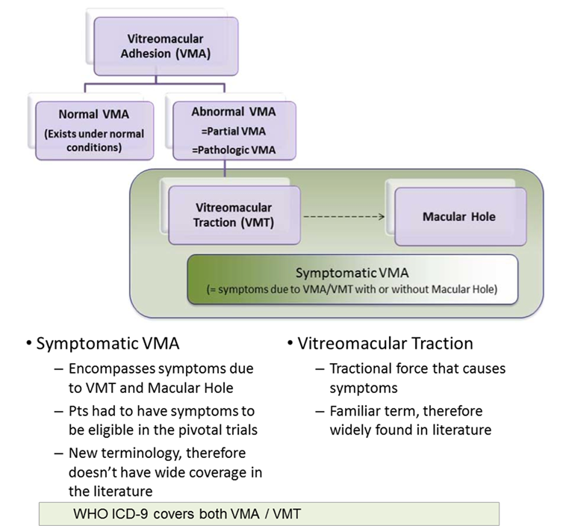

Clinical evaluator's comment
The major issue raised in the sponsor's response relates to whether reference to patients with sVMA associated with macular hole less than or equal to 400 µm in diameter should be included in the wording of the indication. The sponsor notes that patients with FTMH accounted for almost 25% of patients in the two pivotal Phase III studies, and that VMA resolution at Day 28 in patients with FTMH was higher than in patients with VMT only (50% versus 19.6%). The issue of whether the indication should include patients with FTMH was considered in the first round evaluation. Based on the first round evaluation of the submitted data it was concluded that specific reference to patients with FTMH should be excluded from the wording of the indication for the reasons outlined earlier in this CER. However, following consideration of the sponsor's response it is recommended that the indication for ocriplasmin in adults should be for the ‘treatment of symptomatic vitreomacular adhesion (sVMA), including when associated with macular hole less than or equal to 400 microns in diameter’. It is considered that the term sVMA should be used rather than VMT (as proposed by the sponsor), as this term is consistent with that used to describe the condition in the inclusion criteria for the two pivotal Phase III studies.
Review of the integrated efficacy analysis of the data from the two pivotal Phase III studies shows that 23.5% (153/652) of patients with sVMA had FTMH at baseline. Patients with baseline macular holes greater than 400 microns in diameter were excluded from the pivotal studies. Therefore, the pivotal study population included a ‘substantial’ number of patients with sVMA associated with baseline macular holes less than or equal to 400 microns in diameter. In patients with FTMH at baseline, VMA resolution was statistically significantly higher in the ocriplasmin group compared with placebo (Table 24). The absolute difference between the two treatment groups was 24.5% (95% CI: 8.8, 40.2) in favour of ocriplasmin, and the odds ratio (PR) statistically significantly favoured ocriplasmin over placebo.
Table 24: Intraocular inflammation; safety sets.
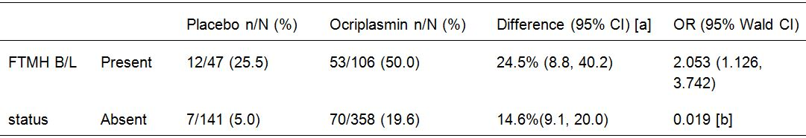
[a] The absolute difference and 95% CI between treatment groups are based on the proportion of successes. [b] P-value is from the analysis of effects from multivariate logistic regression.

Second round benefit-risk assessment

Second round assessment of benefits
Following consideration of the sponsor's response to the clinical questions it is considered that the benefits of treatment with ocriplasmin have been satisfactorily established for patients with sVMA, including when associated with macular hole less than or equal to 400 microns in diameter.
The submitted data indicate that the benefits of treatment with ocriplasmin (single-dose IVT injection, 125 µg) in patients with symptomatic VMA relate primarily to improvements in non-surgical resolution of VMA at Day 28 without creation of an anatomical defect, and total PVD at Day 28. Improvement in non-surgical VMA resolution with ocriplasmin 125 µg was seen as early as Day 7, with benefits peaking at Day 28 and being maintained through to Month 6. However, the benefits observed with ocriplasmin 125 µg for both VMA resolution and PVD at Day 28 were modest, as can be seen from the absolute difference between the two treatment groups and the number of patients needed to be treated for one patient to achieve a benefit (NNT).
In Study TG-MV-006, the primary efficacy endpoint of non-surgical VMA resolution at Day 28 was achieved in 27.9% (61/219) of patients in the ocriplasmin 125 µg group and 13.1% (14/107) of patients in the placebo group (difference 14.8% [95% CI: 6.0, 23.5]; p = 0.003). The absolute difference between the two treatment groups indicates that the NNT is 7 patients. In Study TG-MV-007, the primary efficacy endpoint of non-surgical VMA resolution at Day 28 was achieved in 25.3% (62/254) of patients in the ocriplasmin 125 µg group and 6.2% (5/81) of patients in the placebo group (difference 19.1% [95% CI: 11.6, 26.7]; p<0.001). The absolute difference between the two treatment groups indicates that the NNT is 5 patients. The results for the two pivotal studies were consistent with the results from the integrated efficacy analysis (IEA).
In Study TG-MV-006, the key secondary efficacy endpoint of total PVD at Day 28 was achieved in 16.4% (36/219) of patients in the ocriplasmin 125 µg group and 6.5% (7/107) of patients in the placebo group (difference 9.9% [95% CI: 3.1, 16.7]; p = 0.014. The absolute difference between the two treatment groups indicates that the NNT is 10 patients. In Study TG-MV-007, the key secondary efficacy endpoint of total PVD was achieved in 10.6% (26/245) of patients in the ocriplasmin 125 µg group and 0% (0/81) of patients in the placebo group (difference 10.6% [95% CI: 6.8, 14.5]; p<0.001). The absolute difference between the two treatment groups indicates that the NNT is 9 patients. The results for the two pivotal studies were consistent with the results from the IEA.
The two pivotal studies included a substantial number of patients with sVMA associated with baseline FTMH (23.5% [153/652] in the IEA), but patients with baseline macular hole greater than 400 microns in diameter were excluded from both pivotal studies. In the IEA, VMA resolution at Day 28 was observed in a significantly greater proportion of patients in the ocriplasmin group than in the placebo group (25.5% [12/47] versus 50.0% [53/106], respectively, absolute difference = 24.5% [95% CI: 8.8, 40.2]). In addition, the odds ratio significantly favoured ocriplasmin over placebo in the analysis of patients with baseline FTMH (2.053 [95% CI: 1.126, 3.742]; p = 0.019).
In both pivotal Phase III studies, there was a numerically greater proportion of patients requiring vitrectomy in the study eye by Month 6 in the placebo group compared with the ocriplasmin 125 µg group, but the p-value was nominally insignificant for the difference between the groups in both studies. The data relating to improvements from baseline to Month 6 in BCVA (categorical and mean changes), and from baseline to Month 6 in VFQ-25 mean scores from both pivotal studies suggest that the limited benefits observed with ocriplasmin 125 µg compared with placebo for these functional outcomes are of doubtful clinical significance.

Second round assessment of risks
The second round assessment of the risks of treatment with ocriplasmin in adults for sVMA, including when associated with macular holes less than or equal to 400 microns in diameter, remains largely unchanged from the first round assessment. However, the first PBRER report indicates that there have been 8 spontaneous reports of pupillary reflex impairment following treatment with ocriplasmin (3.63 events/1000 dose distributed).

Second round assessment of benefit-risk balance
Following consideration of the sponsor's response to the first round clinical questions it is considered that the benefit-risk balance for ocriplasmin is favourable for the treatment of adults with sVMA, including when associated with macular hole less than or equal to 400 microns in diameter.
It is considered that the benefits of treatment are modest and are primarily related to beneficial anatomical outcomes of VMA resolution and creation of total PVD. It is considered that the benefits related to improvement in functional outcomes of BCVA and quality of life following administration of ocriplasmin are very modest and are of limited clinical significance.
The place of ocriplasmin relative to surgery for the treatment of VMA is uncertain. It could be a treatment option for patients considered to be unsuitable for surgery or for patients who elect not to undergo surgery. However, in view of the modest treatment effect observed with ocriplasmin 125 µg in the pivotal Phase III studies it is considered unlikely that ocriplasmin will displace vitrectomy as the first treatment option for most patients with VMA.
The results of the pivotal Phase III studies are not applicable to patients excluded from the studies, including patients with large diameter macular holes (greater than 400 μm), high myopia, aphakia, history of retinal detachment, lens instability, recent ocular surgery or intraocular injection (including laser therapy), proliferative diabetic retinopathy, ischaemic retinopathies, retinal vein occlusions, exudative age-related macular degeneration and vitreous hemorrhage. The sponsor stated that patients with these conditions were excluded from the pivotal Phase III studies because it was considered that they were unlikely to benefit from treatment (based on clinical experience or literature), or were theoretically at a higher risk of complications due to the IVT injection procedure or the vitreolytic effect of ocriplasmin. Treatment in these patients is not recommended. Concurrent treatment of both eyes has not been investigated and is not recommended.

Second round recommendation regarding authorisation
Following consideration of the sponsor's response to the first round clinical questions it is recommended that ocriplasmin be approved for the following indication:
Jetrea is indicated in adults for the treatment of symptomatic vitreomacular adhesion (sVMA), including when associated with macular hole less than or equal to 400 microns in diameter.

References
- Carpinetio P et al. Diagnosing and treating vitreomacular adhesion. European Ophthalmic Review 2011; 5(1): 69-73).
- Bottos J et al. Vitreomacular traction syndrome. J Opthalmic Vis Res 2012;7(2):148-161.
- Johnson ME. Editorial – How should we release vitreomacular traction: surgically, pharmacologically, or pneumatically? Am J Ophthalmol 2013;155:203-205.
- 4. Rodrigues IA et al. Intravitreal injection of expansile perfluoropropane (C₃F₈) for the treatment of vitreomacular traction Am J Ophthalmol 2013;155:270-276.
- 5. Larsson L and Osterlin S. Posterior Vitreous Detachment. A Combined Clinical and Physiochemical Study. Graefes Arch Clin Exp Ophthalmol 1985;223:92-95.
- 6. Uchino E, Uemura A and Ohba N. Initial Stages of Posterior Vitreous Detachment in Healthy Eyes of Older Persons Evaluated by Optical Coherence Tomography. Arch Ophthalmol 2001;119(10):1475-79.
- 7. Sebag J. Anomalous Posterior Vitreous Detachment: A Unifying Concept in Vitreo-Retinal Disease. Graefes Arch Clin Exp Ophthalmol 2004;242(8):690-98.
- 8. Reese AB, Jones IS, Cooper WC. Vitreomacular traction syndrome confirmed histologically. Am J Ophthalmol 1970;69:975-977.
- 9. Hikichi T, Yoshida A and Trempe CL. Course of Vitreomacular Traction Syndrome. Am J Ophthalmol 1995;119(1):55-61.
- 10. Ezra E. Idiopathic Full Thickness Macular Hole: Natural History and Pathogenesis. Br J Ophthalmol 2001;85:102–108.
- 11. The Eye Disease Case-Control Study Group. Risk Factors for Idiopathic Macular Holes: The Eye Disease Case-Control Study Group. Am J Ophthalmol 1994;118:754–61.
- 12. Morgan CM and Schatz H. Idiopathic Macular Holes. Am J Ophthalmol 1985;99(4):437-44.
- 13. Akiba J, Yoshida A and Trempe CL. Risk of Developing a Macular Hole. Arch Ophthalmol 1990;108 (8):1088-90.
- 14. Kim JW, Freeman WR, Azen SP, el-Haig W, Klein DJ and Bailey IL. Prospective Randomized Trial of Vitrectomy or Observation for Stage 2 Macular Holes. Vitrectomy for Macular Hole Study Group. Am J Ophthalmol 1996;121(6):605-14.
- 15. Chew EY, Sperduto RD, Hiller R, Nowroozi L, Seigel D, Yanuzzi LA, Burton TC, Seddon JM, Gragoudas ES, Haller JA, Blair NP and Farber M. Clinical Course of Macular Holes: The Eye Disease Case-Control Study. Arch Ophthalmol 1999;117 (2): 242-46.
- 16. Thompson JT, Sjaarda RN and Lansing MB. The Results of Vitreous Surgery for Chronic Macular Holes. Retina 1997;17(6):493-501.
- 17. Guillaubey A, Malvitte L, Lafontaine PO, Hubert I, Bron A, Berrod JP and Creuzot-Garcher C. Incidence of Retinal Detachment After Macular Surgery: A Retrospective Study of 634 Cases. Br J Ophthalmol 2007 Oct 91(10):1327-30. Epub 2007 May 23.
- 18. Ramkissoon YD, Aslam SA, Shah SP, Wong SC and Sullivan PM. Risk of Iatrogenic Peripheral Retinal Breaks in 20-G Pars Plana Vitrectomy. Ophthalmology 2010;117(9):1825-30. Epub 2010 May 14.
- 19. Rizzo S, Belting C, Genovesi-Ebert F and di Bartolo E. Incidence of Retinal Detachment after Small-Incision, Sutureless Pars Plana Vitrectomy Compared with Conventional 20- Gauge Vitrectomy in Macular Hole and Epiretinal Membrane Surgery. Retina 2010;30(7):1065-71.
- 20. Banker AS, Freeman WR, Kim JW, Munguia D and Azen SP. Vision-Threatening Complications of Surgery for Full-Thickness Macular Holes. Vitrectomy for Macular Hole Study Group. Ophthalmology 1997;104 (9):1442-53.
- 21. Chen CJ. Glaucoma after Macular Hole Surgery. Ophthalmology 1998;105:94–100.
- 22. Cheng L, Azen SP, El-Bradey MH, Scholz BM, Chaidhawangul S, Toyoguchi M and Freeman WR. Duration of Vitrectomy and Postoperative Cataract in the Vitrectomy for Macular Hole Study. Am J Ophthalmol 2001;132(6): 881-87.
- 23. Park SS, Marcus DM, Duker JS, Pesavento RD, Topping TM, Frederick AR Jr and D'Amico DJ. Posterior Segment Complications After Vitrectomy for Macular Hole. Ophthalmology 1995;102:775-81.
- 24. Thompson JT, Sjaarda RN, Glaser BM and Murphy RP. Increased Intraocular Pressure after Macular Hole Surgery. Am J Ophthalmol 1996;121(6):615-22.
- 25. Recchia FM, Scott IU, Brown GC, Brown MM, Ho AC and Ip MS. Small-Gauge Pars Plana Vitrectomy: A Report by the American Academy of Ophthalmology. Ophthalmology 2010;117(9):1851-57.
- 26. Cheng L, Azen SP, El-Bradey MH, Scholz BM, Chaidhawangul S, Toyoguchi M and Freeman WR. Duration of Vitrectomy and Postoperative Cataract in the Vitrectomy for Macular Hole Study. Am J Ophthalmol 2001;132(6): 881-87.
- 27. Stalmans, P, DeLaey C, De Smet MD, Van Dijkman E, Pakola S. Intravitreal injection of microplasmin for treatment of vitreomacular adhesion. Results of a Prospective, Randomized, Sham-Controlled Phase II Trial (The MIVI-IIT Trial). Retina 2010; 30:1122–1127.
- 28. Mangione, Carol M. The National Eye Institute 25-ItemVisual Function Questionnaire (VFQ-25) Scoring Algorithm Version 2000. August 2000.
- 29. Ezra E. Idiopathic Full Thickness Macular Hole: Natural History and Pathogenesis. Br J Ophthalmol 2001;85:102–108.
- 30. Jovanovic BD and Levy PS. A look at the rule of threes. The American Statistician 1997;51 (2): 137-139.
- 31. Submacular Surgery Trials Research Group. Evaluation of minimum clinically meaningful changes in scores on the National Eye Institute Visual Function Questionnaire (NEIVFQ) SST Report No. 19. Ophthalm Epidemiol. 2007; 14;205-215.
- 32. Submacular Surgery Trials Research Group. Responsiveness of the National Eye Institute Visual Function Questionnaire to changes in visual acuity: findings in patients with subfovealchoroidal neovascularization SST Report No. 1. Arch Ophthalm 2003; 121;531-59.
- 33. Freund et al. Correlation of transient vision loss with outer retinal disruptions following intravitreal ocriplasmin. Eye (Lond). 2013; 27;773-4.

Therapeutic Goods Administration
PO Box 100 Woden ACT 2606 Australia
Email: info@tga.gov.au Phone: 1800 020 653 Fax: 02 6232 8605
http://www.tga.gov.au

