August 2018

Australian Public Assessment Report for ocrelizumab
  - Proprietary Product Name: Ocrevus
  - Sponsor: Roche Products Pty Limited

About the Therapeutic Goods Administration (TGA)
- The Therapeutic Goods Administration (TGA) is part of the Australian Government Department of Health and is responsible for regulating medicines and medical devices.
- The TGA administers the Therapeutic Goods Act 1989 (the Act), applying a risk management approach designed to ensure therapeutic goods supplied in Australia meet acceptable standards of quality, safety and efficacy (performance) when necessary.
- The work of the TGA is based on applying scientific and clinical expertise to decision-making, to ensure that the benefits to consumers outweigh any risks associated with the use of medicines and medical devices.
- The TGA relies on the public, healthcare professionals and industry to report problems with medicines or medical devices. TGA investigates reports received by it to determine any necessary regulatory action.
- To report a problem with a medicine or medical device, please see the information on the TGA website <https://www.tga.gov.au>.
About AusPARs
- An Australian Public Assessment Report (AusPAR) provides information about the evaluation of a prescription medicine and the considerations that led the TGA to approve or not approve a prescription medicine submission.
- AusPARs are prepared and published by the TGA.
- An AusPAR is prepared for submissions that relate to new chemical entities, generic medicines, major variations and extensions of indications.
- An AusPAR is a static document; it provides information that relates to a submission at a particular point in time.
- A new AusPAR will be developed to reflect changes to indications and/or major variations to a prescription medicine subject to evaluation by the TGA.
Copyright
© Commonwealth of Australia 2018
This work is copyright. You may reproduce the whole or part of this work in unaltered form for your own personal use or, if you are part of an organisation, for internal use within your organisation, but only if you or your organisation do not use the reproduction for any commercial purpose and retain this copyright notice and all disclaimer notices as part of that reproduction. Apart from rights to use as permitted by the Copyright Act 1968 or allowed by this copyright notice, all other rights are reserved and you are not allowed to reproduce the whole or any part of this work in any way (electronic or otherwise) without first being given specific written permission from the Commonwealth to do so. Requests and inquiries concerning reproduction and rights are to be sent to the TGA Copyright Officer, Therapeutic Goods Administration, PO Box 100, Woden ACT 2606 or emailed to <tga.copyright@tga.gov.au>.

Contents
Common abbreviations 5
I. Introduction to product submission 8
Submission details 8
Product background 8
Regulatory status 10
Product Information 10
II. Registration timeline 10
III. Quality findings 11
Introduction 11
Manufacture 12
Stability 12
Biopharmaceutics 13
Quality summary and conclusions 13
Second round evaluation 14
IV. Nonclinical findings 15
Introduction 15
Pharmacology 15
Pharmacokinetics 17
Toxicology 18
Nonclinical summary and conclusions 25
V. Clinical findings 26
Introduction 26
Pharmacokinetics 31
Pharmacodynamics 33
Dosage selection for the pivotal studies 34
Efficacy 35
Safety 42
First round benefit-risk assessment 52
First round recommendation regarding authorisation 55
Second round evaluation 56
Second round benefit-risk assessment 56
Second round recommendation regarding authorisation 58
Population PK 58
VI. Pharmacovigilance findings 59
Risk management plan 59
VII. Overall conclusion and risk/benefit assessment 61
Quality 61
Nonclinical 61
Clinical 62
Risk management plan 70
Risk-benefit analysis 71
Outcome 80
Attachment 1. Product Information 82
Attachment 2. Extract from the Clinical Evaluation Report 82

Common abbreviations
Abbreviation | Meaning
9-HPT | 9-hole peg test
ACM | Advisory Committee on Prescription Medicines
ACR70 | American College of Rheumatology score improvement of ≥ 70%
ADA | Anti-drug antibody
AE | Adverse event
ANCOVA | Analysis of covariance
ARR | Annualised relapse rate
ASA | Australian Specific Annex
BMI | Body mass index
CCOD | Clinical cut-off date
CDI | Confirmed disability improvement
CDP | Confirmed disability progression
CI | Confidence interval
CMH | Cochran-Mantel-Haenszel
CMI | Consumer Medicines Information
CRF | Case report form
CSF | Cerebrospinal fluid
CSR | Clinical study report
DAS | Disease activity score
DIC | Disseminated intravascular coagulation
DMT | Disease modifying therapy
EDC | Electronic data capture
EDSS | Expanded Disability Status Scale
EULAR | European League Against Rheumatism
FS | Function systems
FSS | Function Systems Score
Gd | Gadolinium
HR | Hazard ratio
HRQoL | Health-related quality of life
IDP | Initial disability progression
IFN | Interferon beta-1a
IM | Intramuscular
IRR | Infusion related reaction
ITT | Intent-to-treat
IV | Intravenous
LLN | Lower limit of normal
LOCF | Last observation carried forward
MCS | Mental component summary
MFIS | Modified Fatigue Impact Scale
MMRM | Mixed-Effect Model Repeated Measures
MRI | Magnetic resonance imaging
MS | Multiple sclerosis
MSFC | Multiple Sclerosis Functional Composite
NEDA | No evidence of disease activity
OCR | Ocrelizumab
OLE | Open-label extension
PCS | Physical component summary
PI | Product Information
PK | Pharmacokinetics
PP | Per protocol
PPMS | Primary progressive multiple sclerosis
RA | Rheumatoid arthritis
RMP | Risk Management Plan
RMS | Relapsing forms of multiple sclerosis
RR | Relative risk
RRMS | Relapsing-remitting multiple sclerosis
SC | Subcutaneous
SF-36 | Short-form-36 questionnaire
SFU | Safety follow-up
SIRS | Systemic inflammatory response syndrome
SJC | Swollen joint count
SPMS | Secondary-progressive multiple sclerosis
SD | Standard deviation
T25-FW | Timed 25-foot walk

I. Introduction to product submission

Submission details
Type of submission: | New chemical (biological) entity
Decision: | Approved
Date of decision: | 3 July 2017
Date of entry onto ARTG: | 13 July 2017
ARTG number: | 275778
Active ingredient: | Ocrelizumab
Product name: | Ocrevus
Sponsor’s name and address: | Roche Products Pty Limited  Level 8, 30-34 Hickson Road  Sydney NSW 2000
Strength / dose form: | 300 mg/10 mL vial for injection
Approved therapeutic use: | Ocrevus is indicated for the treatment of patients with relapsing forms of multiple sclerosis (RMS) to delay the progression of physical disability and to reduce the frequency of relapse.  Ocrevus is indicated for the treatment of patients with primary progressive multiple sclerosis (PPMS) to delay the progression of physical disability.
Route of administration: | Intravenous (IV)
Dosage: | Ocrevus is administered by IV infusion as a 600 mg dose every 6 months.  The initial 600 mg dose is administered as two separate IV infusions; one 300 mg infusion, followed by a second 300 mg infusion two weeks later. Subsequent doses are administered as a single 600 mg IV infusion every 6 months. A minimum interval of 5 months should be maintained between each dose of Ocrevus.

Product background
This AusPAR describes the application by the sponsor to register Ocrevus (ocrelizumab) as a new chemical entity. Ocrelizumab is a recombinant humanised monoclonal antibody that selectively depletes CD20 expressing B cells (B lymphocytes).
Ocrelizumab is not currently registered for any indication. The proposed indications are described by the sponsor as follows:
Ocrevus is indicated for the treatment of patients with relapsing forms of multiple sclerosis (RMS) to suppress relapses and disease progression (clinical and subclinical disease activity).
Ocrevus is indicated for the treatment of patients with primary progressive multiple sclerosis (PPMS) to delay disease progression and reduce deterioration in walking speed.
The wording of these two indications raises some issues of interpretation. Together, they cover the full spectrum of disease subtypes in multiple sclerosis (MS), which are schematically illustrated below. The expression ‘relapsing forms of multiple sclerosis’ is problematic because it includes the common, well recognised disease category of relapsing and remitting multiple sclerosis (RRMS), but it could also include secondary progressive MS (SPMS, in which progression develops after an initial relapsing and remitting course) or progressive relapsing MS (RPMS, an intermediate condition in which progression is present from the outset but patients also suffer from superimposed relapses).
Figure 1: Illustration of different clinical courses of MS
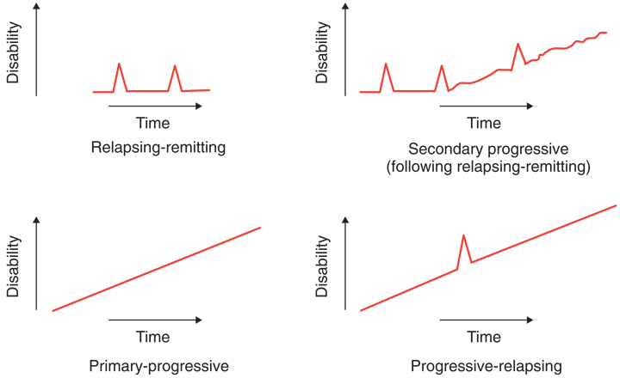
In general, agents with efficacy in RRMS cannot be assumed to have efficacy in SPMS, and it is usually very important to distinguish between these disease subtypes when designing and assessing MS treatment trials. Most agents approved for the treatment of RRMS have demonstrated only limited efficacy in progressive forms of MS, including SPMS, and no disease modifying agents are currently approved for the treatment of PPMS. If the sponsor is correct in claiming that ocrelizumab reduces disease progression in PPMS, as well as in RRMS, then it has efficacy at each end of the notional spectrum between relapse dominant and progression dominant disease; this in turn implies that it is probably effective for intermediate disease subtypes (SPMS and PRMS), and therefore the distinction between the classical disease subtypes may be less important for this particular agent. Nonetheless, it would still be appropriate to choose wording for the indication that explicitly mentions the classic disease subtypes.
Ocrelizumab is supplied as a single strength, 300 mg/10 mL vial for injection (IV infusion). The dose is 600 mg every 6 months.

Regulatory status
At the time of this submission to TGA, a marketing authorisation for ocrelizumab had not been granted in any country. Applications had been made in the US and the EU, and were imminent in Canada, Switzerland and New Zealand.

Product Information
The Product Information (PI) approved with the submission which is described in this AusPAR can be found as Attachment 1. For the most recent PI, please refer to the TGA website at <https://www.tga.gov.au/product-information-pi>.

II. Registration timeline
The following table captures the key steps and dates for this application and which are detailed and discussed in this AusPAR.
Table 1: Registration timeline
Description | Date
Submission dossier accepted and first round evaluation commenced | 30 June 2016
First round evaluation completed | 30 November 2016
Sponsor provides responses on questions raised in first round evaluation | 1 February 2017
Second round evaluation completed | 10 March 2017
Delegate’s overall benefit-risk assessment and request for Advisory Committee advice | 14 April 2017
Sponsor’s pre-Advisory Committee response | 27 May 2017
Advisory Committee meeting | 2 June 2017
Registration decision | 3 July 2017
Completion of administrative activities and registration on ARTG | 13 July 2017
Number of working days from submission dossier acceptance to registration decision* | 215
* Legislative timeframe is 255 working days

III. Quality findings

Introduction

Structure
Ocrelizumab is a humanised monoclonal antibody produced in CHO cells. It is based on the human immunoglobulin G1 framework consisting of two identical 213 residue light chains and two identical 451/452 residue heavy chains (C₆₄₈₂H₉₉₅₂N₁₇₁₂O₂₀₁₄S₄₆). The calculated molecular mass of intact deglycosylated ocrelizumab is approximately 145,564 Da (peptide chains only, without heavy chain C-terminal lysine residues).
The C_{H}2 domain of each heavy chain has a single conserved glycosylation site at Asn302. The N-linked oligosaccharides of ocrelizumab are typical of those observed on other CHO produced monoclonal antibodies. The C-terminal lysine residues of the heavy chains (Lys452) is removed by basic carboxypeptidases during the cell culture process.
Fourier transform infrared spectroscopy (FTIR) confirms that ocrelizumab primarily has a β-sheet structure, consistent with the structure of an IgG1 antibody. The expected intrachain and interchain disulfide linkages have also been confirmed.

Physical and chemical properties
These are shown in Table 2.
Table 2: Physical and chemical properties
Property | Molecule Details
Molecular Formula | C₆₄₈₂H₉₉₅₂N₁₇₁₂O₂₀₁₄S₄₆
Molecular Mass | Approximately 145,564 Da (deglycosylated mass calculated with Asp302 instead of Asn302; peptide chains only, without heavy chain C-terminal lysine residues)
Extinction Coefficient | 1.75 mL/(mg cm) at 278 nm
Isoelectric Point | 9.2 by ICIEF
Immunoglobulin Subgroup | IgG1 with VHIII and VкI region subgroups
Glycosylation Site | Two N-linked glycosylation sites (Asn302) in Fc
Biological Activity | Ocrelizumab is a recombinant humanized monoclonal antibody that selectively depletes CD20-expressing B cells. Biological activity is measured by a combination of the CDC potency assay and the CE-glycan assay. The CE-glycan assay measures afucosylated G0 oligosaccharides and serves as a surrogate for ADCC activity

Manufacture

Drug substance
Ocrelizumab drug substance is manufactured at a facility in the USA. The manufacturing process includes two parts: cell culture and harvest process, and purification and modification reaction process.

Drug product
Ocrelizumab drug product is manufactured in Germany. The manufacture process includes: thawing of drug substance, preparation of the formulation buffer, optional pooling of multiple drug substance batches in the compounding vessel, dilution and mixing of the drug substance with formulation buffer, bioburden reduction filtration, sterile filtration, aseptic filling into glass vials, stoppering, capping and crimping, final vial inspection and labelling and secondary packaging. Refiltration is the only reprocessing step that may be allowed.

Stability

Drug substance
The sponsor proposed a shelf life of 36 months at ≤ -20°C.
Stability data have been generated under real time/stressed conditions to characterise the stability profile of the substance and to establish a shelf life. The real time data and comparability data submitted support a shelf life of 36 months when stored at ≤ -20°C.

Drug product
The sponsor proposed a shelf life of 24 months at 5 ± 3°C.
Stability data have been generated under real time/stressed conditions to characterise the stability profile of the product and to establish a shelf life. The real time data submitted support a shelf life of 18 months when stored at 5 ± 3°C, protect from light. Within the shelf life, the maximum allowable time for the drug product to be exposed to ambient conditions (9°C to 30°C) is 216 hours, which includes 8 days (192 hours) at 25ºC and 1 day (24 hours) at 30°C.
Photostability data shows that the product is not photostable and it should be stored in secondary packaging. In-use stability data have also been submitted.

Important information relevant to testing by TGA Laboratories Branch
- Briefly describe the main degradation pathways for the product and which analytical methods are the most relevant and stability indicating tests.
The main ocrelizumab degradation variants include aggregation/fragmentation (detected by SEC-HPLC and CE-SDS) and deamidation/isomerization/oxidation (detected by IE-HPLC). Among all bioassays, CDC potency was the most sensitive method for detecting changes in ocrelizumab.
- Provide details of the potency assay(s).
The potency assay used for ocrelizumab, the complement-dependent cytotoxicity (CDC) assay, serves as a quantitative in vitro assay to determine the potency of both ocrelizumab drug substance and drug product. The analytical procedure measures the ability of ocrelizumab to lyse human B lymphoblastoid cells (WIL2-S cells) in the presence of human complement. In the procedure, CD20-expressing WIL2-S cells are incubated in the presence of increasing concentrations of ocrelizumab and a fixed amount of complement in a 96-well tissue culture microtiter plate. The cell viability indicator, alamarBlue, is then added and the plate is further incubated. The changes in colour and fluorescence are proportional to the number of viable cells. The results, expressed in relative fluorescent units (RFU), are plotted against the ocrelizumab concentrations and parallel line analysis is used to determine the potency of the test sample relative to the reference standard.
In addition to CDC assay, ‘antibody-dependent cellular cytotoxicity (ADCC (% relative activity))’ has also been proposed to ocrelizumab drug substance specification. This parameter is not valid until relevant information has been assessed via a minor variation request after approval.
- Based on the stability studies conducted, what are the allowable temperature deviations (this should be noted on the CPD when it is provided)?
Temperature excursion ranges and duration are established on the basis of accelerated stability study and temperature cycling study followed by storage of the product until the end of shelf life under recommended storage conditions (also see below). The permitted temperature excursion ranges and duration are:
Within the shelf life, the maximum allowable time for the drug product to be exposed to ambient conditions (9 to 30°C) is 216 hours, which includes 8 days (192 hours) at 25°C and 1 day (24 hours) at 30°C.
- Are there stability data specifically related to transport or temperature cycling that was available in the application?
Stability data of temperature cycling study followed by storage of the product under recommended storage conditions (one clinical batch for 36 months and one commercial batch for 12 months) have been provided.

Biopharmaceutics
Bioavailability data are not required as the product is administered intravenously.

Quality summary and conclusions
At the time of assessment, there is no objection on quality grounds to the approval of Ocrevus subject to receipt of an outstanding GMP certificate.
GMP Clearance for drug substance manufacturing site in California is still outstanding.

Batch release testing & compliance with Certified Product Details (CPD)
- It is a condition of registration that all batches of Ocrevus imported into Australia must comply with the product details and specifications approved during evaluation and detailed in the Certified Product Details (CPD).
- It is a condition of registration that each batch of Ocrevus imported into Australia is not released for sale until samples and/or the manufacturer’s release data have been assessed and endorsed for release by the TGA Laboratories Branch.
The sponsor must supply:
- Certificates of Analysis of all active ingredient (drug substance) and final product.
- Information on the number of doses to be released in Australia with accompanying expiry dates for the product and diluents (if included).
- Evidence of the maintenance of registered storage conditions during transport to Australia.
- 3 vials of each batch for testing by the TGA Laboratories Branch together with any necessary standards, impurities and active pharmaceutical ingredients (with their Certificates of Analysis) required for method development and validation.
Samples and data should be forwarded to the TGA Laboratories Branch, Biochemistry Section, before release of each batch and with sufficient lead time to allow for testing.
This batch release condition will be reviewed and may be modified on the basis of actual batch quality and consistency.

Certified product details
The CPD, as described in Guidance 7: Certified Product Details of the Australian Regulatory Guidelines for Prescription Medicines (ARGPM), for the above products should be provided upon registration of these therapeutic goods. In addition, an updated CPD should be provided when changes to finished product specifications and test methods are approved in an application or notified through a self-assessable change.

Second round evaluation
In the sponsor’s response to the first round evaluation, the sponsor provided comments to the questions raised in the first round evaluation report. Below are the recommendations.
- GMP clearance for drug substance manufacturing site in California is still outstanding, which may delay registration.
- The updated labels are acceptable provided the following requirements are met:
  - The text in real size primary and container labels comply with the requirement of TGO69 3(1)(b)(i) and (ii), that is, ‘the ARTG number is at least 1 mm in height or greater’ and ‘all other letter heights are at least 1.5 mm or greater’.
  - The warning statements in real size primary label complies with the requirement of TGO69 3(2)(g) or ‘Standard for the Uniform Scheduling of Medicines and Poisons’ Part 2.7.1 (a) and (c).
- The revised drug substance specification is acceptable except for the newly added parameter of ‘ADCC (% relative activity)’. As the ADCC method is not currently validated, it should be omitted from the drug substance specification until the relevant supporting information has been assessed via a minor variation request after registration.
- The shelf life of ocrelizumab drug product should be limited to ‘18 months, store at 2°C to 8°C (Refrigerate. Do not freeze), Protect from light’ until sufficient stability data from commercial batches becomes available. In addition, the temperature excursion during drug product manufacturing, shipping and handling should be limited to ‘within the shelf life, the maximum allowable time for the drug product to be exposed to ambient conditions (9°C to 30°C) is 216 hours, which includes 8 days (192 hours) at 25°C and 1 day (24 hours) at 30°C’. Extension of drug product shelf life can be applied for after registration.
The sponsor will be contacted in due course to provide CPD, samples, reference standards and other materials necessary to set-up product testing in TGA.
There is no objection to the registration of Ocrevus on quality grounds subject to receipt of the outstanding GMP certificate and an assurance to meet the label requirements.

IV. Nonclinical findings
There was no requirement for a nonclinical evaluation in a submission of this type.

Introduction
Ocrelizumab is a humanised monoclonal anti-CD20 antibody that targets and depletes CD20⁺ B cells. The overall quality of the nonclinical dossier was good and in general accord with the ICH guideline on nonclinical evaluation of biotechnology derived pharmaceuticals (ICH S6). The species specificity of ocrelizumab precluded standard toxicity testing in commonly used species. All pivotal studies were conducted according to GLP.

Pharmacology

Primary pharmacology
MS is a chronic, inflammatory, demyelinating disease of the central nervous system mediated by an autoimmune mechanism of unknown aetiology. The condition manifests itself through neurological deficits caused by damage to the spinal cord, brainstem, optic nerves, cerebellum, and cerebrum. Resulting symptoms include weakness, spasticity, gait and coordination imbalances, sensory dysfunction, visual loss, sexual dysfunction, fatigue, depression, chronic pain, sleep disorders and cognitive impairment.
A pathogenic role for T cells in MS has been established, however, the presence of B cells, plasma cells, and excess immunoglobulins have been demonstrated in lesions and cerebrospinal fluid of patients with MS. It has thus become evident in recent years that B cells also play a fundamental role in the pathogenesis of MS. B cells are thought to play an important role in the pathogenesis of MS by: presenting auto-antigens and co-stimulatory signals that activate T cells, secreting pro-inflammatory cytokines at greater relative proportions than protective cytokines, producing auto-antibodies which may cause tissue damage and activate macrophages and natural killer cells, and by creating meningeal lymphoid follicle-like structures, linked to microglial activation, local inflammation and neuronal loss in the nearby cortex.
It is proposed that ocrelizumab selectively depletes CD20-expressing B cells, a cell-surface antigen present on pre-B, mature, and memory B cells but not on lymphoid stem cells and antibody-producing plasma cells. Ocrevus is proposed to be used for the suppression of relapses and disease progression in patients with relapsing forms of multiple sclerosis (clinical and subclinical disease activity) and for delaying disease progression and reduction in walking speed in patients with primary progressive multiple sclerosis.
The precise mechanisms through which ocrelizumab exerts its therapeutic clinical effects in MS are not fully elucidated but are hypothesised to involve immunomodulation through the reduction in the number and function of CD20⁺ B cells which are thought to be responsible for the consequent improvement of the disease course of MS.
A range of in vitro studies were submitted that characterised the binding of Ocrelizumab to human CD20, serum complement C1q, and Fcγ receptors, and the ability of Ocrelizumab to mediate antibody-dependent cell-mediated cytotoxicity (ADCC), complement-dependent cytotoxicity (CDC), antibody-dependent cell-mediated phagocytosis (ADCP) and apoptosis (programmed cell death) in human target cell lines or human peripheral blood mononuclear cells (PBMCs). It is presumed that ocrelizumab depletes CD20⁺ B cells through one or more of these mechanisms in vivo. In these in vitro studies the affinity and activity of Ocrelizumab was compared to that of rituximab, a chimeric anti-CD20 antibody that also depletes CD20⁺ B cells and is used for the treatment of non-Hodgkin lymphoma.
Ocrelizumab and rituximab exhibited similar equilibrium binding affinities for binding to CD20 on WIL2-S cells (study 03-0387-0349). Binding potencies of ocrelizumab for the high-affinity Fcγ receptor, FcγRIa and for the low-affinity Fcγ receptors, Fcγ RIIa and Fcγ RIIb were very similar to those of rituximab. Binding of ocrelizumab to the low-affinity Fcγ receptor, FcγRIIIa, was stronger than that of rituximab for both allotypes of this receptor (Study 03-0387-0349). Ocrelizumab and rituximab bound to human complement C1Q with similar affinity (Study 03-0387-0349).
Ocrelizumab was approximately 4 times more potent than rituximab in mediating NK cell-mediated ADCC (Study 03-0387-0349), which is consistent with its stronger binding to both allotypes of FcγRIIIa (Study 03-0387-0349). Ocrelizumab was more potent than rituximab in stimulating ADCC with PBMCs, although the difference was not as great as with NK cells (Study 03-0387-0349). Despite binding complement C1Q with similar affinity (Study 03-0387-0349), Ocrelizumab was approximately 3- to 4-fold less potent than rituximab in promoting CDC activity in vitro. The activation step of the complement cascade, and not simply the binding affinity, may be more sensitive to differences between these antibodies, which may account for this difference. It is claimed in study 14-1579 that ocrelizumab can mediate ADCP, however, data from only a single representative experimental replicate is shown. Therefore, this claim cannot be verified without additional data. In Study 03-0387-0349, it was shown that both ocrelizumab and rituximab induced apoptosis of Ramos cells when cross-linked with anti-human Fc. This suggests that ocrelizumab may deplete B cells via apoptosis in vivo, induced via cross-linking of Fc regions of CD20-bound ocrelizumab by Fcγ receptors on the surfaces of immune effector cells.
The ability of ocrelizumab to deplete CD20⁺ B cells was assessed in a range of in vivo studies conducted in cynomolgus monkeys. The amino acid sequence of cynomolgus CD20 is identical (extracellular domain) or very similar (intracellular domain) to that in humans therefore the cynomolgus monkey was considered a relevant model in which to test the in vivo activity of ocrelizumab. Furthermore, the lack of rodent CD20 recognition precluded the evaluation of ocrelizumab in rodent MS models. B cell depletion in peripheral blood was assessed by flow cytometry (using anti-CD40 antibodies to identify B cells) in all in vivo studies. In some studies, B cell depletion in lymphoid organs was assessed by flow cytometry and immunohistochemistry.
Peripheral B cell depletion was observed across the range of doses tested (0.05, 0.2, 0.5, 2, 10, 50, and 100 mg/kg) and was dose-dependent in its extent and duration. Depletion was incomplete at 0.05 mg/kg and was of relatively short duration at doses of 10 mg/kg. The effects of ocrelizumab-mediated B cell depletion were reversible under all dose regimens examined.
In the repeat-dose retreatment study (Study 03-0114-0349) the duration of peripheral B cell depletion was approximately 3 months at the 50 and 100 mg/kg doses. After re-treatment at 100 mg/kg the duration of peripheral depletion was again approximately 3 months even though mean B cell counts were only approximately 35% of baseline values at the time of retreatment. B cell depletion in lymphatic organs was high but not complete. B cell depletion in the spleen and lymph nodes, but not the bone marrow, was dose-dependent. The extent of depletion was also lower in bone marrow (B cells persisted at between around 20% to 50% of control or pre-dose values), whereas depletion in the other lymphoid organs was > than 85% of control or pre-dose values.
In the pivotal 6 month repeat dose study (Study NC 04-0192-0134) B-cell numbers were reduced to the maximum extent by day 8 and were depleted by greater than 99% at the end of the dosing period. At the end of the recovery period, B cells had recovered to 80%-90% of pre-dose levels in the high dose group. In addition, there were no differences between vehicle control and ocrelizumab groups in absolute T cell counts. Both dose groups showed B cell depletion in the spleen, lymph nodes, and to a lesser extent in bone marrow, at the terminal necropsy on Day 149. At the recovery necropsy on Day 314, B cell percentages in the spleen and marrow in the high dose group had completely recovered but remained at 44.5% and 73% of control values for the inguinal and mandibular lymph nodes, respectively.
To support a change in the manufacturing process of ocrelizumab, a cell line clone switch from Clone 33 to Clone 24-635, a study was conducted in cynomolgus monkeys in which the pharmacodynamic profiles of ocrelizumab derived from these clones was compared (Study 07-0171). Ocrelizumab derived from either clone both depleted blood B cells effectively (> 98% depletion by day 29). Clone 33 induced more prolonged B cell depletion since by the end of the recovery period, peripheral B cells in clone 33-treated animals were 67% of baseline levels whereas clone 24-635 treated animals were 89%.

Secondary pharmacodynamics and safety pharmacology
No secondary or safety pharmacology studies were submitted (this is acceptable for this class of drug), however, some physiological end-points were assessed in some repeat dose toxicity studies. These included blood pressure, heart rate, respiratory rate, and body temperature. In addition, general sensomotory aspects, cerebral reflexes (pupillary, orbicularis occuli, cornea), and spinal reflexes (patellar, anal) were assessed in Study NC 12-0524. None of these parameters were affected by ocrelizumab.

Pharmacokinetics
The proposed clinical route of ocrelizumab is IV and pharmacokinetic profiles were determined by this route in several single and multiple dose studies in mice (including wild-type and human CD20 transgenic mice), rats and cynomolgus monkeys. Since ocrelizumab binds only to human and non-human primate CD20 (and not rodent CD20), the cynomolgus monkey was used as the most appropriate species for pharmacokinetic evaluation.
The volume of distribution at steady state (V_{ss}) and half-life (t_{1/2}) in wild-type mice and wild-type rats given a single IV bolus dose of ocrelizumab across a 100-fold range of doses (0.5, 5, and 50 mg/kg) lacked dose dependence, as expected for a non-binding species (Studies 03-0155-0349 and 03-0157-0349).
In cynomolgus monkeys, ocrelizumab clearance (CL) and half-life (t_{1/2}) were dose-dependent. As the dose or dosing frequency increased, CL decreased and t_{1/2} increased generally. Ocrelizumab had a long terminal t_{1/2} (ranging between around 5 to 25 days) following a rapid initial distribution phase. Given that binding to circulating and tissue-resident B cells reduces levels of free ocrelizumab, CL was partly dependent on binding to CD20 antigen-bearing B cells. Absorption (T_{max} around 7 days) and clearance (around 0.2 to 0.5 mL/h/kg) was slow, and volume of distribution was small (ranging from around 30 to 120 mL/kg) reflecting distribution primarily in the circulatory system, as is typical for monoclonal antibodies.
At lower dose levels (0.2 to 10 mg/kg) ocrelizumab exhibited nonlinear CL. In this dose range, as the dose or dosing frequency or both were increased, CL decreased (from around 154 mL/h/kg at 0.2 mg/kg to around 10 mL/day/kg at 10 mg/kg) and t_{1/2} increased from 1 to 7 days when the dose was increased from 0.2 to 10 mg/kg (Studies 02-0182-0352 and 03-0235-0349). At doses greater than 10 mg/kg, ocrelizumab exhibited mostly linear CL (Studies 03-0113-0349, 03-0114-0349, and 03-0684-0134) and increased dosing frequency resulted in decreased CL and increased t_{1/2}. No gender differences were observed in any pharmacokinetic parameters. In addition, no significant differences were observed in pharmacokinetic parameters (AUC or C_{max}) in the clone comparison study (Study 07-0171).
Anti-ocrelizumab antibodies (AOA) were detected in most studies in cynomolgus monkeys (30% of all ocrelizumab-treated animals across multiple studies were AOA-positive). The presence of AOA to ocrelizumab did impact exposure in some low-dose animals, increasing CL at doses ≤ 10 mg/kg or lower, but there was only minimal impact on pharmacokinetic parameters in animals given ≥ 10 mg/kg ocrelizumab.
Tissue distribution studies in mice engineered to express human CD20 demonstrated that, while ocrelizumab does not recognize CD20 in wild-type mice, there was binding of CD20 in transgenic mice. Transgenic mice cleared ocrelizumab significantly faster and in a dose-dependent manner than wild-type mice (since ocrelizumab was not bound by CD20 and thus achieved higher plasma concentrations) consistent with binding species such as cynomolgus monkeys and humans (Study 03-0431-0349).
Tissue distribution studies by positron emission tomography imaging in cynomolgus monkeys revealed the presence of labelled ocrelizumab within the blood pool and distribution to organs with high levels of B cells (for example, spleen and lymphoid tissues) and also to the liver and kidneys. These data indicate that ocrelizumab localises to organs with high lymphocyte content and that binding to (presumably CD20⁺) lymphocytes influences the in vivo distribution and clearance of ocrelizumab (Study 15-0538).

Toxicology

Acute toxicity
No standard single-dose toxicity studies were submitted and such studies are not considered essential for a monoclonal antibody.

Repeat dose toxicity
The repeat-dose toxicity of ocrelizumab was evaluated in cynomolgus monkeys only. Studies NC 03-0113-0349, NC-03-0684-0134, NC 07-0171, NC 12-0524, Study NC 12-0525 and Study NC 04-0192-0134 (the pivotal study) were GLP-compliant and administrations were all via the IV route, the intended clinical route. The cynomolgus monkey was the only suitable model for nonclinical safety studies since ocrelizumab (apart from human CD20) only binds non-human primate CD20. Ocrelizumab was assessed at a variety of doses (up to 100 mg/kg) and dosing regimens including weekly administration for 2 and 4 weeks, biweekly for two cycles (separated by 14 weeks) and triweekly for 8 cycles (that is, 6 months in the pivotal study). In all clinical studies, ocrelizumab (600 mg or 2 ×00mg) was administered once every 6 months. In all repeat-dose studies, ocrelizumab was well tolerated and ≥ 95% B cell depletion was observed in peripheral blood, at all doses tested, within the first 7 days of administration.
The potential for ocrelizumab to cause haemolysis or coagulation was assessed in vitro. Ocrelizumab at concentrations of 1, 5, or 10 mg/mL did not cause haemolysis, precipitation or coagulation when mixed with an equal volume of human or cynomolgus monkey whole blood or plasma.

Relative exposure
Exposure ratios have been calculated based on monkey: human plasma AUC. Human pharmacokinetic reference values are from a population PK analysis conducted with the combined data from three clinical studies: a Phase II study (WA21493) in relapsing-remitting MS and two pivotal Phase III studies (WA21092 and WA21093) in relapsing MS. The human AUC value used for comparison is from the 6 month period following the first dose administration of ocrelizumab (2904 µg/mL/day). It should be noted that the AUC steadily increased during each 6 monthly interval in the clinical studies: by the fourth interval the AUC was 3513 µg/mL/day (an increase of around 20% over the first 6 month period) and that this would have yielded slightly lower exposure ratios. The AUC data used for the monkey studies is the mean of male and female AUC values.
Table 3: Relative exposure in repeat-dose toxicity studies
Species | Study duration (Study no.) | Dose (mg/kg) | AUC* (µg∙day/mL) | Exposure ratio (ER)#
Monkey  (Cynomolgus) | 2 weeks  NC 02-0182-0352 | 10 (hu2H7 v.16) | 1429 | 5
Monkey  (Cynomolgus) | 2 weeks  NC 02-0182-0352 | 10 (hu2H7 v.31) | 1833 | 5.4
Monkey  (Cynomolgus) | 2 weeks  NC 03-0235-0349 | 0.2 | 3.56 | < 0.1
Monkey  (Cynomolgus) | 2 weeks  NC 03-0235-0349 | 0.5 | 14.5 | < 0.1
Monkey  (Cynomolgus) | 2 weeks  NC 03-0235-0349 | 2.0 | 90.2 | 0.6
Monkey  (Cynomolgus) | 2 weeks  NC 03-0113-0349 | 10 | 671 | 1.5
Monkey  (Cynomolgus) | 2 weeks  NC 03-0113-0349 | 50 | 5645 | 12
Monkey  (Cynomolgus) | 2 weeks  NC 03-0113-0349 | 100 | 15400 | 8.1
Monkey  (Cynomolgus) | 24 weeks  NC 04-0192-0134  (pivotal) | 50 | 107500 | 37
Monkey  (Cynomolgus) | 24 weeks  NC 04-0192-0134  (pivotal) | 100 | 218500 | 75
Monkey  (Cynomolgus) | 4 weeks  NC-03-0684-0134 | 50 | 33900 | 81
Monkey  (Cynomolgus) | 4 weeks  NC-03-0684-0134 | 100 | 61700 | 147
Monkey  (Cynomolgus) | 2 weeks/18 weeks  NC 03-0114-0349; | 10 | 2160 | 1.2
Monkey  (Cynomolgus) | 2 weeks/18 weeks  NC 03-0114-0349; | 50 (2 cycles) (1st treatment cycle only in AUC value) | 18500 | 10
Monkey  (Cynomolgus) | 2 weeks/18 weeks  NC 03-0114-0349; | 100 (1 cycle) | 39600 | 22
Monkey  (Cynomolgus) | 2 weeks/18 weeks  NC 03-0114-0349; | 100 (2 cycles) (1st treatment cycle only in AUC value) | 38700 | 21
Human  RMS and RRMS patients | steady state | 600 mg/6 months | 2904^ | –
# = animal:human plasma AUC; *, AUC data from males and females have been combined for studies NC 03-0113-0349, NC-03-0684-0134 and NC 03-0114-0349; AUC_{last} = 0 – last quantifiable concentration or last reading of a defined period; ^with repeated clinical dosing, ERs would be ca 20% lower (clinical AUC 3513 µg∙day/mL).

Major toxicities
Hypercellularity of the bone marrow was observed in animals given 50 or 100 mg/kg (study 04-0192-0134) and in animals given 50 mg/kg (study 07-0171), with no clear dose dependency. Mild decreases in circulating erythrocyte mass and increases in absolute reticulocyte counts were occasionally observed in association with bone marrow hypercellularity.
Neutrophilic infiltration of splenic sinusoids was observed in one study in animals given 50 mg/kg (Study 07-0171).
Minimal to mild multifocal to diffuse lymphocytic and plasmacytic cell infiltrates in the brain, oesophagus, bladder, stomach, rectum, liver and the ciliary eye body were observed with no clear dose dependency (Study 03-0114-0349). In this study, a dose–dependent effect on spermatogenesis was observed, with reduced testes weight at the high dose. The sponsor attributed this apparent finding to low group size and highly variable animal maturation (Section 31 response). These observations were completely resolved or had significantly reduced in incidence in recovery animals.

Genotoxicity & carcinogenicity
Genotoxicity and carcinogenicity studies were not submitted. Monoclonal antibodies are not expected to enter the cell and interact with DNA and there is no specific genotoxicity concern for ocrelizumab, so genotoxicity studies are not required. Standard carcinogenicity studies are generally inappropriate for monoclonal antibodies. Unless the mechanism of action of the drug or findings from other studies, such as proliferative findings in the repeat-dose toxicity studies, suggest concern regarding potential carcinogenicity, which does not apply to ocrelizumab, no assessment of carcinogenic potential is required.

Reproductive toxicity
An acceptable compilation of reproductive toxicity studies covering investigations of fertility, embryofetal development and pre/postnatal development, was submitted. Dosing was in cynomolgus monkeys by the IV route and administered weekly in all studies, which is appropriate. All studies were GLP compliant.
The potential effects of ocrelizumab on fertility in males and females were investigated by examining fertility markers (sperm quality and menstrual cycling, and gross assessments of reproductive organs) rather than assessing the outcome of matings. This is acceptable.
Study designs were appropriate, including investigation of appropriate end-points and the timing and duration of dosing. Eight weekly doses were given in the male fertility study (NC 12-0524), sufficient time to cover all stages of spermatogenesis in males (around 42 days from spermatogonium to fully developed elongated spermatid). In the female fertility study (NC 12-0525) ocrelizumab was administered once weekly over the course of three menstrual cycles (or the expected duration of three cycles, i.e. up to 105 days). Dosing in the embryofetal development studies was from GD20-50 (covering the period of organogenesis), while dosing in the pre/postnatal development study was from GD50 to LD28. All studies included toxicokinetic monitoring and screening for anti-ocrelizumab antibodies.
High exposure ratios were achieved (up to 226 and 193 in the male and female fertility studies, respectively, up to 281 in the embryofetal development study and 211 in the pre/postnatal development study) (see Table 4). Excretion of ocrelizumab into milk was demonstrated which is expected for a monoclonal antibody.

Relative exposure
See Table 4.
Table 4: Relative exposure in reproductive toxicity studies
Species | Study  (Study no.) | Dose  (mg/kg IV) | AUC  (µg∙day/mL) | Exposure ratio (ER)#
Monkey  (cynomolgus) | Fertility ♂  Study NC 12-0524  (Final dose – AUC represents exposure from day 58-65) | 20 | 6490° | 58
Monkey  (cynomolgus) |  | 100 | 25300° | 226
Monkey  (cynomolgus) | Fertility ♀  Study NC 12-0525  (AUC = mean of last 4 doses; AUC represents exposure for around 1 week) | 20 | 4832.5 | 43
Monkey  (cynomolgus) |  | 100 | 21550 | 193
Monkey  (cynomolgus) | Embryofetal development  NC 04-1272-1342  (AUC from GD20 to >50, AUC represents exposure for >1 month) | 20 | 28900^ | 60
Monkey  (cynomolgus) |  | 100 | 136000^ | 281
Monkey  (cynomolgus) | Pre-/Post Natal Development  NC 06-1260  (AUC from GD22-GD29, AUC represents 1 week) | 20 | 3970* (PD)  5300* (SD) | 47 (SD)
Monkey  (cynomolgus) |  | 100 | 17700* (PD)  23600* (SD) | 211 (SD)
Human  RMS and RRMS patients | steady state  (AUC represents exposure of 6 months) | 600 mg | 2904^  (3513) | –
# = animal:human plasma AUC; °=AUCday58-65; ^=AUClast , GD20 to last observable ; *=AUCGD22-GD29 ; PD Priming Dose, SD Study Dose; AUC values for SD extrapolated from AUC values for PD (x4/3); ^With repeated clinical dosing, ERs would be ca 20% lower (clinical AUC 3513 µg.day/mL).

Fertility studies
There were no findings indicative of an effect of ocrelizumab on fertility in males or females. In the female fertility study, one animal in the high dose group showed amenorrhea during treatment and recovery cycles. This was considered incidental since this is occasionally seen in untreated animals, and all other females of this group showed unaffected menstrual cycles during the treatment cycles. Another female in this group did not show menstruation from recovery cycle 2 onwards which was considered unrelated to treatment since there was no change in cycle length, regular cycles were observed during treatment, and histopathology did not identify any irregularities in the ovaries. In the low dose group, no menstrual bleeding was detected in one female at the end of treatment cycle 3/start of recovery cycle 1. This was not attributed to ocrelizumab since no other animals in this group showed similar signs and all other menstrual cycles during treatment and recovery were normal.

Embryofetal studies
There was no evidence of toxicity in dams, or teratogenicity and embryotoxicity in fetuses.
In maternal animals, there were no ocrelizumab-related effects on the maintenance of pregnancy (the total frequency of abortion and embryofetal death in each group was 16.7% (2/12), 8.3% (1/12), and 8.3% (1/12) in the control, 20 mg/kg, and 100 mg/kg dose groups, respectively). All fetuses (except one in the 100 mg/kg group) were alive, with no external anomalies observed. Although the fetal and placental weights of the dead fetus were small (fetal weight: 11g, around 9% of the control mean; placental weight: 17 g, around 37% of the control mean), no external abnormalities were observed in either the fetus or and placenta.
No treatment-related effects were observed on fetal weight (excluding the one dead fetus) or placental weight. No visceral anomalies or variations were observed in any fetuses. No statistically significant changes were noted in absolute and relative fetal organ weights.
Skeletal variation (the presence of lumbar ribs, unilateral or bilateral, or shortening of the 12th ribs), were observed in 6 of the 11 fetuses (54.5%, statistically significant change) in the 20 mg/kg group. Because the presence of lumbar ribs is a common finding (16.7% in the control background data) in cynomolgus monkey fetuses, and there were no skeletal variations in the 100 mg/kg group, these changes were not considered ocrelizumab-related. A single placenta was observed in 2 of the 10 and 1 of the 11 fetuses in the control and the 20 mg/kg groups, respectively. Because single placenta is common in cynomolgus monkeys (around 16%) 14, these occurrences were judged to be incidental.

Pre/postnatal development study
Ocrelizumab did not have an abortifacient effect since the incidences of embryo-fetal losses in ocrelizumab-treated groups (6.7% to 20.0%) were within the Testing Facility’s historical control range (14.2% ± 10.2%, range from 0 to 33.3%) and there was no statistically significant difference between the control group (13.3%) and the ocrelizumab-treated groups. In neonates, clinical observations, survival, body weight gain, parameters of functional and morphological development, haematology (except for a reduction in B cells), or coagulation up to around 7 months after birth were unaffected by ocrelizumab treatment. B cell depletion was near complete in maternal animals and neonates. There were 0/13, 2/13 and 1/11 stillbirths in the control, low dose and high dose groups, respectively. These incidences were within historical control data ranges and were considered to be unrelated to ocrelizumab. Birth weight was reduced by 12% in neonates in the high dose group but body weight gain thereafter was unaffected.
Euthanasia was required for 3 moribund maternal animals (1 from each of the two treatment groups and 1 from the control group). The cause of the moribundity of these animals was not established, and the relationship to ocrelizumab treatment is unknown. There were no target organ effects (other than B cell depletion). Because maternal mortalities occurred in 1 animal in each group, including the control group, and there were no notable differences in anatomic pathology findings (except for acute renal cortical necrosis observed in the maternal animal from the low dose group), the moribundities were considered unlikely to be related directly to administration of ocrelizumab.
Two unscheduled neonatal necropsies were performed in the high dose group. The cause of death in the first neonate was attributed to weakness due to premature birth (on GD 146) as well as an opportunistic infection, which may have developed as result of B cell depletion. Histologic findings included inflammation of the meninges with intralesional bacteria involving the brain and spinal cord, acute centrilobular hepatocellular necrosis with acute gall bladder necrosis, inflammation of the mesentery (peritonitis), and decreased cellularity in the thymic cortex, splenic lymphoid follicle, and the periarteriolar lymphoid sheath. In the second neonate, the cause of death was attributed to meningoencephalitis involving the cerebellum. Staphylococcal bacteria were identified in breast milk from the maternal dam, which was diagnosed with mastitis, and may have been the source of the opportunistic infection in this neonate. Both the maternal mastitis and the neonatal infections could have potentially been impacted by B cell depletion.
Testicular weights in neonates (absolute, body weight-relative, and brain weight-relative) were lower in the treated groups cf controls, particularly for the high dose group (27-38% reduction). The toxicological significance of this finding remains unclear, given there are no reductions in accessory reproductive organs (epididymis, prostate/seminal vesicle weights). These findings have nevertheless been incorporated into the PI document.
Histopathologically, ocrelizumab related changes in neonates included glomerulopathy (7/24 (29.2%) neonates in treatment groups (3/16 LD, 4/22 HD)), lymphoid follicle formation in the bone marrow (9/24 (37.5%) neonates in treatment groups), and lymphocytic and plasmacytic inflammation in the kidney (2/11 (18.2%) in the high dose treatment group (nil in the LD and control groups) present in patchy or focal distributions. Glomerular immaturity (3/16 in the low dose group; 4/22 in the high dose group), minimal interstitial fibrosis (3/16 in the low dose group; 1/22 in the high dose group) and glomerulosclerosis were also present in the treatment groups and absent in controls.

Pregnancy classification
The sponsor has proposed Pregnancy Category C, which is considered appropriate.

Local tolerance
Subcutaneous injection of ocrelizumab resulted in swelling and redness at the injection sites, with the severity and duration of swelling proportional to the volume administered. For monkeys injected with 1 mL ocrelizumab, the swelling resolved by Day 8, whereas it resolved by Day 6 when ocrelizumab was administered via two simultaneous 0.5 mL injections. Redness attributed to inflammation was observed through to Day 4 in some monkeys in both groups. At Day 8, a mild to moderate mononuclear cell or macrophage infiltrate was observed microscopically in the deep subcutaneous layer of the injection site biopsies. At Day 15, a minimal mononuclear cell/macrophage infiltrate was observed in the deep subcutaneous layer of the injection site biopsies from animals receiving 1 mL injections. Adverse injection site reactions were restricted to groups receiving subcutaneous administration and no adverse reactions were reported for the group administered ocrelizumab IV, the proposed clinical route.

Tissue cross-reactivity
A study was conducted to evaluate tissue distribution of biotinylated ocrelizumab in human and cynomolgus monkey tissues. Specific binding of ocrelizumab was observed in B-cell regions of lymphoid follicles of organized lymphoid tissues (i.e., lymph nodes, spleen, and tonsil) and B-cell regions of lymphoid-associated tissue from other organs (i.e., gastrointestinal tract, lung, and pancreas) from both humans and cynomolgus monkeys, in scattered cells in the thymus (cynomolgus monkeys only) and minimal positive staining in the lens fibres in two of three eyes evaluated (humans only).

Paediatric use
Ocrelizumab is not proposed for paediatric use and no specific studies in juvenile animals were submitted.

Nonclinical summary and conclusions

Summary
- An adequate nonclinical dossier of good quality studies was submitted. All in vivo studies were supported by toxicokinetic and antibody data. All pivotal safety-related studies were GLP compliant.
- In vitro studies demonstrated that ocrelizumab bound CD20 on B cells with high affinity (around 1nM). Binding of the Fc region of ocrelizumab to human Fcγ receptors and complement C1q was demonstrated in vitro. The ability of ocrelizumab to mediate apoptosis, antibody-dependent cellular cytotoxicity and complement-dependent cytotoxicity was also demonstrated in vitro and were proposed as mechanisms that mediate B cell depletion in vivo.
- The in vivo studies performed with ocrelizumab in cynomolgus monkeys demonstrated a dose-dependent and rapid depletion of peripheral B cells. In all studies, B cells repleted or trended to repletion upon termination of treatment. Treatment with low doses of ocrelizumab resulted in short-term depletion of peripheral B cells while at higher doses (at or above 10 mg/kg) CD20⁺ peripheral B cells were undetectable within 24 h and remained thus during repeat-dosing periods. Significant depletion was also observed in lymphoid tissues (such as the spleen and lymph nodes) and to a lesser extent in bone marrow.
- No secondary or safety pharmacology studies were submitted. Safety pharmacology end-points (ECG, blood pressure, respiratory rate) were incorporated in the repeat-dose studies, with no treatment-related effects observed.
- The pharmacokinetics of ocrelizumab were evaluated in several multiple-dose studies (weekly, bi-weekly and tri-weekly administration) at various doses (0.05 to 100 mg/kg). Across this range of doses tested in monkeys, clearance and half-life were dose dependent and non-linear and as the dose increased, clearance decreased and half-life increased. Ocrelizumab had a long terminal half-life following a rapid initial distribution phase. Given that binding to circulating and tissue resident B cells reduces levels of free ocrelizumab, clearance was likely influenced by CD20⁺ B cells.
- Nine repeat dose studies were conducted in cynomolgus monkeys including a pivotal 6 month study. Doses up to 100 mg/kg were administered, achieving systemic exposure ratios (serum AUC) of up to ca 150×. All studies included recovery periods that ranged between 8 -32 weeks. Overall, ocrelizumab was well tolerated with drug-related effects largely restricted to the expected depletion of B cells and findings secondary to B-cell depletion, including lymphoid atrophy in B-cell regions of the spleen and LN (the germinal centres). Mild decreases in circulating erythrocyte mass and increases in absolute reticulocyte counts were observed in several studies in association with bone marrow hypercellularity. Neutrophilic infiltration of splenic sinusoids and minimal to mild multifocal to diffuse lymphocytic and plasmacytic cell infiltrates were observed in some organs. These observations completely resolved or had significantly reduced in incidence in recovery animals.
- Genotoxicity and carcinogenicity studies were not conducted and are not required.
- Reproductive toxicity studies included fertility studies (males and females treated separately; 8 doses), an embryofetal development study (GD20-50) and a pre/postnatal development study (GD50-parturition, with monitoring of infants for 7 months), all in cynomolgus monkeys with weekly IV dosing at 20 and 100 mg/kg. Animals were not mated in the fertility studies, but fertility markers (sperm quality and menstrual cycling, and gross assessments of reproductive organs) were assessed. Generally, there were few effects of treatment, and no evidence of teratogenicity. Ocrelizumab was detected in the milk in the majority of treated animals and, since significant B-cell depletion was observed in neonates, placental transfer occurred.
- In the pre/postnatal study, euthanasia was required for 3 maternal animals for moribundity of unknown cause. In two unscheduled necropsies of neonates, evidence of opportunistic infection was suggestive of infection exacerbation by immunosuppression as a result of ocrelizumab-mediated B cell depletion. Neonatal observations included reduced testicular weight and histopathological changes in the kidney, mostly at both tested doses: glomerulopathy/ immaturity, interstitial fibrosis/infiltrate, glomerulosclerosis, and lymphoplasmacytic inflammation.
- Injection site irritation was observed in a local tolerance study when ocrelizumab was administered subcutaneously but was not observed when administered intravenously, the proposed clinical route of administration.

Conclusions and recommendation
- The nonclinical data provided were satisfactory.
- Primary pharmacology studies adequately demonstrated the mechanism of action, and ocrelizumab was shown to effectively deplete CD20+ B cells in the periphery and in lymphoid organs in cynomolgus monkeys in the repeat-dose toxicity studies.
- Secondary and safety pharmacology studies were not conducted but measurements of ECG, blood pressure and body temperature in the repeat-dose toxicity studies in monkeys revealed no effect of ocrelizumab.
- Adequate repeat-dose toxicity studies in monkeys did not identify any target organs. Adequate to high systemic exposure margins were achieved (up to around 150× in cynomolgus monkeys).
- Genotoxicity and carcinogenicity studies were not conducted and are not required.
- An embryofetal development study and a pre/postnatal study in cynomolgus monkeys, achieving adequate exposure margins, were generally unremarkable. In the latter study, some histopathological changes were apparent in the neonatal kidneys, at both tested doses. The sponsor has proposed Pregnancy Category C, which is considered appropriate.
- Ocrelizumab did not cause local dermal toxicity when administered IV.
- There are no nonclinical objections to registration.
- The draft PI document should be amended as directed.

V. Clinical findings
A summary of the clinical findings is presented in this section. Further details of these clinical findings can be found in Attachment 2.

Introduction

Clinical rationale
MS is generally thought to be an autoimmune disease with some degenerative components. The primary role of the immune system is supported by the finding of peri-venular lymphocytic deposits in MS plaques, the presence of oligoclonal immunoglobulin bands in the cerebrospinal fluid of many patients, and the tendency for corticosteroids to shorten the duration of symptoms during a ‘relapse’ or flare. Furthermore, all disease-modifying treatments approved for the treatment of MS so far appear to have their primary mechanism of action in the immune system, and remissions have been achieved through the strategy of bone-marrow ablation with haematological stem-cell recovery.
Although T lymphocytes (T cells) have been studied extensively in MS, and may play a dominant pathogenic role, it has been known for decades that B lymphocytes (B cells) also play a major role in the development and progression of MS. The sponsor proposes the following key mechanisms by which B-cells contribute to the pathogenesis of MS:
- Presenting auto-antigens and co-stimulatory signals to activate T cells
- Secreting pro-inflammatory cytokines at greater relative proportions than protective cytokines
- Producing auto-antibodies which may cause tissue damage and activate macrophages and natural killer cells
- Creating meningeal lymphoid follicle-like structures, linked to microglia activation, local inflammation and neuronal loss in the nearby cortex.
Ocrelizumab targets the B cell components of the pathogenesis of MS. It is a recombinant, humanised monoclonal antibody that binds to CD20-expressing B cells with high affinity and selectively depletes them in peripheral blood. CD20 is a cell surface antigen found on pre-B cells, mature and memory B cells but it is not expressed on lymphoid stem cells and plasma cells, which means that depletion of CD20-positive cells preserves the capacity for B cell reconstitution and does not appear to compromise pre-existing antibody-mediated (humoral) immunity. According to the sponsor, pre-clinical studies suggest that ocrelizumab depletes CD20-positive B cells through several mechanisms, including antibody-dependent cellular phagocytosis (ADCP), antibody-dependent cellular cytotoxicity (ADCC), complement-dependent cytotoxicity (CDC), and induction of apoptosis. Although there are complex interactions between B cells and T cells in the immune system, the effect on B-cells appears to be quite selective, and the Sponsor has provided evidence that innate immunity and total T cell numbers are not affected.
Ocrelizumab was initially developed with the hope that it would be effective in RA and other auto-immune diseases, but it was abandoned for these indications because of a poor benefit-risk ratio. In particular, when used in combination with other immunosuppressive agents including chronic corticosteroids to treat RA, ocrelizumab appeared to pose an unacceptable risk of infection, and it was also associated with significant infusion-related reactions (IRRs).
Since abandoning the rheumatoid arthritis indication, the sponsor has assessed the efficacy of ocrelizumab in MS. This represents a rational investigational approach, given the existing evidence that B-cells play a substantial role in the pathogenesis of MS. Also, ocrelizumab might be expected to have an improved safety profile in this population, compared to the RA population, because MS patients do not usually receive chronic concurrent immunosuppressive agents. As demonstrated in their submission, ocrelizumab has substantial efficacy in MS, although some safety and tolerability issues remain. The disease-modifying effects of ocrelizumab in MS are believed to result from a reduction in the number and function of B cells, but the precise mechanisms of action are unclear.
Existing disease-modifying agents in MS have primarily been used for RRMS, and sometimes in SPMS for patients still experiencing relapses. No disease-modifying agents have shown acceptable efficacy in PPMS, which is widely thought to have a slightly different aetiology to relapsing forms of MS, with more degenerative and less immunological processes responsible for disease progression. There is, however, some evidence that immunological approaches may be useful in a subset of the PPMS population, particularly younger patents with active inflammatory lesions on MRI. For instance, rituximab, a monoclonal antibody with a very similar mode of action to ocrelizumab, had partial efficacy in PPMS, with significant results in some subgroups, as described in the following abstract.
Ann Neurol. 2009 Oct;66(4):460-71.
Rituximab in patients with primary progressive multiple sclerosis: results of a randomized double-blind placebo-controlled multicenter trial.
Hawker K, O'Connor P, Freedman MS, Calabresi PA, Antel J, Simon J, Hauser S, Waubant E, Vollmer T, Panitch H, Zhang J, Chin P, Smith CH; OLYMPUS trial group.
Objective:
Rituximab, a monoclonal antibody selectively depleting CD20+ B cells, has demonstrated efficacy in reducing disease activity in relapsing-remitting multiple sclerosis (MS). We evaluated rituximab in adults with primary progressive MS (PPMS) through 96 weeks and safety through 122 weeks.
Methods:
Using 2:1 randomization, 439 PPMS patients received two 1,000 mg intravenous rituximab or placebo infusions every 24 weeks, through 96 weeks (4 courses). The primary endpoint was time to confirmed disease progression (CDP), a prespecified increase in Expanded Disability Status Scale sustained for 12 weeks. Secondary endpoints were change from baseline to week 96 in T2 lesion volume and total brain volume on magnetic resonance imaging scans.
Results:
Differences in time to CDP between rituximab and placebo did not reach significance (96-week rates: 38.5% placebo, 30.2% rituximab; p = 0.14). From baseline to week 96, rituximab patients had less (p < 0.001) increase in T2 lesion volume; brain volume change was similar (p = 0.62) to placebo. Subgroup analysis showed time to CDP was delayed in rituximab-treated patients aged < 51 years (hazard ratio (HR) = 0.52; p = 0.010), those with gadolinium-enhancing lesions (HR = 0.41; p = 0.007), and those aged < 51 years with gadolinium-enhancing lesions (HR = 0.33; p = 0.009) compared with placebo. Adverse events were comparable between groups; 16.1% of rituximab and 13.6% of placebo patients reported serious events. Serious infections occurred in 4.5% of rituximab and < 1.0% of placebo patients. Infusion-related events, predominantly mild to moderate, were more common with rituximab during the first course, and decreased to rates comparable to placebo on successive courses.
Interpretation:
Although time to CDP between groups was not significant, overall subgroup analyses suggest selective B-cell depletion may affect disease progression in younger patients, particularly those with inflammatory lesions.
The current submission is unusual in that ocrelizumab has not only shown significant efficacy in the RRMS population, which is the traditional target of disease-modifying agents, but it has also achieved statistically significant results in the PPMS population. Unfortunately, efficacy for this novel indication has only been demonstrated in a single PPMS study, and, as will be discussed, the benefit in the lone PPMS study was primarily seen in the same type of PPMS patient that responded to rituximab: younger patients with active inflammation on MRI.

Guidance
The sponsor provided a detailed chronological account of their interactions with the European and American regulatory authorities, followed by the following summary (emphasis added by clinical evaluator):
In summary, the following key areas of feedback were discussed with US and EU health authorities for the RMS and PPMS development programs:
  - The comprehensive nonclinical program in support of all planned autoimmune indications including MS and was deemed sufficient by FDA to support the BLA. The nonclinical program was presented to the Rapporteurs as part of the MAA pre submission meetings in January 2016.
  - The design of the pivotal studies WA21092 and WA21093, blinding (use of blinded EDSS raters and active control, double-blind, double-dummy design), and endpoints (ARR as the primary endpoint and inclusion of 12-week and 24-week CDP). For Study WA25046, blinding (double blind placebo controlled), and endpoints (12-week CDP as primary) were agreed with FDA and CHMP. CHMP also indicated there would be an expectation to see an effect on both 12-week and 24-week confirmation of CDP in Study WA25046 in line with European guidance.
  - The final proposal of the size of the safety database to support the MAA filing of ocrelizumab in MS was consistent with the recommendations in ICH E1 for patient exposure and the evaluation of the safety of chronic treatments, and was endorsed by the FDA and CHMP.
  - RMS study population: both the FDA and CHMP were in agreement with the overall study population of RMS. The CHMP recommended studying the efficacy and safety of ocrelizumab in patients with more aggressive forms of RRMS, such as those with high disease activity despite treatment with a beta-interferon, or those with rapidly evolving severe RRMS. The sponsor subsequently discussed subgroups of active and highly active RMS disease patients to be analysed for benefit risk with the CHMP. Based on CHMP feedback, updated MS guidance issued by EMA, and the need to provide meaningful and simplified analysis of benefit of ocrelizumab on active and highly active disease the sponsor refined the initial selection of eleven subgroups to four subgroups to ensure a clearer conclusion could be derived from the data. The Sponsor pre-specified the four subgroups of active and highly active disease (containing both treatment naïve patients and patients who had inadequately responded to prior therapy) in the SAP. This was consistent with the final European MS guideline (EMA/CHMP/771815/ 2011, Rev. 2), which recommends that separate conclusions of the efficacy and safety in patients both with low and highly active MS should be provided at the time of benefit risk assessment (…). These subgroups and the results were presented to the Rapporteurs in January at the MAA pre submission meeting.
  - Dose selection was discussed with the FDA and CHMP. Both agencies agreed that 600 mg ocrelizumab was appropriate as the highest dose to be studied, however recommended that a lowest effective dose be determined to allow for a comprehensive benefit/risk analysis.
  - FDA and CHMP provided input on key elements of planned statistical analysis to inform the SAP for Studies WA21092 and WA21093. The hierarchical approach and to prospectively pool Studies WA21092 and WA21093 for the analysis of 12- and 24-week CDP was agreed with both agencies. The sponsor finalised and locked the SAP prior to unblinding of the study.
  - A key point of discussion with FDA and CHMP was use of a single trial to support registration for PPMS. The FDA indicated that in certain circumstances, results from a single, adequate and well-controlled trial could provide substantial evidence of effectiveness to support registration. The study would need to provide unambiguous, robust results and be statistically persuasive. Certain aspects of trial design, for example a large multicenter trial with consistency of effect across subgroups and across centers, were highlighted as being relevant. From the European perspective, CHMP noted that statistical evidence stronger than p< 0.05 on the primary endpoint would be required to account for the fact that a single trial in PPMS was to be conducted, consistent with the CHMP points to consider on applications with one pivotal study (EMA guidance CPMP/EWP/2330/99, 2000). At the Scientific Advice discussion meeting, the Company presented their justification for designing the study such that the significance level of p < 0.01 could be reached. This was considered justified by the sponsor based on the high unmet medical need and the measures taken to ensure high data quality.

Contents of the clinical dossier
The submission contained the following clinical information:
- Three Phase III pivotal efficacy/safety studies in MS (two in RMS, with Rebif as comparator; one in PPMS, with placebo as comparator).
- One Phase II dose-finding study in RRMS.
- Summaries and Clinical Study Reports (CSRs) of the experience with ocrelizumab in other conditions, including rheumatoid arthritis (RA, 9 studies), systemic lupus erythematosis (SLE, 2 studies), and non-Hodgkin’s lymphoma (NHL, 1 study). The Sponsor is not seeking registration for any of these non-MS indications; in the context of the current submission, these 12 non-MS studies are primarily evaluable for PK/PD data, and for safety. Four of the 9 RA studies were Phase I or Phase II clinical pharmacology studies.
- Four population pharmacokinetic analyses, including analyses based on MS studies and non-MS studies.
- Pooled analysis of the two pivotal studies in RMS, Integrated Summary of Safety, summary of safety issues arising from non-MS studies, review of pregnancy cases across all ocrelizumab studies.

Paediatric data
The submission did not include paediatric data.

Good clinical practice
All studies were designed in accordance with the principles of Good Clinical Practice (GCP).
One centre in one pivotal study (WA21093) was found to have breached GCP, as described below:
The Roche Clinical Quality Assurance group or designee conducted audits at six investigator sites.
In addition, the Roche alliance partner/co-development partner Quintiles performed two investigator audits and one internal audit.
Critical audit findings of non-compliance with GCP were identified at a centre in Bosnia and Herzegovina. Following the reporting of serious GCP non-compliance linked to a patient who became pregnant during the study conduct and delivered a stillborn baby under unclear circumstances, Roche conducted a directed Quality Assurance audit at this centre. The Principal Investigator (PI) oversight of the study and adherence to ICH GCP was inadequate as evidenced by non-adherence of protocol requirements, non-compliance with GCP requirements for the obtaining and documenting of patient informed consent, deficient documentation practices and general inadequate management of the study.
These deficiencies at this centre became apparent after the data was submitted, and were addressed in a supplementary report provided during the evaluation process. The sponsor performed sensitivity analyses excluding data from this centre, and the impact on the overall results was negligible. The revised results, with this study excluded, are considered to be more reliable than the original results and, where necessary, the PI and other documentation should be revise to reflect the new analysis.

Pharmacokinetics

Studies providing pharmacokinetic data
PK data was derived from the major clinical studies performed in RA and MS, as summarised in Tables 5-6. All PK studies were performed in patients, in studies that also had efficacy and safety objectives, and the sponsor did not perform any conventional PK studies in healthy volunteers. Apart from the target populations for the abandoned RA indication and the proposed MS indications, no special populations have been assessed. The sponsor did not provide any specific PK data in the context of hepatic or renal impairment, and the submission contained no drug-interaction data. This is reasonable, given that the PK properties of monoclonal antibodies are reasonably well understood, and do not vary greatly from one monoclonal antibody to the next; monoclonal antibodies are also catabolised, so conventional drug interaction studies and mass-balance studies are not relevant; the drug is administered intravenously, so issues about food effects and bioavailability are also not relevant.
None of the pharmacokinetic analyses had deficiencies that excluded their results from consideration. Results across the different studies were also broadly concordant.
Table 5: Overview of Studies in MS.
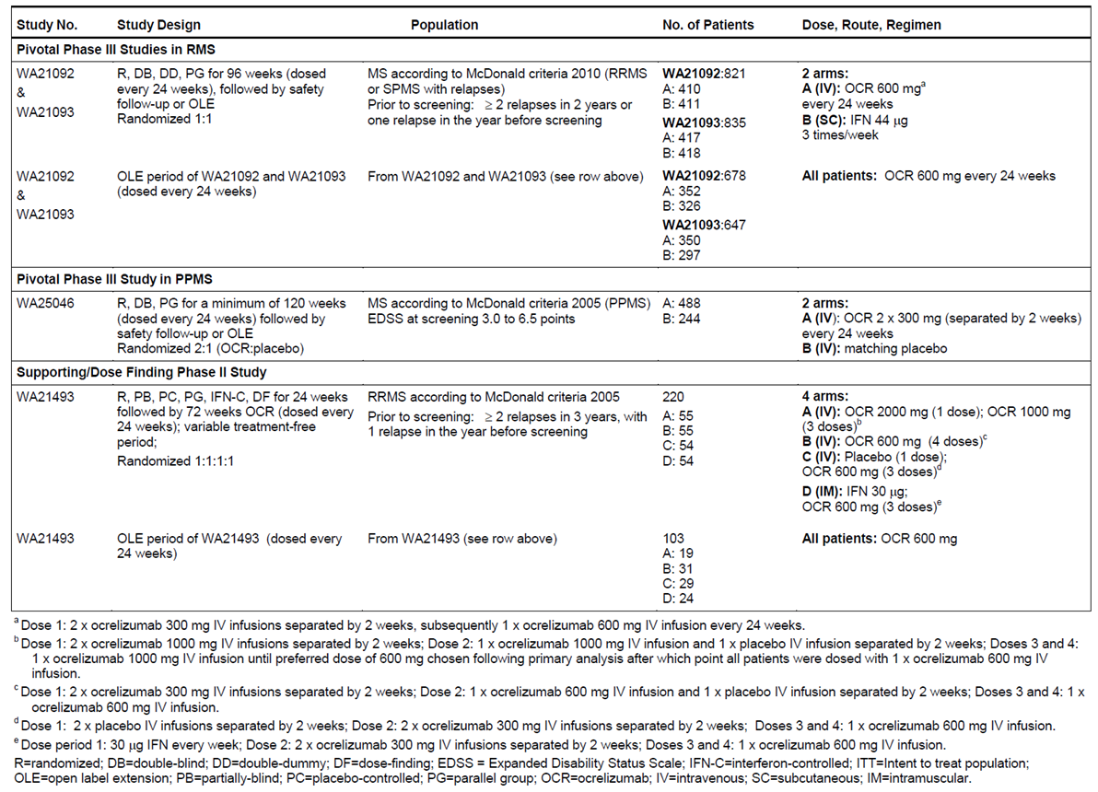
Table 6: Overview of Studies in RA.
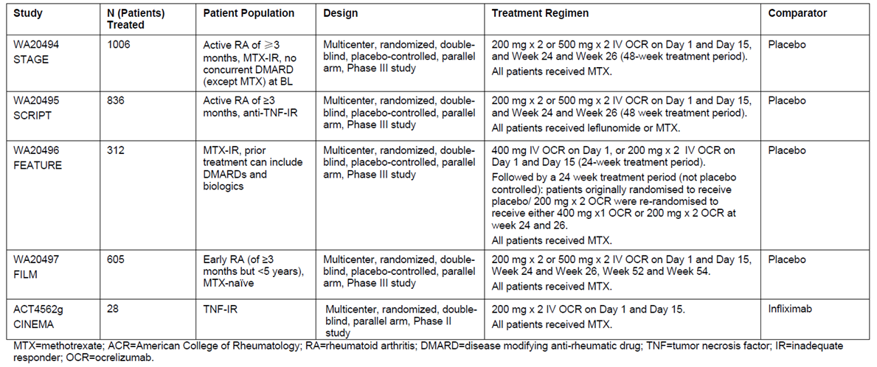
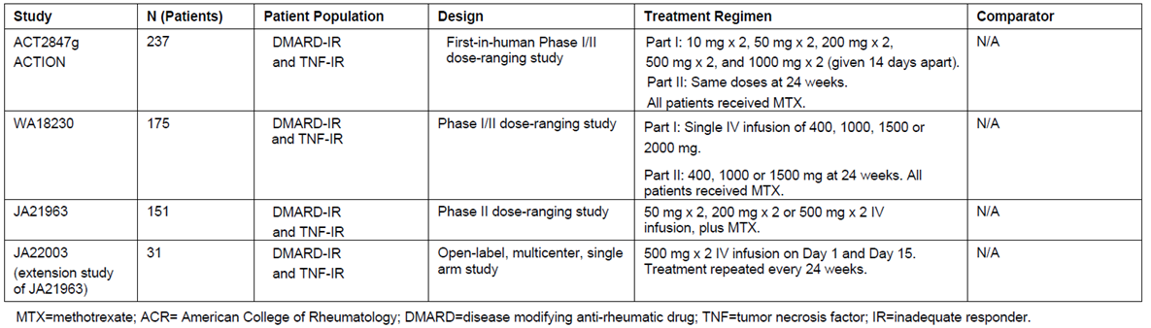

Evaluator’s conclusions on pharmacokinetics
The PK of ocrelizumab has been adequately assessed in the target population, and it is reasonably typical of a monoclonal IgG antibody, apart from the fact that its binding target becomes depleted with use, leading to a time-dependent component to clearance. Ocrelizumab is catabolised, so many conventional PK issues do not arise. The PK of ocrelizumab is adequately described in the proposed PI.

Pharmacodynamics

Studies providing pharmacodynamic data
The key PD data for ocrelizumab, for the currently proposed indications, come from the three Phase III studies in RMS (WA21092 and WA21093) and PPMS (WA25046), with supporting data from the Phase II study WA21493 in RRMS. Similar data was obtained in the earlier RA studies. The relevant studies are listed in Tables 5-7. All PD studies were performed in patients, and the sponsor did not perform any conventional PD studies in healthy volunteers.
None of the PD analyses had deficiencies that excluded their results from consideration. PD results across the different studies were also broadly concordant, showing the expected decline in B cells after ocrelizumab administration, followed by B cell replenishment.
Table 7: Guide to Synopses of Studies providing Pharmacodynamic Data.
Rheumatoid Arthritis Studies | Multiple Sclerosis Studies
Synopsis 1. Study ACT2847g  A Randomized, Placebo-Controlled, Multicenter, Blinded Phase I/II Study of the Safety of Escalating Doses of Ocrelizumab (Pro70769) in Subjects with Moderate to Severe Rheumatoid Arthritis Receiving Stable Doses of Concomitant Methotrexate  Synopsis 2. Study WA18230  A randomized placebo-controlled, multicenter, Phase I/II study of the safety of escalating single intravenous doses of ocrelizumab (rhuMAb 2H7, RO4964913, PRO70769) in patients with moderate to severe rheumatoid arthritis receiving stable doses of concomitant methotrexate but with unsatisfactory clinical response  Synopsis 4. Study JA21963  Dose-Response Study of Ocrelizumab for Rheumatoid Arthritis  Synopsis 6. Study WA20494  A randomized, double-blind, parallel group, international study to evaluate the safety and efficacy of ocrelizumab compared to placebo in patients with active rheumatoid arthritis continuing methotrexate treatment  Synopsis 7. Study WA20495  A randomized, double-blind, parallel group, international study to evaluate the safety and efficacy of ocrelizumab compared to placebo in patients with active rheumatoid arthritis who have an inadequate response to at least one anti-TNF-α therapy  Synopsis 8. Study WA20496  A Randomized, Double-Blind, Parallel-Group, International Study to Evaluate the Safety and Efficacy of Ocrelizumab Given as a Single Infusion or Dual Infusion Compared with Placebo in Patients with Active Rheumatoid Arthritis Who Have an Inadequate Response to Methotrexate  Synopsis 9. Study WA20497  A randomized, double-blind, parallel group, international study to evaluate the safety and efficacy of ocrelizumab in combination with methotrexate (MTX) compared to MTX alone in methotrexate naïve patients with active RA | Synopsis 10. PK Analysis of Study WA21493 in RRMS  Development of a Population Pharmacokinetic Model for Ocrelizumab In Patients With Relapsing-Remitting Multiple Sclerosis  Synopsis 11. Population PK and Exposure Response Analyses in RMS: Studies WA21493, WA21092, WA21093  Population Pharmacokinetic, Graphical Exposure-Efficacy and Graphical Exposure-Safety Analyses  of Ocrelizumab in Patients with Multiple Sclerosis  Synopsis 12. Population PK and Exposure Response in PPMS: Study WA25046  Population Pharmacokinetic, Graphical Exposure-Efficacy and Graphical Exposure-Safety Analyses of Ocrelizumab in Patients with Primary Progressive Multiple Sclerosis  Synopsis 13. ICON 165/118. Population PK in RA: Studies WA20494, WA20495, WA20496  Population Pharmacokinetic Analysis and Graphical Exposure-Safety and Efficacy Analyses of WA20494, WA20495 and WA20496. ICON 165/118

Evaluator’s conclusions on pharmacodynamics
The PD response to ocrelizumab has been adequately characterised, and consists of a rapid and profound depletion of CD20+ B cells, assessed in the major clinical studies using the B-cell marker CD19. Although low levels of B cell reappeared towards the end of the dose cycle in some subjects, levels remained very low in most subjects throughout the treatment cycle.

Dosage selection for the pivotal studies
All of the Phase III studies in MS assessed the proposed ocrelizumab dose of 600 mg. The sponsor’s rationale for the selection of that dose was based on the previous experience with the RA indication.
During the clinical development of ocrelizumab for RA, the sponsor investigated doses in the range 20 mg to 2000 mg. In a Phase I/II dose escalation study in patients with RA (CSR ACT2847g), dose groups ≤100 mg demonstrated reduced clinical efficacy, earlier return of peripheral blood B-cell counts, and higher rates of immunogenicity. The B cell depletion profiles in peripheral blood were similar for all of the higher dose groups receiving ≥ 400 mg, suggesting that maximum peripheral B-cell depletion was reached above 400 mg. Also, the PK of ocrelizumab was approaching linearity at doses ≥ 400 mg, and the Sponsor took this to indicate that this dose approached saturation of
the target mediated drug disposition. Also, doses ≥ 400 mg were noted to provide greater clinical benefit in a number of clinical endpoints for RA: the American College of Rheumatology score, disease activity score (DAS) remission, swollen joint count (SJC) of 0, and European League Against Rheumatism (EULAR) ‘good’ response.
The sponsor also reasoned that that brain exposure to ocrelizumab might be necessary in patients with MS, and higher doses might be needed to penetrate the blood-brain barrier. Accordingly, doses of 600 mg and 2000 mg were assessed in the Phase II dose finding study of ocrelizumab in patients with RRMS, Study WA21493. The primary efficacy analysis at 24 weeks in this study did not suggest an additional benefit of the higher dose. So the lower dose of 600 mg was selected for the subsequent pivotal studies in both RMS (WA21092, WA21093) and PPMS (WA25046).
Overall, this approach to dosing is reasonable. It remains somewhat unclear whether a lower dose, such a 400 mg, would have been appropriate.

Efficacy

Studies providing efficacy data
The Sponsor submitted three studies in RMS, two of which were identical in design and were designated as pivotal (WA21092 and WA21093), and one of which was a supportive study in subjects with RRMS. The design of these studies is shown below.
Table 8: Submitted Ocrelizumab Studies in Relapsing MS
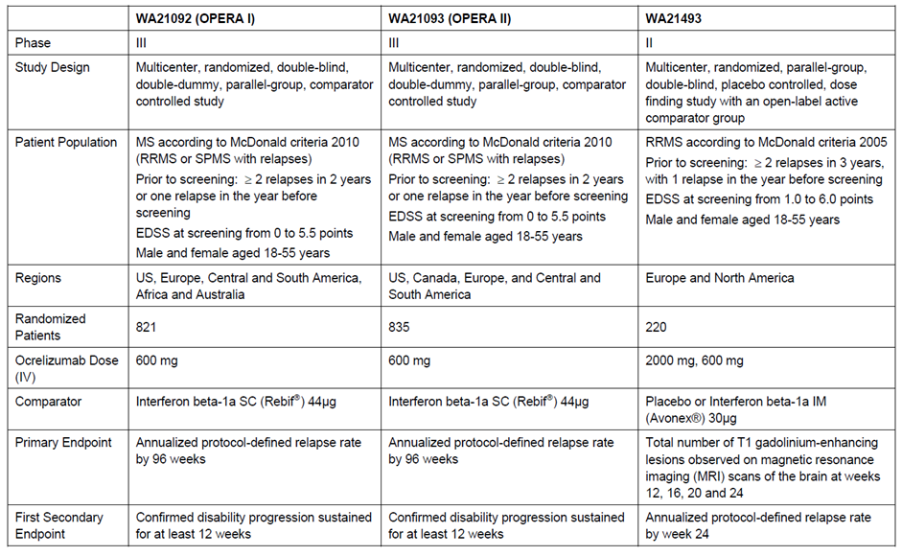
Other efficacy studies:
- Supportive, Dose-Ranging, Phase II Study in RRMS WA21493
Phase II, multicentre, randomised, parallel-group, partially blinded, placebo and Avonex controlled dose finding study to evaluate the efficacy as measured by brain MRI lesions, and safety of 2 dose regimens of ocrelizumab in patients with RRMS.

Evaluator’s conclusions on efficacy
The efficacy of ocrelizumab in MS has been assessed in four studies, including one Phase II study in RRMS, two identical pivotal Phase III studies in ‘RMS’ (including RRMS and other relapsing subtypes), and one Phase III study in PPMS. Efficacy in the RMS and PPMS populations needs to be considered separately.

Efficacy in Relapsing Forms of MS
The sponsor has provided strong evidence that ocrelizumab has substantial efficacy in relapsing forms of MS, with all three studies in RMS producing positive findings for their primary and most secondary endpoints, relative to active controls (low-dose weekly interferon β-1a for the supportive Phase II study, high-dose three-times weekly interferon β-1a for the two pivotal Phase III studies.).
The main results from the two pivotal RMS studies (Studies WA21092 and WA21093) are summarised below. In each study separately, as well as both studies pooled, there was a statistically robust benefit for ocrelizumab relative to interferon β-1a. For the primary endpoint, Annualised Relapse Rate (ARR), the rate ratio was about 0.53 in each study, indicating that the relapse rate on ocrelizumab is about 53% of the rate on three-times-weekly interferon β-1a, which is already known to produce a significant reduction in relapses relative to placebo. The concordance between the two studies, as well as the low p-value (p< 0.0001 in each study) and a variety of sensitivity analyses, strongly suggests that this is not a chance finding but a reproducible result.
For sustained disability progression, regardless of whether this was defined as 12-week-confirmed disability progression or 24-week confirmed, the hazard ratio across both studies pooled was 0.6, with little variation across the two studies. Significant, favourable results were also obtained for confirmed disability improvement and the proportion of patients achieving No Evidence of Disease Activity (NEDA). The absolute increase in NEDA attributable to ocrelizumab was about 20% in each study, indicating that only 5 patients would need to be treated to achieve one extra case of NEDA. The relative increase in NEDA was around 77%, which is a very strong result.
Table 9: Primary and Secondary Efficacy Endpoints at Week 96: Studies WA21092, WA21093 and Pooled (ITT Population).
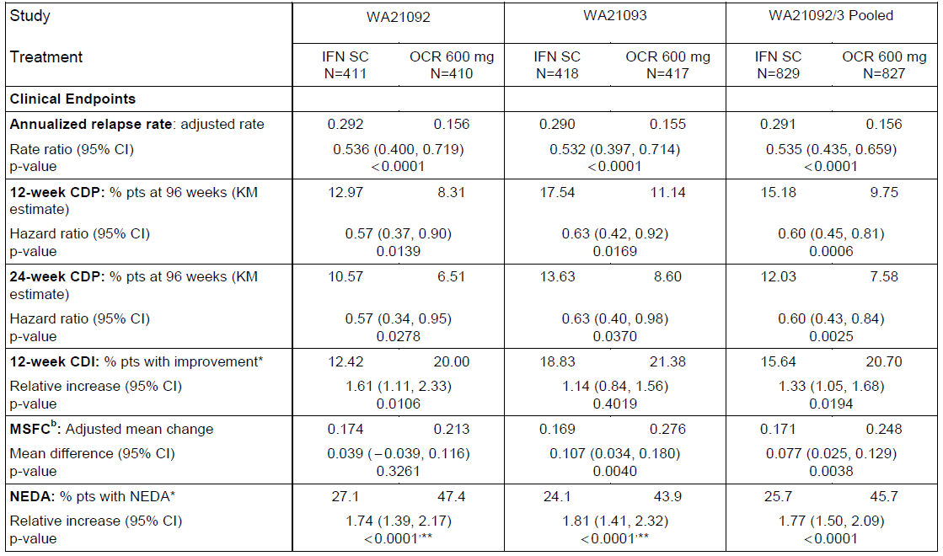
These strong results come with an important qualification. The inclusion criteria for these two pivotal studies were unusual, in that the studies did not restrict the study to subjects with Relapsing Remitting MS (RRMS), who are the traditional target of disease-modifying treatments, but also allowed subjects to enter if they had Secondary Progressive MS (SPMS) and on-going relapses. It appears likely that most of the observed benefit in the pivotal Phase III studies was achieved in subjects with RRMS, rather than in subjects with SPMS, because most other immune treatments have shown greater efficacy in RRMS than in SPMS. Unfortunately, this possibility was not acknowledged or analysed by the Sponsor, and subgroup analyses by basic disease classification were not performed. Considering the RMS data alone, it has not been proven that ocrelizumab has efficacy in subjects with SPMS and on-going relapses – it is possible that the efficacy in RRMS patients was so substantial that the overall study remained positive despite the inclusion of relatively unresponsive SPMS patients. This represents a major flaw in the submitted evidence.
The Sponsor provided some indirect evidence that ocrelizumab has reduced efficacy in subjects with less active disease. In each of the pivotal RMS studies, subgroup analyses based on age, EDSS and presence of Gd+ MRI lesions at baseline showed that the trend in favour of ocrelizumab over interferon β-1a was weaker (with less favourable rate ratios) in subjects who were older, had higher EDSS, or lacked Gd+ lesions. These are the same clinical characteristics that are usually more prevalent in SPMS, compared to RRMS. In all of these subgroups, ocrelizumab still had numerically favourable results, but the effect, as quantified by the rate ratios for ARR, was often modest.
Given that the sponsor is seeking registration for the broad indication of ‘relapsing forms of MS’, which includes SPMS subjects with on-going relapses, it would have been appropriate for the sponsor to perform a subgroup analysis of subjects with a baseline diagnosis of SPMS. The sponsor should be asked to perform such an analysis, so that efficacy in this important subgroup can be assessed.
Admittedly, when the RMS data is considered in the context of positive results for the third pivotal study, conducted in Primary Progressive MS (PPMS) patients, this issue appears somewhat less concerning. If ocrelizumab does have efficacy in PPMS (as suggested by the lone pivotal PPMS study, discussed below), and it also has efficacy in RRMS (as strongly suggested by all 3 RMS studies), then it is very likely to have efficacy in SPMS with on-going relapses, because this represents an intermediate subtype in the spectrum between relapse-dominant disease (exemplified by RRMS) and progression-dominant disease (exemplified by PPMS). Thus, the PPMS study can be considered as a supportive study for the Sponsor’s claims that ocrelizumab has efficacy across the MS spectrum, extending beyond the traditional target of immune therapies in MS, the RRMS population. Nonetheless, it would be preferable if efficacy in the SPMS population had been demonstrated directly, in a study specifically assessing this population, or at least in a subgroup analysis of the pivotal studies.
The Sponsor also submitted a supportive study in RRMS (Study WA21493), which showed a clear therapeutic benefit for ocrelizumab over low-dose weekly interferon β-1a. The primary endpoint was radiological (change in Gd+ lesions) and the blinded treatment period was short (24 weeks), which makes the study unsuitable as a pivotal study. As a Phase II study, it was strongly supportive. Gd+ lesions were reduced substantially, relative to placebo and to interferon β-1a: mean counts were 5.6 and 6.9 for placebo and interferon β-1a, respectively, compared to 0.6 and 0.3 for ocrelizumab 600mg and ocrelizumab 1000mg, respectively (p< 0.0001 for ocrelizumab at either dose versus placebo). Secondary clinical endpoints were also positive, and broadly consistent with the subsequent pivotal studies, as shown in the second table below – ARR was reduced in both ocrelizumab groups, with a relative reduction in the relapse rate of 77% with ocrelizumab 600mg, and 62% with ocrelizumab 1000mg, compared to placebo (p = 0.0019 and p = 0.0136, respectively). This study therefore supports the efficacy of ocrelizumab in RRMS, but does not contribute to understanding of the efficacy of ocrelizumab in subjects with SPMS.
Table 10: Gd+ Lesions from Weeks 12-24, Study WA21493.
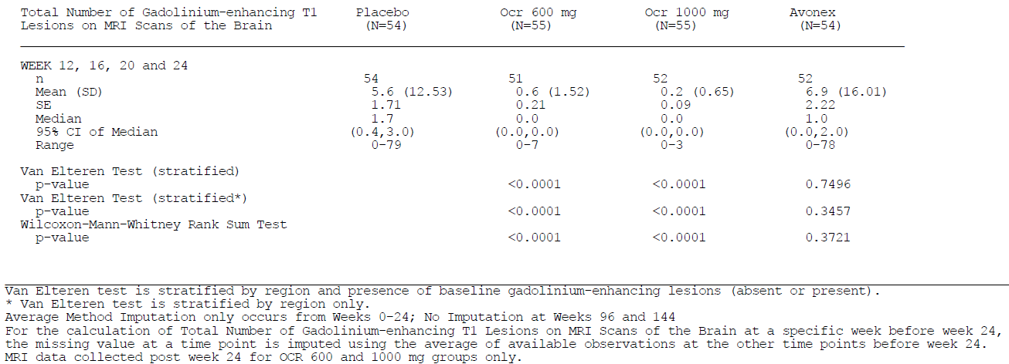
Table 11: Efficacy Endpoints, Primary Analysis at 24 Weeks (ITT Population, Study WA21493).
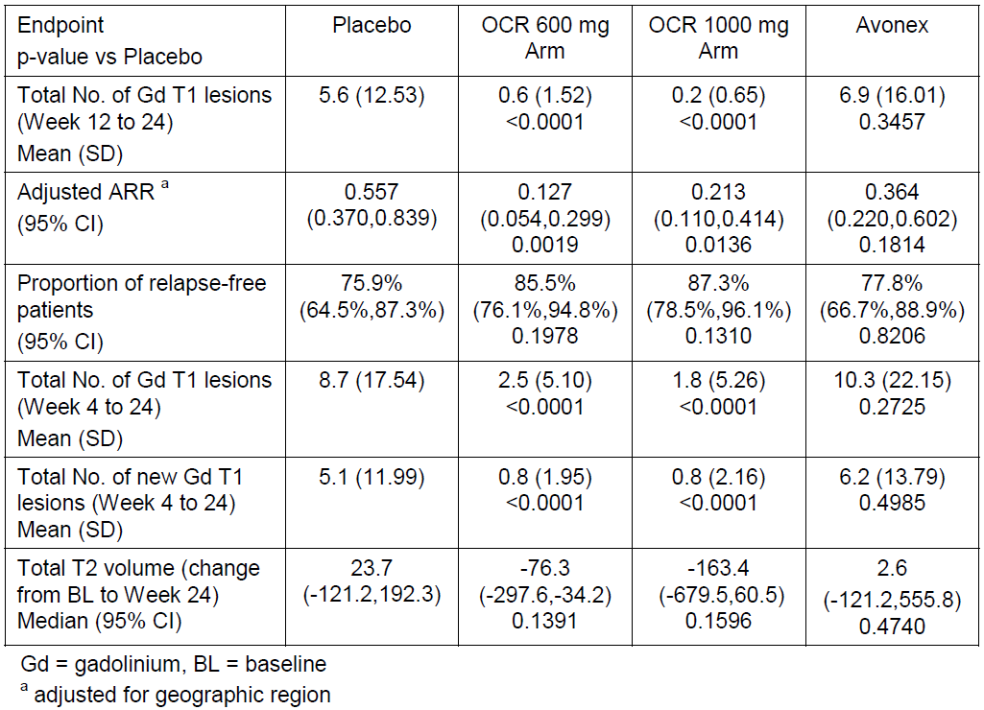

Efficacy in Primary Progressive MS
The sponsor only submitted a single study in PPMS (Study WA25046). This is represents a significant flaw in the overall quality of the efficacy evidence, particularly in view of the fact that there is no other substantial support for the broad hypothesis that immune therapies are useful in PPMS. As already noted, another B-cell depleting agent, rituximab, did not produce overall positive results in PPMS, but benefit was observed in subgroup analyses of younger patients and those with Gd+ lesions on their baseline MRI scan.
The fact that the sponsor has only performed a single study for this indication was flagged as a concern in initial discussions with overseas regulatory authorities, who suggested that the statistical standards required of such a lone study should be more rigorous than would ordinarily be considered standard.
The sponsor’s comments on pre-submission guidance make this clear (emphasis added):
A key point of discussion with FDA and CHMP was use of a single trial to support registration for PPMS. The FDA indicated that in certain circumstances, results from a single, adequate and well-controlled trial could provide substantial evidence of effectiveness to support registration. The study would need to provide unambiguous, robust results and be statistically persuasive. Certain aspects of trial design, for example a large multicenter trial with consistency of effect across subgroups and across centers, were highlighted as being relevant. From the European perspective, CHMP noted that statistical evidence stronger than p< 0.05 on the primary endpoint would be required to account for the fact that a single trial in PPMS was to be conducted, consistent with the CHMP points to consider on applications with one pivotal study (EMA guidance CPMP/EWP/2330/99, 2000). At the Scientific Advice discussion meeting, the sponsor presented their justification for designing the study such that the significance level of p < 0.01 could be reached. This was considered justified by the sponsor based on the high unmet medical need and the measures taken to ensure high data quality.
For the primary endpoint in this lone PPMS study, the final p-value was 0.0321, which means that the sponsor failed to achieve the more ambitious target for statistical significance (p< 0.01), but they did achieve the traditional significance target (p< 0.05) that was pre-specified in the protocol. It thus appears likely that ocrelizumab has efficacy in PPMS, but the evidence is not as robust as might be hoped.
Table 12: Primary Endpoint, 12-Week Confirmed Disability Progression (ITT, WA25046)
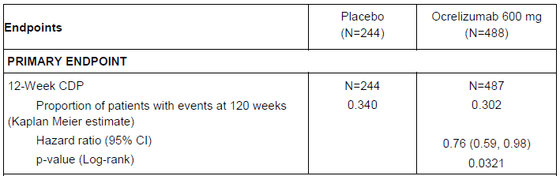
The clinical utility of the observed benefit is also debateable. The hazard ratio was 0.76, suggesting a 24% reduction in instantaneous hazard for reaching the 12-week CDP progression milestone. At 120 weeks, the proportion of patients showing a 12-week CDP was 0.302 in the ocrelizumab group, compared to 0.340 in the placebo group, consistent with a relative risk of 89% and a risk reduction of 11%. The absolute risk reduction was only 0.038 (0.340-0.302), or 3.8%, implying that about 26 subjects would need to receive treatment for 120 weeks to prevent one case of 12-week CDP. This is a clinically modest achievement – it could be perceived as worthwhile by some patients and clinicians, but does not justify any substantial safety risk.
A consideration of the efficacy across different subgroups suggests that much of this modest benefit was observed in subjects who were younger or had active, Gd+ scans at baseline. Although a statistical analysis of these baseline factors did not show a significant interaction with treatment, there are good a priori reasons for suspecting that a lymphocyte-depleting agent would have its greatest effect on subjects with active, inflammatory lesions. Also, very similar observations were made in the pivotal RMS studies for ocrelizumab, and a similar observation was made during subgroup analysis of PPMS patients given rituximab, which has a similar mode of action to ocrelizumab. Thus, it seems likely that ocrelizumab, when used to treat PPMS, has better efficacy in younger subjects and those with active MRI scans, and that efficacy in older subjects and those with inactive scans is likely to be inferior to that seen in the overall PPMS cohort, and of minimal clinical value.
Table 13: Subgroup Analyses of 12-Week CDP (With Imputation), Study WA25046
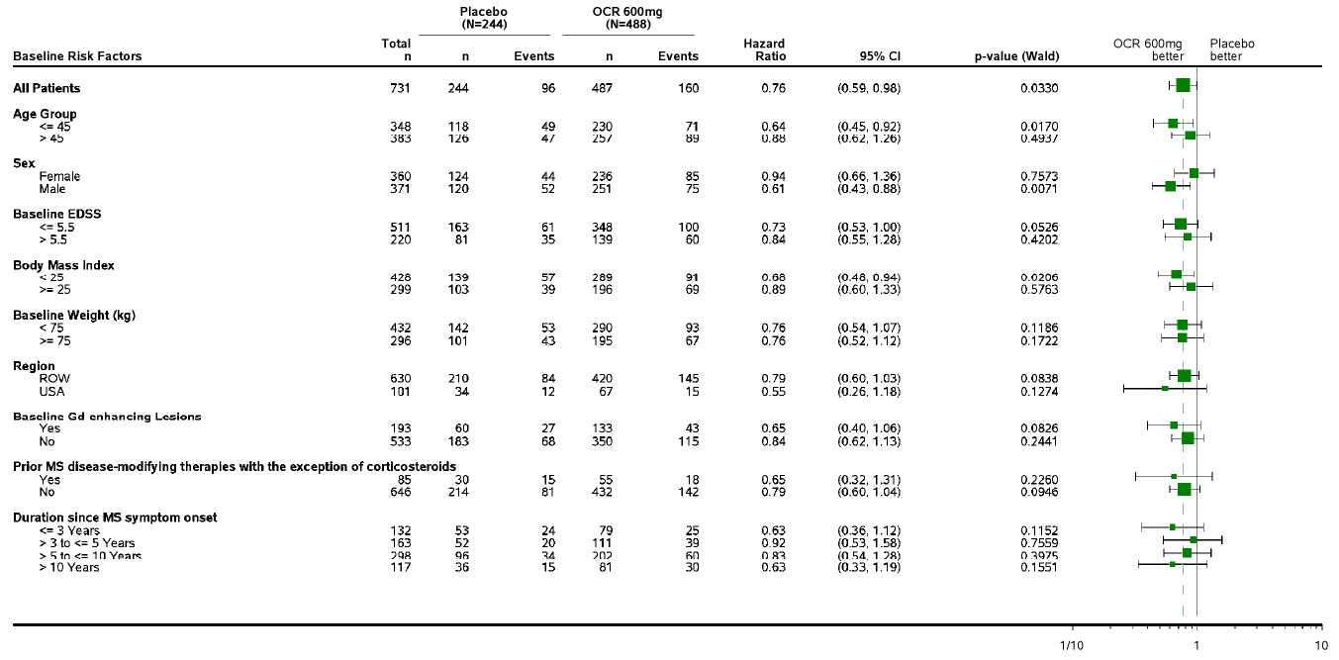
The instantaneous hazard ratio for subjects with unfavourable baseline factors was 0.88 for those aged >45 years, and 0.84 for those without Gd+ lesions (and it would be expected that the HR would be closer to unity for subjects with both of these adverse baseline factors). High EDSS was also associated with a relatively poor HR of 0.84.
In the sponsor’s description of these results, it was not clear how much delay in progression was achieved in the ocrelizumab group. Visual inspection of the Kaplan-Meier curves suggest that, for most of the time period in which there was adequate data, progression curves were roughly linear and parallel in the two treatment groups, with the ocrelizumab group reaching the same proportion of progressed patients as seen in the placebo group, but after a delay of about 18 weeks. The sponsor should be asked to quantify this estimate, or direct the evaluator to the relevant analysis in the submitted material. An 18-week delay in progression is clinically modest, but might be considered worthwhile by some patents and clinicians. The delay in progression achieved with ocrelizumab would be expected to be shorter in less favourable subgroups, and longer in younger patients with active scans.
Figure 2: Visual inspection: Delay in Confirmed Disability Progression.
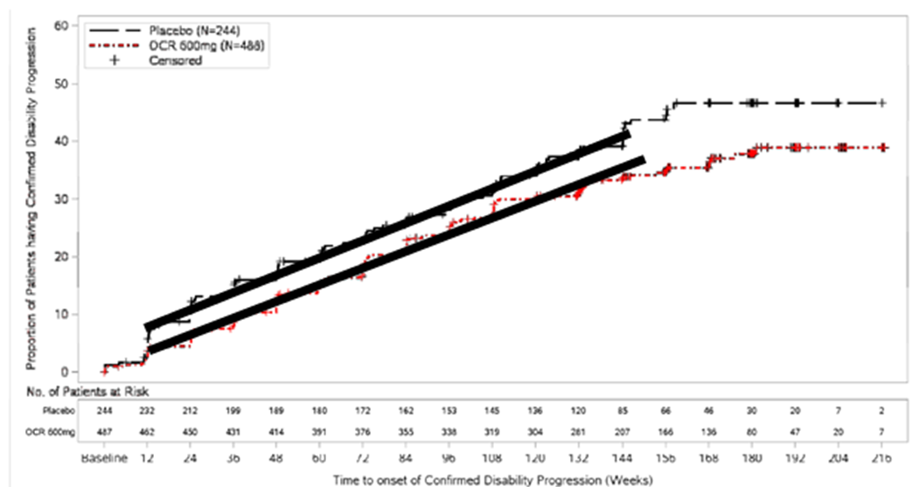
The PPMS study also showed benefits for key secondary endpoints, as summarised below. For the timed 25-foot walk, the placebo group showed a substantial slowing (around 55%) over the 120-week study period (based on a geometric mean of 1.551 for the ratio of week 120 to baseline results). The active group also showed a substantial slowing (around 39%). The difference was significant (p = 0.04), but of uncertain clinical utility. There was also a reduction in the accumulation of T2 lesion volume (p = 0.0365) and a 17% relative reduction in the rate of brain atrophy (p = 0.02). These secondary endpoints increase confidence in the robustness of the study, but remain consistent with a modest clinical benefit.
Table 14: Primary and Secondary Efficacy Endpoints at Week 120 (ITT Population).
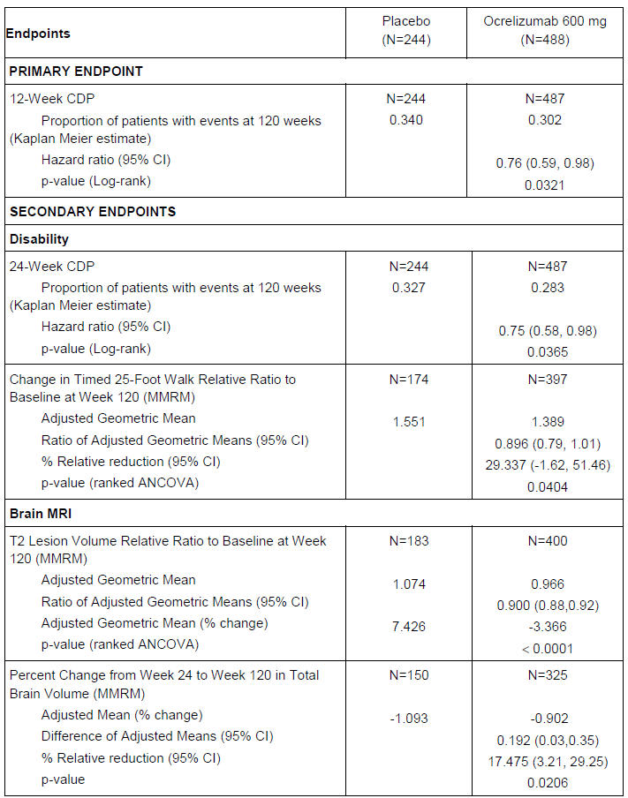
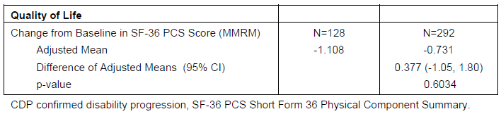

Summary of efficacy conclusions
Overall, there was good evidence of efficacy for ocrelizumab in RMS, even in comparison with an acceptable, high-dose active comparator (interferon β-1a 44 mcg three-times-weekly, Rebif). Annualised relapse rate was reduced by about 47%, compared to Rebif, which is already known to produce a significant reduction in relapses relative to placebo. Disease progression (12-week CDP) was also reduced, along with a number of radiological endpoints, with consistent results across two pivotal studies. There was an absolute increase of 20% in the number of subjects enjoying NEDA status (No Evidence of Disease Activity).
It appears likely that the benefit observed in the two pivotal RMS studies extends to some patients with SPMS, especially if they are experiencing on-going relapses, but unfortunately this important target population was not studied directly, and was not the focus of any subgroup analysis.
It also appears likely that ocrelizumab has efficacy in PPMS, but the evidence is not as robust as could be hoped: only a single study has been submitted, with a modest statistical result for its primary endpoint (p = 0.0321), and the relative risk reduction for 12-week CDP was only 11% (with an absolute risk reduction of only 3.8%). This implies that a fairly high number of subjects would need to receive treatment to prevent one case of Confirmed Disability Progression, particularly if the drug were used in subgroups for which efficacy is less certain, such as older subjects and those with inactive MRI scans. The delay in progression achieved with active treatment was not clearly stated, but appeared to be about 18 weeks; the sponsor should clarify this.

Safety

Studies providing safety data
The sponsor submitted a Summary of Clinical Safety (SCS) and an Integrated Summary of Safety (ISS). Data were pooled from the four Phase II and III MS studies (one Phase II study in RRMS, two Phase III studies in RMS and one Phase III study in PPMS). Data were also pooled from nine previously performed studies in patients with rheumatoid arthritis (RA). Some safety data in studies of other indications (systemic lupus erythematosus (SLE), lupus nephritis (LN), and non-Hodgkin’s lymphoma (NHL)) were also summarised, with a focus on infections and malignancies. The data were not pooled across the different indications, which is appropriate given the different underlying risks of adverse events, active comparators, and concomitant medications.
The RA studies are not described in detail in this report, because the Sponsor is no longer pursuing this indication. The RA studies generally combined ocrelizumab with methotrexate (MTX), but in one RA study (Study WA20494), subjects received ocrelizumab with leflunomide or MTX. Combining ocrelizumab with other immunosuppressant agents, such as MTX, may have increased the risk of infections and other AEs. Also, many RA patients received long-term chronic daily corticosteroids: this not only increases the risk of immunosuppression, but reduces the risk of immunologically mediated infusion-related reactions (IRRs), making it difficult to infer any conclusions of direct relevance to MS, which is not treated with chronic steroids. The comparator for most RA studies was placebo, but one study (Study ACT4562g) compared ocrelizumab with infliximab.
The studies in SLE, LN and NHL provided only limited safety data of relevance to the proposed indication. Most subjects in these studies received a number of concomitant treatments likely to modify the risk profile of ocrelizumab. Also, two of the studies were terminated when it became apparent that other anti-CD20 treatments were not efficacious in these conditions, as summarised by the sponsor:
A Phase III study of ocrelizumab in patients with SLE (WA20499) was terminated during the recruitment period due to negative Phase III efficacy results from another anti-CD20 development program in SLE. A Phase III study of ocrelizumab in patients with LN (WA20500) was terminated early due to lack of efficacy from another Phase III anti-CD20 study in LN and due to the observation of an increased incidence of serious infections in the ocrelizumab LN study. In addition, a Phase I/II trial in NHL (BO18414), was completed but further development in this indication was not pursued.
In this evaluation, the data from these studies has been assessed for evidence of an increased risk of infections and malignancies.
The sponsor defined 6 different data pools in their SCS:
- Pool A: Phase III RMS Controlled Treatment
- Pool B: MS All Exposure (RMS, RRMS, and PPMS)
- Pool C: Phase III RMS All Exposure
- PPMS (WA25046): Phase III PMS Controlled Treatment
- Pool D: Phase II and Phase III RA Controlled Treatment
- Pool E: RA All Exposure
Of these, the combined MS experience (Pool B) and combined RA experience (Pool E) are the most relevant. The MS and RA studies contributing to the overall safety assessment are summarised in the tables below.
Table 15: Studies Contributing to Safety Evaluation of Ocrelizumab in MS
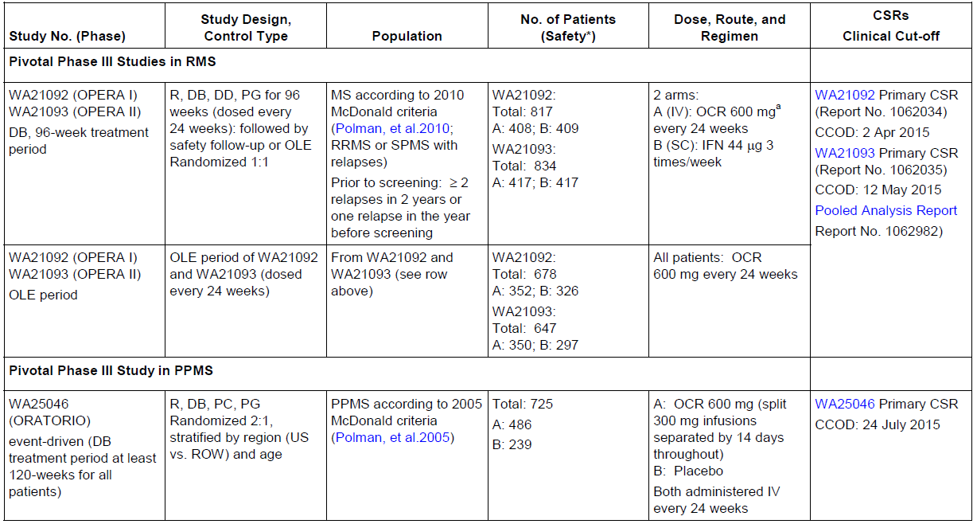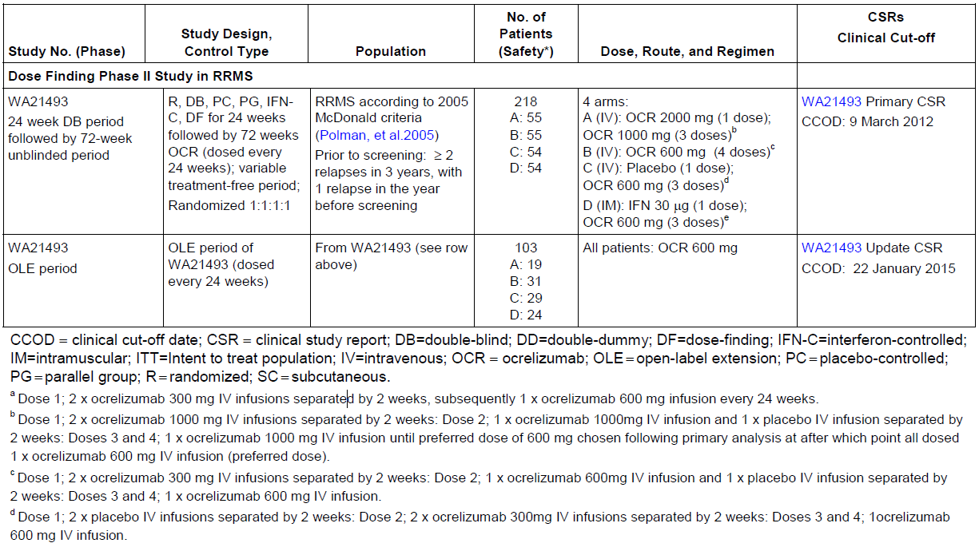
Table 16: Studies Contributing to Safety Evaluation of Ocrelizumab in RA
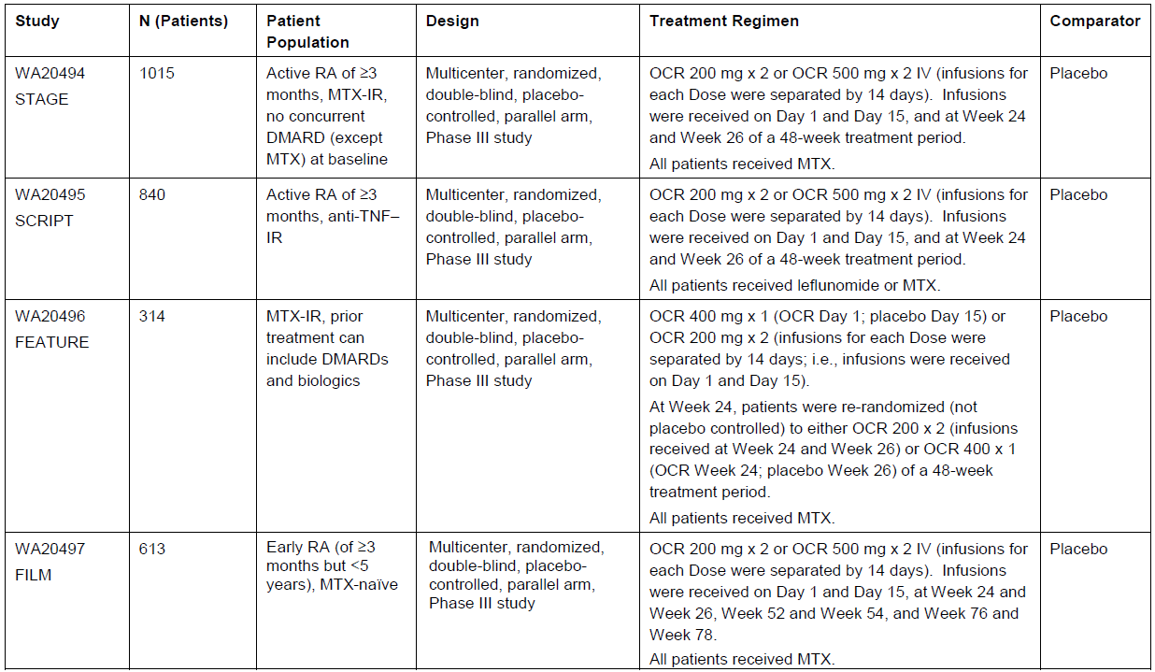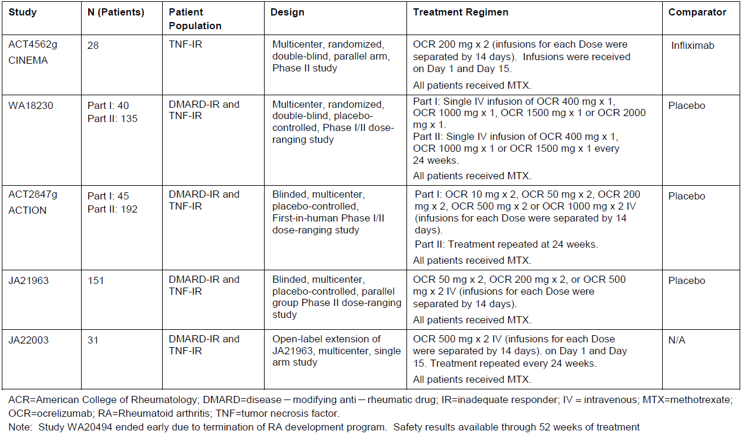

Pivotal efficacy studies
In the major efficacy studies for MS and RA, the following safety data were collected:
- General adverse events (AEs) were assessed through interviews and clinical examinations at scheduled visits as well as unscheduled hospital attendances.
- AEs of particular interest, including infusion related reactions (IRRs), infections, and malignancies, were collected and considered separately.
- Laboratory tests, including monitoring of electrolytes, liver function and haematological parameters, were performed at regular intervals, and exploratory analyses assessed the incidence of AEs in relation to lymphocyte counts.
- The Sponsor also performed a Cox regression analysis for the RA safety data, attempting to assess the extent to which AEs (particularly infections) could be explained by baseline and treatment-emergent risk factors.
Nearly all of the safety data comes from Phase II and III efficacy studies, with some additional uncontrolled data from Open-Label Extensions (OLEs).

Patient exposure
Exposure to ocrelizumab has been fairly extensive for a new MS drug, partly because several additional studies were performed for the RA indication, which is no longer being pursued. The relevance of the safety data from the RA population is somewhat unclear, however, because of the concomitant use of other immunosuppressive agents, including methotrexate and corticosteroids. Considering the MS population alone, 2147 patients were exposed, with 4485 patient-years of follow-up.
Exposure for the MS and RA populations is summarised in the table below, and includes:
- 825 RMS patients (1448 patient years of exposure, Pool A);
- 486 PPMS patients (1416 patient years; PPMS Pool);
- 2147 patients in the MS all exposure population (4485 patient years; Pool B);
- 2926 patients with RA (7324 patient years, Pool E).
Across the MS and RA indications, 1775 patients (35% of all exposed patients) have received more than 4 doses of ocrelizumab, representing at least 2 years of exposure.
Table 17: Patient-years of Exposure in MS and RA Studies, by Number of Doses
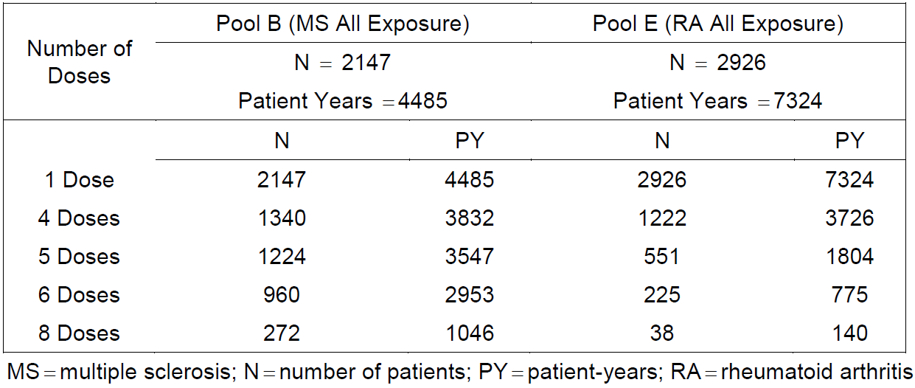
For the proposed indications, the data that provides the clearest safety signals are those derived from the randomised, controlled phases of the pivotal MS studies. For RMS, exposure is summarised in the table below including exposure to placebo infusions in the interferon β-1a control group. For PPMS, the exposure is summarised in the subsequent table, including the placebo control group.
Table 18: Exposure to Ocrelizumab or Placebo Infusion – Phase III RMS Population (Pool A).
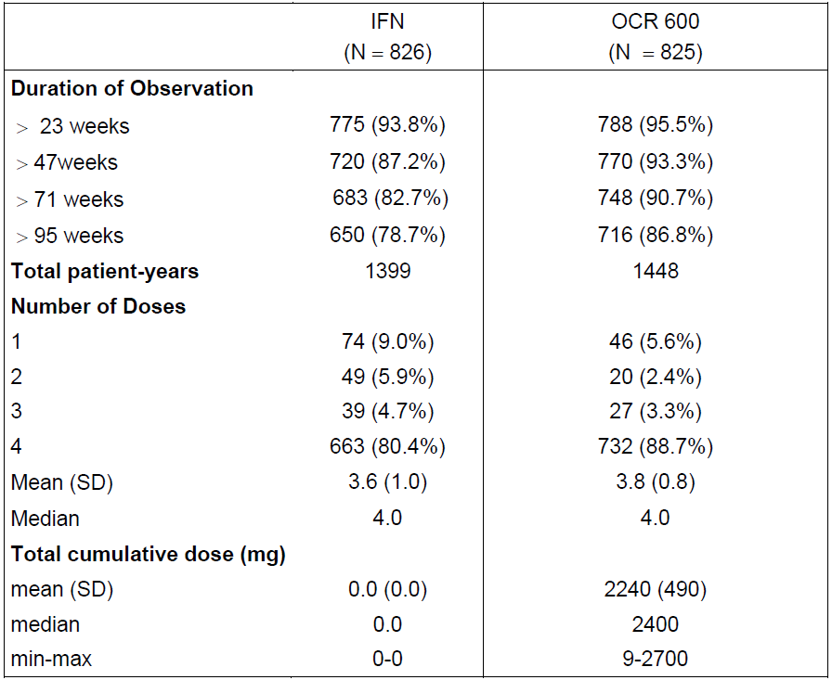
Table 19: Exposure to Ocrelizumab/Placebo – Phase III PPMS Population.
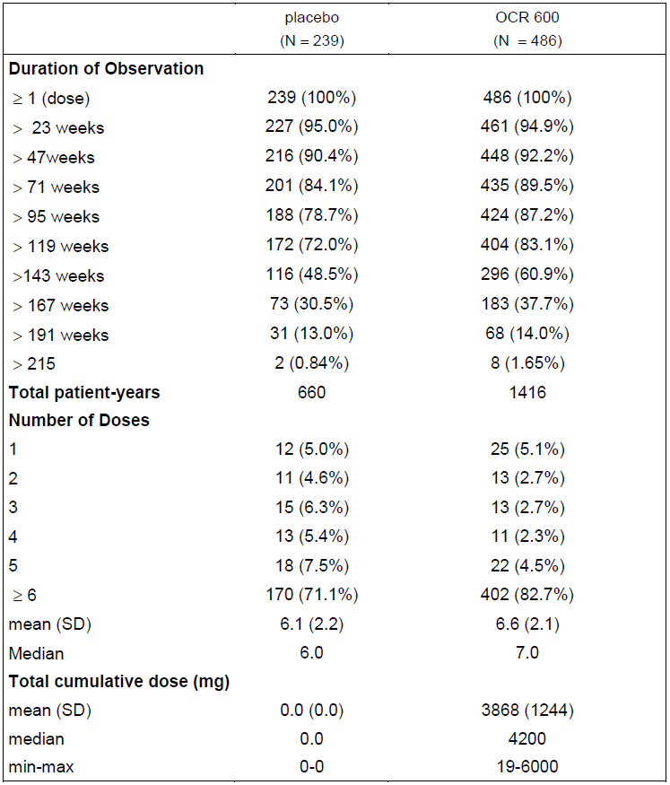
The overall extent of exposure in terms of weeks of safety follow-up is summarised below for the pooled MS population (Pool B) and the pooled RA population (Pool E).
Table 20: Exposure to Ocrelizumab - MS All Exposure Population (Pool B).
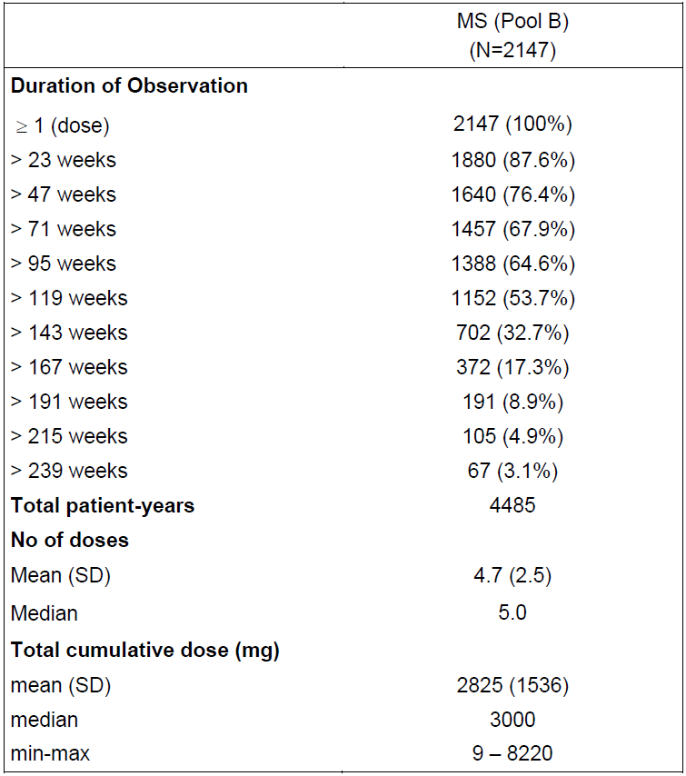
Table 21: Exposure to Ocrelizumab in the RA All Exposure Population (Pool E)
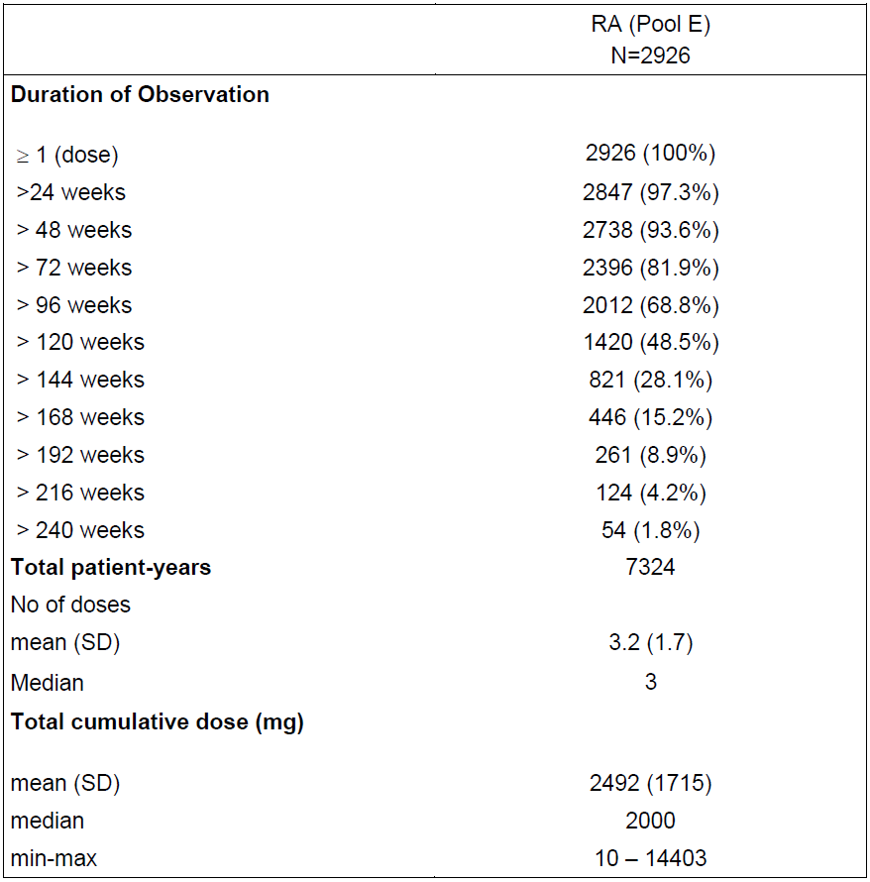

Safety issues with the potential for major regulatory impact

Liver toxicity
There is currently no evidence suggesting that ocrelizumab poses a substantial risk of hepatotoxicity.

Haematological toxicity
Ocrelizumab produces B cell depletion, with associated falls in immunoglobulin levels, particularly IgM. These effects are intrinsic to its mode of action, and may increase the risk of infections. There is no evidence that ocrelizumab produces bone marrow suppression or significant cytopaenias, apart from the expected depletion of B cells.

Serious skin reactions
The incidence of infusion-related reactions included some reversible skin changes. In the RMS population, the incidence of cutaneous symptoms during IRRs was much higher in the ocrelizumab group (58.7% versus 12.5% with ocrelizumab-placebo), with pruritus (30% of patients) and rash (30% of patients) reported most commonly. Across the overall MS study program, however, there was no evidence of a significantly heightened risk of serious, persistent skin reactions.

Cardiovascular safety
There is currently no evidence suggesting that ocrelizumab poses a serious risk of cardiological toxicity, but the infusion of monoclonal antibodies can cause anaphylaxis in a small proportion of patients, so facilities for cardiac resuscitation should be available during ocrelizumab infusions.

Unwanted immunological events
The use of ocrelizumab is associated with infusion-related reactions. IRRs were the most frequently reported AE and occurred with a clear excess in ocrelizumab recipients. Most were Grade 1 and 2 in intensity, and there were no fatal IRRs or hypersensitivity reactions. The highest incidence of IRRs occurred with the first ocrelizumab infusion, and the incidence decreased with subsequent dosing. Overall, IRRs appeared to be manageable with an approach consisting of prophylactic steroids and antihistamines, adjustments of the infusion rate in susceptible individual, and symptomatic treatment.

Post-marketing data
There is no available post-marketing information on the safety of ocrelizumab.

Evaluator’s conclusions on safety
The safety of ocrelizumab is broadly acceptable, given that its proposed use is treatment of a major neurological illness that has serious impacts on patients’ mobility, vision and cognition.
The most common tolerability issue is infusion-related reactions (IRRs), which can be partly reduced by pre-treatment with corticosteroids. The risk of serious IRRs means that ocrelizumab should only be administered in a controlled medical environment – preferably a hospital with resuscitation equipment and the ability to treat anaphylaxis. Ocrelizumab will not be suitable for home treatment by visiting MS nurses.
Ocrelizumab appears to increase the risk of respiratory infections, most of which consist of upper respiratory tract infections.
In the MS population, ocrelizumab did not produce a clear increase in the risk of serious infections or opportunistic infections, but these were seen in the RA population, possibly because of co-treatment with other immunosuppressive drugs including steroids.
Ocrelizumab was associated with an excess of breast cancer cases, with breast cancer reported in 7 female patients who received ocrelizumab, 6 of which occurred during the controlled treatment periods, compared to no reports of breast cancer in the comparator groups (IFN and placebo). All cases were ductal invasive, with a latency period from first infusion of ocrelizumab of between 1 and 3 years. The significance of this post hoc observation is uncertain.
Ocrelizumab suppresses B cell counts, which is intrinsic to its mode of action. It also slightly increased the risk of neutropaenia, and caused a mild reduction in immunoglobulin levels. Laboratory monitoring did not raise any other concerns. Haematological monitoring of ocrelizumab recipients is recommended.
Ocrelizumab is likely to increase the risk of progressive multifocal leukoencephalopathy (PML), based on the experience with other disease-modifying agents and, in particular, the occurrence of PML in some rituximab recipients. The proposed PI does not currently recommend performing JCV serology prior to or during treatment with ocrelizumab, but this seems advisable.

First round benefit-risk assessment

First round assessment of benefits
The benefits of ocrelizumab in the proposed usage in ‘RMS’ are:
- A significant reduction in Annualised Relapse Rate of around 46 to 47%, relative to interferon β-1a 44mcg TIW (Rebif)
- A significant relative reduction in 12-week Confirmed Disability Progression 12-week CDP rates of 36% over 96 weeks, with an absolute reduction of 5.43%, compared to Rebif (ocrelizumab 9.75% versus interferon β-1a 15.18%)
- Significant reductions in radiological activity, relative to Rebif, with ocrelizumab recipients showing 5 to 6% of the number of Gd+ lesions, 17 to 23% of the new/enlarging T2 lesions, and 36 to 43% of the number of T1 ‘ black holes’, compared to the Rebif control group.
- A substantial and clinically meaningful increase in the achievement of NEDA, relative to Rebif, though this was, technically, not significant because of the hierarchical statistical approach. In Study WA21092, NEDA was achieved in 27.1% of interferon β-1a recipients, compared to 47.4% of ocrelizumab recipients. In Study WA21093, NEDA was achieved in 24.1% of interferon β-1a recipients, compared to 43.9% of ocrelizumab recipients.
Benefit across the full spectrum of RMS subjects has not been directly demonstrated. Although a Phase II Study in RRMS showed clear evidence of efficacy of ocrelizumab relative to low-dose weekly IM interferon β-1a (Avonex), no study has assessed ocrelizumab in subjects with SPMS. The pivotal studies in ‘RMS’ included an unknown proportion of subjects with SPMS, but efficacy was not specifically assessed in this important subgroup. The subgroup analyses that were submitted suggested better efficacy in subjects with Gd+ baseline scans, and worse efficacy in subjects without Gd+ lesions.
It appears likely that efficacy in SPMS subjects will be inferior to that observed across the entire RMS study cohort, but this has not been assessed. It also appears likely that, within the SPMS population, efficacy will be reduced in those without clinical or radiological evidence of disease activity, but this has not been assessed. The pivotal studies only recruited subjects with recent relapses, and there is no evidence that ocrelizumab has a role in RMS or SPMS subjects without recent relapses. (The positive results in PPMS do suggest some efficacy in MS subjects without relapses, but this is indirect evidence, and the evidence was not as robust as that in RMS).
Table 22: Summary of primary and secondary efficacy endpoints at Week 96 (ITT Population, Study WA21092)
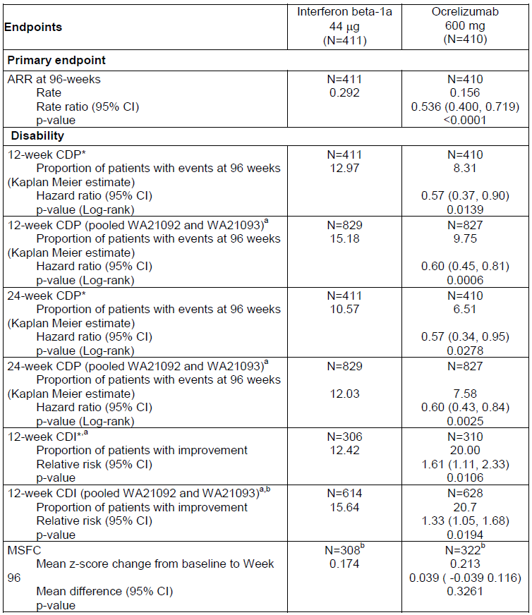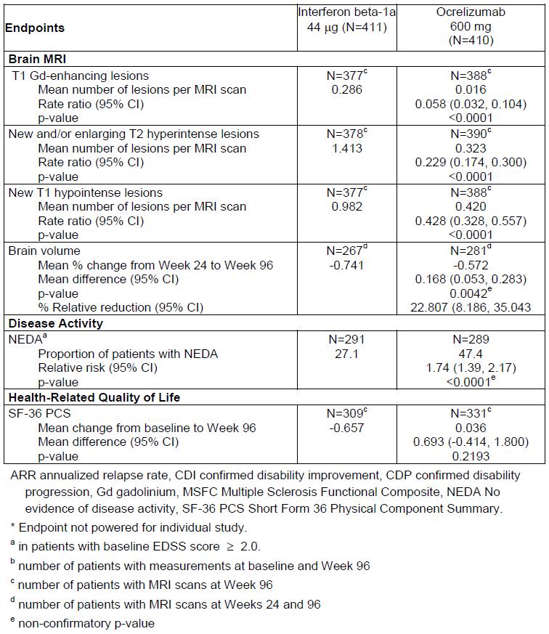
Benefits of ocrelizumab in the proposed PPMS usage are:
- A statistically significant but modest reduction in the rate at which PPMS patients reach 12-week CDP. The ocrelizumab group reached the 12-week CDP endpoint with 89% of the placebo incidence (30.2% versus 34.0%), for a relative risk reduction over 120 weeks of 11% (p = 0.0321). The absolute risk reduction was 3.8%, implying that about 26 subjects would need to receive ocrelizumab treatment for 120 weeks to prevent one case of 12-week CDP.
- A modest, but poorly defined delay in progression, not yet clearly quantified in terms of weeks of delay.
- A variable response across subgroups, with some evidence suggesting that efficacy is reduced, but sill nominally favourable, in older subjects and those without Gd+ MRI scans at baseline. The instantaneous hazard ratio for subjects with unfavourable baseline factors was 0.88 for those aged > 45 years, and 0.84 for those without Gd+ lesions (and it would be expected that the HR would be closer to unity for subjects with both of these adverse baseline factors). The relative risk reduction for older subjects was only around 7%.
- So far, these benefits have only been shown in one study, which reached traditional and pre-specified significance thresholds (p< 0.05), but failed to reach more ambitious targets (p < 0.01) proposed during guidance discussions.
- Improved radiological outcomes, including the change in the volume of T2 hyperintense lesions from baseline to Week 120 (p< 0.0001) and a 17.5% relative reduction in the brain volume loss from Week 24 to Week 120, compared with placebo (p = 0.0206).

First round assessment of risks
The risks of ocrelizumab in the proposed usage are:
- Infusion-related reactions in about one third of patients, although this was also observed to a lesser extent in control groups: (RMS studies, IFN 9.7% versus ocrelizumab 34.3%; PPMS study, placebo 25.5% versus ocrelizumab 39.9%)
- A theoretical risk of anaphylaxis and more serious infusion reactions
- An excess of upper respiratory tract infections
- An excess of herpes infections
- An excess of serious and opportunistic infections, as suggested by the experience in the rheumatoid arthritis studies, but possibly confined to subjects using concomitant immunosuppressive agents.
- Possible compromise of vaccine function, or increased susceptibility to live vaccines.
- An unknown risk of progressive multifocal leukoencephalopathy

First round assessment of benefit-risk balance
For RRMS subjects who have very aggressive MS or those who have had breakthrough disease while on established disease-modifying agents, the benefit-risk profile for ocrelizumab is positive. Even if infusion reactions occur, in most subjects they will be temporary, and the efficacy benefit is expected to last approximately six months. The risk of serious infections appears to be low in subjects who are not taking concurrent immunosuppressive agents, and is likely to be acceptable to patients and clinicians. Many existing agents used to treat RRMS (including natalizumab, dimethyl fumarate and fingolimod) carry a clear risk of causing PML, and despite this they have found a useful role in the treatment of MS.
For SPMS subjects, or RRMS subjects without recent relapses, there is currently insufficient evidence to assess the benefit-risk balance. The benefit-risk balance is likely to be favourable in SPMS subjects who have active baseline scans, and may be favourable even in subjects without active scans, but the submitted evidence does not allow this to be estimated.
For PPMS patients, the benefits of ocrelizumab are relatively modest, but the risks may be considered acceptable to many patients and clinicians. The benefit is unlikely to be consistent across all subjects with PPMS: the evidence for benefit is currently clearest for subjects who are younger and have active baseline scans, and it is less clear for subjects who are older and/or have no Gd+ lesions on their cerebral MRI. The risks of infection are likely to be higher in older, frailer subjects, so older subjects have less to gain and more to lose from ocrelizumab treatment.

First round recommendation regarding authorisation
In the absence of adequate information about the efficacy of ocrelizumab in subjects with SPMS, the recommendations listed below can be made. These recommendations could be revised if further evidence of efficacy in SPMS subjects were made available.
- Ocrelizumab should be approved for treatment of Relapsing and Remitting MS (RRMS), in subjects who have experienced at least 2 relapses in the previous 2 years or at least one relapse in the previous 12 months.
- Ocrelizumab should be approved for treatment of Secondary Progressive MS (SPMS), in subjects who have experienced at least 2 relapses in the previous 2 years and have contrast-enhancing (Gd+) lesions on their cerebral MRI.
- Ocrelizumab should be approved for treatment of Primary Progressive MS (PPMS) in subjects who have contrast-enhancing (Gd+) lesions on their cerebral MRI.

Evaluator comments on round 1 recommendations
It could be argued that the second recommendation listed above is not adequately supported by the evidence, as no study has directly assessed subjects with SPMS. It would be reasonable to exclude the second recommendation and only approve ocrelizumab in the MS subtypes where it has been directly assessed, RRMS and PPMS. On balance, however, the evaluator believes that:
- SPMS occupies an intermediate position on the MS spectrum;
- subtypes at both ends of the spectrum have shown a significant response to ocrelizumab; and, therefore,
- by interpolation, some efficacy in SPMS appears almost certain.
The proposed indication in the EU submission appears to be RRMS, not the broader category of RMS, and the sponsor should clarify reasons for this difference.
It could also be argued that ocrelizumab should not be registered for use PPMS, as there has only been a single study performed in PPMS, and that study did not achieve the ambitious p-value proposed by the sponsor in guidance discussions. The strong concordance across multiple endpoints has convinced the evaluator that ocrelizumab has some efficacy, at least in a subset of patients, and subjects with contrast-enhancing lesions are the subset most similar to the RRMS population, in whom it clearly has good efficacy. These considerations led to the compromise suggested above: approving ocrelizumab in Gd+ PPMS patients, while awaiting confirmation of efficacy in the broader PPMS population.
In addition to denying registration for PPMS patients without Gd+ scans, it would be reasonable to deny registration for use in older PPMS subjects (> 45 years or > 50 years). It is currently unclear how many older subjects had Gd+ scans, and whether ocrelizumab had acceptable efficacy in such patients, and how efficacy varies with age. Age and Gd positivity are not independent variables, and patients with Gd+ scans are likely to have active inflammation regardless of age, so the evaluator has recommended that suitable patients be identified with imaging rather than being excluded on the basis of chronological age alone. This approach, identifying patients with active disease by MRI, is consistent with standard clinical practice in subjects with treatment-resistant RRMS or SPMS and on-going relapses. The relationship between age, Gd-positivity and treatment response could be clarified by answers to the clinical questions posed, which could lead to a revision of these recommendations.

Second round evaluation
For details of the second round evaluation including the issues raised by the evaluator (clinical questions), the sponsor’s responses and the evaluation of these responses please see Attachment 2.

Second round benefit-risk assessment
The new material submitted in response to clinical questions clarifies some aspects of the benefit-risk assessment, but does not change the Evaluator’s overall assessment of the efficacy and safety of ocrelizumab.
Despite the fact that the sponsor provided detailed answers to the questions raised, there are a number of points of residual disagreement between the evaluator and the sponsor about the quality of the efficacy data and its applicability across the full spectrum of MS disease. In particular, the evaluator and the sponsor do not agree on the appropriateness of grouping the traditional disease subtypes, RRMS and SPMS, under the broad heading of ‘RMS’. The Sponsor’s responses reveal that details about disease subtype were not collected at baseline, so it is not possible, even in retrospect, to determine the efficacy of ocrelizumab in SPMS subjects.

Efficacy in RRMS
No substantial new data was submitted in relation to RRMS. The two pivotal ‘RMS’ studies largely consisted of RRMS subjects (> 90%, up to around 98%), and can be considered primarily as positive studies in RRMS.
The first-round clinical evaluation report suggested that the sponsor had only shown efficacy in RRMS subjects with recent relapses, because the pivotal ‘RMS’ studies had only recruited subjects with recent relapses. Strictly speaking, this remains true, but on reflection it appears very likely that other RRMS subjects would also benefit from ocrelizumab, even without a recent relapse, especially if they have radiological evidence of active disease. (The positive results in PPMS subjects support this conclusion.) On balance, the quality of the RRMS evidence is sufficiently robust that it could be left to clinicians to decide which RRMS subjects are suitable for treatment. In practice, this is likely to be subjects with clinical elapses or radiological evidence of disease activity. The recommendations for RRMS have therefore been altered to reflect this.

Efficacy in SPMS
No study in SPMS has been submitted, and SPMS subjects are likely to have constituted only a small proportion of the cohort (2 to 10%) in the pivotal ‘RMS’ studies, so direct evidence of ocrelizumab efficacy in SPMS is currently lacking.
A number of indirect lines of evidence suggest that ocrelizumab probably has efficacy in some subjects with SPMS, at least when SPMS is associated with on-going relapses. These include trends in favour of ocrelizumab for ‘RMS’ subjects with advanced EDSS (≥ 4.0) at baseline, a reduced incidence of progression independent of overt relapses in the ‘RMS’ subjects, and positive results in the pivotal PPMS study.
None of these lines of evidence is considered entirely robust, so it would be reasonable to reject the registration of ocrelizumab in subjects with SPMS, pending an appropriate prospective study in this population. Instead, the evaluator has taken the view that efficacy in two neighbouring regions of the MS spectrum has been studied: the two pivotal RMS studies mostly recruited RRMS subjects, and showed positive results on relapse rate and disability progression; the pivotal PPMS study showed positive results for progression. By interpolation, it thus seems likely that SPMS, which is many ways intermediate between RRMS and PPMS, would also respond to ocrelizumab, with reductions in relapses and progression. Given the indirect nature of this evidence, though, caution should be applied in making inferences about the efficacy of ocrelizumab in SPMS.
The response to ocrelizumab in all three pivotal studies was heterogeneous, with inferior results obtained for subjects who were older (> 45 years or > 50 years) or had no evidence of Gd-positive lesions on their baseline scans.
Given that the claim for efficacy in SPMS relies on the PPMS results for indirect support, the subgroup analysis of PPMS subjects needs to be considered, even though it applies to a different disease subtype. For PPMS subjects >50 years, hazard ratios for disability progression were not in favour of ocrelizumab. Hazard ratios for 12-week CDP in older subjects (>45 years, HR 0.88) and in those without Gd+ baseline scans (HR 0.84) were numerically in favour of ocrelizumab, but 95% CIs crossed unity and the HRs were less favourable than those observed in younger subjects (HR 0.64) and those with Gd+ baseline scans (HR 0.65). Because of those patterns, the evaluator believes the case for efficacy in Gd+ patients with SPMS is probably adequate, despite the fact that it is indirect. By contrast, the case for efficacy in Gd-negative subjects with SPMS currently relies on too many untested assumptions and inferences.

Efficacy in PPMS
The new data supplied in response to Clinical Questions has shown that, in older subjects with PPMS, ocrelizumab has inferior efficacy. In subjects > 50 years, no favourable trends were observed for primary efficacy endpoints (HR 1.05 overall). In subjects > 45 years, favourable trends were observed (HR 0.88), but the benefit was largely observed in subjects who were Gd+ at baseline (> 45 years and Gd+, HR 0.85; >45 years and Gd-negative, HR 0.93). In Gd-negative subjects, the efficacy of ocrelizumab was inferior, but there were trends favouring ocrelizumab over placebo (Gd- HR 0.65, Gd+ HR 0.84). In younger subjects (≤ 45 years), the evidence in favour ocrelizumab was reasonably strong (HR 0.64, 95% CI not crossing unity). See Response 4 (p173) for details including 95%CIs. It is unclear how subjects with PPMS responded to ocrelizumab if they were young but Gd-negative, because this was not reported.
As noted, the evaluator’s overall assessment of this data is that, in the absence of supportive Phase 2 studies or confirmatory Phase 3 studies in the PPMS population, it would be reasonable to restrict ocrelizumab to PPMS subjects who are Gd+ at baseline and ≤ 50 years.
Table 23: CDP for 12 Weeks by Age and Gd+ Lesions in PPMS; WA25046.
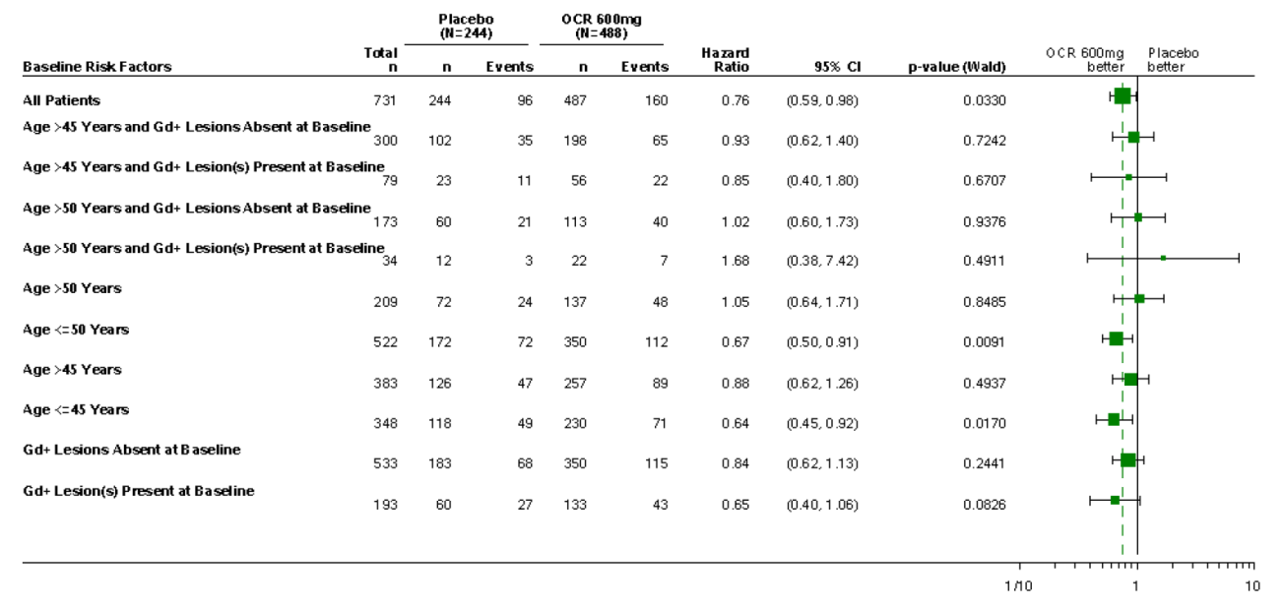

Risks of ocrelizumab
The new data does not raise any new safety concerns. The evaluator accepts the sponsor’s comments on the risks of PML in the setting of anti-CD20 monoclonal antibodies. This risk appears to be low in MS subjects exposed to ocrelizumab, compared to RA subjects exposed to rituximab, and the sponsor’s proposed comments in the PI are adequate. The PI does not need to recommend serological testing for JC virus.

Second round recommendation regarding authorisation
In the absence of adequate information about the efficacy of ocrelizumab in subjects with SPMS, the recommendations listed below can be made. These recommendations could be revised if further evidence of efficacy in SPMS subjects were made available.
- Ocrelizumab should be approved for treatment of Relapsing and Remitting MS (RRMS).
- Ocrelizumab should be approved for treatment of Secondary Progressive MS (SPMS), in subjects who have been experiencing ongoing relapses and have contrast-enhancing (Gd+) lesions on their cerebral MRI.
- Ocrelizumab should be approved for treatment of Primary Progressive MS (PPMS) in subjects who are < 50 years of age and have contrast-enhancing (Gd+) lesions on their cerebral MRI.

Population PK

Summary of findings
The purpose of the primary analyses was to describe the PK of ocrelizumab in subjects with RMS and to explore exposure-response relationships. In an external evaluation of the PK model, it was shown to adequately describe the PK in subjects with PPMS.
On the basis of this evaluation, it was concluded:
- The base and final PK models developed in RMS subjects were successfully replicated, verifying the models and the reported PK parameters in the RMS report.
- A two compartment model described ocrelizumab PK in RMS and PPMS subjects, and was consistent with that previously described in RA. PK parameters were typical of monoclonal antibodies with slow CL (median 0.165 L/day in RMS and 0.164 L/day in PPMS) and small volume of distribution approximating blood volume (median Vss = 5.5 L in RMS and 5.3 L in PPMS).
- Ocrelizumab CL comprised constant and time-dependent components. The time dependent component accounted for approximately 22% of total CL and declined with a half-life of 33 weeks (0.63 y).
- Ocrelizumab PK parameters were correlated with body weight, consistent with other monoclonal antibodies. However, terminal half-life was unaffected by body weight and inverse correlations between body weight and exposures (Cmax and AUC) were deemed to be clinically not relevant.
- Age and markers of liver and renal function were evaluated by diagnostic plots and on this basis were deemed to not influence ocrelizumab PK.
- Exploratory graphical evaluations did not identify relationships between ocrelizumab exposure and various safety endpoints (event rate and grade of SAE, SI and IRR). In RMS, there was no relationship between ocrelizumab exposure and efficacy endpoints (rate of relapse, time to first relapse). In PPMS, there was a trend toward a larger fraction of subjects without CDP and a smaller change in brain volume at 120 weeks for subjects in the highest quantile of exposure. In RMS and PPMS, B cell counts declined after the start of ocrelizumab treatment and depletion was maintained for the duration of treatment.

Implications of findings
The qualitative nature of the exposure-response evaluations and the limited study design from which the data derive (600 mg regimen every 24 weeks only) precluded assessment of risk-benefit for ocrelizumab.
Review of the proposed PI failed to identify any major inconsistencies regarding the PK description.
The reports reviewed provided a description of the PK in RMS and PPMS. They were not intended to support dose justification. Therefore, there are no implications for Dosing.
A minor modification to the text may be considered with regard to Immunogenicity (pages 8-9 of pi-clean.pdf). Since ADA on CL was not able to be assessed in the PK analysis because of the small number of subjects, the following statement could be modified accordingly (as shown in bold):
The impact of treatment-emergent ADAs on PK, safety and efficacy cannot be assessed given the low incidence of ADA associated with Ocrevus.

VI. Pharmacovigilance findings

Risk management plan
Roche Products Pty Limited has submitted EU-RMP version 1.0 (dated 5 April 2016; DLP 4 April 2016) and ASA version 1.0 (dated May 2016) in support of this application.

Summary of RMP evaluation
- The indications proposed for the US and EU are different from those proposed for Australia. The indications proposed for Australia do not specify adult patients and make reference to specific clinical outcomes of suppressing relapses, suppressing disease progression (clinical and subclinical), and reduced deterioration in walking speed.
- The proposed Summary of Safety Concerns and their associated risk monitoring and mitigation strategies are summarised below.
Table 24: Summary of Safety Concerns.
Summary of safety concerns |  | Pharmacovigilance |  | Risk Minimisation
 |  | Routine | Additional | Routine | Additional
Important identified risks | Infusion-related reactions |  | – |  | –
Important identified risks | Infections |  |  |  | –
Important potential risks | Hypersensitivity reactions |  | – |  | –
Important potential risks | Malignancies including breast cancer |  |  |  | –
Important potential risks | Impaired immunisation response |  |  |  | –
Missing information | Use in pregnancy and lactation |  |  |  | –
Missing information | Use in paediatric population |  | – |  | –
Missing information | Use in elderly patients |  | – |  | –
Missing information | Long-term safety of ocrelizumab treatment |  |  |  | –
Missing information | Concomitant use of immunosuppressive medication other than steroids for acute relapses |  | – |  | –
Missing information | Safety of ocrelizumab following immunosuppressive / immunomodulating DMTs other than Avonex, Betaferon, Copaxone, or Rebif |  |  |  | –
Missing information | Safety of immunosuppressive / immunomodulating DMTs following ocrelizumab |  | – |  | –
Missing information | Off-label use in other neurological indications |  | – |  | –
- The sponsor has proposed routine pharmacovigilance for all safety concerns and missing information, and additional pharmacovigilance in the form of clinical trials and PASS studies for select safety concerns and missing information (see preceding table).
- The sponsor has proposed routine risk minimisation for all safety concerns and missing information.

New and outstanding recommendations from second round evaluation
There are no outstanding recommendations from the first round, or any new recommendations that have arisen (for example, from clinical or nonclinical evaluation, from revisions made to the EU-RMP or ASA).

Wording for conditions of registration
Any changes to which the sponsor has agreed should be included in a revised RMP and ASA. However, irrespective of whether or not they are included in the currently available version of the RMP document, the agreed changes become part of the risk management system.
The suggested wording is:
Implement EU-RMP (version 1.0, dated 5 April 2016, data lock point 4 April 2016) with ASA (version 1.0, dated May 2016) and any future updates as a condition of registration.

VII. Overall conclusion and risk/benefit assessment
The submission was summarised in the following Delegate’s overview and recommendations:

Quality
There is no objection on quality grounds to the approval of Ocrevus subject to receipt of the outstanding GMP certificate.
Ocrelizumab is a humanized monoclonal antibody produced in CHO cells. It is based on the human immunoglobulin G1 framework consisting of two identical 213 residue light chains and two identical 451/452 residue heavy chains. The calculated molecular mass of intact deglycosylated ocrelizumab is approximately 145,564 Da (peptide chains only, without heavy chain C-terminal lysine residues).
The CH2 domain of each heavy chain has a single conserved glycosylation site at Asn302. The N-linked oligosaccharides of ocrelizumab are typical of those observed on other CHO-produced monoclonal antibodies. The C-terminal lysine residues of the heavy chains (Lys452) are removed by basic carboxypeptidases during the cell culture process.
Fourier transform infrared spectroscopy (FTIR) confirms that ocrelizumab primarily has a β-sheet structure, consistent with the structure of an IgG1 antibody. The expected intrachain and interchain disulfide linkages have also been confirmed.
The quality evaluator has recommended standard conditions of registration relating to batch release testing and compliance with certified product details.

Nonclinical
There are no nonclinical objections to approval. The nonclinical evaluator has noted the following:
- The nonclinical data provided were satisfactory.
- Primary pharmacology studies adequately demonstrated the mechanism of action, and ocrelizumab was shown to effectively deplete CD20+ B cells in the periphery and in lymphoid organs in cynomolgus monkeys in the repeat-dose toxicity studies.
- Secondary and safety pharmacology studies were not conducted but measurements of ECG, blood pressure and body temperature in the repeat-dose toxicity studies in monkeys revealed no effect of ocrelizumab.
- Adequate repeat-dose toxicity studies in monkeys did not identify any target organs. Adequate to high systemic exposure margins were achieved (up to around 150× in cynomolgus monkeys).
- Genotoxicity and carcinogenicity studies were not conducted and are not required.
- An embryofetal development study and a pre/postnatal study in cynomolgus monkeys, achieving adequate exposure margins, were generally unremarkable. In the latter study, some histopathological changes were apparent in the neonatal kidneys, at both tested doses. The sponsor has proposed Pregnancy Category C which is considered appropriate.
- Ocrelizumab did not cause local dermal toxicity when administered IV.

Clinical

Pharmacology
All PK studies were conducted in patient groups (RA or MS). Because the RA and the MS patient populations have different characteristics (disease, age, comorbidity, concomitant medication, etc.), data from the RA and MS studies were not pooled. For similar reasons, the RMS and PPMS data were analysed separately.
Ocrelizumab is a monoclonal IgG1 antibody and its PK is consistent with that class, apart from a decrease in clearance as its binding target becomes depleted, leading to a time-dependent component to clearance.
Ocrelizumab is administered by IV infusion. The PK is approximately dose-proportional across the range 400 mg to 2000 mg, with that range including the proposed 600 mg dose. Repeat doses of ocrelizumab ae to be given every 6 months. It is not anticipated that peak concentrations will vary substantially with that dose interval. The population PK estimate of the central volume of distribution was 2.78 L, whereas peripheral volume and inter-compartment clearance were estimated at 2.68 L and 0.294 L/day. Ocrelizumab binds to B-cells, which are then likely to be sequestered in immune tissues prior to destruction of the bound B-cells.
The time-dependent clearance is likely to reflect the gradual depletion of CD20-positive B cells, and hence binding sites, in response to the treatment. Clearance stabilises with continued treatment. The time-dependent component constituted 20% of the total initial clearance, and declined with a half-life of 33 weeks. The terminal elimination half-life of ocrelizumab was 26 days.
The metabolism of ocrelizumab has not been directly studied, as antibodies are cleared principally by catabolism. Subjects with raised liver enzymes and with mild renal impairment were included in the pivotal studies but no specific PK studies in these patient groups were conducted. There were no interaction studies or studies in elderly or paediatric subjects.
The rate of decline in B cells after ocrelizumab administration and its subsequent replenishment was examined in studies in patients with MS and with RA. The CD20 marker is on the surface of B lymphocytes. B cells targeted by ocrelizumab are then cleared by components of the endogenous immune system with clearance of CD20-expressing B cells from blood and associated lymphatic system the primary mode of action of ocrelizumab, and this is thought to underlie its efficacy in the treatment of MS.
To monitor B cell depletion, the sponsor used B-cell count in peripheral blood as the primary PD marker. Because ocrelizumab binds to CD20, it obscures measurement of CD20-positive cells, so CD19 was used as an alternative B-cell marker; this marker largely mirrors CD20 expression during B-cell development
Exposure to ocrelizumab 600 mg or 1000 mg suppressed B-cell counts profoundly in most subjects, with suppression below the lower limit of normal (LLN) maintained throughout the 24-week dose cycle in most subjects. B cells were depleted rapidly, within the first two weeks after exposure, and remained low for most the proposed 24-week dosing cycle. All concentrations of ocrelizumab assessed in the Phase II and III studies produced a profound initial suppression of B-cell counts, but lower exposures led to an earlier return of some B-cells than higher exposures.
In the Phase II RMS study (WA21493) median time to B-cell repletion after the last infusion in the ocrelizumab 600 mg dose group was 72 weeks (range 27-175) and 90% of all patients had repleted their B cells to above the LLN or baseline (whichever was lower) by approximately 2.5 years after the last infusion.
Dose finding for the Phase III studies in MS was informed by results from studies in RA. All of the Phase III studies in MS assessed the proposed ocrelizumab dose of 600 mg every 24 weeks. Doses up to 2000 mg were used in the Phase II RMS study but the higher dose did not suggest increased benefit over a 24 week period of assessment.

Efficacy
Four studies assessed the efficacy of ocrelizumab in MS, a Phase II study in relapsing remitting MS (RRMS), 2 identical pivotal Phase III studies in relapsing MS (RMS) and a Phase III study in primary progressive MS (PPMS).

Pivotal studies for RMS
Studies WA21092 and WA21093 were international multicentre, randomised, double-blind, double-dummy, parallel group comparator studies in subjects with RRMS or secondary progressive MS with relapses (SPMS with relapses). The studies compared ocrelizumab 600 mg IV (every 24 weeks) with interferon β-1a 44 μg SC (Rebif) administered three times weekly in RMS patients.
The primary objective of both studies was to assess the efficacy of ocrelizumab versus INF β-1a as measured by annualised relapse rate (ARR) after 96 weeks (1.8 years). Secondary objectives included: time to onset of confirmed disability progression (CDP) for at least 12 weeks; confirmed disability improvement (CDI) for at least 12 weeks; and Multiple Sclerosis Functional Composite (MSFC)), MRI measures (T1 Gd-enhancing, T2 hyperintense and T1-hypointense lesions and brain volume), health related quality of life (Short Form-36 questionnaire (SF-36)) and the proportion of patients achieving NEDA.
Both studies had the same entry criteria. Subjects were adults aged from 18 to 55 years with relapsing forms of MS, including subjects with RRMS and SPMS. Subjects were required to have had at least 2 documented clinical attacks within the last 2 years prior to screening, or one clinical attack in the year prior to screening (but not within 30 days prior to screening) had an Expanded Disability Status Scale (EDSS) score ≤ 5.5 at screening. This maximum EDSS score is consistent with being ambulatory for 100 metres, and with disability which precludes full daily activities. Exclusion criteria included a history of PML or of malignancy. Presence of anti-JCV antibody was not an exclusion criterion.
Ocrelizumab or matching placebo was administered at a dose of 600 mg by IV infusion every 24 weeks, but the first 600 mg was split into two doses of 300 mg separated by 14 days. Subsequent doses consisted of a single IV infusion of 600 mg ocrelizumab. INF recipients received ocrelizumab-placebo instead. Subjects remained under observation for at least 1 hour after the completion of each infusion. Approximately 30 minutes prior to every infusion, subjects were also administered 100 mg IV methylprednisolone (or an equivalent dose of alternative steroid), as well as other optional pre-medication treatments, to lower the risk of infusion-related reactions (IRRs).
INF beta-1a 44 μg (Rebif) or matching placebo was administered SC three times weekly from pre-filled syringes. This is the standard recommended dose for Rebif. Subjects commenced on a lower dose and titrated upwards, and reverted to a lower dose if high doses were not tolerated as per the dosing recommendations for Rebif. The first dose was administered by a nurse or physician and subsequent doses were self-administered.
The primary efficacy endpoint was the protocol-defined annualised relapse rate (ARR) at 96 weeks. For the secondary efficacy endpoints hierarchical methods were used to account for multiplicity issues, with endpoints ranked in terms of importance. Lower ranking endpoints to be considered non-significant if superiority was not demonstrated for all higher endpoints. The hierarchical order was:
- The time to onset of confirmed disability progression (CDP) that persisted for ≥ 12 weeks (12-week CDP), with the initial event of neurological worsening occurring during the 96-week treatment period
- The total number of T1 Gd+ lesions detected by brain MRI at Weeks 24, 48, and 96
- The total number of new or enlarging T2 hyperintense lesions detected by brain MRI at Weeks 24, 48, and 96
- The proportion of patients with confirmed disability improvement (CDI) for ≥ 12 weeks (12-week CDI), with the initial event of neurological improvement occurring during the 96-week treatment period
- The time to onset of CDP for at least 24 weeks (24-week CDP), with the initial event of neurological worsening occurring during the 96-week, double-blind, double-dummy treatment period
- The change MS functional composite (MSFC) score (a quantitative functional measure of leg function/ambulation, arm/hand function, and cognitive function) from baseline to Week 96
- The percentage change in MRI brain volume from Week 24 to Week 96
- The change in SF-36 PCS Score from baseline to Week 96
- The proportion of patients with NEDA by Week 96
Disability progression was defined as an increase in the EDSS score of:
- ≥ 1.0 point from the baseline EDSS score when the baseline score was ≤ 5.5
- ≥ 0.5 point from the baseline EDSS score when the baseline score was ≤ 5.5 that was not attributable to another aetiology such as fever, concurrent illness, or concomitant medication.
Both studies were independent however, for secondary analysis of endpoints based on the EDSS, specifically Confirmed Disability Progression (CDP) and Confirmed Disability Improvement (CDI), data from the two trials were pooled to maintain sufficient power to detect relevant treatment differences.
The analyses of the primary endpoint of ARR, and the secondary endpoints of time to CDP for at least 12 or 24 weeks, were repeated in various pre-specified sensitivity analyses as follows:
Sensitivity Analyses of Primary Endpoint:
- ARR calculated including all protocol-defined relapses occurring during the double-blind, double-dummy period or the SFU, up to 96 weeks after randomisation. This analysis used all available data and estimated the treatment effect up to 96 weeks irrespective of whether patients were on study treatment or not.
- Per-protocol population
- Safety population
- Adjustment by additional covariates (number of relapses within 2 years prior to study entry, baseline Gd lesions (presence versus absence), prior MS treatment, age (< 40, ≥ 40 years))
The clinical evaluation report describes the additional analyses that were performed based on resistance to first-line agents and disease activity. In summary these were: active inadequate responders (to INF or glatiramer), highly active inadequate responders (to INF or glatiramer), active treatment naïve (to any disease modifying treatment), and highly active treatment naïve. Treatment benefit over INF β-1a was strongly suggested for ARR and 12-week CDP. For the 12-week CDP subjects who were active or highly inadequate responders to INF or glatiramer trended towards better responses than subjects who were not active or highly active inadequate responders. While p and confidence intervals were calculated for these comparisons, these were additional exploratory analysis which were agreed with the EMA after the studies were underway. Multiplicity effects appear not to have been accounted for in these analyses. It would not be appropriate to include these subgroup analyses in the PI given the nature of the analyses.
Over 1000 subjects were screened in each of the pivotal studies with 821 randomised in Studies WA21092 and 835 randomised in Study WA21093. Completion rates to Week 96 were slightly higher in the ocrelizumab arms of both studies with the lowest completion rate 77% in the INF β-1a arm in Study WAWA21093. Adverse events were the most frequent reason for withdrawal in both studies and treatment groups.
Demographic data from each of the studies is reported separately. For the pooled pivotal studies there were 1656 subjects randomised to treatment, 829 to INF β-1a and 827 to ocrelizumab. 660 (79.6%) given INF β-1a and 726 (87.8%) given ocrelizumab completed 96 weeks of treatment. The majority of patients were female (65-67% across treatment groups) and were predominantly white (90-91% across treatment groups) with a median age of approximately 37-38 years across treatment-groups (range 18-56 years). The median weight was 72-73 kg (range 38.0-170 kg) across groups. Subjects were mainly from Europe (EU, Switzerland and Norway; approximately 47-48% across treatment groups) or North America (USA and Canada), and Australia (approximately 31 to 32% in each treatment group).
Mean EDSS at baseline was 2.79 for the INF β-1a group and 2.82 in the ocrelizumab group with 75.7% and 76.1% for the INF β-1a group and ocrelizumab groups respectively having an EDSS < 4. Mean MS symptom duration was 6 to 7 years in both groups. The mean number of relapses in the past 2 years was 1.76 in the INF β-1a group and 1.79 in the ocrelizumab group. 45 (5.4%) subjects in the INF β-1a group and 35 (4.2%) in the ocrelizumab group had ≥ 4 relapses in the past 2 years. 73% of subjects in each of the groups had not been treated with any disease-modifying MS medication in the 2 years prior to randomisation. The most common prior disease-modifying treatments for MS were glatiramer acetate and interferons.
The primary efficacy endpoint was met in each of the pivotal studies and in the combined analysis. The ARR was 0.292 and 0.290 relapses/year in the two INF β-1a groups, compared to 0.156 and 0.155 in the two ocrelizumab groups, for Studies WA21092 and WA21093, respectively. For the combined analysis treatment with ocrelizumab significantly reduced the ARR by 46.5% at 96 weeks compared with INF beta-1a (p< 0.0001). Various subgroup analyses of the ARR were performed. No subgroup was defined on the basis of disease subtype (RRMS and SPMS). Also, the subgroup analyses were presented in terms of rate ratios, rather than actual ARRs, so subgroups that were relatively resistant to both INF β-1a and ocrelizumab could not be readily identified.
Superiority of ocrelizumab over INF β-1a was also demonstrated for the first secondary efficacy endpoint of 12-week CDP, in each study and in the prospective pooled analysis of both studies. The pooled analysis 12-week CDP showed hazard ratios of 0.60 in favour of ocrelizumab (p = 0.0006 and p = 0.0025, respectively), broadly consistent with a 40% reduction in hazard. The risk of progression over 96 weeks would be expected to be reduced by less than 40%, given that hazard ratios are based on instantaneous risk reductions: 12-week CDP rates were 9.75% versus 15.18%, a 5.43% absolute risk reduction and a 36% relative risk reduction for ocrelizumab compared with INF β-1a.
For Study WA21092 the secondary endpoints down to and including time to onset of CDP for at least 24 weeks were statistically significant with ocrelizumab superior to INF β-1a. Differences in MSFC were not statistically significant. In Study WA21093 secondary endpoints down to and including MSFC were statistically significant, with ocrelizumab superior to INF β-1a. In the combined analysis all secondary efficacy endpoints including the QoL measure were statistically significant.
In the combined analysis the 24-week CDP rates were 6.51% versus 10.57%, a 4.06% absolute risk reduction and a 38% relative risk reduction for ocrelizumab compared with INF β-1a. The clinical evaluator has noted the favourable results for confirmed disability improvement and the proportion of patients achieving no evidence of disease activity (NEDA) in that analysis. The absolute increase in NEDA attributable to ocrelizumab was about 20% in each study, indicating that only 5 patients would need to be treated to achieve one extra case of NEDA. The relative increase in NEDA was around 77%, which is a very strong result.
There was an open-label extension for both the pivotal studies in RMS in which all subjects received ocrelizumab. Assessment of efficacy during this phase was exploratory and on-going at the time of the submission. No efficacy data from this phase were submitted.

Pivotal study for PPMS
Study WA25046 was a multicentre, randomised, parallel-group, double- blinded, placebo-controlled study to evaluate the efficacy and safety of ocrelizumab in adults with primary progressive multiple sclerosis. The primary objective was to investigate the efficacy of ocrelizumab compared with placebo in patients with PPMS, as measured by the time to onset of confirmed disability progression over the treatment period.
The study recruited subjects aged 18-55 years, with an EDSS of 3.0-6.5, a diagnosis of PPMS as per the revised McDonald criteria (2005), and without a history of RRMS, SPMS or progressive relapsing multiple sclerosis. Ocrelizumab was administered as two IV infusions of 300 mg separated by 14 days for all treatment cycles. That dose regimen differs from the proposed dose regimen which is the same for both proposed indications (RMS and PPMS) with the 600 mg given as a single administration after the first dose. As in the RMS studies, to reduce potential infusion reactions, study subjects received prophylactic treatment with 100 mg of methylprednisolone, administered by slow IV infusion, to be completed approximately 30 minutes before the start of each ocrelizumab or placebo infusion. If methylprednisolone was contraindicated, other corticosteroid was substituted.
The study was designed as an event driven trial where subjects were treated for a variable duration with the primary analysis occurring after a minimum of 120 weeks (5 treatment cycles) and when approximately 253 events had been accrued. If the projected number of confirmed disability progression events had not been reached by Week 120 due to slower than anticipated disability progression rates, the treatment period was to be extended until approximately 253 confirmed disability progression events had occurred.
The primary efficacy endpoint was the time to onset of 12-week confirmed disability progression (12-week CDP) over the duration of the double-blind period which was at least 120 weeks. Missing confirmation data for initial episodes of disease progression were handled by imputation if the subject discontinued prematurely. As noted by the clinical evaluator this approach was reasonable, because most initial progressions in PPMS go on to become permanent progressions. The proportion of subjects with confirmed disability progression was estimated using a Kaplan-Meier approach. As in the RMS studies, disability progression was defined as an increase of ≥ 1.0 point from baseline EDSS (for baseline EDSS ≤ 5.5) or an increase of ≥ 0.5 points (for baseline EDSS > 5.5), not attributable to another aetiology (such as fever, concurrent illness, MS relapse or exacerbation, or concomitant medication).
Secondary efficacy endpoints were ranked as follows:
- The time to onset of 24-week CDP
- The change in 25-foot timed walk (25FTW) from baseline to Week 120
- The change in total volume of T2 lesions on MRI scans of the brain from baseline to Week 120
- The percentage change in total MRI brain volume from Week 24 to Week 120
- The change in SF-36 PCS score from baseline to Week 120
As with the RMS studies multiplicity was controlled by using a hierarchical approach with each endpoint to be analysed and potentially considered significant only if the primary endpoint and each preceding endpoint had reached a significance level of 0.05.
Study subjects were randomised to ocrelizumab or placebo in a 2:1 ratio with 732 subjects randomised and 725 receiving at least one dose of study medication (placebo n=243 versus ocrelizumab n=482). A total of 549 subjects (placebo n=162, 66%, versus ocrelizumab n=387, 79%) were still ongoing with double-blind treatment at the clinical cut-off date. For the ITT population mean age was 44 years, about 50% were male, over 90% were white and mean weight was approximately 72 kg in both groups. The mean duration of symptoms was about 6 years in both groups (Range 0.9 to 32.9 years) with a diagnosis of PPMS established a mean of 2.75 years prior in the placebo group and 2.85 years in the ocrelizumab group. Over 85% of subjects had not received any disease-modifying MS treatment prior to study and just over 18% in both groups had received steroids as MS therapy previously. The most common prior MS disease-modifying treatments were interferons and glatiramer acetate.
On MRI assessment 75.3% of subjects given placebo and 72.5% given ocrelizumab had no T1 Gd-enhancing lesions. The mean lesion number was 0.6 in the placebo group and 1.21 in the ocrelizumab group. The volume and number of T2 lesions and brain volume was similar in the 2 groups.
The study met its primary endpoint with a 24% reduction in the instantaneous hazard for 12-week CDP in the ocrelizumab group compared with placebo (hazard ratio 0.76 (95% CI: 0.59, 0.98), p = 0.0321). Over the main 120-week treatment period, 34.0% of subjects given placebo and 30.2% of subjects given ocrelizumab were estimated to have 12-week confirmed progression. The ocrelizumab group reached the 12-week CDP endpoint with 89% of the placebo incidence (30.2/34.0 = 0.89), for a relative risk reduction over 120 weeks of 11%. The absolute risk reduction was 3.8%, implying that about 26 subjects would need to receive treatment for 120 weeks to prevent one case of 12-week CDP.
In terms of the extent to which progression was delayed, visual inspection of the Kaplan-Meier plot suggests that ocrelizumab recipients progressed about 20-26 weeks later than the placebo recipients. If imputation was not used then the study would have been negative, however as discussed above imputation was the most acceptable method of managing missing data for subjects with PPMS being assessed for disability progression.
Subgroup analyses by age, gender, baseline EDSS, baseline Gd+ lesions, prior treatment and disease duration were also consistent with a positive effect in reduction in 12-week CDP with ocrelizumab. Younger subjects (age< 45 years) and those with baseline Gd+ lesions at baseline tended to do better with ocrelizumab than older subjects and those with no baseline Gd+ lesions. The evaluator has noted the poor efficacy in older, Gd negative subjects in that study and stated that it would be reasonable to restrict ocrelizumab to PPMS subjects who are Gd+ at baseline and ≤ 50 years.
Ocrelizumab was associated with a 25% hazard reduction for 24-week CDP in the ocrelizumab group compared with placebo (hazard ratio 0.75 (95% CI: 0.58, 0.98), p = 0.0365), which is very similar to the results observed with 12-week CDP, suggesting that the results did not critically depend on the precise definition of progression. The absolute risk reduction for 24-week CDP by Week 120 was 4.4%. Subsequent secondary endpoints of change in 25-foot timed walk (25FTW), change in total volume of T2 lesions on MRI and brain volume from baseline to Week 120 all showed a statistically significant benefit from ocrelizumab. The QoL endpoint did not reach statistical significance.

Safety
In total 2147 patients with MS and 2926 patients with RA have been exposed to at least one dose of ocrelizumab with 1775 patients having received more than 4 doses (2 years exposure). In the MS population 272 patients have received 8 doses (around 4 years exposure). Safety data from the RA studies is relevant because the higher AE rate in the ocrelizumab arms of those studies indicates that combining ocrelizumab with other immune suppressant medicines is likely to increase AEs, particularly of AEs requiring dose modification of ocrelizumab (3.10 per 100 patient years for pooled placebo +DMARD versus 18.52 AEs per 100 patient years for ocrelizumab 400 mg +DMARD and 20.63 AEs per 100 patient years for ocrelizumab 1000 mg + DMARD). Serious infection was also more frequent in the ocrelizumab + DMARD arms compared with placebo +DMARD in the RA studies. This was not apparent in the MS studies.
Additionally ocrelizumab was given to patients with SLE in a Phase II study. Concomitant immunosuppressive therapy was also administered. There was a high rate of serious infections in that study which included subject deaths due to infection.
In the RMS studies the largest difference in AEs was in the SOC of ‘Injury, Poisoning, and Procedural Complications (40.4% for ocrelizumab compared with 18.8% for INF β-1a). There was also small excess of ‘Infections and Infestations’ with these reported in 58.4% of subjects given ocrelizumab and in 52.4% of subjects given INF β-1a. The most frequently reported AEs in subjects given ocrelizumab were: infusion related reaction (34.3%), URTI (15.2%), nasopharyngitis (14.8%) and UTI (11.6%). In the PPMS study the AE incidence rate in subjects given ocrelizumab was similar to that of placebo. There was an excess of AEs in subjects given ocrelizumab in the SOC ‘Injury, Poisoning and Procedural Complications’ (43.5% for placebo compared with 54.1% for ocrelizumab) and a small excess in ‘Infections and Infestations’ (69.8% for ocrelizumab compared with 67.8% for placebo). As in the RMS studies the most frequent AEs associated with ocrelizumab was infusion related reaction (25.5% for placebo compared with 39.9% for ocrelizumab). There was no clinically significant increase above placebo for individual infection-related AEs.
SAEs were relatively infrequent, and did not occur with an excess in the ocrelizumab groups. In the RMS studies, the proportion of subjects with SAEs was similar between the IFN (8.7%) and ocrelizumab (6.9%) treatment groups. The most commonly reported SAE (≥ 1% of patients) by SOC was ‘Infections and Infestations’ (IFN 2.9% and ocrelizumab 1.3%), followed by ‘Nervous System Disorders’ (IFN 1.3% and ocrelizumab 1.0%), and ‘Injury, Poisoning and Procedural Complications’ (IFN 1.2% and ocrelizumab 0.7%).
In the MS studies, 11 deaths were reported, including 8 deaths in subjects who were receiving or had received ocrelizumab, and 3 in subjects who had only received control therapies: placebo or interferon β-1a. For subjects given ocrelizumab the deaths were due to: suicide, pulmonary embolism, pneumonia, pancreatic carcinoma metastatic, pneumonia aspiration and systemic inflammatory response syndrome, injury (fall) and ‘death’ (after intrathecal corticosteroid for MS progression). In the Phase III RMS studies there were 5 deaths in subjects given ocrelizumab and 5 in subjects given INF β-1a. There was no indication of an increased rate death due to any specific cause associated with ocrelizumab.
In the RA program there were 13 deaths caused by infections, with the rate of serious infection twice as high in subjects given ocrelizumab + DMARD compared with those given placebo + DMARD. There was an overall increase in the risk of infection with ocrelizumab, including serious and fatal infections, but the fatal infections were not caused by pathogens usually regarded as opportunistic in nature. This reinforces the requirement that ocrelizumab not be given with chronic glucocorticoid or other immune suppressant treatments.
Several abnormalities were observed in clinical chemistry or haematological parameters, but the incidence with ocrelizumab was generally similar to that observed with interferon, or in some cases lower. The incidence of laboratory abnormalities was also similar for ocrelizumab in comparison to placebo. Most of the abnormalities were isolated readings, rather than sustained abnormalities. Exceptions included a fall in immunoglobulin levels, which was seen in ocrelizumab recipients, as well as the expected B-cell depletion.
Marked decreases in total white blood cell counts were observed during treatment in the RMS population, but were more common with interferon (IFN 14.0% and ocrelizumab 2.6% of subjects). A similar pattern was observed with decreases in lymphocytes (IFN 12.8% and ocrelizumab 5.3%). The proportion of subjects with marked decreases in neutrophils was also higher in the interferon group (18.2%) than in the ocrelizumab group (4.4%). In most ocrelizumab recipients who showed a decrease in neutrophils, these were isolated laboratory abnormalities, with only 0.1% of patients showing repeated decreases in neutrophils. In the interferon group, by contrast, 7.0% of subjects had marked decreases in neutrophils that were shown again on repeat testing.
In the PPMS population, a higher proportion of ocrelizumab recipients experienced marked decreases in white blood cells, compared to placebo recipients (19 subjects (3.9%) versus 5 subjects (2.1%)). A similar excess of marked decreases was noted for lymphocytes (6.8% versus 5.0%) and for neutrophils (4.6% versus 1.7%). A total of 0.6% of ocrelizumab-treated subjects had markedly decreased levels of neutrophils that were replicated, compared to no subjects in the placebo group.
Overall, there does not appear to be a major haematological effect of ocrelizumab apart from the B-cell depletion that is intrinsic to its mode of action. Some patients may show a fall in other white cell counts, and most patients can be expected to show a fall in immunoglobulin levels.
Treatment-induced anti-drug antibodies (ADA) were only infrequently detected during the controlled treatment period in both the RMS (0.4%) and PPMS (1.9%) populations. Of the ADA-positive patients, only two tested positive for neutralizing antibodies to ocrelizumab (antibodies that blocked the functional effect of ocrelizumab).
In regard to infusion related reactions (IRR), most were grade 1 or 2 in intensity and were associated with reversible skin changes, mostly pruritus and rash, and throat irritation and oropharyngeal pain. 10 (3.5%) subjects given ocrelizumab in the RMS studies reported dyspnoea as part of an infusion reaction. The highest incidence of IRRs occurred with the first ocrelizumab infusion. These occurred in the presence of pre-dose corticosteroid. Similar findings were reported in the PPMS study. No benefit regarding IRR incidence or severity was apparent from continuing to split the dose to 300 mg given as separate doses two weeks apart.
No cases of PML were observed throughout the development program. There was a small excess of oral herpes infections. Whether patients being considered for treatment with ocrelizumab should be screened for anti-JCV antibody is discussed. Of particular note, most patients would be expected to be anti-JCV positive and there is also a relatively large false negative rate with anti-JCV antibody tests. Subjects in the pivotal studies were not excluded if they were anti-JCV+. The sponsor amended the Precautions section of the PI to contain the following statement which was satisfactory to the clinical evaluator:
However, a risk of PML cannot be ruled out. Physicians should be vigilant for early signs and symptoms of PML, which can include any new onset, or worsening of neurological signs or symptoms as these can be similar to an MS relapse. If PML is suspected, withhold dosing with OCREVUS. Evaluation of PML, including MRI scan preferably with contrast (compared with pre-treatment MRI), confirmatory CSF testing for JC Viral DNA and repeat neurological assessments, should be considered. If PML is confirmed, discontinue treatment permanently.
There was a small increase in HSV infection in the PPMS population with oral herpes reported in 11 (2.3%) subjects given ocrelizumab compared with 1 subject (0.4%) given placebo.
In the Phase III controlled RMS studies, malignancy was reported in 6 subjects during the controlled treatment period: 2 (0.2%) subjects in the IFN group (mantle cell lymphoma and squamous cell carcinoma) and 4 (0.6%) subjects in the ocrelizumab group (renal cancer, malignant melanoma, and two cases of invasive ductal breast carcinoma). Additionally pre-malignant lesions were also reported in 5 (0.6%) subjects, all had received ocrelizumab (Barret’s oesophagus, large intestine polyp, breast dysplasia, cervical dysplasia, and actinic keratosis). In the PPMS study malignancy was reported in 13 subjects during the controlled treatment period: 2 (0.8%) subjects given placebo and 11 (2.3%) given ocrelizumab.
Across the whole MS population there was an excess of breast cancer cases. Of the 19 subjects given ocrelizumab who reported a malignancy in the MS program 7 were of breast cancer with 6 identified during the controlled treatment periods. There were no reports of breast cancer in the comparator groups (IFN and placebo). All cases were ductal invasive, with a latency period from first infusion of ocrelizumab of between 1 and 3 years. There was no signal for increased malignancy in the RA studies, though fewer subjects had been exposed for extended periods, with most having received a single dose of ocrelizumab.

Risk management plan
There are no objections to approval by the RMP evaluator. The evaluator has noted that the indications proposed for the USA and EU are different from those proposed for Australia in that the indications proposed for Australia do not specify adult patients and make reference to specific clinical outcomes of suppressing relapses, suppressing disease progression (clinical and subclinical), and reduced deterioration in walking speed.
The sponsor has proposed routine pharmacovigilance for all safety concerns and missing information, and additional pharmacovigilance in the form of clinical trials and PASS studies for select safety concerns and missing information. These areas of additional pharmacovigilance include: infection, malignancies including breast cancer, impaired immunisation response, use in pregnancy, long-term safety assessment, and safety following immunosuppressive/ immune-modulating DMTs other than interferons or glatiramer.
The RMP evaluator has recommended the following condition of approval regarding the RMP:
Implement EU-RMP (version 1.0, dated 5 April 2016, data lock point 4 April 2016) with ASA (version 1.0, dated May 2016) and any future updates as a condition of registration.

Risk-benefit analysis

Delegate’s considerations
The pharmacology data are sufficient for a monoclonal antibody. There were no interaction studies. The clinical evaluator has noted the potential risk that ocrelizumab could reduce the efficacy of other treatment modalities affecting immunoglobulin function or longevity, such as pooled intravenous gammaglobulin or plasma-exchange if co-administered. Both those treatments have been used in isolated cases to treat aggressive MS or other demyelinating inflammatory syndromes. Interactions could also occur with vaccines. Efficacy of vaccines relying on B-cell activation could be compromised by ocrelizumab and live vaccines could pose a risk if administered to ocrelizumab recipients, because the normal immunological suppression of the live agents could be compromised by the immunosuppressive effects of ocrelizumab. The effect of ocrelizumab on vaccines is currently being studied and results of those studies should be submitted to TGA when available.
As noted by the clinical evaluator, most major MS studies leading to registration of new disease-modifying agents have recruited subjects with RRMS, and, for most of these studies, SPMS has been explicitly listed as an exclusion criterion. That is consistent with the EMA guideline on efficacy in RRMS and SPMS has been shown to be different for most disease-modifying agents, with greater efficacy demonstrated for RRMS than for SPMS. Accordingly, the efficacy of ocrelizumab in these two major disease categories cannot be assumed to be equivalent. The clinical evaluator has extensively discussed this, where the evaluator provides second round recommendations regarding authorisation.
The Delegate notes that the Guideline on clinical investigation of medicinal products for the treatment of MS states that the term relapsing MS includes:
- patients with RRMS;
- patients with SPMS and superimposed relapses; and
- patients with a clinically isolated demyelination event and evidence of dissemination of lesions in time and space on the MRI.
That guideline does not specify that only subjects with RRMS be included in clinical trials of RMS but does specify the following in regard to disease activity:
If a development aims at RMS as the intended indication, it should provide for separate conclusions at the time of the B/R assessment on the efficacy and safety in patients both with low and highly active multiple sclerosis. The recommended approach will be that data on efficacy and safety are generated for both populations. In any case it has to be made possible to conclude that any efficacy as observed in the patients with low disease activity also translates into efficacy in the population with more active disease.
Analyses by disease activity of the primary and first secondary efficacy endpoints in the pivotal trials for RMS were agreed with the EMA and have been discussed in the efficacy section above. Subjects with highly active disease at baseline did appear to show more treatment benefit than those with lower baseline activity however, given the exploratory nature of the analyses it is not appropriate to refer to this information in the study descriptions in the PI.
Also, regarding the RMS studies and as noted by the clinical evaluator, given that INF β-1a (Rebif) is not usually considered effective in subjects with SPMS, and is not registered for this indication, the inclusion of subjects likely to be resistant to the active comparator raises substantial difficulties of interpretation. The clinical evaluator considered that ocrelizumab has been compared with an active comparator that has been methodologically disadvantaged because it has been applied to subjects outside its intended target population. The Delegate considers that, because subject selection included a relapse rate regardless of whether the MS diagnosis was of RRMS or SPMS that this is of less concern. Both treatments have demonstrated reductions in relapse rates in MS in other studies. The indication for Rebif does not specifically refer to RRMS or SPMS but rather to the number of relapses. The relevant indication for Rebif is:
Ambulatory patients with multiple sclerosis who have experienced two or more relapses within the last 2 years. Rebif therapy should not be initiated in secondary progressive MS patients who no longer experience relapses.
Patients with SPMS suffer from progression of disability with or without superimposed relapses. The proposed indication limits patients with SPMS to those with relapses. Given this, the Delegate is satisfied that including subjects with SPMS with relapses and those with RRMS and assessing efficacy based on action on disease activity is a suitable way to assess efficacy for these two groups, noting that efficacy in patients with SPMS without relapses hasn’t been examined and has not been proposed in either of the MS indications for ocrelizumab.
In regard to the demonstration of efficacy in PPMS, a modest degree of reduction in the rate of 12-Week CDP progression over 120 weeks was demonstrated. Sensitivity analyses were generally supportive however if the sponsor’s use of imputed events in this single study were not accepted, the case for using ocrelizumab in PPMS would be very weak. The clinical evaluator has noted that the overall robustness of the evidence would have been greatly enhanced if the sponsor had submitted a second pivotal study in PPMS, or even a single Phase II supportive study in PPMS. These concerns are particularly relevant for PPMS, given the overall lack of evidence that immune modulation is useful in this disease subtype.
Subgroup analyses of the primary efficacy endpoint in PPMS suggest that a substantial part of the benefit of ocrelizumab in the PPMS population arises in younger subjects with active inflammatory disease, who may have pathogenic mechanisms more similar to those in RRMS. It should be recalled that many radiological lesions in MS are clinically silent, so there is clinical overlap between SPMS and PPMS – if early plaques appear in clinically silent regions, a patient could be classified as having PPMS, when another patient with an otherwise similar disease pattern would be classified as having RRMS and then SPMS, simply because the plaques appeared in different locations and caused clinically obvert relapses. The clinical evaluator has suggested that to some extent, patients with the diagnostic label of PPMS and who also have Gd+ lesions on MRI, may have more in common with SPMS patients than with other PPMS patients who have no active lesions. The younger, Gd+ PPMS patients appear to be the most appropriate ones to receive ocrelizumab. The clinical benefit in older PPMS patients and/or who have inactive MRI scans may be minimal, and has not been fully defined. The sponsor produced a post hoc analysis by age and Gd+ lesion status. The clinical evaluator’s discussion of the sponsor’s response also includes consideration of the transient nature of Gd+ results and how this may affect individual patient responses to treatment.
The results for subsequent secondary endpoints were reassuring and showed statistically significant benefit, except for the last secondary endpoint which measured quality of life.
The clinical evaluator has noted that in regard to PPMS it is currently not possible to determine whether ocrelizumab is likely to have substantial efficacy in subjects with predominantly spinal disease, and this issue may not be readily approached using traditional multicentre studies.
The major safety issues with ocrelizumab are infusion reactions, which have been adequately controlled with the pre-dose corticosteroid regimen used in the clinical trials and small increases over placebo in the risks of infection and neutropenia. Whether there is a real increased risk of malignancy as suggested in the MS studies is unclear at present but requires ongoing surveillance. It is also unclear whether ocrelizumab will be associated with PML. The clinical evaluator considers that this is likely, based on the experience with other disease-modifying agents and, in particular, the occurrence of PML in some rituximab recipients. Rituximab is another monoclonal antibody directed against the CD20 antigen. The proposed PI does not currently recommend performing JCV serology prior to or during treatment with ocrelizumab, however testing seems advisable.

Summary of issues
- The extent of benefit of ocrelizumab in patients with SPMS with and without relapse has not been comprehensively assessed.
- There appear to be patient subgroups with PPMS who receive little benefit from treatment, though this has been assessed only in post hoc analyses and with relatively few subjects aged >50 years.
- It is not known whether and to what extent there will be an increased incidence of malignancy in patients who receive ocrelizumab over many years.
- Other monoclonal antibodies that bind with CD20 expressing cells such as rituximab have been associated with PML, though patients receiving those treatments generally also have other predisposing factors to PML. The extent of warnings and requirements for screening and follow-up of patients with regard to risk factors and signs and symptoms of PML requires negotiation with the sponsor.

Request for ACM advice
The committee is requested to provide advice on the following specific issues:
- Does the committee consider that patients with SPMS without relapse in the last 2 years should be specifically excluded in the indications for ocrelizumab? If not should a lack of assessment be stated in the Clinical Trials section of the PI?
- The clinical evaluator recommended that for the PPMS study description in the PI, the sponsor include an estimate of the magnitude of the delay in 12-week CDP achieved with ocrelizumab, expressed in units of time (such as ‘18 weeks’). This was not agreed to by the sponsor. Does the committee consider this information should be included in the PI?
- The clinical evaluator considered that the PPMS indication should be restricted to patients who have a contrast-enhancing (Gd+) lesions on MRI and noted that if there is never any signs of active inflammation, then it seems unlikely that a patient will respond to ocrelizumab. Does the committee consider there should be a statement to the effect that there is a reduced effect in patients with PPMS who are Gd negative on MRI scan, either in the Clinical Trials or Indications section of the PI given this was not a primary analysis? (refer to Attachment 2 PI review)
- Does the committee consider the proposed warning statement regarding risk and monitoring for PML is adequate?
- Does the committee consider there should be additional monitoring and/or follow-up of patients given ocrelizumab for malignancy?
The committee is also requested to provide advice on any other issues that it thinks may be relevant to a decision on whether or not to approve this application.

Pre ACM preliminary assessment
The Delegate has no reason to say, at this time, that the application for Ocrevus (ocrelizumab 300 mg/10 mL vial for injection) should not be approved for registration subject to negotiation of the PI, CMI and RMP to the satisfaction of TGA.

Response from sponsor

Comment on the Delegate’s proposed action
The sponsor concurs with the Delegate’s recommendation to approve Ocrevus (ocrelizumab) 300 mg/10 mL vial for injection for the indications:
Ocrevus is indicated for the treatment of relapsing forms of multiple sclerosis (RMS) to delay the progression of physical disability and to reduce the frequency of relapse.
Ocrevus is indicated for the treatment of patients with primary progressive multiple sclerosis (PPMS) to delay the progression of physical disability.
Based on the results of pivotal studies WA21092 and WA21093, Ocrevus has shown significant benefit in a wide range of RMS patients displaying varying degrees of disease activity and severity. Ocrevus has demonstrated impact on relapse rates, clinical progression (12-week and 24-week Confirmed Disability Progression (CDP)) and profound impact on MRI lesion outcomes. Ocrevus demonstrated a favourable safety profile over multiple doses. The main risks associated with treatment, infusion-related reactions and infections, are consistent with the monoclonal antibody nature and mechanism of action of Ocrevus.
In addition, based on the results from the pivotal Study WA25046, Ocrevus has shown a clinically meaningful effect in patients with PPMS, delaying the progression of disability and reducing the deterioration of walking speed. The significant and consistent benefit of Ocrevus over placebo across a range of endpoints in PPMS patients represents the first positive clinical trial data in this population. Results of equivalent endpoint analysis in the RMS Studies WA21092 and WA21093 indicate similar effects in this population, supporting the results observed in the PPMS patients. The safety profile over the controlled treatment period for Study WA25046 did not reveal any new findings compared with those observed in the pivotal phase III RMS studies and was overall favourable.

Comment on the issues raised in the Delegate’s Overview and the advice sought of the ACM
1. Does the committee consider that patients with SPMS without relapse in the last 2 years should be specifically excluded in the indications for ocrelizumab? If not should a lack of assessment be stated in the CLINICAL TRIALS section of the PI?
All patients enrolled in the two Phase III studies of ocrelizumab in RMS (Studies WA21092 and WA21093) were required to have had at least 2 documented clinical attacks within the last 2 years prior to screening, or one clinical attack in the year prior to screening (but not within 30 days prior to screening). Therefore, the sponsor acknowledges that these studies did not include patients with SPMS without relapses, although patients could have progressed during the study. However, the sponsor is not pursuing a broad indication for SPMS, which would include patients without relapses.
The proposed indication is for the treatment of patients with relapsing forms of MS (RMS). The CHMP guideline on Clinical investigation of medicinal products for the treatment of Multiple Sclerosis (EMA/CHMP/771815/2011, Rev. 2) adopted by TGA, describes the term RMS as including:
1) patients with RRMS,
2) patients with SPMS and superimposed relapses, and
3) patients with a clinically isolated demyelination event and evidence of dissemination of lesions in time and space on the MRI.
It is therefore clear that the proposed indication only includes SPMS patients with relapses.
Although in principle the sponsor would not object to appropriate wording describing a lack of assessment in SPMS patients without relapses being added to the Clinical Trials section of the PI, since the Indication statement clearly does not include SPMS patients without relapses, the sponsor considers this to be unnecessary and would be redundant. Furthermore, it would be inconsistent with the PI for the four DMT’s recently approved for RMS (Zinbryta, Lemtrada, Aubagio and Tecfidera), none of which have such wording on a lack of assessment in SPMS patients without clinical relapses in the Clinical Trials section.
2. The clinical evaluator recommended that for the PPMS study description in the PI, the sponsor include an estimate of the magnitude of the delay in 12-week CDP achieved with ocrelizumab, expressed in units of time (such as ‘18 weeks’).This was not agreed to by the sponsor. Does the committee consider this information should be included in the PI?
The sponsor agrees to add the ‘time taken for 30% of patients to reach 12-week and 24-week CDP’ to the Clinical Trials section of the PI. This is the highest proportion of patients analysed in the sponsor’s post-first round response submitted to the TGA, and is considered the most clinically relevant information to include since the proportion of patients experiencing a CDP event remained below 50% until the end of the controlled treatment period in Study WA25046. Therefore, although the median would conventionally be determined and presented in a survival analysis, when disease progression is slow as in this situation, the median cannot be reached and median times are not estimable. A footnote to this effect has been added.
The sponsor proposes that the magnitude of delay of both 12-week and 24-week CDP are included, given that the durability of effect with the 24-week CDP endpoint is an important treatment outcome as it is a more stable and predictive measure of disability which is also recommended in the CHMP guideline on MS (EMA/CHMP/771815/2011 Rev 2).
3. The clinical evaluator considered that the PPMS indication should be restricted to patients who have contrast-enhancing (Gd+) lesions on MRI and noted that if there is never any signs of active inflammation, then it seems unlikely that a patient will respond to ocrelizumab. Does the committee consider there should be a statement to the effect that there is a reduced effect in patients with PPMS who are Gd negative on MRI scan, either in the Clinical Trials or Indications section of the PI given this was not a primary analysis? (refer to Attachment 2 PI review)
As part of the TGA request following the first round evaluation, the sponsor performed post-hoc analyses of the subgroup of subjects who were > 45 and > 50 years and lacked Gd enhancing (Gd+) T1 lesions at baseline, as well as an analysis of those who had Gd+ lesions for the PPMS population. The results of this analysis indicated that in the ‘All Patient’ population, the hazard ratio was 0.65 in patients where Gd+ lesions were present and 0.84 in patients where Gd+ lesions were absent, although Gd+ lesion status at baseline for patients over 45 or over 50 years of age showed no meaningful impact on treatment effect with regard to 12 and 24 week CDP. Patients less than 50 years of age showed a numerically greater treatment benefit in 12 and 24 week CDP with ocrelizumab compared with placebo than patients over 50 years of age, regardless of Gd+ lesion status at baseline.
It is important to take into account that these analyses were post-hoc and there were relatively few patients > 50 years of age. These limitations have been recognised by the Delegate in the Overview. Also of importance in the assessment of these data is that the study was not powered to demonstrate efficacy differences between these subgroups and the confidence intervals all include the hazard ratio of the ITT population for both 12 and 24 week CDP. For these reasons, the Sponsor does not consider these data to be robust enough to support inclusion in the Indications section of the PI.
In order to provide physicians with sufficient information to make an informed choice on patient treatment, the sponsor proposes to revise the Precautions ‘Use in the elderly’ section of the PI and to include additional information in the Clinical Trials section.
The use in the elderly section previously stated that safety and efficacy have not been studied in patients > 65 years of age. The sponsor proposes to revise this to state that safety and efficacy have not been established in patients > 55 years of age, which reflects the upper age limit for inclusion in the pivotal studies of Ocrevus in RMS and PPMS. This proposed wording is consistent with that in the proposed EU SmPC.
In formulating appropriate information to include in the Clinical Trials section, it is important to note that disease activity at the MRI level is defined by the combination of Gd+ lesions and new or enhancing T2 lesions. Gd+ lesions represent only a part of the ongoing inflammatory activity. Gd+ lesions represent blood-brain barrier (BBB) breakdown with inflammatory infiltrates, but its specificity is limited. There are microscopic inflammatory infiltrates that may not be visualised with a single dose of gadolinium contrast (or even with triple dose). Furthermore, not all types of active inflammation produce enough alteration of the BBB to allow visualisation with gadolinium. For example, chronic active plaques or smoldering plaques are largely not Gd+ but represent a significant portion of the disease activity, especially in patients with progressive MS. Furthermore, contrast-enhancing Gd lesions are transient phenomena that usually persist for only 2 to 4 weeks. Therefore a patient that is lacking Gd+ lesions at a particular time point may develop Gd+ lesions shortly thereafter or may have had a Gd+ lesion shortly before. For this reason, it is important to also take into account the presence of new or enlarging T2 hyperintense lesions in order to capture a more complete representation of inflammatory activity.
The sponsor has performed further post-hoc analysis of the subgroup of subjects who had Gd+ lesions at baseline, and those whose T2 lesion volume was greater than the median (6.9 cm³) or the third quartile (16.1 cm³), and those with different combinations of Gd+ lesion status, T2 lesion volume and age, for CDP 12 week in the PPMS population.
Table 25: Post-hoc analysis of PPMS patient subgroups
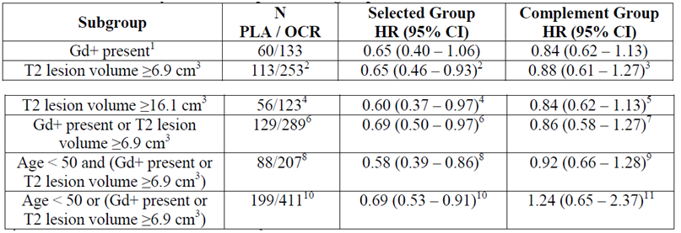
Patients with Gd+ lesions at baseline showed a numerically greater treatment benefit with ocrelizumab compared with placebo than patients without Gd+ lesions at baseline (HR 0.65 (0.40- 1.06) versus 0.84 (0.62-1.13)). However, similar treatment benefit is also seen in patients with T2 lesion volume ≥ 6.9 cm³ (HR = 0.65 (0.46-0.93)) and ≥ 16.1 cm³ (HR = 0.60 (0.37 to 0.97)), respectively. Patients with either Gd+ lesions or T2 lesion volume ≥ 6.9 cm³ at baseline also showed improved treatment benefit (HR=0.69 (0.50-0.97)) compared with the complement group. Hence, Gd+ lesion and T2 lesion volume should both be considered when predicting treatment benefit using inflammation, rather than Gd+ lesions alone. Furthermore, a subgroup of patients younger than 50 years and with active disease as per MRI (Gd+ lesion present or T2 lesion volume ≥ 6.9 cm³) result in similar treatment benefit to those with Gd+ lesions.
Taking into account all of the above information and particularly the observation that both Gd+ lesion and T2 lesion status are important in identifying patients with active disease, the sponsor proposes to add the following statement to the Clinical Trials section of the PI:
A post-hoc analysis suggested that patients who are 50 years of age or below, or patients who have inflammation determined by MRI (Gd enhancing or T2 lesion) may receive a greater treatment benefit than patients who are over 50 years of age or patients who do not have inflammation by MRI.
4. Does the committee consider the proposed warning statement regarding risk and monitoring for PML is adequate?
No cases of PML have occurred in clinical trials with ocrelizumab. Nevertheless, the sponsor is cognizant of the potential risk for PML as a result of ocrelizumab treatment that is associated with altered immunosurveillance, and a theoretical risk based on observations for other anti-CD20 therapies and MS disease modifying therapies (DMTs) associated with risk factors (for example, patient population, polytherapy with immunosuppressants). Since a risk of PML cannot be excluded, the Sponsor included precautionary information in the Precautions section of the proposed PI. The Sponsor agrees with the Delegates request to further strengthen the sub-section on PML in Precautions (see sponsors Comment on PI). The sponsor considers this strengthened sub-section, which describes in detail the early signs and symptoms of PML and what action should be taken, to provide comprehensive precautionary information and to adequately describe the risk and the need for vigilance.
Presently, testing for John Cunningham virus (JCV) antibodies does not appear to identify all patients infected with JCV due to its major limitation of a high rate of false negative results. Therefore, a negative JCV test does not demonstrate an absence of JCV infection and could lead to a false reassurance that PML will not occur in patients apparently negative for JCV antibody. This major JCV testing limitation precludes its use to identify patients at risk for PML. Thus, the sponsor considers that PML diagnosis cannot be driven by JCV antibody status (positive or negative).
A recommendation for JCV testing, as part of the treatment algorithm, exists only in the natalizumab PI due to the existence of a time pattern for risk and identified risk factors associated with an increased risk of developing PML with natalizumab. Risk factors observed with natalizumab have not been observed in any other MS DMTs as well as any anti-CD20 monoclonal antibodies. As a result, there is no recommendation for JCV testing in the PIs for other DMTs or anti-CD20 mAbs, including other therapies where PML is an identified risk with rare occurrence (for example, Tecfidera, Gilenya).
Therefore, the sponsor considers a recommendation to perform JCV testing prior to or during treatment with Ocrevus to be unwarranted for inclusion in the proposed PI. The Sponsor’s opinion is based on data from Ocrevus clinical studies in which no case of PML occurred and the currently available data on PML infection and its risks with other similar drugs to ocrelizumab (anti-CD20 mAbs) and approved MS DMTs. Furthermore, following a similar discussion in the sponsor’s response to the Section 31 request, the clinical evaluator accepted the sponsor’s comments on the risks of PML in the setting of anti-CD20 mAbs, and stated that the risk appears to be low in MS subjects exposed to Ocrevus, compared to rheumatoid arthritis subjects exposed to rituximab. The clinical evaluator stated that the sponsor’s proposed wording for the PI were adequate and agreed that the PI did not need to recommend serological testing for JCV.
In the post-marketing setting, the Sponsor will ensure vigilance for PML. The Sponsor will utilize routine pharmacovigilance (PV) activities in order to obtain additional follow-up information for suspected PML cases reported from spontaneous sources or non-interventional studies/programs by means of the distribution of the company guided questionnaire (GQ) on PML. The additional information obtained via the GQ will be assessed by the sponsor on an ongoing basis and discussed in the periodic benefit risk evaluation report (PBRER).
5. Does the committee consider there should be additional monitoring and/or follow-up of patients given ocrelizumab for malignancy?
The sponsor notes that the Delegate has requested the inclusion of a subsection under the heading of Malignancy in Precautions to include the following:
Immunomodulatory drugs may increase the risk of malignancy. On the basis of limited experience with Ocrevus in MS patients a possible risk for the development of solid tumours cannot be excluded at this time.
Although agreeing with the addition of such a subsection, the Sponsor proposes the inclusion of an alternative statement which combines wording proposed by the Delegate with wording taken from the approved USPI and the proposed EU SmPC, as follows:
Immunomodulatory drugs may increase the risk of malignancy. In controlled trials, malignancies, including breast cancer, occurred more frequently in OCREVUS-treated patients although the incidence was within the background rate expected for an MS population. However, a possible increased risk of malignancy cannot be excluded. Patients should follow standard breast cancer screening guidelines.
The sponsor considers this statement to be more informative for physicians as it presents information on the occurrence of malignancies in Ocrevus clinical trials and provides specific guidance for patients to follow breast screening guidelines. In addition, it enables more consistency in precautionary advice given across regions.
Malignancy including breast cancer remains an important potential risk. The Sponsor also wishes to highlight that, as part of ongoing safety-related surveillance, a multi-source non-interventional Post-Authorisation Safety Study (PASS) will be conducted which will assess and characterise the long-term safety data (including malignancies) from the use of Ocrevus in patients with MS (as per the RMP pharmacovigilance plan). In addition, a Postmarketing Requirement (PMR) related to the approval of Ocrevus in the USA is that the sponsor performs a prospective longitudinal observational study in adult patients with RMS and PPMS exposed to Ocrevus to determine the incidence and mortality rates of breast cancer and all malignancies. All patients will be followed for a minimum of 5 years or until death following their first exposure to Ocrevus. The sponsor will continue to assess the emerging data to further characterise this important potential risk and will communicate diligently any relevant information to prescribers, investigators and health authorities.

Advisory Committee Considerations
The Advisory Committee on Prescription Medicines (ACM), having considered the evaluations and the Delegate’s overview, as well as the sponsor’s response to these documents, advised the following:
1. Does the committee consider that patients with SPMS without relapse in the last 2 years should be specifically excluded in the indications for ocrelizumab? If not should a lack of assessment be stated in the Clinical Trials section of the PI?
ACM agreed that patients with SPMS without relapse in the last 2 years would not qualify for treatment according to the proposed indications for ocrelizumab, and noted that these patients were not included in the pivotal clinical trials. No additional modification of the indication or the PI was considered necessary to clarify this point.
2. The clinical evaluator recommended that for the PPMS study description in the PI, the sponsor include an estimate of the magnitude of the delay in 12-week CDP achieved with ocrelizumab, expressed in units of time (such as ‘18 weeks’). This was not agreed to by the sponsor. Does the committee consider this information should be included in the PI?
ACM noted that the sponsor intended to add the time taken for 30% of patients to reach 12 week and 24 week CDP to the Clinical Trials section in the PI. ACM agreed that this is considered the most clinically relevant information to include since the proportion of patients experiencing a CDP event remained below 50% until the end of the controlled treatment Period I in Study WA25046.
3. The clinical evaluator considered that the PPMS indication should be restricted to patients who have a contrast-enhancing (Gd+) lesions on MRI and noted that if there is never any signs of active inflammation, then it seems unlikely that a patient will respond to ocrelizumab. Does the committee consider there should be a statement to the effect that there is a reduced effect in patients with PPML who are Gd negative on MRI scan, either in the Clinical Trials or Indications section of the PI given this was not a primary analysis? (refer to Attachment 2 PI review)
ACM noted that all the above information and particularly the observation that both Gd+ lesion status and new or enhancing T2 lesions are important in identifying patients with active disease. ACM agreed that the sponsor’s additional proposed statement to the Clinical Trials section of the PI was adequate.
A post-hoc analysis suggested that patients who are 50 years of age or below, or patients who have inflammation determined by MRI (Gd enhancing or T2 lesion) may receive a greater treatment benefit than patients who are over 50 years of age or patients who do not have inflammation by MRI.
4. Does the committee consider the proposed warning statement regarding risk and monitoring for PML is adequate?
ACM agreed with the delegate’s proposed wording of the warning statement regarding risk and monitoring for PML is adequate. ACM noted that there was no evidence that monitoring JC virus status would be beneficial at the current time.
5. Does the committee consider there should be additional monitoring and/ or follow-up of patients given ocrelizumab for malignancy?
ACM agreed with most of the additional wording proposed by the sponsor in the PI and recommended that reference to breast cancer be amended to refer to cancer as follows:
Immunomodulatory drugs may increase the risk of malignancy. In controlled trials, malignancies, including breast cancer, occurred more frequently in Ocrevus-treated patients although the incidence was within the background rate expected for an MS population. However, a possible risk of malignancy cannot be excluded. Patients should follow standard cancer screening guidelines.
ACM advised that implementation by the sponsor of the recommendations outlined above to the satisfaction of the TGA, in addition to the evidence of efficacy and safety provided would support the safe and effective use of this product.

Outcome
Based on a review of quality, safety and efficacy, TGA approved the registration of Ocrevus (ocrelizumab) 300 mg/10 mL concentrate solution for infusion vial, indicated for:
Ocrevus is indicated for the treatment of patients with relapsing forms of multiple sclerosis (RMS) to delay the progression of physical disability and to reduce the frequency of relapse.
Ocrevus is indicated for the treatment of patients with primary progressive multiple sclerosis (PPMS) to delay the progression of physical disability

Specific conditions of registration applying to these goods
- The Ocrevus (ocrelizumab) EU-Risk Management Plan (EU-RMP), version 1.0, dated 5 April 2016 with ASA (version 1.0, dated May 2016) and any subsequent revisions, as agreed with the TGA will be implemented in Australia as a condition of registration.
An obligatory component of RMPs is Routine Pharmacovigilance. Routine Pharmacovigilance includes the submission of Periodic Safety Update Reports (PSURs). Reports are to be provided annually until the period covered by such reports is not less than three years from the date of this approval letter. No fewer than three annual reports are required. The reports are to at least meet the requirements for PSURs as described in the EMA’s Guideline on good pharmacovigilance practices (GVP) Module VII-Periodic Safety Update Report (Rev 1), Part VII.B. Structures and processes. Note that submission of a PSUR does not constitute an application to vary the registration. Each report must have been prepared within ninety calendar days of the data lock point for that report.
Unless agreed separately between the supplier who is the recipient of the approval and the TGA, the first report must be submitted to TGA no later than 15 calendar months after the date of this approval letter. The subsequent reports must be submitted no less frequently than annually from the date of the first submitted report until the period covered by such reports is not less than three years from the date of this approval letter.
The annual submission may be made up of two PSURs each covering six months. If the sponsor wishes, the six monthly reports may be submitted separately as they become available.
You are reminded that sections 29A and 29AA of the Therapeutic Goods Act 1989 provide for penalties where there has been failure to inform the Secretary in writing, as soon as a person has become aware of:
  - information that contradicts information already given by the person under this Act;
  - information that indicates that the use of the goods in accordance with the recommendations for their use may have an unintended harmful effect;
  - information that indicates that the goods, when used in accordance with the recommendations for their use, may not be as effective as the application for registration or listing of the goods or information already given by the person under this Act suggests;
  - information that indicates that the quality, safety or efficacy of the goods is unacceptable.
- Batch Release Testing and Compliance with CPD:
It is a condition of registration that all batches of Ocrevus imported into Australia must comply with the product details and specifications approved during evaluation and detailed in the Certified Product Details (CPD).
It is a condition of registration that each batch of Ocrevus imported into Australia is not released for sale until samples and/or the manufacturer’s release data have been assessed and endorsed for release by the TGA Laboratories Branch.
The sponsor must supply:
  - Certificates of Analysis of all active ingredient (drug substance) and final product.
  - Information on the number of doses to be released in Australia with accompanying expiry dates for the product and diluents (if included).
  - Evidence of the maintenance of registered storage conditions during transport to Australia.
  - 3 vials of each batch for testing by the TGA Laboratories Branch together with any necessary standards, impurities and active pharmaceutical ingredients (with their Certificates of Analysis) required for method development and validation.
Samples and data should be forwarded to the TGA Laboratories Branch, Biochemistry Section, before release of each batch and with sufficient lead time to allow for testing.
This batch release condition will be reviewed and may be modified on the basis of actual batch quality and consistency. This condition remains in place until you are notified in writing of any variation.
Certified Product Details:
The CPD, as described in Guidance 7: Certified Product Details of the Australian Regulatory Guidelines for Prescription Medicines (ARGPM), for the above products should be provided upon registration of these therapeutic goods. In addition, an updated CPD should be provided when changes to finished product specifications and test methods are approved in an application or notified through a self-assessable change.

Attachment 1. Product Information
The PI for Ocrevus approved with the submission which is described in this AusPAR is at Attachment 1. For the most recent PI, please refer to the TGA website at <https://www.tga.gov.au/product-information-pi>.

Attachment 2. Extract from the Clinical Evaluation Report

Therapeutic Goods Administration
PO Box 100 Woden ACT 2606 Australia
Email: info@tga.gov.au Phone: 1800 020 653 Fax: 02 6232 8605
https://www.tga.gov.au

This was subsequently provided by the sponsor at a later stage of the application procedure.
Milo R. Therapeutic strategies targeting B-cells in multiple sclerosis. Autoimmun Rev. 15: 714-8 (2016).
Constant SL. B lymphocytes as antigen-presenting cells for CD4+ T cell priming in vivo. J Immunol. 162: 5695-5703 (1999); Crawford A, et al. Primary T cell expansion and differentiation in vivo requires antigen presentation by B cells. J Immunol. 176: 3498-506 (2006).
Bar-Or A, et al. Abnormal B-cell cytokine responses a trigger of T-cell-mediated disease in MS? Ann Neurol. 67: 452-61 (2010); Duddy M, et al. Distinct effector cytokine profiles of memory and naive human B cell subsets and implication in multiple sclerosis. J Immunol. 178: 6092-99 (2007).
Genain CP, et al. Identification of autoantibodies associated with myelin damage in multiple sclerosis. Nat Med. 5: 170-75 (1999); Storch MK, et al. Multiple sclerosis: in situ evidence for antibody- and complement-mediated demyelination. Ann Neurol. 43: 465-71 (1998).
Serafini B, et al. Detection of ectopic B-cell follicles with germinal centers in the meninges of patients with secondary progressive multiple sclerosis. Brain Pathol. 14: 164-74 (2004); Magliozzi R, et al. A gradient of neuronal loss and meningeal inflammation in multiple sclerosis. Ann Neurol. 68: 477-93 (2010).
Avivi I, Stroopinsky D, Katz T. Anti-CD20 monoclonal antibodies: beyond B-cells. Blood Rev. 27: 217-23 (2013).
Pregnancy Category C: Drugs which, owing to their pharmacological effects, have caused or may be suspected of causing, harmful effects on the human foetus or neonate without causing malformations. These effects may be reversible. Accompanying texts should be consulted for further details.
The sponsor points out that overall, this study was negative.
Routine risk minimisation activities may be limited to ensuring that suitable warnings are included in the product information or by careful use of labelling and packaging. Routine pharmacovigilance practices involve the following activities: • All suspected adverse reactions that are reported to the personnel of the company are collected and collated in an accessible manner; • Reporting to regulatory authorities; • Continuous monitoring of the safety profiles of approved products including signal detection and updating of labelling; • Submission of PSURs; • Meeting other local regulatory agency requirements.
Bonzano L, et al. Gadolinium-enhancing or active T2 magnetic resonance imaging lesions in multiple sclerosis clinical trials? Mult Scler. 15: 1043-7 (2009); Wattjes MP, et al. Evidence-based guidelines: MAGNIMS consensus guidelines on the use of MRI in multiple sclerosis--establishing disease prognosis and monitoring patients. Nat Rev Neurol. 11: 597-606 (2015); Kaunzner UW, et al. Defining Disease Activity and Response to Therapy in MS. Curr Treat Options Neurol. 19: 20 (2017).
Filippi M, et al. Association between pathological and MRI findings in multiple sclerosis. Lancet Neurol. 11: 349-60 (2012).
Filippi M, et al. Association between pathological and MRI findings in multiple sclerosis. Lancet Neurol. 11: 349-60 (2012); Frischer JM, et al. Clinical and pathological insights into the dynamic nature of the white matter multiple sclerosis plaque. Ann Neurol. 78: 710-21 (2015).
Wattjes MP, et al. Evidence-based guidelines: MAGNIMS consensus guidelines on the use of MRI in multiple sclerosis--establishing disease prognosis and monitoring patients. Nat Rev Neurol. 11: 597-606 (2015); Suthiphosuwan S, et al. Imaging Markers for Monitoring Disease Activity in Multiple Sclerosis. Curr Treat Options Neurol. 19: 18 (2017).
The ACM provides independent medical and scientific advice to the Minister for Health and TGA on issues relating to the safety, quality and efficacy of medicines supplied in Australia including issues relating to pre-market and post-market functions for medicines. The Committee is established under Regulation 35 of the Therapeutic Goods Regulations 1990. Members are appointed by the Minister. The ACM was established in January 2017 replacing Advisory Committee on Prescription Medicines (ACPM) which was formed in 2010. ACM encompasses pre and post-market advice for medicines, following the consolidation of the previous functions of the Advisory Committee on Prescription Medicines (ACPM), the Advisory Committee on the Safety of Medicines (ACSOM) and the Advisory Committee on Non-Prescription Medicines (ACNM). Membership comprises of professionals with specific scientific, medical or clinical expertise, as well as appropriate consumer health issues relating to medicines.

