AusPAR Attachment 2

Extract from the Clinical Evaluation Report for ocrelizumab
  - Proprietary Product Name: Ocrevus
  - Sponsor: Roche Products Pty Limited
First round report: October 2016
Second round report: February 2017

About the Therapeutic Goods Administration (TGA)
- The Therapeutic Goods Administration (TGA) is part of the Australian Government Department of Health, and is responsible for regulating medicines and medical devices.
- The TGA administers the Therapeutic Goods Act 1989 (the Act), applying a risk management approach designed to ensure therapeutic goods supplied in Australia meet acceptable standards of quality, safety and efficacy (performance), when necessary.
- The work of the TGA is based on applying scientific and clinical expertise to decision-making, to ensure that the benefits to consumers outweigh any risks associated with the use of medicines and medical devices.
- The TGA relies on the public, healthcare professionals and industry to report problems with medicines or medical devices. TGA investigates reports received by it to determine any necessary regulatory action.
- To report a problem with a medicine or medical device, please see the information on the TGA website < https://www.tga.gov.au>.
About the Extract from the Clinical Evaluation Report
- This document provides a more detailed evaluation of the clinical findings, extracted from the Clinical Evaluation Report (CER) prepared by the TGA. This extract does not include sections from the CER regarding product documentation or post market activities.
- The words (Information redacted), where they appear in this document, indicate that confidential information has been deleted.
- For the most recent Product Information (PI), please refer to the TGA website < https://www.tga.gov.au/product-information-pi>.
Copyright
© Commonwealth of Australia 2018
This work is copyright. You may reproduce the whole or part of this work in unaltered form for your own personal use or, if you are part of an organisation, for internal use within your organisation, but only if you or your organisation do not use the reproduction for any commercial purpose and retain this copyright notice and all disclaimer notices as part of that reproduction. Apart from rights to use as permitted by the Copyright Act 1968 or allowed by this copyright notice, all other rights are reserved and you are not allowed to reproduce the whole or any part of this work in any way (electronic or otherwise) without first being given specific written permission from the Commonwealth to do so. Requests and inquiries concerning reproduction and rights are to be sent to the TGA Copyright Officer, Therapeutic Goods Administration, PO Box 100, Woden ACT 2606 or emailed to < tga.copyright@tga.gov.au>.
Contents
List of abbreviations 5
1. Introduction 8
1.1. Drug class and therapeutic indication 8
1.2. Dosage forms and strengths 9
1.3. Dosage and administration 9
2. Clinical rationale 9
3. Contents of the clinical dossier 11
3.1. Scope of the clinical dossier 11
3.2. Paediatric data 13
3.3. Good clinical practice 13
4. Pharmacokinetics 14
4.1. Studies providing pharmacokinetic data 14
4.2. Summary of pharmacokinetics 14
4.3. Evaluator’s overall conclusions on pharmacokinetics 18
5. Pharmacodynamics 19
5.1. Studies providing pharmacodynamic data 19
5.2. Summary of pharmacodynamics 20
5.3. Evaluator’s overall conclusions on pharmacodynamics 26
6. Dosage selection for the pivotal studies 26
7. Clinical efficacy 27
7.1. Pivotal efficacy studies in Relapsing MS 27
7.2. Other efficacy studies 72
7.3. Evaluator’s overall conclusions on clinical efficacy 81
8. Clinical safety 89
8.1. Studies providing evaluable safety data 89
8.2. Patient exposure 92
8.3. Adverse events 95
8.4. Laboratory tests 118
8.5. Post-marketing experience 127
8.6. Safety issues with the potential for major regulatory impact 127
8.7. Other safety issues 128
8.8. Evaluator’s overall conclusions on clinical safety 140
9. First round benefit-risk assessment 141
9.1. First round assessment of benefits 141
9.2. First round assessment of risks 144
9.3. First round assessment of benefit-risk balance 144
10. First round recommendation regarding authorisation 145
10.1. Evaluator comments on round 1 recommendations 145
11. Clinical questions 145
11.1. Additional expert input 145
11.2. Clinical questions 145
12. Second round evaluation of clinical data submitted 147
12.1. Efficacy question 1 147
12.2. Efficacy question 2 152
12.3. Efficacy question 3 153
12.4. Efficacy question 4 155
12.5. Efficacy question 5 161
12.6. Efficacy question 6 161
12.7. Efficacy question 7 162
12.8. Efficacy question 8 164
12.9. Efficacy question 9 166
13. Second round benefit-risk assessment 167
13.1. Efficacy in RRMS 167
13.2. Efficacy in SPMS 168
13.3. Efficacy in PPMS 168
13.4. Risks of Ocrelizumab 169
14. Second round recommendation regarding authorisation 169
15. References 170

List of abbreviations
Abbreviations | Meaning
9-HPT | 9-hole peg test
ACR70 | American College of Rheumatology score improvement of ≥ 70%
ADA | Anti-drug antibody
AE | Adverse event
ANCOVA | Analysis of covariance
ARR | Annualised relapse rate
BMI | Body mass index
CCOD | Clinical cut-off date
CDI | Confirmed disability improvement
CDP | Confirmed disability progression
CI | Confidence interval
CMH | Cochran-Mantel-Haenszel
CRF | Case report form
CSF | Cerebrospinal fluid
CSR | Clinical study report
DAS | Disease activity score
DIC | Disseminated intravascular coagulation
DMT | Disease modifying therapy
EDC | Electronic data capture
EDSS | Expanded Disability Status Scale
EULAR | European League Against Rheumatism
FS | Function systems
FSS | Function Systems Score
Gd | Gadolinium
HR | Hazard ratio
HRQoL | Health-related quality of life
HRQoL | Health related quality of life
IDP | Initial disability progression
IFN | Interferon beta-1a
IM | Intramuscular
IRR | Infusion related reaction
ITT | Intent-to-treat
IV | Intravenous
LLN | Lower limit of normal
LOCF | Last observation carried forward
MCS | Mental component summary
MFIS | Modified Fatigue Impact Scale
MMRM | Mixed-Effect Model Repeated Measures
MRI | Magnetic resonance imaging
MS | Multiple sclerosis
MSFC | Multiple Sclerosis Functional Composite
NEDA | No evidence of disease activity
OCR | Ocrelizumab
OLE | Open-label extension
PCS | Physical component summary
PK | Pharmacokinetics
PP | Per-protocol
PPMS | Primary progressive multiple sclerosis
RA | Rheumatoid arthritis
RMS | Relapsing forms of multiple sclerosis
RR | Relative risk
RRMS | Relapsing-remitting multiple sclerosis
SC | Subcutaneous
SD | Standard deviation
SF-36 | Short-form -36 (question) questionnaire
SFU | Safety follow-up
SIRS | Systemic inflammatory response syndrome
SJC | Swollen joint count
SPMS | Secondary-progressive multiple sclerosis
T25-FW | Timed 25-foot walk

Introduction
This is an application to register a new chemical entity, Ocrevus ocrelizumab (rch).

Drug class and therapeutic indication
Ocrelizumab is a recombinant humanised monoclonal antibody that selectively depletes CD20 expressing B cells (B lymphocytes).
Ocrelizumab is not currently registered for any indication. The proposed indications are described by the sponsor as follows:
Ocrevus is indicated for the treatment of patients with relapsing forms of multiple sclerosis (RMS) to suppress relapses and disease progression (clinical and subclinical disease activity).
Ocrevus is indicated for the treatment of patients with primary progressive multiple sclerosis (PPMS) to delay disease progression and reduce deterioration in walking speed.
The wording of these two indications raises some issues of interpretation. Together, they cover the full spectrum of disease subtypes in multiple sclerosis (MS), which are schematically illustrated below. The expression ‘relapsing forms of multiple sclerosis’ is problematic, because it includes the common, well-recognised disease category of relapsing and remitting multiple sclerosis (RRMS), but it could also include secondary progressive MS (SPMS, in which progression develops after an initial relapsing and remitting course) or progressive relapsing MS (RPMS, an intermediate condition in which progression is present from the outset but patients also suffer from superimposed relapses).
Figure 1: Illustration of different clinical courses of MS
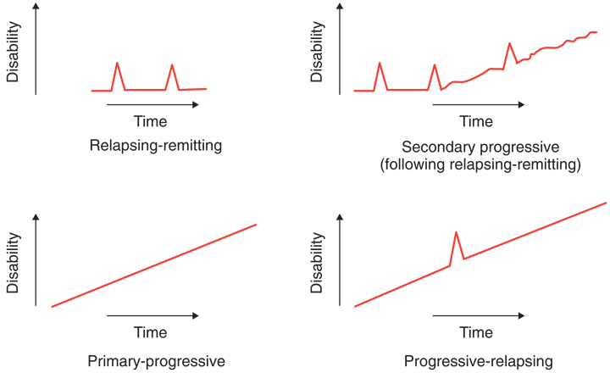
In general, agents with efficacy in RRMS cannot be assumed to have efficacy in SPMS, and it is usually very important to distinguish between these disease subtypes when designing and assessing MS treatment trials. Most agents approved for the treatment of RRMS have demonstrated only limited efficacy in progressive forms of MS, including SPMS, and no disease-modifying agents are currently approved for the treatment of PPMS. If the sponsor is correct in claiming that ocrelizumab reduces disease progression in PPMS, as well as in RRMS, then it has efficacy at each end of the notional spectrum between relapse-dominant and progression-dominant disease; this in turn implies that it is probably effective for intermediate disease subtypes (SPMS and PRMS), and therefore the distinction between the classical disease subtypes may be less important for this particular agent. Nonetheless, it would still be appropriate to choose wording for the indication that explicitly mentions the classic disease subtypes.
As will be discussed, it is also of some concern that (in keeping with the first, broadly worded indication), the pivotal study in ‘relapsing forms of MS’ did not define eligibility criteria on the basis of the classical disease subtypes.

Dosage forms and strengths
Ocrelizumab is supplied as a single strength, 300 mg/10 mL vial for injection.

Dosage and administration
The dose is 600 mg every 6 months. The initial administration schedule is somewhat complex, and is described in the PI as follows:
Ocrevus is administered by IV infusion as a 600 mg dose every 6 months:
Initial Dose
The initial 600 mg dose is administered as two separate IV infusions; one 300 mg infusion, followed by a second 300 mg infusion two weeks later.
Subsequent Doses
Subsequent doses of Ocrevus thereafter are administered as a single 600 mg IV infusion every 6 months. (A minimum interval of 5 months should be maintained between each dose of Ocrevus.)

Table 1: Dose and schedule of Ocrevus
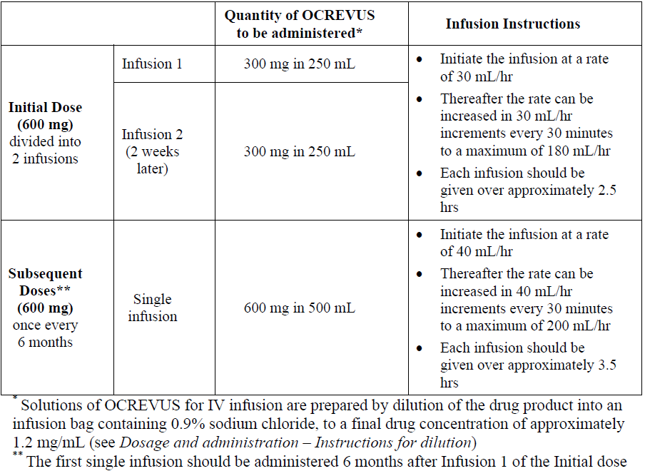

Clinical rationale
Multiple sclerosis (MS) is generally thought to be an autoimmune disease with some degenerative components. The primary role of the immune system is supported by the finding of peri-venular lymphocytic deposits in MS plaques, the presence of oligoclonal immunoglobulin bands in the cerebrospinal fluid of many patients, and the tendency for corticosteroids to shorten the duration of symptoms during a ‘relapse’ or flare. Furthermore, all disease-modifying treatments approved for the treatment of MS so far appear to have their primary mechanism of action in the immune system, and remissions have been achieved through the strategy of bone-marrow ablation with haematological stem-cell recovery.
Although T lymphocytes (T cells) have been studied extensively in MS, and may play a dominant pathogenic role, it has been known for decades that B-lymphocytes (B cells) also play a major role in the development and progression of MA. The sponsor proposes the following key mechanisms by which B cells contribute to the pathogenesis of MS:
- Presenting auto-antigens and co-stimulatory signals to activate T cells
- Secreting pro-inflammatory cytokines at greater relative proportions than protective cytokines
- Producing auto-antibodies which may cause tissue damage and activate macrophages and natural killer cells
Creating meningeal lymphoid follicle-like structures, linked to microglia activation, local inflammation and neuronal loss in the nearby cortex
Ocrelizumab targets the B cell components of the pathogenisis of MS. It is a recombinant, humanised monoclonal antibody that binds to CD20-expressing B cells with high affinity and selectively depletes them in peripheral blood. CD20 is a cell surface antigen found on pre-B cells, mature and memory B cells but it is not expressed on lymphoid stem cells and plasma cells, which means that depletion of CD20-positive cells preserves the capacity for B cell reconstitution and does not appear to compromise pre-existing antibody-mediated (humoral) immunity. According to the sponsor, pre-clinical studies suggest that ocrelizumab depletes CD20-positive B cells through several mechanisms, including antibody-dependent cellular phagocytosis (ADCP), antibody-dependent cellular cytotoxicity (ADCC), complement-dependent cytotoxicity (CDC), and induction of apoptosis. Although there are complex interactions between B cells and T cells in the immune system, the effect on B cells appears to be quite selective, and the sponsor has provided evidence that innate immunity and total T cell numbers are not affected.
Ocrelizumab was initially developed with the hope that it would be effective in rheumatoid arthritis (RA) and other auto-immune diseases, but it was abandoned for these indications because of a poor benefit-risk ratio. In particular, when used in combination with other immunosuppressive agents including chronic corticosteroids to treat RA, ocrelizumab appeared to pose an unacceptable risk of infection, and it was also associated with significant infusion-related reactions (IRRs).
Since abandoning the rheumatoid arthritis indication, the sponsor has assessed the efficacy of ocrelizumab in MS. This represents a rational investigational approach, given the existing evidence that B cells play a substantial role in the pathogenesis of MS. Also, ocrelizumab might be expected to have an improved safety profile in this population, compared to the RA population, because MS patients do not usually receive chronic concurrent immunosuppressive agents. As demonstrated in their submission, ocrelizumab has substantial efficacy in MS, although some safety and tolerability issues remain. The disease-modifying effects of ocrelizumab in MS are believed to result from a reduction in the number and function of B cells, but the precise mechanisms of action are unclear.
Existing disease-modifying agents in MS have primarily been used for relapsing-remitting MS (RRMS), and sometimes in secondary progressive MS (SPMS) for patients still experiencing relapses. No disease-modifying agents have shown acceptable efficacy in primary progressive MS (PPMS), which is widely thought to have a slightly different aetiology to relapsing forms of MS, with more degenerative and less immunological processes responsible for disease progression. There is, however, some evidence that immunological approaches may be useful in a subset of the PPMS population – particularly younger patents with active inflammatory lesions on MRI. For instance, rituximab, a monoclonal antibody with a very similar mode of action to ocrelizumab, had partial efficacy in PPMS, with significant results in some subgroups, as described in the following abstract.
Ann Neurol. 2009 October;66(4):460-71
Rituximab in patients with primary progressive multiple sclerosis: results of a randomized double-blind placebo-controlled multicenter trial
Hawker K, O'Connor P, Freedman MS, Calabresi PA, Antel J, Simon J, Hauser S, Waubant E, Vollmer T, Panitch H, Zhang J, Chin P, Smith CH; OLYMPUS trial group
Objective: Rituximab, a monoclonal antibody selectively depleting CD20+ B cells, has demonstrated efficacy in reducing disease activity in relapsing-remitting multiple sclerosis (MS). We evaluated rituximab in adults with primary progressive MS (PPMS) through 96 weeks and safety through 122 weeks
Methods: Using 2:1 randomization, 439 PPMS patients received two 1,000 mg intravenous rituximab or placebo infusions every 24 weeks, through 96 weeks (4 courses). The primary endpoint was time to confirmed disease progression (CDP), a prespecified increase in Expanded Disability Status Scale sustained for 12 weeks. Secondary endpoints were change from baseline to week 96 in T2 lesion volume and total brain volume on magnetic resonance imaging scans.
Results: Differences in time to CDP between rituximab and placebo did not reach significance (96 week rates: 38.5% placebo, 30.2% rituximab; p = 0.14). From baseline to week 96, rituximab patients had less (p < 0.001) increase in T2 lesion volume; brain volume change was similar (p = 0.62) to placebo. Subgroup analysis showed time to CDP was delayed in rituximab-treated patients aged < 51 years (hazard ratio (HR) = 0.52; p = 0.010), those with gadolinium-enhancing lesions (HR = 0.41; p = 0.007), and those aged < 51 years with gadolinium-enhancing lesions (HR = 0.33; p = 0.009) compared with placebo. Adverse events were comparable between groups; 16.1% of rituximab and 13.6% of placebo patients reported serious events. Serious infections occurred in 4.5% of rituximab and < 1.0% of placebo patients. Infusion-related events, predominantly mild to moderate, were more common with rituximab during the first course, and decreased to rates comparable to placebo on successive courses.
Interpretation: Although time to CDP between groups was not significant, overall subgroup analyses suggest selective B cell depletion may affect disease progression in younger patients, particularly those with inflammatory lesions.
The current submission is unusual in that ocrelizumab has not only shown significant efficacy in the RRMS population, which is the traditional target of disease-modifying agents, but it has also achieved statistically significant results in the PPMS population. Unfortunately, efficacy for this novel indication has only been demonstrated in a single PPMS study, and, as well is discussed; the benefit in the lone PPMS study was primarily seen in the same type of PPMS patient that responded to rituximab: younger patients with active inflammation on MRI.

Contents of the clinical dossier

Scope of the clinical dossier
The submission contained the following clinical information:
- Three Phase III pivotal efficacy/safety studies in MS (two in RMS, with Rebif as comparator; one in PPMS, with placebo as comparator).
- One Phase II dose-finding study in RRMS.
- Summaries and Clinical Study Reports (CSRs) of the experience with ocrelizumab in other conditions, including rheumatoid arthritis (RA, 9 studies), systemic lupus erythematosis (SLE, 2 studies), and non-Hodgkin’s lymphoma (NHL, 1 study). The sponsor is not seeking registration for any of these non-MS indications; in the context of the current submission, these 12 non-MS studies are primarily evaluable for PK/PD data, and for safety. Four of the 9 RA studies were Phase I or Phase II clinical pharmacology studies.
- Four population pharmacokinetic analyses, including analyses based on MS studies and non-MS studies.
- Pooled analysis of the two pivotal studies in RMS, Integrated Summary of Safety, summary of safety issues arising from non-MS studies, review of pregnancy cases across all ocrelizumab studies.

Table 2: Overview of studies in multiple sclerosis
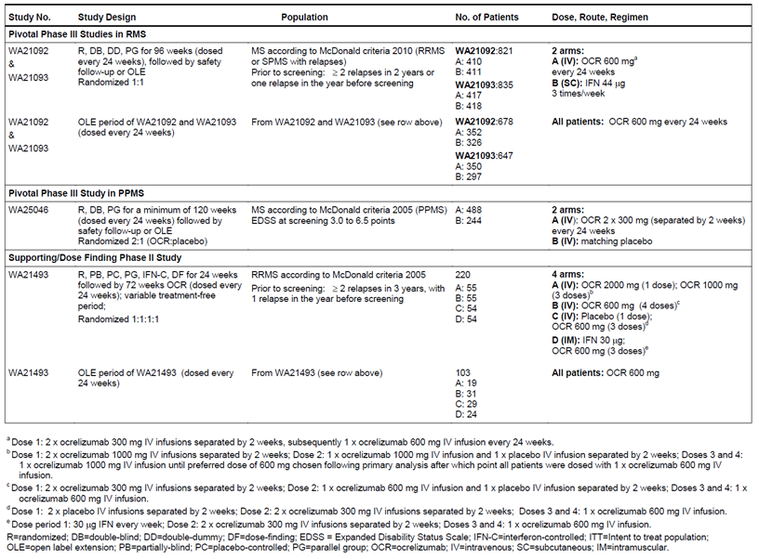

Table 3: Overview of studies in rheumatoid arthritis
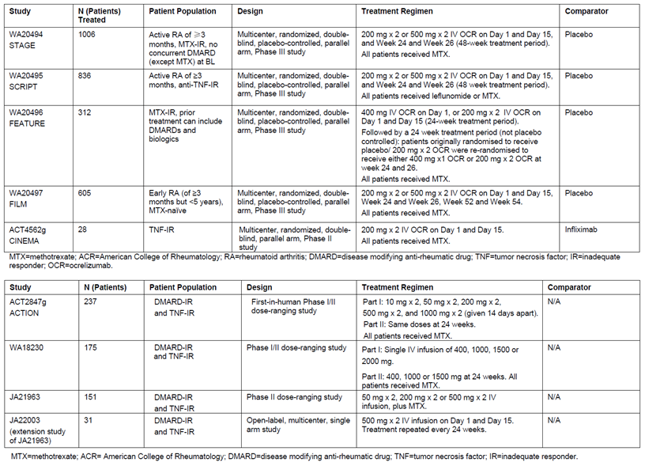

Table 4: Overview of studies in other indications
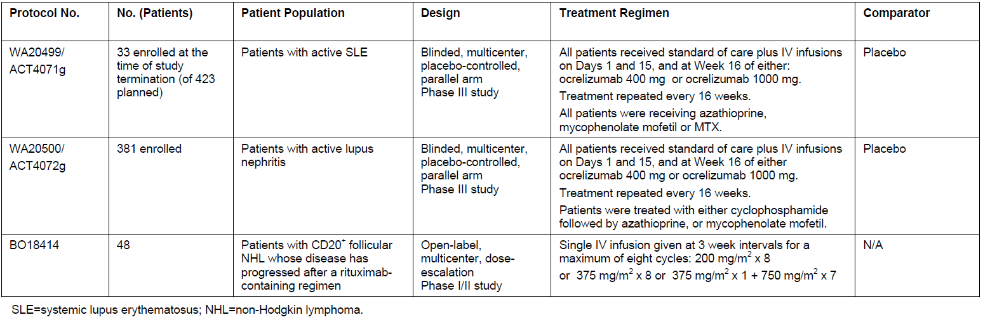

Paediatric data
The submission did not include paediatric data.

Good clinical practice
All studies were designed in accordance with the principles of Good Clinical Practice (GCP). One centre in one pivotal Study (WA21093) was found to have breached GCP, as described below:
The Roche Clinical Quality Assurance group or designee conducted audits at six investigator sites.
In addition, the Roche alliance partner/co-development partner Quintiles performed two investigator audits and one internal audit.
Critical audit findings of non-compliance with GCP were identified. Following the reporting of serious GCP non-compliance linked to a patient who became pregnant during the study conduct and delivered a stillborn baby under unclear circumstances, Roche conducted a directed Quality Assurance audit. The Principal Investigator (PI) oversight of the study and adherence to ICH GCP was inadequate as evidenced by non-adherence of protocol requirements, non-compliance with GCP requirements for the obtaining and documenting of patient informed consent, deficient documentation practices and general inadequate management of the study.
These deficiencies became apparent after the data was submitted, and were addressed in a supplementary report provided during the evaluation process. The sponsor performed sensitivity analyses excluding data from this centre. And the impact on the overall results was negligible. The revised results, with this study excluded, are considered to be more reliable than the original results and, where necessary, the PI and other documentation should be revised to reflect the new analysis.

Pharmacokinetics

Studies providing pharmacokinetic data
All PK studies were performed in patients, in studies that also had efficacy and safety objectives, and the sponsor did not perform any conventional PK studies in healthy volunteers. Apart from the target populations for the abandoned RA indication and the proposed MS indications, no special populations have been assessed. The sponsor did not provide any specific PK data in the context of hepatic or renal impairment, and the submission contained no drug-interaction data. This is reasonable, given that the PK properties of monoclonal antibodies are reasonably well understood, and do not vary greatly from one monoclonal antibody to the next; monoclonal antibodies are also catabolised, so conventional drug interaction studies and mass-balance studies are not relevant; the drug is administered intravenously, so issues about food effects and bioavailability are also not relevant.
None of the pharmacokinetic analyses had deficiencies that excluded their results from consideration. Results across the different studies were also broadly concordant.

Summary of pharmacokinetics
The sponsor Summary of Clinical Pharmacology emphasised PK data derived from population-PK analyses in the pivotal MS studies. The PK analyses were conducted via nonlinear mixed-effects modelling, using the software NONMEM 7.3.0 (ICON Development Solutions), and applying the first-order conditional estimation method with INTERACTION option (FOCEI).
Additional data were derived from conventional PK analyses when ocrelizumab was being developed for the rheumatoid arthritis indication. In general, these different lines of evidence were broadly concordant.
The following information is largely derived from the sponsor summaries in the proposed PI, but it is consistent with the population-PK analyses and individual PK studies. The PK of ocrelizumab appears typical of IgG1 monoclonal antibodies.

Physicochemical characteristics of the active substance
Ocrelizumab is a recombinant humanised anti-CD20 monoclonal antibody (IgG1 subtype).and is therefore a complex protein. It is supplied in a concentrate solution for infusion.

Pharmacokinetics in healthy subjects

Absorption

Sites and mechanisms of absorption
Ocrelizumab is administered as an intravenous infusion. Because it is an immunoglobulin, which is a large, complex protein, it would be expected to undergo extensive degradation if administered by the oral route.

Bioavailability
Availability by the proposed IV route is expected to be essentially complete. The proposed PI notes:
There have been no clinical studies performed with other routes of administration.

Dose proportionality
The PK of ocrelizumab is approximately linear and dose-proportional across the range of 400 mg to 2000 mg. Representative concentration-time curves and dose proportionality plots (C_{max} and AUC) are shown from Study WA18230, below. Slightly higher clearance was observed at lower dose levels, consistent with target-mediated drug disposition and a proportionately higher number of available binding sites with lower doses.
Figure 2: Ocrelizumab concentration verse time, Study WA18230
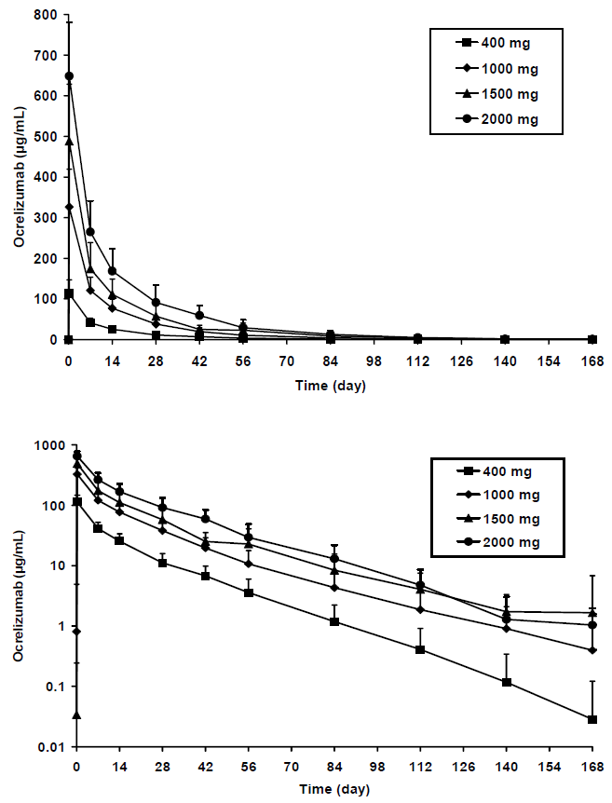
Figure 3: Dose-proportionality plots for ocrelizumab - single dose, Study WA18230
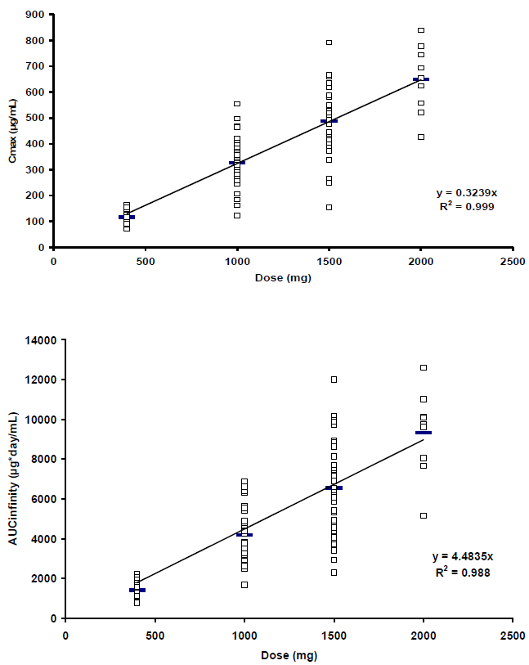

Exposure during multiple-dosing
Peak concentrations are not expected to vary substantially with repeat dosing, but clearance is likely to be altered by prior doses and subsequent B cell depletion (see the comments under non-renal clearance).

Effect of administration timing
Time of day is not expected to influence the PK of ocrelizumab.

Distribution

Volume of distribution
The population PK estimate of the central volume of distribution was 2.78 L, whereas peripheral volume and inter-compartment clearance were estimated at 2.68 L and 0.294 L/day.

Plasma protein binding
Plasma protein binding has not been studied, but is not expected to be a major factor.

Erythrocyte distribution
Erythrocyte distribution has not been studied, but is expected to be minimal.

Tissue distribution
Ocrelizumab binds to B cells, which are then likely to be sequestered in immune tissues prior to destruction of the bound B cells. The clinical studies did not assess the extent of tissue distribution of ocrelizumab.

Metabolism
The proposed PI states:
The metabolism of ocrelizumab has not been directly studied, as antibodies are cleared principally by catabolism.
This is acceptable. Clearance of antibodies, both free and bound to B cells, is likely to be complex, and difficult to study using ordinary PK methodology.

Non-renal clearance
In the sponsor population-PK model, total ocrelizumab clearance was described as the sum of a constant clearance and a time-dependent clearance that decreased slowly and stabilized with continued time. The time-dependent clearance is likely to reflect the gradual depletion of CD20-positive B cells, and hence binding sites, in response to the treatment. The sponsor proposed this mechanism as follows:
The time-dependent clearance was likely attributable to target-mediated drug disposition via depletion of B cells, the target for ocrelizumab binding (and elimination). Initially the target is present in blood and tissue, and blood levels are depleted rapidly with treatment. Perhaps fewer tissue compartments may be accessible for B cell depletion, but re-circulation of B cells from tissue to blood (where they may be more easily depleted) leads to less target being available for binding over time. Thus, clearance decreases and becomes stable with continued treatment as the target is removed and reaches a new steady state.
This also implies that clearance is likely to be reduced for second and subsequent doses, if ocrelizumab is administered before B cells have returned to baseline levels.
In the sponsor summary of the MS population-PK data, ocrelizumab constant clearance and central volume were estimated at 0.17 L/day (95% CI: 0.166 to 0.174 L/day) and 2.78 L (95% CI: 2.71 to 2.85 L); peripheral volume and inter-compartment clearance were 2.68 L (95% CI: 2.53 - 2.82 L) and 0.294 L/day (95%CI: 0.251 to 0.337 L/day). The initial time-dependent clearance component (additional to the constant clearance) was estimated at 0.0489 L/day (95% CI: 0.0464 to 0.0514 L/day). This time-dependent component constituted 20% of the total initial clearance, and declined with a half-life of 33 weeks.
The terminal elimination half-life of ocrelizumab was 26 days.

Excretion
Ocrelizumab, like other antibodies and complex endogenous proteins, is catabolised, rather than excreted.

Intra- and inter-individual variability of pharmacokinetics
Overall inter-patient variability in PK parameters in MS patients was estimated to be moderate, with coefficient of variation (CV) of up to 30%.

Pharmacokinetics in the target population
The sponsor main PK conclusions were drawn from population-PK analyses in the target population.

Pharmacokinetics in other special populations

Pharmacokinetics in subjects with impaired hepatic function
PK in the setting of substantial hepatic impairment has not been studied, as subjects with significant liver disease were excluded from the pivotal MS studies there was no significant change in PK in patients with elevated liver enzymes.
The proposed PI includes the following statement:
Hepatic impairment: No formal PK study has been conducted. Patients with mild hepatic impairment were included in clinical trials and no change in the PK of ocrelizumab was observed in those patients.
This is reasonable.

Pharmacokinetics in subjects with impaired renal function
In the MS population of the pivotal studies, there was no change in PK in patients with mild renal impairment.
The proposed PI includes the following statement:
Renal impairment: No formal PK study has been conducted. Patients with mild renal impairment were included in clinical trials and no change in the PK of ocrelizumab was observed in those patients.
This is reasonable.

Pharmacokinetics according to age
It is unknown how the PK of ocrelizumab varies in the paediatric or elderly populations. The proposed PI includes the following statements:
Elderly Patients: No studies have been conducted to investigate the PK of ocrelizumab in patients ≥ 65 years.
Paediatric Patients: No studies have been conducted to investigate the PK of ocrelizumab in children and adolescents (< 18 years of age).
Given that MS is primarily a disease of young adulthood and middle age, this is acceptable.

Pharmacokinetics related to genetic factors
No known genetic factors affect the PK of ocrelizumab, and the word ‘genetic’ does not appear in the sponsor’s Summary of Clinical Pharmacology.

Pharmacokinetic interactions
Pharmacokinetic interactions have not been studied.

Evaluator’s overall conclusions on pharmacokinetics
The PK of ocrelizumab has been adequately assessed in the target population, and it is reasonably typical of a monoclonal IgG antibody, apart from the fact that its binding target becomes depleted with use, leading to a time-dependent component to clearance. Ocrelizumab is catabolised; so many conventional PK issues do not arise. The PK of ocrelizumab is adequately described in the proposed PI.

Pharmacodynamics

Studies providing pharmacodynamic data
The key PD data for ocrelizumab, for the currently proposed indications, come from the three Phase III studies in RMS (Studies WA21092 and WA21093) and PPMS (Study WA25046), with supporting data from the Phase II Study WA21493 in RRMS. Similar data was obtained in the earlier RA studies. All PD studies were performed in patients, and the sponsor did not perform any conventional PD studies in healthy volunteers.
None of the PD analyses had deficiencies that excluded their results from consideration. PD results across the different studies were also broadly concordant, showing the expected decline in B cells after ocrelizumab administration, followed by B cell replenishment.

Table 5: Guide to synopses of studies providing pharmacodynamic data
Rheumatoid arthritis studies | Multiple sclerosis studies
Synopsis 1. Study ACT2847g  A Randomized, Placebo-Controlled, Multicenter, Blinded Phase I/II Study of the Safety of Escalating Doses of Ocrelizumab (Pro70769) in Subjects with Moderate to Severe Rheumatoid Arthritis Receiving Stable Doses of Concomitant Methotrexate  Synopsis 2. Study WA18230  A randomized placebo-controlled, multicenter, Phase I/II study of the safety of escalating single intravenous doses of ocrelizumab (rhuMAb 2H7, RO4964913, PRO70769) in patients with moderate to severe rheumatoid arthritis receiving stable doses of concomitant methotrexate but with unsatisfactory clinical response  Synopsis 4. Study JA21963  Dose-Response Study of Ocrelizumab for Rheumatoid Arthritis  Synopsis 6. Study WA20494  A randomized, double-blind, parallel group, international study to evaluate the safety and efficacy of ocrelizumab compared to placebo in patients with active rheumatoid arthritis continuing methotrexate treatment  Synopsis 7. Study WA20495  A randomized, double-blind, parallel group, international study to evaluate the safety and efficacy of ocrelizumab compared to placebo in patients with active rheumatoid arthritis who have an inadequate response to at least one anti-TNF-α therapy  Synopsis 8. Study WA20496  A Randomized, Double-Blind, Parallel-Group, International Study to Evaluate the Safety and Efficacy of Ocrelizumab Given as a Single Infusion or Dual Infusion Compared with Placebo in Patients with Active Rheumatoid Arthritis Who Have an Inadequate Response to Methotrexate  Synopsis 9. Study WA20497  A randomized, double-blind, parallel group, international study to evaluate the safety and efficacy of ocrelizumab in combination with methotrexate (MTX) compared to MTX alone in methotrexate naïve patients with active RA | Synopsis 10. PK Analysis of Study WA21493 in RRMS  Development of a Population Pharmacokinetic Model for Ocrelizumab In Patients With Relapsing-Remitting Multiple Sclerosis  Synopsis 11. Population PK and Exposure Response Analyses in RMS: Studies WA21493, WA21092, WA21093  Population Pharmacokinetic, Graphical Exposure-Efficacy and Graphical Exposure-Safety Analyses  of Ocrelizumab in Patients with Multiple Sclerosis  Synopsis 12. Population PK and Exposure Response in PPMS: Study WA25046  Population Pharmacokinetic, Graphical Exposure-Efficacy and Graphical Exposure-Safety Analyses of Ocrelizumab in Patients with Primary Progressive Multiple Sclerosis  Synopsis 13. ICON 165/118. Population PK in RA: Studies WA20494, WA20495, WA20496  Population Pharmacokinetic Analysis and Graphical Exposure-Safety and Efficacy Analyses of WA20494, WA20495 and WA20496. ICON 165/118

Summary of pharmacodynamics

Mechanism of action
Ocrelizumab, as expected for a monoclonal antibody, selectively targets and binds to a specific antigen with high affinity, in this case the CD20 marker found on the surface of B-lymphocytes. B cells targeted by ocrelizumab are then cleared by components of the endogenous immune system, though precise details of the clearance mechanisms were not supplied. The clearance of CD20-expressing B cells from blood and associated lymphatic system is the primary mode of action of ocrelizumab, and is thought to underlie its efficacy in the treatment of MS.
To monitor B cell depletion, the sponsor used B cell count in peripheral blood as the primary PD marker. Because ocrelizumab binds to CD20, it obscures measurement of CD20-positive cells, so CD19 was used as an alternative B cell marker; this marker largely mirrors CD20 expression during B cell development, and the submitted data showed the expected decline in B cells when measured using cytometric flow assays for CD19+ cells, performed on peripheral blood.

Pharmacodynamic effects

Primary pharmacodynamic effects
B cell counts in the four MS studies are displayed in the figures below. Similar results were obtained in each study, and these results closely resembled previous findings in RA studies. Exposure to ocrelizumab 600mg or 1000mg suppressed B cell counts profoundly in most subjects, with suppression below the lower limit of normal (LLN) maintained throughout the 24 week dose cycle in most subjects. Note that sampling of B cell counts was more frequent in the Phase II supportive study (figure below)
Figure 4: Study WA21493: Median B cell count
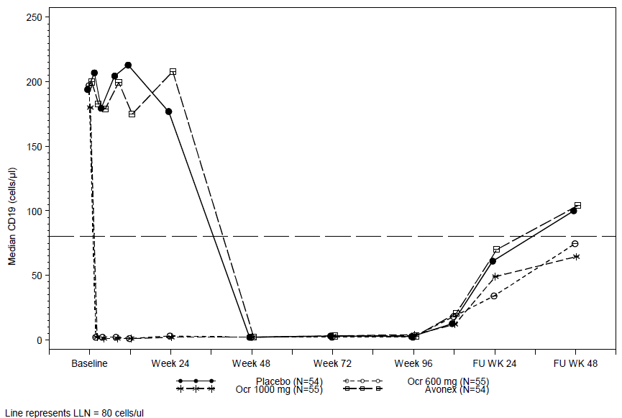
Figure 5: WA21493: Time to B cell Repletion
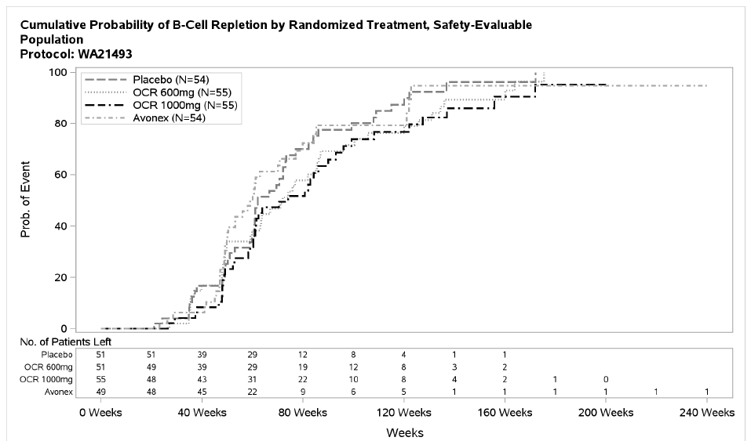
Figure 6: RMS: Median B cell Count (WA21092, WA21093)
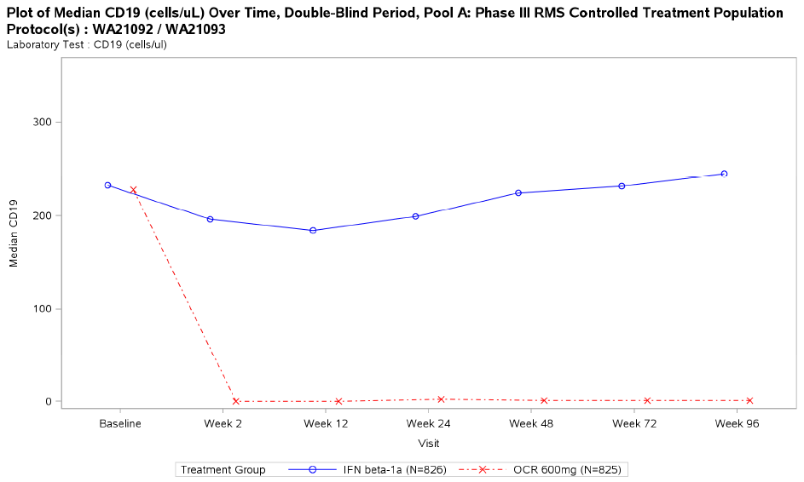

Secondary pharmacodynamic effects
In their population-PK-PD analysis of the three RMS studies, the sponsor performed an exposure-efficacy analysis, using relapse rate as a secondary PD marker, as shown below. There was no consistent pattern across exposure quartiles, and nothing in the data suggests that the dose used produced under-exposure and an inadequate PD effect in any quartile. This broadly suggests that the proposed dose is appropriate.

Table 6: RMS (WA21493, WA21092, WA21093): Occurrence of relapses by exposure category
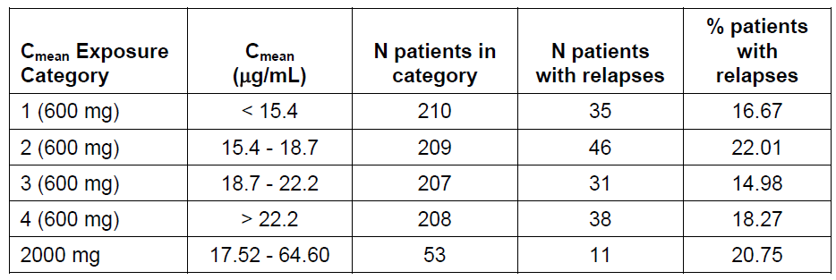

Table 7: RMS (WA21092, WA21093): Protocol defined relapse rate by exposure quartiles
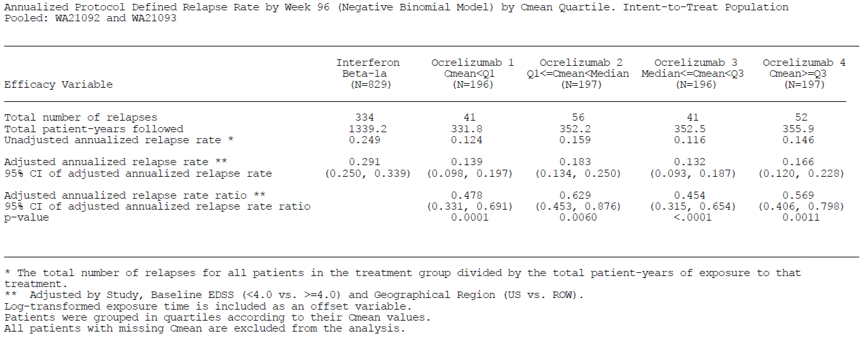

Time course of pharmacodynamic effects
The time course of the B cell depletion is shown in the figures above. B cells were depleted rapidly, within the first two weeks after exposure, and they remained low for most the proposed 24 week dosing cycle.

Relationship between drug concentration and PD effects
Population PK-PD analyses showed that the primary PD effect, B cell depletion, was partially affected by the concentration of ocrelizumab. When analysed by quartiles of exposure at the proposed dose, all concentrations produced a profound initial suppression of B cell counts, as shown in the figure below, but lower exposures led to an earlier return of some B cells than higher exposures. Most subjects nonetheless had very low B cell levels throughout the treatment cycle (the figure below shows the proportion of subjects with B cell counts that were zero or < 10 cells/mcL; the proportions of subjects with B cell counts below LLN was higher.)
Figure 7: RMS (WA21493, WA21092, WA21093): Fraction of patients with a B cell count of zero, respectively ≤ 10 cells/mcL, over time by ocrelizumab exposure at 600 mg
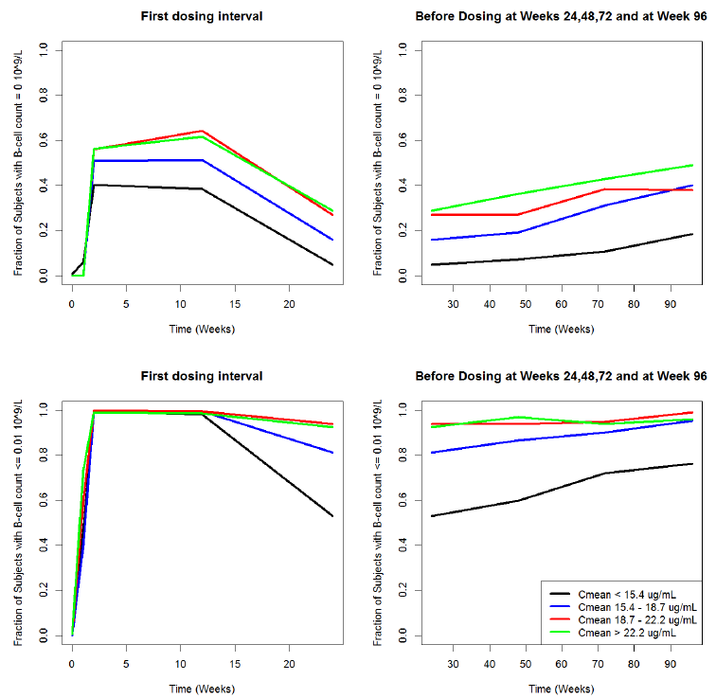
Note: This figure, supplied by the sponsor, is best viewed with colour-printout or colour monitor. Similar conclusions can be drawn from Study, which assessed duration and extent of B cell depletion according to dose, as shown in the figures and table below.
Figure 8: Median B cell profiles following iv ocrelizumab in subjects with rheumatoid arthritis and percentage of subjects with absolute B cell counts ≥ 40 cells/μL over time
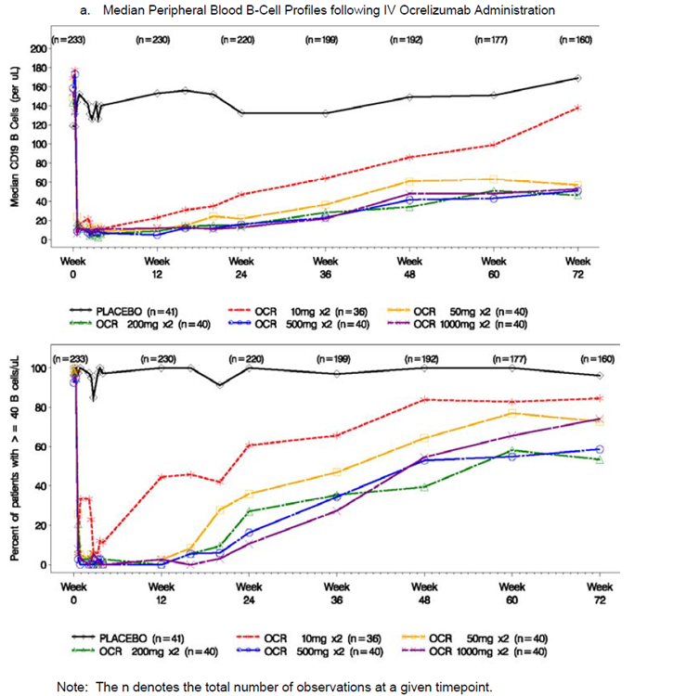

Table 8: CD19 depletion parameters: available phase I/II data on day 168 (Week 24)
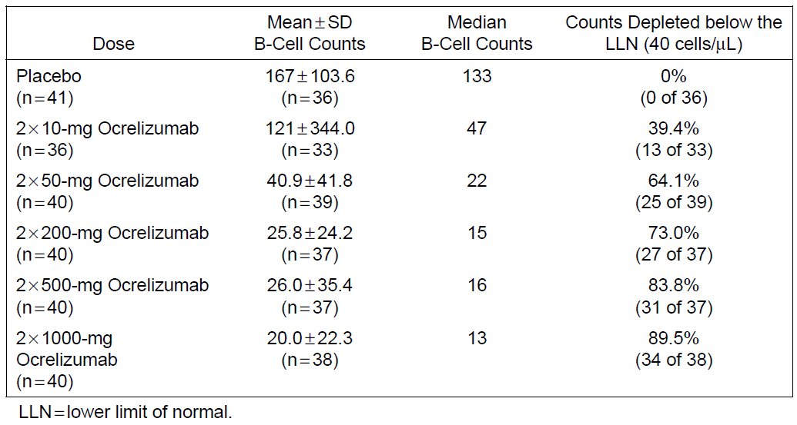

Genetic-, gender- and age-related differences in PD response
Specific analyses of the PD effects of ocrelizumab according to genetic background, gender and age were not performed. In the pop-PK analyses, these factors did not produce significant variations in exposure. It would be expected that the immunosuppression induced by ocrelizumab could have additive clinical effects when combined with the immunosuppression observed at the extremes of age, but this has not been directly demonstrated.

Pharmacodynamic interactions
Traditional PD interaction studies were not performed. It would be expected that ocrelizumab would have significant synergistic interactions with other immunomodulators or immunosuppressants. Although this could potentially lead to greater efficacy in the treatment of MS, the possibility has not been directly tested, and there are good reasons to suspect that combined therapy with ocrelizumab and immunosuppressive agents could be unsafe. When ocrelizumab was being developed as potential treatment for rheumatoid arthritis, it was combined with a number of other agents, including methotrexate (MTX), leflunomide and chronic prednisolone. In this setting, the risk of infection in ocrelizumab recipients appeared to be excessive, which is highly suggestive of a synergistic effect on the immune system. Combining ocrelizumab with immunosuppressive agents should therefore be avoided, with the exception of short courses of corticosteroids to treat MS relapses, which was allowed in the pivotal MS studies and did not lead to excessive infections.
From first principles, it might be expected that ocrelizumab, like any monoclonal antibody, could produce reduced efficacy if combined with other treatment modalities affecting immunoglobulin function or longevity, such as pooled intravenous gammaglobulin or plasma-exchange, both of which have been used in isolated cases to treat aggressive MS or other demyelinating inflammatory syndromes. The potential for such interactions, and the risks and benefits, would need to be considered on a case-by-case basis.
Substantial interactions could occur between ocrelizumab and vaccines. On the one hand, the efficacy of vaccines relying on B cell activation could be compromised by ocrelizumab. On the other hand, live vaccines could pose a risk if administered to ocrelizumab recipients, because the normal immunological suppression of the live agents could be compromised by the immunosuppressive effects of ocrelizumab. The potential for interactions of this nature was not explored in the submitted data, but the sponsor has studies underway to clarify this issue.
The proposed PI contains appropriate warnings about the potential risks of combining ocrelizumab with other immunosuppressive agents and vaccines.

Evaluator’s overall conclusions on pharmacodynamics
The PD response to ocrelizumab has been adequately characterised, and consists of a rapid and profound depletion of CD20+ B cells, assessed in the major clinical studies using the B cell marker CD19. Although low levels of B cell reappeared towards the end of the dose cycle in some subjects, levels remained very low in most subjects throughout the treatment cycle.

Dosage selection for the pivotal studies
All of the Phase III studies in Ms assessed the proposed ocrelizumab dose of 600 mg. The sponsor rationale for the selection of that dose was based on the previous experience with the RA indication.
During the clinical development of ocrelizumab for RA, the sponsor investigated doses in the range 20 mg to 2000 mg. In a Phase I/II dose escalation study in patients with RA (CSR ACT2847g), dose groups ≤ 100 mg demonstrated reduced clinical efficacy, earlier return of peripheral blood B cell counts, and higher rates of immunogenicity. The B cell depletion profiles in peripheral blood were similar for all of the higher dose groups receiving ≥ 400 mg, suggesting that maximum peripheral B cell depletion was reached above 400 mg. Also, the PK of ocrelizumab was approaching linearity at doses ≥ 400 mg, and the sponsor took this to indicate that this dose approached saturation of the target mediated drug disposition. Also, doses ≥ 400 mg were noted to provide greater clinical benefit in a number of clinical endpoints for RA: the American College of Rheumatology score, disease activity score (DAS) remission, swollen joint count (SJC) of 0, and European League against Rheumatism (EULAR) ‘good’ response.
The sponsor also reasoned that that brain exposure to ocrelizumab might be necessary in patients with MS, and higher doses might be needed to penetrate the blood-brain barrier. Accordingly, doses of 600 mg and 2000 mg were assessed in the Phase II dose finding study of ocrelizumab in patients with RRMS, Study WA21493. The primary efficacy analysis at 24 weeks in this study did not suggest any additional benefit of the higher dose. So the lower dose of 600 mg was selected for the subsequent pivotal studies in both RMS (WA21092, WA21093) and PPMS (WA25046).
Overall, this approach to dosing is reasonable. It remains somewhat unclear whether a lower dose, such a 400 mg, would have been appropriate.

Clinical efficacy
The sponsor has submitted four studies assessing the efficacy of ocrelizumab in MS, including one Phase II study in RRMS, two identical pivotal Phase III studies in ‘RMS’ (including RRMS and other relapsing subtypes), and one Phase III study in PPMS.

Pivotal efficacy studies in Relapsing MS
The sponsor submitted three studies in RMS, two of which were identical in design and were designated as pivotal (WA21092 and WA21093), and one of which was a supportive study in subjects with RRMS.

Table 9: Submitted ocrelizumab studies in relapsing MS
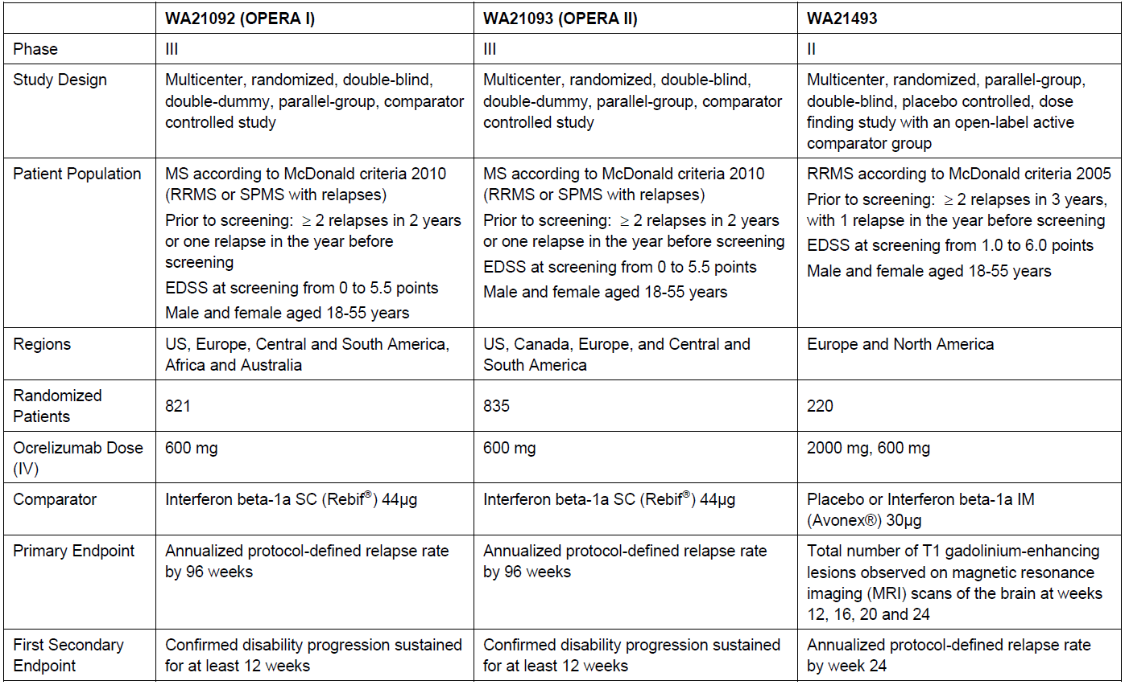

Studies WA21092 and WA21093
‘Protocol WA21092 – A randomized, double-blind, double-dummy, parallel-group study to evaluate the efficacy and safety of ocrelizumab in comparison to interferon beta-1a (Rebif) in patients with relapsing multiple sclerosis.’
‘Protocol WA21093 – A randomized, double-blind, double-dummy, parallel-group study to evaluate the efficacy and safety of ocrelizumab in comparison to interferon beta-1a (Rebif) in patients with relapsing multiple sclerosis.’
These studies also referred to as OPERA I and OPERA II, shared almost identical designs, so they are described together below, with differences noted where relevant. Both studies were international, multicentre, randomised, parallel-group, double-blind, double-dummy, parallel-group active-comparator trials comparing the efficacy and safety of ocrelizumab 600 mg IV (every 24 weeks) with interferon β-1a 44 µg SC (Rebif, three times weekly) in RMS patients, with major endpoints assessed at 96 weeks (1.8 years). Although the studies were conducted independently and the primary results were reported separately, some secondary endpoints were prospectively identified as pooled endpoints to be analysed across both studies.

Study design, objectives, locations and dates
The primary objective of both studies was to assess the efficacy of ocrelizumab versus interferon β-1a as measured by annualised relapse rate (ARR) after 96 weeks (1.8 years, often inaccurately described as ‘2 years’ in the sponsor reports). The studies also included clinical assessments of disability (confirmed disability progression (CDP), confirmed disability improvement (CDI) and Multiple Sclerosis Functional Composite (MSFC)), MRI measures (T1 Gd-enhancing, T2 hyperintense and T1-hypointense lesions and brain volume), health related quality of life (Short Form-36 questionnaire (SF-36)) and the proportion of patients achieving no evidence of disease activity (NEDA).
Study WA21092 was conducted in 32 countries (141 investigational sites), as follows: Argentina (3), Australia (1), Austria (1),Belgium (3), Bulgaria (5), Brazil (3), Switzerland (2), Chile (1), Czech Republic (6), Germany (10), Spain (4), Estonia (2), Finland (1), France (5), United Kingdom (2), Hungary (3), Israel (1), Italy (4), Lithuania (3), Latvia (2), Mexico (2), Netherlands (1), Peru (4), Poland (4), Portugal (1), Russian Federation (11), Serbia (3), Slovakia (4), Tunisia (3), Ukraine (5), South Africa (1), USA (40). It randomised its first patient on 31-Aug-2011, and had a data cut-off date of 02-Apr-2015.
Study WA21093 was conducted in 24 countries (166 investigational sites), as follow: Argentina (2),Belgium (1), Bulgaria (4), Bosnia and Herzegovina (2), Belarus (4), Brazil (3), Canada (8), Czech Republic (4), Germany (10), Spain (10), France (7), United Kingdom (4), Croatia (4), Ireland (1), Italy (10), Mexico (6), Norway (1), Poland (9), Russian Federation (9), Slovakia (3), Sweden (4), Turkey (8), Ukraine (4), USA (48). It ran in parallel with WA21092, randomising its first patient on 20-Sep-2011 and had a data cut-off date of 12 May 2015.

Inclusion and exclusion criteria
Both studies had the same entry criteria. The target population consisted of adult patients with ‘relapsing forms of MS’ (RMS), including subjects with RRMS, SPMS and on-going relapses, or relapsing progressive MS, who had experienced at least 2 relapses in the previous 2 years and had EDSS ≤ 5.5.
These entry criteria are not standard, and raise some problems of interpretation. Most major MS studies leading to registration of new disease-modifying agents have recruited subjects with RRMS, and, for most of these studies, SPMS has been explicitly listed as an exclusion criterion. Efficacy in RRMS and SPMS has been shown to be different for most disease-modifying agents, with greater efficacy demonstrated for RRMS than for SPMS. Accordingly, the efficacy of ocrelizumab in these two major disease categories cannot be assumed to be equivalent. The failure to assess the efficacy of ocrelizumab separately in pivotal studies focussed on subjects with RRMS and SPMS means that, potentially, a study of this design could create the spurious impression that efficacy in SPMS was adequate when, in fact, the benefit was wholly or largely confined to subjects with RRMS.
For ocrelizumab, this methodological concern is less pressing because efficacy in primary progressive MS has been demonstrated in a separate pivotal study. The efficacy of ocrelizumab in RRMS was also assessed in a supportive study using a radiological primary endpoint. It nonetheless remains unclear how effective ocrelizumab is in SPMS, because it has not been directly studied in this population.
Also, given that interferon β-1a (Rebif) is not usually considered effective in subjects with SPMS, and is not registered for this indication, the inclusion of subjects likely to be resistant to the active comparator raises substantial difficulties of interpretation. Ocrelizumab has been compared with an active comparator that has been methodologically disadvantaged because it has been applied to subjects outside its intended target population.

Inclusion criteria
- Ability to provide written, informed consent and be able to follow the schedule of protocol assessments (patients who were unable to complete exploratory assessments due to physical/disease limitations were not excluded from the study)
- Ages 18 to 55 years at screening, inclusive
- Diagnosis of MS, in accordance with the revised McDonald criteria (2010)
- At least 2 documented clinical attacks within the last 2 years prior to screening, or one clinical attack in the year prior to screening (but not within 30 days prior to screening)
- Neurological stability for ≥ 30 days prior to both screening and baseline
- EDSS from 0 to 5.5, inclusive, at screening
- Documented MRI of brain with abnormalities consistent with MS prior to screening
- Patients of reproductive potential using reliable means of contraception.
- For patients of non-reproductive potential:
  - Women were enrolled if postmenopausal
  - Men were enrolled if they were surgically sterile (castration).

Exclusion criteria
Exclusion criteria included a diagnosis of primary progressive MS, major concomitant diseases, pregnancy, or coexistent neurological diseases or treatments that could confound assessment. The details are listed in the Appendix of this evaluation report. Overall, the exclusion criteria appeared appropriate, and were aimed at obtaining a study population in which efficacy and safety could be clearly assessed.
Exclusion of subjects with major concomitant diseases means that the safety of ocrelizumab has not been assessed in the setting of severe hepatic or renal impairment.

Study treatments
Patients were randomised 1:1 to active ocrelizumab or active interferon, and all patients also received placebo in a double-dummy design.
Ocrelizumab (or matching placebo) was administered at a dose of 600mg by IV infusion every 24 weeks, but the first 600mg was split into two doses of 300mg separated by 14 days. Subsequent doses consisted of a single IV infusion of 600 mg ocrelizumab. Interferon recipients received ocrelizumab-placebo instead. Patients remained under observation for at least 1 hour after the completion of each infusion. Approximately 30 minutes prior to every infusion, patients were also administered 100 mg IV methylprednisolone (or an equivalent dose of alternative steroid), as well as other optional pre-medication treatments, to lower the risk of infusion-related reactions (IRRs).
Interferon beta-1a 44 µg (Rebif) or matching placebo was administered SC three times weekly from pre-filled syringes; this is the standard registered dose for Rebif. As is standard practice, subjects commenced on a lower dose and titrated upwards, and reverted to a lower dose if high doses were not tolerated (see the table below). The first dose was administered by a nurse or physician and subsequent doses were self-administered.

Table 10: Overview of Interferon Beta-1a/placebo dosing regimen
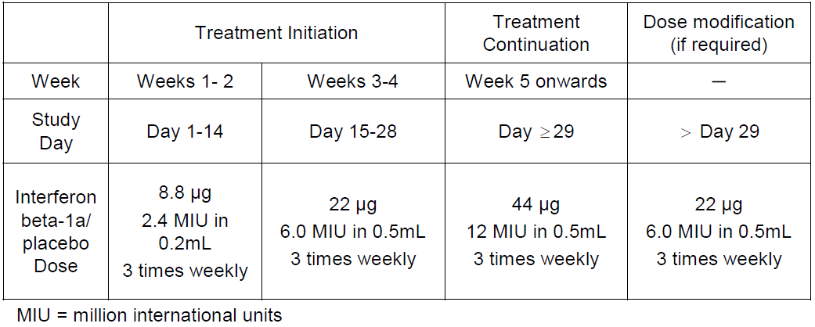

Efficacy variables and outcomes
The primary efficacy endpoint was the protocol-defined annualised relapse rate (ARR) at 96 weeks.
A protocol-defined relapse (PDR) was defined as:
- new or worsening neurological symptoms attributable to MS
- symptoms persisting for > 24 hours
- symptoms not attributable to confounding clinical factors (fever, infection, injury, or adverse reactions to medications)
- symptoms immediately preceded by a stable or improving neurological state for ≥ 30 days
Secondary efficacy endpoints were listed as follows:
- The time to onset of confirmed disability progression (CDP) that persisted for ≥ 12 weeks (12week CDP), with the initial event of neurological worsening occurring during the 96 week treatment period
- The total number of T1 Gd+ lesions detected by brain MRI at Weeks 24, 48, and 96
- The total number of new or enlarging T2 hyperintense lesions detected by brain MRI at Weeks 24, 48, and 96
- The proportion of patients with confirmed disability improvement (CDI) for ≥ 12 weeks (12 week CDI), with the initial event of neurological improvement occurring during the 96 week treatment period
- The time to onset of CDP for at least 24 weeks (24 week CDP), with the initial event of neurological worsening occurring during the 96 week, double-blind, double-dummy treatment period
- The change in MSFC score from baseline to Week 96
- The percentage change in MRI brain volume from Week 24 to Week 96
- The change in SF-36 PCS Score from baseline to Week 96
- The proportion of patients with NEDA by Week 96
Disability progression was defined as an increase the EDSS score of:
- ≥ 1.0 point from the baseline EDSS score when the baseline score was ≤ 5.5
- ≥ 0.5 point from the baseline EDSS score when the baseline score was ≤ 5.5
that was not attributable to another aetiology, such as fever, concurrent illness, or concomitant medication.
Most endpoints were assessed in each pivotal study separately, but CDP (12 week CDP and 24 week-CDP) and CDI (12 week CDI) were pooled to improve the statistical power of the analysis. This was a reasonable approach, as these endpoints only occurred in a minority of subjects.
Figure 9: Hierarchical order of key efficacy endpoints, pivotal RMS Studies
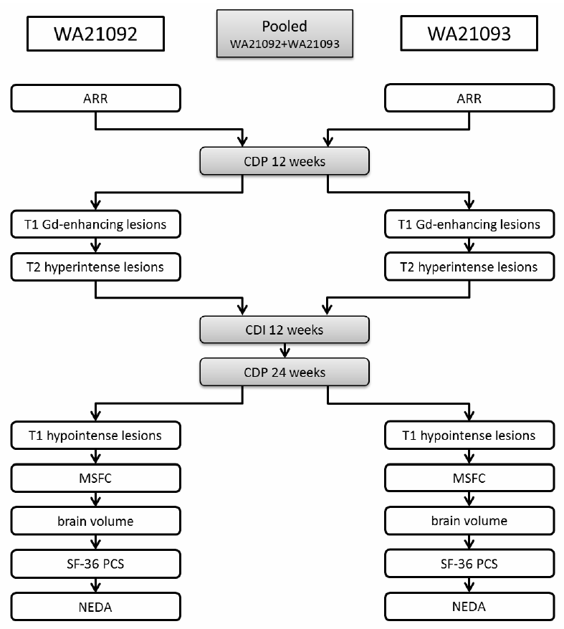

Randomisation and blinding methods
Eligible patients were randomised to ocrelizumab or interferon in a 1:1 ratio, using an independent interactive voice and web response system (IxRS). Randomisation was stratified by region (United States versus rest of the world (ROW)) and by baseline EDSS (< 4.0 versus ≥ 4.0), with a block size of 4 subjects.
Blinding to treatment allocation relied on the use of identical appearing vials and pre-filled syringes in each treatment group. Also, clinical study assessments were performed by an investigator who was not involved in medical management of the patient and who did not have access to patient data. The examining investigator performed the neurological examination, and documented the Functional System Scores (FSS), EDSS and the Karnofsky Performance Status Scale.
Select laboratory parameters that could have led to unblinding were also concealed from the treating team, and MRIs were assessed using a blinded central reporting system.
Despite these measures, it is likely that some degree of unblinding occurred, largely because of the known, tell-tale side effects associated with interferon beta (including injection site reactions and flu-like malaise after each active injection), and the excess of IRRs in the ocrelizumab group.
The sponsor does not appear to have taken any steps to determine the extent of accidental unblinding. This could have been achieved by asking patients and physicians to guess the assigned treatment at the end of the study. The failure to assess this represents a considerable methodological flaw in the studies, but the results were sufficiently robust that it is unlikely to have modified the overall conclusions.

Analysis populations
The main analysis population was the intent–to-treat (ITT) population, which included all randomised subjects. Patients in the ITT population were analysed according to their randomised treatment group regardless of whether they received an incorrect treatment or withdrew from the study.
Sensitivity analyses were performed in the per-protocol (PP) population, which included all subjects who received their randomised treatment and did not have major protocol violations.
The safety population included all patients who received any study drug, analysed according to the actual drug received.

Statistical methods
The studies were designed as a conventional superiority studies. The primary efficacy variable, ARR up to 96 weeks, was compared for the OCR group and the IFN group using a negative binomial model adjusting for region (United States versus ROW) and baseline EDSS (< 4.0 versus ≥4.0). If the difference between the OCR and IFN groups was statistically significant at α < 0.05 (two-sided test), in favour of ocrelizumab, it was to be concluded that ocrelizumab had superior efficacy, compared with interferon beta-1a.
A similar approach was taken for secondary efficacy parameters, which were tested at the 5% significance level (α = 0.05) against two-sided alternatives. Hierarchical methods were used to account for multiplicity issues, with endpoints ranked in terms of importance (see the figure above). Lower ranking endpoints to be considered non-significant if superiority was not demonstrated for all higher endpoints.

Sample size
Based on previous RRMS trials, including the Phase II supportive trial of ocrelizumab, the ARR at 96 weeks in patients receiving ocrelizumab was predicted to be 0.165 (with a standard deviation (SD) of approximately 0.60), compared with 0.33 (SD of approximately 0.80) in patients receiving interferon beta-1a, representing a relative reduction of 50% on ocrelizumab. Sample-size estimations for this endpoint were based on a t-test (although a t-test was not actually used in the final analysis of the results). A group size of 400 patients was predicted to provide 84% power, with a type I error rate of 0.05, and assuming a drop-out rate of approximately 20%.
For sample size estimation for the key secondary endpoint of confirmed disability progression, the sponsor used a two group log-rank test, with the assumption of exponential survival and exponential dropout. Assuming a 2-year CDP rate of 18% for the IFN group and 12.6% for the OCR group, consistent with a relative reduction of approximately 30% on ocrelizumab compared to interferon beta-1a, and assuming a dropout rate of 20 percent over 2 years, the sponsor estimated that a pooled sample size of 800 per treatment across both studies would provide 80% power, maintaining the type I error rate of 0.05, in the pooled analysis of two RMS trials.
The studies achieved this recruitment goal, and achieved clear statistical significance for ARR and CDP, confirming that the studies were adequately powered.
Comment: The studies were not powered for any specific subgroup analysis and, for the important subgroup of SPMS, the studies were clearly underpowered for all major endpoints.

Participant flow
Participant flow in the two pivotal RMS studies is summarised in the figures below. In each study, > 1000 subjects were screened and > 800 were randomised. Most subjects completed the main double-blind 96 week treatment period. In WA21092, the proportion of patients completing 96 weeks was higher in the OCR group (89%). than in the IFN group (83%). Similarly, in WA21093, the proportion of patients completing 96 weeks was higher in the OCR group (86%) than in the IFN group (77%). Given that subjects are more likely to discontinue if they are doing poorly, this may have created a slight withdrawal bias against ocrelizumab. Overall, these completion rates are acceptable for studies of this nature, and do not raise substantial methodological concerns.
Figure 10: Patient disposition, Study WA21092
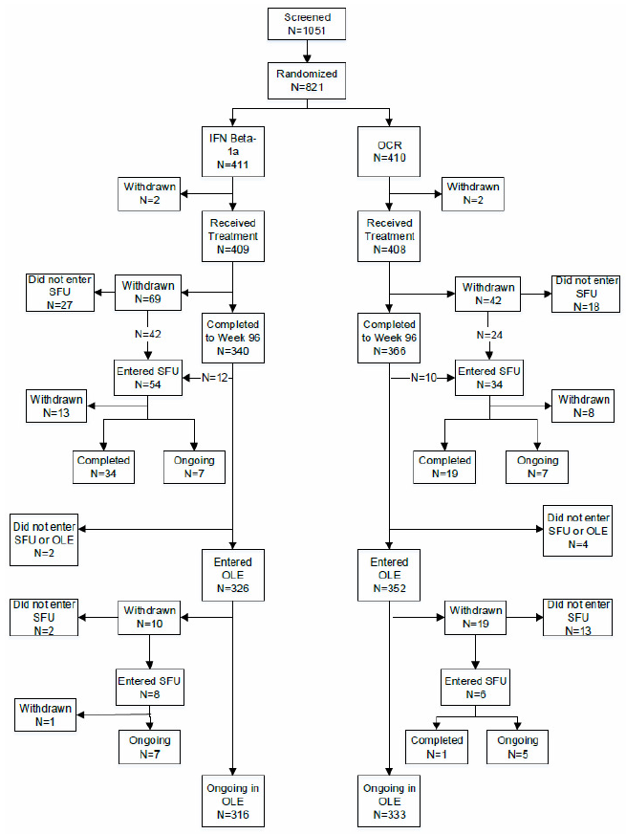
Figure 11: Patient disposition, Study WA21093
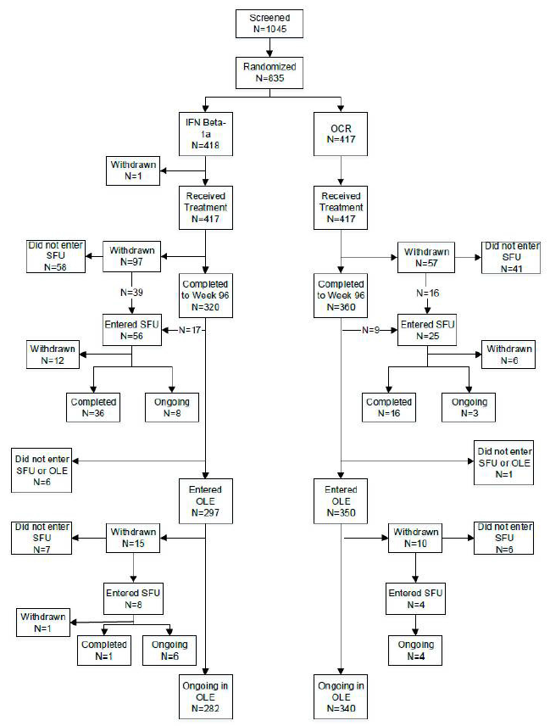
Reasons for withdrawing from the double-blind treatment period are summarised below.

Table 11: Reasons for withdrawal from the double-blind treatment period (ITT population), study WA21092
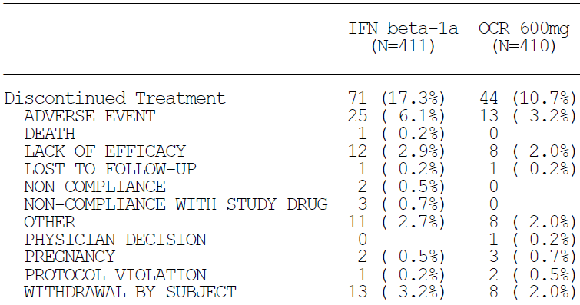

Table 12: Reasons for withdrawal from the double-blind treatment period (ITT population), Study WA21093
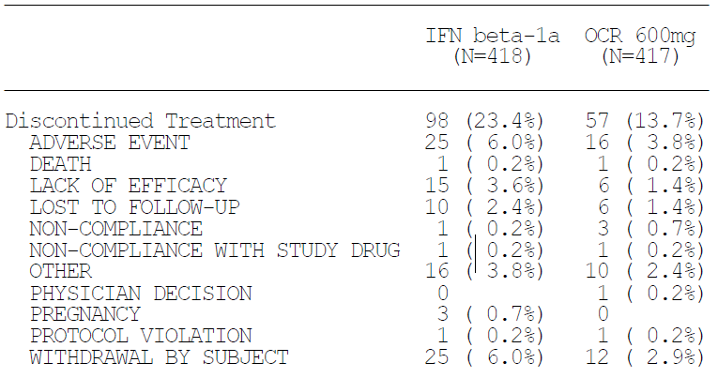

Major protocol violations/deviations
In Study WA21092, the PP population included 780 patients (95% of the 821 patients in the ITT population), with the remaining patients (5%) excluded from the PP population because of significant protocol violations. The most common violations were that the patients received study medication that had been mishandled (for example, incorrect storage temperature), which was reported in 16 patients (2%), or they had ‘neurological instability’ (changing neurological signs or symptoms) in the 30 days prior to screening and baseline (12 patients (1%)).
In Study WA21093, the PP population consisted of 798 patients (96% of the 835 patients in the ITT population). The most common protocol violations were, again, that patients received study medication that had been mishandled (16 patients (2%)) or showed neurological instability within the 30 days prior to screening and baseline (9 patients (1%)).
Occasional doses of incorrect medication were administered, with 3 subjects in WA21092 and 1 subject in WA21093 receiving single doses of active interferon instead of placebo.
The sponsor provided complete listings of all major protocol violations in each study (affecting 41 subjects in WA21092 and 37 subjects in WA21093), in multi-page tables not suitable for reproduction in this report. A review of these violations did not raise substantial methodological concerns. They included mishandling of medication (particularly problems with the storage temperature) and violations of entry criteria, including randomisation prior to completion of baseline laboratory screening.
Overall, the number of protocol violations was acceptable for a study of this nature.

Baseline data
The first four tables below summarise the baseline demographic and stratification data for each study, in the ITT population. There were no important differences between treatment groups.
The subsequent six tables summarise some of the baseline disease characteristics in each study, as provided by the sponsor. But unfortunately the tables do not indicate what proportion of subjects had RRMS and what proportion had other MS diagnoses. The inclusion of subjects with SPMS means that compared to many other studies in MS, both of these studies assessed a broader spectrum of disease severity and duration than is usually assessed. Also, for interferon β-1a (Rebif), the study population included an unknown proportion of subjects in whom treatment with interferon would not normally be considered. Apart from this, the study population appears to have been reasonably representative of the usual subjects contemplating disease-modifying therapy in MS.

Table 13: Summary of demographic data (ITT Population), WA21092
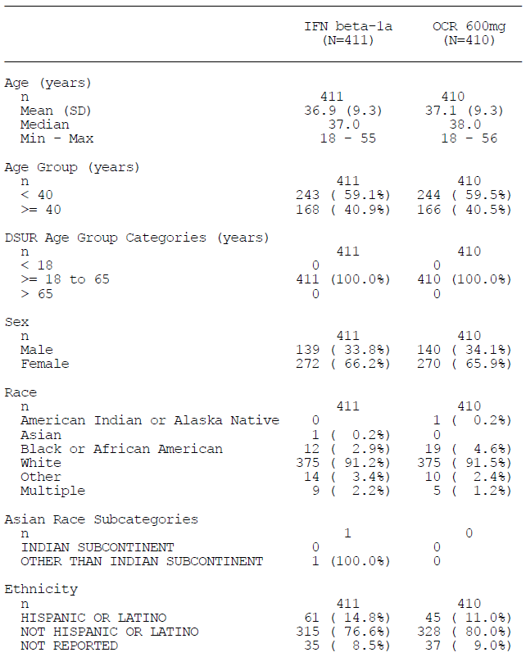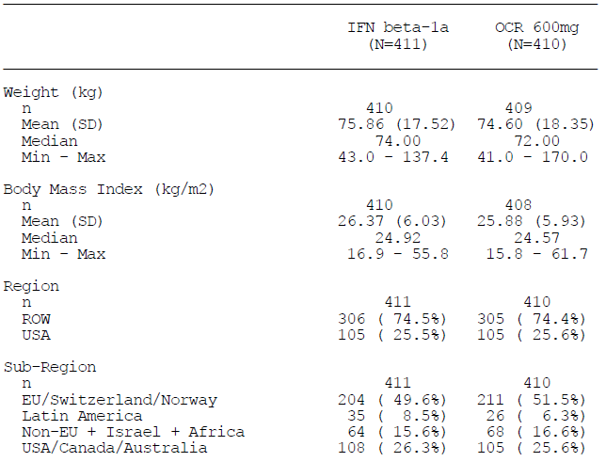

Table 14: Baseline stratification factors, ITT Population, Study WA21092
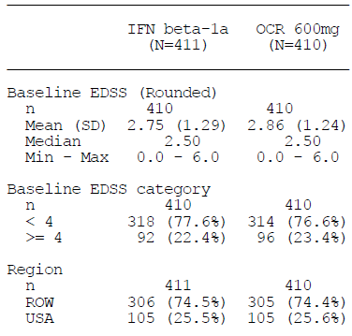

Table 15: Summary of demographic data (ITT Population), WA21093
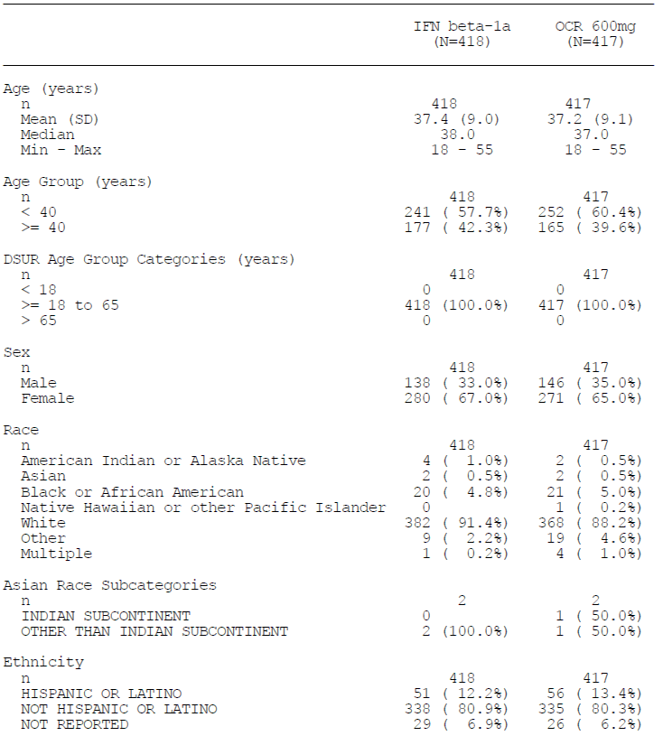

Table 16: Summary of demographic data (ITT Population), WA21093
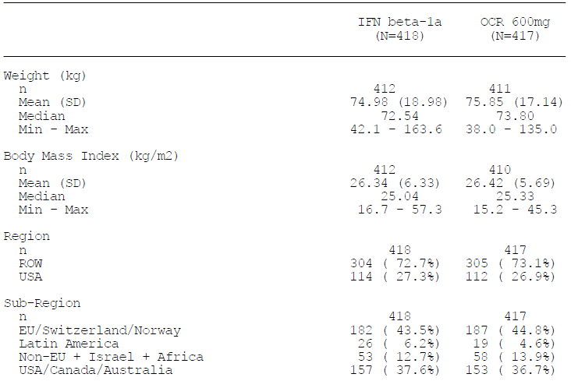

Table 17: Baseline stratification factors, ITT Population, Study WA21093
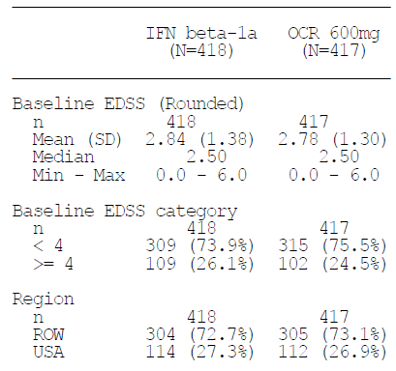

Table 18: Baseline disease history– multiple sclerosis (ITT Population), Study WA21092
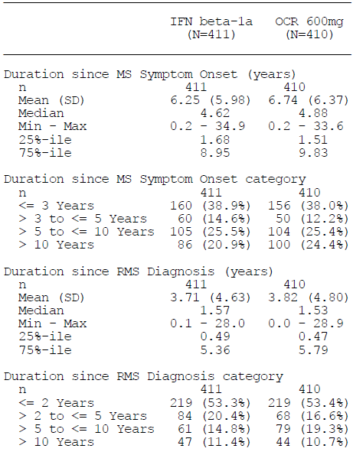

Table 19: Baseline disease characteristics – relapses (ITT Population), Study WA21092
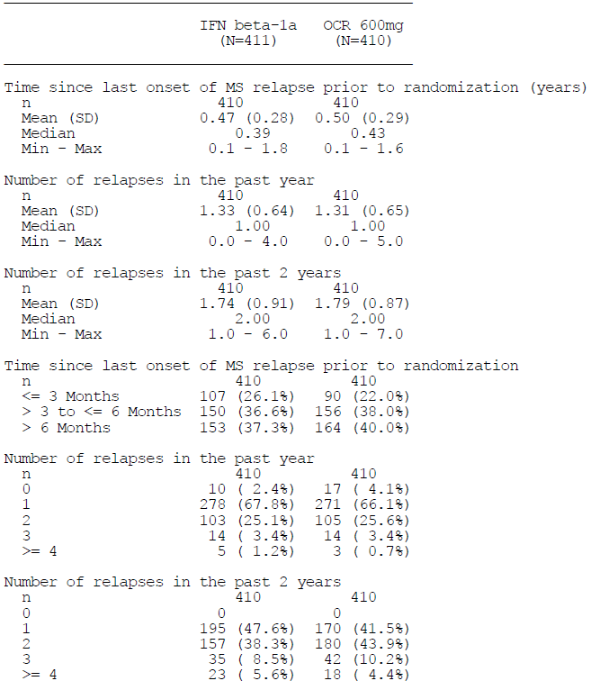

Table 20: Baseline disease characteristics – brain MRI (ITT Population), Study WA21092
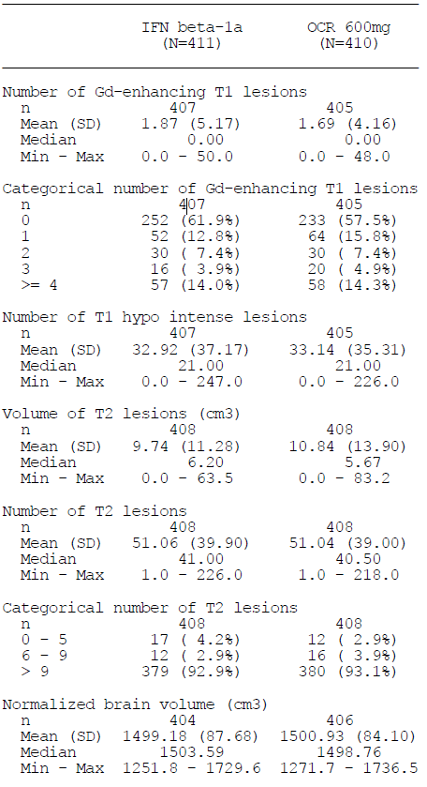

Table 21: Baseline disease history– multiple sclerosis (ITT Population), Study WA21093
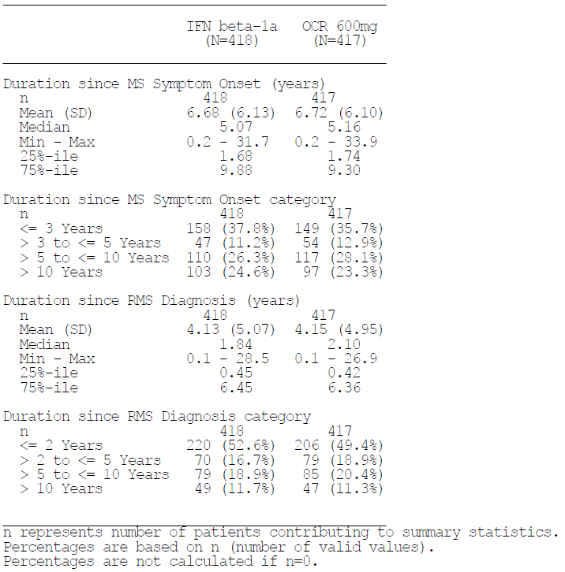

Table 22: Baseline disease characteristics – relapses (ITT Population), Study WA21093
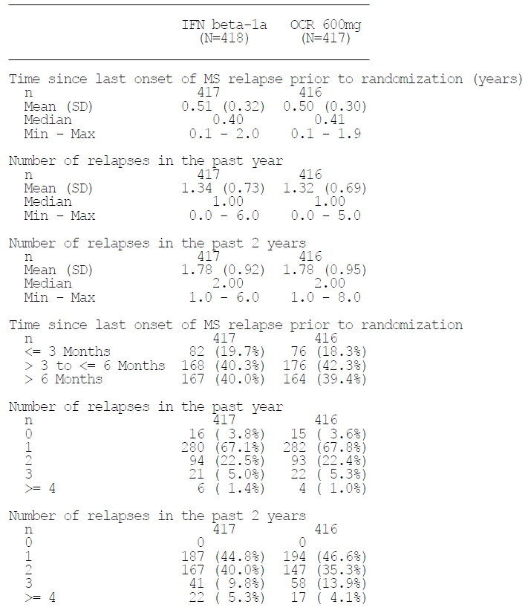

Table 23: Baseline disease characteristics – brain MRI (ITT Population), Study WA21093
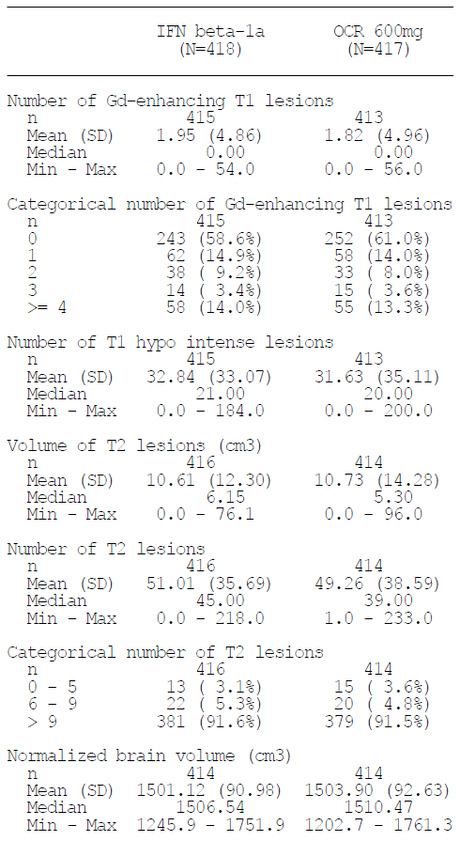

Results for the primary efficacy outcome
Results for the primary endpoint in both studies (annualised relapse rate, ARR) are summarised in the table excerpts below, as originally reported in the Summary of Clinical Efficacy. The results were very similar across studies, indicating high reproducibility of the results: the ARR was 0.292 and 0.290 relapses/year in the two placebo groups, compared to 0.156 and 0.155 in the two ocrelizumab groups, for Studies WA21092 and WA21093, respectively. This is consistent with rate ratios of 0.536 and 0.532, values that are highly statistically significant (p < 0.0001) and clinically worthwhile, representing a reduction of 46-47% in the relapse rate on ocrelizumab, relative to active treatment with interferon β-1a, which is itself clinically superior to placebo.
These results are impressive, especially given that the patients included some subjects with SPMS, who would normally be considered relatively resistant to treatment. Also, the sponsor has chosen an active comparator, Rebif that is considered among the most effective of the first-generation disease-modifying agents in MS. In several other active-controlled MS studies (including the supportive Phase II ocrelizumab Study, WA21493), a different dose and formulation of interferon β-1a has been chosen as the active comparator: Avonex, which is administered as 30µg IM once weekly. In head-to-head studies, Avonex has shown inferior efficacy results to higher-dose interferon treatments, so it is possibly easier for a new agent to demonstrate superiority over Avonex than over Rebif. The sponsor has therefore chosen an ambitious head-to-head design, and nonetheless achieved results that show clear superiority of ocrelizumab over an accepted and adequately dosed first-line agent.
It should be noted, however, that Rebif (and other β interferons) are not generally indicated for subjects with SPMS, so it could be argued that Rebif has been methodologically disadvantaged by the study design, because it has been used outside its expected target population. This highlights the need for subgroup analyses assessing the individual disease subtypes.

Table 24: Annualised relapse rate, ITT Population, Study WA21092
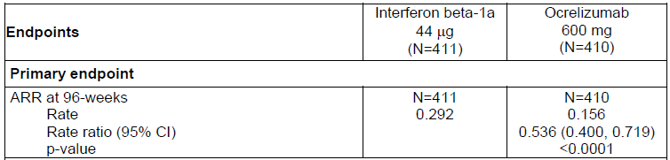

Table 25: Annualised relapse rate, ITT Population, Study WA21093
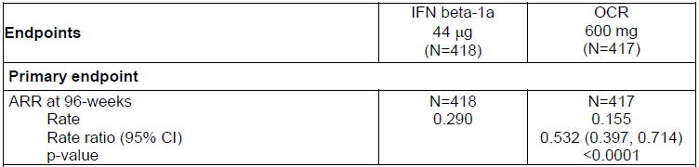
The sponsor has since reported that one study centre in WA21093 deviated from GCP, and new results for that study have been submitted that exclude the centre concerned. These revised results are shown below. The ARR ratio only differs from the original results in the third decimal place, because only 3 relapses were reported from that centre, and the overall conclusions are not altered.
The 6 patients randomized at Centre # 209771 experienced a total of 3 PDRs (two in the IFN group and one in the OCR group (…). Given the small number of patients and PDRs at Centre # 209771, sensitivity analyses excluding patients from this site were consistent with the ITT and PP main analyses presented in the WA21093 Primary CSR ((Table below)).

Table 26: Comparison of results of study WA21093 main analyses of primary endpoint for Study WA21093 (Annualized protocol-defined relapse rate by 2 years) with sensitivity analyses excluding patients from Centre # 209771
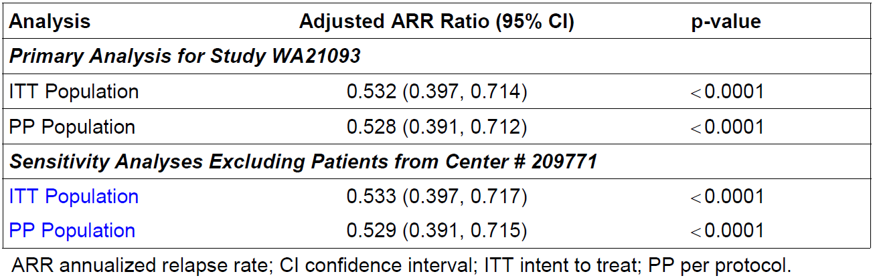
The sponsor also performed a number of sensitivity analyses of the primary endpoint, including assessments in the PP and Safety populations, and with different statistical models and different approaches to missing data. As shown in the tables below, the results were similar in all of these analyses, and produced strong statistical results (p < 0.0001). This strongly suggests that, considering the whole cohort, the results were statistically robust. The only major methodological concerns are whether the results in the whole cohort apply to all patient subgroups, particularly those with SPMS – this was not assessed by the sponsor.

Table 27: Sensitivity analyses of primary endpoint, Study WA21092
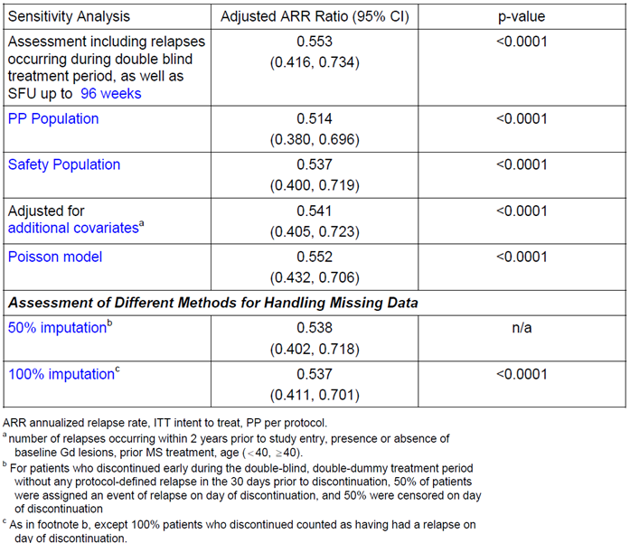

Table 28: Sensitivity analyses of primary endpoint, Study WA21093
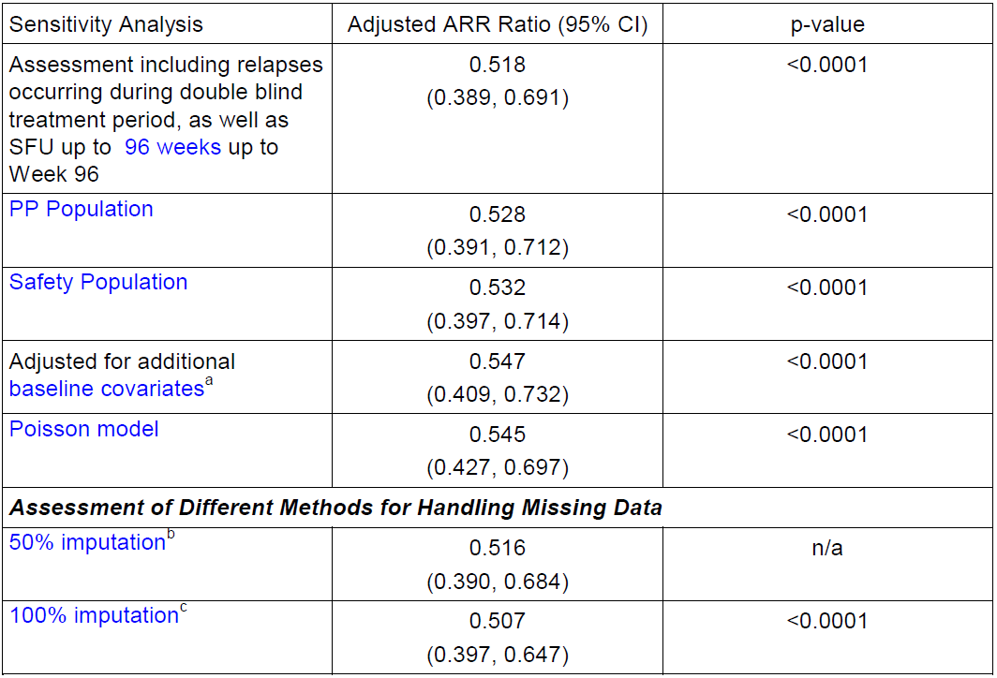

Subgroup analyses
In each of the pivotal RMS studies, the sponsor performed a subgroup analysis of the primary endpoint, with subgroups defined by age, gender, race and region, weight and BMI, EDSS and the presence or absence of baseline Gd+ lesions. Unfortunately, the sponsor did not assess any subgroup defined on the basis of disease subtype, despite the fact that the study had broader than usual inclusion criteria and recruited subjects with RRMS, SPMS and PRMS. Also, the subgroup analyses were presented in terms of rate ratios, rather than actual ARRs, so subgroups that were relatively resistant to both interferon β-1a and ocrelizumab could not be readily identified.
For all subgroups assessed, the overall hazard ratio was favourable, showing a trend to superiority of ocrelizumab, and in many subgroups the superiority was statistically significant despite the reduced statistical power associated with analysing a smaller population. For the few exceptions without significant superiority of ocrelizumab, the subgroups were generally small and in most cases the analysis was clearly underpowered.

Table 29: Annualized protocol defined relapse rate by week 96 (Negative Binomial Model) by Subgroup (ITT Population), Study WA21092
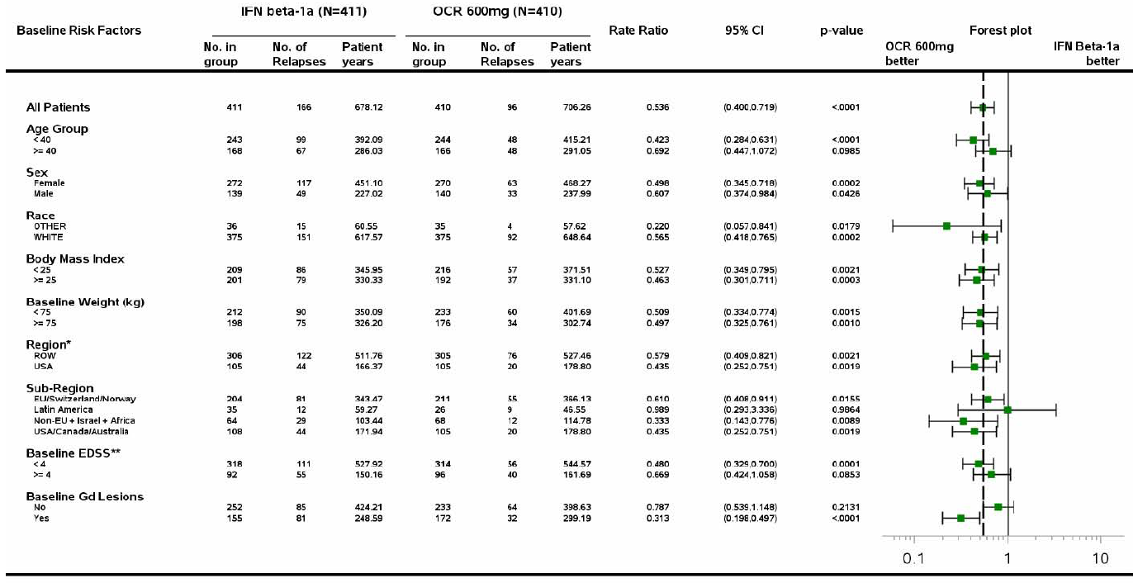
The results for Study WA21092 are shown in the table above. For subjects without Gd+ lesions at baseline, the analysis failed to achieve statistical significance despite this being a relatively large subgroup (containing 252 interferon β-1a subjects and 233 ocrelizumab subjects). Furthermore, the 95%CI for the HR in the Gd-negative subgroup, despite being numerically favourable for ocrelizumab (rate ratio = 0.787), did not overlap the 95%CI for the HR in the Gd+ subgroup, which was much more strongly favourable for ocrelizumab (rate ratio = 0.313). This strongly suggests that ocrelizumab has much better efficacy in Gd+ subjects, or those with highly active disease, and is not necessarily superior to interferon β-1a in subjects with less active disease. A qualitatively similar result was observed in Study WA21093, as shown in the table below, but the 95%CIs for the HRs in Gd-negative and Gd+ subjects overlapped, and the rate ratios were more similar (Gd-negative 0.684, Gd+ 0.422).

Table 30: Annualized protocol defined relapse rate by week 96 (Negative Binomial Model) by Subgroup (ITT Population), Study WA21093
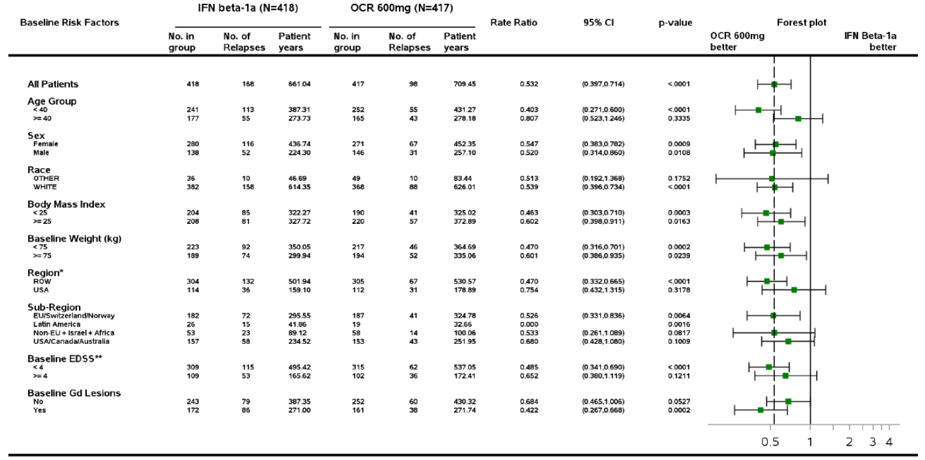
Both studies also showed a difference in the treatment effect based on age, with younger patients (< 40 years) showing stronger superiority of ocrelizumab, but a favourable rate ratio was also observed in older subjects in each study.
Given that these subgroup analyses suggested a stronger treatment effect in younger patients with more active disease, it would be of particular interest to assess the efficacy of ocrelizumab in subjects with SPMS, who tend to be older and have less active disease. The sponsor should be asked to perform subgroup analyses of each study, and both studies pooled, based on the patients’ traditional disease subtype.
Additional analyses were performed based on resistance to first-line agents and disease activity. According to the sponsor summary of guidance from the EMA:
The sponsor pre-specified the four subgroups of active and highly active disease (containing both treatment naïve patients and patients who had inadequately responded to prior therapy) in the SAP. This was consistent with the final European MS guideline (EMA/CHMP/771815/ 2011, Rev. 2), which recommends that separate conclusions of the efficacy and safety in patients both with low and highly active MS should be provided at the time of benefit risk assessment. These subgroups and the results were presented to the Rapporteurs in January at the MAA pre submission meeting.
The four subgroups of interest are defined in the table below.

Table 31: Subgroup Definitions
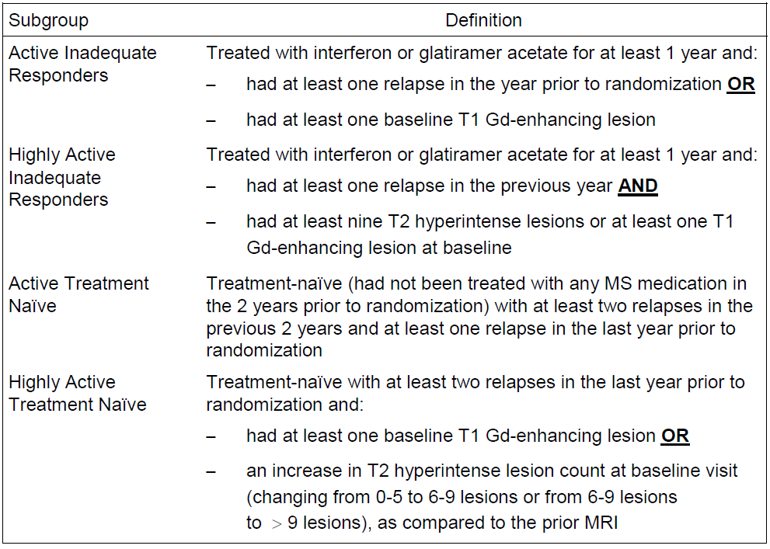
Results in these subgroups are shown in the table below for the primary efficacy variable, ARR, and for the key secondary variable of CDP in the subsequent table. Overall, subgroups with active or highly active disease at baseline showed a more favourable response to ocrelizumab than subjects with less active disease, particularly if they were identified as poor responders to first-line agents, but significant results were nonetheless obtained in the patients without highly active disease or without non-responder status. This is reassuring, suggesting benefit across a range of clinical settings, but it should be recalled that, according to entry criteria, all subjects were required to have some evidence of ongoing relapses. Efficacy in subjects with completely inactive disease would be expected to be minimal, and ocrelizumab would not ordinarily be considered appropriate for such subjects.

Table 32: Annualised relapse rate by clinical subgroup
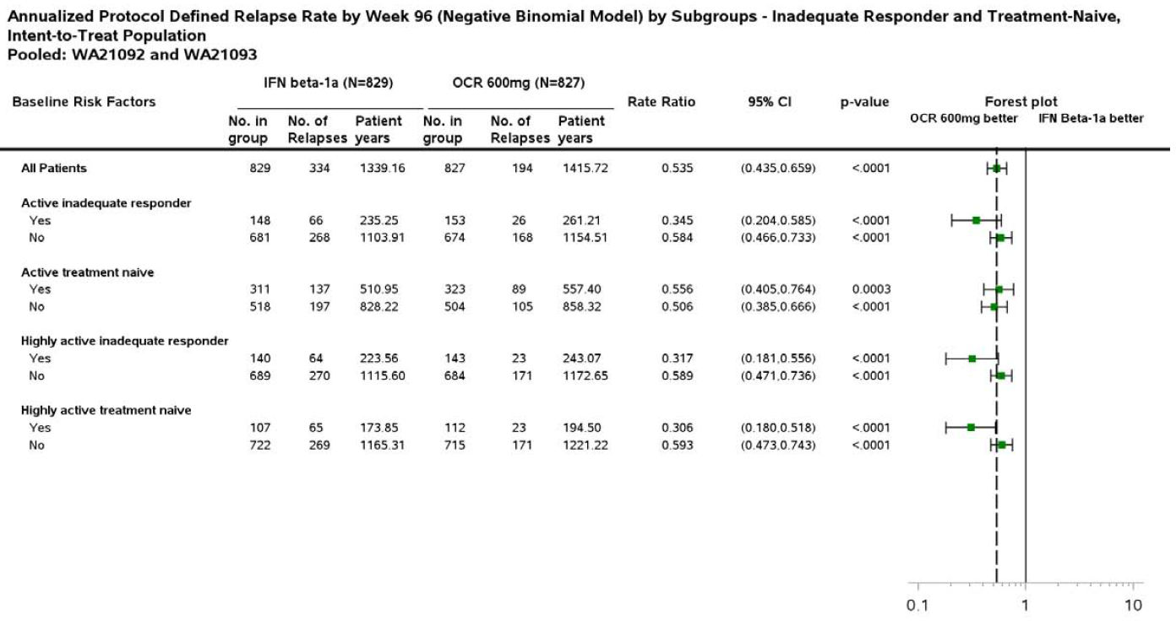

Table 33: Annualised relapse rate by clinical subgroup
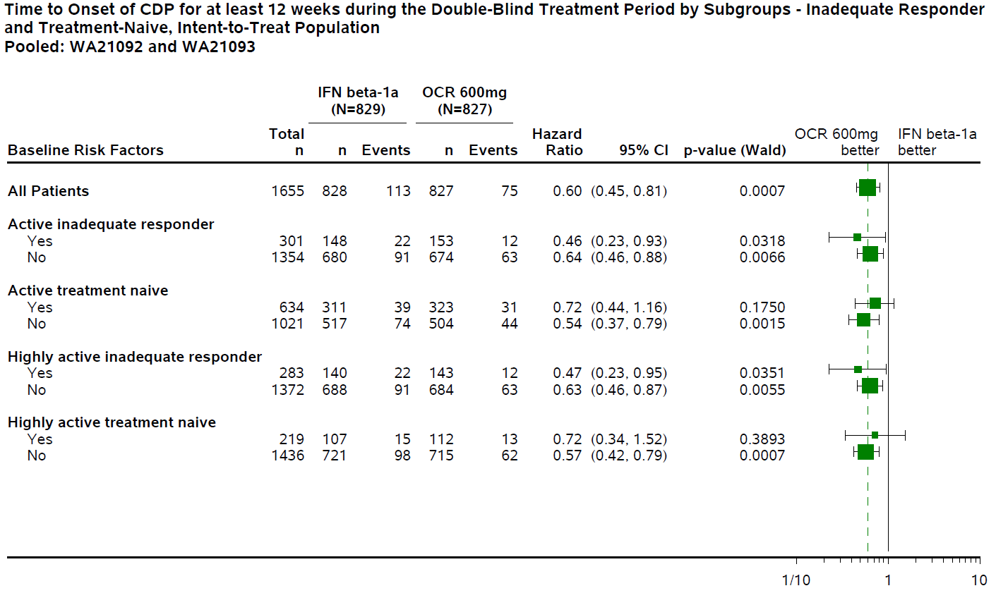

Results for other efficacy outcomes
Results for all of the major endpoints are summarised in the two tables below. Results are shown separately for Study WA21092 and Study WA21093, but the results were generally very similar across the two studies. The results for WA21093 do not include the minor adjustment resulting from exclusion of once centre that violated GCP, but the adjusted results are discussed below the tables.
Most secondary endpoints showed superiority of ocrelizumab over interferon β-1a. This included the key measures of disease progression: 12 week and 24 week CDP, in each individual study and in the prospective pooled analysis of both studies. In the pooled analysis, both 12- and 24 week CDP showed hazard ratios of 0.60 in favour of ocrelizumab (p = 0.0006 and p = 0.0025, respectively), broadly consistent with a 40% reduction in hazard. (The risk of progression over 96 weeks would be expected to be reduced by less than 40%, given that hazard ratios are based on instantaneous risk reductions: 12 week CDP rates were 9.75% verse 15.18%, consistent with a 36% relative reduction for ocrelizumab; the 24 week CDP rates were 6.51% verse 10.57%, consistent with a 38% relative reduction for ocrelizumab). MSFC, another measure of disease progression, showed no significant benefit of ocrelizumab. Given the clear benefits for most other measures, this may reflect poor sensitivity of the MSFC itself, which is performance-based and therefore subject to inter-trial variations.
Some subjects actually improved on treatment, despite the fact that they were considered neurologically stable at baseline. This could partially reflect recovery from unrecognised relapses. The proportion of subjects showing a 12 week Confirmed Disability Improvement (CDI) was 15.64% in the interferon β-1a group, compared to 20.7% in the ocrelizumab group (a relative ‘risk’ of improvement of 1.32, p = 0.0194).
Some of the p-values included in the tables appear nominally significant, but are marked as ‘non-confirmatory’ because they were ranked lower than other endpoints (such as MSFC) that failed to achieve statistical significance. An alternative approach to multiplicity analysis, modifying p-values according to the number of endpoints considered, could have rendered some of these non-confirmatory endpoints significant (NEDA, for instance, showed superiority of ocrelizumab with a p-value < 0.0001 in each study). Also, the strong concordance between the studies suggests that the benefit in the proportion of patients achieving NEDA was genuine. This is important, because NEDA is a highly sought-after goal of MS management, valued by both patients and clinicians. In Study WA21092, NEDA was achieved in 27.1% of interferon β-1a recipients, compared to 47.4% of ocrelizumab recipients, consistent with a substantial, clinically relevant benefit. In Study WA21093, NEDA was achieved in 24.1% of interferon β-1a recipients, compared to 43.9% of ocrelizumab recipients, which is broadly similar to the results seen in WA21092 and again represents a notable, clinically worthwhile achievement. The results suggest that about 5 subjects would need to receive ocrelizumab in pace of interferon β-1a 44 µg for 96 weeks to achieve one extra case of NEDA.
MRI endpoints also showed clear benefits for ocrelizumab over interferon β-1a, consistent with the clinical endpoints. The number of Gd+ lesions, new/enlarging T2 lesions and new T1 hypointense lesions all strongly favoured ocrelizumab (p < 0.0001 for each endpoint in each study individually). The results for Gd+ lesions were particularly striking, with the ocrelizumab groups showing only 5 to 6% of the number of lesions seen in the control group. New/enlarging T2 lesions were reduced to 17 to 23% of the lesions seen in the control group, and T1 ‘black holes’ were reduced to 36 to 43% of the counts seen in the control group.
Brain volume showed nominal superiority for ocrelizumab in Study WA21092 (p = 0.0042) and a favourable trend in Study WA21093 (p = 0.09). Given that active inflammation causes brain swelling, and progressive disease causes atrophy, an effective treatment would be expected to have a mixed effect on brain volume and clear demonstration of superiority for this endpoint may be difficult.
Health-related quality of life, as assessed by the SF-36 PCS, showed minor improvements in both ocrelizumab groups and deteriorations in both interferon β-1a groups. The difference was nominally significant (but non-confirmatory) in Study WA21093, but not significant in Study WA21092.
Overall, these secondary endpoints strongly confirm superiority of ocrelizumab over interferon β-1a in the overall study population. Most endpoints were clearly concordant across the two studies, and the different secondary endpoints were broadly consistent with each other and with the primary endpoint. Measures that clearly relate to inflammation (relapse rate, Gd+ lesions, T2 lesions) showed the strongest results, but benefits were also seen in markers of progression and accumulated disease burden (12 week and 24 week CDP, as well as T1 ‘black holes’). The magnitude of the observed benefits was clinically worthwhile.

Table 34: Summary of primary and secondary efficacy endpoints at week 96 (ITT Population, WA21092)
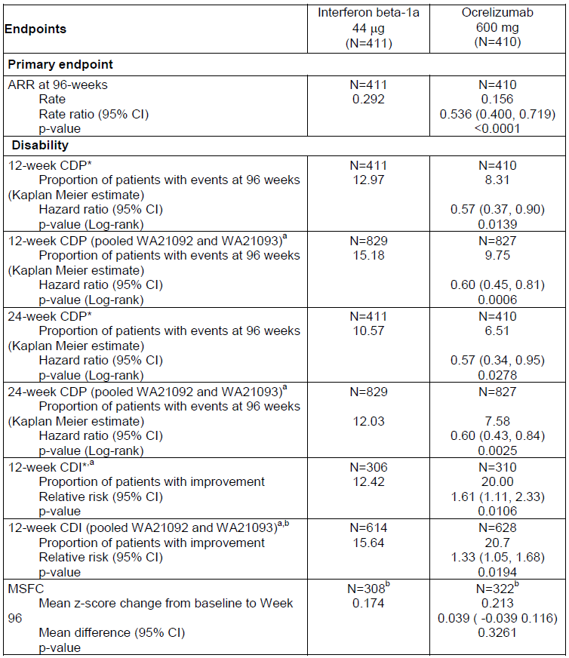

Table 35: Summary of primary and secondary efficacy endpoints at week 96 (ITT Population, WA21092)
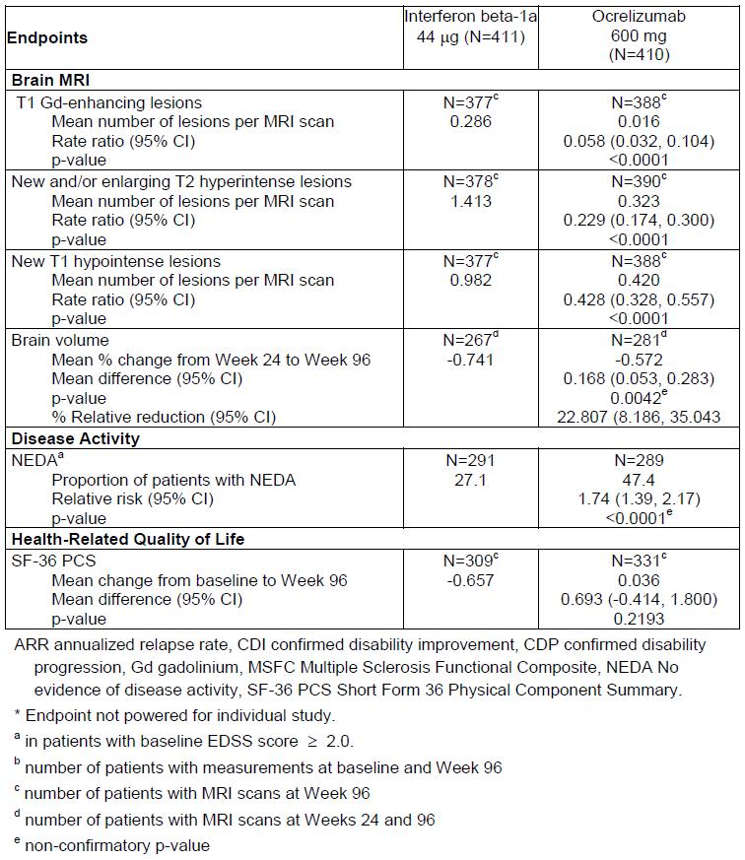

Table 36: Summary of primary and secondary efficacy endpoints at week 96 (ITT Population, WA21093)
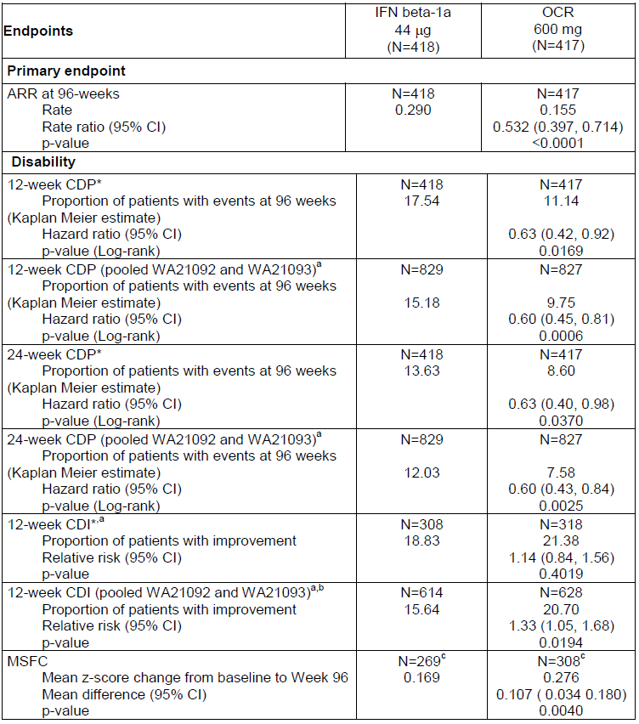

Table 37: Summary of primary and secondary efficacy endpoints at week 96 (ITT Population, WA21093)
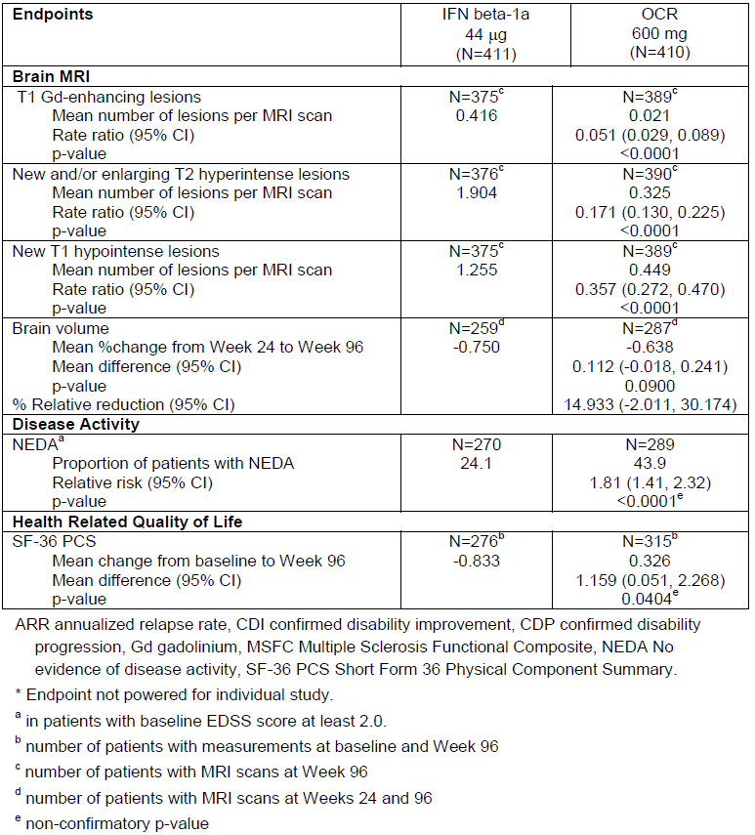
The results shown in the table above do not account for the recent discovery that one centre in Study WA21093 violated GCP. Exclusion of this centre makes little difference to the overall interpretation. For CDP, the event rates and hazard ratios were not affected at all, but the statistical significance as summarised in the p-values was slightly altered because of the lower patient numbers. The sponsor summary of these changes is potentially misleading, because they imply that statistical significance was unchanged – this is only true of HRs, not p-values:
There were no events of 12 week CDP for patients at Centre # 209771. Hazard ratios were therefore unchanged and there was no impact on the statistical significance when comparing sensitivity analyses omitting this site with the main analyses presented in the WA21093 Primary CSR ((Table below)). Note that, as in the Primary CSR, the main analysis of 12 week CDP was conducted using pooled data from both studies WA21092 and WA21093 whereas sensitivity analyses were conducted using data from Study WA21093 only.

Table 38: Comparison of results of Study WA21093 main analyses of time to onset of confirmed disability progression sustained for at least 12 weeks with sensitivity analyses excluding patients from Centre # 209771
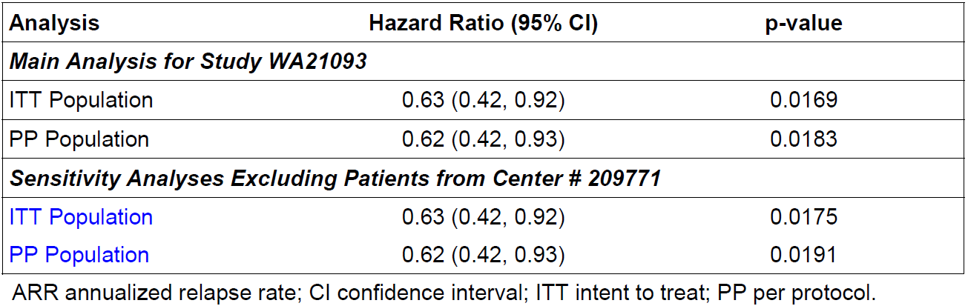

Open-label extension
Patients completing the main double-blind study periods of the pivotal studies were invited to enter an open-label extension (OLE) phase, in which all subjects received ocrelizumab 600mg every 24 weeks. Although the assessment of efficacy during this phase was listed as an exploratory objective of the original pivotal studies, the OLE was still on-going at the time of the submission and no efficacy data from this phase was submitted. Given that treatment in the OLE was open-label and lacked a control group, it would be difficult to draw efficacy conclusions from this data anyway, and the main value of the OLE is that it allows further assessment of the long-term safety of ocrelizumab.

Pivotal efficacy study in primary progressive MS, Study WA25046
Protocol: Study WA25046 was a Phase III, multicentre, randomised, parallel-group, double blinded, placebo controlled study to evaluate the efficacy and safety of ocrelizumab in adults with primary progressive multiple sclerosis.
The sponsor only submitted one study in primary progressive MS (PPMS), Study WA25046. The failure to perform additional confirmatory studies in PPMS represents a considerable deficiency in the overall study program, particularly because there has been no previous study clearly showing that immunomodulation has a useful role in PPMS. The sole pivotal study with ocrelizumab therefore lacks even indirect support from the previous published experience with PPMS. The only other study assessing B cell depletion in PPMS, using rituximab, was negative overall, but did show efficacy in some subgroups (subjects who were younger, or had Gd+ scans at baseline).
In addition to providing the sole justification for the sponsor second proposed indication (use in PPMS, to ‘delay disease progression and reduce deterioration in walking speed’), this pivotal study plays an important supporting role for the first indication, use in ‘relapsing forms of MS’. If the findings of this study are accepted, and ocrelizumab has useful efficacy in PPMS, that makes it more likely that it also has efficacy in SPMS, a patient population in which ocrelizumab has not been adequately studied.

Study design, objectives, locations and dates
Study WA25046 was a multicentre, randomised, parallel-group, double-blind, placebo-controlled study that assessed the efficacy and safety of ocrelizumab in adults with PPMS. Double-blind treatment was continued for at least 120 weeks; subjects who were recruited early continued treatment beyond this minimum period.
The primary objective was to assess the efficacy of ocrelizumab 600 mg IV every 24 weeks compared with placebo, as measured by the time to onset of 12 week CDP in patients with PPMS. Secondary efficacy endpoints included other measures of disability (24 week CDP and timed 25 foot walk (T25-FW)), brain MRI outcomes (volume of T2 lesions and whole brain volume) and health related quality of life (SF-36).
An additional objective was to assess the safety of ocrelizumab in this population.
The study was conducted in 29 countries (182 investigational sites), consisting of: Australia (2), Austria (5), Belgium (2), Bulgaria (2), Brazil (4), Canada (7), Switzerland (2), Czech Republic (3), Germany (18), Spain (14), Finland (3), France (17), United Kingdom (5), Greece (3), Hungary (5), Israel (6), Italy (4), Lithuania (3), Mexico (4), Netherlands (2), Norway (1), New Zealand (2), Peru (3), Poland (7), Portugal (5), Romania (4), Russian Federation (1), Ukraine (11), USA (37).
The first patient was randomised on 3 March 2011, and the submitted data cover events up to data cut-off on 24 July 2015.

Inclusion and exclusion criteria
Essentially, the study recruited patients aged 18 to 55 years and EDSS 3.0 to 6.5, with a diagnosis of PPMS as per the revised McDonald criteria (2005), without a history of RRMS, SPMS or progressive relapsing multiple sclerosis.

Inclusion criteria
Detailed inclusion criteria were listed as follows:
- Ability to provide written informed consent and to be able to follow the schedule of protocol assessments
- Diagnosis of PPMS in accordance with the revised McDonald criteria (2005)
- Ages 18 to 55 years inclusive
- EDSS at screening from 3.0 to 6.5 points
- Score of ≥ 2.0 on the Functional Systems (FS) scale for the pyramidal system that is due to lower extremity findings
- Disease duration from the onset of MS symptoms:
  - a) less than 15 years in patients with an EDSS at screening > 5.0
  - b) less than 10 years in patients with an EDSS at screening ≤ 5.0
- Documented history or presence at screening of at least one of the following laboratory findings in a CSF specimen (source documentation of laboratory results and method must be verified):
  - a) elevated IgG index
  - b) one or more IgG oligoclonal bands detected by isoelectric focusing
- For sexually active female and male patients of reproductive potential, use of reliable means of contraception (…)
- For patients of non-reproductive potential (…):
  - Women may be enrolled if postmenopausal (…);
  - Men may be enrolled if they are surgically sterile (castration).’

Exclusion criteria
Exclusion criteria were essentially the same as the pivotal RMS studies but relapsing forms of MS were listed as exclusion criteria instead of PPMS being listed as an exclusion criterion. In general the exclusion criteria were intended to remove subjects in whom ocrelizumab would be considered unsafe, and subjects in whom efficacy and safety assessments could be difficult to interpret because of confounding disease.

Study treatments
The overall dose of ocrelizumab was 600 mg every 24 weeks, continued for 120 weeks. Unlike the RMS studies, ocrelizumab in Study WA25046 was administered as two IV infusions of 300 mg separated by 14 days for all treatment cycles (The RMS studies divided the standard 600 mg ocrelizumab dose into two 300 mg doses for the first cycle but gave single infusions of 600 mg for subsequent cycles). Accordingly, the regimen used in this study does not quite match the dose in the proposed PI.
Patients randomised to placebo received matching placebo infusions instead.

Efficacy variables and outcomes
The primary efficacy endpoint was the time to onset of 12 week confirmed disability progression (12 week CDP) over the duration of the double-blind period (at least 120 weeks). As in the RMS studies, disability progression was defined as an increase of ≥ 1.0 point from baseline EDSS (for baseline EDSS≤ 5.5) or an increase of ≥ 0.5 points (for baseline EDSS> 5.5), not attributable to another aetiology (such as fever, concurrent illness, MS relapse or exacerbation, or concomitant medication). Disability progression had to be confirmed at a regularly scheduled visit at least 12 weeks after the initial disease progression.
The CSR specified five secondary endpoints, ranked as follows:
- The time to onset of 24 week CDP
- The change in 25-foot timed walk (25FTW) from baseline to Week 120
- The change in total volume of T2 lesions on MRI scans of the brain from baseline to Week 120
- The percentage change in total MRI brain volume from Week 24 to Week 120
- The change in SF-36 PCS score from baseline to Week 120
To control for multiplicity issues, the sponsor tested the secondary endpoints using a hierarchical approach, with each endpoint to be analysed and potentially considered significant only if the primary endpoint and each preceding endpoint had reached a significance level of 0.05.
The CSR also listed several exploratory endpoints:
- The proportion of patients with confirmed 12 week disability progression at Week 120
- The change in EDSS (mean change and AUC) from baseline to Weeks 48, 96, and 120
- The change in MSFC score from baseline to Weeks 48, 96, and 120
- The time to confirmed disability progression over the treatment period, defined as an increase in EDSS that is sustained for at least 12 weeks (0.5 or 1 points, same criteria as for the primary endpoint time to 12 week CDP) or a 20% increase in 25-foot timed walk that is sustained for at least 12 weeks, or a 20% increase in the 9-hole peg test that is sustained for at least 12 weeks
- The time to sustained 20 percent increase in 25 foot timed walk and 9-hole peg test (9HPT)
- The proportion of patients with a 20 percent increase in 25FTW
- The proportion of patients with a 20 percent increase in 9HPT
- The change in PASAT from baseline to Week 120
- The number of gadolinium-enhancing T1 lesions and number of new or enlarging T2 lesions as detected by brain MRI
- The percentage change in cortical grey matter volume from baseline to Week 120
- The percentage change in white matter volume from baseline to Week 120
- The change from baseline in total non-enhancing T1 lesion volume on MRI scan of the brain
- The change in fatigue, as measured by the MFIS total score and subscale scores (Physical Impact, Cognitive Impact, and Psychological Impact) from baseline to Week 120
- The change in quality of life, as measured by the SF-36v2 MCS score from baseline to Week 120
An additional objective was to explore the PK and PD of effects of ocrelizumab.

Randomisation and blinding methods
Patients were randomised to ocrelizumab or placebo in a 2:1 ratio, using an automated IxRS.
Blinding was attempted by using identically appearing active and placebo infusions. Investigators assessing the EDSS and other efficacy measures were blinded to treatment allocation and were not directly involved in the patient’s management. MRIs were reported using a centralised, blinded approach, with reporting radiologists not involved in the patient’s care.
It is possible that some patients or clinicians became unblinded through tell-tale side effects, particularly IRRs, which were more common with ocrelizumab than placebo.
The extent to which the double-blind was maintained was not assessed. This could have been achieved by asking subjects and clinicians to guess the assigned treatment at the end of the blinded study period. The failure to assess this was a significant methodological flaw in the study.

Analysis populations
The sponsor defined ITT, PP and Safety Populations as previously described for the RMS studies. All major efficacy analyses were performed in the ITT population, with additional sensitivity analyses in the PP population.

Statistical methods
For the primary endpoint, the time to onset of 12 week-confirmed CDP, the ocrelizumab and the placebo groups were compared using a two-sided log-rank test stratifying by geographic region (US versus ROW) and age (≤ 45 versus > 45). The proportion of patients with confirmed disability progression was estimated using a Kaplan-Meier approach. The overall hazard ratio for 12 week CDP was estimated using a stratified Cox regression model with the same stratification factors.
Missing confirmation data for initial episodes of disease progression were handled by imputation if the patient discontinued prematurely. The sponsor provided a justification of this approach in the CSR:
There is evidence of higher EDSS confirmation rates in progressive versus relapsing MS with confirmation rates in progressive patients for 12 week CDP of approximately 80%. A PPMS patient who experiences initial disease progression (IDP) has an increased risk of disability progression compared to other patients without an initial event who are still ongoing in the treatment period. Patients who had an IDP and then discontinued the treatment early with no confirmatory EDSS assessments were, therefore, not censored as this would introduce substantial bias. This IDP was used as an event and these events are subsequently referred to as imputed events.
Patients who had initial disability progression with no confirmatory EDSS assessment and who were on treatment at time of CCOD were censored at the date of their last EDSS assessment. Patients who did not have initial disability progression at time of CCOD, time of early discontinuation, or loss to follow up were censored at the date of their last EDSS assessment that occurred during the treatment period.
This approach was reasonable, because most initial progressions in PPMS go on to become permanent progressions – this differs from the situation in RRMS, where many deteriorations in neurological function are due to relapses, and subsequently resolve. Patients who progress and then drop out prematurely are particularly likely to have suffered from disease progression. The sponsor also performed sensitivity analyses without imputation or with 50% of IDP assumed to progress to CDP. (The assumption of 50% confirmation produced significant results, but the analysis with no imputation did not achieve significance).
Secondary efficacy endpoints were also stratified by geographical region (United States versus ROW) and age (≤ 45 years versus > 45). The main statistical methods used are summarised in the table below, and included log rank tests, Cox regression, analysis of covariance (ANCOVA) and a mixed-effects model for repeated measures (MMRM).

Table 39: Statistical analysis of primary and secondary efficacy endpoints, Study WA25046
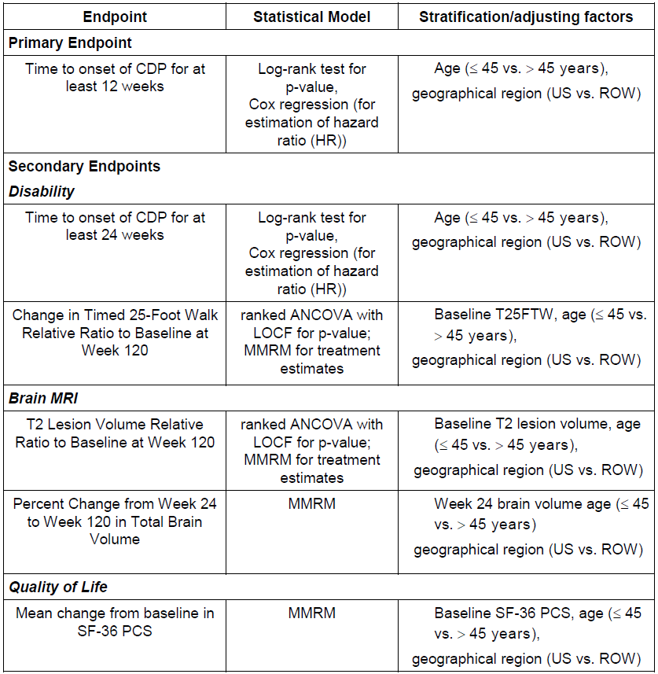

Sample size
Based on a rituximab Phase II/III trial in adults with PPMS (Study U2786g), the two-year progression rate among ocrelizumab recipients was predicted to be 30%, compared to 43% among placebo recipients. A two-group test of equal exponential survival with exponential dropout was used to determine the required sample size for 12 week CDP. A total of 253 disability events were expected to be required to maintain adequate statistical power. With a 2:1 randomisation ratio, a one-year accrual period, with an estimated 3.5 year maximum treatment period, and assuming a dropout rate of 20% over 2 years, the total sample size of 630 patients was expected to provide approximately 80% power for a type I error rate of 0.01, or approximately 92% power for a traditional type I error rate of 0.05.
The study randomised 732 patients, exceeding its recruitment targets, and it achieved significance for its primary endpoint, suggesting it was adequately powered.

Participant flow
A total of 732 patients were randomised into the study and entered the ITT population: placebo 244 patients verse ocrelizumab 488 patients. Of these, 725 received at least one dose of study medication (placebo 243 patients verse ocrelizumab 482 patients). A total of 549 patients (placebo 162 patients, 66%, verse ocrelizumab 387 patients, 79%) were still ongoing with double-blind treatment at the close of study (CCOD).
Patient disposition is summarised in the figure below. Most subjects reached the minimum planned treatment period of 120 weeks (ocrelizumab 82%, placebo 71%). Overall, these completion rates are acceptable for a study of this nature. Early dropouts were more common in the placebo group, which could have produced a slight withdrawal bias against ocrelizumab, given that subjects who are doing poorly in a study are usually more likely to withdraw. As shown in the table below the figure, the excess in premature withdrawals in the placebo group was mainly due to ‘lack of efficacy’ (11% versus 4%) and ‘withdrawal by subject’ (9% versus 5%). Withdrawals due to adverse events were similar in the two groups (5% placebo verse 4% ocrelizumab).
Figure 12: Overview of patient disposition (All patients, Study WA25046)
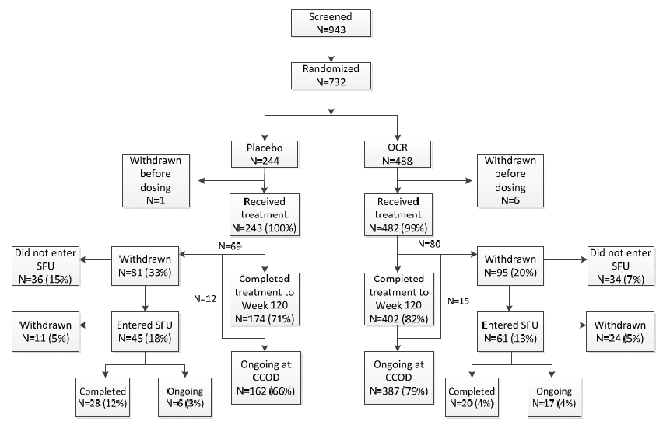

Table 40: Reasons for withdrawal from the double-blind treatment period (ITT Population, Study WA25046)
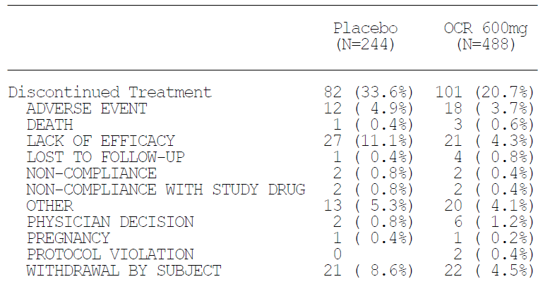

Major protocol violations/deviations
A total of 157 major protocol deviations occurred in 68 patients. Of these, 75 were deviations related to the inclusion or exclusion criteria, and 82 were deviations during study conduct. With the exception of one patient, all other patients with reported major protocol deviations remained on treatment after it was decided that the deviation did not compromise patient safety.
The PP population consisted of 702 patients (96% of the ITT population), with the remaining 30 ITT patients excluded from the PP group because of significant protocol violations. The PP population was balanced across the two treatment groups (232 (95% of ITT) placebo, 470 (96%) ocrelizumab).
The main reasons for exclusion from the PP population were listed by the sponsor as follows:
- Received no dose of study treatment (placebo (1 patient, 0.4%) and ocrelizumab (6 patients, 1.2%)).
- Received study medication that had been mishandled (for example, incorrect storage temperature, administration of study drug that had exceeded permissible stability criteria) (placebo (7 patients, 3%) and ocrelizumab (10 patients, 2%)).
- Received ocrelizumab/ placebo other than the group to which they had been randomised (placebo (4 patients, 2%) and ocrelizumab (0 patients)).
- Did not meet the criteria for diagnosis of PPMS in accordance with the revised McDonald criteria (placebo (0 patients) and ocrelizumab (1 patient, 0.2%).
- Did not meet the EDSS screening criteria (placebo (0 patients) and ocrelizumab (1 patient, 0.2%).
In addition, four placebo patients received one dose of ocrelizumab instead of placebo for one of their study visits.
The number of protocol violations is acceptable for a study of this nature. Overall, these violations are not likely to have led to any substantial biases in favour of active treatment and, if there was any effect on the results, the failure to administer active drug to some patients may have led to a slight underestimate of the treatment effect.

Baseline data
The two treatment groups were well matched for demographic factors at baseline. About 50% of subjects were male, which is typical of the PPMS population and different from the usual 2:1 female preponderance seen in RRMS. The median age was 46 years (range 18 to 56 years).
The treatment groups were also reasonably well-matched for baseline stratification factors, and for disease characteristics, as shown in the subsequent tables. The placebo group had a shorter disease duration, overall, as shown in the mean and median disease duration, as well as the proportion with disease duration ≤ 3 years (22% placebo verse 17% ocrelizumab). The proportion with very long-standing disease (> 10 years) was similar (15% placebo verse 17% ocrelizumab).
Consistent with the general reduction in active inflammatory disease in PPMS, baseline MRI showed that the majority of patients had no T1 Gd+ lesions, and the proportions were similar in the two groups (placebo 75% verse ocrelizumab 73%). Other MRI measures were also well matched at baseline, as shown below.

Table 41: Summary of demographic data (ITT Population, Study WA25046)
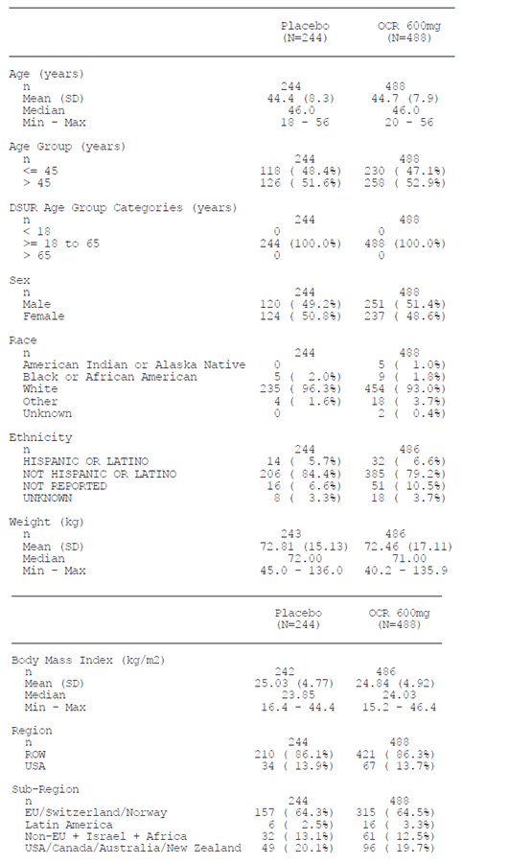

Table 42: Stratification factors, ITT Population, Study WA25046
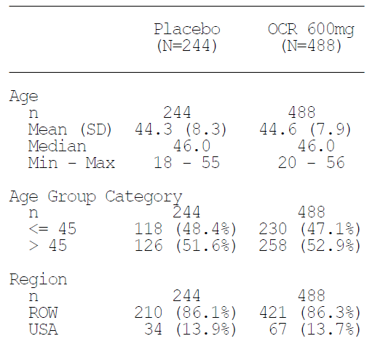

Table 43: Baseline disease characteristics, ITT Population, Study WA25046
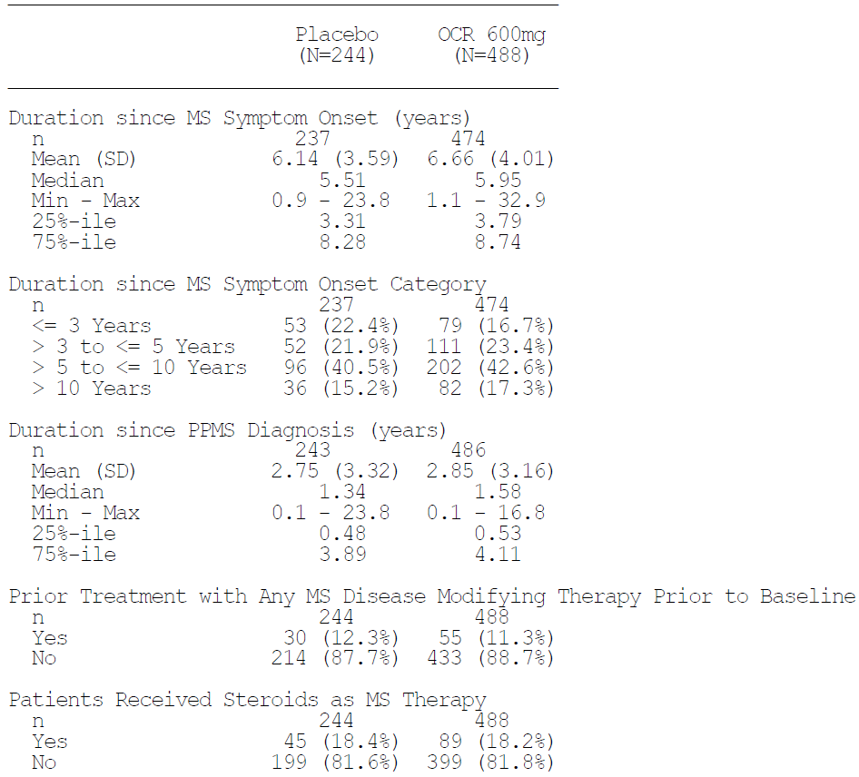

Table 44: Baseline MRI characteristics, ITT population, Study WA25046
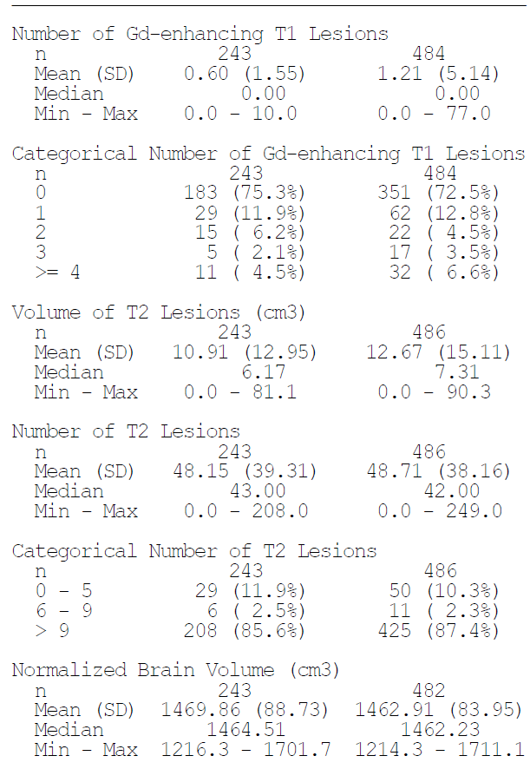

Results for the primary efficacy outcome
The study met its primary endpoint with a 24% reduction in the instantaneous hazard for 12 week CDP in the ocrelizumab group compared with placebo (hazard ratio 0.76 (95% CI: 0.59, 0.98), p = 0.0321).The p-value achieved satisfied standard significance thresholds, but not the p-value of 0.01 anticipated by the sponsor during pre-study guidance discussions.
Over the main 120 week treatment period, 34.0% of placebo subjects and 30.2% of ocrelizumab subjects were estimated to have 12 week confirmed progression. The ocrelizumab group reached the 12 week CDP endpoint with 89% of the placebo incidence (30.2/34.0 = 0.89), for a relative risk reduction over 120 weeks of 11%. The absolute risk reduction was 3.8%, implying that about 26 subjects would need to receive treatment for 120 weeks to prevent one case of 12 week CDP. This is a very modest achievement, albeit one that is likely to be perceived as worthwhile by some patients and clinicians.

Table 45: Primary endpoint, 12 week confirmed disability progression (ITT, Study WA25046)
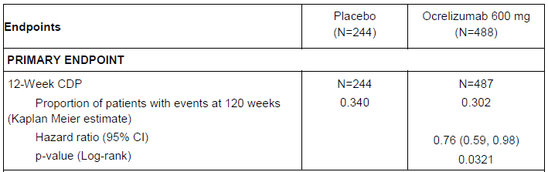
In terms of the extent to which progression was delayed, visual inspection of the Kaplan-Meier plot suggests that ocrelizumab recipients progressed about 18 weeks later than the placebo recipients, but the sponsor did not present the results in terms of delay. To provide more clinical context, this should be estimated.
Figure 13: Kaplan-Meier plot of time to onset of 12-week confirmed disability progression during the double-blind treatment period (With Imputation, ITT Population, Study WA25046)
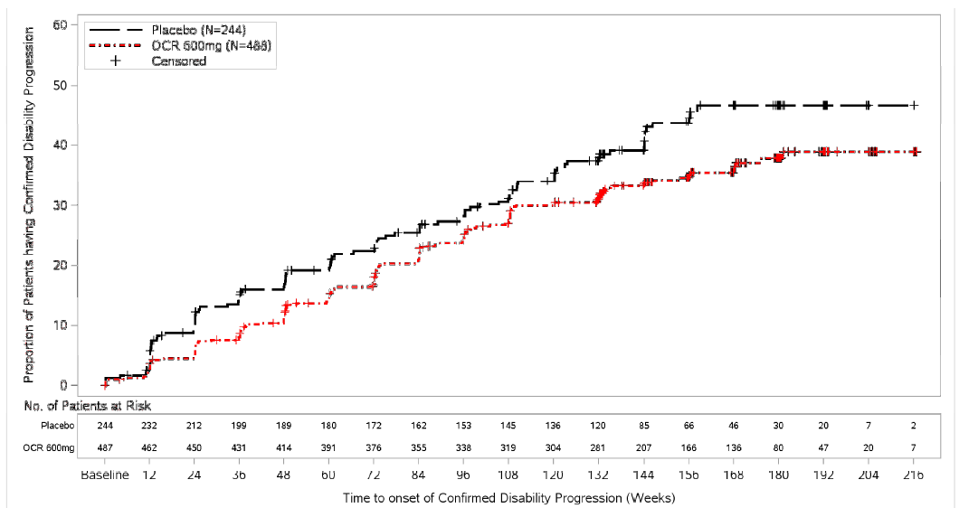
The sponsor also performed a number of sensitivity analyses of the primary endpoint, using alternative imputation methods (including no imputation), or excluding subjects with potentially confounding factors, such as relapses. Not all of these alternative methods achieved statistical significance, but most of the important ones did, including the analysis in the PP population and an analysis excluding relapsing subjects. In general, analyses with lower populations were under-powered and did not achieve significance, and so did analyses which produced lower event rates by assuming that all initial but unconfirmed progressions resolved. Even when significance was not achieved, the hazard ratios remained favourable, and broadly consistent with the primary analysis.
This sensitivity analysis suggests that the results were not completely robust, because without imputing events the study would have produce a negative result, but the most realistic approaches to imputation (including the prospectively declared method) did produce a significant result. Also, as discussed below, most secondary endpoints were also positive, including objective radiological evaluator endpoints. On balance, this suggests that the treatment effect in this population is genuine, and the believes that the study should be accepted as positive, albeit with only modest clinical benefit. Some caution is needed in reaching this conclusion, though, because the study stands alone as the only submitted study of ocrelizumab in PPMS. If the sponsor use of imputed events in this single study were not accepted, the case for using ocrelizumab in PPMS would be very weak. The overall robustness of the evidence would have been greatly enhanced if the sponsor had submitted a second pivotal study in PPMS, or even a single Phase II supportive study in PPMS. These concerns are particularly relevant for PPMS, given the overall lack of evidence that immune modulation is useful in this disease subtype.

Table 46: Sensitivity analyses of primary endpoint (12-Week CDP), Study WA25046 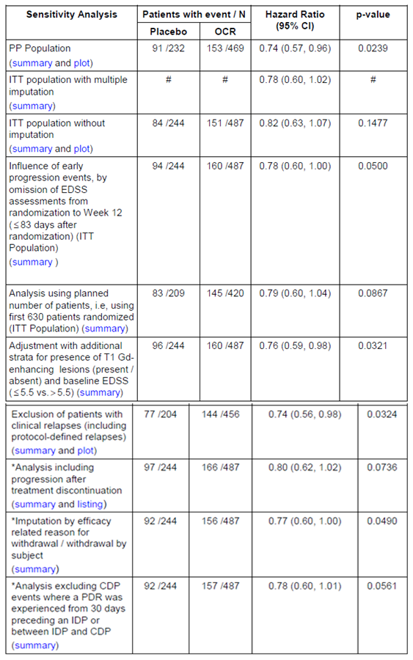

Subgroup analyses of primary efficacy outcome
The sponsor performed a number of subgroup analyses of the primary endpoint, 12 week CDP, assessing the effect of age, gender, baseline EDSS, baseline Gd+ lesions, prior treatment and disease duration. Most of these analyses were underpowered and did not achieve statistical significance, but all showed trends in favour of ocrelizumab, and were broadly consistent with the results in the full study cohort (see table below).
None of the factors produced a significant statistical interaction with the treatment effect (second table below). Reassuringly, the hazard ratio was favourable in subjects with a long duration of disease or a high EDSS, a population in which the diagnosis of primary progressive MS has had many years to be established. On the other hand, several factors that were shown to affect responsiveness of PPMS to rituximab, another B cell depleting agent, seemed to have a broadly similar effect in this study. With rituximab, greater responsiveness (relative to placebo) was seen in younger patients and in those with baseline Gd+ MRI lesions. Similarly, for ocrelizumab, the HR was more favourable in subjects ≤ 45 yrs (HR 0.64 versus 0.88) and in those with Gd+ scans at baseline (HR 0.65 versus 0.84). The subgroup analysis of age in the ocrelizumab study differed from the one previously performed in rituximab in that the ocrelizumab analysis split the cohort at age 45 years, instead of at age 50. Although the trend for ocrelizumab remained weakly favourable in subjects aged > 45 (HR 0.88), it might be expected that subjects aged > 50 would have an even less favourable response to ocrelizumab. In the rituximab study, the median age of patients was 51 years, whereas the median age in the ocrelizumab study was 46 years, and this could account, in part, for the more favourable results observed in the ocrelizumab study. In both the current study and the rituximab study, only 25% of the patients demonstrated Gd+ on baseline brain MRI.
Raw event rates in these subgroups can be calculated from the table below, and converted to approximate relative risks over the 12 week study period. For older subjects, the event rate was 47/126 (0.373 events per study period) with placebo, and 89/257 (0.346) with ocrelizumab, consistent with a relative risk reduction of approximately 7% ((0.373-0.346)/0.373 x 100). The absolute risk reduction of 0.027 events per study period, implying that 37 such subjects would need to receive ocrelizumab for 120 weeks to prevent one event of 12 week CDP. Similar calculations can be performed for subgroups with high EDSS or inactive MRI scans, producing qualitatively similar conclusions.
Overall, the results suggest that a substantial part of the benefit of ocrelizumab in the PPMS population arises in younger subjects with active inflammatory disease, who may have pathogenic mechanisms more similar to those in RRMS. It should be recalled that many radiological lesions in MS are clinically silent, so there is clinical overlap between SPMS and PPMS; if early plaques appear in clinically silent regions, a patient could be classified as having PPMS, when another patient with an otherwise similar disease pattern would be classified as having RRMS and then SPMS, simply because the plaques appeared in different locations and caused clinically obvert relapses. To some extent, patients with the diagnostic label of PPMS and have Gd+ lesions on MRI, may have more in common with SPMS patients than with other PPMS patients who have no active lesions. The younger, Gd+ PPMS patients appear to be the most appropriate ones to receive ocrelizumab. The clinical benefit in older PPMS patients and/or inactive scans may be minimal, and has not been fully defined.

Table 47: Subgroup analyses of 12-week CDP (With Imputation), Study WA25046
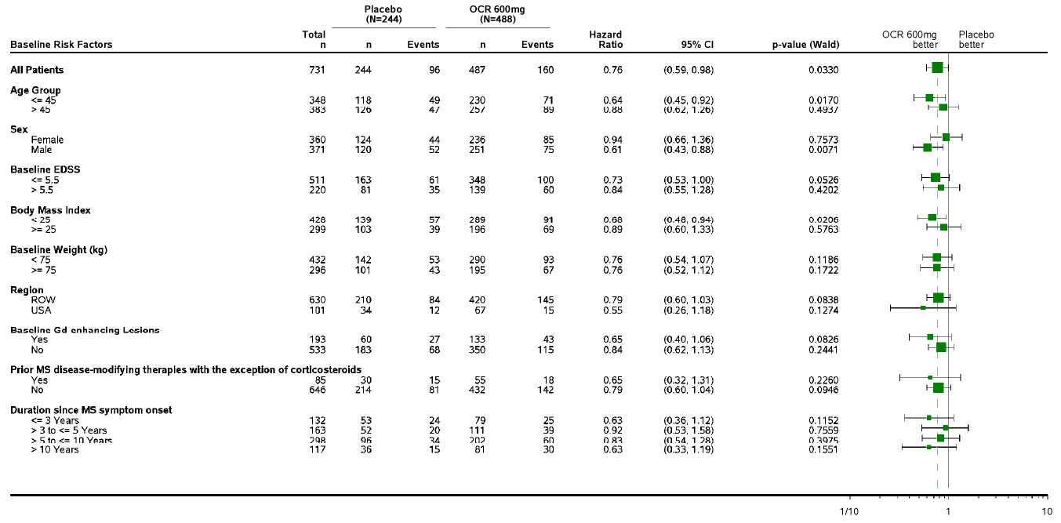

Table 48: Subgroup interaction analysis of 12-week CDP, Study WA25046
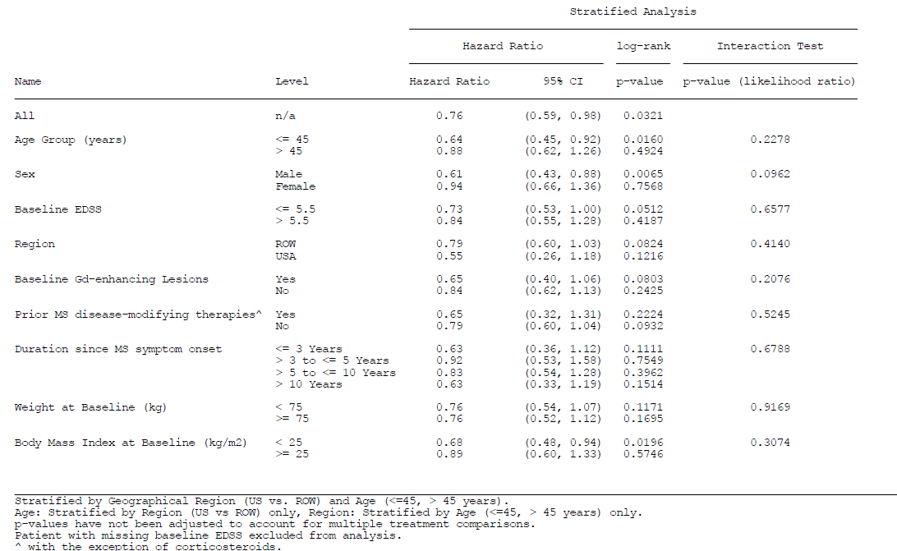

Results for other efficacy outcomes
Results for secondary endpoints were generally favourable, demonstrating statistically significant efficacy of ocrelizumab versus placebo.
Ocrelizumab was associated with in a 25% hazard reduction for 24 week CDP in the ocrelizumab group compared with placebo (hazard ratio 0.75 (95% CI: 0.58, 0.98), p = 0.0365), which is very similar to the results observed with 12 week CDP, suggesting that the results did not critically depend on the precise definition of progression.
Ocrelizumab was also associated with a 29% relative reduction in the T25-FW progression rate from baseline to Week 120 compared with placebo (p = 0.0404).
Ocrelizumab decreased the percentage change in total volume of T2 hyperintense lesions from baseline to Week 120. Changes were expressed as ratios compared to the baseline lesion volume, with the adjusted geometric mean of the ratios showing 0.966 for ocrelizumab and 1.074 for placebo, consistent with a decrease of 3.4% in the ocrelizumab group and an increase of 7.4% in patients on placebo (p < 0.0001 by ranked ANCOVA).

Table 49: Changes in T2 hyperintense lesion volume, ITT Population, Study WA25046
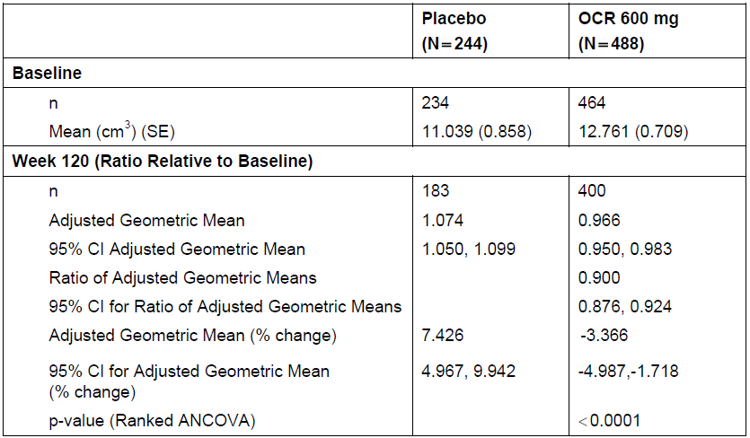
Using a similar approach, ocrelizumab was shown to be associated with a 17.5% relative reduction in the brain volume loss from Week 24 to Week 120, compared with placebo (p = 0.0206).

Table 50: Changes in total brain volume, ITT Population, Study WA25046
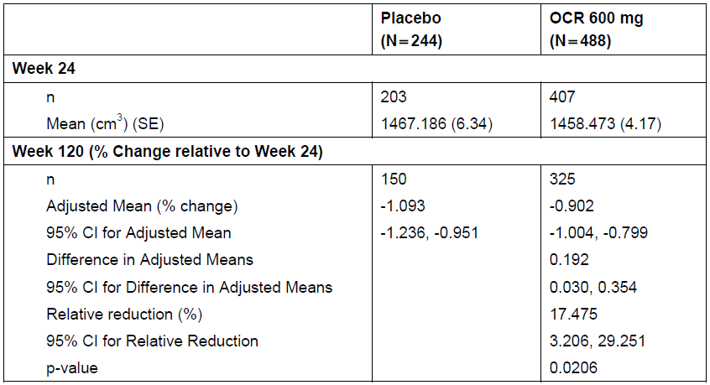
The only secondary endpoint that failed to achieve significance was the change in quality of life (QoL) as measured by SF-36 Physical Component Summary Score (SF36-PCS). Patients in the ocrelizumab group experienced a reduction of 0.73 points (a slight worsening of QoL) in the SF36- PCS score from baseline to Week 120 compared with a greater (more adverse) reduction of 1.11 points in the placebo group (p = 0.6034).
The table below summarises these secondary endpoints, along with the primary endpoint, showing that the results were reasonably concordant across multiple measures.

Table 51: Primary and Secondary Efficacy Endpoints at Week 120 (ITT Population)
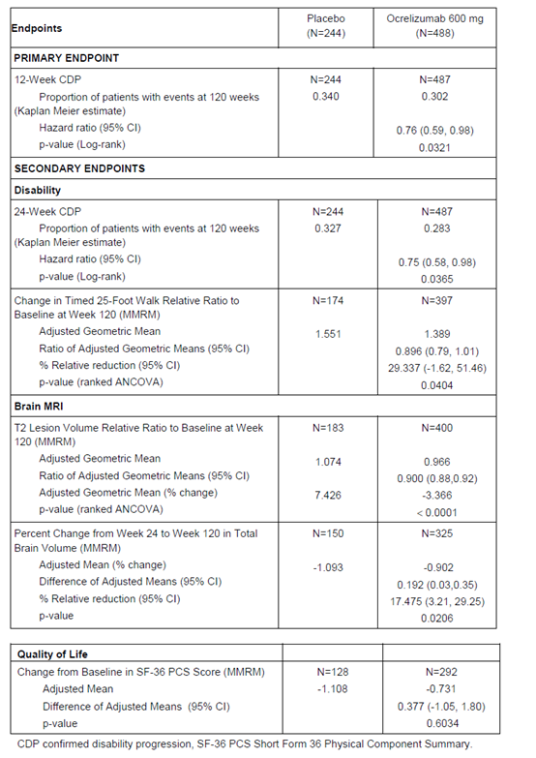

Other efficacy studies

Supportive, dose ranging, Phase II Study in RRMS WA21493
‘Phase II, multicentre, randomized, parallel group, partially blinded, placebo and Avonex controlled dose finding study to evaluate the efficacy as measured by brain MRI lesions, and safety of 2 dose regimens of ocrelizumab in patients with RRMS.’

Study design, objectives, locations and dates
Study WA21493 (randomised n = 220, treated n = 218) was the only submitted study that focussed exclusively on the traditional target population for disease-modifying MS agents: subjects with RRMS. It was not submitted as a pivotal study, and it was not sufficiently rigorous to allow definitive demonstration of efficacy in this important patient population. It was a Phase II, multicentre, randomised, 4-arm parallel-group, partially-double-blind, dose-finding study, which used two blinded doses of ocrelizumab (2000mg and 600mg IV, at the start of the 24 week treatment cycle), a blinded IV placebo control group, and an open-label IM active comparator group (interferon β-1a, Avonex) to evaluate the efficacy of ocrelizumab as measured by brain MRI lesions. An important additional focus was the safety of 2 different dose regimens of ocrelizumab in patients with RRMS. The relatively small size (n = 218) and short duration of blinded treatment (24 weeks), as well as the non-clinical primary efficacy measure (based on MRI) prevent this from being considered as a major supportive study, but it was useful as a minor dose-finding study and supports the overall findings of the two pivotal studies in RMS.
Most subjects also received ocrelizumab during an open-label extension (OLE), for up to four 24 week cycles of treatment in total. Without a control treatment, this part of the study provided efficacy data of very limited value.
Objectives were listed in the CSR as follows:
- Primary:
  - To investigate the effect of ocrelizumab given as two dose regimens of 600 or 1000 mg intravenously on the total number of gadolinium-enhancing T1 lesions observed on magnetic resonance imaging (MRI) scans of the brain at weeks 12, 16, 20 and 24 as compared to placebo.
- Secondary:
  - annualised protocol-defined relapse rate (ARR) by week 24
  - proportion of patients who remained relapse free by week 24 (protocol-defined relapses)
  - total number of gadolinium-enhancing T1 lesions observed on MRI scans of the brain at weeks 4, 8, 12, 16, 20, and 24
  - total number of new gadolinium-enhancing T1 lesions on MRI scans of the brain at weeks 4, 8, 12, 16, 20, and 24
  - change in total volume of T2 lesions on MRI scans of the brain from baseline to week 24
  - evaluation of the safety and tolerability of two dose regimens of OCR in patients with RRMS as compared with placebo and Avonex at week 24 and the overall safety of OCR administered for up to 96 weeks
  - investigation of the pharmacokinetics and other pharmacodynamic study endpoints of OCR.
The study was conducted in 79 centres from Europe and North America.
Including the OLE period, the study period covered by the original CSR was 13 January 2008 – 9 March 2012. Open-label follow-up was continuing at the time of data cut-off, and the sponsor has since submitted an updated CSR that provides safety data collected up to 22 January 2015. The primary (blinded) analysis period was only up to 24 weeks.

Inclusion and exclusion criteria
Subjects of either gender were eligible of they were aged 18 to 55 years, inclusive, and had RRMS in accordance with the standard McDonald criteria available at the time the study commenced. Patients had to have experienced at least two documented relapses within the previous 3 years prior to screening, with at least one of these within the year prior to screening.
The detailed inclusion criteria were listed in the CSR as follows:
- Ability to provide written informed consent and to be compliant with the schedule of protocol assessments
- Diagnosis of RRMS in accordance with the revised McDonald criteria (2005)
- Ages 18 to 55 years inclusive
- At least two documented relapses within the last 3 years prior to screening, at least one of which occurred within the last year prior to screening
- EDSS at baseline from 1.0 to 6.0 points
- Evidence of MS disease burden as defined below:
  - At least six T2 lesions on an MRI scan done in the year prior to screening, based on local reading. Should an MRI scan be unavailable within the last year or showing less than six T2 lesions, a screening MRI scan with at least six T2 lesions is required for the patient to be eligible, OR
  - Patient had 2 documented relapses within the year prior to screening
- For sexually active female and male patients of reproductive potential, use of reliable means of contraception
Exclusion criteria closely resembled those of the pivotal studies (apart from the criteria directly related to the MS disease subtype, which differed across studies according to the subtype being studied).

Study treatments
The study had four treatment arms, but only the first treatment cycle of 24 weeks was randomised, and most subjects reverted to open-label ocrelizumab 600mg for subsequent cycles, which was chosen as the preferred dose in the OLE phase. The higher dose of ocrelizumab, 2000 mg, was discontinued after the first cycle; this group received 1000 mg for Cycles 2 and 3, and 600 mg for Cycle 4, in an unblinded fashion. (This pattern was described inaccurately in some parts of the provided synopses, without mention of the dose change between Cycles 3 and 4). For the first cycle, Groups A, B and C received the total blinded dose in two divided infusions given14 days apart.
- Group A (IV): ocrelizumab 2000 mg (1 dose); ocrelizumab 1000 mg (2 doses); ocrelizumab 600mg (1 dose)
- Group B (IV): ocrelizumab 600 mg (4 doses)
- Group C (IV): Placebo (1 dose); ocrelizumab 600 mg (3 doses)
- Group D (IM): IFN 30 µg (1 dose); ocrelizumab 600 mg (3 doses)
In more detail, the regimens were described as follows (with ‘Cycles’ referring to 24 week periods):
- Group A (ocrelizumab 1000 mg group): Two IV infusions of ocrelizumab 1000 mg separated by 14 days in Cycle 1, followed by an infusion of ocrelizumab 1000 mg on Day 1 and an infusion of placebo on Day 15 of Cycle 2. A single infusion of ocrelizumab 1000 mg or 600 mg was administered on Day 1 of Cycles 3 (1000 mg) and 4 (600 mg), respectively.
- Group B (ocrelizumab 600 mg group): Two IV infusions of ocrelizumab 300 mg separated by 14 days in Cycle 1, followed by an infusion of ocrelizumab 600 mg on Day 1 and an infusion of placebo on Day 15 of Cycle 2. A single infusion of ocrelizumab 600 mg was administered on Day 1 of Cycles 3 and 4.
- Group C (placebo group): Two IV infusions of placebo separated by 14 days in Cycle 1, followed by two infusion of ocrelizumab 300 mg separated by 14 days in Cycle 2. A single infusion of ocrelizumab 600 mg was administered on Day 1 of Cycles 3 and 4 (following selection of the preferred dose).
- Group D (Avonex group): Weekly IM injections of Avonex 30 µg in Cycle 1, followed by two infusion of ocrelizumab 300 mg separated by 14 days in Cycle 2. A single infusion of ocrelizumab 600 mg was administered on Day 1 of Cycles 3 and 4 (following selection of the preferred dose).

Efficacy variables and outcomes
All of the efficacy variables were similar to those described for the pivotal studies, but their relative ranking was changed, with an MRI endpoint (total Gd+ lesions) designated as primary and clinical endpoints designated as secondary. This design decision may reflect concerns about adequate statistical power, given the relatively short duration of blinded treatment, and the increased sensitivity of MRI to subclinical disease activity.
The primary efficacy outcome was the total number of Gd+ T1 lesions observed on MRI scans of the brain at weeks 12, 16, 20, and 24.
Secondary efficacy parameters were:
- the ARR by week 24
- the proportion of patients who remained relapse-free by week 24 (protocol-defined relapses)
- the total number of Gd+ T1 lesions observed on MRI scans of the brain at weeks 4, 8, 12, 16, 20, and 24 (including earlier time points than the primary endpoint).

Randomisation and blinding methods
After a 4 week screening period, eligible patients were randomised equally (1:1:1:1) to one of the four treatment groups (A, B, C, or D), using an interactive voice response system. The two doses of ocrelizumab and placebo (Groups A, B, and C) were allocated in a double-blind manner, and administered IV with identical appearing infusions, but treatment in the interferon β-1a group (Group D) was open-label, with weekly IM injections.
Blinding between groups A, B and C was maintained by using infusions of identical appearance and by rating MRIs in a central MRI reading centre by radiologists blinded to treatment allocation and uninvolved in patient care. Clinical assessments were also performed by independent rating neurologists who were not directly involved in patient care. Investigators did not receive reports from the central MRI reading centre or reports on laboratory parameters that could have led to unblinding.
Avonex treatment, administered to Group D, was not blinded, but MRI readers and clinical raters were blinded to treatment allocation.
It is possible that some degree of unblinding occurred because of tell-tale side effects. This possibility was not assessed.

Analysis populations
The sponsor defined ITT, PP and Safety populations, essentially as described for the pivotal studies. The ITT population was defined as all randomised patients who received any study drug. All major efficacy analyses were performed in the ITT population, with sensitivity analyses performed in the PP population.

Statistical methods
The primary efficacy endpoint, Gd+ MRI lesions, was assessed with the van Elteren test (an extension of the Wilcoxon rank sum test, usually used for comparing two treatments in a stratified experiment). The analysis compared the differences between each ocrelizumab group and the placebo group in the total number of Gd+ T1 lesions at weeks 12, 16, 20, and 24. The test was stratified by geographic region and the presence of baseline Gd+ lesions.
For the main secondary endpoint of ARR, each ocrelizumab group was compared with the placebo group at week 24 using Poisson regression, offsetting for exposure time in years.

Sample size
The sponsor estimated sample size based on the rituximab proof-of-concept study, Study U2787g. From that study, the proportion of patients with Gd+ lesion counts at weeks 12, 16, 20, and 24 was estimated for the placebo and ocrelizumab groups as shown in the table below.

Table 52: Estimation of proportion of patients with GD+ counts for the placebo and ocrelizumab groups
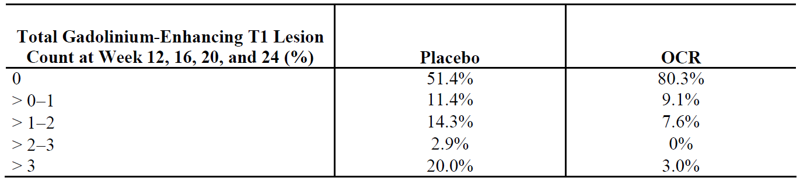
Using the Wilcoxon rank-sum test (of which the van Elteren test is a variant), a sample size of 35 patients per group was estimated to provide 80% power with a two-sided significance level of 0.05 to detect a difference in the total number of Gd+ lesions between each ocrelizumab group and the placebo group. To allow for dropouts, the sponsor planned to randomise 50 patients for each treatment group, leading to a total planned study size of ≥ 200 patients, which was exceeded.

Participant flow
Of the 220 patients initially randomised, 218 received study treatment and, of these, 205 (93%) completed the 24 week placebo-controlled study period. This is an acceptable completion rate for a study of this nature, and satisfied the initial sample size estimations.

Table 53: patients withdrawn from treatment, Study WA21493
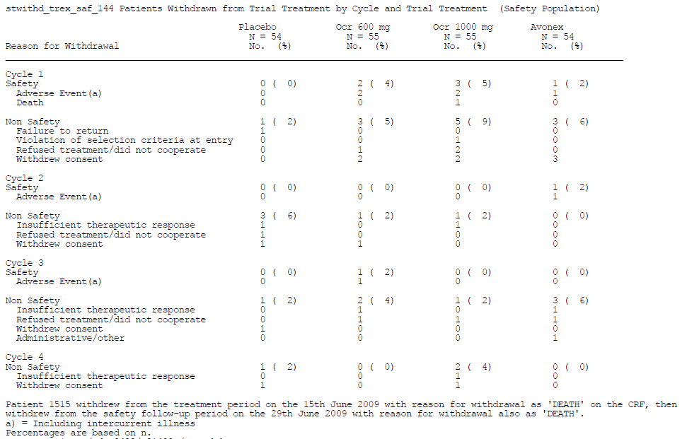

Major protocol violations/deviations
Major protocol violations leading to patients being excluded from the ITT or PP populations are summarised in the table below.

Table 54: Exclusions from study populations because of protocol violations
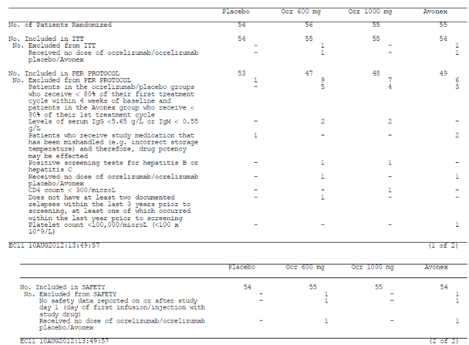

Baseline data
Baseline demographic data and disease characteristics are summarised in the tables below. No important differences were noted between the four treatment groups, but the ocrelizumab 600 mg group was slightly younger, on average, than the other groups. The groups were acceptably matched for disease duration and number of relapses.

Table 55: Baseline demographic data, Study WA21493
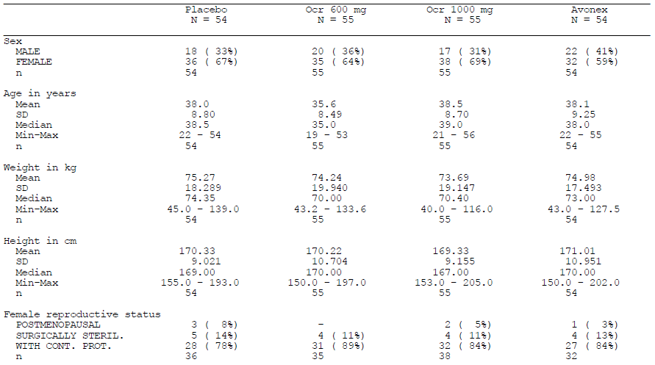

Table 56: Baseline demographic data, Study WA21493
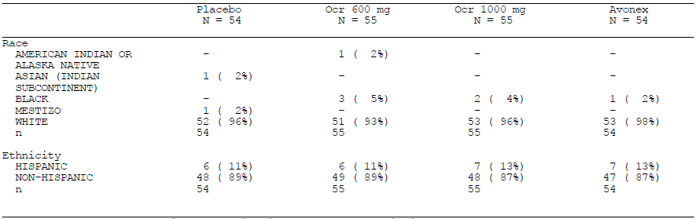

Table 57: Baseline disease characteristics, Study WA21493
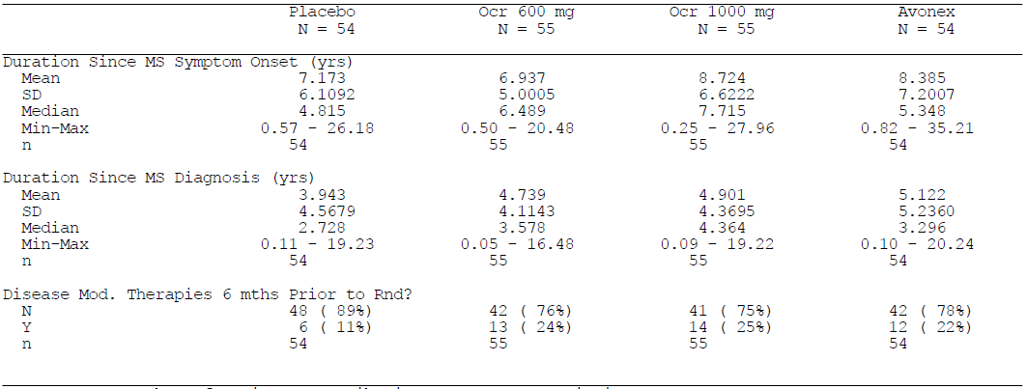

Table 58: Baseline relapse history, Study WA21493
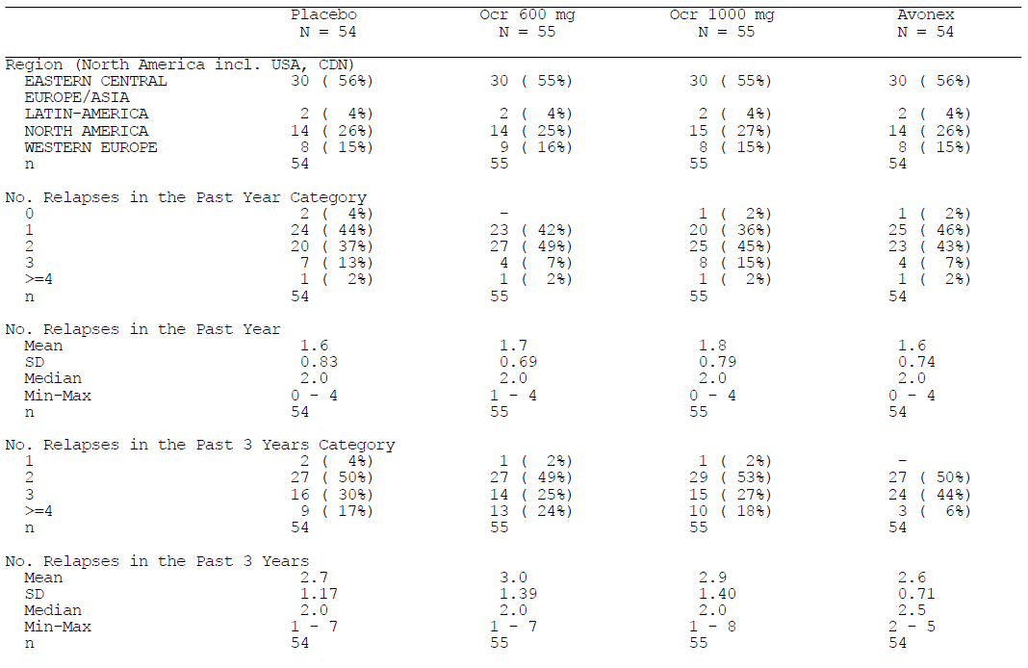
Baseline MRI characteristics are summarised in the table below. Groups A, B and C were broadly matched for the main efficacy variable (Gd+ lesions), but the Avonex group was not well matched. Whereas 45 to 51% of subjects in Groups A, B and C had GD+ lesions at baseline, only 34% of the Avonex group had Gd+ lesions. This difference should not have had a major effect on the results, because the analysis was stratified by the presence of baseline Gd+ lesions, but, because of this mismatch, it is important to consider the results in subgroups with and without Gd+ lesions.

Table 59: Baseline MRI characteristics, Study WA21493
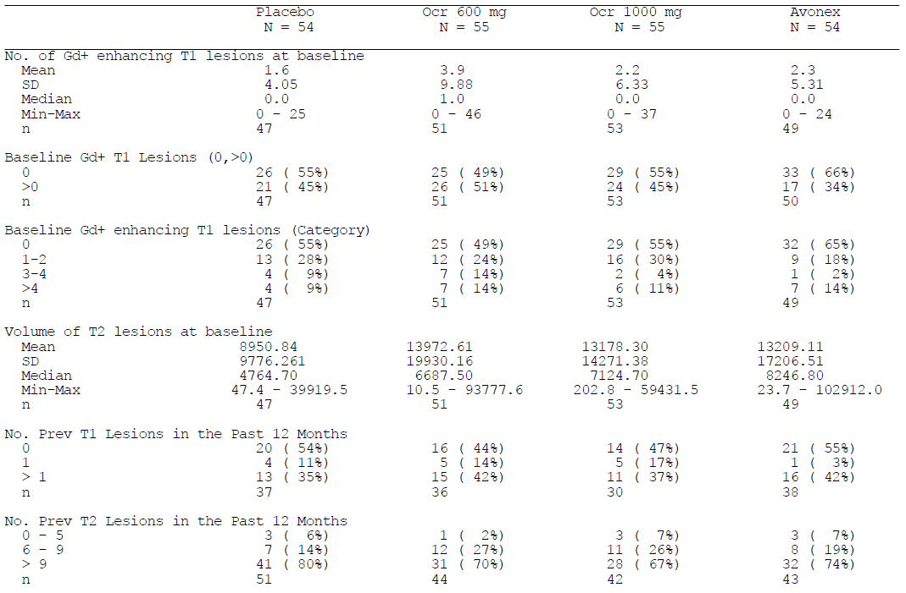

Results for the primary efficacy outcome
The study showed a significant treatment benefit for ocrelizumab, relative to placebo, for its primary endpoint: total number of Gd+ T1 lesions observed on MRI scans of the brain at weeks 12, 16, 20, and 24. Compared to the placebo group, which had a mean (SD) of 5.6 (12.53) Gd+ lesions at weeks 12, 16, 20, and 24; the lesion count was reduced by 89%, to 0.6 (1.52), in the ocrelizumab 600 mg group and by 96%, to 0.2 (0.65), in the ocrelizumab 1000 mg group. The differences between the ocrelizumab groups and placebo were highly statistically significant (p < 0.001).
The mean lesion counts may have been dominated by outliers: the range in counts extended as high as 79 in the placebo group and 78 in the Avonex group, compared to 7 and 3 in the 600mg and 100mg ocrelizumab groups, respectively. It is therefore reassuring that the median counts also favoured ocrelizumab, with a median of zero lesions in both ocrelizumab groups, 1.7 in the placebo group and 1.0 in the Avonex group.

Table 60: Gd+ lesions from weeks 12-24, Study WA21493
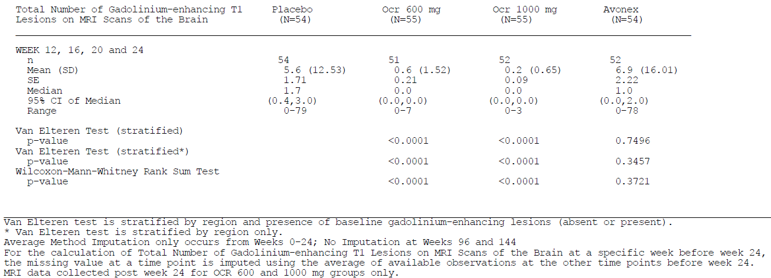
No significant difference was observed between the two ocrelizumab dose groups (p = 0.15). The Avonex group did not have lesion counts significantly different from placebo (p = 0.35) and, numerically, had more lesions than observed in the placebo group (mean 6.9 verse 5.6).
The robustness of these findings were supported by sensitivity analyses, including an assessment of the Gd+ lesion count in the PP population. In the PP population, ocrelizumab recipients showed significant reductions in the total number of Gd+ lesions at weeks 12, 16, 20, and 24 compared to placebo recipients (p < 0.0001). The sponsor also reanalysed the data with a highly pessimistic imputation method, deliberately favouring the placebo and Avonex arms by replacing missing values with zero, but replacing missing values in the ocrelizumab arms by the average lesion count: even this analysis showed significant superiority of ocrelizumab verse placebo (p < 0.0001 for each ocrelizumab group).
Although these primary endpoint results are non-clinical, and therefore only suitable for a Phase II supportive study, they are quite strong statistical results, especially considering the relatively small size and short duration of the study. Also, as discussed in a later section, they were backed by positive results for key secondary endpoints, which included the important clinical endpoint of ARR.

Subgroup Analyses of the primary efficacy outcome
Across the overall study cohort, the reduction in Gd+ lesion count with ocrelizumab, compared to placebo, was 88.5% for 600 mg and 96.2% for 1000 mg. Broadly similar reductions were observed in all major subgroups, as summarised in the table below. There was a slight trend to greater relative efficacy in subjects who were younger, as observed in the pivotal studies. No consistent pattern was observed in patients with or without baseline Gd+ lesions: in the 600mg dose group, the relative reduction was greater in subjects without baseline Gd+ lesions; in the 1000mg dose group, the relative reduction was greater in those with baseline Gd+ lesions. Efficacy was maintained in subjects with higher EDSS. Overall, these results suggest broadly similar efficacy throughout a population with RRMS.

Table 61: Subgroup analysis of the primary endpoint, Study WA21493
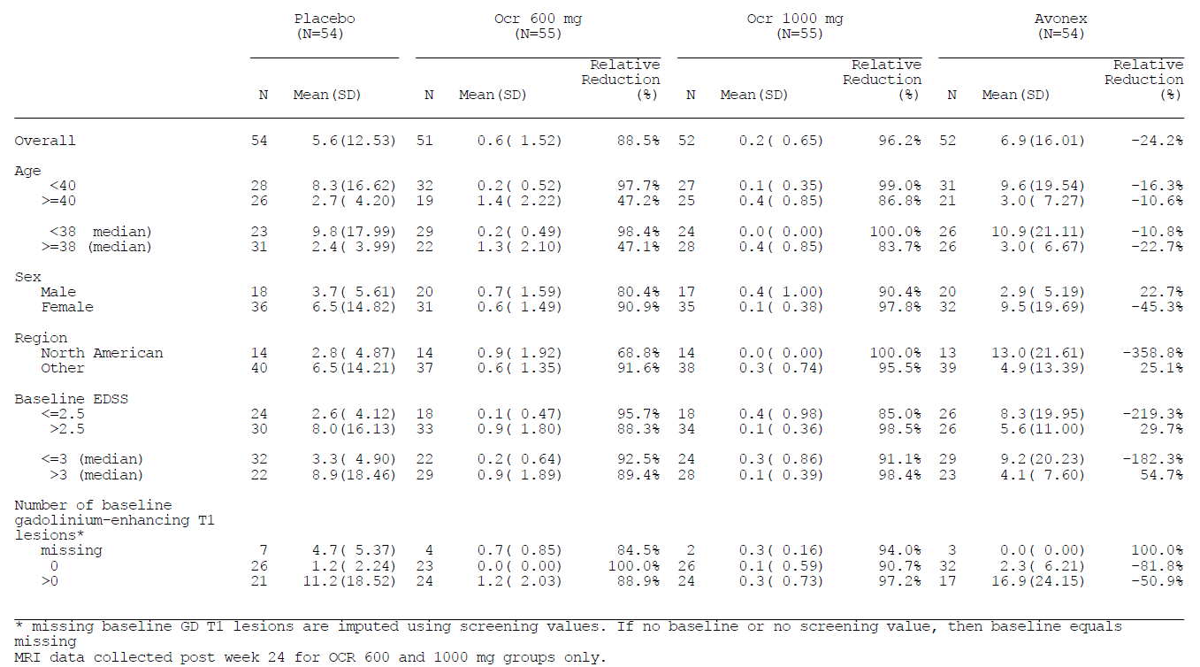

Results for other efficacy outcomes
All of the major efficacy endpoints, including the primary endpoint, are summarised in the table below. Most of the endpoints strongly favoured ocrelizumab.
The blinded treatment period in this study was short and most subjects, even in the placebo group, remained relapse-free. Despite this, the adjusted ARR significantly favoured ocrelizumab, with ARRs of 0.127 and 0.213 observed in the 600mg and 1000mg ocrelizumab groups, respectively, compared to 0.557 in the placebo group (p = 0.0019 and p = 0.0136, respectively). This is consistent with a relative reduction in the relapse rate of 77% with ocrelizumab 600mg, and 62% with ocrelizumab 1000mg. The proportion of relapse-free patients was not statistically different across groups, but this is a relatively underpowered endpoint because it discards information about the timing and frequency of relapses and, even in the placebo group, most subjects did not have a relapse.
Secondary MRI endpoints, including Gd+ lesions counted across a longer time period and counts involving new lesions only, strongly supported the primary MRI endpoint. T2 lesion volume change showed a strongly favourable trend, with reduced total T2 lesion volume in both ocrelizumab groups, compared to increased T2 lesion volume in the placebo group.
Avonex did not achieve a significant difference from the placebo group for any endpoint.

Table 62: Efficacy endpoints, primary analysis at 24 weeks (ITT Population, Study WA21493)
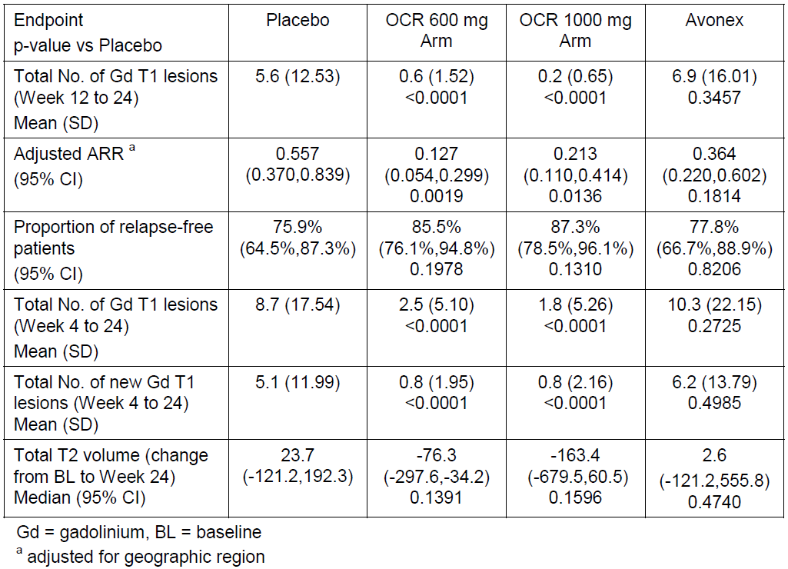

Open-label extension
Although this study was designed with an Open-Label Extension (OLE), the primary purpose of the OLE was to gather long term safety data. No efficacy data from the OLE was submitted.

Evaluator’s overall conclusions on clinical efficacy
The efficacy of ocrelizumab in MS has been assessed in four studies, including one Phase II study in RRMS, two identical pivotal Phase III studies in ‘RMS’ (including RRMS and other relapsing subtypes), and one Phase III study in PPMS. Efficacy in the RMS and PPMS populations needs to be considered separately.

Efficacy in Relapsing Forms of MS
The sponsor has provided strong evidence that ocrelizumab has substantial efficacy in relapsing forms of MS, with all three studies in RMS producing positive findings for their primary and most secondary endpoints, relative to active controls (low-dose weekly interferon β-1a for the supportive Phase II study, high-dose three-times weekly interferon β-1a for the two pivotal Phase III studies.).
The main results from the two pivotal RMS studies (Studies WA21092 and WA21093) are summarised below. In each study separately, as well as both studies pooled, there was a statistically robust benefit for ocrelizumab relative to interferon β-1a. For the primary endpoint, Annualised Relapse Rate (ARR), the rate ratio was about 0.53 in each study, indicating that the relapse rate on ocrelizumab is about 53% of the rate on three-times weekly interferon β-1a, which is already known to produce a significant reduction in relapses relative to placebo. The concordance between the two studies, as well as the low p-value (p < 0.0001 in each study) and a variety of sensitivity analyses, strongly suggests that this is not a chance finding but a reproducible result.
For sustained disability progression, regardless of whether this was defined as 12 week-confirmed disability progression or 24 week-confirmed, the hazard ratio across both studies pooled was 0.6, with little variation across the two studies. Significant, favourable results were also obtained for confirmed disability improvement and the proportion of patients achieving No Evidence of Disease Activity (NEDA). The absolute increase in NEDA attributable to ocrelizumab was about 20% in each study, indicating that only 5 patients would need to be treated to achieve one extra case of NEDA. The relative increase in NEDA was approximately 77%, which is a very strong result.

Table 63: Primary and secondary efficacy endpoints at week 96: studies WA21092, WA21093 and Pooled (ITT Population)
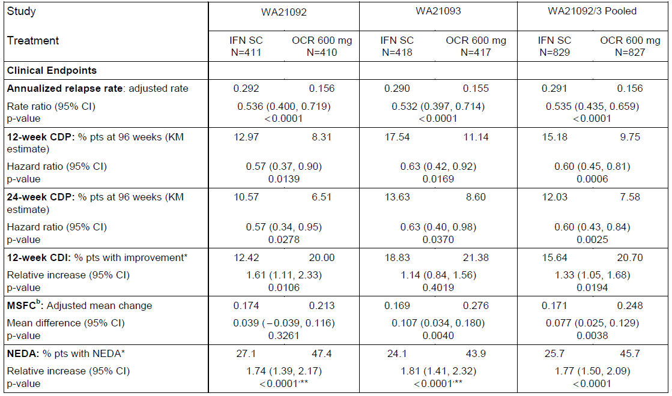
These strong results come with an important qualification. The inclusion criteria for these two pivotal studies were unusual, in that the studies did not restrict the study to subjects with Relapsing Remitting MS (RRMS), who are the traditional target of disease-modifying treatments, but also allowed subjects to enter if they had Secondary Progressive MS (SPMS) and on-going relapses. It appears likely that most of the observed benefit in the pivotal Phase III studies was achieved in subjects with RRMS, rather than in subjects with SPMS, because most other immune treatments have shown greater efficacy in RRMS than in SPMS. Unfortunately, this possibility was not acknowledged or analysed by the sponsor, and subgroup analyses by basic disease classification were not performed. Considering the RMS data alone, it has not been proven that ocrelizumab has efficacy in subjects with SPMS and on-going relapses – it is possible that the efficacy in RRMS patients was so substantial that the overall study remained positive despite the inclusion of relatively unresponsive SPMS patients. This represents a major flaw in the submitted evidence.
The sponsor provided some indirect evidence that ocrelizumab has reduced efficacy in subjects with less active disease. In each of the pivotal RMS studies, subgroup analyses based on age, EDSS and presence of Gd+ MRI lesions at baseline showed that the trend in favour of ocrelizumab over interferon β-1a was weaker (with less favourable rate ratios) in subjects who were older, had higher EDSS, or lacked Gd+ lesions. These are the same clinical characteristics that are usually more prevalent in SPMS, compared to RRMS. In all of these subgroups, ocrelizumab still had numerically favourable results, but the effect, as quantified by the rate ratios for ARR, was often modest.
Given that the sponsor is seeking registration for the broad indication of ‘relapsing forms of MS’, which includes SPMS subjects with on-going relapses, it would have been appropriate for the sponsor to perform a subgroup analysis of subjects with a baseline diagnosis of SPMS. The sponsor should be asked to perform such an analysis, so that efficacy in this important subgroup can be assessed.
Admittedly, when the RMS data is considered in the context of positive results for the third pivotal study, conducted in Primary Progressive MS (PPMS) patients, this issue appears somewhat less concerning. If ocrelizumab does have efficacy in PPMS (as suggested by the lone pivotal PPMS study, discussed below), and it also has efficacy in RRMS (as strongly suggested by all 3 RMS studies), then it is very likely to have efficacy in SPMS with on-going relapses, because this represents an intermediate subtype in the spectrum between relapse-dominant disease (exemplified by RRMS) and progression-dominant disease (exemplified by PPMS). Thus, the PPMS study can be considered as a supportive study for the sponsor claims that ocrelizumab has efficacy across the MS spectrum, extending beyond the traditional target of immune therapies in MS, the RRMS population. Nonetheless, it would be preferable if efficacy in the SPMS population had been demonstrated directly, in a study specifically assessing this population, or at least in a subgroup analysis of the pivotal studies.
The sponsor also submitted a supportive study in RRMS (Study WA21493), which showed a clear therapeutic benefit for ocrelizumab over low-dose weekly interferon β-1a. The primary endpoint was radiological (change in Gd+ lesions) and the blinded treatment period was short (24 weeks), which makes the study unsuitable as a pivotal study. As a Phase II study, it was strongly supportive. Gd+ lesions were reduced substantially, relative to placebo and to interferon β-1a: mean counts were 5.6 and 6.9 for placebo and interferon β-1a, respectively, compared to 0.6 and 0.3 for ocrelizumab 600mg and ocrelizumab 1000mg, respectively (p < 0.0001 for ocrelizumab at either dose verse placebo). Secondary clinical endpoints were also positive, and broadly consistent with the subsequent pivotal studies, as shown in the second table below; ARR was reduced in both ocrelizumab groups, with a relative reduction in the relapse rate of 77% with ocrelizumab 600mg, and 62% with ocrelizumab 1000mg, compared to placebo (p = 0.0019 and p = 0.0136, respectively). This study therefore supports the efficacy of ocrelizumab in RRMS, but does not contribute to understanding of the efficacy of ocrelizumab in subjects with SPMS.

Table 64: Gd+ lesions from weeks 12-24, Study WA21493

Table 65: Efficacy endpoints, primary analysis at 24 weeks (ITT Population, Study WA21493)

Efficacy in primary progressive MS
The sponsor only submitted a single study in PPMS (Study WA25046). This is represents a significant flaw in the overall quality of the efficacy evidence, particularly in view of the fact that there is no other substantial support for the broad hypothesis that immune therapies are useful in PPMS. As already noted, another B cell depleting agent, rituximab, did not produce overall positive results in PPMS, but benefit was observed in subgroup analyses of younger patients and those with Gd+ lesions on their baseline MRI scan.
The fact that the sponsor has only performed a single study for this indication was flagged as a concern in initial discussions with overseas regulatory authorities, who suggested that the statistical standards required of such a lone study should be more rigorous than would ordinarily be considered standard.
The sponsor comments on pre-submission guidance make this clear (emphasis added):
‘A key point of discussion with FDA and CHMP was use of a single trial to support registration for PPMS. The FDA indicated that in certain circumstances, results from a single, adequate and well-controlled trial could provide substantial evidence of effectiveness to support registration. The study would need to provide unambiguous, robust results and be statistically persuasive. Certain aspects of trial design, for example a large multicentre trial with consistency of effect across subgroups and across centres, were highlighted as being relevant. From the European perspective, CHMP noted that statistical evidence stronger than p < 0.05 on the primary endpoint would be required to account for the fact that a single trial in PPMS was to be conducted, consistent with the CHMP points to consider on applications with one pivotal study (EMA guidance CPMP/EWP/2330/99, 2000). At the Scientific Advice discussion meeting, the Company presented their justification for designing the study such that the significance level of p < 0.01 could be reached. This was considered justified by the sponsor based on the high unmet medical need and the measures taken to ensure high data quality.’
For the primary endpoint in this lone PPMS study, the final p-value was 0.0321, which means that the sponsor failed to achieve the more ambitious target for statistical significance (p < 0.01), but they did achieve the traditional significance target (p < 0.05) that was pre-specified in the protocol. It thus appears likely that ocrelizumab has efficacy in PPMS, but the evidence is not as robust as might be hoped.

Table 66: Primary endpoint, 12-week confirmed disability progression (ITT, Study WA25046)
The clinical utility of the observed benefit is also debateable. The hazard ratio was 0.76, suggesting a 24% reduction in instantaneous hazard for reaching the 12 week CDP progression milestone. At 120 weeks, the proportion of patients showing a 12 week CDP was 0.302 in the ocrelizumab group, compared to 0.340 in the placebo group, consistent with a relative risk of 89% and a risk reduction of 11%. The absolute risk reduction was only 0.038 (0.340-0.302), or 3.8%, implying that about 26 subjects would need to receive treatment for 120 weeks to prevent one case of 12 week CDP. This is a clinically modest achievement; it could be perceived as worthwhile by some patients and clinicians, but does not justify any substantial safety risk.
A consideration of the efficacy across different subgroups suggests that much of this modest benefit was observed in subjects who were younger or had active, Gd+ scans at baseline. Although a statistical analysis of these baseline factors did not show a significant interaction with treatment, there are good a priori reasons for suspecting that a lymphocyte-depleting agent would have its greatest effect on subjects with active, inflammatory lesions. Also, very similar observations were made in the pivotal RMS studies for ocrelizumab, and a similar observation was made during subgroup analysis of PPMS patients given rituximab, which has a similar mode of action to ocrelizumab. Thus, it seems likely that ocrelizumab, when used to treat PPMS, has better efficacy in younger subjects and those with active MRI scans, and that efficacy in older subjects and those with inactive scans is likely to be inferior to that seen in the overall PPMS cohort, and of minimal clinical value.

Table 67: Subgroup analyses of 12-week CDP (with imputation), Study WA25046
The instantaneous hazard ratio for subjects with unfavourable baseline factors was 0.88 for those aged > 45 years, and 0.84 for those without Gd+ lesions (and it would be expected that the HR would be closer to unity for subjects with both of these adverse baseline factors). High EDSS was also associated with a relatively poor HR of 0.84.
In the sponsor description of these results, it was not clear how much delay in progression was achieved in the ocrelizumab group. Visual inspection of the Kaplan-Meier curves suggest that, for most of the time period in which there was adequate data, progression curves were roughly linear and parallel in the two treatment groups, with the ocrelizumab group reaching the same proportion of progressed patients as seen in the placebo group, but after a delay of about 18 weeks. The sponsor should be asked to quantify this estimate, or direct the evaluator to the relevant analysis in the submitted material. An 18 week delay in progression is clinically modest, but might be considered worthwhile by some patents and clinicians. The delay in progression achieved with ocrelizumab would be expected to be shorter in less favourable subgroups, and longer in younger patients with active scans.
Figure 14: Visual inspection: Delay in confirmed disability progression
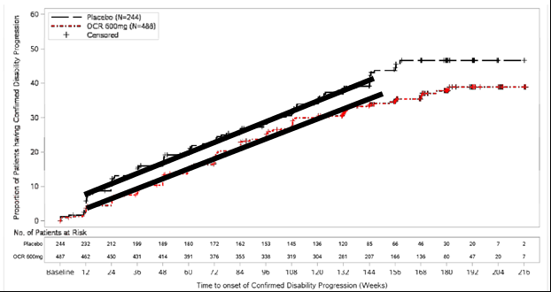
The PPMS study also showed benefits for key secondary endpoints, as summarised below. For the timed 25-foot walk, the placebo group showed a substantial slowing (approximately 55%) over the 120 week study period (based on a geometric mean of 1.551 for the ratio of week 120 to baseline results). The active group also showed a substantial slowing (approximately 39%). The difference was significant (p = 0.04), but of uncertain clinical utility. There was also a reduction in the accumulation of T2 lesion volume (p = 0.0365) and a 17% relative reduction in the rate of brain atrophy (p = 0.02). These secondary endpoints increase confidence in the robustness of the study, but remain consistent with a modest clinical benefit.

Table 68: Primary and secondary efficacy endpoints at Week 120 (ITT Population)
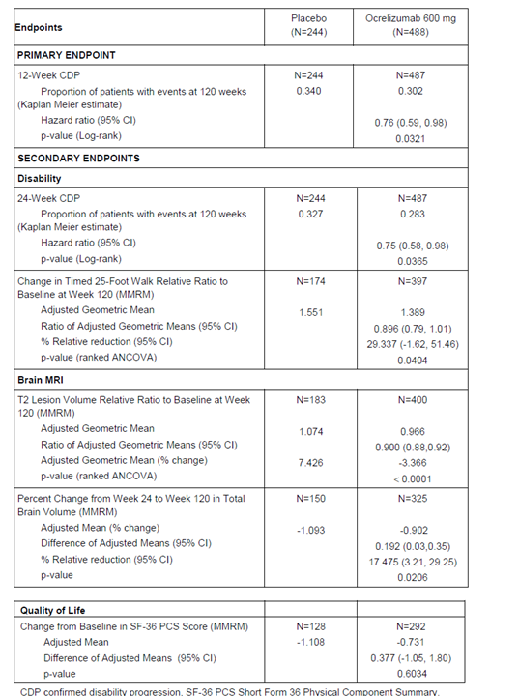

Summary of efficacy conclusions
Overall, there was good evidence of efficacy for ocrelizumab in RMS, even in comparison with an acceptable, high-dose active comparator (interferon β-1a 44mcg three-times weekly, Rebif). Annualised relapse rate was reduced by about 47%, compared to Rebif, which is already known to produce a significant reduction in relapses relative to placebo. Disease progression (12 week CDP) was also reduced, along with a number of radiological endpoints, with consistent results across two pivotal studies. There was an absolute increase of 20% in the number of subjects enjoying NEDA status (No Evidence of Disease Activity).
It appears likely that the benefit observed in the two pivotal RMS studies extends to some patients with SPMS, especially if they are experiencing on-going relapses, but unfortunately this important target population was not studied directly, and was not the focus of any subgroup analysis.
It also appears likely that ocrelizumab has efficacy in PPMS, but the evidence is not as robust as could be hoped: only a single study has been submitted, with a modest statistical result for its primary endpoint (p = 0.0321), and the relative risk reduction for 12 week CDP was only 11% (with an absolute risk reduction of only 3.8%). This implies that a fairly high number of subjects would need to receive treatment to prevent one case of Confirmed Disability Progression, particularly if the drug were used in subgroups for which efficacy is less certain, such as older subjects and those with inactive MRI scans. The delay in progression achieved with active treatment was not clearly stated, but appeared to be about 18 weeks; the sponsor should clarify this.

Clinical safety

Studies providing evaluable safety data
The sponsor submitted a Summary of Clinical Safety (SCS) and an Integrated Summary of Safety (ISS). Data were pooled from the four Phase II and III MS studies (one Phase II study in RRMS, two Phase III studies in RMS and one Phase III study in PPMS). Data were also pooled from nine previously performed studies in patients with rheumatoid arthritis (RA). Some safety data in studies of other indications (systemic lupus erythematosus (SLE), lupus nephritis (LN), and non-Hodgkin’s lymphoma (NHL)) were also summarised, with a focus on infections and malignancies. The data were not pooled across the different indication, which is appropriate given the different underlying risks of adverse events, active comparators, and concomitant medications.
The RA studies are not described in detail in this report, because the sponsor is no longer pursuing this indication. The RA studies generally combined ocrelizumab with methotrexate (MTX), but in one RA Study (Study WA20494), subjects received ocrelizumab with leflunomide or MTX. Combining ocrelizumab with other immunosuppressant agents, such as MTX, may have increased the risk of infections and other AEs. Also, many RA patients received long-term chronic daily corticosteroids: this not only increases the risk of immunosuppression, but reduces the risk of immunologically mediated infusion-related reactions (IRRs), making it difficult to infer any conclusions of direct relevance to MS, which is not treated with chronic steroids. The comparator for most RA studies was placebo, but one study (Study ACT4562g) compared ocrelizumab with infliximab.
The studies in SLE, LN and NHL provided only limited safety data of relevance to the proposed indication. Most subjects in these studies received a number of concomitant treatments likely to modify the risk profile of ocrelizumab. Also, two of the studies were terminated when it became apparent that other anti-CD20 treatments were not efficacious in these conditions, as summarised by the sponsor: ‘A Phase III study of ocrelizumab in patients with SLE (Study WA20499) was terminated during the recruitment period due to negative Phase III efficacy results from another anti-CD20 development program in SLE. A Phase III study of ocrelizumab in patients with LN (Study WA20500) was terminated early due to lack of efficacy from another Phase III anti-CD20 study in LN and due to the observation of an increased incidence of serious infections in the ocrelizumab LN study. In addition, a Phase I/II trial in NHL (Study BO18414), was completed but further development in this indication was not pursued.’ In this evaluation, the data from these studies has been assessed for evidence of an increased risk of infections and malignancies.
The sponsor defined 6 different data pools in their SCS:
- Pool A: Phase III RMS Controlled Treatment
- Pool B: MS All Exposure (RMS, RRMS, and PPMS)
- Pool C: Phase III RMS All Exposure
- PPMS (Study WA25046): Phase III PMS Controlled Treatment
- Pool D: Phase II and Phase III RA Controlled Treatment
- Pool E: RA All Exposure
Of these, the combined MS experience (Pool B) and combined RA experience (Pool E) is the most relevant. The MS and RA studies contributing to the overall safety assessment are summarised in the tables below.

Table 69: Studies contributing to safety evaluation of ocrelizumab in MS
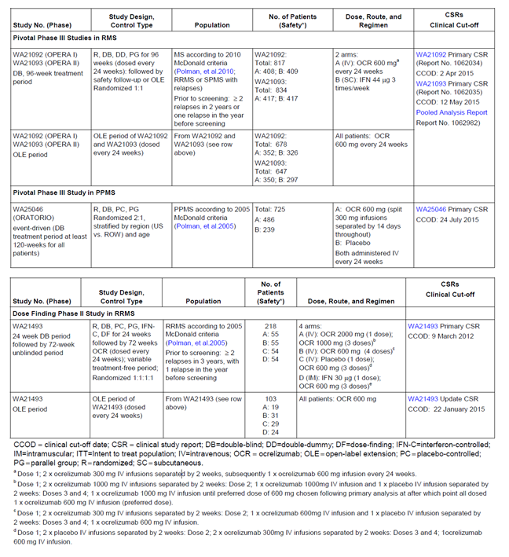

Table 70: Studies contributing to safety evaluation of ocrelizumab in RA
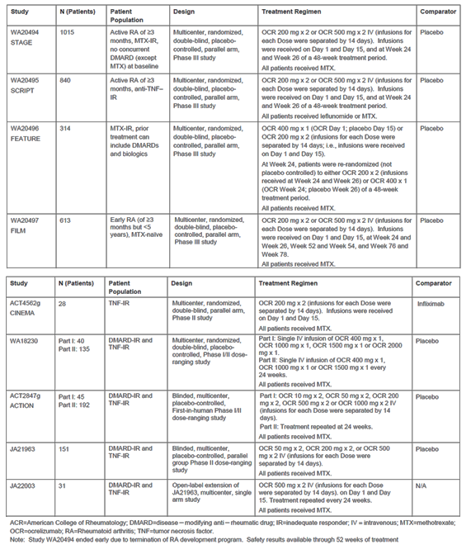

Pivotal efficacy studies
In the major efficacy studies for MS and RA, the following safety data were collected:
- General adverse events (AEs) were assessed through interviews and clinical examinations at scheduled visits as well as unscheduled hospital attendances.
- AEs of particular interest, including infusion related reactions (IRRs), infections, and malignancies, were collected and considered separately.
- Laboratory tests, including monitoring of electrolytes, liver function and haematological parameters were performed at regular intervals, and exploratory analyses assessed the incidence of AEs in relation to lymphocyte counts.
- The sponsor also performed a Cox regression analysis for the RA safety data, attempting to assess the extent to which AEs (particularly infections) could be explained by baseline and treatment-emergent risk factors.
Nearly all of the safety data comes from Phase II and III efficacy studies, with some additional uncontrolled data from Open-Label Extensions. (OLEs).

Patient exposure
Exposure to ocrelizumab has been fairly extensive for a new MS drug, partly because several additional studies were performed for the RA indication, which is no longer being pursued. The relevance of the safety data from the RA population is somewhat unclear, however, because of the concomitant use of other immunosuppressive agents, including methotrexate and corticosteroids. Considering the MS population alone, 2147 patients were exposed, with 4485 patient-years of follow-up.
Exposure for the MS and RA populations is summarised in the table below, and includes:
- 825 RMS patients (1448 patient years of exposure, Pool A);
- 486 PPMS patients (1416 patient years; PPMS Pool);
- 2147 patients in the MS all exposure population (4485 patient years; Pool B);
- 2926 patients with RA (7324 patient years, Pool E).
Across the MS and RA indications, 1775 patients (35% of all exposed patients) have received more than 4 doses of ocrelizumab, representing at least 2 years of exposure.

Table 71: Patient-years of exposure in MS and RA studies, by number of doses
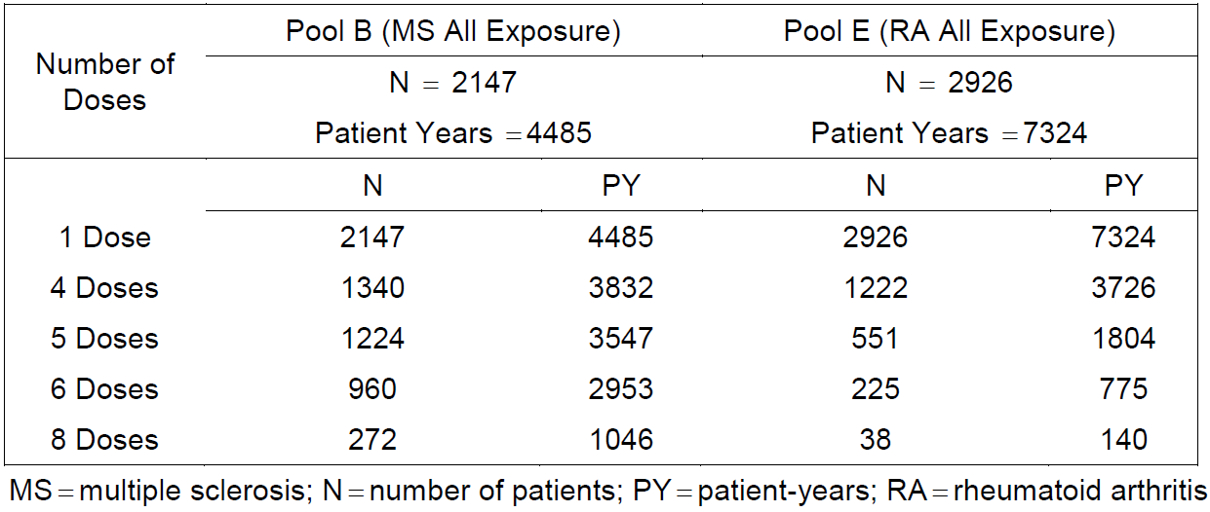
For the proposed indications, the data that provides the clearest safety signals are those derived from the randomised, controlled phases of the pivotal MS studies. For RMS, exposure is summarised in the table below including exposure to placebo infusions in the interferon β-1a control group. For PPMS, the exposure is summarised in the subsequent table, including the placebo control group.

Table 72: Exposure to ocrelizumab or placebo infusion – Phase III RMS population (Pool A)
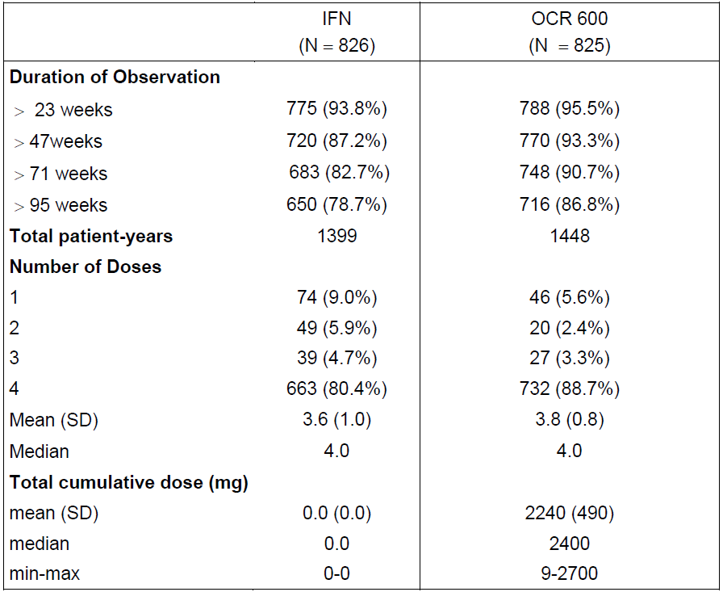

Table 73: Exposure to ocrelizumab/placebo – Phase III PPMS population
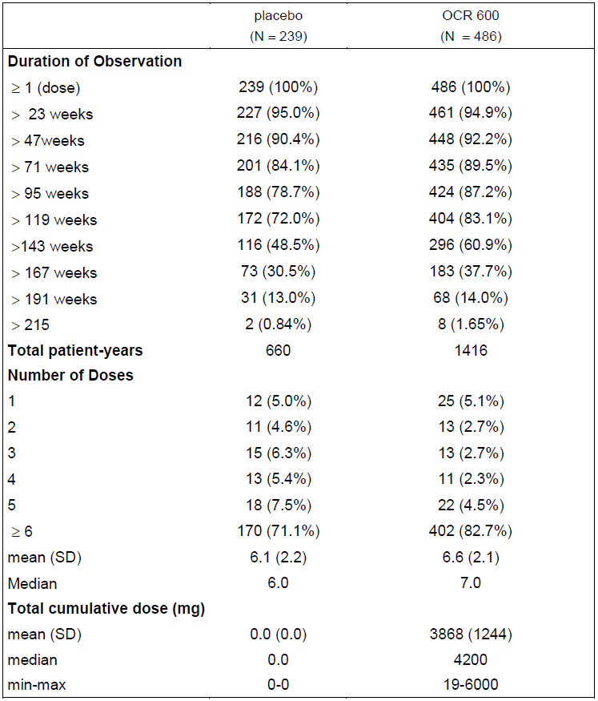
The overall extent of exposure in terms of weeks of safety follow-up is summarised below for the pooled MS population (Pool B) and the pooled RA population (Pool E).

Table 74: Exposure to ocrelizumab - MS all exposure population (Pool B)
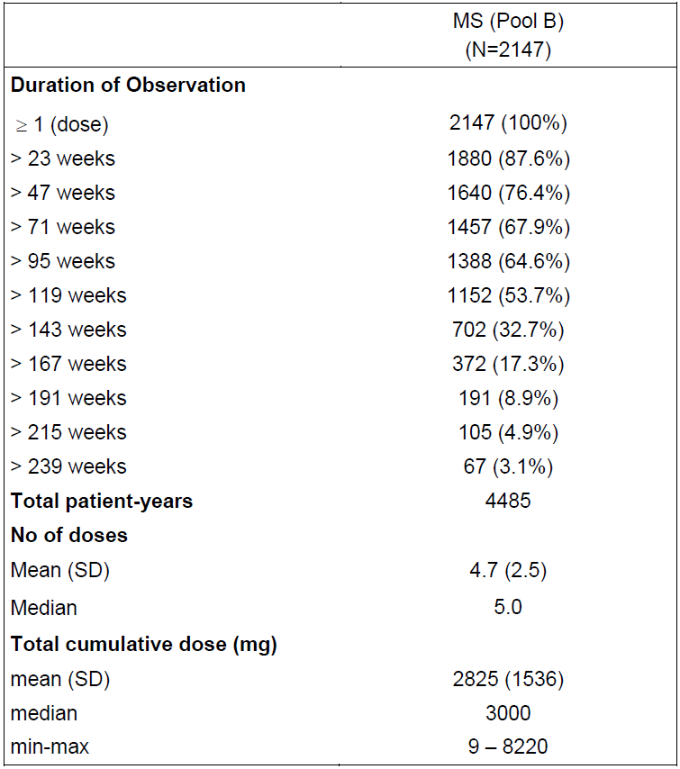

Table 75: Exposure to ocrelizumab in the RA all exposure population (Pool E)
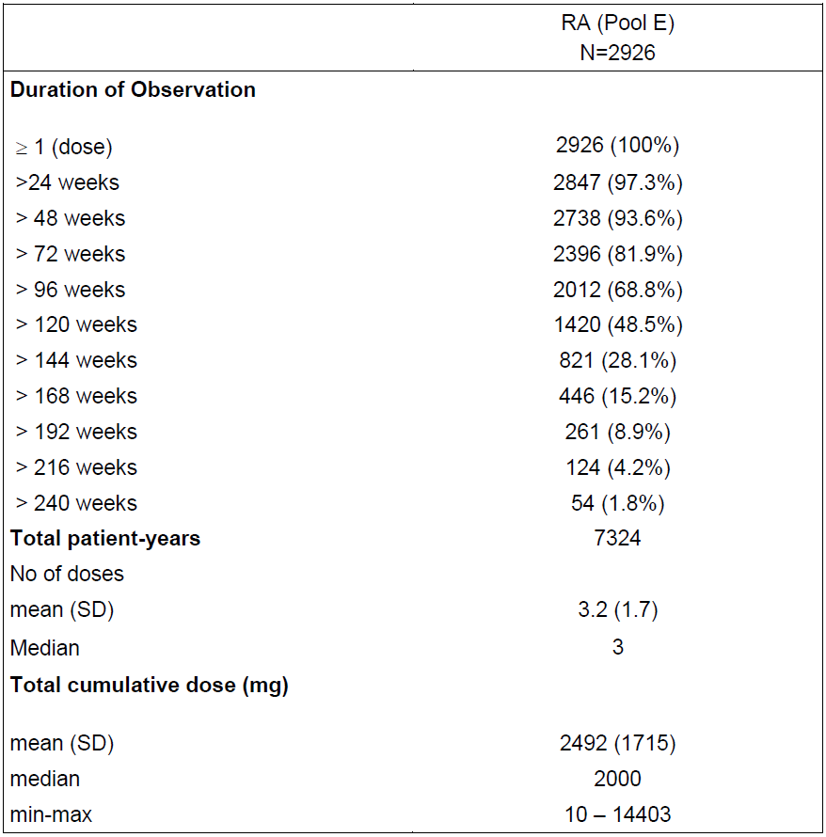

Adverse events

Total adverse events

MS studies
In the Phase III RMS studies, adverse events (AEs) occurred with a very similar overall frequency in the ocrelizumab and interferon β-1a groups (83.3% of subjects in each group reported at least one AE). In the Phase III PPMS study, there was an excess of events with ocrelizumab compared to placebo: 90.0% of placebo recipients and 95.1% of ocrelizumab recipients reported an AE. In other words, of those who would be expected to be free of AEs, based on the background placebo AE rate, about half (5.1% of 10%) experienced an AE on ocrelizumab. Conversely, as will be seen below, event rates per 100 patient-years (PY) were not higher with ocrelizumab than placebo.

Table 76: Adverse events; Phase III RMS controlled treatment population (Pool A)
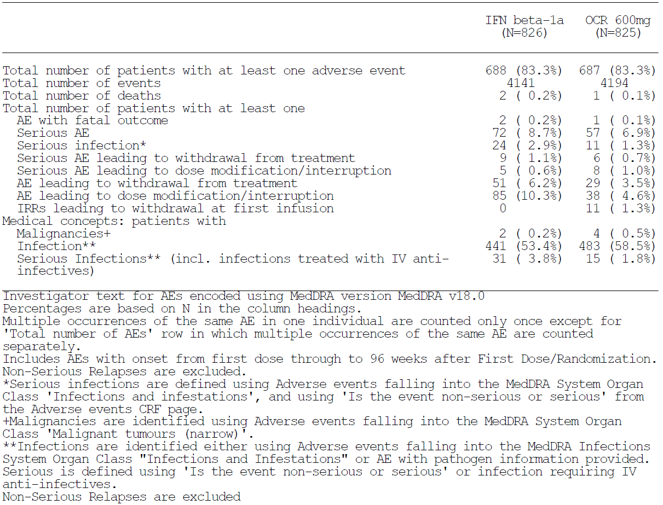

Table 77: Adverse events; Phase III PPMS controlled treatment population
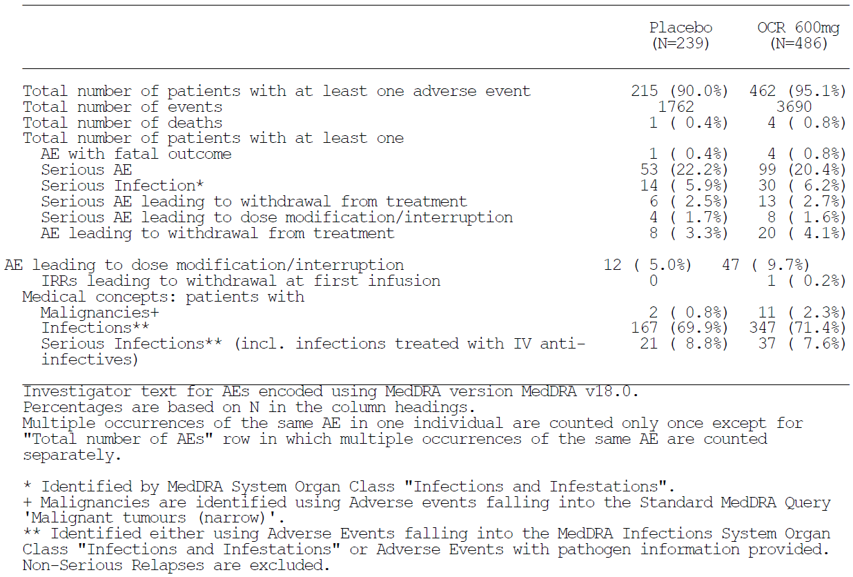
When all MS studies were pooled, and the AEs were expressed in terms of events per 100 PY, the number of AEs in ocrelizumab recipients was 254 per 100 PY (95% CI 249 to 258), including 77 AEs of infection per 100 PY, as shown in the table below. Event rates were higher when considering the controlled period of exposure, as shown in the subsequent tables. For the RMS studies, event rates were similar in the ocrelizumab and interferon β-1a groups, with a slightly higher number of AEs per 100 PY in the interferon β-1a group (296 versus 290 AE per 100 PY). For the PPMS study, event rates were similar in the ocrelizumab and placebo groups, with a slightly higher number of AEs per 100 PY in the placebo group (267 versus 261). Overall, this reflects an acceptable AE rate per 100 PY in the controlled studies, compared to active and inactive controls. (The high background rate of AEs in the control arms could make it difficult to detect tolerability issues from a broad comparison of total AE event rates, however, so it is important to consider individual types of events, as discussed in later sections).

Table 78: Adverse event profile in 100 patient-years – MS all exposure population (Pool B)
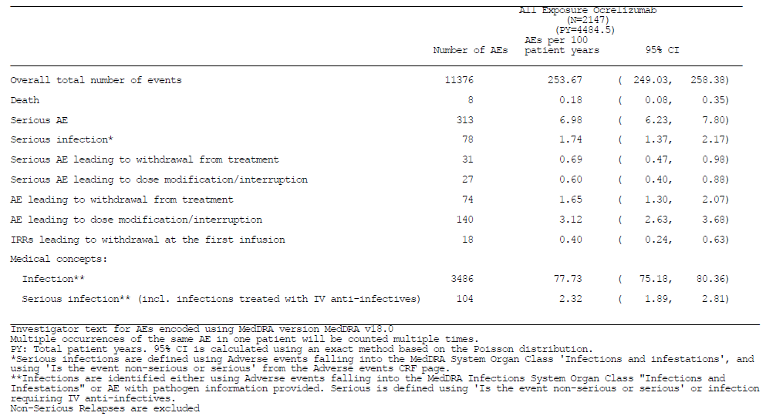

Table 79: AE profile in 100 PY; Phase III RMS controlled treatment population (Pool A) 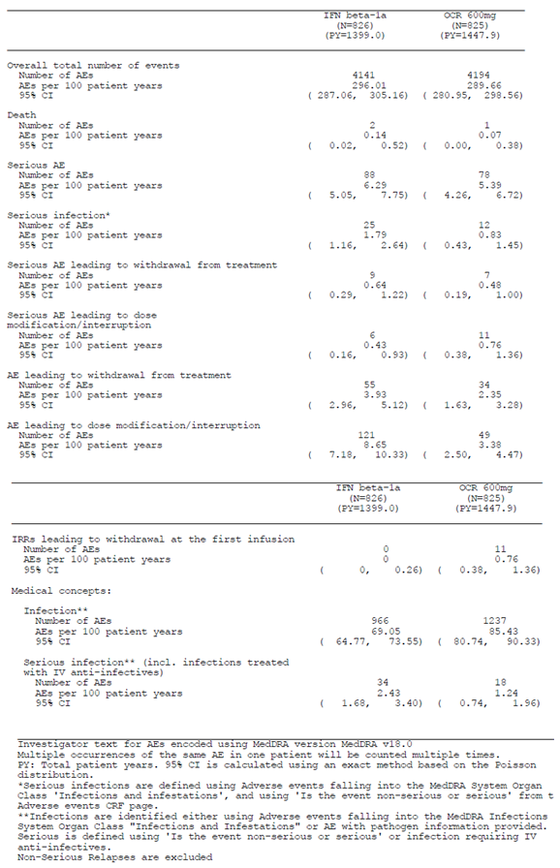

Table 80: AE profile in 100 patient-years; Phase III PPMS controlled treatment population
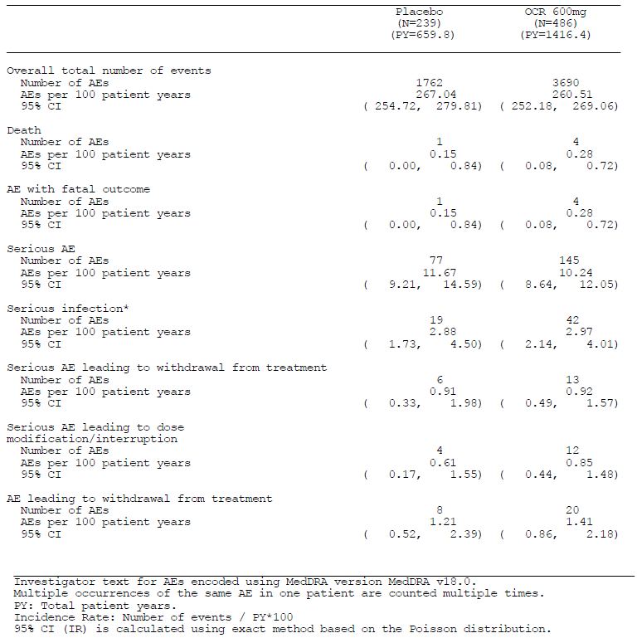

RA studies
The RA studies had unequal durations of follow-up, so the sponsor presented the pooled data in terms of AEs per 100 PY, as summarised in the table below. For the total RA pool, the event rates were broadly similar to those seen in the total MS pool (approximately 250 AEs per 100 PY). In the controlled RA pool (excluding open-label follow-up), event rates were substantially higher (approximately 370 AEs per 100 PY). A broadly similar pattern was observed in MS studies; this could reflect enrichment of the long-term follow-up groups with patients who tolerated the drug.
Compared to the MS population, event rates per 100 PY were substantially higher in the RA studies, even in the placebo control groups, reflecting the underlying diseases and concomitant treatments in this population. Unlike the MS studies, there was a clear (and statistically significant) excess of AEs in the ocrelizumab groups, compared to the placebo controls, 95% CIs for the AE rate per 100 PY did not overlap when comparing placebo to ocrelizumab, in either the low dose ocrelizumab pool (200 mg x 2, then 400 mg per cycle) or the high-dose pool (500 mg x 2, then 1000 mg per cycle).

Table 81: Overview of adverse events, RA controlled treatment population (Pool D)
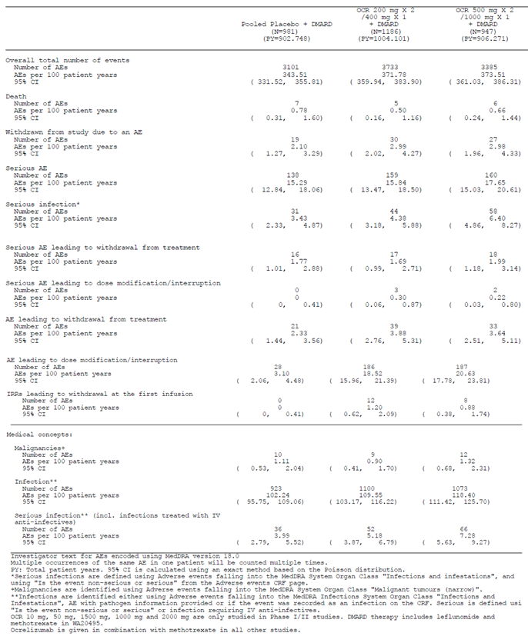

Table 82: Adverse events per 100 patient-Years, RA all exposure population (Pool E)
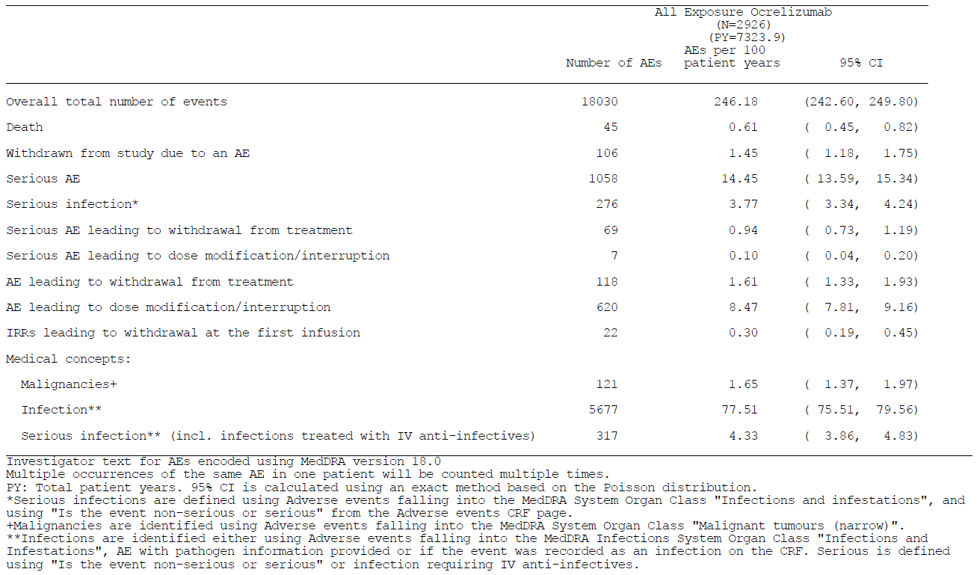

Types of adverse events

RMS studies
The most common AEs in the controlled RMS studies are summarised below, by System Organ Class (SOC). The ocrelizumab group had a mild excess of ‘Infections and Infestations’ and an increased incidence of ‘Injury, Poisoning and Procedural Complications’, relative to interferon β-1a, but it had less ‘General Disorders and Administrative Site Conditions’. This reflects, in part, the excess of infusion reactions with ocrelizumab and injection site reactions and flu-like symptoms with interferon β-1a, as shown in the subsequent table.

Table 83: AEs reported in ≥ 10% of patients in at least one group by SOC, Phase III RMS controlled treatment population (Pool A)
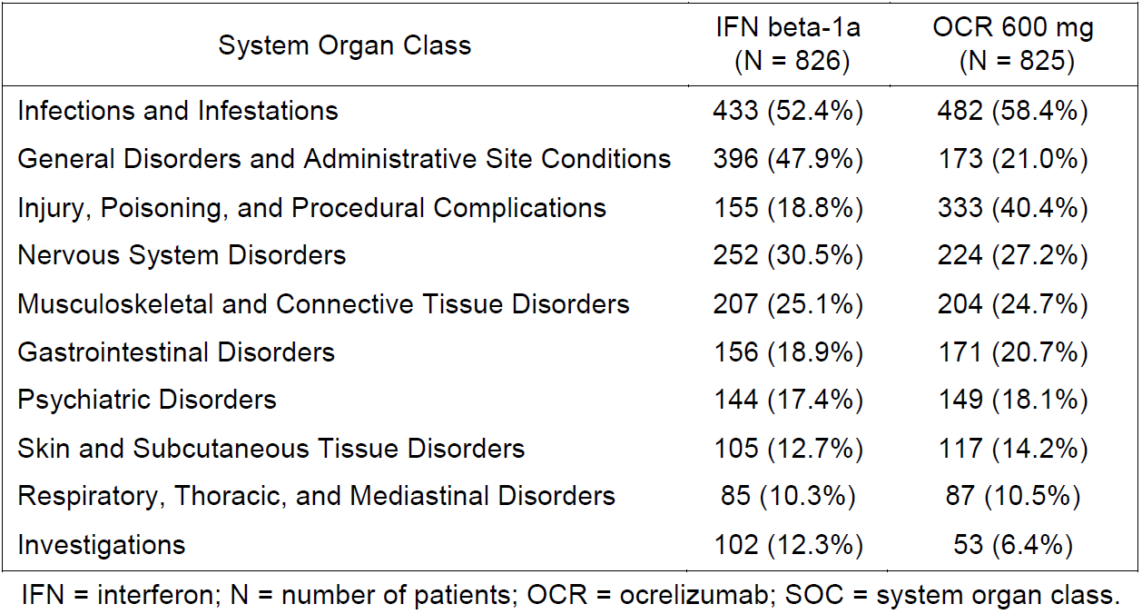
Individual AEs that were common in either treatment group are summarised below. Most individual types of AE occurred with a similar frequency across the two groups. After IRRs, which occurred in about a third of ocrelizumab recipients, the most marked differences between treatment groups were seen for symptoms known to be associated with interferon β-1a treatment (injection-site erythema and influenza-like illness). Most of the excess of infections in the ocrelizumab group could be accounted for by a higher incidence of upper respiratory tract infections and nasopharyngitis (more serious infections are considered separately, in later sections.)

Table 84: AEs reported in ≥ 2% of patients in at least one treatment group by preferred term, Phase III RMS controlled treatment population (Pool A)
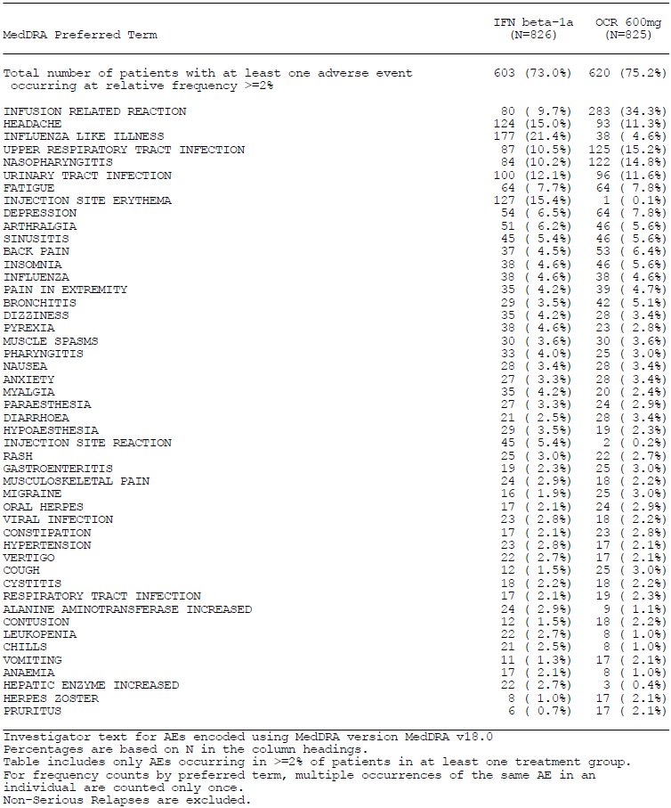

PPMS study
In the PPMS population, the overall incidence of AEs for each SOC was broadly similar in the ocrelizumab and placebo groups, but there was an excess of AEs in the ocrelizumab group related to ‘Injury, Poisoning and Procedural Complications’, which was largely due to IRRs. ‘Infections and Infestations’ were only marginally more common in the ocrelizumab group.
As noted in the RMS studies, infusion reactions were common in the ocrelizumab group (39.9% of subjects) – in this population, they were also quite common with the placebo infusion (25.5%), albeit with a clear excess in the active group. Upper respiratory tract infections were more common in the ocrelizumab group (ocrelizumab 10.9% versus placebo 5.9%), but nasopharyngitis occurred with an excess in the placebo group (ocrelizumab 22.6% verse placebo 27.2%). Urinary tract infections occurred with a similar frequency in each group, and most other individual AEs occurred with a similar incidence in the active and placebo groups. Depression was more common in the placebo group.

Table 85: Adverse events reported in ≥ 10% of patients in at least one treatment group by system organ class, Phase III PPMS controlled treatment population
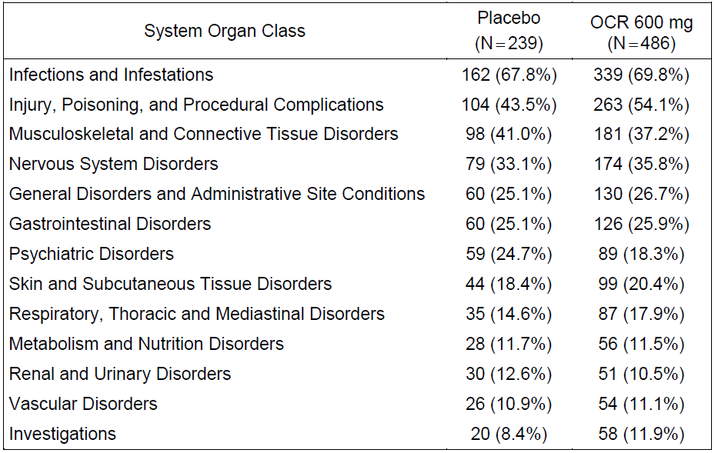

Table 86: Adverse events reported in ≥ 2% of patients by preferred term, Phase III PPMS controlled treatment population
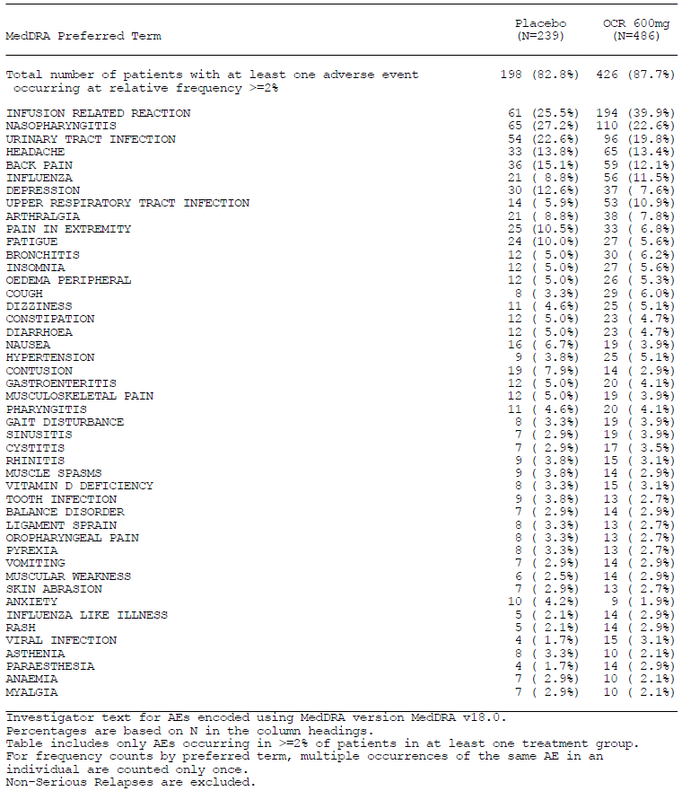

Table 87: Adverse events reported in ≥ 2% of patients by preferred term - Phase III PPMS controlled treatment population
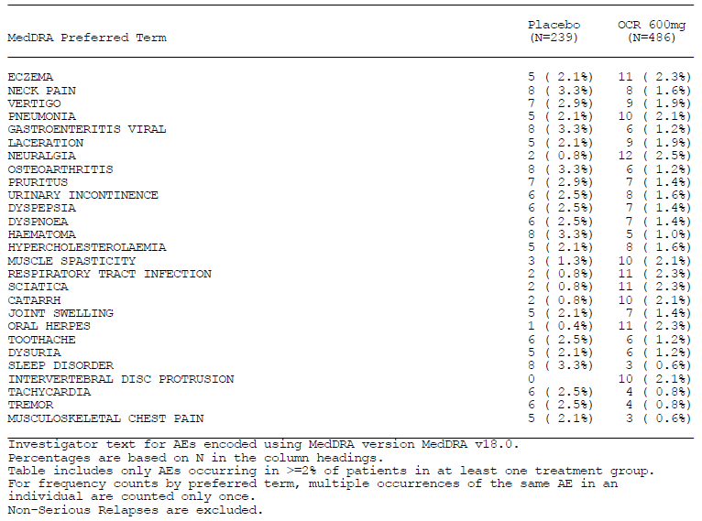

Table 88: Adverse events reported in ≥ 2% of patients by preferred term - Phase III PPMS controlled treatment population
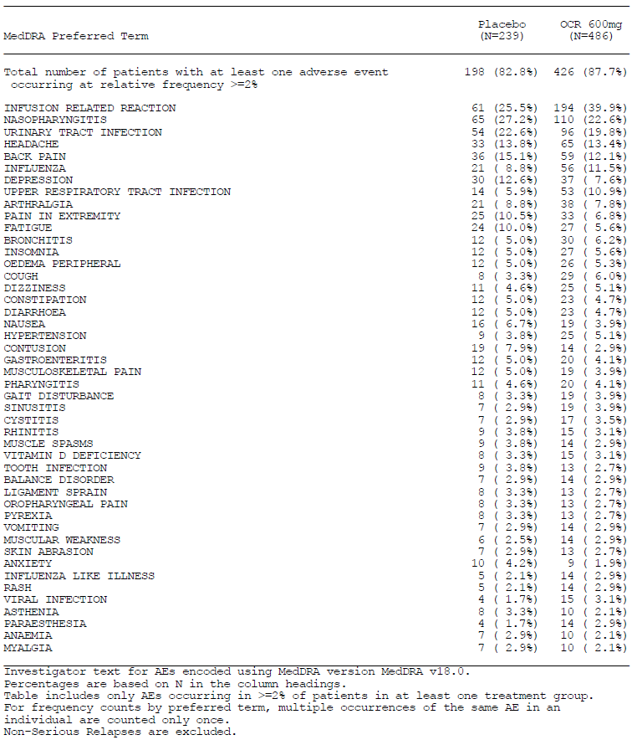

RA studies
The incidence of AEs in the RA population, grouped by organ class (SOC), is shown in the table below. Infusion reactions were common in ocrelizumab recipients, leading to an excess of AEs categorised under ‘Injury, Poisoning, and Procedural Complications’. There was also an excess of ‘Infections and Infestations’, but the excess event rate was small in terms of number of events per 100 PY.

Table 89: Common AEs (Rates per 100 PY) by SOC, RA controlled treatment (Pool D)
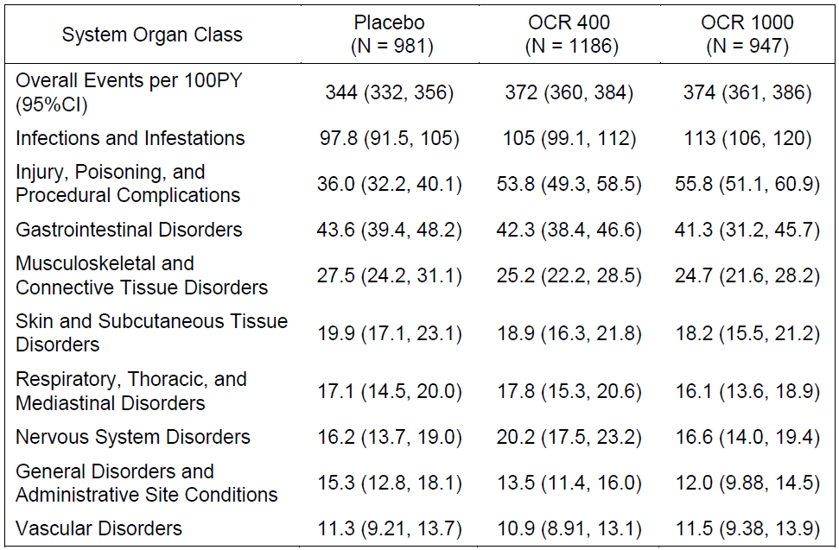
The sponsor did not initially provide a convenient summary table of common individual AEs in each treatment group, but instead provided a multi-page table of all AEs in the RA population. In response to a Clinical Question in the first round Clinical Evaluation Report, the sponsor has since presented the most common AEs in the RA studies in a more convenient format, reproduced below.
As the sponsor notes, only one AE occurred with a clear excess in the ocrelizumab groups: Infusion-Related Reactions, or IRRs, which were much more common with active treatment (placebo 11.0%, ocrelizumab 400 mg 23.8%, and ocrelizumab 1000 mg 29.4%). Other AEs in the RA population showed no clear imbalance between treatment groups.

Table 90: Adverse events reported in ≥ 2% of patients in placebo, ocrelizumab 400 mg or ocrelizumab 1000 mg treatment groups by system organ class and preferred terms. Pool D: Phase II and III RA controlled treatment population
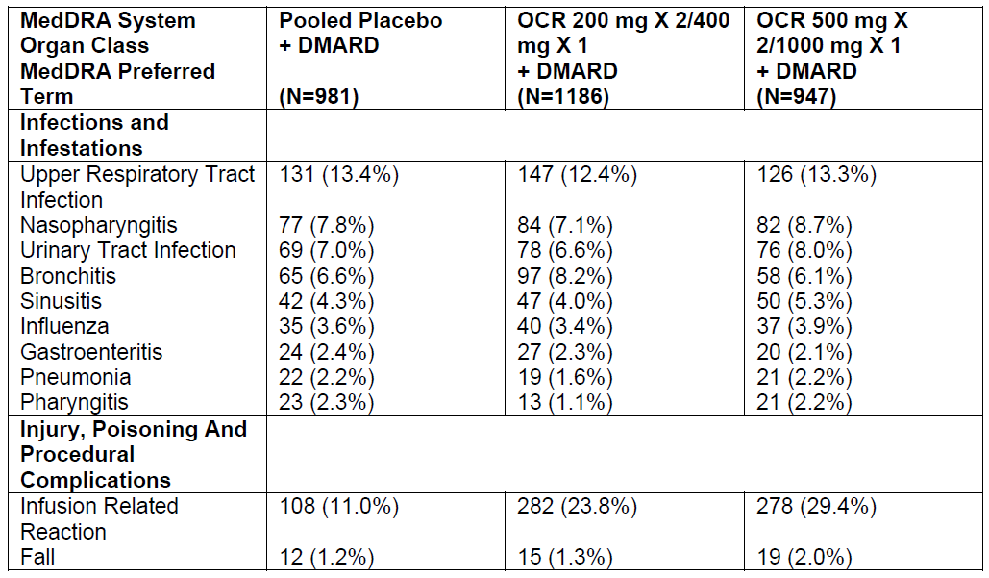

Table 91: Adverse events reported in ≥ 2% of patients in placebo, ocrelizumab 400 mg or ocrelizumab 1000 mg treatment groups by system organ class and preferred terms. Pool D: Phase II and III RA controlled treatment population
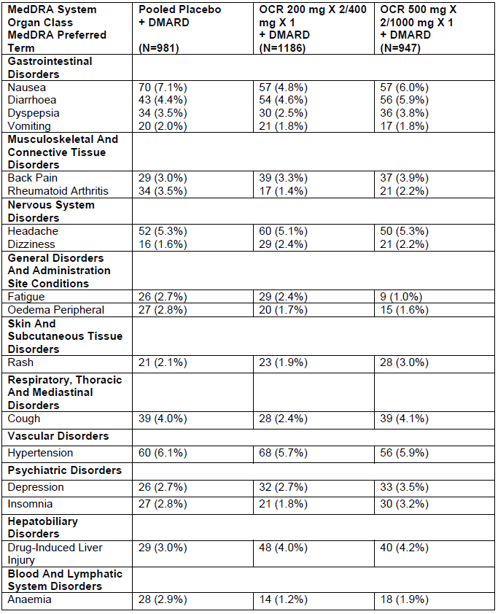

Treatment-related adverse events (adverse drug reactions)
The sponsor did not provide convenient summary tables of AEs that were thought by the investigator to be causally related to treatment. The Clinical Overview and the proposed PI listed AEs that occurred with an incidence of at least 2% and were more common with ocrelizumab than with comparator, classifying these as potential adverse drug reactions (ADRs). The ADRs identified with this approach are shown in the table below. Apart from IRRs, which were clearly related to active treatment with ocrelizumab, upper respiratory tract infections (URTIs) also appeared to be more common with ocrelizumab, and this was observed in both the RMS and PPMS studies, as shown below – in both studies, the excess incidence in URTIs was about 5%.

Table 92: ADRs associated with ocrelizumab (in RMS or PPMS) with an incidence of ≥ 2% and higher than the comparator
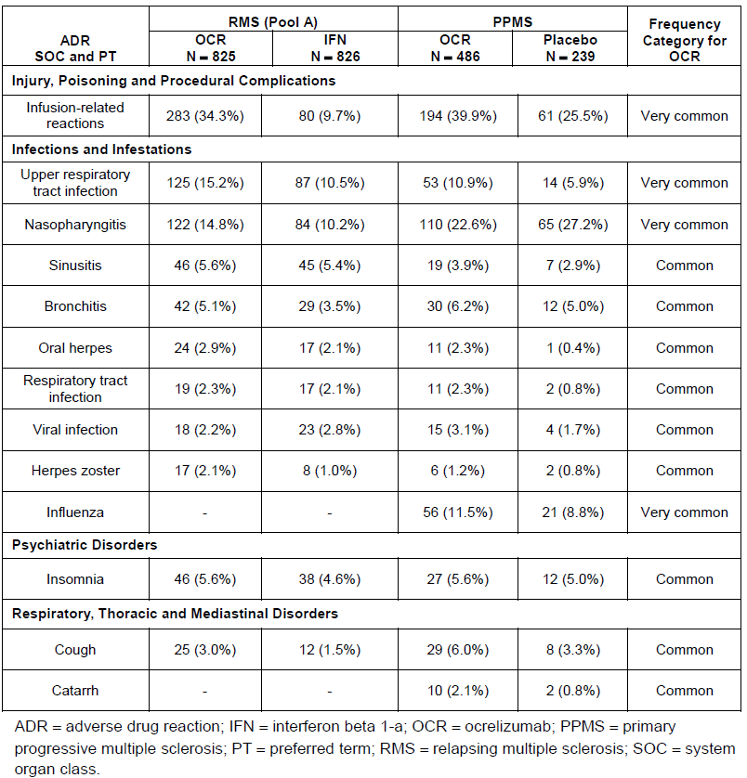

Serious adverse events

MS studies
Serious Adverse Events (SAEs) were relatively infrequent, and did not occur with an excess in the ocrelizumab groups. In the RMS studies, the proportion of patients reporting SAEs was similar between the IFN (8.7%) and ocrelizumab (6.9%) treatment groups. The most commonly reported SAE (≥ 1% of patients) by SOC was ‘Infections and Infestations’ (IFN 2.9% and ocrelizumab 1.3%), followed by ‘Nervous System Disorders’ (IFN 1.3% and ocrelizumab 1.0%), and ‘Injury, Poisoning and Procedural Complications’ (IFN 1.2% and ocrelizumab 0.7%).
When considered by SOC, there was no concerning pattern. In the IFN group, there were more reports of SAEs in the SOCs ‘Infections and Infestations’, (IFN 24 patients versus ocrelizumab 11) and ‘Injury, Poisoning, and Procedural Complications’ (IFN 10 patients versus ocrelizumab 6 patients). In the ocrelizumab group, there more reports of SAEs in the SOC ‘Hepatobiliary Disorders’, but this only amounted to an excess of 3 patients (IFN 3 patients versus ocrelizumab 6 patients).
By PT, there was no imbalance in any specific SAE except serious MS relapse, which was more common with IFN and is best considered as an efficacy endpoint (IFN 5 patients versus ocrelizumab 1 patient) and seizure (IFN 1 versus ocrelizumab 4 patients). There are no a priori reasons for suspecting ocrelizumab to increase the risk of seizures. There were no SAEs reported in ≥ 1% for any one PT in either group.

Table 93: Serious adverse events reported in ≥ 1% of patients by system organ class – Phase III RMS controlled treatment population (Pool A)
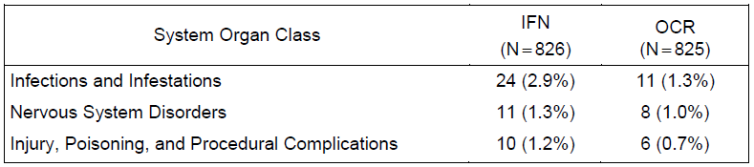
In the PPMS population, the proportion of patients reporting SAEs was higher, but the incidence was similar with placebo (22.2%) and ocrelizumab (20.4%). The most commonly reported SAE by SOC was ‘Infections and Infestations’, for which the incidence was similar between the placebo (5.9%) and ocrelizumab (6.2%) groups.

Table 94: Serious adverse event reported in ≥ 1% of patients by system order class, Phase III PPMS controlled treatment population
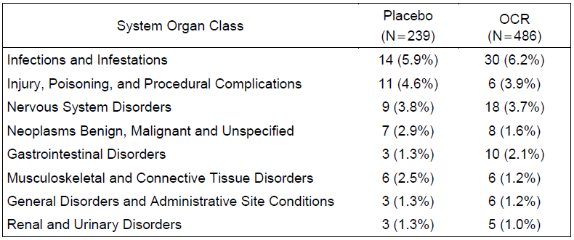

Table 95: Serious adverse events reported in ≥ 1% of patients by preferred term, Phase III PPMS controlled treatment population
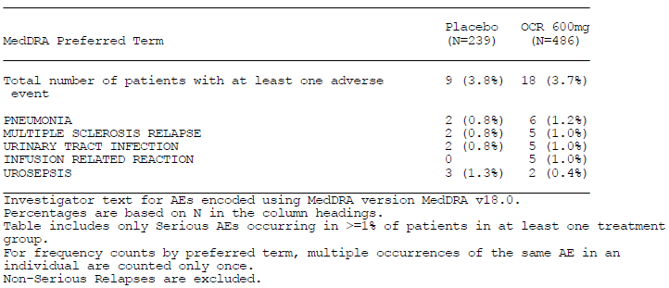

RA studies
The overall incidence of SAEs in the controlled RA data and the total RA population is shown above, but the individual types of SAE reported in the RA studies were not presented in a convenient format. Instead, a multi-page table listing all SAEs was submitted. The sponsor should be asked to provide a summary table of SAEs by organ class and common SAEs by descriptive label (preferred term).

MS studies
In the MS studies, 11 deaths were reported, including 8 deaths in patients who were receiving or had received ocrelizumab, and 3 in patients who had only received control therapies – placebo or interferon β-1a (exposure to control therapies only and to ocrelizumab was not equal, however, because of subjects switching to open-label follow-up). Expressed in terms of event rates per 100 PY, the mortality rate during ocrelizumab treatment was 0.18 (95% CI: 0.08, 0.35).

Table 96: Deaths in subjects who received ocrelizumab in MS studies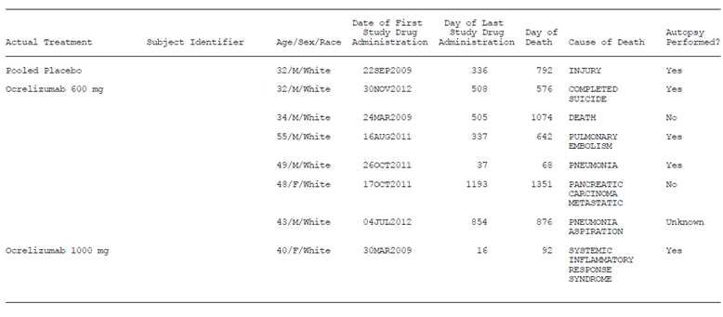
Note: the subject listed as having received placebo also received ocrelizumab.
In the PPMS studies, there were four deaths in ocrelizumab recipients, compared to only one in a placebo recipient, but it should be recalled that the randomisation ratio was 2:1, with more patients receiving ocrelizumab. The only apparent pattern is that two of the four ocrelizumab deaths were attributed to pneumonia. This could indicate a causal role of ocrelizumab, which was associated with increased incidence of upper respiratory tract infections in the MS and RA populations.

Table 97: Deaths on ocrelizumab during controlled treatment, RMS Studies
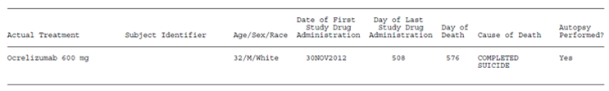

Table 98: Deaths during controlled treatment, PPMS studies
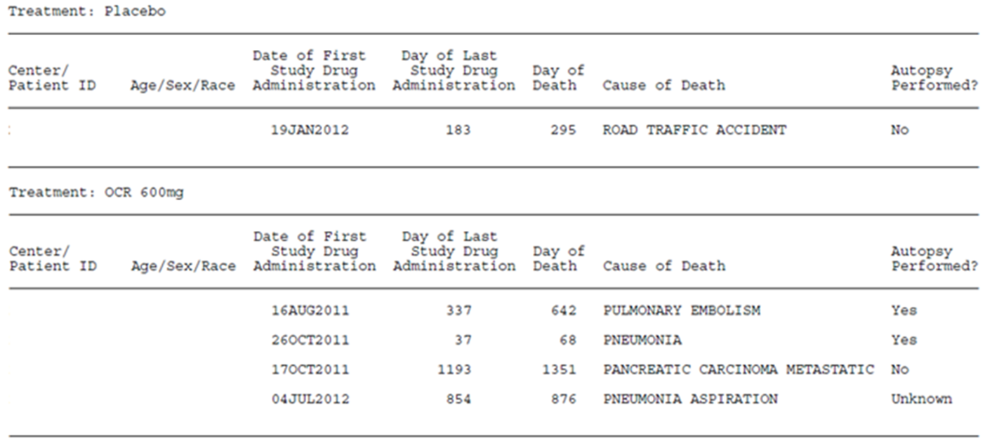

RA studies
In the RA studies, 45 deaths were reported, including deaths in placebo control groups. Expressed as a death rate per 100 PY, the mortality rates were similar across treatment groups, with no excess in the ocrelizumab groups: the event rate in the pooled placebo group was 0.78 per 100 PY (95% CI: 0.31, 1.60); in the ocrelizumab 400 mg group it was 0.50 (95% CI: 0.16, 1.16) and in the ocrelizumab 1000 mg group it was 0.66 (95% CI: 0.24, 1.44). In the pool of all patients who received ocrelizumab (Pool E), the death rate was 0.61 (95% CI: 0.45, 0.82).
As shown in the table below, a high number of deaths were attributed to pneumonia or sepsis. In some cases, the cause of death was listed as ‘Death’, and the sponsor should be asked to provide a revised table listing the actual cause where this is known or can be inferred.

Table 99: Listing of deaths in RA studies
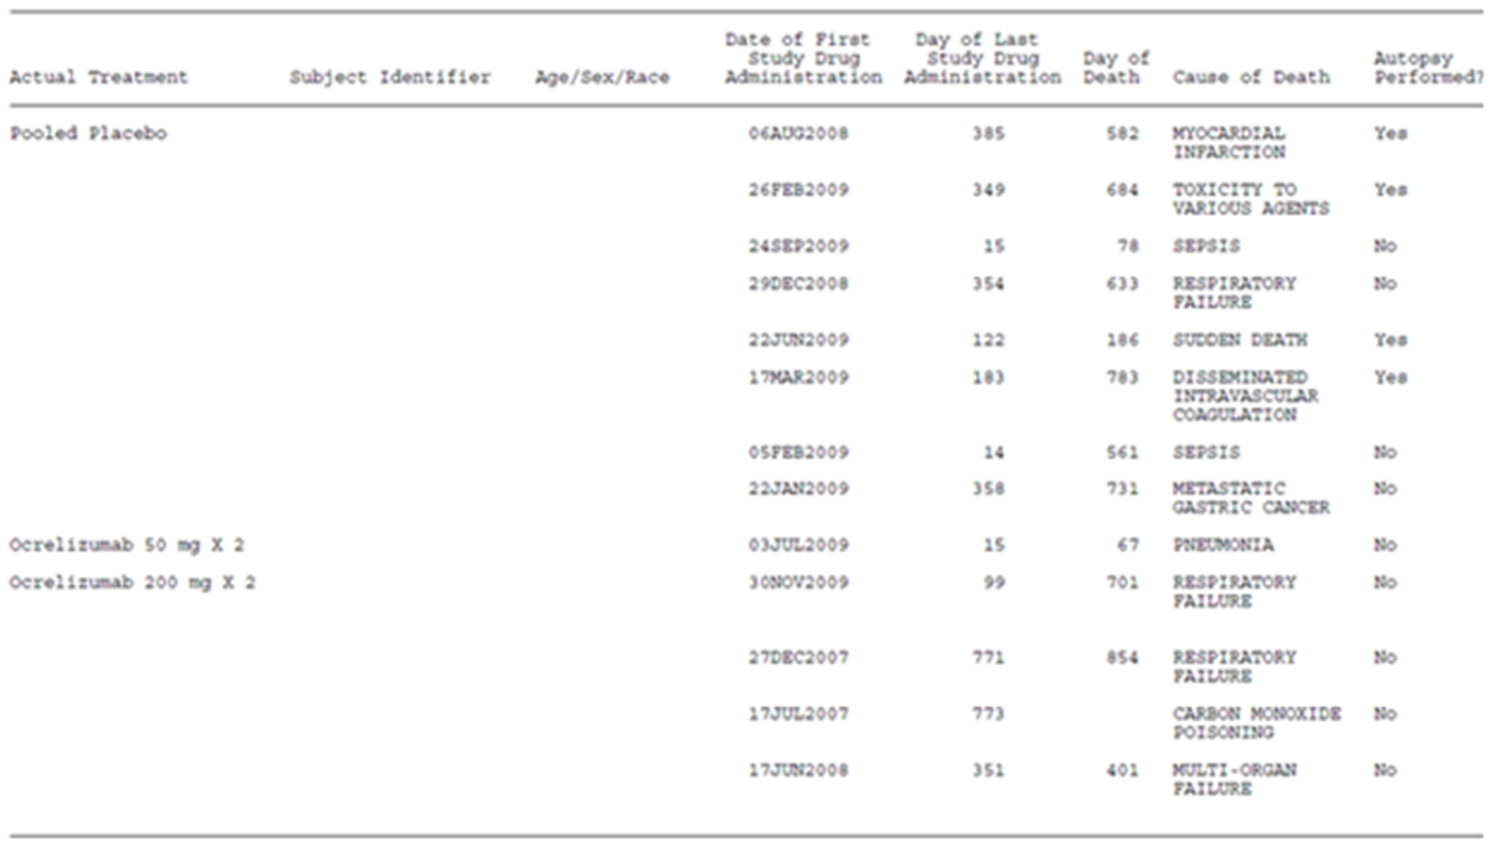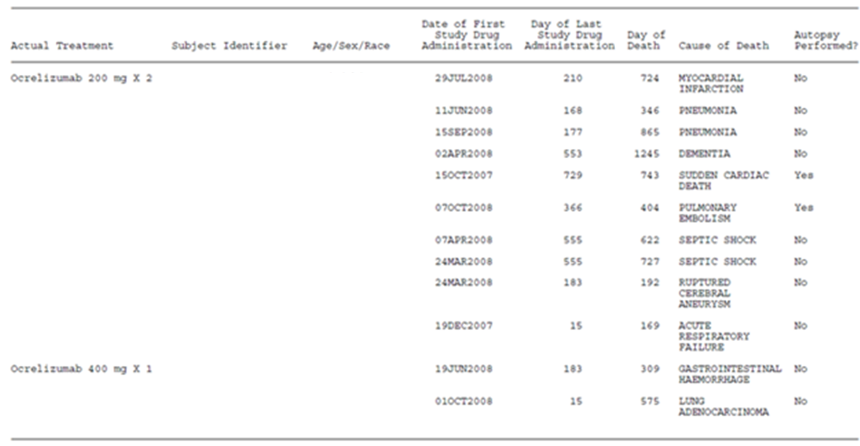

Table 100: Listing of deaths in RA studies
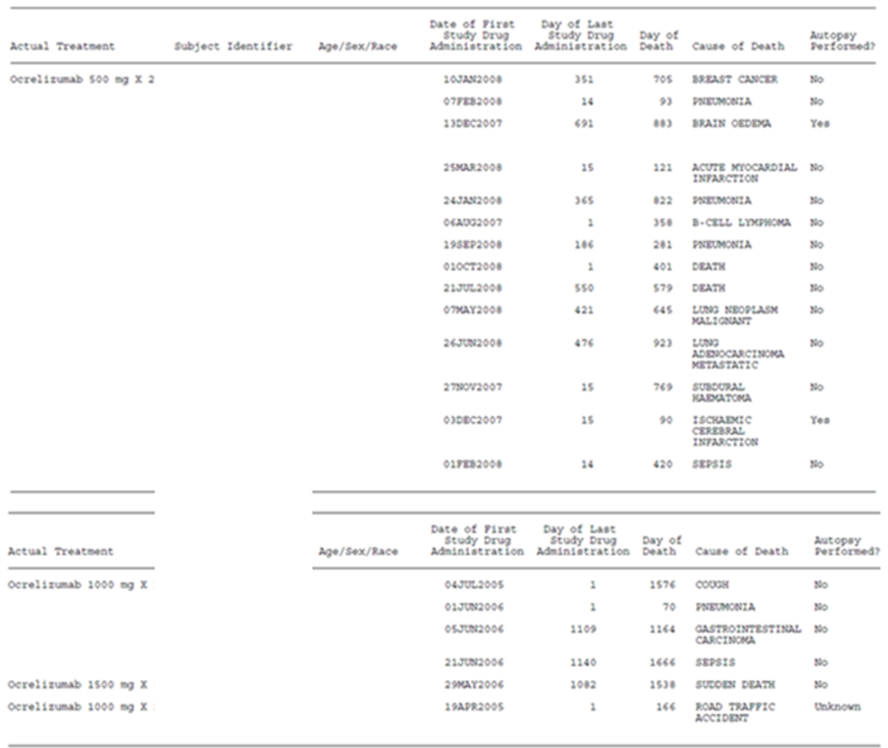

Discontinuation due to adverse events

MS studies
In the Phase III RMS controlled treatment population, the proportion of ocrelizumab recipients withdrawn from study treatment due to an AE was reasonably low, as shown in the table below (3.5%; 29 patients). Withdrawal due to AEs was more common in the pooled interferon recipients (6.2%, 51 patients). Among ocrelizumab recipients, the most common AEs leading to withdrawal were grouped in the SOC ‘Injury, Poisoning, and Procedural Complications’, which was entirely due to IRRs (1.3%; 11 patients). Other individual AEs were an infrequent cause of withdrawal for ocrelizumab recipients (≤ 0.3% of patients for individual preferred terms, ≤ 0.5% for SOCs). Among interferon recipients, influenza-like illness (ILI) was the most common AE leading to withdrawal (1.5%, 12 patients); this is a known tolerability issue with interferon treatment. In the broader pool of RMS patients, including open-label follow-up, the proportion of patients withdrawn from study treatment due to an AE was low (2.9%, 42 patients), and similar to the controlled treatment experience.
In the Phase III PPMS controlled treatment population, the incidence of AEs leading to withdrawal was broadly similar to that observed in the RMS population, as shown in the second table below. The incidence of AEs leading to withdrawal in the active ocrelizumab group was only slightly higher than that observed with placebo (ocrelizumab 4.1%, 20/486 patients, versus placebo 3.3%, 8/239 patients). IRRs were a less common cause of withdrawal, and discontinuations due to IRRs occurred with a similar incidence in the active and placebo groups (0.4% in each group).

Table 101: Adverse events leading to discontinuation of study treatment by body system class and preferred term, Pool A: Phase III RMS controlled treatment population
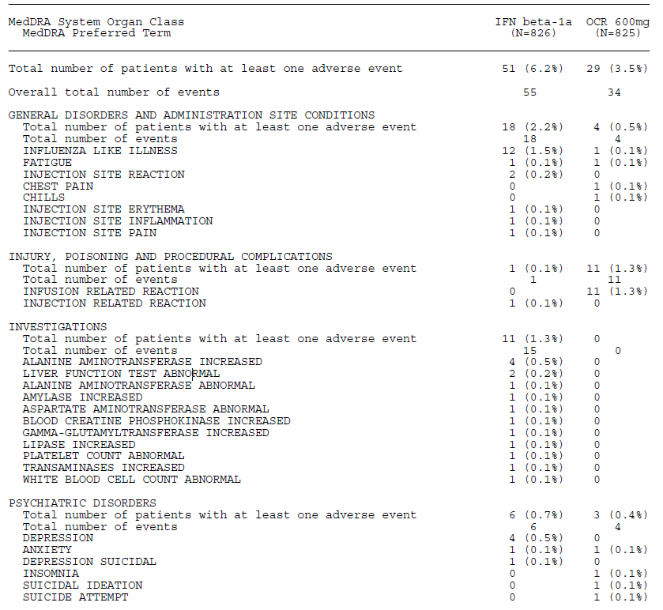

Table 102: Adverse events leading to discontinuation of study treatment by body system class and preferred term, Pool A: Phase III RMS controlled treatment population
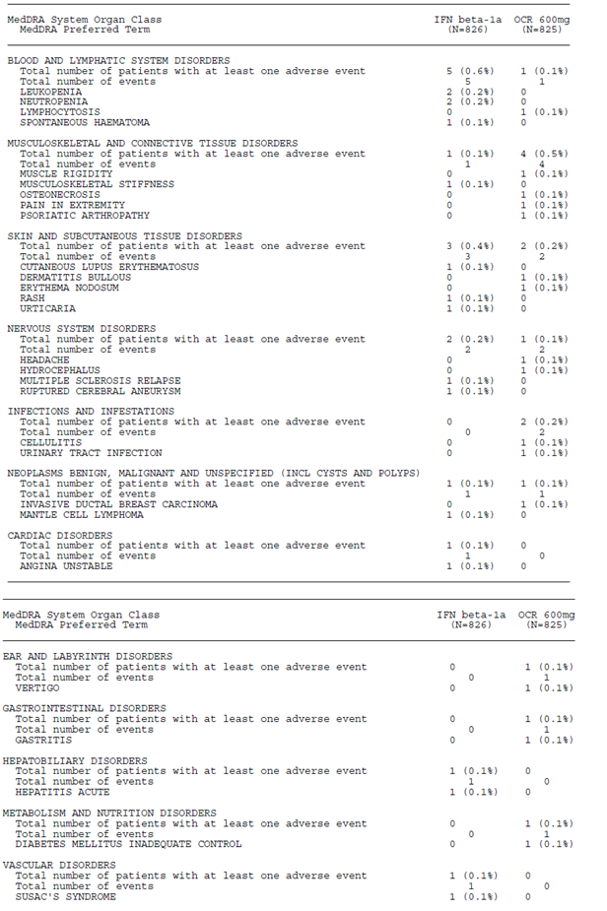

Table 103: Adverse events leading to discontinuation of study treatment by body system class and preferred term; Phase III PPMS controlled treatment population
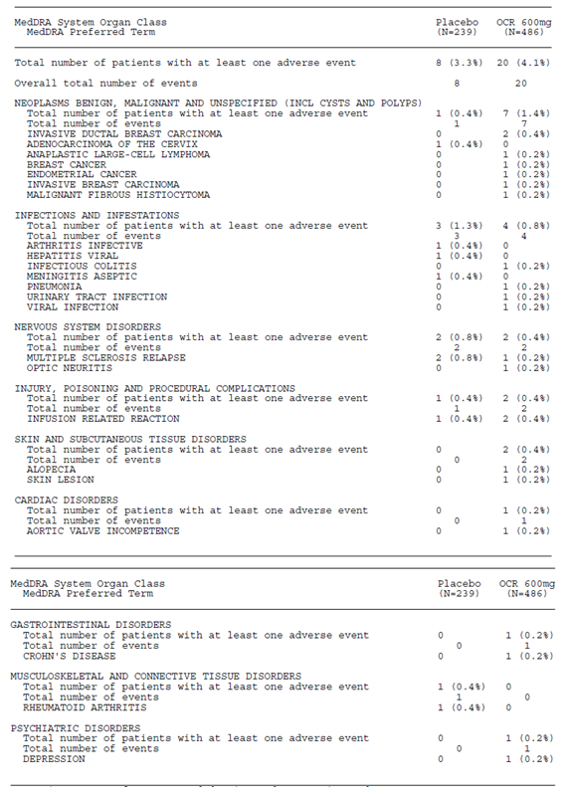

RA studies
Discontinuations due to AEs in the RA population were not presented in a convenient format, but in a 10 page table unsuitable for inclusion in this report. In the RA Controlled Treatment Population (Pool D), the proportion of patients withdrawing due to an AE was generally low, but it was higher in the ocrelizumab groups (3.0% and 3.4% of patients in the ocrelizumab 400 mg and ocrelizumab 1000 mg groups, respectively) compared with placebo (2.1%). In the total RA pool, including open-label and uncontrolled exposure (Pool E), 3.8% of patients discontinued from study treatment due to an AE.

Laboratory tests
Abnormal laboratory abnormalities in the RMS controlled treatment population are listed in the table below, and abnormalities in the PPMS controlled treatment population are listed in the subsequent table. Several abnormalities were observed in clinical chemistry or haematological parameters, but the incidence with ocrelizumab was generally similar to that observed with interferon, or in some cases lower, as discussed in the sections below. The incidence of laboratory abnormalities was also similar with ocrelizumab in comparison to placebo. Most of the abnormalities were isolated readings, rather than sustained abnormalities. Exceptions included a fall in immunoglobulin levels, which was seen in ocrelizumab recipients, as well as the expected B cell depletion (see subsection: Haematology, below).

Table 104: Post-Baseline laboratory abnormalities, Phase III RMS controlled treatment population (Pool A)
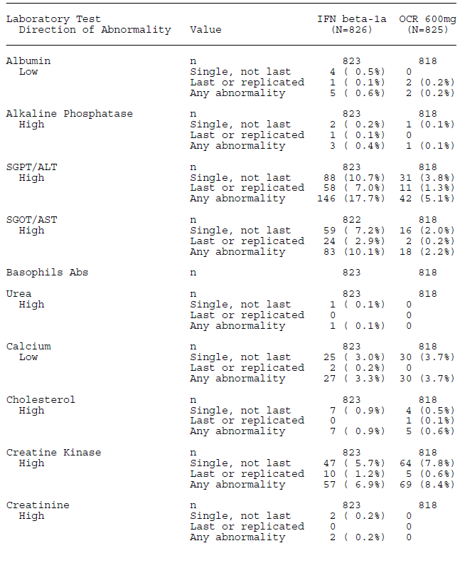

Table 105: Post-Baseline laboratory abnormalities, Phase III RMS controlled treatment population (Pool A)
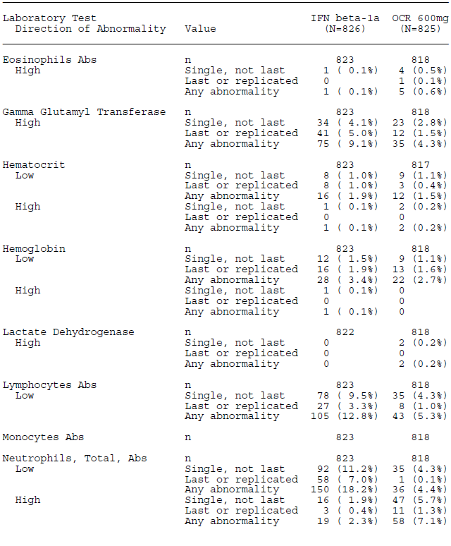

Table 106: Post-Baseline laboratory abnormalities, Phase III RMS controlled treatment population (Pool A)
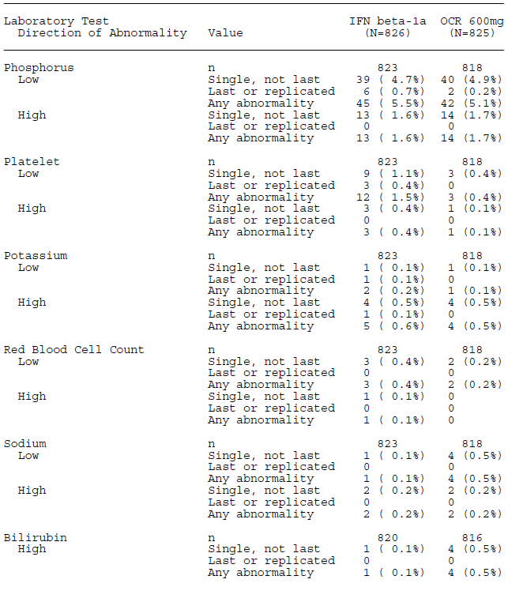

Table 107: Post-Baseline laboratory abnormalities, Phase III RMS controlled treatment population (Pool A)
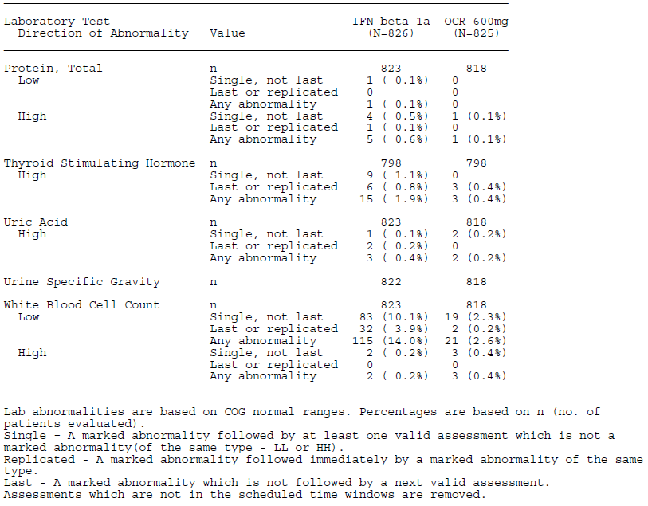

Table 108: Post-Baseline laboratory abnormalities, Phase III PPMS controlled treatment population
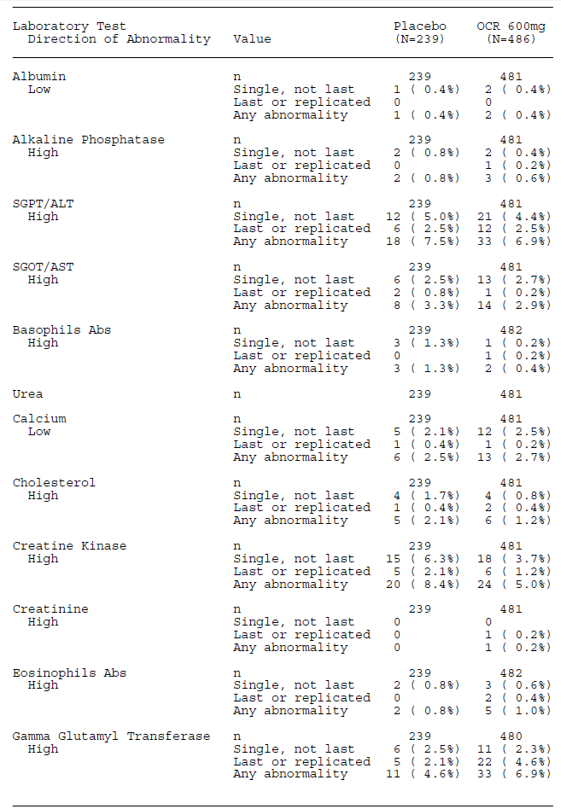

Table 109: Post-Baseline laboratory abnormalities, Phase III RMS controlled treatment population (Pool A)
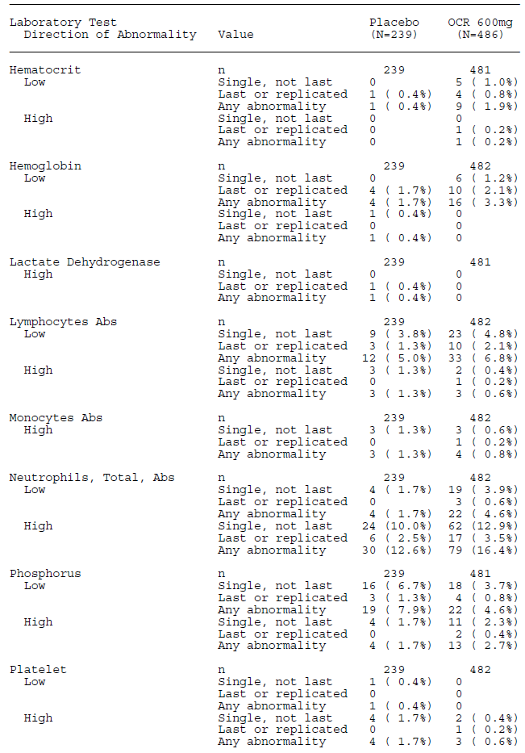

Table 110: Post-Baseline laboratory abnormalities, Phase III RMS controlled treatment population (Pool A)
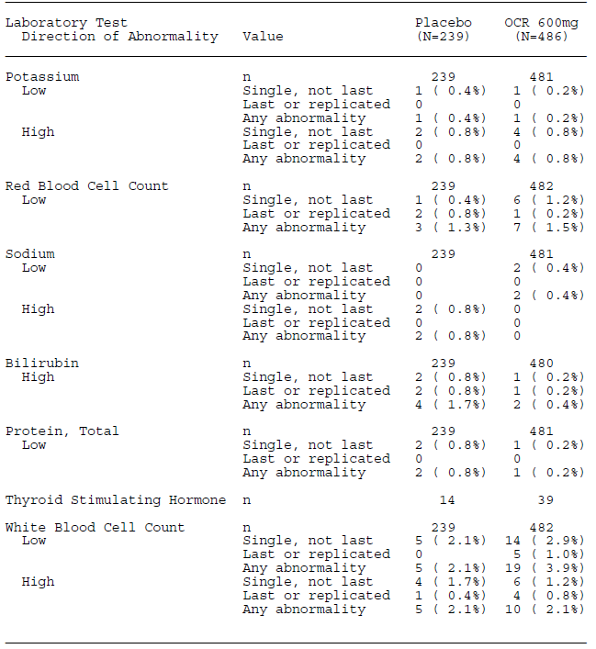

Liver function

MS studies
No strong signals emerged from the safety data suggesting significant hepatic toxicity. There were no cases fulfilling Hy’s Law criteria (simultaneous elevation of aminotransferases > 3 x ULN and total bilirubin > 2 x ULN), during the controlled treatment period. In the RMS population, the incidence of abnormal liver function tests (LFTs) was lower with ocrelizumab than with interferon (as an AE, elevated liver enzymes were reported in 2.9% of ocrelizumab recipients versus 0.4% of ocrelizumab recipients in the Phase III controlled pool of RMS subjects).
In the PPMS population, the incidence of abnormal LFTs was higher in placebo recipients than in ocrelizumab recipients, as shown in the table above.

RA studies
As shown in the table excerpts below, there were no signals in the controlled phases of the RA studies to suggest a significant excess of abnormal LFTs in ocrelizumab recipients, compared to placebo recipients. Also, there were no cases of Hy’s Law reported.

Table 111: Laboratory abnormalities related to LFTS, Controlled RA Studies
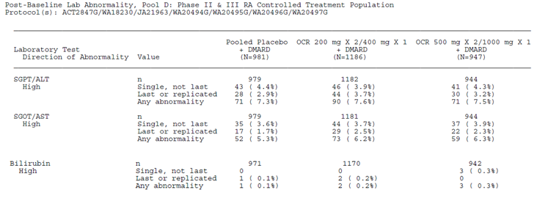

Kidney function

MS studies
The incidence of high urea or high creatinine was low (no ocrelizumab recipients in the RMS controlled data pool, and only one patient in the PPMS data pool.)

RA studies
In the RA studies, the incidence of AEs related to abnormal creatinine levels was also low, as shown in the table excerpt below.

Table 112: Laboratory abnormalities related to creatinine, controlled RA studies
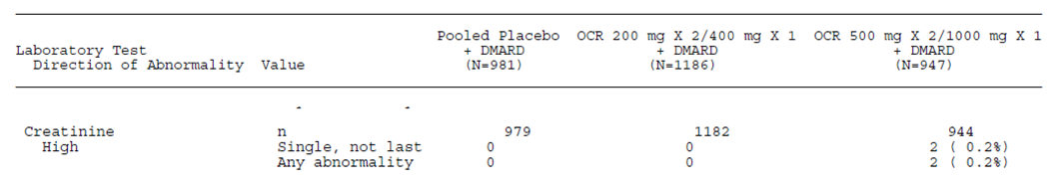

Other clinical chemistry
No concerning signals were observed during routine monitoring of electrolytes and other clinical chemistry parameters in the MS or RA studies.

Haematology

MS studies
Marked decreases in total white blood cell counts were observed during treatment in the RMS population, but were more common with interferon (IFN 14.0% and ocrelizumab 2.6% of patients). A similar pattern was observed with decreases in lymphocytes (IFN 12.8% and ocrelizumab 5.3%). The proportion of patients with marked decreases in neutrophils was also higher in the interferon group (18.2%) than in the ocrelizumab group (4.4%). In most ocrelizumab recipients who showed a decrease in neutrophils, these were isolated laboratory abnormalities, with only 0.1% of patients showing repeated decreases in neutrophils. In the interferon group, by contrast, 7.0% of patients had marked decreases in neutrophils that were shown again on repeat testing.
In the PPMS population, a higher proportion of ocrelizumab recipients experienced marked decreases in white blood cells, compared to placebo recipients (19 patients (3.9%) versus 5 patients (2.1%)). A similar excess of marked decreases was noted for lymphocytes (6.8% versus 5.0%) and for neutrophils (4.6% verse 1.7%). A total of 0.6% of ocrelizumab-treated patients had markedly decreased levels of neutrophils that were replicated, compared to no patients in the placebo group.
Immunoglobulin levels showed falls with ocrelizumab treatment, which is potentially consistent with the depletion of B cells but could reflect a response to exogenous immunoglobulins. The observed falls are unlikely to have been of major clinical significance. The pattern was similar in the RMS and PPMS populations; the table below shows the pooled results in both populations. IgM showed the greatest fall, with a median reduction of 47% in the pooled MS population from baseline to Week 192; decreases in IgG and IgA were smaller, with median decreases of 16% and 12% by Week 192, respectively.

Table 113: Mean levels of immunoglobulins at baseline and Week 192; Phase III MS all exposure (Pool B excluding Phase II)
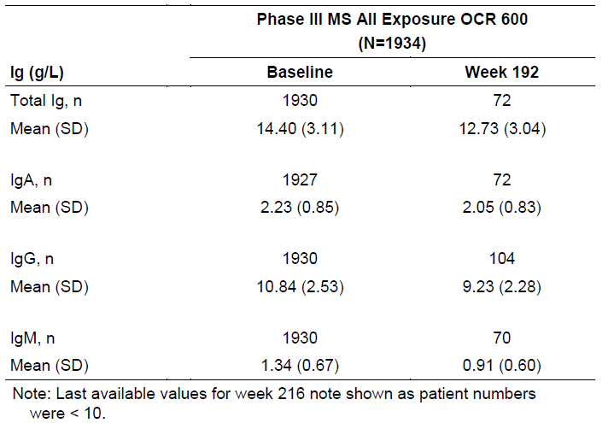
The proportion of patients with immunoglobulin levels below the lower limit of normal (LLN) was clearly elevated in ocrelizumab recipients, compared to interferon β-1a recipients in the RMS studies and placebo recipients in the PPMS study, but this information was not displayed in a convenient table. In the RMS population, the proportion of patients with IgM < LLN (0.4 g/L) was 0.1% at baseline and increased to 16.5% at Week 96. The proportion of patients with IgG or IgA < LLN (IgG LLN: 5.65 g/L, LLN IgA: 0.7 g/L) at Week 96 was 1.5% and 2.4% respectively. In the PPMS population, similar observations were made: the proportion of patients with IgM < LLN (0.4g/L) was 0.2% at baseline and increased to 15.5% at Week 120; the proportion of patients with IgG or IgA < LLN at week 120 was 1.1% and 0.5%, respectively.
The sponsor also monitored antibody titres to common bacterial and viral pathogens, including S. pneumonia, mumps, rubella, and varicella zoster. Ocrelizumab did not appear to have an effect on specific humoral immunity to these antigens, and the proportions of patients with positive antibody titres were similar to the proportions at baseline.
Overall, there does not appear to be a major haematological effect of ocrelizumab apart from the B cell depletion that is intrinsic to its mode of action. Some patients may show a fall in other white cell counts, and most patients can be expected to show a fall in immunoglobulin levels. There are potential safety issues arising from B cell depletion and low immunoglobulin levels, with the potential for immunosuppression leading to opportunistic infections or malignancies, but these issues are considered separately.

RA studies
In the RA studies, small decreases in IgA, IgG, and larger decreases in IgM were observed following treatment with ocrelizumab, and the incidence of Ig levels below the LLN was higher in ocrelizumab recipients. At Week 48 in the placebo, OCR 400 mg, and OCR 1000 mg groups, respectively, the incidence of levels below LLN was:
- IgA: 0.3%, 1.0%, and 1.1%
- IgG: 0.4%, 1.8% and 1.8%
- IgM: 1.0%, 10.8%, and 8.6%%

Anti-drug Antibodies

MS studies
Treatment-induced anti-drug antibodies (ADA) were only infrequently detected during the controlled treatment period in both the RMS (0.4%) and PPMS (1.9%) populations. Of the ADA-positive patients, only two tested positive for neutralizing antibodies to ocrelizumab (antibodies that blocked the functional effect of ocrelizumab).

RA studies
During the placebo-controlled periods of the studies, the incidence of ADAs was low (below 5%) and similar between placebo and OCR groups in all studies. There was no apparent increase in ADA incidence due to OCR treatment.

Vital signs and Electrocardiograph (ECG)

MS studies
Across all MS studies, no concerning signals or patterns were noted for changes in vital signs or physical examination findings in ocrelizumab treated patients.
Events classified in the ‘Cardiac Disorders’ SOC were reported in 2.7% (59 patients) of all patients exposed to ocrelizumab (Pool B). No consistent patterns were observed, and no events were suggestive of QT prolongation.

RA studies
No concerning signals were noted in vital signs and physical examination findings when comparing ocrelizumab recipients with placebo recipients. In the total exposure pool, consisting of 7324 PY of exposure, 257 events (3.51 events per 100 PY) were assigned to the ‘Cardiac Disorders’ SOC. No events were suggestive of QT prolongation.

Post-marketing experience
There is no available post-marketing information on the safety of ocrelizumab.

Safety issues with the potential for major regulatory impact

Liver toxicity
There is currently no evidence suggesting that ocrelizumab poses a substantial risk of hepatotoxicity.

Haematological toxicity
Ocrelizumab produces B cell depletion, with associated falls in immunoglobulin levels, particularly IgM. These effects are intrinsic to its mode of action, and may increase the risk of infections. There is no evidence that ocrelizumab produces one marrow suppression or significant cytopaenias, apart from the expected depletion of B cells.

Serious skin reactions
The incidence of infusion-related reactions included some reversible skin changes. In the RMS population, the incidence of cutaneous symptoms during IRRs was much higher in the ocrelizumab group (58.7% versus 12.5% with ocrelizumab-placebo), with pruritus (30% of patients) and rash (30% of patients) reported most commonly. Across the overall MS study program, however, there was no evidence of a significantly heightened risk of serious, persistent skin reactions.

Cardiovascular safety
There is currently no evidence suggesting that ocrelizumab poses a serious risk of cardiological toxicity, but the infusion of monoclonal antibodies can cause anaphylaxis in a small proportion of patients, so facilities for cardiac resuscitation should be available during ocrelizumab infusions.

Unwanted immunological events
The use of ocrelizumab is associated with infusion-related reactions, as discussed below. IRRs were the most frequently reported AE and occurred with a clear excess in ocrelizumab recipients. Most were Grade 1 and 2 in intensity, and there were no fatal IRRs or hypersensitivity reactions. The highest incidence of IRRs occurred with the first ocrelizumab infusion, and the incidence decreased with subsequent dosing. Overall, IRRs appeared to be manageable with an approach consisting of prophylactic steroids and antihistamines, adjustments of the infusion rate in susceptible individual, and symptomatic treatment.

Other safety issues

Infusion-related reactions (IRRs)
In the pivotal RMS studies, IRRs occurred more commonly in patients treated with ocrelizumab than in interferon β-1a recipients, who received ocrelizumab placebo infusions in a double-dummy design (IFN 9.7% of patients and ocrelizumab 34.3% of patients). The higher incidence of IRRs with active ocrelizumab was most evident with the first infusion (IFN 6.5% versus ocrelizumab 27.5%), but it persisted for all infusions.
These IRRs occurred despite the fact that, about 30 minutes prior to every ocrelizumab infusion, patients were also administered 100 mg IV methylprednisolone (or an equivalent dose of alternative steroid), as well as other optional pre-medication treatments, to lower the risk of IRRs.
Most IRRs in were of Grade 1 or 2 in intensity (IFN 98.8% and IFN 92.6% of patients with IRRs). Grade 3 IRRs were reported in only one patient in the IFN group (0.1%), compared with 20 patients (2.4%) in the ocrelizumab group.
Figure 15: Percentage of patients with ≥ 1 IRR by infusion, Phase III RMS controlled treatment
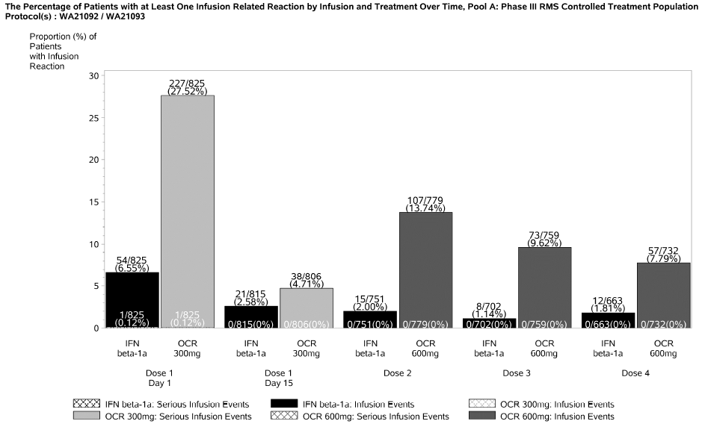
Individual AEs classified as IRRs are summarised in the table below: symptoms primarily included cutaneous and respiratory reactions.

Table 114: Infusion related reactions and symptoms overall and by infusion, RMS, Pool A
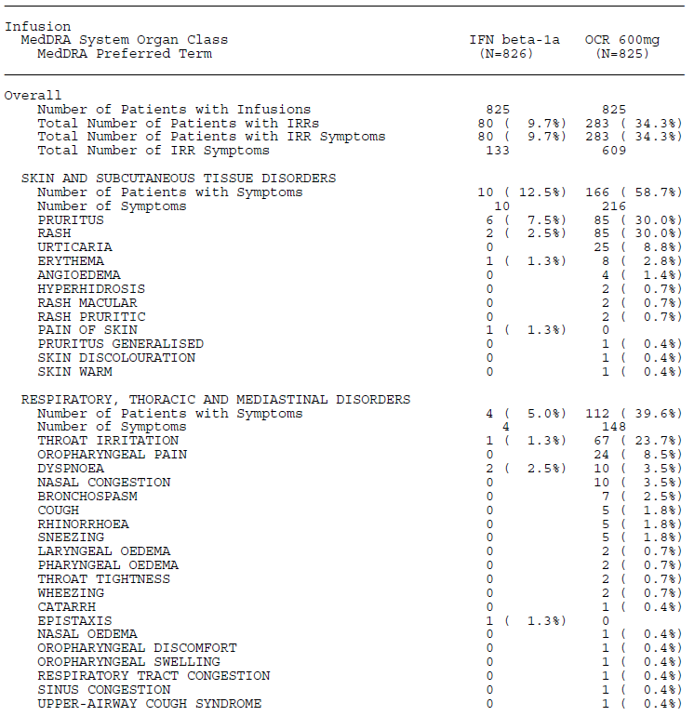
Similar findings were reported in the PPMS study. IRRs occurred more commonly in patients treated with ocrelizumab than in those receiving placebo (placebo 25.5% verse ocrelizumab 39.9% of patients). Again, the higher incidence of IRRs in ocrelizumab recipients was most evident at the first infusion compared with placebo (placebo 12.1%% versus ocrelizumab 27.4%). Comparing the two MS populations, there was no consistent differences between the incidence of IRRs by cycle, even though the PPMS study administered all 600mg dose cycles as two separate 300mg doses, whereas the RMS studies split the dose for the first cycle only.

Table 115: Incidence and severity of IRRs for single infusion versus divided dose regimens
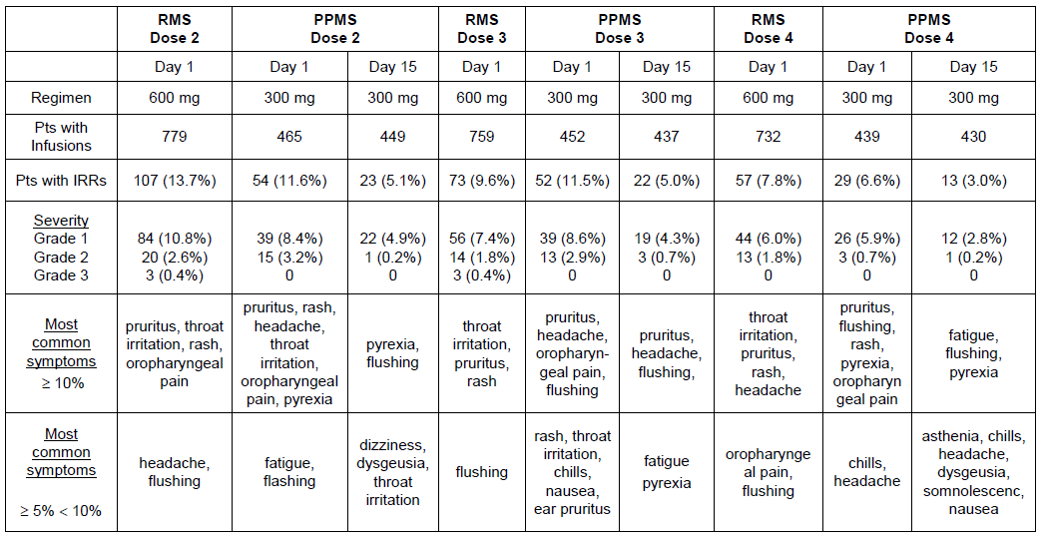

Safety in special populations
No studies have specifically assessed safety in special populations such as extremely young or old patients, or subjects with substantial renal or hepatic impairment. Two broad populations of subjects have been assessed: MS subjects with mild-to-moderate disability and a range of MS subtypes; and RA subjects receiving concomitant immunosuppressive agents.
Safety in the RA population was inferior to that seen in the MS population, with an excess of serious opportunistic infections, which is likely to reflect, in part, the concurrent use of immunosuppressant agents. It could also reflect an additional susceptibility to adverse events related to the underlying RA.
Within the MS population, no concerning safety signals were found in an assessment of safety data based on age, gender and concomitant disease including diabetes.

Safety related to drug-drug interactions and other interactions
No substantial PK interactions are expected, but interventions removing antibodies from circulation, such as plasma exchange, could reduce the efficacy of ocrelizumab.
The experience in the RA population suggests that synergistic immunosuppression could be a substantial problem, leading to an increased risk of infections, including serious and fatal infections.
Interactions between ocrelizumab and vaccines have not been studied, but are a focus of on-going investigation by the sponsor.

Infections

MS studies

Overall infections
For the RMS population, the sponsor listed all AEs classified as infections in a table, ranking AEs by frequency, reproduced below. URTIs and nasopharyngitis were both more common with ocrelizumab than with interferon, with an excess of about 5% for each.

Table 116: Infections by body system and preferred term, Pool A: Phase III RMS controlled treatment population
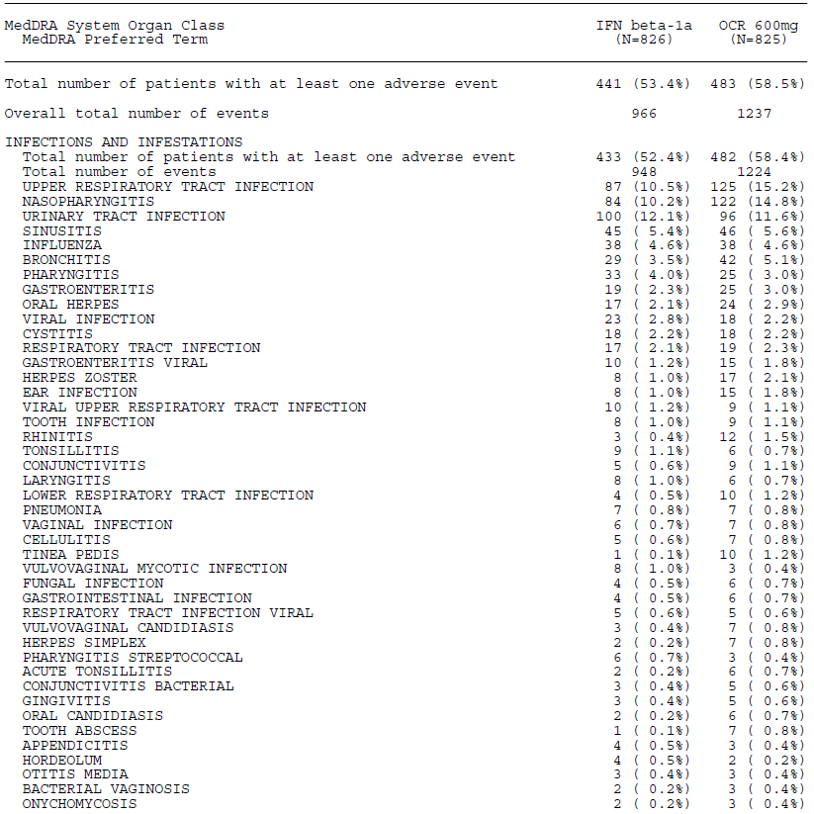
The sponsor also analysed infective AEs by grouping them into clinically meaningful ‘baskets’ of related infections. This confirmed the excess of URTIs and URTI-related infections in ocrelizumab recipients, as shown below. A mild excess of some other infections, including herpes infections, was also observed.

Table 117: Infections by ‘Basket’; Phase III RMS controlled treatment population (Pool A)
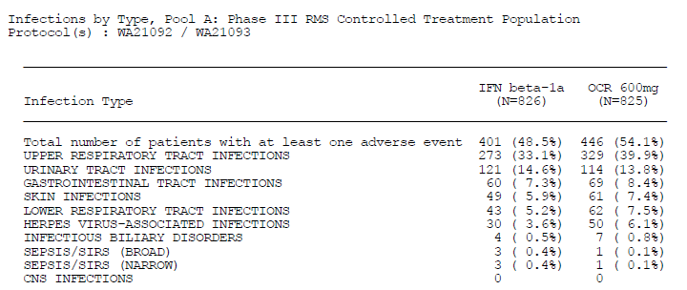
In the PPMS population, the proportion of patients experiencing an infection was high, but similar between placebo and ocrelizumab groups (placebo 69.9% and ocrelizumab 71.4% Infections). When corrected for exposure time, the infection rates per 100PY were very similar (placebo 76.1; 95% CI: 69.6, 83.0 and ocrelizumab 76.5; 95% CI: 72.0, 81.2). For this data pool, like the RMS pool, the sponsor listed all AEs classified as infections in a table, ranking AEs by frequency. The first page is reproduced below. As in the RMS pool, there was an excess of URTIs in ocrelizumab recipients.

Table 118: Infections by body system class and preferred term. Controlled treatment period, PPMS population
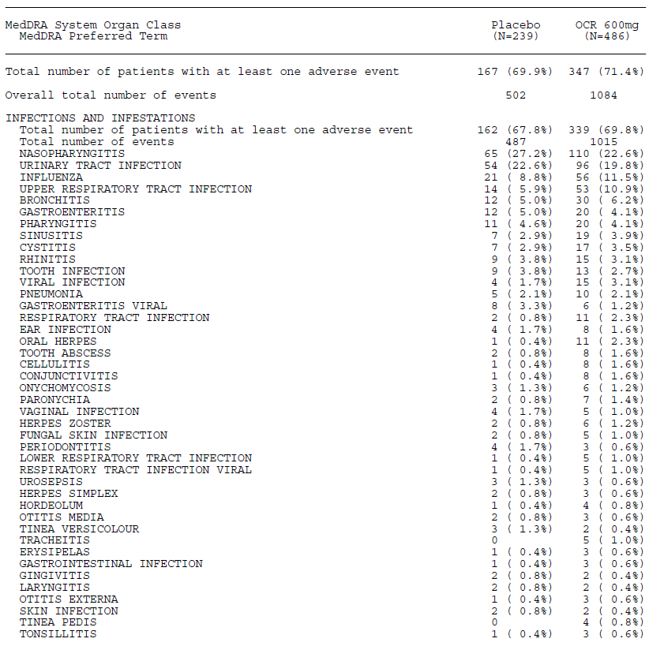

Serious infections
In the RMS population, infections defined as serious occurred at a low frequency, and the proportion of patients reporting serious infections was actually lower in the ocrelizumab group than the interferon group (interferon 2.9% versus ocrelizumab 1.3%).
An analysis of serious infections by affected organ system did not reveal any concerning patterns in the comparison of ocrelizumab and interferon.

Table 119: Serious Infections by type, pool A: Phase III RMS controlled treatment population
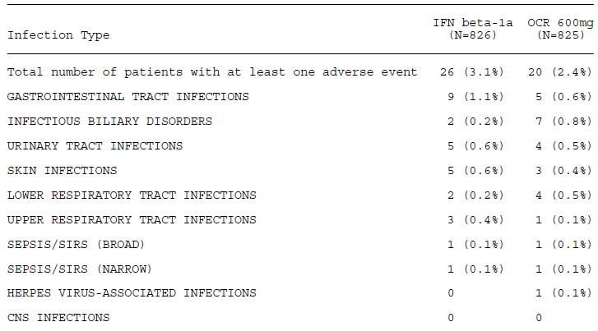
In the PPMS population, the rate of serious infections was similar in the placebo (2.88 per 100 PY) and ocrelizumab (2.97 per 100 PY) groups. The sponsor proposed that the higher rate of serious infections in both arms of the PPMS study (compared with RMS patients) is likely to reflect the relatively greater severity of PPMS. This is broadly plausible, as infections are a common complication of serious neurological dysfunction and impaired mobility.

Opportunistic infections
The sponsor also analysed the infective AEs using a set of terms intended to capture potential opportunistic infections (OI). In this analysis, there was a minor excess of potential OI in the ocrelizumab group, with an excess of herpes infections in particular, although the number of affected patients was small.
In the PPMS population, oral herpetic infections were substantially more common on ocrelizumab recipients, reported in 11 patients (2.3%) in the ocrelizumab group compared to 1 patient (0.4%) in the placebo group.

Table 120: Number of events falling in basket of terms to detect potential opportunistic infections by body system and preferred term, Pool A: Phase III RMS controlled treatment population
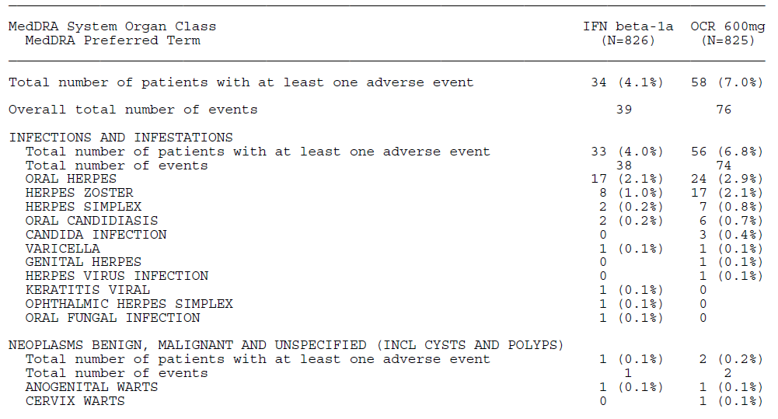

RA studies
An excess of serious infections in the RA studies were identified by the sponsor as one of the main safety concerns leading to abandonment of the RA indication (along with insufficient efficacy against the symptoms of RA). The proposed PI mentions this as an on-gong safety concern.
A simple comparison of the total number of subjects reporting common infections in ocrelizumab recipients does not suggest a major problem: common infections (those with an incidence of ≥5%) occurred in about one third of RA subjects regardless of whether they received a standard disease-modifying anti-rheumatic drug (DMARD) and placebo, or a DMARD and ocrelizumab (see the table below).

Table 121: Infections reported in ≥ 5% of patients in the RA controlled treatment population
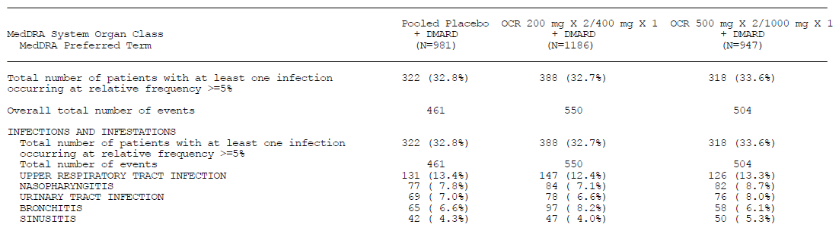
A review of serious infections shows that the proportion of patients reporting a serious infection was higher with ocrelizumab 1000 mg (5.1% of patients; 66 events) than with ocrelizumab 400 mg (3.8%; 52 events) or placebo (3.4%; 36 events). Pneumonia, which was the most commonly reported serious infection, had a similar incidence across the groups: ocrelizumab 1000 mg (1.2%; 11 patients), ocrelizumab 400 mg (0.7%; 8 patients), placebo (1.0%; 10 patients).
Infections potentially classifiable as opportunistic infections also showed a mild excess in the ocrelizumab groups, with an apparent dose trend, as shown in the table below. The most common potentially opportunistic infections were herpes infections, which did not have a clear excess incidence in the ocrelizumab groups. Serious potential opportunistic infections were infrequent, but substantially more common with ocrelizumab treatment: ocrelizumab 1000 mg (9 patients, 10 events); ocrelizumab 400 mg (8 patients, 8 events); placebo (2 patients, 2 events). The imbalance across groups remained evident when converted to a rate per 100 PY: 1.10 (95% CI: 0.53, 2.03) in the ocrelizumab 1000 mg group; 0.80 (95% CI: 0.34, 1.57) in the ocrelizumab 400 mg group and 0.22 (95% CI: 0.03, 0.80) in the placebo group. In the combined ocrelizumab groups, pneumonia (atypical pneumonia, pneumonia systemic, varicella zoster pneumonia, pneumonia, pneumocystis jirovecii pneumonia) and herpes (herpes zoster, herpes zoster oticus, herpes simplex) were the most commonly reported serious potential opportunistic infections. The two serious cases in the placebo group consisted of ophthalmic herpes zoster.
In the broader pool of RA subjects (not just including the controlled data), the incidence of potential opportunistic infections and serious opportunistic infections remained concerning. Overall, 8.8% (258 of 2926 patients) potentially opportunistic infections. Herpes zoster (3.8%; 110 patients) was the most commonly reported, followed by oral herpes (2.3%; 66 patients), oral candidiasis (0.8%; 24 patients), herpes simplex (0.6%; 19 patients), candida infection (0.5%; 14 patients), and pneumocystis jirovecii pneumonia (0.2%; 5 patients), and then by dengue fever, herpes virus infection, and oesophageal candidiasis (each reported in 0.1% of patients).

Table 122: Potential opportunistic infections by basket; RA controlled treatment population
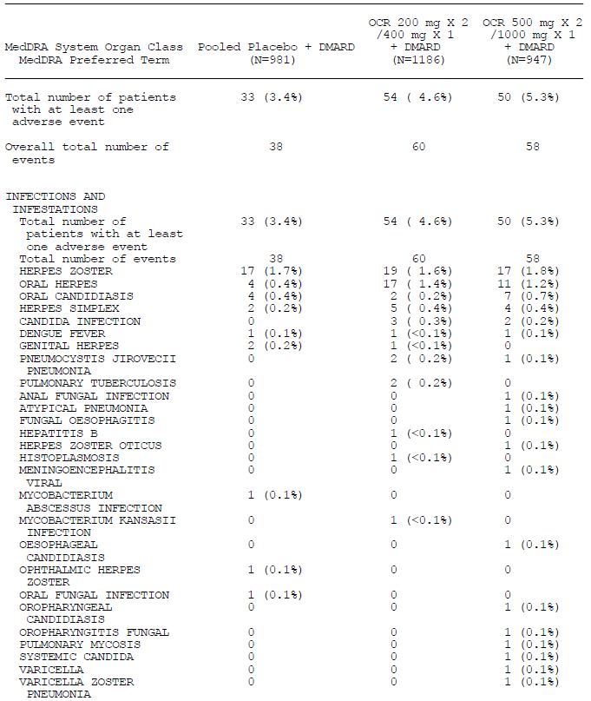
The sponsor assessed the incidence of serious infections according to baseline risk factors. The PI summarises this analysis as follows: ‘Risk factors for serious infections in these trials included other comorbidities, chronic use of immunosuppressants/steroids, and patients from Asia.’ Overall, this statement and the PI’s handling of this issue appear appropriate.

Other studies
Studies for indications other than MS and RA were not evaluated in detail. The sponsor ISS summarises Study WA20499, which used ocrelizumab to treat SLE, as follows (emphasis added):

Study WA20499
Study WA20499 evaluated the safety and efficacy of two ocrelizumab dose levels (1000 mg and 400 mg) compared with placebo in adult patients with moderately to severely active SLE. The OCR 1000 mg group received ocrelizumab 1000 mg IV on Days 1 and 15, followed by ocrelizumab 1000 mg at Week 16, and then every 16 weeks. The OCR 400 mg group received ocrelizumab 400 mg IV on Days 1 and 15, followed by ocrelizumab 400 mg at Week 16, and then every 16 weeks. In all groups, treatment was administered in combination with immunosuppressive therapy (azathioprine (AZA), mycophenylate mofetil (MMF), or MTX) plus corticosteroids. (…)
In total, infection was reported in 18 of 33 patients. The most common infections were upper respiratory tract infection, urinary tract infection, and sinusitis. Serious infections were reported in 3 patients (2 in the OCR 400 mg group and 1 in the OCR 1000 mg group). Two of these patients (both in the OCR 400 mg group) developed opportunistic infections (CMV retinitis and pneumocystis jirovecii pneumonia). Both of these patients died, as a result of upper respiratory infection and pneumocystis, respectively. The third patient with a serious infection had an SAE of pneumonia, which resolved without sequelae. One patient later developed an SAE of abdominal abscess during the SFU period.
Overall, this is a high rate of serious infections for a small study, and suggests that ocrelizumab should not be combined with other immunosuppressive agents.
Study WA20500, performed in lupus nephritis, was described as follows.
Study WA20500 evaluated the safety and efficacy of two ocrelizumab dose levels (OCR 1000 mg and OCR 400 mg) compared with placebo in patients with active lupus nephritis. A total of 381 patients were enrolled of which 378 patients with active LN received study drug (126 patients in the placebo group; 127 patients in the OCR 400 mg group, and 128 patients in the OCR 1000 mg group).
Infections, including serious infections, were common, as shown in the table below. The excess in infections attributable to ocrelizumab was small, overall. There was no clear dose trend: the results in the 400 mg dose group were worse than in the 1000 mg dose group, which had a similar incidence to placebo.

Table 123: Adverse events (Study WA20500)
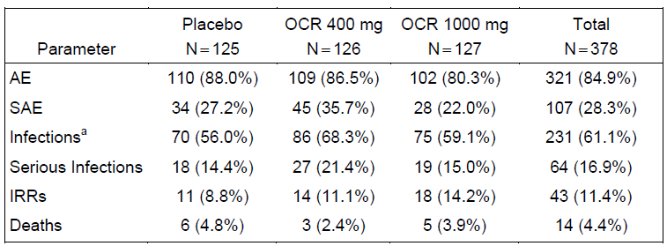
In discussing these infections, the ISS notes:
Among the 64 patients who developed a serious infection, eight patients died from the serious infection (due to Legionella infection, pneumonia, sepsis, urosepsis, septic shock).
From a timing perspective, within each treatment group, more serious infections occurred during the first 12 weeks of study, also characterized by higher concomitant immunosuppressant medication use.
Infections identified as opportunistic in nature by medical review were reported in 6 patients. There were more patients in the OCR 400 mg group (3.2%; 4 patients) compared with OCR 1000 mg (0.8%; 1 patient) and placebo (0.8%; 1 patient).
In the OCR groups, infection events reported by PT were systemic herpes, neurocryptococcosis, disseminated herpes, pneumocystis jirovecii pneumonia, and disseminated herpes zoster.
This is a concerning mortality rate for serious infections, which was not adequately highlighted in the rest of the sponsor safety discussion. Overall, this study suggests that combining ocrelizumab with other immunosuppressive agents is dangerous, and increases the risk of opportunistic infections.
In a study of non-Hodgkin’s lymphoma (NHL), opportunistic infections were also observed, but the lack of a placebo control and the nature of the underlying condition make it difficult to discern a causal relationship. The sponsor described the results as follows.

Study BO18414
This open-label Phase I/II study recruited a total of 48 NHL patients aged 38 to 83 years from 19 centres in six countries (3 Australia, 3 Canada, 5 France, 3 Italy, 3 Sweden and 2 Switzerland).
- Cohort A: 200 mg/m² (8 doses)
- Cohort B: 375 mg/m² (8 doses)
- Cohort C: 375 mg/m² (1 dose) followed by 750 mg/m² (7 doses)
In total, 17 patients experienced at least one infection over the course of the study (4 in Cohort A, 7 in Cohort B and 6 in Cohort C). All infections were Grade 1 or 2 in intensity and included upper respiratory tract infection, herpes simplex, and one case of pneumocystis jirovecii pneumonia.

Malignancies

MS studies
In the Phase III controlled MS studies, malignancy was reported in 6 patients during the controlled treatment period: 2 (0.2% of patients) patients in the IFN group (mantle cell lymphoma and squamous cell carcinoma) and 4 (0.6%) patients in the ocrelizumab group (renal cancer, malignant melanoma, and two cases of invasive ductal breast carcinoma). Expressed as a rate per 100PY, the incidence was 0.14 (95% CI: 0.02, 0.52) for the IFN group and 0.28 (95% CI: 0.08, 0.71) for the ocrelizumab group. Pre-malignant lesions were also reported in a total of 5 patients (0.6%); all of these were in the in the ocrelizumab group (Barret’s oesophagus, large intestine polyp, breast dysplasia, cervical dysplasia, and actinic keratosis).
There was also an excess of malignancy and pre-malignancy in the PPMS study. Malignancy was reported in 13 patients during the controlled treatment period: 2 (0.8%) patients in the placebo group and 11 (2.3%) patients in the ocrelizumab group (but it should be recalled that randomisation was unequal). The most common malignancies were female breast cancers, reported in 4 patients (0.8%) in the ocrelizumab group only, and basal cell carcinoma (BCC), which was also reported in 4 patients (1 patient in the placebo group and 3 in the ocrelizumab group). The rate per 100 PY of malignancy events was elevated in the ocrelizumab group, but numbers were small and the 95%CI was broad: 0.30 per 100PY (95% CI: 0.04, 1.10) for the placebo group and 0.92 (95% CI: 0.49, 1.57) for the ocrelizumab group. Pre-malignant lesions were reported in 7 patients during the controlled treatment period, with a similar incidence across groups: 2 patients (0.8%) in the placebo group and 5 patients (1.0%) in the ocrelizumab group. The pre-malignant disorders included: endometrial hyperplasia, Crohn’s disease, actinic keratosis, large intestine polyp, and dysplastic naevus.
Across the whole MS population, there was an excess of breast cancer cases, summarised in the ISS as follows:
The imbalance observed in MS malignancies identified female breast cancer as the single cluster of events. Of the 19 patients treated with ocrelizumab who reported a malignancy in the MS program, breast cancer was reported in 7 female patients, 6 of which occurred during the controlled treatment periods. There were no reports of breast cancer in the comparator groups (IFN and placebo). All cases were ductal invasive, with a latency period from first infusion of ocrelizumab of between 1 and 3 years.
It is not possible to draw strong conclusions from these results. The excess of malignant an pre-malignant AEs in ocrelizumab recipients raises the possibility that impaired immune surveillance, induced by B cell depletion, increases the risk of malignancy. Alternatively, the inequality in the incidence could simply reflect the low numbers of patients affected. The cluster of breast cancer cases is of some concern, but it is a post hoc observation based on a small number of cases. It would be appropriate for this issue to be the subject of ongoing surveillance and risk management.
The proposed PI does not mention malignancy as a significant safety concern, which is broadly appropriate given the paucity of the data, the lack of any clear signal, and the broadly similar incidence of malignancy across groups in the RA studies, described below.

RA studies
In the RA studies, the frequency of malignancy was broadly similar across the placebo (1.0%; 10 patients), ocrelizumab 400 mg (0.7%; 8 patients), and ocrelizumab 1000 mg groups (1.2%; 11 patients) group. Basal cell carcinoma was the most commonly reported malignancy, and showed a broadly similar incidence across groups: placebo 0.2% (2 patients), ocrelizumab 400 mg 0.2% (2 patients), ocrelizumab 1000 mg 0.3% (3 patients). No other type of malignancy occurred in more than 2 patients in any group. The incidence was also similar when expressed as a rate per 100PY: placebo (1.11; 95% CI: 0.53, 2.04), ocrelizumab 400 mg (0.90; 95% CI: 0.41, 1.70) and ocrelizumab 1000 mg (1.32; 95% CI: 0.68, 2.31) groups.

Other studies
No clear pattern of excess malignancies emerged from the additional studies performed in the setting of SLE, LN and NHL, but these studies were generally small and treatment duration was short. In Study WA20500, which was somewhat larger, no difference was noted across treatment groups:
Malignancy (coded to SOC Neoplasms, Benign, Malignant and Unspecified) was reported in a total of 18 (4.8%) patients. The frequency was similar between placebo (4.8%; 6 patients), OCR 400 mg (4.8%; 6 patients), and OCR 1000 mg (4.7%; 6 patients) groups.

Evaluator’s overall conclusions on clinical safety
The safety of ocrelizumab is broadly acceptable, given that its proposed use is treatment of a major neurological illness that has serious impacts on patients’ mobility, vision and cognition.
The most common tolerability issue is infusion-related reactions (IRRs), which can be partly reduced by pre-treatment with corticosteroids. The risk of serious IRRs means that ocrelizumab should only be administered in a controlled medical environment – preferably a hospital with resuscitation equipment and the ability to treat anaphylaxis. Ocrelizumab will not be suitable for home treatment by visiting MS nurses.
Ocrelizumab appears to increase the risk of respiratory infections, most of which consist of upper respiratory tract infections.
In the MS population, ocrelizumab did not produce a clear increase in the risk of serious infections or opportunistic infections, but these were seen in the RA population, possibly because of co-treatment with other immunosuppressive drugs including steroids.
Ocrelizumab was associated with an excess of breast cancer cases, with breast cancer reported in 7 female patients who received ocrelizumab, 6 of which occurred during the controlled treatment periods, compared to no reports of breast cancer in the comparator groups (IFN and placebo). All cases were ductal invasive, with a latency period from first infusion of ocrelizumab of between 1 and 3 years. The significance of this post hoc observation is uncertain.
Ocrelizumab suppresses B cell counts, which is intrinsic to its mode of action. It also slightly increased the risk of neutropaenia, and caused a mild reduction in immunoglobulin levels. Laboratory monitoring did not raise any other concerns. Haematological monitoring of ocrelizumab recipients is recommended.
Ocrelizumab is likely to increase the risk of progressive multifocal leukoencephalopathy (PML), based on the experience with other disease-modifying agents and, in particular, the occurrence of PML in some rituximab recipients. The proposed PI does not currently recommend performing JCV serology prior to or during treatment with ocrelizumab, but this seems advisable.

First round benefit-risk assessment

First round assessment of benefits
The benefits of ocrelizumab in the proposed usage in ‘RMS’ are:
- A significant reduction in Annualised Relapse Rate of approximately 46 to 47%, relative to interferon β-1a 44mcg TIW (Rebif)
- A significant relative reduction in 12 week Confirmed Disability Progression 12 week CDP rates of 36% over 96 weeks, with an absolute reduction of 5.43%, compared to Rebif (ocrelizumab 9.75% verse interferon β-1a 15.18%)
- Significant reductions in radiological activity, relative to Rebif, with ocrelizumab recipients showing 5-6% of the number of Gd+ lesions, 17 to 23% of the new/enlarging T2 lesions, and 36 to 43% of the number of T1 ‘black holes’, compared to the Rebif control group.
- A substantial and clinically meaningful increase in the achievement of No Evidence of Disease Activity (NEDA), relative to Rebif, though this was, technically, not significant because of the hierarchical statistical approach. In Study WA21092, NEDA was achieved in 27.1% of interferon β-1a recipients, compared to 47.4% of ocrelizumab recipients. In Study WA21093, NEDA was achieved in 24.1% of interferon β-1a recipients, compared to 43.9% of ocrelizumab recipients.
Benefit across the full spectrum of RMS subjects has not been directly demonstrated. Although a Phase II Study in RRMS showed clear evidence of efficacy of ocrelizumab relative to low-dose weekly IM interferon β-1a (Avonex), no study has assessed ocrelizumab in subjects with SPMS. The pivotal studies in ‘RMS’ included an unknown proportion of subjects with SPMS, but efficacy was not specifically assessed in this important subgroup. The subgroup analyses that were submitted suggested better efficacy in subjects with Gd+ baseline scans, and worse efficacy in subjects without Gd+ lesions.
It appears likely that efficacy in SPMS subjects will be inferior to that observed across the entire RMS study cohort, but this has not been assessed. It also appears likely that, within the SPMS population, efficacy will be reduced in those without clinical or radiological evidence of disease activity, but this has not been assessed. The pivotal studies only recruited subjects with recent relapses, and there is no evidence that ocrelizumab has a role in RMS or SPMS subjects without recent relapses. (The positive results in PPMS do suggest some efficacy in MS subjects without relapses, but this is indirect evidence, and the evidence was not as robust as that in RMS).

Table 124: Summary of primary and secondary efficacy endpoints at Week 96 (ITT Population, Study WA21092)

Table 125: Summary of primary and secondary efficacy endpoints at Week 96 (ITT Population, Study WA21092)
Benefits of ocrelizumab in the proposed PPMS usage are:
- A statistically significant but modest reduction in the rate at which PPMS patients reach 12 week CDP. The ocrelizumab group reached the 12 week CDP endpoint with 89% of the placebo incidence (30.2% verse 34.0%), for a relative risk reduction over 120 weeks of 11% (p = 0.0321). The absolute risk reduction was 3.8%, implying that about 26 subjects would need to receive ocrelizumab treatment for 120 weeks to prevent one case of 12 week CDP.
- A modest, but poorly defined delay in progression, not yet clearly quantified in terms of weeks of delay.
- A variable response across subgroups, with some evidence suggesting that efficacy is reduced, but sill nominally favourable, in older subjects and those without Gd+ MRI scans at baseline. The instantaneous hazard ratio for subjects with unfavourable baseline factors was 0.88 for those aged > 45 years, and 0.84 for those without Gd+ lesions (and it would be expected that the HR would be closer to unity for subjects with both of these adverse baseline factors). The relative risk reduction for older subjects was only approximately 7%.
- So far, these benefits have only been shown in one study, which reached traditional and pre-specified significance thresholds (p < 0.05), but failed to reach more ambitious targets (p<0.01) proposed during guidance discussions.
- Improved radiological outcomes, including the change in the volume of T2 hyperintense lesions from baseline to Week 120 (p < 0.0001) and a 17.5% relative reduction in the brain volume loss from Week 24 to Week 120, compared with placebo (p = 0.0206).

First round assessment of risks
The risks of ocrelizumab in the proposed usage are:
- Infusion-related reactions in about one third of patients, although this was also observed to a lesser extent in control groups: (RMS studies, IFN 9.7% verse ocrelizumab 34.3%; PPMS study, placebo 25.5% versus ocrelizumab 39.9%)
- A theoretical risk of anaphylaxis and more serious infusion reactions
- An excess of upper respiratory tract infections
- An excess of herpes infections
- An excess of serious and opportunistic infections, as suggested by the experience in the rheumatoid arthritis studies, but possibly confined to subjects using concomitant immunosuppressive agents.
- Possible compromise of vaccine function, or increased susceptibility to live vaccines.
- An unknown risk of progressive multifocal leukoencephalopathy

First round assessment of benefit-risk balance
For RRMS subjects who have very aggressive MS or those who have had breakthrough disease while on established disease-modifying agents, the benefit-risk profile for ocrelizumab is positive. Even if infusion reactions occur, in most subjects they will be temporary, and the efficacy benefit is expected to last approximately six months. The risk of serious infections appears to be low in subjects who are not taking concurrent immunosuppressive agents, and is likely to be acceptable to patients and clinicians. Many existing agents used to treat RRMS (including natalizumab, dimethyl fumarate and fingolimod) carry a clear risk of causing PML, and despite this they have found a useful role in the treatment of MS.
For SPMS subjects, or RRMS subjects without recent relapses, there is currently insufficient evidence to assess the benefit-risk balance. The benefit-risk balance is likely to be favourable in SPMS subjects who have active baseline scans, and may be favourable even in subjects without active scans, but the submitted evidence does not allow this to be estimated.
For PPMS patients, the benefits of ocrelizumab are relatively modest, but the risks may be considered acceptable to many patients and clinicians. The benefit is unlikely to be consistent across all subjects with PPMS: the evidence for benefit is currently clearest for subjects who are younger and have active baseline scans, and it is less clear for subjects who are older and/or have no Gd+ lesions on their cerebral MRI. The risks of infection are likely to be higher in older, frailer subjects, so older subjects have less to gain and more to lose from ocrelizumab treatment.

First round recommendation regarding authorisation
In the absence of adequate information about the efficacy of ocrelizumab in subjects with SPMS, the recommendations listed below can be made. These recommendations could be revised if further evidence of efficacy in SPMS subjects were made available. Ocrelizumab should be approved for treatment of relapsing and remitting MS (RRMS), in subjects who have experienced at least 2 relapses in the previous 2 years or at least one relapse in the previous 12 months. Ocrelizumab should be approved for treatment of Secondary Progressive MS (SPMS), in subjects who have experienced at least 2 relapses in the previous 2 years and have contrast-enhancing (Gd+) lesions on their cerebral MRI. Ocrelizumab should be approved for treatment of primary progressive MS (PPMS) in subjects who have contrast-enhancing (Gd+) lesions on their cerebral MRI.

Evaluator comments on round 1 recommendations
It could be argued that the second recommendation listed above is not adequately supported by the evidence, as no study has directly assessed subjects with SPMS. It would be reasonable to exclude the second recommendation and only approve ocrelizumab in the MS subtypes where it has been directly assessed, RRMS and PPMS. On balance, however, the evaluator believes that: 1) SPMS occupies an intermediate position on the MS spectrum; 2) subtypes at both ends of the spectrum have shown a significant response to ocrelizumab; and, therefore, 3) by interpolation, some efficacy in SPMS appears almost certain. The proposed indication in the EU submission appears to be RRMS, not the broader category of RMS, and the sponsor should clarify reasons for this difference. It could also be argued that ocrelizumab should not be registered for use PPMS, as there has only been a single study performed in PPMS, and that study did not achieve the ambitious p-value proposed by the sponsor in guidance discussions. The strong concordance across multiple endpoints has convinced the evaluator that ocrelizumab has some efficacy, at least in a subset of patients, and subjects with contrast-enhancing lesions are the subset most similar to the RRMS population, in whom it clearly has good efficacy. These considerations led to the compromise suggested above: approving ocrelizumab in Gd+ PPMS patients, while awaiting confirmation of efficacy in the broader PPMS population. In addition to denying registration for PPMS patients without Gd+ scans, it would be reasonable to deny registration for use in older PPMS subjects (> 45 years or > 50 years). It is currently unclear how many older subjects had Gd+ scans, and whether ocrelizumab had acceptable efficacy in such patients, and how efficacy varies with age. Age and Gd positivity are not independent variables, and patients with Gd+ scans are likely to have active inflammation regardless of age, so the evaluator has recommended that suitable patients be identified with imaging rather than being excluded on the basis of chronological age alone. This approach, identifying patients with active disease by MRI, is consistent with standard clinical practice in subjects with treatment-resistant RRMS or SPMS and on-going relapses. The relationship between age, Gd-positivity and treatment response could be clarified by answers to the Clinical Questions posed, which could lead to a revision of these recommendations.

Clinical questions

Additional expert input
No additional input is recommended.

Clinical questions

Pharmacokinetics
No questions.

Pharmacodynamics
No questions.

Efficacy

Question 1
The two pivotal studies performed in ‘RMS’ included subjects with RRMS and subjects with SPMS and on-going relapses. Please report how many subjects in each pivotal study had RRMS and how many had SPMS.

Question 2
Please perform subgroup analyses of each pivotal RMS study (and both RMS studies pooled), based on the patients’ disease subtype, using standard MS classifications: RRMS, SPMS, (and progressive relapsing MS, PRMS, if some subjects were thought to have this subtype).

Question 3
In the PPMS study, the primary endpoint was described as ‘the time to onset of CDP over the treatment period,’ but the results were not presented in units of time, but as hazard ratios and proportions of subjects reaching each CDP endpoint by the end of the study period. In terms of time taken to reach CDP, please estimate the extent to which active treatment delayed reaching this milestone, expressed as weeks of delay. One possible approach would be to report, with confidence intervals, the number of weeks taken for 5%, 10%, 15%, 20%, 25% and 30% of subjects to reach 12 week CDP.

Question 4
In view of the fact that a previous study of rituximab suggested minimal benefit of B cell depletion in older subjects without Gd+ scans, please estimate efficacy in subjects with all four combinations of these potential markers of poor responsiveness. In particular, please perform a subgroup analysis of subjects who were both old (> 45 and > 50 years) and lacked Gd+ lesions at baseline, as well as an analysis of those who had Gd+ lesions, but were old. In the pivotal PPMS study, please perform a subgroup analysis for subjects aged ≤ 50 years and those > 50 years.

Question 5
What is known about the efficacy of ocrelizumab in subjects who have PPMS and a predominantly spinal distribution of lesions?

Safety

Question 6
Please provide, or indicate the location of, a convenient one-page summary table listing the most common AEs observed in the RA studies. An acceptable format would be the one used to report AEs in the SM population of the Summary of Clinical Safety (‘Adverse Events Reported in ≥ 2% of Patients in at Least One Treatment Group by Preferred Term; Phase III RMS Controlled Treatment Population (Pool A)’ and ‘Adverse Events Reported in ≥ 2% of Patients by Preferred Term - Phase III PPMS Controlled Treatment Population’), but it would be even more appropriate of AEs were grouped by System Organ Class, with totals shown for each SOC, as well as identified by Preferred Term.

Question 7
Please provide, or indicate the location of, a convenient one-page summary table listing the SAEs observed in the RA studies, grouped by SOC and PT.

Question 8
In the listing of deaths in the MS and RA populations, the cause of death was occasionally listed as ‘Death’. What was the likely cause of death in each of these cases? Please provide a table listing all deaths in ocrelizumab recipients.

Question 9
How many deaths in the RA study program were caused by infections, and which of these were potentially opportunistic infections?

Second round evaluation of clinical data submitted
The sponsor has submitted responses to Clinical Questions posed in the first-round Clinical Evaluation Report (CER).

Efficacy question 1
- The two pivotal studies performed in ‘RMS’ included subjects with RRMS and subjects with SPMS and on-going relapses. Please report how many subjects in each pivotal study had RRMS and how many had SPMS.
The sponsor answered as follows:
The physician’s assessment of whether the patient was in the relapsing-remitting or in the secondary progressive course of the disease was not collected at baseline.
The question was raised because most major studies in MS leading to registration of new disease-modifying drugs in the last two decades have considered subjects with RRMS and SPMS separately, and the majority of successful MS studies leading to registration of new treatments have been performed in subjects with RRMS. For most agents, including those with a primarily immunological mechanism of action, efficacy in subjects with SPMS has been disappointing and there are currently no good therapeutic options for subjects with SPMS. Accordingly, it is a priori likely that, for any new MS agent with an immunological mechanism of action, efficacy in these two populations will be different, and efficacy in the SPMS population cannot be inferred from a study largely or solely conducted in an RRMS population. This logic still applies even if, as the sponsor claims, with some support from the literature, the two populations represent different parts of a continuous disease spectrum without clear boundaries. The lack of a clear boundary between RRMS and SPMS has been a feature of MS all along, during the same time period in which it has been observed that RRMS and SPMS have different responsiveness to immunological therapies, so pointing out the continuous nature of this spectrum does not circumvent the need to show efficacy at both ends of the spectrum.
In their two pivotal studies of ‘RMS’, the sponsor recruited a mixed population of subjects with both RRMS and SPMS, but failed to collect data on disease subtypes at baseline. This methodological choice now leads to major difficulties of interpretation of the results. If subjects with SPMS represented a poorly responsive minority within the larger, mixed cohort in the pivotal ‘RMS’ studies, and the positive results of the studies were largely attributable to the more responsive RRMS subjects, which constituted the majority of the study population, then it would be unreliable to conclude that the overall positive results of the pivotal studies could be extended to SPMS subjects merely because some SPMS subjects were recruited.
Because the disease subtype was not collected at baseline, it is not possible to determine how many study subjects had SPMS, and the sponsor has therefore missed the opportunity to estimate the magnitude of the treatment effect in such subjects. This situation was foreseeable when the sponsor decided not to collect this information.
Using an indirect, retrospective approach, the sponsor now estimates that only about 2-10% of the pivotal ‘RMS’ population had SPMS:
Post hoc analyses on relapse-independent disability progression have been performed in order to identify SPMS patients during the treatment period. Depending on the definition applied, the results allowed the identification of a range of 1.9% to 10.2% SPMS patients within the intent-to-treat (ITT) population. These numbers are consistent with an ITT population of predominantly (approximately 90% or greater) RRMS patients.
The evaluator does not accept that this approach is a reliable method of identifying subjects who had SPMS at baseline. One problem is that the treatments being assessed prevent relapses, and a lack of relapses around the time of progression is then interpreted as a marker of SPMS, so the treatments themselves are potentially modifying the categorisation of subjects during the study. This is not methodologically robust. It is known that the two treatments (ocrelizumab and interferon β-1a) have an unequal effect on the incidence of relapses (this was, after all, the primary endpoint of the study), so it is known that at least one of the factors contributing to the sponsor proposed post hoc identification of SPMS subjects was distorted by the treatment itself. There can be no guarantee that the result is an unbiased assessment of subjects with SPMS. (Further methodological issues with this approach are considered below.)
Even if the sponsor identification of SPMS subjects is taken at face value, their own rough estimate suggests that the pivotal ‘RMS’ studies were primarily (> 90%) performed in RRMS subjects, and positive results in RRMS subjects are likely to have had a dominant effect in determining the overall treatment effect in these studies. Accordingly, no reliable conclusions can be drawn about the efficacy of ocrelizumab in subjects with SPMS.
In their response to this question, the sponsor provided some additional material in support of their claim that the efficacy of ocrelizumab extends beyond RRMS. This material did not directly address the question asked, but it is summarised below.
For instance, the sponsor continues (emphasis added):
‘These analyses showed that ocrelizumab has a treatment benefit on relapse independent progression as well.
- A 24% risk reduction in 12 week composite confirmed disability progression independent of relapses, with ocrelizumab compared with interferon beta-1a (p = 0.0098).
- A 22% risk reduction in 24 week composite confirmed disability progression independent of relapses, with ocrelizumab compared with interferon beta-1a (p = 0.0456). These data provide compelling evidence of a consistent effect of ocrelizumab on measures of disability progression independent of acute inflammatory clinical events.’
The sponsor also produced a table, reproduced below, showing that ocrelizumab reduced the proportion of subjects with disability progression independent of relapses.

Table 126: Time to onset of composite confirmed disability progression independent of relapses (EDSS or 25-Foot Timed Walk or 9-Hole Peg Test) and its components for at least 12 weeks (Pooled Studies WA21092 and WA21093; ITT Population)
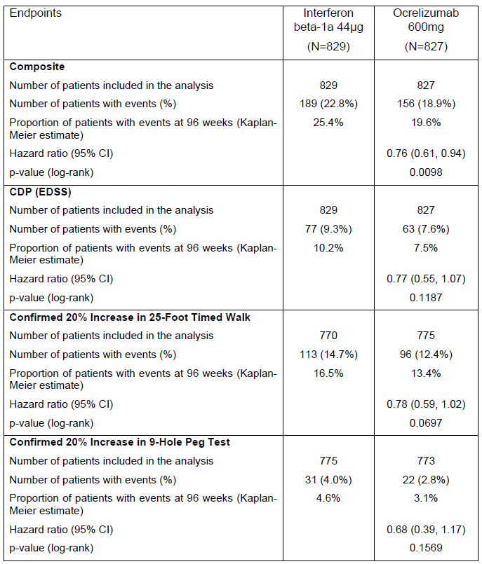
These analyses provide some reassurance that ocrelizumab does more than prevent overt relapses, but they have only partial relevance to the question of efficacy in SPMS subjects. As the sponsor suggests, subjects in whom progression occurs without clinical relapses are likely to be given a clinical diagnosis of SPMS, but it remains unclear when this diagnosis applies to the study subjects and whether subjects with established SPMS at baseline can expect reasonable efficacy from ocrelizumab.
According to the results cited above, it appears that ocrelizumab may reduce the risk of progressing without an identifiable relapse, which in turn implies that ocrelizumab may reduce the rate at which subjects reach a clinical diagnosis of SPMS. Preventing a subject from reaching SPMS is a worthwhile goal of treatment, but a treatment that reduces the risk of developing SPMS is not necessarily successful at treating subjects who already have established SPMS prior to treatment. As noted by the sponsor, there is a continuous spectrum from RRMS to SPMS: this implies that subjects transitioning to SPMS from RRMS are likely to be more treatment-responsive than subjects with established SPMS. Accordingly, the treatment benefits cited above could have been achieved, primarily, in subjects with RRMS who were transitioning to SPMS. The entry requirement for two relapses in the previous two years or one relapse in the previous year makes it even more likely that the few SPMS subjects entering the study were at the early stages of SPMS.
The critical question is whether subjects with known, established SPMS at baseline are likely to achieve acceptable efficacy with ocrelizumab, and this has not been directly tested. The history of MS studies has shown that, in general, established SPMS is much more resistant to immunomodulatory approaches than earlier, relapse-dominant disease, and the sponsor pivotal ‘RMS’ studies do not directly assess whether the same pattern of responsiveness across the MS spectrum applies with ocrelizumab. (The positive results in the PPMS study partially address this gap in the overall study program, but this evidence is indirect.)
It should also be noted that there is a conceptual difference between ‘disability progression independent of acute inflammatory clinical events’ (as underlined above) and ‘disability progression independent of acute inflammatory events’. The sponsor has provided evidence that ocrelizumab reduces the former, but it still seems likely that the main mechanism for reducing disability progression is nonetheless related to the prevention of acute inflammatory events, including subclinical inflammatory events, or so-called ‘radiological relapses’.
It is widely accepted that only a small proportion of new radiological lesions in MS are associated with overt clinical relapses. It is also well known and widely accepted that recovery from many clinical relapses is incomplete, and that this contributes to disease progression. It is therefore very likely that recovery from subclinical inflammatory lesions is also incomplete, and that this contributes to disease progression, but this important contribution to disability is difficult to assess clinically because the lesions themselves do not individually produce immediate and obvious deficits. Although the clinical effect of these lesions may be subtle on an individual basis, at the time the lesions appear, their cumulative effect is to reduce functional reserve in the CNS. A large component of clinical progression that is ostensibly ‘independent’ of relapses is therefore likely to be associated with the formation of new inflammatory subclinical lesions, followed by incomplete recovery. Some of the effects of these lesions are delayed, and include Wallerian degeneration of axons, secondary degeneration of regions that have lost their usual axonal input, and so on, with the result that the clinical fallout from the acute lesion is temporally smeared and indistinct. Whether there are other components of disease progression in MS that are truly independent of acute inflammatory events is unclear, and not addressed by the submitted data.
Given that RRMS subjects are more likely to have inflammatory CNS activity (both clinical and subclinical) than SPMS subjects, their responsiveness to ocrelizumab is likely to be greater than that of SPMS subjects. Subjects with early SPMS, transitioning from RRMS, are likely to have intermediate responsiveness to ocrelizumab. Subjects with established SPMS are likely to have inferior responsiveness. This notion is supported by a number of subgroup analyses in the sponsor pivotal studies, where efficacy was greater in younger subjects and in those with active scans.
In their response to this question, the sponsor also presented a post hoc subgroup analysis of disease progression in subjects who were likely to have had SPMS at baseline on the basis of their relatively advanced EDSS and pyramidal functional scores (see the table below). This approach is inherently unreliable. The presence of disability at baseline should not be considered an acceptable surrogate for a diagnosis of SPMS, because some subjects with RRMS who had failed to recover fully from earlier attacks could have accumulated disability, without entering a progressive stage of their disease.
In this post hoc subgroup, for the composite non-primary endpoint of disability based on EDSS progression or deterioration in the 25FTW or in the 9HPT, there was a significant benefit for ocrelizumab. For progression identified from EDSS alone, there was merely a favourable trend. This analysis is somewhat reassuring, but suffers from the fact that it is retrospective, with no statistical correction for the potential use of multiple different ways of defining the cohort of interest and multiple different potential definitions of disability progression. That is, the post hoc nature of this exercise leaves too much room for ‘cherry picking’ favourable results. Also, the results in this subgroup cannot be extended to all subjects with SPMS, because the entry criteria for the pivotal studies required that subjects had on-going relapses in the two years prior to study entry.
What is needed is prospective proof of efficacy in SPMS, where:
- SPMS subjects are identified prospectively; and
- a single primary efficacy measure is defined prospectively.
The sponsor claims of efficacy in this subgroup would have been far more convincing if the traditional disease subtype had been noted at baseline, and disease progression had been assessed using the main prospective measure of disability (based on EDSS).

Table 127: Time to onset of composite confirmed disability progression independent of relapses (EDSS or 25-Foot Timed Walk or 9-Hole Peg Test) and its components for at least 12 weeks (Subgroup of Patients with Baseline EDSS ≥ 4.0 and Pyramidal FFS ≥ 2)
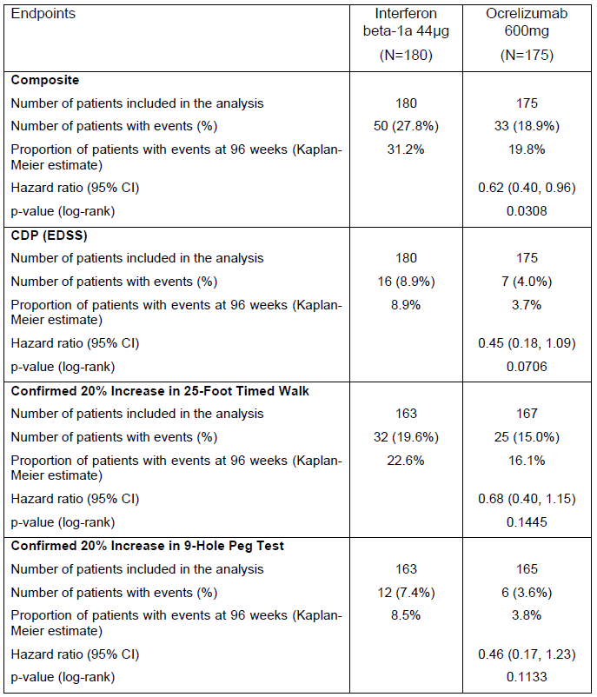
Evaluator’s overall conclusion:
Question 1 asked how many subjects in the ‘RMS’ studies had RRMS, and how many had SPMS. The sponsor has indicated that the requested information about the proportion of subjects with SPMS is unavailable, because it was not collected. The sponsor suggests that, despite this omission, efficacy in SPMS can be inferred, and that the traditional disease categories are not important.
The evaluator concedes that it can be difficult to diagnose subjects with SPMS, and this diagnosis is often made in retrospect, but it remains important to attempt to identify this end of the disease spectrum in all major MS studies and to assess whether efficacy in this population is compromised, relative to efficacy in RRMS. That the sponsor failed to do this represents a substantial deficiency in the overall study program. That deficiency cannot be corrected with post hoc analyses of subjects that might have had SPMS.
As the sponsor notes, there are some indications that ocrelizumab reduces disease progression that is independent of overt clinical relapses, and that it has efficacy in subjects who have already accumulated disability at baseline, so it is possible that the drug has efficacy in subjects with SPMS, provided they have evidence of on-going relapses. Unfortunately, there has been no robust prospective assessment of this hypothesis.
The fact that the sponsor has performed a pivotal study in PPMS partially compensates for the lack of a study specifically assessing SPMS, which is why the first-round CER did not recommend a complete rejection of ocrelizumab in the SPMS population. Without the PPMS study, there would be no valid grounds for considering registration of ocrelizumab in SPMS subjects.
Ultimately, in deciding who might benefit from ocrelizumab, it is probably more important to determine whether subjects have ongoing inflammatory activity at baseline, as evidenced by ongoing relapses or ongoing Gd+ scans, than whether they satisfy traditional definitions of RRMS. As already noted, the sponsor own subgroup analyses in the two ‘RMS’ studies and the pivotal PPMS study suggest that ocrelizumab is more effective in subjects with active scans at baseline, and it would be expected to have relatively poor efficacy in subjects with inactive scans, older age or advanced progressive disease.

Efficacy question 2
- Please perform subgroup analyses of each pivotal RMS study (and both RMS studies pooled), based on the patients’ disease subtype, using standard MS classifications: RRMS, SPMS, (and progressive relapsing MS, PRMS, if some subjects were thought to have this subtype).
The sponsor answered as follows:
Given that this data was not collected, the sponsor was unable to provide the requested analysis.
The sponsor notes that the number of subjects with PRMS was likely to be low:
With regard to PRMS patients enrolled in the trials, it is likely that their number is very limited taking into consideration that the PRMS population represents a small proportion (< 5%) of MS patients. However this number remains unknown because the information was not collected at baseline.
To some extent, the additional material provided in response to Question 1 provided an indirect analysis of efficacy in subjects likely to have had SPMS in the pivotal ‘RMS’ studies. The limitations of this post hoc approach have already been discussed. Overall, it appears likely that ocrelizumab has some efficacy in subjects with SPMS (provided they have ongoing relapses), but the submitted data do not allow any firm conclusions to be drawn about how much efficacy can be expected in this important population.
In their response to this question, and in defence of the pivotal study design that ignored traditional definitions of disease subtypes, the sponsor also revisited some of the issues already discussed in their response to Question 1:
For the past two decades, MS has been clinically subcategorized into four phenotypic disease patterns distinguished by the occurrence and timing of episodes of transient neurological compromise (relapses) relative to disease onset and disability progression: relapsing-remitting MS (RRMS), secondary progressive MS (SPMS), primary progressive MS (PPMS), and progressive-relapsing MS (PRMS). A recently proposed revision to this classification recommends that the term PRMS is dropped as it is considered vague and overlapping with other disease course subtypes, and that PRMS and PPMS should therefore no longer be considered distinct entities but rather characterized both as PPMS, with or without activity. More recently, it has been proposed that PPMS is not a separate entity but rather a part of the spectrum of progressive disease and as such RMS and PPMS can be considered closely related diseases.
These comments mostly apply to PPMS, which was not the focus of the question, but the sponsor general point is that the traditional subtypes of MS have indistinct borders. This can be conceded, but it does not diminish the need to show efficacy for all subtypes. The evaluator agrees that RRMS and SPMS exist on a disease spectrum, with many patients evolving from RRMS to SPMS through a gradual indeterminate stage in which RRMS is associated with some accumulated disability. It may also be the case that the RRMS-SPMS spectrum is closely related to PPMS, and shares some pathogenic mechanisms. It nonetheless remains the case that, throughout the last two to three decades, efficacy in these different disease subtypes has been different for all agents tested despite that fact the subtypes exist on a continuous spectrum. Populations defined on the basis of having higher relapse rates and less progression between relapses have consistently shown a better response to immunological therapies, and populations with more progressive disease and less relapses have shown a poor response. By failing to study the traditional disease subtypes, the sponsor has made it impossible to draw firm conclusions about the efficacy of ocrelizumab in SPMS.

Efficacy question 3
- In the PPMS study, the primary endpoint was described as ‘the time to onset of CDP over the treatment period,’ but the results were not presented in units of time, but as hazard ratios and proportions of subjects reaching each CDP endpoint by the end of the study period. In terms of time taken to reach CDP, please estimate the extent to which active treatment delayed reaching this milestone, expressed as weeks of delay. One possible approach would be to report, with confidence intervals, the number of weeks taken for 5%, 10%, 15%, 20%, 25% and 30% of subjects to reach 12 week CDP.
The sponsor answered as follows:
This question was asked because the clinical utility of ocrelizumab in PPMS is somewhat difficult to judge, but appears to be only modest. Ocrelizumab is not expected to prevent disease progression, but merely to slow it down. The degree to which ocrelizumab delays progression is potentially a natural, intuitive measure of efficacy. One drawback of this approach, noted by the sponsor, is that an estimate of delay, measured in weeks, does not use all of the available information – it is therefore not as robust, statistically, as a hazard ratio. It is, however, clinically meaningful, and it directly corresponds to the sponsor initial description of the endpoint as ‘the time to onset of CDP over the treatment period’. If subjects on ocrelizumab reach the same milestones as placebo recipients, but reach these milestones significantly later, then the clinical utility of the treatment does not depend on the statistical robustness of the analysis but on whether the delay is only a few weeks, or more substantial. (The delay in median time to progression would ordinarily be considered a more natural measure than the delay in 30% of subjects progressing, but not enough patients progressed during the study for calculations of median progression times. )
As the sponsor reports, below, the results of the PPMS study suggests that ocrelizumab provides a delay of about 20 to 26 weeks in the time taken for 30% of subjects to reach progression milestones (12 week CDP, delayed by 20 weeks, 24 week CDP, delayed by 26 weeks). This is a modest result, but one that is likely to be considered worthwhile by patients and clinicians. The provided tables suggest similar delays for other proportions of patients progressing, for both 12 week CDP and 24 week CDP.
The time taken for 30% of subjects to reach 12 week CDP was 100.1 weeks (95% CI: 72.7, 120.4) for those in the placebo group and 120.0 weeks (95% CI: 96.7, 153.0) in the ocrelizumab group. This demonstrates a treatment effect in favour of ocrelizumab of delaying 12 week sustained disability progression by 20 weeks ((first table below)). Furthermore, the time taken for 30% of subjects to reach 24 week CDP was also analysed. The placebo group took 108.1 weeks (95% CI: 84.1, 132.1) and the ocrelizumab group took 134.4 weeks (95% CI: 108.3, 181.0) to reach this milestone. This demonstrates a treatment effect in favour of ocrelizumab of delaying 24 week sustained disability progression by 26 weeks ((second table below)).

Table 128: Time to onset of confirmed disability progression for a least 12 weeks during the double-blind treatment period (With Imputation, ITT Population)
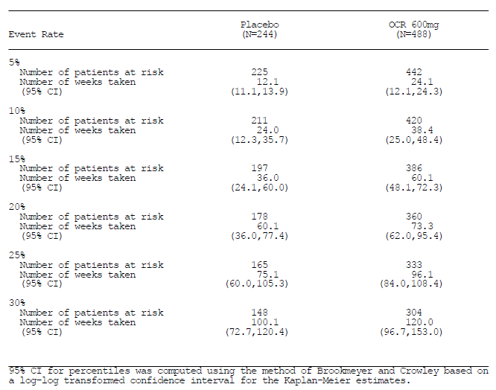

Table 129: Time to onset of confirmed disability progression for a least 24 weeks during the double-blind treatment period (With Imputation, ITT Population)
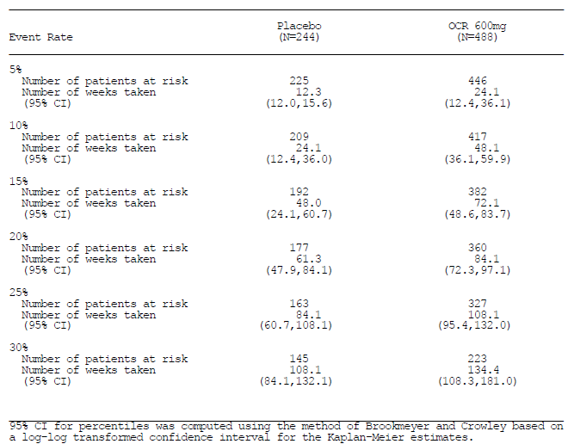

Efficacy question 4
- In view of the fact that a previous study of rituximab suggested minimal benefit of B cell depletion in older subjects without Gd+ scans, please estimate efficacy in subjects with all four combinations of these potential markers of poor responsiveness. In particular, please perform a subgroup analysis of subjects who were both old (> 45 and > 50 years) and lacked Gd+ lesions at baseline, as well as an analysis of those who had Gd+ lesions, but were old. In the pivotal PPMS study, please perform a subgroup analysis for subjects aged ≤ 50 years and those > 50 years.
The original question only related to subjects with PPMS, but the sponsor provided a similar analysis for subjects with ‘RMS’. The subgroup analyses of the PPMS study are particularly important, because the pivotal PPMS study lacked any precedent in the MS literature, and was the first study to suggest a significant benefit of immunomodulatory therapies in PPMS. Typically, patients with PPMS are considered to have relatively less inflammatory activity than subjects on the RRMS/SPMS spectrum, and PPMS subjects are less responsive both to acute corticosteroids and to long-term disease-modifying immunomodulators. The unsupported nature of the sponsor findings in PPMS (including a lack of any supporting Phase II studies) makes it especially important to consider the extent to which the positive results across the full PPMS cohort were due to inclusion of an identifiable subset of patients with active inflammatory disease. If the sponsor wishes to register ocrelizumab for all patients with PPMS, it is important to consider whether the results of the pivotal PPMS study can truly be generalised to all PPMS subjects.
- Subgroup Analysis: Effect of age and Gd-positivity in primary progressive MS
In the first-round CER, it was noted that, in subgroup analyses of the pivotal PPMS study, superior efficacy in the PPMS population was obtained in younger patients with active scans. Hazard ratios for 12 week CDP in older subjects (> 45 years, HR 0.88) and in those without Gd+ baseline scans (HR 0.84) were numerically in favour of ocrelizumab, but 95%CIs crossed unity and the HRs were less favourable than those observed in younger subjects (HR 0.64) and those with Gd+ baseline scans (HR 0.65). This question was raised to clarify the efficacy of ocrelizumab in subjects with an adverse combination of such factors (older age and lack of Gd+ scans). The 50 year age threshold was proposed for an additional exploratory analysis because this was the age cut-off in the rituximab study.
In retrospect, this question was poorly formulated. It asked for ‘all four combinations’ of age and Gd-positivity (old and young, Gd-positive and Gd-negative), to allow a 2 x 2 factorial table to be considered, including young subjects with and without Gd-positivity. Unfortunately, the question confused the issue by also asking for additional analyses based on the age group > 50 years of age. This creates 8 potential combinations, rather than 4. The sponsor did not, in the end, provide an analysis for younger subjects based on the Gd-positivity status, which is understandable, and reflects the wording of the question. Such an analysis could still be of interest.
The sponsor has provided new subgroup analyses of the pivotal PPMS study as shown below. In general, within the limitations of this underpowered, post hoc approach, the analyses were consistent with expectations. Subjects who were both older (> 45 years) and lacked Gd+ baseline scans had a numerically favourable hazard ratio with ocrelizumab, but it was close to unity (HR 0.93). The 95%CI extended above unity, consistent with a non-significant result, but this largely reflects the underpowered nature of the analysis. When Gd+ lesions were present at baseline, older subjects showed a hazard ratio of 0.85, inferior to that observed in the overall Gd+ cohort, which included younger subjects (HR 0.65). The combination of younger age and Gd+ baseline would be expected to produce more favourable HRs, but this statistic was not reported.
When the age cut-off was increased to 50 years, older subjects no longer had a favourable HR, regardless of whether Gd+ lesions were present (HR 1.68) or absent (HR 1.02); the HR in this age bracket was 1.05 overall. In this age group, the effect of Gd-positivity on the HR was reversed, which is unexpected and probably reflects an underpowered analysis: the number of patients older than 50 with Gd+ scans was low (placebo n = 34, ocrelizumab n = 22), so an accurate estimate of efficacy in this subgroup is not possible with the currently available data.

Table 130: CDP for 12 weeks by age and Gd+ lesions in PPMS; Study WA25046
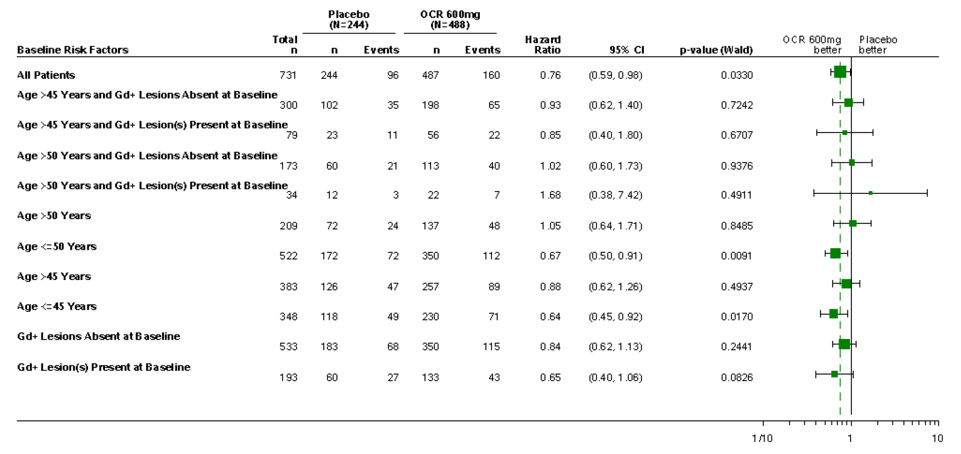
Qualitatively similar results were obtained when disability progression was defined as 24 week CDP, with unfavourable HRs observed in subjects > 50 years.

Table 131: CDP for 24 weeks by age and Gd+ lesions in PPMS; Studies WA25046
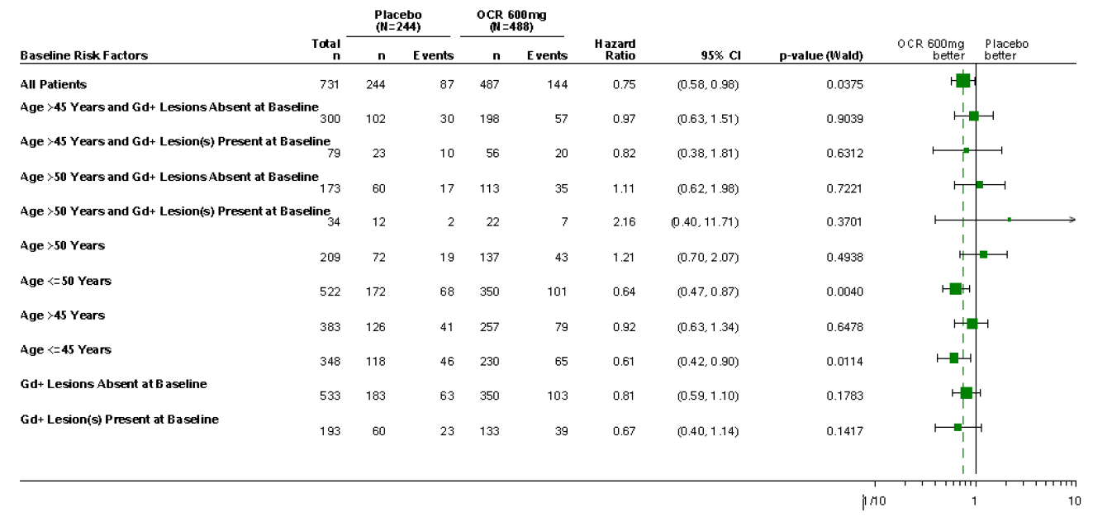
In their response to this question (but not shown here), the sponsor also presented results for other efficacy endpoints, including the 25FTW, 9HPT, T2 lesion volume, total brain volume, and a composite measure of progression (based on the EDSS, 25-Foot Timed Walk, and the 9-Hole Peg Test). Overall, results were qualitatively similar to those obtained with the major efficacy endpoints of 12 week and 24 week CDP, but some individual measures showed apparent efficacy in older subjects (such as T2 lesion volume and 9HPT), with HRs below unity, numerically in favour of ocrelizumab. The finding of occasional positive results for minor endpoints in a post hoc analysis is not statistically robust, particularly when there has been no correction for multiplicity, and emphasis should be placed on the major endpoints shown in the two figures above.
On balance, these results suggest that the efficacy of ocrelizumab is likely to be poor in most subjects older than 50, poor in most subjects with the combination of age > 45 and Gd-negative scans at baseline, and intermediate in subjects with just one factor suggesting poor responsiveness (age > 45 or lack of Gd+ baseline scans). Most of the benefit of ocrelizumab in PPMS was obtained in subjects < 45 years and Gd+ scans at baseline. It is not currently clear whether subjects in the intermediate age bracket (45 to 50 years) would experience acceptable efficacy with ocrelizumab (a specific analysis of this small subgroup was not requested or performed, and would be expected to be underpowered), but efficacy in this intermediate age group would be expected to be relatively poor if baseline scans were Gd-negative.
In a different part of their response (in the discussion of the PI), the sponsor noted that Gd-positivity can fluctuate, and Gd-positive lesions usually cease to be contrast-enhancing after 2 to 3 weeks. Given this fluctuation, it seems likely that many responders among the Gd-negative group would have had Gd-positive lesions at other time points, and that Gd-status at a single time point is not a completely reliable indicator of potential responsiveness. This does not mean that Gd-status is irrelevant, indeed, it seems likely that persistently Gd-negative subjects (those lacking Gd+ lesions over multiple scans) would be even less responsive than the Gd-negative subgroups in this analysis (because some of them would have been Gd+ at other time points). It is not possible to address this possibility on the current evidence, but it is relevant to arguments raised by the sponsor where the sponsor claims that use of Gd-status to determine eligibility for treatment could deny some suitable patients access to ocrelizumab. The evaluator proposes that Gd-positivity on a single recent scan should be considered an adequate marker of inflammatory activity, qualifying a subject for treatment.
In the absence of supportive Phase 2 studies or confirmatory Phase 3 studies in the PPMS population, it would be reasonable to restrict ocrelizumab to PPMS subjects who are Gd+ at baseline and ≤ 50 years. It could be argued that ocrelizumab should not be used in PPMS subjects unless they are both Gd+ and ≤ 45 years, but within the limitations of the currently available data, the evaluator favours a slightly broader definition of the suitable target population (Gd+ and ≤ 50 years).
This differs slightly from recommendations in the first-round CER, where it was suggested that ocrelizumab should be restricted to subjects with Gd+ baseline scans, without reference to patient age, but it was anticipated in the first-round CER that an analysis with an age cut-off of 50 years might identify a poorly responsive group. The new analysis confirms poor responsiveness in subjects > 50 years, and this is consistent with observations of the rituximab study.
- Subgroup Analysis: Effect of Age and Gd-positivity in ‘RMS’
The sponsor submitted a similar subgroup analysis of the pooled pivotal studies in ‘RMS’, although this was not specifically requested. The analysis is potentially relevant because the sponsor did not perform a pivotal study in subjects with SPMS, and did not collect data on SPMS-status at baseline, but instead lumped together subjects with RRMS and SPMS. Within this mixed population, it would be expected that age and Gd-positivity at baseline might serve as potential markers of responsiveness to treatment, in part because these factors may also act as surrogate markers for patients’ position on the RRMS/SPMS spectrum. Indeed, this pattern was observed in the sponsor original subgroup analysis, which considered age and Gd-positivity as separate factors rather than in combination. In that earlier analysis, the effect of Gd-positivity on ARR was statistically significant: the 95%CI for the HR in the Gd-negative subgroup, despite being numerically favourable for ocrelizumab (rate ratio = 0.787), did not overlap the 95%CI for the HR in the Gd+ subgroup, which was much more strongly favourable for ocrelizumab (rate ratio = 0.313). The effect of age was also marked, with the central estimate for the rate ratio in each age bracket (< 40 versus ≥ 40 years) falling outside the 95%CI for the other age bracket, although the 95%CIs overlapped (rate ratio for ARR for younger subjects, 0.423 95% CI 0.284, 0.631; rate ratio for older subjects 0.692, 95%CI 0.447, 1.072).
The new subgroup analysis looked at combinations of advanced age and Gd-positivity status, but focussing on different age groups than the one in the original submission (the new analysis used cut-offs of 45 years and 50 years, instead of 40 years, because the question was directed towards the PPMS population, where these cut-offs were more relevant). Results for the primary ARR endpoint are shown in the figure below. Although the subgroup analysis was underpowered, all rate ratios remained favourable, with a numerical superiority of ocrelizumab observed even in subjects with a combination of age > 45 years and a lack of Gd+ lesions on baseline scans. Similarly, in subjects with age > 50 years and Gd-negative scans, the rate ratio was favourable, compared to interferon β-1a. Statistically significant superiority of ocrelizumab in older subjects was generally not demonstrated, with the exception of subjects who were > 45 years and had Gd+ scans, but this partially reflects the lack of statistical power in this analysis. Rate ratios were not as favourable in subjects without Gd+ scans at baseline, when the age group > 45 years was considered, consistent with observations in the overall cohort. This pattern was also observed in subjects > 50 years, but the number of subjects > 50 years with Gd+ scans was low, and the analysis in this group was underpowered. Results for younger subjects with and without Gd+ scans were not provided.

Table 132: ARR by age and Gd+ lesions; pooled Studies WA21092 and WA21093
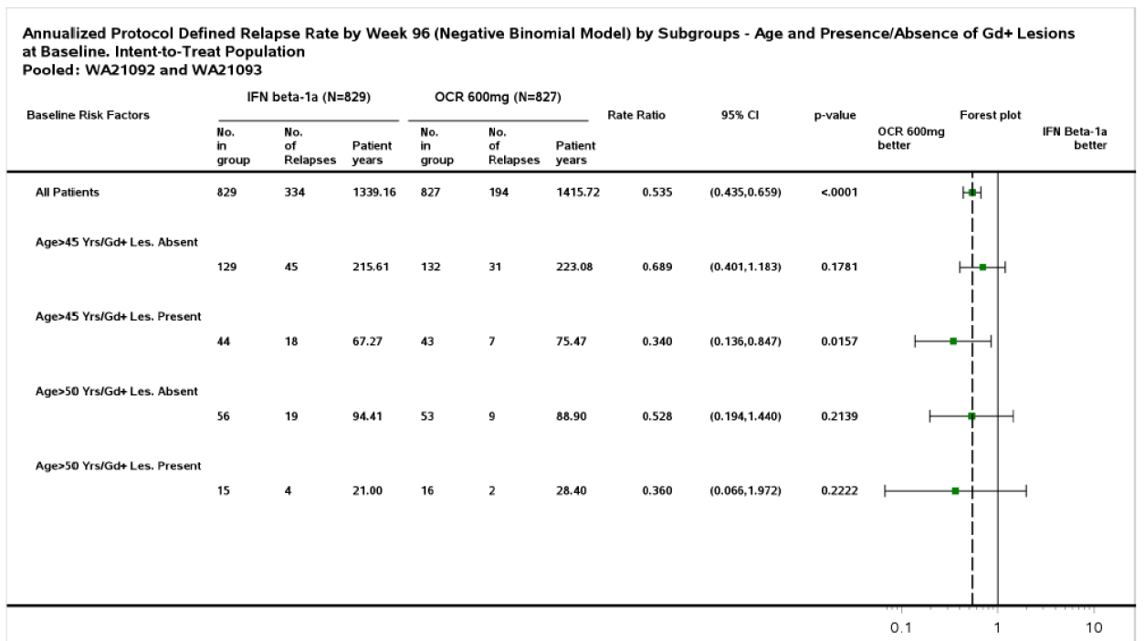
When a similar analysis was performed for the other major efficacy endpoint, CDP, a consistent pattern was not observed. Results were numerically in favour of ocrelizumab in older subjects defined on the basis of age > 45 years or > 50 years, but baseline Gd-positivity did not indicate a more favourable response to ocrelizumab within the older cohorts, compared to interferon β-1a. This could reflect the poor statistical power of the analysis. Results in younger subjects were not presented.

Table 133: CDP for 12 weeks by age and Gd+ Lesions; Pooled Studies WA21092 and WA21093
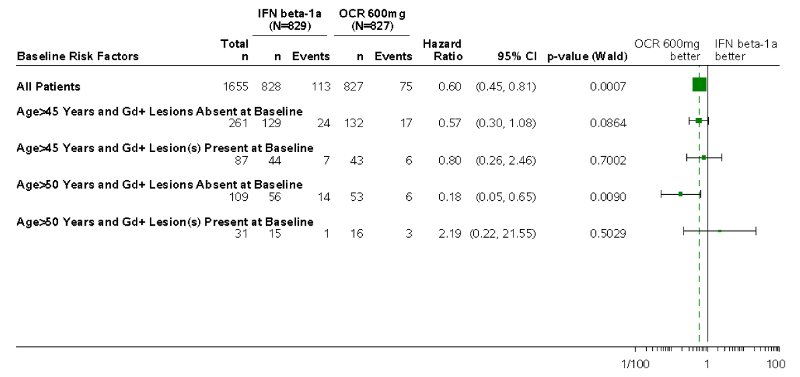
Subgroup analyses by age and GD-positivity for the CDP endpoints of the ‘RMS’ studies were not emphasized in the first-round CER (because CDP was not a primary endpoint in the ‘RMS’ studies), but the results are shown below. The HR for 24 week CDP, in subjects with or without Gd+ scans, did not show a consistent relationship across the two pivotal studies, in terms of whether the treatment effect was better with or without Gd+ scans, but ocrelizumab was numerically superior to interferon β-1a regardless of age and Gd-positivity. Hazard ratios were also inconsistent with respect to the effects of age, but the 95%CIs were broad and overlapping, so no strong conclusions can be drawn.

Table 134: Forest plot of time to onset of confirmed disability progression for at least 24 weeks by subgroup (ITT Population, Study WA21092)
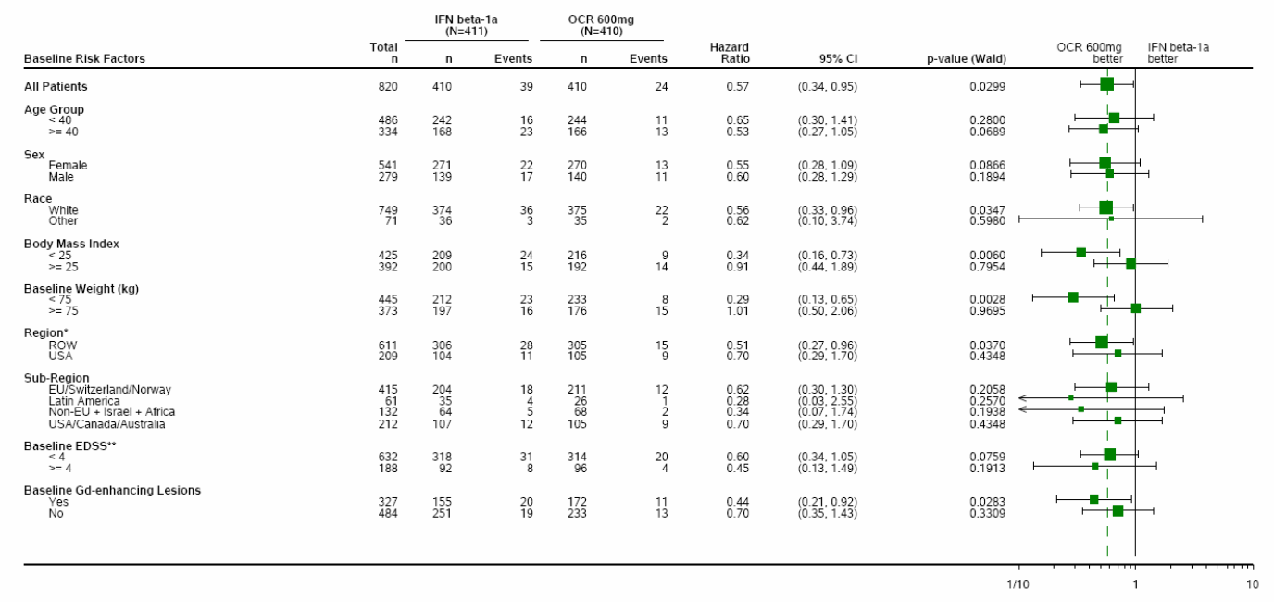

Table 135: Forest plot of time to onset of confirmed disability progression for at least 24 weeks by subgroup (ITT Population, Study WA21093)
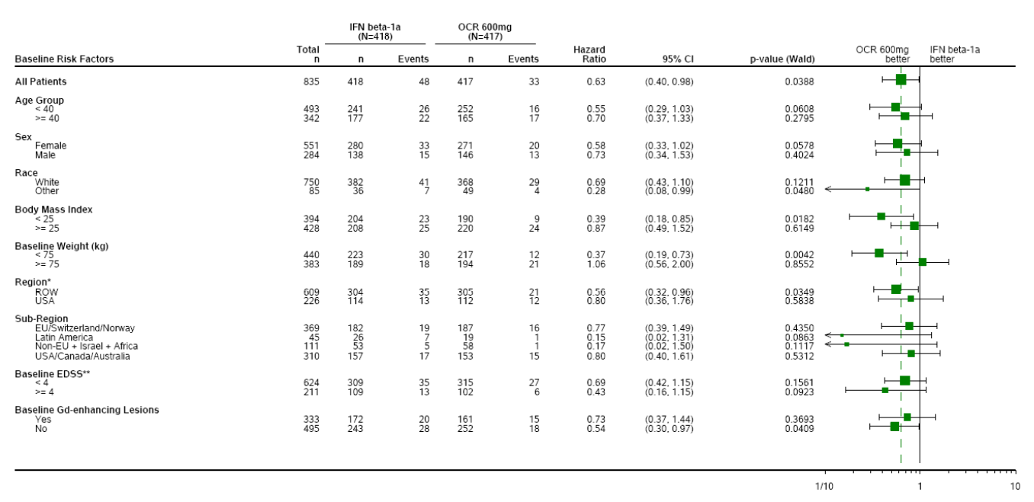
Overall, subgroup analysis of the ‘RMS’ population suggests that, as already noted in the PPMS population, the efficacy of ocrelizumab deteriorates with advancing age and is worse in subjects without Gd+ lesions. Despite this, a poorly responsive subgroup within the broad ‘RMS’ population cannot be identified merely by combining age and Gd-positivity status, because (somewhat surprisingly) lack of Gd-positivity did not predict worse responsiveness within the older subjects. Interpretation of these results is made more difficult because the control treatment, interferon β-1a, would also be expected to have varying efficacy across the spectrum of age and radiological activity. (Interferon β-1a has not been approved for use in subjects with SPMS, and interferon β-1a would not normally be used in subjects with a combination of SPMS, older age and inactive scans. For subjects with SPMS, ocrelizumab was being compared to a treatment not thought to provide acceptable efficacy).
A more relevant subgroup analysis would have been one based on traditional disease subtype (RRMS verse SPMS); such an analysis was requested (see Responses 1 and 2, above), but was not provided, and is unfortunately not possible now because the relevant disease classifications were not collected at baseline. The subgroup analysis the sponsor has provided, based on age and Gd+ status, does not directly address the issue of whether subjects with SPMS can expect reasonable efficacy with ocrelizumab. Until prospective studies have been performed in subjects with SPMS, the evaluator believes that treatment of SPMS with ocrelizumab should be reserved for subjects in whom there is a high expectation of efficacy: at present, the evidence in favour of ocrelizumab is strongest for Gd+ patients.

Efficacy question 5
- What is known about the efficacy of ocrelizumab in subjects who have PPMS and a predominantly spinal distribution of lesions?
Many subjects with PPMS have a predominantly spinal form of the disease, and show a progressive spastic paraparesis without other features typical of MS. It is not clear whether these subjects would necessarily respond to ocrelizumab with the same efficacy as subjects with predominantly cerebral disease.
The sponsor replied:
In study WA25046, magnetic resonance imaging (MRI) of the spinal cord was not performed. Therefore, the information to directly address the TGA’s question is not available.
The sponsor also points out that lesions in the spinal cord can be difficult to quantify because of the longitudinal anatomy of the cord, the tendency for MS to cause diffuse cord atrophy, and the presence of movement and respiration artefacts. The sponsor concludes:
Thus the current understanding of spinal cord pathology in MS continues to be evaluated outside the clinical trial setting, with the use of higher-magnetic fields and advanced MRI technology which will allow better definition of spinal cord involvement in MS and correlation with clinical outcomes. These higher-magnetic field MRIs and advanced image acquisition sequences are only available at a few select clinical sites.
These comments appear reasonable. It is currently not possible to determine whether ocrelizumab is likely to have substantial efficacy in subjects with predominantly spinal disease, and this issue may not be readily approached using traditional multicentre studies. Individual centres with interested MS specialists and radiologists may be able to clarify efficacy in this subgroup in future.

Efficacy question 6
- Please provide, or indicate the location of, a convenient one-page summary table listing the most common AEs observed in the RA studies. An acceptable format would be the one used to report AEs in the SM population in the Summary of Clinical Safety (‘Adverse Events Reported in ≥ 2% of Patients in at Least One Treatment Group by Preferred Term - Phase III RMS Controlled Treatment Population (Pool A)’ and ‘Adverse Events Reported in ≥ 2% of Patients by Preferred Term - Phase III PPMS Controlled Treatment Population’), but it would be even more appropriate of AEs were grouped by System Organ Class, with totals shown for each SOC, as well as identified by Preferred Term.
The sponsor provided the figure below, which has now been incorporated into the second round CER. As shown, IRRs were more common with active treatment (placebo 11.0%, ocrelizumab 400 mg 23.8%, and ocrelizumab 1000 mg 29.4%), but other individual AEs in the RA population showed no clear imbalance between treatment groups. This new table is consistent with the original description of safety in the RA studies, and does not raise any new concerns.

Table 136: Adverse events reported in ≥ 2% of patients in placebo, ocrelizumab 400 mg or ocrelizumab 1000 mg treatment groups by system organ class and preferred terms. Pool D: Phase II and III RA Controlled Treatment Population
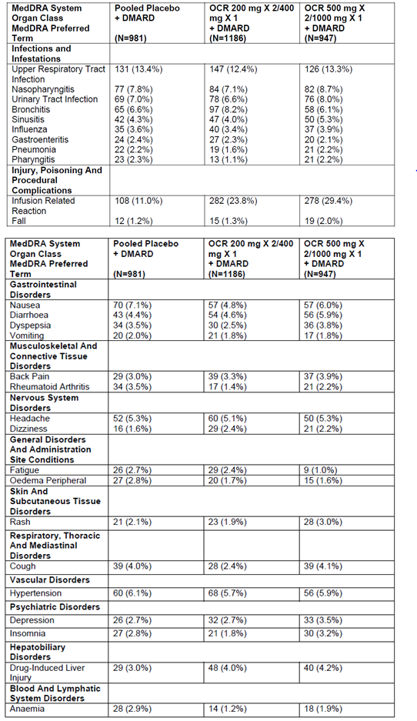

Efficacy question 7
- Please provide, or indicate the location of, a convenient one-page summary table listing the SAEs observed in the RA studies, grouped by SOC and PT.
The sponsor provided the table below, including SAEs that occurred with a frequency of > 0.1%. The sponsor provided the additional comments:
Consistent with the analyses on rates per 100-patient years, SAEs grouped to the SOC Infections and Infestations were reported more frequently in the ocrelizumab 1000 mg group compared with placebo and ocrelizumab 400 mg. Not unexpectedly, serious infusion related reactions (IRRs) were reported more frequently in the ocrelizumab 1000 mg group (6 patients) compared with ocrelizumab 400 mg and placebo (1 patient in each group).
These observations are consistent with the evaluator’s original analysis of SAEs in the RA studies, and confirm that IRRs and infections constitute the major risks with ocrelizumab. The overall assessment of safety is not altered.

Table 137: Serious Adverse Events Reported in > 0.1% of Patients in Placebo, Ocrelizumab 400 mg or Ocrelizumab 1000 mg treatment groups by System Organ Class and Preferred Terms. Pool D: Phase II and III RA Controlled Treatment Population
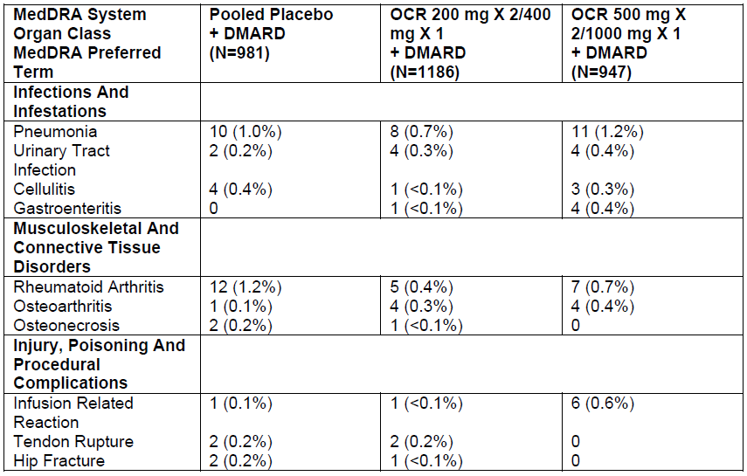

Table 138: Serious Adverse Events Reported in > 0.1% of Patients in Placebo, ocrelizumab 400 mg or ocrelizumab 1000 mg treatment groups by System Organ Class and Preferred Terms. Pool D: Phase II and III RA Controlled Treatment Population
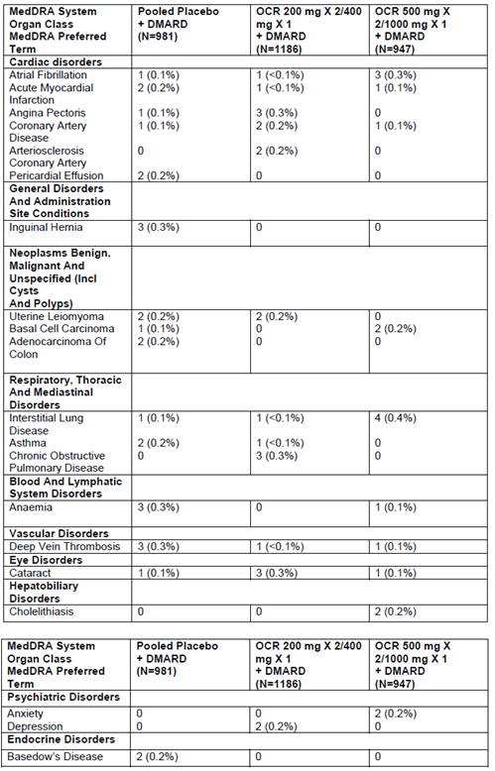

Efficacy question 8
- In the listing of deaths in the MS and RA populations, the cause of death was occasionally listed as ‘Death’. What was the likely cause of death in each of these cases? Please provide a table listing all deaths in ocrelizumab recipients.
The sponsor provided a listing of all deaths, as shown in the tables below. The preferred term was still listed as ‘Death’ for one MS subject below, rather than as the condition causing death, but the cause of death in this subject appears to have been unclear; the sponsor additional information provides some context. In the RA population, two patients had ‘Death’ as the preferred term, and another two had ‘Sudden Death’ as the preferred term. In these cases, the deaths occurred at home, details were lacking, and autopsies were not performed, so the cause of death was unclear, but it was suspected in all four cases that the cause was cardiac. Overall, no new concerning safety signals arise from consideration of these cases and the sponsor appears to have provided as much detail as is available.
The sponsor also reported 3 additional deaths in MS subjects, which occurred after the original data cut-off, as described below:
- Patient [information redacted] (OCR group): A patient was diagnosed with adenocarcinoma of oesophagus on Day 1440. She had medical history of microcytic anaemia with low iron level. On Day 1440, she was diagnosed with adenocarcinoma of oesophagus (diagnostic details not provided). On Day 1446, the patient died due to the event. Autopsy was not performed. The investigator assessed the event as unrelated to study drug and related to disease under study.
- Patient [information redacted] (OCR group) was a patient treated with ocrelizumab 600 mg who died of acute coronary insufficiency (medical history included heart failure, New York Heart Association classification (NYHA) II for 10 years, active smoker, arterial hypertension and obesity) on Day 1686. The investigator assessed the event as unrelated to study drug.
- Patient [information redacted] (OCR group): was a patient treated with ocrelizumab 600 mg who was found dead in his residence on Day 1340. Cause of death was unknown at the time of writing (an autopsy report has been requested). Concurrent conditions included hypercholesterolemia, weight loss for unknown reasons, and smoking. The investigator assessed the event as unrelated to study drug. (Follow-up information received after 30 September 2016 stated the cause of death remained unclear after the autopsy, though an epileptic seizure process with consequent failure of central regulation is conceivable.)
In the RA All Exposure (Pool E, N = 2926 patients), the sponsor reported a total of 45 deaths, in ocrelizumab treated patients, including the 13 deaths already tabulated above. The causes were listed as follows:
- Pneumonia (n = 7)
- Septic shock (n = 2), Sepsis (n = 4)
- Respiratory failure (n = 3), Acute respiratory failure (n = 1)
- Multi-organ failure (n = 1)
- Disseminated intravascular coagulation (n = 1)
- Myocardial infarction (n = 2), Acute myocardial infarction (n = 1)
- Sudden cardiac death (n = 1)
- Pulmonary embolism (n = 1)
- Ruptured cerebral aneurysm (n = 1)
- Subdural haematoma (n = 1)
- Ischaemic cerebral infarction (n = 1)
- Brain oedema (n = 1)
- Gastrointestinal haemorrhage (n = 1)
- Lung adenocarcinoma (n = 1), Lung neoplasm (n = 1), Lung adenocarcinoma metastatic (n = 1)
- Breast cancer (n = 1)
- Gastrointestinal carcinoma (n = 1)
- Metastasis gastric cancer (n = 1)
- B cell lymphoma (n = 1)
- Death (n = 2), Sudden death (n = 2)
- Cough (n = 1)
- Road traffic accident (n = 1)
- Dementia (n = 1)
- Carbon monoxide poisoning (n = 1)
- Toxicity to various agents (n = 1)
This listing was accompanied by a multi-page table providing more detail.
Overall, the sponsor response to this question was adequate, and no new safety concerns were raised.

Efficacy question 9
- How many deaths in the RA study program were caused by infections, and which of these were potentially opportunistic infections?
The sponsor’s main response was:
In the rheumatoid arthritis (RA) study program, 13 deaths were caused by infections. None of these 13 fatal infections were the result of a serious opportunistic infection.
The sponsor provided further details about the overall risk of infection with ocrelizumab, the risk of serious infection, and the risk of fatal infection. There was an overall increase in the risk of infection with ocrelizumab, including serious and fatal infections, but the fatal infections were not caused by pathogens usually regarded as opportunistic in nature.
Considering serious infections in the controlled RA studies, the sponsor summarised the results as follows:
In the controlled treatment period of the 7 placebo-controlled double blind RA trials (Pool D), the rate per 100PY of serious infection (SOC definition) was numerically higher in the OCR 1000 mg (6.40; 95% CI: 4.86, 8.27) group compared with the OCR 400 mg (4.38; 95% CI: 3.18, 5.88) and placebo (3.43; 95% CI: 2.33, 4.87) groups. The rates did not differ substantially when applying the broader definition of serious infection (includes non-serious treated with IV anti-infectives). The rate per 100PY in the placebo group was 3.99 (95% CI: 2.79, 5.52) compared with 5.18 (95% CI: 3.87, 6.79) and 7.28 (95% CI: 5.63, 9.27) in the OCR 400 mg and OCR 1000 mg groups, respectively.
Note that, by both definitions of serious infection, the rate in the high-dose ocrelizumab group approached a level twice that seen with placebo (6.4% versus 3.43% for the SOC definition, and 7.28% verse 3.99% for the broader definition).
The most common serious infections were those that are already common in the general community: pneumonia (1.6% of patients), followed by urinary tract infection (0.7%). No other individual serious infection, classified by preferred term, was reported in more than 0.5% of patients.
Fatal infections were summarised by the sponsor as follows:
In Pool D (the controlled RA studies), no fatal infections were reported in the placebo group, and 9 (in 7 patients) were reported in the OCR groups (n = number of events):
- OCR 50 mg x 2 group: pneumonia (n = 1), Sepsis (n = 1) , Septic shock (n = 1) (all in one patient)
- OCR 200 mg x 2 group: septic shock (n = 2)
- OCR 500 mg x 2 group: pneumonia (n = 2)
- OCR 500 mg x 2 group: sepsis (n = 1)
- OCR 1000 mg x 1 group: pneumonia (n = 1)
In Pool E (all RA studies), 10 additional fatal infections were reported, leading to a total of 19 fatal infections (n = number of events) in 15 patients:
Placebo-OCR switchers : sepsis (n = 3); respiratory failure (n = 1); pneumonia (n = 1); septic shock (n = 1)
- OCR 50mg x 2 group: pneumonia (n = 1); sepsis (n = 1); septic shock (n = 1)
- OCR 200 mg x 2 group: pneumonia (n = 2); septic shock (n = 2),
- OCR 500 mg x 2 group: pneumonia (n = 3); sepsis (n = 1),
- OCR 1000 mg x 1 group: sepsis (n = 1); pneumonia (n = 1)’
For two RA subjects who died from a fatal infection, their past history included an opportunistic infection (mycobacterium abscessus infection in one case, and systemic/oesophageal candidiasis in the other), but the previous opportunistic infections were not temporally related to the deaths.
Reviewing this evidence, it appears that there was an excess of fatal infections in the ocrelizumab groups, which was likely to reflect an immunosuppressive effect of ocrelizumab, but these were not infections that are usually characterised as opportunistic. As already noted, serious infections were much less common in the MS studies, which partially reflects the fact that, in the RA studies, ocrelizumab was combined with other immunosuppressive agents including long-term corticosteroids. Ocrelizumab should therefore be avoided in combination with other chronic immunosuppressive agents. Short-term use of corticosteroids, such as high-dose methylprednisolone for MS relapses, does not appear to pose an excess risk of infection, as already discussed in the first round CER. RA patients were also likely to be older, with additional comorbidities. An increased risk of serious infections and opportunistic infections appeared to arise in RA subjects from Asia, but this was not statistically significant. The potential for ocrelizumab to increase the risk of infection, particularly when combined with other immunosuppressive agents, is already noted with appropriate emphasis in the proposed PI.

Second round benefit-risk assessment
The new material submitted in response to Clinical Questions clarifies some aspects of the benefit-risk assessment, but does not change the evaluator’s overall assessment of the efficacy and safety of ocrelizumab.
Despite the fact that the sponsor provided detailed answers to the questions raised, there are a number of points of residual disagreement between the evaluator and the sponsor about the quality of the efficacy data and its applicability across the full spectrum of MS disease. In particular, the evaluator and the sponsor do not agree on the appropriateness of grouping the traditional disease subtypes, RRMS and SPMS, under the broad heading of ‘RMS’. The sponsor responses reveal that details about disease subtype were not collected at baseline, so it is not possible, even in retrospect, to determine the efficacy of ocrelizumab in SPMS subjects.

Efficacy in RRMS
No substantial new data was submitted in relation to RRMS. The two pivotal ‘RMS’ studies largely consisted of RRMS subjects (> 90%, up to approximately 98%), and can be considered primarily as positive studies in RRMS.
The first-round CER suggested that the sponsor had only shown efficacy in RRMS subjects with recent relapses, because the pivotal ‘RMS’ studies had only recruited subjects with recent relapses. Strictly speaking, this remains true, but on reflection it appears very likely that other RRMS subjects would also benefit from ocrelizumab, even without a recent relapse, especially if they have radiological evidence of active disease. (The positive results in PPMS subjects support this conclusion.) On balance, the quality of the RRMS evidence is sufficiently robust that it could be left to clinicians to decide which RRMS subjects are suitable for treatment. In practice, this is likely to be subjects with clinical elapses or radiological evidence of disease activity. The recommendations for RRMS have therefore been altered to reflect this (see below).

Efficacy in SPMS
No study in SPMS has been submitted, and SPMS subjects are likely to have constituted only a small proportion of the cohort (2 to 10%) in the pivotal ‘RMS’ studies, so direct evidence of ocrelizumab efficacy in SPMS is currently lacking.
A number of indirect lines of evidence suggest that ocrelizumab probably has efficacy in some subjects with SPMS, at least when SPMS is associated with on-going relapses. These include trends in favour of ocrelizumab for ‘RMS’ subjects with advanced EDSS (≥ 4.0) at baseline, a reduced incidence of progression independent of overt relapses in the ‘RMS’ subjects, and positive results in the pivotal PPMS study.
None of these lines of evidence is considered entirely robust, so it would be reasonable to reject the registration of ocrelizumab in subjects with SPMS, pending an appropriate prospective study in this population. Instead, the evaluator has taken the view that efficacy in two neighbouring regions of the MS spectrum has been studied: the two pivotal RMS studies mostly recruited RRMS subjects, and showed positive results on relapse rate and disability progression; the pivotal PPMS study showed positive results for progression. By interpolation, it thus seems likely that SPMS, which is many ways intermediate between RRMS and PPMS, would also respond to ocrelizumab, with reductions in relapses and progression. Given the indirect nature of this evidence, though, caution should be applied in making inferences about the efficacy of ocrelizumab in SPMS.
The response to ocrelizumab in all three pivotal studies was heterogeneous, with inferior results obtained for subjects who were older (> 45 years or > 50 years) or had no evidence of Gd-positive lesions on their baseline scans.
Given that the claim for efficacy in SPMS relies on the PPMS results for indirect support, the subgroup analysis of PPMS subjects needs to be considered, even though it applies to a different disease subtype. For PPMS subjects > 50 years, hazard ratios for disability progression were not in favour of ocrelizumab. Hazard ratios for 12 week CDP in older subjects (> 45 years, HR 0.88) and in those without Gd+ baseline scans (HR 0.84) were numerically in favour of ocrelizumab, but 95% CIs crossed unity and the HRs were less favourable than those observed in younger subjects (HR 0.64) and those with Gd+ baseline scans (HR 0.65). Because of those pattern, the evaluator believes the case for efficacy in Gd+ patients with SPMS is probably adequate, despite the fact that it is indirect. By contrast, the case for efficacy in Gd-negative subjects with SPMS currently relies on too many untested assumptions and inferences.

Efficacy in PPMS
The new data supplied in response to Clinical Questions has shown that, in older subjects with PPMS, ocrelizumab has inferior efficacy. In subjects > 50 years, no favourable trends were observed for primary efficacy endpoints (HR 1.05 overall). In subjects > 45 years, favourable trends were observed (HR 0.88), but the benefit was largely observed in subjects who were Gd+ at baseline (> 45 years and Gd+, HR 0.85; > 45 years and Gd-negative, HR 0.93). In Gd-negative subjects, the efficacy of ocrelizumab was inferior, but there were trends favouring ocrelizumab over placebo (Gd- HR 0.65, Gd+ HR 0.84). In younger subjects (≤ 45 years), the evidence in favour ocrelizumab was reasonably strong (HR 0.64, 95%CI not crossing unity). It is unclear how subjects with PPMS responded to ocrelizumab if they were young but Gd-negative, because this was not reported.
As noted in the discussion, the evaluator’s overall assessment of this data is that, in the absence of supportive Phase 2 studies or confirmatory Phase 3 studies in the PPMS population, it would be reasonable to restrict ocrelizumab to PPMS subjects who are Gd+ at baseline and ≤ 50 years.

Table 139: CDP for 12 weeks by age and GD+ lesions in PPMS; Study WA25046
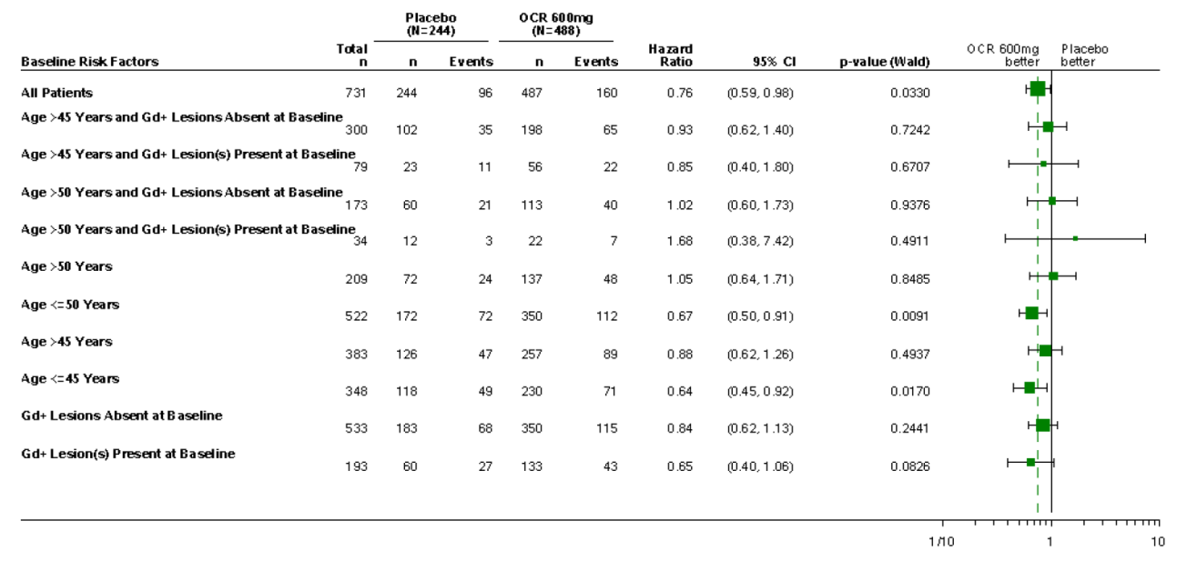

Risks of Ocrelizumab
The new data does not raise any new safety concerns. The Evaluator accepts the sponsor comments on the risks of PML in the setting of anti-CD20 monoclonal antibodies. This risk appears to be low in MS subjects exposed to ocrelizumab, compared to RA subjects exposed to rituximab, and the sponsor proposed comments in the PI are adequate. The PI does not need to recommend serological testing for JC virus.

Second round recommendation regarding authorisation
In the absence of adequate information about the efficacy of ocrelizumab in subjects with SPMS, the recommendations listed below can be made. These recommendations could be revised if further evidence of efficacy in SPMS subjects were made available. Ocrelizumab should be approved for treatment of Relapsing and Remitting MS (RRMS).Ocrelizumab should be approved for treatment of Secondary Progressive MS (SPMS), in subjects who have been experiencing ongoing relapses and have contrast-enhancing (Gd+) lesions on their cerebral MRI. Ocrelizumab should be approved for treatment of Primary Progressive MS (PPMS) in subjects who are < 50 years of age and have contrast-enhancing (Gd+) lesions on their cerebral MRI.

References
Bar-Or A, Favaz J, Fan B, et al. Abnormal B cell cytokine responses a trigger of T-cell–mediated disease in MS? Ann Neurol 2010;67(4):452-61.
Constant SL. B lymphocytes as antigen-presenting cells for CD4+ T cell priming in vivo. J Immunol 1999;162(10):5695-703.
Crawford A, MacLeod M, Schumacher T, et al. Primary T cell expansion and differentiation in vivo requires antigen presentation by B cells. J Immunol 2006; 176(6):3498-506.
Duddy M, Niino M, Adatia F, et al. Distinct effector cytokine profiles of memory and naïve human B cell subsets and implication in multiple sclerosis. J Immunol 2007; 178(10):6092-9.
Genain CP, Cannella B, Hauser SL, et al. Identification of autoantibodies associated with myelin damage in multiple sclerosis. Nat Med 1999; 5(2):170-5.
Lublin FD, Reingold SC, Cohen JA, et al. Defining the clinical course of multiple sclerosis; the 2013 revisions. Neurology 2014;83:278-286.
Magliozzi R, Howell OW, Reeves C, et al. A gradient of neuronal loss and meningeal inflammation in multiple sclerosis. Ann Neurol 2010; 68(4):477-93.
McDonald WI, Compston A, Edan G, et al. Recommended diagnostic criteria for multiple sclerosis: guidelines from the International Panel on the diagnosis of multiple sclerosis. Ann Neurol 2001;50:121–127.
Panitch H, Goodin DS, Francis G, Chang P, Coyle PK, O'Connor P, Monaghan E, Li D, Weinshenker B; EVIDENCE Study Group. Randomized, comparative study of interferon beta-1a treatment regimens in MS: The EVIDENCE Trial. Neurology. 2002 Nov 26;59(10):1496-506.
Storch MK, Piddlesden S, Haltia M, et al. Multiple sclerosis: in situ evidence for antibody- and complement-mediated demyelination. Ann Neurol 1998; 43(4):465-71.
Serafini B, Rosicarelli B, Magliozzi R, et al. Detection of ectopic B cell follicles with germinal centers in the meninges of patients with secondary progressive multiple sclerosis. Brain Pathol 2004; 14(2):164-74.
Tullman MJ. Overview of the epidemiology, diagnosis, and disease progression associated with multiple sclerosis. Am J Manag Care. 2013;19(2):S15-20

Therapeutic Goods Administration
PO Box 100 Woden ACT 2606 Australia
Email: info@tga.gov.au Phone: 1800 020 653 Fax: 02 6232 8605
https://www.tga.gov.au

The sponsor points out that overall, this study was negative.
During evaluation of this submission, the Sponsor reported that one study centre in WA21093 had been found to deviate from GCP, and the major efficacy endpoints for this study were recalculated with this study excluded. The differences were very minor, and the new analysis does not substantially alter interpretation of Study WA21093. The new results for WA21093 are considered to be the most valid results, and should be the results reported in the PI, but some summary tables and pooled analyses included in this report include the old results; use of the old data is flagged where relevant.

