First round CER: September 2013
Second round CER: January 2014

AusPAR Attachment 2

Extract from the Clinical Evaluation Report for Obinutuzumab
  - Proprietary Product Name: Gazyva
  - Sponsor: Roche Products Pty Ltd

About the Therapeutic Goods Administration (TGA)
- The Therapeutic Goods Administration (TGA) is part of the Australian Government Department of Health, and is responsible for regulating medicines and medical devices.
- The TGA administers the Therapeutic Goods Act 1989 (the Act), applying a risk management approach designed to ensure therapeutic goods supplied in Australia meet acceptable standards of quality, safety and efficacy (performance), when necessary.
- The work of the TGA is based on applying scientific and clinical expertise to decision-making, to ensure that the benefits to consumers outweigh any risks associated with the use of medicines and medical devices.
- The TGA relies on the public, healthcare professionals and industry to report problems with medicines or medical devices. TGA investigates reports received by it to determine any necessary regulatory action.
- To report a problem with a medicine or medical device, please see the information on the TGA website <http://www.tga.gov.au>.
About the Extract from the Clinical Evaluation Report
- This document provides a more detailed evaluation of the clinical findings, extracted from the Clinical Evaluation Report (CER) prepared by the TGA. This extract does not include sections from the CER regarding product documentation or post market activities.
- The words [Information redacted], where they appear in this document, indicate that confidential information has been deleted.
- For the most recent Product Information (PI), please refer to the TGA website <http://www.tga.gov.au/hp/information-medicines-pi.htm>.
Copyright
© Commonwealth of Australia 2014
This work is copyright. You may reproduce the whole or part of this work in unaltered form for your own personal use or, if you are part of an organisation, for internal use within your organisation, but only if you or your organisation do not use the reproduction for any commercial purpose and retain this copyright notice and all disclaimer notices as part of that reproduction. Apart from rights to use as permitted by the Copyright Act 1968 or allowed by this copyright notice, all other rights are reserved and you are not allowed to reproduce the whole or any part of this work in any way (electronic or otherwise) without first being given specific written permission from the Commonwealth to do so. Requests and inquiries concerning reproduction and rights are to be sent to the TGA Copyright Officer, Therapeutic Goods Administration, PO Box 100, Woden ACT 2606 or emailed to <tga.copyright@tga.gov.au>.

Contents
List of abbreviations 5
1. Clinical rationale 5
2. Contents of the clinical dossier 6
2.1. Scope of the clinical dossier 6
2.2. Paediatric data 7
2.3. Good clinical practice 7
3. Pharmacokinetics / pharmacodynamics 7
3.1. Studies providing data 7
3.2. Comparison of OB PK across studies 8
3.3. Results 10
3.4. Evaluator’s conclusions 18
4. Dosage selection for the pivotal studies 18
5. Clinical efficacy 19
5.1. Studies providing efficacy data 19
5.2. Study design 19
5.3. Patient disposition 21
5.4. Demographic and baseline characteristics 21
5.5. Extent of exposure to study drug: 22
5.6. Efficacy results for stage IA 22
5.7. Results of study of stage IB of study B021004-CLL 11 26
5.8. Supportive studies 27
6. Clinical safety 27
6.1. Studies providing safety data 27
6.2. Overall extent of exposure 28
6.3. Demographic and other characteristics of the study population 28
6.4. Results 29
6.5. Post-marketing data 43
6.6. Evaluator’s conclusions on safety 43
7. First round benefit-risk assessment 43
7.1. First round assessment of benefits 43
7.2. First round assessment of risks 43
7.3. First round assessment of benefit-risk balance 44
8. First round recommendation regarding authorisation 44
9. Clinical questions 44
10. Second round evaluation of clinical data 45
10.1. Study BO21004/CLL11 45
10.2. Pivotal studies that assessed safety as a primary outcome 46
10.3. Clinical questions: round one 47
10.4. Second round evaluation of clinical data 71
10.5. Second round benefit-risk assessment 81
10.6. Clinical questions: round two 81
10.7. Second round recommendation regarding authorisation 82
11. References 82

List of abbreviations
Abbreviation | Meaning
AE | adverse event
ARTG | Australian Register of Therapeutic Goods
CIRS | Cumulative Illness Rating Scale
Clb | chlorambucil
CLL | chronic lymphatic leukaemia
GClb | combination of obinutuzumab (Gazyva) and chlorambucil
HAHA | human antihuman antibodies
IRC | independent review committee
IRC | independent review committee
IRR | infusion related reaction
ITT | intention-to-treat
LRD | lymphocyte residual disease negative
MRD | minimum residual disease
OB | obinutuzumab
OS | overall survival
PFS | progression free survival
PI | Product information
RClb | combination of rituximab and chlorambucil
TLS | tumour lysis syndrome

Clinical rationale
CLL is a condition commonly affecting the elderly who frequently have associated co-morbidities which limit the nature of chemotherapy which can be administered to these patients. Clb has been a mainstay of treatment for these patients for many years being able to maintain disease control for prolonged periods of time but ultimately the disease remains incurable. More recent approaches to treatment including agents such as fludarabine and rituximab and other monoclonal antibodies have proven efficacious in combination associated with significantly higher incidence of adverse effects in the elderly patients. Accordingly, OB has been under development as a proposed alternative monoclonal antibody with potential for improved efficacy and acceptable safety.

Contents of the clinical dossier

Scope of the clinical dossier
A total of five studies are presented including the pivotal Study B021004, and Phase I/II Studies B021000, B020999, B021003 and J021900. Full clinical reports and tabular summaries are provided with these studies. It is to be noted that only the pivotal study contains data of direct pertinence to the proposed indications. The remaining four studies effectively provide data with regards to PK and safety. There were a total of 38 patients with CLL who received OB monotherapy in the Phase I Study B021003 and Phase I/II Study B020999. These will be reviewed in the Clinical Efficacy section. Overview of the clinical studies provided in relation to both PK/PD data as well as safety and efficacy data is indicated in Tables 1 and 2.
Table 1: Clinical studies contributing safety and efficacy data supporting the application for registration of OB in CLL.
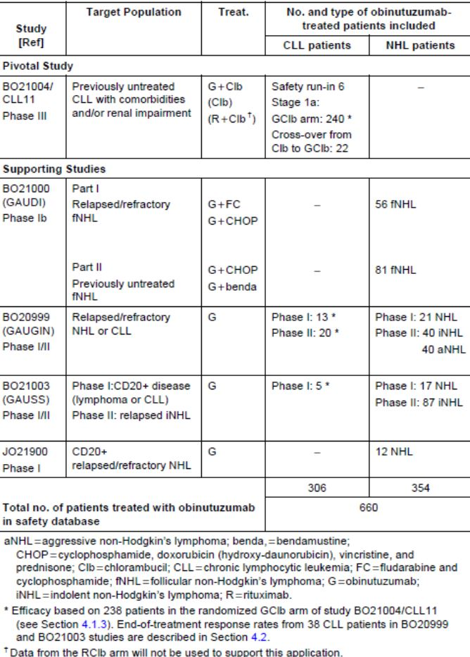
Table 2: Overview of OB studies providing PK/PD data.
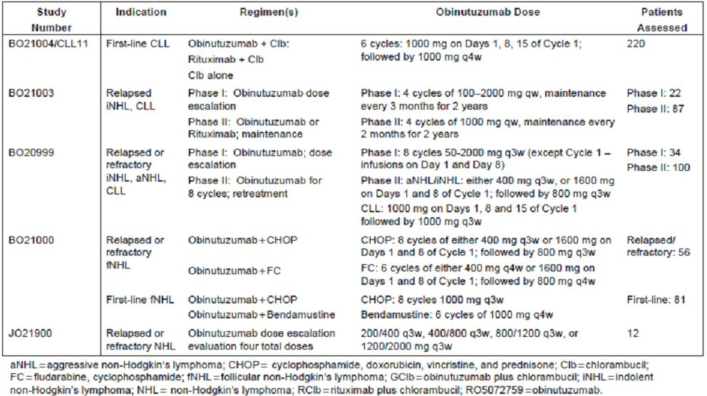

Paediatric data
Not applicable.

Good clinical practice
All aspects of good clinical practice were observed in the studies presented.

Pharmacokinetics / pharmacodynamics

Studies providing data
PK and PD data for this submission is provided from the five studies indicated in Table 2 that included PK, PD, and immunogenicity data. The studies involve the administration of OB to patients principally with NHL as well a small number with CLL. It is noted that three of the studies involve monotherapy with OB but Study B021000 was a combination Phase II study involving the administration of concomitant chemotherapy. Data from four of the clinical studies, namely Studies B020999, B021003, B021000 and B021004, were combined in a population PK analysis and modelling. This provided the most comprehensive analysis of relevant PK and PD data for OB and will be the focus of this evaluation. It is to be noted that the serum sampling scheme for each of these studies is sufficient to enable the development of a population PK model as well as enabling a non compartmental analysis. This included data from both patients with NHL and CLL, OB monotherapy, and OB in combination with chemotherapy in order to conduct a population PK co-variate analysis to identify the main sources of OB PK variability. It was not considered appropriate to include the 12 patients from the Japanese study for the PK analysis since efficacy from this data was not used in the original submission and the safety data was not pooled from other studies.
A two compartment population PK model with time dependent clearance describe OB concentration. Estimates were made from the following structural parameters: steady state clearance (CL_{inf}), initial time dependent clearance (CL_{T}), decay co-efficient of time dependent clearance (k_{des}), central volume of distribution (V₁) inter compartmental clearance (Q), and peripheral volume of distribution (V₂). In the co-variate analysis the following co-variates were tested: weight, gender, age, normalised creatinine clearance, tumour size. Additionally body surface area, body mass index, baseline B cell and lymphocyte count and presence of human anti human antibodies (HAHAs) in Study B021004/CLL 11 were checked for influence on PK parameters by the diagnostic plots.
Graphical analysis of the exposure/efficacy relationship was undertaken with the PK exposure derived from the population PK analysis. Similarly, graphical analysis of the exposure/safety relationship in the pivotal study was undertaken with PK exposure derived from the population PK analysis exploring neutrophil and B cell count time course with neutropenia and B cell count anticipated to be direct consequence of the mechanism of action.
To assess immunogenicity, serum samples obtained during the treatment phase and follow up periods for the four included studies were analysed and assessed for HAHAs. Initially, a first generation HAHA assay was utilised for the three Studies B020999, B021000 and B021003. However, this proved to be extremely sensitive, although only one patient from these studies proved to have developed positive antibodies. A second generation ELISA with improved drug tolerance was developed and used for analysis of the pivotal study.
A sophisticated method of PK analysis was utilised to maximise the information to be obtained from the PK and PD data. This involved a population PK modelling analysis by pooling the serum OB concentration data from all four of the studies. Concentration/time course of OB was accurately described by a two-compartment PK model with time-dependent clearance and with the steady state PK parameters typical for monoclonal antibodies.

Comparison of OB PK across studies
A comparison of OB PK at the start of treatment, ie cycle 1 day 1 is possible across all early clinical studies due a more extensive serum sampling schedule at start of treatment. Table 3 presents the first dose PK across the three studies. It is evident that the inter-patient variability is high particularly for exposure (AUC) (CV range: 28.3-144%). In contrast there is less variability in Cmax (CV range: 21.3-74%); reflective of the nature of OB administration as the infusion input rate of intravenously administered molecule has a major impact on the PK concentration typically observed at the end of the infusion. Moreover the PK model for OB indicates that the clearance is affected by the target and this would have a minimal impact on Cmax. There is strong concordance in Cmax values observed in the monotherapy studies B020999 and B021003 over the 100-1200mg dose range. In addition there is concordance in Cmax between both of these studies with the combination therapy study B021000 at the 1000mg dose.
Table 3: Comparison of OB PK parameters following first dose (Cycle 1 Day 1) in Studies BO20999, BO21000 and BO21003.
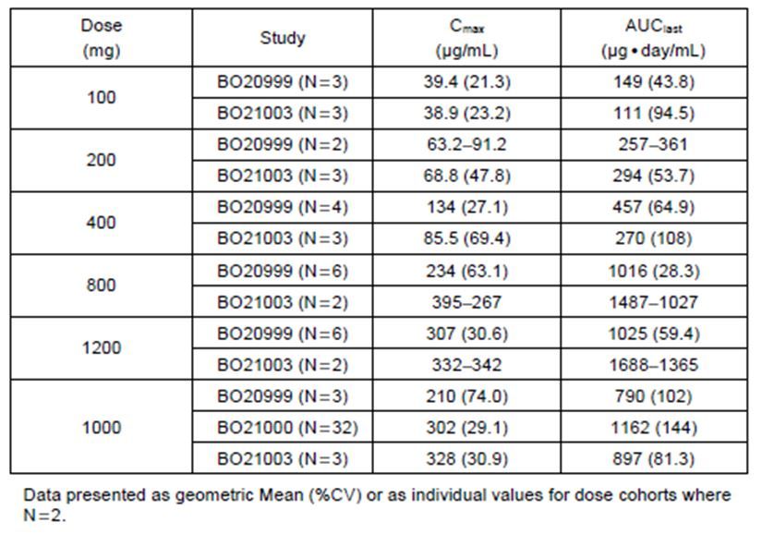
There is also reasonable concordance in exposure (AUClast) among these studies even given the variability in the parameters. Because the second administration of OB in these studies was seven days after first infusion it was not feasible to estimate the PK parameters for clearance (CL), volume of distribution (Vss) and half-life (T½) using non-compartmental analysis for the first dose. The assessments of pre-dose OB serum concentrations in cycles 2-8 for B020999 and cycles 2-4 for B021003 and cycles 2,4,6 or 8 for B021000 and more extensive serum sampling following the final dose to enable adequate characterisation of PK. In addition concordance in Cmax and AUC between the monotherapy and combination studies at the 1000mg dose of OB in all studies is apparent as indicated in Table 3. Cmax for B021000 at 302 µg/ml is between the values obtained for B020999 and B021003 at 210 and 328 µg/ml respectively. AUClast is slightly higher at 1162 µg.day/ml in B021000 although inter-individual variability is high with a CV 144%.
Table 4 presents the PK exposure data for 1000mg OB at the end of treatment for the studies B020999 and B021000 and the end of induction for study B021003. The data following the first dose of OB the PK exposure data at the end of treatment are comparable between the monotherapy studies and the chemotherapy studies. This further indicates the absence of any impact of concomitant chemotherapy on OB PK.
Table 4: Comparison of OB PK parameters for 1000 mg in Studies BO20999, BO21000 and BO21003 at the end of treatment/induction.
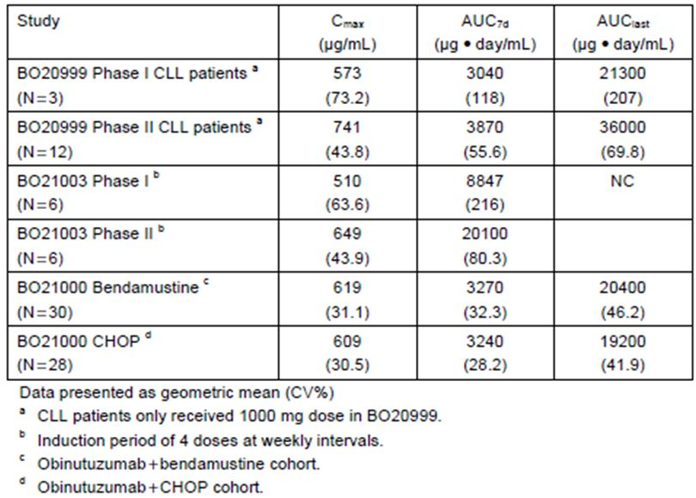
The population PK analysis modelling comprise 1178 serum concentration values from 590 patients including 220 from the pivotal study which confirmed the two-compartment model with time varying and linear clearance pathways usually described OB PK. The initial clearance of OB was 2.85 times higher than steady state clearance, consistent with the decrease in time varying clearance. This analysis further supports the need to minimise the time varying clearance component quickly and the proposed dosing regimen.

Results
A two-compartment population PK model with time-dependent clearance described OB concentrations and this is in line with the PK modelling of other monoclonal antibodies.
Estimates of the structural parameters were: steady state clearance (CLinf) of 0.085L/day (95% CI 0.079-0.091L/day), initial time-dependent clearance (CLT) of 0.242L/day (95% CI 0.204-0.288L/day), Dcay coefficient of time-dependent clearance (kdes) of 0.0413 day (95% CI 0.0324 – 0.0528 day), central volume distribution of 2.77L (95% CI 2.69-2.85L), inter-compartmental clearance of 1.29L/day (95% CI 1.05-1.58L/day) and peripheral volume of distribution of 0.965L (95% CI 0.865-1.08L).
The estimates for CLinf, Q, V1 and V2 were within the range typical for the monoclonal antibody. Initial time-dependent clearance CLT (additional to steady state clearance CLinf) which can possibly be attributed to target-mediated elimination was 2.85 times higher than the steady state clearance. This clearance component decreased to zero with time; half-life of the decrease was approximately 17 and 19 days in CLL and NHL patients, respectively.
Steady state clearance and central volume increased with body size. These dependencies were described by the power functions of body weight with a co-efficient of 0.602 (95% CI 0.404 – 0.800) and 0.403 (95% CI 0.07-0.499), respectively. Allometric scaling with a fixed power co-efficiency of 0.75 and 1 was assumed for inter-compartmental clearance and peripheral volume as the parameters of the peripheral compartment were unable to support the co-variate effect estimate. Steady state clearance and central volume were also higher in males (23% and 18% respectively). Steady state clearance depended on disease sub-type and 19% lower value in Non-Hodgkin’s lymphoma patients and 68% higher values in mantle cell lymphoma patients compared to CLL patients resulting in corresponding changes in the steady state exposure.
Initial time-dependent clearance was 52% higher in males and depended on body weight and disease the same way as steady state clearance. Decline of time-dependent clearance was 87% faster in NHL compared to CLL patients and 148% faster in patients with low baseline tumour size, ie below 1.750/sq.mm. Although the steady state exposure does not depend on time-dependent clearance unless on baseline tumour size where the exposure in patients with low baseline tumour size was higher during the first four months of dosing as indicated in Figure 1.
Figure 1: Model based simulations of typical concentration-time course by tumour size.
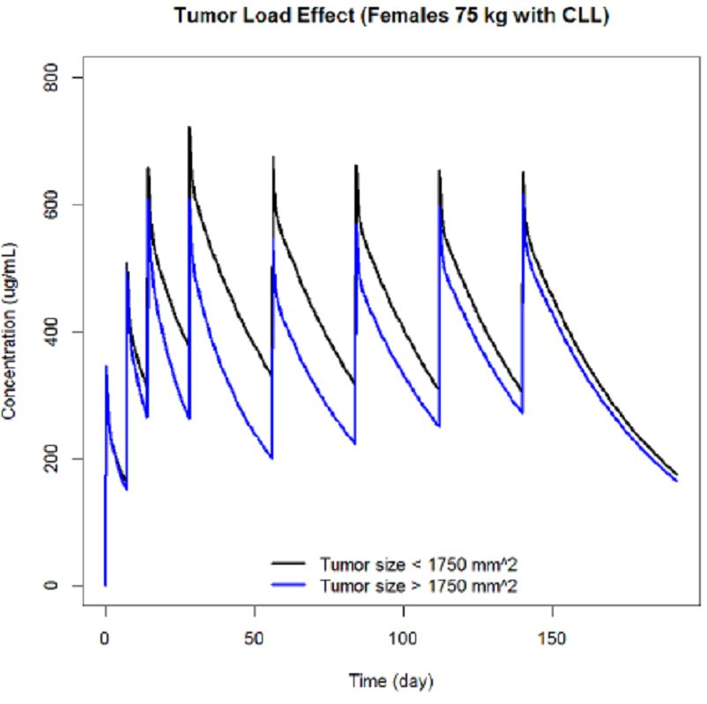
Except for the effect on kdes baseline tumour size did not affect the PK parameters.
There was no influence of baseline B-cell count on PK after accounting for influence on C sub-type.
The PK of OB was independent of age and renal function. Nine patients in the PK database had HAHAs detected after treatment initiation. The PK of these patients was similar to the PK of the other patients.
Following the dosing regimen of the pivotal study of steady state AUCT (Ctrough) was approximately 26% (29%) lower in male, 30% (32%) higher and 18% (19%) lower respectively in patients with body weight <60kg and >90kg compared to patients weighing 62-90kg; 27% (39%) higher in NHL patients and 39% (54%) lower in mantle cell lymphoma patients compared to CLL patients.
These differences were deemed to be not clinically relevant for dose adjustment in CLL patients.

Analyses of exposure/efficacy relationship (study B021004/CLL 11).
Association of the observed best overall response with exposure was assessed by comparing graphically the distributions of Cmean and the distributions of time of best overall response, for all observed best overall response levels, overall and stratified by the baseline tumour size.
Relationships of the survival time efficacy measures (progression free survival, disease free survival for complete responders, event free survival and overall survival) with exposure assessed using two types of plots. Firstly the association with observed efficacy measures with exposure was observed by comparing the distributions of Cmean and distributions of times of the observed efficacy measure for all observed efficacy measure levels, overall and stratified by the baseline tumour size. Secondly Kaplan-Meier plots and illustrated probability of survival type efficacy measures for three exposure categories (low, medium, high) were superimposed and compared, overall and stratified by the baseline tumour size.
Results indicated that there was no dependence of best overall response with time of observations of best overall response. There was a slight trend of better response for patients with higher exposure, which remained after stratification by the baseline tumour size.
As there were no obvious differences between event free survival and progression free survival data analyses were focussed on event free survival plots. The distributions of Cmean and the distributions of time of observation were similar for patients with and without an event and are indicated in Figure 2. However, among patients with events, event times were higher, ie longer survival for patients with higher exposure as indicated in Figure 3. Kaplan-Meier plots also suggest that higher exposure was associated with longer survival and indicated in Figure 4.
Figure 2: Relationships between event free survival and exposure (Cmean) and time of observations, overall and by baseline tumour size group.
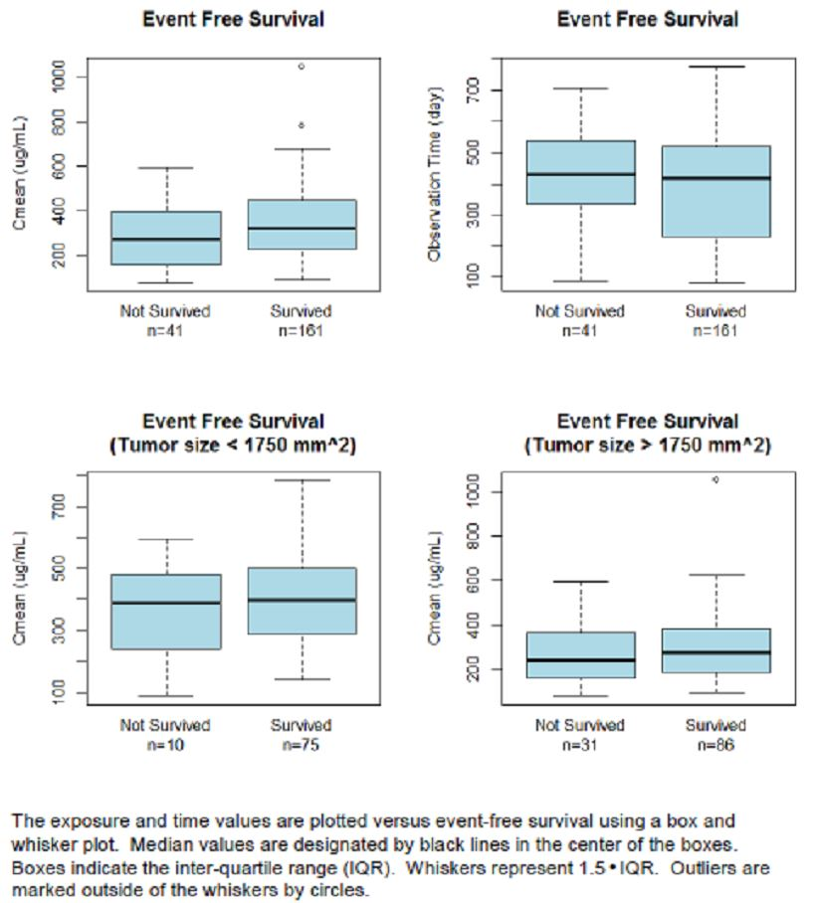

Figure 3: Relationships between time of event and exposure for patients with event free survival event.
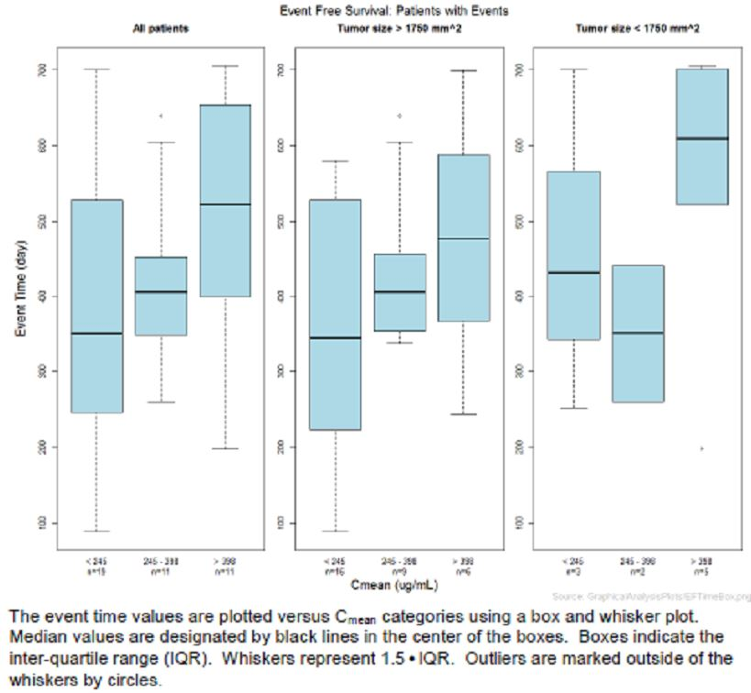

Figure 4: Kaplan-Meier plot for event free survival, by exposure group (Cmean).
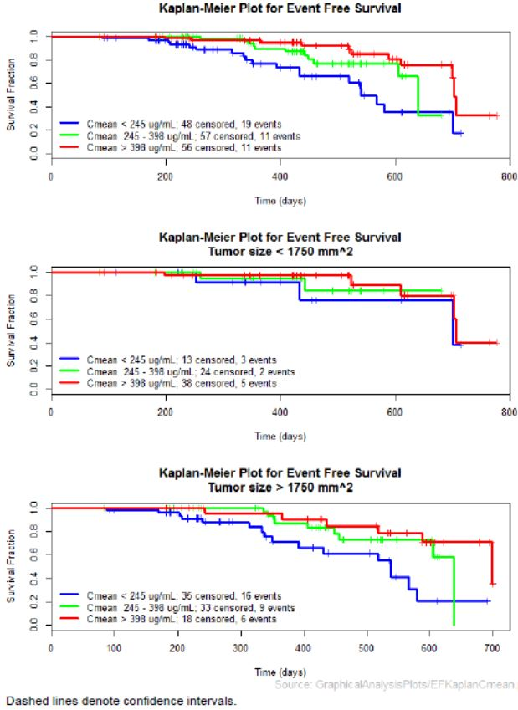

Analyses of exposure/safety relationship in CLL for study B021004/CLL 11
Analyses concentrated on review of serious adverse events which were divided into two groups, those that were observed after the first dose and prior to the second dose and those observed from the second dose onwards. For the early serious adverse events the distribution and magnitude of the Cmax of the first dose of OB were investigated. Beside serious adverse events the distribution the magnitude of exposure to OB which was the cumulative AUC and Cmean up to the time of occurrence were investigated. Only those serious adverse events which occurred on at least five occasions were included in the PK data base. These resulted in review of serious adverse events for infections and infestations; gastrointestinal disorders; cardiac disorders and neoplasms.
Results indicated that these adverse events were not correlated with OB exposure; concentration/time profiles of the patients with serious adverse events were neither higher nor lower than the concentration/time profiles of patients without serious adverse events.
The results of the graphical analysis of the occurrence and grade of early serious adverse events by superclass in patients treated with OB have not indicated any dependencies on Cmax of the first dose of OB. The distributions of Cmax were similar in each grade of serious adverse events following the first dose.
The results of graphical analysis of the occurrence of late serious adverse events by superclass in patients treated with OB have not indicated any dependencies on exposure (ie, cumulative AUC and Cmean up to the time of recurrence).

Relationship between OB exposure and time course of neutrophil counts
Graphical analyses performed to assess the OB, their assessed relationship between the observed values of the neutrophil counts and OB exposure (Cmean) do not indicate any differences between the exposure groups. For all the exposure groups the neutrophil counts declined almost immediately after the start of the drug administration from the median baseline values of about 5 x 10^{9th}/L to median values of about 2 x 10^{9th}/L stayed in that range as long as the drug was in the circulation and then slowly returned to their baseline values.
There was no association between the observed grade of neutropenia and exposure. The distributions of the Cmean were similar in each grade of neutropenia, either overall or stratified by tumour size.

Relationship between OB exposure and occurrence and grade of infusion related reactions
Graphical analysis of the occurrence and grade of infusion related reactions following the first dose in patients treated with OB did not indicate any relationship due to OB exposure. The distributions of Cmax were similar in each grade of infusion reactions before 4.5 days.

Analyses of B-cell count and tumour size following administration of OB
In all studies, treatment with OB caused a rapid and full depletion in circulating B-cell counts and in all exposure categories the B-cell counts declined from their baseline values to nearly zero after start of drug administration and stayed at that concentration as long as the drug was in circulation. It is noted that the B-cell counts did not return to the baseline values even when the drug was cleared from the system.
Graphical analysis performed to assess the relationship between the observed tumour size values and OB exposure suggest that the higher tumour size values occurred in groups of lower exposure and is indicated in Figure 5. Patients with high tumour size at baseline were more likely to have a low exposure which is consistent with their higher target concentrations and the PK model. Those patients also had the lowest decrease in post-treatment tumour size. When looking at tumour size, the percent change from baseline tumour size reduction was less dependent on exposure. The change from baseline tumour size was slightly lower in the lowest exposure group was similar in the medium and higher exposure groups.

Figure 5: Tumour size at baseline and post treatment by OB exposure (Cmean).
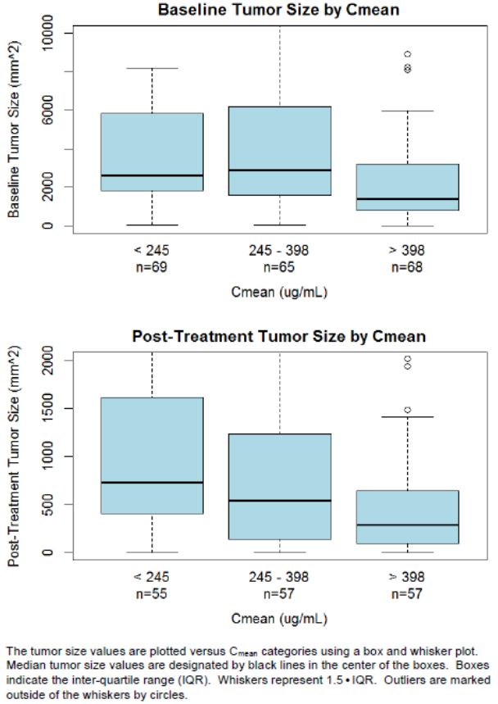
The relationship between tumour size and exposure is further explored in Figure 6. In agreement with the PK model exposure is higher in patients with tumour size below 2000mm². At the same dose patients with high baseline tumour size had generally lower exposure. Post-treatment tumour size declined with exposure while percent change of tumour size from baseline was mostly independent of exposure. This PD data was similar and comparable for OB in monotherapy and combination therapy studies again indicating a lack of effect of concomitant medication on OB pharmacodynamics.

Figure 6: Relationship between tumour size and OB exposure (Cmean).
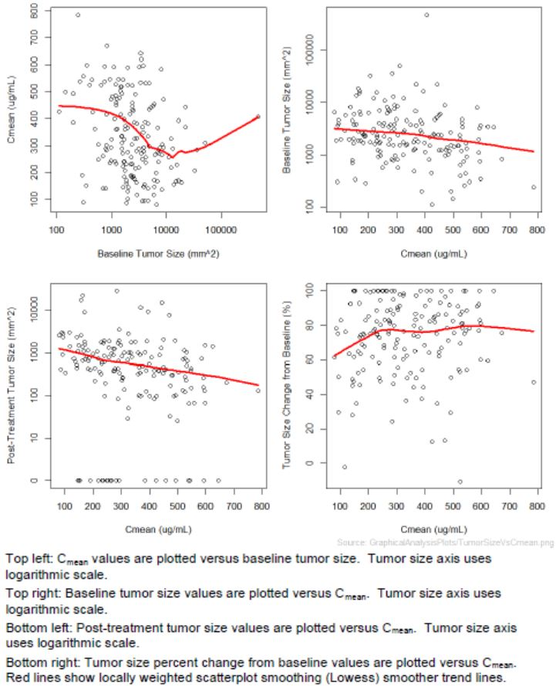

PK studies in special populations
No formal clinical study has been undertaken to evaluate the impact of either hepatic or renal impairment on OB PK. It is noted however that in the pivotal study creatinine clearance was determined in all patients as this measurement formed part of the inclusion/exclusion criteria. A reduced creatinine clearance 70mls/minute or less was one of two ways patients with co-existing medical conditions were identified. Patients with creatinine clearance of <3mls/minute were excluded. Using this data there is no evidence of an impact of renal impairment on OB PK.

Detection of human anti-OB antibodies
All clinical studies included plasma sampling to test for HAHAs. A first screening assay was performed with the pre-dose and a post-dose sample for all patients. Positive samples from the screening assay were tested for specificity with a confirmatory assay. As discussed earlier the three studies B020999, B021000 and B021003 utilised a first generation HAHA assay which was extremely sensitive and according a second generation ELISA with improved drug tolerance was developed for the pivotal study.
Using the first generation HAHA assay, one CLL patient in study B020999 tested positive but it was not possible to further evaluate this finding in the patient.
In the pivotal study using the second generation assay with improved drug tolerance HAHAs were detected in 9/70 or 13% of patients at one or more measurements during follow up. The observed concentration/time courses OB in patients with and without detected HAHAs were similar.

Evaluator’s conclusions
The PK of OB in CLL patients is best described by a two-compartment model with two clearance pathways, namely a time varying clearance pathway and a linear clearance pathway. The time varying clearance pathway is predominant at the start of treatment is consistent with target mediated disposition where there is an abundance of target (CD20/+) cells at the start of treatment. As the target is saturated by the addition of OB the target mediated disposition decreases which is reflected by a decrease in the time-dependent clearance pathway. Consequently this determines a principal aim of dosing is to saturate targets as quickly as possible. Accordingly high doses of OB such as 1000mg are required to minimise the impact of target mediated disposition.

Dosage selection for the pivotal studies
Data from two clinical Studies B020999 and B021003 in NHL, CLL and DLBCL patients were used in conjunction with a PK model of OB to define the recommended dose used in the pivotal study. As discussed above, the PK of OB can be described using a two-compartment PK model. In addition, population PK analysis is undertaken in all serum OB data from the two clinical studies indicated above, in conjunction with data from Studies B021000 and pivotal Study B021004/CLL 11.
As discussed earlier, patients with a high initial tumour burden and high numbers of CD20+ tumour cells clear the drug from plasma at a higher rate in comparison to patients with a lower initial tumour burden. This is because the OB binds to the CD20+ tumour cells and is effectively removed from plasma. Once the majority of CD20+ cells are bound to OB, there is a significantly reduced impact of target mediated disposition on PK. Consequently, the underlying rationale in selecting an appropriate OB dosing schedule is to saturate the target as early and as quickly as possible in the majority of patients to minimise a target mediated disposition and to maintain this saturation over the complete treatment period while minimising AEs. With respect to the PK model, this means reducing the impact of the time varying clearance component as quickly as possible to ensure an adequate dose is delivered regardless of tumour burden.
Reviewing the PK data from Studies B020999 and B021003, a total dose of 3000 mg of OB in Cycle 1 administered 1000 mg on Days 1, 8 and 15 were considered suitable, followed by 1000 mg on Cycle 2 onwards, both to maximise the potential to saturate the target for all patients regardless of tumour burden and to achieve consistent and high plasma concentrations. The observation of infusion related reactions to the first OB infusion resulted in adjustments to the Cycle 1 Day 1 dose to be actually administered over two days with 100 mg on Day 1 and 900 mg on Day 2. Accordingly, the recommended dose of OB for treatment in CLL patients is 1000 mg on Cycles 1, Days 1, 8 and 15 and Cycles 2-6 Day 1, with the first dose being administered over the first two days at 100 mg on Day 1 and 900 mg on Day 2.

Clinical efficacy

Studies providing efficacy data
The principal data to support the efficacy of OB in combination with Clb in previously untreated CLL patients are provided from the pivotal study, a Phase III trial B021004-CLL 11. This study was designed to include two stages:
Stage 1a | A comparison of OB (Gazyva) plus chlorambucil (GClb) versus chlorambucil (Clb) alone in the treatment of previously untreated CLL
Stage 1b | A comparison of rituximab plus chlorambucil (RClb) versus chlorambucil (Clb) alone in the treatment of previously untreated CLL
Stage 2 | A comparison of RClb versus GClb in the treatment of previously untreated CLL
The results from this Stage 1a analysis of the pivotal study form the principal focus for this submission. It is to be noted that Stage 2 of the study remains ongoing without data being made available in this submission.

Study design
The pivotal study was a phase III open-label multicentre three-arm randomised parallel group comparative study of GClb vs Clb alone and RClb in previously untreated CLL patients with co-existing medical conditions. This is illustrated in Figure 7.
Figure 7: Study design of pivotal study BO21004/CLL11.
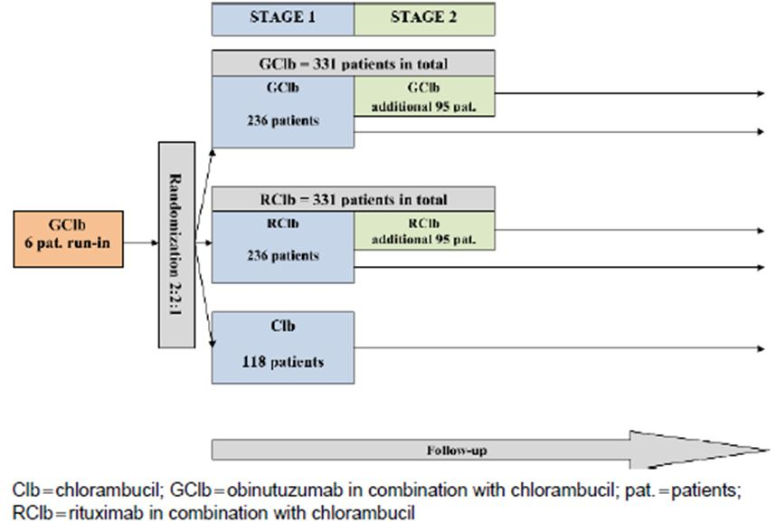
It is noted that an initial six patients received GClb alone to assess safety. None of the stopping rules were met and accordingly subsequently eligible patients were randomly assigned in stage I to GClb, RClb or Clb alone in a 2:2:1 ratio via a block stratified randomisation procedure.
The primary efficacy endpoint of the study was progression free survival (PFS) as assessed by the investigator. PFS based on independent review committee (IRC) assessments is also analysed to support the primary analysis. The key secondary efficacy endpoints were end of treatment response, molecular response (minimum residual disease ie, MRD negative rate), overall survival and event free survival.
There were three primary analyses time points, stage I which was divided into stage IA with a final analysis of GClb vs Clb and stage IB, a final analysis of RClb vs Clb. The principal focus of this submission relates to stage IA.
Protocol defined the final stage of IA analysis to be triggered when all the following criteria occurred, ie at least 175 PFS events reported in the stage I population; a total of 250 randomised patients had been observed for at least 12 months; the planned enrolment of 118 patients into the Clb arm was complete. A data cut-off date of the 11th July 2012 was used and patients had met the above criteria.
Patients in the Clb arm who progressed during or within six months of the end of Clb treatment had the opportunity to be treated with GClb.
Prior to treatment all patients received pre-medication, patients randomised to GClb treatment arm received 1000mg of OB as an intravenous infusion on day 1, day 8 and day 15 of the first treatment cycle and for each subsequent cycle patients received OB 1000mg of IV infusion on day 1 for a total of six cycles. All patients randomised to RClb arm received 375mg/m2 of Rituximab as an IV infusion on day 1 of the first treatment cycle. For each subsequent cycle patients received Rituximab at a dose of 500mg/m2 as an IV infusion on day 1 for a total of six cycles. All patients entered onto study received 0.5mg/kg body weight of Clb given orally on day 1 and day 15 of all treatment cycles. Patients could receive a maximum of six cycles of treatment and each cycle was 28 days in duration.
Key inclusion criteria included documented CD20+ B-cell CLL according to NCI criteria; previously untreated CLL requiring a treatment according to NCI criteria; total cumulative illness rating scale of at least six and/or creatinine clearance <70ml/minute.
Key exclusion criteria included previous CLL therapy; one or more individual organ-system impairment scores of 4 as assessed by the CIRS definition; excluding the IV of nose, throat and larynx organ system. Inadequate renal function with a creatinine clearance of <30ml/minute; inadequate liver function as indicated by grade III liver function tests with AST and ALT at times >5 times the upper limit of normal and bilirubin >3 times the upper limit of normal unless due to underlying disease; patients with positive serology for hepatitis B.
Efficacy assessments were made according to NCI criteria, all patients were assessed on a 28 day basis throughout therapy by clinical examination and laboratory investigations and subsequently until progression was identified. CT scans were performed on those patients who achieved a CR or PR every two to three months from the end of treatment. In those patients who achieved a CR bone marrow aspiration and biopsy were obtained. Blood and bone marrow samples were collected and analysed centrally to explore the effect of treatment on MRD status and CLL patients.
Post-treatment visits continued every three months until three years from the last treatment. Subsequent follow up was to be at six monthly intervals.
Primary analysis was based on the intent to treat population defined as all randomised patients. At the time of the final stage IA analysis an interim analysis for futility and efficacy comparing GClb vs RClb after approximately 30% of investigator assessed PFS events, ie 125 events were reported. The interim analysis was performed by an independent review committee.
For the stage I patients randomised to all three treatment arms involving approximately 590 patients. This set of patients was used for the global test of any difference between any of the three treatment arms. For all comparisons of GClb or RClb vs Clb only stage I patients were used.
Treatment comparison was based on PFS using a two-sided stratified log rank test. Median PFS and 95% confidence limits were estimated using Kaplan-Meier survival methodology. PFS rates for one and two years after randomisation with 95% CI were reported. A secondary multivariate analysis of PFS used a Cox regression model to assess the treatment effect after adjustment for baseline prognostic factors.
Health related quality of life assessments were used to derive pre-specified global and domain scores according to the UITC cancer quality of life questionnaire (QLQ-C30) and associated CLL specific QLQ-CLL-16 module scoring manual. Scores on the QLQ-CLL-16 fatigue sub-scale over treatment period were compared between treatment arms using repeated measures analysis of variance.

Patient disposition
A total of 781 patients were randomised on a 2:2:1 basis to stage I between the three arms and stage II on a 1:1 basis between the two treatment arms. Patients were initially commenced on the stage I enrolment on the 12th April 2010, the last patient being enrolled in stage I on the 24th January 2012 and the last patient enrolled in stage II on the 4th July 2012.
Stage I analysis included 589 patients and stage IA analysis included a total of 356 patients, 118 patients randomised to the Clb arm and 238 patients randomised to the GClb arm. The data cut-off date for the stage IA primary analysis was the 11th July 2012 and data base lock date was the 11th October 2012.
This was a multicentre study involving centres throughout 24 countries.
At the time of data cut-off, 90% of the patients on Clb had completed a three month follow up visit compared to 89% for the GClb arm. A greater proportion of patients in the GClb arm had entered follow up, ie 195 patients or 82% compared with the Clb arm, ie 84 or 71% of patients.
The overall median observation time was 14.2 months with 13.6 months for patients in the Clb arm and 14.5 months for patients in the GClb arm. There were 65 patients in the Clb arm or 55% and 141 patients or 59% in the GClb arm who had been observed for at least 12 months. At the data cut-off a total of 16 patients or 4% had been followed for more than two years.

Demographic and baseline characteristics
There were 60% of the patients that were male and 95% white with 58% <75 years of age with a median age of 73 years and range of 39-88 years. The treatment arms were balanced with respect to most demographic factors although there were more males in the Clb arm and fewer patients aged at least 75 years in the Clb arm, ie 37% vs 45% for the GClb arm.
Key baseline disease characteristics were balanced between the two treatment arms. Seventy-six percent of patients in the study had a CIRS score of at least six at baseline including 78% on the Clb arm and 75% on the GClb arm. Creatinine clearance was <70mls/minute for 72% of patients in the GClb arm and 61% in the Clb arm. There was a higher proportion of patients in the GClb arm with both CRIS score >6 with creatinine clearance of <70mls/minute being 47% compared to the Clb arm at 39%.
Most patients in each treatment arm had co-existing medical conditions in 4 to 8 organ systems, ie Clb arms 76% vs GClb arm at 81%. Most common of these included hypertension, endocrine metabolic dysfunction and cardiac dysfunction.
The distribution of prognostic factors at baseline were balanced between the treatment arms including the unmutated IgVHg 59% of Clb vs 61% for GClb; ZAP-70+ 49% for Clb vs 44% for GClb. Most patients 83% were negative for VH3-21 usage. All patients met the appropriate criteria for initiating treatment including those with stage C disease, more evidence of active disease or progressive disease. The percentage of patients with stage C disease at baseline were Clb 37% vs GClb 36%. Of the remaining 74 patients in the Clb arm and 153 patients in the GClb arm who were not stage C, 47% of Clb patients had B symptoms compared to 46% for GClb. Symptoms due to massive lymphadenopathy/splenomegaly were 45% in each treatment arm and lymphocyte doubling time of <6 months was 43% for Clb vs 8% for GClb.
Analysis of baseline factors included determination of co-morbidities. The most frequently reported severe co-existing medical conditions were vascular disorders, cardiac disorders, gastrointestinal disorders, metabolism and nutrition disorders, renal and urinary disorders and muscular-skeletal and connective tissues disorders.

Extent of exposure to study drug:
A greater percentage of patients in the GClb arm received all six cycles of planned treatment compared to the Clb arm at 81% vs 67%. The median cumulative dose of Clb in each treatment arm was similar being 384mg in the Clb arm vs 370mg in the GClb arm.

Efficacy results for stage IA
As indicated in Table 5, the addition of OB to Clb resulted in a clinically meaningful and statistically significant improvement in the primary endpoint of the investigator assessed PFS. Significant improvements were observed in all of the secondary efficacy endpoints apart from overall survival in which the data remains immature.
Table 5: Overall efficacy: Clb versus GClb (ITT).
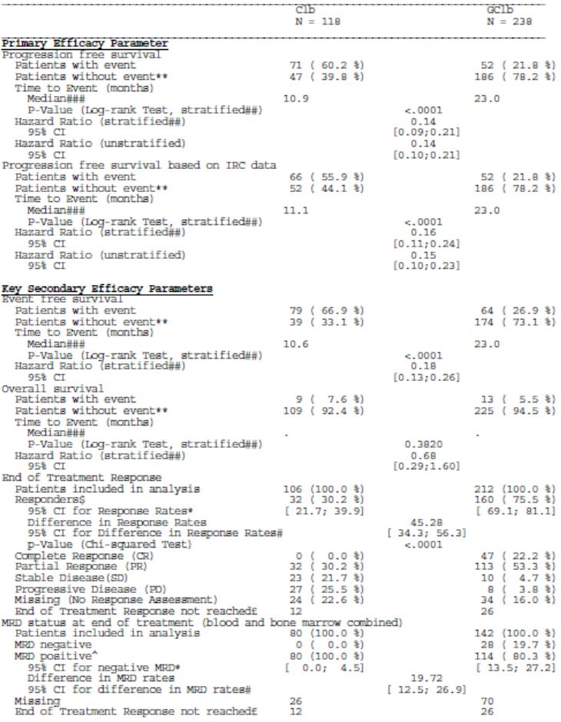
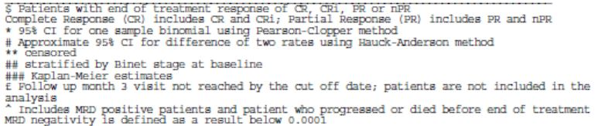
In relation to the primary efficacy endpoint PFS, 71/118 patients or 60.2% in the Clb arm had experienced a PFS event of death or disease progression compared to 52/238 or 21.8% in the GClb arm. The addition of OB to Clb regimen significantly prolongs PFS when compared with Clb alone P<0.0001. Twenty-seven percent of patients in the Clb arm and 84% of the patients in the GClb arm were progression free at one year. The risk of having a PFS event was statistically significantly decreased for patients treated with GClb with stratified HR 0.14 and 95% CI 0.09, 0.21. The Kaplan-Meier estimated median progression free survival was 10.9 months in the Clb arm and 23 months in the GClb arm.
As indicated in Figure 8, the Kaplan-Meier plot showed separation occurred in favour of the GClb arm from one month which is maintained over time until virtually there is no patient at risk. The Kaplan-Meier estimate for event free rate at 18 months in the GClb arm with 40 patients at risk was 0.6824 with a 95% CI 0.593, 0.772 and for the Clb arm with three patients at risk was 0.06868 with a 95% CI 0.004, 0.170.
Figure 8: Kaplan-Meier plot of investigator-assessed progression free survival: Clb vs GClb (ITT).
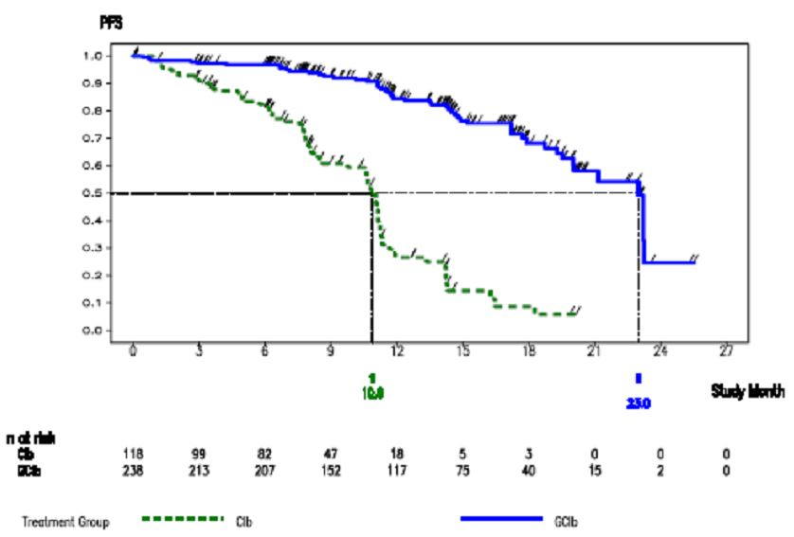
At 12 months 15.3% of patients on the Clb arm vs 49.2% of patients on the GClb arm were at risk of a PFS event while at 18 months 2.5% on the Clb arm and 16.8% of patients on the GClb arm were at risk.
It is noted that the results of the non-stratified analysis of PFS was similar to the stratified analysis with a non-stratified HR of 0.14 and 95% CI 0.10, 0.21 with a P value of <0.0001.
Review of PFS by the independent review committee at time of the final stage IA analysis, 66 or 55.9% of patients on the Clb arm had experienced IRC assessed PFS event at death or disease compared to 52 or 21.8% of the GClb arm. This confirmed the analysis of investigator assessed PFS again with a P value of <0.0001 and a stratified HR of 0.16 and 95% CI of 0.11, 0.24. The Kaplan-Meier estimated median PFS was 11.1 months for the Clb arm and 23 months for the GClb arm and is indicated in Figure 9. At one year 36% of patients in the Clb arm and 83% of patients in the GClb arm were event free and results of non-stratified analysis of PFS using IRC assessments were similar to that for the investigators with an HR 0.15 and 95% CI 0.10, 0.23 with P value <0. 0001.

Figure 9: PFS survival using IRC data: Clb vs GClb (ITT).
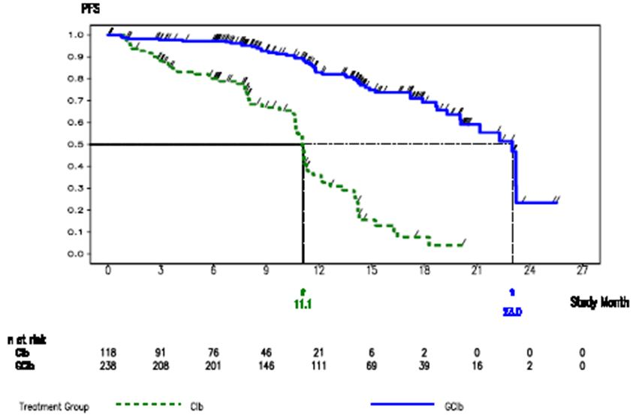
Assessment of concordance of these data between the investigator independent review committee were appropriate and indicated consistent analyses between the two reviews.
A series of pre-specified sensitivity analyses were conducted to support the results from the primary analysis of PFS and the HR for the sensitivity analysis ranged from 0.12-0.26.
In relation to end of treatment responses, it is noted that overall response rates were significantly higher for the patients on GClb at 75.5% compared to the Clb arm at 30.2%. There was a 17% CR rate for the GClb patients compared to zero for the Clb patients. When assessed according to best overall response, there was still a significant difference being 32.1% for Clb patients compared to 75.9% for GClb patients.
Assessment of minimum residual disease for the two treatment arms from evaluation of both blood and bone marrow involved a total of 222 patients including 80 in the Clb arm and 142 in the GClb arm. In the Clb arm no patient was LRD- at the end of treatment compared to 19.7% in the GClb arm.
In relation to overall survival by the time of the data cut-off on the 11th July 2012 a total of 22 randomised patients had died, nine or 7.6% on the Clb arm and 13 or 5.5% on the GClb arm. Accordingly this data remains immature and not assessable.
The risk of an event free survival event was significant lower in the GClb arm compared to the Clb arm P<0.0001 with a median event free survival of 23 months for the GClb arm compared to 10.6 months for Clb arm.
Duration of response was prolonged in the GClb arm compared with the Clb arm with a stratified HR of 0.10 95% CI 0.05, 0.20 with a median duration of response being 15.2 months for the GClb arm compared to 3.5 months for the Clb arm.
In order to assess the impact of potential prognostic factors on the treatment effect, predefined baseline characteristics and prognostic factors were analysed and results. Overall, the results of the PFS sub-group analysis were consistent with results seen in the ITT population.
In relation to patient reported outcomes in the ERTC QQ-C30 and QQ-CLL-16 questionnaires collected, no substantial differences between the two treatment arms in either sub-scales were observed during the treatment period. Additional analysis comparing the QQ-CLL-16 fatigue sub-scale scores during the treatment period revealed no statistically significant difference between patients treated with GClb compared to Clb.
Comment: These data have shown that the combination of OB with Chlorambucil results in a significant improvement in progression free survival with a stratified HR of 0.14 and a median PFS of 23 months for the GClb arm compared to 10.9 months in the Clb arm. These data were confirmed by IRC assessment. Similarly results of secondary efficacy endpoints generally favoured the GClb combination at a significant level. The only area outstanding relates to overall survival.
It is recognised that more aggressive therapies for CLL commonly result in improved progression free survival but less frequently for overall survival. Overall survival data from this study will be of interest although it is recognised that a proportion of patients on Clb initially also crossed over to the GClb and are likely to have also received other anti-leukaemic therapy throughout the remainder of their illness. This will tend to have a masking effect on determination of potential differences in overall survival but at the same time may well point to a suitable more conservative approach of long term management of elderly patients with CLL.

Results of study of stage IB of study B021004-CLL 11
Of the 589 patients enrolled in the stage I of the study, 351 patients were included in the final stage IB analysis comparing RClb to Clb with 233 patients randomised to RClb and 118 to Clb. The stage IB analysis was performed when 155 PFS events in the GClb and RClb arms had occurred at the cut-off date for the study IB analysis on the 10th August 2012.
Demographic data and key baseline diseases information for the two-patient populations receiving RClb and Clb were generally well balanced between treatment arms and comparable with the patients in the stage IA analysis.
In the final analysis for the primary protocol specified endpoint of investigator assessed PFS for stage IB of the study, treatment with RClb resulted in a statistically significant and clinically meaningful reduction in the risk of investigator assessed progression or death with a 68% reduction in the stratified HR of 0.32 95% CI 0.24, 0.44 and log rank P value <0.0001 compared with Clb. The median time to investigator assessed progression or death was longer in the RClb arm at 15.7 months compared with the Clb arm at 10.8 months.
The final analysis of IRC assessed PFS of stage IB also demonstrated a statistically significant and clinically meaningful reduction in the risk of progression or death in the RClb arm compared with the Clb arm with a 61% reduction, stratified HR of 0.39 with 95% CI of 0.29, 0.54 and P value <0.0001. Median time to IRC assessed progression or death was longer in the RClb arm at 14.9 months compared with the Clb arm at 11.1 months. Results of sub-group analyses of PFS were consistent with the primary analysis of PFS.
The results of the secondary endpoints of event free survival with a stratified HR of 0.31, 95% CI 0.23, 0.42, P value <0.0001 and end of treatment response rate Clb 30% with no complete responses vs RClb at 66% with 8% CRs favouring the RClb arm.
It is noted that a futility and efficacy interim analysis of RClb vs GClb was conducted at the time of stage IA analysis which apparently indicated a positive trend in progression free survival with a futility boundary of HR =/<0.88 for GClb compared to RClb.
Comment: These data are of interest as they also demonstrate a significant advantage for the addition Rituximab to Chlorambucil in the elderly patient population with significant co-morbidities. An indirect comparison of response rates and progression free survival data between the GClb and RClb arms suggest the superiority for the GClb treatment, but this can only be objectively determined in stage II of the present study directly comparing GClb to RClb.

Supportive studies
Limited end of treatment response data available from a total of 38 patients with CLL received OB monotherapy in the phase I study B021003 and the phase I/II study B020999. Overall, there were no CRs but in study B020999, 8/13 patients or 62% participated in the phase I part and 3/20 patients or 15% participating in the phase II part had a PR at the end of treatment as indicated in Table 6.
Table 6: Summary of End of Treatment response in patients with relapsed/refractory CLL receiving OB monotherapy (phase I/II results).
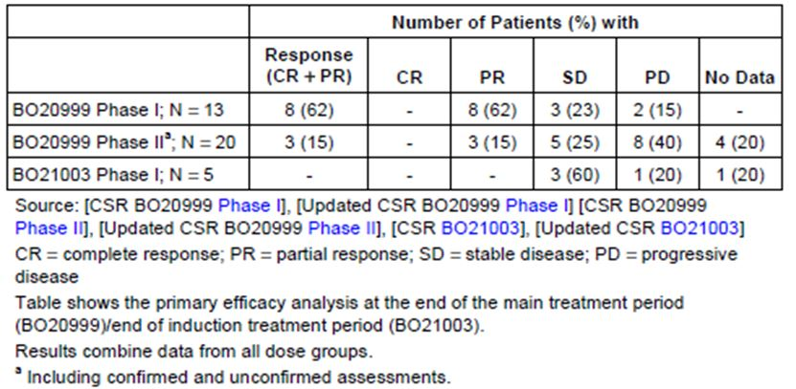
Comment: These data are difficult to assess based on the differences in patient population as well as the OB regimens comparing single-agent OB to combination with Chlorambucil as well as a significant proportion of the patients in the supportive studies with CLL had recurrent or relapsed disease. The only conclusions to be drawn is that there is evidenced of a degree of efficacy for OB alone from the small data in the supportive studies.

Clinical safety

Studies providing safety data
Safety data provided in this submission principally is derived from the pivotal study B021004-CLL 11, specifically the Stage Ia component. Also providing supportive safety data were three studies in patients with CLL or NHL: B020999, B021003, and B021000.
Safety data for the pivotal study is presented separately, while safety data for the monotherapy Studies B020999 and B021003 are combined, and safety data for the chemotherapy combination NHL Study B021000 is presented separately. The data from these four studies involved a total of 648 patients exposed to OB.
The safety analysis population (SAP) for each study included all patients who received at least one dose of study drug. Patient demographic data and baseline disease characteristics for the pivotal study were analysed for the intent to treat population to ensure consistency.
It is to be noted that the patients involved in the pivotal trial all were previously untreated for CLL, whereas those patients in Studies B020999 and B021003 were relapsed and refractory patients with either CLL or NHL. This included a total of 38 patients with relapsed refractory CLL. There were a total of 205 relapsed or refractory NHL patients in these two studies. In Study B021000, 56 patients with relapsed refractory follicular lymphoma received either OB and CHOP or fludarabine and cyclophosphamide, and 81 patients with previously untreated follicular lymphoma received OB plus bendamustine. Safety data from these two patient populations were combined.
Safety was assessed through collection of AEs, clinical examinations including vital signs, ECG, and physical exam, and laboratory test results including haematology coagulation, biochemistry, creatinine clearance, urine analysis, and HAHAs.
Table 7 summarises the duration of reporting of AEs and serious AEs for the pivotal study. Rating of AEs was according to National Cancer Institute (NCI) criteria. A similar process was utilised for collection and assessment of safety data from the supporting studies.
Table 7: Duration and reporting of AEs for the pivotal study (BO21004/CLL11).
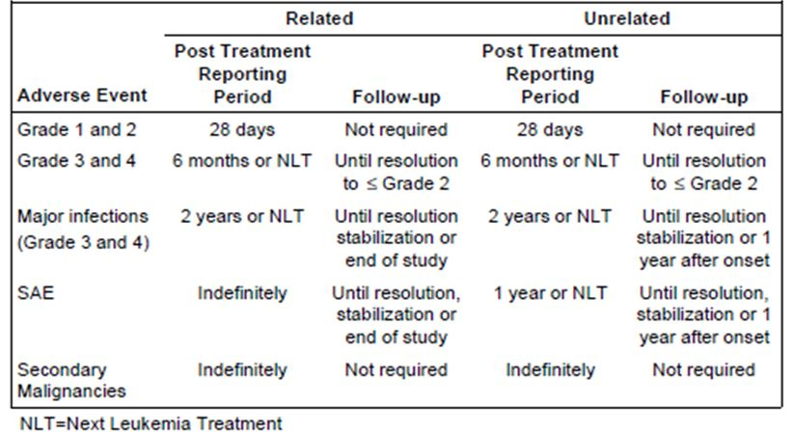

Overall extent of exposure
The clinical cut-off date was July 2012 and database lock was October 2012; 648 patients in pivotal and supporting studies had received at least one infusion of OB. The mean cumulative dose of OB was similar in all studies and populations. The median number of infusions was eight in the pivotal study and nine in studies B020999 and B021003 and ten in study B021000.

Demographic and other characteristics of the study population
Demographic and baseline disease characteristics for the patient population in the pivotal study has been previously presented and for the supporting studies these are indicated in Table 8.
Table 8: Summary of demographic characteristics in different safety analysis populations: supporting studies.
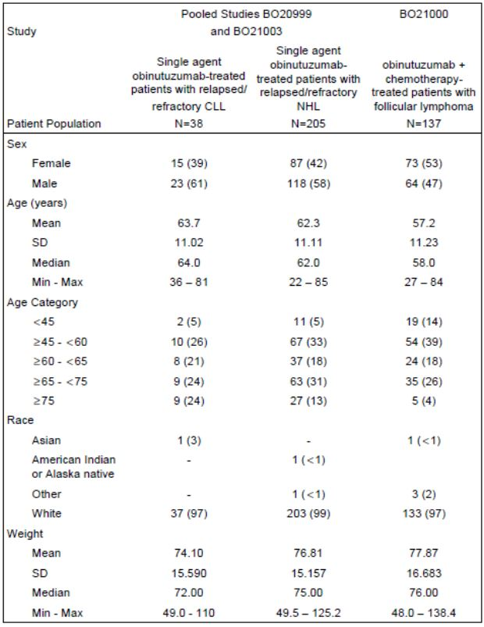

Results
In the pivotal study during the treatment period 91 or 78% of patients on the Chlorambucil experienced 407 adverse events and 223 or 93% in the GClb arm experienced 1098 adverse events. Those with an incidence of at least 5% are indicated in Table 9. The difference between the treatment arms in the proportion of patients who experienced at least one adverse event can largely be accounted for by the administration of OB as 69% of patients in the GClb treatment arm experienced an infusion related reaction (IRR) whereas Clb was administered orally. A greater proportion of patients treated with GClb experienced blood and lymphatic system disorders, ie Clb 32% vs GClb 50% of patients particularly neutropenia which was experienced by 17% of patients in the Clb arm and 40% in the GClb arm. Gastrointestinal disorders occurred in 46% on the Clb arm and 38% of patients on the GClb arm.
Table 9: AEs with an incidence of at least 5% in study BO21004/CL11: treatment period.
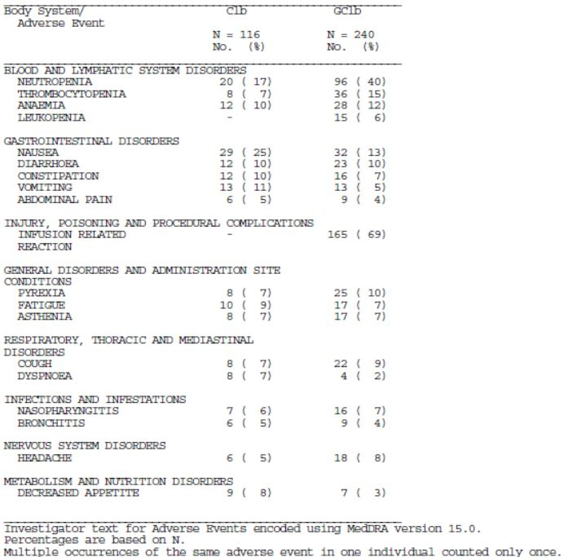
Adverse events that occurred with at least a 2% difference between Clb and GClb arms during the treatment period are summarised in Table 10. A greater proportion of patients administered GClb experienced blood and lymphatic disorders such as neutropenia, thrombocytopenia and leukopenia and IRRs occurred in 68.8% of patients administered OB. Also more frequent among patients receiving GClb included pyrexia. During the treatment period 61 or 53% of patients on the Clb arm experienced 135 adverse events and 207 or 86% of patients on the GClb arm experienced 559 adverse events that were assessed by investigator as related to treatment. The difference for the increased incidence among the OB patients again is principally related to methods of action of OB and including the incidence of IRRs at 69%; blood and lymphatic systems disorders 25% vs 47% for GClb and most frequently neutropenia 15% vs 38%; gastrointestinal disorders 23% vs 14% most frequently nausea 17% vs 8%; fatigue; infections and infestations 9% vs 15%; metabolism and nutrition disorders 3% vs 7%. The majority of adverse events that occurred during the treatment period were assessed as grade I or II with 332 adverse events or 82% in the Clb arm and 813 or 74% in the GClb arm as indicated in Table 10.
Table 10: AEs with an incidence of at least 2% difference in incidence between treatment arms in study BO21004/CL11: treatment period.
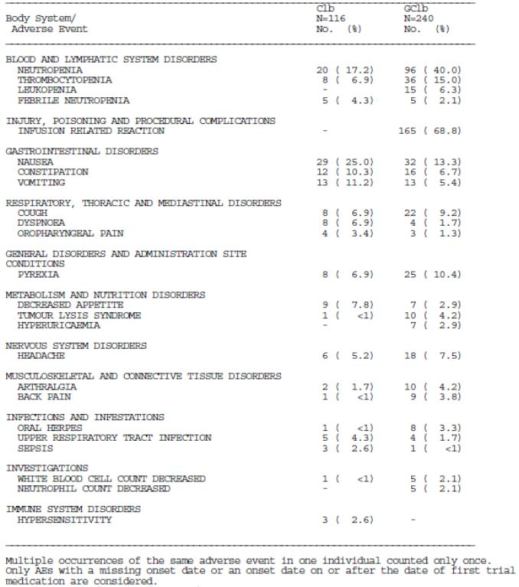
During the treatment period 48 or 41% of patients on the Clb arm experienced 75 grade III-V adverse events and 160 or 67% on the GClb arm experienced 286 grade III-V AEs. This was to be accounted for by the increased incidence of IRRs and neutropenia with an incidence of 21% for IRRs and 34% for neutropenia in the GClb arm compared to 15% in the Clb arm. These differences are summarised in Table 11.
Table 11: Grade 3-5 AEs that occurred with ≥2% difference in incidence between treatment arms in study BO21004/CLL11: treatment period.
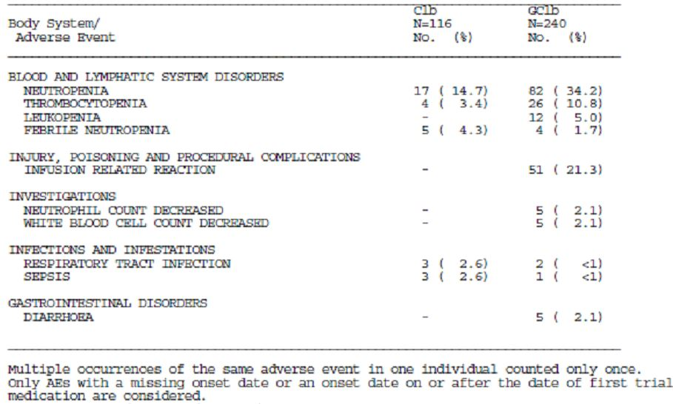
Among the supporting studies the most common adverse event for patients receiving OB were IRRs and is summarised in Table 12. Grade III-V adverse events amongst the supporting studies occurred in 79% of patients on the monotherapy CLL population, 40% in the monotherapy NHL population and 71% in the chemo-combination therapy population and is summarised in Table 13.
Table 12: AEs with an incidence of ≥5%: supporting studies.
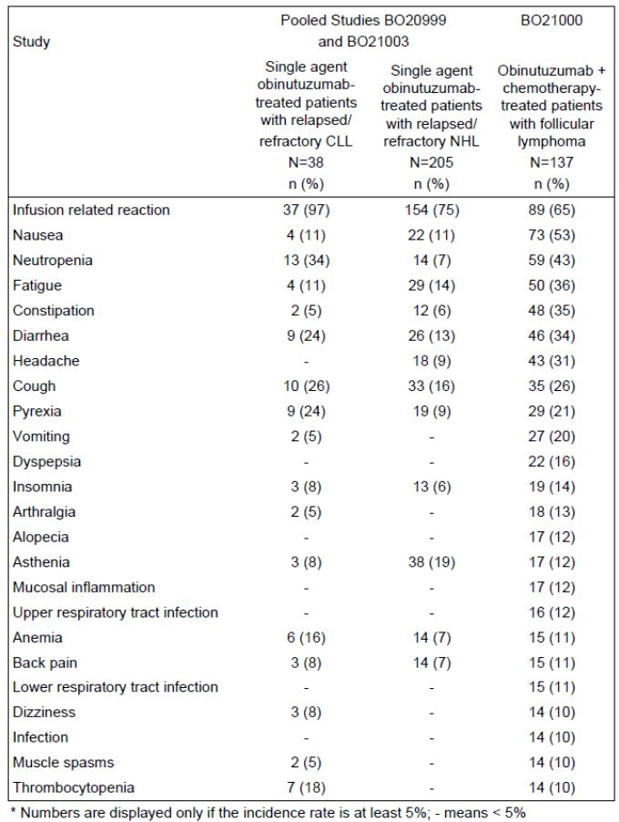
Table 12 (continued): AEs with an incidence of ≥5%: supporting studies.
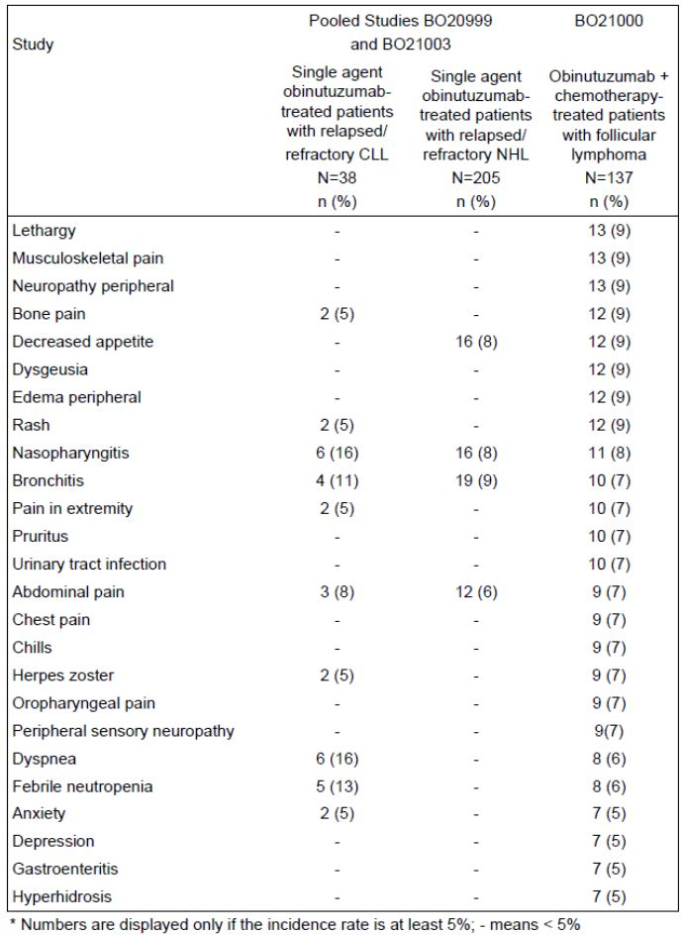
Table 12 (continued): AEs with an incidence of ≥5%: supporting studies.
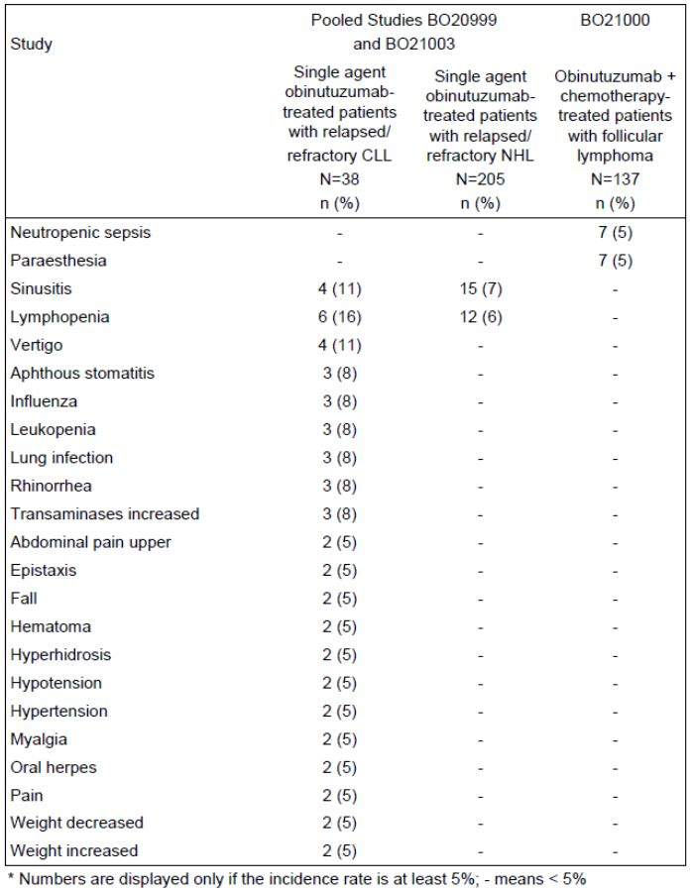
Table 13: NCI CTCAE grade 3-5 AEs in supporting studies.
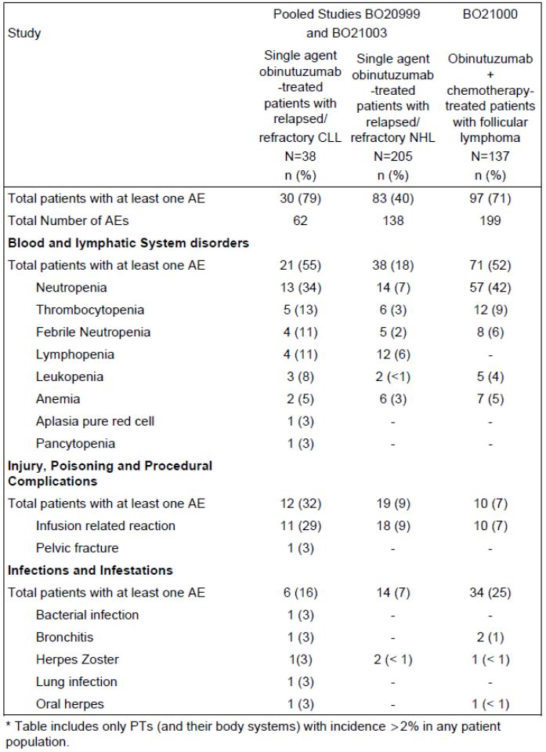
Table 13 (continued): NCI CTCAE grade 3-5 AEs in supporting studies.
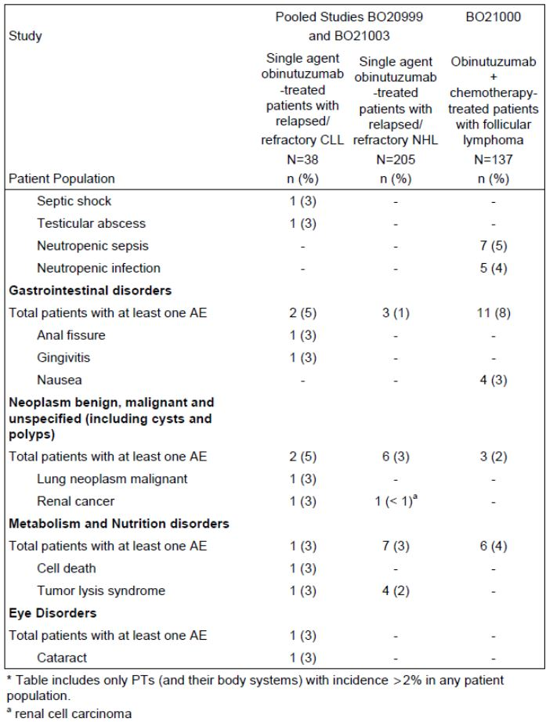
Table 13 (continued): NCI CTCAE grade 3-5 AEs in supporting studies.
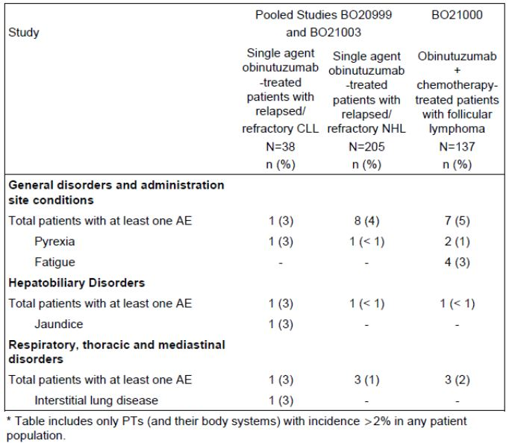

Deaths
There were a total of 22 patients including in the stage I analysis who died, nine in the Clb arm and 13 in GClb arm. It is noted that six patients or 5% in the Clb arm and five patients or 2% in the GClb arm died of an adverse event. Three of the deaths in the Clb arm were because of an infection while none in the GClb arm died of infection.
In the supporting studies a total of 13 patients or 34% died in the monotherapy Clb population, 50 patients or 24% in the monotherapy NHL population and eight patients or 6% in the chemo-combination therapy population with the majority related to disease progression. Only one of these deaths due to lactic acidosis was considered directly related to study drug.

Serious adverse events
During the treatment period, 26 or 22% of patients on the Clb arm experienced 38 serious adverse events and 73 or 30% of patients in the GClb arm experienced 95 serious adverse events. Again the occurrence of serious IRRs in the GClb arm accounted for this major difference between the two arms of therapy with 11% of patients in the GClb arm experiencing these adverse events. It is of note that serious febrile neutropenia occurred in 4% of patients in the Clb arm compared to only one patient in the GClb arm, although serious neutropenia and serious anaemia were experienced by three patients in the GClb arm vs none in the Clb arm. It is also noted that six patients or 3% in the GClb arm and one patient in the Clb arm experienced neoplasm. Also of note is that three patients in the GClb arm experienced a tumour lysis syndrome compared to none in the Clb arm.
Among the supporting studies the proportion of patients at least one SAE was 45% or 17 patients in the monotherapy CLL population, 26% in the monotherapy NHL population and 38% in the chemo-combination as indicated in Table 14. The most common SAEs were infusion related reactions, febrile neutropenia and pyrexia.
Table 14: Summary of most common SAEs in supporting studies.
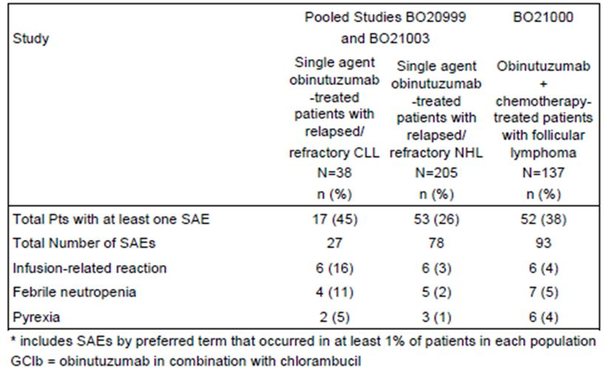

Adverse events lead to treatment discontinuation
In the pivotal study 32 patients or 13% experienced 35 adverse events that led to withdrawal of OB. Nineteen of these were because of infusion related reactions. Three patients were withdrawn because of secondary malignancies and two because of abnormal laboratory investigations, particularly decreased neutrophil counts.
In the supportive studies four patients or 11% with CLL monotherapy withdrew from treatment due to adverse events; three patients withdrew due to infusion reactions and one due to interstitial lung disease. A total of 11 patients or 5% with NHL monotherapy withdrew due to adverse events with the most common again being infusion related reactions in three patients. A total of 12 patients or 9% received chemo-combination therapy withdrew due to adverse events, again with the most common cause in this case being neutropenia in six patients or 4%.

Adverse events leading to dose modification
In the pivotal study 131 or 55% of patients experienced 213 adverse events that required dose modification. This involved delaying, interrupting or slowing down the infusion although a full dose of 1000 mg was administered. The most common adverse events resulting in this was infusion related reaction in 82 patients or 56%. A further 53 patients had their dose modified because of 83 adverse events within the blood and lymphatic system particularly neutropenia in 49 events.
Among the supporting studies a total of 32 patients or 84% had dose modifications due to adverse events in the monotherapy CLL population mainly due to IRRs with 30 patients or 79% followed by neutropenia in six patients. A total of 101 patients or 49% had adverse events leading to dose modification in the monotherapy NHL population again mainly IRRs in 91 patients or 44%. Adverse events leading to dose modification occurred in 90 patients or 66% who received chemo-combination with the most common cause being IRRs in 47% and neutropenia in 20%.

Review of specific adverse events

Neutropenia
In the pivotal study, overall neutropenia occurred in a greater proportion of patients receiving GClb, ie 44% experiencing 209 adverse events compared to Clb with 24 patients experiencing 42 adverse events. The same applies for grade III-V neutropenia with of interest that a greater proportion of patients in the Clb arm discontinued treatment due to neutropenia being 21% on the Clb arm vs 13% GClb arm.
Among the supporting studies, neutropenia was one of the most common adverse events and is summarised. The proportion of patients who experienced grade IV neutropenia was 29% in the monotherapy CLL population, 3% in the monotherapy NHL population and 31% in the chemo-combination therapy population. No patient permanently discontinued study drug due to neutropenia in the two monotherapy studies but six patients or 8% withdrew from treatment due to neutropenia in the chemotherapy studies.

Infections
In the pivotal study the incidence of all grade infection was balanced between the treatment arms being 40% for Clb and 38% for GClb treated patients. The incidence of infections is high on the Clb arm at 14% compared to GClb arm at 5% and five patients on the Clb arm died due to infection whereas none in the GClb arm.
Among the supporting studies infections occurred in 21 patients or 55% with CLL monotherapy, 94 patients or 46% with NHL monotherapy and 96 patients or 76% received chemo-combination therapy.

Infusion related reactions
In the pivotal study, infusion related reactions occurred in 69% of patients involving 249 reactions with the majority being grade I and II. There were no grade V IRRs. The four most common symptoms of IRRs were hypertension in 22%, chills in 23%, nausea in 25% and pyrexia in 21%. The IRRs occurred mainly during the first infusion of OB with 165 patients experiencing 233 IRRs with their second infusion, ie cycle 1 day 8, six patients or 3% had an IRR. Subsequent cycles <1% experienced IRRs. Grade III-V IRRs occurred exclusively during the first cycle involving 51 patients or 21% experiencing 56 episodes.
Subsequent to determination of the high incidence of IRRs with OB, from June 2011 all patients received prophylactic corticosteroids and from December 2012 had the first dose split so that day 1 patients received 100mg of OB 900mg and on day 2. There was a lessening of subsequent infusion reactions.
Review of IRRs by risk factors including tumour burden, stage of disease, BMI and anti-hypertensive treatments failed to reveal any real differences. Similar results were found in the analysis of grade III-V IRRs according to risk factors.
Among the supporting studies most of the patients experienced at least one IRR with the majority being grades I and II and non-serious. There were no grade V IRRs.

Tumour lysis syndrome
In the pivotal study, the incidence of TLS was higher in the GClb arm as 4% experienced a total of 10 TLS events whereas six of these were grade I and II and four grades III/IV.
Among the supporting studies, a total of six patients had TLS in the two monotherapy studies. No patients experienced TLS in study B021000.

Thrombocytopenia
In the pivotal study, 9% of patients receiving Clb experienced 11 events of thrombocytopenia compared to 39 patients or 16% on the GClb arm who experienced 57 events. The incidence of grade III thrombocytopenia was higher in the GClb arm at 9% compared to Clb of 3%. No patients required treatment discontinuation. Eleven or 5% of patients on the GClb arm experienced acute thrombocytopenia within 24 hours of the infusion and in three patients grade IV. No patient discontinued although five patients required dose modification due to acute thrombocytopenia.
Among the supporting studies, the incidence of thrombocytopenia was 18% in the monotherapy CLL, 5% in the monotherapy NHL and 10% in the chemo-combination therapy populations. Most cases were grade III or IV in intensity although no patient required discontinuation of therapy due to thrombocytopenia.
      - Second malignancies after six months of first study drug intake
In the pivotal study two patients on the Clb arm experienced a total of two secondary malignancies and seven or 3% in the GClb arm experienced nine secondary malignancies at least six months after starting therapy. For the Clb arm these were lung adenocarcinoma and pancreatic carcinoma whereas in the GClb arm these were squamous cell carcinoma in four events and other individual incidences of basal cell carcinoma, myelodysplastic syndrome, rectal cancer and prostate cancer.
In the supporting studies 5% of patients in the monotherapy CLL and NHL and 4% in the chemo-combination therapy populations experienced second malignancies.
There is a note that in 22 patients who had crossed over from Clb to GClb and experienced 71 adverse events with the spectrum in severity of these being comparable to that for patients who received GClb as first line treatment.

Clinical laboratory evaluations

Haematology
In the pivotal study, the main differences between the treatment arms was increase in neutropenia for patients on GClb particularly leukopenia and to some extent thrombocytopenia. It is also noted that a total of 17 patients in the Clb arm and 35 patients in the GClb arm had prolonged or late onset neutropenia. Prolonged neutropenia which did not resolve after 28 days involved 10% of patients receiving Clb and 2% receiving GClb respectively, the majority of these recovered at a later date.
Late onset neutropenia occurred at least 28 days after completion of the last OB dose. A total of 12% of patients on the Clb arm and 16% on the GClb arm had at least one laboratory defined late onset neutropenia. These tended to recover at a later date.
It is noted that five patients in the Clb arm with late onset or prolonged neutropenia experienced a total of 10 infections, five of which were grade I and II and five grade III and IV whereas seven or 20% of patients in the GClb arm with late onset or prolonged neutropenia had a total of nine infections, three of which were grade I and II and six grade III-IV.
Among the supporting studies review of haematology changes and details were difficult because of inconsistencies in data collection.

Chemistry laboratory parameters
In the pivotal study, there were no notable differences between the treatment arms in any chemistry laboratory parameter.
In relation to renal function the proportion of patients who experienced renal and urinary disorders or hypertension were similar in each treatment arm being 6% in the Clb and 7% in the GClb arm.

B-cell depletion and recovery
In all studies B-cell depletion is defined as <0.07 x 10⁹/L. Prolonged B-cell depletion is defined as non-recovery of B-cells more than 12 months after the treatment is completed. B-cell recovery is defined as CD19+ B-cell counts at least 0.07 x 10⁹/L where patients CD19+ B-cell counts were previously depleted. In the pivotal studies immuno-pheno typing was analysed during treatment for a sub-set of patients. At the end of the treatment period 2/20 patients who were tested in the Clb arm and 40/44 patients or 91% tested in the GClb arm had B-cell depletion.
Between six and nine months after the end of treatment follow up both patients in the Clb category had B-cell recovery but all 40 patients in the GClb category remained B-cell depleted. Between nine and 12 months of follow up, three patients or 8% had B-cell recovery with recurrent disease while seven patients or 18% had B-cell recovery without PD. The remaining 23 patients remained B-cell depleted. Between 12 and 18 months a further two patients or 5% had B-cell recovery with PD and a further six patients or 15% had B-cell recovery without PD. Nine patients or 23% remained B-cell depleted.

Immunoglobulin depletion recovery
By the end of treatment in the pivotal study the proportion of patients who remained immunoglobulin depleted were similar in each treatment arm at 28% and 30% for IgA; 25% and 22% for IgG and 47% and 51% for IgM. The vast majority of these patients remained immunoglobulin depleted until data cut-off.
In the supporting studies, the majority of patients with CLL monotherapy had depleted immunoglobulin by end of treatment.

Anti-therapeutic antibodies
In the pivotal study four patients developed positive HAHA results at baseline. These were subsequently reverted indicating likely false positive results. Subsequently, seven patients or 11% developed positive results. There was no evidence however that these patients with a positive HAHA test had developed any relevant adverse effects.

Vital signs
No disturbances in vital signs developed in either arm of the pivotal study.

Intrinsic factors
Evaluation of various intrinsic factors in the pivotal study revealed that age had an influence on frequency and severity of adverse events and this is summarised in Table 15.
Table 15: AEs by risk factors treatment group in study BO21004/CLL11.
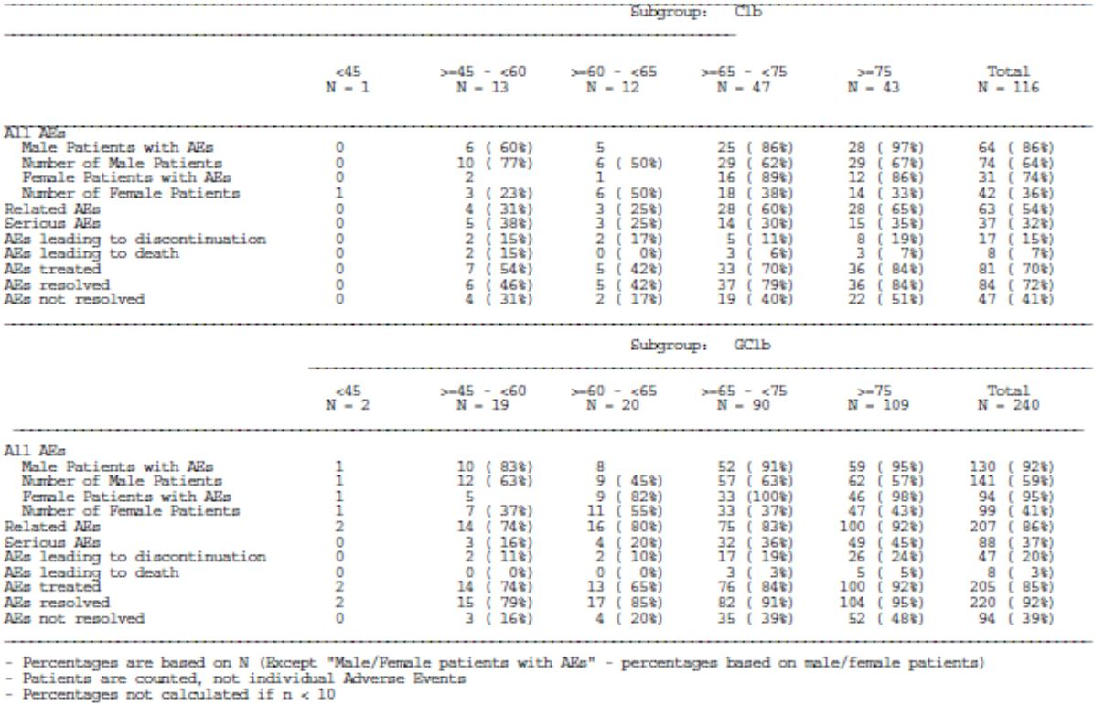
Review of adverse events in relation to creatinine clearance revealed in the pivotal study the incidence of adverse events and serious adverse events was higher in patients with creatinine clearance <50mls/minute.

Post-marketing data
At the time of the Australian submission, there was no post-marketing data available.

Evaluator’s conclusions on safety
The incidence and severity of adverse effects in the pivotal study was clearly greater in the OB combination arm with particular relationship to infusion related reactions. There was a very high incidence of this initially; however, this was ameliorated to some extent with appropriate prophylaxis and alteration in the initial dosing for the first cycle. Overall, it would appear that the tolerance for OB in older patients with associated co-morbidity is acceptable providing appropriate care is taken in relation to infusion related reactions.

First round benefit-risk assessment

First round assessment of benefits
The pivotal Study B021004-CLL 11 is a well conducted but moderate sized multinational randomised trial that has demonstrated significant improvement in PFS for the combination of GClb compared to Clb alone in previously untreated CLL patients with co-existing medical conditions and/or renal impairment. The risk of disease progression or death was reduced by 86% when OB was combined with Clb and the Kaplan-Meier estimated median for investigator assessed PFS was 10.9 months in the Clb arm compared to 23 months in the GClb arm. IRC assessment corroborated this. Sensitivity and sub-group analyses as well as secondary efficacy parameters all support the benefit for GClb. However, at this time OS data is immature and showed no apparent differences between the two arms of study.
It is important to note that for elderly patients with co-morbidities, standard therapy is Clb. Treatment goals are disease control and minimisation of symptoms. Other studies involving more aggressive therapies have demonstrated improvements in PFS without ultimate improvements in OS. It is not unreasonable to anticipate that this may well be the case for GClb in this patient population as those patients receiving Clb are likely to go on to various other treatments maintaining disease control comparable to that achieved with GClb.
Despite the improvement of PFS by meaningful addition of OB to Clb and the complete eradication of disease as determined by minimal residual disease (MRD) negative status achieved in 20% of patients, this just might be indicative of very prolonged disease free survival for these patents.

First round assessment of risks
In the pivotal study there was a greater proportion of patients in the GClb who experienced AEs being Clb 78% versus GClb 93%, Common Terminology Criteria for Adverse Events (CTCAE) grade III-V AEs Clb 47% versus GClb 69%, and serious AEs Clb 32% versus GClb 37%. This is particularly related to the high incidence of infusion related reactions, most particularly during Cycle 1 of therapy. Subsequent introduction of prophylactic corticosteroids adjusting dose schedule for 100 mg on Day 1 and 900 mg on Day 2 for Cycle 1 resulted in a reduction in the incidence of severity of these adverse effects.
Neutropenia was also of higher incidence for patients receiving GClb compared to Clb with grade III/IV AEs of neutropenia in 38% of patients on the combination compared to 18% on Clb. However, it is of some interest that none of these proved fatal as there is no apparent increase in incidence of infections in the GClb arm. Similarly, tumour lysis syndrome (TLS) was more frequent among patients receiving the combination at 4% versus Clb alone at 1% but with appropriate prophylaxis and high hydration this syndrome is likely to be minimised.
It was also noted in older patients adverse effects were more frequent but this was essentially similar for the two arms of study with the exception of those discussed above.
Overall, the safety data for OB in combination with Clb clearly indicates a greater likelihood for adverse effects requiring appropriate prophylaxis and management. In view of the advanced age of the majority of patients with CLL receiving this therapy and relative simplicity for these patients receiving Clb alone, there is a need for caution in easily recommending OB for all patients with previously untreated CLL particularly in the elderly and those with co-morbidities.

First round assessment of benefit-risk balance
As stated above, there are some difficulties in accepting a clear cut benefit over risk balance for the combination of OB with Clb as determined by the result of the pivotal trial. There will be considerable interest in comparing the results for the stage II component of this study presently underway, namely GClb versus RClb as the patients receiving OB in the GClb arm will be receiving relevant prophylaxis and altered schedule for Day 1 of therapy. Further comparison of the adverse effects for OB versus rituximab in this setting will give further clarity to the potential role of OB for the proposed indication.

First round recommendation regarding authorisation
The data available certainly indicates that the addition of OB to Clb in patients with CLL who have increased risk factors was associated with a significant improvement in PFS and a proportion that will have very prolonged improvement in PFS as they become MRD negative. Nevertheless, the adverse effect profile even with relevant prophylaxis is still somewhat greater for the combination compared to Clb alone and is not likely to translate into improved survival. As the combination of RClb is becoming increasingly common as a treatment for this patient population, results of the direct comparison of GClb to RClb is very pertinent. Accordingly, this reviewer is reluctant to recommend approval for OB for its proposed indication of Gazyva in combination with Clb for the treatment of patients with previously untreated CLL until the data from the randomised trial of GClb versus RClb is available and more prolonged follow up of patients in the Phase IA of the pivotal study is available to perhaps better assess potential differences in survival.

Clinical questions
(Q1) Can the sponsor provide an update for the phase Ia component of the pivotal study, particularly in relation to overall survival.
(Q2) Given the age range of subjects in the pivotal trial, including a substantial proportion aged less than 65 years, what was the justification for only treating subjects with chlorambucil in one arm, given that the younger subjects may have benefitted from a combination regimen?
(Q3) Given the equipoise of Gazyva efficacy relative to rituximab in the pivotal trial, what was the justification for treating subjects in the chlorambucil arm only with Gazyva/chlorambucil (GClb) in the event of a relapse/progression, rather than randomly re-allocating them to GClb or rituximab/chlorambucil?
(Q4) VH3-21 confers a poor prognosis. What proportion of the subjects that experienced progressive disease in each study arm of the pivotal trial were VH3-21 positive?
(Q5) The exclusion criteria for the pivotal study included “One or more individual organ/system impairment score of 4 as assessed by the CIRS definition, excluding the eyes, ears, nose, throat, and larynx organ system”. The study disease is also classified with a score of 4. Can the Sponsor reconcile this ambiguity?
(Q6) Stage Ia of the pivotal trial should have included an interim efficacy analysis for GClb vs. RClb (2.7.3 Summary of Clinical Efficacy page 11). What is the result of this interim analysis?
(Q7) Four Subjects in the pivotal trial received the incorrect study treatment (Received GCLb instead of RClb). What were the reasons for these breaches of trial protocol?
(Q8) Protocol amendment 5 of the pivotal trial required all patients to have corticosteroid premedication prior to the first infusion. What was the regimen of corticosteroid dosing used?
(Q9) The concordance of investigator and independent review of PFS event assessments has not been compared, or reported, using an appropriate statistical test (Summary of Clinical Efficacy 2.5.2.3). What are the Kappa values for the levels of agreement of PFS events?
(Q10) In the pivotal trial, did any of the subjects with previously untreated CLL undergo transformation into aggressive lymphoma (Richter’s syndrome)? If so, what were the efficacy and safety outcomes for the subject(s)?
(Q11) In the pivotal trial safety summary of “adverse events leading to death” - was the cause traumatic, or non-traumatic, for the subject who suffered a subdural haematoma?
(Q12) In the chlorambucil arm of the pivotal trial, pancreatitis was listed as the cause of an adverse event leading to one death. This is not a listed side-effect of chlorambucil; what was the underlying diagnosis in this subject?

Second round evaluation of clinical data

Study BO21004/CLL11

Study design, objectives, locations and dates
This study has two stages:
Stage 1a | A comparison of OB (Gazyva) plus chlorambucil (GClb) versus chlorambucil (Clb) alone in the treatment of newly diagnosed CLL
Stage 1b | A comparison of rituximab plus chlorambucil (RClb) versus chlorambucil (Clb) alone in the treatment of newly diagnosed CLL
Stage 2 | A comparison of RClb versus GClb in the treatment of newly diagnosed CLL
The Section 31 response provided an update of safety from stage 1a, plus the primary efficacy and safety analysis from Stage 2.
The study began recruitment in a run-in safety phase in December 2009. Randomization into all three treatment arms opened in April 2010 and was completed on 4 July 2012. The study was conducted in 25 countries at 189 sites in collaboration with the German CLL Study Group (GCLLSG), an independent academic collaborative study group based in Cologne, Germany.

Inclusion and exclusion criteria
Subjects were included if they had CD20+ B-cell CLL which was previously untreated and in need of treatment, with a Cumulative Illness Rating Scale (CIRS) score >6 (additional to the score of 4 for CLL) and/or creatinine clearance <70 ml/minute.
Subjects were excluded if: they had previous CLL therapy, CIRS of 4 in an individual organ class, creatinine clearance <30 ml/min, liver function of CTCAE grade 3 or above or positive Hepatitis B serology.

Study treatments
 | Dose
Gazyva | As described above
Chlorambucil | All patients entering the study received 0.5 mg/kg body weight of Clb given orally on Day 1 and Day 15 of all treatment cycles (Cycles 1−6).  In patients with a Body Mass Index (BMI) >35 (Grade 2 obesity) the dose of Clb was capped at a maximum limit associated with a BMI of 35.
Rituximab | All patients randomized to the RClb arm received 375 mg/m² of rituximab as an IV infusion on Day 1 of the first treatment cycle (Cycle 1).  For each subsequent cycle, patients received rituximab (500 mg/m²) as an IV infusion on Day 1 (Cycles 2−6).
Treatment continued for 6 cycles in each study arm. Patients in the Clb arm who progressed during or within six months of end of Clb treatment had the opportunity to cross-over to the GClb arm.

Efficacy variables and outcomes
The primary efficacy variable was progression-free survival.
Other efficacy outcomes included:
- Event-free survival
- Overall survival
- Time to new anti-leukaemic therapy
- End of treatment response rate
- Minimal residual disease (MRD) negative rate
The intention-to-treat population was used for the primary analysis.

Participant flow
An updated participant flow diagram was presented for Stage 1a patients in the Section 31 response.
A participant flow diagram for Stage 2 patients is shown in Figure 7 section 15; 663 patients were randomised to: RClb (n=330) and GClb (n=333).

Pivotal studies that assessed safety as a primary outcome
No studies assessed safety as a primary outcome.

Clinical questions: round one

Can the sponsor provide an update for the phase Ia component of the pivotal study, particularly in relation to overall survival.
The statistical analysis plan (SAP) included a predefined update of the Stage 1 results at the time of the primary Stage 2 analysis. As the primary Stage 2 analysis has now taken place (see response to Module 5 Question 6), the updated analysis of Stage 1a is available. The key result of this analysis was that an overall survival benefit was observed for GClb over Clb. The updated Stage 1a efficacy and safety analyses are summarised below. The data cutoff for these updated analyses is 9 May, 2013, providing an additional 10 months of follow-up information.

Summary of Updated Stage 1a (with an additional 10 months of follow-up)
The updated efficacy and safety analyses for Stage 1a (GClb vs. Clb) confirmed the results presented in the primary CSR Report #1038127, submitted with the initial application on 7
June 2013:
- Treatment with GClb compared with Clb alone was associated with clinically meaningful improvement in progression-free survival (PFS) (stratified HR 0.19, 95% CI [0.14; 0.27], stratified log-rank test p<.0001). Compared to the primary analysis, the median time to disease-progression or death in the GClb arm increased by almost 4 months, whereas for Clb, the median remained essentially unchanged.
- There was a 59% reduction in the risk of death in the GClb arm compared to the Clb arm (stratified HR 0.41, 95% CI [0.23; 0.74], stratified log-rank test p-value = 0.0022). Compared to the primary Stage 1a overall survival (OS) data, this updated result indicates stronger evidence for an OS benefit of GClb over Clb alone.
- The results of the PFS subgroup analyses were consistent with the respective primary analysis of PFS.
- The results of the secondary endpoints of event-free survival, end of treatment response rate, duration of response, time to new anti-leukemic treatment and molecular remission all confirm the benefit of GClb over Clb treatment.
- In the GClb treatment arm, a higher rate of adverse events (AEs) and Grade 3-5 AEs were reported compared to the Clb arm. Although the rate of serious AEs was higher in the GClb arm compared to the Clb arm, the rate of fatal AEs was lower in the GClb arm.
- The high incidence of infusion-related reactions (IRRs) in the GClb arm (69%) particularly during the first infusion was the main driver for the difference in AE rates compared to the Clb arm. The majority of IRR events in the GClb arm were low grade in intensity and clinically manageable.
- The other most frequent AEs were neutropenia (GClb arm 41%; Clb arm 18%), thrombocytopenia (GClb arm 15%; Clb arm 8%), nausea (GClb arm 13%; Clb arm 25%), anaemia (GClb arm 12%; Clb arm 10%), diarrhoea (GClb arm 10%; Clb arm 11%) and pyrexia (GClb arm 10%; Clb arm 7%).
- Overall, infections were balanced between the treatment arms. However, serious infections were more frequent in the Clb arm (15% patients) than in the GClb arm (12% patients). Six patients (5%) in the Clb arm died because of infection compared to 1 patient (<1%) in the GClb arm.
- Given the limited number of patients in the GClb arm assessed for HAHAs to date, no firm conclusion on the incidence of HAHA positivity or the clinical consequences can be made.
- Based on the updated safety data, no new or unexpected safety concerns were seen for the combination of Gazyva with Clb.
- Updated Stage 1a results are consistent with the primary CSR safety and efficacy results, with the exception of the OS data, which now shows stronger evidence of a benefit in GClb treated patients.
The full CSR with updated Stage 1a and Stage 1b data is provided (Report #1057363, December 2013). The results are further discussed in the Clinical Overview Addendum included in Module 2 of this response. The Sponsor would also like to highlight that a manuscript of the Stage 1 and Stage 2 data has been accepted for publication in the New England Journal of Medicine underscoring the interest and importance of this data to the medical community.
For ease of reference the updated Stage 1a data are provide below.

Patient disposition
At the time of clinical data cutoff for this update, a greater proportion of patients in the GClb arm (91%) had entered follow-up compared to the Clb arm (81%).
A higher percentage of patients in the Clb arm were prematurely withdrawn from trial treatment than in the GClb arm (34% vs. 20%). This was primarily due to an increased incidence of patients being withdrawn because of disease progression in the Clb arm (7%) compared to the GClb arm (<1%). There was also a higher incidence of patients having an insufficient therapeutic response in the Clb arm than in the GClb arm (4% vs. <1%).
More patients in the Clb arm are included as having completed follow up than in the GClb arm (75% versus 29%). This difference is related to the higher proportion of patients having disease progression in the Clb arm and thus leaving the follow up period of the study and moving to the survival follow-up.
A higher percentage of patients in the Clb arm were prematurely withdrawn from trial treatment than in the GClb arm (34% vs. 20%). This was primarily due to an increased incidence of patients being withdrawn because of disease progression in the Clb arm (7%) compared to the GClb arm (<1%). There was also a higher incidence of patients having an insufficient therapeutic response in the Clb arm than in the GClb arm (4% vs. <1%).
Thirty patients (25%) who were randomised to Clb crossed over to GClb treatment.
The overall median observation time (randomisation to last available assessment) at the time of clinical data cutoff for this updated analysis (9 May 2013) was 22.8 months; 20.4 months (range: 0.2 to 35.2 months) for patients in the Clb arm and 23.2 months (range: 0.1 to 36.9 months) for patients in the GClb arm (Table 16). Eighty-six percent of patients in the Clb arm and 90% of patients in the GClb arm had been observed for at least 12 months. At clinical data cutoff, 37% of patients in the Clb arm and 48% of patients in the GClb arm had been followed for at least two years.
At the time of the clinical cutoff for the primary Stage 1a analysis, (11 July 2012) the median observation time was 13.6 months (range: 0.2 to 26.8 months) for patients in the Clb arm and 14.5 months (range: 0.1 to 26.7 months) for patients in the GClb arm. Thus in this update the median observation time has increased by 6.8 months for patients in the Clb arm and by 8.7 months for patients in the GClb arm. There was a 10 month difference between the two clinical cut-off dates.
Table 16: Observation time – Stage 1a update.
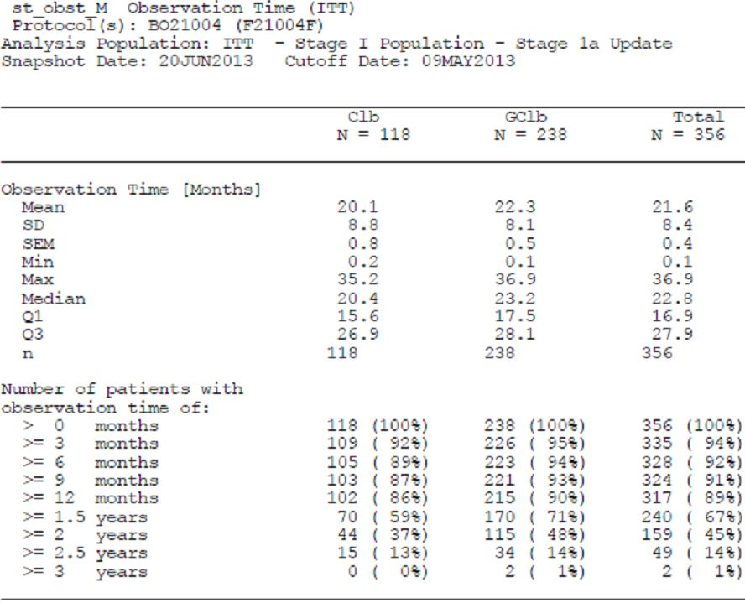

Updated efficacy results – Stage 1a
Overall the updated efficacy results with longer follow-up support the conclusion drawn from the primary analysis that compared to Clb alone, the addition of Gazyva to Clb therapy in previously untreated patients with CLL and comorbidities resulted in a clinically meaningful and statistically significant benefit in terms of PFS.
Calculated hazard ratios for the primary endpoint of PFS as well as for all other time-to-event parameters favour GClb over Clb. The upper limits of the 95% CI for the hazard ratios are all below one, including for OS (Table 17).
The proportion of responders at the end of treatment in the GClb arm was more than double the number in the Clb arm (77.3% vs. 31.4%). A complete response was reported in 22.3% (53/238) of patients in the GClb arm versus none in the Clb arm. Forty-five of 168 GClb patients (26.8%) assessed for molecular remission (blood and bone marrow combined) at the end of treatment were MRD negative.
Table 17: Overview of efficacy – Stage 1a update (ITT).
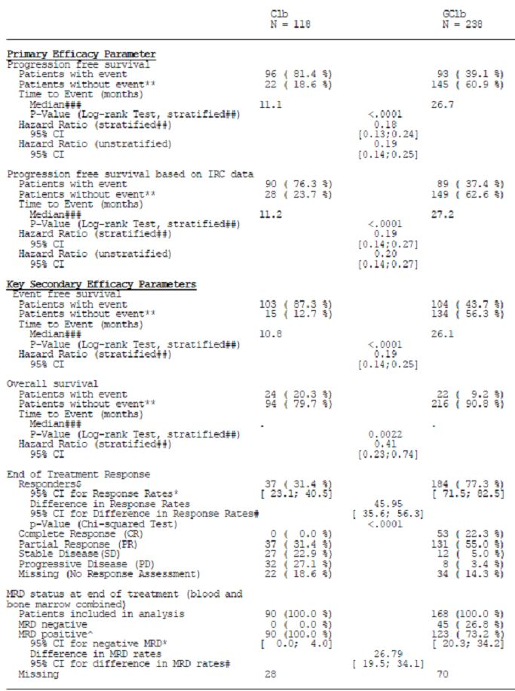
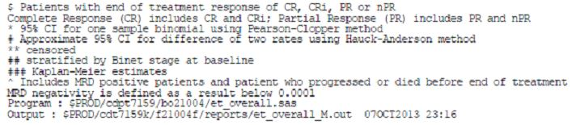

Progression-free survival - Investigator assessment
The protocol-specified primary efficacy analysis was based on a stratified (Binet stage at baseline), two-sided log-rank test of PFS as assessed by the investigator.
At the time of the clinical cutoff for this updated analysis (9 May, 2013), the proportion of patients who had showed a PFS event of death or disease progression was 96/118 patients (81.4%) vs. 93/238 patients (39.1%) in the Clb and GClb arms, respectively (Table 3). The stratified log-rank test p-value was <0.0001.
The updated hazard ratio for PFS was 0.18 (95% CI [0.13; 0.24]). The Kaplan-Meier (KM) estimated median duration of PFS was 11.1 months vs. 26.7 months in the Clb and GClb arms, respectively.
The triggering events (death or disease progression) for PFS are summarised in Table 18.
Table 18: Progression-free survival (investigator assessment) – Stage 1a update (ITT).
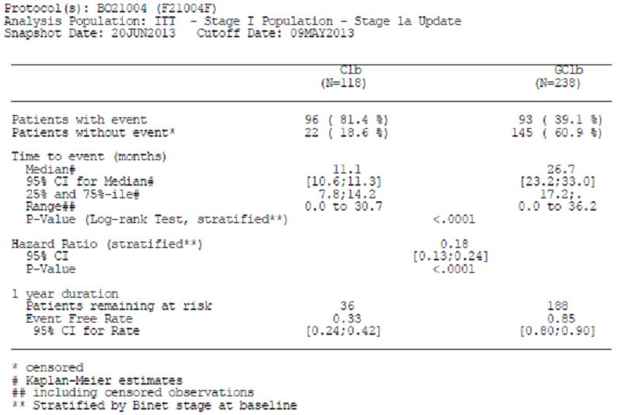
The KM plot showed separation of the PFS curves in favour of the GClb arm after the first month of treatment, which was maintained until the cutoff for this report (Figure 10).
Figure 10: Kaplan-Meier plot of progression-free survival as assessed by the investigator - Stage 1a update (ITT).
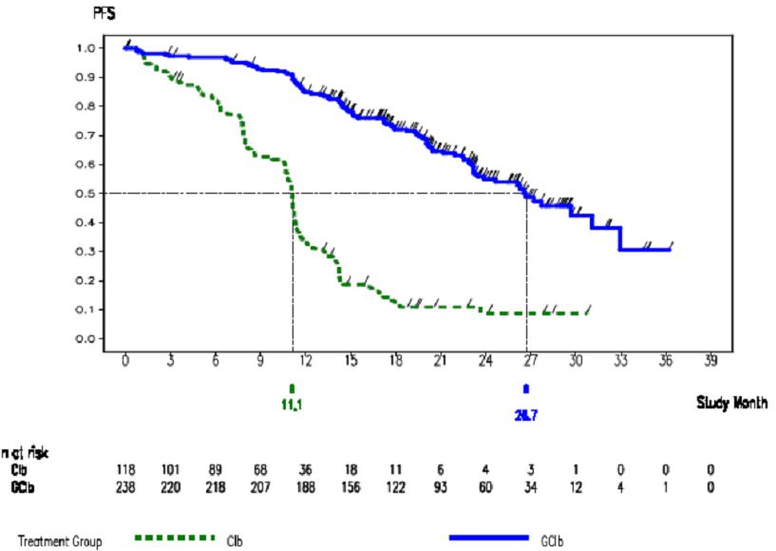
Since the KM estimates are not considered to be reliable beyond the time point when too few patients are at risk (10% - 20% according to Pocock et al.), conclusions based on the right-hand tail of a KM curve beyond this time point should be interpreted with caution.
The proportion of patients at risk at 27 months (i.e. close to the median duration of PFS in the GClb arm of 26.7 months) was 14.3% (34/238 patients) in the GClb arm.
Note that a higher proportion of observations in the GClb arm were censored compared to the Clb arm. The reason was that patients in the Clb arm progressed earlier than GClb patients. In the GClb arm the majority of patients had not progressed by the data cutoff date (9 May 2013).
The KM estimates for event-free rates in the Clb and GClb arms at 18 months were 0.1207 (95% CI [0.057; 0.185], 11 patients at risk) and 0.7213 (95% CI [0.660; 0.782], 122 patients at risk), respectively.
The result of the non-stratified analysis of PFS was very similar to the stratified analysis (HR 0.19; 95% CI [0.14; 0.25]).

Progression-Free Survival - Independent Review Committee (IRC) Assessment
As for the primary analysis, updated results for PFS as determined by IRC were in good agreement with the analysis of investigator-assessed PFS (Table 18).
The KM-estimated median PFS was 11.2 months and 27.2 months in the Clb arm GClb arm, respectively (Table 18; Figure 11).
Figure 11: Kaplan Meier plot of progression-free survival (independent review committee assessment) – stage 1a update (ITT).
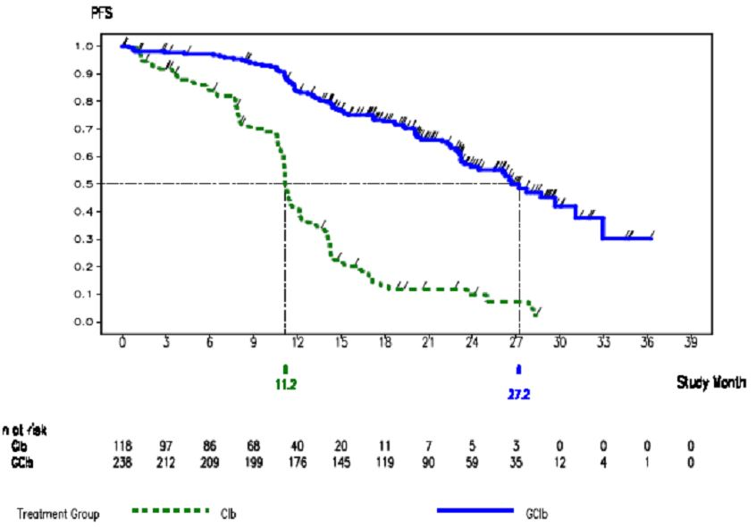
The KM estimates for event-free rates in the Clb and GClb arms at 18 months were 0.1299 (95% CI [0.061; 0.199], 11 patients at risk) and 0.7274 (95% CI [0.666; 0.789], 119 patients at risk), respectively.
The result of the non-stratified analysis of PFS was very similar to the stratified analysis (HR 0.20; 95% CI [0.14; 0.27]).
The triggering events (death or progressive disease) for IRC-assessed PFS are summarised in Table 19.
Table 19: Progression-free survival (independent review committee assessment) – Stage 1a update (ITT).
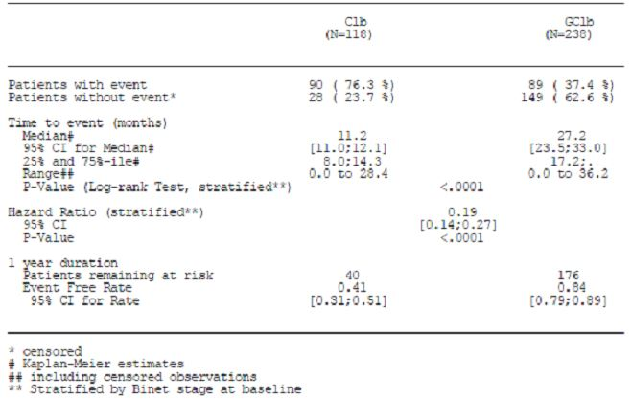
      - Overall Survival
At the time of the clinical cutoff, for this updated analysis (9 May 2013), a total of 46 randomised patients had died; 24/118 patients (20.3%) in the Clb arm and 22/238 patients (9.2%) in the GClb arm (Table 20). The number of deaths was too small to estimate the median survival time in either treatment arm, indicating that the OS data are still preliminary due to the low number of events. In contrast to the primary Stage 1a analysis, there was evidence of a survival benefit for patients in the GClb arm compared to the Clb arm with a stratified hazard ratio of 0.41 (95% CI [0.23; 0.74], stratified log-rank test p-value 0.0022).
Table 20: Overall survival – Stage 1a update (ITT).
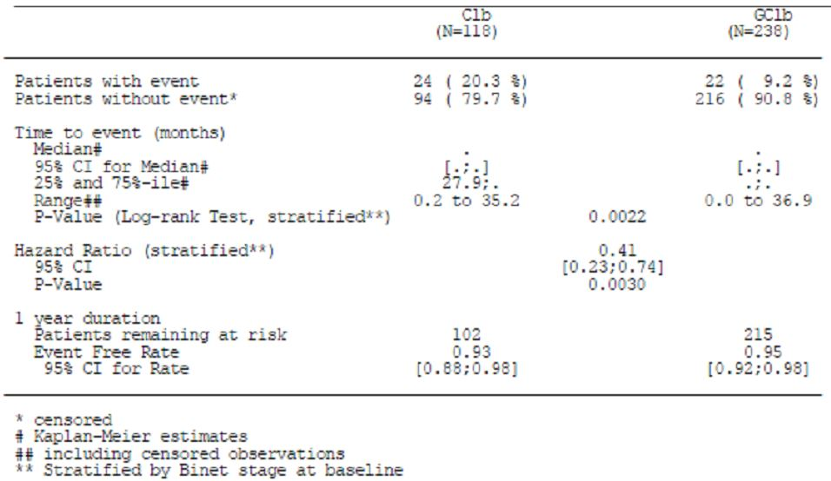
Additional follow up will further quantitate the OS benefit of GClb over Clb.
The corresponding KM plot shows separation of the two survival curves that grows wider in favour of the GClb arm after the first 12 months of the study (Figure 12).
Figure 12: Kaplan-Meier plot of overall survival – stage 1a update (ITT).
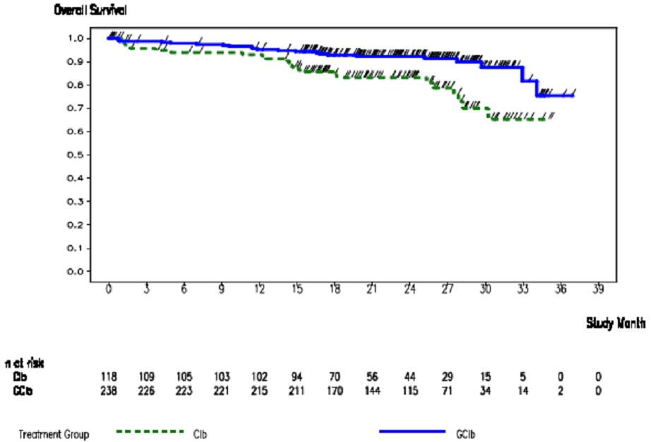

Updated safety results – Stage 1a
An overview of the updated safety data reported in Stage 1a of this study up until the clinical data cutoff (9 May 2013) is provided in Table 21. The safety analyses are based on the safety population and include all patients who received at least one dose of study medication.
In summary the results of the updated safety analyses are as follows:
- Incidence of death was lower in the GClb arm (Clb arm: 21% patients vs. GClb arm: 9% patients).
- Incidence of fatal AEs was lower in the GClb arm (Clb arm: 9% patients vs. GClb arm: 5% patients).
- Incidence of all AEs (any grade) (Clb arm: 83% patients vs. GClb arm: 94% patients), AEs leading to withdrawal from any study medication (Clb arm: 15% patients vs. GClb arm: 20% patients), serious AEs (Clb arm: 38% patients vs. GClb arm: 41% patients) and Grade 3-5 AEs (Clb arm: 50% patients vs. GClb arm: 73% patient) were all higher in the GClb arm.
- Difference between the treatment arms in AEs, serious AEs and Grade 3-5 AEs was mainly due to IRRs, primarily occurring during the first infusion of Gazyva. IRRs were experienced by 166/241 patients (69%) treated with GClb and led to the withdrawal of 19/241 patients (8%) and dose modifications for 86/241 patients (36%). Additionally, but to a lesser extent, Grade 3-5 AEs in the body system of Blood and Lymphatic System contributed to the difference between the treatment arms (28% Clb vs. 43% GClb).
- Overall, there were no unexpected safety signals with GClb. Although 8% patients in the GClb arm were withdrawn because of IRRs, no fatal IRRs occurred and the majority of IRRs were manageable.
- Overall the safety conclusions are similar to the analysis presented in the Stage 1a primary CSR.
Table 21: Overview of adverse events, death and withdrawals – stage 1a update (SAP).
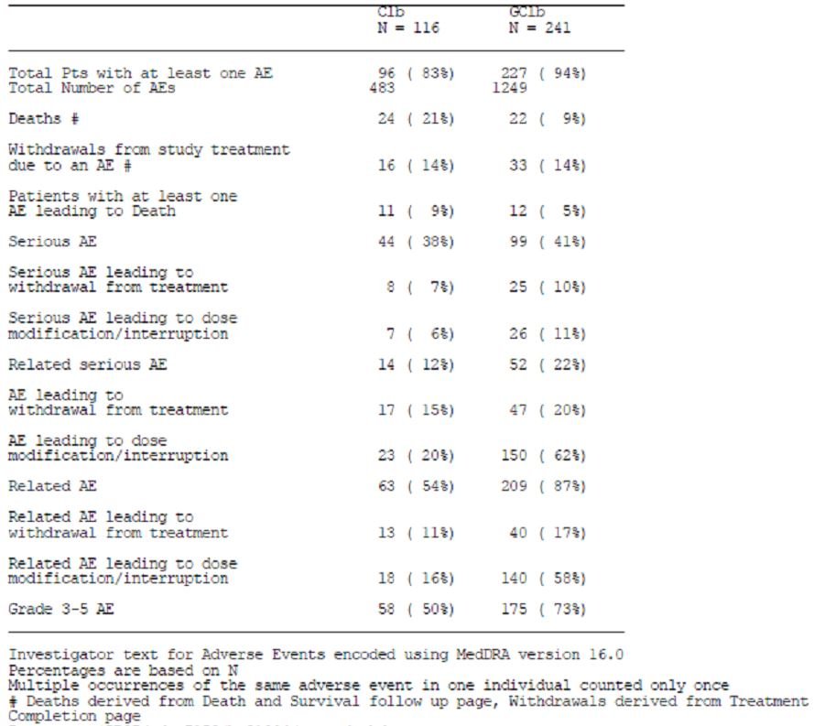

Common adverse events
Up until the clinical data cutoff (i.e. treatment period plus follow-up period), 96/116 patients (83%) in the Clb arm experienced 483 AEs and 227/241 patients (94%) in the GClb arm experienced 1249 AEs.
AEs (NCI CTCAE Grades 1 to 5) that occurred at an incidence of at least 5% in either treatment arm are summarised in Table 22. The most common AEs were reported in the following body systems (Clb vs. GClb):
- Injury, Poisoning and Procedural Complications (6% vs. 71%), most frequently IRRs (not applicable [0%] vs. 69%). IRRs are discussed in detail in the updated CSR.
- Blood and Lymphatic System Disorders (34% vs. 51%), most frequently haematological AEs such as neutropenia (18% vs. 41%), thrombocytopenia (8% vs. 15%), anaemia (10% vs. 12%), and leukopenia (0% vs. 7%). Neutropenia and thrombocytopenia are discussed in detail in the updated CSR, respectively.
- Gastrointestinal Disorders (47% vs. 40%), most frequently nausea (25% vs. 13%), diarrhoea (11% vs. 10%), constipation (10% vs. 7%), vomiting (12% vs. 5%) and abdominal pain (5% vs. 5%).
- Infections and Infestations (41% vs. 41%), most frequently nasopharyngitis (7% vs. 7%) and bronchitis (7% vs. 5%). A variety of infections (45 different types of infections in total) occurred in only 1 or 2 patients in either treatment arm. Infections are discussed in the updated CSR.
- General Disorders and Administration Site Conditions (28% vs. 30%), most frequently pyrexia (7% vs. 10%), fatigue (10% vs. 7%) and asthenia (7% each arm).
- Respiratory, Thoracic and Mediastinal Disorders (20% vs. 22%), most frequently cough (7% vs. 10%) and dyspnoea (7% vs. 2%).
- Nervous System Disorders (16% vs. 20%), most frequently headache (7% vs. 7%).
- Metabolism and Nutrition disorders (12% vs. 20%), most frequently decreased appetite (8% vs. 3%).
Table 22: Adverse events with an incidence of at least 5% - stage 1a update (SAP).
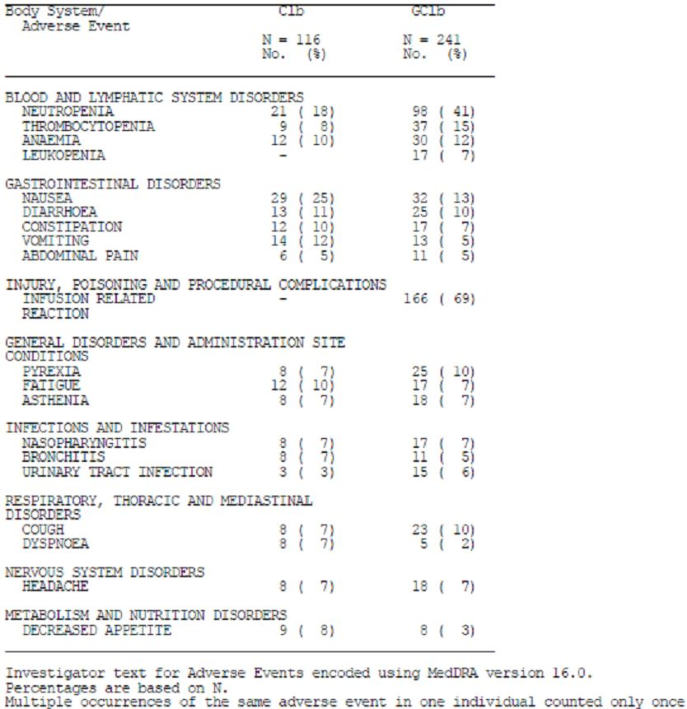
The difference between the treatment arms in the proportion of patients who experienced at least one AE can largely be accounted for by the intravenous administration of Gazyva; 69% patients in the GClb treatment arm experienced an IRR. Clb was administered orally. A greater proportion of patients treated with GClb showed blood and lymphatic system disorders (Clb arm: 34% patients vs. GClb arm: 51% patients), particularly neutropenia which was shown by 18% of patients in the Clb arm and by 41% of patients in the GClb arm.
Similarly, 8% of patients in the Clb arm vs. 15% in the GClb arm showed thrombocytopenia.
Gastrointestinal disorders occurred more frequently in the Clb arm (47% patients) than in the GClb arm (40% patients). This was driven mostly by the higher incidence of nausea in the Clb arm (25% patients) compared to GClb arm (13% patients).

Adverse events with a difference of ≥ 2% in incidence in the GClb arm
AEs that occurred with a ≥2% difference in incidence in the GClb arm compared to the Clb arm are summarised in Table 23.
Table 23: Adverse events that occurred with ≥2% difference in incidence in the GClb arm – stage 1a update (SAP).
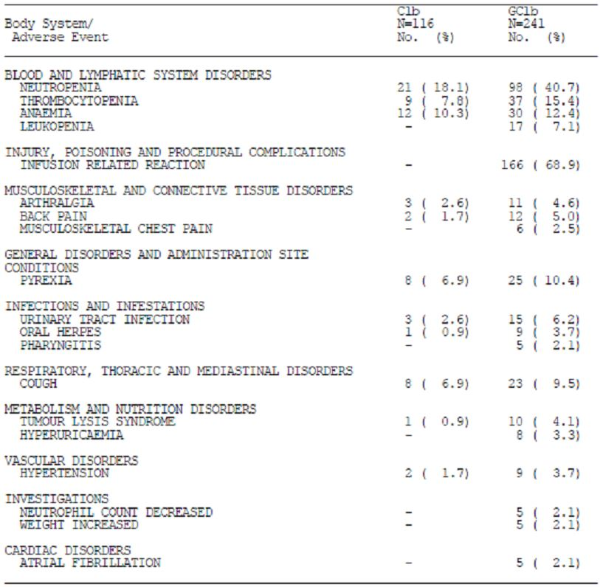
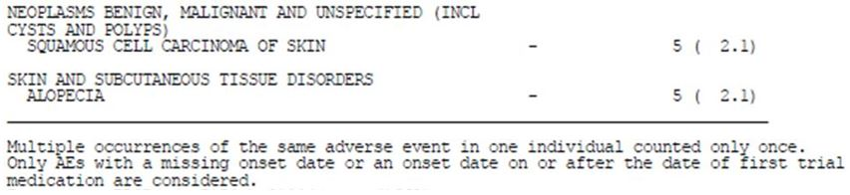
Notably, IRRs occurred in 68.9% of patients administered GClb. A greater proportion of patients administered GClb experienced TLS (GClb arm: 4.1% patients vs. Clb arm: 0.9% patients), infections including oral herpes (GClb arm : 3.7% patients vs. Clb arm: 0.9% patients) and urinary tract infection (GClb arm: 6.2% patients vs. Clb arm: 2.6% patients), atrial fibrillation (GClb arm: 2.1% patients vs. Clb arm: 0% patients), squamous cell carcinoma of the skin (GClb arm: 2.1% patients vs. Clb arm: 0% patients) as well as blood and lymphatic disorders such as neutropenia (Clb arm: 18.1% patients vs. GClb arm: 40.7% patients), thrombocytopenia (Clb arm: 7.8% patients vs. GClb arm: 15.4% patients) and leukopenia (Clb arm: 0% patients vs. GClb arm: 7.1% patients).
Comment: The update for stage 1a of the pivotal trial demonstrates a significant improvement in PFS (stratified for Binet stage at randomisation) for patients treated with GClb over Clb alone in patients with previously untreated CLL. Given the number of deaths in the pivotal trial, the interim data show that OS is currently better in the arm treated with GClb.
The adverse event profile remains similar to that previously described in the original submission, with the inclusion of cardiac disorders and Neoplasms added to the table of the summary of ADRs in stage 1.
The amendment to the dosage regimen for the first dose to be split to a 100mg dose and 900mg dose of Gazyva did not abolish the occurrence of infusion-related reactions. In order for clinicians to adequately assess the risk of IRRs with the amended regimen, and report the risk to their patients, a comparison of the crude proportion of patients with IRRs before, and after, the amendment should be reported in the PI.

Given the age range of subjects in the pivotal trial, including a substantial proportion aged less than 65 years, what was the justification for only treating subjects with chlorambucil in one arm, given that the younger subjects may have benefitted from a combination regimen?
Clb as a single agent is an option in patients who are not sufficiently fit to receive fludarabine-based regimens, even when < 65 years of age.
A previously untreated CLL population is a continuous spectrum of patients that extends from patients who are able to tolerate the toxicity associated with fludarabine, cyclophosphamide and rituximab (FCR) therapy to patients for whom less toxic therapies or no therapy is more suitable. Clinicians recognise that the right choice of treatment for a given CLL patient is complex and a task that requires experience, a good clinical and social assessment of the patient and an appropriate use of diagnostic tools.
Study BO21004/CLL11 was designed to be complementary to the German CLL Study Group CLL8 trial (pivotal in the approval of rituximab + FC for CLL) which enrolled patients considered ‘fit-enough’ to receive FCR therapy. The criteria used for the CLL8 study was the cumulative illness rating scale score (CIRS) ≤6 and adequate renal function CrCl ≥ 70 ml/min.
Study BO21004/CLL11 used entry criteria of CIRS score more than 6 (CIRS >6), and/or impaired renal function (CrCl <70ml/min), and not age, to define the patient population for whom full dose F-based treatment is not appropriate. This is in line with the current ESMO guidelines.
Sixty-eight (68), (19%) of patients enrolled for the stage 1a analysis were younger than 65 years. The majority of these younger patients (83%) had a significant comorbidity burden as determined by a CIRS >6 while 13% had impaired renal function with a creatinine clearance <70 mL/min (see Table 24).
Table 24: CIRS score and creatinine clearance categories at baseline. Patients with age <65 years.
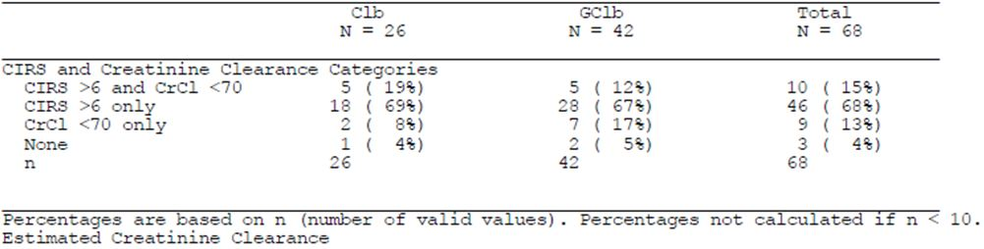
Table 25 summarises the comorbidity data for patients aged < 65 years in the Stage 1a population. Patients in this group had a median number of 5 organ systems with associated comorbidity, with 2 organ systems scored as 2 or higher (moderate or severe).
Table 25: Table Cumulative illness rating scale (ITT).
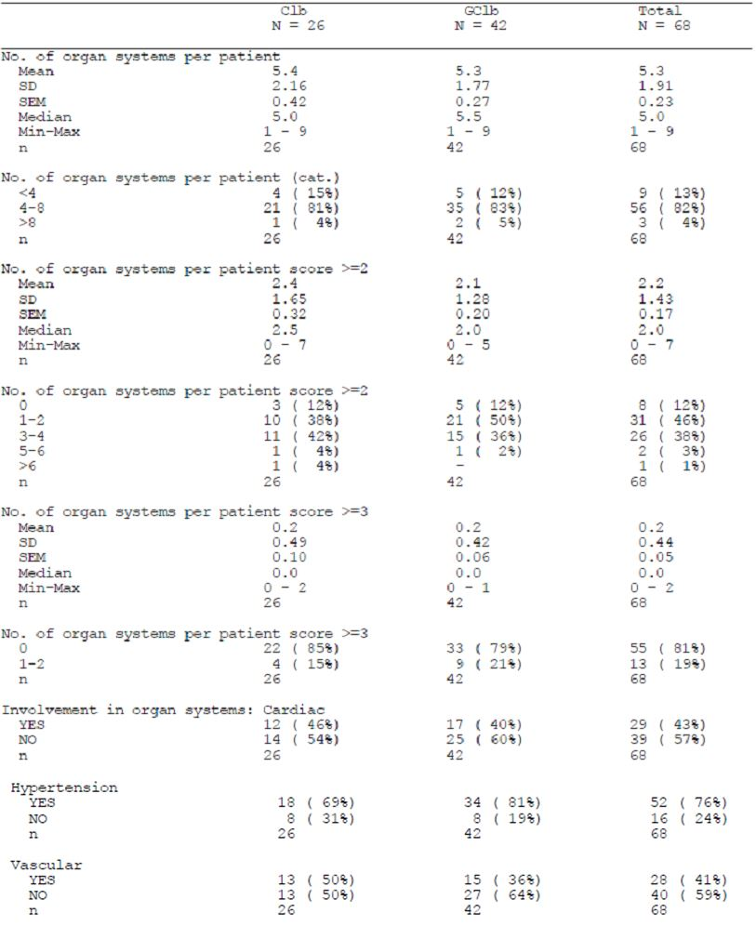
Table 25 (continued): Table Cumulative illness rating scale (ITT).
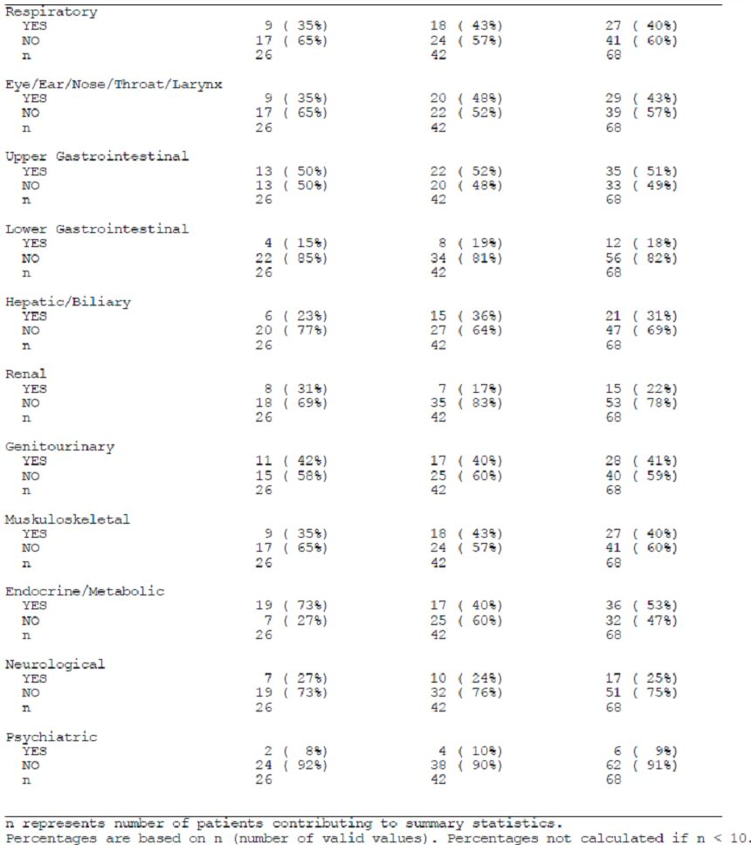
Despite being younger than 65 years, this group of patients was comorbid and had coexisting medical conditions that led the physician to select a regimen of mild toxicity.
Therefore, Clb was a valid treatment option for these younger patients with comorbidities.
Comment: This explanation for restricting therapy to chlorambucil alone in this trial setting is satisfactory.

Given the equipoise of Gazyva efficacy relative to rituximab in the pivotal trial, what was the justification for treating subjects in the chlorambucil arm only with Gazyva/chlorambucil (GClb) in the event of a relapse/progression, rather than randomly re-allocating them to GClb or rituximab/chlorambucil?
Patients were not randomised to GClb or RClb as second line therapy for the following reasons:
- The preclinical experiments which were the foundation for the development of GClb predicted that GClb would be superior to RClb rather than ‘equipoise’. This has since been confirmed with the availability of the Stage 2 data of the pivotal study BO21004/CLL11 (please see response to Module 5 question 6).
- The study was set up to answer a clinical question of first line treatment in CLL and it was not considered appropriate, or standard practice, to randomise the Clb refractory patients between different second line treatments. It was considered more appropriate to leave the second line treatment to investigators discretion, especially, because that part of the study would not have been adequately powered due to the small number of Clb patients.
- In Australia and particularly in Europe, where the majority of participating countries were located, rituximab in combination with chemotherapy was already approved for patients with relapsed/refractory CLL. Patients could therefore be prescribed RClb as an optional second-line therapy out of study.
- For many patients, the incentive to enter a clinical trial is often to receive treatment with novel and promising, although not yet approved drugs. The cross-over possibility to GClb was intended to encourage patients to enter and remain in the trial until the time of disease progression and therefore protecting the primary outcome of the study (PFS) in the Clb arm.
- To highlight, only refractory patients with confirmed progressive disease during or 6 months after treatment with Clb were allowed to cross-over to GClb. Patients who crossed-over would continue to contribute to the Clb treatment arm for reporting of OS.
- The cross-over in the study was an option open to investigators and was not intended to formally assess GClb as a second-line therapy.
- In conclusion, the cross-over period was incorporated into the trial design as an option for investigators to treat refractory Clb patients with GClb. It was designed not to impact the primary endpoint of the study (PFS) and was not intended to assess the efficacy and safety of GClb as second-line treatment. For that reason there was no planned randomisation to second line therapy (GClb, RClb or other second line therapy).
Comment: This response is satisfactory.

VH3-21 confers a poor prognosis. What proportion of the subjects that experienced progressive disease in each study arm of the pivotal trial were VH3-21 positive?
Clb arm: The proportion of patients who progressed and were VH3-21 positive was 3/63 (5%).
GClb arm: The proportion of patients who progressed and were VH3 -21 positive was 3/42 (7%).
A baseline VH3-21 result is available for 72 patients in the Clb arm and 161 patients in the GClb arm (Stage 1a patient population). The VH3-21 analysis together with the IGHV mutation status was performed at a central laboratory in Ulm, Germany. This required shipment of samples from international sites. The specific V gene used in the IGHV rearrangement could not always be determined and therefore, a VH3-21 gene analysis was performed in a limited number of patients (61% of the Clb patients and 68% of the GClb patients).
10/72 (14%) patients with VH3-21 assessment were positive for VH3-21 usage in the Clb arm (Table 26). A similar proportion of patients were positive in the GClb arm, 21/161 (13%).
Table 26: Triggering event for PFS by treatment and VH-23 usage (ITT; stage 1a).
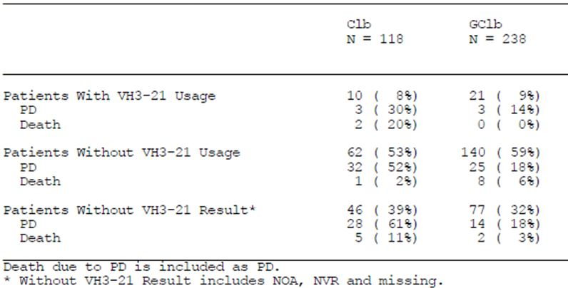
These results are slightly higher compared to published data 66/1063 (6%) but given the small numbers it is difficult to draw definitive conclusions.
Of patients who had progressed in the Clb arm, 3/63 (5%) were VH3-21 positive (with gene usage), 32/63 (51%) were VH3-21 negative (without gene usage), and for 28/63 (44%) VH3- 21 was unknown.
Of patients who had progressed in the GClb arm, 3/42 (7%) were VH3-21 positive, 25/42 (60%) were VH3-21 negative, and for 14/42 (33%) VH3-21 was unknown.
Of note in the Clb treatment arm a similar proportion of patients who were VH3-21 positive 5/10 (50%) compared to 33/62 (53%) VH3-21 negative had progressed or died. In the GClb arm 3/21 (14%) patients in the VH3-21 positive group compared to 33/140 (25%) patients in the VH3-21 negative group had progressed or died.
The Stage 2 data (Table 27) provide similar results, in that the proportion of patients in the RClb arm who progressed and were VH3-21 positive was 6/182 (3%) compared to 7/87 (8%) in the GClb treatment arm.
Table 27: Triggering event for PFS by treatment and VH-23 usage (ITT stage 2).
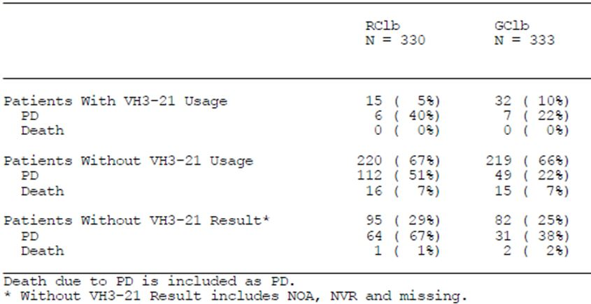
Comment: This response is satisfactory. No additional risk according to VH3-21 status was demonstrated in this trial.
Overall, VH3-21 usage was not considered as a strong risk factor because the rate of patients with disease progression was not higher in patients with VH3-21 usage (positive) compared to without VH3-21 usage (negative) in either treatment arm. However, the limited number of patients who were VH3-21 positive in either treatment arm makes it difficult to reach definitive conclusions.

The exclusion criteria for the pivotal study included “One or more individual organ/system impairment score of 4 as assessed by the CIRS definition, excluding the eyes, ears, nose, throat, and larynx organ system”. The study disease is also classified with a score of 4. Can the Sponsor reconcile this ambiguity?
This can be reconciled by referring to the protocol instructions for completing the CIRS assessment in the pivotal study BO21004/CLL11 (see Appendix 3 of the protocol). The disease under study, ‘CLL’ was specifically not included in the overall CIRS assessment and therefore was not considered to be an exclusion criterion. The pertinent section of Appendix 3 is reported below.
“Appendix 3 CIRS Score
At screening each organ system listed below should be assessed and graded on a scale of 0-4 for the degree of impairment (see instructions below). CLL illnesses or disease related organ damage should not be assessed in this rating scale. If there are two or more illnesses/impairments in one organ system, the illness/impairment with the highest severity will be evaluated. The sum of all individual organ scores should be calculated. If the total score is more than 6 the patient is eligible for the study. If one organ system has extremely severe impairment (Grade 4) the patient is not eligible unless this Grade 4 falls in the Eye, Ear, Nose and Throat category.”
Comment: This response is satisfactory.

Stage Ia of the pivotal trial should have included an interim efficacy analysis for GClb vs. RClb (2.7.3 Summary of Clinical Efficacy page 11). What is the result of this interim analysis?
As described in the SAP, an interim efficacy analysis for GClb versus RClb was performed by a Data and Safety Monitoring Board (DSMB) at the time of the Stage 1a analysis. At this time point 142 of 406 PFS events (35% of the information) had become available. The efficacy boundary at the time of the first efficacy interim analysis (IA) was strict with 0.0001. The DSMB recommendation at that time was not to stop the study for overwhelming efficacy. No further data about the comparison of GClb versus RClb was released at the Stage 1a analysis from the DSMB and the stage 2 portion of the study continued as planned.
The second, pre-planned IA for efficacy was specified to take place after 300 PFS events (after 74% of the information had become available) and the cut-off for that analysis was reached on 9 May 2013. The DSMB recommended to un-blind the study at this stage as the primary endpoint for Stage 2 had been met. The Sponsor endorsed this recommendation and the study was fully analysed.
The results of the Stage 2 analysis are presented in the full CSR of Stage 2 for study BO21004/CLL11 (Report #1056550). The results including a benefit risk assessment are further discussed in the Clinical Overview Addendum provided in Module 2 of this response.
The sponsor would also like to highlight that a manuscript of the Stage 1 and Stage 2 data has been accepted for publication in the New England Journal of Medicine, underscoring the interest and importance of this data to the medical community.
A summary of the Stage 2 efficacy and safety analyses of study BO21004/CLL11 are presented below. The data cut-off for these analyses is 9 May, 2013.

Summary of stage 2 results
- The primary Stage 2 analysis was performed following a pre-planned efficacy IA because the predefined efficacy boundary was met.
- The primary analysis, PFS assessed by the investigator, showed clinically meaningful and statistically significant benefit of GClb over RClb, HR = 0.39, 95% CI = (0.31; 0.49), p < 0.0001, log-rank test.
- Subgroup analyses were consistent with the primary PFS analysis.
- Results were confirmed by IRC assessed PFS, HR = 0.42, 95% CI = (0.33; 0.54), p < log-rank test. Other secondary endpoints, including response rates and MRD, supported the primary endpoint. OS data are immature.
- Assessment of safety showed no new safety signals compared with the Stage 1 analysis. The incidence of AEs, serious AEs, AEs of Grade 3-5, and AEs leading to discontinuation of study treatment was higher in the GClb arm compared with the RClb arm. This difference was mainly due to IRRs, neutropenia and thrombocytopenia.
- The incidence and rate of infections were similar between the treatment arms.
- AEs leading to death were more frequent in the RClb arm compared with the GClb arm.
- Overall, the benefit/risk of the GClb combination is considered superior to the RClb combination.
Comment: the updated stage 1b and the primary stage 2 analyses are discussed below in section 9.

Four Subjects in the pivotal trial received the incorrect study treatment (Received GCLb instead of RClb). What were the reasons for these breaches of trial protocol?
In response to this question the Sponsor provides the following for study BO21004/CLL11:
- A summary of the drug accountability and patient compliance checks;
- The reasons for all patients (updated total number) who received incorrect study treatment.
- Summary of the drug accountability and patient compliance checks
- Accountability and patient compliance was assessed by maintaining adequate “drug dispensing” and return records. Patients returned all used and unused Clb containers at the end of the treatment as a measure of compliance.
- Accurate records were kept for each study drug provided by the sponsor. These records contained the following information: documentation of drug shipments received from the sponsor (date received and quantity); disposition of unused study drug not dispensed to patient.
- A drug dispensing log was kept current and contained the following information: the identification of the patient to whom the study medication was dispensed; the date(s) and quantity of the study medication dispensed to the patient; the date(s) and quantity of Clb returned by the patient.
This inventory was available for inspection by the Monitor. All supplies, including partially used or empty containers and copies of the dispensing & inventory logs, will be returned to the Roche Monitor at the end of the study, unless alternate destruction has been authorised by Roche, or required by local or institutional regulations.

Reasons for all patients who received incorrect study treatment
The reason for all patients who received incorrect study treatment was pharmacy error. In addition to the 4 patients included in the original Stage 1 analysis, one further RClb patient
(164908/1120) breached the trial protocol. This pharmacy error was identified after the primary Stage 1a data snapshot date (12 July 2012). Patient (164908/1120) who received 2 in between doses of GClb was identified on 29 October 2012 as having received incorrect study treatment at 2 cycles (Cycles 4 and 5).
These 5 patients (164841/5702, 164845/5782, 164908/1120, 166005/3440 and 166111/4021) who were randomised to receive RClb erroneously received Gazyva and were therefore included in the Safety Analysis Population in the GClb arm. Details of Gazyva administration to the 5 patients randomised to RClb are summarised in Table 28.
Table 28: Summary of obinutuzumab administration to patients randomised to RClb arm.
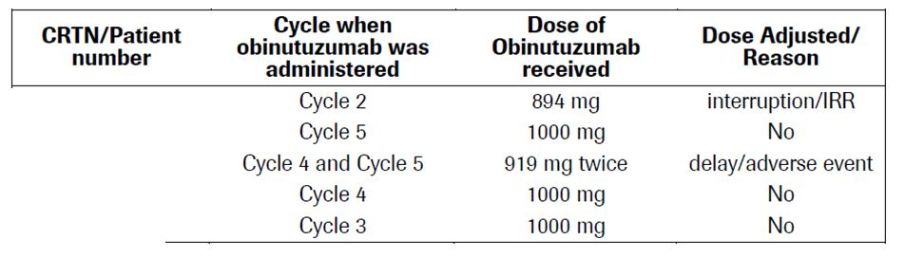
In addition, on 9 August 2012 1 GClb patient was identified as having received an in between dose of RClb (information redacted) after the primary Stage 1a data snapshot date (12 July 2012).
This information was not recorded in the electronic Clinical Report Form, so does not currently appear on the database but will be updated. Details of rituximab administration to this 1 patient randomised to GClb are summarised in Table 29.
Table 29: Summary of rituximab administration to patients randomised to GClb arm.
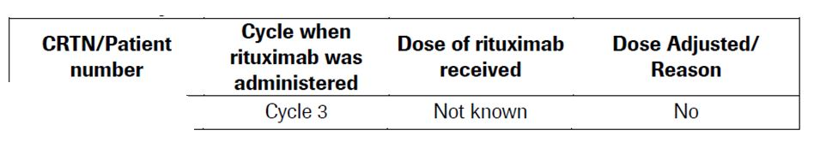
Comment: The explanations for incorrect study-drug administration are acceptable. Given the small number of incorrect study-treatment administrations, the outcome of the trial as assessed by the intention-to treat analysis remains valid.

Protocol amendment 5 of the pivotal trial required all patients to have corticosteroid premedication prior to the first infusion. What was the regimen of corticosteroid dosing used?
The corticosteroid dosing regimen is described below (taken from Protocol amendment #5 - BO21004F). This did not change with future amendments.
“6.2.1.3 Corticosteroid Premedication
For the first infusion, premedication with prednisolone or prednisone (100 mg given i.v. at least one hour before the antibody infusion) is mandatory for RO5072759 and rituximab patients. An equivalent dose of dexamethasone (20 mg) or methylprednisolone (80 mg) is permitted but hydrocortisone should not be used. For subsequent infusions corticosteroid premedication should be given:
- to patients who experienced a Grade 3 IRR with the previous infusion
- to patients with lymphocyte counts >25 × 109/L
- At investigator discretion.”
Comment: No Intravenous prednisone, or prednisolone, formulations are registered for use in Australia – See comments on PI below.

The concordance of investigator and independent review of PFS event assessments has not been compared, or reported, using an appropriate statistical test (Summary of Clinical Efficacy 2.5.2.3). What are the Kappa values for the levels of agreement of PFS events?
The Kappa values have been calculated as requested for Stage 1a (cut-off 11th July 2012), Stage 1b (cut-off 10th August 2012) and Stage 2 (cut-off 9th May 2013) analyses and are based on the PFS events (progression/death or censored) as assessed by the investigator or IRC. The results are displayed in Table 30. These results, all values above 0.8, confirm the good concordance between the investigator and IRC assessed PFS results.
Table 30: Kappa values and 95% confidence limits for concordance between investigator and IRC PFS assessments (ITT).
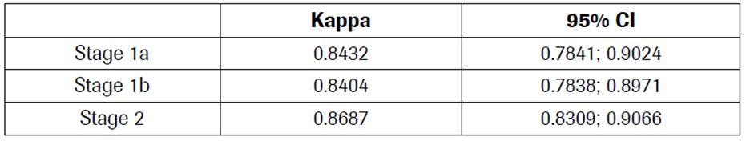
Comment: The kappa values shown above demonstrated a good level of concordance between the assessments between the investigator and IRC.

In the pivotal trial, did any of the subjects with previously untreated CLL undergo transformation into aggressive lymphoma (Richter’s syndrome)? If so, what were the efficacy and safety outcomes for the subject(s)?
As a point of clarification patients were not eligible to enter study BO21004/CLL11 with transformed disease (Richter’s syndrome). This is protocol eligibility exclusion criteria #2.
If a patient underwent disease transformation after randomisation, it was recorded in the database and considered as disease progression. Based on the latest available snapshot (data cut-off date 9 May 2013) disease transformation is reported for 5 patients from the whole trial: 1 patient who was randomised to the Clb arm and later crossed over to GClb and 4 patients from the RClb arm. No patients are reported to have transformed from the randomised GClb treatment arm. For comparison, with a median follow-up of 5.9 years the rate of disease transformation reported in a phase III trial in ‘fit’ patients with previously untreated CLL was 4.1%.
Therefore the data do not suggest that in study BO21004/CLL11 an unexpected rate of transformation has been observed.
Data for the patients with reported disease transformation is provided in Table 31.
- Study Conventions: When patients reported disease transformation, this is captured as disease progression. Patients enter survival follow-up once progression and next treatment have been reported.
- Efficacy: Response at end of study treatment for each patient is reported in the table below.
- Only the date of the first disease progression is collected.
- Safety: During the survival follow-up period, the following safety information is collected: related serious AEs, second primary malignancy (excluding haematological transformation) and survival status data. For 2 patients, safety information is available after disease transformation and is included in Table 31.
Table 31: Data for patients with reported disease transformation.
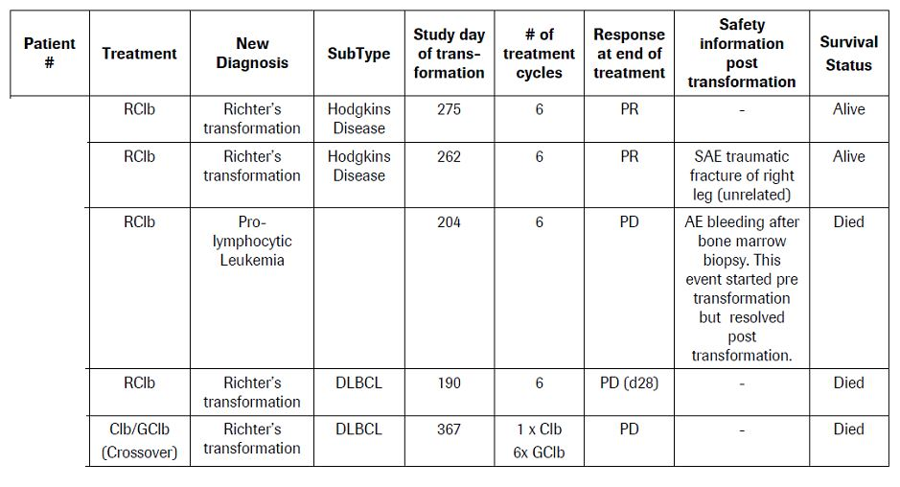
Comment: The pivotal study does not demonstrate an increased risk of Richter’s transformation as a result of Gazyva therapy. There is insufficient data to evaluate the efficacy of Gazyva once Richter’s transformation has occurred.

In the pivotal trial safety summary of “adverse events leading to death” - was the cause traumatic, or non-traumatic, for the subject who suffered a subdural haematoma?
Please find below the clinical case narrative for the patient who participated in study BO21004/CLL11 and who died due to a subdural hematoma caused by head trauma.
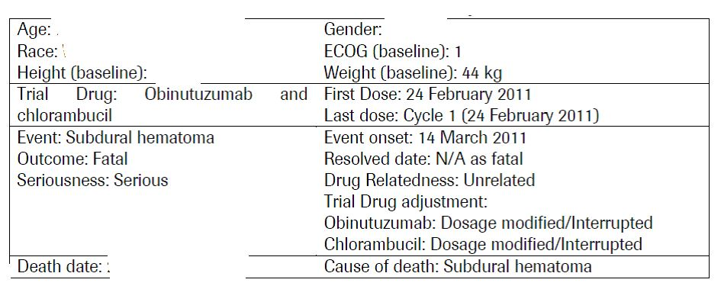
This patient signed the consent form on 6 October 2010 and was randomized to receive obinutuzumab and chlorambucil on 23 February 2011.
The patient was initially diagnosed with Binet stage A CLL on 7 March 2001 and staging at baseline showed that Binet stage had progressed to stage C. The patient had the following areas of involvement: cervical, axillary and spleen regions.
Laboratory results at baseline showed WBC count 232.4 x 103/μL (normal range: 4.8 10.8 x 103/μL), hemoglobin 9.9 g/dL (normal range: 12-16 g/dL), neutrophils 12.6% (normal range: 40-74%); 29.28 x 103/μL, lymphocytes 83.8% (normal range: 19-48%); 194.75 x 103/μL and platelets 183 x 103/μL (normal range: 130-400 x 103/μL). Chromosomal analysis revealed abnormal cytogenetics with a trisomy 12.
At study entry, the patient had CIRS score 11 and creatinine clearance 28.63 mL/min (normal range: 75-125 mL/min). No past medical history relevant to the event was reported.
Concurrent diseases other than CLL included hypertension, pancreatic cyst, renal failure, cardiac myxoma, diabetes mellitus and thalassemia. Previous and concomitant medications included insulin, omeprazole, epoetin alfa, iron, enalapril, sulfamethoxazole/trimethoprim, allopurinol, aspirin and folic acid.
The patient started treatment with obinutuzumab and chlorambucil on Study Day 1 (24 February 2011).

Serious adverse event: Subdural hematoma
The patient received only one dose of obinutuzumab and chlorambucil on Study Day 1 (24 February 2011, Cycle 1 Day 1) prior to this SAE.
On Study Day 9 (4 March 2011), the patient showed anemia (non-serious; unrelated; hemoglobin value not provided for this date). Due to anemia, obinutuzumab and chlorambucil dosing was delayed.
On Study Day 16 (11 March 2011), the patient hit their head and had a traumatic CNS injury.
On Study Day 19 (14 March 2011), the patient was hospitalised having suffered an epileptic attack with focal seizures without recovery of consciousness. Cranial CT scan revealed subdural hematoma in right temporal region (preferred term: subdural hematoma), which was considered by the Investigator to be initially NCI-CTCAE Grade 3 severity. The patient was treated with phenytoin, valproic acid and clonazepam. The Investigator delayed study medication until this event resolved. On Study Day 26 (21 March 2011), the patient’s condition deteriorated with epileptic attacks, requiring sedation with morphine. The same day (21 March 2011), the patient died due to subdural hematoma and the Investigator recorded this event as most extreme intensity, NCI-CTCAE Grade 5 severity. No autopsy was performed. Laboratory values are shown:
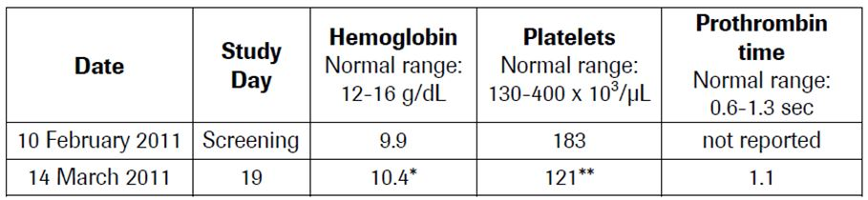
The Investigator considered the event, subdural hematoma, to be unrelated to obinutuzumab and chlorambucil and related to other causes (domestic accident).
Comment: The narrative for this patient adequately describes the event of subdural haematoma. The fall in platelet count on 14 March 2011 may be accounted for by consumption by the haematoma.

In the chlorambucil arm of the pivotal trial, pancreatitis was listed as the cause of an adverse event leading to one death. This is not a listed side-effect of chlorambucil; what was the underlying diagnosis in this subject?
The Investigator considered the event, pancreatitis, to be unrelated to chlorambucil and related to other causes (alcohol use). The sponsor provides the clinical case narrative for this patient in study BO21004/CLL11.
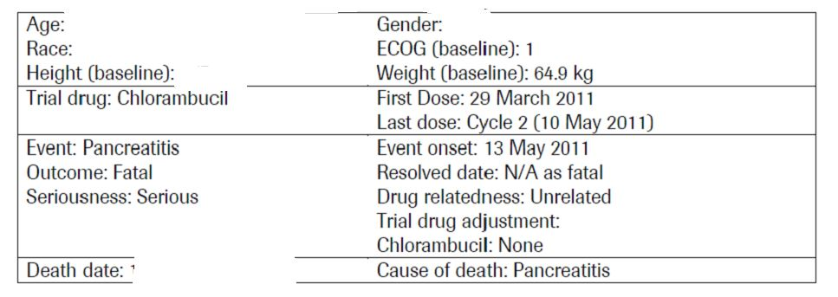
This patient signed the consent form on 17 March 2011 for study BO21004/CLL11 and was randomized to receive chlorambucil on 23 March 2011.
The patient was initially diagnosed with Binet stage A CLL in April 2010 and staging at baseline showed that Binet stage had progressed to stage B. The patient had the following areas of involvement: cervical, inguinal, axillary, liver and spleen regions.
Laboratory results at baseline showed WBC count 19.1 x 10³/μL (normal range: 4-8.8 x 10³/μL), hemoglobin 131 g/L (normal range: 130-160 g/L), neutrophils 8 x 10³/μL (normal range: 2-5.8 x 10³/μL), lymphocytes 6.5 x 103/μL (normal range: 1.2-3 x 10³/μL) and platelets 205 x 10³/μL (normal range: 180-320 x 10³/μL). No chromosomal analysis was reported for this patient.
At study entry, the patient had a CIRS score 12.
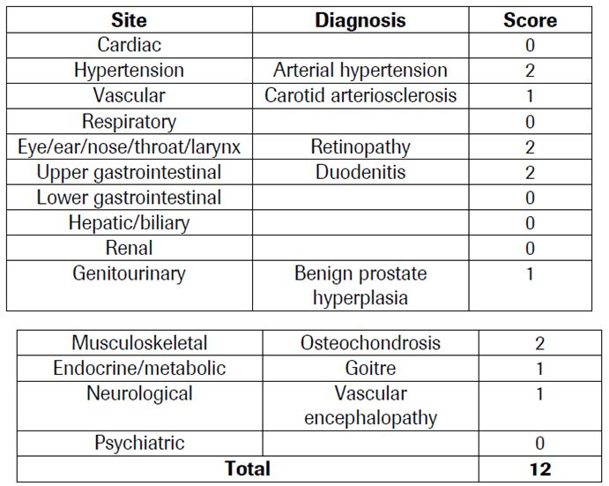
At study entry the patient showed creatinine clearance 60.83 mL/min (normal range: 75-125 mL/min). Concurrent diseases other than CLL included gastritis, duodenitis and hypertension - all reported as ongoing with treatment, esophagitis, retinopathy, benign prostatic hyperplasia, osteochondrosis, hypertension, carotid arteriosclerosis, goitre, vascular encephalopathy and varicose veins - all reported as ongoing without treatment. Previous and concomitant medications included enalapril and famotidine.
The patient started treatment with chlorambucil on Study Day 1 (29 March 2011).

Serious adverse event: Pancreatitis
The patient received the last dose of chlorambucil on Study Day 43 (10 May 2011, Cycle 2 Day 15).
On Study Day 46 (13 May 2011), the patient had acute abdominal pain, watery stools and general weakness and he was hospitalized with pancreatitis, which was initially considered by the Investigator to be NCI-CTCAE Grade 3 severity. Treatment included pancreatin, dopamine, sodium chloride, loperamide, famotidine, and bromhexine/sodium acetate/sodium chloride. He also received vasopressin and infusion therapy. The following day (Study Day 47), his condition worsened, arterial pressure 50/20 mmHg and he was transferred to intensive care unit but died the same day (Study Day 47) due to pancreatitis. The most extreme intensity of this SAE was considered to be NCI-CTCAE Grade 5 severity. No autopsy was performed.
Vital signs are shown:
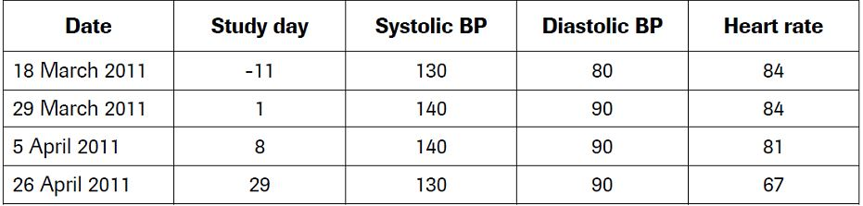
Laboratory values are shown:
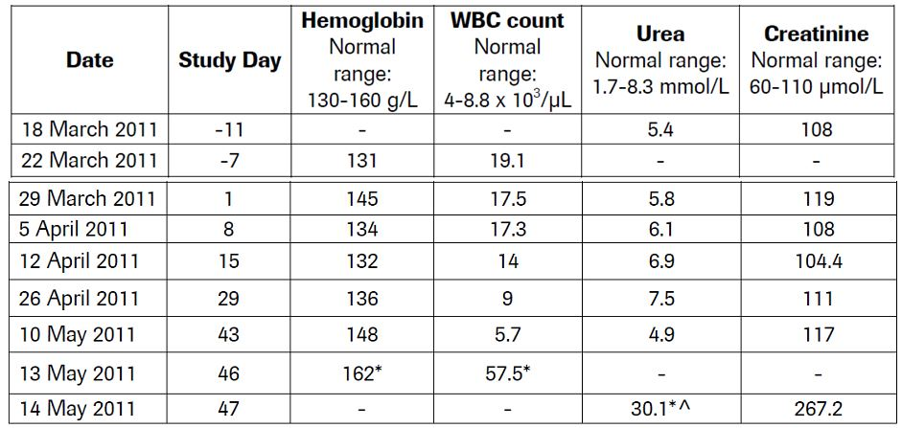
The Investigator considered the event, pancreatitis, to be unrelated to chlorambucil and related to other causes (alcohol use).
Comment: The explanation for pancreatitis in this patient is satisfactory, and unrelated to chlorambucil.

Second round evaluation of clinical data

BO21004/CLL stage 2
The sponsor provided a clinical study report for stage 2 of trial BO21004/CLL – the comparison of RClb and GClb (data cut-off of 9 May 2013).
A total of 663 patients were randomised in stage 2, the participant flow diagram is shown in the appendix.
The primary end-point of this stage was also PFS, with secondary outcomes of event-free survival, overall survival, time to new anti-leukaemic treatment, end of treatment response rate and minimal residual disease (MRD) negative rate. Outcomes were assessed according to the intention to treat population.
Eligible participants were stratified according to Binet stage and region. The region classification was:
- Asia and Oceania: Hong Kong, China, Thailand, Australia and New Zealand
- Europe Group 1: United Kingdom, Netherlands, Romania, Bulgaria, Croatia, Estonia, Slovakia, Czech Republic, Italy, France, Russia, Denmark, Spain and Egypt
- Europe Group 2: Germany, Austria and Switzerland,
- North and Central America and Caribbean: Canada, Mexico and USA
- South America and South Atlantic: Brazil and Argentina

Dose modification
No dose reduction of obinutuzumab or rituximab was permissible. The dose of chlorambucil was permitted to be adjusted if the subject developed grade 3 or 4 cytopaenia.

Patient withdrawal
Patients permanently discontinued treatment in any of the following events listed below.
- Grade 4 infusion−related symptoms
- Re-occurring Grade 3 infusion−related symptom at re-challenge
- Grade 3 or 4 cytopenia that did not resolve to ≤Grade 2 and delayed treatment of the next cycle Day 1 dose by 4 weeks
- Grade ≥2 non−cytopenic toxicity that did not resolve to ≤ Grade 1/baseline and delayed treatment of the next cycle Day 1 dose by 4 weeks.

Treatment schedule
This is shown in Figure 13.
Figure 13: Overview of the treatment schedule.
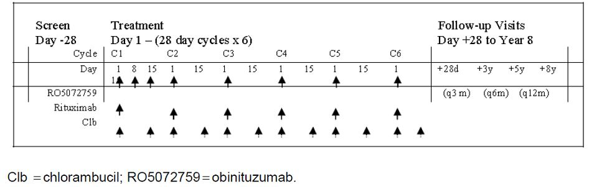

Patient disposition
Four subjects in the RClb arm and two in the GClb arm did not receive the study drug.
Treatment withdrawals – a higher proportion of the 333 patients in the GClb arm withdrew as compared to the 330 in the RClb arm - 20 % (67/333) vs 13% (43/330) respectively as a result of a higher incidence of adverse events to the study treatment. The same number of subjects had no response to treatment, or died in each arm (1 subject and 5 subjects, respectively).

Observation time
The median observation time was similar between study arms: 18.6 (IQR 12.8, 25.6) for RClb and 18.8 (IQR 12.8, 26.0) for GClb.

Baseline demographic data and disease characteristics
There was equal balance of demographic factors and co-morbidities between each treatment arm (Tables 32-34).
Table 32: Demographic data (ITT population).
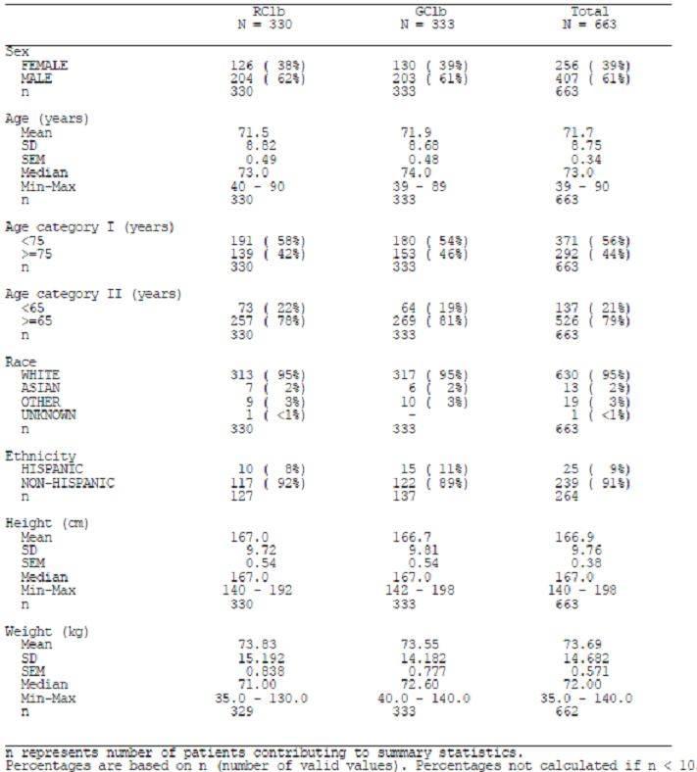
Table 33: Baseline disease characteristics (ITT population).
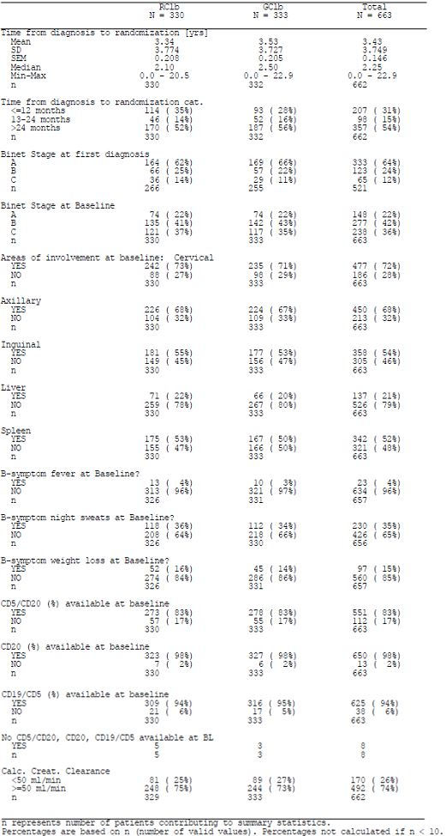
Table 34: Cumulative illness rating scale & creatinine clearance.
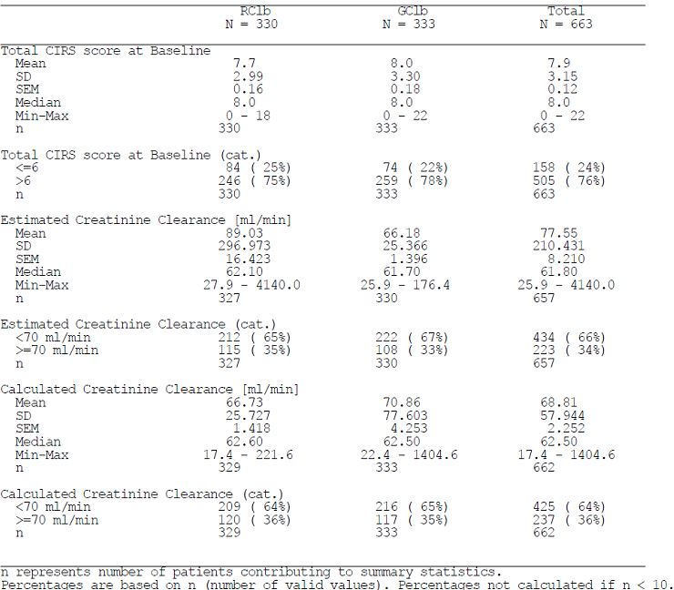

Patient withdrawals
More patients withdrew from the study due to disease progression in the RClb arm – 94 (28%) vs. 43 (13%) in the GClb arm. A similar proportion of patient withdrawals not due to disease progression occurred in each arm.

Protocol violations
In total 46/330 patients (14%) in the RClb arm and 40/333 patients (12%) in the GClb arm had at least one major protocol violation, mainly inclusion/exclusion criteria violations (14 patients in the RClb arm and 12 patients in the GClb arm had inclusion criteria violations, and 22 patients in the RClb arm and 18 patients in the GClb arm had exclusion criteria violations). Additionally, 13 patients in the RClb arm and 11 patients in the GClb arm had other on-study protocol violations.

Treatment exposure
A greater percentage of patients in the RClb arm received all 6 cycles of planned treatment compared to the GClb arm (RClb arm: 89% patients vs. GClb arm: 81% patients).
The median cumulative dose of Clb in each treatment arm was similar with 396.0 mg in the RClb arm (range: 28.0-696.0 mg) and 366.0 mg in the GClb arm (range: 22.0-680.0 mg).
The median cumulative dose of obinutuzumab in the GClb arm was 8000.0 mg (range: 2.4-8061.47 mg).
The median cumulative dose of rituximab in the RClb arm was 5106.0 mg (range 39.0-7130.0 mg). Five patients randomized to the RClb arm were erroneously administered obinutuzumab at one cycle of treatment; the median cumulative dose of rituximab for these 5 patients was 4247.0 mg (range 3447.0-4760.0 mg).

Dose delays
Dose delays were more common in the GClb arm; 36% and 43% of patients in the RClb and GClb arms, respectively, had at least one cycle of treatment delayed for more than 3 days and 10% and 20% of patients in the RClb and GClb arms, respectively, had more than one cycle of treatment delayed for at least 3 days. A greater proportion of patients in the GClb arm had dose delays for 4 to 7 days (RClb: 20% and GClb: 28%), 8 to 14 days (RClb: 16% and GClb: 18%) and more than 14 days (RClb: 8% and GClb: 12%).
Per protocol, pre-planned dose reductions of obinutuzumab were not permitted. Any dose less than 1000 mg obinutuzumab per infusion was classed as a dose reduction.
For Clb and rituximab, any dose that was >10% less than the dose at Cycle 1 was counted as a reduced dose. A greater proportion of patients administered GClb had dose reductions; 140/336 patients (42%) administered GClb had a dose reduction of any study medication component (i.e. obinutuzumab or chlorambucil) compared to 82/321 patients (26%) in the RClb only arm. A greater proportion of patients in the GClb arm had dose reductions of antibody (39/336 patients [12%] vs. 3/321 patients [1%] in the RClb arm). A greater proportion of patients in the GClb arm had dose reductions of Clb (108/336 patients [32%] vs. 81/321 patients [25%] in the RClb arm).
A greater proportion of patients in the GClb arm required slowing, or interruption of the first infusion (15% and 49% respectively) as compared to those in the RClb arm (5% and 22% respectively). Beyond cycle 3, dose modifications were uncommon in both treatment arms (≤2%).

Efficacy
The assessment of PFS, stratified by Binet stage at baseline, was similar for the populations observed (Table 35).
Table 35: Comparison of PFS assessments.
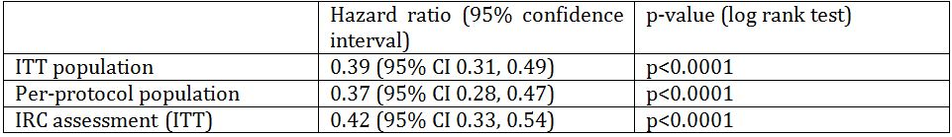

PFS sub-group analysis
A number of exploratory subgroup analyses were assessed for the effect on PFS and are shown in Figure 14.

Figure 14: Hazard ratio for progression-free survival by subgroup (ITT population).
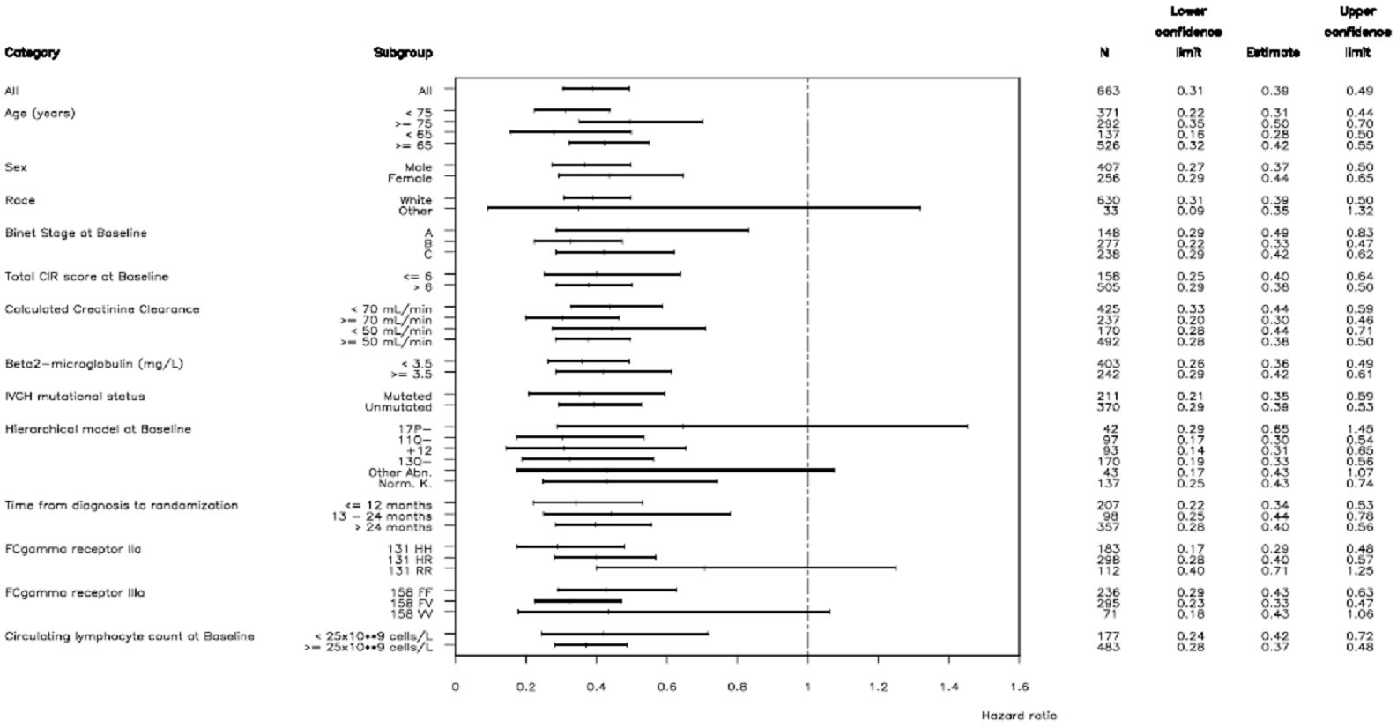
End of treatment response, by study arm is shown in Table 36. The odds ratio for the proportion of responders and non-responders by study arm was 1.95 (95% CI 1.38, 2.75) favouring GClb.
Table 36: End of treatment response.
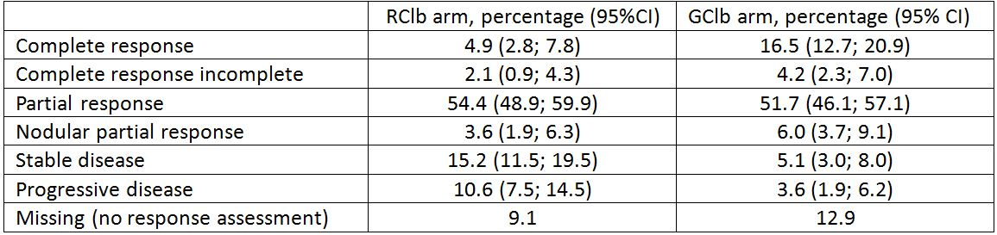

Molecular response
Minimal residual disease was considered negative if result was less than 1 CLL cell in 10000 leukocytes (MRD value < 0.0001) based on the method of allele specific polymerase chain reaction (ASO-PCR). Patients for whom no end of treatment MRD result was available but who had progressed or died before end of treatment were counted as positive.
A greater proportion of subjects in the GClb arm achieved MRD negativity as compared the RClb arm: 26% (95% CI 20.1, 31.5) vs. 2% (95% CI 0.9, 5.3).

Overall survival
At the clinical cut-off date of 9 May 2013, 69 randomized patients had died; 41/330 patients (12.4%) in RClb arm and 28/333 patients (8.4%) in GClb arm. This number of deaths is too small to calculate the median duration of survival, and the data is considered immature by the sponsor. The estimate of OS is HR0.66 (95% CI 0.41; 1.06), p=0.084 log rank test.

Safety
The overall incidence of adverse events was 5% higher in the GClb arm – 94% vs. 89% in the RClb arm. The incidence of IRR, neutropaenia, thrombocytopaenia and leucopaenia was higher in the GClb arm (Table 37).
Table 37: Adverse events with an incidence of at least 5% (safety population).
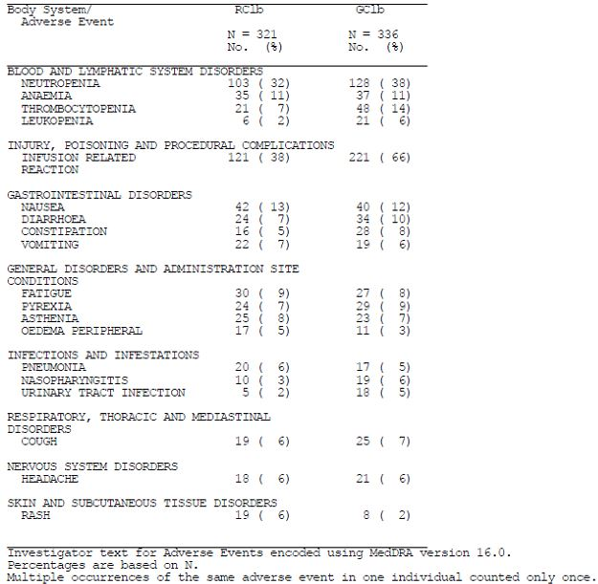

Effect of age and creatinine clearance on incidence of adverse events
The incidence of adverse events increased with age in both treatment arms, and was higher in the GClb arm for each age-group classification.
The incidence of adverse events according to dichotomised creatinine clearance, <50 mL/min and ≥50 mL/min, was higher for those with worse renal function, and those in the GClb arm.

Deaths
Up to the clinical cut-off, a total of 68 patients included in the Stage 2 analysis had died: 40/321 patients (12%) in the RClb arm and 28/336 patients (8%) in the GClb arm. Disease progression and adverse events were the sole causes of death attributed in both study arms (Table 38). A similar proportion of deaths occurred during the survival follow-up period in both arms (5% RClb and 4% GClb).
Table 38: Deaths – safety population.
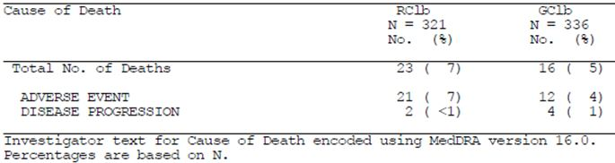

Adverse events leading to death
In stage 2, 20 subjects died in the RClb arm and 15 in the GClb arm.
The sponsor states:
“Nine patients died because of adverse events within the SOC of Benign, Malignant and Unspecified Neoplasms (including cysts and polyps); 5 patients (2%) in the RClb arm and 4 patients (1%) in the GClb arm; all events were isolated with no single neoplasm observed more frequently in either arm. Seven patients died because of adverse events within the SOC Cardiac Disorders; RClb arm: 5 deaths (cardiac arrests [n=3], arrhythmia [n=1], cardiac failure [n=1]); GClb arm: 2 deaths from myocardial infarction. Four and two patients in the RClb and GClb arms, respectively, died because of general disorders and administration site conditions. Two patients in the RClb and GClb arm died because of infections and infestations (both from pneumonia in the RClb and one from pulmonary sepsis and another from septic shock in the GClb arm).”
The causes of death in stage 2 patients listed above do not yield any additional information regarding Gazyva safety that has not already been reported in stage 1a.

Serious adverse events
The summary of serious adverse events within system classes in both treatment arms were reported as:
- Infections and Infestations (RClb: 45/321 patients [14%] vs. GClb: 42/336 patients [13%])
- Injury, poisoning and procedural complications (RClb: 15/321 [5%] vs. GClb: 44/336 [13%])
- Neoplasms benign, malignant and unspecified (RClb: 18/321 [6%] vs. GClb: 19/336 [6%])
- Blood and Lymphatic System Disorders (RClb: 12/321 [4%] vs. GClb: 19/336 [6%])
- Cardiac Disorders (RClb: 13/321[4%] vs. GClb: 13/336 [4%])
- General Disorders and Administration Site Reactions (RClb: 13/321 [4%] vs. GClb: 8/336 [2%])
- Gastrointestinal Disorders (RClb: 7/321[2%] vs. GClb: 7/336 [2%])
- Respiratory, Thoracic and Mediastinal Disorders (RClb: 6/321[2%] vs. GClb: 8/336 [2%])
- Nervous System Disorders (RClb: 7/321[2%] vs. GClb: 6/336 [2%])
- Vascular Disorders (RClb: 4/321 [1%] vs. GClb: 7/336 [2%])
- Renal and Urinary Disorders (RClb: 7/321 [2%] vs. GClb: 1/336 [<1%]).
The following reported only in the GClb arm:
- Metabolism and Nutrition disorders occurred uniquely in patients in the GClb arm (7/336 patients [2%] and included 5 patients with tumour lysis syndrome, 1 patient with dehydration and 1 patient with hyperglycemia.
- Hepatobiliary Disorders (4/336 patients [1%]); the serious events were cholecystitis, cholelithiasis, hepatitis and liver disorder
- Immune System Disorder (1/336 patients [< 1%]); anaphylactic reaction
NB Adverse drug reaction (ADR) reports submitted to the TGA have included patients experiencing cytolytic hepatitis following obinutuzumab therapy.

Risks of second malignancies
The number of subjects experiencing a second malignancy was similar in both treatment arms; the commonest being squamous and basal cell carcinoma of the skin. The complete list of events is shown in Table 39.
Table 39: Second malignancies starting 6 months after first study drug intake.
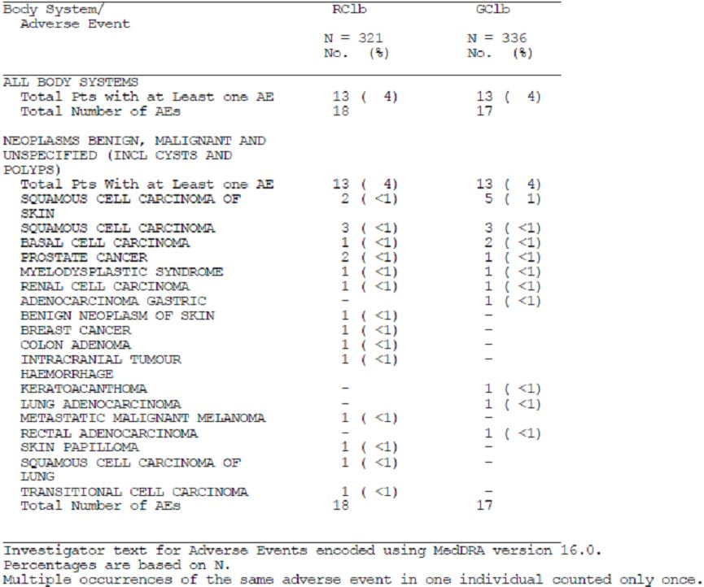
The reported incidence of secondary malignancies following Gazyva is in keeping with the expected increased incidence in CLL overall.

BO21004/CLL stage 1b: Update of efficacy and safety from stage 1b – comparison of chlorambucil and rixtuximab versus chlorambucil alone.
The update of efficacy after median observation time of 22.7 months demonstrates an improvement in PFS in patients in the RClb arm – stratified HR according to Binet stage at randomisation is 0.44 (95% CI 0.34, 0.57), p<0.0001. Median survival time was not reached in either arm.
The sponsor has stated that there are no new safety concerns regarding the use of rituximab from the additional period of stage 1b follow-up.
The summary of safety was reported as follows:
- Incidence of death was lower in the RClb arm (Clb arm: 21% vs. RClb arm: 15%).
- Incidence of fatal adverse events was slightly lower in the RClb arm (Clb arm: 9% vs. RClb arm: 7%).
- Incidence of patients with all grade adverse events (Clb arm: 83% vs. RClb arm: 91%), and Grade 3-5 adverse events (Clb arm: 50% vs. RClb arm: 56%) was higher in the RClb arm.
- Incidence of patients with adverse events leading to withdrawal from any study medication was similar between treatment arms (Clb arm: 15% vs. RClb arm: 14%).
- Incidence of patients with serious adverse events was slightly lower in the RClb arm: (Clb arm: 38% vs. RClb arm: 34%).
- Overall, there were no unexpected safety concerns with RClb and the assessment of safety showed an acceptable safety profile consistent with the established safety profile of both rituximab and chlorambucil.
- The safety conclusions are similar to the analysis presented in the Stage 1b primary CSR.

Second round benefit-risk assessment

Second round assessment of benefits
After consideration of the responses to clinical questions, the benefits of Gazyva in the proposed usage are:
- In patients with previously untreated CLL, with a cumulative illness rating scale (CIRS) score >6 or creatinine clearance <70 mL/min, or both, a significant improvement in PFS and OS is shown with the combination of Gazyva and Clb as compared with Clb alone.
- In patients with previously untreated CLL, with a CIRS score >6 or creatinine clearance <70 mL/min, or both, a significant improvement in PFS is shown with the combination of Gazyva and Clb as compared to the combination of rituximab and Clb. Data regarding OS is immature for these treatment groups.

Second round assessment of risks
After consideration of the responses to clinical questions, the risks of Gazyva in the proposed usage are:
- Progressive multifocal leukoencephalopathy (PML) and hepatitis B reactivation have occurred following Gazyva therapy, which warrant a black box warning;
- AEs occurred more commonly in the GClb arm than the Clb or RClb arms, most frequently infusion related reactions;
- TLS has been seen in subjects with a high tumour burden;
- Serious new, or reactivated, bacterial viral or fungal infections may occur during, and following cessation of, Gazyva treatment;
- Persistent, severe, neutropaenia or neutropaenia occurring during, and following cessation of, Gazyva therapy;
- Severe grades of thrombocytopaenia;
- Worsening of pre-existing cardiac conditions, which may be fatal;
- Hypersensitivity and anaphylaxis to Gazyva, or Chinese hamster ovary (CHO) proteins;
- The risk of AEs is increased with advancing age and worse renal function;
- The premedication regimen to prevent infusion related reactions does not reduce the proportion of subjects that experience grades 3 or 4 events.

Second round benefit-risk assessment
The benefit-risk balance of Gazyva, given the proposed usage, is favourable.

Clinical questions: round two
(Q1a) What proportion of all subjects from stages 1a & 2 experienced an IRR of any grade following at least one dose of Gazyva in the periods before and after the introduction of the split-dose regimen?
(Q1b) What proportion of all subjects from all stages 1a & 2 experienced a grade 3 or 4 IRR following at least one dose of Gazyva in the periods before and after the introduction of the split-dose regimen?
(Q2) Does the sponsor have an explanation as to the reason why the proposed pre-medication regimen is not successful in abolishing all IRRs, particularly those of grades 3 and 4 severity?
(Q3) Given that intravenous prednisone/prednisolone is unavailable in Australia (See PI comments below), what is the comparative experience on IRR reduction (all grades and grades 3 or 4) from using either dexamethasone or methylprednisolone as an alternative to prednisolone/prednisone?
(Q4) In order to inform the ACPM, the sponsor is requested to provide the number of subjects that have experienced either fatal hepatitis B reactivation or PML worldwide following obinutuzumab therapy. (The worldwide data is specifically requested to assess the risk to patients given the heterogeneous origins of the Australian population).

Second round recommendation regarding authorisation
Following the sponsor’s responses, the recommendation is to approve authorisation.

References
- Brown S. Clinical features and severity grading of anaphylaxis. J Allergy Clin Immunol. 2004; 4:371-376
- Stone S. et al. Immediate-type hypersensitivity drug reactions. British Journal of Clinical Pharmacology. 2014;78:1-13

Therapeutic Goods Administration
PO Box 100 Woden ACT 2606 Australia
Email: info@tga.gov.au Phone: 1800 020 653 Fax: 02 6232 8605
http://www.tga.gov.au

Pocock SJ, Clayton TC, Altman DG. (2002) Survival plots of time-to-event outcomes in clinical trials: good practice and pitfalls. Lancet 359: 1686-9.
Eichhorst B. (2009) Frontline therapy for chronic lymphocytic leukemia patients. Clin Adv Hematol Oncol. 7: 638-41.
Hallek M. (2013) Signaling the end of chronic lymphocytic leukemia: new frontline treatment strategies. Hematology Am Soc Hematol Educ Program 138-50.
Eichhorst B. (2009) Frontline therapy for chronic lymphocytic leukemia patients. Clin Adv Hematol Oncol. 7: 638-41.
Bühler A et al., Blood 116, 21; 2010.
Fischer K et al., Blood (ASH Annual Meeting Abstracts) 2012. 120: Abstract 435.

