PRODUCT INFORMATION
SPINRAZA nusinersen heptadecasodium solution for injection.

NAME OF THE MEDICINE
Nusinersen is a fully modified 2′-O-2-methoxyethyl antisense oligonucleotide designed to bind to a specific sequence in the intron downstream of Exon 7 of the SMN2 transcript.

Australian approved name: nusinersen heptadecasodium
CAS registry number (nusinersen): 1258984-36-9
C₂₃₄H₃₄₀N₆₁O₁₂₈P₁₇S₁₇ (nusinersen) MW 7127.1 g/mol
C₂₃₄H₃₂₃N₆₁O₁₂₈P₁₇S₁₇Na₁₇ (nusinersen heptadecasodium) MW 7501.0 g/mol
Chemical name:
all-P-ambo-2'-O-(2-methoxyethyl)-5-methyl-P-thiouridylyl-(3'→5')-2'-O-(2-methoxyethyl)-5-methyl-P-thiocytidylyl-(3'→5')-2'-O-(2-methoxyethyl)-P-thioadenylyl-(3'→5')-2'-O-(2-methoxyethyl)-5-methyl-P-thiocytidylyl-(3'→5')-2'-O-(2-methoxyethyl)-5-methyl-P-thiouridylyl-(3'→5')-2'-O-(2-methoxyethyl)-5-methyl-P-thiouridylyl-(3'→5')-2'-O-(2-methoxyethyl)-5-methyl-P-thiouridylyl-(3'→5')-2'-O-(2-methoxyethyl)-5-methyl-P-thiocytidylyl-(3'→5')-2'-O-(2-methoxyethyl)-P-thioadenylyl-(3'→5')-2'-O-(2-methoxyethyl)-5-methyl-P-thiouridylyl-(3'→5')-2'-O-(2-methoxyethyl)-P-thioadenylyl-(3'→5')-2'-O-(2-methoxyethyl)-P-thioadenylyl-(3'→5')-2'-O-(2-methoxyethyl)-5-methyl-P-thiouridylyl-(3'→5')-2'-O-(2-methoxyethyl)-P-thioguanylyl-(3'→5')-2'-O-(2-methoxyethyl)-5-methyl-P-thiocytidylyl-(3'→5')-2'-O-(2-methoxyethyl)-5-methyl-P-thiouridylyl-(3'→5')-2'-O-(2-methoxyethyl)-P-thioguanylyl-(3'→5')-2'-O-(2-methoxyethyl)guanosine

DESCRIPTION
The pKa of the dinucleoside phosphate diester is approximately 2. The bases have acidic and basic pKas ranging from approximately 3.5 to 10 and the 5’ and 3′-hydroxy groups have pKas of approximately 16 and 12, respectively. The API is a white to yellow amorphous, hygroscopic solid.

SPINRAZA is a sterile, preservative-free clear to colourless isotonic solution for injection in a single use vial, practically free from visible particles.

Each single-use vial contains 12.6 mg of nusinersen heptadecasodium equivalent to 12 mg of nusinersen as the free acid (or 2.4 mg/mL) in artificial cerebrospinal fluid.

The product contains the following excipients: sodium chloride, potassium chloride, calcium chloride dihydrate, magnesium chloride hexahydrate, dibasic sodium phosphate, sodium phosphate monobasic dihydrate, sodium hydroxide (q.s.), hydrochloric acid (q.s.), water for injections q.s. to 5 mL. The pH is approximately 7.2.

For intrathecal administration only by lumbar puncture.

PHARMACOLOGY
SPINRAZA is an antisense oligonucleotide (ASO) specifically designed to treat Spinal Muscular Atrophy (SMA), an autosomal recessive progressive neuromuscular disease, due to mutations in the chromosome 5q. These mutations lead to loss of function of the survival motor neuron 1 (SMN1) gene, resulting in deficiency of SMN protein. The SMN2 gene also produces SMN protein but at low levels.

SMA is a clinical spectrum of disease, with age of onset and disease severity associated to the number of SMN2 gene copies present; fewer SMN2 gene copies are associated with earlier age of onset and increased severity of symptoms.

Nusinersen (contained in SPINRAZA) increases the proportion of exon 7 inclusion in SMN2 messenger ribonucleic acid (mRNA) transcripts by binding to an intronic splice silencing site (ISS-N1) found in intron 7 of the SMN2 pre-messenger ribonucleic acid (pre-mRNA). By binding, the ASO displaces splicing factors, which normally suppress splicing. Displacement of these factors leads to retention of exon 7 in the SMN2 mRNA. Once SMN2 mRNA is produced, it can be translated into the functional full length SMN protein.

Pharmacodynamics
The pharmacodynamic effects are consistent with the biological effects of nusinersen.

Autopsy samples from treated infants had higher levels of SMN2 messenger ribonucleic acid (mRNA) containing exon 7 in the thoracic spinal cord compared to untreated SMA infants.

Pharmacokinetics
Single- and multiple-dose pharmacokinetics of nusinersen, administered via intrathecal injection, were determined in paediatric patients diagnosed with SMA.

Absorption
Intrathecal injection of nusinersen into the cerebrospinal fluid (CSF) allows nusinersen to be fully available for distribution from the CSF to the target central nervous system (CNS) tissues.

Mean CSF trough concentrations of nusinersen accumulated approximately 1.4- to 3-fold after multiple loading and maintenance doses, and reached a steady state within approximately 24 months. No further accumulation in CSF or CNS tissues would be expected with additional doses after steady state.

Following IT administration trough plasma concentrations of nusinersen were relatively low compared to the trough CSF concentration. Median plasma T_{max} values ranged from 1.7 to 6.0 hours. Mean plasma C_{max} and AUC values increased approximately dose proportionally over the evaluated dose range. There is no accumulation in plasma exposure measures (C_{max} and AUC) after multiple doses.

Distribution
Autopsy data from patients (n=3) show that nusinersen administered intrathecally is broadly distributed within the CNS achieving therapeutic levels in the target spinal cord tissues. Presence of nusinersen was also demonstrated in neurons and other cell types in the spinal cord and brain, and peripheral tissues such as skeletal muscle, liver, and kidney.

Metabolism/Biotransformation
Nusinersen is metabolised slowly via exonuclease (3’- and 5’)-mediated hydrolysis and is not a substrate for, or inhibitor or inducer of CYP450 enzymes.

Elimination
The mean terminal elimination half-life in CSF is estimated at 135 to 177 days. The primary route of elimination is likely by urinary excretion of nusinersen and its metabolites.

Renal and hepatic impairment
The pharmacokinetics of nusinersen in patients with renal impairment or hepatic impairment has not been studied.

Gender
Population pharmacokinetic analysis shows that gender does not affect the pharmacokinetics of nusinersen.

CLINICAL TRIALS

Efficacy Results
The efficacy of SPINRAZA was demonstrated in 5 clinical trials in symptomatic patients (Studies CS3B, CS3A, CS4, CS2 and CS12), who ranged in age from 30 days to 15 years at the time of first dose, and one clinical trial in pre-symptomatic patients (Study CS5), who ranged in age from 3 days to 42 days at the time of first dose. Efficacy results from these studies demonstrate that treatment with SPINRAZA provides benefit across disease phenotypes and support the initiation of treatment as soon as possible following diagnosis (Figures 6 and 7). SPINRAZA has only been studied in patients with 5q SMA.

Motor function measures used in clinical studies:
- Hammersmith Infant Neurological Examination (HINE) Section 2: a measure of the achievement of motor milestones comprised of 8 milestone categories (head control, sitting, grasping, ability to kick in supine position, rolling, crawling, standing and walking) with 3 to 5 progressively more difficult items for each milestone category.
- WHO motor milestones: a set of 6 major motor milestones (sitting without support, standing with assistance, hands and knees crawling, walking with assistance, standing alone, walking alone) that are expected to be attained by 24 months of age in healthy children.
- Children’s Hospital of Philadelphia Infant Test for Neuromuscular Disease (CHOP INTEND): a 64-point motor assessment that captures neck, trunk, proximal, and distal limb strength in 14 elicited and 2 observational items, designed to evaluate muscle strength and function in infants with SMA.
- Hammersmith Functional Motor Scale – Expanded (HFMSE): a measure to assess motor function in children with limited ambulation, comprising of 33 scored activities that give objective information on motor ability and clinical progression.
- Upper Limb Module (ULM): designed to assess upper limb function in non-ambulatory patients, consisting of 9 upper limb performance items reflective of activities of daily living. Higher scores indicate greater functional abilities.
- Revised Upper Limb Module (RULM): designed to assess upper limb function in patients with SMA, consistent of 20 items for a maximum total score of 37,
- Six-Minute Walk Test (6 MWT): an evaluation of the distance a person can walk quickly in 6 minutes.
- Compound Muscle Action Potential (CMAP): an electrophysiological measure of motor neuron health for tracking disease progression in neuromuscular disorders, such as SMA.

Symptomatic Patients

Patients with Infantile-onset SMA

Study CS3B (ENDEAR)
Study CS3B was a phase 3, randomized, double-blind, sham-procedure controlled study conducted in 121 symptomatic infants ≤ 7 months of age, diagnosed with SMA (symptom onset before 6 months of age). Patients were randomized 2:1 to either SPINRAZA or sham-control, with a length of treatment ranging from 6 to 442 days (median 258). SPINRAZA-treated patients received a 12 mg scaled equivalent dose based on CSF volume scaling on study days 1, 15, 29, 64, 183 and 302. The median age of onset of clinical signs and symptoms of SMA was 6.5 weeks (range 2-18) and 8 weeks (range 1-20) for SPINRAZA-treated versus sham-control patients respectively, with 99% of patients having 2 copies of the SMN2 gene. Patients in this study were deemed most likely to develop Type I SMA. At baseline, the mean total motor milestone score was 1.37 (range 0-6), the median CHOP INTEND score was 28 (range 8-50.5), and the median CMAP amplitudes were 0.20 (range 0.00-0.87) and 0.30 (range 0.00-1.50) for the ulnar nerve and peroneal nerves, respectively. The median age when patients received their first dose was 164.5 days (range 52-242) for treated patients, and 205 days (range 30-262) for sham-control.

Baseline disease characteristics were largely similar in the SPINRAZA treated patients and sham-control patients except that SPINRAZA treated patients at baseline had a higher percentage compared to sham-control patients of paradoxical breathing (89% vs 66%), pneumonia or respiratory symptoms (35% vs 22%), swallowing or feeding difficulties (51% vs 29%) and requirement for respiratory support (26% vs 15%).

A planned interim analysis was conducted based on patients with the opportunity to reach a 6 month evaluation. The primary endpoint assessed at the interim analysis was the proportion of responders: patients achieving a pre-defined level of improvement in motor milestones (HINE Section 2) .

At the final analysis, time to death or permanent ventilation (≥ 16 hours ventilation/day continuously for > 21 days in the absence of an acute reversible event or tracheostomy) was assessed as the primary endpoint. Statistically significant effects on event-free survival, overall survival, the proportion of patients achieving the definition of a motor milestone responder, and the percentage of patients with at least a 4-point improvement from baseline in CHOP-INTEND score were observed in patients in the SPINRAZA group compared to those in the sham-control group (Table 1, Figures 1 and 2).

In the efficacy set, 18 (25%) patients in the SPINRAZA group and 12 (32%) patients in the sham-control group required permanent ventilation. Of these patients, 6 (33%) in the SPINRAZA group and 0 (0%) in the sham-control group met the protocol-defined criteria for a motor-milestone responder.

Table 1: Primary and secondary endpoints at final analysis – Study CS3B
Efficacy Parameter | SPINRAZA-treated Patients | Sham-control Patients
Survival
Event-free survival^{2,3}  Number of patients who died or received permanent ventilation  Hazard ratio (95% CI)  p-value⁴ | 31 (39%) | 28 (68%)
0.53 (0.32 -0.89)

p = 0.0046
Overall survival²  Number of patients who died  Hazard Ratio (95% CI)  p-value⁴ | 13 (16%) | 16 (39%)
0.37 (0.18 – 0.77)

p=0.0041
Motor function
Motor milestones⁵  Proportion achieving pre-defined motor milestone responder criteria (HINE section 2)^{6,7}  Proportion at Day 183⁸  Proportion at Day 302⁸  Proportion at Day 394⁸  Proportion with improvement in total motor milestone score  Proportion with worsening in total motor milestone score | 37 (51%)¹  P<0.0001  41%  45%  54%  49 (67%)  1 (1%) | 0 (0%)  5%  0%  0%  5 (14%)  8 (22%)
CHOP-INTEND⁵  Proportion achieving a 4-point improvement  Proportion achieving a 4-point worsening  Proportion with any improvement  Proportion with any worsening | 52 (71%)  P<0.0001  2 (3%)  53 (73%)  5 (7%) | 1 (3%)  17 (46%)  1 (3%)  18 (49%)
¹CS3B was stopped following positive statistical analysis on the primary endpoint at interim analysis (statistically significantly greater percentage of patients achieved the definition of a motor milestone responder in the SPINRAZA group (41%) compared to the sham-control group (0%), p<0.0001).
²At the final analysis, event-free survival and overall survival were assessed using the Intent to Treat population (ITT SPINRAZA n=80; Sham-control n=41).
³Median time to death or permanent ventilation was not reached in SPINRAZA group, and was 22.6 weeks in the sham-control group
⁴Based on log-rank test stratified by disease duration
⁵At the final analysis, CHOP-INTEND and motor milestone analyses were conducted using the Efficacy Set (SPINRAZA n=73; Sham-control n=37).
⁶Assessed at the later of Day 183, Day 302, and Day 394 Study Visit
⁷According to HINE section 2: ≥2-point increase [or maximal score] in ability to kick, OR ≥1 point increase in the motor milestones of head control, rolling, sitting, crawling, standing or walking, AND improvement in more categories of motor milestones than worsening), defined as a responder for this primary analysis.
⁸The proportion of motor milestones responders at Day 183, Day 302, and Day 394 are based on evaluable sets at those visits

Figure 1: Overall Survival (ITT) – Study CS3B
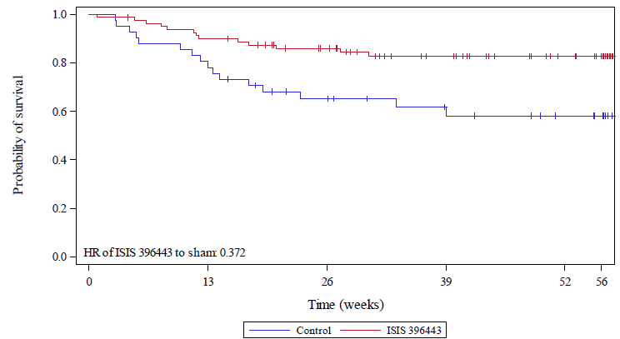ISIS 396443 = nusinersen

Figure 2: Change in Total Motor Milestone Score from Baseline to Later of Day 183, Day 302, and Day 394 Study Visit (Efficacy Set) – Study CS3B
ISIS 396443 = nusinersen

Study CS3A

Study CS3A is an open-label phase 2 study in symptomatic patients diagnosed with SMA. Median age of onset of clinical signs and symptoms was 56 days (range 21 to 154 days) and patients had either 2 SMN2 gene copies (n=17) or 3 SMN2 gene copies (n=2) (SMN2 gene copy number unknown for 1 patient). Patients in this study were deemed most likely to develop Type I SMA. Patients were randomised to receive either a 6 mg or 12 mg scaled equivalent dose of SPINRAZA based on CSF volume during the loading dose phase on days 1, 15 and 85. During the maintenance phase all patients received a 12 mg scaled dose on days 253, 379, 505, 631, 757, 883, 1009, 1135 and 1261. Median age at first dose was 162 days (range 37-223). At screening, the median number of motor milestones (HINE section 2) achieved was 2 (range 1 to 12), median CHOP-INTEND total score was 27 (range 17 to 64), median baseline ulnar CMAP amplitude was 0.235 mV (range 0.00 to 3.20 mV) and baseline peroneal CMAP amplitude was 0.345 mV (range 0.00 to 2.70 mV). At the time of the planned interim analysis patients in the study had a median time on study of 670 days (range 62 – 988 days).

At the time of the interim analysis 15 of 20 patients (75%) were alive and remained in the study (1 patient [aged 62 weeks] withdrew from the study and 4 patients had died [aged 5.13 to 12.62 months]). 13 (65%) were alive and free of permanent ventilation (3 patients were on permanent ventilation aged 6.28 to 17.42 months) (See Figure 4). Of the 15 patients alive all were more than 2 years of age (median 29.6 months, range 24.6 to 39.2 months), with 7 at > 30 months and 2 at > 36 months of age.

The primary endpoint was the proportion of patients who improved in one or more categories in motor milestones (HINE Section 2). (according to HINE section 2: ≥ 2 point increase [or maximal score] in ability to kick or voluntary grasp OR ≥ 1 point increase in the motor milestones of head control, rolling, sitting, crawling, standing or walking). At the interim analysis, 13 out of 20 patients (65%) had met the primary endpoint, with a sustained improvement in mean motor milestone achievement over time (See Figure 6). In contrast to the natural history of SMA where there is a failure to achieve motor milestones after symptom onset, 8 of 20 patients (40%) developed the ability to sit independently, 5 of 20 patients (25%) gained the ability to stand with support or independently, 2 of 20 patients (10%) gained the ability to walk with support or independently.

A sustained improvement in mean CHOP-INTEND score was observed from baseline to day 694 (mean change 16.90). Overall, 11 out of 20 patients (55%) met the endpoint of an increase in total CHOP INTEND score of ≥ 4 points as of their last study visit prior to data cut-off.

Patients with later-onset SMA

Study CS4 (CHERISH)

Study CS4 was a phase 3, randomized, double-blind, sham-procedure controlled study in 126 symptomatic children with later-onset SMA (symptom onset after 6 months of age). Patients were randomized 2:1 to either SPINRAZA or sham-control, with a length of treatment ranging from 324 to 482 days (median 450). SPINRAZA-treated patients received a 12 mg (5 mL) dose on study days 1, 29, 85 and 274.

The median age at screening was 3 years (range 2-9), and the median age of onset of clinical signs and symptoms of SMA was 11 months (range 6-20). The majority of patients (88%) have 3 copies of the SMN2 gene (8% have 2 copies, 2% have 4 copies, and 2% have an unknown copy number). At baseline, patients had a mean HFMSE score of 21.6, a mean RULM of 19.1, all had achieved independent sitting, and no patients had achieved independent walking. Patients in this study were deemed most likely to develop Type II or III SMA. Baseline disease characteristics were generally similar with the exception of an imbalance in the proportion of patients who had ever achieved the ability to stand without support (13% of patients in the SPINRAZA group and 29% in sham-control) or walk with support (24% of patients in the SPINRAZA group and 33% in sham-control).

At the final analysis, a statistically significant improvement in HFMSE score from baseline to Month 15 was seen in the SPINRAZA group compared to the sham-control group (Table 2, Figure 3). The analysis was conducted in the ITT population (SPINRAZA: n=84; sham-control: n=42), and post-baseline HFMSE data for patients without a Month 15 visit were imputed using the multiple imputation method. An analysis of the subset of patients in the ITT population who had observed values at Month 15 demonstrated consistent, statistically significant results. Of those with observed values at Month 15, a higher proportion of SPINRAZA treated subjects had improvement (73% vs 41%, respectively) and a lower proportion had worsening (23% vs 44%, respectively) in total HFMSE score compared to sham-control (Figure 4). All secondary endpoints including functional measures and WHO motor milestone achievement were formally statistically tested and are described in Table 2 and illustrated in Figure 5. Initiation of treatment sooner after symptom onset resulted in earlier and greater improvement in motor function than those with delayed treatment initiation; however, both groups experienced benefit compared to sham-control.

Figure 3: Mean change from baseline in HFMSE score over time at final analysis (ITT) – Study CS4^{1,2,3}

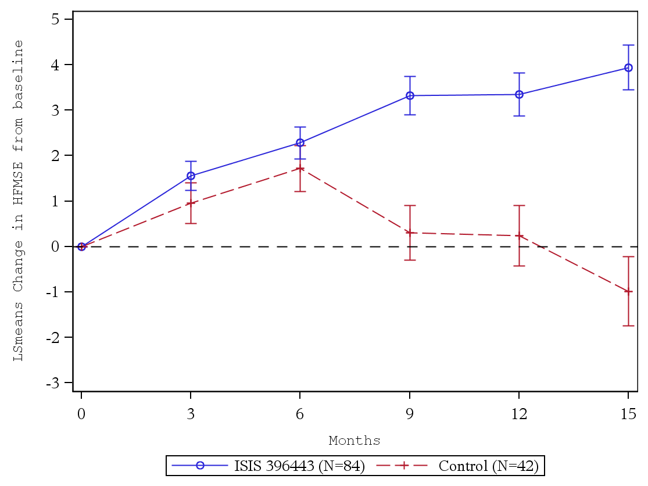

¹Data for patients without a Month 15 visit were imputed using the multiple imputation method
²Error bars denote +/- standard error
³This graph was a pre-specified exploratory analysis of HFSME scores over time
ISIS 396443 = nusinersen

Table 2: Primary and secondary endpoints at final analysis – Study CS4
 | SPINRAZA-treated Patients | Sham-control Patients
HFMSE score  Change from baseline in total HFMSE score at 15 months^{1,2,3,4}  Proportion of patients who achieved at least a 3-point improvement from baseline to month 15² | 3.9 (95% CI: 3.0, 4.9)  p=0.0000001  56.8% (95% CI: 45.6, 68.1)  p=0.0006⁵ | -1.0 (95% CI: -2.5, 0.5)  26.3% (95% CI: 12.4, 40.2)
RULM  Mean change from baseline to month 15 in total RULM score^{2,3,4} | 4.2 (95% CI: 3.4, 5.0) | 0.5 (95% CI: -0.6, 1.6)
WHO motor milestones  Proportion of patients who achieved new motor milestones at 15 months⁵  Mean number of new motor milestones attained^{3,4,5} | 19.7% (95% CI: 10.9, 31.3)  p=0.0811  0.2 (range -1 to 2, 95% CI: 0.1, 0.3) | 5.9% (95% CI: 0.7, 19.7)  -0.2 (range -1 to 1, 95% CI: -0.4, 0.0)³
¹CS4 was stopped following positive statistical analysis on the primary endpoint at interim analysis (statistically significant improvement from baseline HFMSE score was observed in SPINRAZA treated patients compared to the sham-control patients (SPINRAZA vs. sham-control: 4.0 vs. -1.9; p=0.0000002)).
²Assessed using the Intent to Treat population (SPINRAZA n=84; Sham-control n=42); data for patients without a Month 15 visit were imputed using the multiple imputation method.
³Least squares mean.
⁴Negative value indicates worsening, positive value indicates improvement.
⁵Assessed using the Month 15 Efficacy Set (SPINRAZA n=66; Sham control n=34); analyses are based on imputed data when there are missing data.
⁶Based on logistic regression with treatment effect and adjustment for each subject's age at screening and HFMSE score at baseline.

Figure 4: Waterfall plot for change from baseline to Month 15 on HFMSE at final analysis ( ITT Set)*
This figure is based upon subjects with an observed value. Shortest bars at 0 line indicate 0 value.
*26 subjects are not included in this presentation as they did not attend Month 15. This was because the study was stopped by the sponsor to allow them the opportunity to rollover into the open label extension study.
ISIS 396443 = nusinersen

Figure 5: Waterfall plot for change from baseline to Month 15 on RULM at final analysis (ITT Set)
This figure is based upon subjects with an observed value. Shortest bars at 0 line indicate 0 value.
ISIS 396443 = nusinersen

Study CS2 and Study CS12

The efficacy of SPINRAZA in Type II and Type III SMA patients has also been demonstrated in a longitudinal analysis across 2 open-label studies (Study CS2 and Study CS12). The analysis included 28 patients who received their first dose in Study CS2, and then transferred to the extension phase, Study CS12. In Study CS2, patients received 9 mg doses of SPINRAZA on days 1 and 85, or 3, 6, or 12 mg doses on days 1, 29, and 85. In Study CS12, patients received 12 mg doses of SPINRAZA on Days 1, 169, 351, and 533. The studies enrolled patients who were between 2 to 15 years of age at first dose. Of the 28 patients, 3 were at least 18 years of age at their last study visit. 1 out of 28 patients had 2 SMN2 gene copies, 21 had 3 copies, and 6 had 4 copies. Outcome measures included HFMSE in all patients, and either the ULM test in non-ambulatory patients, or the 6 MWT performed in ambulatory patients.

Patients were assessed over a 3-year treatment period. A sustained improvement was seen in patients with Type II SMA who experienced a mean improvement from baseline HFMSE score of 5.1 (SD 4.05, n=11) at Day 253, and 9.1(SD 6.61, n=9) at Day 1050. The mean total score was 26.4 (SD 11.91) at Day 253 and 31.3 (SD 13.02) at Day 1050, no plateau was observed. This is in comparison to the decline typically observed in patients with later-onset SMA over time.

Patients with Type III SMA demonstrated a mean improvement from baseline HFSME score of 1.3 (SD 1.87, n=16) at Day 253 and 1.2 (SD 4.64, n=11) at Day 1050. The mean total score was 49.8 (SD 12.46) at Day 253 and 52.6 (SD 12.78) at 1050 days.
In patients with Type II SMA the ULM test was conducted, with mean improvement of 1.9 (SD 2.68, n=11) at Day 253 and 3.5 (SD 3.32, n=9) at Day 1050. The mean total score was13.8 (SD 3.09) at Day 253 and 15.7 (SD 1.92) at Day 1050. The 6 MWT was conducted for ambulatory patients only. In these patients, a mean improvement of 28.6 meters (SD 47.22, n=12) at Day 253 and 86.5 meters (SD 40.58, n=8) at Day 1050. The mean 6 MWT distance was 278.5 meters (SD 206.46) at Day 253 and 333.6 meters (SD 176.47) at Day 1050. Two previously non-independent ambulatory patients (Type III) achieved independent walking, and one non-ambulatory patient (Type II) achieved independent walking.

Table 3: Percentages of Patients who achieved Clinically Meaningful Changes in HFMSE, ULM and 6 MWT
Efficacy Measure | Day 253 | Day 1050
HFMSE, ≥ 3 points  Type II, n (%)  Type III, n (%) | 9/11 (82%)  3/16 (19%) | 7/9 (78%)  4/11 (36%)
ULM, ≥ 2 points*  Type II, n (%) | 5/11 (45%) | 5/9 (56%)
6 MWT, ≥ 30 meters#  Type III, n (%) | 6/12 (50%) | 8/8 (100%)
*6 Type III patients performed the ULM at Day 253 or Day 1050 but are not included in the table because the majority had the maximum score of 18 points at baseline and no patient declined over time
#1 Type II patients developed the ability to walk independently; otherwise, no Type II patients were assessed by the 6 MWT

Pre-symptomatic infants

Study CS5 (NURTURE)

Study CS5, is an open-label study in pre-symptomatic infants genetically diagnosed with SMA who were enrolled at 6 weeks of age or younger. Patients in this study were deemed most likely to develop Type I or II SMA. Patients received a 12 mg scaled equivalent dose of SPINRAZA based on CSF volume scaling on study days 1, 15, 29, 64, 183, 302, 421, 540, 659 and 778. Median age at first dose was 19 days (range 3-42 days). At baseline the median number of motor milestones achieved was 3 (range 0-7), the median CHOP-INTEND total score was 54 (range 25-60), and the median ulnar CMAP amplitude was 2.5 mV (1.0-6.7). The median time on study was 317.5 days (range 2 to 524).

At the interim analysis, 18 of the 20 patients completed the Day 64 visit, thereby composing the Efficacy Set (2 SMN2 gene copies, n=13; 3 SMN2 gene copies, n=5). The primary endpoint assessed at the time of the interim analysis was time to death or respiratory intervention (defined as invasive or non-invasive ventilation for ≥ 6 hours/day continuously for ≥ 7 consecutive days or tracheostomy). At the planned interim analysis, no patients had met the primary endpoint of death or respiratory intervention (see Figure 5).

Patients achieved milestones unexpected in Type I or II SMA and more consistent with normal development. Compared to baseline, improvements in HINE motor milestones were achieved in 16 (89%) of patients in the efficacy set at the interim analysis. Twelve patients were sitting independently, 9 were standing with or without support, and 6 were walking with or without support. Sixteen patients (89%) demonstrated a ≥ 4 point improvement in CHOP INTEND total score, 7 of which achieved the maximum total CHOP INTEND score of 64. One patient (6%) experienced a ≥ 4 point decrease in CHOP INTEND total score.

The proportion of patients developing clinically manifested SMA was assessed amongst patients who reached the Day 365 visit at the interim analysis (n=9). The protocol-defined criteria for clinically manifested SMA included age-adjusted weight below the fifth WHO percentile, a decrease of 2 or more major weight growth curve percentiles, the placement of a percutaneous gastric tube, and/or the inability to achieve expected age-appropriate WHO milestones (independent sitting, standing with assistance, and hands-and-knees crawling). Five (56%) patients were gaining weight and achieving WHO milestones consistent with normal development. Although 4 (44%) patients (each with 2 SMN2 gene copies) met the protocol-defined criteria for clinically manifested SMA, these patients were gaining weight, and achieving WHO milestones, including independent sitting, inconsistent with Type I SMA.

As illustrated in Figures 6 and 7, the greatest benefit in overall survival and motor milestones occurred when SPINRAZA treatment was initiated prior to symptom onset.

Figure 6: Probability of Survival Versus Study Days in Study CS3B (treated and sham-control), CS3A and CS5 – ITT
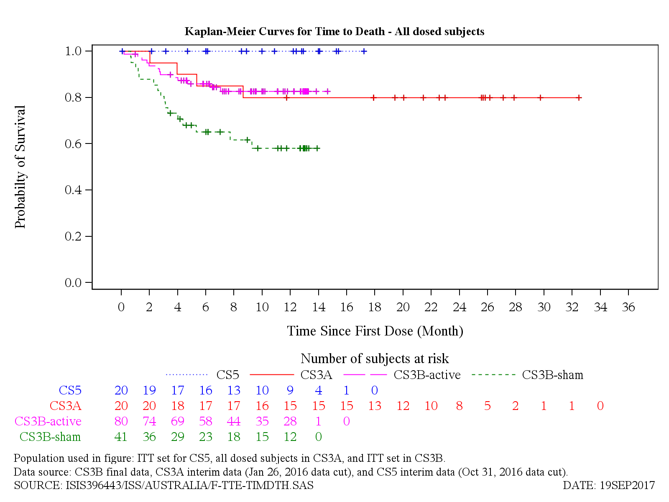

Figure 7: Change in Motor Milestones Versus Study Days for Study CS3B (treated and sham-control, IES), CS3A (IES) and CS5 (ITT)
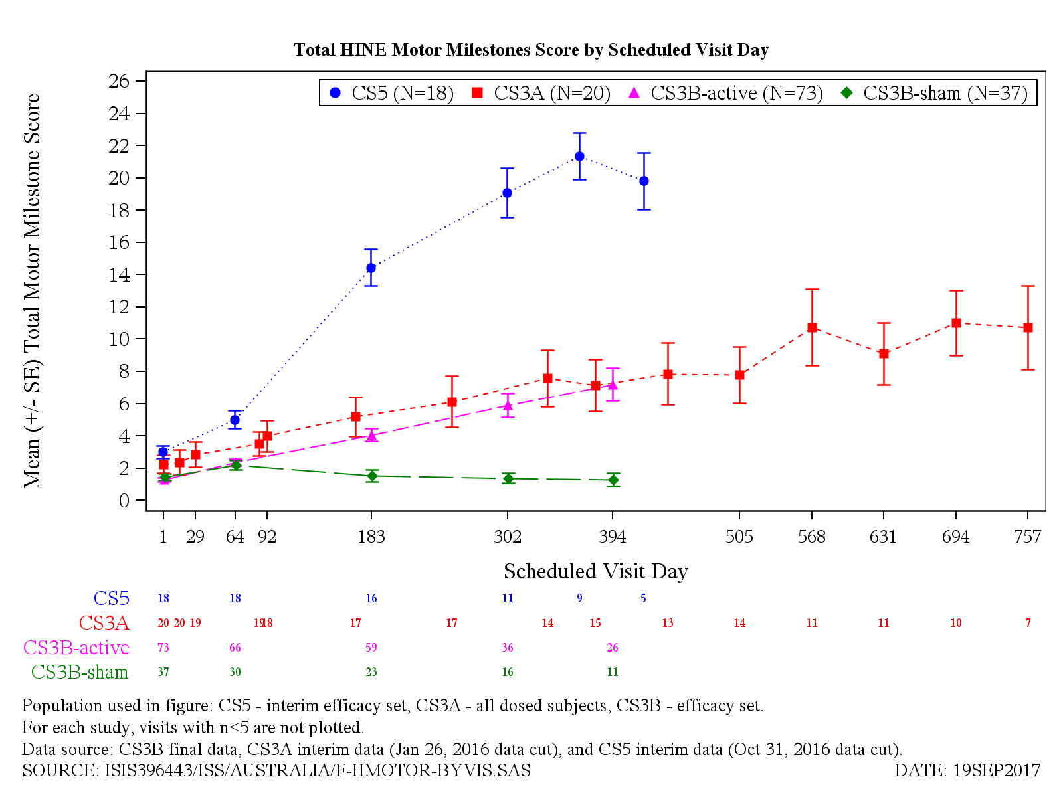

INDICATIONS
SPINRAZA is indicated for the treatment of 5q Spinal Muscular Atrophy (SMA).

CONTRAINDICATIONS
SPINRAZA is contraindicated in patients who have a history of hypersensitivity reactions, to the active ingredient or its excipients.

PRECAUTIONS

Thrombocytopenia and coagulation abnormalities
Thrombocytopenia and coagulation abnormalities, including acute severe thrombocytopenia, have been observed after administration of other subcutaneously or intravenously administered antisense oligonucleotides. If clinically indicated, platelet and coagulation laboratory testing is recommended prior to administration of SPINRAZA.

Renal toxicity
Renal toxicity has been observed after administration of other subcutaneously and intravenously administered antisense oligonucleotides.

In a combined analysis of the sham-controlled studies for patients with infantile-onset and later-onset SMA, 71 of 123 (58%) of SPINRAZA-treated patients had elevated urine protein, compared to 22 of 65 (34%) sham-controlled patients.

If clinically indicated, urine protein testing (preferably using a first morning urine specimen) is recommended. For persistent elevated urinary protein, further evaluation should be considered.

Effects on fertility
Data from nonclinical studies do not suggest that nusinersen would be associated with effects on male or female fertility. Administration of nusinersen via subcutaneous injection to male and female mice at doses of up to 25 mg/kg (87.5 mg/kg/week) had no effects on fertility.

There are no data on the effects of nusinersen on human fertility.

Use in Pregnancy (Category B1)
Data from nonclinical studies do not suggest that nusinersen would be associated with effects on embryo-fetal development. Administration of nusinersen via subcutaneous injection to mice and rabbits at doses up to 25 mg/kg (87.5 mg/kg/week) did not produce any adverse effects on embryo-fetal development. Using liver concentration as a measure of systemic exposure, the estimated nusinersen concentration in the liver at 25 mg/kg (87.5 mg/kg/week) provides an approximately ≥8.4-fold margin over the liver nusinersen concentration in humans at the maximum recommended clinical dose of 12 mg.

The effects of nusinersen on labour and delivery in humans are unknown.

Use in lactation
There are no data on the presence of nusinersen in human milk, the effects on the breastfed infant or the effects of the drug on milk production.

Paediatric use
SPINRAZA has been studied in patients ranging from newborn to 17 years (see Clinical Trials).

Use in adults
There are limited data in patients over the age of 18 years.

Use in the elderly
There are no data in patients over the age of 65.

Genotoxicity
Nusinersen demonstrated no evidence of genotoxicity in in vitro (Ames and chromosomal aberrations in CHO cells) and in vivo (mouse micronucleus) assays. However, no assays were performed to demonstrate nusinersen uptake into bacterial and mammalian cells.

Carcinogenicity
Long-term studies in animals to evaluate the carcinogenic potential of nusinersen have not been performed.

Toxicology
In repeat-dose toxicity studies (14-weeks and 53-weeks) of IT administration to juvenile cynomolgus monkeys, nusinersen was well tolerated. The exception was an acute, transient deficit in lower spinal reflexes which occurred at the highest dose levels in each study (3 or 4 mg per dose). These effects were observed within several hours post-dose and generally resolved within 48 hours.

Effect on Laboratory Tests
There are no data available on whether SPINRAZA interferes with laboratory tests.

Effects on Ability to Drive and Use Machines
No studies on the effects on the ability to drive or use machines during treatment with SPINRAZA have been performed.

Type 0 or IV SMA
Patients most likely to develop type 0 or IV SMA have not been included in the clinical development program for SPINRAZA. The decision to treat should be based on individualized expert evaluation of the expected benefits of treatment for that individual, balanced against the potential risk of treatment with nusinersen. The full benefits and risks are unknown among patients diagnosed with type 0 or IV SMA.

INTERACTIONS WITH OTHER MEDICINES
No clinical studies of interactions with other medicines have been performed.

Nusinersen is metabolized via nucleases and not by the cytochrome P450 (CYP450) system.

In vitro studies indicated that nusinersen is not an inducer or inhibitor of CYP450 mediated metabolism.

In vitro studies indicate that the likelihood for interactions with nusinersen due to competition for plasma protein binding, or competition with or inhibition of transporters is low.

ADVERSE EFFECTS
The safety of SPINRAZA in infants and children with SMA was assessed in two phase 3 randomised, double-blind, sham-controlled studies (Study CS3B and Study CS4), in an open-label phase 2 study in symptomatic infants (Study CS3A), an open-label study in pre-symptomatic infants genetically diagnosed with SMA (Study CS5) and in patients aged 2 to 15 years (at first dose) in an integrated analysis of 4 open-label studies (Studies CS2, CS12, CS1 and CS10), with a total of 260 SMA patients assessed and total time on study from 6 to 1538 days (median 449 days).

In Study CS3B, 121 patients were dosed, of whom 80 patients received SPINRAZA (median exposure 280 days) and 41 patients received sham-control (median exposure 187 days).

In Study CS4, 126 patients were dosed, of whom 84 patients received SPINRAZA (median exposure 451 days) and 42 patients received sham-control (median exposure 450 days).

Adverse events reported at an incidence at least 5% higher in patients treated with SPINRAZA compared to sham-control in Studies CS3B and CS4 are summarized in Tables 5 and 6, respectively. Events reported across open-label studies CS3A, CS2, CS12, CS5, CS1 and CS10 were consistent with those observed in Studies CS3B and CS4. No adverse events were considered related to study drug. The majority of adverse events reported in clinical trials were considered related to SMA disease or related to intrathecal administration procedure.

The adverse events are presented as MedDRA preferred terms and are listed by system organ class and frequency using the following convention: Very Common (≥1/10); Common (≥1/100 - <1/10); Uncommon (≥1/1,000 - <1/100); Rare (≥1/10,000 - <1/1,000); Very Rare (<1/10,000).

Within each frequency grouping, adverse events are presented in order of decreasing seriousness.

Table 4: Adverse events reported in Study CS3B with an incidence at least 5% and is higher in patients treated with SPINRAZA than Sham-Control
MedDRA preferred term | SPINRAZA  n=80 | Sham-control  n=41 | SPINRAZA Frequency Category^
MedDRA preferred term | SPINRAZA  n=80 | Sham-control  n=41 | Very Common  (≥1/10) | Common  (≥1/100 - <1/10)
Upper respiratory tract infection  Pneumonia  Nasopharyngitis  Respiratory tract infection  Bronchiolitis  Viral infection  Oral candidiasis  Pneumonia viral  Urinary tract infection  Bronchitis  Bronchitis viral  Ear infection  Influenza | 24 (30%)  23 (29%)  15 (19%)  9 (11%)  8 (10%)  8 (10%)  7 (9%)  7 (9%)  7 (9%)  6 (8%)  5 (6%)  5 (6%)  5 (6%) | 9 (22%)  7 (17%)  4 (10%)  2 (5%)  3 (7%)  3 (7%)  3 (7%)  2 (5%)  0 (0%)  1 (2%)  0 (0%)  1 (2%)  0 (0%) | Very Common  Very Common  Very Common  Very Common  Very Common  Very Common | Common  Common  Common  Common  Common  Common  Common
Hypoxia  Rhinorrhoea  Upper respiratory tract congestion | 7 (9%)  6 (8%)  6 (8%) | 2 (5%)  3 (7%)  1 (2%) |  | Common  Common  Common
Constipation  Teething  Salivary  hypersecretion | 28 (35%)  14 (18%)  6 (8%) | 9 (22%)  3 (7%)  2 (5%) | Very Common  Very Common | Common
Rash | 9 (11%) | 4 (10%) | Very Common
Weight gain poor | 5 (6%) | 2 (5%) |  | Common
^ Frequency category based upon SPINRAZA treated adverse event.
*Adverse events which are verbally communicated, such as those which commonly occur in the setting of lumbar puncture procedure, could not be assessed due to the infantile patient population.

Table 5: Adverse events reported in CS4 with an incidence at least 5% and is higher in patients treated with SPINRAZA than Sham-Control
MedDRA preferred term | SPINRAZA  n=84 | Sham-control  n=42 | SPINRAZA Frequency Category^
MedDRA preferred term | SPINRAZA  n=84 | Sham-control  n=42 | Very Common  (≥1/10) | Common  (≥1/100 - <1/10)
Influenza  Conjunctivitis | 8 (10%)  6 (7%) | 3 (7%)  2 (5%) | Very Common | Common
Pyrexia | 36 (43%) | 15 (36%) | Very Common
Headache* | 24 (29%) | 3 (7%) | Very Common
Vomiting*  Diarrhoea | 24 (29%)  8 (10%) | 5 (12%)  3 (7%) | Very Common | Common
Cough  Epistaxis  Upper respiratory tract congestion | 21 (25%)  6 (7%)  5 (6%) | 9 (21%)  0  2 (5%) | Very Common | Common  Common
Back pain* | 21 (25%) | 0 | Very Common
^ Frequency category based upon SPINRAZA treated adverse event.
*Adverse events considered related to the lumbar puncture procedure. These events can be considered manifestations of post-lumbar puncture syndrome.

Table 6: Incidence of possibly drug-related adverse events across all studies in patients treated with SPINRAZA^#.
MedDRA preferred term | Pre-symptomatic infants (CS5)  (n=20) | Patients with infantile onset SMA |  | Patients with later onset SMA
MedDRA preferred term | Pre-symptomatic infants (CS5)  (n=20) | CS3A  (n=20) | CS3B  (n=80) | CS4  (n=84) | CS2-12  (n=56)
Headache*  Hyperreflexia | 0  1 (5%) | 0  0 | 0  1 (1%) | 8 (10%)  0 | 1 (2%)  0
Post lumbar puncture syndrome* | 0 | 0 | 0 | 2 (2%) | 2 (4%)
Tachycardia | 1 (5%) | 0 | 1 (1%) | 1 (1%) | 1 (2%)
Vomiting | 0 | 1 (5%) | 0 | 2 (2%) | 0
Pyrexia | 1 (5%) | 0 | 2 (3%) | 6 (7%) | 0
Back pain*  Muscular weakness | 0  1 (5%) | 0  0 | 0  0 | 7 (8%)  1 (1%) | 0  0
*Adverse events which are verbally communicated, such as those which commonly occur in the setting of lumbar puncture procedure, could not be assessed due to the infantile patient population and could only be assessed in the later onset patient population.
^Events were determined as possibly drug-related by the investigator.
#Events listed are those which occurred in 2 patients across all studies.

Lumbar-puncture-related events
Adverse events associated with the administration of SPINRAZA by lumbar puncture, such as headache, back pain, vomiting and post lumbar puncture syndrome, have been observed. The incidence and severity of these events were consistent with events expected to occur with lumbar puncture. No serious complications of lumbar puncture, such as serious infections, have been observed in clinical studies.

Immunogenicity
The immunogenic response to SPINRAZA was determined in 229 patients with baseline and post-baseline plasma samples evaluated for anti-drug antibodies (ADAs). Overall, the incidence of ADAs were low, with 13 (6%) patients developing treatment-emergent ADAs, of which 2 were transient and 5 were considered to be persistent, and 6 were unconfirmed at the last data cut. There was no apparent effect of ADA development on clinical response, adverse events, or the pharmacokinetic profile of nusinersen.

Post Marketing Experience
Adverse events associated with the administration of SPINRAZA by lumbar puncture have been observed in the post-marketing setting, including serious infections and hydrocephalus.

DOSAGE AND ADMINISTRATION
Treatment should be initiated and supervised by specialist medical practitioners experienced in the diagnosis and management of SMA.

Treatment should be administered by health care professionals experienced in performing lumbar punctures.

SPINRAZA is for intrathecal use by lumbar puncture.

Dosing regimen
The recommended dosage is 12 mg (5 mL) per administration. Initiate SPINRAZA treatment as early as possible after diagnosis with 4 loading doses on Days 0, 14, 28, and 63. A maintenance dose should be administered once every 4 months thereafter. (See Special dosage instructions for intrathecal administration).

Dose delay
If a loading dose is delayed or missed SPINRAZA should be administered as soon as possible, with at least 14 days between doses, and dosing continued at the prescribed dosing frequency.

In the maintenance phase, if a planned dose is delayed or missed SPINRAZA should be administered as soon as possible and dosing continued at the prescribed dosing frequency.

Special populations

Adults
There are limited data in patients over the age of 18 years.

Paediatric
SPINRAZA has been studied in patients ranging from newborn to 17 years (See Clinical Trials).

Use in the elderly
There are no data in patients over the age of 65.

Use in patients with renal impairment
SPINRAZA has not been studied in patients with renal impairment.

Use in patients with hepatic impairment
SPINRAZA has not been studied in patients with hepatic impairment. SPINRAZA is not metabolized via the cytochrome P450 enzyme system in the liver; therefore dosage adjustment is unlikely to be required in patients with hepatic impairment. (See Interactions with other medicines and Pharmacokinetics).

Instructions for preparation of the injection
- The SPINRAZA vial should be inspected for particles prior to preparation. If particles are observed and/or the liquid in the vial is not clear and colourless, the vial must not be used.
- Aseptic technique should be used when preparing SPINRAZA solution for intrathecal administration.
- The vial should be taken out of the refrigerator and allowed to warm to room temperature (25ºC) without using external heat sources, prior to administration.
- If the vial remains unopened and the solution is not used, it should be returned back to the refrigerator (2-8°C).
- Just prior to administration, insert the syringe needle into the vial through the center of the over-seal to remove the appropriate volume (see Dosing regimen and dose adjustments). SPINRAZA must not be diluted.
- Once drawn in to the syringe, if the solution is not used within 6 hours, it must be discarded.
- Any unused product or waste material must be disposed of in accordance with local requirements.

Special Dosage Instructions for intrathecal administration
- The solution must be visually inspected prior to administration. Only clear and colourless solutions, free from particles, should be administered. The use of external filters is not required.
- Aseptic technique must be used when administering SPINRAZA.
- Sedation may be required to administer SPINRAZA, as indicated by the clinical condition of the patient.
- Ultrasound (or other imaging techniques) may be considered to guide intrathecal administration of SPINRAZA, particularly in younger patients.
- It is recommended that the volume of cerebrospinal fluid equivalent to the volume of SPINRAZA to be injected is removed prior to administration of SPINRAZA.
- SPINRAZA is administered as an intrathecal bolus injection over 1 to 3 minutes, using a spinal anaesthesia needle. The injection must not be administered in areas of the skin where there are signs of infection or inflammation.
- Any unused contents of the vial should be discarded.

SPINRAZA is for single use in one patient only. Discard any residue.

OVERDOSAGE
No cases of overdose associated with adverse reactions were reported in clinical studies. In case of overdose with SPINRAZA the patient should be advised to seek medical attention if they experience any signs or symptoms of adverse reactions.
For information on the management of overdose, contact the Poisons Information Centre on 13 11 26 (Australia).

PRESENTATION AND STORAGE CONDITIONS
Each pack contains one 5mL liquid in vial (type 1 glass) with a bromobutyl rubber stopper, an aluminium over-seal and a flip-off plastic cap. Each vial contains 5mL of a clear and colourless solution, of 12.6 mg nusinersen heptadecasodium, equivalent to 12 mg of nusinersen for intrathecal injection.

Store between 2ºC to 8ºC. Refrigerate. Do not freeze.
SPINRAZA should be protected from light and kept in the original carton until time of use.

Prior to administration, unopened vials of SPINRAZA can be removed from and returned to the refrigerator a total of 5 times, if necessary. If removed from the original carton, the total combined time out of refrigeration and secondary packaging (carton) should not exceed 30 hours, at a temperature that does not exceed 25ºC.

Do not dilute. Once drawn into syringe, administer within 6 hours. Discard any unused product. For single use in one patient on one occasion only.

Dispose of all the materials, including any unused solution contained within the vial in accordance with local requirements.

NAME AND ADDRESS OF THE SPONSOR
Biogen Australia Pty Ltd
ABN 30 095 760 115
Level 3, 123 Epping Road
North Ryde NSW 2113

POISON SCHEDULE OF THE MEDICINE
Schedule 4 – Prescription Only Medicine

DATE OF FIRST INCLUSION ON THE ARTG
3 November 2017

Biogen® is a registered trademark of Biogen MA Inc.

