First round evaluation 9 June 2017
Second round evaluation 31 July 2017

AusPAR Attachment 2

Extract from the Clinical Evaluation Report for Nusinersen
  - Proprietary Product Name: Spinraza
  - Sponsor: Biogen Australia Pty Ltd

About the Therapeutic Goods Administration (TGA)
- The Therapeutic Goods Administration (TGA) is part of the Australian Government Department of Health, and is responsible for regulating medicines and medical devices.
- The TGA administers the Therapeutic Goods Act 1989 (the Act), applying a risk management approach designed to ensure therapeutic goods supplied in Australia meet acceptable standards of quality, safety and efficacy (performance), when necessary.
- The work of the TGA is based on applying scientific and clinical expertise to decision-making, to ensure that the benefits to consumers outweigh any risks associated with the use of medicines and medical devices.
- The TGA relies on the public, healthcare professionals and industry to report problems with medicines or medical devices. TGA investigates reports received by it to determine any necessary regulatory action.
- To report a problem with a medicine or medical device, please see the information on the TGA website < https://www.tga.gov.au>.
About the Extract from the Clinical Evaluation Report
- This document provides a more detailed evaluation of the clinical findings, extracted from the Clinical Evaluation Report (CER) prepared by the TGA. This extract does not include sections from the CER regarding product documentation or post market activities.
- The words (Information redacted), where they appear in this document, indicate that confidential information has been deleted.
- For the most recent Product Information (PI), please refer to the TGA website < https://www.tga.gov.au/product-information-pi>.
Copyright
© Commonwealth of Australia 2018
This work is copyright. You may reproduce the whole or part of this work in unaltered form for your own personal use or, if you are part of an organisation, for internal use within your organisation, but only if you or your organisation do not use the reproduction for any commercial purpose and retain this copyright notice and all disclaimer notices as part of that reproduction. Apart from rights to use as permitted by the Copyright Act 1968 or allowed by this copyright notice, all other rights are reserved and you are not allowed to reproduce the whole or any part of this work in any way (electronic or otherwise) without first being given specific written permission from the Commonwealth to do so. Requests and inquiries concerning reproduction and rights are to be sent to the TGA Copyright Officer, Therapeutic Goods Administration, PO Box 100, Woden ACT 2606 or emailed to < tga.copyright@tga.gov.au>.

Contents
1. List of abbreviations 5
2. Introduction 12
2.1. Submission type 12
2.2. Drug class and therapeutic indication 12
2.3. Dosage forms and strengths 13
2.4. Dosage and administration 13
3. Clinical rationale 13
3.1. Information on the condition being treated 14
3.2. Current treatment options 16
3.3. Clinical rationale 16
3.4. Formulation 17
3.5. Guidance 17
3.6. Evaluator’s commentary on the background information 17
4. Contents of the clinical dossier 17
4.1. Scope of the clinical dossier 17
4.2. Paediatric data 19
4.3. Good clinical practice 20
4.4. Evaluator’s commentary on the clinical dossier 20
5. Pharmacokinetics 20
5.1. Studies providing pharmacokinetic information 20
5.2. Summary of pharmacokinetics 21
6. Pharmacodynamics 29
6.1. Studies providing pharmacodynamic information 29
6.2. Summary of pharmacodynamics 29
6.3. Evaluator’s overall conclusions on pharmacodynamics 31
7. Dosage selection for the pivotal studies 31
7.1. Pharmacokinetics and pharmacodynamics: dose finding studies 31
7.2. Evaluator’s conclusions on dose finding for the pivotal studies 31
8. Clinical efficacy 31
8.1. Studies providing evaluable efficacy data 31
8.2. Pivotal or main efficacy studies 32
8.3. Other efficacy studies 53
8.4. Analyses performed across trials: pooled and meta analyses 58
8.5. Evaluator’s conclusions on clinical efficacy 58
9. Clinical safety 59
9.1. Studies providing evaluable safety data 59
9.2. Studies that assessed safety as the sole primary outcome 64
9.3. Patient exposure 64
9.4. Adverse events 67
9.5. Evaluation of issues with possible regulatory impact 73
9.6. Other safety issues 80
9.7. Evaluator’s overall conclusions on clinical safety 82
10. First round benefit-risk assessment 84
10.1. First round assessment of benefits 84
10.2. First round assessment of risks 85
10.3. First round assessment of benefit-risk balance 87
11. First round recommendation regarding authorisation 88
12. Clinical questions 88
12.1. Clinical questions 88
13. Second round evaluation of clinical data submitted in response to questions 89
13.1. Overseas regulatory status update 89
13.2. Sponsor’s responses to clinical questions 90
14. Second round benefit-risk assessment 122
14.1. Second round assessment of benefits 122
14.2. Second round assessment of risks 123
14.3. Second round assessment of benefit-risk balance 124
15. Second round recommendation regarding authorisation 125
16. References 125

List of abbreviations
Abbreviation | Meaning
6MWT | Six-Minute Walk Test
aCSF | Artificial cerebrospinal fluid preparation
ACN | Acetonitrile
ADA | Anti-drug antibody
ADP | N2-Acetyl-2,6-Diaminopurine
ADR | Adverse Drug Reaction
AEs | Adverse Events
AhR | aryl hydrocarbon receptor
AMPA | 3-(3-Acetyl-4-methylpyrimidin-2-one-6-yl)-2-aminoimidazole
Amu | Atomic mass unit
AON | Antisense oligonucleotide
API | Active pharmaceutical ingredient
ASO | Antisense oligonucleotide
AUC | Area under the concentration-time curve
BCRP | Breast Cancer Resistance Protein
BiPAP | Bi-level positive airway pressure
BLAST | Basic Local Alignment Search Tool
BLQ | Below the limit of quantitation
BSEP | Bile Salt Export Pump
BWT | Body weight
CAPA | Corrective and preventive actions
CAR | Constitutive androstane receptor
CFU | Colony forming unit
CCP | Critical controlled parameters
CHMP | Committee for Medicinal Products for Human Use
CHOP INTEND | Children’s Hospital of Philadelphia Infant Test for Neuromuscular Disease
CIPC | Critical in-process controls
CIPT | Critical in-process tests
CK | Creatine kinase
CLr | Renal clearance
CMAP | Compound muscle action potential
CNET | 3-N-cyanoethylthymine impurities
CNS | Central Nervous System
CP | Controlled parameters
CPP | Critical process parameter
CQA | Critical quality attribute
CSF | Cerebrospinal Fluid
CTD | Common Technical Document
CWL | Cool white fluorescent light
DCA | Dichloroacetic acid
DCI | 4,5-dicyanoimidazole
DMT | Dimethoxytrity
DS | Drug substance
DSMC | Data Safety Monitoring Committee
DSC | Differential scanning calorimetry
EC | European Community
EMA | European Medicines Agency
ESI-MS | Electrospray ionization - mass spectrometry
ESI-TOF | Electrospray ionization time-of-flight
ETTI | Equal Tail Tolerance Interval
EU | European Union
EU | Endotoxin unit
FMEA | Failure mode and effect analysis
FTIR | Fourier transform infrared spectroscopy
GC-FID | Gas chromatography - flame ionisation detection
GCP | Good Clinical Practice
GMP | Good manufacturing practice
HCPM | Health Canada Product Monograph
HDPE | High density polyethylene
HFMSE | Hammersmith Functional Motor Scale – Expanded
hnRNP | Heterogeneous nuclear ribonucleoprotein
HPLC | High performance liquid chromatography
HPLC-MS | High-pressure liquid chromatography – mass spectrometry
HPLC-UV | High-pressure liquid chromatography - ultraviolet
ICH | International Conference on Harmonisation
ICP-MS | Inductively coupled plasma mass spectrometry
ICP-OES | Inductively coupled plasma-optical emission spectrometry (ICP-OES)
IDP | N²-Isobutyl-2,6-Diaminopurine
IES | Interim efficacy set
INN | International non-proprietary name
IPC | In process control
IP-HPLC-TOF-MS | Ion pair HPLC-TOF-MS
IPS | In-process specification
IPT | In-process tests
ISS-N1 | Intron splicing silencer N1
IT | Intrathecal
IV | Intravenous
IU | International unit
JP | Japanese Pharmacopoeia
KF | Karl Fischer
kg | Kilogram
KCP | Key controlled parameters
LDPE | Low density polyethylene
LLOQ | Lower limit of quantification
LP | Lumbar puncture
m | Metres
MAM | N-Methylacetamidomethyl
max | Maximum
MDCK | Madin-Darby canine kidney
MEK | Methyl ethyl ketone
mg | Milligram
min | Minimum
MOE A Amidite | 2´-O-(2-Methoxyethyl)adenosine Phosphoramidite
MOE G Amidite | 2´-O-(2-Methoxyethyl)guanosine Phosphoramidite
MOE ^{Me}C Amidite | 2´-O-(2-Methoxyethyl)-5-methylcytidine Phosphoramidite
MOE ^{Me}U Amidite | 2´-O-(2-Methoxyethyl)-5-methyluridine Phosphoramidite
MS | Mass spectrometry
m/z | Mass to charge ration
NaOAc | Sodium Acetate
N-KCP | Non-key controlled parameters
NLT | Not less than
NMI | N-methylimidazole
NMR | Nuclear magnetic resonance
NMT | Not more than
ND | Not determined
NO | Not observed
OAT1 | Organic Anion Transporter 1
OAT3 | Organic Anion Transporter 3
OATP1B1 | Organic Anion Transporting Polypeptide 1B1
OATP1B3 | Organic Anion Transporting Polypeptide 1B3
OC | Other concern
Oct-01 | Organic Cation Transporter 1
Oct-02 | Organic Cation Transporter 2
OD | Optical density
PADS | Phenylacetyl disulfide
PAR | Proven acceptable range
PCR | Polymerase chain reaction
PD | Pharmacodynamics
PDE | Permitted Daily Exposures
P-gp | P-glycoprotein
Ph. Eur. | European Pharmacopoeia
PK | Pharmacokinetics
popPK | Population pharmacokinetics
PQ | Process Qualification
PRS | Primary Reference Standards
PXR | Pregnane X receptor
QC | Quality Control
Q.S. | Quantity sufficient
RNA | Ribonucleic acid
RH | Relative humidity
RNA | Ribonucleic acid
mRNA | Messenger RNA
hnRNPs | Heterogeneous nuclear ribonucleoproteins
RP-HPLC | Reverse-phase HPLC
RRT | Relative retention time
RSD | Relative standard deviation
RTU | Ready to use
SAE | Serious adverse event
SAP | Statistical analysis plan
SC | Subcutaneous
SD | Standard deviation
SEM | Standard error of the mean
SMA | Spinal muscular atrophy
SMN | Survival motor neuron
SOC | System organ class
s | Seconds
TAMC | Total aerobic microbial count
TCE | Trichloroethanol
TEA | Triethylamine
TGA | Elemental analysis and thermogravimetric analysis
TMHTT | 1,3,5-trimethylhexahydro-1,3,5-triazine
TYMC | Total yeasts and moulds count
µL | Microliters
ULN | Upper Limb Module
US | United States
USA | United States of America
USAN | United States Adopted Name
USP | United States Pharmacopoeia
USP/NF | United States Pharmacopoeia/National Formulae
UV | Ultraviolet
UVA | Near ultraviolet radiation
VPC | Visual Predictive Check
XRPD | Ray powder diffraction
WBC | White Blood Cell
WFI | Water for injections
WRS | Working Reference Standards
WSS | Working solution standard

Introduction

Submission type
This is a full submission for the registration of a new active substance, nusinersen 2.4 mg/mL solution for injection. Nusinersen (Spinraza) is a novel treatment for spinal muscular atrophy (SMA), an autosomal recessive neuromuscular disease characterised by degeneration of the motor neurons in the anterior horn of the spinal cord, resulting in atrophy of the voluntary muscles of the limbs and trunk.
SMA is a result of reduced levels of the SMN protein, caused by homozygous deletions and, infrequently, by mutations within the SMN1 gene. The lack of SMN protein causes dysfunction and eventually death of motor neurons.
Nusinersen is a 2’-O-(2-methoxyethyl) antisense oligonucleotide (ASO) designed for intrathecal (IT) chronic administration for the treatment of patients with SMA, independent of clinical phenotype. The therapeutic approach is based on increasing the amount of full length protein produced from the SMN2 gene by modulating its mRNA splicing pattern. Nusinersen has been designed to bind to a specific sequence in the intron downstream of exon 7 in the SMN2 pre-mRNA, thus promoting the inclusion of exon 7 in the SMN2 mRNA transcript.

Drug class and therapeutic indication
Nusinersen is a 2´-O-(2-methoxyethyl) antisense oligonucleotide (ASO). It is an 18-base residue (18-mer) phosphorothioate oligonucleotide. All 18 of the sugar residues are 2´-O-(2-methoxyethyl)-D-ribose (MOE) as shown in Figure 1, below. All of the cytosine bases are methylated at the 5´-position with a sequence is as follows:
5´-MeUMeCAMeCMeU MeU MeUMeCAMeUAAMeUGMeCMeUGG-3´
Figure 1: Nusinersen structure
Nusinersen has been designed to bind to a specific sequence in the intron downstream of exon 7 in the SMN2 pre-mRNA, thus promoting the inclusion of exon 7 in the SMN2 mRNA transcript. nusinersen binds to a region of SMN2 pre-mRNA normally occupied by heterogeneous nuclear ribonucleoproteins A1/A2 (hnRNPs) and referred to as intron splicing silencer N1 (Hua 2008; Rigo 2012). This region of the SMN2 pre-mRNA is present in all patients with SMA.
The sponsor has requested the following indication for nusinersen:
‘Spinraza is indicated for the treatment of spinal muscular atrophy (SMA)’

Dosage forms and strengths
Spinraza is formulated as a sterile, preservative free, clear and colourless solution for injection, for intrathecal administration in a single-use vial. Each single-use vial contains 12.6 mg of nusinersen (as heptadecasodium) equivalent to 12 mg of nusinersen as the free acid (or 2.4 mg/mL) in artificial cerebrospinal fluid.
The product contains the following excipients: sodium chloride, potassium chloride, calcium chloride dihydrate, magnesium chloride hexahydrate, dibasic sodium phosphate, sodium phosphate monobasic dihydrate, sodium hydroxide, hydrochloric acid, water for injection to 5 mL. The pH is approximately 7.2.

Dosage and administration

Dosage
The recommended dosage is 12 mg (5 mL) per administration. Initiate Spinraza treatment as early as possible after diagnosis with 4 loading doses on Days 0, 14, 28, and 63. A maintenance dose should be administered once every 4 months thereafter.

Administration
The following instructions for intrathecal administration are included in the proposed product information (PI).
- The solution must be visually inspected prior to administration. Only clear and colourless solutions, free from particles, should be administered. The use of external filters is not required.
- Aseptic technique must be used when administering Spinraza.
- Sedation may be required to administer Spinraza, as indicated by the clinical condition of the patient.
- Ultrasound (or other imaging techniques) may be considered to guide intrathecal administration of Spinraza, particularly in younger patients.
- It is recommended that the volume of cerebrospinal fluid equivalent to the volume of Spinraza to be injected is removed prior to administration of Spinraza.
- Spinraza is administered as an intrathecal bolus injection over 1 to 3 minutes, using a spinal anaesthesia needle. The injection must not be administered in areas of the skin where there are signs of infection or inflammation.
- Any unused contents of the vial should be discarded.
Spinraza is supplied in single dose vials. Use in one patient on one occasion only. Any residue after injection should be discarded.

Clinical rationale
The following background information is taken from the Dossier, specifically the summary by the Committee for Medicinal Products for Human Use (CHMP) 90 (London, 24 January 2017 EMA/CHMP/45080/2017).

Information on the condition being treated

Epidemiology
Spinal muscular atrophy (SMA) is an autosomal recessive neuromuscular disease characterised by degeneration of the motor neurons in the anterior horn of the spinal cord, resulting in atrophy of the voluntary muscles of the limbs and trunk.
SMA diagnosis is suspected when a patient presents with flaccid muscle weakness. Genetic diagnosis is the most common form of diagnosis, which allows for premorbid diagnosis in siblings where one previously affected member has been identified.
SMA is a serious, debilitating, and life threatening disease. With a global incidence of 8.5 to 10.3 per 100,000 live births, it is the most common genetic cause of infant mortality, and a major cause of childhood morbidity due to weakness.
Historically, SMA has been categorised into Types 0, I, II, III, and IV which range in severity from babies who are born with severe impairment and die within weeks of birth (Type 0) to disease which manifests in adult life with proximal muscle weakness (Type IV). The most common variants (Types I, II and III) all present with a pre-symptomatic period and can be classified prospectively based on age of symptom onset and SMN2 gene copy number as infantile onset (closely resembling Type I) and later onset (Type II and III).
Current medical care is supportive, focused on respiratory support, nutritional support, and management of resulting musculotendinous contractures and neuromuscular scoliosis through bracing, physical therapy, and surgery (Wang 2007). As there are currently no approved therapies for the treatment of SMA, a significant unmet clinical need exists for these patients.

Aetiology and pathogenesis
SMA is a result of reduced levels of the SMN protein, caused by homozygous deletions and, infrequently, by mutations within the SMN1 gene. The lack of SMN protein causes dysfunction and eventually death of motor neurons. Despite being a rare disorder, SMA is the most common genetic cause of infant mortality and a major cause of childhood morbidity (Pearn 1973a; Pearn 1973b; Sugarman 2012).
The SMN1 gene lies in a duplicated, inverted region of the chromosome that includes a nearly identical copy of the SMN1 gene, called SMN2 (Figure 2). Although both genes encode proteins with identical amino acid sequences, SMN2 differs from SMN1 by 5 to 11 nucleotides (Lorson 1999; Monani 1999). One of these nucleotide differences, a cytosine-to-thymine substitution, occurs in exon 7 of the SMN2 gene, resulting in an alternative splicing pattern that favors skipping of exon 7. Eighty to 90% of the transcripts produced from the SMN2 gene lack exon 7 (Cho and Dreyfuss 2010; Wirth 2013), resulting in a truncated protein product that is defective and unstable (Cho and Dreyfuss 2010; Wirth 2013). Increasing the amount of full-length transcript from the SMN2 gene is predicted to result in an increase in SMN protein in patients with SMA (Hua 2010). Humans have a variable number of copies of the SMN2 gene (0 to 8 copies). SMN2 copy number is an important predictor of SMA disease severity, and patients with more copies generally have a less severe form of the disease. Furthermore, among families with more than one affected child, siblings with SMA have been found to have high concordance for SMA subtype (Jones 2016; Medrano 2016).
Figure 2: Genetics of spinal muscular atrophy

Clinical presentation, diagnosis and stage/prognosis
SMA has been categorised into Types 0, I, II, III, and IV based on age of symptom onset and maximal achieved motor abilities (Finkel 2015). In general, symptom onset and severity of SMA correlate with SMN2 gene copy number in this genetic disorder (Arnold 2015).
Type 0 or prenatal SMA is a rare type in which infants are born with clinical signs of disease, such as major joint contractures and respiratory compromise that often leads to the need for mechanical ventilation at or shortly after birth (Dubowitz 1999; Finkel 2015; MacLeod 1999; Mercuri 2012). These patients usually have 1 copy of the SMN2 gene. Death or permanent ventilation typically occurs within weeks after birth.
Type I SMA is the most common form of SMA, occurring in approximately 58% of cases (Ogino 2004). Patients with Type I SMA usually have 2 or 3 copies of the SMN2 gene, with 2 copies of the SMN2 gene as the most common genotype (Feldkötter 2002). Symptom onset occurs within the first 6 months of life. The earlier the symptom onset the worse the prognosis (Thomas and Dubowitz 1994). SMA Type I can be further divided into subtypes based on age of symptom onset: Patients with Type IA SMA have symptom onset in utero and are diagnosed within the first 2 weeks of birth; patients with Type IB SMA have symptom onset during infancy and are diagnosed by 3 months of age; and patients with Type IC SMA have symptom onset during infancy and are diagnosed between 3 and 6 months of age (Finkel 2015).
Type II SMA represents approximately 29% of SMA cases (Ogino 2004). Patients with Type II SMA usually have 3 copies of the SMN2 gene, but this can vary from 2 to 4 copies (Feldkötter 2002). Symptom onset occurs after 6 months but before 2 years of age. Patients have a reduced life expectancy, ranging from 2 years to more than 40 years of age (Faravelli 2015).
Type III SMA occurs in approximately 13% of cases (Ogino 2004). Patients with Type III SMA usually have 3 or 4 copies of the SMN2 gene (Feldkötter 2002). Patients with Type III SMA generally have a normal life expectancy (Arnold 2015; Wang 2007). SMA Type III can be further divided into Type IIIA (diagnosed at 18 to 36 months; patients walk but never run or jump well) and Type IIIB (diagnosed at 3 to 10 years; patients are able to walk, run, jump, and participate in sports) (Finkel 2015).
Type IV SMA (adult onset SMA) is the mildest form of SMA and occurs in < 5% of the cases (Arnold 2015). Patients with Type IV SMA usually have 4 or more copies of the SMN2 gene. Patients are ambulatory, and their life expectancy is normal (Faravelli 2015).
The definition of SMA types as described by Finkel et al was used in the clinical development program for nusinersen (Finkel 2015). The studies of nusinersen included subjects with infantile onset and genetically diagnosed (Type I) SMA, pre-symptomatic SMA (Type I or Type II) and subjects with later onset (Type II and Type III) SMA.
Patients with SMA have an urgent unmet need as no therapy has been approved to date that can reverse, delay, or halt the progressive decline in motor function and disability associated with all types of SMA.

Current treatment options
A consensus statement for the standard of care in SMA is intended as a guideline for the care of patients with SMA (Wang 2007). For infants with Type I SMA, current medical care is supportive and is focused on respiratory and nutritional support. Chronic respiratory management includes providing methods for airway clearance, including mechanical insufflation/exsufflation or manual cough assist and non-invasive ventilator support such as bi-level positive airway pressure (BiPAP). Acute respiratory infections are often life threatening for these patients and require these same methods of increased airway clearance and increased ventilation support. Nonetheless, despite best supportive efforts, the progression of respiratory deficits, continuous progression of weakness, and consequent premature death are unavoidable.
The standard of care for later onset SMA is dependent on the severity of the disease but may include physical and occupational therapy, nutritional support, pain management, orthotics, environmental controls and home modifications to facilitate safe mobility, and spinal surgery.

Clinical rationale
Although supportive measures for patients with SMA may prolong survival and improve a patient’s quality of life, there are currently no therapies, to maintain motor function, improve motor function, or reduce permanent ventilation or death in patients with SMA.
Patients with SMA and the families who care for them describe a significant need for therapies that improve motor function and increase survival (Qian 2015). Improvements in motor function would ease the significant burden of supportive care, offer greater independence, and improve the patient’s quality of life as well as that of their caregivers.
In all cases, there exists a high unmet need for a therapy that will prevent the development or reverse the course of neuromuscular weakness among all patients and prolong survival in the most affected patients.

Formulation

Formulation development
Development of the nusinersen drug product formulation was completed in two stages. The objective of the nusinersen drug product formulation development program was to develop a stable formulation that is suitable for manufacturing, storage, and intrathecal administration. An initial formulation for early clinical studies was developed to provide a wide range of doses for intrathecal administration. This was accomplished through the use of a two-vial configuration in which concentrated (20 mg/mL) liquid drug product was diluted into a second vial containing artificial cerebrospinal fluid (aCSF). Once the efficacious dose was determined, a ready to use (RTU) configuration was developed for Phase III pivotal clinical trials and commercial use, with nusinersen formulated at 2.4 mg/mL directly in aCSF (artificial CSF).

Guidance
The evaluator was supplied with the following EMA Guidelines which were applied in the evaluation of this dossier:
- EMA Guideline: Guideline on the role of Pharmacokinetics in the Development of Medicinal Products in the Paediatric Population
- EMA Guideline: Investigation of Medicinal Products in the Paediatric Population
- EMA Guideline: Investigation of Medicinal Products in Term and Preterm neonates.

Evaluator’s commentary on the background information
The background information provided was comprehensive. There were no questions or concerns raised by the background information.

Contents of the clinical dossier

Scope of the clinical dossier
The dossier documented a full clinical development program of pharmacology, efficacy and safety studies as outlined. In response to TGA inquiries, supplementary data (CSRs for Studies CS3B (known as the Endear trial), CS4 (Cherish trial), and CS5.SM201 (Nurture trial)), were supplied by the sponsor.
The following are the responses supplied by the sponsor relevant to the Clinical Dossier.

Sponsor’s response to TGA inquiries
As previously agreed and to aid TGA’s review of the newly emerging data with nusinersen, the sponsor provided:
- the final CSR for Study CS3B (Endear)
- an updated interim CSR for Study SM201 (Nurture)
- an interim CSR for Study CS4 (Cherish), as initially agreed with TGA during the pre-submission negotiation on 17 October 2016.
- the CHMP Day 90 list of questions (assessment included) and the sponsor’s response to Day 90 questions was provided.
The sponsor updated the TGA with results from the following:
- Final CSR for Study CS3B (Endear) in infantile onset SMA patients
- Updated interim CSR for Study SM201 (Nurture) in pre-symptomatic SMA patients
- Interim CSR for Study CS4 (Cherish) in later onset SMA patients.
As previously agreed with the TGA via email dated 3 May 2017, the sponsor submitted the following documents (some of which had been previously suppled):
- Slides from Oral explanation with CHMP meeting
- Meeting minutes from oral explanation with CHMP
- CHMP Day 120 list of outstanding issues (LoOI)
- The sponsor’s responses to day 120 outstanding issues
- EMA press release
- EMA summary of opinion
- Current EU SPC
- CPP-017 report.

Summary of extra data provided during the evaluation
The evaluator was supplied with the following documents during the evaluation process:
From the EMA:
- Day 90 list of questions, Day 120 LoOI Spinraza final, Day 120 responses
- Spinraza CHMP oral explanation dated 22 March 2017
- The sponsor’s company minutes to the nusinersen oral explanation 22 March 2017
- Summary of opinion
- SPC labelling package leaflet (final approved)
- Press Release.
From the FDA:
- The unredacted report summary review nusinersen Spinraza (D17-348962).

Clinical studies
The dossier contained the clinical studies as documented in the study plan (see Figure 3, below) and are listed below.

Subjects with pre-symptomatic or infantile onset SMA
- Study 396443-CS3B (referred to as Study CS3B): a pivotal, multicentre, Phase III, randomised, double blinded, sham procedure controlled study in symptomatic subjects with infantile onset SMA.
- Study 396443-CS3A (referred to as Study CS3A): a supportive, multicentre, Phase II, open label (uncontrolled) study in symptomatic subjects with infantile onset SMA.
- Study 232SM201 (referred to as Study SM201): a supportive, multicentre, Phase II, open label (uncontrolled) study in subjects with genetically diagnosed, pre-symptomatic SMA.

Subjects with later onset SMA
- Study 396443-CS4 (referred to as Study CS4): pivotal, multicentre, Phase III, randomised, sham procedure controlled study in subjects with later onset SMA.
- Study 396443-CS1 (referred to as Study CS1): Phase I, first-in-human, single dose, dose escalation study.
- Study 396443-CS2 (referred to as Study CS2): multicentre, Phase I/IIa open label, dose escalation study.
- Study 396443-C10 (referred to as Study CS10): multicentre, Phase I, single dose, open label extension study for subjects who participated in Study CS1.
- Study 36443-CS12 (referred to as Study CS12): multicentre, Phase I, open label extension study in subjects who completed Studies CS2 or CS10.

Subjects with infantile or later onset SMA
- Study 232SM202 (referred to as Study SM202): A Phase II, randomised, sham procedure controlled study in subjects with SMA not eligible to participate in Studies CS3B or CS4
- Study 396443-CS11 (referred to as Study CS11): An open label extension study for subjects with SMA who previously participated in investigational studies of nusinersen, including Studies CS12, CS3B, and CS4.
The final study report for Study CS4 is not included in the dossier. This is expected to be submitted by June 2017. The clinical development plan is shown in Figure 3, below.
Figure 3: Clinical development plan
In addition, the dossier contained the Clinical Overview, Summaries of Clinical Pharmacology, Clinical Efficacy and Clinical Safety and literature references.

Paediatric data
As children are the primary group affected by SMA, they were included in the clinical data.

Good clinical practice
The clinical study reports in the submission indicated that the studies complied with Good Clinical Practice.

Evaluator’s commentary on the clinical dossier
The dossier was well constructed and easy to follow. All the appropriate reference papers were included in the dossier. The PDF links from the table of contents in the dossier functioned correctly.
There were some minor errors in the original dossier, which were corrected by the sponsor in the form of errata. None of these errors impacted upon the conclusions of the evaluation.

Pharmacokinetics

Studies providing pharmacokinetic information

Table 1: Submitted pharmacokinetic studies
PK topic | Subtopic | Study ID
PK in healthy adults | No PK Studies in Health Adults were conducted
PK in special populations | Target population³  Single dose | Study CS1 (completed)¹
PK in special populations | Multi-dose | Study CS2 (completed)¹  Study CS10 (completed)  Study CS12 (ongoing)  Study CS4 (ongoing)  Study CS3A (ongoing)  Study CS3B (completed)  Studies SM201/396443 CS5 (ongoing)
PK in special populations | Hepatic impairment | No Studies were conducted
PK in special populations | Renal impairment | No Studies were conducted
PK in special populations | Neonates/infants/children/adolescents | See Target Population studies
PK in special populations | Elderly | No Studies were conducted
PK in special populations | Other special population | No Studies were conducted
PK interactions | No PK interaction studies were conducted
Population PK analyses | Other | Report IS 11  Report CPP-017
1) Indicates the primary PK aim of the study; 2) bioequivalence of different formulations; 3) Subjects who would be eligible to receive the drug if approved for the proposed indication.
No pharmacokinetic results were excluded from consideration.

Summary of pharmacokinetics

Pharmacokinetics in healthy subjects
No Pharmacokinetic studies in healthy subjects were included in the dossier.

Pharmacokinetics in the target population
Ten studies comprise the nusinersen clinical program. Of these, 4 studies have been completed and 6 studies are ongoing. The PK and clinical pharmacological properties of nusinersen were characterised in 8 studies: the 3 completed studies in later onset 5q spinal muscular atrophy (hereafter referred to as SMA), 1 completed study in infantile onset SMA and 4 ongoing studies (2 in later onset SMA, 1 in infantile onset SMA and 1 in infants genetically diagnosed with SMA but pre-symptomatic at study start). The PK data from the remaining 2 ongoing studies were not available for inclusion in this summary.
Non-compartmental methods were used to calculate PK parameters from the single- and multiple dose clinical studies when feasible. The PK data from Studies CS1, CS2, CS10, CS3A and CS12 were combined and analysed using a population PK approach. The CSF exposure was simulated and linked with PD data from Study CS3A to conduct an exploratory exposure-response analysis.
Nusinersen concentrations in human CSF and plasma were measured by a validated hybridisation enzyme linked immunosorbent assay method for Study CS1 and by a validated hybridisation electro-chemiluminescence immunoassay method for the other 7 studies. Quantitation ranges are based on the sodium salt form of nusinersen (molecular weight 7518 Daltons). The result of using the sodium salt form for quantitation versus the free acid form (used in dosing solutions) is an increase of approximately 5% in all concentrations reported.
The PK of nusinersen in subjects with later onset SMA were evaluated in Studies CS1, CS2, CS4, CS10 and CS12. Plasma concentration profiles for doses from 3 mg to 9 mg of nusinersen from Study CS1 are shown in Figure 4 and intrathecal concentrations of nusinersen from Study CS2 are shown in Table 2.
Figure 4: Mean (± SE) plasma concentrations of nusinersen versus time (0 to 20 hour Profile) following single IT administration on Day 1 by Cohort, Study CS1

Table 2: Summary Statistics of pre-dose CSF Concentrations (ng/mL) in subjects receiving single and multiple intrathecal administration(s) of nusinersen, Study CS2

Summary of pharmacokinetics in target population
Taken from the Summary of Clinical Pharmacology Studies:
Cerebrospinal Fluid: Concentrations of nusinersen in CSF increased with dose in both populations and appeared to increase less than dose proportionally from 1 mg to 12 mg in subjects with later onset SMA and dose proportionally or more than dose proportionally over doses from 6 mg to 12 mg in infants diagnosed with SMA. Nusinersen accumulated 1.4 to 3.0 fold with multiple 12 mg loading and maintenance doses and ultimately reached a steady state in subjects with later onset SMA and in infants diagnosed with SMA approximately within 24 months, suggesting that no further accumulation in CSF or CNS tissue concentrations would be expected with additional doses after steady state (see Table 3, below).

Table 3: Summary of mean (± SD) predose concentrations of nusinersen (ng/mL) in cerebrospinal fluid over time after single and repeated intrathecal administration of nusinersen in infants diagnosed with SMA
Plasma: Plasma drug concentrations were generally consistent across all studies, after accounting for differences in dosing regimen, age and body weight. As with CSF, a direct comparison of plasma concentration data between studies would be difficult to interpret given the variations in study design and sampling schedule. Comparison of actual exposures from CSF to plasma is limited by the differences in sampling (that is, troughs only for CSF with profiles collected from plasma). Distribution kinetics of nusinersen were similar across studies and relatively similar between subjects with later onset SMA and infants diagnosed with SMA. Following IT administration, plasma concentrations of nusinersen were relatively low compared to CSF concentrations at the same time point. IT administered nusinersen was rapidly transferred from the site of administration (CSF) into the systemic circulation, with peak plasma levels observed within a few hours after single and multiple doses with a median plasma T_{max}: 1.7 to 6.0 hours after the first dose (see Table 4, below). After reaching the peak level, plasma concentrations of nusinersen declined to less than 1% of peak concentration at 168 hours (7 days) post-dose, followed by a much slower decline through later sampling time points of up to 168 days post-dose, indicating a biphasic disposition of nusinersen in plasma following IT administration. The initial decline in plasma concentrations is mainly due to extensive distribution from plasma to systemic tissues.

Table 4: Summary of plasma pharmacokinetic parameters of nusinersen after a single intrathecal administration of nusinersen
AUC= area under the plasma concentration-time curve after the intrathecal administration; AUC_{0-4hr} = AUC from time 0 to 4 hours; AUC₀₋₆hr = AUC from time 0 to 6 hours; AUC_{0-8hr} = AUC from time 0 to 8 hours AUC _{0-20hr} = partial AUC from time 0 to 20hours; AUC_{0-24hr} = AUC from time 0 to 24 hours C_{max} = the maximum concentration observed in plasma; n = number of subjects; t1/2 = terminal half-life; T_{max} = time at which C_{max} occurs, NC = not calculated Data presented as mean + standard deviation, except T_{max}, which is presented as median (minimum-maximum). a) AUC_{0-20hr} was calculated only for subjects who had at least 1 additional blood sample collected between 4 and 20 hours after dosing (at 6, 8, or 12 hours after dosing) through an indwelling catheter; b) Scaled equivalent dose. The dose volume was scaled by infant age to be equivalent to the noted dose in children ≥ 2 years of age, based on CSF volume; c) AUC0-8hr; d) AUC_{0-24hr} was calculated using 45 subjects

Absorption

Sites and mechanism of absorption
Nusinersen is only for intrathecal administration. Nusinersen was administered at doses ranging from 1 mg to 12 mg as an IT bolus injection by lumbar puncture. For subjects over 24 months (2 years) of age at the time of dosing, the injection volume was fixed at 5.0 mL (12 mg). For subjects 24 months of age or younger at the time of dosing, the injection volume was adjusted according to subject age. This was based on estimated CSF volume (see Table 5, below).

Table 5: Nusinersen dose volume injected

Bioavailability
As nusinersen is administered directly intrathecally, no bioavailability data were provided.

Distribution
After intrathecal administration, nusinersen is distributed widely throughout the central nervous system including the cerebral cortex, cerebellum, brain stem and spinal cord. Nusinersen diffuses rapidly into the systemic circulation and is distributed in small amounts to organs including the liver and kidneys.

Transporters
Nusinersen is not a substrate or inhibitor of human BCRP, P-gp, OAT1, OAT3, OCT1, OCT2, OATP1B1, OATP1B3, or BSEP transporters. Therefore, there are no drug-drug interactions anticipated due to competition with, or inhibition of, transporters.

Plasma protein binding
Nusinersen is highly bound to human plasma proteins (> 94% bound) at clinically relevant or higher plasma concentrations (100 ng/mL and 5 µg/mL), which limits glomerular filtration and reduces urinary excretion of the drug. However, protein binding in plasma for this class of ASOs is relatively weak and the binding sites for this type of hydrophilic drug differs from the binding sites of low molecular weight hydrophobic drugs.
Given this information, the sponsor proposes that the likelihood of drug-drug interactions due to competition with plasma protein binding is very low.

Metabolism
The metabolites of nusinersen observed in CSF, plasma, and urine samples from Study CS2 suggest that nusinersen is metabolised slowly via exonuclease (3’ and 5’) mediated hydrolysis, which are not dependent on the liver. In vitro studies indicated that nusinersen is not an inducer or inhibitor of CYP450 mediated oxidative metabolism and therefore should not interact with other drugs for these metabolic pathways.

Excretion

Routes and mechanisms of excretion
Nusinersen and its metabolites are cleared in the urine as supported by urine samples from Study CS2.

Renal clearance
From Study CS2:
The CSF, plasma, and urine samples collected following multiple IT doses of 12 mg of nusinersen. Nusinersen and its metabolites were detected in plasma samples on Day 1 and Day 85 at 4 hours post dose. Intact nusinersen was the most abundant oligonucleotide, accounting for approximately 98% of the total oligonucleotides, and the only remaining metabolite (2%) was a 17-mer oligonucleotide (N-1 from the 3’ end only). No nusinersen or associated metabolites were detected on Day 92 (168 hours post-dose). The 24 hour urine samples collected from subjects in Cohort 4 were analysed in order to evaluate urinary excretion. Urinary excretion of intact nusinersen represented a small fraction of the administered dose, with 0.008% and 0.5% excreted in urine within 24 hours after the first (Day 1) and third (Day 85) IT dose, respectively (Study CS2 CSR). The absence of significant renal clearance (CLr) over 24 hours suggests that plasma clearance immediately after transfer from CSF is related to distribution and not excretion. Consistent with these results, mean CLr values (range 0.00067 to 0.0775 L/hr) are only a small fraction of the typical glomerular filtration rate (7.2 L/hr) reported in healthy subjects (Davies and Morris 1993).
When evaluated as part of the profiling assessment described above, it was found that although intact nusinersen was the most abundant oligonucleotide detected in the urine (63%), the relative abundance of detected metabolites N-1 and N-2 from the 3’ end was greater than in plasma, accounting for approximately 28% and 8% of the total oligonucleotides, respectively. Overall, the metabolism and excretion findings from Study CS2 suggest that nusinersen is metabolised mainly by slow exonuclease (3′ and 5′) mediated hydrolysis and that all nusinersen related moieties are primarily eliminated in humans via urinary excretion.

Pharmacokinetics in special populations

Pharmacokinetics in subjects with impaired hepatic function
No studies were conducted in patients with impaired hepatic function.

Pharmacokinetics in subjects with impaired renal function
No studies were conducted in patients with impaired renal function.

Pharmacokinetics according to age
No separate PK analysis according to age was included in the dossier. However, the population pharmacokinetic analyses (Report IS11) incorporated body weight as a covariate influencing CSF volume, plasma volume and plasma clearance but not CSF clearance. As stated below, since body weight and age are related in infants and children, the covariate of body weight in the model reflects the same effect as age.

Pharmacokinetics related to genetic factors
No specific genetic factors influencing the pharmacokinetics of nusinersen were studied.

Population pharmacokinetics

Reports IS11 and CPP-017
Report IS11 was this initial population PK analysis. The analysis was then updated in Report CPP-017.
Report IS11 was a population PK analysis of nusinersen in CSF and plasma of subjects with later onset SMA and subjects with infantile onset SMA. A model was generated from pooled data from a total of 72 subjects (29 infants and 43 subjects with later onset SMA) in 5 clinical studies (completed Studies CS1, CS2, CS10, and ongoing Studies CS12 and CS3A). Data used from the ongoing studies were those available as of a cut-off date of 27 January 2016.
Report CPP-017 was a population pharmacokinetic (PopPK) analysis of nusinersen in the CSF and plasma of 72 infants and children with SMA from across five different trials. The analysis (Report IS11) was submitted with the original CTD. This model was updated to provide more refined simulations in both infants and children for long term dosing. The objectives of the updated model were to:
- Update the original population PK model that characterises the disposition of nusinersen following IT administration to patients with SMA with the purpose of optimizing the prediction of exposure in older subjects.
- Predict single dose exposure of nusinersen in selected age groups.
- Predict repeat dose exposure of nusinersen following 3 dosing regimens: 4 loading doses with maintenance doses every 4 months 3 loading doses with maintenance doses every 6 months, and 4 loading doses with maintenance doses every 6 months.
- Predict steady-state exposure of nusinersen following maintenance doses every 4 months or every 6 months.
- The final structural model is shown in Figure 5 and the visual predictive checks are shown in Figure 6. Trough CSF concentrations are shown in Figure 7.
Figure 5: Structural diagram of the final updated PopPK model
Figure 6: Prediction corrected VPC (pcVPC) for the concentration-time after dose (TAD) profiles of nusinersen in CSF (CMT = 1) and Plasma (CMT 2) (Semilog Scale)
Figure 7: Observed individual spaghetti plots of trough CSF concentration (ng/mL) of nusinersen

Pharmacokinetic interactions
No pharmacokinetic interaction studies were conducted.

Evaluator’s overall conclusions on pharmacokinetics
There were two pharmacokinetic studies submitted which investigated the intrathecal dosing of nusinersen. The administered doses were between 1 mg and 12 mg. Initially doses up to 9 mg were investigated. The dosing was then extended to 12 mg. There were no dose limiting adverse effects at 12 mg, however higher doses were not investigated. This has not been specifically addressed by the sponsor. Both studies were conducted in children diagnosed with SMA and were aged less than 18 years. Further PK data in children less than 18 years of age with a diagnosis of SMA was provided from the pivotal and supportive efficacy studies.
Serum levels of nusinersen were an order of magnitude lower than CSF concentrations. Because of the intermittent nature of the CSF sampling, the data were insufficient to predict the actual half-life in CSF. However, there are 2 population pharmacokinetic analyses. These analyses well conducted and they clarify the PK profile of nusinersen in both CSF and plasma.
There are deficiencies in the presented pharmacokinetic data that need to be addressed:
- Clarify the development of the dosing schedule. Specifically, the sponsor should explain why doses higher than 12 mg were not explored.
- There are no data in adults older than 18 years of age. There may be age-related changes in CSF composition and circulation that impact upon the pharmacokinetics of nusinersen. Therefore, the sponsor should obtain data in adults treated with SMA as surviving adult patients are treated with nusinersen.

Pharmacodynamics

Studies providing pharmacodynamic information
No specific pharmacodynamic (PD) studies were provided in the dossier. However, all of the submitted studies contained some PD data. The pharmacokinetic studies (Study CS1 and Study CS2) did contain some specific PD endpoints which were SMN protein concentration in cerebrospinal fluid and immunogenicity.

Table 6: Submitted pharmacodynamic studies
PD Topic | Subtopic | Study ID
Primary Pharmacology | Effect on SMN protein concentration in cerebrospinal fluid | Study CS1  Study CS2
Primary Pharmacology | Effect on immunogenicity | Study CS1  Study CS2

Summary of pharmacodynamics

Mechanism of action
Nusinersen targets an intronic region of the SMN2 pre-messenger RNA (mRNA) normally occupied by heterogeneous nuclear ribonucleoproteins (hnRNP) A1/A2 proteins. Nusinersen displaces these proteins, thereby promoting inclusion of exon 7 into the SMN2 mRNA, resulting in higher levels of full length transcripts. This in turn results in the increased production of full length, functional SMN protein.

Pharmacodynamic effects

Primary pharmacodynamic effects

Study CS1
SMN protein concentration in cerebrospinal fluid: SMN protein was detected in CSF samples from subjects in Study CS1. Based on limited data in the age range studied (2 to14 years of age at enrolment), the CSF SMN protein levels do not appear to correlate with baseline age, gender, or SMA type (Type II or Type III). There was no apparent drug related effect on SMN protein in CSF on Day 8 following a single dose and insufficient data to make a conclusion regarding Day 29.
Immunogenicity: For Study CS1, immunogenicity was added as an assessment with Protocol Amendment 3, dated 12 March 2012; for that reason, samples were assessed only for Cohorts 3 and 4. A total of 63 plasma samples from 16 subjects in Cohorts 3 and 4 (6 mg and 9 mg) were evaluated for the presence of ADA. All samples were negative, demonstrating that a specific immunogenic response to nusinersen was not observed in these subjects up to 85 days after a single IT administration.

Study CS2
SMN protein concentration in cerebrospinal fluid: For subjects participating in Study CS2, a statistically significant increase in CSF SMN protein was observed after a single 9 mg IT dose of nusinersen (115% increase on Day 85, p = 0.004), but not after one or two 3 or 6 mg doses, suggesting a dose dependent drug effect on SMN protein concentration in the CSF. There was a trend for increased SMN protein in CSF after one or two 12 mg doses of nusinersen on Days 29 and 85, but the changes were not statistically significant.
Immunogenicity: A total of 134 plasma samples from 34 subjects were evaluated for the presence of ADA. All samples were negative for ADA, demonstrating that a specific immunogenic response to nusinersen was not observed in these subjects up to 85 days after 1 (Cohort 3) or 2 (Cohort 4) IT doses of nusinersen.
Other studies
SMN protein concentration in cerebrospinal fluid: No relationship was observed between CSF concentrations of nusinersen and SMN protein concentrations in the CSF (Studies CS1 and CS2). In addition, since no data are available from control subjects, the actual change in CSF SMN protein concentrations over time could not be assessed.
Immunogenicity: No treatment emergent ADAs were detected in Studies CS1, CS2, CS10, and SM201. A low incidence of ADA was observed in Study CS12 (4.3%; 2 of 47 subjects were ADA positive), Study CS3A (5.0%; 1 of 20 subjects was ADA-positive) and Study CS3B (0.88%; 1 of 113 subjects was ADA positive). Most the immunogenicity responses (3 of the 4 ADA positive subjects) were transient. The presence of ADA in plasma did not appear to affect nusinersen concentrations in CSF, the site of administration.

Secondary pharmacodynamic effects
SMN2 splicing in autopsy CNS tissue samples: SMA infants treated with nusinersen have higher levels of SMN2 mRNA containing exon 7 in the thoracic spinal cord compared to untreated SMA infants and similar high levels of exon 7 transcripts in other regions of the spinal cord and brain, consistent with distribution and the proposed mechanism of action of the drug.
SMN protein localisation in autopsy CNS tissue samples: SMN protein was detected in thoracic spinal cord motor neurons from subjects treated with nusinersen as well as in neurons and other cell types (such as glial, Purkinje, endothelial) in spinal cord tissues and other regions of the CNS. However, quantitative conclusions could not be reached due to limitations in the immunohistochemistry methodology used to localise the protein.

Time course of pharmacodynamic effects
The data submitted were insufficient to fully document a timeline of the pharmacodynamic effects.

Relationship between drug concentration and pharmacodynamic effects
The data submitted did not demonstrate any relationship between CSF concentrations of nusinersen and any of the pharmacodynamic measurements.

Genetic, gender and age related differences in pharmacodynamic response
There was no evidence of gender or race based differences in pharmacodynamic responses. As stated above, younger infants tended to have higher CSF concentrations of SMN Protein when compared to older children.

Pharmacodynamic interactions
No pharmacodynamic interaction studies were submitted.

Evaluator’s overall conclusions on pharmacodynamics
No specific pharmacodynamic studies were conducted. The sponsor was unable to demonstrate a clear dose response relationship between the CSF concentrations of nusinersen and SMN protein concentrations in CSF. This does not necessarily mean that intracellular concentrations of SMN protein were not elevated in a dose dependent manner.

Dosage selection for the pivotal studies

Pharmacokinetics and pharmacodynamics: dose finding studies
There were no formal dose finding studies conducted that demonstrated that the proposed dosage regimen was the optimal one. The final recommended dosing regimen was based upon the pharmacokinetic studies, which investigated doses up to 12 mg. The subsequent efficacy in the clinical studies was demonstrated at this dose.

Evaluator’s conclusions on dose finding for the pivotal studies
The basis of the final recommended dosing is not entirely clear. It may be that alternative dosing regimens are more effective but equally safe.
The sponsor should further clarify the exact basis on which the proposed dosing regimen was based.
The sponsor should also discuss whether an increased dose may be of benefit to poor responders.

Clinical efficacy

Studies providing evaluable efficacy data
The following studies provided evaluable data in terms of efficacy.

Symptomatic SMA

Infantile onset SMA
- Study CS3B: A pivotal, multicentre, randomised, Phase III, sham controlled study in symptomatic subjects with infantile onset SMA.
- Study CS3A: A supportive, multicentre, Phase II, open label (uncontrolled) study in symptomatic subjects with infantile onset SMA.

Later onset SMA
- Study CS4: A pivotal, Phase III, sham controlled study in subjects with later onset SMA.
- Study CS1: A completed, Phase I first in human, single dose, open label dose escalation study.
- Study CS10: A completed, multicentre, Phase I, single dose, open label extension study for subjects who participated in Study CS1.
- Study CS2: A completed, multicentre, Phase I/IIa, open label, dose escalation study, could include subjects who participated in CS1.
- Study CS12: A multicentre, Phase I, open label extension study in subjects who completed Studies CS2 or CS10.

Infantile or later onset SMA
- Study SM202: An ongoing, Phase II, sham controlled study with an open label phase in subjects with SMA not eligible to participate in Studies CS3B or CS4.
- Study CS11: An ongoing, open label extension study for subjects with SMA who previously participated in investigational studies of nusinersen, including Studies CS12, CS3B, and CS4.

Pre-symptomatic SMA
- Study SM201: A supportive, multicentre, Phase II, open label study in subjects with genetically diagnosed, pre-symptomatic SMA.

Pivotal or main efficacy studies

Study CS3B
A Phase III, Randomised, Double-Blind, Sham Procedure Controlled Study to Assess the Clinical Efficacy and Safety of nusinersen Administered Intrathecally in Patients With Infantile onset spinal muscular atrophy; date of report: 10 February 2017.

Study design, objectives, locations and dates

Study design
This was a Phase III, multicentre, double-blind, randomised, sham procedure-controlled study of nusinersen conducted at 31 centres worldwide. Approximately 111 subjects were planned to be enrolled into the study. This study was conducted to test the clinical efficacy, safety, tolerability, and PK of multiple doses of nusinersen administered as IT injections by lumbar puncture (LP) to subjects with infantile onset SMA.

Study objectives
Primary objective: The primary objective of the study was to examine the clinical efficacy of nusinersen administered intrathecally (IT) to patients with infantile onset spinal muscular atrophy (SMA).
Secondary objective: The secondary objective of the study was to examine the safety and tolerability of nusinersen administered IT to patients with infantile onset SMA.
Tertiary objective: The tertiary objective of the study was to examine the cerebrospinal fluid (CSF) and plasma pharmacokinetics (PK) of nusinersen administered IT to patients with infantile onset SMA.

Study period
Date of first treatment: 21 August 2014; date of data cut off: 16 December 2016.

Inclusion and exclusion criteria

Inclusion criteria
- Genetic documentation of 5q SMA homozygous gene deletion, homozygous mutation, or compound heterozygote.
- SMN2 copy number = 2.
- Onset of clinical signs and symptoms consistent with SMA at ≤ 6 months (180 days) of age.
- Males and females ≤ 7 months (210 days) of age at Screening.
- At study entry, receiving adequate nutrition and hydration (with or without gastrostomy), in the opinion of the site investigator.
- Body weight ≥ the third percentile for age using appropriate country specific guidelines.
- Medical care, such as routine immunisations (including influenza vaccine, pneumococcus vaccine, and respiratory syncytial virus prophylaxis (palivizumab) if available), meets and is expected to continue to meet guidelines set out in the Consensus Statement for Standard of
- Care in SMA in the opinion of the investigator.
- Gestational age of 37 to 42 weeks.
Main exclusion criteria
- Hypoxemia (O2 saturation awake < 96% or O2 saturation asleep < 96%, without ventilation support) during screening evaluation.
- Presence of an untreated or inadequately treated active infection requiring systemic antiviral or antimicrobial therapy at any time during the screening period of Study CS3B.
- History of brain or spinal cord disease that would interfere with the LP procedures, CSF circulation, or safety assessments.
- Presence of an implanted shunt for the drainage of CSF or an implanted central nervous system catheter.
- Clinically significant abnormalities in haematology or clinical chemistry parameters, as assessed by the Site Investigator, at screening that would render the subject unsuitable for inclusion.
- Treatment with an investigational drug given for the treatment of SMA (for example, oral albuterol/salbutamol, riluzole, carnitine, sodium phenylbutyrate, valproate, hydroxyurea, and so on), biological agent, or device within 30 days prior to screening or anytime during the study.
- Any history of gene therapy, prior ASO treatment, or cell transplantation.
- Subject’s caregiver is not willing to continue to meet standard of care guidelines for care (including vaccinations and respiratory syncytial virus prophylaxis if available), nutritional, and respiratory support throughout the duration of the study.

Study treatments
There were 2 treatment groups: nusinersen and a sham procedure control. Subjects were to receive 6 doses of nusinersen or 6 sham procedures over the course of 10 months.

Treatment
Subjects randomised to the nusinersen treatment group received a single IT LP injection of nusinersen as a slow bolus (1 to 3 minutes) using a spinal anaesthesia needle and 5 mL syringe on Study Days 1, 15, 29, 64, 183, and 302. The target site for needle insertion was the L3/L4 space, but it could be 1 segment above or 1 to 2 segments below this level, if needed. Prior to each injection of study treatment, 4 to 5 mL of CSF was collected for PK analyses. It is unclear as to whether the lumbar puncture was routinely performed under imaging guidance.
The volume of injection was adjusted based on the subject’s age on the day of dosing such that each subject received a 12 mg scaled equivalent dose based on CSF volume scaling (see Table 7). Thus, younger subjects were given a lower dose of nusinersen, achieved by injecting a smaller volume that was proportional to estimated CSF volume for age, such that dose volume was equivalent to 5 mL for individuals aged 2 years and up.

Sham procedure
Subjects randomised to the sham procedure control group had a sham procedure, rather than study drug administration, on Study Days 1, 15, 29, 64, 183, and 302. To ensure blinding, the sham procedure was administered in a dedicated room by dedicated study personnel who were unblinded to treatment, and neither the subjects’ parents nor key study personnel (that is, the principal investigator, study coordinator, or outcomes assessors) were present during the procedure.
In general, the sham procedure consisted of a small needle prick on the lower back at the location where the LP injection is normally made. The needle broke the skin but no LP injection or needle insertion occurred. The needle stick site was covered with the same type of bandage that was used to cover the LP injection site in active treatment subjects, thus simulating the appearance of an LP injection. The study subject was kept in the procedure room for the same amount of time that subjects administered study treatment were kept, thus simulating the time period of a study treatment administration procedure.

Table 7: Nusinersen dose volume to be injected

Efficacy variables and outcomes
Primary efficacy endpoints
- Proportion of motor milestone responders (Section 2 of the Hammersmith Infant Neurological Examination (HINE)).
- Time to death or permanent ventilation (≥ 16 hours ventilation/day continuously for > 21 days in the absence of an acute reversible event or tracheostomy).
Secondary efficacy endpoints
- Proportion of Children’s Hospital of Philadelphia Infant Test for Neuromuscular Disease (CHOP INTEND) responders.
- Survival rate.
- Percent of subjects not requiring permanent ventilation.
- Proportion of compound muscle action potential (CMAP) responders.
- Time to death or permanent ventilation in the subgroups of subjects below the study median disease duration.
- Time to death or permanent ventilation in the subgroups of subjects above the study
- Median disease duration.
Tertiary efficacy endpoints
- Change from Baseline in growth parameters (weight for age/length, chest circumference, head to chest circumference ratio, and arm circumference).
- Number of serious respiratory events.
- Number of hours of ventilation support.
- Number and length of hospitalisations.

Specific efficacy measures used for assessing SMA
In the Summary of Clinical Efficacy the sponsor included descriptions of the specific efficacy measures, as follows in the following sections.

CHOP INTEND
The Children’s Hospital of Philadelphia Infant Test of Neuromuscular Disorders (CHOP INTEND) scale is a validated 16 item, 64 point motor assessment designed specifically to evaluate muscle strength and function in infants with SMA and to accommodate their fragile nature and observed tolerance to item administration (Finkel 2014; Glanzman 2010). The test was designed by a panel of clinicians who were guided in item selection by the clinical judgment concerning the item’s ability to quantify motor behaviour in Type I SMA as well as by the statistical characteristics of each item. CHOP INTEND captures neck, trunk, proximal, and distal limb strength in 14 elicited and 2 observational items. The CHOP INTEND has been established as a safe, reliable, and clinically meaningful measure of motor function in infants with SMA and was used in CS3B, CS3A, and SM201 to measure the change in muscle strength and function over time.
CHOP INTEND is used to assess spontaneous movement in the upper extremities, spontaneous movement in the lower extremities, hand grip, head in midline with visual stimulation, hip adductors, rolling elicited from the legs, rolling elicited from the arms, shoulder and elbow flexion and horizontal abduction, shoulder flexion and elbow flexion, knee extension, hip flexion and foot dorsiflexion, head control, elbow flexion, neck flexion, head/neck extension, and spinal incurvation. Of the 16 test items: 9 items are scored as 0, 1, 2, 3, or 4 with greater scores indicating greater muscle strength; 5 items are scored as 0, 2, or 4; 1 item is scored as 0, 1, 2, or 4; and 1 item is scored as 0, 2, 3, or 4. This can result in a worst possible total score of 0 to a best possible total score of 64. To minimise the effect of inter-rater variability, physical therapists who administered the CHOP INTEND received initial training followed by periodic refresher training. In addition, to the extent possible, assessments for a particular subject were to be performed by the same physical therapist throughout the study.

Motor Milestones (HINE)
By definition, patients with Type I SMA do not develop independent sitting (De Sanctis 2016; Russman 2007; Wang 2007). As reported in the natural history studies, most infants with Type I SMA also have a profound inability to attain or maintain other motor milestones, including head control (Bach 2007; Rudnik-Schöneborn 2009). While the use of ventilation and nutritional support has had an effect on the life expectancy of some infants with SMA, they have not had an impact on the infants’ ability to achieve motor milestones over the course of their lives (Bach 2007). Capturing the achievement of motor milestones in symptomatic infants as they age provides a clinically relevant assessment of the effectiveness of treatment. The evaluation of motor milestone development in pre-symptomatic infants allows for an assessment of whether treatment can delay or prevent the onset of motor function impairment associated with SMA and allow infants to develop normally. In all 3 clinical studies in infants with SMA, investigators assessed the achievement of motor milestones during the neurological assessment using the Hammersmith Infant Neurological Examination (HINE) Section 2, Motor Milestones, which assesses neuromuscular and motor milestone development in infants (Haataja 1999). The HINE is a well-accepted, clinically relevant measure of motor function in infants with SMA. Given the reliance of SMA phenotype and prognosis on motor milestone development, the HINE provides the most easily interpretable and robust evidence of early benefit of nusinersen in this population. The examination is composed of 8 milestone categories (that is, head control, sitting, grasping, ability to kick in supine position, rolling, crawling, standing, and walking) with 3 to 5 progressively more difficult items within each milestone category.
In Study CS3A, the primary efficacy endpoint was the proportion of subjects who achieved improvement in motor milestones as of their last available visit. Improvement was defined as achievement of any of the following:
- an increase from Baseline of 2 levels or more, or the achievement of pincer grasp in the voluntary grasp category
- an increase from Baseline of 2 levels or more, or achievement of touching toes in the ability to kick category
- an increase from Baseline of 1 level or more in any of the remaining 6 categories: head control, rolling, sitting, crawling, standing, or walking.

Electrophysiological measures (CMAP)
Considered to be complementary to functional outcome measures, electrophysiological measures such as CMAP serve as objective and highly sensitive indicators of the health of motor neurons. For these reasons, CMAP has been included in a number of recent longitudinal and cross-sectional natural history studies of SMA and was assessed in all 3 clinical studies in infants with symptomatic or pre symptomatic SMA and in Studies CS1, CS2, CS10, and CS12 in later onset SMA. Natural history studies indicate that ulnar nerve CMAP amplitude is abnormally low in symptomatic infants with Type I SMA and does not appear to change over time (Finkel 2014). The population mean has been reported to be 0.34 mV, and few patients have values above 1 mV (Swoboda 2005). By comparison, in a study of 92 healthy infants and children, mean CMAP amplitudes were 1.88 (ulnar) and 1.77 mV (peroneal) at 1 month of age; by 48 to 72 months of age, mean ulnar and peroneal CMAP amplitudes had increased to 5.50 and 3.78 mV, respectively (García 2000).

Randomisation and blinding methods

Randomisation
Eligible subjects were randomised in a 2:1 ratio to receive either a scaled equivalent 12 mg dose of nusinersen or a sham procedure control, respectively. Randomisation was stratified based on disease duration (that is, subject’s age at Screening minus age at symptom onset) of ≤ 12 weeks versus > 12 weeks.

Blinding
To ensure blinding, nusinersen was administered in a dedicated room by dedicated study personnel who were unblinded to treatment, and neither the subjects’ parents nor key study personnel (that is, the principal investigator, study coordinator, or outcomes assessors) were present during the procedure.

Analysis populations
For the interim analysis, the analysis populations were the Intent to Treat (ITT) Set, the Interim Efficacy Set, the Safety Set, and the Pharmacokinetic (PK) Set and for the final analysis the analysis populations were the ITT Set, the Efficacy Set, the Per-Protocol (PP) Set, the Safety Set, and the PK Set.

Sample size
For the primary endpoint of motor milestone response, the power was estimated to be approximately 60% to detect a statistically significant difference between treated and sham groups at the time of the interim analysis (N = approximately 80 subjects), under the assumptions of having 3 responders in the sham group (3/26 = 11.5%) and 20 responders in the nusinersen group (20/52 = 38.5%), and alpha = 0.035. At the final analysis, with alpha = 0.03, 111 subjects would provide approximately 78% power to differentiate a response rate of 38.5% for the nusinersen group versus a response rate of 11.5% for the sham group.

Statistical methods
Details of the statistical methodology are summarised in Table 8, below.

Table 8: Primary and sensitivity analyses of the first primary endpoint, proportion of subjects who achieve improvement in motor milestones

Participant flow
A total of 149 subjects were screened of whom 122 were randomised in a 2:1 ratio to receive nusinersen (81 subjects) or undergo a sham procedure (41 subjects in this control group). Apart from the one subject randomised to receive nusinersen who was withdrawn from the study prior to receiving study treatment, all subjects received study treatment according to their randomisation assignment. The details of subject disposition are shown in Figure 8, below.
Figure 8: Subject disposition, all subjects screened

Major protocol violations/deviations
Major protocol deviations occurred in 19% of subjects and were balanced across treatment groups in the ITT Set. Less than 1% (that is, 1 subject each) had visit schedule deviations, or enrolment criteria deviations; 3% had procedure deviations; and 14% had deviations listed as ‘other.’

Baseline data
Of the 121 subjects in the ITT Population, 67 (55%) were female and 54 (45%) were male. Age at first study treatment ranged from 30 to 262 days (median 175 days). One hundred and four (86%) subjects were White.
Baseline demography was balanced between the nusinersen and control groups with the exception of age and geographic region. Subjects in the nusinersen group were on average younger than those in the control group. At the time the first study treatment was administered, median age was 164.5 days in the nusinersen group and 205 days in the control group.
Fifty percent of the population was enrolled in North America (United States and Canada), 39% was enrolled in Europe, and 12% in the Asia-Pacific region. A greater percentage of subjects from North America (54% versus 48%) and Europe (41% versus 38%) were in the control group, while a greater percentage of subjects from the Asia-Pacific region were in the nusinersen group (15% versus 5%).
The nusinersen and control groups were balanced with respect to disease duration and SMN2 copy number. Disease duration was 12 weeks or less for 43% of the subjects and greater than 12 weeks for 57% of subjects. Median disease duration was 13.1 weeks. Ninety nine percent of subjects were documented to have 2 copies of the SMN2 gene. SMN2 gene copy number is based on the central laboratory testing. One subject had 3 copies of the SMN2 gene based on the central laboratory result, but the copy number was 2 based on the local laboratory results at the time of screening.
There was some imbalance in age at symptom onset with 90% of subjects in the nusinersen group and 78% in the control group experiencing symptoms of SMA within the first 12 weeks of life. Median age at symptom onset was 6.5 weeks in the nusinersen group, and 8 weeks in the control group.
Further imbalance was seen with regard to the subjects’ history of SMA symptoms as of the start of the study: a greater percentage of infants in the nusinersen group had a history of paradoxical breathing (nusinersen versus control: 89% versus 66%), pneumonia or respiratory symptoms (35% versus 22%), and swallowing or feeding difficulties (51% versus 29%).

Results for the primary efficacy outcome

Motor milestone response
The analysis of the first primary endpoint was done for the interim analysis. A statistically significantly greater percentage of subjects achieved a motor milestone response in the nusinersen group (41%) compared to the control group (0%; p < 0.0001). In the final analysis, this percentage improved, 51% of subjects in the nusinersen group achieved a response compared to 0% in the control group (p < 0.0001). A consistent and statistically significant effect was observed across all sensitivity analyses conducted. As of the data cut-off date, in the nusinersen group, 16 subjects (22%) achieved full head control, 6 subjects (8%) achieved independent sitting, and 1 subject (1%) achieved standing, whereas no subjects in the control group achieved any of these milestones. A treatment effect was evident in the pre-specified subgroups based on disease duration, age at onset of symptoms of SMA, and geographic region. A Waterfall Plot for motor milestones (excluding voluntary grasp) is shown in Figure 9, below.
Figure 9: Waterfall plot for total motor milestones excluding voluntary grasp change from Baseline to Later of Day 183, Day 302, and Day 394 Study Visit, efficacy set

Sensitivity analyses
Six sensitivity analyses were planned. These sensitivity analyses were consistent with the primary result and the strong treatment effect, both clinically and statistically, of nusinersen, as shown in Figure 10, below.
Figure 10: Difference in proportion of responders and 95% confidence intervals for motor milestones analyses, efficacy set
The majority of nusinersen-treated subjects achieved progressive and sustained increases in total motor milestones over time compared to baseline whereas control group subjects showed slight improvement at the first assessment (Day 64) followed by a decrease over time (see Figures 11 and 12, below). The loss of motor milestones gained prior to symptom onset, as seen in the control group, is consistent with the natural history of SMA.
Figure 11: Figure of total motor milestones over time: mean change from Baseline, efficacy set
Figure 12: Total motor milestones over time: mean results, efficacy set

Results for other efficacy outcomes
A summary of all primary and secondary endpoints is shown in Table 9, below.

Table 9: Summary of results of primary and secondary endpoints

Survival
There was a significantly prolonged overall survival time observed in the nusinersen group compared to the control group (p = 0.0041). As of the data cut-off date, 13 subjects (16%) in the nusinersen group and 16 subjects (39%) in the control group had died. The estimated proportion of subjects alive was higher in the nusinersen group compared to the control group across all time periods (see Figure 13, below). Using a Cox proportional hazards model adjusting for each subject’s disease duration at screening resulted in a hazard ratio of 0.372 (95% CI: 0.179, 0.775), indicating a 62.8% reduction in the risk of death following treatment with nusinersen.
Figure 13: Kaplan-Meier curves for time to death, ITT set
There was a trend toward a lower percentage of subjects in the nusinersen group requiring permanent ventilation during the study compared to the control group (p = 0.1329). Overall, the risk of permanent ventilation was 34% lower in nusinersen treated subjects than in those who received the sham procedure, as shown in Figure 14, below.
Figure 14: Kaplan-Meier Curves for time to death or permanent ventilation (EAC adjudicated events) ITT set

CHOP INTEND
A significantly greater percentage of subjects achieved a CHOP INTEND response in the nusinersen group (71%) compared to the control group (3%; p < 0.0001). A consistent and statistically significant effect was observed across all sensitivity analyses conducted as shown in Figure 15, below.
Figure 15: Waterfall plot for CHOP INTEND change from Baseline to Day 183, Day 302, and Day 394 Study Visit, efficacy set

Compound muscle action potential (CMAP)
Sustained and clinically significant increases of mean CMAP amplitude of the peroneal nerve were observed in the nusinersen group, compared with the control group. For CMAP amplitude of the peroneal and ulnar nerves, progressive improvement from Baseline is observed in the nusinersen group after Day 64, whereas a decrease from Baseline is observed in the control group after Day 64.

Study CS4
This was: ‘a Phase III, randomised, double blind, sham procedure controlled study to assess the clinical efficacy and safety of nusinersen administered intrathecally in patients with later onset spinal muscular atrophy’ (also known as the Cherish trial).
Date of report: 3 February 2017.

Study design, objectives, locations and dates

Study design
This was an ongoing Phase III, double blind, randomised, sham procedure controlled study of nusinersen conducted at 24 centres worldwide. Approximately 117 subjects were to be enrolled in the study. This study was conducted to test the clinical efficacy, safety, tolerability, and PK of multiple doses of nusinersen administered as intrathecal (IT) injections by lumbar puncture (LP) to subjects with later onset SMA. As the study is ongoing, this report presents an interim analysis of the data.

Study objectives
Primary objectives: The primary objective of the study is to examine the clinical efficacy of nusinersen administered intrathecally to patients with later onset spinal muscular atrophy (SMA).
Secondary objective: The secondary objective of the study is to examine the safety and tolerability of nusinersen administered intrathecally to patients with later onset SMA.
Tertiary objective: The tertiary objective of the study is to examine the cerebrospinal fluid (CSF) and plasma pharmacokinetics (PK) of nusinersen administered intrathecally to patients with later onset SMA.

Study period
Date of first treatment: 24 November 2014; date of data cut off: 31 August 2016.

Inclusion and exclusion criteria

Inclusion criteria
- Genetic documentation of 5q SMA (homozygous gene deletion, mutation, or compound
- heterozygote).
- Onset of clinical signs and symptoms consistent with SMA at > 6 months of age.
- Males and females 2 to 12 years of age.
- Can sit independently but has never had the ability to walk independently.
- Hammersmith Functional Motor Scale - Expanded (HFMSE) ≥ 10 and ≤ 54 at Screening.
- Estimated life expectancy > 2 years from Screening, in the opinion of the investigator.
- Meets age-appropriate institutional criteria for use of anaesthesia/sedation, if use is planned for study procedures (as assessed by the Site Investigator and either anaesthetist or pulmonologist).
Main exclusion criteria
- Respiratory insufficiency, defined by the medical necessity for invasive or non-invasive ventilation for > 6 hours during a 24 hour period, at Screening.
- Medical necessity for a gastric feeding tube, where the majority of feeds are given by this route, as assessed by the site investigator.
- Severe contractures or severe scoliosis evident on X-ray examination at Screening.
- Hospitalisation for surgery (for example, scoliosis surgery or other surgery), pulmonary event, or nutritional support within 2 months of Screening or planned during the duration of the study.
- Presence of an untreated or inadequately treated active infection requiring systemic antiviral or antimicrobial therapy at any time during the Screening Period.
- History of brain or spinal cord disease, including tumours, or abnormalities by magnetic resonance imaging or computed tomography that would interfere with the LP procedures or CSF circulation.
- Presence of an implanted shunt for the drainage of CSF or an implanted central nervous system catheter.
- History of bacterial meningitis.
- Dosing with nusinersen in any previous clinical study.
- Prior injury (for example, upper or lower limb fracture) or surgical procedure which impacts the subject’s ability to perform any of the outcome measure testing required in the protocol and from which the subject has not fully recovered or achieved a stable baseline.
- Clinically significant abnormalities in haematology or clinical chemistry parameters or electrocardiogram (ECG), as assessed by the Site Investigator, at the Screening Visit that would render the subject unsuitable for inclusion.
- Treatment with another investigational drug (for example, oral albuterol/salbutamol, riluzole, carnitine, creatine, sodium phenylbutyrate, and so on), another biological agent, or device within 1 month of screening or 5 half-lives of study agent, whichever is longer.
- Treatment with valproate or hydroxyurea within 3 months of Screening.
- Any history of gene therapy, antisense oligonucleotide therapy, or cell transplantation.

Study treatments
There were 2 treatment groups: nusinersen and a sham procedure control. Subjects were to receive 6 doses of nusinersen or 6 sham procedures over the course of 10 months.

Treatment
Subjects randomised to the nusinersen treatment group received a single IT LP injection of nusinersen.
Subjects randomised to the sham procedure control group had a sham procedure rather than study drug administration on Study Days 1, 29, 85, and 274.
The target site for needle insertion was the L3/L4 space, but could be 1 segment above or 1 to 2 segments below this level, if needed. Depending on institutional guidelines, anaesthesia or sedation could be used for the LP procedure, following institutional procedures. Prior to each injection of study treatment, 5 mL of CSF was collected for PK analyses.
The Lot Numbers of ISIS396443 used in this study were CP396443-003 and CP396443-004.

Sham Procedure
Subjects randomised to the sham procedure control group had a sham procedure rather than study drug administration on Study Days 1, 29, 85, and 274.
In general, the sham procedure consisted of a small needle prick on the lower back at the location where the LP injection was normally made. The needle broke the skin but no LP injection or needle insertion occurred. The needle prick site was covered with the same type of bandage that was used to cover the LP injection site in active treatment subjects, thus simulating the appearance of an LP injection. If anaesthesia or sedation was used for the LP procedure in nusinersen-treated subjects, then to maintain the blind, minimal sedation (that is, a low dose of an anxiolytic) was to be used for the sham procedure, following institutional procedures. The study subject was kept in the procedure room for the same amount of time that subjects administered study drug were kept, thus simulating the time-period of a study drug administration procedure.

Efficacy variables and outcomes

Primary efficacy endpoints
The primary efficacy endpoint of the study is the change from Baseline in the Hammersmith Functional Motor Scale, Expanded (HFMSE) score at 15 months.

Secondary efficacy endpoints
- Proportion of subjects who achieve a 3-point or greater increase from Baseline in HFMSE score at 15 months
- Proportion of subjects who achieve any new motor milestone at 15 months
- Number of motor milestones achieved per subject at 15 months
- Change from Baseline in Upper Limb Module Test at 15 months
- Proportion of subjects who achieve standing alone at 15 months
- Proportion of subjects who achieve walking with assistance at 15 months.

Tertiary efficacy endpoints
- Change from Baseline in CSF SMN protein concentration
- Clinical Global Impression of Change (CGI) (Investigator and Caregiver assessment)
- Change from Baseline in Paediatric Quality of Life Inventory (PedsQL)
- Change from Baseline in Assessment of Caregiver Experience with Neuromuscular Disease (ACEND)
- Disease-related hospitalisations and AEs.

Randomisation and blinding methods

Randomisation
Eligible subjects were randomised in a 2:1 ratio to receive either a 12 mg dose of nusinersen or a sham procedure control, respectively. Randomisation was stratified based on the subject’s age at Screening (< 6 years versus ≥ 6 years).

Blinding
To ensure blinding, nusinersen was administered in a dedicated room by dedicated study personnel who were unblinded to treatment, and neither the subjects’ parents nor key study personnel (that is, the Principal Investigator, study coordinator, or outcomes assessors) were present during the procedure.

Analysis populations
This interim analysis of the study data for this ongoing study was conducted with a data cut-off date of 31 August 2016. The statistical methods used for the interim analysis of the study data, which are a subset of those defined for the final analysis, are summarised in the following sections. Details of all planned analyses for this interim and future final reporting were provided in the statistical analysis plan.
For this interim analysis, the analysis populations were the Intent to Treat (ITT) Set, the Interim Efficacy Set, the Safety Set, and the PK Set.

Sample size
The sample size for this study was estimated based on limited available natural history data for the target population and data from Studies CS1 and CS2. Seventy subjects in the nusinersen group and 35 subjects in the control group would give at least 90% power to detect a 3-point difference between the control and nusinersen groups in the change from baseline HFMSE with an SD of 4.4, using a 2 sided test with an alpha level of 0.05. One hundred seventeen subjects enrolled would ensure that a small dropout rate would not affect the power of the primary efficacy analysis.

Statistical methods
Details of the statistical methodology for analysis of the primary endpoint are summarised in Table 10, shown below.

Table 10: Summary of analyses of the primary endpoint

Participant flow
A total of 179 subjects were screened of whom 126 were randomised in a 2:1 ratio to receive nusinersen (84 subjects) or undergo a sham procedure (42 subjects). The first subject was treated on 24 November 2014. As of the data cut-off (31 August 2016), enrolment was complete. All subjects received study treatment according to their randomisation assignment. The details of subject disposition are shown in Figure 16.
Figure 16: Subject disposition as of the data cut-off date, all screened subjects

Major protocol violations/deviations
A summary of the major deviations that occurred on study is presented in Table 11. Major protocol deviations occurred in 4 subjects (3 in the nusinersen group (4%) and 1 in the control group (2%)). Two subjects had deviations in enrolment criteria, 1 subject had a deviation in dosing, and 1 subject had a deviation listed as ‘other’.

Table 11: Summary of major protocol deviations, ITT set

Baseline data
Of the 126 subjects in the ITT Set, 67 (53%) were female and 59 (47%) were male. Age at screening ranged from 2 to 9 years (median 3 years). 106 subjects (84%) were < 6 years of age and 20 subjects (16%) were ≥ 6 years of age. 94 subjects (75%) were White.
Baseline demography was balanced between the nusinersen and control groups, with slight differences in age, sex, and race. Subjects in the nusinersen group were on average older than those in the control group (median age of 4 versus 3 years, respectively). There were slightly more females (55%) than males (45%) in the nusinersen group compared to the control group (50% in both groups). There were more White subjects (76% versus 71%, respectively) and fewer subjects of multiple races (4% versus 10%, respectively) in the nusinersen group compared with the control group.
56% of the population was enrolled in North America (United States and Canada), 33% was enrolled in Europe, and 11% was enrolled in the Asia Pacific region.

Results for the primary efficacy outcome

Change from Baseline in HFMSE score
The primary endpoint of the study, and the only endpoint formally tested for this interim analysis, was the change from Baseline in the HFMSE score at 15 months, shown in Figure 17, below. The HFMSE is a tool assesses motor function in children with SMA Types II and III. The scale has 33 items and is used to assess both ambulant and non-ambulant patients.
The change from Baseline in HFMSE score at 15 months was compared between the 2 treatment groups based on the ITT Set using multiple imputation methodology and an ANCOVA model. The results showed an improvement in HFMSE scores from Baseline to Month 15 in the nusinersen group (least squares mean change of 4.0) and a decline in HFMSE score in the control group (least squares mean change of -1.9), with a least squares mean difference between the nusinersen and control groups of 5.9. This result was highly statistically significant (p = 0.0000002).
Figure 17: HFMSE: Waterfall plot for change from Baseline to Month 15 (subjects with non-missing 15 month values), ITT set

Sensitivity analyses
Three sensitivity analyses were performed for the interim analysis of the primary endpoint. Only sensitivity analyses 2 through 4 were conducted for the interim analysis, shown in Figures 18 and 19, below.
Figure 18: HFMSE: Change in HFMSE and 95% CI for primary and sensitivity analysis (Forest plot), ITT set
Figure 19: HFMSE: Mean change from Baseline (multiple imputation) over time using LS means estimates, ITT Set (exploratory analysis 3)

Results for other efficacy outcomes
Secondary endpoints did not undergo statistical testing for the interim analysis. Only a descriptive summary of the results so far was provided.

3 point Increase in HFMSE Score
The nusinersen group had a higher proportion of responders achieving an increase of 3 points or more in HFMSE score than the control group did: 57.3% versus 20.5%, respectively.

Proportion of subjects achieving new motor milestones
More subjects in the nusinersen group gained motor milestones compared to those in the control group. While there were subjects in the control group who lost motor milestones at 15 months, there were no motor milestones lost in the nusinersen group.

Number of new motor milestones
There was a slight increase in the number of motor milestones gained in the nusinersen group, as well as a slight decrease in the control group.

Upper Limb Module Test
Overall improvements were seen in the Upper Limb Module Test for both groups, but the nusinersen group had a greater improvement than the control group. The greatest improvement occurred in the < 6 years of age subgroup who received nusinersen; in contrast, both groups in the ≥ 6 years of age subgroup had declines from Baseline, although the control group showed a greater decline.

Standing alone and walking with assistance
There were few subjects in either treatment group who achieved the milestones of standing alone or walking with assistance.
      - Evaluator commentary
This interim study report demonstrated a marked difference in motor function between the treatment and the sham groups (p = 0.0000002). The sponsor should submit the final study report as soon as it becomes available.

Other efficacy studies

Study 232SM201
This was an interim report of a Phase II open label study to assess the efficacy, safety, tolerability, and pharmacokinetics of multiple doses of nusinersen delivered intrathecally to subjects with genetically diagnosed and pre-symptomatic spinal muscular atrophy.
The primary objective of the study is to examine the efficacy of multiple doses of nusinersen, administered intrathecally (IT), in preventing or delaying the need for respiratory intervention or death in infants with genetically diagnosed and pre-symptomatic spinal muscular atrophy (SMA).
The secondary objectives of the study are to examine the effects of nusinersen in infants with genetically diagnosed and pre symptomatic SMA on the following:
- Development of clinically manifested SMA as determined by a composite of clinical features seen in
- Subjects with SMA
- Growth and function
- Safety, tolerability, and pharmacokinetics (PK).
It was planned that up to 25 subjects are to be treated. Currently a total of 20 subjects have been enrolled, received at least 1 dose of study treatment, and have been analysed as of the data cut-off date of 31 October 2016.

Treatment
Eligible subjects are expected to participate in the study for a total of approximately 2.5 years (889 days), which includes a Screening Period, a Treatment Period, and a Post-treatment Follow-Up Evaluation Period. During the Treatment Period, subjects will receive a total of 10 injections on Days 1, 15, 29, 64, 183, 302, 421, 540, 659, and 778. Two additional study visits are required on Days 365 and 700 to collect information for the 13 and 24 month of age assessments, respectively.

Interim results
No subject died or had respiratory intervention (defined as either invasive or non-invasive ventilation for ≥ 6 hours/day continuously for ≥ 7 consecutive days or tracheostomy).
- As of the data cut-off date for this interim analysis, 1 subject received ventilation for ≥ 6 hours/day continuously for ≥ 1 day (4 to 6 hours for 9 continuous days) to treat a serious adverse event (SAE) of respiratory distress.
- From Baseline to last study visit, the majority of subjects had achieved the maximum score for HINE motor milestones in the categories of head control (13 of 18 subjects), kicking (13 of 18 subjects), and sitting (10 of 18 subjects). Additionally, 12 of 18 subjects achieved independent sitting, 3 of 18 subjects achieved independent standing, and 2 of 18 subjects achieved independent walking.
- The percentage of responders (subjects who had more categories with improvement (defined as ≥ 2-motor milestone increase or attainment of the maximum of touching toes in the category of ability to kick, respectively, or ≥ 1-motor milestone increase in any of the remaining categories of head control, rolling, sitting, crawling, standing, or walking) than with worsening in HINE motor milestones) was 72% at Day 64 and 100% at Days 183, 302, 365, and 421.
- From Baseline to last study visit, 16 of 18 subjects in the Efficacy Set achieved and maintained improvements in CHOP INTEND total score, which is inconsistent with the natural history of SMA.
- Seven of 18 subjects achieved the highest attainable CHOP INTEND score at the data cut-off date for this interim analysis.
- Mean CHOP INTEND scores were 54.3, 59.9, 58.1, 58.2, and 55.2 at Days 64, 183, 302, 365, and 421, respectively. At Baseline, 2 subjects had CHOP INTEND total scores ≥ 60 (maximum score of 64 points).
- A decrease from Baseline to last study visit of more than 4 points in CHOP INTEND total score was observed in 1 of 18 subjects.
- Achievement of WHO motor milestones increased steadily from Baseline, and all subjects who gained a WHO motor milestone from Baseline retained the motor milestone until the last study visit for this data cut-off.
- Four subjects up to 6 months of age manifested symptoms of SMA at Day 183 (3 subjects with 2 copies of SMN2 and 1 subject with 3 copies of SMN2); all 4 subjects met the criteria for growth failure (defined as weight for age below the 5th percentile (based on WHO growth charts) or a decreased growth velocity resulting in weight for age falling ≥ 2 major percentiles over a 6-month period), including 1 subject who had a percutaneous gastric tube placement to assist with feeding.

Study 232SM202
This study was an ongoing Phase II, multicentre, double-blind, randomised, sham procedure controlled study of nusinersen in subjects with spinal muscular atrophy (SMA) who are not eligible to participate in clinical studies CS3B or CS4. The interim study report does not give details of why they were ineligible for enrolment in the other studies. The first subject received the first treatment in Study SM202 on 19 August 2015. Up to 21 subjects are planned for enrolment.
The primary objective of the study is to assess the safety and tolerability of nusinersen in subjects with SMA who are not eligible to participate in the clinical studies CS3B or CS4. The secondary objective of the study is to examine the pharmacokinetics of nusinersen. The exploratory objective of the study is to explore the efficacy of nusinersen. As of the clinical data cut-off date, enrolment in Study SM202 is complete. There were 21 enrolled subjects who received at least 1 dose of study treatment with all subjects were continuing to participate in the study.
No efficacy data were presented as part of this interim report.

Study CS3A
This ongoing study was an ongoing Phase II, open label study of nusinersen conducted at 4 centres in the United States and Canada. This study is being conducted to test the clinical efficacy, safety, tolerability, and PK of multiple doses of nusinersen administered as IT injections by lumbar puncture (LP) to subjects with infantile onset (symptom onset from 21 days to 6 months of age) SMA who were 21 days to 7 months of age at screening. The total duration of subject participation in the study is approximately 3.7 years and consists of a screening period, a treatment period, and a post-treatment follow-up period. The treatment period includes a loading phase (dosing on Days 1, 15, and 85) and a maintenance phase (dosing on Days 253, 379, 505, 631, 757, 883, 1009, 1135, and 1261). 2 loading dose levels (adjusted based on subject age and CSF volume to be equivalent to either a 6 mg or 12 mg dose for a 2 year old child) were evaluated sequentially. During the maintenance phase, all subjects were to receive doses equivalent to 12 mg of nusinersen.
21 subjects were enrolled in the study, and 20 subjects received at least 1 dose of study treatment and were included in the efficacy, safety, and PK analyses. One subject was withdrawn due to respiratory failure prior to receiving treatment, and 20 subjects were dosed with nusinersen. Of the 20 subjects who received study treatment, 4 subjects died due to SAEs related to SMA disease progression, 1 subject was voluntarily withdrawn from the study, and 15 subjects were continuing in the study.
Results for analyses of motor milestone achievement based on HINE (the primary endpoint), survival and event-free survival, motor function based on CHOP INTEND, and electrophysiological activity based on CMAP (secondary endpoints) as of the 26 January 2016 data cut-off date.

Motor outcomes
Mean increases from Baseline of 0.53, 1.78, 3.76, 4.80, and 9.40 milestones were achieved on Days 29, 92, 253, 379, and 694, respectively. At the time of the data cut off, only 4 subjects had reached Day 820 of the study; however, improvement continued in these 4 subjects, with a mean increase from Baseline of 12.50 milestones at Day 820 as shown in Figure 20, below.
Figure 20: Total motor milestones over time: mean results, safety population (N = 20)

Event free survival
Of the 20 subjects in the safety population, 13 (65%) were alive, free of permanent ventilation, and continuing in the study at the time of the data cut off (shown in Figure 21, below). Therefore, a median time to death or permanent ventilation has not yet been reached.
A total of 7 out of 20 subjects (35%) died or met permanent ventilation criteria as of the data cut-off date. All 7 were subjects with symptom onset at ≤ 12 weeks of age; 6 out of 7 had 2 copies of the SMN2 gene, with the SMN2 gene copy number for the seventh subject unknown.
Figure 21: Kaplan-Meier curves for event-free survival, safety population (N = 20)

Study CS10
This was an open label study to evaluate the safety, tolerability, and PK of a single dose of nusinersen (6 or 9 mg) administered IT by lumbar puncture (LP) in subjects with SMA who previously participated in Study CS1. This Study was initiated using a single dose of 6 mg nusinersen (4 subjects enrolled). However, data indicated that 9 mg nusinersen was well-tolerated and the Study was amended to a single dose of 9 mg nusinersen (14 subjects enrolled). CSF PK sampling occurred pre-dose on Day 1; plasma PK sampling occurred on Day 1 (pre-dose and post-dose), and Days 8, 85, and 169. Additionally, the study centre monitored the subjects’ condition through telephone contact on Study Days 2, 15, 29, 57 and 127.
Exploratory efficacy parameters included Hammersmith Functional Motor Scale, Expanded (HFMSE) and the Paediatric Quality of Life Inventory (PedsQL) (Generic Core Scales and Neuromuscular Module). Electrophysiological measures of compound muscle action potential (CMAP) and quantitative multipoint motor unit number estimation (MUNE) were also assessed, but only in subjects who previously enrolled in the 9 mg dose cohort of Study CS1.
A total of 28 subjects were eligible from Study CS1. Four of these subjects did not re-enrol, 6 subjects enrolled in Study CS2, and 18 subjects enrolled in the current Study CS10. Of the 18 subjects, 4 subjects received 6 mg of nusinersen and 14 subjects received 9 mg of nusinersen. All subjects completed treatment and follow-up evaluations.
On average, HFMSE scores showed sustained and significant improvement (p = 0.008) for the 9 mg Study CS1 dose cohort from the Study CS1 to Study CS10 baseline. Within the CS10 study no change in HFMSE was observed between the Study CS10 baseline visit and the Study CS10 Day 169 visit.
There were slight improvements observed on the Parent report of the PedsQL Generic Core Scales and Neuromuscular Module in the 9 mg Study CS1 dose cohort, when comparing the Study CS1 baseline to the Study CS10 Day 169 visit. No changes in the Parent report of the PedsQL Generic Core Scales or Neuromuscular Module were observed within Study CS10.

Study CS11
This is a Phase III, open label extension study for subjects with SMA who previously participated in investigational studies with nusinersen. The purpose of this study is to gather additional information on the long-term safety, tolerability, and efficacy of repeated doses of nusinersen. The first subject received the first treatment in Study CS11 on 17 November 2015. Up to 274 subjects are planned for enrolment and treatment.
No efficacy data were available at the time of reporting.

Study CS12
This is an ongoing, Phase I, open label study to test the safety, tolerability, and PK of nusinersen administered as IT injections (4 doses of 12 mg) by LP in subjects who previously participated in Studies CS2 or CS10.
All subjects who receive study drug and complete follow-up visits through at least Day 85 are included in the efficacy analyses. Of the 48 subjects screened for the study, 47 subjects were enrolled and treated. Thirty subjects had previously participated in Study CS2, and 17 subjects had participated in Study CS10. As of the data cut-off date, 1 subject has voluntarily withdrawn from the study, 1 subject has been withdrawn by the investigator for noncompliance, 23 subjects have completed the study, and 22 subjects remain ongoing.
Motor function in non-ambulatory subjects as measured by the ULM showed that subjects were stable for their upper limb function; the mean changes from Baseline ranged from 0.26 to 1.00 throughout the study. Subjects with Type II SMA had a small increase on Day 715 in mean total score (mean change from Baseline of 1.17, n = 12), while the 2 subjects with Type III SMA had no change in the mean total score (mean change from Baseline of 0.00).
Motor function in ambulatory subjects as measured by the 6MWT (see Figure 22, below) showed that 13 of 22 subjects could walk farther than they had at Screening, while 3 subjects who were unable to complete the 6MWT at Screening were later able to do so in this study.
Figure 22: Six Minute Walk Test (6MWT) total distance over time relative to the first dose in Study CS12 for 3 subjects unable to complete 6MWT at study initiation

Evaluator commentary: other efficacy studies
These supplementary studies support the efficacy of nusinersen in the treatment of SMA Type II and SMA Type III with improvements or delayed regression of motor function in both ambulant and non-ambulant patients.

Analyses performed across trials: pooled and meta analyses
No pooled study analyses for efficacy were presented in the dossier.

Evaluator’s conclusions on clinical efficacy
The randomised controlled trials support the efficacy of nusinersen in the treatment of SMA Type II and Type III when compared to sham treated controls.
In Study CS3b (severely affected patients), 51% of subjects in the nusinersen group achieved a motor milestone response compared to 0% in the control group (p < 0.0001). There was a significantly prolonged overall survival time observed in the treated group with 13 deaths (16%) in the treatment group compared with 16 deaths (39%) in the control group (p = 0.0041).
In Study CS4 (less severely affected patients), the change from Baseline in HFMSE score at 15 months was compared between the 2 treatment groups. The treatment group showed in improvement of 4 while the control group had a worsening of 1.9. The difference between the groups was 5.9 (treatment group compared to controls) (p = 0.0000002). There were no deaths in either group.
The efficacy is supported by the supplementary studies, which also demonstrated efficacy in both ambulant and non-ambulant patients. The pivotal studies were well conducted and included sham treated controls. The primary endpoints were appropriate for assessing neuromuscular development in patients with SMA at different stages of development. The appropriate patient groups, those with SMA Types II and III were studied. There was evidence of prevention of regression or improvements in motor development that would not be expected in patients with SMA. While patients did not have motor development at the level of their unaffected peers, this was a clinically significant advance on what is available currently. The main missing information is whether the improvements will be sustained over a longer period of years and this will require longitudinal follow-up studies in the post-marketing period. While detailed quality of life studies were not conducted, the outcomes demonstrated will be of significant interest to patients and their families.
The sponsor should provide updates on outcomes of the ongoing supportive studies as these become available.

Clinical safety

Studies providing evaluable safety data
All completed and ongoing studies provided data for the assessment of safety.

Pivotal studies that assessed safety as the sole primary outcome
No pivotal studies assessed safety as the sole primary outcome.

Pivotal and/or main efficacy studies
The following studies included evaluable safety data.

Study CS3B (see Section 7.2.1 above)
One hundred and twenty-two subjects were enrolled and randomised in the study, and 121 subjects received at least 1 administration of study treatment (nusinersen or sham procedure) and were included in the safety analyses. The safety assessment included:
- Assessment of AEs and SAEs.
- Vital signs: resting blood pressure, pulse, respiratory rate, temperature, and pulse oximetry awake.
- Neurological examinations: assessment of mental status, level of consciousness, sensory function, motor function, cranial nerve function, and reflexes.
- Physical examinations and weight.
- Clinical laboratory tests included:
  - Serum chemistry: sodium, potassium, chloride, total protein, albumin, calcium, phosphorus, glucose, blood urea nitrogen, creatinine, cystatin C, total serum bilirubin, alkaline phosphatase, aspartate aminotransferase (AST), alanine aminotransferase (ALT), and creatinine phosphokinase
  - Haematology: red blood cells (RBCs), haemoglobin, haematocrit, platelets, white blood cells (WBCs), and WBC differential (% and absolute neutrophils, lymphocytes, eosinophils, basophils, and monocytes),
  - Coagulation: activation partial thromboplastin time, prothrombin time, and international normalised ratio
- Urinalysis: specific gravity, pH, protein, glucose, ketones, bilirubin, blood, RBCs, WBCs, epithelial cell, bacteria, casts, and crystals
- Immunogenicity evaluation: nusinersen plasma antibodies
- Electrocardiograms (ECGs)
- Assessment of concomitant medications and concomitant procedures.
Safety evaluations were performed by the Investigator and site staff at study visits and by telephone contact at the protocol designated times, as shown in Tables 12 and 13, below.

Table 12: Schedule of procedures

Table 13: Schedule of procedures

Study CS4 (see Section 7.2.2 above)
As of the data cut-off (31 August 2016), enrolment was complete. One hundred twenty-six subjects were enrolled and randomised in the study, and all subjects received study treatment according to their randomisation assignment (nusinersen versus control: 84 versus 42 subjects). Thus, all subjects comprise the Safety and Intent to Treat (ITT) Sets and were included in safety analyses. The safety assessment included:
- Assessment of AEs and SAEs
- Vital signs: resting blood pressure, pulse, respiratory rate, and temperature
- Neurological examinations: assessment of mental status, level of consciousness,
- sensory function, motor function, cranial nerve function, and reflexes
- Physical examinations and weight
- Clinical laboratory tests:
  - Serum chemistry: sodium, potassium, chloride, total protein, albumin, calcium, phosphorus, bicarbonate, glucose, blood urea nitrogen (BUN), creatinine, cystatin C, total serum bilirubin, alkaline phosphatase, aspartate aminotransferase (AST), alanine aminotransferase (ALT), and creatine phosphokinase (creatine kinase) (CPK)
  - Haematology: red blood cells (RBCs), haemoglobin, haematocrit, platelets, white blood cells (WBCs), and WBC differential (percent and absolute neutrophils, eosinophils, basophils, lymphocytes, and monocytes)
  - Coagulation: activated partial thromboplastin time (aPTT), prothrombin time (PT), and international normalised ratio (INR)
  - Urinalysis: specific gravity, pH, protein, glucose, ketones, bilirubin, blood, RBCs, WBCs, epithelial cell, bacteria, casts, and crystals.
- Immunogenicity evaluation: nusinersen plasma antibodies
- ECGs
- Assessment of concomitant medications.
Safety evaluations were performed by the Investigator and site staff at study visits and by telephone contact at the protocol-designated times as shown in Table 14, below.

Table 14: Schedule of procedures

Table 14 (continued): Schedule of procedures

Other studies

Other efficacy studies
The following supportive efficacy studies (described in Section 7, above) were included for the assessment of safety:
- Study 232SM201
- Study 232SM202
- Study CS3A
- Study CS10
- Study CS12
The collection of safety data was similar for all studies. These included evaluations performed by the investigator and site staff at study visits and by telephone contact at the protocol designated times. All studies included assessment of the following safety parameters:
- AE recording
- neurological examinations
- physical examinations and weight
- vital sign measurements: temperature, pulse rate, resting systolic and diastolic blood pressure, and respiratory rate
- pulse oximetry
- 12-lead ECGs
- concomitant medication and treatment recording
- Clinical laboratory tests:
  - Serum chemistry
  - Haematology
  - Coagulation: activated partial thromboplastin time (aPTT), prothrombin time (PT), and international normalised ratio (INR)
  - Urinalysis.

Studies with evaluable safety data: dose finding and pharmacology
- Study CS1
- Study CS2
The collection of safety data was similar for both studies. These included evaluations performed by the investigator and site staff at study visits and by telephone contact at the protocol designated times. Both studies included assessment of the following safety parameters:
- Neurological examinations
- Vital signs
- Physical examinations and weight
- Chemistry
- Haematology
- Coagulation
- Urinalysis
- CSF laboratory tests
- Electrocardiogram (ECG)
- Use of concomitant medications.
Study CS1 included the following data in the safety assessment:
- Immunogenicity
- Plasma cytokine and CSF cytokine.

Studies evaluable for safety only
- Study CS11
This study only included 4 patients at the time of reporting. The following data were included as safety endpoints:
- Adverse events (AEs)
- Vital signs and weight
- Neurological examinations
- Physical examinations
- Clinical laboratory tests (serum chemistry, haematology, urinalysis)
- Electrocardiograms (ECGs)
- Use of concomitant medications.

Studies that assessed safety as the sole primary outcome
No studies that assessed safety as the sole primary outcome were included in the dossier.

Patient exposure
A total of 260 subjects have received nusinersen by IT injection.
- For subjects with infantile onset SMA, a total of 100 subjects were exposed to nusinersen for 91.21 subject years. The sham controlled experience in infantile onset SMA consisted of data from 80 subjects who received nusinersen and 41 subjects who received sham with an overall mean duration of exposure of 251.8 days.
- For subjects with pre-symptomatic SMA, a total of 20 subjects were exposed to nusinersen for 16.48 subject-years.
- For subjects with later onset SMA, a total of 140 subjects were exposed to nusinersen for 247.63 subject years.
- Additionally, 21 infants and children with SMA are participating in ongoing, blinded clinical studies of nusinersen.
The dossier has binned the safety data into pools to simplify the data presentation. The definitions and numbers in each pool are described in Table 15. The total exposure and number of doses are shown in Tables 16, 17 and 18. The relationship between the studies is shown in Figure 23.

Table 15: Sample size for each pool
Pool | Description | Sample size
A | Study in pre-symptomatic SMA (SM201): nusinersen-treated subjects | 20
B | Symptomatic controlled study in infantile onset SMA (CS3B): nusinersen treated subjects; Control subjects | 80; 41
C | Symptomatic controlled and uncontrolled study in infantile onset SMA (CS3B and CS3A): nusinersen-treated subjects | 100
D | Presymptomatic and symptomatic controlled and uncontrolled (SM201, CS3B, and CS3A): nusinersen-treated subjects | 120
E0 | Controlled study in later onset SMA (CS4): nusinersen-treated subjects; Control subjects | 84; 42
E | Controlled and uncontrolled study in later onset SMA (CS4, CS1, CS10, CS2, CS12): nusinersen-treated subjects | 140
F | All treated subjects (Pools D and E combined): nusinersen-treated subjects | 260
G | Controlled SMA studies (CS3B and CS4): nusinersen-treated subjects; Control subjects | 164; 83
Figure 23: Relationship between Studies CS1, CS10, CS2, CS12, and CS11

Table 16: Exposure to nusinersen and placebo in clinical studies
Study type or indication | Controlled studiesª |  | Uncontrolled studies | Total nusinersen
Study type or indication | nusinersen | Placebo | nusinersen
Clinical pharmacology | - | - | 56^{b}
SMA
Pivotal/Main | 164 | 83
Other |  |  | 96
Total | 164 | 83 | 96 | 260
a) Control = comparator; b) patients enrolled in more than 1 study

Table 17: Number of doses of nusinersen in clinical studies according to dose and duration
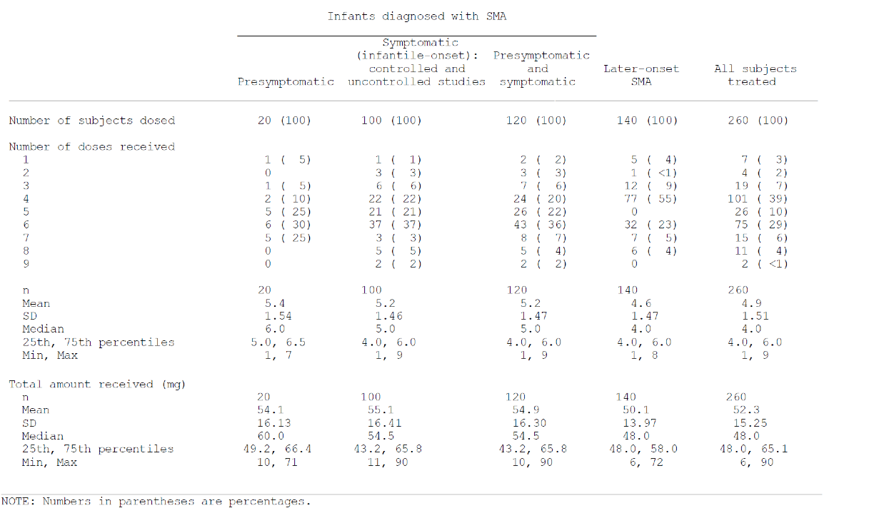

Table 18: Exposure to nusinersen in clinical studies according to duration
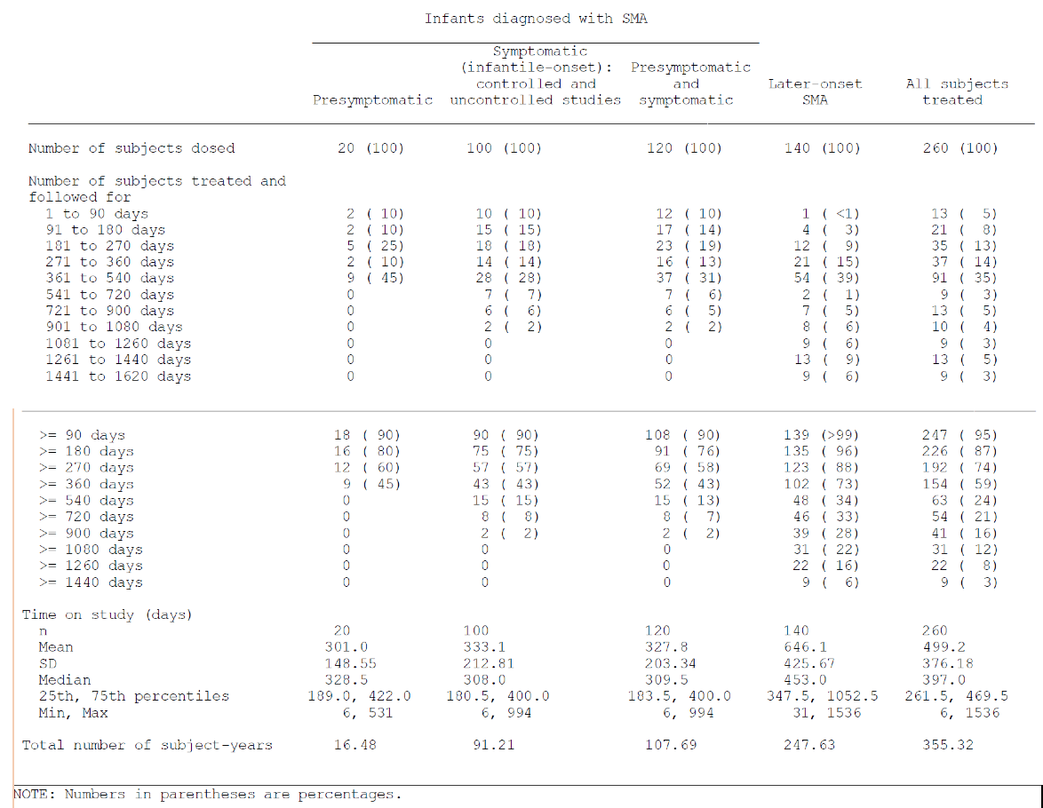

Adverse events

All adverse events (irrespective of relationship to study treatment)

Integrated safety analyses
A total of 2955 events were reported in 247 subjects (95%) overall (Pool F). Of these 2955 events, 1627 events were reported in 97% of subjects in Studies CS3A and CS3B combined (Pool C), 141 events were reported in 80% of subjects in Study SM201 (Pool A), and 1187 events were reported in 96% of subjects with later onset SMA (Pool E).

Pivotal and/or main efficacy studies

Study CS3B
In Study CS3B, AEs were reported most commonly (> 10% of the nusinersen group) in the following system organ classes. Data are presented as nusinersen versus control, and system organ classes (SOCs). Those classes in which the incidence in the nusinersen group is at least 5% lower than that in the control group are shown in italics:
- Infections and infestations (81% versus 76%)
- Respiratory, thoracic and mediastinal disorders (76% versus 88%)
- Gastrointestinal disorders (66% versus 63%)
- General disorders and administration site conditions (64% versus 68%)
- Skin and subcutaneous tissue disorders (29% versus 37%)
- Investigations (26% versus 34%)
- Cardiac disorders (23% versus 32%)
- Injury, poisoning and procedural complications (24% versus 24%)
- Metabolism and nutrition disorders (18% versus 32%)
- Musculoskeletal and connective tissue disorders (14% versus 12%)
- Psychiatric disorders (11% versus 12%)
- Nervous system disorders (11% versus 5%).
For the nervous system disorders system organ class, the incidence in the nusinersen group is more than 5% higher than that in the control group (11% versus 5%). No single event contributed to the higher incidence. The following 10 events with different preferred terms were reported in nine nusinersen treated subjects: nystagmus, involuntary muscle contractions, seizure, drooling, brain injury, clonus, hypoxic-ischemic encephalopathy, language disorder, and somnolence. The single subject who had more than 1 event had an event of brain injury and an event of seizure in the context of the brain injury.
Many of the most commonly reported AEs by preferred term (reported in 20% or more in either the nusinersen or control group) were respiratory and/or infectious in nature: upper respiratory tract infection (nusinersen versus control: 30% versus 22%, respectively), respiratory distress (26% versus 29%, respectively), pneumonia (29% versus 17%, respectively), respiratory failure (25% versus 39%, respectively), atelectasis (23% versus 29%, respectively), acute respiratory failure (14% versus 24%, respectively), cough (11% versus 20%, respectively), and oxygen saturation decreased (13% versus 24%, respectively). Other commonly reported events include pyrexia (56% versus 59%, respectively), constipation (35% versus 22%, respectively), vomiting (18% versus 20%, respectively), gastroesophageal reflux disease (13% versus 20%, respectively), and dysphagia (11% versus 22%, respectively).
In addition to the common AEs (above), the following AEs were reported in 20% or more of subjects in Study CS3A (≥ 20% of nusinersen-treated subjects, n = 20): pyrexia (70%); upper respiratory tract infection (60%); constipation (45%); joint contracture and vomiting (40% each); nasal congestion, pneumonia, respiratory distress, and scoliosis (35% each); cough, gastroesophageal reflux disease, nasopharyngitis, otitis media, respiratory failure, and rhinovirus infection (30% each); atelectasis, diarrhoea, increased upper airway secretion, rash, and respiratory tract infection (25% each); and acute respiratory failure, chronic respiratory failure, dermatitis, hypoxia, kyphosis, pain, teething, and viral infection (20% each).

Study CS4
In Study CS4 (Pool E0), AEs were reported most commonly (in more than 10% of the nusinersen group) in the following SOC (data are presented as nusinersen versus control, and SOCs in which the incidence in the nusinersen group is at least 5% lower than that in the control group are shown in italics):
- Infections and infestations (74% versus 79%)
- Musculoskeletal and connective tissue disorders (36% versus 29%)
- General disorders and administration site conditions (43% versus 40%)
- Injury, poisoning and procedural complications (31% versus 12%)
- Respiratory, thoracic and mediastinal disorders (42% versus 40%)
- Gastrointestinal disorders (38% versus 38%)
- Nervous system disorders (33% versus 17%)
- Skin and subcutaneous tissue disorders (14% versus 14%).
The higher percentage of nusinersen-treated subjects compared to control subjects who experienced musculoskeletal and connective tissue disorders (36% versus 29%, respectively) was largely accounted for by back pain in 25% of nusinersen-treated subjects versus 0% of control subjects. The other events in this SOC that were reported in a higher percentage of nusinersen-treated subjects compared to control subjects were scoliosis (4% (3 subjects) versus 2% (1 subject), respectively) as well as groin pain, muscular weakness, and myalgia (1% (1 subject) versus 0%, respectively, for each event).
The higher percentage of nusinersen-treated subjects compared to control subjects who experienced nervous system disorders (33% versus 17%, respectively) was largely accounted for by headache in 27% of nusinersen-treated subjects versus 7% of control subjects. The other events in this SOC that were reported in a higher percentage of nusinersen-treated subjects compared to control subjects were dizziness and myoclonus (1% (1 subject) versus 0%, respectively, for each event).
A higher percentage of nusinersen-treated subjects compared to control subjects experienced injury, poisoning and procedural complications (31% versus 12%, respectively). No single event contributed to the higher incidence; 34 events with different PTs were reported in 26 subjects. Most the events were injuries such as bone fractures and abrasions. The procedural complications were post lumbar puncture syndrome (nusinersen versus control: 4% versus 0%, respectively), procedural pain (2% versus 2%, respectively), as well as postoperative agitation, anaesthetic pulmonary complication, procedural nausea, and vaccination complication (1% versus 0%, respectively, for each event).

Other studies
In Study CS3A, all 20 subjects (100%) who received treatment reported at least 1 AE. A total of 570 AEs was reported. The most frequently reported events by SOC were infections and infestations (140 events in 19 subjects (95%)). Most these were respiratory in nature; respiratory, thoracic and mediastinal disorders (122 events in 18 subjects (90%)); and gastrointestinal disorders (60 events in 18 subjects (90%)).
In Study SM201, the most common AEs (reported in more than 20% of subjects overall) were infections and infestations (13 subjects (65%) with 47 events); gastrointestinal disorders (8 subjects (40%) with 12 events); skin and subcutaneous tissue disorders (9 subjects (45%) with 11 events); respiratory, thoracic and mediastinal disorders (6 subjects (30%) with 14 events); and general disorders and administration site conditions (6 subjects (30%) with 16 events). The only common AEs by preferred term (reported in 20% or more of subjects) were upper respiratory tract infection (8 subjects (40%)), nasopharyngitis (4 subjects (20%)), and pyrexia (5 subjects (25%))
In Study SM202, AEs were not available due to the ongoing blinding of the study.
In Study CS1, 25 subjects treated with nusinersen experienced 72 AEs. Five subjects had an event that was moderate in severity. The most frequently observed AEs were headache (39.3%), post LP syndrome (21.4%), and back pain (17.9%).
In Study CS2, 32 subjects experienced a total of 211 AEs. 15 subjects had an event that was mild in severity, 13 subjects had an event that was moderate in severity, and 4 subjects had an event that was severe. The most frequently observed AEs were post LP syndrome (38.2%), back pain (26.5%), puncture site pain (23.5%), nasopharyngitis (23.5%), and headache (20.6%).
In Study CS10, of the 18 subjects in the Safety Population, 16 subjects experienced at least one AE (46 AE total): 3 of 4 subjects (75.0%) in the 6 mg CS10 dose cohort and 13 of 14 subjects (92.9%) in the 9 mg CS10 dose cohort (Table 17). Of those subjects with AEs, more than half of the subjects (10/16, 62.5%) experienced only mild events. The majority of AEs recovered (40/46 events, 87%). The most commonly reported TEAEs were headache (16.7%), back pain (16.7%), and upper respiratory tract infection (16.7%).
In Study CS11, total AEs were not reported due to the ongoing blinding of the study.
In Study CS12, all 47 subjects had experienced at least 1 AE with a total of 337 events being reported. The most commonly reported events were infections and infestations (111 events in 36 subjects (76.6%)) and musculoskeletal and connective tissue disorders (59 events in 31 subjects (66.0%)). By preferred term, the AEs reported in at least 10% of subjects were upper respiratory tract infection (36 events in 19 subjects (40.4%)), back pain (23 events in 17 subjects (36.2%)), headache (24 events in 16 subjects (34.0%)), pyrexia (15 events in 10 subjects (21.3%)), post lumbar puncture syndrome (10 events in 10 subjects (21.3%)), scoliosis (10 events in 9 subjects (19.1%)), joint contracture and viral infection (8 events in 7 subjects (14.9%) each), nasopharyngitis (9 events in 6 subjects (12.8%)), gastroenteritis and oropharyngeal pain (7 events in 6 subjects (12.8%) each), viral gastroenteritis (6 events in 6 subjects (12.8%)), and cough (6 events in 5 subjects (10.6%)).

Treatment related adverse events (adverse drug reactions)

Pivotal and/or main efficacy studies

Study CS3B
In Study CS3B, most of the AEs were assessed by the Investigator as unrelated to nusinersen. No AEs were considered by the Investigators to be related to study treatment. Very few events were assessed as possibly related to study treatment with equal distribution between nusinersen treated subjects and the sham treated subjects (nusinersen versus control: 10 events in 9 subjects (11%) versus 7 events in 6 subjects (15%)).

Study CS4
One event was considered related by the Investigator; 1 nusinersen-treated subject experienced nausea post-sedation (procedural nausea). Nausea was attributed to sedation.
A total of 40 events were considered possibly related in 24 nusinersen-treated subjects (29%) and 4 events were considered possibly related in 3 control subjects (7%). One nusinersen-treated subject experienced insomnia. The other possibly related TEAEs, both in the nusinersen-treated and sham treated groups, were generally consistent with those expected in a population with later onset SMA, were consistent with common conditions occurring in the general population, occurred in no more than 1 subject or in the nusinersen group, were consistent with LP.

Other studies
In Study CS3A, 2 out of 20 subjects (10%) experienced mild AEs (1 event each) that were considered possibly related to study treatment. These were transient neutropenia and vomiting.
In Study SM201, 3 subjects (15%) experienced AEs considered by the Investigator to be possibly related to study treatment: muscular weakness and weight-bearing difficulty in 1 subject; hyperreflexia and tachycardia in 1 subject; and pyrexia, ALT increased, and AST increased with eosinophil count, lymphocyte count, and WBC count increased in 1 subject.
In Study SM202, a full listing of AEs was not available due to the ongoing blinding of the study.
In Study CS1, there were 2 AEs considered potentially related to the study drug. Both events were mild in severity and occurred in the low dose cohorts. One subject in Cohort 1 (1 mg) experienced paraesthesia of the left foot medial tarsus, and a subject in Cohort 2 (3 mg) experienced palpitations. No other related TEAE was observed in any of the higher dose cohorts. In terms of procedure related AEs, six of the 55 LPs (10.9%) were associated with post LP syndrome.
In Study CS2, no subjects experienced a treatment-related adverse event. Fourteen (14) of the 91 LPs (15.4%) were associated with post LP syndrome; three subjects in the 3 mg cohort, three subjects in the 9 mg cohort and six subjects in the 12 mg cohorts experienced at least one post LP syndrome. One (1) subject in the 9 mg dose cohort experienced a post LP syndrome following both injections on Day 1 and Day 85. Sixteen (16) events of post LP syndrome were reported because two subjects in the 12 mg cohorts reported two events each; these events, however, were related to the same LP injection and were separated by less than two days.
In Study CS10, no subjects experienced a treatment-related adverse events.
In Study CS11, treatment-related AEs were not reported due to the ongoing blinding of the study.
In Study CS12, as of the data cut-off date, all 47 subjects had experienced at least 1 TEAE with a total of 337 events reported. The most commonly reported events were infections and infestations (111 events in 36 subjects (76.6%)) and musculoskeletal and connective tissue disorders (59 events in 31 subjects (66.0%)). AEs which occurred in at least 10% of subjects included upper respiratory tract infection (36 events in 19 subjects (40.4%)), back pain (23 events in 17 subjects (36.2%)), headache (24 events in 16 subjects (34.0%)), pyrexia (15 events in 10 subjects (21.3%)), post lumbar puncture syndrome (10 events in 10 subjects (21.3%)), scoliosis (10 events in 9 subjects (19.1%)), joint contracture and viral infection (8 events in 7 subjects (14.9%) each), nasopharyngitis (9 events in 6 subjects (12.8%)), gastroenteritis and oropharyngeal pain (7 events in 6 subjects (12.8%) each), viral gastroenteritis (6 events in 6 subjects (12.8%)), and cough (6 events in 5 subjects (10.6%)).

Deaths and other serious adverse events

Pivotal and/or main efficacy studies

Deaths
Study CS3B: In Study CS3B, 13 subjects (16%) in the nusinersen group and 16 subjects (39%) in the control group died. Nineteen deaths were due to respiratory disorders (nusinersen versus control: 9% versus 29%, respectively), including respiratory failure (5% versus 20%, respectively), acute respiratory failure (1% versus 2%, respectively), respiratory arrest (1% versus 0%, respectively), and respiratory distress (1% versus 5%, respectively). Two subjects (3%) in the nusinersen-treated group and 3 subjects (7%) in the control group died of cardio-respiratory arrest. Two subjects (3%) in the nusinersen group died of nervous system disorders, including one due to hypoxic brain injury after cardiorespiratory arrest and one due to hypoxic-ischemic encephalopathy after aspiration. One subject (1%) in the nusinersen-treated group died of general physical health deterioration. One subject (1%) in each group died of unknown causes.
Study CS4: No deaths occurred in Study CS4.

Serious adverse events
Study CS3B: 61 subjects (76%) in the nusinersen group and 39 subjects (95%) in the control group experienced at least one SAE. The most common SAEs were respiratory distress (nusinersen versus control: 26% versus 20%), respiratory failure (25% versus 39%), pneumonia (24% versus 12%), atelectasis (18% versus 10%), acute respiratory failure (14% versus 22%), pneumonia aspiration (10% versus 12%), rhinovirus infection (9% versus 5%), pneumonia viral (8% versus 5%), respiratory tract infection (8% versus 2%), cardiorespiratory arrest (6% versus 12%), respiratory arrest (6% versus 10%), and viral infection (6% versus 2%). No other SAE was reported by more than 5 subjects in the nusinersen group. No SAEs were considered by the Investigator to be related to study treatment.
Study CS4: 12 subjects (14%) in the nusinersen group and 11 subjects (26%) in the control group experienced at least 1 SAE. The most common SAEs were pneumonia (nusinersen versus control: 2% versus 12%), pneumonia viral (2% versus 0%), and respiratory distress (2% versus 5%). No SAE was reported by more than 2 subjects in the nusinersen group. No SAEs were considered by the Investigator to be related to the study treatment.

Other studies

Deaths
In Study CS3A, 4 subjects (20%) died as of the data cut-off date. Two deaths (10%) were due to respiratory failure, one (5%) was due to asphyxia, and one (5%) was due to lower respiratory tract infection viral (see Interim CSR CS3A Table 30). Autopsies were performed on 3 of these 4 subjects. In these subjects, there was clinicopathological correlation with the reported causes of death. Typical changes observed in the setting of SMA were also seen on autopsy, including poor muscle development and the loss of anterior horn cells in the spinal cord. There were no intracellular vacuoles observed similar to the vacuoles observed in the nonclinical monkey toxicity study. Additionally, 1 subject died in Study CS3A after the data cut-off date.
Study SM202 reported one death (brain death).
Study CS11 reported 3 deaths (death due to SMA progression in 1 subject and respiratory events in 2 subjects (pneumonia and acute respiratory failure)).
No deaths occurred in Studies SM201, CS1, CS2, CS10, or CS12.

Serious adverse events
In Study CS3A, a total of 77 SAEs (100%) were reported in 16 subjects (80%). SAEs were most frequently reported in the respiratory, thoracic and mediastinal disorders SOC (35 events (45.5%) in 15 subjects (75%)) and the infections and infestations SOC (32 events (41.6%) in 13 subjects (65%)), most of which were respiratory in nature. Other events included cardiac disorders (5 events (6.5%) in 3 subjects (15%)), metabolism and nutrition disorders (2 events (2.6%) in 2 subjects (10%)), and gastrointestinal disorders, musculoskeletal and connective tissue disorders, and nervous system disorders (1 event each (1.3%) in 1 subject each (5%)). SAEs occurring in more than 1 subject were as follows:
- Acute respiratory failure: 9 events (11.7%) in 4 subjects (20%)
- Respiratory distress: 8 events (10.4%) in 6 subjects (30%)
- Pneumonia: 7 events (9.1%) in 4 subjects (20%)
- Respiratory failure: 6 events (7.8%) in 5 subjects (25%)
- Rhinovirus infection: 4 events (5.2%) in 4 subjects (20%)
- Bronchiolitis: 4 events (5.2%) in 3 subjects (15%)
- Atelectasis: 3 events (3.9%) in 2 subjects (10%)
- Apnoea, pneumonia aspiration, metapneumovirus infection, pneumonia viral, and viral infection: 2 events each (2.6%) in 2 subjects each (10%).
In Study SM201, A total of 6 subjects (30%) had experienced at least 1 SAE. These SAEs were bronchitis, choking, and pneumonia reported by 1 subject; pneumonia reported by 1 subject; urinary tract infection reported by 1 subject; failure to thrive reported by 1 subject; pyrexia reported by 1 subject; and abdominal distension, respiratory distress, dehydration, and rhinovirus infection reported by 1 subject. All SAEs required hospitalisation.
In Study SM202, a total of five subjects (29%) experienced at least 1 SAE. SAEs were bronchitis, pneumonia, urinary tract infection, and failure to thrive reported by 1 subject each and abdominal distension and respiratory distress reported in 1 subject.
In Study CS1, no SAEs were reported during the study.
In Study CS2, there was 1 SAE that occurred pre-treatment and there were 3 treatment emergent SAEs. The 3 treatment emergent SAEs were ‘pseudo-allergic reaction presumably to opioid (fentanyl)’ in a 9-year old; ‘Pneumonia’ in a 4-year-old; and ‘Post Lumbar Puncture Headache’ in a 4-year-old.
In Study CS10, no SAEs re reported.
In Study CS11, a total of 14 SAEs were reported in 6 subjects: upper respiratory tract infection (3 events), respiratory distress (2 events), and 1 event each of acute respiratory failure, bronchial secretion retention, enteral feeding intolerance, pneumonia viral, rhinovirus infection, rotavirus infection, viral infection, urinary retention, and otitis media acute. None of the SAEs were considered by the Investigator to be related or potentially related to study treatment.
In Study CS12, as of the cut-off date, eleven SAEs were reported in 5 subjects (10.6%). Most of the SAEs were infections and infestations (4 subjects (8.5%), 7 events). Viral pneumonia was reported in 2 subjects (4.3%, 2 events); for all other SAEs, 1 event was reported in 1 subject each. None of the SAEs were assessed as potentially related to the study drug.

Discontinuations due to adverse events

Pivotal and/or main efficacy studies

Study CS3B
A lower percentage of nusinersen subjects discontinued treatment due to an AE (16% versus 39%). All discontinuations, in both groups, were due to fatal SAEs. 29 subjects died during the study, all as a result of SAEs related to SMA disease progression.

Study CS4
No subjects discontinued treatment or withdrew from the study as a result of an AE.

Other studies
In Study CS3A, other than the 4 subjects who experienced an SAE with fatal outcome, no subjects discontinued treatment or withdrew from the study due to an AE.
In Study SM201, no subjects experienced AEs that led to withdrawal from the study.
In Study SM202, no subjects experienced AEs that led to withdrawal from the study.
In Study CS1, no subjects experienced AEs that led to withdrawal from the study.
In Study CS2, no subjects experienced AEs that led to withdrawal from the study.
In Study CS10, no subjects experienced AEs that led to withdrawal from the study.
In Study CS11, there were no reported discontinuations.
In Study CS12, 11 SAEs were reported in 5 subjects (10.6%). Most of the SAEs were infections and infestations (4 subjects (8.5%), 7 events). Viral pneumonia was reported in 2 subjects (4.3%, 2 events). For all other SAEs, 1 event was reported in 1 subject each. None of the SAEs were assessed as potentially related to the study drug.

Evaluation of issues with possible regulatory impact

Liver function and liver toxicity
Changes in liver function were defined as an increase above the normal range. The results were further defined if they fell into the following ranges; > 3 x ULN, > 5 x ULN, > 10 x ULN and > 20 x ULN.
      - Pivotal and/or main efficacy studies

Study CS3B
The incidence of shifts from normal to low bilirubin was higher in the nusinersen group (70% versus 50%). The incidence of shifts from normal to low alkaline phosphatase (14% versus 7%) and from normal to high alkaline phosphatase (4% versus 0%) were also higher in the nusinersen group. The incidences of shifts from normal to high ALT and AST were similar in the two groups (ALT: 14% versus 13%; AST: 7% versus 3%). nusinersen subjects did not have a sustained increase in liver enzymes while being continuously exposed to drug.
The following AEs related to liver function were reported in the study:
- liver function test abnormal (1% (1 subject) versus 0%); returned to normal upon retest 14 days later
- ALT increased (1% (1 subject) versus 0%)
- AST increased (1% (1 subject) versus 0%)
- transaminases increased (0% versus 2% (1 subject))

Study CS4
The incidence of shifts from normal to low bilirubin was similar in the nusinersen group and the control group (nusinersen versus control: 69% versus 63%). The incidence of shifts from normal to low alkaline phosphatase was higher in the nusinersen group (12% versus 3%). The incidences of shifts from normal to high ALT and AST were similar in the 2 groups (ALT: 2% versus 7%; AST: 2% versus 2%). nusinersen subjects did not have a sustained increase in liver enzymes while being continuously exposed to drug. The following AEs were reported, both in the control group:
- ALT increased (nusinersen versus control: 0% versus 1%)
- AST increased (0% versus 1%).

Other studies
In Study CS3A, no evidence of liver toxicity was reported.
In Study SM201, 5 subjects with a shift to high in ALT and AST had minor elevations, and the values returned to normal over time. Alkaline phosphatase was not elevated in any the 5 subjects with shifts to high in ALT or AST at any time in the study. Two subjects with a shift to high in ALT had a bilirubin value at screening that was flagged as high. In 1 of these subjects, the high value for bilirubin at screening was associated with AEs for blood unconjugated bilirubin increased starting at Day 2. The subject recovered from these AEs on Day 29.
Study SM202, did not report on liver function.
In Study CS1, values were generally within normal limits throughout the study for all subjects, and no patterns were identified.
In Study CS2, values were reported as generally within normal limits throughout the study for all subjects, and no patterns were identified at any dose.
In Study CS10, values were generally within normal limits throughout the study for all subjects, and no patterns were identified.
Study CS11, did not report on liver function.
In Study CS12, values were generally within normal limits throughout the study for all subjects, and no patterns were identified.

Renal function and renal toxicity

Pivotal and/or main efficacy studies

Study CS3B
The incidence of shifts from normal to low creatinine that is a shift to below the normal range, (20% versus 17%) was similar in the 2 groups. No subjects had shifts from normal to high creatinine. The incidence of shifts from normal to low BUN (4% versus 0%) and from normal to high BUN (1% versus 0%) was similar between the two groups. The 1 subject with elevated BUN in the nusinersen group did not have a Screening value available, had high BUN (8.56 mmol/L) at the Day 64 visit, and had normal values on all subsequent visits. The dossier stated that no clinically significant changes from Baseline were observed in urinalysis results. However, proteinuria occurred in 17 of 51 (33%) nusinersen subjects with infantile onset SMA, compared to 5/25 (20%) control subjects (Table 19).

Table 19: Summary of shifts from Baseline for urinalysis

Study CS4
The incidence of shifts from normal to low creatinine was higher in the nusinersen group (48% versus 39%). One subject in the nusinersen group had an isolated shift from normal to high creatinine that returned to normal at the next assessment. Two subjects in the nusinersen group and 1 subject in the control group shifted from normal to high BUN (2% versus 2%); each of these subjects had an isolated shift that returned to normal at the next assessment. One subject in each group had a shift from normal to a low sodium count (1% versus 2%). No clinically significant changes from Baseline were observed in urinalysis results.

Other studies
In Study CS3A, no clinically significant changes from Baseline were observed.
In Study SM201, no subjects had shifts from normal at Screening to high post-treatment for creatinine, blood urea nitrogen, and protein.
Study SM202, did not report on renal function.
In Study CS1, no patterns were identified in measures of renal function.
In Study CS2, values were generally within normal limits and no patterns were identified.
In Study CS10, values were generally within normal limits throughout the study for all subjects, and no patterns were identified.
Study CS11, did not report on renal function.
In Study CS12, values were generally within normal limits and no patterns were identified.

Other clinical chemistry

Pivotal and/or main efficacy studies

Study CS3B
One subject in the nusinersen group had a shift from normal to a low sodium count that is a shift to below the normal range, (1% versus 0%). No subjects shifted from normal to high sodium. The incidence of shifts from normal to low blood chloride was 7% in the nusinersen group and 3% in the control group. One subject in the nusinersen group shifted from normal to high chloride (that is a shift to above the normal range). The incidence of shifts from normal to low blood potassium was 6% in the nusinersen group and 12% in the control group. The incidence of shifts from normal to high blood potassium was 8% in the nusinersen group and 3% in the control group.

Study CS4
No subject experienced a Grade 3 or 4 result for blood chemistry post-baseline and there were no clinically significant patterns identified.

Other studies
In Study CS3A, low sodium values, reported as AEs of hypernatremia, were reported in 2 subjects.
In Study SM201, a few subjects experienced slight, transient elevations in post-treatment levels compared with Screening for albumin (3 subjects), calcium (2 subjects), glucose (4 subjects), and potassium (2 subjects). Screening and post-treatment values for creatine kinase (CK) varied among subjects over time. Of 16 subjects for whom Screening values were available, 11 were within normal limits and 5 were flagged as high. Of these 11 subjects, at least 1 post-treatment CK value was available for 10 subjects. Of these 10 subjects, 4 experienced no post-treatment CK elevations. A total of 7 subjects experienced shifts to high in CK levels: 6 subjects had a shift to high from normal values at Screening, and 1 subject without a CK Screening value had a shift to high from normal values on Day 29.
Study SM202, did not report on clinical chemistry.
In Study CS1, no patterns were identified for the clinical chemistry.
In Study CS2, only 1 abnormal chemistry result was reported as an AE. A 9-year-old white female in the 9 mg dose cohort, had a low bicarbonate value of 16 mEq/L (reference range: 21 to 33 mEq/L) on Day 2 and this remained stable but below the reference range through the final assessment on Day 169.
In Study CS10, no patterns were identified for the clinical chemistry.
Study CS11, did not report on clinical chemistry.
In Study CS12, Values were generally within normal limits throughout the study for all subjects, and no patterns were identified.

Haematology and haematological toxicity

Pivotal and/or main efficacy studies

Study CS3B
Shifts to low and high were observed for all parameters in both groups. The incidence of shifts from normal to a low platelet count (that is a shift to below the normal range) was higher in the nusinersen group (13% versus 0%). At baseline, the mean and median platelet counts were similar for the two groups, but the minimum value was lower and the maximum value was higher in the nusinersen group (nusinersen versus control: mean of 423 x 10⁹/L (range 5 to 818 x 10⁹/L) versus 441 x 10⁹/L (range 247 to 735 x 10⁹/L)), leading to a larger range of values. There was a similar pattern for every single time point thereafter. Both groups had subjects with a decrease from Baseline of 100 x 10⁹/L or greater. In the nusinersen group, the maximum decreases from Baseline went from 303 x 10⁹/L at Day 64 to 451 x 10⁹/L at Day 394. In the control group, the maximum decreases from Baseline went from 146 x 10⁹/L at Day 64 to 186 x 10⁹/L at Day 394. A review of individual laboratory listings did not reveal a sustained thrombocytopenia while being treated with nusinersen. The following AEs corresponding to changes in haematology values were reported:
- anaemia (nusinersen versus control: 1% versus 2% (1 subject per treatment group))
- neutrophil count increased (1% (1 subject) versus 0%)
- leucocytosis (0% versus 2% (1 subject)).

Study CS4
Shifts to low or high were observed for all parameters in both groups. The incidence of shifts from normal to a low platelet count was lower in the nusinersen group than in the control group (20% versus 26%). There was no sustained thrombocytopenia while being treated with nusinersen. Subjects with a value lower than 100,000 had a repeat result within close proximity of the abnormal result that showed normal platelet counts. The following AEs corresponding to changes in haematology values were reported:
- Anaemia (nusinersen versus control: 4% versus 2%)
- Leucocytosis (1% versus 0%).

Other studies
In Study CS3A, no clinically significant changes from Baseline were observed in coagulation. Changes in haematology values in study subjects included neutrophil count increased (3 events in 2 subjects), WBC count increased and anaemia (2 events each in 2 subjects each), and neutropenia and thrombocytosis (1 event each in 1 subject each). The neutropenia was considered possibly related to nusinersen.
In Study SM201, 2 AEs associated with shifts in haematology values were reported: eosinophilia in 1 subject (mild in severity, unlikely related to study drug) and neutropenia in 1 subject (moderate in severity, not related to study drug). In terms of coagulation studies, 6 of 16 subjects with elevated tests prior to dosing on Day 1 had a high activated partial thromboplastin time value. Of the 14 subjects, 3 subjects had a high prothrombin time value and 1 subject had a low prothrombin time value prior to dosing on Day 1.
Study SM202, did not report on haematology.
In Study CS1, 1 subject receiving the 6 mg dose had an abnormal haemoglobin distribution width (HDW; value of 2.53 g/dL (reference range = 2.69 to 3.17 g/dL)). This subject also reported intermittent pain in left and right thighs, triggered by leg movements and supported walking (pain in extremity) that was assesses as possibly related to the LP. There were no clinically significant patterns identified.
In Study CS2, one patient had a low haemoglobin reported after an episode of epistaxis. There were no clinically significant patterns identified.
In Study CS10, no clinically significant changes from Baseline were observed.
Study CS11, did not report on haematology.
In Study CS12, Values were generally within normal limits throughout the study for all subjects, and no patterns were identified. No subjects had TEAEs related to haematology laboratory results.

Electrocardiograph findings and cardiovascular safety

Pivotal and/or main efficacy studies

Study CS3B
In terms of ECG findings, seventeen subjects (26%) in the nusinersen group and 5 subjects (15%) in the control group shifted from normal or unknown at Baseline to abnormal, not clinically significant post-baseline. Eight subjects (12%) in the nusinersen group and none in the control group shifted from normal or unknown at Baseline to abnormal, clinically significant post-baseline.
Two subjects in the nusinersen group and 1 subject in the control group had an abnormal non-clinically significant ECG at screening that shifted to clinically significant post-baseline. Several additional subjects had clinically significant and non-clinically significant abnormal ECGs at Baseline. There was no overall pattern in the ECG results.
One nusinersen treated subject had ventricular tachycardia. The event was reported by the parent, beginning on Day 57. The last dose of study treatment prior to the event was on Day 29. At the time the event began, the subject also had a respiratory infection and was treated with an antibiotic. The event, which was reported as resolved on Day 66, was assessed as moderate in severity and unlikely related to nusinersen. The next day, on Day 67, the subject was afebrile and had diarrhoea (which may have been associated with the antibiotic). That same day, the subject received her scheduled dose of nusinersen and ventricular tachycardia was reported approximately 4 hours after dosing. No action was taken with the study treatment. The subject continued to participate in the study and no subsequent ventricular tachycardia or other cardiac events were reported. Of note, this subject had a QTc of 455 ms at screening, prior to exposure to nusinersen, which decreased to 420 ms on Day 2, 446 ms on Day 29, and 391 ms on Day 197.

Study CS4
In terms of ECG findings, twenty-three subjects (36%) in the nusinersen group and 13 subjects (39%) in the control group shifted from normal or unknown at Baseline to abnormal, not clinically significant post-baseline changes in their ECGs. No subjects (0%) in the nusinersen group and 2 subjects (6%) in the control group shifted from normal or unknown at Baseline to abnormal, clinically significant post-baseline. Several additional subjects had clinically significant and non-clinically significant abnormal ECGs at Baseline. The study reported that clinically significant ECG results indicated no overall pattern.

Other studies
In Study CS3A, 3 subjects had post-dose ECG abnormalities that were documented as ‘abnormal, clinically significant’ in the test results. None of the findings was considered an AE by the Investigators. For all 3 subjects, the initial ECG findings were suggestive of ventricular hypertrophy. However, echocardiograms were performed as a result of the abnormal ECG findings, all showing normal or near normal results.
In Study SM201, no clinically significant abnormal ECG results were reported.
Study SM202, did not report on ECG findings.
In Study CS1, there were no clinically significant adverse changes in ECG parameters for any subject receiving study drug treatment.
In Study CS2, there were no clinically significant adverse changes in ECG parameters for any subject.
In Study CS10, Overall, there were no clinically significant changes in ECG parameters (ventricular rate, PR interval, QRS duration, QT, or QTc) as compared to the original baseline in nusinersen.
In Study CS11, ECG results were not reported.
In Study CS12, there were no clinically significant changes in ECG parameters (ventricular rate, PR interval, QRS duration, QT interval, or corrected QT interval).

Vital signs and clinical examination findings
No clinically significant physical examination or vital signs findings were described as associated with the investigational product, nusinersen. Information related to vital signs are summarised below.

Pivotal and/or main efficacy studies

Study CS3B
There was no pattern identified in the vital signs or physical examination which fluctuated throughout participation in the trial. There were no notable consistent differences between the nusinersen group and the control group in any vital signs category.

Study CS4
There was no pattern identified and vital signs physical examination which fluctuated throughout participation in the study. The study reported that there were no safety concerns related to nusinersen raised by the findings from the vital sign measurements.

Other studies
In Study CS3A, abnormalities that were reported as AEs included the following: pyrexia (14 subjects); hypoxia (4 subjects); bradycardia (3 subjects); tachycardia and oxygen saturation decreased (2 subjects each); and essential hypertension, heart rate decreased, heart rate increased, hypertension, tachypnoea, and ventricular tachycardia.
In Study SM201, AEs associated with vital sign abnormalities included pyrexia (3 subjects (18%)) and hypertension and respiratory distress (reported in 1 subject (6%) each).
In Study SM202, did not report on vital signs or physical examination.
In Studies CS1 and CS2, heart rate, systolic and diastolic blood pressure, respiratory rate, and temperature assessments did not reveal any apparent treatment- or dose-related trends over time.
In Study CS10, there were no clinically significant changes in heart rate or respiration for subjects reported as AEs. There was 1 AE reported (hypotension) which was not considered related to nusinersen.
Study CS11, did not report on vital signs or physical examination.
In Study CS12, results of vital sign measurements did not reveal any clinically significant changes or patterns. Abnormal vital signs included pyrexia (10 subjects (21.3%), 15 events), heart rate increased, and tachycardia (1 event in 1 subject (2.1%) each). All AEs resolved without the need for interruption or discontinuation of study drug.

Immunogenicity and immunological events

Pivotal and/or main efficacy studies

Study CS3B
Overall, 3 subjects (all in the nusinersen group) had treatment emergent ADA positive results, all at single time points only. One subject had a transient response with a positive response at Day 64 and negative results thereafter. Two subjects were considered to have persistent responses: 1 subject was positive only at Day 222 but this was the last available ADA result for this subject, and the other subject was positive only at Day 183 but did not have at least 16 weeks with negative data available beyond that point.

Study CS4
The dossier stated that immunogenicity analyses were not conducted for this interim report.

Other studies
In Study CS3A, 1 out of 20 subjects (5%) in the Safety Population had a confirmed antibody-positive test result. The subject was considered to have a transient response (2 positive samples: one at the Day 253 and one at the Day 820 evaluation, with all other samples at prior and subsequent time points negative for immunogenic response). AEs experienced by this subject during the study were of mild or moderate severity and were predominantly respiratory in nature. The transient immunogenic response was not considered to have an impact on the subject’s safety profile. The subject is continuing in the study with positive efficacy response and a general decrease in AEs over time.
In Study SM201, no subjects developed anti-nusinersen antibodies.
In Study SM202, did not report on immunogenicity.
In Studies CS1 and CS2, plasma samples collected for subjects in Cohorts 3 and 4 only. Samples from days 1, 8, 29, and 85 were analysed for the presence of anti-nusinersen antibodies using an immunogenicity assay. A total of 63 samples were evaluated, all of which were negative for the presence of specific anti-nusinersen antibodies.
Study CS10, did not report on immunogenicity.
Study CS11, did not report on immunogenicity.
Study CS12 did not present any specific immunological data.

Serious skin reactions
One patient in Study CS3B was identified as having a potentially serious skin reaction which may have been a vasculitis. The sponsor stated that the changes observed were more consistent with post inflammatory changes following an acute skin infection as follows:
‘One subject experienced mild suspected vasculitis of the right hand and naevus anaemicus on both forearms; both conditions were assessed as possibly related to nusinersen. There was no sign of systemic vasculitis. Prior to this event, the subject had a staphylococcal skin infection on the right hand. The subject was seen by a dermatologist who noted anaemic/hypopigmented maculas on both forearms and post-inflammatory residuals/scar like atrophic whitish plaque on the back of the left hand after initial haemorrhagic macula which occurred after vaccination. The dermatologist noted no change or other diagnosis, and no biopsy or further diagnostic procedures and therapies were considered necessary. The suspected vasculitis of the hand resolved spontaneously, and the subject continued with study treatment’.
Also, the FDA identified 3 cases of vasculitis in their submission.

Other safety issues

Growth
In Study CS3B, growth in the active treatment group was less than in the in the sham treatment group (see Figures 24 and 25, below). This is not fully explained in the dossier.
Figure 24: Study CS3B change in body length over the study
Figure 25: Study CS3B change in body weight over the study

Hippocampal toxicity
The issue of hippocampal toxicity in the preclinical data is well summarised in the EU 90 Day questions (below).
In the 14 week monkey toxicity study, 1/7 animals at 3 mg had a necrotic neuron in the hippocampus. Another animal at this dose had some necrotic glial cells, which were also seen in 1 recovery animal at this dose. In the 53 week study, some necrotic cells and cellular debris were observed in the hippocampus in 1 male at 1 mg and 3/7 males at 4mg. Rare necrotic cells were also noted (in the hippocampus) in one recovery male at 4.0 mg. The Applicant goes onto say that based on a 5 point microscopic severity grading scale, the hippocampal vacuolation findings from both studies were mainly slight (Grade 1) and minimal (Grade 2) with one mild (Grade 3). In the opinion of the study pathologist, the histologic findings in the hippocampus were unlikely to cause any clinical signs or influence animal ability to function. This interpretation, based on the microscopic severity, was supported by the lack of effects on neurobehavioral assessments in these animals. As a result, 4 mg was considered the NOAEL in the 53 week study and 1 mg in the 14 week study. Further elaboration on the potential of long-term effects given the persistence of these observations is needed, and to compare it to existing references documenting similar observations.
This risk was not directly addressed in the clinical trials data. There was no direct evidence of toxicity in the safety data. This may be because the toxicity in not present in humans. Alternatively, it may be that the changes are not evident clinically in the timeframe over which the studies were conducted.

Risk of lumbar puncture with skeletal abnormalities
The EU Day 120 questions raised the important issue of the risk of lumbar puncture in patients with scoliosis. In response, the sponsor completed an analysis of patients reported to have scoliosis, shown in Table 20 below, and found no increased risk in that group of patients.

Table 20: Frequency of treatment emergent adverse events related to LP complication for subjects with a history of scoliosis or contractures

Safety in special populations
There are no further safety data related to special populations.

Safety related to drug-drug interactions and other interactions
No drug-drug interaction studies were conducted as part of drug development.

Post marketing experience
There is currently no post marketing experience available.

Evaluator’s overall conclusions on clinical safety
Overall the safety profile of nusinersen is favourable compared to other antisense molecules. This may be, in part, due to the fact that it is largely confined to the CSF and systemic exposure is limited. Many of the adverse events documented were related to the progress of the underlying disease including the deaths and the requirement for ventilator support.
The specific safety issues raised in the dossier are listed below.
- There is a risk of complications of the lumbar puncture associated with administration of nusinersen, especially if there is concurrent thrombocytopenia. The lower platelet count observed in itself would most likely not be clinically significant. However, if there were a small risk of an extradural bleed with a lumbar puncture, this may be unacceptable because of the potential for a severe outcome with paraplegia. There may also be the risk associated with sedation if this is required for the performance of the lumbar puncture.
- The risk of prolonged QTc has not been completely tested. The assessment of the QTc interval is not fully described. This is important as there were reports of ventricular tachycardia in treated patients that are otherwise unexplained.
- There is a potential renal risk of proteinuria given the nature of nusinersen as an antisense oligonucleotide. There is no signal for this in the clinical trials. However, as the systemic exposure of nusinersen is lower than if an oligonucleotide were administered directly into the systemic circulation, renal risks may require a prolonged exposure to be identified.
- Hyponatraemia has been reported in some patients treated with nusinersen. This did not result in any observable acute clinical deterioration in the studies. Prolonged or severe hyponatraemia can result in clinical consequences if unrecognised or untreated.
- Some patients treated with nusinersen had increases in ALT levels. It is uncertain whether these changes may represent an increased risk of liver damage due to nusinersen.
- There is an ongoing risk of immunological reactions in patients treated with nusinersen. The extent and implications of such reactions are, at present, unknown. The development of antibodies with other biological agents can result in either a decrease in efficacy of the treatment or a severe allergic reaction which can be life threatening. Neither of these were observed in the clinical studies.
- There is an unanswered question about the risk of vasculitis in patients treated with nusinersen. There is a single case report (Study CS3B) which may have been a case of vasculitis.
- In the sponsor’s submission to the FDA, 3 cases of vasculitis were identified which were not clearly apparent in the dossier submitted to the TGA. These cases should be identified in the dossier and described in detail.
- In Study CS3B, there was relatively poor growth in some patients treated with nusinersen when compared to sham treated patients. This is unexpected given the clinical motor improvement and the overall improvement in survival.
- Hippocampal damage identified in pre-clinical studies has not been identified in the clinical studies but remains a potential risk with prolonged exposure to nusinersen.
- There is currently a lack of long-term data in the use of nusinersen. It is uncertain whether the clinical benefits observed in the studies will persist over years.
- There is a lack of safety data in adults over the age of 18 years of age treated with nusinersen. It is uncertain whether adults will have a higher rate of particular adverse effects; for example, immunological reactions or organ dysfunction.

First round benefit-risk assessment

First round assessment of benefits
The evaluator’s first round assessment of the benefits of Spinraza nusinersen for the proposed indication are outlined in Table 21, below.

Table 21: First round assessment of benefits
Indication
Benefits | Strengths and Uncertainties
Spinal muscular atrophy (SMA), is a severe neuromuscular disease. Spinraza, nusinersen is the first novel treatment to offer improvement in outcome for both symptomatic and pre-symptomatic patients with SMA Types I, II and III. The main benefits of Spinraza are the improvement in muscle function and improved survival in treated patients as demonstrated in the pivotal studies.  In severely affected individuals with Infantile onset SMA (Study CS3b), there were significant clinical improvements in treated patients.  51% of subjects in the treatment group achieved a response compared to 0% in the control group (p < 0.0001).  16 subjects (22%) achieved full head control, 6 subjects (8%) achieved independent sitting, and 1 subject (1%) achieved standing.  Survival was improved in treated patients with 13 deaths (16%) in the treated groups compared to 16 subjects (39%) the control group (p = 0.0041).  In less severely affected individuals with later onset SMA (Study CS4), the interim efficacy analysis demonstrated that significant clinical improvements at 15 months of treatment. The HFMSE scores from Baseline to Month 15 improved by 4 in the treatment group while there was and a decline of 1.9. The total difference of 5.9 was highly statistically significant (p = 0.0000002). There were no deaths in this study.  The supporting uncontrolled studies are consistent with the pivotal controlled studies. They do demonstrate improvement in motor function where inevitable motor decline or severe delay is the usual outcome in SMA.  The safety profile of Spinraza is acceptable given the severity of the disease that is being treated. There are few drug-related adverse events and there were no severe outcomes (such as death or increased rate of ventilation) attributable to the treatment. This is in a disease where premature death of ventilator dependency is common and inevitable in Type I SMA. | The strength of the application is the strong treatment effect of Nusinersen in terms of motor function and potential survival in an otherwise untreatable disease.  There is significant uncertainty about the long-term effectiveness of nusinersen in all patients with SMA. There is also a lack of data in the treatment of milder disease in adults greater than 18 years of age.  Furthermore, there are no data on the use of nusinersen in the most severe form of the disease (SMA 0) or the mildest adult form (SMA IV). However, it is likely that that Type 0 SMA would survive long enough to benefit from treatment.  Another uncertainty is whether the proposed dose of nusinersen (12mg intrathecally administered once every 4 months after an initial loading regimen) is optimal or whether higher or more frequent dosing may further improve outcomes.

First round assessment of risks
The evaluator’s first round assessment of risks of Spinraza nusinersen for the proposed indication are outlined in Table 22, below.

Table 22: First round assessment of risks
Risks | Strengths and Uncertainties
Given the rarity of SMA and the difficulty of performing placebo-controlled clinical trials in such a severe disease, the dossier presents a comprehensive review of the risks associated with nusinersen. Overall, for a treatment of such a severe disease the treatment has quite a low risk of adverse events. The main risk is associated with the intrathecal administration and the complications of recurrent lumbar punctures (especially as nusinersen may be associated with thrombocytopenia in some cases).  There are also the potential risks of organ dysfunction, immunoreactivity and CNS damage as described in the animal models.  There is also the risk that the short-term gains in motor function may not persist or continue long-term.  The specific safety issues are included below this table. | The incorporation of long term postmarketing monitoring of both efficacy and safety as proposed in the EU registration will potentially clarify the long-term outcomes of the treatment of patients with SMA with nusinersen.  This monitoring of the patient cohort (more than just routine post market surveillance) of these patients will determine the rate of immunoreactivity, whether there is a significant risk form the recurrent lumbar punctures and identify and whether the hippocampal changes in animals appear to translate into clinically significant sequelae in patients.  There is still significant uncertainty as to whether 12 mg is the optimal dose or further benefits could be gained by increasing the dose. There is no current plan to address this.
The specific safety issues raised in the dossier are outlined as follows:
- There is a risk of complications of the lumbar puncture associated with administration of nusinersen, especially if there is concurrent thrombocytopenia. The lower platelet count observed in itself would most likely not be clinically significant. However, if there were a small risk of an extradural bleed with a lumbar puncture, this may be unacceptable because of the potential for a severe outcome with paraplegia. There may also be the risk associated with sedation if this is required for the performance of the lumbar puncture.
- The risk of prolonged QTc has not been completely tested. The assessment of the QTc interval is not fully described. This is important as there were reports of ventricular tachycardia in treated patients that are otherwise unexplained.
- There is a potential renal risk of proteinuria given the nature of nusinersen as an antisense oligonucleotide. There is no signal for this in the clinical trials. However, as the systemic exposure of nusinersen is lower than if an oligonucleotide were administered directly into the systemic circulation, renal risks may require a prolonged exposure to be identified.
- Hyponatraemia has been reported in some patients treated with nusinersen. This did not result in any observable acute clinical deterioration in the studies. Prolonged or severe hyponatraemia can result in clinical consequences if unrecognised or untreated.
- Some patients treated with nusinersen had increases in ALT levels. It is uncertain whether these changes may represent an increased risk of liver damage due to nusinersen.
- There is an ongoing risk of immunological reactions in patients treated with nusinersen. The extent and implications of such reactions are, at present, unknown. The development of antibodies with other biological agents can result in either a decrease in efficacy of the treatment or a severe allergic reaction which can be life threatening. Neither of these were observed in the clinical studies.
- There is an unanswered question about the risk of vasculitis in patients treated with nusinersen. There is a single case report (Study CS3B) which may have been a case of vasculitis.
- In the sponsor’s submission to the FDA, 3 cases of vasculitis were identified which were not clearly apparent in the dossier submitted to the TGA. These cases should be identified in the dossier and described in detail.
- In Study CS3B, there was relatively poor growth in some patients treated with nusinersen when compared to sham treated patients. This is unexpected given the clinical motor improvement and the overall improvement in survival.
- Hippocampal damage identified in pre-clinical studies has not been identified in the clinical studies but remains a potential risk with prolonged exposure to nusinersen.
- There is currently a lack of long-term data in the use of nusinersen. It is uncertain whether the clinical benefits observed in the studies will persist over years
- There is a lack of safety data in adults over the age of 18 years of age treated with nusinersen. It is uncertain whether adults will have a higher rate of particular adverse effects; for example, immunological reactions or organ dysfunction.

First round assessment of benefit-risk balance
The benefits of the use of Spinraza in patients with SMA are significant. Spinraza addresses an unmet need in this group of severely affected individuals. There are improvements in motor function and survival in treated patients when compared with sham treated controls. These changes are clinically and statistically highly significant. In Infantile onset SMA, there is an improvement in motor function and survival following treatment compared to controls. In later onset SMA, there is a highly significant improvement in motor function compared to controls.
This is pivotal as, up until now, there has been no effective therapy for SMA. Up until now, supportive therapies such as physiotherapy and occupational therapy do not alter the progress of the disease with progressive muscle weakness. As the SMA worsens, poor lung function may result in recurrent respiratory infections and the consequences of muscle weakness. These are addressed by specific therapies including antibiotics, alimental supplementation and ventilatory support. However, none of these therapies address the fundamental problem of the inevitable physical decline associated. Spinraza is the first treatment to address the underlying cause of SMA and result in an improved outcome.
SMA Type 0 and Type IV were not addressed in the dossier. Type 0 SMA is a severe disease and patients do not live long enough to potentially benefit from therapy. Also, as patients with Type 0 only have a single copy of the SMA2 gene, there is limited potential for Spinraza to be effective. Type IV SMA is a relatively mild disease with near normal motor function and a normal life expectancy; the risk to benefit ratio of treatment with Spinraza in these patients may be unfavourable. Type IV SMA was not addressed in the dossier and is not specifically excluded in the proposed indication. The ‘Precautions’ section of the PI should include the statement that Type IV SMA is a mild disease with normal lifespan and Spinraza has not been investigated in this group of patients.
The risks of the use of Spinraza are related to the uncertainty as to whether the dosing is optimal, the long-term efficacy, use in adults over 18 years of age. Otherwise there are few drug-related adverse events and there were no severe outcomes (such as death or increased rate of ventilation) that were attributable to the treatment. Most of the treatment related adverse effects related to the lumbar puncture procedure such as nausea post-sedation or post-lumbar puncture syndrome. In Study CS3B no AEs were considered by the study investigators as being related to Spinraza. There are some unresolved safety concerns including potential QT changes, the risk of recurrent lumbar punctures and central nervous system effects. There is also a risk associated with sedation if this is required as part of performing the lumbar puncture. The QT changes are inadequately investigated and this is a specific deficiency in the studies. The other risks, including those associated with the lumbar puncture and the administration of a medicine in to the central nervous system, are inherent to the management of the SMA with Spinraza. These risks can be addressed by the sponsor in their follow-up responses to the questions and the implementation of a comprehensive post-marketing program.
Spinraza is an effective treatment in a severe disease (SMA) with no effective treatment. It addresses an unmet need and the safety profile is acceptable given the severity of the illness. Furthermore, the outstanding risks can be addressed by the sponsor. The benefits of Spinraza outweigh the outstanding risks and it can be recommended for approval for marketing in Australia.

First round recommendation regarding authorisation
The evaluator recommends the authorisation of Spinraza ‘for the treatment of spinal muscular atrophy (SMA)’. This is because of the significant improvement in motor function and improved survival in patients with SMA treated with Spinraza. There are some outstanding issues regarding whether 12 mg is the optimal dosing and some safety concerns around the risk of lumbar puncture if a patient develops thrombocytopenia. However, these can be addressed with the suggested changes to the product information and ongoing post marketing surveillance.

Clinical questions

Clinical questions

Pharmacokinetics
The following deficiencies in the presented pharmacokinetic data should be addressed by the sponsor:
- Could the sponsor please clarify the development of the dosing schedule?
- Could the sponsor please clarify the exact basis on which the proposed dosing regimen was based?
- Is there a possibility that an increased dose may be of benefit to poor responders?
- Could the sponsor please address that there are no data in adults older than 18 years of age although Spinraza is likely to be used in that population?
- Could the sponsor clarify whether any pharmacokinetic data beyond 16 months of treatment will be available as part of post-marketing surveillance or through the proposed patient registry?

Pharmacodynamics
No questions.

Efficacy
- For Study CS4, could the sponsor please submit the final study report as soon as it becomes available?

Ongoing supportive studies
- Could the sponsor outline on how it will provide updates on outcomes of the ongoing supportive studies as these become available?

Safety
- Given the nature of the nusinersen, how will the sponsor monitor liver function, especially ALT concentrations, in treated patients as part of their Risk Management Plan?
- Given that nusinersen is an antisense oligonucleotide, will the sponsor monitor renal function, including urinary protein concentrations, as part of their Risk Management Plan?
- How will the sponsor monitor biochemical markers including hyponatraemia as part of their Risk Management Plan? Will this be more than routine Pharmacovigilance, for example as part of the proposed registry?
- There is a risk of thrombocytopenia in some patients treated with nusinersen. As patients are subject to regular lumbar puncture, will the sponsor provide a specific recommendation (in the product information) as to whether it is necessary to monitor platelet levels prior to a lumbar puncture?
- Could the sponsor please report on changes in QT interval and the risk of ventricular tachycardia in the dossier?
- Could the sponsor please include a comprehensive approach to detecting immunological changes in their Risk Management Plan?
- Could the sponsor please supply detailed clinical information in relation to cases of potential vasculitis? Please include clinical photos in the response to this question?
- Could the sponsor please incorporate a comprehensive approach to detecting any necrotic CNS changes in treated patients in their Risk Management Plan?
- Is it possible for Australian patients to be included in the proposed European post marketing strategy?

Second round evaluation of clinical data submitted in response to questions
The sponsor has not identified any errors or omissions in the first round Clinical Evaluation report.
This section has been structured around the clinical questions posed to the sponsor in Section 11, above. Each question is repeated, followed by a summary of the sponsor’s response and the evaluator’s comment on the response. Summaries of the results of the final analyses for Studies CS4 and CS12 submitted with the first round response are included under the relevant clinical questions. A general heading has been included with an update on the overseas regulatory status of nusinersen.

Overseas regulatory status update
Comment: Since the Round 1 report, Spinraza (nusinersen) has been approved in the EU, the US and Canada (see Table 23, below). Nusinersen is subject to additional monitoring under the black triangle program in the EU. Both the EU and Canada have refined the indication to limit the use of nusinersen to patients with 5q SMA. Non-5q SMAs are rare and a genetically heterogeneous group of disorders. Nusinersen has a mechanism of action targeted to the SMN2 mRNA transcripts to be used in patients with mutations in chromosome 5q. Similar changes to the wording of the proposed Australian indication should be considered in order to exclude non-5q forms of SMA.
It is noted that the EU SmPC and the Health Canada Product Monograph limit the use of nusinersen to healthcare professionals with experience in the management of SMA. The US PI and the proposed Australian PI do not place similar limitations on use but all the international PI documents reviewed state that treatment should be administered by health care professionals experienced in performing lumbar punctures. The evaluator recommends limiting the use of nusinersen to healthcare professionals with experience in the management of SMA in the Australian PI.

Table 23: Current overseas regulatory status at the second round evaluation phase
Country/region | Approval date | Current indication
United States of America | 23 February 2016 | Spinraza is indicated for the treatment of spinal muscular atrophy (SMA) in pediatric and adult patients.
European Union | 30 May 2017 | Spinraza is indicated for the treatment of 5q spinal muscular atrophy.
Canada | 29 June 2017 | Spinraza (nusinersen) is indicated for the treatment of 5q spinal muscular atrophy (SMA).  The efficacy and safety data supporting the use of Spinraza for the treatment of SMA were from:  a randomised, controlled trial and an ongoing open label clinical trial that included patients with infantile onset SMA  completed and ongoing open label clinical trials in children with later onset SMA and;  an ongoing open label clinical trial in presymptomatic infants with genetically diagnosed SMA (see ‘Clinical Trials’).  Knowledge of the disease natural history and the use of management strategies that assist the patient in coping with the manifestations of SMA, which may include decline in motor function, serious respiratory complications and feeding difficulties remain necessary for the overall management of the disease. Treatment with Spinraza should only be initiated by healthcare professionals who are experienced in the management of SMA.  There are limited data in patients over the age of 18 years (see ‘Clinical Trials’).  Adult: There are limited data from patients over 18 years of age. Spinraza has been studied in patients ranging in age from newborn to 19 years (see ‘Clinical Trials’).  Geriatrics (> 65 years of age): There are no data from patients over the age of 65.

Sponsor’s responses to clinical questions

Pharmacokinetics

Question 1
‘Could the sponsor please clarify the development of the dosing schedule?’

Sponsor’s response
In Studies CS2 and CS4 (later onset SMA), loading doses of nusinersen were administered on Days 1, 29 and 85; with maintenance doses every 6 months thereafter. In the original protocol for Study CS3A (infantile onset), subjects received loading doses on Days 1, 15 and 85 followed by maintenance doses every 6 months. The earlier timing for the second dose (Day 15) was selected due to the rapid disease course in this population. The designs of subsequent infant studies (Studies CS3B and SM201) had an accelerated dosing schedule to enhance exposure. These later studies incorporated one additional loading dose and a shorter loading dose period as well as a shorter maintenance dose interval (Days 1, 15, 29, 64 and once every 4 months thereafter). The protocol for Study CS3A was amended to change the maintenance dose interval from 6 months to 4 months.
In Study SM202 (subjects with either infantile or later onset SMA), study treatment was administered on Days 1, 15, 29, 64 and every 4 months thereafter. After reviewing data from Study CS3B and data from the pharmacokinetics-pharmacodynamics analysis from Study CS3A, the protocol for the long-term extension study, Study CS11 was amended to incorporate the dosing regimen evaluated in Study CS3B in all subjects.
The sponsor concludes the proposed dosing regimen is supported by the data from clinical studies that evaluated the proposed regimen, the ability to rapidly achieve and maintain target CSF steady state concentration, and the correlation between higher CSF exposure and efficacy outcomes observed in the population pharmacokinetics-pharmacodynamics analysis.

Evaluator’s comments
The rationale for an accelerated dosing schedule for severely affected populations is understandable. It is noted that Study SM201 was conducted in pre-symptomatic patients but that this population was expected to develop the more severe SMA Types I or II. This is discussed in more detail in the response to Question 2 below.
The sponsor has proposed a dosing regimen of 4 loading doses on Days 0, 14, 28, 63 followed by maintenance doses every 4 months for all patient groups covered by the indication. Studies CS3B, SM201 and SM202 all used the proposed dosage regimen and Study CS3A changed from a 6 monthly maintenance dose to a 4 monthly maintenance dose. However, Study SM202 is the only study that included both patients with later onset SMA and the proposed dosage regimen. A full study report for SM202 is not yet available and it is noted that this study has only exploratory efficacy endpoints. The remaining studies of later onset SMA examined 6 monthly maintenance doses. The sponsor’s justification for recommending a 4 monthly maintenance dose in the late-onset population is discussed in the response to Question 2 below.

Question 2
‘Could the sponsor please clarify the exact basis on which the proposed dosing regimen was based?’

Sponsor’s response
The clinical studies were designed to achieve target therapeutic concentrations in the relevant tissues of the spinal cord within 3 months of initiation. The dosing regimens evaluated in these studies included 3 loading doses over 3 months or 4 loading doses over 2 months followed by maintenance doses every 4 or 6 months. The sponsor proposes the regimen of 4 fixed loading doses of 12 mg nusinersen on Days 0, 14, 28, and 63 followed by 12 mg maintenance doses once every 4 months for all patients.
The proposed dosing regimen is based on safety and efficacy data from Studies CS3B and SM201 as well as available data on the exposure-response relationship. For Study CS3B, the treatment regimen was chosen based on data from earlier studies, including the characterisation of the CSF and spinal cord tissue half-life of nusinersen (approximately 4 months) and Study CS3A, where more frequent treatment may have had a greater impact on motor function in these infants. For Study SM201, the treatment regimen was based on the expectation that the pre-symptomatic subjects may develop the more severe form of SMA (Type 1) without treatment and more frequent treatment may have a greater impact on motor function in these infants. The sponsor considers the benefit/risk profile of the proposed regimen in the later onset population to be positive based on the following factors:
- The basic biology of SMA and the mechanism of action of nusinersen are the same in all patients, regardless of the subtype. The severity of the SMA phenotype is correlated with the number of SMN2 gene copies present in the genome and no genetic variants have been identified in terms of differences in target binding
- In subjects >24 months of age receiving the proposed dosing regimen, the predicted trough concentration and partial AUC values in CSF are higher than those receiving less frequent doses.
- The relationship between increased CSF trough concentration or overall exposure and improved functional outcome is anticipated in subjects with later onset SMA and Studies CS4 and SM202 will examine this relationship.
- Nusinersen has been well-tolerated across the clinical trials. With the proposed dosing regimen, the C_{max} and partial AUC values in CSF are predicted to be similar or lower in older children than in infants with SMA if they received the same regimen. Therefore, there are no anticipated additional safety concerns in subjects with later onset SMA receiving the proposed dosing regimen
- Because the unmet medical need in later onset SMA subjects is high and the identified risk of the drug is low the same dosing regimen in patients with later onset SMA is justified based on the benefit established with the dosing regimen in Study CS3B.
The proposed dosing regimen for the PI consists of 4 fixed loading doses of 12 mg nusinersen, followed by maintenance doses of 12 mg once every 4 months. It is noted that at the time of protocol development for the infant studies, age adjusted dosing was utilised based on a theoretical rationale of differences in CSF volume. However, updated population PK analysis showed comparable exposure for fixed dose and age adjusted dosing. The analysis suggests that there is a similar AUC∞ across all age groups, but a higher C_{max} in the youngest age group (that is, < 3 months), with the fixed dose. There was high variation in the prediction of C_{max} as only trough CSF data being available for population PK model analysis. Population PK simulations indicate that age-based dosing in subjects aged < 2 years does not produce a clinically meaningful difference in exposure over fixed dosing because the distribution of the parameters (C_{max} and AUC) largely overlapped for both dosing schemes.

Evaluator’s comments
The response to this question covers the proposed dosing schedule in later onset SMA and the changes to the proposed dose for infantile onset SMA. The dosing schedule for all SMA patients has been accepted in the EU, US and Canada. The final study report for SM202 is not yet available to support the sponsor’s expectation that an increased CSF trough concentration or overall exposure will lead to improved functional outcome in subjects with later onset SMA. However, no additional safety concerns are anticipated in subjects with later onset SMA receiving the proposed dosing regimen.
The fixed dose for all age groups has also been accepted in the EU, US and Canada. Studies CS3A, CS3B and SM201 used an adjusted dose calculated to be equivalent to 12 mg based on age and CSF volume. The sponsor has adopted fixed dosing for all subjects based on recent analyses and population PK simulations. The analysis did not identify any relevant differences in exposure across age groups in the simulated models and the maximum difference between an age-adjusted dose and a fixed dose is 20%, therefore fixed dosing was considered appropriate for subjects < 24 months of age.

Question 3
‘Is there a possibility that an increased dose may be of benefit to poor responders?’

Sponsor’s response
The 12 mg dose was the highest dose tested during the clinical development program, therefore the sponsor cannot comment on the safety or efficacy of a higher dose. The sponsor states that the optimal dose and dosing regimen will continue to be explored in the post-marketing setting with a Pop PK analysis from Study CS3B and Study CS4, the investigation of a potential biomarker and by studying the proposed dosing regimen in later onset patients in Studies SM202 and CS11.
The 12 mg dose was selected as the highest dose tested in which clinical benefit was observed. Analyses of spinal cord and brain tissues concentrations from 3 infants who died during Study CS3A (1 who received the 6 mg loading dose and 2 who received the 12 mg loading dose) due to causes unrelated to nusinersen, demonstrated that nusinersen concentrations in the spinal cord had achieved the targeted therapeutic range in CNS tissues where optimal pharmacological activity is expected to occur ( ≥ 5 µg/g, based on the exposure-response relationship determined in transgenic mouse models engineered to express human SMN2).
Exposure-response analyses from Study CS3A showed a relationship between exposure of nusinersen in the CSF and functional clinical outcomes and supported the rationale that higher doses and/or more frequent dosing of nusinersen may be beneficial in achieving long-term improvement in SMA patients. A more frequent loading dose regimen was implemented for the Phase III study in infants, Study CS3B and later also in pre-symptomatic subjects in Study SM201.

Evaluator’s comments
The sponsor’s rationale for selecting the 12 mg dosing regimen is discussed above. The sponsor’s response indicates that the optimal dose and dosing regimen is under investigated but the question of whether a higher dose may benefit poor responders has not yet been addressed.

Question 4
‘Could the sponsor please address that there are no data in adults older than 18 years of age although Spinraza is likely to be used in that population?’

Sponsor’s response
The sponsor states that the use of Spinraza for the treatment of the 5q SMA population is supported by the same causal biology and the mechanism of action of Spinraza, which is the same across all patients, regardless of SMA type, SMN2 copy number, or age at onset of disease. As an increase in SMN protein correlates with an increase in functional neuromuscular junctions, muscle fibre size, and muscle strength, a therapeutic approach which increases the levels of full-length SMN2 mRNA by promoting inclusion of exon 7 in the SMN2 transcript and thereby increasing the net amount of full-length SMN protein is expected to provide benefit in all forms of SMA through either amelioration of symptoms or through stabilisation of disease.
A review of the study participant database reveals no data among subjects who initiated treatment at age 18 years or older, however, data is available in 6 patients aged 18 years or older who were receiving treatment with nusinersen, as of 24 January 2017. The duration of therapy for these 6 people ranges from 49-64 months. There are equal numbers of males and females though there is a preponderance of Type III (later onset) patients (n=5). One of these adults had a 3-point improvement in HFMSE by end of study; the others had changes in HFMSE ranging from 0-2 points. Three of these patients are non-ambulatory and three of them improved their 6-minute walk time by 10% or more during CS12.
The sponsor plans to follow subjects enrolled in Study CS11 for 60 months and it is expected that additional patients will turn 18 years old and additional information in adults may be accrued.

Evaluator’s comments
The data available for adult patients is extremely limited with only 6 patients in this age group having been exposed to treatment. As outlined in the Round 1 report there may be age-related changes in CSF composition and circulation that impact upon the pharmacokinetics of nusinersen. Therefore, the sponsor should obtain data in adults treated with SMA as surviving adult patients are treated with nusinersen.

Question 5
‘Could the sponsor clarify whether any pharmacokinetic data beyond 16 months of treatment will be available as part of post-marketing surveillance or through the proposed patient registry?’

Sponsor’s response
The sponsor states that pharmacokinetic data beyond 16 months of treatment is being collected in the ongoing clinical studies and these data will be reported in the interim and final clinical study reports. This PK data will not be included as part of post-marketing surveillance or the proposed patient registry.

Evaluator’s comments
The sponsor will not be collecting pharmacokinetic data as part of postmarket surveillance or patient registry. Pharmacokinetic data will be collected beyond 16 months as part of ongoing clinical studies but the sponsor does not state the planned maximum duration of pharmacokinetic data collection.

Pharmacodynamics
No questions.

Efficacy

Question 6
‘For Study CS4, could the sponsor please submit the final study report as soon as it becomes available?’

Sponsor’s response
The sponsor has included the final clinical study report for CS4 as part of the s31 response. The sponsor states that PI has been updated with data from this study.

Evaluator’s comments
Final study reports for CS4 and CS12 have been submitted to the TGA. CS4 study design, methods and interim results are described in the first round report (see Section 7, above). The results of the final analyses are described below. The updates to the PI [were included but are beyond the scope of this document]. The results of the final analysis for Study CS12 are described below:

Final analysis: Results for the primary efficacy outcome; change from Baseline in HFMSE score at 15 months
Subjects in the nusinersen group showed an improvement in HFMSE scores as compared with those in the control group at 15 months (3.9 versus -1.0, p = 0.0000001) (see Table 24, below). These results were consistent with those from the interim analysis. Figure 26 is a waterfall plot showing the change from Baseline in the HFMSE score at 15 months (only subjects with non-missing observations at 15 month were included in the figure). Figure 27 shows the waterfall plot for the change from Baseline in the HFMSE score at 15 months based on imputed values.

Table 24: HFMSE: Change from Baseline to Month 15 (multiple imputation), ITT set (main analysis)
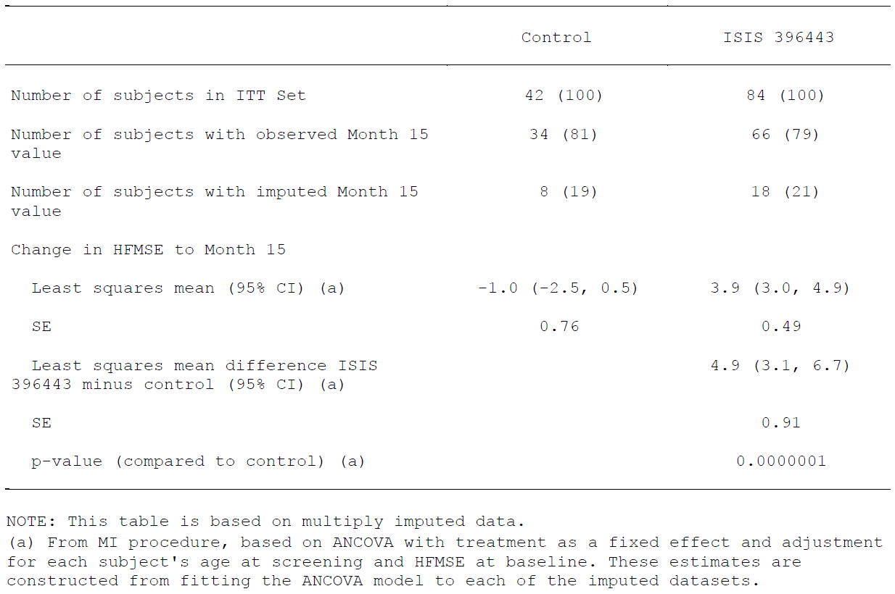
Figure 26: HFMSE: Waterfall plot for change from Baseline to Month 15 (subjects with non-missing 15 month values), ITT set
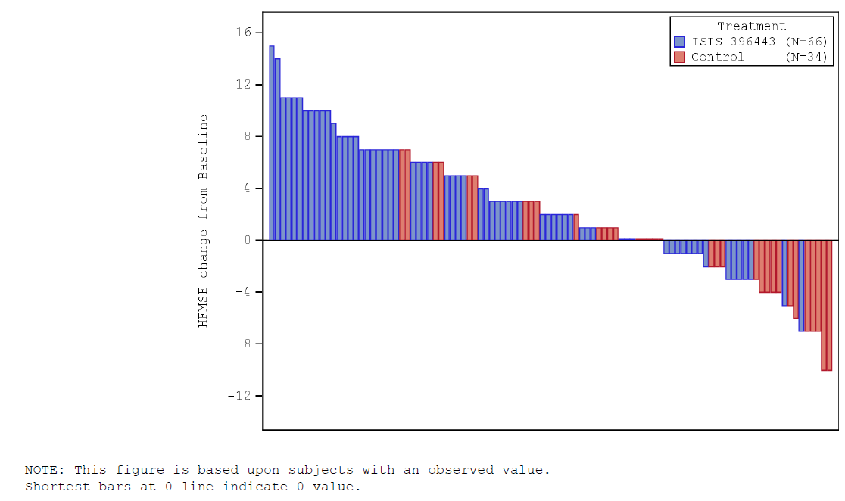
Figure 27: HFMSE: Waterfall plot for change from Baseline to Month 15, ITT set
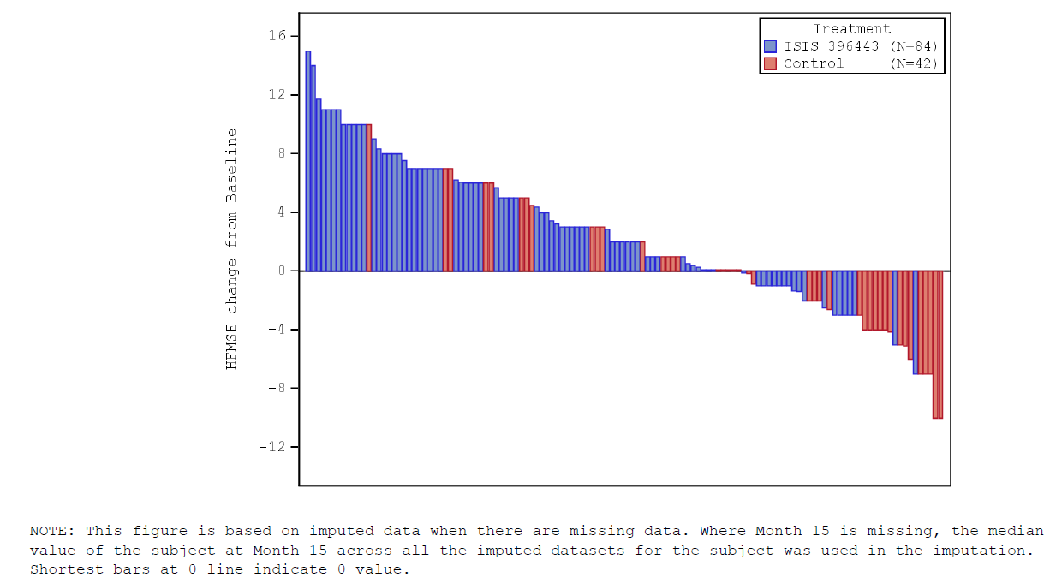

Sensitivity analyses
Five sensitivity analyses were planned for the final analysis. Sensitivity analyses 1 and 5 were the same as the main analysis. The first sensitivity analysis repeated the main analysis to compare treatment groups in the PP set. However, the PP set was the same as the ITT set.
The second sensitivity analysis used an alternative statistical model and found a statistically significant improvement in HFSME scores in the treatment group compared to the control group (least squares mean difference of 4.6 (95% CI: 2.9, 6.4)) (p = 0.0000012)). This is shown in Figure 28, below.
The third sensitivity analysis included subjects in the ITT with non-missing values at 15 months and found a statistically significant improvement in HFSME scores in the treatment group compared to the control group (least squares mean difference of 5.2 (95% CI: 3.4, 7.1)) (p = 0.0000002) (see Figure 28, below).
The fourth sensitivity analysis used the LOCF method to impute missing 15 month values. There was a statistically significant improvement in HFMSE scores in the nusinersen group compared with the control group (least squares mean difference of 4.2 (95% CI: 2.5, 6.0)) (p = 0.0000028) (see Figure 28, below).
The fifth sensitivity analysis used the worse value of LOCF or baseline to impute data for subjects with a missing 15 month assessment and discontinued due to treatment failure or death. The result of this analysis was the same as the main analysis as there were no discontinuations that met this definition.
Figure 28: Difference in change in HFMSE and 95% CI for primary and sensitivity analyses (forest plot)
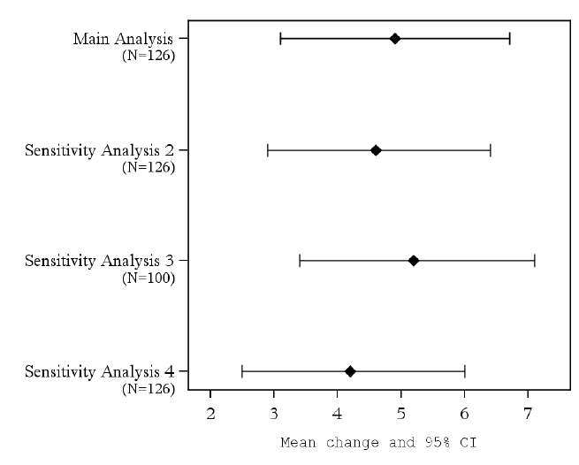

Exploratory analyses: HFMSE score over time
The change from Baseline to each visit was analysed using an ANCOVA model and multiple imputation as described for the main analysis. There was a greater improvement in HFMSE scores in the nusinersen group compared with the control group at all timepoints as shown in Figure 29, below.
Figure 29: HFMSE: Mean change from Baseline (multiple imputation) over time using LS means estimates, ITT set (exploratory analysis 3)
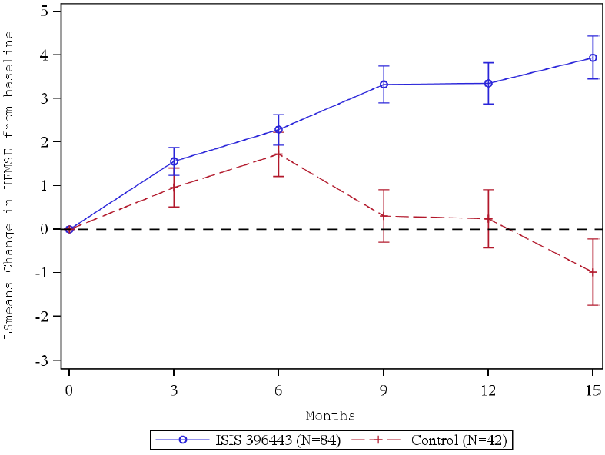

Subgroup analyses
HFMSE scores were examined with respect to age at Screening (< 6 years versus ≥ 6 years), disease duration (< 25 months, ≥ 25 to < 44 months, and ≥ 44 months) and geographic region (North America, Europe, and the Asia Pacific region).
The subgroup analysis by age at Screening showed a treatment difference in favour of nusinersen in the < 6 years of age subgroup across all time points. There were fewer subjects in the ≥ 6 years of age subgroup, therefore it is not possible to draw definitive conclusions. In the older group, subjects in the control initially had better HFMSE total scores than those in the nusinersen group, but by Month 15 there a decline in scores in the control group and the least squares mean difference was in favour of the nusinersen group.
The subgroup analysis based on disease duration showed a treatment difference in favour of nusinersen in the subgroup of subjects with the shortest disease duration (< 25 months). In the ≥ 25 to < 44 months disease duration subgroup, there was a less marked increase in HFMSE scores. The HFMSE score increase in the nusinersen group with the longest disease duration (≥ 44 months) was not as pronounced as in the group with the shortest disease duration. The sponsor states the results are consistent with stabilisation of disease, compared to a decline in HFMSE scores seen in the control group.
The subgroup analysis based on geographic region showed a treatment difference in favour of nusinersen for subjects in both North America and Europe. The number of subjects in the Asia Pacific region was too small to draw definitive conclusions.
The subgroup analyses were repeated using multiple imputation and the results were consistent with those described above.

Final analysis: Results for other efficacy outcomes (secondary endpoints); proportion of subjects who achieve a 3 point or greater increase from Baseline in HFMSE score at 15 months
The proportion of responders in the nusinersen and control groups was 56.8% versus 26.3%, respectively, for a difference of 30.5% in favour of the nusinersen group. The sponsor states that the results is statistically significant (p = 0.0006) but it is unclear if the p-value refers to the difference in proportions of responders or the OR comparison (shown in Table 25, below). The results from the sensitivity analyses were consistent with the main analysis.

Table 25: HFMSE: Proportion of subjects who achieve a 3 point or greater increase from Baseline in HFMSE at 15 months (multiple imputation), ITT Set (main analysis)
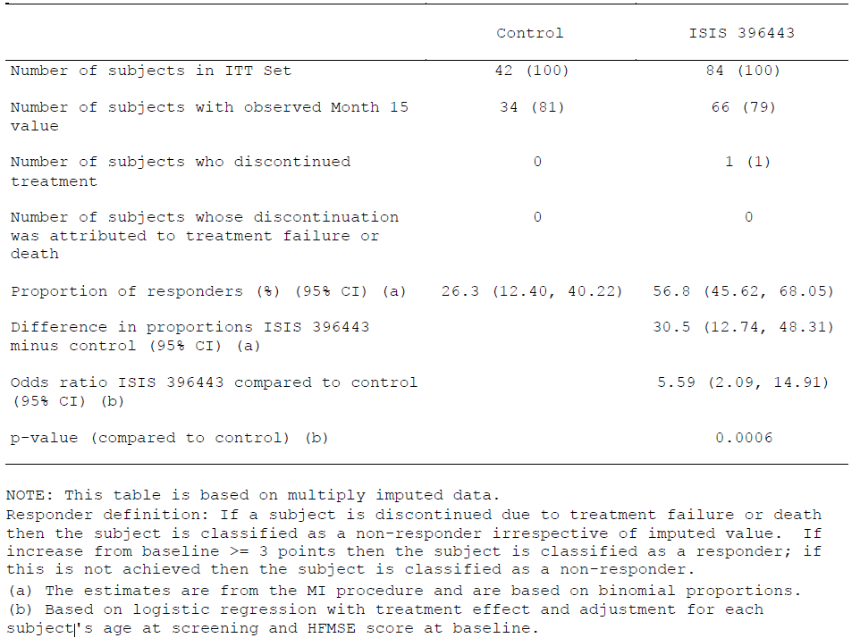

Proportion of subjects who achieve any new motor milestone at 15 months
The proportion of subjects achieving new motor milestones in the nusinersen and control groups was 19.7% and 5.9%, respectively, with a difference of 13.8% (p = 0.0811) (see Table 26, below). Since the proportion of subjects achieving new motor milestones at 15 months was not significantly greater in the nusinersen group relative to sham control, all tests of lower rank are considered exploratory.
The results of the sensitivity analyses were consistent with those of the main analysis.

Table 26: WHO Motor Milestones: Proportion of subjects who achieve any new motor response at 15 months (imputation); Month 15 efficacy set (main analysis)
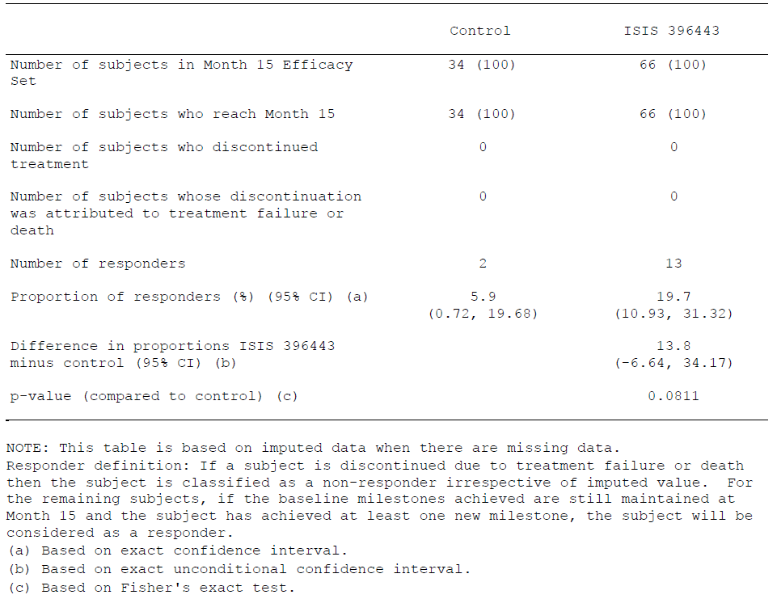

Exploratory efficacy endpoints: Number of motor milestones achieved per subject at 15 months
The number of new (WHO) motor milestones achieved at Month 15 was 0.2 in the nusinersen group versus -0.2 in the control group, with a least squares mean difference of 0.4 between the 2 groups (nominal p = 0.0001) (shown in Table 27, below). Figure 30, also below, shows the plot of the mean change from Baseline in number of new motor milestones achieved by visit (exploratory analysis). Sensitivity analyses were consistent with the main analysis.

Table 27: WHO Motor Milestones: Number of new motor milestones achieved per subject at 15 months (imputation); Month 15 efficacy set (main analysis)
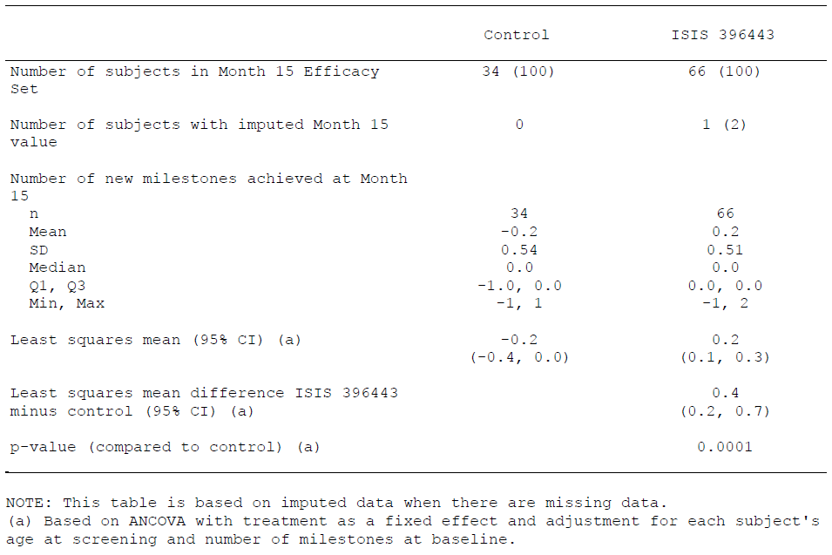
Figure 30: WHO Motor Milestones: Plot of mean change from baseline of number of motor milestones achieved per subject (imputation) over time using LS means estimates, Month 15 efficacy set (exploratory analysis 3)
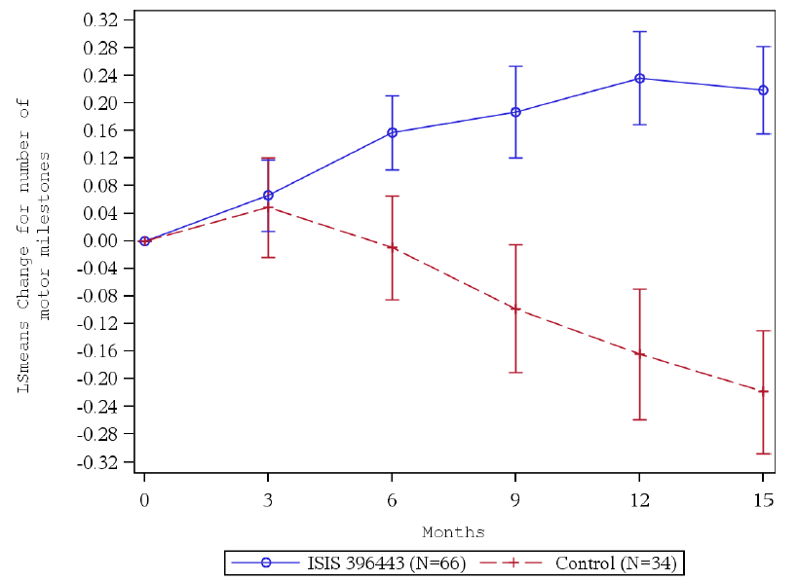

Change from Baseline in Upper Limb Module Test at 15 months
There was a greater improvement in Revised Upper Limb Module Test scores from Baseline to Month 15 in the nusinersen group (least squares mean change of 4.2) than in the control group (least squares mean change of 0.5), with a least squares mean difference of 3.7 between the 2 groups (nominal p = 0.0000001). A waterfall plot showing the change from Baseline in the Revised Upper Limb Module Test score at 15 months (using imputed values for missing data) is shown in Figure 31, below. Figure 32 (also below) includes only subjects with non-missing values at 15 months (sensitivity analysis).

Table 28: Upper Limb Module Test: Change from Baseline to Month 15 in derived total score (multiple imputation), ITT set (main analysis)
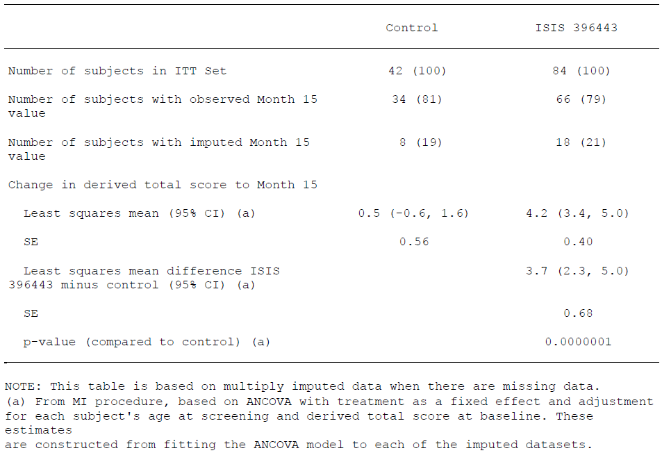
Figure 31: Upper Limb Module Test: Waterfall plot for change from Baseline to Month 15, ITT set
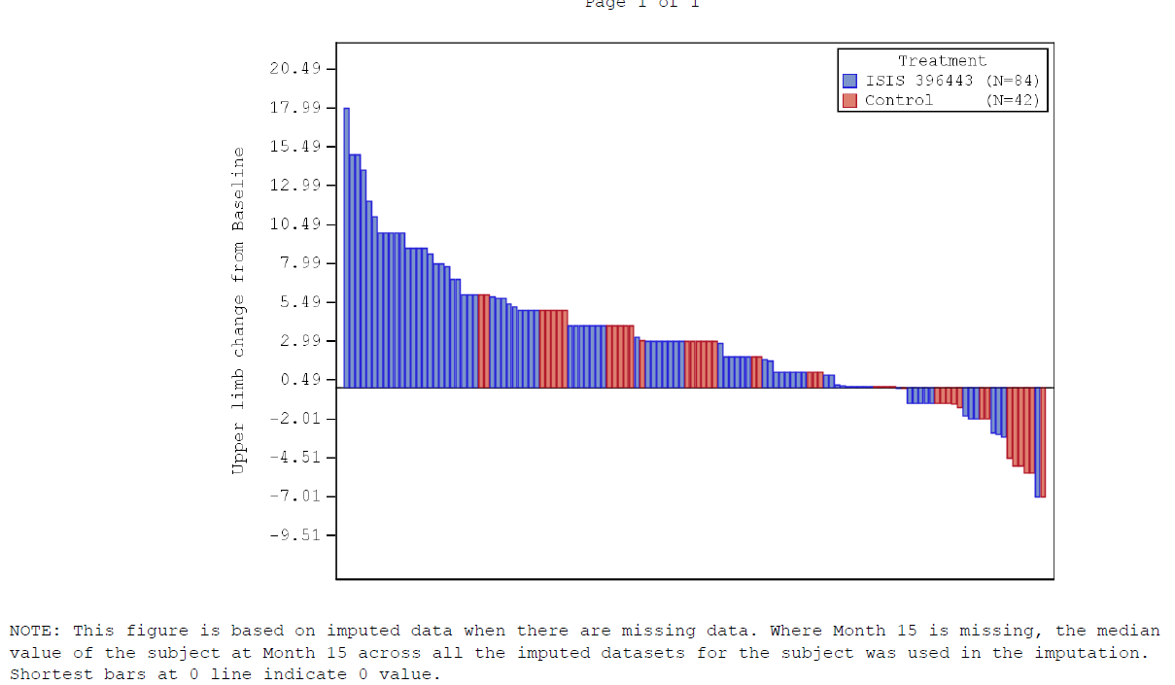
Figure 32: Upper Limb Module Test: Waterfall plot for change from Baseline to Month 15 (subjects with non-missing 15-month values), ITT set
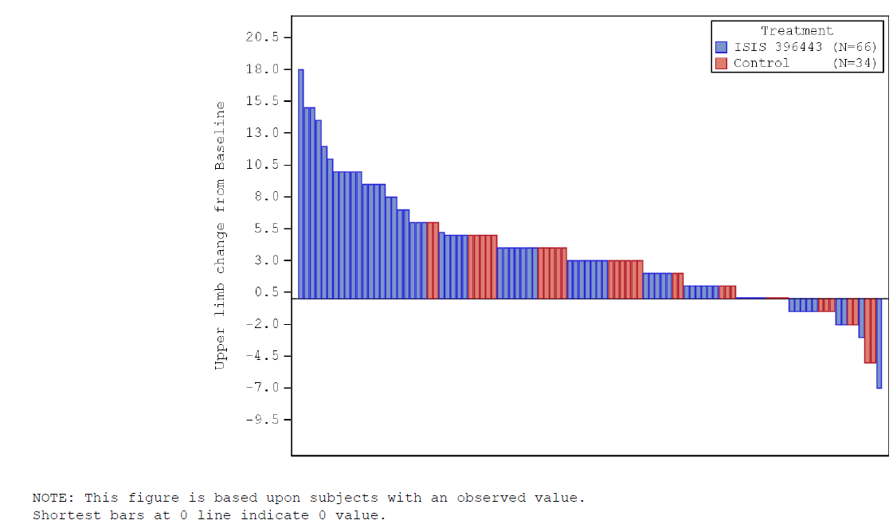

Proportion of subjects who achieve standing alone at 15 months
At 15 months, there was 1 subject (2.9%) in the control group and 1 subject (1.5%) in the nusinersen group who had achieved standing alone. At Baseline, there were 3 patients in each treatment group that had achieved standing alone.

Proportion of subjects who achieve walking with assistance at 15 months
At 15 months, there was 1 subject (1.5%) in the nusinersen group and no subjects in the control group who had achieved walking with assistance. At Baseline, there were 3 patients in the control group and 7 patients in the nusinersen group that had achieved walking with assistance.

Change from baseline in CSF SMN protein concentration
An assay with the sensitivity required to detect changes in SMN protein levels following treatment with nusinersen has not been identified. This assessment was not performed.

Clinical global impression of change (CGI) (investigator and caregiver assessment)
A higher proportion of subjects in the nusinersen group were rated as much improved or having any improvements compared with those in the control group at all time points.

Change from baseline in pediatric quality of life inventory (PedsQL)
The PedsQL results showed improvements in HRQOL in physical functioning for both groups and in communication for subjects in the control group at later timepoints as reported by parents. A subset of subjects completed the questionnaires for themselves, and overall their scores were higher than the corresponding scores from their parents.

Change from baseline in assessment of caregiver experience with neuromuscular disease (ACEND)
ACEND scores showed that caregiver burden was reduced in the domains of feeding/grooming/dressing, transfer, and mobility for subjects in the nusinersen group, while caregiver burden increased in these domains for subjects in the control group. The greatest reduction in caregiver burden was in the domain of mobility (least squares mean change, nusinersen versus control, Month 6: 3.7 versus -3.0; Month 15: 6.0 versus -5.9).

Disease related hospitalisations and AEs
The unadjusted annualised rate of disease-related AEs was lower in the nusinersen group (1.628) than in the control group (2.118) (see Table 29, below). The unadjusted annualised rate of disease related hospitalisations was also lower in the nusinersen group (0.109) than in the control group (0.314) (see Table 30, below).

Table 29: Number of disease related adverse events, ITT set
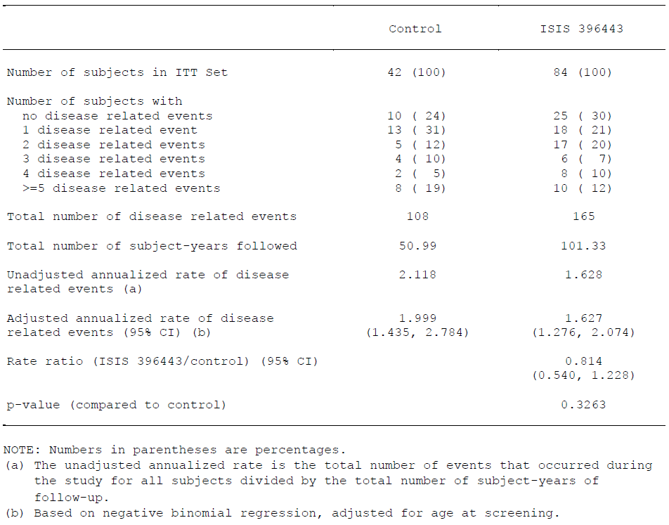

Table 30: Number of disease related hospitalisations, ITT set
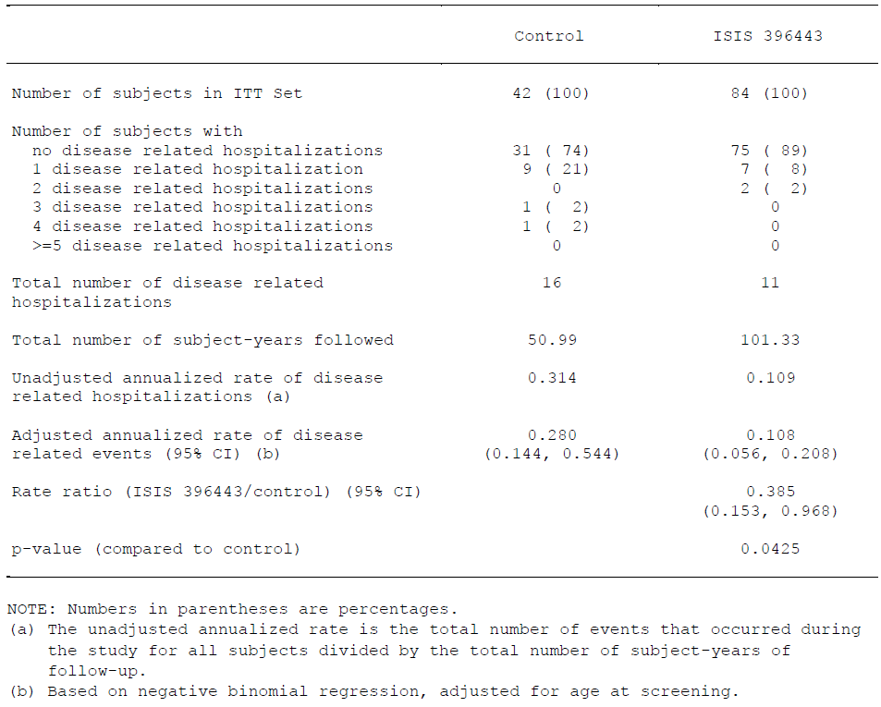

Safety results: adverse events
TEAEs were reported in 93% (78) of subjects who received nusinersen treatment and in 100% (42) of subjects who received sham treatment. The most commonly reported AEs were respiratory or infectious AEs and were considered typical in the context of SMA or a LP.
A lower percentage of subjects in the nusinersen group had a severe or moderate event (nusinersen versus control: 46% versus 55%) or a severe event (5% versus 7%).
The majority of TEAEs occurring within 24 or 72 hours of dose administration were reported in 1 or 2 subjects. The following TEAEs were observed at a 5% difference (nusinersen versus control):
- Back pain (24 hours: 17% versus 0%; 72 hours: 23% versus 0%)
- Headache (24 hours: 11% versus 2%; 72 hours: 26% versus 2%)
- Vomiting (24 hours: 6% versus 2%; 72 hours: 14% versus 2%)
- Epistaxis (24 hours: 5% versus 0%; 72 hours: 5% versus 0%).
Back pain, headache and vomiting were considered related to the study procedure and the cases of epistaxis were not considered drug related as there were alternative explanations for these events and the patients did not have abnormal platelet counts.
When measured by 90-day intervals, the incidence of TEAEs and treatment emergent SAEs tended to remain consistent over time, with the exception of a higher incidence of back pain and headache in nusinersen subjects during the first 90 days. No new types of AEs appeared with longer exposure.
The majority of the AEs were assessed by the investigator as unrelated to nusinersen. A higher percentage of subjects in the nusinersen group had AEs that were considered by the Investigator to be possibly related (nusinersen versus control: 27% versus 10%). One nusinersen-treated subject experienced insomnia. The other possibly related TEAEs, both in the nusinersen-treated and sham treated groups, were generally consistent with those expected in a population with later onset SMA, were consistent with common conditions occurring in the general population, occurred in no more than 1 subject or, in the nusinersen group, were consistent with LP. A total of 41 events were considered possibly related or related in 24 nusinersen-treated subjects (29%), and 5 events were considered possibly related in 4 control subjects (10%); this imbalance was driven mainly by events associated with LP (headache, back pain, post lumbar puncture syndrome and vomiting).
TEAEs were reported most commonly in the following SOCs (nusinersen versus control):
- Infections and infestations (75% versus 83%)
- General disorders and administration site conditions (45% versus 43%)
- Respiratory, thoracic and mediastinal disorders (44% versus 40%)
- Gastrointestinal disorders (42% versus 40%)
- Musculoskeletal and connective tissue disorders (36% versus 31%)
- Nervous system disorders (36% versus 17%)
- Injury, poisoning and procedural complications (31% versus 12%)
- Skin and subcutaneous tissue disorders (15% versus 14%).
The higher percentage of nusinersen subjects who experienced musculoskeletal and connective tissue disorders was largely accounted for by back pain in 25% of nusinersen-treated subjects versus 0% of control subjects.
The higher percentage of nusinersen subjects who experienced nervous system disorders was largely accounted for by headache in 29% of nusinersen-treated subjects (and which largely occurred within 90-days of treatment) versus 7% of control subjects. The other events in this SOC that were reported in a higher percentage of nusinersen subjects were dizziness, myoclonus, and speech disorder development.
A higher percentage of nusinersen subjects experienced injury, poisoning and procedural complications. The majority of the events were injuries such as falls, fractures, and sprains. The procedural complications were post lumbar puncture syndrome (nusinersen versus control: 4% versus 0%) and, procedural pain (2% versus 2%), as well as agitation postoperative, anaesthetic complication pulmonary, and procedural nausea (1% versus 0% for each). It is noted that there were differences in sedation protocols between the two treatment arms. In nusinersen treated subjects anaesthesia or sedation was used in the LP procedures and in order to maintain the blind, minimal sedation was used for the sham procedure.
Many of the most commonly reported AEs, reported in 20% or more of subjects in either the nusinersen or the control group related to respiratory or infectious terms. Other commonly reported events include pyrexia (43% versus 36%), headache (29% versus 7%), vomiting (29% versus 12%), and back pain (25% versus 0%).
The incidence of TEAEs related to contractures was lower in the nusinersen-treated subjects than in the control subjects (13% versus 21%, respectively), primarily due to a lower incidence of joint contracture (5% versus 17%). Additional related events such as pain in extremity, musculoskeletal pain, tendinous contracture, and involuntary muscle contractions had a lower incidence in the nusinersen-treated subjects than in the control subjects.
The incidence of TEAEs related to arthralgia or joint complications was lower in the nusinersen group (14% versus 17%), except for joint dislocation that occurred in 2 subjects in the nusinersen treatment group. The difference in incidence was primarily due to a lower incidence of arthralgia (5% versus 10%). Additional events related to arthralgia or joint complications, all with a lower incidence in the nusinersen-treated subjects than in the control subjects, were pain in extremity, joint swelling, kyphosis, musculoskeletal pain, tendinous contracture, and muscle contractions involuntary.
The incidence of TEAEs related to scoliosis was lower in the nusinersen-treated subjects than in the control subjects (8% versus 17%). The incidence of scoliosis was 7% in the control group compared with 4% in the nusinersen group.
The overall incidence of TEAEs defined as related to SMA was similar in nusinersen-treated and control subjects (70% versus 76%).

Deaths and other serious adverse events
There were no deaths or TEAEs with a fatal outcome.
A lower percentage of subjects in the nusinersen group had an SAE (17% versus 29%). No SAEs were considered by the Investigator to be related or possibly related to the study treatment. Fourteen subjects (17%) in the nusinersen group and 12 subjects (29%) in the control group experienced at least 1 SAE. The most common SAEs were pneumonia (nusinersen versus control: 2% versus 14%), pneumonia viral (4% versus 0%), and respiratory distress (2% versus 5%). The types of SAEs reported are consistent with events observed in the context of SMA. No SAEs were considered by the Investigator to be related to the study treatment.
A lower percentage of subjects in the nusinersen group had a treatment emergent SAE (nusinersen versus control: 17% versus 29%). The most frequently (5% or higher) reported SAEs were as follows (nusinersen versus control):
- Pneumonia (2% versus 14%)
- Respiratory distress (2% versus 5%)
- Influenza (0% versus 5%)
- Dehydration (0% versus 5%)
- Faecaloma (0% versus 5%).

Discontinuations due to adverse events
No subjects in the Safety Set discontinued treatment or withdrew from the study as a result of an AE.

Issues with possible regulatory impact

Liver function and liver toxicity
The incidence of shifts from normal to low bilirubin was similar in the nusinersen group and the control group (nusinersen versus control: 69% versus 70%). The incidence of shifts from normal to low alkaline phosphatase was higher in the nusinersen group (13% versus 3%). The incidences of shifts from normal to high ALT and AST (nusinersen versus control) were: ALT: 4% versus 10% and AST: 2% versus 5%. Nusinersen subjects did not have a sustained increase in liver enzymes while being continuously exposed to drug. The following AEs were reported, both in the control group only (nusinersen versus control):
- ALT increased (0% versus 2%)
- AST increased (0% versus 2%).

Renal function and renal toxicity
The incidence of shifts from normal to low creatinine was higher in the nusinersen group (57% versus 47%). Otherwise, the results for renal function test parameters were the same as those reported in the interim analysis.
For urinalysis, the incidence of shifts from normal to high was greater in the nusinersen group for urine protein (nusinersen versus control: 70% versus 41%), WBCs (18% versus 11%), and RBCs (11% versus 3%). The incidence of shifts from normal to high was greater in the control group for ketones (38% versus 50%). Two subjects in each group shifted from normal to high glucose. One subject in the nusinersen group and 2 subjects in the control group shifted from normal to high specific gravity. After excluding subjects with baseline proteinuria, the subsequent detection of at least 1 positive protein result was present in more nusinersen-treated subjects than control subjects (17% versus 15%). When samples with potentially confounding presence of bacteria, nitrite, or leukocyte esterase were excluded, proteinuria occurred with the same frequency in both groups (12%).

Other clinical chemistry
No significant changes were noted from those reported in the interim analysis.

Haematology and haematological toxicity
No significant changes were noted from those reported in the interim analysis.

Electrocardiograph findings and cardiovascular safety
Twenty-four subjects (38%) in the nusinersen group and 13 subjects (39%) in the control group shifted from normal or unknown at Baseline to abnormal, not clinically significant post-baseline. No subjects (0%) in the nusinersen group and 2 subjects (6%) in the control group shifted from normal or unknown at Baseline to abnormal, clinically significant post-baseline. No subjects in either group had an abnormal nonclinically significant ECG at Screening that shifted to clinically significant post-baseline. Several additional subjects had clinically significant and nonclinically significant abnormal ECGs at Baseline.
No difference in QTc was observed between the 2 treatment groups at any time point. Two cases of QTcF >500 ms were observed in the nusinersen-treated group; 1 subject had a QTcF of 509.81 ms on Day 92 and another had a QTcF of 524.79 ms on Day 456; in both cases, these findings were interpreted as normal.
A review of AEs yielded the following cardiovascular observations:
- no report of torsade de pointes
- fewer cardiac disorders reported in the nusinersen group (nusinersen versus control: 5% versus 7%)
- no sudden death
- no ECGs shifted to abnormal, clinically significant in the nusinersen group.
The sponsor states that no overall pattern or trend in abnormal ECG findings was identified, and no safety concerns were revealed for nusinersen.

Vital signs and clinical examination findings
No significant changes were noted from those reported in the interim analysis (Section 8.5.6.1).

Immunogenicity
Six subjects had treatment emergent ADA positive results. Three subjects were considered to have persistent responses, whereas the ADA status for the remaining subjects was considered not determinable. The immunogenic responses were not considered to have an impact on the subjects’ safety profiles.

Serious skin reactions
No serious skin reactions were reported.

Other safety issues: Hippocampal toxicity
Based on nonclinical findings of hippocampal vacuoles, a medical review was performed for AEs suggestive of epilepsy. No epilepsy or seizures were reported in this study. There was 1 event of myoclonus of the left ring finger reported in a nusinersen treated subject; this subject had a normal electroencephalogram and the event resolved.

Evaluator commentary
There was a statistically significant improvement in HFMSE scores from Baseline to Month 15 in the nusinersen group. A statistically significant result was reported for the secondary efficacy endpoint the proportion of subjects who achieved a 3-point or greater increase from Baseline in HDMSE score at 15 months but it is unclear if the associated p-value refers to the difference in proportions of responders or the OR comparison.
The secondary efficacy endpoint proportion of subjects achieving new motor milestones at 15 months was not significantly greater in the nusinersen group and as a result all tests of lower rank were considered exploratory. In general, non-significant and exploratory results should not be presented in the PI as the study was not powered for the comparison and inclusion of the results in the PI may imply that statistical significance.
TEAEs were reported in a high proportion of subjects in Study CS4 in both the treatment and control group. Many of these AEs were attributed to SMA or the LP procedure. The study did not identify new types of AEs with longer exposure but the nusinersen exposure period was only about 15 months.

Question 7
‘Could the sponsor outline on how it will provide updates on outcomes of the ongoing supportive studies as these become available?’

Sponsor’s response
The sponsor has included the final clinical study reports for Studies CS4 and CS12 as part of this response. The sponsor intends to submit reports for Study CS3a, the NUTURE trial (CS5/232SM201), SHINE trial (CS11) and EMBRACE trial (CS7/232SM202) as they become available.

Evaluator’s comments
The final study reports for Studies CS4 and CS12 are reviewed here. The sponsor has not provided an estimated timetable for submission of Studies CS3a, NUTURE (CS5/232SM201), SHINE (CS11) and EMBRACE (CS7/232SM202). The RMP report indicates final reports are expected for Studies CS3a in 2017, SM201 in 2022, SM202 in 2019 and CS11 in 2022. It is unclear when full study reports will be made available to the TGA for review.

Study CS12
Study CS12 is described in Section 7, above. The primary endpoint for this study related to the safety and tolerability of nusinersen. The secondary endpoint was the plasma and CSF PK of nusinersen. The study had the following exploratory efficacy endpoints:
- Hammersmith Functional Motor Scale, Expanded (HFMSE)
- Pediatric Quality of Life Inventory (PedsQL) (Core and Neuromuscular Modules)
- Upper limb function test (nonambulatory subjects only)
- Myometry (subjects ≥ 5 years old only)
- 6 Minute Walk Test (6MWT) (ambulatory subjects only)
- Assessment of Caregiver Experience With Neuromuscular Disease (ACEND)
- Compound muscle action potential (CMAP) and multipoint incremental motor unit number estimation (MUNE) (subjects who previously participated in Study CS2 or Cohort 4 of Study CS1 (hereafter referred to as Study CS1) only). (Subjects from Cohort 4 of Study CS1 were eligible to participate in Study CS10).

Final analysis: Results for the exploratory efficacy outcomes
The mean change from Baseline in HFMSE total scores across all subjects showed small increases ranging from 0.29 to 1.27. Twelve subjects (25.5%) had a 3-point or greater increase from Baseline in the HFMSE score for 3 or more consecutive visits, while 4 subjects (8.5%) had a 3-point or greater decrease from Baseline for 3 or more consecutive visits.
Motor function in non ambulatory subjects as measured by the ULM showed that subjects were stable for their upper limb function; the mean changes from Baseline ranged from 0.26 to 0.96 throughout the study, with only 1 subject (3.7%) showing a 2-point or greater decline from Baseline for 3 or more consecutive visits. A breakdown of the ULM scores by SMA type showed that mean changes from Baseline were generally greater at most time points for subjects with Type II versus Type III SMA; however, the minimal changes in ULM score from Baseline in subjects with Type III SMA may reflect a ceiling effect, since the Type III subjects had higher mean scores at Baseline that were maintained throughout the course of the study.
Motor function in ambulatory subjects as measured by the 6MWT showed that 3 subjects who were unable to perform the 6MWT at the Screening Visit of this study were later able to complete it during the study. One of these subjects had Type II SMA, which is generally defined by an inability to ever walk unassisted. At their last visit, 11 subjects (50%) were able to walk ≥ 10% farther than they had at Screening, 7 subjects (31.8%) were stable, and 4 subjects (18.2%) had a ≥ 10% decline in distance walked at Screening.
The myometry results were generally consistent with maintenance of muscle strength over time. Although there was no overall discernible pattern to the mean changes in scores from Baseline, there were some signs of improvement over time for the elbow and knee flexion scores.
The results of CMAP showed that subjects had stable muscle electrophysiology over the course of the study.
The PedsQL results showed that subjects were generally stable for their health-related quality of life responses; there were no discernible patterns for positive or negative mean changes in PedsQL total scores or individual components of the Generic Core Scales and Neuromuscular Module. Overall, subjects scored themselves higher than parents.
ACEND scores showed that caregiver impact was generally stable during the study.

Safety results: Adverse events
All 47 subjects experienced at least 1 TEAE and a total of 373 events were reported. The most common TEAEs were upper respiratory tract infection (21 subjects (44.7%)), headache (15 subjects (31.9%)), post lumbar puncture syndrome (14 subjects (29.8%)), and back pain (12 subjects (25.2%)). The majority of TEAEs (71.3%) were mild in severity. There were 95 moderate TEAEs (25.5%) and 12 severe TEAEs (3.2%). Four subjects (8.5%) experienced 12 severe TEAEs. There were no severe TEAEs considered potentially related to the study treatment. Severe TEAEs related to infections, respiratory distress, failure, atelectasis or post lumbar puncture syndrome and migraine.
Five TEAEs (post lumbar puncture syndrome (2 events) and CSF white blood cell count increased, heart rate increased, and headache (1 event each)) were considered potentially related to the study treatment.

Deaths and other serious adverse events
There were no deaths during the study. Fourteen SAEs were reported in 6 subjects; none were considered potentially related to the study treatment. Most of the SAEs were in the SOCs of Infections and Infestations (8 events in 5 subjects (10.6%)) and Respiratory, Thoracic, and Mediastinal Disorders (4 events in 3 subjects (6.4%)). Viral pneumonia and respiratory distress were reported in 2 subjects each (4.3%; 2 events each); for all other SAEs, 1 event was reported in 1 subject each (2.1%).

Discontinuations due to adverse events
No subjects experienced a TEAE leading to study discontinuation after being treated with nusinersen.

Issues with possible regulatory impact
There were no study treatment-related changes in chemistry, haematology, urinalysis, physical or neurological examinations, ECG, or vital signs that were considered clinically significant.

Liver function and liver toxicity
There were no significant changes to the results outlined in Section 8, above.

Renal function and renal toxicity
There were no significant changes to the results outlined in Section 8, above.

Other clinical chemistry
There were no significant changes to the results outlined in Section 8, above. TEAEs corresponding to abnormal laboratory values in this study were vitamin D deficiency and hypercholesterolemia and blood testosterone decreased (1 event in 1 subject (2.1%) each). Each TEAE was assessed as mild and either not related to study treatment (hypercholesterolaemia, blood testosterone decreased) or unlikely/remotely related to study treatment (vitamin D deficiency).

Haematology and haematological toxicity
There were no significant changes to the results outlined in Section 8, above.

Electrocardiograph findings and cardiovascular safety
There were no significant changes to the results outlined in Section 8, above.

Vital signs and clinical examination findings
Results of vital sign measurements did not reveal any clinically significant changes or patterns. TEAEs associated with abnormal vital signs included pyrexia (16 events in 11 subjects (23.4%)), and heart rate increased, tachycardia, and bradycardia (1 event in 1 subject (2.1%) each). All TEAEs resolved with the exception of the event of bradycardia. Most TEAEs were mild in severity; 3 TEAEs of pyrexia were moderate in severity. One moderate TEAE of pyrexia was considered possibly related to LP. The TEAE of heart rate increased was considered possibly related to the study treatment.
No clinically significant adverse physical examination findings or changes in neurological examinations were associated with nusinersen.

Immunogenicity
Two subjects had confirmed low titre positive results for the presence of specific ADAs. A review of the AEs and other safety data for these 2 subjects did not identify any safety issues associated with the presence of ADAs.

Serious skin reactions
No serious skin reactions were reported.

Other safety issues: Hippocampal toxicity
There was no epilepsy or seizures reported in this study and no AEs suggestive of epilepsy.

Evaluator commentary
The efficacy endpoints for this study were exploratory only. There were small mean change from Baseline in HFMSE total scores, upper limb function was stable in non ambulatory patients, 3 subjects who were unable to perform the 6MWT at screening were later able to complete it during the study. At their last visit, 11 subjects (50%) were able to walk ≥ 10% farther than they had at Screening, 7 subjects (31.8%) were stable, and 4 subjects (18.2%) had a ≥ 10% decline in distance walked at Screening.
The myometry results were generally consistent with maintenance of muscle strength over time and CMAP results showed that subjects had stable muscle electrophysiology over the course of the study. Caregiver impact and health-related quality of life responses were generally stable.
All 47 subjects experienced at least 1 TEAE and five TEAEs (post lumbar puncture syndrome (2 events) and CSF white blood cell count increased, heart rate increased, and headache (1 event each)) were considered potentially related to the study treatment.

Safety

Question 8
‘Given the nature of the nusinersen, how will the sponsor monitor liver function, especially ALT concentrations, in treated patients as part of their Risk Management Plan?’

Sponsor’s response
The sponsor does not believe there is a hepatic effect associated with nusinersen as no issue was identified in clinical studies. The sponsor intends to follow liver function tests routinely in ongoing clinical trials and AEs will continue to be collected. No additions specific to liver function have been made to the RMP.
A review of all AEs for potential liver dysfunction from Studies SM201, CS3B, and CS4 was performed. In Study SM201, 3 subjects had AEs related to liver function disturbances (1 subject with preferred terms ‘Blood bilirubin unconjugated increased’ and ‘Blood bilirubin increased’, 1 subject with ‘Hyperbilirubinaemia neonatal’, and 1 subject with ‘Blood alkaline phosphatase increased’, ‘Alanine aminotransferase increased’, and ‘Aspartate aminotransferase increased’). The aminotransferase-related AEs were judged to be possibly related. All other events were reported as unrelated.
In Study CS3B, in the nusinersen-treated subjects, there was 1 subject with 1 event of alanine aminotransferase increased and 1 event of aspartate aminotransferase increased on Day 190. Both resolved after 8 days and were considered not related to the study drug. One subject had an event of liver function test abnormal, which resolved after 15 days and was considered not related. There was 1 control subject with an event of transaminases increased, which resolved after 9 days and was considered not related.
In Study CS4, 1 control subject had AEs reported for ‘Alanine aminotransferase increased’ and ‘Aspartate aminotransferase increased’, which were both assessed as possibly related. No imbalance was noted in the randomised controlled trials. None of these AEs were reported as serious, and all events resolved.
Laboratory values of direct bilirubin, indirect bilirubin, alkaline phosphatase, ALT, and AST were analysed using updated data from Studies CS3B, CS4, and SM201. Median laboratory values were similar between groups and stable over time. No shifts to high direct bilirubin were observed, and only 2 cases of shifts to high indirect bilirubin were detected across all 3 studies (1 nusinersen treated subject and 1 control subject). Shifts to high alkaline phosphatase were not observed in either group in Study CS4. Transient shifts to high alkaline phosphatase were seen in 4% of nusinersen treated subjects in Study CS3B and 11% of subjects in Study SM201. In the absence of abnormalities in bilirubin, these may represent non-hepatic sources of alkaline phosphatase (for example, bone). Shifts to high ALT were seen in similar percentages in ISIS 396433-treated subjects versus control subjects in Study CS3B (14% versus 13%, respectively) but more frequently among control subjects in Study CS4 (nusinersen versus control: 4% versus 10%). Conversely, shifts to high AST were seen more commonly in ISIS 396433-treated subjects versus control subjects in Study CS3B (nusinersen versus control: 7% versus 3%) and Study CS4 (nusinersen versus control: 2% versus 5%) and among 2% of both nusinersen-treated and control subjects in Study CS4.
In summary, there was no evidence of any persistent trend of hepatic dysfunction that emerged over time in either group, and there was no consistent evidence of an increased risk of hepatic dysfunction associated with exposure to nusinersen.

Evaluator’s comments
The overall clinical trial exposure to nusinersen is quite low (260 subjects with 355.32 subject-years of exposure) hence it is possible that a trend for hepatic dysfunction could emerge. The sponsor’s rationale for not adding hepatic events to the PI is satisfactory at this stage given the sponsor intends to continue to monitor liver function in ongoing clinical trials.

Question 9
‘Given that nusinersen is an antisense oligonucleotide, will the sponsor monitor renal function, including urinary protein concentrations, as part of their Risk Management Plan?’

Sponsor’s response
There have been no reports of renal failure, glomerulonephritis, nephrotic syndrome, or other relevant renal toxicity in subjects exposed to nusinersen. The type of renal disorder-related AEs seen in nusinersen-treated and sham control subjects in Studies CS3B and CS4 were similar in nature and the incidence of renal disorder-related AEs was low in all treatment groups from all studies.
Laboratory values of creatinine, cystatin C, and BUN have been analysed. Patterns of all 3 laboratory parameters were nearly identical between groups in both Studies CS3B and CS4 over time (Tables 31, 302 and 33). There was no evidence of sustained renal dysfunction across the studies, and no treatment emergent differences between nusinersen-treated and control subjects for any parameters related to renal function.
The sponsor analysed rates of proteinuria in Studies CS3B and CS4. Quantitative measurements of proteinuria were not available and a positive result was defined as 1+ or greater on urine dipstick for this analysis. Subjects were examined for evidence of proteinuria at Baseline and those without proteinuria at Baseline were then analysed for the development of a) at least 1 positive urinary protein result; b) the development of 2 or more consecutive urinary protein results; and c) the development of proteinuria in the absence of nitrites, leukocyte esterase, or bacteria, which could suggest proteinuria associated specifically with urinary tract infection. Baseline proteinuria was infrequent in both nusinersen-treated and control subjects. After excluding subjects with baseline proteinuria, the subsequent detection of at least 1 positive protein result was present in fewer nusinersen-treated subjects in Study CS3B (11% versus 19%) and in more nusinersen-treated subjects in Study CS4 (17% versus 15%). When samples with potentially confounding presence of bacteria, nitrite, or leukocyte esterase were excluded, proteinuria was less common in nusinersen-treated subjects versus control subjects in Study CS3B (6% versus 9%) and occurred with similar frequency in nusinersen-treated subjects versus control subjects in Study CS4 (12% versus 12%). Only 1 nusinersen-treated subject from Study CS3B and 1 control subject from Study CS4 had 2 consecutive positive urinary protein results.
Based on the above data, the sponsor does not believe there is increased renal disease associated with nusinersen. The sponsor acknowledges that there have been observations of renal toxicity with other subcutaneously or intravenously administered ASOs. Therefore, the following language is proposed for the precautions section in the Product Information:
‘Renal
Renal toxicity has been observed after administration of other subcutaneously or intravenously administered antisense oligonucleotides.
If clinically indicated, urine protein testing is recommended. For persistent elevated urinary protein, further evaluation should be considered’.
The sponsor will continue to monitor the clinical trials and the post-market setting for events of renal toxicity.

Table 31: Shift to high blood urea nitrogen in Studies CS3B, SM201, and CS4
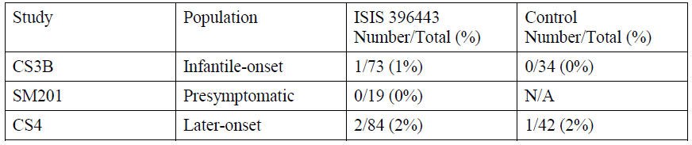

Table 32: Shift to high creatinine in Studies CS3B, SM201, and CS4
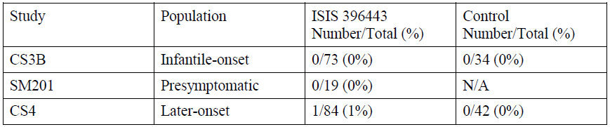

Table 33: Shift to high cystatin c in Studies CS3B, SM201, and CS4
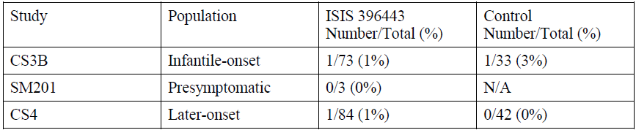

Evaluator’s comments
The information provided above is not consistent with the information on renal toxicity provided in the US PI and the HCPM. These international PI documents state that in one clinical study 33% of nusinersen treated patients had elevated urine protein compared to 20% in sham controlled patients and that in later onset SMA patients 69% had elevated urine protein. Quantitative spot urine testing is recommended at Baseline and then either prior to each dose or as clinically indicated. It is unclear why a similar statement has not been included in the proposed Australian PI.

Question 10
‘How will the sponsor monitor biochemical markers including hyponatraemia as part of their Risk Management Plan? Will this be more than routine Pharmacovigilance, for example as part of the proposed registry?’

Sponsor’s response
The sponsor states that there was only a single case of severe hyponatremia in the Spinraza clinical trials and confounding factors/explanations were provided (increased losses from frequent oral suctioning, excess sweating and complete reliance on maternal breast milk which is low in sodium).
A shift to low sodium was seen in one nusinersen-treated subject in Study CS3B (1%) and in one nusinersen-treated subject in Study CS4 (1%) and in one subject (2%) in the CS4 control group. A plot of median, minimum, and maximum levels of sodium over time in Study CS4 is presented in Figure 33, below, and demonstrates no pattern of difference between the nusinersen treatment group and Control group.
The sponsor does not believe there is increased risk of hyponatremia associated with nusinersen and does not intend to add hyponatremia to the RMP or PI. Related AEs and sodium values will be followed in ongoing clinical trials and through routine pharmacovigilance.
Figure 33: Median, minimum, and maximum values of sodium over time in nusinersen-treated subjects and control subjects in Study CS4
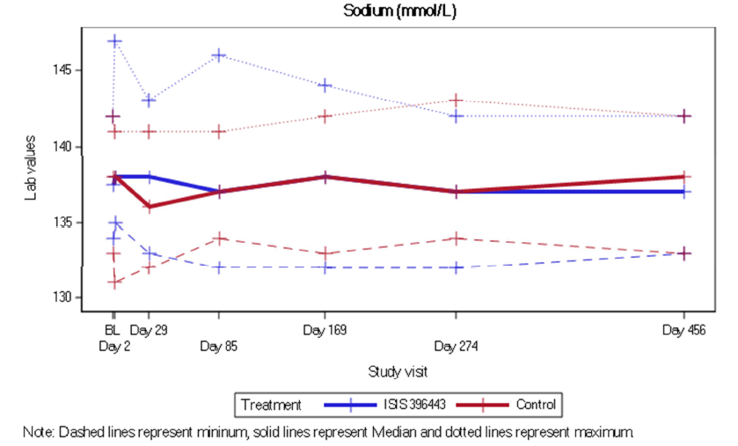

Evaluator’s comments
The sponsor’s response is unsatisfactory. It is noted that both the US PI and the HCPM list hyponatraemia as an adverse effect seen in clinical trials. The above case is described in as severe requiring salt supplementation for 14 months. A similar statement should be included in the Australian PI.

Question 11
‘There is a risk of thrombocytopenia in some patients treated with nusinersen. As patients are subject to regular lumbar puncture, will the sponsor provide a specific recommendation (in the product information) as to whether it is necessary to monitor platelet levels prior to a lumbar puncture?’

Sponsor’s response
The sponsor has reviewed the potential risk of thrombocytopenia associated with nusinersen:
- In the review of the final data from Study CS3B and Study CS4, and interim data from Study SM201, a similar proportion of nusinersen treated subjects developed a shift to low platelets (11% to 18%). 0-24% of sham control subjects developed a shift to low platelets in CS3B and CS4 (see Table 34, below).
- In Study CS3B, fewer control subjects experienced a shift to low platelets in comparison to nusinersen-treated subjects, while in Study CS4, the reverse trend was observed (see Table 34, below). These inconsistent results do not represent a true effect of treatment.
- A review of individual laboratory listings did not reveal evidence of sustained thrombocytopenia for subjects being treated with nusinersen. In the updated data cuts, all 6 subjects with a platelet value below 100,000 (1 subject from Study SM201, 1 nusinersen treated subject from Study CS3B, 3 nusinersen treated subjects from Study CS4, and 1 control subject from Study CS4) had a repeat result within close proximity of the abnormal result that showed normal platelet counts. There were no bleeding events reported during these transient episodes in either treatment group. None of the low platelet values in the nusinersen clinical studies were considered clinically meaningful by the Investigators and were not reported as AEs. There were no treatments reported for thrombocytopenia, and no evaluations reported to further examine thrombocytopenia. Resolution of thrombocytopenia occurred despite ongoing exposure to nusinersen which is inconsistent with drug-induced thrombocytopenia. There is no difference in median platelet count over time between the nusinersen-treated and sham control groups in Studies CS3B and CS4 either study (see Figure 34, below).
In summary, there were no cases of sustained or severe thrombocytopenia in nusinersen treated subjects across clinical studies. There was also no difference in platelet counts over time between the control and nusinersen treated subjects in Studies CS3B and CS4. The sponsor does not believe there is an increased risk of bleeding disorders or thrombocytopenia associated with nusinersen.
Due to observations of thrombocytopenia and coagulation abnormalities with other subcutaneously or intravenously administered ASOs, the sponsor agrees to include the following statement in the PI, but not the platelet shift data from CS3B as these results do not represent the full context of what has been observed with nusinersen administration:
‘Thrombocytopenia and coagulation abnormalities:
Thrombocytopenia and coagulation abnormalities, including acute severe thrombocytopenia, have been observed after administration of other subcutaneously or intravenously administered antisense oligonucleotides. If clinically indicated, platelet and coagulation laboratory testing is recommended prior to administration of Spinraza’.
The sponsor will continue to monitor for thrombocytopenia and coagulation abnormalities in ongoing clinical trials and through routine pharmacovigilance.

Table 34: Shift to low platelets in Studies CS3B, SM201 and CS4
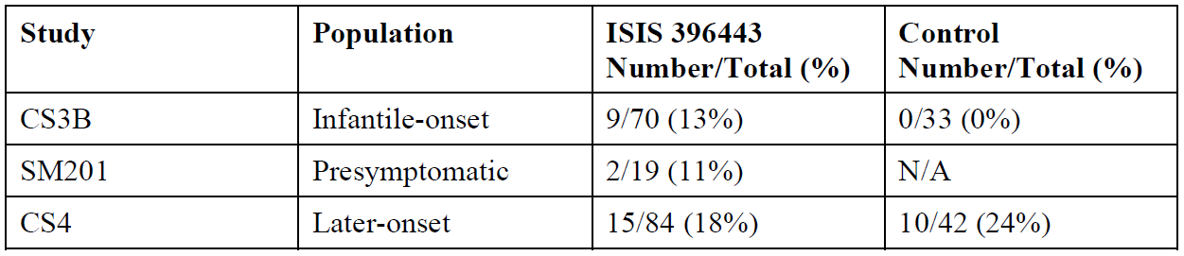
Figure 34: Median, minimum and maximum values of platelets over time in nusinersen treated subjects and control subjects in Studies CS3B and CS4
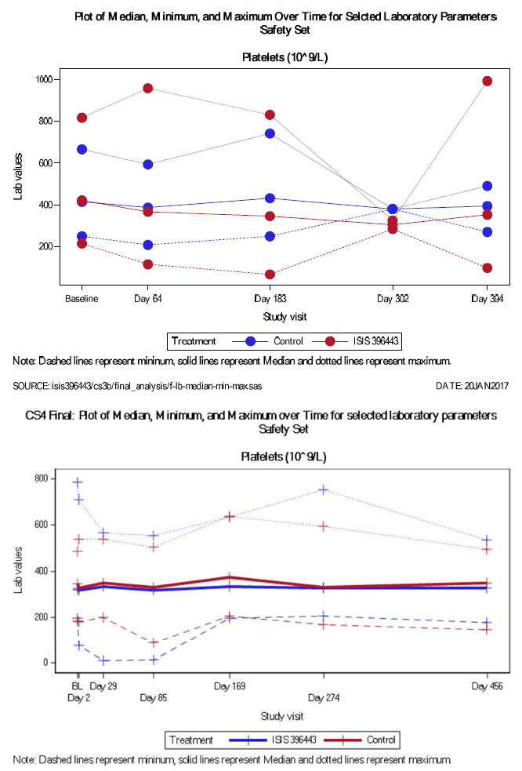

Evaluator’s comment
The sponsor’s rationale for not including the platelet shift results from Study CS3B is unsatisfactory. Given the intrathecal route of administration, the risk of thrombocytopenia is of serious concern. It is noted that both the US PI and HCPM contain statements regarding the risk of thrombocytopenia identified in CS3B, highlight the increased risk of bleeding complications and recommend that platelet counts and coagulation testing occur at Baseline and prior to each administration of nusinersen.

Question 12
‘Could the sponsor please report on changes in QT interval and the risk of ventricular tachycardia in the dossier?’
The sponsor reviewed data from the final CS3B CSR with updated QTc results (the QTc formula used was not reported for this study). In the final data set, only two subjects had any QTc value > 500 ms post baseline and a > 60 ms increase from Baseline. 2 subjects did not meet these outlier criteria in the final data set, and no additional subjects were identified as meeting these criteria.
All QTc values for 2 subjects, along with the previously identified 2 subjects are presented in Table 35, below. Both subjects with QTc values > 500 ms had only one such value and all subsequent QTc measurements were < 500 ms. No additional AEs were noted for these subjects. Neither had cardiovascular events reported during the study.
One nusinersen treated subject in Study CS3B had ventricular tachycardia, beginning on Day 57. The last dose of study treatment prior to the event was on Day 29. At the time the event began, the subject also had a respiratory infection and was treated with an antibiotic. The event, which was reported as resolved on Day 66, was assessed as moderate in severity and unlikely related to nusinersen. The next day, on Day 67, the subject was subfebrile and had diarrhoea. That same day, the subject received her scheduled dose of nusinersen and ventricular tachycardia was reported approximately 4 hours after dosing. Vital signs 4 hours post-dose were blood pressure 110/55, temperature 37.0 C, respirations 40, heart rate 180, and oxygen saturation 95%. The event resolved 3 hours after the onset without intervention. The Investigator assessed the event as mild in severity and as unlikely related to nusinersen. No action was taken with the study treatment. The subject continued to participate in the study and no subsequent ventricular tachycardia or other cardiac events were reported. Of note, this subject had a QTc of 455 ms at screening, prior to exposure to nusinersen, which decreased to 420 ms on Day 2, 446 ms on Day 29, and 391 ms on Day 197.
2 subjects treated with nusinersen in Study CS4 had a QTcF value > 500 ms and a > 60 ms increase from Baseline (see Table 36, below). QTcF measurements for these subjects are presented in Table 37. A review of AEs in Study CS4 found no reports of torsade de pointes, fewer subjects with cardiac disorders reported in the nusinersen group (5% versus 7%), no sudden death, no ECGs shifted to abnormal, clinically significant in the nusinersen group (versus 6% of subjects in the Control group).
The sponsor does not believe there is a cardiac effect associated with nusinersen and does not intend to make any additions specific to QTc interval or ventricular tachycardia that to the RMP and the PI. The sponsor plans to monitor potential changes in QTc and cardiac events in the ongoing open label extension Study CS11 which will involve annual ECGs.

Table 35: QTc Data for 4 Study CS3B subjects
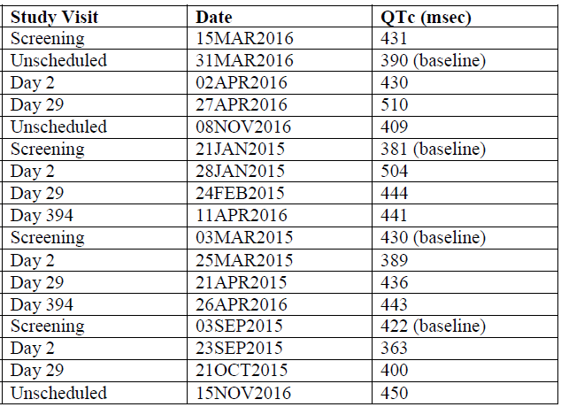

Table 36: Incidence of outliers in ECGs based on Fridericia corrected QT interval, safety set
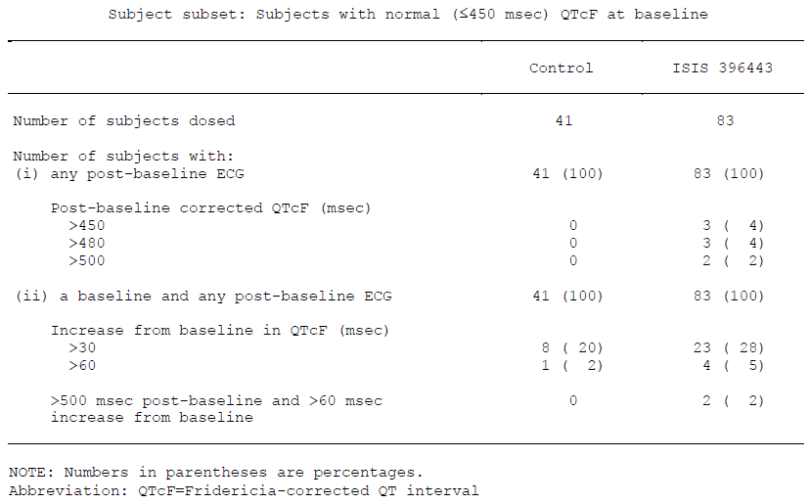

Table 371: QTcF Measurements for 2 Study CS4 subjects
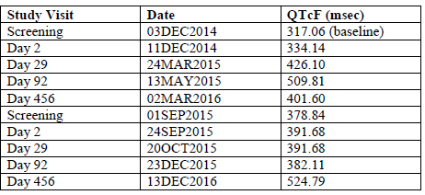

Evaluator’s comments
The sponsor’s response is unsatisfactory. Table 36 indicates that 28% of patients experienced an increase from Baseline in QTcF of > 30 ms and 5% had an increase of > 60 ms. 4% of patients in CS4 experienced a post baseline QTcF > 450 ms, none of which had a QTcF > 450 ms at Baseline and 2% experienced a post-baseline QTcF of > 00 ms. Both the US PI and the HCPM contain statements regarding the risk of QT prolongation. It is recommended that a similar statement should be included in the Australian PI.

Question 13
‘Could the sponsor please include a comprehensive approach to detecting immunological changes in their Risk Management Plan?’

Sponsor’s response
The analysis of the treatment emergent incidence of ADAs in subjects dosed with nusinersen was reviewed using the most recent data from clinical studies (see Table 38, below). The immunogenic response to nusinersen was low and there was no effect of ADA development on clinical response, AEs, or the pharmacokinetic profile of nusinersen. Of the 258 subjects with baseline and post-baseline plasma samples evaluated for ADAs, 14 subjects (5%) developed treatment emergent ADAs.
The sponsor states that route of administration is directly linked with immunogenicity and the subcutaneous route of administration may contribute to the higher incidence of flu-like symptoms, injection site reactions, and kidney inflammatory responses seen with ASO drisapersen. Nusinersen differs from drisapersen in structure and in route of administration and level of systemic exposure.
The sponsor states that there is no evidence in the nonclinical and clinical safety data for nusinersen to suggest a signal for the types of toxicities that were reported in other subcutaneously or intravenously administered ASOs, including injection site reactions, flu-like symptoms, thrombocytopenia, hepatic impairment, and renal impairment.
Based on the above data, the sponsor does not believe there is evidence that the presence of ADA is of clinical significance. The sponsor does not intend change the RMP in relation to this issue. Measurement of ADA and the development of related AEs will be followed in ongoing clinical trials.

Table 38: Incidence of anti-nusinersen antibodies in subjects dosed with nusinersen: Final Studies CS3b, CS4, CS1, CS2, CS10, CS12, CS3a and Interim 3232SM201 data
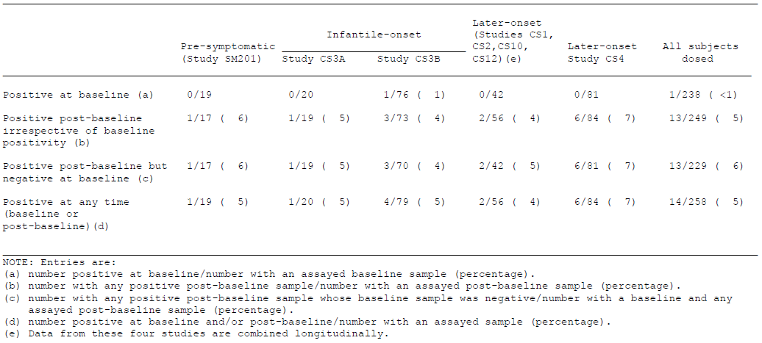

Evaluator comments
The sponsor has indicated that they do not intend to change the RMP with respect to this issue. Table 38 indicates that 6% of clinical trial subjects developed anti-nusinersen antibodies post-baseline but the clinical significance of this is unclear. The US PI and the HCPM state that ‘There are insufficient data to evaluate an effect of ADAs on clinical response, adverse events, or the pharmacokinetic profile of nusinersen.’ This statement conveys to the prescriber the uncertainty regarding the clinical significance of ADAs and should be included in the Australian PI instead of the proposed statement: ‘There was no apparent effect of ADA development on clinical response, adverse events, or the pharmacokinetic profile of nusinersen.’ It is noted that the US PI contains an additional statement regarding the limitations of both ADA assays and the ability to compare results across studies and products. A similar statement should be considered for the Australian PI.

Question 14
‘Could the sponsor please supply detailed clinical information in relation to cases of potential vasculitis? Please include clinical photos in the response to this question?’
- There were no cases of confirmed vasculitis in the nusinersen clinical development program. There are published reports describing vasculitis/drug induced vascular injury in monkeys administered antisense oligonucleotides, this was not observed in the preclinical studies with Spinraza.
- There was a subject in Study CS3B who had 2 reports of ‘suspected vasculitis’. This subject had a staphylococcal skin infection and received a prior vaccination. The dermatology consult states that the final diagnosis was ‘post-inflammatory residues after fix AME following vaccination’. No biopsy was performed. The rash resolved spontaneously, and the subject continued to receive nusinersen throughout Study CS3B and continued into Study CS11.
- Another Study CS3B subject reported a skin rash 246 days after initial administration of nusinersen. A biopsy was performed that ruled out vasculitis. The subject was treated with cetirizine hydrochloride for skin oedema. Treatment for the skin rash included topical hydrocortisone and soft paraffin/fats. It was reported that autonomic dysfunction and poor perfusion may have played a role in the event.
- Neither patient (n = 2) with rash were diagnosed with vasculitis/drug induced vascular injury.
In both cases, patients continued to receive Spinraza through Study CS3B and then into Study CS11 (SHINE trial). The clinical course of both patients is therefore not consistent with the clinical course of a drug induced rash.
The sponsor does not believe that there is evidence of rash or vasculitis associated with nusinersen and does not intend to add vasculitis to the RMP. The sponsor states that related AEs will be followed in ongoing clinical trials and routine pharmacovigilance.

Evaluator’s comments
The sponsor reported 3 cases of vasculitis to the FDA. These AEs appear to have occurred in two patients. The 2 patients described above received alternative diagnoses and the both patients continued to receive study treatment. The international PI documents reviewed do not list vasculitis as an adverse effect. The sponsor’s rationale for not including vasculitis in the RMP and PI is reasonable.
The broader AE of rash is not discussed in the proposed PI. It is noted that both the US and Canadian PI documents contain a description of the rash cases discussed above. The Health Canada Product Monograph (HCPM) states:
‘Cases of rash were reported in the controlled clinical trial in patients with infantile onset SMA. One patient developed painless lesions on the forearm, leg and foot, over an 8-week period 8 months after starting treatment with Spinraza. The lesions were initially red macular skin lesions that ulcerated and scabbed over in 4 weeks. The patient continued to have recurring painless ulcerative lesions in acral distribution. A second patient developed red macular lesions on the hands 10 months after starting treatment with Spinraza, which resolved over a period of 3 months. In both cases there was spontaneous resolution of the rash while the patients continued to receive Spinraza’.
The US PI statement is similar:
‘Cases of rash were reported in patients treated with Spinraza. One patient, 8 months after starting Spinraza treatment, developed painless red macular lesions on the forearm, leg, and foot over an 8 week period. The lesions ulcerated and scabbed over within 4 weeks, and resolved over several months. A second patient developed red macular skin lesions on the cheek and hand ten months after the start of Spinraza treatment, which resolved over 3 months. Both cases continued to receive Spinraza and had spontaneous resolution of the rash’.
It is recommended that a similar statement be included in the Australian PI in the Adverse effects section.

Question 15
‘Could the sponsor please incorporate a comprehensive approach to detecting any necrotic CNS changes in treated patients in their Risk Management Plan?’

Evaluator’s comments
The sponsor has not provided a response to this question and has instead responded to a question regarding off-target hybridisation effects. The response is considered unsatisfactory.

Question 16
‘Is it possible for Australian patients to be included in the proposed European post-marketing strategy?’

Sponsor’s response
The sponsor is unable to include Australian patients in the approved European post-marketing commitments. The sponsor notes that there are 4 active Australian patients in Study CS11 (SHINE trial) and 1 active Australian patient in Study SM201 (NURTURE trial) as part of the post-authorisation efficacy studies (PAES) in the EU RMP v5. The sponsor will report on the ongoing clinical studies and post-marketing data in the PSURs.

Evaluator comment
The sponsor has committed to reporting on ongoing clinical studies and post-market data but will not include Australian patients in the EU post-marketing commitments. The sponsor has not provided a rationale for not including Australian patients in these long term assessments of safety and efficacy.

Second round benefit-risk assessment

Second round assessment of benefits
After consideration of the responses to clinical questions, the benefits of Spinraza (nusinersen) in the proposed usage are similar to those identified in Section 9.1, above.
- Nusinersen is the first novel treatment to offer improvement in outcome for both symptomatic and presymptomatic patients with SMA Types I, II and III. The main benefits are the improvement in muscle function and improved survival in treated patients as demonstrated in the pivotal studies. It is uncertain whether these benefits will be maintained long term across the various SMA types, whether SMA types not included in the clinical trial program will experience benefit from treatment and whether any benefit will be demonstrated for the adult patient population.
- In severely affected individuals with Infantile onset SMA (Study CS3B), there were significant clinical improvements in treated patients:
  - 51% of subjects in the treatment group achieved a response compared to 0% in the control group (p < 0.0001). This translates to a number needed to treat (NNT) of 2 for this endpoint. Two patients would need to receive treatment over 10 months for one patient to meet the definition of a responder.
  - Time to death or permanent ventilation was prolonged in subjects treated with nusinersen – there was a 47% reduction in the risk of death or permanent ventilation compared with subjects who received the sham procedure (HR 0.530 (95% CI 0.3156, 0.8902 p = 0.0164). The NNT for this endpoint was 4, as in four patients would need to received treatment for 10 months to prevent one event of death or permanent ventilation.
- Study CS4 in individuals with later onset SMA, the final efficacy analysis demonstrated significant improvements in HFSME scores at 15 months of treatment. The HFMSE scores from Baseline to Month 15 improved by 3.9 in the treatment group while there was and a decline of 1.0 in the control group. The total difference of 4.9 was statistically significant (p = 0.0000001).
- The safety profile of nusinersen is acceptable given the severity of SMA. There were few drug-related adverse events and there were no severe outcomes attributed to treatment. However, overall clinical trial exposure is relatively low given the rarity of SMA and there are ongoing clinical trials to further characterise the safety and efficacy of long-term treatment.

Second round assessment of risks
After consideration of the responses to clinical questions, the risks of Spinraza (nusinersen) in the proposed usage are:
- The proposed indication includes all SMA types. Nusinersen has not been evaluated for safety or efficacy in SMA Types 0 and IV and non-5q SMA. It is unclear whether treatment with nusinersen would confer any benefit in these patient subgroups. Type IV SMA (adult onset SMA) is the mildest form of SMA and patients are ambulatory with a normal life expectancy. The benefit-risk profile may not positive in this patient population given the risks associated with ASOs and with intrathecal administration. The clinical studies submitted included patients with subjects with infantile onset and genetically diagnosed (Type I) SMA, pre-symptomatic SMA (Type I or Type II) and subjects with later onset (Type II and Type III) SMA.
- As SMA is a rare condition and clinical trial exposure has been limited with respect to patient numbers and length of treatment exposure. There is a lack of long-term data for nusinersen treatment and it is not known whether the clinical benefits observed in the studies will be maintained. As outlined above, the sponsor has committed to long-term post-marketing monitoring of both efficacy and safety as proposed in the EU registration that may clarify the long-term outcomes of the treatment.
- Only a small number of patients over the age of 18 have been included in nusinersen clinical trials to date and there is also a lack of data regarding the safety and efficacy of nusinersen treatment in this patients group. It is uncertain whether adults will experience similar clinical benefit or have higher rates of AEs.
- There is still significant uncertainty regarding the optimal dose and dosing schedule. The same dose and dosing schedule has been requested for all patients (loading doses on Days 0, 14, 28 and 63, followed by 4 monthly maintenance doses). For patients with later onset SMA the clinical trials have had a 6 monthly maintenance dosage regimen except for Study SM202, the results of which are not yet available and the study has only exploratory efficacy endpoints.
- Nusinersen requires intrathecal administration which carries procedure related risks. The important potential risk of thrombocytopenia is of particular relevance to the management of risks associated with intrathecal administration. The sponsor intends to monitor thrombocytopenia and coagulation abnormalities as an important potential risk as part of the RMP. The communication of this risk has been partially addressed in proposed changes to the Australian PI but further information is warranted.
- There is a risk of complications with the LP associated with administration of nusinersen, especially if there is concurrent thrombocytopenia. There are also risks associated with sedation that may be required for the LP procedure.
- As outlined in Round 1, there is an ongoing risk of immunological reactions in patients treated with nusinersen. Decreases in efficacy and severe allergic reactions have not been observed in clinical studies to date but the extent and implications of such reactions are, at present, unknown. 6% of clinical trial subjects developed anti-nusinersen antibodies post-baseline but the clinical significance of this is unclear. The uncertainty regarding the clinical significance of ADAs and should be communicated to prescribers.
- Hippocampal damage identified in pre-clinical studies has not been identified in the clinical studies but remains a potential risk with prolonged exposure to nusinersen. The sponsor has not described their approach to detecting necrotic CNS changes in treated patients in the sponsor’s second round response. This issue is considered unresolved.
- The risk of prolonged QTc has not been completely tested. This is important as there were reports of ventricular tachycardia in treated patients that are otherwise unexplained.
- There is a potential renal risk of proteinuria given the nature of nusinersen as an antisense oligonucleotide. There is no signal for this in the clinical trials. However, as the systemic exposure of nusinersen is lower than if an oligonucleotide were administered directly into the systemic circulation, renal risks may require a prolonged exposure to be identified.
- Hyponatraemia has been reported in some patients treated with nusinersen. This did not result in any observable acute clinical deterioration in the studies. Prolonged or severe hyponatraemia can result in clinical consequences if unrecognised or untreated.
- Some patients treated with nusinersen had increases in ALT levels. It is uncertain whether these changes may represent an increased risk of liver damage due to nusinersen.
- The sponsor has addressed the issue of vasculitis in patients treated with nusinersen but the broader AE of rash needs to be communicated to prescribers.
- In Study CS3B, there was relatively poor growth in some patients treated with nusinersen when compared to sham treated patients. This is unexpected given the clinical motor improvement and the overall improvement in survival.

Second round assessment of benefit-risk balance
The benefit-risk balance of Spinraza (nusinersen) remains favourable but the proposed indication should be refined to exclude the non-5q SMA population. As outlined in the first round, the drug addresses an unmet need in a population of patients with severe disease. Clinically and statistically significant improvements in motor function and survival have been demonstrated. In Infantile onset SMA, Study CS3B demonstrated an improvement in motor function and survival following treatment compared to controls. In later onset SMA, there is a highly significant improvement in motor function compared to controls.
5q SMA Types 0 and IV were not addressed in the dossier. As stated above, the indication should be refined to exclude non-5q SMA patients. As outlined in Round 1 there is limited potential for nusinersen to be effective in Type 0 SMA and the risk to benefit ratio of treatment in Type IV SMA has not been characterised and may be unfavourable. However, specific exclusion of Type 0 and Type IV SMA from the proposed indication is not recommended as these subtypes have the same underlying basic biology of SMA and in certain cases a trial of nusinersen therapy may be warranted. Instead, the ‘Precautions’ section of the PI should include the statement that nusinersen has not been investigated in these patient groups. In addition, the initiation of treatment should be limited to healthcare professionals experienced in the treatment of SMA.
The risks of the use of nusinersen are related to the uncertainty as to whether the dosing is optimal, the long-term efficacy, use in adults over 18 years of age. There were few drug-related adverse events and there were no severe outcomes attributable to the treatment. There are some unresolved safety concerns including potential QT changes, the risk of recurrent lumbar punctures and central nervous system effects. As outlined in the first round evaluation, the QT changes are inadequately investigated and this should be addressed in the PI. The serious potential risk of CNS effects has not been addressed in the sponsor’s post-first round response. The risks of renal toxicity, thrombocytopenia, hyponatraemia and rash need to be addressed in the PI. Advice should be provided to clinicians regarding testing for thrombocytopenia and coagulation abnormalities and urinary protein.
As outlined in the first round the benefit-risk balance is favourable but several outstanding risks need to be addressed by the sponsor through ongoing clinical studies, post-market monitoring of safety and efficacy and changes to the PI to better communicate the outstanding risks and uncertainties.

Second round recommendation regarding authorisation
The evaluator recommends the authorisation of Spinraza (nusineresen) for the treatment of 5q spinal muscular atrophy (SMA). The proposed changes to the indication are discussed in Section 13, above. This recommendation is based on the improvements in motor function and improved survival in patients with SMA treated with nusinersen. There are some outstanding issues regarding optimal dosing and some safety concerns relating to QT changes, CNS effects, the risk of recurrent LP, renal toxicity and thrombocytopenia. However, these can be addressed with the suggested changes to the PI and ongoing post-marketing surveillance.

References
Arnold WD, Kassar D, Kissel JT. Spinal muscular atrophy: diagnosis and management in a new therapeutic era. Muscle Nerve. 2015; 51: 157-167
Bach JR. Medical considerations of long-term survival of Werdnig-Hoffmann disease. Am J Phys Med Rehabil. 2007; 86: 349-355
Bach JR, et al. Long-term survival in Werdnig-Hoffmann disease. Am J Phys Med Rehabil. 2007; 86: 339-45 quiz 346-8, 379.
Cho S and Dreyfuss G. A degron created by SMN2 Exon 7 skipping is a principal contributor to spinal muscular atrophy severity. Genes Dev 2010; 24: 438-442.
Davies B and Morris T. Physiological parameters in laboratory animals and humans. Pharm Res 1993; 10: 1093-1095.
De Sanctis R et al.; Developmental milestones in type I spinal muscular atrophy. Neuromuscular Disorders 2016; 26: 754-759
Dubowitz V. Very severe spinal muscular atrophy (SMA type 0): an expanding clinical phenotype. Eur J Paediatr Neurol. 1999; 3: 49-51.
Faravelli I, et al. Spinal muscular atrophy--recent therapeutic advances for an old challenge. Nat Rev Neurol. 2015;11: 351-359.
Feldkötter M, et al. Quantitative analyses of SMN1 and SMN2 based on real-time light cycler PCR: fast and highly reliable carrier testing and prediction of severity of spinal muscular atrophy. Am J Hum Genet 2002; 70: 358-368.
Finkel R, et al. 209th ENMC International Workshop: Outcome Measures and Clinical Trial Readiness in Spinal Muscular Atrophy 7-9 November 2014, Heemskerk, The Netherlands. Neuromuscul Disord. 2015; 25: 593-602.
Finkel RS, et al. Observational study of spinal muscular atrophy type I and implications for clinical trials. Neurology. 2014; 83: 810-817.
Finkel RS, et al. Respiratory muscle function in infants with spinal muscular atrophy type I. Pediatr Pulmonol. 2014
García A, et al. Peripheral motor and sensory nerve conduction studies in normal infants and children. Clin Neurophysiol. 2000; 111: 513-520.
Glanzman AM, et al. The Children's Hospital of Philadelphia Infant Test of Neuromuscular Disorders (CHOP INTEND): test development and reliability. Neuromuscul Disord. 2010; 20: 155-161.
Haataja L, et al. Optimality score for the neurologic examination of the infant at 12 and 18 months of age. J Pediatr. 1999; 135: 153-161.
Hua Y, et al. Antisense correction of SMN2 splicing in the CNS rescues necrosis in a type III SMA mouse model. Genes Dev. 2010; 24: 1634-1644.
Hua Y, et al. Antisense masking of an hnRNP A1/A2 intronic splicing silencer corrects SMN2 splicing in transgenic mice. Am J Hum Genet. 2008; 82: 834-848.
Jones C, et al. SMA subtype concordance in siblings: findings from the Cure SMA cohort. Presented at the 20th annual spinal muscular atropy researcher meeting 2016; Anaheim, CA.
Lorson CL, et al. A single nucleotide in the SMN gene regulates splicing and is responsible for spinal muscular atrophy. Proc Natl Acad Sci U S A. 1999; 96: 6307-6311.
MacLeod MJ, et al. Prenatal onset spinal muscular atrophy. Eur J Paediatr Neurol. 1999; 3: 65-72.
Medrano S, et al. Genotype-phenotype correlation of SMN locus genes in spinal muscular atrophy children from Argentina. Eur J Paediatr Neurol. 2016.
Mercuri E, Bertini E, Iannaccone ST. Childhood spinal muscular atrophy: controversies and challenges. Lancet Neurol. 2012; 11: 443-452
Monani UR, et al. A single nucleotide difference that alters splicing patterns distinguishes the SMA gene SMN1 from the copy gene SMN2. Hum Mol Genet. 1999; 8: 1177-1183.
Ogino S, Wilson RB, Gold B. New insights on the evolution of the SMN1 and SMN2 region: simulation and meta-analysis for allele and haplotype frequency calculations. Eur J Hum Genet. 2004; 12: 1015-1023.
Pearn JH. The gene frequency of acute Werdnig-Hoffmann disease (SMA type 1). A total population survey in North-East England. J Med Genet. 1973; 10: 260-265.
Pearn JH, Carter CO, Wilson J. The genetic identity of acute infantile spinal muscular atrophy. Brain. 1973; 96: 463-470.
Qian Y, et al. Understanding the experiences and needs of individuals with Spinal Muscular Atrophy and their parents: a qualitative study. BMC Neurol. 2015; 15: 217.
Rigo F, et al. Antisense-based therapy for the treatment of spinal muscular atrophy. J Cell Biol. 2012; 199: 21-25.
Rigo F, et al. Synthetic oligonucleotides recruit ILF2/3 to RNA transcripts to modulate splicing. Nat Chem Biol. 2012; 8: 555-561.
Rudnik-Schöneborn S, et al. Genotype-phenotype studies in infantile spinal muscular atrophy (SMA) type I in Germany: implications for clinical trials and genetic counselling. Clin Genet. 2009; 76: 168-178.
Russman BS. Spinal muscular atrophy: clinical classification and disease heterogeneity. J Child Neurol. 2007; 22: 946-951.
Sugarman EA, et al. Pan-ethnic carrier screening and prenatal diagnosis for spinal muscular atrophy: clinical laboratory analysis of >72,400 specimens. Eur J Hum Genet. 2012; 20: 27-32.
Swoboda KJ, et al. Natural history of denervation in SMA: relation to age, SMN2 copy number, and function. Ann Neurol. 2005; 57: 704-712.
Thomas NH, Dubowitz V. The natural history of type I (severe) spinal muscular atrophy. Neuromuscul Disord. 1994; 4: 497-502.
Wang CH, et al. Consensus statement for standard of care in spinal muscular atrophy. J Child Neurol. 2007; 22: 1027-1049.
Wirth B, Garbes L, Riessland M. How genetic modifiers influence the phenotype of spinal muscular atrophy and suggest future therapeutic approaches. Current opinion in genetics & development. 2013; 23: 330-338. Epub 2013/04/23.

Therapeutic Goods Administration
PO Box 100 Woden ACT 2606 Australia
Email: info@tga.gov.au Phone: 1800 020 653 Fax: 02 6232 8605
https://www.tga.gov.au

The selection criteria for Study CS3b was infantile onset SMA, ≤6 months of age at symptom onset, ≤ 7 months of age at screening (which includes patients most likely to develop Type I and potentially some early onset Type II SMA).
The selection criteria for Study CS4 was for later onset SMA, > 6 months of age at symptom onset, which includes patients most likely to develop Type II or Type III SMA.
Clarification: The selection criteria for Study CS4, was for later onset SMA, > 6 months of age at symptom onset, which includes patients most likely to develop Type II or Type III SMA. Please see Table 1 in the AusPAR for classification of SMA types.
Clarification: The selection criteria for Study CS4, was for later onset SMA, > 6 months of age at symptom onset, which include patients most likely to develop Type II or Type III SMA. Please see Table 1 in the AusPAR for classification of SMA types.

