June 2014

Australian Public Assessment Report for Normal Human Immunoglobulin
  - Proprietary Product Name: Hizentra
  - Sponsor: CSL Behring Ltd

About the Therapeutic Goods Administration (TGA)
- The Therapeutic Goods Administration (TGA) is part of the Australian Government Department of Health and is responsible for regulating medicines and medical devices.
- The TGA administers the Therapeutic Goods Act 1989 (the Act), applying a risk management approach designed to ensure therapeutic goods supplied in Australia meet acceptable standards of quality, safety and efficacy (performance), when necessary.
- The work of the TGA is based on applying scientific and clinical expertise to decision-making, to ensure that the benefits to consumers outweigh any risks associated with the use of medicines and medical devices.
- The TGA relies on the public, healthcare professionals and industry to report problems with medicines or medical devices. TGA investigates reports received by it to determine any necessary regulatory action.
- To report a problem with a medicine or medical device, please see the information on the TGA website <http://www.tga.gov.au>.
About AusPARs
- An Australian Public Assessment Record (AusPAR) provides information about the evaluation of a prescription medicine and the considerations that led the TGA to approve or not approve a prescription medicine submission.
- AusPARs are prepared and published by the TGA.
- An AusPAR is prepared for submissions that relate to new chemical entities, generic medicines, major variations, and extensions of indications.
- An AusPAR is a static document, in that it will provide information that relates to a submission at a particular point in time.
- A new AusPAR will be developed to reflect changes to indications and/or major variations to a prescription medicine subject to evaluation by the TGA.
Copyright
© Commonwealth of Australia 2014
This work is copyright. You may reproduce the whole or part of this work in unaltered form for your own personal use or, if you are part of an organisation, for internal use within your organisation, but only if you or your organisation do not use the reproduction for any commercial purpose and retain this copyright notice and all disclaimer notices as part of that reproduction. Apart from rights to use as permitted by the Copyright Act 1968 or allowed by this copyright notice, all other rights are reserved and you are not allowed to reproduce the whole or any part of this work in any way (electronic or otherwise) without first being given specific written permission from the Commonwealth to do so. Requests and inquiries concerning reproduction and rights are to be sent to the TGA Copyright Officer, Therapeutic Goods Administration, PO Box 100, Woden ACT 2606 or emailed to <tga.copyright@tga.gov.au>.

Contents
List of commonly used abbreviations 5
I. Introduction to product submission 8
Submission details 8
Product background 8
Regulatory status 9
Product Information 10
II. Quality findings 10
Drug substance (active ingredient) 10
Drug product 11
Quality summary and conclusions 13
III. Nonclinical findings 14
Introduction 14
Pharmacology 14
Pharmacokinetics 15
Toxicology 16
Nonclinical summary 22
Nonclinical conclusions and recommendation 24
IV. Clinical findings 24
Introduction 24
Pharmacokinetics 26
Pharmacodynamics 28
Dosage selection for the pivotal studies 29
Efficacy 29
Safety 31
First round benefit-risk assessment 34
First round recommendation regarding authorisation 35
Clinical questions 35
Additional corrected safety data 35
Second round evaluation of clinical data submitted in response to questions 36
Second round benefit-risk assessment 39
Second round recommendation regarding authorisation 39
V. Pharmacovigilance findings 39
Risk management plan 39
VI. Overall conclusion and risk/benefit assessment 44
Quality 44
Nonclinical 45
Clinical 45
Risk management plan 53
Risk-benefit analysis 53
Outcome 58
Attachment 1. Product Information 59
Attachment 2. Extract from the Clinical Evaluation Report 59

List of commonly used abbreviations
Abbreviation | Meaning | Abbreviation | Meaning
ACA | Anti-complement activity | HAV | Hepatitis A virus
AE | Adverse event | HBV | Hepatitis B virus
ALP | Alkaline phosphatase | HCV | Hepatitis C virus
ALT | Alanine aminotransferase | HIV | Human immunodeficiency virus
AMS | Aseptic Meningitis Syndrome | HRQL | Health-Related Quality of Life
ARAG | Autosomal recessive agammaglobulinemia | ICH | International Conference on Harmonisation
AST | Aspartate aminotransferase | IgG | Immunoglobulin G
AUC | Area under the concentration-time curve | IgPro20 | HIZENTRA
AUC24 | Area under the concentration-time curve from 0-24 h | IM | intramuscular
AUC_{last} | Area under the concentration-time curve until last measured concentration | IMIG | Immunoglobulin for intramuscular application
AUCτ | Area under the concentration-time curve during 1 regular dosing interval | IMP | Investigational Medicinal Product
B19V | Parvovirus B19 | IRB | Institutional review board
BMI | Body Mass Index | ITT | Intent to treat
BP | Blood pressure | IV | Intravenous (lV)
bw | Body weight | IVIG | Immunoglobulin for intravenous application
CIDP | Chronic Inflammatory Demyelinating Polyneuropathy | LDH | Lactate dehydrogenase
CNS | Central Nervous System | MA | Marketing Authorisation
CFR | Code of federal regulations | MedDRA | Medical Dictionary for Regulatory Activities
CI | Confidence interval | NBS | Nijmegen breakage syndrome
CIOMS | Council for International Organizations of Medical Sciences | PAGID | Pan-American Group for Immunodeficiency
CJD | Creutzfeldt-Jakob Disease | PCR | Polymerase chain reaction
CL | Confidence Limit | PID | Primary Immunodeficiency Disease
Cl_{ast} | Last measured concentration | PK | Pharmacokinetics
CLSI | Clinical and Laboratory Standards Institute | PP | Per protocol
C_{max} | Maximum concentration | QD | Once daily
C_{min} | Minimum concentration | RMP | Risk Management Plan
CPK | Creatine phosphokinase | sAUC | AUC standardized
CRF | Case report form | SBIs | Serious Bacterial Infections
C_{trough} | Trough level | SC | subcutaneous
CVID | common variable immunodeficiency | SCIG | Immunoglobulin for subcutaneous use
DAC | dose adjustment coefficient | SD | Standard deviation
DD | D-Dimer | SAE | Serious adverse event
DMP | Data Management Plan | SOC | System Organ Class
DSUR | Development Safety Update Report | TAT | Thrombin-antithrombin fragments
DSV | Data study verification | TEE | Thromboembolic Events
ECG | Electrocardiogram | TLR | Trough level ratio
EAE | Experimental allergic encephalomyelitis | T_{max} | Timepoint of maximum concentration
ELISA | Enzyme-linked immunosorbent assay | TNFα | Tumor necrosis factor-alpha
EMA | European Medicines Agency | TSE | Transmissible Spongiform Encephalopathy
ESID | European Society for Immunodeficiencies | ULN | Upper Limit of Normal
EU | European Union | US | United States
FDA | US Food and Drug Administration | URTI | upper respiratory tract infection
F1+2 | Prothrombin fragments 1 and 2 | UTI | urinary tract infection
GCP | Good Clinical Practice | vCJD | variant Creutzfeldt-Jakob-Disease
GCSP | Global Clinical Safety & Pharmacovigilance | WHO-DRL | World Health Organization Drug Reference List
γ-GT | Gamma-glutamyltransferase | WI/WO | wash-in/wash-out
GMR | Geometric mean ratio | XLA | X-linked agammaglobulinemia

I. Introduction to product submission

Submission details
Type of submission: | New Biological Entity
Decision: | Approved
Date of decision: | 16 April 2014

Active ingredient: | Normal Human Immunoglobulin
Product name: | Hizentra
Sponsor’s name and address: | CSL Behring (Australia) Pty Ltd  189-209 Camp Road, Broadmeadows  VIC 3047
Dose form: | Solution for Subcutaneous Injection
Strength: | 20% (20g per 100mL)
Containers: | Type I glass vials or Type II glass vials
Pack sizes: | 1’s, 10’s and 20’s
Approved therapeutic use: | Hizentra is indicated in adults and children for replacement therapy in:  - Primary Immunodeficiency Disease (PID) and  - Symptomatic hypogammaglobulinaemia secondary to underlying disease or treatment.
Route of administration: | Subcutaneous (SC)
Dosage: | The dose may need to be individualised for each patient dependent on the clinical response and serum IgG trough levels. Guideline dose regimens are given in the Product Information (Attachment 1).
ARTG numbers: | AUST R 207386, AUST R 207385, AUST R 207383 and AUST R 207384

Product background
This AusPAR describes the application by the sponsor to register Hizentra, a ready-to-use 20% protein liquid formulation of a polyvalent human immunoglobulin G (IgG) for subcutaneous (SC) administration. The proposed indication is for adults and children for replacement therapy in:
Hizentra is indicated in adults and children for replacement therapy in:
- Primary Immunodeficiency Disease (PID) and
- Symptomatic hypogammaglobulinaemia secondary to underlying disease or treatment.
Hizentra is the only 20% formulation of SC Ig; the higher concentration means smaller volumes need to be infused; this may be preferable in some patients.
The company code “IgPro20” is used in parts of this AusPAR to refer to the active ingredient, although this includes the inactive ingredient L-proline as a stabiliser.

Regulatory status
Human Normal Immunoglobulin 20% for subcutaneous administration is submitted or already licensed on a national basis in several overseas markets under the trade name Hizentra. Table 1 lists the details of similar Marketing Authorisation Applications that have been submitted including their regulatory status.
Table 1. International regulatory status of Hizentra
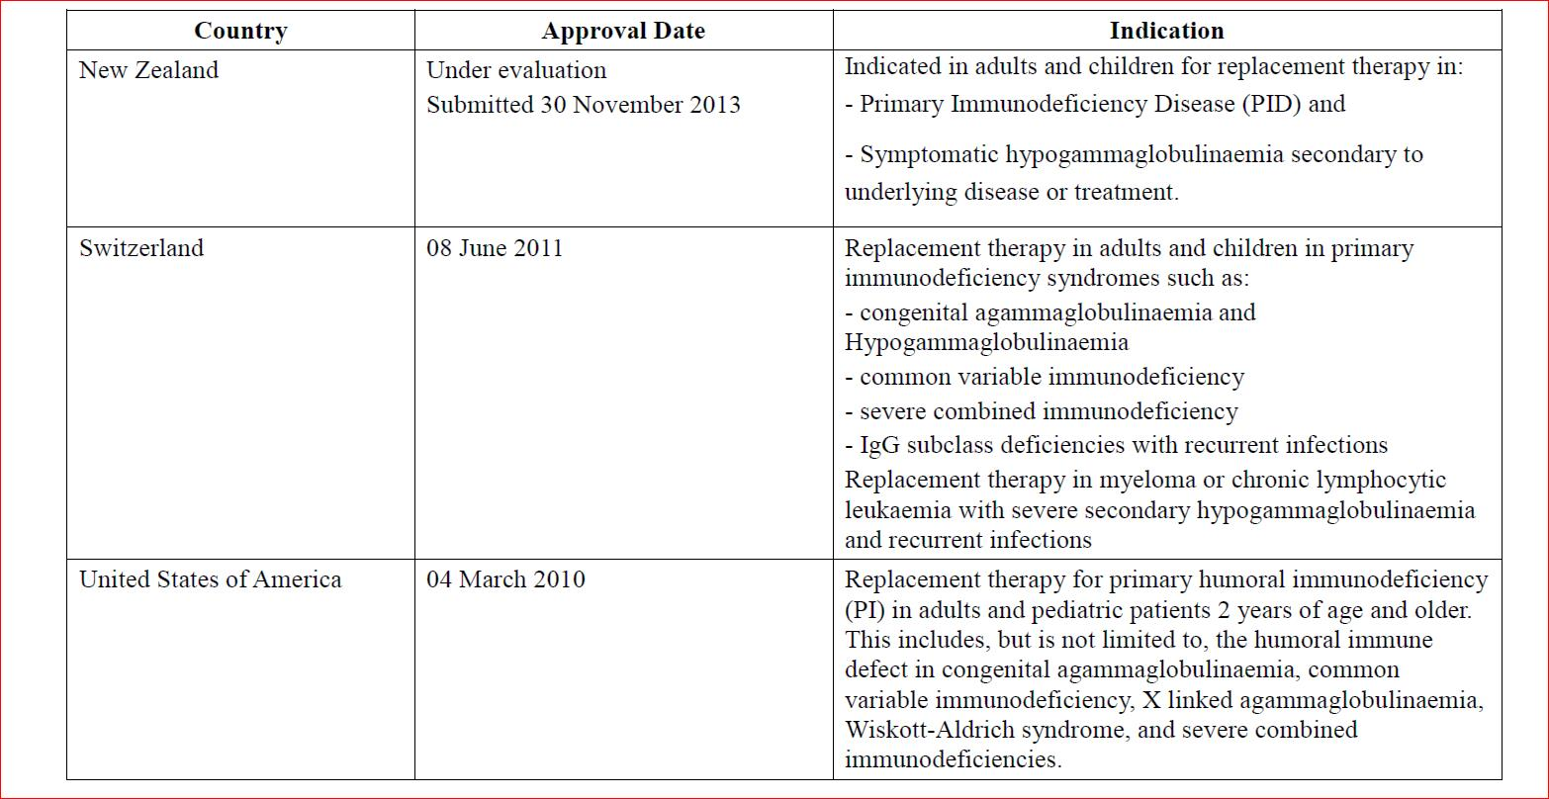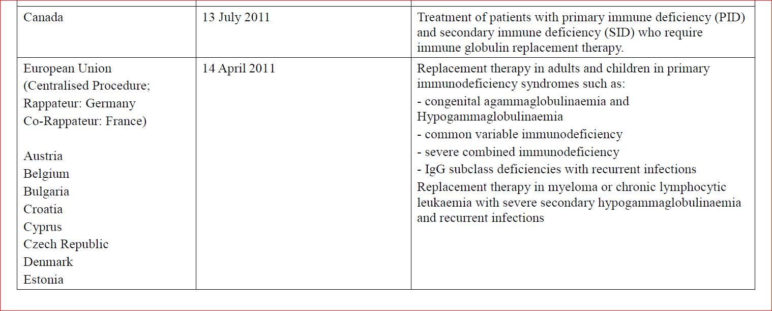

Product Information
The approved Product Information (PI) current at the time this AusPAR was prepared can be found as Attachment 1. For the most recent Product Information please refer to the TGA website at <http://www.tga.gov.au/hp/information-medicines-pi.htm>.

II. Quality findings

Drug substance (active ingredient)
The active ingredient of Hizentra is the immunoglobulin G (IgG) component of human plasma. It consists of a large number of biologically active antibodies normally present in the donor population. IgG is formulated directly to final drug product.
Privigen and Hizentra manufacturing processes are identical down to the drug substance IgPro10-SOL. IgPro10-SOL is purified IgG. Antiviral and antibacterial potencies are determined on the final drug product.

Structure
The drug substance (active) has the following structure:
Figure 1. Hizentra structure
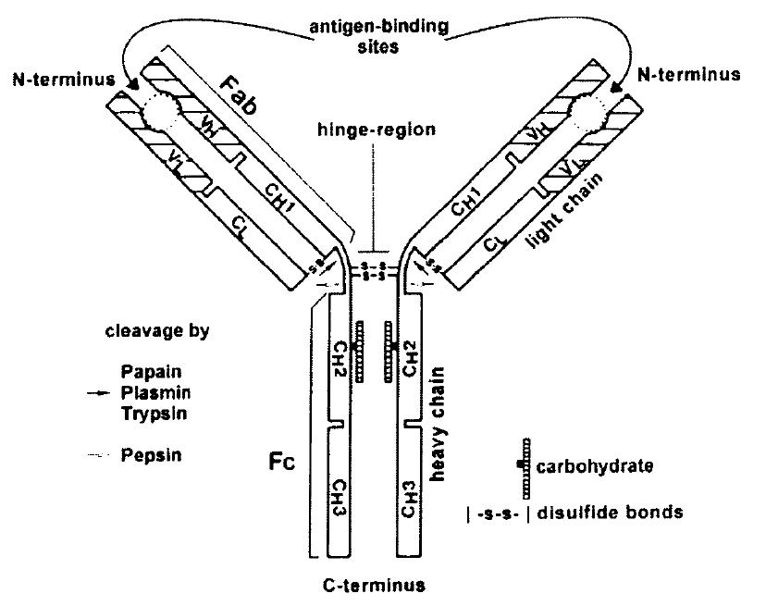
The active ingredient of the drug substance is human polyvalent immunoglobulin G (IgG) isolated from human plasma. The Y-shaped molecule consists of two identical heavy chains (H-chain) of about 420 amino acid residues and two identical light chains (L-chains) of about 210 amino acid residues. The H-chain is composed of four distinct areas or domains (VH, CH1-CH3), whereas the L-chain comprises two domains (VL and CL). A schematic view of the molecule is shown above. The VH and VL regions of the molecule show considerable sequence variation, whereas the other domains of the H-chain (CH1-CH3), as well as the CL, are constant. H chains are linked together and to the L-chain by inter-chain disulphide bridges and non-covalent interactions.
IgG is defined by its γ-type H-chains. The L-chains may belong either to the κ- or the λ-type. Molecular weights are approximately 50 kDa for the H-chain, about 25 kDa for the L-chain and about 150 kDa for the entire IgG-molecule. The structural combination of VH and VL domains determines the shape of the antigen binding site or paratope. Hence, IgG has two identical paratopes, situated at the N-terminal end of the molecule. Together, the two C-terminal domains of both H-chains (CH2 and CH3) forming the Fc-part of the IgG-molecule, are responsible for several effector activities of the IgG molecule (such as binding to immune cells bearing Fc receptors). Carbohydrates linked to CH2 located in the Fc-part of the molecule account for about 3% of the molecular mass. Human IgG has four subclasses, IgG1, IgG2, IgG3 and IgG4, which differ in the amino acid composition of the γ-chains, their relative concentration, numbers and position of inter-chain disulphide bonds and biological activities.
The manufacturing process of the subcutaneous immunoglobulin (SCIG) solution is based on the IgPro10 (Privigen) process except for formulation and final protein concentration. Thus, Privigen and Hizentra manufacturing processes are identical down to the drug substance.
The drug substance, IgPro10-SOL, is immediately further processed and formulated to the product (IgPro20- Bulk), which can be stored up to 8 days prior to aseptic filling into vials. These precipitates are the only stored intermediates between plasma pooling and drug substance isolation.
Pooled source or recovered plasma undergoes cold ethanol fractionation into either Precipitate A (NA PPT) or Fraction II+III Precipitate (II+III PPT). These intermediates are resuspended in a buffer and fractionated with octanoic acid (also called caprylic acid) to selectively remove certain proteins and plasma derived lipids. The pH shift step removes IgM and aggregates whereas anion exchange chromatography removes almost all IgA and IgM molecules leading to an IgG purity of greater than 98%. The process also includes four virus reduction steps; octanoic acid fractionation, low pH inactivation, depth filtration, and virus filtration.
All viral/prion safety issues have been addressed.

Physical and chemical properties
Characterisation was done using Drug Product as this is identical to Drug Substance.
Protein composition determined by agarose gel electrophoresis reveals a principle band with an electrophoretic mobility of gamma globulins. All IgG-subclasses are present with a typical subclass distribution of 68.8 % IgG1, 26.5 % IgG2, 2.7 % IgG3 and 2.0 % IgG4 (mean of 19 lots IgPro20) determined by nephelometry against a reference preparation ultimately based on the WHO 67/97 reference material.

Drug product
The following table describes the composition of Hizentra.

Table 2. Composition of IgPro20
Component | Ref. Standard
Human immunoglobulin
L-proline | Ph. Eur and USP
Polysorbate 80 | Ph. Eur and NF
HCl and/or NaOH | Ph. Eur and NF
Water for Injections | Ph. Eur and USP
Nitrogen gas | Ph. Eur and NF
Ph.Eur=European Pharmacopiea; USP= United States Pharmacopeia; NF= The National Formulary

Formulation(s)
The formulation presents IgPro20 as a stable, clear and almost colourless immunoglobulin solution.
The formulation of IgPro20 (Hizentra) is based on the formulation of IgPro10. The original formulation was then further developed in order to address viscosity features typical of very highly concentrated IgG solutions for subcutaneous application. Several highly concentrated liquid IgG solutions were examined including solutions of 15%, 16%, 18% and 20% protein content. L-proline was demonstrated to reduce the viscosity of liquid IgG solutions particularly those of very high concentrations (≥ 16%).
Addition of a very small amount of P80 was shown to improve the appearance of IgPro20. Inert gassing with N₂ to obtain an oxygen content of ≤ 7% in the headspace was applied to protect IgPro20 from oxidative reactions thus reducing yellowish discoloration of the IgG solution during storage and improving the stability of IgPro20.
Finally, the formulation development resulted in a 20% IgG formulation, stabilised with L-proline and containing trace amounts of P80) This formulation was well tolerated as demonstrated in clinical studies and guarantees optimal stability of the IgPro20 product as shown by real time/real temperature and accelerated stability studies.
There is no overage for IgPro20 in terms of a fixed amount of drug substance in the dosage form that is added in excess of the label claim. Overages in IgPro20 are neither used to compensate for degradation during manufacture nor during the product’s shelf life nor for extending the shelf life. A slight overfill is employed for IgPro20 to compensate for non-extractable volume as requested in European Pharmacopiea (Ph. Eur.) “Parenteral Preparations” 01/2008:0520.

Manufacture
The product is sterilised using filtration.

Specifications
The slightly acidic pH and the amount of L-proline are necessary to achieve optimal stability during storage. Polysorbate 80 is added to improve the appearance of the IgPro20 final product and support a favourable homogenous appearance. Albumin and IgG are specified purity indicating parameters. Iso-agglutinins and Anti-D are measured for safety reasons. The tested immunological parameters demonstrate the potency and functionality of the product and are in accordance with compendial requirements and are therefore satisfactory.
The proposed specifications, which control identity, content, potency, purity and other biological and physical properties of the drug substance relevant to the dose form and its intended clinical use.
Appropriate validation data have been submitted in support of the test procedures.

Stability
The selected test parameters are part of the currently valid final product specification for IgPro20. The additional test parameters ‘fragments’, ‘Fc-function’ and ‘density’ are measured in accordance with ICH guideline Q5C and Monographs (Ph.Eur.).
The analytical methods of all test parameters are validated and suitable for stability testing.
Storage conditions and test intervals were chosen in accordance with ICH guideline Q1A(R2).
Collectively the stability data from stability studies support a shelf life of 30 months storage at 2-25°C, protected from light, for IgPro20 filled under nitrogen into 5 mL,10 mL, and 20 mL glass type I vials and 50 mL glass type II vials filling sizes.
The proposed specifications, which control identity, potency, purity, dose delivery and other physical, chemical and microbiological properties relevant to the clinical use of the product.
The sponsor’s Good Manufacturing Practice (GMP) certification is current.

Quality summary and conclusions
The administrative, product usage, chemical, pharmaceutical, microbiological data submitted in support of this application have been evaluated in accordance with the Australian legislation, pharmacopoeial standards and relevant technical guidelines adopted by the TGA.
There are no outstanding issues regarding manufacturing quality.
The quality evaluator(s) recommend that Hizentra (20%) (Immunoglobulin, normal (human)) 1 g in a 5 mL solution, 2 g in a 10 mL solution, 4 g in a 20 mL solution, 10 g in a 50 mL solution should be approved.

Batch release conditions of registration for clinical delegate
- It is a condition of registration that, as a minimum, the first five independent batches of Hizentra® (20%) (Immunoglobulin, normal (human)) imported into Australia are not released for sale until samples and/or the manufacturer’s release data have been assessed and endorsed for release by the TGA Office of Laboratories and Scientific Services (OLSS).
- An electronic draft of the Certified Product Details (CPD), as described in Guidance 7: Certified Product Details of the Australian Regulatory Guidelines for Prescription Medicines (ARGPM) <http://www.tga.gov.au/industry/pm-argpm-guidance-7.htm>, should be provided upon registration of these therapeutic goods. In addition, an updated CPD should be provided when changes to finished product specifications and test methods are approved in a Category 3 application or notified through a self-assessable change.

III. Nonclinical findings

Introduction
The nonclinical submission comprised data previously submitted and evaluated in the sponsor’s original application to register human normal immunoglobulin for IV administration (Privigen®), containing 10% human IgG, plus new studies on pharmacology and pharmacokinetics, and GLP repeat-dose toxicity and local tolerance studies. The sponsor’s justification for limited nonclinical testing of Hizentra® included the immunogenicity of human immunoglobulins administered to non-human species.
In addition, there is extensive clinical experience with similar polyclonal human immunoglobulin therapies, including CSL’s Evogam® (a SC formulation with a 16% protein content, stabilised by the excipient glycine) and Privigen® (an intravenous (IV) formulation with a 10% protein content, stabilised by L-proline at the same concentration as in Hizentra®). The manufacturing process for Hizentra® is stated to be essentially the same as that of Privigen® but differs with respect to its higher protein content (20% compared to 10% in Privigen®), the inclusion of the non-novel excipient Polysorbate 80, and the proposed route of administration (SC rather than IV). The application also addressed the safety of L-proline, which is present at the same concentration as in the IV formulation, Privigen®. While the maximum proposed dose for Hizentra® provides an IgG dose that is 0.4 times the maximum dose with Privigen®, the corresponding maximum L-proline dose for Hizentra® (115 mg/kg) is 0.2 times that provided by Privigen®. Overall, the submitted studies are considered adequate.

Pharmacology

Primary pharmacology
Data showing the in vitro Fab and Fc function of Hizentra® were included in the quality submission and were not included in the nonclinical evaluation.
IgPro20 (SC doses ≥ 200 mg/kg/day for 5 days) significantly reduced mortality and clinical signs associated with the induction of experimental autoimmune encephalitis (EAE) in female Lewis rats. EAE is an animal model for multiple sclerosis and is of limited relevance to the proposed indication.

Secondary pharmacodynamics and safety pharmacology
No secondary pharmacodynamic studies were submitted. This is acceptable given the nature of the active ingredient and its well established clinical use. Data previously evaluated to support the registration of Privigen® (IgPro10) showed that both IgPro10 and IgPro20 produced a transient decrease in mean arterial blood pressure when administered as an IV bolus at IgG doses of 250 mg/kg. The hypotensive effect of IgPro20 is consistent with the clinical adverse event profile of human immunoglobulins and the transient increase of pro-inflammatory cytokine concentration seen in human serum following IV administration of human immunoglobulins.
L-proline is weakly excitotoxic in the mammalian CNS., It is able to cross the blood brain barrier, although central nervous system (CNS) concentrations may be limited by the activity of the amino acid transporter ATA2 and a sodium-dependent neutral amino acid transporter v7-3 (slc6a15)., Data previously submitted and evaluated in support of Privigen® registration included a CNS safety pharmacology study which found no notable adverse CNS effects in rats administered L-proline by IV infusion at doses up to 1449 mg/kg/day (findings were limited to statistically significant (p < 0.01) increases in mean body temperature on Day 5 of 1.3° C at 579 mg/kg/day and 1.6° C at 1449 mg/kg/day) and a modified Irwin test of acute neurotoxicity, in which juvenile male rats (PND 9-13) showed no clinical signs of acute neurotoxicity after SC administration of 3 g/kg/day (1.5 g/kg twice a day (BD)) of L-proline. A separate group administered 3 g/kg (1.5 g/kg BD) on PND 9, 3.6 g/kg (1.8 g/kg BD) on postnatal day (PND) 16, and 4 g/kg (2 g/kg BD) on PND 23 also showed no signs of acute neurotoxicity. Based on a SC absorption study the highest achieved plasma concentration (C_{max}) in this study was estimated to be at least 14.4 mM, which is approximately 14 fold higher than the estimated plasma proline concentration at the maximum recommended IgG dose of 0.8 g/kg/2 weeks. (See “Relative exposure”).

Pharmacokinetics

Studies with IgPro20
New pharmacokinetic data included two single dose SC absorption studies in congenital heart block (CHB) rabbits, a 5 day repeat dose (SC) study in rats, and a toxicokinetic study carried out as part of the 26 week repeat dose toxicity study.
The single dose absorption studies compared absorption of IgPro20 with two other SC immunoglobulin products, IgPro16, and Vivaglobin® P (not registered in Australia). For all three test substances the plasma IgG concentrations reached C_{max} levels after 2 to 3 days, followed by a mono-exponential decrease. In the first study, the bioavailability of IgPro20 was about 80 to 84% that of the two 16% immunoglobulin products, although this was not statistically significant. The second study, comparing IgPro20 and IgPro16, included more animals to allow for the high degree of inter-animal variability, and demonstrated bioequivalence for the two products.
In the repeat dose kinetic study in female Lewis rats (PSR0206), absorption of SC administered IgPro20 was more rapid in the higher dose group (400 mg/kg, time to C_{max} (T_{max}) 0.55 days, compared to 1.28 days for the 100 mg/kg dose) but the elimination rate was unchanged (elimination half-life (t_{½}) 1-2 days). The area under the concentration time curve values (AUCs) increased less than dose proportionally following SC administration of IgPro20 or IV administration of IgPro10. The bioavailability of the SC dose was 57%. Rats given repeated SC doses of IgPro20 developed anti-human IgG antibodies from as early as 6 days after commencing treatment, with all animals exhibiting an antibody response after 14 days.
The development of anti-human IgG antibodies in repeat dose toxicity studies could theoretically interfere with toxicokinetic data in repeat dose toxicity studies. Nevertheless, a dose dependent increase in plasma human IgG concentrations of treated animals was observed in the 26 week SC repeat dose study. Serum human IgG levels plateaued at Day 62 to 96 and declined thereafter, indicating increased clearance, although not total elimination. Mean maximum plasma concentrations (seen after 28-62 days of treatment) were 3.4 and 7.0 g/L for males dosed at 200 and 1000 mg/kg, respectively, and 6.3 and 11.7 g/L for low dose (LD) and high dose (HD) females, respectively. Anti-human IgG antibodies were detected in the 28 day repeat dose study and in the 26 week study. In the latter study, low amounts of antibody were detected in most animals on Day 4 (after 2 injections), with all animals showing a robust antibody response by Day 28.

Studies with L-proline
Absorption of L-proline following SC administration to female rats at a dose of 2 g/kg was rapid (T_{max} 15 min), and mean plasma C_{max} was 12 mM (previously evaluated by the TGA). L-proline levels had returned to baseline 8 hours following SC administration.
Juvenile rats may metabolise and excrete L-proline at a lower rate compared with adults, as the mean plasma C_{max} in juvenile male Wistar rats (PND 19) dosed SC with 1.9 g/kg L-proline was 14.6 mM. This has been shown by Moreira et al (1988), who found that the plasma clearance of L-proline in juvenile rats increased with age, from 4.4 μL/min/g on PND 6 to 13 to 9.0 μL/min/g on PND 22 to 28. This was associated with a corresponding decrease in elimination half-life (from 102 min on PND 6 to 13, to 66 min on PND 22 to 28) and an increase in volume of distribution (from 0.64 to 0.91 mL/g, respectively). The brain/plasma L-proline concentration ratios were shown by these authors to decrease with age, from 0.11 to 0.01 in 7 and 28 day old rats, respectively. Thus, L-proline elimination from plasma increases with age in juvenile rats, while its permeation across the blood brain barrier decreases. This is discussed further below, under the heading “paediatric use”.
L-proline is likely to be highly metabolised for protein synthesis. In support of this, less than 5% of IV-infused L-proline was excreted in the urine of dogs in the 28-day repeat dose toxicity study (Study 688321).

Toxicology
Newly submitted data to support the current application included a 26 week SC IgPro10 toxicity study in rats (study AA79918; doses of 200 and 1000 mg/kg on alternate days), preceded by a 28 day dose range finding/antigenicity study with SC injections of 200 or 800 mg/kg on alternate days (study PSR 09/08). In addition, two local tolerance studies in rabbits were submitted.

Repeat-dose toxicity studies with L-proline
New studies supporting the safety of L-proline included a 28 day SC repeat dose study in rats and 7 and 28 day IV repeat dose studies in beagle dogs.
The new pivotal studies complied with Good Laboratory Practice (GLP) requirements and were adequately designed to complement previously submitted studies with human IgG and L-proline.

Relative exposures: IgG
In the 26 week repeat dose SC toxicity study in rats (doses of 200 and 1000 mg/kg IgG on alternate days), mean serum human IgG concentrations (determined prior to dosing) increased to maximum levels on study Day 62. The mean concentrations were 3368 and 6964 mg/L in LD and HD males, respectively, with corresponding values in female rats of 6298 and 9319 mg/L, respectively. These concentrations are less than half the mean C_{max} values in US pivotal study ZLB04_009CR (primary immunodeficiency patients, mean weekly IgG dose 229mg/kg, which is approximately one third of the maximum recommended clinical dose).

Relative exposures: L-proline
Relative exposure to L-proline is calculated assuming a maximum anticipated plasma concentration of L-proline at the highest recommended clinical IgG dose (0.8 g/kg) of 1.00 mM. This is based on a peak mean plasma L-proline concentration in US pivotal study ZLB04_009CR of 450 µmol/L, associated with a mean dose of 229 mg/kg IgG, and on the assumption that the pharmacokinetics of L-proline are linear.
Table 3. Relative L-proline exposure in repeat-dose toxicity studies
Species | Study | Dose  (mg/kg/day) |  | C_{max}  (mM) | #Exposure ratio
Dog  (beagle) | 7-day  n = 1/sex  7 h IV infusion | 2170 | ♂ | 6.5 | 6.5
Dog  (beagle) | 7-day  n = 1/sex  7 h IV infusion | 2170 | ♀ | 4.7 | 4.7
Dog  (beagle) | 7-day  n = 1/sex  7 h IV infusion | 4350 | ♂ | 16.5 | 16.5
Dog  (beagle) | 7-day  n = 1/sex  7 h IV infusion | 4350 | ♀ | 14.5 | 14.5
Dog  (beagle) | 28-day  n = 5/sex  7 h IV infusion | 2170 | ♂ | 7.2 | 7.2
Dog  (beagle) | 28-day  n = 5/sex  7 h IV infusion | 2170 | ♀ | 5.0 | 5.0
Dog  (beagle) | 28-day  n = 5/sex  7 h IV infusion | 4350 | ♂ | 14.0 | 14.0
Dog  (beagle) | 28-day  n = 5/sex  7 h IV infusion | 4350 | ♀ | 11.6 | 11.6
Human (Primary immune deficiency) | steady state | 229 mg/kg/week |  | 1.00 | -
# = animal: human plasma C_{max}

Major toxicities
Subcutaneous treatment with IgPro20 on alternate days for up to 26 weeks was well tolerated by rats, with the most notable changes consisting of subacute and chronic inflammatory changes in the subcutis at the injection sites, reductions in erythrocyte parameters, transient increases in circulating neutrophils, increased serum bilirubin concentration, extramedullary haematopoiesis in the spleen and bone marrow granulopoiesis. The observed changes were generally more frequent and/or severe at the higher dose level and were shown to recover after dosing was ceased. All the findings are likely to be due to the administration of an immunogenic protein to rats. The applicant suggested that it might be due to the presence of xenoreactive antibodies in IgPro20 binding to rat erythrocytes, although no supporting evidence was provided. A No Observable Effect Level (NOEL) was not established but given the nature of the effects, the high dose level of 1000 mg/kg is considered to be the NOAEL.

Toxicity of L-proline
The toxicology of L-proline was evaluated as part of the registration applications for Sandoglobulin® NF liquid and Privigen®. As already indicated, the concentration of L-proline in Hizentra® is the same as that in Privigen® and the maximum recommended Hizentra dose of 0.8 g/kg provides 115 mg (1 mmol) of L-proline per kg, which is 0.2 times the amount of L-proline provided by the maximum recommended Privigen® dose of 2 g/kg. However, the proposed route of administration for Hizentra® is SC, while Privigen® is administered by IV infusion.
Table 4. Previously evaluated nonclinical studies with L-proline
Study number | Study type | Test articles | Route | L-proline dose / concentration
ª925/002, ª925/002C | Repeat-dose in rats (2 days) | Nicotinamide, L-proline, L-isoleucine, L-proline + L-isoleucine + L-leucine. IV infusion | IV | ≤ 960 mg/kg/day
ª 925/015 | Repeat-dose in rats (7 days) | Nicotinamide, L-proline + L-isoleucine | IV | ≤ 820 mg/kg/day
ª 925/016 | Repeat-dose in rats (4 wks) | Nicotinamide + L-isoleucine + L-proline | IV | ≤ 828 mg/kg/day
ª 22196 | Genotoxicity: Bacterial reverse mutation assay | Nicotinamide + L-isoleucine + L-proline | In vitro | ≤ 69 µg/plate
ª 49196 | Genotoxicity: Bacterial reverse mutation assay | Nicotinamide + L-isoleucine + L-proline | In vitro | ≤ 6970 µg/plate
ª 1554/3 | Genotoxicity: Chromosome aberration in vitro (CHO cells) | Nicotinamide + L-isoleucine + L-proline | In vitro | ≤ 15 mM
ª Zen-0995 | Genotoxicity: Bacterial stress gene assay | Nicotinamide + L-proline, Nicotinamide + L-proline + L-leucine + L-isoleucine, Nicotinamide + L-proline + L-isoleucine | In vitro | ≤ 16 mM proline
ª 1554/4 | Genotoxicity: Chromosome aberration in vivo (mouse micronucleus) | Nicotinamide + L-isoleucine + L-proline | IV | ≤ 276 mg/kg/day
ª 925/003 | Preliminary embryofetal toxicity in rats | Nicotinamide + L-proline, Nicotinamide + L-proline + L-isoleucine | IV | ≤ 828 mg/kg/day
ª 925/004 | Embryofetal development in rats | Nicotinamide + L-proline + L-isoleucine | IV | 345 mg/kg/day
^{b}1657/ZLB/02 | Safety pharmacology: CNS (rats) | L-proline, glycine | IV | 579 & 1449 mg/kg/day
^{b} PSR 08/06 | Pharmacokinetics: Absorption (rats) | L-proline | SC, IP | 2 g/kg SC  2 & 4 g/kg IP
^{b} 925/034 | Repeat-dose in rats (5 days) | L-proline, glycine | IV | 579 & 1449 mg/kg/day
^{b} 925/035 | Repeat-dose in rats (4 wks) | L-proline, glycine | IV | 579 &1449 mg/kg/day
^{b} AA30034 | Embryofetal development in rats | L-proline, glycine | IV | 1449/mg/kg/day
^{b} PSR 03/07 | SC absorption (rat, PND 19) | L-proline | SC | 1.9 g/kg
^{b} PSR 01/07 | Safety pharmacology: modified Irwin test of acute toxicity (rat, PND 9-23) | L-proline | SC | 1.5-2.0 g/kg BID (3.0-4.0 g/kg/day)
^{b} ZLB 06_006 | Safety pharmacology: CNS (Morris water maze; rat, dosed PND 9-23) | L-proline | SC | 1.5-2.0 g/kg BID (3.0-4.0 g/kg/day)
^{b} HYR 01/06 | Safety pharmacology (blood pressure) | IgPro10, IgPro20 | IV | 36, 72 mg/kg
ªStudies supporting submission for Sandoglobulin NF liquid; ^{b}Studies supporting submission for Privigen®. wks=weeks
As part of the evaluation of Privigen®, the nonclinical evaluator noted that the L-proline exposure levels in the safety pharmacology studies were less than four times the maximum anticipated exposure for most clinical indications (and only 1 to 2 times the exposure level anticipated for the treatment of Kawasaki disease). The amount of L-proline administered during therapeutic use of Hizentra® at the maximum recommended doses is approximately half of the corresponding dose with Privigen® and the relative exposure levels in the safety pharmacology and repeat dose toxicity studies are corresponding higher (relative exposure of 14 for the CNS safety pharmacology study, as discussed above).
Newly submitted repeat dose toxicity studies with L-proline included a 4 week SC toxicity study in rats and 7 and 28 day IV infusion studies in beagle dogs. There were no remarkable toxicities observed in the 28 day SC toxicity study in rats (No Observable Adverse Effect level (NOAEL) 290 mg/kg/day), nor in the 7 and 28 day IV studies in dogs (relative exposures, based on C_{max}12 to 14 fold higher than the maximum anticipated clinical exposure).
The new L-proline toxicity studies do not provide any concerns regarding the proposed application, in particular since the proposed use is associated with L-proline doses lower than those associated with therapeutic use of Privigen®.

Genotoxicity
Genotoxicity studies with human immunoglobulins are not considered to be appropriate since they are a normal constituent of human plasma.
The potential genotoxicity of L-proline was previously addressed in the evaluation of Sandoglobulin® NF liquid. L-proline (as part of an excipient mixture in combination with nicotinamide and isoleucine) was non-genotoxic in a standard battery of tests, including bacterial reverse mutation assays, chromosomal aberration assay in Chinese Hamster Ovary (CHO) cells, and a mouse micronucleus assay in vivo.

Carcinogenicity
Carcinogenicity studies with human immunoglobulins are not considered to be appropriate since they are a normal constituent of human plasma.
Standard carcinogenicity studies with L-proline have not been submitted and this is acceptable. L-proline treatment (1 mL of a 2 mol/L solution, given intraperiotoneally (IP) or SC 3 times per week for 20 weeks) did not cause persistent bile duct hyperplasia in Syrian hamsters, nor did it promote dimethylnitrosamine-induced bile duct tumours.

Reproductive toxicity
No reproductive or developmental toxicity studies were conducted with IgPro20, which is acceptable. Previously evaluated reproductive toxicity studies with L-proline are summarised in the following table.
Table 5. Reproductive studies evaluated previously by the TGA
Study number | Experimental details
925/003 | SD rats (6/group), IV treatment during GD 6-15 with nicotinamide + L-proline, nicotinamide + L-proline, nicotinamide + L-proline + L-isoleucine; L-proline doses up to 828 mg/kg/day
925/004 | SD rats (25/group), IV treatment during GD 6-15 with nicotinamide + L-proline, nicotinamide + L-proline + L-isoleucine; L-proline doses up to 828 mg/kg/day
AA30034 | SD rats (25/group), IV infusion GD 6-17, L-proline + glycine; L-proline doses up to 1449 mg/kg/day
There was no evidence of teratogenicity in any of the studies. There were no adverse maternal or fetal reproductive effects in Study AA30034. The mean maternal serum concentration of L-proline at the end of infusion on gestational day (GD) 17 of this study was 2.6 mM, which is less than 3 fold higher than the maximum anticipated clinical concentrations of L-proline (see above, relative exposure).

Pregnancy classification
Gammaglobulins are exempt from receiving a pregnancy classification.

Local tolerance
Two new local tolerance studies in rabbits were submitted to support the registration of a new SC formulation of human immunoglobulins having a higher protein content than currently marketed products (20%, compared to 16% for Evogam®) and an acidic pH (4.8, compared to 6.6 for Evogam®).
Study 143.143.552 compared the local tolerance of IgPro20 (2.5 mL/kg, administered to rabbits SC as bolus injections and infused at a rate of 5 mL/kg/h) with that of the vehicle (L-proline, pH 4.8), Beriglobin® (a 16% IgG formulation for IM administration, pH 6.8) and IgPro10, IgPro16 and IgPro18 (protein contents of 10%, 16% and18%, respectively; pH approximately 4.8). This represents a local dose rate ten-fold higher than the maximum proposed rate of 25 mL/hour/site in a 50 kg subject. Moderate and well defined erythema was observed with IgPro18, IgPro20 and Beriglobin P®, suggesting that this effect was protein dependent. The extent of oedema formation showed a tendency to increase with increasing protein dose and oedema formation with IgPro20 was significantly greater than that produced by Beriglobin P® (p<0.05). There was no difference in pain assessment between any of the test article formulations, L-proline, control protein or saline. Histological examinations of the injection sites did not reveal any major abnormalities, although incidences of inflammation were observed for groups treated with IgPro16, IgPro18, IgPro20 and Beriglobin P®.
Study 143.140.883 compared IV, IA and PV application of IgPro20 with that of saline, and found no qualitative or quantitative differences in erythema, oedema or pain reaction when administered by the IV or intra-arterial (IA) route. Paravenous (PV) administration of IgPro20 was associated with well-defined erythema and moderate to severe oedema. There were no macroscopic or histopathological changes following IV, IA or PV administration of IgPro20, and recovery.
In conclusion, IgPro20 was well tolerated by the SC, IV and IA routes, although the increased protein content of IgPro20 may be associated with slightly more severe (albeit transient) local reactions compared with existing products. The local tolerance by the PV route was acceptable given that this is not the anticipated route of administration.

Impurities
The proposed specifications for impurities in the drug product are below the International Conference on Harmonisation of Technical Requirements for Registration of Pharmaceuticals for Human Use (ICH) qualification thresholds or are not considered to pose a toxicological concern.

Paediatric use
Hizentra® is proposed for use in adults and children. Nonclinical data submitted to support the paediatric safety of L-proline as an excipient in Privigen was considered to be limited. Of concern was a study by Bavaresco et al (2005), in which SC treatment of juvenile rats with L-proline (on PND 6 to 28) was associated with impaired subsequent performance in the Morris water maze task. The doses of L-proline were intended to yield plasma concentrations of proline of the order of 1.0 to 2.0 mM (similar to those found in patients with hyperprolinaemia type II) based on published pharmacokinetic data in juvenile rats.¹¹ As already discussed, the latter authors found that the elimination of L-proline from the plasma of juvenile rats increased with age, while its permeation across the blood brain barrier decreases, indicating that in this species at least there is a potential for increased neurotoxicity in early life.
The applicant conducted a similar investigation of the effects of L-proline on learning and memory in the Morris water maze task which found no adverse effects on learning and memory when L-proline was administered daily on PND 9-13, or weekly on PNDs 9, 16 and 23 at doses of 3 to 4 g/kg. These doses are comparable to the doses administered in the CNS safety pharmacology study in juvenile rats which were estimated to be associated with relative daily exposure levels (based on C_{max}) approximately 14 fold higher than the estimated plasma proline concentration at the maximum recommended IgG dose of 0.8 g/kg/2 weeks (see “Relative exposures”). As already discussed, there was no evidence of any CNS toxicity in this study.
It is noted that Privigen® (containing 10% protein) is approved for use in adults and children at doses up to 2 g/kg/day (L-proline doses of 576 mg/kg). L-proline is also included in products intended for parenteral nutrition, including in infants. Synthamin® is indicated for use in infants to provide a total amino acid dose of 2.2 g/kg, which corresponds to L-proline at a dose of 150 mg/kg.
The US Product Information document for Hizentra includes a reference to the adverse effects of L-proline on learning and memory in the published studies of Bavaresco et al (2005).¹⁴

Nonclinical summary
- Hizentra® (company code IgPro20) differs from Privigen® with respect to its higher protein content (20% compared to 10% in Privigen®), the inclusion of the non-novel excipient Polysorbate 80, and the proposed route of administration (SC rather than IV). Both products contain the excipient L-proline, which is present at the same concentration as in Privigen® but with a 5 fold lower maximum proposed dose (albeit by a different route of administration).
- Data previously evaluated to support the registration of Privigen® showed that both IgPro10 and IgPro20 produced a transient decrease in mean arterial blood pressure when administered as an IV bolus, consistent with the clinical adverse event profile of human immunoglobulins and the transient increase of pro-inflammatory cytokine concentrations seen in human serum following IV administration of human immunoglobulins.
- L-proline is weakly excitotoxic in the mammalian CNS. Literature studies have shown that the plasma clearance of L-proline is lower in juvenile rats and permeation across the blood brain barrier is higher. Data previously submitted and evaluated included a water maze test in which juvenile male rats showed no clinical signs of acute neurotoxicity after SC administration at daily doses associated with relative L-proline exposures (based on C_{max}) approximately 14 fold higher than the estimated peak plasma proline concentration anticipated at the maximum recommended IgG dose of 0.8 g/kg/2 weeks.
- A new SC absorption study in rabbits demonstrated bioequivalence between IgPro20 and IgPro16.
- The SC bioavailability of IgPro20 in rats was 57%. Rats given repeated SC doses of IgPro20 developed anti-human IgG antibodies from as early as 6 days after commencing treatment, with all animals exhibiting an antibody response after 14 days.
- In a new 26 week SC repeat dose toxicity study in rats dosed on alternate days IgPro20 was well tolerated, with the most notable changes consisted of injection site reactions (subacute and chronic inflammatory changes in the subcutis), reductions in erythrocyte parameters, transient increases in circulating neutrophils, increased serum bilirubin concentration, extramedullary haematopoiesis in the spleen and bone marrow granulopoiesis. All the findings are likely to be due to the administration of an immunogenic protein to rats, or to the presence of xenoreactive anti-rat antibodies binding to rat erythrocytes.
- There were no remarkable toxicities observed in newly submitted repeat dose toxicity studies with L-proline (4 week SC toxicity study in rats and 7 and 28 day IV infusion in beagle dogs). Relative exposures (based on C_{max}) in the 28 day dog study were 12 to 14 fold higher than the maximum anticipated clinical exposure for the excipient.
- Hizentra® is proposed for use in adults and children but no minimum age has been specified. The safety of L-proline as an excipient in Privigen® was previously considered to be of concern based on a literature study showing impaired learning and memory in juvenile rats following SC administration of L-proline, although a similar study by the applicant failed to reproduce this effect. Relative exposure levels (based on C_{max}) were approximately 14 fold higher than the estimated plasma proline concentration at the maximum recommended human dose. Therapeutic use of Privigen®, or amino acid preparations (for example Synthamin®) intended for parenteral nutrition in adults and children are associated with higher doses of L-proline than would be administered with the proposed maximum dose of Hizentra®.
- IgPro20 was well tolerated by the SC, IV and IA routes in two rabbit local tolerance studies. The increased protein content of IgPro20 may be associated with slightly more severe (albeit transient) local reactions compared with existing products that have lower protein contents. The local tolerance by the PV route was acceptable given that this is not the anticipated route of administration.

Nonclinical conclusions and recommendation
- The nonclinical submission is considered to be adequate based on the extensive clinical experience with human immunoglobulins and the similarities with existing products.
- Therapeutic use of Hizentra® may be associated with hypotension, as is observed with similar human immunoglobulin products.
- Concerns remain with the proposed paediatric use of Hizentra®, based on a literature report of deficits in learning and memory in juvenile rats treated with the excipient L-proline. The blood brain barrier of juvenile rats appears to be more permeable to proline and plasma elimination is slower compared with older rats. It is therefore recommended that the juvenile rat findings are summarised in the Product Information.
- Hizentra® was relatively well tolerated by the SC, IV and IA routes.
- There are no nonclinical objections to the registration of Hizentra®.
- The evaluator recommended changes to the PI but these are beyond the scope of this AusPAR.

IV. Clinical findings
A summary of the clinical findings is presented in this section. Further details of these clinical findings can be found in Attachment 2.

Introduction

Clinical rationale
Human immunoglobulins are naturally occurring proteins; highly purified preparations have been marketed by various manufacturers, including CSL Behring, as medicinal products for many years with a well-established safety and tolerability record.

Primary immunodeficiencies (PID)
PIDs include a variety of disorders in which there is an intrinsic defect in the immune system that renders subjects more susceptible to infections. These infections may be fatal if left untreated. The disorders constitute a spectrum of more than 100 innate defects in the body’s immune system. Common PIDs include disorders of humoral immunity (affecting B-cell differentiation or antibody production), T-cell defects and combined B- and T-cell defects, phagocytic disorders and complement deficiencies. Major features of these disorders include multiple infections despite aggressive treatment, infections with unusual or opportunistic organisms, failure to thrive or poor growth and a positive family history. PIDs generally are considered to be relatively uncommon. The true population prevalence however, is not well established. In the US, there may be as many as 500,000 cases of which about 50,000 cases are diagnosed each year. Immunoglobulin replacement therapy is the standard treatment for subjects with PIDs. Providing passive immunity and maintaining consistent serum IgG levels decreases the frequency of the recurrent infections and results in significantly improved quality of life for these subjects. IVIG infusions are common practice; however, the incidence of severe systemic reactions and difficult venous access, particularly in children, has prompted the development of alternatives.
Home based SC administration of IgG (SCIG) is the standard of care in Sweden and is increasingly used in subjects with PID in other European countries and in the USA.,, With SCIG treatment, smaller doses of IgG are given more frequently than with intravenous IgG (IVIG). This gives more stable serum IgG concentrations, as indicated by lower peak concentrations and levels of IgG sustained throughout the treatment cycle.
In contrast, the large IV bolus doses result in rapidly attained high peak concentrations of serum IgG, followed by an initially rapid decline and a period of more gradual decline to baseline., Previous studies have shown that the side effect profile of SC infusions of IgG is more favourable than IVIG.^{18,19} This may be due to the slower systemic absorption of SCIG and the more stable serum IgG concentrations achieved with the SC route.^{18,19} It is assumed that the lower peak serum IgG concentrations with SC treatment reduce systemic adverse events (AEs) such as headaches, chills, fevers and fatigue which are commonly associated with the higher peaks of serum IgG with bolus IV doses.¹⁸ The efficacy of SCIG treatment in subjects with immunodeficiency has been demonstrated by sustained IgG trough concentration level (C_{trough}) values compared to previous IVIG at doses equal to the previous therapy¹⁸ and by reduced or similar infection frequencies compared to IVIG., With SCIG, reported rates of serious bacterial infections (SBIs) were as low as 0.04 infections/subject/year.,

Contents of the clinical dossier
The submission contained the following clinical information.
- 3 Phase III pivotal efficacy/safety studies;
  - ZLB06_002C R (Japan pivotal study) Phase III, prospective, open-label, multicentre, single arm study including a PK substudy;
  - ZLB06_001CR (European pivotal study) Phase III, prospective, open-label, multicentre, single-arm study including a PK substudy;
  - ZLB04_009C R (US pivotal study) Phase III, prospective, open-label, multicentre, single-arm study including a PK substudy;
  - 1 Phase I PK study - ZLB04_008CR, Phase I, prospective, randomized, 4-way cross-over, Assessment-blinded PK study with Comparator: IgPro16 (16 mL); Vivaglobin (15 mL);
  - 1 Phase I PK study - ZLB06_003CR of IV Hizentra administered at SC dose in healthy volunteers
- 3 other efficacy/safety studies that is, extension to the 3 pivotal Phase III studies above.
  - Japan follow-up study ZLB07_001CR; European extension study ZLB07_002CR; US extension study IgPro20_3001
- PSURs for three reporting periods since the International Birth Date of Hizentra in March 2010 and Integrated Summary of Efficacy, Integrated Summary of Safety.
Of the seven studies, one is a Phase I safety and tolerability study conducted in healthy volunteers (ZLB04-008CR). The remaining six studies are Phase III studies conducted in PID patients. Three of these studies are short-term efficacy and safety studies conducted in the EU (ZLB06-001CR), US (ZLB04-009CR) and Japan (ZLB06-002CR). Subsets of patients in each of these studies also contributed Pharmacokinetic (PK) data. Patients from these three studies were eligible to enter extension studies (the remaining 3 clinical studies in the submission), in which longer term safety and health related quality of life was assessed; EU (ZLB07-002CR), US (IgPro20-3001) and Japan (ZLB07-001CR). In addition, the TGA requested that the sponsor included an additional study report of a trial conducted in 20 healthy volunteers that assessed the safety of unintended IV administration of the product at the SC dose used for IgG replacement therapy.
Hizentra is the only 20% formulation of SC Ig; the higher concentration means smaller volumes need to be infused; this may be preferable in some patients.

Paediatric data
The submission included paediatric pharmacokinetic (PK), efficacy and safety data.

Good clinical practice
All studies conducted using good Clinical Practice Guidelines; each study being approved by an appropriate Institutional review board (IRB); informed consent obtained from all trial participants or for paediatric patients an adult with the legal right to consent on their behalf.

Pharmacokinetics

Studies providing pharmacokinetic data
Table 6 shows the studies relating to each PK topic.

Table 6. Submitted pharmacokinetic studies.
PK topic | Subtopic | Study ID | *
PK in healthy adults | General PK Single dose | ZLB04_008CR
PK in healthy adults | Multi-dose | not applicable
PK in healthy adults | Bioequivalence† Single dose | not applicable
PK in healthy adults | Multi-dose
PK in healthy adults | Food effect | not applicable
PK in healthy adults | Other (IV Hizentra) | ZLB06-003CR
PK in special populations | Target population (adults and children with PID) § - Single dose | not applicable
PK in special populations | - Multi-dose | ZLB06_002C R  ZLB06_001CR  ZLB04_009C R
PK in special populations | Hepatic and/or renal impairment | not applicable
PK in special populations | Neonates/infants/children/  adolescents | very limited (in terms of nos.), paediatric data included in Phase III studies
PK in special populations | Elderly | very limited (in terms of nos.), data included in Phase III studies
Genetic / gender-related PK | Males versus females | not applicable, Phase 1 PK study conducted only in Males; the PK substudies of the Pivotal efficacy studies enrolled males and females
* Indicates the primary aim of the study. † Bioequivalence of different formulations. § Subjects who would be eligible to receive the drug if approved for the proposed indication.
None of the PK studies had deficiencies that excluded their results from consideration. Numbers were very small but this has to be put into context; PIDs are rare conditions and the recruitment into the main studies in which these PK substudies were embedded was small.

Evaluator’s conclusions on pharmacokinetics
Very limited PK data is available from the nonclinical setting as testing of human Ig in animal models is problematic due to its immunogenicity. Other challenges in PK studies of Ig relate to variable production of endogenous IgG in PID patients. The safety study in healthy volunteers (ZLB04_008CR) did not generate PK data because there was no discernible change in serum IgG. The assessment of the Ig PK during treatment with IgPro20 is based on the PK substudies of the 3 Phase III pivotal Studies ZLB06_002CR, ZLB06_001CR and ZLB04_009CR. PK data were obtained in 8 adults aged ≥16 to <65 years from the Japan pivotal study ZLB06_002CR; 23 (including 9 children 2 to <12 years of age and 3 adolescents 12 to <16 years of age) subjects in European pivotal Study ZLB06_001CR. There were differences in IgPro20 dosing in the Japan pivotal Study ZLB06_002CR, with mean value of the individual median doses of 75.5 mg/kg bw which was 63% of the value in the ZLB06_001CR (118.9 mg/kg bw) and 33% of the value in the US pivotal Study ZLB04_009CR (229.0 mg/kg bw). This difference in IgPro20 dose resulted in relatively lower maximum concentration (C_{max}) and AUC values at steady-state. The C_{max} for IgG in the European pivotal Study ZLB06_001CR was achieved at approximately 2 days after dosing with IgPro20. This is comparable to the result achieved in the Japan pivotal Study ZLB06_002CR with IgPro20 (approximately 2.5 days after dosing) and also to Vivaglobin, CSL Behring’s other SCIG product (2 days [Vivaglobin European Medicines Agency (EMA) Summary of Product Characteristics (SPC)]). Other SCIG products have described a longer time to maximum concentration (T_{max}) that is, Subcuvia (4 days [Subcuvia SPC]); Subgam (3 to 4 days [Subgam SPC]) and Gammanorm (4 to 6 days [Gammanorm SPC]).
Dosing algorithms used to guide PID patients stable on IVIG switching to SC Hizentra in the Pivotal Phase III studies, were based on the previous experience with Vivaglobin®. The PK substudy of ZLB04_009CR confirmed that the doses of SCIG should be higher compared to the previously received IVIG doses to achieve matching systemic exposure. The TLR (IgG C_{trough} value on steady-state SC IgPro20 treatment divided by the IgG C_{trough} value during previous steady state IVIG treatment) associated with comparable exposure in terms of matching areas under the concentration time-curves was determined to be 1.29 in Study ZLB04_009CR.
Despite the somewhat limited PK data for SC Hizentra, the studies meet the requirement of the EMA and the evaluator concurred with their opinion that there is sufficient PK data for this product. The evaluator noted the lack of any specific PK data in children under the age of 2 years of age.

Pharmacodynamics

Studies providing pharmacodynamic (PD) data
No PD studies have been performed with IgPro20.

Evaluator’s conclusions on pharmacodynamics
No specific PD data was provided; see efficacy data as measured by steady state serum IgG and clinical efficacy as measured by rates of SBIs and other infections.

Dosage selection for the pivotal studies
- Two algorithms depending on whether patients are transitioning to SC Hizentra from intravenous immunoglobulin therapy or from another subcutaneous immunoglobulin product.
- Numbers of injection sites per treatment depend on volume of the total dose individualised by weight and target serum IgG levels.

Efficacy

Studies providing efficacy data
- Three pivotal efficacy studies were provided;
- ZLB06_002C R (Japan pivotal study) Phase III, prospective, open-label, multicentre, single arm study including a PK substudy;
- ZLB06_001CR (European pivotal study) Phase III, prospective, open-label, multicentre, single-arm study including a PK substudy;
- ZLB04_009C R (US pivotal study) Phase III, prospective, open-label, multicentre, single-arm study including a PK substudy.
For further details see Attachment 2.

Evaluator’s conclusions on clinical efficacy for SC Hizentra for immunoglobulin replacement
The applicant has submitted a comprehensive suite of data in support of their drug SC Hizentra.
All the registration studies were performed in children and adults with primary immunodeficiency, using diagnostic criteria defined by the Pan-American Group for Immunodeficiency and the European Society for Immunodeficiencies. The study populations recruited in the European, Japan and US Phase III studies reflect many of the typical demographic characteristics of subjects receiving IgG substitution therapy for PID via the IV route with one caveat, no very young children (2 years or less) were enrolled. Moreover, none of the studies included patients with secondary immunoglobulin deficiency syndromes. All the studies included a single arm switch to weekly SC Hizentra as Ig replacement in patients already stable on IVIG (US and Japan pivotal Studies, ZLB04_009CR and ZLB-06_002CR respectively) or IVIG or SCIG (EU pivotal ZLB06_001CR). The study design meant patients functioned as their own controls in regards to the IgG trough levels prior to switching to SC Hizentra.
The EU pivotal and extension studies (data for >3 years) and combined Japan studies, assessed the sustained IgG C_{trough} values as the primary efficacy endpoint, and the protective effect against infections as a secondary endpoint. IgG trough in this setting is really a surrogate marker of efficacy in so much as achieving the IgG target level known to be protective against SBIs. In contrast, the US pivotal and extension studies in which patients received substantially higher doses of SC Hizentra, the hierarchy of endpoints differed with the primary efficacy endpoint, a clinical one, annual rate of SBI that is, bacterial pneumonia; bacteraemia/septicaemia; osteomyelitis/septic arthritis; bacterial meningitis; visceral abscess. FDA guidelines were used to define the criteria for confirmed SBIs. The EU and Japan studies also explored the effects of IgPro20 treatment on quality of life and in Japan, pharmacoeconomics.
There were a number of design differences across the 3 pivotal studies: In the pivotal study in Japan, the primary analysis was made using the PPS by descriptive comparison using 3 IgG C_{trough} values from the 3 IVIG infusions (baseline) with 3 consecutive C_{trough} values during steady state IgPro20 treatment (that is, Weeks 16, 20 and 24) expressed as a geometric mean ration (GMR) of SC: IV. In the European pivotal study, the Intent-to treat (ITT) population was used for a descriptive comparison of 3 lowest plasma concentration (C_{trough}) values obtained during the subjects’ previous Ig treatment in the 3 to 6 months prior to the study (baseline) to 6 consecutive C_{trough} values measured during steady state IgPro20 treatment (that is, before Infusions 12 to 17).
In the US pivotal study, the modified ITT (MITT) population was used for a descriptive comparison of the individual median IgG trough level values; see Table 7. Importantly, the primary objective of these studies to sustain (>3 years in the EU extension) serum total IgG trough levels at least at the level prior to IgPro20 use was achieved and at levels considered clinically effective that is, protective against SBI; these data further inform on the efficacy of this form of passive immunity.
The US pivotal Study ZLB04_009CR demonstrated an annual rate of SBIs of 0 (and corresponding upper bound of 1-sided 99% CI <1) following >1year of IgPro20 treatment. SBIs were secondary endpoints in the EU and Japan pivotal and rollover studies; there were low rates of SBIs in both studies.
Only one subject had an SBI during the wash-in/wash-out (WI/WO) period in the European pivotal study, resulting in an annual rate of 0.03 SBIs/subject/year (upper 1-sided 99% CL: 0.192). In the European extension Study ZLB07_002CR, a total of 5 SBIs all bacterial pneumonia in 5 subjects were reported. The annualised rate of SBIs was 0.0478, with an upper 1-sided 99% CL of 0.1252. Additional evidence from the US extension Study IgPro20_3001 confirmed sustained efficacy (2 SBIs, upper 1-sided 99% CL for the SBI rate: 0.257 SBIs per subject per year for the ITT population) over a median treatment period of 87 Weeks. Infections (any kind) were high in all 3 studies; reported in 83.3% (annualised rate: 3.83 infections per subject/year) in the combined Japan Studies ZLB06_002CR and ZLB07_001CR, in 78% of subjects in the European pivotal Study ZLB06_001CR (annualised rate: 5.18 infections/subject/year) and in 95% during the EU extension Study ZLB07_002CR (annualised rate: 3.33 infections/subject/ year). In the US pivotal Study ZLB04_009CR, 81.6% of subjects had any infection (annualised rate: 2.76 infections/subject/year) and in the US extension IgPro20_3001, 95.2% had any infection (annualised rate: 2.38 infections/subject/year). Commonest were respiratory that is, URTI, nasopharyngitis, sinusitis, bronchitis and cough. Last, no clinically relevant differences in efficacy of SC Hizentra in paediatric subjects found; no paediatric specific dosing to achieve target serum IgG concentrations aside from standard weight based dosing.
Table 7. Summary of IgG Doses and Serum IgG Trough Levels Before and During IgPro20 SCIG Treatment, Primary Analysis Populations (Studies ZLB06_002CR, ZLB06_001CR and ZLB04_009CR)
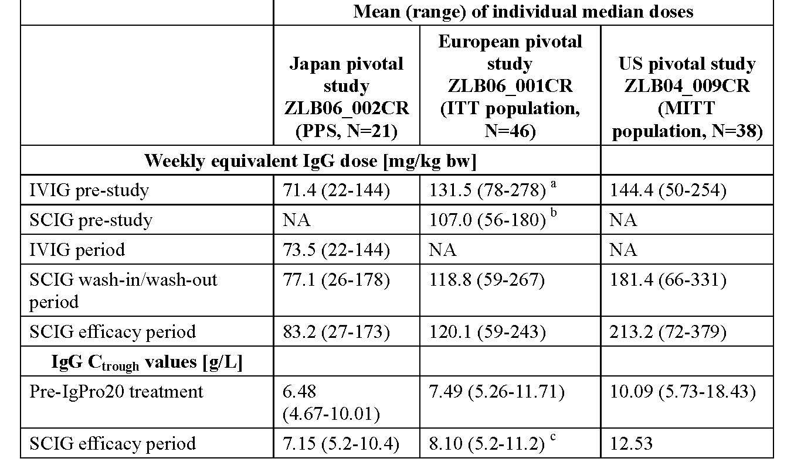
Table 8. Summary of Secondary Efficacy Results, ITT Population (Studies ZLB06_002CR, ZLB07_001CR and ZLB06_001CR)
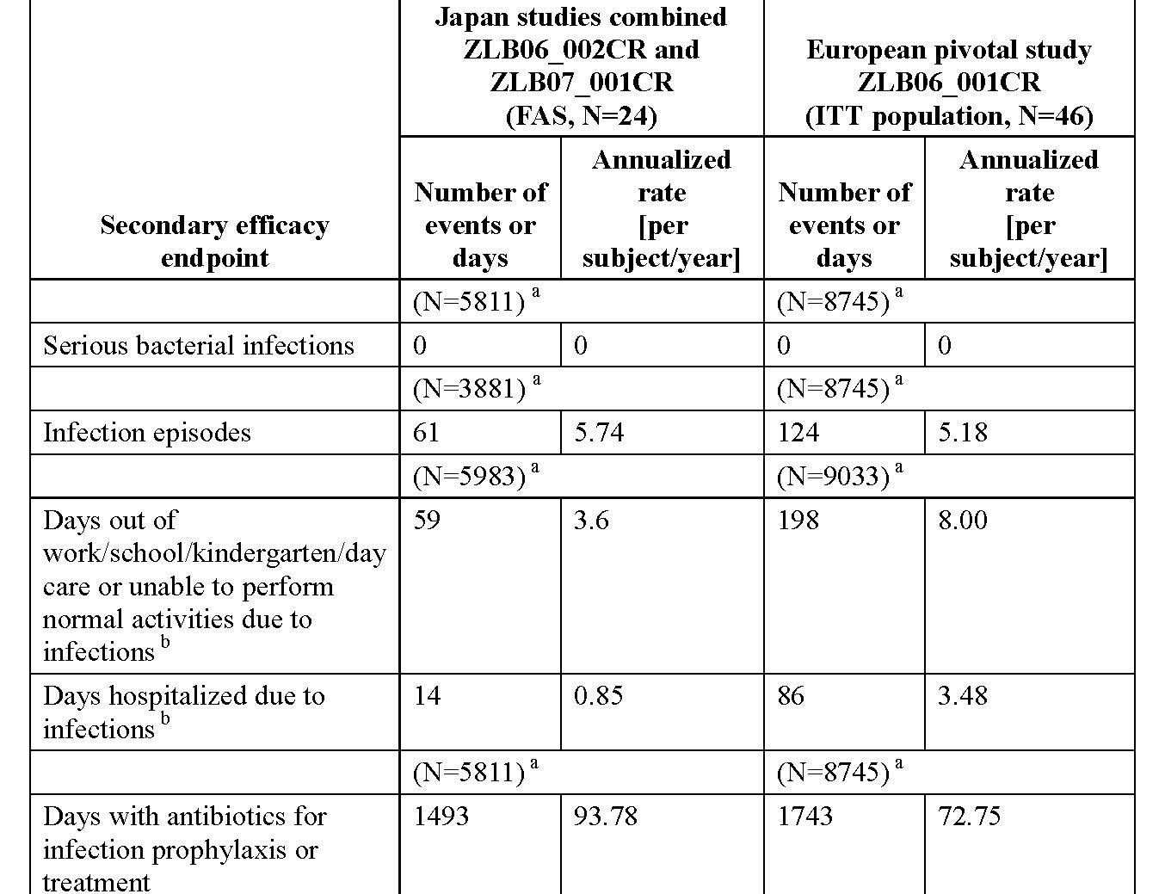
In keeping with common medical practice, these results suggest that IgPro20 could be an effective treatment in other immunodeficiencies of a secondary aetiology.

Safety

Studies providing safety data
The following studies provided evaluable safety data:
- 6 Phase III studies in PID (that is, 3 pivotal studies in Japan, Europe, US and their respective extension studies).
- Safety data from ZLB04_008CR in healthy male volunteers and serious AE (SAE) reporting from the ongoing Phase III study IgPro20_3006 provide further support of the overall safety of IgPro20.
- In addition, there were safety data derived from postmarketing data via spontaneous AE reports.

Patient exposure
In the 7 studies, IgPro20 was administered to 153 subjects, including 125 PID subjects in the 6 Phase III studies (of whom 23 participated in both Japan studies [including 11 subjects ≤16 years old], 40 participated in both European studies [including 19 subjects ≤16 years old], and 21 participated in both US studies [including 2 subjects <16 years old]) with a total of 12348 infusions. There were no comparators in the pivotal studies; all studies were conducted with a single arm.
Table 9. Summary of Exposure to IgPro20 in Completed Clinical Studies (Safety Population)
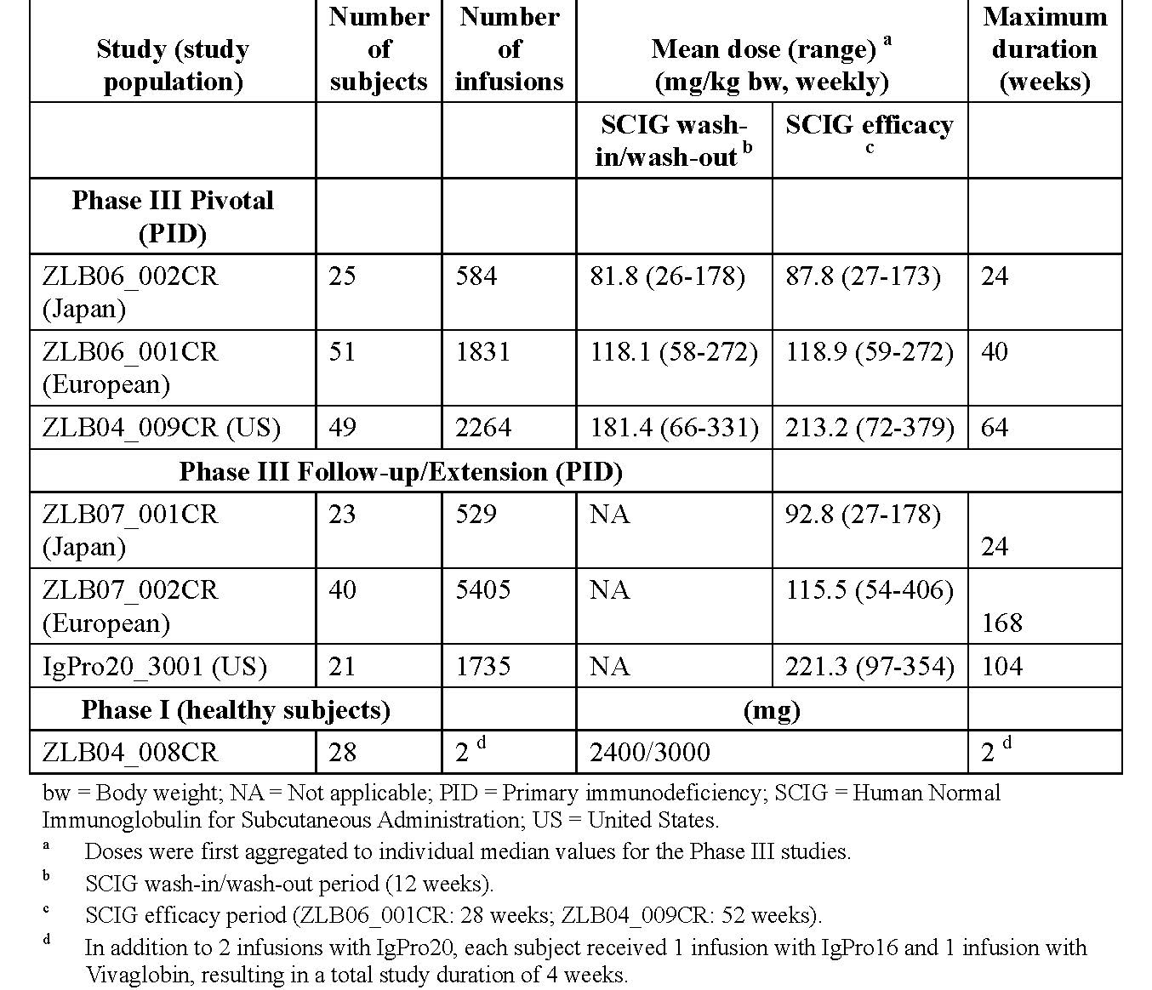

Safety issues with the potential for major regulatory impact
None listed.

Postmarketing data
- Since 4 March 2010 up to and including October 2012, it is estimated that Hizentra exposure has been approximately 18,160 patient years (based on grams sold). The International Birth Date of Hizentra is 4 March 2010 when the product was initially granted a license in the USA. Provided in this application were Periodic Safety Update Reports (PSUR) for the periods detailed below.
- Report number 1. PSUR 04 March 2010 to 14 October 2011: 4405years of patient exposure. This PSUR presents a total of 509 initial spontaneous case reports from worldwide sources, one report from a clinical trial and 180 follow-up reports received from the US prior to data lock point (DLP) of this PSUR are included. 480 initial cases were medically confirmed, 95 thereof report serious events. One case reporting a fatal outcome was received during the current interval. 30 initial consumer reports were received. All spontaneous reports came from the US market exclusively. During the reporting period, a clinical study (European extension study) was newly analysed and 3 papers were published, on Hizentra® US and European pivotal trials.
- Report number 2. PSUR 15 October 2011 to 14 April 2012: 4041years of patient exposure. This PSUR presents a total of 425 initial spontaneous case reports from worldwide sources and one report from a clinical trial. 147 follow-up reports received during the current interval of this PSUR are included. 399 initial cases were medically confirmed, 103 thereof report serious events. Four cases reporting a fatal outcome were received during the current interval. 26 initial consumer reports were received. There was no safety related action taken by either regulatory authorities or the marketing authorization holder (MAH) during the reporting period. No changes have been made to the Reference Product Information for safety reasons.
- Report number 3. PSUR Period 15 April 2012 to 14 October 2012: 5430 years of patient exposure. This PSUR presents 436 new medically confirmed case reports from worldwide sources. Of these, 71 were classified as serious and 365 as non-serious. For 1 medically confirmed case a fatal outcome was reported. In addition, 56 non-medically confirmed consumer reports were registered including 14 serious reports.
As of January 2013 A few cases of IG class effects such as anaphylactic reactions, Aseptic Meningitis Syndrome (AMS) and TEE were reported and the reporting rates of these events were considered as rare or well within the background rate in the general population. The Hizentra Company Core Data Sheet, dated February 2012, was valid at the beginning of reporting period number 3 and has been used as the Reference Safety Information for PSUR nos 3. Changes Planned: An update of the Company core safety information (CCSI) and afterwards of national labelling is currently in progress concerning inclusion of TEE and AMS.

Evaluator’s conclusions on safety
SC Hizentra has been trialled in relatively few adults and children but PID is a relatively rare disease and the studies included in this application were conducted appropriately and in accordance with EMA and FDA guidelines. The drug is well tolerated and as expected, across the clinical studies the most common AEs reported were local reactions at the injection site. These reactions are expected with SC infusions of relatively large volumes and most were mild in intensity and of short duration. Excluding infections, all other AEs apart from local reactions occurred in ≤7 subjects (≤ 28%) in the combined Japan studies and <13 subjects in any of the European and US studies. Although a slightly higher proportion of subjects in the European and US studies (ZLB06_001CR, ZLB04_009CR, and IgPro20_3001) than in the Japan studies reported AEs excluding infections and local reactions, the overall rate of AEs per infusion was lower than the rate reported for IVIG.
Although most subjects had local site reactions they were almost exclusively mild, short lived, not requiring special treatment and incidence decreased over time. There were few severe events and most were reported in only a single subject in any study.
No subject discontinued study participation because of AEs other than the subject who died in the European extension study. There was one death (due to pneumonia, unrelated to study drug in the European extension Study ZLB07_002CR). Across the 7 studies included in this dossier, 45 SAEs occurred in 26 subjects and 42 of these events were treatment-emergent, while 3 occurred prior to treatment. All but one of the SAEs (encephalitis in the Japan follow-up ZLB07_001CR) was considered by the investigators unrelated to study drug. Importantly, although numbers were relatively small and no child under 2 was enrolled in any pivotal studies, there was no evidence for an increased rate of AEs in paediatric subjects (2 to< 12 years) compared to adults. There was no evidence that more AEs were associated with higher starting infusion rate of >25 mL/h. Moreover, in Study IgPro20_3001, no AEs of severe intensity were experienced when using infusion rates of >50 to 70 mL/h. Rates of temporally related AEs per infusion were similar across the infusion rates used in this study suggesting no additional risks with infusions of IgPro20 at high total body infusion rates of up to 70 mL/h. No evidence that systemic AEs of IVIG class effects such as haemolysis, renal dysfunction/failure, thromboembolic events, aseptic meningitis syndrome, transfusion related acute lung injury and so on occurred during IgPro20 treatment in any of the studies that were included in this summary.
Postmarketing surveillance data have not revealed an increased risk of these class effects. There were no safety concerns regarding clinical laboratory parameters, vital signs, physical exam or viral safety. In summary, weekly SC Hizentra appears safe for PID Ig replacement in adult and paediatric (aged 2 or more) subjects.

First round benefit-risk assessment

First round assessment of benefits
The benefits of SC Hizentra in the proposed usage are:
- Efficacious as IgG replacement for PID as measured by serum IgG using dosing algorithms as suggested following a switch from either IVIG of SCIG (different formulation);
- Clinically effective in regards to rates of SBI;
- Safe even at relatively high infusion rates;
- Predictable side effects, predominantly as expected short lived injection site reactions (ISRs);
- The development programme for the drug either during registration studies (albeit small) and postmarketing surveillance did not reveal any new AEs of concern for this class of agent, of which several are already registered in Australia and Worldwide;
- Smaller volumes for infusion may be advantageous for some patients.

First round assessment of risks
The risks of SC Hizentra in the proposed usage are:
- No data is supplied in patients with secondary immunodeficiencies requiring Ig replacement, the three pivotal studies were conducted exclusively in PID patients;
- No data is supplied in patients with PID starting de novo Ig replacement with SC Hizentra;
- No data is provided in children aged less than 2 years of age;
- As the transmission of classical Creutzfeldt–Jakob disease (cCJD) is unknown, there is an unquantifiable risk of transmission through receipt of blood products including Ig;
- It is not possible to screen all blood products for all infections because some infections potentially transmissible through blood have not yet been identified. The production of Ig from donated plasma, whilst rigorous with several steps that minimise transmission of infectious agents, may not exclude all current (for example, variant CJD (vCJD)) or future pathogens.

First round assessment of benefit-risk balance
The benefit-risk balance of SC Hizentra, given the proposed usage, is favourable.

First round recommendation regarding authorisation
The data presented in this application from trials and their extension phases conducted in the EU, US and Japan demonstrate the efficacy, measured by serum IgG levels and protection against SBIs and safety with an expected side effect profile in line with the class of agents to which it belongs. Moreover, there was improved Quality of Life when this SC formulation was used compared to the IVIG. The evaluator recommends SC Hizentra for authorisation for use in PID. Despite the fact that no data was presented for the use of this drug in the setting of secondary immunoglobulin deficiency states, the evaluator had no reason to believe that efficacy and safety of the drug will be anything other equal to that demonstrated in the PID setting.
However, the evaluator had concerns that there is no data in children under the age of 2, and for this reason, the evaluator recommended SC Hizentra be approved for replacement immunoglobulin therapy in children (aged 2 years or older) and adults with Primary Immunodeficiency Disease such as Severe Combined Immunodeficiency (SCID), common variable immunodeficiency, congenital agammaglobulinaemia and hypogammaglobulinaemia and IgG subclass deficiencies with recurrent infections.

Clinical questions
None posed.

Additional corrected safety data
In August 2013, the sponsor provided additional safety data from the Japan Phase III study ZLB06_002CR and its associated extension Study ZLB07_001CR. Subsequent to completion of their company study reports (CSRs), inspection of one of the study sites by the Japanese regulatory agency identified that data on two AEs were not included. These were both local reactions of injection site pain which were mild in intensity and resolved without sequelae in 0.9 and 2.6 hours, respectively.
Data were provided in the sponsor’s submission showing how these affected the previous AE analyses.
The additional AEs did not affect the number of subjects experiencing any AE and did not have a relevant effect on the rate of AEs per infusion. Examples of the revised data are presented below.
Table 10. Revised data
Variable | CSR Data | Correct Data
Number and rate per infusion of any AE including infections | 450 (0.404) | 452 (0.406)
Number and rate per infusion of any causally related AE including infections | 245 (0.220) | 247 (0.222)
Number and rate per infusion of local reactions | 230 (0.207) | 232 (0.208)
Number and rate per infusion of any causally related and temporally associated local reactions | 223 (0.200) | 225 (0.202)
Note: extracted from Hizentra 2.7.4 Summary of Clinical Safety Erratum
It is indicated that an external consultant was commissioned by the sponsor to conduct an independent verification of the study data at this study site followed by a review meeting with the Principal Investigator on 8 May 2013.
From these activities, the sponsor concluded that this was a site specific issue and that there were no other relevant discrepancies between the ZLB06_002CR study source documents and the submission dossier that would have an impact on the efficacy and safety conclusions of the study. The sponsor also concluded that the 2 new local reactions did not have a relevant effect on the rate of AEs per infusion or the overall safety statements or risk benefit assessment of the IgPro20 therapy in immune deficiency patients.
Evaluator comment: These data were reviewed by a second evaluator and not by the evaluator who undertook the primary evaluation of the submission. It is noted that there were nine sites in this study. The sponsor’s conclusion is accepted. However it is considered that the sponsor should provide the following information on:
- The independent consultant engaged to undertake the data study verification (DSV) and,
- How the data from the other 8 sites were verified as accurate.

Second round evaluation of clinical data submitted in response to questions

Indications for use of Hizentra
The proposed indications for use of Hizentra do not include an age restraint. The First round evaluator stated that “... The evaluator recommended SC Hizentra be approved for replacement immunoglobulin therapy in children (aged 2 years of older) and adults with Primary Immunodeficiency Disease such as SCID, common variable immunodeficiency, congenital agammaglobulinaemia and hypogammaglobulinaemia and IgG subclass deficiencies with recurrent infections.”
The sponsor response is presented below:
CSL Behring believes that Hizentra should not be restricted to children < 2 years for the following reasons:

Subcutaneous Immunoglobulin (SCIG) use does not demonstrate age specific dosing requirements
During the clinical evaluation of Hizentra, there were no differences seen in Hizentra PK parameters between children (<12 years old), adolescents (12 to <16) and adults (16 and older).
This suggests that there are no age specific efficacy or safety requirements when using immunoglobulins subcutaneously. Furthermore, no special dosing requirements or precautions were needed for any of these age groups which are indicators that there are no specific dosing requirements across age groups. These findings indicate that Hizentra use in infants less than two would demonstrate similar efficacy and safety findings when using the stated dose per body weight.

Global use of Hizentra within paediatric populations
Hizentra is registered in numerous countries around the world and has celebrated many successful clinical applications in the paediatric population. There are a number of published literature references investigating the use of Hizentra and SCIG in children under the age of two. In one example by Gallagher J (2012), Hizentra was found to be a safe and effective treatment for infants 4 months and 14 months of age. Global marketing experience on the reporting of AEs within children (≤ 12 years old) indicate that the nature and frequency of AEs reported are in line with the expected range of possible adverse reactions to Hizentra, indicating no specific AE issues in children.

Inconsistency with subcutaneous immunoglobulins indications approved in

Australia
CSL Behring notes the age restriction in children is inconsistent with approved indications for commercially available normal subcutaneous immunoglobulins currently approved in Australia:

Gammanorm
Gammanorm is indicated for:
“Replacement therapy in adults and children with primary immunodeficiency syndromes such as:
- congenital agammaglobulinaemia and hypogammaglobulinaemia
- common variable immunodeficiency
- severe combined immunodeficiencies
- IgG subclass deficiencies with recurrent infections
Replacement therapy in myeloma or chronic lymphatic leukaemia with severe secondary hypogammaglobulinaemia and recurrent infections.”
According to the Product Information for Gammanorm the clinical program included children from the age of 1.5 years however the approved indication does not include an age restriction for children.

Kiovig
KIOVIG administered subcutaneously is indicated for:
“(1) Replacement therapy indications
- Primary immunodeficiency disorders (PID).”
According to the Product Information for Gammanorm the clinical program for subcutaneous use of Kiovig included children from the age of 2 years however the approved indication does not include an age restriction for children.
CSL Behring would like to further note that although Kiovig is indicated for use in children, the Product Information highlights the limited efficacy and safety data within the paediatric age group in the ‘Precautions’, ‘Paediatric use’. The proposed Hizentra Product Information is consistent with these products.

Suitability of subcutaneous administration in the infant population
Subcutaneous use of immunoglobulins, especially in infants, is more practical, convenient and offers a real alternative treatment modality for those with poor venous access. Therefore, immune deficiency patients of the youngest age group (that is, less than 2 years old) would benefit the most from a SCIG such as Hizentra.

Second round clinical evaluator comment
The response in relation to global use of Hizentra within the paediatric population references an article by Gallagher et al²⁹ as support for its use in children < 2 years of age. It is indicated that this is noted in the PSUR covering the period 14 April 2011 to 15 October 2012 provided with the submission. It is actually noted in PSUR covering 15 October 2011 to 14 April 2012. A copy of the reference was not provided in the submission.
In the comparison with the indications in the PI for SC immunoglobulins already approved in Australia, for Kiovig it is stated that “According to the Product Information for Gammanorm the clinical program for subcutaneous use of Kiovig included children from the age of 2 years, however the approved indication does not include an age restriction for children.” This statement corresponds to the Kiovig PI and reference to Gammanorm appears to be a typographical error.
As indicated in the First round clinical evaluation, the age limitation to patients > 2 years is included in the US label. However, it is not included in the EU Summary of Product Characteristics (SPC) dated August 2013 accessed via the e-Medicines Compendium. Also, review of European Public Assessment Reports (2011 and 2012) reveals that the clinical data package reviewed for EU marketing authorisation was the same as that provided to the TGA. The sponsor’s rationale for not limiting the age in the indication for use is accepted.

Additional corrected safety data
These (see above) related to one site in the Japan Phase III study ZLB06_002CR and its extension ZLB07_001CR which was conducted across nine sites. The sponsor was asked to provide information on two issues as follows.

Information requested
The independent consultant engaged to undertake the data study verification (DSV).

Sponsor response
The Study Monitor performed the SDV in accordance with the monitoring plan and a recent review conducted by CSL Behring indicated that this was sufficiently carried out. The two unreported AEs were identified as a SDV oversight, mainly attributed to the additional transcription process applied by the Monitor at this site to accommodate the set up in the data verification and review discussion with the Principal Investigator. This extra data transcription step was unique to the site at the National Defense Medical College and was not followed at other sites. Following the Pharmaceuticals Medical Devices Agency (PMDA; Japanese regulatory authority) post inspection inquiries and using a risk based assessment, CSL Behring commissioned an external consultant to lead an independent SDV activity relevant to the study data at the National Defense Medical College. This was performed on 22, 23 and 25 April 2013 and was followed by a review meeting with the PI on 8 May 2013. From these activities CSL Behring concludes that there were no other relevant discrepancies between the ZLB06_002CR study source documents and the submission dossier that would have an impact on the efficacy and safety conclusions of the study. CSL Behring concluded that monitoring at the individual study site had been appropriately conducted in compliance with the Monitoring Plan of the Contract Research Organization.

Information requested
How the data from the other eight sites were verified as accurate.

Sponsor response
At the eight other sites in which the trial was carried out, 100% SDV of Case Report Form entries against subject’s source medical records was performed by an accredited Contract Research Organization. This SDV was carried out according to Standard Operating Procedures.

Second round clinical evaluator comment
The sponsor’s response does not provide any information on the independent consultant appointed to undertake the DSV. Notwithstanding this, the responses to both questions are accepted.

Second round benefit-risk assessment
As presented previously in this evaluation report, based on the efficacy and safety data provided in the submission, it is concluded that the benefits of treatment with Hizentra outweigh its risks. The response to the question regarding its indications for use does not change this assessment.

Second round recommendation regarding authorisation
It is recommended that Hizentra is approved for inclusion in the ARTG as follows:
“Hizentra® is indicated in adults and children for replacement therapy in:
- Primary Immunodeficiency Disease (PID) and
- Symptomatic hypogammaglobulinaemia secondary to underlying disease or treatment.”

V. Pharmacovigilance findings

Risk management plan
The sponsor submitted a Risk Management Plan (global core RMP version 2.0, dated 21 January 2013, data lock point 14 April 2012, and the Australian specific annex version 1.0, dated 14 March 2013) which was reviewed by the TGA’s Office of Product Review (OPR).

Safety specification
A summary of the Ongoing Safety Concerns as specified by the sponsor is shown in Table 11.
Table 11. Summary of Ongoing Safety Concerns
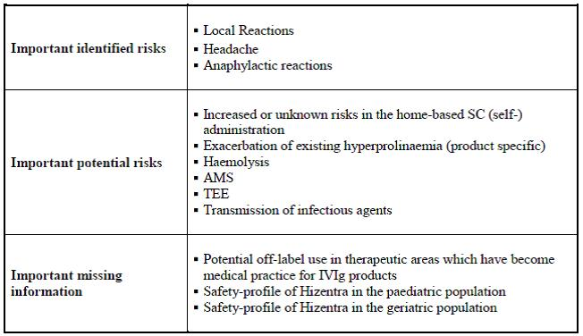

Pharmacovigilance plan
The sponsor proposes routine risk minimisation activities to address all ongoing safety concerns. For the ongoing safety concerns of AMS, TEE and anaphylactic reactions the sponsor has proposed to use follow up forms to collect relevant data regarding these events.
Two Phase III studies are ongoing, one for the indication of PID and the other for the indication of CIDP. These studies are not considered part of the planned studies to the risk management plan and therefore, the protocols have not been reviewed by the RMP evaluator.

Risk minimisation activities
The sponsor proposes routine risk minimisation activities, for some but not all ongoing risks, in the form of provision of information in the Australian PI and Consumer Medicines Information (CMI).
No risk minimisation activity is specified in the summary of the RMP for the important potential risk of haemolysis and all risks classified as missing information.
The sponsor states in the ASA: The risk minimisation activities (including label updates) in the current Core-RMP Version 2.0 (Sections 3 and 4) are applicable and will be implemented in Australia.

Reconciliation of issues outlined in the RMP report
Table 12. Summary the OPR’s first round evaluation of the RMP, the sponsor’s responses to issues raised by the OPR and the OPR’s evaluation of the sponsor’s responses.”
Recommendation in RMP evaluation report | Extracts of the sponsor’s response | OPR evaluator’s comment
- It is recommended that global core RMP version 2.0, dated 21 January 2013, data lock point 14 April 2012, and the Australian specific annex version 1.0, dated 14 March 2013, and any future updates, be implemented as condition of registration. | CSL Behring commits to implementing the current global RMP version 3.0, dated 16 April 2013, and the Australian Specific Annex edition 2.0, dated 23 October 2013 and any future updates as a condition of the Hizentra registration. | This is considered acceptable.
- The following recommendations are made regarding the table of ongoing safety concerns specified by the sponsor:  A.) It is recommended that the following patient populations be added as missing information  a.) Patients with hepatic impairment,  b.) Patients with renal impairment,  c.) Pregnant or lactating women.  B) It is recommended that the following be added as potential risks  a.) TRALI,  b.) Lack of efficacy and/or non-compliance,  c.) Renal Dysfunction.  Risk minimisation and pharmacovigilance activities should be assigned as appropriate. Reporting of safety related events for these patients groups and potential risks should occur in any PSUR submitted to the TGA. | CSL Behring considers missing information for a product to be based on the clinical trial and post approval experience. CSL Behring confirms that no safety concerns have been identified with the use of Hizentra in the special populations of patients with hepatic or renal impairment or pregnant or lactating women. Based on the current exposure and the safety data available, CSL Behring believe it is sufficient for these special populations to not be considered as missing information.  The sponsor proposes not to include any of the potential risks based on postmarketing experience. | Based on the information provided regarding the postmarketing safety data, this is considered acceptable.  Based on the information provided regarding the postmarketing safety data, this is considered acceptable.
- The following points are brought to the Delegate’s attention regarding the table of Ongoing safety concerns.  A.) It is recommended to the Delegate to draw the attention of the clinical evaluator to assess whether it is acceptable that cardiovascular events are not listed as an ongoing risk. | CSL Behring would like to bring to TGA’s attention that TEE has been included as part of the ‘important risks’ for Hizentra in the Risk Management Plan. Thus among these TEEs, specific cardiovascular disorders such are myocardial infarction, have been included. No other types of cardiovascular events are known to be associated with immunoglobulins. There is no evidence that other cardiovascular events should be listed as ongoing risk for this drug class. | The sponsor’s response has been noted. The round 2 clinical evaluator evaluated whether it is acceptable that cardiovascular events are not listed as an ongoing risk, and has found this to be acceptable. However, the clinical evaluator recommended that the PI be amended to more clearly specify this risk in the proposed Australian PI (please refer to proposed text in section 1(outstanding issues) in this report).
- It is recommended that the sponsor submits study reports, resulting from the ongoing clinical trials, to the TGA at the same time as reports are submitted to other regulatory agencies. To this end, it is recommended that the sponsor submits a summary table as attachment to the ASA, outlining anticipated dates for submission of study related reports to the TGA. | CSL Behring has included a summary table as an attachment to the ASA, outlining anticipated dates for submission of study related reports resulting from two remaining ongoing clinical studies; ‘CIDP IgPro20_3003’ and ‘Japan extension IgPro20_3006’ to the TGA. | This is considered acceptable.
- It is recommended the wording in the CCDS for TEE and AMS be provided to the TGA for review prior to approval. | The wording for TEE and AMS is currently under review in the EU. The Core Company Data Sheet will be updated post approval.  Additionally wording regarding TEE and AMS has been included in the Australian Product Information proposed for Hizentra. The updated PI is included in 1.3.1 Proposed Australian PI. | The commitment by the sponsor to update the CCDS post-approval has been noted.  The additional wording provided in the PI is considered acceptable.
- It is recommended that the sponsor submits the questionnaires for TEE, AMS and anaphylactic reactions for review prior to approval. | The questionnaires for TEE, AMS and anaphylactic reactions were provided to the TGA on 30 April 2013 in response to the Planning Letter received for Hizentra.  CSL Behring has provided these questionnaires to the TGA. Please note; the Questionnaire on Thromboembolic Events has since been updated to version 3.00. | The response and the submitted questionnaires are considered acceptable.
- It is recommended that the sponsor amends the RMP to reflect that routine risk minimisation activities are conducted for the missing information of “Safety profile of Hizentra in the paediatric and geriatric population”. | CSL Behring confirms that routine risk minimisation activities for paediatric and geriatric populations have been updated in the next version of global RMP version 3.00 (Table 32) for the missing information. | This is considered acceptable.
- It is recommended that the additional risk minimisation activity of provision of educational materials to prevent medication errors be implemented for Hizentra. | CSL has gained experience in the development and assessment of educational materials for the recently approved CSL subcutaneous normal immunoglobulin, Evogam. Leveraging from the learning’s and feedback from these activities, CSL will develop the Hizentra materials to meet the needs of Australian HCPs and patients. The proposed materials will be provided to health care provider for review and applicability, and will be provided to the TGA prior to product launch. CSL would like to emphasise the strong communication lines with key Health Care Providers within the immunology area in Australia and commit to working with relevant Health Care Providers and patients in order to minimise the risk of medication errors during development and dissemination of such materials. In summary, CSL agree to implement additional risk minimisation activities to prevent medication errors as follows;  1. Development and provision of educational materials for Hizentra to key HCP stakeholders, which will include information on the correct administration of Hizentra.  2. Development and provision to HCPs of a patient diary, as a tool for patients to record their treatment.  3. Review of materials by key HCPs to garner feedback as part of development process  4. Provide materials to the TGA prior to product launch, along with information on proposed target population and distribution methods. | This is considered acceptable. It is recommended that the submission of these materials to the TGA for review be implemented as a condition of registration.
- It is recommended that the sponsor submits a summary table as attachment to the ASA, detailing the wording by which routine risk minimisation is exercised in the Australian PI. This table may be same as/similar to Table 21 in the core RMP, but specifically tailored to outline what information is included in the Australian PI. | CSL Behring has provided a summary table of routine risk minimisation measures included in the Australian PI as Annex 2 in edition 2.0 of the Hizentra ASA. | This is considered acceptable.
- Changes to the PI and CMI as recommended (details are beyond the scope of this AusPAR.). | CSL Behring updated the Product Information and Consumer Medicine Information documents. | The changes to the PI and CMI are considered acceptable.

Summary of recommendations
It is considered that the sponsor’s response to the TGA’s request for further information has not adequately addressed all of the issues identified in the RMP evaluation report (see Outstanding issues below).

Outstanding issues

Issues in relation to the RMP
Amendments to the PI as specified by the clinical evaluator.

Advice from the Advisory Committee on the Safety of Medicines (ACSOM)
ACSOM advice was not sought for this submission.

Key changes to the updated RMP
The sponsor provided an updated RMP, version 3.0, dated 16 April 2013. Key changes from the version evaluated at Round 1 are summarised below:
The sponsor states that “the update to the global RMP included the following major changes”:
- Version 3.0 of the Hizentra Risk Management Plan (RMP) has been updated primarily to reflect the new EU regulations (Regulation (EU) No 1235/2010 and Directive 2010/84/EU) for submission to the EMA in the new format template.
- Version 3.0 has also been updated to the new data lock point of 14 October 2012 (additional 6 months of data) which includes data from an additional completed clinical study (Japan follow up study, ZLB07_001CR) and further postmarketing data compared to version 2.0.
- ‘Headache’ has been removed as an important identified risk.
- Pruritus (systemic), fatigue, pain, and vomiting as important potential risks have been removed.

OPR evaluator’s comments
The evaluator has no objection to the above changes and recommends to the Delegate that the updated version is implemented (see below).

Suggested wording for conditions of registration

RMP
- Implement Global Core RMP version 3.0, dated 16-Apr-2013, data lock point 14-Oct-2012 and Australian Specific Annex version 2.0, dated 23-Oct-2013, and any future updates as a condition of registration.
- Educational materials for Health Care Professionals and Patients should be submitted to the TGA for review prior to product launch.

VI. Overall conclusion and risk/benefit assessment
The submission was summarised in the following Delegate’s overview and recommendations:

Quality
The administrative, product usage, chemical, pharmaceutical, microbiological data submitted in support of this application have been evaluated in accordance with the Australian legislation, pharmacopoeial standards and relevant technical guidelines adopted by the TGA.
There are no outstanding issues with respect to manufacturing quality, endotoxin safety, microbiological, viral and prion safety. The quality evaluator(s) recommend that Hizentra® 20% solution for subcutaneous injection (1 g in a 5 mL solution, 2 g in a 10 mL solution, 4 g in a 20 mL solution and 10 g in a 50 mL solution) should be approved. The recommendations also include the approval of a new commercially available virus removal filter, namely Sartorius Virosart HC, as an alternative to the currently approved nanofilter: Pall Ultipor VF Grade DV20.
It is a condition of registration that, as a minimum, the first 5 independent batches of Hizentra® (20%) imported into Australia are not released for sale until samples and/or the manufacturer’s release data have been assessed and endorsed for release by the TGA Office of Laboratories and Scientific Services (OLSS). This batch release condition will be reviewed and may be modified on the basis of actual batch quality and consistency. An electronic draft of the Certified Product Details (CPD) should be provided upon. In addition, an updated CPD should be provided when changes to finished product specifications and test methods are approved in a Category 3 application or notified through a self-assessable change.

Nonclinical
The nonclinical data was considered to be adequate based on the extensive clinical experience with human immunoglobulins, and the similarities with existing products.
Therapeutic use of Hizentra® may be associated with hypotension, as is observed with similar human immunoglobulin products. Concerns remain with the proposed paediatric use of Hizentra®, based on a literature report of deficits in learning and memory in juvenile rats treated with the excipient L-proline. The blood brain barrier of juvenile rats appears to be more permeable to proline and plasma elimination is slower compared with older rats. It is therefore recommended that the juvenile rat findings are summarised in the Product Information (PI).
Hizentra® was relatively well tolerated by the SC and IV routes. There are no nonclinical objections to the registration of Hizentra®.
The evaluator also recommended some changes to the draft Product Information.

Clinical
The clinical data include one Phase I safety study in healthy volunteers (ZLB04-008CR) and the following pivotal Phase III studies:
- The Japan pivotal study (ZLB06-002CR)
- The EU pivotal study (ZLB06-001CR)
- The US pivotal study(ZLB04-009CR)
Subsets of patients in each of these studies also contributed to the Pharmacokinetic (PK) data. Patients from these 3 studies were eligible to enter the respective extension studies in which longer term safety and health related quality of life was assessed:
- EU extension study(ZLB07-002CR)
- US extension study (IgPro20-3001)
- Japan follow up study (ZLB07-001CR)
In addition, the TGA requested the sponsor to include an additional study report for a trial conducted in 20 healthy volunteers that assessed the safety of unintended IV administration of the product at the SC dose. This study (ZLB06-003CR) was included in the EU submission but was initially excluded from the Australian submission.

Pharmacokinetics (PK) assessment
The PK assessment in the PID patients during the SC Hizentra (IgPro20) therapy is based on the PK sub studies of the 3 Phase III pivotal studies (ZLB06_002CR, ZLB06_001CR and ZLB04_009CR). The PK data were obtained from 8 adults (≥16 to <65 years) in the Japan pivotal study (ZLB06_002CR); 23 subjects (including 9 children 2 to <12 years and 3 adolescents 12 to <16 years) in the EU pivotal study (ZLB06_001CR), and 19 in the US pivotal study. The PK was only assessed in the PID patients who were already stable on IVIG (Japan and US pivotal studies) or IVIG or SCIG therapy (EU pivotal study). There was no PK data in PID patients starting SC Hizentra as de novo IgG replacement.
In the US pivotal study, bioequivalence of IgPro 20 was approximately calculated against the IVIG product Privigen® (IgPro10). Based on serum IgG C_{trough} measured in the PK substudy during IVIG, a mean dose adjustment coefficient (DAC) of 1.53 (range: 1.26 to 1.87) was used for calculating the dose for SCIG treatment. In the Japan and the EU study, the SC dose was determined to be equal to the weekly equivalent doses of the previous IVIG (or SCIG) therapy and the finer dose adjustments was up to the treating doctor with the aim of maintaining sufficient trough levels and good clinical response.
The dose of SC IgPro20 in the Japan study was 63% of the value in the EU pivotal study and 33% of the value in the US pivotal study. The lower dose resulted in relatively lower C_{max} and AUC values in the Japan study. The mean of the individual median IgG C_{trough} at steady state IgPro20 treatment was 7.15 g/L, 8.10 g/L, and 12.53 g/L in the Japan, EU and the US pivotal study, respectively. The C_{trough} values in the Japan and the EU studies were comparable to the values achieved with other SCIG products licensed in the EU (Vivaglobin: 8-9 g/L; Subcuvia: 7.2-7.9 g/L according to their SPCs). Ratios of the individual IgG subclasses contributing to total IgG at steady-state and measurement of specific IgGs were only evaluated in the EU and the US studies. Measured values in these studies are generally within the range of physiological IgG subclasses ratios reported in the literature. Table 13 provides the overview of the PK sub studies conducted with IgPro20 while Table 14 provides the results of the mean steady-state PK values of the serum IgG during the SC IgPro20 therapy in these pivotal studies.
Table 13. Overview of the Human PK Studies Conducted with IgPro20
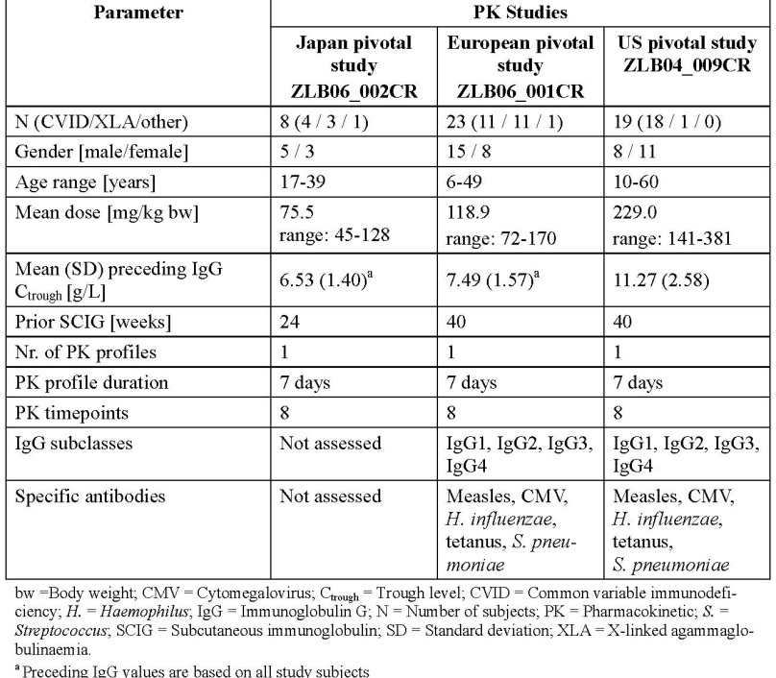
Table 14. Steady-state PK of Serum IgG during IgPro20 Treatment
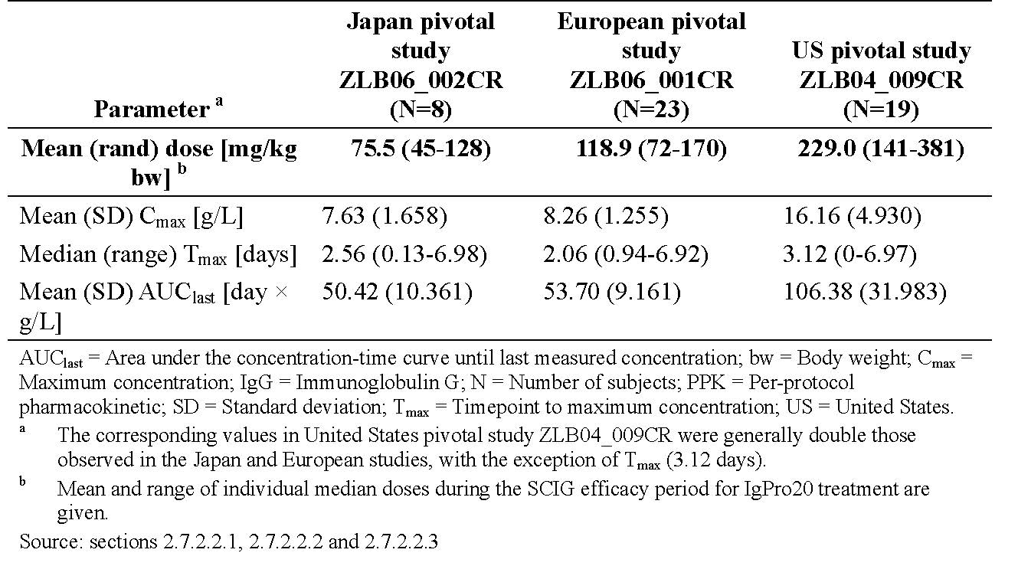
There were limited data in children <16 years of age in these PK sub-studies. However, these data suggest no differences of the PK values for age. No data was provided in children < 2 years of age. Further data in regards to the efficacy endpoint of serum IgG is demonstrated in the pivotal EU study which included 17 children (2 to <12 years) and 5 adolescent (12 to <16 years). A sub-group analysis of the effect of age on serum IgG in the EU study demonstrated no paediatric specific dose requirements beyond weight based dosing.
Serum L-proline was shown to be rapidly eliminated from the circulation in the EU and US pivotal studies. One day post IgPro20 at steady-state (Week 28 ± 1), serum L-proline level had returned to pre infusion levels, indicating rapid elimination and lack of accumulation.
Despite the limited PK data, the studies meet the EMA requirement. The clinical evaluator considers that there is sufficient PK data for this product and noted the lack of specific PK data in children under the age of 2 years of age.

Clinical efficacy
Three pivotal Phase III studies and the respective extension studies are submitted. All the studies were performed in PID patients. The study populations reflect the typical characteristics of PID subjects receiving IVIG replacement therapy, but no very young children (2 years or less) were enrolled. None of the studies included patients with secondary immunoglobulin deficiency syndromes. All the studies included a single arm switch to weekly SC Hizentra in patients already stable on IVIG (US and Japan pivotal studies, respectively) or IVIG or SCIG (EU pivotal study). The EU pivotal and extension studies (duration >3 years) and combined Japan studies assessed the sustained IgG C_{trough} values as the primary endpoint, and the protective effect against infections as a secondary endpoint. In contrast, the US pivotal and extension studies, in which patients received substantially higher doses of SC Hizentra, the primary efficacy endpoint was annual rate of SBI (Serious Bacteria Infections) that is, bacterial pneumonia; bacteraemia/septicaemia; osteomyelitis/septic arthritis; bacterial meningitis; visceral abscess. FDA guidelines were used to define the criteria for confirmed SBIs. The EU and Japan studies explored the effects of IgPro20 treatment on quality of life and in Japan, pharmacoeconomics.

Japan pivotal study (ZLB06-002CR)
This was a multicentre, single-arm, open-label study conducted in 25 PID subjects. The study consisted of an IVIG run-in period with 3 IVIG infusions, a 12 week SCIG Wash in/Wash-out (WI/WI) period, and a 12 week SCIG efficacy period. A total of 25 subjects received the 3 IVIG infusions. All 24 subjects in the FAS and all 21 in the PPS received the 12 weekly infusions during the SCIG WI/WI period. The subject who discontinued the study during the WI/WO period and was not included in FAS and PPS received 8 of 12 infusions in that period and none during the SCIG efficacy period.
The primary analysis was conducted in the PPS set by descriptive comparison of 3 IgG C_{trough} values from the 3 IVIG infusions with 3 consecutive C_{trough} values during steady-state IgPro20 treatment (that is, Week 16, 20 and 24). The primary efficacy outcome was indicated by a GMR of SC vs. IV IgG trough levels. GMR close to 1 would indicate comparable IgG trough levels between weekly SCIG therapy and historically recorded levels with IVIG therapy). The IgG C_{trough} levels increased from 6.53 g/L in the IVIG period to 7.15 g/L in the SCIG efficacy period (PPS set, Table 15). The GMR was 1.09 (90% CI: 1.06 to 1.13) showing that the objective of achieving comparable IgG C_{trough} levels was met (Table 16).
Table 15. Mean and median IgG trough levels SCIG versus IVIG (PPS and FAS set)
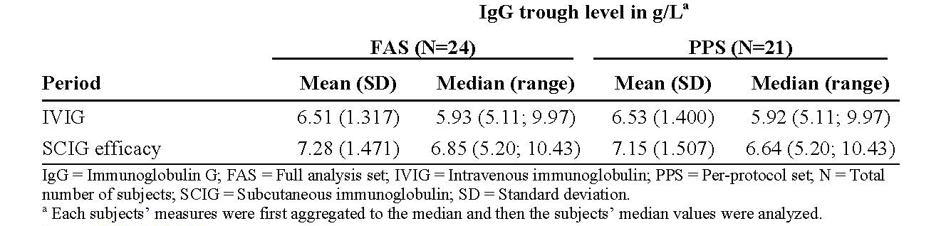
Table 16. GMR and 90% CI of IgG trough levels SCIG versus IVIG (PPS and FAS)
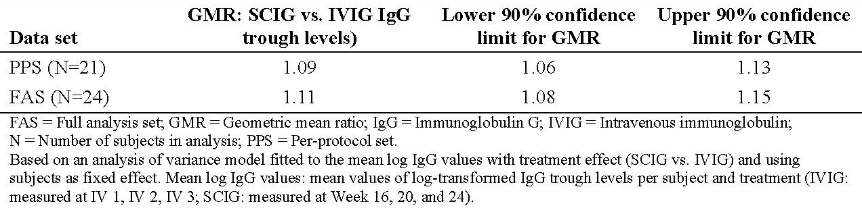

Europe pivotal study (ZLB06-001CR)
This was a prospective, open-label, multicentre, single-arm study in PID subjects (3-60 years old) who were previously treated with IVIG or SCIG for at least 6 months. The study consisted of a 6 month run-in period (IVIG or SCIG infusions), a 12 week SCIG WI/WO period and a 28-week SCIG efficacy period. A total of 53 PID subjects were screened, and 51 subjects were treated for up to 41 weeks. A total of 43 subjects completed the 28-week efficacy period.
The primary efficacy analysis was to descriptively compare IgG C_{trough} values at 6 consecutive weeks at steady-state, that is, IgG levels prior to Infusions 12 to 17, with 3 IgG C_{trough} values obtained from the subject’s previous treatment during the last 3 to 6 months prior to the study. The primary efficacy endpoint was evaluated in ITT population (n = 46) and the secondary efficacy endpoint of SBIs were evaluated in ITT and PPE population. All 46 subjects in the ITT population received the intended 12 infusions during the WI/WO period. In the ITT population, the mean IgG C_{trough} values were stable during the efficacy period. The mean of individual median IgG C_{trough} values was 8.10 g/L at steady-state. Compared to IgG C_{trough} values for 3 infusions during the pre-study IVIG or SCIG treatment, the mean of individual median IgG C_{trough} values increased by 8.1% (from 7.49 g/L to 8.10 g/L). The same increase in IgG C_{trough} values observed when considering C_{trough} pre-Infusions 12 to 41 (Table 17).
Table 17. Median IgG trough levels before and during the study (ITT population)
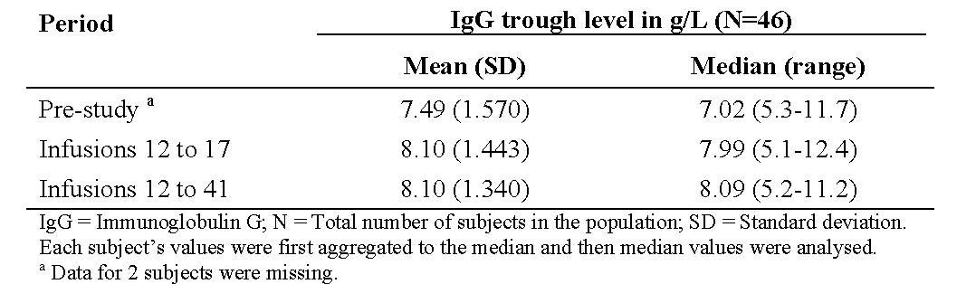
No subjects in ITT or PPE population had an SBI during the efficacy period. The annual rate of SBIs per subject was therefore 0, with upper 99% CL of 0.192 for the ITT and 0.250 for the PPE population. However, 1 subject had an SBI (pneumonia) during the WI/WO period, resulting in an annual rate for the full evaluation period of 0.03 SBIs/subject/year (upper 99% CL: 0.192) for the ITT population and of 0.04 SBIs/subject/year (upper 99% CL: 0.253) for the PPE population.

The US pivotal study (ZLB04_009CR)
This was a multicentre, single-arm, prospective, open-label study conducted in PID subjects (5 to 72 years old). A total of 52 subjects were screened and 49 subjects (including 10 subjects < 16 years) were treated with SC IgPro20 for up to 15 month (12-week WI/WO period followed by a 12-month efficacy period). These 49 subjects comprised the ITT population. 11 subjects in the ITT population were excluded from the MITT population. Thus, the MITT population consisted of 38 subjects who were evaluated for efficacy. Because of the differences in dosing practices in different world regions, the doses of IgPro20 in this study were more than double those used in the Japan studies and nearly twice as high as in the EU study. The study subjects had 3 month IVIG therapy, 12 weeks SC IgPro20 WI/WO period followed by a 12-month efficacy period (longer than the 28 weeks efficacy period in the EU pivotal study).
The primary efficacy endpoint was annual rate of SBI, that is, bacterial pneumonia; bacteraemia /septicaemia; osteomyelitis /septic arthritis; bacterial meningitis; visceral abscess (FDA guidelines were used to define the criteria for confirmed SBIs). The primary objective was to evaluate whether the annual rate of SBIs per subject was < 1. The results showed that following more than 12 months of IgPro20 treatment, no subjects experienced an SBI in the MITT population, the annual SBI rate per subject was 0 and the corresponding upper limit of 1-sided 99% CI was 0.132. As this rate was <1, the primary objective was achieved and this is considered clinically relevant.
The MITT population was also used for a descriptive comparison of the individual median IgG C_{trough} values. The IgG C_{trough} values were generally stable at the WI/WO period and after dose adjustment during the efficacy period. For the MITT population, the mean of the individual median IgG C_{trough} values was 12.56 g/L (SD: 2.92 g/L) during the WI/WO period and 12.53 g/L (SD: 3.21 g/L) during the efficacy period. Compared to the last 3 months of IVIG treatment, the mean IgG C_{trough} levels were increased by 2.44 g/L (24.2%) during the SC efficacy period.
The two tables below summarised the efficacy results from the 3 pivotal studies.
Table 18. Summary of IgG Doses and Serum IgG Trough Levels Before and During IgPro20 SC Treatment in the 3 Pivotal Studies, Primary Analysis Populations
Table 19. Summary of Secondary Efficacy Results, ITT Population (Studies ZLB06_002CR, ZLB07_001CR and ZLB06_001CR)
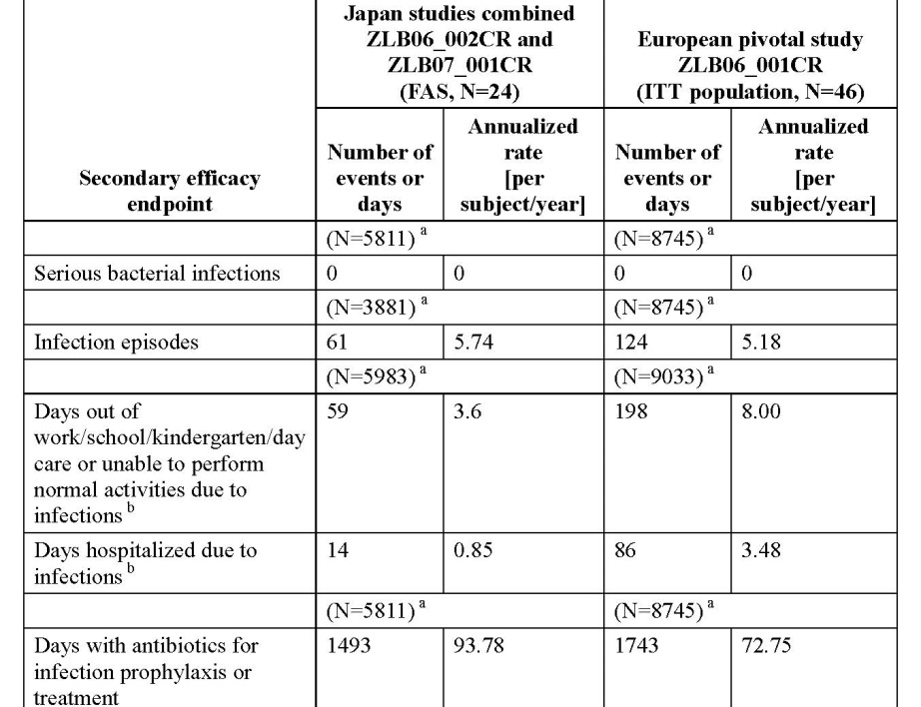

Extension studies
The three extension studies were included in the TGA submission. These extension studies were also submitted to the EU after the initial registration submission.
In the EU extension study, mean IgG trough values in the all treated population (n=40) were measured every 6 months for 36 months and in 4 subjects up to 42 months. Trough levels were stable within a range of 7.5 to 8.5 g/L, with a mean median value of 7.97 g/L (SD: 1.17), and a median of 8.12 g/L (range: 5.8 -11.1 g/L). Stable median IgG trough levels were maintained within a narrow range throughout the three year period (the pivotal and the extension study). A total of 5SBIs (all bacterial pneumonia) in 5 subjects were reported during the extension study (annualised rate: 0.0478 SBIs/subject/year; upper 1-sided 99% CL: 0.1252). 95% had at least 1 infection during the study period (38208 subject days) (rate: 3.334 infections / subject / year; 95% CL: 2.993; 3.703).
The US extension study also confirmed the sustained efficacy over a median treatment period of 87 weeks. There were a total of 2 SBIs (the upper 1-sided 99% CL for the SBI rate: 0.257 SBIs per subject per year for the ITT population).The mean of individual median IgG trough level was 11.98g/L. None of the subjects had IgG trough level less than 5g/L during treatments. Mean IgG trough levels were stable at between 11.71-12.76g/L during the study.
For the Japan extension (or follow up) study, the individual treatment duration per subject will be up to 24 weeks (6 months), followed by viral safety follow-up visit 12 to 17 weeks after W 24/last IgPro20 infusion. The follow up study demonstrated that the median IgG trough levels were comparable in the pivotal study with the follow-up study and there were no SBI in the follow up study period. The safety, efficacy and HRQL results from the follow-up study was consistent with the findings in the pivotal study indicating the study drug is safe, efficacious and well tolerated when given for a longer period.
Overall, the objective of these studies to sustain (>3 years in the EU extension) serum total IgG trough levels at least at the level prior to IgPro20 use was achieved and at levels considered clinically effective i.e. protective against SBI; In keeping with common medical practice, these results suggest that IgPro20 could be an effective treatment in other immunodeficiencies of a secondary aetiology.

Clinical safety
Safety analyses were conducted in the PID patients in the 3 pivotal studies and the respective extension studies. The Phase I study (ZLB04_008CR) assessed the safety in healthy volunteers. In addition, SAE reporting from the ongoing Phase III study (IgPro20_3006) and safety data derived from post-marketing reports were also provided.
In these 7 studies (Table 20), IgPro20 was administered to 153 subjects, including 125 PID subjects in the 6 Phase III studies (of whom 23 participated in both Japan studies [including 11 subjects ≤16 years old], 40 participated in both European studies [including 19 subjects ≤16 years old], and 21 participated in both US studies [including 2 subjects <16 years old]) with a total of 12348 infusions.
Table 20. Summary of Exposure to IgPro20 in Completed Clinical Studies
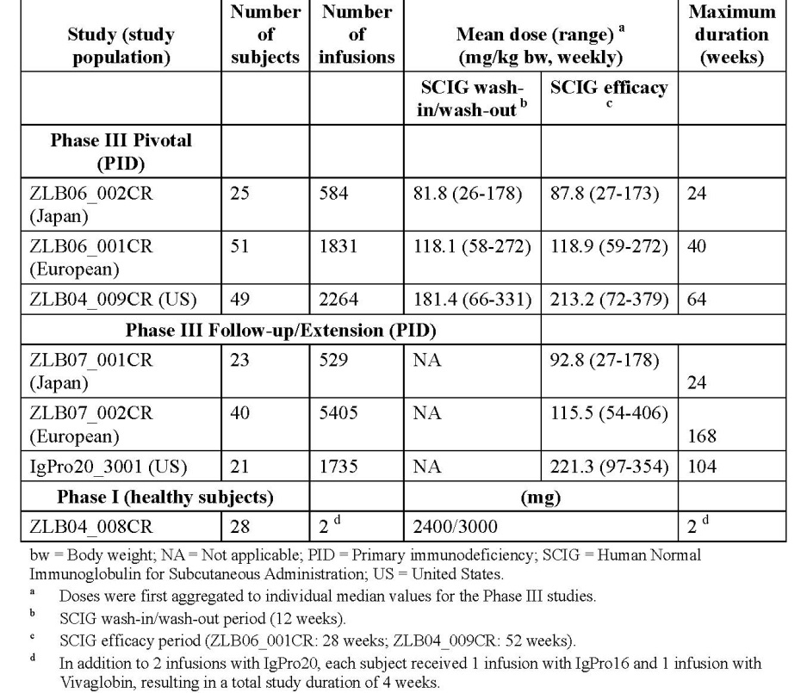
SC Hizentra appears to be well tolerated based on the safety data in the submitted studies. The most common AEs reported were local reactions at the injection site. These reactions are expected with SC infusions of relatively large volumes and most were mild in intensity and of short duration. Excluding infections, all other AEs apart from local reactions occurred in ≤7 subjects (≤ 28%) in the combined Japan studies, and <13 subjects in any of the European and US studies. Although a slightly higher proportion of subjects in the EU and US studies (ZLB06_001CR, ZLB04_009CR, and IgPro20_3001) than in the Japan studies reported AEs excluding infections and local reactions, the overall rate of AEs per infusion was lower than the rate reported for IVIG. Although most subjects had local site reactions they were almost exclusively mild, short-lived, not requiring special treatment and incidence decreased over time. There were few severe events and most were reported in only a single subject in any study. No subject discontinued the studies because of AEs other than the subject who died in the European extension study. There was 1 death (due to pneumonia, unrelated to study drug in the European extension study). Across the 7 studies included in this dossier, 45 SAEs occurred in 26 subjects and 42 of these events were treatment-emergent, while 3 occurred prior to treatment. All but 1 of the SAEs (encephalitis in the Japan follow up study) was considered by the investigators unrelated to study drug. Importantly, although numbers were relatively small and no child under 2 was enrolled in any pivotal studies, there was no evidence for an increased rate of AEs in paediatric subjects (2 to < 12 years) compared to adults. There was no evidence that more AEs were associated with higher starting infusion rate of > 25 mL/h. Moreover, in the US study (IgPro20_3001), no AEs of severe intensity were experienced when using infusion rates of >50 to 70 mL/h. Rates of temporally related AEs per infusion were similar across the infusion rates used in this study, suggesting no additional risks with infusions of IgPro20 at high total body infusion rates of up to 70 mL/h. The systemic AEs of IVIG class effects, such as haemolysis, renal dysfunction/failure, thromboembolic events, aseptic meningitis syndrome, transfusion related acute lung injury and so on were not reported during IgPro20 treatment in the studies submitted. There were no specific safety concerns regarding clinical laboratory parameters, vital signs, physical exam or viral safety.
Study ZLB06-003CR was a Phase I trial conducted in 20 healthy volunteers and the study assessed the safety of unintended IV administration of IgPro20 at the SC dose used for IgG replacement therapy. The clinical evaluator commented that IgPro20 was found to be tolerable for IV administration when given at the SC dose used for IgG replacement therapy. Local and systemic tolerability of IgPro20 was comparable to IgPro10.
AEs of special interest
The following AEs were considered as AEs of special interest:
- Anaphylaxis: no episodes reported in any of the studies included in this application.
- Aseptic Meningitis syndrome (AMS): In the ongoing Japan extension, as of the cut-off date of the 31 January 2013, 1 SAE has been reported: aseptic meningitis experienced by a young female who was hospitalised because of pyrexia, vomiting and nuchal rigidity developed on the day of IgPro20 infusion. Treatment with IgPro20 was not discontinued and the subject recovered. The causal relationship was reported as unknown. The investigator considered the relationship to be highly unlikely considering the clinical course of the event; the symptoms were matched to viral meningitis. The patient was immediately administered high dose IVIG. The subject was discontinued from the study due to the SAE. The subject recovered after 253 days. The investigator considered the causal relationship with IgPro20 could not be excluded because aseptic meningitis has been reported with the use of other immunoglobulin products.
- Thrombotic and Embolic Events (TEE): no episodes of TEE were reported in the submitted pivotal studies.

Postmarketing experience
Cumulatively from 4 March 2010 to October 2012, the estimated exposure of Hizentra is 18,160 patient years. The International Birth Date of Hizentra is 4 March 2010. Three Periodic Safety Update Reports (PSURs) covering 04 March 2010 to 14 October 2012) are provided in this application. As of January 2013, a few cases of IG class effects such as anaphylactic reactions, Aseptic Meningitis Syndrome (AMS) and Thrombotic and Embolic Events (TEE) were reported and the reporting rates of these events were considered as rare or well within the background rate in the general population. The company was planning to update of the Company Core Data Sheet and national labelling concerning the inclusion of TEE and AMS.
It is noted that wording regarding TEE and AMS has now been included in the revised Australian Product Information provided with the sponsor’s response to TGA.

Risk management plan
The RMP evaluator suggested the following to be listed as the condition for registration:
- Implementing the Global Core RMP version 3.0, dated 16 April 2013 (data lock point 14 October 2012) and the Australian Specific Annex version 2.0, dated 23 October 2013 and any future updates should be listed as a condition of registration.
- The Educational materials for Health Care Professionals and Patients should be submitted to the TGA for review prior to product launch.

Risk-benefit analysis
The design of the 3 pivotal studies complies with the EU Guideline adopted by the TGA. This guideline requests data from at least 30 patients (15 subjects for PK) for the period of 12-24 weeks. For the efficacy assessment in the pivotal studies, the primary efficacy objective (sustained IgG trough levels and SBI < 1/subject/year, respectively) were clearly met. The IgG C trough levels were comparable to those measured during the subject’s previous IVIG treatment. During the efficacy period in the US and EU pivotal studies, there were no cases of serious bacterial infections (SBI). There was one case of SBI (pneumonia) in the WI/WO period of the EU pivotal study resulting in an annual rate of respectively 0.03 SBIs/subject/year, which is below the accepted threshold of 1 SBI/subject/year. Overall, the SC Hizentra therapy is shown to be effective in protecting the PID subjects from SBIs and is relatively safe even at relatively high infusion rates. The most frequently reported side-effects were injection site reactions. The available trial data and postmarketing surveillance data did not reveal any new AEs of concern.
The limitation of these studies is that there is no data in children < 2 years of age, in patients with secondary immunodeficiencies or in patients with PID starting de novo replacement with SC Hizentra. The sponsor argues that subcutaneous use of immunoglobulins, especially in infants, is more practical, convenient and offers a real alternative treatment modality for those with poor venous access. Therefore, immune deficiency patients of the youngest age group (that is, less than 2 years old) would benefit the most from SC Hizentra therapy. Global marketing experience on the reporting of Adverse Event’s within children (≤ 12 years old) indicate that the nature and frequency of Adverse Event’s (AE) reported are in line with the expected range of possible adverse reactions to Hizentra, indicating no specific AE issues in children. The sponsor also states that the age restriction in children is inconsistent with approved indications for commercially available normal subcutaneous immunoglobulins currently approved in Australia, including Gammanorm and Kiovig. It is noted that the age limitation to patients > 2 years is included in the US label but not included in the EU SPC (Summary of Product Characteristics). The Delegate is inclined to accept the sponsor’s argument.

Delegate’s considerations
Three pivotal studies and the respective extension studies in patients with primary immunodeficiency (PID) were submitted. The study populations reflect the typical characteristics of subjects receiving IgG replacement therapy via the IV route but there were no very young children (<2 years) and no patients with secondary immunoglobulin deficiency syndromes.
The primary objectives of these studies (sustained IgG trough levels and SBI < 1/subject/year, respectively) were achieved. The C_{trough} levels obtained with subcutaneous (SC) Hizentra were comparable to those measured during the subject’s previous treatment with intravenous IgG therapy. The most frequent adverse events were injection site reactions.

Proposed action
The Delegate had no reason to say, at this time, that the application for Hizentra should not be approved for the indication proposed by the sponsor:
Hizentra® is indicated in adults and children for replacement therapy in:
Primary Immunodeficiency Disease (PID) and,
Symptomatic hypogammaglobulinaemia secondary to underlying disease or treatment.
The proposed weight-based dose regimen is supported by the submitted data and is consistent with the recommendation in the EMEA/CPMP/BPWG/282/00.
Implementing the Global Core RMP version 3.0, dated 16 April 2013 (data lock point 14 October 2012), and the Australian Specific Annex version 2.0, dated 23 October 2013 and any future updates should be listed as a condition of registration.

Request for ACPM advice
The ACPM is requested to provide advice and comments on whether the sponsor proposed indication with no age restriction is considered acceptable.
The committee is also requested to provide advice on any other issues that it thinks may be relevant to the benefit risk assessment and a decision on whether or not to approve this application.

Response from zponsor
CSL welcomed the Delegate’s proposed action.

Biological evaluation
CSL has no comment on the Biological Evaluation summarised by the Delegate. CSL has noted the condition to provide samples from the first 5 independent batches of Hizentra imported into Australia for assessment and endorsement by the TGA prior to release to the market.

Nonclinical evaluation
CSL acknowledges the TGA reviewer (nonclinical) had no objections to the registration of Hizentra.
CSL would like to re-iterate the response provided in the Second Round Evaluation which addressed a number of points in the Nonclinical Evaluation. This included recalculating the projected C_{max} of L-proline at the maximum clinical dose of Hizentra. These corrections led to a lower projected C_{max} of L-proline at a clinical dose (or an increased level of safety when comparing to C_{max} obtained in animals studies). In addition the reviewer considered the measured C_{max} of L-proline as “steady-state”. However these C_{max} are only temporarily obtained, very shortly after administration. Thereafter L-proline plasma levels quickly decrease to baseline due to the short half-life of L-proline as shown in both nonclinical and clinical studies.
Additionally, CSL believes the data from the nonclinical studies do not support the conclusions that the “therapeutic use of Hizentra may be associated with hypotension as is observed with other immunoglobulin products”. Hizentra is exclusively administered subcutaneously to humans, whereas the animal hypotension study described in the nonclinical section was performed with intravenous but not subcutaneous application of Hizentra. From this animal study the reviewer concludes that Hizentra is relatively well tolerated also after intravenous administration.
The reviewer suggests extensively describing water maze studies conducted with high subcutaneous L-proline administrations in juvenile rats within the Product Information (PI). One of the studies referenced was conducted using a rat model of hyperprolinaemia, where deficits in learning and memory were reported (Bavaresco et al. 2005). The results obtained in the hyperprolinaemia model were not considered relevant for the use of Hizentra in patients. CSL conducted another study in rats, which had a similar protocol to the Bavaresco rat study (that is, the same daily high dose L-proline administration to juvenile rats) with the key difference in the proline administration course which better reflected Hizentra administrations in human clinical practice (daily application during 5 succeeding days or weekly applications; Studies PSR 01/07, PSR 03/07 and ZLB06_006). There were no learning or memory deficits observed in the study, even at doses of L-proline demonstrating a C_{max} 14 times higher than the expected Cmax at the highest clinical IgG dose (0.8 g/kg) extrapolated from the mean C_{max} seen in the US clinical study ZLB04_009CR.
The reviewer suggests including safety factor calculations based on C_{max} in the “Use in pregnancy” section of the PI. As the calculation of these safety factors is based on subcutaneous (clinical data) versus slow intravenous (animal data) application of L-proline, and as such a comparison is not warranted due to the short half-life and absorption time of L-proline in both species, CSL suggested in their “Response to Second Round Evaluations – errors on facts and or omissions” to omit mentioning these factors.

Clinical
The summary of Clinical evaluation provided in the Delegate’s request accurately reflects the clinical status of Hizentra.
The summary of Clinical Safety and Postmarketing Experience provided in the Delegate’s request accurately reflects the clinical safety status of Hizentra.

Clinical safety evaluation
CSL would like to clarify the Aseptic Meningitis syndrome (AMS) case referenced under the ‘AE’s of Special Interest’:
In the Japan follow-up study ZLB07_001CR, a possibly related SAE of severe encephalitis (reported term: aseptic meningoencephalitis) was experienced by a young male who was hospitalised. Approximately 12 days prior to the onset of the SAE, the subject, who had a history of aseptic meningitis, started experiencing transient pyrexia, followed by abdominal pain, impaired appetite, and loose or watery stools. Over the 3 days after the first IgPro20 infusion, the subject experienced pyrexia again, associated with difficulty taking in water, tinnitus, neck stiffness, vomiting, sensory disturbance and additional neurological symptoms. The patient was immediately administered high dose IVIG. The subject was discontinued from the study due to the SAE. The subject recovered after 253 days. The investigator considered the causal relationship with IgPro20 could not be excluded, because aseptic meningitis has been reported with immunoglobulin use. However, viral infection could provide a plausible alternative explanation.
In the ongoing Japan extension Study IgPro20_3006, as of the cut-off date of the 31 January 2013, 1 SAE has been reported: aseptic meningitis experienced by a young female who was hospitalised because of pyrexia, vomiting and nuchal rigidity developed on the day of IgPro20 infusion. Treatment with IgPro20 was not discontinued and the subject recovered. The causal relationship between the event and study product was reported as unknown. The investigator considered the relationship to be highly unlikely considering the clinical course of the event; the symptoms were matched to viral meningitis.

Risk management plan
CSL has no comment on the RMP evaluation other than confirming the Hizentra Educational materials for Health Care Professionals and Patients will be submitted to the TGA for review prior to product launch.
An updated RMP will be provided to the RMP team prior to the ACPM meeting.

Discussion
“The clinical evaluator considers that there is sufficient PK data for this product and noted the lack of specific PK data in children under the age of 2 years of age.
The ACPM is requested to provide advice and comments on whether the sponsor proposed indication with no age restriction is considered acceptable.”
CSL welcomes the Delegate’s Pre-ACPM preliminary assessment to approve Hizentra approved for the proposed indication. CSL also acknowledges the clinical evaluation recommendation for approval of the indication as originally proposed based on the Clinical Package and CSL’s Response to the Evaluators comments.
CSL maintains its position to include children less than 2 years of age (y.o.) in the indication. In most Primary Immunodeficiency Disease (PID) patients, diagnosis is made after the age of 2 years due to the time taken to notice frequent infections which suggest immune deficient status. The only exceptions are: X-linked agammaglobulinemia (XLA) patients in whom this condition can be diagnosed within the first months of life based on family history, and; rarely, severe Common Variable Immunodeficiency (CVID) patients.
Hizentra dosing is according to body weight and is adjusted to individual needs of patients of all ages, where body weight is a co factor, from neonates to adults. Additional subgroup analysis of available serum IgG PK data from the EU study demonstrated no paediatric specific dose requirements beyond weight based dosing. There are no reasons to expect this trend would be different in patients <2 year olds.
CSL could not find published PK data on PID patients younger than 2 year olds for any Subcutaneous Immunoglobulin (SCIG) products. This is likely due to the exclusion of these patients from IgG clinical studies since PK testing requires numerous blood draws with high total volume compared to neonate’s average volume of circulated blood. In clinical practice, neonates and infants receive SCIG therapy as soon as they are diagnosed with immune deficiency. This has been seen in patients as young as 1.5 months. Specialists^{34, , ,} believe that SCIG in this age category is the preferred mode of IgG application because, with equal efficacy compared to IVIG:
- SCIG does not require venous access,
- Regular SCIG infusions can easily be managed by patient’s parent/caregivers at home, and no hospital infusions or pumps are required, and
- Most systemic AEs typical for IVIG are avoided with SCIG.
Hizentra, as the most concentrated SCIG product, has the additional benefit of ensuring the lowest volume for subcutaneous infusions compared to 16% and 10% SCIG preparations.
CSL also identified as a part of their response to the TGA, the regulatory precedence set by other commercial SCIG approved in Australia to include children under the ages of 2. According to the Product Information for Gammanorm the clinical program included children from the age of 1.5 years however the approved indication does not include an age restriction for children. Likewise, the Kiovig Product Information indicates that the clinical program for subcutaneous use of Kiovig included children from the age of 2 years however the approved indication does not include an age restriction for children.
CSL Behring would like to further note the Hizentra PI highlights under ‘Precautions’ and ‘Paediatric use’, efficacy and safety data for paediatrics is limited. This is consistent with other commercial SCIGs approved for use in children under the age of 2 years, without relevant clinical trial data.
The above considerations and peer reviewed publications by leading experts in the field suggest that clinical use of Hizentra in immune deficiency without age restriction is substantiated.

Advisory committee considerations
The Advisory Committee on Prescription Medicines (ACPM), having considered the evaluations and the Delegate’s overview, as well as the sponsor’s response to these documents, advised the following:
The submission seeks to register a new chemical entity.
The ACPM, taking into account the submitted evidence of efficacy, safety and quality, agreed with the Delegate and considered Hizentra Solution for injection containing 5 mL, 10 mL, 20 mL and 50 mL of Immunoglobulin normal to have an overall positive benefit–risk profile for the proposed indication;
Hizentra is indicated in adults and children for replacement therapy in:
- Primary Immunodeficiency Disease (PID) and
- Symptomatic hypogammaglobulinaemia secondary to underlying disease or treatment
The proposed weight-based dose regimen is supported by the submitted data and is consistent with the recommendation in the guideline, EMEA/CPMP/BPWG/282/00.

Proposed conditions of registration
The ACPM agreed with the Delegate on the proposed conditions of registration.

Proposed Product Information (PI)/Consumer Medicine Information (CMI) amendments:
The ACPM agreed with the Delegate to the proposed amendments to the Product Information (PI) and Consumer Medicine Information (CMI) and specifically advised on the following:
- Despite the sponsor advising that donors are selected, screened, tested by standard criteria, which implies they are volunteers, however, that information is not provided. The dossier emphasises careful donor selection and deferral rules but nowhere describes the recruitment methods. The PI should detail the plasma source, including where the plasma was collected and whether donors were volunteers or paid.

Specific advice
The ACPM is requested to provide advice and comments on whether the sponsor proposed indication with no age restriction is considered acceptable.
- Although no data were submitted in patients less than 2 years, this would be in line with approvals of other similar products. However, there is limited evidence in the literature for efficacy and no evidence of safety concerns. Weight-based dosing should prevent most problems. The ACPM advised against an age restriction.
The ACPM advised that the implementation by the sponsor of the recommendations outlined above to the satisfaction of the TGA, in addition to the evidence of efficacy and safety provided would support the safe and effective use of these products.

Outcome
Based on a review of quality, safety and efficacy, TGA approved the registration of Hizentra Human Normal Immunoglobulin 20% Solution for Subcutaneous Injection 20 mL Vial; Hizentra Human Normal Immunoglobulin 20% Solution for Subcutaneous Injection 50 mL; vial; Hizentra Human Normal Immunoglobulin 20% Solution for Subcutaneous Injection 10 mL; vial; Hizentra Human Normal Immunoglobulin 20% Solution for Subcutaneous Injection 5 mL vial indicated for;
Hizentra is indicated in adults and children for replacement therapy in:
- Primary Immunodeficiency Disease (PID) and
- Symptomatic hypogammaglobulinaemia secondary to underlying disease or treatment.

Specific conditions of registration applying to these goods
- The Hizentra (Human Normal Immunoglobulin) 20% Solution for Subcutaneous Injection Risk Management Plan (RMP): Global Core RMP version 3.0, dated 16 April 2013, data lock point 14 October 2012 and Australian Specific Annex version 2.0, dated 23 October 2013, and any future updates, as agreed with the TGA will be implemented in Australia. An obligatory component of Risk Management Plans is Routine Pharmacovigilance. Routine Pharmacovigilance includes the submission of Periodic Safety Update Reports (PSURs). Reports are to be provided annually until the period covered by such reports is not less than three years from the date of this approval letter. No fewer than three annual reports are required. The reports are to at least meet the requirements for PSURs as described in the European Medicines Agency's Guideline on Good Pharmacovigilance Practices (GVP) Module VII Periodic Safety Update Report (Rev I), Part VII. B. Structures and processes. Note that submission of a PSUR does not constitute an application to vary the registration. Each report must have been prepared within ninety calendar days of the data lock point for that report.
- It is a condition of registration that, as a minimum, the first five independent batches of Hizentra (20%) (Immunoglobulin, normal (human)) imported into Australia are not released for sale until samples and/or the manufacturer's release data have been assessed and endorsed for release by the TGA Office of Laboratories and Scientific Services (OLSS).

Attachment 1. Product Information
The Product Information approved for main Hizentra at the time this AusPAR was published is at Attachment 1. For the most recent Product Information please refer to the TGA website at <http://www.tga.gov.au/hp/information-medicines-pi.htm>.

Attachment 2. Extract from the Clinical Evaluation Report
Therapeutic Goods Administration
PO Box 100 Woden ACT 2606 Australia
Email: info@tga.gov.au Phone: 1800 020 653 Fax: 02 6232 8605
http://www.tga.gov.au

1 g in a 5 mL solution; 2 g in a 10 mL solution; 4 g in a 20 mL solution; 10 g in a 50 mL solution
CPMP/ICH/138/95. Stability testing of biotechnological/biological products
CPMP/ICH/2736/99. Stability testing of new drug substances and products
CPMP/ICH/302/95 ICH Topic S6. Note for guidance on preclinical safety evaluation of biotechnology-derived pharmaceuticals.
Spycher, M.O et al (1999); reference provided by applicant (citation not provided).
Henzi, V. et al (1992). L-proline activates glutamate and glycine receptors in cultured rat dorsal horn neurones. Molecular Pharmacology 41: 793-801.
Nadler, J.V. (1988). Toxicity of L-proline toward rat hippocampal neurones. Brain Research 456: 168-172.
Oldendorf, W.H & Szabo, J. (1976). Amino acid assignment to one of three blood-brain barrier amino acid carriers. American Journal of Physiology 230: 94-98.
Takanaga, H. et al (2002). ATA2 is predominantly expressed as System A at the blood-brain barrier and acts as brain-to blood efflux transporter for L-proline. Molecular Pharmacology 61: 1289-1296.
Bröer, A. et al (2006). The orphan transporter v7-3 (slc6a15) is a Na+ dependent neutral amino acid transporter (B0AT2). Biochemistry Journal 393: 421-430.
Moreira, J.C.F. et al (1988). Effect of proline administration on rat behaviour in aversive and nonaversive tasks. Pharmacology, Biochemistry and Behaviour 32: 885-890.
Thamvit, W. et al (1994). Lack of promoting effect of proline on bile duct cancer development in dimethylnitrosamine-initiated hamster livers. Teratogenesis, Carcinogenesis, and Mutagenesis 14: 169-174.
CSL Behring, Product list: Immunoglobulins <http://www.cslbehring.com/products/immunoglobulins-product-list.htm>
Bavaresco, C.S et al (2005). Chronic hyperprolinaemia provokes a memory deficit in the Morris water maze task. Metabolic Brain Disease 20(1): 73-80.
Notarangelo L., Casanova J.L., Fischer A., Puck J., et al. (2004). Primary immunodeficiency diseases: an update. Journal of Allergy and Clinical Immunology, 114, 677-687
Cooper M.A., Pommering T.L., Korányi K. (2003). Primary immunodeficiencies. American Family Physician, 68, 2001-2008.
Berger M. (2004). Subcutaneous immunoglobulin replacement in primary immunodeficiencies. Clinical Immunology, 112, 1-7.
Berger M. (2008a). Subcutaneous administration of IgG. Immunology and Allergy Clinics of North America, 28, 779-802
Weiler C.R. (2004). Immunoglobulin therapy: history, indications, and routes of administration. International Journal of Dermatology, 43, 163-166
Bonilla F.A. (2008). Pharmacokinetics of immunoglobulin administered via intravenous or subcutaneous routes. Immunology and Allergy Clinics of North America, 28, 803-819.
Berger M., Pinciaro P.J., Flebogamma 5% Investigators. (2004a). Safety, efficacy, and pharmacokinetics of Flebogamma 5% (Immune Globulin Intravenous [Human]) for replacement therapy in primary immunodeficiency diseases. Journal of Clinical Immunology, 24, 389-396.
Busse J., Hoffmann F., Schlieben S., Strotmann G., et al. (2005). Subcutaneous immunoglobulin substitution in primary B-cell defects. Review of the literature and some experiences with 17 patients over a period of 6 yrs. Intern Praxis, 45, 185-194.
Radinsky S., Bonagura V.R. (2003). Subcutaneous immunoglobulin infusion as an alternative to intravenous immunoglobulin. Journal of Allergy and Clinical Immunology, 112, 630-633.
Gardulf A., Nicolay U., Asensio O., Bernatowska E., et al. (2006). Rapid subcutaneous IgG replacement therapy is effective and safe in children and adults with primary immunodeficiencies - A prospective, multi-national study. Journal of Clinical Immunology, 26, 177-185.
Ochs H.D., Gupta S., Kiessling P., Nicolay U., et al. (2006). Safety and efficacy of selfadministered subcutaneous immunoglobulin in patients with primary immunodeficiency diseases. Journal of Clinical Immunology, 26, 265-273. Ochs H.D., Pinciaro P.J., Octagam Study Group. (2004). Octagam 5%, an intravenous IgG product, is efficacious and well tolerated in subjects with primary immunodeficiency diseases. Journal of Clinical Immunology, 24, 309-314.
Ochs H.D., Gupta S., Kiessling P., Nicolay U., et al. (2006). Safety and efficacy of selfadministered subcutaneous immunoglobulin in patients with primary immunodeficiency diseases. Journal of Clinical Immunology, 26, 265-273. Ochs H.D., Pinciaro P.J., Octagam Study Group. (2004). Octagam 5%, an intravenous IgG product, is efficacious and well tolerated in subjects with primary immunodeficiency diseases. Journal of Clinical Immunology, 24, 309-314.
Borte M., Quinti I., Soresina A., Fernández-Cruz E., et al. (2011). Efficacy and safety of subcutaneous Vivaglobin® replacement therapy in previously untreated patients with primary immunodeficiency: a prospective, multicenter study. J Clin Immunol, 31, 952-961.
Jolles S, Bernatowska E, de Gracia J, et al. (2011) Efficacy and safety of Hizentra® in patients with primary immunodeficiency after a dose-equivalent switch from intravenous or subcutaneous replacement therapy. Clinical Immunology 141, 90-102.
Gallagher JL1, Patel NC. Subcutaneous immunoglobulin replacement therapy with Hizentra® is safe and effective in two infants. J Clin Immunol. 2012 Jun;32(3):474-6.
CPMP/PWG/283/00. Note for Guidance on the clinical investigation of human normal immunoglobulin for subcutaneous and intramuscular use.
Winkelstein J.A et al (2006) X-Linked Agammaglobulinemia Report on a United States Registry of 201 Patients, Medicine, Vol 85 n4: 193 - 202
Lloblet et al (2008) Common Variable Immunodeficiency: 20-yr Experience at a Single Centre, Journal of Pediatric Allergy and Immunology, Vol 20: 113-118
Meth et al, (2010) Subcutaneous Immunoglobulin Infusion to Treat Infants and Toddlers with Antibody Deficiencies, Annals of Allergy, Asthma and Immunology, Vol 105: 187 - 188
Gaspar J, B Gerritsen and A Jones. Immunoglobulin replacement treatment by rapid subcutaneous infusion. Arch. Dis. Child. 1998;79;48-51
Winkelstein J.A et al (2006) X-Linked Agammaglobulinemia Report on a United States Registry of 201 Patients, Medicine, Vol 85 n4: 193 - 202
Meth et al, (2010) Subcutaneous Immunoglobulin Infusion to Treat Infants and Toddlers with Antibody Deficiencies, Annals of Allergy, Asthma and Immunology, Vol 105: 187 - 188
Shapiro R (2013) Subcutaneous Immunoglobulin: Rapid Push vs Infusion Pump in Paediatrics, Pediatric Allergy and Immunology 24: 49 - 53

