November 2019

Australian Public Assessment Report for Nonacog beta pegol
  - Proprietary Product Name: Refixia
  - Sponsor: Novo Nordisk Pharmaceuticals Pty Ltd

About the Therapeutic Goods Administration (TGA)
- The Therapeutic Goods Administration (TGA) is part of the Australian Government Department of Health and is responsible for regulating medicines and medical devices.
- The TGA administers the Therapeutic Goods Act 1989 (the Act), applying a risk management approach designed to ensure therapeutic goods supplied in Australia meet acceptable standards of quality, safety and efficacy (performance) when necessary.
- The work of the TGA is based on applying scientific and clinical expertise to decision-making, to ensure that the benefits to consumers outweigh any risks associated with the use of medicines and medical devices.
- The TGA relies on the public, healthcare professionals and industry to report problems with medicines or medical devices. TGA investigates reports received by it to determine any necessary regulatory action.
- To report a problem with a medicine or medical device, please see the information on the TGA website <https://www.tga.gov.au>.
About AusPARs
- An Australian Public Assessment Report (AusPAR) provides information about the evaluation of a prescription medicine and the considerations that led the TGA to approve or not approve a prescription medicine submission.
- AusPARs are prepared and published by the TGA.
- An AusPAR is prepared for submissions that relate to new chemical entities, generic medicines, major variations and extensions of indications.
- An AusPAR is a static document; it provides information that relates to a submission at a particular point in time.
- A new AusPAR will be developed to reflect changes to indications and/or major variations to a prescription medicine subject to evaluation by the TGA.
Copyright
© Commonwealth of Australia 2019
This work is copyright. You may reproduce the whole or part of this work in unaltered form for your own personal use or, if you are part of an organisation, for internal use within your organisation, but only if you or your organisation do not use the reproduction for any commercial purpose and retain this copyright notice and all disclaimer notices as part of that reproduction. Apart from rights to use as permitted by the Copyright Act 1968 or allowed by this copyright notice, all other rights are reserved and you are not allowed to reproduce the whole or any part of this work in any way (electronic or otherwise) without first being given specific written permission from the Commonwealth to do so. Requests and inquiries concerning reproduction and rights are to be sent to the TGA Copyright Officer, Therapeutic Goods Administration, PO Box 100, Woden ACT 2606 or emailed to <tga.copyright@tga.gov.au>.

Contents
Common abbreviations 4
I. Introduction to product submission 5
Submission details 5
Product background 6
Regulatory status 6
Product Information 7
II. Registration time line 7
III. Submission overview and risk/benefit assessment 8
Background 8
Quality 9
Nonclinical 9
Clinical 9
Risk management plan 16
Risk-benefit analysis 18
Outcome 23
Attachment 1. Product Information 24

Common abbreviations
Abbreviation | Meaning
ABR | Annualised bleeding rate
ACM | Advisory Committee on Medicines
aPTT | Activated partial thromboplastin time
ARTG | Australian Register of Therapeutic Goods
AUC | Area under the curve
AUC_{0-∞, norm} | AUC from time 0 to dose normalised to 50 IU/kg
BU | Bethesda unit
CI | Confidence interval
CMI | Consumer Medicines Information
ED | Exposure day
EMA | European Medicines Agency (EU)
EPAR | European Public Assessment Report
EU | European Union
FDA | Food and Drug Administration (USA)
FIX | Coagulation factor IX
ITI | Immune tolerance induction
IU | International unit
NHP | Normal human plasma
pdFIX | Plasma derived coagulation factor IX
PEG | Polyethylene glycol
PI | Product Information
PK | Pharmacokinetic(s)
PRO | Patient reported outcome
rFIX | Recombinant coagulation factor IX

I. Introduction to product submission

Submission details
Type of submission: | New chemical entity
Decision: | Approved
Date of decision: | 2 September 2019
Date of entry onto ARTG: | 4 September 2019
ARTG numbers: | 308424, 308425, 308426
Black Triangle Scheme | Yes  This product will remain in the scheme for 5 years, starting on the date the product is first supplied in Australia
Active ingredient: | Nonacog beta pegol
Product name: | Refixia
Sponsor’s name and address: | Novo Nordisk Pharmaceuticals Pty Ltd  PO Box 7586  Baulkham Hills NSW 2153
Dose form: | Powder and solvent for solution for injection
Strengths: | 500 international units (IU), 1000 IU, 2000 IU
Containers: | Vial (powder) and prefilled syringe (solvent)
Pack size: | 1
Approved therapeutic use: | Treatment and prophylaxis of bleeding in patients 12 years and above with haemophilia B (congenital factor IX deficiency).
Route of administration: | Intravenous
Dosage: | Routine prophylaxis: 40 IU/kg body weight once weekly.  Bleeding episodes: The dose and duration of the replacement therapy depends on the location and severity of the bleeding.  For further information refer to the Product Information (PI).

Product background
This AusPAR describes the application by Novo Nordisk Pharmaceuticals Pty Ltd (the sponsor) to register Refixia (nonacog beta pegol) for the following indication:
Treatment and prophylaxis of bleeding in patients with haemophilia B (congenital factor IX deficiency). Refixia can be used for all age groups.
Haemophilia B is an X-linked recessive congenital bleeding disorder, caused by mutations in the coagulation factor IX (FIX) gene, with an incidence of approximately one in every 30,000 male births. The gene defects are inherited from a heterozygotic mother (carrier) or are ascribable to new, spontaneous mutations. More than 50% of all patients with haemophilia B have no known family history of the disease, and these are called sporadic or isolated cases.
The severity of bleeding in haemophilia B is generally correlated with the FIX activity level. Patients with severe haemophilia B (FIX activity < 1%) experience bleeds particularly into joints and muscles often without any apparent reason (spontaneous bleeds). Recurrent bleeds may lead to synovitis, chronic arthropathy, muscular atrophy and deformities. In contrast, patients with mild haemophilia B (FIX activity of 5% to < 40%) rarely experience spontaneous bleeds and bleeding in these patients is often caused by trauma or surgery.
There are two main modes of therapy for haemophilia B patients: preventive treatment (prophylaxis) and episodic treatment (on-demand). Prophylaxis is the treatment with regular intravenous injection of FIX concentrate (FIX replacement therapy) to prevent anticipated bleeding and is proposed to lead to successful long term outcomes in patients with haemophilia B. The aim is to minimise the number of spontaneous bleeds in order to prevent the development of severe joint damage. On demand treatment is treatment given at the time of a clinically evident bleed. The goal of on demand treatment is to stop the bleed as soon as possible aiming at preventing long term damage to the musculoskeletal system.
Recombinant and plasma derived FIX has a relatively short half-life of approximately 18 hours which requires treatment 2 to 3 times per week. Refixia (nonacog beta pegol) contains recombinant FIX bonded to a polyethylene glycol (PEG) moiety, which increases the half-life sufficiently to allow once weekly dosing and improves the overall pharmacokinetic profile of the molecule as compared to other FIX products.

Regulatory status
Refixia is a new chemical entity for Australian regulatory purposes.
At the time the TGA considered this application, a similar application had been approved in the European Union (EU), United States of America (USA), Canada, Switzerland and Japan (see Table 1).
Table 1: International regulatory status
Region | Submission date | Approval status | Indication
EU | 7 January 2016 | Approved  2 June 2017 | Refixia: Treatment and prophylaxis of bleeding in patients 12 years and above with haemophilia B (congenital FIX deficiency).
USA | 16 May 2016 | Approved  31 May 2017 | Rebinyn, Coagulation Factor IX (Recombinant), GlycoPEGylated, is a recombinant DNA-derived coagulation Factor IX concentrate indicated for use in adults and children with hemophilia B for:  On-demand treatment and control of bleeding episodes  Perioperative management of bleeding.
Canada | 9 December 2016 | Approved  29 November 2017 | Rebinyn (Coagulation Factor IX (Recombinant), pegylated) is an antihemophilic factor indicated in adults and children with hemophilia B (congenital factor IX deficiency or Christmas disease) for: control and prevention of bleeding episodes, control and prevention of bleeding in the perioperative setting.  Rebinyn is also indicated in patients 18 years and above with hemophilia B for routine prophylaxis to prevent or reduce the frequency of bleeding episodes.
Switzerland | 16 February 2016 | Approved  5 September 2017 | Refixia: Treatment and prophylaxis of bleeding in pretreated patients with haemophilia B (congenital factor IX deficiency).
Japan | 11 July 2017 | Approved  2 July 2018 | Refixia: Suppression of bleeding tendency in patients with blood coagulation factor IX deficiency.

Product Information
The PI approved with the submission which is described in this AusPAR can be found as Attachment 1. For the most recent PI, please refer to the TGA website at <https://www.tga.gov.au/product-information-pi>.

II. Registration time line
Table 2 captures the key steps and dates for this application and which are detailed and discussed in this AusPAR.
Table 2: Timeline for Submission PM-2018-02720-1-6
Description | Date
Submission dossier accepted and first round evaluation commenced | 28 September 2018
First round evaluation completed | 28 February 2019
Sponsor provides responses on questions raised in first round evaluation | 3 May 2019
Second round evaluation completed | 20 June 2019
Delegate’s Overall benefit-risk assessment and request for Advisory Committee advice | 1 July 2019
Sponsor’s pre-Advisory Committee response | 12 July 2019
Advisory Committee meeting | 1-2 August 2019
Registration decision (Outcome) | 2 September 2019
Completion of administrative activities and registration on ARTG | 4 September 2019
Number of working days from submission dossier acceptance to registration decision* | 192
*Statutory timeframe for standard applications is 255 working days

III. Submission overview and risk/benefit assessment
The submission was summarised in the following Delegate’s overview and recommendations.

Background
Haemophilia B is a bleeding disorder caused by partial, complete or qualitative deficiency of FIX activity. This leads to increased bleeding as a result of trauma, including surgery, and can be associated with spontaneous bleeds in severe cases. FIX is activated by factor XIa in the intrinsic clotting pathway, or factor VII/tissue factor complex in the extrinsic clotting pathway.
FIX replacement restores clotting in haemophilia B patients, with prophylaxis being standard in addition to management of acute bleeds in order to prevent tissue damage. Recombinant and plasma derived FIX has a relatively short half-life of approximately 18 hours which requires treatment 2 to 3 times per week. Refixia contains recombinant FIX bonded to a PEG moiety, which increases the half-life sufficiently to allow once weekly dosing.

Overseas regulatory status
Table 1 (see above) shows the overseas regulatory status at the time the application was under consideration.
The USA has not approved a prophylaxis indication for Refixia, whereas the EU has limited the prophylaxis indication to patients 12 years and older.

Quality
Refixia is a PEGylated recombinant FIX produced in a Chinese hamster ovary cell line. It contains no novel excipients.
The quality evaluator has raised no objections to registration.

Nonclinical
The sponsor submitted eleven in vitro pharmacodynamics studies. Overall these indicated that the characteristics of Refixia were comparable to recombinant (un-PEGylated) FIX (rFIX). Five in vivo animal studies were submitted which demonstrated that the haemostatic effect of Refixia was similar to rFIX although it was significantly prolonged compared to rFIX.
In in vitro studies it was noted that the PEG moiety in Refixia interfered with several activated partial partial thromboplastin (aPTT) reagents causing either an over or under-estimate of FIX activity.
Acute dose toxicity studies indicated no significant signs of clinical toxicity. The evaluator noted no indication of thrombus formation as an adverse event, but observed the lack of appropriate models of venous stasis to characterise the potential for thrombogenicity.
Repeat dose studies in rats and monkeys indicated the presence of PEG in the connective tissue of the choroid plexus of the brain and in the cytoplasm of epithelial cells from this area. The distribution of PEG in lysosomes in the choroid plexus of nonacog beta pegol-treated rats was not considered adverse, as cell morphology and ultrastructure was comparable to vehicle control groups except for the presence of PEG containing vesicles.
In general, Refixia was well tolerated in preclinical studies and the nonclinical evaluator had no objections to registration provided the PI was amended as recommended in the nonclinical evaluation.

Clinical
The clinical data submitted comprised:
- 2 clinical pharmacology studies providing pharmacokinetic (PK), and safety data; Studies NN7999-3639 and NN7999-4260.
- 4 pivotal efficacy/safety studies; Studies NN7999-3747, NN7999-3773, NN7999-3774 and NN7999-3775.
- 3 Patient reported outcome (PRO) reports for pivotal studies efficacy/safety studies.
- Other reports; integrated PRO report and integrated immunogenicity report. A protocol for the ongoing study (Study NN7999-3774 ext) is included in the submission but was not evaluated.
- Literature references.
This included paediatric pharmacokinetic, efficacy and safety data.

Pharmacology
The Delegate notes that the concentration of FIX products in the pharmacokinetics studies was assessed via their biological activity (FIX activity) as a clotting agent, and this is therefore also the pharmacodynamics effect of the medication.
Study NN7999-3747 examined the single dose and steady state pharmacokinetic parameters of Refixia.
Table 3: Study NN7999-3747 Summary of pharmacokinetic parameters for Refixia
Study NN7999-3639 compared the pharmacokinetics of Refixia (nonacog beta pegol), plasma derived FIX (pdFIX) and recombinant FIX (rFIX).
Figure 1: Comparative pharmacokinetics of single dose Refixia, rFIX and pdFIX
The area under the curve (AUC) for Refixia was approximately five times that for non-PEGylated FIX products.
Study NN7999-4260 compared the pharmacokinetics of Refixia and the Fc fusion product efrenonacog alpha (Alprolix), which is included in the ARTG. This indicated that the AUC for Refixia was approximately four times that of Alprolix, and the concentration at one week was approximately 6 times than of Alprolix (Figure 2).
Figure 2: Study NN7999-4260 mean profiles of FIX activity (IU/mL) for nonacog beta pegol and Alprolix, one-stage clotting assay normal human plasma (NHP), linear scale; full analysis set
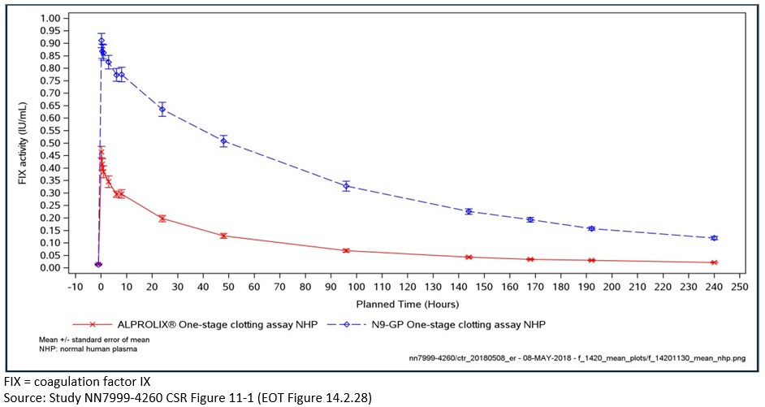
A pooled analysis of Studies NN7999-3747 and NN7999-3774 examined differences in the pharmacokinetics of Refixia in patients of different age groups. FIX activity was generally lower in children than in adults, which the evaluator has noted is probably related to a high volume of distribution in children (Figure 3). There were, however, small numbers of very young children included in the study (3 patients < 2 years of age).
Figure 3: Mean single-dose profiles of FIX activity (IU/mL) by age (one-stage clotting assay); 40 IU/kg nonacog beta pegol (pooled data from Studies NN7999-3747 and NN7999-3774)
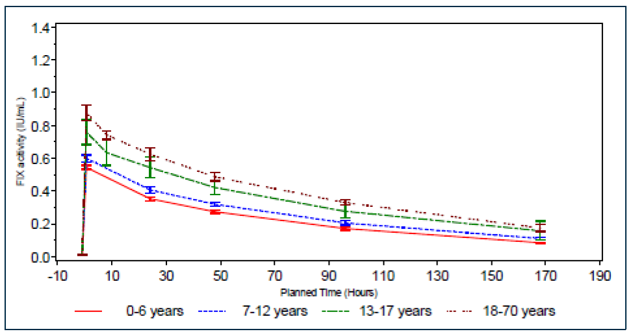

Efficacy
The four completed studies submitted a total of 100 previously treated patients were given Refixia.
The majority of patients were in more than one trial, as shown in Figure 4, below. Three of the studies, Studies NN7999-3747, NN7999-3774 and NN7999-3775 are relevant to the prophylaxis indication.
There were no specific dose-finding studies submitted.
Figure 4: Flow of patients between efficacy studies

Study NN7999-3747
Study NN7999-3747 examined the efficacy of Refixia in the prophylaxis of bleeding episodes, as well as in achieving haemostasis ‘on demand’ in response to bleeding episodes. The trial consisted of two prophylaxis arms who received 10 IU/kg Refixia (n = 30) or 40 IU/kg Refixia (n = 29) for at least 50 days. Patients could choose whether to enter the prophylaxis or on-demand arm of the trial, but the dose received on prophylaxis was randomised.
The study included male patients 13 to 70 years of age with moderate to severe haemophilia B and an untreated FIX activity < 2% of normal according to medical records.
Primary outcome was incidence of inhibitory antibodies against FIX; as a titre ≥ 0.6 Bethesda unit (BU).
Secondary outcomes:
- Success/failure based on four point scale for haemostatic response (excellent, good, moderate and poor) with excellent and good as success and moderate and poor as failure;
- Number of bleeding episodes per patient during routine prophylaxis; and
- Pre-dose FIX activity.
A total of 345 episodes of bleeding occurred during the trial in 55 patients. The majority of the bleeds (65.8%) were spontaneous, 33.6% were traumatic bleeds and 0.6% were due to minor surgery or other reasons.
An annualised bleeding rate (ABR) was calculated from the observed number of bleeds during the trial.
Table 4: Study NN7999-3747 Annualised bleeding rate
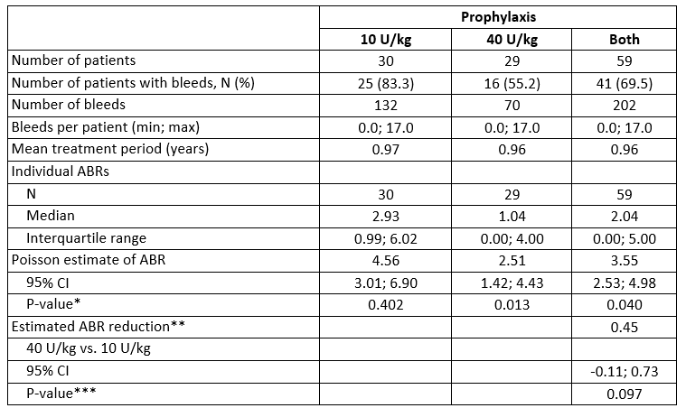
The ABR was lower in the 40 IU/kg than the 10 IU/kg arm, however the difference between the two rates was not statistically significant (p = 0.097).

Study NN7999-3774
This is an ongoing study which enrolled male patients ≤ 12 years of age with moderate to severe haemophilia B and an untreated FIX of < 2%. All patients received 40 IU/kg weekly for prophylaxis of 52 weeks followed by an optional extension phase. Enrolled patients did not have inhibitory antibodies > 0.6 BU at enrolment. A total of 25 patients were enrolled, n = 12; 0 to 6 years of age and n = 13; 7 to 12 years of age.
The primary endpoint of this study was the incidence of inhibitory antibodies > 0.6 BU over 52 weeks.
The ABR was calculated based on the observed rate of bleeding during the trial.
Table 5: Annualised bleeding rate in Study NN7999-3774
An estimated ABR was also calculated by cause of bleed, and was found to be 0.45 bleeds/patient/year for spontaneous bleeds and 0.86 bleeds/patient/year for traumatic bleeds.
No emergence of inhibitor antibodies was detected during the trial. No anti-drug antibodies were detected during the trial.

Study NN7999-3775
Study NN7999-3775 was an open label extension study for patients who had previously been in either NN7999-3747 or NN7999-3773. Patients could choose prophylaxis or on-demand treatment, and prophylaxis patients could choose doses of 10 IU/kg/weekly, 40 IU/kg/weekly or 80 IU/kg/fortnightly.
Table 6: Annualised bleeding rate in Study NN7999-3775
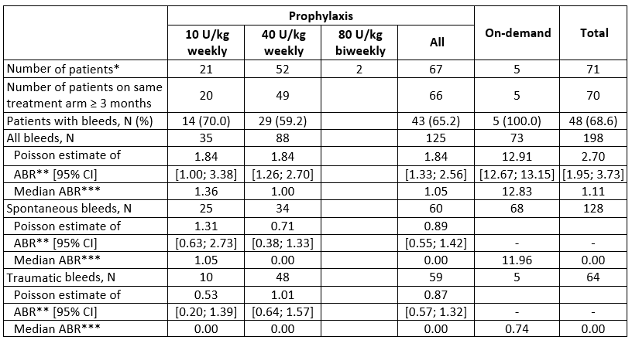
The median (range) ABR of 1.68 (0.00 to 7.85) was reported for patients on prophylaxis who were on on-demand treatment (N = 29) before nonacog beta pegol exposure compared to an ABR (range) of 1.00 (0.00 to 12.53) for patients who were on prophylaxis before first trial and stayed on prophylaxis on this trial (N = 37).
The location of bleeds was mostly confined to joints (80.1% for all patients and 79.2% for prophylaxis patients only). The Poisson estimate (95% confidence interval (CI)) of the ABR for joint bleedings was 1.36 (0.56 to 3.33) for the 10 U/kg treatment arm and 1.49 (0.87 to 2.54) for the 40 U/kg treatment arm.

Safety
The evaluator’s safety analysis is not generally presented by indication. However, 98 patients were exposed to Refixia for a total of 8403 days. This was a significant proportion of the total exposure of 115 patients for 8801 in all the trials submitted.
A total of 647 adverse events (AE) were reported in 98 (85.2%) patients. The overall rate was 3.8 AEs per patient year of exposure. The rate of AEs was higher in children aged 0 to 12 years than in adolescents and adults aged ≥ 13 years. As expected, this difference was mainly driven by frequent adverse events concerning common childhood diseases and did not raise any safety concern.
One serious AE of note occurred which was considered probably related to treatment. In this a patient suffered anaphylaxis after the fourth exposure to Refixia. They were found to have previously been treated for 2 exposure days with rFIX and was considered ‘previously untreated’, but was found to have FIX inhibitors when examined after the adverse event.
Immune tolerance induction has not been examined using Refixia and no nephrotic syndrome was reported during the trials.
No thromboembolic events were reported during the trials to date.

Risk management plan
An acceptable risk management plan (RMP) has been agreed with the RMP evaluator. The RMP evaluator has noted the accumulation of PEG in the brain and other tissues during Refixia treatment to be a potential safety concern. It is noted that the EU RMP will be undertaking a post-market safety study which should be considered by the TGA when available.
Table 7: Summary of safety concerns
Summary of safety concerns |  | Pharmacovigilance |  | Risk minimisation
 |  | Routine | Additional | Routine | Additional
Important identified risks | Allergic/hypersensitivity reactions | * | † |  | –
Important identified risks | FIX inhibitors | * | † |  | –
Important potential risks | Thromboembolic events | * | † |  | –
Important potential risks | Nephrotic syndrome following ITI |  | – |  | –
Important potential risks | Inadequate treatment due to assay overestimation of FIX activity |  | – |  | –
Important potential risks | Accumulation of PEG in the brain and in other tissues/organs after long-term treatment | * | ‡ |  | –
Missing information | Previously untreated patients |  | – |  | –
Missing information | Children below 12 years of age |  | – |  | –
Missing information | Elderly |  | – |  | –
Missing information | Females, including pregnant and breastfeeding women |  | – |  | –
Missing information | Patients with HIV with high viral load and low CD4 count |  | – | – | –
Missing information | Patients with a history of FIX inhibitors |  | – |  | –
Missing information | Patients with a history of thromboembolic events |  | – |  | –
Missing information | Patients on ITI regimen |  | – |  | –
* Targeted follow up questionnaires in EU RMP and the ASA. † EU RMP includes ongoing trials: Studies NN7999-3774, NN7999-3895 and PASS NN7999-4031. ‡ EU RMP refers to a trial patient registry for collection of data relating to use of nonacog beta pegol in national and international registries including the EUHASS registry and PedNet (Study NN7999-4413). There is also a Study PASS NN7999-4031 ITI = immune tolerance induction.

Risk-benefit analysis

Delegate’s considerations

Discussion
The clinical evaluator has recommended two amendments to the proposed indication:
- They have recommended use of Refixia only in previously treated patients.
- They have recommended against approval of prophylaxis.

Limitation to previously treated patients only
The clinical evaluator has concluded that treatment should be confined to pre-treated patients because all the patients in trials had been previously treated. Furthermore, one untreated patient developed anaphylaxis. The clinical evaluator has noted that the lower age limitations imposed on the prophylaxis indication in Canada and the EU would, by default, mean a pre-treated population and that this may, therefore, not have been explicitly stated in that indication. The Delegate feels that the age limit is appropriate for reasons of safety and, in the absence of this being a limiting concern, it may not be to limit the indication to untreated patients given the very low incidence of haemophilia B.

Recommendation against approval of prophylaxis
With regard to prophylaxis, the main concern the clinical evaluator has expressed is that an optimal dose has not been demonstrated. Specifically, the clinical trials have not demonstrated a statistically significant difference between the 10 IU and 40 IU doses.
The sponsor has noted in their response to the clinical evaluation report that the pre-specified endpoint in trial 3747, the main comparative trial, was achieving an ABR of < 4.8 with a 95% confidence limit. A rate of 4.8 was chosen are representing a 60% reduction in an expected rate of 12 bleeds/year. Since the ABR for the 40 IU/kg arm was 2.51 (95% CI 1.42 to 4.43) it achieved this outcome, while in the 10 IU/kg arm this was not achieved with a bleeding rate of 4.56 (95% CI 3.01 to 6.90).
The Delegate has concluded that the sponsors analysis in incorrect. The confidence interval for the estimate of effect in each arm is a measure of the accuracy of that estimate. The confidence interval for the difference between the two arms is the estimate of the accuracy of that difference. They are not the same confidence interval. In this case the difference between the two doses is not statistically significant, being 0.45 (95% CI 0.11 to 0.73). Of more relevance to the Delegate is the fact that the difference is quite small for example, < 1 bleed per year. This is not surprising given the sponsor has performed a pooled analysis of annualised bleeding rate for the two dose arms (see Table 4, above) which indicates an estimate of 3.55 (95% CI 2.53 to 4.98). This means that, if one had a population in which the doses were randomly allocated between 10 IU and 40 IU (that is, the pooled trial population) the effect would nearly achieve the pre-specified endpoint at 95% level of confidence.
The Delegate has concluded that this is strong evidence that there are doses below 40 IU/kg which are equally effective for prophylaxis, albeit it is not conclusively demonstrated that 10 IU/kg is that dose. This conclusion is further supported by the fact that the steady state FIX activity at one week post dose in the 10 IU/kg arm of Study NN7999-3747 was 0.3 IU/mL (see Table 8, below). The Delegate has noted that the EMA states in section 3.3 of its European Public Assessment Report (EPAR):
‘The provided PK results also do not seem to fully support a prophylactic dose of 40 IU/kg once weekly as the only possible or worthwhile prophylactic treatment regimen. It is therefore considered unfortunate that the applicant did not investigate alternative promising dosing regimens (for example, in PK trial 3639 a dose of 25 IU/kg was tested), considering that the prophylactic dosing with 10 IU/kg once weekly produces adequate trough levels. However, it is acknowledged that the higher dose resulted in numerically improved bleeding rates with a noticeable reduction of spontaneous bleeds and bleeding events into target joints in the pivotal trial 3747. Hence, the following recommendation was made in section 4.2 of the SmPC: ‘Adjustments of doses and administration intervals may be considered based on achieved FIX levels and individual bleeding tendency’.’
Table 8: Study NN7999-3747 Summary of single-dose and steady-state PK parameters for nonacog beta pegol (one-stage clotting assay)
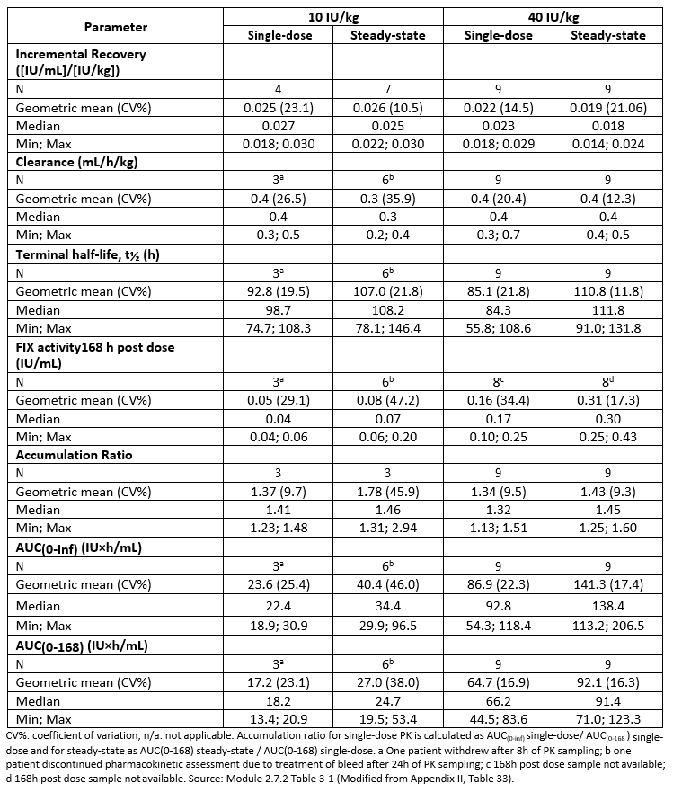
The Delegate is of the view that dosing of factor replacement in haemophilia B is complex and dependent on individual patient’s disease type and so feels the regulatory relevance of ambiguity in the minimal effective dose of Refixia is that clinicians should be made aware that 40 IU/kg may not be essential.
The sponsor requested a meeting with TGA prior to the Delegate’s Overview being drafted.
At this meeting the Delegate raised concerns about the optimal dosing of Refixia and the sponsor has proposed to amend the dosing instructions to be:
Prophylaxis
40 IU/kg body weight once weekly
Adjustments of doses and administration intervals may be considered based on achieved FIX levels and individual bleeding tendency.
The Delegate raised the issue that information regarding FIX activity may be appropriate in the PI based on pharmacokinetic modelling of doses between 10 IU/mL and 40 IU/mL.
At this meeting the Delegate also raised the concerns evident in the EMA’s EPAR regarding the accumulation of PEG in brain tissue. Section 3.7.2 of the EPAR stated that:
‘The provided safety data did not give rise to concern with regard to the short-term treatment of patients (48 patients had ≥ 100 exposure days (EDs), 57 < 100 EDs). However, unfavourable effects associated with accumulation of PEG in the choroid plexus or other tissues or impairment of neural development might only become symptomatic after long-term exposure over several years. Hence, the CHMP has imposed to the MAH to conduct and submit the results of a PASS deriving from a registry of Haemophilia B patients (adults and adolescents) in order to investigate the possible effects of PEG accumulation in the choroid plexus of the brain and other tissues and organs. In addition, the MAH shall submit the first periodic safety update report for this product within 6 months following authorisation.
Based on the data from clinical trials with nonacog beta pegol and safety data of licensed pegylated products for chronic use in the adult population, approval for the treatment and prophylaxis of bleeding in haemophilia B patients with nonacog beta pegol can be granted for the adult population.
No supportive safety data from other pegylated products intended for chronic use are available for the paediatric population. Therefore, the indication in the entire paediatric population cannot be granted. With regards to children below 12 years, at present there is not enough data to conclude and the company should provide additional efficacy and safety data with special considerations on dosing intervals and dosing regimen showing efficacy with even lesser injections. However, the benefit-risk balance has to be seen differently in adolescents compared to children below 12 years of age. Most neurodevelopmental milestones are reached in children below 12 years of age. Moreover, according to literature the treatment compliance generally declines when patients pass from childhood to adolescence. Prophylactic treatment with Refixia in adolescents with just a single infusion per week may lead to improved treatment compliance, could reduce bleeding rates and improve joint health in this patient population and could allow an improved quality of life, thereby outweighing the risks/uncertainties in relation to potential PEG accumulation.’
The Delegate notes that the TGA nonclinical evaluation noted the deposition of PEG in brain tissue but was less concerned regarding long term implications. This was more consistent with the approach the Food and Drug Administration (FDA) appears to have taken in publicly available documents, but FDA states in its assessment of risks and benefits (Summary Basis for Regulatory Action for Rebinyn, page 23):
‘Overall, there were no serious adverse events related to Rebinyn. The risk of development of inhibitory antibodies is considered an expected adverse event. The potential for neurologic risks from Rebinyn were considered when making the recommendation in favor of a marketing approval for Rebinyn for short-term use. Clinical judgment was exercised due to the paucity of safety data to assess this neurological risk, when making a recommendation to support a marketing approval of Rebinyn for short-term use. These clinical considerations included a) the lower risk for PEG accumulation given the short-term use in both pediatric and adult patients, and b) the recommendations with regard to short-term use from the members of the Advisory Committee. In addition, given the uncertainties of neurological risks with long-term use, the prescribing information for Rebinyn includes a limitation of use statement related to routine prophylaxis and neurological considerations for chronic use and use in pediatric and geriatric age groups.’
The sponsor has indicated that there are commercial limitations on the registration of a prophylaxis indication in the US given that orphan exclusivity has been given to rFIX. This is because the US FDA considers the two products to be equivalent for the purpose of granting orphan exclusivity, not because there is another brand of PEGylated FIX.
The sponsor has also noted that the EU has also limited the use of PEGylated factor VIII to children > 12 years of age. The sponsor concludes that
‘It seems clear that EMA is granting these pegylated medicines with similar labels, thus created a well-defined ‘class label group’ of pegylated drugs for the treatment of haemophilia A and B’.
The sponsor should note that the Delegate has not made any conclusion regarding the materiality of the EMA’s or FDA’s views expressed in these extracts to their final decisions regarding the licensing of Refixia in those jurisdictions. The Delegate has taken this as additional information about the analysis of these comparator regulators to the significance for patient safety of the PEG accumulation findings identified in the TGA toxicology report.
The Delegate has concluded that given the relative paucity of safety data for Refixia in the paediatric population, the safety of Refixia for chronic administration in the context of a potentially neuro-developmentally vulnerable paediatric population has not been demonstrated. The sponsor has proposed to adopt wording similar to the indications as approved by the EMA including the age limitation. They have also agreed to submit the safety data being generated for the EMA when it is available. The Delegate notes that the safety concerns relate to long term administration of Refixia, which would be mostly evidence were the product used prophylactically. However, regular ‘on-demand’ treatment of several bleeds per year in severely affected patients could also amount to significant chronic exposure. Hence the Delegate reads the proposed wording to apply to limiting the use of Refixia for both treatment and prophylaxis to 12 year olds and above.
The Delegate intends to accept the revised indication proposed by the sponsor. However, the Delegate is aware that this will limit the treatment options of children with haemophilia B to relatively short acting products for until the long term safety of Refixia in children can be demonstrated. This will be clinically less impactful in ‘on-demand’ treatment since alternative short acting agents are available, but may be clinically meaningful given the weekly dosage regimen possible with Refixia.

Other issues
The Delegate notes that Refixia can interfere with some clotting tests and that advice should be provided as to which Australian-sourced tests are compatible with accurate FIX assessment. This would be necessary to allow accurate dose variation if this was considered clinically indicated.

Summary of issues
The clinical evaluator has recommended not approving the prophylaxis indication on the basis that an optimal dose has not been identified for this use.
The Delegate has discussed with the sponsor the qualification or absence of a prophylaxis indication in several comparator jurisdictions. The Delegate has noted the issue of PEG accumulation raised in the discussions of the safety of Refixia for long term use by the US FDA and EMA.
The sponsor has proposed to amend the prophylaxis indication to that used in EMA or similar. The Delegate proposes to approve the EMA prophylaxis indication, with the acute treatment indications as proposed in the application.
The issue for discussion is whether limiting the indication is appropriate given that it will mean children < 12 years of age with newly diagnosed disease will have to be treated with other agents.

Proposed action
The Delegate was not in a position to say, at this time, that the application for Refixia should be approved for registration for the prophylaxis indication as proposed.
The Delegate intends to approve an ‘on-demand’ indication irrespective of the final decision regarding prophylaxis.

Request for ACM advice
The committee is requested to provide advice on the following specific issues:
- Whether the prophylaxis indication should be limited as proposed by the Delegate.
- Whether additional information should be provided regarding optimal dosing of Refixia.
The committee is (also) requested to provide advice on any other issues that it thinks may be relevant to a decision on whether or not to approve this application.

Advisory Committee Considerations
The Advisory Committee on Medicines (ACM), having considered the evaluations and the Delegate’s overview, as well as the sponsor’s response to these documents, advised the following.
The ACM considered the referral for advice from the TGA Delegate in relation to the submission to register Refixia powder and solvent solution, containing 500 IU, 1000 IU, and 2000 IU of nonacog beta pegol.
The ACM considered this product to have an overall positive benefit-risk profile for the proposed indication:
Treatment and prophylaxis of bleeding in patients 12 years and above with haemophilia B (congenital FIX deficiency).

Specific questions
The ACM advised the following in response to the Delegate’s specific request for advice.
- Whether the prophylaxis indication should be limited as proposed by the Delegate.
The ACM agreed with the Delegate that the treatment and prophylaxis of bleeding with Refixia should be limited to patients 12 years and above. The ACM noted that Refixia is a PEGylated product and accumulation of PEG has been demonstrated in the choroid plexus of the brain in animal models. The ACM agreed with the Delegate regarding the uncertainty surrounding the clinical implication of PEG accumulation in the brain as a result of Refixia treatment, and advised that potential safety concerns would be minimised by limiting the indication of Refixia to those over the age of 12, as the majority of structural brain development has occurred by this age. The ACM noted the importance of including a summary of the toxicological findings regarding PEG accumulation in animal studies in the PI.
- Whether additional information should be provided regarding optimal dosing of Refixia.
The ACM was of the view that additional information should be provided regarding optimal dosing of Refixia. The ACM noted that this is difficult to determine due to the small number of patients with this rare condition, but agreed that the PI should include a recommendation that the dosing can be reduced from 40 IU/kg based on clinical response and FIX levels, as measured pre and post administration.
- The committee is (also) requested to provide advice on any other issues that it thinks may be relevant to a decision on whether or not to approve this application.
The ACM considered the question of whether or not the indication for Refixia should be restricted to previously treated patients, but was of the view that this was not required. The ACM agreed that the proposed age restriction would ensure that most eligible patients would have been previously treated; however, the ACM advised that some patients with a milder form of the disease may not require treatment until their late teens/early adulthood, so the possibility for treatment of naïve patients under the proposed indication does exist.

General advice
The ACM agreed with the Delegate that the effects of interaction of Refixia with routine coagulation tests was not clear and that this should be included as a warning in the PI. The ACM advised that the interference of the drug with coagulation tests would not significantly affect monitoring of the efficacy of the drug on patients however, as in a surgery setting, factor IX levels would normally be measured, and for routine monitoring the most important measure of efficacy is bleeding episodes.

Outcome
Based on a review of quality, safety and efficacy, the TGA approved the registration of Refixia (nonacog beta pegol) powder and solvent for injection, indicated for:
Treatment and prophylaxis of bleeding in patients 12 years and above with haemophilia B (congenital factor IX deficiency).

Specific conditions of registration applying to these goods
The following specific conditions of registration apply to this approval:
- Refixia (nonacog beta pegol) is to be included in the Black Triangle Scheme. The Product Information (PI) and Consumer Medicines Information (CMI) for Refixia must include the black triangle symbol and mandatory accompanying text for five years, which starts from the date that the sponsor notifies the TGA of supply of the product.
- The Refixia (nonacog beta pegol) European Union-Risk Management Plan (EU-RMP) (version 4.0, dated 28 April 2017, data lock point 1 January 2016), with Australian Specific Annex (version 0.3, dated 2 April 2019), included with submission PM-2018-02720-1-6, and any subsequent revisions, as agreed with the TGA will be implemented in Australia.
An obligatory component of risk management plans is routine pharmacovigilance. Routine pharmacovigilance includes the submission of periodic safety update reports (PSURs).
Reports are to be provided in line with the current published list of EU reference dates and frequency of submission of PSURs until the period covered by such reports is not less than three years from the date of this approval letter.
The reports are to at least meet the requirements for PSURs as described in the European Medicines Agency’s Guideline on good pharmacovigilance practices (GVP) Module VII-periodic safety update report (Rev 1), Part VII.B Structures and processes. Note that submission of a PSUR does not constitute an application to vary the registration.
- For all injectable products the Product Information must be included with the product.

Attachment 1. Product Information
The PI for Refixia approved with the submission which is described in this AusPAR is at Attachment 1. For the most recent PI, please refer to the TGA website at <https://www.tga.gov.au/product-information-pi>.

Therapeutic Goods Administration
PO Box 100 Woden ACT 2606 Australia
Email: info@tga.gov.au Phone: 1800 020 653 Fax: 02 6232 8605
https://www.tga.gov.au

Development of neutralising anti-FIX antibodies (inhibitors) is a serious complication of FIX replacement therapy. Approximately 1 to 3% of all patients with haemophilia B develop inhibitors following exposure to FIX. In patients who develop inhibitors to FIX, the condition will manifest itself as an insufficient clinical response to FIX replacement therapy.
Measurement of inhibitors is via the Bethesda assay, which gives a numeric value. This number is quantified in Bethesda units per millilitre (BU/mL), and refers to the inhibitor titre or the antibody titre.
Treatment; prophylaxis, multiple dose.
Integrated safety analysis; all completed studies, all treatments.
The ACM provides independent medical and scientific advice to the Minister for Health and the Therapeutic Goods Administration (TGA) on issues relating to the safety, quality and efficacy of medicines supplied in Australia including issues relating to pre-market and post-market functions for medicines. The Committee is established under Regulation 35 of the Therapeutic Goods Regulations 1990. Members are appointed by the Minister. The ACM was established in January 2017 replacing Advisory Committee on Prescription Medicines (ACPM) which was formed in January 2010. ACM encompass pre and post-market advice for medicines, following the consolidation of the previous functions of the Advisory Committee on Prescription Medicines (ACPM), the Advisory Committee on the Safety of Medicines (ACSOM) and the Advisory Committee on Non-Prescription Medicines (ACNM). Membership comprises of professionals with specific scientific, medical or clinical expertise, as well as appropriate consumer health issues relating to medicines.

