March 2020

Australian Public Assessment Report for Nivolumab
  - Proprietary Product Name: Opdivo
  - Sponsor: Bristol-Myers Squibb Australia Pty Ltd

About the Therapeutic Goods Administration (TGA)
- The Therapeutic Goods Administration (TGA) is part of the Australian Government Department of Health and is responsible for regulating medicines and medical devices.
- The TGA administers the Therapeutic Goods Act 1989 (the Act), applying a risk management approach designed to ensure therapeutic goods supplied in Australia meet acceptable standards of quality, safety and efficacy (performance) when necessary.
- The work of the TGA is based on applying scientific and clinical expertise to decision-making, to ensure that the benefits to consumers outweigh any risks associated with the use of medicines and medical devices.
- The TGA relies on the public, healthcare professionals and industry to report problems with medicines or medical devices. TGA investigates reports received by it to determine any necessary regulatory action.
- To report a problem with a medicine or medical device, please see the information on the TGA website < https://www.tga.gov.au>.
About AusPARs
- An Australian Public Assessment Report (AusPAR) provides information about the evaluation of a prescription medicine and the considerations that led the TGA to approve or not approve a prescription medicine submission.
- AusPARs are prepared and published by the TGA.
- An AusPAR is prepared for submissions that relate to new chemical entities, generic medicines, major variations and extensions of indications.
- An AusPAR is a static document; it provides information that relates to a submission at a particular point in time.
- A new AusPAR will be developed to reflect changes to indications and/or major variations to a prescription medicine subject to evaluation by the TGA.
Copyright
© Commonwealth of Australia 2020
This work is copyright. You may reproduce the whole or part of this work in unaltered form for your own personal use or, if you are part of an organisation, for internal use within your organisation, but only if you or your organisation do not use the reproduction for any commercial purpose and retain this copyright notice and all disclaimer notices as part of that reproduction. Apart from rights to use as permitted by the Copyright Act 1968 or allowed by this copyright notice, all other rights are reserved and you are not allowed to reproduce the whole or any part of this work in any way (electronic or otherwise) without first being given specific written permission from the Commonwealth to do so. Requests and inquiries concerning reproduction and rights are to be sent to the TGA Copyright Officer, Therapeutic Goods Administration, PO Box 100, Woden ACT 2606 or emailed to < tga.copyright@tga.gov.au>.

Contents
Common abbreviations 4
I. Introduction to product submission 7
Submission details 7
Product background 8
Regulatory status 8
Product Information 10
II. Registration timeline 10
III. Quality findings 11
IV. Nonclinical findings 11
V. Clinical findings 11
Introduction 11
Pharmacokinetics 14
Pharmacodynamics 14
Dosage selection for the pivotal studies 15
Efficacy 15
Safety 17
First round benefit-risk assessment 30
First round recommendation regarding authorisation 31
Clinical questions and second round evaluation 31
Second round benefit-risk assessment 34
VI. Pharmacovigilance findings 34
VII. Overall conclusion and risk/benefit assessment 34
Quality 34
Nonclinical 34
Clinical 34
Risk-benefit analysis 39
Outcome 50

Common abbreviations
Abbreviation | Meaning
1L | First line (of treatment)
2L | Second line (of treatment)
3L | Third line (of treatment)
ACM | Advisory Committee on Medicines
ACSOM | Advisory Committee on the Safety of Medicines
ADA | Anti-drug antibody
AE | Adverse event
ALK | Anaplastic lymphoma kinase
ALT | Alanine aminotransferase
ALP | Alkaline phosphatase
ARTG | Australian Register of Therapeutic Goods
AST | Aspartate aminotransferase
BSC | Best supportive care
cHL | Classical Hodgkin lymphoma
CI | Confidence interval
CSR | Clinical study report
CT | Computed tomography
CTCAE | Common Terminology Criteria for Adverse Events
dMMR | DNA mismatch repair genes
ECG | Electrocardiogram
ECOG | Eastern Cooperative Oncology Group
ECOG PS | Eastern Cooperative Oncology Group performance status
EGFR | Epidermal growth factor receptor
EMA | European Medicines Agency (EU)
EU | European Union
FDA | Food and Drug Administration (US)
GC | Gastric cancer/gastric cancer and gastro-oesophageal junction cancer
GCP | Good Clinical Practice
GEJC | Gastro-oesophageal junction cancer
GI | Gastrointestinal
HCP | Healthcare professional
HER-2 | Human epidermal growth factor receptor 2
HR | Hazard ratio
IgG4 | Human immunoglobulin G4
IQR | Interquartile range
ITT | Intention-to-treat
IV | Intravenous
KM | Kaplan-Meier
LFT | Liver function test
LDH | Lactate dehydrogenase
MCID | Minimal clinically important difference
Md | Median
MedDRA | Medical Dictionary for Regulatory Activities
MRI | Magnetic resonance imaging
MSI | Microsatellite instability
MSI-H | Microsatellite instability - high
MSI-L | Microsatellite instability - low
MSS | Microsatellite stable
NR | Not reported
NSCLC | Non-small cell lung cancer
NSQ NSCLC | Non-squamous non-small cell lung cancer
OESI | Other events of special interest
ORR | Objective response rate
OS | Overall survival
PBRER | Periodic benefit risk evaluation report
PD | Progressive disease
PD-1 | Programmed death-1 (receptor)
PD-L1 | Programmed death ligand-1
PD-L2 | Programmed death ligand-2
PFS | Progression free survival
PI | Product Information
PK | Pharmacokinetic(s)
PopPK | Population pharmacokinetic(s)
PSUR | Periodic safety update report
Q2W | Once every two weeks
RCT | Randomised controlled trial
RECIST | Response Evaluation Criteria In Solid Tumours
sd | Standard deviation
SJS | Stevens-Johnson syndrome
SOC | Systems Order Class
SQ NSCLC | Squamous non-small cell lung cancer
TEN | Toxic epidermal necrolysis
TGA | Therapeutic Good Administration

I. Introduction to product submission

Submission details
Type of submission: | Major variation – new indication
Decision: | Rejected
Date of initial decision: | 5 November 2018
Date of final decision: | 27 March 2019
Date of entry onto ARTG: | Not applicable
ARTG numbers: | 231868, 231867
Black Triangle Scheme | No
Active ingredient: | Nivolumab
Product name: | Opdivo
Sponsor’s name and address: | Bristol Myers Squibb Australia Pty Ltd  Level 2, 4 Nexus Court  Mulgrave VIC 3170
Dose form: | Solution for intravenous infusion
Strengths: | 40 mg in 4 mL and 100 mg in 10 mL
Container: | Vial
Pack size: | 1
Approved therapeutic use: | Not applicable
Route of administration: | Intravenous
Dosage: | Not applicable

Product background
This AusPAR describes the application by Bristol-Myers Squibb Australia Pty Ltd (the sponsor) to register Opdivo for the following indication:
Opdivo as monotherapy is indicated for the treatment of adult patients with advanced or recurrent gastric or gastro-oesophageal junction cancer after two or more prior systemic therapies.
Nivolumab is a fully human immunoglobulin G4 (IgG4) monoclonal antibody which binds to programmed death-1 receptor (PD-1) and blocks its interaction with the programmed death ligands 1 and 2 (PD-L1; PD-L2). The PD-1 receptor is a negative regulator of T-cell activity. Engagement of PD-1 with PD-L1 and PD-L2, which are expressed in antigen presenting cells and may be expressed by tumours or other cells in the tumour microenvironment, results in inhibition of T-cell proliferation and cytokine secretion. Nivolumab potentiates T-cell responses, including anti-tumour responses, through blockade of PD-1 binding to PD-L1 and PD-L2. In syngeneic mouse models, blocking PD-1 activity resulted in decreased tumour growth.
Gastric cancer (GC) and gastro-oesophageal junction cancer (GEJC); is a common cancer worldwide with marked geographical variation, the incidence being higher in Eastern Asia. It is the fifth most common global malignancy and the third most cause of cancer death.² It is less common in Australia, with as estimated incidence of 2,117 (2013) and an estimated mortality of 1,137 (2014) (of stomach cancer) (Australian Institute of Health and Welfare, 2017).
Gastric cancer is a heterogeneous disease. Adenocarcinomas are the most common GCs (90%). Adenocarcinomas are subdivided into diffuse and intestinal types. The diffuse type has a greater tendency to metastasise and is associated with a poorer prognosis.
The clinical rationale for the submission is to provide a third line option that has a proven clinical benefit for treatment for advanced and metastatic GC (and GEJC). The sponsor is seeking to address this unmet clinical need with the use of Opdivo (nivolumab).

Regulatory status
The product received initial registration on the Australian Register of Therapeutic Goods (ARTG) on 11 January 2016.
Opdivo is currently registered for the indications of:
- as monotherapy is indicated for the treatment of patients with unresectable (Stage III) or metastatic (Stage IV) melanoma.
- in combination with Yervoy (ipilimumab) is indicated for the treatment of patients with metastatic (Stage IV) melanoma with M1c disease or elevated lactic dehydrogenase (LDH).
- as monotherapy is indicated for the treatment of locally advanced or metastatic squamous non-small cell lung cancer (NSCLC) with progression on or after prior chemotherapy.
- as monotherapy is indicated for the treatment of locally advanced or metastatic non squamous non-small cell lung cancer (NSCLC) with progression on or after prior chemotherapy. In patients with tumour EGFR or ALK genomic aberrations, Opdivo should be used after progression on or after targeted therapy.
- as monotherapy is indicated for the treatment of patients with advanced clear cell renal cell carcinoma after prior anti-angiogenic therapy in adults.
- as monotherapy is indicated for the treatment of adult patients with relapsed or refractory classical Hodgkin lymphoma (cHL) after autologous stem cell transplant and treatment with brentuximab vedotin.
- as monotherapy is indicated for the treatment of recurrent or metastatic squamous cell cancer of the head and neck in adults progressing on or after platinum based therapy.
Concurrent with this submission there are four extensions of indications and one for registration of a different dosage and administration schedule.
- A Category 1, extension of indication application (submission PM-2016-00712-1-4) to support the use of Opdivo in locally advanced unresectable or metastatic urothelial carcinoma after prior platinum-containing therapy.
- A Category 1, extension of indication application (submission PM-2017-02208-1-4) to amend the indication for the use of the combination of nivolumab and ipilimumab to include the treatment of all patients with unresectable (Stage III) or metastatic (Stage IV) melanoma.
- A Category 1, extension of indication application (submission PM-2017-02209-1-4) to support the use of Opdivo in hepatocellular carcinoma after prior sorafenib therapy;
- A Category 1, extension of indication application (submission PM-2017-03329-1-4) to support the use of Opdivo as adjuvant treatment in completely resected Stage III or Stage IV melanoma.
- In addition, a fifth application (submission PM-2017-02207-1-4) is under evaluation to register a dose of 240 mg once every two weeks, a dose of 480 mg once every four weeks, and a 30-minute infusion time for all nivolumab indications.
At the time the Therapeutic Good Administration (TGA) considered this application, a similar application had been approved, withdrawn or was under consideration as shown in Table 1.
Table 1: International regulatory status
Jurisdiction | Date of submission Status | Indication requested or approved
Japan | 27 December 2016 Approved 22 September 2017 | Unresectable advanced or recurrent gastric cancer progressing after cancer chemotherapy
USA | 22 August 2017 Withdrawn | Opdivo as monotherapy for the treatment of patients with advanced gastric and gastroesphageal junction (GC/GEJ) carcinoma after 2 or more prior chemotherapy regimens
European Union (EU)- centralised Procedure | 23 August 2017 Withdrawn | Opdivo as monotherapy for the treatment of adult patients with advanced or recurrent gastric or gastroesphageal junction (GEJ) cancer after two or more prior systemic therapies.
Israel | 1 October 2017 Under review
Canada | 20 April 2018  Under review
Singapore | 20 February 2018 Under review
Switzerland | 10 November 2017 Approved 31 May 2018 | Opdivo is indicated for the treatment of advanced or recurrent gastric or GEJ adenocarcinoma after two or more prior systemic therapies in adults.
Taiwan | 11 July 2017 Approved 19 January 2018 | Opdivo is indicated for the treatment of patients with advanced or recurrent gastric or gastroesophageal junction (GEJ) cancer after two or more prior chemotherapy regimens
Korea | 21 July 2017 Approved 23 March 2018 | Treatment of advanced or recurrent gastric or gastroesophageal junction adenocarcinoma after 2 or more prior chemotherapy regimen.

Product Information
The Product Information (PI) approved with the submission which is described in this AusPAR can be found as Attachment 1. For the most recent PI, please refer to the TGA website at < https://www.tga.gov.au/product-information-pi>.

II. Registration timeline
The following table captures the key steps and dates for this application and which are detailed and discussed in this AusPAR.
Table 2: Timeline for Submission PM-2017-03888-1-4
Description | Date
Submission dossier accepted and first round evaluation commenced | 30 November 2017
First round evaluation completed | 6 May 2018
Sponsor provides responses on questions raised in first round evaluation | 4 July 2018
Second round evaluation completed | 29 July 2018
Delegate’s Overall benefit-risk assessment and request for Advisory Committee advice | 3 September 2018
Sponsor’s pre-Advisory Committee response | 18 September 2018
Advisory Committee meeting | 4 October 2018
Registration decision (initial decision) – Rejected | 5 November 2018
Number of working days from submission dossier acceptance to registration decision* | 191
Appeal decision - (confirmed the initial decision) | 27 March 2019
*Statutory timeframe for standard applications is 255 working days

III. Quality findings
There was no requirement for a quality evaluation in a submission of this type.

IV. Nonclinical findings
There was no requirement for a nonclinical evaluation in a submission of this type.

V. Clinical findings
A summary of the clinical findings is presented in this section.

Introduction

Information on the condition being treated
Gastric cancer (GC) and gastro-oesophageal junction cancer (GEJC);1 is a common cancer worldwide with marked geographical variation, the incidence being higher in Eastern Asia.2 It is the fifth most common global malignancy and the third most cause of cancer death.²
It is less common in Australia, with as estimated incidence of 2,117 (2013) and an estimated mortality of 1,137 (2014) (of stomach cancer) (Australian Institute of Health and Welfare, 2017).
Gastric cancer is a heterogeneous disease. Adenocarcinomas are the most common gastric cancers (90%). Adenocarcinomas are subdivided into diffuse and intestinal types. The diffuse type has a greater tendency to metastasise and is associated with a poorer prognosis.
Tumours of the proximal stomach are associated with obesity, tumours of the gastro-oesophageal junction are associated with reflux and are more common in non-Asian countries.³ Distal cancers are associated with Helicobacter pylori (H. pylori) infection, alcohol and low fruit and vegetable intake.³ The epidemiology of gastric cancer may alter as the risk factors alter.⁴

Current treatment options
Locally advanced unresectable and metastatic GC/GEJC are not curable and therefore the goals of therapy are palliation of symptoms and increased survival. Systemic treatment modalities include cytotoxic chemotherapy and targeted agents. Radiotherapy can be used for localised disease. Surgery may be used for symptom management. Other palliative and support care is usually offered.
The targeted agent, trastuzumab, is indicated for treatment of human epidermal growth factor receptor 2 (HER-2) positive GC and is subsidised for used in Australia. Platinum agents, fluoropyrimidine, irinotecan, taxanes and epirubicin are all currently used for treatment in Australia. Chemotherapy and targeted agents may be offered to patients with a suitable performance status.⁵ There is not clear proven benefit for third line treatment and a variety of agents may be offered.

Clinical rationale
The clinical rationale for the submission is to provide a third line option that has a proven clinical benefit for treatment for advanced and metastatic GC/GJEC. The sponsor is seeking to address this unmet clinical need with the use of Opdivo (nivolumab).

Guidance
The following European Medicines Agency (EMA) guidelines which have been adopted by the TGA, are considered relevant to the current submission:
- Guideline on the evaluation of anticancer medicinal products in man;
- Guideline on applications with one pivotal study; and
- Guideline on ethnic factors in the acceptability of foreign clinical data.
A pre-submission meeting was undertaken with the TGA on the 18 August 2017. It was confirmed that the Phase III study was conducted in Asia because GC was more common in that region. Opinion was also offered by the sponsor that there were potential differences between the Asian and Australian populations. Asian patients may be diagnosed earlier, have a higher likelihood of surgery and may receive more therapies than Australian patients.
The application for GC cross-references the application for flat dosing.
The EMA evaluation was noted to be in advance of the TGA evaluation and the TGA enquired if any interim assessment reports be shared with the TGA to avoid duplication for the sponsor.
A meeting was also held with the TGA’s Pharmacovigilance and Special Access Branch on 14 September 2017.

Evaluator’s commentary on the background information
The evaluation of the background information highlighted potential differences between Asian and Australian patient treatments and outcomes. These highlighted differences are reasonable. Countries that perform gastric cancer surveillance, such as Japan and Korea have lower mortality rates.⁴ Surgical and oncological advances have also contributed to this.⁴
No other concerns were raised. There is an appropriate clinical rationale for the use of Opdivo (nivolumab) in advanced GC/GJEC.

Contents of the clinical dossier
The submission contained the following clinical information.
- One pivotal Phase III efficacy/safety report (Study ONO-4538-12 (also known as the ATTRACTION-2 trial)).
- One other Phase I/II efficacy/safety study (Study CA209032) with an interim report and an addendum supplied.
- One population pharmacokinetic analysis in subjects with gastric cancer (and non-small cell lung cancer) exploring, amongst other issues the comparison of exposures between Asian subjects with gastric cancer to non-Asian subjects with gastric cancer.
- Literature references.

Paediatric data
The submission does not include paediatric data. The indication is only for adult patients. The sponsor has a paediatric investigation plan in Europe with a required submission date of April 2020. A waiver for a paediatric assessment for the United States of America (USA) was granted because of the orphan drug designation in the USA for nivolumab for the treatment of GC and GEJC.

Good clinical practice
The clinical studies reviewed in this evaluation (the ATTRACTION-2 trial and Study CA209032) were in compliance with CPMP/ICH/135/95 ‘Note for Guidance on Good Clinical Practice’.

Pharmacokinetics

Studies providing pharmacokinetic data
The pharmacokinetics (PK) of nivolumab have been previously submitted to the TGA.
A new population pharmacokinetic (popPK) model was provided (Report BMS-936588/MDX-1106). This popPK model combined data from Phase I, Phase II and Phase III studies of solid tumours, including data from the ATTRACTION-2 trial and Study CA209032 which included GC. This model updates a previously developed popPK model that has been submitted to the TGA. The popPK model concluded that nivolumab exposure were similar for Asian and non-Asian populations. It also concluded that clearance was higher in GC subjects than non-small cell lung cancer (NSCLC) subjects.
The results of the popPK model have been described but not formally evaluated in this report.
Table 3: Submitted pharmacokinetic studies
PK topic | Subtopic | Study ID | Aims of the study | Synopsis
Population PK analyses | Target population | BMS-936588/MDX-1106 | Assess the effect of GC tumour type of nivolumab clearance in comparison to NSCLC 2+ subjects.  Compare the exposure of nivolumab in GC subjects with the exposure in nivolumab in NSCLC 2+ subjects.  Compare the exposure of nivolumab following 3 mg/kg Q2W dosing in Asian GC subjects with the exposure of nivolumab in non-Asian GC subjects. | The study concluded that baseline clearance was higher in subjects with GC compared to NSCLC 2+.  Subjects with GC generally had lower exposure than subjects with NSCLC 2+.  The study concluded that nivolumab exposures were similar for Asian and non-Asian subjects.
Abbreviations: GC, gastric cancer/gastric cancer and gastro-oesophageal junction cancer; NSCLC, non-small cell lung cancer; PK, pharmacokinetic; Q2W, once every two weeks.

Evaluator’s conclusions on pharmacokinetics
The PK have been updated with new popPK. The results of the popPK have been reported but not evaluated. The remainder of the PK information remains unchanged from prior evaluations.
Argument has been made for the relative ethnic insensitivity of the PK of nivolumab. These arguments are reasonable and are consistent with the TGA guidance.

Pharmacodynamics
No new pharmacodynamic studies were included in the submission.

Evaluator’s conclusions on pharmacodynamics
Nivolumab is a monoclonal antibody that potentiates anti-tumour responses.
The pivotal study (ATTRACTION-2 trial) and the supportive study (Study CA209032) both included information about the potential relationship (or lack thereof) between the PD-L1 status and outcome.
The potential relationship between extrinsic ethnic factors and outcomes were discussed.
The supportive Study CA209032 contained information about the relationship between microsatellite instability (MSI) status and outcomes. MSI is marker of failure to repair errors in repetitive sequences of DNA. This results from mutations or methylation of DNA mismatch repair genes (dMMR). The subgroup of microsatellite instability high (MSI-H) / dMMR have been identified as a biomarker defined group that benefit less from conventional chemotherapy and may benefit from PD-1 inhibitors in colorectal cancer.
MSI-H status has been shown as a biomarker for benefit for pembrolizumab (another PD-1 receptor inhibitor) and pembrolizumab has been given accelerated approval for treatment on the basis of MSI-H status across cancer types.

Dosage selection for the pivotal studies
The starting dose in the ATTRACTION-2 trial was 3 mg/kg administered as an intravenous infusion every two weeks. This is the same starting dose as for the other indications for nivolumab monotherapy (melanoma, NSCLC, clear cell renal cell carcinoma, etcetera.); and the clinical overview states it was selected based on the collective clinical experience over multiple tumour types. There is a submission to alter the dosing from weight based to flat dosing (submission PM-2017-02207-1-4).

Efficacy

Studies providing efficacy data
Support for the efficacy of nivolumab for the proposed indication is based on the results of one Phase III, randomised, double-blinded, placebo-controlled trial (Study ONO-4538-12 (ATTRACTION-2 trial)) and one supportive Phase I/II, open-label study (Study CA209032). An integrated summary of efficacy was not submitted and results of the two studies were provided separately.
Providing the results separately was appropriate as the two studies have different study designs.

Evaluator’s conclusions on efficacy
The pivotal evidence for the clinical efficacy of nivolumab in GC was based on the double blind randomised placebo-controlled ATTRACTION-2 trial, which was conducted in Japan, Korea and Taiwan. This study was well-designed and clearly demonstrated that nivolumab is an active agent with a statistically significant improvement in the hazard ratio of death.
Inclusion criteria included unresectable advanced gastric (including gastro-oesophageal junction) cancer, Eastern Cooperative Oncology Group (ECOG) performance status of 0 or 1, life expectancy of at least three months and previously received two or more regimens for the treatment of advanced or recurrent gastric cancer. The total number of subjects randomised was 493 (330 to nivolumab monotherapy and 163 to placebo). Overall survival was the primary outcome. The nivolumab monotherapy group had superior efficacy and the hazard rate for the nivolumab group relative to placebo was 0.63 (95% confidence interval (CI) 0.51, 0.78). The median overall survival was 5.26 months for the nivolumab group (95% CI: 4.6, 6.37) compared to 4.14 months in the placebo group (95% CI: 3.42, 4.86).
The main study is clinically relevant, with the use of nivolumab treatment resulting in an increase in median survival of over a month. The lack of quality of life information was a weakness in the assessment of clinical benefit.
The degree of statistical significance of the reduction in the hazard rate of death and the internal consistency across multiple subgroups in the main study increases the confidence in the assessment of benefit for Asian subjects. The hazard rate appeared to be lower for the subjects who had received four or more lines of therapy (0.44) compared to those who received fewer lines of therapy.
The selection of subjects into ATTRACTION-2 trial was not based on (or required) PD-L1 expression and therefore the results can be applied to an Asian population unselected for PD-L1 status. However, the lack of a complete dataset for PD-L1 expression (and microsatellite instability-high (MSI-H)) limits the confidence that the benefit was not attributable to specific subgroups.
The internal validity of the main study was strong. It was a double blinded study performed in accordance with International Conference on Harmonisation (ICH) Good Clinical Practice (GCP) guidelines. The use of double blinding, a lack of cross-over and the use of overall survival as the primary outcome measure lowered the potential for bias. The comparator arm of the main trial was placebo.
A supportive Phase I/II study, with one arm of a multiple cancer, multi treatment (including arms with nivolumab monotherapy and combination treatment with nivolumab and ipilimumab). The supportive study was not comparative to placebo and therefore, the treatment effect of nivolumab relative to placebo cannot be confidently inferred. Whilst the supportive study has similar efficacy results to the efficacy results of the main study it was subject to potential bias because of selection into the study and additional post-progression treatments which make the attribution of the magnitude of benefit to nivolumab monotherapy uncertain.
It is unclear whether the benefit to harm ratio inferred by either study would be observed in the Australian treatment context. The ATTRACTION-2 trial was limited to an almost exclusively Asian population. There is the potential for extrinsic and intrinsic differences between the Asian population recruited to the trial and the Australian population. The pharmacokinetic results and the weight-based dosing suggest that the importance of some of the intrinsic differences is limited. Host genetic polymorphisms may be important in the development of gastric cancer and there are differences between Asian and non-Asian populations.⁴
The external validity of the main trial is limited by the potential for extrinsic differences to exist. These may occur because diagnosis may be earlier and treatment more aggressive in Asian countries (notably Japan). Longer overall survival has been noted in patients from Asia, specifically Japan. The selection into the supportive trial results in a higher proportion of ECOG performance status of ‘0’ subjects than may be expected in Australian practice. Additional, specific issues with regard to the external validity of the trial to current practice in Australia include a lack of a requirement for HER-2 positive tumours to receive trastuzumab in the main study. Subjects had received trastuzumab in both the nivolumab arm (17.9%) and the placebo arm (13.5%). It was required for the supportive study where 22% of the 59 subject cohort and 21.4% of the 42 subject cohort received trastuzumab.
The mechanism of action, the demonstrated comparative benefit of nivolumab in other tumours types for Asian groups in Phase III trials, the demonstrated activity of nivolumab in non-Asian gastric cancer patients, the demonstration of activity of pembrolizumab in non-Asian gastric cancer patients with PD-L1 positive tumours (Phase II); and the demonstrated activity in non-Asian GC patients mean that the proposed benefit attributed to nivolumab is plausible.
The data quality of the ATTRACTION-2 trial was adequate. An issue that may need further clarification was the high number of protocol deviations with regard to additional treatments while receiving nivolumab therapy or placebo. The rate of the protocol deviations was balanced between the arms of the main study, but data about exactly which treatments were applied would be useful for the interpretation of the study and the external validity to the Australian population.

Safety

Studies providing safety data
The safety analyses in support of the GC indication are based on two studies; the ATTRACTION-2 trial and Study CA209032.
Data from the supportive Study CA209032 was also included, but only for patients that matched the specific indication (that is, nivolumab monotherapy in patients with GC after two lines of therapy for advanced disease) (n = 42).
Safety data across the ATTRACTION-2 trial and Study CA209032 were not pooled due to different study designs. There were differences in the method of adverse event (AE) collection and follow-up (ATTRACTION-2 trial; 28 days past last dose versus Study CA209032; 100 days past last dose). No formal statistical inter-study comparison was performed.
Adverse events were coded using the Medical Dictionary for Regulatory Activities (MedDRA) according to the most recent version of the dictionary at the time of the clinical study report (CSR) analyses (version 19.0 for the ATTRACTION-2 trial and version 18.1 for Study CA209032). Analyses conducted in the Summary of Clinical Safety were based on MedDRA version 20.0.
Data extracted from the two trials are presented concurrently where possible. Primarily, data reviewed was based on the Summary of Clinical Safety, then the clinical study reports for each trial, then followed by the publications.
The lack of grouping is appropriate given the different study designs. These studies are combined, with other studies, in the pooled dataset across different cancer subtypes.

Patient exposure
A summary of the extent of exposure in the ATTRACTION-2 trial and Study CA209032 is provided in Table 4 and Table 5.
In the ATTRACTION-2 trial, the median duration of treatment was greater for the nivolumab group than in the placebo group (1.92 months (range: 0 to 19.5 months) versus. 1.05 months (range: 0 to 20.5 months)). The median number of doses received was greater for the nivolumab group than the placebo group (5 doses (range: 1 to 42 doses) versus 3 doses (range: 1 to 45 doses)). The median number of treatment cycles was 2.0 cycles (range: 1 to 14 cycles) in the nivolumab group and 1.0 cycle (range: 1 to 15 cycles) in the placebo group.
The median cumulative dose was 14.49 mg/kg (range: 3.0 to 125.2 mg/kg) and the median relative dose intensity was 96.76% (range: 45.6% to 112.6%) in the nivolumab group. A higher number of subjects in the nivolumab group (50.9% versus placebo group 40.4%) experienced a dose delay. Only subjects in the nivolumab group (2.1%) had at least one infusion interruption. The main reasons for infusion interruptions was due to an AE (6 subjects) and ‘other’ reason (5 subjects). No subjects in either group had experienced an infusion rate reduction.
In Study CA209032, the median duration of nivolumab was 1.84 (95% CI: 0.95, 2.40) months with 30.5% of subjects receiving more than 3 months of therapy, and three subjects (5.1%) continued treatment with nivolumab at the time of database lock. Subjects that crossed over to the combination of nivolumab and ipilimumab were truncated at the date of first dose of the cross over period. There were six of subjects that crossed-over from nivolumab monotherapy to treatment with nivolumab 3 mg/kg plus ipilimumab 1 mg/kg (n = 4) or nivolumab 1 mg/kg plus ipilimumab 3 mg/kg (n = 2).
The data provided for safety does not go beyond the nivolumab monotherapy period in Study CA209032.
Table 4: Extent of exposure
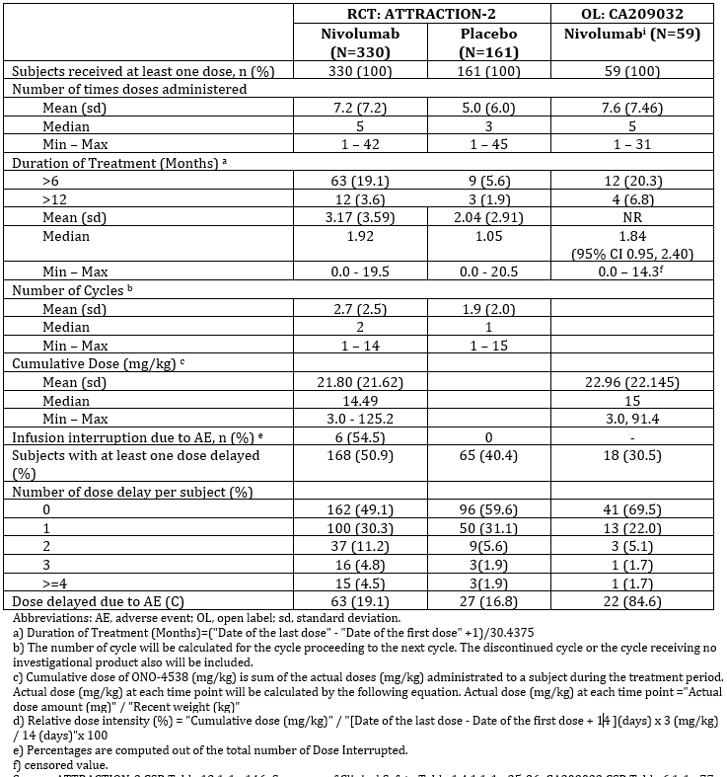
Table 5: Extent of exposure
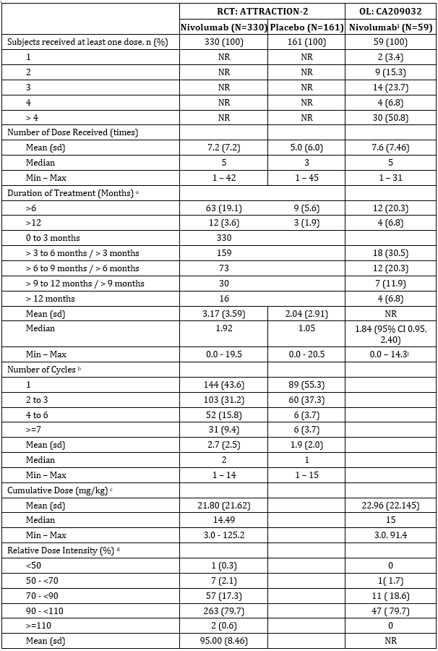
Table 5 (continued): Extent of exposure
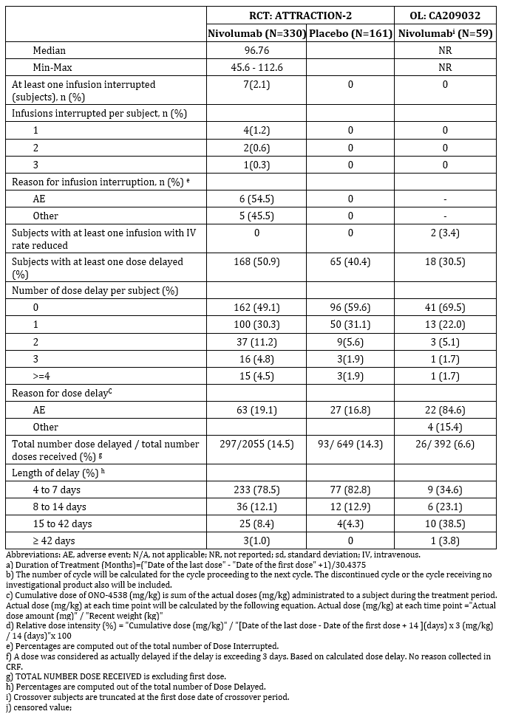

Safety issues with the potential for major regulatory impact
Safety outcomes with possible regulatory impact were reported in the Summary of Clinical Safety as select AEs based on MedDRA version 20.0.

Liver function and liver toxicity
Liver function and liver toxicity outcomes were reported as select AEs based on MedDRA version 20.0.

Pivotal and/or main efficacy studies (ATTRACTION-2)
Hepatic select AEs were reported in 18.8% of subjects in the nivolumab group and 12.4% of subjects in the placebo group. Grade 3 or4 hepatic select AEs were reported in 10.0% and 6.8% of subjects, respectively. A summary of select AEs comprising of hepatic events was provided.
The most commonly reported hepatic AE in the nivolumab group was aspartate aminotransferase (AST) increased (10.0%), followed by blood alkaline phosphatase (ALP) increased (7.6%). The most commonly reported hepatic AE in the placebo group was AST increased (6.8%), followed by alanine aminotransferase (ALT) increased (5.6%).
Drug-related hepatic select AEs were reported in 5.5% of subjects in the nivolumab group and 3.1% of subjects in the placebo group. The most commonly reported drug-related hepatic AEs in the nivolumab group was AST increased (3.3%). Hepatic select AEs leading to discontinuation of study treatment were reported in 1.2% of subjects in the nivolumab group (drug-related hepatitis acute in 1 subject (0.3%)).
A summary of on-treatment laboratory abnormalities in specific liver function tests is provided in Table 6. The majority of abnormal liver function test (LFT) values were Grades 1 or 2 in both treatment groups, and the majority of subjects in the nivolumab group did not have on-study worsening of LFT values. There were no clear differences in the frequencies of worsened hepatic function parameters between the treatment groups. In the nivolumab group, Common Terminology Criteria for Adverse Events (CTCAE) grade was worsened by at least 2 grades from Baseline to ≥ Grade 3 for AST increased in 31 subjects, blood bilirubin.
Table 6: Summary of on-treatment laboratory abnormalities in specific liver tests
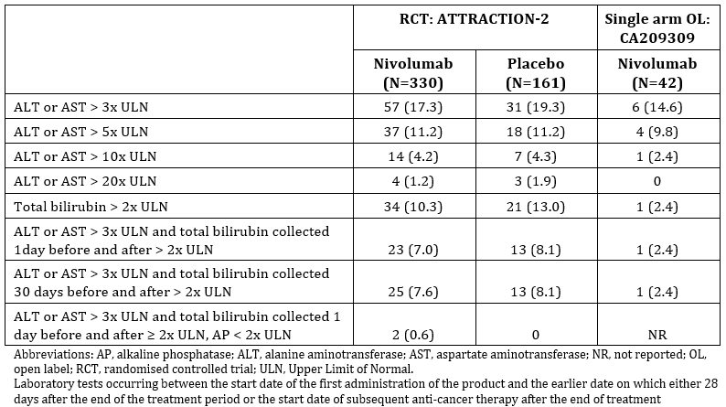

Other studies

Other efficacy studies (Study CA209032)
The frequency of hepatic select AEs was consistent with the ATTRACTION-2 trial (14.3%). A total of 4.8% of subjects had hepatic AEs that were considered to be drug-related by the investigator. No subjects had drug-related events that led to permanent discontinuation of nivolumab.
The median time to onset of drug-related hepatic events was 14.43 weeks. Two subjects were treated with immune modulating medications, of which one subject was treated with high-dose corticosteroids. The duration of high-dose corticosteroids was 22.14 weeks. Overall, both subjects had drug-related hepatic select AEs that resolved, with a median time to resolution of 13.57 weeks.
In the 59 subjects in the GC cohort of Study CA209032, 13.6% of subjects had hepatic select AEs that were considered to be drug-related by the investigator, and the most commonly reported drug-related event was increased AST (11.9%). Other drug-related hepatic select AEs reported in the GC cohort not reported in the 42 subject subset included blood ALP increased (2 subjects, 3.4%), and gamma-glutamyltransferase increased and transaminases increased (1.7%).

Renal function and renal toxicity

Pivotal and/or main efficacy studies (ATTRACTION-2 trial)
Renal select AEs were reported in 3.6% of subjects in the nivolumab group and 1.9% of subjects in the placebo group. Grade 3 to 4 renal AEs were reported in 0.6% of subjects in each group.
The only drug-related renal AE in subjects treated with nivolumab was blood creatinine increased (0.3%), which did not resolve. No drug-related renal select AEs leading to treatment discontinuation in the nivolumab group were reported.
In subjects treated with nivolumab, the time to onset of the drug-related renal event was 2.14 weeks. No subjects were treated with immune modulating medications.

Other studies

Other efficacy studies (Study CA209032)
One subject treated with nivolumab has a reported select AE (acute kidney injury (Grade 3 or 4) and blood creatinine increased (Grade 1 to 2)). These were not considered to be related to drug by the investigator.

Other select adverse events

Pivotal and/or main efficacy studies (ATTRACTION-2 trial)

Endocrine select adverse events
Endocrine select AEs were reported in 6.4% of subjects in the nivolumab group and 1.2% of subjects in the placebo group. Grade 3 or 4 endocrine select AEs were reported in 1.2% of subjects treated with nivolumab. There were no Grade 3 or 4 endocrine select AEs reported in subjects treated with placebo. A summary of endocrine select AEs reported is provided in Table 7.
The most commonly reported endocrine AEs reported in the nivolumab group was hypothyroidism (4.2%) followed by type 1 diabetes mellitus (0.9%). The most commonly reported endocrine AEs in the placebo group were diabetes mellitus and hypothyroidism (each 0.6%).
Drug-related endocrine AEs were reported in 4.8% of subjects in the nivolumab group and 0.6% of subjects in the placebo group. The most commonly reported drug-related endocrine AE in each group was hypothyroidism (3.0% and 0.6%, respectively).
Table 7: Summary of endocrine select adverse events
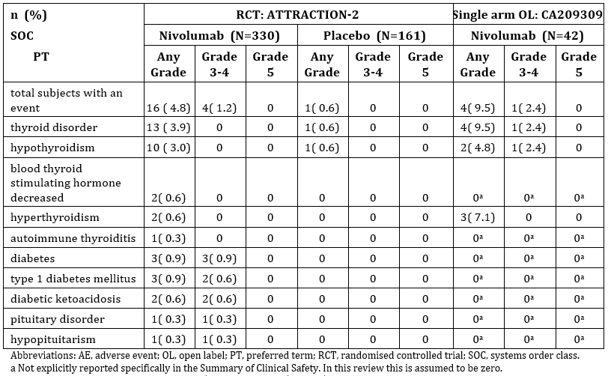
Hypothyroidism is a known immune-related endocrinopathy associated with nivolumab use.

Gastrointestinal select adverse events
Gastrointestinal (GI) select AEs were reported in 17.6% of subjects in the nivolumab group and 9.9% of subjects in the placebo group. Grade 3 or 4 GI select AEs were reported in 1.5% and 0.6% of subjects, respectively. A summary of gastrointestinal select AEs reported is provided in Table 8.
The most commonly reported GI AE in the nivolumab group was diarrhoea (17.6%), followed by colitis (0.6%). The most commonly reported GI AE in the placebo group was diarrhoea (9.3%), followed by gastrointestinal perforation (0.6%).
Drug-related GI select AEs were reported in 7.0% and 2.5% of subjects in the nivolumab monotherapy and placebo groups, respectively. The most commonly reported drug related GI AE in each group was diarrhoea (7.0% and 1.9%, respectively). No drug-related GI select AE lead to discontinuation of study treatment in the nivolumab group.
Table 8: Summary of gastrointestinal select adverse events
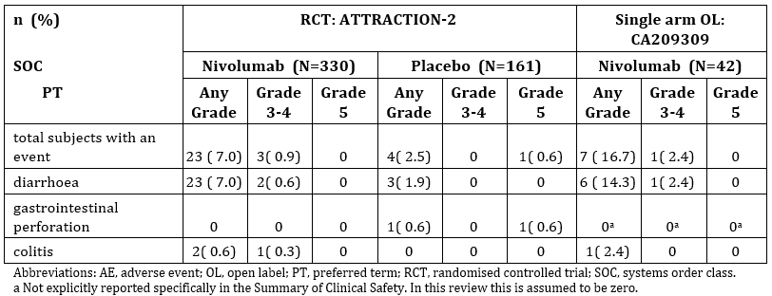
These adverse events are consistent with the known adverse event profile of nivolumab. The exclusion criteria of diverticulitis and symptomatic gastrointestinal ulcerative disease should be noted.

Pulmonary select adverse events
Pulmonary select AEs were reported in 3.0% of subjects in the nivolumab group and no subjects in the placebo group. Pulmonary select AEs reported included lung disease (1.8%), and pneumonitis (1.2%). Grade 3 or 4 pulmonary AEs were reported in 0.6% of subjects in the nivolumab group.
Drug-related pulmonary AEs were reported in 2.1% of subjects in the nivolumab group. The most common drug-related pulmonary AE in the nivolumab group was interstitial lung disease (1.8%). Drug-related pulmonary select AEs leading to discontinuation of study treatment were reported in 1.2% of subjects in the nivolumab group (interstitial lung disease in 3 subjects (0.9%) and pneumonitis in 1 subject (0.3%)).

Skin select adverse events
Skin select AEs were reported in 26.1% of subjects in the nivolumab group and 13.0% of subjects in the placebo group. No Grade 3 or 4 skin AEs were reported in either group. The most commonly reported skin select AE in the nivolumab group was pruritus (16.1%), followed by rash (9.4%). The most common skin AE in the placebo group was pruritus (9.3%), followed by rash (3.7%). Drug-related skin select AEs were reported in 15.5% of subjects in the nivolumab group and 8.1% of subjects in the placebo group.

Other efficacy studies (Study CA209032)

Endocrine select adverse events
A summary of endocrine select AEs reported is provided in Table 7 (see above). Endocrine select AEs were reported in 11.9% of subjects. All endocrine select AEs reported were thyroid disorders. A total of 9.5% of subjects had endocrine select AEs that were considered to be drug related by the investigator. The most commonly reported drug-related event was hyperthyroidism (7.1%). The majority of drug-related endocrine events were Grade 1 to 2. One Grade 3 event (hypothyroidism) was reported. No events led to permanent discontinuation of nivolumab.

Gastrointestinal select adverse events
A summary of GI select AEs reported is provided in Table 8 (see above). GI select AEs were reported in 28.6% of subjects. A total of 16.7% of subjects had GI select AEs that were considered to be drug-related by the investigator. Most drug-related events were Grade 1 to 2 diarrhoea, with 1 subject with an event of Grade 2 colitis and 1 subject with a Grade 3 event of diarrhoea. The Grade 2 drug-related event of colitis led to permanent discontinuation of nivolumab.

Pulmonary select adverse events
Pulmonary select AEs were reported in 7.1% of subjects. Two subjects (4.8%) had pulmonary AEs (pneumonitis) considered to be drug-related by the investigator, all Grade 1 or 2 events. There were no subjects with drug-related pulmonary AEs that led to permanent discontinuation of nivolumab.

Skin select adverse events
A total of 23.8% of subjects had skin AEs that were considered to be drug-related by the investigator. The majority of the events were pruritus. All of the drug-related events were Grade 1 or 2, and none led to permanent discontinuation of nivolumab.

Other events of special interest

Pivotal and/or main efficacy studies (ATTRACTION-2 trial)
No other events of special interest (OESIs) were reported in the nivolumab group.

Other efficacy studies (Study CA209032)
No OESIs were reported in the nivolumab group.

Haematology and haematological toxicity
Evaluation of the haematological parameters are consistent with the known safety profile of nivolumab and did not trigger any additional safety concerns.

Pivotal and/or main efficacy studies (ATTRACTION-2 trial)
In patients treated with nivolumab, CTCAE grade worsened by at least 2 grades from Baseline to ≥ Grade 3 for haemoglobin decreased in 18 subjects, lymphocyte count decreased in 13 subjects, and platelet count decreased in 5 subjects.
In the placebo group, CTCAE grade was worsened by at least 2 grades from Baseline to ≥ Grade 3 for lymphocyte count decreased in 13 subjects, haemoglobin decreased in 12 subjects, platelet count decreased in 6 subjects, white blood cell decreased in 2 subjects, and neutrophil count decreased in 1 subject.

Other efficacy studies (Study CA209032)
Grade 3 or4 haematologic abnormalities reported in ≥ 5% of treated GC/GEJC subjects and ≥ 2 prior regimens with on-treatment laboratory results were decreased haemoglobin (11.9% Grade 3 only) and decreased absolute lymphocytes (21.4% Grade 3; 2.4% Grade 4).

Other laboratory tests

Pivotal and/or main efficacy studies (ATTRACTION-2 trial)
A summary of clinical laboratory evaluations was provided.
Evaluation of laboratory parameters in the ATTRACTION-2 trial are consistent with the results with the known safety profile of nivolumab and did not trigger any additional safety concerns.

Other efficacy studies (Study CA209032)
Evaluation of laboratory parameters in Study CA209032 are consistent with the results with the known safety profile of nivolumab and did not trigger any additional safety concerns.

Electrocardiograph findings and cardiovascular safety

Pivotal and/or main efficacy studies (ATTRACTION-2 trial)
12-lead electrocardiograms (ECG) were used for safety monitoring by the treating physician. A summary of the 12-lead ECG parameters is provided in Table 9. The QTcF; after the start of study treatment was 500 ms or below in all subjects.
Table 9: Summary of the maximal data of 12-lead ECG parameters
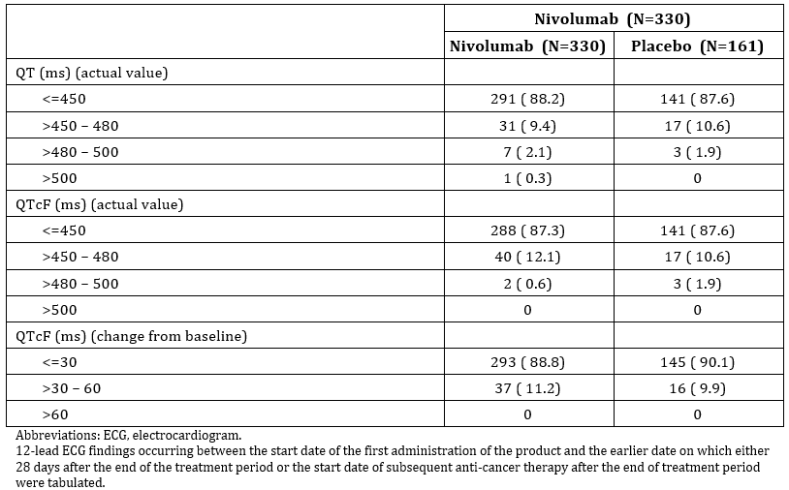
Note: (Periodic Benefit Risk Evaluation Report (PBRER) 3 July 2016 p3): The Health Authority in Japan requested the nivolumab J-RMP was updated to include cardiac disorder as an Important Potential Risk. Additionally, in May 2016, the Health Authorities in the US, Japan, Australia, Canada and Sweden requested assessment of myositis, myocarditis, and rhabdomyolysis events. The Company Corporate Data Sheet (CCDS), Investigator’s Brochure (IB), and the RMP were updated to include myocarditis, myositis and rhabdomyolysis as ADRs. Country labelling updates are ongoing.

Vital signs and clinical examination findings

Pivotal and/or main efficacy studies (ATTRACTION-2 trial)
Vital signs, oxygen saturation by pulse oximetry were used for safety monitoring by the treating physician. No new safety signals were identified from the trial.

Other efficacy studies (Study CA209032)
Vital signs and oxygen saturation by pulse oximetry were monitored by the treating physician. No new safety signals were identified from the trial.

Immunogenicity and immunological events

Pivotal and/or main efficacy studies (ATTRACTION-2 trial)

Hypersensitivity/infusion reactions
Hypersensitivity/infusion reactions were reported in 1.5% of subjects treated with nivolumab group and no subjects treated with placebo. Hypersensitivity/infusion reactions that were considered related to study drug were reported in 0.9% of patients treated with nivolumab, of which no Grade 3/4 events were reported.

Immunogenicity
A summary of immunogenicity outcomes was provided.
Of the 307 subjects from the ATTRACTION-2 trial treated with nivolumab 11.7% were anti-drug antibody (ADA) positive. One subject (0.3%) was persistent positive for ADA, 5.9% had positive samples at the last sampling time point, and 5.5% were considered other positive.
In total, of the six subjects who had infusion-related or hypersensitivity reactions following administration of nivolumab 3 mg/kg once every two weeks (Q2W), two were ADA positive and three were ADA negative. In both ADA positive and ADA negative subsets (including both the ATTRACTION-2 trial and Study CA209032), two of the three AEs were considered drug related. The pattern related to ADA formation and safety events is unclear.

Other efficacy studies (Study CA209032)

Hypersensitivity/infusion reactions
One subject (2.4%) reported a Grade 2 hypersensitivity reaction that was considered to be drug-related by the investigator.

Immunogenicity
A summary of immunogenicity outcomes was provided.
Of the 51 GC subjects from Study CA209032 treated with nivolumab, 23.5% were ADA positive. Of the 12 subjects, none were persistent positive or neutralizing positive, 5 had positive samples at the last sampling time point, and 7 were considered other positive. Overall, the immunogenicity incidence in GC subjects was 13.4% and is similar to that previously reported and within the range of immunogenicity incidences observed across different tumour types.
Only one subject had an infusion-related or hypersensitivity reactions following administration of nivolumab 3 mg/kg Q2W was ADA positive.

Serious skin reactions

Pivotal and/or main efficacy studies (ATTRACTION-2 trial)
No serious skin reactions were reported in the ATTRACTION-2 trial.

Other efficacy studies (Study CA209032)
No serious skin reactions were reported in Study CA209032.

Other safety issues

Safety in special populations
The incidences of AEs by subgroup (location, age, sex, Eastern Cooperative Oncology Group performance status (ECOG PS), and the number of organs with metastases) is provided in Table 10. The incidence of any grade AE is similar across subgroups. The incidence of Grade 3 to 4 adverse events was lower in Japan than Korea and Taiwan in both the nivolumab and placebo groups.
In Study CA209302, small numerical differences in the frequencies of AEs were observed in subgroups:
- Any grade and Grade 3 or 4 drug-related AEs for male (73.3% and 13.3%) versus female (57.1% and 28.6%).
- Any grade and Grade 3 or 4 AEs for < 65 years age (100% and 40.5%) versus ≥ 65 years age (94.1% and 52.9%). Any grade and Grade 3 or 4 drug-related AEs for < 65 years age (64.3% and 14.3%) versus ≥ 65 years age (82.4% and 23.5%).
- A greater frequency of all causality Grade 3 to 4 AEs were reported in Rest of the World (55.6%) versus US (34.4%).
These differences are of limited interpretability due to low sample sizes and event rates, and do not alter the overall safety profile of nivolumab in these subgroups.
There appear to be geographical differences in the adverse event Grade 3 and Grade 4 incidences. The incidences appear to be lower in Japan than in Korea and Taiwan.
Table 10: Summary of total adverse events by subgroup
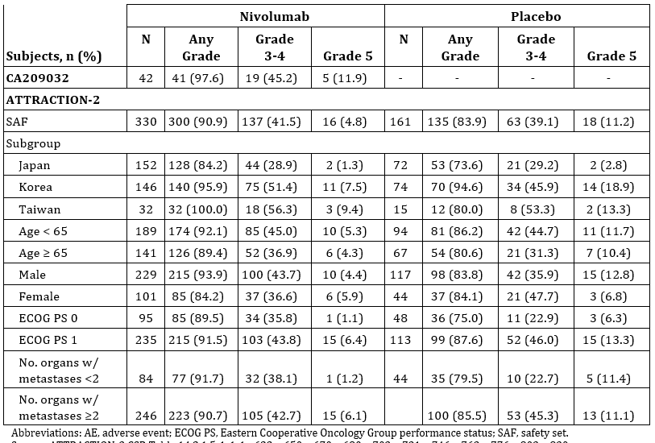

Safety related to drug-drug interactions and other interactions
The submission contained no new information on drug interactions.
During the period between the 4 January 2016 to the 3 July 2016, the sponsor issued two Dear Healthcare Providers Communication (DHCP) letters informing healthcare professionals (HCPs) in Australia that (PBRER 3 July 2016):
- the approved indication for nivolumab in locally advanced or metastatic SQ and NSQ NSCLC; does not include combination with TKIs; and
- there are potential benefits and risks of the influenza vaccine in patients currently receiving the nivolumab plus ipilimumab combination or for those in which this combination is being considered.

Post marketing data
A periodic safety update report (PSUR)/periodic benefit risk evaluation report (PBRER) was not provided with the submission. The most recent PBRER on file (with the TGA), is the version presenting cumulative data for the period from the 4 July 2017 to the 3 January 2018. Review of post-marketing data received during this period did not reveal any new safety concerns.

Evaluator’s conclusions on safety
The pattern of toxicity with nivolumab in the pivotal and supportive studies is consistent with the previously documented adverse events associated with nivolumab. The most common AEs were abdominal pain and nausea. The most common drug related AEs were pruritus, diarrhoea and rash.
The drug related adverse events incidence is higher in the nivolumab group than the placebo group, both for all grades and Grade 3 or 4.
Overall, the toxicities were adequately documented.
The absence of subjects with active diverticulitis or symptomatic GI disease from the pivotal trial means that results of the clinical safety cannot be extrapolated to subjects with GC and those selected co-morbidities.

First round benefit-risk assessment

First round assessment of benefits
A significant reduction in the hazard rate of death was achieved.
Table 11: First round assessment of benefits
Benefits | Strengths and Uncertainties
Opdivo presents clear evidence of activity in the third line treatment of gastric cancer.  A significant reduction in the hazard rate of death was achieved relative to placebo (0.63 (95% CI: 0.51, 0.78)).  The median OS was 5.26 months (95% CI: 4.60 months, 6.37 months) in the nivolumab group and 4.14 months (95% CI: 3.42 months, 4.86 months) in the placebo group. | The benefits were assessed using a well-designed placebo controlled randomised controlled trial (RCT) using an appropriate outcome measure.  Whether the magnitude of the survival gain observed in the trial can be expected among Australian subjects is uncertain due to extrinsic ethnic factors, such as:  - The subjects recruited to the study were almost exclusively Asian and the trial was conducted in Japan, Taiwan and Korea; and  - The trial was conducted in a heavily pre-treated group.  The intrinsic ethnic factors may be subject to less uncertainty (given the results of the popPK and the flat dose response relationship).  The supportive trial in American and European subjects was not comparative to placebo.  The usefulness of potential biomarkers of benefit such as PD-L1 status and MSI status have not been well established in the evidence presented because of incomplete data collection and post-hoc nature of the analysis.

First round assessment of risks
Table 12: First round assessment of risks
Risks | Strengths and uncertainties
An increase in treatment related adverse events including gastrointestinal adverse events and potentially immune-mediated adverse events. | The adverse event profile of nivolumab presented is consistent with previously documented adverse events.

First round assessment of benefit-risk balance
The magnitude of the benefit for Opdivo in the Australian context is subject to uncertainty because of the limited external validity of the pivotal study. Therefore, there is uncertainty around the benefit-risk balance of Opdivo. A decrease in the magnitude of the observed benefit in the Australian population could result in an unfavourable benefit risk ratio.
The uncertainty around the benefit-risk balance is unlikely to be further resolved with the currently available data.

First round recommendation regarding authorisation
There is uncertainty around the benefit risk balance of Opdivo in an Australian population and a clear recommendation for approval cannot be made. If it is accepted that the benefit seen in the pivotal trial would be replicated in an Australia population the benefit risk balance would be favourable and the application could be recommended for approval.

Clinical questions and second round evaluation
- Can more detail be provided regarding the major protocol deviations for other therapy in ATTRACTION-2? For example, in how many instances was the ‘other therapy’ surgery or radiotherapy?
Sponsor’s response
In the Study ONO-4538-12 (ATTRACTION-2 trial) CSR, indicated that 19.1% and 19.0% of subjects in nivolumab and placebo groups, respectively, received any concurrent anti-cancer therapy (that is, chemotherapy, hormonal therapy, immunotherapy, surgery, or radiation therapy) while on study therapy, which was reported as a protocol deviation. However, all of these subjects received concurrent therapies to treat symptoms (that is, diuretics and drainage for ascites, etcetera.) or therapies started after the last study treatment dose, which were allowed per the protocol, and therefore should not be considered relevant protocol deviations.
An additional analysis was conducted, excluding these therapies, which shows no concurrent anticancer therapy was reported while on study therapy (Table 13). No relevant protocol deviations were reported in the nivolumab group. In the placebo group, 1 (0.6%) subject failed to fulfil protocol inclusion criteria number 5, ECOG Performance Status score 0 or 1, which was considered a relevant protocol deviation score.
Table 13: Relevant protocol deviations summary; all randomised subjects (intention-to-treat (ITT) set) Study ONO-4538-12/ATTRACTION-2 trial
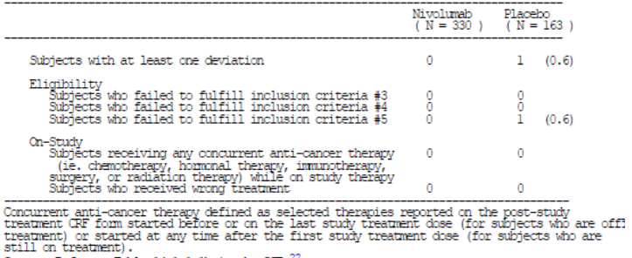
The analysis of subsequent therapies in the Study ONO-4538-12 CSR included cancer-related symptomatic treatment, such as ascites tapping, diuretic agents, palliative radiotherapy, and surgery. An additional analysis was conducted excluding cancer-related symptomatic treatment management (such as ascites tapping, diuretic agents), to reflect the impact of subsequent therapies. In this analysis, the proportion of subjects who received subsequent therapy/therapies was similar between the nivolumab and placebo groups, respectively: 31.2% and 31.3%, 84 (25.5%) and 44 (27.0%) of subjects received pharmacotherapy (systemic therapy), 25 (7.6%) and 15 (9.2%) of subjects received radiotherapy, and 5 (1.5%) and 2 (1.2%) of subjects had surgery, in the nivolumab and placebo groups, respectively. The most frequent subsequent pharmacotherapies were fluoropyrimidine, irinotecan, ramucirumab, and taxane.
Evaluation of response
The sponsor’s response is noted.
- What number of subjects continued nivolumab post progression in the ATTRACTION-2 trial and for how long?
Sponsor’s response
In Study ONO-4538-12, subjects who achieved progressive disease (PD) per Response Evaluation Criteria In Solid Tumours (RECIST) 1.1 could continue treatment beyond progression if the following criteria in the opinion of the investigator or sub-investigator were fulfilled.
- No rapid disease progression, and continuation of study treatment is expected to lead to clinical benefits.
- Tolerated the investigational product.
- A stable ECOG Performance Status score.
- Continuation of study treatment would not cause a delay of any prophylactic intervention for serious complications associated with disease progression (for example, brain metastasis)
The subject’s willingness to continue with study treatment must have been confirmed and written re-consent was obtained. In addition, the continuation of study treatment by such subjects must have been promptly reported to the sponsor.
If further progressive disease (PD) was assessed in accordance with the RECIST version 1.1, as compared to the initial PD time point, study treatment was to be discontinued.
A total of 35.8% (92 out of 257) subjects with reported investigator-assessed RECIST v1.1 progression in the nivolumab group and 26.5% (35 out of 132) in the placebo group continued study treatment post-progression in ONO-4538-12 (defined as a last dosing date after investigator-assessed RECIST v1.1 progression date) (Table 14).
The median duration of treatment beyond progression was 4.6 weeks and 4.7 weeks in the nivolumab and placebo groups respectively, as shown in Table 14.
Table 14: Summary of treatment beyond progression; all randomised subjects (ITT set) Study ONO-4538-12/ATTRACTION-2 trial
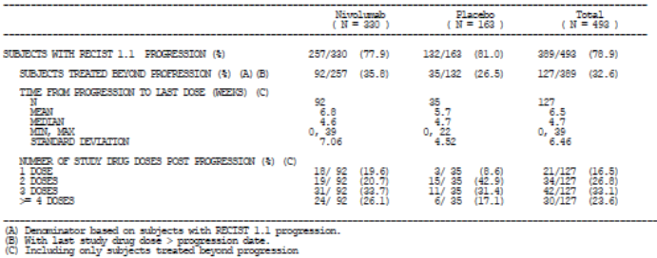
Evaluation of response
Response noted.

Additional information provided by the sponsor
- The external validity (generalisability/applicability) of the pivotal trial to Australian patients.
- Incomplete data for PD-L1 expression and MSI-H status.

Evaluation of the additional information
These data were carefully studied. They are not reproduced here. Matters for consideration are:
- Characteristics of Asian versus EU/US patients were not the same in the data submitted by the sponsor: A higher percentage of Asian patients were ECOG PS = 0 (and a lower percentage were ECOG PS = 2+); and surprisingly, a higher percentage of Asian patients had unresectable disease at the time of diagnosis.
- Study CA209-032 (in non-Asian patients; n = 42) is does not provide convincing supportive evidence that the treatment effect reported from the ATTRACTION-2 trial could be generalised to non-Asian patients. More specifically, the patients in Study CA209-032 seem to have a better prognosis that those in the ATTRACTION-2 trial: median (Md)(OS) = 8.5 months versus Md(OS) = 5.3 (nivolumab) and Md(OS) = 4.1 (placebo) respectively. The objective response rate (ORR) from Study CA209-032 is based on small numbers: 7 out of 42 and is not helpful.
- Of the 330 patients randomised to nivolumab, 1 was MSI-H, 82 were non-MSI-H, and the rest (75%) did not have MSI testing. For the placebo group the percentage without MSI testing was 78%. For PD-L1 status, the percentage without testing was 67% in both the nivolumab and placebo groups. Given the small treatment effect (ORR = 9%), there is material uncertainty as to whether the benefit-risk balance is favourable for the whole group or just MSI-H or PD-L1 high patients.
- It seems unlikely that Australian patients who have received 2 lines of treatment, but remained ECOG PS = (0, 1) would receive no further active treatment. This raises questions as to whether placebo is the appropriate comparator for the Australian setting; and, makes the lack of complete data on MSI and PD-L1 expression problematic (see previous bullet point). A more appropriate comparator might have been investigator choice of third line systemic treatment.

Second round benefit-risk assessment
The clinical benefit demonstrated in the main clinical trial for the primary endpoint seems modest, namely, the median OS was 5.26 months (95% CI: 4.60 months, 6.37 months) in the nivolumab group and 4.14 months (95% CI: 3.42 months, 4.86 months) in the placebo group.
Uncertainty remains on the generalisability of the Phase III trial results to the Australian population for the reasons stated above.
The incomplete dataset for PD-L1 and MSI-H status of patients reduces the precision whereby patients can be selected for treatment.
These factors increase the uncertainty of the assessment of benefit of nivolumab in patients with pre-treated gastric cancer.

Second round recommendation regarding authorisation
The clinical evaluator recommends rejection of the application to extend the indications of nivolumab to third line treatment of patients with gastric cancer based on insufficient evidence of clinical benefit.

VI. Pharmacovigilance findings
The TGA granted a waiver from the requirement for a risk management plan (RMP) for this application.

VII. Overall conclusion and risk/benefit assessment
The submission was summarised in the following Delegate’s overview and recommendations.

Quality
There was no requirement for a quality evaluation in a submission of this type.

Nonclinical
There was no requirement for a nonclinical evaluation in a submission of this type.

Clinical
The clinical evaluator recommended rejection.

Contents of the clinical module
The submission contained:
- The pivotal Phase III efficacy/safety report (Study ONO-4538-12 (ATTRACTION-2 trial)).
- A Phase I/II efficacy/safety study (Study CA209032) with an interim report and an addendum.
- An updated popPK analysis in subjects with gastric cancer (and non-small cell lung cancer) exploring, amongst other issues the comparison of exposures between Asian subjects with GC to non-Asian subjects with GC.

Clinical pharmacology
The pharmacokinetics of nivolumab have been previously submitted to the TGA. A new popPK model was provided (Report BMS-936588/MDX1106). This popPK model combined data from Phase I, Phase II and Phase III studies of solid tumours, including data from the ATTRACTION-2 trial and Study CA209032 which included GC. This model updates a previously developed popPK model that has been submitted to the TGA. The popPK model concluded that nivolumab exposure were similar for Asian and non-Asian populations. It also concluded that clearance was higher in GC patients than NSCLC patients.

Pivotal clinical study; the ATTRACTION-2 trial
ATTRACTION-2 trial (Study ONO-4538-12): a Phase III, randomised (2:1), double-blind, placebo-controlled 49 sites in Japan, South Korea and Taiwan from November 2014 to February 2016.

Patients
Nivolumab n = 330; placebo n = 163.

Inclusion criteria
- Unresectable advanced or recurrent gastric/GEJ adenocarcinoma,
- 2+ previous lines of treatment,
- ECOG PS: 0 or 1,
- Life expectancy > 3 months,
- (recruitment was not dependent on PD-L1 expression).

Exclusion criteria
- Autoimmune disease,
- Interstitial lung disease,
- Other clinically significant medical disorders,
- Symptomatic brain metastases.

Intervention
3 mg/kg nivolumab intravenously every 2 weeks. 6 weeks of study treatment (including three infusions) was considered one treatment cycle. Study treatment was continued until progressive disease per investigator assessment or onset of toxicities.

Comparator
Placebo intravenously every 2 weeks.

Endpoints
Primary: OS.
Secondary: progression free survival (PFS) (investigator assessed); RR.

Stratification
Randomisation was stratiﬁed according to country (Japan versus Korea versus Taiwan), ECOG PS (0 versus 1), and number of organs with metastases (< 2 versus ≥ 2).

Imaging
Tumour responses were assessed by the investigator using computed tomography (CT) or magnetic resonance imaging (MRI) according to RECIST guidelines version 1.1. Tumour assessments were done after every 6 week treatment cycle for ten cycles (about 14 months), then after every two treatment cycles until discontinuation of study treatment because of progressive disease or initiation of post-study treatment, or assessment of progressive disease or recurrence in patients who discontinued study treatment because of toxicity.

Minimal clinically important difference
For the sample size calculation, the pre-specified minimal clinically important difference (MCID) was hazard ratio (HR)(OS) = 0.65.

Baseline characteristics
Table 15: ATTRACTION-2 trial baseline characteristics
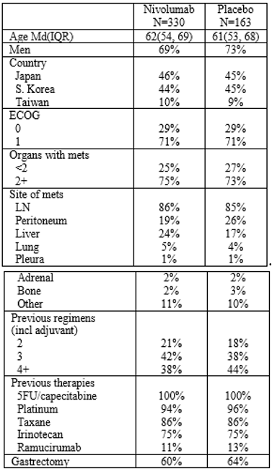
Tumour samples were obtained before the study from 134 (41%) of 330 patients in the nivolumab group and 62 (38%) of 163 patients in the placebo group. However, four samples from the nivolumab group were not suitable for assessment. Among the 192 patients with samples that could be assessed, 16 (12·3%) of 130 patients in the nivolumab group and 10 (16·1%) of 62 patients in the placebo group had PD-L1-positive tumours.

Follow-up (data cut-off)
By the data cutoff date of 13 August 2016, the median follow-up in surviving patients was 8·9 months (interquartile range (IQR) 6·6 to 12·4) in the nivolumab group and 8·6 months (5·7 to 11·4) in the placebo group.
The median duration of treatment was 1.9 months (IQR 0.9 to 4.3) with nivolumab and 1.1 months (IQR 0.6 to 2.5) with placebo. Among patients with progressive disease, 95 (37%) of 257 patients in the nivolumab group and 37 (28%) of 132 patients in the placebo group continued study treatment beyond first progressive disease. Subsequent anticancer therapies after study treatment discontinuation were administered to 155 (47%) of 330 patients in the nivolumab group and 72 (44%) of 163 patients in the placebo group, including pharmacotherapy (115 (35%) of 330 patients in the nivolumab group versus 52 (32%) of 163 patients in the placebo group), surgery (primarily palliative drainage; 65 (20%) versus 28 (17%)), and radiotherapy (24 (7%) versus 15 (9%)).

Results
Results (data cut-off: 19 December 2016; no more recent analyses were available, as per the sponsor’s response).
Table 16: ATTRACTION-2 trial primary endpoint
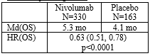
Table 17: ATTRACTION-2 trial progression free survival
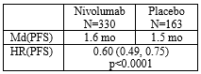
Table 18: ATTRACTION-2 trial overall survival and progression free survival at various time-points
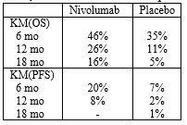
Table 19: ATTRACTION-2 trial response rate
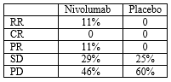

Subgroup analyses
The point estimates for presented the subgroup analyses (for example, previous gastrectomy, site, histological subtype, liver mets, etcetera) favoured nivolumab.
Of the 330 patients randomised to nivolumab, 1 was MSI-H, 82 were non-MSI-H, and the rest (75%) did not have MSI testing. For the placebo group the percentage without MSI testing was 78%. For PD-L1 status, the percentage without testing was 67% in both the nivolumab and placebo groups. Given the small treatment effect (ORR = 9%), there is material uncertainty as to whether the benefit-risk balance is favourable for the whole group or just MSI-H or PD-L1 high patients.
It seems unlikely that Australian patients who have received 2 lines of treatment, but remained ECOG = (0, 1) would receive no further active treatment. This raises questions as to whether placebo is the appropriate comparator for the Australian setting; and, makes the lack of complete data on MSI and PD-L1 expression problematic (previous dot point). A more appropriate comparator might have been investigator choice of third line systemic treatment.

Safety
No new safety signals for nivolumab were identified in the ATTRACTION-2 trial.

Risk-benefit analysis

Delegate’s considerations

Indications
Proposed:
Opdivo as monotherapy is indicated for the treatment of adult patients with advanced or recurrent gastric or gastro-oesophageal junction cancer after two or more prior systemic therapies.
Following receipt of the second round clinical evaluation report, in which the clinical evaluator recommended rejection, the sponsor proposed the following indication:
Opdivo as monotherapy is indicated for the treatment of adult patients with advanced or recurrent gastric or gastroesophageal junction (GEJ) cancer after two or more prior systemic therapies in the metastatic setting. Opdivo should be used in patients when further treatment with chemotherapy is not considered appropriate. This indication is based on overall survival from a clinical trial conducted in Asia.

Current treatment algorithm

First line, HER2+
About 10% to 40% of GC/GEJC (adenocarcinoma) are HER2+ and suitable for trastuzumab, first-line (1L). Chemotherapy backbones used with trastuzumab include: oxaliplatin plus leucovorin and short-term fluorouracil (FU) (FOLFOX), capecitabine plus oxaliplatin (CAPOX), cisplatin plus FU, or cisplatin plus capecitabine.

First line, HER2-
Despite a large number of randomized trials, there is no globally accepted standard first-line chemotherapy regimen in advanced GC/GEJC, HER2-negative adenocarcinoma (or SCC). In general, combination chemotherapy regimens provide higher response rates than do single agents, but this translates into only modestly longer durations of disease control and survival that are measured in weeks to a few months.
Possible platinum doublet options include:
- fluoropyrimidine plus oxaliplatin doublet (for example, oxaliplatin plus leucovorin and short term infusional FU (FOLFOX);
- oxaliplatin plus capecitabine (XELOX);
- fluorouracil plus cisplatin;
- (irinotecan plus leucovorin and FU (FOLFIRI) is sometimes considered).
For highly selected patients with good performance status who are willing to sacrifice treatment related toxicity for a higher response rate and possibly longer progression free survival, a triplet chemotherapy regimen is an option:
- fluoropyrimidine plus oxaliplatin and docetaxel (taxane) FLOT: FU, leucovorin, oxaliplatin and docetaxel;
- fluoropyrimidine plus oxaliplatin and epirubicin (anthracycline);
- (for older patients or those with a poor performance status, possible 1L options include leucovorin-modulated fluorouracil alone, single-agent capecitabine, single-agent irinotecan, or low-dose weekly taxane).

Second line
If the patient retains good performance status, options include, taxane (docetaxel, paclitaxel), or irinotecan, or ramucirumab as single agent or in combination with paclitaxel. There is no evidence that any one of these options is better than any of the others.

3+ line
This is the proposed indication for nivolumab for this particular submission. No standard third-line or subsequent line therapy exists for advanced gastric cancer; although, if the patient remained ECOG PS < 2 and wanted to continue active treatment, one of the 2L options (above) could be tried.

Benefits
The pivotal study was the ATTRACTION-2 trial:
- a randomised, double-blind trial, conducted in Japan, South Korea and Taiwan;
- 3+L metastatic GEJ cancer;
- nivolumab (3 mg/kg q2w): 330 patients; placebo: 163 patients.
The study met its primary endpoint: HR(OS) = 0. 63, 95% CI 0.51 to 0.78, p < 0.0001; Md(OS) 5.3 months versus 4.1 months.
Secondary endpoints:
- HR(PFS) = 0.60, 95% CI 0.49-0.75; Md(PFS) 1.6 months versus 1.5 months.
- RR: 11% versus 0%; no complete responses.

Safety
No new safety signals were identified in this clinical setting. The safety of nivolumab is well characterised.

Uncertainties
- The inadequate information about MSI status (and also PD-L1 expression) means that the modest survival benefit (1.2 month improvement in median OS) could reflect an inadequately defined population. This is a design problem with the pivotal trial.

Other
- It seems unlikely that Australian patients who have received 2 lines of treatment, but remained ECOG PS = (0, 1) would receive no further active treatment. This raises questions as to whether placebo is the appropriate comparator for the Australian setting; and, makes the lack of complete data on MSI and PD-L1 expression problematic (previous dot point). A more appropriate comparator might have been investigator choice of 3+L systemic treatment. In the pivotal trial about 40% of patients had received 4 or more lines of prior systemic therapy (including adjuvant).
- There is uncertainty about the generalisability of the results from a trial conducted exclusively in patients from North-East Asia to Australian patients.

Proposed action
Based on the advice the Delegate had received to this point in time from the clinical evaluator, the efficacy and safety of nivolumab for the extension-of-indication have not been satisfactorily established.

Request for ACM advice
Does the pivotal trial (ATTRACTION-2 trial) provide a sufficient basis to satisfactorily establish the efficacy and safety of nivolumab for use in 3+L GC?

Response from sponsor
The sponsor welcomes the opportunity to submit this pre-ACM response in support of an approval for an indication in the treatment of GC or GEJC after two or more prior systemic therapies based on the results of the ATTRACTION-2 trial (Study ONO-4538-12; hereafter referred to as ATTRACTION-2) and Study CA209032.
In the ATTRACTION-2 trial, nivolumab demonstrated a statistically significant and clinically meaningful overall survival (OS) benefit (HR = 0.63, (95% CI: 0.51, 0.78)) in the all-randomized population. In a recent update to the results, after a minimum of a 2-year follow-up, nivolumab showed consistent survival benefit with HR = 0.62 (95% CI, 0.51 to 0.76). Importantly, the 1-year OS rate was 27.3% versus 11.6%, and 2-year OS rate of 10.6% versus 3.2%, representing a doubling and tripling of OS rates for nivolumab compared with placebo, respectively. The safety of nivolumab is well-characterised and no new safety signal were identified in this setting.
The sponsor believes that the uncertainties cited by the TGA Delegate are debatable. The sponsor emphasises that it is important to recognise that the majority of patients in the proposed indication are not expected to be microsatellite instability high (MSI-H) based on the prevalence of this biomarker (< around 5%) and that the efficacy demonstrated in the ATTRACTION-2 trial is relevant for patients where further treatment with chemotherapy is not recommended. In addition, the sponsor contends that on examination of patient risk factors and disease characteristics of GC/GEJC in a third line and beyond setting, there is no evidence that the benefit demonstrated in the ATTRACTION-2 trial would be expected to be any less for an Australian population of patients than in Asian patients. Therefore, it is expected that the benefit demonstrated in the ATTRACTION-2 trial and Study CA209032 would translate to the Australian population.
The sponsor proposes the following amended indication statement:
Opdivo as monotherapy is indicated for the treatment of patients with advanced or recurrent gastric or gastrooesophageal junction cancer after two or more prior systemic therapies in a metastatic setting. Opdivo should be used in patients when further treatment with chemotherapy is not considered appropriate. This indication is based on overall survival from a clinical trial conducted in Asia.
An expert statement from [information redacted] highlights that the ATTRACTION-2 trial has demonstrated a very meaningful and important benefit to this group of patients who would otherwise have no other treatment option and that the results are practice changing.
In summary, the sponsor believes that per Section 25(1)(c) of the Therapeutic Goods Act 1989, the quality, safety and efficacy of the goods for the purposes for which they are to be used have been satisfactorily established.

Introduction
In 2018, an estimated 2,332 Australians will be diagnosed and 1,078 will die from GC. Although a large proportion of patients with metastatic GC/GEJC may initially respond, nearly all patients will progress following first-line (1L) treatment of platinum-doublet or triplet treatment. For these patients, European clinical practice guidelines, which are the predominant guidelines followed in Australia, recommend either docetaxel, paclitaxel, ramucirumab or ramucirumab in combination with paclitaxel as second-line (2L) treatment options. After failure of 2L treatment, options become severely limited as there is no agent that has shown clear efficacy in a global, randomized study in the third-line (3L)+ setting. ESMO guidelines state treatment options may be used sequentially in the 2L and 3L line setting, but there is no clear evidence for a benefit beyond second-line treatment, and Australian guidelines are silent on 3L treatment. Additionally, a statement from [information redacted] expresses his expert opinion that there are no standard third line agents and patients are usually referred for palliative care. Therefore, treatment for patients with advanced or metastatic GC/GEJC who have progressed following ≥ 2 lines of chemotherapy in the metastatic setting remains a high and unmet need in Australia.
The prospect of nivolumab in this setting as the first immunotherapy agent will offer a new modality of treating this aggressive disease with proven overall survival and an established safety profile.

Question raised by the TGA delegate for ACM advice
Does the pivotal trial (ATTRACTION-2) provide sufficient basis to satisfactorily establish the efficacy and safety of nivolumab for use in 3+L gastric cancer?

Benefits
The ATTRACTION-2 trial is the first Phase III, double-blind, randomised study to report statistically significant and clinically relevant survival benefit of a checkpoint inhibitor in patients with advanced or metastatic GC/GEJC who failed at least 2 prior lines of chemotherapy. In the primary analysis, nivolumab demonstrated statistically significant and clinically meaningful PFS and OS benefit (PFS, HR = 0.60, (95% CI: 0.49, 0.75); OS, HR = 0.63, (95% CI: 0.51, 0.78)) in the all-randomised population.
Although the TGA Delegate has summarised the efficacy of nivolumab as a 1.2 month improvement in median OS, it is important to recognise that this only represents an OS difference at a single point (that is, median survival), in contrast to the log-rank test p-value which represents the totality of difference between the two OS curves. As seen in many immunotherapy trials, these observed differences reflected the larger separation at the ‘tail’ portion of the Kaplan-Meier (KM) curves as exhibited in the difference of OS rates in 6 months, 12 months and 24 months. OS rates for nivolumab and placebo, at 6 and 12 months, were 46.1% versus 34.7%, and 26.2% versus 10.9%, respectively. No patients in the placebo group achieved an objective response, whereas the 30 (11.2%) patients with an objective response on nivolumab had a median duration of response of 9.5 months. In a recent update to the ATTRACTION-2 trial results, after a minimum of a 2 year follow-up, nivolumab maintained a survival benefit with HR = 0.62 (95% CI, 0.51–0.76). The 1 year OS rate compared with placebo was 27.3% versus 11.6%, and 2 year OS rate of 10.6% versus 3.2%, representing a respective doubling and tripling of OS rates for nivolumab.
In addition, clinical activity with nivolumab was also observed in the Western population with advanced or metastatic GC/GEJC who failed prior lines of therapy based on Study CA209032. With a minimum follow-up of 8 months for OS, for the 42 subjects in Study CA209032 with GC or GEJC and ≥ 2 prior regimens most closely matching the ATTRACTION-2 trial subject population, the median OS was 8.97 months (95% CI: 3.35, 14.88 months). OS rates (95% CI) at 6 and 12 months were 57.4% (40.5%, 71.1%) and 45.1% (28.6%, 60.2%), respectively.
In summary, in a population of GC/GEJC patients for whom further chemotherapy is not appropriate, the sponsor attests that the presented results above are clinically significant in a treatment setting where no treatments have been found to extend survival.

Risks
The overall safety profile of nivolumab in this treatment setting is consistent with expectations based on prior data in other indications, in terms of the type and severity of reported events. As summarised by the TGA Delegate, ‘No new safety signals were identified in this clinical setting. The safety of nivolumab is well-characterised’. The sponsor believes that treatment of GC patients with nivolumab offers an important choice for Australian oncologists in a clinical setting devoid of treatments that have demonstrated evidence of efficacy or acceptable tolerability.

Uncertainties
The TGA Delegate identifies three uncertainties which the sponsor believes are disputable and are discussed below.
- The inadequate information about MSI status (and also PD-L1 expression) means that the modest survival benefit (1.2 month improvement in median OS) could reflect an inadequately defined population. This is a design problem with the pivotal trial.
At the time the ATTRACTION-2 trial was initiated in 2014, there were no established biomarkers in gastric cancer, or in relation to enriching a treatment effect for PD-L1 inhibitors such as MSI status. Indeed, other contemporary studies in GC have not prospectively tested MSI expression (for example the KEYNOTE 059 trial). More recent meta-analyses have generally suggested that MSI-H patients have better prognosis and are associated with less lymph node metastasis and early tumour/node/metastases (TNM) stages,although heterogeneity has been observed. In addition, some studies suggest that MSI-H patients do not benefit from chemotherapy, similar to MSI-H patients with colorectal cancer. Although data on the treatment of MSI-H patients with PD-L1 inhibitors looks promising, numbers are still very small.
The ATTRACTION-2 trial did not prospectively collect samples for MSI testing. MSI testing and analysis was retrospective and available in a limited number of samples. These analyses became available in March 2018 and were provided to the TGA as part of the post-first round evaluation response. In the ATTRACTION-2 trial, of the 83 subjects in the nivolumab arm with MSI testing results, only 1 (1.2%) subject had MSI-H status, 82 subjects (98.8%) had microsatellite stable (MSS) status. In the 36 subjects in the placebo arm, 3 subjects (8.3%) had MSI-H and 33 subjects (91.7%) had MSS. There were no subjects reported as MSI-L. MSS and MSI-low were grouped under non-MSI-H status for analysis reporting. The efficacy results by MSI status in subjects with MSI-H, non-MSI-H and unknown/not reported MSI status are provided in Table 20. The 1 subject with MSI-H in the nivolumab arm was not response evaluable since there was no measurable disease at Baseline, and the subject was still alive at the time of data cut-off (13 August 2016), with a reported OS of 14.1+ months. In the placebo arm, there were no responders among the 3 subjects with MSI-H (similar to the intention-to-treat (ITT) population), the median OS and PFS for the MSI-H subjects was 3.65 months (95% CI: 0.79, 13.54) and 1.87 months (95% CI: 0.66, 4.21), respectively. In the non MSI-H and unknown MSI subpopulation, the OS favoured nivolumab over placebo with HR 0.56 (95% CI: 0.35, 0.9) and 0.70 (95% CI: 0.55, 0.89), respectively. This is consistent with the ITT population of HR 0.63 (95% CI: 0.51, 0.78). The KM curves of OS are separated in both subgroups (Figure 1).
Table 20: Efficacy by baseline MSI status - all randomised subjects (ITT) with MSI-H, non-MSI-H, and unknown/not reported MSI status ; Study ONO-4538-12/ATTRACTION-2 trial
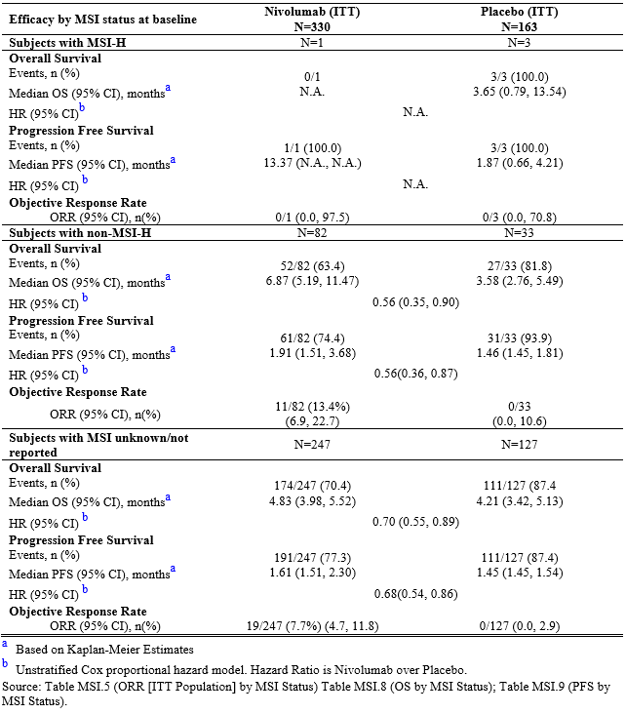
Figure 1: Overall survival by MSI Status - All Randomized Subjects (ITT Set) - ATTRACTION-2 trial
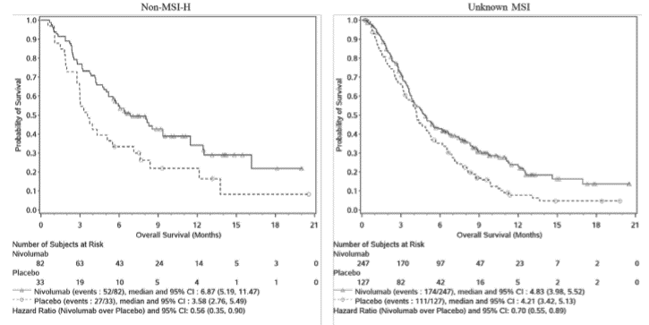
There was improved efficacy versus placebo as measured by OS regardless of MSI status. The small proportion of MSI-H subjects (3.5%) in the MSI evaluable population, 1 (1.2%) subject in the nivolumab group and 3 (8.3%) subjects in the placebo group, is in line with the expected low prevalence (< around 5%) of MSI-H in this population. Therefore, due to the low MSI prevalence, the sponsor asserts that the observed efficacy in ATTRACTION-2 cannot be driven by the MSI-H population alone. Further, there are confirmed MSS responders (n = 11 out of 82, 13.4%), demonstrating that MSS patients also benefit from nivolumab treatment. Therefore, the observed benefit of nivolumab in this setting is not restricted to the MSI-H population and clinical benefit with nivolumab was observed in the MSS and MSI unknown subgroups, consistent with benefit observed in the overall ITT population. Additionally, despite limitations in making comparisons between the ATTRACTION-2 trial and Study CA209032, it is noteworthy that analyses of MSI status from Study CA209032 also suggest that the response to nivolumab is not limited to MSI-H subjects.
Exploratory analyses on PD-L1 expression in immune cells from the ATTRACTION-2 trial were also conducted using an investigational method. The data on tumour and tumour associated immune cells (TAIC) PD-L1 expression (note: in gastric cancer, tumour cells have limited PD-L1 expression while TAIC contribute more to PD-L1 expression within the tumour microenvironment) show that tumour response was observed in both tumour PDL1 < 1% + TAIC PD-L1 abundant and tumour PD-L < 1% + TAIC PD-L1 rare subgroups with ORRs of 16.7% and 14.3% respectively. The HR for OS and PFS favoured nivolumab over placebo across 4 tumour + TAIC PD-L1 subgroups (Table 21). For OS, lower HR was observed in the tumour PD-L1 < 1% + TAIC PD-L1 abundant subgroup (HR = 0.55), in addition to the tumour PD-L1 ≥ 1% + TAIC PD-L1 rare subgroup which is too small for interpretation of HR. These data suggest that patients, regardless of tumour and TAIC PD-L1 expression, benefit from nivolumab.
Table 21: Efficacy by tumour cell and TAIC PD-L1 expression; Study ONO-4538-12/ATTRACTION-2 trial
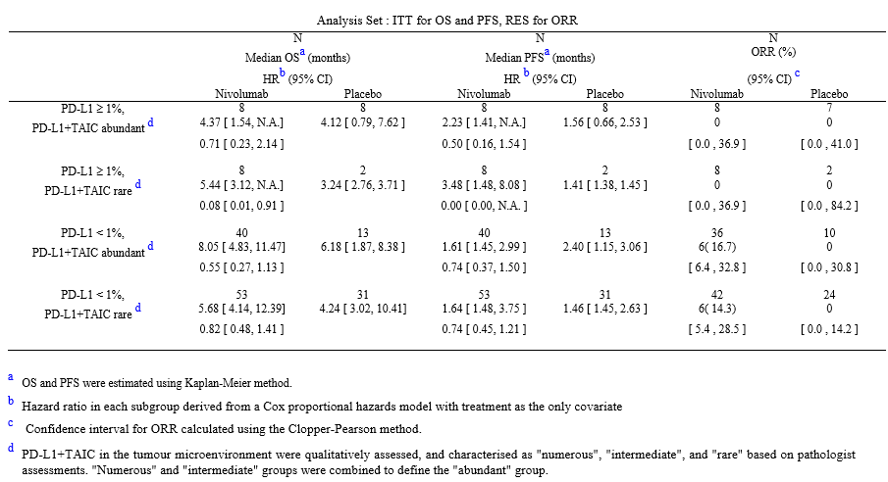
In summary, treatment benefit with nivolumab is observed across the biomarker subpopulations (MSI, PD-L1). Due to the low prevalence of MSI-H, the observed significant results are unlikely to be driven by MSI-H patients and clinically relevant efficacy was observed in MSS patients. Thus, the observed clinical efficacy demonstrated in the ATTRACTION-2 trial was not attributable to specific biomarker subgroups and although there are limitations in the extent of the data, the data available mitigates that a particular biomarker subgroup may be driving the result.
- It seems unlikely that Australian patients who have received 2 lines of treatment, but remained ECOG = (0,1) would receive no further active treatment. This raises questions as to whether placebo is the appropriate comparator for the Australian setting; and, makes the lack of complete data on MSI and PD-L1 expression problematic (previous dot point). A more appropriate comparator might have been investigator chose of 3+L systemic treatment. In the pivotal trial about 40% of patients had received 4 or more lines of prior systemic therapy (including adjuvant).
The ATTRACTION-2 trial was conducted in subjects with unresectable advanced or recurrent GC/GEJC refractory to or intolerant of standard therapy. The study population was defined per protocol inclusion criteria number4, as follows: subject must have previously received 2 or more regimens for the treatment of advanced or recurrent GC/GEJC and deemed refractory to or intolerant of standard therapy and subject was not planned to receive any antineoplastic therapy including antibody products for the treatment of said cancer. Therefore, the study population in the ATTRACTION-2 trial is not solely a third line setting, but a late line setting where, even best available therapies were judged to provide no additional benefit over best supportive care (BSC) in these subjects with heavily pre-treated and intolerant or chemo-refractory gastric and GEJ tumours.
The use of placebo as a control in the study was ethically justified on the basis of the following. According to international clinical practice guidelines, including ESMO and ASCO GC/GEJC treatment guidelines, there is no existing treatment recommendation for any anti-cancer agent or regimen for patients with GC after 2 lines of chemotherapy, which is the patient population consistent with the ATTRACTION-2 trial. Thus, for participants in this study, that is, patients who previously received 2 or more regimens and were not planned to newly receive any antineoplastic treatments including antibody products, the usual BSC is currently recommended. In addition, the use of placebo control in the study allowed for a more objective and rigorous evaluation of the efficacy and safety of nivolumab monotherapy in subjects who have no other possible treatment options. A published review on the Australian management of advanced gastric cancer also does not provide any recommended options after second-line chemotherapy.¹⁹ Additionally, a statement from [information redacted] expresses his expert opinion that there are no standard third line agents and patients are usually referred for palliative care.
- There is uncertainty about the generalisability of the results from a trial conducted exclusively in patients from North-East Asia to Australian patients.
While the study was conducted in Asia, the sponsor contends that the benefit/risk balance for the Australian population is positive since the study population is deemed representative of previously treated advanced or metastatic GC/GEJC in Australia. The sponsor recognises that historically geographic differences in survival outcomes have been observed in studies of Asian and non-Asian patients with advanced GC/GEJC treated with chemotherapy and targeted therapies. There have been various speculated reasons to the different outcomes such as ethnicity, differences in disease biology, stage at initial diagnosis, treatment, and health care systems.
Per the TGA-adopted ICH-E5 (R1) guideline on ethnic factors in the acceptability of foreign clinical data,12 the sponsor assessed the sensitivity of nivolumab to ethnic factors and concluded that there are many properties of nivolumab that make it less likely to be sensitive to ethnic intrinsic factors. It is not expected that exposures in safety or efficacy profiles would be different across ethnic groups. As demonstrated in the popPK analysis across different tumour types, race did not have a clinically relevant effect on clearance, and exposures were similar between Asian and Non-Asian subjects. Thus, in the Asian and non-Asian GC population, it is expected that there are similar PK profiles. In addition, it is believed that ethnic extrinsic factors in GC/GEJC including patient characteristics are similar between Asia (Japan, South Korea and Taiwan) and Australia.
The sponsor has demonstrated that based on internal and external clinical trial data as well as real-world data, baseline characteristics, number of lines of therapy, number and types of subsequent therapies are comparable between Asian and non–Asian subjects with previously treated advanced GC/GEJC. Regional differences in patient outcomes between Asian and Australian (Western/non-Asian) populations have been described in 1L gastric cancer trials, however these differences are not as evident in 2/3L GC trials. Possible contributors leading to the OS differences in 1L studies include factors such as earlier diagnosis/treatment in Asia as GC population screening programs, and the frequency of postsurgical surveillance vary widely across regions. Aside from screening programs, the clinical management of GC is increasingly becoming aligned across regions including Australia for example aggressive D2 surgery; is now more widely used in Australia. Additionally, currently approved Systems Order Class (SOC) systemic therapies are similar across regions, and offer limited benefit in metastatic disease.
In the ATTRACTION-2 trial, nivolumab showed sustained long-term survival benefit with HR = 0.62 (95% CI, 0.51 to 0.76) after a minimum of a 2-year follow-up. OS benefit was observed regardless of baseline risk factors, disease characteristics or lines of therapy. In terms of tumour characteristics, clinical benefit was observed regardless of primary tumour location for both GC (HR = 0.70) and GEJC (HR = 0.43) subgroups. Taking into consideration the increasing prevalence of GEJC in the Western region due to major risk factors like obesity and gastroesophageal reflux, any difference in benefit due location of primary tumour is not expected as the observed treatment effect of nivolumab was high in the GEJC subgroup. Additionally, as survival benefit in the nivolumab arm was observed in both the intestinal (HR = 0.59) and diffuse (HR = 0.82) histologic types, any perceived differences in outcomes due to histologic type are not expected to lead to less benefit in Australian patients where intestinal type may be more prevalent. Nivolumab also demonstrated clinical activity in a similar study patient population in the single arm Study CA209032 consisting of Western/non-Asian patients compared with the ATTRACTION-2 trial. This clinical activity appears to be consistent across different various subgroups, and reinforces the notion that nivolumab will result in clinically relevant efficacy for the Australia target population despite supposed differences in GC disease biology.
No meaningful differences in clinical activity were observed between Asians and non-Asians with advanced or metastatic GC/GEJC treated with another anti-PD-1 agent, pembrolizumab. The Keynote-012 trial, a global, Phase Ib trial evaluated pembrolizumab in PD-L1+ in advanced GC/GEJC subjects: ORR was 24% (95% CI: 7 to 50) and 21% (95% CI: 6 to 46), median PFS was 1.9 months (95% CI: 1.8 to 5.7) and 1.8 months (95% CI: 1.6 to 5.8) and median OS was 11.4 months (95% CI: 3.1 to not reported (NR)) and NR (95% CI: 3.5 to NR) between Asian subset and non-Asian subset, respectively. In Keynote-059, a Phase II single arm, open-label multi-centre trial that evaluated pembrolizumab in 41 Asian and 218 non-Asian subjects with advanced GC and GEJC who progressed on at least 2 prior lines of systemic treatment, a similar population to the ATTRACTION-2 trial, demonstrated clinical activity with an ORR of 11.6%, mOS 5.6 months, and 12 months OS rate of 23.4%, similar to that observed in the ATTRACTION-2 trial. In a subgroup analysis of Asian and non-Asian subjects with PD-L1+ tumours in the Keynote -059 trial (PD L1+ tumours occurred in 42% of Asian and 60% of non-Asian subjects), based on the combined positive score (CPS) ≥ 1%, ORR was 12% (95% CI: 2 to 36) in Asian subjects and 17% (95% CI: 11 to 24) in non-Asian subjects, further demonstrating similar clinical activity in Asian and non-Asian patients. The Keynote-059 trial included 4 Australian sites who contributed patients to the study dataset.

International regulatory status
Opdivo has been approved in Switzerland, Japan, Taiwan and South Korea for use in GC patients based on the ATTRACTION-2 trial results.
In the US [information redacted].
In the EU, the sponsor voluntarily withdrew the application in June 2018 for a new indication for Opdivo in the treatment of advanced or recurrent gastric or GEJ cancer in adults. This withdrawal was based on the CHMP consideration that, despite the promising data shown for in the target indication, uncertainties in the context of the extrapolation of data to the European population did not allow the Committee to conclude on a positive benefit risk balance.
[Information redacted]

Conclusion
The data from the ATTRACTION-2 trial demonstrates a statistically significant and clinically relevant survival benefit of a checkpoint inhibitor in patients with advanced or metastatic GC who failed at least 2 prior lines of chemotherapy. The sponsor believes that the uncertainties cited by the TGA Delegate are disputable. Firstly, the available data does not support that the observed efficacy of nivolumab is driven by the small subset of subjects with MSI-H, and in fact demonstrates that patients with non-MSI-H and MSS also benefit from the nivolumab treatment. Additionally, data on tumour and TAIC PD-L1 expression suggest that patients benefit from nivolumab regardless of expression levels. Secondly, the placebo comparator in the ATTRACTION-2 trial was appropriate recognising that the study population was third line and beyond where, even best available therapies are judged to provide no additional benefit over best supportive care (BSC) in these patients with heavily pre-treated and intolerant or chemo-refractory gastric and GEJ tumours. This is supported by Australian treatment practice. Thirdly, the sponsor contends that the benefit demonstrated in ATTRACTION-2 trial and Study CA209032 would translate to the Australian population. Based on discussion of patient intrinsic and extrinsic factors, including patient risk factors and disease characteristics of GC/GEJC, there is no evidence that the benefit demonstrated in ATTRACTION-2 trial and Study CA209032 in a third line or beyond setting would be any less for an Australian population of patients.
In addition, the overall safety profile of nivolumab in this treatment setting is consistent with expectations based on prior data in other indications. The sponsor believes that treatment of GC patients with nivolumab offers an important choice for Australian oncologists in a clinical setting devoid of treatments that have demonstrated evidence of efficacy or acceptable tolerability. Indeed, an expert statement from [information redacted] testifies that ‘The results of the ATTRACTION-02 trials demonstrated a very meaningful and important benefit to this group of patients who would otherwise have no other treatment options.’
As this is a population of very high unmet medical need for whom outcomes are dire, the sponsor believes it is appropriate to approve nivolumab for use in a population of advanced GC/GEJC patients previously treated with two or more regimens and for who no further chemotherapy is appropriate. Accordingly, the sponsor has amended the indication statement to accurately reflect this population.

Advisory Committee Considerations
The Advisory Committee on Medicines (ACM), having considered the evaluations and the Delegate’s overview, as well as the sponsor’s response to these documents, advised the following.
The ACM taking into account the submitted evidence of efficacy and safety, considered Opdivo concentrated solution for intravenous (IV) infusion vial containing 100 mg in 10 mL; and 40 mg in 4 mL of nivolumab to have a marginal benefit-risk profile for an amended indication:
Opdivo as monotherapy is indicated for the treatment of patients (ECOG performance status 0-1) with advanced or recurrent gastric adenocarcinoma after two or more prior systemic therapies in a metastatic setting. Opdivo should be used in patients when further treatment with chemotherapy is not considered appropriate. This indication is based on overall survival from a clinical trial conducted in Asia.
In providing this advice the ACM noted the following:
- The ATTRACTION-2 trial was a study evaluating the efficacy and safety of nivolumab in patients with adenocarcinoma and was conducted in Japan, South Korea and Taiwan. The primary outcome was OS. The median OS was 5.26 months (95% CI: 4.60 months, 6.37 months) in the nivolumab group and 4.14 months (95% CI: 3.42 months, 4.86 months) in the placebo group.
- There were uncertainties regarding the applicability of the ATTRACTION-2 trial data in the Australian context, including the lack of study population biomarker definition, the absence of non-Asian study centres, and the limitations of the inclusion criteria, including performance status and histology.
- MSI-H tumours appear to be more sensitive to immunotherapy, however there was no information from the ATTRACTION-2 trial about MSI status and the efficacy results in MSI subgroups.
- There was no strong evidence to suggest that Australian patients would respond differently to the trial population (based in Asia).
- There is no standard third-line treatment in this patient population, therefore placebo may be considered an appropriate comparator in this setting.
- The safety of nivolumab is well-characterised and no new safety signals were identified in this clinical setting.
- The efficacy of nivolumab in this indication, although modest, appears to be comparable to current treatment options in this setting.

Specific advice
The ACM advised the following in response to the Delegate’s specific question on the submission:
Does the pivotal trial (ATTRACTION-2) provide a sufficient basis to satisfactorily establish the efficacy and safety of nivolumab for use in 3+L gastric cancer?
The ACM advised that due to design limitations, the evidence provided by the ATTRACTION-2 trial supports a marginal benefit-risk profile of nivolumab for use in 3+L gastric adenocarcinoma in patients with an ECOG performance status of 0 or 1.

Outcome
Based on a review of quality, safety and efficacy, the TGA rejected the registration of Opdivo containing nivolumab 40 mg in 4 mL and 100 mg in 10 mL for the proposed therapeutic indication:
Opdivo as monotherapy is indicated for the treatment of patients with advanced or recurrent gastric or gastro-oesophageal junction cancer after two or more prior systemic therapies in a metastatic setting. Opdivo should be used in patients when further treatment with chemotherapy is not considered appropriate. This indication is based on overall survival from a clinical trial conducted in Asia.
In relation to this decision, the Delegate was not satisfied that efficacy and safety of the products have been satisfactorily established for the purpose for which they are proposed to be used. The reasons for the Delegate’s decision are set out below.

The reasons for the delegate’s decision
Under subsection 25 of the Act
(1)(a) If an application is made for the registration of therapeutic goods in relation to a person in accordance with section 23 … the Secretary (or delegate) must evaluate the goods for registration having regard to:
(c) … whether the quality, safety and efficacy of the goods for the purposes for which they are to be used have been satisfactorily established.

Advice received
The Delegate had received advice regarding the proposed indication for the products from:
- the ACM, specifically, the Committee considered that the benefit risk ratio was marginal; and
- the clinical evaluator who considered that safety and efficacy had not been satisfactorily established.
The Delegate had been advised of two main areas of uncertainty:
- The pivotal trial (ATTRACTION-2) is an anomaly in this era of precision cancer care:
- for three-quarters of the patients, MSI-H status was unknown (missing data)
- for two-thirds of the patients, PD-L1 status was unknown (missing data)
The following is from the discussion of the report of theATTRACTION-2 trial in Lancet;: Additional investigations with these tumour tissues are planned because of the importance of biomarker identification for selecting optimum patients and overcoming resistance.’
- The pivotal trial (ATTRACTION-2) only recruited patients from Japan, South Korea, and Taiwan.
The advice from the ACM meeting was that the balance of clinical benefit/risk of nivolumab; for advanced or metastatic GC/GEJC after two or more prior systemic therapies in that setting; was at the margin of acceptability. Specifically, on the issue of whether the pivotal study (ATTRACTION-2 trial) provides a sufficient basis to satisfactorily establish the efficacy and safety of nivolumab for use in 3+L gastric cancer, the ‘ACM advised that due to design limitations, the evidence provided by the ATTRACTION-2 trial supports a marginal benefit-risk profile of nivolumab for use in 3+L gastric adenocarcinoma in patients with an ECOG performance status of 0 or1’.

Evidentiary issues identified by overseas regulators
Delegates under the Act make decisions based on the statutory criteria having regard to the evidence provided by the sponsor and other relevant evidence. However, because oncology medicines are global products, it is material to note evidentiary issues identified by overseas regulators regarding efficacy.
(This particular application is still under evaluation in Canada. That is, the Canadian regulatory agency, Health Canada, is yet to reach a decision.)

Overseas agency: EMA
The following information was provided by the sponsor to the TGA and is also from the sponsor’s withdrawal letter published on the EMA web site:
‘I would like to inform you that, at this point in time, Bristol-Myers Squibb Pharma EEIG (BMS) has taken the decision to withdraw the application for a new indication for Opdivo (nivolumab) in the treatment of advanced or recurrent gastric or gastroesophageal junction cancer in adults. This withdrawal is based on the CHMP consideration that, despite the promising data shown for nivolumab in the target indication, uncertainties in the context of the extrapolation of data from an Asian population to the European population do not allow the Committee to conclude on a positive benefit-risk balance at the present time.’

Overseas agency: [Information redacted]
In short, the sponsor withdrew this particular application to EMA and [Information redacted], because of material uncertainty regarding evidence of efficacy. As noted above, the Delegate has decided not to register the proposed indication for the products(Opdivo), including due to concerns about efficacy, and note that the [Information redacted] and the EMA appear to share those concerns.
The application was approved by the PMDA, the Japanese national regulatory agency. However, this is not as relevant to Australia as the withdrawals in the EU and [Information redacted]. GC/GEJC is a common cancer in Japan, and the treatment algorithm is somewhat different. Also the pivotal trial (ATTRACTION-2) was exclusively in East Asian patients.

Detailed explanation of nature of uncertainty
The primary endpoint for the pivotal trial (ATTRACTION-2) was statistically significant. However, the difference in median OS was about 1 month: 5.3 months versus 4.1 months. The response rate was 11% (no complete responses), with a median duration of response of 9.5 months.
This is a text-book example of a classic, often-discussed situation in clinical epidemiology, where the results of a trial are statistically significant, but not clinically relevant. Three-quarters of the patients in the trial had missing data for MSI-H and two-thirds had missing data for PD-L1 expression. Without complete data on biomarkers, the possibility that the statistically significant result is driven by (say) MSI-H patients (perhaps 10% of the trial patients) cannot be ruled out.
Allowing the all-comers indication would expose MS-stable patients (perhaps 90%) to the potential harms of nivolumab, with little chance of benefit (all active medicines have harms: toxic, unwanted effects). Put another way, the evidence submitted by the sponsor has not satisfactorily established efficacy and safety for the patients covered by the proposed usage. There is too much uncertainty.
This uncertainty is further explained below, grouped according to two headings:
- Uncertainty associated with missing data for a predictive biomarker in the ATTRACTION-2 trial
MSI-H status was missing for 75% of patients in the nivolumab group and 78% of patients in the placebo group.
PD-L1 status was missing in 67% of patients in both the nivolumab and placebo groups.
Given the modest treatment effect (difference in median overall survival of about 1.2 months; 11% partial response rate; see previous section) and the current state of knowledge about the use of checkpoint inhibitors in GI cancers (see FDA accelerated approval of nivolumab for MSI-H colorectal cancer, below) it is possible that, for MS-stable patients, nivolumab is no better (or only marginally better) than placebo and only adds toxicity (all medicines have toxic, unwanted effects).
The GC/GEJC patients, who are the focus of the proposed indication, have already received (at least) 2 lines of systemic treatment; and maintaining quality-of-life is a key management goal. Cure is not currently possible; the aim of treatment is palliation.
The modest treatment effect (for example, partial response rate of 11%) might be driven by benefit in only the MSI-H group. Administering nivolumab to an MS-stable patient or a patient with unknown PD-L1 status, with an uncertain chance of possible benefit, but a well-characterised risk of toxicity could materially reduce quality-of-life.
Put another way, given the current state of knowledge about the use of PD-1/L1 inhibitors in GI cancers, an all-comers indication (agnostic of biomarkers) could only be approved if the sponsor was able to show that efficacy was maintained in the MS-stable group. Unfortunately, the pivotal trial (ATTRACTION-2) was not able to collect data on this biomarker for about 75% of study participants.
Increasingly regulators expect predictive biomarkers to be utilised in oncology trials to identify patients more likely to derive clinical benefit and hence improve the balance of benefit/harm.
To some extent, design of the ATTRACTION-2 trial, without complete biomarker data, is an anomaly in this era of precision cancer care.
The following is from the Discussion of the report of ATTRACTION-2 in Lancet;²⁸:
‘Additional investigations with these tumour tissues are planned because of the importance of biomarker identification for selecting optimum patients and overcoming resistance’.
It is instructive to contrast the data from the ATTRACTION-2 trial with the data for the recent accelerated approval by the FDA of nivolumab (and nivolumab/ipilimumab) for MSI-H and dMMR metastatic colorectal cancer after treatment with a fluoropyrimidine, oxaliplatin, and irinotecan. This approval was based on CM-142, a multicenter, non-randomized, multiple parallel-cohort, open-label study conducted in patients with locally determined (and centrally confirmed) dMMR or MSI-H metastatic CRC. Response rates were about 30% for single-agent nivolumab and about 50% of nivolumab plus ipilimumab. This contrasts with the response rate of 11% reported from the ATTRACTION-2 trial where patients with the relevant bio-markers were not targeted.
Regulatory decisions are not based on clinical practice guidelines (CPGs). However, CPGs provide an indication of the current state of knowledge. UpToDate; (algorithm for 2+L advanced or metastatic GC/GEJC) advises that nivolumab or pembrolizumab should only be considered if the tumour was MSI-H, dMMR, or PD-L1 high. This highlights the uncertainty inherent in the data submitted by the sponsor: MSI-H missing in about 75% of study participants.
It is also instructive to note that UpToDate is careful to point out that: in Japan nivolumab is approved for the treatment of metastatic GC/GEC that has progressed after ‘conventional chemotherapy’, without regard to specific biomarker expression. In spite of this, UpToDate advises that nivolumab or pembrolizumab should only be considered if the tumour is MSI-H, dMMR, or PD-L1 high.
The sponsor might point out that there are indications for checkpoint inhibitors that do not involve a biomarker. However, these were where one or more of the following applied:
- the response rate was higher (for example, 20% to 50%; not 11% as reported from ATTRACTION-2);
- there was evidence of a response in the biomarker low/negative group (for example, nearly complete data was obtained for the biomarker and a stratified analysis was done to examine efficacy in subgroups; in ATTRACTION-2 about 75% of patients had missing data for MSI; it was not possible to report efficacy stratified by that biomarker);
- there was background knowledge that known biomarker-high subgroups are not common for that cancer type (for example, MSI-H is uncommon in hepatocellular carcinoma; in contrast, estimates of the frequency of MSI-H in advanced or metastatic GC/GEC are approximately 5% to 10%).
The concerns about the uncertainty associated with incomplete data for MSI-H are in line with the regulatory reasoning from [Information redacted].
- Uncertainty associated with the pivotal trial (ATTRACTION-2) only recruiting patients from Japan, Taiwan, South Korea
It is unusual for a pivotal registration study to only include Asian patients.
The sponsor’s response was to cite Study CM-032 (Phase I/II), which recruited European and North American patients. From the relevant cohort with 59 patients: RR = 14%.
However, the all Asian pivotal registration study seems to be the reason for withdrawal of the EMA application. The following is from the sponsor’s withdrawal letter published on the EMA web site:
‘I would like to inform you that, at this point in time, Bristol-Myers Squibb Pharma EEIG (BMS) has taken the decision to withdraw the application for a new indication for Opdivo (nivolumab) in the treatment of advanced or recurrent gastric or gastroesophageal junction cancer in adults. This withdrawal is based on the CHMP consideration that, despite the promising data shown for nivolumab in the target indication, uncertainties in the context of the extrapolation of data from an Asian population to the European population do not allow the Committee to conclude on a positive benefit-risk balance at the present time.’
The specific concerns associated with the all Asian pivotal registration study include:
- GC/GEJC is a common cancer in East Asia and typical treatment pathways for patients from East Asia are different from pathways for patients in Australia, the EU and US. For example, GC/GEJC is often diagnosed early in East Asia and consequently, surgical treatments are more frequent. Whether East Asian patients with advanced or metastatic GC/GEJC, who have received 2 lines of systemic therapy in that setting, are similar to Australian patients, who have received 2 lines of systemic therapy, is an open question, which adds to the uncertainty.
- The biology of GC/GEJC in Asian patients is known to be different from that for non-Asian patients. This might extend to GC/GEJC in Asian patients being more sensitive to PD-1/L1 inhibitors (‘immunologically hotter’). This adds to the uncertainty.

Final outcome
Following the initial decision described above, the sponsor sought a review under the provisions of Section 60 of the Therapeutics Goods Act. The Delegate of the Minister for the review noted that paragraph 25(1)(d) of the Therapeutic Goods Act, which requires the goods to be evaluated with regard to whether the quality, safety and efficacy of the goods for the purposes for which they are to be used have been satisfactorily established, is of particular relevance.
In a letter dated 31 January 2019 the sponsor sought a review by the Minister for Health under section 60 of the Therapeutic Goods Act 1989 (the Act) (request for reconsideration) of the decision (the initial decision), dated 5 November 2019 to not approve the registration of Opdivo nivolumab 40 mg in 4 mL (ARTG 231867) and nivolumab 100 mg in 10 mL (ARTG 231868) (Opdivo) for the proposed indication:
Opdivo as monotherapy is indicated for the treatment of patients with advanced or recurrent gastric or gastro-oesophageal junction cancer after two or more prior systemic therapies in a metastatic setting. Opdivo should be used in patients when further treatment with chemotherapy is not considered appropriate. This indication is based on overall survival from a clinical trial conducted in Asia.
In the request, the sponsor revised the proposed indication to:
Gastric Adenocarcinoma
Opdivo as monotherapy is indicated for the treatment of patients (ECOG performance status 0-1) with advanced or recurrent gastric adenocarcinoma after two or more prior systemic therapies in a metastatic setting. Opdivo should be used in patients when further treatment with chemotherapy is not considered appropriate. This indication is based on overall survival from a clinical trial conducted in Asia.

Review of initial decision
On 27 March 2019 the Delegate of the Minister decided to confirm the initial decision on the basis that they were not satisfied that safety and efficacy of Opdivo have been satisfactorily established for the purpose for which they are proposed to be used.

Request for reconsideration
With submission PM-2017-08333-1-4, the sponsor has sought to extend the registered indications for Opdivo (nivolumab 40 mg in 4 mL (ARTG 231867) and nivolumab 100 mg in 10 mL (ARTG 231868). The final indication prior to the appeal under s60 of the ACT was:
Opdivo as monotherapy is indicated for the treatment of adult patients with advanced or recurrent gastric or gastroesophageal junction (GEJ) cancer after two or more prior systemic therapies in the metastatic setting. Opdivo should be used in patients when further treatment with chemotherapy is not considered appropriate. This indication is based on overall survival from a clinical trial conducted in Asia.
In the request for reconsideration dated 31 January 2019, the sponsor contended that the decision of the Delegate (the initial decision) did not constitute the correct or preferable decision. The Executive Summary of the Appeal Statement set out the reasons for that contention. These reasons have been copied from that statement and are listed below.
- Advanced or recurrent gastric or gastro-oesophageal junction cancers are currently not reversible or curable and the only available goals of therapy are palliation of symptoms and increased survival. There are no formal Australian treatment recommendations after two lines of chemotherapy. The clinical rationale for the application is to provide a third line option that has a proven clinical benefit for the treatment for advanced and metastatic gastric cancer and gastro-oesophageal junction cancer.
- In relation to ‘efficacy,’ the Delegate has placed obvious weight on the final recommendation of the clinical evaluator that there was ‘insufficient evidence of clinical benefit’, and the Advisory Committee on Medicines (ACM), that the balance of clinical benefit/risk ‘was at the margin of acceptability’. However, there is apparent inconsistency in findings as the evaluation progressed. In relation to the Clinical Evaluation Report the evaluator in the first round found that the data unequivocally demonstrated efficacy as well as finding that the clinical rationale for Opdivo was appropriate. The ACM Resolution 11.2.06 clearly recognised that the results of the pivotal ATTRACTION-2 study found that the median Overall Survival (OS) was 5.26 months in the nivolumab group and 4.14 months in the placebo group.
- In relation to safety, the clinical evaluator found that the pattern of toxicity with nivolumab in the pivotal and supportive studies is consistent with previously documented adverse events associated with nivolumab. The ACM noted that nivolumab usage in other tumour types is broad and its safety profile in other tumour types is adequately defined. Most adverse events are related to treatment-related autoimmunity.
- In relation to the benefit/risk balance, given that the safety of nivolumab is well-characterised and no new safety signals were identified in this clinical setting, and that clinical experts attest to the clinical relevance of the efficacy benefit demonstrated in ATTRACTION-2, the sponsor asserts that the statutory test per section 25(1)(c) of the Act, has been met.
- The sponsor has provided expert opinion on the benefit/ risk profile of nivolumab from Professor [Information redacted]. Professor[Information redacted], who was engaged by the sponsor to provide an expert opinion on this matter with respect to this application, was of the view that:
‘The primary study supporting nivolumab in 3rd line is the attraction 2 study. The trial is ultimately a well-designed randomised III trial which supports clinically relevant activity of nivolumab in advanced gastric cancer for patients who have had at least 2 lines of chemotherapy. The survival gain is particularly illustrated at 12 months with 26% still alive on nivolumab and 11% in placebo. This is clinically relevant in my view. Crucially this comes with a non-chemotherapy agent in the third line space. Although there are unproven chemotherapy options that could be considered these come with a cost of toxicity in a pre-treated population and as noted, no evidence that there is any impact on survival. Nivolumab offers an alternate active therapy with a very acceptable toxicity profile.’
Additionally Professor [Information redacted]’s report included the following with regard to the generalisability of the results from the ATTRACTION-2 trial:
‘Considering nivolumab more broadly there is no evidence suggesting its activity should vary by race. Certainly from a toxicity aspect, we know that nivolumab is well tolerated in Caucasian populations. Moreover, Australia is a multicultural country with a significant population from Asia. This should be considered when focusing on race.’
- The sponsor also provided an expert opinion from Associate Professor[Information redacted], who was also engaged by the sponsor to provide an expert opinion, was of the view that:
‘The pivotal data supporting nivolumab is the ATTRACTION-2 study which was a well-designed placebo-controlled randomised phase III study with overall survival as the primary endpoint. The study demonstrated an overall survival benefit with a clinically relevant hazard ratio of -0.63. This means that the use of nivolumab reduced the risk of death overall by 37%. This hazard ratio is substantially higher than the only other approved targeted therapy in gastric cancer in Australia (trastuzumab) which achieved a hazard ratio of 0.74 for survival. The difference in median survival times in ATTRACTION-2 is modest, but it is important to recognise (as is the case for many targeted therapies) that this therapy is benefiting a subgroup of patients and that the survival curves separate mostly beyond the median time-point. Median survival times in this case are misleading and underestimate the benefit of treatment which is far better represented by the hazard ratio. In this study, the later separation of the survival curves indicates durable disease control and survival for a meaningful proportion of patients. This is evident in ATTRACTION-2 which 26.2% of patients in the nivolumab arm are alive at 12 months versus 10.9% of patients in the control arm; a more than doubling of the 1 year survival rates. In fact, the durability of long term disease control for a subgroup of patients is a key feature of immunotherapy observed in multiple tumour types.’
- The sponsor further contended that the ‘uncertainties’ identified by the Delegate, that is, the need for biomarkers, whether placebo was the appropriate comparator, and the ‘generalisability’ of the results from a trial conducted in Asian patients to Australian patients, are either not relevant or are insufficient to prevent the approval of the application.
- The sponsor proposed amendments to the Product Information (PI) for Opdivo additional to those proposed to the Delegate prior to rejection of the submission. The revised proposed PI (version 16.2) was included as Attachment 3 in the appeal documentation. That document contained a revised proposed indication shown below with the additional amendments.
Gastric Adenocarcinoma (GA)
Opdivo as monotherapy is indicated for the treatment of patients (ECOG performance status 0-1) with advanced or recurrent gastric adenocarcinoma after two or more prior systemic therapies in a metastatic setting. Opdivo should be used in patients when further treatment with chemotherapy is not considered appropriate. This indication is based on overall survival from a clinical trial conducted in Asia.
- The following statement is proposed to be included in the ‘Special Warnings and Precautions For Use’ section of the PI.
‘Use of nivolumab in gastric adenocarcinoma patients who have failed prior therapies
The benefit of nivolumab was established in a broad population in whom microsatellite instability (MSI) and PD-L1 status was not prospectively assessed (see Clinical Trials). Data are too limited to predict the magnitude of benefit in subpopulations defined by these biomarkers. In the absence of these data, nivolumab should be used after careful consideration of the potential benefits and risks on an individual basis.’
- Amendments to the description of Study ONO-4538-12/CA209316 (the ATTRACTION-2 trial) in the PI to indicate the origin of patients enrolled in the study and to state that patients were enrolled regardless of MSI expression level have also been proposed.
- In relation to the benefit risk balance, the sponsor contends that when balancing the important clinical role of nivolumab in the 3L+ setting where no other medicines are approved for use, the unequivocal finding of efficacy, and the adequate, well characterised, safety profile, this finding should be positive. The sponsor contends, therefore, that the decision of the Delegate does not constitute the correct or preferable decision. The evidence presented clearly illustrates deficiencies in both the procedural and evaluation aspects of the decision-making process.

Reasons

Alleged inconsistency in findings
The sponsor has stated that there was an apparent inconsistency in findings as the evaluation progressed. The evaluation process is intended to identify whether the quality, safety and efficacy of the goods for the purposes for which they are to be used has been satisfactorily established. Agreement by evaluators, advisory committee members and the Delegate as to the significance of findings, or the regulatory action that is recommended on the basis of those findings, is not required for the Delegate to make a decision regarding registration of a product.
The Delegate of the Minister noted also that neither the first, nor second, round clinical evaluator recommended the approval of Opdivo for any indication relating to treatment of gastric or gastroesophageal junction cancer. The ACM did not recommend approval of any indication, noting only that it considered Opdivo had a marginal benefit-risk profile for the proposed indication.

Efficacy of nivolumab
Efficacy of nivolumab in the treatment of patients with unresectable advanced or recurrent gastric cancer (including oesophagogastric junction cancer) refractory to or intolerant of standard therapy was demonstrated in the ATTRACTION-2 trial by showing a difference in median overall survival between study subjects (who were patients with this type of cancer) given nivolumab and those given placebo treatment. The difference in median overall survival between these groups was 1.12 months.
The 12 month survival data showed a larger difference in survival rates between the treatment groups than was shown by the median overall survival rate. Therefore, there was a subgroup of subjects with gastric cancer (including oesophagogastric junction cancer) in that study that benefited from nivolumab.
It was not possible to identify from the ATTRACTION-2 trial what factors in the tumour were predictive of a response to nivolumab. Accordingly, it was not possible to identify patients likely to benefit from treatment with nivolumab, other than by the patient population in the ATTRACTION-2 trial. The study was conducted in Japan, Korea and Taiwan. The study population was not representative of the population in Australia.
While the sponsor is making ongoing efforts to determine biomarkers on gastric cancer (including GEJC) that are predictive of a favourable response to nivolumab, these have not been identified. A published analysis of more than 1,600 gastric cancers showed that there were gene signatures differentially expressed between Asian and non-Asian gastric cancers. In that paper it was concluded that analyses of > 1,600 gastric cancers suggest that Asian and non-Asian gastric cancers exhibit distinct tumour immunity signatures related to T-cell function. These differences may influence geographical differences in clinical outcome.
There are differences in the frequency of various biomarkers on gastric cancers (including GEJC) between patients in Asian and non-Asian countries. This strongly suggests that there will be differences in the response to nivolumab between the population in the ATTRACTION-2 trial and in the Australian population. Nivolumab appeared to have efficacy in only a subgroup of patients in the ATTRACTION-2 trial. There is no evidence that a similar subgroup will be present in other populations, or that the size of any such subgroup in those other populations will be equivalent to that in the ATTRACTION-2 study. Therefore, efficacy of nivolumab in its intended population has not been demonstrated.
It has now been established that there are differences in the frequency of various tumour biomarkers in gastric cancers in patients in Asian and non-Asian countries. Biomarkers are likely to affect the efficacy of nivolumab. Therefore, while the Delegate of the Minister noted the argument in [information redacted] report, regarding the generalisability of the results from the ATTRACTION-2 study, that ‘there is no evidence suggesting (the products) activity should vary by race’, the Delegate of the Minister nevertheless found (based on the research referred to above) that it is likely that efficacy of nivolumab in the treatment of gastric cancers will be different between these population groups.

Safety of nivolumab
There are safety issues associated with use of nivolumab (Opdivo) as a monotherapy. As stated in the Opdivo PI, nivolumab is most commonly associated with immune-related adverse reactions. These include:
- pneumonitis or interstitial lung disease, including fatal cases which may present with dyspnoea and hypoxia;
- colitis which may present with severe diarrhoea, abdominal pain and mucus or blood in stool;
- hepatitis;
- nephritis and renal dysfunction;
- endocrinopathies including hypothyroidism, hyperthyroidism, adrenal insufficiency (including secondary adrenocortical insufficiency), hypophysitis (including hypopituitarism), diabetes mellitus, and diabetic ketoacidosis;
- skin reactions, rare cases of Stevens-Johnson syndrome (SJS) and toxic epidermal necrolysis (TEN), some with fatal outcome, have been observed;
- neurological adverse reactions including demyelination, autoimmune neuropathy (including facial and abducens nerve paresis), Guillain-Barré syndrome, myasthenic syndrome/myasthenia gravis and encephalitis;
- other clinically significant immune-related adverse reactions, including some with fatal outcome have been observed across clinical trials of nivolumab.
Nivolumab is also associated with severe infusion reactions.
Treatment with nivolumab must be initiated and supervised by specialist physicians experienced in the treatment of cancer and is given by infusion. Detailed monitoring and dose modification instructions must be followed to minimise the risk of adverse effects.
As established above, it is not known whether the efficacy of nivolumab in Australian patients will be similar to the efficacy demonstrated in Asian patients with advanced gastric/ gastroesophageal junction adenocarcinoma. Available evidence suggests that it will not be the same. Nivolumab is associated with adverse effects. It is not acceptable to expose patients to the risks associated with nivolumab when the extent of its efficacy for the purpose for which it is proposed is not known.

Conclusion
For the reasons referred to above, The Delegate of the Minister decided to confirm the initial decision on the basis that they were not satisfied that the safety and efficacy of Opdivo has been satisfactorily established for the revised indication. In coming to their decision, The Delegate of the Minister has taken into account the revised indication and decided that the revised indication would not cause the Delegate to revoke the initial decision, or revoke that decision and make a decision in substitution for the initial decision.
Therapeutic Goods Administration
PO Box 100 Woden ACT 2606 Australia
Email: info@tga.gov.au Phone: 1800 020 653 Fax: 02 6232 8605
https://www.tga.gov.au

From here on, unless otherwise stated, gastric cancer (GC) may be used as an umbrella term to refer to gastric cancer and gastro-oesophageal junction cancer.
Shitara K et al., 2016 Subgroup analyses of the safety and efficacy of ramucirumab in Japanese and Western patients in RAINBOW: a randomized clinical trial in second-line treatment of gastric cancer Gastric Cancer, 2016; 19: 927-38
Smyth EC et al., 2016 Gastric cancer: ESMO Clinical Practice Guidelines for diagnosis, treatment and follow-up Ann Oncol, 2016; 27: 38-49
Ang TL and Fock KM, 2014 Clinicla epidemilogy of gastric cancer. Singapore Medical Journal 2014; 55: 621-628
Smyth EC et al., 2016 Gastric cancer: ESMO Clinical Practice Guidelines for diagnosis, treatment and follow-up Ann Oncol, 2016; 27: 38-49
Ang TL and Fock KM, 2014 Clinicla epidemilogy of gastric cancer. Singapore Medical Journal 2014; 55: 621-628
Japanese Gastric Cancer, A. (2017) Japanese gastric cancer treatment guidelines 2014 (ver. 4) Gastric Cancer 2017; 20: 1-19.
https://www.humanservices.gov.au/organisations/health-professionals/enablers/metastatic-stage-iv-her2-positive-adenocarcinoma-stomach-or-gastro-oesophageal-junction
https://www.eviq.org.au/medical-oncology/upper-gastrointestinal/gastric-and-oesophageal
European Medicines Agency (EMA), Committee for Medicinal Products for Human Use (CHMP) CHMP, Guideline on the evaluation of anticancer medicinal products in man, EMA/CHMP/205/95 Rev.5, 22 September 2017.
European Medicines Agency (EMA), Committee For Proprietary Medicinal Products (CPMP), Points To Consider On Application With 1. Meta-Analyses; 2. One Pivotal Study, CPMP/EWP/2330/99, 31 May 2001.
European Medicines Agency (EMA), Committee For Proprietary Medicinal Products (CPMP), Note for guidance on ethnic factors in the acceptability of foreign clinical data, CPMP/ICH/289/95, September 1998.
TGA guidance at pre-submission meetings is nonbinding and without prejudice.
Kurzawski G et al., 2004 Importance of microsatellite instability (MSI) in colorectal cancer: MSI as a diagnostic tool Ann Oncol, 2004; 15: iv283-284
Overman MJ et al., 2017 Nivolumab in patients with metastatic DNA mismatch repair-deficient or microsatellite instability-high colorectal cancer (CheckMate 142): an open-label, multicentre, phase 2 study The Lancet Oncology, 2017; 18: 1182-1191
https://www.fda.gov/Drugs/InformationOnDrugs/ApprovedDrugs/ucm560040.htm
Fuchs CS et al., 2017 Efficacy and safety of pembrolizumab (pembro) monotherapy in patients with previously treated advanced gastric cancer Journal of Clinical Oncology, 2017; 35: 4003-4003
Kang YK et al 2017 Nivolumab in patients with advanced gastric or gastro-oesophageal junction cancer refractory to, or intolerant of, at least two previous chemotherapy regimens (ONO-4538-12, ATTRACTION-2): a randomised, double-blind, placebo-controlled, phase 3 trial. The Lancet, 2017; 390: 2461-2471
A dose was considered delayed if administration exceeded 3 days. The reasons for dose delays were not reported in the CSR.
QTcF = QT interval corrected for heart rate according to Fridericia’s formula.
NSCLC: non-small cell lung cancer; NSQ NSCLC: non-squamous non-small cell lung cancer; SQ: squamous
Price T, et al 2012 Management of advanced gastric cancer, Expert Review of Gastroenterology & Hepatology, 2012; 6: 199-209
TNM staging is a system to describe the amount and spread of cancer in a patient’s body. T describes the size of the tumour and any spread of the cancer into nearby tissue, N describes the spread of cancer into nearby lymph nodes and M describes the metastasis.
Pollom K et al 2018 Meta-analysis of microsatellite instability in relation to clinicopathological characteristics and overall survival in gastric cancer. Br J Surg, 105: 159–167
Zhu L et al 2015 Microsatellite instability and survival in gastric cancer: A systematic review and meta analysis. Mol Clin Oncol. 2015; 3: 699–705
Choi Y et al 2014. Is microsatellite instability a prognostic marker in gastric cancer?: A systematic review with meta-analysis. J Surg Oncol. 2014; 110:129-135
Kim SY et al 2015 The benefit of microsatellite instability is attenuated by chemotherapy in stage II and stage III gastric cancer: Results from a large cohort with subgroup analyses. Int J Cancer; 2015: 137: 819-825
Kawazoe A et al 2017 Gastric Cancer (2017) 20: 407.https://doi.org/10.1007/s10120-016-0631- 3https://link.springer.com/article/10.1007%2Fs10120-016-0631-3.
Janjigian Y et al 2018. Genetic Predictors of Response to Systemic Therapy in Esophagogastric Cancer. Cancer Discov 2018; 8: 49-58
Fuchs CS et al 2014 Ramucirumab monotherapy for previously treated advanced gastric or gastro-oesophageal junction adenocarcinoma(REGARD): an international, randomised, multicentre, placebo-controlled, phase 3 trial. Lancet 2014; 383: 31– 39
A description of the level of lymph node dissection at the time of gastrectomy, for example DO level is no or incomplete dissection of group 1 lymph nodes whereas D2 involves dissection of all the group 1 and 2 lymph nodes.
The TGA was provided with updated information regarding applications to the FDA.
The ACM provides independent medical and scientific advice to the Minister for Health and the Therapeutic Goods Administration (TGA) on issues relating to the safety, quality and efficacy of medicines supplied in Australia including issues relating to pre-market and post-market functions for medicines. The Committee is established under Regulation 35 of the Therapeutic Goods Regulations 1990. Members are appointed by the Minister. The ACM was established in January 2017 replacing Advisory Committee on Prescription Medicines (ACPM) which was formed in January 2010. ACM encompass pre and post-market advice for medicines, following the consolidation of the previous functions of the Advisory Committee on Prescription Medicines (ACPM), the Advisory Committee on the Safety of Medicines (ACSOM) and the Advisory Committee on Non-Prescription Medicines (ACNM). Membership comprises of professionals with specific scientific, medical or clinical expertise, as well as appropriate consumer health issues relating to medicines.
Kang Y-K et al 2017 Nivolumab in patients with advanced gastric or gastro-oesophageal junction cancer refractory to, or intolerant of, at least two previous chemotherapy regimens (ONO-4538-12, ATTRACTION-2): a randomised, double-blind, placebo-controlled, phase 3 trial. The Lancet, 2017; 390: 2461-2471
UpToDate is an online clinical practice guideline
Janjigian YY et al. CheckMate-032: Phase I/II, open-label study of safety and activity of nivolumab (nivo) alone or with ipilimumab (ipi) in advanced and metastatic (A/M) gastric cancer (GC) JCO 2016; 34: 4010.
Lin SJ et al 2015 Signatures of tumour immunity distinguish Asian and non-Asian gastric carcinomas. Gut 2015; 64: 1721-1731

