January 2020

Australian Public Assessment Report for Nivolumab
  - Proprietary Product Name: Opdivo
  - Sponsor: Bristol-Myers Squibb Australia Pty. Ltd.

About the Therapeutic Goods Administration (TGA)
- The Therapeutic Goods Administration (TGA) is part of the Australian Government Department of Health and is responsible for regulating medicines and medical devices.
- The TGA administers the Therapeutic Goods Act 1989 (the Act), applying a risk management approach designed to ensure therapeutic goods supplied in Australia meet acceptable standards of quality, safety and efficacy (performance) when necessary.
- The work of the TGA is based on applying scientific and clinical expertise to decision-making, to ensure that the benefits to consumers outweigh any risks associated with the use of medicines and medical devices.
- The TGA relies on the public, healthcare professionals and industry to report problems with medicines or medical devices. TGA investigates reports received by it to determine any necessary regulatory action.
- To report a problem with a medicine or medical device, please see the information on the TGA website <https://www.tga.gov.au>.
About AusPARs
- An Australian Public Assessment Report (AusPAR) provides information about the evaluation of a prescription medicine and the considerations that led the TGA to approve or not approve a prescription medicine submission.
- AusPARs are prepared and published by the TGA.
- An AusPAR is prepared for submissions that relate to new chemical entities, generic medicines, major variations and extensions of indications.
- An AusPAR is a static document; it provides information that relates to a submission at a particular point in time.
- A new AusPAR will be developed to reflect changes to indications and/or major variations to a prescription medicine subject to evaluation by the TGA.
Copyright
© Commonwealth of Australia 2020
This work is copyright. You may reproduce the whole or part of this work in unaltered form for your own personal use or, if you are part of an organisation, for internal use within your organisation, but only if you or your organisation do not use the reproduction for any commercial purpose and retain this copyright notice and all disclaimer notices as part of that reproduction. Apart from rights to use as permitted by the Copyright Act 1968 or allowed by this copyright notice, all other rights are reserved and you are not allowed to reproduce the whole or any part of this work in any way (electronic or otherwise) without first being given specific written permission from the Commonwealth to do so. Requests and inquiries concerning reproduction and rights are to be sent to the TGA Copyright Officer, Therapeutic Goods Administration, PO Box 100, Woden ACT 2606 or emailed to <tga.copyright@tga.gov.au>.

Contents
Common abbreviations 4
I. Introduction to product submission 7
Submission details 7
Product background 8
Regulatory status 8
Product Information 9
II. Registration time line 9
III. Quality findings 10
IV. Nonclinical findings 10
V. Clinical findings 10
Introduction 10
Pharmacokinetics 15
Pharmacodynamics 17
Dosage selection for the pivotal studies 17
Efficacy 17
Safety 21
First round benefit-risk assessment 37
First round recommendation regarding authorisation 39
Clinical questions and second round evaluation 39
Second round benefit-risk assessment 49
VI. Pharmacovigilance findings 49
VII. Overall conclusion and risk/benefit assessment 50
Quality 50
Nonclinical 50
Clinical 50
Risk management plan 68
Risk-benefit analysis 69
Outcome 87
Attachment 1. Product Information 88

Common abbreviations
Abbreviation | Meaning
AE | Adverse event
AIHW | Australian Institute of Health and Welfare
ALT | Alanine transaminase
ARTG | Australian Register of Therapeutic Goods
AST | Aspartate transaminase
BCLC | Barcelona Clinic Liver Cancer
BICR | Blinded independent central review (of response)
BMS | Bristol‐Myers Squibb (the sponsor)
BMS‐936558 | Nivolumab (drug development code)
BOR | Best overall response
BSC | Best supportive care
CHMP | Committee for Medicinal Products for Human Use (EU)
CI | Confidence interval
CR | Complete response
CSR | Clinical study report
CTCAE | Common terminology criteria for adverse events
DLT | Dose limiting toxicity
DOR | Duration of response
ECOG PS | Eastern Co‐operative Oncology Group Performance Score
EMA | European Medicines Agency (EU)
EU | European Union
ESC | Dose escalation phase cohort
EXP | Expansion phase cohort
FDA | Food and Drug Administration (US)
GCP | Good Clinical Practice
GI | Gastrointestinal
ICH | International Conference on Harmonisation
IgG | Immunoglobulin G
IMAE | Immune mediated adverse event
IV | Intravenous
L | Litre(s)
MTD | Maximum tolerated dose
NCCN | National Comprehensive Cancer Network (US)
NE | Not evaluable
NSCLC | Non‐small cell lung cancer
OESI | Other events of special interest
ORR | Objective response rate
OS | Overall survival
PBRER | Periodic benefit risk evaluation report
PD | Progressive disease
PD‐1 | Programmed cell death receptor‐1
PD‐L (1 or 2) | Ligands for PD‐1
PFS | Progression free survival
PI | Product Information
PK | Pharmacokinetic(s)
PR | Partial response
RECIST | Response evaluation criteria in solid tumours
SAE | Serious adverse event
SD | Stable disease
TGA | Therapeutic Goods Administration
TSH | Thyroid stimulating hormone
ULN | Upper limit of normal
US | United States (of America)
WHO | World Health Organization

I. Introduction to product submission

Submission details
Type of submission: | Major variation (new indication)
Decision: | Approved
Date of decision: | 17 September 2018
Date of entry onto ARTG: | 18 September 2018
ARTG numbers: | 231867, 231868
Black Triangle Scheme | No
Active ingredient: | Nivolumab
Product name: | Opdivo
Sponsor’s name and address: | Bristol-Myers Squibb Australia Pty. Ltd.  Level 2, 4 Nexus court  Mulgrave VIC 3170
Dose form: | Concentrate solution for intravenous infusion
Strengths: | 40 mg in 4 mL and 100 mg in 10 mL
Container: | Vial
Pack size: | Single vial
Approved therapeutic use: | Hepatocellular Carcinoma  Opdivo, as monotherapy, is indicated for the treatment of patients with hepatocellular carcinoma after prior sorafenib therapy. This indication is approved based on objective response rate and duration of response in a single arm study. An improvement in survival or disease-related symptoms has not been established.
Route of administration: | Intravenous infusion
Dosage: | 3 mg/kg by intravenous infusion over 60 min every 2 weeks. For the full instructions on dosage see the Product Information.

Product background
This AusPAR describes the application by the sponsor to register nivolumab for the following indication:
Opdivo, as monotherapy is indicated for the treatment of adult patients with hepatocellular carcinoma after prior sorafenib therapy. The approval of this indication is based on objective response rate and duration of response. See Clinical Trials.
Nivolumab is an immune checkpoint inhibitor. It is a fully humanised anti-PD-1 monoclonal antibody immunoglobulin G4 (IgG4) produced by recombinant DNA technology. It binds to programmed cell death-1 receptor (PD-1) on T-cells blocking the interaction between PD-1 receptor and its ligands, PD-L1 and PD-L2. Expression of PD-1 ligands occurs on the cells of some tumour types and signalling through this pathway can contribute to inhibition of active T cell immune surveillance of tumours. By inhibiting the PD-1 receptor from binding to PD-L1 and PD-L2, nivolumab reactivates tumour-specific cytotoxic T lymphocytes in the tumour microenvironment. This results in anti-tumour immunity in a proportion of patients.
Hepatocellular carcinoma (HCC), the most common type of primary liver cancer, is an aggressive and heterogeneous malignancy, which develops in the setting of chronic liver disease and cirrhosis. It is common in areas where there are high rates of chronic hepatitis B or C infection, and other conditions causing cirrhosis including alcoholic liver disease and fatty liver disease. In Australia, the median age of onset is 67 years, although it develops in younger patients, including those in the paediatric age group, who have inherited conditions predisposing to cirrhosis such as haemochromatosis and metabolic storage disorders. It remains a challenging disease to treat as it is relatively chemorefractory, and many patients present with advanced disease at diagnosis and have limited hepatic reserve. For many of these patients, the underlying liver disease dictates both treatment options and prognosis, as a competing cause of death.

Regulatory status
Opdivo was first registered in Australia on 11 January 2016 for the treatment of melanoma (MEL) and squamous non-small cell lung cancer (NSCLC). Subsequent applications have resulted in the approval for use in treatment of non-squamous NSCLC, renal cell carcinoma (RCC), squamous cell carcinoma of the head and neck (SCCHN), classical Hodgkin’s lymphoma (cHL), and urothelial carcinoma (UC). At the time of this submission the approved dose regimen for nivolumab was 3 mg/kg infused over 60 min every three weeks.
At the time the TGA considered this application, a similar application had been approved or was under consideration in the following countries as shown in Table 1.
Table 1: International regulatory status
Country | Submission date and status | Indication
United States | 24 March 2017  Approved 22 September 2017 | Opdivo is indicated for the treatment of patients with hepatocellular carcinoma (HCC) who have been previously treated with sorafenib. This indication is approved under accelerated approval based on tumor response rate and durability of response. Continued approval for this indication may be contingent upon verification and description of clinical benefit in the confirmatory trials [see Clinical Studies (14.9)]
European Union (EU) via centralised procedure | 30 November 2016  Withdrawn 20 July 2017
Canada | 27 June 2017  Approved 23 March 2018 | Opdivo is indicated as a monotherapy for the treatment of adult patients with advanced (not amenable to curative therapy or local therapeutic measures) or metastatic hepatocellular carcinoma (HCC) who are intolerant to or have progressed on sorafenib therapy.  The marketing authorization with conditions is primarily based on tumour objective response rate and duration of response. An improvement in survival or disease-related symptoms has not yet been established. (see Clinical Trials).
Singapore | 9 October 2017  Under review
Switzerland | 6 March 2017  Withdrawn 12 October 2017

Product Information
The Product Information (PI) approved with the submission which is described in this AusPAR can be found as Attachment 1. For the most recent PI, please refer to the TGA website at <https://www.tga.gov.au/product-information-pi>.

II. Registration time line
The following table captures the key steps and dates for this application and which are detailed and discussed in this AusPAR.
Table 2: Timeline for Submission PM-2017-02209-1-4
Description | Date
Submission dossier accepted and first round evaluation commenced | 1 August 2017
First round evaluation completed | 22 December 2017
Sponsor provides responses on questions raised in first round evaluation | 1 March 2018
Second round evaluation completed | 2 April 2018
Delegate’s Overall benefit-risk assessment and request for Advisory Committee advice | 1 May 2018
Sponsor’s pre-Advisory Committee response | 15 May 2018
Advisory Committee meeting | The submission was not taken to ACM.
Registration decision | 17 September 2018
Completion of administrative activities and registration on ARTG | 18 September 2018
Number of working days from submission dossier acceptance to registration decision* | 211
*Statutory timeframe for standard applications is 255 working days

III. Quality findings
There was no requirement for a nonclinical evaluation in a submission of this type.

IV. Nonclinical findings
There was no requirement for a nonclinical evaluation in a submission of this type.

V. Clinical findings
A summary of the clinical findings is presented in this section.

Introduction
Hepatocellular carcinoma (HCC), the most common type of primary liver cancer, is an aggressive and heterogeneous malignancy, which develops in the setting of chronic liver disease and cirrhosis. It is common in areas where there are high rates of chronic hepatitis B or C infection, and other conditions causing cirrhosis including alcoholic liver disease and fatty liver disease. In Australia, the median age of onset is 67 years, although it develops in younger patients, including those in the paediatric age group, who have inherited conditions predisposing to cirrhosis such as haemochromatosis and metabolic storage disorders. It remains a challenging disease to treat as it is relatively chemorefractory, and many patients present with advanced disease at diagnosis and have limited hepatic reserve. For many of these patients, the underlying liver disease dictates both treatment options and prognosis, as a competing cause of death.

Staging
Several different disease staging classifications have emerged, incorporating an assessment of underlying chronic liver disease (for example, the Child Pugh score) as well those including tumour factors. Those reported in this clinical study report (CSR) include enrolment based on the Child‐Pugh score, and presentation of baseline status by the Okuda and Barcelona Clinic Liver Cancer (BCLC) staging, which are appropriate for consideration of those undergoing systemic therapies as opposed to being considered for surgical resection. In addition, other baseline factors such as alpha‐fetoprotein and presence of vascular invasion are presented.
The Child‐Pugh score; classifies the underlying liver disease based on scores ranging from 1 to 3 points, increasing according to severity for each of the following: encephalopathy, ascites, bilirubin, albumin, prothrombin time prolongation. These are then classified into Child‐Pugh A (5 to 6 points), B (7 to 9 points) and C (10 to 15 points).
Okuda staging; bases its scoring system on assessment of the presence or absence of 4 key clinical features: tumour size (> 50% of diameter of liver is positive), clinically detectable ascites (positive/negative), albumin < 30 g/L (positive/negative) and bilirubin > 51 µmol/L (positive/negative). Stage I is no positives, Stage II one or two positives and Stage III incorporates 3 or 4 positives. Survival correlates with the Okuda stage in untreated patients (8.3, 2.0, and 0.7 months for Stages I, II, and III, respectively).
The Barcelona Clinic Liver Cancer (BCLC) staging classification; sought to select patients for the best treatments available to them:
- Early stage (A) includes patients with asymptomatic early tumours suitable for radical therapies; resection, transplantation or percutaneous treatments.
- Intermediate stage (B) comprises patients with asymptomatic multinodular HCC.
- Advanced stage (C) includes patients with symptomatic tumours and/or an invasive tumoural pattern (vascular invasion/extrahepatic spread).
- End‐stage disease (D) contain patients with extremely grim prognosis (Okuda Stage III or PST 3 to 4)
Stage B and C patients may receive palliative treatments/new agents in the setting of Phase II investigations or randomised controlled trials. End stage disease should merely receive symptomatic treatment.
Serum alpha‐fetoprotein is an embryonic antigen, with some utility as a biomarker in HCC. A retrospective case series; divided expression levels into three groups: group 1 with normal alpha-fetoprotein (< 20 IU/mL), group 2 with moderately elevated alpha‐fetoprotein (20 to 399 IU/mL) and group 3 with markedly elevated alpha-fetoprotein (≥ 400 IU/mL). HCC patients with high alpha-fetoprotein tended to have larger tumour size, bilobar involvement, massive or diffuse types, and portal vein thrombosis and were more likely to be hepatitis B surface antigen (hepatitis BsAg) positive. Prognosis was higher in the two groups with lower levels that is < 400 IU/ml, but across all patients with HCC, this is not a particularly sensitive tumour marker.

HCC in Australia
From Australian Institute of Health and Welfare (AIHW) statistics for liver cancer for 2013 incidence/2014 mortality, 72% of cases diagnosed in 2013 were in men, with a similar median age of onset of 67 for both men and women. This is currently an uncommon cancer in Australia; in 2009, the fifteenth and twentieth in males and females, respectively; with a lifetime risk of liver cancer of 1 in 113 by the age of 85, and 2,116 new cases estimated to be diagnosed in 2017; by comparison, the tenth most common cancer in men in Australia has a 1 in 57 risk to age 85 (pancreatic cancer) and in women, 1 in 79 for women (leukaemia).
The epidemiology of primary liver cancer in Australia is described in detail in the review included within the Cancer Forum issue on Hepatocellular carcinoma.⁵ Chronic hepatitis B or C infection accounts for approximately 80% of all primary liver cancers. A review of HCC in the Northern Territory reported the most common causative factors were hepatitis B virus in Indigenous people and hepatitis C virus in non‐Indigenous people. These in part reflect the patterns and rates of viral hepatitis infection within Australia, as well as being influenced by the migration patterns to Australia from geographic regions with a high prevalence of viral infection. From serological data obtained in Western Australia; new referrals with chronic hepatitis B infection between 2002 and 2008 to a tertiary centre in Western Australia, were predominantly individuals from Asia (57%) and Africa (35%), with an estimated five to ten percent risk of developing HCC among such people if not treated. Thus, while both hepatitis B vaccination and the use of direct‐acting antiviral therapies for hepatitis C eradication, should lead to a reduction in cases with viral driven HCC, this gain will be balanced against the increased incidence of HCC from those with undetected infection and chronic hepatitis B virus infection particularly among migrants; non‐infective causes of liver disease such as non‐alcoholic fatty liver disease are likely to rise.⁶
Although this is an uncommon cancer in Australia, and the age‐standardised incidence in Australia is much lower than worldwide figures, there has been an increase in both incidence and mortality (2.3 to 6.8 per 100,000) in Australia and few gains in survival over time.
The prognosis is poor for those patients with advanced disease, with the AIHW reporting 1 year and 5 year relative survival in Australia 2009 to 2013, of 43% and 17.3%, respectively. Survival is dependent upon stage at diagnosis and ranges from 6.9% at 2 years in cases of advanced disease, to 50 to 90% at 5 years in earlier stages of disease that are amenable to curative treatment strategies.
Deciding treatment options for HCC is complex, depending on the stage of the disease as well as underlying liver function and cirrhosis. For those who are not candidates for potentially curative surgical intervention such as resection or liver transplantation, the options include liver directed therapies (cryoablation, radiofrequency ablation, transarterial chemoembolisation, radiation (which may also be used for metastatic disease) and systemic therapies including targeted therapies (approved and in clinical trials), and less commonly chemotherapy.

Current and emerging systemic treatment options for advanced, inoperable HCC
The only currently approved first‐line systemic therapy for the treatment of advanced HCC is sorafenib, a multi‐kinase inhibitor. Approval was based on a large (n = 602) randomised trial comparing sorafenib and placebo (the SHARP trial), which demonstrated a modest but statistically significantly longer overall survival (OS) in sorafenib treated patients (10.7 versus 7.9 months) as well as time to radiological progression (5.5 versus 2.8 months) (TGA PI, Nexavar sorafenib). Adverse events were generally moderate and manageable with supportive therapies and/or dose reduction. A meta‐analysis of seven Phase III trials confirmed a benefit in OS and time to progression, but not in objective response rate (ORR) compared with other therapies.
The approved indication for sorafenib (Nexavar) is:
Nexavar is indicated for the treatment of patients with advanced hepatocellular carcinoma.
New treatments have recently emerged with two large Phase III trials reporting potential new first and second line treatment options.

First line
A large randomised Phase III trial of 954 patients with unresectable HCC with good performance status who had received no prior systemic therapy; reported lenvatinib to have a higher ORR and time to progression compared with sorafenib, and to be non‐inferior in terms of median OS. These results were reported at the American Society of Clinical Oncology meeting, and have yet to be published in a peer‐reviewed journal. Although this is not currently approved by the TGA, this may represent an alternative option to sorafenib in patients able to access the treatment. The optimal patient selection and sequencing of lenvatinib and sorafenib remain unclear.

Second line
Since the application was accepted, regorafenib (Stivarga) was approved for the following indication in a population identical to that being sought in this application, based on the Phase III clinical trial (see details below):
Stivarga is indicated for the treatment of patients with hepatocellular carcinoma (HCC) who have been previously treated with sorafenib.
In a Phase III trial, patients with HCC and Child Pugh A liver function with disease progression on sorafenib, were randomised to treatment with regorafenib or placebo. This trial reported an improvement in median OS from 7.8 months to 10.6 months, and is approved by the United States (US) Food and Drug Administration (FDA) but is not currently TGA‐approved. Note is made of the comparable median OS in the control arms for the two randomised trials of sorafenib and regorafenib of approximately 7.8 months.
In patients who have failed to respond to sorafenib, in addition to regorafenib, systemic options include experimental therapies in clinical trial settings, or chemotherapy may be an option for those with adequate performance status and hepatic reserve, but response rates are generally very limited.
Retreatment with sorafenib may also be an option for selected patients or as a comparator for patients progressing after initial sorafenib therapy.,,,

Clinical rationale
As of December 2017, regorafenib is the only TGA approved option for patients in Australia with HCC who are either intolerant of sorafenib or whose disease has progressed after sorafenib therapy. The published reports indicate an improved survival in a highly selected group of patients treated with regorafenib but no other systemic therapies have a proven survival benefit.
The patients recruited to this multi‐cohort Phase I/II clinical trial Study CA209040, presented in this application included those who had not received prior systemic therapy or who have received sorafenib for their advanced HCC; registration is being sought for the latter subset of these patients from two cohorts, based on early response data, and the premise that they do not have effective treatment options currently in Australia. The current indication being sought is:
‘Opdivo, as monotherapy is indicated for the treatment of adult patients with hepatocellular carcinoma after prior sorafenib therapy. The approval of this indication is based on objective response rate and duration of response.’

Evaluator’s commentary on the background information
Hepatocellular carcinoma (HCC) is a common cancer worldwide, but within Australia, it remains one of the rarer cancers, although the standardised incidence and mortality are both rising. It is a heterogeneous and aggressive malignancy, which is often diagnosed at an advanced stage and many patients will have underlying limited hepatic reserve or cirrhosis which may limit treatment options and which pose an independent risk of death. Aetiology is varied and includes conditions leading to cirrhosis and chronic liver disease due to any cause, with known risk factors including hepatitis B and/or C viral infection, alcoholic liver disease and inherited conditions such as haemochromatosis. Programs to immunise against hepatitis B, and to eradicate hepatitis C would appear likely to cause a shift in the predominant aetiology in Australia as well as the incidence in the future.
Unresectable or metastatic HCC carries a very poor prognosis, and sorafenib is the only TGA approved therapy is approved for such patients, on the basis of a 3 month improvement in median survival in a Phase III study.
There remains significant unmet need for effective and well‐tolerated therapies for patients with HCC. The current application proposes nivolumab for use in those whose disease has progressed after sorafenib.

Guidance
This evaluation was undertaken using the following European Medicines Agency (EMA) Scientific Guidelines adopted by the TGA:
- Guideline on the evaluation of anticancer medicinal products in man (EMA/CHMP/205/95/Rev.4)
- Appendix 4 to the guideline on the evaluation of anticancer medicinal products in man – Condition specific guidance (EMA/CHMP/703715/2012)
- CPMP/ICH/364/96 Note for guidance on choice of control groups in clinical trials
- CPMP/EWP/2330/99 Points to consider on application with 1. Meta‐analyses; 2. One pivotal study
- CHMP/EWP/185990/06 Guideline on reporting the results of population pharmacokinetic analyses.

Contents of the clinical dossier
The clinical evaluators have evaluated the documents provided in the dossier which were listed by the sponsor below in the cover letter for the application:
- A population pharmacokinetics (PopPK) report
- Study CA209040 interim CSR:
  - Addendum 01 to interim Study CA209040
  - Addendum 02 to interim Study CA209040
Overall, the clinical dossier presents very limited, preliminary evidence from a small population in a very common cancer globally. The lack of formal reporting of pivotal endpoints in this early hypothesis‐generating and signal finding study, of pivotal endpoints, adds to the limitations and restricts evaluation and ability to form a view as to whether efficacy and safety are satisfactorily established for the treatment of this complex and heterogeneous disease.

Paediatric data
Hepatocellular carcinoma (HCC) is uncommon in the paediatric age group. No data were available for Australia, but US data indicate an annual incidence of approximately 0.5 cases/million. Worldwide, risk factors include viral infection (hepatitis B and C), chronic cirrhosis, inherited conditions such as inborn errors of metabolism or other disorders such as biliary atresia or infantile cholestasis, that predispose to chronic cirrhosis of the liver. Due to the lead‐time for development of HCC from chronic cirrhosis, HCC is rare in infants and is seen more in school age children or adolescents.
No data were provided for the treatment of children or adolescents with HCC in the current dossier, and the proposed indication seeks registration in the adult population only.

Good clinical practice
The sponsor states that Study CA209040 was conducted in accordance with the principles of Good Clinical Practice (GCP.)

Pharmacokinetics
A population pharmacokinetic (popPK) model was presented, building upon the popPK model previously evaluated. The sponsor also submitted an application for consideration of flat‐dosing with a proposed change in dose administered and dose frequency, which changed assumptions of the best fit for the proposed model for that application. It is unclear to the clinical evaluator, the sponsor’s view of whether the currently presented model in this application represents the best fit. Given this has been included in this dossier, it has been summarised and evaluated, based on the information provided.

Studies providing pharmacokinetic data
The secondary endpoint of Study CA209040, from which the application to register for the proposed usage is included. Details of the study follow:
- Study CA209040
  - Study endpoints: pharmacokinetics (PK)/serum nivolumab concentration
  - Baseline and predose trough serum nivolumab concentrations are provided in the immunogenicity listing.
  - Results from characterisation of the PK of nivolumab and exploration of exposure-response relationships are reported separately (see section: population pharmacokinetics, below) and were not reported in the interim CSR.

Evaluator’s conclusions on pharmacokinetics
An issue identified by the clinical evaluator pertaining to there being no pharmacokinetic data presented in the CSR for this early Phase I/II Study which was undertaken with at least one objective being to obtain PK data, to permit a clinical evaluation and determination of whether the data obtained from the study were adequate to inform the model, prior to incorporation into the model. The deficiency identified was not the lack of pharmacometric data summaries and information about the model, which have been provided without being requested. Evaluation of these summaries or re-running of the model is not within the scope of this evaluation, and such data would be requested by TGA popPK evaluators as required, not the clinical evaluator.
This remains an outstanding issue, but its continued relevance remains uncertain given the sponsor has proposed an updated popPK model in support of the flat-dosing strategy and 4 weekly administration, submitted concurrently with this application for evaluation.

Population pharmacokinetics

Population pharmacokinetic and exposure‐response analyses of nivolumab in hepatocellular carcinoma (HCC) after sorafenib therapy
The dataset used in this model appears to be taken from all participants in two of the five cohorts with HCC described as participating in Study CA209040, rather than all patients with HCC included in this adaptive study (that is, no data included from those with HCC treated with nivolumab and ipilimumab, or receiving either sorafenib or nivolumab first line systemic therapy). This would appear to be neither a complete dataset for HCC from Study CA209940, nor one that is fully representative of the population identified proposed usage.
The majority of the samples come from those receiving the 3 mg/kg dose level, but only a proportion of those will be from patients who represent the intended population. It is not possible to evaluate the PK data contributing to the model, without summaries of the pharmacokinetics data as have previously been presented for other applications, with the data from the study presented and reported as an endpoint. Note is also made that the sponsor indicated in a submission to the TGA that the popPK model presented here was superseded. Thus the relevance of this model is unclear.

Exposure‐response of objective response (efficacy)
The exposure-response of blinded independent central review (BICR) assessed objective response included data from patients with advanced HCC who had been previously treated with sorafenib in Study CA209040. This was the only study, which included data from HCC patients.

Exposure-response of Grade 3+ drug related adverse event (safety)
The exposure-response of Grade 3+ drug related adverse events (AE) included the available data from patients with advanced HCC in Study CA209040. This was the only study that included data from HCC patients.
Without presentation of the pharmacokinetics data from HCC patients reported as an endpoint, no comments can be offered on the methods, results and conclusions of the popPK model with respect to predicting safety and efficacy for the proposed usage. The conclusions regarding safety in this population should be informed by direct observations rather than modelling; both are limited by the small numbers of observations and varying dose administered.

Pharmacodynamics
No studies including pharmacodynamics responses were included.

Dosage selection for the pivotal studies
The Phase I part of the study provided in support of the proposed indication included a dose finding escalation cohort, but no data have been provided in support of the dose selection for the expansion cohort and for the proposed indication.

Efficacy

Studies providing efficacy data
- Study CA209040; a Phase I/II, dose escalation, open label, non‐comparative study of nivolumab or nivolumab in combination with ipilimumab in advanced hepatocellular carcinoma patients with or without chronic viral hepatitis; a randomised, open label study of nivolumab versus sorafenib in advanced hepatocellular carcinoma patients who are naive to systemic therapy.
The data supporting the application is based on patients who were previously treated with sorafenib in the dose escalation and dose expansion phase of the study. These are a subset of the patients enrolled, based on serial amendments to the Protocol. The CSR selectively presents the data relating to these cohorts, although the clinical study protocol details for the study overall.
This study followed an adaptive design where initially there were five cohorts in the study, and only a subset of patients from two of those cohorts are included in the interim CSR and addenda as these inform regarding the proposed usage that is in patients with HCC whose disease has progressed on or following sorafenib, or who cannot tolerate sorafenib. For completion, all cohorts are included below with those informing of the proposed usage presented in regular font and the remainder (in italics) and in Figure 1.
As it is stated in the CSR that the results from the three additional cohorts in italics will be reported in a separate document, these cohorts are not discussed further in this evaluation report.
- Dose escalation (ESC) phase cohort: Sorafenib treated patients who received nivolumab at doses of 0.1 mg/kg, 0.3 mg/kg, 1 mg/kg, 3 mg/kg and 10 mg/kg every 2 weeks (Q2W). This phase was to establish the safety, tolerability, dose limiting toxicities and maximum tolerated dose for nivolumab administered Q2W. The study population consisted of three aetiological subtypes: uninfected HCC patients, hepatitis C infected HCC patients and hepatitis B infected HCC patients. The sorafenib‐treated component of this cohort is relevant to the current application and is part of the supporting CSRs. 9 of 37 patients received the proposed dose.
- Expansion (EXP) phase cohort: Sorafenib‐treated patients administered nivolumab 3mg/kg Q2W. There were four aetiological subtypes in this cohort: uninfected sorafenib naïve/intolerant; uninfected sorafenib progressors, hepatitis C‐infected or hepatitis B infected. Following a protocol amendment, all hepatitis B and C patients must have received sorafenib treatment and be either intolerant or have had documented radiographic or symptomatic progression. As for the dose escalation (ESC) cohort described above, this cohort also included patients who had not received previous sorafenib therapy, that is first‐line patients, although results for these patients are not included in the CSR. The sorafenib treated component of this cohort is relevant to the current application and is part of the supporting CSRs.
- First‐line nivolumab versus sorafenib cohort: Patients were randomised to receive open‐label nivolumab at a dose of 240mg every 2 weeks.
- Nivolumab plus ipilimumab combination cohort: In this cohort patients were randomised to receive nivolumab plus ipilimumab in three different dose combinations.
- Nivolumab monotherapy in Child Pugh B patients: No description of this cohort was provided. It is noted that this cohort was initialised in a protocol amendment on 1 June 2016 and is therefore relatively recent.
Figure 1: Study CA209040 Overall study design schema
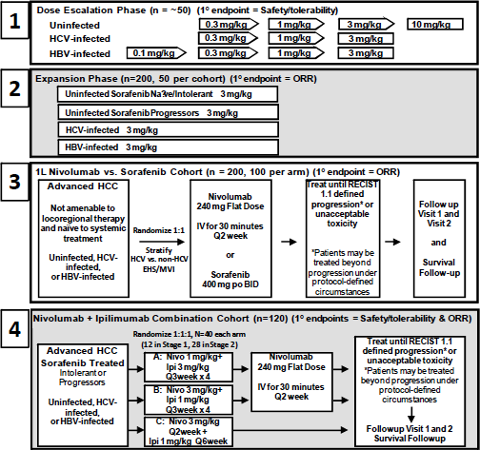
Note: a fifth cohort comprising patients with Child-Pugh B liver disease was added subsequent to the design of the above diagram but is not relevant to the current submission.
The following figure provides a representation of the study design including only the dose escalation (ESC) and expansion (EXP) cohorts relevant to the application. Note is made that the box in red identifies that some patients in this initial grouping were previously untreated. The boxes in blue indicate the population providing data in support of this application.
Figure 2: Study CA209040 study design schema for ESC and EXP cohorts
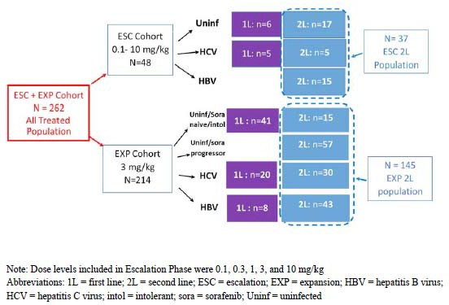
The non‐randomised, open label, non‐comparative study design introduces potential risk of selection bias. While there is blinded independent review of the primary and some reported secondary and exploratory efficacy outcomes, this does not address the internal and external validity issues raised by the lack of randomisation. Patients in the purple boxes had not previously been treated and were eligible based on protocol Amendment 4 which allowed enrolment of patients who had refused sorafenib; this was revoked as part of protocol Amendment 8, which was after the last patient had been enrolled in the ESC cohort, and 6 months after the enrolment of the last patient to be enrolled in the EXP cohort.
In total, 262 patients were treated at 39 sites in 11 countries, and the 145 patients providing data from the EXP and ESC cohorts were enrolled from 10 countries and 35 investigative sites:
- Dose escalation (ESC) cohort; 37 patients from 4 countries: Hong Kong (12 patients), Singapore (2), Spain (10) and the United States (13).
- Expansion (EXP) second‐line or post‐sorafenib cohort 145 patients from 10 countries: Germany (18 patients), Hong Kong (12), Italy (4), Japan (26), Republic of Korea (13), Singapore (3), Spain (11), Taiwan (17), United Kingdom (25) and United States (16).
The CSR provided the number and proportion of patients in the EXP and ESC cohorts, and when these two post‐sorafenib/second‐line cohorts are combined, patient numbers were as follows across the geographic regions or countries: Europe n = 33 (18.1%); UK n = 25 (13.7%); US n = 29 (15.9%); Asia n = 85 (46.7%).

Evaluator conclusions on efficacy
Study CA209040 is an ongoing Phase I/II open label, single arm study of five cohorts of patients with advanced HCC required to have very good performance status, and Child Pugh A liver function scores who were received nivolumab either alone or in combination.
This CSR reports on the results of only two of five planned cohorts and these two have in common that all patients had received prior sorafenib. Patients in the initial dose escalation cohort received one of 5 dose levels, which was not changed throughout their participation in the study, while 145 patients in the expansion cohort received the proposed dose of nivolumab at 3 mg/kg Q2W. The aetiologies of the HCC were varied, consistent with the wide range of causes of cirrhosis and chronic liver disease that are risk factors for HCC, and were predominantly viral (hepatitis B or C; one cohort each) with a separate group of patients who were deemed to have HCC due to non‐infective causes including alcoholic liver disease and haemochromatosis but who could have had prior hepatitis B or C as long as their infection was not deemed to be active and contributory.
The primary efficacy endpoint was blinded independent central review‐assessed ORR based on response evaluation criteria in solid tumours (RECIST) version 1.1 for the expansion (EXP) cohort, and secondary endpoints included the following assessments based on that cohort as well as the ESC cohort (including ORR in the ESC cohort): duration of response, complete response rate, disease control rate, time to response, time to progression, progression‐free and OS, and analyses of efficacy by PD‐L1 status; Exploratory endpoints included ORR using modified-RECIST and overall health status. Results were presented for both analyses of blinded independent central review ‐ assessed and investigator‐assessed efficacy endpoints, but given the open label, single arm study design, the evaluator has considered the blinded independent central review assessments to be the more robust for consideration of these outcomes.
Three data snapshots were provided from this essentially exploratory study as an interim CSR, an Addendum 01 with an additional 3.5 months of follow‐up, and an Addendum 02 reporting 7.5 months later than the Interim CSR and approximately 3.5 months after the first addendum. Not all datasets are updated or presented and notably, the clinical evaluator could not locate a participant flow to determine the number of patients still ongoing as of the final database lock for Addendum 02 or broad categories of reasons for discontinuation from the study. Given Addendum 02 (database lock 17 March 2017) provides the most recent data which is most relevant in establishing whether efficacy is satisfactorily established, the emphasis is on results from this dataset, noting that the interim CSR is largely superseded but contains the details of the study conduct.

Second‐line expansion (EXP) cohort
With a minimum follow‐up time of 15 months for the last patient commencing treatment in the study (17 March 2017 database lock), the BICR-assessed ORR in the 137 of 145 evaluable EXP cohort patients was confirmed in 21 of 145 as treated patients (14.5%; 95% confidence interval (CI): 9.2% to, 21.2%) with 2 patients reported to have a complete response. Among these responders, at the final database lock, 42.9% of these patients had progressed and the estimated median duration of response was 16.6 months (95% CI 9.7, upper bound not applicable (NA)). The median OS for the EXP cohort after 81 of 145 (55.9%) patients had died events was 15.6 months (95% CI: 13.2 to 18.9). blinded independent central review ‐assessed median progression free survival was short at 2.8 months (95% CI: 2.7 to 2.1). BICR-assessed stable disease was reported in 41.1% of all patients (not all were evaluable).

Additional analyses
Investigator assessed responses were slightly higher for complete response, and ORR but were broadly similar. A number of analyses including by PD‐L1 status suggest a possible increase in response and OS with higher PD‐L1 expression levels, but this requires prospective validation; notably, patients in the PD‐L1 negative group responded to treatment suggesting this may, at best, guide but will not direct treatment selection. Analyses of subgroups (age, gender, geographic region, baseline staging) within the EXP and ESC cohorts were not pre-specified and while these did not identify any differences in response rates across these subgroups, a high level of caution should be exercised given the small numbers within each subgroup and that this is a single arm, open label study. Similarly, responses were detected across all aetiological subgroups, although the breakdown of patients with the title ‘uninfected’ requires clarification of the proportion who had previously been infected with hepatitis B or C viruses.

Second‐line dose escalation cohort; second line ESC
The sponsor has not presented the breakdown of the efficacy in the ESC population for those who received the proposed dosage and schedule, which limits the evaluation of the degree of support that might be provided by this population.

Conclusion
The results for patients treated with nivolumab 3 mg/kg Q2W are promising with a median OS of 15.6 months that is twice that reported in the placebo arm (7.8 months) in a recently published Phase III trial of regorafenib versus placebo in patients who had previously tolerated but progressed on sorafenib. In that trial, regorafenib was demonstrated to have a statistically significant increase in median OS of 10.6 months over placebo, which given it was in a Phase III randomised setting, has to be regarded as more robust and indicates a new, fully validated treatment option for this population (noting that only a very small number in Study CA209040 were intolerant of sorafenib). Differences and similarities between the populations cannot be elucidated.
The external validity of Study CA209040 is limited by the small numbers with very good performance status (nearly three quarters had an Eastern Co‐operative Oncology Group (ECOG) performance status (PS) of 0) and well‐compensated liver function as per the predominantly Stage 1 Okuda and Child Pugh A status in all patients in the EXP cohort.
The objective response is too low to be compelling. The time‐dependent endpoints of OS cannot be interpreted in an open label, single arm study enrolling small numbers and presenting amalgamated subgroups with considerable heterogeneity in disease course prior to entry, and selected on the basis of their good performance status and well‐compensated liver function as strong potential sources of bias. Comparison with other populations to understand whether the median OS improvement represents will be inaccurate. This is a very common cancer, and recent publication of two Phase III studies indicates that other more comprehensively validated treatment options have emerged, including one in this population.

Safety

Studies providing safety data
The study upon which the current application is based (Study CA209040) was the source of safety outcomes. While efficacy results were based on the dose escalation (ESC; n = 37) and expansion (EXP; n = 145) cohorts of the study, safety results are only provided for the EXP cohort (n = 145) and a combined expansion and dose escalation cohort (ESC + EXP) (n = 262) the latter which includes 80 sorafenib‐naive patients.
Study CA209040 had as its primary objective and endpoint for the ESC cohort: to establish safety, tolerability, dose limiting toxicities and maximum tolerated dose of nivolumab when administered every 14 days.

Patient exposure
Patient exposure was provided in the Interim CSR and Addendum 01 only and is summarised below from the Addendum 01. 22.1% of patients in the second line EXP cohort received < 90% of the planned dose intensity, which was similar to that in the total ESC + EXP Cohort (19%).
The lowered dose intensity indicates that more than 1 in 5 patients required a dose interruption, as dose reduction is not permitted.
Based on the Kaplan‐Meier analysis, the median duration of therapy was 5.26 months (95% CI: 3.71 to 6.47) in the second line EXP cohort and 2.56 months (95% CI: 2.33 to 6.44) in the second line ESC cohort.
As of the latest database lock (17 March 2017), 83.4% of the 145 EXP patients had discontinued and 95% of the 37 ESC patients, compared with 80% and 95%, respectively at the earlier second database lock 3.5 months earlier (29 November 2016). The following dose and dose intensity data were not updated for the latest database lock, and pertain to the 29 November 2016 database lock.
Table 3: Number of doses and dose intensity as at database lock 29 November 2016
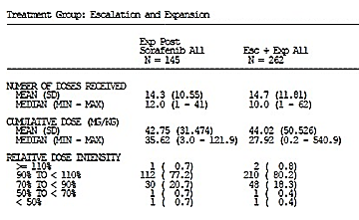
A summary of dose intensity and duration of therapy for the expansion cohort and the entire study cohort (that is including first‐line patients) is provided in the table below from Addendum 01.
Table 4: Duration of study therapy summary; second line ESC; second line EXP; and all treated patients
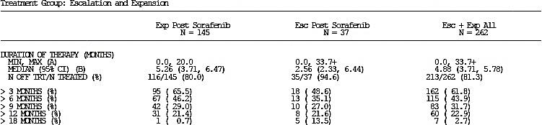

Dose delays (defined as ≥ 3 days after scheduled administration)
The following table indicates that 45% of the 145 EXP patients experienced at least one delay, with 18% having two or more delays. The length of delays was considerable in some patients; in excess of 2 weeks for more than 20% and for a small percentage in each arm, the delay > 42 days represents a protocol violation.
Addendum‐01 states, ‘No additional dose modification, treatment discontinuation, and concurrent medication were reported since the time of database lock for the Interim CSR’.
Table 5: Nivolumab dose delay summary; all treated subjects as at 29 November 2016
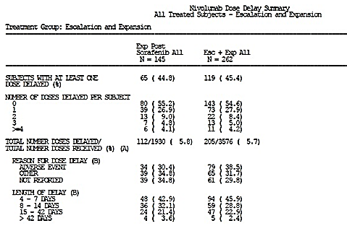
30% were attributed to an adverse event, but the other two categories, ‘other’ or ‘not reported’ presented to explain the remaining 70% of these delays are not adequate to evaluate this issue. Conservatively, this suggests that this treatment was not necessarily well tolerated. The sponsor provided a response to this comment, which did not clarify the terms ‘other’ and ‘not reported’ as this information is not available.
The clinical evaluator does not agree with the statement that there were no additional treatment discontinuations, as stated in the Addendum 01. Between the safety summary in the Interim CSR and the Addendum‐01 updated version, there had been an increase in ‘all‐causality AEs leading to discontinuation’ reported (from 15 to 16 patients) in the second line EXP cohort and from 27 to 29 patients in the EXP + ESC All patients, one of which was a drug related AE leading to treatment discontinuation. Dose modifications were not permitted and concurrent medications have not been checked, as data could not be located for this.

Safety issues with the potential for major regulatory impact
The interim CSR stated that in order to characterise adverse events (AEs) of special clinical interest that are potentially associated with the use of nivolumab, the sponsor identified select AEs based on the following 4 guiding principles:
- AEs that may differ in type, frequency, or severity from AEs caused by non immunotherapies.
- AEs that may require immunosuppression (for example, corticosteroids) as part of their management.
- AEs whose early recognition and management may mitigate severe toxicity.
- AEs for which multiple event terms may be used to describe a single type of AE, thereby necessitating the pooling of terms for full characterisation for example, endocrine, gastrointestinal, hepatic, pulmonary, renal, and skin select AE categories, respectively.
The interim CSR indicated that additional analyses of immune‐mediated adverse events (IMAE) were conducted in order to further characterise AEs of special clinical interest. In addition, other events of special interest (OESIs), which are events that do not fulfil all criteria to qualify as select AEs or IMAEs were also considered. Other events of special interest included the following categories: demyelination, encephalitis, Guillain‐Barré syndrome, myasthenic syndrome, pancreatitis, and uveitis.
Given the considerations described above, the CSR provided safety results based on the following categories:
Endocrine events, gastrointestinal events, hepatic events, pulmonary events, renal events, skin events, hypersensitivity/infusion reactions.
IMAEs consisting of:
Endocrine IMAEs (adrenal insufficiency, hypophysitis, hyperthyroidism, hypothyroidism/thyroiditis, diabetes mellitus), diarrhoea/colitis, immune-mediated AEs, hepatitis, pneumonitis, nephritis and renal dysfunction, rash and hypersensitivity/infusion reactions.
Below AE results are provided based on the interim CSR and initial data cut off of August 2016. Additional results from Addendum 01 and the 29 November 2016 data cut off are also provided. Addendum 02, based on the March 2017 data cut did not include any safety results.

Table 6: Summary of safety in second line EXP and ESC + EXP cohorts including sorafenib‐naive as of database lock of 29 November 2016
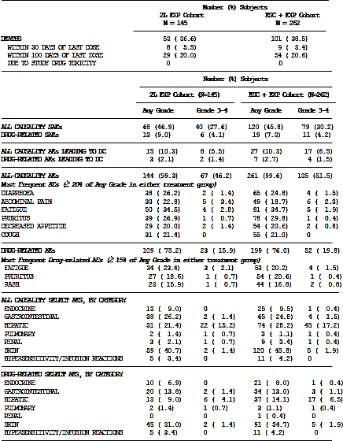

Table 6(continued): Summary of safety in second line EXP and ESC + EXP cohorts including sorafenib-naive as of database lock of 29 November 2016
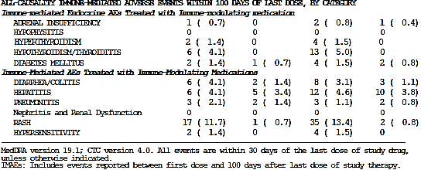
The most common treatment‐related AEs were skin and subcutaneous disorder (36.6%), gastrointestinal disorders (33.1%), and general disorders and administration site disorders (34.5%). These, together with the Metabolism and nutrition disorders (11.7%), would have potentially a significant detrimental effect on quality of life especially AEs such as fatigue, decreased appetite and pruritus. No data are available for comparison of how these patients would with best supportive care or placebo.
In the 262 patient ESC + EXP cohort, the rates of severe treatment‐related rises in alanine transaminase (ALT) and aspartate transaminase (AST) are higher; see Select adverse events of Hepatic AEs below.

Deaths and serious adverse events
Of the total population, 44.8% of patients had died in the second line EXP cohort (Table 7). Disease progression was the most common cause of death, including deaths occurring within 30 days of last dose and deaths occurring within 100 days of last dose. One patient in the second line EXP cohort died from pneumonitis attributed to study drug toxicity, and one in the large cohort including sorafenib‐naïve patients.
A review of the narratives for other patients who died for reasons other than progression does not suggest a treatment related cause of death was likely.
Table 7: Death summary; all treated patients in second line EXP cohort and ESC + EXP all treated cohort as at 29 November 2016
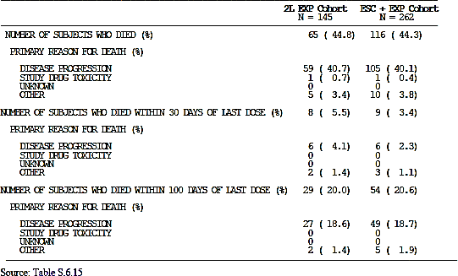

Serious adverse events
Serious adverse events (SAEs) were reported in 47.7% of patients in the ESC + EXP cohort and 49.0% of patients in the second line EXP cohort (Table 8). Grade 3 and 4 SAEs were reported in 32.1% and 29.7% of patients, respectively.
Those considered treatment‐related were reported in 7.6% of patients in the ESC + EXP cohort and 9.0% of patients in the second line EXP Cohort (Table 8). Grade 3 and 4 SAEs were reported in 4.6% and 4.1% of patients, respectively.
Table 8: Drug related SAEs by worst CTCAE Grade reported in at least 2 patients; all treated subjects; second line EXP and ESC + EXP cohorts (n = 262 patients)
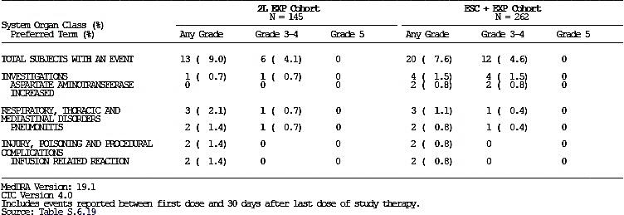

Adverse events leading to discontinuation of study therapy
AEs leading to discontinuation were reported in 11.0% of patients in the second line EXP Cohort. Grade 3 or 4 AEs leading to discontinuation were reported in 6.2% of patients.
AEs leading to discontinuation reported in at least 2 patients, included malignant neoplasm progression (4, 2.8%), metastases to central nervous system (2, 1.4%), and ascites (2, 1.4%). AEs leading to discontinuation were reported in 3 (6.3%) patients in the ESC cohort.
Treatment related AEs leading to discontinuation in 3 patients (2.1%) in the 145 EXP cohort included stomatitis, pneumonitis and polyarthritis (1 patient each). In the larger combined ESC + EXP cohort including 262 patients, 3% discontinued due to adverse drug reactions (Table 9).
Note is made in the patient disposition table that as of the last database lock of 17 March 2017, treatment discontinuations due to events indicating poor tolerability (study drug toxicity, patient request, consent withdrawn) totalled 6.9%.
These are all known toxicities of nivolumab. Specific issues for patients with diminished hepatic reserves would be immune‐related hepatitis but this was observed in only a relatively small number of cases.
Table 9: Drug‐related AEs leading to discontinuation by worst grade; all treated patients, EXP and ESC + EXP cohorts
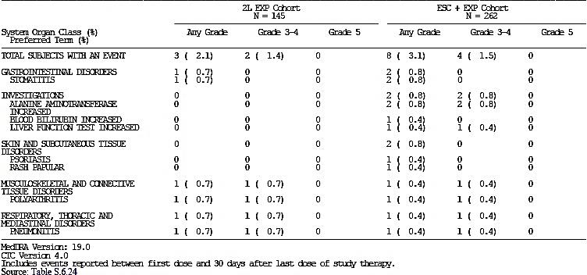

Select adverse events

Endocrine events
Adrenal disorders, diabetes, pituitary disorders, and thyroid disorders were classified as endocrine events. There were 12 patients in the expansion cohort who had endocrine events that were considered to be drug‐related by the investigator. The most commonly reported event was hypothyroidism (n = 6; 4.1%). One subject was treated with immune‐modulating medication but the event did not resolve at time of database lock for the Addendum 01 analysis. Resolution was reported in 6 of the 12 events, with a median time to resolution of 28 weeks. The table below provides a summary of endocrine related events.
Table 10: Endocrine drug related adverse events reported up to 30 days since last dose; 29 November 2016 second line EXP population
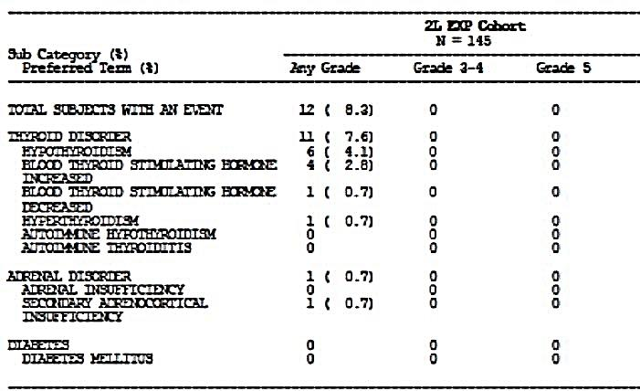

Gastrointestinal events
In the Addendum 01, gastrointestinal (GI)select AEs (all‐causality, any grade) were reported in 39 patients (26.9%) in the second line EXP Cohort, of which 22 patients (15.2%) had GI select AEs that were considered to be drug‐related by the investigator. This is a minor increase from the 14% (n = 20; 13.8%) reported in the Interim CSR. Most drug‐related events were Grades 1 or 2; 2 patients (1.4%) had Grade 3 or 4 drug‐related events. No drug‐related events led to permanent discontinuation of nivolumab.
Three of five patients requiring immune‐modulating medication had resolution of their event and overall, 15 of 21 patients had resolution of their treatment‐related AEs.
Table 11: Gastrointestinal drug related adverse events reported up to 30 days after last dose; all treated patients, second line EXP and ESC + EXP cohorts; 29 November 2016
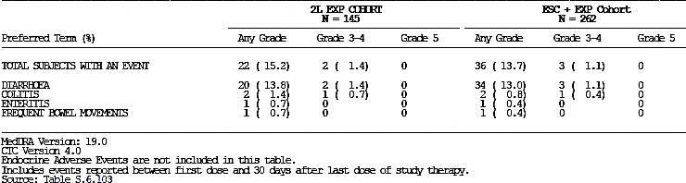

Hepatic events
This is an AE of particular relevance to this population who, because of the aetiology of their disease, have a high likelihood of diminished hepatic reserve, despite their Child Pugh A status. The preferred terms used are listed below:
Acute hepatic failure, acute on chronic liver failure, alanine aminotransferase increased, aspartate aminotransferase increased, autoimmune hepatitis, bilirubin conjugated increased, blood alkaline phosphatase increased, blood bilirubin increased, drug-induced liver injury, gamma glutamyltransferase increased, hepatic enzyme increased, hepatic failure, hepatitis, hepatitis acute, hepatotoxicity, hyperbilirubinaemia, liver disorder, liver function test abnormal, liver function test increased, liver injury, transaminases increased.
Hepatic select AEs (all‐causality, any grade) were reported in 31 patients (21.4%) in the second line EXP cohort, and 76 patients (29.0%) in the all treated ESC + EXP cohort (262 patients)
There was discordance between the reported rate of treatment‐related hepatic AEs, with the number decreasing at the later database lock of 29 November 2016, from 13 to 12 patients (8.3%) with hepatic select AEs considered to be drug related by the investigator. 5 of 12 patients (3.4%) had Grade 3 or 4 drug‐related events, with the remainder Grade 1 or 2. No drug‐related events led to permanent discontinuation of nivolumab within 30 days of last dose.
The median time to onset of drug‐related hepatic events was 6.14 weeks. 2 patients were treated with immune‐modulating medication for a median duration of 6.93 weeks and both patients had resolution of the event at the time of database lock. Overall, 9 of the 12 patients with drug related hepatic select AEs had resolution of their events, with a median time to resolution of 8.43 weeks.
Table 12: Hepatic drug related adverse events reported up to 30 days after last dose; all treated patients second line EXP and ESC + EXP cohorts; 29 November 2016
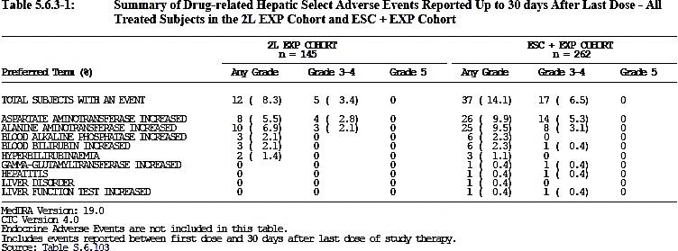
The rates of severe Grade 3 or 4 events are similar in the second line EXP population but higher than recorded in the PI, particularly for increase in AST and ALT in the ESC+EXP cohort, which includes the second line ESC population of 37 patients within the 262 patients. The safety of use in the proposed population cannot be fully elucidated, but modification of the current statement in the PI may be required, ‘The safety of Opdivo 3 mg/kg every 2 weeks as monotherapy evaluated in 145 adult patients with hepatocellular carcinoma previously treated with sorafenib was generally consistent with that in the pooled nivolumab monotherapy population across tumours.’

Pulmonary events
As of 29 November 2016, two patients in the second line expansion cohort (1.4%) experienced adverse events were pneumonitis, both considered treatment‐related and one event led to permanent discontinuation of nivolumab. Both patients were treated with immune‐modulating medication and one subject had resolution of their event.
There appears to be some inconsistency in the reporting of pneumonitis, as it is also reported as part of IMAEs. When reported as an IMAE, the CSR indicates that there were 3 patients in the expansion cohort with pneumonitis, including 2 with Grade 3 events. The CSR tables also report both 2 patients and 3 patients.
The reasons for this apparent discordance in reporting are not clear as it would seem IMAEs are a subset of special AEs of interest. pneumonitis is a known AE for a range of cancer therapies including nivolumab, and therefore, familiar to oncologists.

Renal events
As of the November 29 2016 database lock, renal select AEs (all‐causality, any grade) were reported in 10 patients (3.8%) in the ESC + EXP cohort and 4 patients (2.8%) in the second line EXP cohort. drug‐related renal AEs occurred in one subject (0.7%) which resolved without immune modulating medication.
The Addendum 01 states in the IMAE section below (although none required systemic immune‐ modulating medication so none was considered an IMAE), ‘nephritis and renal dysfunction events occurred in 12 (4.6%) patients in the ESC + EXP cohort and 5 (3.4%) patients in the second line EXP cohort’.
This is one of many inconsistencies noted during the evaluation of the safety section, in reporting what should be the same category of events, and raises concerns about the use of preferred term perhaps influencing the reporting rates and therefore, the evaluation of safety for the proposed usage.

Skin events
60 patients (41.4%) in the second line EXP cohort experienced skin AEs, which were considered drug‐related in 44 patients (30.3%). The most frequently reported drug‐related events were pruritus and rash. Two events were Grade 3 or 4, but there was no event of toxic epidermal necrolysis reported. The majority of the drug‐related events were Grade 1 or 2, many required corticosteroids and none led to permanent discontinuation of nivolumab.
The median time to onset of drug‐related skin select AEs was 2.50 weeks. 18 patients were treated with immune‐modulating medication (1 received a corticosteroid at a dose ≥ 40 mg) for a median duration of 19.50 weeks, and 9 of these patients had resolution of the event.
Overall, 26 of 44 patients with skin select AEs had resolution of their events with a median time to resolution of 17.86 weeks. For the November 2016 data cut, the overall occurrence of skin related events decreased to 30.3%, a drop of less than a percentage. Occurrence of pruritus and rash remained as in August 2016.
Of note, rather than an increase in the reporting of AEs with additional follow‐up, this is the second selected AE of interest where the reporting rate has gone down with longer follow‐up.
Table 13: Skin related adverse event; all treated patients second line EXP and ESC + EXP cohorts; 29 November 2016
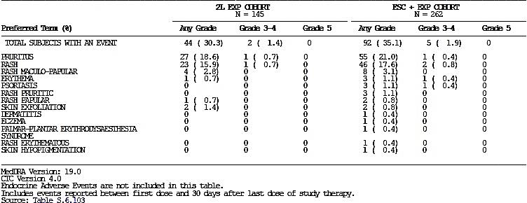

Hypersensitivity/infusion reactions
There were 5 patients in the second line EXP cohort who experienced hypersensitivity/infusion reactions that were considered drug‐related. All events were Grade 1 or 2. Two patients were treated with immune‐modulating medication and both patients had resolution of the event. The remaining patients with events also experienced resolution.
These results were unchanged from the August 2016 data cut off.
Table 14: Hypersensitivity/infusion drug related adverse events; all treated patients second line EXP and ESC + EXP cohorts; 29 November 2016


Haematology and haematological toxicity
The interim CSR states that abnormalities in haematology tests were primarily Grade 1 or 2, with the only Grade 3‐4 haematological abnormalities reported being decreased platelet count (5.6% Grade 3; 0.7% Grade 4) and decreased absolute lymphocytes (14.1% Grade 3; 0.7% Grade 4).
These cannot be interpreted in isolation, as thrombocytopenia is commonly observed with liver disease.

Other laboratory tests
The following laboratory tests were conducted and results reported:
- Kidney function tests. Grade 3 abnormalities in creatinine were observed in 1.4% of patients in the expansion cohort.
- Thyroid function tests: The CSR reports that the majority of patients in the expansion cohort had normal thyroid stimulating hormone (TSH) levels at baseline and throughout the treatment period. The proportion of patients with TSH increases (> upper limit of normal) or decreases (< lower limit of normal) from Baseline was balanced across cohorts.
- Assessment of electrolytes: The CSR reports that most patients in the expansion cohort had normal electrolyte levels during the treatment reporting period. The CSR also states that abnormalities in electrolytes were primarily Grade 1 to 2 in severity. There were some abnormalities reported at a Grade 3‐4 level: hyponatraemia (9.2% Grade 3; 0.7% Grade 4), hyperkalaemia (2.1% Grade 3; 0.7% Grade 4), and hyperglycaemia (5.6% Grade 3; 1.4% Grade 4).
- Hepatitis viral load and serology: Results were provided by subject.
- Pregnancy tests: The CSR reports that pregnancy tests were negative during the study in all treated female patients of childbearing potential.
Comment: hyponatraemia was observed relatively often, but has multiple causes, and assessment requires the clinical context to be able to comment.

Electrocardiograph findings and cardiovascular safety
Cardiac related AEs were reported in 12 patients in the expansion (EXP) cohort (8.3%). The CSR did not report any electrocardiograph (ECG) findings. In regard to cardiac electrophysiology the nivolumab PI notes that the potential effect of nivolumab on QTc interval; has been evaluated in 146 patients at doses up to 10 mg/kg every three weeks. No changes in mean QT interval were detected in nivolumab‐treated patients based on Fridericia correction method.

Vital signs and physical findings
These were presented across tables by individual patient results without a summary. These are not evaluable in their current format, without a summary indicating changes from Baseline.

Immunogenicity and immunological events
An exploratory outcome of the study assessed the incidence of nivolumab anti‐drug antibodies. The CSR reported that among the 210 of 262 patients in the ESC and EXP cohorts treated with 3 mg/kg Q2W, 59 patients (28.0%) who were anti-drug antibody positive across the expansion and dose escalation cohorts as of 29 November 2016 database lock.
The effect on efficacy is limited to the 36 of 57 from the post‐sorafenib cohorts where efficacy data have been presented.
- Among the 36 anti-drug antibody positive patients treated with nivolumab 3 mg/kg Q2W:
  - 4 of 36 (11.1%) patients had partial response (PR), 18/36 (50.0%) had stable disease (SD), 11 of 36 (30.6%) had progressive disease, and 3 of 36 (8.3%) were not evaluable (NE) per BICR review assessment
- 21 of 36 (58.3%) patients had a single anti-drug antibody positive sample:
  - out of these 21 patients, 10 patients continued treatment after detection of anti-drug antibodies at the first visit (2 weeks after first dose) and achieved PR or SD with progression free survival (PFS) ranging from 2.6 to 11.1 months. Nine of these 10 patients had additional anti-drug antibody samples collected that were negative.
- 15 (41.7%) patients had multiple anti-drug antibody positive samples:
  - out of these 15 patients, 9 (60%) continued treatment and achieved partial response or stable disease with progression free survival ranging from 2.7 to 9.6 months
Among the 2 anti-drug antibody‐positive patients treated with nivolumab 1 mg/kg Q2W, 1 had PR, and 1 had progressive disease per BICR assessment.
Among the 3 anti-drug antibody‐positive patients treated with nivolumab 0.3 mg/kg Q2W, 1 had PR, 1 had SD, and 1 had progressive disease per BICR assessment.
One anti-drug antibody‐positive subject treated with nivolumab 0.1 mg/kg Q2W had partial response per BICR assessment.
As previously stated, time dependent variables and in particular, PFS are of limited utility in a single arm trial of nivolumab, due to the confounding factors such as natural course of the disease.
Overall, the ORR was 16.7% (7 of 42) in anti-drug antibody positive patients with prior sorafenib treatment, which was similar to the overall population, suggesting a lack of significant effect of anti-drug antibodies on efficacy. Based on these data, there did not appear to be a causal relationship between the onset of anti-drug antibody response and efficacy.
Anti-drug antibody‐positivity did not appear to predict or correlate with hypersensitivity/infusion reactions: 3 of 70 (4.3%) anti-drug antibody positive and 8 of 178 (4.5%) anti-drug antibody negative patients experienced AEs in the hypersensitivity/infusion.
It is noted that the number of patients with antibodies declined in the update to only 8 of 178 patients with anti-drug antibody‐negative status versus. 8 of180 reported in the Interim CSR; the reason for this discrepancy is unclear.
Overall, presence of anti-drug antibodies does not necessarily predict either a loss of efficacy or occurrence of a hypersensitivity reaction across the study population. While individual adverse outcomes within this population cannot be ruled out, this has been widely studied and is not a concern in other cancer types.

Immune‐mediated adverse events
Immune mediated AE (IMAE)analyses included events, regardless of causality, occurring within 100 days of the last dose (that is, with extended follow up). These analyses were limited to patients who received immune‐modulating medication for treatment of the event, with the exception of endocrine events, which were included in the analysis regardless of treatment since these events are often managed without immunosuppression.

Adrenal insufficiency
There was one patient (0.7%) in the second line EXP cohort who experienced an adrenal insufficiency IMAE. The event was Grade 2 and the CSR indicates that it did not lead to dose delay or permanent discontinuation of nivolumab. The event did not resolve and was ongoing at 38 weeks.

Hypophysitis
There was no occurrence of hypophysitis IMAEs in the expansion cohort by the 29 November 2016 database lock.

Hyperthyroidism
As of 29 November 2016, three patients experienced a hyperthyroidism IMAE as of the Interim CSR, but subsequently, only two were reported at the database lock for the Addendum 01 in the second line EXP cohort. This has not been explained. All events were Grade 1 and none led to dose delay or permanent discontinuation of nivolumab. Two of the patients had resolution of the event and resumed nivolumab. The CSR does not indicate if hyperthyroidism is ongoing in the third subject.
The outcome of the AE for the third patient initially reported has not been provided. Rates were similar in the ESC + EXP cohort, and to those in the PI.

Hypothyroidism/thyroiditis
As of 29 November 2016, there were 6 (4.1%) patients in the second line expansion (EXP) cohort who experienced this IMAE. Four patients had Grade 2 events, and two had a Grade 1 event. The CSR reported that none of the events led to a dose delay or permanent discontinuation of nivolumab, although none of the patients had resolution of the event.
The lack of resolution most likely indicates the need for ongoing replacement therapy.

Diabetes mellitus
As of 29 November 2016, IMAEs of diabetes were reported in 2 (1.4%) patients in the expansion cohort: ‘for the 2 patients in the second line EXP Cohort with a diabetes mellitus IMAE (1 event each of Grade 4 and Grade 1), no events led to dose delay. 1 subject with a Grade 3 event led to permanent discontinuation of nivolumab’.
The AE severities reported include Grade 1, Grade 3 and Grade 4, seemingly in different patients. The events did not lead to dose delay although one subject with a Grade 3 event permanently discontinued nivolumab. The other subject experienced resolution.

Diarrhoea/colitis
As of 29 November 2016 database lock, in the second line EXP cohort there were 2 Grade 3 events, 3 Grade 2 events and one Grade 1 event (n = 6; 4.1%). Two events led to dose delay and no events led to permanent discontinuation of nivolumab. Three patients received high‐dose systemic corticosteroids. Two of three patients had resolution of the event and 1 subject had complete resolution. As such, there was only resolution in half of the patients with the event. Of the 2 patients who resumed nivolumab after resolution, neither had recurrence of diarrhoea/colitis.

Hepatitis
The CSR reports that as of 29 November 2016, hepatitis occurred in 31 (21.4%) patients in the expansion cohort, and the events were considered IMAEs in 4.1% (n = 6) patients. All events led to dose delays but none of the events led to permanent discontinuation of nivolumab. The event resolved in 4 of 6 patients. All patients received immune modulating medication. Of the 2 patients who resumed nivolumab after resolution, neither had recurrence of their hepatitis IMAE. Within the broader safety population of 262 patients receiving any dose of nivolumab, a similar proportion developed a hepatic IMAE (4.1%), including one Grade 4 event.

Pneumonitis
This event occurred in 3 (2.1%) of patients in the second line EXP cohort. Two of the events were Grade 3 and one was Grade 1. The Grade 1 event led to dose delay and one of the Grade 3 events led to permanent discontinuation of nivolumab. None of the patients had complete resolution of the event that is resolution with completion of immune‐modulating medication).
As previously noted, the figures reported here do not tally with those reported above, and the reasons for the differences were not provided. The post-first round response from the sponsor indicated that the difference in rates reported as IMAE is the duration of follow‐up is longer for IMAE (100 days versus 30 days).

Nephritis and renal dysfunction
Nephritis and renal dysfunction events occurred in 12 (4.6%) patients in the ESC + EXP cohort and 5 (3.4%) patients in the second line EXP Cohort. Nephritis and renal dysfunction AEs occurred in 4 (2.8%) of patients in the expansion cohort. None of the events were considered IMAEs.

Rash
This event occurred at a much higher rate than other IMAEs, with 17 (11.7%) of patients in the second line EXP cohort reporting rash, as of the database lock of 29 November 2016. There was one Grade 3 event, 5 Grade 2 events and 11 Grade 1 events. No event led to permanent discontinuation of nivolumab, although one Grade 2 event led to dose delay. Twelve patients had resolution of the event and 9 had complete resolution with use of immune‐modulating medication. Eight patients resumed nivolumab after resolution and of these, one had recurrence of rash IMAE.

Hypersensitivity/infusion
As of the 29 November 2016 database lock, hypersensitivity/infusion reactions were reported in 5 (3.4%) patients in the second line EXP cohort. These events did not lead to dose delay or permanent discontinuation of nivolumab. Two patients received immune modulating medication and both had complete resolution and resumed nivolumab after resolution of the event and neither subject had recurrence of the event.

Immune‐modulating concomitant medications for management of adverse events
This information was presented in the Interim CSR, but not updated in the Addendum 01. Assessment of IMAEs and select AEs reported the use of immune modulating medication for management of AEs. The use of such medication was reported in 40 events and it was reported that the event resolved in 27 (68%) of the cases.

Recurrence of adverse events
Recurrence of IMAEs was reported. There was one instance of recurrence of rash following resumption of nivolumab. The CSR did not provide any indication of the level of the recurring event.
The CSR also provided a listing of multiple episodes of the same AE in a single subject. The table is reproduced below.
Table 15: Adverse events with more than one occurrence in a single subject; November 2016
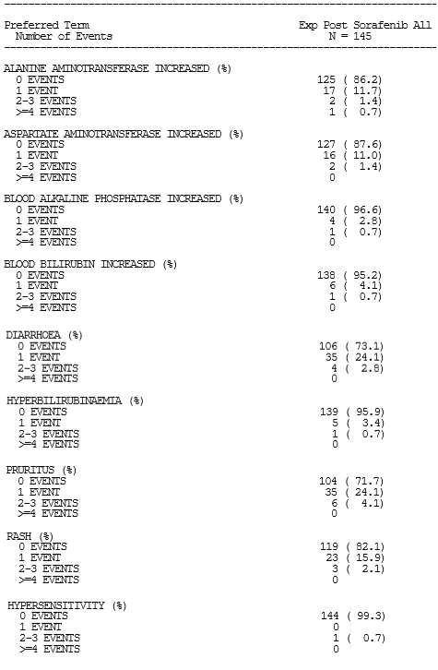

Other events of special interest
The CSR listed the following categories: demyelination, encephalitis, Guillain‐Barré syndrome, myasthenic syndrome, pancreatitis, and uveitis. In the second line EXP cohort, there was one Grade 3 pancreatitis event reported (0.7%). The investigator considered that the event was unrelated to study drug, and the event resolved in 1.6 weeks. One event of Grade 3 pancreatitis, considered related to the study drug, was reported in the larger ESC + EXP cohort, required dose interruption but not discontinuation, and was stated to be ongoing.
There were no events in the remaining categories.

Safety by dose and aetiology subgroups
The Addendum 01 states:
‘The safety profile of nivolumab monotherapy across dose levels in the ESC Cohort and across aetiology subtypes in the ESC and EXP Cohorts were consistent with that reported in the overall population.
No consistent trend between dose or aetiology and the frequency and types of deaths as well as all causality SAEs, all AEs, or AEs leading to discontinuation was observed across the different dose subgroups in the ESC and EXP Cohorts. Although the frequency of reported any grade drug‐related AE across aetiology in the ESC and EXP Cohorts was similar, there was a trend towards a higher frequency of drug‐related Grade 3 or 4 AEs in HCV‐infected patients in both cohorts. There was a trend towards a lower frequency of drug‐related Grade 3 or 4 AEs in HBV‐infected patients in the EXP Cohort.’
The sponsor’s observations are noted, but these groups included patients who were sorafenib‐naïve and had previously received sorafenib, so there is heterogeneity in the extent of prior treatment, and likely to be imbalances in other prognostic factors within these subgroups. It would be expected that the safety profile would be better in the less heavily pre-treated population. These observations require validation in a randomised, controlled trial setting with appropriate stratification factors.
Similarly, the sponsor notes that:
‘In the EXP Cohort, the percentage of patients who died in the EXP uninfected progressor subgroup, in which all patients were previously treated with sorafenib, was greater than that reported in the uninfected naive/intolerant, HCV, HBV subgroups or overall EXP Cohort.’
This underscores the need for clearly, and separately presented safety data for all patients who have previously received sorafenib in order to determine the safety profile in this population.
Data represented a summary of safety across dose levels in the ESC cohort and ESC + EXP cohort by aetiology, but both of these cohorts’ patients include sorafenib‐naïve patients and therefore proportions developing events do not inform regarding the proposed usage.

Late emergent adverse events (> 100 days after last dose)
One subject in the ESC cohort had Grade 1 late‐emergent drug‐related AEs of increased ALT and increased AST. One subject in the EXP cohort experienced Grade 1 late emergent drug related AEs of anaemia and rash papular and one (second line EXP cohort) had a Grade 2 late emergent drug related AE of hypothyroidism.
Reporting rates are likely to be low due to the voluntary nature of reporting, lower attribution rates to the treatment over time from competing causes such as disease progression and a proportion of patients may be followed up by a non‐trial team or in a non‐trial centre.
While none of these sounded particularly of concern, the death that was attributed to study treatment occurred in a patient who had discontinued treatment and then commenced sorafenib, developed pneumonitis and died. This indicates the potential for serious events some time after discontinuation and in particular, for interactions with other drugs such as kinase inhibitors. There is a warning in the PI about ensuring resolution of any AEs prior to commencement of subsequent therapies.

Safety in special populations
The CSR did not provide assessment of safety in any identified special populations.

Post marketing data
The CSR did not address post‐marketing experience for HCC and the first international approval (FDA) was only in September 2017.

Evaluator’s conclusions on safety
Based on the data from the second line EXP cohort, the adverse events encountered were similar to those in frequency and severity as outlined in the PI with the exception of transaminsases and bilirubin levels (the sponsor agreed to amend the PI text to reflect this). Note is made of the proposed changes in the dose modification section of the PI to manage this risk in this population.
The information is, however, incomplete, as the primary endpoint of safety and tolerability in the dose escalation (ESC) cohort, and all safety events for this particular cohort who comprise 20% of the two cohorts providing safety data have not been presented, except as part of a wider cohort which includes a large proportion of patients who were sorafenib‐naïve. As such, safety had not been adequately characterised in this CSR and Addendum‐01 to the Interim CSR, noting that Addendum 02 to the Interim CSR does not include any safety data.
No final conclusions can be drawn about the safety profile for the proposed usage.

First round benefit-risk assessment

First round assessment of benefits
The evaluable evidence to support the proposed indication is drawn essentially from a subgroup of patients from a single cohort five cohorts (expansion post‐sorafenib n = 145; and 9 patients in the second line ESC cohort) participating in a non‐randomised, non‐comparative, open label Phase I/II study. All patients of these 154 patients were previously treated with sorafenib and went on to receive nivolumab 3 mg/kg every two weeks until disease progression (and 72 continued beyond disease progression), unacceptable toxicity or withdrawal of consent.
The primary endpoint of ORR in the larger cohort (145 patients) treated at the proposed dose, by blinded independent central review assessment based on RECIST 1.1 criteria, was 14.5%, indicative of a very modest demonstrable treatment effect. This ORR was smaller than that proposed in the estimates in the statistical analysis plan, but this did not specify a ‘Go/No-go’ decision attached to this estimate for this exploratory trial. Responses were seen across all aetiological subgroups (hepatitis C virus, hepatitis B virus and ‘Uninfected’), although it is noted that a higher proportion of patients died in the largest of the three subgroups, the ‘Uninfected post‐sorafenib’ subgroup. The sponsor has been requested to provide additional information on the responders observed in this particular subgroup, given prior viral hepatitis was permitted as long as it was not currently active or deemed to be causative, and the immunological effect of prior infection is a potential confounding factor for response to immunotherapies.
Secondary endpoints included the median duration of response, which was 19.35 months among 7 of 37 patients who responded in the dose escalation cohort, and 16.6 months in the expansion cohort (21 of 145 patients). The median OS was 15.6 months in the expansion (EXP) cohort, and 14.95 months in the dose (ESC) escalation cohort. As is often seen in immunotherapy trials, PFS was limited, with median PFS at 2.8 months in the expansion cohort and 3.5 months in the dose escalation cohort, and is often not a useful outcome for measuring clinical benefit of these treatments.
These findings can only be suggestive of a benefit, given time‐dependent variables are affected by the natural history of the disease and subject to biases and uncertainties that cannot be resolved. The sponsor included in the second Addendum to the Interim CSR, additional presentations of baseline characteristics including duration of prior therapy, time to start of nivolumab after prior sorafenib, both of which indicate a very variable course of the disease within the patients enrolled. This precludes clear attribution of any change in endpoints such as duration of treatment, to a treatment effect. It clarifies the difficulty in characterising the population who might have benefited, and the extent of any such benefit; while these figures might compare favourably with the median OS recently reported in a Phase III study of regorafenib versus placebo where there was a significant improvement of 10.7 months versus 7.8 months, respectively, the Phase III study design for regorafenib was more robust.
These results with nivolumab require demonstration of reproducibility in a randomised, controlled trial. The uncertainty of the degree and reproducibility of the benefit, and the limitation in being able to characterise and compare the population due to heterogeneity for comparison with published studies, is the critical issue. It is noted that the FDA granted an accelerated approval for the proposed indication, and the sponsor has been requested to provide the details of the confirmatory study identified in the FDA decision letter. By contrast, the sponsor withdrew the application from the EMA on 20 July 2017 and information from the EMA website dated 15 September 2017 indicates the basis of the concerns were mostly around a lack of detail about patients in the study in order to make comparisons with results from other studies. The clinical evaluator is in agreement with the position adopted by the EMA, noting that the TGA does not have a provisional registration pathway.
Overall, these findings indicate a modest response to treatment in terms of the ORR, made up mostly of patients with a partial response. However, beyond this, any clinical benefit is difficult to characterise, as assessment of the durability of any treatment effect is limited by the single arm nature of the study, the complex nature of HCC with its multiple aetiologies, and uncertainties about the influence of the natural history of the disease in the study participants on the results presented.

First round assessment of risks
An assessment of the risks is limited in part due to data not able to be located by the evaluator, reporting of the breakdown of dose levels in the second line ESC cohort or the primary endpoints of safety and tolerability of the proposed dosage in the second line ESC cohort, who form 20% of patients informing regarding the safety of the proposed usage, that is, in patients previously been treated with sorafenib. Safety data for this 37 patient ESC cohort have been presented as part of a very much larger cohort of 262 patients, which includes 80 sorafenib naïve patients as well as the second line expansion cohort.
Note is made of the poorer survival of patients who had received prior sorafenib for HCC deemed caused by a non‐infective aetiology, which underscores the need for the safety for this very clearly delineated population in the indication, to have been presented in a way that matches the efficacy reporting.
Assessment of the data is therefore reliant upon the 145 (80%) of patients who represent the target population, drawn from the second line EXP cohort. This is a small population, given how common this malignancy is worldwide. In this population, there was an increased risk of liver enzymes abnormalities (which were higher at Baseline, especially in those with hepatitis C viral infection), but otherwise appeared to have a comparable safety profile with other patients with different tumours. There remains the uncertainty of how generalizable these findings are beyond this very clearly defined trial population required to have good ECOG performance status (most were ECOG PS 0) and Child‐Pugh A liver scores, and were predominantly Okuda Stage 1; all of which suggest a good prognosis from conditions other than their liver cancer, and better than all-comers with previously treated HCC.
No results from randomised Phase III trials will be available during the course of this evaluation, although the sponsor has been asked to provide details of the confirmatory study required by the FDA. It is noted that one cohort in this exploratory study examined nivolumab versus sorafenib as first line therapy, which might provide insights into the likelihood of confirmation in an earlier line of therapy of the preliminary results presented here, but data were not included in this application.
Issues locating data within the dossier limited the evaluation undertaken at this point, but provision of the information requested is unlikely to address the uncertainties identified regarding characterisation of clinical benefit due to limitations inherent in the study design and the preliminary nature of the data provided.

First round assessment of benefit-risk balance
No assessment of the benefit‐risk balance can be made due to the uncertainties discussed above.
Furthermore, recommendation for registration based on a single arm study must provide compelling evidence of a substantial improvement in efficacy and/or safety over existing therapies, with a stronger case for consideration where there is unmet need. Recent publication of a treatment with substantial evidence supporting an improvement in OS in those demonstrated to tolerate sorafenib, presents a treatment option for this group of patients (with the exception, perhaps of the very small proportion defined as sorafenib intolerant) with clearer evidence of a benefit, thereby changing unmet need.
The currently presented data supports the continued investigation of nivolumab in HCC, but is considered insufficient to support full registration at this time.

First round recommendation regarding authorisation
The sponsor’s proposed indication is:
Opdivo, as monotherapy is indicated for the treatment of adult patients with hepatocellular carcinoma after prior sorafenib therapy. The approval of this indication is based on objective response rate and duration of response.
No benefit‐risk assessment can be made and as such, authorisation is not recommended.

Clinical questions and second round evaluation

Pharmacokinetics

Question 1
An extensive search of the interim CSR and two addenda could not locate a summary of the Baseline and pre-dose trough serum nivolumab concentrations or any other pharmacokinetics results or analyses based on the summaries of the baseline pharmacokinetics sample values. In addition, no data could be located for the intensive sampling described below in the table from the ESC cohort. Without an evaluation of the datasets (including completeness of datasets, doses received etc.) included in the population pharmacokinetics model, the Evaluator cannot comment on or evaluate the pharmacokinetics model and its validity in describing the population pharmacokinetics for patients with HCC.

Sponsor response
The PK of nivolumab in HCC subjects was characterized using a population approach and reported in a separate pharmacometric report of this submission. All nivolumab concentration data, including both intensive and sparse sampling, and nivolumab dosing data in Study CA209040 were pooled with corresponding data from other studies and were used in the population PK (popPK) analysis. Therefore, the dataset was considered complete and the model was considered appropriate for describing the popPK in HCC patients. This dataset will be submitted to assist the evaluation of popPK and exposure-response analyses.

Evaluation of response
The sponsor has provided datasets in spreadsheet format that appear to be those used for the population pharmacokinetics modelling and information pertaining to the modelling. This does not address the issue identified by the clinical evaluator pertaining to there being no pharmacokinetic data presented in the CSR for this early Phase I/II study which was undertaken with at least one objective being to obtain pharmacokinetics data, to permit a clinical evaluation and determination of whether the data obtained from the study were adequate to inform the model, prior to incorporation into the model. The deficiency identified was not the lack of pharmacometric data summaries and information about the model, which have been provided without being requested. Evaluation of these summaries or re-running of the model is not within the scope of this evaluation, and such data would be requested by TGA population pharmacokinetics evaluators as required, not the clinical evaluator. This remains an outstanding issue, but its continued relevance remains uncertain given the sponsor has proposed an updated population pharmacokinetics model in support of the flat-dosing strategy and 4 weekly administration, submitted concurrently with this application for evaluation.

Efficacy

Question 2
The sponsor is requested to provide details of the study identified in the FDA accelerated approval requirement 3270‐1 including the comparator that has been selected, the line of therapy, definition of the target population and the status of the trial currently that is the proportion of the pre specified number of patients have been enrolled.

Sponsor response
The sponsor is conducting a Phase III randomized trial in the first line setting comparing nivolumab versus sorafenib (Study CA209459) with an OS primary endpoint. This study is being used to address the US FDA accelerated approval post marketing requirement. Study design details and study milestones are provided below.
Summary of key features of Study CA209459 design and projected milestones:
- A randomised, multi-centre Phase III study of nivolumab versus sorafenib as first line treatment in patients with advanced hepatocellular carcinoma
- Number of subjects: 726 to be randomised 1:1
- Key inclusion criteria:
  - Subjects disease not amenable for surgical or loco-regional therapy or who have progressed after surgery or loco-regional therapy
  - Subjects must not have received prior systemic therapy for advanced HCC
  - Histologically confirmed HCC with at least one RECIST v1.1 measureable untreated lesion
  - Additional criteria include: Child-Pugh A status, ECOG PS 0 or 1, adequate hepatic function (albumin > 2.8 g/dL, total bilirubin < 3 mg/dL, AST/ALT < 5 x upper limit of normal (ULN)), and adequate renal and haematologic function
- Key exclusion criteria:
  - History of hepatic encephalopathy
  - Ascites by physical examination at screening or prior or current treatment for ascites
  - Co-infection with HBV/HCV or HBV/HDV
- Treatments: nivolumab 240 mg intravenously (IV) Q2W or sorafenib 400 mg BID
- Stratification factors:
  - aetiology (HCV-versus non-infected HCC)
  - presence or absence of vascular invasion and/or extrahepatic spread
  - geography (Asia versus non-Asia)
- Primary endpoint(s): OS
- Secondary endpoint(s): ORR, progression free survival by BICR and efficacy by PD-L1 tumour expression
- Study milestones:
  - Enrolment completion: 07-March-2017
  - Last patient last visit: anticipated March 2018 for interim OS analysis
  - Database lock for OS interim analysis (416 deaths, 80% of target events): anticipated second quarter of 2018
  - Database lock for OS final analysis (520 deaths): anticipated first quarter of 2019.

Evaluation of response
The sponsor’s response is noted.

Question 3
The sponsor should provide a table indicating the breakdown of the doses received for the 37 patients for the ESC second line population for each of the 5 dose cohorts, noting that only those who received 3 mg/kg can be considered supportive of the proposed usage.

Sponsor response
A breakdown of nivolumab doses received for the 37 ESC second line subjects across the 5 dose cohorts is summarised below:
- 0.1 mg/kg (n = 5)
- 0.3 mg/kg (n = 7)
- 1.0 mg/kg (n = 6)
- 3 mg/kg (n = 9)
- 10 mg/kg (n = 10)

Evaluation of response
9 patients from this cohort inform the proposed usage, together with the 145 patients in the second line EXP cohort. Thus, efficacy and safety data from a total of 154 patients who had previously received sorafenib and who received nivolumab at the proposed dose of 3mg/kg Q2W, inform the proposed usage.

Question 4
The sponsor is requested to clarify if those who received treatment beyond initial progression are listed in the subject disposition table, as this is not clear.
- The sponsor should including the following information in the table requested in clinical question 3, providing a breakdown of the doses received in the ESC cohort.
- Within each dose level, indicating clearly the number of patients who received continuous treatment and who did not.
  - For each patient in the 3 mg/kg dose level, clarification about the actual treatment received.
  - Whether the ‘re-treatment’ and continuation beyond initial progression are regarded as the same thing in the Patient Disposition table.

Sponsor response
Patients treated beyond disease progression were included in the Patient Disposition Table in Addendum 01 (using the evaluator’s preferred term of ‘Patient’ rather than ‘Subject’ for consistency within this report).
There were no subjects in the dose escalation phase who were required to discontinue due to reaching the 2 year maximum duration prior to the institution of Amendment 8. In addition, there was only 1 subject in dose escalation who discontinued after 39 doses of study drug due to a confirmed complete response who then was retreated with nivolumab per protocol after disease recurrence approximately 6 months after the last dose.
All other subjects listed in Addendum-01, including subjects who were treated beyond initial progression, are considered as having received continuous treatment, that is, re-treatment was not provided to any other subject upon discontinuation. Therefore, 145 of 145 second line EXP, 36 of 37 second line ESC, and 261 of 262 ESC + EXP subjects had continuous treatment, with only one patient in the second line ESC cohort who did not receive continuous treatment.

Question 5
In response to questions about use of agents other than corticosteroids to manage immune-mediated AEs, the sponsor has previously indicated that no trial protocols have incorporated use of any agents other than steroids. If mycophenolate was used, the outcomes should be reported. Can the sponsor state whether adverse events in the trial have been managed with mycophenylate mofetil and the outcomes if so?

Sponsor response
Two patients received mycophenolate for hepatic immune‐mediated AEs, after commencing corticosteroid therapy. The response states, ‘Subject [information redacted] (EXP Uninfected, second line, 3 mg/kg dose) received 4 doses of nivolumab and experienced a hepatic immune mediated AE of Grade 3 increased AST/Grade 4 increased ALT and Grade 2 increased bilirubin. Nivolumab was discontinued for the hepatic event after a total of 4 doses. The subject initiated steroids on 31 July 2015 (study Day 24).’ A review of the narrative for this patient was provided in the Interim CSR:
‘On Day 176 (30 December 2015), the event of increased ALT remained at Grade 3 intensity. On Day 211 (03 February 2016), ALT improved to baseline status of Grade 1. On Day 286 (18 April 2016), the study therapy was discontinued because of increased ALT, with the last (4th) dose given on Day 71 (16 September 2015). On Day 288, dexamethasone was discontinued. At the time of database lock (Day 398, 08 August 2016), no further HCC treatment had been given, and increased ALT level remained at Grade 1 with no other hepatic adverse events.’

Evaluation of response
This does not appear consistent with the statement that none of the events led to discontinuation.

Question 6
Changes in the baseline status between the Interim CSR and Add‐02 reports for Okuda status and Barcelona Clinic Liver Cancer (BCLC) staging are noted; these were not indicated nor explained within the Addendum 02 and the reasons for these shifts in the baseline datasets are uncertain. The updated dataset indicates a population with better risk as per Okuda staging, as more are Stage Okuda Stage 1. It is not clear why and how these discrepancies emerged, and the sponsor is requested to provide an explanation.

Sponsor response
Barcelona Clinic Liver Cancer (BCLC) and Okuda staging are programmatically derived based on information in the case report form (CRF). Some elements used to calculate the BCLC and Okuda stages were changed by the investigators between the August 2016 clinical database lock for the Study CA209040 Interim CSR and November 2016 clinical database lock for the Addendum-01 to the Study CA209040 Interim CSR.
Although there were minor changes in the BCLC and Okuda staging systems between database locks due to updates to the case record form, the second line subjects who enrolled in Study CA209040 are consistent with an advanced HCC patient population and have similar baseline demographics as those across recent Phase III trials.

Evaluation of response
Eight patients were reclassified from Okuda Stage II to Stage I due to all having a change from baseline liver tumour size > 50% to < 50%. This represents, as per previous comments but such patients still meet the overall consideration as having advance disease. The sponsor’s extrapolation beyond the question posed, that these ‘have similar baseline demographics as those across recent Phase III trials meet the same criteria as for other recent Phase III trials’ does not overcome the difficulties of establishing cross study comparisons, inherent in the choice to present a single arm, open‐label trial in support of the proposed usage.
The evaluator considers this clearly demonstrated by the highly conditional and qualified approach to the assertion of this statement: ‘Although cross‐trial comparisons are limited by the available data presented, in general, baseline characteristics are comparable across the trials with the exception of the reason for sorafenib discontinuation, wherein 100% of subjects had disease progression in the RESORCE and CELESTIAL trials versus 73.1% to 74.5% in second line ESC and second line EXP subjects.’ The evaluator reasserts the position that these data are promising but not of sufficient magnitude to be compelling at this time, requiring randomised evidence from the Phase III Study CA209459, to provide support for consideration of registration for the treatment of advanced or metastatic HCC.
Barcelona Clinic Liver Cancer Stage 3 indicates that the vast majority of these patients were appropriately being treated with systemic therapy, and most had received prior sorafenib therapy.
The predominance of Okuda Stage I (more than 3 of 4 patients), together with the Child‐ Pugh score of 5 in 2 of 3 patients, suggests that the underlying hepatic function of the majority of these patients was well compensated (notwithstanding that the Child Pugh score was not developed for assessment of HCC). Whether these are consistent with the Australian population presenting with HCC is not discussed and remains somewhat uncertain.
The 2 patients with a score of 7 were not eligible for enrolment in the EXP cohort, but their enrolment does not favour the likelihood of a response in the primary endpoint.

Question 7
The sponsor is requested to provide a summary table for the blinded independent central review and investigator assessed efficacy endpoints for the 37 patients reported in the second line ESC cohort including:
- The number of patients at each dose level received;
- The ORR should include complete response/ partial response of patients receiving each dose level;
- Specifically, this should address how many patients in this cohort received the proposed 3 mg/kg and the efficacy results of that group, in addition to the other dose cohorts.

Sponsor response
Summary tables are provided for best objective response assessed by blinded independent central review and by investigator for the 37 second line ESC subjects in Study CA209040. There was no correlation between response and nivolumab dose, and the data support the pooling strategy of the second line ESC subjects (n = 9) and second line EXP subjects (n = 145) who received the 3 mg/kg dose.
Table 16: Study CA209040 Best overall response per BICR RECIST 1.1. by dose; all treated subjects in the second line ESC cohort; no cut‐off date provided
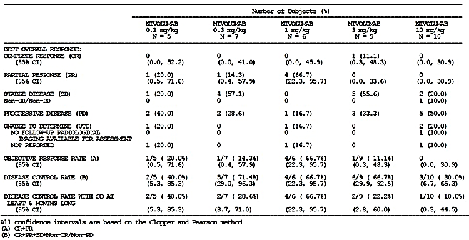
Table 17: Best overall response per investigator RECIST 1.1 by dose; all treated subjects in the second line ESC cohort in Study CA209040
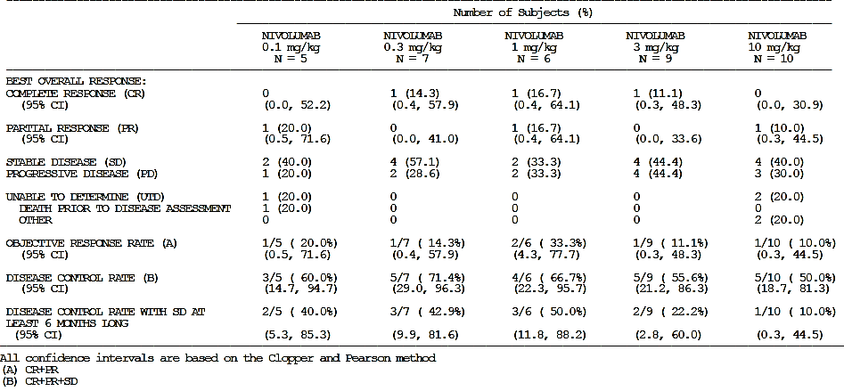

Evaluation of response
The ORR is low with a single patient achieving a complete response and no partial responders in the informative population, consistent with that observed in the second line EXP cohort. Although not informing of the benefit for the proposed usage, no other complete responses were reported in any of the other cohorts by blinded independent central review, and the overall response rate in this group is reported below. The highly variable response rates in these subgroups reflect the small numbers at each dose level and potential for large apparent differences to emerge based on small changes in absolute numbers. Confirmation of these data from the randomised Phase III trial, due to report soon, is recommended.

Question 8
The EXP cohort defined as ‘Uninf’ cohort includes not only those who were ‘sorafenib intolerant’ and ‘sorafenib progressors’, but also those with non‐infective‐related HCC, as well as those with HCC who have past but currently no evidence of active HBV and HCV infection. Given the immunogenic potential of viral infection, the sponsor is requested to present separately for the ‘Uninf’ cohort, the ORR by blinded independent central review RECIST 1.1 supported by a corresponding waterfall plot for those with no evidence of any prior HBV or HCV infection versus those with evidence of prior HBV or HCV infection.

Sponsor response
As shown in Addendum-01 to the Study CA209040 Interim CSR, in the second line EXP subjects (n = 145), Best objective response by blinded independent central review RECIST 1.1 was comparable across the aetiologies.
- Uninfected (n = 72): best objective response of 12.5% (95% CI: 5.9, 22.4)
- HCV-infected (n = 30): best objective response of 20% (95% CI: 7.7, 38.6)
- HBV-infected (n = 43): best objective response of 14% (95% CI: 5.3 to, 27.9)
Uninfected subjects in the EXP cohort could be enrolled with a history of resolved HCV or hepatitis B virus (HBV) infection. These subjects were classified as ‘uninfected’ in order to enrol subjects in the viral cohorts with active infection and explore the potential antiviral properties of nivolumab.
Of the 72 uninfected second line EXP subjects, there were 54 with no viral history, 13 with HCV viral history (resolved HCV), and 5 with HBV viral history (resolved HBV). Table 18 shows the best observed response for the uninfected EXP subjects with and without a history of viral infection. Although there is an approximate two-fold variation in best objective response, the small number of subjects within the resolved viral groups do not allow a robust assessment and the confidence intervals are broad and overlapping. In addition, to further highlight comparable efficacy in the uninfected and resolved subgroups, a similar magnitude of reduction in target lesion size is demonstrated in the waterfall plot for uninfected second line EXP subjects with and without a history of viral infection (Figure 3).
Figure 3: Waterfall plot of best change in target lesion per BICR RECIST 1.1 by viral risk factor; all response-evaluable subjects in second line EXP cohort who were uninfected
Table 18: Best overall response per BICR RECIST 1.1 by viral risk factor; all treated subjects in second line EXP cohort who were uninfected
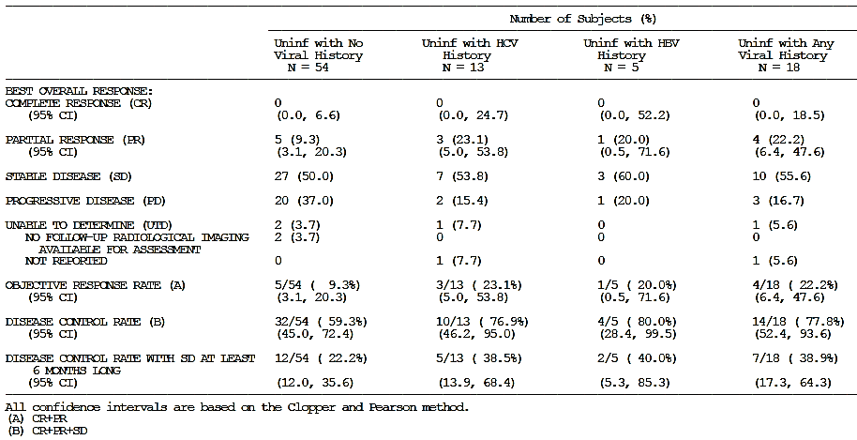
In summary, although there is a trend for a higher response rate with HCV infection (active or resolved) in the second line EXP and uninfected EXP subjects with a history of viral infection, the small subgroups are not powered for a robust statistical assessment and the CIs are all broad and overlapping. Of note, clinically meaningful and durable responses are observed with nivolumab in Study CA209040 regardless of aetiology.

Evaluation of response
Acknowledging the limitations of subgroup analyses and small numbers, on the very limited evidence presented in support of the proposed usage, the response does not seem as high in those with no prior history of any hepatitis B or C viral infection, with more than one third of patients experiencing disease progression and only 9.3% experiencing a best overall response of a partial response (PR). Stable disease cannot be evaluated due to limitations in the study design. Note is made that in the first line HCC Study CA209549, stratification was by HCV infection, suggesting these are the patients who may respond best. Demonstration of efficacy, based on and wholly reliant upon the surrogate endpoint of a low partial response rate given the absence of other data, particularly for those with no previous history of viral infection, is not satisfactorily established.

Safety

Question 9
Study CA209040 had as its primary objective and endpoint for the dose escalation cohort (ESC): to establish safety, tolerability, dose limiting toxicities (DLT) and maximum tolerated dose (MTD) of nivolumab when administered every 14 days. No information has been provided on any of the pre-specified primary safety and tolerability endpoints for the dose escalation cohort and as such, it remains unclear:
- How the MTD was determined as 3 mg/kg Q2W
- Any adverse events (DLT) over a range of doses for this select group who have limited hepatic reserve, particularly the 10 mg/kg.

Sponsor response
In Study CA209040, as well as across the nivolumab program, there was no maximum tolerated dose (MTD) reached with monotherapy doses tested up to 10 mg/kg. The rationale for the selection of the 3 mg/kg dose was provided in the protocol at the time of the EXP cohort amendment and is briefly summarized below:
- Acceptable safety profile in the current study without correlation between dose and frequency or severity of AEs
- Preliminary anti-tumour activity observed at dose levels of 0.1 mg/kg to 10 mg/kg in Study CA209040
- Preliminary pharmacokinetic (PK) analysis of a subset of samples from Study CA209040 that indicate exposures are within the expected range of subjects from other tumour types
- To align with the standard dose in the nivolumab program used in late-stage studies that are based on the safety, efficacy, and exposure-response (ER) data in multiple other tumour types
- In the large Phase I CA209003 study:
  - Anti-tumour activity was observed at dose levels ranging from 1 to 10 mg/kg in melanoma, NSCLC, and renal cell carcinoma, as well as at dose levels of 0.1 and 0.3 mg/kg in melanoma.
  - The observed anti-tumour activity in melanoma and NSCLC was highest at 3 mg/kg, suggesting that anti-tumour activity approaches a plateau at dose levels of 3 mg/kg and above.
  - Results of the ER analyses for these tumour types show that the probability of a tumour response tended to approach a plateau for trough concentrations produced by 3 and 10 mg/kg every 2 week dosing.
  - A favourable risk/benefit profile demonstrated at the 3 mg/kg dose in other ongoing Phase III trials and the nivolumab label.
In the Dose ESC cohort, there was 1 dose limiting toxicity (Grade 2 hepatic impairment) in an uninfected subject at 10 mg/kg with onset at Study Day 17 that occurred in the setting of bladder infection and resolved in approximately 1 week. Overall, there were no drug-related deaths in the ESC cohort, and there was no correlation between dose and type or severity of AE in the Dose ESC cohort.

Evaluation of response
In response to the request for data regarding any dose limiting toxicities, the sponsor indicated that no maximum tolerated dose was identified across the range of doses investigated and a single dose limiting toxicity of hepatic impairment at 10 mg/kg dose level was reported. As indicated by the sponsor, this occurred in the context of a bladder infection, but there is no evidence provided in the narrative to support the statement that these abnormal liver function tests resolved as reported on Day 24; liver function tests remain abnormal (as presented on Day 32 when a diagnosis of progressive disease was made) and the patient received no further nivolumab infusions, and died on Day 104.
The sponsor includes the following:
‘… a description of safety events for the ESC cohort was included in the Study CA209040 Interim CSR (Other Serious Adverse Events), (AEs leading to discontinuation), and (Adverse Events, including a summary of drug‐related AEs by dose for all subjects. In Addendum 01 to the Study CA209040 Interim CSR, some additional safety updates for the ESC cohort were provided (AEs leading to discontinuation) and (Overall AEs), and there were no new signals observed. Overall, there were no drug-related deaths in the ESC cohort, and there was no correlation between dose and type or severity of AE in the Dose ESC cohort’.
Tables referred to by the sponsor as providing safety data for the ESC cohort, as noted by the evaluator above, these tables pertain to the ESC+EXP cohort comprising 262 patients, which include less heavily pre-treated patients who do not inform the proposed usage. No data are presented for the ESC cohort of 37 who meet the defined in the sponsor’s proposed indication of having received prior sorafenib. The response has not addressed the concerns regarding adequate presentation of safety data for evaluation for the intended population.

Question 10
There appears to be some inconsistency in the reporting of pneumonitis, as it is also reported as part of immune‐mediated AEs. When reported as an immune mediated AE, the CSR indicates that there were 3 patients in the expansion cohort with pneumonitis. The CSR tables also report both 2 patients (Table S.6.103) and 3 patients (Table S.6.201). The sponsor is requested to explain.

Sponsor response
The sponsor indicated the differing numbers for the events of pneumonitis is accounted for by the differing durations of follow‐ up (up to 30 days versus up to 100 days after treatment discontinuation).

Evaluation of response
This clarification is accepted.

Question 11
Rather than an increase in the reporting of skin select AEs with additional follow‐up, this is the second selected AE of interest where the reporting rate has gone down with longer follow‐up (between the Interim CSR and Addendum 01 noting that no safety data was included in the Addendum 02). The sponsor is requested to explain the decline in incidence of AEs over time.

Evaluation of response
The sponsor has indicated that the decrease in this reported treatment related AEs was due to a subsequent change in attribution by the investigator. This explanation is accepted.

Second round evaluator overall conclusion on safety
The sponsor included responses to the first round evaluator’s comments in respect of this concern about a lack of presentation of data for the relevant Phase I population. In the response, the second round evaluator was directed to the same tables as reviewed by the first round evaluator. These do not provide data for the 37 patients who had previously been treated with sorafenib (the target population), and received nivolumab at a range of doses in the dose escalation Phase I study. The assertion that no signals were detected without presenting the data (noting this was the primary objective and endpoint of the Phase I study) for evaluation is not adequate to allow evaluation of the safety profile in this population.
Regarding the second round evaluator’s conclusions on safety, the position of the evaluator has not changed and no final conclusions can be drawn about the safety profile for the proposed usage.

Second round benefit-risk assessment
The currently presented data supports the continued investigation of nivolumab in hepatocellular carcinoma, but is considered insufficient to support full registration at this time. The responses to clinical questions indicates that the FDA required a confirmatory study for their accelerated (provisional) approval, which is a randomised controlled Phase III trial comparing nivolumab with sorafenib as first line therapy for HCC, stratified according to HCV exposure. The first interim analysis of OS from this study is anticipated in the second quarter of 2018. This study should address the substantial methodological and reporting issues that have contributed to the limitation of a small, single arm open label Phase I/II Study to satisfactorily establish safety and efficacy for the sponsor’s proposed usage in this application.
The sponsor has not provided safety data for the second line ESC cohort to allow full characterisation of the safety profile for the proposed usage.
No assessment of the benefit‐risk balance can be made due to the uncertainties discussed above.
The clinical evaluator does not recommend approval of the application.

VI. Pharmacovigilance findings
The TGA granted a waiver from the requirement for a risk management plan (RMP) for this application.

VII. Overall conclusion and risk/benefit assessment
The submission was summarised in the following Delegate’s overview and recommendations:

Quality
There was no requirement for a quality evaluation in a submission of this type.

Nonclinical
There was no requirement for a nonclinical evaluation in a submission of this type.

Clinical

Background

Current registered treatment options for hepatocellular carcinoma
Current registered treatment options are:
- First line:
  - Sorafenib (small molecule tyrosine kinase inhibitor including vascular endothelial growth factor (VEGF), platelet-derived growth factor receptor (PDGFR) and Raf kinase family); established first line
  - In addition to sorafenib, recently published (February 2018) trial results indicate lenvatinib (tyrosine kinase inhibitor) to be non-inferior to sorafenib in first line treatment of HCC, however this is not approved in Australia at present.
- Second line:
  - Regorafenib (tyrosine kinase inhibitor) (approved since this application was submitted on the basis of the Phase III RESORCE trial, regorafenib versus placebo after failure of sorafenib).
    - The RESORCE trial only included patients who progressed on sorafenib, not those who were intolerant to sorafenib.
    - The RESORCE trial also did not include patients with >1 line of prior systemic therapy, whereas this was the case for 18.6% of patients in the pivotal trial for this submission, that is, Study CA209040.
  - There are currently no available therapies for patients in Australia with HCC who are intolerant of sorafenib or for whom a tyrosine kinase inhibitor is contraindicated.
Nivolumab has a different safety and toxicity profile compared with tyrosine kinase inhibitors, which could present a clinically useful alternative to a tyrosine kinase inhibitor.
There is unmet need in second line HCC for those intolerant to tyrosine kinase inhibitor therapy or who have already received at least two prior therapies.

Class
Nivolumab is a humanised monoclonal antibody with binding specificity for PD-L1. Its presence disrupts the receptor ligand-interaction between PD-1 on the surface of T cells and the ligand, present on other cells, and therefore removes the inhibitory signal which acts as a marker of self in normal physiological circumstances, to avoid autoimmunity through inappropriate T cell induction of apoptosis. Nivolumab was the second PD-L1 inhibitor to be approved in Australia, after pembrolizumab.

Australian regulatory history
Nivolumab was first approved as a new chemical entity in Australia in January 2016, through submission PM-2014-03852-1-4, for the treatment of NSCLC and melanoma:
- As monotherapy for the treatment of patients with unresectable (Stage III) or metastatic (Stage IV) melanoma, or locally advanced or metastatic squamous non-small cell lung cancer (NSCLC) with progression on or after prior chemotherapy.
- In combination with Yervoy (ipilimumab) for the treatment of patients with metastatic (Stage IV) melanoma with M1c disease or elevated lactic dehydrogenase.
As at 9 March 2018, the indications in the Australian nivolumab product information were:
Melanoma
Opdivo, as monotherapy is indicated for the treatment of patients with unresectable (Stage III) or metastatic (Stage IV) melanoma.
Opdivo, in combination with Yervoy (ipilimumab) is indicated for the treatment of patients with metastatic (Stage IV) melanoma with M1c disease or elevated lactic dehydrogenase.
Non-Small Cell Lung Cancer (NSCLC)
Opdivo, as monotherapy is indicated for the treatment of locally advanced or metastatic squamous non-small cell lung cancer (NSCLC) with progression on or after prior chemotherapy.
Opdivo, as monotherapy is indicated for the treatment of locally advanced or metastatic non squamous non-small cell lung cancer (NSCLC) with progression on or after prior chemotherapy. In patients with tumour EGFR or ALK genomic aberrations, Opdivo should be used after progression on or after targeted therapy.
Renal Cell Carcinoma (RCC)
Opdivo as monotherapy is indicated for the treatment of patients with advanced clear cell renal cell carcinoma after prior anti-angiogenic therapy in adults.
Classical Hodgkin lymphoma (cHL)
Opdivo, as monotherapy is indicated for the treatment of adult patients with relapsed or refractory classical Hodgkin lymphoma (cHL) after autologous stem cell transplant and treatment with brentuximab vedotin. The approval of this indication is based on objective response rate in a single arm study.
Squamous Cell Carcinoma of the Head and Neck (SCCHN)
Opdivo as monotherapy is indicated for the treatment of recurrent or metastatic squamous cell cancer of the head and neck in adults progressing on or after platinum based therapy.
Urothelial Carcinoma (UC)
Opdivo, as monotherapy is indicated for the treatment of patients with locally advanced unresectable or metastatic urothelial carcinoma after prior platinum-containing therapy. The approval of this indication is based on objective response rate and duration of response in a single arm study.
The current submission seeks to add a new indication for use in second line therapy of patients with hepatocellular carcinoma (HCC), on the basis of single arm, open label data from pivotal Study CA209040 (principally ORR). Interim OS results from a confirmatory Phase III trial in the first line setting compared to sorafenib are expected in Q3 2018, based on current event rates and projections.

International regulatory status
Approved indications in hepatocellular carcinoma for two major international regulators are outlined below.

US FDA
Opdivo is a programmed death receptor-1 (PD-1) blocking antibody indicated for the treatment of:
… patients with hepatocellular carcinoma who have been previously treated with sorafenib.
This indication is approved under accelerated approval based on objective response rate and duration of response. Continued approval for this indication may be contingent upon verification and description of clinical benefit in confirmatory trials.

EMA
The EMA application was withdrawn by the marketing authorisation holder. The EMA Committee for Medicinal Products for Human Use (CHMP) Withdrawal Assessment Report concludes:
‘The evidence provided by the exploratory, non-comparative trial Study CA209040 is considered insufficient to support a positive benefit-risk in the target population applied for. The key issues identified pertain to the non-comparative design of the study and an apparent selection bias for relatively indolent tumours in the study population. This selection bias creates a source of uncertainty regarding the study population with respect to a wide range of known and unknown factors that could affect the outcome, thus making it difficult to infer that any favourable outcome, that is long OS, is from the treatment alone. This uncertainty cannot be solved post hoc and also hampers interpretation of the results when compared to an external control. Together, the actual effect size and clinical relevance of the study results cannot be assessed and this renders the benefit/risk negative.’
An initial concern of the EMA was that the majority of trial population (80%) had a time from diagnosis > 5 years. A response from the European sponsor clarified that time from diagnosis had been completed using date of diagnosis of hepatitis (not of HCC) for many subjects:
‘To more accurately characterize the time from initial HCC diagnosis, the sponsor has re-queried all subjects, with or without viral hepatitis, to confirm the date of initial HCC diagnosis and included the updated records in the 17 March 2017 database lock. From the 17 March 2017 database lock, the percentage of second line EXP subjects with time from initial diagnosis ≥ 5 years is 20%, including 17% of the uninfected, 27% of the HCV-infected, and 21% of the HBV-infected subjects.
In addition, the median time from HCC diagnosis to start of study treatment in Study CA209040 is 26.5 months (interquartile range 12 to 51 months) for the second line EXP subjects, which is comparable to other second line HCC trials and the regorafenib treated population in the RESORCE Phase III trial with a median of 21 months (interquartile range 11 to 38 months)’.
Despite this clarification, the EMA remained concerned that the population were not comparable to external/historical controls, as:
‘…the median OS for the non-responder population is considered remarkably high (16.3 months (95% CI 13.83 to 19.44)) and is well-above what could be expected for this setting’.
For comparison, the OS in the placebo arm of the RESORCE trial (of regorafenib in this setting) was 7.8 months.
Additional difficulties interpreting cross trial comparisons are introduced by details of outcome measurement, for example, in each trial, what was the point at which survival time began to be measured: date of initial diagnosis of HCC, or date of recurrence on sorafenib or intolerance to sorafenib (and in that case, date of onset of symptoms or date of formal diagnosis by investigator)?
The other major criticism from the EMA was regarding the validity of ORR as a surrogate for clinical benefit in second line HCC:
‘The evidence provided in support of the claimed indication is too limited. An objective response rate of 14.5% is not considered exceptionally compelling compared as to what is reported for other treatment options in literature. More importantly, it is not a valid surrogate for true, clinically relevant patient benefit, as in the literature on trials for second line treatment of advanced HCC there are several reports on Phase III studies in which differences in surrogate endpoints did not translate into improved overall survival.’
The response in the withdrawal assessment report from the European marketing authorisation holder on this topic was that ORR has been shown to translate to survival benefit in multiple other tumour types with PD-L1 inhibitors, and that survival duration in the single-arm study was longer in responders than non-responders.

Clinical evaluation

Pivotal trial
Study CA209040; a Phase I/II, dose escalation, open-label, non-comparative study of nivolumab or nivolumab in combination with ipilimumab in advanced hepatocellular carcinoma patients with or without chronic viral hepatitis; and a randomized, open label study of nivolumab versus sorafenib in advanced hepatocellular carcinoma patients who are naive to systemic therapy.

Design
This is an ongoing, adaptive, Phase I/II open label, dose escalation and expansion study.
The study consists of five cohorts (see Figure 1 above), two of which inform the proposed usage and were reported in the submitted CSR:
- Phase I of the study; a dose escalation phase referred to as ‘ESC’, consisting of 3 subgroups:
  - Patients without hepatic infection
  - Patients with hepatitis B infection
  - Patients with hepatitis C infection
- Phase II of the study; an expansion phase referred to as ‘EXP’, consisting of 4 subgroups (abbreviations used by the Delegate for these henceforth are bracketed after each):
  - Patients without hepatic infection, and who are sorafenib-naïve (UNINF/SOR-)
  - Patients without hepatic infection, and who progressed on, or were intolerant of sorafenib (UNINF/SOR+progression and UNINF/SOR+intolerance, collectively UNINF/SOR+)
  - Patients with hepatitis B infection (HEPB)
  - Patients with hepatitis C infection (HEPC)
In both the ESC and the EXP cohorts, patients who were sorafenib naïve/first line and patients who were sorafenib pre-treated/second line were included. The subset of the Phase II patients who had previously been treated with sorafenib are called the ‘second line EXP’ cohort (see Figure 2 above).

Analysis Plan
Sample sizes:
- Dose escalation (ESC) cohort
  - Sample size at each dose level depended on the observed toxicity and was not based on statistical considerations. Three to 6 patients were evaluated at each dose level from 0.1 mg/kg to 3 mg/kg, and 13 patients at 10 mg/kg (uninfected arm only)
- Expansion (EXP) cohort
  - Enrolment was intended to be approximately:
  - Uninfected patients; 100 (50 sorafenib progressors and 50 sorafenib naive or intolerant)
  - HCV-infected patients; 50
  - HBV-infected patients; 50
  - If 10 of 50 (20%) patients in any of the expansion arms were responders, the lower bound of 95% CI of the response rate would be 10% using the Clopper-Pearson Method.

Statistical analysis plan
Given the non-comparative design of the relevant components of the trial, limited statistical methods were employed.

Analysis populations
Table 19: Analysis populations in Study CA209040
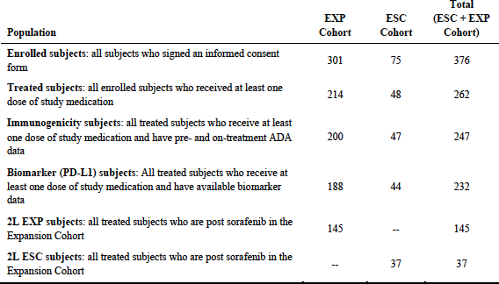
Of the second line ESC cohort, 9 of 37 patients received the same dose as subjects in the EXP cohort (that is 3 mg/kg Q2W), therefore 9 patients from the second line ESC cohort inform the proposed usage in addition to the 145 subjects in the second line EXP cohort. Safety data for the 9 relevant subjects from the second line ESC cohort have not been presented separately.

Locations (study centres) at time of the interim CSR
- Second line EXP and second line ESC cohorts were enrolled from 35 sites in 10 countries
  - 2L ESC cohort; 4 countries, 37 patients: Hong Kong (12 patients), Singapore (2), Spain (10), United States (13)
  - 2L EXP second-line or post-sorafenib cohort; 10 countries, 145 patients: Germany (18 patients), Hong Kong (12), Italy (4), Japan (26), Republic of Korea (13), Singapore (3), Spain (11), Taiwan (17), United Kingdom (25), United States (16)
- In the 2L EXP and 2L ESC cohorts combined:
  - Europe; 33 (18.1%)
  - UK; 25 (13.7%)
  - US; 29 (15.9%)
  - Asia; 85 (46.7%).

Dates
Table 20: Relevant study dates
Visit | Patient visit date |  | Clinical database lock | BICR assessment Database lock
 | ESC cohort | EXP cohort
First patient first visit | 30 October 2012 | 27 January 2015
Last patient’s first treatment | 8 July 2015 | 28 October 2015
Interim analysis |  |  | 8 August 2016 | 10 August 2016
Addendum 01 |  |  | 29 November 2016 | 12 December 2016
Addendum 02 |  |  | 17 March 2017 | Not stated but CSR indicates that the clinical database lock includes blinded independent central review data
BICR =blinded independent central review; ESC=escalation; EXP=expansion

Inclusion criteria (abbreviated)
- Advanced, histologically confirmed HCC not amenable to curative surgery
- ECOG PS 0 or 1
- Child-Pugh A (B7 allowed in ESC only)
- ≥ 1 measurable lesion per RECIST, no biopsies of it if there’s only 1
- Sample available for biomarker analysis
- Cohort-specific as shown in Table 21.
- Adequate organ and bone marrow function
- Consenting, non-reproductive adults.
Table 21: Cohort specific inclusion criteria
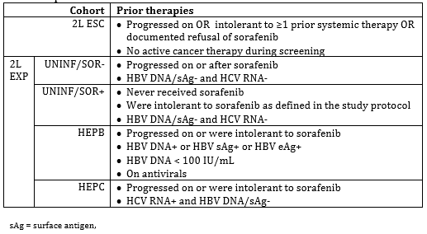

Exclusion criteria (abbreviated)
- Suspected or proven brain metastases
- History of hepatic encephalopathy, ascites requiring paracentesis in last year, clinically meaningful variceal bleeding in last 3 months
- Active co-infection with both HBC and HCV
- Hepatitis D in HEPB arm
- Malignancy in last 3 years unless in situ and treated curatively
- Active, known or suspected significant autoimmune disease or requirement for immunosuppressive medications, HIV or AIDS, allograft or transplant, active infection within 7 days
  - Inhaled or topical steroids and adrenal replacement doses > 10 mg daily prednisone equivalents were permitted in the absence of active autoimmune disease.
- Clinically significant, uncontrolled medical disorders (cardiac)
- Known active drug or alcohol abuse
- Prior checkpoint therapy or T cell co-stimulator therapy
- Toxicity of prior cancer therapy:
  - Persisting neuropathy higher than common terminology criteria AE (CTCAE); grade 2
  - Any other higher than grade 1 (except alopecia or fatigue), unless long lasting sequelae not expected to resolve
- Prior Phase III ipilimumab study participation (blinded)
- Radiotherapy within last 2 weeks
- Other investigational drugs.

Interventions
Second line ESC:
- 0.1 mg/kg (n = 5)
- 0.3 mg/kg (n = 7)
- 1.0 mg/kg (n = 6)
- 3 mg/kg (n = 9); informs the proposed indication
- 10 mg/kg (n = 10).
Second line EXP:
- Nivolumab 3 mg/kg IV Q2W (n = 145).

Dose changes
For both cohorts:
- Dose modifications were not permitted except to adjust for weight changes (> ± 10%).
- Dose reductions were not permitted.
- Dose delays were permitted, up to a maximum of 6 weeks from the last dose.

Treatment beyond progression
Due to the recognition of a pseudo progressive phenomenon with immunotherapies in some patients, treatment after an initial investigator-assessed progression was allowed as long as:
- The investigator assessed there to be clinical benefit
- The subject was tolerating therapy
- Treatment beyond progression would not delay an imminent intervention to prevent serious complications of disease progression (for example, central nervous system metastases).
- Written consent provided
- Treatment to be discontinued if additional progression subsequently seen, defined as 10% increase, including target and new measurable lesions.

Management of hepatic adverse events
Specific protocols were included for management of hepatic events (due to the limited hepatic reserve and hepatitis status of the study population):
- If AST or ALT levels do not improve with a dose delay of 3 to 5 days or if the levels worsen, initiate steroid therapy at 0.5 to 2 mg/kg/day methylprednisolone or oral equivalent.
- For ALT or AST levels > 8 x ULN, initiate steroid therapy promptly at 1 to 2 mg/kg/day methylprednisolone or oral equivalent.
- For all patients initiating steroids, consult the medical monitor within 24 hours after initiation of steroids. Gastroenterology consult is recommended.
- If AST or ALT levels do not improve within 3 to 5 days or the levels worsen after the start of steroid therapy, discuss with the sponsor medical monitor the possibility of adding mycophenolate mofetil at 1 g twice daily.
- Tapering of steroids can start once AST or ALT levels have declined by 1 CTCAE grade.
- Taper steroids slowly over no less than 1 month.
These instructions are included in the proposed PI changes with the exception of the instruction regarding mycophenylate which was only used in two patients during the study.

Endpoints
Table 22: Endpoints in the ESC and EXP cohorts of Study CA209040
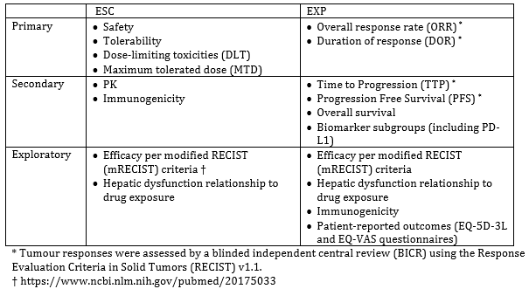

Tumour measurements
Tumour assessments in all cohorts (except the first line nivolumab versus sorafenib cohort) were undertaken every 6 weeks (± 2 days) for the first year, and then every 12 weeks thereafter until disease progression.

Disposition
Table 23: Patient disposition; all treated patients in the second line EXP and second line ESC cohorts as of 17 March 2017, including patients treated beyond progression
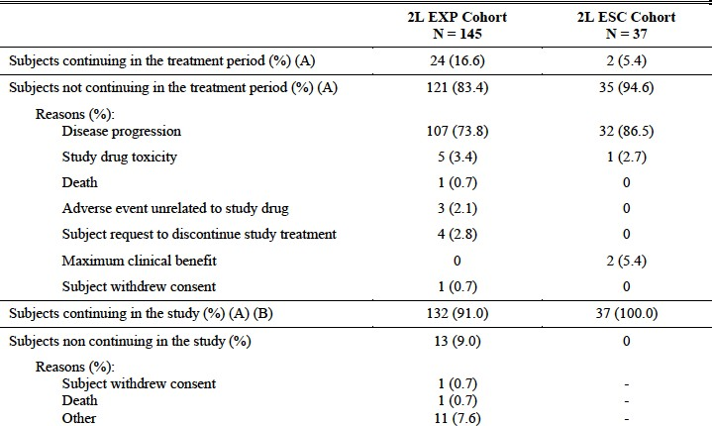

Baseline characteristics
The baseline characteristics of the second line EXP and second line ESC cohorts are outlined in Table 24. The baseline disease characteristics of the second line EXP and second line ESC cohorts are outlined in Table 25. There were 12 patients with recorded tyrosine kinase inhibitor intolerance included in the second line EXP cohort (8.3%). Whether the 1 patient who was sorafenib intolerant in the second line ESC cohort was treated with a 3 mg/kg dose is not clear.
Table 24: Baseline demographics of the second line ESC and second line EXP cohorts in Study CA209040
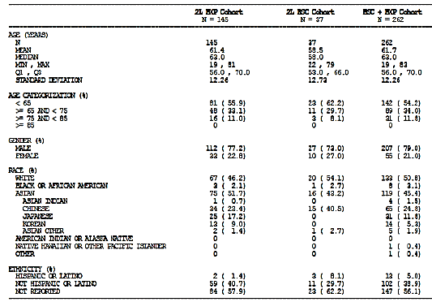
Table 25: Baseline disease characteristics of the second line ESC and second line EXP cohorts in Study CA209040
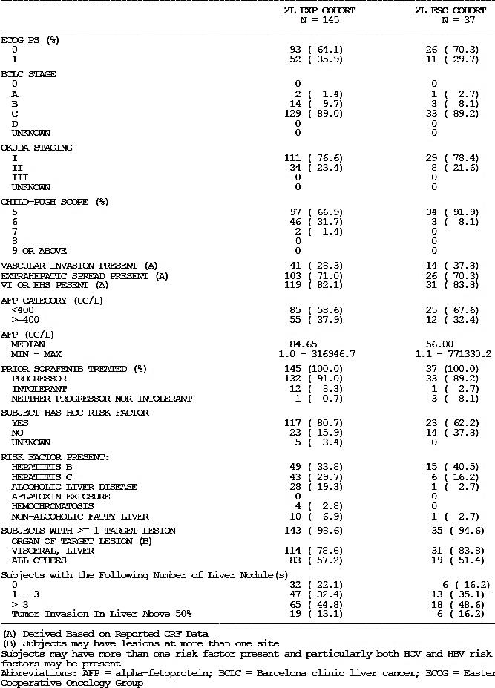
Table 26: Baseline characteristics across three trials in HCC patients second line after sorafenib
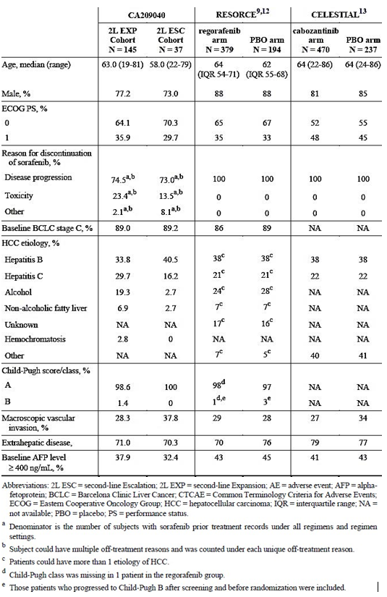
Refs: 9;¹², 12;, 13;

Efficacy
Detailed efficacy results per RECIST 1.1 by BICR in Study CA209040 second line ESC and second line EXP cohorts are outlined briefly:
- Second line EXP cohort: co-primary endpoint BICR assessed ORR per RECIST 1.1 criteria and duration of response (database lock 17 March 2017, minimum follow up around 15 months):
  - ORR 14.5% (21 or 145 patients) [95% CI: 9.2 to 21.3], including two complete responders (1.4%)
    - In the subgroup of uninfected patients without hepatitis infection or any history of it (n = 54), the ORR was 9.3%
    - Eight patients were not evaluable due to not having imaging (4 patients), not having reached RECIST 1.1. criteria for imaging (2), or ‘not reported’ (2)
    - PD-L1 subgroups (hypothesis-generating, based on subgroup size) trended towards higher ORRs with higher PD-L1 expression.
  - Median duration of response in responders (9 events in 21 responders) was 16.59 months (95% CI 9.69, NA).
- Second line ESC cohort: blinded independent central review assessed efficacy was an exploratory endpoint
  - ORR in all second line ESC patients was 18.9% (7 of 37 subjects) [95% CI: 8.0 to 35.2], including 1 complete response (2.7%)
    - Not all of the second line ESC cohort were treated with the proposed dosage: 9 patients from this cohort were treated with the proposed dosage and can be considered to inform this result. In this 3 mg/kg dose subgroup, the ORR was 11.1% (1 of 9 patients) including one complete response
  - Median duration of response in responders (5 events in 7 responders) was 19.4 months (95% CI: 2.83, NA).
For ORR, concordance between the investigators and blinded independent central review was 87.6% for the second line EXP cohort and 89.2% for the second line ESC cohort.
Interim OS results from a confirmatory Phase III trial in the first line setting compared to sorafenib are expected in Q3 2018, based on current event rates and projections. This data would assist in confirming whether clinical benefit is seen on survival outcomes in the first line setting, and if positive, would be reassuring that the ORR/duration of response effect seen in the second line single-arm trial setting is likely to reflect clinically meaningful benefit.
Table 27: Responses per BICR in second line EXP and ESC cohorts
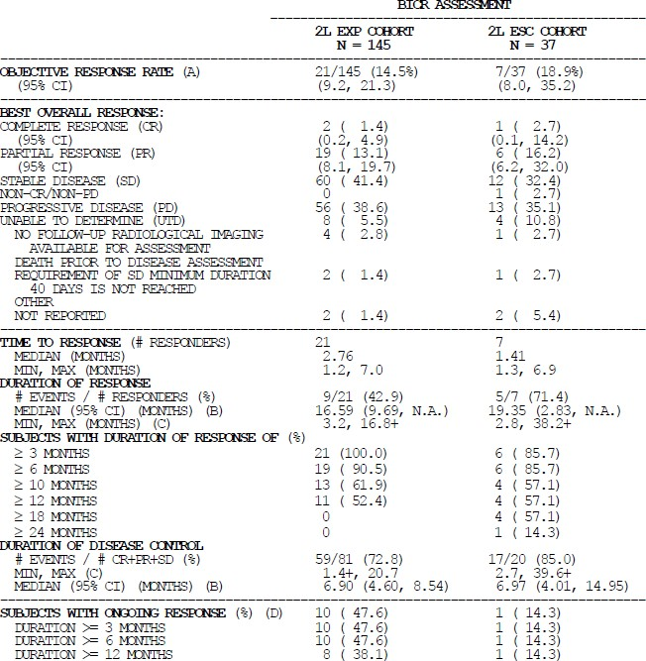
Table 28: Responses per blinded independent central review in overall second line ESC and second line ESC by dose cohorts of Study CA209040
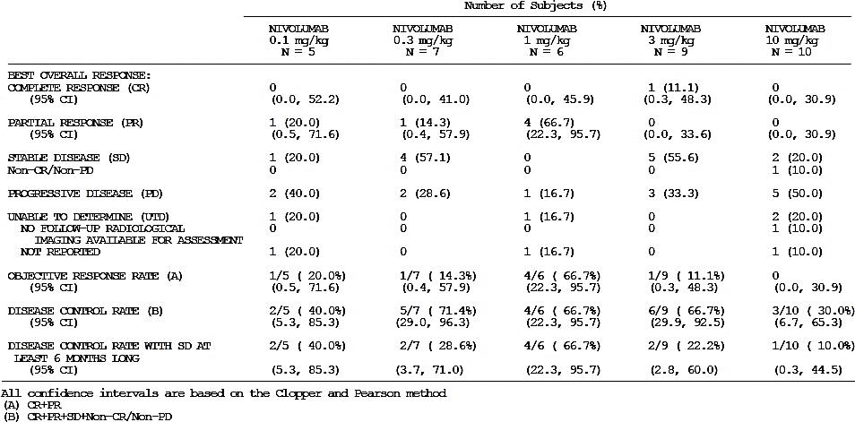

Validity of objective response rate as a surrogate outcome
In response to the concerns expressed by the EMA that objective response rate (ORR) may not translate into survival advantage (and that this has been the case between Phase II and Phase III for a number of prior trials in second line HCC), the marketing authorisation holder (MAH) in the EMA provided a landmark analysis to the EMA, which is recorded in the CHMP withdrawal assessment report (reproduced below as Figure 4).
As stated by the by the European marketing authorisation holder, according to the CHMP withdrawal assessment report:
‘To further highlight the potential for ORR with durability to correlate with OS, a landmark analysis of OS by responders versus non-responders at 4.5 months was conducted. Given that most responses to nivolumab occur within the first 3 months, the 4.5 month landmark was selected to allow up to 3 months (2 scans at Q6 week intervals) for subjects to respond and an additional 1.5 months to allow a follow-up scan to confirm the response’.
Of the 12 responders in the second line EXP cohort, 1 died at 19 months.
Figure 4: Landmark analysis of overall survival by response status per BICR RECIST 1.1; for subjects having survived beyond and including 4.5 months in the second line EXP cohort
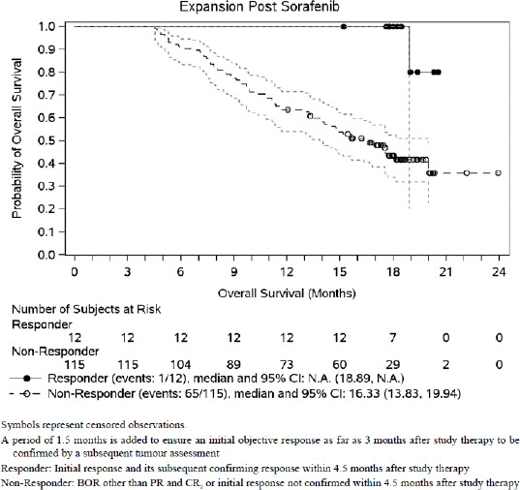
As these data compare responders and non-responders within the same arm, concerns around selection bias should not affect this comparison.

Safety
Safety data for the ESC cohort were not presented separately in the dossier or in the sponsors response, but instead were presented as part of a larger safety set called ‘ESC+EXP’, comprising:
- second line ESC (n = 37)
- second line EXP (n = 145)
- first line ESC (n = 11, doses unknown)
- first line EXP (n = 69)
A separate safety analysis for the patients in the second line ESC is not possible as that data has not been submitted separately from a larger pooled set (the ESC+EXP cohort). The primary safety analysis for the proposed indication therefore relies on the second line EXP cohort, and is supported by the ESC+EXP cohort who were not all pre-treated and therefore may demonstrate better tolerability than the second line patients might.
The sponsor states that in the ESC cohort, there were no drug related deaths, there was no correlation between dose and type/severity of AE, and that no maximum tolerated dose was identified. They state that the 3 mg/kg Q2W dose was chosen based on prior data: anti-tumour activity was highest in melanoma and NSCLC at 3 mg/kg, suggesting a plateau at higher than this dose level.
Nivolumab has been extensively studied in other tumour types and the safety profile is reasonably well established. In HCC patients, additional safety concerns could be predicted to be related to poor underlying hepatic function and viral infection where relevant.
Exposure and adverse event data from Study CA209040 are summarised in the tables below (Table 29 and Table 30).
Table 29: Exposure and dose delays in Study CA209067
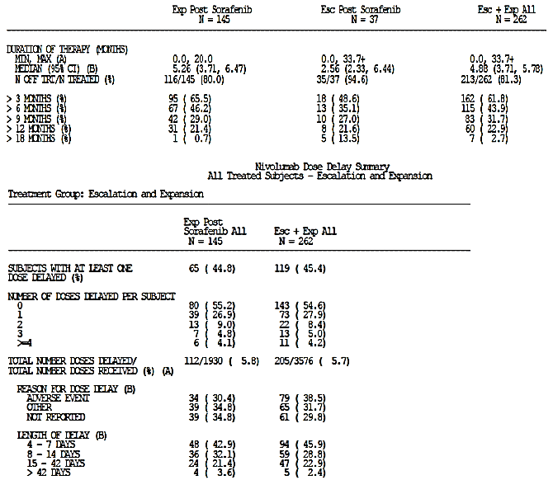
The major precautions listed in the current nivolumab PI are:
- Immune mediated adverse reactions:
  - Immune-mediated pneumonitis
  - Immune-mediated colitis
  - Immune-mediated hepatitis
  - Immune-mediated endocrinopathies
  - Immune-mediated nephritis and renal dysfunction
  - Immune-mediated skin adverse reactions
  - Immune-mediated encephalitis
- Infusion reactions
- Complications of allogeneic haematopoietic stem cell transplant
- Embryo-fetal toxicity
Table 30: Overall safety summary; all treated patients in Study CA 209040
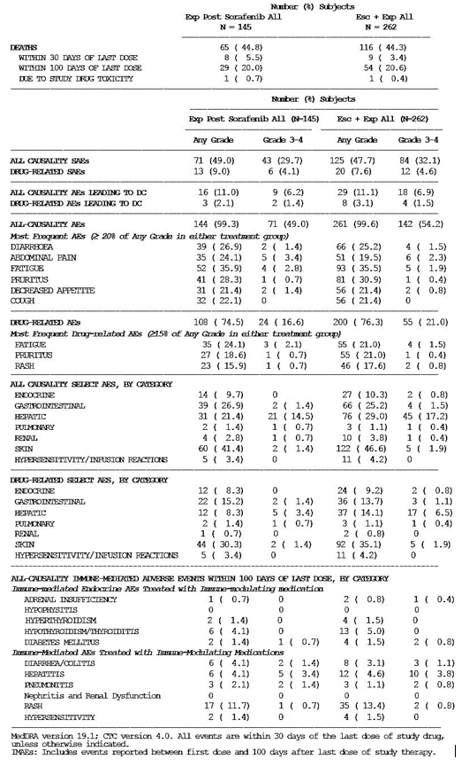
Adverse events in the second line ESC cohort (9 patients) are not reported separately in this dossier. Assessment of possible harms at the proposed dose in the proposed second line usage is therefore based on the second line EXP cohort (n = 145), with supporting data from the pooled ESC+EXP cohort (n = 262, including the 145 from the second line EXP cohort).
The most common adverse events in Study CA209040 (≥ 20%) for both the ESC+EXP and the second line EXP cohort were diarrhoea, abdominal pain, fatigue, pruritus, decreased appetite and cough. Out of the 262 ESC+EXP patients, 4.6% had a grade 3 to 4 serious AE that was deemed to be related to therapy. There was one death that was likely related to treatment; a case of pneumonitis.
The adverse events seen in the second line EXP cohort were similar to those in frequency and severity as outlined in the PI with the exception of elevated transaminases and bilirubin levels. These observations are reflected in the draft PI. There is additional proposed text in the HCC Dose Modification section of the PI to manage this risk in this specific population.

Risk management plan
The TGA has previously agreed that no formal risk management plan (RMP) evaluation would be required for this submission as there were no significant changes to the submitted RMP (RMP version 8.1 and Australian Specific Annex (ASA) version 9.0).

Risk management plan
The summary of safety concerns per the submitted RMP (version 8.1) are as follows:
Table 31: Summary of safety concerns (from the RMP)
Summary of safety concerns
Important identified risks | Immune related pneumonitis  Immune-related colitis  Immune related hepatitis  Immune related nephritis and renal dysfunction  Immune related endocrinopathies  Immune related skin ARs  Other immune related adverse reactions  Severe infusion reactions
Important potential risks | Embryofetal toxicity  Immunogenicity  Cardiac arrhythmias (previously treated melanoma indication only)  Complications of allogeneic HSCT following nivolumab therapy
Missing information | Paediatric patients < 18 years of age  Elderly patients with:  - cHL ≥65 years of age  - SCCHN ≥ 75 years of age  - HCC ≥ 75 years of age  Patients with severe hepatic and/or renal impairment  Patients with autoimmune disease  Patients already receiving systemic immunosuppressants before starting nivolumab  Use in patients who have undergone influenza vaccination  Use in certain subgroups of patients with advanced HCC (ECOG PS > 1, cirrhotic status of Child-Pugh B and C at screening, a history of clinically meaningful variceal bleeding within the last 3 months, uncontrolled or clinically significant cardiac disease, or patients with moderate hepatic impairment at start of nivolumab treatment for HCC)

Risk-benefit analysis

Delegate’s considerations
The data submitted in support of registration of an indication for use in second line treatment of HCC after sorafenib is limited in a number of ways.
Meaningful interpretation of time-to-event endpoints (overall survival (OS)/progression free survival (PFS)) in single arm studies is problematic due to the lack of an internal control group. The only endpoints, therefore, that can be meaningfully interpreted due to the non-comparative design of this study are the objective response rate (ORR) and (to a lesser extent, as this too could be subject to selection bias) duration of response. In the second line EXP cohort, all of whom were treated at the proposed 3 mg/kg Q2W dose, there was an ORR of 14.5% (9.2 to 21.3]) by blinded independent central review, including two complete responses (1.4%), with a median duration of response of 16.59 (9.69, NA) months.
The ORR is likely to reflect some clinical benefit, supported by:
- the presence of two complete responses (the likelihood of seeing such responses in a group of 145 such patients treated with placebo is considered exceedingly small);
- the survival in responders compared to non-responders; and
- the fact that ORR surrogacy for clinically meaningful benefit has been reported with PD-L1 inhibitor therapies in other tumour types.
The size of clinical benefit by comparison to other therapies, however, is uncertain. Cross-trial comparisons can be made and seem promising, but are inherently problematic.
At the time of submission, there were no available therapies registered by TGA for use in HCC after the failure of first line sorafenib. Since that time, regorafenib has been registered for second line HCC after the failure of sorafenib. However, no patients intolerant of sorafenib (or for whom use of a tyrosine kinase inhibitor was clinically inappropriate) were included in the Phase III trial that compared regorafenib to placebo in second line HCC. Additionally, there are no registered therapies for HCC patients who have been treated with two or more prior lines of therapy.
Therefore, even if the magnitude of benefit compared to existing therapies in second line HCC is not clear, given that there are some patients for whom no other therapies are available (third line, tyrosine kinase inhibitor intolerant), the clinical activity suggested by the presence of responses including two complete responses is considered important.
It is not clear whether any responses were seen in the subgroup of patients who were sorafenib intolerant (n = 13) or discontinued sorafenib for toxicity reasons rather than progression (around 25% of Study CA209040), or who had previously been treated with two or more systemic therapies. The sponsor has been asked to provide this data; although these subgroups are very small.
Interim OS results from a confirmatory Phase III trial in the first line setting compared to sorafenib are expected in the third quarter of 2018, based on current event rates and projections. This data may provide reassurance that the ORR/duration of response effect seen in the second line single-arm trial setting is likely to reflect clinically meaningful benefit, and will provide a study in which internal comparison provides insight into the comparative efficacy of these therapies. If a detriment on time-to-event endpoints was seen in this trial with nivolumab, the risk-benefit balance of nivolumab in the second line setting relative to tyrosine kinase inhibitors would have to be questioned.
The safety profile of nivolumab in HCC from the limited available data appears to be consistent with that for other tumour types with the exception of elevated transaminases and bilirubin. Nivolumab is prescribed by experts in the use of oncology medicines. The safety profile for its use in other cancer types is reasonably well characterised, with extensive management guidelines included in the PI for recognition and management of immune-mediated adverse reactions. Warnings regarding severe and fatal immune mediated adverse reactions also exist in the current nivolumab product document, including a black box warning. PI changes made during this submission should reflect the uncertainty inherent in the data due to lack of a control arm.
There was one treatment-related death (pneumonitis), during the pivotal study. Immune related hepatitis (treated with steroids) occurred in 5% (12 of 262) of HCC patients. Given the small sample size, it is difficult to determine whether this is materially different from the 2% incidence reported in other tumour types. It is lower than the 13% incidence of hepatitis reported with nivolumab + ipilimumab combination therapy.
Expert clinician input has been sought as to whether the available data (with associated uncertainty) would be likely to be acceptable to patients that is a benefit of uncertain size and a reasonably well characterised risk profile (including possibly fatal adverse events) in a setting of limited alternatives.

Conditions of registration
If this submission was to be approved, the conditions of registration should include submission to the TGA of the results of studies mandated by FDA as part of the accelerated approval of this indication for nivolumab, as described in the FDA letter of approval:
- Confirmatory trial:
Results from ‘a multicenter, randomized trial or trials to verify and describe the clinical benefit of nivolumab over standard therapy based on an improvement in overall survival in patients with advanced hepatocellular carcinoma’
Expected trial completion: December 2019
- Post market confirmatory data:
The final report from Checkmate-040 [trial] for ‘patients with hepatocellular carcinoma who have progressed on, or are intolerant to sorafenib and who received nivolumab 3 mg/kg in the dose escalation or dose expansion phase’ … ‘In order to further characterize the duration of response in patients who achieve a complete or partial response to nivolumab, duration of response will be assessed by independent central review and responding patients will be followed for at least 12 months from the onset of response.’
Expected trial completion: November 2018

Conclusion
The key evidence for efficacy in this indication comes from a single arm cohort of 145 patients with HCC who were enrolled in the expansion (EXP) cohort of Phase I/II Study CA209040 and had previously progressed on or were intolerant to sorafenib therapy (second line EXP). Patients treated with two or more prior systemic therapies were not excluded. With nivolumab therapy, according to BICR, an ORR of 14.5% and a median duration of response of 16.59 months (95% CI 9.69, NA) was seen. Two complete responses were reported.
The data is limited by the single arm design of the study, and the size of the benefit in terms of clinical significance is therefore not clear. Time to event endpoints such as OS and PFS are of limited use in a single arm setting due to the lack of an internal comparator group. The EMA had concerns that the median OS of 16 months may reflect a selection bias in the study.
The FDA gave this indication accelerated approval, based on the same data, on the basis of ORR and duration of response. ORR has been seen to translate into clinical benefit in other tumour types with use of PD- L1 inhibitors.
The sponsor’s position is that this is an area of unmet need (particularly in subjects who’ve been treated with two or more prior therapies, or for whom tyrosine kinase inhibitor therapy is not tolerated or appropriate), and that in addition, this therapy provides an alternative treatment option with a different risk profile to existing options in second line HCC (that is a tyrosine kinase inhibitor).

Proposed action
The Delegate was not in a position, at this time, to decide whether or not the indication proposed by the sponsor should be approved.

Request for ACM advice
The committee is requested to provide advice on the following specific issues:
- Taking into account the limitations of the available data, do you consider the risk-benefit balance of nivolumab therapy would be positive for some patients in the setting of second line HCC?
- Please comment on the risk of immune hepatitis in this setting.

Response from sponsor
In Study CA209040, nivolumab has shown clinically meaningful BICR assessed confirmed ORR per RECIST 1.1 in sorafenib treated subjects which is supported by durable responses and clinically meaningful OS (median 15.6 months) relative to the median OS observed with best supportive care (BSC) (7 to 8 months) and regorafenib (10.6 months). In addition, nivolumab has demonstrated an acceptable and manageable safety profile that is consistent with that established across various tumour types with the exception of elevated transaminases and bilirubin, reflective of an advanced HCC population. The data presented by the sponsor support the use of nivolumab in addressing the high unmet medical need in subjects with HCC after prior sorafenib therapy. Expert statements received by the sponsor provide clinical insights into treatment considerations in Australia and unanimously endorse the clinically relevant efficacy and favourable tolerability profile for nivolumab as a second line therapy in HCC. For example, [information redacted] concludes in their statement that ‘the risk benefit for many patients when balancing tolerability versus stabilisation of tumour progression would support the use of nivolumab.’
In recognition of the trial design, the sponsor agrees to amend the proposed indication statement per the suggestion in the Delegate’s overview:
From indication in original application
Opdivo, as monotherapy is indicated for the treatment of adult patients with hepatocellular carcinoma after prior sorafenib therapy. The approval of this indication is based on ORR and duration of response. See Clinical Trials.
to the revised indication:
Opdivo, as monotherapy is indicated for the treatment of adult patients with hepatocellular carcinoma after prior sorafenib therapy. The approval of this indication is based on ORR and duration of response in a single-arm trial.
As part of the TGA process for seeking independent expert external advice, the sponsor has also received independent external expert statements from hepatocellular carcinoma treating clinicians (an oncologist, hepatologist and gastroenterologist) who have an expert knowledge and experience in managing Australian patients, including with immuno-oncology agents. Expert statements from these experts are included with this pre-ACM response. These statements provide clinical insights into treatment considerations in Australia and unanimously endorse the clinically relevant efficacy and favourable tolerability profile for nivolumab as a second line therapy in HCC. In order to address the questions for the sponsor from the TGA Delegate, a separate response was provided (see above).
The Delegate has indicated that discussions on the product information content with the sponsor will occur once ACM guidance and expert clinical advice are available.
A Periodic benefit risk evaluation report (PBRER) for Opdivo is not included in this response as the most recent version covering the period 4 July 2017 through 3 January 2017 was submitted to the TGA on 16 March 2018.

Introduction
Outcomes are dismal for patients with second line HCC who receive BSC (median OS of 7 to 8 months). Indeed, estimates from the Australian Burden of Disease Study; have shown between 2003 and 2015, years lost due to treatable diseases decreased for all indications, except liver and pancreatic cancer and chronic liver and kidney disease. The rate of fatal burden in persons with liver cancer increased by 40.6% between 2003 and 2015 (in comparison lung cancer and melanoma of the skin decreased by 15.2% and 13.6% respectively, in the same time frame). Tyrosine and multi-kinase inhibitors including regorafenib have been shown to extend OS by approximately 3 months; however, there are associated safety and tolerability issues that significantly impact treatment decisions and patient quality of life. Thus, there remains significant unmet need for effective and well-tolerated therapies for patients with HCC and which provide a modality for treating the disease that is not based on inhibition of kinase pathways.

Questions raised by the delegate for response

Question 1
Taking into account the limitations of the available data, do you consider the risk-benefit balance of nivolumab therapy would be positive for some patients in the setting of second line HCC?

Clinical relevance and justification of the Study CA209040 design
Study CA209040 was originally started as a Phase I, II and III dose escalation design to explore safety and anti-tumour activity of nivolumab across uninfected, HCV infected, and HBV infected subjects (ESC cohort). After observing investigator assessed responses across all subtypes and establishing safety up to 10 mg/kg in the escalation cohort, the study was expanded to add a Phase II part with a primary endpoint of ORR in 4 additional cohorts of 50 subjects each (EXP cohort). Combined with the observation that anti-tumour responses in HCC can correlate with OS, the sponsor concluded that in the absence of an approved standard of care in the second line HCC setting, a single arm design had the potential to demonstrate clinical benefit and was justifiable as the disease course for such patients is predictable and invariably fatal in a matter of months.
In addition, the sponsor subsequently initiated plans to establish the safety and efficacy of nivolumab in sorafenib naive patients in a large, randomised Phase III Study CA209459 (nivolumab versus sorafenib in first line advanced HCC). Interim analysis for OS from Study CA209459 is anticipated in 3Q 2018.

Clinically meaningful size of benefit compared with regorafenib
The TGA have noted that since the time of submission of the application, regorafenib has been approved for use in a second line treatment option. Although clinical experts have confirmed that regorafenib is not standard of care therapy today, the sponsor has nonetheless compared the efficacy of nivolumab to regorafenib, acknowledging the difficulties inherent to the clinical trials comparison. Of note, baseline demographic characteristics between Study CA209040 and the Phase III regorafenib RESORCE trial are similar (see Table 32). In addition, nivolumab compares favourably to regorafenib with compelling ORR, duration of response, and OS data (Table 33), as well as when indirectly compared to other published data including sorafenib in the first line setting and chemotherapy (Table 34).
Table 32: Demographics and baseline disease characteristics across Studies CA209040, RESORCE, BRISK-PS, REACH, and EVOLVE-1 HCC trials
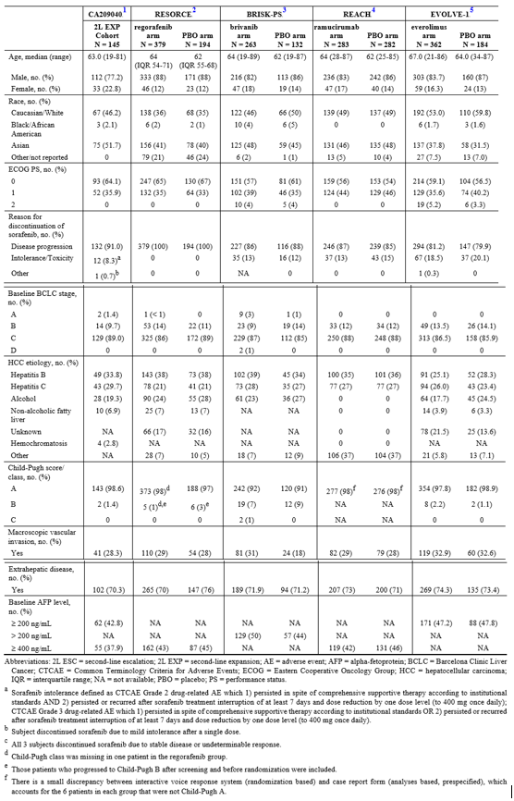
Table 33: Comparison of key efficacy data of Study CA209040 second line EXP cohort subjects to RESORCE trial (regorafenib) subjects
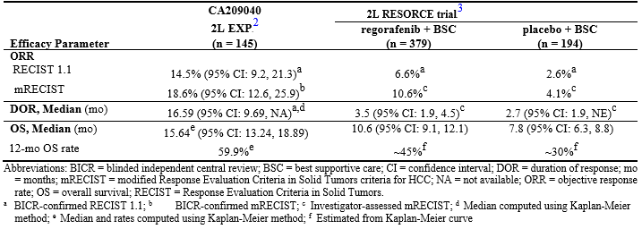
Table 34: Comparison of key efficacy data of Study CA209040 second line EXP cohort subjects to historical data
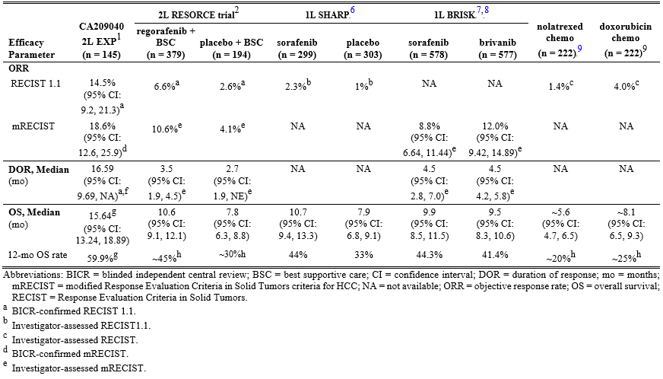

Adjusted comparison of overall survival in nivolumab second line EXP cohort subjects versus regorafenib provides additional support for clinically meaningful size of benefit
The TGA have indicated some of the difficulties with cross-trial comparisons. Therefore, the sponsor has conducted an analysis to adjust for relevant potential confounders using a post-hoc matching adjusted indirect treatment comparison (MAIC) method;,, to indirectly compare second line EXP cohort subjects to regorafenib-treated subjects (n = 379).
3F
4F
Cox proportional hazards regression models adjusting for age, gender, region, viral aetiology, and ECOG performance were determined to be the best fit by backwards selection. Patients treated with nivolumab were more likely to survive (hazard ratio: 0.600 (95% CI: 0.452 to 0.796); p = 0.0004) (Figure 5). Although the sponsor recognises the limitations associated with these analyses (for example, inability to adjust for unmeasured confounders, lack of adjustment for trial effects, no adjustments for multiple comparisons), nevertheless, indirect OS comparisons highlight the potential for improved survival of nivolumab in advanced HCC.
Figure 5: Kaplan-Meier plot treatment comparison using overall survival data for nivolumab adjusted (weighted) and unadjusted (unweighted) with respect to the RESORCE trial regorafenib treatment group
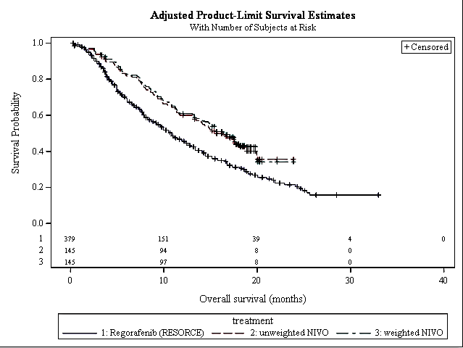

Complete responders further support clinical benefit of nivolumab
Complete responders are exceptionally rare in advanced HCC clinical trials and the results of Study CA209040 highlight the potential for significant clinical benefit for nivolumab in a subset of patients. In Study CA209040, within the 145 second line EXP cohort subjects and 9 second line ESC cohort subjects treated with 3 mg/kg nivolumab, there were a total of 3 of 154 (1.9%) blinded independent central review confirmed complete responders by RECIST1.1 and 5 of 154 (3.2%) BICR-confirmed complete responders by mRECIST (Table 35).
6
Table 35: Comparison of the frequency of complete responders in second line clinical trial subjects
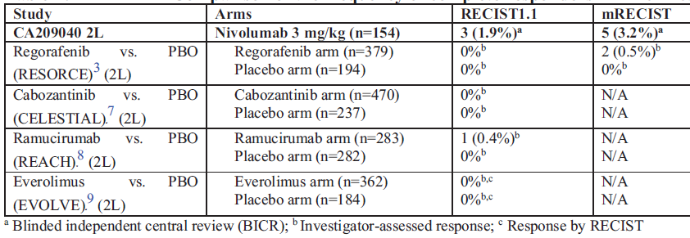PBO placebo refs 3²⁵, 7, 8, 9
Complete responders, even in the setting of advanced malignancies, may occur in a subset of patients due to the unique mechanism of action for nivolumab which allows for the activation of memory T-cell clones that recognise tumour antigens expressed irrespective of histology or organ of origin, thereby resulting in deeper responses and long-lasting duration of response than for therapies directed at the tumour itself, such as tyrosine kinase inhibitors/multi-kinase inhibitors and cytotoxic chemotherapies. As shown in Table 35 above, the frequency of complete responders observed with a variety of tyrosine kinase inhibitors in a second line setting is exceedingly rare and much lower than that reported in Study CA209040. Furthermore, it must be highlighted that most of the comparisons to historical data are based on investigator-assessments and therefore do not have the same level of robustness as the blinded independent central review data from Study CA209040. In addition, the data for tyrosine kinase inhibitors are in the range for spontaneous remission rate reported by Oquinena and colleagues;,who estimated the value by collating data from ten randomized controlled trials involving 1,640 patients with HCC. Based on the incidence of regression in the control groups, spontaneous objective partial regression among patients with HCC was calculated to be 0.406% (95% CI: 0.067 to 1.043). Taken together, the data from Study CA209040 and the higher reported frequency of complete responders versus best standard of care and regorafenib provide additional evidence to support the large magnitude of benefit for nivolumab in patients with HCC following prior sorafenib therapy.

Second line subjects benefit regardless of prior sorafenib progression or toxicity, supporting utility across subgroups
The Delegate has asked the sponsor to provide subgroup response rates. In summary, ORR was comparable across all subgroups including those who discontinued sorafenib due to disease progression (14.8%), any reason other than progression (13.2%), study drug toxicity (14.7%), or sorafenib intolerance per protocol definition (11.6%). The ORR for subjects previously treated with more than one prior systemic therapy was 7.4%. Overall these results support the requested indication and confirm that all subjects with prior sorafenib treatment may derive clinically-meaningful benefit from nivolumab; no particular subgroup has an improved benefit compared to the overall second line EXP population.

Clinical benefit in Study CA209040 observed in responders and non-responders
As mentioned by the TGA Delegate, the EMA had a concern that the Study CA209040 population was not comparable to historical controls due to the high median OS in non-responders. To address this concern, the sponsor has performed additional analyses for second line EXP subjects to highlight that OS directly correlates with best objective response and the amount of anti-tumour activity with nivolumab. Median OS from the March 2017 database lock was not available for responders, 17.51 months for subjects with stable disease, 9.3 months for subjects with progressive disease, and 2.53 months for subjects not evaluable (Figure 6).
Figure 6: Kaplan-Meier plot of overall surival by best overall response per BICR RECIST 1.1 criteria
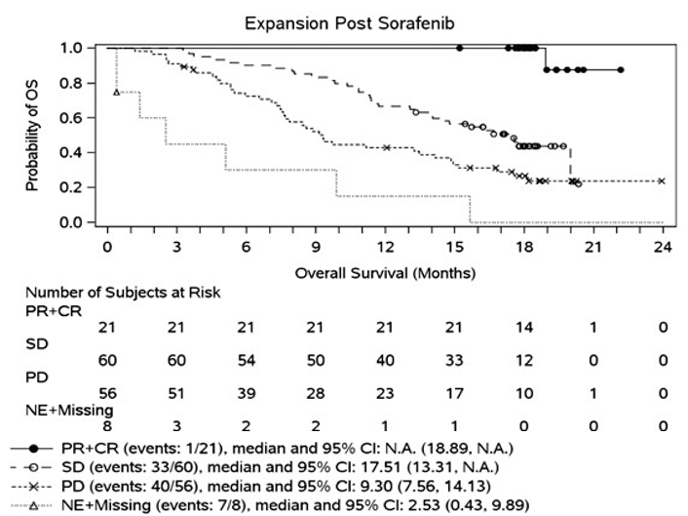
Combined with an acceptable safety profile as outlined in the section below, these data suggest that even in non-responders nivolumab demonstrates clinically meaningful improvements in OS when compared to other clinical trial data as shown in Table 34.
Furthermore, even among the subjects with a best objective response of progressive disease (n = 56), 11 subjects (20%) had ‘non-conventional benefit’ and met at least one of the three following criteria:
- Progression in new lesions followed by decrease in target lesions of at least 10% (6 patients)
- Progression in target lesions followed by decrease in target lesions of at least 30% (3 patients)
- Progression in target or new lesions followed by stabilization defined as less than 10% additional increase in sum of target lesions and measurable new lesions (2 patients).
In summary, these data indicate robust anti-tumour activity in a variety of patients regardless of response status with longer survival correlating with best objective response.
Although the EMA questioned the validity of ORR as an endpoint, in general, sponsor data with nivolumab show that ORR and its related duration of response translate to an OS benefit in multiple other tumours. In addition, the Delegate states that ORR is likely to reflect clinical benefit based on its translation to OS in multiple tumour types, presence of complete responders and survival in responders compared to non-responders. However, the Delegate has identified that it is the size of the clinical benefit which may be uncertain. The sponsor deems that the analyses presented above comparing nivolumab to and regorafenib demonstrate a clinically meaningful benefit with nivolumab including size of effect, durability of response, complete responses and utility across subgroups.
Expert statements received by the sponsor have attested to these different dimensions of the efficacy seen with nivolumab in HCC. Consultant medical oncologist [information redacted] states:
‘we see that patients not only have the opportunity to have disease control and response, they also have prolonged disease control beyond that expected of best supportive care which is current standard of care’.
Additionally, [information redacted], a consultant hepatologist, states:
‘While the ORR was under 20% (partial response + complete response) a high proportion of those patients had prolonged responses over the follow-up period. It is my belief that this is clinically meaningful, and has not been seen with previous systemic therapies where prolonged responses are rarely seen and complete responses have only been rarely reported.’

Safety profile of nivolumab in advanced HCC is well established and manageable
The overall safety profile of nivolumab is consistent with expectations based on prior data in other indications, in terms of the type and severity of reported events. No new safety concerns were identified. As summarised by the TGA Delegate, the adverse events seen in the second line EXP cohort were similar to those in frequency and severity as outlined in the Australian PI with the exception of elevated transaminases and bilirubin levels. [Information redacted] confirms the favourable tolerability profile for nivolumab ‘The benefit of immunotherapy over and above other systemic agents, particularly the tyrosine kinase inhibitors is that the tolerance for the vast majority is excellent.’

Recommendation for nivolumab in National Comprehensive Cancer Network Guidelines for HCC and nivolumab as standard of care in the US
National Comprehensive Cancer Network (NCCN) guidelines now recommend regorafenib or nivolumab for advanced HCC patients who progress on or after sorafenib. Since approval of nivolumab in second line advanced HCC in the US (22 September 2017), Opdivo has quickly become the most widely used treatment for this patient population. Market analyses indicate that in the US, Opdivo is filling an unmet medical need and uptake by providers has been rapid. As of mid-January 2018, Opdivo is being used in 78% of patients starting second line HCC treatment, whereas Stivarga (regorafenib) is being used in only 14.6% of patients starting second line setting (data on file). In Australia, the sponsor has seen a disproportionately high interest and uptake in the Patient Access Programme for nivolumab in HCC compared with other tumours, and particularly so after Study CA209040 was published.
9F

Question 2
Please comment on the risk of immune hepatitis in this setting?
The risk of IMAE of hepatitis and its clinical features in advanced HCC patients in Study CA209040 are comparable to what has been observed in the overall nivolumab program. As shown in Table 36, hepatic immune mediated AEs in Study CA209040 are infrequent (observed in approximately 4% of subjects), occur early on treatment, are manageable and reversible with steroid treatment, and do not typically result in permanent discontinuation of study drug. In addition, within the second line EXP subjects in Study CA209040, there was no enrichment for hepatic immune mediated AE in virally-infected subjects: uninfected (5 of 72 subjects, 7%), HCV infected (1 of 30, 3%), and HBV infected (0 of 43, 0%). In addition, the proposed Australian PI describes management of immune-related hepatitis for non HCC and HCC patients (who may have higher liver enzyme elevations at baseline).
11F
12F
This management algorithm is aligned with the guidance in the US PI and based off the guidance from the nivolumab HCC program in Studies CA209040 and CA209459. Moreover, for any immune mediated AE that is not responsive to steroids or if the clinical scenario worsens, the Australian PI has a recommendation in Section 4.4 (Special Warnings and Precautions for use) which states: ‘Non-corticosteroid immunosuppressive therapy should be added if there is worsening or no improve despite corticosteroid use’. This concept is consistent with recent clinical guidelines for management of IMAEs (ASCO/NCCN; ESMO; and SITC;).
The sponsor is of the view that it is more appropriate that such guidelines are used by clinicians to identify individual immunosuppressants for consideration. Taken together, these data suggest that HCC patients treated with nivolumab are not at greater risk of immune-mediated hepatitis relative to other tumour types, and the guidance in the Australian PI is appropriate for management.
Table 36: Clinical features of immune-mediated hepatitis in advanced HCC patients in Study CA209040 versus nivolumab monotherapy from approved indications
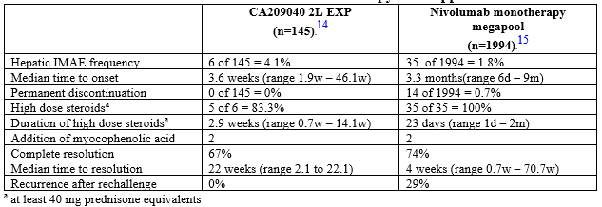
[Information redacted] states that ‘The data from CHECKMATE [trial] indicate that autoimmune hepatitis is an uncommon immune-related adverse event. It did not appear to be more common than in studies of other cancer types.’ Furthermore, [information redacted] also confirms that the Australian Liver Association is developing consensus guidelines for HCC management in Australia where checkpoint inhibitors will be considered including monitoring and management of side effects as a resource and support for local clinicians.

Conclusion
Nivolumab, an agent with a novel mechanism of action compared to tyrosine kinase inhibitors, offers compelling efficacy and OS benefit, and a favourable safety profile to patients with a very high unmet medical need despite available treatment options.
Consistent with other nivolumab indications (NSCLC, SCCHN, and melanoma), higher response rates with longer durability translate into clinical benefit compared with chemotherapy. In Study CA209040, the median OS of 15.64 months compared favourably to that described in comparable study populations with regorafenib (median OS of 10.6 months). In addition, a higher frequency of complete responders versus best standard of care was reported.
The tolerability profile over other systemic therapies is favourable for nivolumab with no increased reporting of immune-mediated hepatitis in HCC relative to other tumours.
Thus, the benefit-risk assessment for nivolumab is favourable and improved compared to best standard of care or regorafenib in this advanced/unresectable or metastatic HCC population. Indeed, statements from expert clinicians in the treatment of HCC, based on the results from Study CA209040, consider nivolumab as an important alternative to tyrosine kinase inhibitor- based therapy that provides a new modality in treating HCC.
Therefore, in spite of the limitations of not having a control group, the clinically meaningful and durable responses observed in Study CA209040 drove the sponsor’s decision to pursue registration as the data suggest that patients receiving treatment with nivolumab have the opportunity to derive clinically meaningful benefit with improved tolerability, addressing a significant unmet medical need in second line therapy for HCC.
The sponsor agrees to submit the final results from Studies CA209040 and CA209459 when they become available.

Advisory Committee Considerations
The Delegate after receipt of the sponsor’s pre ACM response withdrew the request to refer this application to the Advisory Committee on Medicines (ACM) for advice.
The Delegate however had sought external expert advice and provided a summary of that advice for the record as follows.

Background
This submission proposes the following new indication for nivolumab:
Opdivo, as monotherapy is indicated for the treatment of adult patients with hepatocellular carcinoma after prior sorafenib therapy. The approval of this indication is based on objective response rate and duration of response in a single-arm trial.
The following documents record TGA summaries of the details of the submission, issues and expert advice to date:
- Delegate’s overview
- Summary of expert advice received by TGA.
In addition, the sponsor’s pre-ACM response was submitted to the TGA (see below) with answers to some Delegate questions (the submission was withdrawn from ACM as expert advice was received prior to the ACM that provided sufficient information to guide a decision).

Summary of delegate reasoning

Benefits and uncertainties
Standard first line systemic therapy of hepatocellular carcinoma (HCC) is the tyrosine kinase inhibitor sorafenib.
Study CA209040 (the pivotal trial) is a single arm trial of nivolumab therapy in HCC, consisting of a dose escalation (ESC) phase and an expansion phase (EXP), both of which contained patients who had progressed on or were intolerant of sorafenib (second line), as well as patients who were previously not systemically treated for their HCC (first line). Uninfected, HCV infected, and HBV infected subjects were included.
The primary data set supporting the indication is the second line EXP cohort (n = 145), whilst an additional 9 patients in the second line ESC cohort were treated with the proposed dosage (used in the EXP cohort) of 3 mg/kg once every two weeks.
Efficacy in the second line EXP cohort was as follows according to blinded independent central review:
- Overall response rate (ORR) 14.5%
- Median duration of response (DOR) of 16.59 months (95% CI 9.69, NA)
- Two complete responses (CR)
The data is limited by the single arm design of the study, and the size of the benefit is therefore not clear. Time-to-event endpoints such as OS and PFS are not useful in a single arm setting due to the lack of an internal comparator group.
The EMA had concerns that the median OS of 16 months in non-responders may reflect a selection bias in the study and that responses in this setting may not be reflective of clinical benefit. In the past decade there have been eight other therapies that showed Phase II data suggestive of benefit that failed to translate in Phase III studies. However, the duration of responses seen in the current study, the presence of 2 complete responses and the fact that early phase data on anti-PD-L1 therapy has translated into clinical benefit in a large number of other tissue types is reassuring.

Risks and uncertainties
Risks of nivolumab therapy in other settings are well characterised, and the most significant concern is immune related AEs. These can be severe and even or fatal if not recognised and treated early, and some do not appear to be reversible.
Expert clinicians in the treatment of other cancers have more experience with the use of immunotherapies (such as melanoma), but the inclusion of specific information in the product information including a black box warning (though it is focused on combination therapy with nivolumab), as well as current RMP strategies, should provide sufficient risk mitigation strategies for general immune related adverse reactions.
A significant concern for this population (noted by both the clinical experts sourced by TGA and by the sponsor) is immune related hepatitis. Although large numbers of this event have not been seen in the highly selected patient group in the trial (World Health Organization (WHO) PS 0 or 1, Child-Pugh A), the risk is likely to be higher in a real world 2L HCC setting and particularly in those with worse baseline liver disease. Specific PI labeling is required to highlight this important potential adverse reaction and ensure appropriate monitoring and awareness of the critical nature of early intervention.

Risk-benefit balance
Since this submission was received, regorafenib has been approved by the TGA in second line HCC following progression on sorafenib therapy, on the basis of a controlled Phase III study. Despite the approval of regorafenib, unmet need remains: patients intolerant to sorafenib would also be intolerant to regorafenib and were not included in the regorafenib RCT. The regorafenib 2L trial also excluded patients with 2 or more prior therapies. Additionally, like sorafenib, regorafenib is a tyrosine kinase inhibitor and is associated with similar toxicities. So for patients who progress on sorafenib, although there is now an approved indication for regorafenib based on Phase III data, nivolumab presents a very different toxicity profile and therefore may be a preferred therapy despite the less clear magnitude of efficacy benefit due to lack of internal comparator arm.
Topline Phase III data for a study of nivolumab in first line HCC compared to sorafenib is expected to be available internally to the sponsor in September 2018 (Study CA209459).
For the following reasons, the benefit–risk balance is acceptable, given the uncertainty, subject to an amended note to the indication (see PI wording considerations), and provided top-line confirmatory trial study results are supportive:
- There is evidence of activity in second line HCC patients who have progressed on or are intolerant of sorafenib, but the size of the clinical benefit is not clear.
- Nivolumab presents a different safety profile to regorafenib.
- At the time of submission unmet need was present in the entire second line HCC population.
- In sorafenib intolerant patients, in patients for whom tyrosine kinase inhibitor therapy is contraindicated, and in patients who have been treated with two or more prior therapies, unmet need remains in the HCC population.
- Phase III confirmatory data in the first line setting is expected imminently, and approval of this submission should be contingent on the submission of top line results of this data. Although the full trial will not have been evaluated (and thus, the note to the indication will remain accurate), the top line results will be reassuring of the validity of the surrogate data in representing clinical benefit.

Documents submitted by sponsor in conjunction with pre-ACM response
The pre-ACM response from the sponsor contained five documents, numbered here for ease of reference:
- The formal pre-ACM response (6 pages) plus appendices to the response (9 pages)
- Letters of support from 3 clinical experts sourced by the sponsor (9 pages)
- A response document to the TGA Delegate’s questions (4 pages)
- An ‘Adverse Reaction Update’ containing a line listing of all ‘serious, unexpected’ ADRs reported between 4 January 2018 and 15 April 2018 (21 pages, no grade information provided)
- A document containing a ‘consolidated comparison’ of the Australian PI to the European Summary of Medicinal Product Characteristics (SmPC) and USA label for the three nivolumab applications initially referred to the ACM (submissions PM-2017-02207-1-4, PM-2017-02208-1-4, and PM-2017-02209-1-4).
Documents 4 and 5 were unsolicited, and were also submitted with the pre-ACM response for submission PM-2017-02208-1-4. They will not be discussed further here.

Document 1
The pre-ACM response contains re-iteration of data and arguments made in previously submitted material. Additional between-trial comparisons are provided, recognising the limitations of such, with attempts to account for some possible between trial confounding (such as post-hoc matching adjusted indirect treatment comparison). These analyses are hypothesis-generating.
A Kaplan-Meier analysis of OS according to best overall response is provided (Figure 8 above). However, without an internal control group, any suggestion of an OS benefit is hypothesis generating.
The pre-ACM response from the sponsor notes that whilst regorafenib in second line HCC now has marketing approval in Australia, best supportive care may remain a preferred treatment choice. The toxicities associated with tyrosine kinase inhibitor treatment are likely involved in the decision to choose best supportive care over a second line tyrosine kinase inhibitor.
Regarding the issue of immune-related hepatitis in a HCC population, the sponsor states:
‘The risk of immune-mediated adverse event (IMAE) of hepatitis and its clinical features in advanced HCC patients in Study CA209040 are comparable to what has been observed in the overall nivolumab program.
…hepatic IMAEs in Study CA209040 are infrequent (observed in approximately 4% of subjects), occur early on treatment, are manageable and reversible with steroid treatment, and do not typically result in permanent discontinuation of study drug. In addition, within the second line EXP subjects in Study CA209040, there was no enrichment for hepatic IMAE in virally-infected subjects: uninfected (5 of 72 subjects, 7%), HCV-infected (1 of 30, 3%), and HBV-infected (0 of 43, 0%) (see Table 1.3-1 of the Study CA209040 CSR Addendum 01).
… the proposed Australian PI describes management of immune-related hepatitis for non-HCC and HCC patients (who may have higher liver enzyme elevations at baseline). This management algorithm is aligned with the guidance in the USPI and based off the guidance from the nivolumab HCC program in studies Study CA209040 and CA209459.
… for any IMAE that is not responsive to steroids or if the clinical scenario worsens, the Australian PI has a recommendation in Section 4.4 (Special Warnings and Precautions for use) which states: “Non-corticosteroid immunosuppressive therapy should be added if there is worsening or no improve despite corticosteroid use”. This concept is consistent with recent clinical guidelines for management of IMAEs (ASCO/NCCN, ESMO, and SITC). The sponsor is of the view that it is more appropriate that such guidelines are used by clinicians to identify individual immunosuppressants for consideration. Taken together, these data suggest that HCC patients treated with nivolumab are not at greater risk of immune-mediated hepatitis relative to other tumour types, and the guidance in the Australian PI is appropriate for management.’
An addition to the Adverse Events section of the PI is required to clarify the risk.

Document 2
The letters of support from clinical experts reflected similar opinions to those of the external clinical experts sourced by the TGA. All clinical experts agreed that the risk-benefit balance of approving the new indication was positive, and that immune hepatitis may not pose a large risk but should be paid specific attention as it could be catastrophic and may be more likely in the non-trial setting.

Document 3
The response document provides the following answers to Delegate pre-ACM questions:
Question 1
Would it be valuable to prescribers to include some information in the PI on the usefulness of mycophenylate to manage hepatic AEs, guided by the couple of patients in the trial in whom this was used?
Sponsor response
The sponsor does not feel that it is valuable to provide information in the PI on the usefulness of mycophenolate to manage hepatic AEs. As explained in the pre-ACM response to Question 2, the risk of an immune-mediated adverse event (IMAE) of hepatitis and its clinical features in advanced HCC patients in Study CA209040 are comparable to what has been observed in the overall nivolumab program. As mentioned in the US PI, there are only 2 subjects in the nivolumab monotherapy mega-pool who had an IMAE of hepatitis treated with mycophenolate. Similarly, there is only anecdotal information available from Study CA209040 (2 subjects treated with mycophenolate). Although as described in the ‘Response to request for Information’, the outcomes in these 2 subjects were positive, the sponsor feels there is insufficient information to provide language to providers beyond what is currently proposed for inclusion in the Section 4.4 (Special Warnings and Precautions for use) which states: Non-corticosteroid immunosuppressive therapy should be added if there is worsening or no improvement despite corticosteroid use. Moreover, information to consider additional immunosuppression for any IMAE that is not responsive to steroids is readily available to providers of PD-1/PD-L1 inhibitors in recent clinical guidelines for management of IMAE, including ASCO/NCCN0F1, ESMO,1F2 and SITC,2F3 guidelines. The sponsor is of the view that it is more appropriate that guidelines such as these are used by clinicians to identify individual immunosuppressants for consideration.
Delegate comment
The sponsor’s response is reasonable. Agreed.
Question 2
In the second line EXP cohort, please provide the subgroup response rates in
- Subjects who were recorded as sorafenib intolerant per protocol definitions
- Subjects who had previously discontinued sorafenib for reasons other than disease progression on sorafenib
- Subjects who had previously been treated for their HCC with more than one prior systemic therapy
Sponsor response
Subgroup response rates for questions 2a and 2b are summarised below in Table 37. Of note, ORR was comparable across all subgroups including those who discontinued sorafenib due to disease progression (14.8%), any reason other than progression (13.2%), study drug toxicity (14.7%), or sorafenib intolerance per protocol definition (11.6%). All subgroups have similar ORR with overlapping confidence intervals; therefore, regardless of prior sorafenib treatment and outcomes, second line EXP cohort subjects demonstrate clinically meaningful ORR.
Table 37: Objective response rates per BICR RECIST1.1 criteria in second line EXP cohort subjects
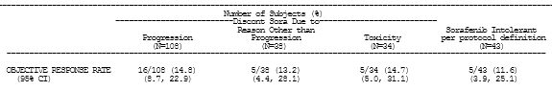
In response to question 2c, ORR for subjects previously treated with > 1 prior systemic therapy (27 of 145 second line EXP cohort subjects) was 7.4% (95% CI: 0.9, 24.3). Although this subset analysis is limited due to small numbers and with overlapping confidence intervals, the ORR in this population may be lower than that observed in the entire second line EXP cohort of 14.5% (95% CI: 9.2, 21.3). These data are not surprising given the subjects with > 1 prior systemic therapy (many of whom are third line) are likely to have had more advanced disease at baseline resulting in a lower ORR.
Since there is no efficacy benefit in any particular subgroup compared with the overall second line EXP population, these subgroup analyses support the proposed indication statement.
Delegate comment
Regarding efficacy in subgroups in whom unmet need remains: the response rates in sorafenib intolerant patients and those discontinuing sorafenib for reasons other than progression are consistent with the overall response rate for the second line EXP cohort. There is also some evidence of activity in later than second line use.
Table 38 Response rates for subgroups of second line EXP cohort subjects
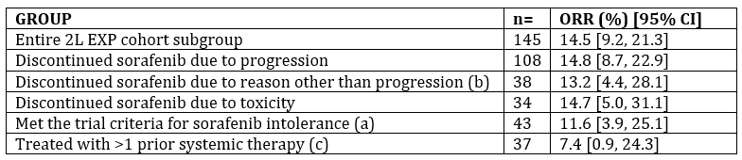
Question 3
Please provide the same subgroup analyses for any patients in the second line ESC cohort who were treated with a 3 mg/kg dose.
Sponsor response
Subgroup analyses for second line ESC subjects treated at 3 mg/kg are listed below in Table 39. Of the 9 2L ESC subjects, 6 discontinued sorafenib due to disease progression, 2 for toxicity, and 1 for other reasons. One of 9 subjects [information redacted] was a complete responder who discontinued sorafenib due to toxicity. In addition, 2 of 9 subjects [information redacted] had sorafenib intolerance per protocol definition, one of whom was a complete responder. Taken together with the information listed above in response to Question 2, these results highlight the potential for any subject with prior sorafenib treatment (including those who discontinue due to disease progression, reasons other than disease progression, study drug toxicity, or sorafenib intolerance per protocol definition) to derive clinically-meaningful benefit from nivolumab.
Table 39: Response rates for subgroups of second line ESC cohort
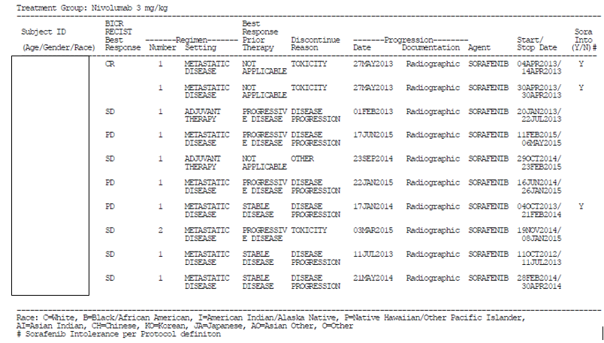
Delegate comment
Of 9 subjects in the ESC cohort who were treated at the proposed dosage, two had previously discontinued sorafenib due to toxicity (one had a best response of complete response and the other a best response of SD) and one had previously discontinued sorafenib due to a reason other than toxicity or progression (this patient’s best response was SD).
This is a very small group but supports that there can be clinically significant responses in patients intolerant to sorafenib, in whom there remains unmet need despite the approval of regorafenib.

Conditions of registration
Approval of the submission should not be processed until topline results of the confirmatory trial in first line HCC (Study CA209459) can be supplied by the sponsor. This will ensure that sufficient reassurance of clinical benefit is present for the entire second line group, not just in the subgroups where completely unmet need remains.
Conditions of registration should include:
- Submission of the CSR for Study CA209459 when available.
The sponsor may in future submit the full study report of the first line trial for formal review if they wish to remove the note to indication regarding the limitations of the fully assessed efficacy data on which this approval is based.

Outcome
Based on a review of quality, safety and efficacy, TGA approved the registration of Opdivo nivolumab concentrate for infusion, indicated for:
Hepatocellular Carcinoma
Opdivo, as monotherapy, is indicated for the treatment of patients with hepatocellular carcinoma after prior sorafenib therapy. This indication is approved based on objective response rate and duration of response in a single arm study. An improvement in survival or disease-related symptoms has not been established.

Specific conditions of registration applying to these goods
- Summary (‘topline’) results for Study CA209459 must be provided to the TGA when available.
- The CSR for Study CA209459 must be provided to the TGA when available.
- If results from Study CA209459 are not available by 30 June 2019, an update on the progress of the trial and the expected availability of data from the trial must be provided to the TGA.
- Periodic Safety Update Reports (PSURs) are to be provided annually until the period covered by such reports is not less than three years from the date of this approval letter. No fewer than three annual reports are required. The reports are to at least meet the requirements for PSURs as described in the European Medicines Agency’s Guideline on good pharmacovigilance practices (GVP) Module VII-Periodic Safety Update Report(Rev 1), Part VII.B. Structures and processes. Note that submission of a PSUR does not constitute an application to vary the registration. Each report must have been prepared within ninety calendar days of the data lock point for that report.
Unless agreed separately between the supplier who is the recipient of the approval and the TGA, the first report must be submitted to TGA no later than 15 calendar months after the date of this approval letter. The subsequent reports must be submitted no less frequently than annually from the date of the first submitted report. The annual submission may be made up of two PSURs each covering six months. If the sponsor wishes, the six monthly reports may be submitted separately as they become available.
Note that this requirement is in addition to any existing requirements for the submission of PSURs as a consequence of the initial registration or subsequent changes. Where there is overlap of the period for an existing requirement and the date of this approval letter, submission of reports will meet both the existing requirements and the requirement imposed by this approval.

Attachment 1. Product Information
The PI for Opdivo approved with the submission which is described in this AusPAR is at Attachment 1. For the most recent PI, please refer to the TGA website at <https://www.tga.gov.au/product-information-pi>.

Therapeutic Goods Administration
PO Box 100 Woden ACT 2606 Australia
Email: info@tga.gov.au Phone: 1800 020 653 Fax: 02 6232 8605
https://www.tga.gov.au

Pugh, RN, et al. Transsection of the oesophagus for bleeding oesophageal varices. Br J Surg 1973; 60: 646–649
Okuda K, et al. Natural history of hepatocellular carcinoma and prognosis in relation to treatment. Cancer 1985; 56: 918-928.
Llovet, J, et al Prognosis of hepatocellular carcinoma: the BCLC staging classification. Semin Liver Dis. 1999; 19 :329-338
Tangkijvanich P, et al. Clinical characteristics and prognosis of hepatocellular carcinoma: analysis based on serum alpha‐fetoprotein levels. J Clin Gastroenterol. 2000; 31: 302-308
Alam, N, Robotin, M and Baker, D Epidemiology of primary liver cancer https://cancerforum.org.au/forum/2009/july/epidemiology‐of‐primary‐liver‐cancer/
George, J and Robotin, M. Overview: Hepatocellular carcinoma – the future starts now https://cancerforum.org.au/forum/2009/july/overview‐hepatocellular‐carcinoma‐the‐future‐ starts‐now/ accessed 20 October 2017
Parker, C et al Hepatocellular carcinoma in Australia’s Northern Territory: high incidence and poor outcome. Med J Aust 2014; 201:470‐474
Subramaniam, K , et al. Hepatitis B status in migrants and refugees: increasing health burden in Western Australia Intern Med J 2012 Aug;42(8):880‐6.
Lavanchy D. Hepatitis B virus epidemiology, disease burden, treatment, and current and emerging prevention and control measures. J Viral Hepat 2004;11(2):97‐107
Peng S, et al. (2014) An Updated Meta‐Analysis of Randomized Controlled Trials Assessing the Effect of Sorafenib in Advanced Hepatocellular Carcinoma. PLoS ONE9(12): e112530. https://doi.org/10.1371/journal.pone.0112530
Cheng A‐L, et al. Phase III trial of lenvatinib (LEN) versus sorafenib (SOR) in first‐line treatment of patients (pts) with unresectable hepatocellular carcinoma (uHCC). J Clin Oncol. 2017; 35 (suppl; abstr 4001)
Bruix J, et al. Regorafenib for patients with hepatocellular carcinoma who progressed on sorafenib treatment (RESORCE): a randomized, double‐blind, placebo‐controlled, Phase III trial. Lancet 2017; 389: 56‐66
Pressiani T, et al. Phase II randomized trial on dose‐escalated sorafenib (S) versus best supportive care (BSC) in patients with advanced hepatocellular carcinoma (HCC) with disease progression on prior S treatment. J Clin Oncol 2011; 20(15 suppl): 4115
Woo H, et al. Clinical course of sorafenib treatment in patients with hepatocellular carcinoma. Scand J Gastroenterol 2012; 47: 809–819
He AR, Goldenberg AS. Treating hepatocellular carcinoma progression following first‐line sorafenib: therapeutic options and clinical observations. Ther Adv Gastroenterol 2013; 6: 447‐458
Kondo M, et al. Treatment of advanced hepatocellular carcinoma after failure of sorafenib treatment: Subsequent or additional treatment interventions contribute to prolonged survival post progression. Gastroenterol Res and Pract 2017; article ID 5728946
Darbari A, et al. Epidemiology of primary hepatic malignancies in U.S. children. Hepatology 2003; 38: 560–566
PD‐L1 and PD-L2 are ligands for PD‐1 (programmed cell death receptor‐1)
Clarification: The discrepancy and as pointed out in the Tables S.6.100 (select AE) and Table S.6.200 (IMAE) is due to the different amount of follow-up time after last dose of 30 days and 100 days, respectively. Additional details on renal select AE and IMAE were provided in the response. The sponsor included both select AE and IMAE in the CSRs for transparency but note the different definitions and follow-up times since last dose
The QT interval is the time recorded on an electrocardiograph (ECG) from the start of the Q-wave and end of the corresponding T-wave. The QTc interval, is the QT interval corrected for heart rate.
Clarification: From an updated analysis based off a March 2017 database lock and a minimum of 15 month follow-up for all subjects, median OS for 2L EXP uninfected = 16.33 months (95% CI: 11.33, 19.94), 2L EXP HCV = NA (95% CI: 11.17, NA), and 2L EXP HBV infected = 14.92 months (95% CI: 9.30, NA). In addition, OS rates were comparable across the different etiologies at 12 and 18 months.
CTCAE = Common terminology criteria for adverse events (National Cancer Institute Common Terminology Criteria for Adverse Events Version 4.0)
Bruix J, et al. Supplementary appendix to: Regorafenib for patients with hepatocellular carcinoma who progressed on sorafenib treatment (RESORCE): a randomised, double-blind, placebo- controlled, phase 3 trial. Lancet. 2017; 389: 56-66
Abou-Alfa GK, et al. Cabozantinib versus placebo in patients with advanced hepatocellular carcinoma who have received prior sorafenib: results from the randomized phase 3 CELESTIAL trial. Presented at American Society of Clinical Oncology 2018 Gastrointestinal Cancers Symposium, January 18-20, 2018
AIHW – Data on Fatal Burden of Disease: Preliminary National Comparisons over Time. Updated: 01-May-2018. https://www.aihw.gov.au/reports/burden-of-disease/fatal-burden-2015preliminary-estimates/contents/summary
Zhu AX, et al. Ramucirumab versus placebo as second-line treatment in patients with advanced hepatocellular carcinoma following first-line therapy with sorafenib (REACH): a randomised, double-blind, multicentre, phase 3 trial. Lancet Oncol. 2015; 16: 859-70.
Zhu AX, et al. Effect of everolimus on survival in advanced hepatocellular carcinoma after failure of sorafenib: The EVOLVE-1 randomized clinical trial. JAMA. 2014; 312: 57-67.
Guyot P, et al. Enhanced secondary analysis of survival data: reconstructing the data from published Kaplan-Meier survival curves. BMC Med Res Methodol. 2012; 12: 9
Final Clinical Study Report for Study CA182033: A randomized, double-blind, multi-center, phase III study of brivanib versus sorafenib as first-line treatment in patients with advanced hepatocellular carcinoma: The BRISK FL study
Johnson PJ, et al. Brivanib versus sorafenib as first- line therapy in patients with unresectable, advanced hepatocellular carcinoma: results from the randomized phase III BRISK-FL study. J Clin. Oncol. 2013; 31: 3517-3524
Gish RG, et al. Phase III randomized controlled trial comparing the survival of patients with unresectable hepatocellular carcinoma treated with nolatrexed or doxorubicin. J Clin Oncol. 2007; 25: 3069-3075
Llovet JM, et al. Sorafenib in advanced hepatocellular carcinoma. New Engl J Med. 2008; 359: 378-3290
Oquiñena S, et al (2009) Spontaneous regression of hepatocellular carcinoma: a systematic review. Eur J Gastroenterol Hepatol 2009; 21: 254–257
NCCN Clinical Practice Guidelines in Oncology (NCCN Guidelines). Hepatobiliary Cancers. Version 4.2017-October 9, 2017. NCCN.org.
Brahmer JR et al. Management of Immune-Related Adverse Events in Patients Treated with Immune Checkpoint Inhibitor Therapy: American Society of Clinical Oncology Clinical Practice Guideline. 2018. J Clin Oncol. 2018; 36: 1-60
Haanet JBAG, et al. Management of toxicities from immunotherapy: ESMO Clinical Practice Guidelines for diagnosis, treatment and followup. 2017. Annals of Oncology. 28 :iv119-iv142
Puzanov I, et la. Managing toxicities associated with immune checkpoint inhibitors: consensus recommendations from the Society for Immunotherapy of Cancer (SITC) Toxicity Management Working Group. 2017. Journal for ImmunoTherapy of Cancer. 2017; 5 :95
The ACM provides independent medical and scientific advice to the Minister for Health and the Therapeutic Goods Administration (TGA) on issues relating to the safety, quality and efficacy of medicines supplied in Australia including issues relating to pre-market and post-market functions for medicines. The Committee is established under Regulation 35 of the Therapeutic Goods Regulations 1990. Members are appointed by the Minister. The ACM was established in January 2017 replacing Advisory Committee on Prescription Medicines (ACPM) which was formed in January 2010. ACM encompass pre and post-market advice for medicines, following the consolidation of the previous functions of the Advisory Committee on Prescription Medicines (ACPM), the Advisory Committee on the Safety of Medicines (ACSOM) and the Advisory Committee on Non-Prescription Medicines (ACNM). Membership comprises of professionals with specific scientific, medical or clinical expertise, as well as appropriate consumer health issues relating to medicines.

