First Round CER: April 2016
Second Round CER: July 2016

AusPAR Attachment 2

Extract from the Clinical Evaluation Report for Nivolumab
  - Proprietary Product Name: Opdivo
  - Sponsor: Bristol-Myers Squibb

About the Therapeutic Goods Administration (TGA)
- The Therapeutic Goods Administration (TGA) is part of the Australian Government Department of Health, and is responsible for regulating medicines and medical devices.
- The TGA administers the Therapeutic Goods Act 1989 (the Act), applying a risk management approach designed to ensure therapeutic goods supplied in Australia meet acceptable standards of quality, safety and efficacy (performance), when necessary.
- The work of the TGA is based on applying scientific and clinical expertise to decision-making, to ensure that the benefits to consumers outweigh any risks associated with the use of medicines and medical devices.
- The TGA relies on the public, healthcare professionals and industry to report problems with medicines or medical devices. TGA investigates reports received by it to determine any necessary regulatory action.
- To report a problem with a medicine or medical device, please see the information on the TGA website <https://www.tga.gov.au>.
About the Extract from the Clinical Evaluation Report
- This document provides a more detailed evaluation of the clinical findings, extracted from the Clinical Evaluation Report (CER) prepared by the TGA. This extract does not include sections from the CER regarding product documentation or post market activities.
- The words [Information redacted], where they appear in this document, indicate that confidential information has been deleted.
- For the most recent Product Information (PI), please refer to the TGA website <https://www.tga.gov.au/product-information-pi>.
Copyright
© Commonwealth of Australia 2016
This work is copyright. You may reproduce the whole or part of this work in unaltered form for your own personal use or, if you are part of an organisation, for internal use within your organisation, but only if you or your organisation do not use the reproduction for any commercial purpose and retain this copyright notice and all disclaimer notices as part of that reproduction. Apart from rights to use as permitted by the Copyright Act 1968 or allowed by this copyright notice, all other rights are reserved and you are not allowed to reproduce the whole or any part of this work in any way (electronic or otherwise) without first being given specific written permission from the Commonwealth to do so. Requests and inquiries concerning reproduction and rights are to be sent to the TGA Copyright Officer, Therapeutic Goods Administration, PO Box 100, Woden ACT 2606 or emailed to <tga.copyright@tga.gov.au>.

Contents
List of abbreviations 5
1. Introduction 8
1.1. Drug class and therapeutic indication 8
1.2. Dosage forms and strengths 9
2. Clinical rationale 9
2.1. Background 9
2.2. Clinical rationale 17
2.3. Guidance 19
3. Contents of the clinical dossier 20
3.1. Scope of the clinical dossier 20
3.2. Paediatric data 21
3.3. Good clinical practice 21
4. Pharmacokinetics 21
4.1. Studies providing pharmacokinetic data 21
4.2. Summary of pharmacokinetics 22
4.3. Evaluator’s overall conclusions on pharmacokinetics 25
5. Pharmacodynamics 25
5.1. Studies providing pharmacodynamic data 25
5.2. Summary of pharmacodynamics 26
5.3. Pharmacodynamic effects 27
5.4. Evaluator’s overall conclusions on pharmacodynamics 42
6. Dosage selection for the pivotal studies 44
6.1. Rationale for study design and comparator 44
7. Clinical efficacy 47
7.1. Pivotal efficacy studies 47
7.2. Other efficacy studies 71
7.3. Evaluator’s conclusions on clinical efficacy 81
8. Clinical safety 85
8.1. Studies providing evaluable safety data 86
8.2. Patient exposure 89
8.3. Adverse events 90
8.4. Laboratory tests 102
8.5. Dose-ranging Studies 105
8.6. Post-marketing Experience 112
8.7. Safety issues with the potential for major regulatory impact 120
8.8. Evaluator’s overall conclusions on clinical safety 122
9. First round benefit-risk assessment 126
9.1. First round assessment of benefits 126
9.2. First round assessment of risks 127
9.3. First round assessment of benefit-risk balance 129
10. First round recommendation regarding authorisation 129
11. Clinical Questions 130
11.1. General questions 130
11.2. Clinical rationale 131
11.3. Pharmacokinetics 131
11.4. Pharmacodynamics 132
11.5. Efficacy 136
11.6. Safety 139
12. Second round evaluation of clinical data submitted in response to questions 145
12.1. Unresolved issues following review of the sponsor’s response to clinical questions 145
12.2. The sponsor’s response to TGA clinical questions 149
13. Second round benefit-risk assessment 175
13.1. Second round assessment of benefits 175
13.2. Second round assessment of risks 176
13.3. Second round assessment of benefit-risk balance 177
14. Second round recommendation regarding authorisation 178
15. References 178

List of abbreviations
Abbreviation | Meaning
ADA | Anti-drug antibody
AE | Adverse Event
ALT | Alanine Transaminase
ARTG | Australian Register of Therapeutic Goods
AST | Aspartate Transaminase
AUC | Area under the curve
BMS | Bristol-Myers Squibb
BMS-936558 | Nivolumab
CHMP | Committee for Medicinal Products for Human Use
CI | Confidence interval
Cmax | Maximum concentration
CMI | Consumer Medicines Information
CL | Clearance
CR | Complete Response
CRS | Cytokine release syndrome
CT | X-Ray Computed Tomography
CV | Coefficient of variation
DILI | Drug-induced liver injury
DLT | Dose limiting toxicity
DoR | Duration of Response
ECOG | Eastern Co-operative Oncology Group
eGFR | Estimated glomerular filtration rate
EMA | European Medicines Agency
EORTC | European Organisation for Research and Treatment of Care
FDA | Food and Drug Administration
GCP | Good Clinical Practice
HRU, HCRU | Healthcare resource utilisation
ICH | International Conference on Harmonisation
IgG | Immunoglobulin G
IHC | Immunohistochemistry
IL-2 | Interleukin 2
IV | Intravenous
L | Litre(s)
LDH | Lactate Dehydrogenase
MEDRA | Medical dictionary for regulatory activities
MRI | Magnetic Resonance Imaging
MTD | Maximum Tolerated Dose
MODS | Multiple organ dysfunction syndrome
MOF | Multiple organ failure
NCI | National Cancer Institute
NCI-CTCAE v4 | National Cancer Institute Common Terminology Criteria for Adverse Events Version 4.0
NSCLC | Non-Small Cell Lung Cancer
ORR | Overall response rate
OS | Overall Survival
PD | Pharmacodynamics
PD-1 | Programmed cell death receptor -1
PD-L (1 or 2) | Ligands for PD-1
PFS | Progression free survival
PI | Product Information
PK | Pharmacokinetics
PR | Partial Response
PRQoL | Patient reported quality of life
QoL | Quality of life
RECIST | Response evaluation criteria in solid tumours
SAE | Serious Adverse Event
SD | Stable Disease
SIRS | Systemic inflammatory response syndrome
TGA | Therapeutic Goods Administration
Tmax | Time of maximum concentration
TSH | Thyroid stimulating hormone
TTP | Time to Progression
ULN | Upper Limit of Normal
Vss | Volume of distribution at steady state
WHO | World Health Organisation

Introduction
This is an application to register nivolumab for the treatment of patients with advanced renal cell carcinoma.

Drug class and therapeutic indication
Nivolumab is an immune checkpoint inhibitor. It is a fully human anti-PD-1 monoclonal antibody (IgG4) produced by recombinant DNA technology. It binds to programmed cell death-1 receptor (PD-1) on cells of the immune system and blocks the interaction between PD-1 receptor and its ligands, PD-L1 and PD-L2. Expression of PD-1 ligands occurs on the cells of some tumour types and signalling through this pathway can contribute to inhibition of active T cell immune surveillance of tumours. By inhibiting the PD-1 receptor from binding to PD-L1 and PD-L2, nivolumab reactivates tumour-specific cytotoxic T lymphocytes in the tumour microenvironment and reactivates anti-tumour immunity.
The current TGA approved indications are:
‘As monotherapy for the treatment of patients with unresectable (Stage III) or metastatic (Stage IV) melanoma.
In combination with Yervoy (ipilimumab) for the treatment of patients with metastatic (Stage IV) melanoma with M1c disease or elevated lactic dehydrogenase (LDH).
As monotherapy for the treatment of locally advanced or metastatic squamous non-small cell lung cancer (NSCLC) with progression on or after prior chemotherapy.
As monotherapy for the treatment of locally advanced or metastatic non-squamous non-small cell lung cancer (NSCLC) with progression on or after prior chemotherapy. In patients with tumour EGFR or ALK genomic aberrations, Opdivo should be used after progression on or after targeted therapy.’
The proposed extension of indications is:
‘Opdivo, as monotherapy is indicated for the treatment of patients with advanced renal cell carcinoma (RCC) after prior therapy in adults.’
Comment: The inclusion criteria of the pivotal efficacy study specified ‘renal-cell carcinoma with a clear-cell component’. It would be appropriate to limit the indication to this population.
The term ‘prior therapy’ is very broad and may include surgery, radiotherapy or other therapies. The unmet need described by the sponsor in the Clinical Overview is ‘advanced RCC after prior systemic therapy’. A more specific indication may be appropriate, such as that recently approved by the FDA: ‘patients with advanced RCC who had received prior anti-angiogenic therapy’. The evaluator recommends the wording: ‘patients with advanced RCC (clear cell) who had received prior anti-angiogenic therapy’.
Nivolumab is a ‘second in class’ to be approved for use in Australia. Pembrolizumab, another anti-PD-1 mAb, was approved by the TGA in April 2015 for use in advanced melanoma.

Dosage forms and strengths
The following dosage forms and strengths are currently registered:
- Opdivo (nivolumab) 40 mg in 4 mL (10 mg/mL) concentrate solution for IV infusion vial
- Opdivo (nivolumab) 100 mg in 10 mL (10 mg/mL) concentrate solution for IV infusion vial
No new dosage forms or strengths are proposed.

Clinical rationale

Background

Kidney cancer in Australia
A description of kidney cancer in Australia is available at the Cancer Australia website.
The overall incidence of kidney cancer in Australia has been increasing since 1978. Kidney cancer is more common in males and the incidence rate generally increases with age, up to the age group of 75 to 79 years, as shown below in Figures 1 and 2.¹
Figure 1. Incidence and mortality of kidney cancer in Australia (1968 to 2012)
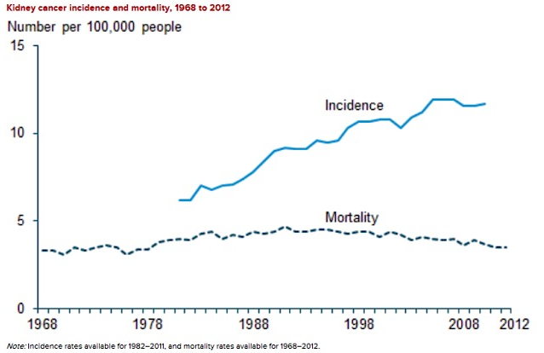
Figure 2. Age specific incidence rates for kidney cancer in Australia (2015)
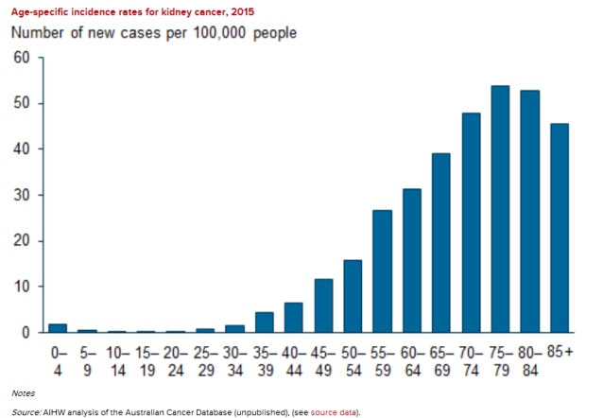
In 2011, there were 2,847 new cases of kidney cancer diagnosed in Australia (1,861 males and 985 females) and the age-standardised incidence rate was 12 cases per 100,000 persons (16 for males and 7.7 for females). At the end of 2009, there were 9,627 people living who had been diagnosed with kidney cancer in the previous 5 years. In 2012, there were 907 deaths from kidney cancer in Australia, giving an age-standardised mortality rate of 3.5 deaths per 100,000 persons (4.9 for males and 2.3 for females). In 2007 to 2011, individuals with kidney cancer had a 73% chance of surviving for 5 years, compared to their counterparts in the general Australian population.

Types of kidney cancer
Renal cell carcinoma (RCC) accounts for approximately 90 to 95% of neoplasms arising from the kidney. Several different types of RCC are now recognised, according to histological appearance, chromosomal alterations and molecular pathway abnormalities, as shown below in Table 1.

Table 1. Subtypes of renal cell carcinoma (Vancouver RCC Classification)
Main subtypes | Proportion of RCC | Histological appearance and other features | Related molecular pathway
Clear cell RCC | 70 to 80% | Characteristic clear appearance of the cells due to glycogen and lipids in their cytoplasm | hypoxia-inducible pathway  mTOR signalling pathway
Papillary RCC | 7 to 15% | Distribution of malignant cells around capillary cores in most of the tumour. Associated chromosomal abnormalities | hypoxia-inducible pathway  TOR signalling pathway  c Met-RAF-MEK-ERK pathway
Chromophobe RCC | 5 to 10% | Polygonal cells with a clear delimitation of the cytoplasmic membrane and reticular cytoplasm. Associated chromosomal abnormalities
Collecting duct RCC | < 1% | High nuclear grade, eosinophilic cytoplasm with predominantly tubular arrangement
Other rare subtypes include medullary RCC, multi-locular cystic RCC, hybrid oncocytoma/chromophobe RCC, microphthalmia associated transcription familial translocation RCC, mucinous tubular and spindle cell carcinoma, tubulocystic RCC, acquired cystic disease associated RCC, clear cell papillary RCC.
RCC is frequently associated with a dysfunction of the von Hippel-Lindau gene, resulting in excessive vascular endothelial growth factor (VEGF) and other pro-angiogenic factors (‘hypoxia-inducible’ pathway). The tumour angiogenesis induced by these factors is a major oncogenic mechanism in RCC. Inactivation of another tumour-suppressor gene, PTEN, which activates the mTOR pathway, can also contribute to oncogenesis. Activation of the mTOR kinase pathway drives cell growth and reduces apoptosis in tumour cells. The mTOR pathway in vascular cells is also activated by VEGF signalling, contributing to tumour angiogenesis.
Although there are many potential biomarkers under investigation, none has yet been validated for general use in the prognostic or predictive assessment of RCC.

Diagnosis and prognosis
RCC is characterised by a lack of early warning signs, diverse clinical manifestations, and resistance to radiation and chemotherapy. More than half of RCCs are currently detected incidentally due to the increasingly widespread use of abdominal imaging for example, ultrasonography, computed tomography and magnetic resonance imaging.
RCC may be cured if diagnosed and treated while it is still localised to the kidney and surrounding tissue. After radical nephrectomy for Stage I RCC, the 5 year survival rate is approximately 94%. Patients with Stage II lesions have a survival rate of 79%. When distant metastases are present, or if any treated RCC patient develops progressing, recurring or relapsing disease, the prognosis is poor with 5 year survival rates of 0 to 20%.

Prognosis with advanced disease
The Memorial Sloane Kettering Cancer Centre (MSKCC), or Motzer, prognostic risk is based on the presence of zero (favourable risk), one (intermediate risk), or two or three (poor risk) of the following prognostic factors: anaemia, hypercalcaemia, and poor performance status. This scoring system has been validated and updated for current use as the Heng or International Metastatic RCC Database Consortium (IMDC) criteria.
Patients are stratified according to the presence of six risk factors:
- Karnofsky performance status (PS) < 80%
- Haemoglobin < lower limit of normal
- Time from diagnosis to treatment of < 1 year
- Corrected calcium above the upper limit of normal
- Platelets greater than the upper limit of normal
- Neutrophils greater than the upper limit of normal
The number of risk factors present is added up and the risk is stratified as follows in Table 2, below.²

Table 2. Risk stratification based on number of risk factors
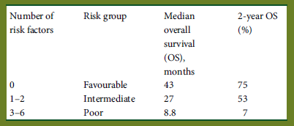

Treatment options
Surgical resection is the standard of care for Stage I to III RCC and may be curative.
There is no curative therapy for Stage IV or metastatic disease. Surgical resection, and/or metastasectomy, may be considered in suitable patients to relieve symptoms and decrease ectopic hormone or cytokine production. Because some RCC have a very indolent course, a period of observation before starting treatment may be considered, especially in patients with limited tumour burden and few symptoms. For some poor prognosis patients, best supportive care may be the most appropriate treatment option.
Systemic treatment of renal cell carcinoma is rapidly evolving. Prior to 2005, the widely used systemic agents were the cytokines, interferon alfa and interleukin-2, which yielded modest efficacy and substantial toxicity, although some patients achieved durable complete responses with interleukin-2. Molecularly targeted therapies have been developed in the last 10 years and have demonstrated significant activity in advanced stage RCC, such that they have displaced cytokine therapy. Currently available targeted therapies are made up of two broad classes, both of which reduce tumour angiogenesis but which demonstrate different anti-tumour activities and side effect profiles:
- anti-vascular endothelial growth factor (VEGF) agents that act via inhibition of the VEGF pathway. These agents currently include:
  - multi-target VEGFR tyrosine kinase inhibitors (TKI) such as sorafenib, sunitinib and pazopanib that block TK activity of VEGF receptors on endothelial cells and other TKIs
  - the selective VEGFR TKI axitinib
  - the anti-VEGF monoclonal antibody bevacizumab which directly inhibits circulating VEGF
- inhibitors of the mammalian Target of Rapamycin (mTOR) kinase signalling within tumour cells causing cell cycle arrest, enhanced apoptosis and inhibition of angiogenesis. These agents currently include:
  - temsirolimus and everolimus
Despite these new therapies, outcome of progressive disease after first line therapies remains poor, with median overall survival less than 2 years. Outcomes from recent Phase III trials are given in Table 3, below.

Table 3. Outcomes from recent Phase III studies in previously treated renal cell carcinoma
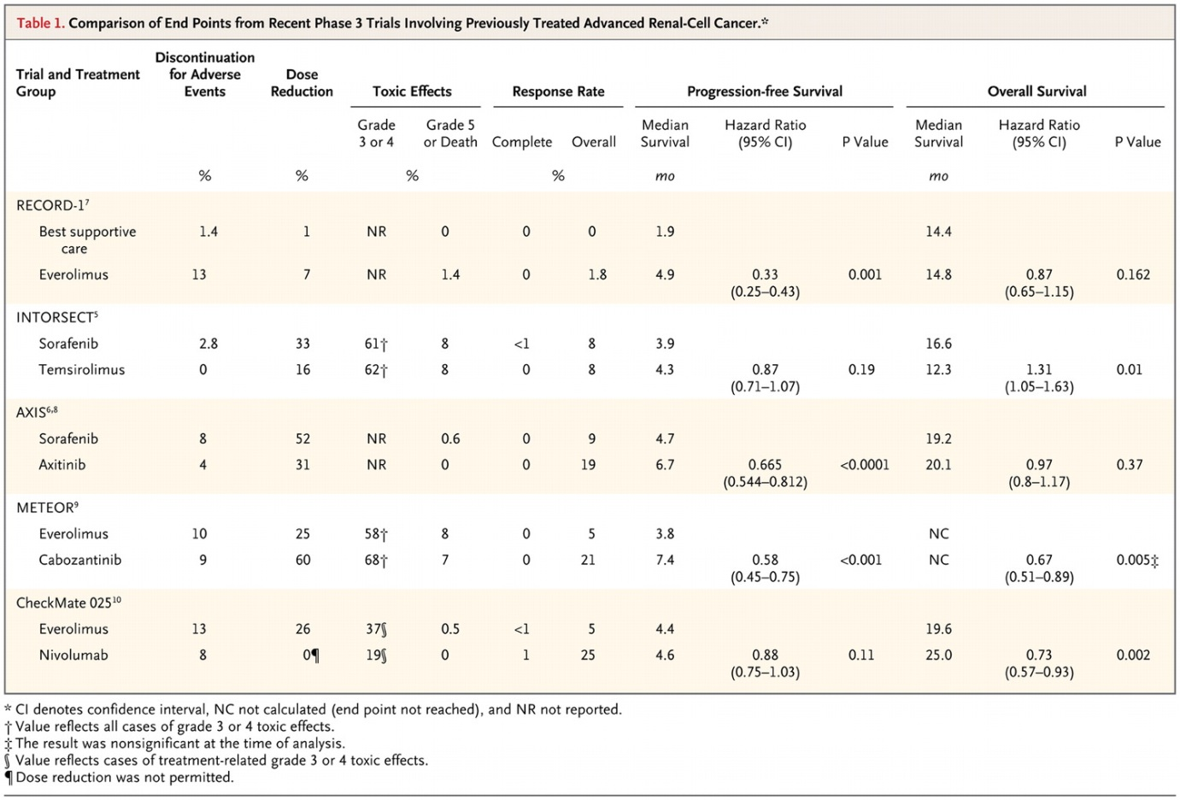
Targeted therapy and immunomodulatory agents are now considered standard of care in patients with metastatic disease, although optimal regimens have not been identified. Most commonly, first line therapy is with a vascular endothelial growth factor receptor (VEGFR) kinase inhibitor. At disease progression, options include another type of angiogenesis-targeted therapy or ‘switching the mechanism of action’ to an mTOR inhibitor (for example everolimus). Interleukin-2 in high dose may still be used alone in some selected patients.³
There is no evidence that any particular follow-up protocol affects outcome in early or advanced RCC. The NCCN guideline states that follow-up should be individualised according to the patient’s requirements. The ESMO guideline recommends: ‘During systemic therapy in mRCC patients, 2 to 4-month follow-up schemes with CT scan should be advised to determine response and resistance. Although not perfect, RECIST criteria remain the best method to assess drug efficacy.’

Table 4. Response Evaluation Criteria in Solid Tumours (RECIST)
Response Evaluation Criteria In Solid Tumours (RECIST) is defined as follows:
Complete response (CR) is disappearance of all target lesions.
Partial response (PR) is a 30% decrease in the sum of the longest diameter of target lesions.
Progressive disease (PD) is a 20% increase in the sum of the longest diameter of target lesions.
Stable disease (SD) is small changes that do not meet above criteria

Treatment guidelines for advanced renal cell carcinoma
A number of options for first and second line therapies are suggested in the available guidelines, reflecting the lack of an established optimal therapy or sequence. The ESMO and NCCN guidelines separate out clear-cell from non-clear-cell carcinoma.
The National Cancer Institute (NCI) offers the first line and second line options shown in Table 5 below and recommends enrolment of the patient in a clinical trial.

Table 5. NCI: Treatment options for metastatic renal cell cancer
First-line therapy | Second-line therapy
- Radical nephrectomy (for T4, M0 lesions)  - Cytoreductive nephrectomy (for any T, M1 lesion)  - Temsirolimus  - Sunitinib  - Panzopanib  - Bevacizumab with or without interferon alpha  - Interferon alpha  - IL-2  - Palliative EBRT | - Nivolumab (for patients who have previously been treated with a sunitinib, panzopanib, sorafenib and/or axitinib)  - Cabozantinib (for patients who have previously been treated with a sunitinib, panzopanib, sorafenib or axitinib)  - Axitinib  - Everolimus (for patients who have previously been treated with sunitinib and/or sorafenib)  - Sorafenib  - Palliative EBRT
The National Cancer Care Network Guideline (dated 24 November 2015) offers similar recommendations for patients with relapsed or Stage IV and surgically unresectable disease (predominant clear cell histology) but includes ‘Clinical Trial’, axitinib and sorafenib (in selected patients) in first line therapy. Second line therapy options include ‘Clinical Trial’ or targeted therapy (options are dependent on prior first line therapy but include nivolumab after prior first line TKI) or cytokine therapy (high dose IL-2 in selected patients). For patients with non-clear cell histology and Stage IV disease, the guideline recommends ‘Clinical Trial’ as the preferred first line option for systemic option with temsirolimus or everolimus or bevacizumab or erlotinib or a TKI (sorafenib, sunitinib, pazopanib,) as other options.
The European Society of Medical Oncology Renal Cell Carcinoma Clinical Practice Guideline recommends cytoreductive nephrectomy in patients with good performance status and limited volumes of metastatic disease and the following algorithm for systemic treatment of metastatic RCC as shown in Table 6, below.² Beyond second-line treatment, enrolment into clinical trials is recommended where possible.

Table 6. ESMO algorithm for systemic treatment in metastatic renal cell carcinoma
Histology and setting | Risk group | Standard | Option
Clear-cell first line | Good or intermediate risk | Sunitinab (I, A) | High-dose IL-2 (III, C)
Clear-cell first line | Good or intermediate risk | Bevacizumab + IFN alpha (I, A) | Sorafenib (II, B)
Clear-cell first line | Good or intermediate risk | Pazopanib (I, A) | Bevacizumab + low dose IFN alpha (III, A)
Clear-cell first line | Poor risk | Temsirolimus (II, A) | Sunitinib (II, B)
Clear-cell first line | Poor risk |  | Sorafenib (III, B)
Clear-cell second line | Post cytokines | Axitinib (I, A) | Sunitinib (III, A)
Clear-cell second line | Post cytokines | Sorafenib (I, A)
Clear-cell second line | Post cytokines | Pazopanib (II, A)
Clear-cell second line | Post TKIs | Axitinib (I, B) | Sorafenib (II, A)
Clear-cell second line | Post TKIs | Everolimus (II, A)
Clear-cell third line | Post 2 TKIs | Everolimus (II, A)
Clear-cell third line | Post TKI and mTOR | Sorafenib (II, B) | Other TKI (IV, B)
Clear-cell third line | Post TKI and mTOR |  | Rechallenge (IV, B)
Non clear cell histology |  |  | Temsirolimus (III, B)
Non clear cell histology |  |  | Sunitinib (III, B)
Non clear cell histology |  |  | Sorafenib (III, B)

TGA Approved Therapies (as of March 2016)
Therapies currently available in Australia for advanced RCC are in keeping with the guidelines above as are shown below in Table 7. Agents approved for first line use are sunitinib, pazopanib, sorafenib and temsirolimus. Agents approved for second line use are axitinib and everolimus.

Table 7. Targeted therapies approved for use in advanced renal cell carcinoma in Australia
Active substance(s) | Approved Indication
Bevacizumab in combination with interferon alfa-2a | Treatment of patients with advanced and/or metastatic renal cell cancer
Sunitinib¹ | The treatment of advanced renal cell carcinoma
Pazopanib¹ | The treatment of advanced and/or metastatic renal cell carcinoma
Sorafenib¹ | The treatment of patients with advanced renal cell carcinoma
Temsirolimus | The treatment of advanced renal cell carcinoma
Axitinib¹ | The treatment of patients with advanced renal cell carcinoma after failure of one prior systemic therapy
Everolimus¹ | The treatment of advanced renal cell carcinoma after failure of treatment with sorafenib or sunitinib
¹⁾ PBS funded for stage IV clear cell variant renal cell carcinoma with strict clinical criteria
Axitinib and everolimus are funded by the Pharmaceutical Benefits Scheme (PBS) for ‘Stage IV clear cell variant’ renal cell carcinoma (RCC) provided the patient has progressive disease according to the Response Evaluation Criteria In Solid Tumours (RECIST) following first-line treatment with a tyrosine kinase inhibitor and has a WHO performance status of 2 or less.

Checkpoint inhibitors
The complexity of tumour interaction with the human immune system is not fully understood. Current thinking is that malignant tumour progression and growth may occur through mechanisms that enable tumour cells to evade detection and destruction by the immune system. One of these mechanisms involves cell-surface expression of one or more of a series of molecules that effectively limit T-cell proliferation and killing capacity. These molecules are referred to as ‘immune checkpoints’ and their natural function is to restrain or dampen excessive immune responses.
One such check-point is the interaction between the Programmed Cell Death Ligands (PD-L1 and PD-L2) and the Programmed Cell Death-1 (PD-1) receptor that may be found on T and B lymphocytes. PD-L1 and PD-L2 are proteins that are normally expressed on macrophage-lineage cells, although expression of PD-L1 can be induced on other haematologic cells. Upon antigen recognition, activated T cells express PD-1 on their surface and produce interferons that lead to the expression of PD-L1 in multiple tissues. Binding of PD-1 to its ligands inhibits effector T-cell activity and protects normal cells from immune mediated cell death. This interaction is believed to be an inhibitory pathway that helps to prevent overstimulation of immune responses and contributes to the maintenance of immune tolerance to self-antigens.
Aberrant expression of PD-L1 by tumour cells has been reported in a number of human malignancies, including urothelial, ovarian, breast, cervical, colorectal, pancreatic, gastric cancer, melanoma, glioblastoma, renal and non-small-cell lung cancer (NSCLC). Expression of PD-L1 or PD-L2 on tumour cells limits and inhibits the anti-tumour immune response, enabling immune evasion by the tumour cells. Tumour PD-L1 membrane expression can be constitutive through oncogenic processes or induced by activated tumour antigen-specific T cells that produce interferons. Expression of PD-L1 on tumour cells has also been studied as a prognostic biomarker in many different primary tumours, with equivocal results.
Blockade of PD-1, or the ligands, results in disinhibition of native immune responses and may re-activate anti-tumour immunity, by restoring T-cell responsiveness as well as the ability to mount a direct T-cell immune attack against tumour cells. Several antibodies that inhibit the PD-1 pathway by blocking either PD-1 or PD-L1 are being developed for clinical use in a variety of tumour types. Antibodies that inhibit PD-1 block its binding to both PD-L1 and PD-L2, whereas anti-PD-L1 antibodies only block the PD-1: PD-L1 interaction.
Figure 3. Checkpoint inhibitors
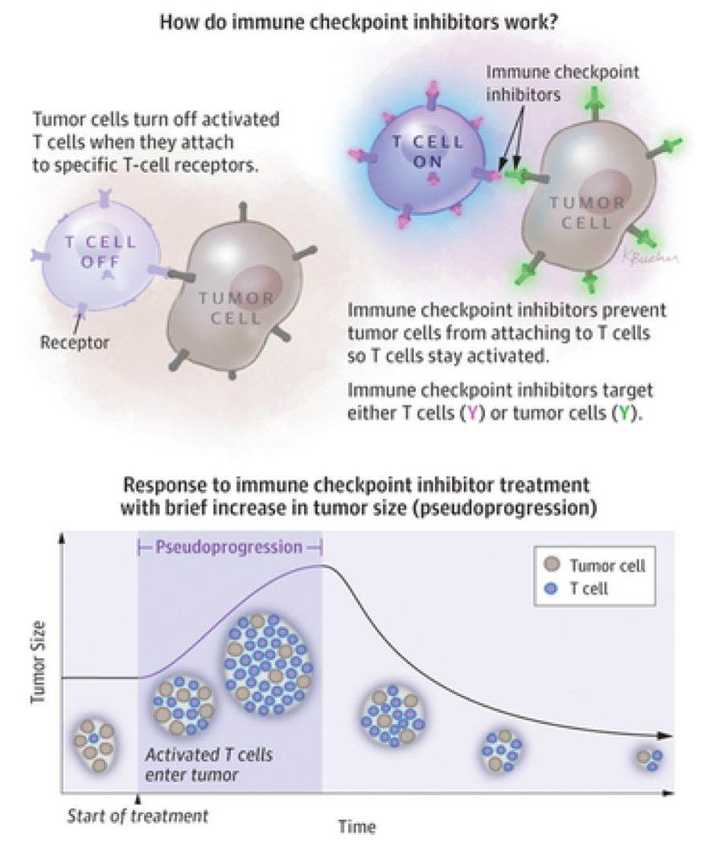
Source: West H. Immune Checkpoint Inhibitors. JAMA Oncol. 2015:1(1):115
Opdivo (nivolumab) is a fully human monoclonal IgG4 antibody (HuMAb) that that blocks the binding of PD-1 receptor to PD-L1 and PD-L2. Nivolumab entered clinical trials in patients with cancer in late 2007. Evidence of clinical activity in multiple tumour types was noted in the initial dose escalation study, in which the drug was administered in an intermittent schedule. Phase III studies in melanoma, squamous and non-squamous NSCLC and renal cell carcinoma have since been completed.
Unlike conventional chemotherapy drugs that may result in a decrease in tumour size over weeks, immune checkpoint inhibitors can take several months to have this effect. These drugs can also cause an initial increase in tumour size (‘pseudoprogression’) due to the large number of activated T cells and other immune system cells that enter the tumour and the associated inflammatory effect. This initial increase in size may be followed by shrinking or eradication of the tumour.
Cytotoxic T-lymphocyte-associated programmed cell death-1 (PD-1) and PD-L1, PD-L2 interactions are believed to have an important role in maintaining immunologic homeostasis and immune tolerance to self-antigens. The use of checkpoint inhibitors has been associated with a unique spectrum of side effects termed ‘immune-related adverse events’ (irAEs). Management of moderate or severe irAEs requires interruption of the checkpoint inhibitor and the use of immunosuppression (usually corticosteroid). The safety of checkpoint inhibitors in patients with an underlying autoimmune condition is uncertain; there is theoretical concern that therapeutic blockade of these receptors could lead to exacerbations of underlying autoimmune conditions.

Clinical rationale
The Clinical Overview includes a section titled ‘Product Development Rationale’. This section provides an overview of RCC including epidemiology, a description of molecular targeted therapies that are currently available and a description of advanced RCC after prior systemic therapy as an ‘unmet need’.
TKIs are described as first line therapy standard treatments as per the ESMO guidelines, and that everolimus and axitinib are the only 2 targeted therapies with a Category 1 recommendation in the NCCN guidelines for use in RCC after first-line TKI therapy. The evidence basis for these two agents in this setting was presented:
- Everolimus: randomised, double blind, placebo controlled Phase III RECORD-1 study, which included 416 subjects with metastatic RCC who received prior sunitinib, sorafenib, or both.
- Axitinib: randomised, controlled, Phase III AXIS trial, which compared two VEGFr TKIs (axitinib and sorafenib) in a total of 723 subjects with advanced RCC who received prior sunitinib, bevacizumab, temsirolimus, or cytokine therapy.

Table 8. Summary of results of pivotal studies for everolimus and axitinib
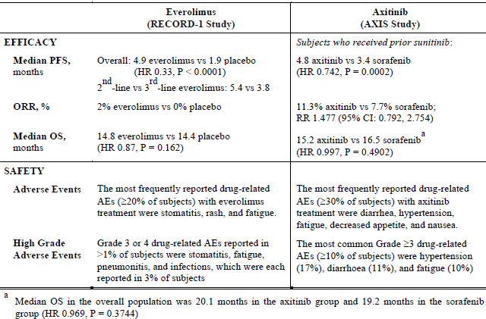
On the basis of the poor responses to currently approved therapies, with median PFS < 6 months with treatment and no demonstrated significant improvement in overall survival, the sponsor states that ‘the prognosis for advanced RCC after prior systemic therapy is poor and there is a clear unmet medical need for treatments that improve clinical outcomes’.
Comment: Everolimus was approved by the TGA for second line therapy of advanced RCC in 2009 with the indication: ‘Treatment of patients with advanced renal cell carcinoma after failure of treatment with sorafenib or sunitinib’. Axitinib was approved by the TGA for second line therapy in 2012 with the indication: ‘For the treatment of patients with advanced renal cell carcinoma after failure of one prior systemic therapy’.
The unmet need described by the sponsor in the Clinical Overview specifically refers to patients with advanced RCC after prior systemic therapy. This is not explicit in the proposed indication (See Section 11, Question 2 ‘Unmet need and proposed indication’).
A brief summary of the clinical development program of nivolumab in RCC and a summary of the regulatory milestones of nivolumab for all indications was provided:
‘There are 4 completed or ongoing studies of nivolumab monotherapy in RCC in previously treated subjects: MDX1106-03, CA209009, CA209010, and CA209025. The current submission includes safety and efficacy data from completed Study CA209025, which focuses on nivolumab monotherapy (3 mg/kg Q2W) at the recommended dose and schedule in subjects with advanced or metastatic RCC after prior therapy. Additional supportive data is provided from CA209010; subjects in CA209010 received nivolumab doses of 0.3, 2, or 10 mg/kg Q3 weeks rather than at the proposed dose and schedule of 3 mg/kg Q2 weeks. In MDX1106-03 subjects were administered nivolumab monotherapy with 1 or 10 mg/kg Q2W, while in CA209009, subjects received nivolumab doses of 0.3, 2, or 10 mg/kg Q3W.’
Comment: The sponsor’s dossier refers extensively to the pivotal study as is appropriate. The dose ranging study, Study CA209010, is also extensively referred to for both efficacy and safety. However, no mention is made of patients with advanced RCC who participated in the Studies MDX1106-03 (also known as CA209003) and CA209009 in the safety and efficacy evaluation provided by the sponsor. Study CA209003 was provided by the sponsor to the TGA as part of an earlier submission. It was evaluated in the Clinical Evaluation Report for that submission with regard to those patients with melanoma and NSCLC that were the target populations for that submission. Study CA209003 was also referred to in the Clinical Evaluation Report for the next nivolumab submission as dose selection for the pivotal study was based on the results from this study. Study CA209009 was referred to by the evaluator of original melanoma-based submission as pharmacodynamic results from this study were provided in one of the clinical summaries. The evaluator of that submission noted that the CSR for the study had not been provided. The evaluator of this current submission has checked both previous dossiers, and the current dossier, and has been unable to locate a CSR for Study CA209009. The CSR for this study was provided upon request by the sponsor during the Round 1 evaluation.
The evaluator is concerned that the efficacy and safety assessments provided by the sponsor are incomplete, as all patients with advanced RCC who have been treated with nivolumab in the Clinical Development Program in RCC have not been included. The evaluator notes that the sponsor has stated that tumour response in RCC was not found to be dose-dependent in RCC in Study CA209003 and that adverse events reported with nivolumab are also not dose-dependent. For a complete description of both the efficacy and safety of nivolumab in patients with advanced RCC, it would therefore be appropriate to include all patients in the clinical trial programme. It is also confusing that patients from Study CA209010, who did not receive the proposed dosing regimen, were included in the analysis provided, but patients from Studies MDX1106-03 (also known as CA209003) and CA209009, who also did not receive the proposed dosing regimen, were not included. See Section 11: Question 3 ‘Completeness of the safety and efficacy assessments’.

Guidance

TGA guidance
A teleconference between the TGA and the sponsor was held on 29 September 2015. According to the minutes, it was agreed that:
- The sponsor could progress the submission of a parallel application for nivolumab in renal cell carcinoma (RCC) based on Study CA209025.
- This submission would have a format similar to another sponsor application (new biological entity application to register nivolumab in the treatment of non-squamous NSCLC) in that it would include components unique to the proposed additional indication but with cross-referencing to prior submissions and evaluations for other components.
- The sponsor confirmed that the RCC application would have the unique components of:
  - Pivotal Study CA209025
  - 1 supportive study, a Phase II dose ranging Study CA209010
  - Population pharmacokinetics report for Study CA209025 with exposure analyses
- The TGA agreed that it was acceptable for the dossier content of the RCC application to include only unique documents required for evaluation of Study CA209025 and that other Modules did not need to be included, providing there was clear cross referencing to previously submitted documents in the first NBE submission).
According to the sponsor’s cover letter, the TGA also agreed to cross-refer to the evaluations of nivolumab from the above submissions and only evaluate Study CA209025 related unique documents for this application for RCC. The evaluator has confirmed with the TGA Delegate that only data unique to the submission needs to be evaluated, unless the evaluator was concerned by an aspect of the submission that required investigation of materials evaluated earlier.

Other guidance
EMA: The Clinical Overview describes CHMP Scientific Advice in relation to Study CA209025, provided in October 2011, as supporting the appropriateness of the study design, including, targeted population, stratification factors, choice of comparator, and endpoints for this study in pre-treated advanced RCC, as well as the overall development in this population as a basis for registration of this indication.

Contents of the clinical dossier
By agreement with the TGA, the sponsor has provided only those submission components that are unique to the proposed additional indication and has cross-referenced the recent submissions [for melanoma and non-squamous NSCLC] for other components. The sponsor’s cover letter includes an attachment that details the cross-referencing to the earlier submissions.

Scope of the clinical dossier
The unique elements of this submission are:
- Integrated Summary of Safety. This includes safety data that has been compared across indications in completed studies that used the intended dose and regimen for nivolumab monotherapy. Data from the RCC study (Study CA209025) was compared to NSCLC studies (Studies CA209057, CA209017, and CA209063) and melanoma studies (Studies CA209037, CA209066, and CA209067 (monotherapy arm only)).
- Clinical Study Report for the pivotal Study CA209025
- Clinical Study Report for the supportive Study CA209010
  - Including Addendum 01, patient PK and initial tolerability
- Population Pharmacokinetic Study Reports with analysis in:
  - subjects with solid tumours including advanced or metastatic clear-cell renal cell carcinoma who have received prior anti-angiogenic therapy
  - exposure-response analysis in subjects with advanced or metastatic clear-cell renal cell carcinoma who have received prior anti-angiogenic therapy
- A Clinical Overview, Summary of Clinical Pharmacology Studies and Summary of Clinical Efficacy for renal cell carcinoma
The Clinical Study Report for Study CA209009 was provided by the sponsor upon request during the Round 1 evaluation. This was a dose-ranging study of nivolumab in patients with advanced RCC with the primary objective of investigating the immune modulatory effects of nivolumab.

Paediatric data
The submission did not include paediatric data.
From the Clinical Evaluation Report for the first NBE submission: ‘The sponsor has a Paediatric Investigation Plan agreed with the EMA. The first report of a study conducted as part of the plan is due in October 2017. The sponsor also has a Paediatric Plan agreed with the FDA in the United States, with the first results being due in the second quarter of 2018.’

Good clinical practice
The Clinical Overview provides the following assurance: ‘All studies in the nivolumab RCC development program were conducted in accordance with the principles of GCP as defined by the ICH and were conducted to meet the ethical requirement of European Directive 2001/20/EC. For each study, the protocol, amendments, administrative letters, and subject informed consent form received IRB/IEC approval prior to implementation. Compliance audits were performed as part of implementing quality assurance, and audit certificates are provided as applicable in the individual study reports. The quality of data collected and analysed was monitored according to BMS standard operating procedures.’

Pharmacokinetics

Studies providing pharmacokinetic data
Only limited new pharmacokinetic data was provided in this submission.
Both Study CA209010 and Study CA209025 had an exploratory objective of ‘To characterize the pharmacokinetics (PK) of nivolumab and explore the exposure-response relationship’. The results from this component of each study have not been reported separately but were included in the population PK analyses included in the submission.
Two separate population PK analyses were included in this submission. The first includes data from subjects with solid tumours (melanoma, NSCLC and RCC) to develop a pharmacokinetic model, with this then applied to the data from subjects with advanced or metastatic clear-cell renal cell carcinoma who have received prior anti-angiogenic therapy. The second is an exposure-response analysis in subjects with advanced or metastatic clear-cell renal cell carcinoma who have received prior anti-angiogenic therapy.
A sequence of Population PK analyses has been included in the recent nivolumab submissions. Each Population PK analysis has been updated as more data has become available and/or has been focussed on a specific condition and/or has included combination therapy with ipilimumab. The most recent population PK analysis of nivolumab as monotherapy was dated 18 July 2014 and was evaluated in the CER for the first NBE submission.
Summaries of the pharmacokinetic component of Study CA209025 and the population pharmacokinetic studies are [not included in this document].

Summary of pharmacokinetics
The clinical pharmacology of nivolumab, as known, was evaluated for the earlier nivolumab submission [indicated for the treatment of melanoma]. It has also been summarised in the CHMP Assessment Report for Opdivo. The following description is based on these documents although updated to include the most recent population PK analysis.
Nivolumab is a fully humanised IgG4 monoclonal antibody, produced in a Chinese hamster ovary (CHO) cell line. It contains two identical heavy chains of 440 amino acids each and two identical kappa light chains of 214 amino acids each. It has a molecular weight of 146,221.
The dose proposed for nivolumab monotherapy is 3 mg/kg administered intravenously over 60 minutes every 2 weeks.
Pharmacokinetics has mainly been documented in patients with different types of solid tumours (NSCLC, Melanoma, RCC, CRC, CRPC, others) and not in healthy volunteers.
Pharmacokinetics of nivolumab appeared dose proportional over the dose range 0.1 mg/kg to 10 mg/kg. No signs of time dependent PK parameters were observed over the period studied. The multiple-dose PK of nivolumab given 3 mg/kg every 2 weeks was mean clearance of 10.3 mL/hr and mean effective half-life of 27.5 days. The elimination and distribution of nivolumab appeared to be independent of the dose in the dose range studied and also independent of tumour type in the studied tumour types. Steady state is expected after the sixth dose (that is, after 12 weeks).
The inter-individual variability in PK parameters was considered to be modest with coefficients of variation being < 30% for C_{max} and AUC, after single or multiple dosing.
The distribution, metabolism and elimination of nivolumab has not been characterised. It is expected that these will resemble those of endogenous immunoglobulin. Immunoglobulin G is largely confined to the extracellular fluid; the volume of distribution described for nivolumab is consistent with this. Using extrapolation from the PK of human immunoglobulin, nivolumab is expected to be cleared through receptor mediated endocytosis or non-specific endocytosis followed by proteolytic degradation, with this occurring mainly in hepatic or reticuloendothelial cells. Degradation into small peptides and amino acids via catabolic pathways is expected to occur in the same manner as endogenous IgG. No renal elimination is likely given the large molecular weight of monoclonal antibodies. The estimated terminal half-life ranged between 17 and 25 days and is consistent with that of human immunoglobulin. The proposed dosing interval of 2 weeks is shorter than the observed terminal half-life.

Population PK analysis
The final model of the population PK analysis provided in this submission was consistent with a 2 compartment PK model with first order elimination. Individual PK parameters estimated by this model are shown below.

Table 9. Summary statistics of individual PK parameters (n = 1484)
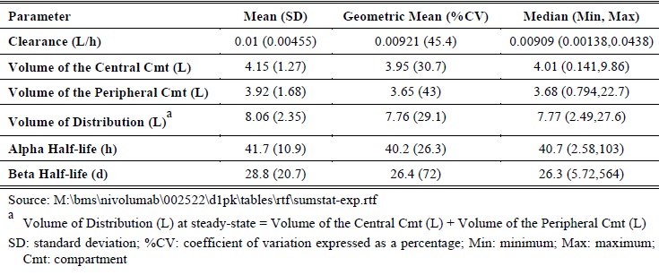
A sequence of population PK analyses has been provided in the sponsor’s submission. The analysis provided in the current submission is consistent with earlier ones, with the additional information that nivolumab PK in patients with advanced RCC is similar to that that in subjects with NSCLC or other tumour types.
Previously described conclusions of the PPK analyses are that the covariates of age, sex, race, tumour type, hepatic impairment, PD-L1 expression, baseline tumour burden, and tumour volume were not reported to influence nivolumab clearance. Nivolumab clearance was found to higher in those with greater baseline body weight, greater estimated glomerular filtration rate (eGFR), and for an Eastern Cooperative Oncology Group (ECOG) status score > 0, compared to ECOG = 0. It is stated that these covariate effects were not clinically important. No clinically relevant effect of the development of anti-drug antibodies or tumour type on nivolumab clearance or exposure was found.
Additional information is provided in the conclusions from the previous evaluation of the PPK model (CER for the melanoma based indication):
- The model predicted that use of a body-weight-based dosing regimen (as is being proposed) would result in consistent nivolumab concentrations (trough and average) across a wide range of bodyweights (34.1 to 161.9 kg)
- Subjects with mild or moderate renal impairment had a model-predicted average concentration at steady state comparable to that for subjects with normal renal function (25.3, 26.6 and 23.1 µg/mL per mg/kg respectively). There were insufficient subjects with severe renal impairment.
- Subjects with mild hepatic impairment had a model-predicted average concentration at steady state comparable to that for subjects with normal hepatic function (22.1 and 24.8 µg/mL per mg/kg respectively). There were no subjects with moderate or severe hepatic impairment in the analysis.
The individual PK characteristics obtained from the final PPK model for patients with advanced renal cell carcinoma is shown below.

Table 10. Summary statistics for nivolumab concentration in subjects enrolled in Study CA209025
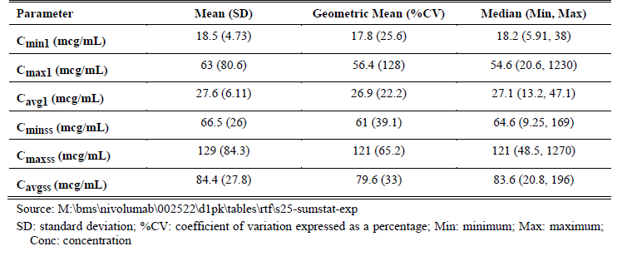
The median serum concentration of IgG4 in humans is around 1000 µg/mL. The addition of nivolumab in the concentration shown above will have minimal impact on the total concentration.

Pharmacokinetics in Special Populations

Elderly
There was no upper age limit in the efficacy studies and patients aged more than 85 years have been included in the clinical trials programme. In the CHMP Assessment Report for Nivolumab, a total of 369 patients aged 65 years or more and 117 patients aged more than 75 years had been included in the clinical trials programme.⁶ The PPK analysis found that age did not affect nivolumab PK.

Renal Impairment
Specific PK studies in patients with renal impairment have not been conducted and patients with renal impairment (Cr > 1.5 x ULN or Cr Cl < 40 mL/min) were excluded from the efficacy studies. PPK analysis has shown a lack of effect on the PK of nivolumab in patients with renal impairment suggesting that no dose adjustment is needed for subject with mild and moderate renal impairment. However, no subjects with severe renal impairment were included in the dataset for the PPK analysis. Therefore, no conclusions regarding the effect of severe renal impairment can be drawn.

Hepatic Impairment
Nivolumab has not been studied in patients with moderate (total bilirubin > 1.5 x to 3 x ULN and any AST) or severe hepatic impairment (total bilirubin > 3 x ULN and any AST). PPK analysis found that subjects with mild hepatic impairment had similar CL and exposures relative to normal subjects, suggesting that no dose adjustment is needed for subjects with mild hepatic impairment. No subjects with moderate and severe hepatic impairment were included in the dataset for the PPK analysis. Therefore, no conclusions regarding the effect of moderate or severe hepatic impairment can be drawn.

Pharmacokinetics according to other population characteristics
In the population PK analysis, bodyweight was found to have a significant effect on nivolumab PK. However when administered on a mg/kg basis, nivolumab systemic exposure would be comparable across a wide range of bodyweights. Gender and race did not have a clinically significant effect on nivolumab PK.

Drug-drug interactions
From the CHMP Assessment Report for Nivolumab: ‘As nivolumab is not subject of metabolism by CYP450 enzymes no classical studies regarding metabolism or elimination were deemed necessary’ and ‘However, recent literature reports suggest that therapeutic proteins that (are) modulators of cytokines may indirectly affect expression of cytochrome (CYP) enzymes. The indirect drug-drug interaction potential of nivolumab was assessed using systemic cytokine modulation data for cytokines known to modulate CYP enzymes, at single and multiple doses of 0.3 to 10 mg/kg Q3W from CA209009. This dose range covers the exposure of nivolumab at proposed dosing regimen of 3 mg/kg Q2W. There was no meaningful change in cytokines across all dose levels of nivolumab (0.3, 2 and 10 mg/kg) during the course of treatment. This lack of cytokine modulation suggests that nivolumab has no or low potential for modulating CYP enzymes, thereby indicating a low risk of therapeutic protein-drug interaction’.⁶
Comment: Study CA209009 was a dose ranging study performed in RCC patients. The clinical study report for this study is not included in the current submission and does not appear to have been provided to the TGA previously. It was provided to the TGA upon request during the Round 1 evaluation for this current submission.

Evaluator’s overall conclusions on pharmacokinetics
This evaluator notes that the conclusion of the evaluator for the first nivolumab submission [melanoma-based indication] with respect to the pharmacokinetic data provided was: ‘The submitted data indicate that the PK of nivolumab are consistent with the PK of endogenous IgG4, with a low volume of distribution, slow clearance and a half-life of approximately 3 to 4 weeks. The PK data included in the submission are considered to meet the requirements of the relevant EMA guideline adopted by the TGA. Overall the PK data are considered acceptable.’
The additional PK information provided in this submission consisted of a population PK analysis. This analysis provided results consistent with earlier PPK analyses, with the additional information that nivolumab PK in patients with advanced RCC is similar to that that in subjects with NSCLC or other tumour types.

Pharmacodynamics

Studies providing pharmacodynamic data
Both Studies CA209010 and CA209025 provided limited new pharmacodynamic data. These studies are described in Section 7: Clinical Efficacy. The data related to QT prolongation was evaluated for the previous submission and is summarised below. The data related to PD-L1 expression and nivolumab immunogenicity is summarised in this section.
Pharmacodynamic information from Study CA209009 has also been included. The Clinical Study Report for this study was provided by the sponsor upon request during the Round 1 evaluation. The pharmacodynamics component of this study [is not included in full in this document] but information related to PD-L1 expression, PD-1 receptor occupancy and chemokine levels have been described in this section.
An exposure-response population PK analysis in subjects with advanced or metastatic clear-cell renal cell carcinoma who have received prior anti-angiogenic therapy was also included in the dossier and is described below.
Table 11, below, summarises the studies providing pharmacodynamic data along with relevant subtopic.

Table 11. Studies providing pharmacodynamic data
Study identifier | Subtopics
CA209025 | Immunogenicity  Biomarker assessment and PD-L1 expression
CA209010 | QT prolongation  PD-L1 expression  Immunogenicity
CA209009 | Immunomodulatory activity (including serum chemokine and cytokine levels, tumour infiltration by lymphocyte subsets)  Immunogenicity  Receptor occupancy  PD-L1 tumour expression

Summary of pharmacodynamics
The PD effects of nivolumab were studied by assessing receptor occupancy (RO), peripheral immune cell population modulation, systemic cytokine modulation, and change in absolute lymphocyte count (ALC). The reports of these studies, except for Study CA209009, were evaluated for earlier nivolumab submissions. The following summary of pharmacodynamics as known is derived from the sponsor’s materials for both this and earlier submissions, publications related to Phase I and II studies, together with the Clinical Evaluation Reports for earlier submissions.

Mechanism of action, disinhibition of the immune system
Nivolumab is a programmed death 1 (PD-1) immune checkpoint inhibitor. It has no direct anti-tumour effects. It is a fully human IgG4 antibody that selectively binds to the PD-1 receptor that is expressed on activated T cells. By doing so, it, it is believed to block the interaction between PD-1, and PD-1 ligand 1 (PD-L1) and PD ligand 2 (PD-L2) as expressed on tumour cells. By blocking this interaction, tumour inhibition of the immune response is believed to be negated, resulting in immune mediated tumour cell destruction.
PD-1 receptor blockade by nivolumab is not limited to the tumour and its surrounds. Blockade of PD-1 receptors on activated T-cells and other immune cells can result in widespread dis-inhibition of the immune system. Off-target effects, ‘immune related adverse events’ (irAEs), involving dermatologic, gastrointestinal, hepatic, endocrine, pulmonary and other effects, have been reported. Treatment of irAEs has included checkpoint inhibitor interruption and immune suppression, including high dose steroids. Use of the immunosuppression may contribute to the occurrence of opportunistic infections. The safety of checkpoint inhibitors in patients with an underlying autoimmune condition is uncertain; these patients have been excluded from clinical trials.
Immunotherapy combinations (such as the recently approved combination of nivolumab and ipilimumab in the treatment of melanoma) increase both the frequency and the severity of irAEs and have had fatal result. Recognition of this resulted in a boxed warning being included in the TGA approved PI for nivolumab.

Pharmacodynamic effects

Primary pharmacodynamic effects
The primary pharmacodynamic effects of nivolumab have been investigated through measuring the effects of nivolumab administration in patients with advanced cancer on PD-1 receptor occupancy, components of the immune system (serum cytokines, serum chemokines, tumour infiltration by lymphocytes, changes in circulating lymphocyte subsets), and PD-L1 expression by tumour cells. These factors were investigated in a number of studies including Studies MDX1106-1, MDX1106-03 (CA209003) and CA209009. PD-L1 expression was also measured in Studies CA209025 and CA209010 that are included in this submission. Summaries of the pharmacodynamics components for each of these studies [are not included in this document].
Study MDX1106-01: was a dose ranging study that included a total of 39 patients and the dose levels of 0.3 mg/kg, 1 mg/kg, 3 mg/kg and 10 mg/kg.
Study MDX-1106-03: (Study CA209003) was a dose-ranging study in subjects with various advanced cancers (melanoma, NSCLC, RCC, colorectal cancer, prostatic cancer) and used the dose levels of 0.1, 0.3, 1.0, 3.0 and 10.0 mg/kg every 2 weeks.
Study CA209009 was a dose ranging study of 91 patients with advanced RCC using the doses of 0.3 mg/kg, 2 mg/kg and 10 mg/kg every 3 weeks. It had the primary objective of investigating the immunomodulatory activity of nivolumab through measuring circulating chemokine levels (CXCL9 and CXCL10), other circulating immune factors, and tumour infiltration by CD4 and CD8 T lymphocytes.

Receptor occupancy
Receptor occupancy has been investigated in Studies MDX1106-01, CA209003 and CA209009.
Study MDX1106-01: This first in-human, open label, Phase I, dose escalation study was evaluated in the CER for the previous melanoma submission. The results after a single infusion of nivolumab in a range of doses to 15 patients are shown below in Figure 4, and described in the related publication as: ‘PD-1 occupancy appeared to be dose-independent, with a mean peak occupancy of 85% (range, 70% to 97%) and a mean plateau occupancy of 72% (range, 59% to 81%) observed at 4 to 24 hours and ≥ 57 days, respectively, after one infusion. These data are consistent with the high affinity of MDX-1106 for PD-1 - in vitro, 0.04 µg/ mLMDX-1106 is sufficient to occupy ≥ 70% PD-1 molecules on T cells suggesting that even when serum levels are undetectable (< 1.2 g/mL), sufficient concentrations persist to maintain plateau PD-1 occupancy. Occupancy eventually decayed after 85 days’.
Figure 4. Study MDX1106-01 PD-1 receptor occupancy on circulating lymphocytes and serum nivolumab (MDX-1106) concentration against time
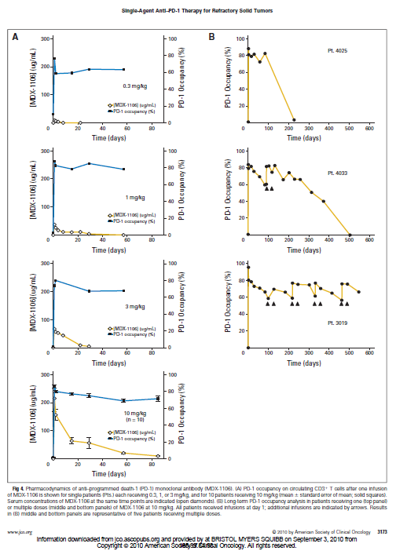
Study CA209003 (Study MDX-1106-03): Occupancy with repeated dosing was assessed in Study CA209003. After 4 doses of nivolumab, administered fortnightly, median receptor occupancies were 64.1% at the dose of 0.1 mg/kg, 65.0% at the dose 1 mg/kg, and 69.5% at the dose of 10 mg/kg. For the proposed dose in this submission, 3 mg/kg, median receptor occupancy was 67.8% (range 51.1% to 84.6%).
Study CA209009: Receptor occupancy with repeated dosing, with nivolumab administered every 3 weeks, was also measured in Study CA209009. Receptor occupancy was ≥ 90% at all doses (0.3 to 10 mg/kg).
Figure 5. Study CA209009 T-lymphocyte receptor occupancy (multiple doses)
Note: ‘C8 oh’ on the x-axis of these figures corresponds to Day 0 of cycle 8, that is after 7 fortnightly doses.
Comment: High and prolonged receptor occupancy was noted with single dose administration of nivolumab, even when serum nivolumab levels were below the lower limit of quantification. Dose independent high receptor occupancy was also noted with multiple dosing, with no decline in occupancy prior to the next dose with administration every 2 weeks or every 3 weeks. In the discussion section of Study CA209009 CSR, it is noted that: ‘This dose-independent receptor occupancy may underlie the lack of a dose-response relationship in the other clinical and immune parameters measured here.’
The difference in receptor occupancy rates reported for Studies CA209003 and CA209009 (around 70% and 90% respectively) has been attributed to the use of frozen peripheral blood mononuclear cells (PBMCs) for the analysis in Study CA209003 and fresh PBMCs in Study CA209009.

Effect on serum cytokines and lymphocyte populations
The effects of nivolumab administration on serum concentrations of a variety of cytokines and other markers of immunological activity and on lymphocyte populations were investigated in two early studies, Study MDX-1106-01 and Study MDX-1106-03, and also in Study CA209009.

Effect on serum cytokines
Study MDX1106-01: Serum concentrations of the following were measured and reported: rheumatoid factor, CRP, thyroglobulin, IgA, Total IgG, IgG4, IgM, interleukins (IL-6, IL-10), interferon gamma, TNFα, ANA ‘screen’ and ‘pattern’ (no further details) have been examined. No summary tables or graphs were provided in the CSR and the results were provided in a 91 page table. According to the sponsor, no notable changes in these parameters were observed.
Study MDX1106-03: Cytokines panel assays included interleukin (IL)-1, 4, 5, 6, 10, 13, interferon (IFN)-α, and TNFα, measured in serum samples at baseline and on-treatment. ‘Immune safety analyses’ were performed of Rheumatoid Factor (RF), Thyroid Stimulating Hormone (TSH), Free T4 Level, adrenocorticotropic hormone (ACTH), C-reactive protein (CRP), and Antinuclear Antibody (ANA) titre and pattern. Of the 11 cytokines analysed, only 3 (IL-6, TGF-beta, and CRP) were measurable above the lower limits of detection of the assay. No pharmacodynamic or dose-response trends were reported to be associated with IL-6, TGF-β, or CRP.

Effect on serum chemokines
The two chemokines CXCL-9 and CXCL-10 are produced in response to interferon-ϒ which in turn is produced by activated T cells and NK cells. These chemokines bind to the CXCR3 receptor which is found on activated T cells, memory T cells and NK cells. This interaction promotes chemotaxis, resulting in directional migration of these cells. Activation of the CXCR3 receptor is believed to be a component of cell-mediated immunity. According to the sponsor’s documents, these chemokines ‘guide the trafficking behaviour of T cells as part of the immune response against tumours’. In vitro studies of nivolumab and CD4+ T lymphocytes found increased IFNϒ release and increased cell proliferation. Increases from baseline have also been observed in a biomarker study with another fully human monoclonal antibody checkpoint inhibitor, ipilimumab.
Study CA209009: Baseline and post-nivolumab treatment modulation of serum levels of the chemokines CXCL9 and CXCL10 (IP10) were assessed, with sampling performed on Day 1 of Cycle 2, Day 8 of Cycle 2 (84 patients) and Day 1 of Cycle 4 (69 patients). There was an apparent increase in CXCL9 and CXCL10 in all dose groups, with this measurable within 24 hours of the first dose and sustained for up to 9 weeks (up to the last time-point of measurement). Median percent increase from baseline to fourth dose pre-dose/12 weeks after start of therapy, across any treatment dose group, was 90% for CXCL9 and 30% for CXCL10.

Effect on lymphocyte populations
A summary of lymphocyte subsets and function is provided below to assist in understanding of this section of the CER.

Table 12. Lymphocyte subsets, function and phenotypic markers
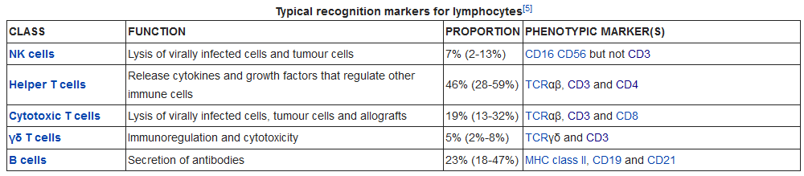
Study MDX-1106-01: Lymphocyte populations assessed in this study included: CD3, CD4, CD8, CD14, CD19, CD56, activated CD4, activated CD8. According to the study protocol: ‘Where tumour tissue is available, the extent of lymphocytic infiltration before and after treatment will be assessed.’ No summary tables or graphs were provided in the CSR and the results were provided in a 93 page table. The sponsor’s conclusion was that: ‘There were no consistent patterns in flow cytometry values over time that would indicate that treatment with MDX-1106 resulted in clinically meaningful flow cytometry abnormalities. Due to the small number of subjects in each dose cohort and high variability, data interpretation was difficult.’
The results of nivolumab therapy on lymphocyte infiltration of tumours was not reported in the CSR.
Additional information regarding changes following a single does is provided in the related publication: ‘The effects of a single 10 mg/kg dose of MDX-1106 on peripheral blood lymphocyte numbers, subset profiles, and activation status were analysed in 17 patients (see figure below). Twenty-four hours post-dose, total lymphocyte as well as CD3, CD4, and CD8 numbers declined and then rebounded from days 2 through 29 and declined again from days 29 through 85. These trends were not observed for CD19 (B lymphocyte) or CD56 (natural killer) cells (not shown), suggesting a selective effect on T cells’.⁸
Figure 6. Effects of a single dose of nivolumab on circulating lymphocyte numbers
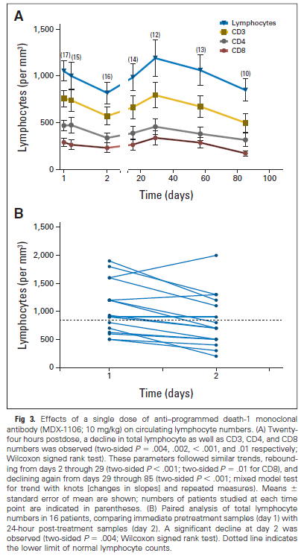
The publication describes the results of tumour biopsies for lymphocyte infiltration, but only for one patient: ‘[one] melanoma patient […] who experienced a PR to anti–PD-1 therapy, underwent pre- and post-treatment biopsies of an axillary lymph node metastasis for characterization of intratumoral lymphoid infiltrates by IHC. Whereas the pretreatment biopsy contained only sparse lymphoid cells, subsequent tumor regression was accompanied by a moderate infiltration of CD8+, but not CD4+, T cells’.
Study MDX-1106-03: Fresh whole blood was investigated using flow cytometry on various cell types, consisted of lymphocyte and T lymphocyte subsets. These included activated T lymphocyte subsets (CD4+/helper and CD8+/cytotoxic), regulatory T lymphocytes, and NK lymphocytes. Testing was performed at baseline and after 4 doses of nivolumab. Absolute lymphocyte counts in peripheral blood before and on treatment were also measured.
Mean increase from baseline across all doses of nivolumab for activated CD4 T-cells were 1.4% to 2.4%. In activated CD8 T-cells, increases ranging from 0.1% to 5.8% compared to baseline were seen. These changes did not appear to be dose-related. There was no meaningful rise over baseline was observed in mean absolute lymphocyte count and the baseline level was not associated with response to nivolumab therapy.
Comment: The information provided in the two studies regarding the effect of nivolumab on circulating lymphocyte subsets does not appear consistent. No discussion is provided in the CSRs, or related publications, as to how the observed changes in peripheral lymphocyte subsets relate to the postulated mechanism of action. The conclusion in the Summary of Pharmacology in the previous melanoma submission was that ‘nivolumab treatment had no clinically meaningful changes in activated T cells in peripheral blood; no dose response was evident’. (See Section 11: Question 5 ‘Changes in lymphocyte subsets with nivolumab dosing in Study CA209003’).
Study CA209009: Measurement of changes in circulating subsets of lymphocytes was an objective of this study. However, ‘due to improper storage at the central laboratory resulting in poor cell viability, the peripheral blood mononuclear cell (PBMC) samples were unable to be tested for activated and memory T cells’.

PD-L1 Expression
The postulated mechanism of action of nivolumab is that it blocks the PD-1 receptor on activated T-lymphocytes. This, in turn, blocks the interaction between the PD-1 receptor and PD-L1 and PD-L2 expressed on tumour cells. Blockade of the PD-1 receptor is believed to negate tumour inhibition of the immune response, resulting in immune mediated tumour cell destruction. Expression of PD-L1 and PDL2 on tumour cells is therefore integral to this mechanism of action. PD-L1 expression on tumour cells and immune cells has been investigated as a possible predictive biomarker in the clinical development programme of nivolumab. Analytic methods and measurement of PD-L1 have been presented in recent submissions (see the extract of the CER (Attachment 2) for the previous Opdivo submission).
The assay used in most of the studies in the clinical development programme was the Dako assay. This automated PD-L1 immunohistochemistry (IHC) assay was co-developed by the sponsor and Dako Pharma using a rabbit anti-human PD-L1 antibody (clone 28-8; Dako Pharma) to assess PD-L1 expression in pre-treatment formalin-fixed, paraffin embedded (FFPE) tumour samples from subjects with melanoma. A cut-off of 5% (according to the percent of tumour cells demonstrating plasma membrane PD-L1 staining) was used to indicate ‘positivity’ in the initial studies using this assay. Subsequently, a range of cut-offs (1%, 5%, 10%) were used in the analyses.
Categories used for description of PD-L1 status were:
- missing: no available specimen.
- quantifiable: specimen available and at least 100 viable tumour cells and an estimate made of the percentage of PD-L1+ cells. Cut-offs of 1%, 5% and 10% were used for reporting.
- indeterminate: unquantifiable, with staining hampered due to biology of specimen.
- not evaluable: unquantifiable due to suboptimal collection or preparation of the specimen.
According to the Delegate’s Overview for the previous NSCLC submission: ‘There is no currently registered PD-L1 assay in Australia’ and that: ‘The FDA has approved the Dako pharma DX PD-L1 assay for companion use with Pembrolizumab, and not in conjunction with nivolumab.’
PD-L1 expression in relation to the end-points of overall survival and objective response rate was investigated in several studies of nivolumab as monotherapy in advanced solid tumours. Those evaluated by the TGA include: Study CA209066 (patients with advanced melanoma), Study CA209037 (patients with advanced melanoma), Study CA209017 (patients with advanced squamous non-small cell lung cancer), Study CAMDX1106-03 (CA209003) (patients with various advanced solid malignancies); Study CA209057 (advanced non-squamous NSCLC). The results of these investigations are reported in varying detail in the CSRs and [are beyond the scope of this document]. PD-L1 expression was also investigated in Studies CA209025, CA209010 and CA209009 that are included in this submission.
Study CA209025: A secondary objective of this study was: ‘To evaluate whether programmed death-ligand 1 (PD-L1) is a predictive biomarker for OS’. This component of the study is [not described further in this document].
Pre-study tumour specimens were available for all study participants and tested retrospectively for PD-L1 expression. Subjects were enrolled regardless of PD-L1 expression. In 92.1% of specimens, PD-L1 was quantifiable, 370/410 in the nivolumab arm and 386/411 in the everolimus arm.
PD-L1 expression was spread evenly across the treatment arms. For the cut-off of 1%, 94/370 nivolumab arm patients and 87/386 of the everolimus patients had PD-L1 expression ≥ 1%. Only 85 patients had PD-L1 expression ≥ 5% (44 in the nivolumab arm and 41 in the everolimus arm) and 62 patients had PD-L1 expression ≥ 10% (32 in the nivolumab arm and 30 in the everolimus arm). A number of analyses of PD-L1 expression against treatment arm and efficacy outcome measure (OS, PFS per investigator) are presented in the CSR.
In general the results were consistent with the overall results of the study, with better outcomes observed in the nivolumab arm but little difference according to the level of PD-L1 expression, as shown in Table 13, below.

Table 13. Study CA209025 overall survival according to PD-L1 expression
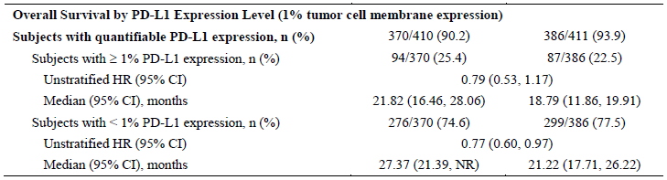
This is supported by a box-plot of PD-L1 expression levels against tumour response per investigator which shows no relationship between PD-L1 level and tumour response, shown in Figure 7 below.
Figure 7. Study CA209025 box plot of PD-L1 expression versus response status per investigator
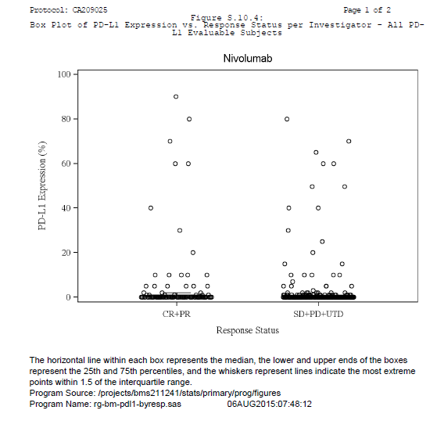
Study CA209010: This study included the exploratory objective of investigation of: ‘To explore associations between PD-L1 expression in tumors and other immune response biomarkers on clinical outcome’.
This component of the study is [not described further in this document]. Of note is that 2 different assays for PD-L1 expression were used for the study: Prototype PD-L1 Assay and Dako verified PD-L1 assays. The second assay (‘Dako’ assay) required that specimens be kept at 4°C; apparently this was not consistently done and could affect reliability of the results.
Results were provided for 2 cut-offs: ≥ 1% and ≥ 5%. A small minority of patients reached these cut-offs, using either assay:
- Prototype: 43/148 for cut-off ≥ 1% and 29/148 for cut-off ≥ 5% (missing data for 61 subjects)
- Dako: 36/148 for cut-off ≥ 1% and 11/148 for cut-off ≥ 5% (missing data for 20 subjects)
Using the cut-off of PD-L1 positive expression ≥ 5%, median OS in PD-L1 positive patients was numerically greater in PD-L1 negative subjects (39 months compared to 24 months using the Dako assay). No difference in OS was observed among PD-L1 positive and negative subjects as defined by the 1% cut-off (22.8 compared to 24.9 months respectively using the Dako assay).
Interpretation of these results is difficult due to: the small number of PD-L1-positive subjects, the number of subjects with missing data, lack of control comparison, and issues with sample storage described above.
Study CA209009: Investigation of PD-L1 expression was not descried as a study objective but was included in the study results, although there was limited detail provided regarding the methods. Pre-treatment tumour tissue samples were tested for PD-L1 expression. There were 58 subjects with evaluable PD-L1 expression in archival tumour tissue samples, 56 with evaluable PD-L1 expression in fresh samples, and 35 with both. Results for cut-offs of 1%, 5% and 10% were provided for archival specimens and for fresh specimens. Around one third of specimens had ‘unknown’ PD-L1 status, for both fresh and archival specimens and across all treatment groups. Among subjects with PD-L1 expression data in both types of samples, 12 samples showed discordant expression between the samples using a 5% expression threshold. For archival specimens, and using a cut-off of 5%, PD-L1 positive expression was reported in 14/91 patients, negative expression in 44/91 and unknown in 33/91 patients.
No association between PD-L1 expression and the efficacy end-points of PFS and OS was apparent in this study.

Evaluators comments on PD-L1
PD-L1 expression in renal-cell cancer tissue, according to the techniques used, did not assist in characterising the patients who were more likely to benefit from nivolumab therapy in the studies provided. However, for a greater understanding of the effect of PD-L1 status on outcome, a direct comparison of PD-L1 positive to PD-L1 negative patients would be helpful. This could include the patients in the nivolumab arm from Study CA209025. See Section 11: Question 4 ‘Mechanism of Action’.
Considerable variability has been reported in PD-L1 status across the studies in the clinical development programme, regardless of tumour type, even when the same assay (Dako) is used.

Table 14. PD-L1 positive expression in patients receiving nivolumab monotherapy in the clinical studies
Study identifier | Number of patients in study who received nivolumab | Number with quantifiable PD-L1 expression | Number with positive expression using 5% cut-off¹ | Percentage positive of those with quantifiable expression | Number (%) not evaluable (‘missing’)
CA209037 | 268 | 111 | 59 | 53.2 | 157 (58.6)
CA209017 | 135 | 117 | 42 | 35.9 | 18 (13.3)
CA209003 | 306 | 101 | 48 | 47.5 | 205 (67)
CA209067 | 313 | 305 | 80 | 26.2 | 8 (2.6)
Renal Cell Carcinoma
CA209025 | 410 | 370 | 44/370 | 11.9 | 40 (9.8)
CA209010 | 168 | 107 | 29/107 | 27.1 | 61 (36.3)
CA209009² | 91 | 58 | 14/58 | 24.1 | 33 (36.3)
1) number with positive result according to the DAKO assay and using 5% cut-off; 2) evaluator unable to determine assay method used
Inconsistent results regarding a relationship between tumour responsiveness and PD-L1 status have been reported. In Study CA209003, patients with tumours rated as PD-L1 positive were found to have a higher rate of objective tumour response (for both melanoma and NSCLC patients). In Study CA209057, patients with non-squamous NSCLC who were PD-L1 negative obtained no survival benefit from nivolumab. In Study CA209066 (melanoma), CA209010 (RCC), CA209025 (RCC), and CA209009 (RCC) outcomes were not better in PD-L1 positive patients. See Section 11: Question 4, ‘Mechanism of action’. The absence of any effect of PD-L1 expression and the high rate of ‘unknown’ results raises questions regarding the purported mechanism of action and/or the assay used. See Section 11: Clinical Question, PD-L1 assay.

Tumour infiltration by lymphocytes
During treatment with immunotherapy, tumours may initially increase in size with this due to lymphocyte infiltration and inflammation (‘pseudoprogression’). Tumour infiltration by lymphocytes during nivolumab treatment was assessed in Studies MDX1106-01 and CA209009.
Study MDX1106-01: The results of the investigation of tumour infiltration were not apparent in the CSR. However, the related publication describes the results of tumour biopsies for lymphocyte infiltration, but only for one patient: ‘melanoma patient […] who experienced a PR to anti–PD-1 therapy, underwent pre- and post-treatment biopsies of an axillary lymph node metastasis for characterization of intratumoral lymphoid infiltrates by IHC. Whereas the pre-treatment biopsy contained only sparse lymphoid cells, subsequent tumor regression was accompanied by a moderate infiltration of CD8+, but not CD4+, T cells’.
Study CA209009: Tumour biopsies were performed in approximately 35 patients at Baseline and on Day 8 of Cycle 2. Samples were investigated for changes in a number of lymphocyte subsets including PD-1 expressing T lymphocytes, activated CD8 (cytotoxic) T cells, activated CD4 (helper) + PD-1 expressing T cells. The numbers of each of these subsets were found to increase from baseline in the tumour biopsy during treatment. It is not known whether this was due to clonal proliferation within the tumour or due to migration from the peripheral circulation.

Time course of pharmacodynamic effects

Receptor occupancy versus drug half-life
Pharmacokinetic studies have demonstrated a half-life of 12 to 20 days for nivolumab, with this dose dependent. Receptor occupancy studies of nivolumab binding to PD-1 receptors, have found that this is dose-independent, with occupancy greater than 70% even when serum levels of nivolumab are undetectable (see above). The occupancy, after a single dose, ‘eventually decayed after 85 days’. Investigation of receptor occupancy with multiple dosing also found it to be dose independent and to show no decline between doses administered every 2 weeks or every 3 weeks.

Tumour response
Some information regarding the time course for the pharmacodynamics effect of tumour shrinkage is available in the results of several studies.
In the dose ranging study performed in patients with advanced solid tumours, Study CA209003, it was reported that:
- Objective response could take some time to be evident with response observed in 30/65 (46%) by 8 weeks but 59/65 (91%) by 24 weeks.
- The median duration of responses ranged from 56 to 104 weeks across tumour types. At the time of analysis, responses were ongoing in 35 of 65 (53.8%) subjects.
- Of the 5 NSCLC, 17 melanoma, and 5 RCC responders who discontinued treatment due to reasons other than disease progression, responses of ≥ 24 weeks were noted in 3 NSCLC subjects and ≥ 16 weeks in 12 melanoma and 4 RCC subjects.
In the dose ranging study performed in patients with advanced RCC (Study CA209010), time to investigator assessed response ranged from approximately 1.2 to 10 months across three dose groups, with no dose dependent effect. The median duration of response in this study for the 2 mg/kg and 10 mg/kg groups (as provided in the addendum to the Final CSR) was 21.6 and 22.3 months respectively.
In the pivotal study for this submission, Study CA209025, there were 103 ‘responders’ in the nivolumab arm. The median time to investigator assessed objective response in these patients was 3.5 months (range 1.4 to 24.8 months) and the median duration of response was 12 months (range 7.9 to 23 months).
Comment: Given the apparently avid binding of nivolumab to the PD-1 receptor, as shown by the prolonged high occupancy, the duration of pharmacodynamic effects can therefore be expected to last much longer than the half-life of nivolumab. The dosing interval chosen for nivolumab is apparently based on the pharmacokinetic measure and may be considerably more frequent than required. Receptor occupancy would be the major factor in the postulated mechanism of action and the dosing interval would more appropriately be based on the duration of this occupancy than the half-life of free nivolumab in the circulation. Biological activity against solid tumours has been demonstrated at dosing intervals of 2 weeks and three weeks but no investigations of longer dosing intervals have been provided. The time course of tumour response is slow compared to conventional chemotherapy. Dosing that is more frequent than the duration of mean plateau receptor occupancy is unlikely to alter this time-course as it is unlikely to significantly alter receptor occupancy. See Section 11: Clinical Question Half-life versus duration of action and dosing regimen.

Relationship between drug concentration and pharmacodynamic effects
In a Phase I dose-ranging study, Study CA209003, patients with solid organ tumours (melanoma, renal cell carcinoma, NSCLC, colorectal cancer, prostate cancer) were treated at one of five dose levels (0.1, 0.3, 1.0, 3.0 and 10.0 mg/kg) with treatment was administered every 2 weeks, for up to 48 doses. RCC patients in this study received 1 mg/kg (18 patients) or 10 mg/kg (16 patients) dosing. Efficacy was determined by investigator-assessed tumour measurements using RECIST v1.0 criteria, and consisted primarily of the objective response rate (ORR). This study reported that:
- the maximum tolerated dose was not defined within the range tested.
- there was no apparent dose-response relationship across the evaluated dose ranges in the rate of objective responses for patients with melanoma or RCC: the ORR in RCC patients was 27.8% at 1 mg/kg dosing and 31.3% at 10 mg/kg dosing; the ORR in melanoma patients was 31.4% at 1 mg/kg dosing, 41.2% at 3 mg/kg dosing and 20.0% at 10 mg/kg dosing.
- A possible dose-response relationship was seen in patients with NSCLC with ORRs of 24.3% and 20.3% at 3 or 10 mg/kg nivolumab respectively compared to the ORR of 3.0% at 1 mg/kg dosing.
It was also reported that the spectrum, frequency, and severity of treatment related adverse events were generally similar across the dose levels tested.
An exposure–response analysis was provided by the sponsor [not included in this document]. Data from Studies CA209025 and CA209010 were used in the efficacy analysis; data from Study CA209025 was used in the safety analysis. Both of these studies were performed in patients with clear cell RCC who had received prior anti-angiogenic therapy/therapies.
The exposure–response efficacy analysis found that:
- Sex, region (Western Europe), baseline MSKCC risk score, baseline KPS, and baseline weight, were significant predictors of OS in subjects with advanced RCC. Risk of death was higher in females (relative to males), intermediate and poor MSKCC risk (relative to favourable risk), and Western European region (relative to US/Canada). The risk of death increased with increasing weight.
- The number of prior anti-angiogenic therapies, region (Rest of World), age, PD-L1 status (≥ 1%), baseline ANC, and baseline platelet count were not significant predictors of OS in previously treated subjects with RCC.
- A sensitivity analysis was performed of the impact of baseline tumour size and tumour shrinkage at 8 weeks on OS. This found a higher risk of death with less tumour shrinkage and that baseline tumour size and tumour shrinkage were significant predictors of OS.
The exposure-safety analysis showed some inconsistent results with the risk of AE-DC/D appearing to decrease with increasing exposure. The sponsor’s conclusion was that nivolumab exposure did not appear to have a significant risk of AE-DC/D. The risk of AE-DC/D appeared to increase with increasing age, body weight and KPS < 90, although these effects were small or insignificant.
    - Genetic-, gender- and age-related differences in pharmacodynamic response
Not investigated.

QT Prolongation
Study CA209010: This study included the exploratory objectives of ‘Evaluation of changes in corrected QTc interval with nivolumab’. A subpopulation of subjects enrolled in the study underwent assessment of QTc interval effects. This component of Study CA209010 was evaluated in the Clinical Evaluation Report for the first Opdivo NBE submission [and has not been included in this report].⁹ The conclusion of the evaluator for [the previous submission] is as follows: ‘The study design, conduct and analysis were satisfactory. The data suggest that the proposed dosage regimen is unlikely to produce clinically significant QT prolongation. However, the study does not meet the criteria for a ‘thorough’ QT study according to the relevant EMA guideline adopted by the TGA.’

Immunogenicity
Although nivolumab is a fully humanised immunoglobulin, according to the sponsor’s Summary of Pharmacology: ‘All therapeutic proteins have the potential to elicit an antibody response. Antibody responses can cause general immune-mediated adverse events such as infusion reactions and hypersensitivity reactions.’ Both studies included in this evaluation (Studies CA209010 and CA209025), and the late submitted Study CA209009, had an immunogenicity component. These analyses included all nivolumab-treated subjects with baseline and at least one post-baseline assessment for anti-drug antibody (ADA). Three generations of ADA assay methods have been used during the clinical development programme for nivolumab. The second generation assay method appears to have been used for Study CA209010 and the third generation assay method for Study CA209025.
The following definitions of ADA status were used in both studies;
ADA Status:
- Persistent Positive: ADA-positive sample at 2 or more consecutive time-points, where the first and last ADA-positive samples at least 16 weeks apart.
- Only the Last Sample Positive: Not persistent but ADA positive sample in the last sampling time-point.
- Other Positive: Not persistent but some ADA positive samples with the last sample being negative. Post-baseline is defined as after initiation of treatment.
- ADA-negative: no ADA-positive sample after the initiation of treatment.
- If patients were ADA positive at baseline, a subsequent sample was considered ADA positive only if the ADA titre was ≥ 4 times the baseline positive titre.
Study CA209025 added the following category:
- Neutralising Positive: At least one ADA-positive sample with neutralising antibodies detected
Study CA209025: In Study CA209025, 371/410 patients from the nivolumab arm were evaluable with baseline and at least one post-baseline assessment. There were 10 patients (2.7%) who tested positive at baseline. Most patients (344/371, 92.7%) were ADA negative throughout. No subjects tested positive for neutralising ADA. One patient was ‘Persistent Positive’. This patient became positive after the first cycle and continued to receive further cycles for a three month period with no reported infusion related or hypersensitivity reactions. A total of 26 nivolumab treated subjects experienced select AEs in the hypersensitivity infusion reaction category and all were ADA negative.
Study CA209010: In Study CA209010, there were 133/168 evaluable patients. Of these, 15 (11.3%) were positive at baseline. Most patients (112, 84.2%) were ADA negative throughout. The number of patients with persistent positive results is not clear; the Final CSR describes three patients in this category but according to the table of ADA results in the Addendum to the Final CSR provided with this submission, there were no persistent positive patients. The Final CSR states that: ‘The safety profile of the 3 persistent positive subjects was no different from those seen in the general population; no new or additional AEs were reported in these subjects.’ The CSR also expresses a concern that the detection of ADA at higher doses of nivolumab (2 and 10 mg/kg) could be affected by the ‘drug tolerance limit of the assay’. It is also not clear from the tables provided as to how many of the patients who were ADA negative at baseline, tested positive during the study (See Section 11: Question 4 ‘Mechanism of action’). The proportion of patients testing positive for ADA appeared to decline as the nivolumab dose was increased with 17/43 (36.2%) of the 0.3 mg/kg group testing positive, 4/43 (9.3%) of the 2 mg/kg group and none of the 10 mg/kg group.
Study CA209009: In Study CA209009, there were 91 patients treated with nivolumab. Of these 79 were evaluable for ADA, 4/79 (5.1%) ADA positive at baseline, 71/79 (89.9%) ADA were negative throughout and 5/79 (6.3%) patients became ADA positive during treatment. Of the ADA positive patients, 2 were ‘persistent positive’. No assessment of any relationship between ADA status and efficacy or safety measures was made.
ADA and the assays used: The Integrated Summary of Safety presented a summary of immunogenicity findings that includes only those studies in which nivolumab was administered according to a dosing regimen of 3 mg/kg every 2 weeks.

Table 15. Summary of nivolumab ADA in subjects treated with 3 mg/kg every 2 weeks
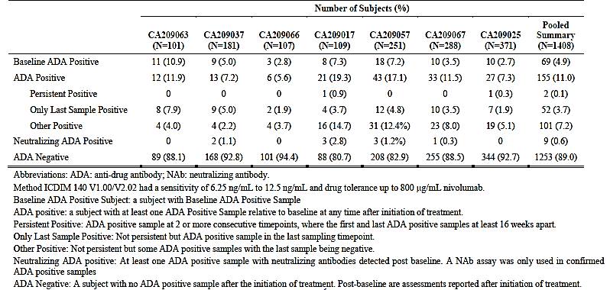
The PPK study provided summary statistics for ADA results for these and other studies and included information on the ‘generation method’ used.

Table 16. Summary of nivolumab ADA tests according to study and method
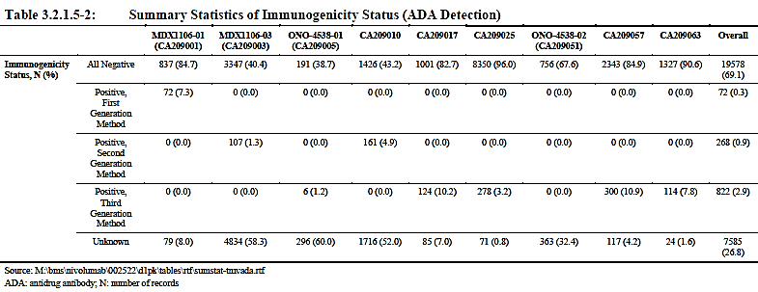
Comparison of the two tables suggests that the third generation assay method was used in Study CA209025 and the second generation assay used in Study CA209010. The use of different assay methods may account for the much higher rate of baseline positive patients observed in the Phase II CA209010 study compared to the Phase III CA209025 study (11.3% compared to 2.7%). However, even in studies which appear to use the same generation method (such as Studies CA209025, CA209017, CA209057 and CA209063), baseline rates ranged from 2.7% to 10.9% and the proportion that was ADA positive during the study ranged from 7.3% to 19.3%.

Integrated assessment of immunogenicity in the draft RMP
The following assessment is provided in the draft RMP:
‘To further explore the relationship between immunogenicity and safety following nivolumab monotherapy, an integrated assessment of the potential impact of nivolumab ADA on immunogenicity-related effects was performed by summarizing the ADA status of subjects who experienced hypersensitivity reactions or infusion reactions after treatment with nivolumab.’
‘A total of 51 subjects experienced hypersensitivity reactions/infusion reactions and were evaluable for the presence of ADA. Of the 51 evaluable patients, 48 (94.1%) were negative for nivolumab ADA and 3 (5.9%) were positive for ADA. One subject that was ADA positive (in Study CA209037) had an ADA positive status only for the last sample and experienced an infusion site reaction earlier on in treatment when the ADA status was negative Thus, the infusion reaction in this subject was not associated with the positive ADA status. Two subjects from Study CA209057 were ADA positive and had Grade 1-2 infusion related reactions on the same day. In Study CA209067 (monotherapy group), all subjects who experienced a hypersensitivity or infusion reaction were ADA negative. These patients went on to receive additional nivolumab doses and ADA were not detectable in subsequent assessments. Overall, no association was established between the presence of ADA positivity and hypersensitivity or infusion reactions, suggesting nivolumab ADA is not clinically meaningful’.
Comment: The evaluator is of the opinion that the immunogenicity of nivolumab has not been fully characterised.
Assays for antibodies to monoclonal PD1 antibodies appear to be problematic. The FDA label for the first-in-class, pembrolizumab, describes 0.3% of patients treated with pembrolizumab testing positive for anti-drug antibodies and states:
‘The detection of antibody formation is highly dependent on the sensitivity and specificity of the assay. Additionally, the observed incidence of antibody (including neutralizing antibody) positivity in an assay may be influenced by several factors including assay methodology, sample handling, timing of sample collection, concomitant medications, and underlying disease.’
Inconsistent results for ADA were seen in the studies provided in the current nivolumab submission. In Study CA209025, 2.7% were ADA positive at baseline and another 7.3% tested positive during the study. In Study CA209010, 11.3% were ADA positive at baseline and another 4.5% tested positive during the study. In Study CA209009, 5.1% were ADA positive at baseline and another 6.3% tested positive during treatment. Considerable variation in measured ADA positive rates across a number of studies is also evident in the tables provided by the sponsor, even when the same generation method assay appears to have been used (see tables above). No discussion of this, or the differences in the first, second and third generation assays has been provided by the sponsor (See Section 11: Question 9 ‘Immunogenicity and the ADA assay’). Considerable variation is also evident in the reported rates for neutralising ADA positive (from 0.3% to 2.8%).
It is not clear to the evaluator that a reliable anti-nivolumab antibody assay has been developed, or a reliable neutralising ADA assay. Given this, determining any relationship between ADA status and adverse events or efficacy is not possible. The effect(s) of ADA on efficacy and safety should be regarded as ‘missing information’. The evaluator recommends that ADA positive rates and any conclusions regarding ADA and effects on efficacy and safety are not included in the PI.
The evaluator also notes that nivolumab is a fully humanised IgG4 monoclonal antibody, produced in a Chinese hamster ovary (CHO) cell line. Anti-CHO antibodies have been recognised to occur in subjects treated with other therapeutic proteins produced in Chinese hamster ovary cell lines. The presence of ADA antibodies in patients receiving nivolumab does not appear to correlate with the occurrence of infusion reactions. This may reflect deficiencies in the ADA assay or the development of a different antibody. The evaluator is not aware of any investigation of the development of anti-CHO antibodies in patients receiving nivolumab and whether these may be contributing to infusion reactions. (See Section 11: Question 11 ‘Anti-CHO antibodies and nivolumab).

Evaluator’s overall conclusions on pharmacodynamics
Some major questions are raised by the pharmacodynamics information that is available:
- The postulated mechanism of action does not appear to be confirmed.
- The dosing interval selected for the Phase III studies does not appear to be consistent with the pharmacodynamics of receptor interaction, a key component of the postulated mechanism of action.
- The dose chosen for the Phase III study in advanced renal cell carcinoma may be greater than required. Unnecessarily large dosing and excessively frequent dosing may expose the patient to greater risk of adverse consequences.

Mechanism of action
The sponsor has not confirmed the mechanism of action. It is postulated that nivolumab blocks the interaction between PD-L1 expressed on tumour cells and the PD-1 receptor on activated lymphocytes, with this resulting in immune mediated destruction of tumour cells.
The human immune system is immensely complicated and not fully understood. Immune mediated cellular destruction would be expected to be accompanied by the release of a variety of cytokines and by changes in the sub-populations of lymphocytes ; for example, activated helper T cells (CD4+) may release a variety of interleukins (IL 4, 5, 6, 10, and 13) and, once activated, cytotoxic T cells (CD8+) undergo rapid clonal expansion, with this evident in the peripheral circulation.
The essential steps of the postulated mechanism of action are that:
- Nivolumab binds to the PD-1 receptor
- PD-L1 and PD-L2 are expressed on tumour cells
- Binding of nivolumab to the PD-1 receptor blocks the interaction between PD-L1 and PD-L2 on tumour cells, thereby enabling destruction of the tumour cells by immune cells.
This mechanism of action has been investigated in the clinical trial programme through measurement of receptor occupancy, measurement for changes in cytokine levels, chemokine levels and lymphocyte populations and measurement of PD-L1 expression on tumour cells, with correlation of the latter to clinical efficacy.

Receptor occupancy
PD-1 receptor occupancy by nivolumab has been shown to be dose independent and to be both prolonged and avid. The time course of receptor occupancy was investigated in Study CA209003. This found that after a single dose of nivolumab, a prolonged mean plateau occupancy of greater than 70% was observed, with this persisting even when serum levels of nivolumab were undetectable and that occupancy ‘eventually decayed after 85 days’. In Study CA209009, receptor occupancy with multiple dosing was found to be around 90% within one hour of dose administration and to remain at this level with all subsequent doses. Receptor occupancy was not dose related and there was no decline prior to the next dose (administered every three weeks).
Pharmacokinetic studies have demonstrated a half-life of 12 to 20 days, with this dose dependent. Given the apparently avid binding of nivolumab to the PD-1 receptor, as shown by the prolonged high occupancy, the duration of pharmacodynamic effects can therefore be expected to last much longer than the half-life of nivolumab in the circulation. The dosing interval chosen for nivolumab for the Phase III studies of 14 days appears to have been based on the pharmacokinetic measure and may be considerably more frequent than required. Receptor occupancy would be the major factor in the postulated mechanism of action and the dosing interval would more appropriately be based on the duration of this occupancy than the half-life of free nivolumab in the circulation. See Section 11: Question 16 ‘Half-life versus duration of action and dosing regimen’.

Cytokine levels and lymphocyte populations
Apart from an elevation in the levels of two chemokines (CXCL-9 and CXCL-10) that was described in patients receiving nivolumab for renal cell carcinoma (Study CA209009), no notable changes in either cytokine levels or other markers of immunological activity (for example CRP, interleukins, TNF-alpha, interferon gamma) have been demonstrated. Small increases in the circulating lymphocyte populations of CD4+ and CD8+ were reported on treatment in one study. The lack of change in cytokine levels is in one sense reassuring as it means that widespread activation of the immune system, resulting in a ‘cytokine storm’, is not occurring. Some signs of immune system activity should, however, be evident given that these patients have metastatic disease and tumour destruction, hopefully, is occurring in many sites.

PD-L1 expression by tumour cells
Considerable variability has been reported in PD-L1 status across the studies, even when the same assay is used; rates of PD-L1 expression using the 5% cut-off ranged from 12% to 53%. Inconsistent findings were reported for efficacy outcomes in relation to PD-L1 status.
From these investigations of the mechanism of action, PD-1 receptor occupancy by nivolumab on peripheral lymphocytes and small increases in the circulating populations of CD4+ and CD8+ T lymphocytes has been demonstrated. However, no corresponding changes in absolute lymphocyte count or circulating cytokine levels have been demonstrated. PD-L1 expression appears to be variable and not to relate to efficacy. These findings, particularly in relation to PD-L1 expression, are not consistent with the postulated mechanism of action. See Section 11: Question 4 ‘Mechanism of action’.

Dose dependency and tumour response
There was no apparent dose-response relationship across the evaluated dose ranges in subjects in the rate of objective responses for patients with melanoma or RCC. The objective response rate in RCC patients was 27.8% and 31.3% for patients treated with 1 mg/kg and 10 mg/kg respectively. The objective responses observed were 31.4%, 41.2% and 20.0% of melanoma patients treated at 1, 3 and 10 mg/kg respectively. The dose chosen for the pivotal study in patients with advanced RCC (3 mg/kg) is not consistent with these findings. A dose of 1 mg/kg may have been adequate. See Section 11: Question ‘Dose-selection and the pivotal study’.

Time course of tumour response
Response to nivolumab in terms of measurable decrease in tumour size may be slow. One study of nivolumab therapy in advanced solid organ tumours (Study CA209003) found that, although measurable tumour response occurred within 8 weeks for 46% of responders, tumour shrinkage occurred between 8 weeks and 24 weeks of treatment in another 45% of responders. In two studies in patients with advanced RCC, the dose-ranging Study CA209010 and the pivotal Study CA209025, a range of 6 weeks to 25 months was reported in the time to response (investigator assessed). The median duration of response in these studies was around 20 months in Study CA209010 and 12 months in Study CA209025. Tumour response with conventional chemotherapy is expected within days to weeks. The prolonged time course for tumour response seen with nivolumab is consistent with the slower course of immune cell-mediated tumour cell destruction. With the observed receptor occupancy, both degree and duration, frequent administration of nivolumab is unlikely to change this time course. See Section 11: Question 16 ‘Half-life versus duration of action’.

Exposure response analysis
An exposure-response analysis for efficacy (risk of death and OS) and safety (AE-DC/D) was provided. These analyses included data from patients with advanced clear cell RCC who had received prior anti-angiogenic therapy in Studies CA209025 (efficacy and safety) and CA209010 (efficacy only). No relationship between exposure (as indicated by average steady state concentration) and overall survival or the occurrence of AE-DC/D was found.
The exposure response analysis for overall survival suggests that male sex, region (Western Europe), favourable baseline MSKCC risk score, baseline KPS, and baseline weight, were significant predictors of OS in subjects with advanced RCC. The risk of death increased with increasing weight. The number of prior anti-angiogenic therapies, age, and PD-L1 status (≥ 1) were not significant predictors of OS. The exposure-response analysis for safety found that, although the risk of AE-DC/D increased with increasing age and baseline body weight, these effects were small and not expected to be clinically relevant.

Secondary pharmacodynamics effects
Secondary pharmacodynamics effects have been assessed through a QT prolongation study and investigations of immunogenicity.

QT prolongation
The QT prolongation component of Study CA209010 found that nivolumab was unlikely to cause any clinically meaningful QT prolongation.

Immunogenicity
Anti-drug antibodies (ADA) were investigated in a number of studies in the nivolumab clinical trial programme. The assay used to measure ADA has been through several generations of development, with each assay having different levels of sensitivity. Considerable variability in measured rates of ADA positive patients is notable across the clinical studies, even when the same assay method is used in the studies being compared. The evaluator is not convinced that a reliable assay for anti-nivolumab antibodies has yet been developed and recommends against drawing any conclusions from the measured ADA rates, including the apparent lack of effect on safety and efficacy and the apparent lack of any relationship between infusion related reactions and ADA status. See Section 11: Question 9 ‘Immunogenicity and the ADA assay’.

Dosage selection for the pivotal studies
The study protocol for Study CA209025 provides the following rationale for the study design, choice of comparator and nivolumab dosing regimen.

Rationale for study design and comparator
A population of subjects who received prior anti-angiogenic therapy, rather than subjects who have received any prior systemic therapy, was chosen because the type of prior regimen received has been shown to have an impact on clinical outcome in subjects with pre-treated advanced or metastatic RCC. For example, in the Phase III AXIS trial, cytokine pre-treated subjects experienced a greater improvement in PFS compared to sunitinib pre-treated subjects. Everolimus was, therefore, chosen as the comparator because it is the only agent whose approval was based on the results of a Phase III trial limited to subjects who had received prior anti-angiogenic therapy.
An open-label, rather than blinded, study design was selected for a number of reasons including differing management of adverse reactions and high potential for inadvertent un-blinding due to differing toxicities/ different administration routes/different treatment schedules/ different dose modification rules.
The primary endpoint of overall survival rather than progression free survival was selected due to the potential for false positive assessments of disease progression resulting from:
- inflammation within tumours resulting from the immune response causing an initial increase in the size of lesions
- the slow onset of effect may result in new tumour growth initially being faster than the anti-tumour effects
This same concern is the rationale for allowing continued treatment despite initial evidence of disease progression, as long as they are experiencing an investigator-assessed clinical benefit and tolerating study drug. The FDA-approved product label for everolimus allows for continued treatment as long as clinical benefit is observed or until unacceptable toxicity occurs.
Comment: The rationale for the study design and comparator is reasonable. The choice of comparator is consistent with existing guidelines (described above) and the TGA approved indication for everolimus, the treatment of advanced renal cell carcinoma after failure of treatment with the anti-angiogenic therapies, sorafenib or sunitinib, with a recommended dose of 10 mg daily orally.
Overall survival is a preferred end-point. Progression free survival may be regarded as a surrogate end-point and would be subject to potential bias in this open-label study design in which the outcome measure of tumour progression is determined by the investigators rather than an independent panel. The complexity of tumour response using the RECIST criteria may also result in inter-rater variability.
The wording of the proposed indication of ‘for the treatment of patients with advanced renal cell carcinoma (RCC) after prior therapy in adults’ does not match the pivotal study population of patients with clear cell RCC who have had prior anti-angiogenic therapy. This is of importance given the statement in the study protocol: ‘as the type of prior regimen received has been shown to have an impact on clinical outcome in subjects with pre-treated advanced or metastatic RCC.’ See Section 11: Question 17 ‘Pivotal study design and proposed indication’.

Rationale for nivolumab dosing regimen
According to the CSR for Study CA209025:
‘The nivolumab dose regimen of 3 mg/kg Q2W evaluated in this study was chosen based upon an interim analysis on 24 February 2012 of safety, efficacy, and exposure-response data from approximately 300 subjects treated in the Phase I Study CA209003 (also known as MDX1106-03). The results of exposure-response analyses showed that the probability of a tumor response tended to approach a plateau for trough concentrations produced by 3 mg/kg and 10 mg/kg administered Q2W. Nivolumab was adequately tolerated up to 10 mg/kg, the highest dose tested, and no maximum tolerated dose was identified.’
The Study protocol provides additional information: ‘Anti-tumor activity was observed at dose levels ranging from 1 to 10 mg/kg in melanoma, NSCLC, and RCC, as well as at dose levels of 0.1 and 0.3 mg/kg in melanoma. The antitumor activity of nivolumab (BMS-936558) tended to increase with dose, as did the incidence of SAEs. The anti-tumor activity of nivolumab (BMS-936558) in RCC was investigated at dose levels 1 and 10 mg/kg, with the higher activity observed at 10 mg/kg. The observed anti-tumor activity in melanoma, and NSCLC was highest at 3 mg/kg, suggesting that anti-tumor activity approaches a plateau at dose levels of 3 mg/kg and above. Consistent with these observations, the results of the exposure-response analyses for these tumor types show that the probability of a tumor response tended to approach a plateau for trough concentrations produced by 3 and 10 mg/kg every 2 week dosing.’
Comment: Study CA209003 (also known as Study MDX1106-03) was evaluated for the first Opdivo NBE submission.⁹ Although the focus of this evaluation was pharmacokinetic and pharmacodynamic variables. In this dose-ranging study, patients with solid organ tumours (melanoma, renal cell carcinoma, NSCLC, colorectal cancer, prostate cancer) were treated at one of five dose levels (0.1, 0.3, 1.0, 3.0 and 10.0 mg/kg). Treatment was administered every 2 weeks, for up to 48 doses. RCC patients in this study received 1 mg/kg (18 patients) or 10 mg/kg (16 patients) dosing. Efficacy was determined by investigator-assessed tumour measurements using RECIST v1.0 criteria, and consisted primarily of the objective response rate (ORR). There was no apparent dose-response relationship across the evaluated dose ranges in subjects in the rate of objective responses for patients with melanoma or RCC. The objective response rate in RCC patients was 27.8% and 31.3% for patients treated with 1 mg/kg and 10 mg/kg respectively. The objective responses observed were 31.4%, 41.2% and 20.0% of melanoma patients treated at 1, 3 and 10 mg/kg respectively. The response rate was greater in NSCLC subjects treated with 3 or 10 mg/kg nivolumab (24.3% and 20.3%, respectively) than in subjects treated with 1 mg/kg nivolumab (3.0%). The conclusion of this study recommended the dose of 3 mg/kg given two weekly for all cancer types.
Study CA209010 and Study CA209009 were dose ranging studies in patients with advanced RCC who had received prior anti-angiogenic therapy(ies), with patients randomised to dosing regimens of 0.3, 2 or 10 mg/kg Q3W with similar efficacy outcome measures to CA209003. The rationale provided for the dose selection in Study CA209009 was: ‘Based on the long half-life (20 to 24 days), results from PK modelling suggested Q3wk schedule would result in sustained exposure between treatments. PK modelling also indicated a 2 mg/kg dose administered on a Q3wk schedule would provide similar exposure (C_{max}, C_{trough}, AUC) as a 1 mg/kg dose administered on a Q2wk schedule. The Q3wk schedule would also be a more convenient schedule for subjects’.
Study CA209010 found no significant difference in outcome between the three dose levels. Study CA209009 found similar efficacy outcomes for the 2 mg/kg arm and 10 mg/kg arm.
The dosing regimen for Study CA209025 is in accordance with the recommendation from the CSR for Study CA209003. However, on the basis of the results of Study CA209003, Study CA209009 and Study CA209025, a dose of 1 mg/kg every 2 weeks or 2 mg/kg every three weeks may have provided similar efficacy to the selected dosing regimen in patients with renal cell carcinoma (clear cell) and prior anti-angiogenic therapy. The evaluator also notes that, on the basis of the pharmacodynamics properties of nivolumab, dosing intervals considerably longer than 3 weeks may also be appropriate. A dosing interval of 3 weeks, or longer, would be more convenient to patients and lower drug exposure may reduce any dose-related toxicities. See Section 11: Question 15 ‘Dose selection and the pivotal study’.
The evaluator also notes that the proposed indication of ‘for the treatment of patients with advanced renal cell carcinoma (RCC) after prior therapy in adults’ is much broader than the population in the pivotal study. See Section 11: Question 17 ‘Pivotal study design and proposed indication’.

Clinical efficacy
For the proposed indication: ‘as monotherapy for the treatment of patients with advanced RCC after prior therapy in adults.’

Pivotal efficacy studies

Study CA209025

Study Summary
Enrolment to Study CA209025 was ceased early after independent data monitoring committee review of a pre-planned formal interim OS analysis concluded that the study had met its end point with regard to significant results for overall survival. Crossover from the everolimus arm to the nivolumab arm was allowed following this.

Table 17. Study CA209025 summary
Study details
Study Identifier | CA209025; ClinicalTrials.gov number: NCT01668784
Study title | ‘A Randomised, Open-Label, Phase III Study of Nivolumab (BMS-936558) versus Everolimus in Subjects with Advanced or Metastatic Clear-Cell Renal Cell Carcinoma Who Have Received Prior Anti-Angiogenic Therapy (CheckMate 025, CHECKpoint pathway and nivoluMAb clinical Trial Evaluation)’
Related publication | Motzer R et al. Nivolumab versus everolimus in advanced renal-cell carcinoma. N Engl J Med 2015;373:1803-1813
Design | Phase III, randomised, open label study of nivolumab versus everolimus
Patient group | Subjects with advanced or metastatic RCC who had received prior anti-angiogenic therapy
Dates | Enrolment commenced 9 October 2012; last patient was randomised on 11 March 2014. The study is ongoing: last patient visit and database lock was 18 June 2015 for the final CSR provided in the dossier CSR
Location(s) | 146 sites in 24 countries (Argentina, Australia, Austria, Belgium, Brazil, Canada, Czech Republic, Denmark, Finland, France, Germany, Greece, Ireland, Israel, Italy, Japan, Norway, Poland, Romania, Russian Federation, Spain, Sweden, United Kingdom, and United States)
Main eligibility criteria | Patients with advanced RCC with clear cell component who had received 1 or 2 prior anti-angiogenic therapy regimens for advanced or metastatic disease, who had pre-study archival or recently collected tumour specimens at time of randomisation and who did not have CNS metastases, prior treatment with an MTOR inhibitor, active autoimmune disease or medical condition requiring systemic immunosuppression.
Randomisation and blinding | Subjects were randomised 1:1 to nivolumab or everolimus and stratified according to the following: geographic region (US/Canada versus Western Europe versus ROW), Memorial Sloan-Kettering Cancer Center (MSKCC) risk groups (favourable versus intermediate versus poor), and number of prior anti-angiogenic therapies (1 versus 2).
Study treatments | Nivolumab 3 mg/kg every 2 weeks by IV infusion OR everolimus 10 mg oral daily.
Primary efficacy outcome measure | OS (database lock 18 June 2015)
Secondary outcome measures | Investigator-assessed ORR and PFS per RECIST criteria, DOR, OS by baseline PD-L1 expression level, disease related symptom progression rate.
Other measures | Immunogenicity of nivolumab; Safety and tolerability.
No of subjects | N = 821 randomised (410 nivolumab and 411 everolimus); N = 803 treated (406 nivolumab and 397 everolimus)
Duration of follow-up | Study duration was event driven. The study was closed early when pre-planned interim analysis found that the pre-specified boundary for significance was crossed (P < 0.0148). As a result, the minimum follow-up was approximately 14 months (median of 18.25 months for nivolumab and 17.22 months for everolimus).
Results (demographics) | Median age 62 years (range: 18 to 88), 87.7% were white; 75.4% were male; 52.8% had 3 or more baseline disease sites; 58.8% and 21.8% of subjects were in the intermediate or poor Heng risk group at baseline respectively.
Primary efficacy outcome | Completed primary endpoint based on pre-defined interim OS analysis. (18 June 2015 database lock), additional OS follow-up ongoing. There were 183/410 (44.6%) deaths in the nivolumab arm compared to 215/411 (52.3%) in the everolimus arm; HR 0.73 (95% CI 0.57, 0.93). Median survival (K-M estimate) was 25.0 months (95%CI 21.8, NR) in the nivolumab arm compared to 19.6 months (95% CI 17.6, 23.1)
Secondary outcomes | Investigator-assessed ORR and PFS per RECIST, DOR results not included in this summary due to high risk bias (open label, investigator assessed tumour progression).  OS according to PD-L1 status showed no significant survival benefit with PD-L1 positive status compared to PD-L1 negative status.  QoL measure showed small increase in median score according to the tool used in the nivolumab arm during treatment that favoured nivolumab. Median baseline and follow-up visit scores were the same in both arms.
DOR = duration of response; ORR = objective response rate; OS = overall survival; PD-L1 = programmed death-ligand 1; PFS = progression-free survival; RCC = renal cell carcinoma; RECIST = Response Evaluation Criteria In Solid Tumours; CR/uCR = complete response/unconfirmed complete response; ITT = intent-to-treat population; IAP = Independent assessment panel (blinded)

Good Clinical Practice
The associated publication states: ‘This study was approved by the institutional review board or an independent ethics committee at each center and was conducted in accordance with Good Clinical Practice guidelines, as defined by the International Conference on Harmonisation.’
The CSR included two signed audit certificates to indicate that the study was the subject of independent audit by the Global Quality and Regulatory Compliance.

Study Objectives

Primary objective
- To compare the clinical benefit, as measured by the duration of overall survival (OS), provided by nivolumab versus everolimus in subjects with advanced or metastatic renal cell carcinoma (RCC) who have received prior anti-angiogenic therapy.

Secondary objectives
- To compare the objective response rate (ORR) of nivolumab versus everolimus
- To compare the duration of progression-free survival (PFS) of nivolumab versus everolimus
- To assess the duration of overall response (OR) of nivolumab versus everolimus
- To evaluate whether programmed death-ligand 1 (PD-L1) is a predictive biomarker for OS
- To assess the overall safety and tolerability of nivolumab versus everolimus
- To assess the disease-related symptom progression rate in each treatment arm based on the Functional Assessment of Cancer Therapy-Kidney Symptom Index - Disease Related Symptoms (FKSI-DRS) subscale of the FKSI-15

Exploratory objectives
- To characterise the pharmacokinetics (PK) of nivolumab and explore the exposure-response relationship
- To characterise the immunogenicity of nivolumab
- To identify potential predictive biomarkers of efficacy, other than PD-L1 expression status, in subjects receiving nivolumab by analysing tumour specimens for expression of other proteins involved in regulating immune responses (for example, PD-1 and PD-L2)
- To assess the effect of natural variation single nucleotide polymorphisms (SNPs) in select genes (for example PD-1, PD-L1, PD-L2 and CTLA-4) on clinical endpoints and/or on the occurrence of AEs
- To assess changes in reported global health outcomes in each treatment arm based on the EQ-5D Index score
- To assess health resource utilisation (HRU) in each treatment arm during study therapy and at the first 2 follow-up visits

Inclusion and exclusion criteria
Main inclusion criteria were age 18 years of age or older, had histologic confirmation of advanced or metastatic renal-cell carcinoma with a clear-cell component and measurable disease according to the Response Evaluation Criteria in Solid Tumors (RECIST version 1.1), and had received one or two previous regimens of antiangiogenic therapy.
Additional inclusion criteria were no more than three total previous regimens of systemic therapy, including cytokines and cytotoxic chemotherapy drugs, and disease progression during or after the last treatment regimen and within 6 months before study enrolment. All patients had a Karnofsky performance status of at least 70 at the time of study entry (Karnofsky performance status scores range from 0 to 100, with higher scores indicating better functioning). Prior cytokine therapy (for example, IL-2, IFN-α), vaccine therapy, or treatment with cytotoxics was also allowed.
Key exclusion criteria were metastasis to the central nervous system, previous treatment with an mTOR inhibitor, or a condition requiring treatment with glucocorticoids (equivalent to > 10 mg of prednisone daily).

Study Design
A Phase III, randomised, open label study of nivolumab versus everolimus. Study design can be seen below in Figure 8.
Figure 8. Study CA209025 design
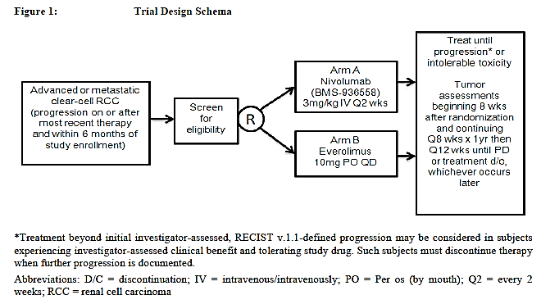

Protocol Amendments
A list of protocol amendments (7 to 15) is provided in the ‘Document History’ section of the Clinical Protocol CA209025 with the revised date of 12 August 2015. Other protocol amendments (1 to 6) are described in the appendix to the CSR. Most of the amendments are wording clarifications or minor changes. Other more significant amendments are described below

Protocol amendment 1
Addition of exploratory pharmacogenetic research for which participants of Study CA209025 were requested to voluntarily provide a blood sample that would be stored for use in ‘future exploratory pharmacogenetic research’

Protocol amendment 7
- Additional advice regarding reproductive toxicology, the length of time of contraceptive use and a ‘Guide on Contraception’.

Protocol amendment 12
- Changed the order of secondary objectives throughout document to indicate that ORR will be first and PFS second.

Protocol amendment 15
- Protocol update d to indicate early closure of the study and to enable crossover of patients from the everolimus arm to the nivolumab arm with the following rationale provided: ‘The DMC for the CA209025 study convened on 17 July 2015 to evaluate data from a planned, formal Interim Analysis of overall survival (OS). The DMC declared superiority for OS in subjects receiving nivolumab as compared to everolimus.
As a result of the DMC assessment, this protocol amendment is being implemented to provide a mechanism for eligible subjects originally randomised to the everolimus treatment Arm B to receive subsequent nivolumab therapy, as part of a nivolumab extension phase.
In addition, as a result of the DMC assessment, this protocol amendment indicates that the interim analysis results should now be considered the final primary analysis results of the protocol.’

Study treatments
The study is described as consisting of 3 phases: screening, treatment, and follow-up.
Taken from Study CA209010; confirm for Study CA209025 from study protocol:

Screening Phase
During this phase, the following are done:
- Patient’s initial eligibility is established, consent form signed and patient enrolled in the study.
- Medical history, including pulmonary risk factors collected.
- Physical examination including height, weight, blood pressure, heart rate, temperature, oxygen saturation by pulse oximetry (at rest and after exertion).
- Availability of tumour tissue confirmed.
- Baseline imaging of chest, abdomen, pelvis, brain, and all known sites of disease performed
- Baseline serum chemistries (blood urea nitrogen (BUN), creatinine, LFTs (ALT, AST, alkaline phosphatase, total bilirubin), Ca, Mg, Na, K, HCO₃, Cl, Glucose, albumin, CRP) and haematology (CBC plus differential), endocrine panel (including TSH, T3, T4); Hep B/C, HIV testing, fasting serum lipids profile including total cholesterol, triglycerides, LDL, and HDL; fasting glucose.
- Baseline creatinine clearance, if required, was determined using the central lab creatinine value and the Cockcroft-Gault formula.
- Pregnancy test in women of child-bearing age (WOCB age).
Eligibility was then assessed against all inclusion and exclusion criteria. Eligible patients were randomised to 1 of 2 treatment arms (nivolumab or everolimus). The first dose of study drug was to be administered within 3 days of randomisation.
A similar screening process was followed by subjects who were previously randomised to everolimus entering the nivolumab extension phase, as allowed with Protocol Amendment 15 described above.

Treatment Phase
A single dose of nivolumab, calculated according the subject’s body weight assessed at each visit, was administered to subjects as an IV infusion over 60 minutes on Day 1. Subjects subsequently received nivolumab in 2 week cycles until treatment discontinuation or study end. Dose reductions or escalation were not allowed. Everolimus was administered orally as a daily dose of 10 mg. Dose modifications for everolimus were allowed as per the approved product label or as per standard practice in countries where everolimus is not approved for the treatment of advanced RCC.
Dose delays were permitted for nivolumab and everolimus for up to 6 weeks from the last dose. Delays longer than 6 weeks were allowed only in cases where a prolonged steroid taper was required to manage drug-related AEs, or in some cases, if the delay was due to a non-drug related cause. Treatment modifications (for example, dose delay) were to be based on specific laboratory and AE criteria. [Dose delay criteria for each treatment arm are not shown here].
Treatment was continued until development of progressive disease (PD), intolerable toxicity, death, or other protocol-defined reasons. Treatment beyond progression was allowed in subjects who were tolerating study drug and experiencing clinical benefit as assessed by the investigator: tumour assessments continued according to the treatment phase schedule until treatment was discontinued.
Assessments during the treatment phase for the nivolumab arm:
- Clinic visits occurred on Day 1 of every cycle:
  - Performance status, AEs and concomitant medications were documented
  - Targeted physical examination, (including pulse oximetry, at rest and with exertion), performance status, AE status and weight
  - FKSI-DRS and EQ-5D completed by the patient
- Laboratory evaluations (CBC with differential, LFTs, BUN or serum urea, creatinine) were performed within 72 hours of dosing. Additional laboratory investigations, fasting serum lipids profile (total cholesterol, triglycerides, LDL, and HDL), fasting glucose, and TSH, were performed every second cycle.
- Pregnancy test was performed in WOCB age every cycle.
- Tumour assessment: using the same imaging modality as at baseline, subjects were evaluated for tumour response at Week 8,16, 24, 32, 40, 48, and 56 (± 1 week) from randomisation, then every 12 weeks (± 1 week) until disease progression is documented or treatment is discontinued, whichever occurs later.
Assessments for the everolimus arm during treatment were similar to those of the nivolumab arm except that the cycle length was regarded as 4 weeks; assessments that occurred ‘every cycle’ or every two weeks in the nivolumab arm therefore occurred every 4 weeks in the everolimus arm.

Follow-up Phase
The follow-up phase began when subjects were discontinued from study therapy. The first follow-up visit was 30 days after the last dose, the second was 100 days after last dose:
- Two follow-up visits occurred with:
  - Targeted physical examination
  - AE assessment: All new and continuing adverse events were to be documented and followed until 100 days after last dose. If drug related events continue at second follow-up visit they were to be followed to resolution or until they are deemed irreversible by the investigator
  - Laboratory investigations, CBC w/ differential, LFTs, BUN, creatinine, fasting serum lipids profile (total cholesterol, triglycerides, LDL, and HDL), fasting glucose, and TSH were to be done at the first visit and repeated at the second visit if any persisting drug related toxicity
  - FKSI-DRS and EQ-5D were collected at both follow-up visits.
- Subject status (alive or dead, any subsequent anti-cancer therapy) was to be determined every 3 months by visit or phone contact. EQ-5D information was collected either in person or via telephone at, every 3 months for 1 year, then every 6 months.
- Disease assessment continued only for those patients without progression on study therapy every 8 weeks from randomisation for first 12 months, then every 12 weeks until documented disease progression.
Evaluation and management guidelines for the following types of adverse events were developed to assist investigators and provided in the Investigator Brochure: Pulmonary toxicity, Diarrhoea or colitis, Endocrinopathies, Hepatotoxicity (including asymptomatic LFT elevations), Nephrotoxicity.
Comment: the evaluator was unable to locate these guidelines in the CSR
Concomitant Treatments

Prohibited concomitant treatments
The following medications or treatments were prohibited during the study:
- Immunosuppressive agents (except to treat a drug-related adverse event)
- Systemic corticosteroids > 10 mg daily prednisone equivalent (except as described below or to treat a drug-related adverse event)
- Any concurrent antineoplastic therapy (that is, chemotherapy, hormonal therapy, immunotherapy, extensive radiation therapy, or standard or investigational agents for treatment of cancer).
- Strong or moderate CYP3A4 and/or PgP inhibitors and strong CYP3A4 inducers due to potential interactions with everolimus (a list of these was provided)
- Surgical resection of lesions

Permitted concomitant treatments
- Supportive care for disease-related symptoms may be offered to all subjects on the trial
- Palliative (limited-field) radiation therapy and palliative surgical resection was permitted but only if the subject was considered to have progressed at the time of palliative therapy, the lesion being considered for palliative radiation was not a target lesion and it was discussed with the medical monitor.

Permitted use of corticosteroids
- Subjects were permitted to use topical, ocular, intra-articular, intranasal, and inhalational corticosteroids (with minimal systemic absorption). Physiologic replacement doses of systemic corticosteroids were permitted, even if > 10 mg/day prednisone or equivalent. A brief course of corticosteroids for prophylaxis (for example contrast dye allergy) or for treatment of non-autoimmune conditions (for example delayed-type hypersensitivity reaction caused by contact allergen) was permitted

Efficacy variables and outcomes

Primary outcome measure
Overall Survival (OS): Defined as the time from randomisation to the date of death. A subject who has not died will be censored at last known date alive. Subject status will be followed every 2 to 4 weeks while on treatment and then every 3 months.

Secondary Outcome Measures
Objective response rate (ORR): Defined as the number of subjects with a best response of CR or PR divided by the number of randomised subjects. Best overall response (BOR) is defined as the best response designation, as determined by the investigator, recorded between the date of randomisation and the date of objectively documented progression or the date of subsequent therapy, whichever occurs first. For subjects without documented progression or subsequent therapy, all available response designations will contribute to the BOR determination. For subjects who continue treatment beyond progression, the BOR should be determined based on response designations recorded up to the time of the initial RECIST 1.1, defined or clinical progression, whichever occurs first.
Tumour response: Disease assessments were performed with the use of computed tomography or magnetic resonance imaging at baseline, every 8 weeks for the first year, and then every 12 weeks until disease progression or discontinuation of treatment. Imaging data were evaluated by the investigator to assess tumour response (according to RECIST version 1.1). After discontinuation of treatment, patients were followed every 3 months for assessment of survival and subsequent anticancer therapy.
Progression free survival (PFS): Defined as the time from randomisation to the date of the first documented tumour progression as determined by the investigator (per RECIST 1.1 criteria or clinical) or death due to any cause whichever occur first. Subjects who die without a reported prior progression and without subsequent anti-cancer therapy will be considered to have progressed on the date of their death. Censoring will be in accordance with the following rules:
- Subjects who did not progress or die will be censored on the date of their last evaluable tumour assessment.
- Subjects who did not have any on-study tumour assessments and did not die will be censored on the date they were randomised.
- Subjects who received any subsequent anti-cancer therapy without a prior reported progression will be censored at the last evaluable tumour assessment prior to or on the date of initiation of the subsequent anti-cancer therapy.
Duration of objective response and time to objective response: These endpoints will only be evaluated in subjects with objective response of CR or PR.
Duration of objective response was defined as the time from first response (CR or PR) to the date of the first documented tumour progression as determined by the investigator (per RECIST 1.1 criteria or clinical) or death due to any cause, whichever occurs first. For subjects who neither progress nor die, the duration of objective response will be censored at the same time they were censored for the primary definition.
Time to objective response is defined as the time from randomisation to first response (CR or PR).
Comment: Assessment of tumour response and progression was by the investigators. The section ‘Assessment of Overall Tumor Burden and Measurable Disease’ in the study protocol provides a 6 page description of how to assess tumour response using imaging modalities and the RECIST criteria. These assessments are complex, as shown by the definitions of response according to changes in the size of target lesion copied below:

Table 18. Evaluation of target lesions using the RECIST 1.1 criteria
Response | Definition of response
Complete Response (CR) | Disappearance of all target lesions. Any pathological lymph nodes (whether target or non-target) must have reduction short axis to < 10 mm.
Partial Response (PR) | At least a 30% decrease in the sum of diameters of target lesions, taking as reference the baseline sum diameters.
Progressive Disease (PD) | At least a 20% increase in the sum of diameters of target lesions taking as reference the smallest sum on study (this includes the baseline sum if that is the smallest on study). In addition to the relative increase of 20%, the sum must also demonstrate an absolute increase of at least 5 mm. (Note: the appearance of one or more new lesions is also considered progression).
Stable Disease (SD) | Neither sufficient shrinkage to qualify for PR nor sufficient increase to qualify for PD, taking as reference the smallest sum diameters while on study.
No specific training of investigators is described and there was no independent verification of the investigators assessments. Given that this study was open label, both considerable bias and inter-assessor variability is likely in the determining of these secondary outcome measures. See Section 11: Question 18 ‘Minimising variability and bias in assessment of tumour response in the pivotal study’.
It is also important to note that tumour response criteria have been modified for use in immunotherapy (immune related response criteria (irRC)) to allow for the potentially slower onset of response and the phenomenon of ‘pseudo-progression’ that may be seen with immunotherapy.

Other efficacy outcomes
Quality of life: According to the study protocol, patient-reported outcomes (PROs) will be measured using two validated subject self-reported quality of life questionnaires: the Functional Assessment of Cancer Therapy-Kidney Symptom Index (FKSI), Disease-Related Symptoms (DRS) scale, and the EuroQol Group’s EQ-5D. Subjects will be asked to complete the questionnaires before any clinical activities, after randomisation (before Cycle 1 dosing) and on Day 1 of each cycle (starting with Cycle 2) as well as at the follow-up visits.
The FKSI-DRS questionnaire consists of nine symptom-specific questions that address lack of energy, pain, weight loss, bone pain, fatigue, dyspnoea, cough, fevers, and haematuria. A questionnaire was considered valid and included in the results if over 50% of the items (that is, 5 out of 9 items) had been completed. A summary score ranges from 0 to 36, with 36 as the best possible score (no symptoms) and 0 as the worst possible score (all the worst symptoms). Disease-related symptom progression was defined as a decrease of 2 points in the FKSI-DRS relative to the subject’s baseline FKSI-DRS score without returning to above that point during the remainder of the study. A single measure reporting a decrease of at least 2 units was considered disease-related symptom progression only if it was the last one available for the subject.
Comment: The intent of the FKIS-DRS questionnaire is to assess those symptoms that are predominantly attributable to kidney cancer itself rather than its treatment. A minimally important difference (MID) of 2 to 3 was recommended by the developers of the scale during a limited validation process.

Other outcome measures
PD-L1 protein expression: PD-L1 expression is defined as the percent of tumour cell membrane staining in a minimum of 100 evaluable tumour cells per Dako PD-L1 IHC assay unless otherwise specified. This is referred as quantifiable PD-L1 expression. This component of the study is described above (see Section 5: Pharmacodynamics ‘PD-L1 expression’).PD-L1 Expression
Health Resource Utilisation (HRU): HRU data associated with medical encounters related to disease or treatments or both will be collected for all subjects. Specifically, HRU was to be evaluated based on the number of medical care encounters such as hospital admissions and their duration, outpatient visits, diagnostic tests and procedures, concomitant medications, and reasons for the encounters. HRU data will be collected on all randomised subjects during the treatment period and for the first 2 follow-up visits.
Immunogenicity assessments: Scheduled blood samples for immunogenicity analysis will be collected from subjects assigned to nivolumab arm. Samples will be evaluated for development of Anti-Drug Antibody (ADA) for nivolumab in subjects by a validated electrochemiluminescent (ECL) immunoassay in human serum. Samples may also be analysed for neutralising ADA response to nivolumab. (neutralising ADA testing conditioned upon validated assay availability.) This component of the study is discussed above in Section 5: Pharmacodynamics ‘Immunogenicity’.

Randomisation and blinding methods
Subjects were randomised 1:1 via the Interactive Voice Response System (IVRS) to either the nivolumab treatment group or the everolimus treatment group
Randomisation was stratified by:
- region (for example, US/Canada, Western Europe or Rest of World)
- Memorial Sloan-Kettering Cancer Center (MSKCC) risk group (favourable versus intermediate versus poor risk)
- number of prior anti-angiogenic therapy regimens in the advanced or metastatic setting (1 versus 2)

Analysis populations
All patients who underwent randomisation were included in the efficacy analyses; patients who received one or more doses of study drug were included in the safety analyses. Other populations are described below in Table 19.

Table 19. Study CA209025 analysis populations
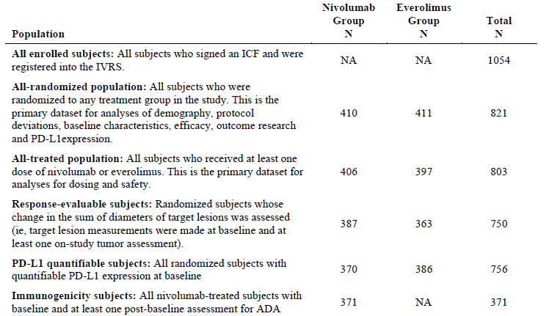

Statistical methods
The core statistical analysis plan is [not provided here]. The statistical analysis plan is summarised in the study protocol.

Sample size and planned analyses
The sample size was calculated in order to compare the OS between subjects randomised to receive nivolumab and subjects randomised to receive everolimus. Approximately 569 events (that is, deaths) with an interim analysis after 398 events (70% of total OS events needed for final analysis) provides 90% power to detect a hazard ratio (HR) of 0.76 with an overall type 1 error of 0.05 (two-sided). The HR of 0.76 corresponds to a 32% increase in the median OS, assuming a median OS of 14.8 months for everolimus and 19.5 months for nivolumab. The stopping boundaries at interim and final analyses will be derived based on the number of deaths using O’Brien and Fleming spending function. It is projected that an observed hazard ratio of 0.845 or less, which corresponds to a 2.7 months or greater improvement in median OS (14.8 months versus 17.5 months), would result in a statistically significant improvement in OS for nivolumab at the final OS analysis.
If the results for overall survival were significant at the significance level of 0.0148, the study could be stopped at the recommendation of the data monitoring committee and declared to be positive for efficacy. The interim analysis would then be considered the final analysis. Planned analyses (interim and final) are summarised in Table 20, below.

Table 20. Study CA209025 planned analyses, interim and final
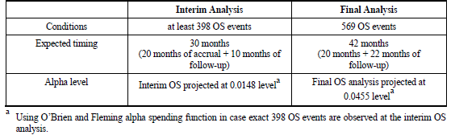
Approximately 822 subjects will be randomised to the two arms in a 1:1 ratio. Accrual is expected to take approximately 20 months. The total duration of the study from start of randomisation to final analysis of OS is expected to be 42 months (20 months of accrual + 22 months of follow-up).
Comment: As noted above, enrolment to Study CA209025 was ceased early after independent data monitoring committee review of the pre-planned formal interim OS analysis concluded that the study had met its end point with regard to significant results for overall survival.

General methods
Unless otherwise noted, discrete variables were tabulated by the frequency and proportion (percentages were rounded) of subjects falling into each category, grouped by treatment (with total). Continuous variables were summarized by treatment group (with total) using the mean, standard deviation, median, minimum and maximum values.
Time to event distributions (that is, OS, PFS, DOT, and DOR) was estimated using Kaplan-Meier (K-M) techniques. When appropriate, the median along with 95% CI was provided. Rate at fixed time-point (for example, PFS at 6 months) was derived from the K-M estimate and corresponding CI was derived based on Greenwood formula.
Unless otherwise specified, the stratified log-rank test was performed to test the comparison between time to event distributions (PFS and OS). Stratification factors were the MSKCC risk group (poor versus intermediate versus favourable), the number of prior anti-angiogenic therapies in the advanced/metastatic setting (1 versus 2), and the region (Western Europe, US/Canada versus Rest of the Word). Unless otherwise specified, the stratified hazard ratio between 2 groups along with CI was obtained by fitting a stratified Cox model with the group variable as unique covariate.
P-values from sensitivity analyses for efficacy endpoints were for descriptive purpose only and there were no multiplicity adjustment for these analyses.

Statistical analysis of efficacy
The comparison of OS distribution between the treatment groups was tested via a two-sided α stratified log-rank test. In addition, the stratified hazard ratio was estimated in a stratified Cox proportional hazards model using the randomised group as a single covariate.
Additional analyses regarding the following are:
- Status of subjects who were censored in the OS K-M analysis
- Examination of the assumption of proportional hazards in the Cox regression model, in addition to treatment
- Sensitivity, multivariate and subgroup analyses for OS
- Analyses of subsequent therapy, and survival by tumour response
A hierarchical testing approach was applied to test key secondary endpoints at an alpha = 5% level following analysis of the primary endpoint of OS (only applied when primary endpoint OS is statistically significant). The hierarchical ordering of key secondary endpoints was as follows:
- ORR
- PFS
Comment: The order in the initial SAP was 1. PFS; 2. ORR. The order was subsequently changed in a protocol amendment.

Other variables, outcome research analyses
FKSI-DRS questionnaire: FKSI-DRS questionnaire completion rate, defined as the proportion of valid questionnaires actually received out of the expected number (that is, the number of randomised subjects still in the study (on treatment or in follow-up)), was calculated and summarised at each assessment point and for each treatment group. The disease-related symptom progression rate and its corresponding 95% exact CI was also calculated by the Clopper-Pearson method for each treatment group
EQ-5D Questionnaire and Health Resource Utilisation: According to the CSR, results of the EQ-5D-Index and the health resource utilisation (HRU) data will be reported separately. The HRU data will be used to conduct economic analyses.

Participant flow
The enrolment period lasted 18 months (from October 2012 to March 2014). The last patient visit for the CSR was in May 2015. The minimum follow-up was approximately 14 months.
There were 1054 subjects enrolled of whom 821 were randomised. Of these, 803 out of 821 were treated. Of the 18 subjects who were randomised but not treated, 4 were in the nivolumab arm and 14 in the everolimus arm. Patient disposition is shown in the diagram and table below.
Figure 9. Study CA209025 Participant flow
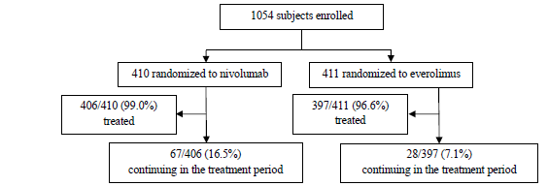
The following information regarding enrolled but not randomised patients was provided in a supplemental table and is copied below. From this, it would appear that the most common reason for enrolled patients not to be randomised is that they failed to meet the more extensive inclusion criteria evaluated during the screening phase.

Table 21. Study CA209025 Reasons for enrolled patients not being randomised
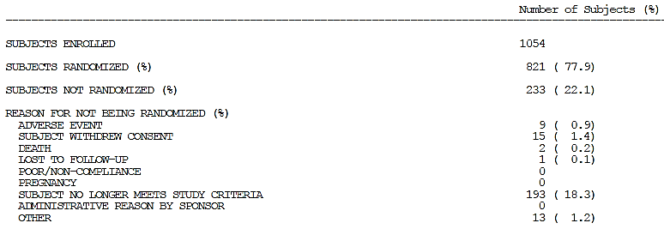
Additional detail regarding the disposition of randomised patients is provided below.

Table 22. Study CA209025 Disposition of randomised patients
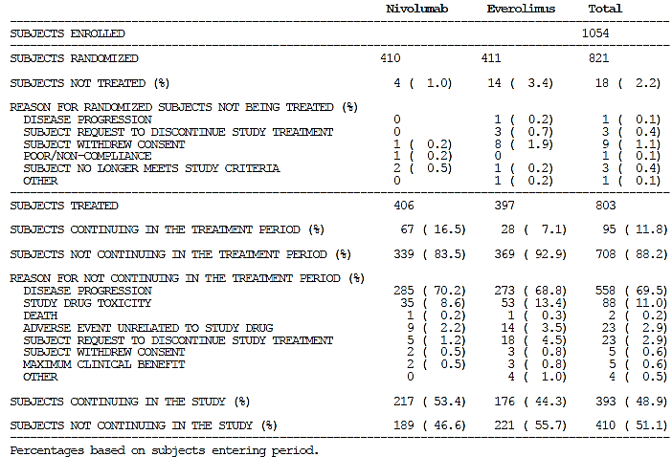
There were 339/406 patients who discontinued treatment in the nivolumab arm, with 285/339 discontinuing due to disease progression and 35/339 due to study drug toxicity. In the everolimus arm, 369/397 discontinued treatment with 273/369 due to disease progression and 53/369 due to drug toxicities. There were 2 patients in the nivolumab arm and 3 patients in the everolimus arm who discontinued treatment after achieving ‘maximum clinical benefit’.

Major protocol violations/deviations
Protocol deviations were identified via (1) on-site monitoring and reported in monitoring visit reports and protocol deviation report forms; (2) programmed checks based on data collected in the electronic CRF; and (3) review of data listings.

Significant protocol deviations
Significant protocol deviations were defined as study conduct that differed significantly from the protocol, including GCP noncompliance and are summarised in Table 23, below. All significant protocol deviations were listed in an Appendix to the CSR. The most common reason for a protocol deviation to be reported was delayed reporting of an SAE. Failure to obtain consent usually involved delayed re-consenting after a protocol amendment. Incorrect dosing on 2 occasions was from a dose of nivolumab being administered over 30 minutes instead of 60 minutes, on each occasion there were no adverse consequences.

Table 23. Study CA209025 Summary of significant protocol deviations
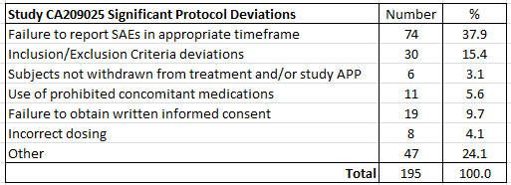

Relevant protocol deviations
Relevant protocol deviations were significant protocol deviations that could potentially affect the interpretability of study results and were predefined in the SAP.
Definitions of relevant protocol deviations were:
- At entrance:
  - Subject without prior systemic regimen in the advanced/metastatic setting
  - Subject without prior anti-angiogenic regimen in the advanced/metastatic setting
  - Subject with two or more prior anti-angiogenic regimens in the advanced/metastatic setting
  - Subjects with baseline Karnofsky Performance Score (KPS) < 70%
- On study:
  - Subjects receiving anti-cancer therapy (chemotherapy, hormonal therapy, immunotherapy, non-palliative radiation therapy, standard or investigational agents for treatment of cancer while on study therapy
  - Subjects treated differently than as randomised (subjects who received the wrong treatment, excluding the never treated)
Relevant protocol deviations were low in frequency (12 subjects (1.5%)) and similar between treatment groups. The most common relevant protocol deviation was subjects receiving concurrent anti-cancer therapy while on study treatment: 8 subjects (1.0%): 3 subjects in the nivolumab group and 5 subjects in the everolimus group.

Table 24. Study CA209025 Summary of relevant protocol deviations
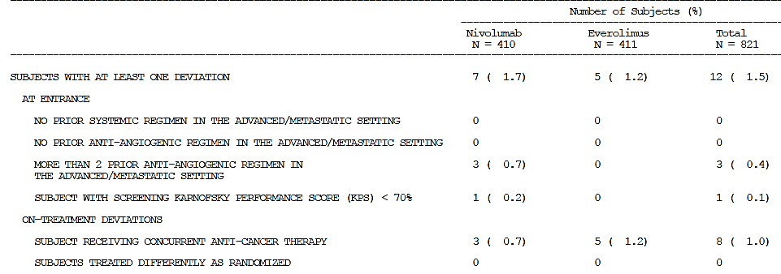
According to the CSR: ‘After review of the reported protocol deviations, it was determined that there was no impact on the interpretability of study results.’
Comment: On the basis of the information provided, the evaluator is in agreement with this.

Populations analysed
The all-randomised population was the primary population used for the primary efficacy analysis. The response-evaluable population was used for the secondary outcome measures that required assessment of tumour response. These groups are described in Tables 25 and 26 below.

Table 25. Study CA209025 Analysis populations for efficacy measures
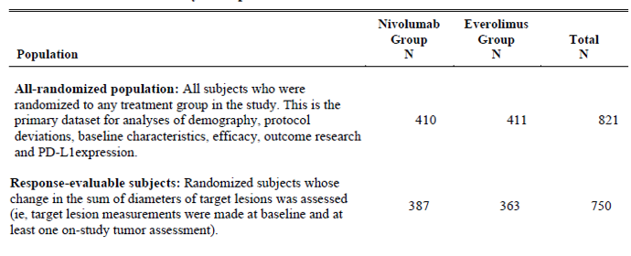

Table 26. Study CA209025 End of treatment period subject status summary
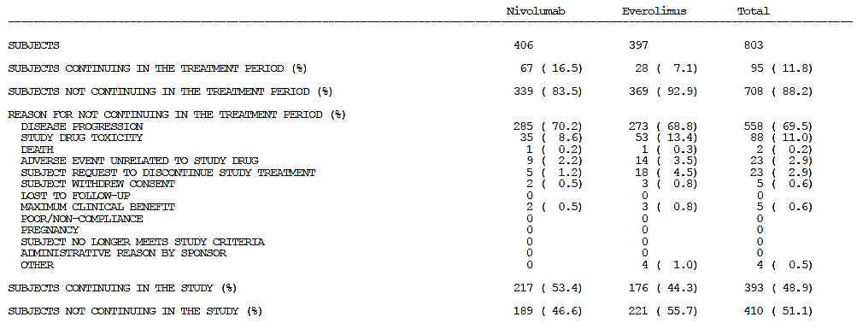

Baseline data
Baseline demographic and disease characteristics and tumour assessments were well balanced between the nivolumab and everolimus groups and summarised in Table 27 (from the related publication article) below.¹² In particular, the number of patients with 2 or more evaluable sites of tumour was similar across the two arms. A relatively small number of patients had tumour confined to one site across the two arms of the study (17% of each arm). A similar proportion of patients in each arm had had a prior nephrectomy (87 to 88%).

Table 27. Study CA209025 Baseline characteristics
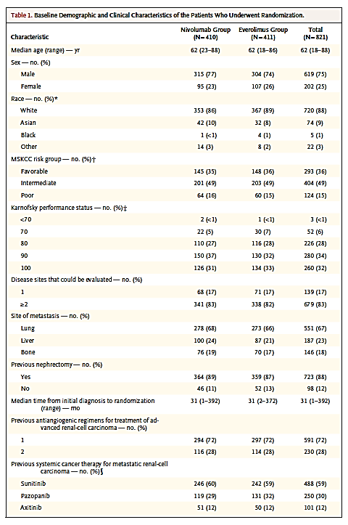
Baseline stratification factors of: MSKCC risk group (poor versus intermediate versus favourable; number of prior anti-angiogenic therapies in the advanced/metastatic setting (1 versus 2) and the region (Western Europe versus US/Canada versus Rest of the World) were also balanced across the treatment arms.

Table 28. Study CA209025 Stratification factors
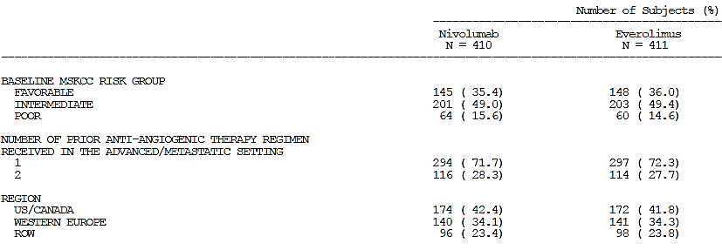
Most randomised subjects had a quantifiable PD-L1 status at pre-study (baseline) (756/821, (92.1%)). However, subjects were enrolled regardless of PD-L1 expression level, and PD-L1 expression level was not a stratification factor.
Comment: the PD L1 status component of the study is discussed above in Section 5: Pharmacodynamics ‘Immunogenicity’.
The median duration of nivolumab treatment was 5.5 months, with a median of 12 doses received (range 1 to 65). The median duration of everolimus treatment was 3.7 months, with a median daily dose of 9.9 mg.
Most subjects (99.3% nivolumab and 98.7% everolimus) received concomitant medications, defined as medications other than study medication taken by subjects at any time while on study treatment (that is, on or after the first day of study drug administration and within 100 days following the last dose of study drug). Use of the different classes was similar across the treatment arms.

Table 29. Study CA209025 Concomitant medications
Therapeutic Class | Nivolumab N = 406 |  | Everolimus N = 397
 | N | % | N | %
Most common (> 50% of subjects)
Analgesic | 334 | 82.3 | 303 | 76.3
Antacid, Treatment of peptic ulcer/flatulence | 254 | 62.6 | 233 | 58.7
Antibacterial | 23 | 54.9 | 228 | 57.4
Other
Systemic corticosteroids | 180 | 44.3 | 167 | 42.1
Thyroid therapy | 175 | 43.1 | 125 | 31.5
Systemic anti-histamine | 106 | 26.1 | 89 | 22.4
Corticosteroids, dermatological prep | 97 | 23.9 | 89 | 22.4
There were 8 subjects (3 in the nivolumab group and 5 in the everolimus group) who received concurrent cancer therapy; each was reported as a protocol deviation. Subsequent systemic cancer therapy was received by 227/410 (55%) of patients treated with nivolumab and 259/411 (63%) of patients treated with everolimus. Not all patients who developed disease progression received subsequent cancer therapy.

Results for the primary efficacy outcome measure
At the time of analysis for the primary outcome measure, 398/821 (48.5%) of patients had died and only 72/821 (8.8%) had not developed disease progression. There were 183/410 (44.6%) deaths in the nivolumab arm and 215/411 (52.3%) in the everolimus arm. The median follow-up for OS was 17 to 18 months. Follow up for OS was current most of the subjects: 96.1% of randomised subjects in the nivolumab arm and 93.9% of randomised subjects in the everolimus arm had either died or had a last known alive date on or after the last patient last visit date for the CSR of 6 May 2015.

Table 30. Study CA209025 Duration of follow-up for overall survival
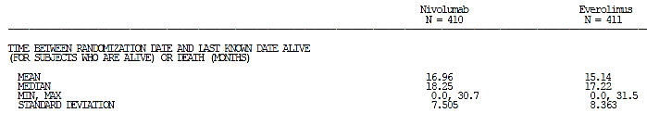

Primary end point: Overall Survival (OS)
For the primary outcome measure of overall survival, nivolumab was superior to everolimus (HR: 0.73 (98.52% CI: 0.57, 0.93); stratified log-rank test p-value = 0.0018), as shown in Table 31 and Figure 10 below. Median OS was 25.00 months in the nivolumab group and 19.55 months in the everolimus group. Median follow-up for OS (time between randomisation and death or last known date alive) was 18.25 months (range: 0.0 to 30.7 months) in the nivolumab group and 17.22 months (range: 0.0 to 31.5 months) in the everolimus group.

Table 31. Study CA209025 Results for the primary efficacy outcome measure (OS)
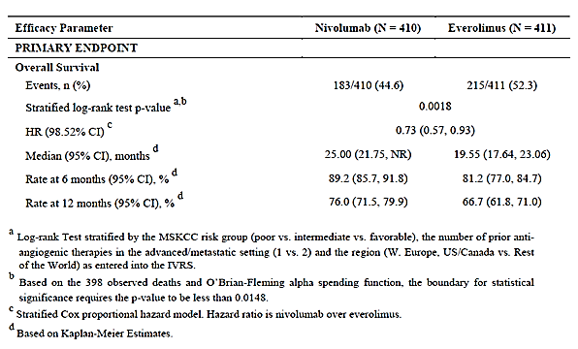
Figure 10. Kaplan-Meier overall survival plot (All randomised subjects)
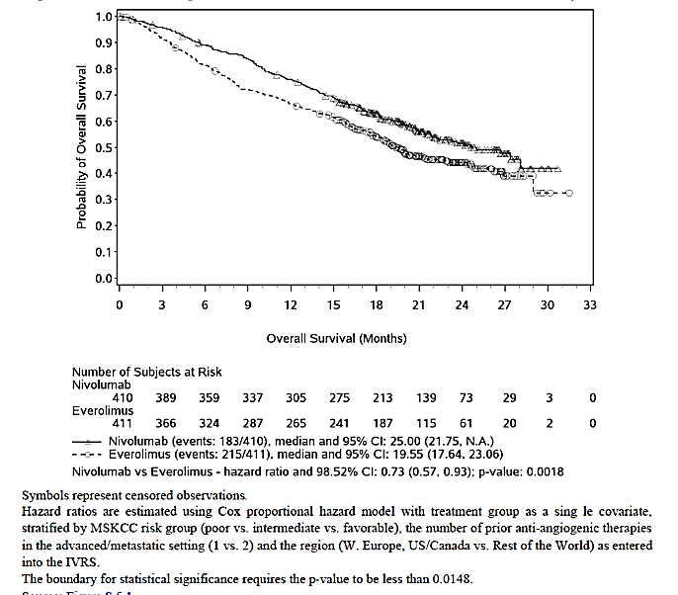

Sensitivity analyses
The results of 3 sensitivity analyses (unstratified analysis, analysis using stratification factors as determined at baseline and analysis of all treated subjects) were consistent with the primary OS analysis, as shown in Table 32, below).

Table 32. Study CA209025 Sensitivity analyses for OS
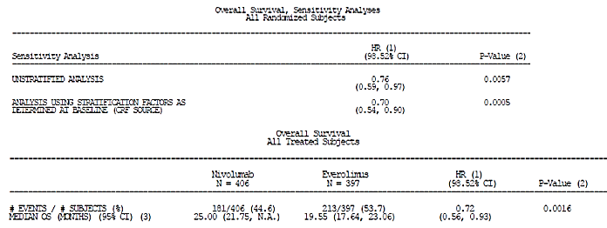

Multivariate analysis
In a multivariate analysis of OS, the treatment effect when adjusted for time from diagnosis to start of first systemic therapy in metastatic regimen (< 1 year), baseline ANC > ULN, and baseline platelets > ULN, was consistent with the primary OS analysis (HR: 0.73; stratified Cox model p-value = 0.0030). Time from diagnosis to start of first systemic therapy in metastatic regimen, baseline ANC, and baseline platelets were significant prognostic variables for OS.

Subgroup analyses
Sub-group analyses for all pre-defined sub-groups favoured nivolumab, except for the subgroups aged ≥ 75 years and Asian, as shown in Table 33, below.

Table 33. Study C209025 Subgroup analyses for Overall Survival (OS)
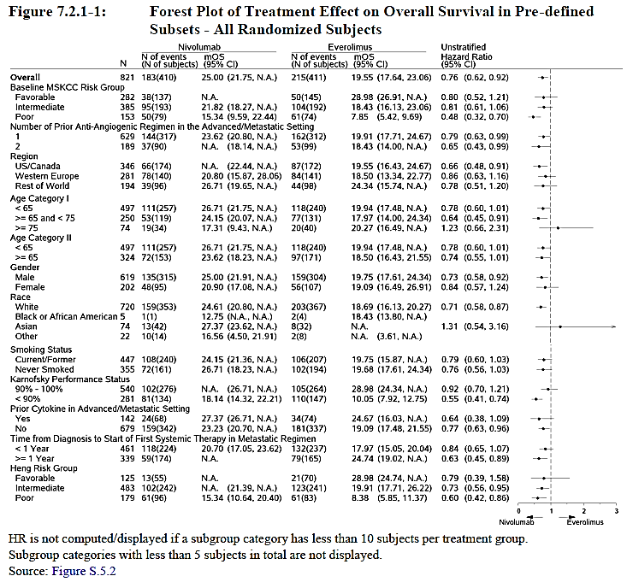

Overall survival according to PD-L1 status (secondary endpoint)
Results for the primary end-point according to PD-L1 status are discussed above (see Section 6: PD-L1 expression) and are also summarised in Table 34, below. Patients with pre-study PD-L1 positive or negative status appeared to have similar survival benefit with nivolumab compared to everolimus.

Table 34. Study CA209025 OS according to PD-L1 status
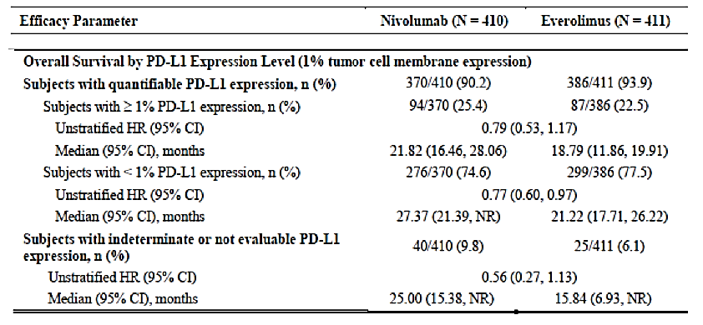

Results for other efficacy outcomes

According to investigator assessed tumour response
Comment: The secondary outcome measures of objective response rate, progression free survival and duration of response were dependent on assessments of tumour size using the RECIST criteria as applied by the investigator. As this was an open label study and no specific training appears to have been provided to the investigators, there is a strong possibility of both bias and inter-rater variability (See Section 11: Question 18 ‘Minimising variability and bias in assessment of tumour response in the pivotal study’. These results should be interpreted with caution.
The ORR (CR + PR) per investigator assessment with nivolumab was 25.1% compared to 5.4% with everolimus (OR 5.98). The median duration of response was 12 months in all responders, nivolumab and everolimus arms. There was no significant difference in progression free survival (see Table 35, below).
Table 35. Study CA209025 Secondary outcome measures (investigator assessed)
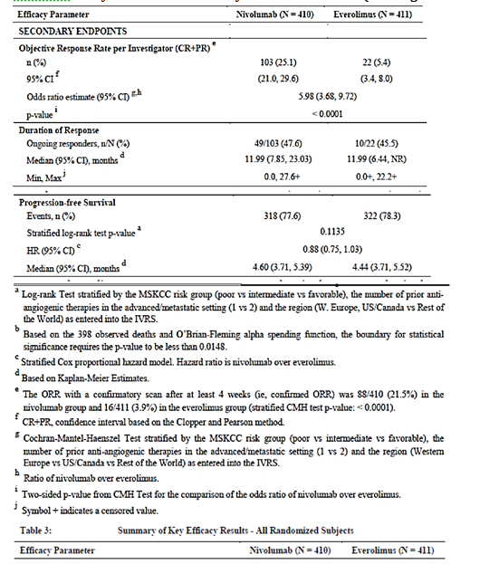
The median time to an objective response was 3.5 months in the nivolumab group and 3.7 months in the everolimus group.

Table 36. Study CA209025 Time to response and duration of response
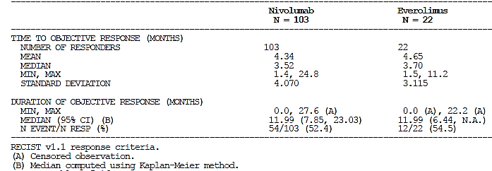

Subgroup analysis, patients treated beyond disease progression
Treatment beyond progression was allowed in subjects who were tolerating study drug and experiencing clinical benefit as assessed by the investigator. Of 803 treated subjects, 179/406 (44.1%) subjects in the nivolumab group and 183/397 (46.1%) subjects in the everolimus group were treated beyond initial RECIST v1.1 progression. Of the 179 subjects in the nivolumab group treated beyond initial RECIST v1.1 progression, 51 experienced ‘non-conventional benefit’ with this defined as:
- Criterion 1: Appearance of a new lesion followed by decrease from Baseline of at least 10% in the sum of the target lesions (15 subjects)
- Criterion 2: Initial increase from nadir ≥ 20% in the sum of the target lesion followed by reduction from Baseline of at least 30% (5 subjects)
- Criterion 3: Initial increase from nadir ≥ 20% in the sum of the target lesions or appearance of a new lesion followed by at least 2 tumour assessments showing no further progression defined as a 10% addition increase in sum of target lesions and new lesions (44 subjects).
Comment: No further summary information was provided. Subject listings were included in the CSR with these including the number of doses received beyond PD, duration of treatment beyond PD, overall survival (months) and outcome (death yes/no). From the information as provided, it is not possible to determine if it would be reasonable to continue treatment beyond progression: the overall survival and duration of treatment of the 51 patients who experienced a ‘non-conventional benefit’ is not provided in an accessible format. See Section 11: Question 19 ‘Study CA209025 Treating beyond disease progression’.

Quality of life
Quality of life measures were included as secondary outcome measures. The study protocol describes two different tools to be used: the FKSI-DRS and the EQ-5D. The collection of Health Resource Utilisation data was also described in the protocol.
FKSI-DRS: Eighty-four (84) % of subjects completed the FKSI-DRS at Baseline, and 81 - 94% completed the FKSI-DRS at Day 1 of each cycle for the first year of the study. The median score at baseline was 31 in each arm. This increased to 33 in the nivolumab arm by Week 28 and ranged between 33 and 34 until Week 100; at this time there were 21 patients on treatment. The median score at the two follow-up visits was 30. The median FKIS-DRS score in the everolimus arm remained between 30 and 31 until Week 96 at which time there 9 patients still on treatment. The median score at the two follow-up visits was 29 and 30.
The disease related symptom progression rate was 41.2% for the nivolumab arm, compared to 54.2% for the everolimus arm and is shown in Table 37, below.

Table 37. Disease related symptom progression rate
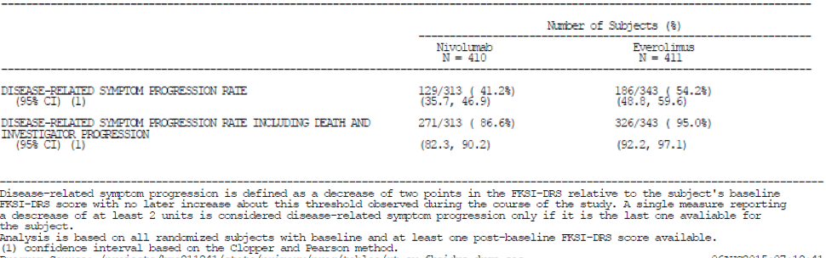
EQ-5D: No results were provided in the CSR
Health Resource Utilisation (HRU): No results were provided in the CSR
Comment: According to the study protocol, patient-reported outcomes (PROs) were to be measured using two validated subject self-reported quality of life questionnaires: the Functional Assessment of Cancer Therapy-Kidney Symptom Index (FKSI)- Disease-Related Symptoms (DRS) scale and the EuroQol Group’s EQ-5D. Subjects were to be asked to complete the questionnaires before any clinical activities, after randomisation (before Cycle 1 dosing) and on Day 1 of each cycle (starting with Cycle 2) as well as at the follow-up visits. Health resource utilisation data was also to be provided. This was to include the number of medical care encounters such as hospital admissions and their duration, outpatient visits, diagnostic tests and procedures, concomitant medications, and reasons for the encounters. As such, this information could provide valuable insights into the impact of treatment on the patient’s life.
Patient reported outcomes are important in determining if patients are both living longer and with an acceptable quality of life. In the CSR, only the results for the FKSI-DRS scale are provided and no mention is made of the EQ-5D or HRU. See Section 11: Question 20 ‘Study CA209025 Quality of life measures’.

Other efficacy studies
Nivolumab has been studied as monotherapy in patients with advanced renal cell carcinoma in 3 Phase I and II studies, Studies CA209003, CA209010 and CA209009. None of these studies used the proposed dosing regimen. The sponsor’s dossier for the indication of ‘’Opdivo, as monotherapy is indicated for the treatment of patients with advanced renal cell carcinoma (RCC) after prior therapy in adults’ only refers to Study CA209010 as supportive of efficacy but does not include Studies CA209003 or CA209009. The reasons for their exclusion, given the inclusion of Study CA209010, are not clear to the evaluator. As the pharmacokinetic and pharmacodynamic studies have not established a dose-dependent relationship for efficacy in advanced renal cell carcinoma, the evaluator has included all three studies below.

Study CA209010
Comment: An Addendum to the Final Study Report for Study CA209010 was included in this submission. The addendum provided an updated analysis for progression-free survival (PFS) including duration of response, overall survival, rate of adverse events, and programmed cell death-1 ligand 1 (PD-L1) expression. The addendum reported cumulative data for all treated subjects up to a cut-off date of 12 March 2015 with last patient visit on 2 February 2015 and database lock occurred on 12 March 2015. The Final CSR (dated 4 November 2013) for Study CA209010 reported data collected from all subjects up to a cut-off date of 15 May 2013, with database lock on 02 July 2013. It was provided with the sponsor’s earlier Opdivo submission, with the QT prolongation and safety components of the study evaluated in that submission. The pharmacokinetic and pharmacodynamics components of the study have been discussed above.
Study CA209010 is provided by the sponsor as supportive of efficacy and safety. It is discussed over several pages in the Clinical Overview. It is important to note that this was a Phase II dose ranging study that did not include the recommended dosing regimen for the proposed usage (3 mg/kg administered intravenously over 60 minutes every 14 days) and with a primary outcome that was determined by investigator assessment of tumour response. Given this, a brief summary of the study is provided by the evaluator.

Table 38. Study CA209010 Summary
Study details
Study Identifier | CA209010
Terminology | At the time of the study, nivolumab was referred to as BMS-936558. This nomenclature is used in tables and figures copied from the Final CSR
Related publication | Motzer R, et al. Nivolumab for metastatic renal cell carcinoma: results of a randomised Phase II trial. J Clin Oncol 2015;33:1430-1437s
Study objectives | Primary objective: To evaluate the dose response relationship in the 0.3, 2, and 10 mg/kg BMS-936558 arms as measured by PFS.
Study design and treatments | Phase II, randomised, blinded, dose ranging study. Patients were randomised to one of three nivolumab treatment arms (0.3, 2, and 10 mg/kg) every 21 days. Treatment was continued until disease progression or unacceptable toxicity occurred.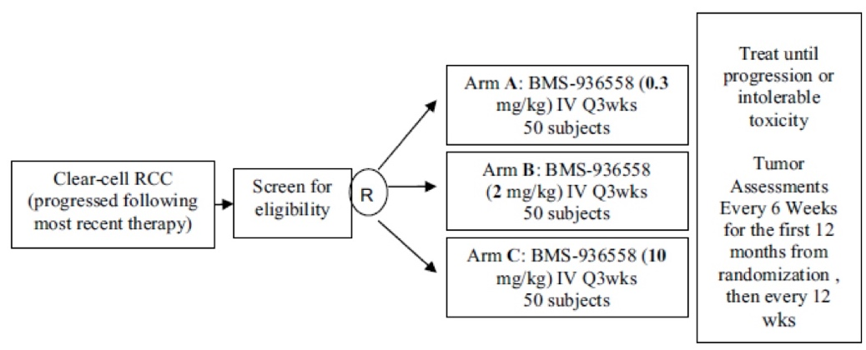  Immunosuppressive agents, including immunosuppressive doses of systemic corticosteroids, were prohibited during the study (unless to treat a drug-related adverse event).
Patient group | Subjects with advanced clear cell RCC who have received prior treatment with at least 1 anti-angiogenic agent in the advanced/metastatic setting.
Dates | Study initiation date: May 2011; Data cut-off for Final CSR: 15 May 2013; Data cut-off for Addendum to CSR: March 2015.
Location(s) | 39 sites in four countries (USA = 33 sites, Canada = 4 sites, Finland and Italy = 1 site each).
Main eligibility criteria | Age ≥ 18 years, histologically confirmed RCC with a clear cell component, measurable disease as defined by RECIST v1.1 criteria, at least 1 prior anti-angiogenic agent in the advanced/metastatic setting, but no more than 3 prior treatment regimens in total, Karnofsky Performance Score ≥ 70%, tumour tissue available for correlative studies.
Randomisation and blinding | Enrolled subjects were randomly assigned in a 1:1:1 ratio to 1 of 3 nivolumab treatment arms. Randomisation was stratified by MSKCC prognostic score (0 versus 1 versus 2/3), number of prior treatment regimens (1 or > 1) in the advanced/metastatic setting, and study site. Subjects, investigators, study site personnel (except the pharmacist), and sponsor were blinded to the subjects’ nivolumab dose assignment.
Concomitant medications | Immunosuppressive agents were prohibited unless required to treat a drug-related adverse event. Anti-neoplastic agents were prohibited.
Tumour assessment | Baseline tumour assessments were performed within 30 days of randomisation by CTs/MRI, then every 6 weeks for the first 12 months from randomisation and every 12 weeks thereafter, until tumour progression or treatment discontinuation. Tumour response was based on the investigator’s assessment according to RECIST v1.1 criteria of a subject’s target lesions, non-target lesions, and new lesions. The overall response was according to the following criteria:  Time point response: Subjects with (± non-target) disease  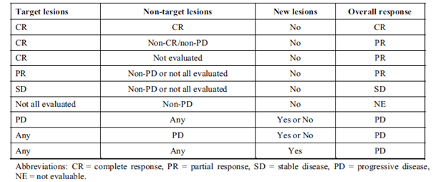
Primary efficacy outcome measure | Dose-response relationship based on progression free survival (PFS).  Disease progression, either clinical or radiographic using RECIST v1.1 criteria was assessed by the investigator. Patients who died without a reported prior progression were considered to have progressed on the date of their death.
Secondary outcome measures | Progression free survival (PFS), Response rate (RR), Overall Survival (OS).
Other measures | Safety and tolerability, PK, immunogenicity, QT effects.
No of subjects | 198 were enrolled; 168 were randomised; 167 were treated with nivolumab (59, 54, and 54 subjects in the 0.3, 2, and 10 mg/kg groups, respectively).
Results, Demographics | Median age was 61.0 years, with 6.5% aged 75 years or older. Most subjects were white (93.5%) and male (72.0%).  33.0%, 42.0%, and 25.0% of randomised subjects in the favourable, intermediate, and poor-risk MSKCC prognostic categories, respectively.  Most subjects had a quantifiable PD-L1 status at baseline (88.1%) using the BMS/Dako verified IHC assay.
Primary efficacy outcome | Median PFS of 2.7 months (80% CI 1.81 to 3.02), 4 months (80% CI 2.76 to 4.24) and 4.2 months (80% CI 2.79 to 5.49) in the 0.3, 2, and 10 mg/kg groups. There was no significant difference between treatment arms.  Kaplan-Meier plot all PFS subjects All randomised subjects  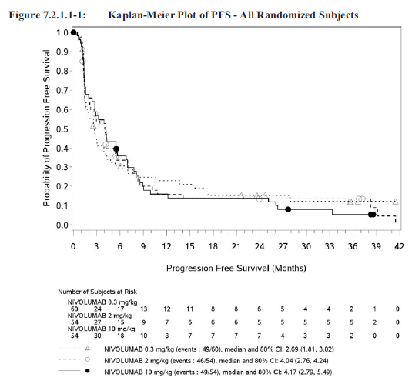
Other outcomes | ORR: Response rates in the 0.3, 2, and 10 mg/kg treatment groups were similar (20%, 22%, and 20%, respectively). The trend test P-value of > 0.99 indicates that there is no dose relationship for ORR. The stratified odds ratios also indicate that there is no difference in ORR between treatment groups  OS: Updated overall survival for each treatment group was provided in the Addendum. Median OS was reached for all three treatment groups and was 18.5 months (80% CI 16.23 to 23.98), 25.5 months (80% CI 19.78 to 31.24), and 24.8 months (80% CI 15.31 to 25.95), for the 0.3, 2, and 10 mg/kg groups, with no significant difference between treatment arms.  A multivariate analysis of overall survival for all randomised subjects found no significant differences based on treatment group for the number of prior treatments in an advanced setting, prior immunotherapy, number of disease sites, or MSKCC score (0 versus 1). Significant differences in OS were observed based on MSKCC score (1 versus 2/3) and (0 versus 2/3).
CR/uCR = complete response/unconfirmed complete response; ITT = intent-to-treat population; IAP = Independent assessment panel (blinded)
Comment: The primary endpoint in this open label study was determined by the investigator analysing CT or MRI or X-ray images and applying complex criteria. Both bias and high inter-rater variability are likely.

Study CA209003
This study has been referred to elsewhere in this clinical evaluation report and provided the basis for the selection of the dosing regimen for the Phase III studies in the clinical development programme. The summary of the study with regards to the pharmacokinetic and pharmacodynamics components is available in the CER for first Opdivo NBE submission.⁹ The study design and efficacy outcomes are described here. Efficacy outcomes, except for OS, were dependent on tumour measurements made by the investigators and are, therefore, subject to potential bias and unknown inter-rater reliability.

Table 39. Study CA209003 Summary
Study details
Study identifier |  | CA209003
Terminology |  | At the time of the study, nivolumab was referred to as BMS-936558. This nomenclature is used in tables and figures copied from the Final CSR
Related publication |  | Topalian S, et al. Safety, activity, and immune correlates of anti-PD-1 antibody in cancer. N Engl J Med 2012; 366: 2443-54
Study objectives |  | Primary objective: Assess the safety and tolerability of multiple doses of nivolumab in subjects with advanced or recurrent malignancies.  Other objectives included: Assess the preliminary efficacy of nivolumab monotherapy; Characterise the dose response relationship.
Study design and treatments |  | Phase I dose ranging study in patients with advanced solid tumours. Patients were randomised to one of one of five dose levels (0.1, 0.3, 1.0, 3.0 and 10.0 mg/kg) administered every 2 weeks for a maximum of 48 doses initially. RCC patients were allocated to a dose of 1 mg/kg or 10 mg/kg. Expansion cohorts were enrolled on the initial signals of safety and efficacy. Patients with stable disease or an ongoing objective response (complete or partial response) at the end of treatment were followed for up to 1 year and were offered retreatment for 1 additional year in the event of disease progression. Intrapatient dose escalation was not permitted. Treatment was ceased if rapid disease progression or clinical deterioration or unacceptable toxicity.  Patients were assessed every 8 weeks for tumour response and the decision to continue treatment was made before the next dose.  The maximum duration of follow-up was 48 weeks. All subjects completed Follow-up Visit 1 (0 to 7 days after the last visit of the last treatment cycle). Re-initiation of study therapy was permitted for subjects who entered the follow-up period with ongoing disease control who subsequently experienced confirmed disease progression. Survival status was checked every three months (telephone or in-person contact) every three months until study completion.
Patient group |  | Subjects with recurrent or treatment-refractory NSCLC, colorectal cancer, melanoma, clear cell renal cell carcinoma or hormone refractory prostate cancer.
Inclusion and Exclusion Criteria |  | Eligible patients had documented advanced solid tumours for wwhich they had received between 1 and 5 prior systemic therapies; age ≥ 18 years or older; life expectancy ≥ 12 weeks, ECOG performance status ≤ 2; measurable disease according to modified Response Evaluation Criteria in Solid Tumors (RECIST); adequate hematologic, hepatic, and renal function. Patients with a history of chronic autoimmune disease, prior therapy with antibodies that modulate T-cell function; conditions requiring immunosuppressive medications, or chronic infection (for example, human immunodeficiency virus infection and hepatitis B or C) were excluded.
Dates |  | Between 2008 and 2013.
Location(s) |  | 13 sites in the USA.
Tumour assessment |  | All efficacy end-points were based on tumour response based on the RECIST (v1.0) by the sponsor based on the tumour measurements assessed by the investigators.
Efficacy outcome measure |  | Efficacy endpoints were based on Best overall response (BOR) as defined by the best response designation over course of the study based on RECIST v1.0 for the individual subject in the study with outcomes of: CR, PR, SD, PD, and unable to be determined.  Primary efficacy endpoints were:  Objective response rate: proportion of subjects whose confirmed BOR was either CR or PR, where the denominator is the number of treated subjects in the population of interest.  Duration of response: was calculated for subjects with an objective response as the time between the date of the first documented tumour response (PR or CR) and the subsequent date of the objectively documented disease progression or death while on study.  Other efficacy endpoints included time to response, progression free survival, overall survival.
Other measures |  | Safety and tolerability, PK, immunogenicity, QT effects.  Safety evaluations (clinical examination and laboratory assessments) were conducted for all treated patients at baseline and regular intervals. The severity of adverse events was graded according to the National Cancer Institute Common Terminology Criteria for Adverse Events, version 3.0.
No of subjects |  | 395 subjects who enrolled and were screened for study participation, 306 subjects were treated. 295 were evaluable for tumour response with measurable disease at baseline and at least one on-treatment assessment. One patient with RCC was not evaluable
Results, Demographics |  | Median age was 63 years (range 29-85); 203 were male and 103 were female; 93% were of white race. Tumour types were NSCLC (n=129), melanoma (107), RCC (34), CRC (19) and prostate cancer (17). 11 patients had stage III disease, all of the rest had stage IV disease.  Of the 34 RCC patients: 33 had stage IV clear cell RCC and one had stage I disease; 44% had received 3 or more prior systemic therapies; 18 patients received the dose of 1 mg/kg, 16 received 10 mg/kg,
Efficacy outcomes (all patients) |  | For the overall population (all tumour types and all dose levels), there was an objective response in 65 of 306 (21.2%) subjects.  Objective responses occurred 8 weeks in 30 out of 65 (46%) responders and by 24 weeks in 59 out of 65 of responders.  An analysis of OS in all treated NSCLC, melanoma, and RCC subjects showed 1-year rates of 42%, 62%, and 70%, respectively.
Primary efficacy outcome (RCC patients) | The overall objective response rate (across doses) was 29.4% (10/34 RCC subjects) (95% CI:15.1, 47.5). Four of the 10 responses occurred by the Week 8 tumour measurements; range in time to response was 8 to 48 weeks.  There was no apparent dose-response effect: by-dose response rates were 27.8% and 31.3% for subjects treated with 1 and 10 mg/kg nivolumab, respectively. The median duration of response was 56 weeks for each dose.  Non-conventional responses (such as a persistent reduction in baseline target lesions in the presence of new lesions consistent with an immune related response pattern) were reported in 3 RCC subjects treated with 1 and 10 mg/kg nivolumab and were not included in the calculation of ORR.  Median OS in all RCC subjects was not reached; 1 year overall survival rate was 70%.  Kaplan Meier plot of OS All treated subjects with RCC  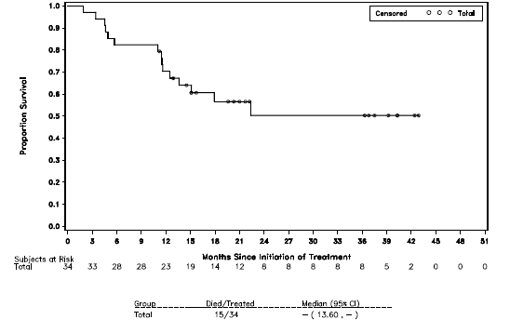

Study CA209009
This study has not previously been provided to the TGA for evaluation, although it was referred to in the sponsor’s dossiers for earlier submissions. The study is registered as Trial NCT01358721 at clinicaltrials.gov and some of the results were published in abstract form in 2015. The CSR was requested of the sponsor during the Round 1 evaluation for this submission and subsequently provided.

Table 40. Study CA209009 summary
Study details
Study identifier | CA209009
Terminology | At the time of the study, nivolumab was referred to as BMS-936558.
Related publication | Choueiri T et al. Immunomodulatory activity of nivolumab in metastatic renal cell carcinoma (mRCC): association of biomarkers with clinical outcomes. J Clin Oncol 2015; 33: Suppl: 4500.
Study title | An Exploratory Study to Investigate the Immunomodulatory Activity of Various Dose Levels of Anti Programmed-Death-1 (PD-1) Antibody (BMS-936558) in Subjects With Metastatic Clear Cell Renal Cell Carcinoma (RCC).
Study objectives | Primary objective: to investigate the pharmacodynamic immunomodulatory activity of anti-PD-1 antibody (BMS-936558, nivolumab) on circulating T cell subsets (activated and memory T cells), serum chemokines (CXCL9, CXCL10) and on CD4 and CD8 T cell infiltrations in tumours in subjects with metastatic clear-cell RCC.  Other objectives included: To further assess the safety and tolerability of various dose levels of nivolumab in subjects with metastatic clear-cell RCC.  To assess the preliminary antitumor activity of various dose levels of nivolumab in subjects with metastatic clear-cell RCC; to investigate the immunogenicity of nivolumab.
Study design and treatments | Phase I, open label, parallel group (4 arm), randomised (arms 1 to 3 only) dose comparison study. Patients were randomised to one of one of 3 dose levels (0.3, 2.0, 10.0 mg/kg) (arms 1 to 3) with the dose administered every 3 weeks. Treatment naïve patients with RCC could be enrolled and received 10 mg/kg (arm 4). Treatments were administered every 3 weeks indefinitely, depending on response. Treatment was ceased if disease progression or unacceptable toxicity. Patients in the 0.3 mg/kg dose group were offered the opportunity to escalate to 2 mg/kg at the time of documented disease progression.  Study design  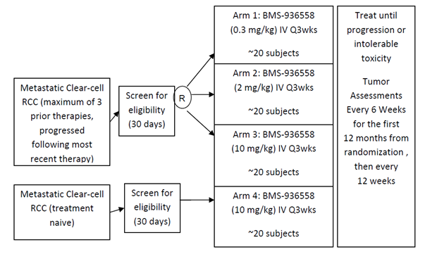  Biopsies were obtained at baseline and Cycle 2 Day 8.  Overall survival (OS) parameters were estimated by Kaplan-Meier method. Tumour PD-L1 expression was measured by immunohistochemistry (Dako assay). PD-L1 positivity was defined as ≥ 5% tumour membrane staining in ≥ 1 biopsy; tumour burden response as ≥ 20% reduction
Patient group | Subjects with advanced or metastatic clear cell renal cell carcinoma
Inclusion and exclusion criteria | Eligible patients had histologic confirmation of renal cell carcinoma with a clear cell component. Previously treated subjects must have failed at least 1 prior anti-angiogenic agent and could have a maximum of 3 prior systemic treatments for renal cell cancer. Subjects in the treatment naive arm could not have received prior systemic therapy for their renal cell carcinoma.  Other inclusion criteria were: age ≥ 18 years or older; life expectancy ≥ 12 weeks, ECOG performance status ≤ 2; measurable disease according to modified Response Evaluation Criteria in Solid Tumors (RECIST); tumour sites that were accessible for repeat biopsies with acceptable clinical risk.  Patients with a history of autoimmune disease, prior therapy with antibodies that modulate T-cell function; conditions requiring systemic corticosteroids were excluded.
Dates | Commenced August 2011; the study is ongoing; database lock for the CSR provided was 12 January 2015.
Location(s) | 14 sites including 10 sites in the USA, 1 site in France, 1 site in Spain.
Tumour assessment | All efficacy end-points were based on tumour response according to the RECIST (v1.0) as assessed by the investigators. Tumour assessments were to be performed every 6 weeks.
Efficacy outcome measure | Efficacy endpoints included:  Tumour response rate: as assessed by the Investigator assessment of best overall response (Time Frame: Up to 22 months after study start).  Overall response rate: as assessed by the number of subjects which demonstrate an objective response divided by the total number of treated subjects with measurable disease at Baseline.  Duration of response: as measured by the time when the criteria for an objective response are first met until the date of documented disease progression or death.  Other efficacy endpoints included time to response, progression free survival, overall survival.
Other measures | Safety evaluations: based on the incidence of adverse events (AEs), serious adverse events (SAEs), select AEs, AEs leading to discontinuation, and deaths. In addition clinical laboratory test abnormalities were examined. Adverse events and laboratory values were graded according to the National Cancer Institute (NCI) Common Terminology Criteria for Adverse Events (CTCAE) version 4.0.
No of subjects | 91 patients were treated. There were 22 patients randomised to the 0.3 mg/kg arm, 22 to the 2 mg/kg arm and 23 to the 10 mg/kg arm and 24 enrolled in the treatment naïve arm (10 mg/kg). Of these, 89/91 patients discontinued treatment: the most common reasons were disease progression (66/91. 72.5%); AEs (15/91, 16.5%). Two patients had died.
Results – demographics | Median age was 60 years, (range 32 to 82 years), 67% were male, 94.5% were White. Of 56 evaluable BL biopsies, 32% were PD-L1+.
Efficacy outcomes | Efficacy assessments were a secondary objective of this study and included ORR, PFS, and OS.  ORR: The overall objective response rate in this study was 15% (95% CI, 8.7-24.5) and stable disease was observed in 46% of the subjects. There was no significant difference between the treatment arms. The median duration of response was 53.6 weeks.  PFS: The median PFS was 11.6, 12.4, 29.9, and 20.8 weeks in the 0.3, 2, 10 (non-naive), and 10 mg/kg (naive) groups, respectively.  OS: The assessment of OS is ongoing. Median OS was shorter in the 0.3 mg/kg nivolumab dose group at 16.4 months compared to 25.2 months in the 10 mg/kg nivolumab dose group. Median OS had not been reached in the other 2 groups (2 mg/kg and 10 mg/kg-naive). The 1 year and 2 year OS rates across all nivolumab doses in this study are 75 and 58%, respectively.  Nivolumab appears to exhibit a similar level of activity at the 2 and 10 mg/kg dose levels, based on PFS, ORR, and OS. Additionally, the efficacy results are similar to those seen in the Phase II study, Study CA209010.

Evaluator’s conclusions on clinical efficacy
For the indication of:
‘monotherapy for the treatment of patients with advanced renal cell carcinoma (RCC) after prior therapy in adults.’
In the pivotal Study CA209025, nivolumab has demonstrated improved overall survival compared to the mTOR inhibitor everolimus in patients with advanced clear cell renal cell carcinoma who have received one or two previous regimens of anti-angiogenic therapy. The difference was clinically meaningful with overall survival of 55.4% and median survival (K-M estimate) of 25.0 months in the nivolumab arm compared to overall survival of 47.7% and estimated median survival of 19.6 months in the everolimus arm. According to the results for one of the QOL tools used, nivolumab was not associated with a worse quality of life compared to patients receiving everlimus. However, the results for all QOL measures were not provided. Biological activity in patients with advanced clear cell renal cell carcinoma who have received one or two previous regimens of antiangiogenic therapy was also demonstrated in the dose ranging Studies CA209003, CA209009 and CA209010. These studies did not demonstrate dose dependent response across the range 2 mg/kg to 10 mg/kg and the dosing interval of 2 weeks or 3 weeks.

Pivotal Study CA209025
The pivotal study for this submission is Study CA209025, a Phase III, open label, randomised multicentre study in which 821 patients with metastatic renal cell carcinoma and a clear-cell component who had previously received one or two anti-angiogenic regimens were randomised to nivolumab, with a dosing regimen of 3 mg/kg fortnightly (n = 410), or everolimus, 10 mg orally daily (n = 411). Enrolment in the study was ceased early after independent data monitoring committee review of a pre-planned formal interim OS analysis concluded that the study had met its end point with regard to significant results for overall survival. Crossover from the everolimus arm to the nivolumab arm was allowed following this.
The study was conducted in 146 sites across 24 countries. Enrolment occurred between October 2012 and March 2014. Follow-up for overall survival is ongoing; database lock for the final Clinical Study Report provided in the dossier was June 2015. Inclusion criteria were: metastatic renal cell carcinoma as already described; age ≥ 18 years; more than one but nor more than three previous regimens of systemic therapy with these not including an mTOR inhibitor; pre-study archival or recently collected tumour specimens at time of randomisation, disease progression after the last regimen occurring within 6 months prior to study entry, measurable disease according to the Response Evaluation Criteria in Solid Tumors (RECIST version 1.1), Karnofsky performance status of at least 70. Patients with CNS metastases, active autoimmune disease or medical condition requiring systemic immunosuppression or significant organ impairment were excluded. Subjects were randomised 1:1 to nivolumab or everolimus and stratified according to the following: geographic region (US/Canada versus Western Europe versus ROW), Memorial Sloan-Kettering Cancer Center (MSKCC) risk groups (favourable versus intermediate versus poor), and number of prior anti-angiogenic therapies (1 versus 2). The study was conducted in accordance with GCP and there were no protocol amendments or protocol deviations that would have affected the results of the study.
There were 821 patients randomised, of whom 406 in the nivolumab arm were treated and 397 in the everolimus arm. The most common reasons for not receiving treatment in the nivolumab arm included patient no longer meeting study criteria (n = 2) and patient withdrawing consent (n = 8) in the everolimus arm. At the time of analysis, there were 95 patients continuing in treatment (67 in the nivolumab arm and 28 in the everolimus arm). The most common reason for discontinuing treatment in each arm was disease progression (285 patients in the nivolumab arm and 273 patients in the everolimus arm). There were 35 patients in the nivolumab arm who discontinued treatment due to drug toxicity and 53 in the everolimus arm. There were 2 patients in the nivolumab arm and 3 patients in the everolimus arm who discontinued treatment after achieving ‘maximum clinical benefit’.
For the randomised patients, the median age 62 years (range: 18 to 88); 88% were white; 75% were male; 83% had 2 or more baseline disease sites; 88% had had prior nephrectomy; 59% and 22% of subjects were in the intermediate or poor Heng risk group at baseline respectively. These attributes were evenly matched across the treatment arms.

Primary efficacy outcome measure
At the time of the pre-planned interim analysis for the randomised population, with median follow-up for OS of 17 to 18 months, there had been 183/410 (44.6%) deaths in the nivolumab arm compared to 215/411 (52.3%) in the everolimus arm; HR 0.73 (95% CI 0.57, 0.93). Median survival (K-M estimate) was 25.0 months (95% CI 21.8, NR) in the nivolumab arm compared to 19.6 months (95% CI 17.6, 23.1).
Figure 11. Kaplan-Meier overall survival plot, all randomised subjects
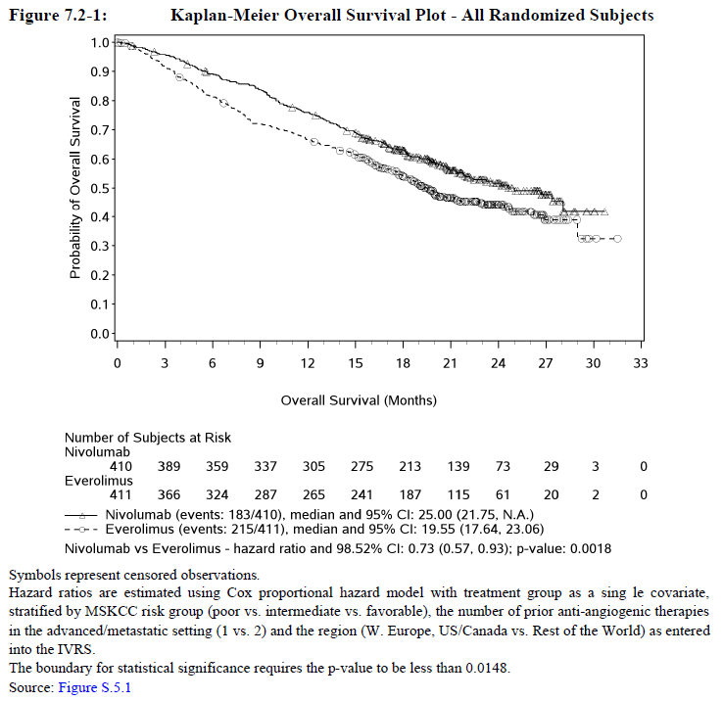
The results of 3 sensitivity analyses (unstratified analysis, analysis using stratification factors as determined at baseline and analysis of all treated subjects) were consistent with the primary OS analysis. The result of analysis of pre-specified subgroups was also consistent, except for the groups ‘Asian’ and age 75 years or more (absence of demonstrated benefit in the Asian population may be relevant to the target population in Australia).
Overall survival according to tumour PD-L1 expression, positive or negative, appeared to have similar benefit with nivolumab compared to everolimus. See Section 11: Question 6 ‘Study CA209025 Results for OS according to PD-L1 status’.

Secondary outcome measures
Secondary efficacy outcome measures included objective response rate, progression free survival and duration of response. These outcome measures also favoured nivolumab with 103 patients with best response of CR or PR in the nivolumab arm compared to 22 in the everolimus arm. The objective response rate was 25.1% compared to 5.4% with everolimus (odds ratio 5.98, 95% CI: 3.68 to 9.72, p < 0.0001). The median duration of response was 12 months in all responders, nivolumab and everolimus arms. There was no significant difference in progression free survival with the Kaplan Meier estimate for median PFS 4.6 months (95% CI 3.7 to 5.4) in the nivolumab arm and 4.4 months (95% CI 3.7 to 5.5) in the everolimus arm.
These secondary outcome measures were all dependent on assessments of tumour size using the RECIST criteria made by the investigator, with no independent verification of the assessment. Applying RECIST criteria to images of tumour deposits is complex. Detailed ‘how-to’ descriptions of this were provided in the study protocol but no specific training of investigators was described, nor were any measures of inter-rater reliability. Given that this also was an open label study, there is a strong possibility of both bias and high inter-rater variability. These results should be interpreted with caution. See Section 11: Question 18 ‘Minimising variability and bias in assessment of tumour response in the pivotal study’.

Consistency of results for the everolimus arm
The results reported for everolimus in this study are consistent with those reported in the pivotal study for TGA approval of everolimus for use in patients with advanced RCC. This was a placebo controlled trial involving patients whose disease progressed during angiogenesis targeted therapy that reported median progression free survival of 4.9 months (95% CI 4.0 to 5.5) with everolimus 10 mg orally daily compared to 1.9 months (95% CI 1.8 to 1.9) with placebo.

Treatment beyond disease progression
Treatment with nivolumab was allowed to be continued beyond initial RECIST v1.1 disease progression, at the discretion of the investigator. Of the 179 subjects in the nivolumab group treated in this way, 51 experienced ‘non-conventional benefit’, with subsequent reduction in tumour size or no further increase in tumour size. No other outcome measures were described for this group. Insufficient information has, therefore, been provided to support continuing treatment beyond disease progression. See Section 11: Question 19 ‘Study CA209025 Treating beyond disease progression’.

Quality of life assessments
Quality of life at baseline, during and after treatment was assessed using the Functional Assessment of Cancer Therapy-Kidney Symptom Index (FKSI) Disease-Related Symptoms (DRS) scale. This found similar results for both the nivolumab and everolimus arms at baseline and follow-up visits but a small difference of 2 to 4 points in the 36 point score that favouring nivolumab during treatment. The clinical meaning of this difference is unclear but the results indicate that nivolumab does not worsen quality of life compared to everolimus. Results for the other quality of life measure described in the study protocol (EQ-5D) were not described in the CSR so it is not known whether the results for this measure concur with the results for the FKSI-DRS. Results for Health Resource Utilisation data were also not presented in the CSR. See Section 11: Question 20, ‘Study CA209025 Quality of life measures’.

Other studies
There are three open label dose ranging studies that describe the investigation of nivolumab treatment in patients with advanced clear cell carcinoma who have received prior systemic therapy: Studies CA209003, CA209009 and CA209010. Of these, only Study CA209010 in included in the sponsor’s evaluation of efficacy and safety for reasons that are not clear to the evaluator. Study CA209003 included patients with different advanced solid organ tumours; 34 patients had advanced RCC. Studies CA209010 and CA209009 included patients with advanced RCC, although 24 of the patients in Study CA209009 had not received prior therapies. Efficacy results from these studies are roughly similar and consistent with the pivotal study (see table below). Both the pivotal study and Study CA209010 found a lower median PFS (of around 4 months) compared to Study CA209009.

Table 41. Results from other studies investigating nivolumab in patients with advanced RCC who have received prior therapies
Study identifier | Patient number | Dosing regimen | ORR | Median PFS months | Median OS (months)
CA209003 | 16 | 1 mg/kg Q2W | 27.8% | NA | NR
CA209003 | 18 | 10 mg/kg Q2W | 31.3% | NA | NR
CA209009 | 22 | 0.3 mg/kg Q3W | 15%  (overall) | 11.6 | 16.4(95% CI 10.1 to NR)
CA209009 | 22 | 2 mg/kg Q3W | 15%  (overall) | 12.4 | NR
CA209009 | 23 + 24* | 10 mg/kg Q3W | 15%  (overall) | 29.9 | 25.2 (95% CI 12.0 to NR)
CA209010 | 59 | 0.3 mg/kg Q3W | 20% | 2.7 | 18.5 (80% CI 16.2 to 24.0)
CA209010 | 54 | 2 mg/kg Q3W | 22% | 4 | 25.5 (80% CI 19.8 to 31.2)
CA209010 | 54 | 10 mg/kg Q3W | 20% | 4.2 | 24.8 (80% CI 15.3 to 26.0)
CA209025 | 406 | 3 mg/kg Q2W | 25% | 4.6 | 25
NR = Not reached at time of analysis; NA = not available; ORR = Objective response rate; PFS = progression free survival; OS = overall survival. *24 patients had not received prior systemic therapies

Selection of dose and dosing interval
Selection of dose and dosing interval for the pivotal study was apparently based on Study CA209003. This dose ranging study included patients with a number of different types of advanced solid organ tumours, including RCC, melanoma and non-small cell lung cancer (NSCLC). Dose dependency in terms of tumour response was not demonstrated for RCC or melanoma. Some dose-dependency was demonstrated for NSCLC. A dose of 3 mg/kg given fortnightly was, however, chosen as the Phase III dose for all tumour types.
As described above there are three dose ranging studies that describe the investigation of nivolumab treatment in patients with advanced clear cell carcinoma who have received prior systemic therapy with dose levels of 0.3, 1, 2 and 10 mg/kg and dosing intervals of two or three weeks. Efficacy measures in these studies included measures of tumour response as assessed, in general, by the investigator using the RECIST criteria (including objective response rate, duration of response, progression-free survival with tumour response) and overall survival. According to the results of these studies (shown in the table above and described below), no particular dose or dosing interval appeared to offer any advantage in these studies.
- In Study CA209010, 168 patients received 0.3 mg/kg or 2 mg/kg or 10 mg/kg every 3 weeks (50 to 60 patients in each arm). At the time of an updated analysis of overall survival provided in an addendum to the study, median OS was reached for all three treatment groups and was 18.5 months (80% CI 16.23 to 23.98), 25.5 months (80% CI 19.78 to 31.24), and 24.8 months (80% CI 15.31 to 25.95), for the 0.3, 2, and 10 mg/kg groups, with no significant difference between treatment arms.
- In Study CA209003, 34 patients with RCC received 1 mg/kg or 10 mg/kg every two weeks. This found response rates of 27.8% and 31.3% for subjects treated with 1 and 10 mg/kg nivolumab, respectively and an estimated 1 year OS rate of 70%. The median duration of response was 56 weeks for each dose.
- In Study CA209009, 91 patients received 0.3, 2.0, or 10.0 mg/kg every three weeks. The median OS for each group (95% CI) was 16.4 months (95% CI 10.1, not reached (NR)) for 0.3 mg/kg, NR for 2 mg/kg, 25.2 months (95% CI 12.0, NR) for 10 mg/kg. The estimated 1 year OS rate in this study was 75% (95% CI 64 to 83).
The lack of dose dependency reported in these dose-ranging studies is consistent with the pharmacodynamics studies that demonstrate high PD-1 receptor occupancy, at even low levels of serum nivolumab and small doses of nivolumab, with no dose dependent effect on receptor occupancy rates. In the pharmacodynamics component of Study CA209009, receptor occupancy was reported to be ≥ 90% at all doses (0.3 to 10 mg/kg). These studies also demonstrated avid binding of nivolumab to the PD-1 receptor, with the receptor occupancy plateau rate of 70% persisting for more than 57 days after a single dose of nivolumab.
It is not clear to the evaluator that the dose of 3 mg/kg is necessary for patients with advanced renal cell carcinoma; similar efficacy may have been achieved with a dose of 1 mg/kg given every 2 weeks or 2 mg/kg every three weeks. The dosing interval of two weeks appears to have been based on the half-life of nivolumab and may not have taken into account the prolonged and avid binding to the PD-1 receptor that is the presumed basis of the therapeutic effect. See Section 11: Question 15 ’Dose selection and the pivotal study’ and Question 16 ‘Half-life versus duration of action and dosing regimen’.

Clinical safety
The sponsor has provided a limited and somewhat confusing assessment of safety. The pivotal Study CA209025 is presented in detail. The dose ranging study of nivolumab in patients with advanced RCC, Study CA209010 is also described, although in less detail. Two other dose ranging studies that included patients with advanced RCC, Studies CA209003 and CA209009 are not referred to. A comparison of the rates of a small number of AEs reported in Study CA209025 to the reported rates in the pivotal studies for other indications has been provided.
The use of checkpoint inhibitors has been associated with a unique spectrum of side effects, ‘immune related adverse events’ (irAEs). Nivolumab has received recent approval for four indications, with each safety evaluation focussing on the specific indication. The presentation of safety concerns in the PI is also divided up according to the indication, resulting in difficult to access information. The pattern of irAEs seems to be largely similar regardless of tumour type. A more informed understanding of these AEs may have been obtained through a ‘big picture’ evaluation of safety that included information from all of the clinical studies. This could also have facilitated a more user friendly presentation of safety concerns in the PI.
A more comprehensive and integrated assessment of safety was requested during the Round 1 evaluation process to address the issues identified above. This, however, only resulted in the provision of 210 pages of line listings of AEs reported in the above studies.

Studies providing evaluable safety data
The following studies provided evaluable safety data for the use of nivolumab in patients with advanced RCC:
- Pivotal Study CA209025
- Dose-ranging Studies CA209003, CA209009 and CA209010
Of the 3 dose ranging studies, only Study CA209010 is included in the sponsor’s evaluation of safety for reasons that are not clear to the evaluator. Study CA209003 included patients with different advanced solid organ tumours: 34 patients had advanced RCC. Studies CA209010 and CA209009 included patients with advanced RCC, although 24 of the patients in Study CA209009 had not received prior therapies. Studies CA209003 and CA209010 were included in the ‘Clinical Safety’ evaluation in the CER for the first nivolumab NBE submission.⁹
The following evaluation of safety for the proposed indication will focus on the pivotal study. The dose ranging studies will be referred to in less detail. A summary of safety of nivolumab, including all indications, will be provided to the extent that this is possible with the information provided.

Pivotal efficacy study (Study CA209025)
The safety profile was assessed through summaries of deaths, SAEs, AEs leading to discontinuation or modification, overall AEs, select AEs, and laboratory abnormalities. Detailed listings were also provided for all deaths, SAEs, AEs leading to discontinuation, AEs, and all select AEs. The safety population included all treated subjects.
Evaluation and management guidelines for the treatment of AEs, including select AEs, were provided to investigators in the Investigator Brochure for sites in all countries to assist in their identification and treatment.
Comment: The evaluator was unable to locate this brochure in the dossier. See Section 11: Question 20 Use of infliximab and other immunosuppressive agents for irAE.

Adverse events
Adverse events could be spontaneously reported or elicited during open-ended questioning, examination, or evaluation of a subject. The causal relationship to study drug (‘related’ or ‘not related’) and grading (according to the National Cancer Institute Common Terminology Criteria for Adverse Events) was to be determined by the physician. AEs were to be reported for up to 100 days after last study drug administration. The investigator was to also report any SAE occurring after this time period that was believed to be related to study drug or protocol-specified procedure. Late-emergent toxicities were defined as drug-related AEs reported beyond 100 days after the last dose. All AEs should be followed to resolution or stabilisation.
SAEs, whether related or not related to study drug, were to be reported to the sponsor within 24 hours. Any pregnancy, overdose (inadvertent or deliberate), cancer, and potential drug induced liver injury (DILI) was to be handled as an SAE. Potential drug induced liver injury was defined as ALT or AST elevation > 3 times upper limit of normal (ULN) AND Total bilirubin > 2 times ULN, without initial findings of cholestasis (elevated serum alkaline phosphatase), and no other immediately apparent possible causes of AT elevation and hyperbilirubinemia, including, but not limited to, viral hepatitis, pre-existing chronic or acute liver disease, or the administration of other drug(s) known to be hepatotoxic.
All on-study AEs were summarised for the entire treatment period from the first dosing date to the last dosing date plus 30 and 100 days. The analyses with a 30-day window were the primary analyses of safety. The additional analyses using a 100-day window, although potentially confounded by subsequent therapies, were provided to assess differences in safety potentially due to late-occurring AEs. In the AE summary tables, unless otherwise specified, subjects were counted only once at the PT, only once at the SOC, and only once at subject level for the counting of total number of subjects with an AE.

Select adverse events
Select AEs (as defined below in the CSR), drug-related select AEs (as assessed by the investigators), serious select AEs and select AEs leading to discontinuation were summarised by worst CTC grade and presented by select AE Category/PT. Analysis of AEs belonging to select AE categories were not performed on an individual term level, but instead include all terms in each select AE category. The groupings of PT according to AE categories areshown in an appendix to the CSR [not included with this Attachment 2].
Characterisation of Select AE’s was as follows:
In order to characterise AEs of special clinical interest that are potentially associated with the use of nivolumab, the sponsor identified select AEs based on the following 4 principles:
- AEs that may differ in type, frequency or severity from AEs caused by non-immunotherapies
- AEs that may require immunosuppression (for example corticosteroids) as part of their management
- AEs whose early recognition and management may mitigate severe toxicity
- AEs for which multiple event terms may be used to describe a single type of AE thereby necessitating the pooling of terms for full characterisation.
Based on these guiding principles and taking into account the types of AEs already observed across studies of nivolumab monotherapy, endocrinopathies, diarrhoea/colitis, hepatitis, pneumonitis, interstitial nephritis, and rash are currently considered to be select AEs. Multiple event terms that may describe each of these were grouped into endocrine, GI, hepatic, pulmonary, renal and skin select AE categories respectively.

Concomitant immune modulating medication for management of AEs
The percentage of subjects who received immune modulating concomitant medication for management of AEs was reported (percentages of treated subjects by medication class and generic term). For each category of select AEs, the following were reported for each treatment group:
- Percentage of subjects who received immune modulating concomitant medication for management of any select AE in the category among subjects who experienced at least one select AE in the category.
- The total medication treatment duration.

Laboratory tests
- Laboratory test (CBC with differential, LFTs, BUN or serum urea and creatinine) were performed within 72 hours of dosing. Additional laboratory investigations, Fasting serum lipids profile (total cholesterol, triglycerides, LDL, and HDL), fasting glucose, and TSH, were performed every second cycle.
- Laboratory tests, CBC with differential, LFTs, BUN, creatinine, fasting serum lipids profile (total cholesterol, triglycerides, LDL, and HDL), fasting glucose, and TSH were to be done at the first visit and repeated at the second visit if any persisting drug related toxicity.
- Clinical laboratory parameters (haematology and serum chemistry) were graded using the NCI CTC, version 4.0, and reported using SI units. The following parameters were summarised as worst CTC grade on-treatment per subject and as shift table of worst on-Study CTC grade compared to baseline CTC grade per subject: haemoglobin, platelets, WBC and absolute neutrophil count, lymphocyte count, ALT, AST, ALP, total bilirubin, creatinine, sodium (high and low), potassium (high and low), calcium (high and low), and magnesium (high and low).
- In addition, ALT, AST, and total bilirubin elevations were summarised, and scatter plots of ALT and AST peak values versus total bilirubin peak values were produced.
- The number of subjects with laboratory abnormalities related to the thyroid function (TSH, free T3, and free T4) was summarised.

Pivotal studies that assessed safety as a primary outcome
None of the studies provided assessed safety as a primary outcome.

Dose-response and non-pivotal efficacy studies
There are three open label dose ranging studies that describe the investigation of nivolumab treatment in patients with advanced clear cell carcinoma who have received prior systemic therapy: Studies CA209003, CA209009 and CA209010. Study CA209003 included patients with different advanced solid organ tumours: 34 patients had advanced RCC. Studies CA209010 and CA209009 included patients with advanced RCC, although 24 of the patients in Study CA209009 had not received prior therapies. Studies CA209003 and CA209010 were included in the ‘Clinical Safety’ evaluation in the CER for the first nivolumab NBE submission.
Safety assessment was similar for each of these studies. Assessment of safety was based on AEs, including non-serious AEs and serious adverse events (SAEs), deaths, and results of clinical laboratory assessments (including haematology and clinical chemistry). Adverse events were coded using MedDRA) version 17.1. Adverse events and laboratory values were graded for severity using the National Cancer Institute (NCI) common terminology criteria for adverse events (CTCAE) version 4.0.
The incidence of select AEs was recorded in each study. These were considered to be adverse events that could represent an immune related AE whose early recognition and management could mitigate severe toxicity. In general there were defined by a list of preferred terms grouped by specific event categories by the sponsor: endocrinopathies, gastrointestinal, hepatic, infusion reaction, pulmonary, renal, and skin.
Timeframe for reporting deaths and SAEs:
- Study CA209003
  - Deaths and SAEs were reported for up to 100 days after last dose of nivolumab
- Study CA209010
  - Deaths and SAEs with onset date within 90 days of the last dose were included in summary tables.
- Study CA209009
  - All adverse events on-treatment and including 100 days after last treatment dose are summarised.
A maximum tolerated dose was not determined in any of these dose ranging studies (doses up to 10 mg/kg Q2W were administered).

Patient exposure

Table 42. Exposure of patients with advanced RCC to nivolumab and comparators in clinical studies.
Study type/ Identifier | Controlled Studies |  | Uncontrolled Studies
 | Nivolumab | Everolimus
Dose Ranging:
CA209003 |  |  | 34
CA209010 |  |  | 168
CA209009 |  |  | 91
Pivotal:
CA209025 | 406 | 397

Study CA209025

Study drug exposure
406 subjects received at least 1 infusion of nivolumab and 397 subjects received at least one oral dose of 10 mg of everolimus. At the time of the database lock for this CSR (18 June 2015), 708/803 (88.2%) patients had discontinued study therapy: 339 subjects (83.5%) in the nivolumab group and 369 subjects (92.9%) in the everolimus group. The majority of subjects (82.0%) in the nivolumab group received ≥ 90% of the planned dose intensity. In the everolimus group, 68.5% of subjects received ≥ 90% of the planned dose intensity.
The median duration of nivolumab treatment was 5.54 months (95% CI: 5.06, 6.93), with a median of 12 doses received (range 1 to 65). For everolimus treatment, the median duration of treatment was 3.71 months (95% CI: 3.29, 4.14), with a median daily dose of 9.94 mg/day (range 2.1 to 10.0). The mean cumulative dose of nivolumab was 57.72 mg/kg (SD 49.03); the median cumulative dose was 36.03 mg/kg (range 0.5 to 195.1).
A higher proportion of subjects in the nivolumab group had therapy lasting > 6 months as compared to the everolimus group, which persisted for duration of therapy > 12 months, represented in a K-M analysis in Figure 12, below.
Figure 12. Study CA209025 Kaplan-Meier analysis of duration of therapy
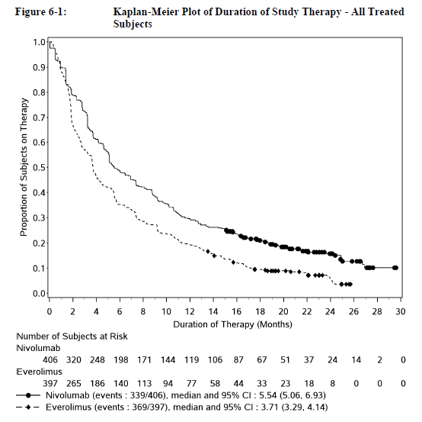

Interruption or delay of nivolumab therapy
A delay in dose occurred in 207/406 (51%) of patients. The dose delay was usually 14 days or less. Reasons for dose delay were:
- AEs: 172/406 (42.4%). The following AEs leading to dose delay were reported in ≥ 2% of subjects: diarrhoea (3.7%), increased ALT (3.2%), increased AST (2.7%), increased blood creatinine (2.7%), and pneumonitis (2.2%).
- ‘Other reasons’: 184/406 (45.3%) including knee surgery, personal convenience, administrative or logistic issue (for example, lack of appointment or study medication).
- No reason reported: 50/406 (12.3%).
Infusion interruption occurred in 26 (6.4%) patients, with this occurring once for 23 , twice for 2 and three times for one patient. The total number of infusion interruptions was 33/7796 (0.4%). Reasons for infusion interruption were:
- Hypersensitivity reaction in 19 patients.
- Infusion administration issues in 10 patients.
- Other in 4 patients.
Infusion rates were slowed in 17 subjects. This was due to hypersensitivity reactions in 16 patients and infusion administration issues in 9 patients.

Adverse events

All adverse events (irrespective of relationship to study treatment)
For all-causality AEs of any grade, 97.8% of subjects in the nivolumab group and 97.2% of subjects in the everolimus group reported an AE. Grade 3 or 4 AEs were reported in 53.2% of subjects in the nivolumab arm and 56.4% of subjects in the everolimus arm. There were 14 Grade 5 AEs in the nivolumab arm and 27 in the everolimus arm. The most commonly reported Grade 5 AE was ‘malignant neoplasm progression’ (8/14 in the nivolumab arm and 20/27 in the everolimus arm.
Graphical exploration of exposure-adjusted incidence rates for AEs suggests that reported toxicities were not cumulative with continuing nivolumab exposure, for all AEs or for drug toxicity related AEs. A similar pattern was seen with everolimus (not shown).
Figure 13. Study CA209025 Exposure adjusted rate of AEs (all and drug-related)
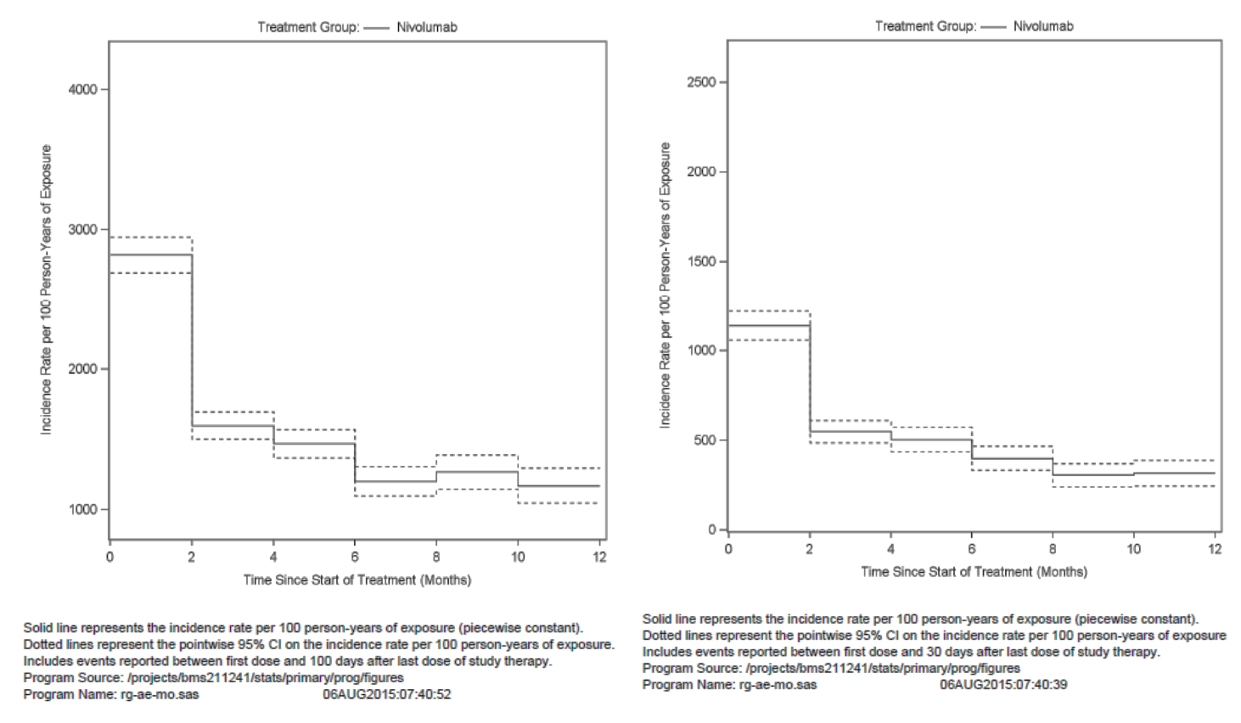

AEs reported in ≥ 20%
The following AEs in the nivolumab group were reported in ≥ 20% of subjects: fatigue (48.0%), cough (31.8%), nausea (28.3%), diarrhoea (23.6%), dyspnoea (23.2%), constipation (22.7%), decreased appetite (22.9%), and back pain (21.4%).
The following AEs in the everolimus group were reported in ≥ 20% of subjects: fatigue (44.8%), cough (35.5%), anaemia (35.0%), stomatitis (31.7%), diarrhoea (31.2%), decreased appetite (30.5%), nausea (28.7%), dyspnoea (26.7%), peripheral oedema (25.7%), rash (23.2%), mucosal inflammation (20.7%), and pyrexia (20.2%).

AEs in subjects with extended follow-up (to 100 days after last dose)
The sponsor’s conclusions were that: ‘Overall a similar incidence was observed for all-causality, all-grade AEs reported within 100 days of the last dose compared to those reported within 30 days for the nivolumab group. With extended follow-up, the incidence of all-causality, all-grade SAEs, and Grade 5 SAEs/AEs increased compared to the incidence reported within 30 days. This increase was observed for subjects in both treatment groups and was primarily due to disease related deaths.’
The number and size of the tables to support this precluded confirmation by the evaluator; just the list of tables referred to in support these statements extended over two and a half pages.

Treatment related adverse events (adverse drug reactions)
The overall frequency of drug-related any grade AEs was 78.6% in the nivolumab group and 87.9% in the everolimus group. The rate of reported Grade 3 or 4 drug related AEs was 18.7% in the nivolumab group and 36.5% in the everolimus group. A summary is given in Table 43, below.

Table 43. Study CA209025 Summary of drug related AEs by worst grade
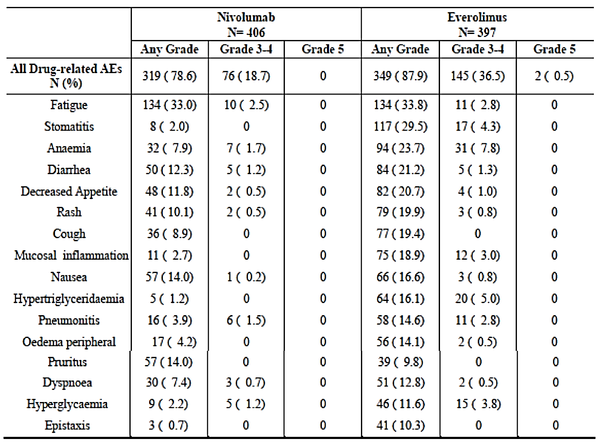

Grade 3 to 4 drug related AEs
Grade 3 or 4 drug related AEs that occurred in more than 2 subjects in the nivolumab group were fatigue (10 subjects); anaemia and increased ALT (7 subjects each); increased AST and pneumonitis (6 subjects each); diarrhoea and hyperglycaemia (5 subjects each); dyspnoea, decreased lymphocyte count, colitis, hypertension, and acute kidney injury (3 subjects each).
Grade 3 or 4 drug related AEs that occurred more commonly in the everolimus group (≥ 2% difference compared with the nivolumab group) were: anaemia (7.8% versus 1.7%); hypertriglyceridaemia (5.0% versus 0); stomatitis (4.3% versus 0); hyperglycaemia (3.8% versus 1.2%); and mucosal inflammation (3.0% versus 0).

Drug related AEs and sub-groups
The sponsor’s conclusions were that: ‘The frequencies of all-causality and drug-related AEs in the nivolumab group for subgroups of gender, race, age, and region were similar to the AE frequencies in the overall treated population. Small numerical differences in frequencies of all-causality AEs of any grade and Grade 3 or 4 AEs were observed in nivolumab-treated subjects in the following subgroups: for Black/African American (n = 1) and ‘other’ races (n = 13), age (≥ 75 and < 85 (n = 30), ≥ 85 years (n = 4)), and in the ‘rest of world’ regions (n = 95). These differences are of limited interpretability due to low sample sizes and event rates.’
The number and size of the tables referenced in support of these statements precluded confirmation by the evaluator; the table for the age groups alone was 58 pages.
Overall, no consistent differences in the frequencies of AEs were observed by PD-L1 expression subgroup (using a 1%, 5% or 10% PD-L1 expression level).

Deaths and other serious adverse events

Deaths
Prior to database lock, fewer nivolumab-treated subjects had died (181 subjects (44.6%)) compared with everolimus-treated subjects (213 subjects (53.7%)). Disease progression was the most common cause of death for both groups, including deaths occurring within 30 days of last dose and deaths occurring within 100 days of last dose. There were 4 subjects who died after randomisation but did not receive study drug. No deaths were attributed to study drug toxicity with nivolumab. There were 2 deaths in the everolimus group were assessed as study drug toxicity: one due to septic shock and one due to acute bowel ischemia.

Table 44. Study CA209025 Summary of deaths
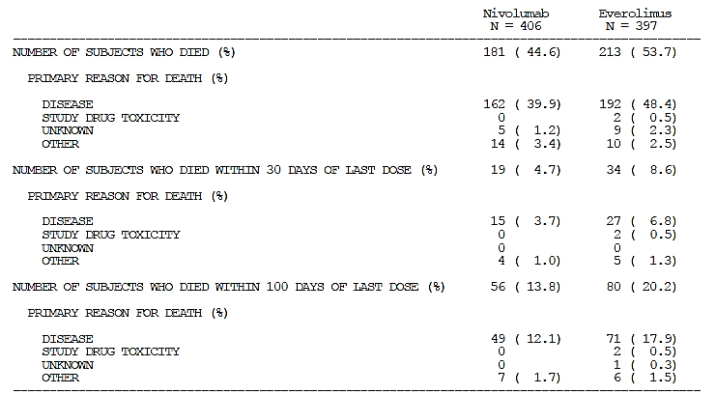
There were 19 deaths in the nivolumab arm with reason for death described as ‘unknown’ or ‘other’. The verbatim terms reported for the reasons for death of ‘other’ in the nivolumab group were provided in CSR.
Verbatim description of ‘reason for death’ where this was categorised as ‘other’ (total nivolumab = 14) was as follows: pulmonary embolism; pancytopaenia and pneumonia in the setting of RCC; renal failure; sepsis; pneumonia (n = 2); renal insufficiency and oedema polmonare; heart failure; acute kidney injury; sepsis of uncertain aetiology; suicide; ischemic heart failure; acute cardiac failure; and cardial infarction.
Narratives were available for most of these patients. The deaths were, in general, consistent with the verbatim descriptions provided in the table above. In some, for example, the two cases of pneumonia, there was insufficient detail to exclude immune mediated pneumonitis as the cause of death.

SAEs
Any grade SAEs were reported in 47.8% of subjects in the nivolumab group and 43.6% of subjects in the everolimus group. In the nivolumab group, the most frequently reported SAEs (≥ 2% of subjects) were malignant neoplasm progression (5.4%), pleural effusion (3.4%), pneumonia (2.7%), hypercalcemia (2.5%), pneumonitis (2.0%), spinal cord compression (2.0%), and acute kidney injury (2.0%). In the everolimus group, the most frequently reported SAEs (≥ 2% of subjects) were malignant neoplasm progression (6.0%), pneumonia (3.8%), pleural effusion (3.3%), pneumonitis (3.0%), and anaemia (3.0%). A summary of SAEs is given in Table 45, below.

Table 45. Study CA209025 Summary of SAEs
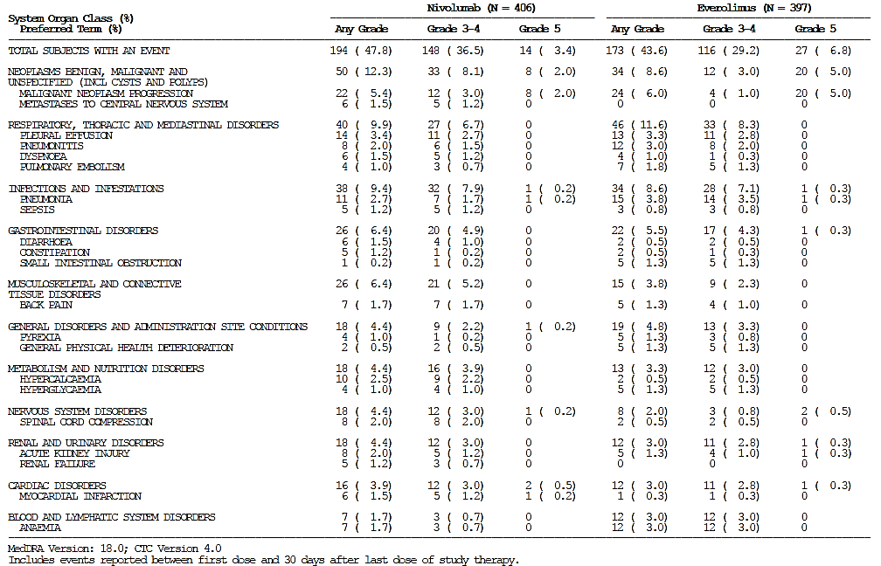
Drug related SAEs for any grade SAE and Grade 3 to 5 were similar between the nivolumab and everolimus groups. For any grade SAE, 11.6% of subjects in the nivolumab group and 13.4% of subjects in the everolimus group reported drug related SAEs, and for Grade 3 or 4, 7.9% of subjects in the nivolumab group and 9.3% of subjects in the everolimus group reported drug-related SAEs. There were no Grade 5 drug related SAEs reported for nivolumab treated subjects, and 2 subjects (0.5%) had Grade 5 drug related SAEs in the everolimus group.
The most frequently reported drug related SAEs (≥ 1%) for nivolumab were pneumonitis (1.7%) and diarrhoea (1.2%). The most frequently reported drug related SAEs (≥ 1%) for everolimus were pneumonitis (3.0%), anaemia and pneumonia (1.3% of subjects for each).

Narratives of deaths and SAEs
There were 263 narratives provided for subjects in the nivolumab group. These included narratives of 7 deaths, 217 SAEs, 78 discontinuations due to AEs and 98 IMAEs. Each narrative could include more than one type of event and some of the narratives of adverse events included patients who subsequently died. Around 60 of these narratives were read by the evaluator. These showed patients with complex conditions and illness courses. Attribution of SAEs and deaths as related to study drug or not appeared reasonable in most cases.

Select AEs: immune mediated AEs
AEs that were consistent with immune related reactions were considered ‘select AEs’ and included endocrinopathies, diarrhoea/colitis, hepatitis, pneumonitis, interstitial nephritis, and rash. The search for AEs belonging to select AE categories were not performed on an individual term level, but instead included multiple preferred terms in each select AE category: endocrine, GI, hepatic, pulmonary, renal, and skin select AE categories, respectively.
Hypersensitivity/infusion reactions were analysed along with the select AE categories because multiple event terms may be used to describe such events and pooling of terms was used to enable better characterisation. This is discussed separately below.
The sponsor’s presentation of Select AEs is in two parts, the first part is of ‘select AEs’ and the second part is a more detailed description of ‘immune mediated AEs’. Immune mediated AEs (IMAEs) were defined as specific events (or groups of PTs describing specific events) that include diarrhoea/colitis, hepatitis, pneumonitis, nephritis and renal dysfunction, rash, and endocrine (adrenal insufficiency, hypophysitis, hypothyroidism/thyroiditis, hyperthyroidism, and diabetes mellitus). IMAE analyses included events, regardless of causality, occurring within 100 days of the last dose (that is, with extended follow up). These analyses were limited to subjects who received immune modulating medication for treatment of the event, with the exception of endocrine events (adrenal insufficiency, hypophysitis, hypothyroidism/thyroiditis, hyperthyroidism and diabetes mellitus), which were included in the analysis regardless of treatment since these events are often managed without immunosuppression. The descriptive analysis of IMAEs included time-to-onset, severity, duration, action taken with the study drug, dosing delays of the study drug, corticosteroid details, rechallenge information, outcome of the AE, and time to resolution.
Comment: The distinction between ‘select AEs’ and ‘IMAEs’ is not clear to the evaluator given the definition of each appears to be the same, except for the use of immunosuppression for some IMAEs. Comparison of numbers across the descriptions of select AEs and IMAEs is difficult as the tables for select AEs seemed to cover 30 days post-last dose, whereas descriptions of IMAE numbers were for 100 days post-last dose (See Section 11: Question 21 ‘Select AEs and immune mediated AEs as presented in the CA209025 CSR’). The description of immune mediated adverse events, as seen in the nivolumab group, is presented here, with this supplemented as appropriate with information regarding ‘Select AEs’.
Among nivolumab-treated patients, skin, GI, renal and hepatic were the most frequently reported select AE categories (> 15% of subjects), regardless of causality. The majority of select AEs reported were Grade 1 or 2, and most were considered drug-related by the investigator. The most frequently reported (≥ 1% of subjects) Grade 3 or 4 drug-related select AE categories with nivolumab treatment were hepatic (2.7%), GI (2.0%), pulmonary (1.5%); endocrine, renal and skin were each reported by 1.0% of subjects.
Among treated subjects in the nivolumab group, the most frequently reported IMAEs (> 2% of subjects) were the hypothyroidism/thyroiditis (8.1%), rash (7.4%), pneumonitis (4.4%), diarrhoea/colitis (3.2%), nephritis and renal dysfunction (3.0%), and hyperthyroidism (2.5%) categories, followed by adrenal insufficiency (2.0%), hepatitis (1.5%), diabetes mellitus (1.5%), and hypophysitis (0.5%).
Across IMAE categories, the majority of events were manageable, with resolution occurring when immunosuppressive medications (mostly systemic corticosteroids) were administered. Median time to resolution was less than 7 weeks for most categories, although longer for the hepatitis and rash categories. Some endocrine IMAEs (for example, hypothyroidism) though well-controlled, were not considered resolved due to the continuing need for hormone replacement therapy.
There were 98 narratives for IMAEs provided, with around 35 of these read by the evaluator. Narratives could only be read at random as they were not ordered or listed in any way that related to the type of IMAE. Many of the IMAEs were associated with SAEs. IMAE narratives that were not associated with an SAE commonly involved Grade 2 hypothyroidism that was controlled by administration of thyroxine or levothyroxine. Onset of the IMAE ranged from the day after the first dose to occurring after a year of regular nivolumab or longer. According to the narratives, a wide variety of corticosteroid regimens were used in the management of IMAEs. A common regimen was 1 to 3 days of intravenous methylprednisolone at a dose of 100 to 250 mg daily, followed by a course of oral prednisolone commencing at 60 to 100 mg daily and tapering by 10 mg every week. If a response was not observed in the next 1 to 2 days, or the patient deteriorated, corticosteroid doses were increased for example, methylprednisolone 500 to 1000 mg intravenously daily. A single dose of infliximab (500 to 600 mg) was also added on a small number of occasions. Other corticosteroid courses reported had seemingly erratic tapering and/or very prolonged courses. This may have been due to symptoms that were not evident in the narratives. A small number of patients had recurrence of the IMAE on cessation of the corticosteroids or on rechallenge with nivolumab. Many patients had treatment discontinued due to progressive disease before rechallenge or resolution of the IMAE. Some patients experienced two or more IMAEs concurrently or sequentially, for example pneumonitis and hypothyroidism; pneumonitis, colitis and nephritis; pneumonitis and blepharitis; erythema multiforme followed by trismus and odynophagia; colitis followed by diabetes. Many patients, especially those with pneumonitis, were treated with broad spectrum antimicrobial drugs simultaneously with corticosteroids.

Endocrine IMAEs
Endocrine events include PTs of adrenal insufficiency, hypophysitis, hypothyroidism/thyroiditis, hyperthyroidism, and diabetes mellitus. All endocrine select AEs were considered IMAEs (see above).

Adrenal insufficiency
According to Table 8.7.1-1 in the CSR [not reproduced here], there were 7 select AEs of adrenal disorder, up to 30 days after the last dose. However, immune mediated adrenal insufficiency occurred in 8 nivolumab treated subjects (up to 100 days after last dose). These were all reported as Grade 1 to 3 events, although 3 subjects had events reported as SAEs, one subject discontinued treatment due to the IMAE and 5 subjects had dose delay due to the event. The time to onset ranged from 3 to 91 weeks.
All 8 patients were treated with systemic corticosteroids (three with initial dose > 40 mg daily of oral prednisolone), with this tapered over 6 to 7 weeks. 2 had complete resolution. 6 were rechallenged with nivolumab treatment with two of these having no recurrence and the outcome in the other 6 unclear.

Hypophysitis
Immune mediated hypophysitis occurred in 2 (0.5%) subjects in the nivolumab group – one event was Grade 1 and the other Grade 3. The time to onset was 14 weeks and 40 weeks respectively. Nivolumab treatment was discontinued with the Grade 3 event and this patient was treated with systemic corticosteroids, with these ongoing at the time of database lock.

Hypothyroidism/Thyroiditis, Hyperthyroidism
Thyroid function abnormalities were mainly detected through regular laboratory testing of thyroid function.
Immune mediated hypothyroidism was reported in 32 (8%) of subjects and thyroiditis in one. Of the 32 hypothyroidism events, 30 were Grade 1 or 2 and two were Grade 3. The thyroiditis event was Grade 2. Time to onset ranged from 2 to 59 weeks. Nivolumab dose was delayed for 4 events but was not discontinued for any subject. Levothyroxine replacement therapy was provided to 28/33 patients and one patient received systemic corticosteroids with an initial dose of more than 40 mg oral prednisolone and tapered over 10 weeks. In 10/33, the AE was reported as resolved although it appears that 5 or 6 of these continued to receive thyroxine. Rechallenge with nivolumab occurred in 28/33 patients. In 4 of the patients this was without problem. In the other 24 patients, the outcome of rechallenge was not clear.
Immune mediated hyperthyroidism occurred in 10 (2.5%) subjects and all events were Grade 1 or 2. Time to onset ranged from 3 to 62 weeks. None of the events resulted in treatment discontinuation; none were considered SAEs; 2 Grade 2 events resulted in dose delay. One subject was treated with methimazole; one received systemic corticosteroids (initial dose more than 40 mg oral prednisolone and course continued for 9 weeks). In 7/10 patients the AE resolved, with this occurring between 2 and 61 weeks. Rechallenge with nivolumab occurred in 8/10, with no recurrence in 7 of these patients. In one patient the effect of rechallenge was unclear.

Diabetes mellitus
Immune mediated diabetes mellitus occurred in 6 (1.5%) subjects, with one event of diabetic ketoacidosis (DKA) and the rest of hyperglycaemia. Three events were Grade 1 or 2 and three were Grade 3, with two of the latter reported as SAEs (including the DKA event). Time to onset ranged from 10 to 95 weeks. No event resulted in treatment discontinuation; the DKA event resulted in dose delay. Insulin was required by 4/6 patents. No patients received systemic corticosteroids. The IMAE is described as ‘resolved’ in 2 patients. Three patients were rechallenged with nivolumab: this was without any recurrence in one and unclear outcome in two.

Diarrhoea/colitis IMAEs
Diarrhoea/colitis occurred in 115 (28.3%) subjects in the nivolumab group, with this considered to be drug related in 51 patients and IMAE in 13 (3.2%) patients. Of these 13 patients, 10 had diarrhoea, 2 had both diarrhoea and colitis, 1 had colitis. All events were Grade 1 to 3 although 5 events were considered SAEs (3 Grade 3 diarrhoea, 1 Grade 3 colitis and 1 Grade 2 diarrhoea). Time to onset ranged from 2 days to 68 weeks. Treatment was discontinued in 4 subjects (one with diarrhoea/colitis, one with Grade 3 colitis and one with Grade 2 diarrhoea). Dose delay occurred in 8 patients.
All 13 patients were treated with systemic corticosteroids, with 11 receiving an initial dose of more than 40 mg prednisolone (3 patients commenced on intravenous methylprednisolone). Corticosteroid courses were continued for 1 to 10 weeks. In all 13, the diarrhoea/colitis was reported to have resolved, with this taking 1 to 17 weeks. Rechallenge with nivolumab occurred in 11/13 with no recurrence in 7 patients; recurrence in 2 patients and unclear outcome in 2 patients.

Hepatitis IMAEs
Hepatitis occurred in 62 (15.3%) subjects in the nivolumab group, with this considered to be drug-related in 46 patients and IMAE in 6 (1.5%) patients. Most patients had Grade 2 or 3 elevations in AST and/or ALT. One patient had Grade 3 autoimmune hepatitis and one had an elevation in ALP. Of the 6 patients, 3 had events that were considered SAEs. Time to onset ranged from 2 to 23 weeks. Nivolumab treatment was discontinued in 4 subjects and dose delays occurred in 4 patients. All six patients received systemic corticosteroids with initial dose of more than 40 mg prednisolone (4 patients received intravenous methylprednisolone) and course of 2 to 11 weeks. All 6 were reported to have resolution of the IMAE with this taking 4 to 71 weeks. Rechallenge occurred in 4 patients: 2 had no recurrence, one had recurrence and in one the outcome was unclear.

Pneumonitis IMAEs
The pulmonary select AE category included the following terms: acute respiratory distress syndrome, acute respiratory failure, interstitial lung disease, lung infiltration, and pneumonitis. Hypoxia and dyspnoea were not included but all reported events were queried to determine if there was an underlying diagnosis of pneumonitis or similar. Pneumonia was deliberately excluded due to the ‘high frequency with which it was expected to be reported’ with this hindering characterisation of the true frequency of pneumonitis.
Comment: The exclusion of ‘pneumonia’ from the search terms may have resulted in underestimation of the frequency of immune mediated pneumonitis. The clinical presentation of pneumonitis may be indistinguishable from that of pneumonia and common clinical practice is to commence antibiotics pending the results of cultures and serology. Patients labelled as ‘pneumonia’ may be subsequently found to be culture negative and to have pneumonitis. The evaluator notes that in the narratives of patients with moderately severe ‘pneumonitis’, both corticosteroids and broad spectrum antibiotics were usually administered.
The AEs of cough and dyspnoea were very common in patients receiving nivolumab in this study (reported in 31.8% and 23.2% respectively). These may represent patients with un-diagnosed pneumonitis.
Pneumonitis occurred in 26 (6.4%) subjects, with this considered to be IMAE in 18 (4.4%) patients. Of the 18, 17 were reported as pneumonitis and one as interstitial lung disease. There was one Grade 4 event, four Grade 3 and thirteen Grade 1 or 2. In 7 patients, the event was reported as an SAE. Time to onset ranged from 3 days to 97 weeks. Nivolumab treatment was discontinued in 6 subjects and dose delays occurred in 8 patients. The number of patients requiring hospitalisation or invasive ventilation was not described. All 18 patients received systemic corticosteroids with 15 receiving an initial dose of more than 40 mg prednisolone (7 patients received intravenous methylprednisolone). Two patients also received infliximab. From the narratives, for one patient with Grade 4 pneumonitis not responding within several days to methylprednisolone 225 mg daily, a dose of infliximab 550 mg was given, followed by a tapering course of oral prednisolone and a second dose of infliximab 500 mg was given 30 days later for reasons that are unclear. The second patient had persistent dyspnoea and hypoxia despite increasing doses of methylprednisolone over 24 days. A single dose of infliximab 300 mg was given followed by ongoing methylprednisolone. Corticosteroid course duration ranged from 2 to 11 weeks. In 16/18, investigators reported resolution of the IMAE with this taking 1 to 42 weeks. Rechallenge occurred in 9 patients: 4 had no recurrence, one had recurrence and in four the outcome was unclear.

Nephritis and renal dysfunction IMAEs
Nephritis and renal dysfunction occurred in 75 (18.5%) subjects, with this considered to be drug-related in around 28 and IMAE in 12 patients. Of the 12 patients, 4 were reported as having blood creatinine increased (all Grade 2), 4 as renal failure (2 Grade 3 and 2 Grade 2), 3 with acute kidney injury (1 Grade 4 and 2 Grade 3), and one with had tubulointerstitial nephritis (Grade 2). In 6 patients, the event was reported as an SAE. The number of patients requiring hospitalisation or renal replacement therapy was not described. Time to onset ranged from 5 to 54 weeks. Nivolumab treatment was discontinued in 3 subjects and dose delays occurred in 8 patients. All 12 patients received systemic corticosteroids with an initial dose of more than 40 mg prednisolone (5 patients received intravenous methylprednisolone). Corticosteroid course duration ranged from 1 to 65 weeks. In 9/12, investigators reported resolution of the IMAE with this taking 1 to 78 weeks. Rechallenge occurred in 5 patients: 3 had no recurrence and in 2 the outcome was unclear.

Rash IMAEs
Rash occurred in 92 (22.7%) subjects, with this considered to be IMAE in 30 (7.4%) patients. Of the 30 patients, 23 subjects had a PT of rash (2 Grade 3, 5 Grade 2, 16 Grade 1) and 7 subjects had a PT of rash maculo-papular (2 Grade 3, 2 Grade 2, and 3 Grade 1). None were reported as SAEs. In 6 patients, the event was reported as an SAE. Time to onset ranged from 5 to 54 weeks. Nivolumab treatment was discontinued in no subjects and dose delays occurred in 2 patients. All 30 patients received corticosteroids: 3 received systemic corticosteroids with intravenous methylprednisolone, an initial dose of more than 40 mg prednisolone and course duration of 3 to 6 weeks; 27 received topical corticosteroids. In 24/30, investigators reported resolution of the IMAE with this taking 1 to 41 weeks. Rechallenge occurred in 22/30 patients: 13 had no recurrence and in 9 the outcome was unclear.

Other events of special interest
Other events of special interest for the nivolumab program include: myasthenic syndrome, demyelination, Guillain-Barré syndrome, pancreatitis, uveitis, and encephalitis. No events of myasthenic syndrome, demyelination, Guillain-Barré syndrome, or encephalitis were reported in this study.
There was one case of uveitis, with this developing after 35 weeks. It was treated by intra-ocular corticosteroids and resolved within 4 weeks. Treatment was not delayed or discontinued.
Pancreatitis occurred in 2 (0.5%) subjects (one Grade 2 and one Grade 3) and was not considered drug related in either case. Time to onset was 17 and 24 weeks. Neither event led to treatment discontinuation; the Grade 3 event resulted in dose delay. Neither event was treated with corticosteroids. Both events resolved over 9 and 24 weeks.
There was one case of systemic inflammatory response syndrome (SIRS). This patient had a complicated course with Grade 4 acute kidney injury treated with systemic corticosteroids followed by a confusional state during which corticosteroids were recommenced. The first episode of SIRS developed 20 days later and was treated with a course of oral prednisolone 30 mg daily for 5 days followed by a 20 day taper. An episode of SIRS occurred 3 days later and was treated with a further course of systemic corticosteroids, initially intravenous hydrocortisone for 3 days, then oral prednisolone at 60 mg daily for one week followed by a 4 week taper. Both events of SIRS resolved.

Infusion related reactions
Hypersensitivity/infusion reactions included the following terms: anaphylactic reaction, anaphylactic shock, bronchospasm, hypersensitivity, and infusion related reaction. Hypersensitivity/infusion related reactions (all causality, any grade) were reported in 6.2% of subjects in the nivolumab group and 1.0% in the everolimus group.
In the nivolumab group, drug-related hypersensitivity and infusion reactions were reported in 21 subjects (5.2%). Of these, two patients discontinued treatment, one due to a Grade 4 anaphylactic reaction (reported as an SAE) and one due to a Grade 2 infusion-related reaction. Time to onset ranged from 1 day to 120 weeks. Seven patients with drug-related hypersensitivity events received immunosuppressive medication: 3 received corticosteroids. From the narratives, this was usually a single dose of corticosteroid (dexamethasone or hydrocortisone or similar) at the time of the reaction and premedication was administered prior to subsequent infusions.

Discontinuation due to adverse events
At the time of the database lock for this CSR (18 June 2015), 708/803 (88.2%) patients had discontinued study therapy: 339 subjects (83.5%) in the nivolumab group and 369 subjects (92.9%) in the everolimus group. In the everolimus arm, an additional 12.3% had received < 90% of the planned dose intensity. Reasons for treatment discontinuation are summarised in Table 46, below.

Table 46. Study CA209025 Reasons for treatment discontinuation
Reason for treatment discontinuation | Nivolumab | Everolimus
Disease progression | 285 | 273
Adverse event | 44 | 67
AE due to study drug toxicity | 35 | 53
AE unrelated to study drug | 9 | 14
Death | 1 | 1
Subject request to discontinue or subject withdrew consent | 7 | 21
Maximum clinical benefit | 2 | 3
Other |  | 4
Total | 339 | 369
Other reasons for discontinuation in the everolimus arm were: PI discretion, progressive disease on CT report (RECIST criteria not used); investigator decided to provide radiotherapy for cutaneous lesions, everolimus interruption for > 6 weeks.
Reasons for patient initiated discontinuation (request or withdrawal of consent), where provided, were:
- Nivolumab arm: subject refusal to continue treatment, study procedures and survival follow-up; subject request as does not wish to continue ‘perfusion’; subject request as commute to study site too long; subject request as did not want to continue study treatment; ‘patient’s wish’; subjects request to cease treatment due to pulmonary embolus; subject withdrew consent
- Everolimus arm: subject request (n = 9; no other information provided); subject request as ‘not strong enough following hospitalisation’; subject request due to exertional dyspnoea and cough; subject request due to treatment ‘making him feel worse’; subject request due to side effects; subject request due to mucositis; subject admitted on oncological network and accessing on-market everolimus (n = 2); subject decided to stop the medication and not accept follow-up contact; subject refused further treatment under the protocol and refused surveillance in the site; subject will see doctor closer to home; subject request as going to another country for treatment; subject request as planning to continue everolimus with local oncologist; subject request due to delay in availability of 5 mg tablets.

Discontinuations due to AEs
The overall rates of all-causality, any grade AEs leading to discontinuation of study therapy were similar between the nivolumab group (17.7%) and the everolimus group (20.7%).
A summary of AEs leading to discontinuation by worst CTC grade in all treated subjects was provided. Only those for the nivolumab arm are shown in Table 47, below.

Table 47. Study CA209025 Summary of adverse events leading to discontinuation, nivolumab arm
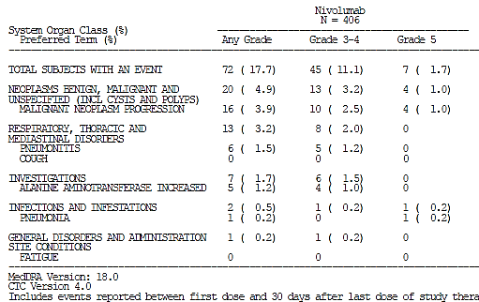

Discontinuations due to unrelated AEs
There were 9 patients in the nivolumab arm and 14 in the everolimus arm who withdrew due to AEs that were considered to be unrelated to study drug:
- Unrelated AEs, Nivolumab arm: Grade 2 cerebral ischemia, Grade 4 sepsis, Grade 5 pneumonia, Grade 4 cerebral haemorrhage, Grade 3 ileus, Grade 3 increased ALT and Grade 3 increased AST, Grade 5 hepatorenal failure, Grade 5 cardiac failure, Grade 5 myocardial infarction.
- Unrelated AEs, Everolimus arm: Grade 3 general physical health deterioration, Grade 2 upper respiratory infection and Grade 2 dyspnoea, Grade 4 cerebrovascular accident, Grade 3 pneumonia, Grade 3 pneumonia and Grade 2 muscular weakness, Grade 3 cerebrovascular accident, Grade 5 acute kidney injury, Grade 4 hypotension, Grade 3 pneumonia, Grade 5 cerebrovascular accident, Grade 4 acute kidney injury, Grade 2 metastatic neoplasm, Grade 4 groin infection, Grade 3 tumour pain.

Discontinuations due to study drug toxicity
Any-grade drug-related AEs leading to discontinuation of study therapy were reported at a lower frequency in the nivolumab group (7.6%) than the everolimus group (13.1%).
- In the nivolumab group, the most frequently reported all-grade drug-related AEs leading to discontinuation (≥ 1% of subjects) were pneumonitis (1.2%) and ALT increased (1.0%).
- In the everolimus group, the most frequently reported all-grade drug-related AEs leading to discontinuation (≥ 1% of subjects) were: pneumonitis (3.0%), cough (1.0%), and fatigue (1.0%).
- Grade 3 or 4 drug related AEs leading to discontinuation of study therapy were reported at lower frequency in the nivolumab group (4.7%) than the everolimus group (7.1%).
- In the nivolumab group, pneumonitis (1.2%) was the only Grade 3 or 4 drug related AE leading to discontinuation reported by ≥ 1% of subjects.
- In the everolimus group, pneumonitis (1.3%) was the only Grade 3 or 4 drug related AE leading to discontinuation reported by ≥ 1% of subjects.

Laboratory tests
Many of the immune related adverse events were detected through regular laboratory testing during treatment. These have been described above.
A summary of on-treatment laboratory test changes is shown below in Table 48.

Table 48. Study CA209025 Summary of on-treatment laboratory test changes (Number of subjects)
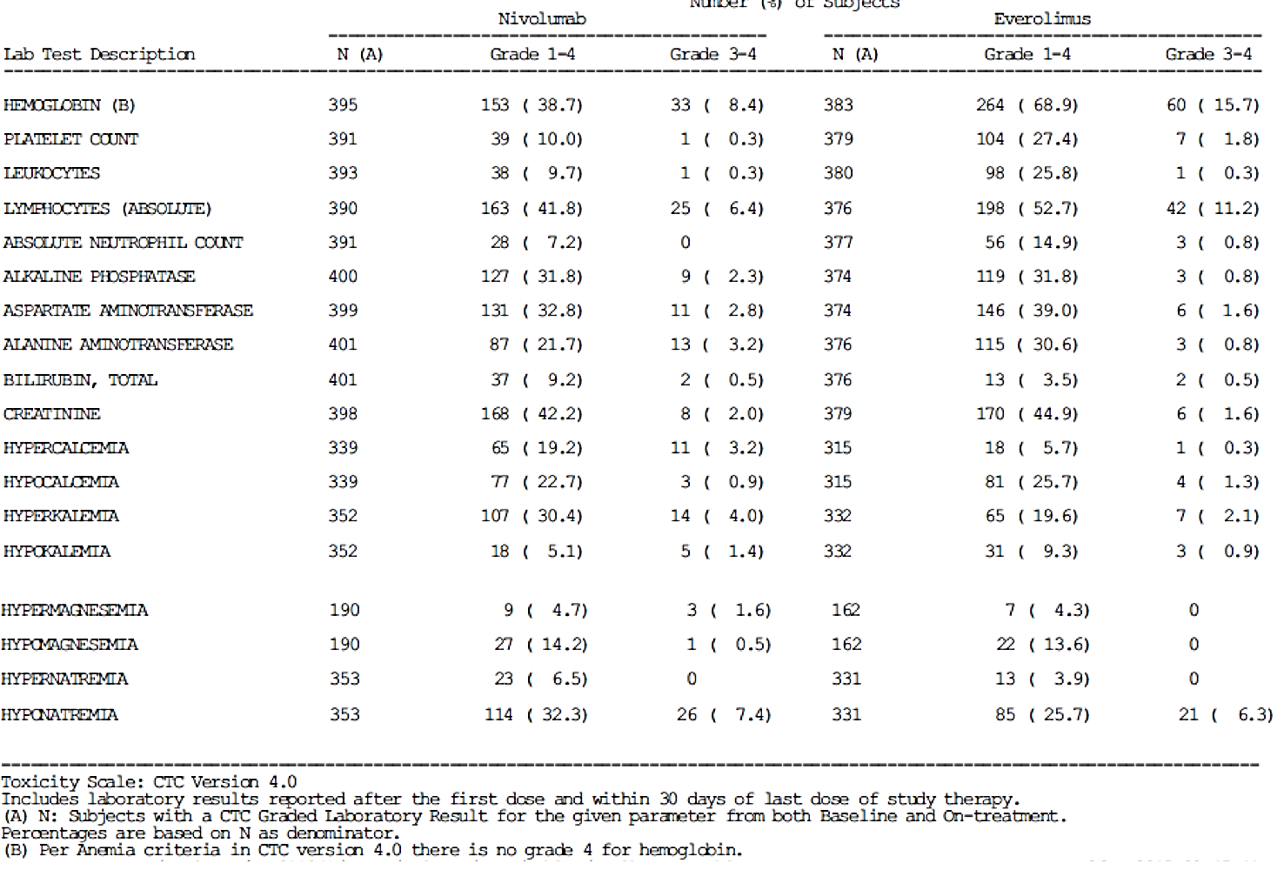

Liver function
Liver function was assessed through serum chemistry laboratories (AST, ALT, ALP, and total bilirubin) and review of AEs related to hepatic function abnormalities. The majority of subjects in both treatment groups did not have on-study worsening in liver function tests. Most abnormalities in liver function were Grade 1 or 2 in both treatment groups. AEs related to hepatic function abnormalities were more common in the nivolumab arm (65/406, 16% compared to 45/397, 11.3%). Summaries of abnormalities in liver function tests and hepatic AEs are reported in Tables 49 and 50, respectively.

Table 49. Study CA209025 Summary of abnormalities in liver function tests
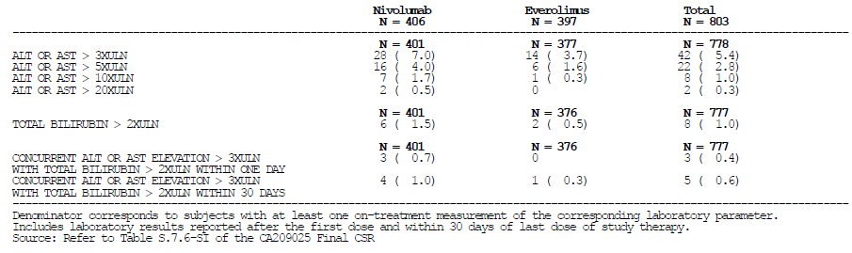

Table 50. Study CA209025 Summary of abnormalities in hepatic AEs due to these
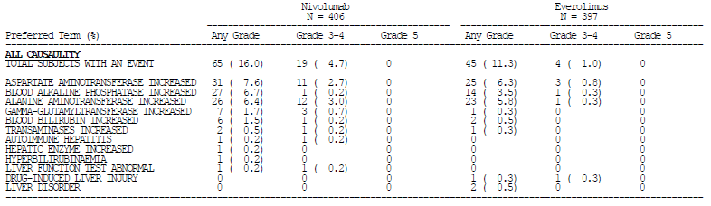
Comment: From the Clinical Overview table of on-treatment laboratory abnormalities, there were 7 patients in the nivolumab arm who met the laboratory requirements for the definition of drug induced liver injury (DILI) used by the sponsor: ‘Potential drug induced liver injury was defined as ALT or AST elevation > 3 times upper limit of normal (ULN) AND Total bilirubin > 2 times ULN, without initial findings of cholestasis (elevated serum alkaline phosphatase)’. No discussion of these patients is provided in the CSR. See Section 11: Question 22 ‘Study CA209025, DILI’.

Kidney function
Serum creatinine that worsened relative to baseline (any grade) was reported in 42.2% of subjects in the nivolumab group and 44.9% of subjects in the everolimus group (see table above). Grade 3 to 4 abnormalities in serum creatinine were reported in 2.0% of subjects in the nivolumab group and 1.6% of subjects in the everolimus group. Adverse events related to renal function occurred in 71/406 (17.5%) of patients in the nivolumab group compared to 56/397 (14.1%) of the everolimus group, and are summarised in Table 51, below.

Table 51. Study CA209025 Summary of renal AEs
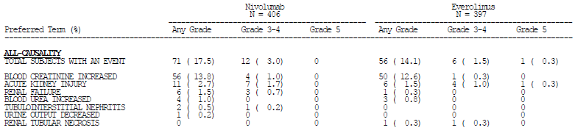

Other clinical chemistry
Changes in serum electrolyte levels appeared to be more common in patients in the nivolumab arm (see Table 48, above), with this most evident for hypercalcaemia.

Thyroid function tests
Thyroid function was measured every 2 cycles during treatment. Abnormalities in these tests and AEs were more common in the nivolumab patients, as shown below in Table 52.

Table 52. Summary of endocrine select AEs reported up to 30 days after last dose
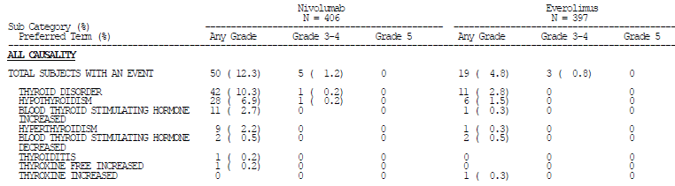

Haematology
Haematology was assessed through laboratory evaluation of haemoglobin, platelet count, leukocytes, lymphocytes, and absolute neutrophils. Most patients had no on-study worsening of haematology variables, summarised in Table 53, below. Abnormalities in tests performed during treatment or within 30 days of last treatment dose were primarily Grade 1 to 2 in the nivolumab and everolimus groups. The only Grade 3 to4 haematologic abnormalities reported in ≥ 5% of subjects in the nivolumab group was haemoglobin decrease (8.4%) and absolute lymphocyte count decrease (6.4%). In the everolimus group, Grade 3 to 4 haemoglobin decrease (15.7%) and absolute lymphocyte count decrease (11.2%) were also reported in ≥ 5% of subjects.

Table 53. Study CA209025 Summary of haematology test changes
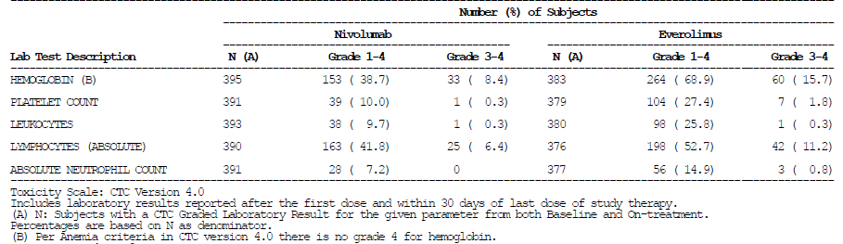

Electrocardiograph
ECGs were not routinely performed during the study.

Vital signs
Vital signs, including pulse oximetry, were monitored and recorded at the site as per the institutional standard of care during each infusion of nivolumab and at everolimus cycle visits. There was no requirement for these assessments to be recorded in the study documentation, except as related to AE reporting.

Overdose
There were no reports of inadvertent or deliberate overdose during the study. Two patients had the nivolumab infusion inadvertently administered over 30 minutes instead of over 60 minutes without any adverse sequelae (see protocol deviations).

Dose-ranging Studies
The safety results for the two open label dose ranging studies that describe the investigation of nivolumab treatment in patients with advanced clear cell carcinoma who have received prior systemic therapy, Studies CA209009 and CA209010, are summarised below. The CSR for Study CA209003 did not show separate safety results for the 34 patients with RCC; information regarding these patients is included where possible. Comparison to the pivotal Study CA209025 is provided, together with pooled data for all patients with advanced renal cell carcinoma treated with nivolumab monotherapy.

Study drug exposure

Table 54. Study drug exposure, dose ranging studies
Study identifier | Total patient number with advanced RCC | Number per dose | Dose  (mg/kg) | Dose frequency |  | Median cumulative dose  (mg/kg) | Median cycle number  (range)
CA209003 | 34 |  |  |  | Q2W
CA209003 |  | 18 | 1 |  | Q2W
CA209003 |  | 16 | 10 |  | Q2W
CA209010 | 168 |  |  |  | Q3W
CA209010 |  | 59 | 0.3 |  | Q3W | 1.8 | 6 (1 to 29)
CA209010 |  | 54 | 2 |  | Q3W | 15 | 7.5 (1 to 32)
CA209010 |  | 54 | 10 |  | Q3W | 79.8 | 8 (1 to 31)
CA209009 | 91 |  |  |  | Q3W
CA209009 |  | 22 | 0.3 |  | Q3W | 5.8 | 7 (1 to 49)
CA209009 |  | 22 | 2 |  | Q3W | 14 | 7 (1 to 40)
CA209009 |  | 23 | 10 |  | Q3W | 60 | 6 (2 to 45)
CA209009 |  | 24* | 10 |  | Q3W | 95 | 9.5 (1 to 48)
Pivotal
CA209025 |  |  | 3 |  | Q2W | 36 | 12 (1 to 65)
*Patients with advanced RCC but no prior systemic therapy

Dose-toxicity relationship
In each of the dose ranging studies there was no clear relationship between toxicity and dose except for hypersensitivity/ infusion reaction which occurred in a higher percentage of subjects in the 10 mg/kg group:
- Study CA209010: 16.7% in the 10 mg/kg group compared to < 5% in the 0.3 and 2 mg/kg groups.
- Study CA209009: 21.7% in the 10 mg/kg prior treatment group and 25% in the 10 mg/kg-naive groups compared to 4.5% in the 0.3 mg/kg group and 9% in the 2 mg/kg group
Comment: The exposure-safety population PK analysis provided by the sponsor [not reproduced here] showed some inconsistent results with the risk of AE-DC/D appearing to decrease with increasing exposure. The sponsor’s conclusion was that nivolumab exposure did not appear to have a significant risk of AE-DC/D.

Adverse events
A summary of the most common AEs and drug-related AEs in patients receiving nivolumab monotherapy for advanced RCC is shown below in Table 55. Occurrence according to PT was, in general, consistent across the studies.

Table 55. Summary of adverse events (%) for patients with advanced RCC receiving nivolumab monotherapy
Study ID | CA902010 |  |  | CA902009 |  | CA902025 |  | All RCC
Total patient number | 167 |  |  | 91 |  | 406 |  | 664
 | Any Grade | Grade 3 to 4 |  | Any Grade | Grade 3 to 4 | Any Grade | Grade 3 to 4 | Any Grade | Grade 3 to 4
All AEs (Regardless of causality)* | 98.8 | 54.5 |  | 100 | 52.7 | 97.8 | 53.2 | 98.3 | 53.5
Most Frequent (> 20% of any grade in Study CA209025)
Fatigue | 31.1 | 4.8 | 44.0 |  | 2.2 | 48.0 | 4.4 | 43.2 | 4.2
Nausea | 18.6 | 2.4 | 34.1 |  | 0.0 | 28.3 | 0.5 | 26.7 | 0.9
Diarrhoea | 16.2 | 0.0 | 24.2 |  | 2.2 | 23.6 | 1.2 | 21.8 | 1.1
Constipation | 17.4 | 0.6 | 25.3 |  | 1.1 | 22.7 | 0.5 | 21.7 | 0.6
Back pain | 24.6 | 1.8 | 22.0 |  | 2.2 | 21.4 | 3.4 | 22.3 | 2.9
Cough | 25.1 | 0.0 | 26.4 |  | 0.0 | 31.8 | 0.0 | 29.4 | 0.0
Dyspnoea | 21.6 | 3.6 | 13.2 |  | 1.1 | 23.2 | 2.7 | 21.4 | 2.7
Decreased appetite | 16.8 | 0.0 | 19.8 |  | 0.0 | 22.9 | 1.2 | 20.9 | 0.8
Drug-related AEs* | 73.1 | 11.4 | 89.0 |  | 25.3 | 78.6 | 18.7 | 78.6 | 17.8
Most Frequent (> 10% of any grade in Study CA209025)
Fatigue | 19.8 | 0.0 | 41.8 |  | 2.2 | 33.0 | 2.5 | 30.9 | 1.8
Cough | 4.2 | 0.0 | 8.8 |  | 0.0 | 0.0 | 0.0 | 2.3 | 0.0
Nausea | 12.0 | 1.8 | 16.5 |  | 0.0 | 14.0 | 0.2 | 13.9 | 0.6
Diarrhoea | 9.6 | 0.0 | 12.1 |  | 1.1 | 12.3 | 1.2 | 11.6 | 0.9
Decreased Appetite | 5.4 | 0.0 | 4.4 |  | 0.0 | 11.8 | 0.5 | 9.2 | 0.3
Pruritus | 3.6 | 0.6 | 13.2 |  | 0.0 | 14.0 | 0.0 | 11.3 | 0.2
Rash | 9.6 | 0.0 | 9.9 |  | 0.0 | 10.1 | 0.5 | 9.9 | 0.3
All SAEs (regardless of causality) | 49.1 | 36.5 | 51.6 |  | 31.9 | 47.8 | 36.5 | 48.6 | 35.8
Drug-related SAEs | 7.2 | 7.2 | 11.0 |  | 9.9 | 11.6 | 7.9 | 10.4 | 8.0
All AEs leading to discontinuation (regardless of causality) | 12.6 | 3.0 | 24.2 |  | 13.2 | 17.7 | 11.1 | 17.3 | 9.3
Drug-related AEs leading to discontinuation | 6.6 | 3.0 | 14.3 |  | 8.8 | 7.6 | 4.7 | 8.3 | 4.8

Deaths and other serious adverse events
A summary of deaths and other SAEs from the dose ranging studies is given in Table 56, below.

Table 56. Summary of deaths and SAEs in patients with advanced RCC receiving nivolumab monotherapy
Study ID: | CA902010* |  |  | CA902009 |  | CA902025 |  |  | All RCC
 | Patient number | % | Patient number |  | % |  | Patient number | % |  | Patient number | %
Patient number | 167 |  | 91 |  |  |  | 406 |  |  | 664
Deaths | 112 | 43.7 | 39 |  | 42.9 |  | 181 | 44.6 |  | 293 | 44.1
Within 30 days | NA |  | 4 |  | 4.4 |  | 19 | 4.7 |  | 23 | 3.5
Within 100 days | NA |  | 14 |  | 15.4 |  | 56 | 13.8 |  | 70 | 10.5
Cause of death
Due to Study Drug Toxicity | 0 | 0.0 | 0 |  | 0.0 |  | 0 | 0.0 |  | 0 | 0.0
Due to disease progression | 103 | 41.9 | 33 |  | 36.3 |  | 162 | 39.9 |  | 265 | 39.9
Unknown/other | 9 | 1.8 | 6 |  | 6.6 |  | 19 | 4.7 |  | 28 | 4.2
SAEs
ALL SAEs (regardless of causality) | 82 | 49.7 | 47 |  | 51.6 |  | 194 | 47.8 |  | 323 | 48.7
Drug Related SAEs | 12 | 7.2 | 10 |  | 11.0 |  | 47 | 11.6 |  | 69 | 10.4
*data regarding deaths taken from Study Addendum with database lock date of 12 March 2015

Deaths

Study CA209010
There were 73 deaths among the 167 subjects. Most were attributed to disease progression and none were considered related to nivolumab. There were a number of patients in whom the cause of death was described as ‘unknown’ or ‘other’. Narratives for only 2 deaths were provided in the CSR appendices (Final CSR and Addendum to Finals CSR) and are summarised below:
Subject 1:
- RCC metastatic to lung and lymph nodes with dyspnoea and cough at Baseline.
- Hospitalised with fever, dyspnoea, fatigue 2 days after the first dose of nivolumab 10 mg/kg. Treated with antibiotics and endobronchial debulking of right main stem bronchus mass with dilatation of the bronchus. Condition improved.
- Hospitalised with multiple organ failure (WCC, transminases, creatinine all elevated) 12 days after second dose of nivolumab and died one day later. Treated with immunosuppression (methylprednisolone 125 mg daily) and broad-spectrum antibiotics. Continued to deteriorate (increasing transaminitis, worsening renal function and clinical condition). Methyl prednisolone decreased to 60 mg daily. No autopsy performed and no results of cultures. Not considered related to study treatment by investigator.
Subject 2:
- RCC metastatic to liver and pancreas. Previous DVT.
- Received 54 infusions of nivolumab 2 mg/kg complicated by Grade 1 increase in blood glucose not requiring treatment and Grade 2 hypertension treated with lisinopril.
- Found dead at home 37 days after the fifty-fourth dose of nivolumab without prodromal deterioration. Cause of death reported as unknown. No autopsy performed.

Study CA209009
A total of 39 (42.9%) subjects died: 33 subjects died of progressive disease 2 subjects died due to reasons reported as ‘unknown’ and 4 subjects due to reason reported as ‘other’. Narratives provided in the CSR were reviewed by the evaluator:
Subject 1:
- RCC metastatic to soft skin (sic) tissue, adrenal gland and lung
- Received 11 infusions of nivolumab 10 mg/kg
- Death due to complications of resection of cerebral metastasis.
Subject 2:
- RCC metastatic to lung and lymph nodes
- Received 5 doses of nivolumab 0.3 mg/kg
- Death due to ischaemic stroke.
Subject 3:
- RCC metastatic to lung, liver, bone and lymph nodes
- Received 2 doses of nivolumab 0.3 mg/kg
- 8 days after second dose, hospitalised with hypotension, acute renal and respiratory failure. Commenced on methylprednisolone 125 mg daily and antibiotics. Required intubation, haemodialysis and vasopressors. Care redirected to palliation and patient died that day
- Not considered related to study treatment by investigator.
Subject 4:
- RCC metastatic to lung, adrenal gland and lymph nodes
- Received 10 doses of nivolumab 2 mg/kg
- Found dead at home 7 days after the tenth dose. Family described brief prodrome of nasal discharge and abdominal discomfort.
Comment: There were two deaths associated with rapidly progressive multiple organ failure (one in each of Studies CA209010 and CA209009). These were not considered treatment-related by the investigator. The evaluator is unable to exclude a fulminant immune mediated adverse reaction or SIRS/MOF triggered by an immune mediated adverse reaction from the information provided in the narrative. There was also one case of Systemic Inflammatory Response Syndrome (SIRS), without fatal outcome, described in Study CA209025.
SIRS, Multiple Organ Dysfunction Syndrome and MOF may be considered as being on a spectrum of non-specific systemic inflammatory reactions to a variety of insults, including immune mediated organ injury. These syndromes are associated with elevated levels of circulating pro-inflammatory cytokines, particularly IL-6, TNF-α and IL-1β. The evaluator also notes that a similar syndrome, ‘Cytokine Release Syndrome’, described as a ‘non–antigen-specific toxicity that occurs as a result of high-level immune activation’, has been described with other immunotherapies.
The evaluator has not reviewed all narratives for all studies and cannot determine if there were other reports of SIRS or MOF or MODS or CRS, in which immune mediated adverse reactions may be causing serious compromise or failure of more than one organ simultaneously. See Section 11 Question 28, SIRS, MOF and combined organ failure.

Study CA209003
There were 75 deaths within 100 days of the last dose, among the 306 treated subjects. There were 6 deaths amongst the 34 RCC patients.
Five patients died after developing treatment-related pneumonitis, with three of these deaths occurring within 100 days of last dose. Two of these patients had NSCLC and one had colon cancer. After the data cut-off date for the CSR, 2 deaths related to pneumonitis were reported in NSCLC subjects treated with 3 mg/kg nivolumab. The narratives of these deaths see describe a fulminant course in 2 patients and a relapsing and prolonged course in the other 3 patients. All patients received multiple immunosuppressives, including corticosteroids (intravenous and oral), infliximab, mycophenylate, cyclophosphamide an intravenous immunoglobulin. These narratives have been summarised by the evaluator [but are beyond the scope of this document].
Comment: Despite the number of deaths due to pneumonitis reported in NSCLC patients in this dose ranging study, there were no deaths due to this reported in the registrational studies for squamous and non-squamous NSCLC.

SAEs

Study CA209010
Drug related SAEs included adrenal insufficiency (n = 1), hypothyroidism (n = 1), enterocolitis/colitis (n = 1), pneumonitis (n = 1).

Study CA209009
The most frequently reported SAE (≥ 5%) was malignant neoplasm progression (9.9%).All other SAEs occurred in less than 5% of the subjects treated with any nivolumab. Drug-related AEs included colitis (n = 2), pneumonitis (n = 3), acute renal failure (n = 1), liver function test abnormalities (n = 3).

Study CA209003
Of the 34 RCC patients, 5 experienced a SAE, with 3 of these being Grade 3 or 4. These included colitis and increased alkaline phosphatase.

Select AEs

Study CA209010
Hypothyroidism was the most common select endocrine AE reported in all 3 groups (3 to 7%) Grade 3 or 4 reported in 1 subject (2 mg/kg group). Grade 3 or 4 adrenal insufficiency was reported in 1 subject (2 mg/kg group). Diarrhoea (none Grade 3 or 4) was the most commonly reported select gastrointestinal AE (10 to 22%). Grade 3 or 4 gastrointestinal AEs included colitis (1 subject in the 10 mg/kg group) and enterocolitis (1 subject in the 2 mg/kg group). The most common hepatic PTs reported were AST increased (7%) and ALT increased (7%). Grade 3 or 4 hepatic AEs included AST increased (1 subject each in the 0.3 and 2 mg/kg groups), ALT increased (1 subject each in the 0.3 and 2 mg/kg groups), hyperbilirubinaemia (1 subject in the 10 mg/kg group), transaminases increased (1 subject in the 10 mg/kg group) and liver function test abnormal (1 subject in the 2 mg/kg group). The Preferred Term pneumonitis was the most common pulmonary AE (4 to 6%). No Grade 3 or 4 select pulmonary AEs were reported. Select renal AEs (any grade) were reported in 4 to 9%. Grade 3 or 4 select renal AEs included blood creatinine increased and renal failure (1 subject each in the 0.3 mg/kg group) and renal failure acute (2 subjects in the 2 mg/kg group).
Hypersensitivity/infusion reaction: Hypersensitivity/infusion reaction (any grade) occurred mostly in subjects in the 10 mg/kg treatment group (19% versus 5% and 4% in the 0.3 and 2 mg/kg groups, respectively). Preferred Terms reported included hypersensitivity and infusion related reaction. No Grade 3 or 4 hypersensitivity/infusion reactions AEs were reported.

Study CA209009
Among the select AE categories, skin AEs were the most common select AEs overall (reported in 36.3% of subjects, treated with any nivolumab). Gastrointestinal AEs were the next most common select AE (reported in 25.3% of subjects treated with any nivolumab).

Use of immunosuppression

Study CA209009
From the narratives provided, patients were treated with systemic corticosteroids for pneumonitis, colitis, polyarthritis, nephritis and urticarial rash. Topical corticosteroids were used for rash and uveitis. Other treatments used for possible immune mediated adverse reactions included intravenous immunoglobulin for polyneuropathy and mesalazine for colitis.

Discontinuation due to adverse events

Study CA209010
12.6% experienced an AE that led to discontinuation. In 6.6% of subjects the event was considered related to nivolumab. Pneumonitis (3.8%) and increased AST (3.8%) were the most common of these.

Study CA209009
A total of 22 (24.2%) of the 91 treated subjects discontinued due to an AE. The most frequently reported AE overall for subjects who discontinued from the study was malignant neoplasm progression (7.7% of treated subjects).

Study MDX1106-03
18.6% experienced an AE that led to discontinuation. In 10.5% of subjects the event was considered related to nivolumab. Pneumonitis (2.6%) and colitis (1.0%) were the most common of these.

Laboratory tests
Laboratory investigations schedule:
- Study CA209010:
  - Every cycle and first follow-up visit: to include CBC with differential, LFTs, BUN, creatinine
- Study CA209009:
  - Every cycle and at follow-up visit: CBC with differential, LFTs (to include a minimum of AST, ALT, Alkaline Phosphatase, T. bilirubin, and LDH), BUN, creatinine, glucose, Ca, Mg, Na, K, HCO3, Cl, phosphorous.
  - Every 9 weeks during treatment: Endocrine panel (TSH, T3, T4).
Haematological, hepatic function and renal function parameters remained stable in the majority of subjects during treatment in both Study CA209010 and Study A209009.

Post-marketing Experience
Nivolumab has been approved for use in the US since December 2014 and in Japan since July 2014. No post-marketing reports have been provided by the sponsor. The Summary of Clinical Safety states: ‘No new significant safety concerns were identified based on the postmarketing reports’. The evaluator is unable to confirm this statement. The evaluator also notes, from publically available documents on the EMA website, that a ‘Periodic Safety Update EU Single assessment: Nivolumab’ was provided to the EMA in January 2016. See Section 11: Question 33 ‘Post marketing reports’.
Comment: The two PSURs that were available at the time have been evaluated during the Round 2 process; See Section 11: ‘Post-marketing reports and PSURs/PBRERs’ below.

Clinical study programme
There have been over 8000 patients exposed to nivolumab through the clinical study programme, including patients exposed to nivolumab in combination with another agent such as ipilimumab. No information regarding this total population was provided in the Summary of Clinical Safety or the Clinical Overview. According to the draft PI, there have been 1728 patients exposed to nivolumab in completed registrational studies. The patients in the registrational studies can be used to provide an overview of the more common adverse events and to determine if there are differences in these according to tumour types. Pooling of information across the studies can also facilitate in describing the more common immune mediated adverse reactions. For detection of the less common immune mediated adverse reactions, the whole population should be used.

Registrational studies
Nivolumab has been approved for use in Australia, after prior therapies, in advanced melanoma and non-small cell lung cancer (squamous and non-squamous) with a dosing regimen of 3 mg/kg every two weeks. Additional safety information is available from the registration studies for these indications.

Table 57. Registrational studies for nivolumab
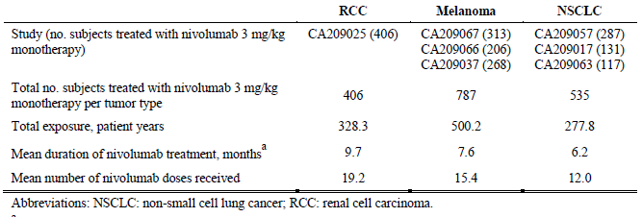

Adverse events
The Summary of Clinical Safety for this submission provides a comparison of safety of nivolumab in patients with advanced RCC to patients with other solid organ tumours and found that ‘the type, frequency, and severity of AEs were consistent between RCC and other tumour types (melanoma and NSCLC)’. Exceptions to this were:
- Fatigue and back pain were reported more frequently (> 5% difference) in RCC than in both melanoma and NSCLC.
- Cough was reported at a similar frequency in RCC and NSCLC, higher than in melanoma.
A table, comparing AE rates (all grades and Grades 3 or 4) across tumour types, was provided (see Table 58, below) along with another table in the Summary of Clinical Safety [not included in this document]. This data can be pooled to create a summary of the use of nivolumab as monotherapy in the dosing regimen of 3 mg/kg every two weeks (see Table 59, below). The display of AEs is in accordance with those displayed in the [non-included] table of the Summary of Clinical Safety provided by the sponsor; these were selected as AEs reported in > 20% and drug related AEs reported in > 10% of patients treated with nivolumab in Study CA209025. Display of AEs in accordance with frequency across the whole population receiving 3 mg/kg Q2W has been requested (See Section 11: Question ‘Summarising the presentation of safety across tumour types’).

Table 58. Summary of safety of nivolumab monotherapy according to tumour types (registrational studies)
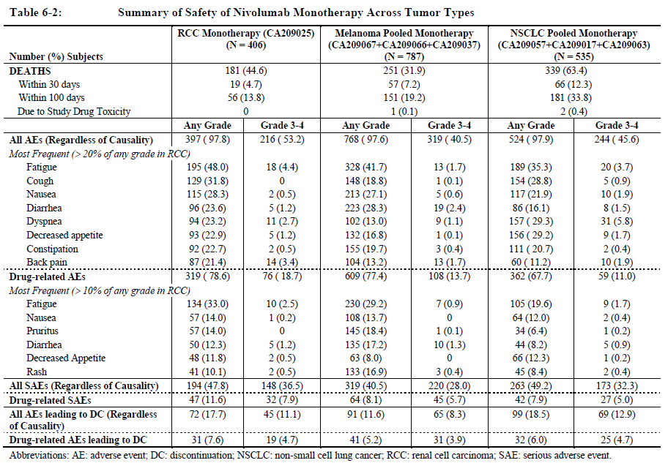

Table 59. Summary of safety of nivolumab monotherapy (registrational studies: melanoma, NSCLC, RCC)
 | Number of subjects | % of subjects
 | 1728
Deaths | 771 | 44.6
Within 30 days | 142 | 8.3
Within 100 days | 388 | 22.5
Due to Study Drug Toxicity | 3 | 0.2
 | Any Grade |  | Grade 3 to 4
 | Number | % | Number | %
All AEs (Regardless of Causality)¹ | 1689 | 97.7 | 779 | 45.1
Most Frequent (> 20% of any grade in RCC)
Fatigue | 712 | 41.2 | 51 | 3.0
Cough | 331 | 19.2 | 6 | 0.3
Nausea | 445 | 25.8 | 17 | 1.0
Diarrhoea | 405 | 23.4 | 32 | 1.9
Dyspnoea | 353 | 20.4 | 51 | 3.0
Decreased appetite | 381 | 22.0 | 15 | 0.9
Constipation | 358 | 20.7 | 7 | 0.4
Back pain | 251 | 14.5 | 37 | 2.1
Drug-related AEs² | 1290 | 74.7 | 243 | 14.1
Most Frequent (> 10% of any grade in RCC)
Fatigue | 469 | 27.1 | 26 | 1.5
Nausea | 229 | 13.3 | 3 | 0.2
Pruritus | 236 | 13.7 | 2 | 0.1
Diarrhoea | 229 | 13.3 | 20 | 1.2
Decreased Appetite | 177 | 10.2 | 3 | 0.2
Rash | 219 | 12.7 | 7 | 0.4
All SAEs (regardless of causality) | 776 | 44.9 | 541 | 31.3
Drug-related AEs | 153 | 8.9 | 104 | 6.0
All AEs leading to discontinuation (regardless of causality) | 266 | 15.4 | 179 | 10.4
Drug-related AEs leading to discontinuation | 104 | 6.0 | 75 | 4.3
1) AEs occurring within 30days of dose and reported in > 20% of patients in the nivolumab group in Study CA209025; 2) Drug related AEs occurring within 30days of dose and reported in > 10% of patients in the nivolumab group in Study CA209025
Comment: The proposed PI provides Adverse Event information for nivolumab monotherapy for each tumour type separately. Given the similarities in the rate and pattern of AE occurrence across the tumour types, a more concise and accessible presentation of this information may be possible. See Section 11: Question ‘AE’s in the ‘Megapool’’.
A summary table of adverse events for nivolumab monotherapy across tumour types (melanoma and NSCLC) has been provided in the current SmPC (see below). A similar table including patients from the registrational studies for melanoma, NSCLC (squamous and non-squamous) and RCC would be helpful (See Section 11: Question ‘Summarising the representation of safety across tumour types’).

Table 60. Adverse reactions in patients with advanced melanoma and with squamous NSCLC treated with nivolumab 3 mg/kg
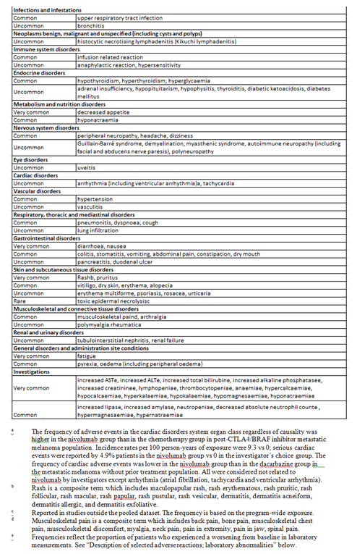

Immune mediated adverse reactions
The proposed PI provides information regarding the incidence of these with nivolumab monotherapy in the section ‘Description of selected adverse reactions – OPDIVO monotherapy’ with this information based on seven clinical studies in melanoma, NSCLC and RCC (CA209066, CA209037, CA209067, CA209017, CA209057, CA209063 and CA209025 with a total patient population of 1728). Additional descriptive information has been added from the draft RMP where available, this is indicated in italics.

Immune related pneumonitis
In patients treated with nivolumab monotherapy, the incidence of pneumonitis, including interstitial lung disease, was 3.2% (56/1728). The majority of cases were Grade 1 or 2 in severity reported in 0.7% (12/1728) and 1.7% (29/1728) of patients respectively. Grade 3 and 4 cases were reported in 0.8% (14/1728) and < 0.1(1/1728) of patients respectively. No Grade 5 cases were reported.
‘The majority of cases reported were Grade 1-2 and subjects presented with either asymptomatic radiographic changes (eg, focal ground glass opacities, patchy infiltrates) or with symptoms of dyspnea, cough, or fever. Subjects with reported Grade 3-4 pulmonary toxicities were noted to have more severe symptoms, more extensive radiographic findings, and hypoxia.’
Median time to onset was 3.6 months (range: 0.4 to 19.6). Fourteen patients (0.8%), 13 with Grade 3 and 1 with Grade 4, required permanent discontinuation of nivolumab.
Forty-one patients received high-dose corticosteroids (at least 40 mg prednisone equivalents) at a median initial dose of 1.2 mg/kg (range: 0.5 to 17.6) for a median duration of 3.4 weeks (range: 0.1 to 13.1).
Resolution occurred in 47 patients (84%) with a median time to resolution of 5.3 weeks (range: 0.6 to 53.1).

Immune related colitis
In patients treated with nivolumab monotherapy, the incidence of diarrhoea or colitis was 13.6% (235/1728). The majority of cases were Grade 1 or 2 in severity reported in 9.0% (156/1728) and 3.0% (52/1728) of patients, respectively. Grade 3 cases were reported in 1.6% (27/1728) of patients. No Grade 4 or 5 cases were reported.
‘Most patients presented with diarrhea and/or abdominal pain with or without fever. Diarrhea/colitis was manageable using the established management guidelines. Generally, Grade 1-2 events were treated symptomatically and Grade 3-4 events were treated with systemic corticosteroids or with additional immunosuppressant agents for events that were refractory to steroid treatment.’
Median time to onset was 1.8 months (range: 0.0-20.9). Twelve patients (0.7%) with Grade 3 diarrhoea or colitis required permanent discontinuation of nivolumab.
Thirty-four patients received high-dose corticosteroids (at least 40 mg prednisone equivalents) at a median initial dose of 0.9 mg/kg (range: 0.4 to 4.7) for a median duration of 3.0 weeks (range: 0.4 to 40.3).
Resolution occurred in 207 patients (89%) with a median time to resolution of 2.1 weeks (range: 0.1 to 88.3).

Immune related hepatitis
In patients treated with nivolumab monotherapy, the incidence of liver function test abnormalities was 7.0% (121/1728). The majority of cases were Grade 1 or 2 in severity reported in 3.9% (68/1728) and 1.3% (22/1728) of patients, respectively. Grade 3, and Grade 4 cases were reported in 1.4% (25/1728) and 0.3% (6/1728) of patients, respectively. No deaths due to liver function abnormalities were reported.
‘In clinical studies, hepatotoxicities manifesting as transaminase elevations were detectable with liver function testing and signs and symptoms monitoring, and were manageable according to the treatment guidelines established. Generally, immune-related hepatitis is managed by withholding nivolumab and administering corticosteroids. Additional immunosuppressant therapy (eg, mycophenolate mofetil) is recommended in steroid refractory cases.’
Median time to onset was 1.9 months (range: 0.0 to 18.7). Fifteen patients (0.9%) required permanent discontinuation of nivolumab.
Nineteen patients received high-dose corticosteroids (at least 40 mg prednisone equivalents) at a median initial dose of 1.0 mg/kg (range: 0.4 to 4.7) for a median duration of 4.0 weeks (range: 0.4 to 8.9).
Resolution occurred in 95 patients (79%) with a median time to resolution of 5.1 weeks (range: 0.1 to 82.6).

Immune related nephritis and renal dysfunction
In patients treated with nivolumab monotherapy, the incidence of nephritis and renal dysfunction was 3.2% (55/1728). The majority of cases were Grade 1 or 2 in severity reported in 1.9% (32/1728) and 0.8% (14/1728) of patients, respectively. Grade 3 and 4 cases were reported in 0.5% (8/1728) and < 0.1% (1/1728) of patients, respectively. No Grade 5 nephritis and renal dysfunction was reported.
‘Most patients present with asymptomatic increase in serum creatinine. Immune-related nephritis or renal dysfunction is manageable according to the treatment guideline established. Generally, Grade 2 or 3 events are managed by withholding nivolumab and administrating corticosteroids and Grade 4 events are managed by discontinuing nivolumab and administering high dose corticosteroids.’
Median time to onset was 2.3 months (range: 0.0 to 18.2). Two patients (0.1%), 1 with Grade 3 and 1 with Grade 4 nephritis or renal dysfunction, required permanent discontinuation of nivolumab.
Fifteen patients received high-dose corticosteroids (at least 40 mg prednisone equivalents) at a median initial dose of 0.8 mg/kg (range: 0.5 to 2.1) for a median duration of 3.0 weeks (range: 0.1 to 67.0).
Resolution occurred in 33 patients (62%) with a median time to resolution of 11.1 weeks (range: 0.1 to 77.1).

Immune related endocrinopathies
In patients treated with nivolumab monotherapy, the incidence of thyroid disorders was 8.6% (149/1728). The majority of cases were Grade 1 or 2 in severity reported in 3.6% (62/1728) and 4.9% (85/728) of patients, respectively. Grade 3 thyroid disorders were reported in 0.1% (2/1728) of patients.
Hypophysitis (1 Grade 1, 1 Grade 2, and 3 Grade 3), adrenal insufficiency (1 Grade 1, 5 Grade 2, and 4 Grade 3), diabetes mellitus (1 Grade 2), and diabetic ketoacidosis (2 Grade 3) were reported. No Grade 4 or 5 endocrinopathies were reported.
Median time to onset of these endocrinopathies was 2.8 months (range 0.4-14.0). Two patients (< 0.1%) with Grade 3 endocrinopathies required discontinuation of nivolumab.
Eleven patients received high dose corticosteroids (at least 40 mg prednisone equivalents) at a median initial dose of 0.8 mg/kg (range: 0.5-2.2) for a median duration of 1.6 weeks (range: 0.1 to 4.9).
Resolution occurred in 74 patients (45%) with a median time to resolution of 66.6 weeks (range: 0.4 to 96.1).

Immune related rash and severe skin reactions
In patients treated with nivolumab monotherapy, the incidence of rash was 28.0% (484/1728). The majority of cases were Grade 1 in severity reported in 21.9% (378/1728) of patients. Grade 2 and Grade 3 cases were reported in 5.2% (89/1728) and 1.0% (17/1728) of patients, respectively. No Grade 4 or 5 cases were reported.
In other ongoing clinical trials, 3 cases (0.03%, 3/8490) of TEN with fatal outcome were reported: in a patient receiving nivolumab monotherapy, in a patient receiving antibacterial drug (with known risk of severe skin reaction) after discontinuing nivolumab in combination with ipilimumab due to colitis, and in a patient receiving ipilimumab after discontinuing nivolumab due to severe erythema multiforme.
Median time to onset was 1.4 months (range: 0.0 to 17.2). Three patients (0.2%) with Grade 3 rash required permanent discontinuation of nivolumab. Eighteen patients received high-dose corticosteroids (at least 40 mg prednisone equivalents) at a median initial dose of 0.9 mg/kg (range: 0.4 to 2.7) for a median duration of 2.1 weeks (range: 0.1 to 38.7).
Resolution occurred in 295 patients (62%) with a median time to resolution of 18.1 weeks (range: 0.1 to 113.7).
Comment: the information regarding TEN is only available in the draft RMP. It has not been included in the sponsor’s other documents, including the draft PI.

Infusion reactions
In patients treated with nivolumab monotherapy, the incidence of hypersensitivity/infusion reactions, including anaphylactic reaction, was 4.1% (71/1728), including 3 Grade 3, and 2 Grade 4 cases. No deaths due to infusion reactions were reported.

Other immune related adverse reactions
The following clinically significant immune related adverse reactions were reported in less than 1% of patients treated with Opdivo monotherapy in clinical trials across doses and tumour types: pancreatitis, uveitis, demyelination, autoimmune neuropathy (including facial and abducens nerve paresis), Guillain-Barré syndrome, hypopituitarism, myasthenic syndrome, and encephalitis.
‘Another event of special interest observed in CA209025 was systemic inflammatory response syndrome. One subject had 2 Grade 3 drug-related SAEs of systemic inflammatory response syndrome reported during the extended follow-up period. The subject was treated with systemic corticosteroids, and both events resolved.’
Comment: This is helpful and important information to include in the PI and in any evaluation of safety. It could, however, be improved by:
Including the number (%) estimated to be immune mediated. If the numbers provided above (as copied from the PI) indicate the number (%) of AEs that were considered to be immune mediated, then there is considerable discrepancy compared to the rates described for Study CA209025 for example in Study CA209025, diarrhoea/colitis occurred in 115 (28.3%) subjects in the nivolumab group, with this considered to be IMAE in 13 (3.2%) patients; in the pooled data from the registrational studies, In patients treated with nivolumab monotherapy, the incidence of diarrhoea or colitis was 13.6% (235/1728).
Presenting the time to onset, time to resolution and duration of corticosteroid therapy as the range only. The evaluator does not consider the median to be helpful given the very wide ranges observed for each of these factors.
Including in the description of the number of patients who were treated with systemic corticosteroids - how many received an initial dose of more than 40 mg prednisolone; the number of these commencing on intravenous methylprednisolone.
Include a clinical description of presentation (such as provided in the draft RMP and included in italics above) and severity, for example, how many required hospitalisation, how many with nephritis required renal replacement therapy, how many with pneumonitis required invasive ventilation and if any deaths occurred.
Including a description of any other immunosuppressive therapy(ies) provided, including drug name and dosing regimen, number of patients and outcome.
Result of rechallenge with nivolumab.
More detail on the endocrinopathies with a separate section for each of the endocrinopathies (hypophysitis, hypothyroidism, hyperthyroidism, diabetes, adrenal failure) The description should including the number requiring ongoing hormone replacement therapy after ‘resolution of the AE’ and any other treatments provided, such as methimazole for hyperthyroidism.
A full picture of immune mediated adverse reactions may require a cumulative review of each of the categories of immune mediated adverse reactions, with this including all patients exposed to nivolumab, and broken down according to monotherapy or combination therapy. See Section 11: Questions ‘Cumulative review of all immune mediated AEs including all patients exposed to nivolumab’.

Safety issues with the potential for major regulatory impact

Immune mediated adverse reactions
AEs that were consistent with immune related AEs were considered select AEs in the clinical study programme and included endocrinopathies, diarrhoea/colitis, hepatitis, pneumonitis, nephritis, and rash. These have been described above according to their occurrence in the studies involving patients with RCC and patients from the registrational studies. These reactions are the main issue so far identified that have the potential for major regulatory impact.
These reactions do not appear to be common in patients receiving nivolumab, although it is not clear how easily they may be distinguished from a non-immune cause for example, in Study CA209025:
- Diarrhoea/colitis occurred in 115 (28.3%) subjects in the nivolumab group, with this considered to be IMAE in 13 (3.2%) patients by the investigator
- Hepatitis occurred in 62 (15.3%) subjects in the nivolumab group, with this considered to be IMAE in 6 (1.5%) patients by the investigator
- Pneumonitis occurred in 26 (6.4%) subjects, with this considered to be IMAE in 18 (4.4%) patients by the investigator.
- Nephritis and renal dysfunction occurred in 75 (18.5%) subjects, with this considered to be IMAE in 12 patients by the investigator
In general, these reactions appear to be mild (Grade 1 or 2) although more severe reactions, including fatalities have been reported. The following deaths have been attributed to immune mediated adverse reactions in patients receiving nivolumab:
- 5 due to study drug related pneumonitis reported in Study CA209003
- 1 due to pneumonitis in a patient also receiving ipilimumab in Study CA209069
- 1 due to enterocolitis and pancreatitis in a patient also receiving ipilimumab in Study CA209004
- 1 due to encephalitis in Study CA209057
- 1 due to pneumonitis in Study CA209063
The recognition of fatal immune mediated adverse reactions is evolving as more patients are exposed to nivolumab. In the draft RMP, 3 fatal cases of toxic epidermal necrolysis are described in patients treated with nivolumab monotherapy. Two of these patients also received other medications known to be possible causes of TEN (Bactrim and ipilimumab). An additional 4 cases of encephalitis were described, although these were all in patients treated with nivolumab/ipilimumab combination therapy.
Comments: There were a number of deaths categorised as due to ‘Unknown’ or ‘Other’ causes in each of the clinical studies discussed above (Studies CA209025, CA209010 and CA209009). The narratives of these patients were read by the evaluator if these could be located in the dossiers. It is notable that the verbatim descriptions attributed a number of deaths to such non-specific causes as ‘pneumonia’, ‘sepsis’, ‘hepatorenal syndrome’, ‘acute cardiac failure’. There were also a number of patients who were found dead without apparent prodrome. Severe pneumonia, sepsis, or acute cardiac failure may all present as multiple organ failure and be clinically undistinguishable. The clinician makes the best guess as to cause and implements care according to this, pending the results of further investigations and response to treatment. Severe pneumonia may present as bilateral lung infiltrate and is commonly culture negative. From the narratives provided for IMAEs, clinical presentations similar to these have been attributed by some investigators to immune mediated adverse reactions. It was also notable that patients assessed as having immune mediated severe pneumonitis were treated with broad spectrum antimicrobials and aggressively investigated for an infective cause. In some of the narratives provided for SAEs and deaths from Other causes, clinical presentations similar to those described in IMAE have not been assessed as IMAE by the investigator and there is insufficient clinical detail provided to exclude IMAE as the cause of the clinical condition. See Section 11: Question ‘Deaths from other or unknown causes in the clinical studies’.
The evaluator is concerned that there may have been inconsistent attribution of deaths, AEs and SAEs as IMAEs, or as non-drug-related, and that this, in turn, may have resulted in an under-estimation of the frequency and severity of IMAEs. Inconsistent attribution between investigators could reflect both the clinical difficulty of determining the cause of illness and death in complex patients and a lack of familiarity with immune mediated adverse reactions associated with nivolumab. Each investigator is likely to have had little exposure to nivolumab treated patients, for example Study CA209025 was conducted across 146 sites and 406 patients were treated with nivolumab, resulting in an average of three patients treated with nivolumab at each site during an 18 month period. No specific training of investigators in the recognition or management of IMAE was described in the CSR, although an investigator’s brochure regarding evaluation and management of IMAE was provided to them. This brochure was not included in the CSR and no assessment of it can be made. The evaluator notes that in regard to 2 of the 5 patients who died due to pneumonitis in Study CA209003, the draft RMP states: ‘In the first 2 subjects, there was a delay of approximately 1 to 2 weeks between the onset of symptoms and treatment with high doses of corticosteroids. Earlier recognition and treatment with higher dose corticosteroids may have led to a different outcome, as has been reported for GI toxicity elicited by ipilimumab.’ According to the draft RMP, an investigator’s brochure regarding IMAE that included management advice was developed and used in subsequent studies. This brochure was not included in the Study CSRs or the sponsor’s dossier, as far as the evaluator could tell.
An overview of the range of severity, beyond the severity grade, and clinical consequences of the immune mediated adverse reactions has not been provided for example it is not evident to the evaluator how many patients required hospitalisation due to immune mediated adverse reactions or how many patients with acute kidney injury or nephritis required haemodialysis/ haemofiltration or how many patients with pneumonitis or interstitial lung disease required intubation and mechanical ventilation. See Section 11: Question 29 ‘Cumulative reviews of immune mediated AEs including all patients exposed to nivolumab’ and Question 30: Descriptions of immune mediated AE’s in the ‘Megapool’.

Other safety issues

Safety in special populations
Safety in the paediatric population has not been tested. Safety in the elderly has not been presented.

Safety and racial differences
The majority of patients included in the clinical studies were white. Safety in other racial groups has not been presented.

Safety related to drug-drug interactions and other interactions
Not investigated.

Safety in pregnancy
There are no data on the use of nivolumab in pregnant women. Effects of nivolumab on prenatal and postnatal development were investigated in pregnant cynomolgus monkeys. Nivolumab treatment at 10 mg/kg and 50 mg/kg (administered 2QW) dosed from GD 20 to 22 through parturition was associated with increases in third trimester abortions, stillbirths, and/or death/euthanasia of premature infants. The RMP states: ‘At present, the cause of adverse pregnancy outcome and infant mortality associated with nivolumab administration in monkeys is unknown. While the clinical implications of these findings are unclear, nivolumab is not recommended during pregnancy or in women of childbearing potential not using effective contraception, unless the clinical benefit outweighs the potential risk.’
According to the draft RMP, ‘Contraception is required for women of child bearing potential (WOCBP) and for men with WOCBP partner during nivolumab clinical trials.’ Despite this, ‘One ectopic pregnancy was reported from CA209066, resolved with surgical intervention while dose of nivolumab was delayed. Nivolumab dosing resumed after the surgery.’

Evaluator’s overall conclusions on clinical safety
The evaluator is of the opinion that the safety for the proposed indication has not been adequately characterised by the sponsor. The assessment of safety provided in the Summary of Clinical Safety and Clinical Overview is limited to the pivotal Study CA209025 and the dose-ranging Study CA209010. Reference has been made to the safety profile of nivolumab in other solid organ tumour types but only to enable comparison of the safety profile as seen in patients with RCC.
The sponsor has stated that adverse events are not dose related and included the dose-ranging Study CA209010 in the safety assessment. However, two other dose ranging studies that included patients with advanced RCC, Studies CA209009 and CA209003, were not included in the safety assessment. An overview of the frequency of AEs in all patients exposed to nivolumab has not been provided, although such an overview is available in the EMA’s SmPC (for patients with melanoma and NSCLC). An overview of the frequency of AEs in all patients with advanced RCC exposed to nivolumab was also not provided – the overview provided above was constructed by the evaluator from the CSRs of the relevant studies where this information was able to be located (patients with RCC in Study CA209003 could not be included).
Nivolumab has been recognised as a having a unique adverse effect profile due to the occurrence of IMAE and has been rapidly introduced into clinical practice for a number of indications. The sponsor has stated that the occurrence of IMAE is not related to tumour type. According to reports in individual studies, the frequency of IMAE appears to be low but severity seems highly variable. As the number of patients treated in the registrational studies for the different indications is relatively small, dependence on each of these studies individually to satisfactorily describe IMAE is not possible. A comprehensive overview of the occurrence of IMAE across all tumour types was not provided in the Summary of Safety and Clinical Overview. Some information was available in the proposed PI, although this was limited to registrational studies rather than the whole population exposed to nivolumab monotherapy, and has been included in the evaluator’s assessment above. A more detailed depiction of each of the categories of IMAE is needed and this may be best obtained through a cumulative review for each category and type of IMAE, with this including all patients exposed to nivolumab. A better understanding of both the frequency of occurrence and the range of severity (according to clinically important measures such as need for hospitalisation and organ support and including any associated deaths) and the treatments used is essential for the risk-benefit analysis of the use of nivolumab for the proposed indication, and any future indications. This information is also essential if appropriate advice for the recognition and management of these conditions is to be is to be provided in the PI and in educational materials provided to the patient and healthcare professionals. The evaluator notes that in regard to 2 of the 5 patients who died due to pneumonitis in Study CA209003, the draft RMP states: ‘In the first 2 subjects, there was a delay of approximately 1 to 2 weeks between the onset of symptoms and treatment with high doses of corticosteroids. Earlier recognition and treatment with higher dose corticosteroids may have led to a different outcome, as has been reported for GI toxicity elicited by ipilimumab.’ The occurrence of severe IMAEs and deaths due to IMAEs may have been under-estimated in the clinical studies due to lack of investigator familiarity with the varying manifestations of these reactions. Similarly, milder manifestations may also have gone un-diagnosed and untreated, for example, the high incidence of cough and dyspnoea across the clinical studies is suggestive of un-diagnosed pneumonitis; the high incidence of fatigue is suggestive of endocrinopathies.
The following description of safety is compiled from various sources within the sponsor’s dossiers and should not be regarded as complete.

Study CA209025
In Study CA209025, safety was evaluated in 406 patients with advanced clear cell RCC who had previously received at least one anti-angiogenic therapy. The most common (greater than or equal to 20%) adverse reactions included fatigue, cough, nausea, rash, dyspnoea, diarrhoea, constipation, decreased appetite, back pain, and arthralgia. The most common (greater than or equal to 30%) laboratory abnormalities which have worsened compared to baseline included increased creatinine, lymphopenia, anaemia, increased AST, increased alkaline phosphatase, hyponatraemia, elevated triglycerides, and hyperkalaemia.
Serious adverse events were reported in 47% of patients. The most common serious adverse events (greater than or equal to 2%) were acute kidney injury, pleural effusion, pneumonia, diarrhoea, and hypercalcaemia. Nineteen deaths were reported within 30 days of the last nivolumab dose. 15 were attributed to progressive disease and 4 due to pneumonia, suicide, heart failure, and myocardial infarction. Immune mediated adverse events, including pneumonitis, diarrhoea/colitis, hepatitis, nephritis and endocrinopathies were reported. No deaths were attributed to immune mediated adverse events.
There was a higher incidence of deaths, SAEs and drug-related AEs in the everolimus arm compared to the nivolumab arm.

Studies CA209009, CA209003 and CA209010
Doses ranging from 0.3 mg/kg to 10 mg/kg and dosing interval of 2 weeks or 3 weeks were used in these studies. The adverse event profile seen in these studies was similar to that seen in the pivotal study, with no evidence of dose-dependence except for an increase in infusion-related reactions with the dose 10 mg/kg. Immune mediated adverse reactions were reported in each study, although no deaths were attributed to these in Studies CA209009 and CA209010. There were 5 deaths attributed to immune mediated pneumonitis in Study CA209003, although these occurred in patients with NSCLC (n = 4) and colorectal cancer (n = 1).

Registrational studies (using dosing regimen of 3 mg/kg every 2 weeks)
This comprised a total of 1728 patients from seven studies. The individual studies and pooled data showed a similar overall adverse event profile to that seen with Study CA209025; with fatigue the most common (> 40%) and nausea, diarrhoea, dyspnoea, constipation and decreased appetite reported in more than 20%. The most common Grade 3 to 4 events were fatigue, dyspnoea and back pain. Immune mediated adverse reactions were reported in each of these studies.

Immune mediated adverse reactions (IMAE)
This group of adverse reactions is the most concerning with regards to safety, and appears to be poorly understood and characterised. It is concerning that the sponsor has not used all of the information available to attempt to better understand the manifestations of these reactions or to determine the most effective treatment regimens.
IMAEs have been reported in all studies. The frequency of occurrence in individual studies is difficult to determine as the reported rates are dependent on investigator recognition of the event as immune mediated, for example in Study CA209025:
- Diarrhoea/colitis occurred in 115 (28.3%) subjects in the nivolumab group, with this considered to be IMAE in 13 (3.2%) patients by the investigator
- Hepatitis occurred in 62 (15.3%) subjects in the nivolumab group, with this considered to be IMAE in 6 (1.5%) patients by the investigator
- Pneumonitis occurred in 26 (6.4%) subjects, with this considered to be IMAE in 18 (4.4%) patients by the investigator.
- Nephritis and renal dysfunction occurred in 75 (18.5%) subjects, with this considered to be IMAE in 12 patients by the investigator
Data regarding select AEs from the registrational studies is provided in the proposed PI, with frequencies as shown in Table 61, below.

Table 61. Overview of IMAE in the registrational studies (Patient number = 1728)
IMAE category | Number (%) reported | Number treated with systemic immunosuppression | Number discontinuing nivolumab due to IMAE
Pneumonitis | 56 (3.2) | 41 | 14
Colitis | 235 (13.6) | 34 | 12
Hepatitis | 121 (7) | 19 | 15
Nephritis | 55 (3.2) | 15 | 2
Skin reaction | 484 (28.0) | 18 | 3
Thyroid dysfunction | 149 (8.6) | ? | ?
Hypophysitis | 4 (0.23) | ? | ?
Adrenal insufficiency | 10 (0.58) | ? | ?
Diabetes mellitus | 3 (0.17) | ? | ?
Encephalitis | ? | ? | ?
Guillaine-Barre | < 1% | ? | ?
Pancreatitis | < 1% | ? | ?
Uveitis | < 1% | ? | ?
Autoimmune neuropathy | < 1% | ? | ?
Myasthaenic syndrome | < 1% | ? | ?
In general, these reactions appear to be mild (Grade 1 or 2) although more severe reactions, including fatalities have been reported. The following deaths have been attributed to immune mediated adverse reactions in patients receiving nivolumab:
- 5 due to study drug related pneumonitis reported in Study CA209003
- 1 due to pneumonitis in a patient also receiving ipilimumab in Study CA209069
- 1 due to entero-colitis and pancreatitis in a patient also receiving ipilimumab in Study CA209004
- 1 due to encephalitis in Study CA209057
- 1 due to pneumonitis in Study CA209063
From the narratives in Studies CA209010, CA209025 and CA209009 that have been read by the evaluator it is possible that this under-represents the number of patients whose deaths may be related to immune mediated adverse reactions. This can reflect the clinical difficulty of determining the cause of illness and death in complex patients for example, if a patient dies from sepsis due to immunosuppression required to treat an immune mediated adverse reaction, this death may or may not be attributed to the study drug by an investigator; deaths due to SIRS/MODS/MOF may have been attributed to sepsis or cardiac failure or ‘other’ instead of to immune mediated AEs; unexpected deaths at home may be due to a cardiac arrhythmia and myocarditis; deaths from respiratory failure may be attributed to pneumonia rather than pneumonitis. It may also reflect a lack of familiarity of the investigators with immune mediated adverse reactions, resulting in a failure to either consider or diagnose these reactions. Similarly, less severe manifestations of IMAE may not have been recognised by the investigators.
A lack of familiarity with immune–mediated adverse reactions associated with nivolumab treatment in the greater population of health-care professionals who may become involved in the care of these patients is extremely concerning and represents a major safety risk. From the narratives provided, IMAE may take a fulminant course and require prompt recognition and early institution of systemic immunosuppressive therapies. This has been demonstrated in Study CA209003 in 2 of the 5 patients who died due to pneumonitis in this study: according to the draft RMP: ‘In the first 2 subjects, there was a delay of approximately 1 to 2 weeks between the onset of symptoms and treatment with high doses of corticosteroids. Earlier recognition and treatment with higher dose corticosteroids may have led to a different outcome, as has been reported for GI toxicity elicited by ipilimumab.’ Patients who become acutely unwell may present to their local doctor or local emergency department for emergency care. Delays in appropriate care, and worse outcome, may result from lack of awareness of the unique side effect profile of checkpoint inhibitors. The EMA has sought to address this lack of familiarity through the use of a patient alert card (including advice for both patient and medical practitioners providing emergency care) and physician education packages. The evaluator strongly recommends that the TGA also adopt this approach.
In conclusion, this assessment of safety is considered incomplete by the evaluator and will need to be revised, and completed, following the evaluation of the sponsor’s responses to the Clinical Questions. On the information currently available, additional safety measures that target the patient and healthcare professionals awareness of IMAE are strongly recommended as the use of nivolumab becomes more wide spread.

First round benefit-risk assessment

First round assessment of benefits
Nivolumab has demonstrated clinically meaningful improved overall survival in comparison to everolimus in patients with advanced clear cell renal cell carcinoma who have progressed despite prior anti-angiogenic therapy. At the median follow-up of 17 to 18 months, there had been 183/410 (44.6%) deaths in the nivolumab arm compared to 215/411 (52.3%) in the everolimus arm; HR 0.73 (95% CI 0.57, 0.93). Median survival (K-M estimate) was 25.0 months (95% CI 21.8, NR) in the nivolumab arm compared to 19.6 months (95% CI 17.6, 23.1).
Despite the small improvement in overall survival with nivolumab, outcome overall was very poor. At the time of analysis for the primary outcome measure (median follow-up of 17 to 18 months), only 67/410 patients in the nivolumab arm and 28/411 patients in the everolimus arm were continuing with study treatment. A total of 398/821 (48.5%) of patients had died and only 72/821 (8.8%) patients had not developed disease progression.
For the increase in overall survival and estimated 5months increase in median duration of survival to be meaningful to patients, it is important that it be associated with an acceptable quality of life. The study protocol for the pivotal study describes the use of two quality of life tools, the FKSI-DRS and the EQ-5D, together with the collection of health resource utilisation data. The results using the FKSI-DRS tool were presented in the clinical study report. This found no difference in median scores between the two arms at baseline and at the follow-up visit. There was a small difference favouring nivolumab in the median scores during treatment. The result of the EQ-5D and health resource utilisation were not presented in the CSR; nor was there any explanation given for their omission.
Everolimus and axitinib are currently approved as second line agents for the treatment of advanced renal cell carcinoma. On the basis of improved survival and no worsening in quality of life, as demonstrated in Study CA209025, nivolumab appears to offer an advantage over everolimus. No information has been presented to indicate if nivolumab offers any advantage over axitinib.
The wording of the proposed indication is also concerning. The sponsor proposes the indication of monotherapy in ‘patients with advanced renal cell carcinoma (RCC) after prior therapy’ without any definition of prior therapy or distinguishing the type of RCC. This is not consistent with the population studied in the pivotal trial in which patients with RCC with a clear cell component were included if they had received prior anti-angiogenic treatment. In the discussion of the selection of comparator for the pivotal study, the sponsor noted that ‘A population of subjects who received prior anti-angiogenic therapy, rather than subjects who have received any prior systemic therapy, was chosen because the type of prior regimen received has been shown to have an impact on clinical outcome in subjects with pre-treated advanced or metastatic RCC’. The wording ‘prior therapy’ may refer to surgery alone or to systemic therapies other than anti-angiogenic therapy. The indication, as proposed, could result in patients receiving nivolumab in whom the efficacy and safety has not been established for example, patients with non-clear cell carcinoma or patients who have not received anti-angiogenic therapy. The wording of the indication, therefore, should be more specific if the benefit for nivolumab is to be realised. The evaluator notes that the indication approved by the FDA used the wording: ’patients with advanced RCC who had received prior anti-angiogenic therapy’. Wording that most accurately reflects the population in the pivotal study (in whom efficacy was demonstrated) is ‘patients with advanced clear cell RCC who had received prior anti-angiogenic therapy’.

First round assessment of risks
In general, the safety of nivolumab appears to be acceptable in a population of patients with advanced renal cell carcinoma with poor prognosis. However, the evaluator is concerned that a full picture of the most concerning risk, immune mediated adverse reactions, has not been provided. As a result, the frequency and possible clinical consequences of these reactions cannot be adequately assessed. Reliance on post-marketing measures to enable better characterisation of these reactions appears inappropriate given that there is considerable information that should be available from the clinical study programme.
As an example of the evolving nature of the safety of nivolumab and the need for regular comprehensive review of safety, with this included in any submissions for new indications, the evaluator notes the following in the proposed Risk Management Plan:
‘Newly identified safety concerns since the last EU-RMP submitted:
Across the ongoing clinical program, a new adverse drug reaction (ADR) of toxic epidermanl necrolysis (TEN) was identified based on one additional case of TEN with fatal outcome on nivolumab monotherapy (2 previous cases included one case that occurred on subsequent Bactrim after discontinuation from nivolumab and ipilimumab (one dose) due to colitis, and 1 case occurred on subsequent ipilimumab after discontinuation from nivolumab due to erythema multiforme). The estimated frequency of TEN is rare (3 cases (0.03%, 3/8490)) and TEN is added to the immune related rash category under important identified risks.
Another new ADR of encephalitis was identified during routine pharmacovigilance signal detection activities from the ongoing nivolumab clinical program. As of 29 April 2015, five cases (1 on nivoliumab monotherapy, 4 on combinational therapies of nivolumab + ipilimumab) were identified and considered related to study drug(s). The estimated frequency of encephalitis was rare at 0.01% (1/6718) in nivolumab monotherapy and uncommon at 0.2% (4/1772) in nivolumab + ipilimumab combination therapy studies. Based on this information, encephalitis was considered as an ADR of nivolumab and is added to the ‘other immune related adverse reactions’ category under important identified risks.’
Encephalitis is mentioned under ‘Other Immune related adverse reactions’, without fatal outcome being described, in the proposed PI. Toxic epidermal necrolysis is not explicitly mentioned in the proposed PI. The term ‘Immune related rash and severe skin reactions’ which is used has quite different clinical connotations from toxic epidermal necrolysis. Neither of these immune related adverse reactions was reported in Study CA209025 or Study CA209010. Reliance on the safety assessment as provided by the sponsor in the Summary of Clinical Safety and Clinical Overview would result in under-appreciation of the potential significance of IMAE.
The evaluator is also concerned that there has not been sufficient consideration given to where and how these patients may present for emergency care. Patients from outer suburban, rural and regional centres in Australia may receive their treatment with nivolumab in tertiary referral hospitals in the nearest city but may present to their local doctor or local emergency department when they become acutely unwell. Given that nivolumab is new in clinical practice and has an adverse effect profile unlike that of any other class of anti-tumour treatment, medical practitioners providing emergency care cannot be expected to be familiar with immune mediated adverse reactions. As a result, appropriate treatment may be delayed, with worse outcomes for the patient. Early treatment of the severe manifestations of immune mediated adverse reactions is essential. The evaluator notes that in regard to 2 of the 5 patients who died due to pneumonitis in Study CA209003, the draft RMP states: ‘In the first 2 subjects, there was a delay of approximately 1 to 2 weeks between the onset of symptoms and treatment with high doses of corticosteroids. Earlier recognition and treatment with higher dose corticosteroids may have led to a different outcome, as has been reported for GI toxicity elicited by ipilimumab.’
The evaluator notes that similar concerns have been addressed by other regulatory bodies, in particular the EMA. A requirement for marketing both PD-1 monoclonal antibodies (pembrolizumab and nivolumab) in the EU is that the patient is provided with a patient alert card and that physician education be provided.
The evaluator is of the opinion that, if nivolumab is to be approved for the proposed indication, this approval should be contingent upon the adoption of additional safety measures as indicated by the changes in product documentation recommended. These include:
- Substantial revision of the product information.
The proposed version constitutes a safety risk due to excessive length impairing easy access to important safety information:
- Revision of the consumer medicine information
- Introduction of a patient safety alert in wallet card format
- Introduction of a Healthcare professional education brochure.
The evaluator notes that the Australian Annex of the Risk Management Plan describes ‘additional risk minimisation measures’ of a Patient Communication tool and Healthcare Professional tool. The evaluator has been able to locate a limited description of an ‘Adverse Reaction Management Guide’ and ‘Patient Alert Card’ in the RMP. It is not clear to the evaluator as to whether these are the same as the ‘Patient communication tool’ and ‘Healthcare Professional tool’ and no mock-ups or samples are provided in the draft RMP. Nor is it clear to whether these additional risk management measures have, in fact, been implemented in Australia.
Serious consideration should also be given to a sponsor-funded registry of Australian patients receiving nivolumab to facilitate post-marketing monitoring of use and safety. Participation in the registry could be used to identify health services to target with educational resources.

First round assessment of benefit-risk balance
The evaluator recognises that the proposed population is a group with poor prognosis and that the risks with treatment may be less of a concern in such a group if there is a meaningful increase in overall survival. However, it is important to ensure that these patients are not just living longer but also living better. The treatment regimen should not be so onerous and the side effects of treatment so unpleasant that their additional months of life are too miserable for them to benefit from this time. Given the unique profile of adverse events, it is also important that measures are taken to ensure early and appropriate treatment is provided for these. A careful evaluation of the risks and benefits of treatment, together with how the risks may be minimised, is therefore, essential.
Due to the number of clinical questions that address many aspects of the use of nivolumab for the proposed indication, the evaluator is unable to make an adequate assessment of benefit-risk balance. This is largely due to:
- Lack of confirmation of the postulated mechanism of action
- Incomplete characterisation of immunogenicity
- Missing quality of life and health resource utilisation results from the pivotal study
- Incomplete characterisation of the safety of nivolumab, particularly in relation to immune mediated adverse reactions
- Lack of risk minimisation strategies to address the predictable deficiencies in familiarity with immune mediated adverse reactions in medical practitioners who may be required to provide emergency care.

First round recommendation regarding authorisation
The evaluator is unable to make a recommendation regarding authorisation at this time. Any recommendation to be made by the evaluator will be dependent on the responses provided by the sponsor to the Clinical Questions posed by the evaluator. Consideration will also need to be given by the evaluator to the sponsor’s response to the proposed additional documentation (patient safety information wallet card and health professional education brochure) and revision of the proposed product information and consumer medicines information.

Clinical Questions

General questions

Question 1: Progress of EMA applications
The publically available minutes for the February CHMP meeting document the progress of three of the proposed indications that have yet to be approved for marketing in the EU.
- The proposed indication in advanced RCC was ‘adopted’. However, a request for supplementary information was made with the minutes noting: ‘The Committee discussed the issues identified in this application, which were related to the wording of indication. The Committee adopted Request for Supplementary Information with a specific timetable.’
- The proposed indication of monotherapy of locally advanced or metastatic non-squamous NSCLC after prior chemotherapy was ‘adopted’ although a second request for supplementary information was made as: ‘The Committee discussed the PD-L1 expression cut-off values and safety data. The Committee concluded that additional analysis on the cut-off points are needed.’
- The proposed indication of combination therapy with ipilimumab for advanced (unresectable or metastatic) melanoma was also ‘adopted’ although a second request for supplementary information was made with the minutes noting:
  - ‘The CHMP noted the report from the SAG Oncology meeting held on 14 January 2016. The SAG report concluded that positive association between PD-L1 expression and activity of nivolumab appears to be consistent across trials in the non-SQ NSCLC and melanoma indications. Concerns were expressed about the reliability and clinical utility of the method in view of the dynamic nature of this marker and tumour environment, and the difficulties with PD-L1 determination in clinical practice. The overall effect in terms of progression-free survival (PFS) was considered convincing and of clinical relevance but only at levels of PD-L1 expression < 1%. At higher level of expression, the addition of ipilimumab was associated with significant toxicity and there were no added benefit in terms of PFS.
  - The Committee discussed the wording of indication (indicated only for a subgroup of patients with no or very low PD-L1 expression) and discussed the need to have more mature data. The Committee had different views on it.
  - The Company’s presentation focussed on describing efficacy results through different endpoints and addressing safety issues. Furthermore PFS data by PD-L1 expressions levels were presented.
  - The CHMP further discussed the wording of the indication, possible sub-group of patients, efficacy endpoints and agreed that more deliberation was required. Furthermore SmPC changes should be proposed and safety issues addressed.’
Unlike the US and Australia, the sequential approval of multiple indications for nivolumab has been delayed in the EU, with this appearing to be due to ongoing requests for more information from the sponsor. There appear to be concerns regarding the wording of indications to better represent the patients demonstrated to benefit in the pivotal studies. There also appear to be concerns in relation to PD-L1 expression and what this may mean for both safety and efficacy. More information regarding the concerns of the CHMP and additional information requested of the sponsor would be helpful. Specifically, could the sponsor provide any supplemental analyses or materials that have been provided to the CHMP in response to requests for supplementary information for any of the proposed indications?

Clinical rationale

Question 2: Unmet need and proposed indication
The unmet need described by the sponsor in the Clinical Overview specifically refers to patients with advanced RCC after prior systemic therapy. This is not explicit in the proposed indication. Could the sponsor please comment on the target population of the proposed indication as currently written and how this would compare to the population with unmet need described in the Clinical Rationale?

Question 3: Completeness of the safety and efficacy assessments
The evaluator is concerned that the efficacy and safety assessments provided by the sponsor is incomplete, as all patients with advanced RCC who have been treated with nivolumab in the Clinical Development Program in RCC have not been included.
The sponsor has stated in the Clinical Overview that: ‘The current submission includes safety and efficacy data from completed Study CA209025, which focuses on nivolumab monotherapy (3 mg/kg Q2W) at the recommended dose and schedule in subjects with advanced or metastatic RCC after prior therapy. Additional supportive data is provided from CA209010; subjects in CA209010 received nivolumab doses of 0.3, 2, or 10 mg/kg Q3 weeks.’
According to the sponsor’s documents, there were an additional 2 studies of nivolumab monotherapy performed in previously treated patients with advanced RCC: in Study MDX1106-03 (CA209003), subjects were administered nivolumab monotherapy with 1 or 10 mg/kg Q2W; in Study CA209009, subjects received nivolumab doses of 0.3, 2, or 10 mg/kg Q3W. The safety and efficacy results of these studies are not referred to in the efficacy and safety assessment of nivolumab monotherapy in previously treated patients with advanced RCC provided by the sponsor.
The evaluator notes that the sponsor has stated that tumour response in RCC was not found to be dose-dependent in RCC in Study CA209003 and that adverse events reported with nivolumab are also not dose-dependent. For a complete description of both the efficacy and safety of nivolumab in patients with advanced RCC, it would therefore be appropriate to include all patients in the clinical trial programme. It is also confusing that patients from Study CA209010, who did not receive the proposed dosing regimen, were included in the analysis provided, but patients from Study MDX1106-03 (also known as Study CA209003) and Study CA209009 who also did not receive the proposed dosing regimen were not included. Inclusion of all patients receiving nivolumab monotherapy for advanced RCC is particularly important for the assessment of safety.
Could the sponsor provide a revised assessment of safety and efficacy taking into account the results of the two studies, Study MDX1106-03 and Study CA209009, from the assessment of efficacy and safety, or provide a rationale for the exclusion of these studies and the inclusion of Study CA209010?

Pharmacokinetics
No questions.

Pharmacodynamics

Question 4: Mechanism of Action
The sponsor’s documents propose that nivolumab blocks the interaction between PD-L1 expressed on tumour cells and the PD-1 receptor on activated lymphocytes, with this resulting in immune mediated destruction of tumour cells.
Immune mediated cellular destruction would be expected to be accompanied by the release of a variety of cytokines and by changes in the sub-populations of lymphocytes, for example activated helper T cells (CD4+) may release a variety of interleukins (IL-4, 5, 6, 10, and 13) and activated cytotoxic T cells (CD8+) undergo rapid clonal expansion, with this evident in the peripheral circulation.
The essential steps of the postulated mechanism of action are that:
- Nivolumab binds to the PD-1 receptor on peripheral lymphocytes
- PD-L1 and PD-L2 are expressed on tumour cells
- Binding of nivolumab to the PD-1 receptor blocks the interaction between PD-L1 and PD-L2 on tumour cells, thereby enabling cell-mediated destruction of the tumour cells by immune cells.
This mechanism of action has been investigated in the clinical trial programme through measurement of receptor occupancy, measurement for changes in cytokine levels and lymphocyte populations and measurement of PD-L1 expression on tumour cells, with correlation of the latter to clinical efficacy as measured by tumour shrinkage.
Adequate receptor occupancy on circulating lymphocytes has been demonstrated, with this extending for more than 60 days after a single dose. Some changes in lymphocyte subsets in the peripheral blood have been observed, although the significance and nature of these changes is not clear. No changes in absolute lymphocyte count or circulating cytokine levels have been demonstrated, although there were changes in the levels of two chemokines. An increase in lymphocyte infiltration of tumour tissue following the commencement of nivolumab treatment has also been demonstrated. PD-L1 expression by the target tumour cells appears to be variable and PD-L1 status positive or negative appears to be inconsistently related to tumour shrinkage and does not appear to be related to efficacy end-points. These findings, particularly in relation to PD-L1 expression, do not seem consistent with the postulated mechanism of action.
Could the sponsor provide a description of the postulated mechanism of action that takes into account the pharmacodynamic variables that have been assessed (receptor occupancy, peripheral blood lymphocyte subset counts, serum levels of cytokines and chemokines) and includes a description as to how these may relate to each other and relate to cell-mediated tumour cell destruction and tumour shrinkage? Could the sponsor also provide a separate explanation of why PD-L1 expression on tumour cells has not been shown to be predictive of response to nivolumab?

Question 5: Changes in lymphocyte subsets with nivolumab dosing in Studies CA209003 and MDX-1106-01
Changes in the lymphocyte subsets in peripheral blood were investigated in Studies CA209003 and MDX1106-01. These included activated T lymphocyte subsets (CD4+/helper and CD8+/cytotoxic), regulatory T lymphocytes, and NK lymphocytes.
In the CSR for Study CA209003, it is reported that testing was performed at baseline and after 4 doses of nivolumab. The following changes from baseline were described: ‘Mean increase from baseline across all doses of nivolumab for activated CD4 T-cells were 1.4% to 2.4% at C2D1. In activated CD8 T-cells, increases from baseline were seen, ranging from 0.1% to 5.8% at C2D1. Minimal pharmacodynamic activity was seen in regulatory T-cells, with changes in baseline ranging from -1.3% to 2.2%. Increases were observed in NK cells from baseline in each of the dose cohorts ranging from -0.8% to 4.6%.’
The publication related to Study MDX1106-01, reports that: ‘The effects of a single 10 mg/kg dose of MDX-1106 on peripheral blood lymphocyte numbers, subset profiles, and activation status were analysed in 17 patients […]. Twenty-four hours post-dose, total lymphocyte as well as CD3, CD4, and CD8 numbers declined and then rebounded from days 2 through 29 and declined again from days 29 through 85. These trends were not observed for CD19 (B lymphocyte) or CD56 (natural killer) cells (not shown), suggesting a selective effect on T cells.’⁸
These results do not appear consistent. Could the sponsor please provide a description using current information regarding the changes in lymphocyte subsets in the peripheral circulation? Could these changes, if any, be related to the postulated mechanism of action (unless this has already been described in the response above to Question 4. Mechanism of action)?

Question 6: Study CA209025 Results for OS according to PD-L1 status
The analysis for overall survival is presented as a comparison of PD-L1 + patients in the nivolumab arm to the everolimus arm and of PD-L1 patients in the nivolumab arm to the everolimus arm. To assist in a greater understanding of the effect of PD-L1 status on outcome in Study CA209025, could the sponsor provide a direct comparison of the two patient groups i.e patients with pre-study PD-L1 expression ≥ 1% who were randomised to the nivolumab arm compared to patients with pre-study PD-L1 expression < 1% who were randomised to the nivolumab arm for the outcome measure of overall survival?

Question 7: PD-L1 Assay
In the discussion regarding biomarkers, the CSR for Study CA209003 states: ‘In this study, while tumor PD-L1 positivity may suggest responsiveness to nivolumab, several issues limited the interpretability of the data including:
- Low ascertainment rates of samples
- Data based on a small sample size
- Uncertain relationship with a clinically meaningful endpoint such as OS (no reference arm)
- Use of archival versus fresh samples
- Uncertainty in defining a threshold for determination of PD-L1 expression
- Potential heterogeneity of PD-L1 expression within tumors’
How has the situation with regards to PD-L1 expression progressed since this study, in terms of the assay, appropriate specimens, defining a threshold for ‘positive PD-L1’ expressions, determining the relationship between PD-L1 status and both tumour responsiveness and clinically meaningful endpoints? Does the information regarding PD-L1 status as now known support the postulated mechanism of action for nivolumab?

Question 8: Immunogenicity and Study CA 209010
An addendum to the Final CSR for Study CA209010 was provided in the sponsor’s dossier. The Final CSR had been provided previously with the original melanoma based submission and was evaluated only with respect to the QT prolongation analysis.
The following summary table for the immunogenicity results of Study CA 209010 was provided in the addendum:

Table 62. Addendum to the final CSR for Study CA209010, immunogenicity summary
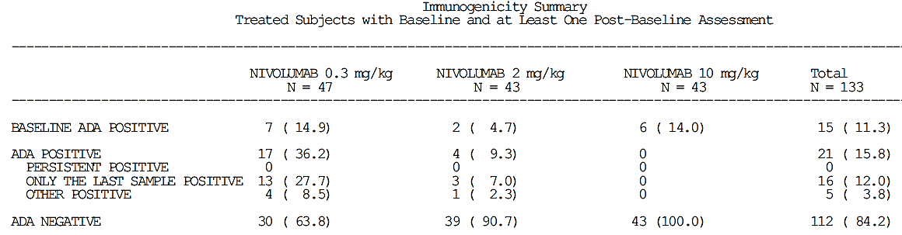
The addendum states: ‘For purposes of this addendum, there were no new immunogenicity data available to report. A summary of previously available data can be found in the Final CSR.’
The following summary table was provided in the Final CSR:

Table 63. Final CSR for Study CA209010, immunogenicity summary
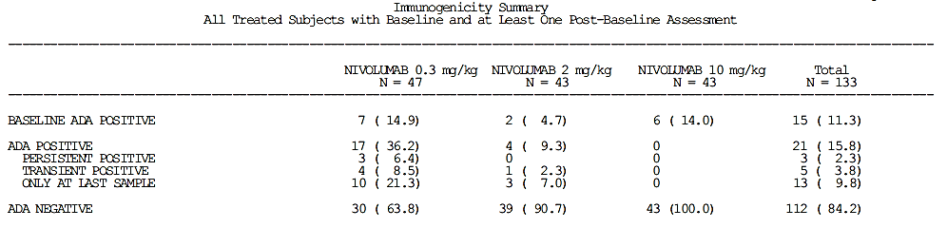
The two tables are not the same. The table from the Final CSR, and accompanying narrative regarding the immunogenicity results, describe 3 patients who were ‘Persistent Positive’. The table from the addendum to the Final CSR does not describe any patients as ‘Persistent Positive’. Could the sponsor please explain this discrepancy?
Could the sponsor also provide the results of the ADA testing according to the number (%) who was positive at Baseline, the number (%) who were negative at baseline but who became positive during the study as this is not clear from the tables provided?

Question 9: Immunogenicity and the ADA assay
Assays for antibodies to monoclonal PD1 antibodies appear to be problematic. The FDA label for the first-in-class, pembrolizumab, describes 0.3% of patients treated with pembrolizumab testing positive for anti-drug antibodies and states: ‘The detection of antibody formation is highly dependent on the sensitivity and specificity of the assay. Additionally, the observed incidence of antibody (including neutralizing antibody) positivity in an assay may be influenced by several factors including assay methodology, sample handling, timing of sample collection, concomitant medications, and underlying disease.’
Inconsistent results for ADA were seen in the 2 studies provided in the current nivolumab submission. In Study CA209025, 2.7% were ADA positive at Baseline and another 7.3% tested positive during the study. In Study CA209010, 11.3% ADA positive at baseline and another 4.5% tested positive during the study, and the proportion testing positive declined with increasing dose. Considerable variation in measured ADA positive rates across a number of studies is also evident in the tables provided by the sponsor (see Table 14. ‘PD-L1 positive expression in patients receiving nivolumab monotherapy in the clinical studies’). The evaluator notes that the first, second and third generation assays are referred to in Table 3.2.1.5-2 in the Population PK report provided in the dossier [not reproduced here].
Could the sponsor please describe the differences in the three generations of assay (in terms of reliability: sensitivity and specificity)? Is the third generation method still in use or has it also been superseded? If the method for determining anti-nivolumab antibodies is still in development, can any conclusions be drawn from the results of these tests, particularly given the variation across studies and dosing regimens?

Question 10: Immunogenicity and infusion reactions
Nivolumab is a fully human monoclonal antibody and, according to the sponsor’s documents, is not expected to be antigenic. This appears to be confirmed by the, in general, low incidence of anti-nivolumab antibodies. Despite this, the proposed PI states that ‘the incidence of hypersensitivity/infusion reactions, including anaphylactic reaction, was 4.1%.’ How does the sponsor account for this high an incidence of infusion reactions?

Question 11: Anti-CHO antibodies and nivolumab
Nivolumab is a fully humanised IgG4 monoclonal antibody, produced in a Chinese hamster ovary (CHO) cell line. Anti-CHO antibodies have been recognised to occur in subjects treated with other therapeutic proteins produced in Chinese Hamster ovary cell lines. The presence of ADA antibodies in patients receiving nivolumab does not appear to correlate with the occurrence of infusion reactions. This may reflect deficiencies in the ADA assay or the development of a different antibody. The evaluator is not aware of any investigation of the development of anti-CHO antibodies in patients receiving nivolumab and whether these may be contributing to infusion reactions. Could the sponsor please clarify if the occurrence of anti-CHO antibodies has been investigated in patients receiving nivolumab and if these have been linked to the occurrence of infusion reactions?

Question 12: Immunogenicity and Study CA209025
From the sponsor website, conditions related to FDA approval of use of nivolumab in advanced RCC included:
- ‘Evaluate the impact of anti-drug-antibody on the safety and efficacy of nivolumab in Trial CA209025, and submit the report (date of commitment: 23 November 2015; due date 31 March 2016)’
Could this report be provided to the TGA?

Question 13: Study CA209009
Study CA209009 is referred to in the Clinical Evaluation Report for the original melanoma based submission for receptor occupancy results described in the Summary of Clinical Pharmacology, although the evaluator notes that the CSR was not provided in that submission. The study is also referred to in the May 2015 EPAR for Nivolumab BMS. This describes an ‘ongoing’ dose ranging study (0.3, 2, 10 mg/kg every 3 weeks) involving 91 RCC patients with the pharmacology component of PBMC and cytokine concentrations. The RMP with this current submission notes that ‘Three additional completed or ongoing studies of nivolumab monotherapy in RCC include MDX1106-03, CA209009, and CA209010. Studies MDX1106-03, CA209009, and CA209010 did not use the same dosing regimen as CA209025; therefore, safety results are restricted to CA209025 in this RMP.’ Clinical Study Reports for Studies MDX1106-03 (also known as Study CA209003) and CA209010 have been provided to the TGA for evaluation. Despite the use of a different dosing regimen in Study CA209010, the Clinical Overview and Integrated Summary of Safety both refer to the efficacy and safety results of this study.
Can the sponsor explain why Study CA209009, a study of nivolumab monotherapy in RCC patients, has not been referred to in this current submission?

Question 14: Study NCT-1358721
A study with the official title of: ‘An Exploratory Study to Investigate the Immunomodulatory Activity of Various Dose Levels of Anti Programmed-Death-1 (PD-1) Antibody (BMS-936558) in Subjects With Metastatic Clear Cell Renal Cell Carcinoma (RCC)’ the objective to evaluate the pharmacodynamic and biologic properties of BMS-936558 in subjects with metastatic renal cell carcinoma and sponsored by Bristol-Myers Squibb is registered at clinicaltrials.gov. This study has been referred to in the publication related to the pivotal study for this application and has been published in abstract form. The study does not appear to have been provided to the TGA. Could the sponsor confirm if this corresponds to the missing Study CA209009? Could the clinical study report please be provided?

Efficacy

Question 15: Dose selection and the pivotal study
The Study CA209025 protocol states that: ‘The dose and schedule of nivolumab (BMS-936558) is 3 mg/kg every two weeks, based upon the analyses of safety, efficacy, and exposure-response data from the ongoing Phase I Study CA209003’
Study CA209003 (also known as Study MDX1106-03) was a dose-ranging study in which patients with solid organ tumours (melanoma, renal cell carcinoma, NSCLC, colorectal cancer, prostate cancer) were treated at one of five dose levels (0.1, 0.3, 1.0, 3.0 and 10.0 mg/kg). Treatment was administered every 2 weeks, for up to 48 doses. RCC patients in this study received 1 mg/kg (18 patients) or 10 mg/kg (16 patients) dosing. Efficacy was determined by investigator-assessed tumour measurements using RECIST v1.0 criteria, and consisted primarily of the objective response rate (ORR). The CSR states that there was no apparent dose-response relationship across the evaluated dose ranges in subjects in the rate of objective responses for patients with melanoma or RCC: the objective response rate in RCC patients was 27.8% and 31.3% for patients treated with 1 mg/kg and 10 mg/kg respectively; the objective responses observed were 31.4%, 41.2% and 20.0% of melanoma patients treated at 1, 3 and 10 mg/kg respectively. NSCLC subjects seemed to demonstrate a dose-response relationship with objective response rates higher in patients treated with 3 or 10 mg/kg nivolumab (24.3% and 20.3%, respectively) than in subjects treated with 1 mg/kg nivolumab (3.0%).
Study CA209010 and Study CA209009 were dose ranging studies in patients with advanced RCC who had received prior anti-angiogenic therapy(ies), with patients randomised to dosing regimens of 0.3, 2 or 10 mg/kg Q3W with similar efficacy outcome measures to CA209003. The rationale provided for the dose selection in Study CA209009 was: ‘Based on the long half-life (20-24 days), results from PK modelling suggested Q3wk schedule would result in sustained exposure between treatments. PK modelling also indicated a 2 mg/kg dose administered on a Q3wk schedule would provide similar exposure (C_{max}, C_{trough}, AUC) as a 1 mg/kg dose administered on a Q2wk schedule. The Q3wk schedule would also be a more convenient schedule for subjects’. Study CA209010 found no significant difference in outcome between the three dose levels. Study CA209009 found similar efficacy outcomes for the 2 mg/kg arm and 10 mg/kg arm.
The dosing regimen for Study CA209025 is in accordance with the dosing for Phase III studies made in the CSR for Study CA209003. However, on the basis of the actual results of Study CA209003 and Study CA209009, a dose of 1 mg/kg every 2 weeks or 2 mg/kg every three weeks may have provided similar efficacy to the selected dosing regimen in patients with renal cell carcinoma (clear cell) and prior anti-angiogenic therapy. The pharmacodynamics properties for nivolumab, in particular the avid binding to the PD-1 receptor suggests that dosing intervals considerably longer than 3 weeks may also be appropriate. A dosing interval of 3 weeks, or longer, would be more convenient to patients and lower drug exposure may reduce any dose-related toxicities.
Could the sponsor please explain both the dose of 3 mg/kg and the dosing interval of Q2W were chosen for the pivotal study in patients with renal cell carcinoma as, on the basis of the information provided by the sponsor’s submissions, a dose of 0.3 mg/kg given every 3 weeks may have provided similar efficacy? The evaluator notes:
- Study CA209003 indicates that response in this particular tumour type is the same with 1 mg/kg or 10 mg/kg
- Study CA209010 indicates similar efficacy for 0.3 mg/kg, 2 mg/kg and 10 mg/kg given every 3 weeks
- Study CA209009 indicates similar efficacy for 2 mg/kg or 10 mg/kg given every three weeks
- Pharmacodynamic properties of nivolumab suggest that longer dosing intervals would not adversely affect efficacy

Question 16: Half-life versus duration of action and dosing regimen
Pharmacokinetic studies have demonstrated a half-life of 12 to 20 days, with this dose dependent. In Study CA209003 and Study CA9009, receptor occupancy was found to be dose independent. In Study CA209003, the median receptor occupancy in circulating lymphocytes at a dose of 3 mg/kg after repeated dosing was 67.8% (range 51.1% -84.6%). In Study CA209009 receptor occupancy was reported to be ≥ 90% at all doses (0.3 to 10 mg/kg). The time course of receptor occupancy was investigated in Studies MDX1106-01. This found that after a single dose of nivolumab, occupancy remained greater than 70% even when serum levels of nivolumab were undetectable and that occupancy ‘eventually decayed after 85 days’. Given the apparently avid binding of nivolumab to the PD-1 receptor, as shown by the prolonged high occupancy, the duration of pharmacodynamic effects can therefore be expected to last much longer than the half-life of nivolumab. The dosing interval chosen for nivolumab is apparently based on the pharmacokinetic measure and may be considerably more frequent than required. Receptor occupancy would be the major factor in the postulated mechanism of action and the dosing interval would more appropriately be based on the duration of this occupancy than the half-life of free nivolumab in the circulation. Biological activity against solid tumours has been demonstrated at dosing intervals of 2 weeks and three weeks but no investigations of longer dosing intervals have been provided. The time course of tumour response is slow compared to conventional chemotherapy. Dosing that is more frequent than the duration of mean plateau receptor occupancy is unlikely to alter this time-course as it is unlikely to significantly alter receptor occupancy.
Given the potential long duration of pharmacodynamic effect, could the sponsor explain the choice of a two week dosing interval for the Phase III studies? Have dosing intervals longer than every 3 weeks been explored in the clinical study programme and, if so, was similar efficacy seen with longer dosing intervals?

Question 17: Pivotal study design and proposed indication
The rationale for the design of the pivotal study provided in the study protocol was that ‘a population of subjects who received prior anti-angiogenic therapy, rather than subjects who have received any prior systemic therapy, was chosen because the type of prior regimen received has been shown to have an impact on clinical outcome in subjects with pre-treated advanced or metastatic RCC’. The Phase III study AXIS is referred to as an example of this. Despite the narrow population studied in the pivotal trial, the proposed indication is very broad: ‘for the treatment of patients with advanced renal cell carcinoma (RCC) after prior therapy in adults’. The term ‘prior therapy’ is not limited to ‘systemic’ therapies and could potentially be interpreted as referring to surgery. The evaluator also notes that clear cell RCC was an inclusion criteria for the pivotal study and that efficacy and safety of nivolumab in other forms of RCC have not been investigated. To accurately reflect the patient population tested in the pivotal study, the wording of the indication should be: ‘for the treatment of patients with advanced renal cell carcinoma (clear cell) after prior anti-angiogenic therapy in adults’.
Can the sponsor please explain the choice of wording in the proposed indication in relation to the rationale given for the design of the pivotal study and the population studied?

Question 18: Minimising variability and bias in assessment of tumour response in the pivotal study
Assessment of tumour response and progression was by the investigators. The section ‘Assessment of overall tumor burden and measurable disease’ in the study protocol provides a 6 page description of how to assess tumour response using imaging modalities and the RECIST criteria. These assessments are complex, as shown by the definitions of response according to changes in the size of target lesion shown in Table 64, below:

Table 64. Evaluation of target lesions using the RECIST 1.1 criteria
Response | Definition of response
Complete Response (CR) | Disappearance of all target lesions. Any pathological lymph nodes (whether target or non-target) must have reduction short axis to < 10 mm.
Partial Response (PR) | At least a 30% decrease in the sum of diameters of target lesions, taking as reference the baseline sum diameters.
Progressive Disease (PD) | At least a 20% increase in the sum of diameters of target lesions taking as reference the smallest sum on study (this includes the baseline sum if that is the smallest on study). In addition to the relative increase of 20%, the sum must also demonstrate an absolute increase of at least 5 mm. (Note: the appearance of one or more new lesions is also considered progression).
Stable Disease (SD) | Neither sufficient shrinkage to qualify for PR nor sufficient increase to qualify for PD, taking as reference the smallest sum diameters while on study.
The evaluator was unable to find any description of specific training of investigators or assessments of inter-rater reliability of the evaluations of tumour response or any independent verification of the investigators assessments. Can the sponsor advice as to any measures that were taken to minimise inter-rater variability and bias in the assessments of tumour response?

Question 19: Study CA209025 Treating beyond disease progression
Treatment beyond progression was allowed in subjects who were tolerating study drug and experiencing clinical benefit as assessed by the investigator. From the CSR, of 803 treated subjects, 179/406 (44.1%) subjects in the nivolumab group and 183/397 (46.1%) subjects in the everolimus group were treated beyond initial RECIST v1.1 progression. Of the 179 subjects in the nivolumab group treated beyond initial RECIST v1.1 progression, 51 experienced ‘non-conventional benefit’ with a list of the criteria for assessment of non-conventional benefit and the number in each group.
No further summary information was provided in the CSR. Subject listings were included in the CSR (over 37 pages) with these including the number of doses received beyond PD, duration of treatment beyond PD, overall survival (months) and outcome (death yes/no). From the information as provided, it is not possible to determine if it would be reasonable to continue treatment beyond progression: the overall survival and duration of treatment of the 51 patients who experienced a ‘non-conventional benefit’ is not provided in an accessible format. It would be helpful if a summary table of patients in the nivolumab arm who were treated beyond disease progression could be provided. This should be presented as two groups: the 128 patients who did not experience non-conventional benefit and the 51 patients who did. For each group, could the following information be provided: median and range of number of doses received beyond PD, median (range) of total duration of treatment, median (range) of duration of treatment beyond PD, median (range) of overall survival, number (%) of deaths.

Question 20: Study CA209025 Quality of life measures
According to the study protocol, patient-reported outcomes (PROs) will be measured using two validated subject self-reported quality of life questionnaires: the Functional Assessment of Cancer Therapy-Kidney Symptom Index (FKSI) Disease-Related Symptoms (DRS) scale and the EuroQol Group’s EQ-5D. Subjects will be asked to complete the questionnaires before any clinical activities, after randomisation (before Cycle 1 dosing) and on Day 1 of each cycle (starting with Cycle 2) as well as at the follow-up visits.
Health resource utilisation data was also to be collected. This was to include the number of medical care encounters such as hospital admissions and their duration, outpatient visits, diagnostic tests and procedures, concomitant medications, and reasons for the encounters. As such, this information could provide valuable insights into the impact of treatment on the patient’s life.
Patient reported outcomes are important in determining if patients are both living longer and with an acceptable quality of life. In the CSR, only the results for the FKSI-DRS scale are provided and the EQ-5D has not been included in Table 3.5.1-1 Study CA209025 Objectives and Endpoints [table not included here]. Are the EQ-5D results available and, if so, could they please be provided? If they are not available, could the sponsor please provide an explanation? Could the HRU results also be provided?

Safety

Question 21: Select AEs and immune mediated AEs as presented in the Study CA209025 CSR
There are a number of discrepancies between the numbers of IMAEs by category as given in the CSR for Study CA209025. Could the sponsor please clarify if the tables summarising select AEs by category only include those events that occur within the first 30 days of last dose and that the descriptions of IMMAEs in include those events for 100 days after last dose?

Question 22: Study CA209025, DILI
From the Clinical Overview Table 3.2.1-2 [not included here] of On-treatment laboratory abnormalities [not included here] there were 7 patients in the nivolumab arm who met the laboratory requirements for the definition of drug-induced liver injury (DILI) used by the sponsor: ‘Potential drug induced liver injury was defined as ALT or AST elevation > 3 times upper limit of normal (ULN) AND Total bilirubin > 2 times ULN, without initial findings of cholestasis (elevated serum alkaline phosphatase)’. The evaluator was unable to locate any discussion of these patients in the CSR as to whether they met the rest of the definition of DILI: ‘AND no other immediately apparent possible causes of AT elevation and hyperbilirubinemia, including, but not limited to, viral hepatitis, pre-existing chronic or acute liver disease, or the administration of other drug(s) known to be hepatotoxic’. Could the sponsor please provide this information?

Question 23: Deaths from other or unknown causes in the clinical studies
There were a number of deaths categorised as due to ‘Unknown’ or ‘Other’ causes in each of the clinical studies discussed above (Studies CA209025, CA209010 and CA209009). The narratives of these patients were read by the evaluator if these could be located in the dossier. It is notable that the verbatim descriptions attributed a number of deaths to such non-specific causes as ‘pneumonia’, ‘sepsis’, ‘hepato-renal syndrome’ and ‘acute cardiac failure’. There were also a number of patients who were found dead without apparent prodrome. Severe pneumonia, sepsis, or acute cardiac failure may all present as multiple organ failure and be clinically undistinguishable. The clinician makes the best guess as to cause and implements care according to this, pending the results of further investigations and response to treatment. Severe pneumonia may present as bilateral lung infiltrate and is commonly culture negative. From the narratives provided for IMAEs, clinical presentations similar to these have been attributed by some investigators to immune mediated adverse reactions. It was also notable that patients with severe pneumonitis were treated with broad spectrum antimicrobials and aggressively investigated for an infective cause. In some of the narratives provided for deaths from Other causes, there is insufficient clinical detail provided to exclude IMAE as the cause of the clinical condition.
The evaluator is concerned that lack of familiarity with immune mediated adverse reactions by the investigators may have resulted in inconsistent attribution of deaths and SAEs as IMAEs or as non-drug-related. This, in turn, may have resulted in an under-estimation of the frequency and severity of IMAEs. Could this be discussed by the sponsor?

Question 24: Use of infliximab and other immunosuppressive agents for irAE
The current PI proposes that immune related AEs be managed with systemic corticosteroids (using the dose of 1 to 2 mg/kg/day of methylprednisolone equivalents, followed by a corticosteroid taper. Other immunosuppressive therapy is not described although it is mentioned in the preamble in the ‘Precautions’ section of the PI. Recent literature describes the use of infliximab, mycophenylate and tacrolimus in the management of immune related adverse effects not responding to corticosteroids. The PI for ipilimumab approved by the TGA advises the use of infliximab for immune related colitis and mycophenylate for immune related hepatotoxicity, although this information is not included in the current PI regarding combination therapy. There were two patients in Study CA209025 who received infliximab for the management of irAE.
- Could the sponsor provide information regarding the use of immunosuppressive agents other than corticosteroids in the management of immune related adverse events associated with nivolumab monotherapy (all tumour types) or combination therapy? Could this information include a clinical narrative for each case?
- Could the sponsor also indicate if tocilizumab has been used in the management of immune mediated adverse reactions or cytokine release syndrome in patients receiving nivolumab monotherapy or combination therapy?

Question 25: Investigator training in the recognition of IMAE
The evaluator is concerned that there may have been inconsistent attribution of deaths, AEs and SAEs as IMAEs, or as non-drug-related, and that this, in turn, may have resulted in an under-estimation of the frequency and severity of IMAEs. Inconsistent attribution between investigators could reflect both the clinical difficulty of determining the cause of illness and death in complex patients and a lack of familiarity with immune mediated adverse reactions associated with nivolumab. Each investigator is likely to have had little exposure to nivolumab treated patients, for example Study CA209025 was conducted across 146 sites and 406 patients were treated with nivolumab, resulting in an average of three patients treated with nivolumab at each site during an 18 month period. No specific training of investigators in the recognition or management of IMAE was described in the CSR, although an investigator’s brochure regarding evaluation and management of IMAE was provided to them.
Could the sponsor describe any training provided to investigators in Study CA209025, or any of the other studies in the clinical studies programme, in the recognition of IMAEs? Could the sponsor also indicate if there was any ‘quality control’ or review of SAEs and deaths in Studies CA209025, CA209010 and CA209009 to determine if there were any IMAEs that may have been missed?

Question 26: The investigators brochure
The CSR for Study CA209025 states: ‘Evaluation and management guidelines for the treatment of AEs, including select AEs, were provided to investigators in the Investigator Brochure for sites in all countries to assist in their identification and treatment.’ Elsewhere in the CSR, it was noted that the evaluation and management guidelines for the following types of adverse events were developed to assist investigators and provided in the Investigator Brochure: Pulmonary toxicity, Diarrhoea or colitis, Endocrinopathies, Hepatotoxicity (including asymptomatic LFT elevations), Nephrotoxicity.
The evaluator notes that in regard to 2 of the 5 patients who died due to pneumonitis in Study CA209003, the draft RMP states: ‘In the first 2 subjects, there was a delay of approximately 1 to 2 weeks between the onset of symptoms and treatment with high doses of corticosteroids. Earlier recognition and treatment with higher dose corticosteroids may have led to a different outcome, as has been reported for GI toxicity elicited by ipilimumab.’ According to the draft RMP, an investigator’s brochure regarding IMAE that included management advice was developed and used in subsequent studies.
The introduction of checkpoint inhibitors into clinical practice will result in patients developing immune related adverse effects that are not traditionally associated with anti-tumour therapies. There will be an inevitable lag between the introduction of these therapies and recognition of these adverse events by healthcare professionals. As with the provision of evaluation and management guidelines to the investigators in Study CA209025, provision of educational materials to assist healthcare professionals in the recognition and management of immune related adverse effects would be expected to improve the safety of these drugs. The investigators brochure may provide a basis for such materials. Could this brochure please be provided?

Question 27: Summarising the presentation of adverse events across tumour types
A summary table of adverse events for nivolumab monotherapy across tumour types (melanoma and NSCLC) has been provided in the current SmPC (see Table 58, above). A similar table including patients from the registrational studies for melanoma, NSCLC (squamous and non-squamous) and RCC would be helpful.
Could the sponsor provide a similar table including patients receiving nivolumab monotherapy from the registrational studies for melanoma, NSCLC (squamous and non-squamous) and RCC? This may also be helpful for the presentation of AEs in the Australian PI.

Question 28: Summarising the presentation of safety across tumour types
A table comparing AE rates (all grades and Grades 3 to 4) across tumour types was provided. The display of AEs was selected according to their occurrence in Study CA209025: AEs reported in > 20% and drug related AEs reported in > 10% of patients treated with nivolumab in Study CA209025. This evaluator has combined the data for the tumour types to create a summary of the use of nivolumab as monotherapy in the dosing regimen of 3 mg/kg every two weeks.

Table 65. Summary of safety of nivolumab monotherapy; registrational studies: melanoma, NSCLC, RCC
 | Number Subjects | % of subjects
 | 1728 | 100
Deaths | 771 | 44.6
Within 30 days | 142 | 8.3
Within 100 days | 388 | 22.5
Due to study drug toxicity | 3 | 0.2
Adverse events | Any Grade |  | Grade 3 or 4
 | Number | % | Number | %
All AEs (regardless of causality)¹ | 1689 | 97.7 | 779 | 45.1
Fatigue | 712 | 41.2 | 51 | 3.0
Cough | 331 | 19.2 | 6 | 0.3
Nausea | 445 | 25.8 | 17 | 1.0
Diarrhoea | 405 | 23.4 | 32 | 1.9
Dyspnoea | 353 | 20.4 | 51 | 3.0
Decreased appetite | 381 | 22.0 | 15 | 0.9
Constipation | 358 | 20.7 | 7 | 0.4
Back pain | 251 | 14.5 | 37 | 2.1
Drug related AEs² | 1290 | 74.7 | 243 | 14.1
Fatigue | 469 | 27.1 | 26 | 1.5
Nausea | 229 | 13.3 | 3 | 0.2
Pruritus | 236 | 13.7 | 2 | 0.1
Diarrhoea | 229 | 13.3 | 20 | 1.2
Decreased appetite | 177 | 10.2 | 3 | 0.2
Rash | 219 | 12.7 | 7 | 0.4
All SAEs (regardless of causality) | 776 | 44.9 | 541 | 31.3
Drug related AEs | 153 | 8.9 | 104 | 6.0
All AEs leading to discontinuation (regardless of causality) | 266 | 15.4 | 179 | 10.4
Drug related AEs leading to discontinuation | 104 | 6.0 | 75 | 4.3
1) AEs occurring within 30 days of dose and reported in > 20% of patients in the nivolumab group in Study CA209025; 2) Drug related AEs occurring within 30days of dose and reported in > 10% of patients in the nivolumab group in Study CA209025
Could the sponsor re-populate the sections of this table that relate to AEs, with the AEs selected according to AEs reported in > 20% and drug related AEs reported in > 10% of patients treated with nivolumab in all registrational studies combined?

Question 29: Cumulative reviews of immune mediated AEs including all patients exposed to nivolumab
The information presented by the sponsor has not enabled an adequate characterisation of immune mediated adverse reactions associated with nivolumab as the information is dispersed across three submissions and the only pooled information is that provided in the ‘Descriptions of Select AEs’ in the proposed PI. The evaluator requests that a cumulative review is provided for each of the categories of select AEs/IMAEs:
- endocrinopathies – broken down according to type, hypophysitis, hypothyroidism, hyperthyroidism, diabetes, adrenal failure
- pneumonitis
- hepatitis
- nephritis
- rash and severe skin reactions, including TEN
- colitis/enterocolitis
- encephalitis
- other including pancreatitis, uveitis, demyelination, autoimmune neuropathy (including facial and abducens nerve paresis), Guillain-Barré syndrome and myasthenic syndrome.
These reviews should include all patients exposed to nivolumab in the clinical development programme. These reviews may then assist in answering the questions below that request greater detail in the description of the clinical presentation, course and treatment(s) of IMAE.

Question 30: Descriptions of immune mediated AEs
The evaluator has a number of questions regarding the clinical descriptions and management of IMAE, and the effects of IMAE on the overall safety assessment. These questions are asked both in relation to the overview of safety and information provided in the PI.
See also: Question 29 ‘Cumulative reviews of immune mediated AEs including all patients exposed to nivolumab’ above.
The information requested by the evaluator may be provided in the cumulative reviews requested above.
The proposed PI provides information regarding the incidence of these with nivolumab monotherapy in the section ‘Description of selected adverse reactions – Opdivo monotherapy’ with this information based on seven clinical studies in melanoma, NSCLC and RCC (Studies CA209066, CA209037, CA209067, CA209017, CA209057, CA209063 and CA209025 with a total patient population of 1728 (the ‘megapool’).
This is helpful and important information to include in any evaluation of safety. It could, however, be improved by more clinical detail and more specific advice regarding management. This information should be included in the sponsor’s assessment of safety, the PI and the Healthcare Professionals Educational brochure.
The description of each IMAE category should include:
- a brief description of the clinical presentations of the IMAE, descriptions of this type have been provided in the draft RMP
- the estimated incidence (using the whole population exposed to nivolumab)
- the time to onset, time to resolution and duration of corticosteroid therapy as the range only. The evaluator does not consider the median to be helpful given the very wide ranges observed for each of these factors
- the number of patients who were treated with systemic corticosteroids, how many received an initial dose of more than 40 mg prednisolone; the number of these commencing on intravenous methylprednisolone
- Inclusion of any other immunosuppressive therapy(ies) provided, including drug name and dosing regimen, number of patients and outcome
- Result of rechallenge with nivolumab
Each of the endocrinopathies (hypophysitis, hypothyroidism, hyperthyroidism, diabetes, adrenal failure) should be presented separately, pooled information across the endocrinopathies is of little clinical value given the differing treatment needs. The description should include the number requiring ongoing hormone replacement therapy after ‘resolution of the AE’ and any other treatments provided, for example methimazole for hyperthyroidism.
Could the sponsor please provide the descriptions with this information included?

Question 31: Rates of immune mediated AEs in Study CA209025 and the ‘megapool’
The proposed PI provides information regarding the incidence of these with nivolumab monotherapy in the section ‘Description of selected adverse reactions – OPDIVO monotherapy’ with this information based on seven clinical studies in melanoma, NSCLC and RCC (Studies CA209066, CA209037, CA209067, CA209017, CA209057, CA209063 and CA209025 with a total patient population of 1728 (the ‘megapool’). If the numbers provided in these descriptions, indicate the number (%) of AEs that were considered to be immune mediated, then there is considerable discrepancy compared to the rates described for CA209025 across several of the categories for example ‘in Study CA209025, diarrhoea/colitis occurred in 115 (28.3%) subjects in the nivolumab group, with this considered to be IMAE in 13 (3.2%) patients’; in the pooled data from the registrational studies, ‘In patients treated with nivolumab monotherapy, the incidence of diarrhoea or colitis was 13.6% (235/1728)’.
Could the sponsor confirm if the rates provided in the proposed PI section ‘Description of selected adverse reactions – Opdivo monotherapy’ refer to rates of AEs that were assessed as immune mediated? If no, what do these rates refer to? If yes, can the sponsor account for the disparities in rates between Study CA209025 and the megapool?

Question 32: SIRS, MOF and combined organ failure
There were two deaths associated with rapidly progressive multiple organ failure (MOF) described in the narratives provided (one in each of Studies CA209010 and CA209009) and are briefly summarised above in Section 8: Safety ‘Deaths and other serious adverse events’. These were not considered treatment-related by the investigator, although the evaluator is unable to exclude a fulminant inflammatory process triggered by an immune mediated adverse reaction from the information provided in the narrative. There was also one case of Systemic Inflammatory Response Syndrome (SIRS), without fatal outcome, described in Study CA209025.
SIRS, Multiple Organ Dysfunction Syndrome and MOF may be considered as being on a spectrum of non-specific systemic inflammatory reactions to a variety of insults, including immune mediated organ injury. These syndromes are associated with elevated levels of circulating pro-inflammatory cytokines, particularly IL-6, TNF-α and IL-1β. They may present with dysfunction of two or more organs for example, circulatory compromise with respiratory failure; respiratory and renal failure; liver and renal failure. The evaluator also notes that a similar syndrome, ‘Cytokine Release Syndrome’, described as a ‘non–antigen-specific toxicity that occurs as a result of high-level immune activation’, has been described with other immunotherapies.
The evaluator has not reviewed all narratives for all studies and cannot determine if there were other reports of SIRS or MOF or MODS in which immune mediated adverse reactions may be triggering more widespread inflammatory processes, with this resulting in serious compromise or failure of more than one organ simultaneously. Could the sponsor please indicate if any other narratives include descriptions consistent with SIRS or MOF or MODS or CRS in other patients receiving nivolumab monotherapy in the clinical study programme? This should include all studies within the clinical development programme and all cases, regardless of causality. The number of such cases, together with the narratives, should be provided.

Question 33: Post marketing reports
Nivolumab has been approved for use in the US since December 2014 and in Japan since July 2014. No post-marketing reports have been provided by the sponsor. The Summary of Clinical Safety states: ‘No new significant safety concerns were identified based on the postmarketing reports’ No post-marketing reports were provided in this submission. From the EMA website (EPAR: Procedural steps taken and scientific information after authorisation) a Periodic Safety Update was provided to the EMA in January 2016. Could the sponsor please provide any post-marketing reports or periodic safety updates for evaluation?

Second round evaluation of clinical data submitted in response to questions

Unresolved issues following review of the sponsor’s response to clinical questions
A number of unresolved issues remain following review of the sponsor’s responses to clinical questions.

Wording of the indication
The evaluator remains of the opinion that the wording of the indication should be consistent with the population in whom efficacy and safety has been demonstrated and recommends the following wording:
‘Adult patients with advanced RCC (clear cell) who had received prior anti-angiogenic therapy’
The evaluator is of the opinion that the wording proposed by the sponsor is too broad and includes populations in whom safety and efficacy has not been established:
- The sponsor provided the ORR results of 9 patients with advanced RCC who were treated with 1 mg/kg or 10 mg/kg Q2W of nivolumab and who had not received prior anti-angiogenesis therapy to support the use in this population.
- No information was presented to support the use in patients with non-clear cell RCC although the sponsor speculated that due to the unique mechanism of action, nivolumab may be effective in this population. The sponsor also indicated that a study of nivolumab in patients with non-clear cell RCC in currently ongoing.
- ‘Prior therapy’ may be interpreted as prior surgery, with nivolumab then used as first-line systemic therapy.

Translating safety of nivolumab into wider clinical use
The familiarity, or otherwise, with nivolumab’s unique adverse event profile and its relevance to the translation of safety, as demonstrated in the clinical trials, into wider clinical practice is addressed in a number of clinical questions (see ‘Investigator and post-marketing training in the recognition of immune mediated complications of nivolumab therapy’ later in this section).
One issue is that a lack of familiarity may have affected the depiction of safety in the clinical trial programme: the investigator’s familiarity with nivolumab and irARs in Study CA209025 (and other studies in the clinical development programme) may have limited their ability to consider irARs as the cause of deterioration, or death, in complex patients. The sponsor has described a single workshop-based training and oversight by the sponsor’s medical monitor. However, sites in Study CA209025 enrolled an average of 3 patients over the duration of the study, preventing the investigators at most sites from developing any familiarity. Lack of familiarity with nivolumab and irARs may have resulted in under recognition of immune mediated adverse events and their possible contribution to patient deaths in Study CA209025. The 2 cases of fatal MOF are possible examples of under-recognition of an irAR by the investigators and the sponsor’s medical monitors, noting that in the non-fatal case of SIRS, the investigator suspected an irAR and commenced immunosuppressive therapy.
The second issue is that early recognition and appropriate institution of immunosuppressive therapy is believed to improve the outcome of irARs, although no formal studies demonstrating this have been performed. Anecdotal evidence provides support with:
- Several deaths due to immune mediated pneumonitis in an early study in the clinical trials programme were partly attributed to delayed recognition and treatment.
- In a prospective study of 32 patients receiving nivolumab and in which patients were specifically monitored for SIRS, 12/32 patients were admitted to hospital with SIRS and treated with immunosuppression with subsequent improvement. Of the 25 patients with SIRS/MODS/MOF/CRS identified in the sponsor’s cumulative review, the only 2 patients in whom an irAR was suspected and treated with immunosuppressive therapy were also the only 2 patients to survive (see also ‘Occurrence of SIRS/MODS/MOF in patients receiving nivolumab’ later in this section).
Awareness of possible irARs, and education regarding these, will affect the translation of the safety of nivolumab, as reported into the clinical trial programme, into the wider post-marketing space. All irARs present with non-specific symptoms and signs, with no diagnostic test available. Recognition requires a high index of suspicion and this, in turn, requires some familiarity. Recognition of irARs can be expected to be considerably worse outside of clinical trials, resulting in delays in the administration of immunosuppressive therapies. As a result, the safety of nivolumab as found in clinical trials may not be replicated in the wider setting.

Addressing the lack of familiarity with irARs
The amendments to the warning box are one means of raising awareness regarding irARs. Other means are through ensuring appropriate clinical detail is provided in the PI and/or HCP tool (titled ‘Immune Related Adverse Reaction Management Guide’) and that appropriate emergency care advice (for the patient and the emergency care provider) is provided in the patient alert card. It is also essential that not just the oncologists, oncology nurses and pharmacists are targeted by post-marketing educational efforts. Given the unique characteristics of the Australian healthcare system, education must also be available to general practitioners, emergency medicine specialists and all hospitals as these may be required both immediate and ongoing care to patients experiencing severe irARs (see also ‘Investigator and post-marketing training in the recognition of immune mediated complications of nivolumab therapy’ later in this section).

Adequacy of the ‘Healthcare Professional Communication’ tool and the ‘Patient Alert Card’
These two tools, together with the full TGA approved PI, are essential components of the safe introduction of nivolumab beyond the clinical trial setting. The evaluator notes that there are a small number of clinical guidelines regarding immunotherapy and immune checkpoint inhibitors starting to appear and that institutional guidelines can be expected over time., However, at present, the sponsor’s materials may represent the main source of information specific to nivolumab (as monotherapy and in combination therapy).
The evaluator is concerned by a number of aspects of these tools. The evaluator is of the opinion that:
- more comprehensive clinical information should be provided in the HCP tool with the level of detail commensurate with that provided in Section 7 (above) and Appendix 3 of the sponsor’s Investigator’s Brochure [not included in this document].
- prominent directions for locating the full PI should be provided on both tools, with this not dependent on a third party such as medicines.org.au. The directions should include both the TGA website and the sponsor’s website. This is of particular importance given that the PI is not being distributed as a package insert.
- the warning box should be displayed prominently on the first page of the HCP tool. If the 4 page format is continued for the ‘Patient Alert Card’, the warning box should be displayed prominently.
- the ‘Patient Alert Card’ is overly detailed for emergency use and that the 4 page format will limit both durability and the ease with which it can be carried in a patient’s wallet
- the ‘Patient Alert Card’ should include directions for locating the HCP tool on the sponsor’s website.
- Patient Counselling section of the PI
The evaluator recommended more specific advice and detail in the patient counselling section than had been provided. The sponsor has agreed to add a reference to the Patient Alert Card and that prescribers must be familiar with the risks of therapy and discuss these risks with the patient. The evaluator finds the wording suggested by the sponsor to not have sufficient detail.

Adequacy of the planned post-marketing study and need for an Australian post-marketing observational registry
According to the RMP, one post-marketing study is planned. This study was the subject of a clinical question given that it was only to include 1200 patients (with the incidence of many of the irARs less than 0.1%) and given that it was only to include two tumour types. The sponsor’s response was that ‘Study CA209234 was developed as a post-marketing commitment for the approved indications at that time - NSCLC and melanoma’ (see also ‘Adequacy of the proposed post-marketing study later in this section). An additional pharmacovigilance study is described in the RMP (Study CA209357), a ‘US Multisite Observational Study in Patients with Unresectable and Metastatic Melanoma (observational registry)’.
The evaluator recommends that a national multicentre observational registry also be conducted in Australia, with this to include all patients who are treated with nivolumab (current and future indications, off-label use). This would address the gap in the planned post-marketing activities by including all tumour types and would provide patterns of use, effectiveness and safety of nivolumab in the Australian context.

ADA status and immunogenicity
According to the presence of anti-nivolumab antibodies as measured by the assays used by the sponsor, there appears to be a low rate of development of ADA in patients exposed to nivolumab. There are, however, a number of inconsistencies including:
- considerable variability in this rate even when the same assay is used in a population with the same tumour type. The sponsor has speculated that this may be due to ‘Different disease state population, disease condition, as well as prior treatment regimens could account for the apparent variation in immunogenicity observed across studies’.
- infusion reactions reported with nivolumab monotherapy appear to have no relationship to the presence of ADA. Severe infusion reactions are an ‘Important Identified Risk’ with nivolumab. According to the latest PBRER (July 2015 to January 2016), infusion reactions of any grade occur in 4.1% (71/1728) of patients receiving nivolumab monotherapy, with Grade 3 or 4 (including anaphylactic reactions) occurring in 0.3%. No alternative explanation for this common rate of infusion reactions has been provided by the sponsor.
- the disparity in the rate of development of anti-nivolumab antibodies when used in combination with ipilimumab with the pooled analysis for monotherapy showing a rate of 12.3% and the pooled analysis for combination therapy a rate of 37.8%.
A report into the effect of ADA status on safety in Study CA209025 requested by the FDA as a condition of approval was not provided by the sponsor, despite the evaluator’s specific request (see also ‘Request for FDA report regarding the impact of ADA on safety and efficacy in Study CA209025’ later in this section).
The evaluator is of the opinion that there is considerable uncertainty around the development of ADA and does not consider that any conclusions can be drawn regarding ADA status and safety/efficacy.
The evaluator considers the following to be an appropriate description of Immunogenicity and ADA status for the PI:
‘Nivolumab Monotherapy and Nivolumab in Combination with Ipilimumab Treatment emergent anti-nivolumab antibody titres have been measured in a number of clinical trials using several generations of assay methods. Considerable variability in measured rates have been observed. There is insufficient information to determine if the presence of anti-nivolumab antibodies affect safety or efficacy.’

Mechanism of action
The postulated mechanism of action continues to contain some speculation. The effect of nivolumab on immune system elements in the peripheral circulation appears to be minimal (small increases in 2 chemokines only). The presence of the PD-L1 ligand on tumour cells has not been demonstrated to be necessary for biological activity, even if a 1% cut-off is used (remembering that the 1% cut-off only means that 1 tumour cell in a field of 100 tumour cells expresses PD-L1). In fact, the sponsor has suggested that increased expression of PD-L1 (≥ 5% expression) worsens prognosis with nivolumab treatment (see also ‘PD-L1 status and mechanism of action’ later in this section). The sponsor has suggested that the tumour micro-environment is more supportive of the mechanism of action, but the evidence for this has not been provided.
The evaluator remains of the opinion that a more precise description of the mechanism of action in the PI would be:
‘Binding of the PD-1 ligands, PD-L1 and PD-L2, to the PD-1 receptor found on T cells, inhibits T-cell proliferation and cytokine production. Upregulation of PD-1 ligands occurs in some tumours and it is believed that signalling through this pathway can contribute to inhibition of active T-cell immune surveillance of tumours. Nivolumab is a human immunoglobulin G4 (IgG4) monoclonal antibody that binds to the PD-1 receptor with this believed to blocks its interaction with PD-L1 and PD-L2 and release PD-1 pathway-mediated inhibition of the immune response, including the anti-tumour immune response. In syngeneic mouse tumour models, blocking PD-1 activity resulted in decreased tumour growth.’

The sponsor’s response to TGA clinical questions
The sponsor has provided a response to the Clinical Questions asked by the evaluator. This begins with an ‘Executive Summary’ that summarises the unmet medical need in patients with advanced renal cell carcinoma (RCC) after prior systemic therapy and that the pivotal study for this submission (Study CA209025) has demonstrated an improvement in OS with nivolumab in comparison to everolimus.
The sponsor then disagrees with the limitations described by the evaluator that prevented a recommendation being made (see Section 9.3: First round assessment of benefit-risk balance, above).
The sponsor has expressed the opinion that the requested quality of life and health resource utilisation data from the pivotal study are not critical to the risk-benefit assessment of nivolumab in RCC. The evaluator notes that it is not sufficient to demonstrate an improvement in overall survival; an acceptable quality of life must also be demonstrated. This is particularly important given that no improvement in progression free survival was demonstrated with nivolumab in the pivotal study.
The sponsor has expressed the opinion that the mechanism of action, pharmacodynamics and dose frequency has been evaluated and approved by the TGA in previous applications. The evaluator notes that:
- The studies provided by the sponsor for this evaluation each included a pharmacodynamics component with new information that required re-evaluation of the postulated mechanism of action and how well this had been supported by pharmacodynamic information that had been submitted by the sponsor. This was particularly important given the assessment of the clinical evaluator of the first nivolumab NBE submission, that ‘Only a limited amount of clinical PD data was included in the submission’.⁹
- The different dosing intervals described in the pivotal study and supporting dose escalation study provided with the submission, and the apparent lack of dose-dependency with respect to tumour response, necessitated further questions regarding the dose and dosing interval. This was also prompted by the discrepancy between the duration of receptor occupancy demonstrated in the pharmacodynamic components of the submitted studies and the half-life of nivolumab in the circulation.
The evaluator acknowledges that this information may not be ‘critical’ to the benefit-risk assessment of the use of nivolumab in patients with renal cell carcinoma but that it is of relevance to an understanding of nivolumab and in the evaluation of the PI.
The sponsor has also expressed the view that the RMP and risk mitigation measures had been agreed to previously by the TGA. This was not apparent to the evaluator in the materials submitted by the sponsor nor is it appropriate to consider that risk mitigation measures agreed to at one point in time, with the knowledge available at that time, will not be reconsidered subsequently as more information becomes available.
The sponsor notes that the questions raised in the CER were the subject of a series of discussions with the TGA Delegate in which the ‘sponsor has been provided with clarifications and guidance by the TGA Delegates’ on a suitable approach to this response to the CER’. As a result, the questions have not been answered in the order in which they were posed in the CER but in 5 sections, grouped according to question type. A summary of errors in the CER was also provided. The evaluator will use the same format to comment on the sponsor’s responses, although additional sub-headings have been added by the evaluator

Errors in the CER and the progress of the EMA submissions
Question 1 (above) requested further information regarding the progress of the application to the EMA, given that the publically available CHMP meeting minutes documented ongoing requests for supplementary information for this and other nivolumab applications. In the interim, the EMA approved the RCC application.
The sponsor clarified the overseas regulatory status of the RCC indication with the information that this indication was approved by the EMA in April 2016, following ‘a single round of questions with no major objections by the EU Rapporteur.’ No further information was provided by the sponsor regarding the CHMP requests for supplementary information regarding PD-L1 expression and the relation of this to safety and efficacy in response to the Question 1. This decision was apparently made by the sponsor on the basis that these CHMP requests referred to the nivolumab indications of non-squamous non-small cell lung cancer (NS NSCLC) and melanoma combination and were no longer relevant given that these indications have been approved by the TGA.

Evaluator’s response
From the EMA website, the RCC indication was approved by the EMA on 4 April 2016 with the following wording:
‘Opdivo as monotherapy is indicated for the treatment of advanced renal cell carcinoma after prior therapy in adults’.
The EPAR for this RCC approval is publically available and includes the following: ‘The biomarker analysis presented by the Applicant was not comprehensive, and additional analyses can be envisioned which may lead to improved understanding of predictive biomarkers in patients treated with nivolumab, including: determination of other biomarkers (including but not restricted to PD-L2, PD-L1, mismatch-repair status) and alternative methods for immunohistochemical scoring of PD-L1/PD-L2 (e.g. expression localisation (e.g. tumour center versus invasive margin), tumour versus immune cell staining).
The impact of different biomarkers on nivolumab treatment will still be further investigated for all approved indications including RCC, post approval. Further investigations on the potential role of PD-L1/2 expression, or any other biomarker, on the efficacy of nivolumab in RCC was considered needed, consistent with previous requirements for already approved indications.’
The EMA has required the post-authorisation measures shown in the figure below, with the exploration of biomarkers not limited to the studies in patients with melanoma and NSCLC, but to now also include the studies of patients with RCC (Studies CA209025 and 209009).
Figure 14. Required post-authorisation measures by the EMA
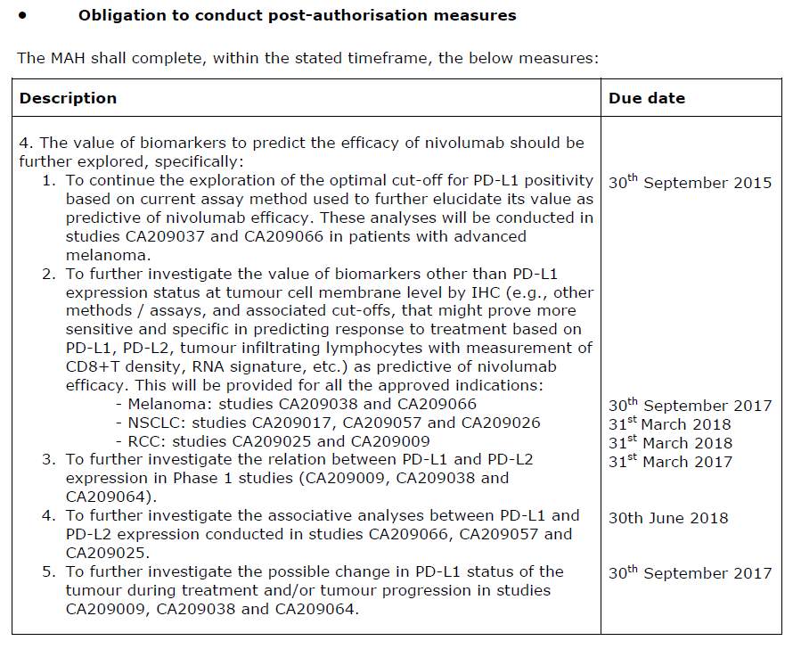
This indicates ongoing uncertainties around PD-L1 status, its relevance as a biomarker and its relationship to efficacy in patients with melanoma, NSCLC and RCC. It is important that the results of the measures required by the EMA are also provided to the TGA as they become available.

Proposed RCC indication and pivotal Study CA209025
This section includes the sponsor’s responses to Questions 2, 3, 13, 14, 15 and 17 outlined above in Section 11.

Wording of the indication
The wording of the indication proposed by the sponsor is:
‘Opdivo, as monotherapy is indicated for the treatment of patients with advanced renal cell carcinoma (RCC) after prior therapy in adults.’
Clinical Questions 2 and 17 asked that the sponsor address the issue of whether the wording of the proposed indication was consistent with the population studied in the pivotal study (patients with advanced clear cell carcinoma who had received prior anti-angiogenesis therapy) and described as having unmet need as described in the Clinical Rationale. The issue of how the term ‘prior therapy’ may be interpreted (surgery, radiotherapy, chemotherapy) was also raised.

RCC rather than clear cell RCC
The rationale provided by the sponsor for the broad indication that includes all types of RCC is that ‘optimal systemic therapy for non-ccRCC remains a topic of debate among clinicians as limited clinical efficacy and safety data exist in non-ccRCC in comparison to ccRCC across the range of approved VEGF TKIs and mTOR inhibitors’ such that this population has high unmet need that may be met by the ‘unique mechanism of action’ of nivolumab. The sponsor also provides the information that a Phase IIIb/IV safety study of nivolumab fixed dose in subjects with advanced or metastatic RCC including patients with ccRCC and non-ccRCC (Study CA209374) is currently ongoing.

Prior anti-angiogenesis therapy
The sponsor’s response provides some data to support the use of nivolumab in patients who have not received prior anti-angiogenic therapy. This data consists of a small number of patients with RCC who participated in Study CA209003. In this Phase I, open label, multicentre, dose escalation study of nivolumab in subjects with selected advanced or recurrent malignancies, 9 of 34 subjects with clear-cell RCC (ccRCC) had not received prior antiangiogenic therapy before enrolment in the study. The BOR for these 9 patients was provided: 3 of the 9 patients had a BOR of partial response, 5 had stable disease and 1 had progressive disease. The sponsor acknowledges the limitations of the data but argues that it is consistent with the ORR reported with Study CA209025 and that as ‘nivolumab has a different mode of action than the available RCC treatment options there is no rationale to suppose that nivolumab would not be effective after another treatment than antiangiogenic therapy’.

Interpretation of ‘prior therapy’
The sponsor provides the statement that ‘The sponsor believes that the language ‘prior therapy’ best characterize the population who received nivolumab therapy in CA209025, and should be included in the indication language.’

Evaluator’s response
As noted above, the population in the pivotal study for this indication had clear cell RCC and had received prior anti-angiogenesis therapy. It is not clear to the evaluator that the results in this population can be generalised to patients receiving any prior therapy (including surgery or radiotherapy) and to patients with non-clear cell renal carcinoma.
It may appear plausible to assume that prior treatment will not affect the response to a particular therapy. However, the evaluator notes the results of the AXIS trial, a randomised multi-centre trial comparing axitinib and sorafenib as second line therapy in patients with metastatic RCC with the IRRC-determined end-point of PFS. Pre-specified sub-group analysis found varying responses according to prior therapy. This trial result was provided in the Study CA209025 CSR as the rationale for only including patients who had received prior anti-angiogenesis therapy in the study. The results of 9 patients in the Phase I open label dose escalation study, who received either 1 mg/kg or 10 mg/kg Q2W of nivolumab, and in which tumour response was assessed by the investigator, is not convincing of the efficacy of nivolumab in patients who have not received prior anti-angiogenesis therapy.
The evaluator remains concerned regarding the interpretation of the very broad term ‘prior therapy’ with this potentially interpreted to mean prior surgery or radiotherapy, with nivolumab introduced as first line systemic therapy. The evaluator does not consider the ‘mechanism of action’ sufficient rationale to presume efficacy in patients with non-clear cell RCC and considers that it would be appropriate to wait for the results of the ongoing study in this population before extending the indication.
The evaluator recommends that the indication wording be:
‘Adult patients with advanced RCC (clear cell) who had received prior anti-angiogenic therapy.’
This is consistent with the wording chosen by the FDA although the evaluator acknowledges that the EMA chose the broad terms proposed by the sponsor.

Sponsor’s choice of studies for presentation of efficacy and safety
Question 3 noted that the sponsor had presented the randomised open label Study CA209025 as pivotal for efficacy and safety and had presented the dose escalation study (using the dosing interval of Q3W) as supportive of efficacy and safety and queried why two other Studies (CA209003 and CA209009) which had included patients with advanced RCC had not also been referred to.
The sponsor’s response stated that there are 4 completed or ongoing studies of nivolumab monotherapy in RCC in previously treated subjects: Studies MDX1106-03 (Study CA209003), CA209009, CA209010, and CA209025 and that, of these, only Study CA209025 had used the dosing regimen of 3 mg/kg Q2W. The ‘pooled monotherapy safety database’ therefore only included Study CA209025. The rationale for the inclusion of Study CA209010 as supportive of efficacy and safety was that it provided longer term follow-up (approximately 38 months).

Evaluator’s response
It is stated in the sponsor’s dossier that neither tumour response nor adverse events appeared to be dose-dependent. Inclusion of all patients with advanced RCC who received nivolumab could have provided a more comprehensive picture of safety, particularly given the rarity of some of the immune mediated adverse reactions.

Inclusion of Study CA209009
Questions 13 and 14 sought further clarification regarding Study 209009 as results from pharmacodynamics components of this study had been referred to in an earlier submission but the CSR for the study had not been provided to the TGA.
The sponsor’s response indicated that the study was inappropriate for inclusion as it was a Phase I dose escalation study including both treatment naïve and treatment experienced RCC patients and because it was completed after the RCC dossier was completed.

Evaluator’s response
The CSR for Study CA209009 was subsequently provided on request of the TGA and has been discussed in the CER above. This study was of particular interest due to its objective of investigating pharmacodynamic immunomodulatory aspects of nivolumab.

Dose selection and dosing interval
Question 15 questioned the dosing interval and dose selection for the pivotal study, given that dose escalation studies in this population suggested similar efficacy at lower doses and longer interval.
The sponsor’s response noted that the dose selection and interval was based on Study CA209003 and that the dose escalation Studies CA209010 and CA209009 were ongoing at the time of the development of Study CA209025, with data not available to influence dosing choice.

Evaluator’s response
The sponsor’s response is noted.

Clarifications on the efficacy and safety questions raised for Study CA209025
This section includes the sponsor’s responses to Clinical Questions 6, 12, 13, 16, 18 to 26, 31, and 32.

OS according to PD-L1 status in the nivolumab arm of Study CA209025
Question 6 requested an analysis of the OS for patients in the nivolumab arm of Study CA209025 according to the PD-L1 status (using the cut-off of 1%) to assist in a greater understanding of the effect of PD-L1 status on outcome, noting that there appeared to be no difference in outcome across the two arms of the study according to PD-L1 status (see Table 13, earlier in this document).
The sponsor commented that OS by programmed cell death ligand 1 (PD-L1) expression was a secondary objective of Study CA209025, with subjects enrolled regardless of PD-L1 status. The descriptive analysis of the whole cohort (nivolumab versus everolimus arms) was presented and has been described in the CER. The sub-group analysis requested in the clinical question (outcome according to PD-L1 status for the nivolumab arm only) was not provided.

Evaluator’s response
The clinical question was not specifically answered. However, from the tables and graphs provided, the following can be derived:

Table 66. Study C209025 Outcome measures according to PD-L1 status, nivolumab arm only
 | Median OS (months) | OS number of events (%)
PD-L1 status ≥ 1% (n = 94) | 21.82 | 48/94 (51%)
PD-L1 status < 1% (n = 276) | 27.37 | 118/276 (42.8%)
This crude analysis suggests that outcomes are similar within the nivolumab arm regardless of PD-L1 expression using the 1% cut-off.

Request for FDA report regarding the impact of ADA on safety and efficacy in Study CA209025
Question 12 requested that a report required by the FDA as a condition of approval for the RCC indication be provided to the TGA. This report was to evaluate the impact of anti-drug-antibody on the safety and efficacy of nivolumab in Trial CA209025 with the date for submission of 31 March 2016.
The sponsor has provided a one paragraph description of this report. This noted that a ‘univariate analysis comparing OS in subjects who were ADA positive, ADA negative, or treated with comparator showed that ADA positive subjects had the lowest median OS’. This result was not considered meaningful by the sponsor due to ‘the small sample size (approximately 6.7% of the nivolumab treated population), the lack of a strong temporal relationship between onset of ADA and OS or PFS, confounding patient factors, and the fact that ADA did not preclude response to nivolumab treatment’. The sponsor further commented that ‘following submission of these analyses to FDA and subsequent reviews by FDA of other indications which include immunogenicity analyses, no changes were made to the USPI.’

Evaluator’s response
The clinical question specifically requested that the report provided to the FDA be provided to the TGA. This was not done. The conclusions drawn by the sponsor from the report cannot be evaluated. The possible effects of ADA status on response to nivolumab remain uncertain. This is relevant to statements made in the PI.

Dosing interval versus duration of receptor occupancy
Question 16 requested clarification of the nivolumab dosing interval for Study CA209025, given the prolonged receptor occupancy and that biological activity had been demonstrated in dose escalation studies using the dosing interval of Q3W.
As in the response to Clinical Question 15 the sponsor noted that the dose selection and interval was based on Study CA209003 and that the dose escalation Studies CA209010 and CA209009 were ongoing at the time of the development of CA209025, with data not available to influence dosing choice. A brief description of Studies CA209010 and 209009 was provided, noting that these studies were ‘designed to understand changes in biomarkers, including RO (receptor occupancy) and changes in cytokines, following administration of exploratory 0.3, 2, and 10 mg/kg Q3W dosing regimens.’ The potential for prolonged PD effects was noted given the high and prolonged receptor occupancy (> 90%) at doses ranging from 0.3 mg/kg to 10 mg/kg. The concern was raised that the exploratory outcome measure of OS in the dose escalation studies was numerically lower than that seen in Study CA209025 (Study CA209009: 16.2 months, Study CA209010: 18.45 months, Study CA209025: 25 months). The sponsor also comments that ‘Doses which provide approximately equivalent exposures to nivolumab 3 mg/kg Q2W over longer dosing intervals are currently being investigated.’

Evaluator’s response
This response is satisfactory. The evaluator notes the importance of a longer dosing interval to patients, given that administration requires hospital or out-patient attendance.

Investigator training for the assessment of tumour response as required for the secondary efficacy measures in CA209025
Question 18 requested information regarding investigator training and measures to reduce inter-rater variability, given that the secondary outcome measures of ORR, PFS and DOR in Study CA209025 were dependent on assessment of tumour response (using the RECIST criteria version 1.1) by the investigators.
In response, the sponsor notes that sites ‘were instructed’ to use the same method and technique for each tumour response assessment with image-based evaluation preferred over clinical examination and that the RECIST criteria version 1.1 were used ‘consistently’.

Evaluator’s response
Given the complexity of the RECIST version 1.1 criteria and that the investigators would not routinely be performing such assessments outside this clinical study, these measures do not appear to be adequate. There is a strong likelihood of both bias and inter-rater variability in the results for these secondary measures for this open label study.

Outcome of patients treated beyond disease progression in Study CA209025
Question 19 asked for a summary of results for those patients in Study CA209025 who were treated beyond disease progression, as was allowed by the study protocol. As described above (Section 7: Results for the other efficacy outcomes) there were 179/406 (44.1%) subjects in the nivolumab group and 183/397 (46.1%) subjects in the everolimus group were treated beyond initial RECIST v1.1 progression. Results available in the CSR were that 51/179 of the patients in the nivolumab arm experienced ‘non-conventional benefit’. As noted in the evaluator’s conclusions on clinical efficacy, ‘No other outcome measures were described for this group. Insufficient information has, therefore, been provided to support continuing treatment beyond disease progression.’
The sponsor provided a baseline table that compared 153 patients in the nivolumab arm treated beyond disease progression to 145 patients in the nivolumab arm who were not treated beyond disease progression. The two groups were comparable according to the characteristics displayed (MSKCC risk, KPS, tumour burden and prior therapies). Safety and efficacy results were provided in an appendix to the response. This consisted of a poster of an analysis of this sub-group of patients that was presented at an ASCO conference according to the bookmark for the appendix. This poster provided the same table of baseline characteristics and same comparative groups. Patient disposition was shown with the median time to first progression described as 2.7 months (range 1.9 to 3.8) for the group treated beyond disease progression and 2.3 months (range 1.8 to 3.3) for the group not so treated. Patients who received treatment beyond progression appeared to have better KPS, less deterioration in KPS, lower incidence of new bone lesions, fewer changes from small to bulky tumour burden, and higher quality of life score at the time of first progression. The median duration of treatment continuation beyond progression was 3.4 months (range 3.0 to 5.1). At the time of analysis, 19/153 patients were still receiving treatment. Of the 134/153 patients who had discontinued treatment, 123 did so due to disease progression, 8 due to nivolumab toxicity, one due to unrelated AE and 2 for ‘other reasons’. An overall survival analysis was provided (see Figure 15, below). A landmark analysis beginning from 4 weeks post-progression, found that median OS was 20.4 months (95% CI, 17.3, not estimable (NE)) in patients treated with nivolumab beyond progression and 11.4 months (95% CI, 9.4 to 14.6) in patients not treated beyond progression.
Figure 15. Study CA209025 OS analysis for patients in the nivolumab arm with disease progression, comparison of those patients in whom nivolumab was continued to those in whom it was not continued
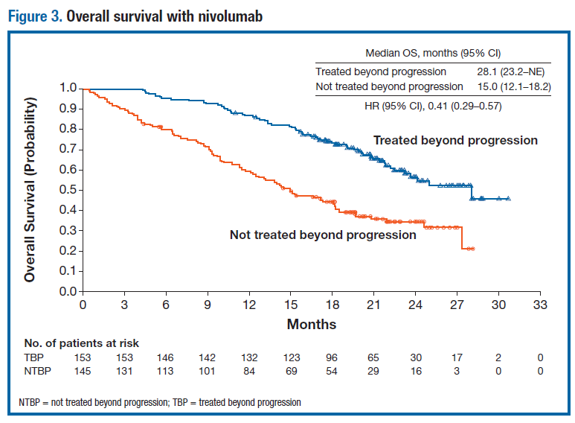
A number of secondary outcome measures were also described but are not reproduced here. A brief safety analysis was provided; this showed that AEs were similar both before and after disease progression although a numerically higher number experienced Grade 3 to 4 AEs with treatment continued beyond disease progression. No details were provided regarding the 8 patients who discontinued treatment due to nivolumab toxicity. Quality of life measures during this phase of treatment were not described.

Evaluator’s response
There is a disparity in the number of patients in the nivolumab arm treated beyond disease progression described in the CSR (179 patients) and in the sponsor’s response (153 patients). The poster refers to 153 patients, with another 18 patients who were ‘treated briefly beyond progression’ and who were not included in the subsequent analysis. From the OS results provided, continuation of nivolumab beyond disease progression in selected patients may be worthwhile. On the basis of the reported AEs, this treatment did not appear to be too onerous although additional quality of life measures would be informative. However, these results should be interpreted with caution given that there appear to be 26 patients who received nivolumab after disease progression but who were not included in the analysis provided.

All QoL and HRU results for Study CA209025
Question 20 noted that the Study CA209025 study protocol described QoL assessments using both the FKSI-DRS scale and the EQ-5D tool and the collection of health resource utilisation data. The CSR provided results only for the QoL measure of FKSI-DRS. Given the importance of these patient-reported outcomes in determining if patients are both living longer and with an acceptable quality of life, this clinical question requested that the EQ-5D and HRU results be provided.
EQ-5D: The sponsor’s response described an improvement in the EQ-5D utility index and visual analogue scale in patients receiving nivolumab, between Baseline and Week 104. Over the same time period, deterioration in these scales occurred with everolimus. This was supported by an article analysing quality of life measures based on Study CA209025 that was published online in the Lancet Oncology in June 2016. This article was provided in an appendix to the sponsor’s response.
The article analysed FKSI-DRS and EQ-5D data for all patients who underwent randomisation and had a baseline assessment and at least one post-baseline assessment, although analysis was limited to on-treatment assessments due to the small number of available assessments in follow-up. Completion rates are shown below in Table 67.

Table 67. Completion rates for the FKSI-DRS and EQ-5D tools in Study CA209025
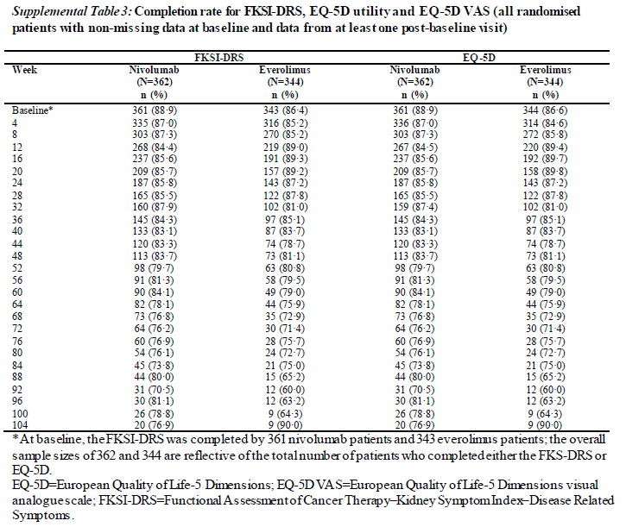
The study found that baseline HRQoL was similar for the nivolumab and everolimus arm using both the FKSI-DRS and EQ-5D. An extensive analysis of the FSI-DRS was provided, including the graphic shown below (see Figure 16).
Figure 16. Mean change from baseline for FKSI-DRS scores in Study CA209025
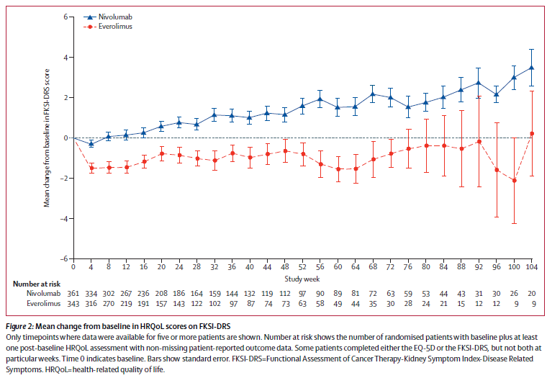
A more limited analysis of the EQ-5D was provided in the article, with more information available in the appendix to the article, including the following graphic, Figure 17.
Figure 17. Mean change from Baseline in EQ-5D scores in Study CA209025
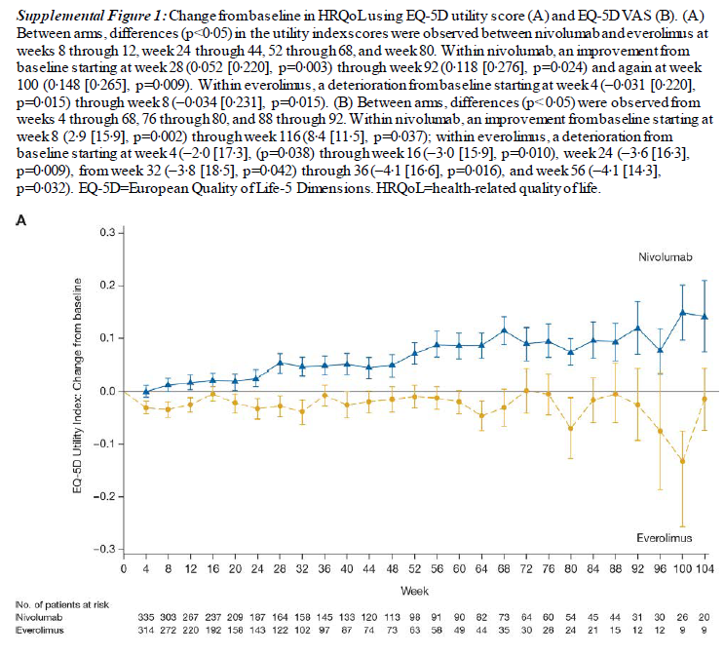
The appendix to the article included a list of investigator sites together with their location and number of patients recruited. There were 4 Australian locations with a total of 25 patients recruited.
HRU: The sponsor provided the information that fewer nivolumab patients had one or more hospital/physician visits than everolimus patients at Week 4 and at Week 26. Overall there were significant differences between groups in number of hospital visits or length of hospitalisations. To support this, the sponsor provided a poster that was presented at the International Society for Pharmacoeconomics and Outcomes Research 2016. This poster presented results of both the HRQoL measure, FKSI-DRS, and healthcare resource utilisation (HCRU) according to the number of non-protocol medical visits (home healthcare, emergency department with no hospital admission, hospital OP/physician visits) and hospital admissions.
The analysis of the FKSI-DRS was similar to that provided in the CSR. The analysis of non-protocol medical visits found that fewer nivolumab patients than everolimus patients had ≥ 1 outpatient hospital/physician office visit from Week 4 through Week 16 (OR at Week 4 0.28; OR at Week 16 0.53). The analysis of hospital visits found the proportion of patients with hospital visits within the first 30 days was similar for nivolumab and everolimus: 8.0% versus 7.0%, respectively with OR 1.16 (95% CI 0.66 to 2.04); the mean duration of hospital visits was also similar.

Evaluator’s response
Complete results for the EQ-5D and HRU were not provided. The evaluation is therefore limited to the results and information as provided. The results for the HRQoL measures of FKSI-DRS and EQ-5D were consistent with each other and showed that, during treatment with nivolumab, the patient’s QoL did not worsen. The results suggest an improvement in these patient reported outcomes over time with nivolumab but this is difficult to interpret as the MID compared to baseline was not reached for most of this time. There was, however, a difference compared to everolimus with patients in this arm seeming to have unchanged or slight worsening of the QoL measures compared to baseline.
The HRU data showed no difference between patients receiving nivolumab and patients receiving everolimus, except for fewer nivolumab patients needing 1 or more non-protocol visits from Week 4 to 16. A comparison of the number of visits outside this time-frame was not reported.

Clarification of terminology regarding immune mediated complications of nivolumab therapy as presented in Study CA209025 CSR
Question 21 asked for clarification of the representation of the numbers of AEs, IMAEs and irAEs in sections of the CSR.
The sponsor advised that a category of ‘select AEs’ was used across the clinical development programme for nivolumab with these thought to represent AEs with an immune basis and that immunosuppression may be required for management. The select AEs were categorised as endocrinopathies, diarrhoea/colitis, hepatitis, pneumonitis, interstitial nephritis, and rash with multiple PTs used in the search for each category. Select AEs were reported for the period up to 30 days from the last dose. The category of immune related adverse reactions (irAR) was similar to that of ‘select AEs’ but differed in that immune modulating treatment was required for their management (except for the endocrine group) and were reported for up to 100 days after the last dose.

Evaluator’s response
From this definition, it appears that irARs are a sub-set of ‘select AEs’. The use of separate terminology and different reporting timeframes does not seem to be helpful and may only create confusion. It would be more appropriate to consider, and name, all of these AEs as irARs, with the more severe manifestations requiring immunosuppression.

Clarification of patients with elevated liver enzymes in Study CA209025 and if criteria for DILI had been met
Question 22 asked for more information regarding 7 patients who appeared to meet the laboratory definition of drug-induced liver injury (DILI), according to the table of on-treatment laboratory abnormalities, but who were not discussed in the CSR.
This was clarified by the sponsor as representing as a total of 4 subjects, with 3 subjects experiencing elevation in liver enzymes within one day and the same three patients, with one other, also experiencing elevation in liver enzymes within 30 days.
Of these 4 patients, one had cholecystitis and three had hepatic metastases. These were considered to be the cause of the liver enzyme abnormalities rather than the study drug.

Evaluator’s response
This is acceptable

Investigator and post-marketing training in the recognition of immune mediated complications of nivolumab therapy
Questions 23, 25 and 26 noted that there were 146 sites with an average of 3 patients recruited per site over an average period of 18 months and that the patient narratives provided described complex patients in whom the recognition of irARs could be difficult. A concern was expressed that a lack of familiarity with nivolumab and immune related adverse reactions on the part of the investigators may have resulted in these being ‘under-called’ due to a failure of recognition and that this may also have been the case with the attribution of causes of death. The sponsor was asked to describe training in the recognition and management of AEs provided to investigators and any ‘quality control measures’ that were implemented during the study. The investigator’s brochure was also requested.
The sponsor provided a description of ‘the mechanisms and tools implemented by the Sponsor during the nivolumab development program and post launch of Opdivo, both globally and in Australia.’
- In the clinical development programme:
  - Investigators and study teams were trained in the review/ identification/ treatment of irARs at the investigator meetings, with this organised in breakout sessions and with de-identified cases used as examples.
  - The sponsor’s medical monitors reviewed all SAEs and followed-up real time with the investigators. The sponsor’s pharmacovigilance groups and the global clinical research group reviewed all deaths and SAEs and sought clarification as needed. Any inconsistencies in attribution or treatment management that were identified were queried. Additional safety training was provided to ‘sites in need’ by the local site monitors.
- Post-approval for marketing:
  - Education and guidance is provided through the approved PI – specifically in the sections ‘Precautions’ and ‘Dosage and Administration’.
  - As required by the EU RMP (and associated Australian Specific Annex), the sponsor developed and implemented the healthcare professional (HCP) and patient communication tools with these aligned to the Opdivo PI. The HCP tool is intended to provide ‘simplified management recommendations for each of the potentially affected organ systems’ in an easy to use format.
  - The HCP tool has been made available to prescribing oncologists, oncology and infusion suite nurses and hospital pharmacists. Further educational activities directed at other HCPs such as physicians in emergency departments, general practitioners, and pathologists are planned.
The HCP educational tool (preparation date February 2016) and the Study CA209025 investigators’ brochure (Version 14, dated June 2015) was provided by the sponsor

Evaluator’s response
Under-calling: The evaluator is not convinced that attendance at a breakout session, however well run, will be sufficient to enable recognition of an irAR 18 months later. The surveillance by medical monitors and pharmacovigilance groups is reassuring but this will be limited by the information as provided by the investigator.
The occurrence of SIRS/MODS/MOF may represent an example of the potential for under-calling. This spectrum of disorders represents non-specific inflammatory processes that may be triggered by a variety of acute illnesses, with this potentially including immunotherapy. There were two deaths associated with rapidly progressive multiple organ failure (MOF) described in the narratives provided for Studies CA209010 and CA209009, and one case of Systemic Inflammatory Response Syndrome (SIRS) without fatal outcome, described in Study CA209025. Only the case of SIRS was considered by the investigator to be possibly related to nivolumab.
A cumulative search to 20 June 2016 of the Corporate safety database using the PTs Cytokine Release Syndrome (CRS), Multiple Organ Dysfunction Syndrome (MODS), Organ Failure, and Systemic Inflammatory Response Syndrome (SIRS) retrieved 25 cases. Of these, two were considered possibly related to nivolumab and were treated with corticosteroids – both survived. Of the 23 other cases, no relationship was suspected and all patients died. A poster presented at the 2016 ASCO conference describes prospective monitoring of a series of 32 patients who were treated with nivolumab for advanced lung cancer specifically for signs and symptoms of SIRS. Twelve of the 32 patients (37.5%) were hospitalised with such signs and symptoms and treated with methylprednisolone ± tocilizumab, with treatment resulting in improvement in inflammatory symptoms and CRP. There is considerable discrepancy between the incidence of SIRS/MODS/MOF when investigators are specifically looking for it and when they are not.
Appendix 2.1 of the July to January 2016 PBRER provides a cumulative summary of Serious Adverse Events for Clinical Trial Cases from IBID to January 2016. This lists 31 cases of MOF, 7 cases of SIRS, and one case of CRS. There were also 103 cases of hypotension, 35 cases of septic shock and 159 cases of sepsis. It is possible that some of these cases may have been attributed to SIRS/MODS/MOF triggered by nivolumab if the investigators had been asked to consider/monitor for these complications.
Educational Tools; the PI and HCP tool: The PI is referred to by the sponsor as ‘an integral part of all the HCP educational materials’ and that it includes ‘education guidance to assist healthcare professionals in the recognition and management of irARs’. It is concerning, therefore, that the PI is not provided as package insert with all nivolumab vials. The important educational materials contained within the PI will not be immediately available to clinical staff prescribing or administering nivolumab. The sponsor appears to depend on third parties (such as the TGA website, medicines.org.au and MIMS) to distribute the PI. The evaluator is concerned that there is a lack of familiarity with the TGA and medicines.org.au website amongst clinicians and that only paid access is available for MIMS. Clinical staff who are accustomed to accessing drug-related information through the package insert, therefore, may be unable to access the full PI. It would appear reasonable that the sponsor ensure that all clinical sites to which nivolumab is provided are also provided with multiple copies of the PI and that a copy of the PI be hosted on the sponsor’s Opdivo website.
The HCP communication tool, titled ‘Immune-Related Adverse Reaction Management Guide’, has been read by the evaluator who agrees that this is a useful educational tool for practitioners who are not familiar with nivolumab and who may be providing emergency care. However, it appears to be over-simplified for oncologists or physicians providing ongoing care to patients experiencing severe irARs. The evaluator notes that there is considerably more useful and clinically relevant material included in the Investigator’s brochure.
The evaluator notes that the HCP tool states on the cover page that: ‘Please refer to OPDIVO Approved Product Information for more information on treatment’. However, advice on where to locate the PI is only provided on the final page, amongst the fine print, with:
‘Please refer to the Approved Product Information before prescribing the Product Information is available upon request from BMS Medical Information Department: 1800 067 567 or can be accessed at http://www.medicines.org.au/files/bqpopdiv.pdf’
It would be appropriate for the information on how to locate the PI to be included with the advice on the cover page and that this also includes the TGA website and the sponsor’s website.
Also of note, in the HCP tool, is the section ‘Other irARs’ that contains the current list of irARs that do not fit into the organ categories selected for separate display (pulmonary, renal, hepatic, skin and endocrine). According to this section, there are now 6 different types of neurological manifestations of irARs that have been reported: encephalitis, demyelination, Guillain-Barre syndrome, auto-immune neuropathy (including facial and abducens nerve paresis), myasthenic syndrome and peripheral neuropathy (motor and sensory). It would be more appropriate to present these in a separate section of ‘neurological irARs’ as has been done in the investigator’s brochure. The evaluator also notes that the ‘Other irARs’ section does not include the more recently described irARs of myositis, rhabdomyolyis and myocarditis (see version 3.3 of the proposed PI and SRR). Due to the increasing number of organ systems recognised as affected by nivolumab-induced irARs, the current structure of the HCP tool will require frequent updating, with distribution and replacement of outdated tools. It may be helpful to include a comment along the lines that irARs should be considered for all unexplained illnesses, with management according to the severity of the illness. This could be added to the preamble on page 4 of the HCP tool.

Use of immunosuppressive therapies other than corticosteroids, including tocilizumab
Question 24 requested more information regarding the use of immunosuppressive agents other than corticosteroids for irARs throughout the clinical development programme, with this including the use of tocilizumab for irARs or cytokine release syndrome.
The sponsor re-iterated the proportion of patients in Study CA209025 who received immune modulating medications and listed the relevant tables in the CSR. The sponsor also noted that the ‘Precautions’ section of the PI includes the statement ‘Non-corticosteroid immunosuppressive therapy should be added if there is worsening or no improvement despite corticosteroid use’ with these guidelines developed through discussions between the sponsor’s medical monitors and investigators as there ‘has not been a formal clinical study to determine which agents should be used or whether other immunosuppressive agents improve outcome in patients with severe irARs.’ The recommendation for anti-TNF agents for steroid-refractory diarrhoea is based on the use of these agents in the ipilimumab programme and inclusion of this information in the ipilimumab PI. Specific guidelines regarding the use of infliximab in pneumonitis has been removed from the most recent investigators brochure. The sponsor expresses considerable reluctance to provide specific advice regarding the use of immunosuppressive agents other than corticosteroids on the basis that ‘immunosuppressive therapy is driven by clinical judgement and treatment is individualized … to meet individual patient circumstance’.
With regards to tocilizumab, the sponsor also reported that a search of the Corporate safety database identified one patient with a nivolumab-induced irAR (described as SIRS with onset after the first cycle) in whom tocilizumab was considered. It was not, however, administered as the patient improved on corticosteroids. This patient had a long and complex course, with possible recurrence of SIRS after the next cycle of nivolumab. The SIRS was considered by the sponsor’s medical evaluation to be possibly related to nivolumab.

Evaluator’s response
The approach taken by the sponsor appears inconsistent. On one hand the sponsor is prepared to advise the use of corticosteroids in the management of immune related adverse reactions induced by the sponsor’s product, and anti-TNF agents for diarrhoea, despite only anecdotal evidence for these practices. On the other hand, the sponsor is not prepared to provide advice, or information, in the PI regarding the use of other immunosuppressive therapies in those patients who do not respond to corticosteroids. This is disappointing as the sponsor’s medical monitors currently have the greatest experience and expertise in the management of such patients. However, the evaluator notes that the HCP irAR management guide, provided with the sponsor’s response to TGA questions, does include advice regarding the use of other immunosuppressive agents including mycophenolate mofetil for hepatitis, infliximab for gastrointestinal complications and infliximab or mycophenolate for pneumonitis. The evaluator also notes that the sponsor’s expertise was available to nivolumab study investigators with the Investigator’s Brochure advising that the sponsor’s medical monitor be contacted for advice in the management of patients with severe irARs.
The evaluator agrees that all treatment must be tailored to the individual patient but the provision of information regarding what agents have been used and whether they appeared to be effective could be extremely useful to clinicians managing complex and/or deteriorating patients. It may be appropriate to continue to include this anecdotal evidence in the HCP guide rather than the PI, provided a greater level of clinical detail was included in this guide (similar to that provided in the Investigator’s Brochure). An alternative could be for the sponsor to provide a ‘Hot-line’ with a 1800 telephone number through which clinicians could contact a sponsor medical staff member for guidance.
With regards to the use of the anti-IL6R monoclonal antibody, the evaluator notes that a poster presented at the 2016 ASCO conference described the use of this agent in 8 patients who developed SIRS during treatment with nivolumab (see ‘Occurrence of SIRS/MODS/MOF in patients receiving nivolumab’ below).

Clarification of terminology regarding immune mediated complications of nivolumab therapy as presented in Study CA209025 CSR and proposed PI
Question 31 asked for further clarification regarding reported rates of ‘select ARs’ in the nivolumab monotherapy registrational studies as provided in the PI and rates reported in Study CA209025, with the example of ‘diarrhoea/colitis’ the rate of this ‘select AE’ in the PI was 13.6%, the rate of diarrhoea/colitis in the nivolumab arm in Study CA209025 was 28.3% but ‘considered to be IMAE in 13 (3.2%) patients’
The sponsor provided a description of the registrational studies and noted that ‘the mean duration of nivolumab therapy and the number of nivolumab doses received was higher in RCC than melanoma and NSCLC’ with the speculation that ‘This may explain in part some of the differences in AEs and select AEs incidence rates reported across tumor types’.
Additional information was provided that: ‘Hepatic and renal adverse reactions occurred most commonly in RCC (11.3% and 6.9%, respectively), while gastrointestinal and skin adverse reactions occurred most commonly in melanoma (17.7% and 38.4%, respectively), and pulmonary reactions, specifically pneumonitis, occurred most commonly in RCC and NSCLC (3.9% and 3.6%, respectively) [...] Overall, most cases of select adverse reactions, across tumor types, were either Grade 1 or 2 in severity. Grade 3 or 4 select adverse reactions occurred at an incidence of 1% to 2% of patients, regardless of whether treated with nivolumab 3 mg/kg monotherapy for melanoma, NSCLC, or RCC.’

Evaluator’s response
The response did not address the question that was more directed at terminology. As in Question 21, the use of terms such as ‘select AEs’, ‘IMAEs’, and ‘irARs’ with the artificial distinction of ‘select AEs’ being AEs that may be immune mediated and may require immunosuppression and irARs being AEs that may be immune mediated but do require immunosuppression (except for endocrinopathies) is a source of considerable confusion. As stated above, the term irARs or IMAEs is preferred for all AEs which may be immune mediated. The ongoing use of the term ‘select AEs’, particularly in the PI, may serve only to confuse and obscure the likely aetiology of these AEs.

Occurrence of SIRS/MODS/MOF in patients receiving nivolumab
Question 32 noted that there were two deaths associated with rapidly progressive multiple organ failure (MOF) described in the narratives provided (one in each of Studies CA209010 and CA209009) and one case of Systemic Inflammatory Response Syndrome (SIRS), without fatal outcome, described in Study CA209025. A review of all such cases (SIRS, MODS, MOF) in the Nivolumab Clinical Development Programme was requested as these may represent systemic inflammatory response triggered by nivolumab. The occurrence of ‘cytokine release syndrome’ with other immunotherapies was noted.
The sponsor described a cumulative search to 20 June 2016 of the Corporate safety database using the PTs Cytokine Release Syndrome (CRS), Multiple Organ Dysfunction Syndrome (MODS), Organ Failure, and Systemic Inflammatory Response Syndrome (SIRS). This retrieved 25 cases: Multiple Organ Dysfunction Syndrome (n = 23), Cytokine Release Syndrome (n = 1), and Systemic Inflammatory Response Syndrome (n = 1). The treatment indications reported in the 25 cases were NSCLC (n = 7); melanoma and RCC (n = 3 each); diffuse large B cell lymphoma, hepatocellular carcinoma, and gastric cancer (n = 2 each); and follicular lymphoma, acute myeloid leukaemia, Hodgkin’s lymphoma, urothelial cancer, solid tumours, and malignancy (n = 1 each). Of the 25 cases, 23 were fatal and 1 was reported recovering/resolving. The outcome of the one patient was not described.
Brief narratives for 25 of the cases were provided. These narratives described complex cases with the MOF and SIRS not considered related to nivolumab by the sponsor in every case. The case of CRS was considered possibly related to nivolumab. One case of SIRS was described – this patient participated in Study CA209025 and has been referred to above. The narrative provided in the response to TGA questions did not indicate that this patient was treated with steroids, although this information was available in the CSR.
The sponsor briefly refers to a review of the data related to SIRS in relation to nivolumab and ipilimumab in March 2016 by the sponsor’s cross-functional Medical Surveillance Team (MST) that was prompted by 3 spontaneous reports of SIRS. The MST came to the conclusion that the clinical parameters for SIRS may be seen with multiple diverse conditions and that no update to the CCDS or other RSI was required.

Evaluator’s response
Insufficient detail was provided in the narratives for the evaluator to properly evaluate the sponsor’s assessment, although there appeared to be a number of cases in which MOF developed without evident precipitant. Of particular note were 4 cases in which fulminant MOF occurred with fatal outcome in 24 to 48 hours. A relationship with nivolumab was not considered for any of the 23 cases of MODS, all of which had fatal outcome. In the case of SIRS and the case of CRS, an immune mediated process secondary to nivolumab was suspected by the investigators, resulting in treatment with steroids and subsequent improvement in the patient’s condition. The evaluator also notes that the sponsor’s response to Question 24 that described 3 patients who were hospitalised with SIRS while on therapy with nivolumab who do not appear to have been included in the above 25 cases. A narrative was provided for one of these cases; this patient was treated with glucocorticoids and survived.
A poster presentation at the 2016 ASCO conference describes prospective monitoring of a series of 32 patients who were treated with nivolumab for advanced lung cancer. Twelve of these patients were hospitalised with signs and symptoms of SIRS (including one or more of: fever, tachypnoea, tachycardia, hypotension, organ failure) occurring 1 to 2 days to weeks after immunotherapy. Symptomatic patients were treated with methylprednisolone (1 to 2 mg/kg). Of these patients, 8 were also treated with tocilizumab (anti-IL6R monoclonal antibody). Treatment was described as resulting in improvement in inflammatory symptoms and CRP. These 12 patients do not appear to have been captured in the sponsor’s Corporate safety database.
Appendix 2.1 of the July 2015 to January 2016 PBRER provides a cumulative summary of Serious Adverse Events for Clinical Trial Cases from IBID to January 2016. This lists 31 cases of MOF, 7 cases of SIRS, and one case of CRS.
The sponsor identified 25 cases of SIRS/MODS/MOF/CRS in the corporate safety database to June 2016, with 23 of these fatal. This does not appear to include all cases listed in the January 2016 PBRER (total of 39 cases). Another 15 reports of SIRS have also been described that were not included in the safety database. Of note is that all non-fatal cases, for which there is information available, appear to have had early treatment with corticosteroids and/or tocilizumab.
The evaluator considers that there is sufficient information available to categorise SIRS/MODS/MOF as an important potential risk with nivolumab monotherapy. As such it should be included in the ‘Precautions’ section of the PI and be described in the HCP tool.

Post-marketing reports and PSURs/PBRERs
Question 13 requested that any post-marketing reports or PSURs/PBRERs be provided to the evaluator.
The sponsor noted that the latest PBRER (4 July 2015 to 3 January 2016) had been provided to the TGA in February 2016. The additional information provided was that a ‘comprehensive and detailed review of all safety and efficacy data/information currently available for nivolumab did not reveal a change to the overall, favourable benefit-risk profile of nivolumab’.

Evaluator’s response
The evaluator has been able to locate both Nivolumab PBRERs submitted to the TGA: one for the period 4 July 2014 to 3 July 2015 and one for the period 4 July 2015 to 3 January 2016.
The latter PBRER describes a cumulative total number of patients treated with nivolumab (in clinical trials and post-marketing) estimated at 38,556.
Section 3 of each report describes Actions taken in the Reporting Period for Safety Reasons. These included in chronological order in Table 68:

Table 68. Nivolumab Actions taken according to available PBRERs (Period: 4 July 2014 to 3 January 2016)
Date | Issue and Action Taken
October 2014 | The FDA requested that informed consent forms (ICF) and Investigator’s Brochures (IB) be updated to include information regarding a case of fatal myasthenia gravis and fatal sepsis.
February 2015 | The FDA requested that informed consent forms (ICF) and Investigator’s Brochures (IB) be updated to include toxic epidermal necrolysis (TEN), rhabdomyolysis/polymyositis, and encephalopathy.
March 2015 | The FDA requested that informed consent forms (ICF) and Investigator’s Brochures (IB) be updated to include haemophagocytic lymphohistiocytosis (HLH).
June 2015 | TEN and encephalitis were identified as ADRs through routine pharmacovigilance signal detection. All RSI documents updated and a Dear Healthcare Providers letter distributed.
August 2015 | TEN was added to the Warnings and Precautions section of the Company Core Data Sheet (CCDS).
September 2015 | The Japanese regulatory body requested an update to their PI and RMP to include information to include ‘excessive immune response’, ’Myasthenia gravis, myositis’ and ‘Colitis, Severe diarrhoea’ as ADRs and Important Identified Risks.
November 2015 | The Japanese regulatory body requested an update to their PI and RMP to include information to include Type 1 Diabetes as an ADR and Important Identified Risk
December 2015 | Accrual to Study CA209070 was temporarily suspended due to 5 cases of rapid tumour progression and/or pleural effusion.
December 2015 | A safety variation was submitted to the EMA to update the PI and CMI to include TEN and encephalitis. The sponsor committed to perform a cumulative search for all cases of encephalitis for inclusion in the January 2016 PBRER.
December 2015 | The Japanese regulatory body requested an update to their PI and RMP to include Neurological disorder, Renal disorder, Adrenal disorder, Encephalitis, Severe skin disorder and Venous thromboembolism’ as ADRs and Important Identified Risks.
Data regarding cumulative exposure to nivolumab monotherapy in the clinical trials programme was provided, by age and gender.

Table 69. Exposure to nivolumab monotherapy in company-sponsored trials by age group and gender
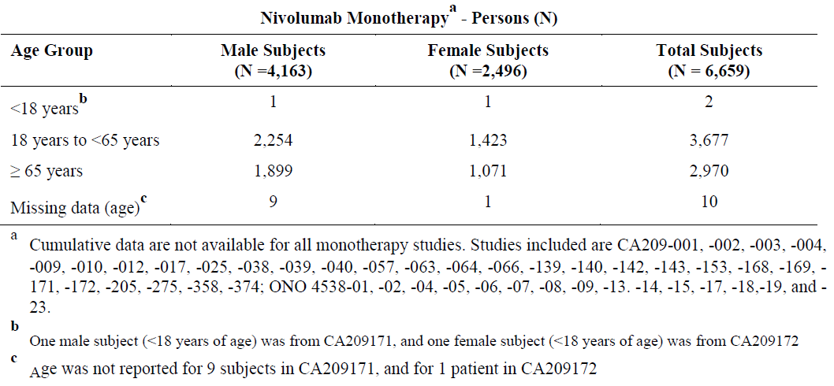
Estimates of cumulative use post-marketing are provided, with these estimates based on limited sales data. The overall cumulative patient exposure to nivolumab in clinical trials and post-marketing exposure to 3 January 2016 was estimated at 38,556 patients. The estimates per reporting period show a dramatic increase in the number of patients treated with nivolumab following marketing approval: from 1870 in the first 12 months to 10,702 in the next 6 months. Reports of ADRs showed a similar increase.

Table 70. ADR reports from post-marketing sources
Reporting period | Estimated patient number exposed | ADR reports
Reporting period | Estimated patient number exposed | Serious | Non-serious | Total
4 July 2014 to 3 July 2015 | 1870 | 457 | 211 | 668
4 July 2015 to 3 January 2016 | 10,702 | 1950 | 1085 | 3035
The most frequently reported events (> 7) from 4 July 2014 to 3 July 2015 were death-unknown cause (38), malignant neoplasm progression (32), pyrexia (28), diarrhoea (26), off-label use (19), pneumonitis (17), nausea (15), colitis (13), fatigue (13), interstitial lung disease (12), rash (12), pleural effusion (12), hepatic function abnormal (10), infusion related reaction (10), cough (9), vomiting (8), hypothyroidism (8), and headache (8).
The most frequently reported serious events (≥ 20) from 4 July 2015 to 3 January 2016 were death-unknown cause (215), malignant neoplasm progression (182), pneumonitis (50), interstitial lung disease (42), colitis (40), diarrhoea (37), pleural effusion (32), pneumonia (29), pyrexia (27), hyperthyroidism (26), drug ineffective (24), and infusion-related reaction (20).
A multicentre, open label, uncontrolled, Phase II study in advanced NSCLC conducted in Korea (Study ONO 4538-09) is briefly described in the second PBRER. This was described as showing similar efficacy and safety profile as seen in other Phase III studies.
The most recent PBRER provides a list of studies of nivolumab (monotherapy or combination therapy) that are currently ongoing. This describes 82 studies in cancers including hepatocellular carcinoma, haematological malignancies (including Hodgkin and non-Hodgkin lymphoma, acute myeloid leukaemia, myelodysplastic syndrome, polycythaemia rubra vera), small cell lung cancer, urothelial cancer, glioblastoma, gastric carcinoma, ovarian cancer, mesothelioma, sarcoma, adenocarcinoma of lung, breast cancer and squamous cell carcinoma of the head and neck. Another 15 studies of compassionate/early use are listed. The study in squamous cell carcinoma of the head and neck was stopped early (January 2016) when an interim analysis showed that the endpoint of superior OS had been met.
Safety specifications: The summary of safety concerns provided in each PBRER shows an increase in the number and variety of risks (see Table 71 and 72 below).
Changes in the Safety Specifications since July 2014 include:
- A change in terminology with the introduction of the descriptor ‘immune related’.
- The category ‘Other Immune-related adverse reactions’ (other irAR) was added to ‘highlight clinically important but uncommon adverse reactions from the nivolumab program, including uveitis, pancreatitis, Guillain-Barre Syndrome (GBS), myasthenic syndrome, and encephalitis’.
- The category of severe infusion reaction was added as an important identified risk based on uncommon Grade 3 or 4 infusion reactions observed in the nivolumab program and 6 postmarketing cases of infusion-related reactions during the first reporting period.
- The risk of uveitis was reclassified as an important identified risk under the category of ‘Other immune-related ARs’.
- A new category of embryofoetal toxicity was added to the important potential risks based on the feedback from health authorities and known nonclinical findings.
- Immunogenicity was added to the important potential risks based on the biologic class per feedbacks from health authorities.
- There were 2 cases of rhabdomyolysis and fatal myocarditis during the most recent reporting period, with a comprehensive assessment report to be provided in the next PBRER. The evaluator notes that, in the interim, an SRR for myositis, rhabdomyolysis and myocarditis has been submitted to the TGA.

Table 71. Safety specifications known at the beginning of the reporting period July 2014 to July 2015
Safety specifications July 2014 to July 2015
Important Identified Risks | Pulmonary ARs (such as pneumonitis, lung infiltration, interstitial lung disease)  GI ARs (such as diarrhoea, colitis)  Hepatic ARs (such as hepatitis, ALT elevated, AST elevated)  Renal ARs (such as acute renal failure, tubulointerstital and/or allergic nephritis  Endocrinopathies (such as hypophysitis, adrenal insufficiency, hypothyroidism, hyperthyroidism, thyroiditis)
Important Potential Risks | Uveitis
Important Missing Information | Paediatric patients (< 18 years)  Pregnancy and lactation  Patients with severe hepatic or renal insufficiency

Table 72. Safety specifications from PBRER July 2015 to January 2016
Safety specifications July 2015 to January 2016
Important Identified Risks | Immune related pneumonitis  Immune related colitis  Immune related hepatitis  Immune related nephritis and renal dysfunction  Immune related endocrinopathies  Immune related rash  Other immune related adverse reactions  Severe infusion reactions
Important Potential Risks | Embryofetal toxicity  Immunogenicity  Cardiac arrhythmias (previous treated melanoma indication, EU only)
Important Missing Information | Paediatric patients (< 18 years of age)  Patients with severe hepatic or renal impairment  Patients with autoimmune disease  Patients already receiving systemic immunosuppressant before starting nivolumab
A number of safety signals were investigated during each reporting period.
In the first reporting period, there were 7 signals (myasthenia gravis, toxic epidermal necrolysis (TEN), encephalitis, drug induced liver injury (DILI), neurological SAEs, hypercalcemia, and cardiac arrhythmia) evaluated:
Myasthenia Gravis: A cumulative review of myasthenia gravis identified 4 confirmed serious cases. Two cases occurred with nivolumab monotherapy and two with combination therapy with ipilimumab. Study drugs were discontinued in all 4 cases and the patients were treated with steroids (4/4), cholinesterase inhibitors (3), plasmapheresis (1), and intravenous immunoglobulin (3). Patient outcomes were recovered (1), recovering (1), not resolved at the time of death due to disease progression (1), and death due to myasthenia gravis complicated with sepsis (1). The assessment was that myasthenic syndrome/myasthenia gravis is considered as an ADR of nivolumab (estimated frequency < 0.1%, 4/5244) and was added to the ‘Other Immune-Related Adverse Reactions’ category in the CCDS and RMP.
TEN: A total of 3 cases of TEN were identified. One fatal case had close temporal relationship between nivolumab monotherapy and onset. In the other two cases, the patients had also received confounding medication (sulfamethoxazole + trimethoprim or ipilimumab). The estimated overall frequency for TEN is < 0.1% (0.03%, (2/6718) in nivolumab monotherapy studies and 0.05% (1/1772) in nivolumab + ipilimumab combination/sequential therapy studies). TEN is considered to be an ADR of nivolumab and was added to the category of ‘Immune-related rash’ in the CCDS and to the Important Identified Risks in the RMP.
An updated review provided later during the second round evaluation identified 20 cases of TEN/SJS, with 5 of these fatal (3 with monotherapy).
Encephalitis: As of April 2015, 5 cases (1 receiving nivolumab monotherapy, 4 receiving combination therapies of nivolumab + ipilimumab) were identified and considered related to study drug(s). The nivolumab monotherapy case had fatal outcome. The estimated frequency of encephalitis was 0.01% (1/6718) in nivolumab monotherapy and uncommon at 0.2% (4/ 1772) in nivolumab + ipilimumab combination therapy studies. Encephalitis was considered as an ADR of nivolumab and was added to the category of ‘Other immune-related adverse reactions’ in the CCDS and the nivolumab RMP.
This review was updated in the second PBRER, with 16 cases of encephalitis described in the sponsor’s database of which 8 were with nivolumab monotherapy and 8 were with nivolumab + ipilimumab. Of the 16 cases, 8 were considered to be possibly related to nivolumab.
Cardiac arrhythmia: The incidence of arrhythmias was found to be higher in the nivolumab arm in Study CA209037 in which patients with advanced melanoma were randomised to nivolumab or a comparator. The review conducted by the sponsor did not consider cardiac arrhythmia as an important potential risk at that time, partly on the basis that this was not found in any other comparator studies and lack of effect of nivolumab on QT interval.
Drug-Induced Liver Injury: This review was conducted at the request of the FDA. There were 16 potential DILI cases identified by laboratory criteria (concurrent AST or ALT > 3 x ULN and TB > 2 x ULN). The majority of these cases had additional potential confounding risk factors (baseline liver metastases, concomitant medications with known hepatotoxicity, abnormal liver tests at baseline, or concurrent medical conditions). 2 cases (< 0.1%, 2/3994) had ALP < 2 x ULN without other causes and met Hy’s Law criteria:
- 1 case occurred with nivolumab + ipilimumab combination treatment. The patient improved after stopping study drugs and treatment with corticosteroids.
- 1 case occurred with sequential ipilimumab followed by nivolumab treatment. Study drug was stopped and the patient was treated with steroids and MMF and the event resolved.
Review of the case management for all 16 cases confirmed that the hepatotoxicity cases were manageable using the established hepatic AE management guideline with 14/16 responding to the treatment with favourable outcomes. As hepatotoxicity was already an identified risk of nivolumab, no changes were made to the CCDS or RMP.
Neurological SAEs: A cumulative review of serious neurological events found 30 events that were reported as possibly related to nivolumab monotherapy or nivolumab + ipilimumab. These included:
- 6 cases of Guillain-Barre syndrome or Miller Fisher syndrome with 1 case occurring with nivolumab monotherapy, one with combination therapy, one with sequential therapy and 2 with ‘blinded therapy’. Treatment included high-dose corticosteroids and IV Ig (4), IV Ig (1), or corticosteroids and plasmapheresis (1) with outcomes of resolved in 4, resolving in 1 and resolved with sequelae in 1. The overall frequency was 0.1% (6/5244). 2 cases of Paraneoplastic limbic encephalitis in 63 treated patients with SCLC receiving nivolumab monotherapy.
- a number of other neurological events (not described).
As a result of this review, GBS was added to the ‘Other Immune-Related Adverse Reactions’ category under the important identified risks of the nivolumab reference safety information and RMP.
Hypercalcaemia: This review was triggered by a single case of fatal hypercalcaemia. There were 63 serious cases reporting hypercalcemia received by the Company as of 27-Jan-2015 with most involving patients with tumour types that are associated with a higher frequency of hypercalcaemia. Nivolumab was not considered to be a contributor to hypercalcaemia.
Three safety signals (myositis, thrombocytopenia, and cardiac arrhythmia) were evaluated during the reporting interval July 2015 to January 2016. The myositis and thrombocytopenia reviews were conducted as part of routine signal detection activities. At the conclusion of the myositis review (November 2015), myositis was considered a Product Specific Monitored Event (PSME) as there was a lower frequency observed in the sponsor’s data than the background rate (≤ 0.51% versus 3 to 4%). At the conclusion of the thrombocytopenia review (December 2015), thrombocytopenia was also considered a Product Specific Monitored Event (PSME) for ongoing monitoring. The conclusions regarding cardiac arrhythmias were as for the review in the first reporting period.
New safety concerns were raised in the ‘Late-Breaking Information’ section of the most recent PBRER:
- A brief description of a study of nivolumab and an EGFR inhibitor (EGF816) in patients with NSCLC was provided (Study CEGF816X2201C). Two deaths had been reported, one due to pneumonitis and one to TEN, with causality assessment as suspected and related to EGF816, nivolumab, or the combination. As a result, nivolumab was discontinued from this treatment arm.
- On 27 January 2016, a routine medical surveillance team (MST) meeting was held to review 2 cases of rhabdomyolysis and fatal myocarditis. Preliminary steps of signal detection activities were discussed (sponsor’s database search for relevant PTs, epidemiology review, and so on) to evaluate any potential association between the events and prior influenza vaccination. A comprehensive assessment report will be updated in the next PBRER.
Comment: This review was provided to the TGA during the Round 2 process as part of a Safety Related Request to change the PI.

Responses to some questions on mechanism of action and pharmacodynamics that are not critical to the clinical evaluator’s recommendation regarding the use in advanced RCC
This section includes the sponsor’s responses to Clinical Questions 4, 5, and 7 to 11 outlined in Section 11 above.
Questions 4, 5 and 7 are related to the mechanism of action and PD-L1 status. Questions 8 to 11 are related to immunogenicity and ADA status.

Mechanism of action
As noted above, the sponsor has expressed the opinion that the mechanism of action, pharmacodynamics and dose frequency has been evaluated and approved by the TGA in previous applications. The evaluator notes that:
The studies provided by the sponsor in this submission (in particular Studies CA209010 and CA209009) provided new pharmacodynamics information that required re-evaluation of the postulated mechanism of action and how well this had been supported by pharmacodynamic information that had previously been submitted by the sponsor. This was particularly important given the assessment of the clinical evaluator of the first nivolumab NBE submission, that ‘Only a limited amount of clinical PD data was included in the submission’.
The evaluator acknowledges that this information may not be ‘critical’ to the benefit-risk assessment of the use of nivolumab in patients with renal cell carcinoma but that it is of relevance to an understanding of nivolumab and in the evaluation of the PI.
The following description (Figure 18) of the mechanism of action is included in the nivolumab PI.
Figure 18. Nivolumab, mechanism of action (Opdivo PI)
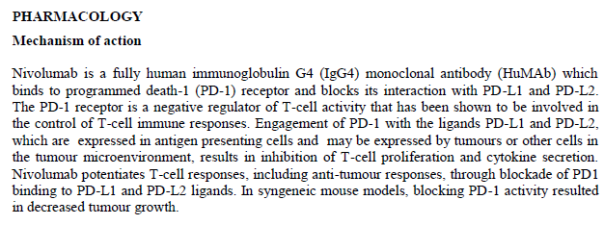
The description contains a number of speculations regarding the mechanism of action that do not appear to be supported by the clinical studies. In particular, biological activity of nivolumab appears to be independent of PD-L1 expression by tumour cells.
Clinical Question 4 asked for an updated description of the mechanism of action according to all pharmacodynamics variables that have been investigated in the clinical trial programme. The sponsor stated that the description above was considered to be accurate. PD effects of nivolumab were studied by assessing receptor occupancy (RO), peripheral immune cell population modulation, systemic cytokine modulation, and change in absolute lymphocyte count (ALC) in Studies MDX1106-03 and/or CA209009 with the findings that PD-1 receptor is saturated at low doses of nivolumab (0.3 mg/kg); there was no meaningful change in activated T-cells in peripheral blood or absolute lymphocyte count or immune cells subsets with nivolumab treatment (this was confirmed in the response to question 5); the increase in the chemokines CXCL9 and CXCL10 was consistent with ‘demonstration of immunomodulatory activity of nivolumab on these chemokines’.

PD-L1 status and mechanism of action
Clinical Question 7 asked for further information regarding the PD-L1 assay and whether the PD-L1 status as known supported the postulated mechanism of action, noting that this is dependent on nivolumab blocking the interaction between the PD-1 receptor and the ligand PD-L1 as expressed on tumour cells. The sponsor’s response included:
‘Thresholds for association of PD-L1 expression on tumor cells with response continue to be evaluated for different tumor types. No single threshold of tumor cell PD-L1 expression has been identified across tumor types that is able to identify subjects more likely to respond to nivolumab.
The association between PD-L1 expression on tumor cells and tumor responsiveness may be different for each tumor type evaluated. This may be due to differences in tumor microenvironment, expression of PD-L2, or other factors.’
The sponsor argues that the existing data ‘support the proposed MOA of nivolumab, inhibiting the interaction of PD-1 with its ligands (PD-L1, PD-L2) as expressed within the tumor microenvironment. This is demonstrated by increased expression of IFN-gamma regulated genes and increased infiltration of CD8+ T cells.’ No clinical study was cited in support of the increased expression of IFN-γ regulated genes and increased infiltration of activated CD-8 cells was not provided.
The response to Clinical Question 4 also contained the information that ‘increased PD-L1 expression in RCC tumors has been shown to be a poor prognostic factor for nivolumab. Patients with tumor PD-L1 expression ≥ 5% have been shown to be at increased risk of death from RCC compared to those with < 5% PD-L1 expression. An additional study demonstrated that patients with PD-L1 expression ≥ 5% had shorter OS and were more likely to die in the 5 years post-nephrectomy than those with < 5% PD-L1 expression.’

Evaluator’s response
The postulated mechanism of action continues to contain some speculation. The effect of nivolumab on immune system elements in the peripheral circulation appears to be minimal (small increases in 2 chemokines only). The presence of the PD-L1 ligand on tumour cells has not been demonstrated to be necessary for biological activity even if a 1% cut-off is used (remembering that the 1% cut-off only means that 1 tumour cell in a field of 100 tumour cells expresses PD-L1). In fact, the sponsor has suggested that ‘increased’ expression of PD-L1 worsens prognosis with nivolumab treatment.
The sponsor has suggested that the tumour micro-environment is more supportive of the mechanism of action, but the evidence for this has not been provided.
A more precise definition of the mechanism of action in the PI may be more like the description found in the FDA approved label and Health Canada description:
‘Binding of the PD-1 ligands, PD-L1 and PD-L2, to the PD-1 receptor found on T cells, inhibits T-cell proliferation and cytokine production. Upregulation of PD-1 ligands occurs in some tumours and it is believed that signalling through this pathway can contribute to inhibition of active T-cell immune surveillance of tumours. Nivolumab is a human immunoglobulin G4 (IgG4) monoclonal antibody that binds to the PD-1 receptor with this believed to blocks its interaction with PD-L1 and PD-L2 and release PD-1 pathway-mediated inhibition of the immune response, including the anti-tumour immune response. In syngeneic mouse tumour models, blocking PD-1 activity resulted in decreased tumour growth.’

Immunogenicity and ADA Status
Clinical Questions 8, 9, 10 and 11 related to immunogenicity and ADA status of nivolumab. The evaluator agreed that the following questions were not ‘critical’ to the risk-benefit analysis of nivolumab in advanced RCC on the basis that the rate of infusion reactions and their management has been previously documented. However, immunogenicity and ADA status is obviously an important aspect of the safety of nivolumab and the PI makes a number of statements regarding ADA and immunogenicity that require evaluation.
Clinical Question 8 asked for clarification regarding immunogenicity results for Study CA209010, due to a discrepancy between the Final CSR and Addendum to the CSR.
The sponsor’s response indicated that there had been a change in categories (Other Positive instead of Transient Positive) and criteria for Persistent Positive with positive specimens required 16 weeks apart instead of the previous definition of 8 weeks apart.

Evaluator’s response
Response noted.
Clinical Question 9 asked for more information regarding the ADA assay, noting that three generations of assay had been used in the Clinical Trials programme and that there was considerable variability even when the same assay was used in the same tumour population.
The sponsor provided a description of the assays and indicated that the third generation assay remains in use. The sponsor speculated that ‘Different disease state population, disease condition, as well as prior treatment regimens could account for the apparent variation in immunogenicity observed across studies’

Evaluator’s response
Response noted.
Clinical Question 10 asked the sponsor to provide an explanation for the occurrence of the high rate of infusion reactions, including anaphylaxis, given that there appeared to be no relationship between positive ADA status and infusion reactions.
The sponsor disagreed that there was a high rate of infusion reactions, citing the rate of 5.2% in Study CA209025 and 4.1% across studies, with most events reported as being Grade 1. No alternative explanation for their development was provided.

Evaluator’s response
The evaluator notes that infusion related reactions are categorised as ‘common’ in Table 13: Adverse Reactions in Clinical Trials of the revised PI (Version 3.3) [table not included here].
Clinical Question 11 noted that nivolumab is produced in a Chinese hamster ovary (CHO) cell line and asked if there had been any investigation regarding the development of anti-CHO antibodies as an alternative explanation for the infusion reactions seen with nivolumab.
The sponsor’s response was that: ‘The occurrence of anti-CHO antibodies has not been investigated in patients receiving nivolumab and therefore no association to the occurrence of infusion reactions has been explored’

Evaluator comment regarding immunogenicity and ADA status
According to the presence of anti-nivolumab antibodies as measured by the assays used by the sponsor, there appears to be a low rate of development of ADA in patients exposed to nivolumab.
There are, however, some inconsistencies in this even when the same assay is used in a population with the same tumour type. As noted above, in Study CA209025, 2.7% were ADA positive at baseline and another 7.3% tested positive during the study whereas in Study CA209010, 11.3% ADA positive at baseline and another 4.5% tested positive during the study. The sponsor has speculated that this may be due to ‘Different disease state population, disease condition, as well as prior treatment regimens could account for the apparent variation in immunogenicity observed across studies.’
There other major inconsistency is that infusion reactions appear to have no relationship to the presence of ADA. Infusion reactions are a concern with nivolumab: severe infusion reactions are an ‘Important Identified Risk’; infusion reactions of any grade occur in 4.1% (71/1728) of patients receiving nivolumab monotherapy, with Grade 3 to 4 (including anaphylactic reactions) occurring in 0.3% according to the latest PBRER (July 2015 to January 2016). No alternative explanation for this rate, and potential severity, of infusion reactions has been provided by the sponsor.
A report into the effect of ADA status on safety in Study CA209025 requested by the FDA as a condition of approval was not provided by the sponsor, despite the evaluator’s specific request (see ‘Request for FDA report regarding the impact of ADA on safety and efficacy in Study CA209025’).
The evaluator does not consider that the immunogenicity of nivolumab has been fully characterised and does not consider that any conclusions can be drawn regarding ADA status and safety/efficacy.
The evaluator considers the following to be an appropriate description of Immunogenicity and ADA status for the PI:
Nivolumab Monotherapy and Nivolumab in Combination with Ipilimumab Treatment emergent anti-nivolumab antibody titres have been measured in a number of clinical trials using several generations of assay methods. Considerable variability in measured rates have been observed. There is insufficient information to determine if the presence of anti-nivolumab antibodies affect safety or efficacy.

Second round benefit-risk assessment

Second round assessment of benefits

Table 73. Second round assessments of benefits, strengths and uncertainties
Benefits | Strengths and Uncertainties
Study CA209025 demonstrated clinically meaningful improvement in overall survival in patients with advanced clear cell RCC who have received prior anti-angiogenesis therapy in comparison to everolimus. The median of OS for nivolumab group was 25 months, whereas subjects treated with everolimus achieved a median of OS of 19.55 months (HR: 0.73 (98.52% CI: 0.57, 0.93); stratified log-rank test p value = 0.0018). | Sensitivity analyses were consistent.  Secondary endpoint of ORR was consistent.  Secondary endpoint of PFS was not consistent; it showed no difference between the two arms of the study with PFS of 4.6 months in the nivolumab arm and 4.4 months in the everolimus arm.  Improvement in OS was independent of PD-L1 status.
Study CA209025 found that QoL in comparison to baseline was not worsened by treatment with nivolumab and was improved in comparison to everolimus. | Analysis was reported during the treatment period only.
Study CA209025 found that health resource utilisation was not increased by treatment with nivolumab in comparison to everolimus. | Data regarding non-protocol medical visits and hospital admissions were collected. Analysis was provided for Weeks 4 to 16 only.
Studies CA209010, 209009, and 209003 reported ORRs in patients with advanced RCC that were consistent with Study CA209025. | ORR was dependent on investigator assessed tumour response; all studies were open label.
Only patients with clear cell RCC were included in the pivotal study and other dose escalation studies. | There is no clinical data to guide use in patients with non-clear cell RCC.
Only patients with prior anti-angiogenesis therapy were included in the pivotal study. | There is minimal clinical data to guide use in patients with RCC who have not received prior anti-angiogenesis therapy.
Both everolimus and axitinib are currently approved as second line agents for the treatment of advanced renal cell carcinoma. On the basis of improved survival and no worsening in quality of life, as demonstrated in Study CA209025, nivolumab appears to offer an advantage over everolimus. No information has been presented to indicate if nivolumab offers any advantage over axitinib.

Second round assessment of risks

Table 74. Second round assessment of risks, strengths and uncertainties
Risks | Strengths and Uncertainties
In Study CA209025, rates of adverse events were similar in both arms: Grade 3 or 4 AEs were reported in 53.2% of subjects in the nivolumab group and 56.4% of subjects in the everolimus group; any-grade SAEs were reported in 47.8% of subjects in the nivolumab group and 43.6% of subjects in the everolimus group.
In Study CA209025, there were no deaths reported that were assessed as related to study drug toxicity. | Deaths due to irAR with nivolumab monotherapy have been reported in other studies. Lack of familiarity on the part of investigators may have resulted in under-recognition of deaths due to irARs in Study CA209025.
In Study CA209025, AEs that were potentially immune mediated occurred commonly: diarrhoea/colitis in 28.3%, hepatitis in 15.3%, nephritis in 18.5% and pneumonitis in 6.4%, although only a small proportion were considered related to study drug therapy by the investigators. | irAR have non-specific presentations with no confirmatory diagnostic test with recognition is dependent on clinical suspicion and familiarity. Lack of familiarity on the part of investigators may have resulted in under-recognition of irARs in Study CA209025
There were no new safety concerns identified in Study CA209025. | Two patients died from MOF and one patient developed SIRS in Study CA209025 and 209010. Apart from these patients, there may be as many as 51 patients who have been reported as developing SIRS/MODS/MOF during nivolumab treatment. During prospective monitoring specifically for SIRS in a group of 32 patients receiving nivolumab for NSCLC, 12 patients were reported to develop SIRS.
Major safety concerns have been identified with the use of nivolumab monotherapy in other studies in the clinical development programme and as the number of patients exposed has increased. These include fatal and/or serious irARs such as pneumonitis, hepatitis, nephritis, colitis, SJS/TEN, encephalitis, myasthenic syndrome, demyelination, myasthenia gravis, Guillain-Barre syndrome, rhabdomyolysis, myocarditis, myositis, severe infusion reactions, adrenal failure, hypopituitarism, pancreatitis, duodenitis, and gastritis. It is likely that immune related reactions related to every body part will be recognised as patient exposure increases. | irAR have non-specific presentations with no confirmatory diagnostic test, creating diagnostic uncertainty. Recognition is dependent on clinical suspicion. Appropriate education of healthcare professionals involved in the care of patients being treated with nivolumab is essential.
Limitations to information available to prescribers and due to full PI not included as package insert and distribution dependent on internet access. | The PI is an important educational tool. It should be easily accessed both as hard copy and electronically by all prescribers.
Limitations to information available to medical practitioners providing ongoing care to patients with severe irARs. | The evaluator is of the opinion that the HCP tool provides only limited and over-simplified information regarding the ongoing management of irARs. The level of detail provided in the Investigators Brochure is more appropriate.
Limitations to ‘Patient Alert Card’ with current format 4 pages long. | The intention of a ‘Patient Alert Card’ is that it be carried at all times by the patient and provides essential basic information, including immediate actions if life-threatening condition, and indicates contacts whereby further information can be obtained. The evaluator does not consider the 4 page format of the current nivolumab card to be suitable for the intended purpose.
Lack of post-marketing information regarding real world use in all tumour types, in particular safety outside clinical trial setting, with the proposed post-marketing surveillance study only including 1200 patients and only the tumour types of melanoma and NSCLC. | The evaluator recommends that a national multicentre observational registry also be conducted in Australia, with this to include all patients who are treated with nivolumab (current and future indications, off-label use). This would address the gap in the planned post-marketing activities by including all tumour types and would provide patterns of use, effectiveness and safety of nivolumab in the Australian context.

Second round assessment of benefit-risk balance
The benefit-risk balance of nivolumab for the indication of: ‘Adult patients with advanced RCC (clear cell) who had received prior anti-angiogenic therapy’ is favourable.
Ongoing refinement of the educational/awareness tools of the PI, Patient Alert Card and Healthcare Professionals guide are essential to minimise the risks associated with irARs. A multicentre national observational registry would provide information regarding the safety and efficacy of nivolumab outside of clinical trials in the Australian context.

Second round recommendation regarding authorisation
The evaluator recommends that nivolumab be approved for the indication of:
‘Adult patients with advanced RCC (clear cell) who had received prior anti-angiogenic therapy’
Ongoing refinement of the educational/awareness tools of the PI, Patient Alert Card and Healthcare Professionals guide are essential to minimise the risks associated with irARs. A multicentre national observational registry would provide information regarding the safety and efficacy of nivolumab outside of clinical trials in the Australian context.

References
Australian Product Information (PI) for everolimus. Via the TGA website, April 2016.
Brahmer J, et al. Phase I study of single-agent anti-programmed death-1 (MDX-1106) in refractory solid tumors: safety, clinical activity, pharmacodynamics, and immunologic correlates. J Clin Oncol 2010; 28: 3167-75.
Cella D, et al. Development and Validation of a Scale to Measure Disease-Related Symptoms of Kidney Cancer. Value Health Volume 10, Issue 4, pp285–293.
Cella D, et al. Quality of life in patients with advanced renal cell carcinoma given nivolumab versus everolimus in CheckMate 025: a randomised, open label, Phase III trial.
Choueiri T, et al. Immunomodulatory activity of nivolumab in metastatic renal cell carcinoma (mRCC): association of biomarkers with clinical outcomes. J Clin Oncol 2015; 33: Suppl: 4500.
Committee for Medicinal Products for Human Use (CHMP) Assessment Report Opdivo dated 23 April 2015.
Drake C et al. (2014). Breathing new life into immunotherapy: review of melanoma, lung and kidney cancer. Nature Reviews. Clinical Oncology, 11(1), 24–37.
EMA/CHMP/244718/2016: Minutes for the meeting on 22-25 February 2016. European Medicines Agency (EMA), Committee for medicinal products for human use (CHMP). Date published: 4 April 2016.
European Medicines Agency Assessment Report for Opdivo, Procedure Number: EMEA/H/C/003985/II/0008; European Medicines Agency (EMA), Committee for Medicinal Products for Human Use (CHMP). 25 January 2016.
EMA Guideline on the investigation of pharmacokinetics of therapeutic proteins
Escudier B et al. Renal cell carcinoma: ESMO Clinical Practice Guidelines for diagnosis, treatment and follow-up Annals of Oncology 25 (Supplement 3): iii 49–iii 56, 2014.
Lee D, et al. Current concepts in the diagnosis and management of cytokine release syndrome. Blood. 2014;124(2):188-195.
Motzer R et al. Nivolumab versus everolimus in advanced renal-cell carcinoma. N Engl J Med 2015;373:1803-13.
National Cancer Institute: Renal Cell Cancer Treatment for Health Professionals (Updated 4 February 2016).
Nijkamp F and Parnham M (eds.), Principles of Immunopharmacology: 3rd revised and extended edition. Springer Basel AG (2011).
Quinn D et al. Renal-Cell Cancer: Targeting an Immune Checkpoint or Multiple Kinases. N Engl J Med 2015; 373:1872-1874.
Sharma N, et al. Systemic inflammatory response syndrome (SIRS) with immune checkpoint inhibitors. J Clin Oncol 34, 2016 (suppl; abstr 3061).
Taylor F, et al. Overall Survival, Health-Related Quality of Life, and Healthcare Resource Use: Independent Analyses From CheckMate 025, a Phase III Study of Nivolumab Versus Everolimus in Patients With Advanced or Metastatic Clear-Cell Renal.
Topalian S, et al. Safety, Activity, and Immune Correlates of Anti–PD-1 Antibody in Cancer. N Engl J Med 2012;366:2443-54.
UpToDate: Toxicities associated with checkpoint inhibitor immunotherapy. Last update June 2016.
Villadolid J, et al. Immune checkpoint inhibitors in clinical practice: update on management of immune-related toxicities. Transl Lung Cancer Res. 2015 Oct; 4(5): 560–575.
Wolchok J, et al. Guidelines for the Evaluation of Immune Therapy Activity in Solid Tumors: Immune-Related Response Criteria. Clin Cancer Res December 1, 2009:15; 7412.

Therapeutic Goods Administration
PO Box 100 Woden ACT 2606 Australia
Email: info@tga.gov.au Phone: 1800 020 653 Fax: 02 6232 8605
https://www.tga.gov.au

Cancer Australia (website) based on Australian Institute of Health and Welfare data.
Escudier B et al. Renal cell carcinoma: ESMO Clinical Practice Guidelines for diagnosis, treatment and follow-up Annals of Oncology 25 (Supplement 3): iii 49–iii 56, 2014.
Quinn D et al. Renal-Cell Cancer: Targeting an Immune Checkpoint or Multiple Kinases. N Engl J Med 2015; 373:1872-1874.
National Cancer Institute: Renal Cell Cancer Treatment for Health Professionals (Updated 4 February 2016)
Drake C et al. (2014). Breathing new life into immunotherapy: review of melanoma, lung and kidney cancer. Nature Reviews. Clinical Oncology, 11(1), 24–37.
Committee for Medicinal Products for Human Use (CHMP) Assessment Report Opdivo dated 23 April 2015
EMA Guideline on the investigation of pharmacokinetics of therapeutic proteins.
Brahmer J, et al. Phase I study of single-agent anti-programmed death-1 (MDX-1106) in refractory solid tumors: safety, clinical activity, pharmacodynamics, and immunologic correlates. J Clin Oncol 2010; 28: 3167-75
AusPAR for Opdivo nivolumab Bristol-Myers Squibb Australia Pty Ltd PM-2014-03852-1-4. Therapeutic Goods Administration (TGA); Canberra, Australia. Published online: 7 September 2016.
Topalian S, et al. Safety, Activity, and Immune Correlates of Anti–PD-1 Antibody in Cancer. N Engl J Med 2012;366:2443-54
Nijkamp F and Parnham M (eds.), Principles of Immunopharmacology: 3rd revised and extended edition. Springer Basel AG (2011).
Motzer R et al. Nivolumab versus everolimus in advanced renal-cell carcinoma. N Engl J Med 2015;373:1803-13.
Wolchok J, et al. Guidelines for the Evaluation of Immune Therapy Activity in Solid Tumors: Immune-Related Response Criteria. Clin Cancer Res December 1, 2009:15; 7412.
Cella D, et al. Development and Validation of a Scale to Measure Disease-Related Symptoms of Kidney Cancer. Value Health Volume 10, Issue 4, pp285–293.
Choueiri T, et al. Immunomodulatory activity of nivolumab in metastatic renal cell carcinoma (mRCC): association of biomarkers with clinical outcomes. J Clin Oncol 2015; 33: Suppl: 4500.
Australian Product Information (PI) for everolimus. Via the TGA website, April 2016.
Lee D, et al. Current concepts in the diagnosis and management of cytokine release syndrome. Blood. 2014;124(2):188-195.
EMA/CHMP/244718/2016: Minutes for the meeting on 22-25 February 2016. European Medicines Agency (EMA), Committee for medicinal products for human use (CHMP). Date published: 4 April 2016
Nijkamp F and Parnham M (eds.): Principles of Immunopharmacology: 3rd revised and extended edition. Springer Basel AG; 2011.
An exploratory study to investigate the immunomodulatory activity of various dose levels of anti programmed-death-1 (PD-1) antibody (BMS-936558) in subjects with metastatic clear cell renal cell carcinoma (RCC). ClinicalTrials.gov Identifier: NCT01358721.
Motzer RJ et al. Nivolumab versus Everolimus in Advanced Renal-Cell Carcinoma. N Engl J Med 2015;373:1803-13
Lee D, et al. Current concepts in the diagnosis and management of cytokine release syndrome. Blood. 2014;124(2):188-195.
Villadolid J, et al. Immune checkpoint inhibitors in clinical practice: update on management of immune-related toxicities. Transl Lung Cancer Res. 2015 Oct; 4(5): 560–575.
UpToDate: Toxicities associated with checkpoint inhibitor immunotherapy. Last update June 2016.
European Medicines Agency Assessment Report for Opdivo, Procedure Number: EMEA/H/C/003985/II/0008; European Medicines Agency (EMA), Committee for Medicinal Products for Human Use (CHMP). 25 January 2016.
Cella D, et al. Quality of life in patients with advanced renal cell carcinoma given nivolumab versus everolimus in CheckMate 025: a randomised, open label, Phase III trial.
Taylor F, et al. Overall Survival, Health-Related Quality of Life, and Healthcare Resource Use: Independent Analyses From CheckMate 025, a Phase III Study of Nivolumab Versus Everolimus in Patients With Advanced or Metastatic Clear-Cell Renal.
Sharma N, et al. Systemic inflammatory response syndrome (SIRS) with immune checkpoint inhibitors. J Clin Oncol 34, 2016 (suppl; abstr 3061).
Sharma N et al. Systemic inflammatory response syndrome (SIRS) with immune checkpoint inhibitors. J Clin Oncol 34, 2016 (suppl; abstr 3061).

