PRODUCT INFORMATION

OPDIVO ®
(nivolumab)

10mg per 1mL concentrate solution for infusion

WARNING: IMMUNE-RELATED ADVERSE REACTIONS WITH OPDIVO AND YERVOY (IPILIMUMAB) COMBINATION THERAPY.

Physicians should consult the YERVOY product information prior to initiation of OPDIVO in combination with YERVOY.

It is recommended that the combination of OPDIVO and YERVOY should be administered and monitored under the supervision of physicians experienced with the use of immunotherapy in the treatment of unresectable or metastatic melanoma.

More frequent, and more serious, immune-related adverse reactions are seen with OPDIVO and YERVOY combination therapy than with the use of single agent nivolumab or ipilimumab.

OPDIVO and YERVOY combination therapy can cause a wide range of potentially life-threatening immune- related adverse reactions including pneumonitis, hepatitis, diarrhoea/colitis, rash, hypophysitis and thyroid dysfunction as well as immune related adverse reactions in other organ systems.

Early diagnosis and appropriate management are essential to minimise life-threatening complications (see PRECAUTIONS, ADVERSE EFFECTS and DOSAGE & ADMINISTRATION).

NAME OF THE MEDICINE

OPDIVO ® (nivolumab): 10 mg/mL concentrate solution for infusion

Each 1 mL of concentrate contains 10 mg of nivolumab.
One 10 mL vial contains 40 mg of nivolumab in 4mL.
One 10 mL vial contains 100 mg of nivolumab in 10mL.

DESCRIPTION

CAS: 946414-94-4. OPDIVO (nivolumab (rch)) is a fully human anti-PD-1 monoclonal antibody (IgG4) produced in mammalian (Chinese hamster ovary) cells by recombinant DNA technology.
Clear to opalescent, colorless to pale yellow liquid for intravenous infusion that may contain few light particles. The solution has a pH of approximately 6.0 and an osmolality of approximately 340 mOsm/kg. It is supplied at a nominal concentration of 10mg/mL nivolumab in single-use vials.
Each 1 milliliter contains 10 mg of nivolumab and 0.1mmol sodium (or 2.50mg sodium).
Inactive ingredients are: sodium citrate, sodium chloride, mannitol (E421), pentetic acid (diethylenetriaminepentaacetic acid), polysorbate 80, sodium hydroxide (for pH-adjustment), hydrochloric acid (for pH-adjustment), water for injections.

PHARMACOLOGY

Mechanism of action

Nivolumab is a fully human immunoglobulin G4 (IgG4) monoclonal antibody (HuMAb) which binds to programmed death-1 (PD-1) receptor and blocks its interaction with PD-L1 and PD-L2. The PD-1 receptor is a negative regulator of T-cell activity that has been shown to be involved in the control of T-cell immune responses. Engagement of PD-1 with the ligands PD-L1 and PD-L2, which are expressed in antigen presenting cells and may be expressed by tumours or other cells in the tumour microenvironment, results in inhibition of T-cell proliferation and cytokine secretion. Nivolumab potentiates T-cell responses, including anti-tumour responses, through blockade of PD1 binding to PD-L1 and PD-L2 ligands. In syngeneic mouse models, blocking PD-1 activity resulted in decreased tumour growth.

Combined nivolumab (anti-PD-1) and ipilimumab (anti-CTLA-4) mediated inhibition results in enhanced T-cell function that is greater than the effects of either antibody alone, and results in improved anti-tumor responses in metastatic melanoma. In murine syngeneic tumor models, dual blockade of PD-1 and CTLA-4 resulted in synergistic anti-tumor activity.

Cardiac Electrophysiology

The potential effect of nivolumab on QTc interval was evaluated in 146 patients at doses up to 10 mg/kg every three weeks. No changes in mean QT interval were detected in nivolumab-treated patients based on Fridericia correction method.

Ipilimumab did not have a clinically meaningful effect on the QTc interval at doses up to 10mg/kg. Thus, QT interval prolongation is not expected with the nivolumab and ipilimumab combination.

Immunogenicity
As with all therapeutic proteins, there is a potential for an immunogenic response to nivolumab.
Nivolumab Monotherapy:
In a pooled analysis of 497 patients (CA209066, CA209037, CA209063, CA209017) who were treated with nivolumab 3 mg/kg every 2 weeks, and were evaluable for the presence of anti-nivolumab antibodies, 51 (10.3%) patients tested positive for treatment-emergent anti-nivolumab antibodies by an electrochemiluminescent (ECL) assay. Only 4 (0.8%) patients were persistent positive. Neutralizing antibodies were detected in only 5 (1.0% of evaluable patients) of the positive anti-nivolumab antibody patients. There was no evidence of altered pharmacokinetic or toxicity profile associated with the presence of anti-nivolumab antibodies. Neutralizing antibodies were not associated with loss of efficacy.
Nivolumab in Combination with Ipilimumab:
Of 394 patients who were treated with nivolumab in combination with ipilimumab and evaluable for the presence of anti-nivolumab antibodies, 149 patients (37.8%) tested positive for treatment-emergent anti-nivolumab antibodies by an ECL assay. Neutralizing antibodies were detected in 18 patients (4.6%). Of 391 patients who were treated with nivolumab in combination with ipilimumab and evaluable for the presence of anti-ipilimumab antibodies, 33 patients (8.4%) tested positive for treatment-emergent anti-ipilimumab antibodies by an ECL assay. One (0.3%) patient had neutralizing antibody detected. There was no evidence of altered toxicity profile associated with anti-product antibody development. Neutralizing antibodies were not associated with loss of efficacy.

PHARMACOKINETICS
The pharmacokinetics (PK) of nivolumab is linear in the dose range of 0.1 to 10 mg/kg. The geometric mean (% coefficient of variation [CV%]) clearance (CL) is 9.5 mL/h (49.7%), geometric mean volume of distribution at steady state (Vss) is 8.0 L (30.4%), and geometric mean elimination half-life (t1/2) is 26.7 days (101%), based on a population PK analysis. The geometric mean trough concentration at steady state (Cminss), maximum concentration at stead state (Cmaxss) and time averaged concentration at steady state (Cavgss) following 3 mg/kg every 2 weeks of nivolumab were 57, 116, and 75.3 μg /mL, respectively.

Nivolumab CL increased with increasing body weight. Body weight normalized dosing produced approximately uniform steady-state trough concentration over a wide range of body weights (34-162 kg).

The metabolic pathway of nivolumab has not been characterized. As a fully human IgG4 monoclonal antibody, nivolumab is expected to be degraded into small peptides and amino acids via catabolic pathways in the same manner as endogenous IgG.

In the nivolumab and ipilimumab combination, nivolumab 1mg/kg had no effect on the clearance of ipilimumab, and ipilimumab 3mg/kg had a 24% increase in clearance of nivolumab based on a population PK analysis.

In the nivolumab and ipilimumab combination, the clearance of nivolumab increased by 42% in the presence of anti-nivolumab antibody based on a population PK analysis. There was no effect of anti-ipilimumab antibodies on the clearance of ipilimumab based on a population PK analysis.

Special populations

A population PK analysis suggested no difference in CL of nivolumab based on age, gender, race, tumour type, tumour size, and hepatic impairment. Although ECOG status, baseline glomerular filtration rate (GFR), body weight, and mild hepatic impairment had an effect on nivolumab CL, the effect was not clinically meaningful.

Patients with lower baseline serum albumin tended to have lower exposure to nivolumab. However, because of the flat exposure-response relationship between nivolumab exposure and overall survival, this effect is unlikely to be clinically meaningful and no dose adjustment is recommended for patients with lower serum albumin.

Renal impairment

The effect of renal impairment on the CL of nivolumab was evaluated in patients with mild (GFR < 90 and ≥ 60 mL/min/1.73 m²; n = 379), moderate (GFR < 60 and ≥ 30 mL/min/1.73 m²; n = 179), or severe (GFR < 30 and ≥ 15 mL/min/1.73 m²; n = 2) renal impairment compared to patients with normal renal function (GFR ≥ 90 mL/min/1.73 m²; n = 342) in population PK analyses. No clinically important differences in the CL of nivolumab were found between patients with mild or moderate renal impairment and patients with normal renal function. There were insufficient data to determine the effect of severe renal impairment on the CL of nivolumab (see DOSAGE AND ADMINISTRATION).

Hepatic impairment

The effect of hepatic impairment on the CL of nivolumab was evaluated in patients with mild hepatic impairment (total bilirubin 1.0 × to 1.5 × ULN or AST > ULN as defined using the National Cancer Institute criteria of hepatic dysfunction; n = 92) compared to patients with normal hepatic function (total bilirubin and AST ≤ ULN; n = 804) in the population PK analyses. No clinically important differences in the CL of nivolumab were found between patients with mild hepatic impairment and normal hepatic function. Nivolumab has not been studied in patients with moderate (total bilirubin > 1.5 × to 3 × ULN and any AST) or severe hepatic impairment (total bilirubin > 3 × ULN and any AST) (see DOSAGE AND ADMINISTRATION).

Clinical trialS
UNRESECTABLE OR METASTATIC MELANOMA
OPDIVO MONOTHERAPY
Study CA209066. A randomised phase 3 study comparing OPDIVO monotherapy to dacarbazine in subjects with previously untreated unresectable or metastatic melanoma.

The safety and efficacy of OPDIVO 3 mg/kg as a single agent for the treatment of advanced (unresectable or metastatic) melanoma were evaluated in a phase 3, randomized, double-blind study (CA209066). The study included adult patients with previously untreated BRAF wild-type melanoma. Patients with active autoimmune disease, ocular melanoma, or active brain or leptomeningeal metastases were excluded from the study.
Patients were randomized on a 1:1 basis to receive either OPDIVO administered intravenously over 60 minutes at 3 mg/kg every 2 weeks plus dacarbazine-matched placebo or dacarbazine at 1000 mg/m2 every 3 weeks plus OPDIVO-matched placebo. Randomization was stratified by PD-L1 status and M stage (M0/M1a/M1b versus M1c). Treatment was continued as long as clinical benefit was observed or until treatment was no longer tolerated. Treatment after disease progression was permitted for patients who had a clinical benefit and did not have substantial adverse effects with the study drug, as determined by the investigator. Tumour assessments were conducted 9 weeks after randomization and continued every 6 weeks for the first year and then every 12 weeks thereafter. The primary efficacy outcome measure was OS. Key secondary efficacy outcome measures were investigator-assessed PFS and ORR.
A total of 418 patients were randomized to either OPDIVO 3 mg/kg (n = 210) or dacarbazine (n = 208). Baseline characteristics were balanced between groups. The median age was 65 years (range: 18-87), 59% were men, and 99.5% of the randomized patients were White. Most patients had Eastern Cooperative Oncology Group (ECOG) performance score of 0 (64%) or 1 (34%). Sixty-one percent of patients had M1c stage disease at study entry. Seventy-four percent of patients had cutaneous melanoma, and 11% had mucosal melanoma; 35% of patients had PD-L1 positive melanoma (≥5% tumour cell membrane expression). Four percent of patients had a history of brain metastasis, and 37% of patients had a baseline LDH level greater than ULN at study entry.
OPDIVO demonstrated a statistically significant and clinically meaningful improvement in OS over dacarbazine in previously untreated patients with BRAF wild-type advanced (unresectable or metastatic) melanoma (HR 0.42; 99.79% CI: 0.25, 0.73; p-value < 0.0001, Figure 1). Median OS was not reached for OPDIVO and was 10.8 months (95% CI: 9.33, 12.09) for dacarbazine. The estimated OS rates at 6 months were 84% (95% CI: 78.3, 88.5) for OPDIVO and 72% (95% CI: 64.9, 77.6) for dacarbazine and at 12 months were 73% (95% CI: 65.5, 78.9) and 42% (95% CI: 33.0, 50.9), respectively.
The observed OS benefit was consistently demonstrated across subgroups of patients including baseline ECOG performance status, M stage, history of brain metastases, and baseline LDH level. Survival benefit was observed regardless of whether PD-L1 expression was above or below a PD-L1 tumour membrane expression cut-off of 5% or 10%.
Figure 1: Kaplan-Meier Curves of OS (CA209066)

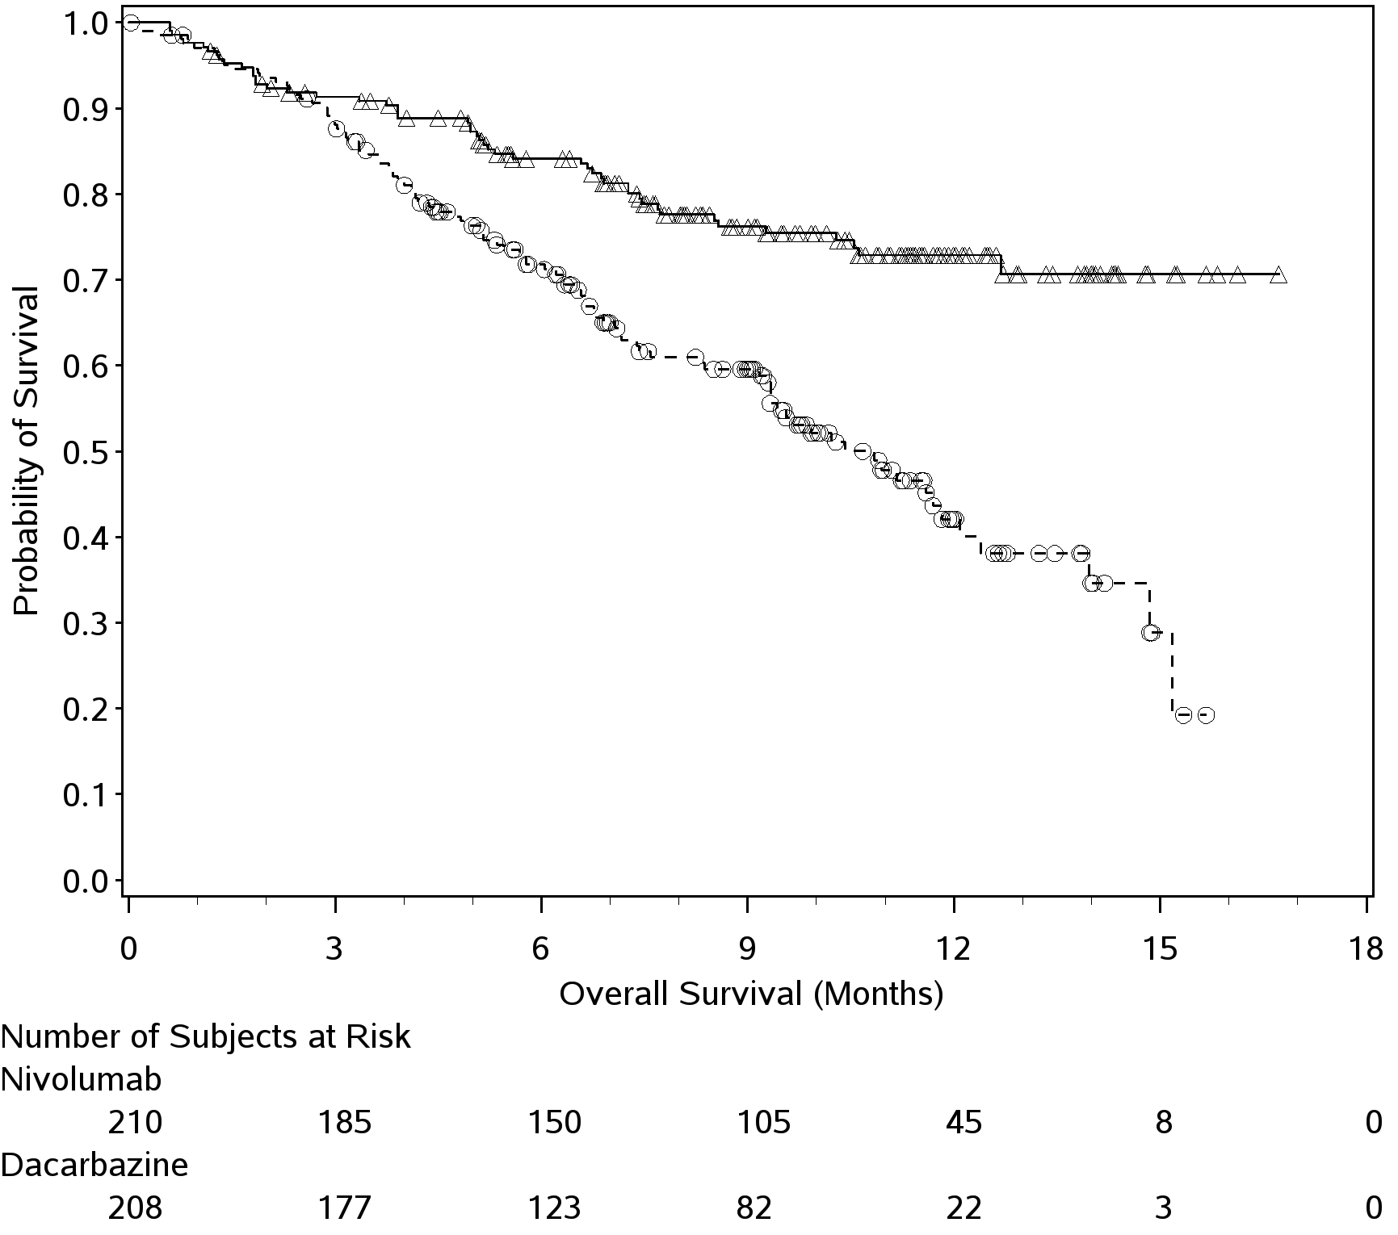
──∆─── Nivolumab (events: 50/210), median and 95% CI: N.A.
- - -- - - Dacarbazine (events: 96/208), median and 95% CI: 10.84 (9.33, 12.09)
Hazard Ratio (Nivolumab over Dacarbazine) and 95% CI (1): 0.42 (0.30, 0.60)
Hazard Ratio (Nivolumab over Dacarbazine) and 99.79% CI (1): 0.42 (0.25, 0.73)
Stratified log-rank p-value: <0.0001

OPDIVO also resulted in statistically significant improvement in PFS compared with dacarbazine (HR=0.43 [95% CI: 0.34, 0.56]; p<0.0001, Figure 2). The median PFS was 5.1 months (95% CI: 3.48, 10.81) for OPDIVO and 2.2 months (95% CI: 2.10, 2.40) for dacarbazine. The estimated PFS rates at 6 months were 48% (95% CI: 40.8, 54.9) for OPDIVO and 18% (95% CI: 13.1, 24.6) for dacarbazine. The estimated PFS rate at 12 months was 42% (95% CI: 34.0, 49.3) for OPDIVO.

Figure 2 Kaplan-Meier Curves of Progression-free Survival (CA209066)

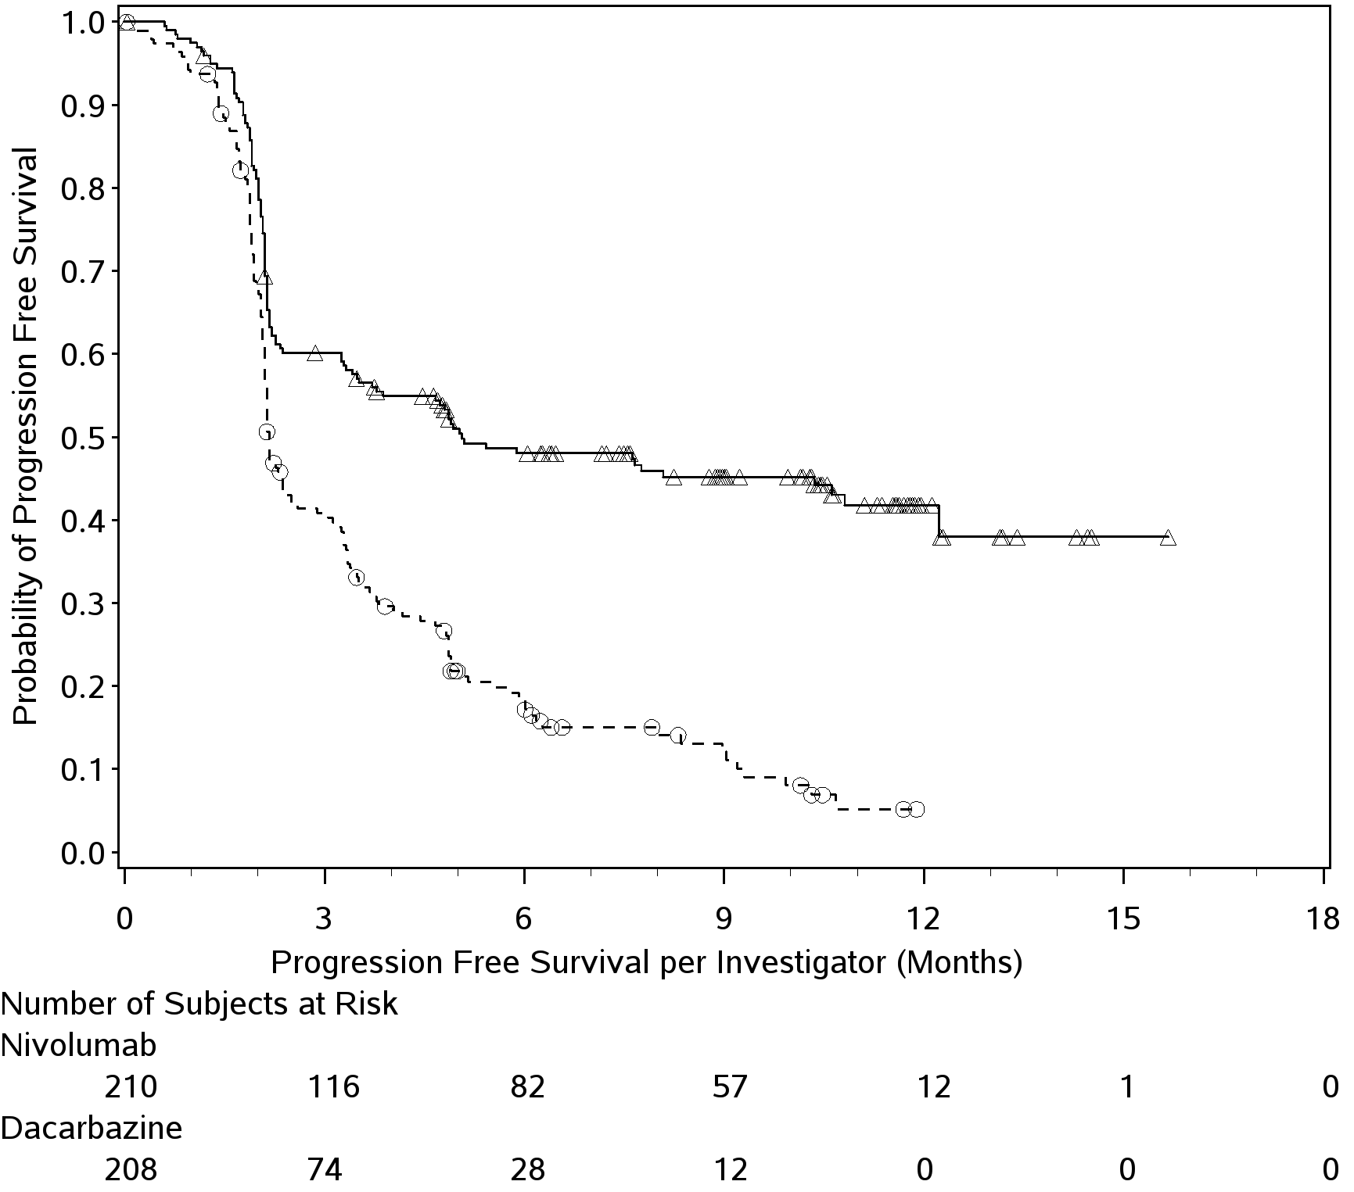
──∆─── Nivolumab (events: 108/210), median and 95% CI: 5.06 (3.48, 10.81).
- - -- - - Dacarbazine (events: 163/208), median and 95% CI: 2.17 (2.10, 2.40)
Hazard Ratio (Nivolumab over Dacarbazine) and 95% CI (1): 0.43 (0.34, 0.56)
Stratified log-rank p-value: <0.0001

The investigator-assessed ORR by RECIST v1.1 criteria was 40% (84/210) for OPDIVO and 14% (29/208) for dacarbazine (odds ratio 4.06 [95% CI: 2.52, 6.54]: p-value <0.0001). Complete response (CR) was observed in 16 (8%) OPDIVO-treated patients and in 2 (1%) dacarbazine-treated patients. Stable disease (SD) was observed in 35 (17%) OPDIVO-treated patients and 46 (22%) dacarbazine-treated patients. Median duration of response was not reached for OPDIVO (range 0+ to 12.5+ months) and 6.0 months (range 1.1 to 10.0+) for dacarbazine. At the time of analysis, 82% (69/84) of OPDIVO-treated patients and 31% (9/29) of dacarbazine-treated patients had ongoing responses, which included 46 and 4 patients, respectively, with ongoing response of 6 months or longer. Median time to response was 2.1 months (range 1.2-7.6) for OPDIVO and 2.1 months (range 1.8-3.6) for dacarbazine.
In 54 OPDIVO-treated patients, treatment was continued beyond an initial investigator assessment of RECIST disease progression if the investigator determined the patient had sufficient ongoing clinical benefit and was tolerating therapy. Of these patients, 12 (22.2%) had target lesion reductions (> 30% compared to baseline).

Study CA209037. A randomised phase 3 study comparing OPDIVO monotherapy to chemotherapy in subjects with unresectable or metastatic melanoma following progression on anti-CTLA-4 therapy.

The safety and efficacy of OPDIVO 3 mg/kg as a single agent for the treatment of advanced (unresectable or metastatic) melanoma were evaluated in a phase 3, randomized, open-label study (CA209037). The study included adult patients who had progressed on or after ipilimumab and if BRAF V600 mutation positive had also progressed on or after BRAF kinase inhibitor therapy. Patients with active autoimmune disease, ocular melanoma, or a known history of prior ipilimumab-related high-grade (Grade 4 per CTCAE v4.0) adverse reactions except for resolved nausea, fatigue, infusion reactions, or endocrinopathies were excluded from the study.

Patients were randomized on a 2:1 basis to receive either OPDIVO administered intravenously over 60 minutes at 3 mg/kg every 2 weeks or chemotherapy. Chemotherapy consisted of the investigator’s choice of either dacarbazine (1000 mg/m² every 3 weeks) or carboplatin (AUC 6 every 3 weeks) and paclitaxel (175 mg/m² every 3 weeks). Tumour assessments were conducted 9 weeks after randomization and continued every 6 weeks for the first year and then every 12 weeks thereafter.

The co-primary efficacy outcome measures were confirmed objective response rate (ORR), as measured by independent radiology review committee (IRRC) using Response Evaluation Criteria in Solid Tumours (RECIST 1.1), and comparison of overall survival (OS) of OPDIVO to chemotherapy. Additional outcome measures included duration and timing of response.

A total of 405 patients were randomized to receive either OPDIVO (n = 272) or chemotherapy (n = 133). The median age was 60 years (range: 23-88). Sixty-four percent of patients were men and 98% were white. ECOG performance scores were 0 for 61% of patients and 1 for 39% of patients.The majority (75%) of patients had M1c stage disease at study entry. Seventy three percent of patients had cutaneous melanoma and 10% had mucosal melanoma. The number of prior systemic regimen received was 1 for 27% of patients, 2 for 51% of patients, and > 2 for 21% of patients. Twenty-two percent of patients were BRAF mutation positive and 50% of patients were PD-L1 positive. Sixty-four percent of patients had no prior clinical benefit (CR/PR or SD) on ipilimumab. Baseline characteristics were balanced between groups except for the proportions of patients who had a history of brain metastasis (19% and 13% in the OPDIVO group and chemotherapy group, respectively) and patients with LDH greater than ULN at baseline (51% and 35%, respectively).

At the time of this final ORR analysis, results from 120 OPDIVO-treated patients and 47 chemotherapy-treated patients who had a minimum of 6 months of follow-up were analyzed. Confirmed objective response by IRRC was reported in 38/120 OPDIVO-treated patients (ORR 31.7% [95% CI: 23.5, 40.8], Figure 3) and 5/47 chemotherapy-treated patients (ORR 10.6% [95% CI: 3.5, 23.1]). Complete response was achieved in 4 OPDIVO-treated patients and none of chemotherapy-treated patients. Partial response was achieved in 34 OPDIVO-treated patients and 5 chemotherapy-treated patients. The median time to response was 2.1 months (range: 1.6-7.4) for the OPDIVO group and 3.5 months (range: 2.1-6.1) for the chemotherapy group. The median duration of response was not reached for the OPDIVO group and 3.6 months for the chemotherapy group. Of the 38 OPDIVO-treated patients with a confirmed response, 33 were still in response at the time of analysis.

Objective responses to OPDIVO were observed in patients with or without BRAF mutation-positive melanoma. Of patients who received OPDIVO, the ORR in the BRAF mutation subgroup (n=26) was 23% (95% CI: 9.0, 43.6) and 34% (95% CI: 24.6, 44.5) in patients whose tumours were BRAF wild-type (n=94). Objective responses to nivolumab were observed regardless of whether PD-L1 expression was above or below a PD-L1 tumour membrane expression cut-off of 5% or 10%. However the role of the biomarker (PD-L1 expression) has not been fully elucidated.

Figure 3: Waterfall Plot of Best Reduction in Target Lesion following treatment with OPDIVO, Per IRRC (CA209037)

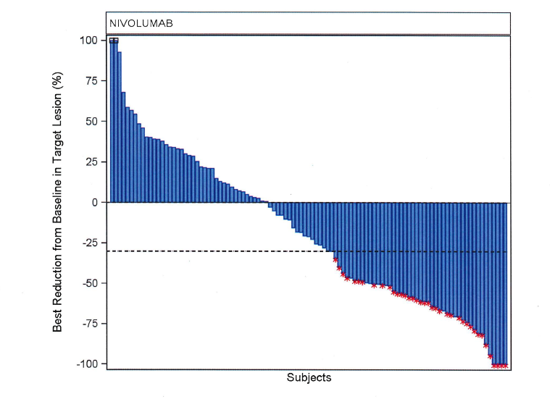
Note: Symbol (“*”) represents confirmed responders.

In 37 (31%) OPDIVO-treated patients, treatment was continued beyond an initial investigator assessment of RECIST disease progression if the investigator determined that the patient had sufficient ongoing clinical benefit and was tolerating therapy. Of these patients, 10 (27%) had target lesion reductions (>30% compared to baseline).

The OS data were not mature at the time of the PFS analysis. It is of note that 42 (31.6%) patients in the chemotherapy arm subsequently received an anti-PD1 treatment and the preliminary OS analysis was not adjusted for the potentially confounding effects of subsequent therapy. As a consequence there was no statistically significant difference between nivolumab and chemotherapy.

Study MDX1106-03. Open-label phase 1 dose-escalation study

The safety and tolerability of OPDIVO were investigated in a phase 1, open-label dose-escalation study in various tumour types, including malignant melanoma. Of the 306 patients enrolled in the study, 107 had melanoma and received OPDIVO at a dose of 0.1 mg/kg, 0.3 mg/kg, 1 mg/kg, 3 mg/kg, or 10 mg/kg for a maximum of 2 years. In this patient population, objective response was reported in 33 patients (31%) with a median duration of response of 22.9 months (95% CI: 17.0, NR). The median PFS was 3.7 months (95% CI: 1.9, 9.3). The median OS was 17.3 months (95% CI: 12.5, 36.7), and the estimated OS rates were 63% (95% CI: 53, 71) at 1 year, 48% (95% CI: 38, 57) at 2 years, and 41% (95% CI: 31, 51) at 3 years.

OPDIVO IN COMBINATION WITH YERVOY (ipilimumab)

Study CA209067 Randomised phase 3 study of nivolumab in combination with ipilimumab or nivolumab as monotherapy versus ipilimumab

The safety and efficacy of nivolumab in combination with ipilimumab and nivolumab monotherapy for the treatment of advanced (unresectable or metastatic) melanoma were evaluated in a phase 3, randomised, double-blind study (CA209067). The study included adult patients (18 years or older) with confirmed unresectable Stage III or Stage IV melanoma, regardless of PD-L1 expression. Patients were to have ECOG performance status score of 0 or 1. Patients who had not received prior systemic anticancer therapy for unresectable or metastatic melanoma were enrolled. Prior adjuvant or neoadjuvant therapy was allowed if it was completed at least 6 weeks prior to randomization. Patients with active autoimmune disease, ocular/uveal melanoma, or active brain or leptomeningeal metastases were excluded from the study.

A total of 945 patients were randomised to receive nivolumab in combination with ipilimumab (n = 314), nivolumab as monotherapy (n = 316), or ipilimumab alone (n = 315). Patients in the combination arm received nivolumab 1 mg/kg over 60 minutes and ipilimumab 3 mg/kg over 90 minutes administered intravenously every 3 weeks for the first 4 doses, followed by nivolumab 3 mg/kg as monotherapy every 2 weeks. Patients in the nivolumab monotherapy arm received nivolumab 3 mg/kg every 2 weeks. Patients in the comparator arm received ipilimumab 3 mg/kg and nivolumab-matched placebo intravenously every 3 weeks for 4 doses followed by placebo every 2 weeks. Randomisation was stratified by PD-L1 expression (≥5% vs. <5% tumor cell membrane expression), BRAF status, and M stage per the American Joint Committee on Cancer (AJCC) staging system. Treatment was continued as long as clinical benefit was observed or until treatment was no longer tolerated. Tumor assessments were conducted 12 weeks after randomization then every 6 weeks for the first year, and every 12 weeks thereafter. The co-primary outcome measures were progression-free survival and OS. ORR and the duration of response were also assessed. This study evaluated whether PD-L1 expression was a predictive biomarker for the co-primary endpoints. The efficacy of nivolumab in combination with ipilimumab and nivolumab monotherapy was each compared with that of ipilimumab. In addition, the differences between the two OPDIVO-containing groups were evaluated descriptively, but not included in formal hypothesis testing.

Baseline characteristics were balanced across the three treatment groups. The median age was 61 years (range: 18 to 90 years), 65% of patients were men, and 97% were white. ECOG performance status score was 0 (73%) or 1 (27%). The majority of the patients had AJCC Stage IV disease (93%); 58% had M1c disease at study entry. Twenty-two percent of patients had received prior adjuvant therapy. Thirty-two percent of patients had BRAF mutation-positive melanoma; 26.5% of patients had PD-L1 ≥5% tumour cell membrane expression. Four percent of patients had a history of brain metastasis, and 36% of patients had a baseline LDH level greater than ULN at study entry.

Median duration of follow up was approximately 12 months. Overall survival was not mature at time of this analysis. Efficacy results are shown in Table 1 and Figure 4.

Table 1: Efficacy results (CA209067)

 | OPDIVO  (n=316) | OPDIVO +  Ipilimumab  (n=314) | Ipilimumab  (n=315)
Progression-free survival
Events, n (%) | 174 (55%) | 151 (48%) | 234 (74%)
Hazard ratio (vs. ipilimumab)  (99.5% CI) | 0.57  (0.43, 0.76) | 0.42  (0.31, 0.57)
p-value | p<0.0001 | p<0.0001
Hazard ratio (vs. nivolumab monotherapy)  (95% CI) |  | 0.74  (0.60, 0.92)
Median  (95% CI) | 6.9 months  (4.3, 9.5) | 11.5 months  (8.9, 16.7) | 2.9 months  (2.8, 3.4)
Rate (95% CI)
At 6 months | 0.52 (0.46, 0.57) | 0.62 (0.52, 0.67) | 0.29 (0.24, 0.34)
At 9 months | 0.45 (0.40, 0.51) | 0.56 (0.50, 0.61) | 0.21 (0.17, 0.26)
Objective response | 138 (44%) | 181 (58%) | 60 (19%)
(95% CI) | (38.1,49.3) | (52.0, 63.2) | (14.9, 23.8)
Odds ratio (vs ipilimumab) | 3.40 | 6.11
(95% CI) | (2.02, 5.72) | (3.59, 10.38)
p-value | p<0.0001 | p<0.0001
Complete response (CR) | 28 (9%) | 36 (11%) | 7 (2%)
Partial response (PR) | 110 (35%) | 145 (46%) | 53 (17%)
Stable disease (SD) | 34 (11%) | 41 (13%) | 69 (22%)

Figure 4 Progression-free Survival: Unresectable or Metastatic Melanoma (Study CA209067)

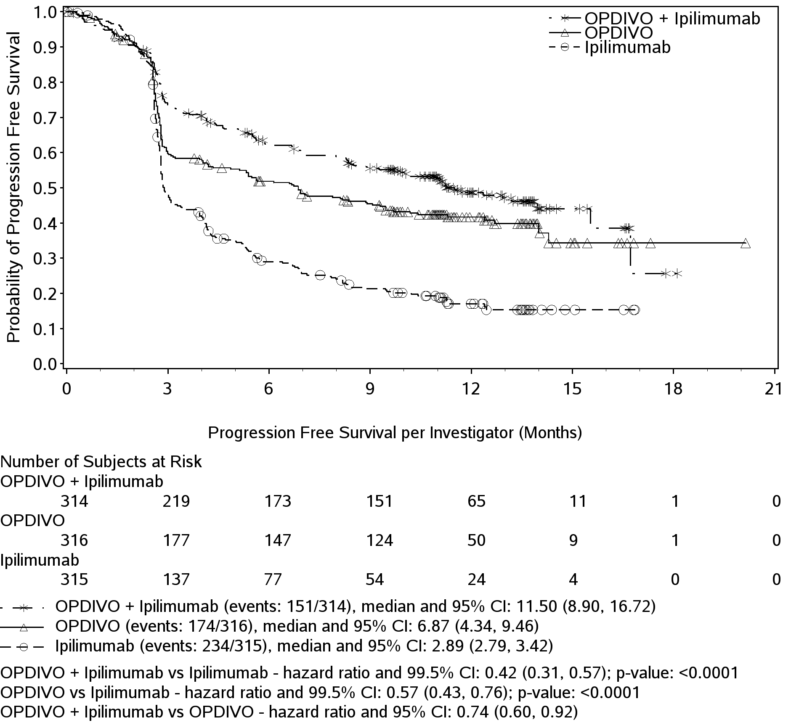
At the time of this analysis, 76% (138/181) of responding patients randomized to nivolumab in combination with ipilimumab and 78% (107/131) of responding patients randomized to nivolumab monotherapy had ongoing responses, which included 123 patients and 93 patients, respectively, with durable responses of 6 months or longer. Responses were observed within the first 3 months for 94 of the 181 patients with an objective response to nivolumab in combination with ipilimumab and 69 of the 138 patients with an objective response to nivolumab monotherapy. The observed PFS and ORR results for nivolumab in combination with ipilimumab and nivolumab monotherapy were consistently demonstrated across subgroups of patients including baseline ECOG performance status, BRAF status, M stage, age, history of brain metastases, and baseline LDH level.
Patients in the nivolumab in combination with ipilimumab and the nivolumab monotherapy arms had a median reduction in tumor volume of 52% and 35%, respectively, while patients in the ipilimumab arm had a median increase in tumor volume of 6%.
Among 120 patients who discontinued nivolumab in combination with ipilimumab due to adverse reaction, median PFS was 11.7 months (95% CI: 9.92, 16.72), and the ORR was 68% (81/120) with 15% (18/120) achieving a complete response.
Efficacy in Stage IV metastatic melanoma by M-stage status.
The majority of the patients had AJCC Stage IV disease (93%, n=881); of these patients, 63% (n=559) had M1c disease and 37% (n=322) had M1a/M1b disease at study entry.
The combination of nivolumab and ipilimumab demonstrated longer PFS over nivolumab monotherapy in Stage IV patients (HR 0.75; 95% CI: 0.60, 0.94) and ipilimumab monotherapy (HR 0.43; 95% CI: 0.35, 0.54) (Table 2).
In addition, a higher objective response rate (ORR) was reported in Stage IV patients randomized to the combination (57.2%; 95% CI: 51.4, 62.9) than to nivolumab monotherapy (42.6%; 95% CI: 36.9, 48.5) and ipilimumab monotherapy (18.1%; 95% CI 13.9, 23.0) (Table 3).

Table 2: Stage IV Pre-defined Subgroup Analysis on Progression Free Survival across all treatment groups in Study CA209067.

 |  |  | Nivolumab + Ipilimumab |  | Nivolumab |  | Ipilimumab
AJCC Stage at Study Entry | N |  | N of Events (N of Patients) | mPFS  (95% CI) | N of Events (N of Patients) | mPFS  (95% CI) | N of Events (N of Patients) | mPFS  (95% CI)
Stage IV | 881 |  | 143 (297) | 11.27  (8.51, 15.54) | 162 (291) | 6.87  (4.21, 9.46) | 217 (293) | 2.86  (2.79, 3.48)
M1c |  | 559 | 100 (185) | 8.51 (5.52, 12.35) | 111 (185) | 5.39 (2.83, 8.87) | 142 (189) | 2.79 (2.73, 2.83)

Table 3: Stage IV Pre-defined Subgroup Analysis on Objective Response Rate across all treatment groups in Study CA209067.

 |  |  | Nivolumab + Ipilimumab |  | Nivolumab |  | Ipilimumab
AJCC Stage at Study Entry | N |  | N of Response (N of Patients) | ORR (95% CI) | N of Response (N of Patients) | ORR  (95% CI) | N of Response (N of Patients) | ORR  (95% CI)
Stage IV | 881 |  | 170 (297) | 57.2%  (51.4, 62.9) | 124 (291) | 42.6%  (36.9, 48.5) | 53 (293) | 18.1%  (13.9, 23.0)
M1c |  | 559 | 95 (185) | 51.4% (43.9, 58.8) | 72 (185) | 38.9% (31.9, 46.3) | 27 (189) | 14.3% (9.6, 20.1)

The safety of the combination of nivolumab and ipilimumab in patients with M1c disease was consistent with that in all randomized patients.

Efficacy by elevated LDH .
Three hundred forty-one patients (36%) had a baseline LDH level greater than ULN. In this population, the median PFS was 4.2 months (95% CI: 2.79, 9.26) in the nivolumab in combination with ipilimumab arm, 2.8 months (95% CI: 2.63, 4.04) in the nivolumab monotherapy arm and 2.63 months (95% CI: 2.60, 2.76) in the ipilimumab arm (Table 4).
The ORR was 44.7% (95% CI: 35.4, 54.3), 30.4% (95% CI: 22.0, 39.8) and 9.6% (95% CI: 4.9, 16.5) in the nivolumab in combination with ipilimumab, nivolumab monotherapy and ipilimumab monotherapy arms respectively (Table 5).

Table 4: Elevated LDH Pre-defined Subgroup Analysis on Progression Free Survival across all treatment groups in Study CA209067.

 |  | Nivolumab + Ipilimumab |  | Nivolumab |  | Ipilimumab
LDH | N | N of Events (N of Patients) | mPFS  (95% CI) | N of Events (N of Patients) | mPFS  (95% CI) | N of Events (N of Patients) | mPFS  (95% CI)
>ULN | 341 | 69 (114) | 4.21 (2.79, 9.26) | 73 (112) | 2.79 (2.63, 4.04) | 93(115) | 2.63 (2.60, 2.76)

Table 5: Elevated LDH Pre-defined Subgroup Analysis on Objective Response Rate across all treatment groups in Study CA209067.

 |  | Nivolumab + Ipilimumab |  | Nivolumab |  | Ipilimumab
LDH | N | N of Events (N of Patients) | ORR  (95% CI) | N of Events (N of Patients) | ORR  (95% CI) | N of Events (N of Patients) | ORR  (95% CI)
>ULN | 341 | 51 (114) | 44.7% (35.4, 54.3) | 34 (112) | 30.4% (22.0, 39.8) | 11(115) | 9.6% (4.9, 16.5)

Efficacy by BRAF status: BRAF [V600] mutation-positive and BRAF wild-type patients randomized to nivolumab in combination with ipilimumab had a median PFS of 11.73 months (95% CI 8.02, NA) and 11.24 months (95% CI: 8.34, NA), respectively, while those randomized to nivolumab monotherapy had a median PFS of 5.62 months (95% CI: 2.79, 9.46) and 7.89 months (95% CI: 4.86, 12.68), respectively. Regardless of the BRAF mutation status, median PFS of both nivolumab in combination with ipilimumab and nivolumab monotherapy was greater than with ipilimumab. ORR results by BRAF status are shown in Table 6.

Table 6 Objective Response by BRAF [V600]-Mutation Status (CA209067)

 | BRAF [V600] Mutation-Positive |  |  | BRAF Wild-Type
Treatment | Number of Responses/Patients | ORR%  [95% CI] | Number of Responses/Patients |  | ORR%  [95% CI]
OPDIVO + Ipilimumab | 68/102 | 66.7  (56.6, 75.7) | 113/212 |  | 53.3  (46.3, 60.2)
OPDIVO | 36/98 | 36.7  (27.2, 47.1) | 102/218 |  | 46.8  (40.0, 53.6)
Ipilimumab | 22/100 | 22.0  (14.3, 31.4) | 38/215 |  | 17.7  (12.8, 23.4)

Efficacy by PD-L1 Expression: Baseline tumor tissue specimens were systematically collected prior to randomisation in order to conduct planned analyses of efficacy according to PD-L1 expression. Quantifiable PD-L1 expression was measured in 89% (278/314) of patients randomised to nivolumab in combination with ipilimumab, 91% (288/316) of patients randomised to nivolumab monotherapy, and 88% (277/315) of patients randomised to ipilimumab alone. Among patients with quantifiable PD-L1 expression, the distribution of patients was balanced across the three treatment groups at each of the predefined PD-L1 expression levels of ≥1% (56% in the nivolumab in combination with ipilimumab arm, 59% in the nivolumab monotherapy arm, and 59% in the ipilimumab arm) and ≥5% (24%, 28%, and 27%, separately). PD-L1 expression was determined using the PD-L1 IHC 28-8 pharmDx assay.

In patients with low or no PD-L1 expression (based on the predefined expression level of <5%), nivolumab in combination with ipilimumab (HR 0.42, 95% CI: 0.32, 0.54) and nivolumab monotherapy (HR 0.59, 95% CI: 0.47, 0.75) demonstrated significant improvements in PFS compared with ipilimumab alone. Nivolumab in combination with ipilimumab demonstrated a greater improvement in PFS than nivolumab monotherapy. In patients with ≥5% PD-L1 expression, a significant improvement in PFS relative to ipilimumab was also observed for both nivolumab in combination with ipilimumab (HR 0.39, 95% CI: 0.25, 0.62) and nivolumab monotherapy (HR 0.41, 95% CI: 0.26, 0.63). The improvement in PFS was similar between nivolumab in combination with ipilimumab and nivolumab monotherapy. Results are shown in Figures 5 and 6.

Figure 5 PFS: Patients with PD-L1 expression < 5% (CA209067)

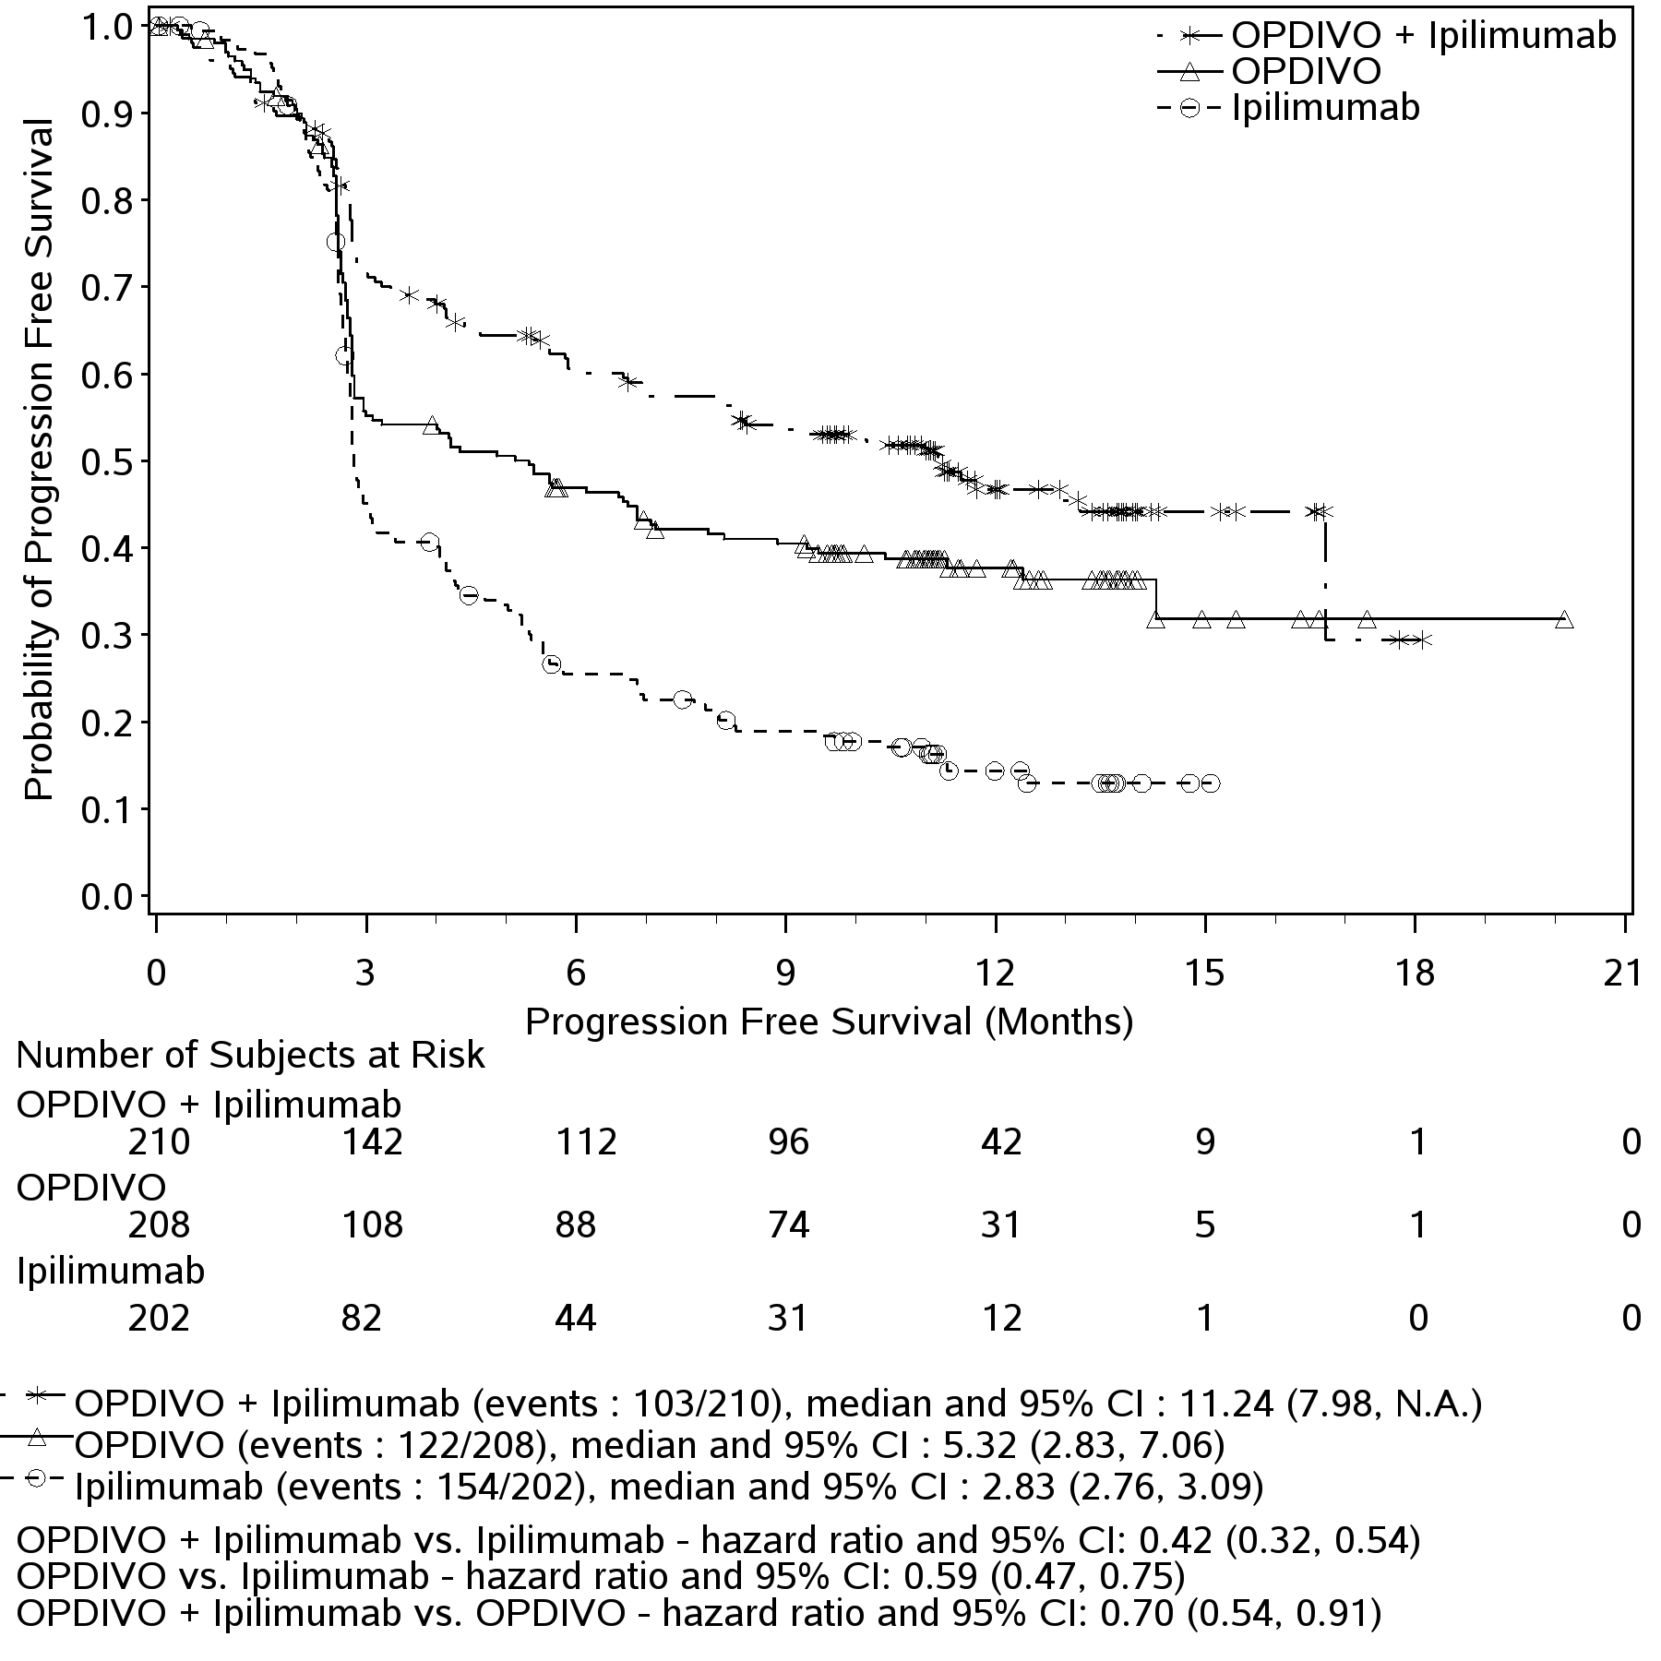

Figure 6 PFS: Patients with PD-L1 expression ≥ 5% (CA209067)

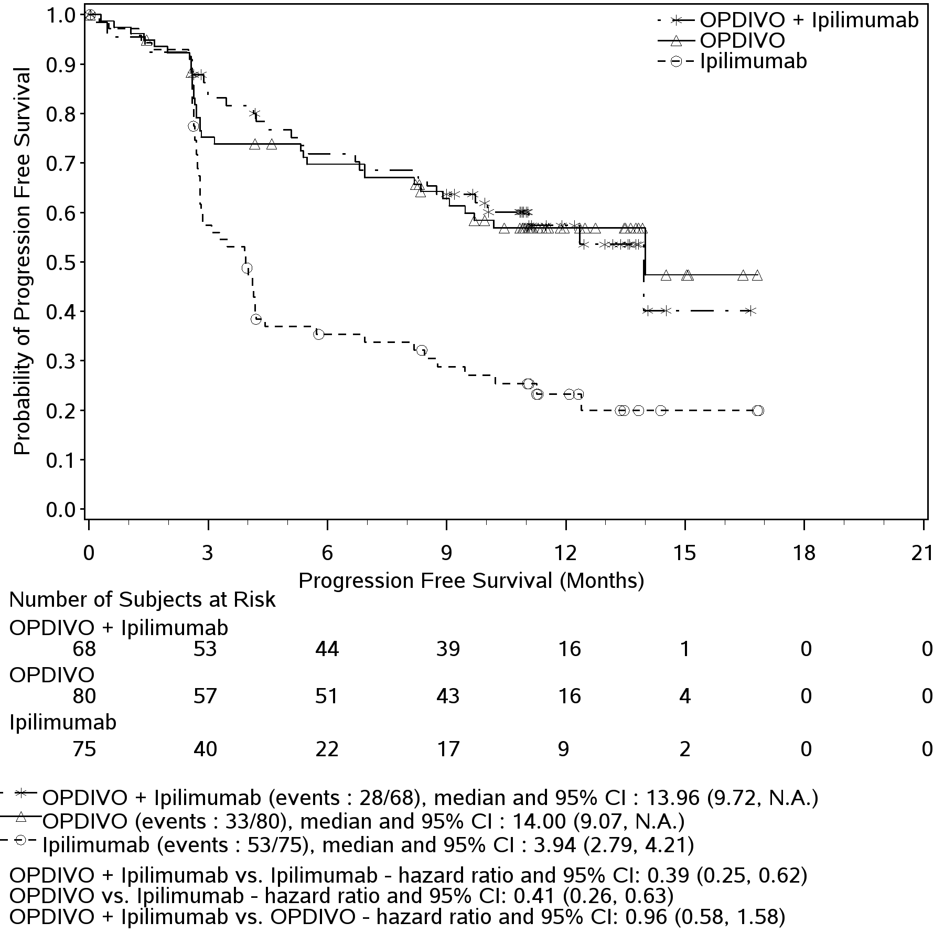

Table 7 shows the objective response rates in CA209067 based on PD-L1 expression level. Both nivolumab in combination with ipilimumab and nivolumab monotherapy demonstrated greater objective response rates than ipilimumab regardless of PD-L1 expression levels of 1% or 5%. Nivolumab in combination with ipilimumab demonstrated greater objective response rates than nivolumab monotherapy regardless of PD-L1 expression levels of 1% or 5%.

Table 7: Objective Response by PD-L1 Expression (CA209067)

 | PD-L1 Expression Level | Number. of Patients | ORR
Treatment | PD-L1 Expression Level | Number. of Patients | % | [95% CI]
OPDIVO +Ipilimumab | ≥5% | 68 | 72% | (59.9, 82.3)
OPDIVO +Ipilimumab | <5% | 210 | 55% | (47.8, 61.6)
OPDIVO +Ipilimumab | ≥1% | 155 | 65% | (56.4, 72.0)
OPDIVO +Ipilimumab | <1% | 123 | 52% | (42.8, 61.1)
OPDIVO | ≥5% | 80 | 58% | (45.9, 68.5)
OPDIVO | <5% | 208 | 41% | (34.6, 48.4)
OPDIVO | ≥1% | 171 | 54% | (46.6, 62.0)
OPDIVO | <1% | 117 | 33% | (24.9, 42.6)
Ipilimumab | ≥5% | 75 | 21% | (12.7, 32.3)
Ipilimumab | <5% | 202 | 18% | (12.8, 23.8)
Ipilimumab | ≥1% | 164 | 19% | (13.2, 25.7)
Ipilimumab | <1% | 113 | 19% | (11.9, 27.0)

As compared to the overall study population, no meaningful differences in safety were observed based on BRAF status or PD-L1 expression level.

Study CA209069. A randomized, phase 2 study of OPDIVO in combination with ipilimumab vs ipilimumab alone in subjects with previously untreated, unresectable or metastatic melanoma

The safety and efficacy of nivolumab in combination with ipilimumab, compared with ipilimumab alone, for the treatment of advanced (unresectable or metastatic) melanoma were evaluated in a phase 2, randomised, double-blind study (CA209069). Key eligibility criteria were similar to those in CA209067. Patients were enrolled regardless of PD-L1 expression. Patients in the combination arm received nivolumab 1 mg/kg and ipilimumab 3 mg/kg intravenously every 3 weeks for the first 4 doses, followed by nivolumab 3 mg/kg as a single agent every 2 weeks. Patients in the comparator arm received ipilimumab 3 mg/kg alone and nivolumab-matched placebo intravenously every 3 weeks for 4 doses followed by placebo every 2 weeks. The primary efficacy outcome measure is ORR, as determined by investigator, in patients with BRAF wild-type unresectable or metastatic melanoma using RECIST 1.1. Magnitude of tumor reduction and duration of response were also assessed. Additional outcome measures were progression-free survival (PFS) in patients with BRAF wild-type melanoma, ORR and PFS in patients with BRAF mutation-positive melanoma, and Health Related Quality of Life (HRQoL) as assessed by the European Organization for Research and Treatment of Care (EORTC) QLQ-C30. OS was also assessed as an exploratory endpoint.
A total of 142 patients were randomized: 95 to nivolumab in combination with ipilimumab and 47 to ipilimumab. The baseline study population characteristics were generally balanced between treatment groups except for history of brain metastasis (4% in the nivolumab in combination with ipilimumab arm and none in the ipilimumab arm), acral/mucosal melanoma (8% and 21%, respectively), and cutaneous melanoma (84% and 62%, respectively). Seventy-seven percent of patients had BRAF wide-type melanoma and 23% of patients had BRAF mutation positive melanoma. Minimum follow up was 11 months.
Efficacy results in BRAF wild-type melanoma are presented in Table 8 and Figure 7.
Table 8: Efficacy results in BRAF wild-type melanoma (CA209069)
Endpoint | OPDIVO  +Ipilimumab  (n=72) | Ipilimumab  (n=37)
Objective Response Rate (95% CI) | 44 (61%)  (48.9, 72.4) | 4 (11%)  (3.0, 25.4)
Odds Ratio (95% CI) | 12.96 (3.91, 54.49)
P-value | <0.0001
CR, n (%) | 16 (22%) | 0
PR, n (%) | 28 (39%) | 4 (11%)
SD, n (%) | 9 (13%) | 13 (35%)
Duration of Response (months)
Median (range) | Not reached (0.0⁺-12.1⁺) | Not reached (6.9-9.8⁺)
Progression-free Survival
Number of Events (%) | 30 (42%) | 25 (68%)
Hazard Ratio (95% CI) | 0.40 (0.23, 0.68)
p-value | 0.0006
Median PFS (months) (95% CI) | Not reached | 4.4 months  (2.8, 5.8)
Rate (95% CI)
At 6 months | 68% (55, 77) | 31% (16, 47)
At 12 months | 55% (42, 66) | 22% (9, 39)
OSª
Number of Events (%) | 15 (21%) | 14 (38%)
Hazard Ratio (95% CI) | 0.54 (0.26, 1.11)
Median OS (months) (95% CI) | Not reached | Not reached
OS Rate at 6 months (95% CI) | 83% (72, 90) | 73% (56, 84)
OS Rate at 12 months (95% CI) | 79% (67, 87) | 64% (46, 77)
ª Exploratory endpoint
Overall Survival (OS) was an exploratory endpoint, therefore not powered to demonstrate improvement. Furthermore, patients who progressed on the control arm were permitted, by design, to crossover to receive nivolumab monotherapy further complicating the interpretation of the OS endpoint.

Figure 7: Progression-free Survival in BRAF Wild-Type Previously Untreated, Unresectable or Metastatic Melanoma (CA209069)

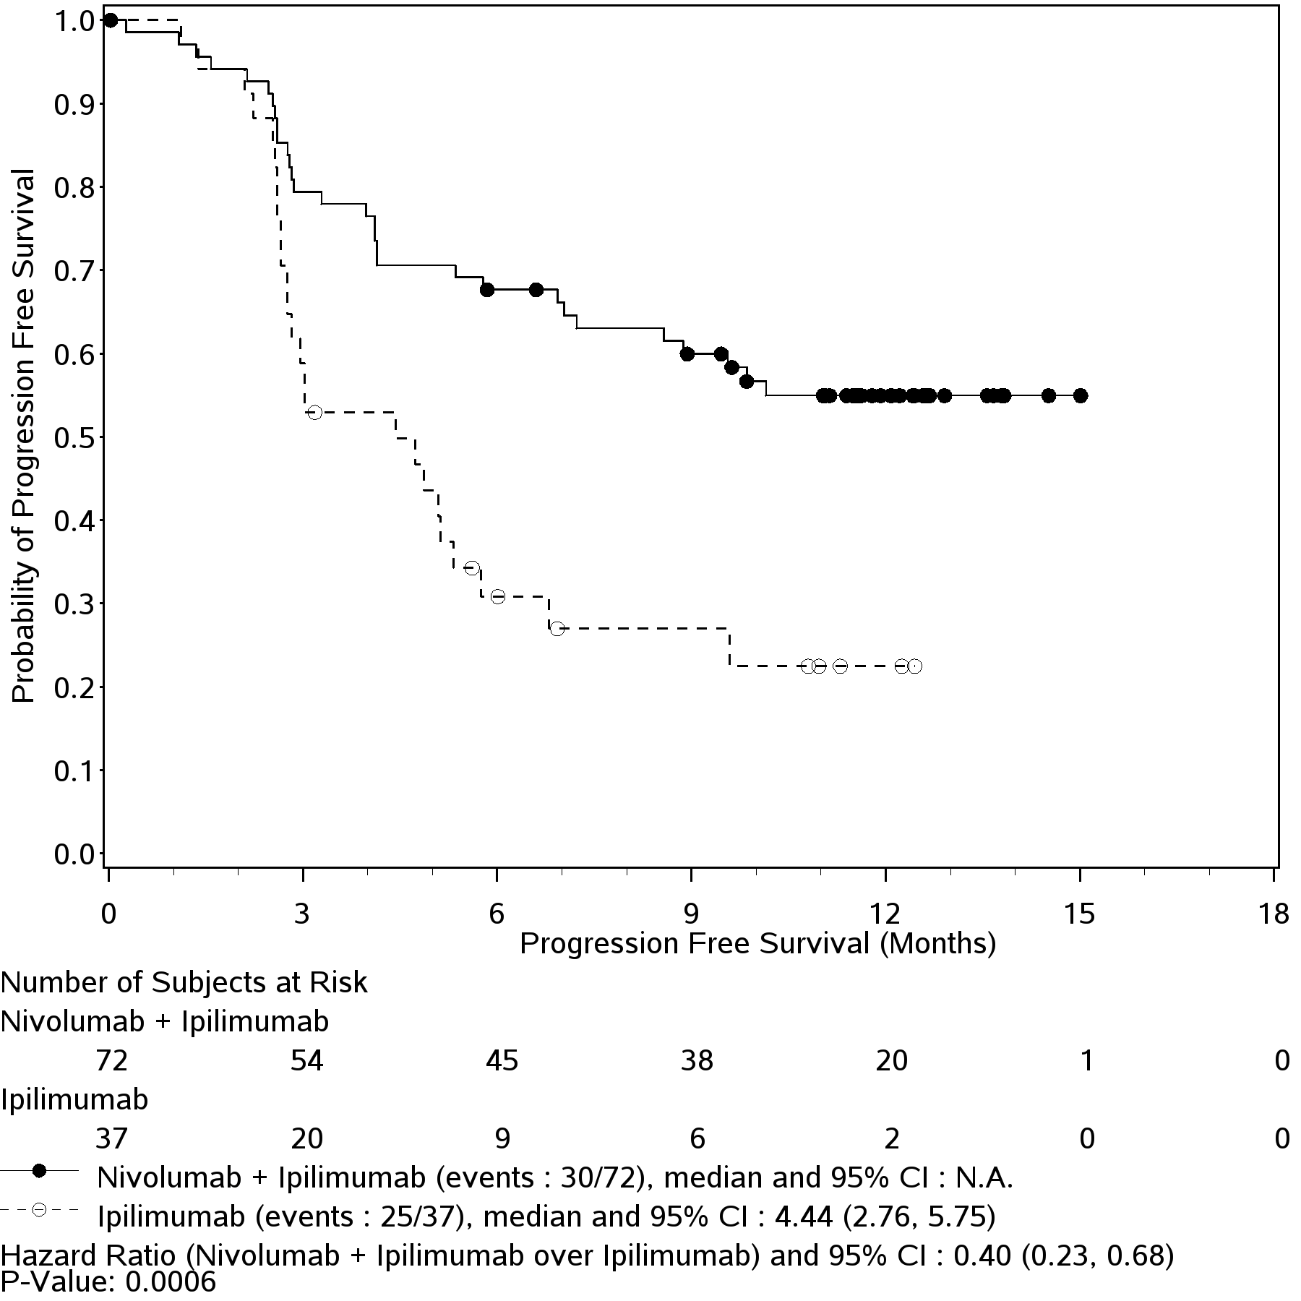
Among the 44 BRAF wild-type patients randomized to OPDIVO in combination with ipilimumab who had an objective response, 38 (86%) had their responses within the first 3 months and 36 (82%) had ongoing responses at the time of analysis. Patients randomized to OPDIVO in combination with ipilimumab had a median reduction in tumor volume of 68% while patients treated with ipilimumab alone had a median increase of 5%.
Among 38 patients with BRAF wild-type melanoma who discontinued OPDIVO in combination with ipilimumab due to adverse reaction, the confirmed ORR was 71% (27/38) with 26% (10/38) achieving a complete response. The ORR result was consistently demonstrated across subgroups of patients (M stage, AJCC State, age, gender, race, baseline ECOG performance status, history of brain metastases, and baseline LDH).
Results for patients with BRAF mutation-positive melanoma were consistent with the primary analyses in patients with BRAF wild-type melanoma. Among 23 patients with BRAF mutation-positive melanoma randomized to OPDIVO in combination with ipilimumab, ORR was 52% (95% CI: 30.6, 73.2); 5 complete responses and 7 partial responses).
The median PFS was 8.5 months (95% CI: 2.79, NA) in patients randomized to OPDIVO in combination with ipilimumab and 2.7 months (95% CI: 0.99, 5.42) in patients randomized to ipilimumab alone (HR 0.38, 95% CI: 0.15, 1.00).
Responses to OPDIVO in combination with ipilimumab were observed across levels of PD-L1 tumour membrane expression.
Treatment with OPDIVO in combination with ipilimumab was not associated with clinically significant deterioration in quality of life as measured by the EORTC-QLQ-C30.

SQUAMOUS NON SMALL CELL LUNG CANCER (SQ NSCLC)

Study CA209017. An Open-label Randomized Phase 3 Trial of Nivolumab versus Docetaxel in Previously Treated Advanced or Metastatic Squamous Non-small Cell Lung Cancer (SQ NSCLC).
The safety and efficacy of nivolumab 3 mg/kg as a single agent for the treatment of advanced or metastatic squamous NSCLC were evaluated in a phase 3, randomized, open-label study (CA209017). The study included patients (18 years or older) who have experienced disease progression during or after one prior platinum doublet-based chemotherapy regimen. Patients were enrolled regardless of their PD-L1 status. Patients with active autoimmune disease, symptomatic interstitial lung disease, or untreated brain metastasis were excluded from the study. Patients with treated brain metastases were eligible if neurologically returned to baseline at least 2 weeks prior to enrolment, and either off corticosteroids, or on a stable or decreasing dose of <10 mg daily prednisone equivalents.

Patients were randomized on a 1:1 basis to receive either nivolumab 3 mg/kg administered intravenously over 60 minutes every 2 weeks or docetaxel 75 mg/m² every 3 weeks. Treatment was continued as long as clinical benefit was observed or until treatment was no longer tolerated. Tumour assessments, according to the Response Evaluation Criteria in Solid Tumours (RECIST), version 1.1, were conducted 9 weeks after randomization and continued every 6 weeks thereafter. The primary efficacy outcome measure was overall survival (OS). Key secondary efficacy outcome measures were investigator-assessed objective response rate (ORR) and progression-free survival (PFS). In addition, symptom improvement and overall health status were assessed using the Lung Cancer Symptom Score (LCSS) average symptom burden index and the EQ-5D Visual Analogue Scale (EQ-VAS), respectively. At the pre-specified interim analysis conducted by an independent data monitoring committee, it was concluded that the study reached its primary endpoint, with nivolumab demonstrating superior OS over docetaxel (p=0.0002; stratified log-rank test). Based upon the committee’s recommendation, this study was declared to have met its primary OS endpoint.

A total of 272 patients were randomized to either nivolumab (n = 135) or docetaxel (n = 137). Eighty-two percent of the patients in the nivolumab group and 71% of the patients in the docetaxel group were men. The median age was 62 years (range: 39-85) in the nivolumab group and 64 years (range: 42-84) in the docetaxel group. The proportions of patients ≥65 years of age were 41% and 47%, respectively, and ≥75 years of age were 8% and 13%, respectively. Baseline Eastern Cooperative Oncology Group (ECOG) performance status was 0 in 20% of the patients in the nivolumab group and 27% of the patients in the docetaxel group, and 1 in 79% and 73% of patients, respectively. The other baseline characteristics were balanced between the two treatment groups. Among all randomized patients, 93% were white. Thirty-one percent had progressive disease reported as the best response to their most recent prior regimen and 45% received nivolumab within 3 months of completing their most recent prior regimen.

Nivolumab demonstrated a statistically significant improvement in OS compared with docetaxel, with a hazard ratio of 0.59 (96.85% CI: 0.43, 0.81; p=0.0002). Median OS was 9.2 months (95% CI: 7.3, 13.3) for nivolumab and 6.0 months (95% CI: 5.1, 7.3) for docetaxel. The estimated 1-year survival rate was 42% (95% CI: 33.7, 50.3) for nivolumab and 24% (95% CI: 16.9, 31.1) for docetaxel. At the pre-defined PD-L1 tumour membrane expression cutoff levels of 1%, 5%, and 10%, similar survival was observed regardless of PD-L1 expression status. OS results are shown in Figure 8. The observed OS benefit was consistently demonstrated across subgroups of patients, including patients ≥65 years of age (nivolumab n=56 and docetaxel n=64; HR 0.70; 95% CI: 0.46, 1.06) and <65 years of age (nivolumab n=79 and docetaxel n=73; HR 0.52; 95% CI:0.35, 0.75 ). Study CA209017 included a limited number of patients ≥ 75 years (11 in the nivolumab group and 18 in the docetaxel group). In these patients there was a numerical trend in the OS favouring docetaxel (HR 1.85; 95% CI: 0.76, 4.51). Because of the small sample size, no conclusions can be drawn on this population.

Figure 8: Kaplan-Meier curves of OS (CA209017)
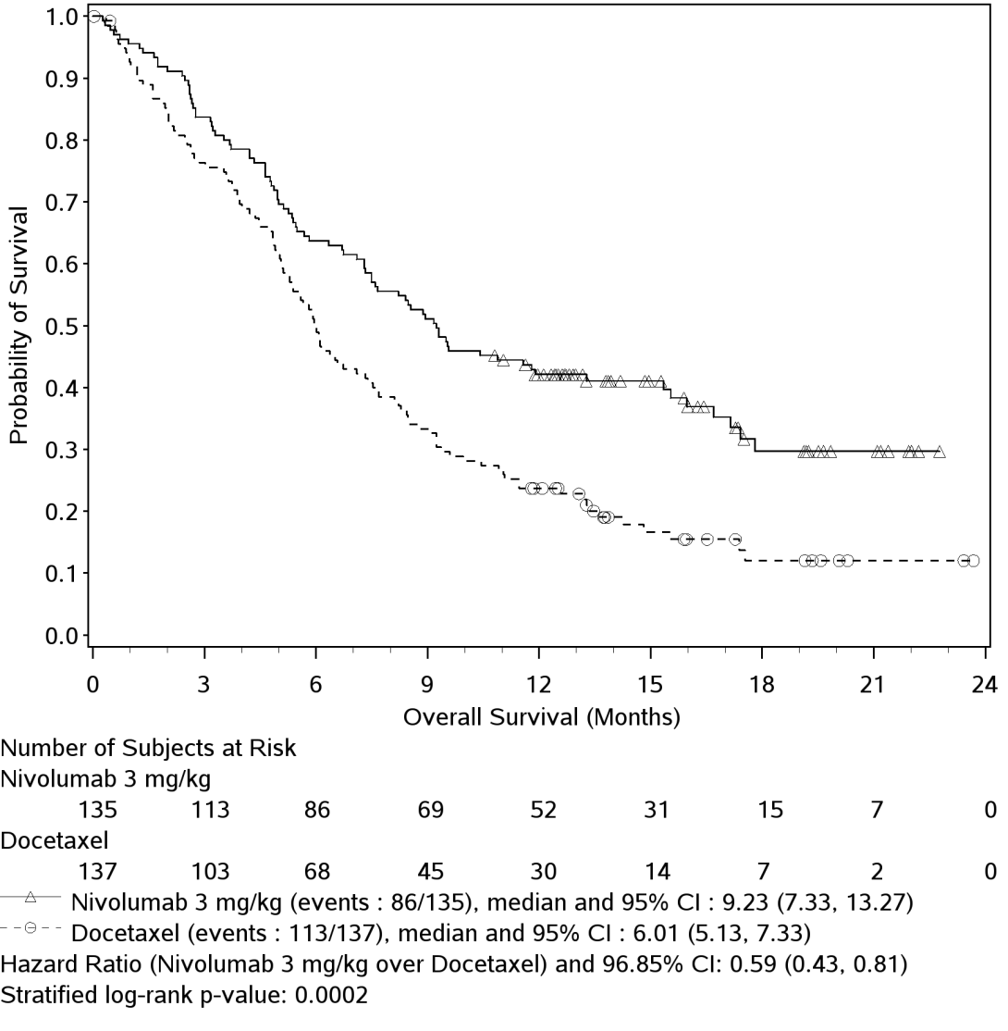

The investigator-assessed ORR using RECIST v1.1 criteria was significantly higher in the nivolumab group than in the docetaxel group (odds ratio: 2.64 [95% CI: 1.27, 5.49], p = 0.0083). Response rates, time to response, and duration of response are shown in Table 9.

Table 9: Best overall response, time and duration of response (CA209017)
 | nivolumab  (n = 135) |  | docetaxel  (n = 137)
Confirmed objective response | 27 | (20.0%) | 12 | (8.8%)
(95% CI) | (13.6, 27.7) |  | (4.6, 14.8)
Odds ratio (95% CI) | 2.64 (1.27, 5.49)
p-value | 0.0083
Complete response (CR) | 1 | (0.7%) | 0
Partial response (PR) | 26 | (19.3%) | 12 | (8.8%)
Stable disease (SD) | 39 | (28.9%) | 47 | (34.3%)
Median duration of response
Months (range) | Not reached | (2.9 - 20.5⁺) | 8.4 | (1.4⁺ - 15.2⁺)
Median time to response
Months (range) | 2.2 | (1.6 - 11.8) | 2.1 | (1.8 - 9.5)

Nivolumab treatment also demonstrated statistically significant improvement in PFS compared with docetaxel, with a hazard ratio of 0.62 (95% CI: 0.47, 0.81; p=0.0004) (Figure 9). Median PFS was 3.5 months (95% CI: 2.1, 4.9) for nivolumab and 2.8 months (95% CI: 2.1, 3.5) for docetaxel. The estimated PFS rates for nivolumab and docetaxel at 12 months were 20.8% (95% CI: 14.0, 28.4) and 6.4% (95% CI: 2.9, 11.8), respectively.
Figure 9: Kaplan-Meier curves of PFS (CA209017)
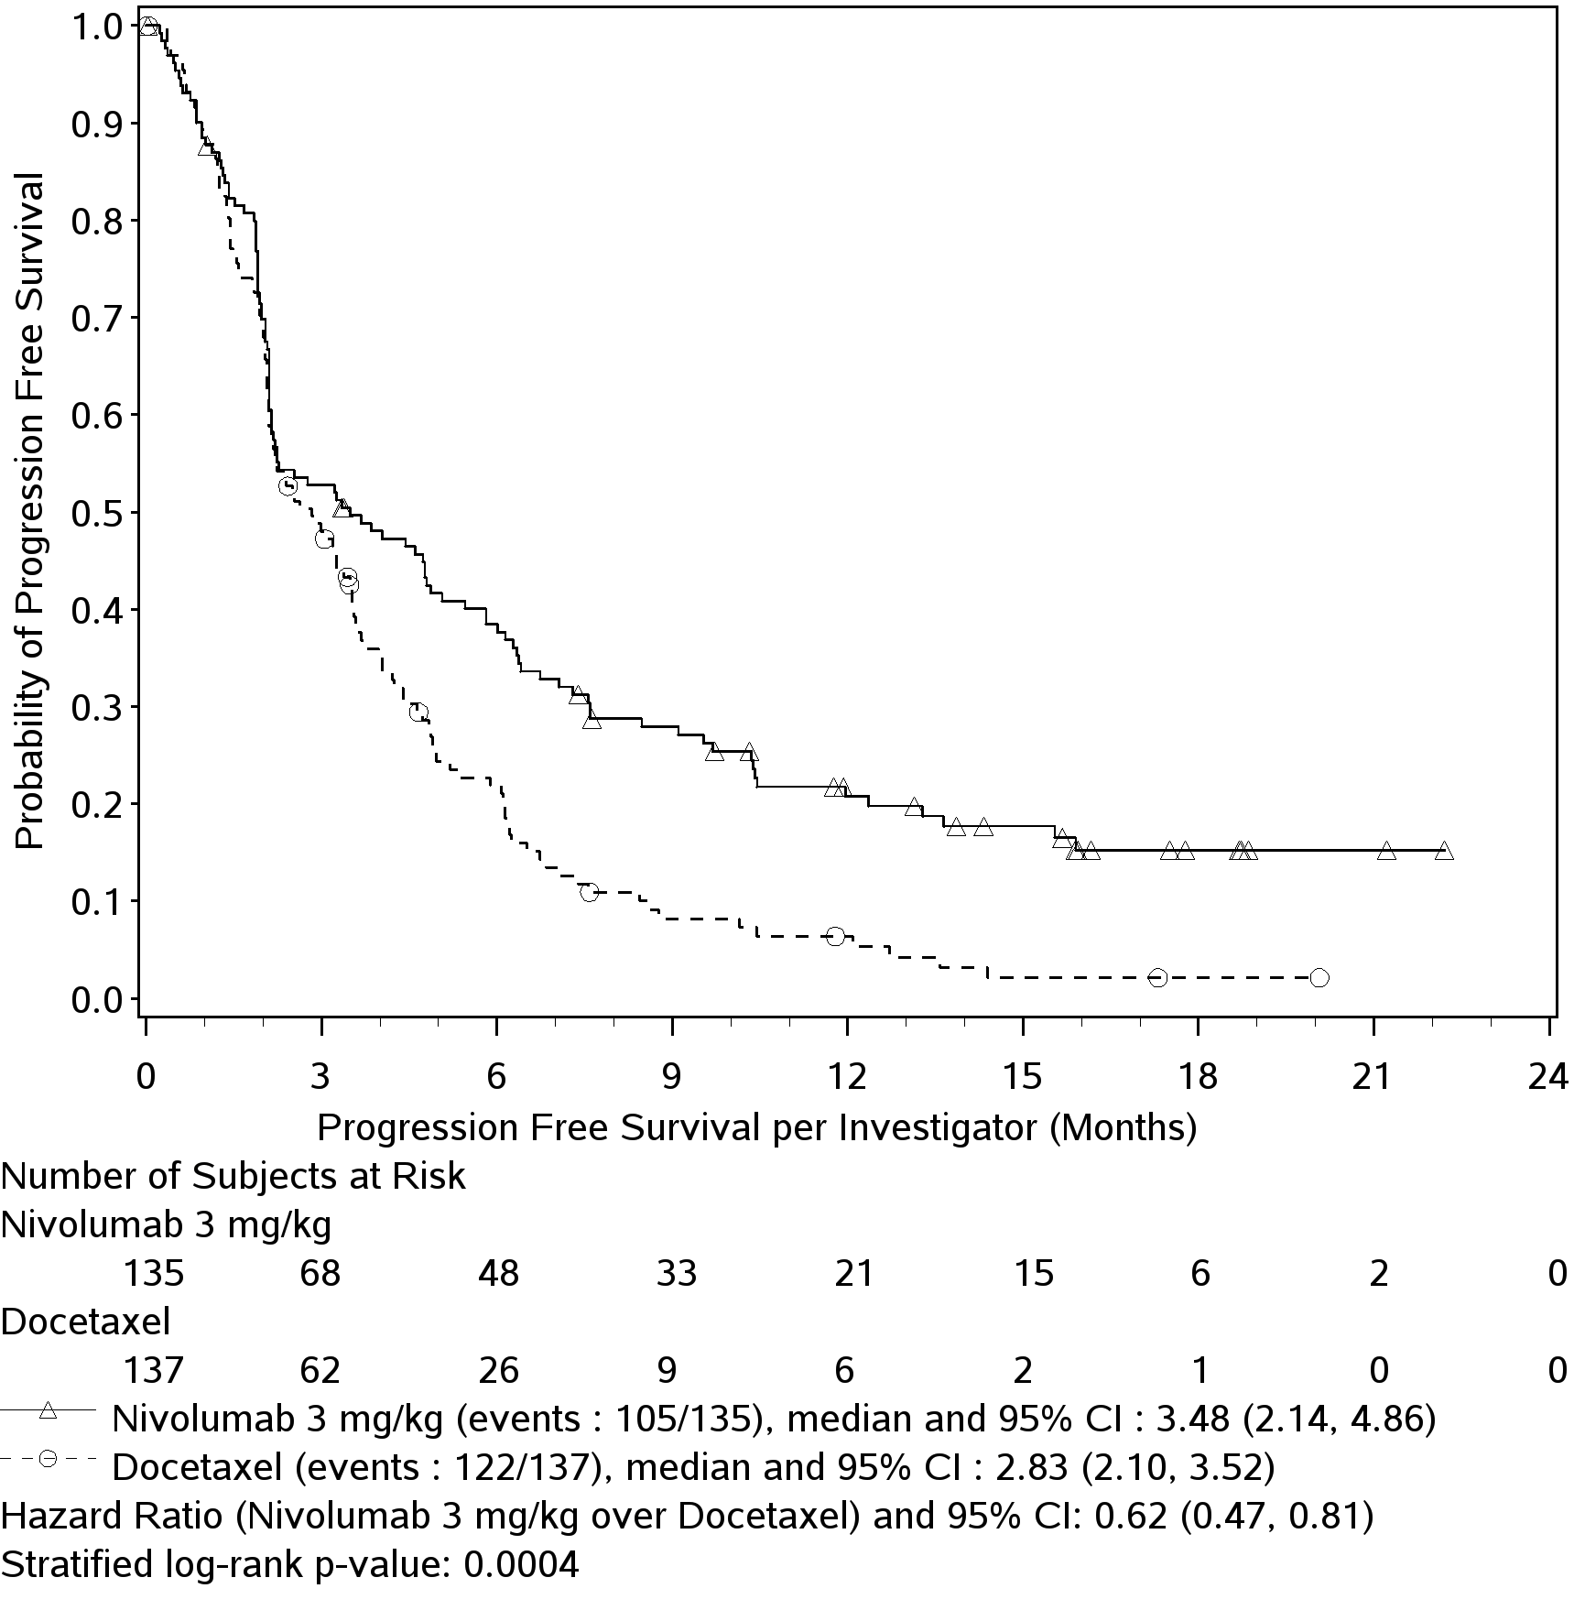
The rate of disease-related symptom improvement, as measured by LCSS, was similar between the nivolumab group (18.5%) and the docetaxel group (21.2%). The average EQ-VAS increased over time for both treatment groups, indicating better overall health status for patients remaining on treatment.

Study (CA209063). A Single-Arm Phase 2 Study of Nivolumab in Subjects with Advanced or Metastatic Squamous Cell Non-Small Cell Lung Cancer Who Have Received at Least Two Prior Systemic Regimens

The safety and efficacy of nivolumab 3 mg/kg as a single agent for the treatment of squamous NSCLC were evaluated in a phase 2, single-arm, multinational, multicenter study (CA209063). All patients had progressed after receiving a platinum doublet-based therapy and at least one additional systemic treatment regimen. Patients were enrolled regardless of their PD-L1 status. Patients with active autoimmune disease, symptomatic interstitial lung disease, or untreated brain metastasis were excluded from the study. Patients with treated brain metastases were eligible if neurologically returned to baseline at least 2 weeks prior to enrolment, and either off corticosteroids, or on a stable or decreasing dose of <10 mg daily prednisone equivalents.

Patients received 3 mg/kg of nivolumab administered intravenously over 60 minutes every 2 weeks as long as clinical benefit was observed or until treatment was no longer tolerated. Tumour assessments took place at week 8 and every 6 weeks thereafter. The primary efficacy outcome measure was confirmed ORR as assessed by an independent review committee (IRC) according to RECIST version 1. Duration and timing of responses were also assessed. Additional outcome measures included IRC-assessed PFS and OS.

A total of 117 patients received treatment with nivolumab 3 mg/kg. The median age of patients was 65 years (range: 37-87) with 50% ≥ 65 years of age and 14% ≥ 75 years of age. The majority of patients were male (73%) and white (85%). All patients received two or more prior systemic treatments: 35% received two, 44% received three, and 21% received four or more. Sixty-one percent had progressive disease reported as the best response to their most recent prior regimen. The majority of patients (76%) received nivolumab within 3 months of completing their most recent prior regimen.
The most common tumour sites at baseline were lung (86%), lymph node (46%), liver (25%), mediastinum (20%), bone (18%), and kidney (10%). Fifty percent of patients had 3 or more baseline disease sites. Baseline ECOG performance status was 0 (22%) or 1 (78%).

Efficacy results based on a minimum follow up of approximately 11 months are shown in Table 10 and Figure 10.

Table 10: Efficacy results (CA20963)
nivolumab
(n = 117)
Confirmed objective response | 17 | (14.5%)
(95% CI) | (8.7, 22.2)
Complete response (CR) | 0
Partial response (PR) | 17 | (14.5%)
Stable disease (SD) ª | 30 | (25.6%)
Median duration of response
Months (range) | Not reached | (1.9⁺- 11.5⁺)
Median time to response
Months (range) | 3.25 | (1.7 - 8.8)
Median PFS (months [95% CI]) | 1.87 | (1.77, 3.15)
PFS rate at 12 months (95% CI) | 20.0% | (12.7, 28.5)
Median OS (months [95% CI]) | 8.21 | (6.05, 10.91)
OS rate at 12 months (95% CI) | 40.8% | (31.6, 49.7)
a Median duration of SD was 6 months (95% CI: 4.7, 10.9).

At the pre-defined PD-L1 tumour membrane expression cut-off levels of 1%, 5%, and 10%, similar response rates were observed regardless of PD-L1 expression status.

Figure 10: Waterfall plot of best reduction in target lesion, Per IRC according to survival status (CA209063)
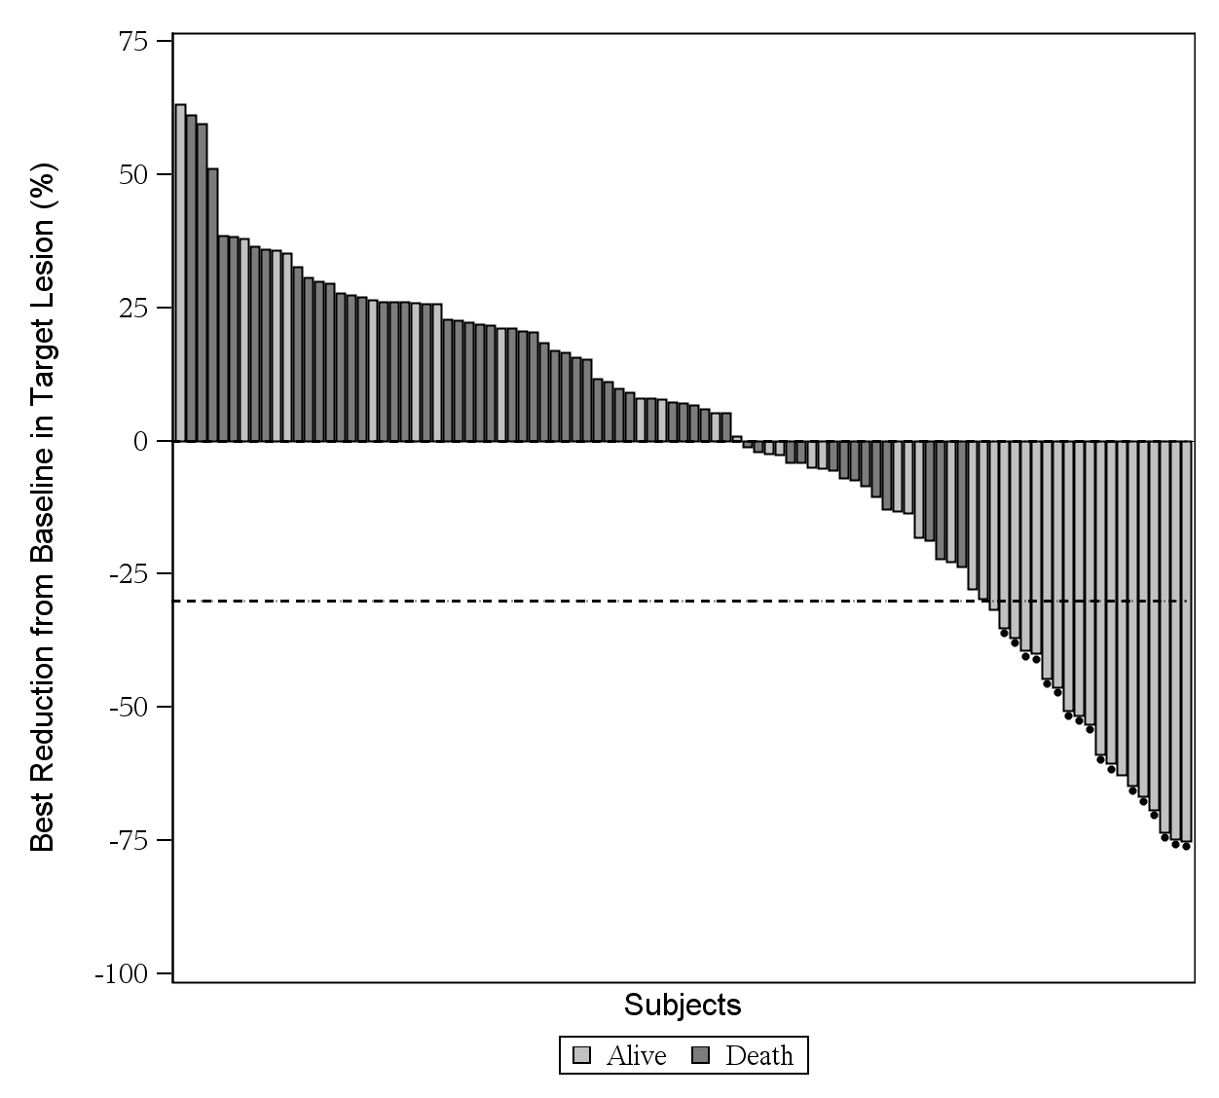
Note: Symbol (“●”) represents confirmed responders.

Study MDX1106-03. Open-label phase 1 dose-escalation study
The safety and tolerability of nivolumab were investigated in a phase 1, open-label, dose-escalation study in various tumour types, including NSCLC. Of the 306 patients enrolled in the study, 54 had squamous NSCLC and received nivolumab at a dose of 1 mg/kg, 3 mg/kg, or 10 mg/kg every 2 weeks for a maximum of 2 years. Objective response was reported in 4/18 patients (22% [95% CI: 6.4, 47.6]) with squamous NSCLC treated at the 3 mg/kg dose level.

INDICATIONS

OPDIVO, as monotherapy is indicated for the treatment of patients with unresectable (Stage III) or metastatic (Stage IV) melanoma.
OPDIVO, in combination with YERVOY (ipilimumab) is indicated for the treatment of patients with metastatic (Stage IV) melanoma with M1c disease or elevated lactic dehydrogenase (LDH).
OPDIVO, as monotherapy is indicated for the treatment of locally advanced or metastatic squamous non-small cell lung cancer (NSCLC) with progression on or after prior chemotherapy.

CONTRAINDICATIONS
Hypersensitivity to the active substance or to any of the excipients.

PRECAUTIONS
Early identification of adverse reactions and intervention are an important part of the safe use of OPDIVO with or without ipilimumab. OPDIVO monotherapy is associated with immune-related adverse reactions. In clinical trials, almost all immune-related adverse reactions have occurred at higher frequencies when OPDIVO was administered in combination with ipilimumab compared with OPDIVO as a monotherapy. Most immune-related adverse reactions improved or resolved with appropriate management, including initiation of corticosteroids and dose modifications.

Patients should be monitored continuously as an adverse reaction with OPDIVO monotherapy or OPDIVO in combination with ipilimumab may occur at any time during or after discontinuation of therapy.

For suspected immune-related adverse reactions, adequate evaluation should be performed to confirm aetiology or exclude other causes. Based on the severity of the adverse reaction, OPDIVO monotherapy or OPDIVO in combination with ipilimumab should be withheld (see DOSAGE AND ADMINISTRATION) and corticosteroids administered.

If immunosuppression with corticosteroids is used to treat an adverse reaction, a taper of at least one month duration should be initiated upon improvement. Rapid tapering may lead to worsening or recurrence of the adverse reaction.

Non-corticosteroid immunosuppressive therapy should be added if there is worsening or no improvement despite corticosteroid use.

OPDIVO monotherapy or OPDIVO in combination with ipilimumab should not be resumed while the patient is receiving immunosuppressive doses of corticosteroids or other immunosuppressive therapy.

Prophylactic antibiotics should be used to prevent opportunistic infections in patients receiving immunosuppressive therapy.

OPDIVO monotherapy or OPDIVO in combination with ipilimumab must be permanently discontinued for any severe immune related adverse reaction that recurs and for any life threatening immune related adverse reaction (see DOSAGE AND ADMINISTRATION).

Immune-related pneumonitis

Severe pneumonitis or interstitial lung disease, including fatal cases, has been observed with OPDIVO monotherapy or OPDIVO in combination with ipilimumab.

Patients should be monitored for signs and symptoms of pneumonitis such as radiographic changes (e.g., focal ground glass opacities, patchy filtrates), dyspnoea, and hypoxia. Infectious and disease-related should be ruled out.

For Grade 3 or 4 pneumonitis, OPDIVO monotherapy or OPDIVO in combination with ipilimumab, must be permanently discontinued and corticosteroids should be initiated at a dose of 2 to 4 mg/kg/day methylprednisolone equivalents.

For Grade 2 (symptomatic) pneumonitis, OPDIVO monotherapy or OPDIVO in combination with ipilimumab, should be withheld and corticosteroids initiated at a dose of 1 mg/kg/day methylprednisolone equivalents. Upon improvement, OPDIVO monotherapy or OPDIVO in combination with ipilimumab, maybe resumed after corticosteroid taper. If worsening or no improvement occurs despite initiation of corticosteroids, corticosteroid dose should be increased to 2 to 4 mg/kg/day methylprednisolone equivalents and OPDIVO monotherapy or OPDIVO in combination with ipilimumab, must be permanently discontinued.

Immune-related colitis

Severe diarrhoea or colitis has been observed with OPDIVO monotherapy or OPDIVO in combination with ipilimumab. Patients should be monitored for diarrhoea and additional symptoms of colitis, such as abdominal pain and mucus or blood in stool. Infectious and disease-related aetiologies should be ruled out.

For Grade 4 diarrhoea or colitis, OPDIVO monotherapy or OPDIVO in combination with ipilimumab, must be permanently discontinued and corticosteroids should be initiated at a dose of 1 to 2 mg/kg/day methylprednisolone equivalents.

For Grade 3 diarrhoea or colitis observed with OPDIVO in combination with ipilimumab, permanently discontinue both agents and follow the management guideline for Grade 4 diarrhoea or colitis above.

OPDIVO monotherapy should be withheld for Grade 3 diarrhoea or colitis and corticosteroids initiated at a dose of 1 to 2 mg/kg/day methylprednisolone equivalents. Upon improvement, OPDIVO monotherapy may be resumed after corticosteroid taper. If worsening or no improvement occurs despite initiation of corticosteroids, OPDIVO monotherapy must be permanently discontinued.

For Grade 2 diarrhoea or colitis, OPDIVO monotherapy or OPDIVO in combination with ipilimumab, should be withheld. Persistent diarrhoea or colitis should be managed with corticosteroids at a dose of 0.5 to 1 mg/kg/day methylprednisolone equivalents. Upon improvement, OPDIVO monotherapy or OPDIVO in combination with ipilimumab, may be resumed after corticosteroid taper, if needed. If worsening or no improvement occurs despite initiation of corticosteroids, corticosteroid dose should be increased to 1 to 2 mg/kg/day methylprednisolone equivalents and OPDIVO monotherapy or OPDIVO in combination with ipilimumab, must be permanently discontinued.

Based on limited data from clinical trials on the management of corticosteroid-refractory diarrhoea or colitis, administration of other systemic immunosuppressants (e.g., anti-TNF-α agents) can be considered.

Immune-related hepatitis

Severe hepatitis has been observed with OPDIVO monotherapy or OPDIVO in combination with ipilimumab. Infectious and disease-related aetiologies should be ruled out.

Elevations in liver function tests may develop in the absence of clinical symptoms. Monitor patients for abnormal liver tests prior to and periodically during treatment as indicated based on clinical evaluation.

For Grade 3 or 4 transaminase or total bilirubin elevation, OPDIVO monotherapy or OPDIVO in combination with ipilimumab, must be permanently discontinued and corticosteroids should be initiated at a dose of 1 to 2 mg/kg/day methylprednisolone equivalents.

For Grade 2 transaminase or total bilirubin elevation, OPDIVO monotherapy or OPDIVO in combination with ipilimumab should be withheld. Persistent elevations in these laboratory values should be managed with corticosteroids at a dose of 0.5 to 1 mg/kg/day methylprednisolone equivalents. Upon improvement OPDIVO monotherapy or OPDIVO in combination with ipilimumab, may be resumed after corticosteroid taper, if needed.

If worsening or no improvement occurs despite initiation of corticosteroids, corticosteroid dose should be increased to 1 to 2 mg/kg/day methylprednisolone equivalents and OPDIVO monotherapy or OPDIVO in combination with ipilimumab must be permanently discontinued.

Immune-related nephritis and renal dysfunction

Severe nephritis and renal dysfunction have been observed with OPDIVO monotherapy or OPDIVO in combination with ipilimumab. Disease-related aetiologies should be ruled out.

Creatinine elevations may develop in the absence of clinical symptoms. Monitor patients for elevated serum creatinine prior to and periodically during treatment as indicated based on clinical evaluation.

For Grade 4 serum creatinine elevation, OPDIVO monotherapy or OPDIVO in combination with ipilimumab must be permanently discontinued and corticosteroids should be initiated at a dose of 1 to 2 mg/kg/day methylprednisolone equivalents.

For Grade 2 or 3 serum creatinine elevation, OPDIVO monotherapy or OPDIVO in combination with ipilimumab, should be withheld and corticosteroids should be initiated at a dose of 0.5 to 1 mg/kg/day methylprednisolone equivalents. Upon improvement, OPDIVO monotherapy or OPDIVO in combination with ipilimumab, may be resumed after corticosteroid taper. If worsening or no improvement occurs despite initiation of corticosteroids, corticosteroid dose should be increased to 1 to 2 mg/kg/day methylprednisolone equivalents and OPDIVO monotherapy or OPDIVO in combination with ipilimumab, must be permanently discontinued.

Immune-related endocrinopathies

Severe endocrinopathies, including hypothyroidism, hyperthyroidism, adrenal insufficiency, hypophysitis, diabetes mellitus, and diabetes ketoacidosis have been observed with OPDIVO monotherapy or OPDIVO in combination with ipilimumab.

Patients should be monitored for clinical signs and symptoms of endocrinopathies and for changes in thyroid function (at the start of treatment, periodically during treatment, and as indicated based on clinical evaluation).

Patients may present with fatigue, headache, mental status changes, abdominal pain, unusual bowel habits, and hypotension, or nonspecific symptoms which may resemble other causes such as brain metastasis or underlying disease.

Unless an alternate aetiology has been identified, signs or symptoms of endocrinopathies should be considered immune-related.

For symptomatic hypothyroidism, OPDIVO monotherapy or OPDIVO in combination with ipilimumab, should be withheld, and thyroid hormone replacement should be initiated as needed. For symptomatic hyperthyroidism, OPDIVO monotherapy or OPDIVO in combination with ipilimumab, should be withheld and an antithyroid medicine should be initiated as needed. Corticosteroids at a dose of 1 to 2 mg/kg/day methylprednisolone equivalents should also be considered if acute inflammation of the thyroid is suspected. Upon improvement OPDIVO monotherapy or OPDIVO in combination with ipilimumab, may be resumed after corticosteroid taper, if needed. Monitoring of thyroid function should continue to ensure appropriate hormone replacement is utilized. OPDIVO monotherapy or OPDIVO in combination with ipilimumab should be permanently discontinued for life-threatening hypothyroidism or hyperthyroidism.

For symptomatic Grade 2 adrenal insufficiency, OPDIVO monotherapy or OPDIVO in combination with ipilimumab, should be withheld, and physiologic corticosteroid replacement should be initiated as needed. OPDIVO monotherapy or OPDIVO in combination with ipilimumab must be permanently discontinued for severe (Grade 3) or life-threatening (Grade 4) adrenal insufficiency. Monitoring of adrenal function and hormone levels should continue to ensure appropriate corticosteroid replacement is utilized.

For symptomatic Grade 2 or 3 hypophysitis, OPDIVO monotherapy or OPDIVO in combination with ipilimumab should be withheld, and hormone replacement should be initiated as needed. Corticosteroids at a dose of 1 to 2 mg/kg/day methylprednisolone equivalents should also be considered if acute inflammation of the pituitary gland is suspected. Upon improvement, OPDIVO monotherapy or OPDIVO in combination with ipilimumab may be resumed after corticosteroid taper, if needed. OPDIVO monotherapy or OPDIVO in combination with ipilimumab must be permanently discontinued for life-threatening (Grade 4) hypophysitis. Monitoring of pituitary function and hormone levels should continue to ensure appropriate hormone replacement is utilized.

For symptomatic diabetes, OPDIVO monotherapy or OPDIVO in combination with ipilimumab should be withheld, and insulin replacement should be initiated as needed. Monitoring of blood sugar should continue to ensure appropriate insulin replacement is utilized. OPDIVO monotherapy or OPDIVO in combination with ipilimumab should be permanently discontinued for life-threatening diabetes.

Immune-related rash and severe skin reactions

Patients should be monitored for rash. Severe rash (including rare cases of fatal toxic epidermal necrolysis) has been observed with OPDIVO in combination with ipilimumab and less commonly with OPDIVO monotherapy. OPDIVO monotherapy or OPDIVO in combination with ipilimumab should be withheld for Grade 3 rash and permanently discontinued for Grade 4 rash.
Severe rash should be managed with high-dose corticosteroids at a dose of 1 to 2 mg/kg/day methylprednisolone equivalents.

Caution should be used when considering the use of nivolumab in a patient who has previously experienced a severe or life-threatening skin adverse reaction on prior treatment with other immunostimulatory anticancer agents.

Immune-related encephalitis

Immune-related encephalitis can occur with OPDIVO treatment. Withhold OPDIVO in patients with new-onset moderate to severe neurologic signs or symptoms and evaluate to rule out infectious or other causes of moderate to serve neurologic deterioration. Evaluation may include, but not be limited to, consultation with a neurologist, brain MRI, and lumbar puncture.

If other aetiologies are ruled out, administer corticosteroids at a dose of 1 to 2 mg/kg/day methylprednisolone equivalents for patients with immune-related encephalitis, followed by corticosteroid taper. Permanently discontinue OPDIVO for immune-related encephalitis.

Other immune-related adverse reactions

Other clinically significant immune-related adverse reactions have been observed with OPDIVO monotherapy or OPDIVO in combination with ipilimumab (see ADVERSE EFFECTS).
For suspected immune-related adverse reactions, adequate evaluation should be performed to confirm aetiology or exclude other causes. Based on the severity of the adverse reaction, OPDIVO monotherapy or OPDIVO in combination with ipilimumab, should be withheld and corticosteroids administered. Upon improvement, OPDIVO monotherapy or OPDIVO in combination with ipilimumab, maybe resumed after corticosteroid taper. OPDIVO monotherapy or OPDIVO in combination with ipilimumab , must be permanently discontinued for any severe immune-related adverse reaction that recurs and for any life-threatening immune-related adverse reaction.

Infusion reaction

Severe infusion reactions have been reported in clinical trials of OPDIVO monotherapy or OPDIVO in combination with ipilimumab (see ADVERSE EFFECTS). In case of a severe or life-threatening infusion reaction, the OPDIVO monotherapy or OPDIVO in combination with ipilimumab infusion must be discontinued and appropriate medical therapy administered. Patients with mild or moderate infusion reaction may receive OPDIVO monotherapy or OPDIVO in combination with ipilimumab with close monitoring and use of premedication according to local treatment guidelines for prophylaxis of infusion reactions.

OPDIVO IN COMBINATION WITH YERVOY (ipilimumab)

Review the full prescribing information for YERVOY (ipilimumab) prior to initiation of the OPDIVO in combination with YERVOY (ipilimumab). Both agents are associated with immune-related adverse reactions and may require immunosuppression. In clinical trials, immune-related adverse reactions described in the PRECAUTIONS section have occurred at higher frequencies when OPDIVO was administered in combination with YERVOY (ipilimumab) compared with OPDIVO as a monotherapy. Most immune-related adverse reactions (except for endocrinopathies) improved or resolved with appropriate management, including initiation of corticosteroids and treatment modifications.

Patients receiving OPDIVO in combination with YERVOY should be monitored for serum creatinine, thyroid function, and liver function prior to each dose during the combination phase.

Special populations

Patients with a baseline performance score ≥ 2, active brain metastases, or autoimmune disease, and patients who had been receiving systemic immunosuppressants prior to study entry were excluded from the melanoma clinical trials of OPDIVO monotherapy or OPDIVO in combination with ipilimumab. Patients with symptomatic interstitial lung disease and those with ocular/uveal melanoma were excluded from clinical trials of NSCLC and melanoma, respectively. In addition, CA209037 excluded patients who have had a Grade 4 adverse reaction that was related to anti-CTLA-4 therapy (except for resolved nausea, fatigue, infusion reaction or an endocrinopathy controlled by hormone replacement therapy). In the absence of data, OPDIVO should be used with caution in these populations after careful consideration of the potential benefit-risk on an individual basis.

RENAL IMPAIRMENT

The safety and efficacy of nivolumab have not been studied in patients with severe renal impairment. Based on the population pharmacokinetic (PK) results, no dose adjustment is required in patients with mild or moderate renal impairment (see PHARMACOKINETICS and DOSAGE AND ADMINISTRATION).

HEPATIC IMPAIRMENT

The safety and efficacy of OPDIVO have not been studied in patients with moderate or severe hepatic impairment. Based on the population PK results, no dose adjustment is required in patients with mild hepatic impairment (see PHARMACOKINETICS and DOSAGE AND ADMINISTRATION).

OPDIVO must be administered with caution in patients with moderate (total bilirubin > 1.5 × to 3 × the upper limit of normal [ULN] and any AST) or severe (total bilirubin > 3 × ULN and any AST) hepatic impairment.

Patients on controlled sodium diet
Each mL of this medicinal product contains 0.1 mmol (or 2.5 mg) sodium. To be taken into consideration when treating patients on a controlled sodium diet.

EFFECTS ON FERTILITY
Studies to evaluate the effect of OPDIVO on fertility have not been performed. Thus, the effect of OPDIVO on male and female fertility is unknown.

USE IN PREGNANCY (Category D)
OPDIVO is not recommended during pregnancy or in women of childbearing potential not using effective contraception, unless the clinical benefit outweighs the potential risk. Advise females of reproductive potential to use effective contraception during treatment with OPDIVO for at least 5 months following the last dose of OPDIVO.

There are no data on the use of OPDIVO in pregnant women. Human IgG4 is known to cross the placental barrier and OPDIVO is an IgG4; therefore OPDIVO has the potential to be transmitted from the mother to the developing foetus. It is not known whether ipilimumab can cause fetal harm when administered to a pregnant woman.

The effects of OPDIVO on prenatal and postnatal development were evaluated in monkeys that received OPDIVO at 10 and 50 mg/kg twice weekly from the onset of organogenesis in the first trimester through delivery, at exposure levels 8 and 35 times, respectively, those observed at the clinical dose of 3 mg/kg of OPDIVO (based on AUC). There was a dose-dependent increase in fetal losses and increased neonatal mortality mainly in the 3rd trimester of pregnancy and after birth.

The remaining offspring of OPDIVO-treated females survived to scheduled termination, with no treatment-related clinical signs, alterations to normal development, organ-weight effects, or gross and microscopic pathology changes. Results for growth indices, as well as teratogenic, neurobehavioral, immunological and clinical pathology parameters throughout the 6-month postnatal period were comparable to the control group.

USE IN LACTATION
It is not known whether OPDIVO is secreted in human breast milk. Because many drugs, including antibodies, can be secreted in human milk, a risk to newborns/infants cannot be excluded. Clinical judgement is required to determine whether to discontinue breast-feeding or to discontinue OPDIVO therapy, taking into account the benefit of breast-feeding for the child and the benefit of therapy for the mother.

PAEDIATRIC USE

The safety and efficacy of OPDIVO in children below 18 years have not been established. The use of OPDIVO in children or adolescents is not recommended.

GENOTOXICITY AND CARCINOGENICITY
Studies to evaluate the genotoxic and carcinogenic potential of OPDIVO have not been performed.

DRUG INTERACTIONS
OPDIVO is a human monoclonal antibody, as such pharmacokinetic interaction studies have not been conducted. As monoclonal antibodies are not metabolized by cytochrome P450 (CYP) enzymes or other drug metabolizing enzymes, inhibition or induction of these enzymes by co-administered medicinal products is not anticipated to affect the pharmacokinetics of OPDIVO. In addition, OPDIVO is not expected to have an effect on CYP or other drug metabolizing enzymes in terms of inhibition or induction. Therefore, OPDIVO is not expected to have pharmacokinetic-based interactions and as such interaction studies have not been performed.

Other forms of interaction

Systemic immunosuppression
The use of systemic corticosteroids and other immunosuppressants at baseline, before starting nivolumab, should be avoided because of their potential interference with the pharmacodynamic activity. However, systemic corticosteroids and other immunosuppressants can be used after starting nivolumab to treat immune-related adverse reactions. The use of systemic immunosuppression after starting nivolumab treatment does not appear to impair the efficacy of nivolumab.

EFFECTS ON ABILITY TO DRIVE AND USE MACHINES

No studies on the effects on the ability to drive and use machines have been performed. Based on its pharmacodynamic properties, OPDIVO is unlikely to affect this ability. Because of potential adverse reactions such as fatigue (see ADVERSE EFFECTS), patients should be advised to use caution when driving or operating machinery until they are certain that OPDIVO does not adversely affect them.

PATIENT COUNSELLING INFORMATION
Patients should be advised to report immediately any signs or symptoms suggestive of adverse reactions as described in PRECAUTIONS. The importance of reporting any worsening of symptoms or severity should be emphasized. Patients should be strongly advised not to treat any of these symptoms with over-the-counter medications without consultation with a health care provider.

ADVERSE EFFECTS

In a clinical program investigating its use in various tumour types, OPDIVO 3 mg/kg monotherapy has been administered to approximately 1,800 patients, and OPDIVO in combination with ipilimumab has been administered to approximately 900 patients. The data described below reflect experience of the use of OPDIVO (3mg/kg) as monotherapy in three phase 3 randomised studies and the use of OPDIVO (1 mg/kg) in combination with ipilimumab (3mg/kg) in one phase 2 study and one phase 3 study.

UNRESECTABLE OR METASTATIC MELANOMA

OPDIVO MONOTHERAPY

Adverse events reported in Study CA209066
Study CA209066 was a randomized, double-blind study in patients with previously untreated unresectable or metastatic melanoma (see CLINICAL TRIALS). The study included 206 patients treated with OPDIVO at 3 mg/kg and 205 patients treated with dacarbazine. The median duration of therapy was 6.5 months (95% CI: 4.9, NA) for OPDIVO and 2.1 months (95% CI: 1.9, 2.4) for dacarbazine. Patients in the OPDIVO group received a median of 12 doses.

The most frequent adverse events reactions (≥ 20%) reported with OPDIVO in study CA209066 were fatigue, musculoskeletal pain, rash, diarrhoea, constipation, nausea, and pruritis. Study therapy was discontinued for adverse reactions in 2% of patients in the OPDIVO group and 3% of patients in the dacarbazine group.

Table 11 lists adverse events that occurred in at least 10% of patients.

Table 11: Adverse Events Reported in at Least 10% of Patients in Study CA209066
 | OPDIVO  3 mg/kg every 2 weeks  (n=206) |  | Dacarbazine  (n=205)
System Organ Class  Preferred Term | Any  Grade | Grades  3-4 |  | Any  Grade | Grades  3-4
 | Percentage (%) of Patientsa
Gastrointestinal Disorders
Nausea | 23 | 0 |  | 47 | 0.5
Constipation | 24 | 0 |  | 26 | 0.5
Diarrhoea | 25 | 2 |  | 21 | 0.5
Vomiting | 11 | 0.5 |  | 25 | 1
Abdominal pain | 11 | 0.5 |  | 13 | 0.5
General Disorders and Administration Site Conditions
Fatigue^{b} | 49 | 2 |  | 39 | 3
Pyrexia | 13 | 0.5 |  | 9 | 0.5
Edema^{c} | 12 | 1 |  | 5 | 0
Skin and Subcutaneous Tissue Disorders
Rash^{d} | 28 | 1 |  | 12 | 0
Pruritus | 23 | 0.5 |  | 12 | 0
Erythema | 10 | 0 |  | 3 | 0
Vitiligo | 11 | 0 |  | 0.5 | 0
Musculoskeletal and Connective Tissue Disorders
Musculoskeletal pain^{e} | 32 | 3 |  | 25 | 2
Arthralgia^{f} | 11 | 0 |  | 7 | 0
Nervous System Disorders
Headache | 16 | 0 |  | 14 | 0.5
Infections and Infestations
Upper respiratory tract infection^{g} | 17 | 0 |  | 6 | 0
Respiratory, Thoracic, and Mediastinal Disorders
Cough | 12 | 0 |  | 12 | 0
Dyspnea | 9 | 1 |  | 13 | 1
Metabolism and Nutrition Disorders
Decreased appetite | 13 | 0.5 |  | 14 | 1
ª Incidences presented in this table are based on reports of adverse events regardless of causality.
^{b} Fatigue includes asthenia.
^{c} Edema includes face edema, peripheral edema, local swelling, localized edema, orbital edema, generalized edema, peripheral swelling, swelling face.
^{d} Rash includes maculopapular rash, rash erythematous, rash macular, rash papular, rash pustular, rash pruritic, rash generalized, dermatitis, dermatitis exfoliative, dermatitis acneiform, dermatitis bullous, drug eruption, toxic skin eruption, and erythema.
^{e} Musculoskeletal pain includes back pain, bone pain, musculoskeletal chest pain, musculoskeletal discomfort, myalgia, neck pain, pain in extremity, and spinal pain.
^{f} Arthralgia includes arthritis and osteoarthritis.
^{g} Upper respiratory tract infection includes rhinitis, pharyngitis, and nasopharyngitis.

Other clinically important adverse events included: dry skin, alopecia, peripheral neuropathy, decreased weight, hyperglycaemia, hypothyroidism, hyperthyroidism, hypopituitarism, infusion related reaction, pneumonitis, renal failure, psoriasis, rosacea, stomatitis, colitis, dizziness, Guillain-Barre syndrome, diabetes mellitus, diabetic ketoacidosis, hypophysitis, uveitis, and hypertension.

Laboratory Abnormalities
Table 12 shows the incidence of worsening laboratory abnormalities.
Table 12: Laboratory Abnormalities (CA209066)
 | Number (%) of Patients with Worsening Laboratory Test from Baseline
Test | OPDIVO 3 mg/kg |  |  | Dacarbazine
Test | Na | Grades  1-4 | Grades  3-4 | Na | Grades  1-4 | Grades  3-4
Decreased haemoglobin^{b} | 195 | 72 (36.9) | 3 (1.5) | 189 | 78 (41.3) | 12 (6.3)
Decreased platelet count | 203 | 23 (11.3) | 1 (0.5) | 195 | 65 (33.3) | 13 (6.7)
Decreased absolute lymphocytes | 195 | 56 (28.7) | 11 (5.6) | 186 | 87 (46.8) | 13 (7.0)
Decreased absolute neutrophil count | 196 | 15 (7.7) | 1 (0.5) | 190 | 47 (24.7) | 17 (8.9)
Increased alkaline phosphatase | 194 | 41 (21.1) | 5 (2.6) | 186 | 26 (14.0) | 3 (1.6)
Increased AST | 195 | 47 (24.1) | 7 (3.6) | 191 | 37 (19.4) | 1 (0.5)
Increased ALT | 197 | 49 (24.9) | 6 (3.0) | 193 | 37 (19.2) | 1 (0.5)
Increased total bilirubin | 194 | 26 (13.4) | 6 (3.1) | 190 | 12 (6.3) | 0
Increased creatinine | 199 | 21 (10.6) | 1 (0.5) | 197 | 19 (9.6) | 1 (0.5)

Toxicity scale: CTC Version 4.0.Includes laboratory results reported after the first dose and within 30 days of the last dose of study therapy.
ª The total number of patients who had both baseline and on-study laboratory measurements available.
^{b} Per anemia criteria in CTC version 4.0, there is no Grade 4 for haemoglobin.

Adverse events reported in Study CA209037

Study CA209037 was a randomized, open-label study in patients with previously-treated unresectable or metastatic melanoma (see CLINICAL TRIALS). The study included 268 patients treated with OPDIVO at 3 mg/kg and 102 patients treated with chemotherapy, investigator’s choice of either dacarbazine (n = 45) or carboplatin/paclitaxel therapy (n = 57). The median duration of therapy was 5.26 months (95% CI: 3.29, 6.47) for OPDIVO and 1.95 months (95% CI: 1.61, 2.86) for chemotherapy. Patients in the OPDIVO group received a median of 8 doses.

The most frequent adverse events reactions (≥ 20%) reported with OPDIVO in study CA209037 were fatigue, musculoskeletal pain, nausea, rash, and diarrhoea. Study therapy was discontinued for adverse reactions in 2% of patients in the OPDIVO group and 8% of patients in the chemotherapy group. Twenty-six percent of patients who had their dose withheld for an adverse reaction were able to resume OPDIVO.

Table 13 lists adverse events that occurred in at least 10% of patients.

Table 13: Adverse Events Reported in at Least 10% of Patients in Study CA209037
 | OPDIVO  3 mg/kg every 2 weeks  (n=268) |  | Chemotherapyª  (n=102)
System Organ Class  Preferred Term | Any  Grade | Grades  3-4 |  | Any  Grade | Grades  3-4
 | Percentage (%) of Patientsb
General Disorders and Administration Site Conditions
Fatigue^{c} | 47 | 2 |  | 51 | 6
Pyrexia | 13 | 0 |  | 10 | 1
Edema^{d} | 12 | 0 |  | 5 | 0
Musculoskeletal and Connective Tissue Disorders
Musculoskeletal pain^{e} | 27 | 1 |  | 24 | 3
Arthralgia^{f} | 13 | <1 |  | 16 | 2
Gastrointestinal Disorders
Nausea | 24 | 1 |  | 42 | 2
Diarrhoea | 20 | 1 |  | 17 | 2
Abdominal pain | 18 | 4 |  | 15 | 1
Vomiting | 14 | 2 |  | 24 | 2
Constipation | 13 | 1 |  | 20 | 1
Skin and Subcutaneous Tissue Disorders
Rash^{g} | 21 | <1 |  | 9 | 0
Pruritus | 19 | 0 |  | 4 | 0
Alopecia | 1 | 0 |  | 28 | 0
Respiratory, Thoracic, and Mediastinal Disorders
Cough | 17 | 0 |  | 6 | 0
Dyspnea | 16 | 1 |  | 17 | 2
Metabolism and Nutrition Disorders
Decreased appetite | 15 | 0 |  | 18 | 0
Nervous System Disorders
Headache | 11 | 1 |  | 11 | 0
Peripheral neuropathy | 7 | <1 |  | 25 | 2
Infections and Infestations
Upper respiratory tract infection^{h} | 11 | 0 |  | 2 | 0
a Investigator’s choice of either dacarbazine (1000 mg/m2 every 3 weeks) or carboplatin (AUC 6 every 3 weeks) and paclitaxel (175 mg/m2 every 3 weeks).
b Incidences presented in this table are based on reports of adverse events regardless of causality.
^{c} Fatigue includes asthenia.
^{d} Edema includes face edema, peripheral edema, local swelling, localized edema, orbital edema, generalized edema, peripheral swelling, swelling face.
^{e} Musculoskeletal pain includes back pain, bone pain, musculoskeletal chest pain, musculoskeletal discomfort, myalgia, neck pain, pain in extremity, and spinal pain.
^{f} Arthralgia includes arthritis and osteoarthritis.
^{g} Rash includes maculopapular rash, rash erythematous, rash macular, rash papular, rash pustular, rash pruritic, rash generalized, dermatitis, dermatitis exfoliative, dermatitis acneiform, dermatitis bullous, drug eruption, toxic skin eruption, and erythema.
^{h} Upper respiratory tract infection includes rhinitis, pharyngitis, and nasopharyngitis.

Other clinically important adverse events included: pneumonitis, hyperthyroidism, uveitis, thyroiditis, colitis, pancreatitis, demyelination, tubulointerstitial nephritis, autoimmune neuropathy, facial and abducens nerve paresis, vitiligo, and infusion-related reaction.

Laboratory abnormalities
Table 14 shows the incidence of worsening laboratory abnormalities.

Table 14: Laboratory Abnormalities (CA209037)
 | Number (%) of Patients with Worsening Laboratory Test from Baseline
Test | OPDIVO 3 mg/kg |  |  | Chemotherapyª
Test | Nb | Grades  1-4 | Grades  3-4 | Na | Grades  1-4 | Grades  3-4
Decreased hemoglobinc | 259 | 94 (36.3) | 16 (6.2) | 99 | 59 (59.6) | 9 (9.1)
Decreased platelet count | 257 | 24 (9.3) | 0 | 99 | 40 (40.4) | 9 (9.1)
Decreased lymphocytes | 256 | 112 (43.8) | 17 (6.6) | 99 | 52 (52.5) | 15 (15.2)
Decreased absolute neutrophil count | 256 | 20 (7.8) | 3 (1.2) | 99 | 44 (44.4) | 21 (21.2)
Increased alkaline phosphatase | 252 | 55 (21.8) | 6 (2.4) | 94 | 12 (12.8) | 1 (1.1)
Increased AST | 253 | 70 (27.7) | 6 (2.4) | 96 | 11 (11.5) | 1 (1.0)
Increased ALT | 253 | 41 (16.2) | 4 (1.6) | 96 | 5 (5.2) | 0
Increased total bilirubin | 249 | 24 (9.6) | 1 (0.4) | 94 | 0 | 0
Increased creatinine | 254 | 34 (13.4) | 2 (0.8) | 94 | 8 (8.5) | 0
a Investigator’s choice of either dacarbazine (1000 mg/m2 every 3 weeks) or carboplatin (AUC 6 every 3 weeks) and paclitaxel (175 mg/m2 every 3 weeks).
b The total number of patients who had both baseline and on-study laboratory measurements available.
c Grade 4 for hemoglobin is not applicable per anemia criteria in CTCAE v4.0.

The safety profile of OPDIVO 3 mg/kg in the melanoma population in an open-label, dose-escalation study MDX1106-03 (see CLINICAL TRIALS) with a minimum follow up of approximately 20 months was consistent with that observed in Study CA209037.

OPDIVO IN COMBINATION WITH YERVOY (ipilimumab)
Adverse events reported in Study CA209067

The safety of OPDIVO in combination with ipilimumab and OPDIVO as a monotherapy was evaluated in study CA209067, a randomized, Phase 3, double-blind trial in patients with unresectable or metastatic melanoma who had not been treated with systemic anticancer therapy (see CLINICAL TRIALS).
Treatment was discontinued for adverse reactions in 43% of patients receiving OPDIVO in combination with ipilimumab, 14% of patients receiving OPDIVO monotherapy, and 23% of patients receiving ipilimumab alone.
In patients receiving OPDIVO in combination with ipilimumab, diarrhoea, colitis, AST and ALT elevations were the most frequently reported (≥2%) adverse events leading to discontinuation. In patients receiving OPDIVO monotherapy, malignant neoplasm progression was the most frequently reported (≥2%) adverse event leading to discontinuation. The percentage of patients who had doses withheld for an adverse reaction was 55% in the OPDIVO in combination with ipilimumab arm, 28% in the OPDIVO monotherapy arm, and 38% in the ipilimumab arm. The frequencies of serious adverse reactions were 73%, 37%, and 51%, respectively. The most frequent serious adverse events in the OPDIVO in combination with ipilimumab arm were diarrhoea (13%) and colitis (10%) and in the OPDIVO monotherapy arm was diarrhoea (2.6%). There were no treatment-related deaths in patients receiving OPDIVO in combination with ipilimumab. One patient treated with OPDIVO monotherapy died due to neutropenia and subsequent sepsis, and one patient treated with ipilimumab died due to intestinal perforation.
Among the patients treated with OPDIVO in combination with ipilimumab, 193/313 (62%) had the first onset of Grade 3-4 adverse events during the initial combination phase. Among the 147 patients in this group who continued treatment in the monotherapy single-agent phase, 53 (36%) experienced at least one Grade 3-4 adverse event during the monotherapy single-agent phase.
As compared to the overall study population, no meaningful differences in safety were observed based on BRAF status or PD-L1 expression level.
Table 15 summarizes the adverse events that occurred in at least 10% of patients in either OPDIVO-containing arm in study CA209067. The most common adverse events (reported in at least 20% of patients) in both the OPDIVO in combination with ipilimumab arm and the OPDIVO monotherapy arm were fatigue, rash, diarrhoea, and nausea. Vomiting and pyrexia were also reported in greater than 20% of patients receiving OPDIVO in combination with ipilimumab.

Table 15: Adverse Events Occurring in ≥10% of Patients Treated with OPDIVO in combination with ipilimumab or OPDIVO monotherapy (CA209067)
 | Percentage (%) of Patientsa
 | OPDIVO +  Ipilimumab  (n=313) |  | OPDIVO  (n=313) |  | Ipilimumab  (n=311)
System Organ Class  Preferred Term | All Grades | Grades  3–4 | All Grades | Grades  3–4 | All Grades | Grades  3–4
General Disorders and Administration Site Conditions
Fatigue^{b} | 59 | 6 | 53 | 1.9 | 50 | 3.9
Pyrexia | 37 | 1.6 | 14 | 0 | 17 | 0.6
Edema^{c} | 12 | 0 | 14 | 0 | 19 | 0.6
Skin and Subcutaneous Tissue Disorders
Rashd | 53 | 5 | 40 | 1.6 | 42 | 3.9
Pruritus | 36 | 1.9 | 23 | 0 | 39 | 0.3
Gastrointestinal Disorders
Diarrhoea | 52 | 11 | 31 | 3.8 | 46 | 8
Nausea | 40 | 3.5 | 28 | 0.6 | 29 | 1.9
Vomiting | 28 | 3.5 | 17 | 1.0 | 16 | 1.6
Abdominal pain | 22 | 1.6 | 21 | 1.3 | 25 | 2.6
Constipation | 17 | 0.3 | 20 | 0.3 | 22 | 0
Colitis | 12 | 8 | 1.6 | 0.6 | 12 | 9
Musculoskeletal and Connective Tissue Disorders
Musculoskeletal pain^{e} | 28 | 2.2 | 35 | 3.5 | 34 | 1.6
Arthralgia^{f} | 18 | 0.3 | 17 | 0.6 | 15 | 0
Respiratory, Thoracic and Mediastinal Disorders
Cough | 24 | 0 | 22 | 0.3 | 21 | 0
Dyspnoea | 21 | 2.2 | 15 | 1.3 | 17 | 0.6
Nervous System Disorders
Headache | 23 | 0.3 | 19 | 0 | 21 | 0.6
Dizziness | 12 | 0 | 11 | 0 | 10 | 0
Metabolism and Nutrition Disorders
Decreased appetite | 27 | 1.9 | 19 | 0 | 23 | 1.3
Endocrine Disorders
Hypothyroidism | 17 | 0.6 | 9 | 0 | 4.8 | 0
Hyperthyroidism | 10 | 1.3 | 6 | 0 | 1.0 | 0
Infections and Infestations
Upper respiratory tract infection^{g} | 18 | 0 | 16 | 0.3 | 14 | 0
Psychiatric Disorders
Sleep disorder | 13 | 0.6 | 12 | 0.3 | 13 | 0
Investigations
Decreased weight | 11 | 0 | 6 | 0 | 7 | 0.3
a Incidences presented in this table are based on reports of adverse events regardless of causality.
^{b} Fatigue includes asthenia.
^{c} Edema includes face edema, peripheral edema, local swelling, localized edema, orbital edema, generalized edema, peripheral swelling, swelling face.
^{d} Rash includes maculopapular rash, rash erythematous, rash macular, rash papular, rash pustular, rash pruritic, rash generalized, dermatitis, dermatitis exfoliative, dermatitis acneiform, dermatitis bullous, drug eruption, toxic skin eruption, and erythema.
^{e} Musculoskeletal pain includes back pain, bone pain, musculoskeletal chest pain, musculoskeletal discomfort, myalgia, neck pain, pain in extremity, and spinal pain.
^{f} Arthralgia includes arthritis and osteoarthritis.
^{g} Upper respiratory tract infection includes rhinitis, pharyngitis, and nasopharyngitis.
Other clinically important adverse reactions in less than 10% of patients treated with either OPDIVO in combination with ipilimumab or OPDIVO monotherapy in study CA209067 were: stomatitis, intestinal perforation, vitiligo, myopathy, polymyalgia rheumatica, Sjogren’s syndrome, spondyloarthropathy, neuritis, peroneal nerve palsy, pleural effusion, blurred vision, eosinophilia and atrial fibrillation.

Laboratory Abnormalities
Table 16 shows the incidence of worsening laboratory abnormalities (CA209067).

Table 16 Laboratory Abnormalities (CA209067)
 | Number (%) of Patients with Worsening Laboratory Test from Baseline
 | OPDIVO +  Ipilimumab  (n=313) |  |  | OPDIVO  (n=313) |  |  | Ipilimumab  (n=311)
 | Na | Any Grade | Grade  3–4 | Na | Any Grade | Grade  3–4 | Na | Any Grade | Grade  3–4
Decreased hemoglobin^{b} | 296 | 148 (50) | 8 (2.7) | 305 | 118 (38.7) | 8 (2.6) | 301 | 119 (39.5) | 17 (5.6)
Decreased platelet count | 294 | 31 (10.5) | 4 (1.4) | 305 | 26 (8.5) | 1 (0.3) | 300 | 14 (4.7) | 1 (0.3)
Decreased leukocyte | 296 | 36 (12.2) | 1 (0.3) | 306 | 49 (16.0) | 1 (0.3) | 304 | 17 (5.6) | 1 (0.3)
Decreased lymphocytes | 293 | 102 (34.8) | 14 (4.8) | 304 | 118 (38.8) | 13 (4.3) | 298 | 80 (26.8) | 10 (3.4)
Decreased absolute neutrophil count | 295 | 36 (12.2) | 2 (0.7) | 304 | 43 (14.1) | 1 (0.3) | 301 | 18 (6.0) | 1 (0.3)
Increased alkaline phosphatase | 290 | 115 (39.7) | 16 (5.5) | 301 | 73 (24.3) | 6 (2.0) | 297 | 65 (21.9) | 6 (2.0)
Increased AST | 292 | 136 (46.6) | 37 (12.7) | 300 | 80 (26.7) | 11 (3.7) | 299 | 82 (27.4) | 5 (1.7)
Increased ALT | 297 | 157 (52.9) | 44 (14.8) | 303 | 70 (23.1) | 9 (3.0) | 299 | 83 (27.8) | 8 (2.7)
Increased total bilirubin | 295 | 39 (13.2) | 4 (1.4) | 303 | 29 (9.6) | 4 (1.3) | 299 | 16 (5.4) | 0
Increased creatinine | 295 | 68 (23.1) | 8 (2.7) | 304 | 49 (16.1) | 1 (0.3) | 300 | 45 (15.0) | 4 (1.3)
Increased amylase | 241 | 61 (25.3) | 22 (9.1) | 260 | 38 (14.6) | 5 (1.9) | 253 | 36 (14.2) | 4 (1.6)
Increased lipase | 276 | 112 (40.6) | 55 (19.9) | 290 | 83 (28.6) | 25 (8.6) | 287 | 67 (23.3) | 20 (7.0)
Hypercalcemia | 278 | 20 (7.2) | 0 | 296 | 17 (5.7) | 1 (0.3) | 283 | 7 (2.5) | 0
Hypocalcemia | 278 | 83 (29.9) | 3 (1.1) | 296 | 40 (13.5) | 2 (0.7) | 283 | 62 (21.9) | 2 (0.7)
Hyperkalemia | 293 | 41 (14.0) | 0 | 303 | 41 (13.5) | 1 (0.3) | 297 | 32 (10.8) | 3 (1.0)
Hypokalemia | 293 | 49 (16.7) | 13 (4.4) | 303 | 21 (6.9) | 3 (1.0) | 297 | 29 (9.8) | 3 (1.0)
Hypermagnesemia | 284 | 8 (2.8) | 1 (0.4) | 299 | 9 (3.0) | 1 (0.3) | 293 | 8 (2.7) | 1 (0.3)
Hypomagnesemia | 284 | 40 (14.1) | 0 | 299 | 35 (11.7) | 0 | 293 | 33 (11.3) | 2 (0.7)
Hypernatremia | 294 | 9 (3.1) | 0 | 302 | 22 (7.3) | 0 | 297 | 15 (5.1) | 0
Hyponatremia | 294 | 123 (41.8) | 27 (9.2) | 302 | 60 (19.9) | 10 (3.3) | 297 | 75 (25.3) | 20 (6.7)
Toxicity scale: CTC Version 4.0.Includes laboratory results reported after the first dose and within 30 days of the last dose of study therapy.
ª The total number of patients who had both baseline and on-study laboratory measurements available.
^{b} Per anemia criteria in CTC version 4.0, there is no Grade 4 for haemoglobin.

Adverse events reported in Study CA209069

Study CA209069 was a randomized, double-blind study in patients with previously untreated unresectable or metastatic melanoma (see CLINICAL TRIALS).

The study included 94 patients treated with OPDIVO 1 mg/kg in combination with ipilimumab 3 mg/kg and 46 patients treated with ipilimumab 3 mg/kg alone. The median number of doses was 4 for both treatment groups. After the initial 4 doses, 40% of patients in the combination arm continued to receive OPDIVO.
The most common adverse events (≥20%) reported with the OPDIVO and ipilimumab combination were rash, fatigue, diarrhoea, pruritus, nausea, musculoskeletal pain, pyrexia, headache, constipation, vomiting, cough, colitis, edema, and dyspnea. Study therapy was discontinued due to adverse events in 36% of patients receiving the OPDIVO and ipilimumab combination and in 9% of patients receiving ipilimumab alone. Colitis was the most frequently reported adverse event that led to discontinuation of the OPDIVO and ipilimumab combination regimen (16%), followed by diarrhoea and ALT increase (4% each) and AST increase (3%). Serious adverse events were reported in 48% of patients receiving the OPDIVO and ipilimumab combination regimen and 20% of patients receiving ipilimumab alone. Colitis was also the most frequently reported serious adverse event in patients who received the OPDIVO and ipilimumab combination (17%), followed by diarrhoea (7%), pneumonitis (5%), and pyrexia (3%).

Table 17 lists adverse events that occurred in at least 10% of patients (CA209069).

Table 17: Adverse Events Reported in at least 10% of patients: OPDIVO+Ipilimumab Combination (CA209069)
System Organ Class  Preferred Term | OPDIVO 1 mg/kg+  Ipilimumab 3 mg/kga  Combination Regimen  (n=94) |  | Ipilimumab 3 mg/kgb  (n=46)
System Organ Class  Preferred Term | All Grades | Grade 3-4 |  | All Grades | Grade 3-4
 | Percentage of Patients
General Disorders and Administration Site Conditions
Fatigue^{c} | 64 | 7 |  | 78 | 4
Pyrexia | 24 | 4 |  | 30 | 0
Edema^{d} | 21 | 0 |  | 22 | 0
Pain | 14 | 0 |  | 17 | 4
Chills | 14 | 0 |  | 11 | 0
Gastrointestinal Disorders
Diarrhoea | 48 | 9 |  | 46 | 11
Nausea | 34 | 3 |  | 50 | 2
Constipation | 23 | 1 |  | 28 | 0
Vomiting | 23 | 2 |  | 22 | 0
Abdominal pain | 19 | 1 |  | 28 | 4
Colitis | 22 | 16 |  | 13 | 7
Gastrointestinal hemorrhage | 3 | 0 |  | 11 | 2
Skin and Subcutaneous Tissue Disorders
Rash^{e} | 67 | 9 |  | 61 | 2
Pruritus | 37 | 1 |  | 26 | 0
Vitiligo | 12 | 0 |  | 9 | 0
Respiratory, Thoracic, and Mediastinal Disorders
Cough | 23 | 0 |  | 39 | 2
Dyspnea | 21 | 3 |  | 28 | 2
Pneumonitis | 10 | 2 |  | 2 | 0
Oropharyngeal pain | 3 | 0 |  | 11 | 0
Metabolism and Nutrition Disorders
Decreased appetite | 19 | 0 |  | 30 | 0
Dehydration | 17 | 3 |  | 9 | 2
Musculoskeletal and Connective Tissue Disorders
Musculoskeletal pain^{f} | 29 | 0 |  | 41 | 0
Arthralgia^{g} | 15 | 0 |  | 20 | 0
Nervous System Disorders
Headache | 24 | 2 |  | 20 | 0
Dizziness | 10 | 1 |  | 11 | 0
Infections and Infestations
Upper respiratory tract infection^{h} | 6 | 0 |  | 13 | 0
Psychiatric Disorders
Sleep disorder | 17 | 0 |  | 22 | 0
Depression | 2 | 0 |  | 11 | 0
Endocrine Disorders
Hypothyroidism | 14 | 0 |  | 9 | 0
Hypophysitis | 13 | 2 |  | 7 | 4
Eye Disorders
Blurred vision | 12 | 0 |  | 0 | 0

ª Four doses of OPDIVO in combination with ipilimumab every 3 weeks followed by OPDIVO 3 mg/kg as a single agent every 2 weeks.
^{b} Four doses of ipilimumab every 3 weeks followed by placebo every 2 weeks
^{c} Fatigue includes asthenia.
^{d} Edema includes face edema, peripheral edema, local swelling, localized edema, orbital edema, generalized edema, peripheral swelling, swelling face.
^{e} Rash includes maculopapular rash, rash erythematous, rash macular, rash papular, rash pustular, rash pruritic, rash generalized, dermatitis, dermatitis exfoliative, dermatitis acneiform, dermatitis bullous, drug eruption, toxic skin eruption, and erythema.
^{f} Musculoskeletal pain includes back pain, bone pain, musculoskeletal chest pain, musculoskeletal discomfort, myalgia, neck pain, pain in extremity, and spinal pain.
^{g} Arthralgia includes arthritis and osteoarthritis.
^{h} Upper respiratory tract infection includes rhinitis, pharyngitis, and nasopharyngitis.
Other clinically important adverse events included: peripheral neuropathy (7%), stomatitis (5%), hypersensitivity/infusion reaction (3%), uveitis (2%), pancreatitis (2%), Guillain-Barre syndrome (1%), and hypopituitarism (1%).

Laboratory Abnormalities
Table 18 shows the incidence of worsening laboratory abnormalities (CA209069).
Table 18: Laboratory Abnormalities (CA209069)
 | Number (%) of Patients with Worsening Laboratory Test from Baseline
Test | OPDIVO 1 mg/kg+  Ipilimumab 3 mg/kg  Combination Regimena |  |  | Ipilimumab 3 mg/kg
Test | Nb | All  Grades | Grades  3-4 | N | All  Grades | Grades  3-4
Decreased hemoglobinc | 87 | 35 (40) | 1 (1) | 46 | 16 (35) | 1 (2)
Decreased platelet count | 87 | 7 (8) | 1 (1) | 46 | 5 (11) | 0
Decreased lymphocytes | 87 | 32 (37) | 8 (9) | 46 | 14 (30) | 1 (2)
Decreased absolute neutrophil count | 87 | 10 (11) | 1 (1) | 46 | 1 (2) | 0
Increased alkaline phosphatase | 87 | 26 (30) | 0 | 46 | 8 (17) | 0
Increased AST | 87 | 37 (43) | 9 (10) | 46 | 10 (22) | 0
Increased ALT | 87 | 39 (45) | 11 (13) | 46 | 9 (20) | 0
Increased total bilirubin | 86 | 5 (6) | 0 | 46 | 3 (7) | 1 (2)
Increased creatinine | 88 | 22 (25) | 1 (1) | 46 | 6 (13) | 0
Increased total amylase | 84 | 19 (23) | 5 (6) | 46 | 4 (9) | 0
Increased total lipase | 84 | 30 (36) | 11 (13) | 46 | 8 (17) | 3 (7)
Hypercalcemia | 87 | 3 (3) | 1 (1) | 46 | 3 (7) | 0

a Four doses of the OPDIVO in combination with ipilimumab every 3 weeks followed by OPDIVO 3 mg/kg as a single agent every 2 weeks.
b The total number of patients who had both baseline and on-study laboratory measurements available.
c Grade 4 for hemoglobin is not applicable per anemia criteria in CTCAE v4.0.

Description of selected Adverse Reactions for OPDIVO monotherapy, and OPDIVO in combination with YERVOY (ipilimumab) in patients with unresectable or metastatic melanoma.
OPDIVO Monotherapy

Data for the following immune-related adverse reactions are based on patients who received nivolumab 3mg/kg monotherapy in two studies clinical studies of melanoma (CA209066 and CA209037).

OPDIVO in combination with YERVOY (ipilimumab)

Data for the following immune-related adverse reactions are based on patients who received OPDIVO in combination with ipilimumab in three clinical studies in melanoma (CA209067, CA209069 and CA209004-Cohort 8).

The management guidelines for these adverse reactions are described inDOSAGE AND ADMINISTRATION and PRECAUTIONS.

Immune- related pneumonitis

OPDIVO Monotherapy

The incidence of pneumonitis, including interstitial lung disease, was 2.3% (11/474). All of these cases were Grade 1 or 2 in severity. Median time to onset was 9.1 weeks (range: 3.6-22.1). Eight patients received high-dose corticosteroids (at least 40 mg prednisone equivalents) for a median duration of 2.6 weeks (range: 0.6-4.1). Resolution occurred in 8 patients (73%) with a median time to resolution of 6.0 weeks (range: 1.0-12.1).

OPDIVO in combination with YERVOY (ipilimumab)

In patients treated with OPDIVO in combination with ipilimumab, the incidence of pneumonitis including interstitial lung disease, was 7.4% (33/448). Grade 2, Grade 3, and Grade 4 cases were reported in 4.5% (20/448), 1.1% (5/448), and 0.2% (1/448) of patients, respectively. One of the Grade 3 pneumonitis worsened over 11 days with a fatal outcome. Median time to onset was 10 weeks (range: 3.0-29.1). Nine patients (2.0%) required permanent discontinuation of nivolumab in combination with ipilimumab.

Twenty-one patients received high-dose corticosteroids (at least 40 mg prednisone equivalents) at a median initial dose of 1.2 mg/kg (range: 0.4-5.0) for a median duration of 4.3 weeks (range: 0.7-51.1).

Resolution occurred in 29 patients (87.9%) with a median time to resolution of 6.1 weeks (range: 0.3-46.9⁺); ⁺ denotes a censored observation.

Immune- related colitis

OPDIVO monotherapy

The incidence of diarrhoea or colitis was 16.5% (78/474). Grade 3 cases were reported in 1.3% (6/474) of patients. No Grade 4 or 5 cases were reported in these studies. Median time to onset was 8.4 weeks (range: 0.1-57.7).

Seven patients received high-dose corticosteroids (at least 40 mg prednisone equivalents) for a median duration of 4.7 weeks (range: 0.4-10.3). Two patients (0.4%) with Grade 3 colitis required permanent discontinuation of nivolumab.

Resolution occurred in 68 patients (88%) with a median time to resolution of 1.4 weeks (range: 0.1-54.3).

OPDIVO in combination with YERVOY (ipilimumab)

In patients treated with OPDIVO in combination with ipilimumab, the incidence of diarrhoea or colitis was 45.5% (204/448). Grade 2, Grade 3, and Grade 4 cases were reported in 13.2% (59/448), 15.4% (69/448), and 0.4% (2/448) of patients, respectively. No deaths due to diarrhoea or colitis were reported. Median time to onset was 4.9 weeks (range:1 day-45.2 weeks). Seventy-one patients (15.8%) required permanent discontinuation of OPDIVO in combination with ipilimumab.

Ninety-six patients received high-dose corticosteroids (at least 40 mg prednisone equivalents) at a median initial dose of 1.1 mg/kg (range: 0.3-12.5) for a median duration of 4.6 weeks (range: 0.1-50.7).

Resolution occurred in 184 patients (90.6%) with a median time to resolution of 3.0 weeks (range: 0.1-78.7⁺).

Immune- related hepatitis

OPDIVO monotherapy

The incidence of liver function test abnormalities was 6.8% (32/474). Grade 3 or 4 cases were reported in 1.9% (9/474) of patients. No Grade 5 cases were reported in these studies. Median time to onset was 12.1 weeks (range: 2.0-61.0). Four patients received high-dose corticosteroids (at least 40 mg prednisone equivalents) for a median duration of 5.1 weeks (range: 4.0-7.4). Six patients (1.3%), 4 with Grade 3 and 2 with Grade 4 liver function test abnormalities, required permanent discontinuation of nivolumab.

Resolution occurred in 26 patients (81%) with a median time to resolution of 3.0 weeks (range: 0.7-41.6).

OPDIVO in combination with YERVOY (ipilimumab)

In patients treated with OPDIVO in combination with ipilimumab, the incidence of liver function test abnormalities was 27.9% (125/448). Grade 2, Grade 3, and Grade 4 cases were reported in 6.3% (28/448), 15.0% (67/448), and 1.8% (8/448) of patients, respectively. No deaths due to liver function abnormalities were reported. Median time to onset was 6.1 weeks (range:1 day-47.8 weeks). Forty-one patients (9.2%) required permanent discontinuation of OPDIVO in combination with ipilimumab.

Fifty-eight patients received high-dose corticosteroids (at least 40 mg prednisone equivalents) at a median initial dose of 1.2 mg/kg (range: 0.4-4.7) for a median duration of 3.8 weeks (range: 0.1-57.6).

Resolution occurred in 116 patients (92.8%) with a median time to resolution of 5.0 weeks (range: 0.1-53.1).

Immune- related nephritis and renal dysfunction

OPDIVO monotherapy

The incidence of nephritis or renal dysfunction was 1.9% (9/474). Grade 3 cases were reported in 0.6% (3/474) of patients. No Grade 4 or 5 nephritis or renal dysfunction was reported in these studies. Median time to onset was 15.1 weeks (range: 3.9-27.7). Four patients received high-dose corticosteroids (at least 40 mg prednisone equivalents) for a median duration of 2.3 weeks (range: 1.0-4.1). Resolution occurred in 7 patients (78%) with a median time to resolution of 5.4 weeks (range: 2.1-20.4).

OPDIVO in combination with YERVOY (ipilimumab)

In patients treated with OPDIVO in combination with ipilimumab, the incidence of nephritis or renal dysfunction was 4.2% (19/448). Grade 2, Grade 3, and Grade 4 cases were reported in 1.1% (5/448), 0.9% (4/448), and 0.7% (3/448) of patients, respectively. No deaths due to nephritis or renal dysfunction reported. Median time to onset was 11.1 weeks (range: 2.2-63.9). Four patients (0.9%) required permanent discontinuation of OPDIVO in combination with ipilimumab.

Four patients received high-dose corticosteroids (at least 40 mg prednisone equivalents) at a median initial dose of 2.1 mg/kg (range: 1.2-6.6) for a median duration of 2.5 weeks (range: 0.1-4.1).

Resolution occurred in 17 patients (89.5%) with a median time to resolution of 1.9 weeks (range: 0.4- 42.6⁺).

Immune-related endocrinopathies

OPDIVO monotherapy

The incidence of thyroid disorders, including hypothyroidism or hyperthyroidism, was 7.6% (36/474) Grade 3 cases were reported in 0.2% (1/474) of patients. Hypophysitis (Grade 3), adrenal insufficiency (Grade 2), diabetes mellitus (Grade 2), and diabetic ketoacidosis (Grade 3) were each reported in 1 patient (0.2% each). Median time to onset of these endocrinopathies was 10.4 weeks (range: 3.6-46.9). Two patients received high-dose corticosteroids (at least 40 mg prednisone equivalents) for 1.6 weeks and 3.1 weeks, respectively.

Resolution occurred in 18 patients (45%) with a median time to resolution of 28.0 weeks (range: 0.9-66.9).

OPDIVO in combination with YERVOY (ipilimumab)

In patients treated with OPDIVO in combination with ipilimumab, the incidence of thyroid disorders was 23.7% (106/448). Grade 2 and Grade 3 thyroid disorders were reported in 13.4% (60/448) and 1.6% (7/448) of patients, respectively. Grade 2 and Grade 3 hypophysitis occurred in 6.0% (27/448) and 1.8% (8/448) of patients, respectively. Grade 2 and Grade 3 adrenal insufficiency each occurred in 1.1% (5/448), and Grade 4 adrenal insufficiency occurred in 0.2% (1/448) of patients. Grade 1 and Grade 2 diabetes mellitus and Grade 4 diabetic ketoacidosis were each reported in 0.2% (1/448) of patients. No deaths due to endocrinopathy were reported. Median time to onset of these endocrinopathies was 6.7 weeks (range:1 day-43.9 weeks). Eleven patients (2.5%) required discontinuation of OPDIVO in combination with ipilimumab.

Thirty-six patients received high dose corticosteroids (at least 40 mg prednisone equivalents) at a median initial dose of 1.0 mg/kg (range: 0.4-9.3) for a median duration of 2.9 weeks (range: 0.1-12.7).

Resolution occurred in 59 patients (45.0%). Time to resolution ranged from 0.4 to 74.4⁺ weeks.

Immune-related rash and severe skin reactions

OPDIVO monotherapy

In CA209066 and CA209037, the incidence of rash was 36.1% (171/474). Grade 2 and Grade 3 cases were reported in 6.1% (29/474) and 0.8% (4/474) of patients. No Grade 4 or 5 cases were reported in these studies.

Median time to onset was 1.4 months (range: 0.0-13.1). Two patients received high-dose corticosteroids (at least 40 mg prednisone equivalents) at an initial dose of 0.7 mg/kg and 0.9 mg/kg for 0.5 month and 0.1 month, respectively. Resolution occurred in 87 patients (51%) with a median time to resolution of 4.6 months (0.0-19.1⁺).

OPDIVO in combination with YERVOY (ipilimumab)

In patients treated with OPDIVO in combination with ipilimumab, the incidence of rash was 63.4% (284/448). Grade 2 and Grade 3 cases were reported in 19.2% (86/448) and 7.4% (33/448) of patients, respectively. No Grade 4 or 5 cases were reported. Median time to onset was 2.0 weeks (range:1 day-42.2 weeks). Three patients (0.7%) required permanent discontinuation of OPDIVO in combination with ipilimumab.

Twenty patients received high-dose corticosteroids (at least 40 mg prednisone equivalents) at a median initial dose of 0.9 mg/kg (range: 0.3-1.8) for a median duration of 1.6 weeks (range: 0.3-15.6).

Resolution occurred in 192 patients (67.6%) with a median time to resolution of 10.4 weeks (range: 0.1-74.0⁺).

Infusion reactions

OPDIVO monotherapy

In CA209066 and CA209037, the incidence of hypersensitivity/infusion reactions was 5.3% (25/474), including a Grade 3 case in 1 patient (0.2%).

OPDIVO in combination with YERVOY (ipilimumab)

In patients treated with OPDIVO in combination with ipilimumab, the incidence of. hypersensitivity/infusion reactions was 3.8% (17/448); all were Grade 1 or 2 in severity. Grade 2 cases were reported in 2.2% (10/448) of patients. No Grade 3-5 cases were reported.

SQUAMOUS NON SMALL CELL LUNG CANCER (SQ NSCLC)

Adverse events reported in Study CA209017

Study CA209017 was an open-label randomized Phase 3 trial of nivolumab versus docetaxel in Previously Treated Advanced or Metastatic SQ NSCLC. A total of 272 patients were randomized to either nivolumab (n = 135) or docetaxel (n = 137). All subjects who received at least one dose of nivolumab or docetaxel were included in the safety analyses conducted.

The most frequent adverse events (≥ 20%) reported with OPDIVO in study CA209017 were fatigue, musculoskeletal pain, dyspnea, cough and decreased appetite.

Table 19 lists adverse events that occurred in at least 10% of patients in either treatment group.
Table 19: Adverse Events Reported in at Least 10% of Patients in Study CA209017
 | OPDIVO  3 mg/kg every 2 weeks  (n=131) |  | Docetaxel  (n=129)
System Organ Class  Preferred Term | Any  Grade | Grades  3-4 |  | Any  Grade | Grades  3-4
 | Percentage (%) of Patients
General Disorders and Administration Site Conditions
Fatigueª | 45.0 | 2.3 |  | 58.1 | 14.0
Pyrexia | 16.0 | 1.5 |  | 18.6 | 0.8
Chest Pain | 10.7 | 0 |  | 9.3 | 1.6
Edema^{b} | 9.9 | 0 |  | 12.4 | 0
Musculoskeletal and Connective Tissue Disorders
Musculoskeletal pain^{c} | 26.0 | 2.3 |  | 32.6 | 3.9
Arthralgia^{d} | 9.9 | 0.8 |  | 12.4 | 0.8
Gastrointestinal Disorders
Nausea | 15.3 | 2.3 |  | 24.8 | 2.3
Diarrhoea | 15.3 | 1.5 |  | 25.6 | 3.1
Constipation | 13.0 | 0 |  | 15.5 | 0
Vomiting | 7.6 | 1.5 |  | 14.0 | 1.6
Stomatitis | 4.6 | 0 |  | 12.4 | 0
Skin and Subcutaneous Tissue Disorders
Rash^{e} | 12.2 | 0 |  | 12.4 | 1.6
Alopecia | 0.8 | 0.8 |  | 22.5 | 0.8
Respiratory, Thoracic, and Mediastinal Disorders
Dyspnea | 37.4 | 5.3 |  | 31.8 | 6.2
Cough | 32.8 | 1.5 |  | 21.7 | 0
Metabolism and Nutrition Disorders
Decreased appetite | 24.4 | 0.8 |  | 27.1 | 1.6
Nervous System Disorders
Headache | 13.7 | 0.8 |  | 7.0 | 0
Peripheral neuropathy | 9.9 | 0 |  | 21.7 | 2.3
Dizziness | 8.4 | 0 |  | 10.1 | 0.8
Infections and Infestations
Upper respiratory tract infection^{f} | 13.0 | 0 |  | 9.3 | 0.8
Pneumonia | 9.2 | 6.9 |  | 14.0 | 7.8
ª Fatigue includes asthenia.
^{b} Edema includes face edema, peripheral edema, local swelling, localized edema, orbital edema, generalized edema, peripheral swelling, swelling face.
^{e} Rash includes maculopapular rash, rash erythematous, rash macular, rash papular, rash pustular, rash pruritic, rash generalized, dermatitis, dermatitis exfoliative, dermatitis acneiform, dermatitis bullous, drug eruption, toxic skin eruption, and erythema.
^{c} Musculoskeletal pain includes back pain, bone pain, musculoskeletal chest pain, musculoskeletal discomfort, myalgia, neck pain, pain in extremity, and spinal pain.
^{d} Arthralgia includes arthritis and osteoarthritis.
^{e} Rash includes maculopapular rash, rash erythematous, rash macular, rash papular, rash pustular, rash pruritic, rash generalized, dermatitis, dermatitis exfoliative, dermatitis acneiform, dermatitis bullous, drug eruption, toxic skin eruption, and erythema.
^{f} Upper respiratory tract infection includes rhinitis, pharyngitis, and nasopharyngitis.

Other clinically important adverse events included: urticaria, increased amylase, increased lipase, and histiocytic necrotising lymphadenitis (Kikuchi lymphadenitis). All of these adverse events occurred in <1% of patients.

Laboratory abnormalities
Table 20 shows the incidence of worsening laboratory abnormalities.
Table 20: Laboratory Abnormalities (CA209017)
 | Number (%) of Patients with Worsening Laboratory Test from Baseline
Test | OPDIVO 3 mg/kg |  |  | Docetaxel
Test | Nª | Grades  1-4 | Grades  3-4 | Na | Grades  1-4 | Grades  3-4
Decreased hemoglobin^{b} | 130 | 32.3 | 2.3 | 126 | 57.1 | 5.6
Decreased platelet count | 130 | 10.8 | 0.8 | 125 | 13.6 | 0
Decreased leucocytes | 130 | 12.3 | 3.1 | 128 | 80.5 | 51.6
Decreased lymphocytes | 129 | 45.7 | 10.9 | 125 | 63.2 | 28.0
Decreased absolute neutrophil count | 130 | 8.5 | 3.1 | 126 | 73.0 | 57.9
Increased alkaline phosphatase | 129 | 24.0 | 0 | 124 | 17.7 | 1.6
Increased aspartase aminotransferase | 129 | 24.8 | 0 | 123 | 11.4 | 1.6
Increased alanine aminotransferase | 129 | 17.8 | 0 | 124 | 20.2 | 0.8
Increased total bilirubin | 129 | 5.4 | 0 | 124 | 8.9 | 0
Increased creatinine | 130 | 16.9 | 0 | 124 | 11.3 | 0.8
Hypercalcaemia | 130 | 23.8 | 3.1 | 124 | 7.3 | 1.6
a N: Subjects with a CTC Graded Laboratory Result for the given parameter from both Baseline and On-treatment. Percentages are based on N as denominator.
b Per Anemia criteria in CTC version 4.0 there is no grade 4 for hemoglobin.

The safety profile of nivolumab 3 mg/kg in the squamous NSCLC population in a phase 1 study MDX1106-03 with a minimum follow-up of approximately 20 months and in the phase 2 study (CA209063) was consistent with that observed in the phase 3 study (CA209017).

Description of selected adverse reactions
Data for the following immune-related adverse reactions are based on patients who received nivolumab 3 mg/kg in two NSCLC studies (CA209017 and CA209063). The management guidelines for these adverse reactions are described in DOSAGE AND ADMINISTRATION.
Immune-related pneumonitis
In CA209017 and CA209063, the incidence of pneumonitis, including interstitial lung disease, was 5.2% (13/248). Grade 3 cases were reported in 1.6% (4/248) of patients. No Grade 4 or 5 cases were reported in these studies. In the clinical program of OPDIVO across doses and tumor types, fatal immune-mediated pneumonitis occurred in five patients. All five fatal cases occurred in a phase 1, dose-finding study, MDX1106-03, with OPDIVO doses of 1 mg/kg (two patients), 3 mg/kg (two patients), and 10 mg/kg (one patient). In three of these cases, sufficient corticosteroids were not initiated when symptoms of pneumonitis, such as dyspnea, were first recognized.

Median time to onset was 11.6 weeks (range: 2.6-85.1). Eleven patients received high-dose corticosteroids (at least 40 mg prednisone equivalents) for a median total duration of 4.3 weeks (range: 0.6-13.1). Eight patients, including the 4 patients with a Grade 3 case, required permanent discontinuation of nivolumab due to pneumonitis. Resolution occurred in all 13 patients with a median time to resolution of 3.9 weeks (range: 0.6-13.4).

Immune-related colitis
In CA209017 and CA209063, the incidence of diarrhoea or colitis was 9.3% (23/248). Grade 3 cases were reported in 1.6% (4/248) of patients. No Grade 4 or 5 cases were reported in these studies.

Median time to onset was 5.6 weeks (range: 0.1-91.0). Three patients, including 2 patients with a Grade 3 case, received high-dose corticosteroids (at least 40 mg prednisone equivalents) for a median duration of 2.0 weeks (range: 1.4-14.1). One patient required permanent discontinuation of nivolumab due to Grade 3 diarrhoea. Resolution occurred in 19 patients (83%) with a median time to resolution of 2.0 weeks (range: 0.1-31.0).

Immune-related hepatitis
In CA209017 and CA209063, the incidence of liver function test abnormalities was 1.2% (3/248). No Grade 3-5 cases were reported in these studies.

Median time to onset was 25.1 weeks (range: 4.1-31.1). None of these patients received high-dose corticosteroids. One patient required permanent discontinuation of nivolumab due to Grade 2 increases in transaminases. Resolution occurred in 2 patients (67%) with a median time to resolution of 4.1 weeks (range: 2.9-22.3⁺).

Immune-related nephritis and renal dysfunction
In CA209017 and CA209063, the incidence of nephritis or renal dysfunction was 3.2% (8/248). Grade 3 cases were reported in 0.4% (1/248) of patients. No Grade 4 or 5 nephritis or renal dysfunction was reported in these studies.

Median time to onset was 10.5 weeks (range: 2.1-27.0). Two patients, including the one patient with a Grade 3 case (tubulointerstitial nephritis), received high-dose corticosteroids (at least 40 mg prednisone equivalents) for a median duration of 5.3 weeks (range: 0.9-9.7). Resolution occurred in 5 patients (71%), including the Grade 3 case, with a median time to resolution of 5.9 weeks (range: 0.7- 37.6⁺).

Immune-related endocrinopathies
In CA209017 and CA209063, the incidence of thyroid disorders, including hypothyroidism or thyroiditis, was 4.4% (11/248). No Grade 3-5 thyroid disorders were reported. The incidence of adrenal insufficiency was 0.4% (1/248; Grade 3).

Median time to onset of these endocrinopathies was 17.8 weeks (range: 6.1-33.1). Three patients, including the one patient with Grade 3 adrenal insufficiency, received high-dose corticosteroids (at least 40 mg prednisone equivalents) for 2.7 weeks (range: 0.6-4.6). The Grade 3 case required permanent discontinuation of nivolumab. Resolution occurred in 6 patients (50%) with a median time to resolution of 20.6 weeks (0.4-47.6⁺).

Infusion reactions
In CA209017 and CA209063, the incidence of hypersensitivity/infusion reactions was 1.6% (4/248). Grade 3 anaphylactic reaction and Grade 4 hypersensitivity were each reported in 1 patient; both of these cases led to discontinuation and resolved with treatment.

Other Immune-related adverse reactions
OPDIVO monotherapy across tumour types.
The following clinically significant immune-related adverse reactions were reported in less than 1% of patients treated with OPDIVO monotherapy in clinical trials across doses and tumour types: pancreatitis, uveitis, demyelination, autoimmune neuropathy (including facial and abducens nerve paresis), Guillain-Barré syndrome, hypopituitarism, myasthenic syndrome, and encephalitis.
OPDIVO in combination with YERVOY (ipilimumab).
Across clinical studies of OPDIVO in combination with ipilimumab, the following, clinically significant immune-related adverse reactions were reported in less than 1% of patients: pancreatitis, uveitis, Guillain-Barré syndrome, hypopituitarism gastritis, sarcoidosis, duodenitis and encephalitis.

DOSAGE AND ADMINISTRATION

Treatment must be initiated and supervised by specialist physicians experienced in the treatment of cancer.

OPDIVO infusion must not be administered as an intravenous push or bolus injection.

Dose escalation or reduction is not recommended. Guidelines for permanent discontinuation or withholding of doses are described in Table 21. Detailed guidelines for the management of immune-related adverse reactions are described in PRECAUTIONS.

OPDIVO MONOTHERAPY (Unresectable or metastatic melanoma and Squamous NSCLC)

The recommended dose of OPDIVO as a monotherapy is 3 mg/kg administered intravenously over 60 minutes every 2 weeks. Treatment should be continued as long as clinical benefit is observed or until treatment is no longer tolerated by the patient.

OPDIVO IN COMBINATION WITH YERVOY (ipilimumab) [Metastatic (Stage IV) melanoma with M1c disease or elevated LDH]

OPDIVO and YERVOY should be administered and monitored under the supervision of physicians experienced with the use of immunotherapy.

Please review the full prescribing information for YERVOY (ipilimumab) prior to initiation of OPDIVO in combination with ipilimumab.

Combination Phase:

In the initial combination phase, administer OPDIVO and YERVOY (ipilimumab) on the same day. Use separate infusion bags and filters for each infusion. Administer OPDIVO first followed by YERVOY (ipilimumab), after completion of the OPDIVO infusion.

The recommended dose of OPDIVO in the combination phase is 1mg/kg administered intravenously over 60 minutes every 3 weeks for the first 4 doses in combination with YERVOY (ipilimumab) 3mg/kg administered intravenously over 90 minutes. This should be followed by OPDIVO monotherapy therapy in the single-agent phase (see below).

Single-agent Phase:

The recommended dose of OPDIVO in the single-agent phase is 3mg/kg as a monotherapy administered intravenously over 60 minutes every 2 weeks.

Continue treatment with OPDIVO as long as clinical benefit is observed or until treatment is no longer tolerated by the patient.

RECOMMENDED TREATMENT MODIFICATIONS FOR OPDIVO AS MONOTHERAPY AND OPDIVO IN COMBINATION WITH YERVOY (ipilimumab).

Dose escalation or reduction is not recommended. Dosing delay or discontinuation may be required based on individual safety and tolerability.

When OPDIVO is administered in combination with YERVOY (ipilimumab), if either agent is withheld, the other agent should also be withheld. If dosing is resumed after a delay, both OPDIVO and ipilimumab should be resumed.

Table 21: Recommended Treatment Modifications for OPDIVO as monotherapy or OPDIVO in combination with YERVOY (ipilimumab)
Immune-related adverse reaction | Adverse Reactionª | Treatment Modification
Immune-related pneumonitis | Grade 2 pneumonitis | Withhold dose(s) until symptoms resolve, radiographic abnormalities improve, and management with corticosteroids is complete
Immune-related pneumonitis | Grade 3 or 4 pneumonitis | Permanently discontinue treatment
Immune- related colitis | Grade 2 diarrhoea or colitis | Withhold dose(s) until symptoms resolve and management with corticosteroids, if needed, is complete
 | Grade 3 diarrhoea or colitis  OPDIVO monotherapy | Withhold dose(s) until symptoms resolve and management with corticosteroids is complete
 | Grade 3 diarrhoea or colitis  OPDIVO+ipilimumab | Permanently discontinue treatment
 | Grade 4 diarrhoea or colitis | Permanently discontinue treatment
Immune-related hepatitis | Grade 2 elevation in aspartate aminotransferase (AST), alanine aminotransferase (ALT), or total bilirubin | Withhold dose(s) until laboratory values return to baseline and management with corticosteroids, if needed, is complete
Immune-related hepatitis | Grade 3 or 4 elevation in AST, ALT, or total bilirubin | Permanently discontinue treatment
Immune-related nephritis and renal dysfunction | Grade 2 or 3 creatinine elevation | Withhold dose(s) until creatinine returns to baseline and management with corticosteroids is complete
 | Grade 4 creatinine elevation | Permanently discontinue treatment
Immune-related endocrinopathies | Symptomatic Grade 2 or 3 hypothyroidism, hyperthyroidism, hypophysitis  Grade 2 adrenal insufficiency  Grade 3 diabetes  Grade 4 hypothyroidism  Grade 4 hyperthyroidism  Grade 4 hypophysitis  Grade 3 or 4 adrenal insufficiency  Grade 4 diabetes | Withhold dose(s) until symptoms resolve and management with corticosteroids (if needed for symptoms of acute inflammation) is complete. OPDIVO should be continued in the presence of hormone replacement therapyª as long as no symptoms are present  Permanently discontinue treatment
Immune-related rash and severe skin reactions | Grade 3 rash  Grade 4 rash | Withhold dose(s) until symptoms resolve and management with corticosteroids is complete  Permanently discontinue treatment
Encephalitis | New onset moderate or severe neurologic signs or symptoms  Immune-related encephalitis | Withhold dose(s) until symptoms resolve and management with corticosteroids is complete  Permanently discontinue treatment
Other adverse reactions | Other Grade 3 adverse reaction
 | First occurrence | Withhold dose(s) until symptoms resolve and management with corticosteroids is complete
 | Recurrence of same Grade 3 adverse reactions | Permanently discontinue
 | Life-threatening or Grade 4 adverse reaction | Permanently discontinue
 | Inability to reduce corticosteroid dose to 10 mg prednisone or equivalent per day | Permanently discontinue
 | Persistent Grade 2 or 3 adverse reactions despite treatment modification | Permanently discontinue
Note: Toxicity grades are in accordance with National Cancer Institute Common Terminology Criteria for Adverse Events Version 4.0 (NCI-CTCAE v4).
a Recommendation for the use of hormone replacement therapy is provided inPRECAUTIONS.

SPECIAL POPULATIONS

Paediatric patients

The safety and efficacy of OPDIVO in children below 18 years of age have not been established. No data are available. OPDIVO should not be used in children below 18 years of age.

Elderly patients

No overall differences in safety or efficacy were reported between elderly (≥ 65 years) and younger patients (< 65 years). No dose adjustment is required for elderly patients (≥ 65 years) (see section PHARMACOKINETICS).

Patients with renal impairment

The safety and efficacy of OPDIVO have not been studied in patients with severe renal impairment. Based on the population pharmacokinetic (PK) results, no dose adjustment is required in patients with mild or moderate renal impairment (see section PHARMACOKINETICS). Data from patients with severe renal impairment are too limited to drawn conclusions from this population..

Patients with hepatic impairment

The safety and efficacy of OPDIVO have not been studied in patients with moderate or severe hepatic impairment. Based on the population PK results, no dose adjustment is required in patients with mild hepatic impairment (see section PHARMACOKINETICS). Data from patients with moderate or severe hepatic impairment are too limited to draw conclusions on these populations. OPDIVO must be administered with caution in patients with moderate (total bilirubin > 1.5 × to 3 × the upper limit of normal [ULN] and any AST) or severe (total bilirubin > 3 × ULN and any AST) hepatic impairment.

PREPARATION AND ADMINISTRATION INSTRUCTIONS

Preparation should be performed by trained personnel in accordance with good practices rules, especially with respect to asepsis.

Calculating the dose

The prescribed dose for the patient is given in mg/kg. Based on this prescribed dose, calculate the total dose to be given. More than one vial of OPDIVO concentrate may be needed to give the total dose for the patient.

- Each 4 mL vial of OPDIVO concentrate contains 40 mg of nivolumab; each 10 mL vial of OPDIVO contains 100 mg of nivolumab.
- The total nivolumab dose in mg = the patient’s weight in kg × the prescribed dose in mg/kg.
- The volume of OPDIVO concentrate to prepare the dose (mL) = the total dose in mg, divided by 10 (the OPDIVO concentrate strength is 10 mg/mL).

Preparing the infusion

Take care to ensure aseptic handling when you prepare the infusion. The infusion should be prepared in a safety cabinet using standard precautions for the safe handling of intravenous agents. OPDIVO can be used for intravenous administration either:
- without dilution, after transfer to an infusion container using an appropriate sterile syringe; or
- after diluting to concentrations as low as 1 mg/mL. The final infusion concentration should range between 1 and 10 mg/mL. OPDIVO concentrate may be diluted with either sodium chloride 9 mg/mL (0.9%) solution for injection or 50 mg/mL (5%) glucose solution for injection.

STEP 1

- Inspect the OPDIVO concentrate for particulate matter or discoloration. Do not shake. OPDIVO concentrate is a clear to opalescent, colourless to pale yellow liquid that may contain a few light particles.
- Withdraw the required volume of OPDIVO concentrate using an appropriate sterile syringe.

STEP 2

- Transfer the concentrate into a sterile, evacuated glass bottle or IV container (PVC, non-PVC or polyolefin).
- If applicable, dilute with the required volume of sodium chloride 9 mg/mL (0.9%) solution for injection or 50 mg/mL (5%) glucose solution for injection. Gently mix the infusion by manual rotation. Do not shake.

ADMINISTRATION

OPDIVO infusion must not be administered as an intravenous push or bolus injection.

Administer the OPDIVO infusion intravenously over a period of 60 minutes.

OPDIVO infusion should not be infused at the same time in the same intravenous line with other agents. Use a separate infusion line for the infusion.

When OPDIVO is administered in combination with YERVOY (ipilimumab), administer both therapeutics on the same day. Use separate infusion bags and filters for each infusion. Administer OPDIVO first followed by YERVOY (ipilimumab), no earlier than 30 minutes after completion of the OPDIVO infusion (see DOSAGE AND ADMINISTRATION).

Use an infusion set and an in-line, sterile, non-pyrogenic, low protein binding filter (pore size of 0.2 μm to 1.2 μm).

OPDIVO infusion is compatible with:
- PVC or non-PVC containers
- Polyolefin containers
- Glass bottles
- PVC infusion sets
- In-line filters with polyethersulfone membranes with pore sizes of 0.2 μm to 1.2 μm.

After administration of dose, flush the line with sodium chloride 9 mg/mL (0.9%) solution for injection or 50 mg/mL (5%) glucose solution for injection.

EACH VIAL OF OPDIVO® IS FOR SINGLE USE IN ONE PATIENT ONLY. DISCARD ANY RESIDUE.

Do not store any unused portion of the infusion solution for reuse. Any unused medicinal product or waste material should be discarded in accordance with local requirements.

OVERDOSE
There is no information on overdosage with OPDIVO.
In case of overdosage, patients must be closely monitored for signs or symptoms of adverse reactions, and appropriate symptomatic treatment instituted.
In the event of an overdose or poisoning contact the Poisons Information Centre on 131126.

PRESENTATION
40 mg of nivolumab in 4 mL of concentrate solution for infusion is supplied in a 10 mL vial (Type I glass) with a stopper (coated butyl rubber) and an aluminium dark blue “flip off” seal. Pack of 1 vial containing 4 mL.

100 mg of nivolumab in 10 mL of concentrate solution for infusion is supplied in a 10mL vial (Type I glass) with a stopper (coated butyl rubber) and an aluminium grey “flip off” seal. Pack of 1 vial containing 10 mL.

STORAGE AND STABILITY CONDITIONS:
Unopen vial: 24 months

After opening:
- To reduce microbiological hazard, once opened, the medicinal product should be infused immediately.
- After preparation of infusion: The administration of the OPDIVO infusion must be completed within 24 hours of preparation. If not used immediately, the solution may be stored under refrigeration conditions: 2°-8°C and protected from light for up to 24 hours (a maximum of 4 hours of the total 24 hours can be at room temperature 20°-25°C and room light – the maximum 4-hour period under room temperature and room light conditions should be inclusive of the product administration period).

This medicinal product does not contain any preservatives.

Special precautions for storage
Store in a refrigerator (2°C to 8°C).
Do not freeze.
Store in the original package in order to protect from light.

POISONS SCHEDULE: S4

NAME AND ADDRESS OF THE SPONSOR:
Bristol-Myers Squibb Australia Pty Ltd
Level 2, 4 Nexus Court
MULGRAVE VIC 3170.

DATE OF INCLUSION IN THE artg
11 January 2016

OPDIVO® and YERVOY® are registered trademarks of Bristol-Myers Squibb:

