Melanoma indication:
First round CER: 15 April 2015
Second round CER: 15 June 2015
Supplementary CER: 28 September 2015
Squamous non-small cell lung cancer indication:
First round CER: 19 May 2015
Second round CER: 23 June 2015
Non-squamous non-small cell lung cancer indication:
First round CER: 9 November 2015

AusPAR Attachment 2

Extract from the Clinical Evaluation Report for nivolumab
  - Proprietary Product Name: Opdivo
  - Sponsor: Bristol-Myers Squibb Australia Pty Ltd

About the Therapeutic Goods Administration (TGA)
- The Therapeutic Goods Administration (TGA) is part of the Australian Government Department of Health, and is responsible for regulating medicines and medical devices.
- The TGA administers the Therapeutic Goods Act 1989 (the Act), applying a risk management approach designed to ensure therapeutic goods supplied in Australia meet acceptable standards of quality, safety and efficacy (performance), when necessary.
- The work of the TGA is based on applying scientific and clinical expertise to decision-making, to ensure that the benefits to consumers outweigh any risks associated with the use of medicines and medical devices.
- The TGA relies on the public, healthcare professionals and industry to report problems with medicines or medical devices. TGA investigates reports received by it to determine any necessary regulatory action.
- To report a problem with a medicine or medical device, please see the information on the TGA website <https://www.tga.gov.au>.
About the Extract from the Clinical Evaluation Report
- This document provides a more detailed evaluation of the clinical findings, extracted from the Clinical Evaluation Report (CER) prepared by the TGA. This extract does not include sections from the CER regarding product documentation or post market activities.
- The words [Information redacted], where they appear in this document, indicate that confidential information has been deleted.
- For the most recent Product Information (PI), please refer to the TGA website <https://www.tga.gov.au/product-information-pi>.
Copyright
© Commonwealth of Australia 2016
This work is copyright. You may reproduce the whole or part of this work in unaltered form for your own personal use or, if you are part of an organisation, for internal use within your organisation, but only if you or your organisation do not use the reproduction for any commercial purpose and retain this copyright notice and all disclaimer notices as part of that reproduction. Apart from rights to use as permitted by the Copyright Act 1968 or allowed by this copyright notice, all other rights are reserved and you are not allowed to reproduce the whole or any part of this work in any way (electronic or otherwise) without first being given specific written permission from the Commonwealth to do so. Requests and inquiries concerning reproduction and rights are to be sent to the TGA Copyright Officer, Therapeutic Goods Administration, PO Box 100, Woden ACT 2606 or emailed to <tga.copyright@tga.gov.au>.

Contents
List of abbreviations 5
1. Melanoma indication 8
1.1. Introduction 8
1.2. Clinical rationale 8
1.3. Contents of the clinical dossier 9
1.4. Pharmacokinetics 9
1.5. Pharmacodynamics 12
1.6. Dosage selection for the pivotal studies 13
1.7. Clinical efficacy 13
1.8. Clinical safety 39
1.9. First round benefit-risk assessment 52
1.10. First round recommendation regarding authorisation 54
1.11. Clinical questions 54
1.12. Second round evaluation 55
1.13. Second round benefit-risk assessment 59
1.14. Second round recommendation regarding authorisation 59
1.15. Supplementary evaluation 60
2. Squamous non-small cell lung cancer indication 75
2.1. Introduction 75
2.2. Clinical rationale 76
2.3. Contents of the clinical dossier 76
2.4. Pharmacokinetics 77
2.5. Pharmacodynamics 83
2.6. Dosage selection for the pivotal studies 83
2.7. Clinical efficacy 83
2.8. Clinical safety 102
2.9. First round benefit-risk assessment 113
2.10. First round recommendation regarding authorisation 113
2.11. Clinical questions 114
2.12. Second round evaluation 116
2.13. Second round benefit-risk assessment 119
2.14. Second round recommendation regarding authorisation 120
3. Non-squamous non-small cell lung cancer indication 120
3.1. Introduction 120
3.2. Clinical rationale 120
3.3. Contents of the clinical dossier 123
3.4. Pharmacokinetics 123
3.5. Pharmacodynamics 126
3.6. Dosage selection for the pivotal studies 126
3.7. Clinical efficacy 127
3.8. Clinical safety 142
3.9. First round benefit-risk assessment 149
3.10. First round recommendation regarding authorisation 150
3.11. Clinical questions 150

List of abbreviations
Abbreviation | Meaning
AE | Adverse Event
ALT | Alanine Transaminase
ARTG | Australian Register of Therapeutic Goods
AST | Aspartate Transaminase
AUC | Area under the curve
CI | Confidence interval
Cmax | Maximum concentration
CMI | Consumer Medicines Information
CL | Clearance
CR | Complete Response
CT | X-Ray Computed Tomography
CV | Coefficient of variation
DILI | Drug-induced liver injury
DLT | Dose limiting toxicity
DoR | Duration of Response
ECOG | Eastern Co-operative Oncology Group
eGFR | Estimated glomerular filtration rate
EMA | European Medicines Agency
EORTC | European Organisation for Research and Treatment of Care
FDA | Food and Drug Administration (US)
GCP | Good Clinical Practice
ICH | International Conference on Harmonisation
IgG | Immunoglobulin G
IHC | Immunohistochemistry
IL-2 | Interleukin 2
IV | Intravenous
LDH | Lactate Dehydrogenase
MEDRA | Medical dictionary for regulatory activities
MRI | Magnetic Resonance Imaging
MTD | Maximum Tolerated Dose
NCI | National Cancer Institute
NSCLC | Non-Small Cell Lung Cancer
ORR | Overall response rate
OS | Overall Survival
PD | Pharmacodynamics
PD-1 | Programmed cell death receptor -1
PD-L (1 or 2) | Ligands for PD-1
PFS | Progression free survival
PI | Product Information
PK | Pharmacokinetics
PR | Partial Response
RECIST | Response evaluation criteria in solid tumours
SAE | Serious Adverse Event
SD | Stable Disease
Tmax | Time of maximum concentration
TSH | Thyroid stimulating hormone
TTP | Time to Progression
ULN | Upper Limit of Normal
Vss | Volume of distribution at steady state
WHO | World Health Organization

Melanoma indication

Introduction
According to Cancer Council Australia, there were 11,405 new cases of melanoma diagnosed in Australia in 2010, and 1,544 people died form the disease in 2011.
Until recently there were limited options available for the treatment of subjects who developed unresectable or metastatic disease. The cytotoxic agent dacarbazine was the most commonly used agent for many years. Other cytotoxic agents registered in Australia for advanced melanoma are temozolomide and fotemustine. Despite use of these agents the prognosis was poor, with median overall survival typically being 6-9 months.
In recent years a number of new agents have been registered for the treatment of advanced melanoma. These agents include the BRAF inhibitors vemurafenib and dabrafenib, which are effective in subjects with melanoma positive for a BRAF V600 mutation. The MEK inhibitor trametinib has also been registered for use in combination with dabrafenib, or as monotherapy in BRAF mutation-positive subjects in whom BRAF inhibitors cannot be used.
In April 2015, the TGA approved pembrolizumab (Keytruda), another monoclonal antibody that targets the PD-1 receptor on activated T-lymphocytes for the first-line treatment of advanced melanoma. If approved, nivolumab would therefore be the second agent in this class approved in Australia. The approved indication for pembrolizumab is identical to that being proposed for nivolumab.
Another monoclonal antibody, ipilimumab, has also been registered in Australia, in both the first and second-line settings. This agent blocks the CTLA-4 receptor on activated T-lymphocytes. Stimulation of the CTLA-4 receptor produces an inhibitory signal to the lymphocyte, and therefore blockage by ipilimumab results in enhanced T-cell mediated antitumour effects.

Clinical rationale
Nivolumab is a monoclonal antibody that inhibits the PD-1 receptor (also known as CD279), which is expressed on activated T-lymphocytes. Similar to the CTLA-4 receptor, stimulation of PD-1 results in an inhibitory effect on T-cell function. The normal function of the PD-1 receptor is to limit or “check” overstimulation of immune responses. There are two known normal ligands for PD-1: PD-L1 (also known as CD274 or B7-H1) and PD-L2 (also known as CD273 or B7-DC). Multiple normal tissues express PD-L1, whereas PD-L2 is expressed only in macrophages and dendritic cells.
Several different tumours, including melanoma, express PD-L1. Tumour expression of PD-L1 may result in inhibition of T-cell mediated antitumour effects. The clinical rationale for PD-1 receptor blockade with nivolumab is to remove such inhibition.

Contents of the clinical dossier

Scope of the clinical dossier
The submission contained the following clinical information:
- Two Phase I dose escalation studies of nivolumab monotherapy (MDX-1106-01 and MDX-1106-03).
- One Phase 1 dose escalation study of nivolumab in combination with ipilimumab (CA209004).
- Two pivotal Phase III efficacy/safety studies of nivolumab monotherapy (CA209066 and CA209037);
- One pivotal Phase II efficacy/safety study of nivolumab in combination with ipilimumab (CA209069);
- One Phase II study of nivolumab monotherapy in subjects with non-small cell lung cancer, which provided safety data (CA209063);
- One Phase II study of nivolumab monotherapy in subjects with renal cell carcinoma, which provided data on safety and QT prolongation (CA209010);
- 3 population pharmacokinetic analyses, which included some exposure-response analyses.
- Literature references.

Paediatric data
The submission did not include paediatric data. All the submitted clinical studies excluded subjects aged less than 18 years. The sponsor has a Paediatric Investigation Plan agreed with the EMA. The first report of a study conducted as part of the plan is due in October 2017. The sponsor also has a Paediatric Plan agreed with the FDA in the United States, with the first results being due in the 2nd quarter of 2018.

Good clinical practice
All study reports in the submission included an assurance that the study was conducted in accordance with Good Clinical Practice (GCP), as defined by the ICH.

Pharmacokinetics

Studies providing pharmacokinetic data
There were only two studies in the submission in which intensive PK sampling was conducted. In Study MDX-1106-01, intensive sampling was conducted after a single dose of nivolumab. In Study MDX-1106-03 (CA209003), intensive sampling was conducted after single and multiple dosing. In the remainder of the studies in the submission, only sparse PK sampling was conducted and these data were analysed in population PK analyses. All the submitted studies were conducted in subjects with advanced cancer.
Three separate population PK analyses were included in the submission. The first (dated 26 May 2014) focussed on subjects with NSCLC. The second analysis (dated 18 July 2014) included all the data from the first analysis as well as data from one other study and it focussed on subjects with advanced melanoma. The third analysis (dated 8 December 2014) included all the data from the first and second analyses, as well as a further two studies of the combination of ipilimumab and nivolumab. It also focussed on subjects with advanced melanoma. Only the second and third analyses are reviewed in this report.
Table 1 shows the studies relating to each pharmacokinetic topic.

Table 1. Submitted pharmacokinetic studies.
PK topic | Subtopic | Study ID | *
PK in patients with advanced cancer | General PK - Single dose | MDX-1106-01 | *
PK in patients with advanced cancer | Single & multi-dose | MDX-1106-03 | *
Population PK analyses | Melanoma subjects | -
Population PK analyses | Melanoma subjects – combination with ipilimumab | -
* Indicates the primary aim of the study.
None of the PK studies had deficiencies that excluded their results from consideration.

Summary of pharmacokinetics
The information in the following summary is derived from conventional pharmacokinetic studies unless otherwise stated.

Physicochemical characteristics of the active substance
The following information is derived from the sponsor’s summaries. Nivolumab is a fully humanised IgG4 monoclonal antibody, produced in a Chinese hamster ovary (CHO) cell line. It contains two identical heavy chains of 440 amino acids each and two identical kappa light chains of 214 amino acids each. It has a molecular weight of 146,221.

Pharmacokinetics in patients with advanced cancer

Absorption
Nivolumab is only administered intravenously and therefore by definition absorption and bioavailability are 100%.

Dose proportionality
Following single or multiple doses of between 0.1 and 10 mg/kg, C_{max} and AUC increased in an approximately dose-proportional manner. In a population PK model developed to describe the PK of nivolumab, the PK of the drug was linear.

Bioavailability during multiple-dosing
Systemic exposure to nivolumab increased with repeated dosing, with an accumulation index of 3.3 for AUC and 2.4 for C_{max} in subjects receiving 3 mg/kg every 2 weeks for 16 weeks.
The population PK analysis predicted that steady state would be expected to occur after the 6th dose of nivolumab (i.e. at 12 weeks) and the accumulation index based on trough concentration would be approximately 3-fold.

Distribution

Volume of distribution
Following a single IV dose of nivolumab, estimates of volume of distribution (Vz) ranged from 82.8 – 112.7 mLs/kg (5.80 – 7.89 L for a 70 kg individual). In the most recent population PK analysis, the estimated volume of distribution at steady state (geometric mean) was 7.92 L.

Plasma protein binding
There were no clinical data relating to plasma protein binding.

Tissue distribution
There were no clinical data relating to tissue distribution.

Metabolism and excretion

Sites of metabolism and mechanisms / enzyme systems involved
There were no clinical data that specifically examined nivolumab metabolism or excretion. As a large protein nivolumab would be expected to undergo catabolism to peptides and amino acids in various tissues.

Clearance
Following a single IV dose of nivolumab, estimates of total clearance ranged from 0.13 – 0.19 mLs/kg/hr (0.218 – 0.319 L/day for a 70 kg individual). In the most recent population PK analysis, the estimated total clearance (geometric mean) was 0.01 L/hr (0.240 L/day).

Half-life
Following a single IV dose of nivolumab, estimates of half-life ranged from 17.0 – 24.8 days. Following multiple doses of nivolumab, estimates of half-life ranged from 555 – 661 hours (23.1 – 27.5 days). In the most recent population PK analysis, the estimated half-life at steady state (geometric mean) was 24.8 days.

Intra- and inter-individual variability of pharmacokinetics
The inter-individual variability in PK parameters was considered to be modest with coefficients of variation being < 30% for C_{max} and AUC, after single or multiple dosing.

Pharmacokinetics in other special populations

Pharmacokinetics in subjects with impaired hepatic function
There were no dedicated studies in subjects with hepatic impairment. In a population PK analysis, mild hepatic impairment was found not to have a significant impact on nivolumab PK. There were insufficient data to enable conclusions regarding the effect of moderate or severe hepatic impairment.

Pharmacokinetics in subjects with impaired renal function
There were no dedicated studies in subjects with renal impairment. In a population PK analysis, mild or moderate renal impairment was found not to have a significant impact on nivolumab PK. There were insufficient data to enable conclusions regarding the effect of severe renal impairment.

Pharmacokinetics according to age
In a population PK analysis, age was not found to have a significant impact on nivolumab PK.

Pharmacokinetics according to other population characteristics
In the population PK analysis, bodyweight was found to have a significant effect on nivolumab PK. However when administered on a mg/kg basis, nivolumab systemic exposure would be comparable across a wide range of bodyweights. Gender and race did not have a clinically significant effect on nivolumab PK.

Pharmacokinetic interactions

Pharmacokinetic interactions demonstrated in human studies
There were no dedicated PK interaction studies in the submission. In a population PK analysis, co-administration of ipilimumab 3 mg/kg resulted in a 24% increase in nivolumab clearance with a resulting reduction in nivolumab serum concentrations. The sponsor considered that this effect was unlikely to be clinically significant. Co-administration of nivolumab with ipilimumab was found to have a smaller effect on ipilimumab PK

Clinical implications of in vitro findings
There were no in vitro interaction studies in the submission.

Evaluator’s conclusions on pharmacokinetics
The submitted data indicate that the PK of nivolumab are consistent with the PK of endogenous IgG4, with a low volume of distribution, slow clearance and a half life of approximately 3-4 weeks. The PK data included in the submission are considered to meet the requirements of the relevant EMA guideline adopted by the TGA. Overall, the PK data are considered acceptable.

Pharmacodynamics

Studies providing pharmacodynamic data
Table 2 shows the studies relating to each pharmacodynamic (PD) topic.
Table 2. Submitted pharmacodynamic studies.
PD Topic | Subtopic | Study ID
Primary Pharmacology | Effect on serum cytokines | MDX-1106-01
Primary Pharmacology |  | MDX-1106-03
Primary Pharmacology | Effect on lymphocyte populations | MDX-1106-01
Primary Pharmacology |  | MDX-1106-03
Primary Pharmacology | Receptor occupancy | MDX-1106-03
Secondary Pharmacology | Effect on QT interval | CA209010
None of the PD studies had deficiencies that excluded their results from consideration.

Summary of pharmacodynamics
The information in the following summary is derived from conventional pharmacodynamic studies in humans unless otherwise stated.

Pharmacodynamic effects

Primary pharmacodynamic effects

Effect on serum cytokines
Studies MDX-1106-01 and MDX-1106-03 examined the effects of nivolumab administration on serum concentrations of a variety of cytokines and other markers of immunological activity (e.g. rheumatoid factor, CRP, interleukins, TNF-alpha, interferon gamma). No notable changes in these parameters were observed.
The summary of clinical pharmacology described the results of an analysis of changes in two chemokines (CXCL-9 and CXCL-10) in patients receiving nivolumab for renal cell carcinoma in study CA209009. A report of this study was not included in the current submission. In this study, CXCL-9 increased by >90% and CXCL-10 increased by 30% after multiple dosing.

Lymphocyte populations
Studies MDX-1106-01 and MDX-1106-03 examined the effects of nivolumab administration on circulating lymphocyte populations as assessed by flow cytometry. Not notable changes were observed.

Receptor occupancy
Study MDX-1106-03 examined the percentage of CD3+ T-cells that had nivolumab bound to the PD-1 receptor on the cell surface, after multiple doses. It was demonstrated that > 60% of T-cells had nivolumab bound nivolumab at all doses.
The summary of clinical pharmacology described the results of an analysis of receptor occupancy in patients receiving nivolumab for renal cell carcinoma in study CA209009. A report of this study was not included in the current submission. In this study receptor occupancy was ≥ 90% at all doses (0.3 – 10 mg/kg).

Secondary pharmacodynamic effects

QT prolongation
In a study conducted in subjects with renal cell carcinoma (CA209010), administration of nivolumab at doses up to 10 mg/kg every 3 weeks did not produce evidence of prolongation of the QT interval.
Comment: Although the study was conducted in subjects with renal cell carcinoma, the findings should also be applicable to melanoma patients.

Evaluator’s conclusions on pharmacodynamics
Only a limited amount of clinical PD data was included in the submission. The studies were acceptable.

Dosage selection for the pivotal studies
For monotherapy, the selected dose of 3 mg/kg every 2 weeks was based on both preclinical and clinical data. The clinical data came from Study MDX-1106-03. In this dose ranging study, objective responses were observed 31.4%, 41.2% and 20.0% of melanoma patients treated at 1, 3 and 10 mg/kg, respectively. No maximum tolerated dose was determined.
For combination therapy, the chosen doses for nivolumab and ipilimumab were based on the findings of a Phase I dose escalation study (CA209004). This study is discussed.

Clinical efficacy

Nivolumab monotherapy

Study CA209066

Study design, objectives, locations and dates
Study CA209066 was a Phase 3, randomised, double blind, double-dummy trial with two parallel groups. Subjects with advanced melanoma were randomised to receive either nivolumab or dacarbazine. A study schematic for the trial is shown in Figure 1.
Figure 1. Study CA209066 - Study Schematic
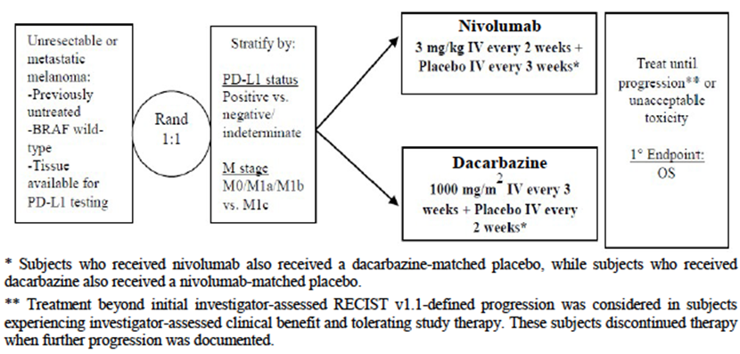
The primary objective of the trial was to compare the clinical benefit (as measured by the duration of overall survival) provided by nivolumab, compared to that provided by dacarbazine, in subjects with previously untreated, unresectable or metastatic melanoma. Secondary objectives were:
- To compare the duration of investigator-assessed progression-free survival (PFS) of nivolumab vs. dacarbazine in subjects with previously untreated, unresectable or metastatic melanoma;
- To compare the investigator-assessed objective response rate (ORR) of nivolumab vs. dacarbazine in subjects with previously untreated, unresectable or metastatic melanoma;
- To evaluate whether programmed cell death ligand 1 (PD-L1) expression is a predictive biomarker for overall survival;
- To evaluate health-related quality of life (HRQoL) as assessed by European Organisation for Research and Treatment of Care (EORTC) QLQ-C30 (Quality of Life Questionnaire - Core 30).
A number of exploratory objectives were also stated.
The trial was conducted 76 sites in 16 countries (Argentina, Australia, Canada, Chile, Denmark, Finland, France, Germany, Greece, Israel, Italy, Mexico, Norway, Poland, Spain, and Sweden). These were countries where dacarbazine was considered first-line standard of care for patients with previously untreated, unresectable or metastatic melanoma.
The study commenced in January 2013 and was closed on 24 June 2014. The date of data cut-off for the study report was 5 August 2014 and the report itself was dated 20 October 2014. The study has been published.

Inclusion and exclusion criteria
Inclusion and exclusion criteria were outlined.
Comment: Enrolment in the study was restricted to subjects with tumours known to be BRAF wild type. Subjects with BRAF mutant or BRAF indeterminate disease were not randomised. Subjects could not have received previous treatment for their advanced disease. Most subjects with pre-existing autoimmune disease were excluded.

Study treatments
Subjects were randomised (1:1) to receive one of the following treatments:
- Nivolumab 3 mg/kg by IV infusion over 60 minutes every 2 weeks, and placebo for dacarbazine over 60 minutes every 3 weeks; or
- Dacarbazine 1000 mg/m2 by IV infusion over 60 minutes every 3 weeks, and placebo for nivolumab over 60 minutes every 2 weeks.
Treatment was continued until the subject developed progressive disease or unacceptable toxicity. However, a subject was permitted to continue treatment after disease progression if the investigator considered that he or she was still deriving clinical benefit and was tolerating the drug. Such use was permitted because it was known that some subjects receiving immune stimulating agents developed an initial increase in tumour size followed by a reduction. In this situation treatment was discontinued if the subject experienced further disease progression.
Dose escalation was not permitted for either study drug. Dose reductions of dacarbazine were permitted in the event of toxicity. No dose reductions were permitted for nivolumab. Dose delays were permitted for both drugs.
The following drugs were prohibited during the study, except for the treatment of a drug-related adverse event:
- Immunosuppressive agents;
- Systemic corticosteroids > 10-mg/day prednisone or equivalent. However, brief courses were permitted for the management of non-autoimmune conditions, as were replacement doses of systemic corticosteroids;
- Antineoplastic therapy.
Anti-emetics (other than corticosteroids) were routinely administered prior to dacarbazine (or placebo for dacarbazine) administration.
Comment: Dacarbazine is registered in Australia for the treatment of metastatic melanoma. The dosage regimen for dacarbazine used in this study is the same as that recommended by the Cancer Institute of NSW. Although ipilimumab was registered in Australia in 2011 (prior to the commencement of this study), it was only approved as second-line therapy at that time. The choice of dacarbazine as a comparator (in the setting of the first-line treatment of BRAF wild type disease) is therefore appropriate.

Efficacy variables and outcomes
The main efficacy variables were:
- Survival;
- Change in tumour size;
- Quality of life (QoL).
The primary efficacy outcome was overall survival (OS), defined as the time between date of randomisation and the date of death.
Secondary efficacy outcomes included:
- Progression-free survival (PFS) as determined by the investigator. PFS was defined as the time from randomisation to date of documented disease progression or death, whichever occurred first. Progression was defined according to RECIST 1.1 criteria.
- Objective response rate (ORR) as determined by the investigator. ORR was defined as the proportion of subjects who developed a complete response (CR) or partial response (PR) as per RECIST 1.1 criteria. Responses did not need to be confirmed.
- Health-related QoL as assessed by the EORTC QLQ-C30 questionnaire. This questionnaire is a validated, cancer-specific QoL instrument consisting of 30 items contained within five functional scales (measuring physical, role, emotional, social and cognitive functioning), three symptom scales (measuring pain, fatigue and nausea and vomiting), a global health status/ quality of life scale, and 6 single items measuring dyspnoea, insomnia, appetite loss, constipation, diarrhoea and financial impact. Scores range from 0-100. For functional and global quality of life scales, higher scores mean a better level of functioning. For symptom-oriented scales, a higher score means more severe symptoms.
- OS based on PD-L1 expression.
Time to response (TTR), duration of response (DOR), overall safety, pharmacokinetics and immunogenicity were exploratory endpoints.
Overall survival was assessed every 3 months. Tumour assessments (CT or MRI) occurred at baseline and at 9 weeks after randomisation, then every 6 weeks for the first 12 months and then every 12 weeks until disease progression or treatment discontinuation. The EORTC QLQ-C30 questionnaire was administered at baseline and then every 6 weeks while on study and then at follow-up.
Comment: Overall survival is an appropriate primary endpoint for oncology studies in subjects with advanced malignancies, consistent with the relevant EMA guideline adopted by the TGA. It is noted that a secondary endpoint was PFS as assessed by the investigator, and not by a blinded independent panel. Blinded independent review of PFS data is generally recommended to avoid investigator bias. However, this is not considered a significant issue for this study as it was a double-blind trial and PFS was only a secondary endpoint.

Randomisation and blinding methods
Subjects were randomised via an interactive voice response system (IVRS). Subjects were randomised 1:1 and randomisation was stratified according to:
- PD-L1 status (positive vs. negative vs. indeterminate); and
- Stage of disease (M0/M1a/M1b vs. M1c – Table 3).
Table 3. Study CA209066 - M stage categories for cutaneous melanoma.
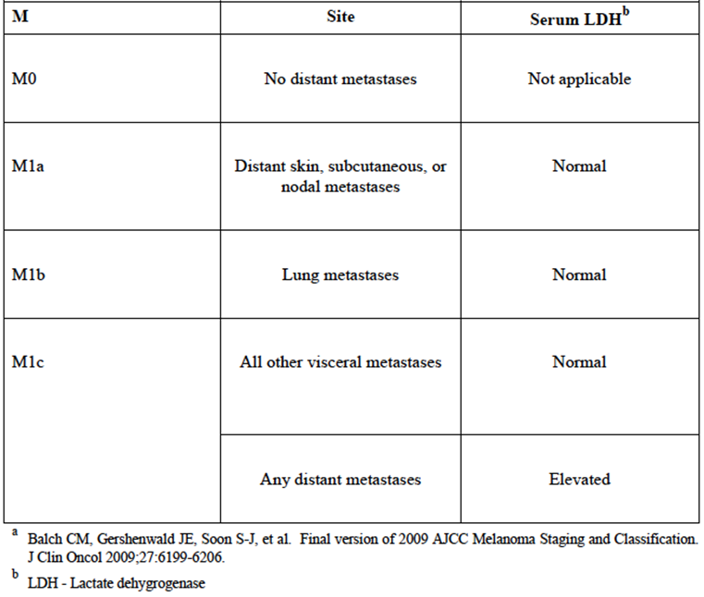
Subjects were randomised via an interactive voice response system (IVRS).
Blinding was maintained through the use of placebos for both nivolumab and dacarbazine.

Analysis populations
The All Randomized Population included all subjects who were randomized to any treatment arm in the study. This was the primary dataset for analyses of efficacy.
The All Treated Population included all subjects who received at least one dose of nivolumab, nivolumab-placebo, dacarbazine, or dacarbazine-placebo. This was the primary dataset for analyses of safety.
Response-Evaluable Subjects were all randomized subjects with measurable disease at a baseline tumour assessment and at least one on-treatment tumour assessment.

Sample size
It was assumed that median OS in the dacarbazine group would be 10 months and median OS in the nivolumab group would be 14.49 months (i.e. a 45% increase or a hazard ratio of 0.69). With an overall type 1 error of 0.05 (two-sided) and 90% power, it was calculated that the study would require a total of 312 deaths. It was planned to randomise approximately 410 subjects.

Statistical methods
OS was to be compared between the two groups using a two-sided, log-rank test stratified by PD-L1 status and M-stage. The hazard ratio of nivolumab to dacarbazine, with 95% confidence interval, was to be estimated using a Cox proportional hazards model, with treatment group as a single covariate, stratified by PD-L1 status and M-stage.Overall survival curves for each treatment group were to be estimated using the Kaplan-Meier product-limit method. Median OS and corresponding two-sided, 95% confidence intervals were to be computed. Survival rates at 6 and 12 months were to be estimated using K-M estimates on the OS curve for each treatment group. Associated two-sided 95% CIs were to be calculated.
Similar methods were used for PFS. Response rate was to be compared between the two treatment groups using a two-sided, Cochran-Mantel-Haenszel test stratified by PD-L1 status and M-stage.
One interim analysis was planned after approximately 218 deaths.
In order to preserve an experimental-wise type I error rate of 5%, a hierarchical testing approach was to be applied to the secondary endpoints of PFS and ORR following analysis of the primary endpoint of OS. If the p-value for the primary analysis of OS was not statistically significant either at the interim or final analysis, neither secondary endpoint was to be formally tested. If the OS result was significant, PFS would be tested first. ORR would be tested only if the PFS result was significant.
Descriptive statistics were used to summarise the EORTC QLQ-C30 data. No statistical testing of differences between the treatment arms was conducted.

Participant flow
A total of 583 subjects were enrolled. Of these, 418 subjects were randomised and 411 were treated (206 in the nivolumab group and 205 in the dacarbazine group). Seven subjects who were randomised were not treated because they no longer met entry criteria (4), withdrew consent (1) were non-compliant (1) or experienced an adverse event not related to study drug (1).
The Data Monitoring Committee (DMC) for the study noted a consistent imbalance in mortality between the two study arms and in May 2014 requested an expedited abbreviated report on efficacy and safety. This was reviewed by the DMC in June 2014. The analysis of overall survival was based on a total of 110 deaths only but demonstrated a highly significant difference between arms in favour of nivolumab. The DMC recommended that treatment be unblinded and that patients randomised to dacarbazine who had ended study treatment should be allowed to crossover to receive nivolumab. As a result the sponsor amended the protocol on 9 July 2014 to allow unblinding and crossover. All placebo treatment was ceased. The efficacy data presented in the study report were based on a database lock of 5 August 2014. At this time, none of the subjects randomised to dacarbazine had been treated with nivolumab and hence efficacy results were not confounded.
Only 6.3% of dacarbazine subjects were still on treatment at the database cut-off compared to 46.1% of nivolumab subjects. The main reason for the higher rate of discontinued treatment was a higher incidence of disease progression.
Median duration of treatment was 6.5 months for nivolumab and 2.1 months for dacarbazine.

Major protocol violations/deviations
Significant protocol deviations that could potentially affect the interpretability of study results were infrequent, occurring in 9 subjects (4.3%) in each study arm. The most common of these violations were unknown or mutant BRAF status (8 nivolumab vs. 4 dacarbazine) and ECOG status > 1 (1 vs. 3).
Comment: The incidence of violations was low and comparable in the two arms. It is unlikely that they would have affected interpretation of the efficacy results.

Baseline data
Subjects were predominately male and white, with a median age of 65 years. The most common adjuvant therapy used in both groups was interferon.
Comment: The two treatment groups were well balanced with respect to baseline characteristics.

Results for the primary efficacy outcome
Results for OS are shown in Table 4 and Figure 2. Nivolumab treatment was associated with a significant reduction in the risk of death (HR: 0.42; 95% CI 0.30 – 0.60; p < 0.0001). Median survival was 10.84 months in the dacarbazine group and had not been reached in the nivolumab group. Survival at 12 months was 72.9% for nivolumab compared to 42.1% for dacarbazine.
Table 4. Study CA209066 – Overall survival (all randomised subjects).
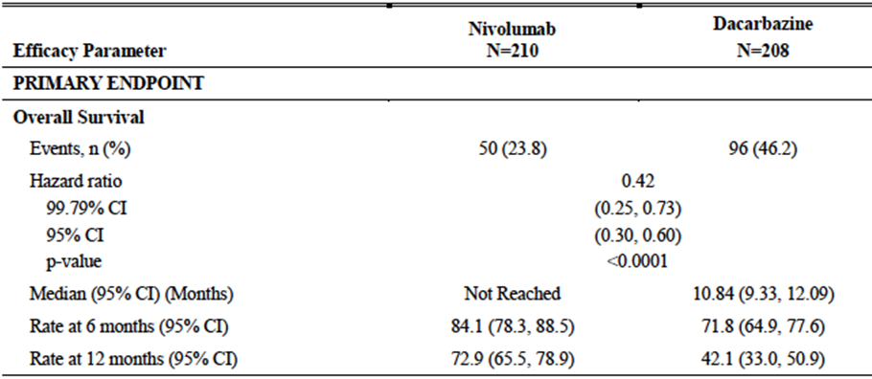
Figure 2. Study CA209066 – Overall survival (all randomised subjects).
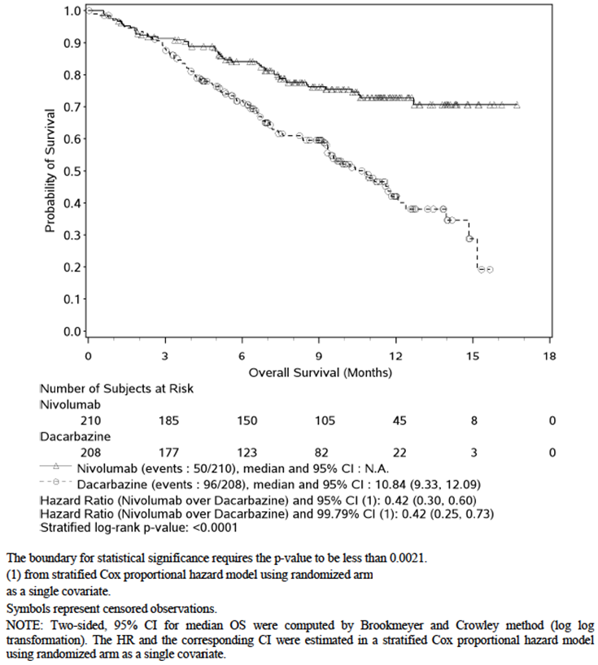
The survival benefit was consistent across a variety across a number of pre-defined subgroups (Figure 3), with all hazard ratios being less than 1. In particular, a survival benefit was demonstrated both for subjects with PD-L1 positive tumours (HR: 0.30; 95% CI 0.15 – 0.60) and subjects with PD-L1 negative tumours (HR: 0.48; 95% CI 0.32 – 0.71).
Figure 3. Study CA209066 – Overall survival in subgroups.
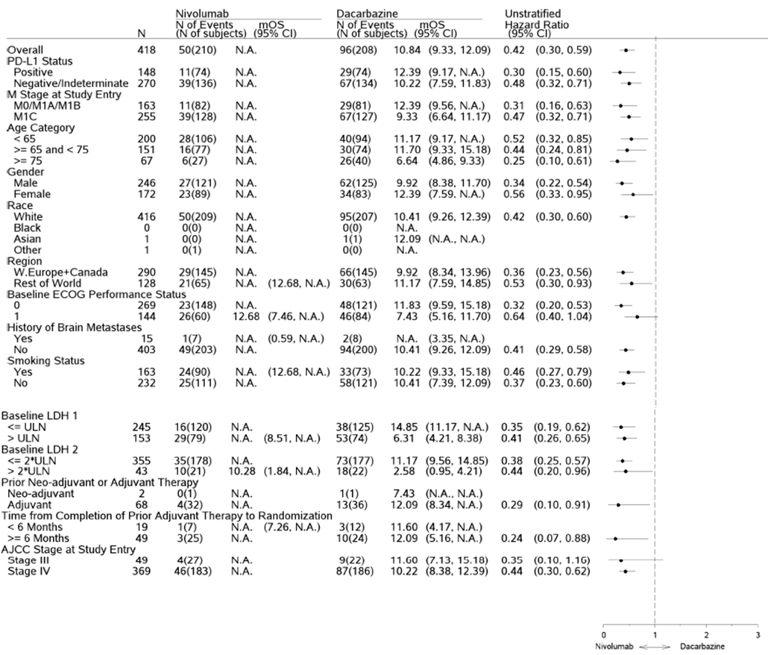
Subsequent anticancer treatment was received by 63.9% of subjects in the dacarbazine arm compared to 39.0% of subjects in the nivolumab arm. Ipilimumab treatment was received 38.0% and 21.4% of subjects respectively. The greater use of other therapies in the dacarbazine arm may have had the effect of decreasing the true survival benefit produced by nivolumab.

Results for other efficacy outcomes

Progression-free survival
Results for PFS are shown in Table 5 and Figure 4. Nivolumab treatment was associated with a significant reduction in the risk of disease progression or death (HR: 0.43; 95% CI 0.34 – 0.56; p < 0.0001). Median PFS was prolonged by approximately 3 months (5.06 vs. 2.17 months).
Table 5. Study CA209066 – Progression-free survival (all randomised subjects).
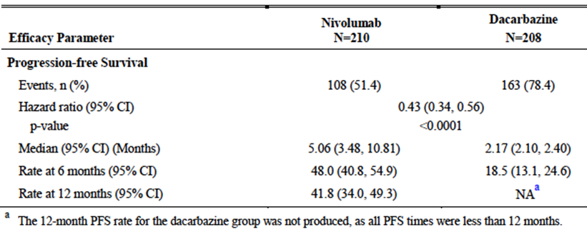
Figure 4. Study CA209066 – Progression-free survival (all randomised subjects)
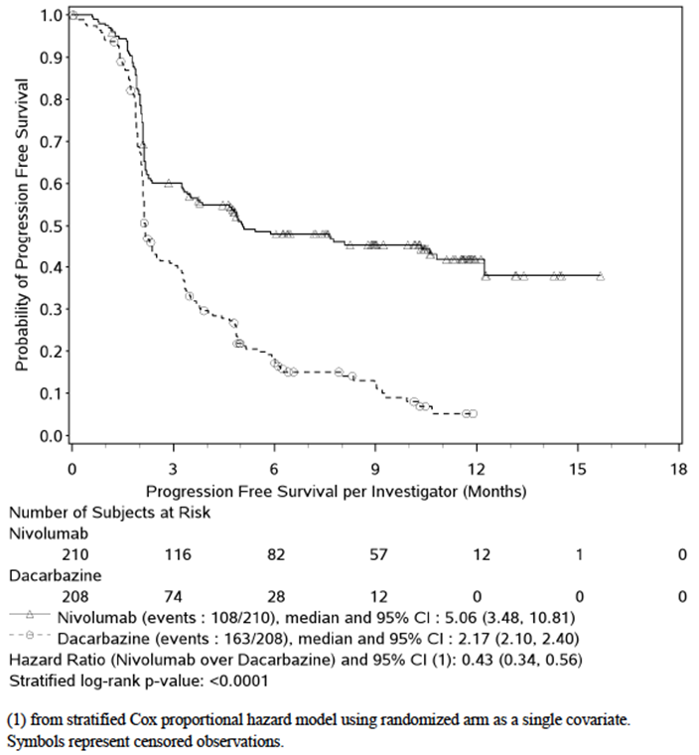

Overall response rate
Results for ORR are summarised in Table 6. The ORR with nivolumab was 40.0% compared to 13.9% with dacarbazine (p<0.0001). Complete responses were more common with nivolumab (7.6% vs. 1.0%).
Table 6. Study CA209066 – Overall response rate (all randomised subjects).
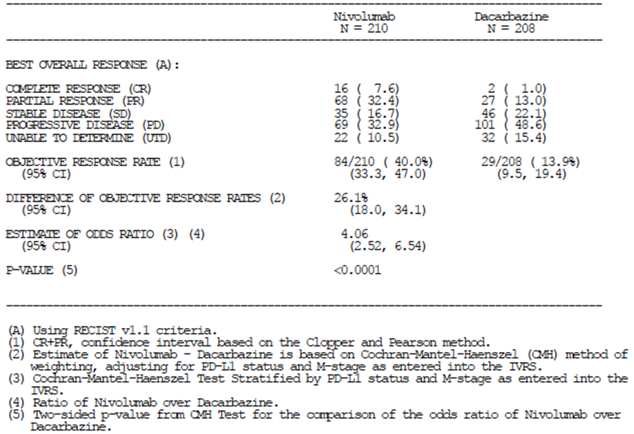

Time to response
Median time to response was 2.10 months (range: 1.2 to 7.6) in the nivolumab group and 2.10 months (range 1.8 to 3.6) in the dacarbazine group.

Duration of response
The median duration of response with dacarbazine was 5.98 months, while a median had not yet been reached for nivolumab (Figure 5).
Figure 5. Study CA209066 - Duration of response (responding patients).
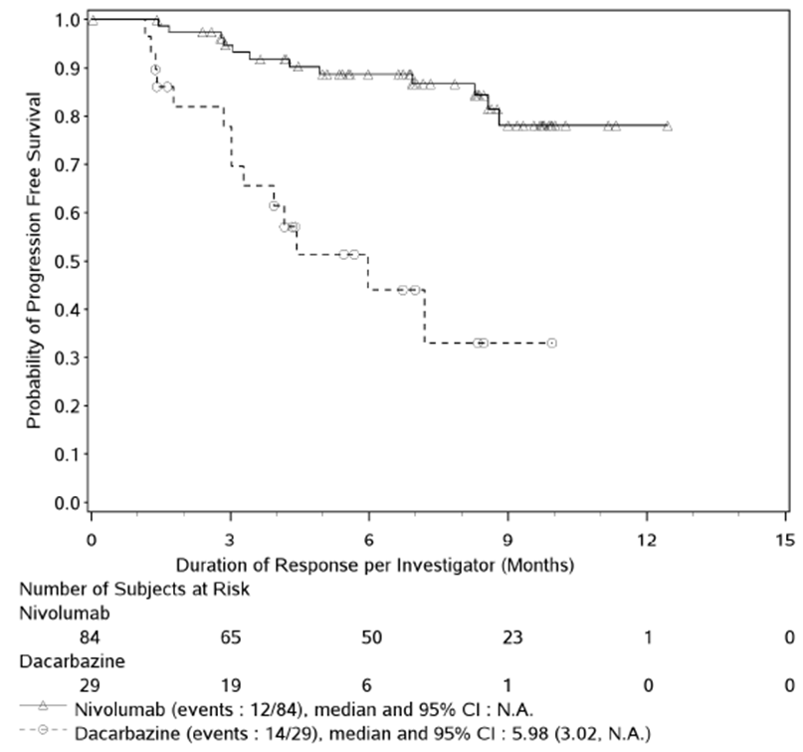

EORTC QLQ-C30
The various scales and symptom scores remained stable over the course of the study, with changes from baseline generally not being clinically significant in either group.

Treatment after disease progression
103 subjects received ongoing study treatment after documented disease progression (nivolumab 54 and dacarbazine 49). 12 nivolumab subjects (22.2%) developed or maintained a >30% reduction compared to baseline in the size of their target lesion. Only 2 of the dacarbazine-treated subjects (4.1%) developed or maintained such a response.
Comment: These data do not establish that there is a benefit (e.g. improved survival) associated with continuing treatment with nivolumab after a patient has developed evidence of disease progression.

Study CA209037

Study design, objectives, locations and dates
Study CA209037 was a Phase 3, randomised, open trial with two parallel groups. Subjects with advanced melanoma, who had progressed on prior anti-CTLA-4 therapy, were randomised (2:1) to receive either nivolumab or the investigator’s choice of chemotherapy (either dacarbazine or the combination of carboplatin with paclitaxel). A study schematic for the trial is shown in Figure 6.
Figure 6. Study CA209037 – Study Schematic.
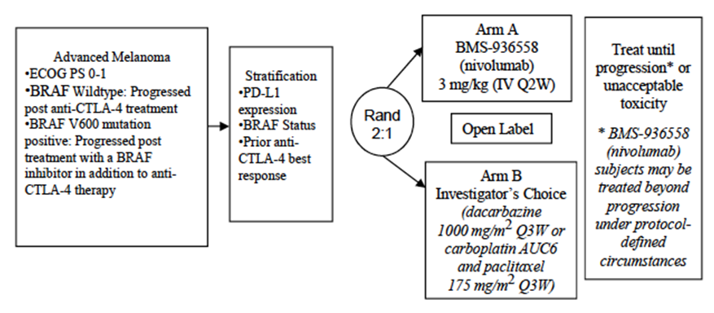
The primary objective of the study was to estimate the ORR in nivolumab treatment group and to compare OS of nivolumab to investigator’s choice in subjects with advanced melanoma. The secondary objectives were to:
- Compare the PFS of nivolumab to investigator’s choice in subjects with advanced melanoma.
- Evaluate whether PD-L1 expression is a predictive biomarker for ORR and OS.
- Evaluate HRQoL as assessed by the EORTC QLQ-C30.
There were also a number of exploratory objectives relating to safety, PK, immunogenicity, potential biomarkers for response, the effects of genetic variation on clinical endpoints and QoL.
The study was conducted at 90 centres in 14 countries (USA, Austria, Belgium, Brazil, Canada, Denmark, France, Germany, Israel, Italy, Netherlands, Spain, Switzerland and the United Kingdom).
The study commenced in December 2012 and is ongoing. The study report included in the submission was an interim study report. The cut-off date for inclusion of imaging data in the report was 10 March 2014. The report itself was dated 18 July 2014. The study has been published.
Comment: As described below, the study was designed with two co-primary efficacy endpoints – overall response rate (ORR) and overall survival (OS). These were to be analysed at different time points. ORR was analysed first and OS at later time points. The interim report contained in the current submission was the initial report on ORR.

Inclusion and exclusion criteria
Inclusion and exclusion criteria were outlined. All subjects were required to have progressed following anti-CTLA4 therapy (i.e. ipilimumab). Subjects who were BRAF mutation positive were also required to have progressed following treatment with a BRAF inhibitor.

Study treatments
Subjects were randomised (2:1) to receive one of the following treatments:
- Nivolumab 3 mg/kg by IV infusion over 60 minutes every 2 weeks; or
- Dacarbazine 1000 mg/m2 by IV infusion over 30-60 minutes every 3 weeks, OR a combination of paclitaxel (175 mg/m2 IV over 180 minutes every 3 weeks) and carboplatin (AUC 6 IV over 30 minutes every 3 weeks). The investigator made the choice of chemotherapy regimen.
Treatment was continued until the subject developed progressive disease or unacceptable toxicity. However, a subject receiving nivolumab was permitted to continue treatment after disease progression if the investigator considered that he or she was still deriving clinical benefit and was tolerating the drug.
Dose escalation was not permitted for either study arm. Dose reductions of dacarbazine or paclitaxel/carboplatin were permitted in the event of toxicity. No dose reductions were permitted for nivolumab. Dose delays were permitted for both study arms. Subjects in the chemotherapy arm were not permitted to cross over to nivolumab following disease progression.
The following drugs were prohibited during the study, except for the treatment of a drug-related adverse event:
- Immunosuppressive agents;
- Systemic corticosteroids > 10-mg/day prednisone or equivalent. However, brief courses were permitted for the management of non-autoimmune conditions, as were replacement doses of systemic corticosteroids;
- Antineoplastic therapy.
In the chemotherapy arm, premedications (e.g. antiemetics, corticosteroids) were administered according to local practice.
Comment: Dacarbazine is an acceptable comparator for subjects who have already failed ipilimumab ± a BRAF inhibitor. Paclitaxel and carboplatin are not registered for the treatment of advanced melanoma in Australia. However, the combination is one of several recommended cytotoxic regimens for the treatment of advanced melanoma according to widely accepted clinical practice guidelines.

Efficacy variables and outcomes
The main efficacy variables were:
- Survival;
- Change in tumour size;
- Quality of life (QoL).
There were two co-primary efficacy endpoints in this study:
- Objective response rate (ORR) and duration of response in nivolumab-treated subjects, as determined by an independent radiology review committee (IRRC). Response was defined according to RECIST 1.1 criteria and responses had to be confirmed.
- Overall survival.
The two endpoints were to be analysed at different time points. ORR was to be analysed based on the first 120 nivolumab-treated subjects who had completed 6 months follow-up. OS was to be analysed using the entire randomised population.
Secondary efficacy endpoints included:
- Progression-free survival (PFS) as determined by the IRRC. Progression was defined according to RECIST 1.1 criteria
- Association between efficacy endpoints and tumour PD-L1 expression.
- Health-related QoL as assessed by the EORTC QLQ-C30 questionnaire.
Overall survival was assessed continuously during treatment and every 3 months during follow up. Tumour assessments (CT or MRI) occurred at baseline and at 9 weeks after randomisation, then every 6 weeks for the first 12 months and then every 12 weeks until disease progression or treatment discontinuation. The EORTC QLQ-C30 questionnaire was administered at baseline and then every 6 weeks while on study and then at follow-up.

Randomisation and blinding methods
Subjects were randomised (2:1) to nivolumab or chemotherapy via an interactive voice recognition service. Randomisation was stratified by:
- Tumour PD-L1 expression (positive or negative). PD-L1 positive tumours were those which had ≥ 5% tumour cell membrane staining;
- BRAF mutation status (wild-type vs. mutation positive);
- Best response to prior anti-CTLA-4 therapy (response or stable disease vs. progressive disease);
There was no blinding of investigators or patients in the study. However, the IRRC that assessed response/disease progression was blinded to treatment allocation, subject identity and demographics.

Analysis populations
The All Randomized Population included all subjects who were randomized to any treatment arm in the study.
The All Treated Population included all subjects who received at least one dose of study drug.
The ORR Population included all randomized subjects with at least 6 months of follow-up at the time of the ORR analysis, which occurred when the first 120 nivolumab-treated subjects had a minimum of 6 months of follow-up. The Treated Subjects Among ORR Population were those subjects who received at least one dose of treatment (nivolumab or investigator’s choice) and had at least 6 months of follow-up at the time of the ORR analysis.

Sample size
There were two co-primary endpoints designated for the study – ORR and OS. These were to be analysed at different time points. The alpha allocation was 0.1% for the ORR analysis and 4.9% for the OS analysis.
The ORR analysis was to occur after approximately 180 subjects (120 in nivolumab arm and 60 in the chemotherapy arm) had completed a minimum of 6 months follow-up. The formal analysis was to be restricted to subjects in the nivolumab arm (i.e. no formal statistical comparison of the two arms was planned).
For the OS analysis, it was assumed that median OS in the chemotherapy group would be 8 months and median OS in the nivolumab group would be 12.3 months (i.e. a 4.3 month increase or a hazard ratio of 0.65). With an overall type 1 error of 0.049 (two-sided) and 90% power, it was calculated that the study would require a total of 260 deaths. It was planned to randomise approximately 390 subjects. One interim analysis was planned after 169 deaths.

Statistical methods
The IRRC-determined ORR in the nivolumab group was estimated and its corresponding 95% exact two-sided CI was calculated using the Clopper-Pearson method. Duration of response (DOR) in each treatment group was estimated using the Kaplan-Meier product-limit method. Median DOR and corresponding two-sided 95% CI were calculated.
OS was to be compared between the two treatment groups using a two-sided, log-rank test stratified by BRAF status, prior response to anti-CTLA-4 treatment, and PD-L1 status. The hazard ratio (HR) of nivolumab to chemotherapy and corresponding 95% CI (adjusted for the interim analysis) were to be estimated using a Cox proportional hazards model, with treatment group as a single covariate, stratified by BRAF status, prior response to anti-CTLA-4 treatment, and PD-L1 status. OS curves for each treatment group were to be estimated using the Kaplan-Meier product limit method. Median OS and corresponding two-sided, 95% confidence intervals would be computed. PFS was to be analysed using similar methods, but only if the result for OS was statistically significant.

Participant flow
A total of 631 subjects were enrolled. Of these, 405 subjects were randomised (272 to nivolumab and 133 to chemotherapy) and 370 were treated (268 in the nivolumab group and 102 in the chemotherapy group).
Comment: 23.3% of subjects (n=31) who were randomised to chemotherapy did not commence treatment. This compares to 1.5% of subjects (n=4) who were randomised to nivolumab. The main reasons given for not commencing treatment with chemotherapy were withdrawal of consent (n=22) and subject request to discontinue (n=5). This imbalance may have introduced some bias into the study.
At the time of date cut-off, 48.1% of subjects in the nivolumab were still on treatment, compared with 17.6% of subjects in the chemotherapy arm. The rates of discontinuation due to disease progression and discontinuation due to study drug toxicity were both higher in the chemotherapy arm.
Median duration of treatment was 5.26 months in the nivolumab arm and 1.95 months in the chemotherapy arm.

Major protocol violations/deviations
Significant protocol deviations that could potentially affect the interpretability of study results were infrequent, occurring in 5 subjects (1.8%) in the nivolumab arm and 5 subjects (3.8%) in the chemotherapy arm. The types of violation were similar in the two arms.
Comment: The incidence of violations was low and comparable in the two arms. It is unlikely that they would have affected interpretation of the efficacy results.

Baseline data
A wide variety of chemotherapy and immunotherapy regimens had been used. Use of individual regimens was well balanced between the two arms.
Comment: These tables present data for the ORR and All Randomised populations. They suggest that the two populations were reasonably well balanced with respect to baseline factors at randomisation. However, they do not take into account the fact that 23.3% of subjects randomised to the chemotherapy arm withdrew from the study before receiving treatment. There were no tables in the study report comparing baseline factors in the All Treated population, or for treated subjects in the ORR population. However, the FDA review of study CA209037 did include such tables and these indicated that the two treated populations were reasonably well balanced with respect to baseline factors.

Results for the primary efficacy outcome
ORR was the only primary endpoint analysed in the interim report included in the current submission. The ORR in the nivolumab arm was 31.7% (95%CI: 23.5% – 40.8%). For comparison, the ORR in the chemotherapy arm was 10.6% (95%CI: 3.5% – 23.1%). The difference between the two arms was not tested statistically. 3.3% of nivolumab-treated subjects developed a complete response compared to none of the chemotherapy-treated subjects.
There were no responses among 19 subjects treated with dacarbazine and 5 partial response among 28 subjects treated with paclitaxel/carboplatin (ORR = 17.9%).
Median duration of response had not been reached in the nivolumab arm whereas the median was 3.6 months in the chemotherapy arm. Median time to response was 2.1 months in the nivolumab arm and 3.5 months in the chemotherapy arm.
Results of sensitivity analyses included the following:
- In the ORR population (which included subjects randomised but not treated) the ORR was 31.1% in the nivolumab arm and 8.3% in the chemotherapy arm;
- As assessed by the investigator, the ORR was 25.8% in the nivolumab arm and 10.6% in the chemotherapy arm (among treated subjects in the ORR population).
Subgroup analyses indicated that the higher response rate for nivolumab compared to chemotherapy was consistent among the subpopulations examined. Among nivolumab-treated subjects, ORR was higher in subjects with PD-L1 positive disease (43.6%) than in subjects with PD-L1 negative disease (20.3%).

Results for other efficacy outcomes

Progression-free survival
Only a descriptive analysis of PFS data on the ORR population was performed for the interim analysis. A formal analysis of PFS data from the all randomised population was due to be performed at the time of the first planned interim analysis of OS. Results of the descriptive analysis (in the ORR population) are summarised in Table 7 and Figure 7. Median PFS in the nivolumab arm was 4.7 months compared to 4.2 months in the chemotherapy arm. 6-month PFS rate was 48% with nivolumab and 34% with chemotherapy.
Table 7. Study CA209037 – Progression-free survival.
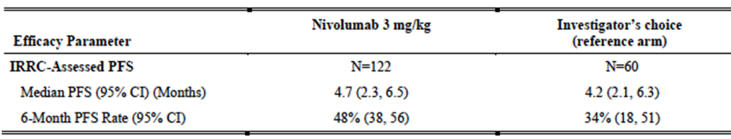
Figure 7. Study CA209037 – Progression-free survival (ORR population).
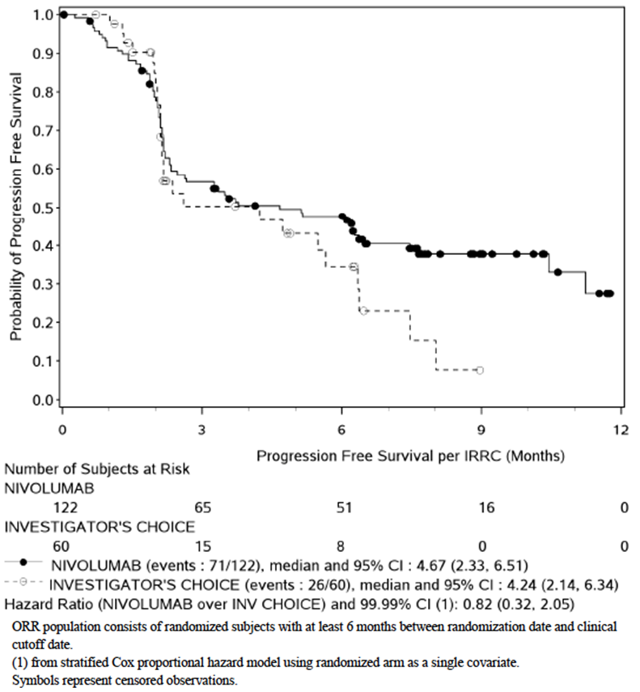

Treatment after disease progression
37 nivolumab-treated subjects received ongoing study treatment after documented disease progression. 10 of these (27.0%) developed or maintained a >30% reduction compared to baseline in the size of their target lesion. Treatment after progression was not permitted in the chemotherapy arm.

QoL
Results for the EORTC QLQ-C30 questionnaire were not presented in the interim study report.

Other analyses

Response by PD-L1 status
As described above, response rate with nivolumab appeared higher in subjects with PD-L1 positive disease than in subjects with PD-L1 negative disease. However in this analysis, tumour PD-L1 status was determined using a non-validated assay. The submission included an addendum to the study report in which tumour PD-L1 status was determined using a validated immunohistochemistry assay. PD-L1 positive status was defined as a tumour specimen with ≥ 5% tumour cell membrane staining and PD-L1 negative status was defined as a tumour specimen with <5% tumour cell membrane staining.
Among nivolumab-treated subjects, PD-L1 positive status was associated with an ORR of 42.4%, whereas PD-L1 negative status was associated with an ORR of 19.2%.
Among chemotherapy-treated subjects, PD-L1 positive status was associated with an ORR of 8.7%, whereas PD-L1 negative status was associated with an ORR of 14.3%.

Overall survival
The FDA requested an analysis of OS data at the time of the planned ORR analysis. This OS analysis was unplanned and was conducted after a total of only 94 deaths had occurred in the All Randomised population. The first planned OS analysis was not scheduled until 169 deaths had occurred.
Results of the unplanned analysis in the All Randomised population are summarised in Figure 8. There was no significant reduction in the risk of death (HR 0.96; 95%CI: 0.60 – 1.52). Median survival had not been reached in the nivolumab arm and was 11.76 months in the chemotherapy arm.
Figure 8. Study CA209037 – Overall survival (All Randomised Population).
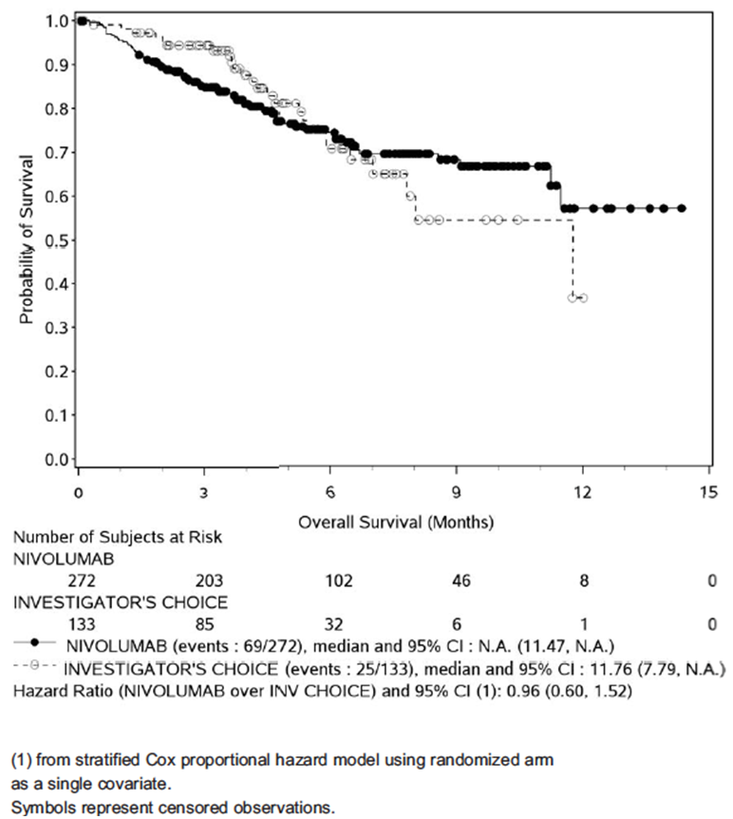
Comment: These OS data are immature and the analysis was unplanned. Reliable conclusions regarding comparative efficacy cannot therefore be drawn. The planned first interim analysis of OS was expected to be available in March 2015 and the results of this should be requested from the sponsor.

Investigator-assessed PFS
The FDA also requested an analysis of investigator-assessed PFS data at the time of the planned ORR analysis. This was also an unplanned analysis. Results are summarised in Figure 9. There was a trend towards improved PFS in the nivolumab arm (HR 0.70; 95%CI: 0.46 – 1.08).
Figure 9. Study CA209037 – Investigator-assessed PFS.
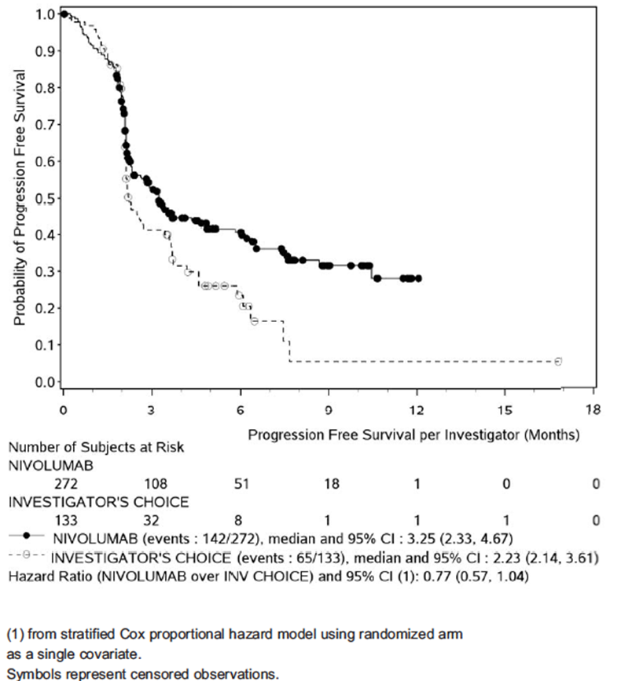

Study MDX-1106-01
This phase 1 trial was the first-in-man study for nivolumab. The study enrolled 10 subjects with advanced melanoma and 1 of these subjects (10%) achieved a confirmed partial response. The subject had received 10 mg/kg. Duration of response was not stated.

Study MDX-1106-03 (CA209003)
This was a phase 1 study in subjects with various types of advanced/recurrent malignancies. The study included 107 subjects with advanced melanoma and these were treated with doses ranging from 0.1 to 10 mg/mg every 2 weeks for up to 96 weeks.
Efficacy was assessed using RECIST 1.0 criteria. Overall 34/107 subjects (31.8%) developed an objective response. 1 subject had a complete response and 33 subjects had a partial response. Median duration of response was 22.9 months (range: 3.9+ to 26.9+). Time to response ranged between 7.1 and 40 weeks. Response rate and duration of response were not related to dose level.
Median PFS was 3.65 months (95% CI: 1.9 to 9.3). The PFS rate at 48 weeks was 38% and at 96 weeks was 29%. Median OS was 17.3 months (95% CI: 12.5 to 36.7). The survival rate was 63% at 1 year, 48% at 2 years and 41% at 3 years.
In NSCLC the response rate was 17.1% and in RCC it was 29.4%. No responses were observed in subjects with prostate or colon cancer.

Analyses performed across trials (pooled analyses and meta-analyses)
There were no pooled analyses or meta-analyses of the monotherapy efficacy data.

Evaluator’s conclusions on efficacy for monotherapy
There were two Phase III studies submitted to support use of nivolumab as monotherapy in patients with advanced melanoma. Study CA209066 examined use of the drug in first-line treatment, whereas study CA209037 examined use in subjects who had progressed on ipilimumab and (if BRAF mutation positive) a BRAF inhibitor.
Study CA209066 was well designed and executed. The design of the study complied with the requirements of the relevant EMA guideline adopted by the TGA. The study demonstrated a highly clinically significant efficacy benefit when compared to dacarbazine, with a 58% reduction in the risk of death. The survival benefit did not appear to be associated with any deterioration in quality of life. The evidence for the efficacy of nivolumab monotherapy in the first line treatment of advanced melanoma is therefore convincing.
Only interim results were available for Study CA209037. They demonstrated that nivolumab monotherapy is associated with an overall response rate of 31.7%. Although not subjected to statistical analysis, this response rate was numerically higher than that obtained with dacarbazine or paclitaxel/carboplatin (10.6%). The study has not yet demonstrated a benefit for nivolumab compared to chemotherapy in terms of clinically meaningful endpoints such as OS, PFS, or quality of life. Data from the first planned (interim) analysis of OS should be sought from the sponsor. However, the population studied in this trial had already failed ipilimumab and a BRAF inhibitor (if BRAF mutation positive). Such subjects have limited treatment options available. The ORR of 31.7% was notably numerically higher than that obtained with chemotherapy (10.6%). Given the limited treatment options available, the submitted evidence of efficacy is considered sufficient to support approval of nivolumab monotherapy in subjects who have progressed following treatment with ipilimumab and a BRAF inhibitor (if BRAF mutation positive).
The data from these monotherapy studies suggest that nivolumab produces higher response rates in subjects who have PD-L1 positive tumours. However, the OS data from Study CA209066 suggest that the drug is also effective in subjects with PD-L1 negative tumours, with survival being greater in these subjects with nivolumab than with dacarbazine. The data therefore do not support limiting approval to subjects with PD-L1 positive tumours. There was no analysis of tumour PD-L2 expression as a potential biomarker for efficacy.
Among subjects who develop progressive disease while on nivolumab, a proportion (approximately 25%) will develop or maintain evidence of a response if treatment is continued. However it is not clear whether these subjects derive any clinical benefit (for example, improved survival) from continued treatment. These data therefore do not support persisting with nivolumab treatment after disease progression.

Nivolumab in combination with ipilimumab

Study CA209069

Study design, objectives, locations and dates
Study CA209069 was a Phase 2, randomised, double blind with two parallel groups. Subjects with previously untreated advanced melanoma were randomised to receive either nivolumab in combination with ipilimumab or ipilimumab monotherapy. A study schematic is shown in Figure 10.
Figure 10. Study CA209069 – Study schematic.
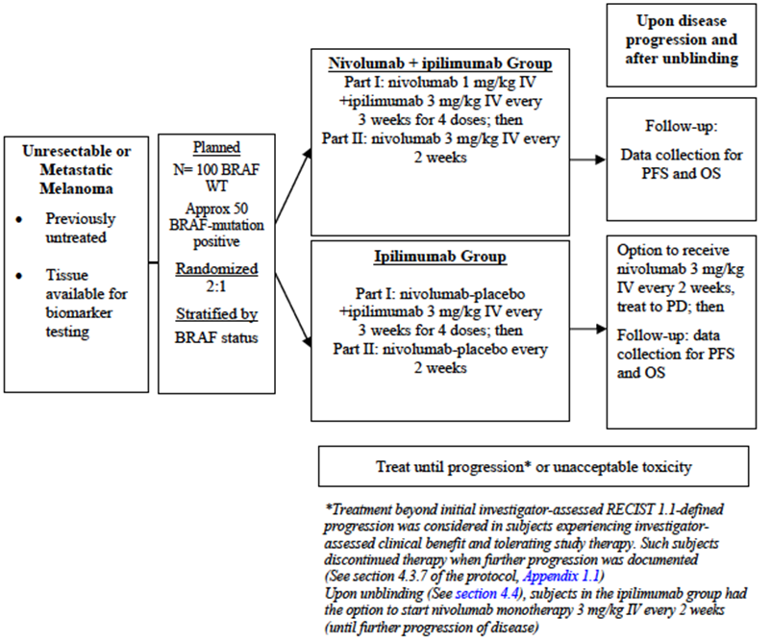
The primary objective of the study was to compare the ORR, as determined by investigators, of nivolumab combined with ipilimumab to ipilimumab monotherapy in subjects with BRAF wild type unresectable or metastatic melanoma. Secondary objectives were to:
- Compare PFS with nivolumab combined with ipilimumab to that with ipilimumab monotherapy in subjects with BRAF wild type unresectable or metastatic melanoma;
- Evaluate ORR and PFS of nivolumab combined with ipilimumab and ipilimumab monotherapy in BRAF mutation-positive subjects with unresectable or metastatic melanoma;
- Evaluate Health Related Quality of Life (HRQoL) as assessed by the EORTC QLQ-C30.
There were also a number of exploratory objectives relating to safety, assessment of overall survival, PK, immunogenicity, potential biomarkers for response, the effects of genetic variation on clinical endpoints and QoL.
The study was conducted at 21 centres in 2 countries (19 in the United States and 2 in France).
The trial commenced in August 2013 and is ongoing. The cut-off date for data for inclusion in the study report was 24 July 2014. The report itself was dated 5 December 2014. The study has been published.

Inclusion and exclusion criteria
Inclusion and exclusion criteria were outlined.
Comment: The study enrolled subjects who had not received prior systemic anticancer treatment for their advanced disease. Unlike the pivotal study of nivolumab monotherapy in previously untreated disease (CA206066) this study included subjects with either BRAF wild type disease or BRAF mutation positive disease.

Study treatments
Subjects were randomised (2:1) to one of the following treatment regimens:
- Arm A:
  - Nivolumab 1mg/kg IV and Ipilimumab 3 mg/kg every 3 weeks for 4 cycles; then
  - Nivolumab 3 mg/kg IV every 2 weeks.
- Arm B:
  - Ipilimumab 3 mg/kg (and nivolumab placebo) every 3 weeks for 4 cycles; then
  - Nivolumab placebo IV every 2 weeks.
In the combination arm, during the first four cycles, nivolumab (or placebo) was administered first, over 60 minutes. Ipilimumab was then administered over 90 minutes. Dose reduction or escalation was not permitted but dose delay was permissible in both arms. Randomised treatment was continued until disease progression or unacceptable toxicity. Continued treatment after disease progression was permitted provided that the investigator considered that the subject was deriving clinical benefit and the subject tolerated the study drug and provided written informed consent. Subjects in the ipilimumab monotherapy arm who experienced disease progression were able to crossover to receive nivolumab monotherapy.
The following drugs were prohibited during the study:
- Immunosuppressive agents (except when used to treat a drug-related AE);
- Systemic corticosteroids > 10-mg/day prednisone or equivalent. However, brief courses were permitted for the management of non-autoimmune conditions, as were replacement doses of systemic corticosteroids;
- Antineoplastic therapy.
Comment: Ipilimumab is registered in Australia for the first-line treatment of advanced melanoma. The dose of ipilimumab used in the study (3 mg/kg IV over 90 minutes every 3 weeks for a total of 4 doses) is consistent with the approved regimen in Australia.

Efficacy variables and outcomes
The main efficacy variables were:
- Survival;
- Change in tumour size;
- Quality of life (QoL).
The primary efficacy endpoint in this study was objective response rate (ORR) in BRAF wild-type subjects, as determined by the investigator. Response was defined according to RECIST 1.1 criteria and responses had to be confirmed by a second scan conducted at least 4 weeks after initial documentation of response. Duration of response, time to response and per cent change in tumour volume were also analysed to further characterise the ORR. A sensitivity analysis using ORR assessed by an independent radiology review committee was also performed.
Secondary efficacy endpoints included:
- Progression-free survival (PFS) in BRAF wild-type subjects as determined by the investigator. Progression was defined according to RECIST 1.1 criteria. A sensitivity analysis using PFS assessed by an independent radiology review committee was also performed.
- ORR and PFS in BRAF mutation-positive subjects;
- Health-related QoL as assessed by the EORTC QLQ-C30 questionnaire.
There were multiple exploratory endpoints, including assessment of overall survival.
Tumour assessments (CT or MRI) occurred at baseline and at 12 weeks after the first dose, then every 6 weeks for the first 12 months and then every 12 weeks until disease progression or treatment discontinuation. The EORTC QLQ-C30 questionnaire was administered at baseline and then every 6 weeks for the first 6 months of the study.

Randomisation and blinding methods
Subjects were randomised (2:1) to combination treatment or ipilimumab monotherapy via an interactive voice recognition service. Randomisation was stratified by BRAF V600 mutation status (wild type vs. mutation positive).
Subjects and investigators were blinded to nivolumab treatment via the use of a placebo infusion (normal saline).

Analysis populations
The population of All Randomized Subjects included all subjects who were randomized to any treatment arm in the study. The population of All Treated Subjects included all subjects who received at least one dose of any study medication.

Sample size
The sample size was calculated to compare the ORR (based on investigator assessments) between BRAF wild type subjects randomized to receive the combination versus those randomised to ipilimumab monotherapy. Based on data from an earlier study it was assumed that the ORR in combination arm would be 40% and that in the ipilimumab arm it would be 10%. With a two-sided alpha of 0.05, and a power of approximately 87%, it was calculated that approximately 100 BRAF wild-type subjects would be required to show a significant difference. Assuming that 66% of randomised subjects would be BRAF wild type, a total of 150 subjects would be randomised.

Statistical methods
The comparison of investigator-assessed ORR was carried out in the all randomized BRAF wild type population using Fisher’s exact test. An associated odds ratio and corresponding two-sided 95% CI was calculated. An estimate of the difference in ORRs and corresponding exact 95% CI was also calculated.
Investigator-assessed PFS in the all randomized BRAF wild type population was compared using a two-sided, log-rank test. The hazard ratio and corresponding two-sided 95% CI was estimated in a Cox proportional hazards model using treatment as a single covariate. PFS curves were estimated using the Kaplan Meier product-limit method.
Descriptive statistics only were used to analyse results in the BRAF mutation positive population. Descriptive analyses were also used for the EORTC QLQ-C30 data.

Participant flow
A total of 179 subjects were enrolled. Of these, 142 subjects were randomised (95 to combination treatment and 47 to ipilimumab) and 140 were treated (94 with combination treatment and 46 with ipilimumab).
Of the 46 subjects treated with ipilimumab monotherapy, 22 (47.8%) crossed over to nivolumab monotherapy. At the time of data cut-off, 25/94 subjects in the combination arm (26.6%) were continuing with combination treatment, whereas 19/46 subjects in the ipilimumab monotherapy arm were continuing with treatment (ipilimumab or nivolumab monotherapy).
Median duration of treatment was 2.15 months in the combination arm and 2.71 months in the ipilimumab arm.

Major protocol violations/deviations
There were four significant protocol deviations, all in the combination arm. Two subjects had a baseline ECOG status > 1 and two had missing BRAF status at the time of the first dose.
Comment: These deviations are unlikely to affect interpretation of the study. Subjects with higher ECOG scores are less likely to derive benefit and hence any effect would be a decrease in efficacy in the combination arm.

Baseline data
The two study arms were reasonably well balanced.
Comment: There was a small excess of patients aged > 65 years in the ipilimumab arm (57.4% vs. 49.5%).

Results for the primary efficacy outcome
The ORR in the BRAF wild type population was 59.7% in the combination arm compared to 10.8 % in the ipilimumab arm. The difference was statistically significant (p < 0.0001). Results in the all randomised population were similar (55.8% vs. 8.5%; p < 0.0001). In the combination arm 16.7% of subjects achieved a complete response, compared to none in the ipilimumab arm.
A sensitivity analysis was conducted using ORR as assessed by a blinded IRRC. Results were similar to the primary analysis - 58.3% vs. 13.5% (p < 0.0001) in the BRAF wild type population and 52.6% vs. 10.6% (p < 0.0001) in the all randomised population.
Median time to response was similar in the two arms (2.76 vs. 2.66 months). Data on duration of response were not mature.
Subgroup analyses indicated that the greater efficacy was observed with the combination across all subgroups examined.
In the population of patients with BRAF mutation-positive disease, a response was observed in 10/23 subjects (43.5%; 95%CI: 23.2 – 63.2) in the combination arm. Four subjects (17.4%) experienced a complete response. There were no responses among 10 BRAF mutation-positive patients in the ipilimumab arm.
Results for per cent change in tumour volume (Figure 11) were consistent with ORR data.
Figure 11. Study CA209069 – Per cent change in tumour volume.
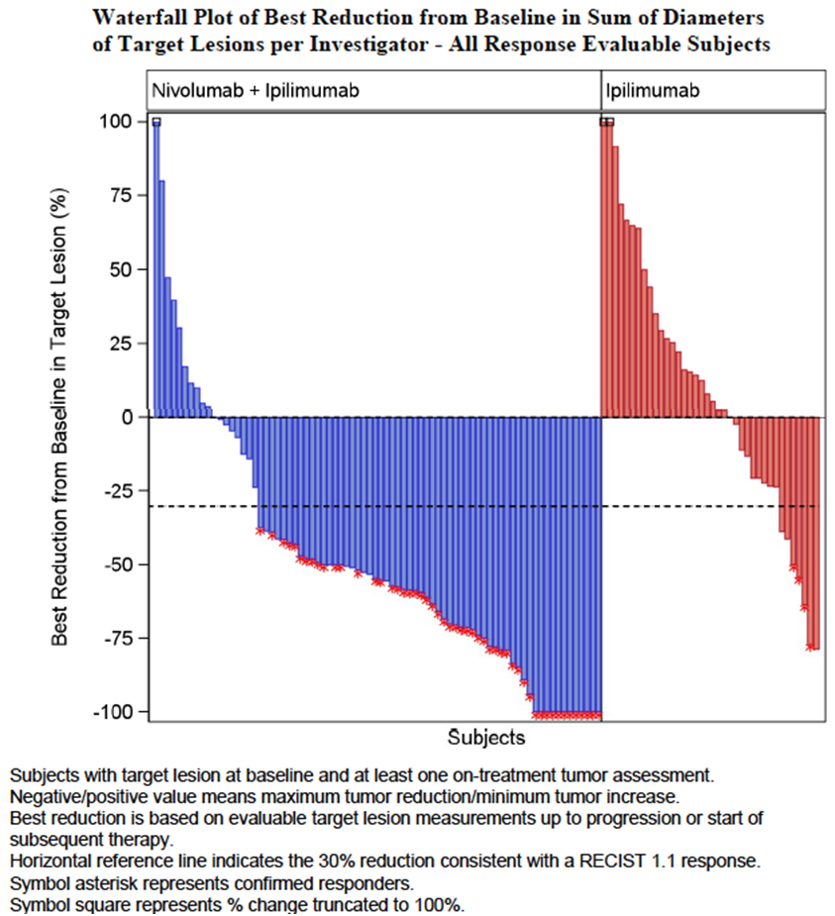

Results for other efficacy outcomes

Progression-free survival
In the BRAF wild type population, combination treatment was associated with a significant reduction in the risk of a PFS event – HR = 0.40; (95% CI: 0.22 – 0.71); p = 0.0012. Median PFS was increased (8.87 vs. 4.73 months). Results in the all randomised population were similar. A Kaplan-Meier plot of PFS for the BRAF wild type population is shown in Figure 12. Subgroup analyses of the BRAF wild type population indicated that the PFS benefit was consistent across various subgroups.
Figure 12. Study CA209069 - Progression-free survival (BRAF wild type population).
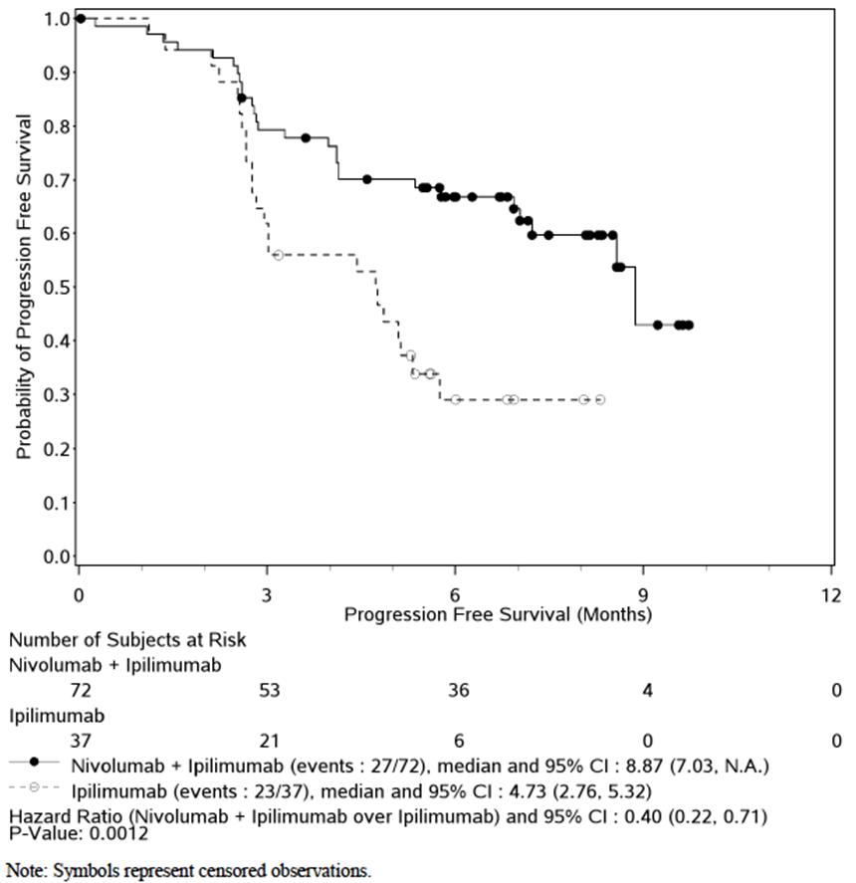
PFS was also prolonged with combination treatment in the BRAF mutation positive subgroup – HR = 0.33 (95% CI: 0.12 – 0.90).
PFS in the BRAF wild type population, as assessed by a blinded IRRC, was conducted as a sensitivity analysis. Results were similar – HR = 0.31 (95%CI: 0.17 – 0.55); p < 0.0001).

Overall survival
Overall survival data were not mature with only 31/142 randomised subjects (22%) having died. The available data did not suggest any difference in survival between the two treatment groups.
Comment: The OS data may be confounded by the high rate of crossover of patients from the ipilimumab arm to nivolumab treatment (22/47 or 46.8% of subjects in the all randomised population).

EORTC QLQ-C30
The various scales and symptom scores remained stable over the course of the study, with changes from baseline generally not being clinically significant in either group. Differences between treatment arms were not subjected to statistical testing.

Study CA209004
Study CA209004 was a Phase 1b, open-label dose escalation trial of nivolumab in combination with ipilimumab. The primary objective was to assess safety and tolerability of the combination. One of the secondary objectives was to assess preliminary evidence of efficacy for the combination. The study was conducted between December 2009 and June 2014 at 4 centres in the United States. The study report was dated December 2014.
There were a total of nine dose cohorts either planned or implemented. Cohorts 1, 2 and 3 examined dose escalation of the two drugs given concurrently. Cohort 3 was found to exceed the maximum tolerated dose (MTD) and therefore Cohort 2a was added. Cohorts 2 and 2a did not exceed the MTD and they had similar safety and efficacy profiles. However Cohort 2 had longer follow up. The dose used in Cohort 2 was therefore chosen for further study. Data from Cohorts 1-3 indicated that maximum tumour reduction occurred by week 24, before the combination maintenance treatment began. This suggested that the combination maintenance regimen used in these cohorts did not add substantially to the anti-tumour activity. Therefore, maintenance treatment with both drugs was replaced with nivolumab (3 mg/kg) treatment Q2W for further study in the expansion cohort of the trial (Cohort 8).
Cohorts 4 and 5 were not implemented and Cohorts 6 and 7 examined sequential use of nivolumab after ipilimumab treatment.
Subjects enrolled were required to have unresectable stage III or IV melanoma. Subjects in Cohorts 1-3 could have been treatment-naïve or previously treated. Other inclusion and exclusion criteria were unremarkable for a Phase 1 study.
The ORR was comparable in Cohorts 2, 2a and 3 at approximately 50%. Across Cohorts 1-3, the median duration of response was 105 weeks. In the expansion cohort (Cohort 8) the ORR was 44%. Median duration of response was not reached in Cohort 8. ORRs in Cohorts 6 and 7 were 53% and 19% respectively.
In Cohort 8, median PFS was 37.1 weeks (8.5 months).

Analyses performed across trials (pooled analyses and meta-analyses)
There were no pooled analyses or meta-analyses of the combination treatment efficacy data.

Evaluator’s conclusions on efficacy for combination therapy
There was one pivotal study submitted to support the combination of nivolumab with ipilimumab (CA209069). It was conducted in the first line setting. The study was well designed and executed. However, it was a Phase II trial that used ORR as the primary endpoint. Although an impressive response rate was obtained with the combination (59.7% in the BRAF wild type population), the data on duration of response were not mature and therefore it has not been established that these responses are durable.
The relevant EMA guideline adopted by the TGA does not consider ORR to be an acceptable primary endpoint for a confirmatory study, and suggests that clinically relevant endpoints such as PFS or OS should be used. Investigator assessed PFS was a secondary endpoint in this trial and a significant benefit was demonstrated. Median PFS was prolonged by approximately 4 months (8.87 versus 4.73 months).
The choice of comparator (ipilimumab) in the study was appropriate. However, it would be useful to know whether the combination provides any benefit over nivolumab monotherapy. Cross trial comparison of efficacy results in the BRAF wild type population in the first line setting suggests that this may be the case.
Table 8. Cross-trial comparison of monotherapy and combination therapy for ORR and median PFS.
 | Study | ORR | Median PFS
Nivolumab monotherapy | CA209066 | 40.0 % | 5.06 m
Combination therapy | CA209069 | 59.7% | 8.87 m
However, cross trial comparisons are unreliable. It is noted that the sponsor is currently undertaking another Phase III trial in the first line setting (Study CA209067) with three treatment arms: nivolumab monotherapy, ipilimumab monotherapy, and combination therapy. The co-primary endpoints for this study are OS and PFS. Given the limitations of Study CA209069, it may be prudent to await the results of Study CA209067 before approving combination treatment.
Although the pivotal study was conducted in the first line setting and included BRAF mutation positive subjects, the combination was not compared to a standard first line therapy for these subjects (that is, BRAF inhibitor therapy). The study therefore does not support the use of the combination in the first line treatment of BRAF mutation positive disease.
In the Phase I study the ORR with the proposed combination regimen was lower than in the pivotal study (44% versus 59.7%).

Clinical safety
The submission did not include analyses of pooled safety data. Hence safety will be reviewed for each study included in the submission.

Studies providing evaluable safety data
The following studies provided evaluable safety data:

Pivotal efficacy studies
There were three studies in the submission that are considered pivotal – studies CA209037 and CA209066 for monotherapy and study CA209069 for combination therapy. In these studies, the following safety data were collected:
- General adverse events (AEs) were assessed either continuously or at each study visit;
- The sponsor identified the following as AEs of special interest – endocrinopathies, diarrhoea/colitis, hepatitis, pneumonitis, interstitial nephritis and rash. These were referred to in the dossier as ‘select AEs’. The choice of these events was based on observations in early studies and the expected effects of an immunotherapy. Because multiple individual AE terms could be used to describe these toxicities, the following categories of AEs were examined: endocrine, gastrointestinal, hepatic, pulmonary, renal and skin. Hypersensitivity/infusion reactions were added as another category of select AEs.
- Measurement of vital signs and physical examination were conducted at baseline and at regular intervals during treatment.
- Laboratory tests were performed at baseline, at regular intervals during treatment and during follow up. Testing included complete blood count with differential, liver function testing, urea, creatinine, calcium, magnesium, sodium, potassium, chloride, lactate dehydrogenase, glucose and thyroid function testing. Study CA209069 also included monitoring of amylase and lipase.

Non-pivotal efficacy studies
The following non-pivotal efficacy studies provided safety data:
- Studies MDX-1106-01 and MDX-1106-03 (CA209003), which were Phase I dose-ranging studies conducted using nivolumab monotherapy in subjects with various advanced malignancies;
- Study CA209004, which was a Phase I dose-ranging study of the combination of nivolumab with ipilimumab in subjects with advanced melanoma;
- Study CA209010, which was a Phase II dose-ranging study in subjects with renal cell carcinoma;
- Study CA209063, which was a Phase II single-arm study in 117 subjects with advanced NSCLC.
Safety monitoring in the non-pivotal studies was generally similar to that used in the pivotal studies. ECGs were monitored in some of the early studies.
None of the non-pivotal studies had a placebo or active comparator arm. Hence the most informative safety data are likely to come from the pivotal studies.

Patient exposure
Approximately 1130 subjects had received treatment with nivolumab monotherapy. Only 188 subjects had been treated with the combination of nivolumab and ipilimumab. The submission did not contain an analysis of overall extent of exposure by dose and duration.

Adverse events with monotherapy

All adverse events (irrespective of relationship to study treatment)

Pivotal studies

CA209066
The incidence of AEs was 93.2% in the nivolumab arm and 94.6% in the dacarbazine arm. The incidence of grade 3 or 4 toxicity was also comparable (34.0% vs. 38.0%). Nivolumab was associated with increased rates of skin toxicity and hypothyroidism, whereas dacarbazine was associated with more nausea and vomiting, neutropaenia and thrombocytopaenia.

CA209037
The incidence of AEs was 95.1% in the nivolumab arm and 93.1% in the chemotherapy arm. Grade 3 or 4 toxicity was more common in the chemotherapy arm (34.3% vs. 43.1%). Nivolumab was again associated with increased rates of skin toxicity (apart from alopecia) and hypothyroidism. In this study it was also associated with a higher incidence of LFT abnormalities and increased creatinine reported as AEs and cough. Chemotherapy was associated with more nausea and vomiting, cytopaenias and alopecia.

Other studies
- MDX1106-01. AEs were experienced by 100% of subjects. Individual AE terms did not show increasing frequency with increasing dose (0.3 – 10 mg/kg).
- MDX1106-03. AEs were experienced by 99.0% of subjects. Individual AE terms did not increase in frequency with increasing dose (0.1 – 10 mg/kg) or vary according to tumour type.
- CA209010. AEs were experienced by 98.8% of subjects. There was no consistent pattern of increasing toxicity with increasing dose (0.3 – 10 mg/kg).
- CA209063. AEs were experienced by 100% of subjects. All subjects were treated with 3 mg/kg q 2 weeks.
In all these studies the most common AEs were those that might be expected in subjects with advanced cancer – e.g. fatigue, nausea, decreased appetite, diarrhoea, anaemia, constipation, decreased weight, etc.

Treatment-related adverse events (adverse drug reactions)

Pivotal studies

CA209066
The incidence of drug-related AEs was 74.3% in the nivolumab arm and 75.6% in the dacarbazine arm. The incidence of grade 3 or 4 toxicity was higher in the dacarbazine arm (11.7% vs. 17.6%). The pattern of toxicity for each arm was similar to that observed for all AEs.

CA209037
The incidence of drug-related AEs was 67.5% in the nivolumab arm and 79.4% in the chemotherapy arm. Grade 3 or 4 toxicity was also more common in the chemotherapy arm (9.0% vs. 31.4%). Again, the pattern of toxicity for each arm was similar to that observed for all AEs.

Other studies
Treatment-related AEs were experienced at the following frequencies:
- MDX1106-01. 89.7%.
- MDX1106-03. 75.2%.
- CA209010. 73.1%.
- CA209063. 70.9%.
The pattern of treatment-related AEs in these studies was similar to that for overall AEs.

Deaths and other serious adverse events

Pivotal studies

CA209066 - Deaths
The incidence of death was 22.8% in the nivolumab arm and 46.8% in the dacarbazine arm. None of the deaths were considered related to the study drugs, and virtually all were due to disease progression. The incidence of death within 30 days of the last dose was 6.3% with nivolumab and 8.3% with dacarbazine.

CA209037 - Deaths
The incidence of death was 25.0% in the nivolumab arm and 23.5% in the chemotherapy arm. None of the deaths were considered related to the study drugs, with the vast majority due to disease progression. The incidence of death within 30 days of the last dose was 10.4% with nivolumab and 2.0% with chemotherapy.

CA209066 – Serious AEs
SAEs occurred with a slightly lower frequency in the nivolumab arm – 31.1% vs. 38.0%. None of the individual AE terms were notably more common with nivolumab.

CA209037 – Serious AEs
SAEs occurred with an increased frequency in the nivolumab arm (44.0% vs. 21.6%).
Comment: In this study, the median duration of treatment with nivolumab (5.26 months) was notably longer than the median duration of treatment with chemotherapy (1.95 months). The longer duration of treatment may account for the higher incidence of SAEs in the nivolumab arm. The incidence of drug-related SAEs was slightly lower in the nivolumab arm (6.3% vs. 9.8%).

Other studies

Deaths
- MDX1106-01. There were 12 deaths within 28 days of the last dose, among the 39 subjects. None were considered related to nivolumab.
- MDX1106-03. There were 75 deaths within 100 days of the last dose, among the 306 treated subjects. Five subjects died after developing treatment-related pneumonitis. Four of these subjects had NSCLC and one had colon cancer.
- CA209010. There were 73 deaths among the 167 subjects. None were considered related to nivolumab.
- CA209063. There were 44 deaths within 100 days of the last dose among the 117 NSCLC subjects. Two deaths were considered related to nivolumab – 1 subject with hypoxic pneumonia and 1 with ischaemic stroke.

Serious AEs
- MDX1106-01. SAEs were experienced by 59% of subjects. Only one event (colitis/anaemia) was considered related to nivolumab.
- MDX1106-03. SAEs were experienced by 52% of subjects. Treatment-related SAEs occurred in 13.7% of subjects. Of these the most common were pneumonitis (2.3%), colitis (1.3%), diarrhoea (1.3%) and pyrexia (1.0%).
- CA209010. SAEs were experienced by 49% of subjects. Treatment-related SAEs occurred in 7.2% of subjects. Each individual SAE term occurred in 1 subject only.
- CA209063. SAEs were experienced by 56% of subjects. Treatment-related SAEs occurred in 9.4% of subjects. Of these, the only related SAE that occurred in more than 1 subject was pneumonitis (3.4%).

Discontinuation due to adverse events

Pivotal studies

CA209066
AEs led to discontinuation of study drug less frequently with nivolumab than with dacarbazine (6.8% vs. 11.7%). Abnormal LFTs leading to discontinuation occurred more frequently with nivolumab.

CA209037
AEs leading to discontinuation of study drug occurred less frequently with nivolumab than with chemotherapy (9.3% vs. 11.8%).

Other studies
- MDX1106-01. 2 subjects discontinued due to an AE. Only 1 of these (polymyalgia rheumatica) was considered related to nivolumab.
- MDX1106-03. 18.6% experienced an AE that led to discontinuation. In 10.5% of subjects the event was considered related to nivolumab. Pneumonitis (2.6%) and colitis (1.0%) were the most common of these.
- CA209010. 12.6% experienced an AE that led to discontinuation. In 6.6% of subjects the event was considered related to nivolumab. Pneumonitis (3.8%) and increased AST (3.8%) were the most common of these.
- CA209063. 29.1% experienced an AE that led to discontinuation. In 9.4% of subjects such an event was considered related to nivolumab. Pneumonitis (3.4%) was the most common of these.
Comment: Pneumonitis was a common reason for discontinuation in the early phase studies, but was not a common cause in the pivotal studies.

Select AEs

CA209066
Median time to onset for select AE categories ranged from 2.2 to 15.0 weeks for nivolumab. Notable findings were as follows:
- The increased incidence of endocrine AEs was largely due to an increased incidence of hypothyroidism (6.3% vs. 1.0%) and hyperthyroidism (3.4% vs. 0%). There was one case of grade 3/4 hypophysitis in the nivolumab arm and none with dacarbazine.
- Diarrhoea was the most common GIT AE and the incidence was comparable in the two arms. There were 3 cases of colitis with nivolumab and 1 with dacarbazine.
- The most common hepatic AEs were abnormal ALT, AST and GGT and these were all more common with nivolumab.
- Pneumonitis was the only pulmonary select AE reported. This occurred in 3 subjects on nivolumab and none on dacarbazine.
- Increased creatinine (2.4% vs. 2.0%), renal failure (1.5% vs. 0.5%) and acute renal failure (0.5% vs. 1.0%) occurred with comparable frequency.
- Skin events were the most common form of select AE. Although approximately half of nivolumab-treated subjects experienced skin toxicity, the incidence of grade 3/4 events was only 1.9%.
Uveitis (grade 1) was reported in 2 subjects in the nivolumab group. Guillain-Barre syndrome was reported in 1 subject in each group.

CA209037
Median time to onset for select AE categories ranged from 3.9 to 8.7 weeks for nivolumab. Notable findings were as follows:
- The increased incidence of endocrine AEs was largely due to an increased incidence of hypothyroidism (7.1% vs. 0%) and hyperthyroidism (3.0% vs. 1.0%). Thyroiditis (n=1) and autoimmune thyroiditis (n=1) were reported in the nivolumab group but not in the chemotherapy group. Adrenal insufficiency occurred in 1% of subjects in both groups.
- Diarrhoea was more common with nivolumab (20.1% vs. 16.7%). Colitis occurred in 1.1% of subjects on nivolumab and no subject on chemotherapy.
- Abnormal LFTs occurred more commonly with nivolumab (AST, ALT GGT and bilirubin).
- Pneumonitis (n=7) and interstitial lung disease (n=1) were reported with nivolumab but not with chemotherapy.
- Increase in blood creatinine was more common with nivolumab (6.3% vs. 1.0%). One nivolumab-treated subject developed tubulointerstitial nephritis.
- Skin events were again the most common form of select AE. The individual AE terms reported were similar to those reported in study CA209066, with pruritus (19.0%) and rash (11.9%) being the most common.
Other AEs of special interest reported in the nivolumab arm were uveitis (n=3), demyelinating brain disease (1), autoimmune neuropathy (1) and pancreatitis (1).

Other studies
- MDX1106-01. This study collected data on “immune-related” AEs. Overall 39% of subjects developed such AEs. The most common were rash (13%), erythema (10%) and pruritus (8%). Skin events were more common in the higher dose groups. There was only one grade 3/4 event (colitis).
- MDX1106-03. Select AEs occurred in 45.8% of subjects with grade 3/4 select AEs occurring in 6.2%. The most common events were rash (14.7%), pruritus (10.5%), diarrhoea (13.4%), pneumonitis (3.9%), infusion-related reaction (3.9%), hypothyroidism (3.6%), increased TSH (3.6%) and increased ALT (3.9%).
- CA209010. An overall incidence of select AEs was not reported. The most common select AEs were skin events, which occurred in 31.7% of subjects. The most common individual select AEs were diarrhoea (16.2%), rash (13.8%), and pruritus (12.6%).
- CA209063. An overall incidence of select AEs was not reported. The most common select AEs were skin events, which occurred in 22.2% of subjects. The most common individual select AEs were diarrhoea (15.4%), rash (11.1%), pruritus (10.3%) and increased creatinine (8.5%).

Other safety data
The submission included a “90-day safety update” report that was prepared for the FDA. This included an update on safety findings from the ongoing study CA209037 with an additional 3 months of follow-up. There were small increases in the incidences of AEs, SAEs, discontinuations etc. However, the overall pattern of toxicity was not altered. There were no deaths assessed as related to study treatment.

Adverse events with combination therapy
Safety data to support combination use of nivolumab with ipilimumab come from studies CA209069 (Phase II comparison with ipilimumab monotherapy) and CA209004 (Phase I dose escalation study). For CA209004 the study report focused on Cohorts 1-3 and Cohort 8.

All adverse events (irrespective of relationship to study treatment)

Pivotal study (CA209069)
The incidence of AEs was 100% in the combination arm and 97.8% in the ipilimumab arm. There was a sizeable increase in grade 3/4 toxicity with the combination (69.1% vs. 43.5%). The addition of nivolumab to ipilimumab was associated with the following notable increases in toxicity:
- Skin toxicity (incidence 79.8% vs. 67.4%). Rash and pruritus accounted for most of the increase. Most of the skin events were grade 1 or 2 in severity;
- Colitis (22.3% vs. 10.9%; grade 3 or 4: 16.0% vs. 6.5%);
- Endocrine toxicity, particularly hypothyroidism (13.8% vs. 8.7%) and hypophysitis (12.8% vs. 6.5%). Abnormalities of TSH (both increase and decrease) were also reported more commonly in the combination arm;
- LFT abnormalities (increases in AST and ALT);
- Pneumonitis (8.5% vs. 2.2%; grade 3 or 4: 2.1% vs. 0%);
- Blurred vision (11.7% vs. 0%). All these events were grade 1 or 2.

Study CA209004
The incidence of AEs was 100% in Cohorts 1-3, and 100% in Cohort 8. Grade 3/4 AEs occurred in 77.4% and 68.3% respectively. The pattern of AEs was consistent with that observed in the pivotal study.

Treatment-related adverse events (adverse drug reactions)

Pivotal study (CA209069)
The incidence of treatment-related AEs was 91.5% in the combination arm compared to 91.3% in the ipilimumab arm. The incidence of grade 3 or 4 related AEs was notably higher in the combination arm (51.1% vs. 19.6%). The pattern of the increased toxicity was similar to that described for all AEs.

Study CA209004
The incidence of treatment-related AEs was 96.2% in Cohorts 1-3, and 97.6% in Cohort 8. Grade 3/4 treatment-related AEs occurred in 62.3% and 65.9% respectively. The pattern of AEs was again consistent with that observed in the pivotal study.

Deaths and other serious adverse events

Pivotal study (CA209069)

Deaths
Death occurred in 19/94 subjects (20.2%) in the combination arm and in 12/46 (26.1%) subjects in the ipilimumab arm. Most deaths were assessed as being due to disease progression. However, there were two deaths in the combination arm that investigators considered related to study drug. These were:
- [information redacted] died due to pneumonitis. The subject had discontinued treatment on day 85 because of diarrhoea, having received the last dose of combination treatment on day 46. On day 103 the patient presented with dyspnoea, dry cough and fever. A transbronchial biopsy showed diffuse alveolar damage with cellular interstitial infiltrate. The subject died on day 114.
- Another [information redacted] presented with generalised weakness and was found to have elevated cardiac troponin on day 24 (23 days after his first and only infusion of combination treatment). He had had no chest pain and there were no definite ST changes on ECG. A diagnosis of myocardial infarction was made. He subsequently developed ventricular tachycardia, 3rd degree AV block and respiratory failure. He experienced a cardiac arrest and died on day 29. The cause of death was stated to be a ventricular arrhythmia.
There were 7 deaths in the combination arm and 1 in the ipilimumab arm, which were not due to study drug or disease progression. In the combination arm these were: pulmonary embolism (2), supraventricular tachycardia, myocardial infarction, heart failure, septic shock and stroke.

Serious AEs
The incidence of serious AEs was 61.7% in the combination arm and 39.1% in the ipilimumab arm. Events with a notably higher incidence in the combination arm were:
- Colitis (17.0% vs. 8.7%);
- Pneumonitis (5.3% vs. 0%);
- Hepatobiliary disorders (3.2% vs. 0%).

Study CA209004

Deaths
One subject in Cohort 8 (1.9%) died from AEs that were assessed as related to study drug toxicity. The patient was a [information redacted] who developed grade 4 enterocolitis and grade 4 pancreatitis approximately one month after their second dose of combination treatment. The patient subsequently developed multiorgan failure and died.

Serious AEs
The incidence of serious AEs was 75.5% in Cohorts 1-3, and 63.4% in Cohort 8. The pattern of SAEs was consistent with that observed for combination therapy in the pivotal study.

Discontinuation due to adverse events

Pivotal study (CA209069)
The incidence of such AEs was higher in the combination arm (42.6% vs. 10.9%). The pattern of toxicity was similar to that for serious AEs. In addition, elevations of AST or ALT were responsible for discontinuation in 4.3% of subjects treated with the combination, compared to 0% in the ipilimumab arm.

Study CA209004
The incidence of discontinuations due to AEs was 30.2% in Cohorts 1-3, and 31.7% in Cohort 8. The pattern of these AEs was consistent with that observed for combination therapy in the pivotal study.

Select AEs

Pivotal study (CA209069)
In all categories the incidence was higher with combination treatment than with ipilimumab monotherapy. Median time to onset for select AE categories ranged from 1.9 to 24.1 weeks for nivolumab.
- The increased incidence of endocrine AEs was largely due to an increased incidence of hypothyroidism (13.8% vs. 8.7%) and abnormalities on testing of TSH. Autoimmune thyroiditis was reported in 3.2% of subjects in the combination arm but in no subjects in the ipilimumab arm. The incidence of hypophysitis was also increased (12.8% vs. 6.5%).
- For GIT events, only colitis was notably more common in the combination arm (22.3% vs. 10.9%);
- For hepatic AEs increased AST (27.7% vs. 6.5%) and increased ALT (25.5% vs. 6.5%) accounted for most of the increased events in the combination arm.
- Pneumonitis or interstitial lung disease occurred in 9.6% of subjects in the combination arm and 2.2% of subjects in the ipilimumab arm.
- Increased creatinine (8.5% vs. 2.2%%) was the only renal event more common in the combination arm.
- Skin events were the most common form of select AE. Rash (42.6% vs. 30.4%), pruritus (37.2% vs. 26.1%) and vitiligo (11.7% vs. 6.5%) accounted for most of the excess events in the combination arm.
Uveitis (n=2), Guillain-Barre syndrome (1) and pancreatitis (2) were also reported in the combination arm.

Study CA209004
The incidence and pattern of select AEs was consistent with that observed for combination therapy in the pivotal study. Skin toxicity was the most common form (86.8% in Cohorts 1-3 and 82.9% in Cohort 8).

Laboratory tests with monotherapy

Liver function

Pivotal studies

CA209066
LFT abnormalities were more common with nivolumab than with dacarbazine. There were 6 subjects with concurrent elevation of AST or ALT (>3x ULN) and bilirubin (>2x ULN). However, all these subjects had concurrent elevation of ALP (>2x ULN) or a documented cause for LFT abnormalities (e.g. biliary tract obstruction). They did not therefore meet the ‘Hy’s law’ criteria which are predictive for severe drug-induced liver injury (DILI).

CA209037
LFT abnormalities were again more common with nivolumab than with dacarbazine. There were 3 subjects with concurrent elevation of AST or ALT (>3x ULN) and bilirubin (>2x ULN). However, all these subjects had concurrent elevation of ALP (>2x ULN). They did not therefore meet the criteria for Hy’s law.

Other studies
- MDX1106-01. 1 subject (2.6%) developed an elevation of AST.
- MDX1106-03. The incidences of Grade ≥ 2 shifts from baseline were ALP 1.7%, ALT 4.9%, AST 5.2%, and total bilirubin level 2.3%. No subject met Hy’s law criteria.
- CA209010. AST or ALT elevation > 3x ULN occurred in 8.4% of subjects. Bilirubin elevation > 2x ULN occurred in 3.6%. No subject met Hy’s law criteria.
- CA209063. AST or ALT elevation > 3x ULN occurred in 2.7% of subjects. Bilirubin elevation > 2x ULN occurred in 1.8%. No subject met Hy’s law criteria.

Kidney function

Pivotal studies

CA209066
The incidence of creatinine elevations was comparable in the two treatment arms (17.0% vs. 17.1%). Grade 3/4 creatinine abnormalities occurred in 0.5% of subjects in both groups.

CA209037
The incidence of creatinine elevations was comparable in the two treatment arms (16.4% vs. 13.5%). Grade 3/4 creatinine abnormalities occurred in 0.8% of subjects in the nivolumab arm and no subject in the chemotherapy arm.

Other studies
- MDX1106-01. There were no creatinine increases reported as AEs.
- MDX1106-03. The incidence of Grade ≥ 2 shifts from baseline for creatinine was 1.6%.
- CA209010. Two subjects (1.2%) developed grade 3 elevation of creatinine.
- CA209063. 7.9% of subjects developed a grade 2 creatinine increase. There were no grade 3 or 4 increases.

Thyroid function

Pivotal studies

CA209066
Abnormalities of thyroid function occurred more frequently in the nivolumab arm.

CA209037
Abnormalities of thyroid function were generally more common in the nivolumab arm.

Other studies
- MDX1106-01. Elevated TSH was reported in 7 subjects (all grade 1). Eight subjects developed low TSH (all grade 1 or 2).
- MDX1106-03. The study report did not present an analysis of thyroid function test results.
- CA209010. TFTs were not routinely monitored.
- CA209063. Elevated TSH was reported in 19.7% of subjects. Low TSH was reported in 17.1%.

Other clinical chemistry
The submitted study reports did not provide analyses of other clinical chemistry variables (sodium, potassium etc.).

Haematology

Pivotal studies

CA209066
Haematological toxicity was more frequent in the dacarbazine arm. Lymphopaenia and anaemia were the most common abnormalities in the nivolumab arm. Grade 3 lymphopaenia occurred in 6.1% of subjects. Otherwise, grade 3 or 4 toxicities were uncommon.

CA209037
The pattern of haematological toxicity was similar to that observed in CA209066, with anaemia and lymphopaenia being the most common abnormalities in the nivolumab arm. Grade 3 lymphopaenia occurred in 8.9% of subjects and grade 3 anaemia in 6.5%. However, haematological toxicity was notably more common in the chemotherapy arm.

Other studies
- MDX1106-01. Lymphopaenia occurred in 10.3% of subjects (grade ≥ 3 in 2.6%). Decreases in CD4 lymphocytes occurred in 41.0% (grade ≥ 3 in 17.9%).
- MDX1106-03. Among melanoma subjects (n=107) the most common grade 3/4 toxicities were lymphopaenia (10.2%) and anaemia (3.7%). Other grade 3/4 toxicities were uncommon.
- CA209010. Grade 3 anaemia occurred in 7.8% of subjects. Results for lymphocytes were not reported.
- CA209063. Grade 3/4 lymphopaenia occurred in 19.3% of subjects. Otherwise grade 3/4 toxicity was uncommon.

Immunogenicity testing
Testing was conducted in all studies for the presence of anti-drug antibodies (ADAs). In most subjects antibodies were transient. Only two subjects developed neutralising antibodies and in both cases their presence was transient. There was no clear effect on PK, safety or efficacy.
In the other monotherapy studies, a different classification was used and no testing was performed for neutralising antibodies. The overall incidence of positive antibody tests was comparable to that observed in the pivotal studies.

Electrocardiograph

Pivotal studies
ECGs were not routinely collected in the pivotal studies.

Other studies
- MDX1106-01. No clinically significant changes were observed on routine monitoring of ECGs.
- MDX1106-03. No analysis of ECG monitoring data was presented.
- CA209010. This study did not suggest any clinically significant effects on ECG parameters.
- CA209063. ECGs were not routinely collected.

Vital signs
Monitoring of vital signs in all the monotherapy studies did not raise ant safety concerns.

Laboratory tests with combination therapy

Liver function

Pivotal study (CA209069)
Transaminase elevations were significantly more common in the combination arm. No subject in the combination arm met the criteria for Hy’s law within 30 days of the last dose.

Study CA209004
Shifts to grade 3 or 4 AST/ALT levels occurred in 11.3% of subjects. No subject met the criteria for Hy’s law.

Kidney function

Pivotal study (CA209069)
Increases in serum creatinine were more common in the combination arm (23.4% vs. 13.0%). However, only 1 subject (1.1%) in the combination arm developed a grade 3 or 4 elevation.

Study CA209004
The incidence of grade 3 or 4 creatinine increase was 0% in Cohorts 1-3 and 2.4% in Cohort 8.

Thyroid function

Pivotal study (CA209069)
Abnormalities on thyroid function testing were more common in the combination arm.

Study CA209004
Elevated TSH occurred in 49.1% of subjects in Cohorts 1-3 and 19.5% of subjects in Cohort 8. Decreased TSH occurred in 37.7% of subjects in Cohorts 1-3 and 34.1% of subjects in Cohort 8.

Pancreatic function

Pivotal study (CA209069)
Grade 3 or 4 increases in amylase were more common in the combination arm (5.3% vs. 0%). Grade 3 or 4 increases in lipase were also more common in the combination arm (11.7% vs. 6.5%).

Study CA209004
Amylase and lipase were not measured.

Other clinical chemistry
The submitted study reports did not provide analyses of other clinical chemistry variables (sodium, potassium etc.).

Haematology

Pivotal study (CA209069)
The incidence of an increase in grade of lymphopaenia was higher in the combination arm (34.0% vs. 30.4%). Increases to grade 3 or 4 lymphopaenia were also more common (8.5% vs. 2.2%). Otherwise, haematological toxicities occurred with comparable frequency in the two arms.

Study CA209004
Shifts to grade 3 or 4 lymphopaenia occurred in 18.9% of subjects in Cohorts 1-3, and in 14.6% of subjects in Cohort 8. Other haematological toxicity was uncommon.

Immunogenicity testing
Neutralising antibodies were detected in one subject and another two subjects had persistent antibodies in CA209069. All 3 subjects experienced a response (2 CR and 1 PR) and no hypersensitivity reactions were observed.
In study CA209004, 11 subjects developed persisting antibodies and 3 had neutralising antibodies. Efficacy and safety appeared to be unaffected in these subjects.

Electrocardiograph

Pivotal study (CA209069)
ECGs were not routinely monitored in the pivotal study.

Study CA209004
No safety issues were identified on routine ECG monitoring.

Vital signs
Monitoring of vital signs did not raise any safety issues in either of the two combination therapy studies.

Post marketing experience
Two spontaneous adverse reaction reports had been received in Japan, where the drug was approved in July 2014. One was for disease progression and one was for an infusion reaction.

Safety issues with the potential for major regulatory impact

Liver toxicity
As described above, nivolumab treatment is associated with hepatic toxicity, manifested mainly as elevated LFTs. From the individual study reports, it appears that no cases of severe drug-induced liver injury (DILI) have been documented. It also appears that there have been no patients who meet Hy’s law criteria predictive of severe DILI in the submitted studies. However, one subject in an ongoing study (CA209067) developed DILI, although it was not clear whether the subject had received nivolumab. The sponsor should be asked whether any cases of severe DILI or subjects meeting Hy’s law criteria have been reported from any clinical trials or in the post-marketing setting.

Haematological toxicity
Nivolumab appears to be associated with lymphopaenia. Other haematological toxicities were uncommon. Overall, haematological toxicity occurs less frequently with nivolumab than with chemotherapy regimens used in the two pivotal monotherapy studies.

Serious skin reactions
Skin toxicity is very common with nivolumab therapy. However most events are mild or moderate in severity, with grade 3 or 4 toxicity occurring in less than 5% of subjects. No cases of Stevens-Johnson syndrome (SJS) or toxic epidermal necrolysis (TEN) were reported in the submitted studies. There appear to have been at least two reports of toxic epidermal necrolysis in ongoing studies (CA209012 and CA209067) but it is not clear from the submitted information whether these subjects were receiving nivolumab. The sponsor should be asked whether any cases of SJS or TEN have been reported from any clinical trials or in the post-marketing setting.

Cardiovascular safety
In comparative studies nivolumab did not appear to be associated with an increased of cardiovascular AEs. In a Phase II study, the drug was not associated with prolongation of the QT interval.

Unwanted immunological events
Nivolumab is associated with a variety of autoimmune toxicities. Such toxicities are expected given the mechanism of action of the drug and their occurrence with other checkpoint inhibitors such as ipilimumab and pembrolizumab. The most commonly reported events were skin disorders, colitis/diarrhoea, pneumonitis, hepatitis (elevated LFTs) and disorders of the thyroid. Other reported events included uveitis, hypophysitis, Guillain-Barre syndrome and pancreatitis.
In the pivotal studies, the median time to onset for the various categories of ‘select’ AEs was generally less than 10 weeks. However, in some patients onset was delayed. For example, time to onset of endocrine AEs in study CA209066 ranged up to 59.9 weeks.
In the pivotal studies investigators were provided with guidelines for the management of these events. The most common treatment was systemic corticosteroids. For skin events topical corticosteroids were the most commonly used agents. Most events resolved with use of these agents and withholding of nivolumab.

Other safety issues

Safety in special populations
In the pivotal studies, subgroup analyses of the incidence of AEs and grade 3/4 AEs were presented by gender, age (<65 vs. 65-75 vs. > 75 years), race and geographical region. No notable differences in the overall incidences of AEs or grade 3/4 AEs were noted.

Evaluator’s overall conclusions on clinical safety

Monotherapy
The safety profile of nivolumab monotherapy has been reasonably well characterised. The submission included data on approximately 1,100 subjects and median duration of treatment with nivolumab in the two pivotal studies was approximately 6 months.
The overall toxicity profile of nivolumab monotherapy was comparable to, or slightly better than, that observed for the conventional chemotherapy agents used as comparators (dacarbazine and paclitaxel/carboplatin), with generally lower incidences of grade 3/4 AEs, serious AEs and discontinuations due to AEs. In the two pivotal studies there were no deaths related to nivolumab treatment. The rate of discontinuation of nivolumab due to AEs in the two pivotal studies was reasonably low (6.8% and 9.3% respectively), suggesting that toxicities produced by the drug are manageable.
The most prominent toxicities associated with nivolumab were those assessed as autoimmune in nature. Pneumonitis caused a number of deaths in early studies, although not in the pivotal melanoma trials. Overall, the incidence of grade 3/4 or serious autoimmune AEs was low in the pivotal trials.
Nivolumab is intended for use in a population of subjects with severe disease with limited life expectancy. The safety profile of the drug described above is not so adverse as to preclude its use in such a population. The drug as monotherapy is therefore considered to have acceptable safety given the intended patient population.

Combination therapy
The experience with nivolumab in combination with ipilimumab is limited, with safety data from only 188 subjects. The median duration of treatment with the combination in the pivotal study was only 2.15 months.
The combination was associated with significant increases in overall toxicity compared to ipilimumab alone in the pivotal study. Grade 3/4 AEs (69.1% vs. 43.5%), serious AEs (61.7% vs. 39.1%) and discontinuations due to AEs (42.6% vs. 10.9%) were all increased in the combination arm. There were also two deaths in the combination arm that were assessed as related to the combination, compared to none in the ipilimumab arm. One additional death was assessed as related to the combination in study CA209004.
The pattern of excess AEs in the combination arm of the pivotal study was consistent with that observed for nivolumab monotherapy – predominantly autoimmune type events.
A cross-trial comparison of rates of grade 3/4 AEs, serious AEs and discontinuations due to AEs is shown in the following table.
Table 9. Cross trial comparison of rates of grade 3/4 AEs, SAEs and discontinuations due to AEs.
 | Study | Grade 3/4 | SAE | Discontinuation
Nivolumab monotherapy | CA209066 | 34.0 % | 31.1 % | 6.8 %
 | CA209037 | 34.3 % | 44.0 % | 9.3 %
Combination therapy | CA209069 | 69.1 % | 61.7 % | 42.6 %
These data suggest that combination therapy may be associated with significantly greater toxicity than nivolumab monotherapy. The high rate of discontinuation due to AEs with combination treatment is a concern. If the combination regimen were to be approved, there would need to be convincing evidence of an efficacy benefit over nivolumab monotherapy.

First round benefit-risk assessment

First round assessment of benefits
The benefits of nivolumab monotherapy in the treatment of advanced melanoma are:
- Improved OS (compared to dacarbazine) in the first line setting with a 58% reduction in the risk of death. The proportion of subjects still alive at 12 months was increased from 42.1% to 72.9%.
- A substantial rate of tumour response (31.7%) in subjects who had already failed ipilimumab and a BRAF inhibitor (if BRAF mutation positive). Such subjects have limited treatment options available.
The benefits of nivolumab in combination with ipilimumab in the treatment of advanced melanoma are:
- A substantial rate of tumour response (59.7%) in previously untreated subjects. This response rate was significantly higher than that achieved with ipilimumab monotherapy (10.8%). However, data on duration of response were not mature.
- An increase in PFS compared to ipilimumab monotherapy in previously untreated subjects, with a 60% reduction in the risk of a PFS event. Median PFS was prolonged by approximately 4 months.
In the current submission there were no studies that compared nivolumab monotherapy with the combination of nivolumab and ipilimumab. Cross trial comparison suggests that there may be some additional efficacy benefit from use of the combination.
The efficacy of nivolumab (as monotherapy or in combination) has not been compared with that of BRAF inhibitor therapy in subjects with BRAF mutation positive disease.

First round assessment of risks
The risks of nivolumab in the treatment of advanced melanoma are:
- An increased risk (compared to conventional chemotherapy) of a variety of autoimmune type events such as pneumonitis, endocrinopathies, hepatitis, colitis, skin disorders etc.
As monotherapy, the overall toxicity of nivolumab is comparable to, or slightly lower than, that of conventional chemotherapy.
The toxicity of the combination of nivolumab with ipilimumab is significantly greater than that of ipilimumab monotherapy. In the current submission there were no studies that compared the safety of nivolumab monotherapy with that of the combination of nivolumab and ipilimumab. Cross trial comparison suggests that the combination may be associated with significantly more toxicity.

First round assessment of benefit-risk balance
The benefit-risk balance of nivolumab monotherapy, given the proposed usage, is favourable. The drug has better efficacy and comparable or better safety than conventional chemotherapy.
It is considered that the currently available data are insufficient to permit a conclusion that the combination of nivolumab with ipilimumab has a favourable benefit-risk balance in the treatment of advanced melanoma. Limitations of the data are as follows:
- The pivotal data to support the efficacy of the combination come from a phase II study (CA209069) that used ORR as the primary efficacy endpoint. The relevant EMA guideline adopted by the TGA does not support use of ORR as a primary efficacy endpoint.
- Data on duration of response in CA209069 were not mature, and it could not be concluded that the observed responses were durable.
- The number of subjects treated with combination therapy was low (approximately 180 in all). Median duration of treatment in CA209069 was short (2.15 months). This raises a concern that the toxicity of combination treatment has not been adequately defined.
- The combination was associated with a significant increase in toxicity compared to ipilimumab monotherapy. Cross trial comparisons suggest that the combination may also be associated with a significant increase in toxicity compared to nivolumab monotherapy.
Given these limitations, it would be difficult to justify commencing a patient with advanced melanoma on combination therapy rather than nivolumab monotherapy. It is noted that the sponsor is currently conducting a further Phase III trial (CA209067) that compares three treatments: nivolumab monotherapy, ipilimumab monotherapy, and the combination of ipilimumab with nivolumab. OS will be a primary endpoint. It is recommended that the results of this study be evaluated prior to a decision being made to approve combination therapy.
For both monotherapy and combination therapy, the submitted data do not establish a role for nivolumab in the first line treatment of subjects with BRAF mutation positive disease.

First round recommendation regarding authorisation
It is recommended that the application be approved for a more limited indication than that proposed by the sponsor, along the following lines:
Opdivo, as monotherapy, is indicated for the treatment of patients with unresectable or metastatic melanoma. In subjects with BRAF V600 mutation positive disease, treatment should be commenced only after failure of BRAF inhibitor therapy.

Clinical questions

Pharmacokinetics
None

Pharmacodynamics
None

Efficacy
- Please provide a summary of the first planned interim analysis of OS from Study CA209037.
- Please provide a summary of any updated data on duration of response from Study CA209069.
- Please advise when the results of Study CA209067 will be available.

Safety
- In the submitted study reports, nivolumab treatment was associated with hepatic toxicity. However, no cases of severe DILI were reported. In addition it appears that there were no cases of subjects meeting ‘Hy’s law’ criteria predictive for severe DILI. There appears to have been at least one case of DILI in one of the ongoing studies (CA209067). It was not clear whether this subject had received nivolumab. Please advise whether any cases of severe DILI or subjects meeting Hy’s law criteria have been reported with nivolumab treatment in clinical trials or in the post-market setting.
- In the submitted study reports, no cases of SJS or TEN appear to have been reported. However, there appear to have been at least two reports of TEN in ongoing studies (CA209012 and CA209067). It was not clear whether these subjects had received nivolumab. Please advise whether any cases of SJS or TEN have been reported with nivolumab treatment in clinical trials or in the post market setting.
- The submitted study reports did not provide analyses of several of the clinical chemistry parameters that were monitored during the trials (urea, calcium, magnesium, sodium, potassium, chloride, glucose). Please comment.

Second round evaluation

Responses to questions

(Q1) Overall survival in Study CA209037
The sponsor submitted an updated ‘ad hoc’ study report for study CA209037. The cut-off date for inclusion of data in the report was 12 November 2014. The previous report had a cut-off of 10 March 2014. The report itself was dated 5 February 2015 (previous report was dated 18 July 2014).
At the time of the updated analysis 182/405 randomised subjects (45%) had died. Nivolumab treatment was not associated with any survival benefit when compared with investigator’s choice of chemotherapy.
The sponsor argued that failure to demonstrate a survival benefit could have been due to the following reasons:
- Survival data were not yet mature. The final survival analysis is planned after 260 deaths have occurred (expected in late 2015);
- There were some imbalances in prognostic factors at baseline such as history of brain metastases (19.5% of nivolumab subjects versus 13.5% of chemotherapy subjects) and presence of elevated LDH (51.1% versus 34.6%) that may have adversely affected outcomes in the nivolumab arm. The estimated OS rate of 76.7% at 6 months for nivolumab treated subjects in this study was somewhat lower than the observed 6 month survival rates for nivolumab treated melanoma subjects in both MDX-1106-03 (82%) and CA209066 (84.1%);
- OS in the chemotherapy arm was prolonged (median = 13.67 months) compared with historical data. In the sample size calculation for the trial it was assumed that median OS in the chemotherapy group would be only 8 months;
- More subjects in the chemotherapy arm received further anticancer treatment after disease progression (63.2% versus 41.5%). Subjects in the chemotherapy arm who developed progressive disease were not permitted to cross over to nivolumab therapy. However, 31.6% of these subjects did receive an anti PD-1 agent (mainly pembrolizumab) after disease progression. This may have confounded the analysis of survival.
An updated descriptive analysis of PFS (as assessed by the investigators) was also conducted.
Comment: OS was a co-primary endpoint in this study and is a more clinically relevant endpoint than overall response rate, the other co-primary endpoint. The survival data are approaching maturity and there is no suggestion of a beneficial effect of nivolumab. This raises the question of whether nivolumab monotherapy should have a role in the treatment of subjects who have already progressed after ipilimumab ± a BRAF inhibitor. The descriptive data on PFS suggest there may be a beneficial effect on this endpoint, and the frequent use of subsequent anti PD-1 therapy in the chemotherapy arm may have confounded the survival results. It is noted that there was a late separation of the PFS curves. The final survival analysis should be reviewed when available, to see whether a similar effect is observed for OS. In addition, the updated report did not include any results for quality of life endpoint. These data should also be provided when available.
Given the potential confounding of the survival data, this reviewer still considers it would be reasonable to approve nivolumab monotherapy for 2nd/3rd line use.

(Q2) Duration of response in Study CA209069
The sponsor provided an addendum to the original study report, which contained updated data on efficacy and safety. The cut-off date for data for inclusion in the study report was 30 January 2015 (cut-off for the original report was 24 July 2014). The addendum was dated 4 May 2015 (original report was dated 5 December 2014).
The ORR in the BRAF wild type population was 61.1% (44/72) in the combination arm compared to 10.8 % (4/37) in the ipilimumab arm. The difference was statistically significant (p < 0.0001). Results in the all randomised population were again similar (58.9% versus 10.6%; p < 0.0001). In the combination arm 22.2% of subjects achieved a complete response, compared to none in the ipilimumab arm.
Median duration of response had still not been reached in either arm. Figure 13 illustrates the features of the 44 responses observed in the combination arm in the BRAF wild type population. Responses were still ongoing in 36/44 subjects. Typically, responses occurred at around week 12 and were still ongoing at around week 52, suggesting that responses are generally durable.
Figure 13. Study CA209069 – Time to response and duration of response (updated data).
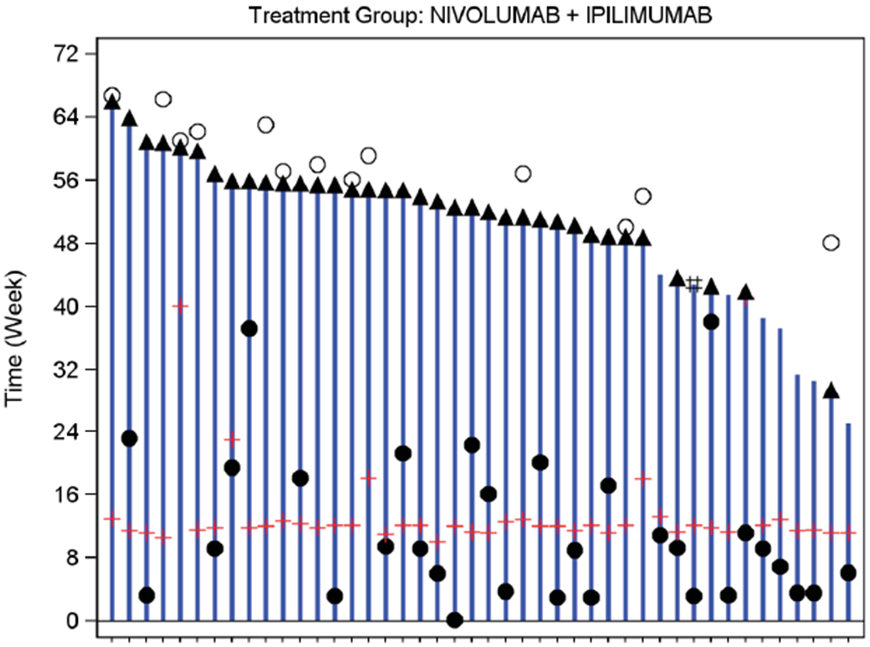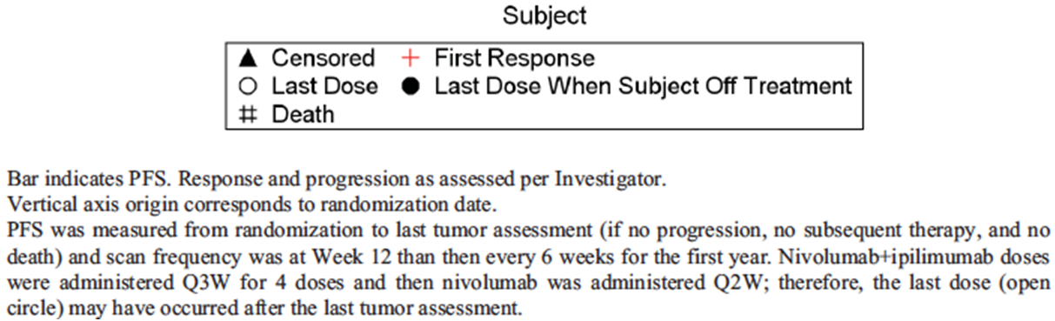

(Q3) Results of Study CA209067
The sponsor indicated that the results of this study are now available. The study has recently been published. It is understood that a clinical study report will be submitted to the TGA and will be the subject of a separate evaluation report.

(Q4) Drug induced liver injury
The sponsor presented the results of an updated review of 10 clinical studies it had conducted. A total of 2,354 subjects had received nivolumab in these studies.
Among nivolumab treated subjects there was only one case that met the criteria for Hy’s law (concurrent elevation of a transaminase > 3x upper limit of normal (ULN) and total bilirubin 2x ULN, with alkaline phosphatase < 2x ULN and no other identifiable cause). This was a subject enrolled in Study CA209069 who received the combination of nivolumab with ipilimumab. The patient developed abnormal LFTs/grade 4 hepatitis on Day 164 of the study, 86 days after his last nivolumab infusion. Nivolumab was discontinued and he was treated with prednisone. The hepatitis resolved.
The sponsor therefore estimated the incidence of cases meeting Hy’s law criteria by to be 1 in 2,354 (0.04%). A review of post marketing data did not identify any further cases meeting Hy’s law criteria, or any cases of severe DILI.
Comment: These data suggest that nivolumab may be associated with rare cases of severe DILI. Given the life-threatening nature of advanced melanoma, this finding does not significantly alter the overall benefit-risk balance for the drug.

(Q5) SJS/TEN
The sponsor conducted a search of its safety database for reports of SJS or TEN up to 22 April 2015. No cases of SJS were reported. Two reports of TEN were identified. Both of these cases were fatal. The first case involved a subject with advanced NSCLC treated with nivolumab and ipilimumab in a Phase I study. The diagnosis of TEN was established on biopsy. The second case involved a subject with melanoma treated with nivolumab monotherapy in a named patient program. An initial skin biopsy suggested erythema multiforme. Nivolumab was discontinued and she was treated with immunosuppressive therapy. The rash resolved. The patient subsequently commenced treatment with ipilimumab and the rash returned. A diagnosis of TEN was made and the patient died soon afterwards.
Comment: Severe/life threatening dermatological adverse events appear to occur with nivolumab but are rare. This finding is not considered to significantly alter the overall benefit-risk balance for the drug. However, the product information should warn that fatal dermatological reactions, such as TEN, have been observed with nivolumab.

(Q6) Clinical chemistry results
The sponsor presented a summary of the incidence of worsening of the following parameters: calcium, potassium, magnesium and sodium for the three pivotal studies. In terms of new grade 3 or 4 abnormalities, the incidence of hyponatraemia was increased with nivolumab in two of the three studies (Table 10).
Table 10. Incidence of new grade 3 or 4 hyponatraemia.
Study | Nivolumab arm | Comparator arm
CA209066 (monotherapy) | 3.1% | 3.3%
CA209037 (monotherapy) | 5.1% | 1.1%
CA209066 (combination therapy) | 8.5% | 2.2%
There were no other consistent findings relating to these parameters across the three studies. The sponsor stated that monitoring of chloride was not required in the studies. It appears that urea and glucose were also not routinely monitored.

Other issues

Use in subjects with BRAF mutation positive disease
Earlier, it was recommended that the indication be restricted such that, for patients with BRAF mutation positive disease, therapy with a BRAF inhibitor should have been tried and failed in the first instance. The reasons for this recommendation were:
- In Study CA209066, subjects with BRAF mutation positive disease were excluded;
- In Study CA209037, subjects with BRAF mutation positive disease could only be enrolled if they had failed BRAF inhibitor therapy;
- None of the studies had compared nivolumab with a BRAF inhibitor in subjects with BRAF mutation positive disease.
The sponsor has presented a series of arguments against the recommended restriction:
- Immunotherapies such as nivolumab have a mechanism of action that is independent of the presence or absence of a BRAF mutation;
- Nivolumab treatment produces similar response rates in both BRAF mutation positive and mutation negative disease;
- Although BRAF inhibitors have been shown to produce a high response rate in patients with BRAF mutation positive disease, the duration of such responses is usually short. Responses with nivolumab are durable;
- Expert opinion, such as the NCCN guideline, recommends nivolumab or pembrolizumab as an option for the first line treatment of BRAF mutation positive disease;
- The EMA expert advisory committee has recommended approval of nivolumab, without a restriction relating to BRAF mutation status;
- The TGA has recently approved pembrolizumab with an indication that includes first-line treatment of BRAF mutation positive patients. According to the information contained in the approved product information, a comparative study comparing pembrolizumab with a BRAF inhibitor appears not to have been conducted.
Comment: BRAF inhibitors are established therapy for the first-line treatment of advanced melanoma positive for a BRAF V600 mutation. In the experience of this reviewer, regulatory approval of a new agent for this indication would normally require a head-to-head comparison (that is, a Phase III trial of the new agent versus an approved BRAF inhibitor in subjects with BRAF mutation positive disease). However, if the TGA has waived this requirement for pembrolizumab, it would appear reasonable to do the same for nivolumab.

Safety of combination therapy
As indicated above, the sponsor provided updated safety data from study of combination therapy (CA209069). The pattern of AEs was consistent with that described in the original clinical study report (CSR). There was a small increase in the proportion of subjects who experienced drug related AEs and SAEs as shown in Table 11. With the longer follow-up there was a notable increase in the proportion of subjects who had discontinued treatment due to drug related AEs: from 36.2% in the original CSR to 55.3% in the CSR addendum.
Table 11. Incidence of new grade 3 or 4 hyponatraemia.
Incidence (%)
Combination (n = 94) versus Ipilimumab (n = 46)
 | Original CSR | CSR Addendum
Minimum follow-up | 6 months | 11 months
Drug-related AEs | 91.5% versus 91.3% | 91.5% versus 93.5%
Drug-related AEs – grade 3 or 4 | 51.1% versus 19.6% | 54.3% versus 23.9%
Drug-related serious AEs | 47.9% versus 19.6% | 53.2% versus 28.3%
Discontinuations due to drug-related AEs | 36.2% versus 8.7% | 55.3% versus 21.7%
Although a high proportion of subjects discontinued from the combination due to AEs, the sponsor states that 71.1% of subjects who discontinued treatment due to study drug toxicity had obtained a confirmed objective response.
There was one additional death in the combination arm that was considered related to treatment. This was a subject who died due to panhypopituitarism with severe cortisol deficiency and adrenal crisis. Therefore, in total there were 3 drug related deaths in the combination arm and none in the ipilimumab arm.

Second round benefit-risk assessment
The additional information provided is not considered to significantly alter the benefit-risk assessment made in the first round.

Second round recommendation regarding authorisation
It is recommended that the application be approved for monotherapy. Although the data are considered inadequate to support regulatory approval for first line treatment in subjects with BRAF mutation positive disease, it may be appropriate to grant such an approval to be consistent with pembrolizumab.
Approval for combination therapy is not recommended until such time as the data from Study CA209067 have been evaluated.

Supplementary evaluation

Introduction
This is a follow up submission to register a new chemical entity. The initial submission to register the product has been evaluated. The sponsor had sought approval for use of the product both as monotherapy and in combination with ipilimumab. Use as monotherapy was recommended for approval but it was recommended that approval for combination use be withheld until the results of an ongoing Phase III study (CA209-067) became available. The sponsor has now submitted a report of this study, which is the subject of this evaluation.
The sponsor has made an editorial change to the proposed indication, which now reads:
Opdivo, as monotherapy is indicated for the treatment of patients with unresectable or metastatic melanoma. Opdivo, in combination with Yervoy (ipilimumab), is indicated for the treatment of patients with unresectable or metastatic melanoma.

Scope of the clinical dossier
The supplementary submission contained the following clinical information:
- A full clinical study report for Study CA209067;
- An addendum to the clinical study report, providing data additional analyses according to baseline tumour PD-L1 status;
- A revised draft PI and Consumer Medicines Information (CMI) document.

Paediatric data
There have been no changes since the original evaluation.

Good clinical practice
The submitted study report for Study CA209067 contained an assurance that the trial was conducted in accordance with GCP, as defined by the ICH.

Pharmacokinetics
No new PK data were submitted.

Pharmacodynamics
No new PD data were submitted.

Dosage selection for the pivotal studies
The dosage regimens for nivolumab monotherapy and combination therapy that were used in Study CA209067 were the same as those justified and used in the previously evaluated studies.

Efficacy
As described above, the sponsor has submitted the results of one additional phase III trial (study CA209067).

Study CA209067

Study design, objectives, locations and dates
The study is a phase III randomised, double-blind trial with three parallel groups. The study had three phases – screening, treatment and follow-up (Figure 14).
Figure 14. Study CA209067 – Study schema.
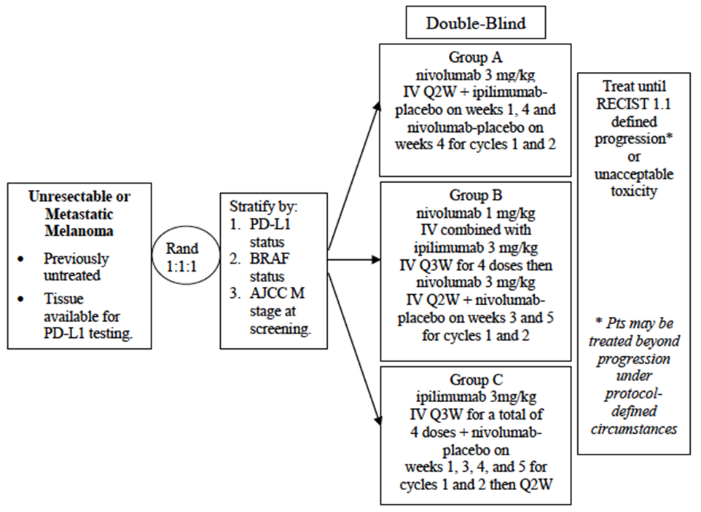
The primary objective was to compare progression-free survival (PFS) and overall survival (OS) of nivolumab monotherapy to ipilimumab monotherapy and that of nivolumab combined with ipilimumab to ipilimumab monotherapy in subjects with previously untreated, unresectable or metastatic melanoma.
Secondary objectives were to:
- Compare objective response rate (ORR) of nivolumab monotherapy to ipilimumab monotherapy and that of nivolumab combined with ipilimumab to ipilimumab monotherapy in subjects with unresectable or metastatic melanoma;
- Evaluate differences in OS, PFS, and ORR between nivolumab combined with ipilimumab and nivolumab monotherapy;
- Evaluate whether PD-L1 expression is a predictive biomarker for OS;
- Evaluate Health Related Quality of Life (HRQoL) as assessed by the European Organisation for Research and Treatment of Cancer (EORTC) QLQ-C30.
There were also a number of exploratory objectives related to assessing duration of response, time to response, safety, PK, immunogenicity, biomarkers and HRQoL.
The study is being conducted at 137 sites in 21 countries (Australia, Austria, Belgium, Canada, Czech Republic, Denmark, Finland, France, Germany, Ireland, Israel, Italy, Netherlands, New Zealand, Norway, Poland, Spain, Sweden, Switzerland, United Kingdom, and United States).
The trial commenced in June 2013 and is ongoing. The study report presented is an interim study report, with a cut-off date for inclusion of data of 17 February 2015. The report itself was dated 19 June 2015. The study has been published.

Inclusion and exclusion criteria
Inclusion and exclusion criteria were outlined. The study enrolled subjects who had not received prior treatment for their unresectable or metastatic disease. Subjects with either BRAF mutation positive or negative disease were eligible.

Study treatments
Subjects were randomised (1:1:1) to receive one of the following three treatments:
- Arm A: Nivolumab 3mg/kg IV every 2 weeks;
- Arm B: Ipilimumab 3 mg/kg IV and nivolumab 1mg/kg IV every 3 weeks for 4 treatments; then nivolumab 3 mg/kg IV every 2 weeks;
- Arm C: Ipilimumab 3 mg/kg every 3 weeks for 4 treatments.
Nivolumab was administered over 60 minutes and ipilimumab over 90 minutes. In the combination arm, nivolumab was administered first. For this study a cycle consisted of 6 weeks. For the first 2 cycles (12 weeks) placebos for nivolumab and ipilimumab were used to maintain blinding. For subsequent cycles, subjects in Arms A and B received nivolumab every 2 weeks, whereas subjects in Arm C received nivolumab placebo every 2 weeks.
Dose reduction or escalation was not permitted but dose delay was permissible in all arms. Randomised treatment was continued until disease progression or unacceptable toxicity. Continued treatment after disease progression was permitted provided that the investigator considered that the subject was deriving clinical benefit and the subject tolerated the study drug. After disease progression and discontinuation from treatment, the subject and the investigator were unblinded. However, it appears that the protocol did not allow for subjects to crossover to another of the randomised treatments (e.g. from Arm C to Arm A) after disease progression.
The following drugs were prohibited during the study, except for the treatment of a drug-related adverse event:
- Immunosuppressive agents;
- Systemic corticosteroids > 10-mg/day prednisone or equivalent. However, brief courses were permitted for the management of non-autoimmune conditions, as were replacement doses of systemic corticosteroids;
- Antineoplastic therapy.

Efficacy variables and outcomes
The main efficacy variables were:
- Survival;
- Change in tumour size;
- Quality of life (QoL).
There were two co-primary efficacy outcomes:
- Progression-free survival (PFS) as determined by the investigator. PFS was defined as the time from randomisation to date of documented disease progression or death, whichever occurred first. Progression was defined according to RECIST 1.1 criteria.
- Overall survival (OS), defined as the time between date of randomisation and the date of death
Secondary efficacy outcomes included:
- Objective response rate (ORR) as determined by the investigator. ORR was defined as the proportion of subjects who developed a complete response (CR) or partial response (PR) as per RECIST 1.1 criteria. Responses did not need to be confirmed.
- A comparison PFS, OS and ORR between the two nivolumab arms (Arm A and Arm B);
- Health-related QoL as assessed by the EORTC QLQ-C30 questionnaire.
- OS based on PD-L1 expression.
Time to response (TTR), duration of response (DOR), overall safety, pharmacokinetics, potential biomarkers, immunogenicity and other HRQoL measures were exploratory endpoints.
Tumour response and progression were assessed using imaging (CT or MRI). A baseline scan (of chest, abdomen, pelvis, brain and all other known sites) was required no more than 28 days prior to randomisation. After randomisation, scans (of chest, abdomen, pelvis, and all other known sites) were to be performed at 12 weeks, then every 6 weeks for the first 12 months and then every 12 weeks thereafter until disease progression. Subjects continued to have tumour assessments during follow up if they had discontinued treatment for reasons other than progression (e.g. toxicity).
After study discontinuation, survival status was determined every 3 months, either by clinic visit or phone contact.
The EORTC QLQ-C30 questionnaire was administered on week 1 of each 6-week cycle. During the first 6 months after randomisation it was also administered on week 5 of each cycle.

Randomisation and blinding methods
Subjects were randomised via an interactive voice response system (IVRS). Randomisation was stratified by the following factors:
- PD-L1 status:
  - PD-L1 positive (≥ 5% tumour cell membrane staining in a minimum of a hundred evaluable tumour cells) vs.
  - PD-L1 negative (< 5% tumour cell membrane staining in a minimum of a hundred evaluable tumour cells) OR indeterminate (tumour cell membrane scoring hampered by high cytoplasmic staining or melanin content);
- M Stage at screening: M0/M1a/M1b vs. M1c;
- BRAF V600 mutational status: Wild type vs. mutation positive.
Randomisation was performed in blocks.
Blinding was achieved through the use of placebos for nivolumab (normal saline) and ipilimumab (normal saline or 5% dextrose).

Analysis populations
The following analysis populations were defined in the protocol:
- All Enrolled Subjects: All subjects who signed an informed consent form and were registered into the IVRS;
- All Randomised Subjects: All subjects who were randomized to any treatment group. This population was used for analyses of efficacy.
- All Treated Subjects: All subjects who received at least one dose of any study medication. This population was used for analyses of safety.

Sample size
The planned sample size was 915 subjects.
The study has two co-primary endpoints. An alpha value of 0.01 was allocated to the analysis of PFS and 0.04 to the analysis of OS. It was planned to analyse PFS and OS at different time points. Analysis of PFS was targeted to occur after all subjects had completed 9 months of follow-up. However the required minimum follow-up was 6 months. Analysis of OS was targeted to occur after all subjects had completed 28 months of follow-up. However the required minimum follow-up was 22 months.
For PFS, the proposed sample size would provide 83% power to detect a hazard ratio of 0.71, with an alpha value of 0.005 (two-sided). It was expected that 266 PFS events would be observed at 9 months in the ipilimumab arm and 223 events in each of the nivolumab arms. Median PFS was expected to be 2.8 months in the ipilimumab arm and 3.1 months for both the nivolumab arms.
For OS, the proposed sample size would provide 99% power to detect a hazard ratio of 0.65, with an alpha value of 0.02 (two-sided). It was expected that 240 deaths would have occurred at the time of analysis in the ipilimumab arm and 202 deaths in each of the nivolumab arms. Median OS was expected to be 10.2 months in the ipilimumab arm and 17.2 months for both the nivolumab arms.

Statistical methods
PFS and OS were to be estimated using Kaplan Meier techniques. Medians and 95% CIs were calculated. PFS and OS were to be compared between the ipilimumab group and each of the nivolumab groups using a two-sided log-rank test with stratification as outlined above. Hazard ratios (HRs) and corresponding two-sided 99.5% CIs were estimated using a Cox proportional hazards model, with treatment group as a single covariate, stratified by the above factors.
ORRs were compared using a two-sided Cochran–Mantel–Haenszel test stratified according to PD-L1 status, BRAF mutation status, and M stage.
Comment: The study was designed and powered to compare 1) nivolumab monotherapy with ipilimumab monotherapy and 2) combination therapy with ipilimumab monotherapy. An alpha of 0.005 (two-sided) was allocated to each PFS comparison based on a Bonferroni adjustment to control the overall Type I error rate at 0.01 for PFS. The study was not designed to test for significant differences between nivolumab monotherapy and combination therapy. However, a descriptive hazard ratio (and corresponding two-sided 95% CI) was to be calculated to evaluate differences between these two groups.

Participant flow
A total of 1296 subjects were enrolled and 945 were randomised. Of these, 937 were treated.
At the time of data cut-off, all subjects had completed at least 9 months of follow-up after their first dose of randomised treatment. Median follow-up was 12.2 to 12.5 months across the three treatment arms.
Overall, 72.3% of subjects had discontinued randomised treatment at the time of data cut-off, with the most common reasons being disease progression and study drug toxicity.

Major protocol violations/deviations
Significant protocol deviations were defined as study conduct that differed significantly from the protocol, including GCP noncompliance. ‘Relevant’ protocol deviations were significant protocol deviations that could potentially affect the interpretability of study results. The incidence of relevant protocol deviations was 0.9% in the nivolumab arm, 0% in the combination arm and 1.0% in the ipilimumab arm. One subject in the nivolumab arm had an ECOG performance status > 1 at baseline. The remaining relevant violations were instances of subjects receiving concurrent anti-cancer therapy (n=2 for nivolumab, n=3 for ipilimumab).
Comment: The incidence of major violations was low and these were unlikely to affect the efficacy conclusions of the study.

Baseline data
Median age of the study population was 61 years. Approximately 40% were aged over 65 years. Approximately 65% were male and 97.5% of subjects were white.
Approximately 46% of the population had tumours that were PD-L1 positive and 32% were BRAF mutation positive.
The proportion of subjects who had received prior adjuvant therapy was 21.7%. The most commonly used adjuvant therapy in all three groups was interferon.
Comment: The 3 treatment groups were well balanced with respect to baseline variables.

Results for the primary efficacy outcome
The study report submitted presented final results for PFS. The planned analysis of OS had not yet been conducted because insufficient deaths had occurred.

Progression-free survival
Results for PFS are summarised in Figure 15. The proportion of subjects who had experienced a PFS event was 55.1% in the nivolumab arm, 48.1% in the combination arm and 74.3% in the ipilimumab arm.
Figure 15. Study CA209067 – Progression-free survival.
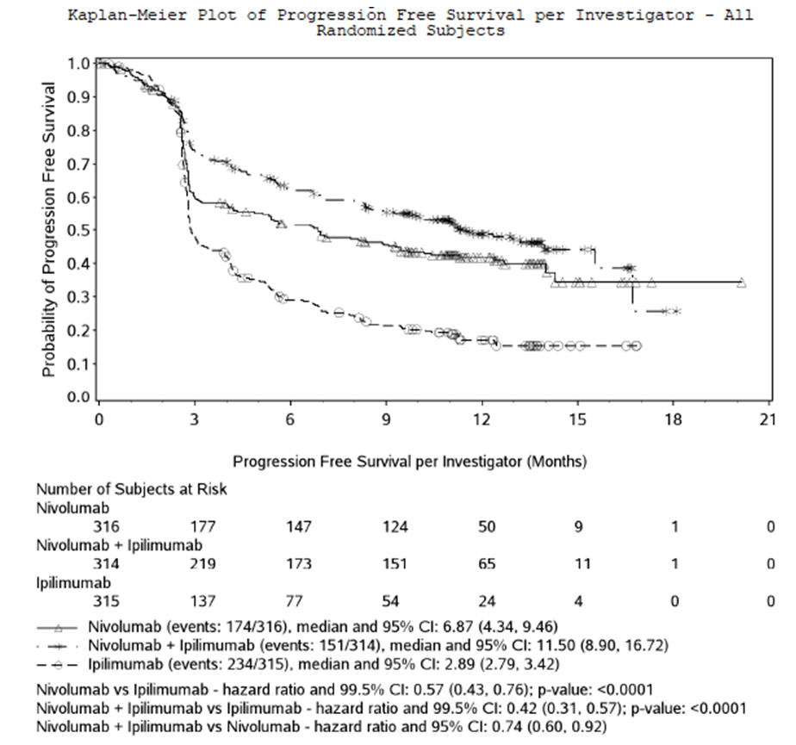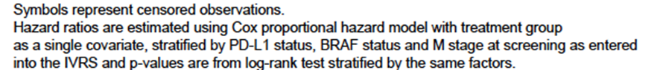
Nivolumab monotherapy significantly improved PFS compared to ipilimumab (hazard ratio [HR] = 0.57; 95% CI: 0.43 – 0.76; p < 0.0001). Median PFS was increased by approximately 4 months (6.87 vs. 2.89 months). The proportion of subjects alive and progression-free after 9 months was increased from 21% to 45%.
Combination therapy also significantly improved PFS compared to ipilimumab (HR = 0.42; 95% CI: 0.31 – 0.57; p < 0.0001). Median PFS was increased by approximately 8.6 months (11.50 vs. 2.89 months). The proportion of subjects alive and progression-free after 9 months was increased from 21% to 56%. Two pre-planned sensitivity analyses gave comparable results.
A secondary efficacy outcome in the trial was a comparison of PFS between the nivolumab and combination arms. A formal statistical comparison of the two groups was not performed. However, combination therapy appeared to improve PFS compared to nivolumab monotherapy (HR = 0.74; 95% CI: 0.60 – 0.92).
- Subgroup analyses: Improvement in PFS was consistent across a number of pre-defined subgroups (nivolumab vs. ipilimumab and combination vs. ipilimumab), as hazard ratios were all < 1.0. Nivolumab monotherapy was at least as effective as ipilimumab in subjects with BRAF mutation positive disease (HR = 0.77; 95%CI: 0.54 – 1.09). BRAF mutation positive subjects were excluded from the previously evaluated study of nivolumab monotherapy in the first-line treatment of advanced melanoma (CA209066).
- Subgroup analysis by PD-L1 status: PD-L1 status of tumours was assessed using automated immunohistochemistry (IHC) assays. PD-L1 expression was defined as the percent of tumour cells demonstrating plasma membrane PD-L1 staining in a minimum of 100 evaluable tumour cells. During the study two different assays were used. These were referred to as the ‘verified’ assay and the ‘validated’ assay. The validated assay was not available at the time of subject randomisation and hence the verified assay was used to stratify subjects as PD-L1 positive or PD-L1 negative/indeterminate at baseline. A cut-off of staining in ≥ 5% of cells was used for positivity. Using this cut-off it was determined that 46% of subjects were PD-L1 positive and 54% were PD-L1 negative/indeterminate at baseline.
When the validated assay became available, available tissue samples were retested. Quantifiable PD-L1 results were obtained on 288, 278 and 277 samples for the nivolumab, combination and ipilimumab groups, respectively. The proportion of subjects who were determined to be PD-L1 positive using the validated assay is summarised in Table 12. If the same cut-off of ≥ 5% of cells is used, only 26.5% of subjects would be considered PD-L1 positive. However the proportion of subjects who would be considered PD-L1 positive was still comparable across the three treatment groups.
Table 12. Study CA209067 – Tumour PD-L1 status.
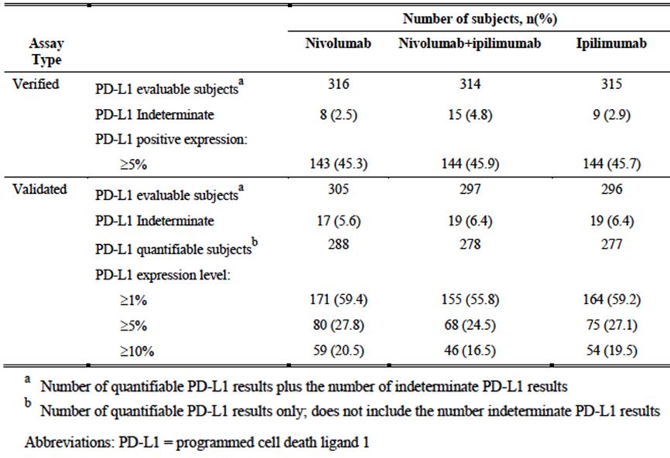
Subgroup analysis of PFS by baseline PD-L1 status (as determined using the validated assay and using a cut-off of 1%, 5% or 10%) is summarised in Table 13. These analyses indicate that both nivolumab monotherapy and combination therapy are superior to ipilimumab monotherapy, regardless of PD-L1 status. They also suggest that nivolumab monotherapy and combination therapy have similar efficacy in subjects with PD-L1 positive tumours, but that combination therapy may be more effective than nivolumab monotherapy in subjects with PD-L1 negative tumours.
Table 13. Study CA209067 – Tumour PD-L1 status.
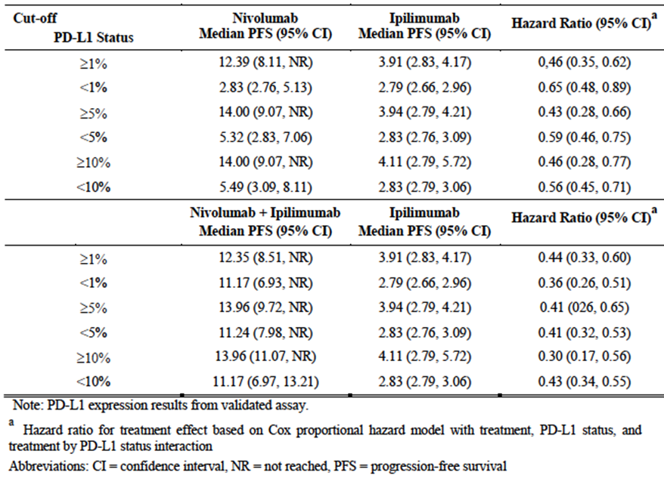

Results for other efficacy outcomes

Objective response rate
The ORRs achieved with nivolumab (43.7%) and combination treatment (57.6%) were significantly higher (p<0.0001 for both) than the ORR achieved with ipilimumab (19.0%). Complete response rates were also numerically higher.
Forest plots were also presented for subgroups. Improved response rates with nivolumab and combination treatment compared to ipilimumab were observed in all pre-defined subgroups.

Time to response
The median time to response was 3 months in all treatment groups.

Duration of response
Median duration of response had not been reached in any of the three treatment groups.

Quality of life
Mean changes from baseline in Global Health Status and the various functional scales of the EORTC QLQ-C30 were generally small and only reached clinical significance (a change of > 5-10 points on a 100-point scale) infrequently during treatment. Differences between treatment arms were not analysed statistically.

Analyses performed across trials (pooled analyses and meta-analyses)
Not applicable.

Evaluator’s conclusions on clinical efficacy
Study CA209067 was well designed and executed. The design complied with the relevant EMA guidelines adopted by the TGA.
The study provided further clinical evidence to support the use of nivolumab as monotherapy in the treatment of advanced melanoma. Previously evaluated data (CA209066) had shown that nivolumab, as first-line treatment, was associated with a highly clinically significant efficacy benefit when compared to dacarbazine, with a 58% reduction in the risk of death. Study CA209067 has now demonstrated that the drug is superior to ipilimumab in the first-line treatment of melanoma. The new study also provided evidence of efficacy in the first-line treatment of subjects with BRAF-mutation positive disease.
The study also demonstrated that the combination of nivolumab and ipilimumab was superior to ipilimumab alone. It therefore confirmed the findings of the previously evaluated phase II study (CA209069). The efficacy results with the combination (HR for PFS, median PFS, response rate) were less impressive in the phase III study than in the phase II study, but this was also true of ipilimumab.
CA209067 was not designed to establish superiority of combination treatment over nivolumab monotherapy. The hypothesis that combination therapy is superior to nivolumab monotherapy has therefore not been formally tested. However the efficacy results obtained with the combination were numerically superior to those obtained with monotherapy. When comparing the two treatments the HR for PFS was 0.74 and the 95% CI did not include 1.00 (0.60 to 0.92). Median PFS was longer (11.50 vs. 6.87 months) and response rate was higher (57.6% vs. 43.7%).
Subgroup analyses suggested that the combination might be more effective than nivolumab monotherapy in subjects with PD-L1 negative tumours. However the study was not powered to detect such an effect. It is noted that the sponsor is not proposing to limit the indication for combination treatment to subjects with PD-L1 negative tumours. It is also not clear whether the validated PD-L1 assay is to be marketed in Australia.
Overall it is concluded that the efficacy of nivolumab monotherapy has been adequately demonstrated, and that combination treatment has been demonstrated to be superior to ipilimumab monotherapy. However, doubts remain as to whether combination therapy is superior to nivolumab monotherapy.

Safety

Studies providing evaluable safety data
The only additional safety data submitted were those generated by study CA209067. In this study the following safety data were collected:
- General adverse events (AEs) were assessed by continuously. Toxicities were graded using the National Cancer Institute (NCI) Common Terminology Criteria for Adverse Events (CTCAE) version 4.0.
- The following categories of AEs (referred to as ‘select AEs’) were of special interest: endocrine, gastrointestinal, hepatic, pulmonary, renal, skin and hypersensitivity/infusion reactions.
- Physical examination including measurement of vital signs was conducted on day 1 of weeks 1, 3, 4 and 5 during cycles 1 and 2, and then on day 1 of weeks 1, 3 and 5 for subsequent cycles.
- Laboratory tests were performed on day 1 of weeks 1 and 4 during cycles 1 and 2, and then on day 1 of weeks 1 and 5 for subsequent cycles. Tests performed were: complete blood count with differential, LFTs, urea, creatinine, calcium, magnesium, sodium, potassium, chloride, lactate dehydrogenase (LDH), glucose, amylase, lipase and thyroid function tests.

Patient exposure
A total of 313 subjects received treatment with nivolumab monotherapy, 313 with combination treatment and 311 with ipilimumab.
- In the nivolumab monotherapy arm the median number of doses of nivolumab received was 15.0 (range 1-38). Median duration of treatment was 6.6 months (95% CI: 5.16 to 9.69);
- In the combination arm the median number of doses of nivolumab received was 4.0 (range 1 -39) and the median number of doses of ipilimumab received was 4.0 (range 1 - 4). Median duration of treatment was 2.8 months (95% CI: 2.40 to 3.91);
- In the ipilimumab monotherapy arm the median number of doses of ipilimumab received was 4.0 (range 1 -4). Median duration of treatment was 3.0 months (95% CI: 2.56 to 3.91).
Comment: Duration of nivolumab treatment was notably reduced in the combination arm compared to the nivolumab monotherapy arm. This is likely to be due to increased toxicity with combination treatment as discussed below.

Adverse events
The overall incidence of adverse events (AEs) is summarised in Table 14.
Table 14. Study CA209067 – Overall safety summary.
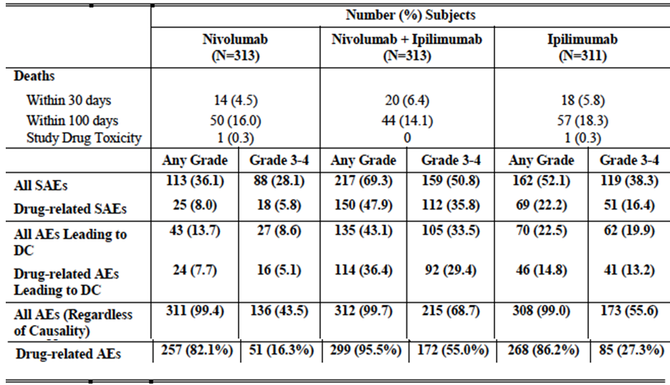

All adverse events (irrespective of relationship to study treatment)
There was a high incidence of AEs in all three arms of the study (99.4% with nivolumab, 99.7% with the combination and 99.0% with ipilimumab).
In general, combination treatment was associated with a higher incidence of most individual AE terms. There was a notably higher incidence of the following events in the combination arm:
- Diarrhoea – 52.4% (combination) vs. 31.3% (nivolumab) and 45.7% (ipilimumab);
- Colitis – 12.1% vs. 1.6% and 11.6%;
- Pyrexia – 37.4% vs. 13.4% and 17.0%;
- Pneumonitis – 6.4% vs. 1.9% and 2.6%;
- ALT increased – 19.5% vs. 7.3% and 4.8%;
- AST increased – 16.9% vs. 7.0% and 5.1%;
- Endocrine disorders – 31.9% vs. 17.3% and 12.2%.
The incidences of individual AE terms with nivolumab were generally comparable to those observed with ipilimumab.
The incidence of grade 3 or 4 AEs was increased in the combination arm (68.7%) compared with the nivolumab arm (43.5%) and the ipilimumab arm (55.6%).
When adjusted for duration of exposure, the incidence rate for all AEs was 1630.1 per 100 patient-years (PY) for nivolumab, 2776.6 per 100PY for the combination and 2316.1 per 100 PY for ipilimumab.

Treatment-related adverse events (adverse drug reactions)
AEs considered to be drug-related occurred more frequently in the combination arm (82.1% with nivolumab, 95.5% with the combination and 86.2% with ipilimumab). The pattern of toxicities was consistent with that observed for all AEs.
The incidence of grade 3 or 4 drug-related AEs was notably increased in the combination arm (55.0%) compared with the nivolumab arm (16.3%) and the ipilimumab arm (27.3%).

Deaths and other serious adverse events

Deaths
There were more deaths in the ipilimumab arm (36.7%) compared with the nivolumab arm (27.2%) and the combination arm (27.5%). Most deaths were due to disease progression. There were 2 deaths that were assessed as being due to study drug toxicity:
- A [information redacted] in the ipilimumab arm died from bowel perforation due to treatment-induced ulcerative colitis, following 4 infusions. Cause of death was stated to be cardiac arrest.
- A [information redacted] in the nivolumab arm died of septic shock after developing neutropaenia following 9 infusions.
There were 8 deaths in the nivolumab arm, and 13 in the combination arm, where death was assessed as being due to ‘other’ causes. The narratives for these cases have been reviewed. The deaths were due to a variety of causes that might be expected in a population of subjects with advanced malignancies (e.g. pulmonary embolus, pneumonia, sepsis etc.). The narratives do not raise any concerns that these deaths may have been due to nivolumab.

Other serious adverse events
Serious AEs (SAEs) occurred more frequently in the combination arm (36.1% with nivolumab, 69.3% with the combination and 52.1% with ipilimumab). The pattern of toxicities was consistent with that observed for all AEs. However, the incidence of individual SAE terms was generally lower in the nivolumab monotherapy arm, compared with the other two arms.

Discontinuation due to adverse events
AEs leading to discontinuation occurred more frequently in the combination arm (13.7% with nivolumab, 43.1% with the combination and 22.5% with ipilimumab).
Diarrhoea and colitis were the most common AEs leading to discontinuation. In the combination arm discontinuations due to abnormal LFTs, liver disorders and pneumonitis were more common than in the other arms.

Select AEs
Generally, select AEs occurred more frequently in the combination arm than in the other two arms. This was most notable for gastrointestinal, endocrine and hepatic events.
Notable findings were as follows:
- The most common endocrine select AEs were hypothyroidism and hyperthyroidism. Hypophysitis occurred in 7.7% of subjects in the combination arm (3.9% with ipilimumab and 0.2% with nivolumab). Median time to onset for endocrine select AEs ranged from 6.29 to 9.00 weeks. Across treatment groups, the events resolved in 40-50% of subjects.
- Diarrhoea and colitis were the most common gastrointestinal select AEs, in all treatment groups. Median time to onset ranged from 4.57 to 8.71 weeks. Across treatment groups, the events resolved in 90-95% of subjects.
- Abnormal LFTs (ALT, AST, ALP, GGT) were the most common hepatic selects AEs. Grade 3 or 4 hepatitis was reported as an AE in 6 subjects in the combination arm (1.9%) compared to zero subjects in the other arms. Median time to onset ranged from 5.86 to 8.14 weeks. Across treatment groups, the events resolved in 77-88% of subjects.
- Pneumonitis or interstitial lung disease accounted for most of the pulmonary select AEs in all treatment groups. Median time to onset ranged from 8.71 to 10.07 weeks. Across treatment groups, the events resolved in 80-91% of subjects.
- The most common renal select AE was increased serum creatinine. Acute renal failure was reported as AE in 3.8% of subjects in the combination arm (1.3% with ipilimumab and 0.2% with nivolumab). Median time to onset of renal select AEs ranged from 7.14 to 9.57 weeks. Across treatment groups, the events resolved in 80-100% of subjects.
- Although skin select AEs were very common in all three treatment groups, most were grade 1 or 2 in severity. The most common AE terms were rash and pruritus. Median time to onset of skin select AEs ranged from 2.14 to 5.57 weeks. Across treatment groups, the events resolved in 57-72% of subjects.
- Hypersensitivity and infusion reactions occurred more commonly in the two nivolumab arms. Grade 3 or 4 events were uncommon. Median time to onset ranged from 2.29 to 2.86 weeks.
The following additional events of special interest were reported:
- Pancreatitis – 2 subjects on nivolumab, 3 on the combination and 2 on ipilimumab;
- Guillain-Barre syndrome – 1 subject on the combination;
- Encephalitis – 1 subject on the combination.

Laboratory tests

Liver function
Consistent with previous studies, grade 3 or 4 LFT abnormalities were more common with nivolumab treatment than with ipilimumab treatment. The incidence of LFT abnormalities was notably higher in the combination arm than in the other two arms.
Four subjects in the nivolumab arm and six in the combination arm had concurrent elevation of a transaminase to 3xULN and elevation of bilirubin to 2xULN. However all of these subjects also had concurrent elevation of alkaline phosphatase to at least 2xULN. They therefore did not meet the criteria for Hy’s law (concurrent elevation of a transaminase > 3xULN and total bilirubin 2xULN, with a alkaline phosphatase < 2xULN and no other identifiable cause). Many of these subjects were diagnosed with drug-related autoimmune hepatitis.

Kidney function
Grade 3 or 4 elevations in creatinine were uncommon but were more frequent in the combination arm than in the monotherapy arms.

Other clinical chemistry
Hyponatraemia and hypokalaemia occurred more frequently in the combination arm than in the monotherapy arms. Otherwise there were no notable differences between arms in the incidence of abnormalities of sodium, potassium, calcium or magnesium.

Pancreatic function
Grade 3 or 4 elevations of amylase and lipase occurred more frequently with combination treatment.

Haematology
Grade 3 or 4 haematological abnormalities were uncommon and occurred with comparable frequency across the three treatment arms.

Thyroid function
Elevated TSH occurred more frequently in the nivolumab arms of the study. Decreased TSH also occurred more frequently in the nivolumab arms, but was notably more common in the combination arm.

Immunogenicity
Blood samples for the detection of antibodies directed against nivolumab were collected at baseline, at various time points in the first 4 cycles of treatment and then at two follow-up visits, approximately up to 100 days after discontinuation. A cycle lasted 6 weeks. Blood samples for the detection of antibodies against ipilimumab were collected at baseline, and at time points in cycles 1, 2 and 4.
Antibodies directed against nivolumab, including neutralising antibodies, were more common in the combination arm than in the nivolumab monotherapy arm. Antibodies against ipilimumab were not notably increased in the combination arm compared to the ipilimumab monotherapy arm.
No association was observed between the presence of anti-nivolumab antibodies or anti-ipilimumab antibodies and the occurrence of hypersensitivity and infusion-related reactions. Subjects with persistent or neutralising antibodies had had a comparable overall response rate to other subjects, and the development of such antibodies was not associated with loss of response.

Vital signs
No safety concerns were raised through monitoring of vital signs.

Post marketing experience
No post marketing data were submitted.

Safety issues with the potential for major regulatory impact

Liver toxicity
Study CA209067 demonstrated again that nivolumab is associated with hepatotoxicity. However, there were no cases of severe drug-induced liver injury or cases that met Hy’s law criteria.

Haematological toxicity
In the nivolumab arm there was one case neutropaenia resulting in sepsis and death. The investigator assessed the event as being related to the drug. However, laboratory monitoring did not suggest that nivolumab was associated with increased haematological toxicity compared with ipilimumab. Neutropaenia was not identified as a toxicity associated with nivolumab in the previously evaluated studies.

Serious skin reactions
As noted previously, nivolumab is associated with serious skin reactions. In CA209067, serious skin select AEs occurred in approximately 1% of subjects in each of the three treatment arms. There was only one case of toxic epidermal necrolysis (TEN) and this occurred in a subject in the ipilimumab monotherapy arm. There were no cases of Stevens-Johnson syndrome.

Cardiovascular safety
The incidence of overall cardiac AEs was not increased with nivolumab compared to ipilimumab (6.1% with nivolumab, 10.5% with the combination, 11.6% with ipilimumab). The incidence of overall vascular AEs was comparable across the study arms (17.9% with nivolumab, 17.6% with the combination, 17.0% with ipilimumab).

Unwanted immunological events
The incidence of hypersensitivity/infusion reaction select AEs was increased with nivolumab compared to ipilimumab (5.1% with nivolumab, 4.5% with the combination, 2.9% with ipilimumab). However grade 3 or 4 events only occurred in 1 subject in the nivolumab arm and 1 subject in the ipilimumab arm. Antibody development has been summarised.

Evaluator’s overall conclusions on clinical safety
Study CA209067 provides additional data to define the safety profile of nivolumab monotherapy. These data indicate that nivolumab has a favourable overall safety profile when compared to that of ipilimumab. Nivolumab was associated with a lower incidence of grade 3 or 4 AEs (43.5% vs. 55.6%), serious AEs (36.1% vs. 52.1%) and AEs leading to discontinuation (13.7% vs. 22.5%). This is despite duration of treatment being longer in the nivolumab arm. The two drugs have a similar spectrum of toxicities, with autoimmune-type events (e.g. diarrhoea/colitis, skin toxicity, hepatotoxicity, endocrinopathies) being prominent.
The study confirms that combination therapy is associated with significant additional toxicity when compared to either nivolumab monotherapy or ipilimumab monotherapy. When compared to nivolumab monotherapy, combination treatment is associated with an increase incidence of grade 3 or 4 AEs (68.7% vs. 43.5%), serious AEs (69.3% vs. 36.1%) and AEs leading to discontinuation (43.1% vs. 13.7%). The increase in toxicity is due to a higher incidence of autoimmune-type events. In the previously evaluated phase II study of combination therapy, there was an increased incidence of treatment-related deaths in the combination arm. However, this was not noted in CA209067.

First round benefit-risk assessment

First round assessment of benefits
Considering the previously evaluated studies together with the results of CA209067, the benefits of nivolumab monotherapy in the treatment of advanced melanoma are:
- Improved OS (compared to dacarbazine) in the first line setting with a 58% reduction in the risk of death. The proportion of subjects still alive at 12 months was increased from 42.1% to 72.9%.
- Improved PFS (compared to ipilimumab) in the first line setting with a 43% reduction in the risk of a PFS event. The proportion of subjects still alive and free of progression after 9 months was increased from 29% to 52%.
- A substantial rate of tumour response (31.7%) in subjects who had already failed ipilimumab and a BRAF inhibitor (if BRAF mutation positive). Such subjects have limited treatment options available.
Based on the results of CA209067, the benefits of nivolumab in combination with ipilimumab in the treatment of advanced melanoma are:
- An increase in PFS compared to ipilimumab monotherapy in previously untreated subjects, with a 58% reduction in the risk of a PFS event. Median PFS was prolonged by approximately 8.6 months.
Study CA209067 suggested that combination therapy might also be associated with superior efficacy compared to nivolumab monotherapy. However, the study was not designed to formally test this comparison

First round assessment of risks
Considering the previously evaluated studies together with the results of CA209067, the risks of nivolumab in the treatment of advanced melanoma are:
- An increased risk of a variety of autoimmune type events such as pneumonitis, endocrinopathies, hepatitis, colitis, skin disorders, etcetera
As monotherapy, the overall toxicity of nivolumab is comparable to, or slightly lower than, that of conventional chemotherapy, and somewhat lower than that of ipilimumab.
The toxicity of the combination of nivolumab with ipilimumab is significantly greater than that of ipilimumab monotherapy or nivolumab monotherapy.

First round assessment of benefit-risk balance
The benefit-risk balance of nivolumab monotherapy, given the proposed usage, is favourable. The drug has better efficacy and comparable or better safety than conventional chemotherapy or ipilimumab.
Given that nivolumab monotherapy has better efficacy and safety than ipilimumab, it should be preferred over ipilimumab for the treatment of advanced melanoma. Regulatory approval for combination therapy should only be considered if the combination has a more favourable benefit-risk balance than nivolumab alone. A statistically significant improvement in efficacy for combination treatment over nivolumab monotherapy has not been established, as Study CA209067 was not designed to demonstrate this. However the study clearly demonstrates that the combination is associated with a significant increase in toxicity. It is therefore not possible to conclude that combination treatment is associated with a more favourable benefit-risk balance than nivolumab monotherapy.
If approval is restricted to nivolumab monotherapy, ipilimumab could still be used as a second line agent. It is possible that such sequential use of these agents might result in comparable efficacy and reduced toxicity compared to combination use. However, there are no clinical data to support such a hypothesis.

First round recommendation regarding authorisation
It is recommended that the application for monotherapy should be approved. The proposed monotherapy indication is acceptable. It is recommended that the application for use in combination with ipilimumab be rejected due to uncertain evidence of efficacy, and concerns regarding increased toxicity, when compared to nivolumab monotherapy.

Clinical questions

Efficacy
- Please provide an assurance the formulation of nivolumab used was identical to that being proposed for registration in Australia.
- In Study CA209067, the subgroup analysis of PFS according to baseline PD-L1 status suggested that combination therapy might be superior to nivolumab monotherapy in subjects with PD-L1 negative tumours. Please advise whether the validated PD-L1 IHC assay used to classify subjects in this analysis will be marketed in Australia.

Squamous non-small cell lung cancer indication

Introduction
This clinical evaluation report is of data in support of use in squamous non-small cell lung cancer (SQ NSCLC) and is supplementary to the melanoma clinical evaluation report.
The sponsor’s submission to register nivolumab, dated 6 January 2015, requested approval for use in advanced melanoma. Based on the sponsor’s summary of outcomes in a Phase III study in SQ NSCLC, the TGA allowed the scope of the submission to enlarge.
The proposed indications are:
Opdivo is indicated for the treatment of patients with unresectable or metastatic melanoma.
Opdivo is indicated for the treatment of locally advanced or metastatic squamous non-small cell lung cancer (NSCLC) with progression on or after prior chemotherapy.
For the SQ NSCLC indication, the dosage and route of administration are as follows:
The recommended dose of Opdivo is 3 mg/kg administered intravenously over 60 minutes every 2 weeks. Treatment should be continued as long as clinical benefit is observed or until treatment is no longer tolerated by the patient.
Opdivo infusion must not be administered as an intravenous push or bolus injection.
For the monotherapy use of nivolumab in advanced melanoma, the dosage regimen is the same as for SQ NSCLC (that is, 3 mg/kg IV over 60 minutes every 2 weeks, while there is clinical benefit and while the treatment is tolerated).

Clinical rationale
The sponsor states that historically, patients with SQ NSCLC had worse outcomes and fewer acceptable treatment options than patients with NSQ NSCLC (this was used to explain the sponsor’s approach of pursuing SQ and NSQ NSCLC indications separately).
Some therapies in NSCLC are not indicated in SQ NSCLC. Pemetrexed is only indicated in locally advanced or metastatic NSCLC “other than predominantly squamous cell histology”. Bevacizumab’s NSCLC indication is restricted to NSQ NSCLC. Likewise, afatinib’s approval is restricted to use in NSQ disease.

Contents of the clinical dossier

Scope of the clinical dossier
The dossier in support of nivolumab’s use in SQ NSCLC was a rolling submission, that is, different components arrived at the TGA at different times. It included three studies as shown in Table 15.
Table 15. Incidence of new grade 3 or 4 hyponatraemia.
ID | Status | Description | Comment
Study 017 | Final CSR | Phase III, randomised, controlled trial versus docetaxel in patients failing first-line treatment | pivotal
Study 063 | Final CSR; and Addendum 1 | Phase II, single arm study in 3rd or subsequent line patients | supportive
Study 003 | Final CSR; and Addendum 1 | Phase I, single arm study in various malignancies including NSCLC | supportive
The dossier also included a population PK analysis (with an update incorporating Study 017).
The Dossier does not include substantial clinical data in support of use in NSQ NSCLC (although in Study 003, some patients had this condition). The sponsor has not, in this application, requested approval for use in NSQ NSCLC.
A separate Phase III trial, Study 057, is studying patients with NSQ NSCLC. The sponsor has announced that this trial, comparing nivolumab versus docetaxel in previously treated patients, was stopped early because a planned interim assessment found that the study had shown superior OS in the nivolumab arm.
The sponsor also mentioned two studies in untreated NSCLC patients: CA209012 and CA209026. These studies were not submitted for review and are apparently outside of the scope of this clinical dossier.

Paediatric data
The submission did not include paediatric data.

Good clinical practice
In the clinical study reports for Studies 017, 063 and 003, it was stated that GCP was adhered to.

Pharmacokinetics
Studies of the PK properties of nivolumab have been evaluated in the CER for advanced melanoma. The sponsor has provided further data about the PK of nivolumab in NSCLC.

Studies providing pharmacokinetic data in SQ NSCLC
In Study 003, there was intensive PK sampling; this study has been taken into account in the “melanoma CER” and its PK findings are not re-evaluated here.
The document ‘Nivolumab population pharmacokinetics in patients with solid tumors and exposure-response analysis in patients with previously treated squamous non-small cell lung cancer’ (report dated 23 April 2015) takes into account two large studies in NSCLC and is considered below.

Population pharmacokinetic analysis (report dated 23 April 2015)

PK characterisation
The population PK analysis dataset was of n=1314 subjects from 9 studies, for whom nivolumab serum concentration data were available. The studies are shown in Table 16.
Table 16. Population pharmacokinetic analysis studies.
MDX1106-01 (CA209001) | various refractory or relapsed malignancies (n=39), including NSCLC | 0.3, 1, 3, 10 mg/kg, Q4W
ONO-4538-01 (CA209005) | progressive or recurrent solid tumours (n=24) | 1, 3, 10 and 20 mg/kg, mainly Q3W
MDX1106-03 (“Study 003”) | various tumour types (n=306, including 129 with NSCLC) including SQ NSCLC | 0.1, 0.3, 1, 3, 10 mg/kg Q2W
CA209010 | clear cell renal cell carcinoma (n=150) | 0.3, 2, 10 mg/kg Q3W
ONO-4538-02 (CA209051) | melanoma (n=35) | 2 mg/kg Q3W
CA209063 (“Study 063”) | SQ NSCLC patients (n=117) | 3 mg/kg Q2W
CA209037 | melanoma (n=260) | 3 mg/kg Q2W
CA209017 (“Study 017”) | SQ NSCLC patients (n=132) | 3 mg/kg Q2W
CA209057 | non-squamous NSCLC (n=287) | 3 mg/kg Q2W
There have been previous population PK analyses for nivolumab; these earlier analyses, all submitted in the initial ‘melanoma’ Dossier, did not include data from studies 017 and 057.
Evaluator’s comment: There was a population PK report dated 26 May 2014, studying n=669 subjects, focusing on NSCLC (e.g. including Study 063) and not considered in the “melanoma CER”.
A population PK report dated 18 July 2014 (n=909) was evaluated on pages 55-56 of the “melanoma CER”.
Another population PK analysis (report dated 8 December 2014; n=1110) was evaluated on pages 57-58 of the “melanoma CER”. This supported PK reporting in the proposed PI.
The current population PK model was developed in three stages.

Base model
The sponsor stated that nivolumab concentration-time data were “well described by the previously developed linear, 2-compartment, zero-order input intravenous (IV) infusion model with first-order elimination”.
A conclusion of the population PK analysis was that PK of nivolumab was linear in patients with solid tumours across the dose range studied (0.1 mg/kg to 20 mg/kg Q2W, and 0.3 mg/kg to 10 mg/kg Q3W).
Evaluator’s comment: Linearity of PK was suggested in the “melanoma CER”, in the description of Study 003 (pages 51-54), with Cmax and AUC increasing in a dose-proportional manner over the range 0.1 to 10 mg/kg. The report noted that only a small Phase 1 study included 20 mg/kg data.
In this previously developed model, terminal half-life was 26.7 days and typical clearance was 8.7 mL/h, consistent with human IgG.

Full covariate model
This took into account the effects on PK of: body weight; gender; eGFR; ECOG performance status; and cell type / histology. Missing covariate data were imputed.
All but 29 of 1314 subjects had ECOG status 0-1.
Evaluator’s comment: The population PK analysis does not reliably inform about patients with worse ECOG performance status, because of the small sample of patients with ECOG status ≥2.
The distribution plot of baseline eGFR is copied below.
Figure 17. Distribution plot of baseline eGFR.
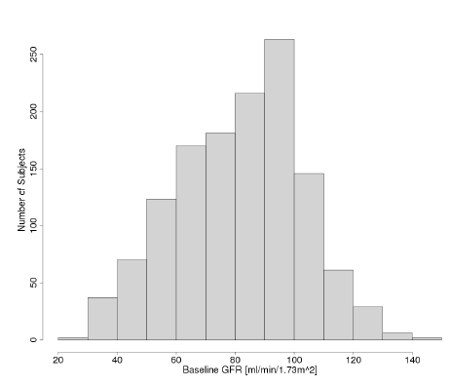
Evaluator’s comment: A negligible number of people had severe renal disease, according to this plot. Severe renal disease might affect PK because the assumption that nivolumab is not eliminated via filtration through the glomerulus might not hold. Furthermore, severe renal disease may be associated with hypoalbuminaemia. In addition, eGFR was found to be an influential covariate for nivolumab PK, and its influence could be more pronounced at extremes.
The effect of baseline serum albumin was examined in a subset of patients (the covariate was not available in subjects from study 037). In this analysis, baseline serum albumin did have a significant effect on clearance, with nivolumab clearance decreasing with increasing serum albumin.
Evaluator’s comment: Given the influence of albumin on nivolumab clearance, and lack of data in patients with severe renal impairment and in patients with moderate or severe hepatic impairment, can the sponsor comment on the potential for these impairments to influence nivolumab PK via hypoalbuminaemia, and implications for dosing. A possibility is that in patients with hypoalbuminaemia, clearance is higher than normal.
Cell type / histology was found to influence volume of distribution of central compartment (“VC”); the sponsor claimed the influence was not clinically relevant. Thus, nivolumab’s VC was “slightly lower” in patients with NSCLC as compared with patients with other tumours.
The most influential covariates for PK were weight, sex, ECOG status and eGFR.
Evaluator’s comment: Dosing varied across the studies. Exposure will vary with dose regimen. In model evaluation, the procedure was stratified by dose level. In model application, dose normalised individual measures of exposure were summarised, and that in studies 017 and 057, patients received 3 mg/kg Q2W. This seems appropriate given PK is linear, across the 1-10 mg/kg range.

Final population PK model
The final population PK model included effects of baseline weight, eGFR and ECOG status on clearance (CL), and the effects of baseline weight, sex and cell type / histology (using the combined SQ and non-squamous groups) on VC, as follows:
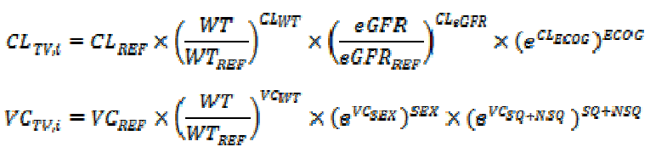
In these equations, CL_{REF} and VC_{REF} were the typical values of CL and VC at the reference values of weight (80 kg) and eGFR (80 mL/1.73 m²), ECOG status = 0, female gender and neither SQ nor non-squamous cell type / histology.
Evaluator’s comment: The sponsor noted the influence of various covariates on CL and VC. Is there an analysis that integrates the influence of covariates on exposure (Cmin1, Cminss, Cmaxss and Cavgss), so that the influence of the nominated covariates can be understood directly for exposure?
For example, if both CL and VC increased with increasing weight, what was the net effect of varying weight on exposure as measured by Cmin1, Cminss, Cmaxss and (or) Cavgss? Can the sponsor provide estimates of Cavgss for otherwise typical patients weighing 60 kg, 90 kg, and 120 kg, to illustrate the influence of weight on nivolumab concentration? Is there any indication that dosing per kilogram of body weight does not result in broadly equivalent exposure across a range of weights, all other covariates being equal?
In a sensitivity analysis, albumin level influenced nivolumab CL, but this covariate was not included in the final model.
The final population PK model allowed prediction of nivolumab exposure, as reflected by Cmin1, Cminss, Cmaxss and Cavgss. These terms are further defined in a footnote.
The relationship between these measures of exposure and tumour type (SQ NSCLC vs non-squamous NSCLC vs melanoma) was evaluated graphically. Tumour type was not found to be a clinically relevant predictor of nivolumab PK, as illustrated below for Cavgss.
Figure 18. Tumour type according to dose-normalised average steady state concentration.
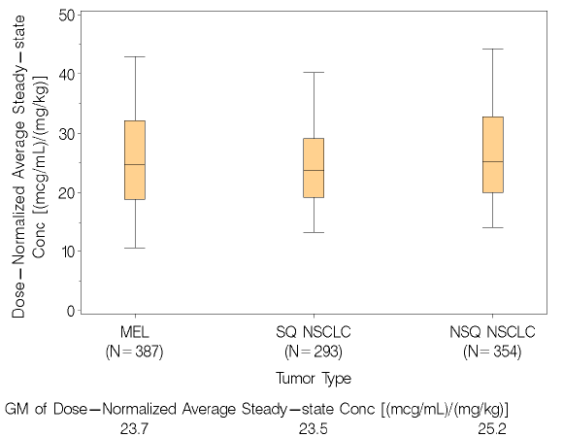

Relationship between nivolumab exposure and overall survival in SQ NSCLC
The analysis included data from patients with SQ NSCLC in studies 003, 063 and 017. Nine subjects were excluded due to lack of exposure estimates, so n=293 were analysed.
Nivolumab exposure (time-averaged steady state concentration, Cavgss) was predicted using the population PK model discussed above. The sponsor noted that other measures (Cminss, Cmaxss) were highly correlated with Cavgss. Graphs of all correlations supported this view.
Covariates considered were body weight, age, clearance, albumin, ECOG status, disease stage, gender and line of therapy.
Variables with a significant influence on OS were found to be: ECOG status; baseline albumin; nivolumab CL; body weight; and baseline LDH. Nivolumab Cavgss was not found to be a significant predictor of OS “after accounting for the effect of CL” in SQ NSCLC.
Evaluator’s comments: Baseline albumin and nivolumab CL influence nivolumab exposure. Can the sponsor comment on whether the influence of albumin and nivolumab CL on OS could be mediated by their effect on nivolumab exposure? (It is noted that a sensitivity analysis was conducted to evaluate the confounding effect between nivolumab clearance and exposure, and that in this sensitivity analysis where CL was removed, nivolumab Cavgss became a significant predictor of OS, with higher exposure correlating with better OS.)
Even if it is accepted that nivolumab CL and not Cavgss per se had an influence on OS, it seems premature to exclude the possibility that exposure has no influence on OS.
Variables with no significant influence on OS outcomes with nivolumab were found to be: line of therapy; disease stage; sex and age.
Evaluator’s comment: Factors that might reasonably be considered prognostic, such as disease stage and age, were found to have no influence on OS. Their risk may be captured by the ECOG performance status parameter. The sponsor is invited to comment.
The model-estimated hazard ratios of death (and 95% CIs), relative to the median Cavgss at 3 mg/kg (71.5 microg/mL), are presented for the 5th percentile of Cavgss (39.85 microg/mL) and the 95th percentile (116 microg/mL):
Evaluator’s comment: There is a suggestion that at lower average exposure, there is a higher risk of death, despite formal analysis excluding Cavgss as a significant predictor for OS.
Effects of baseline tumour size and “week 8 tumour shrinkage” were evaluated in a sensitivity analysis, and found to be significant predictors for OS. In the sensitivity analysis, baseline albumin and ECOG status dropped off the list of significant predictors of OS.
Evaluator’s comment: It is possible that the week 8 tumour shrinkage is correlated with exposure.
A Kaplan-Meier curve of OS by dose and study is included.

Relationship between exposure and AEs leading to discontinuation or death in SQ NSCLC
The analysis included data from patients with SQ NSCLC in studies 003, 063 and 017.
Nivolumab exposure was taken to be indicated by Cavgss.
Covariates considered were body weight, age, lactate dehydrogenase, albumin, clearance, ECOG status, gender, line of therapy and disease stage.
Evaluator’s comment: Immune-related AEs might be related to duration above a certain threshold of exposure, i.e. exposure over time.
Nivolumab exposure was not found to correlate with risk of AEs leading to discontinuation or death, in the range 1-10 mg/kg in SQ NSCLC patients.
Baseline ECOG status and line of therapy were identified as influential. The hazard of these AEs was 3.35-fold higher in patients with baseline ECOG ≥1, and was 1.89-fold higher in third line relative to second line patients (for NSCLC).
Evaluator’s comment: The model appeared to find that at the 5th percentile of Cavgss, there was a higher risk of such AEs than at the 95th percentile:
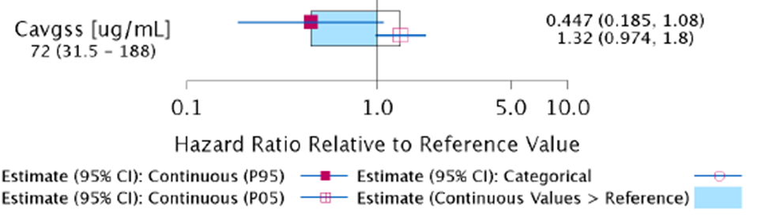
This is counter-intuitive, unless there is confounding (e.g. by duration of treatment), as traditionally it is assumed that increased exposure correlates with increased toxicity. However, the findings for Cavgss did not attain statistical significance. The sponsor’s view was that “the effect of Cavgss was likely confounded with other unidentified covariates”.

Evaluator’s overall conclusions on pharmacokinetics
The pharmacokinetics of nivolumab have been characterised in sufficient detail, primarily by successive population PK analyses. Findings derived from exposure-response analyses should be considered exploratory, given the suggestion that there may be confounding (i.e. that unmeasured covariates may be influencing outcomes such as OS and AEs).
There is no indication that the pharmacokinetics of nivolumab vary appreciably in patients with SQ NSCLC and patients with melanoma.
The sponsor took the view that the influence of covariates on PK was clinically irrelevant if the effect size was <20%. There is an indication within Study 003 of a steep exposure-response curve around the dose being proposed (i.e. objective response rate was 3% in NSCLC patients treated at 1 mg/kg, but >20% at 3 mg/kg and 10 mg/kg doses). It should be noted that no such threshold was seen in melanoma. Also, the formal ‘exposure – response’ analyses within population PK reports did not detect any strong relationship between exposure and efficacy. Nevertheless, even if the ‘threshold’ suggested by Study 003 exists, a change of <20% in exposure due to a single variable is much smaller than a 3-fold decrease in dose, so the sponsor’s approach is probably reasonable in this regard.
Anti-PD-1 mAbs may cause autoimmune AEs. The general approach is to withhold treatment and trial corticosteroids, but other agents may be required if AEs persist. One medicine sometimes used for autoimmune disease is intravenous immunoglobulin. There are grounds to suspect that nivolumab’s PK would be influenced by use of high doses of IVIG, since elevated total Ig levels may saturate FcRn and facilitate degradation of nivolumab. The sponsor is invited to comment.

Pharmacodynamics
No new PD data have been considered in this evaluation report.

Dosage selection for the pivotal studies
Study 017’s CSR notes the 3 mg/kg once every two weeks (Q2W) dose regimen was chosen based on an interim analysis (24 February 2012) of data from ~300 subjects in Study 003:
The probability of a tumour response tended to approach a plateau for trough concentrations produced by 3 mg/kg and 10 mg/kg administered Q2W.
No maximum tolerated dose was identified.

Clinical efficacy

Pivotal efficacy study: CA209017 (“017”)

Study design, objectives, locations and dates

Design
Study 017 was a Phase 3, randomised, open-label study of the efficacy of nivolumab in the treatment of adult patients with previously treated advanced or metastatic squamous cell non-small cell lung cancer, using docetaxel as a comparator.
Evaluator’s comment: The sponsor describes docetaxel as the current standard of care therapy upon progression from first-line therapy in squamous cell NSCLC. This is acceptable (at least in patients without a known driver mutation).

Objectives
The primary objective was to compare overall survival (OS) of nivolumab vs docetaxel.
Secondary objectives were: to compare, across arms, ORR and PFS; to evaluate whether PD-L1 is a predictive biomarker for OS, ORR or PFS; and to evaluate disease-related symptom improvement by 12 weeks.
Exploratory objectives were: to assess safety and tolerability; to characterise PK and explore exposure-response relationships; to characterise immunogenicity; and to assess overall health status using the EQ-5D Index and visual analogue scale.

Locations
The study was conducted at 95 sites in 21 countries (with 4 sites in Australia, enrolling 10 patients and randomising 5 patients in total). Sites in the USA randomised 84 patients. No single study site randomised more than 9 subjects.

Dates
The CSR report date was 26 February 2015; the CSR was described as “final”.
The study was conducted from October 2012 to November 2014. Randomisation occurred from October 2012 through to December 2013 (first patient first visit date was 16th October 2012; last patient first treatment date was 3rd January 2014; last patient last visit date for this CSR was 17th November 2014).
The clinical database lock was 15th December 2014 for this CSR.

Inclusion and exclusion criteria
Subjects (≥18 yrs) had advanced squamous cell NSCLC (i.e. presentation with Stage IIIB / IV, or recurrent or progressive disease following multimodal therapy) that had progressed during or after one prior platinum doublet-based chemotherapy regimen.
Performance status was to be 0-1 (ECOG). Subjects with untreated CNS metastases were excluded; subjects with “active, known or suspected” autoimmune disease were excluded (exceptions were type 1 diabetes mellitus, hypothyroidism only requiring replacement therapy, and skin disorders such as vitiligo, psoriasis and alopecia not requiring systemic treatment). Prior therapy with checkpoint inhibitors (e.g. ipilimumab) was an exclusion criterion, as was acute or chronic HIV / HBV / HCV. Various treatments were prohibited on study, and these included strong CYP3A4 inhibitors (for subjects receiving docetaxel).

Study treatments
Patients were randomised 1:1 to receive either:
- Nivolumab monotherapy (3 mg/kg IV every 2 weeks [Q2W]), or
- Docetaxel (75 mg/m² IV every 3 weeks [Q3W])
Subjects randomised to docetaxel were to receive premedication with corticosteroids, e.g. dexamethasone 8 mg PO BD, on days -1, 0 and 1.
Dose escalation was not permitted in either arm. Dose reductions were not permitted for nivolumab, but were permitted for docetaxel (e.g. for febrile neutropenia, neutropenia <500 cells/mm3 for >7 days, severe or cumulative cutaneous reactions, or other grade 3-4 non-haematological toxicities). Dose delays were permitted in both arms.
Patients were treated until progression, unacceptable toxicity, or other protocol-defined reasons. Unacceptable toxicity was specified in the protocol. There were separate recommendations for infusion reactions, with grade 3-4 reactions requiring permanent discontinuation.
Treatment beyond disease progression (initial call of PD, defined by RECIST 1.1) was not allowed for docetaxel, but was allowed for nivolumab under the following circumstances:
- Investigator-assessed clinical benefit, and do not have rapid disease progression
- Tolerance of study drug
- Stable performance status
- Treatment beyond progression will not delay an imminent intervention to prevent serious complications of disease progression (eg, CNS metastases)
- Subject provides written informed consent prior to receiving additional BMS-936558 (nivolumab) treatment, using an ICF describing any reasonably foreseeable risks or discomforts, or other alternative treatment options.
A radiographic assessment was performed within 6 weeks of original PD to determine whether there has been continued PD (i.e. additional 10% increase in tumour burden volume from time of initial PD, thus taking into account all target lesions and new lesions).

Efficacy variables and outcomes
The primary efficacy endpoint was overall survival (OS).
Other main efficacy endpoints were:
- Objective response rate (ORR) as per RECIST 1.1 as determined by investigator
- Progression-free survival (PFS) as per RECIST 1.1 as determined by investigator
- Duration and time to objective response
- Patient-reported outcomes
For objective response, in nivolumab subjects continuing treatment beyond progression, best objective response was determined based on responses recorded up to the time of the initial RECIST 1.1-defined progression.
For patient-reported outcomes, symptom improvement was measured using the LCSS and health-related quality of life was measured using EQ-5D.
“Disease-related symptom improvement” was defined as a 10 point or more decrease from baseline in average symptom burden index score (within the LCSS instrument) at any time between randomisation and week 12. The subject portion of the LCSS scale consists of six symptom-specific questions that address cough, dyspnoea, fatigue, pain, haemoptysis and anorexia, plus three summary items on symptom distress, interference with activity level, and global health-related quality of life. The study protocol states:
The degrees of impairment is recorded on a 100mm visual analogue scale, with scores reported from 0 to 100 and 0 representing the best score. The average symptom burden index score at each assessment will be computed as the mean of the six symptoms specific questions of the LCSS. The average symptom burden index score is ranging from 0 to 100, with zero being the best possible score and 100, the worst possible score.
The questionnaire was completed on day 1 of every second cycle of nivolumab, and day 1 of every cycle for docetaxel, for the first 6 months. Within the first 12 weeks after baseline, nivolumab patients had the opportunity to complete the questionnaire at weeks 4, 8 and 12; docetaxel patients at weeks 3, 6, 9 and 12.
The Statistical Analysis Plan notes “the summary at baseline and at each time point is based on all randomised subjects with a baseline measurement … change from baseline analysis will only include subjects who have an assessment at baseline and at the assessment point”.
Evaluator’s comments: LCSS has been developed to measure physical and functional dimensions of quality of life. It is a valid approach to assessing lung cancer’s impact on QoL.
The LCSS questionnaire evaluates six major symptoms AND symptomatic distress, functional activities and global QoL. The endpoint emphasised by the sponsor in Study 017 is the average symptom burden index score, which focuses on the six specific symptoms (cough, dyspnoea, fatigue, pain, haemoptysis, anorexia). The endpoint may not be suitable to capture treatment-related toxicities’ effects on QoL (e.g. if they product symptoms other than cough, dyspnoea, fatigue, pain, haemoptysis and anorexia). Some drug toxicities (e.g. pneumonitis) will be captured. The endpoint will not capture changes in general health (e.g. mobility; ability to work; levels of anxiety, fear and depression) – but EQ-5D was also used. Symptom / QoL changes may be confounded by imbalances across in arms in use of supportive care, such as symptom-control medicines.
The sponsor also used the EQ-5D instrument to gather information on health-related quality of life. This consists of five dimensions: mobility, self-care, usual activities, pain / discomfort and anxiety / depression. Each has three levels. With the VAS used, 0 reflects worst imaginable health and 100 reflects best imaginable health.

Randomisation and blinding methods
Randomisation was 1:1. There was stratification by: prior treatment with paclitaxel-based doublet vs other doublet; and region (US / Canada vs Europe vs Rest of World).
The study was open-label.

Analysis populations
Analysis populations are described below.
Table 17. Analysis populations.
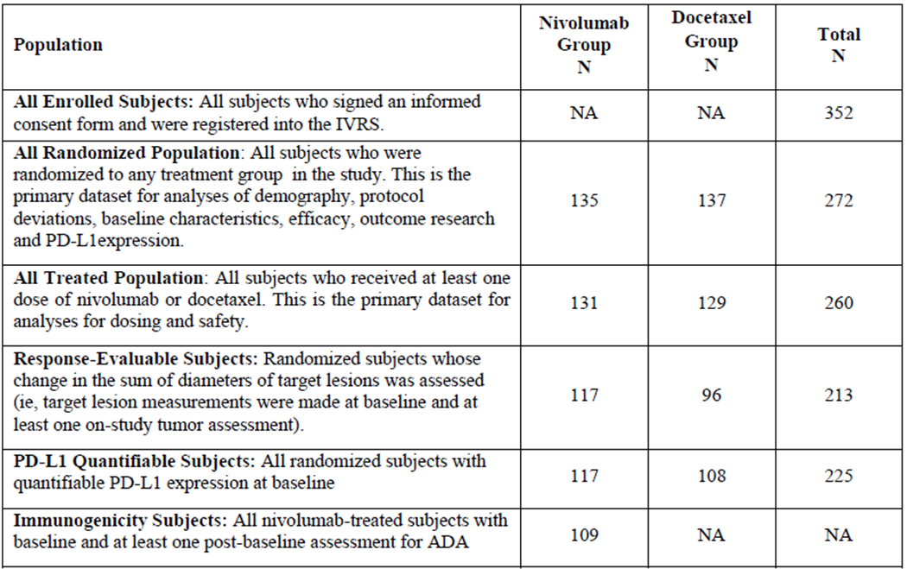
With regard to PD-L1 status, PD-L1 expression was defined as the percent of tumour cells showing plasma membrane PD-L1 staining in a minimum of 100 evaluable tumour cells per validated Dako PD-L1 IHC assay. This used a rabbit anti-human PD-L1 antibody (clone 28-8; Epitomics Inc) to assess PD-L1 expression in archived, pretreatment, formalin-fixed, paraffin-embedded tumour samples. For association with clinical efficacy and safety data, expression was evaluated with thresholds of 1%, 5% and 10% defining positivity.

Sample size
272 patients were randomised.
Sample size was calculated to power comparison of OS across arms. An interim analysis of OS was planned after ≥196 deaths. The final analysis was to take place after 231 deaths among 272 randomised subjects (however see ‘Statistical methods’ below).
There was a 55% chance of declaring superiority at the interim analysis, and a 35% chance at the final analysis – the study was powered to have a 90% chance of declaring superiority (based on a piecewise mixture model of assumptions including 7 month median OS for docetaxel, with exponential OS distribution, and 8.9 month median OS for nivolumab, with an 18% long-term survival rate for nivolumab).

Statistical methods
On 15th December 2014, the clinical database was locked for a planned interim OS analysis, based on 199 deaths. The independent data monitoring committee reviewed the interim OS data on 10th January 2015 and declared that the study reached its primary endpoint.
In order to preserve an experiment-wise type I error rate of 5%, a hierarchical testing approach was applied to key secondary endpoints following analysis of OS. The ordering was ORR then PFS.
Disease stage was not reported in subset analyses, since disease stage was variably reported on the CRF (stage at study entry vs stage at initial diagnosis).

Participant flow
352 subjects were enrolled; 272/352 were randomised (n=135 nivolumab, n=137 docetaxel); and 260 were treated (n=131 nivolumab; n=129 docetaxel).
Minimum follow-up for OS was for 10.6 months. As of database lock, 21/131 nivolumab subjects (16%) and 2/129 docetaxel subjects (1.6%) were continuing treatment. Disease progression was the commonest reason for discontinuation (67.2% for nivolumab; 62% for docetaxel). Other reasons included: study drug toxicity (3.8% vs 10.1% respectively); AEs unrelated to study drug (4.6% vs 10.1%); and “maximal clinical benefit” (1.5% vs 5.4%).

Major protocol violations/deviations
There were two tiers of protocol deviation: “significant protocol deviation” (study conduct differing significantly from protocol) and “relevant protocol deviation” (significant protocol deviations that were “programmable” and could potentially affect interpretability of study results). Relevant protocol deviations were limited to pre-defined situations (see the CSR’s Statistical Analysis Plan).
There was an imbalance in relevant protocol deviations, with 6.7% of nivolumab subjects (n=9) and 0.7% of docetaxel subjects (n=1) reporting a (pre-defined) significant protocol deviation that could potentially affect interpretability of study results.
For the nivolumab arm, 2/135 subjects did not have SQ NSCLC ([information redacted] had non-squamous histology; [information redacted] had non-squamous histology), 1 had no measurable disease at baseline ([information redacted]), and 6 subjects received concurrent anti-cancer therapy. Amongst these 6 subjects, the concurrent therapy was radiation therapy in each case. For the docetaxel arm, 1 subject received concurrent radiation.
Palliative radiotherapy to bone or CNS lesions was allowed per protocol, but this was not incorporated into the Statistical Analysis Plan’s definition of relevant protocol deviations (which included on-study receipt of radiation therapy).
Evaluator’s comment: Can the sponsor comment, per patient receiving concurrent radiation, on the potential impact of radiation on change in size of target lesions and any influence on objective response?
Based on review of Appendix 1.16 (“Significant protocol deviations”) there were other influential deviations. Patient [information redacted] had stage 1B disease; [information redacted] had metastatic SCC of head or neck. Using “relevant protocol deviations” may artificially limit assessment of important deviations. Was there a per protocol analysis? If not, why not?
The summary of significant protocol deviations in Appendix 1.16 of the CSR did not distinguish subjects by treatment arm.
Could the sponsor provide a list of significant protocol deviations that includes the treatment arm of the patient (i.e. nivolumab vs docetaxel)?

Baseline data
Across randomised subjects, median age was 63 yrs; 93% of subjects were white, and 76.5% were male.
In the nivolumab arm, subjects were slightly younger (mean age 62.2 yrs for nivolumab, 64.4 yrs for docetaxel; similar for medians; 8.1% vs 13.1% were ≥75 yrs). Also, there were more males in the nivolumab arm (82.2% vs 70.8%). ECOG performance status was 0 in 20% (nivolumab) vs 27% (docetaxel).
Tumour characteristics were broadly similar across arms, although 24.4% (nivolumab) vs 16.7% (docetaxel) of patients had ≥4 sites with at least one lesion, and the median sum of reference diameters of target lesions was higher in the nivolumab arm (87.5 mm) than in the docetaxel arm (74 mm). Stage IV disease was reported at baseline for 78% of the nivolumab arm, 82% of the docetaxel arm.
Evaluator’s comments: Could the sponsor clarify whether the baseline data concerning disease stage are robust, given the earlier comment about reporting of disease stage (stage at study entry vs stage at initial diagnosis)?
Some of these imbalances in baseline characteristics are prognostic (e.g. stage of disease; performance status; gender). Considered together, the baseline imbalances did not clearly favour one arm or another.
All subjects were required to have disease recurrence or progression during or after one prior platinum doublet-based chemotherapy regimen for advanced or metastatic disease. In 81.3% of patients, prior systemic therapy was in a metastatic (as opposed to locally advanced) setting. Time from completion of most recent prior therapy to randomisation was <3 months in 45% of subjects, and within 3-6 months for a further 28% of subjects. Half of subjects had prior surgery (53%) and radiotherapy (53%).
Evaluator’s comment: Data about EGFR activating mutation or ALK mutation tumour status were not evident. Based on limited prior and subsequent use of EGFR inhibitors and ALK inhibitors, it seems few patients had such tumour characteristics. The sponsor is invited to comment on this.

Drug exposure

Extent of exposure to study drug
131 subjects received at least 1 infusion of nivolumab; 129 received at least 1 infusion of docetaxel. Cumulative dose and relative dose intensity are summarised below.
Table 18. Extent of exposure to study drug.
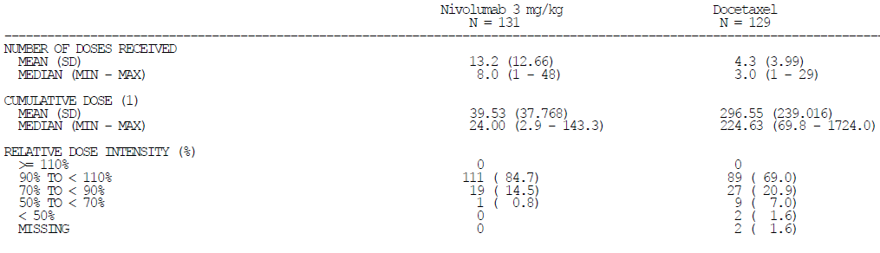
The lower dose intensity with docetaxel is consistent with dose reduction for docetaxel toxicity (there was no dose reduction for nivolumab).
According to the NSCLC RMP v1.1, 51/131 patients were treated for >6 months (38.9%).

Dose delays, reductions, infusion interruptions, reductions of infusion rate
Of the total number of doses received, 0.5% of nivolumab doses were interrupted, and 1.4% of docetaxel doses; the disparity was even greater for number of doses where the IV infusion rate was reduced. Delay in starting a cycle of treatment was broadly similar across arms, per person, but of the total number of cycles received, 6.4% of nivolumab cycles were delayed, and 16.1% of docetaxel cycles. The length of delay was similar across arms.

Concomitant therapy
Major imbalances were observed in the use of some concomitant therapies, namely:
- Corticosteroids for systemic use (in 48% for nivolumab, 99% for docetaxel [noting that dexamethasone is a pre-medication for docetaxel])
- Antiemetics and antinauseants (27.5% vs 61%)
- Antihistamines for systemic use (13% vs 35%)
43% of nivolumab patients and 46.5% of docetaxel patients were given concomitant immune-modulating medicines for management of AEs (see ‘Clinical Safety’ below):
- Systemic corticosteroids in 37% of nivolumab patients and 28% of docetaxel patients (more nivolumab patients received methylprednisolone, 6.9% vs 3.1%, and prednisone, 18.3% vs 8.5%; but a similar proportion received dexamethasone, 12.2% vs 13.2%)
- Filgrastim or similar in 2.3% vs 17.1%
Usage was higher when considering any use rather than management of AEs.

Subsequent therapy
24% of nivolumab arm patients subsequently trialled docetaxel; few docetaxel arm patients subsequently tried immunotherapies.

Results for the primary efficacy outcome
Overall survival was the primary endpoint in this study. The hazard ratio for survival, in favour of nivolumab over docetaxel, was 0.59 (96.85% CI 0.43-0.81; the 95% CI is slightly narrower, at 0.44-0.79). The Kaplan Meier OS curve is copied below.
Figure 19. Kaplan Meier OS curve.
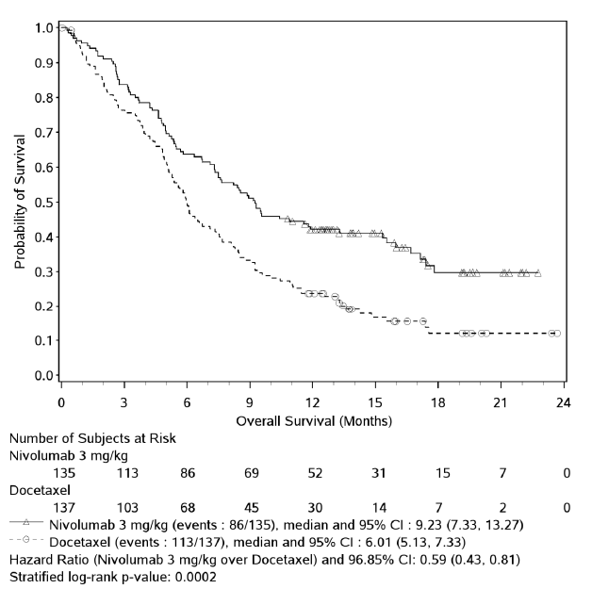
The 1 year overall survival rate was 42.1% (nivolumab) vs 23.7% (docetaxel). As of the last known clinical data date, 86/135 nivolumab subjects had died (63.7%), whereas 113/137 docetaxel subjects (82.5%) had died.
Median OS was 9.2 months for nivolumab, 6.0 months for docetaxel.
A multivariate analysis sought to adjust treatment effect for: time from diagnosis to randomisation; gender; baseline ECOG; smoking status; and age (many of these factors were slightly or moderately imbalanced at baseline). The resultant HR was 0.51. ECOG performance score at baseline was the only significant prognostic variable for OS (a score of 1 was associated with a HR of 2.6, relative to a score of 0), other than arm of treatment.
Evaluator’s comment: The 1-year OS rate for docetaxel was low in Study 017, at 23.7%. This compares with rates in historical studies of previously treated NSCLC of 29-42% (ref: initial Clinical Overview for SQ NSCLC). However, Study 017 was in SQ NSCLC, which may have a worse prognosis than other types of NSCLC.
This difference in overall survival is clinically significant, especially in the context of the two drugs’ toxicity profiles.

Sub-group analysis of OS
In most sub-groups, OS results favoured nivolumab. This was not the case for the sub-group of patients ≥75 yrs of age (this finding was consistent with sub-group analyses of ORR and PFS).
The sponsor noted that only 11 nivolumab and 18 docetaxel subjects were in this category. A post-hoc analysis found an imbalance for ECOG PS in the category (90.9% of nivolumab patients but 61.1% of docetaxel patients, i.e. 10/11 vs 11/18, had ECOG PS 1).
Evaluator’s comment: The <65 yr and the 65-75 yr categories showed a broadly similar benefit for nivolumab. There is insufficient evidence to exclude or demonstrate benefit for nivolumab in older subjects. In terms of efficacy, use ahead of docetaxel in subjects ≥75 yrs of age would be on the basis of bridging from sub-groups with larger sample size.
There is a large literature about the effects of ageing on the immune system. It is possible the limited effect of nivolumab in older patients is based on a reduced capacity for immune responses to tumours. The sponsor is invited to comment.
The PI should indicate the results of this sub-group analysis of OS by age.

Sub-group analysis of OS by PD-L1 status
This was a secondary endpoint. 87% of nivolumab subjects and 79% of docetaxel subjects had quantifiable PD-L1 expression; most samples were of the primary tumour site. Overall frequency of PD-L1 expression at baseline used three different thresholds (1, 5 and 10% thresholds were associated with 53%, 36% and 31% positivity in those with quantifiable expression, respectively). Using these thresholds, there was no convincing difference in benefit conferred by nivolumab relative to docetaxel, based on OS, PFS and ORR outcomes. Within the nivolumab arm, there was no signal that subjects with PD-L1 positive tumours had better outcomes than subjects with PD-L1 negative tumours. Kaplan Meier OS curves are reported.
Evaluator’s comment: It is entirely unclear whether PD-L1 expression is best assessed on tumour cells, tumour infiltrating lymphocytes, or both.

Results for other efficacy outcomes
Key secondary efficacy outcomes are summarised in the following table.
Table 19. Key secondary efficacy outcomes.
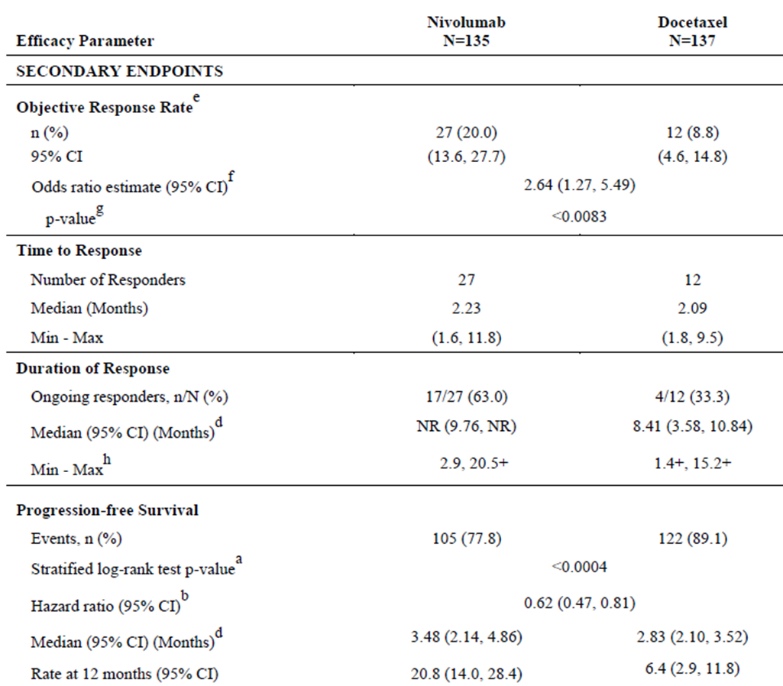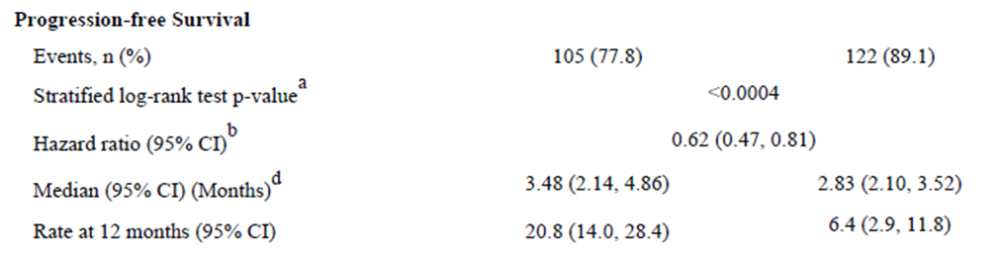
For ORR, 1 subject (0.7%) had a complete response in the nivolumab arm; there were no CRs in the docetaxel arm. Median time to response was 2.1-2.2 months across arms. In responders, 17/27 (63%) nivolumab subjects and 4/12 (33%) docetaxel subjects had ongoing responses as of the database lock. 16 of the 17 nivolumab ongoing responders were still on treatment.
Evaluator’s comment: The objective response rate for docetaxel is low relative to the Taxotere PI’s information that in previously treated NSCLC patients, ORR was 17%. Taxotere patients apparently received 100 mg/m2.
Survival time (presumably median) was stated to be 8 months for these patients (in Study 017 it was closer to 6 months). In subsequent studies using docetaxel (typically 75 mg/m2), median OS results for the docetaxel arm in broadly comparable populations were closer to 8 than 6 months.
It might be argued that efficacy outcomes for nivolumab are comparable to historical docetaxel outcomes. Given that Study 017 was apparently well conducted as a randomised, controlled trial, it may be argued that patients in this study had a more adverse prognosis than in historical studies. This may be related, at least in part, to the study of SQ NSCLC in Study 017 (historical studies were of NSCLC more broadly).
For ORR, sub-group analysis revealed that ‘never smokers’ had an ORR with nivolumab in 1/10 cases, vs 1/7 cases for docetaxel (10% vs 14.3%).
Evaluator’s comment: While sample size is limited in this sub-group analysis, the result is worth follow-up since there is evidence that PD-1 blockade in NSCLC may be more effective in patients with a high mutational burden (as might be seen in smoking-related NSCLC).
There was no sign of worse OS outcomes in nivolumab never-smokers than docetaxel never-smokers; again, sample size was small. PFS outcomes were not better in nivolumab never-smokers relative to docetaxel never-smokers (medians, 2.7 vs 3.4 months respectively) but sample size was small (n=10 and 7 respectively).
In the study of pembrolizumab in NSCLC by Rizvi et al, self-reported smoking history did not discriminate those most likely to benefit, while the molecular signature of smoking (transversion high) did discriminate.
In Study 017, data were not analysed by heavy vs light smoking history or by molecular signature.
For PFS, the Kaplan Meier curve is presented below.
Figure 20. Kaplan Meier PFS curve.
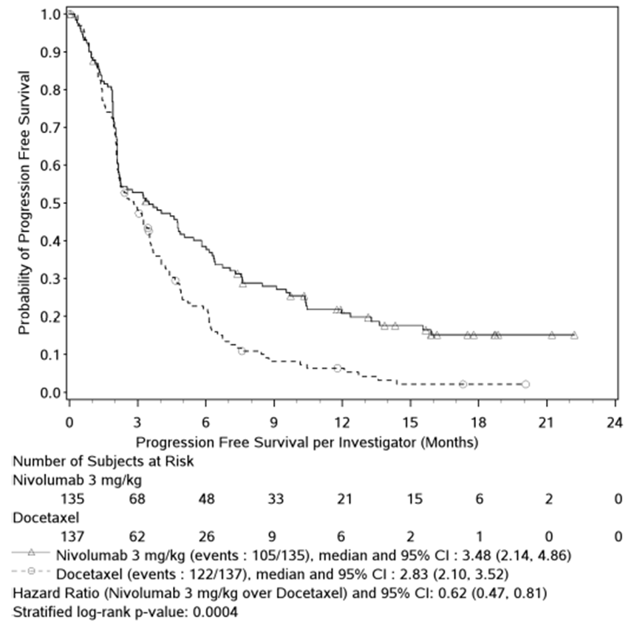
Evaluator comment: It is relevant that progression-free survival is better with nivolumab, as advanced NSCLC is a condition with a precipitous clinical course, not marked by long periods of stable disease. PFS outcomes are not confounded by subsequent use of anti-cancer treatments – so they provide more evidence of a dramatic treatment effect with nivolumab relative to docetaxel. There is also a signal that some patients treated with nivolumab may have an enduring response to therapy, as suggested by the PFS Kaplan Meier curve, however further follow-up of more subjects is required to validate this signal.

Disease-related symptom improvement by week 12
LCSS Questionnaire compliance rate was not high (e.g. 67-71% at baseline), but was >70% to week 12 (the percentage is of available subjects, so that by week 12, for example, only 71 nivolumab subjects and 45 docetaxel subjects were ‘available’).
At baseline, the mean “average symptom burden index score” across 90 nivolumab patients was 30, and across 97 docetaxel subjects was 32 (medians were 30 and 33.7, suggesting a degree of imbalance in this regard at baseline).
The rate of disease-related symptom improvement (defined as a 10+ point decrease from baseline in average symptom burden index score any time between randomisation and wk 12) was 19% for nivolumab, 21% for docetaxel. The sponsor provided several literature references supporting a 10 point change as a minimally important difference.
Based on average symptom burden index scores, the sponsor claimed improvement in symptom burden in the nivolumab arm, except at the first assessment after baseline (which was at week 4). Beyond week 54, the sample size was too small to interpret results.
Evaluator comment: There was relatively low compliance at baseline, which introduces bias – it may be that patients with lower baseline symptom burden were more inclined to participate. This is consistent with the finding of a mean average symptom burden index score of 30-32; a recent “real-world cross-sectional study” of US patients with advanced NSCLC recorded a mean symptom score of 42.3 (37.1 for Stage IIIB; 44.5 for Stage IV).
There was similarly low compliance post-baseline, so there remains the risk of further bias, in that patients with good responses to treatment may be more likely to respond. Analysis of changes in symptoms may not capture all of those patients whose symptoms are most likely to worsen, i.e. non-responders.
Can the sponsor stratify PROs by responder status (e.g. presence of objective response at the time of PRO data collection)?
Sample size in the docetaxel arm was low (n<30) after week 12, so results are difficult to compare across arms beyond week 12. Up to that point, results were broadly similar – better for docetaxel at week 4, better for nivolumab at week 12. After week 12, patients in the nivolumab arm appeared to have improvement in symptoms, but patients who did not respond to the questionnaire may have had a different outlook.
Can the sponsor further characterise reasons for the apparent dip in QoL outcomes for nivolumab patients at week 4? Why was there low compliance at baseline?
Health-related quality of life was also assessed via the EQ-5D instrument, every other cycle for nivolumab, and every cycle for docetaxel patients. The minimally important difference on this scale has been estimated as 7 points out of 100. Baseline scores were 63/100 in the nivolumab arm and 64.4/100 in the docetaxel arm; by way of context, the sponsor reports that 80/100 is the norm for the general US population. Scores improved over time for patients compliant with the questionnaire – although, as with the LCSS index, at week 4 for nivolumab there was a slight decrease in score (mean 61.8).
Evaluator’s comment: The lag in response as measured by LCSS and EQ-5D instruments might reflect a lag in onset of efficacy for nivolumab. Amongst the subset with an objective response (27 nivolumab patients and 12 docetaxel patients), median time to response was 2.2 months for nivolumab and 2.1 months for docetaxel; mean times to response were 3.4 and 2.9 months respectively. On the other hand, Kaplan Meier OS curves separate quite early. An alternative explanation is the impact of early-onset and nivolumab-specific toxicity, but no specific toxicity is apparent.

Treatment beyond progression
28 of 135 nivolumab subjects were treated beyond progression. 9/28 (32%) were “non-conventional benefiters” – subjects who had not experienced a best objective response of PR/CR prior to initial RECIST-defined progression, but who subsequently met one of the following criteria:
- Appearance of a new lesion followed by decrease from baseline of at least 10% in sum of target lesions (5 subjects)
- Initial increase from nadir ≥20% in sum of target lesions followed by reduction from baseline of ≥30% (1 subject)
- Initial increase from nadir ≥20% in sum of target lesions followed by at least 2 tumour assessments showing no further progression, defined as 10% additional increase in sum of target lesions and new lesions (3 subjects)
Five other nivolumab subjects appeared to benefit despite not meeting these criteria, as indicated by receipt of 7, 8, 9, 32 and 33 doses of nivolumab post-progression.

Study CA209063 (“063”)

Study design
This was a single-arm, open label, Phase 2 study of nivolumab in subjects with advanced or metastatic SQ NSCLC who had received at least two prior systemic regimens. One of these had to be platinum doublet-based chemotherapy. Some details of inclusion criteria were similar to those in Study 017.
The sponsor justified the single arm design by noting that no approved / proven efficacious therapies exist for SQ NSCLC patients who have progressed after two chemotherapies.
Information discussed below is from “Addendum 1 to Clinical Study Report for Study CA209063” dated 5th November 2014; the clinical database lock for this addendum is 23rd July 2014 (in the earlier “Final CSR”, the clinical DBL was 6th March 2014). This provides a minimum follow-up of ~11 months (the “Final CSR” had provided ~5.5 months minimum follow-up).
The primary objective of the study was to assess the clinical activity of nivolumab, as measured by independent radiology review committee (IRC)-assessed ORR.
Evaluator’s comment: This study is considered supportive rather than pivotal because of the combination of its single-arm design, emphasis on ORR, and enrolment of 3rd or subsequent line subjects.
117 subjects were treated at 27 sites in 4 countries (USA; France; Germany; Italy). The first patient visit was in November 2012; the last patient started treatment in August 2013.
Patients were treated with nivolumab, 3 mg/kg as a 60 minute IV infusion every 2 weeks. The median number of doses received was 6 (range, 1-34 doses). The median duration of study therapy was 2.33 months. Dose escalation or reduction was not permitted.
Dose delays were allowed, based on AE grade, laboratory value abnormalities and intercurrent illness. In 24.8% of subjects there were dose delays; this amounted to 5.4% of all doses being delayed. In 79.1% of cases of dose delay, the delay was <15 days. Delays were mostly due to AEs – leading AEs causing delays were fatigue (in 5.1% of subjects), dyspnoea (2.6%) and pneumonia (2.6%).
Treatment was continued until disease progression, but in some patients treatment could continue despite progression, i.e. if the following criteria were met:
- The investigator-assessed clinical benefit
- Treatment beyond progression did not delay an imminent intervention to prevent serious complications of PD
- The subject did not have rapid PD
- The subject tolerated the study drug, had stable performance status, and provided written informed consent prior to receiving additional nivolumab treatment
Of 117 subjects, 20 were considered eligible to receive nivolumab beyond progression.
Radiographic assessments of tumours were performed at week 8 and every 6 weeks thereafter. Tumour responses were assessed by the independent radiology review committee (IRC) and investigator using RECIST 1.1.
Pre-study tumour tissues were collected for determination of baseline PD-L1 expression, using an automated IHC assay (rabbit anti-human PD-L1 antibody, clone 28-8, Epitomics Inc). As noted in the CSR, actual PD-L1 expression in tumours at the time of treatment may vary from expression in pre-study tumour samples.
As of CSR Addendum 1, 15/117 subjects (12.8%) remained on treatment. 78 (66.7%) had discontinued for disease progression, and 14 (12%) had discontinued for study drug toxicity.

Baseline characteristics
Of 117 treated subjects, 72.6% were male, 84.6% were white, and median age was 65 yrs (range 37-87). 13.7% of subjects were 75+ yrs of age.
At study entry, 82.9% had stage IV disease, 17.1% had IIIB. Time from initial diagnosis of SQ NSCLC to treatment was <2 yrs in 61.5%, with median time of 1.7 yrs (range 0.2 to 10.7 yrs). 49.6% of subjects had 3 or more baseline disease sites with 1+ lesions. 22.2% had ECOG 0, and 77.8% had ECOG 1 performance status. 2 subjects had treated CNS metastases (those with active or untreated CNS metastases were excluded).
92.3% were current or former smokers.
35% of patients had received 2 prior systemic therapies; 44.4% had received 3 prior systemic therapies; 20.5% had received 4 or more prior systemic therapies. Most subjects had received a taxane (65% docetaxel; 60.7% paclitaxel); 33.3% had received a prior EGFR TKI, erlotinib. Other common prior therapies were gemcitabine and vinorelbine.
Three-quarters had completed their most recent prior regimen <3 months before starting nivolumab. 60.7% of subjects had progressive disease as their best response to the most recent prior regimen. About 70% of subjects had received prior cancer surgery, and about 75% had received prior radiotherapy.

Efficacy results
The primary endpoint was IRC-assessed ORR. 17/117 subjects (14.5%) were responders. The median duration of response was not reached in these 17 subjects (range, 1.9+ to 11.5+ months; 13/17 subjects [76%] had ongoing responses). All responses were partial, with a maximum tumour burden reduction of 75.1%.
This analysis included 4 additional subjects with IRC-assessed BOR of confirmed PR, relative to the “Final CSR”. One of these subjects received only one dose of nivolumab but is progression free after 11.6 months despite receiving no further anti-cancer treatment.
The sponsor claimed that historical objective response rates in the refractory setting are 2-8% for chemotherapy and EGFR TKIs.
There was stable disease in a further 25.6% of subjects. Median duration of stable disease was 6 months.
Median PFS was 1.9 months. 1-yr PFS rate was 20%. The sponsor reports historical 1-yr PFS rates of 2-10% in previously treated advanced NSCLC (based on studies published in 2003 and 2005).
Median follow-up for OS (i.e. median time between date of first dose and last known date alive, or death) was 8.0 months. Median OS was 8.2 months. The 1-year OS rate was 40.8%. The Kaplan Meier curve for OS is copied below.
Figure 21. Kaplan Meier curve for OS.
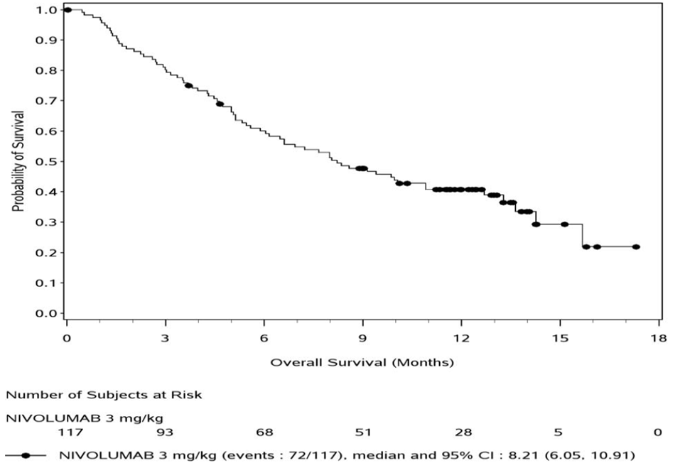
The sponsor reports historical median OS of 4 to 6.5 months in this type of population, and historical 1-yr OS rates of 5-22%.
Non-conventional benefit was observed in a total of 4 subjects (out of 20 on treatment after progression); 3 of these 4 remained alive at the clinical DBL, with survival times of 11.6+ to 13.5+ months.
After discontinuation of nivolumab, 23.9% of subjects received further systemic cancer therapy, often gemcitabine, docetaxel or vinorelbine.
Of 117 subjects, 86 (73.5%) had a pre-study tumour sample tested for PD-L1 with a quantifiable result. Response rates were higher in ‘positive’ subjects at each threshold examined (1%, 5%, 10%), but ‘negative’ subjects had reasonable outcomes. There was no clear association between the biomarker and PFS. There was a trend towards better OS in subjects with >5% PD-L1 positive cells (medians, 15.7 vs 8.2 months), but results were similar in groups defined using a 1% threshold.

Study MDX1106-03 (CA209003) (“003”)

Study design
This was a Phase 1, open-label, dose-escalation study of nivolumab in subjects with various advanced or recurrent malignancies.
A “Final CSR” was provided with a 5th March 2013 database lock, and an “Addendum 1” was provided with updated OS outcomes based on a 17th September 2013 cut-off.
395 subjects were enrolled and screened; 306/395 subjects were treated, at 13 US sites. The study was initiated in October 2008, and completed in 2013. The study was started by Medarex, and ‘acquired’ by BMS in 2010.
Patients had advanced or recurrent malignancies despite treatment with 1-5 prior systemic therapies, and had no alternative curative options. Tumour types included metastatic castrate resistant prostate cancer (mCRPC), renal cell carcinoma (RCC), colorectal adenocarcinoma (CRC), malignant melanoma and non-small cell lung cancer (NSCLC).
Nivolumab was given IV at doses of 0.1, 0.3, 1, 3 and 10 mg/kg, depending on tumour type. Dosing was every 2 weeks. The 0.1 and 0.3 mg/kg cohorts in melanoma were added by way of protocol amendment. A total of 54 subjects were treated with 3 mg/kg Q2W, across all tumour types.
Key efficacy variables were objective response rate and duration of response. PFS and OS were counted amongst secondary efficacy endpoints.
54 patients with squamous cell NSCLC were assessed for efficacy. Of these 54 patients, 15 received 1 mg/kg; 18 received 3 mg/kg dosing; and 21 received 10 mg/kg dosing.
There were also 74 patients with non-squamous NSCLC (treated with 1, 3 or 10 mg/kg), 107 with melanoma (treated with 0.1, 0.3, 1, 3 or 10 mg/kg), 34 with renal cell carcinoma (treated with 1 or 10 mg/kg), 19 with CRC (treated with 10 mg/kg) and 17 with mCRPC (treated with 10 mg/kg).
Evaluator’s comment: Efficacy in subjects with non-squamous NSCLC, melanoma and RCC is considered to be irrelevant in the assessment of efficacy in SQ NSCLC, and will not be detailed. The sponsor did not note any large differences in efficacy outcomes for non-squamous and squamous NSCLC.
In SQ NSCLC patients, study drug discontinuation was often due to disease progression (57.4% of patients based on the Final CSR), although AEs were the cause in 13%.

Baseline characteristics
Median age in SQ NSCLC patients was 65 yrs (range, 49-83 yrs). 16.7% (n=9) were 75+ yrs of age. 65% were male. 91% were white. ECOG performance status was 1 in 81.5%, 0 in 16.7%. Almost all had metastatic disease at screening.
Of 54 patients with SQ NSCLC, 14 had received 1 prior cancer regimen, 14 had received 2 prior regimens, 12 had received 3 and 14 had received 4+ prior regimens, so broadly this was a heavily pre-treated population.

Efficacy results
Based on the Final CSR, objective responses were observed in 9/54 subjects (16.7%) with SQ NSCLC. The objective response rates were 3% for 1 mg/kg, 24.3% for 3 mg/kg and 20.3% for 10 mg/kg in NSCLC (all histologies), however no such threshold effect was seen in melanoma (where doses as low as 0.1 mg/kg were tested) or RCC. In SQ NSCLC, median duration of response had not been reached (although in non-squamous NSCLC, the median had been reached, and was 64 weeks).
Only 63 of 129 subjects with NSCLC had PD-L1 status determined, so the lack of variation in ORR by PD-L1 status using either a 5% or 1% positivity threshold is difficult to interpret.
In Addendum 1 to Study 003, the emphasis was on results in NSCLC, rather than the SQ subset that is the subject of the current application. However, some results were presented for the SQ NSCLC subset, as follows.
Overall survival outcomes in NSCLC (in the 128 patients treated with 1-10 mg/kg and with known histology) were presented by histology:
Figure 22. Overall survival outcomes in NSCLC by histology.
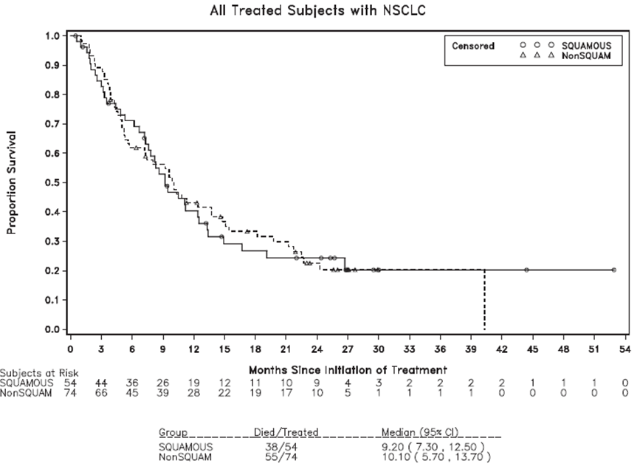
Evaluator’s comment: Results were similar for SQ NSCLC and non-SQ NSCLC patients. After 12 months, and particularly after 24 months, there were very few subjects at risk.
A further 6/54 SQ NSCLC patients were considered to have non-conventional clinical benefit. The pattern of OS in these patients was intermediate between conventional responders and non-responders, across all NSCLC patients.

Evaluator’s conclusions on clinical efficacy for SQ NSCLC
There was only one pivotal study in the setting of SQ NSCLC, Study 017. Apart from being an open-label study, it was well designed. Lack of blinding does not have a direct impact on the primary endpoint of overall survival. Efficacy results in the comparator docetaxel arm were not good relative to recent studies. This may be because Study 017 only examined SQ NSCLC, which may have a worse prognosis than non-squamous NSCLC. The randomisation process appeared valid and baseline prognostic factors were mostly balanced across arms. It is possible that despite randomisation, there was an imbalance in unmeasured baseline prognostic factors; but the modest imbalances that were apparent (e.g. in ECOG performance status) in Study 017 seemed to favour better results for docetaxel (as suggested by the lower HR, 0.51, in the multivariate analysis of OS).
Study 063, despite being uncontrolled, provided some evidence of nivolumab’s efficacy as third (or subsequent) line therapy in SQ NSCLC.
In my view, there is acceptable evidence that nivolumab monotherapy (3 mg/kg Q2W) has sufficient efficacy in the proposed indication.
The sponsor proposes use of nivolumab in lung cancer as per the following indication:
OPDIVO is indicated for the treatment of locally advanced or metastatic squamous non-small cell lung cancer (NSCLC) with progression on or after prior chemotherapy.
The term ‘locally advanced’ is open to interpretation. NSCLC has well-established clinical staging criteria, based on TNM classification. Study 017 included patients with stage IIIB or stage IV disease. Consideration should be given to whether the indication should specify stage IIIB / stage IV disease. Use of the term ‘locally advanced’ is enshrined in the indications of various other TGA-approved therapies for NSCLC; also, the nivolumab PI ‘Clinical Trials’ section can provide further information about the type of patient studied. On balance, the term ‘locally advanced’ is acceptable to this evaluator.
The wording “on or after prior chemotherapy” opens up the possibility that use could be in patients groups not well tested in the trial programme. For example, patients refractory to targeted therapies might be considered to have progressed on prior chemotherapy. On the whole, that wording is acceptable (given that further information is supplied in the Clinical Trials section of the PI about the type of SQ NSCLC patients that have been studied).
In the pivotal and supportive SQ NSCLC trials of nivolumab, use was as monotherapy. This should be reflected in the indication, since use in combination with other therapies may result in an unpredictably altered benefit / risk profile. A preferable wording of the indication is:
OPDIVO is indicated as monotherapy for the treatment of locally advanced or metastatic squamous non-small cell lung cancer (NSCLC) with progression on or after prior chemotherapy.

Clinical safety

Studies providing evaluable safety data
Studies 017, 063 and 003 provided evaluable safety data. There was a pooled analysis of safety from studies 017 and 063, within the Clinical Overview Update.
Evaluator’s comments: Only where this pooled analysis provides major new safety information, above and beyond that found in individual CSRs, is it referenced. The two studies revealed different rates of some AEs, e.g pneumonitis, so a pooled analysis risks losing information, e.g. if pneumonitis is more likely in more heavily pre-treated subjects.
The latest version of the proposed nivolumab PI presents AEs in SQ NSCLC according to the pooled dataset from 017 and 063. Supporting data were provided in a ‘Clinical Overview Update Attachment’ dated 4th March 2015.
In Study 017, AEs were analysed primarily for events reported up to 30 days after the last dose of study medication. A separate analysis considered AEs reported up to 100 days after the last dose of study medication.

Pivotal studies that assessed safety as a primary outcome
There were no pivotal studies that addressed safety as a primary outcome, in SQ NSCLC.

Patient exposure
In Study 017, the primary population for safety analysis was all treated subjects (131 nivolumab subjects, all receiving 3 mg/kg Q2W, and 129 docetaxel subjects). In Study 063, there were 117 treated subjects, all receiving nivolumab 3 mg/kg Q2W. Thus the pooled analysis of safety across these two studies drew from 248 subjects given nivolumab.
In Study 003, there were 54 SQ NSCLC subjects, of whom 18 received 3 mg/kg Q2W; and there were a further 74 non-squamous NSCLC subjects.

Adverse events

All adverse events (irrespective of relationship to study treatment)

Study 017 (pivotal)
Leading AEs for nivolumab were: dyspnoea (36.6%); cough (31.3%); fatigue (30.5%) and decreased appetite (24.4%).
Leading AEs for docetaxel were: fatigue (39.5%); neutropenia (33.3%); dyspnoea (29.5%); anaemia (28.7%); decreased appetite (27.1%); diarrhoea (25.6%); nausea (24.8%); alopecia (22.5%); and asthenia (20.9%).
Evaluator’s comment: Leading AEs for nivolumab are also common symptoms of NSCLC.
Since pneumonitis has been identified as a toxicity of nivolumab, it is possible that some of these AEs are not simply symptoms of disease, but are early or isolated symptoms of pneumonitis. For example, cough was reported in 31.3% of nivolumab subjects, but 18.6% of docetaxel subjects. However, the imbalance in dyspnoea was less pronounced. Likewise, there was little imbalance in ‘fever’ (including chills) across arms.
It is noted that in Study 037 (melanoma), any grade cough of all causality was reported in 15.3% (nivolumab) vs 4.9% (investigator’s choice), while frequencies of dyspnoea were the same (~15%). In Study 066 (melanoma), the frequencies of cough were the same across arms.
The frequency of grade 3-5 AEs was 51.1% for nivolumab, 72.9% for docetaxel. More fatigue and neutropenia-related AEs for docetaxel accounted for much of this difference. Grade 3-4 hypercalcaemia was the only grade 3-4 AE more frequent in the nivolumab arm.
Evaluator’s comment: Hypercalcaemia is often seen in lung cancer, but in a well-randomised study one might expect similar distribution of hypercalcaemia unless there is a drug effect.
Immune-mediated hyperparathyroidism is generally rare, but it is possible that nivolumab is inducing hyperparathyroidism.
Can the sponsor supply any clinical data (e.g. biochemistry test results such as PTH, PTHrP) to help resolve this issue? Was hypercalcaemia associated with any other electrolyte disturbance or adverse reaction? What was the tempo of rises? Were rises symptomatic?
It is noted that there were bone lesions in 16.3% of nivolumab patients, vs 10.9% of docetaxel patients, at baseline, however bisphosphonates or denosumab were used concomitantly (i.e. on study) in 15.3% vs 10.1% respectively.
When incident rates were exposure-adjusted (i.e. accounting for the fact that there were 73.7 person-years of exposure for nivolumab, but only 36.4 person-years of exposure for docetaxel), incident rates of any AE per 100 PY were 1411 for nivolumab and 3398 for docetaxel, for AEs occurring in at least 5% of subjects in either group. The only distinct AEs appreciably more common for nivolumab when thus adjusted for exposure were: dysphonia (12.2 cases per 100 PY, vs 2.7 cases per 100 PY for docetaxel); hypercalcaemia (17.6 vs 0); and hypothyroidism (10.8 vs 0). Distinct AEs dramatically less common for nivolumab when exposure-adjusted (difference in IR per 100 PY of >50, or >10-fold) were: fatigue; asthenia; mucosal inflammation; diarrhoea; nausea; anaemia; neutropenia (5.4 vs 162.2 events / 100 PY); febrile neutropenia (0 vs 44 events / 100 PY); decreased appetite; myalgia; and alopecia (1.4 vs 79.7 events per 100 PY).
Evaluator’s comment: One caveat is that this approach to analysis of AEs is most appropriate when the hazard rate of an event is relatively constant over time (e.g. allergic reactions might occur early in the study; other events might become more or less frequent over time).
Delays in nivolumab dosing due to AEs occurred in 27.5% of subjects; leading causes were pneumonia (3.8%); pneumonitis (3.1%); and pyrexia (3.8%). Delays or reductions in the docetaxel arm occurred in 41.1% of subjects, often due to haematological AEs, fatigue and infections.
Evaluator’s comment: Comparison with docetaxel in this regard was confounded: tabulations included AEs leading to dose reduction (as well as dose delay), and dose reduction was not allowed for nivolumab.
The relevant table in the CSR (S.6.83) reports a low rate of nivolumab delays for fatigue and asthenia (0.8% and not reported) but the text reports much higher rates, 7% and 3.9%. In the table, these rates for fatigue and asthenia were for docetaxel subjects. Can the sponsor confirm whether table or text figures should be regarded as accurate?

Other studies (063, 003)
In Study 063 (Addendum 1), leading AEs were fatigue (49.6%; asthenia contributed a further 18.8%); nausea (29.1%); constipation (23.9%); dyspnoea (37.6%); cough (31.6%) and decreased appetite (35%).
Notable was the frequency of hypercalcaemia (10.3%) – although some other electrolyte disturbances occurred with a frequency of 5-8%.
The frequency of grade 3-4 AEs was 51.3% - very similar to the frequency in Study 017. Leading grade 3-4 AEs were fatigue (6.8%), dyspnoea (8.5%), hyponatraemia (5.1%) and pneumonia (5.1%).
In Study 003 (Final CSR), the leading AEs in the SQ NSCLC cohort (n=54) were cough, dyspnoea, nausea, constipation, diarrhoea, fatigue (50.4%), pyrexia, decreased appetite, Hb decreased, back pain and dizziness.

Treatment-related adverse events (adverse drug reactions)

Study 017 (pivotal)
The overall frequency of drug-related AEs was 58% for nivolumab, 86% for docetaxel. Grade 3-5 drug-related AEs were reported in 6.9% vs 57.4%; this dramatic difference was mainly attributable to imbalance in occurrence of neutropenia, febrile neutropenia and fatigue.
Evaluator’s comment: Study 017 was open-label, so bias may be introduced more easily into the investigator’s attribution of AE causality to study drug. Therefore, emphasis is placed on analysis of all AEs regardless of causality.

Other studies (063, 003)
In Study 063 (Addendum 1), the leading related AE was fatigue (32.5%; asthenia was reported in a further 12%); notable other AEs were pneumonitis (5.1%) and a fatal case of pneumonia. Grade 3-5 drug-related AEs were reported in 18% (fatigue and pneumonitis were leading contributors).
In Study 003 (Final CSR), the leading related AE was again fatigue (24%), followed by decreased appetite (12.4%) and diarrhoea (10.1%). Other commoner related AEs were nausea, Hb decreased, pruritus, rash and pyrexia. These frequencies are for the NSCLC cohort. In Study 003, one patient developed myelodysplastic syndrome, which was considered to be treatment-related.

Deaths and other serious adverse events (SAEs)

Study 017 (pivotal)
No nivolumab patients died due to study drug toxicity. In the docetaxel arm, 3 deaths (2.3%) were attributed to study drug toxicity (interstitial lung disease; pulmonary haemorrhage; and sepsis).
Serious AEs occurring more commonly in the nivolumab arm than the docetaxel arm, regardless of causality, were: malignant neoplasm progression (13.7% vs 7.0%); pyrexia (3.8% vs 0.8%); and hypercalcaemia (3.1% vs 0%). SAEs commoner with docetaxel were: febrile neutropenia (10.1% vs 0%); pneumonia (7.8% vs 5.3%); neutropenia (3.1% vs 0.8%); pulmonary haemorrhage (2.3% vs 0%); lung infection (2.3% vs 0%); and atrial fibrillation (2.3% vs 0%).
The overall frequency of drug-related SAEs was lower in the nivolumab arm than the docetaxel arm. This was mainly attributable to the occurrence of febrile neutropenia, neutropenia and infection in the docetaxel arm.

Other studies (063, 003)
In 063 (Addendum 1), there were two reports of drug-related deaths (hypoxic pneumonia, and ischaemic stroke; both deaths occurred in patients with progressive disease).
In 063 (Addendum 1), the rate of all-causality SAEs was 58.1%. Leading SAEs were dyspnoea (6%), pneumonitis (4.3%; all of these were considered drug-related), COPD (3.4%), pneumonia (6%), malignant neoplasm progression (6.8%) and hypercalcaemia (4.3%).
In 003, 2 NSCLC subjects (out of 129) died after developing treatment-related pneumonitis. A further 2 NSCLC subjects died after developing pneumonitis, but after the data cut-off date. One of the four deceased patients had SQ NSCLC (so 1/54 was thus affected; 1.9%); the other three had non-squamous NSCLC (3/78, 3.8%). One other SQ NSCLC patient experienced pneumonitis as a serious AE (and four non-squamous NSCLC subjects also reported pneumonitis as a serious AE). Other leading causes of treatment-related serious AEs were colitis and diarrhoea (in altogether 4/129 NSCLC patients).

Discontinuation due to adverse events

Study 017 (pivotal)
The overall frequency of AEs leading to discontinuation was 10.7% for nivolumab, and 20.2% for docetaxel (for grade 3-5 AEs leading to discontinuation, frequencies were 6.9% and 15.5% respectively; for drug-related AEs leading to discontinuation, frequencies were 3.1% vs 10.1% respectively).
Leading causes of discontinuation due to all-cause AEs were neoplasm progression (3.2%), pneumonitis (2.3%) and pneumonia (2.3%) for nivolumab, and peripheral neuropathy (3.1%) for docetaxel. In the docetaxel arm, asthenia and fatigue together contributed to discontinuation in another 3.2%. Despite the imbalance in (febrile) neutropenia observed across arms for SAEs, few docetaxel subjects discontinued treatment for such AEs.

Other studies (063, 003)
In Study 063 (Addendum 1), the overall frequency of AEs leading to discontinuation was 31.6% (for grade 3-5 AEs leading to discontinuation, the frequency was 28.2%; for drug-related AEs leading to discontinuation, the frequency was 12%).
Evaluator’s comment: These rates are higher than rates in Study 017. The population was more heavily pre-treated.
Leading causes of discontinuation due to all-cause AEs were pneumonitis (4.3%) and malignant neoplasm progression (3.4%). Also notable were individual cases of anaphylaxis and hypersensitivity.
Drug-related AEs leading to discontinuation were reported in 9.4%.
In Study 003, the frequency of drug-related AEs leading to discontinuation in the NSCLC cohort was 12.4%. The leading AE was pneumonitis although myalgia and infusion-related reactions were also reported in two patients each.

Laboratory tests
Results are from the pivotal study. Results from supportive studies are mentioned only where exceptional.

Liver function
There were no severe abnormalities in LFTs reported in the nivolumab arm.

Kidney function
There were no severe abnormalities in creatinine in the nivolumab arm. There was a suggestion that more subjects receiving nivolumab (left-hand side below) developed elevated creatinine (worst CTC grade on treatment is reported):
Table 20. Kidney function.
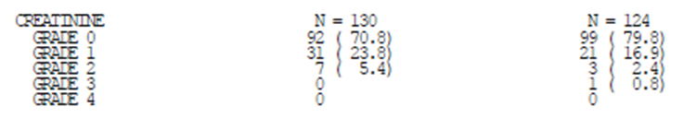

Thyroid function tests
There were some imbalances across arms in TFT results, as shown below.
Table 21. Thyroid function tests.
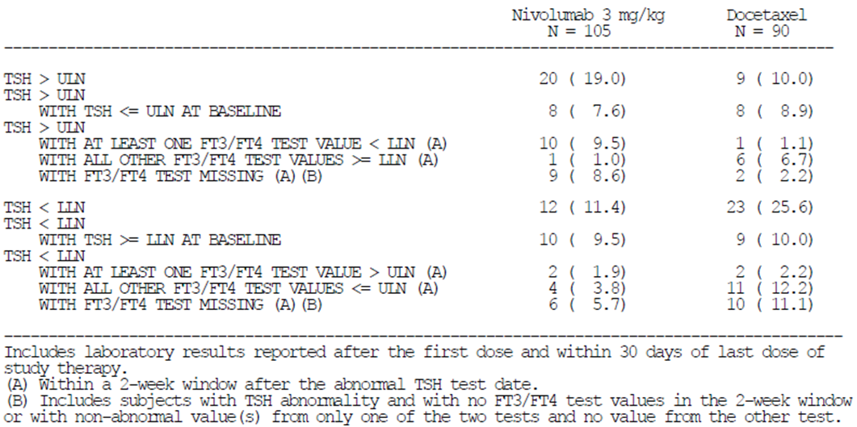
Evaluator’s comment: There is apparently an imbalance across arms in subjects with elevated TSH who also had elevated TSH at baseline (11.4% for nivolumab vs 1.1% for docetaxel). This suggests a quite high percentage of patients with elevated TSH at baseline (e.g. at least 11.4% for the nivolumab arm, but presumably higher).
Can the sponsor detail the percentage of subjects in each arm who had elevated / normal / suppressed TSH at baseline? This will help interpret TFT results.
Can the sponsor supply the percentage of subjects in each arm who shifted from normal TSH at baseline to high TSH on treatment, and from normal TSH at baseline to low TSH on treatment?

Haematology

Study 017 (pivotal)
Grade 3 falls in absolute lymphocyte count were reported in 8.5% of nivolumab subjects (vs 31% for docetaxel); grade 4 falls were reported in 3.8% (vs 3.9% for docetaxel). Furthermore, 6.9% of nivolumab subjects experienced a ≥2 grade shift from baseline to a grade 3-4 fall in absolute lymphocyte count.
One nivolumab patient had a shift from grade 0 to grade 4 in platelet count. Four had a shift from grade 0 to grade 4 in neutrophil count. Can the sponsor provide further details of these cases? Was a role for nivolumab possible or likely?
Docetaxel subjects had much more severe impacts on blood counts, e.g. 15.5% of docetaxel subjects had a ≥2 grade shift from baseline to a grade 3-4 fall in absolute lymphocyte count.

Other studies (063, 003)
In Study 063, 19.3% of subjects reported a grade 3-4 decrease in absolute lymphocytes – although only 6 subjects had an increase of at least 2 grades from baseline.
In 003, decreases in absolute lymphocyte count were also noted – across tumour cohorts, ~50% of subjects had a shift of at least 1 grade at some time on treatment, and ~12% had an increase of at least 2 grades from baseline.

Serum calcium
In Study 017, hypercalcaemia was reported as a serious AE in 3.1% (nivolumab) vs 0% (docetaxel). This was consistent with biochemical test results (nivolumab is the left-hand column).
Table 22. Serum calcium.
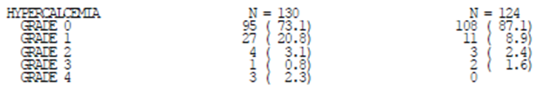
For hypocalcaemia, results were similar across arms.

Serum sodium
In Study 017, there was a case of grade 4 hypernatraemia in the nivolumab arm, and there were more cases of grade 1 hypernatraemia (5.4% vs 2.4%), with no grade 2-3 events in either arm. Events of hyponatraemia were more common, but were balanced across arms with no strong suggestion of a drug effect.

Electrocardiograph
ECG outcomes were not reported in Study 017. The sponsor noted in the Clinical Overview that nivolumab did not meaningfully affect the QTc interval.

Vital signs
The sponsor reported that review of vital signs identified no safety concerns. Listings, not summaries, were provided.
Evaluator’s comment: Can the sponsor provide summaries per study arm of the percentage of patients with shifts to clinically significant outlying values for heart rate and blood pressure (systolic and diastolic)?

Post marketing experience
No post marketing safety data were supplied.

Safety issues with the potential for major regulatory impact

Liver toxicity
There are strong grounds to suspect nivolumab may cause immune-related / autoimmune hepatitis. However, in SQ NSCLC studies, there was not a strong signal that this occurs commonly or that when it occurs it is particularly severe or irreversible.

Haematological toxicity
Nivolumab does not appear to cause marked haematological toxicity, although it may cause occasionally significant peturbations in blood counts (e.g. absolute lymphocyte counts may fall).

Serious skin reactions
There are strong grounds to suspect nivolumab may cause immune-related / autoimmune skin reactions. However, in SQ NSCLC studies, there was not a strong signal that this occurs commonly or that when it occurs it is severe or irreversible.

Cardiovascular safety
There was no signal in the SQ NSCLC studies that nivolumab causes cardiovascular toxicity. However, it is plausible that immune-related AEs arising from nivolumab use may occur within the cardiovascular system. For example, there has been a case report of myocarditis with use of pembrolizumab.

Unwanted immunological events

Hypersensitivity
In the pivotal study, hypersensitivity reactions and infusion-related AEs were reported in 0.8% (nivolumab) vs 2.3% (docetaxel). The nivolumab case was mild and did not result in discontinuation, but premedication with acetaminophen and diphenhydramine was given for subsequent doses.
In Study 063, 94% of patients (110/117) received all doses of nivolumab without an IV infusion interruption. In 3/7 subjects the reason for interruption was hypersensitivity.

Immunogenicity
In Study 017, n=109 nivolumab subjects had evaluable anti-drug antibody tests at baseline and on treatment. 21 subjects were ADA positive, including 1/21 considered persistently positive, 3/21 with neutralising ADAs at least at one time point, and 4/21 with positive results as of the last test.
There were no hypersensitivity or infusion-related AEs in subjects with ADAs.
There was no evidence of loss of efficacy in subjects with ADAs. Indeed, the three subjects with neutralising ADAs had relatively good overall survival (13.3, 19.2+ and 9.5 months).
In Study 063, 12/101 subjects (11.9%) had detectable ADA at any stage; in no subjects were ADAs persistently positive, and in no subjects were ADAs neutralising.
In Study 003, ADAs were detected in 8.6% after treatment started, and in 2 subjects across all tumour cohorts, ADAs were persistently positive (these 2 subjects had no unusual AEs).
The sponsor provided a pooled analysis of immunogenicity in the Clinical Overview Update for NSCLC. Data from Studies 017, 063, 037 and 066 were pooled, i.e. the analysis included patients with SQ NSCLC and patients with advanced melanoma. Of 497 patients treated with nivolumab 3 mg/kg Q2W and evaluable for the presence of ADAs, 51 patients (10.3%) had treatment-emergent ADAs, but only 4 patients (0.8%) were persistently positive, and only n=5 (1.0%) had neutralising antibodies. The sponsor found no association between ADAs and altered PK or toxicity.
Evaluator’s comment: Despite nivolumab being a fully human mAb, there remains potential for the formation of clinically relevant anti-drug antibodies. Immunogenicity may emerge with ongoing therapy.
The Clinical Overview Update is silent on whether, in the pooled analysis of ADAs, there was any association detected between ADAs and altered efficacy. Can the sponsor provide analysis of this association?
The proposed PI notes that in studies of combined nivolumab and ipilimumab, “the clearance of nivolumab increased by 42% in the presence of anti-nivolumab antibodies”. Can the sponsor justify why the effect of anti-nivolumab antibodies with monotherapy as described in the population PK analysis dated 8 December 2014 (i.e. 22% higher CL) should not be reported? Can the sponsor comment on the apparent difference between reports with regard to the influence of ADAs on PK?

Immune-related AEs

General comments
Checkpoint blockade can induce autoimmune AEs. The sponsor identified the following AEs for further characterisation: diarrhoea / colitis; hepatitis; pneumonitis; nephritis / renal dysfunction; hypothyroidism / thyroiditis; hyperthyroidism; hypophysitis; diabetes mellitus; adrenal insufficiency; and rash.
Evaluator’s comment: Autoimmunity can affect virtually any body system. For example, there was a report of myasthenia in a patient receiving nivolumab. However, the sponsor’s list is appropriate to characterise the commoner autoimmune / immune-related AEs due to nivolumab.
Attribution as ‘autoimmune’ is often unclear. For example, there are many causes of hepatitis, one of which is autoimmune hepatitis. However, overall, characterisation of potentially immune-mediated AEs was very good in the Study 017 CSR. Also, the CSR analysed AEs reported within 30 days (main analysis) but also within 100 days. Results in this Clinical Evaluation Report reflect the main analysis, but there were no dramatic differences based on the 100 day ‘extended follow-up’ safety data, which is relevant for immune-related AEs that could potentially have a relatively late onset.
Immune-related AEs can be mitigated by early, appropriate management, and guidelines were provided to investigators to assist in the identification and treatment of such AEs.
Evaluator’s comment: The frequency of immune-related AEs reported in this study can be generalised only if similar recommendations are made to prescribers, e.g. via the PI or other educational approaches.

Diarrhoea / colitis
Diarrhoea was reported as an AE in 16% (nivolumab) vs 26% (docetaxel). However, there were two cases of colitis for nivolumab (one was grade 3-4), none for docetaxel. There was an earlier onset of gastrointestinal AEs in many docetaxel subjects, relative to nivolumab subjects (e.g. 3.8% of nivolumab subjects had reported such an AE within 2 week, vs 17.8% of docetaxel subjects). Median time to onset was 5.6 weeks for nivolumab, 1 week for docetaxel. The case of grade 3 colitis in the nivolumab arm started at week 91. In 77% of affected nivolumab subjects (17/22), the AE resolved (over a median of 1.6 wks, although one patient had ongoing symptoms at 33.4 weeks). Two of 21 nivolumab subjects required prednisone treatment (one grade 3 colitis, one grade 2 diarrhoea). In 5 nivolumab subjects diarrhoea was reported on 2-3 separate occasions, and in 1 subject diarrhoea was reported 4 or more times. Can the sponsor comment on when colonoscopy was indicated in this study?

Hepatitis
As reflected by deranged LFTs, hepatitis was reported in 2.3% (nivolumab) vs 4.7% (docetaxel). No subject on nivolumab was reported to have elevated bilirubin. No subject required immunosuppressive medication.

Pneumonitis
There was an imbalance in reporting of relevant pulmonary AEs, as follows.
Table 23. Pneumonitis.
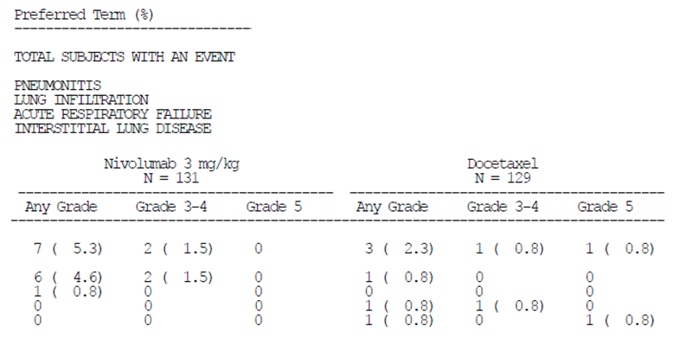
Pulmonary AEs were reported as early as 4 wks after onset of treatment for nivolumab, but as late as 36 wks. Median time to onset was 21.1 wks in the nivolumab patients. In 6/7 nivolumab subjects, the AE resolved (over a median of 6.4 wks, though one subject had ongoing symptoms at 30 wks). Six of 7 nivolumab subjects had systemic corticosteroids. Two of 7 nivolumab subjects reported no potential risk factors for pneumonitis.
Evaluator’s comment: Early management (e.g. before the AE progresses to become severe or life-threatening) may mitigate nivolumab’s toxicity. Pneumonitis was a leading cause of discontinuation in the nivolumab arm; 3/131 subjects discontinued due to that AE. Also, in 5/131 nivolumab subjects, treatment delay was attributed to pneumonitis.
Data about median time to onset, etc, are not robust. For example, in the pooled analysis across studies 017 and 063, the median time to onset of pneumonitis was 11.6 weeks rather than the 21.1 weeks reported for study 017. Pooling may be inappropriate in that more heavily pre-treated subjects may have an earlier onset, or because by the time 017 was being conducted, investigators were less likely to allow early symptoms to evolve unchecked.
Did any patients who developed pneumonitis receive concurrent chest radiotherapy?
In Study 063 (Addendum 1), all-causality relevant pulmonary AEs were reported in 6.8%; pneumonitis contributed most events (it was reported in 5.1% of subjects; all cases were considered drug-related, and 4 cases reached grade 3, although all cases resolved; 1 case was reported more than 30 days after last nivolumab dose; 1 case led to discontinuation; 1 case recurred with steroid taper and required mycophenolate).

Nephritis / renal dysfunction
There was an imbalance in reporting of relevant AEs, as follows.
Table 24. Nephritis / renal dysfunction.
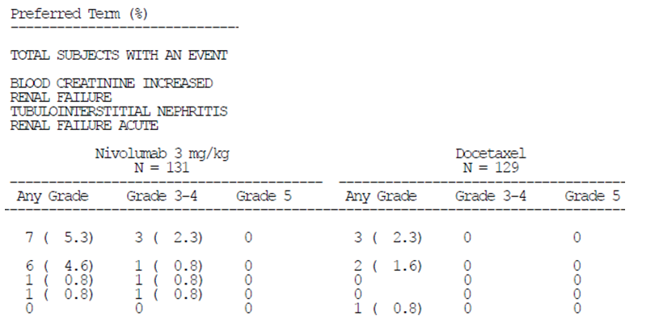
Median time to onset of renal AEs was 3.9 weeks in the nivolumab arm, although the TIN case occurred at 24.1 weeks. Renal AEs resolved in 4/7 cases, over a median of 12.9 weeks. Three of 7 nivolumab subjects were given systemic corticosteroids (including 1 requiring methylprednisolone).
In Study 063 (Addendum 1), 12% of patients reported relevant renal AEs (mild-moderate in all cases), although only 3.4% of patients had drug-related events. In Study 003, renal AEs were similarly prominent.

Endocrine events
There was an imbalance in reporting of endocrine AEs, as follows.
Table 25. Endocrine AEs.
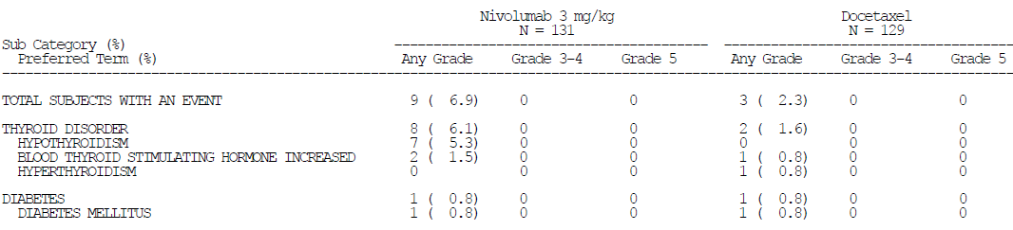
Median time to onset of any such endocrine AE in the nivolumab arm was 6.6 weeks. Only 3 of 9 endocrine AEs were considered resolved for nivolumab subjects, due to ongoing use of replacement therapy. The Clinical Study Report stated that events were well-controlled with replacement therapies.
No cases of thyroiditis, hypophysitis or adrenal insufficiency were reported in either arm.

Rash
Urticaria and pruritus were more frequent in the nivolumab arm (8.4% in total; one case grade 3) than in the docetaxel arm (2.3%). Otherwise, there was no major imbalance.

Relationship between immune-related AEs and efficacy
The sponsor analysed whether occurrence of such immune-mediated AEs affected overall survival, with no sign of an adverse correlation.

Further comments about select AEs in Study 063 (Final CSR)
In Study 063, 47% of subjects were given immune-modulating medicines to treat AEs. Usually systemic corticosteroids were used. Notable was a case of grade 3 adrenal insufficiency, treated with methylprednisolone and prednisone, resolving after 1.1 weeks. There were no cases of colitis reported (all gastrointestinal select AEs were events of diarrhoea). There were 5 drug-related cases of pneumonitis; 3 were severe; all subjects had corticosteroids; all events resolved. Median time to onset for pulmonary select events was 6.1 weeks.

Further comments about select AEs in Study 003 (Final CSR)
Select AEs in the NSCLC cohort (n=129, including SQ and non-squamous NSCLC) had patterns consistent with those observed in 003 and 017.

Other safety issues

Safety in special populations
In Study 017, AEs were analysed by various sub-groups (e.g. gender, ethnicity, age), but sample size was insufficient to allow robust conclusions to be drawn (e.g. there were only 24 female subjects treated with nivolumab; there were only 10 subjects 75+ yrs of age treated with nivolumab).
Evaluator’s comment: External validity (generalizability) of the safety results observed in the SQ NSCLC dataset is influenced by, amongst other things: exclusion from trials of patients with active, known or suspected autoimmune disease; and the extent to which clinicians will be encouraged to follow rigorous procedures for early management of potential autoimmune AEs.

Safety related to drug-drug interactions and other interactions
There is no evidence of nivolumab’s safety when used with other agents to treat SQ NSCLC.

Safety in patients with viral infections
Evaluator’s comment: It was noted in the CSR for Study 003 that a Phase 1 study in subjects with hepatitis C has been conducted (MDX1106-02; https://clinicaltrials.gov/show/NCT00703469). This appears to have been reported. In that study, 54 HCV patients were evaluated, using a range of doses but a single infusion. One patient receiving 10 mg/kg experienced grade 4 ALT elevation coincident with the onset of a 4-log viral load reduction. This suggests immunopathology due to reactivation of immunity. While a rare event in this study, it may be commoner in HCV / HBV patients who receive more than a single dose of nivolumab.
The sponsor should be asked to comment on whether any safety issues are raised for NSCLC subjects with HCV, HBV or HIV by the outcomes of MDX1106-02 or similar studies.
Could the sponsor comment on clinical implications of the observation in MDX1106-02 that increases in anti-tetanus antibody titres were seen in some subjects?

Evaluator’s overall conclusions on clinical safety
Nivolumab’s safety has been characterised in sufficient depth, considering its proposed use as an agent to treat SQ NSCLC. This class of agent is known to produce immune-mediated AEs, and studies 017, 063 and 003 revealed a distinct spectrum of ‘select AEs’ (pneumonitis, etc). Beyond these immune-mediated AEs, many reported AEs were consistent with symptoms of advanced lung cancer. In the pivotal study, 017, toxicity of nivolumab was distinct from that of docetaxel; the most obvious difference was the significant decrease in haematological toxicity with nivolumab. Several signal were not clearly related to immune-related reactions (but might be): the increased frequency of cough (relative to docetaxel), and the occurrence of hypercalcaemia.

First round benefit-risk assessment

First round assessment of benefits
The benefits of nivolumab in the proposed usage (treatment of SQ NSCLC after progression on prior chemotherapy) are:
- Improvement in OS, with a hazard ratio for death of 0.59 relative to a widely used comparator (docetaxel). 42% of nivolumab subjects were alive at 12 months versus 24% of docetaxel subjects. Efficacy appeared to be maintained in subjects receiving nivolumab as a 3rd or subsequent line agent.
- Durability of anti tumour responses, relative to docetaxel (for example, 12.5% of nivolumab subjects versus 2.9% of docetaxel subjects had an ongoing objective response in Study 017).
- No apparent decrease in quality of life, while on treatment (although there is uncertainty about impact on quality of life, because many patients did not return questionnaires).
- Marked reduction of myelosuppression and risk of infection; absence of alopecia

First round assessment of risks
The risks of nivolumab in the proposed usage are:
- Onset of immune mediated adverse reactions. Commoner such reactions in the studies of SQ NSCLC were diarrhoea and pruritus. Pneumonitis, nephritis and endocrine system reactions were also prominent. It is likely any bodily system can be affected in this way. Most of these immune mediated reactions appear manageable by early recognition, dose deferral or discontinuation, and/or use of corticosteroids. There was a high rate of steroid use to manage immune related AEs in patients on nivolumab.
- Relatively high frequency of cough, potentially related to subclinical pneumonitis.
- Potential for development of hypercalcaemia, of unclear cause.

First round assessment of benefit-risk balance
The benefit-risk balance of nivolumab (3 mg/kg every 2 weeks), given as monotherapy in treatment of SQ NSCLC after progression on chemotherapy, is favourable at the population level. This is demonstrated by the OS advantage conferred relative to a widely used comparator (docetaxel 75 mg/m² every 3 weeks), the apparent absence of any reduction in quality of life relative to docetaxel, and the differing but overall favourable toxicity profile relative to docetaxel.

First round recommendation regarding authorisation
Approval is recommended for this extension of nivolumab’s indications. The sponsor has proposed the following indication in SQ NSCLC:
Opdivo is indicated for the treatment of locally advanced or metastatic squamous non-small cell lung cancer (NSCLC) with progression on or after prior chemotherapy.
In the pivotal and supportive SQ NSCLC trials of nivolumab, use was as monotherapy. This should be reflected in the indication. A preferable wording of the indication is:
Opdivo is indicated as monotherapy for the treatment of locally advanced or metastatic squamous non-small cell lung cancer (NSCLC) with progression on or after prior chemotherapy.

Clinical questions

Pharmacokinetics
- Given the influence of albumin on nivolumab clearance and lack of data in patients with severe renal impairment and in patients with moderate or severe hepatic impairment, the sponsor should be asked to comment on (a) the potential for these impairments to influence nivolumab PK via hypoalbuminaemia, and (b) implications for dosing.
- The sponsor noted the influence of various covariates on clearance (CL) and the volume of distribution of central compartment (VC). The sponsor should be requested to provide an analysis that integrates the influence of covariates on exposure (C_{min1}, C_{minss}, C_{maxss} and C_{avgss}) so that the influence of the nominated covariates can be understood directly for exposure.
For example, if both CL and VC increased with increasing weight t was there a net effect of varying weight on exposure as measured by C_{min1}, C_{minss}, C_{maxss} and/or C_{avgss} and to provide estimates of C_{avgss} for otherwise typical patients weighing 60 kg, 90 kg, and 120 kg, to illustrate the influence of weight on nivolumab concentration, and to indicate if dosing per kilogram of body weight did not result in broadly equivalent exposure across a range of weights, assuming all other covariates being equal.
- In the exposure-efficacy analysis, factors that might reasonably be considered prognostic, such as disease stage and age, were found to have no influence on OS. Their risk may be captured by the Eastern Cooperative Oncology Group (ECOG) performance status parameter. The sponsor is invited to comment.
- Anti PD-1 mAbs may cause autoimmune AEs. The general approach is to withhold treatment and trial corticosteroids, but other agents may be required if AEs persist. One medicine sometimes used for autoimmune disease is IV immunoglobulin. There are grounds to suspect that nivolumab’s PK would be influenced by use of high doses of IVIG, since elevated total Ig levels may saturate FcRn and facilitate degradation of nivolumab. The sponsor was invited to comment.

Pharmacodynamics
No questions

Efficacy
- For Study 017, the sponsor was requested to comment per patient receiving concurrent radiation on the potential impact of radiation on change in size of target lesions and any influence on objective response. Also, if there was a per protocol analysis, and if not why not, and to provide a list of significant protocol deviations that includes the treatment arm of the patient (that is, nivolumab versus docetaxel).
- For Study 017, the sponsor was requested clarify whether the baseline data concerning disease stage are robust given the earlier comment about reporting of disease stage (stage at study entry versus stage at initial diagnosis).
- There is a large literature about the effects of ageing on the immune system. It is possible the limited effect of nivolumab in older patients is based on a reduced capacity for immune responses to tumours. The sponsor was invited to comment.
- For Study 017, the sponsor was requested to stratify patient reported outcomes (PROs) by responder status (for example, presence of objective response at the time of PRO data collection, and to further characterise reasons for the apparent dip in Quality of Life (QoL) outcomes for nivolumab patients at Week 4, particularly as to why there was low compliance at baseline.

Safety
- With regard to the signal of hypercalcaemia in Study 017, hypercalcaemia is often seen in lung cancer, but in a well randomised study one might expect similar distribution of hypercalcaemia unless there is a drug effect.
Can the sponsor supply any clinical data (for example, biochemistry test results such as PTH, PTHrP) to help resolve this issue? Was hypercalcaemia associated with any other electrolyte disturbance or adverse reaction? What was the tempo of rises? Were rises symptomatic?
- Regarding delays in nivolumab dosing in Study 017, the relevant table in the CSR (S.6.83) reports a low rate of nivolumab delays for fatigue and asthenia (0.8% and not reported) but the text reports much higher rates, 7% and 3.9%. In the table, these rates for fatigue and asthenia were for docetaxel subjects. Can the sponsor confirm whether table or the text figures should be regarded as accurate?
- In Study 017, there is apparently an imbalance across arms in subjects with elevated Thyroid Stimulating Hormone (TSH) who also had elevated TSH at baseline (11.4% for nivolumab versus 1.1% for docetaxel). This suggests a quite high percentage of patients with elevated TSH at baseline (for example, at least 11.4% for the nivolumab arm, but presumably higher).
Can the sponsor detail the percentage of subjects in each arm who had elevated/normal/suppressed TSH at baseline? This will help interpret thyroid function test (TFT) results.
Can the sponsor supply the percentage of subjects in each arm who shifted from normal TSH at baseline to high TSH on treatment, and from normal TSH at baseline to low TSH on treatment?
- For Study 017, can the sponsor provide further detail about a case of grade 4 thrombocytopenia and several cases of significant neutropenia, in patients on nivolumab? Was a role for nivolumab considered possible or likely?
- For Study 017, can the sponsor provide summaries per study arm of the percentage of patients experiencing shifts to clinically significant outlying values for heart rate and blood pressure (systolic and diastolic)?
- Can the sponsor clarify when colonoscopy was recommended within study protocols to assess diarrhoea/colitis, in these studies, and indicate how extensively patients were investigated in this way?
- Did any patients who developed pneumonitis receive concurrent chest radiotherapy?
- With regard to ADAs, the Clinical Overview Update is silent on whether, in the pooled analysis of ADAs, there was any association detected between ADAs and altered efficacy. Can the sponsor provide analysis of this association?
The proposed PI notes that in studies of combined nivolumab and ipilimumab, “the clearance of nivolumab increased by 42% in the presence of anti-nivolumab antibodies”.
Can the sponsor justify why the effect of anti nivolumab antibodies with monotherapy as described in the population PK analysis dated 8 December 2014 (that is, 22% higher CL) should not be reported? Can the sponsor comment on the apparent difference between reports with regard to the influence of ADAs on PK?
- Can the sponsor comment on whether any safety issues are raised for NSCLC subjects with the hepatitis C virus (HBV), hepatitis B virus (HBV) or human immunodeficiency virus (HIV) by the outcomes of MDX1106-02 or similar studies?
- Can the sponsor comment on clinical implications of the observation in MDX1106-02 that increases in anti tetanus antibody titres were seen in some subjects?

Second round evaluation

Pharmacokinetics
- (Q1) Given the influence of albumin on nivolumab clearance and lack of data in patients with severe renal impairment and in patients with moderate or severe hepatic impairment, the sponsor should be asked to comment on (a) the potential for these impairments to influence nivolumab PK via hypoalbuminaemia, and (b) implications for dosing.
The sponsor responded that the population PK analysis dated 26 May 2014 showed that lower baseline serum albumin was linked with ~45% lower dose normalised C_{avgss} (Figure 23).
Figure 23. Nivolumab dose normalised C_{avg,ss} versus ALB for Q2W dose regimen.
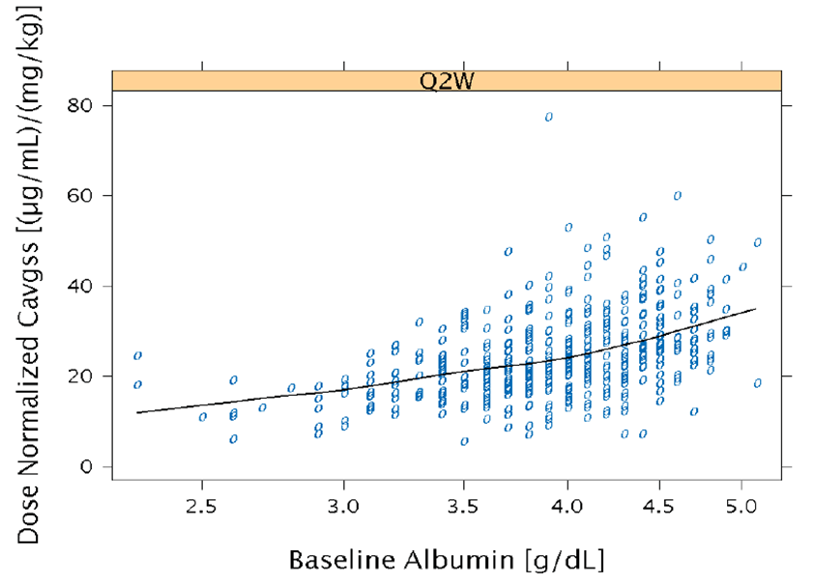
The population PK report noted: “the lower than normal ALB (<3.4 g/dL) could be sign of liver or kidney disease, increased catabolic activity, or low FcRn receptor expression level or activity”.
The sponsor then analysed whether a decrease in exposure of this magnitude was likely to translate into a decrease in response (OS), referring to the analysis in the report dated 18-July-2014 but seemingly referring to the SQ NSCLC E-R report dated 23 April 2015. In the main analysis of E-R in that report, baseline albumin was a significant predictor of OS, along with ECOG status, nivolumab CL, body weight and baseline LDH. Only in a sensitivity analysis that evaluated the impact of baseline tumour size and tumour shrinkage at Week 8 (TSW8) were the effects of exposure and/or albumin on OS lost. However, for this sensitivity analysis, ~26% of subjects did not have TSW8 data to contribute. Also, TSW8 does not appear to be an independent baseline variable, and might well be influenced by baseline variables and correlated with OS. Therefore, the sensitivity analysis is less influential than the main analysis.
The sponsor’s view was that “lower exposure resulting from hypoalbuminaemia would not be expected to have a clinically meaningful effect” and that dose adjustment is not required. However, given the discussion above, the PI should discuss a possible correlation between low albumin and lower efficacy.
- (Q2) The sponsor noted the influence of various covariates on clearance (CL) and the volume of distribution of central compartment (VC). The sponsor should be requested to provide an analysis that integrates the influence of covariates on exposure (C_{min1}, C_{minss}, C_{maxss} and C_{avgss}) so that the influence of the nominated covariates can be understood directly for exposure.
For example, if both CL and VC increased with increasing weight t was there a net effect of varying weight on exposure as measured by C_{min1}, C_{minss}, C_{maxss} and/or C_{avgss} and to provide estimates of C_{avgss} for otherwise typical patients weighing 60 kg, 90 kg, and 120 kg, to illustrate the influence of weight on nivolumab concentration, and to indicate if dosing per kilogram of body weight did not result in broadly equivalent exposure across a range of weights, assuming all other covariates being equal.
The sponsor’s response is acceptable, although it is noted that the analysis of covariate effects that is referenced did not take into account baseline albumin as a variable.
- (Q3) In the exposure-efficacy analysis, factors that might reasonably be considered prognostic, such as disease stage and age, were found to have no influence on OS. Their risk may be captured by the Eastern Cooperative Oncology Group (ECOG) performance status parameter. The sponsor is invited to comment.
The sponsor’s response is acceptable.
- (Q4) Anti PD-1 mAbs may cause autoimmune AEs. The general approach is to withhold treatment and trial corticosteroids, but other agents may be required if AEs persist. One medicine sometimes used for autoimmune disease is IV immunoglobulin. There are grounds to suspect that nivolumab’s PK would be influenced by use of high doses of IVIG, since elevated total Ig levels may saturate FcRn and facilitate degradation of nivolumab. The sponsor was invited to comment.
The sponsor’s response is acceptable.

Pharmacodynamics
No questions.

Efficacy
- (Q5) For Study 017, the sponsor was requested to comment per patient receiving concurrent radiation on the potential impact of radiation on change in size of target lesions and any influence on objective response. Also, if there was a per protocol analysis, and if not why not, and to provide a list of significant protocol deviations that includes the treatment arm of the patient (that is, nivolumab versus docetaxel).
The sponsor’s response is acceptable.
- (Q6) For Study 017, the sponsor was requested clarify whether the baseline data concerning disease stage are robust given the earlier comment about reporting of disease stage (stage at study entry versus stage at initial diagnosis).
The sponsor’s response is acceptable.
- (Q7) There is a large literature about the effects of ageing on the immune system. It is possible the limited effect of nivolumab in older patients is based on a reduced capacity for immune responses to tumours. The sponsor was invited to comment.
The sponsor’s response is acceptable, although data are still considered unimpressive in the very elderly (either because of sample size or because of an effect of age on anti tumour immunity) and efficacy outcomes by age should be mentioned in the PI. The updated proposed PI contains acceptable text.
- (Q8) For Study 017, the sponsor was requested to stratify patient reported outcomes (PROs) by responder status (for example, presence of objective response at the time of PRO data collection, and to further characterise reasons for the apparent dip in Quality of Life (QoL) outcomes for nivolumab patients at Week 4, particularly as to why there was low compliance at baseline.
The sponsor notes that an analysis of PROs by responder status is ongoing. Otherwise, the sponsor’s response is acceptable.

Safety
- (Q9) With regard to the signal of hypercalcaemia in Study 017, hypercalcaemia is often seen in lung cancer, but in a well randomised study one might expect similar distribution of hypercalcaemia unless there is a drug effect.
Can the sponsor supply any clinical data (for example, biochemistry test results such as PTH, PTHrP) to help resolve this issue? Was hypercalcaemia associated with any other electrolyte disturbance or adverse reaction? What was the tempo of rises? Were rises symptomatic?
The sponsor’s response is acceptable. Although the sponsor claims that in Study 057 (NSQ NSCLC) there was no such imbalance, and also infers that the signal was essentially attributable to malignancy, the PI should reference the imbalance observed in Study 017.
- (Q10) Regarding delays in nivolumab dosing in Study 017, the relevant table in the CSR (S.6.83) reports a low rate of nivolumab delays for fatigue and asthenia (0.8% and not reported) but the text reports much higher rates, 7% and 3.9%. In the table, these rates for fatigue and asthenia were for docetaxel subjects. Can the sponsor confirm whether table or the text figures should be regarded as accurate?
The sponsor’s response is acceptable.
- (Q11) In Study 017, there is apparently an imbalance across arms in subjects with elevated TSH who also had elevated TSH at baseline (11.4% for nivolumab versus 1.1% for docetaxel). This suggests a quite high percentage of patients with elevated TSH at baseline (for example, at least 11.4% for the nivolumab arm, but presumably higher).
Can the sponsor detail the percentage of subjects in each arm who had elevated/normal/suppressed TSH at baseline? This will help interpret TFT results.
Can the sponsor supply the percentage of subjects in each arm who shifted from normal TSH at baseline to high TSH on treatment and from normal TSH at baseline to low TSH on treatment?
The sponsor’s response is acceptable. There appears to be a moderate imbalance in baseline TFH levels across arms, potentially accounting for most of the on-treatment imbalances in TSH across arms.
- (Q12) For Study 017, can the sponsor provide further detail about a case of grade 4 thrombocytopenia and several cases of significant neutropenia, in patients on nivolumab? Was a role for nivolumab considered possible or likely?
The sponsor’s response is acceptable although further information about patients with outlying laboratory parameters would have been useful. Also, regarding the subject with neutropenia, normal bone marrow does not rule out an effect of nivolumab (for example, induction of anti neutrophil autoantibodies). Resolution of neutropenia in a relatively short timeframe is more re-assuring, although it would be useful to know whether this resolution was spontaneous or due to medical intervention (for example, steroids; G-CSF).
- (Q13) For Study 017, can the sponsor provide summaries per study arm of the percentage of patients experiencing shifts to clinically significant outlying values for heart rate and blood pressure (systolic and diastolic)?
The sponsor’s response is acceptable.
- (Q14) Can the sponsor clarify when colonoscopy was recommended within study protocols to assess diarrhoea/colitis, in these studies, and indicate how extensively patients were investigated in this way?
The sponsor’s response is acceptable.
- (Q15) Did any patients who developed pneumonitis receive concurrent chest radiotherapy?
The sponsor’s response is acceptable.
- (Q16) With regard to ADAs, the Clinical Overview Update is silent on whether, in the pooled analysis of ADAs, there was any association detected between ADAs and altered efficacy. Can the sponsor provide analysis of this association?
The proposed PI notes that in studies of combined nivolumab and ipilimumab, “the clearance of nivolumab increased by 42% in the presence of anti-nivolumab antibodies”.
Can the sponsor justify why the effect of anti nivolumab antibodies with monotherapy as described in the population PK analysis dated 8 December 2014 (that is, 22% higher CL) should not be reported? Can the sponsor comment on the apparent difference between reports with regard to the influence of ADAs on PK?
The sponsor’s response is acceptable.
- (Q17) Can the sponsor comment on whether any safety issues are raised for NSCLC subjects with HCV, HBV or HIV by the outcomes of MDX1106-02 or similar studies?
The sponsor’s response is acceptable.
- (Q18) Can the sponsor comment on clinical implications of the observation in MDX1106-02 that increases in anti tetanus antibody titres were seen in some subjects?
The sponsor’s response is acceptable.
The sponsor’s response ‘Clarification of statements in the clinical evaluation report’ is noted.

Second round benefit-risk assessment
Unchanged from first round evaluation, that is:
The benefit-risk balance of nivolumab (3 mg/kg every 2 weeks), given as monotherapy in treatment of SQ NSCLC after progression on chemotherapy, is favourable at the population level. This is demonstrated by the OS advantage conferred relative to a widely used comparator (docetaxel 75 mg/m² every 3 weeks), the apparent absence of any reduction in quality of life relative to docetaxel, and the differing but overall favourable toxicity profile relative to docetaxel.

Second round recommendation regarding authorisation
Unchanged from first round evaluation.

Non-squamous non-small cell lung cancer indication

Introduction
The initial submission for Opdivo was considered by the ACPM with the following proposed indications:
Opdivo, as monotherapy is indicated for the treatment of patients with unresectable or metastatic melanoma.
Opdivo, in combination with Yervoy (ipilimumab) is indicated for the treatment of patients with metastatic melanoma with elevated lactic dehydrogenase (LDH) or M1c disease.
Opdivo, as monotherapy is indicated for the treatment of locally advanced or metastatic squamous non-small cell lung cancer (NSCLC) with progression on or after prior chemotherapy
A concurrent submission was then submitted to the TGA, with the following proposed indication:
Opdivo, as monotherapy is indicated for the treatment of locally advanced or metastatic non squamous non-small cell lung cancer (NSCLC) with progression on or after prior chemotherapy.
The second submission was considered by a clinical evaluator and TGA Delegate, but was not considered by ACPM.

Clinical rationale

Non squamous non-small cell lung cancer (NSQ NSCLC)
Lung cancer is classified as small cell and non-small cell lung cancer (NSCLC; this comprises ~85% of lung cancers). The WHO histological classification of NSCLC is:
- Squamous cell carcinoma (25% of lung cancers; ~31% of NSCLC) (“SQ NSCLC”).
- Adenocarcinoma (40% of lung cancers; ~50% of NSCLC).
- Large cell carcinoma (10% of lung cancers; ~13% of NSCLC).
- Other (≤5% of lung cancers; ~6% of NSCLC)
These histological subtypes arise in different anatomical compartments, for example, SQ NSCLC may often arise from the central airway compartment (so may arise close to large vessels, etcetera). There are further histological divisions within the adenocarcinoma subtype.
As well as histology, key influences on the choice of initial therapy for advanced disease are:
- extent of disease (for example, number and site of metastases);
- presence of symptoms related to a specific metastatic site;
- presence of driver mutations (for example, EGFR; ALK; ROS1); and
- the patient’s overall condition and co-morbidities
Influences on the choice of subsequent therapy for advanced disease are similar. Another influence is choice of prior treatment (that is, the need for a non cross resistant approach).
It is generally considered that treatment of advanced NSCLC aims to prolong survival and maintain quality of life, while minimising side effects of treatment, that is, there is a palliative focus. Further, almost all patients with advanced NSCLC eventually develop progressive disease that requires additional treatments.
Historically, patients with NSQ NSCLC had better outcomes and more acceptable treatment options than patients with squamous NSCLC (this was used to explain the sponsor’s approach of pursuing SQ and NSQ NSCLC indications separately).
Pemetrexed is only indicated in locally advanced or metastatic NSCLC “other than predominantly squamous cell histology”. Bevacizumab’s NSCLC indication is restricted to NSQ NSCLC. Likewise, afatinib’s approval is restricted to use in non squamous disease. Therefore, there are more treatment options in NSQ NSCLC. In particular, there is the choice of pemetrexed (instead of docetaxel) for patients who have progressed after treatment with a platinum based approach, although this might not apply if pemetrexed has been used as part of initial therapy.
The sponsor’s initial submission to register nivolumab, dated 6 January 2015, requested approval for use in advanced melanoma. Based on the sponsor’s summary of outcomes in a Phase III study in SQ NSCLC (“Study 017”), the TGA allowed the scope of the submission to enlarge to include SQ NSCLC. That application is yet to be decided.
The current submission for use in NSQ NSCLC is separate.
There is a further submission being considered, for use of nivolumab in a subset of patients with renal cell carcinoma.
Pembrolizumab is another mAb in the same class, that is, an anti-PD-1 mAb. It was registered in April 2015 for use in advanced melanoma. A study of pembrolizumab in NSCLC has been published.

Overseas regulatory history

USA: FDA
Nivolumab is registered in the US with the following indications:
Unresectable or Metastatic Melanoma
Opdivo (nivolumab) as a single agent is indicated for the treatment of patients with unresectable or metastatic melanoma and disease progression following ipilimumab and, if BRAF V600 mutation positive, a BRAF inhibitor [see Clinical Studies (14.1)].
This indication is approved under accelerated approval based on tumor response rate and durability of response. Continued approval for this indication may be contingent upon verification and description of clinical benefit in confirmatory trials.
Opdivo, in combination with ipilimumab, is indicated for the treatment of patients with BRAF V600 wild-type, unresectable or metastatic melanoma [see Clinical Studies (14.1)].
This indication is approved under accelerated approval based on tumor response rate and durability of response. Continued approval for this indication may be contingent upon verification and description of clinical benefit in confirmatory trials.
Metastatic Non-Small Cell Lung Cancer
Opdivo (nivolumab) is indicated for the treatment of patients with metastatic non-small cell lung cancer (NSCLC) with progression on or after platinum-based chemotherapy. Patients with EGFR or ALK genomic tumour aberrations should have disease progression on FDA-approved therapy for these aberrations prior to receiving Opdivo [see Clinical Studies (14.2)].
Initial approval dated 22 December 2014 was accelerated approval as a single agent in patients with disease progression following ipilimumab and, if BRAF V600 mutation positive, a BRAF inhibitor.
The stipulated trial commitment is described as follows:
Conduct and submit the results of a multicentre, randomized trial or trials establishing the superiority of nivolumab over standard therapy in adult patients with unresectable or metastatic melanoma who are refractory to ipilimumab or who have not been previously treated with ipilimumab.
The scheduled final report submission was 31 December 2016.
Subsequently there was standard approval for metastatic SQ NSCLC dated 4th March 2015. The application was not referred to an FDA advisory committee. The FDA determined that a study was needed in the post market setting to assess immune mediated adverse reactions, including immune mediated pneumonitis; the condition is as follows:
Conduct a randomised trial that will characterize the incidence, severity and response to treatment of nivolumab induced immune-mediated adverse reactions to include immune-mediated pneumonitis.
The study’s final report is scheduled for submission on 31 December 2015. The sponsor has explained that Study 017 fulfils this requirement (RMP Round 2 Evaluation page 8).
There was also a post marketing commitment as follows:
Submit the final report and efficacy datasets for the open-label randomized trial of nivolumab versus docetaxel in patients with previously treated advanced squamous non-small cell lung cancer.
This study’s final report was also scheduled for submission on 31 December 2015.
Lately, there has been accelerated approval for use in combination with ipilimumab in melanoma dated 30 September 2015.
As outlined in the FDA approval letter, accelerated approval was on the undertaking to conduct and submit for evaluation a clinical trial. The stipulated trial commitment is described as follows:
Conduct and submit the results of a multicentre, randomized trial or trials to verify and describe the clinical benefit of nivolumab in combination with ipilimumab in previously untreated adult patients with unresectable or metastatic, BRAF V600 wild-type melanoma.
The scheduled final report submission is 31 July 2015, that is, apparently this should already have been submitted; the trial may refer to Study 067 (which is in a broader patient group, that is, not restricted to patients with BRAF WT tumours).
Most recently, there has been approval for NSQ NSCLC (the indication was merged with the existing SQ NSCLC indication, with addition of restrictions in patients whose tumours have EGFR or ALK tumour genomic aberrations). The approval letter required the conduct of a study of immune mediated encephalitis, as follows:
An Enhanced Pharmacovigilance Study to evaluate the risks factors and clinical sequelae of immune-mediated encephalitis following exposure to Opdivo (nivolumab). This study will include a mechanism to collect, classify, and analyse data on moderate to severe neurologic deterioration in patients exposed to Opdivo (nivolumab).
An interim report is due at the end of 2017; a final report is due at the end of 2021.

EU: EMA
In the EU, nivolumab (as Opdivo or Nivolumab BMS) is approved for the following indications:
Opdivo as monotherapy is indicated for the treatment of advanced (unresectable or metastatic) melanoma in adults. [authorised 16.6.2015]
and
Nivolumab BMS is indicated for the treatment of locally advanced or metastatic squamous non-small cell lung cancer (NSCLC) after prior chemotherapy in adults. [authorised 20.7.2015]
With regard to nivolumab in melanoma, a requirement for marketing authorisation was provision of physician educational materials and patient alert cards. There was also an obligation to submit:
- the final study report for Study 037, by 30 June 2016, and
- updated OS data for Study 066, by 31 December 2015.
There was a further requirement to explore the value of biomarkers.
With regard to nivolumab in SQ NSCLC, a requirement for marketing authorisation was provision of physician educational materials and patient alert cards. There was also an obligation to submit updated OS data for Study 017, by 31 December 2015. There was a further requirement to explore the value of biomarkers, as per above for Opdivo.
The combination with ipilimumab has not yet been approved in the EU.

Contents of the clinical dossier

Scope of the clinical dossier
Study 057 (pivotal) and Study 003 (supportive) have been considered in this review of nivolumab’s use in NSQ NSCLC.

Good clinical practice
The CSR for Study 057 stated that the study was conducted in accordance with GCP. There is no reason to suspect this was not the case.

Pharmacokinetics

Studies providing pharmacokinetic data in NSQ NSCLC
Study 057 had as an exploratory endpoint, the characterisation of the PK of nivolumab and exploration of exposure-response relationships. This characterisation is the subject of a separate report, entitled “Nivolumab Population Pharmacokinetics and Exposure-Response Analyses in Subjects with Previously Treated Squamous or Non-Squamous Non-Small Cell Lung Cancer” (report dated 20 June 2015). As suggested by the title, the report considers both SQ and NSQ NSCLC.
Previous Population PK analyses of nivolumab have been conducted as follows:
- Population PK Report dated 26 May 2014 (n=669 patients) focusing on NSCLC patients in Study 003 and Study 063
- Population PK Report dated 18 July 2014 (n=909)
- Population PK Report dated 8 December 2014 (n=1110)
- Population PK Report dated 23 April 2015 (n=1314)
The report dated 23 April 2015 included data from Study 057 (amongst other studies, as detailed in the TGA Clinical Evaluation Report for nivolumab in squamous NSCLC). While that report was based on analysis of n=1314 subjects, it focused on exposure-response outcomes in patients with squamous NSCLC.
The report dated 20 June 2015 includes the same population PK modelling as was included in the report dated 23 April 2015.
On the other hand, the report dated 20 June 2015 includes exposure-efficacy (OS) analyses in patients with SQ NSCLC, and separately, NSQ NSCLC. Exposure-safety analyses were conducted after pooling across SQ and NSQ patients.
Thus, the exposure-efficacy (OS) analysis of patients with SQ NSCLC in this synoptic report was the same as that shown in the report dated 23 April 2015. However, the exposure-efficacy analysis of patients with non-squamous NSCLC is ‘new’ information, as is the exposure-safety analysis. These analyses are considered below.

Population pharmacokinetic analysis
The exposure-efficacy (OS) analysis presented in the report dated 20 June 2015 was based on:
- nivolumab exposures inferred from population PK modelling of data from n=1314 patients (evaluated in the TGA Clinical Evaluation Report for nivolumab in squamous NSCLC)
- efficacy (OS) outcomes from patients with non-squamous NSCLC from Study 003 (n=74) and Study 057 (n=280) (7 of 354 subjects were excluded due to lack of exposure estimates)
The variables with a statistically significant effect on overall survival were:
- ECOG status
- PD-L1 status
- Line of treatment
- Nivolumab clearance
- Body weight
- Baseline LDH
In this analysis, nivolumab Cavg ss was not a significant predictor.
A graphical representation shows what other variables were considered but found to have no statistically significant influence on OS.
Since clearance presumably interacts with nivolumab exposure, the sponsor’s sensitivity analysis with CL removed is relevant.
This sensitivity analysis (a) retained ECOG status, PD-L1 status, line of therapy and baseline LDH as significant predictors of OS, (b) discarded body weight, and (c) added nivolumab Cavg ss and baseline albumin as predictive variables. “Subjects with higher exposure or higher baseline albumin appeared to have better OS”.
This suggests that there is a relationship between nivolumab exposure and efficacy, although other variables evidently also influence efficacy.
An analysis that predicted the HR of OS at various values of Cavg,ss used the full model, i.e. there is a possibility that CL is a confounder in this analysis.
A further sensitivity analysis (taking into account the impact of tumour shrinkage at week 8) is not discussed here. It is considered by this evaluator that tumour shrinkage at week 8 and OS may be correlated.
The sponsor’s report argues that in model evaluation, the sensitivity analysis without CL “did not provide adequate description of observed OS data” and that “the influence of Cavg ss effect on OS should be derived from the full model” (in other words, that the absence of a correlation between exposure and efficacy should be accepted).
The model evaluation on which this argument relies suffers somewhat from the relatively small sample sizes in the 1 mg/kg and 10 mg/kg groups. Also, it could be argued that the most relevant group is the 3 mg/kg group (large sample size, and proposed dose), and here, the model (full excluding CL) did not under- or over-predict.
The report dated 20 June 2015 explicitly compared E-R OS results for SQ and NSQ NSCLC patients. The comparison noted that:
- Both E-R OS analyses identified nivolumab CL, baseline LDH, body weight and ECOG as significant predictors of OS
- Nivolumab Cavg ss, baseline tumour size and smoking status were not significant covariates of OS in either SQ or NSQ NSCLC analyses
- Although higher CL is associated with reduced OS in both analyses, the magnitude of CL effect in SQ is smaller relative to that in NSQ NSCLC
- Line of therapy has no effect on OS in SQ NSCLC, but in NSQ NSCLC the risk of death is higher in subjects with >2 lines of therapy (relative to 2nd line subjects)
- PD-L1 status was not a significant covariate for SQ NSCLC, but in NSQ NSCLC those patients with PD-L1 positive tumours have a lower risk of death than patients with PD-L1 negative tumours
As the sponsor points out, the conclusion about line of therapy may be confounded, since subjects in Study 057 who received 3 lines of therapy were subjects with EGFR or ALK mutations.
The exposure-response safety analysis presented in the report dated 20 June 2015 was based on:
- nivolumab exposures inferred from population PK modelling of data from n=1314 patients (evaluated in the TGA Clinical Evaluation Report for nivolumab in squamous NSCLC)
- safety outcomes (AEs leading to discontinuation [excluding disease progression] or death) from a total of 648 patients with squamous or non-squamous NSCLC, across various studies (063 and 017 in SQ NSCLC, 057 in NSQ NSCLC and 003 across histologies)
The variables with a statistically significant effect on risk of discontinuation or death due to AEs were:
- line of therapy (risk higher with >2 prior therapies)
- ECOG status (risk higher for ECOG PS >0)
- Baseline serum albumin (risk higher with decreasing baseline ALB)
- Baseline LDH (risk higher with increasing baseline LDH)
The graphical representation shows what other variables were considered but found to have no statistically significant influence on safety.
There was no overt signal in this analysis of a relationship between nivolumab exposure and safety outcomes.
Baseline serum albumin appears to influence nivolumab clearance (low baseline serum albumin correlates with high nivolumab clearance) and so may also influence nivolumab exposure (e.g. low baseline serum albumin may correlate with low nivolumab exposure). It is possible that the absence of an overt relationship between nivolumab exposure and safety outcomes is due to confounding by baseline albumin.
A sensitivity analysis was conducted to assess whether the risk of AEs leading to discontinuation or death was associated with PD-L1 expression status. The sponsor concluded that the risk of AE (DC/D) was not associated with PD-L1 expression (using the 1% threshold). However, PD-L1 expression was not known for 177 subjects. The hazard ratio for risk of AE (DC/D) was 1.13 (95% CI 0.755 – 1.69) for PD-L1 positive subjects, relative to PD-L1 negative subjects.

Evaluator’s overall conclusions on pharmacokinetics
There was no sign of any dramatic difference in the PK of nivolumab in patients with NSQ NSCLC, relative to other studied patient groups.
A correlation between nivolumab exposure and efficacy has not been ruled out (see above). Also, an influence of baseline serum albumin level (presumably a surrogate for various conditions that may influence nivolumab PK) on nivolumab exposure has not been ruled out.
There was little focus on the potential relationship between dose interval (e.g. Q2W vs Q3W) and efficacy or safety outcomes.

Pharmacodynamics
No new pharmacodynamic data have been considered in this evaluation report.

Dosage selection for the pivotal studies
The Clinical Study Report for Study 057 notes that:
The nivolumab dose regimen of 3 mg/kg Q2W evaluated in this study was chosen based upon an interim analysis on 24-Feb-2012 of safety, efficacy, and exposure-response data from approximately 300 subjects treated in the Phase 1 study CA209003 (also known as MDX1106-03). The results of exposure-response analyses showed that the probability of a tumor response tended to approach a plateau for trough concentrations produced by 3 mg/kg and 10 mg/kg administered Q2W. Nivolumab was adequately tolerated up to 10 mg/kg, the highest dose tested, and no maximum tolerated dose was identified. The nature, frequency, and severity of drug-related AEs (including pulmonary select AEs), SAEs, AEs leading to discontinuation, and deaths were similar in NSCLC subjects across dose levels and histologies, as compared to the overall study population.
Study CA209003 has been evaluated in the Clinical Evaluation Report for the application to register nivolumab for use in squamous NSCLC (see CER for efficacy and safety in Study 003). The focus of that evaluation was evidence of efficacy / safety in the squamous NSCLC population. Exposure-response analyses for nivolumab have been considered in that CER, again with a focus on squamous NSCLC. The ~300 subjects referred to by the sponsor above are a heterogeneous group of patients, including patients with NSCLC, melanoma, renal cell carcinoma and colorectal and prostate cancers. Comments about selection of dose regimen copied above appear reasonable. For the NSCLC group in Study 003, objective response rates were 3% for 1 mg/kg, 24% for 3 mg/kg and 20% for 10 mg/kg, and this pattern held for both SQ and NSQ subgroups, although it did not extend to overall survival outcomes. The sponsor’s conclusions copied above remain valid despite this possible threshold effect.

Clinical efficacy

Pivotal efficacy study: CA209057 (“057”)

Study design, objectives, locations and dates

Design
This was an open-label, Phase 3 study that randomised previously treated advanced or metastatic non-squamous NSCLC patients to nivolumab or docetaxel.
Choice of comparator was docetaxel; the CSR for Study 057 states this “represents the current standard of care therapy upon progression from first-line therapy in non-squamous non-small cell lung cancer”. While some sources suggest pemetrexed may be a good choice in adenocarcinoma, many patients in Study 057 had already used pemetrexed as part of prior therapy (whereas prior treatment with docetaxel was an exclusion criterion). The choice of comparator in Study 057 is acceptable.

Objectives
The primary objective of the study was to compare overall survival (OS) of nivolumab vs docetaxel. Secondary objectives included comparison across arms of ORR and PFS, evaluation of whether PD-L1 is a predictive biomarker for OS and ORR, and evaluation of symptomatic improvement using the Lung Cancer Symptom Scale. There were various exploratory objectives.
The CSR mentions exploratory objectives involving analysis of tumour PD-1 and PD-L2 expression, and analysis of polymorphisms in select genes (e.g. PD-1, PD-L1, PD-L2 and CTLA-4).
In correspondence from the sponsor dated 13.8.2015, it is noted that analyses of factors other than PD-L1 on efficacy and safety are ongoing, but are hypothesis-generating in nature.

Locations
The study enrolled patients at 106 sites in 22 countries, including Australia where 16 patients were randomised across 5 centres. The USA provided most randomised patients (n=205/582). No individual site randomised >23 patients.

Dates
The study was initiated in November 2012, and was completed (i.e. last patient’s last visit for this CSR) in February 2015. The report, described as a final clinical study report, was dated 20 May 2015.
The independent Data Monitoring Committee considered interim data on 16 April 2015 (based on an 18 march 2015 database lock), for a pre-planned formal interim analysis. The superiority of nivolumab over docetaxel for OS was declared at that analysis.
The Clinical Study Report being evaluated here also used a database lock of 18 March 2015 (last patient last visit date of 5 February 2015).

Inclusion and exclusion criteria
Adult subjects with advanced or metastatic non-squamous NSCLC, after failure of platinum-based doublet chemotherapy, could enrol. Enrolment criteria specified that patients required presentation with Stage IIIB or Stage IV disease, or had recurrent or progressive disease following multimodal therapy.
Patients also required measurable disease, and an ECOG performance status of 0 or 1.
The study included patients with EGFR mutations or ALK translocations who had disease progression after the use of a tyrosine kinase inhibitor AND platinum-based doublet chemotherapy (in either order).

Study treatments
Nivolumab was given as an IV infusion over 60 minutes, as was docetaxel. The regimens tested were:
- Nivolumab, 3 mg/kg every 2 weeks (Q2W)
- Docetaxel, 75 mg/m² every 3 weeks (Q3W)
Subjects randomised to docetaxel received steroid premedication (e.g. dexamethasone 8 mg BD PO one day before, on the day of, and one day after chemotherapy, or equivalent).
There could be dose reductions for docetaxel toxicity (i.e. febrile neutropenia, neutropenia, cutaneous toxicity or other severe or life-threatening toxicities) (but not for nivolumab). Dose delays were allowed in both groups.
Subjects were treated until progression or unacceptable toxicity, in the main. However, there was scope in the protocol for treatment with nivolumab beyond disease progression; for this, the patient needed to meet the following criteria:
- Investigator-assessed clinical benefit, without rapid disease progression
- Tolerance of study drug
- Stable performance status
- No delay (because of treatment beyond progression) to an imminent intervention to prevent serious complications of disease progression (e.g. CNS metastases)
- Written informed consent
Within 6 weeks of original progression, imaging was to be performed to reveal whether there has been a decrease in tumour size, or continued progression (i.e. additional 10% increase in tumour burden volume from time of initial progression). The protocol stated: “assessment of clinical benefit should be balanced by clinical judgement as to whether the subject is clinically deteriorating and unlikely to receive any benefit from continued treatment with… nivolumab”. With further progression, permanent discontinuation of nivolumab was required.

Efficacy variables and outcomes
The primary endpoint was OS. Secondary endpoints included investigator-assessed ORR (confirmed responses were required), PFS, and efficacy based on baseline PD-L1 expression. Measurement of objective responses was with RECIST 1.1; responses in patients who continued on nivolumab post-progression were excluded.
It appears there was no pre-planned assessment based on immune response criteria. However, under ‘Changes to the Planned Analyses’ the CSR notes that “additional exploratory analyses were performed for subjects experiencing unconventional benefit and re-challenge”.
PD-L1 status was determined by IHC of tumour samples available pre-study. 58.7% of samples were collected at the primary tumour site. The sponsor states:
A novel, automated PD-L1 IHC assay was co-developed by BMS and DAKO North America (Carpinteria, CA US) using a rabbit anti-human PD-L1 antibody (clone 28-8; Epitomics Inc, Burlingame, CA US) to assess PD-L1 expression in archived pre-study (baseline) FFPE tumor samples from the subjects in this study.
Tumour ‘positivity’ was determined by assaying tumour cell plasma membrane expression (as reflected by antibody staining of any intensity), based on analysis of ≥100 evaluable tumour cells. Various ‘thresholds’ for overall tumour positivity were applied, i.e. 1%, 5% and 10%. Assessment was central, and by pathologists.
Per subject, PD-L1 expression could be: missing (no available specimen); quantifiable (i.e. available specimen + at least 100 viable cells per Dako IHC assay + a call on the percentage of PD-L1+ cells); indeterminate (i.e. unquantifiable, with staining hampered due to biology of specimen); or not evaluable (i.e. unquantifiable due to suboptimal collection or preparation of the specimen).
Expression on tumour-infiltrating lymphocytes (or ‘immune cells’, c.f. Study 003) was not taken into account. In correspondence from the sponsor dated 13.8.2015, it is noted that outcomes according to PD-L1 expression on ‘tumour plus immune’ cells have not been analysed for this trial.
Health-related quality of life (HRQoL) was a secondary endpoint, and was based on the proportion of subjects exhibiting disease-related symptom improvement by week 12, as measured by the Lung Cancer Symptom Scale. A 10+ point improvement from baseline per subject in the average symptom burden index was considered to reflect improvement in disease-related symptoms, at any time from randomisation to week 12. HRQoL was also assessed with the EQ-5D Index (a descriptive system) and visual analogue scale (VAS).
Immunogenicity was also assessed by measuring serum anti-drug antibodies (ADAs) and neutralising ADAs.

Randomisation and blinding methods
Randomisation was 1:1 and was stratified according to:
- prior use of maintenance therapy (yes or no); and
- second vs third line therapy.

Analysis populations
Efficacy analysis used randomised patients; safety analysis used treated patients.

Statistical methods
For OS, there was a pre-specified interim analysis for superiority (planned after 380 deaths) to be followed by a final analysis of OS (after 442 deaths).

Participant flow
792 patients were enrolled into the study. 582 of these 792 (i.e. 73.5% of enrolled subjects) were randomised: 292 to nivolumab, 290 to docetaxel. Of these, n=287 (nivolumab) and n=268 (docetaxel) were treated. A common reason for patients being randomised but not treated, in the docetaxel arm, was loss of consent.
The extent of this imbalance in subjects randomised but not treated (1.7% for nivolumab vs 7.6% for docetaxel) may introduce bias. However, given the size of the efficacy effect, this is not a major issue.
A summary of end of treatment subject status is included below, from the CSR.
Table 26. Summary of end of treatment subject status.
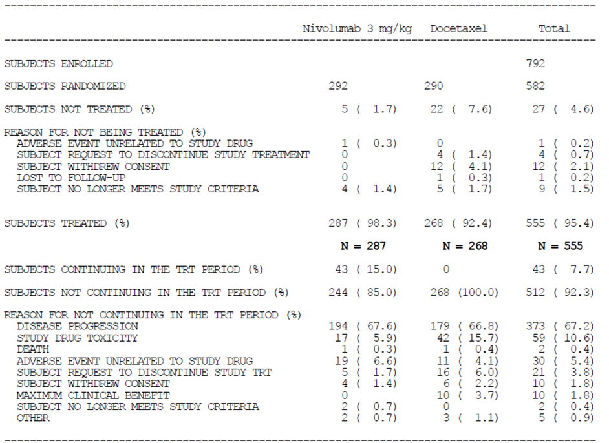

Major protocol violations/deviations
Protocol deviations were classified as ‘significant’ or, if significant AND impacting on the interpretation of study results, ‘relevant’. Relevant protocol deviations were reported in 7.2-7.5% of subjects. Most commonly, the ‘relevant’ deviation was “inadequate prior lines of therapy” at study entry (5.1-5.2% of subjects), and this typically related to negative or unreported EGFR or ALK mutation status despite use of 2 prior lines of therapy. More nivolumab subjects (5/292, 1.7%) than docetaxel subjects (0/290) had prohibited anti-cancer therapy on treatment. This was radiation in all five cases, extending to sites other than non-target bone or CNS lesions.

Baseline data
Baseline characteristics are copied from CSR tables; prior systemic cancer therapies are noted. The sponsor’s description of studied subjects as having extensive baseline disease burden is reasonable.
The study arms were only broadly balanced for baseline characteristics. Areas of moderate imbalance in demographic characteristics included: median age (61.0 yrs for nivolumab vs 64.0 yrs for docetaxel); percentage ≥65 yrs of age (37.0% vs 46.6%); gender (51.7% male vs 57.9% male); and performance status = 0 (28.8% vs 32.8%). These variables may be prognostic, but the imbalances did not consistently ‘favour’ a better outcomes for one arm over another (e.g. docetaxel subjects might have been more often older and male, but this did not translate to less frequent ECOG performance status of 0). Only ~3% of enrolled subjects were Asian. About 28% of subjects did not have EGFR mutation status reported.
The sponsor states that disease stage was inconsistently reported on the Case Report Form (i.e. disease stage at study entry vs stage at initial diagnosis); consequently, disease stage was not reported in the sub-group analysis.
The nivolumab arm included 5/292 with ‘broncho-alveolar’ carcinoma (1.7%), whereas 0/290 in the docetaxel arm had this cell type. Similarly, 4.5% vs 2.8% respectively were positive for ALK gene translocation (though for most the status was ‘not reported’; also, <1% in each arm had received an ALK inhibitor).
Up-to-date topic 4643 v15.0 notes that in 2011, it was recommended that ‘BAC’ be abandoned as a term. The 2004 WHO classification of lung tumours considered BAC to be a subset of adenocarcinomas. BAC patients may have a different clinical course. For example, Up-to-date reports that “a subset of patients with advanced, multifocal disease who are asymptomatic and who demonstrate a rate of progression that appears to be extremely indolent… may not require immediate systemic therapy”. This suggests the need for efficacy subgroup analysis by BAC cell type vs other cell types. However, only 5 (vs 0) patients had BAC cell type, so no major influence on overall outcomes is expected.
Depending on threshold for positivity (1%, 5% or 10%), ~35-55% of subjects had PD-L1 positive tumours. More nivolumab patients had highly PD-L1 positive tumours: the expression level for the patient ranked at the 75th percentile for PD-L1 expression was at ~50% PD-L1 expression for the nivolumab arm, and ~30% expression for the docetaxel arm.

Drug exposure

Extent of exposure to study drug
A Kaplan-Meier plot of duration of study therapy is copied below from the CSR.
Figure 24. Kaplan-Meier plot of duration of study therapy.
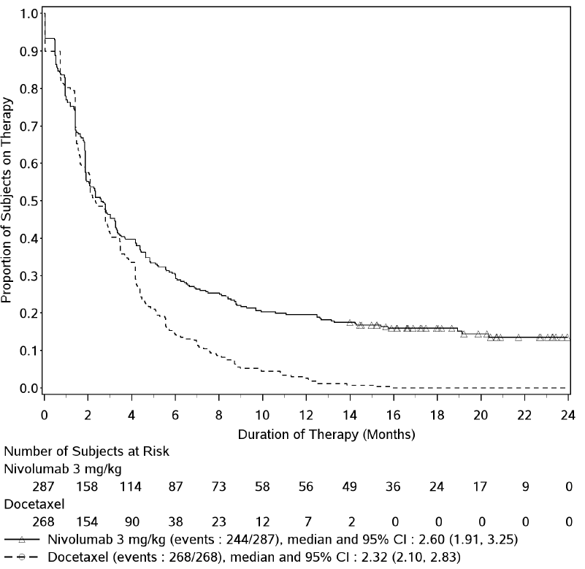
Duration of therapy was >6 months for 87 nivolumab patients (30.3%) vs 38 docetaxel patients (14.2%), and >12 months for 56 nivolumab patients (19.5%) and 7 docetaxel patients (2.6%).

Dose delays, reductions, infusion interruptions, reductions of infusion rate
5.9% of nivolumab subjects and 8.2% of docetaxel subjects had at least one infusion interruption (overall, this was because of hypersensitivity in 1.7% vs 7.5%). The rate of IV infusion was reduced in 1.4% vs 7.1% respectively, again mainly because of docetaxel hypersensitivity. There were cycle delays in 39% vs 37% respectively, about half the time due to AEs in each arm. Longer delays were more common in the nivolumab arm, e.g. delays were >2 weeks in 22.4% vs 9.5%.

Concomitant therapy
One major imbalance in use of concomitant immunomodulators was use of filgrastim or lenograstim, in <1% of nivolumab subjects vs >23% of docetaxel subjects, consistent with the myelotoxicity of docetaxel.
Another imbalance was in use of corticosteroids for systemic use: in 48.8% of nivolumab subjects vs 99.3% of docetaxel subjects (where steroid pre-medication was per protocol). There was moderately more use of systemic steroids for management of AEs in the nivolumab arm (39% vs 28%); there was also more use of topical steroids in the nivolumab arm (10% vs 5%). Two nivolumab patients vs no docetaxel patients needed infliximab for AE management. The use of concomitant corticosteroids for systemic use, other than for AE management or pre-medication, was balanced (17-18% of patients per arm).
There was less use of antiemetics in the nivolumab arm than the docetaxel arm (33% vs 78%). Some other classes of medication were also used less in the nivolumab arm (e.g. antacids, 55% vs 69%; antibacterials, 48% vs 61%; systemic antihistamines, 24% vs 41%; diuretics, 18% vs 28%; antidiarrhoeals, 9% vs 18%). Thyroid therapies were used more in the nivolumab arm (18% vs 9%).

Subsequent therapy
Subsequent systemic anti-cancer therapy was received by 42% of nivolumab subjects and 50% of docetaxel subjects (15% of nivolumab subjects were continuing to receive nivolumab at the cut-off date). There was an imbalance in the use of subsequent erlotinib (6.5% nivolumab vs 17.2% docetaxel arm) and chemotherapies (e.g. docetaxel: 23% vs 5% respectively). It is relevant that about two-thirds of subjects in each arm had already received pemetrexed as part of prior therapy. In the docetaxel arm, only 2.1% received subsequent immunotherapy.

Results for the primary efficacy outcome
Across all subjects, the HR for OS was 0.73 (95% CI 0.59 to 0.89) in favour of nivolumab, with a median OS of 12.2 months for nivolumab and 9.4 months for docetaxel, and a 12 month OS rate of 50.5% vs 39.0%.

Sub-group analysis of OS by PD-L1 status
A key finding was that efficacy outcomes varied by PD-L1 status. The CSR states:
Interaction p-values reported for PD-L1 expression subgroups by each of the pre-defined expression levels suggested a clinically important signal of a predictive association.
    - In PD-L1 positive subjects, nivolumab demonstrated improved efficacy vs docetaxel across all efficacy endpoints (OS, ORR, and PFS)
    - In contrast, there were no meaningful differences in efficacy between the treatment groups in the PD-L1 negative subgroups by any expression level
The remaining evaluation emphasises sub-group analysis by PD-L1 status.
Subjects with PD-L1 positive tumours (based on a 1% threshold for positivity) constituted 42% of each arm; subjects with PD-L1 negative tumours (i.e. <1% of tumour cells had membrane expression of PD-L1) constituted 37% of the nivolumab arm and 35% of the docetaxel arm; and non-quantifiable subjects constituted 21% and 23% respectively.
Again using the 1% threshold, the HR for OS was 0.59 for subjects with PD-L1 positive tumours (95% CI 0.43-0.82), and the HR for OS was 0.90 for subjects with PD-L1 negative tumours (95% CI 0.66-1.24). The HR for OS in the non-quantifiable group was not intermediate; it was 0.91 (the KM curves, not shown, were close to superimposable).
Table 27. Overall survival by PD-L1 expression status (1% tumour cell membrane expression).
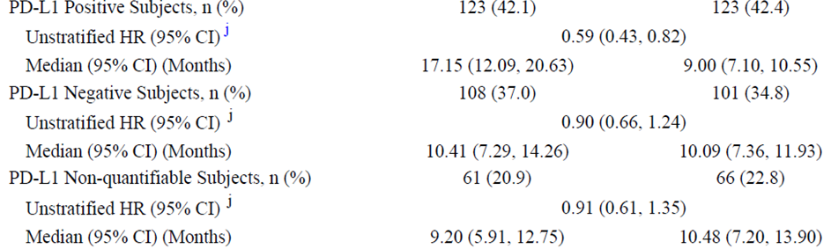
“Non-quantifiable” apparently covers a range of scenarios. In correspondence from the sponsor dated 13.8.2015, it is noted:
Of the cases in which PD-L1 status was non-quantifiable (n = 61 for nivolumab), all but 1 were classified as non-evaluable. In this case, PD-L1 status was non-quantifiable due to missing material. No case was PD-L1 status indeterminate. Indeterminate staining is generally applicable only to melanoma samples and includes examples in which high levels of melanin obscure the chromagen used for PD-L1 staining.
Therefore, results above for ‘non-quantifiable’ refer essentially to non-evaluable subjects (situations of suboptimal collection or preparation of the specimen).
Using 5% and 10% thresholds, there were similar outcomes (with higher threshold, the difference in point estimate of OS HR between positive and negative became greater, so that using a 10% threshold, the HR for positive subjects, favouring nivolumab, was 0.40, while the HR for negative subjects was 1.00).
In correspondence from the sponsor dated 13.8.2015, the following breakdown of PD-L1 expression was provided, which helps define the extent of ‘intermediate’ expression.
Table 28. Breakdown of PD-L1 expression.
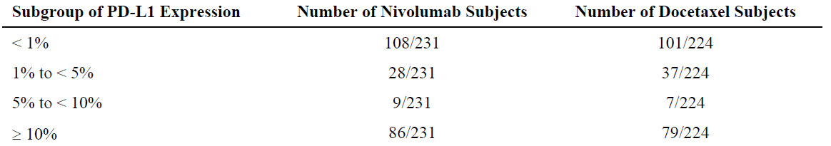
The sponsor conducted ad-hoc efficacy analyses in the subgroup composed of subjects whose tumours had 1-<10% expression of PD-L1 (nivolumab n=37, docetaxel n=44). The OS curve was better in the docetaxel group, as follows.
Figure 25. Kaplan-Meier curve for OS.
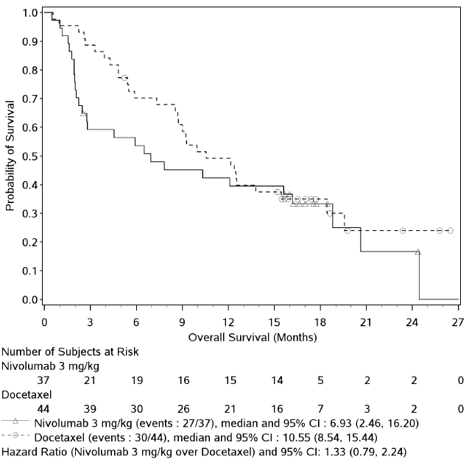
A similar finding was made for PFS. However, the sponsor notes that sample size was limited in this exploratory analysis. Also, in sub-group analyses for patients whose tumours had <1% expression, and separately patients whose tumours had ≥10% expression, there was no such advantage for docetaxel. Therefore, it seems reasonable to attribute this finding to fluctuation seen with small samples.
The sponsor concludes regarding PD-L1 negative subjects that “no OS detriment was apparent in the PD-L1 negative subgroups as compared to docetaxel”.
The sponsor describes the shape of the KM curve for the PD-L1 negative nivolumab arm as initially overlapping and then separating. This is perhaps optimistic in that initially the curve appears to be below that for docetaxel.
It is possible that a biologically or clinically defined group of subjects may contribute disproportionately to the initially worse survival (and more obviously, initially worse progression-free survival) in PD-L1 negative subjects on nivolumab, relative to docetaxel.
In correspondence from the sponsor dated 13.8.2015, the sponsor notes exploratory analyses of baseline demographics and disease characteristics for all subjects with early (<3 months post-baseline) mortality (59/292 subjects for nivolumab, 44/290 subjects for docetaxel), vs subjects with no such early mortality, as follows.
Table 29. Deaths < 3 months.
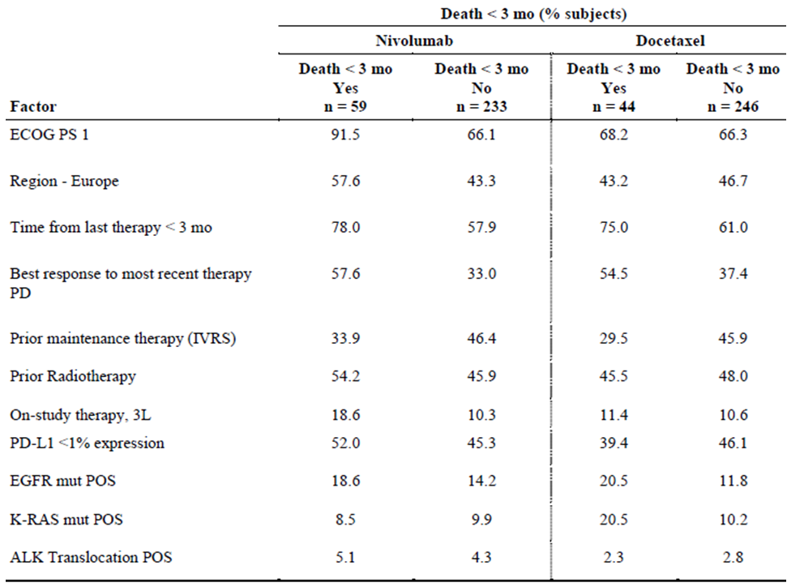
The imbalance in ECOG PS 1 in the above table was considered potentially meaningful. 91.5% of nivolumab subjects who died early, vs 68.2% of docetaxel subjects who died early, has ECOG PS 1.
An assessment of baseline tumour burden, or distribution of metastatic disease in subjects with early death was not conducted.

Further sub-group analysis of OS
The sponsor writes:
Subgroup analyses assessing the impact of age, gender, race, region, baseline ECOG PS, smoking status, presence of CNS metastases, prior neoadjuvant vs adjuvant treatment, prior use of maintenance therapy, line of therapy, EGFR mutation status, ALK translocation status, KRAS mutation status, MET receptor status, cell type, time from diagnosis to randomization, and time from completion of most recent regimen to randomization were conducted.
Sub-group analysis of OS is included.
Patients on third-line therapy did not share in the OS benefit conferred by nivolumab (the HR was 1.34, 95% CI 0.73-2.43). These patients are essentially those who received TKIs by virtue of having EGFR (seldom, ALK) tumour gene changes, so the finding is consistent with the finding that EGFR positive patients did not share in the OS benefit (HR 1.18, 95% CI 0.69-2.00). The analysis of HR in ALK positive subjects was curtailed by low numbers. There was an imbalance in OS based on region (HR for ‘Rest of World’ 1.49 [95% CI 0.91-2.45] favouring docetaxel), but this is difficult to ascribe to a higher EGFR positivity amongst Asian patients, since only few Asian patients were studied.
In correspondence from the sponsor dated 13.8.2015, the sponsor noted small sample size in the ‘Rest of World’ group (nivolumab n=52, docetaxel n=46) as a potential factor explaining the above imbalance for ‘Rest of World’, and noted that docetaxel median OS was better (rather than nivolumab median OS worse) in the RoW group. The sponsor also noted that due to baseline imbalances, the docetaxel RoW group may have had a better prognosis than the nivolumab RoW group (e.g. 77% of the nivolumab group has ECOG PS 1, vs 65% of the docetaxel group).
It is relevant that the sub-group analysis by smoking status found an unconvincing OS effect in ‘never smokers’, as this group may have tumours with lower mutation burden and therefore less susceptibility to nivolumab’s mechanism of action.
It may be relevant that the OS benefit in older subjects (>75 yrs) was less convincing (HR 0.90, 95% CI 0.43-1.87), since it is feasible that nivolumab’s mechanism of action is less potent in older subjects, who may have weaker immunity.
In patients with CNS metastases, the OS benefit of nivolumab over docetaxel was not visible (HR 1.04, 95% CI 0.62-1.76). A proportion of such patients would be on low dose steroids, which may possibly dampen nivolumab’s effect.
Because of the strong influence of PD-L1 status, it is relevant to consider interactions between subgroups and PD-L1 status. The sponsor states “there were no meaningful imbalances of demographic characteristics, stratification factors, prior cancer therapy, mutation status, smoking history, or ECOG PS between PD-L1 expression subgroups for both the nivolumab and docetaxel groups”. This assertion is reasonable.
In correspondence from the sponsor dated 13.8.2015, the sponsor conducted exploratory analyses of patients sub-grouped by EGFR mutation status and smoking history, stratified by PD-1 expression (1% threshold). Of most relevance, in the few patients with both EGFR mutation positive and PD-L1 expression positive tumours, the OS HR was 0.95 (95% CI 0.39-2.29, i.e. wide).

Results for other efficacy outcomes

Progression-free survival
The difference in PFS across groups was not statistically significant (HR 0.92, 95% CI 0.77-1.11), and median PFS was higher with docetaxel (2.3 months vs 4.2 months), but 12-month PFS rate was higher with nivolumab (18.5% vs 8.1%). The KM curve follows.
Figure 26. Kaplan-Meier curve for PFS.
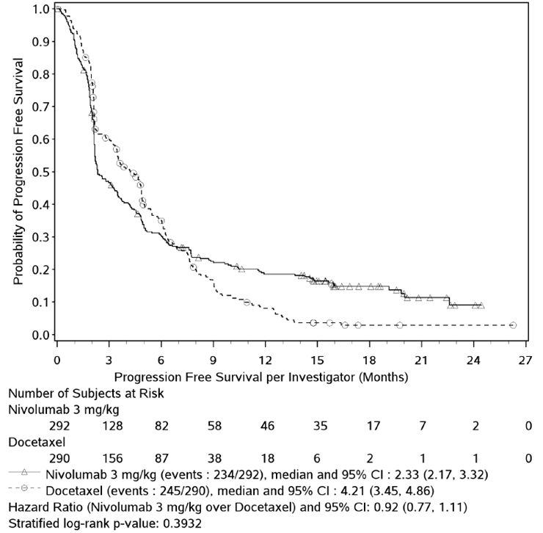
In sub-group analyses of PFS by PD-L1 status, nivolumab subjects with positive status had a clear-cut PFS advantage over docetaxel. The sponsor makes the following relevant observation:
In the PD-L1 negative subgroup there appears to be more subjects with an early PFS event in the nivolumab group compared to those in the docetaxel group or to the overall population.

Objective response rate
Overall ORR rates were 19.2% (nivolumab) vs 12.4% (docetaxel), OR 1.68 (95% CI 1.07-2.64, favouring nivolumab). Four nivolumab patients and one docetaxel patient had a complete response. Responses were more likely to be ongoing in the nivolumab arm (29/56 or 52% ongoing for nivolumab, vs 5/36 or 14% for docetaxel).
Disease stabilisation (OR + SD) was seen in 44.5% (nivolumab) vs 54.5% (docetaxel), i.e. fewer patients in the nivolumab arm had stable disease (25.3% vs 42.1%) and more patients in the nivolumab arm had progressive disease (44.2% vs 29.3%). This pattern suggests that sub-group analysis by PD-L1 status is required (see below).
A pattern similar to that seen for OS emerged for analysis of ORR by PD-L1 status.
Table 30. Objective response rate by PD-L1 expression status (1% tumour cell membrane expression).
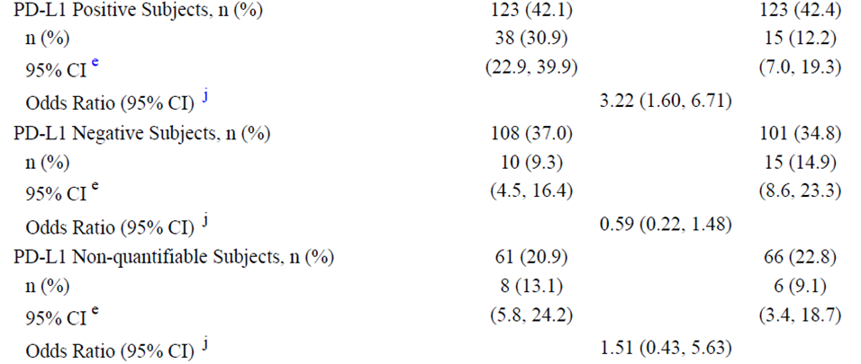
In PD-L1 negative subjects, based on the 1% threshold, ORR is less frequent with nivolumab than with docetaxel, although the difference was apparently not statistically significant (9.3% vs 14.9%; HR 0.59 [95% CI 0.22-1.48]). Stable disease rates were lower in the nivolumab arm than the docetaxel arm.
Regarding anti-tumour response, in PD-L1 positive subjects (1% threshold), there is a clear increase in objective responders (30.9% for nivolumab vs 12.2% for docetaxel) but there is also a modest increase in patients with progressive disease (37.4% vs 29.3%). In PD-L1 negative subjects, there is a decrease in objective responders (9.2% vs 14.9%) AND a clear increase in progressive disease (54.6% vs 33.7%). Thus there is no evidence of efficacy in this subgroup for nivolumab when objective response rates are considered alone.
Other sub-group analyses of ORR followed trends observed for OS analyses. The variation by region was quite pronounced, although numbers were low in the ‘Rest of World’ group.
Table 31. ORR sub-group analyses.
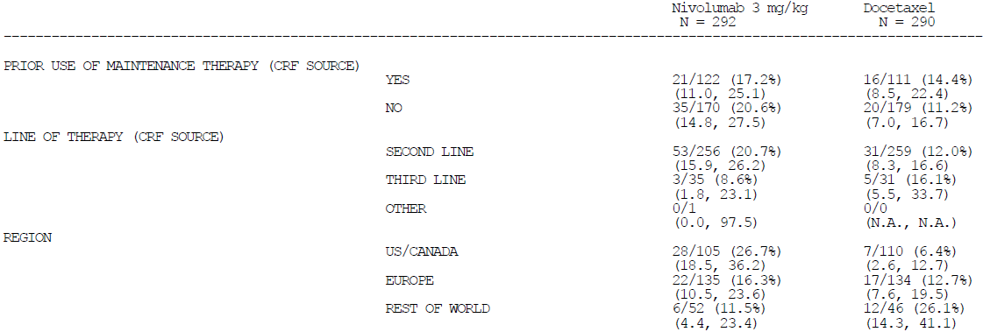

Efficacy measured in subjects treated beyond progression
71 of 287 nivolumab subjects (25%) were treated beyond progression and 16/71 (22.5%, or 5.6% of the whole nivolumab arm) were considered non-conventional benefiters, defined as follows:
Subjects who had not experienced a best objective response of PR/CR prior to initial RECIST-defined progression, and met at least one of the following:
    - Criterion 1: Appearance of a new lesion followed by decrease from baseline of at least 10% in the sum of the target lesions (12 subjects).
    - Criterion 2: Initial increase from nadir ≥20% in the sum of the target lesions followed by reduction from baseline of at least 30% (no subjects).
    - Criterion 3: Initial increase from nadir ≥20% in the sum of the target lesions or appearance of new lesion followed by at least 2 tumor assessments showing no further progression defined as a 10% additional increase in sum of target lesions and new lesions (7 subjects).
A further 14/71 nivolumab subjects did not meet these technical criteria but survived for a ‘long’ time (OS ranging from 12.3 to 24.4 months).
In correspondence from the sponsor dated 13.8.2015, the sponsor notes that of 16 subjects meeting criteria for non-conventional response, 8 had tumours expressing PD-L1 at ≥1%, 7 had no expression, and 1 subjects was not assessed for expression.

Quality of life
Compliance with the LCSS questionnaire was ≥75% at baseline and ≥65% at all on-treatment assessments to week 66, which does introduce uncertainty but which is not unexpected. Compliance was generally slightly higher in the nivolumab arm (>81%) than the docetaxel arm (>67%) to week 12.
Baseline average symptom burden index scores were similar across arms (nivolumab, 26.2; docetaxel, 24.4 [means]).
The sponsor concluded that “overall, the rate of disease-related symptom improvement [i.e. 10+ point decrease from baseline] by Week 12, as measured by the LCSS, was comparable between the nivolumab group (17.8%) and the docetaxel group (19.7%)”. For nivolumab, the score went from 26.2 at baseline to 20.0 at week 12; for docetaxel, it went from 24.4 to 26.0; with medians the difference was more pronounced still. A similar pattern emerged with use of the EQ-5D metric, which is not necessarily lung cancer symptom-specific.
There was insufficient detail in the CSR to explore LCSS results further, although a by subject listing of LCSS (including scores for specific symptoms) was provided.
It appears that nivolumab does not detract from quality of life relative to docetaxel. There is some indication it may be beneficial, but this requires further study.
In correspondence from the sponsor dated 13.8.2015, the sponsor supplied the proportion of subjects with 7+ point improvement in EQ-5D at 12 weeks. Results were similar across arms (32% for nivolumab, 33% for docetaxel). Also, the sponsor supplied data suggesting a distinct QoL improvement for nivolumab patients (over and above that seen in docetaxel patients) in the PD-L1 positive subgroup, but potentially better QoL outcomes with docetaxel than with nivolumab in the PD-L1 negative subgroup, as follows.
Table 32. QoL outcomes.
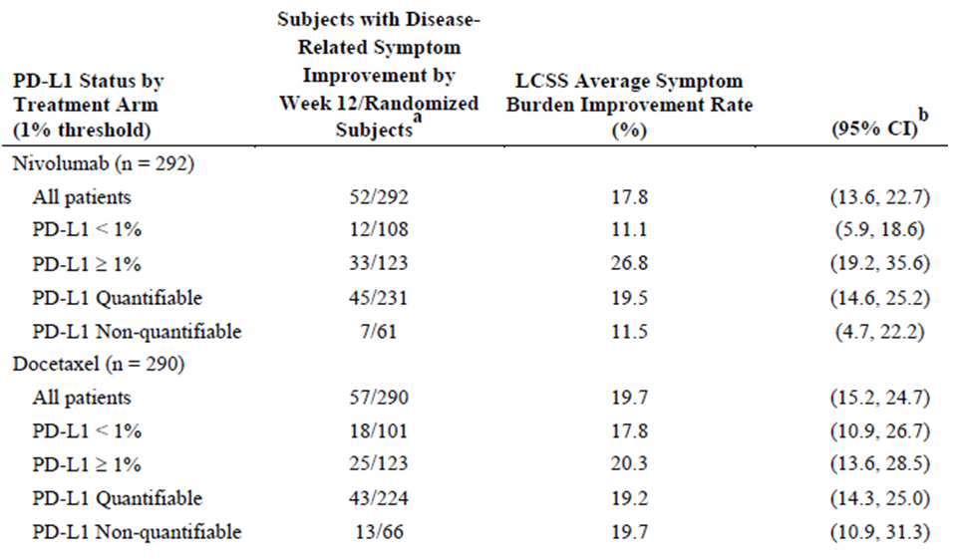

Study MDX1106-03 (CA209003) (“003”)

Study design
This was a Phase 1, open-label, dose-escalation study of nivolumab in subjects with various advanced or recurrent malignancies. A “Final CSR” was provided with a 5th March 2013 database lock, and an “Addendum 1” was provided with updated OS outcomes based on a 17th September 2013 cut-off.
395 subjects were enrolled and screened; 306/395 subjects were treated, at 13 US sites. The study was initiated in October 2008, and completed in 2013.
Patients had advanced or recurrent malignancies despite treatment with 1-5 prior systemic therapies, and had no alternative curative options. Tumour types included metastatic castrate resistant prostate cancer (mCRPC), renal cell carcinoma (RCC), colorectal adenocarcinoma (CRC), malignant melanoma and non-small cell lung cancer (NSCLC).
Nivolumab was given IV at doses of 0.1, 0.3, 1, 3 and 10 mg/kg, depending on tumour type. Dosing was Q2W. The 0.1 and 0.3 mg/kg cohorts in melanoma were added by way of protocol amendment.
Key efficacy variables were objective response rate and duration of response. PFS and OS were counted amongst secondary efficacy endpoints.
There were 74 patients with non-squamous NSCLC, treated as follows.
Table 33. NSQ NSCLC patients treated.
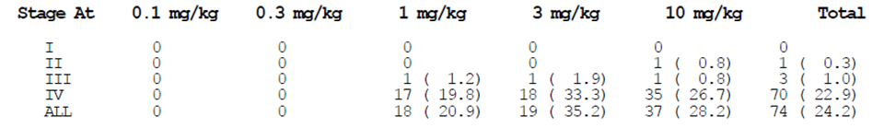

Baseline characteristics
Median age in NSQ NSCLC patients was 64.5 yrs (range, 38-85 yrs). 17.6% (n=13) were 75+ yrs of age. 58% were male. 92% were white. ECOG performance status was 1 in 75.7%, 0 in 23%. Almost all had metastatic disease at screening.
Of 74 patients with NSQ NSCLC, 11 had received 1 prior cancer regimen, 20 had received 2 prior regimens, 15 had received 3 and 28 had received 4+ prior regimens, so broadly this was a heavily pre-treated population.

Efficacy results
Based on the Final CSR, objective responses were observed in 13/74 subjects (17.6%) with NSQ NSCLC; all responses were partial. The objective response rates were 5.6% for 1 mg/kg, 26.3% for 3 mg/kg and 18.9% for 10 mg/kg in NSQ NSCLC, similar to the pattern in SQ NSCLC, however no such threshold effect was seen in melanoma (where doses as low as 0.1 mg/kg were tested) or RCC. Also, the pattern did not extend to OS. In NSQ NSCLC, median duration of response was 64 weeks (although in squamous NSCLC, the median had not been reached).
Only 63 of 129 subjects with NSCLC had PD-L1 status determined, so the lack of variation in ORR by PD-L1 status using either a 5% or 1% positivity threshold is difficult to interpret.
Updated efficacy results were also provided (Addendum 1; 17th September 2013 cut-off), for subjects with NSCLC, melanoma and RCC. For the NSQ NSCLC subset, the overall survival rate at 1 year was 43%; median OS was 10.1 months. Median PFS was 1.9 months.
Overall survival outcomes in NSCLC (in the 128 patients treated with 1-10 mg/kg and with known histology) were presented by histology.
Figure 27. Kaplan-Meier plot of OS.
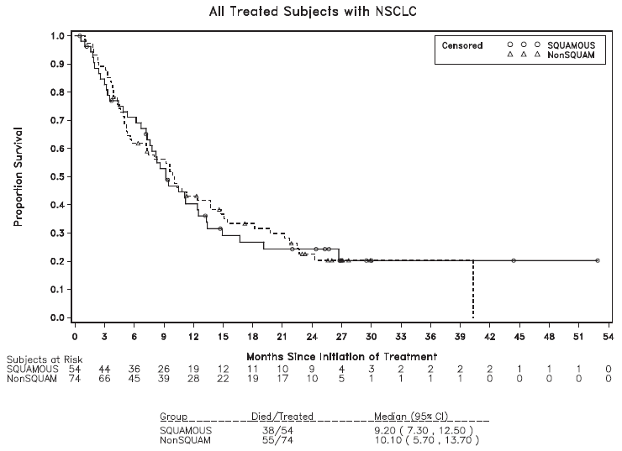
Results were similar for SQ NSCLC and non-SQ NSCLC patients. After 12 months, and particularly after 24 months, there were few subjects remaining at risk.
A further 5/74 NSQ NSCLC patients were considered to have non-conventional clinical benefit. The pattern of OS in these patients was intermediate between conventional responders and non-responders, across all NSCLC patients.

Evaluator’s conclusions on clinical efficacy for NSQ NSCLC
Nivolumab provides a survival advantage over docetaxel in NSQ NSCLC patients who have failed initial platinum-based therapy AND whose tumours are PD-L1 positive. This is also reflected in PFS and ORR advantages.
In NSQ NSCLC patients who have failed initial platinum-based therapy AND whose tumours are PD-L1 negative, there is no advantage in survival over docetaxel, but no strong sign of detriment. There were imbalances in use of subsequent therapies (e.g. docetaxel in the nivolumab arm) that may have contributed to this outcome. PFS outcomes in this group are mixed (e.g. median PFS is higher with docetaxel; 12-month PFS rate is higher with nivolumab). Objective response outcomes favour docetaxel. In this group, with evidence of no survival advantage, analysis suggests no quality of life advantage with nivolumab.
While PD-L1 subgroup analyses are clearly relevant in NSQ NSCLC, other subgroup analyses of efficacy are also notable. For example, as a group, patients with EGFR mutations did not appear to share in the overall survival benefit (and this was not, it seems, due to any interaction with tumour PD-L1 status). Also, efficacy outcomes were strongly influence by geographic region (potentially due to baseline imbalances across arms in the ‘Rest of world’ group). Finally, the ‘never smokers’ group did not have a clear overall survival benefit. This finding superficially accords with views about nivolumab’s mechanism of action.
In summary, there is ample evidence of good efficacy (relative to docetaxel) for nivolumab in NSQ NSCLC patients who have failed initial platinum-based therapy AND whose tumours are PD-L1 positive (using a 1%, 5% or 10% threshold) and whose tumours are not EGFR mutation positive. In others, the evidence for efficacy is less clear-cut. There is no strong signal of any harm conferred by nivolumab in these other patients. Finally, there are too few subjects with ALK mutations to understand the benefit / risk balance of second-line nivolumab in such subjects.

Clinical safety

Studies providing evaluable safety data
The focus of safety evaluation is on Study 057.

Pivotal studies that assessed safety as a primary outcome
None.

Patient exposure
In Study 057, the primary population for safety analysis was all treated subjects (n=287 for nivolumab, and 268 for docetaxel). There were 156.7 person-years of exposure to nivolumab, and 95.5 PYs for docetaxel.

Adverse events

All adverse events (irrespective of relationship to study treatment)

Study 057
Common AEs in the nivolumab arm include fatigue (31.7%), decreased appetite (28.9%), cough (26.5%), constipation (23%), dyspnoea (22.6%), nausea (22%) and asthenia (20.6%).
The safety profiles of nivolumab and docetaxel are quite distinct, in that nivolumab is not often associated with alopecia (nivolumab, 1.4%; docetaxel, 26.1%), neutropenia (0.7% vs 32.5%, with a similar imbalance in related terms) or febrile neutropenia (0% vs 11.2%).
Much less diarrhoea (15.7% vs 27.2%), anaemia (11.8% vs 25.4%), mucosal inflammation (2.1% vs 7.8%), stomatitis (2.1% vs 9%), peripheral neuropathy (3.1% vs 9.3%), dysgeusia (2.4% vs 10.1%), skin erythema (2.1% vs 6.7%) and ‘lacrimation increased’ (1.0% vs 8.2%, presumably due to tear duct stenosis) are seen with nivolumab.
With nivolumab, there is more musculoskeletal pain (13.6% vs 4.5), pruritus (11.5% vs 1.9%) and hypothyroidism (6.6% vs 0%).
Rates of other AEs are reasonably similar, but tend to be modestly higher in the docetaxel arm, e.g. fatigue or asthenia (52.3% vs 61.2%).
With presentation of AEs by incidence rate (i.e. adjustment for exposure), the rate of AEs was lower for nivolumab (1745 AEs per 100 person-years) than docetaxel (2862 / 100 PY). AEs with a higher incidence rate for nivolumab than docetaxel are pleural effusion (12.1 vs 7.3 / 100 PY), musculoskeletal pain (28.7 vs 15.7), back pain (25.5 vs 19.9 / 100 PY), rash (25.5 vs 14.7 / 100 PY), pruritus (26.8 vs 5.2 / 100 PY), dry skin (12.8 vs 8.4 / 100 PY), ALT increased (10.2 vs 6.3 / 100 PY), anxiety (10.9 vs 5.2 / 100 PY), malignant neoplasm progression (16.0 vs 8.4 / 100 PY) and hypothyroidism (12.1 vs 0 / 100 PY). For 10 terms the incidence rate was higher for nivolumab, for 43 terms the incidence rate was higher for docetaxel (only AEs occurring in at least 5% of either arm were counted).
Diarrhoea (2.8%) and fatigue (2.1%) were key causes of dose delay for nivolumab.
Drug-related AEs tended to present patterns similar to those described above.
In analysis of AEs by sub-group, drug-related AEs tended to be more frequent in nivolumab patients with ≥5% PD-L1 tumour expression, and this was not the case so consistently in the docetaxel arm. The most prominent example was the select AE of pruritus, seen in 4/106 PD-L1 negative nivolumab subjects, vs 25/121 positive nivolumab subjects (3.8% vs 20.7%). The sponsor invokes as a possible reason, shorter duration on study of PD-L1 negative patients.
In correspondence from the sponsor dated 13.8.2015, the sponsor presents an exploratory analysis of key safety parameters stratified by tumour PD-L1 expression (5% threshold). The analysis was in 227 subjects with quantifiable expression. There was no major imbalance in safety according to tumour PD-L1 expression, except for drug-related AEs, which were reported less frequently in subjects with low expression:
Drug-related AEs were reported less frequently in subjects with < 5% PD-L1 expression than subjects with ≥ 5% PD-L1 expression for any grade (59.7% vs 80.6%) and for Grade 3-4 events (6.7% vs 16.1%).
If borne out in other datasets, this finding would influence the benefit / risk balance. It is not immediately obvious how systemic autoimmunity induced by nivolumab can be influenced by tumour PD-L1 expression status, so it is important to await confirmation of the finding before taking it into account in the present benefit / risk analysis.

Treatment-related adverse events (adverse drug reactions)

Study 057 (pivotal)
There were fewer treatment-related AEs for nivolumab than docetaxel.
Table 34. Drug related AEs – Study 057.
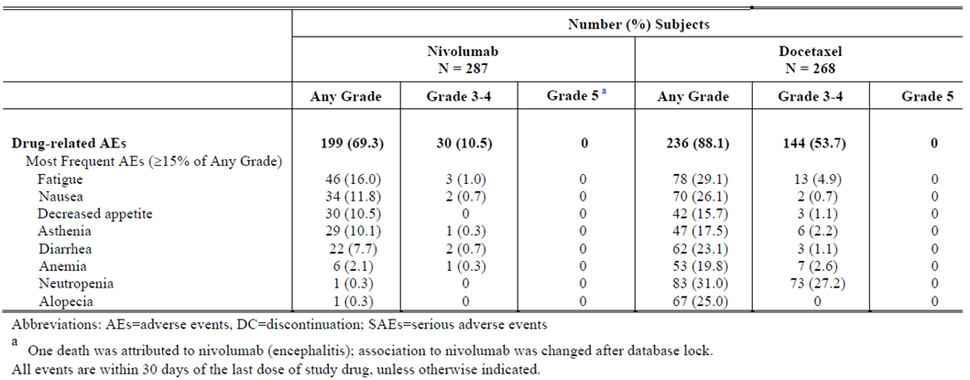
However, some groups of ‘select AEs’ considered treatment-related were more common in the nivolumab arm than the docetaxel arm, e.g.: endocrine select AEs (9.4% for nivolumab, 0.4% for docetaxel); hepatic AEs (5.2% vs 1.9%); pulmonary AEs (3.5% vs 0.4%); renal AEs (2.4% vs 0.4%); and skin AEs (17.8% vs 13.1%).

Deaths and other serious adverse events (SAEs)

Study 057 (pivotal)
Overall, 185/287 (64.5%) of nivolumab subjects had died, vs 204/268 (76.1%) of docetaxel subjects. Within 30 days of the last dose of study drug, 12.5% vs 7.8% of subjects had died, respectively.
In Study 057, one patient in the nivolumab group died due to encephalitis, and this AE was considered study-drug associated. The patient was a [information redacted], ECOG PS = 1, who reported tremor on day 44 (with tremor recorded in the medical history), new onset depression on day 122 (requiring hospitalisation for a week), hypothyroidism on day 176, fatigue on day 206 then grade 3 encephalitis on day 219 (presenting as ongoing fatigue overlaid with confusion), which was first diagnosed as paraneoplastic limbic encephalitis. This encephalitis proved fatal on day 248 after a sudden decline (clinically suspected to be vascular in origin) on day 235. Something had prompted a brain MRI on day 56; this showed foci of hyperintense signalling in deep white matter “due to mild small vessel disease”. An MRI on day 229 showed “impressive bilateral thalamic signal abnormalities”. After database lock, the investigator changed categorisation to limbic encephalitis related to study drug. A post-mortem report noted almost all cases of paraneoplastic encephalitis are related to small cell lung cancer, and that viral- or treatment-related encephalitis could not be ruled out. There were no other SAEs of encephalitis for nivolumab, although there were 4 SAEs of headache and 2 in total of confusional state.
Serious AEs included febrile neutropenia (0% for nivolumab, 9% for docetaxel); malignant neoplasm progression (8.0% vs 2.6%); pneumonia (4.2% vs 4.9%); pulmonary embolism (3.8% vs 1.1%); dyspnoea (3.1% vs 1.9%); pleural effusion (2.8% vs 1.1%); respiratory failure (2.1% vs 1.5%); and neutropenia (0% vs 3.0%). Also relevant is pneumonitis as an SAE (1.4% [i.e. 4/287] vs 0%), and interstitial lung disease (0.7% vs 0%). Given the fatal AE of encephalitis linked to nivolumab, it is relevant ‘mental status changes’ was reported as an SAE in 0% vs 1.1%.

Discontinuation due to adverse events

Study 057 (pivotal)
AEs leading to discontinuation occurred in 16.7% of the nivolumab arm and 21.6% of the docetaxel arm. Leading AEs were ‘fatigue or asthenia’ (0.6% for nivolumab vs 5.3% for docetaxel), ‘malignant disease progression’ (3.1% vs 0.7%), peripheral oedema (0% vs 1.9%) and peripheral neuropathy (0% vs 1.9%).
The difference was pronounced for ‘drug-related AEs leading to discontinuation’ (4.9% vs 14.9%), with only ‘pneumonitis or interstitial lung disease’ being the reason for discontinuation for more than one patient on nivolumab (for docetaxel, diarrhoea, fatigue / asthenia, malaise, peripheral oedema, peripheral neuropathy and febrile neutropenia were all reported multiple times).

Laboratory tests

Liver function
More patients in the nivolumab arm than the docetaxel arm had deranged LFTs. A snapshot of findings follows.
Table 35. Liver function tests.
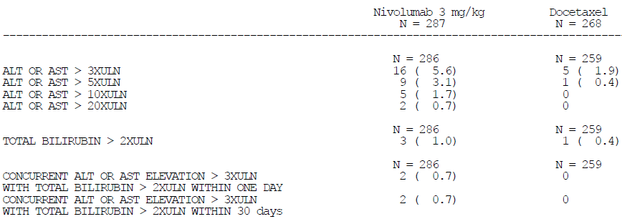
In the nivolumab arm, two subjects (0.7%) had concurrent ALT or AST elevation (>3 x ULN) AND total bilirubin elevation (>2 x ULN); one subject’s hepatotoxicity (occurring after the 20th infusion) was considered due to nivolumab. It resolved on prednisone, but nivolumab was discontinued. The subject also had pneumonitis.

Kidney function
There were no pronounced imbalances in creatinine changes across arms.

Thyroid function tests
12% of nivolumab subjects had high TSH and low free T3/T4, suggesting hypothyroidism, on treatment – as opposed to 2.4% of docetaxel subjects.
6.7% of nivolumab subjects had low TSH and high free T3/T4, suggesting hyperthyroidism – vs 0.5% of docetaxel subjects.

Haematology

Study 057 (pivotal)
Absolute lymphocyte counts were decreased significantly in 13.2% of nivolumab patients (12.2% grade 3 [0.2-0.5 x 109/L]; 1.0% grade 4 [<0.2 x 109/L]). Two subjects had grade 4 platelet decreases.
Very many patients in the docetaxel arm had deranged white cell parameters (though none had a grade 4 platelet decrease).

Serum calcium
A snapshot of impact on serum calcium is provided below; there were no pronounced imbalances although 2/287 nivolumab subjects had grade 3 elevations.
Table 36. Serum calcium.
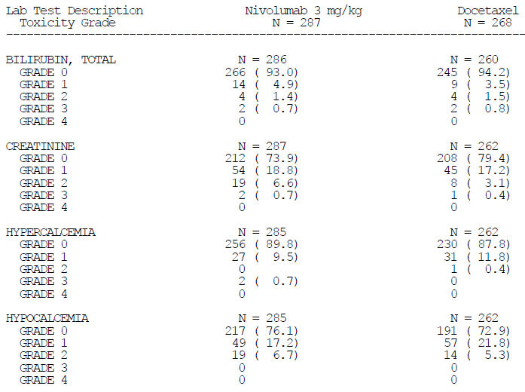

Serum sodium
A snapshot of impact on serum sodium is provided below; 4/287 nivolumab subjects (but no docetaxel subjects) had grade 4 decreases, and there was also an imbalance in grade 3 decreases.
Table 37. Serum sodium.
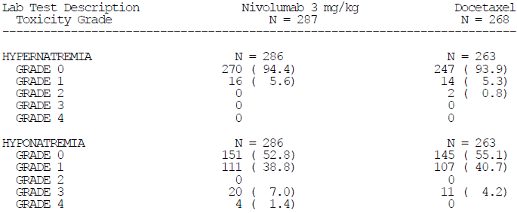
In correspondence from the sponsor dated 13.8.2015, the sponsor notes that in all 4 patients with grade 4 hyponatraemia, significant medical events such as sepsis, acute renal failure, respiratory failure and head trauma were taking place. The signal for drug-induced hyponatraemia is not strong.

Electrocardiograph
No data were gathered systemically.

Vital signs
The sponsor reported no impact of nivolumab on vital signs.

Post marketing experience
No data were provided.

Safety issues with the potential for major regulatory impact

Liver toxicity
While nivolumab appears to cause LFT derangements, there was not a strong signal for dangerous hepatotoxicity, with only occasional severe derangements.

Haematological toxicity
Beyond significant suppression of absolute lymphocyte counts in ~12% of subjects (a lower percentage than for docetaxel), there was not a strong signal for haematological toxicity. Grade 4 falls in platelet counts were reported in two nivolumab subjects.

Serious skin reactions
Rash and pruritus were common, but serious reactions (e.g. those reported as grade 3-4) were uncommon (2/287 nivolumab patients).

Cardiovascular safety
There is no signal of direct cardiovascular toxicity with nivolumab, although it can be presumed that autoimmune events such as myocarditis will occur, probably uncommonly. Other toxicities (e.g. diarrhoea causing dehydration; pneumonitis causing hypoxia; etc) could have as their sequelae cardiovascular events.

Unwanted immunological events

Hypersensitivity
The frequency of hypersensitivity or infusion-related reactions was 3.5% for nivolumab and 5.2% for docetaxel patients. There were no reports of anaphylaxis, although bronchospasm was reported in 3 subjects (~1%) per arm (none of the nivolumab cases were thought to be drug-related).

Immunogenicity
Study 057 had as an exploratory endpoint characterisation of nivolumab’s immunogenicity. In the nivolumab arm (n=251 with baseline and at least 1 post-baseline result), 7.2% were positive at baseline for anti-drug antibodies (ADAs), while 17.1% (n=43) were ADA positive on study. No subject was persistently positive, but 12/43 subjects were positive for the last sample tested and 3 subjects had neutralising antibodies. One of these three subjects also reported drug-related thyroiditis / hypothyroidism, over 2 months after neutralising ADAs were noted. 2/43 ADA positive subjects (4.7%) versus 6 out of >200 ADA negative subjects (<3.0%) had hypersensitivity or infusion site reactions. Survival times for the patients with neutralising antibodies were good (7.5, 23.9 and 24.1 months).
Version 0.8 of the nivolumab PI refers to an analysis of immunogenicity data pooled across various studies. The studies were 037, 063, 066, 017, 057 and 067 (monotherapy only). This pooled analysis relies on what is said to be an improved assay, ICDIM 140 V1.00/V2.02. The analysis as presented relies somewhat on assertion, e.g. regarding the 9 subjects with neutralising antibodies, “the safety profiles of these 9 subjects were examined and determined to be no different than those observed in ADA negative subjects”. Overall, the text proposed in the PI regarding this topic is reasonable.

Immune-related AEs

General comments
The sponsor defined various categories of ‘select AE’ – i.e. AEs of special clinical interest, very broadly overlapping with ‘immune-related AEs’ (e.g. requiring corticosteroids for management, or whose early recognition and management may mitigate severe toxicity). These are discussed below.
The sponsor also characterised ‘immune-mediated AEs’ (pneumonitis, diarrhoea / colitis, hepatitis, nephritis / renal dysfunction, rash and endocrine events). These overlap with ‘select AEs’, although immune-mediated AEs were limited to subjects who received immunosuppressive medicines to treat the event (except in the case of endocrine AEs).

Diarrhoea / colitis
Gastrointestinal select AEs were reported in 15.7% of nivolumab subjects but 27.2% of docetaxel subjects. In the nivolumab arm, there were two subjects with grade 3 events (a subject with grade 3 diarrhoea and colitis; another with grade 3 diarrhoea). Median time to onset of any drug-related GI select AE was 4.7 weeks. Five subjects required high dose corticosteroids. One subject received infliximab. In 21/22 cases of drug-related GI select AEs, events resolved (with median time to resolution of 1.5 weeks). An additional serious AE of grade 3 colitis was reported in extended follow-up (between 30 and 100 days after the last dose). Amongst nivolumab subjects reporting diarrhoea (45/287 or 15.7%), 14/45 had >1 event.

Hepatitis
There was routine monitoring of LFTs prior to each dose. Hepatic select AEs were reported in 10.1% of nivolumab subjects vs 2.6% of docetaxel subjects. Grade 3-4 hepatic select AEs were also more prominent with nivolumab (2.8% vs 0.7%). There was resolution in 11/15 cases. A case of grade 4 transaminitis was ‘ongoing’ as of the database lock (this 42 yr old female died after sudden onset of respiratory insufficiency due to massive pleural effusion, associated with severely deranged LFTs, within 5 days of the 1st dose of nivolumab). In two nivolumab cases, there was drug-related hyperbilirubinaemia. Another case was notable in that an initial grade 3 AST increase (at 33.7 weeks) resolved with high dose corticosteroids after 4 weeks (and dose delay), but re-challenge resulted in further hepatotoxicity resulting in treatment discontinuation.

Pneumonitis
Pulmonary select AEs were reported in 3.8% of nivolumab subjects (all were consistent with a pneumonitis-like process) vs 1.1% of docetaxel subjects. Of note, grade 3 drug-related pneumonitis or interstitial lung disease was seen in 4 nivolumab subjects; these events were all serious AEs and all led to discontinuation. Median time to onset in the 4 subjects was 27.5 weeks. All four patients received high-dose corticosteroids, and 3/4 events resolved. An additional report of pneumonitis was received in extended follow-up.

Nephritis / renal dysfunction
Renal select AEs were reported in 5.6% of nivolumab patients and 1.1% of docetaxel subjects. Most events were considered unrelated to study drug, however there were seven reports of nivolumab-related renal impairment / failure (vs 1 docetaxel-related report).

Endocrine events
Endocrine select AEs were reported in 10.8% of nivolumab subjects vs 1.1% of docetaxel subjects. Most events in the nivolumab arm were hypothyroidism, with some reports of hyperthyroidism. There was an AE of adrenal insufficiency in each study arm, and an AE of diabetes mellitus in each study arm; in the nivolumab arm neither AE was considered drug-related. Median time to onset for endocrine select AEs was 12.1 weeks. Many events were not considered resolved, because of ongoing use of hormone replacement therapy. No AE of hypophysitis was reported.

Rash
Skin select AEs were reported in 26.5% of nivolumab subjects and 18.3% of docetaxel subjects. Most events were thought to be drug-related. In the nivolumab arm, there were two grade 3 events, but all others were grades 1-2 and no drug-related events were serious or led to discontinuation. 40/51 subjects (78.4%) with drug-related events had resolution; 14 subjects used immune-modulating medicines. Median time to onset of drug-related events was 5.1 weeks (the range was wide), but median time to resolution was 12.1 weeks.

Relationship between immune-related AEs and efficacy
In correspondence from the sponsor dated 13.8.2015, the sponsor presented landmark analyses of overall survival from month 4, 6, 8 and 12 by prior occurrence of any select adverse event. There was no compelling signal of a relationship, although it is noted that the point estimate for the HR (OS) consistently favoured ‘prior occurrence’ (magnitude of HR, ~0.8), at least suggesting no clear OS harm in patients who reported select AEs.

Other safety issues

Safety in special populations
Safety outcomes sub-grouped by patient’s tumour PD-L1 status have been discussed above. The sponsor also analysed safety sub-grouped by gender, race, age and region, and found no particular interactions.
As an example, hypothyroidism appeared more frequent in females than males on nivolumab (9.1% vs 4.1%). As another example, the frequency of hypothyroidism rises from 6.0% in patients <65 yrs, to 8.2% for those aged 65 to <75 yrs, to 10% for those aged 75+ yrs.
In correspondence from the sponsor dated 13.8.2015, the sponsor concluded that subgroup analyses of AEs by gender and age were generally comparable, which is a fair conclusion except perhaps for hypothyroidism in females vs males as per above.

Safety related to drug-drug interactions and other interactions
No data were analysed on this topic.

Evaluator’s overall conclusions on clinical safety
Nivolumab’s safety in this patient group has been reasonably well characterised, although for the dose likely to be proposed for use, i.e. 3 mg/kg Q2W, there is large reliance on Study 057. Nivolumab is, overall, better tolerated than docetaxel. Much of the difference comes from the profoundly lower frequency of neutropenia with nivolumab, but there are other benefits (e.g. a basic absence of alopecia, and lower rates of some other important AEs such as diarrhoea and stomatitis). On the other hand, nivolumab does cause immune-mediated AEs, prominent examples being skin-related events such as pruritus and rash, as well as diarrhoea (uncommonly, colitis), hepatitis (uncommonly including hyperbilirubinaemia), pneumonitis, nephritis and hypo- and hyper- thyroidism. These immune-mediated AEs may be very well managed in a clinical trial context, and a risk is that in the community setting, clinicians and patients will have fewer prompts to manage early signs of such AEs appropriately. It is also important to understand whether the moderate signal of a different safety profile in patients with positive vs negative PD-L1 status is real or not – given the clear difference in efficacy across these groups, this will influence benefit / risk balance. Study 057’s safety findings were broadly consistent with the safety profile of nivolumab seen in other settings.

First round benefit-risk assessment

First round assessment of benefits
The benefits of nivolumab in the treatment of NSQ NSCLC patients who have failed platinum based doublet chemotherapy (and tyrosine kinase inhibitor therapy in relevant subjects) are, relative to docetaxel:
- A clear OS benefit in PD-L1 positive subjects (who constitute about half of studied subjects), consistent with advantages in PFS and ORR outcomes in this sub-group.
- The prospect of meaningful survival gains in a higher fraction of patients than is seen with docetaxel.
- An overall better safety profile, in large part because nivolumab does not induce neutropenia (whereas docetaxel commonly causes profound neutropenia), but also because nivolumab does not cause other important toxicities seen with docetaxel (for example, alopecia), or causes them less frequently (for example, diarrhoea, stomatitis).

First round assessment of risks
The risks of nivolumab in the treatment of NSQ NSCLC patients who have failed platinum-based doublet chemotherapy (and tyrosine kinase inhibitor therapy in relevant subjects) are, relative to docetaxel:
- Apparently less frequent objective responses coupled with more frequent early disease progression in patients whose tumours are PD-L1 negative. This is offset by the absence of any sign of OS detriment, in PD-L1 negative subjects.
- The possibility of worse efficacy outcomes in patients whose tumours are EGFR mutation positive. In the case of patients whose tumours are ALK mutation positive, there are insufficient data to understand benefit-risk very clearly.
- The possibility that in other subgroups (for example, the elderly, or ‘never smokers’) the efficacy benefits of nivolumab relative to docetaxel may not materialise.
- The occurrence of immune mediated adverse reactions, akin to autoimmune events, which can be severe and/or persistent, and even fatal, despite the close monitoring for and early management of such events in the clinical trial context. In the community context, where such monitoring and management may be less stringent, immune mediated adverse reactions of significance could be more common. This implies the need for considerable investment in risk mitigation measures, for example, tailored education.

First round assessment of benefit-risk balance
The benefit / risk balance is positive for this use of nivolumab in patients whose tumours are PD-L1 positive and EGFR WT.
In patients whose tumours are PD-L1 positive but EGFR mutant, benefit-risk is less clear.
In patients whose tumours are PD-L1 negative, benefit-risk is also unclear. There is no indication that OS is worse in such patients who receive nivolumab compared to such patients who receive docetaxel. Anti tumour responses are better with docetaxel in this group (although duration of response in nivolumab responders is encouraging). This must be balanced against the better safety profile of nivolumab (there is even a weak signal that in PD-L1 negative patients, nivolumab related AEs may be less frequent than in PD-L1 positive subjects, although the sponsor does not consider there to be any particular difference in this regard).
Availability of a validated PD-L1 assay is of interest given the above assessment. The sponsor notes that:
…a validated PD-L1 assay utilised in the BMS studies will be made available in Australia through our diagnostic partner Dako/Agilent. A device application to register the biomarker test is planned to be submitted to the TGA by Dako/Agilent.

First round recommendation regarding authorisation
The clinical evaluator recommends approval of nivolumab for use in NSQ NSCLC, but with a modified indication:
Opdivo, as monotherapy is indicated for the treatment of locally advanced or metastatic non squamous non-small cell lung cancer (NSCLC) in patients with progression on or after chemotherapy. In patients with tumour EGFR or ALK genomic aberrations, Opdivo should be used after progression on or after targeted therapy.
This approach to patients with tumour EGFR or ALK genomic aberrations is in line with entry criteria for Study 057, that is, such patients used nivolumab as a third line agent. There was no signal that efficacy was improved with nivolumab (relative to docetaxel) in such patients; the recommendation for inclusion of such patients in the indication is on the basis of better safety, resulting in a possibly acceptable benefit-risk balance. However, this is a somewhat grey area, since the HR for OS in patients with EGFR mutations was 1.18 favouring docetaxel (95% CI 0.69-2.00).
An alternative approach would be to exclude these patients from the indicated use, although targeted therapeutic options for patients progressing after initial targeted therapy for EGFR or ALK mutated tumours are unavailable in Australia currently.
It is also noted that the proposed indication, and the indication recommended above, make reference to progression on or after ‘chemotherapy’ whereas in Study 057, patients had failed platinum doublet based chemotherapy.
The clinical evaluator also recommends that the PI make very clear the distinct variation in efficacy outcomes seen in NSQ NSCLC patients depending on tumour PD-L1 expression, for example, within the Clinical Trials section of the PI. Suitable text is already proposed.

Clinical questions

Pharmacokinetics
No questions.

Pharmacodynamics
No questions.

Efficacy
No questions.

Safety
No questions.

Therapeutic Goods Administration
PO Box 100 Woden ACT 2606 Australia
Email: info@tga.gov.au Phone: 1800 020 653 Fax: 02 6232 8605
https://www.tga.gov.au

Cancer Council Australia. [Internet]. Cancer Council Australia; 2015. Melanoma; 2015 April 2015.
Eggermont AMM, Spatz A, Robert C. Cutaneous melanoma. Lancet 383: 816-27 (2014).
Dolan DE and Gupta S. PD-1 Pathway Inhibitors: Changing the Landscape of Cancer Immunotherapy. Cancer Control 21: 231-237 (2014).
McDermott DF and Atkins MB. PD-1 as a potential target in cancer therapy. Cancer Medicine 2: 662-673 (2013).
European Medicines Agency, “Guideline on the clinical investigation of pharmacokinetics of therapeutic proteins (CHMP/EWP/89249/2004)”, 24 January 2007.
European Medicines Agency, “Guideline on the evaluation of anticancer medicinal products in man (EMA/CHMP/205/95/Rev.4)”, 13 December 2012.
European Medicines Agency, “Guideline on the evaluation of anticancer medicinal products in man (EMA/CHMP/205/95/Rev.4)”, 13 December 2012.
Larkin J, et al. Combined Nivolumab and Ipilimumab or Monotherapy in Untreated Melanoma. N Engl J Med. 373: 23-34 (2015).
National Comprehensive Cancer Network (NCCN), NCCN Clinical Practice Guidelines in Oncology – Melanoma, Version 3.2015. 2015.
Kaysen G. Biological basis of hypoalbuminemia in ESRD. J Am Soc Nephrol 9: 2368-2376 (1998).
Cmin1 was defined as the trough concentration after the first nivolumab dose, and Cminss was defined as the theoretical steady-state trough concentration obtained by the nominal (initially assigned) nivolumab dosing regimen. Similarly, Cmaxss and Cavgss were defined as the steady state peak and time-averaged nivolumab concentrations obtained with the nominal nivolumab dosing regimen. Cavgss was calculated by dividing the area-under the steady-state concentration time curve (AUCss) by the nominal dosing interval (21 days for Q3W and 14 days for Q2W). The AUCss of each subject was obtained for the purpose of computing Cavgss by dividing nivolumab dose by the MAP Bayesian estimate of CL.
Wang W, et al. Monoclonal antibody pharmacokinetics and pharmacodynamics. Clinical Pharmacology & Therapeutics 84: 548-558 (2008).
Hollen P, et al. Quality of life assessment in individuals with lung cancer: testing the Lung Cancer Symptom Scale (LCSS). Eur J Cancer 29A Suppl 1: S51-8 (1993).
Montecino-Rodriguez et al. Causes, consequences and reversal of immune system ageing. JCI 123: 958-965 (2013).
Kim E, et al. Gefitinib versus docetaxel in previously treated non-small-cell lung cancer (INTEREST): a randomised phase III trial. Lancet 372: 1809-18 (2008); Garassino MC, et al. Erlotinib versus docetaxel as second-line treatment of patients with advanced non small-cell lung cancer and wild-type EGFR tumours (TAILOR): a randomised controlled trial. Lancet Oncol. 14: 981-88 (2013).
Rizvi N et al. Mutational landscape determines sensitivity to PD-1 blockade in non-small cell lung cancer. Science 348: 124-128 (2015).
Rizvi N et al. Mutational landscape determines sensitivity to PD-1 blockade in non-small cell lung cancer. Science 348: 124-128 (2015).
Iyer S et al. The symptom burden of non-small cell lung cancer in the USA: a real-world cross-sectional survey. Support Care Cancer 22: 181-187 (2014).
Gardiner D et al. A randomised, double-blind, placebo-controlled assessment of BMS-936558, a fully human monoclonal antibody to programmed death-1 (PD-1), in patients with chronic hepatitis C virus infection. PLoS One 22: e63818 (2013).
Montecino-Rodriguez E, et al. Causes, consequences, and reversal of immune system aging. J Clin Invest. 123: 958-65 (2013).
Montecino-Rodriguez E, et al. Causes, consequences, and reversal of immune system aging. J Clin Invest. 123: 958-65 (2013).
Garon EB, et al. Pembrolizumab for the treatment of non-small-cell lung cancer. N Engl J Med. 372: 2018-28 (2015).
Arbitrarily defined as an absolute difference in frequency of at least 10%, or at least 3-fold difference in frequency.

