First round 2 September 2015
Second round 2 December 2015

AusPAR Attachment 2

Extract from the Clinical Evaluation Report for Nitric oxide
  - Proprietary Product Name: VasoKINOX
  - Sponsor: Air Liquide Healthcare Pty Ltd

About the Therapeutic Goods Administration (TGA)
- The Therapeutic Goods Administration (TGA) is part of the Australian Government Department of Health, and is responsible for regulating medicines and medical devices.
- The TGA administers the Therapeutic Goods Act 1989 (the Act), applying a risk management approach designed to ensure therapeutic goods supplied in Australia meet acceptable standards of quality, safety and efficacy (performance), when necessary.
- The work of the TGA is based on applying scientific and clinical expertise to decision-making, to ensure that the benefits to consumers outweigh any risks associated with the use of medicines and medical devices.
- The TGA relies on the public, healthcare professionals and industry to report problems with medicines or medical devices. TGA investigates reports received by it to determine any necessary regulatory action.
- To report a problem with a medicine or medical device, please see the information on the TGA website < https://www.tga.gov.au >.
About the Extract from the Clinical Evaluation Report
- This document provides a more detailed evaluation of the clinical findings, extracted from the Clinical Evaluation Report (CER) prepared by the TGA. This extract does not include sections from the CER regarding product documentation or post market activities.
- The words (Information redacted), where they appear in this document, indicate that confidential information has been deleted.
- For the most recent Product Information (PI), please refer to the TGA website < https://www.tga.gov.au/product-information-pi > .
Copyright
© Commonwealth of Australia 2018
This work is copyright. You may reproduce the whole or part of this work in unaltered form for your own personal use or, if you are part of an organisation, for internal use within your organisation, but only if you or your organisation do not use the reproduction for any commercial purpose and retain this copyright notice and all disclaimer notices as part of that reproduction. Apart from rights to use as permitted by the Copyright Act 1968 or allowed by this copyright notice, all other rights are reserved and you are not allowed to reproduce the whole or any part of this work in any way (electronic or otherwise) without first being given specific written permission from the Commonwealth to do so. Requests and inquiries concerning reproduction and rights are to be sent to the TGA Copyright Officer, Therapeutic Goods Administration, PO Box 100, Woden ACT 2606 or emailed to < tga.copyright@tga.gov.au >

Contents
1. Introduction 10
1.1. Drug class and therapeutic indication 10
1.2. Dosage forms and strengths 10
1.3. Dosage and administration 10
2. Clinical rationale 11
3. Contents of the clinical dossier 12
3.1. Scope of the clinical dossier 12
3.2. Paediatric data 13
3.3. Good clinical practice 13
4. Pharmacokinetics 13
4.1. Studies providing pharmacokinetic data 13
4.2. Summary of pharmacokinetics 13
4.3. Evaluator’s overall conclusions on pharmacokinetics 16
5. Pharmacodynamics 17
5.1. Studies providing pharmacodynamic data 17
5.2. Evaluator’s overall conclusions on pharmacodynamics 22
6. Dosage selection for the pivotal studies 23
7. Clinical efficacy 23
7.1. Efficacy in the paediatric population 23
7.2. Efficacy of iNO in adult population 53
8. Clinical safety 76
8.1. Studies providing evaluable safety data 76
8.2. Safety results from studies conducted by sponsors 77
8.3. Safety results from published studies 80
8.4. Clinical laboratory evaluation, vital signs 90
8.5. Safety in special groups and situations 90
8.6. Post marketing experience 91
8.7. Evaluator’s overall conclusions on clinical safety 92
9. First round benefit-risk assessment 93
9.1. First round assessment of benefits 93
9.2. First round assessment of risks 93
9.3. First round assessment of benefit-risk balance 94
10. First round recommendation regarding authorisation 96
11. Clinical questions 97
11.1. Pharmacokinetics 97
11.2. Pharmacodynamics 97
11.3. Efficacy 97
11.4. Safety 97
11.5. Other questions 97
12. Second round evaluation of clinical data submitted in response to questions 98
12.1. Pharmacodynamics 98
12.2. Efficacy 98
12.3. Safety 99
12.4. Other questions 100
12.5. Evaluation of other data submitted by the sponsors as part of the first round response 100
13. Second round benefit-risk assessment 104
13.1. Second round assessment of benefits 104
13.2. Second round assessment of risks 105
13.3. Second round assessment of benefit-risk balance 105
14. Second round recommendation regarding authorisation 105
15. References 107
List of abbreviations
Abbreviation | Meaning
95% CI | 95% confidence interval
a/A ratio | Arteriolo-alveolar ratio
AaDO2 | Alveolar-arterial oxygen gradient
AE | Adverse event
ALAT | Alanine aminotransferase
ALSI | Air Liquide Santé Internationale
ANOVA | Analysis of variance
ARDS | Acute respiratory distress syndrome
ASA | Australia Specific Annex
ASAT | Aspartate aminotransferase
ASD | Atrial septal defects
ATU/TAU | Autorisation temporaire d’utilisation/Temporary authorisation use
AVSD | Atrioventricular septal defect
BGA | Blood gas analyses
BPD | Broncho-pulmonary dysplasia
CDH | Congenital diaphragmatic hernia
cGMP | Cyclic guanosine-monophosphate
CHD | Congenital heart disease
CI | Cardiac index
CO | Cardiac output
CPB | Cardiopulmonary bypass
CVP | Central venous pressure
D | Day
dSAP | Diastolic systemic arterial pressure
ECMO | Extracorporeal membrane oxygenation
ED₅₀ | Effective dose 50
EEG | Electroencephalogram
FAS | Fool analysis set
FiO₂ | Fraction of inhaled oxygen
GA | Gestational age
GCP | Good clinical practice
Hb | Haemoglobin
HbNO | nitrosohaemoglobin
HFO | High Frequency Oscillation
HFOV | High frequency oscillatory ventilation
HMD | Hyaline Membrane Disease
HR | Heart rate
HV | Healthy volunteer
IV | Intravenous
ICSR | Individual case safety report
ICU | Intensive care unit
iNO | Inhaled nitric oxide
IQR | Interquartile range
ITT | Intention to treat
IVH | Intra-ventricular haemorrhage
LV | Left ventricular
LVAD | Left ventricular assist device
m | Mean
MA | Marketing Authorisation
MAS | Meconium aspiration syndrome
MetHb | Methaemoglobin
mg | Milligram
Mil | Milrinone
min | Minute
MITT | Modified Intention to treat
mL | Millilitre
mmHg | Millimetre of mercury
Mmol | Millimol
MSI | Major sequelae index
MV | Mechanical ventilation
N₂ | Nitrogen
NHMRC | National Health & Medical Research Council of Australia
NO | Nitric oxide
NO2- | Nitrite (ion)
NO₂ | Nitrogen dioxide
NO₃- | Nitrate (ion)
NS | No statistically significant difference
NS | Not significant
NTG | Nitroglycerin
NTG | Nitroglycerin
NYHA | New York Heart Association
O₂ | Oxygen
OI | Oxygenation index [= (mean airway pressure x FiO2)/PaO2 x 100]
PaCO₂ | Partial arterial carbon dioxide pressure
PaO₂ | Partial arterial oxygen pressure
PAP | Pulmonary artery mean pressure
PCWP | Pulmonary capillary wedge pressure
PD | Pharmacodynamics
PDE5 | Phosphodiesterase type 5
PEEP | Positive end expiratory pressure
PGE1 | Prostaglandin E1
PGI2 | Prostacyclin
PHT | Pulmonary hypertension
pK | Pharmacokinetics
PP | Per protocol
Pp:Ps | Ratio of pulmonary to systemic blood pressure
ppb | Parts per billion
PPHN | Persistent pulmonary hypertension of the newborn
PPHN | Persistent pulmonary hypertension of the newborn
ppm | Parts per million
PSUR | Periodic safety update report
PT | Prothrombin time
PVR | Pulmonary vascular resistance
PVRI | PVR index
Qp/Qs | Pulmonary flow/systemic flow
Qs/Qt | Intrapulmonary shunt fraction
RAP | Right Atrial Pressure
RBC | Red blood cells
RCT | Randomised controlled clinical trial
RDS | Respiratory distress syndrome
RR | Respiratory rate
RV | Right ventricular
RVEF | Right ventricular ejection fraction
SAE | Serious adverse event
SaO₂ | Arterial oxygen saturation
SAP | systemic arterial pressure
SD | Standard deviation
SE | Standard error
SEM | Standard error of the mean
sPAP | Systolic Pulmonary artery pressure
sSAP | Systolic systemic arterial pressure
SvO₂ | Venous oxygen saturation
SVR | Systemic vascular resistance
SVRI | SVR index
TAPVD | Total anomalous pulmonary venous return
TAU | Temporary Authorisation of Use
TGA-VSD | Transposition of great vessels - ventricular septal defect
TPG | Transpulmonary pressure gradient
WBC | White blood cell

Introduction

Drug class and therapeutic indication
Nitric oxide (NO) is a medicinal gas belonging to the pharmacotherapeutic class of pulmonary vasodilators.
The proposed indication was:
‘VasoKINOX is indicated in conjunction with ventilatory support and other appropriate active substances for the treatment of perioperative pulmonary hypertension in adults and newborn infants, infants and toddlers, children and adolescents, ages 0 to 17 years in conjunction to heart surgery, in order to selectively decrease pulmonary arterial pressure and improve right ventricular function and oxygenation by increasing the pulmonary flow.’

Dosage forms and strengths
The submission proposed registration of the following dosage forms and strengths: 5 L, 11 L and 20 L aluminium alloy gas cylinders with a nitric oxide concentration of 450ppm mol/mol NO 0.450 ml in nitrogen (N₂) 999.55 ml. The gas cylinders are equipped with a stainless steel residual pressure valve with a specific outlet connector.

Dosage and administration
Dosage: is determined by the patient’s clinical condition (severity of pulmonary arterial hypertension) and patient’s age.
Prescription should be limited to those cardio-thoracic units that have received adequate training in the use of a nitric oxide delivery system. VasoKINOX should only be delivered according to an anaesthetist’s or intensive care physician’s prescription.
The recommended operating range is 2 to 20 ppm. The maximum recommended dose is 20 ppm. In adults, the dose may be increased up to 40 ppm if the lower dose has not provided sufficient clinical effects. In this case the patient’s state should be followed up more regularly and the exposure to this higher dosage should be as limited as possible.
The duration of treatment in this situation is variable according to the pathology, the population treated and pulmonary circulation remodelling. The treatment and the dose should be established according to the patient’s response and effects of iNO should be clinically evaluated by monitoring the pulmonary arterial pressure, oxygen saturation and cardiac output. When the patient is haemodynamically stable, the dose should be adjusted to the lowest effective dose.
Inhaled NO treatment should not be stopped abruptly to avoid the risk of rebound. Once inhaled nitric oxide has been started with beneficial effects, reasonable attempts to wean it off should be made every 12 to 24 hours utilising a weaning protocol.
Administration: Nitric oxide is administered by ventilation after dilution in an air/oxygen mixture. Direct intra-tracheal administration must be avoided due to the risk of local lesions occurring on contact with the mucous membrane. Before initiation of therapy, during set-up, the device setting should be in agreement with the cylinder gas concentration. The system used to administer VasoKINOX must allow for inhalation of a stable concentration of nitric oxide, regardless of the ventilator used. Furthermore, the contact time between nitric oxide and oxygen in the inspiration circuit should be kept to a minimum to limit the risk of toxic oxidation by-product production in the inhaled gas.

Clinical rationale
Nitric oxide relaxes vascular smooth muscle by activating guanylate cyclase and increasing intracellular levels of cyclic guanosine 3’, 5’-monophosphate (cGMP), which then leads to vasodilation and increased oxygenation. When inhaled, NO produces selective pulmonary vasodilation. Nitric oxide is a medical gas, classified in the pharmacotherapeutic group as ‘Other respiratory system products’, ATC code: R07 AX01. Inhaled NO (iNO) is delivered to the patient via mechanical ventilation after dilution with an oxygen/air mixture using an approved (CE marked) NO delivery system.
The objective of this literature-based submission was to document the efficacy and safety of iNO (VasoKINOX) in the treatment of perioperative pulmonary hypertension (PHT) experienced in conjunction with cardiac surgery in children and adults.
Children with many forms of congenital heart disease (CHD) are prone to developing postoperative PHT. Furthermore, the surgical correction of CHD requires cardiopulmonary bypass (CPB), which can further increase pulmonary hypotension (PHT) in the perioperative period and promote the occurrence of acute, life-threatening PHT crises (Hopkins, et al. 1991). Postoperative PHT is associated with significant delay in post-operative recovery and significant morbidity and even mortality (Beghetti, et al. 1995, Hiramatsu, et al. 1997, Duke, et al. 1997, Wessel, et al. 1993, Wheller, et al. 1979). According to more recent studies, PHT still accounts for approximately 8% of postoperative deaths (Lindberg, et al. 2002, Ma, et al. 2007). The sponsors claim that in Australia, iNO is considered the standard of care for PHT in patients recovering from cardiac surgery, especially in paediatric population (Cheechia et al, 2012). According to the Australian and New Zealand Paediatric Intensive Care database, 1,816 children in Australia and New Zealand were treated with iNO for PHT related to cardiac disease between 2000 and 2012. Of these, 32.9% were neonates, 36.7% were aged 1 to 12 months, 18.0% were aged 1 to 4 years, 5.2% were aged 5 to 9 years, 4.9% were aged 10 to 14 years, and 2.3% were aged 15 to 17 years. At the Royal Children’s Hospital (RCH) in Melbourne, 585 children aged from newborn infants to 16 years of age have received a total of approximately 48,000 hours of iNO treatment since 2005. The use of iNO in postoperative PHT in the paediatric population with CHD has been widely studied and published. The publications retrieved in the literature search in this submission were provided as evidence to support the proposed indication.
The causes of postoperative PHT in adults are diverse, but the treatment always aims at reducing pulmonary vascular resistance (PVR) to prevent or treat right ventricular failure. In adult patients with preoperative PHT, CPB may increase pulmonary arterial pressure (PAP) by several mechanisms: release of vasoactive pro-inflammatory mediators, pulmonary arterial vasoconstriction secondary to the administration of protamine, acidosis, hypercapnia, and hypoxaemia. In addition, the production of endogenous NO by the pulmonary vascular endothelium is inhibited by CPB. There is a loss of endothelium-dependent relaxation with acetylcholine, while the reactivity of the pulmonary vessels to the inhalation of exogenous NO is conserved (Wessel, et al. 1993). The administration of iNO to a patient with postoperative PHT leads to a significant drop in PAP and in PVR without a systemic effect. However, iNO has no effect in the absence of an elevation in PVR. Many studies have compared iNO after cardiac surgery to other intravenous vasodilators, including prostaglandin E1 (PGE1), nitroglycerin, and 3’- and 5’-phosphodiesterase inhibitors for the treatment of PHT. Unlike intravenous vasodilators, iNO has a selective effect on pulmonary resistance and does not reduce systemic arterial pressure (SAP), which can adversely affect renal perfusion. Between 2010 and 2012, adult patients in Australian ICUs received approximately 100,000 hours of iNO treatment for a variety of conditions, including PHT, right ventricular dysfunction, after cardiac surgery, after transplantation (lung and heart), arterial hypoxaemia, and acute respiratory distress syndrome (ARDS). The use of iNO in adults is similar to its use in children and infants with similar safety, specificity, and functionality. Inhaled prostacyclin is also used in adults with good effect, although this option involves a more complicated method of delivery and the possibility of systemic hypotension when used at higher doses. The use of iNO in PHT after cardiac surgery in adults has been widely studied and published, and the publications retrieved in the literature search in this submission were provided as evidence to support the indication.
Inhaled NO, in conjunction with ventilatory support and other appropriate treatments, induces a selective pulmonary anti-hypertensive effect. The absence of systemic effects enables SAP, and particularly coronary perfusion pressure, to be maintained. The decrease in PVR without a decrease in coronary perfusion pressure should permit an improvement in right ventricular function. By being a rapid onset, direct pulmonary vasodilator, iNO works quickly and specifically to decrease acute pulmonary hypertension and allow rapid ventricular recovery. The immediate, selective, and reversible effect of iNO makes it very convenient for use in perioperative PHT.

Contents of the clinical dossier

Scope of the clinical dossier
Evidence provided in this submission supporting the proposed indication was obtained from company sponsored studies and a systematic review of the literature that was done following consultation and approval by the TGA.
The submission contained the following clinical information:
- Four clinical studies were sponsored by ALSI:
- Study ALS-1-97-P-301: A prospective, multicentre, double blind, parallel-group, randomised, placebo controlled study testing iNO for the ‘prevention’ of postoperative PHT after surgery for congenital heart disease (CHD) in children.
Comment: Although this study has been discussed under pivotal studies conducted by sponsors, it failed to provide any evidence of efficacy as discussed in Section 7.1 of this report.
Three other studies were conducted outside the indication of perioperative PHT:
- Study CT04009 (in newborns with hypoxic respiratory failure);
- Study ALS-94 30 (in adults with acute respiratory distress syndrome); and
- Study ALS-1-98-A-301 (for the prevention of pulmonary oedema after pulmonary thromboendarterectomy for chronic cor pulmonale in adults).
- 56 evaluable publications (including two versions of one meta-analysis), 24 met the inclusion criteria for both efficacy and safety, 3 met the criteria for efficacy only, and 29 met the criteria for safety only. Of the 56 included publications, 37 involved paediatric patients and 19 involved adult patients.
- 98 other papers cited in the submission are review-type articles or background information rather than reports of specific studies.
- A draft Australian PI and CMI, European Summary of Product Characteristics and a Risk Management Plan (RMP).
Comment: The RMP submitted with the dossier is the current approved version in the EU. The sponsor advises that there is currently a revised RMP under evaluation in the EU which has not yet been finalised. The majority of the updates included in the revised RMP relate to the inclusion of an additional indication which is not being sought in Australia at this time. The company provides assurance that as soon as the revised RMP has received approval in the EU, a copy will be provided to the TGA along with any required revisions to the Australian Specific Annex.
- A Clinical Overview, Summary of Clinical Efficacy, Summary of Clinical Safety and literature references.

Paediatric data
The submission included paediatric pharmacokinetic, pharmacodynamic, efficacy and safety data.

Good clinical practice
A declaration by the Qualified Person of Air Liquide Santé France confirming that the drug substance nitric oxide is manufactured in accordance with the Good Manufacturing Practices for starting materials was provided.
Comment: There was no statement in confirming that all studies were conducted in compliance with GCP. However, all 4 studies conducted by sponsors complied with GCP guidelines. Furthermore, all published studies included a statement of approval by an ethics committee, except Fattouch (2005); Fattouch (2006); Gorenflo (2010) and Harimurti (2012).

Pharmacokinetics

Studies providing pharmacokinetic data
The company has not performed any new pharmacokinetic (PK) studies on iNO for this application. However, the information on clinical pharmacology of iNO was derived from available literature.
The selected published studies were performed with different doses of iNO, ranging from 20 to 100 ppm, and different inhalation durations, ranging from few minutes up to few hours.
The studies were conducted in healthy volunteers (HVs), except one study in adult patients with severe heart failure. The analytical methods used were different in each study.

Summary of pharmacokinetics

Physicochemical characteristics of the active substance
The following information is derived from the sponsor’s summaries:
VasoKINOX is a colourless and odourless medicinal gas.
The structural formula, including relative and absolute stereochemistry is shown below in Figure 1.
Figure 1: Structural formula of nitric oxide (NO) molecule
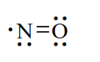
Molecular formula: NO. Chemical Abstracts Service (CAS) registry number is 10102-43-9.

Pharmacokinetics in healthy subjects

Absorption, distribution, metabolism and excretion
In 8 healthy volunteers inhaling 25 ppm of ¹⁵N-labelled NO (¹⁵NO) for 1 hour, it was estimated that 55% of the ¹⁵NO delivered reaches the alveoli and that 90% of the alveolar NO was absorbed (Westfelt, 1995). The absorbed NO was detected in blood in the form of ¹⁵NO₃-, reaching a plasma concentration of 15 µmol/L (µM) after 1 hour of inhalation. At the end of inhalation, the concentration of plasma ¹⁵NO₃ decreased immediately, corresponding to a plasma half-life of 6 to 7 hours and 70% of the absorbed NO was found in the urine in the form of nitrates, the majority being eliminated in the first 24 hours, and the rest in the following 24 hours (Westfelt, 1995). Overall, inhalation of 25 ppm NO for 1 hour was accompanied by an increase in methaemoglobinaemia from 7 to 13 µM, without modification of nitrosohaemoglobin.
Another study was conducted in 8 HVs and 8 adult patients with severe heart failure (Wennmalm, 1993). HVs received iNO 25 ppm for 60 minutes whereas patients with severe heart failure received 20, 40 and 80 ppm iNO in consecutive 10-minutes periods. Inhalation of 25 ppm NO for 1 hour in HVs led to an increase in plasma nitrates from 26 to 38 µM and that of metHb from 7 to 13 µmol/L (corresponding in a change from about 0.35% to 0.64% of the total Hb concentration in the blood) as shown below in Figure 2.
Figure 2: Plasma levels of nitrate and whole blood metHb concentration in basal state and during NO 25 ppm inhalation in 8 healthy volunteers (Wennmalm, 1993)
Data are presented as mean ± SEM. P-values refer to changes in the levels of plasma nitrate and whole blood MetHb with time (by one-way ANOVA).
During inhalation of NO in the adult patients, there was a significant dose-related increase in plasma nitrate, both in systemic and pulmonary arteries; significant amounts of metHb appeared in the blood cell fraction with a change from 0.99% to 2.19% of the total Hb concentration in the blood. The plasma levels of nitrite and HbNO did not change significantly during the inhalation of NO; 20 minutes after cessation of iNO, plasma nitrate had dropped in most patients, both in systemic and pulmonary arteries as shown below in Table 1.
Table 1: Arterial and pulmonary arterial levels of nitrate in basal state, during inhalation of NO 20 to 80 ppm and 20 minutes after NO inhalation in 8 heart failure patients (Wennmalm, 1993)
These observations indicate that all NO that is delivered is converted and eliminated in the form of nitrates. The observation that nitrate clearance is only 20 mL/min indicates that a significant portion of filtered nitrates is actively or passively reabsorbed by the renal tubule. The combination of NO with haemoglobin explains the short half-life of iNO (ranging from 6 to 10 seconds), its selectivity for the pulmonary circulation, and its conversion into nitrates. Nitric oxide binds to deoxyhaemoglobin with an affinity 10⁶ times greater than that of oxygen (O₂). When O₂ saturation is low, NO also binds to oxyhaemoglobin, with an affinity 1500 times greater than that of carbon monoxide. The binding of NO to oxyhaemoglobin forms nitrosylated haemoglobin, which rearranges into methaemoglobin (metHb) with the release of nitrates.
In 6 subjects inhaling 100 ppm NO for 3 hours, an increase in methaemoglobinaemia was observed (Young, 1995). Results of this study showed that the majority of iNO reacts with Hb producing metHb and nitrogen oxides, but up to 14% apparently undergoes direct conversion to nitrogen oxides. The nitrogen oxides produced have a volume of distribution of one-third of body weight and are mainly eliminated through the kidneys.
Comment: The inhaled concentration of NO used in this study was greater than used clinically (maximum of 40 ppm) the greater dose was used to ensure measurable changes within an acceptable time scale for a volunteer study.
Discontinuation of NO was followed by a rapid decrease in methaemoglobinaemia, which returned to normal in 1 hour. The rapid binding of NO to haemoglobin limits the effects of iNO to the pulmonary circulation. Haemoglobin inactivates the inhaled NO as well as the endogenous NO synthesized by the endothelium, reducing the vasodilating action of endogenous NO (Deem, et al. 1998) and the amount of exhaled NO (Defouilloy, et al. 1998).

Pharmacokinetics in the target population
None.

Pharmacokinetics in other special populations
Pharmacokinetics of iNO in specific populations, related to extrinsic or intrinsic factors, were not evaluated. PKs in adult patients with severe heart failure was evaluated in the study by Wennmalm et al; discussed above.

Pharmacokinetic interactions

Pharmacokinetic interactions demonstrated in human studies
No drug interaction studies were conducted in humans, but interactions between iNO and other drugs were described in the non-clinical summary.

Clinical implications of in vitro findings
NO can potentially interact with other drugs that induce metHb formation (for example alkyl nitrates or prilocaine) or that can act as NO donors (for example sodium nitroprusside or nitroglycerin). Some in vitro data also suggest that there is a synergy between the anti-platelet aggregation effects of NO and prostacyclin (Radonski, et al, 1987). Less importantly, other non-clinical data suggest that non-specific inhibitors of phosphodiesterases, as well as specific inhibitors of phosphodiesterase 5, may potentiate the vasodilator effects of NO (Eddahibi, et al, 1998).
Comment: These potential interactions are adequately reflected in the proposed Product Information (PI).

Evaluator’s overall conclusions on pharmacokinetics
No new pK studies on iNO were conducted for this application. The selected publications cover the evaluation of absorption, lung distribution, metabolism and excretion after NO inhalation. The studies were conducted in both HVs and adult patients with severe heart failure, with iNO doses ranging from 20 to 100 ppm.
Inhaled NO is well absorbed, diffuses into ventilated areas of the lungs, crosses the alveolar-capillary membrane and reaches the arteriolar pulmonary vasculature. NO conversion to metHb and to nitrate is the major metabolic pathway. Contrary to other pulmonary vasodilators, iNO has little systemic effect because of its short half-life (6 to 10 seconds) related to its inactivation by binding to Hb to form metHb. NO reacts with oxygen and water to form nitrogen dioxide and nitrites, which react with oxyhaemoglobin to produce metHb and nitrates which are the principal metabolites of NO found in the systemic circulation.
Nitrates are eliminated mainly in urine whereas metHb is metabolised in several hours into Hb by endogenic reductases. The nitrates excreted in urine represent over 70% of the inhaled nitric oxide dosage.
According to EU guidelines adopted by the TGA, bioequivalence studies are not required for medicinal gases that are intended to be inhaled. Therefore, it is not necessary to demonstrate therapeutic equivalence between the various sources of NO used within the supporting clinical data.
The sources of iNO within the published literature were delivered via inhalation route of administration using the same or similar doses of iNO in ppm, regardless of initial strength of NO. All clinical data are therefore considered as relevant whatever the source of the molecule NO. No clinical drug interactions studies were conducted for this submission.
Although no new PK studies were conducted by the sponsors, this is not a limitation of the submission as the PK characteristics are quite well-characterised in various published studies.

Pharmacodynamics

Studies providing pharmacodynamic data

Summary of pharmacodynamics
The pharmacodynamics (PD) of nitric oxide is well characterised and no new studies were submitted in the current dossier. However, many publications were provided in the current submission which have been evaluated. Relevant results have been summarised in the following sections.

Mechanism of action
NO is a medicinal gas, delivered mechanically to the patient after dilution with an oxygen/air mixture. iNO reaches the arteriolar pulmonary vasculature where vasodilatation occurs through activation of soluble guanylate cyclase and generation of cyclic guanosine monophosphate (cGMP) and subsequent activation of the cGMP-dependant kinase protein. Inhaled nitric oxide exerts a selective action on pulmonary arterial circulation due to its very short half-life in plasma. The haemoglobin circulating in the vicinity of its point of diffusion through the alveolocapillary membrane is responsible for its deactivation. Nitric oxide induces a reduction in pulmonary vascular resistance and is effective only in the presence of existing vasoconstriction in the ventilated area of the lung. It improves arterial oxygenation by re-distributing pulmonary blood flow from the unventilated areas of the lung with a low ventilation/perfusion ratio (V/Q) to the ventilated areas, consequently reducing the shunt effect.

Pharmacodynamic effects

Primary pharmacodynamic effects
A study involving 9 adult healthy volunteers (Frostell et al, 1993) showed that inhalation of 40 ppm of iNO selectively induced pulmonary vasodilatation and reversed hypoxic pulmonary vasoconstriction in HVs without causing systemic vasodilatation; dilatation of pulmonary vessels produced by inhaling NO during hypoxia was not accompanied by any alteration in the SVR or SAP of the subjects as shown below in Figure 3.
Figure 3: Effects of NO 40 ppm inhalation during hypoxia on PAP, PCWP, PVR, PaO₂, PaCO₂ and VSWI (Right and Left) in 9 healthy volunteers (Frostel, 1993)
PAP = pulmonary arterial pressure; PCWP = pulmonary capillary wedge pressure; PVR = pulmonary vascular resistance; PaO₂ = arterial oxygen (tension) PaCO₂ = arteria carbon dioxide (tension); L/R VSWI = left/right ventricular stroke work indexes. All data are the mean ± SE of the mean (p < 0.01).
Another study in 9 adult patients with ARDS (Rossaint, et al, 1993) showed that inhalation of NO by patients with severe ARDS reduces the PAP and increases arterial oxygenation without producing systemic vasodilatation. Injection with a prostacyclin analogue in same study reduced PAP but increased intrapulmonary shunting and reduced PaO₂/FiO₂ and systemic arterial pressure as shown below in Table 2.
Table 2: Haemodynamic responses in adult ARDS patients during inhaled NO and prostacyclin infusion (Rossaint, 1993)
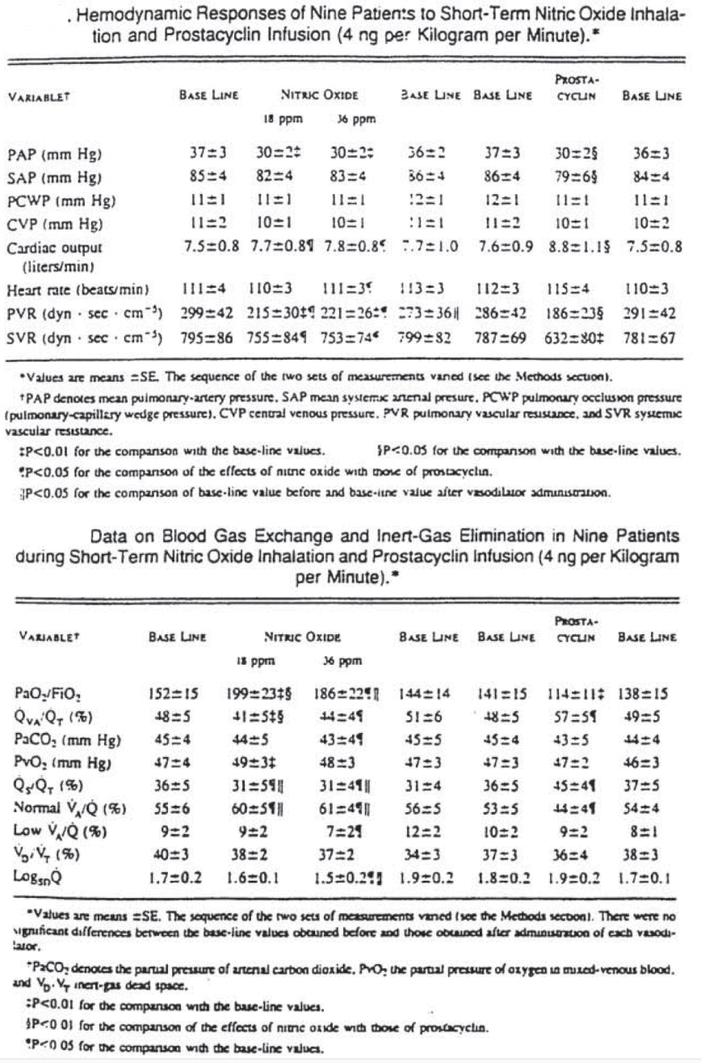
Comment: There were no specific PD studies conducted in the target patient population. However, almost all published studies discussed in Section 7 (Efficacy) of this report had haemodynamic and oxygenation parameters as their efficacy endpoints.

Secondary pharmacodynamic effects
No new studies provided.

Time course of pharmacodynamic effects
The time course and dose-response of initial short term iNO treatment was evaluated in 12 patients with ARDS (10 adults with mean age of 30 years and two children aged 9 and 13) (Gerlach, 1993). Multiple comparisons demonstrated that compared to baseline (76.4 ± 18.7 mmHg), iNO increases PaO₂ significantly at 0.1 ppm (101.0 ± 20.2 mmHg), 1 ppm (122.8 ± 23.5 mmHg), 10 ppm (129.4 ± 25.1 mmHg) and 100 ppm (92.8 ± 22.2 mmHg). There were no significant differences between the 1 and 10 ppm data and no further improvement was observed with the 100 ppm dose. The calculated effective dose was low (Effective dose 50 (ED₅₀) was approximately 100 ppb). The effect on PAP was also statistically significant but only with iNO doses of 1 ppm and more (PAP at baseline: 41.7 ± 14.6 cm H₂O; mean PAP with 100 ppm iNO: 28.9 ± 4.9 cm H₂O). For lowering the PAP, the calculated ED₅₀ was 2 to 3 ppm. During the whole NO inhalation therapy, the effect on oxygenation did not show any tendency to decrease but rather increased. In contrast haemodynamic parameters such as mean SAP, PAP, CO and HR did not change significantly as shown below in Figure 4.
Figure 4: Changes in haemodynamic parameters following NO inhalation in adults with ARDS (Gerlach, 1993)
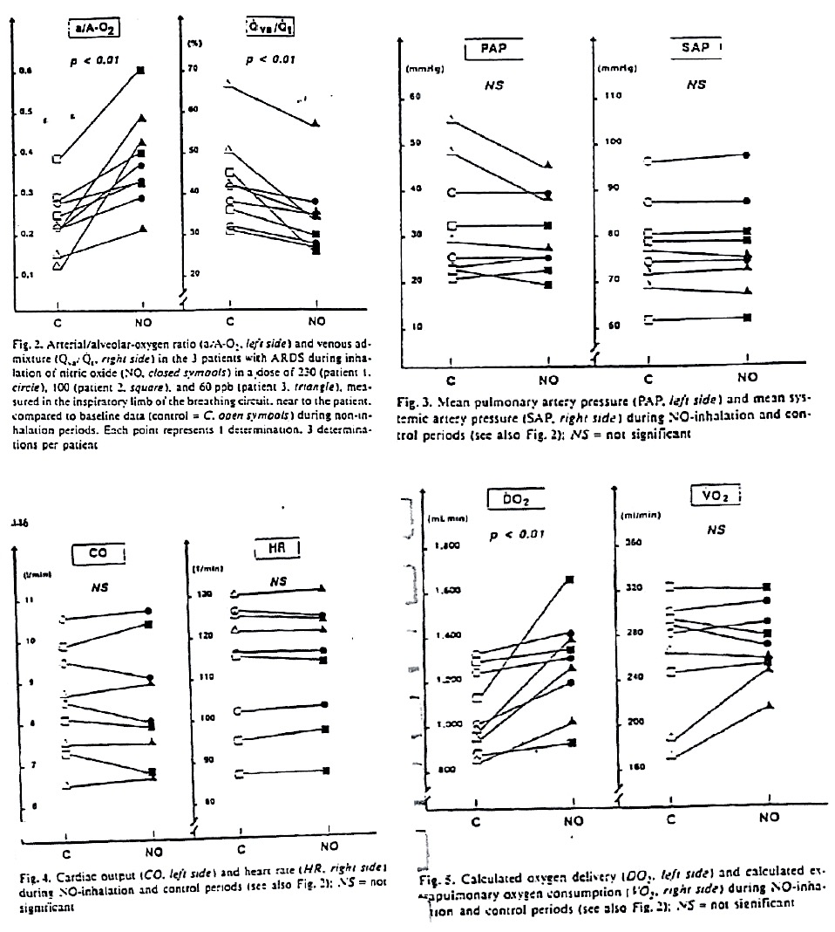
Furthermore, this study showed that even with using NO doses in the ppb range, termination of iNO requires stepwise weaning-off procedure since a sudden withdrawal of NO after prolonged inhalation may result in marked deterioration of pulmonary oxygenation and arterial pressure and even increased PVR.
Comment: Interpretation from the above study was limited by the fact that it was conducted only in patients with ARDS which is not the proposed indication in this submission.

Relationship between drug concentration and pharmacodynamic effects
Results of a study involving 6 critically ill adults with ARDS (Puybasset, 1994) showed that iNO induced a significant dose related decrease in PAP and PVR (p = 0.0001). In 4 patients, decreases in PAP and PVR were progressive and dose-related, beginning at 100 ppb and reaching a plateau after 1900 ppb. In the other two patients, a decrease in PAP of 91% and 74% was obtained with the 100 ppb dose whereas the plateau was observed from the 1600 to 5000 ppb doses as shown in Figure 5. Simultaneously, a statistically significant dose-related increase in PaO₂ occurred (p = 0.001) via a dose-dependent reduction of the pulmonary shunt. A slight but significant decrease in PaCO₂ occurred, via a reduction in alveolar dead space. Systemic haemodynamic variables and metHb blood concentrations did not change and maximum concentrations of nitrogen dioxide (NO₂) never exceeded 165 ppb. Overall, the maximum effects on the pulmonary circulation and gas exchange were obtained for an inhaled NO concentration of 2 ppm. These beneficial effects were observed without significant changes in systemic haemodynamic parameters and methaemoglobin blood concentrations.
Figure 5: Change in mean PAP and other haemodynamic markers in adult patients with ARDS following inhaled NO treatment (Puybasset, 1994)
A prospective, open label study evaluated the effects of iNO in 17 neonatal (n = 9, mean) and paediatric (n = 8, mean age = 1.75 years, range 1 month to 6 years) ARDS patients with respect to dosage, prolonged inhalation and weaning (Demirakea, 1996). The dose-response curves differed between the neonatal and the paediatric groups as shown below in Figure 6.
Figure 6: Dose response curves for neonate (dashed line) and paediatric groups (solid line) with ARDS following NO therapy (Demirakca, 1996)
Dose response of NO inhalation on oxygenation index (OI) expressed in percent of maximum effect. ED₅₀, calculated dosage at which 50% of effect on oxygenation index can be achieved. Solid line = data from patients with acute respiratory distress syndrome; dashed line, data from patients with acute respiratory distress syndrome plus persistent pulmonary hypertension of the newborn. Error bars show SD.
The optimal dose was 20ppm in neonates and 10ppm in paediatric patients. The treatment period with iNO ranged from 4 to 21 days (mean: 9 ± 5 days). Prolonged iNO treatment was associated with continuous improvement of the oxygenation status of the patients. Withdrawal from inhaled NO was attempted as soon as stable respiratory status (PEEP of 5cm H₂O, inspiration/ expiration ratio of 1:2, FiO₂ of < 0.8) and the administration of 5ppm of NO was achieved. An oxygenation index of < 5cm H₂O predicted successful withdrawal with a sensitivity of 75% and a specificity of 89%. iNO treatment never had to be discontinued because of increased methaemoglobinemia (which always remained ≤ 3%) or increased NO₂ (which always remained ≤ 0.8 ppm). None of the patients had to be rescued with ECMO and 16 of the 17 patients survived.

Genetic, gender and age related differences in pharmacodynamic response
No data submitted.

Pharmacodynamic interactions
No data submitted.

Evaluator’s overall conclusions on pharmacodynamics
Inhaled NO induces selective pulmonary arterial vasodilation which is rapid, sustained throughout the time of inhalation, and quickly reversible when inhalation is stopped. The studies presented above showed that iNO can reverse the pulmonary vasoconstriction induced by hypoxia in HVs (Frostell, 1993) as well as in adults with ARDS (Rossaint, 1993). Dilatation of pulmonary vessels produced by inhaling NO during hypoxia was not accompanied by systemic vasodilation. This effect appears within a few minutes following the initiation of iNO treatment.
With regard to the dose/concentration-response relationships, the studies report a dose-dependent improvement of pulmonary circulation and arterial oxygenation. In the considered studies, a significant effect on arterial oxygenation and/or PAP was reported for iNO concentrations ranging from less than 1 ppm to 100 ppm. In adult and paediatric patients with ARDS or acute respiratory failure, the maximum effect of iNO on arterial oxygenation and PAP seems to be obtained at concentrations of 2 to 10 ppm. In neonatal patients with ARDS and PPHN, the maximum effective dose has been reported to be of 10 to 20 ppm.
The PD studies submitted in the dossier only involved HVs or patients with ARDS which are not the targeted patient population in the proposed indication for this submission. Interpretation was limited by lack of dose-response or other specific PD studies in the target patient population with perioperative pulmonary hypertension in conjunction to heart surgery. However, almost all published studies discussed in the efficacy section of this report had haemodynamic and oxygenation parameters as their efficacy endpoints.

Dosage selection for the pivotal studies
There were no specific dose-ranging studies for the proposed indication.

Clinical efficacy
‘VasoKINOX indicated in conjunction with ventilatory support and other appropriate active substances for the treatment of perioperative pulmonary hypertension in adults and newborn infants, infants and toddlers, children and adolescents, ages 0-17 years in conjunction to heart surgery, in order to selectively decrease pulmonary arterial pressure and improve right ventricular function and oxygenation by increasing the pulmonary flow.’
The sponsor conducted 4 studies, but only one Phase III study (ALS-1-97-P-301) was considered ‘pivotal’ by the sponsors and has been discussed below in Section 7.1. The other 3 studies were for other indications and only provided safety data; these studies have been evaluated and results summarised.
Numerous studies have been published in the literature, both in paediatric and in adult populations for the proposed indication. However, Air Liquide Santé International (ALSI) did not sponsor any of these published studies. Efficacy in the paediatric and adult patient populations is summarised in Sections 7.1 and 7.2, respectively.
Comment: Publication bias was minimised by the use of a systematic review of the literature; all published studies that met the pre-defined inclusion criteria were included regardless of their results or language. However, it is possible that publication bias (where studies with a ‘positive result’ are more likely to be published) may have had a positive influence on the overall outcomes reported in this submission. The potential for selection bias was minimised by the inclusion of only randomised studies reporting efficacy outcomes.

Efficacy in the paediatric population

Pivotal randomised controlled study conducted by sponsor (ALS-1-97-P-301)

Study design, objectives, methodology
This was a prospective, multicentre, randomised, double blind, placebo controlled, parallel-design study in paediatric patients, who were at risk for developing pulmonary hypertensive episodes, following corrective cardiac surgery. Prior to surgery, on admission to ICU, patients still eligible for study entry, were randomised (max delay 30 mins) to receive placebo or iNO and were evaluated after 30 mins, 3 h, 6 h, 12 h, 24 h and every 12 h thereafter. The time period for primary study endpoint monitoring varied depending on the type of surgical intervention for example; 48 h for left-to-right shunt lesions or 4 days in case of obstruction to pulmonary venous return. The study was completed after all patients have undergone at least one follow-up visit at 3 or 6 months and one visit at 1 year and if possible 5 years following intervention.
The primary objective of this study was to evaluate the relative reduction of patients experiencing a postoperative pulmonary hypertensive event, by the preventive use of low concentrations of iNO/N₂ versus N₂ (placebo) after surgical repair of specified congenital heart defects. The secondary objectives were to evaluate the effects of iNO on duration of ventilation, duration of stay in ICU and safety, as assessed by haemodynamic parameters, laboratory tests, blood gases and reports of adverse experiences.
The study was conducted from July 1997 to December 1999 at 16 centres in Belgium, Finland, France, Germany, Norway, UK and Slovakia.

Inclusion and exclusion criteria
Patients aged 0 to 5 years undergoing corrective operations for left-to-right shunt lesions or obstruction to pulmonary venous drainage were considered to be at high risk for postoperative pulmonary hypertension and were eligible for study entry. Inclusion was based on pre-operative studies which revealed the following:
- High Flow group (VSD, AVSD, TGA-VSD, Truncus arteriosus, AP window) with high pulmonary blood flow, defined as a Qp/Qs > 2/1, or a directly measured PAPI SAP of > 50%;
- Obstructed pulmonary venous return, Mitral stenosis, obstructed TAPVD.
The main exclusion criteria were: children requiring iNO for treatment of pulmonary hypertension in the operating room before ICU admission were by definition excluded from the prophylactic protocol; Known methaemoglobin reductase deficiency; Platelet count < 50 000 or known platelet function abnormality; Severe coagulopathy or history of bleeding disorder; Severe left ventricular failure in the absence of right ventricular failure (Shortening fraction < 20%); Documented infection; Administration of prostacyclin; received another investigative drug within 30 days; Previous treatment with iNO within 6 months of participation in this Protocol; Refusal of parents or child to consent to the study.
Comment: The patients included in this study were not truly representative of target patient population for treatment of perioperative PHT, as children requiring iNO for PHT before operation were excluded from the study.

Study treatments, randomisation and blinding
Patients qualifying for randomisation received 5 ppm iN0 or placebo. The gas (NO/placebo) was administered to the patient via mechanical ventilation after dilution in the respiratory circuit with an oxygen/air mixture, using the Opti-NO delivery system. Patients received prophylactic treatment until the occurrence of the first hypertensive episode of sufficient severity to require treatment or until extubation. Both the investigator and patient were blinded to the study medication which was supplied in gas cylinders. Each cylinder had a tear-off label. When cylinders of study medication were dispensed, the tear-off portion of the label was removed intact and attached to the appropriate page of the patients case report form.
Comment: The rationale for choosing the 5 ppm dose of iNO was based on published evidence from 2 dose-response studies (Miller, 1993 and Puybasset, 1994). However, these studies had their own limitations and as evidenced by results of this study, this dose of iNO was sub-optimal.

Efficacy endpoints
Data for the primary efficacy endpoint was monitored for a period of 48 h (left-to-right shunt lesions) or 4 days (obstructed pulmonary venous return) depending on the type of surgical intervention. The primary endpoint for efficacy analysis related to the occurrence of the first pulmonary hypertensive episode of sufficient severity to require treatment. The efficacy of 5 ppm iNO was assessed by evaluating the effect of prophylactic treatment on the proportion of patients reaching extubation, within a specified observation period (48 h or 4 days) without experiencing a hypertensive event of sufficient severity to require treatment. Success of preventive therapy was defined by extubation without occurrence of a hypertensive event of sufficient severity to require treatment, within a specified monitoring period depending on the type of surgical intervention. The first episode of pulmonary hypertension, within 48 h or 4 days, that was of sufficient severity to require treatment was classified as a treatment failure.

Sample size, statistical analysis, analysis populations
Sample size calculation was based on the primary endpoint. A sample size of 125 in each group had 90% power using a Chi-Squared test with a 0.05 two-sided significance level to detect a difference of 20 % between the placebo (N₂) and iNO group based on estimation of the proportion of patients experiencing a pulmonary hypertensive event would be 50% and 30% in the placebo and iNO groups, respectively.
Analysis of episodes of post-operative pulmonary hypertension were analysed using a Fisher's exact test; while duration of stay in ICU were compared using Mann-Whitney test. A survival analysis was also carried out in order to provide Kaplan-Meier survival curves. In order to avoid a bias due to patients who died (even if this number of patients was small in the present study), an additional analysis of these parameters in patients alive at the time corresponding to the parameter studied (that is, alive at the end of intubation or alive when leaving the ICU) was made. Changes in haemodynamic, arterial blood gases, respiratory and laboratory parameters during the study were analysed by 2-way ANOVA for one within and one between factors.

Participant flow
The total number of full analysis set (FAS) patients was 219 (group NO: 106; placebo group: 113). The total number of mITT patients was 215 (group NO: 105; placebo group: 110). Only 4 patients with protocol violations were excluded from the FAS analysis.

Baseline patient characteristics
The number of males was slightly less in the iNO (47.2%) compared with the placebo (52.8%) group. The mean age was 4.5 to 5.5 months, mean weight was 4.7kg (2 to 12 kg) and height was 58.8 cm (43 to 88cm). Both groups were similar with respect to congenital heart defects as shown below in as shown below in Table 3 and in terms of duration of CPB and CCT during surgery and baseline haemodynamic parameters.
Table 3: Congenital heart defects at baseline, FAS population
Note: Group A = NO treated group; Group B = Placebo group.

Primary efficacy results
In the FAS population, the percentage of patients alive at 48 h without PHT was not significantly different between the 2 groups (iNO versus placebo: 87.7% versus 85.8%, p = 0.7). The frequency of PHT was 12.3% and 12.4% in the iNO and placebo groups, respectively, as shown below in Table 4.
Table 4: Frequency of patients with PHT and survuval at 48 h, (mITT population, left; FAS population, right)
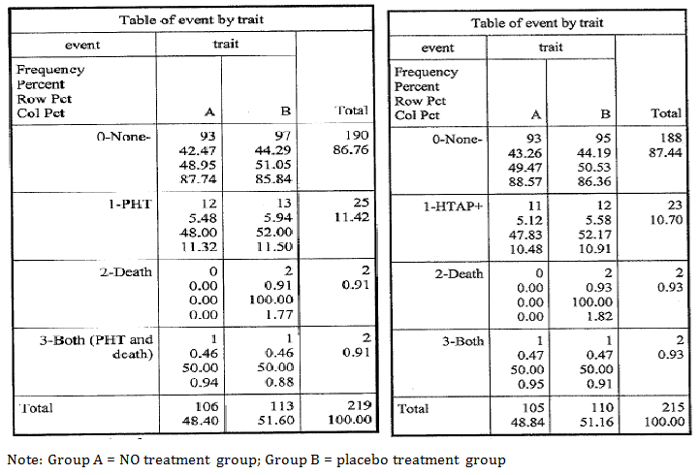
Two patients died before 48 h in the placebo group and one patient after PHT in each treatment group. One patient ended the study in the placebo group (due to failure in the delivery system). Similar results were obtained when an additional sensitivity analysis was made excluding the patient who experienced a failure of the delivery system (NS), or when considering only the frequency of PHT versus non PHT in the 2 groups. Primary efficacy results in the FAS were confirmed in the mITT analysis (iNO versus placebo: 88.6% versus 86.4%, p = 0.68) as shown above in Table 5. The number of patients with PHT tended to be similar in both treatment groups irrespective of the type of congenital heart defect.

Other efficacy results
The mean duration of inhalation was significantly (p < 0.01) shorter in the placebo group (35.5 ± 24.6 h) compared to iNO group (45.1 ± 28.6 h). The mean duration of intubation was also significantly (p = 0.03) shorter in the placebo group (4.3 ± 4.1days) than in the group NO (5.1 ± 4.8 days). The mean duration of stay in ICU was significantly (p = 0.04) shorter in the placebo group (7.4 ± 7.5 days) than in the group NO (9.7 ± 13.3 days). In order to avoid a bias due to patients who died (even if this number of patients was small in the present study), an additional analysis of these parameters in patients alive at the time corresponding to the parameter studied (that is, alive at the end of intubation or alive when leaving the ICU) was performed which showed similar results.
Comment: This study cannot be considered a pivotal study in support of efficacy of iNO for proposed indication of ‘treatment’ of perioperative PHT in paediatric patients due to the following limitations:
- This was a preventative study in which children requiring iNO for treatment of pulmonary hypertension in the operating room before ICU admission were excluded. Hence, this study did not really evaluate efficacy of iNO for proposed indication of ‘treatment’ of perioperative PHT.
- The dose of iNO used in this study was only 5ppm which was clearly suboptimal and failed to show any evidence of efficacy.
- Interpretation was further limited by low incidence of PHT crises. The sample size calculation was based on estimated PHT crisis incidence rates of 50% and 30% in placebo and iNO groups, respectively while the actual incidence was only 12.4% and 12.3%, respectively. The study was designed based on the Hopkins report (1991) which showed a high incidence of pulmonary hypertensive crises associated with a high mortality rate (50%) after surgery for congenital cardiac disease at risk of PHT. However, in the years since the Hopkins report, there has been a dramatic decrease in the incidence of PHT crises and mortality rate after repair of CHD. Therefore the study clearly lacked adequate power to detect statistically significant difference for the primary endpoint.
- Results showed no difference in incidence of PHT between the iNO and placebo groups. Furthermore, duration of inhalation, intubation and stay in ICU was significantly shorter in the placebo group.

Published studies in paediatric patients
In the paediatric population, 15 published studies (14 publications, including 2 versions of 1 meta-analysis and 1 abstract) were selected which evaluated the effectiveness of iNO at doses ranging from 5 to 80 ppm in a population of newborns or children (ages 1 day to 20 years), who had pre or post-operative PHT. Efficacy was mainly evaluated by the reduction in PHT, reduction in pulmonary vascular resistance (PVR), and the improvement of oxygenation, without modification of cardiac output. There were 13 prospective, randomised controlled studies of which 4 were considered pivotal by the sponsors and are discussed in the following Section 7.1.2.1. Other randomised studies are discussed in Section 7.1.2.2.

Pivotal randomised controlled published studies

Russell (1998)

Study design, objectives, patient population
This was a prospective, randomised, placebo controlled, double blind study testing iNO 80 ppm in 40 paediatric patients scheduled to undergo CPB during surgical correction of congenital heart defects. The main inclusion criteria were: pre-operative PHT diagnosed by either cardiac catheterisation or echocardiography; PHT defined as MPAP > 50% of MSAP. Echocardiographic criteria included VSD velocity of < 2 m/s, a tricuspid regurgitant jet of > 2 m/s resulting in estimated MPAP > 50% of MSAP.

Study treatment
The patients were hyperventilated to maintain a partial arterial carbon dioxide pressure (PaCO₂) of 30 to 35 mmHg and pH > 7.45. All patients were weaned from CPB with dopamine 5 to 10 µg/kg/min and if systolic function was assessed to be inadequate, epinephrine 0.02 to 0.08 µg/kg/min was added. Inhalation of the study gas (nitrogen or NO) continued for 20 mins during which time haemodynamic variables were continuously recorded. Four study periods were defined: immediately before study gas administration (baseline), after 10 and 20 mins of study gas administration, and after study gas administration had been discontinued for 1 min. Patients were randomly assigned to receive nitrogen (placebo) or inhaled NO (80 ppm). Treatment with iNO or N₂ was initiated immediately after cardiopulmonary bypass (CPB) for surgical repair. Both patients and medical staff were blinded to treatment. After surgery, the patients were observed in the intensive care unit (ICU) where they could receive iNO in case of PHT.

Efficacy endpoints, statistical analysis
Arterial blood gases were measured at similar intervals or when clinically indicated. Systemic, pulmonary and atrial blood pressures were measured continuously using fluid filled catheters. For analysis, patients were divided into 2 groups: those who emerged from CPB with or without PHT and in both groups patients had received inhaled NO or placebo. Percent change in MPAP was calculated from baseline to each of the 4 follow-up times: after 1, 10 and 20 mins of administration of NO or placebo and 1 min after ceasing administration of NO or placebo. These were compared using the Mann-Whitney U-test. Patients were also observed in ICU to document incidence of PHT and received treatment with iNO (80 ppm) as part of a separate study protocol.

Study participants; Baseline data
The 40 patients included were aged from 2 days to 6.5 years. Half of the patients had atrioventricular septal defects; most of the others had atrial or ventricular septal defects. Among the patients who completed the study (N = 36), 13 (36%) emerged from bypass with PAP > 50% of SAP. The remaining 23 patients (64%) emerged from bypass with PAP < 50% SAP. Therefore, the incidence of post-bypass PHT was only 36%.

Results
Patients who emerged from bypass with MPAP > 50% of MSAP and received inhaled NO had a significantly greater reduction in MPAP at 20 mins compared to placebo group (19% versus 9%, p = 0.008). In patients who emerged from CPB without PHT (MPAPA < 50% of MSAP), there was no significant difference in reduction of PAP between NO and placebo groups. Results are shown below in Figure 7.
Figure 7: Percent change in MPAP in patients with and without PHT during inhalation of NO or placebo (N₂) (Russel, 1998)
Note: error bars represent standard deviations
Inhalation of NO compared with placebo did not significantly alter systemic haemodynamics (MSAP, HR, atrial pressure).
Comment: This was the first published randomised, blinded, placebo controlled study of iNO for treatment of postoperative PHT and results showed that inhaled NO (80 ppm) was effective in treating PHT immediately after congenital heart surgery as it selectively reduced PAP in patients who emerged from CPB with PHT. However, iNO had no effect on patients who emerged from bypass without PHT.
This study had the following limitations:
- Small sample size and the low incidence (36%) of postoperative PHT despite a requirement of preoperative hypertension for study entry. The lower incidence of postoperative PHT may be due to fact that patients underwent surgery before significant pulmonary vascular changes developed. In the population of patients evaluated in this study, conventional therapy with hyperventilation and 100% O₂ may be sufficiently effective and use of inhaled NO maybe more beneficial in older infants/ children with increased pulmonary blood flow lesions and advanced changes to the pulmonary circulation.
- The dose of iNO (80ppm) evaluated in this study was almost 4 times the maximum recommended dose in children.
- All patients survived and went home. Hence larger prospective studies using patients with more advanced disease may be required to assess effect of iNO on mortality/ morbidity.
- Although this study randomised patients, neither the random sequence generation method nor the allocation method was described. Only 10% of the study patients discontinued and were excluded from analysis; however, the groups to which these patients were assigned were not reported.
- Only PAP was measured in this study; PVR was not assessed and use of only PAP as the efficacy endpoint may not be enough to analyse effects of iNO.
Due to the above limitations, the evaluators do not consider this as a pivotal published study to support the proposed indication.

Miller (2000)

Study design, objectives, patient population
This was a prospective, randomised, double blind study to compare iNO with placebo (N₂) in prevention of PHT after surgery for CHD in 124 paediatric patients.
Inclusion criteria were: Infants suitable for corrective heart surgery with high pulmonary flow, pressure or both; congenital heart lesions such as non-restrictive VSD, truncus arteriosus or total anomalous pulmonary venous drainage with objective evidence of PHT at immediate preoperative assessment (MPAP > 25 mmHg; MPAP > 50% of MSAP). The study was conducted in Sydney, Australia.

Study treatment
Patients were randomly assigned to treatment with continuous low-dose NO (n = 63) or placebo (n = 61). Study gas was administered continuously as inhaled NO 10 ppm or placebo nitrogen from surgery until just before extubation. Infants were randomised by a computer-based stratified minimisation algorithm based on presence or absence of Down’s syndrome. Other than study gas administration, all patients were managed according to same intensive care protocol for sedation, ventilation, inotropes and vasodilators. When infants were eligible for extubation, the study gas flow was reduced by 20% per hour aiming for complete withdrawal by 4 hours. The clinical investigators were blinded to the study gas flow. If major PHTC occurred, the weaning process was suspended.

Efficacy endpoints, statistical analysis
PHT crisis (PHTC) was defined as episodes in which pulmonary/ systemic artery pressure ratios rose to more than 0.75. Episodes were classified as major if there was fall in SAP of at least 20%, a fall in transcutaneous oxygen saturation to < 90% or both and minor if SAP and transcutaneous oxygen saturation remained stable. Pulmonary artery, systemic artery, right and left atrial pressures and transcutaneous oximetry were continuously monitored. Cardiac index, pulmonary and systemic vascular resistances were calculated.
Assuming average time to extubation of about 6 days (based on prior experience), the study sample size had 80% power to detect a 30% reduction (about 2 days) in the time to reach the criteria for weaning at 2-sided significance of 0.05. All analyses were done by intention to treat. Since data were unlikely to be normally distributed, outcomes were analysed based on time to reach set criteria with survival-time methods based on the log-rank test. Additional analyses for outcomes related to time were done with Cox’s proportional hazards regression, with adjustment for baseline characteristics. Interim analyses were scheduled when recruitment reached 100 infants and final analyses was done when all 124 infants had completed the study.

Study participants; Baseline data
Overall, 102 (82%) infants completed the study in < 7 days; the remaining 22 were weaned from the study gas at 7 days as per protocol. Study included 124 infants (64 male, 60 female) with median age of 3 months (range 1 to 5 months). Baseline characteristics were similar for both treatment groups as shown below in Table 5.
Table 5: Baseline characteristics, Miller (2000)

Results
The incidence of PHTC was significantly lower in infants who received inhaled NO compared with placebo (median of 4 versus 7; adjusted RR = 0.65, 95% CI: 0.43 to 0.99, p = 0.045) as shown below in Figure 8.
Figure 8: Relative risk (95% CI) of PHTC in NO compared with placebo group (Miller, 2000)
The median time to eligibility for extubation was shorter in the inhaled NO group compared to placebo group (80 (range: 38 to 121) versus 112 (63 to 164) hours, p = 0.019) and the median weaning time from study gas was similar in both treatment groups (4 versus 5 hours, HR = 1.35, p = 0.19). In the iNO group, 17 infants required longer than 4 hours for weaning compared with 2 hours in the placebo group. Despite the longer weaning time, the total time on study gas including weaning time was still shorter in the iNO group compared with placebo (87 (43 to 125) versus 117 (67 to 168) hours, p = 0.023) even after adjustment for age, diagnosis and presence of Down’s syndrome (Figure 9). The pulmonary vascular resistance index (PVRI) measured every 12 hours was not significantly different between iNO and placebo groups (Figure 10). During the study period, 7 infants (2 from iNO and 5 from placebo group) required rescue iNO and duration of rescue iNO use was similar in both groups. After weaning from study gas, a similar proportion of infants in each group had an extubation delay of more than 6h (iNO versus placebo: 55 versus 53). The median time of intubation was shorter in the iNO group (117 (70 to 173) versus 140 (86 to 214) hours), as was the median time to discharge from ICU (138 (89 to 192) versus 162 (96 to 222) hours), but these differences were not significant. Overall, there were 8 deaths (6.5%), 11 hrs to 42 days after surgery; 5 on iNO and 3 on placebo (p = 0.49).
Figure 9: Hazard ratios (95% CI) for postoperative course with differences in median times (Miller, 2000)
T_{cr} = time to criteria for weaning; T_{w} = time weaning; T_{g} = time on study gas; T_{ext} = time to extubation; T_{ICU} = time in intensive care unit.
Figure 10: Median pulmonary vascular resistance index by treatment group over time after surgery until eligible extubation (Miller, 2000)
Comment: The risk of bias in this study was low. Both the random sequence generation (computer-based) and allocation methods were adequate. The study was double blinded, all patients completed the study and all outcomes were reported. Overall, results of this well-conducted study indicated that prophylactic use of inhaled NO at 10 ppm may help to reduce the frequency of major pulmonary hypertensive crises and lessen time to extubation eligibility by about 30 hours. The use of inhaled NO appeared to be easy to monitor and weaning protocols with gradual withdrawal over 4 hours appeared to be successful. Despite the increased weaning time in the iNO group, the total time on study gas (time to extubation criteria plus hours required for weaning) was also significantly shorter by more than 24 hours even after adjustment for age, diagnosis and presence of Down’s syndrome.
Although iNO showed significantly lower incidence of PHTC compared with control, it was just barely statistically significant with p = 0.045 and upper limit of 95% CI almost unity. Although PVRI showed significantly greater reduction compared with placebo, there was no difference in mortality. However, interpretation on mortality was limited by the fact that only 1 death occurred during the study gas administration (related to surgical complication and unrelated to study treatment). The other 7 deaths occurred when infants were no longer under study protocol and were mainly related to low cardiac output and septicaemia, which were not likely to be associated with NO.
Another limitation of this study was that although it was mentioned in study methodology that CI was calculated along with PVRI and SVRI, results for cardiac index were not reported in the publication.

Day (2006)

Study design, objectives, patient population
This was a prospective, randomised, controlled study comparing iNO versus conventional therapy in 38 paediatric patients who underwent biventricular repair or heart transplantation who had echocardiographic evidence of PHT before operation and systolic PAP ≥ 50% systolic SAP during the early postoperative period. The study was performed from August 1993 to August 1999 at a single hospital in the USA.

Study treatment
Patients were randomly assigned to a control group that received conventional therapy or a treatment group that received iNO 20 ppm. Randomisation was by a blind draw from sequential groups containing 6 assignments. No strict criteria or definition of ’conventional management’ were utilised in this trial and management of the control group was left to the discretion of the attending cardiothoracic surgeon. iNO 20 ppm was given until care providers decided to wean the patient from assisted ventilation. Before extubation, NO was gradually withdrawn by decreasing dose during a period of 6 to 12hours; the amount of supplemental oxygen was transiently increased when NO was discontinued.

Efficacy endpoints, statistical analysis
The primary efficacy endpoint was occurrence of PHT crisis in each group, defined as an acute episode of supra-systemic PAP associated with a decrease in blood pressure, heart rate, or oxygenation that required a change in medical therapy or ventilatory support. Haemodynamic and blood gas measurements were secondary efficacy endpoints. Serial haemodynamic and blood gas measurements were compared by analysis of variance for repeated measures. Factorial analysis of variance or Fischer’s exact test for comparison between patient groups (p values < 0.05 were considered statistically significant, using a Scheffe’s F test).

Study participants, Baseline data
The patients included were aged from 1 day to 3 years (median age: 6 months) in the control group, and from 1 day to 20 years (median age: 7 months) in the iNO group. A similar number of patients in each group had Down syndrome and/or radiographic evidence of lung disease before operation. There were no significant differences in baseline haemodynamic and blood gas measurements between patient groups. Neuromuscular blockage was used in 16 control and 15 iNO patients. The inotropic and vasodilatory agents used at the time of baseline haemodynamic and blood gas measurements were similar in both groups as shown below in Table 6.
Table 6: Diagnoses (above) and inotropic and vasodilatory agent use (below) at Baseline (Day, 2000)
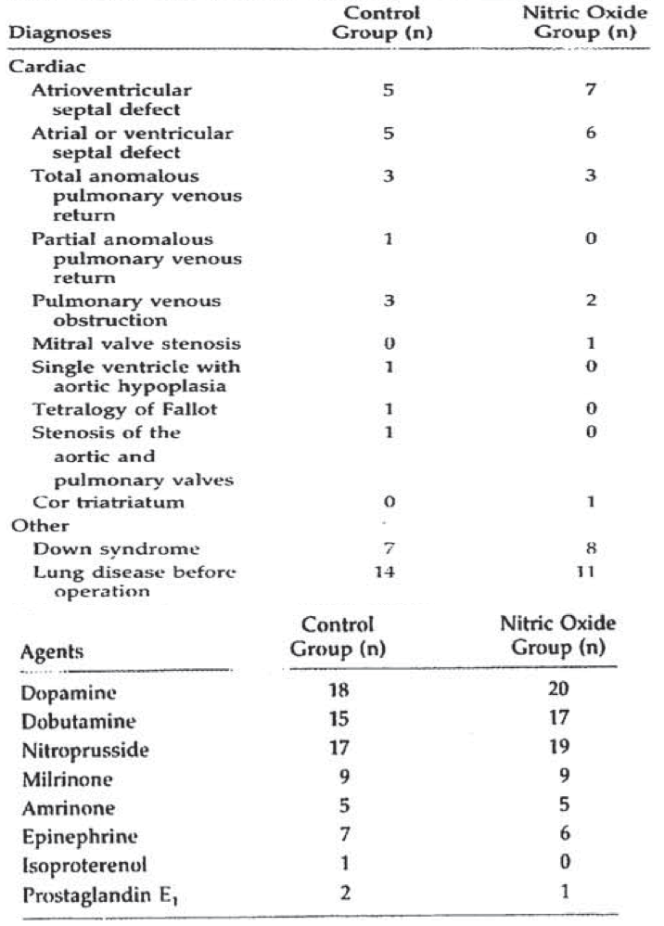

Results
PHT crisis occurred in 4 patients in the control group and in 3 patients in the iNO group. A life-threatening episode of PHT occurred in one patient in the control group, which was refractory to conventional therapy. This patient was treated with iNO, and a marked increase in PaO₂:FiO₂ and a 47% reduction in the ratio of systolic PAP: systolic SAP ratio occurred. In all the other patients, the crisis was less severe. The pulmonary haemodynamics or oxygenation improved in all 4 control patients who experienced PHTC and were treated with iNO as shown below in Table 7.
Table 7: Acute haemodynamic and blood gas measurements of the 4 control patients treated with NO after PHTC (Day, 2000)
None of the control patients experienced a PHTC after being treated with iNO. Furthermore, none of the patients initially randomised to iNO experienced subsequent PHTC when neuromuscular blockage and sedation were gradually reduced over a period of 4 to 6 days. Patients who experienced a PHTC required an increased duration of paralysis compared to those who did not get PHTC (4.6 ± 1.2 versus 2.1 ± 0.3 days, p = 0.007), but did not require significantly increased duration of assisted ventilation (8.1 ± 1.7 versus 5.5 ± 0.7 days) or inotropic support (6 ± 0.9 versus 5 ± 0.5 days). If the patients who had PHTC were excluded from the analysis, control and iNO groups required similar duration of paralysis, assisted ventilation and inotropic support.
In comparison to baseline, significant changes in heart rate, PAP, left atrial pressure and PaO₂ were observed only in patients receiving iNO, but there were no measured differences between iNO and control groups at 1 hour as shown below in Table 8. However, the difference between the changes in ratio of PAP/SAP between the iNO and control groups did approach statistical significance (p = 0.066), as shown below in Figure 11.
Table 8: Acute haemodynamic and blood gas measurements (Day, 2000)
Figure 11: Ratio of systolic PAP/systolic SAP at baseline and 1 hour (Day, 2000)
Figure description: Ratio of systolic pulmonary and systolic systemic arterial pressures. In comparison to baseline, patients developed a small improvement in the ratio of systolic pulmonary and systolic systemic arterial pressures (systolic PAP/systolic SAP) after the onset of iNO therapy (*p = 0.011). However, there were no differences between patient groups at baseline or after 1 hour of observation.
Comment: The inhalation of NO significantly improved the PAP: SAP ratio and the PaO₂:FiO₂ ratio at 1 hour, but there was no significant difference compared to conventional therapy. However, the published study does not provide any information on whether the study was adequately powered to detect a difference between the treatment groups.
Inhaled NO failed to significantly decrease the incidence of PHT crisis, but it was effective as a rescue therapy for one patient who developed PHT crises and failed conventional therapy.
Interpretation from this study was limited due to the following:
- the study was not blinded
- detailed information on conventional therapy used in this study was not provided in the publication
- number of patients was too small and there was no significant difference between the iNO and conventional therapy groups with respect to primary efficacy endpoint (PHT crisis)
- iNO did not improve pulmonary haemodynamics and gas exchange immediately after operation for congenital heart disease
- pulmonary vascular resistance was not measured in this study
Due to above limitations, this study cannot be considered as a pivotal study as claimed by the sponsors.

Morris (2000)
Study design, objectives, patient population
This was a prospective, randomised, crossover study comparing the consecutive use of iNO 5 ppm and iNO 40 ppm to hyperventilation in postoperative paediatric patients with CHD. The objective was to compare the haemodynamic effects of iNO with those of mild alkalosis (pH 7.5) induced by hyperventilation in children with increased PVR after surgical repair of CHD. The study included 12 children with mean PAP > 25 mmHg at normal pH after biventricular repair of CHD. Residual intra-cardiac shunts were excluded.

Study treatment
Patients received either iNO 5 ppm with iNO 40 ppm for 15 min each or hyperventilation (PaCO₂ = 32.3 mmHg and pH 7.5) for 30 minutes. After 30 min of wash-out, the patients received the alternative treatment. At the end of the second treatment, both treatments were given in combination for further 30 min. It was a crossover study with order of treatments randomised. Patients were studied for a mean of 8.5 hours (range 4 to 40 h) after arrival in ICU; inotropic and vasodilator infusions were not altered during the study period and no fluid boluses were given.

Efficacy endpoints; statistical analysis
Cardiac output and haemodynamic parameters. Changes within each treatment period were analysed by using a paired Student’s t-test with statistical significance defined as p < 0.05; the Bonferroni correction for the p value, adjusted for multiple comparisons was set at < 0.01.

Study participants; Baseline data
The 12 patients included were aged from 0.1 to 17.7 years. The most common diagnoses were atrioventricular septal defect, total anomalous pulmonary venous connection, and hemitruncus. Patients were studied for a median of 8.5 hours (range, 4 to 40 hours) after arrival in the ICU.

Results
Hyperventilation was associated with significant changes in both systemic (decreased CI, SI, CVP and increased SVRI) and pulmonary (decreased PAP and PVR) haemodynamic parameters. Inhalation of NO resulted in selective pulmonary vasodilatation with no effect on systemic vascular resistance index (SVRI) or cardiac index. No difference in response was seen between 5 ppm and 40 ppm. The reduction in PVR was similar between iNO and hyperventilation as shown below in Figure 12. No rebound PHT was associated with the discontinuation of iNO. Compared with iNO alone, the combination of iNO and HV increased SVRI and a further reduction in PAP was seen without a change in PVRI as shown below in Table 9.
Figure 12: Comparison of PVRI after hyperventilation and NO with a line of unity shown (Morris, 2000)
Table 9: Haemodynamic comparison of hyperventilation (HV), NO and combined therapy (mean ± SD) (Morris, 2000)
Comment: Alkalosis, induced by hyperventilation, and iNO (5 ppm or 40 ppm) were equally effective in reducing PVR in children after open heart surgery. This study did provide preliminary evidence to suggest that selective action of iNO on pulmonary circulation may offer advantage over hyperventilation because a decrease in CO and increase in SVR are undesirable in the postoperative period. However, interpretation from this study was limited due to open label, crossover study design and small number of patients.
Overall, this study cannot be considered as a pivotal study as claimed by the sponsors.

Supportive randomised published studies

Khazin (2004)
This was a prospective, randomised, double blind study comparing iNO 30 ppm, intravenous (IV) infusion of milrinone (Mil) 0.5 µg/kg/min, and the combination of both treatments after repair of congenital heart defects in paediatric patients who had a preoperative PHT. The objective of this study was to investigate the effect of Mil combined with iNO on PAP after CPB for repair of congenital heart defects in children. Ninety patients were randomly allocated to 3 groups: iNO, IV Mil and combination of the two drugs (n = 30 in each group). Immediately after weaning from CPB, patients received immediately after weaning from CPB either iNO 30 ppm for 20 min or continuous Mil infusion, 0.5 µg/kg/min, for 20 min, or the combination of both treatments at the same doses for 20 min. Haemodynamic and blood gas measurements were done after weaning from CPB (before starting treatment = baseline value), 10 min and 20 min after starting treatment, and 10 min after stopping treatment. A repeated measures general linear model was applied to the data set to identify differences within each group and among the groups, while adjusting the results for age, sex, and weight. Two-way ANOVA was used to determine if the groups were different at baseline. Results were expressed as mean ± SD and p value ≤ 0.05 was considered significant.
The 90 patients (49 males and 41 females) had mean age of 2.7 to 2.9 months; the reasons for operation were ventricular septal defect (n = 45), atrioventricular canal (n = 17), total anomalous pulmonary venous connection (n = 16), double-outlet right ventricle (n = 10), and mitral stenosis (n = 2). There were no differences among the 3 groups with regards to the type of heart defect, age, sex, length of aortic cross-clamping, and bypass time. The patients enrolled from developing countries had advanced cardiac pathology.
The mean systemic blood pressure was significantly lower in the combined treatment group after discontinuation of the drugs. The mean PAP values were significantly lower in the combined group compared with the iNO and the Mil groups (p < 0.05). However, no difference was recorded with regard to pH, PaCO₂, and PaO₂. The mean PAP after discontinuation of treatment was lower than the baseline value in the iNO and combination groups (p < 0.05). Haemodynamic and blood gas results are shown below in Tables 10 and 11.
Table 10: Haemodynamic results (Khazin, 2004)
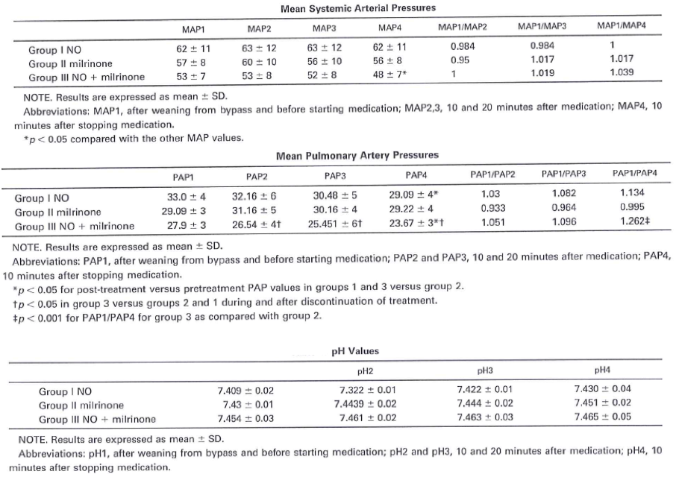
Table 11: Arterial blood gas results (Khazin, 2004)
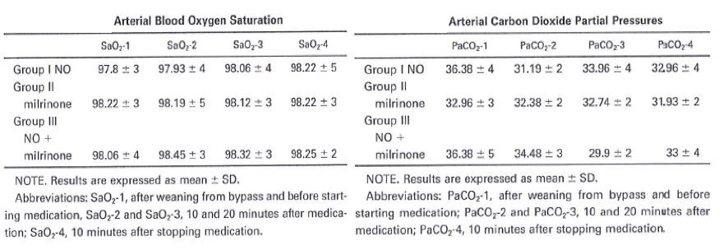
Comment: The combination of iNO and Mil was more effective in reducing PAP than Mil alone in children with PHT who were undergoing repair of congenital heart defects. However, in this population with advanced cardiac pathology, the patients who received both treatments had lower systemic blood pressures than those who received the single agents, which might be detrimental in critically ill patients. However, this study had the following limitations: lack of additional haemodynamic data such as CO or PVR; and the dose of iNO (30 ppm) evaluated in this study was higher than the maximum recommended dose for children (20 ppm) in this submission.

Cai (Annals of thoracic surgery, 2008)
This was a prospective, randomised, parallel group study comparing the effects of iNO < 20 ppm, Mil continuous infusion at 0.5 µg/kg/min, or the combination of both drugs in children undergoing a Fontan procedure. The objective was to evaluate the early haemodynamic and oxygenation responses to iNO, Mil (IV), or both in patients with marked elevation of PVR after a Fontan. Patients received either iNO alone (starting at 10 ppm with subsequent adjustment as needed up to 20 ppm), IV infusion of Mil 0.5 µg/kg/min, or both treatments. The study included children who underwent modified fenestrated Fontan operation and developed severe post-operative high PVR (TPG > 10 mmHg or CVP > 5 mmHg with concomitant arterial oxygen saturation (SaO₂) < 85%). Haemodynamic variables (central venous pressure, TPG, systolic aortic blood pressure) were measured at baseline and 4, 12, and 24 hours after initiation of treatment. Two-way ANOVA was used for repeated measurements. Subsequent comparison among groups at respective time points by one-way ANOVA followed by Duncan’s multiple range test. Difference was considered statistically significant if p value < 0.05.
The 46 patients (23 males and 23 females) had mean age of about 5.5 years and similar baseline characteristics in all treatment groups. The reduction in TPG in the iNO group was significantly greater than that in the Mil group at each time point (p < 0.05). The greatest reduction was obtained with the combination iNO plus Mil (p < 0.05 compared with iNO and p < 0.01 compared with Mil). Similarly, the greatest changes in central venous pressure were observed in the iNO plus Mil group. The greatest improvement in arterial blood oxygenation was also observed in the combination group as shown in Figure 13 below. Compared to the iNO and Mil groups, patients in the iNO plus Mil group showed the maximum increase in PaO₂:FiO₂ ratio and had the least time on mechanical ventilation. The total amount of chest drainage was not different among the 3 groups. Although the time in the ICU and hospital tended to be shorter in the iNO plus Mil group, the difference was not statistically significant as shown below in Table 12. One patient in the iNO plus Mil group and 3 patients in the iNO group had rebound PHT during iNO withdrawal.
Figure 13: Haemodynamic changes from baseline to 24 h (Cai, 2008)
Table 12: Other secondary outcomes related to inhalational nitric oxide or milrinone (Cai, 2008)
Comment: This study had the following limitations:
- Doppler echocardiography was not done before or after bypass to assess effects of Fontan surgery and may have helped provide information regarding cardiac influence of both drugs
- rebound PHT during iNO withdrawal was a concern.

Cai (Artificial organs, 2008)
The study design, objectives, patient characteristics, efficacy endpoints were similar to those described above.
Comment: Some of the patients described in this study may be the same as in study described above. The main difference from the earlier study was that there was no ‘Milrinone alone’ treatment group in this publication.
The 31 patients (15 males and 16 females) had mean age of about 5.5 years with similar baseline characteristics in both groups. Both TPG and central venous pressure decreased significantly (p < 0.05), whereas SAP increased significantly, after 24 hours of treatment with either iNO or iNO in combination with Mil. Compared to the iNO group, the iNO plus Mil group showed significantly greater reduction in TPG (15.3% ± 2.6% versus 18.2 ± 4.8%, p < 0.05) and central venous pressure (15.2 ± 4.6% versus 19.6 ± 3.5%, p < 0.05). The increase in SAP was also significantly greater in the iNO plus Mil group (8.7% ± 2.7%) than in the iNO only group (5.2% ± 3.1%; p < 0.05).
Both SaO₂ and the PaO₂:FiO₂ ratio increased significantly (p < 0.05) after 24 hours of treatment with either iNO or iNO in combination with Mil; the increase in SaO₂ was significantly greater in the iNO plus Mil group (9.3% ± 3.2%) than that in the iNO group (6.8% ± 2.8%; p < 0.01), but there was no significant difference in the increase in PaO₂:FiO₂ ratio between the treatment groups. One patient in the iNO plus Mil group and 6 patients in the iNO group had iNO withdrawal failure or rebound PHT during iNO withdrawal (p < 0.05). In patients who withdrew from iNO treatment without event, the mean time of iNO treatment was significantly shorter in the iNO plus Mil group (65 ± 42 hours) than in the iNO group (88 ± 57 hours; p < 0.05).
There was no evidence of toxicity during iNO administration and methaemoglobin level was within 2.5%.
Comment: Both the above publications by Cai showed that the combined use of iNO and Mil provided additive benefits as compared with iNO or Mil alone for patients with elevated PVR after Fontan procedure. The combination produced a greater decrease in TPG and central venous pressure as well as a greater improvement in arterial oxygen saturation. Besides improving haemodynamics and oxygenation, the combination may offer unique advantage in minimising the potential side effects related to longer exposure period. However, rebound PHT during iNO withdrawal was a concern in both studies.

Stocker (2003)
This was a prospective, randomised study and the objective of this study was to investigate the acute effects of IV sildenafil on haemodynamics and oxygenation and its interaction with iNO in 16 infants at risk of PHT early after cardiac surgery. Only infants undergoing surgical repair of ventricular or atrioventricular septal defects with a large left-to-right shunt, diagnosed on pre-operative echocardiography, entered the study. They were treated within 7 hours after weaning from CPB. Patients received either iNO 20 ppm for 20 minutes or IV sildenafil 0.35 mg/kg for 20 minutes, then both agents simultaneously for an additional 20 minutes. The main efficacy endpoint was PVRI at 0, 20 (after first treatment) and 40 minutes (after second treatment).
The patients were aged from 48 to 262 days (median age: 132 days). Demographic variables, baseline systemic and pulmonary haemodynamics, and gas exchange data were similar in the two patient groups. In patients receiving iNO first, the PAP and PVRI fell significantly by 20 minutes with a trend towards an improvement in PaO₂. The addition of sildenafil did not further influence the PAP, but significantly reduced the SAP, PVRI, SVRI, and PaO₂. In patients receiving IV sildenafil first, the SAP, PVRI, SVRI, and PaO₂ fell significantly and the PAP fell, but not significantly (p = 0.055) by 20 minutes. The addition of iNO resulted in a further reduction of PAP and PVRI to levels significantly below baseline, without any further decrease in SVRI. There was no statistically significant difference in the relative reduction of PVRI between the two treatment groups during the first period (p = 0.7) as shown in Table 13 below.
Table 13: Haemodynamic and ventilatory data at baseline and in response to interventions (Stocker, 2003)
Comment: Intravenous sildenafil enhanced the pulmonary vasodilator effects of iNO in infants after cardiac surgery. However, sildenafil also produced a systemic hypotension and impaired oxygenation, which were not improved by addition of iNO. Inhalation of NO did not show this systemic effect or oxygenation impairment, but did not prevent them when added to sildenafil. Interpretation from this study was limited by the fact that none of the patients had a clinically significant degree of PHT at study entry but were only at risk of developing PHT.

Kirbas (2012)
This was a randomised, parallel group study and the objective was to compare the haemodynamic effects of iNO and aerosolised iloprost in children with PHT secondary to surgery for CHD. The study included 16 children (aged 1 to 84 months) with CHD who developed PHT (PAP: aortic pressure ratio > 0.7) during or after corrective surgery. Patients were randomised (8 patients in each group) to receive either iNO (20 ppm for at least 72 h if weaning was not possible) or aerosolised iloprost (0.5 µg/kg every 90 min for at least 72 h using an ultrasound nebuliser).
The primary efficacy endpoint was cumulated PAP during a 72 h observation period; PAP:SAP ratio. Statistical methods included Mann-Whitney U test to compare groups. Repeated measures of Friedman test for differences at each time point, with Dunn’s multiple comparison test for pairwise comparison when p < 0.05.
The patients ranged in age from 1 to 84 months with mean age of 33 to 38 months and mean weight of 10 to 11kg. The patients had ventricular septal defect (n = 8), atrioventricular septal defect (n =6), atrial septal defect (n = 1), atrioventricular canal defect (n = 1), total anomalous pulmonary venous return (n = 2), and/or truncus arteriosus (n = 2). The mean PAP before the operation was 45 to 47mmHg and the mean PAP: SAP ratio before the operation was 0.82 in both groups. There were no differences between groups in any clinical or haemodynamic parameters before the operation.
Both treatments significantly decreased PAP (iNO: 45.75 to 32.50 mmHg; iloprost: 47.00 to 36.75 mmHg) and the PAP:SAP ratio (iNO: 0.82 to 0.49; iloprost: 0.82 to 0.47), and increased heart rate and cardiac output during the 72-hour observation period. There were no differences between treatments at any time point. No serious side effects and no mortality during the treatment were observed.
Comment: Results from this study suggest that neither NO nor iloprost caused a significant change in the arterial tension and central venous pressure values, whereas they caused an increase in the heart rate and cardiac output values and a decrease in the pulmonary arterial pressure and ratio of pulmonary artery pressure to systemic artery pressure values. Overall, this small study provided evidence that both iNO and iloprost produced similar reduction in PAP in children who developed PHT during corrective surgery for CHD.

Harimurti (2012)
This was a conference abstract which reported the results of an open label, randomised study comparing iNO plus inhaled iloprost with iloprost only in 13 children with PHT after corrective surgery for CHD. Both iNO plus iloprost and iloprost alone reduced PAP. Although, the mean (± SD) PAP was lower in the iNO plus iloprost group (23.0 ± 7.7 mmHg) than in the iloprost only group (30.4 ± 15.9 mmHg), the difference was not statistically significant (p = 0.359).
Comment: Interpretation from this abstract was limited due to open label nature of study and lack of details regarding patient characteristics, statistical methods and small number of patients.

Loukanov (2011)
This was an open label, randomised pilot study comparing iNO and aerosolised iloprost in 15 infants (aged 2.6 to 8.6 months) who developed PHT (PAP > 25 mmHg) immediately after weaning from CPB during corrective surgery for left-to-right shunt. All patients underwent cardiac catheterisation before surgery. The main exclusion criteria were: presented with atrialseptal defect, cyanotic congenital heart disease, univentricular atrioventricular connexion, or valvular or subvalvular pulmonary or aortic stenosis; required emergency cardiac surgery; had systemic arterial hypertension, renal failure, diabetes mellitus, or known disorders of blood coagulation and haemostasis; on extracorporeal membrane oxygenation before cardiac surgery and patients treated with epoprostenol. The main objective was to compare PAP reduction, rate of PHT crises, and need for mechanical ventilation in paediatric patients receiving iNO or aerosolised iloprost for PHT during surgery for CHD. Patients received either iNO (10 ppm) with gradual weaning within 4 h (if no signs of PHT crisis) or aerosolised iloprost (0.5 µg/kg) using an ultrasound nebuliser every 2 h for 72 h. The study was performed from September 2003 to September 2008 at a single centre in Heidelberg, Germany.
The primary efficacy endpoint was incidence of PHT crises during 72 h after CPB. Secondary efficacy endpoints included PAP; Pp:Ps; duration of mechanical ventilation. Fisher’s exact test was used to compare PHT crisis rate between groups; Student’s t-test to compare haemodynamic and clinical variables.
All patients had congenital heart defects with left-to-right shunt. Associated trisomy 21 was present in 11 patients. The mean PAP before the operation was 47 mmHg (range 35 to 56 mmHg), the mean ratio of pulmonary to systemic blood flow was 3.7 (range 2.0 to 6.9), and the mean PVRI was 2.8 (range 1.1 to 5.5) U m². The 7 patients receiving iNO were treated for mean (± SD) of 3.9 ± 1.6 days, whereas the 8 patients receiving iloprost were treated for 6.3 ± 3.0 days. There were no differences between groups in patient characteristics. There were no differences between groups in the rate of PHT crises (p = 1.0, Fisher’s exact test). In the iNO group, there were 2 major PHT crises (both in one patient) and 26 minor PHT crises. In the iloprost group, there were 6 major PHT crises (in 3 patients) and 25 minor PHT crises (in 6 patients). Intensified standard treatment was sufficient in all, but one case to alleviate the PHTCs (one patient in the iloprost group was given additional iNO at day 2. The mean (± SD) duration of ventilation was much shorter in the iNO group (11.9 ± 4.6 days) compared with the iloprost group (37.3 ± 48.4 days), but the difference was not statistically significant (p = 0.19). There were no differences between groups in the mean PAP or Pp:Ps during the 72h observation period. PVR and CO did not differ between the groups.
Comment: The inclusion criteria were chosen to select patients known to be at the highest risk for postoperative pulmonary hypertension reflected by the high proportion of patients with Trisomy 21. This pilot study reported that iNO and iloprost had similar effects on occurrence of PHT crises, PAP, Pp:Ps, and duration of mechanical ventilation in infants with PHT during or after corrective surgery for CHD. Interpretation was limited by the open label study design and small number of patients.

Gorenflo (2010)
This was an open label, randomised pilot study comparing iNO and aerosolised iloprost in 15 infants who developed PHT (PAP > 25 mmHg) immediately after weaning from CPB during corrective surgery for left-to-right shunt.
Comment: The study described in this publication appears to be the same as that described in Loukanov (2011) above. The Gorenflo (2010) publication appears to be a review on ‘Peri-Operative Pulmonary Hypertension in Paediatric Patients: Current Strategies in Children with Congenital Heart Disease’.

Goldman (1995)
This was a prospective, randomised, crossover study comparing iNO to IV infusion of prostacyclin in 13 paediatric patients (aged 3 days to 12 months) with severe postoperative PHT (PAP > 0.66 SAP) after receiving high-inspired oxygen hyperventilation. Patients received either iNO 20 ppm or IV prostacyclin 20 ng/kg/min, then both agents, then the alternative agent. The main objective was to compare the vasodilator effect of iNO versus IV prostacyclin in severe postoperative PHT. The primary efficacy endpoints were change from baseline of PAP, SAP, PAP: SAP ratio, and PaO₂. The paired Student’s t-test was used to compare haemodynamic and PaO₂ differences.
All the children underwent a corrective heart operation for CHD and developed a severe postoperative PHT within 5 days. The broad categories of congenital heart lesions included left-to-right shunt lesions and lesions causing obstruction to pulmonary venous drainage. Severe postoperative PHT was defined either as PAP > 2/3 SAP or PHT severe enough to cause pulmonary compromise as reflected by hypoxia, hypotension, or one or more PHT crisis. The PAP: SAP ratio was significantly lower in the group who received iNO first compared with those who received prostacyclin first (p < 0.01), but it was not significantly different from that of iNO and prostacyclin administered simultaneously. The decrease in the PAP: SAP ratio with iNO was not dependent on the continuation of the prostacyclin administration in those patients who received prostacyclin first as shown below in Figure 14.
Inhalation of NO improved the mean PaO₂ by 70% from baseline (95% CI: 39% to 101%). Prostacyclin infusion was not associated with an improvement in oxygenation (95% CI of absolute change from baseline: -2 to 3 mmHg). The improvements in haemodynamics and oxygenation observed with iNO therapy were neither increased by simultaneous administration of iNO plus prostacyclin nor were they dependent on the continuation of prostacyclin administration in the patients who received prostacyclin first.
Figure 14: Haemodynamic and blood gas comparisons (Goldman, 1995)
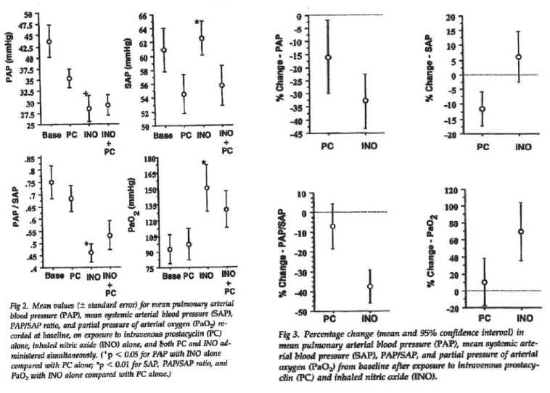
Comment: This study showed that iNO is a more selective pulmonary vasodilator than IV prostacyclin; iNO demonstrated a marked decrease in the PAP:SAP ratio, when treating children with severe PHT after congenital heart operation. Intravenous prostacyclin, although being an effective pulmonary vasodilator, also causes systemic hypotension. Oxygenation improved only with iNO, despite both agents reducing PAP. Interpretation was limited by small number of patients in the study. Effect on clinical outcomes could not be evaluated in this study; however, 9 of these critically ill patients responded to iNO and recovered and no patients died of PHT while receiving iNO.

Other non-randomised published studies in paediatric patients
There were 24 other published studies to support proposed indication in paediatric patients. The majority of these studies evaluated infants and demonstrated reduction in MPAP following administration of inhaled NO. However, these studies do not provide additional evidence of efficacy for proposed indication as many of these studies were case reports or only evaluated safety of iNO.

Analyses performed across trials (pooled analyses and meta-analyses)

Bizzaro (2005)
The main objective of this meta-analysis was to compare the effects of postoperative iNO versus placebo or conventional management, or both; in infants and children with CHD (pre-term neonates were not included). The primary outcome was mortality (long term mortality and mortality prior to hospital discharge). Secondary outcomes included length of ICU or hospital stay; neurodevelopmental disability; number of pulmonary hypertensive crises (PHTC); changes in MPAP, MAP and HR; changes in oxygenation measured as the ratio of arterial oxygen tension (PaO₂) to fraction of inspired oxygen (FiO₂); and measurement of maximum methaemoglobin level as a marker of toxicity.
The Search methods included search of the Cochrane Central Register of Controlled Trials (CENTRAL) (The Cochrane Library 2004, Issue 3), MEDLINE (1966 to 2004), and EMBASE (1980 to 2004). In the updated version, the CENTRAL search was extended to 2007, Issue 4 of The Cochrane Library, and MEDLINE and EMBASE through to November 1, 2007 (abstracts and all languages were included). The meta-analysis included randomised controlled trials comparing iNO with placebo or conventional management, or both. Trials included only children with CHD requiring surgery complicated by pulmonary hypertension.
Four RCTs were included in the review (Day 2000; Miller 2000; Morris 2000; Russell 1998) Each of the four trials included in the review evaluated the use of postoperative iNO in infants and children with CHD necessitating repair and having pulmonary hypertension either in the preoperative or postoperative period. In three of the studies (Day 2000; Morris 2000; Russell 1998) postoperative pulmonary hypertension was used as a criterion either for inclusion or for a separate, subgroup analysis. One of the RCTs (Miller 2000) utilised preoperative diagnosis as part of entry criteria into the trial but did not comment on the presence or absence of postoperative pulmonary hypertension in individual included participants.
The RCTs differed with respect to the method of treatment utilised in the control groups. Day 2000 compared the use of iNO with ’conventional treatment’ in the control group. Morris 2000 employed a cross over method with patients randomised to receive either iNO in the treatment group or hyperventilation as the treatment comparison in the control group (often part of the conventional management protocol) and utilised a 30 minute washout period between treatments. With the exception of the intervention, patient management was similar in both groups. Russell 1998 and Miller 2000 initiated iNO in the treatment group versus placebo in the control group, although underlying conventional therapies (such as hyperventilation and the use of inotropes) were maintained in both groups. The trials also differed with respect to onset and duration of iNO therapy in the postoperative period. Russell 1998 initiated iNO or placebo therapy immediately after patients were removed from CPB and continued treatment for a total of 20 minutes. Day 2000 initiated therapy upon the patient’s arrival in the intensive care unit (ICU) and continued treatment until extubation, although data collection occurred at one hour after initiation of therapy. Morris 2000 used a cross over study design comparing iNO with hyperventilation. Treatment was initiated at a mean of eight and one-half hours post operation (range of 4 to 40 hours) and each treatment was given for a period of 30 minutes. Miller 2000 initiated therapy just after completion of surgery and continued iNO or placebo for a maximum of seven days.
The concentration of iNO utilised also differed among studies. Russell 1998 initiated iNO at 80 ppm while Day 2000 initiated 20 ppm. Morris 2000 initiated a 5 ppm concentration of iNO for 15 minutes and then 40 ppm for the remaining 15 minutes of treatment (although data were presented only for outcomes based on 40 ppm). Miller 2000 initiated iNO at 10 ppm and continued the use of this concentration throughout the duration of the study.
Primary outcomes differed slightly among the RCTs as well. Russell 1998 and Morris 2000 compared changes in haemodynamics (MPAP, MAP, HR) as their primary outcomes of interest. Day 2000 and Miller 2000 compared the number of PHTCs/mortality in each group as their primary endpoints and changes in haemodynamic measurements were the secondary endpoints.
Data presentation differed among the RCTs included in this review. Russell 1998 and Morris 2000 presented individual data whereas Day 2000 and Miller 2000 presented group data. Individual data were collected from primary investigator of Day, 2000 so that certain outcomes of interest, specifically MPAP and MAP, could be calculated and included. In Miller 2000, most data were presented as group data in the form of median values and interquartile ranges. It was thus assumed that the data were skewed, making it difficult to calculate the necessary means and SDs required for inclusion in the analysis. Attempts to obtain the data from the authors in a form that could be utilised were unsuccessful.
Blinding was adequate in Miller 2000 and Russell, 1998. However, investigators were unblinded with respect to study treatment in Morris 2000 and Day 2000 allowing for the possibility of performance bias.
Overall, Miller 2000 had the highest methodological quality with a low risk of bias. Day 2000 was of above average quality with a low to moderate risk of bias; although concealment of allocation was adequate in Day, 2000, a lack of patient, physician, and outcome assessor blinding made the potential for performance and detection bias likely. Russell 1998 was of average methodological quality due to lack of concealment of allocation and Morris 2000 was of poor methodological quality, particularly for the lack of concealed allocation and blinding. Bizzaro et al attempted to assess the trials of higher quality (for example Miller 2000 and Day 2000) separately using sensitivity analysis, but could not do so due to small sample size.

Results
No data was available on long term mortality.

Mortality prior to discharge
This was only reported in 2 trials (Day 2000 and Miller 2000). There were no deaths reported in iNO or control group in Day, 2000. In Miller, 2000 there were 5 deaths out of 63 patients in the iNO group compared to 3 deaths out of 61 patients in the control group. However, only 1 death in each group was related to PHTC. Overall, based on results from these 2 studies, there was no statistically significant difference between iNO and control group with respect to mortality (OR = 1.67, 95% CI: 0.38 to 7.30, p = 0.50).
Comment: Interpretation of results on mortality was limited by wide confidence limits and very few events.
Miller (2000) reported that the median time to discharge from ICU was shorter in the iNO group, but the difference from placebo was not significant.
No data were available on incidence or severity of neurodevelopmental disability.
In the study reported by Day 2000, incidence of postoperative PHTC showed no significant difference between the iNO and control groups (3/18 versus 4/20; OR = 0.80; 95% CI: 0.15, 4.18, p=0.79). In infants at high risk of PHT crises after cardiac surgery, use of iNO can lessen the occurrence of crises and shorten the postoperative course (Miller, 2000).
MPAP, MAP and HR were reported in three of the included trials (Day 2000; Morris 2000; Russell 1998).
A reduction in MPAP was considered a favourable outcome. Overall, the meta-analysis revealed no significant change in MPAP between iNO and control (treatment effect -2.94 mmHg, 95% CI -9.28 to 3.40; p = 0.36). The level of heterogeneity (I2 = 45%) was just below that considered significant.
A reduction in MAP was considered an unfavourable outcome whereas no change or an increase in MAP from baseline was considered favourable. Overall, the meta-analysis revealed no significant difference in effect between the two groups (treatment effect -3.55 mmHg, 95% CI -11.86 to 4.76; p = 0.40) with no heterogeneity (I2 = 0%) between trials.
A reduction in HR, assuming constant stroke volume, was considered an unfavourable outcome as compared to no change or an increase from baseline. Overall, the meta-analysis did not show a significant difference in overall effect in either group (treatment effect 0.02 bpm, 95% CI -8.13 to 8.18; p = 1.00) with no heterogeneity between studies (I2 = 0%).
Difference in PaO₂:FiO₂ change score was only evaluated in one parallel trial (Day 2000). An increase in this ratio was considered a favourable outcome and indicative of improved arterial oxygenation. The trial observed no significant change in the ratio with the use of iNO compared with control (WMD 17.18, 95% CI -28.21 to 62.57; p = 0.46).
Maximum methaemoglobin level was reported in only one of the four studies (Day 2000). An increase in methaemoglobin level was considered an unfavourable outcome. These data were from a parallel trial and thus we calculated a weighted mean difference (WMD). Overall, there was a significantly elevated methaemoglobin level in the iNO group when compared to control (WMD 0.30%, 95% CI 0.24 to 0.36; p < 0.00001). However, the maximum methaemoglobin level did not approach toxicity (> 10%).
Comment: This meta-analysis had the following limitations which confounded interpretation:
- Findings indicate no substantial difference in mortality between those children treated with iNO and those treated with placebo or conventional therapy, but interpretation was limited by the relatively small sample size (N = 162) and low incidence of pulmonary hypertensive crisis-related postoperative deaths (N = 2).
- No differences were observed between treatment and control groups with respect to the number of PHTC in the postoperative period, although the data were based on only one RCT (Day 2000).
- No statistically significant change in MPAP with the use of iNO versus control. Similarly, no significant differences were observed between groups with respect to changes in MAP or HR.
- Ratio of PaO₂:FiO₂ is a measure of oxygenation and a positive change in this ratio implies an improvement. This outcome was measured in only one trial (Day 2000) and revealed no significant difference between treatment and control groups.
- No data were available for several clinical outcomes including long-term mortality and neurodevelopmental outcome.
Overall, it was difficult to draw valid conclusions from this meta-analysis given concerns regarding methodological quality, sample size, and heterogeneity.

Bizzaro (2014)
In the original review (Bizzarro 2005), only 4 RCTs were included (Day 2000; Miller 2000; Morris 2000; Russell 1998). In the first update (search to November 2007), 2 new relevant studies were evaluated but both were excluded (Khazin 2004; Smith 2006). For this updated search (from November 2007 to 1 December 2013), 49 studies were excluded considering the inclusion criteria and only three additional relevant trials were identified (Checchia 2013; Kirbas 2012; Loukhanov 2011) but none met the inclusion criteria. Hence, this updated review contains data from the same 4 RCTs already evaluated and discussed in Bizzaro, 2005 above.

Evaluator’s conclusions on clinical efficacy for treatment of peri-operative PHT in paediatric patients
The only study conducted by sponsors for the proposed indication was Study ALS-1-97-P-301 in 219 infants (mean age of 4 to 5 months) at risk of developing PHT following corrective cardiac surgery. However, the 5ppm dose of iNO used was found to be suboptimal and this study failed to provide any evidence to support efficacy of iNO for proposed indication due to limitations outlined in the evaluator’s comments in Section 7.1.1.
In the paediatric population, 15 published studies (14 publications, including 2 versions of 1 meta-analysis, and 1 abstract) were selected which evaluated the effectiveness of inhaled nitric oxide (iNO) at doses ranging from 5 to 80 ppm in a population of newborns or children (ages 1 day to 20 years), who had pre- or post-operative pulmonary hypertension (PHT). Efficacy was mainly evaluated by the reduction in PHT, reduction in pulmonary vascular resistance (PVR), and the improvement of oxygenation; without modification of cardiac output.
In most of the studies, the patients had PHT at inclusion, in general defined as a PAP: SAP ratio > 0.50 (> 0.66 in Goldman 1995, > 0.7 in Kirbas 2012), PAP > 25 mmHg (Morris 2000), or TPG > 10 mmHg (Cai, Ann Thor Surg, 2008 and Cai, Artificial Organs, 2008). In addition, in some studies, the patients were hyperventilated before randomisation and so the severity of the PHT differed between the studies.
Four randomised controlled studies compared iNO with N₂ (Russell 1998; Miller 2000), hyperventilation (Morris 2000), or conventional therapy (not specified) (Day 2000) and these were labelled as ‘pivotal’ by the sponsor. However, only one of them (Miller, 2000) was considered ‘pivotal’ by the evaluator due to limitations of the other studies (discussed in Section 7.1.1). In infants at high risk of PHT crises after cardiac surgery, use of iNO can lessen the occurrence of crises and shorten the postoperative course (Miller, 2000). One meta-analysis (Bizzarro 2005, 2014) of these four studies was also included but it was difficult to draw valid conclusions from this meta-analysis given concerns regarding methodological quality, sample size, and heterogeneity.
Five randomised controlled studies compared iNO with other active drugs, specifically, IV prostacyclin (Goldman 1995), IV sildenafil (Stocker 2003), and aerosolised iloprost (Gorenflo 2010; Loukanov 2011; Kirbas 2012). Three randomised studies compared iNO with Mil infusion and with the combination of iNO and Mil (Khazin 2004; Cai, Ann Thorac Surg 2008; Cai, Artif Organs 2008). One conference abstract reported a comparison of iNO plus aerosolised iloprost with iloprost alone (Harimurti 2012). The heterogeneity of the control groups in these studies precludes direct comparison.
In most studies, iNO administration started in the early postoperative period, usually immediately after CPB termination. In some studies, iNO administration was started at later times, including several hours after CPB termination (Stocker 2003) and after admission to the ICU (Morris 2000). Some studies did not specify the timing of iNO administration (Day 2000; Cai, Ann Thor Surg 2008; Cai, Artificial Organs 2008; Harimurti 2012). Inhaled NO doses ranged from 5 to 80 ppm and in most studies, the dose of iNO was 20 ppm. In some studies (Morris 2000; Cai, Ann Thor Surg 2008; Cai, Artificial Organs 2008), the dose of iNO was increased as part of the study procedures. Haemodynamic parameters were usually recorded after 10 to 20 minutes of iNO inhalation. In some studies, continuous administration and haemodynamic measurements were performed for several days (Miller 2000; Loukanov 2011; Kirbas 2012).
The premedication and ventilation provided to the patients throughout the perioperative period and before randomisation seemed to be similar between groups in all the studies.
In most studies, the main endpoint was the change from baseline in PAP and the PAP: SAP ratio. Changes from baseline in PVR, cardiac index, and blood gas measurements were also provided in many of the studies. The number of PHT crises was the primary endpoint in the Miller 2000, Day 2000, Gorenflo 2010, and Loukanov 2011 studies.
The statistical methods used differed among the studies. In some studies, the analysis was only descriptive, whereas in other studies, within-group and/or between-group statistical tests were performed.
The heterogeneity in terms of inclusion criteria, controls used, endpoints, and the limited sample size in these studies does not allow a global analysis of the data. However, the main efficacy results obtained are summarised below.

Pulmonary arterial pressure
In the studies that reported changes in PAP (Russell 1998; Day 2000; Morris 2000; Khazin 2004; Goldman 1995; Stocker 2003; Loukanov 2011; Kirbas 2012; Harimurti 2012), iNO was effective in reducing PAP by approximately 10% to 30% in paediatric patients with PHT after cardiac surgery. Treatment with iNO appeared to be more effective than N₂, prostacyclin 20 ng/kg/min, and equally effective as conventional therapy, hyperventilation, sildenafil, and aerosolised iloprost. Combination of iNO with Mil produced a greater reduction in PAP than either iNO or Mil alone. Only iNO selectively dilated the pulmonary vasculature; all other active comparators also dilated the systemic vasculature, reducing SAP.

Vascular resistance
In the studies that reported changes in vascular resistance (Morris 2000; Stocker 2003), iNO reduced the PVRI by approximately 15% to 25% and had no significant effect on SVRI in paediatric patients with PHT after cardiac surgery. No difference in the reduction of PVRI was seen between iNO and hyperventilation or sildenafil. Both the publications by Cai (200, 2008) showed that the combined use of iNO and Mil provided additive benefits as compared with iNO or Mil alone for patients with elevated PVR after Fontan procedure. The combination produced a greater decrease in TPG and central venous pressure as well as a greater improvement in arterial oxygen saturation. Besides improving haemodynamics and oxygenation, the combination may offer unique advantage in minimising the potential side effects related to longer exposure period. However, rebound PHT during iNO withdrawal was a concern in both studies.

Oxygenation
In the studies that reported changes in oxygenation (Day 2000; Cai, Ann Thorac Surg 2008; Cai Artif Organs 2008; Goldman 1995; Stocker 2003), PaO₂ or the PaO₂:FiO₂ ratio was improved only with iNO. No improvement in oxygenation was seen with prostacyclin, Mil, or sildenafil, despite their effects on PAP. Conventional therapy also improved oxygenation, although not significantly.

PHT crises
In the studies that reported PHT crises (Miller 2000; Day 2000; Gorenflo 2010; Loukanov 2011), iNO reduced the number of PHT crises compared with N₂, but not compared with conventional treatment or iloprost.

Cardiac function
In both studies that reported cardiac index (Morris 2000; Stocker 2003), iNO did not affect this parameter, whereas hyperventilation significantly reduced cardiac index.
Given the limited sample size and the low level of detail in the publications, the comparison of results in sub-populations was not possible. Nevertheless, the Russell (1998) study showed significant efficacy of iNO in reducing PAP only in patients who emerged from CPB with PHT (and not in those without PHT). In the Day (2000) study, the presence of lung disease had no significant effect on measurements at baseline (before treatment) or at 1-hour treatment with iNO or conventional therapy. However, interpretation was limited due to very small sample size in subgroups.
The main limitations of the submission were:
- Although 1000 infants and children were evaluated in the submitted paediatric studies, majority of studies included infants with mean age < 1 year; studies in toddlers, children and adolescents were few with inconsistent results.
- Study ALS-1-97-P-301 in 219 infants (mean age of 4 to 5 months) at risk of developing PHT following corrective cardiac surgery showed that the 5 ppm dose of iNO used in this study was found to be suboptimal. However, the sponsor has stated that this study was not considered or claimed to be a pivotal study and was provided for evaluation to demonstrate the safety of inhaled nitric oxide in the paediatric population.
- Four randomised controlled studies compared iNO with N₂ (Russell 1998; Miller 2000), hyperventilation (Morris 2000), or conventional therapy (not specified) (Day 2000) and these were labelled as ‘pivotal’ by the sponsor. However, only one of them (Miller, 2000) was considered ‘pivotal’ by the evaluators due to limitations of the other studies (discussed in Section 7.1.2).
- The meta-analysis (Bizzarro 2005, 2014) of the four main randomised studies failed to show any significant changes in MPAP, MAP, PVRI, HR or oxygenation compared to control groups although it was difficult to draw valid conclusions from this meta-analysis given concerns regarding methodological quality, sample size, and heterogeneity.
- In the studies that reported PHT crises (Miller 2000; Day 2000; Gorenflo 2010; Loukanov 2011), iNO reduced the number of PHT crises compared with N₂, but not compared with conventional treatment or iloprost.
- Clinical outcomes such as morbidity and mortality were not adequately evaluated. The only study with primary objective of evaluating impact of iNO treatment on survival was a single-arm uncontrolled study in 24 children (Sharma, 2001) which showed equivocal results. However, there were no controlled studies; evaluating effects of iNO on mortality.
- Effects of iNO on long term mortality and neurodevelopment were not evaluated.

Efficacy of iNO in adult population
The sponsor did not conduct any study in adults. Overall, 12 published studies were selected which evaluated the effectiveness of iNO at doses ranging from 4 to 40 ppm in reducing PHT in adults undergoing cardiac/thoracic surgery, including heart transplantation, and who had PHT. All 12 studies were prospective, randomised controlled studies and one of these studies investigated the dose response relationship. The sponsors have designated three of these studies as ‘pivotal’ published adult studies, the other randomised studies in adults were evaluated and are discussed.

Pivotal randomised controlled studies

Argenziano (1998)

Study design, objectives, patient population
This was a prospective, randomised, placebo controlled, double blind study investigating the short term effects of iNO in 11 adult patients receiving a left ventricular assist device (LVAD) for advanced heart failure. The study included patients undergoing LVAD insertion with significant PHT on weaning from CPB, defined as PAP > 25 mmHg and LVAD-assisted cardiac index < 2.5 L/min/m² despite maximal medical therapy (volume loading to a CVP > 15mmHg and administration of IV amrinone 0.375 µg/kg). The study was conducted at 1 centre in New York, USA.

Study treatment
On meeting the selection criteria 5 minutes after weaning from CPB, LAVD patients were blindly randomised to receive iNO 20 ppm or N₂. Patients having no clinical response after 15 min inhalation were given the alternative treatment in a blinded manner. If a clinical response was observed, the assigned treatment was continued postoperatively. On arrival in ICU, patient was weaned from iNO or N₂ to maintain MPAP at < 25mmHg and LVAD flow at > 2.5L/min/m².

Efficacy endpoints, statistical analysis
The primary efficacy endpoints were changes in PAP, LVAD output. Paired variables were analysed by the paired Student’s t-test, and unpaired variables were compared using Wilcoxon non-parametric test (p value < 0.05 was considered significant).

Study participants, Baseline data
The patients (aged 55 ± 3 years) underwent a LVAD insertion for end-stage heart failure and the indication for LVAD support was mainly ischemic cardiomyopathy.

Results
In the 6 patients randomised to iNO, the PAP decreased rapidly to 24 ± 4 mmHg (p = 0.02) and the LVAD flow index increased to 2.7 ± 0.3 L min-1 m-2 (p = 0.02). The increase in SAP was not significant. In the 5 patients randomised to N₂, no significant changes were seen in PAP, SAP or LVAD flow index. When these patients were crossed over to receive iNO, MPAP rapidly decreased from 31 ± 4 to 22 ± 3 mmHg (p = 0.02) and LVAD flow index increased from 2 ± 0.2 to 2.5 ± 0.2 L/min/m² (p = 0.002) as shown if Figure 15 below.
Figure 15: Effects of iNO and N₂ on MPAP, LVAD flow and MAP (Argenziano, 1998)
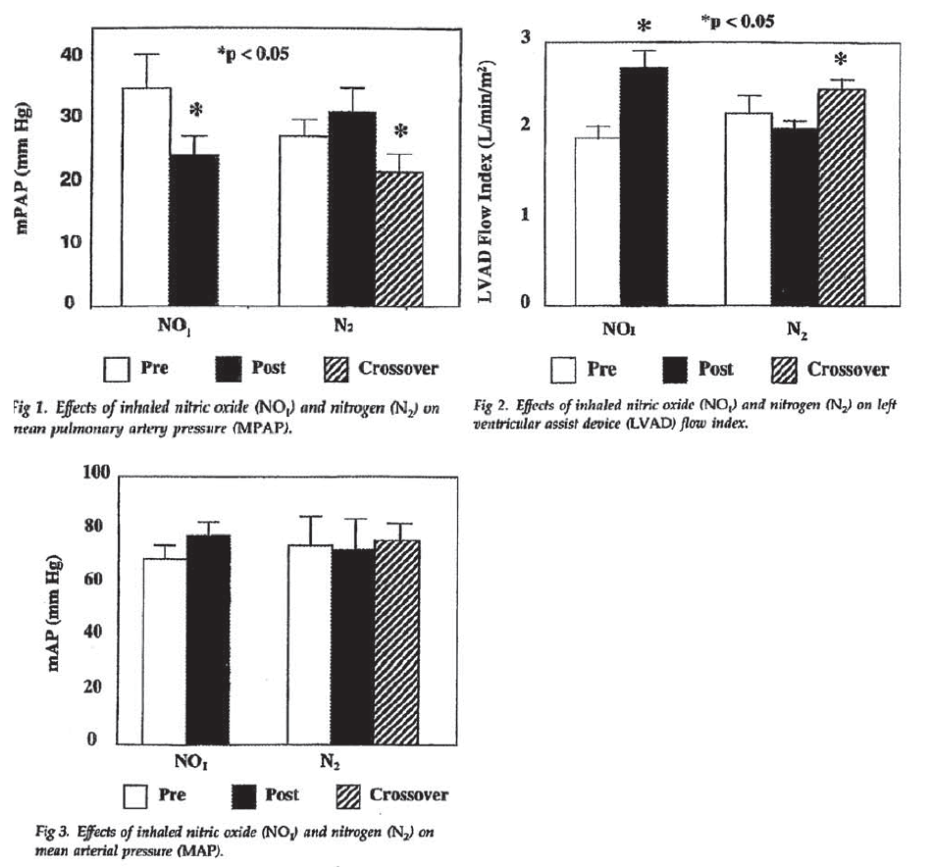
Overall, 11 LVAD recipients with PHT received iNO (either at primary randomisation or after crossover from the N₂ group) and this treatment resulted in significant decreases in MPAP and increases in LVAD flow without significant reduction in SAP as shown below in Table 14.
Table 14: Haemodynamics in patients with LVAD before and after iNO treatment (Argenziano, 1998)
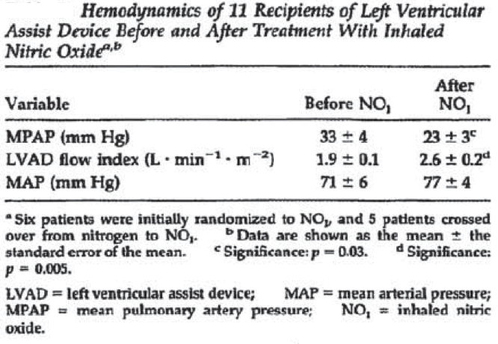
For patients showing a clinical response, iNO was slowly reduced from 20 ppm to 2 ppm and then discontinued; the median duration of iNO support was 24 hours (range 12 hours to 6 days).
No complications were associated with iNO therapy except 1 patient with ventilator malfunction on postoperative Day 2 where abrupt discontinuation of iNO led to haemodynamic collapse and ventricular fibrillation. The patient was resuscitated and received RVAD with iNO support and he underwent transplantation later. There were 2 deaths: 1 on post-operative Day 1 due to intractable haemorrhage in patient with multi-system organ failure; other death on post-operative Day 3 due to brain death in patient with intraoperative CV embolic event.
Comment: Results from this small study showed that in patients receiving LVADs and with PHT, iNO administration results in significant improvements in PAP and right ventricular function without adverse effects (such as systemic hypotension, hypoxia or other AEs). Furthermore, all 11 patients were successfully weaned from iNO in less than a week. Although results were positive, the study cannot be considered as a pivotal study as proposed by the sponsors due to small sample size and risk of bias (as the random sequence generation method or allocation method were not adequately described).

Knothe (1996)

Study design, objectives, patient population
This was a randomised study assessing the effect of iNO, compared with conventional treatment, on haemodynamic parameters in 20 adults (aged 46 to 80 years; 10 men, 10 women) who had moderate PHT (PAP > 25 mmHg) undergoing valve replacement surgery.

Study treatment
10 patients each were randomised to receive either iNO (30 ppm for 20 min starting 10 min after extracorporeal membrane oxygenation was stopped) or conventional treatment.

Efficacy endpoints, statistical analysis
The primary efficacy endpoints were: PAP; PVR; right heart parameters (right ventricular ejection fraction (RVEF), end-diastolic volume, end-systolic volume). Other haemodynamic and oxygenation parameters were secondary endpoints. Parameters were measured before iNO, at 3, 10, and 20 min during iNO, and 10 min after stopping iNO, or at the corresponding time points in the conventional treatment group. Differences between groups were tested using two-factorial, repeated measures ANOVA and Scheff test (when needed). Within-group differences were tested using a t test; p < 0.05 was considered significant.

Study participants, Baseline data
The patient age ranged from 46 to 80 years and weight from 55 to 99 kg. The patients had surgery for atrial valve replacement (n = 11), mitral valve replacement (n = 10), and/or aortocoronary bypass (n = 5). The mean (± SD) PAP before treatment was similar in iNO and conventional groups (29.7 ± 3.9 versus 30.0 ± 4.0 mmHg), but the mean (± SD) PVR before treatment was higher in the iNO compared to the conventional treatment group (169.4 ± 51.9 versus 149.0 ± 41.5 dyn sec⁻¹ cm⁻⁵).

Results
Treatment with iNO for 20 min significantly (p < 0.05) reduced PAP and PVR. Both haemodynamic parameters returned to baseline after iNO was stopped. The PAP and PVR were also reduced in the conventional treatment group, but the changes were not statistically significant. There was no significant difference between the iNO and conventional treatment groups for either PAP or PVR. Oxygenation was not affected by iNO; mean (± SD) PaO₂ fell slightly, but not significantly, from 377.7 ± 60.7 mmHg to a minimum of 317.0 ± 65.9 mmHg, and was not different from PaO₂ in the conventional treatment group (initial: 341.3 ± 118.1 mmHg; minimum: 315.7 ± 132.0 mmHg). NO inhalation does not affect the systemic circulation, according to the results of studies to date. In this study, a significant increase of the SVR from 851.4 ± 389.3 dyn⋅s⋅cm⁻⁵ to an average of 930.6 ± 378.1 dyn⋅s⋅cm⁻⁵ occurred with NO (p < 0.05), followed by another insignificant increase after ending the NO inhalation (957.9 ± 280.1 dyn⋅s⋅cm⁻⁵). In the control group, the SVR values also rose during the comparison period in response to NO inhalation but not significantly. However, the changes in PVR and SVR had no effect on CI, CVP or PCWP. Right heart function (RVEF) did not improve in either group.
Comment: The study had the following limitations and cannot be considered as a pivotal study as proposed by the sponsors:
- Results from this small study (only 20 patients) showed that although iNO reduced PAP and PVR, it did not improve oxygenation or RVEF in patients coming off ECMO after valve replacement surgery
- Risk of bias as the random sequence generation method or allocation method were not adequately described; blinding methods were not adequately described.

Fernandes (2011)

Study design, objectives, patient population
This was a randomised study assessing the effect of iNO, compared with oxygen (control), on haemodynamic parameters and short term clinical outcomes in 29 adults who had severe PHT (systolic PAP > 60 mmHg) and surgery for mitral valve stenosis. The study was conducted at 1 centre in Brazil.
The main inclusion criteria were: Men and women aged > 18 years; mitral stenosis with a valve area < 1.5 cm²; severe pulmonary hypertension, defined as pulmonary artery systolic pressure (PASP) > 60 mmHg; and symptomatic disease with New York Heart Association functional class ≥ II. Main exclusion criteria were: concomitant valvular disease other than mitral stenosis (specifically moderate or important mitral regurgitation as defined by preoperative quantitative echocardiography) or had severe left or right ventricular dysfunction, defined as an ejection fraction < 40% by preoperative echocardiography.

Study treatment
Twenty-nine patients (4 men, 25 women; mean age 46 + 2 years) were randomly allocated to receive iNO (n = 14) or oxygen (n = 15) for 48 hours immediately after surgery. Patients received either iNO (10 ppm, beginning immediately before weaning from CPB) or oxygen only (standard anaesthesia care to maintain oxygen saturation > 95%). Treatment continued for up to 48 h in the ICU or hospital ward.
Central computerised randomization of the treatment assignments was performed. Concealment was interrupted only when the patient was weaned from cardiopulmonary bypass and started to receive the designated therapy.

Efficacy endpoints, statistical analysis
The primary efficacy endpoints were changes in cardiac index and PVR from baseline to 48 h. Secondary efficacy endpoints included Systolic PAP; pulmonary capillary wedge pressure, postoperative complications, total days in ICU, total hospital stay and use of systemic IV vasoactive drugs. Parameters were measured before and 24 and 48 h after the operation. Absolute haemodynamic values were analysed using repeated measures. Analyses of differences and comparisons between group differences were tested using a Student’s t test for continuous variables, Mann-Whitney or chi-square tests for proportions, and Fisher’s exact test as needed. A 2-tailed p <0.05 was considered significant.

Study participants, baseline data
The mean (±SD) age was 48 ± 11 years in the iNO group and 44 ± 13 years in the control group. The patients had substantial mitral valve stenosis (mean ± SD valve area = 0.89 ± 0.04 cm²). Preoperative cardiac index was 2.35 ± 0.6 L and 2.89 ± 0.9 L/min/m² in the iNO and control groups, respectively; Preoperative PVR was 341 ± 183 and 264 ± 133 dyn sec⁻¹ cm⁻⁵, respectively while preoperative systolic PAP was 73 ± 10 and 73 ± 14 mmHg, respectively. Baseline characteristics of the patients did not differ significantly between treatment groups.

Results
The increase from baseline in cardiac index was significantly greater (p < 0.0001) in patients receiving iNO than in those receiving oxygen at both 24 and 48 hours; decrease from baseline in PVR was also significantly greater (p = 0.005) in the iNO group than in the oxygen group, but only at 48 hours. Pulmonary capillary wedge pressure and systolic PAP were significantly reduced in both groups, but the difference between groups was not significant. Patients who received iNO had significantly shorter stays in ICU than patients who received oxygen (2.0 ± 0.25 days versus 3.0 ± 7.0 days, p = 0.02), although total hospital stays were similar between the groups. The mean number of systemic vasoactive drugs used was also smaller in the iNO group than in the oxygen group (2.1 ± 0.14 versus 2.6 ± 0.16, p = 0.046). The percentage of patients with any of the predefined complications was similar in the 2 groups (9 of 15 (60%) in the oxygen group versus 4 of 14 (29%) in the iNO group, p = 0.14)., Furthermore, patients who presented with complications after surgery had significantly smaller change in PVR values compared to patients with no complications at 24 and 48 h; the mean change in PVR in patients with complications was 4 ± 42 dyne/s/cm⁵ compared to 124 ± 34 dyne/s/cm⁵ in patients with no complications at 24 h (p = 0.02) and -31 ± 41 and -98 ± 37 dyne/s/cm⁵, respectively, at 48 hours (p = 0.03).
Comment: Results from this study provided some evidence to support efficacy of treatment with iNO (compared to oxygen only) for increasing cardiac index and decreasing PVR in adult patients with severe PHT undergoing surgery for mitral valve stenosis. However, the study cannot be considered a pivotal study due to the following limitations:
- small number of patients (only 14 patients received iNO)
- dose of iNO was lower than proposed dose; furthermore, no details provided regarding weaning of iNO administration
- blinding of study medication not done in this study
- haemodynamic parameters were measured at 24 to 48 hours in the ICU setting while patients were receiving other vasoactive drugs that may have confounded results.

Other supportive studies

Supportive randomised studies

Dose response study; Solina (2001)
This was a prospective, randomised, controlled, non-blinded study determining the dose responsiveness to iNO in 62 adult cardiac surgery patients with preoperative PHT (defined as PVR > 125 dyn sec⁻¹ cm⁻⁵ immediately before anaesthesia). The main exclusion criteria were: patients with history of preoperative dependence on inotropes or vasopressors, intraoperative use of nitroglycerin (NTG) or sodium nitroprusside, asthma, or pregnancy. The study was conducted at 1 centre in New Jersey, USA.
Patients received one of 4 doses of iNO: Group 1 (n = 11) received 10 ppm, Group 2 (n = 12) received 20 ppm, Group 3 (n = 12) received 30 ppm, and Group 4 (n = 12) received 40 ppm on termination of CPB. NO administration was continued at specified concentration throughout the remainder of the intraoperative period. Group 5 (n = 15) was a control group who received Mil by bolus administration (50 µg/kg) 15 minutes before separation from CPB. Mil was maintained at 0.5 µg/kg/min in the operating room. Table 15 (below) summarises the algorithm used to treat disturbances related to BP, CI, SVR and PVR in the PR and the ICU which ensured a uniform clinical approach to treat all haemodynamic disturbances during the study period.
Table 15: Therapeutic algorithm for haemodynamic disturbances (Solina, 2001)
The primary efficacy endpoint was change in PVR; other haemodynamic parameters were evaluated as secondary endpoints. The haemodynamic data were recorded before anaesthesia (baseline), immediately after CPB, and at chest closure ANOVA in conjunction with Student-Keuls Multiple Comparison Analysis was performed (p-value < 0.05 was considered significant).
The patients (aged 66 to 73 years) had PHT (defined as PVR > 125 dyn sec⁻¹ cm⁻⁵) before cardiac surgery. There were no significant differences in demographic data, baseline haemodynamic data, surgical treatment, conduct of CPB, or the use of inotropic or vasoactive drugs among the five treatment groups. However, valve replacement did occur more frequently in the milrinone and iNO 20 ppm groups (p < 0.001) while patients in the 30 ppm iNO group received significantly less fentanyl than patients in the other groups (p = 0.0008) as shown in Table 16 below. The use of vasoactive drugs in the post-bypass period did not differ significantly between treatment groups.
Table 16: Patient characteristics at baseline (Solina, 2001)
The percent decrease in PVR upon treatment was not significantly different between the groups (10 ppm = 38%, 20 ppm = 50%, 30 ppm = 44%, 40 ppm = 36%, Mil = 58%, p = 0.86). The dose effect was not significant for any of the haemodynamic variables as shown below in Table 17.
Table 17: Haemodynamic variable pre-surgery, post-CPB and at end of cardiac surgery (Solina, 2001)
Comment: The study showed that iNO 10 ppm was effective in significantly reducing PVR in adult cardiac surgery patients. Doses higher than 10 ppm were not associated with greater reduction of PVR.
This study had the following limitations:
- effect on clinical outcomes such as PHT crisis, etc. was not evaluated
- no details on how iNO was withdrawn and no safety results were presented
- the lack of dosing effect could be attributed to poor control of factors that affect pulmonary vascular tone, such as haemodilution and specific anaesthetic dosing; although the choice of anaesthetic drug was dictated in the protocol
- minimum effective dose was not identified in this study.

Fattouch (2005)
This was a prospective, randomised, double blind study investigating the efficacy of inhaled NO, inhaled prostacyclin and IV vasodilators (control group) in the treatment of PHT in 58 patients with mitral stenosis undergoing cardiac surgery with CPB. The study was conducted at 1 centre in Italy and included patients affected by severe mitral valve stenosis and PHT (systolic PAP > 45 mmHg) with high PVR (> 250 dyn/sec/cm⁵) and a mean PAP > 25 mmHg. The main exclusion criteria were: emergency operative status, ejection fraction < 25%, preoperative haematocrit < 38%, thromboembolic disease treated with anticoagulant therapy, patients with peripheral vascular disease, renal failure (creatinine > 2.0 mg/dL), liver dysfunction, patients with coagulopathy and thrombocytopenia.
Patients were randomised to inhaled prostacyclin (10 g/min), iNO 20 ppm, or IV nitroprusside (5 to 15 g/min). Administration started immediately after patient admission in intensive care unit. Drugs were given for consecutive 30 minutes followed by a 15 minute control period (wash out). The following interruption criteria for drug administration were used: (1) severe systemic hypotension (systemic arterial pressure < 90 mmHg and/or fall by more than 25% despite the administration of 15 mL/kg of colloid), (2) severe postoperative mediastinal bleeding (> 300 mL/h), (3) increase of intrapulmonary shunt, and (4) pulmonary oedema.
The primary efficacy endpoints were changes in PAP, PVR, RVEF, and other haemodynamic parameters. Data were analysed using ANOVA in conjunction with Student-Newman-Keuls multiple comparison tests. A p value < 0.05 was considered statistically significant.
The mean age was about 63 years and mean NYHA class ranged from 3 to 3.6. Baseline patient characteristics were not significantly different between groups.
Operative mortality was 1.7% (one patient died due to right ventricular failure). One patient needed biventricular assist device because of right ventricular failure. Two patients had massive bleeding requiring re-exploration. Hospital mortality was 5.1% (two patients died due to multi organ failure and ARDS syndrome). There were no significant changes in HR, MAP, CVP, PCWP, CO, and SVR in patients receiving PGI2 and/or NO. Systolic and MAP decreased significantly in seven patients in nitroprusside group requiring drug interruption. Both drugs improved cardiac indices and RVEF and reduced mean pulmonary arterial pressure, pulmonary vascular resistance and trans pulmonary gradient.
Cardiopulmonary bypass produced an increase in PVR, MPAP, and PCWP in each group. Inhalation of PGI2 reduced significantly PVR (−50%), TPG (−64%), and MPAP (−20%), while PCWP did not change significantly; after inhalation of PGI2, the CO and SV were increased Inhalation of NO reduced significantly PVR (−45%), TPG (−62%), and MPAP (−19%), the CO and SV were not significantly modified. In Group C, the effects of administration of sodium nitroprusside were calculated in 11/18 patients because in other patients treatment was interrupted. The sodium nitroprusside reduced significantly PVR (−45%), SVR (−51%), TPG (−44%), and MPAP (−21%). Haemodynamic changes for the 3 groups are show below in Tables 18 to 20.
Table 18: Haemodynamic changes in the prostacyclin group (Fattouch, 2005)
Table 19: Haemodynamic changes in the iNO group (Fattouch, 2005)
Table 20: Haemodynamic changes in the nitroprusside group (Fattouch, 2005)
Comment: Inhaled prostacyclin and nitric oxide were effective in the treatment of postoperative pulmonary hypertension in patients with mitral valve stenosis undergoing mitral valve surgery. Both drugs improved cardiac indices and RVEF and reduced mean pulmonary arterial pressure, pulmonary vascular resistance and trans pulmonary gradient and may be useful in patients with acute right ventricular failure following cardiac surgery. In comparison to nitric oxide, inhaled prostacyclin is free from toxic side effects and is easier to administer. IV nitroprusside does not appear to be an effective option as administration was interrupted in 62% patients due to occurrence of systemic hypotension. Overall, this study provided more evidence to support use of inhaled prostacyclin rather than the proposed iNO.

Fattouch (2006)
This was a prospective, randomised, double blind study investigating the efficacy of inhaled NO, inhaled prostacyclin and IV vasodilators (control group) in the treatment of PHT in 58 patients with mitral stenosis undergoing cardiac surgery with CPB. The study appears to be identical to the one described above by the same authors. Patients were randomised to inhaled prostacyclin (10 g/min), iNO 20 ppm, or IV vasodilator (dose not specified); however, earlier publication by same authors clearly states that the IV vasodilator used was IV nitroprusside.
Haemodynamic results were already discussed in publication above. However, this abstract also provided some additional results: patients in the inhaled drug groups were weaned more easily from CPB (p = 0.04), and they had a shorter intubation time (p = 0.03) and a shorter stay in ICU (p = 0.02) compared to the control group patients although details were not provided.
Comment: Only 1-page abstract was provided for this reference. Furthermore, this appears to be identical to the Fattouch, 2005 study described above although the abstract was lacking in details. Overall, this publication did not provide any additional information.

Solina (2000)
This was a prospective, randomised, non-blinded study investigating the efficacy of IV Mil, iNO 20 ppm, or iNO 40 ppm in three parallel groups of patients (n = 15 each) undergoing cardiac surgery (with CPB) with PVR > 125 dyn sec cm⁻⁵ immediately before induction of anaesthesia. The main exclusion criteria were: history of preoperative dependence on inotropes or vasopressors, asthma and pregnancy. The study was performed at 1 centre in New Jersey, USA.
Patients were randomised to one of 3 groups: IV Mil initiated by bolus of 50 µg/kg/min followed by continuous infusion of 0.5 µg/kg/min on separation from CPB; iNO 20 ppm; or iNO 40 ppm on termination of CPB. A haemodynamic goal and a therapeutic algorithm (shown below in Table 21) were used and the disparity in amount of vasoactive drug required would presumably be a reflection of the difference in haemodynamic effects of the different treatments. Haemodynamic parameters were recorded through the operating procedure up to the arrival in the ICU. Data were analysed using ANOVA in conjunction with Student-Newman-Keuls multiple comparison tests. A p value < 0.05 was considered significant.
Table 21: Treatment algorithm (Solina, 2000)
The mean age was 66, 73 and 62 years in the Mil, iNO 20 ppm and iNO 40 ppm groups, respectively. The three groups did not differ with regard to NYHA class, CPB, surgical or anaesthesia treatment and baseline haemodynamics did not differ among the three groups.
After the administration of anaesthesia (post-heparin time point), the mean PAP and PVR were statistically higher in the iNO 20 ppm group than in the other groups. After initiation of treatment (iNO or Mil), there were no differences in PVR, SVR or cardiac index among the three groups at any time point. The group receiving Mil tended to have a higher heart rate (not significant). On arrival in the ICU, the iNO 20 ppm group had a statistically higher mean arterial pressure than the other two groups, and the iNO 40 ppm group had a statistically higher RVEF than the other two groups (40% versus 30% for the Mil group and 33% for the iNO 20 ppm group; p < 0.05) as shown in Table 22 below. In the ICU, the Mil group required significantly more phenylephrine than either of the NO groups (0.3 plus 0.7 µg/kg/min versus 0.1 plus 0.1 µg/kg/min for each iNO group, p = 0.01) as shown in Table 23 below.
Table 22: Haemodynamic data (Solina, 2000)
Table 23 Doses (mean) of inotropes/pressors used post-bypass and in the ICU in µg/kg/min (Solina, 2000)
Comment: Inhaled NO administered during the early postoperative period in cardiac surgery patients with PHT was associated with a favourable effect on RVEF and a reduced requirement for treatment with pressor agent when compared with Mil treatment. The requirement of a pressor agent support is usually an indication of haemodynamic instability and use of pressor agents is also associated with increased morbidity in terms of compromised organ perfusion, arrhythmias and pulmonary vasoconstriction. However, clinical outcomes (PHT crises, morbidity and mortality) were not evaluated in this study.

Winterhalter (2008)
This was a prospective, randomised, parallel group study performed to compare inhaled iloprost and iNO in 46 patients with PHT during weaning from CPB in cardiac surgery. The study included patients who presented with PHT (mean PAP > 26 mmHg) preoperatively at rest or after anaesthesia induction or at the end of CPB. Patients undergoing heart or lung transplantation or receiving left ventricular assist device support were excluded. The study was conducted at a single centre in Germany.
Patients were randomised (by computer-generated random code) to either iNO 20 ppm or inhaled iloprost (20 µg in 2 mL of NaCl) immediately after the end of CPB, before heparin reversal; this was in addition to standard institutional treatment for right-heart dysfunction during weaning from CPB.
The primary efficacy endpoint was PAP. Other haemodynamic and oxygenation parameters were secondary endpoints. Groups were compared by using chi-square test for qualitative data and 2 tailed unpaired t-test or Mann-Whitney U test for quantitative data.
The mean age was 68 to 69 years and baseline patient characteristics did now show significant difference between groups.
Both therapies caused significant reductions in mean PAP and PVR, as well as significant increases in cardiac output 30 minutes after administration (p < 0.0001). The effects were still detectable 90 min after iloprost inhalation or after the start of iNO therapy. A direct comparison at 30 min showed a greater reduction in PVR and PAP with iloprost compared to iNO (p = 0.013 and p = 0.0006, respectively). The increase in PaO₂ was greater following therapy with iNO (from 310 ± 118 mmHg at baseline to 356 ± 123 mmHg after 30 min) compared to iloprost (337 ± 89 mmHg to 310 ± 75 mmHg at the same time points), but the difference did not reach significance. In contrast to iNO, inhaled iloprost caused a significant increase in heart rate and significant reduction in SVR, demonstrating a less selective pulmonary effect as shown below in Table 24. Systemic blood pressure data are not reported in the publication. No major side effects were observed during the study period. Furthermore, the vasoactive support used for weaning from CPB was comparable between the iNO and iloprost groups.
Table 24: Haemodynamic and pulmonary data (Winterhalter, 2008)
Comment: Inhaled iloprost and iNO both reduced PHT in patients undergoing cardiac surgery after weaning of CPB. Iloprost was found to induce a greater decrease in PVR and PAP and a greater increase in cardiac output, whereas iNO improved SaO₂ to a greater extent. Both therapies were well tolerated with no significant side effects.
Limitations:
- Systemic blood pressure was not reported in this study
- Effects on clinical outcomes were not evaluated.

Rajek (2000)
This was a prospective, randomised, double blind study investigating the efficacy of inhaled NO compared to inhaled prostaglandin E1 (PGE1) in the treatment of PHT in 68 patients undergoing orthoptic heart transplant surgery.
Patients were randomised to PGE1 infusion at a rate of 8 ng/kg/min starting 10 min before weaning from CPB or iNO starting at 4 ppm. Both treatments were increased stepwise (up to 24 ng/kg/min PGE1 and 24 ppm iNO), if necessary, and were stopped 6 h postoperatively. The study protocol specified that the PGE1 and iNO dose would be increased as required to maintain mean PAP < 25 mmHg. Patients were switched to the alternative study drug when PAP was consistently elevated at the highest permitted dose and weaning from CPB difficult because of right heart ventricular failure. Isoproterenol was administered to all patients to achieve a heart rate between 100 and 120 bpm and to improve cardiac output. The infusion was started 10 min before weaning from CPB, at a dose of 0.02 mg /kg/min. Continuous infusions of norepinephrine or epinephrine were also given as required to maintain mean arterial pressure > 65 mmHg.
The primary efficacy endpoints were changes in haemodynamic parameters recorded after induction of anaesthesia, 10 and 30 min after weaning from CPB, and 1 h and 6 h postoperatively. Data were analysed using ANOVA in conjunction with Student-Newman-Keuls multiple comparison tests. A p value < 0.05 was considered statistically significant.
The mean age was 54 to 55 years and patients’ characteristics were not statistically different between the PGE1 and iNO groups. All but 2 patients had congestive heart failure resulting from ischemic cardiomyopathy or dilated idiopathic cardiomyopathy.
Immediately after weaning from CPB, PVR was nearly halved in the iNO group but only reduced by 10% in the PGE1 group Pulmonary artery pressure was decreased approximately 30% during iNO, but only approximately 16% during PGE1 infusion. However at 6 hours after surgery, PVR and PAP were similar in the two groups.
The administration of PGE1 increased the ratio of pulmonary to systemic resistance by approximately 30%, while this ratio was reduced by approximately 20% in patients in the iNO group. Haemodynamic changes from induction to 6 hours post-surgery are shown below in Figure 16.
After transplantation, cardiac output, heart rate, mean SAP, right atrial pressure, and pulmonary wedge pressure did not differ between the groups as shown below in Table 25.
Figure 16: Haemodynamic changes from induction to 6 hours post-surgery (Rajek, 2000)
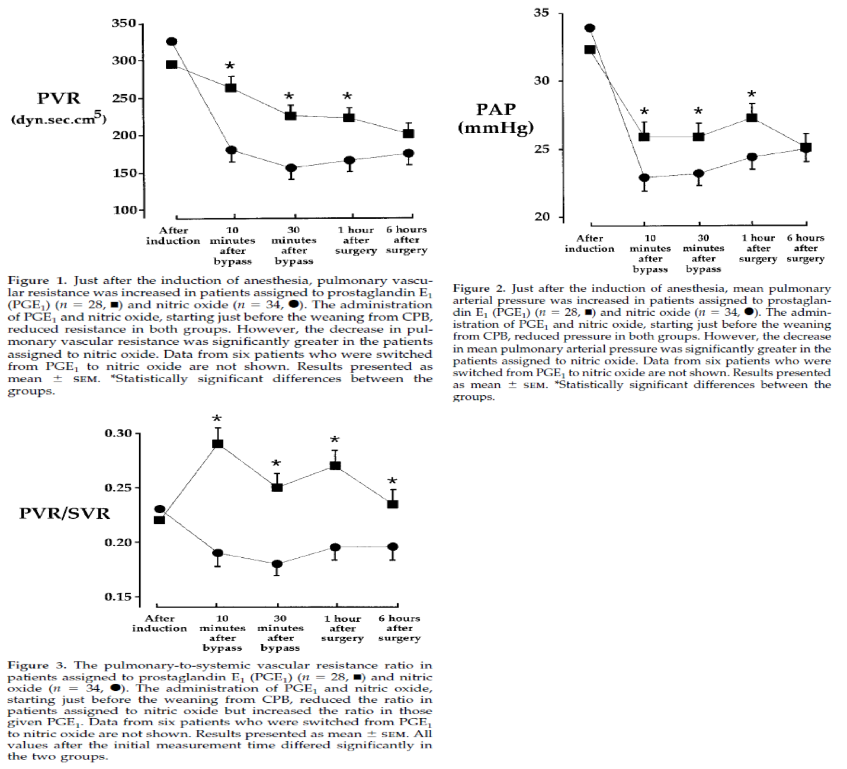
Table 25: Haemodynamic responses pre- and post-surgery (Rajek, 2000)
Weaning from CPB was successful in all patients assigned to iNO; in contrast, high PVR and RVF precluded weaning from CPB in six patients assigned to PGE1. In contrast to all the other patients, cardiac output in switched patients did not increase immediately after heart transplantation. Consequently, PVR remained high after heart transplantation, although the values gradually decreased. Six hours after surgery, there was no difference in PVR between switched patients and the remaining patients in either study group as shown below in Table 26. After the weaning from CPB, the switched patients required significantly more inotropic support than those who were able to continue with PGE1.
Table 26: Haemodynamic responses in patients switched from PGE1 to iNO (Rajek, 2000)
Most patients in this study were weaned from NO inhalation after 6 h postoperatively. However, in 7 patients, attempts to terminate NO therapy abruptly increased PVR and reduced mixed-venous oxygen saturation and cardiac output. The concentration of inhaled NO in these patients was thus gradually reduced over a maximum of 48 h.
None of the patients died within 3 days of transplantation. Two patients from the iNO group and one patient who was given PGE1, developed systemic infections and died within the first month.
Comment: This study provided evidence that iNO selectively reduced PVR and PAP when administered immediately after heart transplantation. The reduction was more pronounced than with PGE1 infusion and was not accompanied by a decrease in SVR. Furthermore, iNO may also facilitate weaning from CPB in patients undergoing heart transplantation. However, there was no long term follow-up and clinical outcomes were not evaluated.

Schmid (1999)
This was a prospective, randomised, crossover study to determine whether iNO 40 ppm is superior to IV PGE1 0.1 µg/kg/min and NTG 3 to 5 µg/kg/min in 14 adults with severe PHT after cardiac surgery. The study included adult cardiac surgery patients with preoperative PHT and persistence of PHT after cardiac surgery (defined as PAP ≥ 30 mmHg and/or PVR ≥ 300 dyn sec⁻¹ cm⁻⁵), with stable postoperative circulatory conditions. Patients with mechanical circulatory assistance or with echocardiographic evidence of significant pulmonary or tricuspid valve regurgitation were excluded. The study was conducted at 1 centre in Zurich, Switzerland.
The study started within 24 hours after surgery. Patients received sequential treatment: iNO 40ppm, PGE1 0.1 µg/kg/min, and NTG 3 to 5 µg/kg/min. Inhaled NO, PGE1 and NTG were administered in randomised sequences for 20 minutes, with a 20-minute wash-out period before the next randomised treatment. After study completion, the patients continued with PGE1 administration.
The age of patients ranged from 25 to 76 years and most of patients underwent mitral valve repair or replacement and had postoperative PHT. All 3 vasodilators induced significant reductions in PAP and PVR. Unlike PGE1 and NTG, inhaled NO did not induce any significant change in SAP or SVR. Serious hypotension occurred with NTG in 3 patients and with PGE1 in 2 patients. Inhaled NO and PGE1 led to a significant increase in cardiac index. RVEF increased with PGE1, but was unaltered with iNO and NTG. No significant differences were found when the degree of change in cardiac index and RVEF from baseline was compared between vasodilators. Intrapulmonary shunt fraction (Qs:Qt) and PaO₂:FiO₂ ratio did not change significantly with iNO. In contrast, PGE1 and NTG induced an increase in Qs:Qt and a decrease in PaO₂:FiO₂, but the changes were not significant when compared with iNO. With iNO, NO₂ levels of 2.4 (1.8; 4.2) ppm were detected at FiO₂ values of 0.35 to 0.70. Median metHb levels significantly increased from 0.64% to 1.06% with iNO. With NTG and PGE1, metHb was significantly lower than with iNO (p < 0.05), and the change from baseline was not significant. After study completion, PGE1 administration was continued, as planned in the protocol, with favourable outcomes. In hospital outcome was favourable in all patients and all were discharged in good condition. Long-term follow-up revealed 12 survivors (2 deaths were after 3 and 9 months due to gastric cancer and unknown cause, respectively).
Comment: Results from this small, crossover study showed that all 3 vasodilators (iNO, PGE1 and NTG) were of similar efficacy in reducing PVR and PAP, but only iNO had pulmonary selectivity. Inhaled NO was not superior to PGE1 with regard to cardiac index and right ventricular performance.
However, interpretation was limited due to the following:
- small number of patients
- crossover study design especially as in 4 patients the effects induced by iNO, PGE1 and NTG were not fully reversible after drug withdrawal even after waiting for up to 60mins
- lack of evaluation of any clinical outcomes.

Khan (2009)
This was a prospective, randomised, crossover, pilot study comparing iNO and inhaled prostacyclin in 25 adult heart transplant and lung transplant recipients. Patients who presented with PHT (mean PAP > 25 mmHg) and/or right ventricular dysfunction (central venous pressure > 12 mmHg) and/or hypoxemia (PaO₂:FiO₂ < 150) after heart or lung transplant were to be included.
Patients were randomised to either inhaled NO (20 ppm) or prostacyclin (20,000 ng/ml) for 6 hours. Then the randomised agent was stopped for 30 minutes (washout) and the crossover agent was started for another 30 minutes. Eventually, the patient was possibly switched to the initial agent again, depending on the clinician’s decision.
The primary efficacy endpoint was mean PAP; secondary endpoints included central venous pressure, cardiac index, venous oxygen saturation, mean SAP, oxygenation index. Changes in haemodynamic and oxygenation parameters were analysed using paired t tests. Significance level: 0.05 with power of 90%.
The patients, aged 59 ± 2 years (20 males; 5 females), underwent heart (n = 6) or lung (n = 19) transplant. In heart transplant patients, the decision to institute pulmonary vasodilator therapy was made at weaning of CPB. In lung transplant patients, the decision was made at the time of clamping the pulmonary artery intra-operatively or anytime thereafter.
Both iNO and PGE1 significantly improved haemodynamic parameters, at initiation (i.e., as measured after 30 minutes) and after 6 hours of treatment. PAP and central venous pressure were reduced to a similar extent. The therapies also increased cardiac index and improved venous oxygen saturation with no significant reduction in systemic arterial blood pressures. No significant difference was observed between groups for any of the parameters studied as shown below in Table 27. In this study, prostacyclin did not result in a decrease in systemic blood pressure.
Table 27: Initial response to NO and PGI2 (Khan, 2009)
The 30 day survival of this cohort was 100% and the median ICU stay was 3 days. None of the 25 patients who completed the study required re-exploration due to bleeding. Furthermore, none of the heart transplant patients required therapy for PHT or RV dysfunction (i.e., insertion of intra-aortic balloon pump, opening of chest or insertion of RV assist device). There were no complications related to PGI2 (systemic hypotension, flushing, nonsurgical bleeding) or to iNO (methaemoglobinemia).
Comment: Inhaled NO and prostacyclin provided equivalent reductions in PAP and similar improvements in other haemodynamic parameters in patients presenting with PHT, right ventricular dysfunction, or hypoxemia after heart or lung transplant. Both therapies were well tolerated. However, interpretation from this study was limited by the following:
- Small pilot study
- crossover design with risk of rebound PHT in washout period. Although all patients showed increase in PAP during washout period, none became haemodynamically unstable. Furthermore, crossover was performed 6 hours after starting inhaled pulmonary vasodilator therapy, as it was not safe to do crossover at 30 minutes postoperatively
- lack of improvement in oxygenation, although a larger number of patients with hypoxemia may have shown effects (only 5 of 25 patients had PaO₂/FiO₂ ratio at crossover of < 150)
- findings only applicable to heart and lung transplant patients with moderate PHT in early post-operative periods.

Matamis (2012)
This was a prospective, randomised study comparing iNO and oral sildenafil, alone or in combination, in 20 adult cardiac surgery patients with postoperative, out of proportion PHT. The study included patients who presented with out of proportion PHT (mean PAP > 25 mmHg and TPG > 12 mmHg) after surgery for valve replacement. Patients were randomised to either iNO (10 ppm) for 90 min, with oral sildenafil (100 mg) administered after 30 min, or sildenafil followed 60min later by iNO for 30 min. The primary efficacy endpoints included haemodynamic (PAP, PVRI, SAP, SVRI, cardiac index) and oxygenation (PaO₂:FiO₂ ratio, mixed venous oxygen saturation) parameters. Differences within and between groups were compared using repeated measures ANOVA or Friedman’s test (for nonparametric variables); p < 0.05 was considered significant.
The patients, aged 65 ± 6 years (11 males; 9 females), underwent aortic valve replacement (n = 6), mitral valve replacement (n = 4), aortic valve replacement and coronary artery bypass grafting (n = 4), mitral valve replacement and coronary artery bypass grafting (n = 4), and aortic valve replacement and mitral valve replacement (n = 2).
Table 28: Haemodynamic and oxygenation parameters (Matamis, 2012)
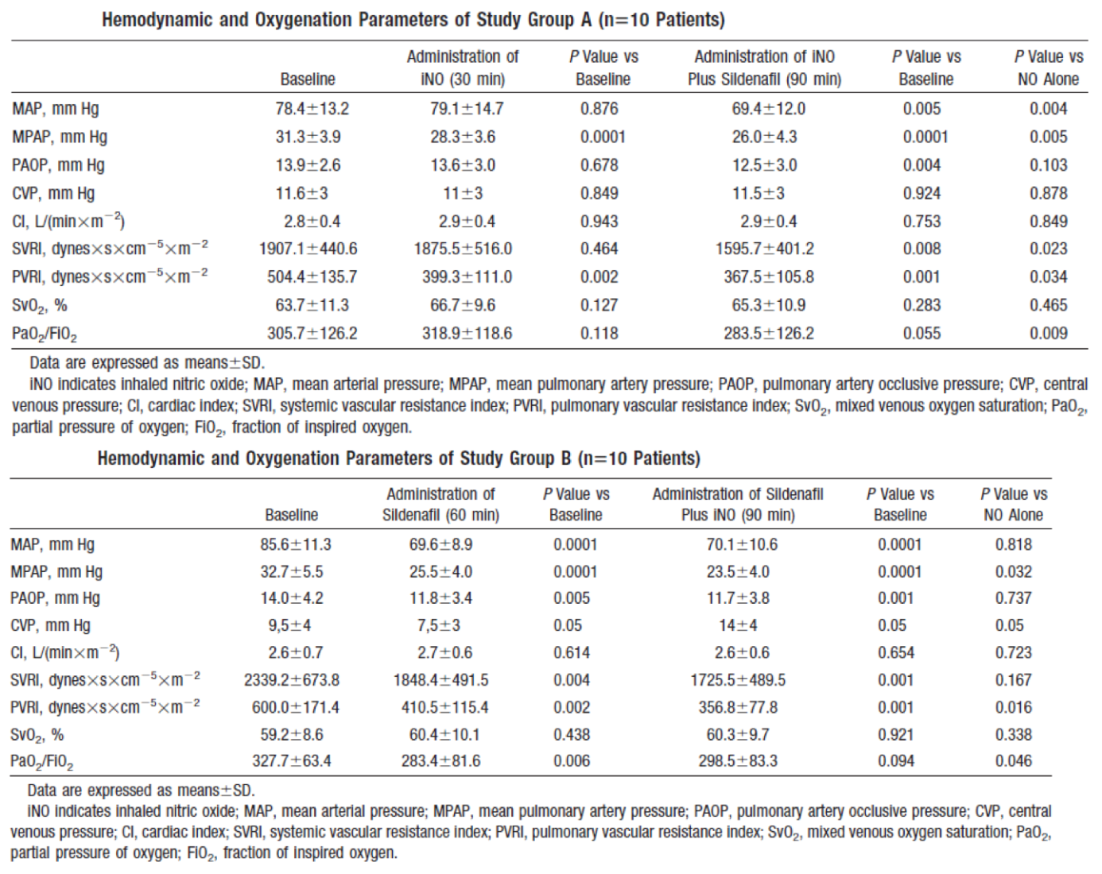
Administration of iNO alone resulted in significant decreases in mean PAP (by 9.6%; p = 0.0001) and PVRI (by 20.8%; p = 0.002), without any significant change in SAP or SVRI. Administration of sildenafil alone resulted in significant decreases in mean PAP (by 22.0%; p = 0.0001) and PVRI (by 31.6%; p = 0.002), as well as decreases in SAP (by 18.7%; p = 0.0001) and SVRI (by 21.3%; p = 0.004). Sildenafil alone also decreased the PaO₂:FiO₂ ratio (14%; p = 0.006), whereas iNO alone did not change the PaO₂:FiO₂ ratio. Addition of sildenafil to iNO significantly decreased SAP (p = 0.004) and SVRI (p = 0.023). In contrast, addition of iNO to sildenafil did not result in further decreases in SAP or SVRI; however, iNO did reverse the decrease in PaO₂:FiO₂ ratio elicited by sildenafil as shown in Table 28 above. Regardless of the order of administration, the combination of iNO and sildenafil significantly decreased PAP and PVRI to a greater extent than either treatment alone. Cardiac index was not significantly changed by any treatment.
Comment: In patients with postoperative, out-of-proportion PHT (mean PAP > 25 mmHg and TPG > 12 mmHg), inhaled NO significantly decreased PAP and PVRI, without changes in systemic haemodynamics or oxygenation. In contrast, sildenafil decreased both pulmonary and systemic pressure and resistance, as well as oxygenation. The combination of iNO and sildenafil resulted in a greater decrease in PAP and PVRI than either treatment alone, without significant effects on the systemic circulation.
However, interpretation was limited due to the following:
- crossover design of study which used a combination of 2 drugs acting on the NO-cGMP signalling pathway
- short term duration of study protocol- only 90mins
- small number of patients.

Other supportive non-randomised studies
Five non-randomised, uncontrolled studies were also submitted for clinical evaluation to provide supportive evidence for proposed indication of treatment of perioperative PHT in adult patients. Interpretation of results from these studies was limited by small sample size, lack of control groups, poor study design and inconsistent efficacy endpoints.

Analyses performed across trials (pooled analyses and meta-analyses)
None.

Evaluator’s conclusions on clinical efficacy for treatment of peri-operative PHT in adult patients
There were 12 main published studies submitted to provide evidence of efficacy of iNO for the proposed indication in adult patients after various cardiac surgeries. The definition of PHT based on PVR and/or mean PAP differed among the studies. In most studies, the patients had postoperative severe PHT, defined as mean PAP ≥ 30 mmHg and/or PVR ≥ 300 dyn sec⁻¹ cm⁻⁵ (Schmid 1999), mean PAP ≥ 25 mmHg (Argenziano 1998; Knothe 1996; Winterhalter 2008; Khan 2009; Matamis 2012), systolic PAP > 60 mmHg (Fernandes 2011), and PVR > 250 dyn sec ¹ cm⁻⁵ with accompanying systolic PAP > 45 mmHg or mean PAP > 25 mmHg (Fattouch 2006). In the Solina (2000, 2001) studies, the patients had preoperative PHT (defined as PVR > 125 dyn sec⁻¹ cm⁻⁵). In the majority of studies, the diagnosis of PHT was made preoperatively as an inclusion criterion (Solina 2000, Solina 2001, Knothe 1996, Fernandes 2011, Schmid 1999, Fattouch 2005, Fattouch 2006, Winterhalter 2008; Matamis 2012). The presence of postoperative PHT was confirmed in the immediate postoperative period in the Winterhalter (2008) study. In the Argenziano (1998) study, PHT was documented in patients after LVAD insertion, and in the Khan (2009) study, after heart or lung transplantation. The type of surgery with CPB differed among the studies. The haemodynamic effect of iNO was documented in patients after cardiac surgery, including arterial grafts, venous grafts, and valve repair / replacement (Solina 2001, Solina 2000, Knothe 1996, Fernandes 2011, Fattouch 2006, Fattouch 2005, Winterhalter 2008, Schmid 1999; Matamis 2012), after LVAD insertion (Argenziano 1998), or after heart or lung transplantation (Rajek 2000, Khan 2009).
The selected main studies were randomised and controlled versus inhaled N₂ (Argenziano 1998), conventional treatment (Knothe 1996), oxygen (Fernandes 2011), IV Mil (Solina 2000), IV PGE1 (Schmid 1999; Rajek 2000), IV nitroprusside or NTG (Schmid 1999; Fattouch 2005; Fattouch 2006), inhaled iloprost (Winterhalter 2008; Khan 2009), inhaled prostacyclin (Fattouch 2005; Fattouch 2006), or oral sildenafil (Matamis 2012). One study (Solina 2001) compared different doses of iNO with Mil. The heterogeneity of the control groups in these studies precludes direct comparison. The premedication and ventilation provided to the patients throughout the perioperative period and before randomisation seemed to be similar between groups in all the studies.
In adults, inhaled NO doses ranged from 4 to 40 ppm. In most of the studies, the dose of iNO was 20 ppm. The timing of administration in cardiac surgery patients in most studies was at weaning from CPB. The duration of administration ranged from 15 to 20 minutes in acute haemodynamic studies to several hours (up to the arrival in the ICU or later). The doses of iNO used in the included publications support the recommended dosage of 2 to 20 ppm. In adults, the dose may be increased up to 40 ppm if the lower dose has not provided sufficient clinical effects.
The endpoints were similar in each study, including haemodynamic (changes from baseline in PAP, SAP, cardiac index), vascular parameters (changes from baseline in PVR), and right ventricular performance (RVEF) in most of the studies. The statistical methods used were different between trials. In some trials, the analysis was only descriptive, while in other trials between-groups statistical tests were performed.
The sponsors designated 3 out of the 12 published studies as pivotal (Argenziano, 1998; Knothe, 1996 and Fernandes, 2011), but the evaluator did not consider these studies as pivotal due to limitations which have been described above. The heterogeneity in terms of inclusion criteria, controls used, endpoints, and the limited sample size in these studies does not allow a global analysis of the data. Furthermore, the methods used to collect haemodynamic and vascular parameters were not always described, and different methods (pulmonary arterial catheters or echocardiography) may have affected the results obtained. However, the main efficacy results obtained are summarised below.

Pulmonary arterial pressure
In the studies that reported changes in PAP (Argenziano 1998; Knothe 1996; Fernandes 2011; Fattouch 2005; Fattouch 2006; Solina 2000; Winterhalter 2008; Rajek 2000; Schmid 1999; Khan 2009; Matamis 2012), iNO was effective in reducing PAP by approximately 15% to 40% in adult patients with PHT after cardiac surgery. Treatment with iNO appeared to be more effective at reducing PAP than N₂ (in patients undergoing LVAD insertion), nitroprusside, and NTG, and at least as effective as conventional therapy, oxygen, Mil, prostacyclin, PGE1, and sildenafil. In all these studies, only iNO selectively dilated the pulmonary vasculature; the other active comparators also dilated the systemic vasculature, reducing SAP. The only active comparator reported to be more effective than iNO in reducing PAP was iloprost (Winterhalter 2008). Although SAP was reduced by both agents in this study, iNO had greater pulmonary selectivity than iloprost.

Vascular resistance
In the studies that reported changes in vascular resistance (Solina 2001; Knothe 1996; Fernandes 2011; Fattouch 2005; Fattouch 2006; Solina 2000; Winterhalter 2008; Rajek 2000; Schmid 1999; Matamis 2012), iNO reduced the PVR by approximately 35% to 65% and had no significant effect on SVR (where reported) in adult patients with PHT after cardiac surgery. Treatment with iNO appeared to be more effective at reducing PVR than oxygen, nitroprusside, and NTG, at least as effective as PGE1 and sildenafil, and equally effective as Mil and conventional treatment. The only active comparator reported to be more effective than iNO in reducing PVR was iloprost (Winterhalter 2008); however, iloprost also significantly reduced SVR, whereas iNO did not. In all these studies, only iNO selectively reduced pulmonary resistance; the other active comparators also reduced systemic resistance.

Cardiac function
All the studies reported changes in at least one cardiac function parameter, that is, cardiac index, cardiac output, RVEF, and/or LVAD flow index (Solina 2001; Argenziano 1998; Knothe 1996; Fernandes 2011; Fattouch 2005; Fattouch 2006; Solina 2000; Winterhalter 2008; Rajek 2000; Schmid 1999; Khan 2009; Matamis 2012). In all studies, iNO treatment maintained or improved cardiac function. In most studies, the effects of iNO on cardiac function were not significantly different from those of the comparator treatments. However, the increase in cardiac index after iNO was significantly greater than after oxygen (Fernandes 2011), and the increase in LVAD flow index after iNO was greater than after N₂ (Argenziano 1998). In contrast, the increase in cardiac output after iNO was significantly lower than after iloprost (Winterhalter 2008).
Overall, the efficacy of iNO was assessed in 12 randomised, controlled published studies involving 398 adults presenting with PHT after or immediately before cardiac surgery. All the studies showed consistent evidence of the efficacy of iNO in postoperative PHT and also demonstrated its pulmonary selectivity. The efficacy of iNO in this indication is largely recognized in the medical community. The other nonrandomised studies submitted did not provide additional evidence for efficacy of iNO in adults.
However, interpretation of evidence to support proposed indication of iNO for treatment of perioperative PHT in adult patients was limited by the following:
- lack of any large, controlled randomised studies by the sponsors;
- heterogeneity of submitted published studies (in terms of inclusion criteria, controls used, endpoints, and the limited sample size); and
- effect on clinical outcomes including morbidity and mortality was not adequately evaluated.

Clinical safety

Studies providing evaluable safety data
The following studies provided evaluable safety data:
- Clinical studies sponsored by Air Liquide Santé International (ALSI); only 1 study was conducted for proposed indication (in children only); other 3 studies were for other indications.
- Safety data from publications on the use of iNO in the treatment of perioperative PHT in adult and paediatric patients.
- Post-marketing data of Kinox and VasoKINOX: Prescription tracking and drug safety monitoring in the context of a compassionate use program (referred to as Temporary Authorisation for Use (TAU)) of Kinox in France from 1996 to 2001 and cumulative safety data from periodic safety update reports (PSURs) of Nitric Oxide Air Liquide since January 2002.

Pivotal efficacy studies
In the pivotal efficacy studies, the safety of iNO was assessed by haemodynamic parameters, laboratory tests, methaemoglobin levels and adverse event reporting.

Pivotal studies that assessed safety as a primary outcome
None.

Dose response and non-pivotal efficacy studies
All published studies.

Other studies evaluable for safety only
Three studies conducted by the sponsor for other indications.
Comment: Since this submission is predominantly based on published literature references with very few studies conducted by the sponsors, the safety section of this evaluation report has been discussed under the following headings: safety results from studies conducted by sponsors; and safety results from published studies.

Safety results from studies conducted by sponsors

Pivotal studies
In the pivotal study conducted by the sponsors (ALS-1-97-P-301), the study treatment was administered until the occurrence of the first pulmonary hypertensive episode of sufficient severity to require treatment or until extubation. The specific duration of treatment was not reported.
The percentage of patients alive at 48 hours without PHT was not significantly different between the two groups (p = 0.7). The frequency of PHT was 12.3% in the iNO group versus 12.4% in the N₂ group. The mean duration of inhalation, duration of intubation, and duration of stay in ICU were significantly shorter in the N₂ group than in the iNO group (p < 0.04).
The safety evaluation focussed on deaths and other serious AEs (SAEs). A total of 9 deaths occurred during the study, including 4 within the first 48 hours; and 5 during the observation period (up to 30 days). Among those 9 deaths, 3 occurred in the iNO group and 6 in the N₂ group. None of the reported deaths were considered related to the study drugs.
A total of 19 SAEs without fatal outcome occurred during the study, including 9 during the study period (within 48 hours after the start of study in the left-to-right shunt lesion group and within 96 hours in the obstructed pulmonary venous return group) and 10 during the observation period. One SAE (PHT at the end of iNO administration (life threatening rebound)) was reported 49 hours after the start of the study and was considered as possibly related to the study drug.
MetHb levels were monitored after 30 minutes, 3, 6, 12, and 24 hours, and every 12 hours thereafter. A significant increase in metHb with time was observed, but there was no significant difference between the two groups. No significant differences between the two groups were observed in any of the haemodynamic and blood gas parameters. Data for these variables are shown in Table 29 below.
Table 29: MetHb, haemodynamic and blood gas parameters, Study ALS-1-97-P-301
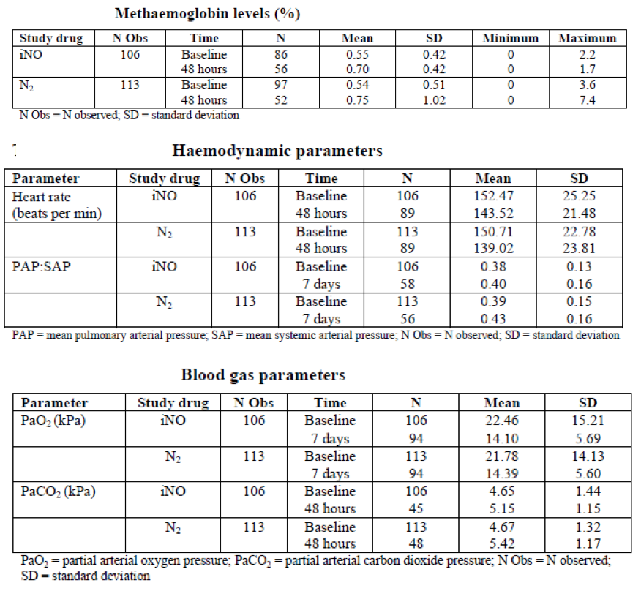

Other studies
Three other studies were conducted by the sponsors for indications other than the proposed perioperative PHT:
- Mercier, Air Liquide Santé Study CT04009, in 192 newborns with hypoxic respiratory failure.
- Payen, Air Liquide Santé Study ALS-94 30, in 203 adults with acute respiratory distress syndrome.
- Hervé, Air Liquide Santé Study ALS-1-98-A-301, for the prevention of pulmonary oedema after pulmonary thromboendarterectomy for chronic cor pulmonale in 57 adults.
The main characteristics and safety results of these 3 studies are summarised in Table 30 below.
Table 30: Summary of sponsor-led studies for indications other than that of the submission
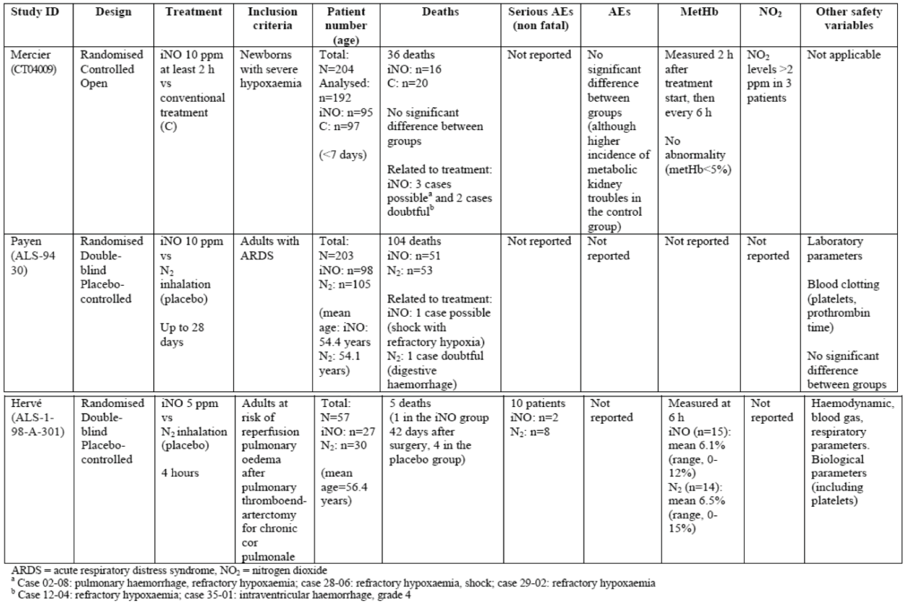
In the Study CT04009 (Mercier) involving 192 newborns with hypoxic respiratory failure (iNO = 95, control = 97), there was no significant difference in the number of deaths or AEs between the iNO group and the conventional treatment control group as shown in Table 31 below.
Table 31: Summary of adverse events and complications, Study CT04009
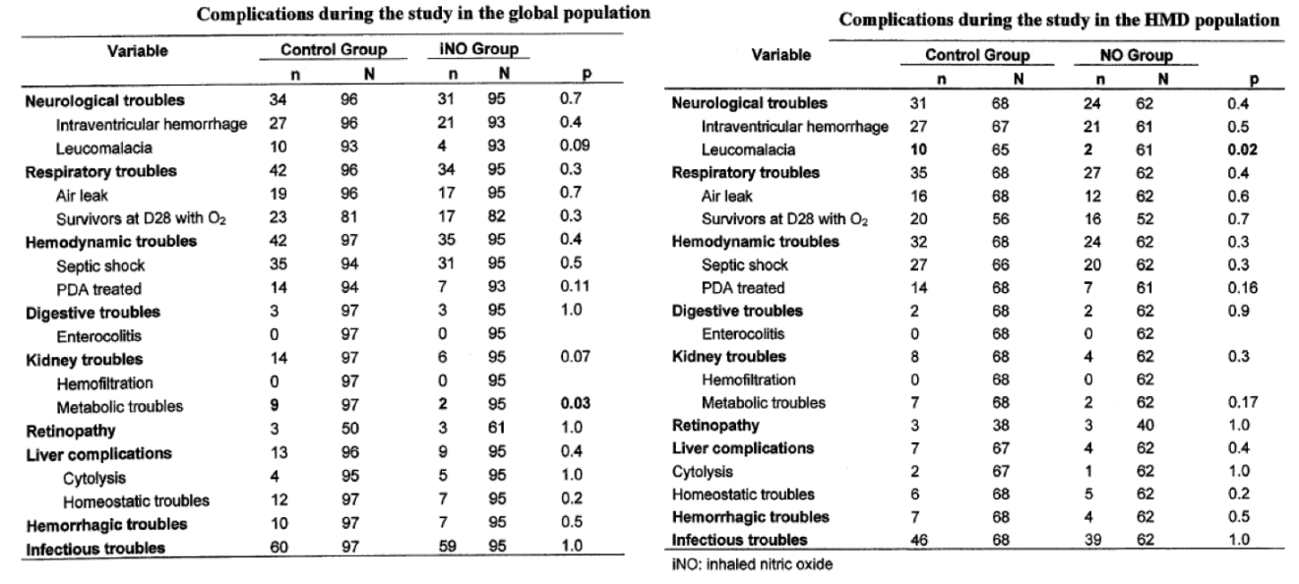
Study ALS-94 30 was a Phase III, prospective multicentre randomised double blind controlled study to evaluate the efficacy and tolerance of NO versus N₂ inhaled during Acute Respiratory Distress Syndrome (ARDS) in 203 adults. AEs, SAEs, and so on were not reported in this study. The prognosis of ARDS is very poor with survival rates generally reported between 40 to 70% so it was very difficult to distinguish SAE and evolution of pathology. Analysis of laboratory parameters (LFT and blood clotting parameters) did not show any difference between treatment groups. There was no difference in terms of mortality or cause of death between treatment groups.
Study ALS-1-98-A-301 was a single centre, randomised, double blind study versus placebo, in 57 patients having undergone pulmonary thromboendarterectomy (surgical clearing of the pulmonary arteries) and who were susceptible to developing pulmonary reperfusion oedema.
Comment: Overall, the 3 studies conducted by sponsors for other indications did not provide any relevant information regarding safety of iNO. In Study CT04009 involving 192 newborns with hypoxic respiratory failure (iNO = 95, control = 97), there was no significant difference in the number of deaths or AEs between the iNO group and the conventional treatment control group. Limited safety information was provided in the two other studies that compared iNO with placebo in adults. AEs were not reported and no significant difference was seen in the number of deaths between groups.

Safety results from published studies
The selected publications reporting safety information on the use of iNO in the treatment of perioperative PHT were analysed. These publications included:
- 2 publications of 1 meta-analysis of 4 randomised studies conducted in paediatric patients.
- 22 publications of randomised studies (12 in paediatric patients, 10 in adult patients).
- 13 publications of prospective, non-randomised studies (12 in paediatric patients, 1 in adult patients); 2 of the studies in paediatric patients were dose-response studies.
- 6 publications of retrospective studies (5 in paediatric patients, 1 in adult patients).
- 5 publications of paediatric case studies.
- 5 publications on the use of iNO in the assessment of adult heart transplant candidates.
Excluding the patients in the meta-analysis, there were 1,235 children and 462 adults involved in the included publications. However, as many as 46 adults may have been included in more than one publication. Of the total number of patients involved, approximately 844 children and 276 adults received iNO.
Safety information was not reported in all publications and reporting was not standardised. The main available information included clinical outcome, withdrawal failure or rebound PHT, metHb levels in the blood, and nitrogen dioxide (NO₂) levels in the inhaled gas.

Adverse events
AEs were not reported in the majority of publications; the available AE information is included in the summary Tables 32 and 33 below.
Table 32: Summary of AE data from published studies (PHT in the paediatric group)
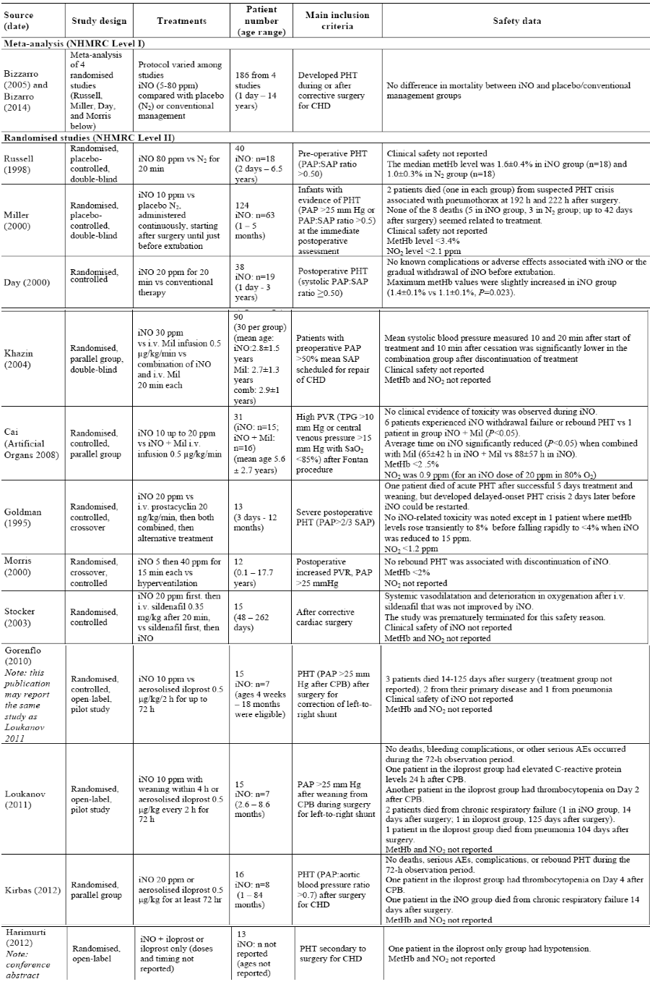
Table 32 (continued): Summary of AE data from published studies (PHT in the paediatric group)
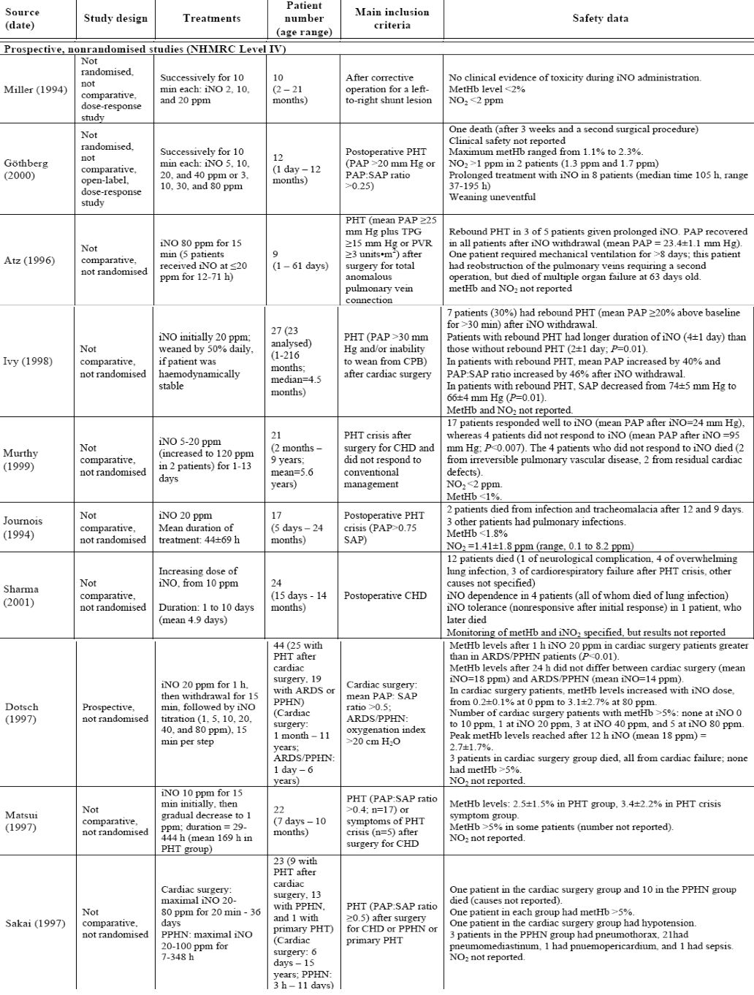
Table 32 (continued): Summary of AE data from published studies (PHT in the paediatric group)
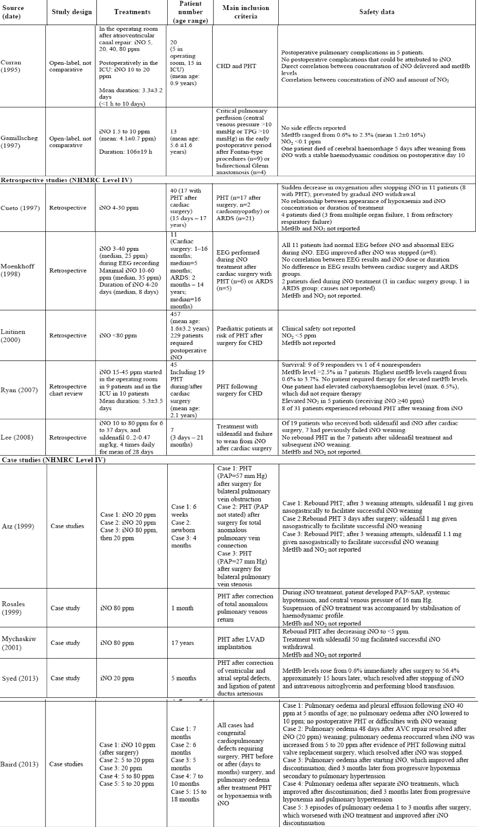
Table 33: Summary of AE data for the published studies (PHT in adult patients)
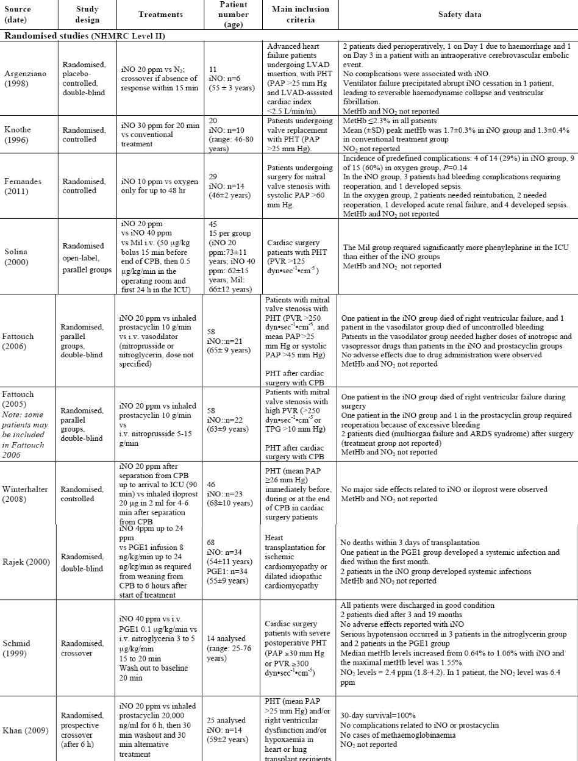
Table 33 (continued): Summary of AE data for the published studies (PHT in adult patients)
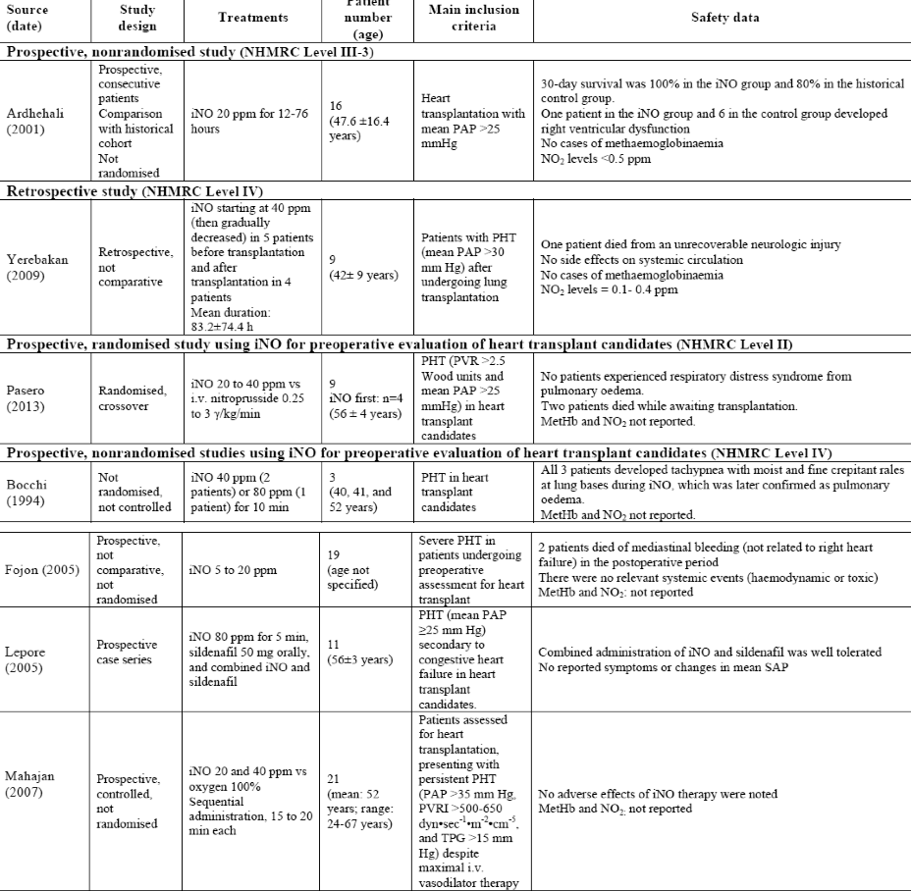
Comment: The reporting of AEs was not standardised in publications. The quality of published safety data does not allow a global analysis of AEs. Therefore, a tabulated list of the frequency of AEs according to the Medical Dictionary for Regulatory Activities (MedDRA) was not feasible.

Deaths, SAEs
SAEs were not reported systematically in studies not conducted by ALSI or in published studies.
A total of 61 paediatric patients (15 publications) and 11 adult patients (6 publications) in the included studies died (excluding those described in the meta-analysis, which were also reported elsewhere). No deaths attributed to iNO treatment were reported.

Deaths in Paediatric studies
In the randomised, placebo controlled, double blind study by Miller (2000), there were 8 deaths (5 in the iNO group, 3 in the placebo N₂ group, p = 0.49) among the 124 infants, which occurred 11 hours to 42 days after surgery. This overall death rate (6.5%) was the same or less than that reported by other major centres for similar groups of high-risk young infants who underwent surgery for CHD. Only one patient died while still in the study protocol (≤ 7 days after surgery). Only two patients (one in each treatment group) died from suspected PHT crisis, each associated with pneumothorax, at 192 hours and 222 hours, respectively, after surgery. Overall, none of the 8 deaths seemed related to the effects of study treatment.
In the randomised, crossover study by Goldman (1995), 4 of 13 children died, only one of whom died of acute PHT. The patient had undergone a mitral valve replacement for severe mitral stenosis and had been successfully weaned from iNO after 5 days of treatment. The patient died of a delayed-onset PHT crisis 2 days later, before iNO therapy could be recommenced. The cause of death in the other 3 patients was underlying lung disease, multi-organ failure and left ventricular failure due to severe left ventricular hypoplasia.
In the randomised, controlled, pilot studies published by Gorenflo (2010) and Loukanov (2011), which appear to be the same study comparing iNO with aerosolised iloprost, 3 of 15 patients died 14 to 125 days after surgery. Two patients (one in each treatment group) died from chronic respiratory failure, and one patient (iloprost group) died from pneumonia.
In the non-randomised, dose-response study by Göthberg (2000), one death occurred after 3 weeks and after a second surgical procedure.
In the non-randomised study by Atz (1996), one patient required mechanical ventilation for more than 8 days, required a second operation for reobstruction of the pulmonary veins, and died of multiple organ failure.
In the non-randomised study by Dotsch (1997), 3 of 25 patients who received iNO for PHT after cardiac surgery died from cardiac failure.
In the non-randomised study by Sakai (1997), one patient with PHT after cardiac surgery and 10 patients with PPHN died. The causes of death were not reported.
In the non-randomised study by Murthy (1999), 4 of 21 patients with PHT crisis after surgery for CHD did not respond to iNO treatment and died (2 from irreversible pulmonary vascular disease, 2 from residual cardiac defects).
In the non-randomised study by Journois (1994), 2 infants died, one from a pulmonary infection after 12 days and the other from an upper respiratory tract problem (tracheomalacia) after 9 days.
In the non-randomised study by Sharma (2001), 12 of 24 patients died, all of whom were either unresponsive to iNO or developed iNO dependence or tolerance.
In the non-randomised study by Gamillscheg (1997), one patient died of a cerebral haemorrhage 5 days after weaning from iNO with a stable haemodynamic condition on postoperative day 10.
In the retrospective study by Cueto (1997), 11 of 40 patients treated with iNO for PHT and/or ARDS experienced a sudden decrease in oxygenation after iNO was stopped abruptly. Resumption of iNO treatment, followed by gradual weaning from iNO, resulted in successful outcomes for 7 of these patients, whereas 4 patients died (3 of multiple organ failure and 1 of refractory respiratory failure).
In the retrospective study by Moenkhoff (1998), 2 patients (1 with PHT after cardiac surgery, 1 with ARDS) died during iNO treatment. The causes of death were not reported.
In the retrospective review by Ryan (2007), 9 of 13 patients with documented PHT after surgery for CHD responded to iNO with a decrease in mean PAP. All 9 of these patients survived, whereas only 1 of the 4 non-responders survived.
In the case studies reported by Baird (2013), 2 of the patients who experienced pulmonary oedema during iNO treatment died 3 months after the last episode of oedema. Neither death was attributed to iNO.

Deaths in Adult studies
There were 2 perioperative deaths in the randomised, placebo controlled, double blind involving 11 adult patients undergoing left ventricular assist device (LVAD) insertion (Argenziano 1998). One patient had multisystem organ failure and died of intractable haemorrhage the day after surgery. The other patient had an intraoperative cerebrovascular embolic event and died of brain death 3 days after surgery.
In the randomised, double blind study by Fattouch (2006), one patient in the iNO group died of right ventricular failure and one in the vasodilator group died of uncontrolled bleeding. The death of the patient in the iNO group is likely to be the same death reported by Fattouch (2005).
In the randomised, crossover study by Schmid (1999), all patients were discharged from hospital in good condition. However, 2 of these patients died 3 months (cause unknown) and 19 months (gastric cancer) later.
There were no deaths within 3 days of heart transplantation in the randomised, double blind study by Rajek (2000). One patient treated with prostaglandin E1 (PGE1) developed a systemic infection and died within one month of surgery.
In the randomised, crossover study of iNO in the assessment of adult heart transplant candidates by Pasero (2013), 2 patients died while awaiting transplantation. Neither patient was being treated with iNO at the time of death.
In the study of the use of iNO in the assessment of adult heart transplant candidates by Fojon (2005), 2 patients who received heart transplants died in the postoperative period. Both deaths were secondary to mediastinal bleeding and were not related to right ventricular failure.

AEs of special interest

Withdrawal failure or rebound PHT
In most publications, the weaning period was described as progressive and uneventful. However, some studies reported difficulties with weaning (in a total of 53 patients), particularly when iNO was stopped abruptly. These difficulties usually involved an increase in PAP (rebound PHT).

Paediatric studies
In the study involving children with increased PVR after Fontan procedure (Cai, 2008), failure or rebound PHT was observed in 6 patients in the iNO group and 1 patient in the combined iNO and Mil group (p < 0.05 for the difference between treatment groups).
In the non-randomised study by Atz (1996), rebound PHT was observed in 3 of 5 patients who had received prolonged (12 to 71 hours) iNO treatment. In this study, the withdrawal of iNO was abrupt rather than gradual, which may have contributed to the occurrence of rebound PHT.
In the non-randomised study by Ivy (1998), 7 of 23 patients had rebound PHT after gradual iNO withdrawal (iNO concentration reduced by 50% daily, if patient was haemodynamically stable). Patients who had rebound PHT had received iNO for a longer time than those who did not have rebound PHT (4 ± 1 day versus 2 ± 1 day, p = 0.01) and also experienced a significant decrease in SAP upon iNO withdrawal.
In the non-randomised study by Sharma (2001), 4 patients developed iNO dependence and had recurrence of acidosis and hypoxaemia whenever either iNO or ventilatory weaning was attempted. All 4 of these patients eventually died of lung infection. One patient, a 3- month-old child with obstructed infra-diaphragmatic total anomalous pulmonary venous connection, was described as having iNO tolerance. After an initial response to iNO, this patient later became nonresponsive to iNO, with his PAP gradually becoming greater than his SAP, irrespective of the maximal dose of iNO.
In the retrospective study by Cueto (1997), a sudden decrease in oxygenation was observed in 11 patients (8 with PHT) after iNO was stopped abruptly. Hypoxaemia and PHT improved in all patients when iNO was restarted. Subsequent gradual weaning from iNO was successful in 7 of the patients.
In the retrospective review by Ryan (2007), 8 of the 31 patients who were successfully weaned from iNO experienced rebound PHT and required iNO to be readministered. All of these patients were eventually weaned from iNO (over the course of 1 to 168 hours), and 4 of the patients were gradually changed to oral sildenafil treatment.
In the retrospective study by Lee (2008), 7 of 19 patients who had received iNO treatment had previously failed to wean successfully. After receiving oral sildenafil, all 7 patients were successfully weaned from iNO without rebound PHT.
The publications by Atz (1999) and Mychaskiw (2001) together described 4 cases of rebound PHT after attempts to withdraw iNO. In each case, successful weaning was facilitated by the administration of oral sildenafil.

Adult studies
In one adult patient included in the randomised study published by Argenziano (1998), a ventilator malfunction on the second day after LVAD insertion caused abrupt discontinuation of iNO, resulting in haemodynamic collapse and ventricular fibrillation. This patient was resuscitated and received a right ventricular device, which was removed successfully 3 days later, again with iNO support. The patient was weaned from iNO over the next 2 days and subsequently underwent heart transplantation.

MetHb and NO₂ levels
Where available, metHb (expressed as %) and NO₂ (expressed in ppm) levels were reported as means or medians, or as the number of patients with individual values exceeding a defined threshold.
In most studies in which it was reported, metHb levels remained well below 5%. However, metHb was elevated in several patients:
- In one paediatric patient in the randomised study by Goldman (1995), metHb level rose transiently to 8% and then fell rapidly to less than 4% when the iNO dose was reduced from 20 ppm to 15 ppm.
- In the non-randomised study of paediatric patients by Dotsch (1997), metHb levels rose above 5% in one patient receiving 20 ppm iNO, 3 patients receiving 40 ppm iNO, and 5 patients receiving 80 ppm iNO. No patient receiving 10 ppm iNO had metHb levels greater than 5%.
- The non-randomised study by Matsui (1997) reported that metHb levels rose above 5% in some paediatric patients, although the number of patients was not specified.
- The case study by Syed (2013) reported metHb levels that rose to 56.4% during treatment with 20 ppm iNO, which resolved after discontinuation of iNO.
Nitrogen dioxide (NO₂) is a toxic by-product that forms when NO and O₂ gases are allowed to mix. The concentration of NO₂ obtained in the presence of NO and of O₂ depends on the time of contact between the 2 molecules (t), the FiO2 and the concentration of NO according to the formula: NO₂ = K. t. (FIO₂). (NO₂). In human studies, it was shown that inhaled NO₂ at approximately 2 ppm affected alveolar permeability and increased airway responsiveness. The results of NO₂ level were inconsistently reported. In most studies in which it was reported, NO₂ levels in the inhaled gas remained below 2 ppm. However, NO₂ was greater than 2 ppm in several instances:
- In the non-randomised study of paediatric patients by Journois (1994), the maximal NO₂ level was reported as 8.2 ppm.
- In the retrospective study of paediatric patients by Laitinen (2000), NO₂ levels were reported as remaining below 5 ppm.
- In the retrospective review study of paediatric patients by Ryan (2007), NO₂ levels were reported as to be elevated (ppm not specified) in 5 patients receiving ≥ 40 ppm iNO.
- In the randomised, crossover study of adult patients by Schmid (1999), the NO₂ level was 6.4 ppm in one patient. Because exposure to iNO was relatively brief (15 to 20 minutes) in this study, the authors considered NO₂ levels greater than 5 ppm to be acceptable.
Comment: It is specified in the method of administration section of the proposed PI that the contact time between NO and O₂ in the inspiration circuit should be kept to a minimum to limit the risk of toxic oxidation by-product production in the inhaled gas.

Left ventricular dysfunction
Although not studied in the context of perioperative PHT, the haemodynamic effects of 10 minutes of iNO (80 ppm) were documented in 19 patients with heart failure due to left ventricular dysfunction (Loh 1994). Inhalation of NO caused a 23 ± 7% increase in the mean pulmonary artery wedge pressure associated with a 31 ± 7% decrease in PVR. The increase in mean pulmonary artery wedge pressure was due to an increase in left ventricular filling pressure. These findings suggested that iNO should be used with caution in patients with left ventricular dysfunction and this has been mentioned in the proposed PI.

Effect on renal function
At the request of Swedish health authorities after cases of renal failure were observed in an open label European study in adult patients with acute lung injury (final results published in Lundin 1999), an assessment of renal function in patients receiving iNO was undertaken.
The double blind randomised controlled study conducted for ALSI between December 1994 and March 1997 in adult patients with ARDS (Study ALS-94 30) did not show any statistically significant increase in risk with regard to renal function for the population treated with iNO.
Nonclinical studies have not shown any iNO-linked renal toxicity. The renal effects found were seen at high doses in a context of multi visceral attacks. At low doses, no renal toxicity is found. Between September 1999 and December 2000, 68 reports of impaired renal function concomitant with iNO treatment were gathered by ALSI in France. The analysis of 43 documented reports confirmed the existence of pre-existing renal function impairment in 26 reports, concomitant serious infection in 15 reports, and multi visceral failure and/or haemodynamic disorders in 21 reports. Follow-up on impaired renal function was carried out until December 2001 and confirmed the overriding role played by pre-existing pathology and/or multi visceral failure, without it being possible to establish any causal link with iNO.

Neurodevelopmental changes
A retrospective analysis by Moenkhouff (1998) suggested that NO inhalation could cause EEG abnormalities which appear reversible after cessation of NO. These changes may result from structural damage or functional disturbances, but their importance in terms of neurologic function and development remains unknown. These preliminary results suggest the need for comprehensive prospective clinical assessment of the effect of inhaled NO on EEG, including records before, during, and after NO. However, none of the clinical studies or randomised published studies submitted in the dossier evaluated this.

Pulmonary oedema
Bocchi (1994) reported 3 cases of pulmonary oedema in adults aged 41 to 52 years with PHT and undergoing heart transplantation who received iNO. The mechanism of increased PCWP and CO after NO inhalation is not clear. Nitric oxide is rapidly inactivated by haemoglobin before it can produce systemic effects. The hypothesis is that acute reduction in right ventricular afterload can cause an acute increment of right ventricular cardiac output. The acute increment of blood return to the impaired left ventricle not associated with reduction in afterload caused the increase in wedge pressure and consequently pulmonary oedema.

Clinical laboratory evaluation, vital signs
Information on metHb and NO₂ levels was reported in the pivotal ALSI study and many, but not all, publications. Rare cases of metHb or NO₂ levels exceeding the upper permitted limit were reported.
Haemodynamic, blood gas, and respiratory parameters were assessed as efficacy endpoints for each individual study conducted by ALSI and in most publications and results are discussed under efficacy.
Comment: Regular monitoring of haemostasis and measurement of bleeding time is recommended during the administration of VasoKINOX for more than 24 hours to patients with functional or quantitative platelet anomalies, a low coagulation factor or receiving anticoagulation treatment. Animal testing has shown that inhaled nitric oxide is likely to interfere with haemostasis and induce an increase in bleeding time. There is inadequate data from human studies and hence due caution should be exercised. The proposed PI includes adequate precautions regarding this.

Safety in special groups and situations
Effect of intrinsic and extrinsic factors on safety of iNO was not evaluated.

Drug interactions
No specific drug interactions studies have been conducted. Concomitant treatments were used in accordance with the acute pathology and its complications. The combined administration of iNO and other vasodilators (Mil infusion, prostacyclin IV, sildenafil IV, and inhaled iloprost) in children has been documented in some publications.
Inhaled NO can potentially interact with other drugs that are known to induce the formation of metHb (for example, alkylated nitrates and sulphamides, prilocaine) or that can act as NO donors (for example, sodium nitroprusside or nitroglycerin). Potential interactions with drugs acting by an NO-dependent mechanism (NO stimulators) have not been evaluated.

Pregnancy/lactation
There is very little information on the safety of iNO use during pregnancy or breast-feeding. The effect of VasoKINOX administration in pregnant women has not been studied. However, as summarised in a recent review on the safety of iNO to measure pulmonary diffusing capacity by Zavorsky (2010), several reports have described the use of iNO in 11 pregnant women with PHT. In these reports, iNO was administered at delivery rates of 5 to 80 ppm for minutes to hours, with no reported elevation in maternal metHb levels. According to the authors, as NO in the blood is metabolised too rapidly for it to travel from the maternal lung to the foetal circulation, there should be no concern that inhaling NO will result in fetal methaemoglobinaemia. It is not known whether VasoKINOX passes into human breast milk.
Comment: Despite results from the above mentioned review, it should be noted that it was only in 11 women and hence it would be prudent to avoid use of iNO in pregnancy. The proposed PI includes adequate precautions regarding this.

Overdose, abuse potential
iNO was administered at doses up to 80 ppm. No specific toxicities were seen at this dose.
The concentrations of NO present in the ambient air in an ICU administering NO to ventilated patients are primarily influenced by urban pollution outside the ICU; at concentrations administered at doses ≤ 10 ppm, there is no particular toxicity for paramedical and medical personnel, and the expired gases coming from the respirator do not need to be collected and evaluated separately. American (National Institute for Occupational Safety and Health), European and Australian (Safe Work Australia) organisations in charge of occupational exposure have set the following standard threshold limit values: NO, 25 ppm for 8 hours; NO₂, 2 ppm (3 ppm in Australia) for 8 hours. To meet those recommendations, an analysis of the atmospheric value of NO and NO₂ should be set up.
Only a few cases of iNO overdose have been reported in the context of clinical use. Overdose of iNO leads to increased levels of metHb and NO₂. Elevated metHb reduces the O₂ delivery capacity of the blood and elevated NO₂ levels may cause acute lung injury.
In case of a patient overdose with persisting methaemoglobinaemia despite iNO reduction or discontinuation, a specific treatment (for example, IV methylene blue, IV vitamin C, or blood transfusion) should be considered based upon the clinical situation.
The inhalation of NO has no potential for abuse.
Effects on ability to drive or operate machinery or impairment of mental ability were not evaluated and not likely to be important.

Withdrawal
Progressive withdrawal of iNO is recommended. In most publications of studies performed in the claimed indication, the weaning period was described as progressive and uneventful. However, some studies reported difficulties with weaning (in a total of 53 patients), particularly when iNO was stopped abruptly (Atz 1996; Cueto 1997; Argenziano 1998; Ivy 1998; Atz 1999; Mychaskiw 2001; Sharma 2001; Ryan 2007; Lee 2008; Cai, Artificial Organs 2008). These difficulties usually involved an increase in PAP, that is, rebound PHT. Isolated cases of dependence or tolerance to iNO were also reported (Sharma 2001). Details of cases of weaning difficulties and rebound PHT are described above.

Post marketing experience

Periodic safety update reports
PSURs provided in this submission covered the period from January 2004 to June 2014. The adverse reactions were coded with MedDRA dictionary versions from 11.0 to 17.0 due to continuous updates of MedDRA versions.
Comment: Some of the reports and/or their appendices contained documents in French, which were not translated into English as the subsequent PSURs contained all the cumulative data and assessed the benefit/risk of the product from all the available data. The most recent PSUR was evaluated and approved by the European PRAC (Pharmacovigilance Risk Assessment Committee); their assessment contains all available safety information for all approved nitric oxide products in Europe.
On average, a patient receives 5 m³ of nitric oxide 225 ppm or 2.5 m³ of nitric oxide 450 ppm. In total, 143,000 m³ of nitric oxide 225 ppm and 225,600 m³ of nitric oxide 450 ppm have been distributed to hospitals since the first marketing authorisation. The estimated number of patients exposed to nitric oxide since the first marketing authorisation is 118,800.
During the period from 25 January 2002 to 23 June 2014, 76 adverse events were reported in spontaneous individual case safety reports in countries where Air Liquide has marketing authorisation for iNO, including reports from healthcare professionals, consumers, scientific literature, and Competent Authorities. No serious adverse events have been reported from non-interventional post marketing surveillance or other solicited sources.
The available post marketing data confirm the safety profile of iNO. Nine cases of methaemoglobinaemia, a listed reaction, were reported in the period of January 2002 to June 2014.
Comment: During the last PSUR (dated August 2014), the sponsor (ALSI) was made aware of the use of iNO to treat Acute Respiratory Distress Syndrome (ARDS) in some Intensive Care Units (ICUs) in France and UK. A recently published meta-analysis (Adhikari 2014) confirms that iNO does not improve mortality in ARDS whatever the severity of hypoxemia; it may lead to a temporary improvement in oxygenation. However, some found an increase of risk renal failure with iNO when used in ARDS (Adhikari 2007, Afshari 2011). Individual case reports of off-label use in ARDS have been reported.

Temporary authorisation for use
Kinox was first authorised in France under a compassionate use program between February 1996 and January 2002. Air Liquide collected safety information during this period; no unexpected AEs associated with iNO were identified.

Evaluator’s overall conclusions on clinical safety
Although the safety profile of iNO is well characterised because of its extensive use in children and adults for more than two decades in different clinical conditions (including in the treatment of perioperative PHT), the safety database in this submission is limited because the reporting of safety in publications is heterogeneous and incomplete.
In the present submission, the clinical safety of iNO has been evaluated based on: clinical studies sponsored by ALSI; safety data from publications on the use of iNO in the treatment of perioperative PHT in adult and paediatric patients; and published safety studies in other indications.
A total of four clinical studies were sponsored by ALSI; one clinical study was conducted within the indication in paediatric patients, and three were conducted in other indications (one in newborns with hypoxic respiratory failure, one in adults with ARDS, and one in the prevention of pulmonary oedema after pulmonary thromboendarterectomy for chronic cor pulmonale in adults).
The safety evaluation focussed on deaths and other serious AEs (SAEs) in the pivotal study in 209 neonates. A total of 9 deaths occurred during the study, including 4 within the first 48 hours and 5 during the observation period (up to 30 days). Among those 9 deaths, 3 occurred in the iNO group and 6 in the N₂ group. None of the reported deaths were considered related to the study drugs.
In the Mercier study, there was no significant difference in the number of deaths or AEs between the iNO group and the conventional treatment control group in newborns with hypoxic respiratory failure.
Limited safety information is provided in the two other studies conducted by the sponsor that compared iNO with placebo in adults. Adverse events were not reported. No significant difference was seen in the number of deaths between groups.
Adverse events were not reported in the majority of publications; the available AE information is included in the summary Tables 32 and 33 above. No death attributed to iNO treatment was reported in any publication. A total of 59 (of 1,275) paediatric patients and 9 (of 515) adult patients in the included publications died. SAEs were not reported systematically in studies not conducted by ALSI or in published studies.
In the Macrae (ALSI) study, the metHb levels were monitored after 30 minutes, 3, 6, 12, and 24 hours, and every 12 hours thereafter. The metHb level increased significantly with time, but there was no significant difference between the two groups. Information on metHb and NO2 levels was reported in many, but not all, publications. Rare cases of metHb or NO₂ levels exceeding the upper permitted limit were reported.
Haemodynamic, blood gas, and respiratory parameters were evaluated as primary and secondary efficacy endpoints for each individual study conducted by ALSI. No effect on SAP was observed in patients receiving iNO due to the selectivity of iNO on pulmonary resistance.
Safety of iNO based on intrinsic or extrinsic factors was not evaluated. No specific drug interactions studies were conducted. There is limited information on use of iNO in pregnant or lactating women. In the submitted studies, iNO was administered at doses up to 80ppm and no specific toxicities were observed. iNO does not have any potential for drug abuse.
Withdrawal failure or rebound PHT was a concern associated with administration of iNO. In most publications, the weaning period was described as progressive and uneventful. However, some studies reported an increase in PAP, that is, rebound PHT with weaning (in a total of 53 patients), particularly when iNO was stopped abruptly.
Post marketing data and safety information from the compassionate use program in France have confirmed the safety profile of iNO. Nine cases of methaemoglobinaemia (which is a listed ADR) were reported over the period January 2002 to June 2014. No new event that was likely to modify the evaluation of the safety profile was observed during the period under consideration.

First round benefit-risk assessment

First round assessment of benefits
The benefits of VasoKINOX in the proposed usage are:
- Selective pulmonary vasodilation resulting in significant decrease in PAP and PVR.
- Short acting, rapidly reversible action.
- Does not affect systemic circulation and does not cause decreased SAP.
- Improved oxygenation and right ventricular function were observed in the paediatric studies. However, adult studies did not show consistent improvement in oxygenation and right ventricular function following iNO treatment.

First round assessment of risks
The risks of VasoKINOX in the proposed usage are:
- Withdrawal failure with risk of rebound PHT.
- Methaemoglobinemia and increase in NO_{2.}
- Potential risk of increased bleeding.
- Lack of pivotal controlled studies conducted by sponsors; hence efficacy and safety based predominantly on published studies which showed inconsistent results.
- Majority of patients in paediatric studies included infants- very few toddlers, children and adolescents were included in the paediatric studies.
- Long term effects on mortality, neurodevelopmental toxicity, mutagenesis are not known.
- Risk of off-label use in ARDS.
- Risk of pulmonary oedema in adults.

First round assessment of benefit-risk balance
Although 1000 infants and children were evaluated in the submitted paediatric studies, the majority of studies included infants with mean age < 1 year; studies in toddlers, children and adolescents were few with inconsistent results. In the paediatric population, inhaled NO doses ranged from 5 to 80 ppm with the proposed 20ppm dose used in most studies. In the majority of studies, iNO administration started in the early postoperative period, although administration was later in some studies.
In the published paediatric studies that reported changes in PAP, iNO was effective in reducing PAP by approximately 10% to 30% in paediatric patients with PHT after cardiac surgery. Treatment with iNO appeared to be more effective than N₂, prostacyclin 20 ng/kg/min, and equally effective as conventional therapy, hyperventilation, sildenafil, and aerosolised iloprost. Combination of iNO with Mil produced a greater reduction in PAP than either iNO or Mil alone. Only iNO selectively dilated the pulmonary vasculature; all other active comparators also dilated the systemic vasculature, reducing SAP. In the studies that reported changes in vascular resistance, iNO reduced the PVRI by approximately 15% to 25% and had no significant effect on SVRI. No difference in the reduction of PVRI was seen between iNO and hyperventilation or sildenafil. The combined use of iNO and Mil provided additive benefits as compared with iNO or Mil alone for patients with elevated PVR after Fontan procedure (Cai 2000, 2008). In the studies that reported changes in oxygenation, PaO₂ or the PaO₂:FiO₂ ratio was improved only with iNO. No improvement in oxygenation was seen with prostacyclin, Mil, or sildenafil, despite their effects on PAP. In the studies that reported PHT crises (Miller 2000; Day 2000; Gorenflo 2010; Loukanov 2011), iNO reduced the number of PHT crises compared with N₂, but not compared with conventional treatment or iloprost. In the 2 studies that reported cardiac index (Morris 2000; Stocker 2003), iNO did not affect this parameter, whereas hyperventilation significantly reduced cardiac index.
Due to pulmonary selectivity of iNO in postoperative PHT and the absence of systemic effects, in contrast with most comparators, iNO permits the maintenance of SAP, and particularly coronary perfusion pressure, and therefore could allow an improvement in right ventricular function although this was not evaluated in majority of the studies.
Given the limited sample size and the low level of detail in the publications, the comparison of results in sub-populations was not possible.
The sponsor’s claim that the use of iNO in the treatment of postoperative PHT in newborns, infants, children, and adolescents in the context of cardiac surgery has become the standard therapy (Checchia; 2012), including in Australia.
Based on submitted data, there is evidence to suggest that iNO may provide a therapeutic option for treatment of perioperative PHT in newborns/infants with CHD; however, there is limited evidence to support use in toddlers, children and adolescents. Furthermore, effect of iNO on clinical outcomes such as morbidity/mortality and neurodevelopment were not adequately evaluated.
Twelve randomised, controlled published studies involving 398 adults presenting with PHT after or immediately before cardiac surgery provided evidence to support use of iNO for perioperative PHT in adults. In adults, inhaled NO doses ranged from 4 to 40 ppm. In most of the studies, the dose of iNO was 20 ppm. The time of administration in cardiac surgery patients in most studies was at weaning from CPB. The duration of administration ranged from 15 to 20 minutes in acute haemodynamic studies to several hours (up to the arrival in the ICU or later).
All the published adult studies showed consistent evidence of the efficacy of iNO in postoperative PHT and also demonstrated its pulmonary selectivity. However, the data in adult studies in the current submission were limited by the lack of large, controlled randomised studies, relatively low number of patients in the individual published studies, heterogeneity of the trials and lack of evaluation of clinical outcomes.
The safety data are supported by clinical trials (in neonates only) and publications and by extensive post-marketing data. In general, these data are insufficiently detailed to retrieve maximal safety information, partly because of the context of iNO administration (that is, emergency situations, ICU or operating rooms). Results of studies consistently demonstrated that within the recommended dosage a selective pulmonary vasodilatation is obtained without reaching clinically significant increase of methaemoglobin and NO₂ level. However, rebound PHT on withdrawal of iNO remains a concern. To avoid the risk of rebound, iNO treatment should not be stopped abruptly. Once iNO has been started with beneficial effects, reasonable attempts to wean patients off iNO should be made every 12 to 24 hours using a weaning protocol. Drug safety monitoring during the compassionate use program and the periodic safety reports did not raise any additional safety concerns. Overall, the main safety concerns associated with iNO, metHb and rebound PHT can be readily avoided or minimised with appropriate dosing of iNO, monitoring, and management.
Inhaled nitric oxide is approved by TGA and also by FDA for the treatment of term and near-term (> 34 weeks) neonates with hypoxic respiratory failure, in conjunction with ventilatory support and other appropriate agents, where it improves oxygenation and reduces the need for extracorporeal membrane oxygenation (ECMO). The approval was based on results from several double blind, randomised, placebo controlled, multicentre trials. The Neonatal Inhaled Nitric Oxide Study Group trial documented that iNO reduced the need for ECMO without increasing neurodevelopmental, behavioural, or medical abnormalities at 2 years of age.
Inhaled nitric oxide is well established and widely accepted for use in acute vasodilator testing in adults with PAH due to its selective effect on the pulmonary vasculature and lack of systemic haemodynamic effects (such as hypotension) that can occur with some other forms of vasodilators.,
Clinical trials evaluating the use of inhaled nitric oxide for numerous indications are ongoing.
The potential therapeutic role of inhaled nitric oxide in adults remains uncertain at this time and FDA approved indications are restricted to paediatric practice.
Increased morbidity and mortality is generally associated with PHT in paediatric and adult patients undergoing cardiac surgery. Inhaled NO, acting as a selective pulmonary vasodilator may provide a useful therapeutic option in these seriously ill patients. However, there is inadequate data on whether these short term improvements in haemodynamic parameters are translated into beneficial effects on clinical outcomes such as morbidity and mortality.
Overall, the benefit-risk profile for VasoKINOX is unfavourable for the following proposed indication:
‘VasoKINOX indicated in conjunction with ventilatory support and other appropriate active substances for the treatment of perioperative pulmonary hypertension in adults and newborn infants, infants and toddlers, children and adolescents, ages 0 to 17 years in conjunction to heart surgery, in order to selectively decrease pulmonary arterial pressure and improve right ventricular function and oxygenation by increasing the pulmonary flow.’
However, there is evidence to suggest favourable benefit-risk profile for treatment of perioperative pulmonary hypotension in newborn infants and infants but not for the other age groups such as toddlers, children, adolescents and adults.

First round recommendation regarding authorisation
It is recommended that VasoKINOX be rejected for the proposed indication:
‘VasoKINOX indicated in conjunction with ventilatory support and other appropriate active substances for the treatment of perioperative pulmonary hypertension in adults and newborn infants, infants and toddlers, children and adolescents, ages 0 to 17 years in conjunction to heart surgery, in order to selectively decrease pulmonary arterial pressure and improve right ventricular function and oxygenation by increasing the pulmonary flow.’
The main reasons for rejection at this stage are:
- Although 1000 infants and children were evaluated in the submitted paediatric studies, the majority of studies included infants with mean age < 1 year; studies in toddlers, children and adolescents were few with inconsistent results.
- Lack of adequate randomised, controlled clinical trials in adults.
- Although reduction in pulmonary arterial pressure was shown in most of the paediatric and adult studies, effects on right ventricular function and oxygenation were not evaluated in many studies and did not show consistent results.
Although the proposed indication does not make claims for effects on morbidity/mortality, it is important to evaluate effects on clinical outcomes following short term improvements in haemodynamic parameters following administration of iNO to patients in conjunction with cardiac surgery; there was inadequate data regarding this in the submitted data.

Clinical questions

Pharmacokinetics
None.

Pharmacodynamics
- The source of a Figure from Gerlach (1993): Dose response of iNO on oxygenation and PAP provided in [the submission data] is not clear as this figure is not included in the original publication. Could the sponsors please clarify source of this figure and confirm its accuracy.
The following was also mentioned in the summary of above study but these results were not available in the original publication ‘Analysis of the time-course showed that after starting NO inhalation, an increasing PaO₂ could be registered after 1 to 2 minutes and a plateau was reached after 8 to 12 min. PAP did not decrease in the first 3 minutes after induction of iNO (that is, the effect of iNO on PAP was usually registered after PaO₂ had already changed). The time course was independent from the iNO dose except at 0.01 ppm where no reproducible effect on PAP and PaO₂ was seen.’ Could the sponsors please clarify the source of the above information on time-course?

Efficacy
- In the literature reference: Schimd, 1999 provided in the submission, one of the pages is missing; specifically page 1114 is missing from the following reference: Anest Analg 1999: 1108-15. Could the sponsor please provide the missing page?
- In study report of ALS-1-97-P-301, some of the results are in French and the gases are described in kPa. Can the sponsors provide these tables in English?
- Does the sponsor’s delivery system allow for manual ventilation and BVM ventilation? This may be important to ensure the continuity of the prescribed dose (and the avoidance of rebound pulmonary hypertension from supply disruption). Is the sponsor’s delivery system registered for use in Australia? Are there any clinical implications from using this product with another sponsor’s delivery system?

Safety
- The PSURs submitted in the dossier mention that on average, a patient receives 5 m³ of nitric oxide 225 ppm or 2.5 m³ of nitric oxide 450 ppm. In total, 143,000 m³ of nitric oxide 225 ppm and 225,600 m³ of nitric oxide 450 ppm have been distributed to hospitals since the first marketing authorisation. Could the sponsors please clarify how 5 m³ of nitric oxide 225 ppm or 2.5 m³ of nitric oxide 450 ppm compared to the proposed dose for which approval is being sought in this submission?

Other questions
- The sponsors intend to add ‘off-label use in ARDS’ as another safety concern to the RMP but it was not included in the draft provided in this submission. Kindly clarify if this will be added to the Australian RMP?
- No information has been provided regarding the regulatory status of VasoKINOX in USA and Canada. Could the sponsors please provide an update on overseas regulatory status?

Second round evaluation of clinical data submitted in response to questions

Pharmacodynamics

Question 1
The source of a Figure from Gerlach (1993): Dose response of iNO on oxygenation and PAP provided in [the submission data] is not clear as this figure is not included in the original publication. Could the sponsors please clarify source of this figure and confirm its accuracy.
The following was also mentioned in the summary of above study but these results were not available in the original publication ‘Analysis of the time-course showed that after starting NO inhalation, an increasing PaO₂ could be registered after 1 to 2 minutes and a plateau was reached after 8 to 12 min. PAP did not decrease in the first 3 minutes after induction of iNO (i.e. the effect of iNO on PAP was usually registered after PaO₂ had already changed). The time course was independent from the iNO dose except at 0.01 ppm where no reproducible effect on PAP and PaO₂ was seen.’ Could the sponsors please clarify the source of the above information on time-course?

Sponsor’s response:
[Information redacted]
The sponsor responded that the inadvertent inclusion of publications in this submission was the reason for confusion.

Evaluation of response
The sponsor’s response is satisfactory.

Efficacy

Question 2
In the literature reference: Schimd, 1999 provided in the submission, one of the pages is missing; specifically page 1114 is missing from the following reference: Anest Analg 1999: 1108-15. Could the sponsor please provide the missing page?

Sponsor’s Response:
A copy of the complete reference is provided as requested.

Evaluation of response
The last page of the study had the following information: ‘in adult cardiac surgery, PH per se, even if severe, does not necessarily imply postoperative RV failure, and, provided RV function is preserved and coronary artery perfusion not compromised, iNO may not be superior to IV PGE1 with regard to CI and RV performance. This finding might contribute to a more restrictive patient selection for iNO application. Selective pulmonary vasodilation may be indicated, when isolated RV failure is present independent of the degree of PH. In patients with additional LV failure, PGE1-induced concomitant reductions of LV filling pressure and outflow impedance might be beneficial.’ Hence this study seems to suggest that iNO may be more suitable compared to PGE-1 in only certain sub-groups of adult patients.

Question 3
In study report of ALS-1-97-P-301, some of the results are in French and the gases are described in kPa. Can the sponsors provide these tables in English?

Sponsor’s response:
[Information redacted]

Evaluation of response
The sponsor’s response is satisfactory.

Question 4
Does the sponsor’s delivery system allow for manual ventilation and BVM ventilation? This may be important to ensure the continuity of the prescribed dose (and the avoidance of rebound pulmonary hypertension from supply disruption). Is the sponsor’s delivery system registered for use in Australia? Are there any clinical implications from using this product with another sponsor’s delivery system?

Sponsor’s response
[Information redacted] The VasoKINOX cylinders are fitted with a valve which is dedicated to NO/N₂ mixtures containing 100 ppm < NO, 1000ppm according to ISO 5145. Therefore, VasoKINOX cylinders cannot be connected to any other sponsors Nitric Oxide gas delivery system (NODS) used in Australia that does not have compatible ISO5145 connections without adaptation of the pressure reducer and NO low pressure hose connecting the pressure reducer to the NODS. In this case, the parameter settings relative to the strength of the concerned cylinder connected to another sponsors NODS (for example, changed from 800 to 450ppm), would need to be made in order to maintain the same dosed iNO concentration to the end user. The sponsor does not believe that there would be any clinical implications if such adaptations are made for use with another sponsor's NODS.

Evaluation of response
The sponsor’s response is satisfactory.

Safety

Question 5
The PSURs submitted in the dossier mention that on average, a patient receives 5 m³ of nitric oxide 225 ppm or 2.5 m³ of nitric oxide 450 ppm. In total, 143,000 m³ of nitric oxide 225 ppm and 225,600 m³ of nitric oxide 450 ppm have been distributed to hospitals since the first marketing authorisation. Could the sponsors please clarify how 5 m³ of nitric oxide 225 ppm or 2.5 m³ of nitric oxide 450 ppm compared to the proposed dose for which approval is being sought in this submission?

Sponsor’s response
[Information redacted]
The sponsor highlights the estimations that were provided in the PSURs cover the indications of PPHN and perioperative pulmonary hypertension in children and in adults.

Evaluation of response
The sponsor’s response is satisfactory.

Other questions

Question 7
The sponsors intend to add ‘off-label use in ARDS’ as another safety concern to the RMP but it was not included in the draft provided in this submission. Kindly clarify if this will be added to the Australian RMP?

Sponsor’s response
[Information redacted]

Evaluation of response
The sponsor’s response is satisfactory.

Question 8
No information has been provided regarding the regulatory status of VasoKINOX in USA and Canada. Could the sponsors please provide an update on overseas regulatory status?

Sponsor’s response
[Information redacted]

Evaluation of other data submitted by the sponsors as part of the first round response
[Information redacted]
The sponsor highlights that iNO treatment in Australia, as elsewhere globally is considered standard of care in both paediatric and adult populations. This is supported by expert statement obtained from leading Australian Key Opinion Leader (KOL) [included with the sponsor’s response to the clinical evaluators]. The sponsor reiterates that based on total body of evidence presented for evaluation that the submitted studies supports iNO in controlling this life-threatening condition.
Comment: The expert statement obtained from a leading Australian ICU specialist provides important information about incidence and use of iNO for treatment of perioperative PHT in children in different age groups. The concluding remarks in this expert statement were: ‘Inhaled Nitric Oxide is the standard drug for the treatment of postoperative PHT in paediatric in context of cardiac surgery in Australia, Europe and North America. This is because of its specificity for the pulmonary rather than systemic circulation and also its safety. There are a few small trials of iNO being compared with inhaled prostacycline which show equivalence of affect but iNO is much easier to nebulise and safer to use and as such we have not used inhaled prostacycline. The other intravenous drugs all have systemic effects that may cause hypotension, especially in the immediate post- operative period. In the adults situation iNO is used in a similar fashion but usually for patients with pulmonary hypertension AND right ventricular dysfunction. This is seen uncommonly in patients after Valvular surgery or in patients with cardiomyopathy or patients after transplantation. For similar reasons as in children, iNO is the preferred drug.’
Based on this and review of other data provided by the sponsors, the benefit-risk profile of VasoKINOX may be considered to be favourable for the modified indication being proposed by the sponsors in their response [to TGA questions]:
‘VasoKINOX is indicated in conjunction with ventilatory support and other appropriate active substances for the treatment of perioperative pulmonary hypertension in adults and newborn infants, infants and toddlers, children and adolescents, aged 0-17 years in conjunction to heart surgery, in order to selectively decrease pulmonary arterial pressure and improve right ventricular function and oxygenation by increasing the pulmonary flow.’
However, the evaluators still strongly feel that the evidence does not support use of VasoKINOX for treatment of perioperative pulmonary hypertension in adults. Although iNO may be beneficial in some adults with perioperative pulmonary hypertension such as those with pulmonary hypertension AND right ventricular dysfunction as indicated in the ‘expert statement’ provided by the sponsors, there is not enough data to evaluate subgroups of the adult patient population that could benefit from iNO. This has been discussed in the second round report [below].
The sponsor has also addressed the main reasons stated in the first round report for recommending rejection for the proposed indication. The reason for rejection is mentioned first followed by sponsor’s response and then the evaluator’s comments on the sponsor’s response.

Conclusion 1
‘Although 1000 infants and children were evaluated in the submitted paediatric studies, the majority of studies included infants with mean age < 1 year; studies in toddlers, children and adolescents were few with inconsistent results.’

Sponsor’s response
[Information redacted] In summary the sponsor discussed the incidence of PHT following cardiac surgery in the different age groups together with supporting reference to the Australian and New Zealand Paediatric Intensive care database and proposed to add the following statement to the PI
‘Clinical data supporting the suggested dose in the age range of 12-17 years is limited.’
Limited data in this age group is also identified as a risk addressed within the sponsor’s Risk Management Plan (RMP) and associated Australian Specific Annex (ASA)

Evaluation of response
The above explanation provided by the sponsors is satisfactory and inclusion of above statement in proposed PI and the RMP help to address the issues raised by evaluators in first round report.

Conclusion 2
‘Lack of adequate randomised, controlled clinical trials in adults’

Sponsor’s response
[Information redacted]

Evaluation of response
Of the 12 published studies submitted to support use in adults, the sponsors had initially designated three of these studies as ‘pivotal’ published adult studies (Argenziano, 1998; Knothe 1996 and Fernandez, 2011). However, in this response to TGA questions, they propose that 6 studies were important. The 6 studies involved 235 adults (mean age ranging from 48 to 73 years) with peri-operative pulmonary hypertension in the context of cardiac surgery. The limitations of each of these 6 studies now proposed by the sponsor are briefly mentioned below:-
- Argenziano, 1998: small sample size and risk of bias (as the random sequence generation method or allocation method were not adequately described).
- Knothe, 1996: Results from this small study (only 20 patients) showed that although iNO reduced PAP and PVR, it did not improve oxygenation or RVEF and in fact increased SVR; furthermore, the effects of iNO treatment were not significantly different from those seen with conventional treatment when administered to patients with PHT before valve surgery. Interpretation was further limited by risk of bias as the random sequence generation method or allocation method and the blinding methods were not adequately described.
- Fernandes, 2011: Results from this study provided some evidence to support efficacy of treatment with iNO (compared to oxygen only) for increasing cardiac index and decreasing PVR in 29 adult patients with severe PHT undergoing surgery for mitral valve stenosis. However, interpretation of results was limited by the following:- dose of iNO was lower than proposed dose; no details provided regarding weaning of iNO administration; blinding of study medication not done in this study; haemodynamic parameters were measured at 24 to 48 hours in the ICU setting while patients were receiving other vasoactive drugs that may have confounded results.
- Solina 2000: iNO (20 and 40 ppm) and IV milrinone administered during the early postoperative period in 45 cardiac surgery patients with PHT was associated with favourable effect on RVEF with highest reduction observed in the iNO 40ppm group; however, there was no difference between the 3 groups in PVR, SVR or cardiac index.
- Solina 2001: showed that iNO 10 ppm was effective in significantly reducing PVR in 62 adult cardiac surgery patients. Doses higher than 10 ppm were not associated with greater reduction of PVR. No details on how iNO was withdrawn and no safety results were presented; Minimum effective dose was not identified in this study.
- Rajek, 2000: This study provided evidence that iNO selectively reduced PVR and PAP when administered immediately after heart transplantation (n = 68). Although, improvement in PVR and RVF enabled early weaning from CPB in patients on iNO, it is important to note that these switched patients required significantly more inotropic support than those who were able to continue with PGE1.
The sponsors have not included results of 2 other prospective randomised adult studies in their new list of ‘main adult studies’ in this response. These 2 studies do not appear to favour iNO and have been briefly summarised below:
- Fattouch 2005: Inhaled prostacyclin and nitric oxide were effective in the treatment of postoperative pulmonary hypertension in 58 patients with mitral valve stenosis undergoing mitral valve surgery. Both drugs improved reduced mean pulmonary arterial pressure, pulmonary vascular resistance, and transpulmonary gradient and may be useful in patients with acute right ventricular failure following cardiac surgery. However, only inhaled prostacyclin increased CO and SV.
- Winterhalter, 2008: A prospective, randomised, parallel group study showed that both inhaled Iloprost and iNO reduced PHT in 46 patients with PHT during weaning from CPB in cardiac surgery. Iloprost induced greater decrease in PVR and PAP and a greater increase in cardiac output, while iNO improved SaO₂ to a greater extent.
The pulmonary selectivity and therefore the absence of systemic effects of iNO enable to maintain systemic arterial pressure, and particularly coronary perfusion pressure. The sponsors had initially also mentioned that the decrease in pulmonary vascular resistance without decrease in coronary perfusion pressure results in an improvement of the right ventricular function, although they have now agreed to remove this claim from the proposed indication due to lack of adequate evidence to prove this mechanism of action. Furthermore, as already mentioned in the First round assessment of benefit-risk balance above, the potential therapeutic role of inhaled nitric oxide in adults still remains uncertain at this time and FDA approved indications are restricted to paediatric practice.
Overall, interpretation of results from these studies were limited by study design, heterogenous patient population and small sample size and the evidence to support registration of iNO for treatment of perioperative PHT in all adults is still considered to be inadequate.

Conclusion 3
‘Although reduction in pulmonary arterial pressure was shown in most of the paediatric and adult studies, effects on right ventricular function and oxygenation were not evaluated in many studies and did not show consistent results.’

Sponsor’s response
[Information redacted]
The sponsor proposes to reword the indication as follows:
‘VasoKINOX is indicated in conjunction with ventilatory support and other appropriate active substances for the treatment of adults and newborn infants, infants and toddlers, children and adolescents, aged 0-17 years with peri-operative pulmonary hypertension in conjunction with heart surgery.’

Evaluation of response
The evaluators agree with the removal of mention of effect on oxygenation and/or right ventricular ejection fraction in the proposed indication. However, as discussed above evidence to justify use in adults is still insufficient.

Conclusion 4
‘Although the proposed indication does not make claims for effects on morbidity/ mortality, it is important to evaluate effects on clinical outcomes following short- term improvements in haemodynamic parameters following administration of iNO to patients in conjunction with cardiac surgery; there was inadequate data regarding this in the submitted data.’

Sponsor’s response
[Information redacted] The sponsor acknowledged the lack of evidence to support effectiveness of iNO measured in terms of the following clinical outcomes: length of hospital stay, morbidity and mortality. However, the current submission does not relate to these outcomes and hence these aspects are not considered in this evaluation.

Evaluation of response
The sponsor’s response is considered to be acceptable.

Sponsor’s response to the benefit-risk assessment in the first round evaluation report
The sponsor has provided responses below to the clinical evaluator’s benefit-risk assessment and recommendations.
The sponsor concurs with the CER on the benefits of VasoKINOX:
The sponsor’s response to the identified risks in the first round CER is summarised below:

Withdrawal failure with risk of rebound PHT
[Information redacted] In this aspect, adequate precautionary statements related to progressive withdrawal of iNO are included in the PI as a risk mitigation strategy.

Methaemoglobinaemia and increase in NO2
[Information redacted] In this aspect, adequate precautionary statements related to appropriate dosing and monitoring are included in the PI as a risk mitigation strategy. Similar measures are taken in RMP and ASA.

Potential risk of increased bleeding
[Information redacted] In this aspect, adequate precautionary statements are included in the PI and RMP as risk mitigation strategies.

Lack of pivotal controlled studies conducted by sponsors; efficacy and safety based predominantly on published studies which showed inconsistent results
The sponsor’s response is similar to that already discussed.

Majority of patients in paediatric studies included infants- very few toddlers, children and adolescents included in the paediatric studies
The sponsor’s response is similar to that already discussed.

Long term effects on mortality, neurodevelopmental toxicity, mutagenesis not known

Mortality and neurodevelopmental toxicity
[Information redacted] The evidence based on published literature provided by the sponsor suggest lack of association between iNO and mortality, neurodevelopment toxicity and mutagenesis in the paediatric age group. However, the findings cannot be generalised because of the heterogeneity of conditions being treated, related pathophysiology and the inherent morbidity and mortality. Moreover, further long term studies are needed to examine these aspects in a wider age group and a range of clinical applications.

Mutagenesis
[Information redacted]

Risk of off-label use in ARDS
This risk has been acknowledged and included in the updated approved European RMP provided as part the S31 responses and also included in the RMP-ASA.

Risk of pulmonary oedema in adults
The sponsor highlights that pulmonary oedema in patients with pre-existing left ventricular dysfunction has been included as an important identified risk in the EU RMP and associated ASA to same. This risk is also already included in the proposed PI under ‘Special patient populations’ and within the proposed Australian educational material.

Evaluator’s comments on the sponsor’s response to potential risks associated with iNO for the proposed indication
The sponsor has acknowledged all the risks listed in the first round report and these have been addressed with adequate precautions in the proposed PI as well the RMP ASA

Second round benefit-risk assessment

Second round assessment of benefits
After consideration of the responses to clinical questions, the benefits of VasoKINOX in the proposed usage are unchanged from those identified in the first round assessment of benefits.

Second round assessment of risks
After consideration of the responses to clinical questions and evaluation of additional data provided by the sponsors in their response to the TGA, the risks of VasoKINOX in the proposed usage are:
- ‘Withdrawal failure with risk of rebound PHT.
- Methaemoglobinaemia and increase in NO₂.
- Potential risk of increased bleeding.
- Risk of off-label use in Acute Respiratory Distress Syndrome (ARDS).
- Risk of pulmonary oedema in adults.’
However, the proposed PI and Australian RMP have included adequate measures to minimize the risks associated with iNO when used for the proposed indication.

Second round assessment of benefit-risk balance
The benefit-risk balance of VasoKINOX for the modified proposed indication:
‘VasoKINOX is indicated in conjunction with ventilatory support and other appropriate active substances for the treatment of perioperative pulmonary hypertension in adults and newborn infants, infants and toddlers, children and adolescents, aged 0-17 years in conjunction to heart surgery’
is unfavourable, but would become favourable if the changes recommended below are adopted.

Second round recommendation regarding authorisation
It is recommended that the application to register VasoKINOX for the following indication be rejected:
‘VasoKINOX is indicated in conjunction with ventilatory support and other appropriate active substances for the treatment of perioperative pulmonary hypertension in adults and newborn infants, infants and toddlers, children and adolescents, aged 0-17 years in conjunction to heart surgery.’
It should be noted that according to the ARTG the TGA has recently approved (30 July 2015) an extension of indication to the Australian alternative approved nitric oxide product for the same indication in the paediatric age group of 0 to 17 years:
‘Interpretation of results from adult studies was limited by study design, heterogeneous patient population, sample size and lack of evaluation of clinical outcome. Although iNO may be beneficial in some adults with perioperative pulmonary hypertension such as those with pulmonary hypertension and right ventricular dysfunction, there is not enough data based on submitted studies to determine which subgroups of the adult patient population could benefit from iNO.’
Due to lack of adequate evidence to support use in adults, a modified indication (which excludes adults) and is in line with the recently approved indication for alternative approved nitric oxide may be approved:
‘VasoKINOX is indicated in conjunction with ventilatory support and other appropriate active substances for the treatment of perioperative pulmonary hypertension in newborn infants, infants and toddlers, children and adolescents, aged 0-17 years in conjunction to heart surgery.

References
Adhikari N et al. Effect of nitric oxide on oxygenation and mortality in acute lung injury: systematic review and meta-analysis. BMJ 2007; 334: 779.
Afshari A. et al. Inhaled nitric oxide for acute respiratory distress syndrome and acute lung injury in adults and children: a systematic review with meta-analysis and trial sequential analysis. Anesth Analg 2011;112: 1411-1421.
Albert J. et al. Neither endogenous nor inhaled nitric oxide influences the function of circulating platelets in healthy volunteers. Clin Sci 1999; 97: 345-453.
Atz A.M. et al. Rebound Pulmonary Hypertension After Inhalation of Nitric Oxide. Ann Thorac Surg 1996; 62: 1759-1764.
Atz A.M. and Wessell D.L. Sildenafil ameliorates effects of inhaled nitric oxide withdrawal. Anesthesiology 1999; 91: 307-310.
Argenziano M. et al. Randomized, double blind trial of inhaled nitric oxide in LVAD recipients with pulmonary hypertension. Ann Thorac Surg 1998; 65:340-345.
Ardhehali A. et al. Inhaled nitric oxide for pulmonary hypertension after heart transplantation. Transplantation 2001; 72: 638-641
Assreuy J. et al. Feedback inhibition of nitric oxide synthase activity by nitric oxide. Br J Pharmacol 1993; 108: 833-837.
Bando K., et al. Pulmonary hypertension after operations for congenital heart disease: analysis of risk factors and management. J Thorac Cardiovasc Surg 1996;112: 1600-1607; disc.1607-9.
Baird J.S. et al. Nitric oxide-associated pulmonary edema in children with pulmonary venous hypertension. Pediatric Cardiology 2013; 34: 817-825.
Barr F.E., Macrae D., Inhaled nitric oxide and related therapies. Pediatr Crit Care 2010; 11: S30-S36.
Beckman J.S. and W.H. Koppenol. Nitric oxide, superoxide, and peroxynitrite: the good, the bad, and ugly. Am J Physiol 1996; 271: 1424-1437.
Beghetti M., et al., Continuous low dose inhaled nitric oxide for treatment of severe pulmonary hypertension after cardiac surgery in paediatric patients. Br Heart J, 1995;73(1): 65-8.
Bizzarro M. and I. Gross. Inhaled nitric oxide for the postoperative management of pulmonary hypertension in infants and children with congenital heart disease. Cochrane Database of Systematic Reviews 2005(4):CD005055.
Bizzarro, M., I. Gross, and F.T. Barbosa. Inhaled nitric oxide for the postoperative management of pulmonary hypertension in infants and children with congenital heart disease. Cochrane Database of Systematic Reviews 2014(7):CD005055.
Black S.M., et al. Increased endothelial NOS in lambs with increased pulmonary blood flow and pulmonary hypertension. Am J Physiol 1998; 275:1643-1651.
Bocchi E.A. Inhaled nitric oxide leading to pulmonary edema in stable severe heart failure. American Journal of Cardiology 1994; 74:70-72
Brady T.C. et al. Nitric oxide inhalation transiently elevates pulmonary levels of cGMP, iNOS mRNA, and TNF-alpha. Am J Physiol 1998; 275: 509-515.
Cai J. et al. Nitric oxide in conjunction with milrinone better stabilized pulmonary hemodynamics after Fontan procedure. Artif Organs 2008; 32: 864-869.
Cai J. et al., Nitric oxide and milrinone: combined effect on pulmonary circulation after Fontan-type procedure: a prospective, randomized study. Ann Thorac Surg 2008; 86: 882-888.
Celermajer D.S. et al. Impairment of endothelium-dependent pulmonary artery relaxation in children with congenital heart disease and abnormal pulmonary hemodynamics. Circulation 1993; 87: 440-446.
Checchia P.A. et al. Review of inhlaed nitric oxide in the pediatric cardiac surgery setting. Pediatr Cardiol 2012; 33: 493-505.
Cueto E., et al., Life-threatening effects of discontinuing inhaled nitric oxide in children. Acta Paediatr, 1997;86(12): 1337-9.
Curran R.D. et al. Inhaled nitric oxide for children with congenital heart disease and pulmonary hypertension. Ann Thorac Surg 1995; 60: 1765-1771.
Daher A.H. et al. Effects of exogenous nitric oxide on neutrophil oxidative function and viability. Am J Respir Cell Mol Biol 1997; 16: 407-412.
Day R.W. et al. Randomized controlled study of inhaled nitric oxide after operation for congenital heart disease. Ann Thorac Surg 2000; 69: 1907-1912; discussion 1913.
De Caterina R. et al. Nitric oxide decreases cytokine-induced endothelial activation. Nitric oxide selectively reduces endothelial expression of adhesion molecules and proinflammatory cytokines. J Clin Invest 1995; 96: 60-68.
Deem S. et al. Red-blood-cell augmentation of hypoxic pulmonary vasoconstriction: hematocrit dependence and the importance of nitric oxide. Am J Respir Crit Care Med 1998; 157: 1181-1186.
Defouilloy C. et al. Polycythemia impairs vasodilator response to acetylcholine in patients with chronic hypoxemic lung disease. Am J Respir Crit Care Med 1998; 157: 1452-1460.
Demirakca S. et al. Inhaled nitric oxide in neonatal and pediatric acute respiratory distress syndrome: dose response, prolonged inhalation, and weaning. Crit Care Med 1996; 24: 1913-1919.
DiBlasi R.M. et al. Evidence-based clinical practice guideline: inhaled nitric oxide for neonates with acute hypoxic respiratory failure. Respir Care 2010; 55: 1717-1745.
Dotsch J. et al. Extracorporeal circulation increases nitric oxide-induced methemoglobinemia in vivo and in vitro. Crit Care Med 1997 ;25: 1153-1158.
Ducrocq C.G., et al Chemistry and biochemistry of the nitric oxide. II: reactivity. Blood Thrombosis Vessels. Sang Thrombose Vaisseaux 1994; 6: 449-457.
Duke T. et al. Altered activation of the L-arginine nitric oxide pathway during and after cardiopulmonary bypass. Perfusion 1997; 12: 405-410.
Dupuy P.M. et al. Bronchodilator action of inhaled nitric oxide in guinea pigs. J Clin Invest 1992; 90: 421-428.
Dweik R.A. et al. Nitric oxide synthesis in the lung. Regulation by oxygen through a kinetic mechanism. J Clin Invest 1998; 101: 660-666.
Eddahibi, S., et al., Effect of DMPPO, a phosphodiesterase type 5 inhibitor, on hypoxic pulmonary hypertension in rats. Br J Pharmacol, 1998;125(4): 681-8.
Fattouch K. et al. Inhaled prostacyclin, nitric oxide, and nitroprusside in pulmonary hypertension after mitral valve replacement. J Cardiac Surgery 2005; 20: 171-176.
Fattouch K. et al. Treatment of pulmonary hypertension in patients undergoing cardiac surgery with cardiopulmonary bypass: a randomized, prospective, double blind study. J Cardiovasc Med (Hagerstown), 2006; 7: 119-123.
Fernandes J.L. et al. Comparison of inhaled nitric oxide versus oxygen on hemodynamics in patients with mitral stenosis and severe pulmonary hypertension after mitral valve surgery. Am J Cardiol 2011; 107: 1040-1045.
Finer N.N. and K.J. Barrington. Nitric oxide for respiratory failure in infants born at or near term. Cochrane Database of Systematic Reviews 2006(4):CD000399.
Fojon S. et al. Inhaled nitric oxide through a noninvasive ventilation device to assess reversibility of pulmonary hypertension in selecting recipients for heart transplant. Transplant Proc 2005; 37: 4028-4030.
Foubert, L., et al., Safety guidelines for use of nitric oxide. Lancet, 1992;339(8809): 1615-6.
Frostell C. et al. Inhaled nitric oxide. A selective pulmonary vasodilator reversing hypoxic pulmonary vasoconstriction. Circulation 1991; 83: 2038-2047.
Frostell C.G. et al. Inhaled nitric oxide selectively reverses human hypoxic pulmonary vasoconstriction without causing systemic vasodilation. Anesthesiology 1993; 78: 427-435.
Gamillscheg A. et al. Inhaled nitric oxide in patients with critical pulmonary perfusion after Fontan-type procedures and bidirectional Glenn anastomosis. J Thorac Cardiovasc Surg 1997; 113: 435-442
Garat C. et al. Effects of inhaled nitric oxide or inhibition of endogenous nitric oxide formation on hyperoxic lung injury. Am J Respir Crit Care Med 1997; 155: 1957-1964.
Gaston B. et al. The biology of nitrogen oxides in the airways. Am J Respir Crit Care Med 1994; 149: 538-551.
George I. et al. Clinical indication for use and outcomes after inhaled nitric oxide therapy. Ann Thorac Surg 2006; 82: 2161-2169.
Gerlach H. et al. Long-term inhalation with evaluated low doses of nitric oxide for selective improvement of oxygenation in patients with adult respiratory distress syndrome. Intensive Care Med, 1993; 19: 443-449.
Gerlach H. et al. Time-course and dose-response of nitric oxide inhalation for systemic oxygenation and pulmonary hypertension in patients with adult respiratory distress syndrome. Eur J Clin Invest 1993; 23: 499-502.
Germann P. et al. Inhaled nitric oxide therapy in adults: European expert recommendations. Intensive Care Med 2005; 31: 1029-1041.
Goldman, A.P., et al., Nitric oxide is superior to prostacyclin for pulmonary hypertension after cardiac operations. Ann Thorac Surg, 1995;60(2): 300-5; discussion 306.
Gorenflo M. et al. Peri-operative pulmonary hypertension in paediatric patients: current strategies in children with congenital heart disease. Cardiology 2010; 116: 10-17.
Gothberg S. and K.E. Edberg. Inhaled nitric oxide to newborns and infants after congenital heart surgery on cardiopulmonary bypass. A dose-response study. Scand Cardiovasc J 2000; 34: 154-158.
Gries A. et al. Randomized, placebo controlled, blinded and cross-matched study on the antiplatelet effect of inhaled nitric oxide in healthy volunteers. Thromb Haemost 2000; 83 :309-315.
Guidot D.M. et al. Inhaled nitric oxide prevents neutrophil-mediated, oxygen radical- dependent leak in isolated rat lungs. Am J Physiol 1995; 269: 2-5.
Guo F.H. et al. Continuous nitric oxide synthesis by inducible nitric oxide synthase in normal human airway epithelium in vivo. Proc Natl Acad Sci U S A 1995; 92: 7809-7813.
Guthrie S.O. et al. Initial dosing of inhaled nitric oxide in infants with hypoxic respiratory failure. J Perinatol 2004; 24: 290-294.
Haddad I.Y. et al. Mechanisms of peroxynitrite-induced injury to pulmonary surfactants. Am J Physiol 1993; 265: 555-564.
Hamon I. et al. Methaemoglobinaemia risk factors with inhaled nitric oxide therapy in newborn infants. Acta Paediatr 2010; 99: 1467-1473.
Harimurti G.M. et al. Subsequent nitric oxide with inhaled iloprost versus inhaled iloprost alone in pulmonary hypertension following cardiac surgery in children with congenital heart disease. Cardiology in the Young 2012; 22: 15.
Heath D. and J.E. Edwards. The pathology of hypertensive pulmonary vascular disease; a description of six grades of structural changes in the pulmonary arteries with special reference to congenital cardiac septal defects. Circulation 1958; 18: 533-547.
Hervé P. Air Liquide Santé study ALS-1-98-A-301. Inhaled NO in the prevention of pulmonary oedema after pulmonary thromboarterectomy for post-embolic chronic cor pulmonae. Clinical study report ALSI. 2006
Higenbottam,T.P.-Z. et al. Inhaled endothelial derived relaxing factor (EDRF) in primary hypertension (PPH). Am Rev Resp Dis,1988; 137: 107.
Hiramatsu T. et al. Time course of endothelin-1 and nitrate anion levels after cardiopulmonary bypass in congenital heart defects. Ann Thorac Surg 1997; 63: 648-652
Hogman M. et al. Inhalation of nitric oxide modulates methacholine-induced bronchoconstriction in the rabbit. Eur Respir J 1993; 6: 177-180.
Hogman M. et al. Prolonged bleeding time during nitric oxide inhalation in the rabbit. Acta Physiol Scand 1994; 151: 125-129.
Hopkins R.A. et al. Pulmonary hypertensive crises following surgery for congenital heart defects in young children. Eur J Cardiothorac Surg 1991; 5: 628-634.
Imanaka H. et al. Inaccuracies of nitric oxide delivery systems during adult mechanical ventilation. Anesthesiology 1997; 86: 676-688.
Ivy D.D. et al. Dipyridamole attenuates rebound pulmonary hypertension after inhaled nitric oxide withdrawal in postoperative congenital heart disease. Journal of Thoracic & Cardiovascular Surgery 1998; 115: 875-882
Jain B. et al. Modulation of airway epithelial cell ciliary beat frequency by nitric oxide. Biochem Biophys Res Commun 1993; 191: 83-88.
Journois D. et al. Inhaled nitric oxide as a therapy for pulmonary hypertension after operations for congenital heart defects. J Thorac Cardiovasc Surg 1994; 107: 1129-1135.
Kanner J. et al. Nitric oxide as an antioxidant. Arch Biochem Biophys 1991; 289: 130-136.
Kavanagh B.P. et al. Effects of inhaled NO and inhibition of endogenous NO synthesis in oxidant-induced acute lung injury. J Appl Physiol 1994; 76: 1324-1329.
Khan T.A. et al. A prospective, randomized, crossover pilot study of inhaled nitric oxide versus inhaled prostacyclin in heart transplant and lung transplant recipients. J Thorac Cardiovasc Surg 2009; 138: 1417-1424.
Khazin V. et al. Milrinone and nitric oxide: combined effect on pulmonary artery pressures after cardiopulmonary bypass in children. J Cardiothorac Vasc Anesth 2004; 18: 156-159.
Kirbas A. et al. Comparison of inhaled nitric oxide and aerosolized iloprost in pulmonary hypertension in children with congenital heart surgery. Cardiology Journal 2012; 19: 387-394.
Kirmse M. et al. Delivery of inhaled nitric oxide using the Ohmeda INOvent Delivery System. Chest 1998; 113: 1650-1657.
Knothe C. et al. [NO inhalation in heart surgery procedures: relevance for right heart function?]. Anaesthesist 1996; 45: 240-248.
Koelling T.M. et al. Inhaled nitric oxide improves exercise capacity in patients with severe heart failure and right ventricular dysfunction. Am J Cardiol 1998; 81: 1494-1497.
Kooy N.W. et al. Evidence for in vivo peroxynitrite production in human acute lung injury. Am J Respir Crit Care Med 1995; 151: 1250-1254.
Kouyoumdjian C. et al. Continuous inhalation of nitric oxide protects against development of pulmonary hypertension in chronically hypoxic rats. J Clin Invest 1994; 94: 578-584.
Kurose I. et al. Modulation of ischemia/reperfusion-induced microvascular dysfunction by nitric oxide. Circ Res 1994; 74: 376-382.
Laitinen P.O. et al. Postoperative nitric oxide therapy in children with congenital heart disease. Can the need be predicted? Scand Cardiovasc J 2000; 34: 149-153.
Lindberg L. et al. How common is severe pulmonary hypertension after pediatric cardiac surgery? J Thorac Cardiovasc Surg 2002; 123:1155-1163.
Lee J.E. et al Use of sildenafil to facilitate weaning from inhaled nitric oxide in children with pulmonary hypertension following surgery for congenital heart disease. Journal of Intensive Care Medicine 2008; 23: 329-334
Lepore J.J. et al. Hemodynamic effects of sildenafil in patients with congestive heart failure and pulmonary hypertension. Combined administration with inhaled nitric oxide. Chest 2005; 127: 1647-1653.
Loh E. et al. Cardiovascular effects of inhaled nitric oxide in patients with left ventricular dysfunction. Circulation 1994; 90:2780-2785.
Loukanov T. et al. Comparison of inhaled nitric oxide with aerosolized iloprost for treatment of pulmonary hypertension in children after cardiopulmonary bypass surgery. Clin Res Cardiol 2011; 100: 595-602.
Lu Q. et al. Dose-response curves of inhaled nitric oxide with and without intravenous almitrine in nitric oxide-responding patients with acute respiratory distress syndrome. Anesthesiology 1995; 83: 929-943.
Lundberg, J.O., et al., High nitric oxide production in human paranasal sinuses. Nat Med, 1995;1(4): 370-3.
Lundin S. et al. Response to nitric oxide inhalation in early acute lung injury. Intensive Care Med 1996; 22: 728-734.
Lundin S. et al. Inhalation of nitric oxide in acute lung injury: results of a European multicentre study. Intensive Care Med 1999; 25: 911-919.
Ma M. et al. Causes of death after congenital heart surgery. Ann Thorac Surg 2007; 83: 1438-1445.
Macrae D. Air Liquide Santé study ALS-1-97-P-301. Evaluation of the use of inhaled nitric oxide for the prevention of pulmonary hypertension following congenital heart surgery in children. European iNO clinical trial group Air Liquide Santé, Study report 2006
Macrae D.J. et al. Inhaled nitric oxide therapy in neonates and children: reaching a European consensus. Intensive Care Medicine 2004; 30: 372-380. 2015-03-AU-4947-MA Page 44 of 49
Mahajan A. et al Inhaled nitric oxide in the preoperative evaluation of pulmonary hypertension in heart transplant candidates. J Cardiothorac Vasc Anesth 2007; 21: 51-56.
Matamis D. et al. Inhaled NO and sildenafil combination in cardiac surgery patients with out-of-proportion pulmonary hypertension: acute effects on postoperative gas exchange and hemodynamics. Circulation: Heart Failure 2012; 5: 47-53.
Matsui J. et al. Effects of inhaled nitric oxide on postoperative pulmonary circulation in patients with congenital heart disease. Artif Organs 1997; 21: 17-20.
Matsumoto M. et al. [Risk factors for pulmonary hypertensive crisis (PHC) following VSD repair in infants]. Masui 1995 ;44: 1208-1212.
Mercier J.C. Air Liquide Santé International (study number CT04009). Multicentric randomised study of nitric oxyde in neonate severe hypoxaemic syndrome. Clinical trial report 2006
Michael J.R. et al. Inhaled nitric oxide versus conventional therapy: effect on oxygenation in ARDS. Am J Respir Crit Care Med 1998; 157: 1372-1380.
Miller O.I. et al. Rebound pulmonary hypertension on withdrawal from inhaled nitric oxide. Lancet 1995; 346: 51-52.
Miller O.C. et al. Very-low-dose inhaled nitric oxide: a selective pulmonary vasodilatator after operations for congenital heart disease. J. Thorac. Cardiovasc. Surg. 1994; 108: 487-494.
Miller O.I. et al. Inhaled nitric oxide and prevention of pulmonary hypertension after congenital heart surgery: a randomised double blind study. Lancet 2000; 356: 1464-1469.
Moenkhoff M. et al Electroencephalogram changes during inhalation with nitric oxide in the pediatric intensive care patient-a preliminary report. Critical Care Medicine 1998; 26:1887-1892
Moncada S. et al Nitric oxide: physiology, pathophysiology, and pharmacology. Pharmacol Rev 1991; 43: 109-142.
Moncada, S. and E.A. Higgs, Molecular mechanisms and therapeutic strategies related to nitric oxide. FASEB J, 1995;9(13): 1319-30.
Morris K. et al. Comparison of hyperventilation and inhaled nitric oxide for pulmonary hypertension after repair of congenital heart disease. Crit Care Med 2000; 28: 2974-2978.
Mourgeon E. et al. Factors influencing indoor concentrations of nitric oxide in a Parisian intensive care unit. Am J Respir Crit Care Med 1997; 156: 1692-1695.
Murthy K.S., et al. Role of inhaled nitric oxide as a selective pulmonary vasodilator in pediatric cardiac surgical practice. Indian Journal of Pediatrics 1999;66:357- 361
Mychaskiw G. et al. Sildenafil (viagra) facilitates weaning of inhaled nitric oxide following placement of a biventricular-assist device. Journal of Clinical Anesthesia 2001; 13: 218-220
Namachivayam P. et al. Sildenafil prevents rebound pulmonary hypertension after withdrawal of nitric oxide in children. Am J Respir Crit Care Med 2006; 174: 1042-1047.
Narula, P., et al., Synergistic cytotoxicity from nitric oxide and hyperoxia in cultured lung cells. Am J Physiol, 1998;274(3 Pt 1): L411-6.
Nelin L.D. et al. Nitric oxide increases the survival of rats with a high oxygen exposure. Pediatr Res 1998; 43: 727-732.
Nitric oxide/ Peroxide of nitrogen.1996 occupational safety and health, technological form n°133
Okayama N. et al. Exogenous NO enhances hydrogen peroxide-mediated neutrophil adherence to cultured endothelial cells. Am J Physiol 1998; 274: 820-826.
Papazian L. et al. Does norepinephrine modify the effects of inhaled nitric oxide in septic patients with acute respiratory distress syndrome? Anesthesiology,1998; 89: 1089-1098.
Pasero D. et al. Inhaled nitric oxide versus sodium nitroprusside for preoperative evaluation of pulmonary hypertension in heart transplant candidates. Transplantation Proc 2013; 45 :2746-2749
Payen D. Air Liquide Santé study ALS-94 30. Inhaled nitric oxide in the treatment of acute respiratory distress syndrome. Clinical study report ALSI. 1999
Periodic Safety Update Report – KINOX – January 01, 2004 to July 31, 2004
Periodic Safety Update Report - KINOX – August 1, 2004 to January 31, 2005
Periodic Safety Update Report - KINOX –February 01, 2005 to July 31, 2005
Periodic Safety Update Report - KINOX – August 1, 2005 to January 31, 2005
Periodic Safety Update Report - KINOX - February 01, 2006 to July 31, 2006
Periodic Safety Update Report - KINOX - August 1, 2006 to July 31, 2007
Periodic Safety Update Report - KINOX - August 1, 2007 to July 31, 2008
Periodic Safety Update Report - KINOX –May 05, 2008 to November 04, 2008
Periodic Safety Update Report - KINOX – November 05 2008 to May 04, 2009
Periodic Safety Update Report - KINOX - May 05, 2009 to November 04, 2009
Periodic Safety Update Report - KINOX - November 05 2009 to May 04, 2010
Periodic Safety Update Report - KINOX –Addendum August 01, 2008 to January 10, 2009
Periodic Safety Update Report - KINOX – August 01, 2008 to July 31, 2011
Periodic Safety Update Report - VasoKINOX – May 5, 2008 to November 4, 2008
Periodic Safety Update Report - VasoKINOX – November 5, 2008 to May 4 2009
Periodic Safety Update Report - VasoKINOX – May 5, 2009 to November 4, 2009
Periodic Safety Update Report - VasoKINOX – November 5, 2008 to May 4 2010
Periodic Safety Update Report – VasoKINOX – May 5, 2010 to May 4, 2011
Periodic Safety Update Report – VasoKINOX - May 5, 2008 to May 4, 2012
Periodic Safety Update Report – Nitric Oxide - May 5, 2012 to June 23, 2013
Periodic Safety Update Report - Nitric Oxide – June 24, 2013 to December 23, 2013
Periodic Safety Update Report - Nitric Oxide – December 24, 2013 to June 23, 2014
Putensen C. et al. Continuous positive airway pressure modulates effect of inhaled nitric oxide on the ventilation-perfusion distributions in canine lung injury. Chest 1994; 106: 1563-1569.
Puybasset L. et al. Inhaled nitric oxide in acute respiratory failure: dose-response curves. Intensive Care Med 1994; 20: 319-327.
Puybasset L. et al. Factors influencing cardiopulmonary effects of inhaled nitric oxide in acute respiratory failure. Am J Respir Crit Care Med 1995; 152: 318-328.
Radomski M.W. et al. The anti-aggregating properties of vascular endothelium: interactions between prostacyclin and nitric oxide. Br J Pharmacol 1987; 92: 639-646.
Rajek A. et al. Inhaled nitric oxide reduces pulmonary vascular resistance more than Prostaglandin E1 during heart transplantation. Anesth Analg 2000; 90:523-530.
Rengasamy, A. and R.A. Johns, Regulation of nitric oxide synthase by nitric oxide. Mol Pharmacol, 1993;44(1): 124-8.
Rimar S. and C.N. Gillis. Selective pulmonary vasodilation by inhaled nitric oxide is due to hemoglobin inactivation. Circulation 1993; 88: 2884-287.
Riou Y. et al. Combined effects of inhaled nitric oxide (iNO) and oxidant agents on the production of methemoglobinemaia in newborn piglets. Crit Care Med 2000; 23:1068-1071.
Roberts J.D. Jr. et al. Continuous nitric oxide inhalation reduces pulmonary arterial structural changes, right ventricular hypertrophy, and growth retardation in the hypoxic newborn rat. Circ Res 1995; 76: 215-222.
Rosales A.M. et al. Adverse hemodynamic effects observed with inhaled nitric oxide after surgical repair of total anomalous pulmonary venous return. Pediatric Cardiology 1999; 20: 224-226
Rossaint R. et al. Inhaled nitric oxide for the adult respiratory distress syndrome. N Engl J Med 1993; 328: 399-405.
Russell I.A. et al. The effects of inhaled nitric oxide on postoperative pulmonary hypertension in infants and children undergoing surgical repair of congenital heart disease. Anesth Analg 1998; 87: 46-51.
Ryan, A. and J.D. Tobias, A 5-year survey of nitric oxide use in a pediatric intensive care unit. Am J Ther, 2007. 14(3): p. 253-8.
Sakai H. Effectiveness of nitric oxide inhalation for pediatric pulmonary hypertension. Journal of the Medical Society of Toho University 1997; 43: 546-553
Samama C.M. et al. Inhibition of platelet aggregation by inhaled nitric oxide in patients with acute respiratory distress syndrome. Anesthesiology 1995; 83: 56-65.
Schmid, E.R., et al., Inhaled nitric oxide versus intravenous vasodilators in severe pulmonary hypertension after cardiac surgery. Anesth Analg, 1999;89(5): 1108-15.
Schwartz A.C.I.F. Pathophysiological approach to congenital heart disease, in Pediatric cardia anesthesia. 1998, Carol L. Appleton & Lange eds.
Seghaye M.C. et al. Endogenous nitric oxide production and atrial natriuretic peptide biological activity in infants undergoing cardiac operations. Crit Care Med 1997; 25: 1063-1070.
Sharma R. et al. Does inhaled nitric oxide improve survival in operated congenital disease with severe pulmonary hypertension? Indian Heart J 2001; 53: 48-55.
Solina A. et al. A comparison of inhaled nitric oxide and milrinone for the treatment of pulmonary hypertension in adult cardiac surgery patients. J Cardiothorac Vasc Anesth 2000; 14: 12-17.
Solina A.R. et al. Dose response to nitric oxide in adult cardiac surgery patients. J Clin Anesth 2001; 13: 281-286.
Stamler J.S. et al. Biochemistry of nitric oxide and its redox- activated forms. Science 1992; 258: 1898-1902.
Stamler J.S. et al. Nitric oxide circulates in mammalian plasma primarily as an S- nitroso adduct of serum albumin. Proc Natl Acad Sci U S A 1992; 89: 7674-767.
Stocker C. et al. Intravenous sildenafil and inhaled nitric oxide: a randomised trial in infants after cardiac surgery. Intensive Care Med 2003; 29: 1996-2003.
Su W.Y. et al. Lung epithelial cell-released nitric oxide protects against PMN- mediated cell injury. Am J Physiol 1996; 271: 581-586.
Syed AU, et al. Methemoglobinemia due to nitric oxide therapy in a child after cardiac surgery. Asian Cardiovascular and Thoracic Annals 2013; 21: 345-347.
Thomassen M.J. et al. Nitric oxide inhibits inflammatory cytokine production by human alveolar macrophages. Am J Respir Cell Mol Biol 1997; 17: 279-283.
Tracey W.R. et al. Immunochemical detection of inducible NO synthase in human lung. Am J Physiol 1994; 266: 722-727.
Umamaheswara Rao, G.S.L. et al Inhibition of platelet aggregation by inhaled nitric oxide in ARDS patients - a dose effect study. Br J Anaesth 1996; 76: 112, A360 (abstract).
Ward J.K. et al. Distribution of human i-NANC bronchodilator and nitric oxide-immunoreactive nerves. Am J Respir Cell Mol Biol 1995; 13: 175-184.
Wennmalm, A., et al., Metabolism and excretion of nitric oxide in humans. An experimental and clinical study. Circ Res, 1993;73(6): 1121-7.
Wessel D.L. et al. Use of inhaled nitric oxide and acetylcholine in the evaluation of pulmonary hypertension and endothelial function after cardiopulmonary bypass. Circulation 1993; 88: 2128-2138.
Westfelt U.N. et al. Conversion of inhaled nitric oxide to nitrate in man. Br J Pharmacol 1995; 114: 1621-1624.
Wheller J. et al. Diagnosis and management of postoperative pulmonary hypertensive crisis. Circulation 1979; 60: 1640-1644.
Wink D.A. et al. Nitric oxide protects against cellular damage and cytotoxicity from reactive oxygen species. Proc Natl Acad Sci U S A 1993; 90: 9813-9817.
Winterhalter M. et al. Comparison of inhaled iloprost and nitric oxide in patients with pulmonary hypertension during weaning from cardiopulmonary bypass in cardiac surgery: a prospective randomized trial. J Cardiothorac Vasc Anesth 2008; 22: 406-413.
Wu M. et al. Involvement of nitric oxide and nitrosothiols in relaxation of pulmonary arteries to peroxynitrite. Am J Physiol 1994; 266: 2108-2113.
Wysocki M. et al. Additive effect on gas exchange of inhaled nitric oxide and intravenous almitrine bismesylate in the adult respiratory distress syndrome. Intensive Care Med 1994; 20: 254-259.
Yerebkan C. et al. Effects of inhaled nitric oxide following lung transplantation. J Card Surg 2009; 24: 269-274
Young J.D. et al. Methaemoglobin production in normal adults inhaling low concentrations of nitric oxide. Intensive Care Med 1994; 20: 581-584.
Young J.D. et al. Kinetics of methaemoglobin and serum nitrogen oxide production during inhalation of nitric oxide in volunteers. Br J Anaesth 1996; 76: 652-656
Zamanian, R.T. et al. Management strategies for patients with pulmonary hypertension in the intensive care unit. Crit Care Med 2007; 35: 2037-2050.
Zapol W.M. et al. Nitric oxide and the lung. Am J Respir Crit Care Med 1994; 149: 1375-1380.
Zavorsky G.S. et al. CO and NO pulmonary diffusing capacity during pregnancy: safety and diagnostic potential. Respir Physiol Neurobiol 2010; 170: 215-225.

Therapeutic Goods Administration
PO Box 100 Woden ACT 2606 Australia
Email: info@tga.gov.au Phone: 1800 020 653 Fax: 02 6232 8605
https://www.tga.gov.au

The Opti-NO system allowed both discontinuous and continuous delivery of gas via the inspiratory fine. The Opti-NO tube had to be positioned downstream of the humidifier.
Predefined extubation criteria were: haemodynamic stability (an absence of major PHTC during the previous 6 h, hourly urine output > 0.5 mL/kg, no acidosis, mean system artery pressure within age-related normal values); and satisfactory gas exchange (partial pressure of carbon dioxide < 6.0kPa, and of oxygen > 13.3kPa, and spontaneously breathing an inspired oxygen fraction < 0.40 at a mechanical ventilation rate of < 8 breaths per min).
Measurements recorded at the start and end of each treatment period were heart rate, systemic arterial pressure (BP), PAP, left atrial pressure (LAP), central venous pressure, dye dilution (indocyanine green) cardiac output (mean of three values), arterial pH, Pao2, Paco2 and mixed venous oxygen saturation. Cardiac index (CI), systemic vascular resistance index (SVRI) and pulmonary vascular resistance index (PVRI) were calculated using standard formulae. Arterial oxygen saturation minus mixed venous oxygen saturation was calculated.
The reasons for operation were heterotaxy syndrome (asplenia or polysplenia, n = 19), double-outlet right ventricle (n = 11), tricuspid atresia (n = 8), and pulmonary atresia with intact ventricular septum (n = 8).
The reasons for operation were heterotaxy syndrome (asplenia or polysplenia, n = 14), double-outlet right ventricle (n = 8), tricuspid atresia (n = 5), and pulmonary atresia with intact ventricular septum (n = 4).
Major PHT crisis = ratio of pulmonary to systemic blood pressure (Pp:Ps) > 0.75 plus either > 20% reduction of systemic blood pressure or reduction of SaO₂ to < 90%. Minor PHT crisis = Pp:Ps > 0.75 with no reduction in systemic blood pressure or SaO₂.
The large mean value in the iloprost group reflects the ventilator dependency until death of one patient.
No strict criteria or definition of ’conventional management’ were utilized in this trial and management of the control group was instead left to the discretion of the attending cardiothoracic surgeon.
A clinical response was defined as a decrease in MPAP of ≥ 5mmHg, an increase in LVAD output or ≥ 20%, or both in the absence of other pharmacologic or surgical interventions.
Complications were defined as acute renal insufficiency (renal output 0.3 ml/kg/hour), need for reintubation, sepsis according to standardised definitions, 14 cardiogenic shock, and need for urgent reoperation.
In the oxygen group, 2 patients needed reintubation, 2 patients underwent urgent reoperation (1 for cardiac tamponade and 1 for high blood drainage), 1 patient developed acute renal failure, and 4 patients were diagnosed with sepsis.
3 patients in the iNO group needed urgent reoperation due to bleeding complications (1 for cardiac tamponade and 2 for > 500 ml of sanguineous drainage in the first hour postoperatively), and 1 patient developed sepsis.
MPAP had to be > 26 mmHg at 3 consecutive time points- preoperatively at rest via right heart catheter; then again after anaesthesia induction at rest and then at end of CPB before heparin reversal with protamine.
Right heart failure was defined by a high mean pulmonary artery pressure, an increase in right atrial pressure to more than 15 mmHg, a decrease in mean arterial pressure to ,40 mmHg, and a decrease in mixed venous oxygen saturation to ,40%. Additionally, right heart failure was detected by dilation and hypocontractility of the right ventricle as observed in the surgical field.
Although 17 patients were initially enrolled, 3 were excluded as MPAP and/or PVR decreased after surgery below values read for inclusion in study.
Two patients died before 48 hours in the N₂ group and one after PHT in each group.
Note: the exact number cannot be determined.
Hypoxic respiratory failure in neonates born at or near term may be caused by such conditions as primary persistent pulmonary hypertension, respiratory distress syndrome, aspiration syndromes, pneumonia or sepsis, and congenital diaphragmatic hernia. According to the American Academy of Paediatrics, conventional therapies, which have not been validated by randomised controlled trials, include administration of high concentrations of oxygen, hyperventilation, high-frequency ventilation, the induction of alkalosis, neuromuscular blockade, and sedation.
Vasodilator testing is performed to determine whether the patient might derive clinical benefit from calcium channel blocker therapy (for example, nifedipine). During the vasoreactivity trial, inhaled NO is administered after baseline haemodynamic parameters are measured. Haemodynamic measurements are repeated after inhalation of NO for five to ten minutes at doses between 10 and 80 parts per million. The ability of vasoreactivity testing with inhaled NO to predict nifedipine-induced vasodilation of the pulmonary vasculature has been confirmed in several small studies. Ricciardi et al (1998) demonstrated that vasodilation of the pulmonary vasculature induced by inhaled NO at a dose of 80 ppm predicted an acute haemodynamic response to nifedipine with a sensitivity, specificity, and predictive accuracy of 88, 100, and 94 percent, respectively.
Scientific Rationale – Update May 2010 file:///C:/Users/Me/Downloads/InhaledNitricOxideTherapy.pdf

