First Round 31 October 2014
Second Round 6 May 2015

AusPAR Attachment 2

Extract from the Clinical Evaluation Report for Nitric oxide
  - Proprietary Product Name: INOmax
  - Sponsor: Ikaria Australia Pty Ltd

About the Therapeutic Goods Administration (TGA)
- The Therapeutic Goods Administration (TGA) is part of the Australian Government Department of Health, and is responsible for regulating medicines and medical devices.
- The TGA administers the Therapeutic Goods Act 1989 (the Act), applying a risk management approach designed to ensure therapeutic goods supplied in Australia meet acceptable standards of quality, safety and efficacy (performance), when necessary.
- The work of the TGA is based on applying scientific and clinical expertise to decision-making, to ensure that the benefits to consumers outweigh any risks associated with the use of medicines and medical devices.
- The TGA relies on the public, healthcare professionals and industry to report problems with medicines or medical devices. TGA investigates reports received by it to determine any necessary regulatory action.
- To report a problem with a medicine or medical device, please see the information on the TGA website <https://www.tga.gov.au>.
About the Extract from the Clinical Evaluation Report
- This document provides a more detailed evaluation of the clinical findings, extracted from the Clinical Evaluation Report (CER) prepared by the TGA. This extract does not include sections from the CER regarding product documentation or post market activities.
- The words [Information redacted], where they appear in this document, indicate that confidential information has been deleted.
- For the most recent Product Information (PI), please refer to the TGA website <https://www.tga.gov.au/product-information-pi>.
Copyright
© Commonwealth of Australia 2017
This work is copyright. You may reproduce the whole or part of this work in unaltered form for your own personal use or, if you are part of an organisation, for internal use within your organisation, but only if you or your organisation do not use the reproduction for any commercial purpose and retain this copyright notice and all disclaimer notices as part of that reproduction. Apart from rights to use as permitted by the Copyright Act 1968 or allowed by this copyright notice, all other rights are reserved and you are not allowed to reproduce the whole or any part of this work in any way (electronic or otherwise) without first being given specific written permission from the Commonwealth to do so. Requests and inquiries concerning reproduction and rights are to be sent to the TGA Copyright Officer, Therapeutic Goods Administration, PO Box 100, Woden ACT 2606 or emailed to <tga.copyright@tga.gov.au>.

Contents
List of abbreviations 5
1. Introduction 12
1.1. Drug class and therapeutic indication 12
2. Clinical rationale 13
3. Contents of the clinical dossier 13
3.1. Scope of the clinical dossier 13
3.2. Paediatric data 15
3.3. Good clinical practice 15
4. Pharmacokinetics 16
4.1. Studies providing pharmacokinetic data 16
4.2. Summary of pharmacokinetics 16
4.3. Evaluator’s overall conclusions on pharmacokinetics 17
5. Pharmacodynamics 17
5.1. Studies providing pharmacodynamic data 17
5.2. Summary of pharmacodynamics 19
5.3. Evaluator’s overall conclusions on pharmacodynamics 30
6. Dosage selection for the pivotal studies 31
7. Clinical efficacy 33
7.1. Overview of available efficacy studies 33
7.2. Pivotal efficacy studies 36
7.3. Supportive studies in children 67
7.4. Supportive efficacy studies in adults 94
7.5. Uncontrolled studies 167
7.6. Analyses performed across trials 169
7.7. Endorsement of iNO by authoritative bodies 170
7.8. Evaluator’s conclusions on clinical efficacy 170
8. Clinical safety 175
8.1. Studies providing evaluable safety data 175
8.2. Known safety issues for iNO 176
8.3. Patient exposure 176
8.4. Safety observations in individual studies 179
8.5. Adverse events 183
8.6. Elevated left atrial filling 196
8.7. Laboratory tests 197
8.8. Post-marketing experience 204
8.9. Safety issues with the potential for major regulatory impact 205
8.10. Other safety issues 206
8.11. Evaluator’s overall conclusions on clinical safety 207
9. First round benefit-risk assessment 208
9.1. First round assessment of benefits 208
9.2. First round assessment of risks 208
9.3. First round assessment of benefit-risk balance 209
10. First round recommendation regarding authorisation 210
11. Clinical questions 210
11.1. General questions 210
11.2. Questions related to specific studies 210
12. Second round evaluation of clinical data submitted in response to questions 211
12.1. General questions 211
12.2. Questions related to specific studies 215
12.3. Unresolved clinical questions 221
13. Second round benefit-risk assessment 222
14. Second round recommendation regarding authorisation 223
15. References 223

List of abbreviations
Abbreviation | Meaning
AAA | Abdominal Aortic Aneurism
ACCF | America College of Cardiology Foundation
ADR | Adverse Drug Reaction
AE | Adverse Event
AHA | American Heart Association
ALI | Acute Lung Injury
ALT | Alanine aminotransferase
AH | Arterial Hypertension
APH | Arterial Pulmonary Hypertension
ARDS | Adult Respiratory Distress Syndrome
ASD | Atrium septum defect
AST | Aspartate aminotransferase
AUC | Area under the curve
AVERSUSD | Atrio-Ventricular Septal Defect
BNP | Brain natriuretic peptide
BP | Blood Pressure
BPD | Bronchopulmonary Dysplasia
BUN | Blood Urea Nitrogen
CABG | Coronary Artery Bypass Grafting
CAD | Coronary Artery Disease
cAMP | Cyclic Adenosine Monophosphate
CER | Clinical evaluation report
cGMP | Cyclic Guanosine Monophosphate
CHD | Congenital Heart Disease
CHF | Chronic Heart Failure
CHMP | Committee for Medicinal Products for Human Use
CI | Cardiac Index
CK | Creatinine kinase
CMI | Consumer Medicine Information (sheet)
CMV | Controlled Mechanical Ventilation
CO | Cardiac Output
COD | Cause of Death
CPAP | Continuous Positive Airway Pressure
CPB | Cardio Pulmonary Bypass
CT | Clinical Trial
CVA | Cerebro-Vascular Accident
CVP | Central Venous Pressure
DB | Double Blind
DCP | Decentralised Procedure
DO₂I | Oxygen delivery index
DPAP | Diastolic Pulmonary Arterial Pressure
DM | Diabetes mellitus
ECG | Electrocardiogram
ECMO | Extra Corporal Membrane Oxygenation
EDRF | Endothelium Derived Relaxing Factor
EDV | End Diastolic Volume
EF | Ejection Fraction
ESV | End Systolic Volume
FiO₂ | Fraction of Inspired Oxygen
GCP | Good Clinical Practice
GMP | Guanosine Monophosphate
HFV | High Frequency Ventilation
HR | Heart Rate
HV | Hyperventilation
IBD | International Birth Date
IABP | Intra-aortic Balloon Pump
ICU | Intensive Care Unit
ICH | Intracranial Haemorrhage
iNO | inhaled Nitric Oxide
iPGI2 | inhaled Prostacyclin (prostaglandin I2)
IPSF | Intrapulmonary shunt fraction
IQR | Interquartile range
IPAH | Idiopathic Pulmonary Arterial Hypertension
ITT | Intention to treat
IVH | Intra-ventricular Haemorrhage
kPa | kilo Pascal
LAP | Left Atrial Pressure
LBS | Literature-based Submission
LVAD | Left Ventricular Assist Device
MA | Marketing Authorisation
MAA | Marketing Authorisation Application
MAH | Marketing Authorisation Holder
MAP | mean Pulmonary Artery Pressure
MB | Creatine kinase Muscle and brain subunits analysis CKMB
MI | Myocardial Infarction
metHB | Methahaemoglobin
mmHg | mm of Mercury
MPAP | Mean Pulmonary Artery Pressure
mPAP | Mean Pulmonary Artery Pressure
MSAP | Mean Systemic Arterial Pressure
mSAP | Mean Systemic Arterial Pressure
MVR | Mitral Valve Replacement
MVERSUS | Mitral Valve Stenosis
NB | Nota bene
N2 | Nitrogen
NO | Nitric Oxide
NO₂ | Nitrogen Dioxide
NP | Nitroprusside
N/S | Not specified
NTG | Nitroglycerin
NYHA | New York Heart Association
OD | Orphan Drug
OHT | Orthotopic Heart Transplant
OL | Open Label
02ext | Oxygen extraction (ratio)
PA | Pulmonary Artery
PaCO₂ | Arterial Carbon Dioxide Tension/Pressure
PAH | Pulmonary Artery Hypertension
PaO₂ | Arterial Oxygen Tension/Pressure
PAP | Pulmonary Artery Pressure
PBO | Placebo
PC | Prostacyclin
PEEP | Positive end expiratory pressure
PRCA | Perfusion pressure, Right coronary artery
PCWP | Pulmonary Capillary Wedge Pressure
PD | pharmacodynamic
PDA | Patent Ductus Arteriosus
PG | Prostaglandin
PGE | Prostaglandin E
PGE1 | Prostaglandin E1
PH | Pulmonary Hypertension
PHT | Pulmonary Hypertension
PHTC | Pulmonary Hypertensive Crisis
PI | Product Information (sheet)
PK | pharmacokinetic
ppb | part per billion
PPHN | Persistent Pulmonary Hypertension of the Newborn
ppm | part per million
Pp/Ps | Pulmonary pressure : Systemic pressure
PSUR | Periodic Safety Update Report
PvO₂ | Mixed Venous Oxygen Tension
PVL | Periventricular Leukomalacia
PVR | Pulmonary Vascular Resistance
PVRI | Pulmonary Vascular Resistance Index
Qs/Qt | Intrapulmonary shunt fraction
RCT | Randomised Controlled Trial
Rp:Rs | Pulmonary pressure : Systemic pressure
RR | Respiratory Rate
RV | Right Ventricular
RVAD | Right Ventricular Assist Device
RVD | Right Ventricular Dysfunction
RVEF | Right Ventricular Ejection Fraction
RVF | Right Ventricular Failure
SAE | Serious Adverse Event
SaO₂ | Oxygen Saturation
SAP | Systemic Arterial Pressure
SCE | Summary of Clinical Efficacy
SD | Standard Deviation
SNP | Sodium Nitroprusside
SPAP | Systolic Pulmonary Arterial Pressure
SPC | Summary of Product Characteristics
SpO₂ | Plethysmographic measured arterial oxygen saturation
SSAP | Systolic Systemic Arterial Pressure
ST | ST-segment within ECG
SV | Stroke Volume
SVR | Systemic Vascular Resistance
SVRI | Systemic Vascular Resistance Index
TG | Transpulmonary Pressure Gradient
TPG | Transpulmonary Pressure Gradient
TV | Tidal volume
VAD | Ventricular Assist Device
VF | Ventricular Fibrillation
VO₂I | Oxygen consumption index
VERSUSD | Ventricular Septum Defect
WU | Wood Unit

Introduction

Drug class and therapeutic indication
Nitric oxide (NO) is an endogenous signalling molecule originally known as endothelial derived relaxing factor, but later shown to be identical to the simple gaseous molecule, nitric oxide. It is unique in its class.
INOmax is an inhaled vasodilator that diffuses into vascular smooth muscle cells where it activates guanylate cyclase, causing the formation of cyclic guanosine monophosphate (cGMP). Elevated levels of cGMP set off a phosphorylation cascade leading to smooth muscle relaxation and vasodilatation. Because it is inhaled, it has relative selectivity for the pulmonary vasculature.
The approved indication is:
INOmax, in conjunction with ventilatory support and other appropriate agents, is indicated for the treatment of term and near-term (> 34 weeks) neonates with hypoxic respiratory failure associated with clinical or echocardiographic evidence of pulmonary hypertension, in order to improve oxygenation and to reduce the need for extracorporeal membrane oxygenation.
The proposed new additional indication is:
INOmax, in conjunction with ventilatory support and other appropriate agents, is indicated as part of the treatment of peri- and post-operative pulmonary hypertension in newborn infants, infants and toddlers, children and adolescents, ages 0-17 years in conjunction with heart surgery, in order to selectively decrease pulmonary arterial pressure and improve right ventricular function and oxygenation.
The following dosage forms and strengths are currently registered: nitric oxide 800 ppm medicinal gas for inhalation, supplied in a pressurised cylinder. No new dosage forms or strengths are proposed.
The approved dose for the existing indication (persistent pulmonary hypertension of the newborn, PPHN) is described in the proposed Product Information sheet (PI) as follows:
INOmax should only be used after respiratory support is optimised including the use of surfactant. The maximum recommended dose of INOmax is 20 ppm and this dose should not be exceeded, as the risk of methaemoglobinaemia and increased NO₂ increases significantly at doses > 20 ppm. In the pivotal clinical trials, the starting dose was 20 ppm. Starting as soon as possible and within 4 to 24 hours of therapy, the dose should be weaned to 5 ppm provided that arterial oxygenation is adequate at this lower dose. Inhaled nitric oxide therapy should be maintained at 5 ppm until there is improvement in the neonate’s oxygenation such that the FiO₂ (fraction of inspired oxygen) < 0.60.
The proposed dose for the new cardiac surgery indication is:
The starting dose of inhaled nitric oxide is 10 ppm of inhaled gas. The dose may be increased up to 20 ppm if the lower dose has not provided sufficient clinical effects. The lowest effective dose should be administered and the dose should be weaned down to 5 ppm provided that the pulmonary artery pressure and systemic arterial oxygenation remain adequate at this lower dose.

Clinical rationale
Cardiopulmonary bypass (CPB) causes complex changes in the lung that have the end result of impairing endothelial function in the pulmonary vasculature and producing pulmonary vasoconstriction. Impaired endogenous production of NO appears to be a major contributor to this problem. Even without these CPB effects, many subjects undergoing cardiac surgery have pre-existing pulmonary hypertension because of impaired cardiac function, shunting, or other causes. The combination of these problems puts cardiac surgical patients at high risk of post-operative pulmonary hypertension, with subsequent right heart strain or right heart failure. Subjects are also at risk of pulmonary hypertensive crises (PHTCs), in which severe pulmonary hypertension compromises cardiac output and impairs oxygenation, leading to circulatory collapse and a high mortality rate unless the pulmonary hypertension is reversed.
Systemically administered vasodilators (such as sodium nitroprusside, nitroglycerin or milrinone) may lower pulmonary blood pressure, but they lack specificity for the pulmonary circulation, so their use is often complicated by systemic hypotension. Inhaled vasodilators, such as iNO, offer the prospect of treating pulmonary hypertension without compromising systemic blood pressure. Furthermore, to the extent that post-operative pulmonary hypertension is caused by impaired production of endogenous NO, inhaled NO potentially restores normal NO levels.
Another proposed advantage of iNO is that it has better access to parts of the lung that are well ventilated, so it potentially improves ventilation-perfusion matching by preferentially dilating pulmonary vessels in well-ventilated parts of the lung.
Because of these theoretical advantages of iNO over intravenous pulmonary vasodilators, it has shown increasing off-label use for the treatment of pulmonary hypertension (PH) in the cardiac surgical setting, and over the last 20 years it has become the first-line agent for the treatment and prevention of PHTC. Even though it was not formally approved for this indication, iNO has been recommended for this indication for many years, by a number of specialist bodies.
The sponsor now seeks to officially register iNO for this indication.

Contents of the clinical dossier

Scope of the clinical dossier
The current submission is primarily a literature-based submission, with all pivotal studies and most supportive studies consisting of published, peer-reviewed papers that were identified through a literature search, using a search strategy approved by the TGA. In the updated literature searches conducted prior to the Australian submission, two new published clinical studies were retrieved that were not available at the time of preparation of the EU submission (Kirbas et al., 2012, and Loukanov et al., 2011) but in other respects the submitted data is essentially the same. The Australian submission retains the studies done in adults, but these are considered supportive.
The submission contained the following clinical information:
- 12 clinical pharmacology studies in children, none of which provided pharmacokinetic data, 11 of which provided interventional pharmacodynamic data and one of which was an observational study recording endogenous NO levels. One of the interventional PD studies (INOT22) was a sponsor led study; the other 10 were investigator led studies identified through a literature search.
- No population pharmacokinetic analyses.
- 4 pivotal efficacy studies, in which iNO was compared to placebo or standard care in the target population of paediatric cardiac surgery patients. All of these were investigator led studies, and safety monitoring and reporting was suboptimal.
- 5 supportive efficacy studies in the target population, where iNO was compared to an active control. All of these were investigator led studies. In no case was the active control an approved agent for the treatment of pulmonary hypertension in the cardiac surgical setting, which is why these studies can only be considered supportive.
- 13 supportive efficacy studies in adults, which have only indirect relevance to the proposed indication in children, but have been retained after the EU application and remain of substantial interest for both efficacy and safety assessments. One of these studies (INOT41) was a sponsor led study with comprehensive safety assessments; the others were investigator led studies with variable and generally suboptimal safety reporting.
- A Cochrane meta-analysis of the efficacy of iNO for the treatment of pulmonary hypertension in the cardiac surgery setting; this was actually of minimal value given that it only accepted a small number of underpowered studies with clinical endpoints.
- Clinical Overview, Summary of Clinical Pharmacology, Summary of Clinical Efficacy, Summary of Clinical Safety
- Literature references.
- Synopses of all 34 submitted studies.
The 34 submitted studies are listed in Table 1.
The original Clinical Evaluation Report (CER), assessing iNO for the PPHN indication, was also consulted in the preparation of this report.

Table 1: Submitted studies
Type of study | Study identifier
Pharmacodynamics
Paediatric population | INOT22, 2008  Beghetti et al 1998  Girard et al 1992  Journois et al 1994  Lepore et al 2005  Lindberg et al 1994  Miller at al 1994  Roberts et al 1993  Turanlahti et al 1998  Turanlahti et al 2000  Wessel et al 1993  Winberg et al 1994
Efficacy
Paediatric cardiac surgery | Cai et al 2008  Day et al 2000  Goldman et al 1995  Kirbas et al 2012  Loukanov et al 2011  Miller et al 2000  Morris et al 2000  Russell et al 1998  Stocker et al 2003
Adult cardiac surgery | Fattouch et al 2005  Fattouch et al 2006  Gianetti et al 2004  Schmid et al 1999  Solina et al 2000  Solina et al 2001  Winterhalter et al 2008
Adult cardiac assessment | Kieler-Jensen et al 1994  Radovancevic et al 2005
Adulat LAVD | INOT41 2009  Argenziano et al 1998
Adult cardiac transplant | Rajek et al 2000  Ardehali et al 2001

Paediatric data
The proposed indication exclusively refers to paediatric use, though a similar application in the EU sought and gained approval for use of iNO in children and adults with PH in the setting of cardiac surgery. As outlined above, all 12 of the PD studies and 9 of the efficacy studies were performed in the paediatric population. An additional 13 supportive efficacy studies were performed in adults, and these are only indirectly relevant to the proposed indication.

Good clinical practice
Both of the sponsor led studies (INOT22 and INOT41) were performed according to Good Clinical Practice (GCP) guidelines. The remaining studies, which include all four pivotal studies, did not contain a formal declaration of compliance with GCP, and in most cases clearly failed to comply with GCP. For instance, most investigator led studies did not formally declare a single prospective primary endpoint, many of them performed multiple statistical comparisons without correcting for this in reporting p-values, only a few studies performed power calculations, and most studies failed to collect or report on adverse events.
Overall, the quality of the investigator led studies was well below the standard normally expected of sponsor led studies, and the two GCP compliant studies performed by the sponsor were not pivotal; one was a PD study using a crossover design, without an untreated control group, and the other was performed in adults. This means that no single, well designed, adequately powered, GCP compliant pivotal study has been submitted in support of the proposed indication. On the other hand, iNO is already widely recognised as effective for the proposed indication, it is widely used off-label for this indication, and its use is recommended by all of the major authorities and guidelines. The proposed target population represents a relatively small population with very specific needs in whom, it could be argued, placebo controlled studies would no longer be ethical. Furthermore, no competing agent is registered for the same indication, so a non-inferiority study against an active agent would not allow clear efficacy inferences to be made.
Despite their lack of GCP compliance, one distinct advantage of the investigator led studies is that in most cases, the authors have no particular incentive to exaggerate the efficacy or safety of iNO. (In fact, in a couple of the submitted papers, the authors were primarily arguing that they preferred some new agent to iNO, so they potentially had some incentive to highlight problems with iNO.) Furthermore, the large number of different investigative teams, different hospitals and different treatment protocols involved in the submitted studies means that are likely to have good external validity.
Thus, despite the lack of GCP compliant studies in the submission, it remains reasonably appropriate to assess the efficacy and safety of iNO on the basis of the studies found in the literature.

Pharmacokinetics
No new PK data was submitted for evaluation, and understanding of the PK of iNO has not changed since it was originally approved for treatment of PPHN. The proposed use of iNO in the post-surgical paediatric population does not raise any significant new issues, particularly in view of the fact that PD studies did not show a dose response across a wide range of doses.
The main importance of iNO levels relates to potential toxicity with metHb and NO₂, so iNO should be used at the lowest effective dose to reduce exposure. This is discussed in more detail in the safety section.

Studies providing pharmacokinetic data
No new studies were submitted that investigated the PK of iNO. The sponsor wrote:
“Regarding pharmacokinetics, since the original European (EU) approval of INOmax in 2001, there have been no new studies which significantly add to or fundamentally change the understanding of the pharmaco-kinetics of NO. Therefore no new published study investigating pharmacokinetics of iNO is included in this application. For previously evaluated pharmacokinetic studies we refer to the previous PPHN application.”

Summary of pharmacokinetics
In the absence of any new data or evidence, the following brief summary is based on the approved PI for iNO, which was in turn based on PK studies submitted for the PPHN submission, along with the early published experience of iNO.
NO is administered by inhalation, either during controlled mechanical ventilation or during spontaneous respiration. Absorption of NO takes place in aerated alveoli, with diffusion of NO across the alveolar capillary membrane and into the smooth muscle layers of the vessel wall, where it exerts its action. NO also diffuses into the capillary lumen, where it binds rapidly to haemoglobin. The rate of NO diffusion in the alveolus is limited by the diffusion resistance of erythrocyte cell membranes, reflecting the high affinity of NO for haemoglobin and the high velocity constant for haemoglobin to react with NO (280 fold higher than O₂). The scavenging effect of erythrocytes maintains a steep diffusion gradient from the alveolus to the pulmonary capillary bed, which causes rapid influx of NO through the alveolar epithelium, but a low residence time for NO within the epithelial cells.
When haemoglobin is 60 to 100% oxygen saturated, iNO combines predominantly with oxyhaemoglobin to produce methaemoglobin and nitrate (NO₃⁻). At lower oxygen saturation levels, iNO can combine with deoxyhaemoglobin to form nitrosylhaemoglobin which subsequently converts to nitrogen dioxide (NO₂) and methaemoglobin (metHb) on exposure to oxygen. Once NO traverses the pulmonary capillary bed to enter the blood stream, its half-life in blood is very short (estimated to be as brief as 0.46 msec, Borland, 1991, though other authors speak of a half-life of “a few seconds”). This short half-life effectively limits the vasodilatory effect of iNO to the vascular bed of the aerated alveoli where absorption occurred.
The predominant NO metabolite is nitrate, which is excreted in the urine and accounts for > 70% of the iNO dose received.
The uptake and metabolism of iNO is not affected by gender or genetics, but diffusion of iNO might decrease with age (Aguilaniu et al., 2008).
Compared to the approved target population of neonates, no major PK differences are expected in the paediatric cardiac surgery population, because the uptake, metabolism and elimination of iNO is similar in newborns, children and adults. The concentration of iNO that reaches the lung depends on the administered dose in ppm, not on the size of the patient (Lundberg and Weitzberg, 2008), but the absorption from the alveolus also depends on the minute ventilation, which is higher in neonates, resulting in a relatively higher effective dose in neonates.
The proposed dosing instructions for the new indication are similar to the original dosing instructions for PPHN, and recommend titration to the lowest effective dose, but the proposed starting dose is 10 ppm, instead of 20 ppm, with titration up to 20 ppm if needed. Coupled with the lower minute ventilation in older children, the lower starting dose implies that the new dosing instructions are somewhat more cautious, but, overall, these recommendations appear appropriate on PK grounds.

Evaluator’s overall conclusions on pharmacokinetics
The proposed extension of indications does not raise specific concerns based on the PK of iNO. The PK of iNO in the new proposed target population are expected to be very similar to the PK in neonates.

Pharmacodynamics

Studies providing pharmacodynamic data
Summaries of the 12 individual pharmacodynamic studies are presented in this report. One of the studies, INOT22, was a sponsor driven PD study of the effects of iNO and oxygen in patients undergoing pulmonary vasoreactivity testing; the other 11 were published investigator led studies uncovered by a literature search.
Many of the PD studies involved post-operative care of patients and iNO was used therapeutically, not merely as an investigational agent, so the line between PD studies and efficacy studies is somewhat blurred. Many of the studies submitted as efficacy studies could also be considered to be PD studies, because they merely assessed the short-term haemodynamic response to iNO, with the main distinction being that all studies submitted as “efficacy” studies employed a control group (placebo or active comparator). By contrast, the studies designated as PD studies required a comparison to baseline haemodynamic status to infer the effects of iNO. Where the studies were based on pre-operative vasoreactivity testing, the comparison to baseline provided a reasonably robust measure of the haemodynamics of iNO. Where the setting was post-operative treatment of pulmonary hypertension, it was sometimes not possible to determine to what extent the observed changes were due to recovery from the surgery.
Most of the submitted PD studies (11 of 12) directly assessed the primary PD effect of iNO on the pulmonary vasculature, as reflected in pulmonary vascular resistance (PVR) and mean pulmonary artery pressure (MPAP), and in all studies where these parameters were assessed, iNO produced significant and clinically meaningful reductions.
None of the submitted PD studies specifically addressed differences in responsiveness to iNO based on age or gender, but results were broadly similar in adults and children. Many of the studies assessed the effect of baseline PVR on subsequent sensitivity to iNO, showing that iNO produced relatively little haemodynamic change in subjects without elevated PVR, and the efficacy of iNO was correlated with baseline PVR.
Two studies sought to clarify the proposed mechanism of action of iNO, assessing the role of post-CPB endothelial dysfunction as a contributor to post-operative pulmonary hypertension. One of these (Wessel et al, 1993) compared the effects of acetylcholine (ACH), an endothelium-dependent vasodilator, with iNO, which is an endothelium independent vasodilator (normally NO is produced by the endothelium, but exogenous iNO bypasses this step). The other study (Beghetti et al, 1998) was an observational study, measuring levels of exhaled endogenous NO to infer endothelial dysfunction after CPB. Both of these studies were consistent with the proposed mechanism of action and the hypothesis that CPB induces endothelial dysfunction characterised by a deficiency of endogenous iNO (see Section 5.2.1, below, with more detail provided in Wessel et al 1993 and Beghetti 1998).
One study (Lepore et al, 2005) assessed a pharmacodynamic interaction between iNO and dipyridamole, while a couple of early studies assessed the effects of oxygen in comparison to iNO, as well as the combination of oxygen and iNO. All of these interaction studies showed an effect of iNO on MPAP and PVR that exceeded the effects of pure oxygen.
Table 2 below, shows the studies relating to each pharmacodynamic topic and the location of each study summary.

Table 2: Submitted pharmacodynamic studies
PD Topic | Subtopic | Study ID
Primary Pharmacology | Effect on PVR and MPAP | Girard et al, 1992  INOT22  Journois et al, 1994  Lindberg et al, 1994  Miller et al, 1994  Roberts et al, 1993  Turanlahti et al, 1998  Turanlahti et al, 2000  Wessel et al, 1993  Winberg et al, 1994  Lepore et al, 2005
Secondary Pharmacology | Effect on oxygenation | Girard et al, 1992  Journois et al, 1994  Lindberg et al, 1994
Gender other Genetic and Age-Related Differences in PD Response |  | None provided
PD Interactions | Interaction with dipyridamole | Lepore et al, 2005
Population PD and PK-PD Analyses |  | None provided
None of the pharmacodynamic studies had deficiencies that excluded their results from consideration.

Summary of pharmacodynamics
The information in the following summary is derived from conventional pharmacodynamic studies in humans, including newly submitted studies and those that led to the original registration of iNO.

Mechanism of action
Nitric oxide (NO) is an endogenous chemical mediator originally known as Endothelium Derived Relaxing Factor (EDRF) and then identified as NO. NO is produced in vascular endothelium and diffuses into vascular smooth muscle cells where it activates guanylate cyclase, causing the formation of cyclic guanosine monophosphate (cGMP). Elevated levels of cGMP set off a phosphorylation cascade leading to smooth muscle relaxation and vasodilatation.
The peer-reviewed literature on NO suggests that invasive procedures, particularly cardiopulmonary bypass (CPB) induce profound physiological changes in the pulmonary endothelium, which ultimately reduce the production of endogenous NO. Reductions in endogenous NO cause vasoconstriction of the pulmonary arteries and an increase in the pulmonary vascular resistance (Griffiths & Evans, 2005).
One of the submitted studies (Beghetti et al, 1998) provided evidence for this, showing a reduction in the levels of exhaled NO in post-CPB patients compared to pre-operative baseline levels (see Figure 1).
Figure 1: Exhaled NO Levels before and after CPB
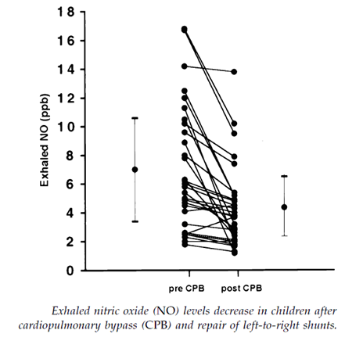
Another submitted PD study (Wessel et al 1993, see Figure 2) showed that ACH, which causes vasodilation via an endothelium dependent process, is able to induce vasodilation pre-operatively but the ACH response is blunted post-operatively, consistent with endothelial dysfunction. The same patients were still able to respond to iNO with pulmonary vasodilation, suggesting that the smooth muscle was capable of relaxation if the missing endogenous NO was replaced.
Figure 2: ACH-induced changes in PVR
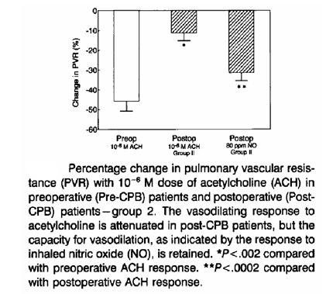
The proposed mode of action for the currently proposed indication, the treatment of pulmonary hypertension in the paediatric cardiac surgery setting, is the same as that proposed for the registered indication, treatment of PPHN. In both settings, iNO is believed to cause pulmonary vasodilation, a reduction of the pulmonary artery pressure (PAP), and unloading of the right ventricle. Because inhaled NO necessarily only reaches lung that is ventilated, the vasodilatory response is expected to be greater in ventilated lung, which would be expected to improve ventilation-perfusion matching resulting in improved oxygenation/oxygen delivery. Some of the PD and efficacy studies provided evidence of this, as discussed below.

Pharmacodynamic effects

Primary pharmacodynamic effects
The following 10 PD studies investigated the primary PD effect of iNO on pulmonary artery pressure. As shown in the table, all of them demonstrated a reduction in MPAP with iNO.
Two additional PD studies were submitted, which are not included in Table 3 below: Beghetti et al, 1998, which was a non-interventional study measuring endogenous NO exhalation in the setting of CPB, and Lepore et al, 2005, which was a drug interaction study assessing the effects of combining iNO and intravenous dipyridamole.

Table 3: Effects of inhaled NO on pulmonary and systemic blood pressure
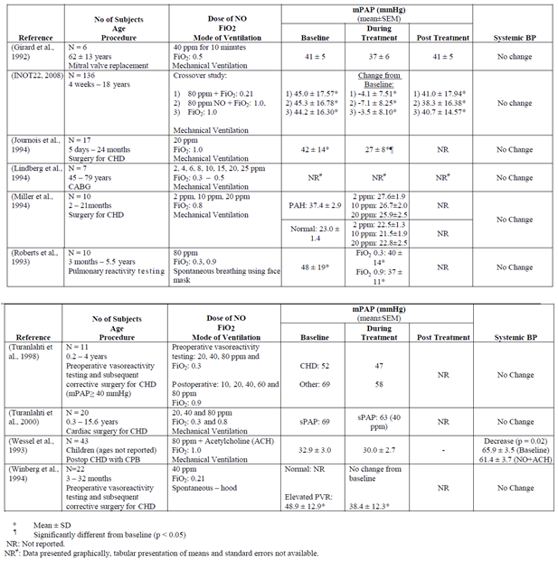
Notes on the sponsor’s provided table:
Roberts et al also assessed iNO doses of 20 and 40 ppm. The above table confuses the two Turanlahti studies: the earlier study assessed doss of 20, 40 and 80 ppm in 20 subjects undergoing pre-operative catheterisation, while the later study assessed pre-operative vasoreactivity in 11 subjects as well as post-operative response to iNO in 8 subjects, at a range of iNO doses.
The results in Lepore et al were consistent with the other ten studies assessing the effect of iNO on MPAP and PVR. Compared with O₂ alone, iNO produced significant pulmonary vasodilation, reflected in significant reductions in MPAP and PVR (reduced by 10 ± 4% and 26 ± 12%, respectively; both p < 0.05). These changes were augmented by co-administration with dipyridamole. As shown in Table 3, the reductions in MPAP and PVR were obtained without significant changes in systemic blood pressure.

Secondary pharmacodynamic effects
Improvement in oxygenation via improved ventilation perfusion matching could be considered a secondary PD effect, resulting from better delivery of the iNO to well ventilated regions of the lung. Several PD studies directly assessed oxygenation as a secondary endpoint, usually showing an improvement when subjects received iNO.
For instance, in Girard et al, 1992, mixed venous oxygen saturation significantly improved on treatment with iNO. In Journois et al, 1994, a significant improvement in arterial and venous oxygen saturation occurred with iNO. By contrast, in Lindberg et al, 1994, the authors reported no effect on oxygenation.

Time course of pharmacodynamic effects
Most of the PD studies used treatment times lasting only 5 to 15 minutes, and washout periods of 5 to 10 minutes, reflecting the investigators confidence that the onset and offset of the effects of iNO were rapid. The evidence generally supports this confidence, though the onset of the response was not usually reported with high temporal precision. Significant effects were seen in the studies using treatment times of ≤ 10 minutes, and many authors explicitly stated that onset of action was observed within a couple of minutes. The offset of the PD effects was also seen within minutes, and several authors explicitly commented that the effects wore off within 15 minutes.
As an example, Lindberg et al tested several doses, and used 5 minute treatment periods separated by 5 minute washout periods. This time was sufficient to observe the fluctuating onset and offset of the iNO effect.
Figure 3: SPAP, MPAP, DPAP and PVR, dose response after coronary artery bypass surgery
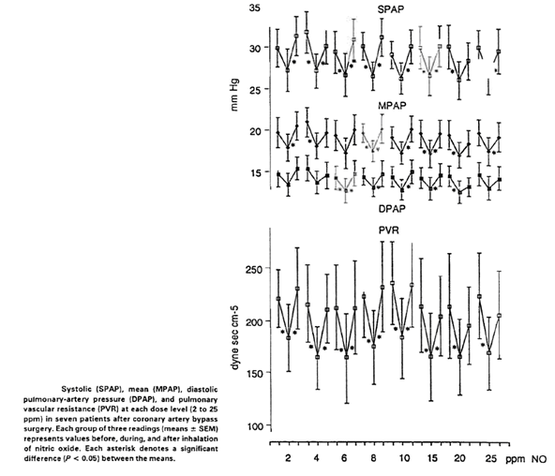
On the other hand, the use of iNO appears to produce a secondary PD effect that makes patients prone to rebound pulmonary hypertension, and this effect may last for hours, such that most authors recommend slow and cautious weaning of iNO. The propensity for rebound pulmonary hypertension (PHT) and its temporal profile has not been formally studied and it would be difficult to assess this effect in a rigorous scientific fashion without risking the welfare of the study subjects. Indirect estimates of delays in weaning can be derived from the efficacy studies, instead, such as Miller et al, 2000, which used weaning time as a clinical endpoint, as described in the efficacy section.

Relationship between drug concentration and PD effects
PD and efficacy studies have used a range of doses, from 2 ppm to 80 ppm, and a couple of PD studies specifically compared the haemodynamic effects of multiple doses. Despite this, no formal dose response studies have been conducted, and it is still unclear what constitutes the lowest effective dose.

Low-dose studies
Miller et al, 1994, studied iNO at doses of 2 ppm, 10 ppm and 20 ppm in FiO₂: 0.8 during mechanical ventilation in infants. In subjects with elevated pulmonary artery pressure at baseline, iNO produced a significant decrease in mPAP after 10 minutes of iNO at all three doses (see Figure 6 below).
Lindberg et al, 1994, studied iNO doses of 2 ppm to 25 ppm in adult patients after coronary artery bypass graft (CABG) surgery, and found that decreases in MPAP and PVR were similar at all doses. Responsiveness in this study is likely to have been low because of other factors, such as the fact that patients had normal MPAP at baseline (mean baseline MPAP < 20 mm Hg). See the Figure 3 for details.

High-dose studies
Roberts et al, 1993, tested iNO doses of 20 ppm, 40 ppm and 80 ppm in 10 children with elevated MPAP (mean baseline MPAP 48 mm Hg). An apparent dose trend was observed across the three doses, but inter-individual variation was marked. Only the higher doses, 40 ppm and 80 ppm, produced a significant response relative to baseline and to oxygen alone.
Figure 4: PVR changes while breathing iNO in oxygen
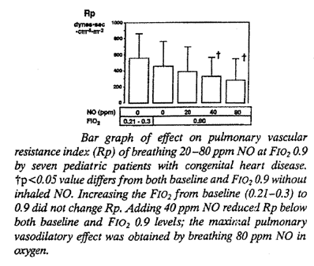
Turanlahti et al, 2000, studied iNO doses of 20 ppm, 40 ppm and 80 ppm. The difference between the 20 ppm and 40 ppm doses was significant, and was consistent with a dose trend, but there was no overall dose trend when all three doses were considered, and the results with 80 ppm resembled those seen with 20 ppm, both being apparently less effective than 40 ppm. (The sponsor’s description of these results in the Summary of Clinical Pharmacology is potentially misleading, implying a plateau effect: “There was a dose-related reduction in mPAP at the 20 and 40 ppm doses; no further decrease in mPAP was observed when the dose was increased to 80 ppm dose.” As Figure 5 demonstrates, the increase to 80 ppm produced a partial reversal of the efficacy seen at 40 ppm.).
Figure 5: Vasodilator effect on MPAP of iNO, O₂ and PGI2
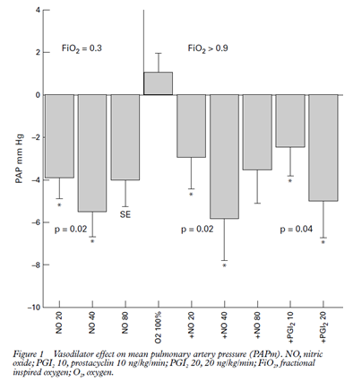
In the efficacy study by Solina et al, 2001, 62 consecutive adult cardiac surgery patients demonstrating pulmonary hypertension immediately before induction of anaesthesia were treated with iNO or milrinone. The percentage decrease in PVR was not significantly different among the groups (10 ppm = 38%, 20 ppm = 50%, 30 ppm = 44%, 40 ppm = 36%, milrinone = 58%, p = 0.86).
In the pre-operative vasoreactivity study by Radovancevic et al, 19 heart transplant candidates were treated with iNO or prostaglandin E1 (This study was classified as an efficacy study). The haemodynamic response to all doses of iNO was very similar, with no apparent dose trend across the range of 40 to 80 ppm.
Overall, considering all the PD studies and the efficacy studies, the evidence for any dose response curve in the range 2 to 80 ppm is fairly weak. It appears likely that the response to iNO depends upon the degree of deficiency in endogenous NO production, and many other factors, so that intra and inter individual variation overwhelms the relatively minor changes seen as doses are increased. It appears likely that the response to iNO is saturable, and also that the response to iNO is reduced once endogenous NO deficiencies have been corrected, but this has not been subjected to formal study. Given that the proposed use of iNO is in a highly monitored post-surgical setting where the haemodynamic response can be seen immediately, it is feasible and appropriate for the dose to be tailored for each individual and titrated to the desired effect, so the lack of a clear dose response relationship is not a major deficiency in the submission.

Effect of pulmonary hypertension on responsiveness to iNO
A couple of studies suggested that responsiveness to iNO was greater in subjects with pulmonary hypertension (PH) than in subjects without PH.
In Winberg et al, 1994, iNO 40 ppm in room air, administered during pre-operative reactivity testing, decreased mean PVR by 32% in infants who had elevated PVR or MPAP prior to iNO, but had no effect on PVR in infants with normal MPAP. Furthermore, a correlation was observed between individual responsiveness to iNO (change in PVR) and the baseline PVR.
Figure 6: Individual PVR responses to iNO and correlation of PVR response with initial PVR
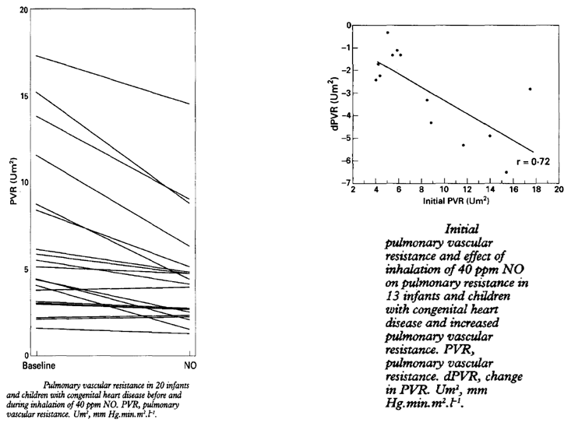
Miller et al, 1994, made similar observations. Subjects were divided into those with a high pulmonary: systemic arterial pressure ratio (PAP/SAP) at baseline (PAP/SAP > 0.50) and those with a low ratio (PAP/SAP < 0.50). A significant reduction in PVR was observed in the high ratio group but not in the low ratio group. Individual responses were correlated with the PAP/SAP ratio.
Figure 7: DVR response to iNO for high and low PAP/SAP ratios
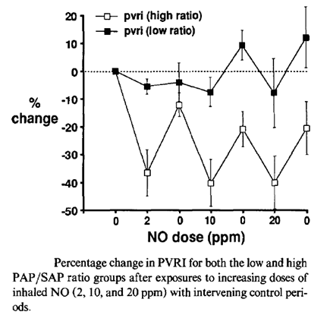
Figure 8: Correlation of PVR response with initial PVR/SVR ratio
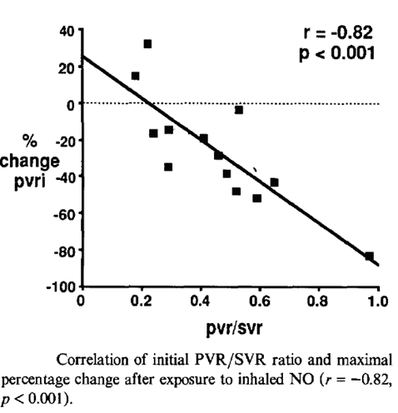
Consistent with this, Russell et al., 1998, in one of the pivotal efficacy studies, showed that, in children undergoing CPB for congenital heart surgery, post-operative iNO selectively reduced MPAP in patients with PH, but had no effect on patients without elevated MPAP.

Genetic, gender and age related differences in PD response
No study directly assessed the effect of genetic background, gender or age, but several studies included patients with Trisomy 21 (Down’s Syndrome), a group in whom congenital heart disease is common, and the response to iNO was the same as in subjects without Trisomy 21.

Pharmacodynamic interactions
One drug interaction study was submitted, Lepore et al, 2005. The main findings are shown in Table 4 and Figure 9 below, and suggest that dipyridamole significantly augments the pulmonary vasodilating effects of iNO.

Table 4: Haemodynamic effects of O₂, iNO and dipyrimadole
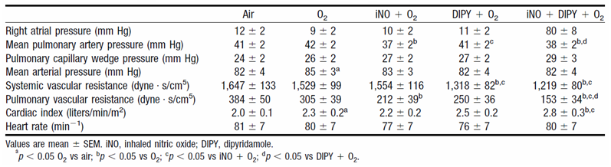
Figure 9: Effect of dipyridamole on duration of PVR response to iNO
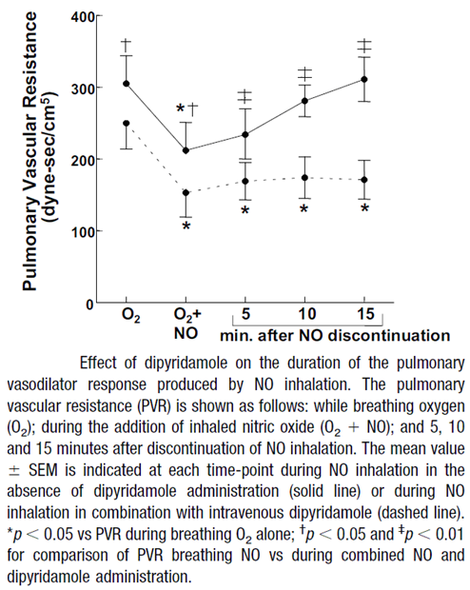
In most studies, iNO was administered with oxygen, which is already known to function as a pulmonary vasodilator, acting as natural mediator of ventilation-perfusion matching, with relative vasoconstriction of poorly ventilated hypoxic areas of the lung.
The interaction between iNO and oxygen was studied explicitly in Roberts et al, 1993. Oxygen by itself did not significantly lower PVR (as assessed by the PVR index), but the addition of iNO produced a significant reduction in PVRI (designated Rp in Figure 10).
Figure 10: PVR Response to iNO and O₂
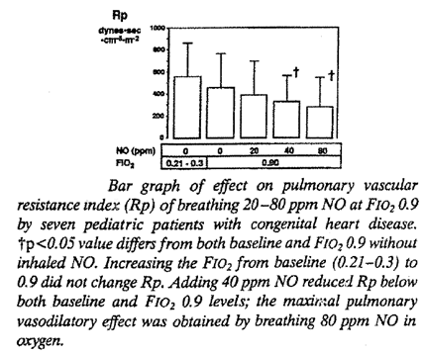
Roberts also showed that iNO produced a greater reduction in MPAP with high fraction of inspired oxygen (FiO₂ 0.9) compared to the reduction observed with low inspired oxygen (FiO₂ 0.21 to 0.3).
The study by Lepore et al, as shown in the table above, also included a comparison of haemo-dynamics on room air compared to oxygen; no significant changes were noted with oxygen when it was added to room air, but significant improvements in PVRI and MPAP were noted when iNO was added to oxygen.
The sponsor led study, INOT22, showed pulmonary vasodilating effects with oxygen and with iNO, when either was used as monotherapy, but significantly better effects were observed with the combination of both, as shown in Figure 11.
Figure 11: PVR change from baseline by treatment
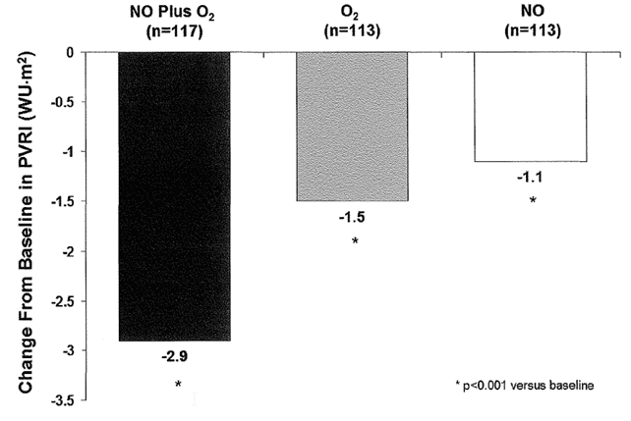

Evaluator’s overall conclusions on pharmacodynamics
The pharmacodynamics of iNO was established with the original marketing authorisation application for treatment of persistent neonatal pulmonary hypertension, and the proposed indication is consistent with that original characterisation.
In the current submission, the sponsor has submitted studies specifically pertaining to the perioperative setting, including both pre-operative vasoreactivity studies and post CPB studies, in both children and adults. Many of these studies were small in scale and lacked clearly defined prospective endpoints, but the studies can be considered reasonably robust as a group because of the high reproducibility of the PD effects which were observed across a range of independent investigative teams, different hospital settings and different target populations.
Although the submitted PD studies lacked control groups, and therefore did not qualify as efficacy studies, the use of baseline-comparisons and crossover designs allowed the various investigators to demonstrate the haemodynamic effects of iNO. The PD studies provided a consistent view of iNO as an agent that produces selective pulmonary vasodilation in most subjects with elevated PVR, and particularly in subjects who have undergone CPB and have impaired endothelial function. The effect was observed in both children and adults, and was clinically meaningful in magnitude.
Additional exploratory studies were consistent with the hypothesis that CPB induces a deficit in endogenous NO production, which iNO specifically and effectively targets.
Overall, despite their methodological limitations, the PD studies provide strong independent support of the likely efficacy of iNO for the proposed indication.

Dosage selection for the pivotal studies
As discussed above, there was little evidence of a dose response relationship over a large range of doses from 2 ppm to 80 ppm, but occasional studies suggested that the effect of 40 ppm might be more pronounced than lower doses.
None of the pivotal efficacy studies was sponsor driven, and several different doses were used by the investigators, ranging from 5 ppm to 80 ppm, as shown in Table 5.

Table 5: Studies in paediatric patients post-surgery for congenital heart disease
Publication | Design | N | Age | Dose & duration iNO | Primary endpoints
Miller et al 2000 | Randomised, placebo controlled, double blind | 124 | NO: 1-5 mths  PBO: 1-4 mths | 10 ppm for mean 87 hrs | Clinical: PHTC Frequency
Russell et al 1998 | Randomised, placebo controlled, double blind | 40 | 2 days – 6.5 yrs | 80 ppm for 20 min | Haemodynamics: MPAP, MSAP, HR
Day et al 2000 | Randomised, Conventional therapy control | 40 | NO: 1 day – 20 yrs  Control: 1 day – 3 yrs | 20 ppm until weaned from ventilation | Clinical: PHTC Frequency
Morris et al 2000 | Randomised, conventional therapy control, cross-over | 12 | 0.1 – 17.7 yrs | 5 and 40 ppm for 15 min | Haemodynamics: MPAP, MSAP, HR
Increasing doses of iNO increase exposure to potentially toxic by-products, including metHb and nitrate. This is evident in Figure 12 below from Kieler-Jensen et al, 1994 (one of the submitted efficacy studies).
Figure 12: Levels of nitrate and metHb in response to iNO
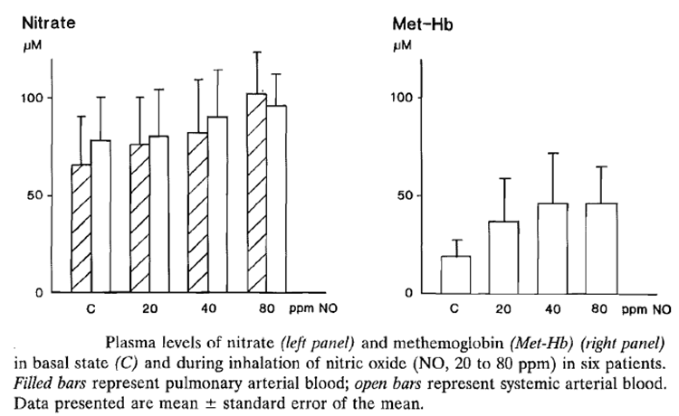
A similar relationship between administered dose and metHb was described in the approved PI, based on a study previously submitted as part of the original marketing application.
“Methaemoglobin disposition has been investigated as a function of time and nitric oxide exposure concentration in neonates with respiratory failure. The methaemoglobin (MetHb) concentration time profiles during the first 12 hours of exposure to: 0, 5, 20, and 80 ppm INOmax is shown in Figure 13.”
Figure 13: MetHb Concentration- Time Profiles, Neonates, 0, 5, 20 or 80 ppm INOmax
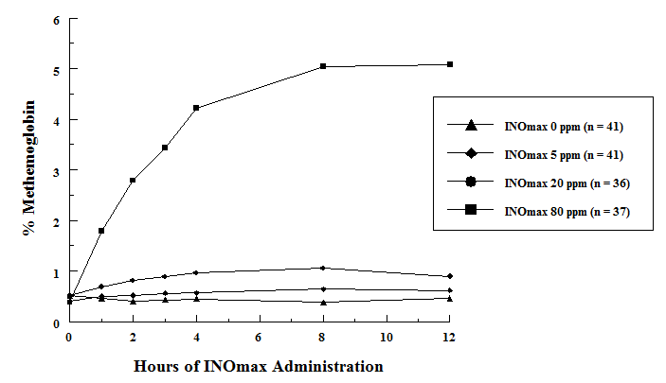
Importantly, this figure suggests that accumulation of metHb is minimal for doses of 20 ppm and below, but becomes problematic for sustained doses of 80ppm.
In the proposed PI, the following recommendations are made in the section relating to “Pulmonary Hypertension associated with Cardiac Surgery in children (0 to 17 years)”:
Dosage
Newborn infants, infants and toddlers, children and adolescents, ages 0-17 years
The starting dose of inhaled nitric oxide is 10 ppm of inhaled gas. The dose may be increased up to 20 ppm if the lower dose has not provided sufficient clinical effects. The lowest effective dose should be administered and the dose should be weaned down to 5 ppm provided that the pulmonary artery pressure and systemic arterial oxygenation remain adequate at this lower dose.
Clinical data supporting the suggested dose in the age range of 12-17 years is limited.
These recommendations are somewhat more conservative than the approved dosing recommendations for Persistent Pulmonary Hypertension in the Newborn (PPHN), which propose a starting dose of 20 ppm instead of 10 ppm and read as follows:
The maximum recommended dose of INOmax is 20 ppm and this dose should not be exceeded, as the risk of methaemoglobinaemia and increased NO₂ increases significantly at doses > 20 ppm. In the pivotal clinical trials, the starting dose was 20 ppm. Starting as soon as possible and within 4 to 24 hours of therapy, the dose should be weaned to 5 ppm provided that arterial oxygenation is adequate at this lower dose. Inhaled nitric oxide therapy should be maintained at 5 ppm until there is improvement in the neonate’s oxygenation such that the FiO₂ (fraction of inspired oxygen) < 0.60.
The proposed starting dose for the cardiac surgery indication is 10 ppm, which matches that used in the main pivotal study, Miller et al 2000.
Given the available studies on the treatment of pulmonary hypertension in the cardiac surgery setting, which show no major advantage of higher doses, and the safety requirement to minimise accumulation of metHb and NO by-products, the proposed dosing recommendations for the new indication are appropriate.

Clinical efficacy

Overview of available efficacy studies
The three tables below (Tables 6, 7 and 8) provided by the sponsor, list the 22 efficacy studies that were submitted for review. These included 9 randomised controlled studies in children undergoing cardiac surgery, which constitute the primary evidence base on which the submission rests, as well as 13 supportive studies in adults, which are only indirectly relevant to the proposed paediatric indication. Many of the studies submitted as efficacy studies would ordinarily be considered pharmacodynamic studies, because they only involved brief treatment and haemodynamic endpoints; iNO was not used as a sustained intervention as it would be when used for the proposed indication.
The only study that used iNO in a sustained, double blind fashion in the target population was the study by Miller et al, which should be considered the pivotal study of the submission.
As noted in the comments below, the second and third tables contain some minor inaccuracies.

Table 6: Studies in children undergoing cardiac surgery for congenital heart disease
Authors | Study Design | No Pts | Primary Outcome
Pivotal studies, placebo controlled
Miller et al 2000 | R, C, DB | 124 | Routine iNO post cardiac surgery can reduce the risk of pulmonary hypertensive crises with no adverse effects.
Russell et al 1998 | R, C, DB | 40 | iNO selectively reduced mPAP in those who had evidence of postoperative PAH.
Pivotal studies, versus conventional therapy
Day et al 2000 | R, C | 40 | No significant difference in incidence of PHTC compared with control (3 patients for iNO versus. 4 for control). Control patients who experienced PHTC were allowed to crossover and receive iNO after failing conventional; none of the control patients experienced a PHTC after being treated with iNO.
Morris et al 2000 | R, C, XO | 12 | iNO versus. hyperventilation. NO selective for pulmonary circulation and did not increase SVR.
Supportive studies, versus active controls
Cai et al 2008 | R, C | 46 | Combined iNO and milrinone were more effective in lowering PVR, PAH compared to either drug alone. The combined group had significantly shorter time on mechanical ventilation (p < 0.043)
Goldman et al 1995 | R, C, XO | 13 | mPAP lower during iNO compared to prostacyclin.
Kirbas et al 2012 | R, C | 16 | Both iNO and aerosolized iloprost are effective to selectively reduce PAP following cardiac surgery; no difference was found between the groups in terms of these effects.
Loukanov et al 2011 | R, C | 15 | There was no difference between the groups treated with iNO or iloprost with regard to the frequency of PHTCs, mean PAP and duration of mechanical ventilation (p > 0.05).
Stocker at al 2003 | R, XO, C | 15 | Both drugs, iNO20 ppm and intravenous sildenafil lowered pulmonary vascular resistance index. Sildenafil also lowered systemic blood pressure.
R = randomised, C = controlled, DB = Double blind, XO = cross-over

Table 7: Studies in adults undergoing cardiac surgery (excluding heart transplant and LVAD insertion)
Authors | Study Design | No Pts | Primary Outcome
Fattouch et al 2005 | R, C, DB | 58 | iNO was as effective in treating PAH as inhaled prostacycline. Both inhaled treatments superior to nitroprusside.
Fattouch et al 2006 | R, C, DB | 58 | iNO was as effective in treating PAH as inhaled prostacycline. Both inhaled treatments superior to nitroprusside. Inhaled treatments superior with regards to time to weaning, intubation time and ICU stay (p<0.05)
Gianetti et al 2004 | R, C | 29 | Low concentration iNO can blunt release of markers of myocardial injury and antagonise LV dysfunction after CPB.
Schmid et al 1999 | R, XO | 14 | iNO and prostacycline iv decreased PVR and increased cardiac index
Winterhalter et al 2008 | R, C | 46 | iNO and iloprost both reduced PAP and PVR immediately after weaning from CPB. Iloprost gave larger reductions in PVR and mPAP and greater increase in CO.
Solina et al 2000 | R, C | 45 | iNO lead to lower HR, higher RV ejection fraction and lower vasopressor requirement compared to milrinone.
Solina et al 2001 | R, C | 62 | Doses of iNO > 10p pm showed no difference in PVR response.
Of note, the two Fattouch studies were described as double blind but it is unclear if blinding was adequate. The second Fattouch study did not use nitroprusside as the sole intravenous comparator, as implied in the table above; the study instead refers to “intravenous vasodilators” which were not clearly described but appear to have included nitroprusside and nitroglycerin.

Table 8: Studies in adult patients undergoing heart transplant or LVAD insertion
Authors | Study Design | No. Pts | Primary Outcome
Heart transplant patients
Ardehali et al 2001 | Pr, C | 16 | Post-transplant iNO significantly reduced RV stroke work and PVR.
Kieler-Jensen et al 1994 | Pr, C | 12 | iNO significantly reduced PCWP and PVR at a dose of 20ppm.
Rajek at al 2000 | R, C | 68 | iNO 4 ppm cause selective reduction in PAP iNO aided weaning from CPB more successfully than PGE1.
Radovancevic et al 2005 | R, XO | 19 | iNO and PGE1 have comparable dilatory effects in PAH.
Left Ventricular Assist Device (LVAD) Placement
Argenziano et al 1998 | R, C, DB | 11 | LVAD. iNO at 20 ppm induced significant reductions in mPAP and increases in LVAD .
INOT41 | R, C | 150 | LVAD. iNO reduced the incidence of right ventricular dysfunction, but not significantly. Time on mechanical ventilation reduced for iNO (p=0.0077)
The sponsor’s description of the outcome for Kieler-Jensen et al, 1994, is inaccurate in this table: PVR was significantly reduced but PCWP was significantly increased. Also, the changes observed at 20 ppm persisted through stepwise increases to 40 ppm and 80 ppm.
The dose provided in Table 8 for Rajek et al is inaccurate. Inhaled NO was commenced at 4 ppm but titrated as needed up to 24 ppm.
The sponsor’s description of Argenziano et al, 1998, refers to “increases in LVAD,” which makes no sense because LVAD is a device, not a variable. This is presumably meant to read “LVAD flow index”, a measure of cardiac output.
The sponsor’s description of their own study, INOT41, is also inaccurate. There was a trend to lower time on mechanical ventilation in the iNO group, but this did not achieve statistical significance: the p-value was 0.077, not 0.0077 as stated in Table 8.

Pivotal efficacy studies
The sponsor identified four investigator led studies that satisfied their criteria for being considered “pivotal”: the studies were performed in paediatric patients undergoing cardiac surgery, iNO was used to treat pulmonary hypertension and it was compared with placebo or conventional therapy in a randomised, prospective design.
Although the sponsor designated all four of these as “pivotal”, only the study by Miller et al, 2000, was sufficiently large and robust that it would ordinarily be considered pivotal. The studies by Russell et al and Morris et al used haemodynamic endpoints rather than clinical endpoints, with only brief iNO treatment, and they were both quite small studies – the study by Russell et al based its positive results on a subset of the study population, consisting of 13 subjects with elevated pulmonary artery pressure, only 5 of whom received iNO. Also, the iNO dose used in Russell et al was well above that proposed for registration (80 ppm, instead of 10 to 20 ppm as recommended in the PI), so it is only indirectly supportive of the submission. The study by Day et al used a clinical endpoint, PHTCs, but it was clearly underpowered for this endpoint and for secondary haemo-dynamic endpoints, and it was ultimately a negative study. All three of these studies had other significant methodological issues, such as a lack of clarity surrounding the ranking of endpoints and the use of multiple statistical comparisons without corrections for multiplicity. Both Day et al and Morris et al used an open label design, which could have introduced bias.

Table 9: Studies in paediatric patients post-surgery for congenital heart disease
Publication | Design | N | Age | Dose &  duration iNO | Primary endpoints
Miller at al 2000 | Randomised, placebo controlled, double blind | 124 | NO: 1-5 mths PBO: 1-4 mths | 10 ppm for mean 87 hrs | Clinical: PHTC Frequency
Russell et al 1998 | Randomised, placebo controlled, double blind | 40 | 2 days – 6.5 yrs | 80 ppm for 20 min | Haemodynamics: MPAP, MSAP, HR
Day et al 2000 | Randomised, conventional therapy control | 40 | NO: 1 day –20 yrs Control: 1 day – 3 yrs | 20 ppm until weaned from ventilation | Clinical: PHTC Frequency
Morris yet al 2000 | Randomised, conventional therapy control, cross-over | 12 | 0.1 – 17.7 yrs | 5 and 40 ppm for 15 min | Haemodynamics: MPAP, MSAP, HR

Miller 2000

Abstract
Inhaled nitric oxide and prevention of pulmonary hypertension after congenital heart surgery: a randomised double blind study.
Background. Pulmonary hypertensive crises (PHTC) are a major cause of morbidity and mortality after congenital heart surgery. Inhaled nitric oxide is frequently used as rescue therapy. We did a randomised double blind study to investigate the role of routinely administered inhaled nitric oxide to prevent pulmonary hypertension in infants at high risk.
Methods. We enrolled 124 infants (64 male, 60 female; median age 3 months [IQR 1 to 5]), 76% with large ventricular or atrioventricular septal defects, who had high pulmonary flow, pressure, or both, and were undergoing corrective surgery for congenital heart disease. They were randomly assigned continuous low-dose inhaled nitric oxide (n = 63) or placebo (n = 61) from surgery until just before extubation. We measured the numbers of PHTC, time on study gas, and hours spent in intensive care. Analysis was done by intention to treat.
Findings. Compared with placebo, infants receiving inhaled nitric oxide had fewer PHTC (median four [IQR 0 to 12] versus seven [1 to 19]; relative risk, unadjusted 0·66, p < 0·001, adjusted for dispersion 0·65, p = 0·045) and shorter times until criteria for extubation were met (80 [38 to 121] versus 112 h [63 to 164], p = 0·019). Time taken to wean infants off study gas was 35% longer in the nitric oxide group than in the placebo group (p = 0·19), but the total time on the study gas was still 30 h shorter for the nitric oxide group (87 [43 to 125] versus 117 h [67 to 168], p = 0·023). No important toxic effects arose.
Interpretation. In infants at high risk of pulmonary hypertension, routine use of inhaled nitric oxide after congenital heart surgery can lessen the risk of pulmonary hypertensive crises and shorten the post-operative course, with no toxic effects.

Study design, objectives, locations and dates
This investigator led study used a randomised, double blind, placebo controlled design to assess the efficacy of routine post-operative iNO in preventing pulmonary hypertension after paediatric cardiac surgery.
The main objective was to determine whether iNO reduced the incidence of pulmonary hypertensive crisis (PHTC) following paediatric cardiac surgery in subjects thought to be at high risk. Secondary objectives were to assess the effect of iNO on other clinical measures (time to extubation and time in ICU), and to assess the safety of routine iNO.
This study was performed in the Royal Alexandra Hospital for Children, Sydney, Australia, in the lead-up to publication in 2000.

Inclusion and exclusion criteria
According to Miller et al: “Eligible patients were sequentially presenting infants suitable for corrective heart surgery with high pulmonary flow, pressure, or both, congenital heart lesions, such as non-restrictive ventricular septal defect, complete atrioventricular septal defect, truncus arteriosus, or total anomalous pulmonary venous drainage, with objective evidence of pulmonary hypertension at the immediate pre-operative assessment.”
The important elements of these entry criteria were that the subjects
- were infants
- required corrective surgery for high pulmonary flow
- had evidence of pulmonary hypertension
- were sequential patients.
The last of these requirements; sequential recruitment, reduces the risk of recruitment bias and makes it likely that the results of this study are applicable to a typical population of infants undergoing corrective cardiac surgery for high pulmonary flow.
Exclusion criteria were not explicitly discussed in the paper, but only six subjects from the cohort of sequential subjects were excluded, all on the basis of a lack of parental consent.

Study treatments
Subjects were treated with iNO (active treatment) or nitrogen (placebo), administered continuously as 10 ppm. Administration began after surgery.
Inhaled NO was prepared as medical grade nitric oxide at 1000 parts per million (BOC Australia, Sydney, NSW) in a base mixture of nitrogen, delivered via stainless steel cylinders and gas regulators. Medical grade nitrogen without nitric oxide (BOC Australia) was provided in identical cylinders.
Study gas was delivered in two different ways as techniques were refined during the course of the study. For the first 40 infants, a simple calibrated flow meter and mixing chamber was used, monitored by a commercially available electrochemical device (NOxBox, Bedfont Scientific, Upchurch, Kent, UK). The remaining infants received study gas via an integrated dosing, delivery, and analysis device (NODomo, Dräger Australia, Victoria).
Subjects with “clinically important” pulmonary hypertension (defined as pulmonary/systemic arterial pressure ratio > 0·50 together with haemodynamic instability, or a ratio > 0·75 at any time) were managed initially by intensifying medical therapy in a stepwise fashion (as per the table below). Open label nitric oxide (10 ppm) in addition to study gas, was used as rescue therapy for persistent or recurrent major PHTC associated with a clinical deterioration that was unresponsive to the maximum conventional treatment. The duration of rescue therapy was determined by the treating physician.
The maximum duration for administration of study gas was 7 days, and patients still on mechanical ventilation at this stage were weaned from study gas. Any subsequent pulmonary hypertension was treated according to the investigating team’s standard post-operative protocol, which included open label inhaled nitric oxide. All other elements of care were based on the treating institution’s standard protocol, as summarised in Table 10.

Table10: Protocol for management of patients with pulmonary hypertension
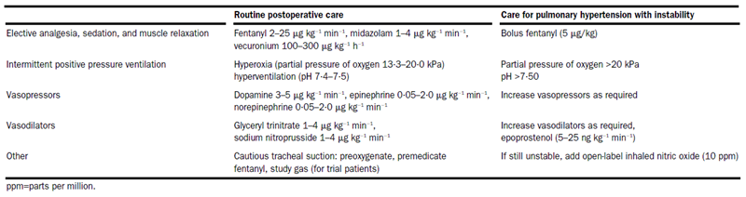

Efficacy variables and outcomes
The main efficacy variables were:
- number of pulmonary hypertensive crises
- time until extubation (weaning) criteria were reached (see below)
- time to wean study gas
- total time on study gas
- time to extubation
- time in ICU
- pulmonary vascular resistance index.
The investigator’s predefined extubation criteria were based on the presence of both haemodynamic stability and satisfactory gas exchange, defined as follows:
- absence of major PHTC during the previous 6 h;
- hourly urine output > 0·5 mL/kg;
- no acidosis;
- mean systemic artery pressure within age-related normal values;
- partial pressure of carbon dioxide < 6·0 kPa;
- partial pressure of oxygen > 13·3 kPa;
- spontaneously breathing an inspired oxygen fraction < 0·40 at a mechanical ventilation rate of < 8 breaths per min.
The primary efficacy outcome was the mean number of PHTCs per patient, and the secondary efficacy outcome was the time to meet extubation criteria.

Randomisation and blinding methods
Subjects were stratified according to the presence or absence of Down’s Syndrome (trisomy 21), because of the possibility that Down’s Syndrome might modify the risk of pulmonary hypertension and PHTC. Down’s Syndrome is a common cause of congenital cardiac defects, and it is also commonly associated with lung hypoplasia and obstructive airways disease, which could increase the risk of pulmonary hypertension independent of the degree of cardiac shunting. This was an appropriate step aimed at ensuring balance between the two treatment groups.
Because the investigator intended to test the routine use of iNO in cardiac surgery in subjects at risk of pulmonary hypertension, randomisation was performed prior to surgery, without reference to (and without stratification of) post-operative haemodynamics.
Blinding was achieved by using identical delivery equipment for the delivery of active treatment and nitrogen placebo. Study gas was prepared by an investigator who knew the identity of the treatment, but took no part in the treatment of the patient.
No formal assessment of potential unblinding, such as asking investigators to guess the assigned treatment, was included in the study. This represents a minor deficiency in the study, which is unlikely to have had a major impact on the findings. The introduction of continuous study treatment in the immediate post-operative period (rather than starting treatment as needed, in response to worsening pulmonary hypertension) reduced the likelihood that investigators would identify active treatment by observing a haemodynamic response to its initiation.
The equipment was set up with safety alarms, which were set at 25 parts per million for nitric oxide and 5 parts per million for nitrogen dioxide, and methaemoglobin concentrations were assessed twice daily. Potentially, these measures could have led to unblinding if the alarms were triggered. It was not explicitly stated in the paper whether the blinded investigators and main treating clinicians were restricted from access to the methaemoglobin results, but it was stated that protocols for dealing with methaemoglobinaemia were available at the bedside, implying that there was no attempt to restrict access to this potentially unblinding data. This is acceptable given the safety requirements of prompt treatment of methaemoglobinaemia.

Analysis populations
All randomised patients were analysed, and the analysis was based on intention to treat (ITT).

Sample size
Sample size estimations were based on the presumption that iNO would be associated with a 50% decrease in the number of PHTCs. The absolute incidence of post-operative PHTC in infants at high risk is not well documented, but unpublished data from the investigator’s unit, along with limited published experience (Hopkins et al, 1991) suggested that up to 50% of at-risk children might suffer at least one post-operative PHTC. The investigator’s pilot data also suggest a mean of 2·8 (SD 2·9) episodes per patient in the post-operative period. Based on this, it was estimated that 136 patients would need to be studied to detect a 50% decrease in PHTC with 80% power at a traditional two sided significance level of 0·05.
For the secondary endpoint of time to meet extubation criteria, the investigator sought a 30% reduction with active treatment. Previous published experience (Miller et al, 1995) suggested that the average time to extubation was about 6 days (SD 3·4). The investigator estimated that, for this endpoint, 112 infants would need to be studied to detect a reduction of about 2 days, with 80% power at a two sided significance of 0·05.
The authors did not specify whether they inflated their recruitment target in anticipation of dropouts, but there were no dropouts amongst studied patients so this was not a major concern. Recruitment was continued to a target that was intermediate between the two sample-size estimations: 130 patients were thought to be eligible, of whom 124 were randomised and studied (with consent not obtained for the other 6 patients). The authors did not explicitly justify the final population size of 124, which was less than the 136 subjects estimated to be required for assessment of the primary endpoint. Despite this, the study was positive for its two main efficacy endpoints, suggesting that the authors’ power estimations were broadly appropriate and the study was adequately powered.

Statistical methods
The investigator described the statistical methods as follows [bullets and emphasis added]:
“We compared baseline characteristics between groups with unpaired Student’s t tests (or Wilcoxon’s rank sum tests for non-normal data), with Bonferroni correction for multiple comparisons.
- All analyses were done by intention to treat.
- Since the data were unlikely to be normally distributed, we analysed the outcomes based on time to reach set criteria with survival-time methods based on the log-rank test.
- The counts over time of the numbers of PHTC were analysed by Poisson regression. If the variance substantially exceeded the mean count, the Poisson regression was adjusted for overdispersion; we present adjusted and unadjusted analyses.
- For subsidiary analyses of normally distributed data, means (SD) are presented and differences between groups assessed with unpaired t tests. For data not normally distributed, medians (IQR) are shown and non-parametric methods were used. Additional analyses for outcomes related to time were done with Cox’s proportional hazards regression, with adjustment for baseline characteristics.
- We took p < 0·05 to be significant. Interim analyses were scheduled when recruitment reached 100 randomised infants, and final analyses were done when all 124 randomised infants had completed the study.”
Thus, in summary, the primary endpoint of number of PHTCs was analysed with Poisson regression, and the secondary endpoint of time to reach extubation criteria was analysed with survival time methods based on the log-rank test. These methods appear broadly appropriate. The analyses were based on intention to treat (ITT), which is appropriate, but all 124 randomised subjects were treated.

Participant flow
Participant flow is summarised in Figure 14. All randomised patients completed the study and entered the ITT population, which removes the possibility of withdrawal bias.
Figure 14: Patient disposition
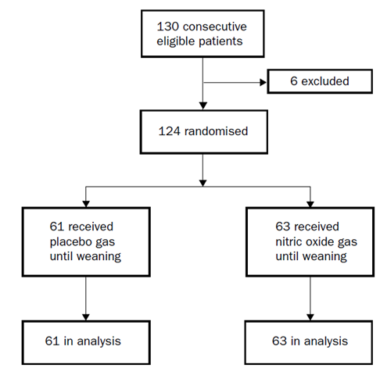

Major protocol violations/deviations
The paper did not mention any deviations or violations; not even in the context of saying that no protocol violations occurred. This would be unacceptable in a sponsor led study, but could reflect the word count limitations of a published paper.

Baseline data
The two groups were reasonably well matched at baseline in terms of demographics (gender balance and age), proportion with Down’s syndrome, underlying cardiac diagnosis and haemodynamics. No baseline between group differences were statistically significant. The groups were particularly well matched for median baseline pulmonary artery pressure (20mm Hg in each group).

Table 11: Baseline characteristics
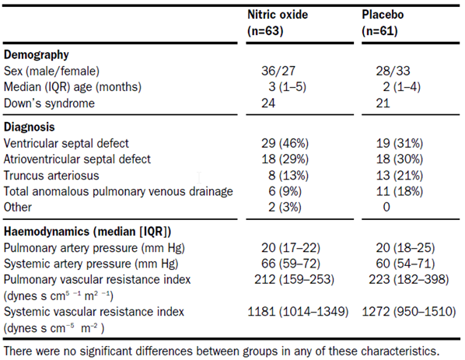

Results for the primary efficacy outcome
This study was positive for its primary endpoint. The infants who received inhaled NO oxide had significantly fewer PHTCs (median four [IQR 0 to 12]) than infants receiving placebo (seven PTHCs [IQR 1 to 19]; unadjusted relative risk 0·66 [95%CI 0·59 to 0·74] p < 0·001; adjusted for dispersion 0·65 [0·43 to 0·99], p = 0·045). The adjusted p-value is the more appropriate measure of the significance of the study; by this method the study only narrowly achieved significance. The adjusted and unadjusted relative risks were similar (0.65 and 0.66 respectively).
A reduction in PHTCs from seven to four represents a reduction of approximately 43%, which would be clinically worthwhile if sustained in clinical practice, especially given that PHTCs are themselves associated with a poor prognosis (Lai et al., 2007, Hopkins et al., 1991). The adjusted p-value was borderline (p = 0.045), but the results for this clinical endpoint were broadly consistent with several other studies using haemodynamic endpoints, which showed that iNO reduces pulmonary hypertension, so the result has reasonable external validity. The result is more impressive given that placebo recipients had access to rescue open label iNO, which could be continued at the treating clinician’s discretion, and which could have prevented further episodes of PHTC. Rescue iNO was used more often in the placebo group (used by five infants) than the iNO group (two infants), so that the most vulnerable placebo recipients actually received open label active treatment, potentially weakening the apparent treatment effect.

Results for other efficacy outcomes
Other efficacy outcomes, including the main secondary endpoint of time to reach weaning (extubation) criteria (T_{cr}) generally favoured iNO, as shown in the figure below. For infants treated with NO, the median T_{cr} was 80h [IQR 38 to 121], compared to 112h [IQR 63 to 164] for infants receiving placebo; this difference was significant (p = 0·019), and it represents a reduction of 32 h.
Note that the T_{cr} results were misquoted in the sponsor’s Summary of Clinical Efficacy (SCE) and the proposed PI, presumably due to a typographic error replacing “112 h” with “122 h”.
From the original paper:
“Compared with placebo, infants receiving inhaled nitric oxide had fewer PHTC (median four [IQR 0 to 12] versus seven [1 to 19]; relative risk, unadjusted 0·66, p < 0·001, adjusted for dispersion 0·65, p = 0·045) and shorter times until criteria for extubation were met (80 [38 to 121] versus 112 h [63 to 164], p = 0·019).”
From the SCE:
“Also, infants randomised to NO had shorter time until criteria for extubation were met (80 [38-121] versus. 122 h [63-164]; p = 0·019).”
From the proposed PI:
Miller et al (2000) also documented favourable outcomes for inhaled nitric oxide (iNO) patients on other secondary clinical endpoints such as shorter time until criteria for extubation were met (80 [38-121] versus. 122 h [63-164], p = 0.019) and shorter total time on study gas by 30 h for the nitric oxide group (87 [43-125] versus. 117 h [67-168], p = 0.023).
Also, in Table 2 of the SCE, the sponsor describes two endpoints based on time to reach criteria: time to reach “criteria for extubation”, and time to reach “criteria for weaning”.
“Patients on iNO had:
[...]
Shorter time to meet criteria for extubation (p = 0.019)
Shorter time to meet criteria for weaning (estimated difference: 32 hrs, p < 0.05)”
These appear to be the same endpoint, mistakenly interpreted by the sponsor as two different endpoints, possibly as a consequence of the previous typographical error, which changed the apparent difference from 32 h to 42 h. When mentioning “criteria for extubation”, the sponsor has used the p-value of 0.019; when mentioning “criteria for weaning”, the sponsor has used the placebo-subtracted difference of 32 h, but both of these values apply to the single endpoint cited above.
As a consequence of this mistake, the author also provides a faulty description of the original paper’s “Figure 3”; this is reproduced below as Figure 15 and was labelled Figure 1 in the sponsor’s Summary of Clinical Efficacy.
“Figure 1 below shows hazard ratios for time to meet criteria for weaning, time for weaning, time on study gas, time to meet criteria for extubation and time in intensive care unit.”
What the sponsor has interpreted as “time to meet criteria for extubation” is actually T_{ext}, explicitly labelled by Miller et al as “the time to extubation”.
Figure 15: Hazard ratios (95% CI) for post-operative course with differences in median times
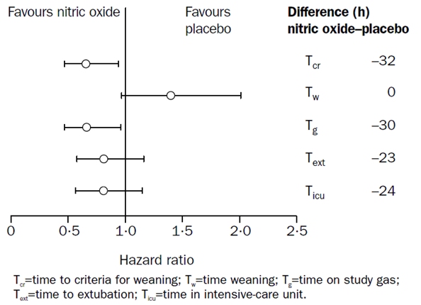
The median time spent weaning from study gas (T_{w}) was similar in the two groups, with no difference in the medians, but there was a trend to longer times with iNO (iNO: 4h [IQR 4 to 5] versus placebo 4h [4 to 4], hazard ratio 1·35; p = 0·19). This does not necessarily represent an adverse effect of iNO, because withdrawal of an inactive agent would not be expected to have any effects and so weaning placebo should be relatively straightforward; by contrast, withdrawal of iNO from infants who were benefiting from it might be expected to expose the underlying deficiency of pulmonary endothelial function, potentially causing appearance of pulmonary hypertension. On balance, despite the trend to slower weaning times in the iNO group, the total time on study gas (Tg) including weaning time was significantly shorter in the NO group (87 [43 to 125] versus 117 h [67 to 168], p = 0·023; see the figure above). This suggests that the net effect of iNO was positive, with infants becoming ready to be weaned sooner, and finishing weaning sooner, if they received active treatment. The shorter overall time on study gas did not translate into significantly shorter times to extubation or shorter times in ICU, but both of these times are likely to have been affected by other factors, including staffing levels at different times of the day and the availability of non-ICU beds. There were trends in favour of active treatment for both of these times.
Most infants (102 out of 124, 82%) were weaned from study gas in less than 7 days; the remainder (n = 22, iNO n = 6, placebo n = 16) were weaned at 7 days as per protocol. The between group difference in number of subjects still ventilated at 7 days was statistically significant (iNO 6 infants, 10% versus placebo 16 infants, 26%, p = 0·02).
Haemodynamic monitoring also showed a significant treatment effect. The pulmonary vascular resistance index (PVRI) was measured every 12 h; the two treatment groups had similar median PVRI at baseline but PVRI during study-gas administration was significantly lower in the iNO group compared with the placebo group (p < 0·001, presumably by Cox’s proportional hazards regression; see Figure 16). A flaw in the original paper was that the PVRI data were displayed without error bars.
Figure 16: Pulmonary vascular resistance versus time
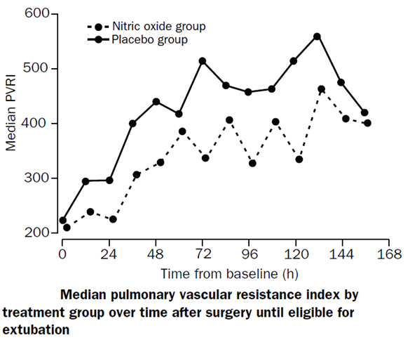

Conclusion
Miller et al performed a relatively large study (n = 124) in the target population of paediatric cardiac surgical patients using a prospective, randomised, placebo controlled design, with a robust methodology and clearly defined clinical endpoints. The study was positive for its primary endpoint, the number of pulmonary hypertensive crises (PHTCs): infants who received iNO had significantly fewer PHTCs (median four [IQR 0 to 12]) than infants receiving nitrogen placebo (median seven PHTCs [IQR 1 to 19]; unadjusted relative risk 0·66 [95%CI 0·59 to 0·74] p < 0·001; adjusted for dispersion 0·65 [0·43 to 0·99], p = 0·045).
Active treatment was also associated with shorter times until criteria for extubation were met (80 h [38 to 121] versus 112 h [63 to 164], p = 0.019). The time taken to wean infants off study gas was longer in the nitric oxide group than in the placebo group, but the total time on the study gas was still 30 h shorter for the nitric oxide group (87 [43 to 125] versus 117 h [67 to 168], p = 0.023). Favourable trends were seen for total time in ICU, and significantly fewer infants in the active group were still being ventilated at the end of the seven-day study period.

Russell 1998

Abstract
The Effects of Inhaled Nitric Oxide on Post-operative Pulmonary Hypertension in Infants and Children Undergoing Surgical Repair of Congenital Heart Disease.
The role of inhaled nitric oxide in the immediate post bypass period after surgical repair of congenital heart disease is uncertain. In a controlled, randomized, double blind study, we tested the hypothesis that inhaled nitric oxide (NO) would reduce pulmonary hypertension immediately after surgical repair of congenital heart disease in 40 patients with pre-operative evidence of pulmonary hypertension (mean pulmonary arterial pressure [MPAP] exceeding 50% of mean systemic arterial pressure [MSAP]). Patients were then followed in the intensive care unit (ICU) to document the incidence of severe pulmonary hypertension. Of the patients, 36% (n = 13) emerged from bypass with MPAP > 50% MSAP. In these patients, inhaled NO reduced MPAP by 19% (P = 0.008) versus an increase of 9% in the placebo group. No effect on MPAP was observed in patients emerging from bypass without pulmonary hypertension (n = 23). Inhaled NO was required five times in the ICU, always in the patients who had emerged from cardiopulmonary bypass with pulmonary hypertension (5 of 13 [38%] versus 0 of 23). We conclude that, in infants and children undergoing congenital heart surgery, inhaled NO selectively reduces MPAP in patients who emerge from cardiopulmonary bypass with pulmonary hypertension and has no effect on those who emerge without it. Implications: In a randomized double blind study, inhaled nitric oxide selectively reduced pulmonary artery pressures in paediatric patients who developed pulmonary hypertension (high blood pressure in the lungs) immediately after cardiopulmonary bypass and surgical repair.

Study design, objectives, locations and dates
This study, published two years earlier than Miller et al, 2000, was a relatively small study (evaluable n = 36) of the haemodynamic effects of post-operative iNO in paediatric subjects undergoing cardiac surgery. The positive results reported in the abstract were based on a subgroup analysis of just 13 patients (5 iNO recipients).
The authors used a randomised, placebo controlled and double blind design but, despite that, it was a weak study that can at best be considered supportive. The statistical methods were somewhat unclear, and it was also unclear to what extent subgroup analysis was performed post hoc, in response to the results. Furthermore, it assessed a short duration of treatment (20 minutes) and it used a simple haemodynamic endpoint (mean pulmonary artery pressure, MPAP), so it could be more properly considered a PD study rather than a true efficacy study. The dose of iNO (80 ppm) was 8 times the recommended starting dose (10 ppm) for the proposed indication and 4 times the maximum recommended dose (20 ppm), so this study has only limited applicability to the proposed indication.
The study was performed in San Francisco, USA, in the lead-up to publication in 1998.

Inclusion and exclusion criteria
Subjects were eligible if they were children undergoing cardiac surgery for congenital heart defects, and had pre-operative pulmonary hypertension diagnosed directly by cardiac catheterisation or inferred from echocardiography.
In particular, pulmonary hypertension was defined as:
- MPAP > 50% of mean systemic arterial pressure (MSAP) on cardiac catheterisation; or
- a ventricular septal defect velocity of < 2.0 m/s, a tricuspid regurgitant jet > 3 m/s, or a pulmonary insufficiency jet > 2.0 m/s, resulting in an estimate of systolic pulmonary artery pressure > 50% of MSAP.

Study treatments
Subjects received active treatment by inhalation (iNO 80 ppm, diluted in nitrogen) or placebo (nitrogen) at an inspired oxygen concentration of 0.90, in a double blind fashion, in addition to standard anaesthetic and peri-operative care.
Subjects were treated with study gas as soon as the surgical repair was considered satisfactory and the patient had been weaned from cardiopulmonary bypass (CPB). Inhalation of the study gas continued for 20 min, a much shorter duration than would be used in standard clinical care if iNO were approved.
Additional open label iNO was given as rescue therapy when needed.
Non-randomised treatments included:
- anaesthesia induction with halothane, nitrous oxide, and oxygen;
- anaesthesia maintenance with IV fentanyl 25 to 100 µg/kg, midazolam 0.1 to 0.5 mg/kg, and inhaled halothane;
- hyperventilation to maintain a PaCO₂ of 30 to 35 mm Hg and pH > 7.45;
- dopamine 5 to 10 µg/kg·min as patients were weaned from CPB;
- adrenaline (epinephrine) 0.02 to 0.08 µg/kg·min, if systolic function was inadequate.

Efficacy variables and outcomes
Systemic, pulmonary and atrial blood pressures were measured by fluid filled catheters, placed by the surgeon before weaning from CPB.
Four study periods and a baseline period were defined:
- immediately before study gas administration (baseline),
- after 1 min of study gas administration
- after 10 min of study gas administration
- after 20 min of study gas administration
- after study gas administration had been discontinued for 1 min.
The main efficacy variable appeared to be MPAP after 20 min of study gas administration, with additional (secondary) comparisons performed at the other time points, but the paper did not clearly state a single prospective primary efficacy endpoint (see Statistical methods, below).
Arterial blood gases were measured at similar time-points or when clinically indicated.

Randomisation and blinding methods
Randomisation and blinding methods were not discussed in the paper, except that it is stated that the patient’s family, surgeons, anaesthetists and echocardiographers were unaware of assigned treatment. Randomisation appears to have been performed with equal weighting of the two arms, such that 18 subjects received iNO and 18 received placebo (one actual patient was represented as two subjects, receiving iNO for one procedure and placebo for another).

Analysis populations
The paper reports that the initial study population consisted of 40 studies in 39 patients; one subject underwent two operations and entered the study twice. Four subjects were excluded from the final analysis set, 3 because a decision was made by the surgeon not to perform pulmonary catheterisation, and 1 because of technical difficulties with the equipment. Thus, the final set consisted of 36 studies in 35 subjects.
Of the final set, 13 of 36 (36%) patients emerged from bypass with pulmonary hypertension (MPAP > 50% of MSAP); 5 of these received iNO and 8 received placebo. The remaining 23 patients emerged from bypass without pulmonary hypertension; 13 received iNO and 10 received placebo.

Sample size
No formal sample size estimations were performed.

Statistical methods
The authors’ description of their statistical methodology lacked detail. It read as follows (emphasis added):
“For analysis, patients were divided into those who had emerged from CPB with pulmonary hypertension (MPAP values exceeding 50% of MSAP) and who had received inhaled NO or placebo, and those who had emerged without pulmonary hypertension and who had received inhaled NO or placebo. We compared the MPAP values obtained immediately after bypass (baseline) with those recorded at 10 and 20 min during study gas administration (inhaled NO or placebo) and after the study gas had been discontinued for 1 min. We calculated the percent change in MPAP from the value immediately after bypass (before administration of NO or placebo) to each of four follow-up times: after 1, 10, and 20 min of administration of NO or placebo and 1 min after ceasing administration of NO or placebo. These measures were compared between the NO and placebo groups by using the Mann-Whitney U-test. We chose this nonparametric test because the small number of subjects would not permit convincing verification of the assumptions needed for a parametric approach such as the two-sample t-test. We calculated the Mann-Whitney P values using an exact algorithm because approximations may not have been accurate for our small number of subjects.”
Importantly, subjects were stratified according to the presence (n = 13) or absence (n = 23) of pulmonary hypertension as they emerged from CPB, and results were only significant in those with pulmonary hypertension; only five subjects received active treatment in this subgroup. It is unclear if this stratification was prospective or post hoc. While it is reasonable to consider the effects of iNO on subjects with and without pulmonary hypertension, the statistical conclusions of the paper would be considerably weakened if the stratification was performed post hoc. In particular, the p-values cited in the abstract would be technically invalid if they were performed on a post hoc subgroup.
It is also unclear from the authors’ description whether a single time point was considered primary and, if so, whether this primary time point was chosen prospectively or post hoc. If the selection of the time point was post hoc, then a correction should be made for the performance of multiple statistical comparisons. The lack of such an adjustment would also render the cited p-values invalid.
The efficacy results cited in the abstract imply that the main efficacy variable of interest was the change from baseline in MPAP among subjects with pulmonary hypertension post-CPB in iNO recipients versus placebo recipients after 20 min of study gas, but the p-value cited for this time point was different in the text of the abstract (p = 0.008) and the main efficacy results table (p = 0.0016, see below), suggesting that two different statistical methods were used for the same comparison. One p-value could represent a comparison with baseline, and the other represent a comparison between groups, but this is not clear. Another possibility is that one of the p-values was based on a repeated-measures statistical test, looking at the overall distribution of MPAP in each group across all four time-points, and the other was based on a single, specific time-point. Yet another possibility is that one sided and two sided statistical tests have been used. The discrepancy in the p-values remains unresolved, however, with both authors and the sponsor failing to comment on the matter.

Participant flow
An initial total of 40 subjects were recruited to the study, but only 36 had evaluable efficacy data (representing 35 unique patients, including one who was counted twice). In three subjects, a surgical decision was made on clinical grounds not to place a pulmonary catheter. In another subject, unspecified “technical difficulties with the equipment” occurred. This completion rate is acceptable. The surgeon’s decision about placement of a pulmonary catheter occurred prior to the expected commencement of randomised blinded treatment, so it is unlikely to have caused any withdrawal bias.

Major protocol violations/deviations
Protocol violations were not discussed in the paper.

Baseline data
Baseline data is summarised in Table 12 reproduced from the original paper. Unfortunately, the table does not indicate which treatment each subject received; nor do the original authors provide a summary of the baseline characteristics for each treatment group. Thus, it is impossible to determine whether the treatment groups were well matched at baseline.

Table 12: Demographic data
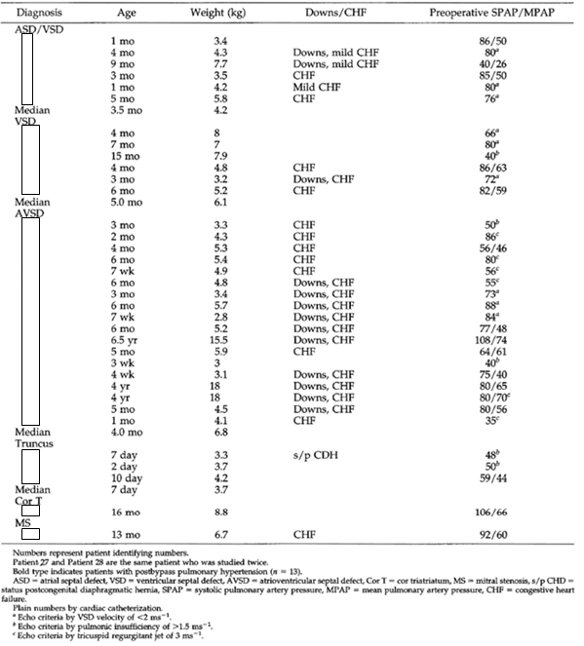

Results for the primary efficacy outcome
The main efficacy result cited in the paper’s abstract was a subgroup analysis: a reduction in MPAP of 19% in subjects with pulmonary hypertension post-CPB who received iNO (n = 5) compared to an increase of 9% in subjects with pulmonary hypertension post-CPB who received placebo (n = 8), with the comparison performed after 20 minutes of study gas. This difference was significant, and the p-value cited in the abstract was 0.008, as follows: “Of the patients, 36% (n = 13) emerged from bypass with MPAP > 50% MSAP. In these patients, inhaled NO reduced MPAP by 19% (P = 0.008) versus an increase of 9% in the placebo group.” In Table 13, showing comparisons at individual time points, the p-value cited for 20 minutes was p = 0.0016, even though the mean changes in each group were the same as those cited in the abstract. No explanation of this discrepancy was provided in the paper, and the issue was not noted by the sponsor. (The provided table is also inadequate in that it cites a p-value without declaring the statistical test used)

Table 13: Percent change in post-bypass MPAP (MPAP > 50%MSAP)
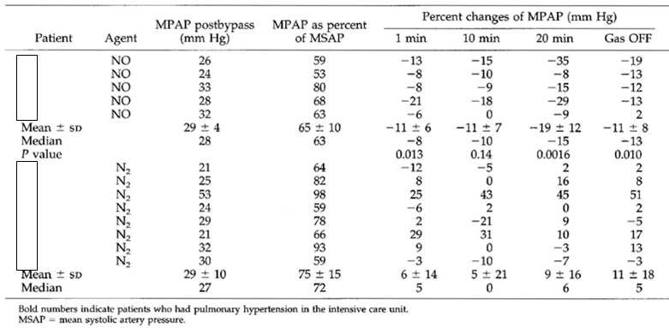
In the other main subgroup, subjects without pulmonary hypertension, no between group difference in MPAP was noted, as shown in Table 14. There was a weak trend to lower pressures in the iNO group at all three time points on treatment (1 min, 10 min and 20 min), and a weak trend to higher pressures in the iNO group one minute after ceasing study gas.

Table14: Percent change in post-bypass MPAP (MPAP < 50% SPAP)
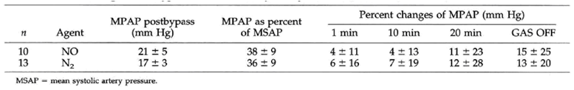
The different response to iNO in the two subgroups is displayed in Figure 17.
Figure 17: Changes in MPAP during iNO treatment
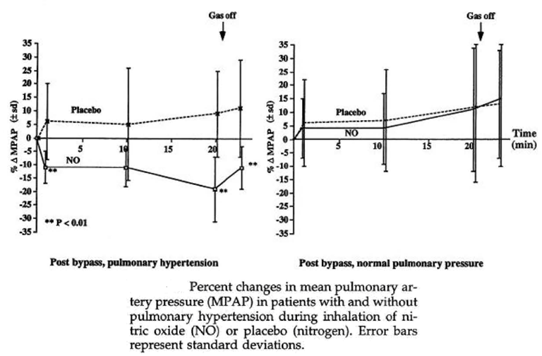
Essentially, this study suggests that subjects who are likely to benefit from iNO are those who display pulmonary hypertension soon after bypass; this could reflect greater pulmonary endothelial dysfunction in such patients, with a subsequent deficiency of endogenous NO. Providing inhaled NO for such subjects might be expected to have a more pronounced antihypertensive effect in the pulmonary vasculature than in subjects without such a deficiency, who exhibit normal MPAP post-CPB.
It appears likely that the subgroup analysis was conceived post hoc, in response to the results, which weakens the study considerably, but the observation is at least consistent with PD studies that also showed a greater effect of iNO in subjects with greater baseline elevations of MPAP or pulmonary vascular resistance (PVR).

Results for other efficacy outcomes
In addition to pulmonary arterial pressure, a number of other haemodynamic variables were monitored, as summarised Table 15 for the subgroup with post-bypass pulmonary hypertension. (This table appears to contain two errors for the control group, with MPAP mislabelled as SPAP, and SPAP mislabelled as MSPAP; note that MSPAP receives no definition in the legend).

Table 15: Haemodynamic data for patients with post-bypass pulmonary hypertension
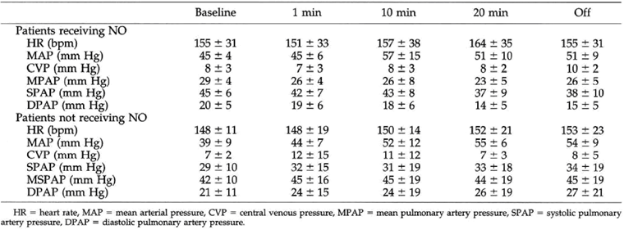
The original authors did not explicitly report any statistical comparisons between the two treatment groups for haemodynamic variables other than MPAP, apart from the overall summary statement: “Inhalation of NO compared with placebo did not significantly alter systemic hemodynamics (MSAP, heart rate, atrial pressure).”
There was no difference between groups in the level of inotropic support needed. The authors noted that, in addition to routine dopamine, one patient in each treatment group required additional inotropic support.
Oxygenation was not altered by iNO in this study, with the authors stating “There was no significant change in the arterial oxygenation during the study period.”

Conclusion
This randomised, double blind study demonstrated a pharmacodynamic effect for iNO 80 ppm in paediatric patients with pulmonary hypertension undergoing cardiac surgery, in response to a short period of iNO treatment (20 minutes) at a dose much higher (80 ppm) than that proposed for registration. The effect was confined to a small subgroup of patients (n = 13, of whom only 5 received iNO) who demonstrated elevated mean pulmonary arterial pressure immediately after cardiopulmonary bypass. MPAP in this subgroup was reduced by 19% in the iNO group versus an increase of 9% in the placebo group (P = 0.008). Many aspects of the study were unclear, including the exact statistical test used to generate the headline p-value, and it was not stated whether the subgroup analysis was planned prospectively or performed post hoc in response to weak results in the whole cohort.
On balance, this study is consistent with supportive PD studies, but it cannot be considered an adequate efficacy study, much less a pivotal one.

Day 2000

Abstract
Randomized Controlled Study of Inhaled Nitric Oxide After Operation for Congenital Heart Disease
Background. Inhaled nitric oxide selectively decreases pulmonary vascular resistance. This study was performed to determine whether inhaled nitric oxide decreases the incidence of pulmonary hypertensive crises after corrective procedures for congenital heart disease.
Methods. Patients with a systolic pulmonary arterial pressure of 50% or more of the systolic systemic arterial pressure during the early post-operative period were randomized to receive 20 parts per million inhaled nitric oxide (n = 20) or conventional therapy alone (n = 20). Acute hemodynamic and blood gas measurements were performed at the onset of therapy. The efficacy of sustained therapy was determined by comparing the number of patients in each group who experienced a pulmonary hypertensive crisis.
Results. In comparison to controls, there were no significant differences in the baseline and 1-hour measurements of patients who were treated with nitric oxide. Four patients in the control group and 3 patients in the nitric oxide group experienced a pulmonary hypertensive crisis.
Conclusions. Nitric oxide did not substantially improve pulmonary hemodynamics and gas exchange immediately after operation for congenital heart disease. Nitric oxide also failed to significantly decrease the incidence of pulmonary hypertensive crises.

Study design, objectives, locations and dates
This small study (n = 40, with 38 unique patients) employed a randomised, open label design to compare the efficacy of iNO versus conventional therapy in the prevention of pulmonary hypertensive crises after cardiac surgery in children and young adults. Conventional therapy was variable and was administered at the discretion of the treating physician. The study was clearly underpowered for its primary endpoint. Along with the open label design, this would ordinarily make it unsuitable to be considered as a pivotal efficacy study.
The study was performed in Utah, USA, from August 1993 to August 1999.

Inclusion and exclusion criteria
Subjects were eligible if they had congenital heart disease with pulmonary hypertension, underwent a biventricular repair or heart transplantation, and their systolic pulmonary arterial pressure was at least 50% of the systolic systemic arterial pressure at the time they were successfully removed from cardiopulmonary bypass (CPB).
Because eligibility was determined at the time of removal from CPB, several patients were flagged as potential subjects pre-operatively and their families were informed about the study, but only a proportion of these became eligible.
The study did not limit eligibility based on age, but most subjects (and all control subjects) were paediatric. The median age in control subjects was 6 months (range, 1 day to 3 years); the median age in iNO recipients was 7 months (range, 1 day to 20 years). The number of non-paediatric subjects in the active group was unclear.
All patients had at least echocardiographic evidence of pulmonary hypertension before operation, but pre-operative catheter evidence of pulmonary hypertension was not required because heart catheterisation was not a prerequisite for operation.

Study treatments
Subjects received either “active treatment” (iNO, 20 ppm) or “conventional therapy”, where conventional therapy was determined individually by each subject’s attending clinical team. This design was mandated by the local ethics committee, who felt that conventional therapy should not be limited artificially; as a result, the control group did not receive uniform treatment. This may have limited the ability of the study to demonstrate a clear between group difference.
Control patients who experienced a pulmonary hypertensive crisis were allowed to receive iNO as rescue therapy after failing conventional therapy. Nitric oxide was not discontinued in treated patients who experienced a pulmonary hypertensive crisis unless there was a concern of drug toxicity. This rescue therapy may have limited the ability of the study to detect major differences in outcome, such as mortality, but it seems appropriate on ethical grounds.
Some endpoints were based on haemodynamic changes after one hour of iNO, but iNO treatment was continued for most of the time subjects were in intensive care. All subjects receiving iNO (as randomised active treatment or as rescue therapy) “continued iNO until care providers decided to wean the patient from assisted ventilation.” Prior to extubation, iNO was gradually withdrawn by decreasing the dose during a period of 6 to 12 hours. Supplemental oxygen was transiently increased when nitric oxide was discontinued.
Subjects in both groups were permitted to receive additional agents with haemodynamic effects, as summarised in Table 16. Such agents included inotropes for support of blood pressure or cardiac output, as well as vasodilators for hypertension. Most subjects (control n = 17, iNO n = 19) received the systemic NO donor, nitroprusside, which may have limited the ability of the study to show additional benefit of inhaled NO.

Table 16: Inotropic and vasodilatory agents
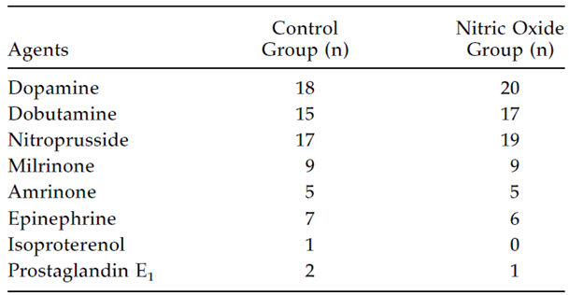

Efficacy variables and outcomes
The main efficacy variables were the number of patients with PHTC and the haemodynamic course of subjects over the first hour of treatment.
A PHTC was defined as “an acute episode of suprasystemic pulmonary arterial pressure associated with a decrease in blood pressure, heart rate, or oxygenation that required a change in medical therapy or ventilatory support.”
Heart rate, systemic arterial pressure, pulmonary arterial pressure, atrial pressures, and pulse oximetry were supposed to be monitored continuously in all subjects. Baseline measurements were performed “when patients were clinically stable after admission to the intensive care unit”, prior to the commencement of open label iNO. After about one hour, the haemodynamic and blood gas measurements were repeated and compared to baseline.

Randomisation and blinding methods
Patients were randomly assigned with equal probability to a control group that received conventional therapy or an active-treatment group that received iNO (20 ppm). Randomisation was achieved using a blind draw from sequential blocks containing six assignments.

Analysis populations
The investigators did not specify distinct analysis groups, but it appears that the main efficacy analysis included all randomised patients, all of whom received treatment. Nineteen unique patients were enrolled into each patient group, but two patients were each enrolled on two separate occasions; analysis was thus based on 20 notional subjects in each group.

Sample size
The investigators did not present any prospective sample size calculations, and it appears that the sample size was instead based on logistical feasibility.
The authors suggest that a much larger study would be needed to demonstrate a significant between group difference in the primary endpoint, PHTCs: “Using a power analysis for contingency tables, more than 2,000 patients may be needed to determine whether nitric oxide decreases the incidence of pulmonary hypertensive crises with a power (1-β) more than 0.90”. This estimate appears unduly pessimistic, given that the previously described study of Miller et al, 2000, achieved statistical significance with similar endpoints, based on treatment groups that were approximately three times larger than those in Day et al.
In reference to the negative haemodynamic outcomes in the study, the authors commented that “The sample size was large enough to conclude that nitric oxide did not decrease the ratio of systolic pulmonary and systemic arterial pressures by 20% in comparison to controls with a power (1-β) more than 0.75.”

Statistical methods
Comparisons between patient groups used a factorial analysis of variance or Fisher’s exact test. Serial haemodynamic and blood gas measurements were compared by analysis of variance for repeated measures (RM-ANOVA). Results were considered significant if they were associated with a p-value < 0.05, using a Scheffe’s F test. Descriptive numerical values were expressed as mean ± standard error.

Participant flow
Participant flow was not directly discussed in the paper, but it appears that all randomised subjects were treated, and all completed the study.

Major protocol violations/deviations
Several haemodynamic or blood gas variables were not recorded for several subjects:
- Heart rate comparisons were limited to 17 control patients and 13 iNO patients, because heart rate was determined by temporary pacing in 10 patients.
- Left atrial pressure comparisons were limited to 17 patients in each group because 6 patients did not have a catheter placed in the left atrium.
- Matching sets of systemic and pulmonary arterial blood gas measurements were inadvertently obtained in only 11 patients in the control group and 15 patients in the iNO group.

Baseline data
The major baseline disease characteristics (cardiac diagnoses, presence of Down’s Syndrome, and lung disease) are shown in Table 17. The median age in control subjects was 6 months (range, 1 day to 3 years); the median age in iNO recipients was 7 months (range, 1 day to 20 years). The groups appeared reasonably well matched for age, the presence of Down’s Syndrome, and the presence of pre-operative lung disease.
Baseline haemodynamic parameters were not particularly well matched. The baseline systolic pulmonary pressure was 47 ± 2 mm Hg in the control group, compared to 52 ± 3 in the iNO group. The mean difference of 5 mm Hg was not statistically significant, but it equalled the size of the treatment effect in the iNO group. (The authors did not explicitly state whether they compared the two groups in terms of haemodynamic changes from baseline, so the presence of differences at baseline may have limited the ability of the study to find a treatment effect.)

Table 17: Patient diagnoses
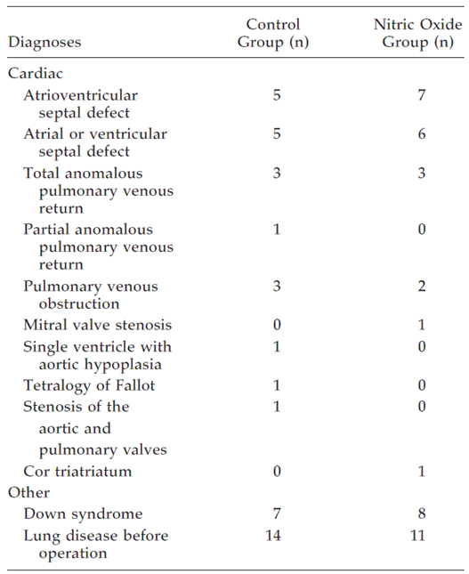

Results for the primary efficacy outcome
The primary endpoint, PHTC, occurred infrequently, which limited the overall power of the study to detect a between group difference. PHTCs occurred in 4 control patients and in 3 iNO patients. This difference was not significant (p-value and 95% CIs not supplied), but it represents a reduction of 25%, which would be clinically meaningful if sustained in practice. Clearly, no conclusions can be drawn from such small numbers.

Table 18: Characteristics of patients who developed PHTC
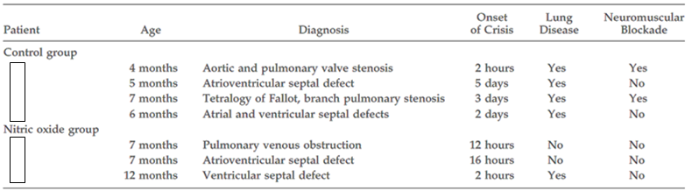
All four subjects receiving control therapy were switched to rescue iNO therapy, and they subsequently showed a statistically significant fall in systolic pulmonary artery presssure. Unfortunately, in the absence of a control therapy at the time of switching, it is not possible to estimate the extent to which this improvement represents a pharmacological effect, or the natural termination of a surge in pulmonary arterial pressure.

Table 19: Haemodynamic and blood gas measurements treated with iNO for PHTC
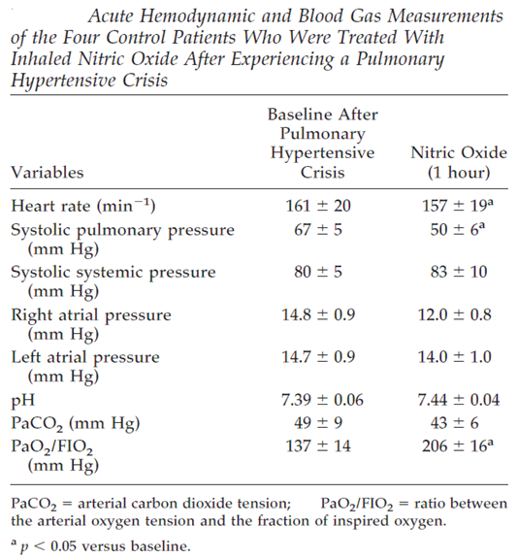

Results for other efficacy outcomes
Results of haemodynamic monitoring were highly suggestive of a treatment effect, but did not achieve formal statistical significance. At baseline, there were no significant differences in haemodynamic parameters and, at one hour, there were still no significant differences, but systolic pulmonary arterial pressure (SPAP) in the control group started relatively low and increased after an hour, whereas SPAP in the iNO group started relatively high and decreased by approximately 10%. Note that, based on SPAP alone, this study provided no evidence that conventional therapy had any utility in the treatment of pulmonary hypertension; mean SPAP actually increased in the control group. The fact that the contrasting outcomes in the active and control groups did not achieve statistical significance is likely to reflect the fact that the study was underpowered.
The authors compared the changes in ratio of systolic pulmonary and systolic systemic arterial pressures (SPAP/SSAP) for the two patient groups, and this comparison approached statistical significance (p = 0.066) but the actual values of this ratio were not reported. It would have been appropriate to perform a similar comparison of the mean changes in SPAP in each group, because the differences in group means at baseline worked against the finding of a significant difference at one hour, but this statistic was not reported. (It is unclear from the paper whether the authors performed this analysis, but it appears likely that they did, given that it is an obvious analysis to perform and they performed the more complex analysis of changes in SPAP/SSAP ratio. The authors may have performed the analysis but failed to mention it because it did not achieve significance.) The lack of clarity on this point is another weakness of the paper.
Relative to baseline several haemodynamic and oximetry parameters in the iNO group showed a significant change, but it is unclear to what extent this represents the normal recovery of haemodynamic function after CPB. These parameters included heart rate, pulmonary arterial pressure, left atrial pressure, pH, arterial carbon dioxide tension, and the ratio of arterial oxygen tension and fraction of inspired oxygen. The change in right atrial pressure for iNO patients approached statistical significance (p = 0.065). Also, as shown in Figure 18, there was a small but significant decrease in the SPAP/SSAP ratio in the active group, relative to baseline (p = 0.011). This change was not significant when compared to change in the placebo group, as noted above. In the control group, no changes compared to baseline reached statistical significance.

Table 20: Acute haemodynamic and blood gas measurements
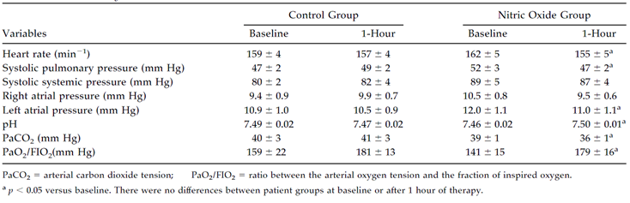
Figure 18: Change in ratio of SPAP to SSAP with iNO
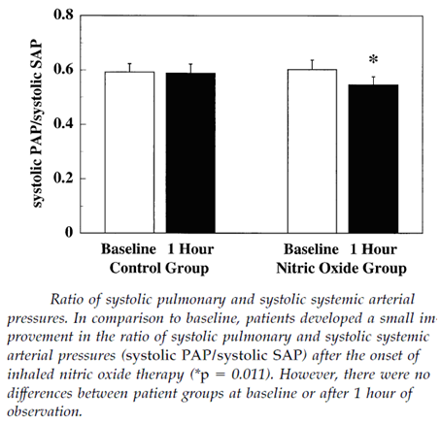
The summary of this study that appears in the sponsor’s Summary of Clinical Efficacy and in the proposed PI highlights the fact that significant changes were observed in the active group and not the control group. This is an important observation, and it is suggestive of a treatment effect, but it does not amount to a positive finding of a between group difference because the changes in the active group include an unknown component of post-CPB changes unrelated to the assigned treatment. The control-subtracted changes relative to baseline would have been of more interest, but these were not reported; with the exception of the systolic pulmonary: systemic pressure ratios, which did not show a significant difference between groups (despite showing a difference in the iNO group relative to baseline). The failure of pulmonary arterial pressures to show a significant treatment effect could reflect the fact that iNO has only modest haemodynamic effects, but it could also reflect an under-powered study. Given that several other studies did show a significant change in PAP, the latter explanation appears more likely.
The analysis of secondary endpoints was compromised by the failure of the investigators to collect comprehensive haemodynamic and blood gas data in all subjects, but it appears unlikely that this applies to pulmonary arterial pressure data. The paper explicitly states that data collection at one hour was incomplete for heart rate, left atrial pressure and blood gases, but it does not explicitly state the number of subjects contributing data to the pulmonary arterial pressure analyses. It seems likely that data collection was complete for this endpoint because pulmonary artery pressure was closely monitored in all subjects and represented a major focus of the study; furthermore it would be expected that the authors would comment if such data were missing.

Conclusion
This was a small, underpowered, open label study that assessed the efficacy of iNO 20 ppm in paediatric patients undergoing cardiac surgery. It had incomplete matching of the patient groups at baseline, and it failed to demonstrate a significant treatment effect for iNO 20 ppm in terms of both PHTCs (the primary endpoint) and several haemodynamic endpoints including systolic pulmonary arterial pressure (SPAP) and the ratio of systolic pulmonary and systemic arterial pressure. The use of rescue therapy may have limited the ability of the study to show a treatment difference.
The trends observed in this study were favourable for iNO, so it does not actually undermine the efficacy evidence obtained from other studies, but it is only weakly supportive.

Morris 2000

Abstract
Comparison of hyperventilation and inhaled nitric oxide for pulmonary hypertension after repair of congenital heart disease.
Background: Pulmonary hypertension is associated with congenital heart lesions with increased pulmonary blood flow. Acute increases in pulmonary vascular resistance (PVR) occur in the post-operative period after repair of these defects. These increases in PVR can be ablated by inducing an alkalosis with hyperventilation (HV) or bicarbonate therapy. Studies have shown that these patients also respond to inhaled nitric oxide (iNO), but uncertainty exists over the relative merits and undesirable effects of HV and iNO.
Hypothesis: Alkalosis and iNO are equally effective in reducing PVR and pulmonary artery pressure (PAP) in children with pulmonary hypertension after open heart surgery.
Setting: Critical care unit of a tertiary care paediatric hospital.
Design: Prospective, randomized, crossover design.
Patients: Twelve children with a mean PAP > 25 mm Hg at normal pH after biventricular repair of congenital heart disease.
Interventions: Patients were assigned to receive iNO or HV (pH > 7.5) in random order, and the effect on haemodynamics was measured. Each treatment was administered for 30 mins with a 30 min washout period between treatments. Finally, both treatments were administered together to look for a possible additive effect.
Measurements and Main Results: Cardiac output and derived haemodynamic parameters using the dye dilution technique. Hyperventilation, achieved by an increase in ventilator rate without a change in mean airway pressure, decreased PaCO₂ from a mean (SD) of 43.7 ± 5.3 to 32.3 ± 5.4 mm Hg and increased pH from 7.40 ± 0.04 to 7.50 ± 0.03. This significantly altered both pulmonary and systemic haemodynamics with a reduction in PAP, PVR, central venous pressure, and cardiac output and an increase in systemic vascular resistance. In comparison, iNO selectively reduced PAP and PVR only. The reduction in PVR was comparable between treatments, although addition of iNO to HV resulted in a small additional reduction in PVR. An additional decrease in PAP was seen when HV was added to iNO, attributable to a reduction in cardiac output rather than a further decrease in PVR.
Conclusions: Inhaled NO and HV are both effective at lowering PAP and PVR in children with pulmonary hypertension after repair of congenital heart disease. The selective action of iNO on the pulmonary circulation offers advantages over HV because a decrease in cardiac output and an increase in SVR are undesirable in the post-operative period.

Study design, objectives, locations and dates
This small study (n = 12) used a randomised, controlled, open label crossover design to compare the haemodynamic effects of iNO (at 5 ppm and at 40 ppm) versus hyperventilation induced alkalosis (HV) in children recovering from biventricular repair and CPB. Subjects received each treatment for 30 minutes, in a random order, with a 30 minute washout period between treatments. The iNO was administered at two doses, 5 ppm for 15 minutes and then 40 ppm for 15 minutes. Finally, after receiving both treatments, subjects received combined therapy with both iNO and HV.
Although the sponsor designated this study as pivotal, because it used a control therapy and it was performed in a paediatric cardiac surgical setting, it lacked most of the features required for a Phase III pivotal study: it was very small, it was unblinded, it had no untreated control group by virtue of its crossover design, and it did not clearly define a prospective primary endpoint. Furthermore, it only involved very short term treatment (30 minutes of iNO) with haemodynamic rather than clinical endpoints. A study of this design would ordinarily be classified as a PD study. Thus, it should be considered a small supportive study, not as pivotal.

Inclusion and exclusion criteria
Subjects were eligible if they were children undergoing biventricular repair for congenital heart disease, and they exhibited post-operative pulmonary hypertension (mean PAP > 25 mm Hg at a normal pH).

Study treatments
All subjects received HV and iNO in random order. Treatments were administered for 30 minutes, separated by a 30 minute washout period. After receiving both treatments separately, subjects then received both treatments concurrently to assess for potential additive effects.
HV was performed in order to produce alkalosis, with a target arterial pH of 7.50, achieved by increasing the ventilator rate. Patients were ventilated with a Servo 900C ventilator (Siemens, Solna, Sweden) in pressure control mode with a positive end expiratory pressure of 5 cm H₂O and peak inspiratory pressure set to deliver 10 to 15 mL/kg tidal volume. To avoid causing alterations in PVR directly by changing lung volume, PaCO₂ was reduced by increasing the ventilator rate while holding the tidal volume constant. Inspiratory to expiratory time ratios and mean airway pressures were also kept constant during HV.
Inhaled NO was administered for 30 minutes, at two different doses: 5 ppm for 15 mins followed by 40 ppm for 15 mins. The concentration was determined by an electrochemical monitor (Sensor-Stik EIT, Exton, PA). Methaemoglobin concentration was also measured; it remained < 2% in all patients.
In addition to randomised treatment, all subjects received standard intraoperative and post-operative care, including admission to an intensive care unit. All subjects were sedated with a continuous morphine sulfate infusion at 40 mg/kg/hr, and all subjects received muscle relaxants. Core body temperature was maintained at 36.0 to 37.8°C. Subjects received inotropes and other medications as indicated. Eight subjects received sodium nitroprusside at baseline. This agent is a systemic nitric oxide donor and its use in the majority of subjects may have partially limited the ability of the study to find additional pharmacodynamic effects in response to iNO. It is unclear if the use of such agents was reasonably constant across the different treatment intervals.

Efficacy variables and outcomes
The main efficacy variables, recorded at the start and end of each treatment period, were:
- heart rate
- systemic arterial pressure (BP)
- pulmonary artery pressure (PAP)
- left atrial pressure (LAP)
- central venous pressure (CVP)
- cardiac output measured by dye dilution (indocyanine green), based on the mean of three values
- arterial pH, PaO₂, PaCO₂, and mixed venous oxygen saturation
- cardiac index (CI)
- systemic vascular resistance index (SVRI)
- pulmonary vascular resistance index (PVRI)
- arterial oxygen saturation minus mixed venous oxygen saturation was calculated.
The primary efficacy outcomes were not declared explicitly, but they appeared to be the change in PVRI and PAP, based on the hypothesis declared in the abstract: “Alkalosis and iNO are equally effective in reducing PVR and pulmonary artery pressure (PAP) in children with pulmonary hypertension after open heart surgery.”

Randomisation and blinding methods
Each subject received the two main treatments in random order, with the randomisation method unspecified.
Treatment was open label, with no attempts to perform blinding. Given the fact that the efficacy variables were objective, the lack of blinding is unlikely to have had a major impact on the study results, but subtle changes in the clinicians’’ treatment, based on their expectations of the response to each treatment, could have introduced small changes in the haemodynamic parameters of the patients. For a small supportive study, this is not a major issue.

Analysis populations
The authors did not formally define analysis populations. It appears that all 12 randomised subjects were analysed.

Sample size
No discussion of sample size was provided. It appears that the sample size was based on logistical feasibility rather than power considerations.

Statistical methods
The description of the statistical methods in the paper was very brief:
“Changes within each treatment period were analysed by using a paired Student’s t-test with statistical significance defined as p < .05, whereas differences between the three treatments (NO, HV, NO+HV) were analysed by comparing the values recorded at the end of each treatment period by using analysis of variance for repeated measures [RM-ANOVA] and the Fisher least significant difference multiple comparison procedure. The Bonferroni correction for the p-value, adjusted for multiple comparisons, was set at < .01. Values are given as mean ± SD.”
These statistical tools are broadly appropriate. For the main inter group comparisons, the primary statistical tool was RM-ANOVA, which is suitable for assessing different measures reapplied to the same subjects. The authors appropriately corrected the significance threshold for the use of multiple endpoints. A paired t-test was used to assess changes within treatment periods, which is appropriate for showing whether the haemodynamic changes associated with each treatment were significant, but this approach does not clarify the relative efficacy of the different treatments. Also, it remains unclear to what extent the changes during treatment were potentially due to natural recovery from CPB. (It is implied by the authors, but not directly shown, that haemodynamic parameters deteriorated during the 30 minute washout period between treatments; it would have been useful to explore this deterioration explicitly, otherwise it could be hypothesized that a major source of improvement was simply the increasing time since CPB).
The main statistical flaws in the paper were:
- the failure to present or discuss power considerations
- the failure to provide confidence intervals for the results.
These omissions are particularly important given that the authors’ hypothesis was a negative one; they predicted (and subsequently found) a lack of difference between treatments. A failure to find a significant difference is not the same as proving equivalence, because the lack of demonstrated significance could be due to an inadequately powered study. To draw any reliable inferences from the analysis, it is important to know how big a difference the study could have missed, and with what likelihood.

Participant flow
This was a small study with all subjects under direct monitoring in the operating theatre and then intensive care, so all subjects completed the study. The paper implies that all subjects were fully evaluable for efficacy.

Major protocol violations/deviations
Protocol deviations were not discussed in the paper.

Baseline data
Baseline data for all twelve subjects is shown in Table 21. The age range extended from 0.1 years to 17.7 years.

Table 21: Patient details
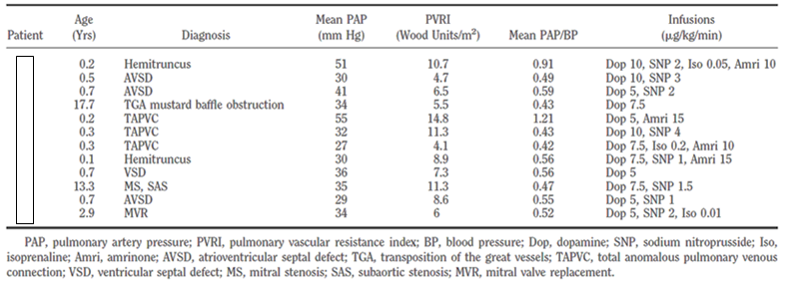

Results
The authors did not distinguish between primary and secondary outcomes. This study showed no significant differences between iNO and HV for pulmonary haemodynamic parameters, but it showed some differences relative to baseline for each treatment.
Hyperventilation was successful in reducing PaCO₂ and increasing pH: mean PaCO₂ decreased from 43.7 ± 5.3 mm Hg to 32.3 ± 5.4 mm Hg and arterial pH increased from 7.40 ± 0.04 to 7.50 ± 0.03. During hyperventilation, significant changes were observed for both systemic and pulmonary haemodynamics, as shown in the table below. The median reduction in PVRI during HV was 19.9% (range 22 to 43.2), and this was significant compared to baseline (p < 0.01). MPAP was reduced from 36.8 ± 9.8 to 28.4 ± 5.3, and this was also a significant change compared to baseline (p < 0.001). HV was also associated with a significant increase in SVRI (p < 0.01), as shown in Table 22.

Table 22: Haemodynamic effects of hyperventilation
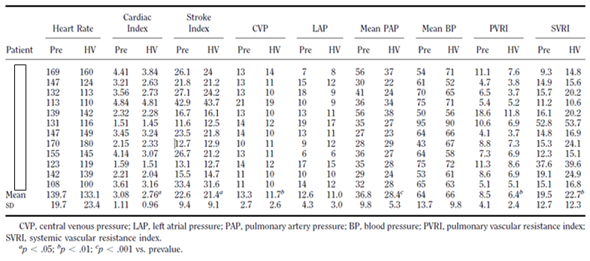
Inhaled NO produced marginally greater reductions in PVRI, which showed a median reduction of 23.7% (range 3.8 to 41.2); the changes were significant relative to baseline (p < 0.001). MPAP was also significantly reduced, from 34.5 ± 2.8 to 29.4 ± 2.7 mm Hg (p < 0.01). No difference in response was seen between 5 ppm and 40 ppm. The effect on pulmonary vasodilatation was selective, with no effect on SVRI. The cardiac index also remained unchanged with iNO. The authors commented that no rebound pulmonary hypertension was associated with the discontinuation of iNO (possibly reflecting a short duration of treatment).

Table 23: Haemodynamic effects of nitric oxide at 40ppm
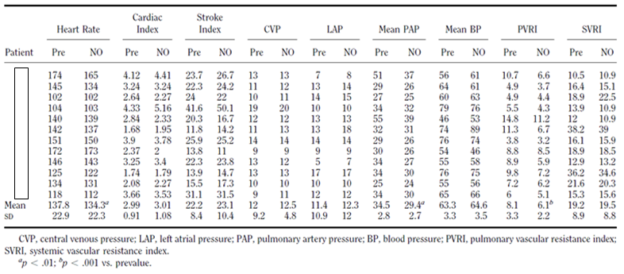
There was no significant difference in the response to iNO and to HV, when either therapy was used alone, as shown in Table 24 and Figure 19. The combination of both therapies produced a marginally greater reduction in PVRI than either individual therapy, but the differences were not significant. There was a greater reduction in MPAP with combination therapy than with either therapy alone, and the difference between the combination and iNO alone was significant (p < 0.01). Cardiac index and stroke index were both significantly lower with the combination than with iNO alone, and SVRI was significantly higher with the combination than with iNO alone, as shown in Table 24.

Table 24: Haemodynamic comparison of HV, iNO, and combined therapy (Mean ± SD)
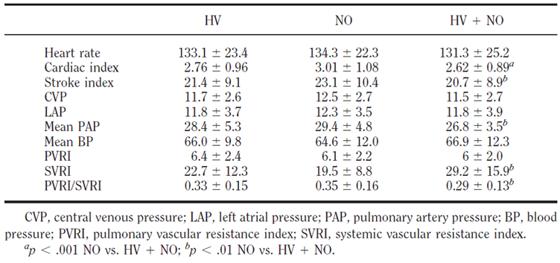
Figure 19: Comparison of PVRI after HV and iNO
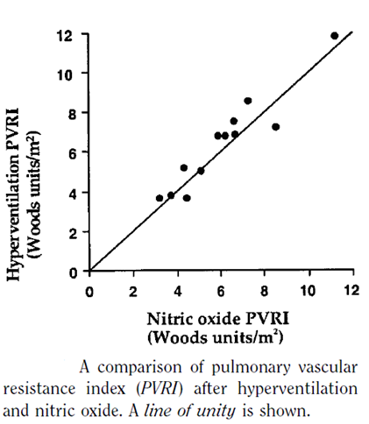

Conclusion
No significant differences were noted when comparing the combination of iNO and HV to HV alone, so this study does not provide evidence that iNO adds significantly to the pulmonary vasodilating effects of standard care with HV. Significant changes were observed in PVRI and MPAP with both treatments, relative to baseline, but this does not constitute clear positive evidence of a treatment effect because some improvement could be due to recovery from CPB.
The study does, however, suggest that HV has potentially adverse systemic effects that include an increase in SVRI, whereas iNO had no significant systemic effects (the difference in SVRI was not significant when comparing the two treatments).
In many post-surgical settings, an increase in SVRI could be detrimental, increasing the afterload on the heart at the same time that the heart is coping with reperfusion injury. The authors conclude that, based on this difference in systemic effects, rather than on differences in pulmonary effects, iNO offers advantages over HV alone:
“In this study we demonstrated that iNO and alkalosis, induced by HV, are equally effective in reducing PVR in children after open heart surgery but that the latter resulted in an adverse effect on cardiac output and an increase in SVR mediated through a reduction in PaCO₂ and an increase in pH that was independent of a change in intra thoracic pressure.”
“After repair of congenital heart disease, a reduction in cardiac output is seen that reaches its nadir in the first 8 to 12 hrs after surgery (31), probably as a result of ischemia-reperfusion injury to the myocardium. A reduction in cardiac output and an increase in SVR during HV, therefore, are likely to be detrimental.”
“The selective action of iNO on the pulmonary circulation offers advantages over HV by maintaining cardiac output without increasing afterload.”
These observations appear reasonable, but ultimately this was a negative study that only provides weak support for the sponsor’s claim of efficacy. It is, at least, consistent with other submitted studies that did achieve positive results. Several PD studies, for instance, showed that iNO induces pulmonary vasodilation with significant reductions in MPAP and PVR, without accompanying changes in SVR. The pivotal study by Miller et al produced broadly similar findings, with iNO producing reductions in PVR in comparison to placebo, but the study by Miller et al was adequately powered and the haemodynamic changes were clearly significant.

Supportive studies in children
The following studies are considered supportive, rather than pivotal, because they used active controls that are not themselves validated or registered for treatment of pulmonary hypertension. In some cases, the studies were larger and had more robust methodology than studies proposed as pivotal.
Table 25 lists all the paediatric efficacy studies in alphabetical order, including the “pivotal” studies already considered. After Miller et al, the next largest study was that by Cai et al, 2008 (n = 46, 31 who received iNO, 15 who received milrinone alone); this study also involved treatment for an appropriate duration (24 h) and could therefore be considered a major supportive study. Unfortunately, the focus of Cai et al was not the efficacy of iNO, but rather the utility of adding milrinone to iNO. It was also unblinded.
All of the other studies were quite small and used only brief treatment with iNO; individually, they can only be considered weakly supportive of the proposed indication. On the other hand, the overall consistency of the studies (along with similar supportive studies in adults) partially compensates for their individual deficiencies.

Table 25: Study populations in submitted paediatric efficacy studies paediatric population
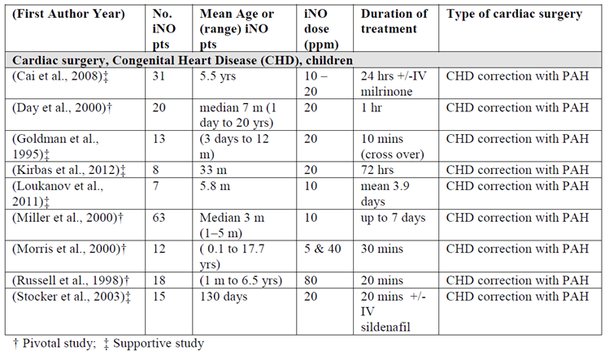

Cai 2008

Abstract
Background. Early morbidity and mortality after Fontan operations are related to the elevation of post-operative pulmonary vascular resistance. Inhalation of nitric oxide (iNO) and intravenous milrinone are two options capable of reducing pulmonary vascular resistance. We hypothesized that their combined use could maximally stabilize the pulmonary circulation after Fontan operation.
Methods. Forty-six patients with high pulmonary vascular resistance (transpulmonary pressure gradient > 10 mm Hg or central venous pressure > 15 mm Hg) and impaired oxygenation after Fontan operation were prospectively randomized into three groups: group Mil (n = 15, milrinone at 0.5µg kg⁻¹ min⁻¹), group iNO (n = 15, iNO at < 20 ppm), and group iNO+Mil (n = 16, iNO+Mil). Pulmonary hemodynamic and oxygenation changes were compared among the three groups.
Results. Inhalation of nitric oxide with milrinone led to (1) the most significant reduction of pulmonary vascular resistance (transpulmonary pressure gradient from 11.26 ± 1.4 0 mm Hg [baseline] to 7.93 ± 0.90 mm Hg [24 hour use] in group iNO+Mil versus from 11.10 ± 1.38 to 8.69 ± 0.86 mm Hg; p = 0.048 in group iNO and from 11.17 ± 1.41 mm Hg to 9.72 ± 1.32 mm Hg; p < 0.001 in group Mil); (2) the most significant improvement of arterial blood oxygenation (ratio of arterial oxygen partial pressure to inspired fraction of oxygen from 68.88 ± 14.09 to 131.25 ± 15.92 in group iNO+Mil versus from 70.07 ± 14.24 to 120.20 ± 15.92; p = 0.047 in group iNO and from 72.60 ± 12.92 to 95.20 ± 13.49; p < 0.001 in group Mil). Time on mechanical ventilation was shortest in group iNO+Mil (p = 0.043).
Conclusions. Combined use of iNO and milrinone optimally stabilized pulmonary haemodynamics after Fontan operation.

Study design, objectives, locations and dates
Cai et al used a randomised, open label, active controlled parallel group design to compare the efficacy of iNO, milrinone, and the combination of both agents in the treatment of elevated pulmonary vascular resistance after paediatric cardiac surgery (the Fontan procedure).
The study was a single hospital study performed in Shanghai Children’s Medical Center, in Shanghai, China, prior to May 2008, when it was accepted for publication.

Inclusion and exclusion criteria
Subjects were eligible if they were paediatric patients, who underwent a modified fenestrated Fontan operation and suffered a marked elevation of PVR:
- characterised by a transpulmonary pressure gradient (TPG, the difference between central venous pressure [CVP] and left atrial pressure) > 10 mm Hg or CVP > 15 mm Hg
- with no other “explainable causes” (such as low cardiac output, arrhythmia, and atrial-ventricular valve regurgitation)
- without response to conventional management (sedation, analgesia, and hyperventilation to arterial carbon dioxide tension of about 40 mm Hg, and an arterial pH of approximately 7.40)
- with concomitant deterioration of arterial blood oxygen saturation (SaO₂ < 85%) despite increased inspiratory oxygen fraction.
Exclusion criteria included major complications, such as major organ dysfunction, pulmonary infection, and conduit thrombosis. Subjects were also excluded from the final analysis if they were randomised to milrinone but subsequently needed rescue iNO therapy because of refractory elevations of PVR. This design feature potentially created withdrawal bias, removing from the milrinone group the subjects that had the most severe and refractory PVR; this could have biased the study against iNO.

Study treatments

Nitric oxide
NO was stored as a mixture of iNO 800 ppm with nitrogen (Shanghai Jiliang Gas Reference Co Ltd, Shanghai, China), and then added into the inspiratory circuit of the prototype Servo ventilator 300 NO-A (Siemens, Germany). Inhalation of NO began at 10 ppm, with subsequent adjustment aimed at achieving a > 20% improvement in TPG or > 10% SaO₂ within 2 hours after initiation, using the lowest possible iNO dose in the range 1 to 20 ppm to achieve these targets.
Peak nitrite and nitrate concentrations were continuously monitored, and methaemoglobin in the blood was measured with a radiometer ABL 700 blood gas analyser (Copenhagen, Denmark) at baseline and every 4 hours after onset of iNO treatment.
Weaning from iNO was attempted after24 hours; if the patient’s haemodynamics or SaO₂ deteriorated, the weaning attempt was postponed until their recovery.

Milrinone
Milrinone (LuAnn Pharmaceutical Inc, Shandong, China), was prepared from a vial of 5 mg/5 mL and infused systemically at 0.5 µg kg⁻¹ min⁻¹. If there was no significant improvement in TPG (> 10%) and SaO₂ (> 5%) within 6 hours of commencing milrinone, rescue iNO was added to therapeutic regimen and the patient was excluded from final statistical analysis. (As noted above, this could bias the study in favour of milrinone and against iNO by excluding the most difficult to treat subjects from the milrinone group). Weaning from milrinone was to be performed after uneventful extubation when subjects had a consistently stable hemodynamic condition.

NO+Milrinone
One group received both of the above treatments.

Efficacy variables and outcomes
The “primary” efficacy variables were said to be pulmonary (TPG and CVP) and systemic haemodynamics, and arterial blood oxygenation (including oxygenation index, define as the ratio of arterial oxygen partial pressure to inspiratory oxygen fraction, and SaO₂). A single primary efficacy endpoint was not identified, but the abstract and discussion implied that TPG was the main measure of efficacy.
So called “secondary” efficacy variables (which actually ranked lower than several other variables, so they could be considered tertiary) consisted of total time on mechanical ventilation and amount of chest drainage, as well as time in ICU and time in hospital.

Randomisation and blinding methods
Randomisation procedures were not described in detail, but consisted of “random number allocation”. Subjects appeared to be randomised with equal likelihood to the three treatment groups. The study was not blinded.

Analysis populations
The authors did not formally define different analysis populations, but the final population for analysis (n = 46) appeared to consist of all randomised subjects (n = 56) except:
- 1 patient in the iNO group, 2 patients in the Mil group, and 2 patients in the iNO+Mil group, who were excluded because of major complications of surgery
- 3 milrinone recipients who needed rescue iNO added because of severe hypoxemia and abnormally high TPG within 6 hours of the use of milrinone
- 1 patient in the Mil group and 1 in the iNO+Mil group were excluded because of severe thrombocytopenia.
Thus, the analysis was not a true intent to treat (ITT) analysis.

Sample size
Sample size estimations were not discussed in the paper. Positive results were obtained, suggesting that the study was adequately powered for most of its endpoints.

Statistical methods
The statistical methods were described as follows: “The data are expressed as the mean standard deviation for continuous variables. Statistical analysis was performed using statistical software (Statistica 6.0, Statsoft Inc, Tulsa, OK). Two-way analysis of variance for repeated measurements [RM-ANOVA] was used to test null hypotheses regarding the effects of between-subject factor (medication group), the within-subjects factor (time), and the interaction between them. If a statistically significant interaction between group and time was found, subsequent comparison among the groups at respective time points was performed by one-way analysis of variance followed by Duncan’s multiple range test. Nominal variables were analysed by nonparametric test. A difference was considered significant if the probability value was less than 0.05.”
The key points of this approach is that RM-ANOVA was used first, to establish that the treatments were significantly unequal, and a one-way ANOVA was then used to compare groups at individual time points. The overall statistical approach appeared appropriate, with the important exception that the authors should have prospectively defined a single primary endpoint.

Participant flow
See ‘Analysis populations’, above, for a summary of discontinued patients.

Major protocol violations/deviations
The paper did not discuss protocol violations.

Baseline data
The three treatment groups appeared to be reasonably well matched at baseline, in terms of demographics and cardiac diagnoses, as shown in Table 26. There was also no significant baseline difference in the main efficacy variables, TPG and CVP.

Table 26: Pre-operative and operative data of patients undergoing modified Fontan procedure
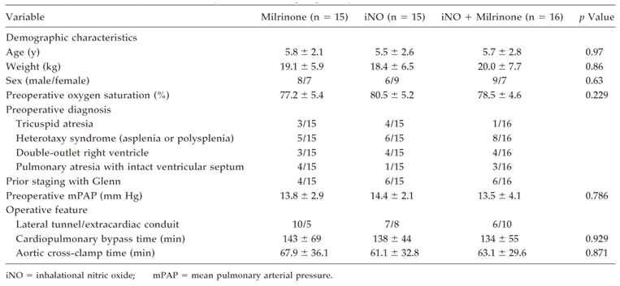

Results for the primary efficacy outcome (haemodynamic variables)
The main efficacy results of the paper were presented graphically, rather than with tables. Use of iNO, either alone or in conjunction with milrinone, appeared to reduce pulmonary vascular resistance, as reflected in the TPG and CVP, which decreased below 15 mm Hg and 10 mm Hg, respectively, within 4 hours. Milrinone alone led to a smaller and later reduction in pulmonary vascular resistance.
As shown in Figure 20, changes in TPG relative to baseline were significant in the iNO and iNO+Mil groups at all major time points, but changes in the Mil group relative to baseline were only significant from 12 hrs onwards.
From 4 hours to 24 hours, the difference in CVP and TPG between the Mil group and the other two groups achieved statistical significance; strongly supporting the case that iNO produces significant pulmonary vasodilation in this setting.
The difference in TPG between the iNO group and iNO+Mil group achieved statistical difference at 24 hours, providing some evidence that milrinone has efficacy for this indication. The effect of iNO+milrinone on CVP did not achieve significant superiority compared to iNO alone.
Figure 20: Transpulmonary gradient (mm Hg)
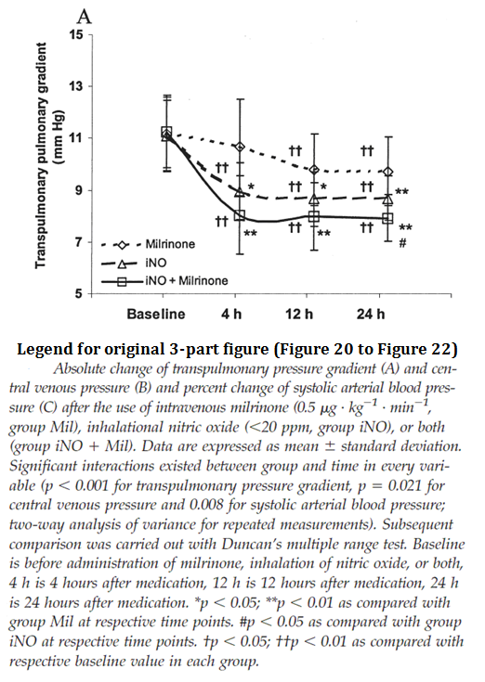
Figure 21: Central venous pressure (mm Hg)
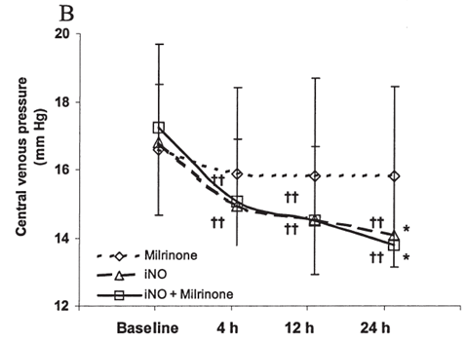
The effects of the three treatments on system arterial blood pressure are shown in Figure 22 (Part C of the authors’ original figure). Systolic systemic arterial blood pressure (SSAP) increased with all three treatments, consistent with improved cardiac function, but the maximal increase was seen with combination therapy. Importantly, iNO did not cause a decrease in SSAP relative to baseline or to the milrinone control group.
Figure 22: Systolic blood pressure (mm Hg)
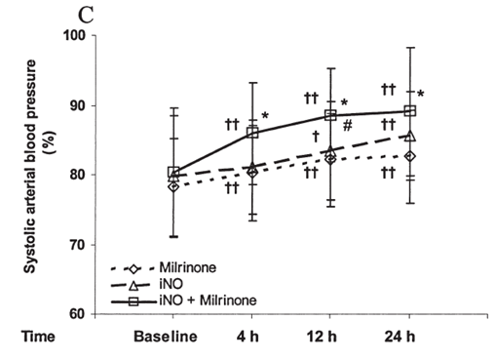

Results for other efficacy outcomes
The authors also assessed the effects of the three treatments on oxygenation, as shown in the two part figure (Figure 23). All three treatments were associated with an improvement in the ratio of PaO₂/FiO₂, as well as an improvement in oxygen saturation. The greatest improvements were seen with combination therapy. Relative to milrinone alone, both iNO-containing regimens were significantly superior at all time points post-baseline.
Figure 23: Changes in oxygenation index and arterial blood oxygen saturation
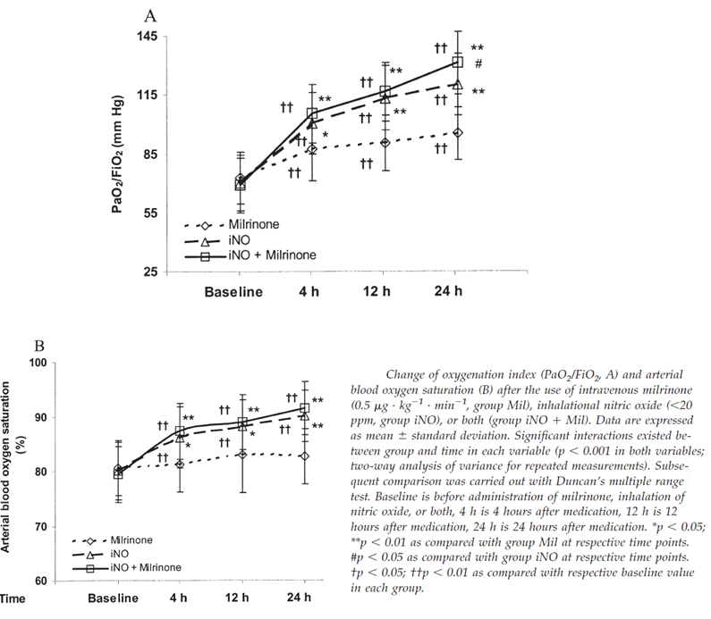
The other secondary endpoints considered by the authors were chest drainage, time in ICU and time in hospital, but none of these showed significant differences between the groups (see Table 27).

Table 27: Other secondary outcomes
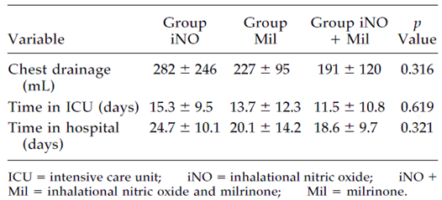

Conclusion
This study demonstrated significant superiority of iNO (starting dose 10 ppm, range 1 to 20 ppm) compared to milrinone for major haemodynamic endpoints including the study’s main measure of pulmonary vascular resistance, transpulmonary gradient (TPG). TPG was significantly lowered by both agents relative to baseline, but it was reduced earlier and to a greater extent with iNO than with milrinone. The superiority of iNO, relative to milrinone, was apparent at 4 hours and persisted to 24 hours. Pulmonary vasodilation with iNO was not accompanied by systemic hypotension, and systemic arterial pressures were significantly higher with combinations involving iNO than with milrinone alone.
The study also demonstrated that the combination of iNO+milrinone was more effective than milrinone alone, causing significantly greater reductions in TPG. Significant benefits were also observed for iNO in terms of oxygenation.
If it can be assumed that milrinone, at the doses employed in this study, is superior or at least equivalent to placebo in its effect on TPG, the superiority of iNO compared to milrinone strongly implies superiority of iNO relative to placebo. Superiority of milrinone relative to placebo seems likely given that milrinone is widely recognised as a vasodilator, its use in this study was associated with a significant fall in TPG relative to baseline, and the addition of milrinone to iNO produced even greater falls in TPG than seen with iNO alone. Thus, while not qualifying as a pivotal study because it lacked an officially approved control agent, this study nonetheless provides strong support for the sponsor’s efficacy claims.
Even if milrinone is not accepted as a suitable control agent, the three-group design of this study allows an estimate of the relative efficacy of iNO compared to no additional treatment. If the iNO-only treatment group is put aside, the remaining two groups consist of subjects that all received milrinone, but who were randomised to be treated with or without iNO. The superiority of the iNO+Mil group relative to the Mil group was statistically significant for all major endpoints, including TPG, CVP, systemic arterial pressure, PaO₂/FiO₂ ratio, and oxygen saturation. This superiority was demonstrated in paediatric subjects undergoing cardiac surgery, at iNO doses matching those recommended in the proposed PI, and thus the study has strong applicability to the proposed indication.

Goldman 1995

Abstract
Nitric Oxide Is Superior to Prostacyclin for Pulmonary Hypertension after Cardiac Operations
Background. Severe pulmonary hypertension is still a cause of morbidity and mortality in children after cardiac operations. The objective of this study was to compare the vasodilator properties of inhaled nitric oxide, a novel pulmonary vasodilator, and intravenous prostacyclin in the treatment of severe postoperative pulmonary hypertension.
Methods. Thirteen children (aged 3 days to 12 months) with severe pulmonary hypertension after cardiac operations were given inhaled nitric oxide (20 ppm x 10 minutes) and intravenous prostacyclin (20 ng·kg⁻¹ min⁻¹ x 10 minutes) in a prospective, randomized cross over study.
Results. Both nitric oxide and prostacyclin resulted in a reduction in pulmonary arterial pressure, although lht mean pulmonary arterial pressure was significantly lower during nitric oxide therapy (28.5 ± 2.9 mm Hg) than during prostacyclin therapy (35.4 ± 2.1 mm Hg; p < 0.05). The mean pulmonary to systemic arterial pressrun ratio was also significantly lower during nitric oxide than prostacylin administration (0.46 ± 0.04 versus 0.68 ± 0.05; p < 0.01), due mainly to only prostacyclin lowering systemic blood pressure.
Conclusions. Inhaled nitric oxide was a more effective and selective pulmonary vasodilator than prostacyclin and should be considered as the preferred treatment for severe postoperative pulmonary hypertension.

Study design, objectives, locations and dates
Goldman et al used a randomised, open label crossover design to compare the efficacy and pulmonary selectivity of iNO versus intravenous prostacyclin in 13 children with pulmonary hypertension after cardiac surgery, using haemodynamic endpoints and a short duration of therapy (10 minutes iNO, 5 minutes of full dose prostacyclin, and 10 minutes of combination therapy). The sequence of the two agents was randomised, with combination therapy employed between each period of monotherapy. The short duration of treatment, the crossover design, and the use of haemodynamic endpoints means that this study has more in common with PD studies than with typical Phase III efficacy studies.

Inclusion and exclusion criteria
Subjects were eligible if they were children who exhibited severe pulmonary hypertension after cardiac surgery, and they were recruited at the time that the treating clinician requested intravenous prostacyclin.
Severe pulmonary hypertension was defined either as pulmonary artery pressure (PAP) greater than two thirds the systemic arterial pressure (SAP) or pulmonary hypertension severe enough to cause cardiopulmonary compromise as reflected by either hypoxia, hypotension, or one or more pulmonary hypertensive crises.

Study treatments
Subjects were randomised to prostacyclin first (n = 8) or iNO first (n = 5).

Prostacyclin
The prostacyclin regimen required a titrated, step wise introduction of prostacyclin to limit systemic hypotension and other side effects, starting at 5 ng per kg per minute and increasing in steps of 5 ng per kg per minute every 5 minutes, aiming for a target dose of 20 ng per kg per minute, which was then administered for 5 minutes. This titration was performed at the start of the prostacyclin phase in the prostacyclin-first group, and at the start of the combination phase in the iNO first group, as illustrated below (Figure 24).

Inhaled NO
The iNO regimen used NO stored at 1000 ppm and subsequently diluted in nitrogen to 20 ppm, which was introduced into the inspiratory circuit of a paediatric ventilator. Monitoring for NO₂ and methaemoglobinaemia was performed during iNO treatment. iNO monotherapy continued for ten minutes.
Figure 24: Treatment regimen
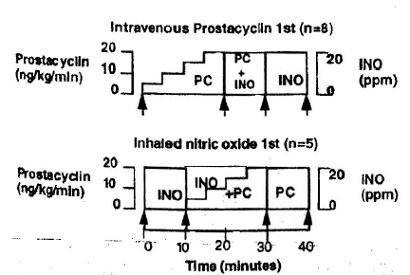
The Study protocol consisted of 3 phases: in phase 1, patients were randomly assigned to either inhaled nitric oxide (iNO) or intravenous prostacyclin C (PC). ln phase 2, both INO and PC were administered simultaneously. In Phase 3, the alternate agent was administered alone. Arrows indicate times when measurements were recorded.
The protocol specified that, after open label treatment with both agents, the clinician caring for the patient should select what appeared to be the most effective agent for that patient (iNO or prostacyclin) and continue therapy with that agent for at least 24 hours, or as long as was clinically indicated to control pulmonary hypertension. In practice, this led to the selection of continued iNO in every case. The chosen treatment was weaned slowly, after the patient had shown haemodynamic stability for at least 24 hours.
Other treatments consisted of standard post-operative care, and were not altered during the course of the study. Muscle paralysis and deep sedation were continued during the crossover period and for the post-study period in which iNO therapy was continued for at least 24 hours.

Efficacy variables and outcomes
The main efficacy variables were pulmonary arterial pressure (PAP, or MPAP), systemic arterial pressure (SAP), the PAP/SAP ratio, and PaO₂. None of these variables was specified as the primary efficacy measure, but PAP and SAP appeared to be the main variables of interest.

Randomisation and blinding methods
Subjects were randomised with equal probability to iNO first or prostacyclin first. The randomisation method was not stated. Treatment was unblinded.

Analysis populations
Thirteen eligible subjects were identified during the study period, and all of them received both agents and were analysed.

Sample size
No sample size estimations were discussed, and the size of the study appeared to have been determined on grounds of logistical feasibility, but significance was achieved for between group differences in MAP and SAP, so the study had adequate statistical power.

Statistical methods
The authors only described their statistical methods very briefly, as follows: “Data are presented as means ± standard errors. The paired Student’s t test was used to compare the hemodynamic and arterial oxygen tension (Pa02) differences between iNO therapy and intravenous prostacyclin therapy, as well as between iNO alone and iNO and prostacyclin administered simultaneously. A p value less than 0.05 was taken as significant. To avoid using multiple t tests, mean and 95% confidence intervals (CI) were used to summarize changes between baseline and iNO, and baseline and prostacyclin.”
The authors do not appear to have performed any correction for the use of multiple comparisons, but this is of only minor concern given that both of the major haemodynamic variables, MAP and SAP, showed significant results. (The results would have remained significant with a hierarchical testing procedure, for instance, regardless of which of the two variables was considered primary).

Participant flow
All randomised subjects were treated with both agents and were available for analysis.

Major protocol violations/deviations
Protocol deviations were not discussed.

Baseline data
Basic baseline characteristics are shown in Table 28. The13 patients appear reasonably typical of the population intended to be treated for the proposed indication.

Table 28: Patient characteristics and outcomes
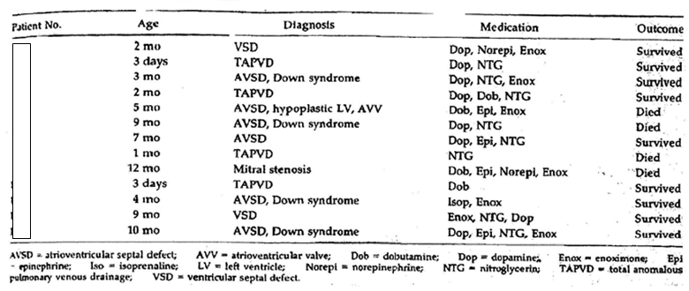

Results
The paper did not tabulate its results, and the figures provided in the scanned version of this paper were not sufficiently legible for reproduction.
Both drugs were effective in lowering MPAP from baseline: iNO reduced MPAP by 33% (95%CI, -24% to -51%), and prostacyclin by 16% (95%Cl, -4% to -38%). The reduction in MPAP with iNO was significantly better than that observed with prostacyclin (p < 0.01). Prostacyclin produced a systemic vasodilatory/hypotensive response, dropping SAP significantly (95%CI, -4 to -10 mm Hg), whereas iNO did not produce a significant change in SAP (95%CI, -2 to +7 mm Hg). Primarily reflecting this difference, the mean PAP/SAP ratio was significantly lower with iNO compared with prostacyclin (0.46 ± 0.04 versus 0.68 ± 0.05; p < 0.01).
Results for oxygenation were better during iNO treatment, when there was a significant increase relative to baseline (increase in mean PaO₂ 70%, 95%CI 39 to 101%). There was no significant increase during prostacyclin treatment (percent change not provided).

Conclusion
This small (n = 13), brief, unblinded crossover study showed that iNO 20 ppm was significantly superior to intravenous prostacyclin 20 ng per kg per minute in the short term (10 minute) treatment of severe pulmonary hypertension in paediatric subjects after cardiac surgery. MPAP was reduced by 33% during iNO treatment (95%CI, -24% to -51%), compared to a reduction of 16% during prostacyclin treatment (95%Cl, -4% to -38%; p < 0.01 for the between treatment difference). At the doses used in this study, prostacyclin produced a systemic vasodilatory/hypotensive response, whereas iNO did not produce a significant change in systemic blood pressure. In every case, unblinded physicians preferred iNO and continued this treatment after the crossover period was complete.
The study had a design that was more consistent with a PD study than an efficacy study, but it showed a clear vasodilatory effect of iNO at doses typical of those proposed in the draft PI, and demonstrated this effect in the target population of paediatric cardiac surgery patients, so it provides clear support for the sponsor’s efficacy claims.

Kirbas 2012

Abstract
Comparison of inhaled nitric oxide and aerosolized iloprost in pulmonary hypertension in children with congenital heart surgery.
Background: Pulmonary arterial hypertension is of importance in congenital cardiac surgery as being a significant cause of morbidity and mortality. Although therapy options are limited, inhaled nitric oxide (NO) is used as a standard therapy. The present study aimed to compare inhaled NO and aerosolized iloprost in children with secondary pulmonary hypertension who underwent congenital cardiac surgery.
Methods: Sixteen children included in the study were randomized into either inhaled NO or aerosolized iloprost group. For both groups, the observation period terminated at 72 h after cardiopulmonary bypass.
Results: There was no significant difference between the groups in terms of mean age, weight, cross clamp time, pump time, and extubation time. No significant change was observed in the arterial tension and central venous pressure of both groups before the operation, 30 min after the pump, 45 min after the pump, and after extubation, whereas an increase was observed in the heart rate and cardiac output, and a decrease was observed in the pulmonary artery pressure. The mean values at the above-mentioned time points showed no difference between the groups. No serious adverse event and mortality was detected.
Conclusions: Both inhaled NO and aerosolized iloprost were found to be effective and comparable in the management of pulmonary hypertension.

Study design, objectives, locations and dates
Kirbas et al used an open label, randomised, active controlled study to assess the efficacy of inhaled iloprost with iNO in the treatment of pulmonary hypertension in children undergoing congenital heart surgery. The main objective of the study was to assess aerosolised iloprost in relation to iNO, which was considered standard therapy.
The study was performed in Medicana Camlica Hospital, Istanbul, Turkey, with patients enrolled between September 2009 and November 2011, in the lead-up to publication in 2012.

Inclusion and exclusion criteria
Subjects were eligible if they were children with severe primary pulmonary arterial hypertension, defined as pulmonary arterial/aortic pressure ratio greater than 0.7, who were undergoing cardiac surgery for congenital cardiac defects.
If subjects were older than 24 months, or they had echocardiographic and clinical findings suggestive of fixed pulmonary hypertension, they underwent pre-operative catheterisation and assessment of pulmonary vascular reactivity testing.

Study treatments
Subjects were randomised to aerosolised iloprost or iNO, which were administered immediately after CPB and before heparin reversal.
Aerosolised iloprost, (Ilomedin, Schering AG, Schlieren, Switzerland) was administered at a dose of 0.5 µg/kg every 90 min for a minimum of 72 h using an ultrasound nebulizer connected to the distal inspiratory part of the respiratory circuit.
Inhaled nitric oxide was administered at a dose of 20 ppm using a commercially available system and delivered into the inspiratory limb of the ventilator with standard monitoring in place for NO by-products. Inhaled NO was administered for at least 72 h after cardiopulmonary bypass if weaning was not possible but it was potentially ceased earlier if the patient was suitable for extubation.
Nitric oxide or iloprost was then continued on an individual basis as clinically required.
In addition to randomised treatment, subjects received standard operative and perioperative management, including moderate hypothermia (at 24 to 26°C), and antegrade extracellular cardioplegia. Patients were normo-ventilated by pressure controlled ventilation during weaning from CPB, and transferred to ICU. Patients were ventilated with 100% oxygen for 30 min and FiO₂ was then reduced according to individual arterial pO₂ values. End-tidal CO₂ was kept at 35 to 40 mm Hg and positive end expiratory pressure was kept at 5 cm H₂O.

Efficacy variables and outcomes
The following efficacy variables were monitored or calculated:
- pulmonary arterial pressure (MPAP, referred to as PAP throughout the paper)
- systemic arterial pressure (SAP)
- PAP/SAP ratio
- right atrial pressures
- cardiac output (CO)
- heart rate (HR)
- transcutaneous arterial oxygen saturation
- arterial blood gas sampling (partial pressure of oxygen, partial pressure of carbon dioxide, pH, base excess, and oxygen saturation).
The authors specified two major endpoints:
- cumulated mean pulmonary arterial pressure and pulmonary artery pressure to systemic artery pressure ratio, as measured with arterial lines during the observation period
- duration of mechanical ventilation (in hours) until weaning from the respirator.
They did not specify which component of the number 1 endpoint was considered primary (PAP or PAP/SAP ratio).

Randomisation and blinding methods
Subjects were randomised with equal probability to aerosolized iloprost or iNO by an independent monitor using a computer based scheme.

Analysis populations
The authors did not define specific analysis populations, but it appears that all patients were analysed.

Sample size
Sample size and power considerations were not discussed, which represents a major limitation of the study. The authors found no difference between the new therapy, aerosolised iloprost, and what they considered to be an accepted active control, iNO, but it is not possible to draw any inferences about the lack of a statistical difference, as discussed below.

Statistical methods
The authors described their statistical methods as follows: “Statistical calculations were performed using the Number Cruncher Statistical System 2007 Statistical Software program for Windows (NCSS Statistical Systems, Kaysville, Utah, USA). Standard descriptive statistics were performed and expressed as mean and standard deviation. Groups were compared using the Mann-Whitney U test. In each treatment group repeated measures of Friedman test was used to determine the differences in measurement at each time point. When p less than 0.05, Dunn’s multiple comparisons tests were used for pairwise comparisons. A p value less than 0.05 was considered statistically significant.”
These statistical tools appear appropriate for demonstrating superiority of one or other agent, but do not amount to a rigorous test for equivalence or non-inferiority of either agent. The study was ultimately negative for its endpoints (see below), and the statistical approach taken does not allow this negative result to be placed into any meaningful context. The lack of any power calculations and failure to report 95% CIs prevents the drawing of any strong inferences from the lack of statistical difference between the two treatment groups, because the lack of difference could merely reflect inadequate statistical power.
On the other hand, visual inspection of the results (figures below) suggests that the two treatments were quite similar, and any differences in efficacy between the two studies would be hard to detect without a much larger study.

Participant flow
All sixteen subjects were treated and analysed.

Major protocol violations/deviations
Protocol deviations were not discussed.

Baseline data
The basic patient characteristics including underlying cardiac diagnosis are listed in Table 29. No significant differences were found between the groups for a range of baseline haemodynamic parameters, as shown in the pre-operative values of the results table (Table 30).

Table 29: Patient characteristics and extubation times
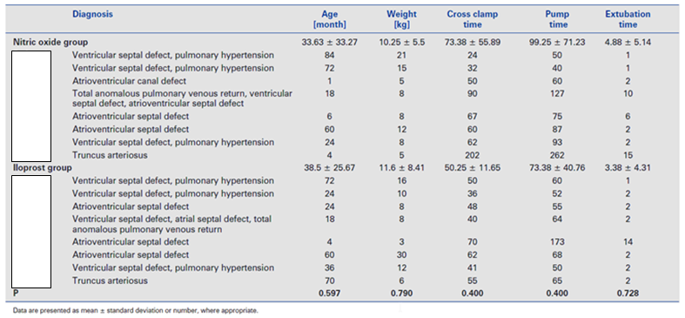

Results for the primary efficacy outcome
Both the iNO and iloprost groups showed a decrease in the pulmonary arterial pressure and ratio of pulmonary artery pressure to systemic artery pressure values, as shown in the figure and table below. The authors interpreted this as a therapeutic response to treatment, which seems plausible, but the study design does not strictly allow such an inference because no placebo group was used and some improvements in haemodynamics could have been due to recovery from surgery. As shown in the table, no significant between group differences were observed at any time point. Visual inspection of the figures for PAP and MAP/SAP ratio suggests that variation within each group was much greater than differences between the groups.
Pulmonary selectivity appears to be present for both agents as reflected in the falling PAP/SAP ratio.
Figure 25: Changes in PAP and PAP/SAP through to extubation
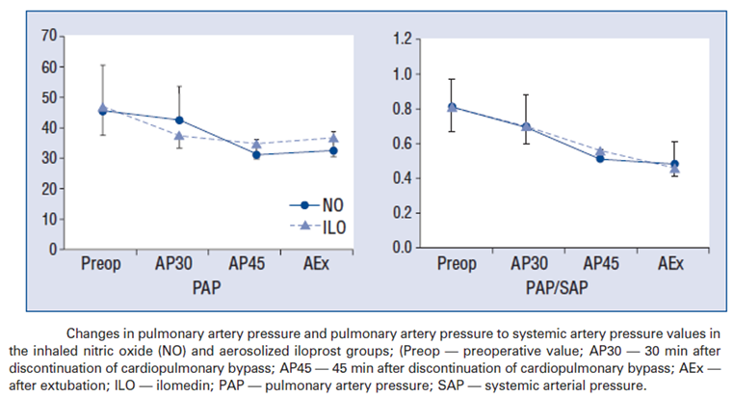

Table 30: Mean values of efficacy variables
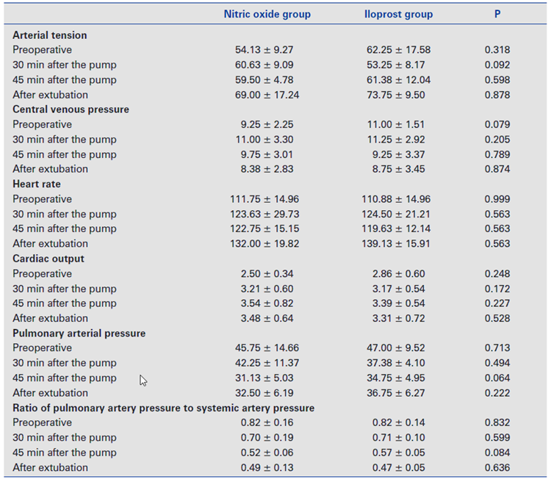

Results for other efficacy outcomes
No significant changes were produced for other haemodynamic endpoints or for “arterial tension”, by which the authors appear to be referring to arterial oxygen tension. No differences were observed between the groups.
Figure 26: Changes in arterial oxygen tension (TA) and CVP
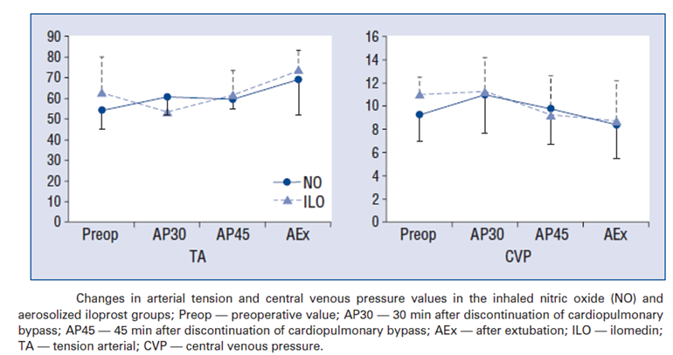
Figure 27: Changes in heart rate (HR) and cardiac output (CO)
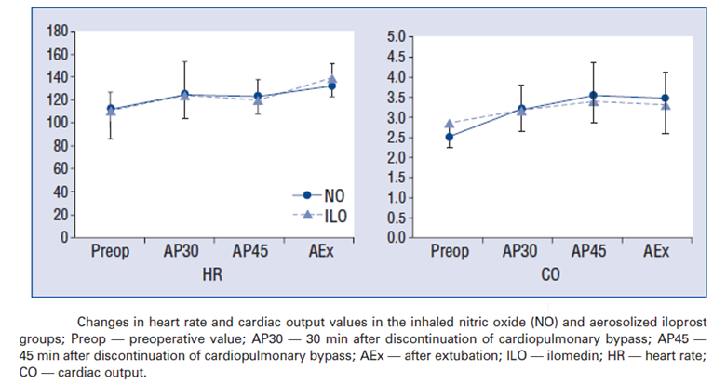

Conclusion
This small study (n = 16) compared the efficacy of iNO and aerosolised iloprost in the treatment of pulmonary hypertension in paediatric cardiac surgery patients, and found no difference. The results suggest that the efficacy of iNO and aerosolised iloprost are similar in their ability to lower MPAP without lowering systemic blood pressure. The study fails to demonstrate formal equivalence or non-inferiority of either drug, because it did not consider statistical power. It also fails to confirm conclusively that either drug has substantial efficacy, because it lacked a placebo group. The findings are consistent with the sponsor’s claims of efficacy in this setting, because favourable reductions in PAP and in PAP/SAP ratio were observed, but this does not add much to the submission because such changes could have been due to spontaneous recovery post-CPB.
If it is already accepted that iNO has efficacy in this setting, as the authors proposed, then this study provides support for further exploration of the efficacy of iloprost, which the authors considered to be less established as a treatment for pulmonary hypertension than iNO. If it is not yet accepted that iNO has efficacy in this setting, this study does not provide strong support for the claim that iNO is effective, because it was not superior to iloprost and it could be the case that both agents are similarly ineffective rather than similarly effective.

Loukanov 2011

Abstract
Comparison of inhaled nitric oxide with aerosolized iloprost for treatment of pulmonary hypertension in children after cardiopulmonary bypass surgery.
Objectives: Pilot study to compare the effect of inhaled nitric oxide (iNO) and aerosolized iloprost in preventing perioperative pulmonary hypertensive crises (PHTCs). Background Guidelines recommend the use of iNO to treat PHTCs, but treatment with iNO is not an ideal vasodilator. Aerosolized iloprost may be a possible alternative to iNO in this setting.
Methods: Investigator-initiated, open label, randomized clinical trial in 15 infants (age range 77 to 257 days) with left-to-right shunt (11 out of 15 with additional trisomy 21), and pulmonary hypertension (that is, mean pulmonary artery pressure [PAP] > 25 mm Hg) after weaning from cardiopulmonary bypass. Patients were randomized to treatment with iNO at 10 ppm or aerosolized iloprost at 0.5 µg/kg (every 2 h). The observation period was 72 h after weaning from cardiopulmonary bypass. The primary endpoint was the occurrence of PHTCs; the secondary endpoints were mean PAP, duration of mechanical ventilation, safety of administration, and in-hospital mortality.
Results: Seven patients received iNO and eight patients received iloprost. During the observation period, 13 of the 15 patients had at least one major or minor PHTC. There was no difference between the groups with regard to the frequency of PHTCs, mean PAP and duration of mechanical ventilation (p > 0.05).
Conclusions: In this pilot study, aerosolized iloprost had a favourable safety profile. Larger trials are needed to compare its efficacy to iNO for the treatment of perioperative pulmonary hypertension. However, neither treatment alone abolished the occurrence of PHTCs.

Study design, objectives, locations and dates
Loukanov et al used a randomised, active controlled, open label design to compare the efficacy of iNO and aerosolised iloprost in the prevention of pulmonary hypertensive crises (PHTCs) after corrective cardiac surgery for congenital heart disease in infants.
The study was a small pilot study (n = 15) performed in Heidelberg, Germany, in 2010.

Inclusion and exclusion criteria
Subjects were eligible if they were infants undergoing cardiac surgery and CPB for congenital heart disease, and their MPAP was > 25 mm Hg immediately after weaning from CPB.
Subjects were excluded if they had:
- atrial septal defect
- cyanotic congenital heart disease
- univentricular atrioventricular connection
- valvular or subvalvular pulmonary or aortic stenosis
- emergency cardiac surgery
- systemic arterial hypertension
- renal failure
- diabetes mellitus
- disorders of blood coagulation and haemostasis
- extracorporeal membrane oxygenation before cardiac surgery
- treatment with epoprostenol.

Study treatments
Subjects were randomised to iNO or aerosolised iloprost. Treatment commenced in the operating theatre after weaning from CPB.
Iloprost (Ventavis, Bayer Vital, Germany) was administered at 0.5 µg/kg every 2 h for a minimum of 72 h using an ultrasound nebulizer (Nebutec).
Nitric oxide was administered at 10 ppm into the input limb of the ventilatory circuit using a commercially available delivery system, with standard monitoring for iNO by-products.
Iloprost was continued through the observation period of 72 h after termination of CPB. In the iNO group, iNO was also given for at least 72 h after termination of CPB if weaning was not possible but it was potentially ceased earlier if the patient was suitable for extubation. After 72 hours, treatment with iNO and iloprost was continued on an individual basis as clinically required.
The protocol specified a cautious weaning process for iNO, which was reduced gradually (20% reduction per h) with the aim of ending iNO within 4 h. In patients who showed signs of PHTC, the iNO was continued for another 24 h before trying again to wean from iNO.
In addition to standard perioperative care, and randomised study treatment, subjects also received rescue therapy for PHTC if needed, described by the authors as follows: “Patients with PHTCs refractory to the trial treatment were treated with the combination of: fentanyl IV (0.005 mg/kg), intensified hyperventilation and hyperoxia (pH > 7.5; PaO₂ > 20 kPa). Patients with PHTCs refractory to this intensified treatment were treated as follows: patients on iNO received aerosolized iloprost (0.5 µg/kg/10 min) and patients on iloprost were given iNO at 20 ppm.” This was an important ethical component of the study but could have blunted the study’s ability to show a difference in efficacy between the two treatments.

Efficacy variables and outcomes
The primary endpoint was the occurrence of PHTCs during the 72 h observation period. PHTCs were defined according to Miller et al, 2000, as previously discussed in this evaluation report.
A major PHTC was defined as an episode with a rise in the ratio of pulmonary to systemic blood pressure (Pp/Ps) to > 0.75, plus either a > 20% decline of systemic blood pressure or a decline of oxygen saturation to < 90% as measured by transcutaneous pulse oxymetry. A minor PHTC was an episode with a rise in Pp/Ps to > 0.75, but no concomitant decline in systemic blood pressure or oxygen saturation. No formal endpoint was based on this distinction between major and minor PHTCs.
Secondary endpoints were listed as:
- the cumulated mean PAP and Pp/Ps
- the duration of mechanical ventilation
- the in-hospital mortality (until discharge from hospital).

Randomisation and blinding methods
Subjects were randomised with equal probability to either iNO or aerosolized iloprost, by an independent monitor using a computer based scheme. Treatment was open label, with no blinding.

Analysis populations
The paper did not describe analysis populations and it appears that all eligible randomised patients were available for analysis.

Sample size
This was a small pilot study with no attempt to recruit an adequate cohort based on power considerations.

Statistical methods
As in most of the published studies, the description of the statistical approach was very brief: “Data are expressed as mean ± SD. The Fisher’s exact test was used to analyse the difference in occurrence of minor or major PHTCs between the two treatment groups. Pre and post-operative haemodynamics and clinical data were compared using the Student’s t test. Significant results were determined by p < 0.05.”
For the primary analysis of the main PHTC endpoint, Fisher’s exact test was used. Secondary endpoints were assessed with Student’s t test, without any apparent correction for the use of multiple endpoints.
The most substantial flaw in the study was the small sample size coupled with the lack of any power analysis, such that negative results cannot be used to make any strong inferences. This is acceptable given that this was a small proof-of-concept study.

Participant flow
All subjects were available for analysis.

Major protocol violations/deviations
Protocol deviations were not discussed.

Baseline data
Baseline characteristics are shown in Table 31. The groups appeared reasonably well balanced in terms of the age distribution, mix of underlying cardiac diagnoses, and presence of Down’s Syndrome (Trisomy 21). They were also well matched for pre-operative haemodynamics, as shown in the table.

Table 31: Clinical characteristics
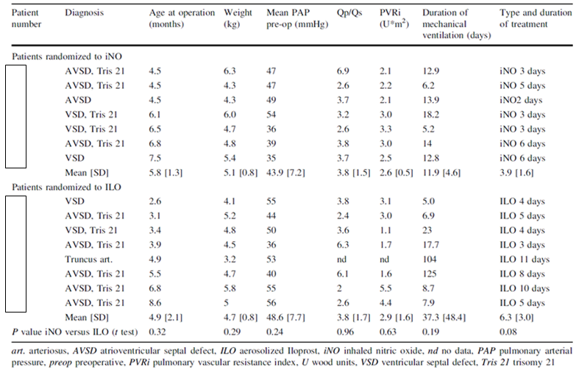

Results for the primary efficacy outcome
For the primary comparison of number of PHTCs, no significant difference was observed between treatment groups. In the iNO group, there were two major and 26 minor PHTCs. In the iloprost group, there were six major PHTCs and 25 minor PHTCs (Fisher’s exact test, p = 1.0). Considering the number of patients with major PHTCs, there appeared to be a benefit with iNO (1 of 7 patients) compared to iloprost (3 of 8 patients), but this observation is based on very low numbers.
Intensified standard treatment was sufficient to treat PHTCs in most cases, but one patient in the iloprost group was given additional iNO at Day 2.
Figure 28: Comparison of the number of PHTCs observed with iNO and iloprost
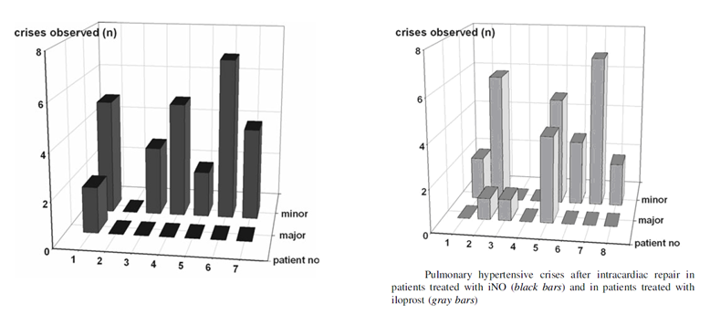

Results for other efficacy outcomes
Mean pulmonary artery pressure averaged within each group showed a variable course after surgery, with an initial decline over the first few hours, followed by fluctuations and some increase, with large within group variations that greatly exceeded the between group differences (see figures below). Without a placebo control group, it is not possible to determine which changes, if any, were due to the randomised inhalational therapies. The differences between the two agents were not significant for MPAP or Pp/Ps ratio (described in other studies as the PAP/SAP ratio).
Other haemodynamic endpoints, such as cardiac output and PVRI also showed no difference between the groups, but suffer from the same problem of interpretation in the absence of a placebo group.
The secondary clinical endpoints, time on ventilation and in-hospital mortality, also showed no significant difference between groups. Time on ventilation is shown with baseline data, in the table above; meaningful comparison is difficult because of a couple of outliers in the iloprost with very long times on ventilation (104 and 125 days) presumably related to post-surgical complications. No patient died during the observation period, but there were three delayed in-hospital deaths in the iNO group, 14 days, 104 days and 125 days after surgery.
Figure 29: MPAP after weaning from CPB
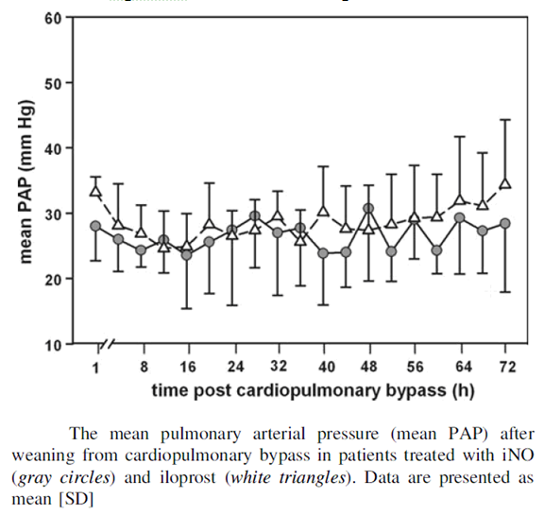
Figure 30: PAP/SAP ratio after weaning from CPB
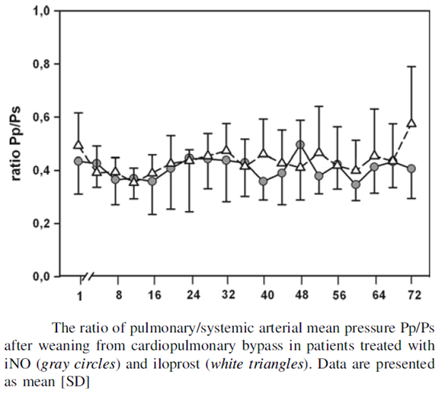

Conclusion
Overall, this small pilot study (n = 15) suggests that iNO 10 ppm and aerosolised iloprost 0.5 µg/kg every 2 h might have similar efficacy when used to prevent PHTCs in the paediatric setting, but the study was not adequately powered to demonstrate equivalence. Also, because neither therapy is registered for the indication, similarity of efficacy in the two drugs is not directly supportive of the claims of efficacy for iNO, because both agents could be similarly ineffective.
The trends in MPAP were weakly in favour of iNO, but there was no convincing reduction in MPAP relative to baseline. The paper is at least consistent with the sponsor’s claims that iNO is effective in this setting, raising no significant concerns, but it also provides no real support.

Stocker 2003
Abstract
Intravenous sildenafil and inhaled nitric oxide: a randomised trial in infants after cardiac surgery.
Objective: To investigate the acute effects of intravenous sildenafil on haemodynamics and oxygenation, and its interaction with inhaled nitric oxide (iNO) in infants at risk of pulmonary hypertension early after cardiac surgery.
Design: Prospective, randomised trial.
Setting: Paediatric intensive care unit of a children’s hospital.
Patients and participants: Sixteen ventilated infants early after closure of ventricular or atrioventricular septal defects were randomly assigned to one of two groups. The study was completed in 15 infants.
Interventions: Studies were commenced within 7 h of separation from bypass. Seven infants received iNO (20 ppm) first, with the addition of intravenous sildenafil (0.35 mg/kg over 20 min) after 20 min. Eight infants received sildenafil first, iNO was added after 20 min. Vascular pressures, cardiac output and a blood gas were recorded at 0, 20 and 40 min.
Measurements and results: In infants receiving iNO first, iNO lowered the pulmonary vascular resistance index (PVRI) from 3.45 to 2.95 units (p = 0.01); sildenafil further reduced PVRI to 2.45 units (p < 0.05). In those receiving sildenafil first, PVRI was reduced from 2.84 to 2.35 units (p < 0.05) with sildenafil, and fell to 2.15 units (p = 0.01) with the addition of iNO. In both groups, sildenafil reduced the systemic blood pressure and systemic vascular resistance (p < 0.01) and worsened arterial oxygenation and the alveolar arterial gradient (p < 0.05).
Conclusion: Intravenous sildenafil augmented the pulmonary vasodilator effects of iNO in infants early after cardiac surgery. However, sildenafil produced systemic hypotension and impaired oxygenation, which was not improved by iNO.

Study design, objectives, locations and dates
Stocker et al used a randomised, prospective, open label add-on design to assess the short-term haemodynamic effects of iNO, sildenafil and the combination of both drugs in 15 infants after closure of atrioventricular or ventricular septal defects. Infants were randomised to iNO therapy followed by the addition of sildenafil, or sildenafil therapy followed by the addition of iNO.
The study was performed in the Royal Children’s Hospital, Victoria, Australia, in the lead-up to publication in 2003.

Inclusion and exclusion criteria
Eligible subjects were infants undergoing surgical repair of ventricular septal defects or atrio ventricular septal defects with a large left to right shunt, diagnosed on pre-operative echo-cardiograph.

Study treatments
Study duration was 40 min for both groups, with 20 minutes of monotherapy followed by 20 minutes of combination therapy.
Infants were randomised to receive:
- nitric oxide first (20 ppm), with the addition at 20 min of intravenous sildenafil (0.35 mg/kg, infused over 20 min); or
- intravenous sildenafil first (dose as above), with the addition of nitric oxide 20 ppm at 20 min.
The protocol specified that infants should commence randomised treatment within 7 hours of surgery, and all randomised treatments were commenced between 3.8 and 6.7 h after separation from cardiopulmonary bypass. Given that the intervention was relatively short, the delay means that changes within the study are likely to reflect the effects of treatment rather than primarily represent recovery from surgery.
In addition to randomised treatment, all subjects received standard perioperative care. They were given sedation and muscle relaxation agents (vecuronium, midazolam and morphine) and mechanically ventilated with an inspired oxygen fraction of 0.5. Subjects received a single inotropic agent, either intravenous dopamine or dobutamine (between 1 and 5 µg/kg per min), which was kept constant during testing of study drugs. Alpha-blockers, other phosphodiesterase inhibitors or nitrovasodilators were not used at any time prior to or during the study.

Efficacy variables and outcomes
The following variables were either measured or calculated:
- systemic and pulmonary arterial pressure
- central venous and left atrial pressures
- cardiac output
- pulmonary and systemic vascular resistance index (PVRI and SVRI)
- arterial oxygen tension
- alveolar arterial oxygen gradient.
These variables were recorded at 0 min (baseline) and at 20 and 40 min (following each intervention). The most important of these variables appeared to be the PVRI, but it was not formally designated as primary, and the other endpoints were not formally ranked in importance.

Randomisation and blinding methods
Subjects were randomised with equal probability to the two treatment sequences, by block allocation. The study was open label, with no blinding.

Analysis populations
The analysis was performed on the fifteen patients who received randomised treatment, all of whom completed the study.

Sample size
Formal sample-size estimations were not presented. Instead, the authors indicate that the study was terminated early because of positive interim analysis results: “We initially intended to enrol 30 infants, but the trial was terminated early after interim analysis of the first 15 completed studies.” Thus, the study was adequately powered for its key endpoints, because it achieved significance in this preliminary analysis.
The authors do not discuss the potential inflation of the significance of the study (and increased risk of Type 1 error) that could have arisen from the presence of multiple potential stopping points. In the context of a small pilot study, this is not a major problem.

Statistical methods
The authors described their analysis as follows: “The results were analysed using Sigmastat for Windows, version 2.03 (SPSS, Chicago, IL). The results are expressed as means ± standard errors of the mean (SEM). Student’s t-test was used to compare between group data at baseline and for changes between baseline and each time point, and paired t-tests to compare within group data at different time points. Probability values of less than 0.05 were considered statistically significant.”
Essentially, the authors used paired t-tests for the main within-group comparison of different time-points. No correction was applied for the use of multiple endpoints or multiple time point comparisons.
The abstract implies that PVRI was the primary endpoint, but this was not stated explicitly and the rest of the paper discusses MPAP and SPAP results before dealing with PVRI. No particular time point comparison was designated as primary.

Participant flow
From eighteen suitable patients, seventeen families provided consent for the study, sixteen were recruited and randomised, and fifteen completed the study. One patient was excluded before treatment commenced, because of arrhythmias. The analysis was performed on the fifteen completers.
Figure 31: Flow diagram showing number of patients eligible, recruited, and studied
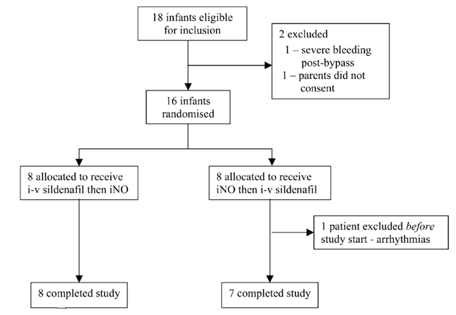

Major protocol violations/deviations
Protocol deviations were not discussed.

Baseline data
As shown in Table 32, the two groups were reasonably well matched at baseline.

Table 32: Patient characteristics by group
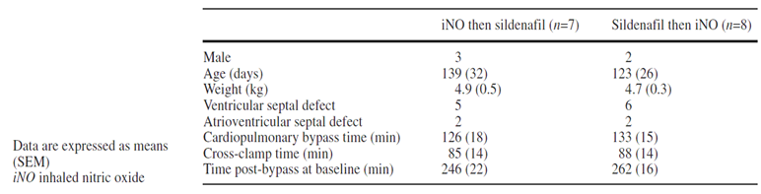

Results for the primary efficacy outcome
In the iNO-first group, the MPAP had fallen by 20 min, reducing by 1.4 ± 0.4 mm Hg (by 7.8 ± 2.1%; p = 0.008), while mean systemic arterial pressure, left atrial pressure and central venous pressures and cardiac index were all unchanged. The addition of sildenafil did not further influence MPAP over the next 20 minutes, but systemic blood pressure fell by 8.9 ± 2 mm Hg (13.4 ± 2.7%; p = 0.004), while left atrial pressure, central venous pressure and cardiac index remained unchanged.
In the sildenafil-first group, MPAP had fallen by 20 min, but not significantly (reduced by 10 ± 4.1%; p = 0.055), and the vasodilatory effect was not confined to the pulmonary circulation: MSAP fell by 12 ± 1.2 mm Hg in the first 20 min (17 ± 1.8%; p < 0.001), while left atrial and central venous pressures, and cardiac index were unchanged. The addition of iNO resulted in a further reduction in MPAP to levels significantly below baseline (p = 0.001).
Thus, iNO reduced MPAP significantly, regardless of whether it was commenced first, or added to sildenafil, and it appeared to be selective for the pulmonary vasculature, having no major effects on systemic blood pressure. By contrast, sildenafil only produced a trend to lowering MPAP when used as monotherapy and provided no additional benefit when added to iNO. Furthermore, sildenafil significantly lowered systemic blood pressure regardless of whether it was used as monotherapy or added to iNO.
When pulmonary hypertension was assessed by PVRI, instead of MPAP, both agents produced a significant reduction in PVRI, and the addition of the second agent produced further reductions. As stated in the abstract: “In infants receiving iNO first, iNO lowered the pulmonary vascular resistance index (PVRI) from 3.45 to 2.95 units (p = 0.01); sildenafil further reduced PVRI to 2.45 units (p < 0.05). In those receiving sildenafil first, PVRI was reduced from 2.84 to 2.35 units (p < 0.05) with sildenafil, and fell to 2.15 units (p = 0.01) with the addition of iNO.” The reductions in PVRI associated with both agents, when used as monotherapy, were similar (p = 0.7).

Table 33: Haemodynamic and ventilatory data at baseline and in response to interventions
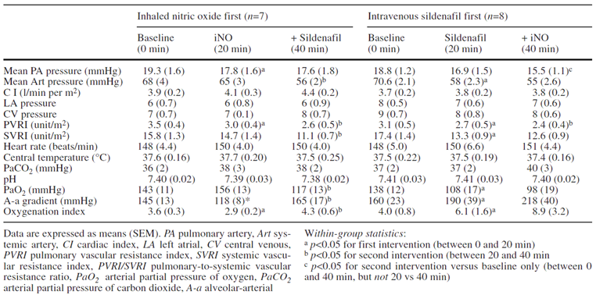
Figure 32: Haemodynamics, oxygenation and ventilation parameters
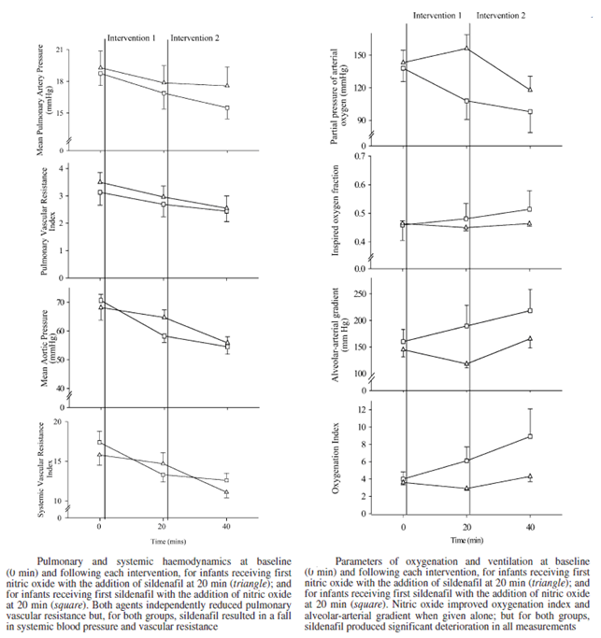

Results for other efficacy outcomes
Oxygenation based endpoints also suggested that iNO was superior to sildenafil, because sildenafil caused reductions in oxygenation whereas iNO had no significant effect. In the iNO-first group, there was a trend towards an improvement in PaO₂. The addition of intravenous sildenafil reduced PaO₂ by 38.2 ± 15.9 mm Hg (p = 0.045) and, reflecting this, increased the oxygenation index by 1.4 ± 0.5 (p = 0.04) and increased the alveolar-arterial gradient by a mean of 47 ± 14 mm Hg (p = 0.03).
In the sildenafil first group, sildenafil reduced PaO₂ by 29.9 ± 6.9 mm Hg (p = 0.003), increased the oxygenation index by 2.0 ± 0.8 (p = 0.003) and increased the alveolar-arterial gradient by 30 ± 6 mm Hg (p = 0.007). Addition of iNO improved oxygenation, but not significantly.

Conclusion
Overall, this small study suggests that both iNO 20 ppm and sildenafil 0.35 mg/kg lower PVRI in paediatric cardiac surgery patients, but iNO is more selective for the pulmonary circulation. In the iNO-first group, MPAP had fallen after 20 min of therapy, reducing by 1.4 ± 0.4 mm Hg (7.8 ± 2.1%; p = 0.008). The subsequent addition of sildenafil did not further lower PA pressure.
In the sildenafil first group, MPAP had also fallen by 20 min, and the reduction was numerically greater when expressed as a percentage of baseline, but the fall was not statistically significant (reduction of 10 ± 4.1%; p = 0.055). The subsequent addition of iNO produced a further fall in MPAP. Similar findings were observed with PVRI. iNO also produced significant improvements in oxygenation. The use of sildenafil was associated with significant falls in systemic blood pressure, regardless of whether it was used first or added to iNO, whereas iNO had no major effect on the systemic circulation.
Sildenafil is not a registered treatment for this indication, which is why this study was considered merely supportive. Also, treatment was unblinded. Nonetheless, the significant haemodynamic changes observed with iNO relative to the pre-treatment baseline, and the ability of iNO to produce further reductions in MPAP and PVRI in patients already receiving sildenafil provide reasonably robust support for the proposed indication. No placebo group was used, but the clear and significant haemodynamic changes seen in iNO recipients occurred during a brief intervention a few hours after surgery, which strongly suggests a causal process directly related to the intervention. The pulmonary selectivity of iNO represents a clear advantage over intravenous sildenafil, and it is consistent with other submitted studies in which iNO had greater pulmonary selectivity than intravenous vasodilators.

Supportive efficacy studies in adults
The studies listed below were performed in adults who were undergoing cardiac surgery or being prepared for cardiac surgery with vasoreactivity testing. Because of the age of the patients studied, the results are only indirectly supportive of the proposed paediatric indication. Nonetheless, the findings in adults were broadly consistent with those observed in children. The individual studies were small, and generally they were underpowered for clinical endpoints, but together they provide a robust and reproducible set of results.
Given that very few subjects were studied in the age bracket 12 to 17, these studies in adults provide important reassurance that the efficacy of iNO is not confined to very young children, but spans all ages tested from neonates to older adults.

Table 34: Supportive efficacy studies in adults
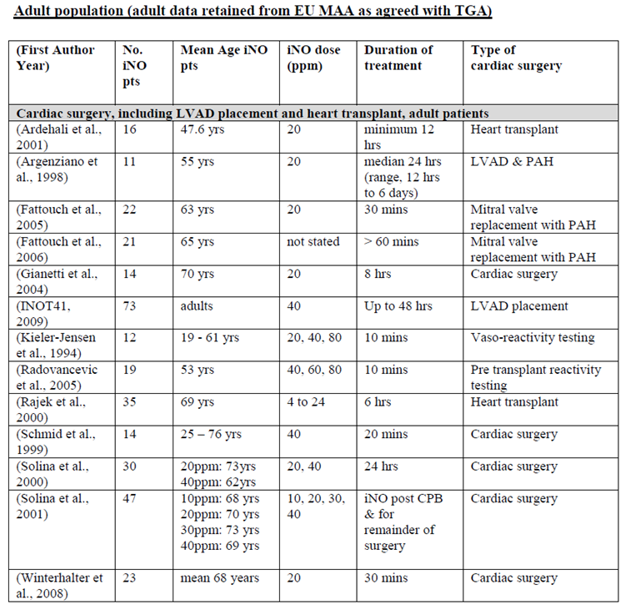

Fattouch 2005

Abstract
Inhaled Prostacyclin, Nitric Oxide, and Nitroprusside in Pulmonary Hypertension After Mitral Valve Replacement
Objective: Pulmonary hypertension increases morbidity and mortality in patients undergoing heart surgery. Mitral valve stenosis is frequently associated with an increase in pulmonary vascular resistance (PVR). Cardiopulmonary bypass exacerbates pulmonary hypertension in patients undergoing cardiac surgery. The aim of this study was to compare the hemodynamic effects of inhaled prostacyclin and nitric oxide and the administration of IV nitroprusside during cardiac surgery with a clinical, pharmacodynamic dose response, prospective, randomized, and double blind study (Group A: inhaled prostacyclin; Group B: inhaled nitric oxide; Group C: nitroprusside).
Materials and Methods: Fifty-eight patients with mitral valve stenosis and elevated PVR (> 200 dynes∙sec/cm⁵) after mitral valve surgery were studied. Inhaled prostacyclin and nitric oxide were administered at concentrations of 10 g/min and 20 ppm, respectively. Nitroprusside IV was administered at the dose of 5 to 15 g/min. Results: Prostacyclin and nitric oxide produced a significant dose related decrease of mean pulmonary arterial pressure, pulmonary vascular resistance, and transpulmonary gradient. A significant increase in cardiac output was observed in both groups. In Group C, nitroprusside administration was interrupted in 62% patients due to occurrence of systemic hypotension.
Conclusions: Inhaled prostacyclin and nitric oxide are effective in the treatment of post-operative pulmonary hypertension in patients with mitral valve stenosis undergoing mitral valve surgery. Both drugs improve cardiac output and reduce mean pulmonary arterial pressure, pulmonary vascular resistance, and transpulmonary gradient. They may be useful in patients with acute right ventricular failure following cardiac surgery. In comparison to nitric oxide, inhaled prostacyclin is free from toxic side effects and is easier to administer.

Study design, locations and dates
Fattouch et al compared the haemodynamic efficacy of iNO, inhaled prostacyclin (iPGI2) and intravenous nitroprusside (NP) in adult patients (n = 58) with elevated PVR undergoing mitral valve surgery, using a randomised, double blind design.
Although the study was structured as a parallel group study, statistical comparisons between groups were not the main focus of the study, and the results tables only show comparisons across different time-points within each group.
The study was performed in two centres in Italy (Operative Unit of Cardiac Surgery, Universita di Palermo “Paolo Giaccone”, Palermo; Cardiac Surgery Center, Villa Azzura, Rapallo), over the course of 58 consecutive eligible cases prior to publication in 2005.

Inclusion and exclusion criteria
Subjects were eligible if they were undergoing mitral valve replacement (MVR) and had elevated PVR (> 200 dynes∙sec/cm⁵ and/or a TPG > 10 mm Hg).
The authors list the following exclusion criteria:
- concomitant coronary artery disease
- aortic and/or tricuspid valve disease
- emergency operative status
- ejection fraction < 25%
- pre-operative haematocrit < 38%
- thromboembolic disease treated with anticoagulant therapy
- peripheral vascular disease
- renal failure (creatinine > 2.0 mg/dL)
- liver dysfunction
- coagulopathy
- thrombocytopenia.

Study treatments
Administration of randomised study drug began immediately after admission to the intensive care unit. Drugs were given for 30 minutes, followed by a 15 minute washout period.

Group A: Inhaled prostacyclin (iPGI2, n = 18)
Prostacyclin was administered with a nebulizer attached to the inspiratory limb of the ventilator. A PGI2 concentration of 10 µg/mL was prepared, and delivered at rates of 0.30 mL/min. (The abstract refers to a prostacyclin dose of 10 g/min, which is not believable: at the stated concentration, this would imply that 1000,000 mLs (1,000 L) were inhaled each minute [10g = 1000,000 x 10 µg]).

Group B: Inhaled NO (iNO, n = 22)
NO was mixed in nitrogen at 1000 ppm and delivered via a calibrated flowmeter into the inspiratory limb of the ventilator at 20 ppm.

Group C: Intravenous nitroprusside (NP, n = 18)
Nitroprusside was started at a dose of 2.5 to 25 ng/kg/min, and titrated according to effect, until there was a considerable decrease of MAP or a reduction of PVR.
The following criteria were used to interrupt study treatment:
- severe systemic hypotension (systemic arterial pressure < 90 mm Hg and/or fall by more than 25% despite the administration of 15 mL/kg of colloid)
- severe post-operative mediastinal bleeding (> 300 mL/h)
- increase of intrapulmonary shunt; and
- pulmonary oedema.
In addition to randomised treatment, all subjects received standard anaesthetic and perioperative care, described in more detail in the paper.

Efficacy variables
Haemodynamic data were obtained via a radial artery and a Swan-Ganz pulmonary artery catheter, and blood was collected for arterial and venous oxygen assays.
Data were collected at four time-points:
- before CPB
- 30 minutes after CPB interruption
- during infusion therapy
- during a 15 minute control period (without vasodilatory therapy).
No single variable was designated as primary. The authors list the following efficacy variables: heart rate (HR), systolic, diastolic, and mean arterial pressure (MAP), cardiac output (CO), stroke volume (SV), systolic, diastolic, and mean pulmonary arterial pressure (MPAP), central venous pressure (CVP), pulmonary capillary wedge pressure (PCWP), systemic vascular resistance (SVR), PVR, TPG (MPAP-PCWP), MPAP/MAP ratio and PVR/SVR ratio.
Arterial and venous oxygen saturation (SaO₂ and SvO₂), and PaO₂ were measured continuously, and intrapulmonary shunt fraction (IPSF) and arterial venous oxygen difference were calculated using standard formulas.

Methods
The authors described their statistical methods as follows: “Data were expressed as mean ± standard deviation. Data were compared using an analysis of variance for repeated measurements; paired t-tests with Bonferroni correction was used. Hemodynamic differences between PGI2, NO, and nitroprusside were evaluated using the analysis of variance. A p value of less than 0.008 was taken as significant (we performed at least six comparisons per variable). Patient characteristics were compared between groups by a chi-square test.”
These methods sounded appropriate. It is reassuring to see that the authors used corrections for the use of multiple endpoints. On the other hand, it would have been desirable to specify a specific hypothesis for the study and to identify a primary endpoint. Also, it is unclear whether the ANOVA, intended to be performed on haemodynamic differences, applied to on-treatment differences or merely to baseline differences; the ANOVA results were not reported.
No sample size estimations were presented. In conjunction with the lack of ANOVA results, this makes it impossible to draw firm conclusions about the equivalence of iPGI2 and iNO.
Techniques for maintaining blinding were not discussed, but the study is described as “double blind”. The investigators would have needed to use double-dummy placebo infusions and placebo inhalation circuits to maintain the blind, but these are not mentioned. Indeed, it is difficult to see how blinding could be maintained for rapidly acting intravenous vasodilators such as nitroprusside, particularly when these were not given at a fixed dose but were instead titrated to effect. The study set-up would require that active drug and one (or possibly two) dummy agents were all titrated simultaneously, otherwise it would be easy to infer which agent was active by observing the response or lack of response after adjustments to the IV or inhalational therapy. The authors were clearly using English as their second language (they described themselves as an Operative Unity, instead of an Operating Unit), and they may not have understood what is implied by the term “double blind”. The study could have been single blinded, or it could have used treatment blinded recorders to note down haemodynamic data.

Baseline data
The three treatment groups appeared reasonably well matched at baseline in terms of age, gender distribution, and severity of cardiac impairment according to the New York Heart Association (NYHA) class. They also spent a similar time on bypass.

Table 35: Patient characteristics
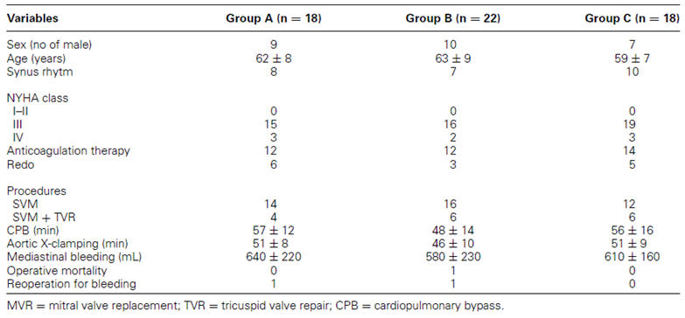

Results
In their description of their statistical methods, the authors write “Hemodynamic differences between PGI2, NO, and nitroprusside were evaluated using the analysis of variance,” but the results of this analysis were not reported. The first sentence of the authors’ Results section reads “There were no significant differences in pre-operative hemodynamic values between groups (Table 1)”, but their Table 1 is shown above (as Table 35), and it includes no haemodynamic data. This represents a mistake in the original paper; it appears that a table was removed during editing. It remains unclear whether the authors ever intended to compare on-treatment haemodynamic values across groups, or merely used ANOVA for pre-operative haemodynamic values. If the authors did statistically compare groups from an efficacy perspective, on treatment, they did not find results they chose to report, and this represents a substantial flaw and unresolved issue in the study. In the absence of any between group comparison (by accident or design), results were assessed within each treatment group, relative to the post-CPB baseline and to the “Control” or washout period.
In subjects receiving iNO or iPGI2, there were no significant changes in HR, MAP, CVP, PCWP, CO, and SVR. By contrast, systolic and MAP decreased significantly in seven patients receiving nitroprusside, requiring interruption of study drug. Following CPB, there was an increase in PVR, MPAP, and PCWP in all three groups.
Inhalation of PGI2 produced significant reductions of PVR (−50%), TPG (−64%), and MPAP (−20%), relative to the post-CPB period, but PCWP did not change significantly. These improvements are likely to include some recovery from CPB not directly related to therapy, as suggested by the fact that there were also favourable differences between the post-CPB results and the Control results. CO and SV were increased during iPGI2 treatment, but not significantly. The authors mention that prostacyclin was interrupted in 2 out of 14 cases, but the reasons were not provided. This seems at odds with their comment in the abstract that PGI2 was free of toxic side effects and easy to administer.

Table 36: Haemodynamic changes in prostacyclin group
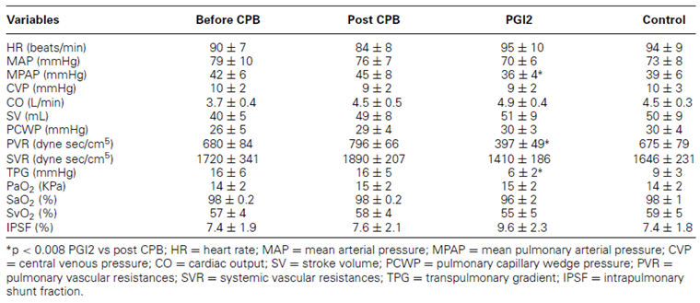
Inhalation of NO also produced significant reductions of PVR (−45%), TPG (−62%), and MPAP (−19%), without any significant change in CO and SV. For PVR and TPG, the results in the Control period were intermediate between the post-CPB results and the on-treatment results, possibly reflecting progressive recovery from surgery, but the Control MPAP was actually slightly worse than the immediate post-CPB results. This could partially reflect a withdrawal or rebound effect because the Control period occurred soon after interruption of iNO. Thus, it is not straightforward to assess the effect of iNO on MPAP from these data: there is no placebo group and the results in the iNO group over the four readings include a mixture of acute post-CPB effects that might be expected to resolve over time, efficacy effects, and withdrawal/rebound effects. It could be argued that the MPAP results in the iNO column are superior to those in the post-CPB column because the patients had begun to recover from CPB, and superior to those in the Control column because the Control results reflect rebound pulmonary hypertension. (Some confidence that the NO results shown below actually reflect efficacy can be drawn from the fact that they are consistent with placebo controlled data in other studies).

Table 37: Haemodynamic changes in nitric oxide group
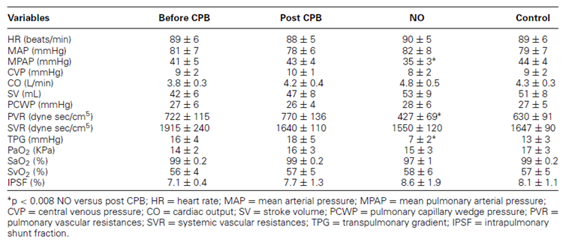
Results for the nitroprusside group were limited to 11 out of 18 patients because systemic hypotension led to treatment interruption in 7 patients. Administration of NP in the 11 patients who tolerated it caused significant reductions in PVR (−45%), SVR (−51%), TPG (−44%), and MPAP (−21%).

Table 38: Haemodynamic changes in nitroprusside group
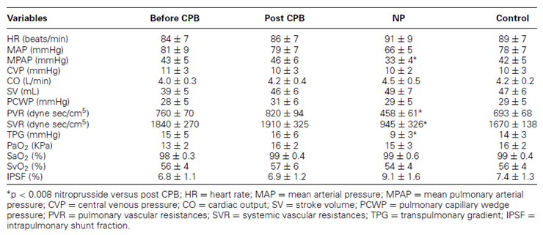

Conclusion
Overall, this study suggests that iNO 20 ppm and iPGI2 have similar efficacy in reducing pulmonary arterial pressure and PVR following CPB, in adults with right ventricular failure, but this has not been demonstrated with sufficient rigour.

Fattouch et al, 2006

Abstract
Treatment of pulmonary hypertension in patients undergoing cardiac surgery with cardiopulmonary bypass: a randomized, prospective, double blind study.
Objective: Pulmonary hypertension can already be present in patients undergoing cardiac surgery or can be exacerbated by cardiopulmonary bypass. Post-operative treatment is still a challenge for physicians. The aim of this study was to evaluate the effects of inhaled prostacyclin (iPGI2) and nitric oxide (iNO) compared with those of intravenous vasodilators.
Methods: This prospective, randomized, double blind study included 58 patients affected by severe mitral valve stenosis and pulmonary hypertension with high pulmonary vascular resistance (> 250 dynes∙s/cm⁵) and a mean pulmonary artery pressure > 25 mm Hg. All patients were monitored by central venous, radial arterial and Swan–Ganz catheters. Data were recorded at six different time points, before induction of anaesthesia, during and after surgery. Prostacyclin and nitric oxide were administered by inhalation 5 min before weaning from cardiopulmonary bypass and continued in the intensive care unit. Right ventricular function was evaluated by transoesophageal echocardiography.
Results: Hospital mortality was 3.4%. After drug administration, the mean pulmonary artery pressure and pulmonary vascular resistance were significantly decreased in the iNO and iPGI2 groups with respect to the baseline values (P < 0.05) and such a decrease was maintained throughout the study; this was not observed in the control group. In the iNO and iPGI2 groups we demonstrated a significant increase in cardiac indices and right ventricular ejection fraction after drug administration with respect to baseline. Furthermore, patients in the inhaled drug groups were weaned easily from cardiopulmonary bypass (P = 0.04) and had a shorter intubation time (P = 0.03) and intensive care unit stay (P = 0.02) than the control group.
Conclusions: Our data suggest that both iNO and iPGI2 are effective in the treatment of pulmonary hypertension. iPGI2 has a number of advantages over iNO, including its easy administration and lower cost. Intravenous vasodilator treatment, on the other hand, is effective in terms of mortality but has a higher morbidity rate.

Differences between Fattouch studies
The second study reported by Fattouch was similar in many ways to the study described above, Fattouch et al, 2005. Both studies were performed at a similar time, in the same institutions, with largely the same list of contributing authors, and both assessed the efficacy of iPGI2, iNO and “intravenous vasodilators” (presumably nitroprusside) in adult patients who exhibited elevated PVR in the setting of mitral valve surgery. The number of patients was the same in each study (n = 58), but distribution to the three treatment groups was slightly different. In places, the text of the two papers is identical, indicating that the second was prepared in part by cutting and pasting from the first, or from a common source document. The second paper does not mention the earlier study, and it seems somewhat odd to perform two studies in rapid succession that essentially address the same issues in the same patient population. Fattouch 2005 mentioned analyses that were not subsequently presented in that paper, potentially suggesting some confusion on the part of the authors as to which analyses belonged in which paper. Some odd coincidences in the results were also observed, raising the possibility that data or analysis in the two studies was potentially overlapping. A careful comparison of the two studies shows enough differences, however, that they should be considered as two entirely distinct studies performed in distinct, non-overlapping patient sets.
The main differences between the studies were:
- elevated PVR in the second study was defined using a threshold of 250 dynes∙s/cm⁵ instead of 200 dynes∙s/cm⁵
- the second study commenced study drug prior to ending CPB, rather than in ICU
- the mean time on CPB was substantially longer in the second study
- the second study used different source concentrations of iNO and iPGI2
- the second study assessed haemodynamics at 6 different time points instead of 4
- the second study used different clinical endpoints in addition to haemodynamic endpoints.

Study design, locations and dates
The authors report that they used a randomised, double blind parallel group design to compare the effect of iPGI2, iNO and intravenous nitroprusside on the haemodynamics and clinical outcome of adult patients with elevated PVR undergoing mitral valve surgery.

Inclusion and exclusion criteria
Subjects were eligible if they had severe mitral valve stenosis requiring cardiac surgery, associated with elevated pulmonary vascular resistance (PVR), defined as PVR> 250 dynes∙s/cm⁵.
Exclusion criteria were similar to the previous study:
- left ventricular dysfunction (ejection fraction < 30%)
- emergency operative status
- diathesis
- known coagulopathy
- thrombocytopenia
- concomitant cardiac procedures.

Study treatments
Drugs were given just before the interruption of CPB and they were discontinued at least 60 min after exposure. The doses of inhalational agents (iPGI2 and iNO) were not clearly stated in the paper, but it seems likely that they were titrated to effect and varied from patient to patient. Of more concern, the drugs used as control therapies were not clearly stated in the Methods or Results sections (which instead referred to “intravenous vasodilators”), though the Discussion section revealed that the control drugs were nitroprusside and nitroglycerin. This lack of detail seriously undermines confidence in this study.

Group A: Inhaled prostacyclin (iPGI2, n = 19)
Prostacyclin was administered with a nebuliser attached to the inspiratory limb of the ventilator. A PGI2 concentration of 15 µg/mL was prepared, and nebulisation was achieved with an oxygen flow of 8 l/min. The final administration rate after mixing into the ventilator circuit was not clearly stated.

Group B: Inhaled NO (iNO, n = 21)
NO was mixed in nitrogen at 400 ppm. It was delivered via a calibrated flow meter into the inspiratory limb of the ventilator, but the target dose was not clearly stated.

Group C: Intravenous vasodilators (NP, n = 18)
The nature and identity of the intravenous dilators used as a control treatment are not clearly stated in the Methods section, much less their doses. In the Discussion section, the following comment appears: “Moreover, we aimed at comparing the effects of iNO and iPGI2 with respect to intravenous vasodilator therapy (nitroglycerin or nitroprusside).” The number of subjects receiving each IV vasodilator remains unclear. It seems likely that similar nitroprusside doses were used in Fattouch 2006 as previously reported in Fattouch 2005.

Efficacy variables
The haemodynamic variables monitored in this study were the same as in the previous study:
- heart rate
- systolic, diastolic and mean arterial pressure
- cardiac index
- stroke volume
- systolic and diastolic pulmonary artery pressure, MPAP
- central venous pressure
- pulmonary capillary wedge pressure
- systemic vascular resistance
- PVR
- right ventricular ejection fraction.
None of these variables is specified as the primary efficacy variable in the study, but the text implies that PVR and MPAP were both major variables of interest.
Haemodynamic data were recorded at six different times, with the key first on-treatment time point being T3:
- T1, at baseline (before induction of anaesthesia)
- T2, after heparin dose
- T3, at CPB interruption (drug administration)
- T4, after protamine
- T5, at chest closure
- T6, 2 h before arrival at the intensive care unit.
It was not specified in the paper how long, after commencement of study drug, the investigators waited before recording haemodynamic data. It was also not clear whether the change over time within each group or the between group comparison should be considered primary.
The dose of inotropic and pressor agents administered intraoperatively was recorded for each patient, and the average dose in each treatment group was used as an additional minor endpoint. Other clinical endpoints reportedly included length of time on CPB, length of time intubated and length of time in ICU. The abstract refers to “ease of weaning” as an endpoint, but what this represents was not specified; it is likely that it refers to length of time on CPB.

Methods
The authors describe their statistical methods as follows: “Data were expressed as mean ± SD. Data were statistically analysed using standard analyses of variance (ANOVA) in conjunction with Student-Newman–Keuls multiple comparison tests. All tests were two sided. A two-way ANOVA (group by time) with time as a repeated measure factor was performed on the variables heart rate, mean arterial pressure, MPAP, cardiac index, PVR and systemic vascular resistance, using the values from postbypass to arrival at the intensive care unit. When either the groups’ effects were significant (P < 0.05) or a significant interaction (group by time) was present, an analysis at each time point was performed. A P value of < 0.05 was considered statistically significant.”
These statistical methods sound broadly appropriate, but they are undermined by the lack of a clearly defined primary analysis method or primary endpoint. No sample-size estimations were presented, so the lack of a clear difference between the two inhalational agents does not allow any strong inferences to be drawn about the equivalence of the two drugs. As in the previous study by the same authors, the study is described as “double blind” but techniques for maintaining blinding were not discussed.

Baseline data
The three treatment groups were reasonably well matched at baseline in terms of age, severity of heart disease, as shown in Table 39. (Confusingly, the table also includes some efficacy endpoints, including time on CPB, time spent intubated, time in ICU, time in hospital and in-hospital mortality). Haemodynamic data were also similar in all three groups at baseline (T1), as shown in the subsequent table under “Results”.

Table 39: Pre-operative and perioperative patient characteristics
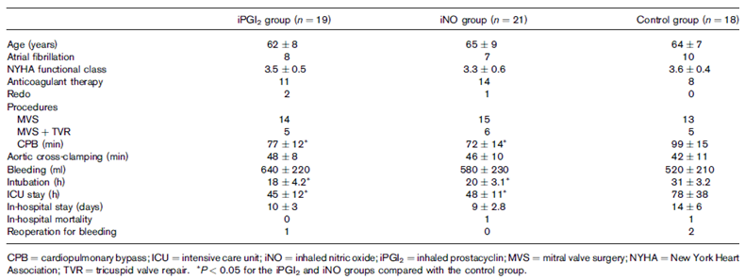

Results
The haemodynamic data in all three treatment groups and at all six time-points are summarised in the table below. Significant changes with respect to baseline are marked with an asterisk, and significant changes across groups (inhalational versus control) are marked with a “§” character.

Table 40: Haemodynamic data
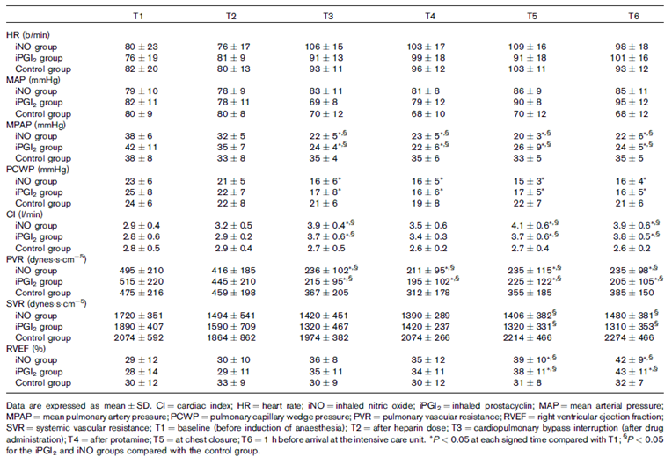
Important observations to note are that induction of anaesthesia (T2) was associated with moderate reductions in MPAP and PVR (relative to baseline, T1) that did not reach statistical significance. In both inhalational groups, MPAP and PVR were significantly decreased after drug administration (T3) compared to baseline (P < 0.05); this was not observed in the control group. In contrast, the mean MAP increased slightly during treatment with inhalational agents; this was not significant.
The right ventricular ejection fraction (RVEF) was significantly increased at the conclusion of the operation (at T5 and T6) with respect to baseline (T1) in both inhalational groups, but not in the control group. A statistically significant difference in RVEF was observed in the iNO and iPGI2 groups compared to the control group. Similarly, in the inhalational groups, a statistically significant increase in the cardiac indices was observed at all times on treatment (T3, T5 and T6) compared to baseline (T1) and to the control group.
All of these significant changes are consistent with previous observations of the effects of iNO, suggesting a relatively selective vasodilatory effect on the pulmonary circulation. No significant differences were observed between iNO and iPGI2, suggesting that these agents might have similar efficacy, but the power calculations were not presented. Also, it is unclear if the drugs were used at optimal doses, because no dosing information was provided. The relative selectivity of the two inhalational agents for the pulmonary vasculature appears broadly similar.
With respect to clinical endpoints, the authors comment: “Patients in the inhaled drug groups were weaned easily from CPB with respect to the control group (P = 0.04) and a significant difference was observed for time of intubation (P = 0.03) and intensive care unit stay (P = 0.02) (Table 1)” [See Table 39, above]. Mentioning these three endpoints together, in reference to the original Table 1 (Table 39 in this report) implies that the “ease of weaning” referred to in the abstract was actually total time spent on CPB. Reasons for delays in the control group were not discussed. The improvement in time spent intubated is likely to reflect more stable haemodynamics and/or improved oxygenation, and it would be of clinical worth if sustained in a larger population (iPGI2 18 ± 4.2 h; iNO 20 ± 3.1 h; control 31 ± 3.2 h).
The fact that these clinical endpoints favoured inhalational therapy in adults is generally reassuring, and provides indirect support for the proposed indication in children, but it is not possible to draw strong conclusions because the paper provided inadequate details about the control intravenous therapies.

Conclusion
Overall, this was a weakly supportive paper that lacked clarity on several key aspects of its methodology, including the doses used, but it is at least consistent with the pivotal iNO studies performed in children, in that MPAP showed a progressive fall during treatment with iNO.

Gianetti 2004

Abstract
Supplemental nitric oxide and its effect on myocardial injury and function in patients undergoing cardiac surgery with extracorporeal circulation.
Background: Cardiopulmonary bypass induces a systemic inflammatory response that may contribute to clinical morbidity. Gaseous nitric oxide at relatively low concentrations may elicit peripheral anti-inflammatory effects in addition to a reduction of pulmonary resistances. We examined the effects of 20 ppm of inhaled nitric oxide administered for 8 hours during and after cardiopulmonary bypass.
Methods and Results: Twenty-nine consecutive patients undergoing aortic valve replacement combined with aortocoronary bypass were randomly allocated to either 20 ppm of inhaled nitric oxide (n = 14) or no additional inhalatory treatment (n = 15). Blood samples for total creatine kinase, creatine kinase MB fraction, and troponin I measurements were collected at 4, 12, 24, and 48 hours post-surgery. In addition, we collected perioperative blood samples for measurements of circulating nitric oxide by-products and brain natriuretic peptide. Soluble P-selectin was analysed in blood samples withdrawn from the coronary sinus before and after aortic clamping. The area under the curve of creatine kinase MB fraction (P < 0.03), total creatine kinase (P < 0.04), and troponin I (P < 0.04) levels were significantly decreased in the nitric oxide–treated patients. Moreover, in the same group we observed blunted P-selectin and brain natriuretic peptide release (P < 0.01 and P < 0.02, respectively). Nitric oxide inhalation consistently enhanced nitric oxide metabolite levels (P < 0.01).
Conclusions: Nitric oxide, when administered as a gas at low concentration, is able to blunt the release of markers of myocardial injury and to antagonize the left ventricular subclinical dysfunction during and immediately after cardiopulmonary bypass. The organ protection could be mediated, at least in part, by its anti-inflammatory properties.

Study design, locations and dates
Gianetti et al report a prospective, randomised, parallel group open label study that assessed the effect of standard care plus iNO versus standard care alone on biochemical markers of myocardial injury in adult subjects undergoing aortic valve replacement.
Unlike most other studies included in the submission, the focus of the study was not on haemodynamic parameters or clinical endpoints likely to reflect pulmonary haemodynamic function. Instead, the authors presented a discussion about the nature of myocardial reperfusion injury after CPB, and suggested that endothelial dysfunction within the heart, characterised by a deficiency of endothelial NO, could play a contributing role. If this hypothesis were true, it would represent an additional mechanism of benefit with iNO therapy largely unrelated to the proposed mechanism of action in pulmonary vasculature. This would be expected to provide an additional rationale for using iNO in the post-operative control of pulmonary hypertension. Because this is the only study addressing this hypothesis, and because this study did not attempt to use iNO to modify pulmonary haemodynamics, this study should be considered somewhat tangential to the sponsor’s application.
The study was conducted at the Pasquinucci Hospital in Massa, Italy, between July 2000 and April 2002.

Inclusion and exclusion criteria
Subjects were eligible if they were undergoing nonemergency aortic valve replacement combined with CPB.
Exclusion criteria included:
- active infection
- ejection fraction < 30%;
- malignancy;
- a history of haematologic, hepatic, or renal disorders;
- corticosteroid or a nonsteroidal anti-inflammatory treatment within the previous 7 days;
- post-operative treatment with nitrates or sodium nitroprussiate [nitroprusside].

Study treatments
Subjects were randomised with equal probability to iNO (20 ppm, n = 14) or no extra inhalational therapy (n = 15). Inhaled NO was initially mixed with nitrogen at 500 ppm, and introduced into the inspiratory limb of the patient’s ventilatory circuit at a controlled and monitored concentration of 20 ppm. Inhaled NO was administered at the onset of CPB, and the cardioplegic solution circuit was designed to administer oxygenated hyperkalemic blood enriched with NO. Thus, unlike most other studies, iNO was used during cardioplegia. It was also continued through CPB and for 8 hours after CPB.
All subjects also received standard care including anaesthetic and perioperative care. Surgery was performed using mild hypothermia (32 to 35°C), and the heart was paralysed using a retrograde, intermittent, hyperkalemic cardioplegic solution.

Efficacy variables
All efficacy variables were based on levels of biochemical markers in blood, drawn as follows:
- indices of myocardial injury (total creatine kinase [CK], creatine kinase MB fraction [CK-MB], and troponin I); 4, 12, 24, and 48 hours after surgery
- NO by-products (NO-2 and NO-3); prethoracotomy, 5 minutes post–aortic clamping, 5 minutes post–aortic unclamping, and 24 hours post-surgery
- brain natriuretic peptide (BNP); prethoracotomy (before heparinisation), 5 minutes post-aortic clamping, 5 minutes post–aortic unclamping, 5 minutes post-CPB, and 4 and 24 hours post-surgery
- P-selectin; before and after cardioplegia.
None of these variables was identified as the primary variable, but the main focus of the paper was the extent of myocardial injury, for which troponin is the most commonly accepted biomarker.

Methods
Statistical methods were described as follows:
“All data are presented as mean ± standard error of the mean (SEM). Statistical analysis was performed by multivariate analysis of variance for repeated measurements for a comparison among more than 2 groups and Student t test for a comparison between 2 groups; correlation among variables was estimated by a linear regression analysis with the aid of the Statview statistical package (Abacus Concepts, Inc, Berkeley, Calif).”
These statistical methods appear to be appropriate, except that no correction was made for using multiple endpoints.

Baseline data
The two groups were well matched at baseline in terms of age, gender balance, cardiovascular risk factors and pre-operative cardiac ejection fraction, as shown in Table 41. They also underwent CPB and aortic clamping for similar periods of time.

Table 41: Demographic, clinical and surgical characteristics
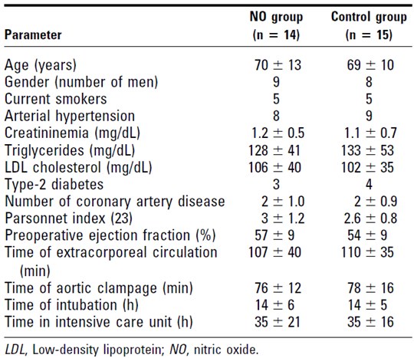

Results
As expected, assays for NO by-products showed increased levels of these in iNO recipients, but the control group also had NO by-products in blood, consistent with endogenous production and the difference between the groups was modest, as shown in Figure 33. In this figure and all subsequent figures reproduced from the paper, reference is made to an asterisk as a marker of statistical significance, but no asterisk appears in the figure; these appear to have been lost during editing of the original paper. The text of the paper indicates that comparison between iNO and control groups showed a significant overall difference in NO by-products (P = 0.01).
Figure 33: NO by-products
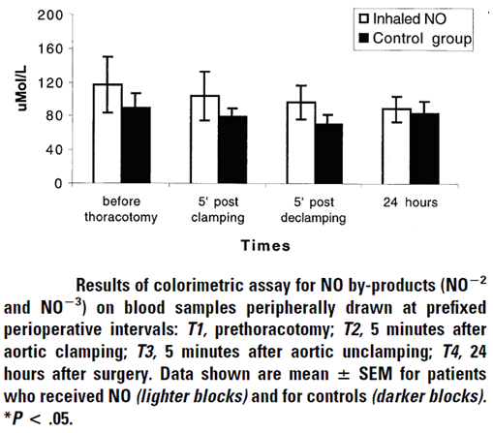
For the main analysis of myocardial injury, the authors presented CK and CK-MB at individual time-points, as well as the overall area under the curve (AUC) for both markers. Troponin 1 data was only presented in terms of total AUC. Quantitative results were not reported in the text, but only illustrated in figures, as shown below; significance was supposed to be marked with asterisks but these were missing.
The authors note that markers of myocardial injury increased throughout the first 24 hours after surgery, but the increase was reduced in the iNO group. Total CK release was significantly lower in the iNO group at 24 and 48 hours (P = .02; Figure below, Part, A), and cumulative release (AUC) was also lower (P = .04; Figure below, Part B). Similar observations were made for peak levels of CK-MB at 24 hours (P = .01) and at 48 hours (P = .01; Figure below, Part C), and the AUC (P = .03; Figure below, Part D). The AUC of troponin I was also lower in the iNO group than in the control group (P = .04; subsequent figure).
Figure 34: CK and CK-MB release
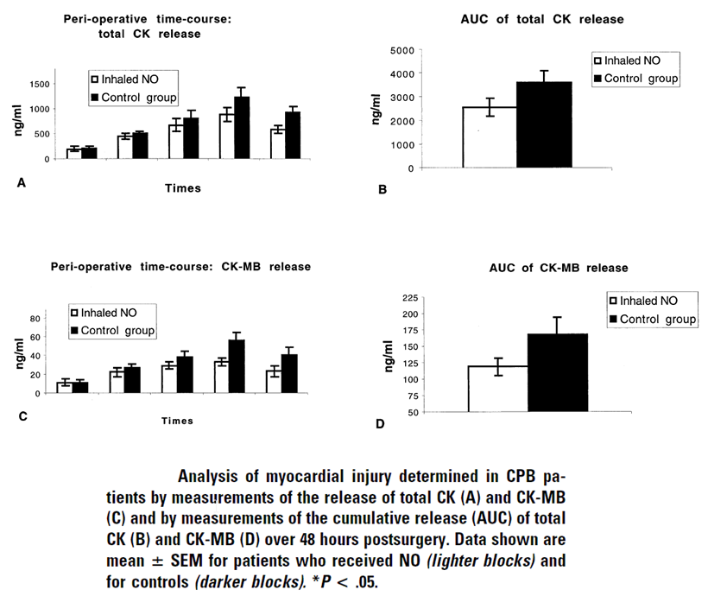
Figure 35: Troponin l release
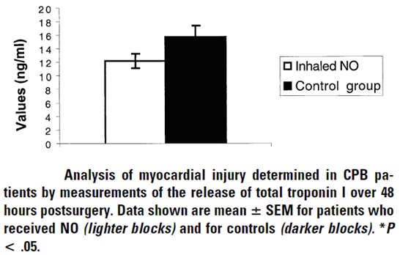
The authors also assessed endothelial activation using the biomarker P-selectin, which they interpreted as an important mediator of the inflammatory cascade associated with reperfusion injury. The results were illustrated in terms of the gradient (difference) between P-selectin levels before and 5 minutes after aortic clamping (B, upper part of figure), and as actual values of P-selectin (A, lower part). The rise in P-selectin was significantly reduced in the iNO group (p = 0.02).
Figure 36: P-Selection levels before and after aortic clamping
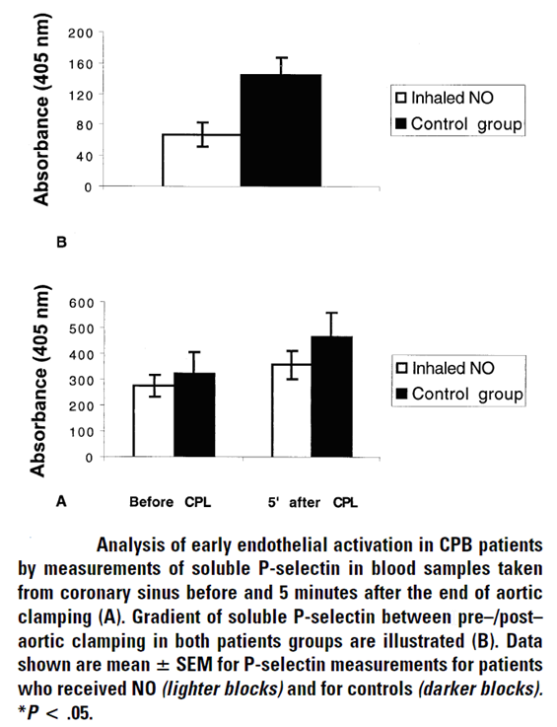
The authors also presented levels of brain natriuretic peptide (BNP), which is a biomarker of left ventricular dysfunction. The results were normalised according to baseline values, as follows: “To normalize the basal values (T1), we analysed the gradient of BNP release as measured by the percent of the ratio between the levels at each time (T2-T6) compared with T1 [see figure].” They demonstrated a statistically significant difference at T5 (P = .02), with lower levels in the iNO group than the control group (249 ± 71 versus 311 ± 141 pg/mL).
Figure 37: BNP gradients
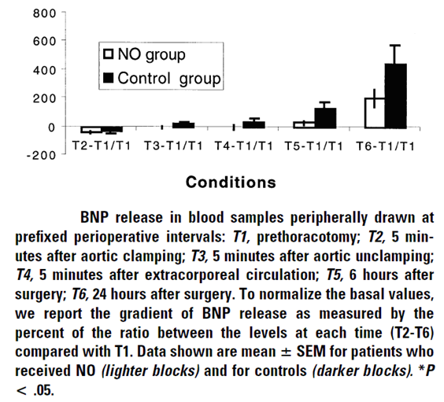

Conclusion
This small study (n = 29) had an acceptable design and the results were positive. It investigated a different patient group than that proposed for registration (adults rather than children), and the proposed benefits of iNO occurred in a completely different vascular bed (the myocardium rather than the pulmonary circulation) compared to the proposed mechanism of action. Nonetheless, the study raises the possibility that iNO might be beneficial in the CPB setting for reasons other than its claimed effects on the pulmonary vasculature. The results would need to be replicated in a larger study and repeated in the target population before the study could be considered directly supportive of the sponsor’s submission.

Schmid 1999

Abstract
Inhaled Nitric Oxide Versus Intravenous Vasodilators in Severe Pulmonary Hypertension After Cardiac Surgery.
Inhaled nitric oxide (iNO) is superior to IV vasodilators for treatment of pulmonary hypertension (PH) after cardiac surgery, but iNO is a potentially toxic gas, and patient subsets who benefit from iNO are not yet clearly defined. We administered iNO 40 ppm, prostaglandin E1 (PGE1) 0.1 µg∙kg⁻¹∙min⁻¹, and nitroglycerin (NTG) 3 to 5 µg kg⁻¹∙min⁻¹, in a randomized crossover study to 14 adult patients with severe PH after cardiac surgery. iNO, PGE1, and NTG were of similar efficacy in reducing pulmonary vascular resistance (P = 0.003). iNO induced selective pulmonary vasodilation, while PGE1 and NTG had significant concomitant systemic vasodilatory effects. iNO led to an increase in cardiac index (CI) (P = 0.012), and PGE1 increased CI (P = 0.006) and right ventricular (RV) ejection fraction (P = 0.015), while NTG had no effect on CI and RV performance. After study completion, patients continued with PGE1 administration with favourable in-hospital outcome. We conclude that PH per se, even if severe, does not necessarily imply post-operative RV dysfunction, and selective pulmonary vasodilation with iNO may not be superior to PGE1 with regard to CI and RV performance. Implications: In a prospective, randomized crossover study of inhaled nitric oxide (iNO) versus IV vasodilators, performed in adult patients with severe pulmonary hypertension but preserved right ventricular function after cardiac surgery, iNO was not superior to IV prostaglandin E1 with regard to cardiac index and right ventricular performance. Considering the potential toxicity of iNO, better definition of patient subsets with a positive benefit/risk ratio is warranted.

Study design, locations and dates
Schmid et al used an open label, randomised crossover design to assess the haemodynamic response to 3 vasodilatory agents (iNO, intravenous prostaglandin E1 [PGE1], and intravenous nitroglycerin [NTG]) in 14 adult subjects who had elevated PVR after cardiac surgery.
Administration of vasodilators occurred within the first 24 hours of the ICU admission, and at least one hour after cessation of routine perioperative intravenous PGE1. The three agents were given in a random sequence and the haemodynamic response to each agent was compared to the individual baseline haemodynamic status immediately prior to administration of that agent.
The study was performed in the University Hospital of Zurich, Switzerland, in the lead up to publication in 1999.

Inclusion and exclusion criteria
Potential subjects were adults with severe pulmonary hypertension (PH) prior to cardiac surgery. To be eligible, subjects had to demonstrate persistence of PH after cardiac surgery, defined as MPAP > 30 mm Hg or PVR > 300 dyne∙sec∙cm⁻⁵.
Surgical procedures differed among subjects, and included coronary artery bypass grafting, atrial septal defect repair, tricuspid valve annuloplasty, mitral valve repair, pulmonary artery thromb-endarterectomy, and sub-endocardial resection.
Subjects also required stable post-operative haemodynamics to allow repeated withdrawal of vasodilators and reassessment of baseline values, without hemodynamic interventions during the crossover period, such as fluid boluses or inotropic support.
Patients were excluded if they required mechanical circulatory assistance or if they had echocardiographic evidence of significant pulmonary or tricuspid valve regurgitation.

Study treatments
Subjects received all three agents, in random sequence: iNO 40 ppm, PGE1 0.1 µg∙kg⁻¹∙min⁻¹, and NTG, 3 to 5 mg∙kg⁻¹∙min⁻¹. The agents were administered for 15 to 20 min each, followed by a washout period of at least 20 min to allow haemodynamic variables to return to baseline.
NO was delivered from a tank containing 1000 ppm NO diluted in nitrogen, via a calibrated flow-meter and a nebuliser circuit, diluted to 40 ppm, with standard monitoring in place for NO₂ and metHb.
In other respects, patients received standard perioperative care, which varied according to the individual case. Patient sedation consisted of propofol and morphine (11 patients) or midazolam and alfentanil (2 patients) or midazolam and fentanyl (1 patient), which was continued at constant infusion rates. During administration and washout, no other interventions were performed that could modify the patients’ haemodynamics, and ventilator settings were kept constant.

Efficacy variables
The following variables were directly measured:
- heart rate (HR)
- mean systemic arterial pressure (MAP)
- MPAP
- CVP
- pulmonary capillary wedge (PCWP) pressure
- cardiac output (CO)
- RVEF (if applicable)
- arterial and mixed venous pH
- partial pressures of carbon dioxide, oxygen, arterial and mixed venous oxygen saturations
- haemoglobin and MetHb.
From these variables, the following derived variables were calculated using standard formulas:
- transpulmonary pressure gradient (TPG = MPAP – PCWP)
- PVR
- SVR
- PVR/SVR ratio
- right coronary artery perfusion pressure (PRCA = MAP – CVP)
- cardiac index (CI)
- oxygen delivery index (DO₂I)
- oxygen consumption index (VO₂I)
- oxygen extraction ratio (O₂ext)
- intrapulmonary shunt fraction (Qs/Qt)
- the ratio of arterial partial pressure of oxygen to inspired oxygen fraction (PaO₂/FiO₂).
The authors did not indicate that any single variable was considered primary, but the focus of the paper was on the ability of the vasodilators to reduce PVR, the pulmonary selectivity of the agent as reflected in the PVR/SVR ratio, and the effect on right ventricular and overall cardiac function as reflected in RVEF and CI.

Methods
The authors describe their statistical methods as follows: “Values are presented as median and percentile. Comparison of treatments were performed using the Friedman test, followed by pairwise Wilcoxon Signed Rank tests with Bonferroni correction. For the Friedman test, a P value < 0.05 was considered significant. For the post hoc comparisons (by the Wilcoxon Signed Rank test), P values were multiplied by 3 and considered significant if P, 0.05 after multiplication (Bonferroni correction).”
This approach seems reasonably appropriate, with a clear mechanism for correcting for the multiple between group comparisons performed on each variable. The authors did not, however, perform any adjustment for the large number of different variables being assessed. Also, the authors failed to perform any sample size estimations or to consider the statistical power of their analysis, so it is not possible to draw strong conclusions about the equivalence of the different agents where statistical differences were not found. Finally, there was no attempt to present 95% CIs, so the upper and lower plausible limits for each effect are not clear.
When assessing the effect of each treatment, the authors used the individual baseline values observed prior to onset of that treatment.

Baseline data
Baseline data and basic peri-operative information is shown for each subject below. The subjects underwent a broad range of cardiac procedures but all had substantial elevations of PVR post-operatively.

Table 42: Patient characteristics
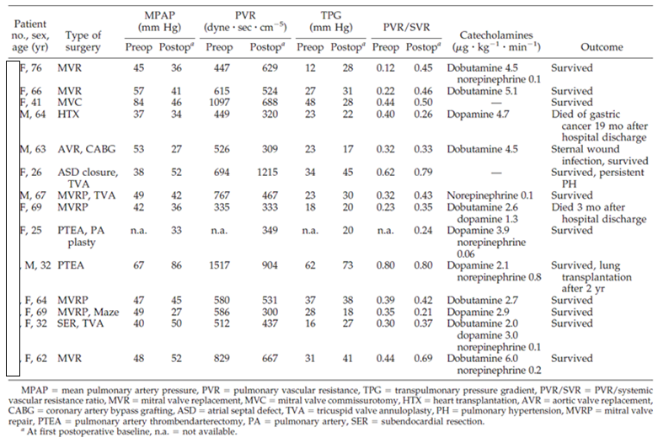

Results
The haemodynamic results are shown in the table below, with the subsequent table showing the effects of each agent on oxygenation. Significant differences relative to baseline or between groups are marked with symbols, as described in the legend, but the meaning of the § symbol was not provided.
All three agents produced a significant reduction in MPAP, as expected (p < 0.01), and all were effective in reducing PVR and TPG (p = 0.003). They differed in their effect on the systemic circulation: iNO did not produce a significant change in MAP or SVR, but PGE1 and NTG both produced a similar decrease in MAP (p = 0.003) and a reduction in SVR (p ≤ 0.005). Accordingly, the median PVR/SVR ratio decreased with iNO (p = 0.003), confirming pulmonary selectivity, but it was unchanged with PGE1 and NTG. The authors report that serious systemic hypotension occurred with NTG in three patients and with PGE1 in two patients, consistent with a lack of pulmonary selectivity for these agents when administered intravenously.
Left atrial pressure as estimated from PCWP was not modified by iNO, but it decreased with both PGE1 (p = 0.01) and NTG (p = 0.003). CVP was reduced with all three vasodilators (p < 0.015), but the reduction in CVP was more marked with NTG than with PGE1 or iNO and the difference was significant (p = 0.003). Perfusion of the right coronary artery (PRCA) was not affected by iNO, but there were significant reductions of PRCA with NTG and PGE1 (p = 0.003).
In terms of overall cardiac function, both iNO and PGE1 produced a significant increase in CI (p = 0.012 for iNO and p = 0.006 for PGE1) and Stroke Volume Index (p ≤ 0.005). By contrast, NTG was not associated with a significant change in CI or HR.
Right ventricular ejection fraction (RVEF) increased significantly with PGE1 (p = 0.015), but the changes in RVEF were not significant for iNO or NTG. The differences between groups for this variable were not statistically significant and the median changes in the iNO and PGE1 groups were actually the same. This broadly suggests that PGE1 and iNO might have similar effects on RVEF, but the study was not specifically powered to address this question.

Table 43: Effects of iNO, PGE1, and NTG on systemic and pulmonary haemodynamics
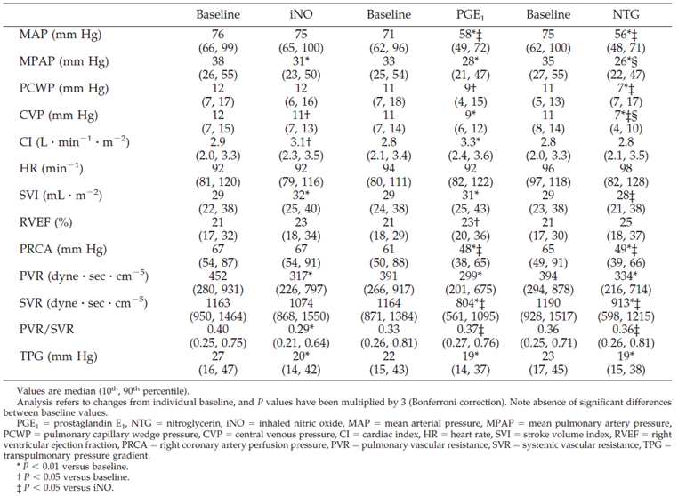
Figure 38: Changes from baseline in haemodynamic variables
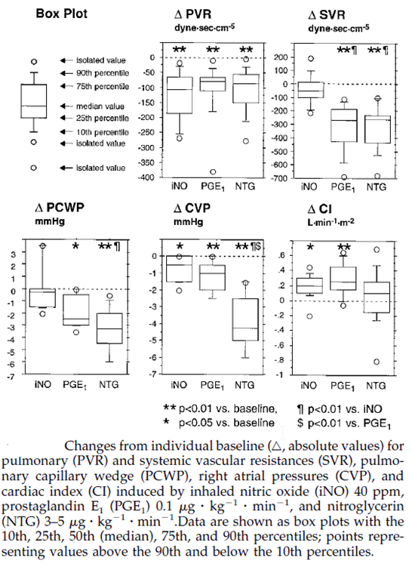
With respect to changes in oxygenation, the results during iNO therapy appeared favourable overall. No significant changes in intrapulmonary shunt fraction (Qs/Qt) or PaO₂/FiO₂ ratio were observed with iNO, but PGE1 and NTG both produced adverse changes: an increase in Qs/Qt (p = 0.006 for PGE1 and p = 0.014 for NTG) and a decrease in PaO₂/FiO₂ (p < 0.005). Inhaled NO also significantly increased DO₂I (p = 0.039), whereas PGE1 led to a significant reduction in O₂ext (p = 0.045). These changes in shunting and oxygenation were not significantly different across treatment groups, but they are consistent with previous suggestions that iNO improves ventilation-perfusion matching, producing greater vasodilation in those parts of the lung where the inhaled agent has better access.

Table 44: Effects of iNO ,PGE1 and NTG on oximetric and gas exchange data
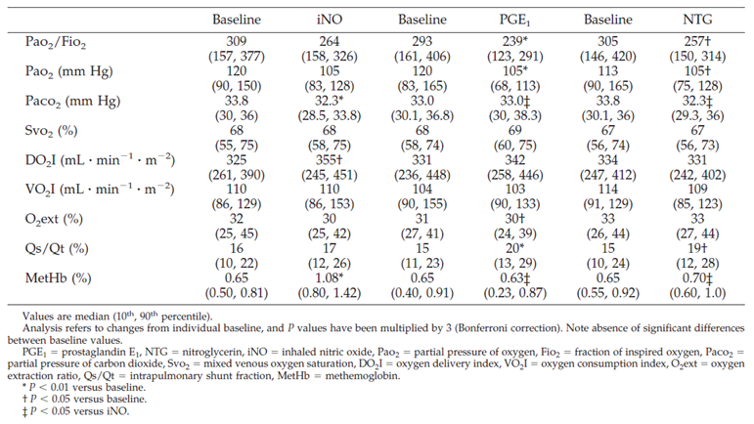
Figure 39: Changes in derived variables
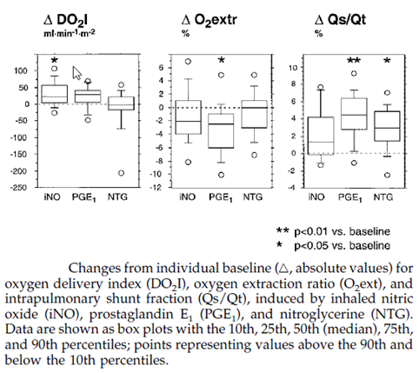

Conclusion
Overall, the haemodynamic results confirm that iNO produces selective pulmonary vasodilation, with resulting improvements in cardiac output in the setting of adult cardiac surgery. The study raises the possibility that PGE1 might be similarly effective at reducing PVR and improving cardiac output, despite the lack of pulmonary selectivity, but this agent lowered mean arterial pressure and produced severe hypotension in two patients. NTG lowered PVR at the expense of causing lowered MAP, and produced three cases of severe hypotension. Of the three agents tested, iNO would appear to be the preferred agent when pulmonary selectivity is important, but intravenous PGE1 could be useful in other contexts.

Winterhalter 2008

Abstract
Comparison of Inhaled Iloprost and Nitric Oxide in Patients With Pulmonary Hypertension During Weaning From Cardiopulmonary Bypass in Cardiac Surgery: A Prospective Randomized Trial.
Objective: The objective of this study was to compare the efficacy of inhaled iloprost and nitric oxide (iNO) in reducing pulmonary hypertension (PHT) during cardiac surgery immediately after weaning from cardiopulmonary bypass (CPB).
Design: A prospective randomized study.
Setting: A single centre university hospital.
Participants: Forty-six patients with PHT (mean pulmonary artery pressure (mPAP) ≥ 26 mm Hg pre-operatively at rest, after anaesthesia induction, and at the end of CPB) scheduled to undergo cardiac surgery were enrolled.
Interventions: Patients were randomly allocated to receive iloprost (group A, n = 23) or iNO (group B, n = 23) during weaning from CPB.
Measurements and Main Results: Heart rate, mean arterial pressure, central venous pressure, pulmonary artery pressure (PAP), pulmonary capillary wedge pressure, and left atrial pressure were recorded continuously. Iloprost and iNO were administered immediately after the end of CPB before heparin reversal. Both substances caused significant reductions in mean PAP (mPAP) and pulmonary vascular resistance (PVR) and significant increases in cardiac output 30 minutes after administration (p < 0.0001). However, in a direct comparison, iloprost caused significantly greater reductions in PVR (p = 0.013) and mPAP (p = 0.0006) and a significantly greater increase in cardiac output (p = 0.002) compared with iNO.
Conclusions: PHT after weaning from CPB was significantly reduced by the selective pulmonary vasodilators iNO and iloprost. However, in a direct comparison of the 2 substances, iloprost was found to be significantly more effective.

Study design, locations and dates
Winterhalter et al used a randomised, prospective, parallel group study (n = 46) to compare the haemodynamic efficacy of iNO and inhaled iloprost in adults with pulmonary hypertension undergoing cardiac surgery and CPB. Blinding was not explicitly mentioned in the paper, but it is strongly implied that the study was open label.

Inclusion and exclusion criteria
Subjects were eligible if they were adult patients with pulmonary hypertension (MPAP > 26 mm Hg) scheduled to undergo cardiac surgery with CPB. Eligibility had to be confirmed (MPAP> 26 mm Hg) at 3 consecutive time points: pre-operatively at rest, after anaesthesia induction at rest and immediately after the end of CPB.
Subjects were excluded if they were undergoing heart or lung transplantation or received a left ventricular assist device, or showed MPAP < 26 mm Hg at any of the specified time-points. Three of 49 subjects initially enrolled were subsequently rejected because of inadequate MPAP.

Study treatments
Subjects were randomised equally to iloprost (group A, n = 23) or iNO (group B, n = 23).
In Group A, 20 µg of aerosolized iloprost (Ventavis) in 2 mL of NaCl were administered for 4 to 6 minutes immediately after separation from CPB.
In Group B, iNO was delivered at 20 ppm, starting immediately after separation from CPB and continuing until soon after arrival in the ICU, when the iNO was stopped as rapidly as possible, allowing for the possibility of a rebound effect.
In addition to randomised inhaled vasodilators, subjects received standard anaesthetic and perioperative care, which included patients’ regular cardiac medication pre-operatively, premedication with oral midazolam, anaesthesia induction with etomidate, fentanyl, and cisatracurium, and maintenance of anaesthesia with sevoflurane and propofol. Depending on the clinical situation, patients were weaned from CPB with alpha- and beta-adrenergic sympathomimetics and intravenous vasodilators (nitrates) in accordance with institutional standards. (The use of systemic nitrates could have partially masked the response to iNO). The authors used dobutamine and epinephrine (adrenaline) as needed for contractility problems. In the event of impending right-heart failure, inhaled vasodilators were used.

Efficacy variables
Heart rate, mean arterial pressure (MAP), CVP, PAP, pulmonary capillary wedge pressure (PCWP), left atrial pressure (LAP) and cardiac output (CO) were recorded continuously. PVR and systemic vascular resistance (SVR) were calculated using standard formulas. MPAP was designated as the primary efficacy variable, and the paper also focussed on PVR and CO.
The following time points were studied:
- T1: after anaesthesia induction
- T2: immediately after the end of CPB (start of iloprost [1 single dose]/iNO administration)
- T3: 30 minutes after start of treatment; and
- T4: on arrival in the ICU (90 minutes after start of treatment).

Methods
The authors described their statistical approach as follows:
“Data are presented as frequencies for qualitative data and as mean values ± standard deviations for quantitative data, together with the median for skewed distributions. Groups were compared by using the chi-square test for qualitative data and the 2-tailed unpaired t test or Mann-Whitney U test for quantitative data.
A linear mixed model for repeated measures was applied for the hemodynamic data, with time point (T1-T4) and treatment as fixed factors and the patient as random factor. Residuals were assumed to be independent but with unequal variances. The fixed factors were modelled according to the study design; differences between the treatment groups were incorporated into the model only after the start of treatment (that is, from T3 onward). Thus, the treatment differences at T3 and T4 may be interpreted as differences in changes after T2. Specific contrasts were computed to analyse time effects separately for each treatment group. The Proc Mixed procedure (SAS 9.1; SAS, Cary, NC) was used to conduct the analysis. All tests were applied at the local significance level of p < 0.05.”
Thus, the main analysis method was a linear mixed model for repeated measures, effectively using T2 as the main baseline. The authors did not mention any correction for the use of multiple efficacy variables, but they did designate PAP as the single primary endpoint.
The authors performed power estimations suggesting that the sample size of 23 per group would produce a power of 90% when applying a 2 tailed t test at a significance level of p < 0.05, with an effect size of 5 mm Hg for PAP. The study easily achieved significance for its major endpoints, indicating it was adequately powered.

Baseline data
The two treatment groups showed acceptable matching at baseline for key demographic and medical characteristics, as well as intra-operative details, as shown in the tables below. There was a trend to increased use of beta-blockers in the iloprost group (p = 0.07), which could have partially confounded the results.

Table 45: Baseline characteristics
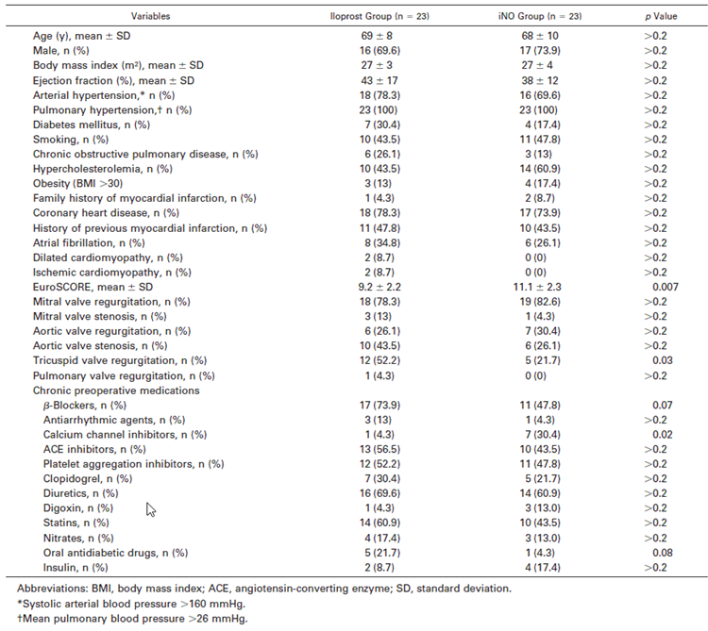

Table 46: Intraoperative characteristics
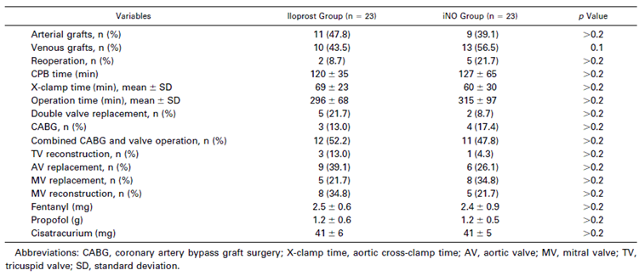

Results
Substantial and statistically significant changes were noted for a number of haemodynamic variables from T2 to T3, and from T2 to T4, particularly the key parameters MPAP, PVR, SVR and CO. Both inhalational agents produced a major, significant reduction in MPAP and PVR, but the reduction in MPAP and PVR was greater with iloprost, particularly at T3 (between group MPAP difference, p = 0.006; PVR difference, p = 0.013). The mean MPAP was the same in each group at T4, and the difference in PVR favoured iloprost at T4 but was no longer significant. In the absence of a placebo group, it is unclear to what extent recovery from surgery contributed to these improvements.
The reductions in SVR were also more marked in the iloprost group, which could be of concern in hypotensive patients; the between group difference was significant at the T3 time-point.
Cardiac output (CO) showed steady improvement across the time-points from T2 to T4, and this was highly significant in both treatment groups. CO was significantly better at both T3 and T4 in the iloprost group than the iNO group, suggesting that this drug could be superior to iNO in this patient group.

Table 47: Haemodynamic and pulmonary data
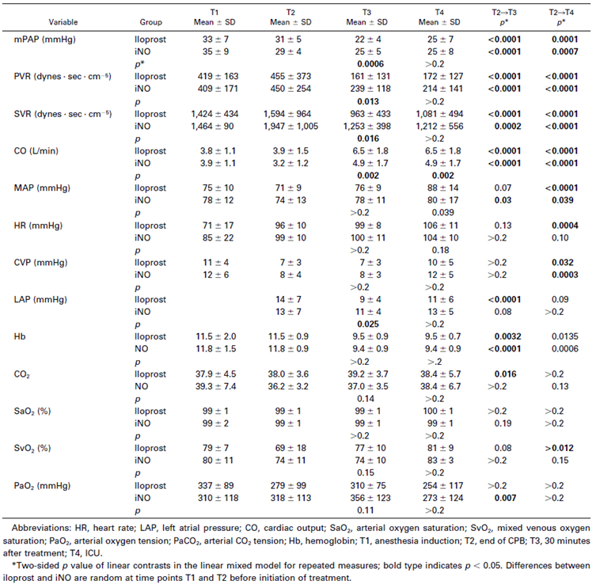
Oxygenation parameters showed no significant between group differences, but the iNO group showed greater and earlier improvements in PaO₂. The improvement in PaO₂ to T3 was significant for iNO (p = 0.007), but not for iloprost. On the other hand, iloprost showed greater improvements in venous O₂ saturation, partly reflecting poor saturation prior to treatment, at T2; the venous saturation was actually better in the iNO group.

Conclusion
The authors of this study in adults concluded that both drugs improved haemodynamics and successfully lowered MPAP and PVR, but they noted the significant superiority of iloprost in terms of reducing MPAP and PVR and increasing cardiac output. This study raises the possibility that inhaled iloprost may be superior to iNO in some patient groups with pulmonary hypertension, but the study is nonetheless indirectly supportive of the proposed use of iNO in children with pulmonary hypertension. The safety and efficacy of inhaled iloprost in children undergoing cardiac surgery is unknown.

Solina 2000

Abstract
A Comparison of Inhaled Nitric Oxide and Milrinone for the Treatment of Pulmonary Hypertension in Adult Cardiac Surgery Patients.
Objective: To investigate the relative effects of milrinone and nitric oxide on pulmonary and systemic hemodynamic responses in cardiac surgery patients with a history of pulmonary hypertension.
Design: Prospective and randomized.
Setting: University hospital.
Participants: Forty-five adult cardiac surgery patients.
Interventions: Cardiac surgery patients with pulmonary hypertension were randomly assigned to one of three study groups: Group 1 patients (n = 15) were treated with intravenous milrinone on separation from cardiopulmonary bypass, group 2 patients (n = 15) with 20 ppm of inhaled nitric oxide, and group 3 patients (n = 15) with 40 ppm of inhaled nitric oxide. Heart rate, right ventricular ejection fraction, and pulmonary vascular resistance were measured throughout the perioperative period at specific data points.
Measurements and Main Results: There were no significant differences in demographics, anaesthesia, surgery, or baseline haemodynamics among the groups. The group receiving 40 ppm nitric oxide had a significantly higher (p < 0.05) right ventricular ejection fraction on arrival in the intensive care unit (40% versus 30% for the milrinone group and 33% for the nitric oxide 20 ppm group). The milrinone group required significantly more phenylephrine in the intensive care unit (p < 0.05).
Conclusions: Treatment of pulmonary hypertension in adult cardiac surgery patients with inhaled nitric oxide compared with milrinone is associated with lower heart rates, higher right ventricular ejection fraction, and a lower requirement for treatment with vasopressor agents.

Study design, locations and dates
Solina et al used a randomised, controlled, parallel group, open label study to compare the efficacy of iNO at two doses (20 ppm and 40 ppm) with intravenous milrinone, in adult patients undergoing cardiac surgery and exhibiting pulmonary hypertension.

Inclusion and exclusion criteria
Subjects were 45 cardiac surgery patients whose pulmonary resistance was greater than 125 dyne∙sec∙cm⁻⁵ immediately before anaesthesia.
Patients were excluded if they had a pre-operative requirement for inotropes or vasopressors, had a history of asthma, or were pregnant.

Study treatments
Subjects were randomly allocated to one of the following treatments:
- Group 1 (n = 15) Intravenous milrinone
- Group 2 (n = 15) Inhaled nitric oxide, 20 ppm
- Group 3 (n = 15) Inhaled nitric oxide, 40 ppm
Inhaled NO was started on termination of CPB and continued for the first 24 hours in the ICU. NO was supplied as an 800 or 400 ppm mixture, diluted in nitrogen, which was then mixed with medical grade nitrogen to achieve the desired final concentration and introduced to the input circuit of the ventilator. The delivered gas was monitored for NO and nitrogen dioxide concentration.
Milrinone was initiated by bolus administration (50 µg/kg), 15 minutes before separation from CPB, and maintained at 0.5 µg/kg/min in the operating room and for the first 24 hours in the ICU.
All subjects also received standard perioperative care, including analgesia, sedatives and 100% oxygen. Patients were cooled to a venous return temperature of 28°C while on CPB and they were rewarmed to a rectal temperature of 36°C before separation from CPB.
The investigators used a structured algorithm for management of haemodynamic disturbances, as shown in Table 48.

Table 48: Therapeutic algorithm for haemodynamic disturbances
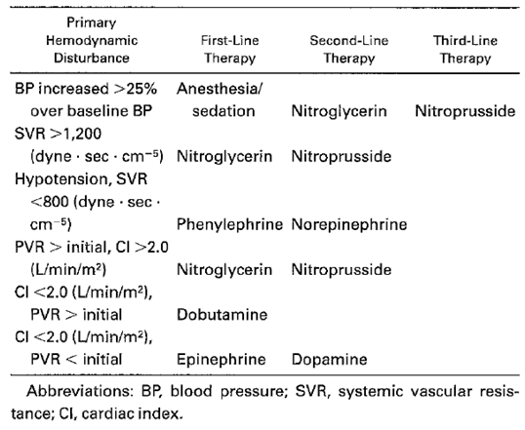

Efficacy variables
The following haemodynamic variables were recorded:
- heart rate
- arterial blood pressure
- pulmonary artery pressure
- pulmonary capillary wedge pressure
- central venous pressure
- cardiac output
- cardiac index
- SVR
- PVR
- RVEF.
These variables were recorded at pre-induction, post-induction, after heparin, after CPB separation, after protamine, on chest closure, before leaving the operating room, and on arrival to the ICU. The average doses of inotropic and pressor agents used intra-operatively and post-operatively were also recorded for each patient. The study did not indicate which of these variables was to be considered primary, but the focus of the study was on right ventricular ejection fraction.

Methods
The authors described their statistical methods as follows: “Data were statistically analysed using standard analysis of variance (ANOVA) in conjunction with Student-Newman Keuls multiple comparison tests. Wilcoxon rank sum analysis was used in cases in which ANOVA assumptions were not satisfied. All tests were two sided. A two-way ANOVA (group by time) with time as a repeated measure factor was performed on the variables heart rate, mean arterial pressure, mean pulmonary artery pressure, cardiac index, PVR, SVR, and RVEF using the values from post-bypass to arrival at the ICU. When either the group effect was significant (p < 0.05) or a significant interaction (group by time) was present, an analysis at each time point was performed. A p value < 0.05 was considered significant.”
The selection of the individual statistical tools appears appropriate, but the authors have not performed any correction for the use of multiple efficacy variables. Also, they have failed to designate any particular analysis as primary.
The authors did not perform any sample-size estimations or present any discussion of statistical power, so it is not possible to draw any strong inferences from the lack of difference between treatment groups.

Baseline data
The three treatment groups were reasonably well matched at baseline in terms of demographics and severity of heart disease, and for details of their perioperative management. There was a trend to milder heart disease (lower NYHA status) in the higher-dose iNO group, and trend to higher age in the lower dose iNO group.

Table 49: Patient characteristics
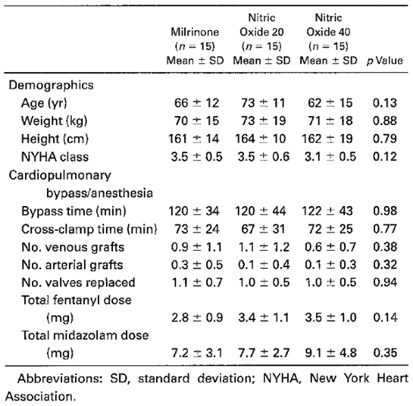

Results
The three treatment groups followed a broadly similar haemodynamic pattern through the course of surgery and the post-operative period, but occasionally significant differences between groups were noted, as follows:
- after administration of anaesthesia, MPAP and PVR were higher in the iNO 20 ppm group
- on arrival in ICU, the iNO 20 ppm group had a higher MAP than the other two groups
- on arrival in ICU, the iNO 40 ppm group had a higher RVEF than the other two groups.
The significant elevation in PVR in the NO 20 group occurred before initiation of randomised treatment; after initiation of NO or milrinone, there were no significant differences in PVR at any time-point. There were no significant differences among the three groups for cardiac index or SVR at any time-point.
It might have been more informative to assess changes in haemodynamic parameters rather than absolute values. The milrinone group began with the lowest PVR and ended up with the highest PVR, and the iNO 20 ppm group had the highest PVR prior to treatment, falling the most on commencement of treatment, a change that was not captured by the analysis.

Table 50: Haemodynamic data
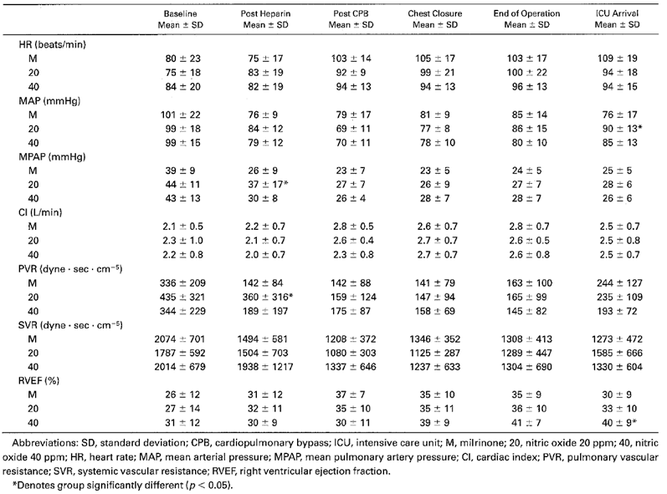
Figure 40: Pulmonary vascular resistance (PVR) as a function of time
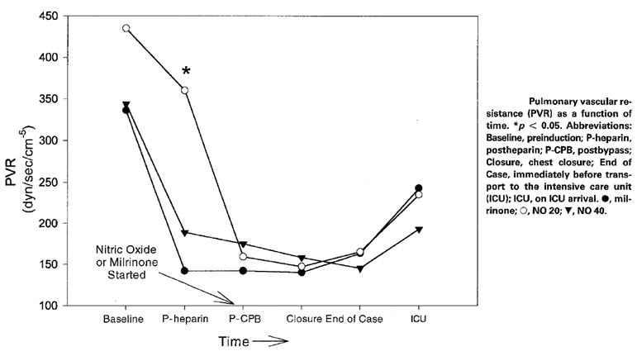
Figure 41: Ejection fraction (EF) as a function of time
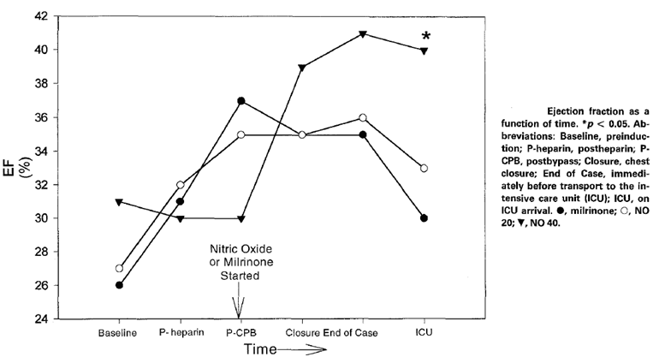
To some extent, the study design with its structured regimen for handling haemodynamic disturbances could have disguised potential differences between treatments. An assessment of the use of individual inotropes and vasopressor agents in the three groups, by ANOVA, showed that the milrinone group required significantly more support of systemic blood pressure and cardiac function than the two iNO groups, consistent with other studies that have shown inhaled NO to be relatively selective for the pulmonary circulation.

Table 51: Dose of inotropes/pressors used
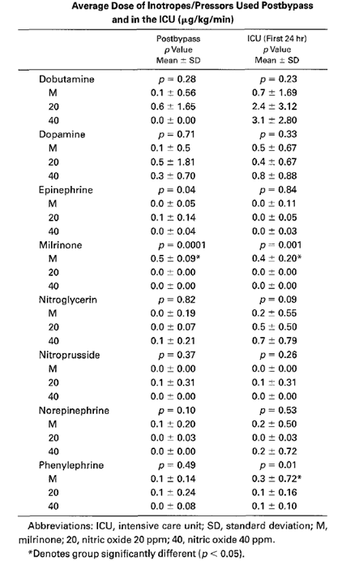

Conclusion
Overall, this study in adults is consistent with the pivotal studies performed in children, and shows that iNO is broadly comparable to the intravenous vasodilator milrinone in its ability to reduce PVR. In the absence of a placebo group, it remains unclear how much improvement in PVR was due to the surgery and recovery process, and the study was not powered to clearly show the relative efficacy of the different agents. The study provides indirect evidence that NO is selective for the pulmonary vasculature, because iNO recipients did not require as much inotropic/pressor support as milrinone recipients.

Solina 2001

Abstract
Dose Response to Nitric Oxide in Adult Cardiac Surgery Patients.
Study Objective: To determine the dose responsiveness to nitric oxide in adult cardiac surgery patients, especially in those patients with pulmonary hypertension.
Design: Prospective, randomized, non-blinded study.
Setting: University teaching hospital.
Patients: 62 consecutive cardiac surgery patients demonstrating pulmonary hypertension immediately before induction of anaesthesia.
Interventions: Subjects were assigned by random number allocation to receive one of five doses of inhaled nitric oxide on termination of cardiopulmonary bypass (CBP, that is,, restitution of pulmonary artery flow). Subjects in Group 1 (n = 11) received 10 ppm of inhaled nitric oxide, Group 2 subjects (n = 12) received 20 ppm, Group 3 subjects (n = 12) received 30 ppm, and Group 4 subjects (n = 12) received 40 ppm. The fifth group (n = 15) received no nitric oxide. This fifth group served as a control and was treated with milrinone only. Those patients who were randomized to the milrinone group, had milrinone initiated by bolus administration (50 mg/kg) 15 min before separation from CPB. Milrinone was maintained at 0.5 mg/kg/min in the operating room thereafter. The conduct of anaesthesia, surgery, and CBP were controlled. A therapeutic algorithm dictated the use of vasoactive substances for all patients.
Measurements: Heart rate, mean arterial pressure, pulmonary vascular resistance (PVR), peripheral vascular resistance, cardiac index, and right ventricular ejection fraction were monitored throughout the operative experience.
Main Results: There were no significant differences found in demographic data, baseline hemodynamic data, surgical treatment, conduct of CBP, or the use of inotropic or vasoactive drugs among the five treatment groups. The percentage decrease in PVR on treatment with nitric oxide as compared to baseline values was not significantly different among the groups (10 ppm = 38%, 20 ppm = 50%, 30 ppm = 44%, 40 ppm = 36%, milrinone = 58%, p = 0.86).
Conclusions: Treatment with nitric oxide was associated with significant reductions in PVR in all groups. Dosages higher than 10 ppm were not associated with greater reductions in pulmonary vascular tone. In view of the fact that nitric oxide-related toxicity is dose-related, doses greater than 10 ppm do not appear to be justified in this patient population.

Study design, locations and dates
Solina et al used a randomised, open label, parallel group design to compare the haemodynamic effects of a range of iNO doses with the active control, intravenous milrinone, in adult patients undergoing cardiac surgery. The study was performed at Robert Wood Johnson Medical School, University of Medicine and Dentistry of New Jersey, Piscataway, New Jersey, in the lead-up to publication in 2001.

Inclusion and exclusion criteria
Adult subjects were eligible if they were undergoing cardiac surgery and demonstrated pulmonary hypertension (PVR greater than 125 dyne∙sec∙cm⁻⁵) immediately before induction of anaesthesia.
Patients were excluded if they had a history of pre-operative dependence on inotropes or vasopressors, required intraoperative use of nitroglycerin or sodium nitroprusside, had asthma, or were pregnant.

Study treatments
Subjects were randomly assigned to receive one of four doses of inhaled NO on termination of CBP, or milrinone. Subjects in Group 1 (n = 11) received 10 ppm, Group 2 (n = 12) received 20 ppm, Group 3 (n = 12) received 30 ppm, and Group 4 (n = 12) received 40 ppm. Nitric oxide was continued at the specified dose throughout the remainder of the operation. Subjects in Group 5 (n = 15) served as a control and received milrinone initiated by bolus (50 mg/kg) 15 minutes before separation from CPB and maintained at 0.5 mg/kg/min in the operating room.
As in the previous study by Solina et al, a structured algorithm was used to manage haemodynamic disturbances, as shown in Table 52.

Table 52: Therapeutic algorithm for treatment of haemodynamic disturbances
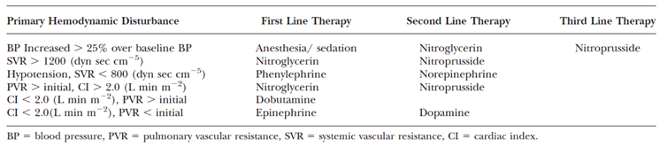

Efficacy variables
Haemodynamic data was collected at multiple time-points: before induction of anaesthesia, following the administration of heparin, following termination of CBP, after the administration of protamine, upon chest closure, before leaving the OR, and on arrival to the ICU. The main time-points used for efficacy analysis were pre-induction, post-CPB, and chest closure.
The primary efficacy variable was PVR. (This was not stated explicitly, but it was strongly implied.) Other variables included: heart rate, BP, PA pressures, PAP, CVP, CO, CI, SVR, PVR, and RVEF.
Use of inotropes and pressor agents was also recorded, and constituted an additional minor endpoint.

Methods
The statistical approach used in this study was very similar to the previous Solina study, and was described by the authors as follows: “Data were statistically analysed using standard analysis of variance (ANOVA) in conjunction with Student-Keuls Multiple Comparison Analysis. Wilcoxon rank sum analysis was used when assumptions for ANOVA were not met. A two-way repeated measures ANOVA (dose by time) was performed for the variables HR, mean arterial pressure (MAP), CI, PVR, and RVEF. All statistical tests were two sided. A p-value of less than 0.05 was considered significant.”
According to the authors, sample size was determined by statistical power analysis, which indicated an 85% power to detect a 10% difference in percent change in PVR at the p < 0.05 level. The assumptions underlying this estimate were not discussed.
Based on the authors’ comments about sample size, the primary efficacy variable appeared to be the PVR, so the primary analysis was the ANOVA for PVR. The authors appeared to correct significance estimates for multiple between group comparisons, by virtue of their use of the Student-Keuls Multiple Comparison Analysis, but they did not correct significance estimates for the use of multiple efficacy variables.

Baseline data
The treatment groups were reasonably well matched for most baseline demographic and peri-operative characteristics, but the number of valves replaced showed significant differences across groups (more valves replaced in the milrinone and iNO 20 ppm groups, p = 0.001). The total fentanyl dose also differed, with less used in the iNO 30 ppm group (p < 0.001), as shown in the table below. There was a trend to differing bypass times across the groups (p = 0.07), with the iNO 10 ppm group having the shortest time and the iNO 20 ppm group having the longest time on bypass. Overall, these differences are not likely to have had a major impact on the outcome of the study.

Table 53: Patient characteristics
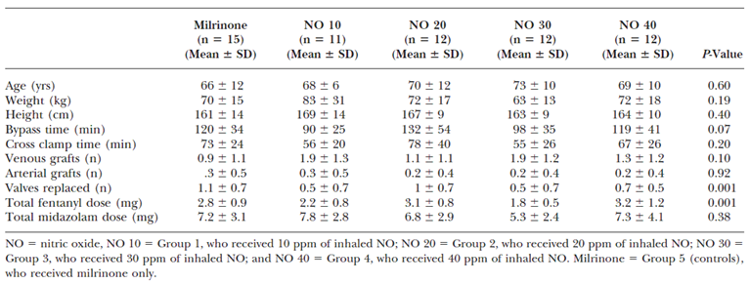

Results
Haemodynamic results are summarised in the table below. Overall, there was no evidence of a significant dose effect. A two way repeated measures ANOVA showed no significant dose effect for all haemodynamic variables, including the main variable of interest, PVR, as well as other important indicators of haemodynamic function (HR, MAP, CI and RVEF). The percentage decrease in PVR upon treatment with iNO (see the figure below) did not show a consistent dose trend and was not significantly different between the groups by ANOVA (10 ppm = 38%, 20 ppm = 50%, 30 ppm = 44%, 40 ppm = 36%, milrinone = 58%; p = 0.86).
As expected, time was a highly significant factor for all variables in the ANOVA (p < 0.05), but the interaction of dose by time was significant in the ANOVA only for CI (p = 0.03).
There were only minor differences noted between iNO and milrinone. Both heart rate (p = 0.002) and CI (p = 0.001) showed significant heterogeneity across groups. Heart rate was significantly higher (p = 0.002) for the milrinone group at the post CBP data collection point. CI was low for the iNO 10 ppm group, but similar for other doses of iNO and milrinone. MAP did not show significant variation across groups, and was not low with milrinone despite the observation in other studies that intravenous vasodilators are less selective for the pulmonary vasculature.
Figure 42: Changes in PVR
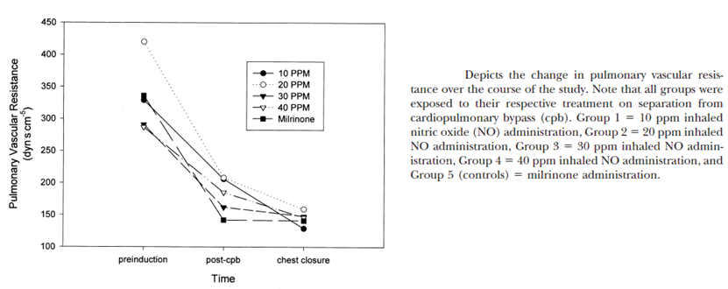

Table 54: Haemodynamic data
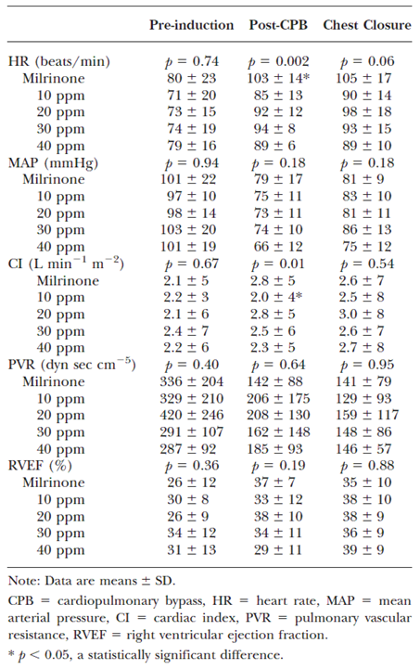
As in the previous Solina study, it is possible that the use of rescue therapies disguised some differences in the efficacy of milrinone and iNO, but an assessment for heterogeneity across treatment groups found no significant differences or consistent trends in the use of inotropes and pressor agents as reflected in average dose.

Table 55: Vasoactive drug dosage by cohort
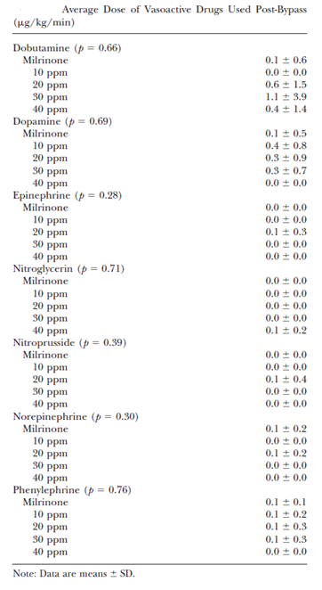

Conclusion
Overall, this dose response study in adults undergoing cardiac surgery does not suggest that a significant dose tend exists for iNO in the range of 10 pm to 40 ppm, as reflected in major haemodynamic parameters including PVR. It is possible that a larger study could reveal small differences, but the authors estimated that this study had reasonable (85%) power to detect 10% differences in PVR at a standard significance threshold (p < 0.05). The study shows broadly equivalent reductions in PVR amongst different doses of iNO and intravenous milrinone.

Ardehali 2001

Abstract
Inhaled Nitric Oxide for Pulmonary Hypertension after Heart Transplantation.
Background. Recipient pulmonary hypertension due to chronic congestive heart failure is a major cause of right ventricular (RV) dysfunction after heart transplantation. We hypothesized that inhaled nitric oxide (NO), in the post-operative period, would a) selectively reduce pulmonary vascular resistance and improve RV haemodynamics and b) reduce the incidence of RV dysfunction compared with a matched historical group.
Methods. Sixteen consecutive adult heart transplant recipients with lowest mean pulmonary artery (PA) pressures > 25 mm Hg were prospectively enrolled. Inhaled NO at 20 ppm was initiated before termination of cardiopulmonary bypass (CPB). At 6 and 12 hours after CPB, NO was stopped for 15 minutes and systemic and pulmonary haemodynamics were measured. RV dysfunction was defined as central venous pressure > 15 mm Hg and consistent echocardiographic findings. The incidence of RV dysfunction and 30 day survival in this group was compared with a historical cohort of 16 patients matched for pulmonary hypertension.
Results. Discontinuation of NO for 15 minutes at 6 hours after transplantation resulted in a significant rise in mean PA pressure, pulmonary vascular resistance (PVR), and RV stroke work index. Systemic haemodynamics were not affected by NO therapy. One patient in the NO treated group, compared with 6 patients in the historical cohort group developed RV dysfunction (P <.05). The 30 day survival in the NO-treated group and the historical cohort group were 100% and 81%, respectively (P >.05).
Conclusion. In heart transplant recipients with pulmonary hypertension, inhaled NO in the post-operative period selectively reduces PVR and enhances RV stroke work. Furthermore, NO reduces the incidence of RV dysfunction in this group of patients when compared with a historical cohort matched for pulmonary hypertension. Inhaled NO is a useful adjunct to the post-operative treatment protocol of heart transplant patients with pulmonary hypertension.

Study design, locations and dates
This study was a non-randomised, historical control study comparing the efficacy of iNO in 16 consecutive adult patients undergoing heart transplant versus standard treatment in 16 historical control subjects, using haemodynamic monitoring to gauge efficacy.
The study was performed at UCLA Medical Centre, Los Angeles, California, between March 1999 and September 1999.

Inclusion and exclusion criteria
Sixteen consecutive adult heart transplant recipients were recruited, and were eligible provided their measured mean pulmonary artery (PA) pressure was at least 25 mm Hg and they provided consent.
Historical controls consisted of the sixteen consecutive heart transplant recipients with PA at least 25 mm Hg who had their transplant operations immediately prior March 1999. This approach meant that the controls were not specifically chosen to minimise baseline mismatch, but the recruitment of 32 consecutive patients reduces recruitment bias and implies that the study has high external validity.

Study treatments
All 32 subjects (16 cases and 16 historical controls) received standard care for their heart transplants, according to institutional guidelines. Donor hearts were initially arrested using 15 cc/kg (mL/kg) of University of Wisconsin solution and topical hypothermia. Solumedrol (7 mg/kg) was given before reperfusion. The standard inotropic regimen during weaning of CPB was dopamine and dobutamine, which was replaced with epinephrine (adrenaline) and isoproterenol if difficulty was encountered. Subjects were mechanically ventilated and maintained on inotropic support for at least 12 hours post-operatively, with inotropes adjusted to maintain a cardiac index > 2.5. Immunosuppression was achieved with cyclosporine, azathioprine or mycophenolate mofetil and steroids. Cytolytic agents were not used.
The iNO group received the same treatment as historical controls but in addition received inhaled NO (20 ppm) before termination of CPB, which continued until patients were weaned from mechanical ventilation or had attained haemodynamic stability (> 12 hours). The iNO therapy was briefly interrupted at 6 and 12 hours after reperfusion, for recording of haemodynamic parameters on iNO and then again after 15 min without iNO.
The duration of iNO therapy ranged from 12 to 76 hours.

Efficacy variables
The authors’ abstract implies that PVR was the efficacy variable of primary interest, but this was not stated explicitly.
The main efficacy variables consisted of heart rate, systemic arterial pressure, PA pressure, left atrial pressure, cardiac output, and central venous pressure, which were recorded 6 and 12 hours after reperfusion. After recording the on-treatment haemodynamic data, iNO was discontinued for 15 minutes and the haemodynamic data were reassessed. Note that this approach does not directly assess the benefits of adding iNO, but instead assesses the results of interrupting iNO; given that abrupt iNO withdrawal is known to cause rebound effects, the authors’ approach conflates primary efficacy effects with withdrawal effects. The same parameters were assessed in historical controls.
Systemic vascular resistance (SVR, measured in dyne.s/cm⁵) was calculated as 80 × (mean systemic arterial pressure – right atrial pressure)/cardiac output. Pulmonary vascular resistance (PVR, in dynes.s/cm⁵) was calculated as transpulmonary pressure gradient/cardiac output. Right ventricular (RV) stroke work index was defined as 0.0136 × (mean PA pressure – right atrial pressure) × (stroke volume index).
RV dysfunction was defined as central venous pressure (CVP) > 15 mm Hg in the operating room or for more than 2 hours in the post-operative period, with consistent echocardiographic findings (RV dilatation and poor contractility). It was treated as needed by standard approaches including inotropic adjustment, followed if necessary by intra-aortic balloon pump, opening of the chest, and insertion of an assist device or extracorporeal membrane oxygenation (ECMO). Cellular rejection as an explanation for RV dysfunction was ruled out by endomyocardial biopsy. The incidence of RV dysfunction was compared in cases and historical controls.
Survival at 30 days was also assessed and can be considered a key secondary endpoint.

Methods
The statistical methods were only briefly described, as follows: “Data measurements are presented as the mean ± standard deviation (SD) from the mean. Comparison of the mean values was done using the Student’s t-test method, chi-squared analysis was used to compare subsets of patients, and the Wilcoxon-Rank Sum test was used in comparing median values. A P-value > 0.05 was considered to be statistically significant.”
This statistical approach seems broadly appropriate for a small, non-randomised, open label, historically-controlled study, but the authors can be criticised for not explicitly identifying a primary prospective endpoint, not specifying which statistical method was considered to be primary, and not adjusting p-values to compensate for the use of multiple endpoints. In association with the non-randomised nature of the study, these flaws mean that the study can only be considered weakly supportive for efficacy.
Sample size estimations were not discussed, and the study size appears to have been chosen on the basis of logistical feasibility.

Baseline data
Subjects were broadly matched in terms of age and gender distribution, underlying cardiac diagnoses, and initial pulmonary haemodynamics, as shown in Table 56.

Table 56: Pre-operative patient characteristics
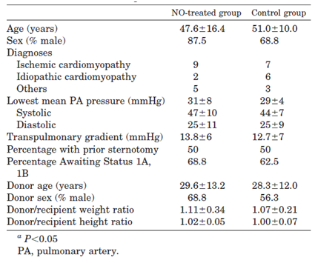
The two groups also showed similar intraoperative characteristics.

Table 57: Intraoperative characteristics
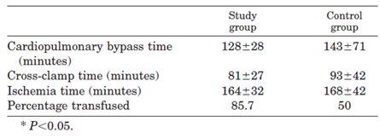

Results

Case-control comparison
When study subjects (who received iNO) were compared with control subjects (who did not receive iNO), the incidence of RV dysfunction was substantially lower (p < 0.05, statistical test not stated), and it was easier to treat.
Only one patient in the iNO treated group (1 out of 16, approximately6%) developed RV dysfunction, and it responded to inotropic adjustment. In the control group, RV dysfunction occurred in six patients (6 out of 16, approximately38%). In three of these subjects, the RV dysfunction responded to adjustments in inotropic therapy, but one control subject required opening of the chest to optimize RV haemodynamics and, in two control subjects, persistent RV dysfunction required insertion of Intra-Aortic Balloon Pump (IABP), followed by right ventricular assist devices, and then institution of Extra Corporeal Membrane Oxygenation (ECMO). Both of these patients died.
The overall 30 day mortality of the heart transplant was zero in the iNO-treated group, but it was 3 out of 16 (18.75%) in the historical controls. Two of the deaths were attribute to biventricular failure and followed RV dysfunction. The third death occurred in a control subject who had stable haemodynamics but died of intracranial haemorrhage on post-operative day 1; this death is relatively unlikely to have been influenced by the lack of iNO.
These between group comparisons are summarised in the table below. Detailed haemodynamic data in historical controls was not presented.

Table 58: Post-operative characteristics
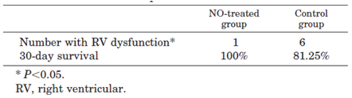

Intra-group crossover comparison, iNO interruption
In the sixteen study patients, haemodynamics were compared in the presence and absence of iNO at 6 and 12 hours following reperfusion. Discontinuation of iNO did not affect mean systemic arterial pressure, CVP, cardiac indices, left atrial pressure, or systemic vascular resistance.
When subjects were on iNO, they exhibited significantly lower mean PA pressure (PAP), PVR, and RV stroke work index (RVERSUSWI) at 6 hours compared to 15 minutes after interrupting iNO. The authors describe this as a significant reduction in PAP, PVR and RVERSUSWI, attributable to iNO, but this ignores the fact that haemodynamic parameters on iNO were recorded first, and then the response to ceasing iNO for 15 minutes was assessed second. Any differences observed could be partly or entirely due to a withdrawal effect. (Analogously, interrupting alcohol can cause withdrawal seizures, even though alcohol does not have useful anti-seizure properties in subjects not already on alcohol.) A more informative design might have been to record haemodynamics on iNO, after 15 min of interruption, and then again after 15 min back on iNO, but this could still reflect the subjects’ adaptation to iNO therapy in the preceding hours rather than the primary efficacy of iNO.
Interruption of iNO at 12 hours did not significantly affect mean PAP, PVR or RVERSUSWI, and the authors interpreted this as possible sign that “these parameters had reached a stable baseline.” As shown in Table 59, the changes in these parameters during iNO interruption were consistent with the changes observed at 6 hours, but smaller in magnitude, and the parameters were closer to normal (lower PAP, PVR and RVERSUSWI) both with and without iNO. One possibility is that pulmonary endothelial dysfunction had partly resolved by 12 hours.

Table 59: Pulmonary and systemic haemodynamic parameters
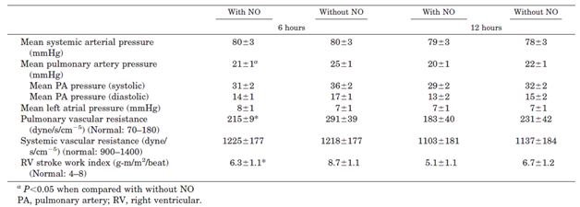
These results are consistent with other efficacy studies and PD studies showing a relatively selective effect of iNO on the pulmonary circulation.

Conclusion
Ardehali et al, 2001, have performed a small study using historical controls, assessing the efficacy of iNO in preventing right ventricular dysfunction in heart transplant patients. Such a study design clearly has major limitations, and is subject to several potential biases and confounding factors, but the study was supportive of the overall efficacy of iNO in this setting. Subjects who received iNO 20 ppm (n = 16) were compared with historical control subjects (n = 16), and the incidence of RV dysfunction was significantly lower with iNO (1 out of 16 patients versus 6 out of 16, p < 0.05). Survival was also 100% with iNO, compared to 13 out of 16 (81.25%) in historical controls.

Kieler-Jensen 1994

Abstract
Inhaled Nitric Oxide in the Evaluation of Heart Transplant Candidates with Elevated Pulmonary Vascular Resistance.
The reversibility of elevated pulmonary vascular resistance in heart transplant candidates is currently evaluated with intravenous vasodilators. The aim of this study was to evaluate the effects of increased concentrations of inhaled nitric oxide (20, 40, and 80 ppm) on central haemodynamics and right ventricular function in heart transplant candidates with elevated pulmonary vascular resistance (> 2.5 Wood units). Comparison was made with intravenous vasodilators, sodium nitroprusside, and prostacyclin in doses that lowered the mean arterial pressure by about 15%. Inhalation of nitric oxide did not change systemic or pulmonary arterial pressure, cardiac output, right ventricular function, or systemic vascular resistance. Pulmonary capillary wedge pressure increased and transpulmonary pressure gradient and pulmonary vascular resistance decreased (-34% ± 4% and -36% ± 4%, respectively; p < 0.01) during 20 ppm nitric oxide, with no further effects at higher doses. Prostacyclin and sodium nitroprusside decreased pulmonary vascular resistance (-50% ± 6% and -33% ± 5%; p < 0.01). Prostacyclin reduced to some extent (p = 0.08) transpulmonary pressure gradient, which was not seen during sodium nitroprusside infusion. Systemic vascular resistance decreased during both sodium nitroprusside (-37% ± 5%) and prostacyclin (- 44% ± 4%) infusion. The pulmonary vascular resistance/systemic vascular resistance ratio, which was used as an index of pulmonary selectivity, was decreased by nitric oxide (p < 0.01) but not by the intravenous vasodilators. Metabolic data indicate that inhaled nitric oxide is metabolized in the same way as that formed endogenously. In conclusion, inhaled nitric oxide is a selective pulmonary vasodilator that can be used safely in the hemodynamic evaluation of heart transplant candidates with elevated pulmonary vascular resistance.

Study design, locations and dates
Kieler-Jensen et al used an open label crossover design to compare the haemodynamic effects of increasing concentrations of iNO (20, 40 and 80 ppm) with intravenous vasodilators, sodium nitroprusside (SNP) and prostacyclin (PGI2) in 12 subjects with elevated PVR undergoing diagnostic right heart catheterisation.

Inclusion and exclusion criteria
Eligible subjects were adults undergoing right heart catheterisation in the pre-operative diagnostic work-up for heart transplantation, who had elevated PVR (> 2.5 Wood Units [WU]). Note that different authors used different units for vascular resistance: conversions between units are explained in the footnote below and Table 60 (Source: http://en.wikipedia.org/wiki/Vascular_resistance). The paper did not mention exclusion criteria.

Table 60: Conversion table for Wood units
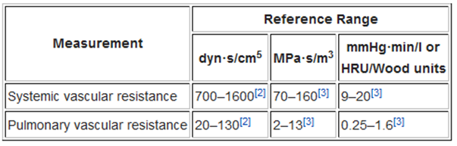

Study treatments
After a baseline control period, all subjects received iNO through a tight fitting face mask in a non-rebreathing system. They received iNO at 20 ppm for ten minutes, 40 ppm for ten minutes, then 80 ppm for ten minutes. After a second control period of unspecified duration, sodium nitroprusside (SNP) and PGI2 were given intravenously for ten minutes each, in random order, separated by a third control period. The dose of the intravenous agents was titrated to achieve an approximate 15% reduction (range, 9% to 25%) in mean arterial pressure (but avoiding MAP < 60 mm Hg).
Subjects were not to be treated with systemic nitrates for 12 hours prior to iNO. As in other studies of iNO, subjects were monitored for toxic by-products of iNO therapy.

Efficacy variables
Haemodynamic variables were recorded at baseline, after ten minutes of inhalation at each iNO dose and after ten minutes of infusion of each intravenous agent.
The following variables were measured or calculated:
- cardiac output
- heart rate
- stroke volume
- right ventricular end-diastolic and end-systolic volume
- right ventricular ejection fraction
- systolic, diastolic, and mean arterial blood pressures
- systolic, diastolic, and mean pulmonary arterial pressures
- central venous pressure
- pulmonary capillary wedge pressure
- systemic vascular resistance (SVR)
- PVR
- the transpulmonary pressure gradient (MPAP – PCWP)
- PVR/SVR ratio
- arterial and mixed venous oxygen saturation (SaO₂ and SvO₂)
- intrapulmonary shunt fraction;
- arterial oxygen tension (PaO₂).
The authors did not designate any variable as primary.

Methods
Description of the statistical methods was very brief, and consisted of the following comments: “Data are presented as individual values or as mean ± SEM. Data were compared by a one-way analysis of variance for repeated measurements, followed by paired t-test with modified Bonferroni correction. A p value of less than 0.05 was considered to indicate statistical significance.” From this description, it appears that a correction was applied to allow for the multiple time point (treatment) comparisons within the analysis of each variable, but no correction was applied for the use of multiple variables.

Baseline data
The main characteristics of the 12 subjects are tabulated below (Table 61).

Table 61: Patient characteristics
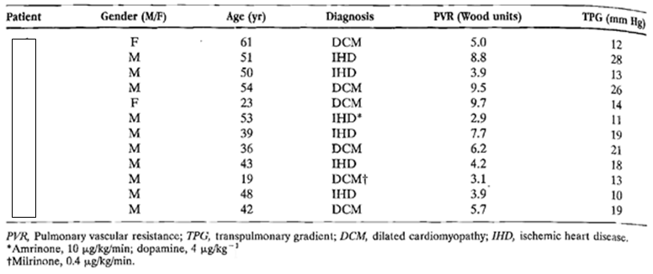

Results
Results obtained during inhalation of iNO are shown in the table below. Significant changes are marked with an asterisk, and these include a reduction in mean PVR from 5.9 Wood Units (WU) to 3.7 WU during inhalation of iNO. The change was observed on commencing 20 ppm iNO, and no further changes were observed during stepwise dose escalation. The PVR returned to baseline in the second control period. The transpulmonary gradient (TPG) followed the changes in PVR, as expected. MPAP did not show a significant fall during treatment, which is a different result to that observed in children and adults post-CPB. This could reflect the fact that endothelial function would be expected to be relatively normal during a pre-operative workup, so sensitivity to iNO could be less.

Table 62: Haemodynamics, RV function and oximetric data
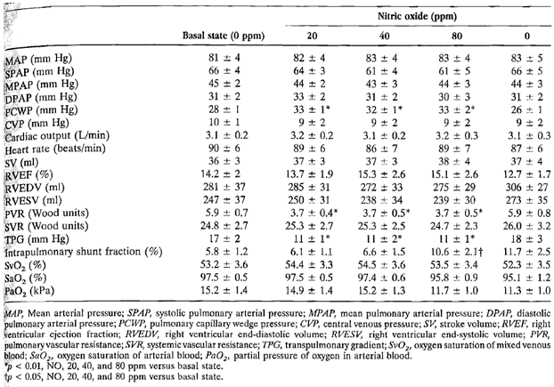
The only other significant change was PCWP, which showed a significant increase during iNO treatment that appeared at 20 ppm and persisted through each step-wise dose increase, without any apparent dose response. In some contexts, this could be an undesirable haemodynamic change, and represents a potential safety issue when iNO is used in subjects with left ventricular failure; as discussed further in the Safety section.
No significant changes in MAP or SVR were observed during iNO treatment, consistent with other studies showing pulmonary selectivity for iNO.
Figure 43: Haemodynamic response to iNO
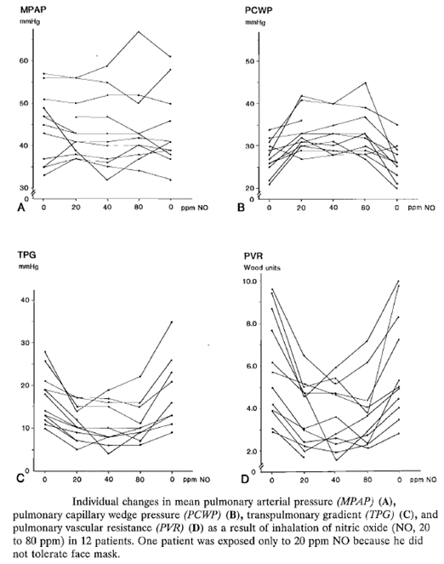
When the effects of iNO were compared to intravenous vasodilators, several significant differences were observed, as noted in the table below. In particular, both intravenous vasodilators caused a reduction in systemic arterial pressure (MAP) which was significant relative to baseline and significantly different from the lack of change observed during iNO treatment. Both intravenous drugs also significantly lowered PVR, and PGI2 produced a lower PVR than had been observed on iNO 20ppm, though this difference was not significant. Unlike iNO, both intravenous vasodilators produced a significantly lower MPAP, compared to baseline, and the comparisons with iNO were also significant. Thus, the intravenous vasodilators appeared more potent than iNO in both the pulmonary and systemic vasculature, with less pulmonary selectivity. This was reflected in the PVR/SVR ratio, which fell significantly in the iNO group but not in the intravenous groups; the difference between SNP and iNO was significant.

Table 63: Comparison of the effects of iNO, SNP and PGI2
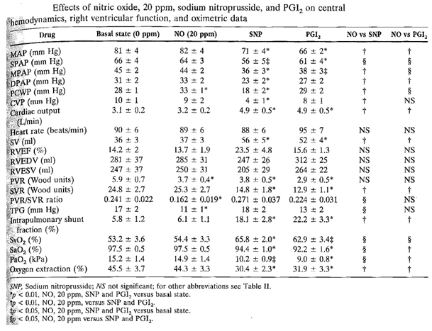
Figure 44: Effects on efficacy variables of iNO, SNP and PGI2
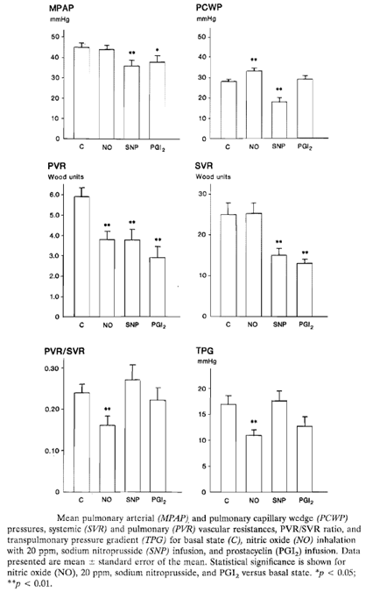

Conclusion
Overall, this study in adults confirms that iNO is a selective vasodilator in the pulmonary circulation, lowering PVR, though it showed minimal direct effects on MPAP in this particular pre-operative population, who showed a greater MPAP reduction with intravenous PGI2 and nitroprusside. One of the proposed rationales for iNO therapy in the post-operative setting – replacement of a lack of NO caused by endothelial dysfunction; does not apply to the patients in this study. The study is therefore only indirectly supportive of the efficacy of iNO for the proposed indication. Importantly, the study did not show a dose response effect in the dose range 20 ppm to 80 ppm, though this observation might not apply to the post-CPB setting, where the causes of elevated PVR and the adequacy of endogenous NO production are likely to be different.

Rajek 2000

Abstract
Inhaled Nitric Oxide Reduces Pulmonary Vascular Resistance More Than Prostaglandin E1 During Heart Transplantation.
Heart transplantation in patients with increased pulmonary vascular resistance is often associated with post-bypass right heart failure. We therefore compared the abilities of prostaglandin E1 (PGE1) and inhaled nitric oxide to reduce pulmonary vascular resistance during heart transplantation. Patients undergoing orthotopic heart transplantation for congestive heart failure were randomly assigned to either a PGE1 infusion at a rate of
8 ng∙kg⁻¹∙min⁻¹ starting 10 min before weaning from cardiopulmonary bypass (CPB) (n = 34) or inhalation of 4 ppm nitric oxide starting just before weaning from CPB (n = 34). Both treatments were increased stepwise, if necessary, and were stopped 6 h post-operatively. Hemodynamic values were recorded after the induction of anaesthesia, 10 and 30 min after weaning from CPB, and 1 h and 6 h post-operatively. Immediately after weaning from CPB, pulmonary vascular resistance was nearly halved in the nitric oxide group but reduced by only 10% in the PGE1 group. Pulmonary artery pressure was decreased approximately 30% during nitric oxide inhalation, but only approximately 16% during the PGE1 infusion. Six hours after surgery, pulmonary vascular resistance and pulmonary artery pressure were similar in the two groups. The ratio between pulmonary vascular resistance and systemic vascular resistance was significantly less in the nitric oxide patients, at all post-bypass times. In contrast, the pulmonary-to-systemic vascular resistance ratio increased approximately 30% in the patients given PGE1. Cardiac output, heart rate, mean arterial pressure, right atrial pressure, and pulmonary wedge pressure did not differ between the groups. Weaning from CPB was successful in all patients assigned to nitric oxide inhalation; in contrast, weaning failed in six patients assigned to PGE1 (P = 0.03).
Implications: Nitric oxide inhalation selectively reduces pulmonary vascular resistance and pulmonary artery pressure immediately after heart transplantation which facilitates weaning from cardiopulmonary bypass.

Study design, locations and dates
Rajek et al assessed the haemodynamic efficacy of iNO in comparison to intravenous PGE1 in 70 adult patients (59 men, 11 women, evaluable n = 68) undergoing orthotopic heart transplantation in a randomised, prospective, open label, parallel group, active controlled study.
At the time of the study, in the investigators’ hospital, PGE1 was considered standard care to limit right heart failure after heart transplantation.

Inclusion and exclusion criteria
Eligible subjects were adults undergoing heart transplantation.
Phosphodiesterase inhibitors were not allowed in the protocol, and two subjects (one from each group) who received these during the observation period were subsequently excluded from analysis. The main analysis is therefore based on 34 subjects in each group although 35 were initially randomised to each group.

Study treatments
Subjects were randomised to iNO or PGE1 with equal probability.
The nitric oxide group (n = 35) received iNO just before termination of CPB, at an initial concentration of 4 ppm. (This dose is much lower than in several of the other studies submitted.) The dose was increased, stepwise, as required, to treat pulmonary hypertension and maintain MPAP < 25 mm Hg, up to a maximum of 24 ppm. The iNO was delivered from a cylinder containing 1000 ppm in nitrogen, diluted as needed and introduced into the ventilator circuit, with standard monitoring for by-products.
The prostaglandin group (n = 35) received IV PGE1, starting 10 min before weaning from bypass, at an initial rate of 8 ng∙kg⁻¹∙min⁻¹. The dose was increased, stepwise, to 16 ng∙kg⁻¹∙min⁻¹ and then to 24 ng∙kg⁻¹∙min⁻¹, as needed to keep MPAP < 25 mm Hg.
The protocol allowed rescue crossover between treatment groups if right heart failure developed, as follows: “Patients were switched to the alternative study drug when pulmonary artery pressure was consistently elevated at the highest permitted dose, and weaning from bypass proved difficult because of right heart failure. Right heart failure was defined by a high mean pulmonary artery pressure, an increase in right atrial pressure to more than 15 mm Hg, a decrease in mean arterial pressure to < 40 mm Hg, and a decrease in mixed venous oxygen saturation to < 40%. Additionally, right heart failure was detected by dilation and hypocontractility of the right ventricle as observed in the surgical field.” This was an appropriate ethical measure, though it potentially limited the ability of the study to show differences in outcome in the two groups.
In addition to randomised therapy, subjects received routine perioperative care, which potentially included digoxin, diuretics, angiotensin-converting enzyme inhibitors, beta-blockers, and nitrates. Some patients in both groups required a continuous pre-operative infusion of PGE1 and/or dobutamine. Anaesthesia was induced with IV etomidate (0.2 mg/kg), midazolam (0.1 mg/kg), fentanyl (5 mg/kg), and pancuronium (0.1 mg/kg). Anaesthesia was maintained with fentanyl (0.3 mg/h), midazolam (4 mg/h), and pancuronium. CPB was performed at a core temperature of 32°C.
Isoproterenol was administered to all patients to achieve a heart rate between 100 and 120 bpm. Infusions of norepinephrine or epinephrine (adrenaline) were given as required to maintain mean arterial pressure > 65 mm Hg.

Efficacy variables
The following variables were measured or calculated:
- mean arterial pressure
- mean pulmonary arterial pressure
- right atrial pressure
- heart rate
- cardiac output (average of three thermodilution measurements)
- pulmonary vascular resistance
- systemic vascular resistance
- transpulmonary gradient
- mixed venous oxygen saturation
- mixed venous and arterial blood gas tensions.
Hemodynamic variables were monitored continuously but recorded for efficacy analysis at the following time-points:
- after the induction of anaesthesia
- 10 and 30 min after weaning from CPB
- 1 and 6 h post-operatively in the intensive care unit.

Methods
The authors described their statistical methods as follows: “Our primary statistical analysis was multiple regression. The patients were nested random factors within the two study groups. The five time points were considered categorical factors. Comparison between groups was restricted to pre-planned contrasts at the five specified time points. The fraction of patients switched from one study drug to the other was evaluated with a Fisher’s exact test. Patients switched to the alternative drug were statistically evaluated separately. A P value of 0.05 was considered statistically significant. All results were expressed as mean and least-square standard errors.”
Thus, the primary statistical analysis was based on multiple regression. No single haemodynamic variable was explicitly designated as primary, and there was no apparent correction for the use of multiple efficacy variables, but the paper focussed on PVR as the main measure of efficacy. Power calculations and sample size were not discussed.

Baseline data
The two treatment groups were reasonably well matched at baseline and for key operative details, as shown in the table below.

Table 64: Patient characteristics
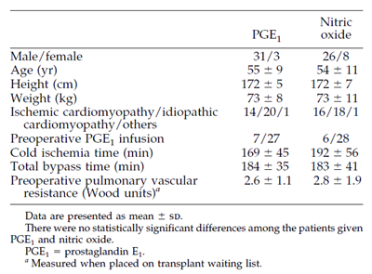

Results
The authors presented the key results for PVR, PAP and PVR/SVR as figures rather than as tables. These are shown below. In the iNO group, a major reduction in PVR occurred early, within ten minutes of CPB (from 326 ± 21 to 180 ± 15 dynes∙s∙cm⁻⁵), and this was statistically significant (p < 0.0001) compared to PGE1, where the initial reduction was relatively minor (295 ± 30 to 264 ± 27 dynes∙s∙cm⁻⁵). The difference was still significant at one hour post-CPB. By six hours after CPB, subjects in the PGE1 group had shown further reductions in PVR and were approaching the levels seen in the iNO group; the difference between groups as no longer significant.
Figure 45: Evolution of PVR in response to iNO and PGE1
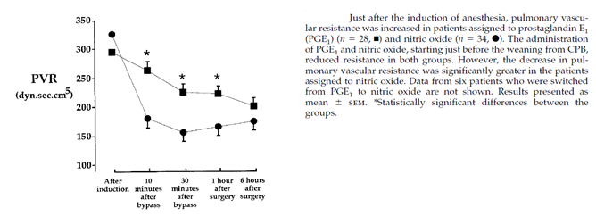
Reductions in MPAP are shown in Figure 46. Despite the fact that both treatments were supposed to have their dose titrated to MPAP < 25 mm Hg, this was not achieved in the PGE1 group and MPAP in this group remained significantly higher than in the iNO group until 6 hours after surgery. It was not clear if the failure to achieve the target reflected an inadequate maximum PGE1 dose. Six subjects switched from PGE1 to iNO, because of right heart failure not controlled by PGE1, and the data from these subjects has been excluded. Had these failing subjects remained on their assigned treatment, the superiority of iNO would be expected to have been even greater.
Figure 46: Evolution of PAP in response to iNO and PGE1
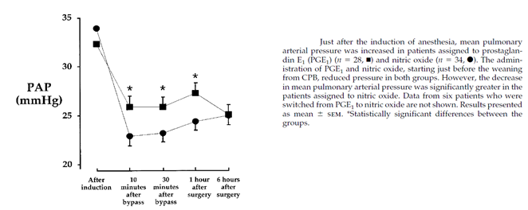
The PVR/SVR ratio showed that iNO was more selective for the pulmonary circulation than PGE1, and the differences between the groups persisted throughout the treatment period.
Figure 47: Evolution of PVR/SVR ratio in response to iNO and PGE1
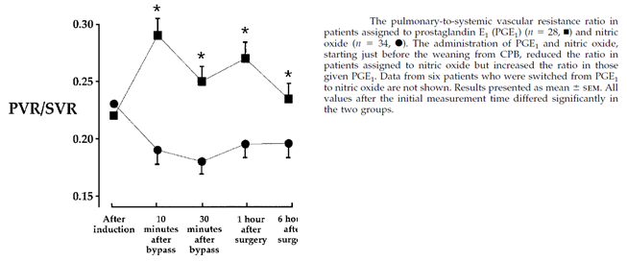
For several other efficacy variables, both treatment groups showed a change from pre-treatment values, as shown in the table below. Some of these changes could reflect the use of other agents, such as isoproterenol, norepinephrine or epinephrine (adrenaline), so it is the between group differences that are important. Mean arterial pressure fell more in the PGE1 group, reflecting the non-selectivity of this agent. Cardiac output improved more in the iNO group.

Table 65: Haemodynamic responses
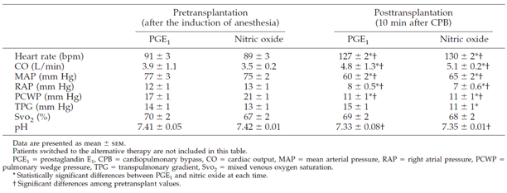
In subjects who switched from PGE1 to iNO because of persistent treatment failure, cardiac output and PVR were poorer at 10 minutes post-CPB, but these had improved at 6 hours post-surgery. Given that this was a non-random subgroup of the original population, selected for non-responsiveness; it is difficult to draw firm conclusions from this data. Nonetheless, the fact that 6 PGE1 subjects required rescue therapy with iNO, and no subjects randomised to iNO required rescue with PGE1, supports the overall superiority of iNO. The difference in the number of subjects requiring rescue therapy was significant (iNO, 0 out of 34, PGE1, 6 out of 34, p = 0.03).

Table 66: Haemodynamic responses of patients switched from PGE1 to iNO
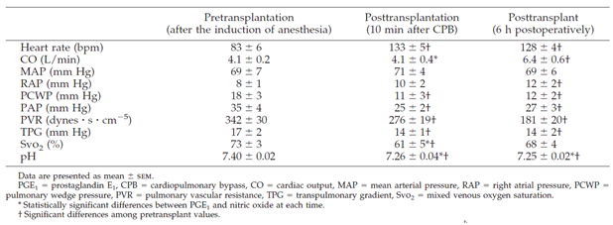

Conclusion
Overall, this study confirms that iNO is effective at reducing PVR in subjects following CPB, and that it has selectivity for the pulmonary vasculature. In this population (adults undergoing heart transplant), it appears superior to IV PGE1, at least at the doses of PGE1 tested. This provides indirect support for the somewhat different context of children undergoing CPB for congenital heart disease.

Radovancevic 2005

Abstract
Nitric Oxide versus Prostaglandin E1 for Reduction of Pulmonary Hypertension in Heart Transplant Candidates.
Background: We sought to directly compare the effects of prostaglandin E1 (PGE1) and nitric oxide (NO) in testing for pulmonary hypertension reversibility in heart transplant candidates.
Methods: We included 19 heart transplant candidates who fulfilled at least 1 of 3 criteria: pulmonary vascular resistance (PVR) of >4 Wood units; transpulmonary gradient (TPG) of > 12 mm Hg; or systolic pulmonary artery pressure (PAP) of >60 mm Hg. Patients randomly received either PGE1 (0.05, 0.2 and 0.5 µg/kg/min) or NO (40, 60 and 80 ppm) and were crossed over to the second medication after receiving the maximal dose of the first.
Results: With PGE1, TPG decreased by 21% (baseline 20.3 ± 6.8 mm Hg; final 16.0 ± 7.0 mm Hg) compared to a 34% decrease with NO (baseline 20.8 ± 6.2 mm Hg; final 13.8 ± 5.4 mm Hg) (p = 0.13). PVR decreased by 42% with PGE1 (baseline 6.2 ± 4.0 Wood units; final 3.6 ± 1.8 Wood units) and by 47% with NO (baseline 6.0 ± 3.9 Wood units; final 3.2 ± 1.6 Wood units) (p = 0.87). Mean systemic pressure decreased with PGE1 (baseline 76.1 ± 10.5 mm Hg; final 69.4 ± 12.2 mm Hg; –9%) but not with NO administration (baseline 70.2 ± 14.7 mm Hg; final 71.6 ± 10.9 mm Hg; 2%) (p = 0.01). TPG was lowered to < 12 mm Hg in 14 patients. Of these, 6 (46%) responded to both PGE1 and NO, 4 (27%) responded only to PGE1, and 4 (27%) responded only to NO.
Conclusions: The effects of PGE1 and NO on pulmonary hypertension are comparable, with PGE1 having more systemic hypotensive effects. Due to variability of patient responses, we recommend multiple rather than single-agent pharmacologic testing for the reversibility of pulmonary hypertension.

Study design, locations and dates
Radovancevic et al used an open label crossover design to compare the haemodynamic effects of iNO and intravenous PGE1 in adult subjects with pulmonary hypertension being considered for heart transplant. Each agent was assessed at multiple doses.

Inclusion and exclusion criteria
Eligible subjects were adult patients who were thought to be suitable for heart transplant except for the presence of pulmonary hypertension (PH). Subjects had to fulfil one of three PH criteria: pulmonary vascular resistance (PVR) of > 4 Wood units; transpulmonary gradient (TPG) of > 12 mm Hg; or systolic pulmonary artery pressure (PAP) of > 60 mm Hg.

Study treatments
Subjects received PGE1 and iNO in a random order. Each agent was started at a low dose and increased in stepwise fashion, with haemodynamic assessments performed after ten minutes at the new dose. PGE1 (500 µg/100 ml) was administered at a dose of 0.05, 0.2 and 0.5 µg/kg/min for 10 minutes each. Inhaled NO was administered via a tight-fitting facemask in a non-rebreathing system at doses of 40, 60 and 80 ppm. Inspired oxygen concentration was kept constant.
Subjects also received standard care for their underlying cardiac condition, except that vasoactive agents were withheld 24 hours before the procedure No pre-medication was administered.

Efficacy variables
The following efficacy variables were measured or calculated:
- systolic PAP
- PCWP
- right atrial pressure
- cardiac output
- cardiac index (litres/min/m2) = cardiac output/body surface area
- TPG (mm Hg) = mean PAP – PCWP
- PVR (Wood units) = TPG/cardiac output
- SVR (dyn∙s∙cm^{–5}) = 80 (mean systemic arterial pressure – right atrial pressure)/CO.

Methods
The authors described their statistical methods as follows: “Variables are expressed as mean ± SD. A paired, 2 tailed Student’s t-test was used to compare hemodynamic parameters before and after administration of either PGE1 or NO. The effects were analysed using 1 factor analysis of variance (ANOVA) followed by Tukey’s studentized test for continuous variables; p < 0.05 was considered statistically significant.”
Although these are appropriate statistical tools, the paper did not designate a single efficacy variable or statistical test as primary, and no correction was performed for the assessment of multiple variables. The authors did not discuss power considerations or sample size.

Baseline data
The paper provided only brief details about the cohort under consideration. This omission was tolerable because the crossover design removed the possibility of baseline mismatch. They described their cohort as follows: “The study group included 19 patients (12 men, 7 women) with long-standing heart failure in whom pulmonary hypertension was the only contraindication for heart transplantation. Patient age ranged from 20 to 63 years (mean age 53 ± 12 years). Seven patients (37%) had ischemic heart failure and 12 (63%) had non-ischemic heart failure. The mean left ventricular ejection fraction was 21 ± 4%.”

Results
The haemodynamic effects of each agent are shown in the tables and figures below. Both PGE1 and iNO produced reductions in TPG and PVR. The reduction in TPG was not significant for the lowest dose of PGE1, but higher doses of PGE1 and all doses of iNO produced significant mean reductions, compared to baseline. The haemodynamic response to all doses of iNO was very similar, with no apparent dose trend across the range of 40 to 80 ppm. The reduction in PVR and TPG was not significantly different for the two agents, but the changes were numerically greater during the iNO treatment.
The effect of the two agents on systolic pulmonary artery pressure (SPAP) was somewhat different; with PGE1 producing a significant reduction in SPAP compared to baseline but iNO having no major effect. The difference between the two treatments for this parameter was not statistically significant (p = 0.10). (The lack of a major effect for iNO on SPAP is broadly consistent with the results of Kieler-Jensen et al, who also studied heart transplant candidates pre-operatively.)

Table 67: Comparison of the effects of PGE1 and iNO on pulmonary haemodynamics
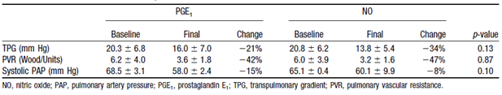
Figure 48: Haemodynamic responses to increasing doses of PGE1 and iNO
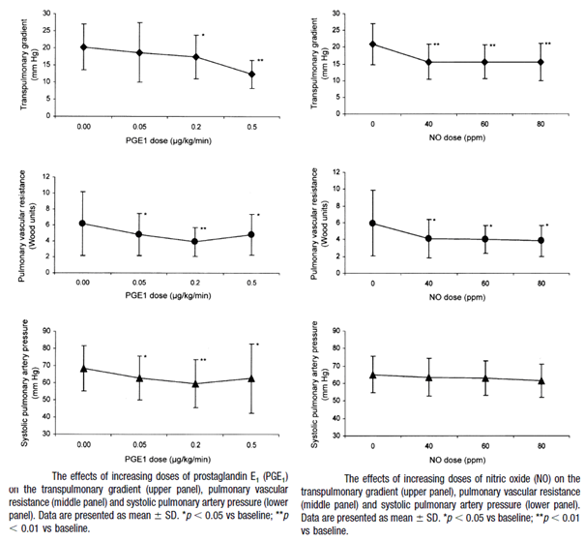
The two agents differed in their effects on the systemic circulation, with PGE1 producing a systemic vasodilation response characterised by a reduction in mean BP and SVR. There was an associated increase in cardiac index, which the authors suggested could be due to decreased afterload in the PGE1 phase. The difference between the two agents was statistically significant for all three variables (BP, SVR, CI), as shown in Table68.

Table 68: Comparison of the effects of PGE1 and iNO on systemic haemodynamics
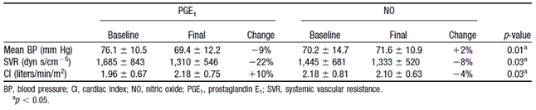
Finally, the authors noted that not all subjects responded to iNO and PGE1 in the same way. They defined a response as a reduction of the TPG to < 12 mm Hg, and they noted that, by this definition, 6 subjects (46%) responded to both PGE1 and iNO, 4 (27%) responded only to PGE1, and 4 (27%) responded only to iNO. This implies that non-responders to either therapy could potentially be treated with the alternative agent.

Conclusion
It remains unclear how well these results in pre-operative adults apply to the post-CPB paediatric setting, but this study confirms that iNO is effective at reducing pulmonary vascular resistance and that it is relatively selective for the pulmonary circulation, providing indirect support for the propose indication. As in several other studies, higher doses of iNO (60 ppm, 80 ppm) did not produce greater efficacy than seen at 40 ppm.

Argenziano 1998

Abstract
Randomized, Double blind Trial of Inhaled Nitric Oxide in LVAD Recipients With Pulmonary Hypertension.
Background. Pulmonary vascular resistance is often elevated in patients with congestive heart failure, and in those undergoing left ventricular assist device (LVAD) insertion, it may precipitate right ventricular failure and hemodynamic collapse. Because the effectiveness of inotropic and vasodilatory agents is limited by systemic effects, right ventricular assist devices are often required. Inhaled nitric oxide (NO) is an effective, specific pulmonary vasodilator that has been used successfully in the management of pulmonary hypertension.
Methods. Eleven of 23 patients undergoing LVAD insertion met criteria for elevated pulmonary vascular resistance on weaning from cardiopulmonary bypass (mean pulmonary artery pressure > 25 mm Hg and LVAD flow rate < 2.5 L∙min⁻¹∙m⁻²) and were randomized to receive either inhaled NO at 20 ppm (n = 6) or nitrogen (n = 5). Patients not manifesting a clinical response after 15 minutes were given the alternative agent.
Results. Haemodynamics for the group at randomization were as follows: mean arterial pressure, 72 ± 6 mm Hg; mean pulmonary artery pressure, 32 ± 4 mm Hg; and LVAD flow, 2.0 ± 0.3 L∙min⁻¹∙m⁻². Patients receiving inhaled NO exhibited significant reductions in mean pulmonary artery pressure and increases in LVAD flow, whereas none of the patients receiving nitrogen showed hemodynamic improvement. Further, when the nitrogen group was subsequently given inhaled NO, significant hemodynamic improvements ensued. There were no significant changes in mean arterial pressure in either group.
Conclusions. Inhaled NO induces significant reductions in mean pulmonary artery pressure and increases in LVAD flow in LVAD recipients with elevated pulmonary vascular resistance. We conclude that inhaled NO is a useful intraoperative adjunct in patients undergoing LVAD insertion in whom pulmonary hypertension limits device filling and output.

Study design, locations and dates
Argenzio et al used a randomised, placebo controlled, double blind design to assess the short-term haemodynamic efficacy of iNO in 11 adult subjects with pulmonary hypertension immediately undergoing insertion of a left-ventricular assist device (LVAD). After 15 minutes of treatment, rescue therapy of non-responders provided additional crossover data for the 5 placebo recipients switching to iNO. The study was performed in New York, USA, in the lead-up to publication in 1998.

Inclusion and exclusion criteria
Potential subjects were adults with severe cardiac failure scheduled to undergo LVAD insertion. Final eligibility was determined at the time of weaning from CPB: subjects were required to have elevated pulmonary vascular resistance (mean pulmonary artery pressure > 25 mm Hg and LVAD flow rate < 2.5 L∙min⁻¹∙m⁻²). Eleven of 23 initial candidates met these criteria and were randomised.

Study treatments
The active treatment was iNO, delivered at 20 ppm into the inspiratory limb of the ventilator circuit, after suitable dilution in oxygen from the source cylinder containing NO at 800 ppm. The placebo control consisted of nitrogen.
Non-responders switched after 15 minutes to the alternative therapy, which ostensibly remained blinded (though investigators are likely to have inferred that these subjects were receiving placebo when they showed no response).

Efficacy variables
Efficacy variables consisted of:
- mean arterial pressure
- mean pulmonary artery pressure
- LVAD flow.
None of these was formally designated as the primary endpoint, but iNO was being assessed for its efficacy in treating pulmonary hypertension so the MPAP could be considered the main efficacy variable.

Methods
The authors described their statistical approach as follows: “Hemodynamic and clinical data are reported as the mean ± the standard error of the mean. Paired variables were analysed by the paired Student’s t test, and unpaired variables were compared using the Wilcoxon nonparametric test. A p value of less than 0.05 was considered significant.”
The authors did not identify a single primary endpoint, and they did not perform any correction for the use of multiple endpoints. No discussion of sample size or statistical power was provided. These methodological flaws are unlikely to have had a major impact on the study’s conclusions, given that all iNO recipients and no placebo recipients showed a response to treatment.

Baseline data
Basic demographic characteristics and disease characteristics for all eleven subjects are shown in the table below, and pre-treatment haemodynamics in each treatment group are compared in the subsequent table. Overall, the groups were reasonably well matched but the MPAP elevations were milder, on average, in those randomised to placebo; this could have made it more difficult to demonstrate superiority of iNO.

Table 69: Baseline haemodynamics
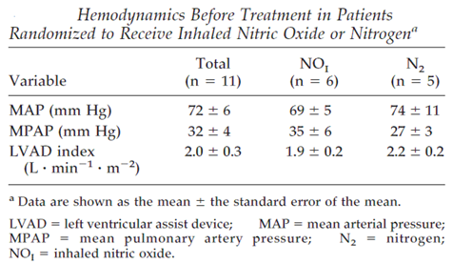

Table 70 Patient characteristics
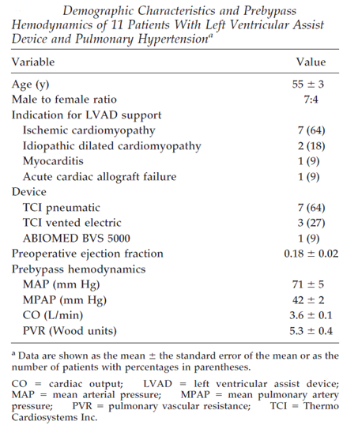

Results
Subjects randomised to iNO showed a reduction in MPAP from 35 ± 6 mm Hg to 24 ± 4 mm Hg (p = 0.02) and an increase in the LVAD flow index from 1.9 ± 0.2 L∙min⁻¹∙m⁻² to 2.7 ± 0.3 L∙min⁻¹∙m⁻² (p = 0.02). Those randomised to nitrogen placebo showed no significant haemodynamic response, but subsequently responded to crossover therapy with iNO, with a reduction in MPAP from 31 ± 4 mm Hg to 22 ± 3 mm Hg (p = 0.02) and an increase in the LVAD flow index from 2.0 ± 0.2 L∙min⁻¹∙m⁻² to 2.5 ± 0.2 L∙min⁻¹∙m⁻² (p = 0.002). Inhaled NO did not have any significant effect on systemic blood pressure.
Figure 49: Treatment effects on MPAP and LVAD flow
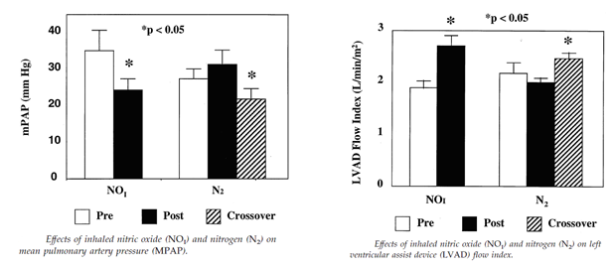
The authors also presented the combined iNO data from all 11 subjects, as shown in the table below. Inhaled NO at a dose of 20 ppm produced a substantial and statistically significant reduction in MPAP, an improvement in LVAD flow index, and no substantial change in MAP. (The MAP increased slightly after commencing iNO, consistent with pulmonary selectivity, but the changes were not significant.)

Table 71: Haemodynamics before and after treatment with iNO
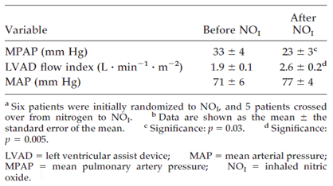

Conclusion
Despite its small size, this study showed clear superiority of iNO over placebo and is consistent with other studies in demonstrating that iNO selectively reduces pulmonary vascular resistance in the post-CPB setting. One substantial limitation of the study is that it was very short term, with rescue therapy instituted after 15 minutes, but longer delays in commencement of effective therapy would have been problematic on ethical grounds.
Although this study was performed in an adult population undergoing LVAD insertion, rather than in children undergoing cardiac surgery, many of the mechanisms of post-CPB pulmonary hypertension are likely to be similar in the two populations and thus this study provides strong indirect support for the proposed indication.

Sponsor Study, INOT41
This sponsor led study was published by Potapov et al, with the following abstract:
Inhaled nitric oxide after left ventricular assist device implantation: A prospective, randomized, double blind, multicentre, placebo controlled trial.
Background: Used frequently for right ventricular dysfunction (RVD), the clinical benefit of inhaled nitric oxide (iNO) is still unclear. We conducted a randomized, double blind, controlled trial to determine the effect of iNO on post-operative outcomes in the setting of left ventricular assist device (LVAD) placement.
Methods: Included were 150 patients undergoing LVAD placement with pulmonary vascular resistance > 200 dyne/sec/cm–5[sic]. Patients received iNO (40 ppm) or placebo (an equivalent concentration of nitrogen) until 48 hours after separation from cardiopulmonary bypass, extubation, or upon meeting study defined RVD. For ethical reasons, crossover to open label iNO was allowed during the 48-hour treatment period if RVD criteria were met.
Results: RVD criteria were met by 7 of 73 patients (9.6%; 95% confidence interval, 2.8 to 16.3) in the iNO group compared with 12 of 77 (15.6%; 95% confidence interval, 7.5 to 23.7) who received placebo (p = 0.330). Time on mechanical ventilation decreased in the iNO group (median days, 2.0 versus 3.0; p = 0.077), and fewer patients in the iNO group required an RVAD (5.6% versus 10%; p = 0.468); however, these trends did not meet statistical boundaries of significance. Hospital stay, intensive care unit stay, and 28 day mortality rates were similar between groups, as were adverse events. Thirty-five patients crossed over to open label iNO (iNO, n = 15; placebo, n = 20). Eighteen patients (iNO, n = 9; placebo, n = 9) crossed over before RVD criteria were met.
Conclusions: Use of iNO at 40 ppm in the perioperative phase of LVAD implantation did not achieve significance for the primary end point of reduction in RVD. Similarly, secondary end points of time on mechanical ventilation, hospital or intensive care unit stay, and the need for RVAD support after LVAD placement were not significantly improved.

Study design, objectives, locations and dates
This sponsor led study used a randomised, double blind, prospective design to assess the clinical utility of iNO to prevent right ventricular dysfunction in the setting of LVAD insertion in adults with cardiac failure.
The stated objectives were as follows:
“Primary: To assess the utility of inhaled nitric oxide (iNO) for the management of acute right ventricular failure (RVF) during left ventricular assist device (LVAD) placement with cardiopulmonary bypass (CPB).
Secondary:
- Assess the safety of iNO in this population
- Assess effect of iNO on:
  - length of time on mechanical ventilation
  - number of ICU and total hospital days from date of surgery until discharge date
  - need for renal replacement therapies (haemodialysis, […] hemofiltration) by Day 28
  - blood product usage
  - survival, assessed at Day 28
  - number of subjects requiring right ventricular assist device (RVAD) by Day 28”
The study was designed as a multinational study, but ultimately only USA and Germany contributed patients. The study ran from 4 September 2003 to 13 March 2008.

Inclusion and exclusion criteria
The target population consisted of adults undergoing a LVAD insertion with cardiopulmonary bypass, who exhibited elevated pulmonary vascular resistance (PVR).
Specific inclusion criteria consisted of:
- age ≥ 18 years
- informed consent
- scheduled to undergo first LVAD implantation (or 6 months after explanation of previous LVAD)
- pulmonary vascular resistance (PVR) of ≥ 2.5 Wood units (200 dynes.sec.cm⁻⁵) in the 30 day period prior to LVAD placement.
Exclusion criteria were:
- pregnancy
- undergoing elective biventricular assist device (BiVAD) surgery, or currently using temporary BiVAD
- received iNO within 24 hours prior to study onset
- congestive cardiac failure due to giant cell myocarditis or restrictive cardiomyopathy
- other investigational drugs that could change systemic or pulmonary vascular resistance.

Study treatments
Subjects were randomised to iNO 40 ppm or matching nitrogen placebo.
NO was obtained from source cylinders containing NO 800 ppm in nitrogen. The iNO was administered using a blinded version of the INOvent delivery system, connected to the inspiratory limb of the ventilator circuit, and mixed with oxygen.
The placebo control consisted of one hundred percent (100%) grade 5 nitrogen (N2) gas which was administered via an iNO delivery system at an ostensibly identical dose to the active agent.
After 48 hours of double blind treatment, investigators could switch their patients to open label iNO (INOmax) if clinically indicated. When ceasing study drug or open label iNO, a pre-specified cautious weaning process was used.

Efficacy variables and outcomes
The primary endpoint was treatment failure (right ventricular dysfunction) occurring within 48 hours during treatment with study drug.
The definition of failure was complex but clearly articulated in the study protocol. The sponsor modified the definition to make it more inclusive during the study, in protocol amendments, but before any subjects had reached treatment failure. A major reason for adopting failure as the endpoint is that it potentially allowed subjects to be rescued with open label iNO without compromising demonstration of efficacy; unfortunately, several patients received rescue iNO without satisfying the formal definition of treatment failure and this weakened the study.
Failure criteria consisted of specific physiological criteria, which had to be sustained for 15 minutes after complete removal from CPB support, OR failure to wean from CPB at least once due to hemodynamic failure (not including re-initiation of CPB to correct bleeding or other technical issues) or death.
The physiological criteria for failure consisted of having 2 or more of the following for 15 minutes:
- Left ventricular flow rate index (LVFRI) ≤ 2.0 L/min/m²
- Administration of ≥ 20 inotropic equivalents (IE)
- Mean arterial pressure (MAP) ≤ 55 mm Hg
- Central venous pressure (CVP) ≥ 16 mm Hg
- Percentage of mixed venous oxygen saturation (SvO₂) of ≤ 55%.
Inotropic equivalents were specified for all inotropes, as follows:
- 10 µg/kg/min dopamine, dobutamine, enoximone or amrinone was equivalent to 10 IE
- 0.1 µg/kg/min epinephrine or norepinephrine was equivalent to 10 IE
- 1 µg/kg/min milrinone was equivalent to 15 IE
- 0.1 U/min vasopressin was equivalent to 10 IE.
Secondary endpoints consisted of the following, which were specified in hierarchical order:
- duration of mechanical ventilation
- number of ICU days
- number of hospital days
- number of subjects requiring renal replacement therapy
- quantity of blood products used
- survival by Day 28
- number of subjects requiring right ventricular assist device (RVAD) by Day 28.
Overall, these endpoints appeared appropriate and clinically meaningful. In retrospect, for a study of this size, the primary endpoint was reached too infrequently and the study was underpowered. Also, several subjects switched to open label iNO without meeting these criteria, indicating that investigators were not comfortable waiting for formal treatment failure or were unaware of the precise definition.

Randomisation and blinding methods
Subjects were randomised with equal probability to iNO or placebo, using block randomisation by site. Blinding was achieved by using identically appearing coded cylinders for iNO and placebo, and using a masked version of the iNO delivery system that prevented detection of the administered substance.
Some degree of unblinding could have occurred as investigators observed the response to therapy, but this is an unavoidable feature of using an active agent in comparison to placebo. No other tell-tale features of iNO therapy are likely to have compromised blinding.

Analysis populations
The sponsor defined an efficacy population, consisting of all randomised subjects, who were analysed on an intent to treat (ITT) basis, and a safety population, consisting of all patients who received study drug. The ITT population contained 150 subjects, 129 men and 21 women; the safety population contained 137 subjects.

Sample size
The sponsor performed appropriate power calculations to determine sample size, but the assumptions underlying these calculations proved to be false and the study was ultimately under-powered. The main problem was that the failure endpoint was reached less commonly than anticipated, and some patients were switched to open label iNO without reaching the formal failure endpoint.
Originally, a total of 110 subjects (55 per treatment group) were planned, based on an assumed failure rate of 50% in the placebo group and a target failure rate of 25% in the treatment group. By these assumptions, with a desired type I (α) error of 0.05 used as the threshold for statistical significance (2 tailed), the study would have had a power (1 – β) of 80%.
Blinded surveillance during the study showed that the failure rate was lower than this, and the total recruitment target was increased to 150 subjects. The eventual failure rate was only 15.6% in the placebo group, so the study remained under-powered.

Statistical methods
The sponsor proposed two main methods of analysing the primary endpoint: Fisher’s Exact test and logistic regression models. The Fisher’s exact test was considered the primary analysis method, whereas the logistic regression model was used in an exploratory manner, to clarify the significance of treatment and to investigate the effects of other covariates. Factors included in the model were “centre, interaction of treatment group and centre, device type, age, sex, aetiology (that is, myocardial infarction, hypertension, valvular heart disease, cardiomyopathy, other), pre-operative circulatory support, and the use of blood products.”
Additional analysis included a Kaplan-Meier survival analysis of time to failure.
Secondary endpoints were assessed with an analysis of variance (ANOVA) model or logistic regression model, depending on the variable, and with appropriate co-factors included in the model.
The sponsor use a hierarchical testing procedure with a clearly defined ranking of the secondary endpoints (as listed above), such that significance of lower-ranked endpoints would only be considered valid if higher endpoints achieved significance. Analysis was based on the ITT population, with no data imputation. Overall, the statistical methods were appropriate, and they were clearly defined in a rigorous prospective manner.

Participant flow
Participant flow is summarised in the figure below, from Potapov et al. All randomised patients were analysed, with 100% patient follow-up, even though 13 subjects did not receive treatment.
Figure 50: Patient disposition
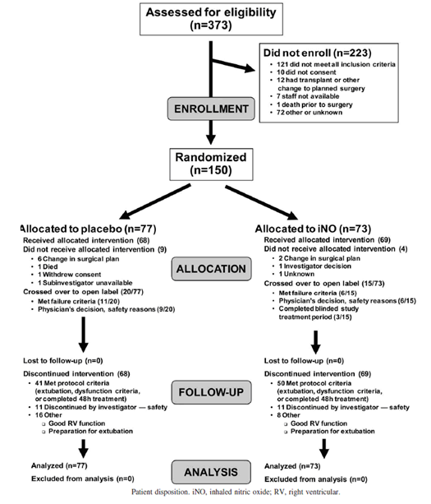

Major protocol violations/deviations
Protocol violations were rare in this study, and are described by the sponsor as follows: “Six (4%) of the 150 enrolled subjects (4 PBO, 2 iNO) had protocol deviations at study entry; however, no subject was excluded from the efficacy analysis for this reason. Four of the 6 subjects (2 PBO, 2 iNO) did not have a PVR of ≥ 2.5 Wood Units in the 30 day period prior to LVAD placement. The 2 other deviations included 1 subject in the placebo group who was to undergo an LVAD placement in the absence of cardiopulmonary bypass and 1 who received iNO therapy within 24 hours prior to the study.“
The most common protocol deviation, lack of sufficiently elevated PVR, might be expected to make it more difficult to demonstrate efficacy of iNO. None of the deviations is likely to have caused bias in the study.
As shown in the participant flow diagram, some subjects (placebo 9, iNO 6) switched to open label iNO without satisfying the criteria for treatment failure, but this was not considered a protocol deviation as it was within the scope of the study for clinicians to make this switch on safety grounds. These switches are likely to have weakened the power of the study, however, because they protected patients from reaching the formal failure criteria and reduced the treatment differences between the groups.

Baseline data
Baseline data in the study population is summarised in the table below, from Potapov et al. The two groups differed significantly in age (p = 0.046, iNO recipients slightly older), and baseline PCWP (p = 0.013, iNO recipients with higher left atrial pressures). These minor differences could have biased the study against iNO, but are unlikely to have made a major difference to the outcome.

Table 72: Baseline characteristics of the intent-to-treat population
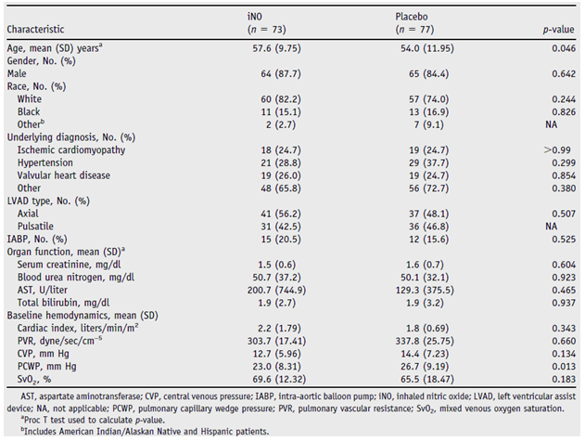

Results for the primary efficacy outcome
This study was negative for its primary outcome, with no significant difference noted between the two treatment groups in the incidence of treatment failure (p = 0.3301). There was a numerical superiority in the iNO group, however, that would be of substantial clinical worth if it were confirmed in an adequately powered study: the failure rate was 9.6% with iNO, compared to 15.6% with placebo.
The distribution of the time to failure was not significantly different in the two groups, but there was a trend suggesting earlier failure in the placebo group (0.6 h) than the iNO group (3.6 h, p = 0.2486; see Table 73 and Figure 51).
For reasons that remain unclear, the primary endpoint showed a significant result in female patients, but not even a favourable trend in males (failure in women: iNO 0/9 versus Placebo (PBO) 5 out of 12 [41.7%], p = 0.0451; failure in men: iNO, 7 out of 64 [10.9%] versus PBO, 7 out of 65 [10.8%], p ≥ 1.0). Despite this, gender did not emerge as a significant cofactor in the analysis, reflecting the lack of statistical power in the study. There are no a priori grounds for expecting a different result in women, and this has not emerged as a feature of other iNO studies.

Table 73: Number of subjects who met primary outcome criteria, ITT population
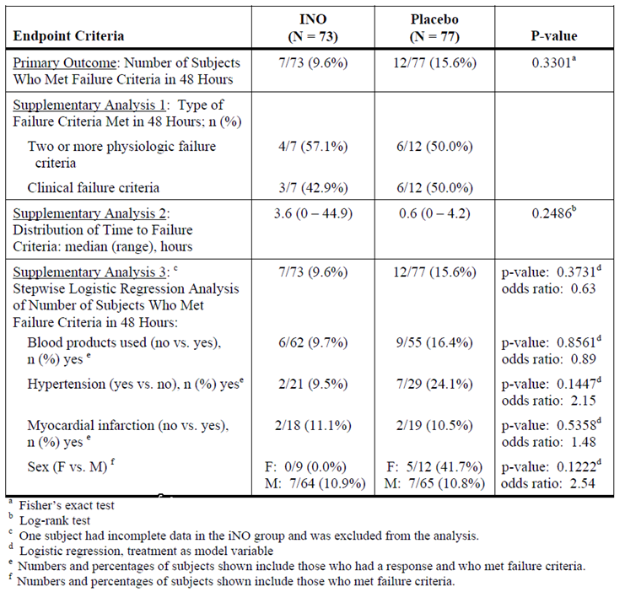
Figure 51: Time to meeting failure criteria
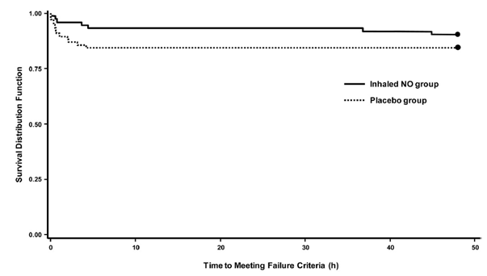
A supplementary logistic regression analysis of the primary endpoint also failed to achieve significance (p = 0.3731), and the variables of blood products used (yes, no), presence of hypertension (yes, no), the presence of myocardial infarction (yes, no), and sex did not affect the model, as shown in the table above.
The results were similar, and not significant, in the safety population (see table below).

Table 74: Primary outcome: patients meeting failure criteria in 48 hours
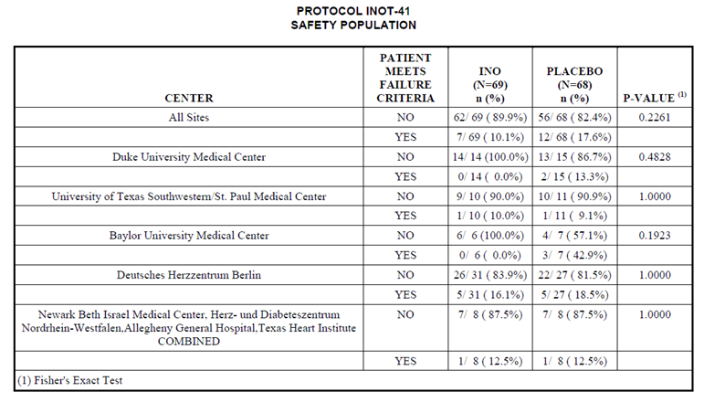
An analysis of the primary endpoint stratified by PVRI did not identify a subgroup with statistically significant treatment benefit, but there was a strong numerical trend in favour of active treatment in the 14 subjects with PVRI > 270.5 (Table 75).

Table 75: Primary outcome: patients meeting failure criteria in 48 hours by PVRI strata
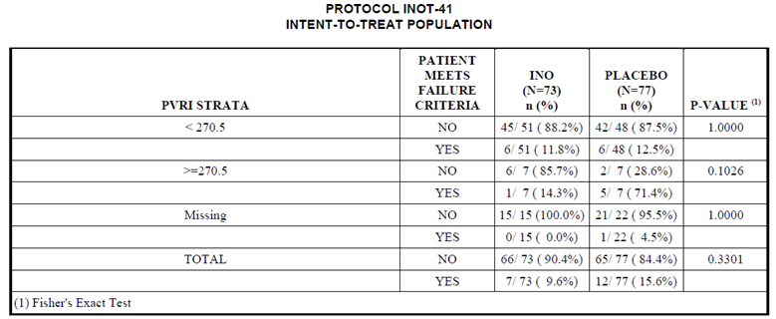
Reasons for treatment failure were assessed, but they were distributed across most pre-specified failure criteria, as shown in the table below.

Table 76: Subjects meeting failure criteria in 48 h, safety population
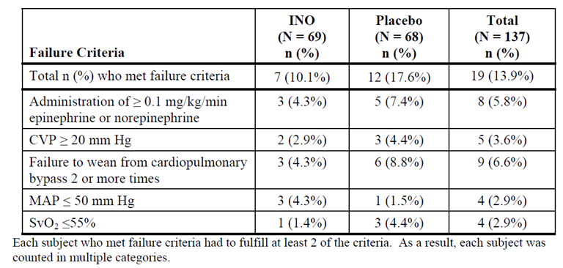
One factor that may have made it more difficult to demonstrate efficacy for the primary endpoint was that patients at high risk of failure were often switched to open label therapy. Including those who met failure criteria as well as those who did not, 20 placebo recipients and 15 iNO recipients crossed over, as shown in Figure 52.
Figure 52: Time to crossover to open label treatment
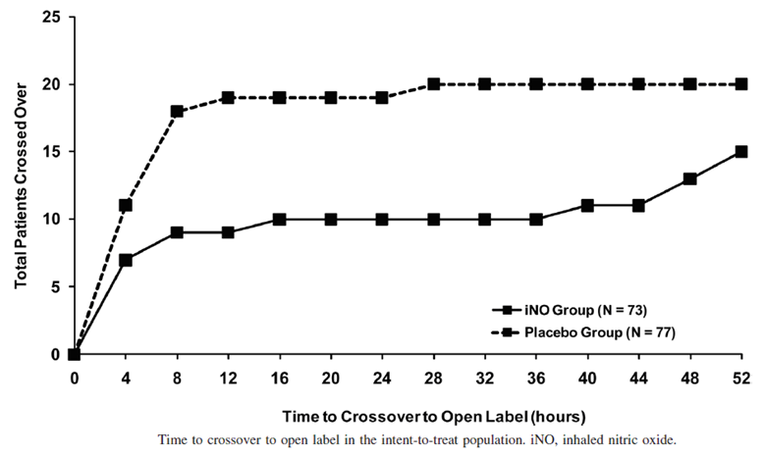

Results for other efficacy outcomes
None of the secondary endpoints achieve statistical significance, but for the length of time on mechanical ventilation, there was a trend in favour of the iNO group, who had mean (median) of 5.37 (2.0) days, compared to 11.1 (3.0) in the placebo group (p = 0.077). Note that this result was misreported by the sponsor in at least one part of their submission, with a p-value of 0.0077 cited in error.
The other secondary efficacy variable that strongly favoured iNO from a numerical perspective was the percentage of subjects who required RVAD by Day 28 (iNO n = 4/71 [5.6%]; PBO n = 7/70 [10.0%]), but result this did not approach significance (p = 0.4680). This would be a clinically worthwhile difference if sustained in a larger population.

Table 77: Results of secondary outcome measures, ITT population
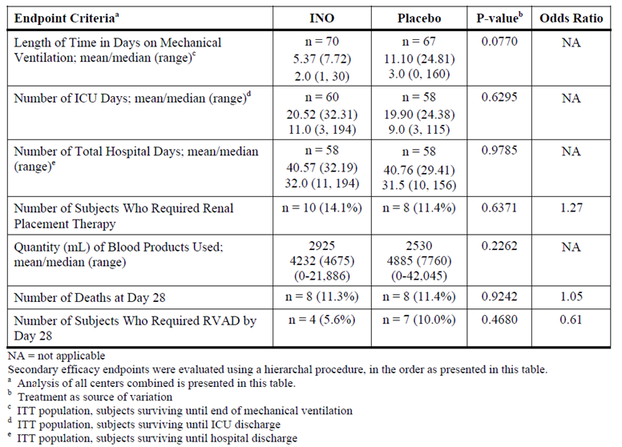

Conclusion
Overall, the results of this study were disappointing, but its failure to achieve significant outcomes primarily reflects a low event rate. The trends observed in this population for clinical events were favourable. It is likely that a larger study, or a study in subjects with a higher underlying risk of RV failure, might be needed to confirm that iNO has efficacy in adults requiring LVAD insertion. The study only provides weak indirect support for the proposed indication in children, but it does not raise any concerns or doubts about the efficacy of iNO when used for the proposed indication.

Uncontrolled studies
The sponsor’s Summary of Clinical Efficacy mentions three efficacy studies that were captured by their literature search (because they were mentioned in a review article) but then appropriately rejected because the studies were not randomised or controlled. The abstracts of these studies are included below for the sake of completeness.

Table 78: Uncontrolled clinical efficacy studies
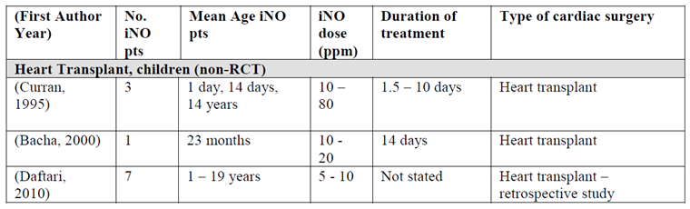
Curran et al (1995) and Bacha et al (2000) present brief case series on the use of iNO post-operatively, showing modest reductions in pulmonary arterial pressure that are difficult to interpret given the lack of control therapies. Curren et al noted that iNO had a greater effect on pulmonary arterial pressure in subjects with refractory post-operative pulmonary hypertension than in subjects without substantial post-operative pulmonary hypertension, an observation that is in accord with other studies described above.
Daftari et al (2010) present a retrospective case-control analysis of heart transplant recipients primarily aimed at determining the upper limits of pulmonary vascular resistance (PVR) that would contraindicate paediatric heart transplantation. Cases in the Daftari study were subjects with high PVR (> 6 WU), and controls were subjects with lower PVR (< 6 WU). Inhaled iNO was used in most subjects as part of standard care and was not the main focus of the study, but the response to iNO was assessed as part of the pre-surgical work-up in four cases. The authors mention that “Four of the [seven] patients with pulmonary hypertension were tested pre-OHT [pre-orthotopic heart transplantation] for PVR reactivity with oxygen and NO at catheterization. Three of these patients had < 2 WU decrease in PVR, while one with RCM [restrictive cardiomyopathy] decreased from 13 WU to 8 WU. Three cases were not tested for PVR reactivity prior to OHT.”
Reassuringly, the findings in each of these uncontrolled studies were broadly consistent with the rest of the literature.

Abstract: Curran et al, 1995
Inhaled Nitric Oxide for Children with Congenital Heart Disease and Pulmonary Hypertension.
Background. Endothelium derived nitric oxide (NO) is a potent vasodilator and a major mediator of pulmonary vascular tone.
Methods. Five infants underwent a trial of inhaled NO with hemodynamic monitoring in the operating room after atrioventricular canal repair. An additional 15 patients with congenital heart disease and refractory pulmonary hypertension were treated with inhaled NO for 1 day to 10 days post-operatively.
Results. In the 5 infants with atrioventricular canal, corrective surgical intervention and conventional therapy (hyperventilation, inspired oxygen fraction of 0.80, and inotropic agents) lowered mean pulmonary artery pressure from 49.5 ± 10.5 to 20.0 ± 2.2 mm Hg (p < 0.001). Adding inhaled NO further decreased mean pulmonary artery pressure to 18.0 ± 2.8 mm Hg (p = not significant). Inhaled NO had no effect on ventricular function curves (inflow occlusion) in this group. In the 15 patients with refractory post-operative pulmonary hypertension, 11 had a favourable response to inhaled NO, with a decrease in mean pulmonary artery pressure from 30.9 ± 5.8 to 23.1 ± 5.4 mm Hg (p < 0.01) in 8 patients with pulmonary artery catheters.
Conclusions. These studies demonstrate that inhaled NO has minimal beneficial effect on pulmonary artery pressure or cardiac output in infants after repair of atrioventricular canal. Inhaled NO is effective in decreasing PAP post-operatively in select patients with congenital heart disease and pulmonary hypertension refractory to conventional therapeutic modalities.

Abstract: Bacha et al, 2000
Management of Pulmonary Arteriovenous Malformations after Surgery for Complex Congenital Heart Disease.
Pulmonary arteriovenous malformations (PAVMs) are a known complication after cavopulmonary shunt operations. Their cause is unknown, but they may be related to the absence of pulsatile flow, the diversion of hepatic venous flow away from the pulmonary circulation, or other humoral factors. By shunting a large amount of un-oxygenated blood across the lungs, PAVMs cause cyanosis and may make subsequent operations riskier. However, there is a paucity of data related to the latter subject. We describe the post-operative course of 3 recent patients with multiple PAVMs, cyanosis, and complex congenital heart disease (CHD).

Abstract: Daftari et al, 2010
Initial Experience with Sildenafil, Bosentan, and Nitric Oxide for Paediatric Cardiomyopathy Patients with Elevated Pulmonary Vascular Resistance before and after Orthotopic Heart Transplantation.
Background. Although pulmonary hypertension complicating dilated cardiomyopathy has been shown to be a significant risk factor for graft failure after heart transplantation, the upper limits of pulmonary vascular resistance (PVR) that would contraindicate paediatric heart transplantation are not known.
Methods. A retrospective review of all paediatric orthotopic heart transplant (OHT) performed at our institution from 2002 to 2007 was performed. Seven patients with PVR > 6 WU) prior to transplant were compared pre- and post-operatively with 20 matched controls with PVR < 6 WU. All pulmonary vasodilator therapies used are described as well as outcomes during the first year post-transplant.
Results. The mean PVR prior to transplantation in the 7 study cases was 11.0 ± 4.6 (range 6 to 22) WU, compared to mean PVR of 3.07 ± 0.9WU (0.56 to 4.5) in the controls (P = 0.27×10⁻⁶). All patients with elevated PVR were treated pre-OHT with either Sildenafil or Bosentan. Post-OHT, case patients received a combination of sildenafil, iloprost, and inhaled nitric oxide. All 7 case patients survived one year post-OHT, and there was no statistical difference between cases and controls for hospital stay, rejection/readmissions, or graft right ventricular failure. Mean PVR in the cases at one and three months post-OHT was not significantly different between the two groups. Only one of the cases required prolonged treatment with iloprost after OHT.
Conclusions. A PVR above 6WU should not be an absolute contraindication to heart transplantation in children.

Analyses performed across trials
The sponsor’s literature search found a Cochrane review of direct relevance to the proposed indication:
Bizzarro, M; Gross, I. Inhaled nitric oxide for the post-operative management of pulmonary hypertension in infants and children with congenital heart disease Cochrane Database of Systematic Reviews (2005) Issue 4) Art. No.: CD005055. DOI: 10.1002/14651858.CD005055.pub2.
Bizzarro et al observed no significant differences between iNO and placebo (or standard care) for a number of clinical endpoints, including mortality (p = 0.50), PHTC (p = 0.79), change in MPAP (p = 0.16), MSAP (p = 0.40), HR (p = 1.00), and PaO₂:FiO₂ (p = 0.46). They detected a significant reduction in MPAP in a subgroup of younger patients from birth to three months (p = 0.005), but this was based on only 23 patients. The authors concluded they were unable to confirm superiority of iNO versus placebo for the management of pulmonary hypertension in the paediatric cardiac surgery setting.
The literature search also identified a commentary on the Bizzarro review, produced by Barr & Macrae, 2010. Both papers, the one by Bizarro and Gross as well as the one by Barr and Macrae, reviewed the same four studies designated as pivotal in the sponsor’s submission, but they drew somewhat different conclusions.
Bizzarro et al chose mortality as the primary endpoint in their meta-analysis, which automatically ensured that their analysis was underpowered: they combined patients from Miller et al, 2000, and Day et al, 2000, to produce a cohort of 162 patients. This sample is too small for a mortality endpoint, given that deaths are uncommon, even in the setting of paediatric cardiac surgery. Also, ethical constraints meant that both studies allowed rescue open label therapy in the event of severe pulmonary hypertension; the inferiority of placebo was not, by design, readily allowed to be manifested as a fatal outcome. Unsurprisingly, this primary endpoint showed no statistical benefit for iNO. Only two deaths were related to PHTC, both from one study only (Day et al, 2000).
Although the incidence of PHTC would be expected to have greater statistical power than mortality, this analysis was also underpowered. Because Bizzarro’s meta-analysis technique required access to individual patient data, they were unable to include the largest study of PHTC incidence (Miller et al, 2000), and instead included just one smaller study (Day et al, 2000), which only included 40 patients (38 evaluable for PHTC). This meta-analysis of PHTCs was underpowered and added little to consideration of the individual studies; indeed it was statistically much weaker than Miller et al, 2000, which had 124 patients.
In view of these underpowered analyses, Barr and Macrae made the following comments about the Cochrane meta-analysis:
Utilizing pre-established inclusion and exclusion criteria, only the four randomized clinical trials that have been previously presented were included in the analysis. However, because each of these studies reported different outcomes, the number of patients included in the subsequent meta-analysis of each outcome was severely restricted and did not add much to the previously published literature. For example, only the studies by Day et al and Miller et al reported mortality and the subsequent meta-analysis was done on a cohort of 162 patients, hardly an adequate sample size in a population where post-operative mortality is a fairly rare event. Analysis of the prevalence of post-operative pulmonary hypertensive crisis was limited to the study by Day et al and thus included data on only 38 patients. Analysis of physiologic outcomes was likewise restrictive. The authors [Bizzarro and Gross] concluded that there were no differences in the use of inhaled NO in the outcomes that were reviewed, at the same time acknowledging the limitations of the review due the concerns over methodologic quality, sample size, and heterogeneity of patients in the four studies. These limitations severely restrict any conclusions that can be drawn from this Cochrane review.
These conclusions appear appropriate. Overall, the meta-analysis by Bizzarro et al did not add much of value to consideration of the individual pivotal studies.

Endorsement of iNO by authoritative bodies
As the sponsor points out, several authoritative bodies already recommend iNO for the treatment of pulmonary hypertension in the setting of cardiac surgery. Such recommendations cannot substitute for formal demonstration of efficacy within randomised prospective trials, because clinicians may be susceptible to group think or to confirmation bias, finding evidence in anecdotal exposures for something that they already believe. Also, confounding influences and general improvements in care and outcomes may create an appearance of efficacy that can be misattributed to a single element of treatment.
Despite these reservations, the recommendations of experts carry considerable weight, because they represent the overall experience of clinicians with iNO in realistic clinical settings, without any apparent conflict of interest or financial motivation. Given the short half-life and prompt onset of the pulmonary vasodilatory effects of iNO, clinicians using iNO are in a very good position to judge its haemodynamic efficacy. This is particularly the case in the highly monitored settings of ICU, the cardiac surgical theatre, and the catheterisation laboratory, which provide objective physiological monitoring during the introduction and cessation of iNO. If iNO were ineffective, this would be easy for clinicians to detect, and the fact that iNO is considered by many experts to be a first-line treatment for the treatment of pulmonary hypertension strongly supports the sponsor’s submission.
A full assessment of those recommendations is beyond the scope of this evaluation report, but the following endorsements of iNO, cited in the sponsor’s Clinical Overview, provide some confidence that the efficacy demonstrated in the submitted studies appears to be sustained in the real world setting:
The European consensus document for the use of iNO published in 2005 states: “Clinical experience suggests that in patients with confirmed right ventricular dysfunction and elevated PVR, use of iNO may result in haemodynamic improvement when used during or after cardiac surgery.” (Germann et al., 2005). The guidelines from the American College of Cardiology Foundation /American Heart Association 2009 also advocate iNO as an effective short term therapy for pulmonary hypertension in conjunction with heart surgery: “On balance, inhaled NO is an effective short-term strategy for the management of PH following cardiac surgery” (McLaughlin et al., 2009).

Evaluator’s conclusions on clinical efficacy
The efficacy data submitted by the sponsor was largely derived from investigator led studies found in a literature search (the two sponsor led studies, consisting of a PD study in children, and a negative efficacy study in adults, were merely supportive). After identifying potentially relevant investigator led studies of the use of iNO in relation to cardiac surgery, the sponsor subdivided the studies into 22 efficacy studies (9 in children, 13 in adults) and 11 PD studies according to whether they compared iNO to a randomised control therapy. This subdivision was somewhat artificial, and many of the studies classified as efficacy studies had designs more typical of PD studies. Also, many of the studies listed as efficacy studies were small, used iNO for only short periods to gauge the short-term haemodynamic response, or used a control therapy of unproven utility.
Four of 9 efficacy studies in children were designated as “pivotal”, because the control group received placebo or standard care in a randomised prospective design, but three of these lacked the core features expected of a Phase III pivotal study. For instance, both Day et al and Morris et al used an open label design. Of the four studies, only two were positive (Miller et al, 2000, and Russell et al, 1998) and one of these (Russell et al) was only positive in a small subgroup that was possibly identified post hoc.
The only truly pivotal study was the one by Miller et al, 2000 (n = 124). Miller et al assessed the efficacy of iNO 10 ppm versus placebo in the target population of paediatric cardiac surgical patients using a prospective, randomised, double blind design, with a robust methodology and clearly defined clinical endpoints. The treatment benefits in this study could have been partially masked by the use of rescue therapy with open label iNO, but it demonstrated a statistically significant benefit anyway. The primary endpoint was the number of pulmonary hypertensive crises (PHTCs) in the treatment period, which lasted for up to 7 days. Infants who received iNO had significantly fewer PHTCs (median four [IQR 0 to 12]) than infants receiving nitrogen placebo (median seven PHTCs [IQR 1 to 19]; unadjusted relative risk 0·66 [95%CI 0·59 to 0·74] p < 0·001; adjusted for dispersion 0·65 [0·43 to 0·99], p = 0·045). They also reached extubation criteria significantly sooner, and spent less time overall on study gas. The pulmonary vascular resistance index (PVRI) during study-gas administration was also significantly lower in the iNO group (p < 0·001).
The studies by Russell et al and Morris et al were listed as pivotal but they used haemodynamic endpoints rather than clinical endpoints, and the iNO treatment duration (≤ 30 min) was more consistent with a brief pharmacodynamic assessment than with realistic clinical use.
The study by Russell et al (n = 40) showed a significant haemodynamic effect for iNO over 20 min compared to placebo, but it produced its positive results in a subset of the study population, consisting of 13 subjects with elevated pulmonary artery pressure, only 5 of whom received iNO. Russell et al demonstrated that MPAP in this subgroup was reduced by 19% with iNO (p = 0.008) versus an increase of 9% with placebo. The iNO dose used in Russell et al was well above that proposed for registration (80 ppm, instead of 10 to 20 ppm as recommended in the PI).
Morris et al performed a small study (n = 12) with a randomised, controlled, open label crossover design to compare the haemodynamic effects of iNO (at 5 ppm and at 40 ppm for 15 min each) versus hyperventilation induced alkalosis (HV) in children recovering from biventricular repair and CPB. They showed no significant differences between the combination of iNO and HV and HV alone, so this study does not provide evidence that iNO adds significantly to the pulmonary vasodilatory effects of standard care with HV. Significant changes were observed in PVRI and MPAP with both treatments, relative to baseline, but this does not constitute clear positive evidence of a treatment effect because some improvement could be due to recovery from CPB.
The open label study by Day et al (n = 40) compared the efficacy of iNO 20 ppm with conventional therapy (determined by the treating clinician) in children with post-operative pulmonary hypertension after cardiac surgery. It used a similar clinical endpoint as Miller et al (number of PHTCs), but it was clearly underpowered for this endpoint and for secondary haemodynamic endpoints. The primary endpoint, PHTC, occurred infrequently: PHTCs occurred in 4 control patients and in 3 iNO patients, a difference that was not statistically significant. It was also negative for all major secondary endpoints, but the trends were favourable. Systolic pulmonary arterial pressure (SPAP) in the control group started relatively low and increased after an hour, whereas SPAP in the iNO group started relatively high and decreased by approximately10%. The changes in ratio of systolic pulmonary and systemic arterial pressures were greater with iNO than with conventional therapy, and this comparison approached statistical significance (p = 0.066). Given that the study was underpowered and open label, and that clinicians used variable agents as control therapies, this study cannot be considered pivotal.
The remaining 5 efficacy studies in children compared iNO to active alternatives. None of the non-iNO therapies has been approved for the treatment of pulmonary hypertension in the setting of paediatric cardiac surgery, which is why none of these studies was considered pivotal. In general, the emphasis of these studies was in demonstrating that the non-iNO therapy was comparable in efficacy to iNO (which was used as a control therapy because the authors considered iNO to be the standard treatment of pulmonary hypertension in this setting). These studies were not specifically powered to demonstrate equivalence or non-inferiority of iNO compared to the active alternative, but in general the findings were favourable, as follows:
- In Cai et al, 2008 (n = 46), iNO at a starting dose of 10 ppm and continued for at least 24 hours was compared to intravenous milrinone 0.5 µg kg⁻¹ min⁻¹ in children with pulmonary hypertension after a Fontan procedure. In a 3 group, open label design, each agent was compared to the other agent and to the combination of both agents. Inhaled NO was significantly superior to milrinone for the study’s main measure of pulmonary vascular resistance, transpulmonary gradient (TPG). Given that milrinone is likely to be superior to placebo, this provides reasonably strong evidence of haemodynamic efficacy of iNO in this setting. The combination of iNO and milrinone was also significantly more effective at reducing TPG than milrinone alone.
- Goldman et al, 1995 (n = 13), was a small, brief, open label crossover study, which showed that iNO 20 ppm was significantly superior to intravenous prostacyclin 20 ng per kg per minute in the short-term (10 minute) treatment of severe pulmonary hypertension in paediatric subjects after cardiac surgery. MPAP was reduced by 33% during iNO treatment (95%CI, -24% to -51%), compared to a reduction of 15% during prostacyclin treatment (95%Cl, -4% to -38%; p < 0.01).
- Kirbas et al, 2012 (n = 16), was another small, open label study performed in paediatric cardiac surgery patients. It compared the efficacy of iNO 20 ppm and aerosolised iloprost in the treatment of pulmonary hypertension, and found no difference. Favourable reductions in PAP and in PAP/SAP ratio were observed, but these are difficult to interpret given the lack of an untreated or placebo treated control group.
- Loukanov et al, 2011 (n = 15), was a small, open label pilot study comparing iNO 10 ppm and aerosolised iloprost 0.5 µg/kg every 2 h. The study suggested that the two drugs might have similar efficacy when used to prevent PHTCs in the paediatric setting, but the study was not adequately powered to demonstrate equivalence. Trends in MPAP were weakly in favour of iNO, but there was no convincing reduction in MPAP relative to baseline.
- Stocker et al, 2003 (evaluable n = 15), compared iNO 20 ppm and intravenous sildenafil 0.35 mg/kg in a small, open label crossover study in paediatric cardiac surgery patients, showing that the two drugs were similar in their ability to lower MPAP and PVRI. In the iNO first group, MPAP had fallen after 20 min of therapy, reducing by 1.4 ± 0.4 mm Hg (by 7.8 ± 2.1%; p = 0.008). The subsequent addition of sildenafil did not further lower PA pressure. In the sildenafil-first group, MPAP had also fallen by 20 min; the reduction seen with sildenafil was numerically greater than that seen in the iNO first group when expressed as a percentage of baseline, but the fall was not statistically significant (reduction of 10 ± 4.1%; p = 0.055). The subsequent addition of iNO produced a further fall in MPAP. The authors noted that iNO had greater pulmonary selectivity.
Thus, of the five supportive studies in children, two of them (Cai et al and Goldman et al) produced significant results strongly supportive of a short term haemodynamic effect with iNO relative to an unproven active control. The other three showed broad equivalence of iNO and the active control.
The remaining 13 efficacy studies were performed in adults, and so they are not directly relevant to the proposed indication. Also, most of these studies were small, or used iNO for only a brief period, as indicated in the Table 34 above.

Positive results
Positive results were obtained for the 3 studies below, which all showed superiority of iNO relative to the control therapy.
Ardehali, 2001, was a study of heart transplant patients. Study subjects who received iNO 20 ppm (n = 16) were compared with historical control subjects (n = 16), and the incidence of RV dysfunction was substantially lower with iNO (p < 0.05). Survival was 100% with iNO, compared to 13 out of 16 (81.25%) in historical controls.
In Argenzanio et al, 1998 (evaluable n = 11), iNO 20 ppm (n = 6) was compared to placebo (n = 5) in subjects receiving an LVAD. The period of randomised treatment was brief (15 min), after which rescue therapy was initiated. Subjects randomised to iNO showed a reduction in MPAP from 35 ± 6 mm Hg to 24 ± 4 mm Hg (p = 0.02) and an increase in the LVAD flow index. Those randomised to nitrogen placebo showed no haemodynamic response, but subsequently responded to crossover therapy with iNO, with a reduction in MPAP from 31 ± 4 mm Hg to 22 ± 3 mm Hg (p = 0.02) and an increase in the LVAD flow index.
In Rajek, 2000 (evaluable n = 68), iNO at doses of up to 24 ppm was compared to PGE1 in adults undergoing heart transplantation, with treatment initiated at the end of CPB. In the iNO group, a major reduction in PVR occurred within 10 minutes of CPB (from 326 ± 21 to 180 ± 15 dynes∙s∙cm⁻⁵), and this was statistically significant (p < 0.0001) compared to PGE1, where the initial reduction was relatively minor (295 ± 30 to 264 ± 27 dynes∙s∙cm⁻⁵). The difference was still significant at one hour post-CPB but, by six hours, subjects in the PGE1 group had shown further reductions in PVR and the difference between groups was no longer significant.

Significant changes from baseline
Significant changes from baseline were obtained in the studies below, though no significant difference was observed between treatments (or, in the case of Winterhalter et al, iNO was significantly inferior to the active control, iloprost).
Kieler-Jensen et al, 1994 (n = 12), studied iNO in the setting of pre-operative vasoreactivity testing in adults. They confirmed that iNO (ten min at each of 20, 40 and 80 ppm) is a selective vasodilator in the pulmonary circulation, lowering PVR, though it showed minimal direct effects on MPAP. The active controls, intravenous PGI2 and nitroprusside, produced a greater MPAP reduction than achieved with iNO. There was no convincing dose trend for iNO.
Radovancevic et al, 2005 (n = 19), compared prostaglandin E1 (PGE1) and iNO (40, 60 and 80 ppm) during pre-operative vasoreactivity testing of heart transplant candidates with pulmonary hypertension, using an open label crossover design. This study showed positive haemodynamic results for both agents, with reductions in PVR and TPG relative to baseline, but no significant difference between the two agents. The reduction in TPG was not significant for the lowest dose of PGE1, but higher doses of PGE1 and all doses of iNO produced significant mean reductions, compared to baseline. The haemodynamic response to all doses of iNO was very similar, with no apparent dose trend across the range of 40 to 80 ppm.
Schmid et al, 1999 (n = 14), used a crossover design to compare three agents, in random sequence: iNO 40 ppm, intravenous PGE1 0.1 µg∙kg-1∙min-1, and intravenous nitroglycerine (NTG), 3 to 5 mg∙kg-1∙min-1. All three agents produced a significant reduction in MPAP (p < 0.01), and all were effective in reducing PVR and TPG (p = 0.003). They differed in their effect on the systemic circulation: iNO did not produce a significant change in MAP or SVR, but PGE1 and NTG did.
Solina et al, 2000 (n = 45), assessed iNO at two doses (20 ppm and 40 ppm) in comparison to IV milrinone. They showed that iNO 40 ppm is broadly comparable to the intravenous vasodilator milrinone in its ability to reduce PVR. All three treatments produced a clear reduction in PVR compared to baseline. At a dose of 20 ppm, iNO was associated with a higher PVR than the other two treatments, but this could reflect pre-treatment differences.
Solina et al, 2001 (n = 62), compared several different doses of iNO to milrinone. Subjects in Group 1 (n = 11) received 10 ppm, Group 2 (n = 12) received 20 ppm, Group 3 (n = 12) received 30 ppm, and Group 4 (n = 12) received 40 ppm. Subjects in Group 5 (n = 15) received milrinone initiated by bolus (50 mg/kg) 15 minutes before separation from CPB and maintained at 0.5 mg/kg/min in the operating room. All groups showed a clear and significant reduction in PVR. The percentage decrease in PVR did not show a consistent dose trend and was not significantly different between the groups by ANOVA (10 ppm = 38%, 20 ppm = 50%, 30 ppm = 44%, 40 ppm = 36%, milrinone = 58%; p = 0.86).
Winterhalter et al, 2008 (n = 46), compared iNO to inhaled iloprost using an open label, randomised, prospective, parallel group design. Both agents produced a major, significant reduction in MPAP and PVR, relative to baseline, but the reduction in MPAP and PVR was greater with iloprost (between group MPAP difference, p = 0.006; PVR difference, p = 0.013).

Negative or borderline results
Negative or borderline results were obtained for the remaining studies, though this usually reflected inadequate statistical power. None of these negative studies casts significant doubt on the efficacy of iNO.
Fattouch 2005 (n = 58) suggested that iNO 20 ppm and iPGI2 have similar efficacy in reducing pulmonary arterial pressure and PVR following CPB, in adults with right ventricular failure. Fattouch et al, 2006 (n = 58), showed a progressive fall in MPAP during treatment with iNO, but there was no difference between iNO and intravenous controls, and many details of the paper were unclear.
Giannetti et al, 2004 (n = 29), was only indirectly relevant to the proposed indication, because it did not assess the effect of iNO on pulmonary hypertension, but instead assessed its effects on markers of myocardial injury following CPB, finding significant benefits for iNO in comparison to no additional treatment.
The sponsor’s study INOT41 (n = 150) was a well-designed study of adult subjects undergoing LVAD insertion. It used an appropriate randomised, double blind, placebo controlled design, but in retrospect it was underpowered for its clinical endpoint (“treatment failure”, largely equivalent to right ventricular dysfunction). Subjects received iNO or placebo for up to 48 hours. There was a trend suggesting superiority in the iNO group, which would be of substantial clinical worth of it were confirmed in an adequately powered study: the failure rate was 9.6% with iNO, compared to 15.6% with placebo (p not significant).
Overall, despite some flaws in the individual studies, the submitted data are strongly supportive of the efficacy of iNO in the proposed indication. The largest and best-designed pivotal study in children, by Miller et al, 2000, produced clear evidence of a significant benefit for both clinical and haemodynamic endpoints and the remaining studies provided strong supportive evidence of haemodynamic benefit in both children and adults.

Clinical safety

Studies providing evaluable safety data
Safety data potentially comes from 11 PD studies in the paediatric population (one of the 12 PD studies was a non-intervention study), 9 efficacy studies in the context of paediatric cardiac surgery, and 13 supportive efficacy studies in adults. One of the PD studies (INOT22) and one of the supportive adult studies (INOT41) had a sponsor driven design with comprehensive safety monitoring, but the other 32 studies were investigator-driven studies with variable and largely incomplete safety monitoring.
In the two sponsor led studies, adverse event reports were collected and grouped by organ system, and basic laboratory monitoring and vital sign reporting appeared to be comprehensive. Unfortunately, neither of these was performed in the proposed target population for the proposed indication.
In the 4 pivotal studies, safety assessments largely consisted of assays for methaemoglobin and nitrogen dioxide, along with continuous monitoring of haemodynamic profile and vital signs. Adverse events were not reported systematically, and so it is not possible to pool all the adverse events that have occurred on iNO for the proposed indication, much less compare this to the incidence of AEs with placebo. The number of paediatric subjects exposed to iNO in the pivotal studies was also small (Miller et al, 2000, n = 63; Russell et al, 1998, n = 18; Day et al, 2000, n = 20; Morris et al, 2000, n = 12). On the other hand, a review of the individual studies does not raise substantial new safety concerns related to the proposed indication, and the safety profile of iNO in the post-cardiac surgery setting appears to be broadly similar to that already established for the neonatal setting. There is already extensive worldwide experience with iNO in paediatric subjects, including those treated for the approved indication, PPHN, as well as subjects treated off-label for the proposed indication. The safety profile established for the original indication remains relevant to the proposed indication: both target populations consist of highly vulnerable paediatric patients in an intensive care setting.
The 13 supportive studies in adults provide indirect evidence of the safety of iNO for the proposed indication, with particular relevance to older children and teenagers. These studies include one sponsor led study (INOT41), where AE reporting was complete, and 12 investigator led studies which merely provided broad descriptions of the safety of iNO.
In many of the investigator-driven studies, particularly the PD studies, adverse events were not even mentioned. Although it seemed likely in many cases that any serious safety concerns would have been discussed, had they occurred, there was no explicit reassurance that adverse events did not occur.
In total, the sponsor considered (and the evaluator agrees) that the key safety data came from the following sources:
- “Safety data from studies in the proposed indication within the paediatric cardiac surgery setting (n = 10 published studies)
- Safety data from studies in the paediatric cardiac setting, but not specifically for the proposed indication (company-sponsored study INOT22)
- Supportive safety data from adult populations in a variety of cardiac surgery settings”
The primary source of information of relevance to the proposed indication is therefore the 10 studies performed in the setting of paediatric cardiac surgery; this include all 9 paediatric efficacy studies (4 pivotal, 5 supportive) and one of the paediatric PD studies (Wessel et al, 1993). These studies are considered individually below.

Known safety issues for iNO
The published experience of iNO and the previously approved PI for the existing indication suggests that the use of iNO raises a number of specific safety concerns:
- NO combines with haemoglobin (Hb) to produce methaemoglobin (metHb), which makes the Hb unavailable for carrying oxygen
- NO by-products include NO₂, and so monitoring is required to ensure that levels of NO₂ remain within safe limits
- abrupt cessation of NO can induce rebound pulmonary hypertension
- NO can increase left-atrial (LA) filling, potentially exacerbating cardiac failure or pulmonary oedema in susceptible individuals with pre-existing left ventricular dysfunction
- NO could, in theory, effect platelet function
- NO has unknown effects on the immune system.
Some of the submitted studies specifically commented on these issues. Virtually all of the studies specifically monitored and reported metHb levels, and most studies reported NO₂ levels or indicated that alarms were in place for alerting investigators to elevated levels of NO₂. MetHb levels and NO₂ are discussed further in Section 8.7.1.
All authors appeared to be aware of the potential for rebound pulmonary hypertension to occur when iNO is ceased abruptly, and most study protocols avoided this with cautious weaning protocols. The ease of weaning therapy was specifically assessed in the main pivotal study, Miller et al 2000, where weaning time was considered a secondary efficacy endpoint.
The sponsor’s study, INOT22, provides evidence that LA filling may be excessive when iNO is administered in the setting of pre-existing left ventricular failure. This issue has been noted by previous investigators (Bocchi et al, 1994, Semigran et al, 1994) and is appropriately mentioned in the current and proposed PIs. See Section 8.6 for details.
Ardehali et al, 2001, also raise the following safety concern about iNO: “The immunological properties of NO are incompletely understood. Low-level NO production appears to be necessary for maximal proliferation of lymphocytes. Furthermore, expression of inducible NO synthetase has been linked with acute solid organ rejection. On the other hand, activation of inducible NO synthetase is associated with a reduction in lymphocyte proliferation and inhibition of the expression of class II major histocompatibility complex. Further research in this area is needed to better elucidate the immune-modulating properties of inhaled NO in thoracic transplantation.”
The current safety database does not allow any substantial conclusions to be drawn about the effect of iNO on immunological function, but this should be a focus of ongoing post-marketing surveillance.

Patient exposure
Exposure to iNO in the submitted efficacy studies is summarised in the tables below, with paediatric and adult subjects pooled (Table 79) or considered separately (subsequent tables). The doses involved range from below the proposed 10 ppm starting dose, in 12 subjects, up to 80 ppm, which is well beyond the maximum recommended dose of 20 ppm. The most common exposure was to a dose of 10-20 ppm, used in 257 subjects, which is within the dose range recommended in the proposed PI.

Table 79: Paediatric and adult iNO exposure in submitted studies, by dose and duration
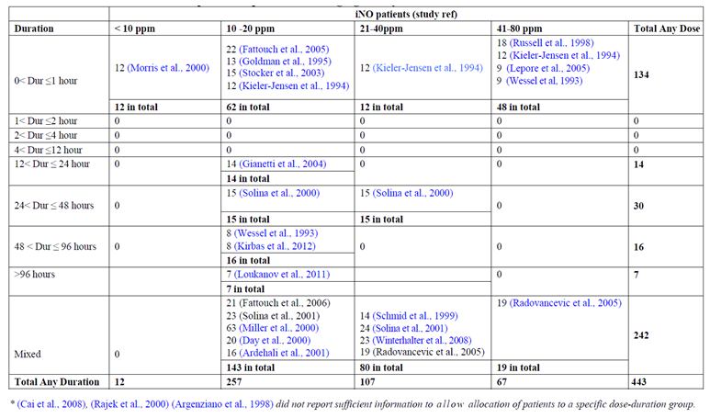

Table 80: Paediatric iNO exposure, by dose and duration
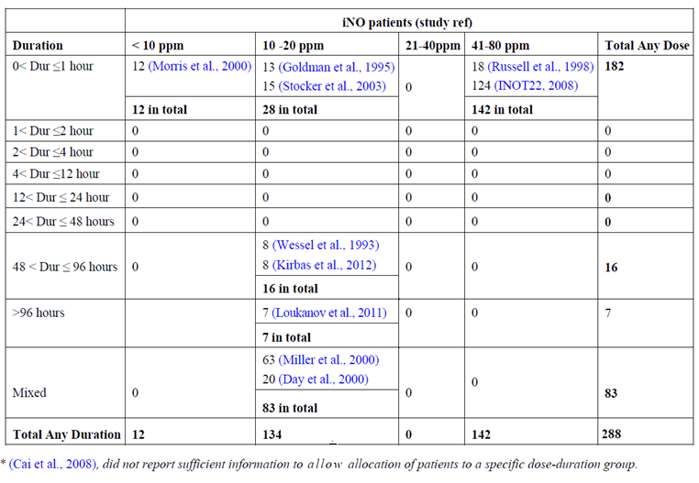

Table 81: Adult iNO exposure, by dose and duration
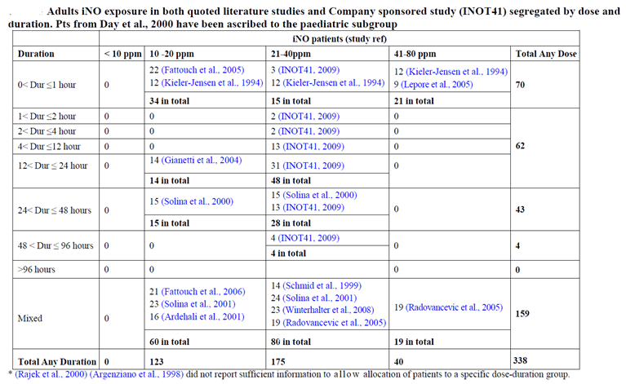
Exposure to iNO in sponsor led studies is summarised below: 69 adult subjects received 40 ppm in INOT41, and 124 paediatric subjects received 80 ppm in INOT22. INOT22 was classified as a PD study, and it did not specifically assess subjects in the context of cardiac surgery, but it provides the largest pool of comprehensive safety data in the submission. In this study, each patient served as their own control, and sequentially received iNO, oxygen and the combination of iNO and oxygen. Given that AEs could be delayed, and all subjects received all treatments, it would be difficult to determine whether any individual AE had been caused by one of the three treatment regimens, so even this data pool does not provide a clear placebo controlled context to assess the AE-rate observed with iNO.

Table 82: Patient iNO exposure in sponsor led studies (INOT22 and INOT41)
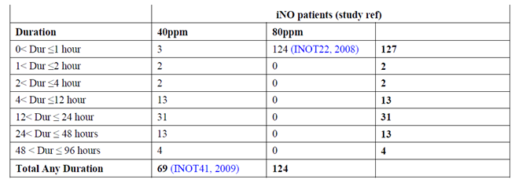
Overall, the quality of the safety data and the extent of exposure would be considered inadequate for the registration of a new pharmacological agent, but they are acceptable in the context of a drug that already has extensive post-marketing surveillance and is already being used off-label for the proposed indication.

Safety observations in individual studies

Paediatric studies relevant to the proposed indication
The multi-page table below (Table 83), prepared by the sponsor, lists the ten paediatric studies of direct relevance to the proposed indication (9 efficacy studies plus Wessel et al, 1993). The sponsor’s summary of the safety data in each study is contained in the right-most column; these summaries have been compared with the original publications in the preparation of this evaluation report, and they contain no significant distortions or inaccuracies. Specific comments on the safety reporting within each study can be found below, in Section 8.5.2.

Table 83: Safety overview in paediatric studies
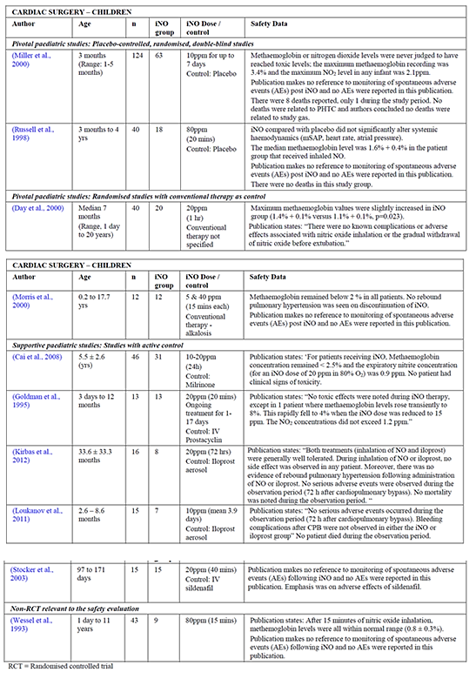

Adult studies
The Table 84, prepared by the sponsor, summarises safety data from adult studies in cardiac surgery patients, including five studies in non-transplant cardiac surgery, two in transplant surgery, three in pre-surgical cardiac assessment, and two in the setting of LVAD insertion. Most of these studies were described as supportive studies in the Efficacy section, but Lepore et al, 2005, was classified as a PD study. The sponsor’s summary of each study, in the right-hand column, has been compared with the original publications. No significant discrepancies were noted.
Most of the studies had little or no safety discussion beyond the reporting of metHb levels, but four studies (Fattouch et al, 2006; Winterhalter et al, 2008; Lepore et al, 2005; Argenziano, 1998) included an explicit claim that no major side effects or complications were observed. A more detailed assessment of each study can be found in Section 8.5.2.

Table 84: Safety overview in adult studies
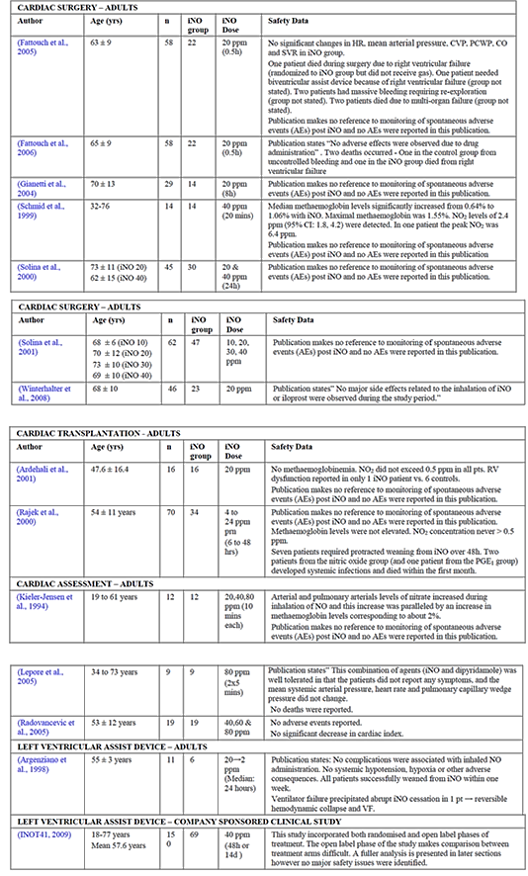

Adverse events

AEs in sponsor led studies with detailed adverse event reporting

INOT22
INOT22 was a pharmacodynamic study comparing the effects of iNO, oxygen and both in the treatment of pulmonary hypertension in children. All subjects received all three treatments, and served as their own controls, so no untreated control group exists to give context to the observed AEs. Seven patients (7 out of 124, 5.6%) experienced AEs during the treatment period, which included cardiac arrest, bradycardia, low cardiac output, elevated ST segments on the ECG, decreased oxygen saturation, hypotension, mouth haemorrhage, and pulmonary hypertension. In four patients, investigators indicated that the AEs were potentially related to study drug. These “related” events included bradycardia, low cardiac output, ST segment elevation, low oxygen saturation, pulmonary hypertension, and hypotension. AEs were observed in subjects with cardiomyopathy and in subjects with congenital heart disease (CHD) but not in those with idiopathic pulmonary arterial hypertension. (Not counted in the 7 AEs tabulated below were 4 SAEs that occurred shortly after the treatment period, and possibly other non-serious AEs that occurred outside the treatment period.)
In the absence of a control group, it is not possible to determine if this event rate (7 out of 124, 5.6% ) is excessive for the population being assessed. Exposure to iNO was brief, as shown in the table below, so the study was not a good test of the overall safety of iNO.

Table 85: Duration of exposure in INOT22
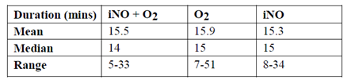

Table 86: Adverse events by diagnosis, INOT22
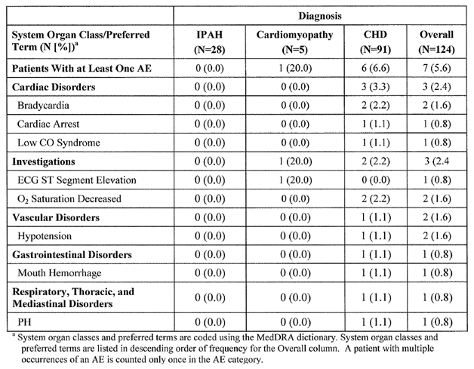

Table 87: Individual adverse events; INOT22
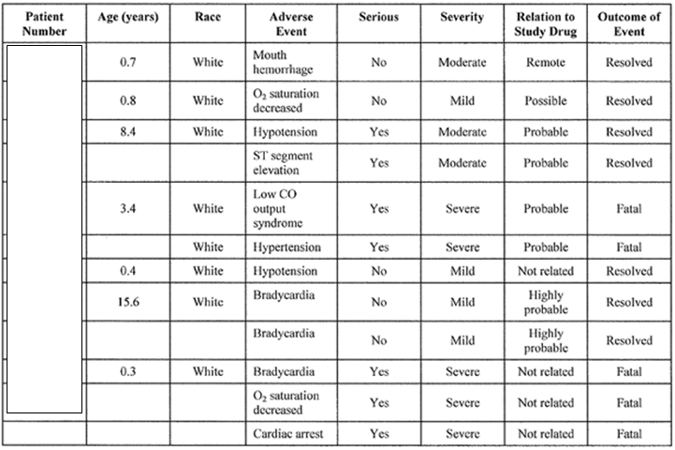
As discussed under “Serious adverse events”, iNO appeared to be poorly tolerated in 10 subjects with elevated PCWP at baseline, and an amendment to the exclusion criteria was made during the study to exclude patients that had a baseline PCWP of > 20 mm Hg. This means that the safety results of INOT22 could not be directly applied to a broader population that included subjects with elevated PCWP.

INOT41
INOT41 was a supportive efficacy study performed in adults undergoing LVAD insertion. It had a double blind, placebo controlled design, with comprehensive collection and reporting of AEs, so of all the submitted studies, it provides the best comparative database of the safety of iNO in the setting of cardiac surgery; albeit in adults. Assessment of AEs is complicated by the fact that some subjects subsequently switched to open label rescue therapy with iNO. Adverse events occurred at a similar incidence in the iNO (26.1%) and placebo groups (26.5%) during the blinded phase, but occurred in a higher proportion of subjects receiving open label iNO. This possibly reflects both the longer exposure to open label iNO, and the fact that subjects requiring open label therapy had more severe underlying cardiac or pulmonary disease.

Table 88: Duration of exposure, INOT41
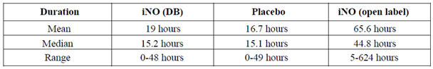

Table 89: Classification of adverse events in INOT41¹
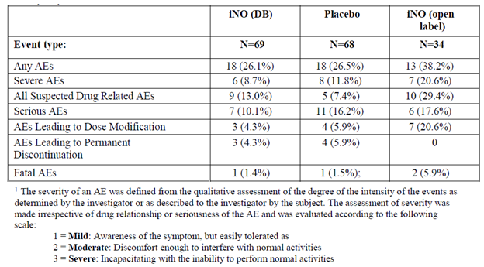
The distribution of AEs was similar in the two groups, based on counts for each organ class and for each individual type of AE. A complete listing of AEs reported in this study was provided.

AEs in published investigator led studies

Paediatric cardiac surgery studies
In seven of the nine paediatric efficacy studies, no AEs were reported in the iNO treatment groups, but the authors did not explicitly declare that no AEs occurred. The study population consisted of patients with serious congenital heart disease who were in intensive care receiving invasive ventilation, so it is very likely most subjects experienced an adverse event at some stage.
In the major efficacy study by Miller et al, 2000, the authors reported deaths in both the iNO and control groups, and Miller et al also reported the incidence of lung injury, but other AEs were not reported. These deaths are discussed in Section 8.5.5.2.
Miller et al reported the incidence of lung injury as follows:
“Most patients had no radiographic evidence of lung injury. The proportion of infants with a lung injury score of less than 1 was 82%, 59%, and 72% on days 0, 3, and 7, respectively. There were no differences between the treatment groups in lung injury scores on any day.”
In the context of a drug used in the cardiac surgical setting, time in ICU reflects both safety and efficacy, and is an indirect guide to the overall clinical significance of adverse events. Miller et al reported a non-significant reduction in ICU time in the iNO group: (median 138 h [IQR 89 to 192] for iNO versus 162 h [96 to 222] for placebo). This suggests that safety was acceptable.
In the pivotal study by Russell et al, 1998, AEs were not discussed. The authors noted that iNO was selective for the pulmonary circulation and systemic hypotension did not occur.
In the pivotal study by Day et al, 2000, the authors explicitly comment on the lack of AEs:
“There were no known complications or adverse effects associated with nitric oxide inhalation or the gradual withdrawal of nitric oxide before extubation. All patients completed the study and were weaned from assisted ventilation.”
The pivotal study by Morris et al, 2000, contained very little safety reporting, although the authors mentioned that they did not observe rebound pulmonary hypertension on ceasing iNO. Adverse events were not discussed directly, but the authors implied that safety was acceptable: “Inhaled NO therapy, on the other hand [in contrast to hyperventilation], results in selective pulmonary vascular effects and appears to be safe and free from serious side effects when administered in the dose range currently employed with appropriate monitoring of inhaled nitrogen dioxide and plasma methaemoglobin concentrations [emphasis added].”
In the supportive study by Cai et al, 2008, which compared iNO, milrinone and the combination of iNO and milrinone, AEs were not discussed. Time in ICU, which can be considered as an imprecise surrogate marker of significant adverse outcomes, was shortest for the iNO+Mil group, intermediate for the Mil group, and longest for the iNO group. The authors note: “Although the time in the intensive care unit and hospital tended to be shorter in group iNO+Mil, the difference was not statistically significant.”

Table 90: Other secondary outcomes related to iNO or Milrinone
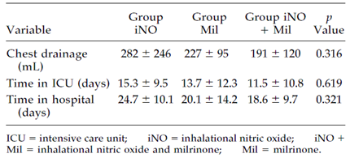
The supportive paediatric study by Goldman et al, 1995, reported deaths in both the iNO and control groups, but the study design meant that all patients, including control patients, were exposed to iNO:
“Inherent in the design of this study was that each patient would be continued on the treatment providing the greatest benefit to the patient. All 13 patients studied had a more favourable hemodynamic response to iNO than prostacyclin and were therefore continued on this treatment for 1 to 17 days (median, 6 days). Nine of the 13 patients continued to improve with iNO and survived to discharge from hospital. Four patients died even though they had also demonstrated an initial improvement with iNO.”
The four deaths are discussed in Section 8.5.5.2.
AEs were not reported by Goldman et al, but it would have been difficult to make sensible between group comparisons given that all subjects received iNO. It appears that the investigators did not notice any AEs they related to iNO, because they concluded:
“Inhaled nitric oxide, unlike intravenous prostacyclin, proved to be an effective selective pulmonary vasodilator, improved oxygenation, did not cause systemic hypotension, was associated with good clinical outcome, and appeared to lack significant toxicity at the doses and duration of administration used in the present study.”
In Kirbas et al, 2012, the authors explicitly commented that iNO was well-tolerated, no “side effects” (that is, treatment related AEs) occurred, and no SAEs occurred in the 72 h after CPB, but AEs were not systematically reported. They state:
“Both treatments (inhalation of NO and iloprost) were generally well tolerated. During inhalation of NO or iloprost, no side effect was observed in any patient. Moreover, there was no evidence of rebound pulmonary hypertension following administration of NO or iloprost. No serious adverse events were observed during the observation period (72 h after cardiopulmonary bypass). Patient [information redacted] in the iloprost group had thrombocytopenia (less than 70 000 platelets/µL) at Day 4 after cardiopulmonary bypass, which did not need to be treated because it spontaneously improved. No mortality was noted during the observation period. After the observation period, one in-hospital death was observed in the NO group; the patient died 14 days after surgery due to chronic respiratory failure.”
In Loukanov et al, 2011, AEs and SAEs were explicitly reported under the heading “Adverse Events” and the only two AEs occurred in the iloprost group, as follows:
“No serious adverse events occurred during the observation period (72 h after cardiopulmonary bypass). Patient [information redacted] of the iloprost group showed an increase in levels of C-reactive protein at 24 h after cardiopulmonary bypass. […]Patient [information redacted] of the iloprost group had thrombocytopenia count o < 50,000 platelets/µl at day 2 after cardiopulmonary bypass, which was treated with thrombocyte concentrate and immunoglobulin. In both instances, there was probably no correlation with the study medication because inflammation and thrombocytopenia are the known complications after cardiopulmonary bypass. Bleeding complications were not observed in either the iNO or the iloprost group.”
In Stocker et al, 2003, which used a randomised crossover design, comparing iNO with sildenafil, systemic hypotension and impairments in oxygenation were noted with sildenafil, but not with iNO. It is implied in the paper that the safety of iNO was acceptable, particularly in contrast to sildenafil. The authors comment:
“The study was terminated early because, having consistently observed these latter two important side effects of sildenafil which potentially outweighed any benefits in this stable group of infants, we did not feel justified in continuing the investigation further.”
In Wessel et al, 1993, which was categorised by the sponsor as a PD study but listed as a study providing relevant safety information, investigators administered ACH and iNO 80 ppm to paediatric subjects after CPB, comparing the pulmonary vasodilatory effects. Administration of iNO was only continued for 15 minutes. AEs were not explicitly discussed.

Adult cardiac surgery studies
In six of the seven studies in adult cardiac surgery patients (not including transplant patients, considered separately), no AEs were reported in the iNO treatment groups, but in most studies it was not explicitly stated that no AEs occurred. Only in Fattouch et al, 2006 and Winterhalter et al, 2008, was it explicitly stated that no major side effects were noted with iNO. In Fattouch et al, 2005, four adverse events of hypotension were reported, but these were restricted to the recipients of nitroprusside. In two studies of adult cardiac surgery patients, (Fattouch et al, 2005 and Fattouch et al, 2006), deaths were reported, these are considered in Section 8.5.5.3.
In Fattouch et al, 2005, the authors summarised safety-related outcomes as follows:
“Operative mortality was 1.7% (one patient died due to right ventricular failure). One patient needed biventricular assist device because of right ventricular failure. Two patients had massive bleeding requiring re-exploration. Hospital mortality was 5.1% (two patients died due to multi-organ failure and ARDS syndrome). There were no significant changes in HR, MAP, CVP, PCWP, CO, and SVR in patients receiving PGI2 and/or NO [as shown in efficacy tables]. Systolic and MAP decreased significantly in seven patients of Group C [the sodium nitroprusside group], requiring drugs interruption.”
This passage implies that 7 nitroprusside recipients required drug interruption, but in the discussion, the authors write: “Four patients treated with nitroprusside had severe hypotension episodes requiring drug interruption before PVR < 200 dynes sec/cm⁵”. They also mention that two of 14 prostacyclin recipients required drug interruption, but no mention is made of any iNO recipients requiring discontinuation of therapy, implying better tolerability for iNO.
In Fattouch et al, 2006, the authors included the following safety-related comments:
“Hospital mortality was 3.4% (one patient died for right ventricular failure in the iNO group and one for uncontrolled bleeding in the control group).”
“Patients in the control group needed higher doses of inotropic and vasopressor drugs than patients in the iNO and iPGI2 groups. No adverse effects were observed due to drug administration.” [Emphasis added.]
In Gianneti et al, 2004, the authors did not provide any explicit discussion of safety, though the authors noted that “NO and control [standard care] groups showed comparable results in term of arterial oxygen saturation and arterial tension of oxygen, time of intubation, time in intensive care unit, and post-operative ejection fraction (data not shown).”
In Schmid et al, 1999, discussion of safety was minimal, but the authors commented that “In-hospital outcome was favourable in all patients (Table 1), and all were discharged in good condition.” This study used a crossover design, so it would not have been possible to draw strong inferences from the incidence of AEs, even if these had been comprehensively reported.
In Solina et al, 2000, adverse events were not discussed, and safety-related observations were restricted to noting that the haemodynamic effect of iNO was relatively selective, leading to less systemic hypotension than observed with milrinone.
In Solina et al, 2001, adverse events were not discussed.
In Winterhalter et al, 2008, discussion of safety was minimal and AEs were not listed, but the following comment suggested similar tolerability of iNO and inhaled iloprost: “No major side effects related to the inhalation of iNO or iloprost were observed during the study period. Also, the vasoactive support used for weaning from CPB was comparable between the groups.”

Adult cardiac transplant studies
In Ardehali et al, 2001, the incidence of right ventricular dysfunction was lower in the iNO group than in historical controls, but AEs other than right ventricular dysfunction were not reported.
In Rajek et al, 2000, no AEs or deaths occurred within the treatment period, but two patients in the iNO group and one patient in the PGE1 group developed systemic infections that eventually resulted in death.

Adult cardiac assessment studies
Adverse events were not explicitly mentioned in Kieler-Jensen et al, 1994, Lepore et al., 2005, or Radovancevic et al, 2005.

Adult LVAD studies
In Argenziano et al, 1998, the authors state “No complications were associated with inhaled NO administration,” but this is immediately followed by a description of a serious event clearly related to abrupt cessation of iNO.
“In 1 patient dependent on inhaled NO, a ventilator malfunction on post-operative day 2 caused abrupt discontinuation of the gas, resulting in hemodynamic collapse and ventricular fibrillation. This patient was resuscitated and received a right ventricular assist device, which was removed successfully 3 days later, again with inhaled NO support. The patient was weaned from inhaled NO over the next 2 days and subsequently underwent transplantation.”
This event highlights an intrinsic risk of administering an important vasoactive drug through a ventilator; in the event of a ventilator malfunction, subjects will experience an abrupt drug interruption along with the other complications of ventilator malfunction.
The authors also describe two perioperative deaths (see Section 8.5.5.3). Apart from the ventilator malfunction and the two deaths, AEs were not discussed.
The only other LVAD study was a sponsor led study, described above (see Section 8.5.1.2).

Treatment related adverse events (adverse drug reactions)
Investigator led studies did not report the incidence of treatment related AEs. In the two sponsor led supportive studies, AEs were classified on the basis of their possible causal relation to treatment.
In INOT22, four subjects (3.2%) had at least one AE thought to be potentially related to the study drug. All subjects received iNO and so there was no untreated control group to provide context for the AEs. In two subjects, drug-related AEs led to discontinuation of iNO.

Table 91: Adverse events related to study drug by diagnosis, INOT22
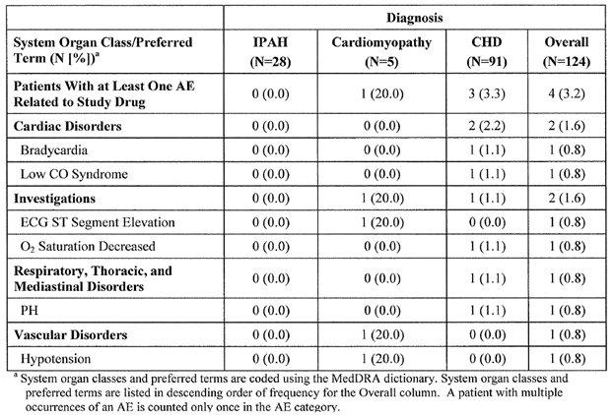
In INOT41, suspected drug-related AEs were more common with double blind iNO (9 subjects, 13.0%) than with double blind placebo (5 subjects, 7.4%). The incidence of drug-related AEs was even higher in the open label phase (29.4%), but this partly reflects the longer duration of open label treatment. As shown in the table below, the most common AEs in the iNO group where a causal role was thought possible were right ventricular failure and post-procedural haemorrhage. Right ventricular failure was less frequent with iNO, as discussed in the Efficacy section, so an adverse causal role for iNO in producing this AE seems unlikely. Similarly, in the overall post-marketing experience of iNO, bleeding has not emerged as a significant increased risk in iNO recipients (see Section 8.9.2).

Table 92: Adverse events in INOT41, severity and relatedness
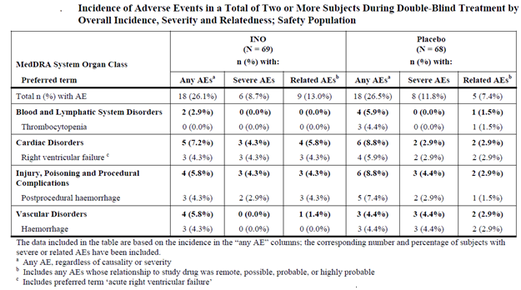

Serious adverse events
In general, investigator led studies did not formally report the incidence of SAEs, with the exception of Kirbas et al, 2012, and Loukanov et al, 2011. In both of these studies, it was stated that no SAEs occurred within the observation period.
In the two sponsor led studies, SAEs were explicitly reported and tabulated.
In INOT22, three SAEs occurred during the study period (listed below), and four additional SAEs occurred shortly after the treatment period, for a total of seven SAEs. Three of these were fatal.

Table 93: Serious adverse events, INOT22
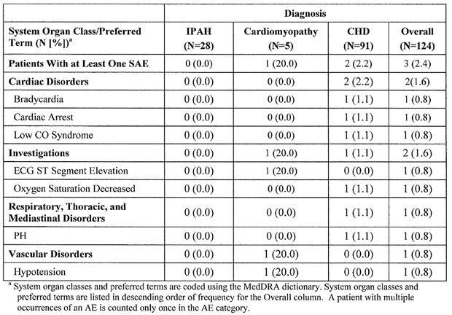
SAEs in the INOT22 study appeared to be more common in subjects with elevated left atrial pressure. At baseline, 10 of 124 patients (7.5%) had a PCWP ≥ 18 mm Hg; of these 10 patients, 3 had a SAE or were prematurely discontinued from the study, a serious event rate of 30%, compared to 6.5% for the entire cohort. Because of this, an amendment to the exclusion criteria was made during the study, to exclude patients that had a baseline PCWP of > 20 mm Hg.
In INOT41, during double blind treatment with iNO or placebo, the incidence of SAEs was lower in the iNO group (10%) than the placebo group (16.2%). After double blind treatment, patients were allowed to switch to open label iNO, which they received for much longer than they received double blind treatment. The fact that open label iNO was used in subjects who needed it – that is, in those with persistent pulmonary hypertension – as well as the longer exposure time, probably accounts for the higher incidence of SAEs with open label iNO than with double blind iNO or placebo.
The most common SAEs consisted of a need for renal replacement therapy, haemorrhage, and pyrexia; these AEs could be attributable to the underlying disease (severe cardiac failure) and the procedure (LVAD insertion). The incidence of these SAEs was generally similar in the iNO and placebo groups. The only SAE that was more common with double blind iNO than placebo was the need for renal replacement therapy (10 patients, 14.1% versus 8 patients, 11.4%) but this was not statistically significant.

Table 94: Incidence of serious adverse events during treatment, INOT41
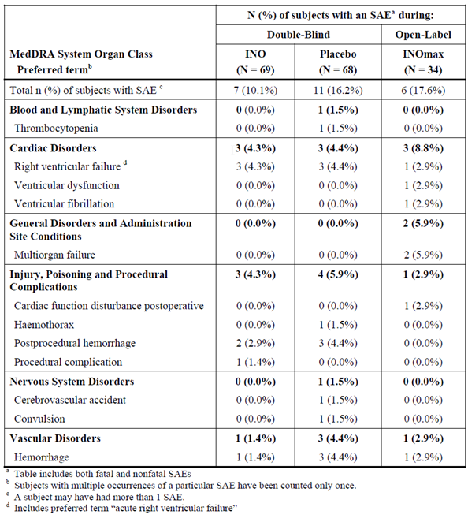

Deaths
Deaths in the submitted studies that occurred in iNO recipients within the study period are summarised in the tables below. No study was adequately powered to compare the mortality rate with iNO versus placebo or active controls, and the mortality data across different studies cannot be pooled given the different designs employed in different studies.
Many of the deaths occurred well after exposure to study drug, and, in the investigator led studies, no death was thought to be directly related to study drug. In INOT22, two deaths were thought to be potentially related to study drug, but no clear causal mechanism existed (see discussion below). In INOT41, three deaths were thought to be potentially related to study drug, but a review of these deaths did not suggest that iNO played a significant role.
Overall, the mortality rate in the submitted studies was broadly consistent with the expected mortality rate in a cardiac surgery population, and a review of the individual patient narratives did not raise any specific safety concerns, as discussed below.

Table 95: Deaths reported in published literature
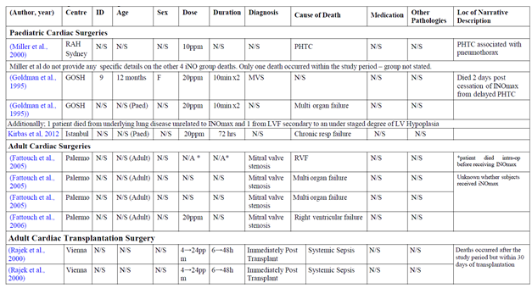

Table 96: Deaths in Study INOT22
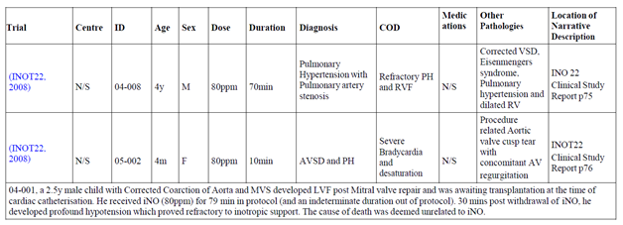

Table 97: Deaths in Study INOT41
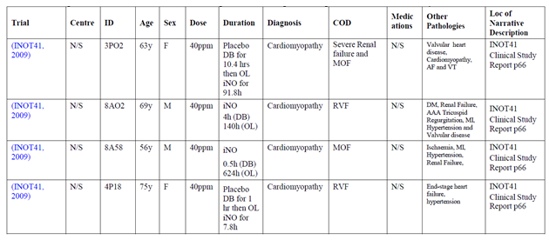

Deaths in sponsor led studies
There were three deaths reported in INOT22, two during the study period and one shortly after the treatment period.
One death occurred in a 4 year old boy with a history of congenital heart disease, increased right ventricular pressure, ventricular septal defect repair, pulmonary artery stenosis, transposition of the great vessels, balloon atrial septostomy, pulmonary hypertension, and Eisenmenger's syndrome. He underwent a cardiac catheter study for pulmonary artery stenosis and, during the procedure, was found to have severe pulmonary hypertension. Between receiving O₂ 100% and iNO 80 ppm, he was accidentally extubated. He was stabilised and continued with the study protocol, but while receiving iNO alone, he experienced severe hypotension with hypoxia and bradycardia. He was transferred to the intensive care unit but suffered a severe deterioration with pulmonary hypertension and right ventricular failure. Despite ongoing support with inotropes and iNO, he died the next day. The investigator deemed this event to have a “probable” relation to the study drug.
Another death occurred in a 4 month old girl with a history of congenital heart disease (atrio-ventricular septal defect) and secondary pulmonary hypertension. During catheterisation, the posterior aortic cusp was accidentally perforated, resulting in aortic regurgitation. Two hours after the procedure, she suffered oxygen desaturation and severe bradycardia. She required cardio-pulmonary resuscitation, which was unsuccessful. The investigator involved regarded the death as unrelated to study drug, but the medical monitor classified the event as “possibly” related to the study drug. It appears very likely the death was ultimately caused by the accidental perforation of the aortic valve.
Finally, a 2.5 year old boy with a history of coarctation of the aorta and severe cardiac failure was being worked up for a possible heart transplant, and received iNO 80 ppm for 79 minutes. Thirty minutes after withdrawal of iNO, he suffered hypotension, bradycardia, hypoxia, and cardiac arrest. Cardiac compressions and a dobutamine infusion were initiated and he recovered a normal rhythm. He was transferred to the intensive care unit. Treatment with dobutamine, sildenafil, and sedation was maintained during the next 72 hours. Catheterisation was repeated the next day to re-evaluate the pulmonary resistances and iNO was administered again, outside the context of the study protocol, along with an oral loading dose of sildenafil. There was no response in pulmonary pressure, which remained markedly elevated, and the patient died 8 hours after the procedure with refractory hypotension. The death was thought to be unrelated to iNO.
In INOT41, two deaths occurred due to RVF during double blind treatment, but they were balanced across treatment groups: 1 out of 69 (1.4%) in the iNO group and 1 out of 68 (1.5%) in the placebo group. The death in the iNO recipient was considered “remotely” related to study drug, and while the death in the placebo recipient was considered unrelated. Overall, RVF was less frequent with iNO.
Two more deaths occurred during open label iNO treatment. Both deaths were attributed to multi-organ failure and were considered to be “remotely” related to study drug. There is no evidence of a causal relation between iNO treatment and the deaths.

Table 98: Adverse events with a fatal outcome during treatment, INO41
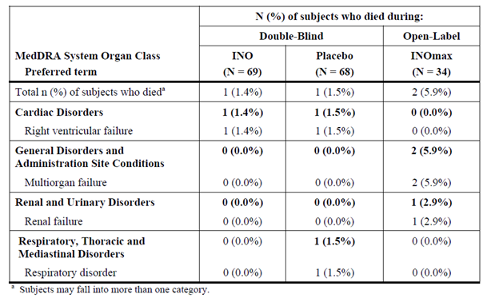

Deaths in pivotal studies
In Miller et al, 2000, the authors report 8 deaths as follows:
“There were eight deaths (6·5% of whole study group, five on nitric oxide, three on placebo; p = 0·49), 11 h to 42 days after surgery. This overall death rate is the same or less than that reported by other major centres for similar groups of high risk young infants who underwent surgery for congenital heart disease. Only one patient died while still in the study protocol (≤ 7 post-operative days). This patient, with truncus arteriosus and interruption of the aortic arch, died from surgical complications in the immediate post-operative period. Two patients died from low cardiac output (one after reoperation for mitral-valve replacement) and three died from sepsis .None of the six deaths was related to pulmonary hypertension. Only two patients (one in each group) died from suspected PHTC, each associated with pneumothorax, at 192 h and 222 h, respectively, after surgery. Thus none of the eight deaths seemed related to the effects of study gas.”
In Russell et al, 1998, no deaths were reported; it is not explicitly stated that no deaths occurred, but this seems likely. In Day et al, 2000, no deaths were reported; the authors propose that one of their control subjects avoided death by prompt commencement of rescue iNO. In Morris et al, 2000, deaths were not mentioned.

Deaths in other investigator led studies
Many studies either explicitly reported that no deaths occurred or implied that no deaths occurred.
In Goldman et al, 1995, four deaths were reported. Three were attributed to severe underlying lung disease, multi-organ failure or LVF. The fourth death was due to a fulminant hypertensive crisis two days after the cessation of iNO therapy; death was not thought to be related to previous iNO treatment and the authors stated that the patient did not survive long enough to restart iNO therapy.
In Fattouch et al, 2005, one patient died intra-operatively before receiving iNO and another two patients died “due to multi-organ failure and ARDS syndrome” but it was not stated which treatment these patients received.
In Fattouch et al, 2006, deaths were balanced across treatment groups: “Hospital mortality was 3.4% (one patient died for right ventricular failure in the iNO group and one for uncontrolled bleeding in the control group).”
In Ardehali et al, 2001, the 30 day survival in the iNO-treated group was 100% compared with 81% in the historical control group (three deaths).
In Rajek et al, 2000, no deaths were reported within the treatment period but two patients in the iNO group and one patient in the PGE1 group developed systemic infections that resulted in deaths within the first month post transplantation.
In Argenziano et al, 1998, two deaths were reported: “One occurred on post-operative day 1 and was due to intractable haemorrhage in a patient with multiple-system failure. The other occurred on post-operative day 3 and was due to brain death in a patient with an intraoperative cerebrovascular embolic event.”

Discontinuation due to adverse events
In the investigator led studies, discontinuations were not reported systematically, but in most studies it was implied that all subjects continued therapy for the protocol-specified period. (A couple of investigator led studies allowed switching to open label rescue iNO in the event of refractory pulmonary hypertension, so control therapy was discontinued; this is discussed in the Efficacy section.)
In the sponsor led studies, discontinuations were tabulated as shown below. In INOT22, two discontinuations were reported: one for hypotension and ST segment elevation, and one for reduced oxygen saturation. In this study, all subjects received iNO and there was no untreated control group to provide context for the AEs.
- An 8.4 year old girl with a history of cardiac valvuloplasty in the neonatal period, aortic stenosis, moderate aortic regurgitation, cardiomyopathy, and pulmonary hypertension experienced severe systemic hypotension after 4 minutes on iNO with 100% O₂; the iNO was discontinued and she was treated with 100% O₂ and a dobutamine infusion. She recovered normal blood pressure in 20 minutes.
- A 1 year old female with congenital heart disease, pulmonary hypertension and a history of a repaired ventricular septal defect experienced systemic desaturation (35%) 7 minutes after initiation of the third dose of iNO. The iNO was discontinued and the event resolved after 2 minutes. The patient also received concomitant treatment with intravenous midazolam and nalbuphine hydrochloride.

Table 99: Adverse events leading to withdrawal from treatment, INOT22
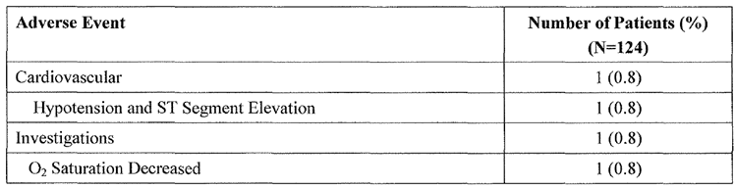
In INOT41, seven discontinuations were reported: three in the iNO group and four in the placebo group. Six of these discontinuations were related to right ventricular failure, and one was related to elevated central venous pressure.

Table 100: Adverse events resulting in permanent discontinuation, INOT41
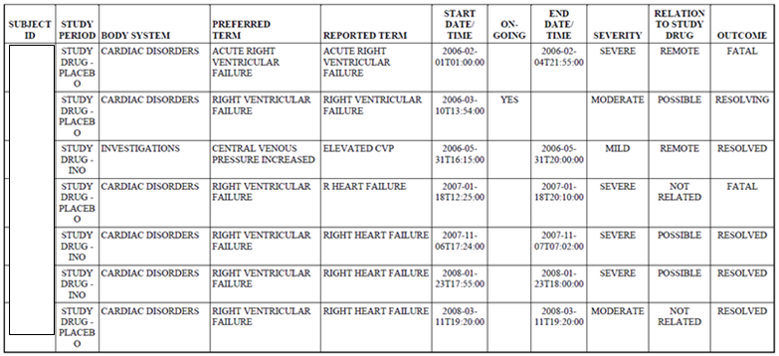

Elevated left atrial filling
In the sponsor led PD study, INOT22, SAEs or permanent discontinuations occurred in 3 of 10 subjects with elevated PCWP (30%), compared to only 6.5% of the full study cohort. This is in accord with other observations in the literature suggesting an increased risk of left ventricular failure or pulmonary oedema when iNO is administered to subjects with pre-existing left ventricular dysfunction.
Similar problems were not generally observed in the investigator led studies that formed the submission, but some authors commented on the issue. In Schmid et al, 1999, the authors reported that they did not observe adverse effects of iNO on increasing left atrial pressures in their own study subjects, but they noted that such adverse effects had been observed in other studies where left ventricular function was impaired. They made the comment:
“It is currently unclear whether volume shifts caused by selective pulmonary vasodilation, leading to an increase in pulmonary venous return to the failing LV or a NO induced attenuation of the positive inotropic response to β-adrenergic stimulation in humans with LV dysfunction, are responsible for the rise in LV filling pressure, but recent studies suggest that a negative inotropic action of iNO is unlikely.”
In Ardehali et al, 2001, the authors note that iNO had no effect on left atrial pressure in their own subjects, and they contrast to previous reports in which iNO caused increased PCWP. “In this study, NO did not induce any change in left atrial pressure. It is interesting to note that in patients with congestive biventricular failure, inhaled NO increased pulmonary capillary wedge pressure (PCWP), possibly due to pulmonary vasodilation, and augmented venous return to the left heart.”
In Kieler-Jensen et al, PCWP was increased with iNO, compared to baseline (28 ± 1 mm Hg at baseline, increased to 33 ± 1 with iNO 20 ppm, 32 ± 1 at 40 ppm and 33 ± 2 at 80 ppm.
In the Summary of Clinical Safety, the sponsor makes the following observations:
While inhaled NO appears to have no appreciable effect on the normal left ventricle (Budts et al., 2001), inhaled NO may increase left ventricular filling pressure (as measured by the pulmonary capillary wedge pressure [PCWP]) in some patients (Costard-Jackle & Fowler, 1992). However, in which patients this will occur cannot be accurately predicted a priori; it is far more likely to occur in patients that have left ventricular (systolic or diastolic) dysfunction with elevated PCWP at baseline. These patients are at risk of sudden onset of congestive heart failure with acute pulmonary oedema or cardiogenic collapse (Hayward et al., 1996), (Hayward et al., 1997). This effect appears to be pharmacologic in nature and in that sense, predictable (Bocchi et al., 1994).
This is a significant safety issue and it is important that clinicians using iNO are aware of it.

Laboratory tests

Methaemoglobin and NO₂
The use of iNO is potentially associated with the formation of methaemoglobin and toxic by-products, and most submitted studies reported the results of monitoring for these.

Methaemoglobin
Methaemoglobin (methemoglobin, metHb) is an alternate form of the main endogenous oxygen-carrying metalloprotein, haemoglobin (Hb), in which the iron in the heme group is in the Fe3+ (ferric) state, rather than the Fe2+ (ferrous) state of normal haemoglobin. The switch to the ferric state is encouraged by high concentrations of nitric oxide, and the main consequence is that the Hb is no longer available for carrying oxygen; this impairs the oxygen-carrying capacity of blood, potentially leading to tissue hypoxia.
There are many potential causes of methaemoglobinaemia, including genetic deficiencies (cytochrome b5 reductase deficiency, G6PD deficiency, haemoglobin M disease, pyruvate kinase deficiency) and a range of environmental and pharmacological exposures. Drugs that have been known to increase methaemoglobin levels include prilocaine, benzocaine, amyl nitrite, chloroquine, dapsone, nitrates, nitrites, nitroglycerin, nitroprusside, phenacetin, phenazopyridine, primaquine, quinones and sulfonamides. Also, as stated in the PI for iNO, neonates have diminished metHb reductase activity, and are therefore more vulnerable to drugs promoting formation of metHb.
MetHb levels are expressed as the percentage of total Hb that is in the ferric state, and up to 2% is normal. A rough guide to the significance of different metHb levels is as follows:
- 1 to 2% Normal
- Less than 10% metHb; No symptoms
- 10 to 20% metHb; Skin discoloration only (most notably on mucous membranes)
- 20 to 30% metHb; Anxiety, headache, dyspnoea on exertion
- 30 to 50% metHb; Fatigue, confusion, dizziness, tachypnoea, palpitations
- 50 to 70% metHb; Coma, seizures, arrhythmias, acidosis
- Greater than 70% metHb; Death.
Levels < 5% are generally considered to pose minimal risk. The previously approved PI recommends dose adjustment if levels exceed 2.5%.

Nitrogen dioxide
Nitrogen dioxide (NO₂) is a toxic compound that can produce lung injury with resulting pulmonary oedema. It can also precipitate asthma in susceptible individuals. The gas is acrid and usually detectable by smell, but low concentrations (4 ppm) can anaesthetize the nose. It is an environmental pollutant, with most atmospheric NO₂ arising from the burning of fossil fuels. It is also produced at low levels when iNO and oxygen are combined, with the rate of formation dependent on the levels of both NO and O₂. (It should not be confused with the sedative agent, nitrous oxide, which has the formula N₂O).
According to the National Environment Protection Council of Australia, a desirable level for nitrogen dioxide in outdoor air is 0.12 ppm over a one hour period or 0.03 ppm averaged over a one year period. According to the previously approved PI for iNO, “The upper limit of exposure (mean exposure) to nitric oxide for personnel (as defined by worker’s legislation in most countries including Australia) is 25 ppm for 8 hours (30 mg/m³) and the corresponding limit for NO₂ is 2 to 3 ppm (4 to 6 mg/ m³).” The PI recommends a downward dose adjustment if monitoring detects levels of > 0.5ppm.
Most submitted studies reported the results of monitoring for NO₂, as shown in the table below. Mean levels up to 2.4 ppm were observed in Schmid et al, 1999, after use of iNO 40 ppm. In the largest pivotal study, Miller et al, 2000, iNO was administered at a dose of 10 ppm, and all NO₂ levels were < 2.1 ppm. Overall, when iNO is administered at doses < 20 ppm, it does not pose a major risk of producing NO₂ toxicity, but it is important that monitoring remain in place during administration.
The proposed indication does not pose any substantial new risks with respect to metHb or NO₂ monitoring; the drug is already approved in neonates who would be expected to be one of the most vulnerable populations if subjected to high levels of metHb or NO₂.

Table 101: Methaemoglobin and NO₂ levels compared with controls in all literature studies
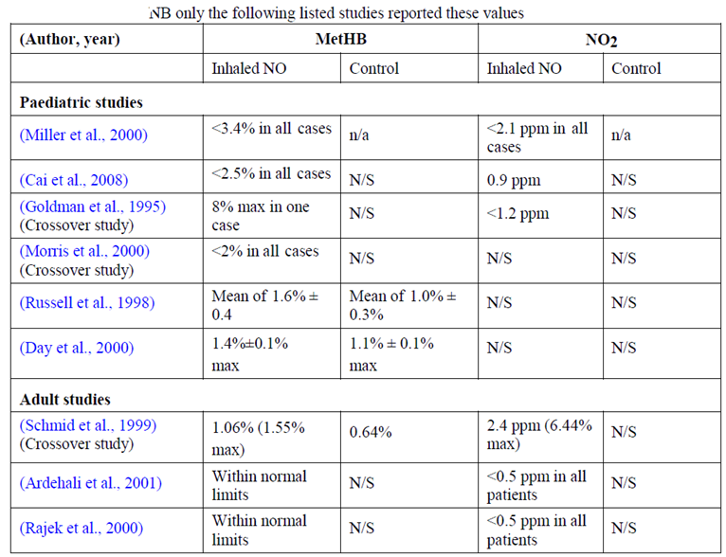
Quantitative values were not supplied in Kieler-Jensen et al, 1994, but the authors produced the following figure.
Figure 53: Nitrate and methaemoglobin during iNO treatment
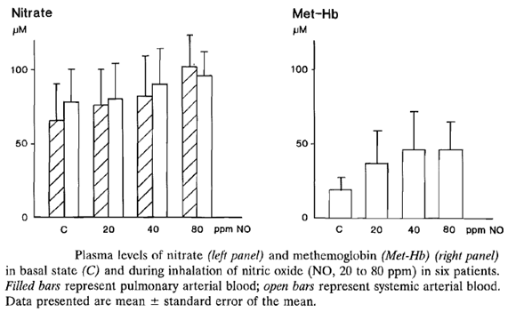
The submitted studies did not assess environmental exposures to NO₂ within the intensive care unit, due to leakage or exhalation of iNO, but this issue has been assessed previously. During standard usage and simulated leaking accidents, NO₂ levels did not reach concerning levels (Lindwall et al, 2006).

Liver function
Based on the original registration of iNO for the PPHN indication, and extensive post-marketing use, there is no suspicion that iNO is hepatotoxic. Monitoring of liver function would have been a normal part of post-operative care in nearly every submitted study, but the results were not systematically assessed or reported.
In INOT41, liver functions tests were monitored in all subjects. ALT and AST tended to decrease in the 48 hour treatment period in both treatment groups, probably reflecting improved cardiac function after insertion of an LVAD. The placebo group had lower baseline values, but the changes in AST and ALT were similar between the two treatment groups. Most subjects had AST and ALT values that were within normal limits, but 14 iNO recipients and 12 placebo recipients had AST or ALT values that were at least 10 times the upper limit of normal at baseline or at other time points. There was no overall concerning trend noted in these cases.

Kidney function
Previous experience with iNO has not suggested any adverse effect on renal function, and so most investigator led studies did not systematically report laboratory monitoring of kidney function, even though renal function was likely to have been closely watched in all post-operative patients. The sponsor stated that, in INOT41, renal parameters were similar in the two groups.
The need for renal replacement was one of the minor efficacy endpoints in Study INOT41. No significant difference was observed between the iNO and placebo groups, but there was a very slight excess of renal replacement therapy in the iNO group (iNO 10 patients, 14.1% versus placebo 8 patients, 11.4%).

Other clinical chemistry
Apart from metHb and NO₂ monitoring, already discussed, no other clinical chemistry was closely followed in any of the submitted studies.

Haematology
Because nitric oxide activates cyclic GMP, it is theoretically possible that it could modify platelet function, though it is likely to have only brief access to platelets because NO is rapidly taken up by haemoglobin.
The sponsor’s Risk Management Plan, the previously approved PI and the new proposed PI all contain the following comment: “Animal models have shown that nitric oxide may interact with haemostasis, resulting in an increased bleeding time. The clinical data in adult humans is conflicting, and there has been no increase in bleeding complications in randomised controlled trials in term and near term neonates with hypoxic respiratory failure.”
In most investigator led studies, haematological monitoring is likely to have been performed in all patients as part of routine peri-operative care, but the details were not reported. A review of the adverse events mentioned in those papers did not suggest that changes in cell counts or clotting parameters were a recognised complication of iNO therapy in any of the investigator led studies.
In the sponsor’s randomised, double blind study in LVAD patients, INOT41, no difference was noted between treatment groups in terms of haematological cell counts, blood loss, bleeding episodes or other signs of impaired coagulation.
The sponsor’s Summary of Clinical Safety refers to a couple of reassuring clinical studies in the literature, as follows:
“… data from humans have not identified signs or signals of an increased risk of bleeding from the administration of low clinical doses of inhaled nitric oxide. Similarly a low dose of 30 ppm inhaled nitric oxide in healthy volunteers did not cause significant change in bleeding time or platelet function as compared to placebo, while active control with aspirin caused an expected change in both parameters (Albert et al., 1999), (Breuer et al., 1998), (Mellgren et al., 1998), (de Mol et al., 2007). The effects on coagulation parameters of the clinical use of iNO in children having undergone cardiac surgery due to congenital heart disease have been studied by Breuer (Breuer et al., 1998) and in patients with inhaled NO the same pattern was observed and there was no difference between iNO treated and the control groups of patients. In children having received iNO before ECMO no signs of increased bleeding were observed in a study by de Mol (de Mol et al., 2007). There is also a study evaluating the effects on coagulation parameters in conjunction with the treatment in PPHN without showing any increased risk of bleeding (Beghetti et al., 1995).”
On balance, it does not appear that iNO poses any significant haematological risk, though it should remain a focus of post-marketing safety surveillance.

Electrocardiograph
Subjects in all submitted studies are likely to have had frequent ECG monitoring because this is a mandatory component of cardiac catheterisation and post-cardiac-surgery care. No investigators reported any consistent or concerning patterns in the ECGs of iNO recipients, though an abnormal ECG with ST segment elevation was a component of a previously discussed adverse event in a patient from INOT22.
In general, the effects of iNO on cardiac function have been neutral or beneficial, with some studies reporting improvements in cardiac index. As previously mentioned, iNO can increase left ventricular preload by vasodilating the pulmonary circulation, and this effect could cause problems in subjects with pre-existing left ventricular dysfunction. Resulting left ventricular strain or worsening failure could be manifest in the ECG, though this was not directly reported in any study.
Given that the haemodynamic effects of iNO were the principal focus of nearly every submitted study, and iNO has been used extensively in the intensive care setting for its approved indication as well as off-label for the proposed indication, there is no reason to suspect that iNO has any other adverse effects on cardiac function that would be manifested in the ECG.

Vital signs
No studies reported that iNO produced adverse changes in respiration or temperature. Most submitted studies specifically assessed the effect of iNO on pulmonary and systemic haemodynamics, so these factors have already been discussed extensively in the Efficacy section. Compared to other pulmonary vasodilators, particularly intravenous vasodilators, iNO poses much less risk of causing systemic hypotension.
Nonetheless, the sponsor provided a summary of the systemic blood pressure and heart rate changes reported in response to iNO, in both published studies and the sponsor’s own studies, as shown in the tables below. Overall, no concerning changes in vital signs were noted.

Table 102: Variation of MAP and HR between iNO and control groups across literature studies
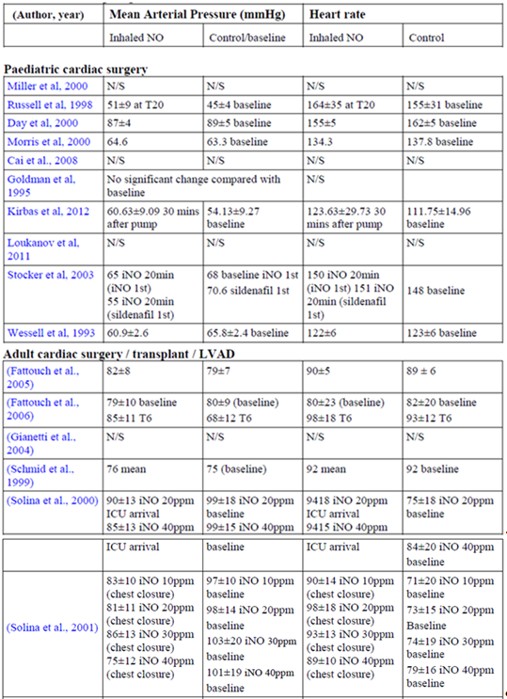

Table 102 (continued): Variation of MAP and HR between iNO and control groups across literature studies
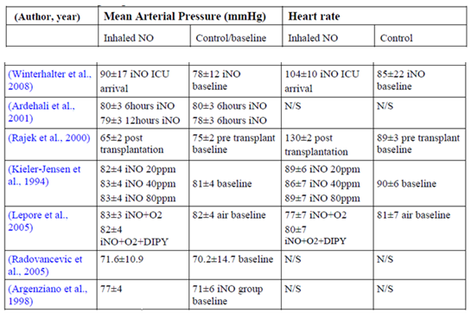

Table 103: INOT22: Vital signs – HR change from baseline by treatment (ITT)
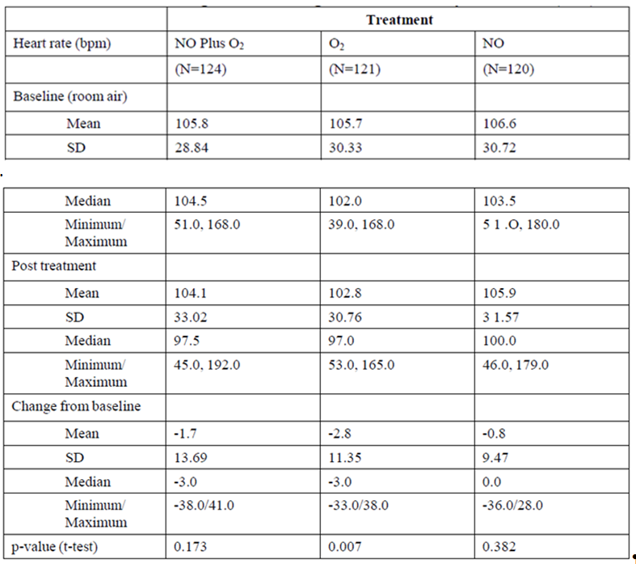

Table 104: INOT22: Vital signs – SAP change from baseline by treatment (ITT)
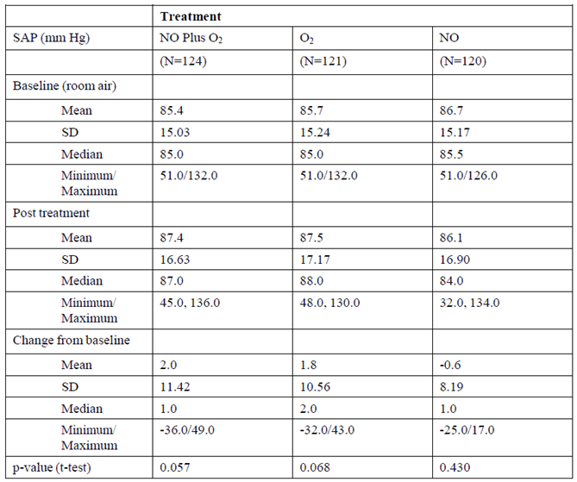

Post-marketing experience
There is extensive post-marketing experience with iNO, which has been approved for use in PPNH for many years and also used off-label for treatment of pulmonary hypertension in the setting of cardiac surgery, in both children and adults.
The sponsor summarised post-marketing exposure as follows:
- US; 497,458 patients
- Canada; 17,150 patients
- South America; 3,632 patients
- EU; 44,821 patients
- Australia; 4,821 patients.
Overall, the sponsor estimates that total number of exposed patients from marketing experience since 1999 is 603,449.
Since the original Australian approval on 16 November 2007, seven Periodic Safety Update Reports (PSURs) have been submitted. In the first two PSURs, no new safety signals were identified. In the third, the sponsor noted that iNO may exacerbate cardiac failure or cause pulmonary oedema in patients who have pre-existing left ventricular dysfunction, as reported in Study INOT22. In the fourth PSUR, no new safety signals were identified.
The most recent three PSURs were summarised by the sponsor in the Summary of Clinical Safety. The PSURs covering the periods ending on Dec 2011 and Dec 2012 identified no new safety signals. The sponsor’s summary of the most recent PSUR, covering the period ending Dec 2013, is reproduced below. The only new safety was retinopathy of prematurity (ROP), which was raised as a potential complication of iNO therapy in an investigator led study, subsequently described in a paper by van Sorge (2014). The authors performed a retrospective logistic regression study, looking for factors predisposing to ROP, and identified use of iNO as a potential risk factor (iNO; OR 2.6, 95% CI 1.1 to 6.2, P = 0.03). This approach is highly susceptible to confounding, because use of iNO was not randomised and subjects receiving iNO are likely to have been less well than subjects who did not receive iNO. A subsequent review of the Global Safety Database found only two reports of ROP and no evidence of an increased risk of ROP, so the sponsor rejected the claim that iNO increases the risk of ROP.
PSUR for INOmax (nitric oxide) for Inhalation, 24 December 2012 to 23 December 2013
In the current 1-year reporting period, 145 patients were enrolled in Ikaria sponsored clinical studies, and 265 subjects were enrolled in Investigator sponsored studies. It is estimated that a total of 603,449 patients worldwide have been treated with INOmax from international birth date (IBD) to 23 Dec 2013. During the review period, the RSI was modified in order to provide a more accurate description of the safety profile of INOmax. No signals were ongoing from the prior PSUR. One new signal, retinopathy of prematurity (ROP), was closed and refuted on the basis of equivalent incidence for INOmax and placebo in prospective, randomized, placebo controlled clinical trials, and rare post-marketing reports (2 over approximately15 years of real world use).
On balance, the on-going safety monitoring of iNO in the post-marketing setting has not detected any substantial new safety issues, though the PD study INOT22 confirmed other reports that there is an increased rate of pulmonary oedema in subjects with left ventricular dysfunction when they are exposed to iNO.
A full listing of all SAEs in the safety database, including those reported in clinical trials as well as post-marketing reports, were provided.

Safety issues with the potential for major regulatory impact

Liver toxicity
There is no evidence that iNO induces liver toxicity, but this issue was not directly addressed in any of the submitted studies. The original CER did not identify hepatotoxicity as a significant concern. The rapid binding of iNO to haemoglobin and its very short half-life (a few seconds at most) means that its effects are almost entirely limited to the lungs.

Haematological toxicity
As discussed, there is a theoretical basis for suspecting increased bleeding risk with iNO, and animal studies have suggested an increased risk of bleeding, but this has not emerged as a significant problem in the current submitted studies or in post-marketing surveillance.

Serious skin reactions
There are no reports of an increased risk of serious skin reactions with iNO.

Cardiovascular safety
As a vasodilator, inhaled nitric oxide has profound effects on the circulation, which underlie its efficacy in the treatment of pulmonary hypertension, but the effects appear to be beneficial in most cases. The efficacy and PD studies suggest that, compared to intravenous vasodilators, iNO is relatively pulmonary selective and therefore carries less risk of inducing systemic vasodilation and hypotension.
Three significant cardiovascular risks have been identified with iNO, which have already been discussed in this report, and which are acknowledged by the sponsor.
Firstly, abrupt cessation of iNO can cause rebound cardiovascular effects including pulmonary hypertension, bradycardia, and circulatory collapse. This represents a very serious safety issue, with potentially fatal consequences, but it is a manageable risk that is offset by the cardiovascular benefits that that are associated with iNO use, such as reduced risk of pulmonary hypertensive crises, reductions in right heart strain and improvements in ventilation-perfusion matching. Inhaled NO must be used in a monitored environment by intensivists or anaesthetists trained in its use, and the proposed PI and risk management plan (RMP) both clearly highlight the need to withdraw iNO slowly.
Secondly, by virtue of its pulmonary vasodilating effects, iNO can increase flow of blood through the lungs to the left atrium, increasing left atrial filling and left ventricular preload. In a patient with pre-existing left ventricular dysfunction, this could increase the risk of pulmonary oedema. Consistent with this, an excess of AEs was noted in subjects with elevated PCWP in the sponsor led study INOT22 (see Section 8.6). This effect has been noted by investigators in the literature, and it is already mentioned in the PI.
Thirdly, by lowering pulmonary vascular resistance, iNO could change the relative pressures between the left and right sides of the heart, modifying shunt flow. Although these effects would be expected to be favourable in most cases, some subjects with complex cardiac malformations and atypical cardiac physiology could be relying on shunt flows and they could experience a worsening of haemodynamics in response to iNO. The PI carries a warning to this effect, under “Contraindications”, where it lists “Neonates known to be dependent on right to left or significant left to right shunting of blood.” This warning is appropriate, even though it does not define what constitutes “dependence” on a shunt. Deciding on the correct management of such cases is likely to be an extremely difficult and highly specialised process, and individual clinicians involved in the care of such neonates will be in the best position to judge the suitability of iNO.

Unwanted immunological events
There was no evidence in the submitted studies of any unwanted immunological events.

Other safety issues

Safety in special populations
The safety of iNO in subjects in the age range 12 to 17 is only poorly characterised, because most paediatric cardiac surgery is performed sooner than this, and teenagers are generally too young to require surgery for typical adult conditions such as coronary artery disease or degenerative valve disease. Nonetheless, there is extensive experience in subjects younger and older than this age bracket, and there is no reason to suspect that the 12 to 17 year age group poses substantial new risks.
Because NO is rapidly absorbed in the lung and rapidly combines with Hb, with no hepatic metabolism, there is no reason to suspect that it poses substantially different risks in the setting of hepatic impairment. The most common metabolite of NO is nitrate, which is cleared by the kidneys. The nitrate is produced at low levels and poses no particular safety issues in subjects with renal impairment.
As already discussed, subjects with pre-existing left ventricular dysfunction and subjects dependent on intra-cardiac shunts may have adverse haemodynamic responses to iNO, and iNO should be avoided, or used with extreme caution in such patients.
Subjects with predisposition to methaemoglobinaemia (such as those with certain genetic deficiencies) should only use iNO if the perceived benefits outweigh the risk, and they should be carefully monitored for metHb levels.

Safety related to drug-drug interactions and other interactions
Two important categories of drug interactions pose significant safety risks with iNO.
Firstly, when used in combination with other vasodilators, iNO is likely to produce additive or synergistic vasodilation, which could have adverse haemodynamic consequences. This risk is lessened by the fact that iNO is relatively selective for the pulmonary vasculature. Given that iNO will be used in an intensive care setting with close haemodynamic monitoring, this is a manageable risk. The proposed PI does not list this as a risk under “Drug Interactions”, but this seems reasonable given that it is an obvious and predictable interaction.
Secondly, iNO combines with Hb to produce metHb, so it will increase the risk of significant methaemoglobinaemia if used in conjunction with other drugs that encourage formation of metHb. Such drugs include other nitrogen-based compounds (sodium nitroprusside, nitroglycerin) as well as many local anaesthetic agents, such as prilocaine, and also sulfonamides. The proposed PI appropriately raises this as a concern under “Drug Interactions”. This should also be a feature of post-marketing education programs.

Evaluator’s overall conclusions on clinical safety
The use of iNO poses a number of significant but manageable safety concerns, which are acceptable in the context of a drug used in intensive care to treat and to prevent life-threatening pulmonary hypertension in relation to cardiac surgery.
Levels of toxic nitric oxide by-products, including metHb and NO₂, need to be monitored in all recipients of iNO, but levels are expected to be within acceptable limits when the dose is kept ≤ 20 ppm. The proposed indication does not increase the risk of methaemoglobinaemia or elevated NO₂ compared to the existing indication. Occupational exposure to NO in medical and nursing staff is expected to be minimal.
The risk of methaemoglobinaemia can be increased by co-administration of iNO and other drugs, particularly NO donors such as nitroprusside, and some local anaesthetic agents. The PI carries warnings about this potential interaction, and monitoring for metHb would be expected to provide additional safeguards in the vent of inadvertent co-treatment with agents at risk of causing methaemoglobinaemia.
Inhaled nitric oxide causes pulmonary vasodilation, and this can have adverse consequences in patients with pre-existing left ventricular failure, or in infants relying on a particular level of cardiac shunting that could be modified by lowering resistance in the pulmonary vascular bed. This risk is intrinsic to the primary pharmacodynamic mode of action of iNO, and would be expected with any selective pulmonary vasodilator. The proposed PI carries adequate warnings about these risks, and the onus will be on clinicians to use iNO in appropriately targeted patients, and to monitor for adverse haemodynamic effects.
Abrupt withdrawal of iNO can produce rebound pulmonary hypertension. This effect was not well demonstrated in the submitted studies, because clinicians specifically avoided abrupt withdrawal, but weaning times were noted to be significantly longer in the main pivotal efficacy study.
Because it is a vasodilator, iNO would be expected to have synergistic effects when combined with other vasodilators. This is not likely to be a more significant issue with iNO than other agents used to treat pulmonary hypertension, and the onus will be on clinicians to use sensible combinations of agents and to monitor for hypotension or other adverse haemodynamic effects. The PI carries appropriate warnings about this.
The submitted studies, including supportive studies in adults, only provided limited evidence about the incidence of AEs and SAEs on iNO in relation to placebo, but there does not appear to be a significantly increased risk of adverse outcomes. No study has been adequately powered to demonstrate the effects of iNO on mortality rate, but mortality in the submitted studies did not appear to be increased with iNO. Of the deaths reported in the submitted studies, no concerning patterns emerged to suggest significant safety concerns with iNO. Instead, the efficacy data revealed a significant reduction in the incidence of PHTCs in children undergoing cardiac surgery (Miller et al, 2000), so there may be mortality benefits associated with the use of iNO, particularly in subjects at high risk of pulmonary hypertensive crises (PHTCs).
Theoretical considerations raise the possibility of increased bleeding with iNO, but this did not emerge as a significant issue in the submitted studies. The PI already carries appropriate warnings about this.
Extensive post-marketing experience with iNO has not significantly modified the safety profile of iNO since it was first registered. The published and post-marketing experience with iNO shows broadly similar safety across several different age groups, ranging from near-term or full-term neonates to elderly adults. There is relatively little experience with teenage patients, but the extensive experience in younger and older patients allows a reasonable interpolation of the safety profile to this age group.
Overall, the safety of iNO is acceptable, but it will need to be used by staff who have been trained in its use and who are familiar with its potential problems, and adequate monitoring will need to be in place. This is already the case for the existing indication, and the proposed indication does not raise substantial new safety concerns.

First round benefit-risk assessment

First round assessment of benefits
In the context of paediatric cardiac surgery, iNO significantly reduces pulmonary hypertension with subsequent improvements in right ventricular function, and it has been shown to prevent a significant proportion of pulmonary hypertensive crises. This would be expected to produce mortality benefits, but the design of the major efficacy studies included rescue therapy with iNO, limiting the ability of the studies to show a mortality benefit.
Because iNO is selective for the pulmonary vasculature, these haemodynamic gains can be achieved without causing systemic hypotension, as has been demonstrated in several efficacy and pharmacodynamic studies. By contrast, intravenous vasodilators often produced clinically significant systemic vasodilation and systemic hypotension. This partly reflects the different routes of administration, and other pulmonary vasodilators could offer similar benefits over intravenous agents, though none is currently registered for this indication.
Inhaled NO can also significantly improve oxygenation, presumably through improved ventilation perfusion matching.
When used pre-operatively, as part of vasoreactivity testing, iNO can identify surgical candidates with reversible pulmonary hypertension who might otherwise be considered ineligible for surgery.

First round assessment of risks
Inhaled NO carries a number of acknowledged and manageable risks.
Of the risks identified in the submitted studies, the following are considered the most important:
- risk of NO by-products; manageable through dose restriction and monitoring for NO₂ and metHb;
- risk of adverse haemodynamic effects; manageable through patient selection and monitoring (in particular avoiding use of iNO in subjects with elevated left atrial pressure, or subjects relying on right-to-left shunting, and monitoring subjects for systemic hypotensive responses or adverse modifications of shunt haemodynamics);
- risk during pregnancy; treatment during pregnancy should be avoided because of a complete lack of information about the safety of iNO in this setting. This situation is expected to arise relatively rarely in the paediatric setting, particularly because surgery for congenital heart disease is usually performed in the first few years of life, teenagers were not commonly treated in the paediatric studies, and severe cardiac disease is likely to lower fertility. Girls of child bearing age should be screened for pregnancy as part of the cardiac surgical work-up, and decisions would need to be made about the appropriateness of continuing the pregnancy and the timing of surgery.
The risks listed below are acknowledged by the sponsor in their RMP.

Table 105: Summary of safety concerns identified in RMP
Safety concerns
Important identified risks | Methaemoglinaemia
Important identified risks | Risk of acute cardiac failure with circulatory collapse in certain patient populations and  Risk of heart failure or pulmonary oedema in certain patient populations
Important identified risks | Rebound reactions (pulmonary hypertension) with abrupt withdrawal
Important potential risks | NO2 formation
Important potential risks | Increased bleeding time
Important potential risks | Critical failure of the delivery system
Missing information | Combined use with other vasodilators
Missing information | Use during pregnancy and lactation
Missing information | Paediatric use < 34 GA for PPHN, and patients 12 to 17 years treated for pulmonary hypertension in conjunction with heart surgery
Overall, the risks associated with iNO are adequately acknowledged in the PI and can be limited by the use of trained staff and appropriate monitoring.

First round assessment of benefit-risk balance
The benefit-risk balance of iNO in the proposed indication is favourable, because the risks that have been identified are manageable, the drug has proven efficacy in preventing or ameliorating life-threatening pulmonary hypertension, and no other standard agents are registered for this indication.
There is a general lack of efficacy and safety data in the age range 12 to 17 years, but the data in younger children and older adults show consistent effects, and there is no reason to expect that the benefit-risk balance is substantially different in teenagers compared to younger and older patients. Because congenital cardiac defects are usually corrected before the age of 12, and acquired cardiac diseases often appear in older adults, this intermediate age group is under-represented in the clinical studies, and evidence in this group is likely to remain relatively limited. The potential hazard of approving iNO prior to obtaining an extensive database in this age group must be balanced against the potential hazard of denying such subjects a treatment that works in younger and older subjects, and for which there is no currently registered alternative therapy.
To optimise the benefit-risk balance, care will need to be taken to ensure appropriate patient selection and ongoing vigilance in terms of monitoring during iNO use. Inhaled NO will need to be administered by staff specifically trained in its use.

First round recommendation regarding authorisation
Inhaled nitric oxide (INOmax) should be approved for the proposed indication, following revision of the PI.

Clinical questions
As already discussed, the investigator led studies were not always clearly described in terms of their primary endpoints, blinding techniques, and safety monitoring. By contrast, the sponsor led studies had clear prospective endpoints and comprehensive safety monitoring.
It is acknowledged that, in the setting of a literature-based submission, it may be difficult for the sponsor to provide full information on studies that they did not initiate or supervise. Nonetheless, the following clinical questions represent substantial unresolved issues arising from the submission.

General questions
- To what extent does the pulmonary selectivity of iNO reflect the proposed route of administration, rather than an intrinsic pharmacodynamic property of the drug?
- What effects does iNO have on the immune system and are these effects likely to be clinically relevant?

Questions related to specific studies
- Why did the pivotal study by Miller et al (2000) only recruit 124 patients after sample size estimations suggested that 136 subjects would be need to reach an adequate statistical power?
- Does the sponsor agree that, amongst time-based endpoints in the pivotal study by Miller et al (2000), they have misinterpreted the study by treating the time to meeting extubation criteria and the time to meeting weaning criteria as two different endpoints when they were actually the same endpoint?
- What statistical test was used to generate the p-value of 0.008 in the study by Russell et al (1998), as cited in the abstract? “Of the patients, 36% (n = 13) emerged from bypass with MPAP > 50% MSAP. In these patients, inhaled NO reduced MPAP by 19% (P = 0.008) versus an increase of 9% in the placebo group.” How does this p-value relate to the different p-value of 0.0016 shown for the 20 min time-point in the authors’ table, reproduced below?

Table 106: Percent change in post-bypass MPAP (MPAP > 50%MSAP)
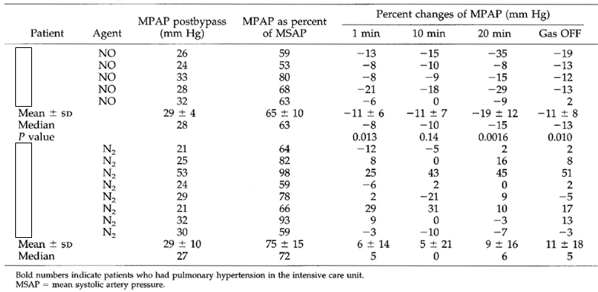
- Russell et al (2000) performed a subgroup analysis in which they assessed efficacy in 13 subjects who emerged from bypass with MPAP > 50% MSAP, and the significant efficacy results cited in the abstract were confined to this subgroup. Was this analysis and the precise definition of the subgroup declared prospectively, or was the analysis performed post hoc in response to the results?
- What was the statistical power of the study performed by Kirbas et al (2012)?
- What were the between group differences demonstrated by Fattouch et al (2005)? What did the ANOVA demonstrate?
- What drugs at what doses were administered in the study described by Fattouch et al (2006)?
Several authoritative bodies have endorsed the off-label use of iNO for the proposed indication, so additional expert input is not required.

Second round evaluation of clinical data submitted in response to questions

General questions
- To what extent does the pulmonary selectivity of iNO reflect the proposed route of administration, rather than an intrinsic pharmacodynamic property of the drug?
The sponsor responded (emphasis added):
“Animal and human studies have demonstrated that nitric oxide causes selective pulmonary vasodilatation, lowering PAP and pulmonary vascular resistance (PVR). Once inhaled, gaseous NO easily diffuses through the air–blood barrier into the pulmonary circulation and into vascular smooth muscle cells, increasing intracellular concentrations of cyclic Guanylate Monophosphate (cGMP) and promoting vasodilatation.
Once combined with haemoglobin in blood (RBC) inhaled nitric oxide is rapidly metabolized hence preventing the systemic vasodilatation, thus supporting current understanding that pulmonary selectivity of inhaled nitric oxide is dependent on route of administration. Hence, while it is likely that pulmonary selectivity of iNO is primarily driven by mode of inhalation [sic; The sponsor means ‘administration’ ] that is, inhalation, to date there are no human studies comparing relative selectivity of inhaled nitric oxide with NO donor compound, or other modes of administration in the same study.”
This is an acceptable response, consistent with the evaluator’s interpretation of the submitted studies. Inhaled NO is a useful agent to prevent or treat pulmonary hypertension in the setting of cardiac surgery, offering relative pulmonary selectivity in comparison to systemic intravenous vasodilators. As the sponsor concedes above, this selectivity is primarily likely to reflect the inhalational mode of administration, rather than resulting specifically from a greater NO sensitivity of the pulmonary vasculature than the systemic vasculature. The extremely rapid metabolism of NO assists in targeting the pulmonary vessels.
Because the selectivity arises largely from the mode of administration, other agents may eventually offer similar pulmonary selectivity if they are administered by the same inhalational route, and the proposed benefits for iNO may be less important in clinical practice when other inhalational vasodilators are available. Indeed, some of the studies reviewed here have already suggested that various inhaled agents have similar efficacy to iNO, even though such agents are not yet registered for this indication. For instance, Kirbas et al 2012 compared iNO and aerosolised iloprost, showing no difference in efficacy.
In terms of the regulatory decision to approve INOmax, this is not an important consideration, but it was appropriate to clarify this issue, for two reasons. Firstly, the sponsor should describe the evidence accurately in all future promotion of the drug; they should avoid implications that the compound itself is highly selective for the pulmonary vasculature. Secondly, the benefits demonstrated for INOmax in many of the submitted studies were benefits relative to intravenous vasodilators; these benefits may become less relevant in the future if other inhalational agents are approved. It is therefore appropriate to limit the claims made for INOmax now so that clinicians and regulatory authorities assessing the relative merits of those future agents are not given the false impression that INOmax is more selective than it is.
Comment: Advertising and other promotional materials for INOmax will therefore need to avoid claims that the drug itself offers unique pulmonary selectivity. The proposed PI was acceptable in this regard.
- What effects does iNO have on the immune system and are these effects likely to be clinically relevant?
This question was asked because some authors in the submitted studies noted that the effects of iNO on the immune system were unknown. For instance, Ardehali et al, 2001, raised the following safety concern: “The immunological properties of NO are incompletely understood. Low-level NO production appears to be necessary for maximal proliferation of lymphocytes. Furthermore, expression of inducible NO synthetase has been linked with acute solid organ rejection. On the other hand, activation of inducible NO synthetase is associated with a reduction in lymphocyte proliferation and inhibition of the expression of class II major histocompatibility complex. Further research in this area is needed to better elucidate the immunomodulating properties of inhaled NO in thoracic transplantation.”
The sponsor has responded as follows:
“Potential effects of iNO on the immune system can be derived from the chronic toxicity and carcinogenicity GLP study in rats (Study N005243) and the non-GLP safety and efficacy study in sheep (Study ABRAB1) with iNO. In both studies, no signals on the immune system were detected as evidenced by the absence of immune related haematological changes, alterations in immune system organ weights and/or histology, changes in serum globulins, increased incidence of infections, and an increased occurrence of tumours. In the 2 year rat study, a standard panel of haematology and clinical chemistry parameters were evaluated at 6 and 18 months of exposure, whereas in the 6-month sheep study, these parameters were evaluated on a monthly basis. In addition, no test article-related changes were noted in the inflammatory markers as measured in bronchoalveolar lavage (tissue kallikrein, myeloperoxide, alpha-1-protease inhibitor, and elastase) in the 6 month sheep study.
The absence of signals on the immune system in the nonclinical studies is in line with results in patients. Inhaled nitric oxide has been administered globally over more than two decades in hundreds of thousands of paediatrics and adults and has no known effects on immunocompetence / immunosuppression. In recent years, inhaled nitric oxide has been administered peri-operatively in transplant patients; no adverse effects to immune system have been reported to date.”
The evaluator agrees that the submitted clinical safety data showed no concerning signals suggesting an increased risk of infection in iNO recipients. It should be noted, however, that such a signal could be very difficult to detect given the nature of the submitted studies: adverse event collection was often informal or incomplete, and the studies were small and lacked the statistical power needed to detect an increased rate of infection. Although thousands of subjects have been exposed to iNO over the last couple of decades in the non-trial context, those subjects have primarily received the drug in an intensive care setting where the risk of infection is already high (because of invasive treatments, the requirement for artificial ventilation, and so on) and there was no control group with which to compare the incidence of adverse events. Infections in this context would generally be attributed to factors other than iNO, and even if iNO increased the incidence of such infections, this would not be apparent without a careful statistical analysis of subjects with and without iNO exposure. Such evidence is simply unavailable.
The lack of safety signals on this issue is, therefore, only partially reassuring. It seems unlikely that iNO has a major effect on immunocompetence, but a small effect cannot be excluded.
The sponsor made further comments on this issue in relation to the RMP, following a suggestion in the First Round Clinical Evaluation Report that immunological effects be listed as a “potential risk” in the RMP.
The sponsor provides the following justification for not listing any interaction with the immune system in the RMP as an additional safety concern:
- The referenced literature (Ardehali et al, 2001) by the TGA’s clinical evaluator suggests inconclusive and/or contradictory effect of NO on immune system.
- Nonclinical studies have not shown potential effects of iNO on the immune system based on the chronic toxicity and carcinogenicity GLP study in rats (Study N005243) and the non-GLP safety and efficacy study in sheep (Study ABRAB1) with iNO. In both studies, no signals on the immune system were detected as evidenced by the absence of immune-related haematological changes, alterations in immune system organ weights and/or histology, changes in serum globulins, increased incidence of infections, and an increased occurrence of tumours. In the 2 year rat study, a standard panel of haematology and clinical chemistry parameters were evaluated at 6 and 18 months of exposure, whereas in the 6 month sheep study, these parameters were evaluated on a monthly basis. In addition, no test article-related changes were noted in inflammatory markers as measured in bronchoalveolar lavage (tissue kallikrein, myeloperoxide, alpha-1- protease inhibitor, and elastase) in the 6 month sheep study.
- The absence of signals on the immune system in the nonclinical studies is in line with results in patients. In the prospectively designed, double blind and placebo controlled studies, such as CINRGI and NINOS, supporting initial Hypoxic Respiratory Failure indication registration, evaluation of incidence of infections was conducted. The suspected sepsis cases in CINRGI study were 59 out of 89 (66.3%) in placebo treated arm and 54 out of 97 (55.7%) in iNO treated arm (CINRGI CSR Table 68). The suspected sepsis/infection as cause of death in NINOS study was 4 out of 20 (20%) in placebo treated arm and 1 out of 16 (6%) in iNO treated arm (NINOS CSR Table 33).
- Inhaled nitric oxide has administered globally over more than two decades in hundreds of thousands of paediatrics and adults and has no known effects on immunocompetence / immunosuppression. In recent years, inhaled nitric oxide has been administered peri-operatively in transplant patients; no adverse effects on the immune system have been reported to date.
- The clinical study results and post marketing safety data stated in c and d above are consistent with the TGA clinical evaluator assessment, “No direct evidence of such an interaction was identified, and subjects did not appear to have an increased risk of infection, but the database is insufficient to draw strong conclusions”. This should be listed in the RMP as an additional safety concern, albeit one for which there is no evidence.
- Based on the definition of risk (Ref. EMA/838713/2012: Guideline on good pharmacovigilance practices. Module V—Risk management systems), the unknown effect of iNO on immune system does not qualify as a “potential risk”. Therefore, the sponsor does not agree that effect of iNO on immune system should be listed as a potential risk.
These comments appear reasonable on the whole, but the clinical evaluator still believes it would be appropriate to mention the issue in the RMP, with appropriate caveats based on the sponsor’s statements above. The sponsor should not be required to describe this issue as a “potential risk” in the sense of a definite risk for which there is good positive evidence, but completely omitting the issue from the RMP could imply complete confidence in the immunological safety of iNO, which is not appropriate given the paucity of clinical data addressing this issue. The clinical studies cited above (CINGRI and NINOS) were not part of the current submission, but the passages above indicate that the patient groups were relatively small. Also, if iNO is an effective treatment for Hypoxic Respiratory Failure in the Newborn (HRFN), as claimed, then it might reduce infective complications of respiratory failure in this patient group (such as ventilation associated pneumonia) by improving respiratory function, despite having some immunosuppressive actions; this would not be detected in a simple accounting of the number of infections in each treatment arm. Although the cited results suggest that, on balance, the infection rates were improved or unchanged with iNO in those studies of HRFN, relative to placebo, the balance could be different for other indications, such as prevention or treatment of pulmonary hypertension after cardiac surgery. In future, when other inhaled treatments for pulmonary hypertension are registered, it might be possible to resolve this issue more completely.
Overall, given the life-threatening nature of pulmonary hypertension in the context of cardiac surgery, the demonstrated benefits of iNO outweigh what is, at present, a purely theoretical concern about possible deleterious immune changes. As Ardehali suggests, further research on the issue would be appropriate.
An assessment of the animal studies that are mentioned above is beyond the scope of this clinical evaluation, but the Pre-clinical Evaluation should be consulted on this issue.
Comment: In conclusion, the sponsor’s response on this issue was acceptable, and this theoretical safety concern should not be a barrier to registration, provided the nonclinical evaluator agrees with the sponsor’s assessment of the animal data. It would nonetheless be appropriate to continue to monitor this issue in post-marketing surveillance programs, and to mention the issue in the RMP. Such a mention would not have to describe the risk in strong terms, and the sponsor would be justified in stating that there is no positive clinical evidence of risk. They would not be justified in stating that there is sufficient clinical data to dismiss this theoretical risk.

Questions related to specific studies
- Why did the pivotal study by Miller et al (2000) only recruit 124 patients after sample size estimations suggested that 136 subjects would be need to reach an adequate statistical power?
The sponsor has explained this discrepancy as follows:
“The principal investigator, Dr Miller has advised that the power calculation was performed on an estimated clinical change. During recruitment, the independent data and safety monitoring committee (NHMRC Clinical Trials Unit) reviewed all data for adverse outcomes. The monitoring committee was also able to perform interim analyses without unblinding the study as the data were kept securely offsite and the investigators were blind to the data.
Although the study had intended to recruit until the predetermined recruitment endpoint, various factors led to an earlier analysis of results.
- The primary research fellow who had been intimately involved with the study was about to return to Malaysia after a 3 year fellowship in Sydney.
- The principal investigator was about to relocate to London on sabbatical leave and for both these reasons it was decided to do a blinded evaluation of the data, which led to the decision of completion of the enrolment.
As it happened there was already a statistically significant difference at the lower number of subjects than predicted due to the marked difference in the primary outcome variable (number of Pulmonary Hypertensive Crises).”
In summary, the study was in part closed early for logistical reasons, related to the availability of the key investigators. From the sponsor’s description, it appears that the data were evaluated by a blinded committee, but the final decision to cease the study was not made in ignorance of the outcome of that blinded analysis. In fact, the comments from Dr Miller state that the evaluation of the data “led to the decision of completion of the enrolment”. It thus seems very likely that the principal investigator was happy to cease the study because a significant result had already been obtained. The implication is that, if the study had merely shown a favourable trend at that point, further patients would have been recruited and logistical arrangements would have been altered, prolonging the study in the hope of achieving significance with more patients.
This is a significant methodological issue. The decision to terminate a study early because it has achieved significance compromises the statistical purity of a study, because it gives the study more than one chance to achieve a significant result. (Indeed, even a random walk of random numbers can generate significance if one adopts a policy of waiting until the p-value crosses a threshold of 0.05 and then calling a halt to the sequence.)
It is very difficult to judge how important this effect is, in a particular study. If each chance at achieving significance were independent of each other chance, standard adjustments for multiplicity could be applied, but instead the premature results are a subset of the results that would have been obtained with a complete study, and the results at each stage therefore exhibit correlation with each other.
The study was terminated after recruiting 124 subjects, which is 91% of the planned target of 136. This is a much less serious case of premature closure than if recruitment had been far short of the target. The important question is how likely it was that 12 additional patients would have changed the final reported p-value to a non-significant result, had the study continued as planned (under the assumption of the null hypothesis of no treatment effect).
The answer to this question is unknown, but it is at least plausible that the study outcome might not have remained statistically significant. For the primary endpoint of number of PHTCs in this study, the result was borderline (p = 0.045) when considered with the appropriate adjustment for dispersion. The abstract states: “Compared with placebo, infants receiving inhaled nitric oxide had fewer PHTC (median four [IQR 0 to 12] versus seven [1 to 19]; relative risk, unadjusted 0·66, p < 0·001, adjusted for dispersion 0·65, p = 0·045)”. By another analysis method (Poisson regression without adjustments for dispersion), the statistical result was stronger (p < 0.001), but the adjusted p-value appears more reliable given the sparseness of the data. The p-value of 0.045 should therefore be considered the major statistical result of this study and, from a purist perspective; it stands in need of adjustment for the non-random, results-driven decision to terminate the study early. It is of some concern that neither the original authors of the paper nor the sponsor have acknowledged this point.
The published literature dealing with the issues surrounding early termination of trials is complex, but it has been suggested that inflation of the apparent treatment benefit is of more concern when termination occurs early, before 50% of the planned data has been collected (Freidlin and Korn, 2009). From this perspective, the early termination of Miller et al is of less concern, and the required adjustment of the p-value is likely to be small. The problem is that the p-value is already borderline. Even a minor adjustment of the p-value of 0.045 could be enough to make p > 0.05, and hence render this study formally negative.
Despite this issue, the weight of evidence suggests that iNO has efficacy. The secondary endpoints of Miller et al were positive, and the clinical endpoints in Miller et al were consistent with several other studies using haemodynamic endpoints. It is also possible that the study could have been terminated for the stated logistical reasons even if it had been negative; it is not possible to guess, years after the study, the exact intent of the principal investigator when the decision to terminate was made.
Comment: It could be argued that the submission should be rejected, on the basis of this methodological flaw in the only study worthy of being considered pivotal, but, on balance, the Clinical Evaluator feels that the overall weight of evidence is favourable. Although there is no single study that unambiguously and rigorously demonstrates a clear positive result for a well-defined, prospective endpoint, without methodological concerns, the Miller study comes very close to achieving this. Rather than being demonstrated in any single study, the efficacy of iNO is apparent in the mutual consistency of multiple flawed investigator led studies, including Miller’s study, and a couple of decades of experience with iNO, such that the overall balance of the evidence comes down narrowly in favour of registration. Nonetheless, in the interests of accuracy, this flaw should be mentioned in the Product Information sheet.
- Does the sponsor agree that, amongst time-based endpoints in the pivotal study by Miller et al (2000), they have misinterpreted the study by treating the time to meeting extubation criteria and the time to meeting weaning criteria as two different endpoints when they were actually the same endpoint?
The sponsor has provided two responses to this question. The first response was inadequate, and showed continued confusion about the number and identity of time based endpoints in the paper by Miller et al, as discussed below. When further explanations were provided, the sponsor conceded that they had been confused and they confirmed this with the original author of the paper.
The sponsor’s second response to this question reads as follows:
The sponsor (Ikaria, Australia) agrees with the clinical evaluator that “time to meet weaning criteria” and “time to meet extubation criteria” are both referring to T_{cr} in the Figure (below [see Figure 15]), which was associated with a time difference of 32 hours and a p-value of 0.019, and that Table 2 of the Summary of Clinical Efficacy and our associated description for the figure was therefore misleading.
Given this, the following comments, which relate to the sponsor’s first response, are now largely of academic interest, but they are included for completion.
In their initial response to this question, the sponsor appeared to misunderstand the basis of the question, and did not return to the original paper to reassess whether “weaning criteria” and “extubation criteria” could be the same thing or whether they could have confused the two terms. Instead, their answer spelled out the difference between the time to meeting weaning criteria (eligibility for weaning) and the time to “actual extubation”.
Dr Miller has advised that this study, although randomized, double blind and placebo controlled, was carried out in a busy real life paediatric intensive care unit (PICU). The reality of PICU life is that many uncontrollable factors will influence when a clinical task is undertaken. For example, changing of medication infusions often will occur at times when adequate numbers of staff are available for the necessary double checking of medications, endotracheal suction may occur to coincide with physiotherapy visits, and importantly extubation (where the endotracheal tube is removed from the airway) will routinely be done when appropriately trained staff are present to re-intubate the patient should they develop acute respiratory insufficiency. Typically extubation happens during daylight hours when more senior staff are available.
In addition to these human factors, the period of time between reaching eligibility and actual extubation needed a period of structured weaning form “study gas”.
Because of the potential for a pause in the weaning of study gas, the two endpoints had potential to be different but given the observed similar time points of time to extubation and actual weaning in both arms, there was no confounding effect observed on the end point.
Note that the question does not mention the time to actual extubation, which was reported unambiguously in the paper; nor does the question ask why extubation was delayed after subjects became eligible. The reasons for this delay were clear in the original paper. The questions asks whether the two expressions “time to meet criteria for extubation” and “time to meet criteria for weaning” actually refer to a single endpoint, as one reading of the paper suggests (and the author has since confirmed).
This question was raised because the study by Miller et al uses the expressions “extubation criteria” and “weaning criteria” (and variations of those terms) without providing contrasting definitions for each, and in some places the paper switches between the two terms without appearing to treat them as different variables. Also, the paper does not ever report different times or p-values for each of these expressions within the same paragraph.
In Miller et al, a figure was provided that showed numerical results for all of the important time-based endpoints; this figure is reproduced below with its original legend.
Figure 54: Hazard ratios (95% CI) for post-operative course with differences in median times
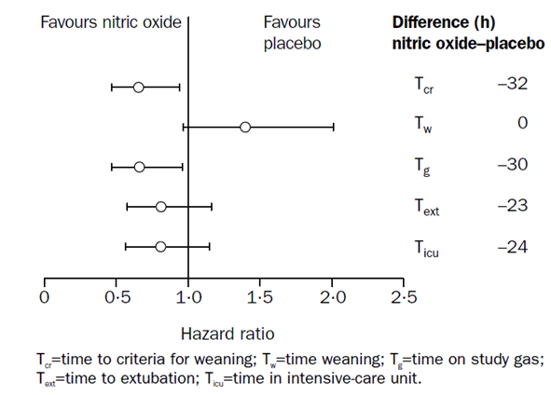
The following time based endpoints are included in the figure: T_{cr} (time to criteria for weaning), T_{w} (time weaning), T_{g} (time on study gas), T_{ext} (time to extubation), T_{icu} (time in intensive care unit). Note that the time to meeting “extubation criteria” is not among these displayed endpoints, and is not listed in the original paper’s figure legend, but the sponsor’s description of this figure in the sponsor’s Summary of Clinical Efficacy includes “time to meet criteria for extubation” in place of “time to extubation” (but otherwise keeps the order of the endpoints unchanged, making it clear that they thought T_{ext} referred to time to meet criteria for extubation):
“Figure 1 [the sponsor’s version of the same figure] below shows hazard ratios for time to meet criteria for weaning, time for weaning, time on study gas, time to meet criteria for extubation and time in intensive care unit.”
That is, in this context, the sponsor was prepared to treat “criteria for extubation” and “actual extubation” as synonyms (and this probably accounts for their original response to this Clinical Question: they thought the question referred to T_{cr} and T_{ext}, and was asking if these were the same endpoint, which they are obviously not). Note that the sponsor’s interpretation of T_{ext} as time to meeting extubation criteria must be mistaken because the time difference cited for T_{ext} in the figure above (23 hours) does not match the time difference cited in the paper for “times until criteria for extubation were met” (32 hours).
From the original paper’s abstract:
“Compared with placebo, infants receiving inhaled nitric oxide had fewer PHTC (median four [IQR 0 to 12] versus seven [1 to 19]; relative risk, unadjusted 0·66, p < 0·001, adjusted for dispersion 0·65, p = 0·045) and shorter times until criteria for extubation were met (80 [38 to 121] versus 112 h [63 to 164], p = 0·019).”
From the original paper’s Results section:
The median time to eligibility for extubation was shorter in the inhaled nitric oxide group than in the placebo group (80 [38 to 121] versus 112 h [63 to 164]; p = 0·019)
The only time-based endpoint in the figure that does match the 32-hour difference in the T_{ext} of the paper is T_{cr}, which has been explicitly labelled in the figure legend as “time to criteria for weaning”. The most likely explanation is that “time to criteria for weaning”, “time to weaning criteria”, “time to extubation criteria” and “ time to eligibility for extubation” are all different terms for the same endpoint, T_{cr}. The only plausible reason for the sponsor to reject the original, explicit label of T_{ext} provided in the paper, and to replace it with “time to meet criteria for extubation”, is that the sponsor did not realise that T_{cr} already covered this endpoint.
That the sponsor has interpreted time to weaning criteria and time to extubation criteria as two endpoints was apparent in Table 2 of the Summary of Clinical Efficacy, where the sponsor described two endpoints based on time to reach criteria, citing different statistical outcomes for each: time to reach “criteria for extubation” (p = 0.019), and time to reach “criteria for weaning” (p < 0.05).
“Patients on iNO had:
Shorter time to meet criteria for extubation (p = 0.019)
Shorter time to meet criteria for weaning (estimated difference: 32 hrs, p < 0.05)”
The passages from the original paper in the abstract and results section, cited above, suggest that the difference of 32 hours and the p-value of 0.019 both apply to the same endpoint. This is also suggested by the authors’ figure, which does not show two separate criteria-based endpoints, but instead includes a single criteria-based endpoint, T_{cr}. Another clue that the sponsor’s interpretation was faulty is evident in their use of “p < 0.05” in the T_{ext} cited above, instead of an explicit p-value; all p-values in the original text of Miller et al are cited with explicit numerical values, and it appears likely the sponsor had to resort to the inequality (“p < 0.05”) because they took the result from a figure, not from the text. In fact, no explicit p-value is provided in Miller’s paper for “time to meet weaning criteria”; the best explanation for this apparent omission is that this is not a different endpoint to “time to meet criteria for extubation”.
Other reasons for favouring the evaluator’s interpretation have been mentioned previously, but include the following comment in Miller et al: “Despite an increased weaning time, the total time on study gas (that is, time to extubation criteria plus hours required for weaning) was also significantly shortened...” In other words, total time on study gas = time to meet extubation criteria + time spent weaning; Tg = T_{cr}+Tw. For this to be true, weaning must have begun when subjects reached “criteria for extubation”, implying that these were also the criteria for commencing weaning.
The power calculations in the original paper also appear to switch from one usage to the other mid-paragraph, as though “criteria for weaning” and “criteria for extubation” were the same thing:
“For the effect of treatment on the time until the objective criteria for extubation were met, previous experience suggested that the average time to extubation was about 6 days (3·4).13 We required a 30% reduction (about 2 days) in the time to reach the criteria for weaning. To detect these reductions with 80% power at a two sided significance of 0·05, we needed to recruit 136 and 112 infants for these study endpoints, respectively.”
As noted previously, the sponsor’s assessment of this issue could have been further confused by a typographical error that crept into much of their discussion, suggesting a spurious time difference of 42 hours for this same endpoint, and preventing them from recognising this endpoint as the one already reported in the abstract with a 32 hour difference.
From the original paper:
“Compared with placebo, infants receiving inhaled nitric oxide had fewer PHTC (median four [IQR 0 to 12] versus seven [1 to 19]; relative risk, unadjusted 0·66, p < 0·001, adjusted for dispersion 0·65, p = 0·045) and shorter times until criteria for extubation were met (80 [38 to 121] versus 112 h [63 to 164], p = 0·019).”
From the SCE:
“Also, infants randomised to NO had shorter time until criteria for extubation were met (80 [38 to 121] versus. 122 h [63 to 164]; p = 0·019).”
From the proposed PI:
Miller et al (2000) also documented favourable outcomes for inhaled nitric oxide (iNO) patients on other secondary clinical endpoints such as shorter time until criteria for extubation were met (80 [38 to 121] versus. 122 h [63 to 164], p = 0.019) and shorter total time on study gas by 30 h for the nitric oxide group (87 [43 to 125] versus. 117 h [67 to 168], p = 0.023).
In conclusion, the sponsor’s original response to this question appears to have missed the point of the question. Their response explained why T_{ext} and T_{cr} are not the same thing, which was not at issue.
Comment: The sponsor has since conceded that their original interpretation of these results was mistaken, and they have confirmed this with the author of the paper. Ultimately, this does not affect the validity of the study, but care must be taken in describing the results accurately.
This residual point of confusion does not affect the proposed PI, because the disputed endpoint is not discussed in the PI.
- What statistical test was used to generate the p-value of 0.008 in the study by Russell et al (1998), as cited in the abstract? “Of the patients, 36% (n = 13) emerged from bypass with MPAP > 50% MSAP. In these patients, inhaled NO reduced MPAP by 19% (P = 0.008) versus an increase of 9% in the placebo group.” How does this p-value relate to the different p-value of 0.0016 shown for the 20 min time point in the authors’ table, reproduced below? (Table 106 above)
The sponsor writes:
“The p value of 0.008 is quoted in the abstract and study T_{ext} is the significance of the difference between iNO and placebo treatment on the % change in MPAP using the Mann-Whitney U-test. It is possible that the p values quoted in Table 2 of the publication relate to the significance of the % change in MPAP from baseline for the iNO-treated group, although the 4 p-values quoted in Table 2 are not mentioned anywhere else in the publication. Mention of the p value of 0.008 within the publication is not referenced to Table 2. Dr Russell was not able to confirm this specific detail for this 1998 publication.”
The sponsor has conceded that this discrepancy is not covered by the paper and that the paper does not explain the statistical test used to generate the p-values in this table. Even attempts to clarify the issue with Dr Russell directly have not been able to clarify how the p-value of 0.0016 was determined and how it differs from the p-value cited in the T_{ext} (p = 0.008). It seems likely that the p-value of 0.008 was generated by the Mann-Whitney U-test, as claimed, but the lack of clarity surrounding the analysis is concerning.
Comment: If the method of analysis used in Table 2 is unknown, the table is of no value. If it is assumed that the p-values of Table 2 represent changes within the iNO group, without reference to the placebo group, the analysis potentially conflates changes due to treatment with changes unrelated to treatment (such as spontaneous recovery), and hence the analysis would be of little value anyway. Table 2 should therefore be rejected, and the overall value and accuracy of the study should be considered compromised. Given that this was only one of two studies marked as a pivotal placebo controlled study, this weakens the overall submission.
- Russell et al (2000) performed a subgroup analysis in which they assessed efficacy in 13 subjects who emerged from bypass with MPAP > 50% MSAP, and the significant efficacy results cited in the abstract were confined to this subgroup. Was this analysis and the precise definition of the subgroup declared prospectively, or was the analysis performed post hoc in response to the results?
The reason this is important is that statistical tests should involve the testing of hypotheses that have not been cherry-picked to match the results. If the results are known first, and the hypothesis is then tailored to match those results retrospectively, the chance of achieving significance is artificially inflated, and significance can be obtained even in the absence of a true treatment effect.
The sponsor writes:
“The author, Dr Russell, has confirmed in an email reply to the sponsor that the analysis of outcomes by subgroup (MPAP > 50% MSAP post-surgery) was a predetermined study outcome, although this is not specified in the publication.”
The sponsor has conceded that the publication does not specify that the main reported primary analysis of this study was planned prospectively, and the sponsor has not provided any documents produced at the time of the study that confirm the prospective nature of the analysis. This is of substantial concern. Had the authors realised how important it is to specify endpoints and analysis methods prospectively, they should have mentioned this in their paper. Their failure to mention the issue suggests they did not consider it important. A mere assertion that the subgroup analysis was “a predetermined outcome”, given 15 years later, by email, does not carry much weight, particularly because the author is completely unable to account for the statistical analysis discussed in the previous question, suggesting poor documentation and a lack of overall clarity in the statistical analysis of this study.
Comment: While it is plausible (and indeed likely) that iNO is particularly effective in the subgroup of post-operative patients with elevated MPAP, it is not certain that this was formally tested as a prospective hypothesis by Russell et al. Overall, the study by Russell et al was not documented with the rigor expected of a pivotal study and it should be considered merely supportive of the sponsor’s overall claims of efficacy. In the context of several other clinical and pharmaco-dynamic studies suggesting a similar conclusion, this does not substantially detract from the overall weight of evidence.

Unresolved clinical questions
For the following three questions, the sponsor reports that they were unable to obtain any further information from the authors. These studies should therefore be considered to provide only minimal support for the sponsor’s claims of efficacy.
- What was the statistical power of the study performed by Kirbas et al (2012)?
- What were the between group differences demonstrated by Fattouch et al (2005)? What did the ANOVA demonstrate?
- What drugs at what doses were administered in the study described by Fattouch et al (2006)?
In the case of Kirbas et al, 2012, iNO was compared to an active control, and no between group differences were observed. Without a power analysis, it is not possible to infer whether the lack of significance represents a similarity of efficacy or instead reflects poor statistical power.
In the case of Fattouch et al 2005, the failure to report the ANOVA results means the study should be rejected.
In the case of Fattouch et al 2006, the failure to report the drugs being tested means the study should be rejected.

Second round benefit-risk assessment
The sponsor’s responses have clarified a number of important issues in relation to the studies by Miller et al and Russell et al, revealing that both of these studies, flagged as pivotal by the sponsor, contained methodological flaws. These flaws mean that the proposed benefits of iNO are less statistically certain than they at first seemed, but there is no strong reason to suspect that the overall benefit-risk balance is substantially different to that described in the first round clinical evaluation report (FRCER). That is, estimations of the benefit-risk balance suggest a similar overall balance, but the estimate is now surrounded by greater uncertainty.
In the case of Miller et al, the study was terminated early in response to an interim analysis showing it had achieved statistical significance; this decision means that the study had multiple potential ending times, multiple chances to achieve significance, and therefore stands in need of adjustment for multiplicity. No such adjustment was performed, and the borderline nature of the primary result (p = 0.045) raises the distinct possibility that the positive outcome of this study would have been negated if such an adjustment had been performed. From a purist perspective, the study should therefore be considered negative, unless the sponsor or the original authors perform a formal statistical analysis showing that the p-value remains significant after an appropriate adjustment.
The sponsor also conceded that they misinterpreted the secondary endpoints of Miller et al, but this makes no difference to the benefit-risk balance because it was assumed in the first round report that they were mistaken, and the FRCER adopted the correct interpretation.
In the case of Russell et al, the sponsor has passed on assurances from the original author that this study’s subgroup analysis was planned prospectively. No documentation was provided to back this up. This is a potential problem because positive results were only obtained in one small subgroup, subjects with elevated MPAP post-surgery. Given that this subgroup would be expected to be the main target group for iNO on the basis of other studies that have reached similar conclusions, this methodological flaw does not substantially change the benefit-risk balance, though it does suggest that the study lacked rigour. The original authors were also unable to explain the p-values declared in a secondary analysis, adding to the concerns about the rigour of this paper and suggesting it should be considered merely supportive. On balance, given the large number of other papers reaching similar conclusions, this does not change the benefit-risk balance.
The sponsor was unable to obtain information from the original authors in regard to three minor papers, but these papers did not contribute much to the benefit-risk assessment anyway.
With respect to safety issues, the sponsor has provided arguments suggesting that the risk of infection is not increased by iNO, and that the RMP does not need to mention theoretical concerns about the potential effects of iNO on the immune system. The evaluator concedes that there is no positive clinical evidence of an immunosuppressive effect, but nonetheless concludes that the current clinical data is inadequate to address this risk. Some mention should be made of this theoretical issue in the RMP.
In conclusion, the benefits and risks outlined in the FRCER appear unchanged by the new data, and remain positive. The new data reveal that no individual pivotal study demonstrated the efficacy of iNO with complete rigour, and, in particular, the response to clinical Question 3 raises concerns that the main study by Miller et al should be considered negative, from a purist statistical perspective. Despite this, the flaws in the individual studies are offset by the following:
- Multiple studies across multiple institutions, using both clinical and haemodynamic endpoints, have all been essentially concordant.
- The drug has been used off-label for a couple of decades for the proposed indication, with no concerns being raised about lack of efficacy.
- Experienced clinicians have been well-placed to observe its use directly in a closely monitored intensive care setting, so the safety issues are largely known.
- Several expert bodies have supported its use after considering much the same evidence as evaluated in this report.
Thus, despite the flaws of the individual submitted studies, the balance of evidence falls narrowly in favour of registration.

Second round recommendation regarding authorisation
The application to register iNO should be approved, following appropriate revision of the PI and RMP.
The revisions to the PI should include those already recommended in the first round clinical evaluation, which the sponsor has accepted.
A new statement should be added to the PI that acknowledges the early termination of the pivotal study by Miller et al and the resulting uncertainty about the statistical significance of the cited results.
The proposed wording of the extension of the indication is acceptable, and it is consistent with the submitted evidence. It could be argued that a formal document should not contain the split infinitive, “to selectively decrease”, but the current evaluator feels that split infintives have become part of modern English, and no changes are suggested. Similarly, it could be argued that “improve” is also part of an infinitive, and it should therefore be replaced by “to improve.”
“INOmax, in conjunction with ventilatory support and other appropriate agents, is indicated:
- for the treatment of term and near-term (> 34 weeks) neonates with hypoxic respiratory failure associated with clinical or echocardiographic evidence of pulmonary hypertension, in order to improve oxygenation and to reduce the need for extracorporeal membrane oxygenation.
- as part of the treatment of peri- and post-operative pulmonary hypertension in newborn infants, infants and toddlers, children and adolescents, ages 0-17 years in conjunction with heart surgery, in order to selectively decrease pulmonary arterial pressure and improve right ventricular function and oxygenation.”

References
Adatia, I. Inhaled nitric oxide in the treatment of post-operative graft dysfunction after lung transplantation. Ann Thorac Surg 1994; 57: 1311-1318.
Aguilaniu, B. et al. European reference equations for CO and NO lung transfer. Eur Respir J 2008; 31: 1019-1017.
Albert, J. et al. Inhaled nitric oxide does not influence bleeding time or platelet function in healthy volunteers. Eur J Clin Invest 1999; 29: 953-959.
Albin JE, et al. Nitric oxide production is required for murine resident peritoneal macrophage to suppress mitogen stimulated T-cell proliferation. J Immunol 1991; 147: 144.
Ardehali, A. et al. Inhaled nitric oxide for pulmonary hypertension after heart transplantation. Transplantation, 2001; 72: 638-641
Argenziano, M. et al. Randomized, double blind trial of inhaled nitric oxide in LVAD recipients with pulmonary hypertension. Ann Thorac Surg 1998; 65: 340-345
Bacha, E. Management of pulmonary arteriovenous malformations after surgery for complex congenital heart disease. J Thorac Cardiovasc Surg 2000; 119: 175-176
Barr, F. and Macrae, D. Inhaled nitric oxide and related therapies. Paediatr Criti Care Med 2010; 11(Suppl.): S30-36.
Beghetti, M. et al. Continuous low dose inhaled nitric oxide for treatment of severe pulmonary hypertension after cardiac surgery in paediatric patients. Br Heart J 1995; 1: 65-68
Beghetti, M. et al. Decreased exhaled nitric oxide may be a marker of cardiopulmonary bypass-induced injury. Ann Thorac Surg 1998; 66: 532-534
Bizzarro, M. and Gross, I. Inhaled nitric oxide for the post-operative management of pulmonary hypertension in infants and children with congenital heart disease. 2005 Cochrane
Bocchi EA, et al. Inhaled nitric oxide leading to pulmonary edema in stable severe left heart failure. Am J Cardiol 1994;74: 70-72.
Borland et al Endothelium in control. Br Heart J 1991; 66: 405-407
Breuer, J. et al. Effects of cardiopulmonary bypass and inhaled nitric oxide on platelets in children with congenital heart defects. Eur J Pediatr 1998; 157: 194-201.
Budts W et al. Residual pulmonary vasoreactivity to inhaled nitric oxide in patients with severe obstructive pulmonary hypertension and Eisenmenger syndrome. Heart 2001; 86: 553-558
Cai, J. et al. Nitric oxide and milrinone: combined effect on pulmonary circulation after Fontan-type procedure: a prospective, randomized study. Ann Thorac Surg 2008; 86: 882-888
Cecchia, P. et al. Review of inhaled nitric oxide in the paediatric cardiac surgery setting. Pediatr Cardiol, 2012; 33: 493-505
Costard-Jackle A and, Fowler MB. Influence of Preoperative Pulmonary Artery Pressure on Mortality After Heart Transplantation: Testing of Potential Reversibility of Pulmonary Hypertension With Nitroprusside Is Useful in Defining a High Risk Group. JACC 1992 19: 48-54
Curran, R. Inhaled nitric oxide for children with congenital heart disease and pulmonary hypertension. Ann Thorac Surg 1995; 60: 1765-1774
Daftari, B. Initial Experience with Sildenafil, Bosentan, and Nitric Oxide for Pediatric Cardiomyopathy Patients witElevated Pulmonary Vascular Resistance before and after Orthotopic Heart Transplantation. J Transplant 2010: 1-6
Database of Systematic Reviews (2005), Issue 4 Art. No.: CD005055. DOI: 10.1002/14651858.CD005055.pub2.
Day, R. et al. Randomized controlled study of inhaled nitric oxide after operation for congenital heart disease. Ann Thorac Surg 2000; 69: 1907-1913
del Nido, P. et al. Changes in pericardial surface pressure during pulmonary hypertensive crises after cardiac surgery. Circulation 1987; 73: 93-96.
de Mol, A. et al. Abnormalities of coagulation related to the use of inhaled nitric oxide before extracorporeal membrane oxygenation. Pediatr Crit Care Med 2007; 8: 261-263.
Efron DT, et al. Nitric oxide generation from LArginine is required for optimal human peripheral blood lymphocyte DNA synthesis. Surgery 1991; 110: 327.
Fattouch, K. et al. Inhaled prostacyclin, nitric oxide, and nitroprusside in pulmonary hypertension after mitral valve replacement. J Card Surg 2005; 20: 171-176
Fattouch, K. et al. Treatment of pulmonary hypertension in patients undergoing cardiac surgery with cardiopulmonary bypass: a randomized, prospective, double blind study. J Cardiovasc Med (Hagerstown ) 2006; 7: 119-123
Freidlin B, Korn EL. Stopping clinical trials early for benefit: impact on estimation. Clin Trials. 2009; 6: 119-125
Friesen, R. and Williams, G. Anesthetic management of children with pulmonary arterial hypertension. Paediatr Anaesth 2008; 18: 208-216
Germann P et al. Inhaled nitric oxide therapy in adults: European expert recommendations. Intensive Care Med. 2005; 31:1029–1041
Gianetti, J. et al. Supplemental nitric oxide and its effect on myocardial injury and function in patients undergoing cardiac surgery with extracorporeal circulation. J Thorac Cardiovasc Surg 2004; 127: 44-50
Girard, C. et al. Inhaled nitric oxide after mitral valve replacement in patients with chronic pulmonary artery hypertension. Anesthesiology 1992; 77: 880-883
Goldman, A., et al. Nitric oxide is superior to prostacyclin for pulmonary hypertension after cardiac operations. Ann Thorac Surg 1995
Griffiths, MJD and Evans T W. Inhaled Nitric Oxide Therapy in Adults N Engl J Med 2005; 353: 2683-2695
Hare JM, et al. Nitric oxide inhibits the positive inotropic response to beta-adrenergic stimulation in humans with left ventricular dysfunction. Circulation 1995; 92: 2198–2203
Hare, J. et al. Influence of inhaled nitric oxide on systemic flow and ventricular filling pressure in patients receiving mechanical circulatory assistance. Circulation 1997; 95: 2250-2253
Hayward CS et al. Inhaled Nitric Oxide in Cardiac Failure: Vascular Versus Ventricular Effects Journal of Cardiovascular Pharmacology 1996; 27:80-85
Hayward CS, et al. Effect of inhaled nitric oxide on normal human left ventricular function. J Am Coll Cardiol 1997; 30: 49 –56
Hopkins RA, et al. Pulmonary hypertensive crises following surgery for congenital heart defects in young children. Eur J Cardiothorac Surg 1991; 5: 628–634
INOT41, 2009. Inhaled nitric oxide in treatment of patients undergoing Left Ventricular Assist Device Insertion. Internal Study Report. INO Therapeutics LLC (USA)
Journois, D. et al. Inhaled nitric oxide as a therapy for pulmonary hypertension after operations for congenital heart defects. J Thorac Cardiovasc Surg 1994; 104: 1129-1135
Kieler-Jensen, N. et al. Inhaled nitric oxide in the evaluation of heart transplant candidates with elevated pulmonary vascular resistance. J Heart Lung Transplant 1994; 13: 366-375
Kirbas, A. et al. Comparison of inhaled nitric oxide and aerosolized iloprost in pulmonary hypertension in children with congenital heart surgery. Cardiol J 2012; 19: 387-394
Kuo PC, et al. Differential localization of allograft nitric oxide synthesis: comparison of liver and heart transplantation in the rat model. Immunology 1996; 87: 647
Lepore, J. et al., Combined administration of intravenous dipyridamole and inhaled nitric oxide to assess reversibility of pulmonary arterial hypertension in potential cardiac transplant recipients. J Heart Lung Transplant , 2005; 24: 1950-1956
Lai H –C et al Severe pulmonary hypertension complicates postoperative outcome of non-cardiac surgery British Journal of Anaesthesia 2007; 99: 184–190
Lindberg, L. et al., Nitric oxide gives maximal response after coronary artery bypass surgery. J Cardiothorac Vasc Anesth 1994.; 8: 182-187
Lindwall R et al Workplace NO and NO2 during combined treatment of infants with nasal CPAP and NO. Intensive Care Medicine 2006; 32: 2034-2041
Loh E, et al. Cardiovascular effects of inhaled nitric oxide in patients with left ventricular dysfunction. Circulation 1994; 90: 2780 –2785
Loukanov, T. et al. Comparison of inhaled nitric oxide with aerosolized iloprost for treatment of pulmonary hypertension in children after cardiopulmonary bypass surgery. Clin Res Cardiol 2011; 100: 595-602
Lundberg, J. and Weitzberg, E. Extrapulmonary effects of nitric oxide inhalation therapy: time to consider new dosing regimens? Crit Care 2008; 12: 406
McLaughlin V V et al ACCF/AHA 2009 Expert Consensus Document on Pulmonary Hypertension A Report of the American College of Cardiology Foundation Task Force on Expert Consensus Documents and the American Heart Association Developed in Collaboration With the American College of Chest Physicians; American Thoracic Society, Inc.; and the Pulmonary Hypertension Association. Journal of the American College of Cardiology 2009; 53: 1573-1619
Ma, M. et al. Causes of death after congenital heart surgery. Ann Thorac Surg 2007; 83:1438-1445
Mellgren, K. et al. Effect of nitric oxide gas on platelets during open heart operations. Ann Thorac Surg, 1998; 65: 1335-1341
Miller, O., et al. Very-low-dose inhaled nitric oxide: a selective pulmonary vasodilator after operations for congenital heart disease. J Thorac Cardiovasc Surg 1994; 108: 487-94
Miller OI, et al. Rebound pulmonary hypertension on withdrawal from inhaled nitric oxide. Lancet 1995; 346: 51–52
Miller, O. et al. Inhaled nitric oxide and prevention of pulmonary hypertension after congenital heart surgery: a randomised double blind study. Lancet 2000; 356: 1464-1469
Morris, K. et al. Comparison of hyperventilation and inhaled nitric oxide for pulmonary hypertension after repair of congenital heart disease. Crit Care Med 2000; 28: 2974-2978
Potapov, E. Inhaled nitric oxide after left ventricular assist device implantation: a prospective, randomized, double blind, multicenter, placebo controlled trial. J Heart Lung Transplant 2011; 30: 870-878
Radovancevic, B. et al. Nitric oxide versus prostaglandin E1 for reduction of pulmonary hypertension in heart transplant candidates. J Heart Lung Transplant 2005; 24: 690-695
Rajek, A. et al. Inhaled nitric oxide reduces pulmonary vascular resistance more than prostaglandin E(1) during heart transplantation. Anesth Analg 2000; 90: 523-530
Roberts, J.J. et al. Inhaled nitric oxide in congenital heart disease. Circulation 1993; 87: 447-453
Russell, I. et al. The effects of inhaled nitric oxide on post-operative pulmonary hypertension in infants and children undergoing surgical repair of congenital heart disease. Anesth Analg 1998; 87: 46-51.
Schmid, E. et al. Inhaled nitric oxide versus intravenous vasodilators in severe pulmonary hypertension after cardiac surgery. Anesth Analg 1999; 89: 1108-1115
Semigran MJ, et al. Hemodynamic effects of inhaled nitric oxide in heart failure. J Am Coll Cardiol 1994; 24: 982
Sichel SC, et al. Inhibition of macrophage I-A expression by nitric oxide. J Immunol 1994; 163: 1293
Solina, A. et al. Dose response to nitric oxide in adult cardiac surgery patients. J Clin Anesth 2001; 13: 281-286
Solina, A. et al. A comparison of inhaled nitric oxide and milrinone for the treatment of pulmonary hypertension in adult cardiac surgery patients. J Cardiothorac Vasc Anesth 2000; 14: 12-17
Stocker, C. et al. Intravenous sildenafil and inhaled nitric oxide: a randomised trial in infants after cardiac surgery. Intensive Care Med 2003; 29: 1996-2003
Turanlahti, M., et al. Nitric oxide, oxygen, and prostacyclin in children with pulmonary hypertension. Heart 1998; 79: 169-174
Turanlahti, M., et al. Preoperative and postoperative response to inhaled nitric oxide. Scand Cardiovasc J 2000; 34: 46-52
Turner-Gomes, S. et al. Abnormalities in von Willebrand factor and antithrombin III after cardiopulmonary bypass operations for congenital heart disease. J Thorac Cardiovasc Surg 1992; 103: 87-97
van Sorge A et al. Nationwide Inventory of Risk Factors for Retinopathy of Prematurity in the Netherlands. The Journal of Pediatrics. 2014; 164: 494-498
Wagner, F. et al. Nitric oxide inhalation in the treatment of right ventricular dysfunction following left ventricular assist device implantation. Circulation 1997; 96: II-6
Wessel, D. et al. Use of inhaled nitric oxide and acetylcholine in the evaluation of pulmonary hypertension and endothelial function after cardiopulmonary bypass. Circulation 1993; 88: 2128-2138
Winberg, P. et al. Effect of inhaled nitric oxide on raised pulmonary vascular resistance in children with congenital heart disease. Br Heart J 1994; 71: 282-786
Winterhalter, M. et al. Comparison of inhaled iloprost and nitric oxide in patients with pulmonary hypertension during weaning from cardiopulmonary bypass in cardiac surgery: a prospective randomized trial. J Cardiothorac Vasc Anesth 2008; 22: 406-413

Therapeutic Goods Administration
PO Box 100 Woden ACT 2606 Australia
Email: info@tga.gov.au Phone: 1800 020 653 Fax: 02 6232 8605
https://www.tga.gov.au

* Even the study by Miller et al, 2000, had a methodological issue, related to premature termination, that became apparent during evaluation of the sponsor’s response to questions raised (Section 12).
Hopkins RA, Bull C, Haworth SG, de Leval MR, Stark J. Pulmonary hypertensive crises following surgery for congenital heart defects in young children. Eur J Cardiothorac Surg 1991; 5: 628–34.
Miller OI, Tang SF, Keech A, Celermajer DS. Rebound pulmonary hypertension on withdrawal from inhaled nitric oxide. Lancet 1995; 346: 51–52.
Over-dispersion was not defined in the paper, but essentially refers to a higher-than-expected variance. A usual characteristic of the Poisson distribution is that its mean is equal to its variance. If the observed variance is greater than the mean, this is known as over dispersion, which indicates that a simple Poisson model is not appropriate. The authors reported unadjusted and dispersion-adjusted p-values. The latter should be considered more indicative of the true significance of the results.
All p-values cited in the text of the original paper are given specific values, rather than ranges such as “p < 0.05”; the Sponsor’s use of “p < 0.05” in their table suggests that they read the significance from a figure in the original paper rather than from the text. In the legend for the figure, the original authors (Miller et al) used the term “time to criteria for weaning”, whereas the text mostly referred to “time to meet criteria for extubation,” but they are likely to be the same thing. (The original authors, Miller et al, could have been clearer on this point.) The interpretation of these as the same endpoint is supported by the following comment in Miller et al: “Despite an increased weaning time, the total time on study gas (that is, time to extubation criteria plus hours required for weaning) was also significantly shortened...” In other words, total time on study gas = time to meet extubation criteria + time spent weaning; T_{g} = T_{cr}+T_{w}. For this to be true, weaning must have begun when subjects reached “criteria for extubation”. Extubation could not have taken place until weaning was complete, so the criteria could have been more clearly described as criteria for “beginning weaning with a view to extubation.” The original authors used both terms (“criteria for extubation” and “criteria for weaning”) in consecutive sentences in their description of the power calculations, apparently treating them as synonyms. The Sponsor’s interpretation of these terms as two different endpoints is also not consistent with the original paper’s Figure 3, which shows all important time-based parameters but only shows a single “criteria”-based endpoint. Thus, the Sponsor appears to have made a mistake in interpreting this study, but it does not affect the overall efficacy conclusions. The PI needs editing to correct the typographical error.
This sentence (bolded above) omits mention of the 1-min time period, but MPAP after 1 minute of treatment was also compared with baseline, as shown in the main results table. Confusingly, in another part of the text, the authors refer to four time-periods, including baseline, but they actually analysed four time-periods in comparison to baseline.
Although this hypothesis refers to PVR, not PVRI, all efficacy results were reported in terms of PVRI (which is essentially the PVR normalised for body size, calculated by dividing PVR by body surface area; it is expressed in Wood Units/m², or [mmHg·min/l]/m²).
The Fontan procedure is a palliative surgical procedure, used in children with congenital heart defects, that diverts venous blood from the right atrium directly to the pulmonary arteries without passing through the right ventricle.
The prostacyclin and nitroprusside doses described in the abstract are unlikely to be correct.
Among the coincidences: the subjects had the same number of patients; the incidence of sinus rhythm in the 2005 study was 8, 7 and 10 across the iPGI2,iNO iNO and NP groups, whereas the incidence of atrial fibrillation was 8, 7 and 10 in the 2006 study; the mediastinal blood loss in the two inhaled groups was exactly the same, including mean and standard deviations (iIGI2, 640 ± 220 mls;iNO iNO 580 ± 230 mls); causes of death were similar.
Units for measuring vascular resistance are dyn.s.cm⁻⁵, pascal seconds per cubic metre (Pa.s/m³) or, for ease of deriving it by pressure (measured in mm Hg) and cardiac output (measured in L/min) it can be given in mm Hg.min/L. This is numerically equivalent to hybrid reference units (HRU), also known as Wood units frequently used by paediatric cardiologists. To convert from Wood units to MPa.s/m³ you must multiply by 8, or to dyn.s.cm⁻⁵ you must multiply by 80.
Note that the Sponsor’s description of this study in Table 3 of their Clinical Overview reads “iNO significantly reduced PCWP and PVR at a dose of 20ppm.” This is an error, because the study actually showed a significant increase in PCWP at all three doses tested.
Throughout Potapov et al and the Sponsor’s description of this study, units of vascular resistance were mistakenly referred to as dyne/sec/cm⁻⁵ instead of dyne∙sec∙cm⁻⁵.
Efron DT, Kirk SJ, Regan MC, et al. Nitric oxide generation from LArginine is required for optimal human peripheral blood lymphocyte DNA synthesis. Surgery 1991; 110: 327. Kuo PC, Alfrey EJ, Krieger NR, et al. Differential localization of allograft nitric oxide synthesis: comparison of liver and heart transplantation in the rat model. Immunology 1996; 87: 647. Albin JE, Abate JA, Henry WL. Nitric oxide production is required for murine resident peritoneal macrophage to suppress mitogen stimulated T-cell proliferation. J Immunol 1991; 147: 144. Sichel SC, Vasquez MA, Lu CY. Inhibition of macrophage I-A expression by nitric oxide. J Immunol 1994; 163: 1293.
Loh E, Stamler JS, Loscalzo J, Colucci WS. Cardiovascular effects of inhaled nitric oxide in patients with left ventricular dysfunction. Circulation 1994; 90: 2780 –2785. Bocchi EA, Bacal F, Aulor JO Jr, et al. Inhaled nitric oxide leading to pulmonary edema in stable severe left heart failure. Am J Cardiol 1994; 74: 70 –72. Hare JM, Shernan SK, Body SC, et al. Influence of inhaled nitric oxide on systemic flow and ventricular filling pressure in patients receiving mechanical circulatory assistance. Circulation 1997; 95: 2250 –2253. Hare JM, Loh E, Creager MA, Colucci WS. Nitric oxide inhibits the positive inotropic response to beta-adrenergic stimulation in humans with left ventricular dysfunction. Circulation 1995;92: 2198–2203. Hayward CS, Kalnins WV, Rogers P, et al. Effect of inhaled nitric oxide on normal human left ventricular function. J Am Coll Cardiol 1997; 30: 49 –56.
Semigran MJ, Cockrill BA, Kakmarek R, et al. Hemodynamic effects of inhaled nitric oxide in heart failure. J Am Coll Cardiol 1994; 24: 982.
Lindwall R et al Workplace NO and NO2 during combined treatment of infants with nasal CPAP and NO. Intensive Care Medicine 2006; 32: 2034-2041

