January 2022

Australian Public Assessment Report for nirmatrelvir/ritonavir
  - Proprietary Product Name: Paxlovid
  - Sponsor: Pfizer Australia Pty Ltd

About the Therapeutic Goods Administration (TGA)
- The Therapeutic Goods Administration (TGA) is part of the Australian Government Department of Health and is responsible for regulating medicines and medical devices.
- The TGA administers the Therapeutic Goods Act 1989 (the Act), applying a risk management approach designed to ensure therapeutic goods supplied in Australia meet acceptable standards of quality, safety and efficacy (performance) when necessary.
- The work of the TGA is based on applying scientific and clinical expertise to decision-making, to ensure that the benefits to consumers outweigh any risks associated with the use of medicines and medical devices.
- The TGA relies on the public, healthcare professionals and industry to report problems with medicines or medical devices. TGA investigates reports received by it to determine any necessary regulatory action.
- To report a problem with a medicine or medical device, please see the information on the TGA website <https://www.tga.gov.au>.

About AusPARs
- An Australian Public Assessment Report (AusPAR) provides information about the evaluation of a prescription medicine and the considerations that led the TGA to approve or not approve a prescription medicine submission.
- AusPARs are prepared and published by the TGA.
- An AusPAR is prepared for submissions that relate to new chemical entities, generic medicines, major variations and extensions of indications.
- An AusPAR is a static document; it provides information that relates to a submission at a particular point in time.
- A new AusPAR will be developed to reflect changes to indications and/or major variations to a prescription medicine subject to evaluation by the TGA.

Copyright
© Commonwealth of Australia 2022
This work is copyright. You may reproduce the whole or part of this work in unaltered form for your own personal use or, if you are part of an organisation, for internal use within your organisation, but only if you or your organisation do not use the reproduction for any commercial purpose and retain this copyright notice and all disclaimer notices as part of that reproduction. Apart from rights to use as permitted by the Copyright Act 1968 or allowed by this copyright notice, all other rights are reserved and you are not allowed to reproduce the whole or any part of this work in any way (electronic or otherwise) without first being given specific written permission from the Commonwealth to do so. Requests and inquiries concerning reproduction and rights are to be sent to the TGA Copyright Officer, Therapeutic Goods Administration, PO Box 100, Woden ACT 2606 or emailed to <tga.copyright@tga.gov.au>.

Contents
List of abbreviations 4
I. Introduction to product submission 8
Submission details 8
Product background 10
Regulatory status 13
Product Information 14
II. Registration timeline 14
III. Submission overview and risk/benefit assessment 15
Quality 16
Nonclinical 16
Clinical 17
Risk management plan 88
Risk-benefit analysis 89
Outcome 95
Attachment 1. Product Information 97

List of abbreviations
Abbreviation | Meaning
ACE-2 | Angiotensin converting enzyme 2
ACM | Advisory Committee on Medicines
AE | Adverse event
ALT | Alanine transaminase
ASA | Australian specific annex
AST | Aspartate transaminase
aPTT | Activated partial thromboplastin time
ARTG | Australian Register of Therapeutic Goods
AUC | Area under the plasma concentration versus time curve
AUC_{inf} | Area under the plasma concentration versus time curve from time zero to infinity
AUC_{tau} | Area under the plasma concentration versus time curve for a dosing interval
AUC_{last} | Area under the plasma concentration versus time curve to the last measurable time point
BLQ | Below the limit of quantification
BMI | Body mass index
C_{12h} | Concentration at 12 hours
CC₅₀ | 50% cytotoxic concentration
CD4 | Cluster of differentiation 4
CI | Confidence interval
CL/F | Apparent oral clearance
CLr | Centred log ratio
C_{max} | Maximum concentration
C_{max,ss} | Maximum concentration at steady state
CMI | Consumer Medicines Information
C_{min} | Minimum concentration
COVID-19 | Coronavirus disease 2019
C_{trough} | Trough concentration
CYP | Cytochrome P450
CYP3A4 | Cytochrome P450 3A4
DBP | Diastolic blood pressure
DDI | Drug-drug interaction
DHCPL | Dear Healthcare Professional Letter
DLP | Data lock point
dNHBE | Differentiated normal human bronchial epithelium
EC₅₀ | Half maximal (50%) effective concentration
EC₉₀ | 90% effective concentration
E-DMC | Environmental Data Management Committee
eGFR | Estimated glomerular filtration rate
GVP | Good Pharmacovigilance Practices
EU | European Union
F1 | Relative bioavailability
FAS | Full analysis set
FDA | Food and Drug Administration (United States of America)
FIH | First in human
19F-NMR | Fluorine-19 nuclear magnetic resonance
HBcAb | Hepatitis B core antibody
HBsAg | Hepatitis B surface antigen
HCVAb | Hepatitis C virus antibodies
HIV | Human immunodeficiency virus
HPLC-MS/MS | High performance liquid chromatography with tandem mass spectrometry
IC | Inhibitory concentration
ICU | Intensive care unit
IIV | Inter-individual variability
IOV | Inter-occasion variability
K_{a} | Absorption rate constant
K_{i} | Inhibitory constant
LLN | Lower limit of normal
mAb | Monoclonal antibody
MATE1 | Multidrug and toxin extrusion protein 1
mITT | Modified intention-to-treat
OATP1B1 | Organic anion transporter family member 1 B1
PCD | Primary completion date
PCRU | Pfizer Clinical Research Unit
PF-07321332 | Drug development code for nirmatrelvir
PI | Product Information
PK | Pharmacokinetic(s)
PMAR | Population Modelling Analysis Report
PopPK | Population pharmacokinetic(s)
PSUR | Periodic safety update report
PT | Preferred Term
QTc | Corrected QT interval
∆∆QTcF | Placebo adjusted change from Baseline in the QT interval corrected for heart rate using Fridericia’s formula
QTcF | QT interval corrected for heart rate using Fridericia’s formula
RMP | Risk management plan
RNA | Ribonucleic acid
RT-PCR | Reverse transcription polymerase chain reaction
SAE | Serious adverse event
SAP | Statistical analysis plan
SARS-CoV-2 | Severe acute respiratory syndrome coronavirus 2
SBP | Systolic blood pressure
SD | Standard deviation
SE | Standard error
SmPC | Summary of product characteristics
SoA | Schedule of activities
SOC | System Organ Class
SIADH | Syndrome of inappropriate secretion of antidiuretic hormone
t_{1/2} | Terminal elimination half life
T₄ | Thyroxine
TEAE | Treatment emergent adverse event
T_{max} | Time at maximum concentration
TGA | Therapeutic Goods Administration
TSH | Thyroid stimulating hormone
ULN | Upper limit of normal
V | Volume of distribution
V/F | Apparent volume of distribution
VOC | Variant of concern
VOI | Variant of interest
UK | United Kingdom
U/L | Units per litre
US(A) | United States of (America)
WHO | World Health Organization

I. Introduction to product submission

Submission details
Type of submission: | New chemical entity
Product name: | Paxlovid
Active ingredients: | Nirmatrelvir/ritonavir
Decision: | Approved for provisional registration
Date of decision: | 18 January 2022
Date of entry onto ARTG: | 20 January 2022
ARTG number: | 377572
Black Triangle Scheme: | Yes.  As a provisionally registered product, this medicine will remain in the Black Triangle Scheme for the duration of its provisional registration.
Sponsor’s name and address: | Pfizer Australia Pty Ltd  Level 17, 151 Clarence Street  Sydney NSW 2000
Dose form: | Film-coated tablet
Strengths: | Each nirmatrelvir tablet contains 150 mg of nirmatrelvir.  Each ritonavir tablet contains 100 mg ritonavir.
Container: | Blister card
Pack sizes: | A carton of 30 tablets in 5 blister cards, each blister card contains 4 nirmatrelvir and 2 ritonavir tablets.
Approved therapeutic use: | Paxlovid has provisional approval for the treatment of coronavirus disease 2019 (COVID-19) in adults 18 years of age and older, who do not require initiation of supplemental oxygen due to COVID-19 and are at increased risk of progression to hospitalisation or death (see Section 5.1 Pharmacodynamic properties, Clinical trials).  The decision has been made on the basis of short term efficacy and safety data. Continued approval of this indication depends on the efficacy and safety data from ongoing clinical trials and post-market assessment.
Route of administration: | Oral
Dosage: | Nirmatrelvir must be taken together with ritonavir. Failure to correctly take nirmatrelvir with ritonavir will result in plasma levels of nirmatrelvir that will be insufficient to achieve the desired therapeutic effect.  The recommended dosage is 300 mg nirmatrelvir (two 150 mg tablets) with 100 mg ritonavir (one 100 mg tablet) taken together orally every 12 hours for 5 days.  Paxlovid should be taken as soon as possible after a diagnosis of COVID-19 has been made and within 5 days of symptoms onset.  Paxlovid (both nirmatrelvir and ritonavir tablets) can be taken with or without food. The tablets should be swallowed whole and not chewed, broken, or crushed.  For further information regarding dosage, refer to the Product Information.
Pregnancy category: | B3  Drugs which have been taken by only a limited number of pregnant women and women of childbearing age, without an increase in the frequency of malformation or other direct or indirect harmful effects on the human fetus having been observed.  Studies in animals have shown evidence of an increased occurrence of fetal damage, the significance of which is considered uncertain in humans.  The use of any medicine during pregnancy requires careful consideration of both risks and benefits by the treating health professional. This must not be used as the sole basis of decision making in the use of medicines during pregnancy. The TGA does not provide advice on the use of medicines in pregnancy for specific cases. More information is available from obstetric drug information services in your State or Territory.

Product background
This AusPAR describes the application by Pfizer Australia Pty Ltd (the sponsor) to register Paxlovid (nirmatrelvir/ritonavir) 150 mg nirmatrelvir film-coated tablets and 100 mg ritonavir film-coated tablets for the following proposed indication:
Paxlovid is indicated for treatment of COVID-19 in adults who do not require supplemental oxygen and who are at increased risk for progressing to severe COVID-19.
Severe acute respiratory syndrome coronavirus 2 (SARS-CoV-2) is an enveloped, positive sense, single stranded ribonucleic acid (RNA) betacoronavirus which was first identified following reports of a cluster of acute respiratory illness cases in December 2019. The virus causes a respiratory illness in people known as coronavirus disease 2019 (COVID-19), which is thought to spread primarily via respiratory droplets and aerosol transmission between people who are in close contact. The average incubation period is between 5 to 6 days before showing symptoms, but may vary from as little as one day to as long as 14 days, and the most common clinical manifestations include fever, cough, dyspnoea and myalgia.,Severity ranges from asymptomatic or mild presentations, to severe cases requiring intensive care/respiratory support, and death in > 2% of cases. Increasing age is a strong risk factor for morbidity and mortality associated with COVID-19, with a case fatality rate in those aged over 65 years estimated to be around 60 times higher than in those aged under 55 years. Comorbidities such as chronic kidney disease and chronic obstructive pulmonary disease have been found to be significantly associated with a worse prognosis.
Since its emergence, the SARS-CoV-2 has spread rapidly around the globe. It was officially declared a pandemic by the World Health Organization (WHO) on 11 March 2020. As of 21 January 2022, there have been over 340 million confirmed cases of COVID-19 globally, with over 5.5 million deaths reported to the WHO. In Australia, there have been over 1.6 million cases and 3,103 deaths reported to date.
As of 5 January 2022, the following COVID-19 treatments have been provisionally approved by the Therapeutic Goods Administration (TGA) and listed on the Australian Register of Therapeutic Goods (ARTG):
- Veklury (remdesivir), provisionally registered on 10 July 2020 for the treatment of COVID-19 in adults and adolescents (aged 12 years and older, weighing at least 40 kg) with pneumonia, requiring supplemental oxygen.,
- Xevudy (sotrovimab), provisionally registered on 20 August 2021 for the treatment of adults and adolescents (aged 12 years and over and weighing at least 40 kg) with COVID-19 who do not require initiation of oxygen due to COVID-19 and who are at increased risk of progression to hospitalisation or death.,
- Ronapreve (casirivimab/imdevimab), provisionally registered on 18 October 2021 for the treatment of COVID-19 in adults and adolescents (aged 12 years and older and weighing at least 40 kg) who do not require supplemental oxygen for COVID-19 and who are at increased risk of progressing to severe COVID-19. Ronapreve is also indicated for the prevention of COVID 19 in adults and adolescents (aged 12 years and older and weighing at least 40 kg) who have been exposed or are at high risk of exposure to SARS-CoV-2; and/or have a medical condition making them unlikely to respond to or be protected by vaccination. Ronapreve is not intended to be used as a substitute for vaccination against COVID-19.,
Actemra (tocilizumab), provisionally registered on 2 December 2021 for the treatment of COVID-19 in hospitalised adults who are receiving systemic corticosteroids and require supplemental oxygen or mechanical ventilation.,
Regkirona (regdanvimab), provisionally registered on 6 December 2021 for the treatment of adults with COVID-19 who do not require supplemental oxygen and are at increased risk of progressing to severe COVID-19.,
There are various other monoclonal antibodies and antivirals that are currently undergoing TGA evaluation.
The following COVID-19 preventative vaccines have provisional approval can be found listed on the Australian Register of Therapeutic Goods (ARTG) as of 5 January 2022:
  - Comirnaty (BNT162b2 (mRNA) or tozinameran), the Pfizer/BioNTech messenger ribonucleic acid (mRNA) vaccine, provisionally approved for active immunisation to prevent COVID-19 caused by SARS-CoV-2, in individuals 5 years of age and older.,,,
  - Vaxzevria (previously named COVID-19 Vaccine AstraZeneca (ChAdOx1-S)), an adenoviral vectored vaccine, provisionally approved for active immunisation to prevent COVID-19 caused by SARS-CoV-2, in individuals 18 years of age and older.,
  - COVID-19 Vaccine Janssen (Ad26.COV2.S), an adenoviral vectored vaccine, provisionally approved for active immunisation to prevent COVID-19 caused by SARS-CoV-2, in individuals 18 years of age and older.,
  - Spikevax (elasomeran) COVID-19 vaccine, the Moderna mRNA vaccine, provisionally approved for active immunisation to prevent COVID-19 caused by SARS-CoV-2, in individuals 12 years of age and older.,,
No COVID-19 therapy or vaccine has full approval. While over 80% of the Australian population aged 16 years and older has now completed a primary vaccination series, emerging data suggest a waning of immunity after around 6 months, and in addition there have been emergent variants (for example, the Delta variant) with increased transmissibility and ability to partially escape immunity. Such waning over time may place vulnerable populations at a greater risk of infection or disease. In addition, international borders have reopened, providing another avenue for the virus to enter the community and circulate. The extra protection against COVID-19 afforded by booster vaccination may help mitigate the ongoing effects of the pandemic.
Nirmatrelvir (drug development code: PF-07321332), is a potent and selective peptidomimetic inhibitor of the SARS-CoV-2 3-chymotrypsin like protease, a virally encoded enzyme that is critical to the SARS-CoV-2 replication cycle. Nirmatrelvir is co-administered with ritonavir. Ritonavir is a strong cytochrome P450 3A4 (CYP3A4) inhibitor. The low dose of ritonavir (100 mg) is used as a pharmacokinetic (PK) enhancer to achieve exposures of nirmatrelvir sufficient to robustly suppress viral replication through the entire dosing interval (that is, trough concentration (C_{trough}) > 90% effective concentration (EC₉₀)). Internal data shows that ritonavir alone (in concentrations up to 3 μM) does not exert antiviral activity against SARS-CoV-2.

Regulatory status
This product is considered a new chemical entity for Australian regulatory purposes.
At the time the TGA considered this application, a similar application had been approved in the United States of America (USA) on 22 December 2021, the United Kingdom (UK) on 31 December 2021, the European Union (EU, under Conditions of Use Article 5 (3) referral) on 16 December 2021 and Canada on 17 January 2022. Similar applications were under consideration in the EU (under a Conditional Marketing Authorisation Application (Centralised Procedure; submitted on 10 December 2021) and New Zealand (submitted on 22 October 2021).
Table 1: International regulatory status
Region | Submission date | Status | Approved indications
United States of America | 21 October 2021 | Emergency Use Authorization (EUA) Approved on 22 December 2021 | Paxlovid for the treatment of mild-to-moderate coronavirus disease 2019 (COVID-19) in adults and pediatric patients (12 years of age and older weighing at least 40 kg) with positive results of direct severe acute respiratory syndrome coronavirus 2 (SARS-CoV-2) viral testing, and who are at high risk for progression to severe COVID-19, including hospitalization or death.
United Kingdom | 24 November 2021 | Conditional Marketing Authorisation approved on 31 December 2021 | Paxlovid is indicated for the treatment of COVID-19 in adults who do not require supplemental oxygen and who are at increased risk for progression to severe COVID-19 (see Section 5.1).
European Union | 19 November 2021 | Conditions of Use Article 5(3) referral approved on 16 December 2021 | Paxlovid is indicated for the treatment of COVID-19 in adults who do not require supplemental oxygen and who are at increased risk for progressing to severe COVID-19 (see Section 6).
European Union | 10 December 2021 | Conditional Marketing Authorisation Application (Centralised Procedure)  Under consideration | Under consideration
Canada | 1 December 2021 | New Drug Submission with Flexibilities for Designated COVID-19 Drug approve on 17 January 2022 | Paxlovid (nirmatrelvir tablets; ritonavir tablets) is indicated for the treatment of mild-to-moderate coronavirus disease 2019 (COVID-19) in adults with positive results of direct severe acute respiratory syndrome coronavirus 2 (SARS-CoV-2) viral testing, and who are at high risk for progression to severe COVID-19, including hospitalization or death.
New Zealand | 22 October 2021 | Under consideration | Under consideration

Product Information
The Product Information (PI) approved with the submission which is described in this AusPAR can be found as Attachment 1. For the most recent PI, please refer to the TGA website at <https://www.tga.gov.au/product-information-pi>.

II. Registration timeline
The following table captures the key steps and dates for this application and which are detailed and discussed in this AusPAR.
Data were provided as a rolling submission. Under normal circumstances, the TGA's assessment (for both provisional and general registration) begins once all information to support registration is available. As part of the Department of Health's response to the pandemic, the TGA has agreed to accept rolling data for COVID-19 vaccines and treatments, to enable early evaluation of data as it comes to hand.
Table 2: Timeline for Submission PM-2021-04880-1-2
Description | Date
Determination (Provisional) | 1 October 2021
Submission dossier accepted and first round evaluation commenced | 23 November 2021
Evaluation completed | 6 January 2022
Delegate’s Overall benefit-risk assessment and request for Advisory Committee advice | 7 January 2022
Sponsor’s pre-Advisory Committee response | 10 January 2022
Advisory Committee meeting | 13 January 2022
Registration decision (Outcome) | 18 January 2022
Completion of administrative activities and registration on the ARTG | 20 January 2022
Number of working days from submission dossier acceptance to registration decision* | 35
*Statutory timeframe for standard applications is 255 working days

III. Submission overview and risk/benefit assessment
The submission was summarised in the following Delegate’s overview and recommendations.
The following guidelines were referred to by the Delegate as being relevant to this submission:
- Therapeutic Goods Administration (TGA) Biopharmaceutic studies, Previously Guidance 15: Biopharmaceutic Studies, Version 1.2, December 2019.
- United States of America (USA) Food and Drug Administration (FDA), COVID-19: Developing Drugs and Biological Products for Treatment or Prevention, Guidance for Industry, updated 22 February 2021.

Quality
Paxlovid is a new antiviral combination therapy composite pack containing 150 mg nirmatrelvir film-coated tablets co-packaged with 100 mg ritonavir film-coated tablets. Nirmatrelvir. Nirmatrelvir is a peptidomimetic inhibitor of the coronavirus 3C-like protease which renders the protein incapable of processing polyprotein precursors which leads to the prevention of viral replication. Nirmatrelvir is to be co-administered with ritonavir to achieve and maintain exposures greater than the in vitro antiviral EC₉₀ throughout the duration of treatment. The chemical structures of nirmatrelvir and ritonavir are shown below in Figure 1.
Figure 1: Chemical structures of nirmatrelvir and ritonavir
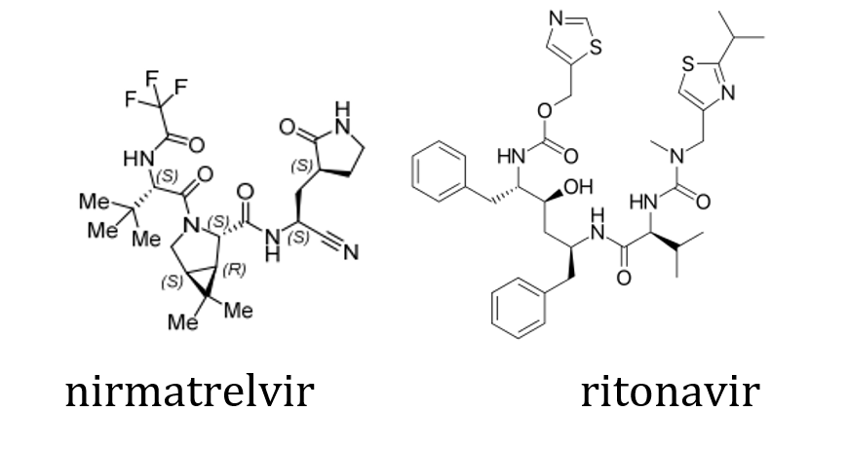
The intended presentation is a carton of 30 tablets in five PA/Al/PVC/Al; blister cards marked as ‘morning dose’ and ‘evening dose’ for tablets to be taken each morning and each evening. Each blister card is to contain 4 nirmatrelvir tablets and 2 ritonavir tablets.

Quality summary and recommendations
Outstanding issues have been resolved prior to registration. The quality evaluator has made the following recommendations:
- Due to the accelerated development timelines associated with the proposed product, process optimisation for the synthesis and quality control of nirmatrelvir continues. The sponsor has committed to provide additional data with respect to these aspects to global regulators; a target date of June 2022 has been proposed.
- The risk associated with the absence of these data is mitigated to a large extent by other data provided with respect to the drug substance and the finished product. Given the provisional determination granted to this submission and the associated risk/benefit considerations, approval is recommended from a pharmaceutical chemistry and quality control perspective.

Nonclinical
The nonclinical evaluator has confirmed that there are no nonclinical objections to the provisional registration of nirmatrelvir and made the following conclusions:
- Primary pharmacology studies indicate nirmatrelvir exhibits antiviral activity against SARS-CoV-2 and its variants of concern (Alpha, Beta, Gamma, Lambda, and Delta variants).
- New variants are continuously emerging and require testing to confirm effective antiviral activity by nirmatrelvir.
- Cytochrome P450 3A4 (CYP3A4) and P-glycoprotein inhibitors/inducers may affect nirmatrelvir exposure. Nirmatrelvir inhibits CYP3A4 and induces CYP3A4. It also inhibits P-glycoprotein, multidrug and toxin extrusion protein 1 (MATE1), and organic anion transporter family member 1 B1 (OATP1B1) at clinically relevant concentrations and hence may reduce the clearance of drugs that are substrates of these transporters.
- Repeat dose toxicity studies with the proposed drug in rats and monkeys raised no safety concerns.
- In reproductive and developmental studies, decreased fetal weights were observed in rabbits. Pregnancy category B3 is considered acceptable.
- There are no toxicology studies with on the proposed nirmatrelvir/ritonavir combination.
Outstanding issues have been resolved prior to registration.

Clinical
The clinical dossier consisted of the following studies:
- Five Phase I studies: Studies C4671001, C4671010, C4671011, C4671014 and C4671015,
- One Phase II/III pivotal study: Study C4671005.

Pharmacokinetics
The PK of nirmatrelvir/ritonavir has been studied in 3 clinical pharmacology studies (Studies C4671001, C4671014 and C4671015) in healthy adult participants and one study (Study C4671011) in participants with renal impairment.
- In Study C4671001, upon administration of single dose of nirmatrelvir at 250 and 750 mg oral suspension, enhanced with 100 mg ritonavir, the increase in exposure was less than dose proportional. Also, following repeat-dose of nirmatrelvir/ritonavir up to 500 mg/100 mg twice daily as oral suspension in fasted state, the increase in systemic exposure at steady-state was less than dose proportional studied with dose normalised area under the plasma concentration time curve for a dosing interval (AUC_{tau}) and maximum concentration (C_{max}) values decreasing as the dose increased. Mean terminal elimination half life (t_{1/2}) values across all tested multiple dose regimens ranged between approximately 6.8 hours to 8.0 hours. Mean steady state concentrations were achieved on Day 2 with approximately 2-fold accumulation. Systemic exposures on Day 5 and Day 10 were similar at all doses. The absorption of nirmatrelvir/ritonavir in the fasted state occurred with the median time at maximum concentration (T_{max}) ranging between 0.75 hours to 2.75 hours across all doses upon single or repeat dosing.
- The effect of food (for example, a high fat high calorie meal) on the exposure of nirmatrelvir after oral administration of a suspension of nirmatrelvir, enhanced with 100 mg ritonavir, resulted in approximately 1.5% increase in area under the plasma concentration time curve (AUC) and 15% increase in C_{max} of nirmatrelvir. Nirmatrelvir plasma exposure was approximately 1.5- and 2.4-fold higher based on the geometric mean area under the plasma concentration time curve to the last measurable time point (AUC_{last}) and C_{max} values following administration of a 250 mg oral nirmatrelvir tablet with a high fat, high calorie meal compared to fasted conditions.
- The exposure of nirmatrelvir in Japanese participants was numerically lower but not meaningfully different than in non-Japanese participants. In Study C4671001, the geometric mean dose-normalised AUC_{tau} and C_{max} of nirmatrelvir at steady-state following nirmatrelvir 250/100 mg twice daily for 10 days was approximately 30% and 21% to 26% lower in Japanese participants compared to those observed in non-Japanese participants across all days. Urinary recovery of unchanged nirmatrelvir in Japanese participants was 54.2% and was similar to that observed for the non-Japanese participants.
- The primary route of elimination of nirmatrelvir when administered with ritonavir was renal excretion of intact drug. A total of 49.6% and 35.3% of the administered dose of nirmatrelvir 300 mg was recovered in urine and faeces, respectively. Nirmatrelvir was the predominant drug related entity with small amounts of metabolites arising from hydrolysis reactions in excreta. After normalisation of the data to 100% mass balance, un-metabolised nirmatrelvir represented 82.5% of the drug related material, with 55.0% in urine and 27.5% in faeces. In plasma, the only drug related entity quantifiable fluorine-19 nuclear magnetic resonance (19F-NMR) was unchanged nirmatrelvir.
- Nirmatrelvir plasma exposure for the tablet treatment was lower compared to the suspension. The test to reference ratios of the adjusted geometric means (90% confidence intervals (CI)) for nirmatrelvir AUC_{last} and C_{max} were 81.21% (69.21%, 95.28%) and 56.38% (43.42%, 73.19%) respectively, for the tablet treatment (test) compared to the suspension treatment (reference).
- The exposure of nirmatrelvir in renally impaired patients increased with increase in severity of renal impairment. In Study C4671011, the exposure (mean area under the plasma concentration time curve from time zero to infinity (AUC_{inf})) in moderately and severely renally impaired patients was higher than those in healthy participants by 87% and 204%, respectively.
- Two drug-drug interaction (DDI) studies were conducted to assess the effect of a potent inhibitor (Study C4671015) of CYP3A4, itraconazole, as well as a CYP3A4 strong inducer (Study C4671014), carbamazepine, with coadministration of nirmatrelvir/ritonavir 300 mg/100 mg.
- Co-administration of multiple oral doses of itraconazole 200 mg increased steady-state nirmatrelvir adjusted geometric mean AUC and C_{max} by approximately 39% and 19%, respectively.
- Co-administration of multiple oral doses of carbamazepine titrated up to 300 mg twice daily decreased single dose nirmatrelvir AUC and C_{max} by approximately 55 to 43%, respectively.
- There was a significant effect of carbamazepine on the systemic exposure of ritonavir as compared to nirmatrelvir. Carbamazepine titrated up to 300 mg twice daily decreased single dose ritonavir AUC_{inf} and C_{max} by approximately 83 to 74%, respectively.
- Simulations using population PK model, developed using healthy participants data from Study C4671001, shows that the dose of nirmatrelvir/ritonavir 300 mg/100 mg twice daily results in median Day 1 and steady-state concentration at 12 hours (C_{12h}) unbound trough concentrations approximately 3 to 4 time and 5 to 6 time in vitro EC₉₀, respectively. A quantitative systems pharmacology model capable of describing viral dynamics with time was used to confirm the selection of a 5-day dosing duration of oral nirmatrelvir/ritonavir 300 mg/100 mg twice daily for the treatment of symptomatic confirmed SARS-CoV-2 participants.

Study C4671001 (pharmacokinetics in healthy volunteers)
This Phase I first in human (FIH) study was to evaluate safety, tolerability, and PK of nirmatrelvir in healthy participants.
Figure 2: Study C4671001 Study design
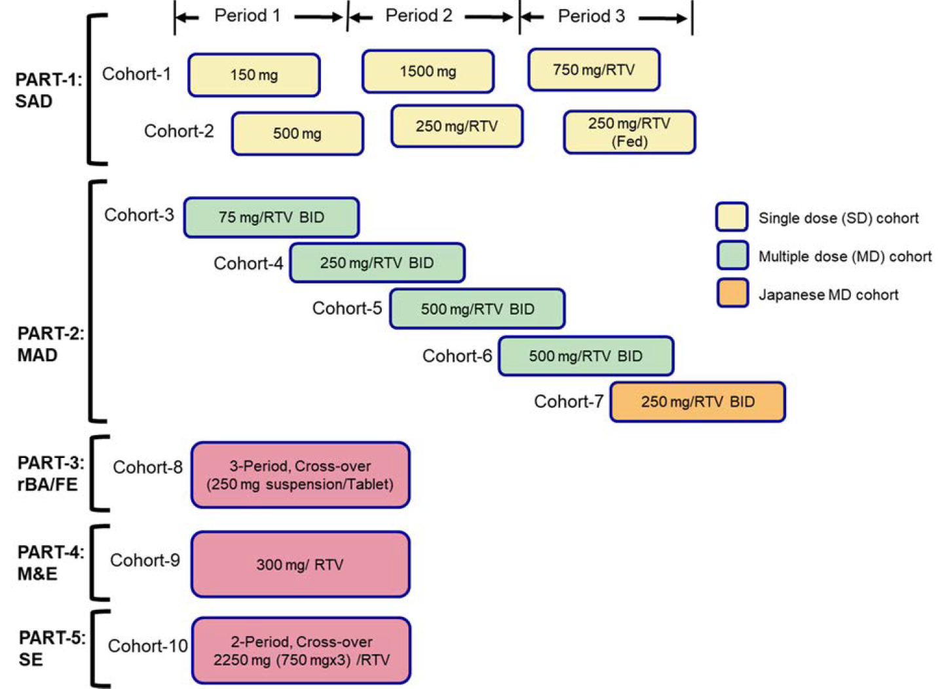
BID = twice a day; MAD = multiple ascending dose; MD =multiple dose; M & E = metabolism and excretion; rBA/FE = relative bioavailability/effect of food; RTV = ritonavir; SAD = single ascending dose; SD = single dose; SE = supratherapeutic exposure.

Inclusion criteria
Key inclusion criteria were:
- Male and female participants must be 18 to 60 years of age, inclusive, at the time of signing the informed consent document. Only male participants were included in Part 4.
- Participants who were overtly healthy as determined by medical evaluation including medical history, physical examination, laboratory tests, and vital signs and standard 12-lead electrocardiograms.
- Body mass index (BMI) of 17.5 to 30.5 kg/m²; and a total body weight > 50 kg.
- For Japanese cohort only: Japanese participants who had 4 Japanese biologic grandparents who were born in Japan.

Exclusion criteria
Key exclusion criteria were:
- Evidence or history of clinically significant haematological, renal, endocrine, pulmonary, gastrointestinal, cardiovascular, hepatic, psychiatric, neurological, or allergic disease (including drug allergies, but excluding untreated, asymptomatic, seasonal allergies at the time of dosing); any condition possibly affecting drug absorption (for example, gastrectomy, cholecystectomy, and intestinal resection).
- Positive test result for SARS-CoV-2 infection at the time of screening or Day -1.
- History of human immunodeficiency virus (HIV) infection, hepatitis B, or hepatitis C; positive testing at screening for HIV, hepatitis B surface antigen (HBsAg), hepatitis B core antibody (HBcAb), or hepatitis C virus antibodies (HCVAb). As an exception, a positive HBsAb test due to hepatitis B vaccination was allowed.
- Participants who had received a COVID-19 vaccine within 7 days before screening or admission, or who were vaccinated with a COVID-19 vaccine at any time during the study confinement period.
- Screening supine blood pressure ≥ 140 mmHg (systolic) or ≥ 90 mmHg (diastolic), following at least 5 minutes of supine rest. If blood pressure was ≥ 140 mmHg (systolic) or ≥ 90 mmHg (diastolic), the blood pressure should have been repeated 2 more times and the average of the 3 blood pressure values should have been used to determine the participant’s eligibility.
- Baseline 12-lead electrocardiogram that demonstrated clinically relevant abnormalities that may have affected participant safety or interpretation of study results.
- Participants with any of the following abnormalities in clinical laboratory tests at screening, as assessed by the study specific laboratory and confirmed by a single repeat test, if deemed necessary.
- Aspartate transaminase (AST) or alanine transaminase (ALT) level ≥1.5 x upper limit of normal (ULN); total bilirubin level ≥ 1.5 x ULN; participants with a history of Gilbert’s syndrome may have direct bilirubin measured and were eligible for this study provided the direct bilirubin level is ≤ ULN.

Treatments
The sponsor provided nirmatrelvir and placebo as bulk powders/tablets for extemporaneous preparation of oral suspensions at the Pfizer Clinical Research Unit (PCRU). Ritonavir 100 mg tablets were supplied locally by the PCRU. The study (Part 3) comprised of fed and fasted studies conducted in subjects administered nirmatrelvir as either a 250 mg suspension or 250 mg tablet. This has been confirmed acceptable by the quality evaluator that the gas is consistent with the requirements of the TGA guidance for biopharmaceutic studies.

Analysis populations
All participants treated with study drug were included in the safety analysis. All participants treated with nirmatrelvir were included in the PK analysis.
In Part 1, 13 participants received at least one dose of study intervention. In Part 2, 29 participants (6 Japanese participants) received at least one dose of study intervention. All the participants were between the age of 21 to 56 years. Most of the participants (11/13) were male.
In Part 3, 12 participants received at least one dose of study intervention between the age of 20 to 48 years and were all male.
In Part 4, 6 participants received at least one dose of study intervention between the age of 26 to 57 years and were all male.
In Part 5, 10 participants received at least one dose of study intervention between the age of 20 to 57 years and the majority were male (7/10 participants).

Pharmacokinetic results

Part 1: single ascending dose
Figure 3: Study C4671001 Part 1 Median plasma nirmatrelvir concentration time profiles following single oral doses of nirmatrelvir alone or enhanced with ritonavir
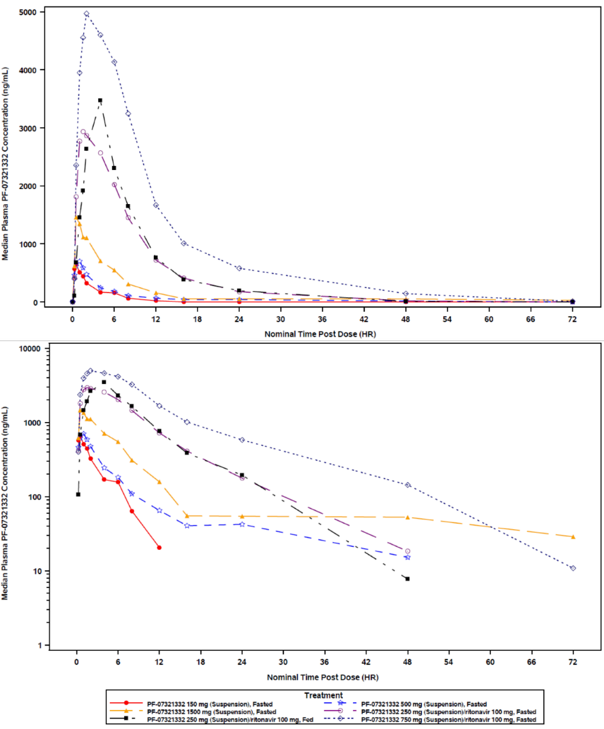
PF-07321332 = drug development code for nirmatrelvir; HR = hour.
Ritonavir dosed at -12, 0 and 12 hour post-dose.
Summary statistics had been calculated by setting concentration values below the lower limit of quantification to zero.
The lower limit of quantification was 10 ng/mL
Upper and lower panels were linear and semi-logarithmic scales, respectively.
Use of ritonavir as pharmacokinetic enhancer appeared to considerably increase nirmatrelvir exposure.
Table 3: Study C4671001 Part 1 (single ascending dose) Descriptive summary of plasma nirmatrelvir pharmacokinetic parameters (pharmacokinetic parameter set)
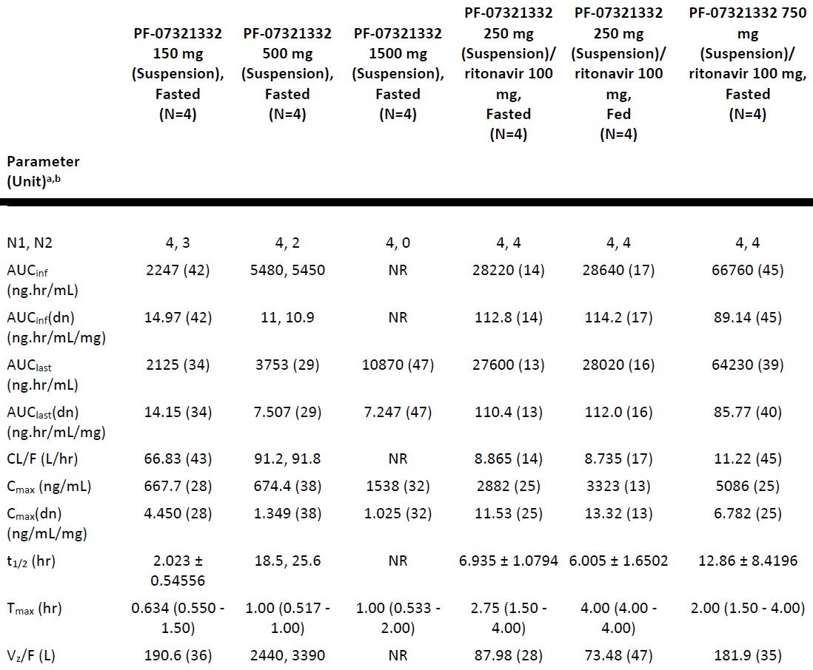
AUC_{inf} = area under the plasma concentration time curve from time zero to infinity; AUC_{last} = area under the plasma concentration time curve to the last measurable time point; CL/F = apparent oral clearance; C_{max} = maximum concentration; N = total number of participants in the treatment group; N1 = number of participants contributing to the summary statistics; N2 = number of participants where t_{1/2}, AUC_{inf}, AUC_{inf(dn)}, CL/F and Vz/F were determined; NR = not reported; PF-07321332 = drug development code for nirmatrelvir; t_{1/2} = terminal elimination half life; T_{max} = time at maximum concentration; Vz/F = apparent volume of distribution
Ritonavir dosed at -12, 0 and 12 hour post-dose.
a. Geometric mean (geometric % coefficient of variation (CV)) for all except: median (range) for T_{max} and arithmetic mean ± standard deviation (SD) for t_{1/2}.
b. Individual values were listed when there were less than 3 evaluable measurements.
Summary statistics were not presented if fewer than 3 participants had reportable parameter values.

Part 2: multiple ascending dose
Urinary recovery of unchanged nirmatrelvir decreased with an increase in nirmatrelvir dose, with 64%, 52% and 23% of the dose recovered in urine for the 75 mg, 250 mg, and 500 mg nirmatrelvir doses enhanced with 100 mg ritonavir, respectively. However, renal clearance was similar across all doses with 3.782, 3.433 and 2.934 L/hr at 75 mg, 250 mg and 500 mg nirmatrelvir doses enhanced with 100 mg ritonavir, respectively.
Figure 4: Study C4671001 Part 2 (multiple ascending dose) Median plasma nirmatrelvir concentration time profiles on across all dosing days following multiple oral doses of nirmatrelvir enhanced with ritonavir
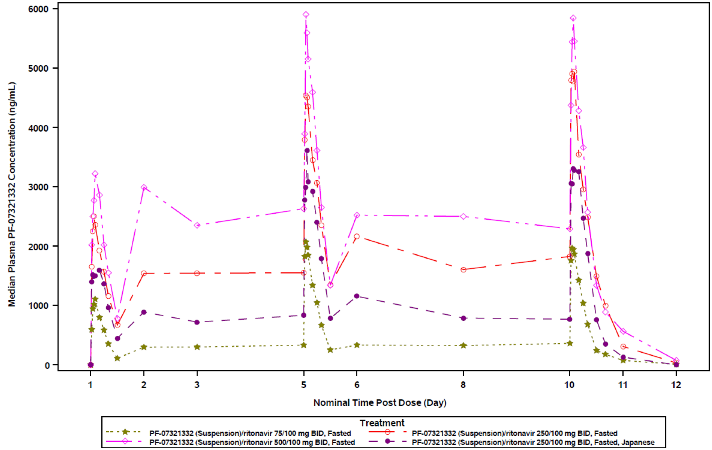
BID = twice a day; PF-07321332 = drug development code for nirmatrelvir.
Summary statistics had been calculated by setting concentration values below the lower limit of quantification to zero.
The lower limit of quantification was 10 ng/mL

Part 3: relative bioavailability and effect of food
For relative bioavailability (without ritonavir) nirmatrelvir plasma exposure for the tablet was lower compared to the suspension following a single 250 mg oral dose of nirmatrelvir, with approximately 19% and 44% lower geometric mean AUC_{last} and C_{max} values, respectively. The test to reference ratios of the adjusted geometric means (90% CI) for nirmatrelvir AUC_{last} and C_{max} were 81.21% (69.21%, 95.28%) and 56.38% (43.42%, 73.19%) respectively, for the tablet treatment (test) compared to the suspension treatment (reference).
Regarding food effect, nirmatrelvir plasma exposure was higher for the fed treatment following administration of a 250 mg high fat, high calorie meal, with approximately 1.5 and 2.4-fold higher geometric mean AUC_{last} and C_{max} values for fed treatment compared to the fasted treatment, respectively. The test to reference ratios of the adjusted geometric means (90% CI) for nirmatrelvir AUC_{last} and C_{max} were 148.91% (126.92%, 174.72%) and 244.84% (188.58%, 317.87%), respectively, for the fed treatment (test) compared to the fasted treatment (reference).
Following administration of a 250 mg nirmatrelvir tablet with a high fat, high calorie meal, a median T_{max} of 1.75 hours post-dose was observed compared to 1.0 hour post-dose for the fasted treatment. Plasma concentrations for the fed treatment were higher than those observed for the fasted treatment and appeared to decline more rapidly over time, with mean t_{½} values of 1.85 hours for the fed treatment compared to 9.09 hours for the fasted treatment.
Table 4: Study C4671001 Part 3 (relative bioavailability/effect of food) Descriptive summary of plasma nirmatrelvir pharmacokinetic parameters (pharmacokinetic parameter set)
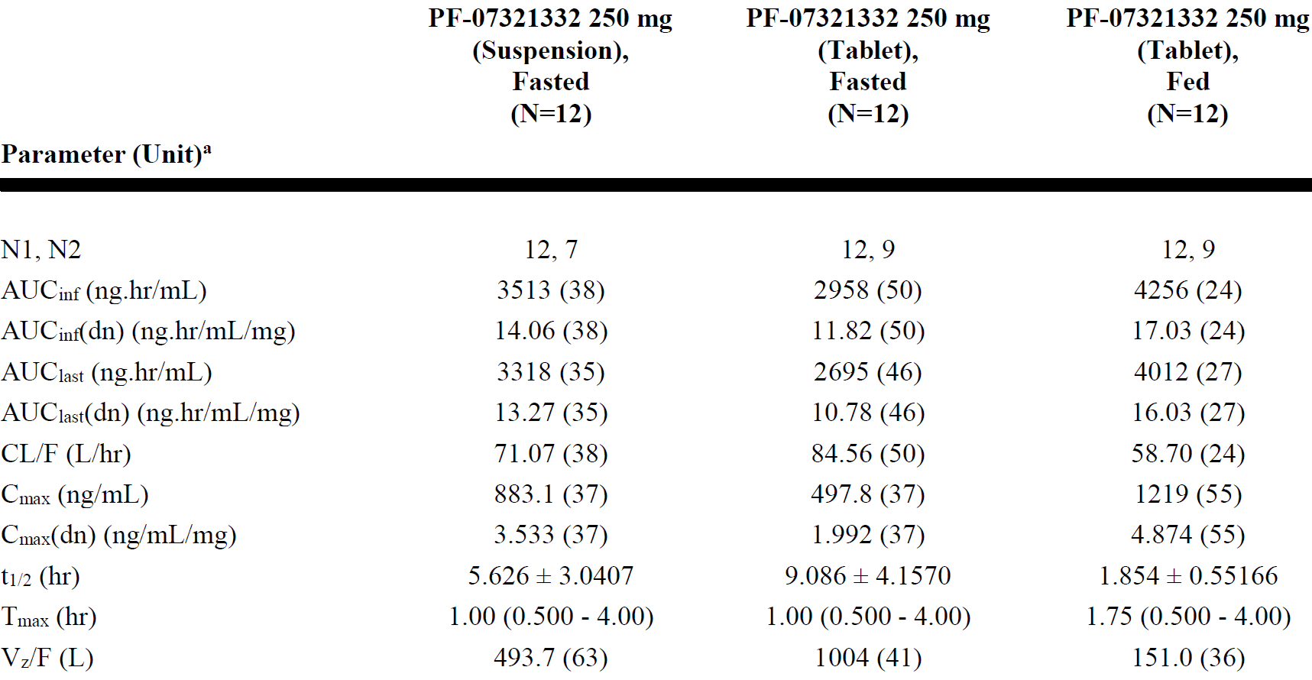
AUC_{inf} = area under the plasma concentration time curve from time zero to infinity; AUC_{last} = area under the plasma concentration time curve to the last measurable time point; CL/F = apparent oral clearance; C_{max} = maximum concentration; N = total number of participants in the treatment group; N1 = number of participants contributing to the summary statistics; N2 = number of participants where t_{1/2}, AUC_{inf}, AUC_{inf(dn)}, CL/F and Vz/F were determined; PF-07321332 = drug development code for nirmatrelvir; t_{1/2} = terminal elimination half life; T_{max} = time at maximum concentration; Vz/F = apparent volume of distribution.
a. Geometric mean (geometric % coefficient of variation (CV)) for all except: median (range) for T_{max} and arithmetic mean ± standard deviation (SD) for t_{1/2}.
Summary statistics were not presented if fewer than 3 participants had reportable parameter values.

Part 4: metabolism and excretion
Following administration of a 300 mg oral suspension of nirmatrelvir enhanced with 100 mg ritonavir under fasted conditions, nirmatrelvir mean C_{max} values were observed in a median T_{max} of 2.0 hours post-dose. nirmatrelvir mean t½ was approximately 9.49 hours. nirmatrelvir mean AUC_{last} and C_{max} values were 32.96 μg hr/mL and 4.07 μg/mL, respectively.
Mass balance in Part 4: Overall mean ± standard deviation (SD) (range) mass recovery of nirmatrelvir related material in excreta (urine and faeces) was calculated at 84.9% ± 8.9% (70.7%, 95.5%) which included 80.7% ± 8.0% by quantitative 19F-NMR and 4.2% ± 1.3% excreted as metabolite M8 (19F-NMR silent due to loss of trifluoroacetyl group) quantified by ultra-high performance liquid chromatography high resolution mass spectrometry. The excretion into urine and faeces was 49.6% and 35.3% of dose, respectively. Almost all of the excretion of drug related material occurred over the first 5 days following the dose, and most of the drug related material that was excreted in the urine appeared in within the first day following the dose.
Additionally, quantifying nirmatrelvir and M5 (most prevalent metabolite in preliminary metabolite scouting) by high performance liquid chromatography with tandem mass spectrometry (HPLC-MS/MS) method showed overall mean ± SD mass recovery of 75.6 ± 9.7% with 40.6% and 35.0% excretion into urine and faeces, respectively. The correspondence between the mass recovery by both methods (19F-NMR and HPLC-MS/MS) suggested that nirmatrelvir and metabolite M5 comprise the vast majority of drug related material in excreta.
Metabolic profiling in Part 4: In plasma, the only drug related entity quantifiable by 19F-NMR was unchanged nirmatrelvir.
In excreta, nirmatrelvir was the predominant drug related entity. After normalisation of the data to 100% mass balance, unmetabolised nirmatrelvir represented 82.5% of the drug related material, with 55.0% in urine and 27.5% in faeces. Metabolite M5, arising via hydrolysis, was present at 12.1% of dose with almost all in the faeces. All other fluorine containing metabolites were minor (< 1% of dose), and M8 was 4.2% of dose. Overall, these findings support that nirmatrelvir is the major drug related entity excreted and that 19F-NMR was an effective technology to develop quantitative metabolite profile information.

Part 5: supratherapeutic exposure
Following supratherapeutic oral dose of nirmatrelvir as a 2250 mg suspension (dosed as 3 split doses of 750 mg administered at 0, 2 and 4 hours) enhanced with 100 mg ritonavir, nirmatrelvir mean C_{max} was observed in a median T_{max} of 5.0 hours after the first split dose. nirmatrelvir mean t_{½} was 7.5 hours. nirmatrelvir mean AUC_{last} and C_{max} values were 188.2 μg hr/mL and 15.94 μg/mL, respectively.

Population modelling analysis report
A summary of the population modelling analysis report for exposure-response modelling of Study C4671001 Part 5: supratherapeutic exposure cohort data for nirmatrelvir and electrocardiogram/vitals measures is given below:
Study C4671001 is a first in human 5-part study. Part 5, Supratherapeutic exposure cohort is a two-period, crossover design which evaluated nirmatrelvir 2250 mg administered as 3 split doses of 750 mg administered at intervals of approximately 2 hours and ritonavir (100 mg dosed at -12 hour, 0 hour, 12 hour) in 10 participants. Triplicate electrocardiogram measurements, vital signs, and PK samples were collected in fasted state (approximately 4 hour after the food) at nominal times of 0, 2, 3, 3.5, 4, 4.5, 5, 5.5, 6, 8, 12, 24, 48, 72 and 96 hours after the first dose.
An exposure-response analysis of Fridericia heart rate corrected QT interval (QTcF), heart rate, PR interval, systolic blood pressure (SBP), and diastolic blood pressure (DBP) were conducted.
Fridericia heart rate corrected QT interval modelling: No clinically relevant effect of nirmatrelvir/ritonavir on QT interval corrected for heart rate using Fridericia’s formula (QTcF) interval is expected based on C-QTc analysis of electrocardiogram data collected in the supratherapeutic exposure part of the study. The upper bounds of 90% CI for placebo adjusted change from Baseline in the QT interval corrected for heart rate using Fridericia’s formula (∆∆QTcF) estimates across the entire concentration range were all less than 10 ms, the threshold for potential clinical and regulatory concern. The upper bound of 90% CI for ∆∆QTcF estimate at 2-fold of expected mean maximum concentration at steady state (C_{max,ss}) for the therapeutic dose was 1.07 ms and the value at mean C_{max} of the highest dose in Study C4671001, which is approximately 4-fold higher than the expected mean C_{max,ss} for the therapeutic dose, was 1.96 ms.
At a nirmatrelvir dose of 2250 mg, the data suggest an electrocardiogram or vital signs with a potential clinical concern for SBP based upon exposure-response analyses of data from Study C4671001. The analyses suggest that QTcF, heart rate, PR interval, and DBP do not exceed their predefined thresholds of potential clinical concern.
Systolic blood pressure: At the highest dose of 2250 mg with a geometric mean C_{max} of 15944 ng/mL, there is a potential SBP concern with the upper bound of the two-sided 90% CI exceeding 10 mmHg. Hysteresis was assessed graphically, and a difference between treatment days (that is, tachyphylaxis or sensitisation) was assessed by the model. A summary of placebo and Baseline corrected change in BP predictions at dose(s) exceeding the threshold of potential clinical concern at supratherapeutic dose however, it did not appear to be a concern at the therapeutic dose.
- The mean (90% CI) predicted SBP is 5.8 (1.46 to 10.14) mmHg evaluated at the highest observed mean C_{max} (15944 ng/mL) following at a dose of 2250 mg.
- The mean (90% CI) predicted SBP is 2.22 (0.84 to 3.59) mmHg evaluated at the therapeutic concentration (4140 ng/mL).
- The maximum C_{max} predicted not to reach the threshold of potential clinical concern is 15697 ng/mL with the current formulation.

Study C4671011 (pharmacokinetics in renal impairment)
This was a Phase I, non-randomised, open label, 2-part study to investigate the effect of renal impairment on the plasma and urine PK, safety, and tolerability of a single oral dose of nirmatrelvir in combination with the PK enhancing agent ritonavir in approximately 36 participants.

Study design
Nirmatrelvir/ritonavir is intended for short-term (for example, 5 day) use in patients with COVID-19, some of whom may have some degree of impaired renal function. PK data following multiple oral administrations of nirmatrelvir/ritonavir at doses of 75/100 mg, 250/100 mg, and 500/100 mg every 12 hours suggested that the renal pathway might play a significant role in nirmatrelvir excretion when co-administered with ritonavir. Therefore, the purpose of this study was to characterise the effect of renal impairment on the plasma PK of nirmatrelvir. Findings from this study were to be used to develop dosing recommendations so that the dose and/or dosing interval could be adjusted appropriately in the presence of renal disease.
It was planned in Part 1 to enrol approximately 16 adult male and female participants with stable mild or moderate renal impairment and a control group of up to 12 adult participants with normal renal function. Part 2 was planned to be conducted in approximately 8 adult male and female participants with stable severe renal impairment.
Participants were selected and categorised into normal renal function or renal impairment groups based on their estimated glomerular filtration rate (eGFR) as shown in Table 5 below.
Table 5: Study C4671011 Renal function categories by estimated glomerular filtration rate ranges
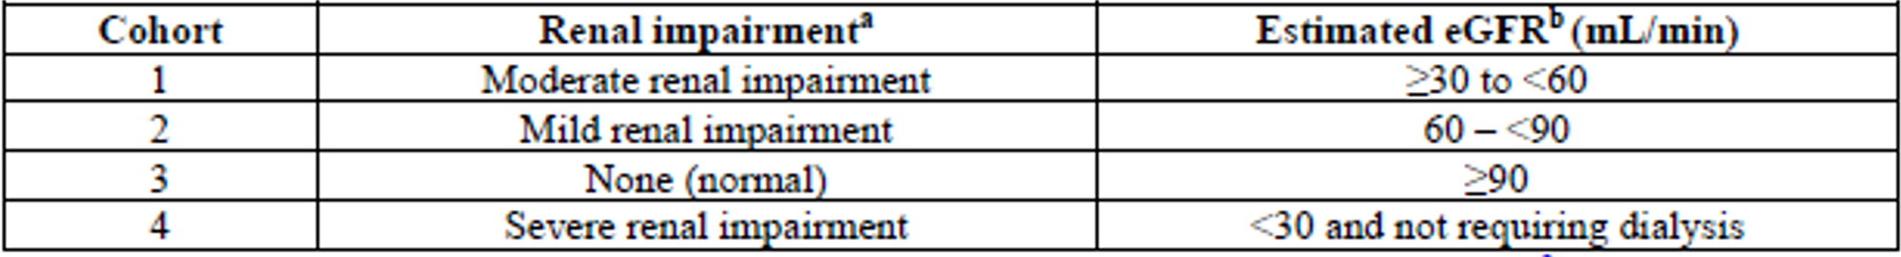
eGFR = estimated glomerular filtration rate.
a. Stages of renal impairment are based on Kidney Disease Outcomes Quality Initiative (KDOQI) Clinical Practice Guidelines for chronic kidney disease (CKD).
b. Estimate of eGFR based on CKD-epidemiology collaboration (EPI) formula. The average of 2 screening eGFR values were used for group assignment.

Treatments
A single oral dose of 100 mg nirmatrelvir, pharmacokinetically enhanced with ritonavir was dosed in this study. This was anticipated to be at the lower end of the clinically effective dose range, and below the anticipated Phase II/III dose of nirmatrelvir/ritonavir 300 mg/100 mg.
Although single dose up to 750 mg nirmatrelvir with ritonavir has been evaluated, exposure increased less than dose proportional within the 250 mg to 750 mg dose range evaluated. Therefore, 100 mg nirmatrelvir was appropriate considering systemic exposures of nirmatrelvir might be increased in the presence of renal impairment.
The dose of ritonavir used in this study was 100 mg administered every 12 hours. This dose is the typical dose of ritonavir when dosed as a PK enhancer. As ritonavir is not eliminated renally and is not expected to be significantly altered by renal impairment, no dose reduction was considered necessary for participants with renal impairment.

Participant disposition
Thirty five participants were assigned to treatment and 34 of them were treated, 8 each in mild, moderate, and severe renal impairment group and 10 in healthy control group. One participant in the moderate renal impairment group was discontinued because of an adverse event (AE) before any nirmatrelvir administration on Day 1. One participant in the severe renal impairment group was discontinued from study due to an AE, after the last dose of study treatment.
A total of 34 participants, including 23 male and 11 female participants were enrolled. The mean (SD) age across 4 renal function groups was 62.2 (7.45) years, ranging from 47 to 76 years. The overall mean (SD) weight and BMI across the 4 renal function groups was 86.75 (13.88) kg and 29.37 (3.89) kg/m², respectively. Gender and race distribution across the 4 renal function groups was approximately 2:1 for male to female and 2:1 White to Black/African American.

Pharmacokinetic results
Table 6: Study C4671011 Descriptive summary of plasma and urine nirmatrelvir pharmacokinetic parameters (pharmacokinetic parameter analysis set)
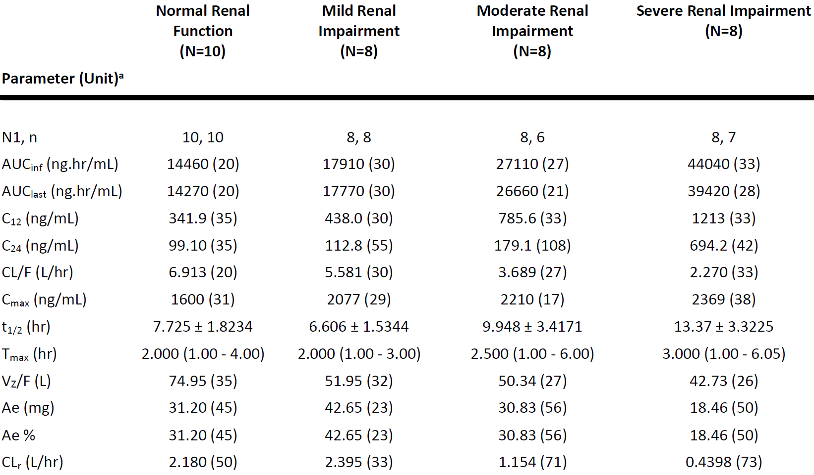
AUC_{inf} = area under the plasma concentration time curve from time zero to infinity; AUC_{last} = area under the plasma concentration time curve to the last measurable time point; C12 = concentration at 12 hours; C24 = concentration at 24 hours; CL/F= apparent oral clearance; CLr = centred log ratio; C_{max} = maximum concentration; t_{1/2} = terminal elimination half life; T_{max} = time at maximum concentration; Vz/F = apparent volume of distribution.
N = Total number of participants in the cohort in the indicated population; N1 = Number of participants contributing to the summary statistics; n = Number of participants contributing to the summary statistics for t_{1/2}, AUC_{inf}, CL/F and VZ/F;
a. Geometric mean (geometric % coefficient of variation (CV)) for all: except Median (Range) for T_{max} and arithmetic mean ± standard deviation (SD) for t_{1/2}.
Table 7: Study C4671011 Statistical summary (analysis of variance) of plasma nirmatrelvir pharmacokinetic parameters (area under the plasma concentration time curve from time zero to infinity and maximum concentration)
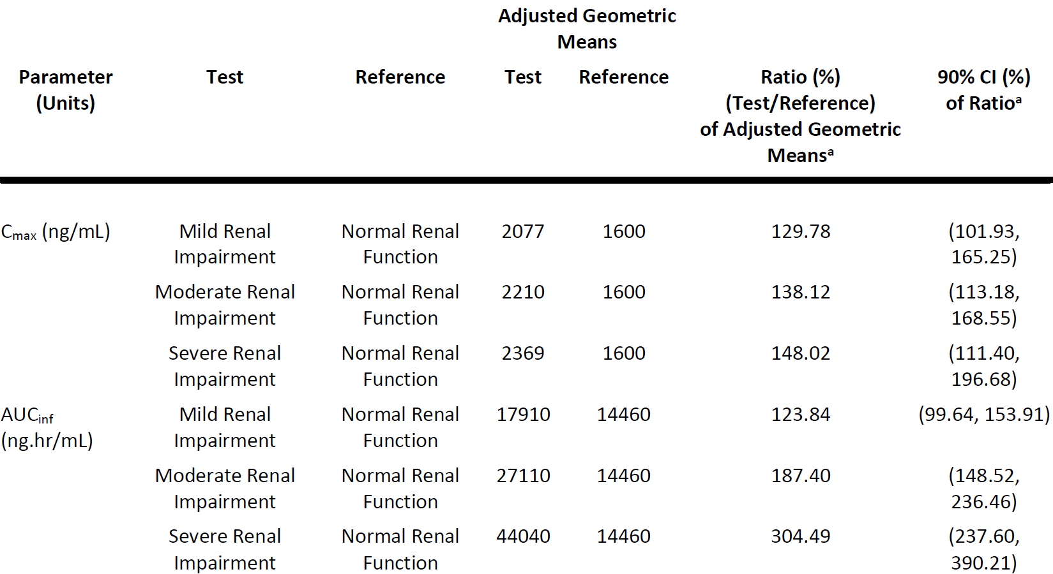
AUC_{inf} = area under the plasma concentration time curve from time zero to infinity; CI = confidence interval; C_{max} = maximum concentration.
Natural log-transformed AUC_{inf} and C_{max} for nirmatrelvir were analysed using a mixed effect model with cohort as a fixed effect and assuming unequal variances.
a. The ratios (and 90% CIs) were expressed as percentages.
Figure 5: Study C4671011 Median plasma nirmatrelvir concentration time plot, following a single oral dose of nirmatrelvir/ritonavir, linear scale (upper panel) and semi-log scale (lower panel)
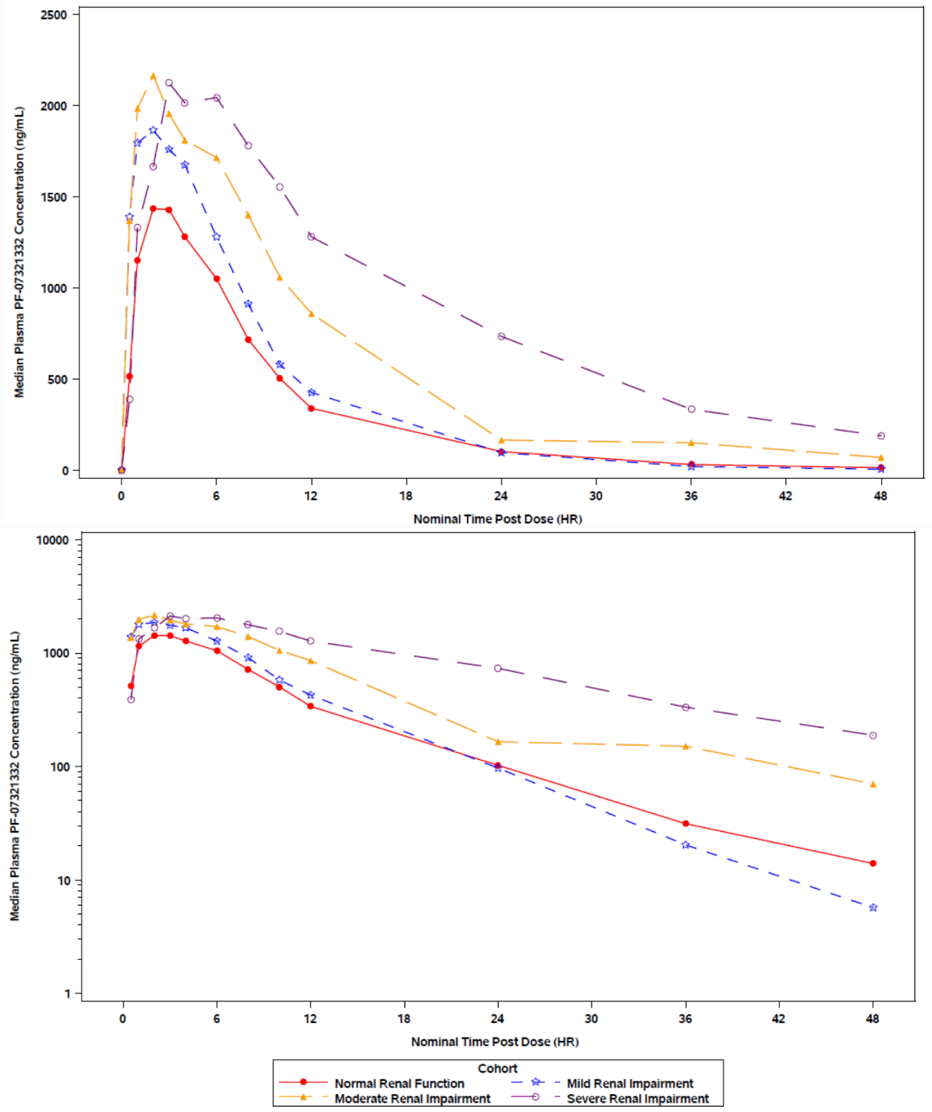
HR = hour; PF-07321332 = drug development code for nirmatrelvir.
The lower limit of quantification was 10 ng/mL.
Summary statistics were calculated by setting concentration values below the lower limit of qualification to zero.
- Results of the regression analysis using eGFR showed a decrease in apparent oral clearance (CL/F) for nirmatrelvir with an increase in severity of renal impairment with an approximately 47% and 67% decrease in mean CL/F of participants in the moderate and severe renal impairment groups, respectively, compared to the normal renal functional group. Renal clearance also decreased especially for the moderate and severe renal impairment groups with an approximately 47% and 80% decrease in geometric mean centred log ratio (CLr) values, respectively, compared to the normal renal functional group.
- Urinary recovery of unchanged nirmatrelvir was 31.2%, 42.7%, 30.8%, and 18.5% for the normal functional group, mild, moderate, and severe renal impairment groups, respectively.

Sponsor’s rational of dosing in moderate renal impairment subjects
In Study C4671011, mild renal impairment resulted in an increase in AUC and C_{max} of 24% and 30%, respectively. In moderate renal impairment subjects, AUC and C_{max} increased 87%, and 38%, respectively. Hence, the preliminary population PK model was used to predict the Day 5 C_{trough} plasma concentration of nirmatrelvir/ritonavir twice daily to simulate the following scenarios.
The figure below shows the predicted C_{trough} concentrations of nirmatrelvir with reduced clearance and with doses which provided a close approximation to C_{trough} concentration to that of a reference group (that is, no reduction in clearance). There was significant overlap in the individual predicted nirmatrelvir C_{trough} values when clearance was reduced by one-third and dosed with 300 mg/100 mg nirmatrelvir/ritonavir twice daily, and when clearance was reduced by one-half and dosed with 150/100 mg nirmatrelvir/ritonavir twice daily. In both scenarios, the median C_{trough} values were slightly higher than the reference group, and the vast majority of individual predicted C_{trough} values were above EC₉₀ (292 ng/ml). It is presumed that maintaining C_{trough} values above EC₉₀ for SARS-CoV-2 would be necessary for therapeutic activity, and hence slightly higher C_{trough} values are not expected to compromise therapeutic activity of nirmatrelvir/ritonavir.
Figure 6: Study C4671011 Predicted nirmatrelvir trough concentration plasma concentrations by dosing regimen and clearance
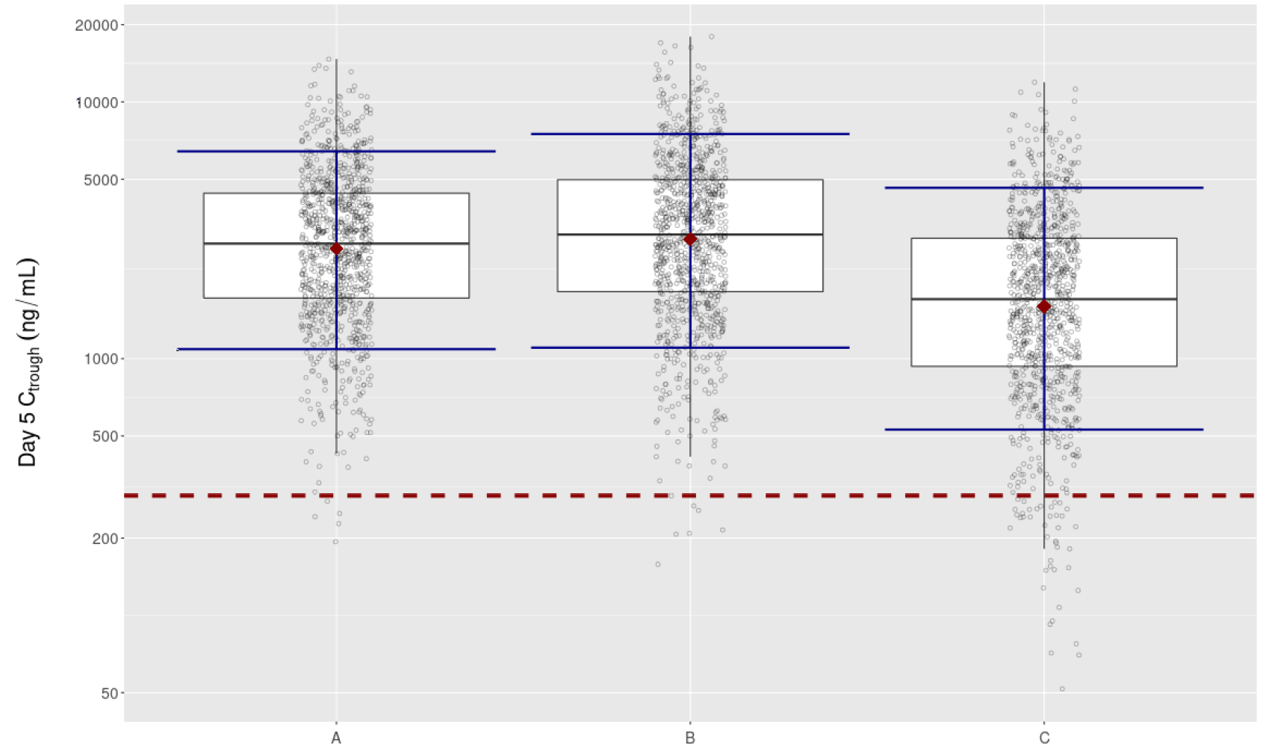
C_{trough} = trough concentration.
Distribution of stimulated nirmatrelvir C_{trough} on Day 5 from 1000 simulated subjects: inter-individual variability on clearance inflated to 60%.
Open circles represent individual predicted C_{trough}; red dots represent the group means; blue lines represent tenth and ninetieth percentiles; red dashed line is 90% effective concentration (EC₉₀) of 292 ng/mL.
A. nirmatrelvir/ritonavir 150 mg/100 mg every 12 hours; population pharmacokinetic (PopPK) clearance reduced by 1/2.
B. nirmatrelvir/ritonavir 300 mg/100 mg every 12 hours; PopPK clearance reduced by 1/3.
C. nirmatrelvir/ritonavir 300 mg/100 mg every 12 hours; no reduction in PopPK clearance.
The Phase II/III Study C4671005 enrolled participants with eGFR ≥ 45 mL/min/1.73 m², and all study participants including mild and moderate renal impairment, received nirmatrelvir/ritonavir 300 mg/100 mg twice daily or placebo for 5 days. Overall, the safety data suggest that nirmatrelvir/ritonavir was well tolerated and supports the PK derived dosing recommendation for mild and moderate renal impairment.

Safety results
Table 8: Study C4671011 Treatment emergent adverse events (all causalities; safety analysis set)
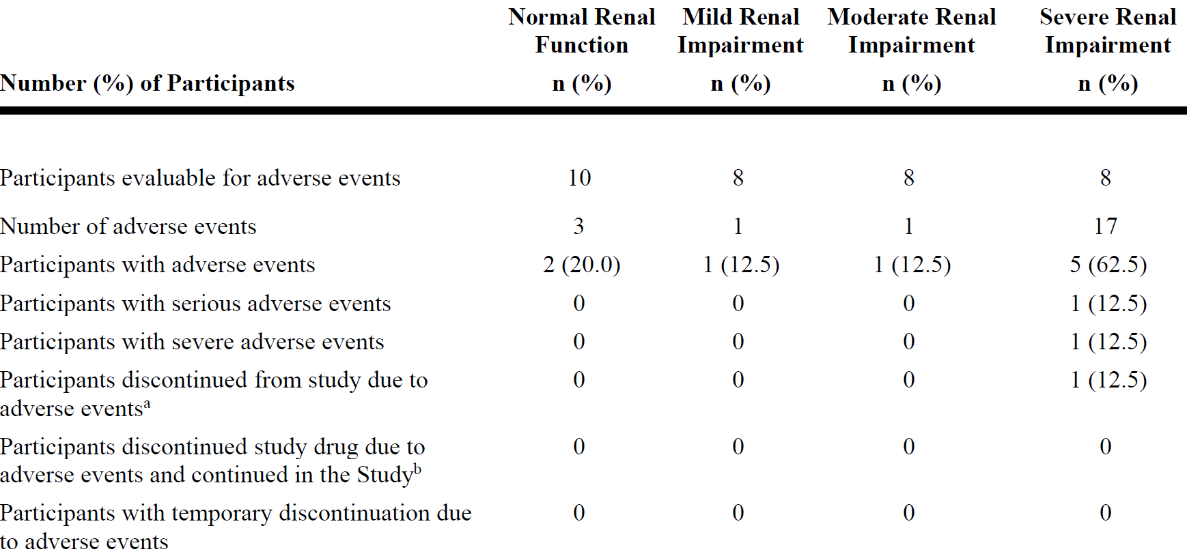
n = sample size.
Included all data collected since the first dose of study treatment.
Except for the number of adverse events, participants were counted only once per treatment in each row.
Serious adverse events - according to the investigator's assessment.
a. Participants who had an adverse event record that indicated that the adverse event caused the participant to be discontinued from the study.
b. Participants who had an adverse event record that indicated that action taken with study treatment was drug withdrawn but adverse event did not cause the participant to be discontinued from study.
Medical Dictionary for Regulatory Activities (MedDRA); v24.0 coding dictionary applied.
Table 9: Study C4671011 Treatment-emergent adverse events (treatment-related; safety analysis set)
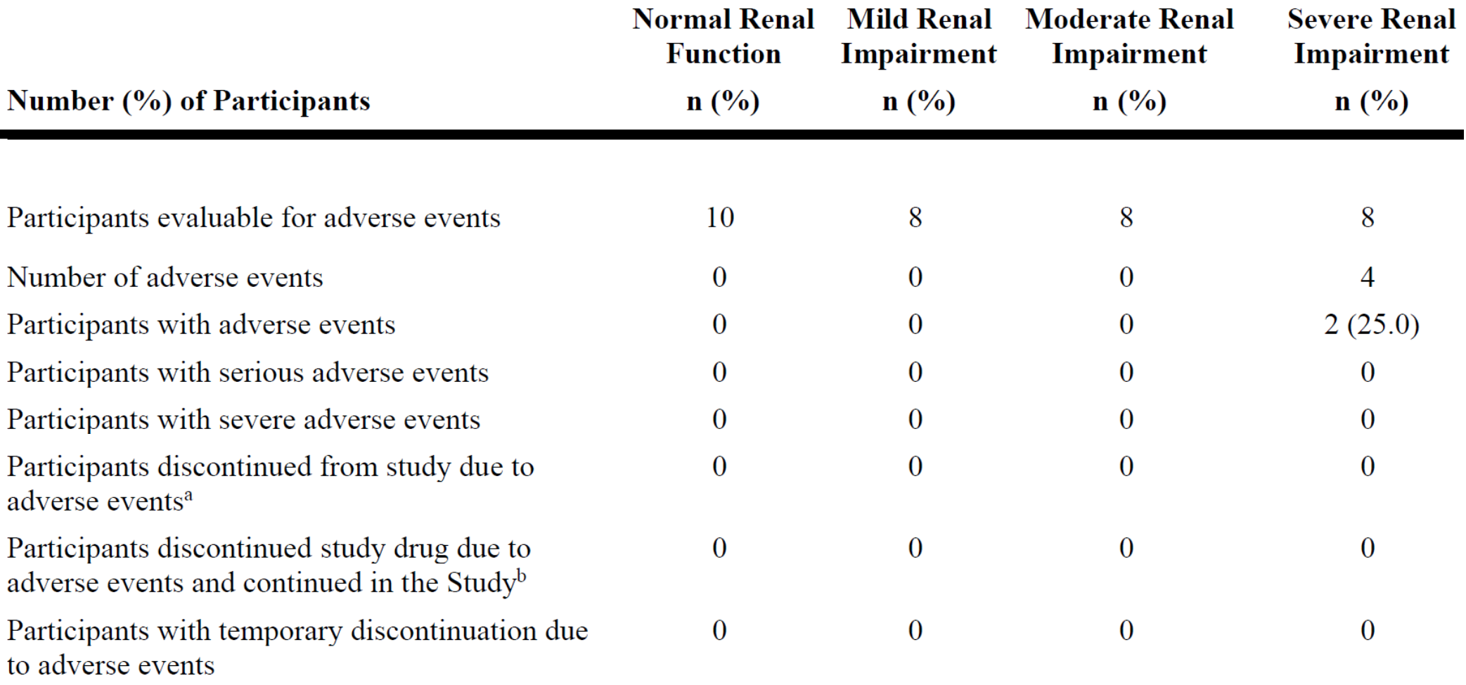
n = sample size.
Included all data collected since the first dose of study treatment.
Except for the number of adverse events participants were counted only once per treatment in each row.
Serious adverse events - according to the investigator's assessment.
a. Participants who had an adverse event record that indicated that the adverse event caused the participant to be discontinued from the study.
b. Participants who had an adverse event record that indicated that action taken with study treatment was drug withdrawn but adverse event did not cause the participant to be discontinued from study.
Medical Dictionary for Regulatory Activities (MedDRA) v24.0 coding dictionary applied.
Table 10: Treatment emergent adverse events by System Organ Class and Preferred Term (all causalities; safety analysis set)
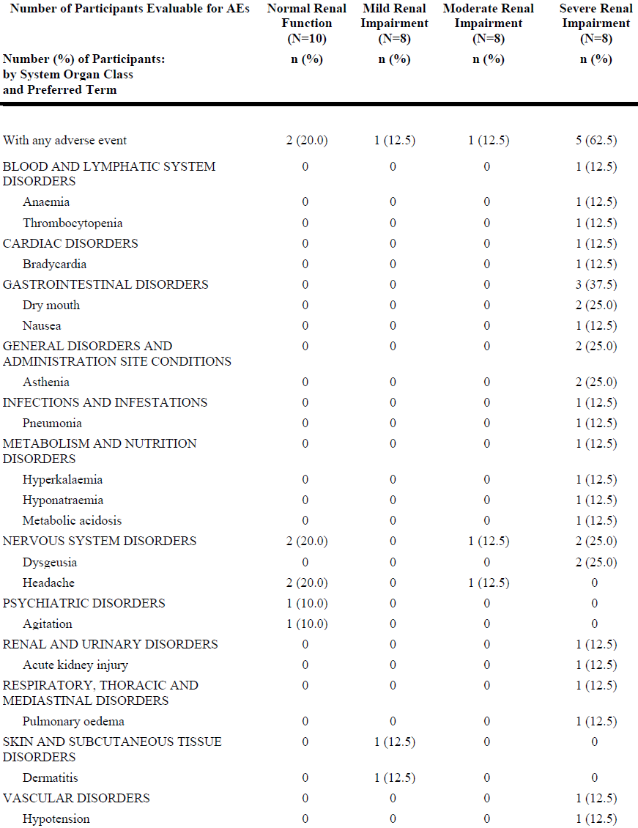
N = total number of participants in the treatment group in the indicated population, n = sample size.
Participants were only counted once per treatment per event.
Totals for the number of participants at a higher level were not necessarily the sum of those at the lower levels since a participant may report two or more different adverse events within the higher level category.
Included all data collected since the first dose of study treatment.
Medical Dictionary for Regulatory Activities (MedDRA) v24.0 coding dictionary applied.
Most of the all-causality AEs (17 out of 22) were reported by participants in the severe renal impairment group. All the AEs reported in participants with normal renal function, mild and moderate renal impairment were mild. One participant in the severe renal impairment had 3 serious adverse events (SAEs), including one severe SAE (pulmonary oedema), and 2 moderate SAEs (one acute kidney injury, one pneumonia), and all 3 were considered not treatment related. This participant discontinued study due to the SAE of acute kidney injury.
Treatment related adverse events only occurred in participants with severe renal impairment, and all were mild in severity. In the severe renal impairment group, one participant discontinued study due to the SAE of acute kidney injury. This event was considered not related to study treatment but was related to concomitant drug treatment
There were no deaths in this study. The 3 SAEs, including one pulmonary oedema, one acute kidney injury, and one pneumonia, were reported by the same participant in the severe renal impairment group, and were considered not related to the study treatment.

Laboratory parameters
Most of the laboratory test abnormalities were reported in the severe renal impairment group. The most frequently reported laboratory test abnormalities (reported for over 10 participants) were urea nitrogen (mg/dL) > 1.3x ULN (reported for 1, 4, and 7 participants in the mild, moderate, and severe renal impairment groups, respectively) and creatinine (mg/dL) >1.3 x ULN (reported for 1, 6, and 8 participants in the mild, moderate, and severe renal impairment groups, respectively).
Nearly all the participants in the moderate (N = 6) and severe (N = 7) renally impaired groups had abnormal urea nitrogen values at Baseline, and none of these participants met the secondary criteria (> 1.3 x Baseline) during the study. All participants in the moderate and severe renally impaired groups had abnormal creatinine values at Baseline, and of only one participant in the severe renal impairment group met the secondary criteria (> 1.3 x Baseline) during the study, which was reported as an SAE (acute kidney injury) and considered not related to treatment. Additionally, there were 3 participants each, in the moderate and severe renally impaired groups, with haemoglobin (g/dL) < 0.8 x lower limit of normal (LLN). All 6 participants had haemoglobin values below reference range at Baseline.
There were 4 AEs of laboratory abnormalities (anaemia, thrombocytopenia, hyperkalaemia, and hyponatraemia) in one participant (who had a history of anaemia and hyperkalaemia) in the severe renally impaired group who experienced the 3 SAEs previously described, and these AEs were not considered treatment related.
Overall, there were no significant laboratory trends observed in this study.
There was one AE of hypotension in one participant in the severe renal impairment group who also experienced the 3 SAEs described above. The event of hypotension was moderate in severity and aetiology was reported as concomitant drug treatment (hydralazine and nifedipine). No clinically relevant changes in vital signs were identified in this study.
An AE of bradycardia was reported in the participant previously described with the 3 SAEs, with onset of the AE of bradycardia on Study Day 2 and end date Study Day 3. The AE of bradycardia was moderate in severity and considered not treatment related but caused by hyperkalaemia. During the treatment phase, no other clinically significant electrocardiogram findings were reported.

Study C4671014 (pharmacokinetics and carbamazepine drug-drug interaction)

Study design
Nirmatrelvir is a potent and selective inhibitor of the SARS-CoV-2 3C-like protease that is currently being developed as an oral treatment of COVID-19. Ritonavir is a strong CYP3A4 inhibitor being used to inhibit the metabolism of nirmatrelvir in order to increase plasma concentrations of nirmatrelvir to values that are anticipated to be efficacious.
This was a Phase I, fixed sequence, two-period study to estimate the effect of a strong CYP3A4 inducer, carbamazepine, on the PK of nirmatrelvir and ritonavir in healthy participants. Based on preclinical and clinical data, nirmatrelvir and ritonavir are both CYP3A4 substrates, and therefore concomitant administration with a strong inducer, carbamazepine, would be expected to decrease systemic exposures of nirmatrelvir and ritonavir. The purpose of this study was to estimate the effect of a strong inducer of CYP3A4, carbamazepine on the PK of nirmatrelvir/ritonavir in healthy participants. Safety and tolerability were also assessed throughout the duration of the study.

Treatments
This study consisted of 2 periods. Period 1 included nirmatrelvir/ritonavir 300 mg/100 mg as a single oral dose and Period 2 included carbamazepine on a titration schedule as follows: Days 1, 2, and 3 at 100 mg twice daily, Days 4 to 7 at 200 mg twice daily, and Days 8 to 15 at 300 mg twice daily. On Day 14, a single dose of nirmatrelvir/ritonavir 300 mg/100 mg was co-administered with carbamazepine. The treatment consisted of a single fixed sequence.

Study participants
Twelve participants were enrolled into the study. All 12 participants were treated and 10 completed the study. Two participants discontinued from the study in Period 2; one due to an AE and the other withdrew due to personal reasons. Both participants only took carbamazepine at the time of withdrawal and did not take nirmatrelvir/ritonavir 300 mg/100 mg at Period 2, these participants were not included in the PK analysis set.
Of the 12 participants, 11 were male and 7 were White. The median (range) age of the participants was 39.50 (22.0, 56.0) years, and the median (range) BMI was 25.40 (20.2, 29.3) kg/m².

Pharmacokinetic results
Table 11: Study C4671014 Descriptive summary of plasma nirmatrelvir pharmacokinetic parameters
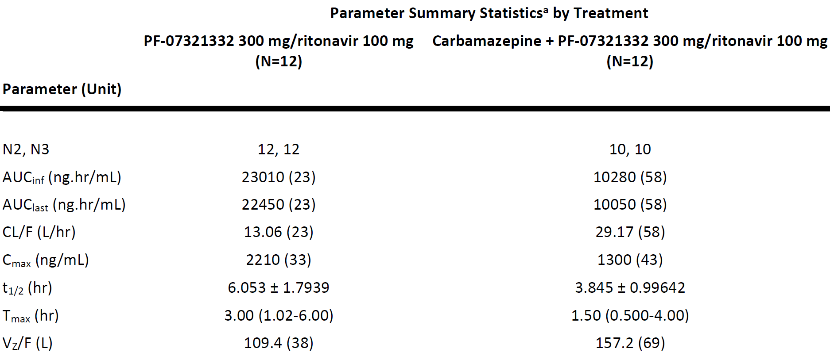
AUC_{inf} = area under the plasma concentration time curve from time zero to infinity; AUC_{last} = area under the plasma concentration time curve to the last measurable time point; CL/F = apparent oral clearance; C_{max} = maximum concentration; N = total number of participants in the treatment group in the indicated population; N2 = number of participants contributing to the summary statistics; N3 = number of participants contributing to the summary statistics for AUC_{inf}, CL/F, t_{1/2}, and Vz/F; PF-07321332 = drug development code for nirmatrelvir; t_{1/2} = terminal elimination half life; T_{max} = time at maximum concentration; Vz/F = apparent volume of distribution.
a. Geometric mean (geometric % coefficient of variation (CV)) for all except median (range) for T_{max} and arithmetic mean ± standard deviation (SD) for t_{1/2}.
Table 12: Study C4671014 Statistical summary of plasma nirmatrelvir pharmacokinetic parameters (area under the plasma concentration time curve from time zero to infinity, area under the plasma concentration time curve to the last measurable time point and maximum concentration)
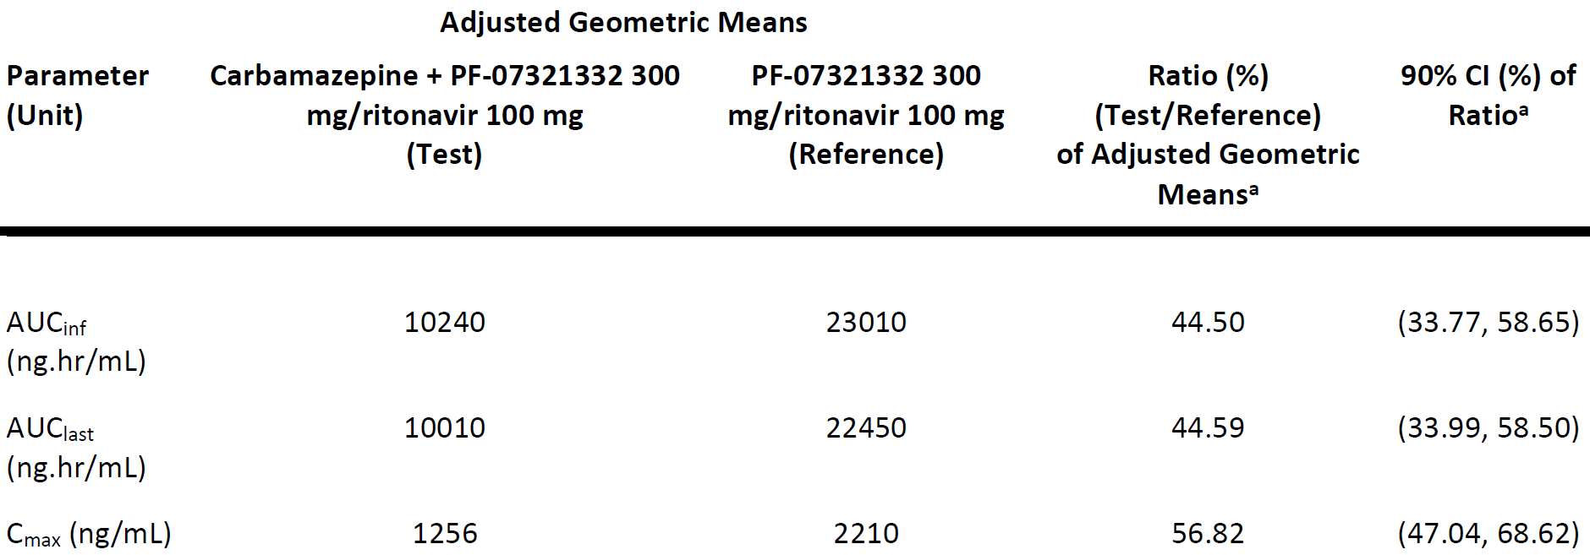
AUC_{inf} = area under the plasma concentration time curve from time zero to infinity; AUC_{last} = area under the plasma concentration time curve to the last measurable time point; CI = confidence interval; C_{max} = maximum concentration; PF-07321332 = drug development code for nirmatrelvir.
Natural log-transformed AUC_{inf}, AUC_{last} and C_{max} for nirmatrelvir are analysed using a mixed effect model with treatment as fixed effect and participant as a random effect.
a. The ratio (and 90% CIs) are expressed as percentages.

Figure 7: Study C4671014 Median plasma nirmatrelvir concentration time profiles following a single oral dose of nirmatrelvir/ritonavir administered alone or with multiple oral doses of carbamazepine, linear scale (upper panel) and semi-log scale (lower panel)
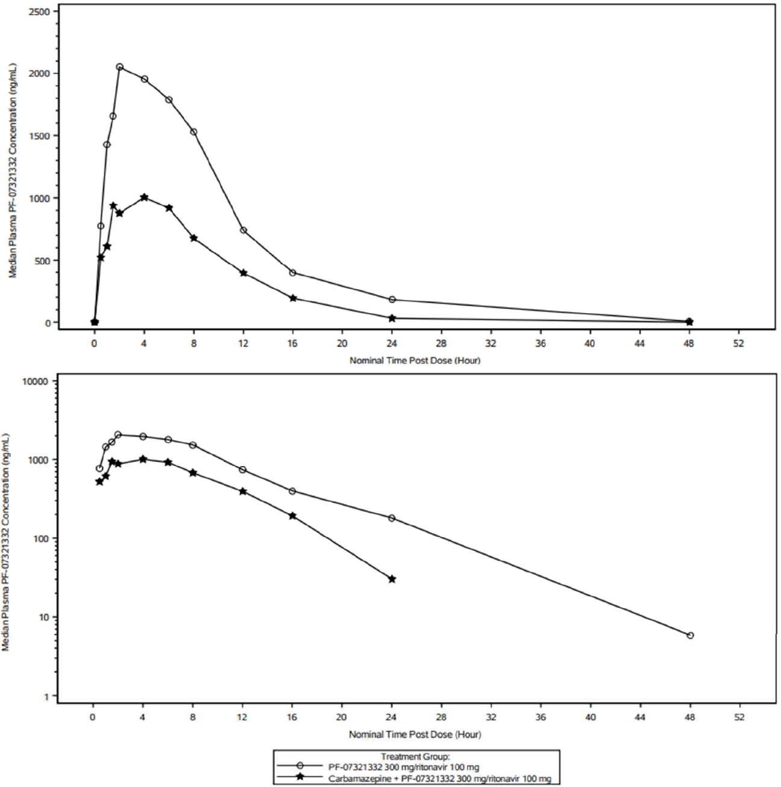
PF-07321332 = drug development code for nirmatrelvir.
Summary statistics have been calculated by setting concentration values below the lower limit of quantification to zero.
The lower limit of quantification is 10.0 ng/mL.
The Period 2 nirmatrelvir 300 mg/ritonavir 100 mg pre-dose measurement of participant who only tool carbamazepine at Period 2 has been excluded from this presentation.

Ritonavir pharmacokinetics
Table 13: Study C4671014 Descriptive summary of plasma ritonavir pharmacokinetic parameters
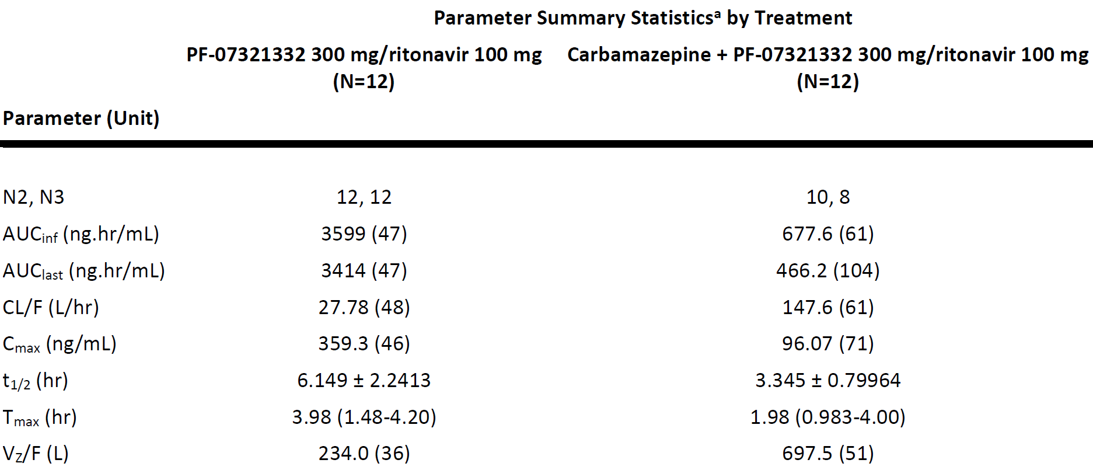
AUC_{inf} = area under the plasma concentration time curve from time zero to infinity; AUC_{last} = area under the plasma concentration time curve to the last measurable time point; CL/F = apparent oral clearance; C_{max} = maximum concentration; N = total number of participants in the treatment group in the indicated population; N2 = number of participants contributing to the summary statistics; N3 = Number of participants contributing to the summary statistics for AUC_{inf}, CL/F, t_{1/2} and VZ/F; PF-07321332 = drug development code for nirmatrelvir; t_{1/2} = terminal elimination half life; T_{max} = time at maximum concentration; Vz/F = apparent volume of distribution.
a. Geometric mean (geometric % coefficient of variation (CV)) for all except median (range) for T_{max} and arithmetic mean ± standard deviation (SD) for t_{1/2}.
Table 14: Study C4671014 Statistical summary of plasma ritonavir pharmacokinetic parameters (area under the plasma concentration time curve from time zero to infinity, area under the plasma concentration time curve to the last measurable time point and maximum concentration)
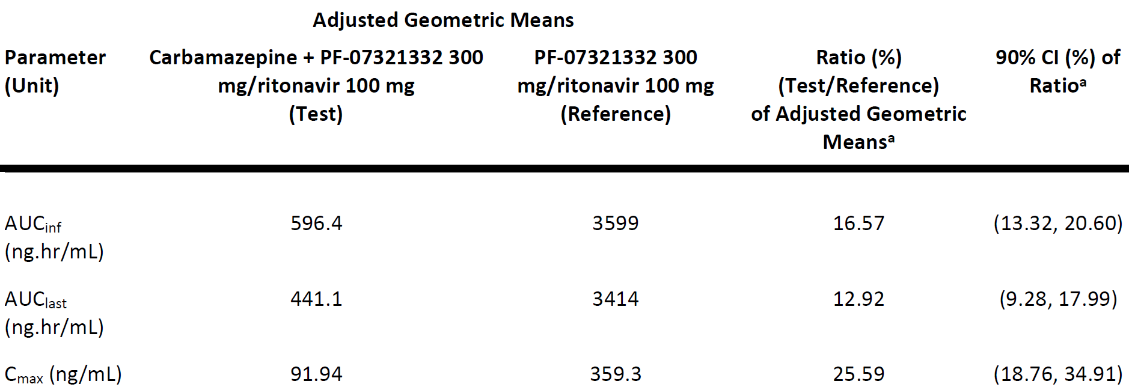
AUC_{inf} = area under the plasma concentration time curve from time zero to infinity; AUC_{last} = area under the plasma concentration time curve to the last measurable time point; CI = confidence interval; C_{max} = maximum concentration; PF-07321332 = drug development code for nirmatrelvir.
Natural log-transformed AUC_{inf}, AUC_{last} and C_{max} for ritonavir are analysed using a mixed effect model with treatment as fixed effect and participant as a random effect.
a. The ratio (and 90% CIs) are expressed as percentages.

Safety results
Table 15: Study C4671014 Treatment emergent adverse events (all causalities; safety analysis set)
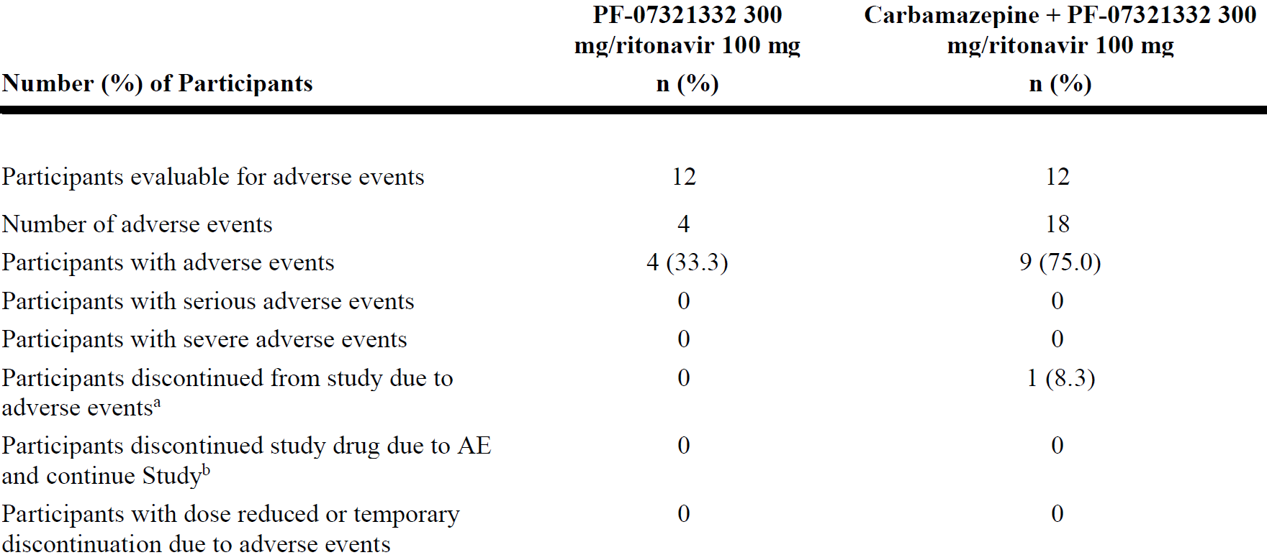
AE = adverse event; n = sample size; PF-07321332 = drug development code for nirmatrelvir.
Safety analysis set: all participants randomly assigned to study intervention and who take at least one dose of study intervention.
Includes data up to lag days after last dose of study drug.
Except for the number of adverse events participants are counted only once per treatment in each row.
Serious adverse events: according to the investigator's assessment.
a. Participants who have an AE record that indicates that the AE caused the participant to be discontinued from the study.
b. Participants who have an AE record that indicates that action taken with study treatment was drug withdrawn but AE did not cause the participant to be discontinued from study.
Medical Dictionary for Regulatory Activities (MedDRA) v24.0 coding dictionary applied.
Two participants only took carbamazepine at the time of withdrawn, and did not take nirmatrelvir 300 mg/ritonavir 100 mg at Period 2.
Table 16: Study C4671014 Treatment emergent adverse events (treatment related; safety analysis set)
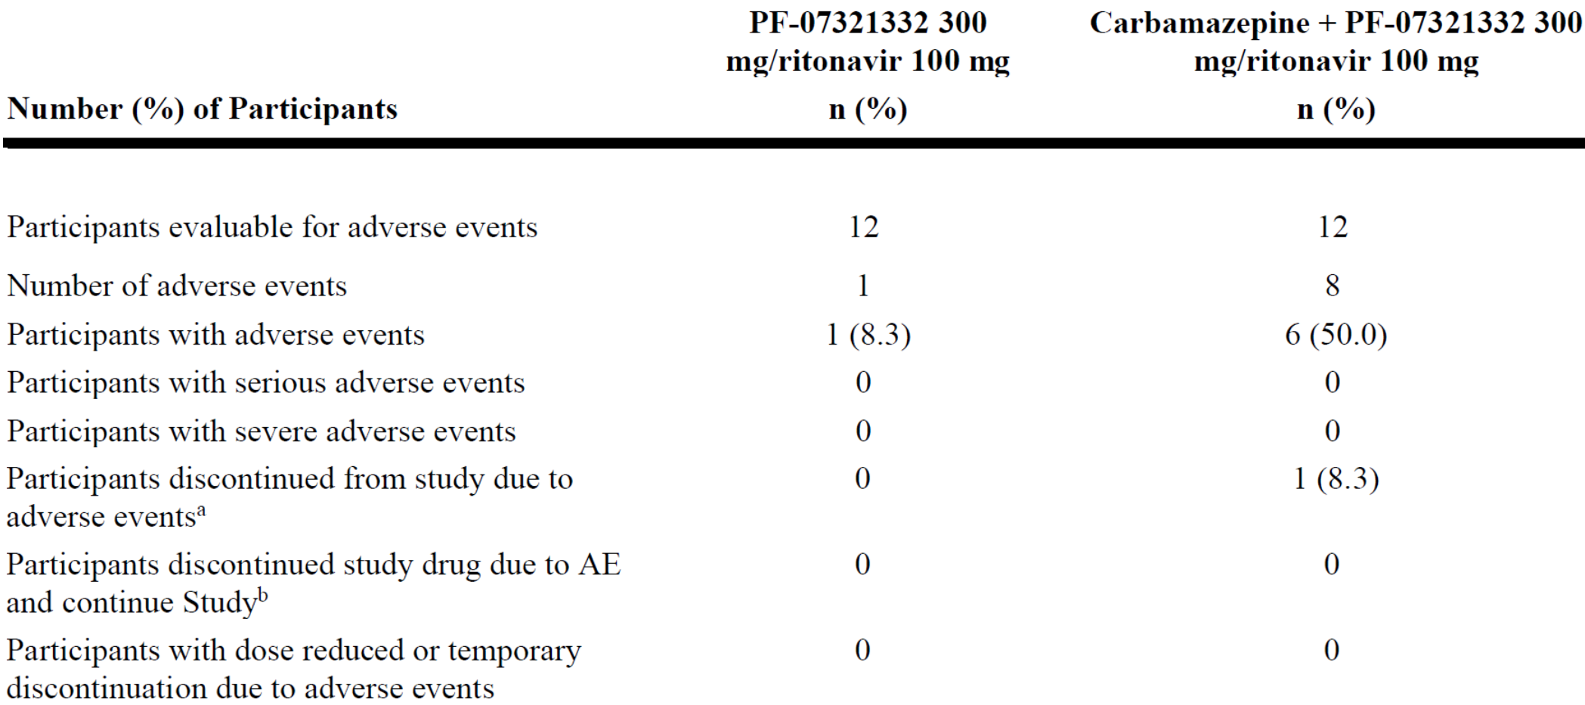
AE = adverse event; n = sample size; PF-07321332 = drug development code for nirmatrelvir.
Safety analysis set: all participants randomly assigned to study intervention and who take at least one dose of study intervention.
Includes data up to lag days after last dose of study drug.
Except for the number of adverse events participants are counted only once per treatment in each row.
Serious adverse events: according to the investigator's assessment.
a. Participants who have an AE record that indicates that the AE caused the participant to be discontinued from the study.
b. Participants who have an AE record that indicates that action taken with study treatment was drug withdrawn but AE did not cause the participant to be discontinued from study.
Medical Dictionary for Regulatory Activities (MedDRA) v24.0 coding dictionary applied.
Two participants only took Carbamazepine at the time of withdrawn, and did not take nirmatrelvir 300 mg/ritonavir 100 mg at Period 2.
In Period 1, there were 4 treatment emergent adverse events (TEAEs) reported by 4 participants. The TEAEs reported by Preferred Terms (PT) were vessel puncture site haematoma, dysgeusia, sciatica and polyuria (one participant each, 8.3%). All 4 TEAEs were mild in severity. One participant had a treatment related TEAE of dysgeusia.
In Period 2, there were 18 TEAEs reported by 9 participants. The most frequently reported all-causality TEAEs by PT, regardless of System Organ Class (SOC), were transaminases increased (5 participants, 41.7%). The majority of the TEAEs (17/18) were mild in severity. There was one moderate TEAE of Inappropriate antidiuretic hormone secretion (hyponatremia/syndrome of inappropriate secretion of antidiuretic hormone (SIADH)). Eight TEAEs reported by 6 participants were considered treatment related. The most frequently reported treatment related TEAEs by PT were transaminases increased (5 participants, 41.7%).
There were no deaths or SAEs reported in this study. Most of the TEAEs in both periods of the study were mild in severity except one moderate treatment related AE of inappropriate antidiuretic hormone secretion (hyponatremia/SIADH) in Period 2. In Period 2 there was one participant discontinued from study due to a moderate AE of inappropriate antidiuretic hormone secretion (hyponatremia/SIADH), which was considered treatment related.
There were no deaths. There were no other SAEs.

Laboratory parameters
In Period 1, laboratory test abnormalities of eosinophils/leukocytes (%) > 1.2 x ULN and monocytes/leukocytes (%) > 1.2 x ULN were reported for one participant each. In Period 2, the most frequently reported laboratory test abnormalities were monocytes/leukocytes (%) > 1.2 x ULN (5 participants), eosinophils/leukocytes (%) > 1.2 x ULN, and alanine aminotransferase (units per litre (U/L)) > 3.0 x ULN (4 participants each).
The 5 participants with laboratory abnormalities (transaminases increased) were reported as AEs by the investigator.
Vital signs: one instance of supine systolic blood pressure absolute value < 90 mmHg was reported in Period 1. One instance of supine diastolic blood pressure increase ≥ 20 mmHg was reported in Period 2.
Electrocardiogram: no participants met the pre-defined criteria during the study.

Study C4671015 (pharmacokinetics and itraconazole drug-drug interaction)

Study design
This was a Phase I, open label, two-period, fixed sequence crossover study to estimate the effect of the strong CYP3A4 inhibitor, itraconazole, on the PK of nirmatrelvir in healthy participants. In Period 1, participants received nirmatrelvir/ritonavir 300 mg/100 mg orally every 12 hours for a total of 5 doses, with the last dose administered on the morning of Day 3. In Period 2, participants received itraconazole 200 mg orally once a day for 8 days. On Days 4 through 6 of Period 2, participants received nirmatrelvir/ritonavir 300 mg/100 mg orally every 12 hours for a total of 5 doses. The objective of this study was to evaluate the effect of a probe CYP3A4 inhibitor, itraconazole, at steady state, on the PK, safety, and tolerability of nirmatrelvir/ritonavir combined treatment.

Treatments
- In Period 1, participants received nirmatrelvir/ritonavir 300 mg/100 mg administered orally every 12 hours for a total of 5 doses, from Day 1 morning to Day 3 morning.
- In Period 2, participants received itraconazole 200 mg orally every 24 hours for 8 days. On Days 4 through 6 of Period 2 participants received nirmatrelvir/ritonavir 300 mg/100 mg orally every 12 hours for a total of 5 doses.

Study participants
A total of 12 participants were assigned to treatment and 11 of them completed the study as planned. Most of the participants were White (10/12) and male (11/12). The mean (SD) age was 41.5 (12.03) years, ranging from 28 to 60 years. The overall mean (SD) weight and BMI were 79.86 (13.121) kg and 25.43 (3.434) kg/m², respectively.

Pharmacokinetic results
Table 17: Study C4671015 Descriptive summary of plasma nirmatrelvir pharmacokinetic parameters
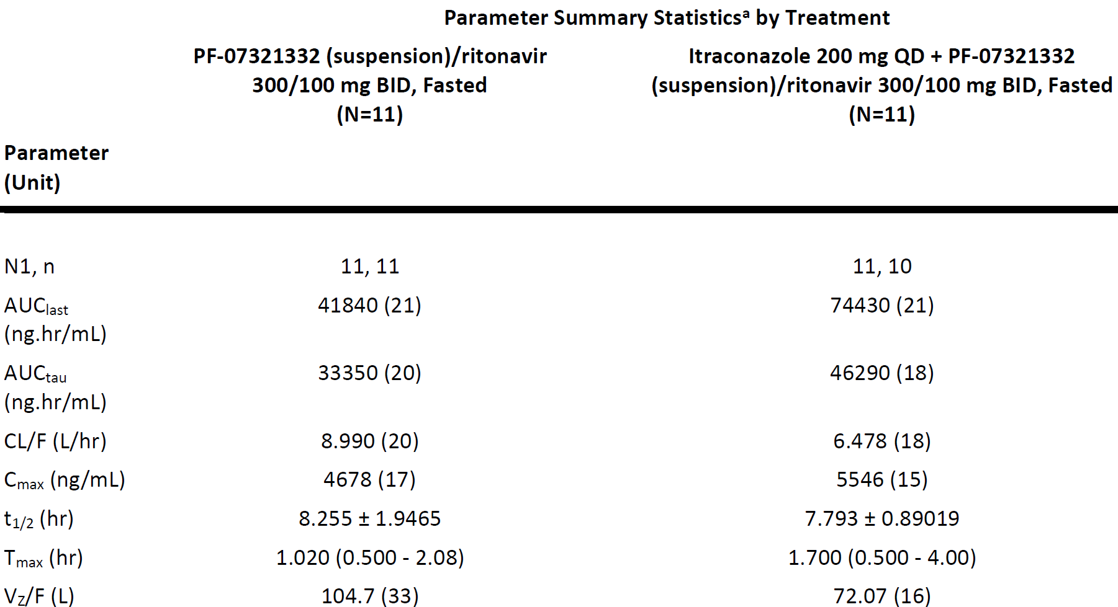
AUC_{last} = area under the plasma concentration time curve to the last measurable time point; AUC_{tau} = area under the plasma concentration time curve for a dosing interval; CL/F = apparent oral clearance; C_{max} = maximum concentration; N = total number of participants in the treatment group in the indicated population; N1 = number of participants contributing to the summary statistics; n = number of participants contributing to the summary statistics for t_{1/2} and V_{Z}/F; PF-07321332 = drug development code for nirmatrelvir; t_{1/2} = terminal elimination half life; T_{max} = time at maximum concentration; Vz/F = apparent volume of distribution.
a. Geometric mean (geometric % coefficient of variation (CV)) for all: except median (range) for T_{max} and arithmetic mean ± standard deviation (SD) for t_{1/2}.
Table 18: Study C4671015 Statistical summary of plasma nirmatrelvir pharmacokinetic parameters (area under the plasma concentration time curve for a dosing interval and maximum concentration)
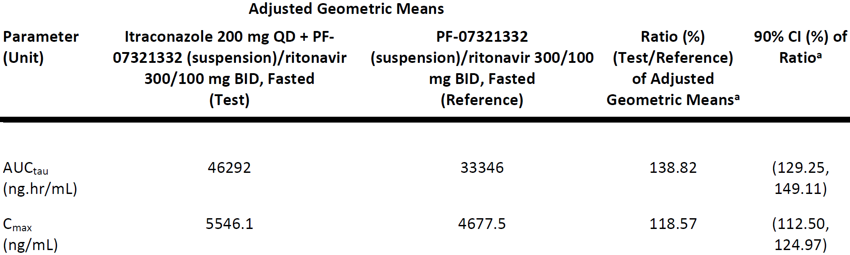
AUC_{tau} = area under the plasma concentration time curve for a dosing interval; BID = twice a day; CI = confidence interval; C_{max} = maximum concentration; PF-07321332 = drug development code for nirmatrelvir; QD = once a day.
Natural log-transformed AUC_{tau} and C_{max} for nirmatrelvir were analysed using a mixed effect model with treatment as fixed effect and participant as a random effect.
a. The ratios (and 90% CIs) were expressed as percentages.

Figure 8: Study C4671015 Median plasma nirmatrelvir concentration time profiles following multiple oral twice daily doses of nirmatrelvir/ritonavir combination, administered alone or with multiple once daily doses of itraconazole, linear scale (upper panel) and semi-log scale (lower panel)
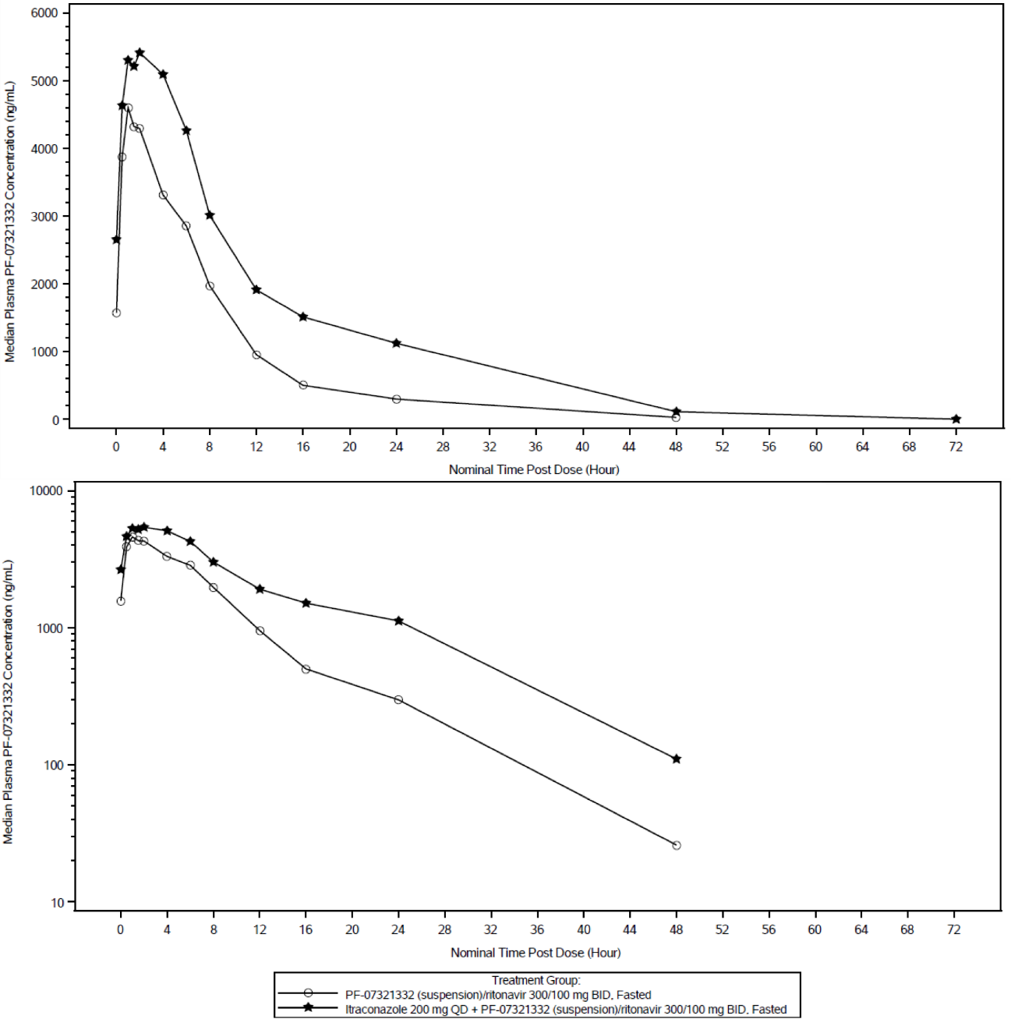
BID = twice a day; PF-07321332 = drug development code for nirmatrelvir; QD = once a day.
Summary Statistics had been calculated by setting concentration values below the lower limit of quantification to zero.
The lower limit of quantification was 10 ng/mL

Ritonavir pharmacokinetics
Table 19: Study C4671015 Descriptive summary of plasma ritonavir pharmacokinetic parameters
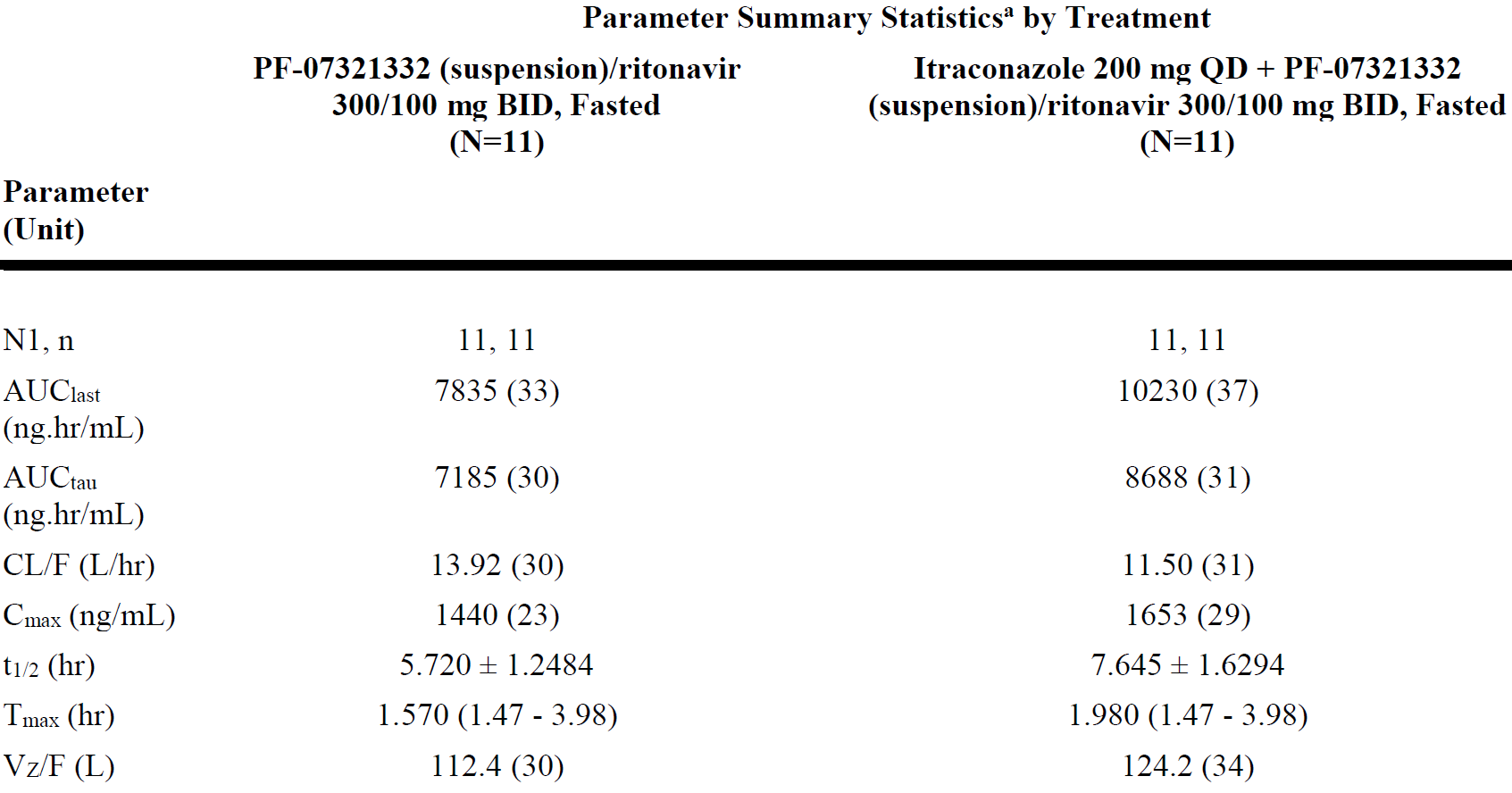
AUC_{last} = area under the plasma concentration time curve to the last measurable time point; AUC_{tau} = area under the plasma concentration time curve for a dosing interval; BID = twice a day; CL/F = apparent oral clearance; C_{max} = maximum concentration; N = total number of participants in the treatment group; N1 = number of participants contributing to the summary statistics; n = number of participants contributing to the summary statistics for t_{1/2} and Vz/F; PF-07321332 = drug development code for nirmatrelvir; QD = once a day; t_{1/2} = terminal elimination half life; T_{max} = time at maximum concentration; Vz/F = apparent volume of distribution.
a. Geometric mean (geometric % coefficient of variation (CV)) for all: except median (range) for T_{max} and arithmetic mean ± standard deviation (SD) for t_{1/2}.
Co-administration of multiple oral 200 mg doses of itraconazole increased ritonavir exposure with approximately 21% and 15% increases in ritonavir geometric mean AUC_{tau} and C_{max}, respectively, compared to nirmatrelvir/ritonavir administered alone.

Safety evaluations
Table 20: Study C4671015 Treatment emergent adverse events (all causalities)
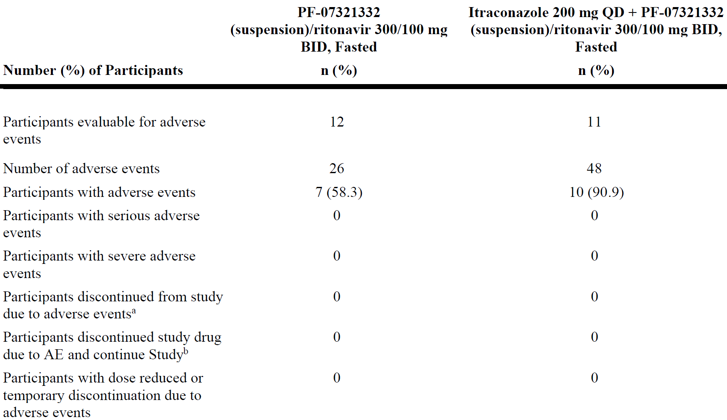
AE = adverse event; BID = twice a day; n = sample size; PF-07321332 = drug development code for nirmatrelvir; QD = once a day.
Included all data collected since the first dose of study drug.
Except for the number of adverse events participants were counted only once per treatment in each row.
Serious adverse events: according to the investigator's assessment.
Medical Dictionary for Regulatory Activities (MedDRA) v24.0 coding dictionary applied.
a. Participants who had an AE record that indicated that the AE caused the participant to be discontinued from the study.
b. Participants who had an AE record that indicated that action taken with study treatment was drug withdrawn but AE did not cause the participant to be discontinued from study.
Table 21: Study C4671015 Treatment emergent adverse events (treatment related)
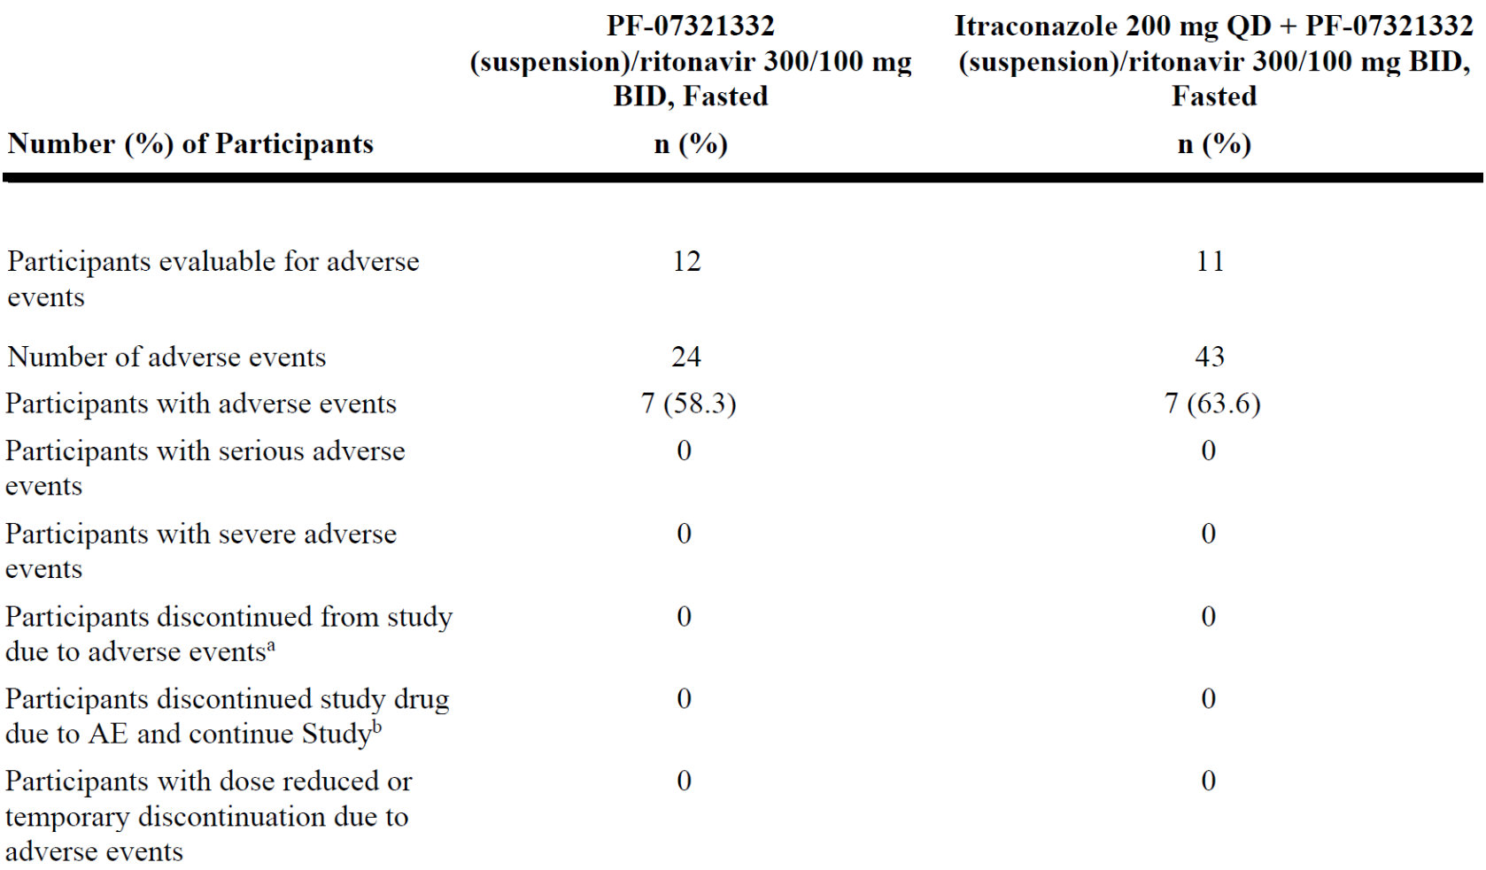
AE = adverse event; BID = twice a day; n = sample size; PF-07321332 = drug development code for nirmatrelvir; QD = once a day.
Included all data collected since the first dose of study drug.
Except for the number of adverse events participants were counted only once per treatment in each row.
Serious adverse events: according to the investigator's assessment.
Medical Dictionary for Regulatory Activities (MedDRA) v24.0 coding dictionary applied.
a. Participants who had an AE record that indicated that the AE caused the participant to be discontinued from the study.
b. Participants who had an AE record that indicated that action taken with study treatment was drug withdrawn but AE did not cause the participant to be discontinued from study.
A total of 26 AEs (22 mild AEs and 4 moderate AEs) were reported by 7 participants in Period 1 and 48 (43 mild and 5 moderate) by 10 participants in Period 2, respectively. The SOCs with the most participants reporting all-causality TEAEs are gastrointestinal disorders (5 participants in Period 1 and 7 in Period 2), General disorders and administration site conditions (2 participants in Period 1 and 6 in Period 2), and nervous system disorders (6 participants in Period 1 and 6 in Period 2). All the other SOCs were reported by one or two participants in either period. No SAEs were reported in either period.
A total of 24 treatment related AEs (21 mild AEs and 3 moderate AEs) were reported by 7 participants in Period 1 and 43 (38 mild and 5 moderate) treatment related AEs by 7 participants in Period 2, respectively. The SOCs with the most participants reporting treatment related TEAEs are the same as all-causality TEAEs, including gastrointestinal disorders (5 participants in Period 1 and 7 in Period 2), General disorders and administration site conditions (one participant in Period 1 and 4 in Period 2), and Nervous system disorders (6 participants in Period 1 and 6 in Period 2).

Analysis of adverse events
Most of the reported AEs were mild in severity. Among the all-causality AEs, 4 participants reported moderate AEs: 2 participants reported 4 moderate AEs in Period 1 and 2 participants reported 5 moderate AEs in Period 2:
- In Period 1, one participant reported vomiting and headache (both related to study treatment); one participant reported dizziness (not related to study treatment) and headache (related to study treatment).
- In Period 2, one participant reported constipation (related to study treatment); and one participant reported anorectal discomfort, constipation, diarrhoea, and gastrointestinal motility disorder (all related to study treatment).
All AEs, with concomitant medications given when necessary, were resolved before the end of study, except one event of constipation, which was reported as resolving at the time of the last report.
One participant experienced the event of atrioventricular block first degree on Study Day 3 in Period 1, which continued through Period 2. The event resolved on Study Day 13.
There were no deaths among participants who participated in this study. No severe AEs or SAEs were reported.

Laboratory parameters
Overall, the following test abnormalities were detected:
- In Period 1, 6 participants had bicarbonate > 1.1 x ULN, and one participant had monocytes/leukocytes > 1.2 x ULN.
- In Period 2, 2 participants had monocytes/leukocytes > 1.2 x ULN, and fibrinogen >1.25 x Baseline and leukocyte esterase ≥ 1 was detected in one participant each.
The readings of elevated bicarbonate normalised upon repeat testing and laboratory error was considered as a possible aetiology. None of the laboratory abnormalities was considered clinically significant.

Vital signs and electrocardiogram
One participant had clinically significant electrocardiogram qualitative results on Study Day 10 (Period 2, Day 6), 1 hour and 1.5 hours post-dose and the following AE was reported: one event of atrioventricular block first degree of mild severity from Study Day 3 to Study Day 13. The event was considered related to the study treatment. No other electrocardiogram abnormalities of potential clinical concern were noted as no participants had electrocardiogram values meeting predefined reporting criteria.

Population pharmacokinetic data

Population modelling analysis report (population pharmacokinetics of nirmatrelvir in healthy adult participants in Study C4671001)
The objectives of this population pharmacokinetic (PopPK) analysis are:
- to characterise the PK of nirmatrelvir in healthy adult participants;
- to evaluate time and dose dependent change in PK of nirmatrelvir;
- to perform PK simulations for various treatment regimens of nirmatrelvir to support dose recommendation in patients with COVID-19.

Data for analysis
A preliminary PopPK analysis data file including all subjects enrolled in Part 1 to Part 3 of Study C4671001 (data cut-off date 30 June 2021) was provided against a data set specification by the Statistical Programming and Analysis - Specialised Data Programming group. Individuals who did not receive at least one dose of nirmatrelvir or did not have at least one measurable concentration were excluded from this analysis.

Methods
Only PK data collected from the nirmatrelvir with ritonavir treatment arms were included in PopPK modelling. The sponsor claims this was based on the preliminary single dose PK data from Study C4671001 which indicated that co-administration of nirmatrelvir with ritonavir is required to achieve the target exposure.
A one or two compartment model with first order elimination and first order absorption (first order absorption rate constant (K_{a})) was tested as the structural model. The base model included an allometric model of baseline body weight on CL/F and apparent volume of distribution (V/F) with exponents fixed to 0.75 and 1, respectively. Inter-individual variability (IIV) and inter-occasion variability (IOV) in the PK parameters was assumed to be log normally distributed and was modelled using multiplicative exponential random effects. Models with and without covariance for random effects were tested. Residual random effects were described with a combined proportional and additive model in the log domain. Food effect on K_{a} and relative bioavailability (F1) and time dependent change in clearance were evaluated.
The methodology appears appropriate.

Results
A total of 20 subjects on nirmatrelvir with ritonavir treatment contributing 536 evaluable nirmatrelvir plasma concentrations were included in the PopPK analysis.
The PK of nirmatrelvir with ritonavir 100 mg following oral administration were adequately characterised by a two compartment disposition model with first order absorption. Separate power functions were used to describe the dose effect on K_{a} and F1. With the final model, the parameter estimates after adjustment by F1 at a nirmatrelvir dose of 300 mg are clearance 8.2 L/h, volume of distribution (V) (sum of V2 and V3) 111 L, and K_{a} 1.1 1/h. This gives a population mean t_{1/2} of approximately 15 hours (the individual post-hoc t_{1/2} ranged from 8.7 to 32.8 hours). No obvious time dependent change in nirmatrelvir clearance was noted. A high fat meal reduced K_{a} by approximately 50%. Considering its impact on minimum concentration (C_{min}) would be minimal, and the inclusion of IIV and IOV on K_{a}, food effect was not included in the final model for subsequent simulation.
Additional data will be required to perform proper covariate modelling to account for the unexplained variability.
With the final PopPK model based on the preliminary data from Study C4671001, the predicted nirmatrelvir PK exposures showed that a nirmatrelvir dose of 300 mg with ritonavir administered twice daily orally would expect to have >90% of simulated subjects achieving C_{12h} ≥ IC₉₀ even after the first dose and with IIV in clearance inflated to 60%.
Based on the preliminary data from Study C4671001
- The concentration time data of nirmatrelvir for healthy adults were adequately described by a two-compartment disposition model with first order absorption, and dose dependent absorption described by separate power functions for K_{a} and F1.
- Inter-individual variability in clearance was low at 26.4% comparing with IIV in V2 30.7%, V3 69.9%, K_{a} 54.3%, and IOV on K_{a} 60.7%.
- A nirmatrelvir dose of 300 mg with ritonavir projected to have > 90% of simulated subjects achieving C_{12h} ≥ IC₉₀ of 292 ng/mL.
- The current modelling and simulation analyses support a nirmatrelvir dose of 300 mg with ritonavir administered twice daily orally.

PMAR-EQDD-C467a-DP4-1307 (population pharmacokinetics evaluation of nirmatrelvir data from Study C4671005)

Overview
Plasma concentration time data were pooled from the FIH Study C4671001 in healthy adults and Study C4671005 in participants with COVID-19. Studies varied in terms of nirmatrelvir formulation, fed versus fasted state, and subject population. For the FIH study, only subsets of PK data collected from the nirmatrelvir/ritonavir treatment arms were included in the current analysis.

Study design
Study C4671005 included a sentinel cohort for safety review after approximately the first 60 participants who have completed Day 10 of the study, and a planned interim analysis for efficacy after approximately 45% of participants completed the Day 28 assessment. nirmatrelvir 100 mg tablets were given to participants in the sentinel cohort, while nirmatrelvir 150 mg tablets were given to participants in the rest of the study (non-sentinel cohort).

Objectives and data sources
The objectives of this analysis are:
- To evaluate the observed concentration data of nirmatrelvir/ritonavir in participants with COVID-19 from Study C4671005 and healthy adults from the FIH Study C4671001 by graphical analysis.
- To use a predictive check (simulation) approach to assess the adequacy of the previous PopPK model, developed based on the preliminary healthy adult data, in describing the patient data from Study C4671005.
- To summarise the percentage of participants from Study C4671005 achieving a C_{min} ≥ EC₉₀.
Data for analysis are:
- A preliminary PopPK analysis data file including all participants enrolled in Part 1 to Part 3 of Study C4671001 (data cut-off date 30 June 2021), and
- Separate preliminary PopPK analysis data file including participants from Study C4671005 (data cut-off date 28 October 2021).

Analysis methods
The analysis was divided into graphical and numerical data check and Pop PK analysis.
With the limited and sparse samples from Study C4671005, a predictive check (simulation) approach was used. The preliminary PopPK model based on healthy adult data (PMAR-EQDD-C467a-Proof of Concept-1246) was used to simulate the plasma nirmatrelvir concentration time profiles and demonstrated that the PK of nirmatrelvir with ritonavir 100 mg following oral administration were adequately characterised by a two-compartment disposition model with first-order absorption. Standard allometric functions for clearances and volumes were applied with exponents fixed to 0.75 and 1, respectively. Separate power functions were used to describe the dose effect on first order K_{a} and F1.
A simulation data set was created by using the healthy adults in Study C4671001 (Part 1 to 3), and assuming a dose regimen of nirmatrelvir/ritonavir 300 mg/100 mg every 12 hours given orally for 5 days (total of 10 doses).
Simulation was conducted using the parameter estimates from the preliminary PopPK model. Assessment was based on the median and 90% prediction interval constructed from a simulation with 1000 sub-problems, and overlaid with the observed plasma nirmatrelvir concentration time data from Study C4671005.

Results
The current analysis included approximately 45% of participants (planned interim analysis) from Study C4671005 instead of the approximately first 60 participants who have completed Day 10 (sentinel cohort).
Table 22: Study C4671005 Number of observations by planned sample collection day
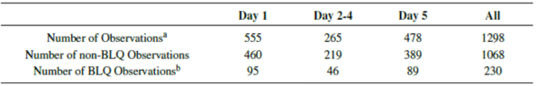
BLQ = below limit of quantification.
Repository artifact identification (ID) FI-26824837.
a. One sample collected per participant per visit.
b. Below limit of quantification defined as < 10 ng/mL and was set to 0.

Strategy for graphical and numerical data check
The observed plasma nirmatrelvir concentrations from participants with COVID-19 (Study C4671005) are consistent with concentrations (dose normalised to 300 mg) observed in the healthy participants in the FIH Study C4671001.
The observed plasma nirmatrelvir concentrations obtained from the sentinel cohort (33 participants received three nirmatrelvir 100 mg tablets) are comparable with those obtained from the non-sentinel cohort (568 participants received two nirmatrelvir 150 mg tablets).
Of total collected samples during the planned Day 5 visit, including those without measurable concentrations (below the limit of quantification (BLQ) samples), 140 out of 173 (> 80%) participants achieved a Day 5 C_{min} ≥ EC₉₀ of 292 ng/mL. When excluding the BLQ samples during the planned Day 5 visit, 140 out of 153 (> 90%) participants achieved a Day 5 C_{min} ≥ EC₉₀.

Strategy for population pharmacokinetic analysis
Figure 9: Study C4671005 Median and 90% prediction intervals (fifth and ninety fifth percentile) for nirmatrelvir concentration based on 1000 simulations (nirmatrelvir/ritonavir 300 mg/100 mg every 12 hours after first dose) overlaid with observed data
EC₉₀ = concentration required for 90% of maximum effect; PF-07321332 = drug development code for nirmatrelvir.
Symbols represent individual observations; orange diamond represent median of Day 1 observations; dashed horizontal line represents the target exposure EC₉₀.

Figure 10: Study C4671005 Median and 90% prediction intervals (fifth and ninety fifth percentile) for nirmatrelvir concentration based on 1000 simulations (nirmatrelvir/ritonavir 300 mg/100 mg every 12 hours at steady-state) overlaid with observed data
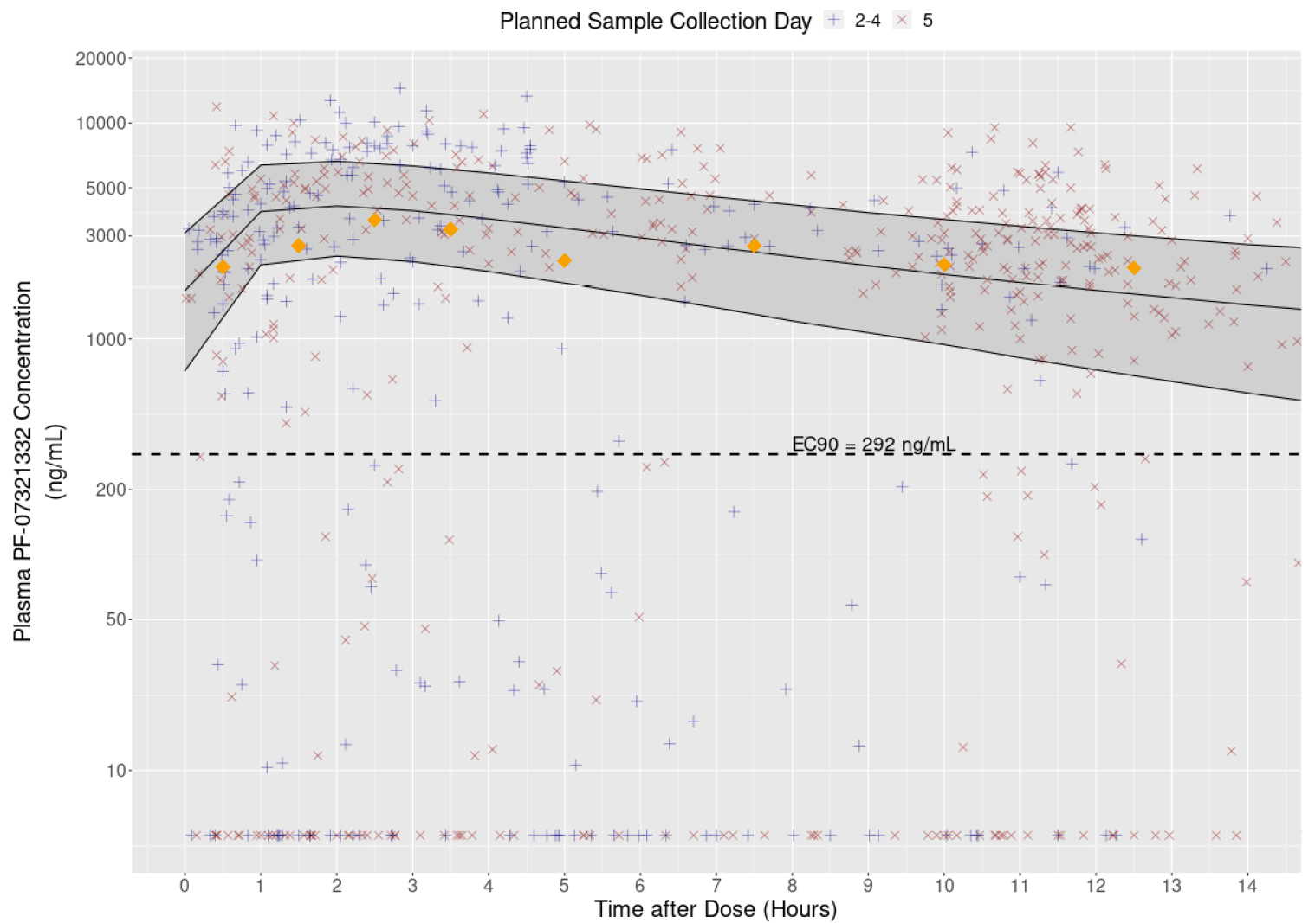
EC₉₀ = concentration required for 90% of maximum effect; PF-07321332 = drug development code for nirmatrelvir.
Symbols represent individual observations; blue symbols represent pharmacokinetic (PK) samples collected on Day 2 to Day 4, and red symbols represent PK samples collected on Day 5; orange diamonds represent median of Day 5 observations binned by intervals (0, 1, 2, 3, 4, 6, 9, 11, and 14 hours post dose); dashed horizontal line represents the in vitro EC₉₀ value. Excluded observations with time after dose >14 hours. Below the limit of quantification (BLQ) samples are shown below the lower limit of quantitation (LLOQ) of 10 ng/mL
In general, the majority of the observed plasma nirmatrelvir concentrations from Study C4671005 fall within the 90% PI. The median observed data for samples collected during the planned Day 1 and Day 5 visits were in good agreement with the model predictions generated by the preliminary PopPK model.
Conclusions, based on the preliminary data from Studies C4671001 and C4671005:
- The observed plasma nirmatrelvir concentrations in participants with COVID-19 from Study C4671005 are comparable with those obtained from the healthy adult participants in the FIH Study C4671001.
- For Study C4671005, the observed plasma nirmatrelvir concentrations obtained from the sentinel cohort (100 mg tablet) are comparable with those obtained from the non-sentinel cohort (150 mg tablet).
- The nirmatrelvir concentration data collected from participants with COVID-19 in Study C4671005 are consistent with the predictions generated by the preliminary PopPK model based on the healthy adult data from Study C4671001.
- At least 80% of participants with COVID-19 receiving nirmatrelvir/ritonavir 300 mg/100 mg every 12 hours for 5 days achieved a Day 5 C_{min} ≥ EC₉₀ of 292 ng/mL.

Pharmacodynamics
Nirmatrelvir is a peptidomimetic inhibitor of the SARS-CoV-2 main protease (Mpro), also referred to as 3C-like protease or coronavirus non-structural protein 5 protease. Inhibition of SARS-CoV-2 Mpro renders the protein incapable of processing polyprotein precursors which leads to the prevention of viral replication. Nirmatrelvir was shown to be a potent inhibitor of SARS-CoV-2 Mpro (inhibitory constant (K_{i}) = 3.1 nM, or inhibitory concentration (IC) = 19.2 nM) in a biochemical enzymatic assay. Nirmatrelvir was found to bind directly to the SARS-CoV-2 Mpro active site by X-ray crystallography.
Nirmatrelvir will be co-administered with ritonavir (acting as a PK enhancer) to achieve and maintain exposures greater than the in vitro antiviral EC₉₀ throughout the duration of the dosing interval. Ritonavir is not active against SARS-CoV-2 3C-like protease and is not expected to have any antiviral activity against the SARS-CoV-2 virus. Ritonavir inhibits the CYP3A mediated metabolism of nirmatrelvir, thereby providing increased plasma concentrations of nirmatrelvir.
Activity was confirmed in the most physiologically relevant antiviral assays of SARS-CoV-2 infection of differentiated normal human bronchial epithelial (dNHBE) cells with mean half maximal (50%) effective concentration (EC₅₀) and EC₉₀ values of 0.0618 μM and 0.181 μM, respectively, at Day 3 post-infection. The in vitro antiviral activity of nirmatrelvir against SARS-CoV-2 was also evaluated in VeroE6 cells, enriched for cellular expression of angiotensin converting enzyme 2 (ACE-2) receptor, displaying mean EC₅₀ and EC₉₀ values of 0.0745 μM and 0.155 μM, respectively, in the presence of efflux inhibitor and no measurable cytotoxicity (50% cytotoxic concentration (CC₅₀) > 10 μM).
In vivo models for evaluation of nirmatrelvir against SARS-CoV-2 use a SARS-CoV-2 virus that has been adapted to infect mice (SARS-CoV-2-MA10). The activity of nirmatrelvir has been evaluated in two different laboratories in 2 different models and similar results have been observed for both studies. nirmatrelvir has antiviral efficacy (reduced lung titre, histopathology, and ameliorated weight loss) in the mouse adapted model of SARS-CoV-2 with the data supporting efficacy at exposures approximate 1 x EC₉₀ (292 ng/mL (181 nM)) at C_{min}.

Efficacy

Study C4671005
This Phase II/III, randomised, double blind, placebo controlled study in non-hospitalised, symptomatic adult participants with COVID-19 at increased risk of progressing to severe illness determined the efficacy, safety, and tolerability of nirmatrelvir/ritonavir compared with placebo.
Figure 11: Study C4671005 Study design
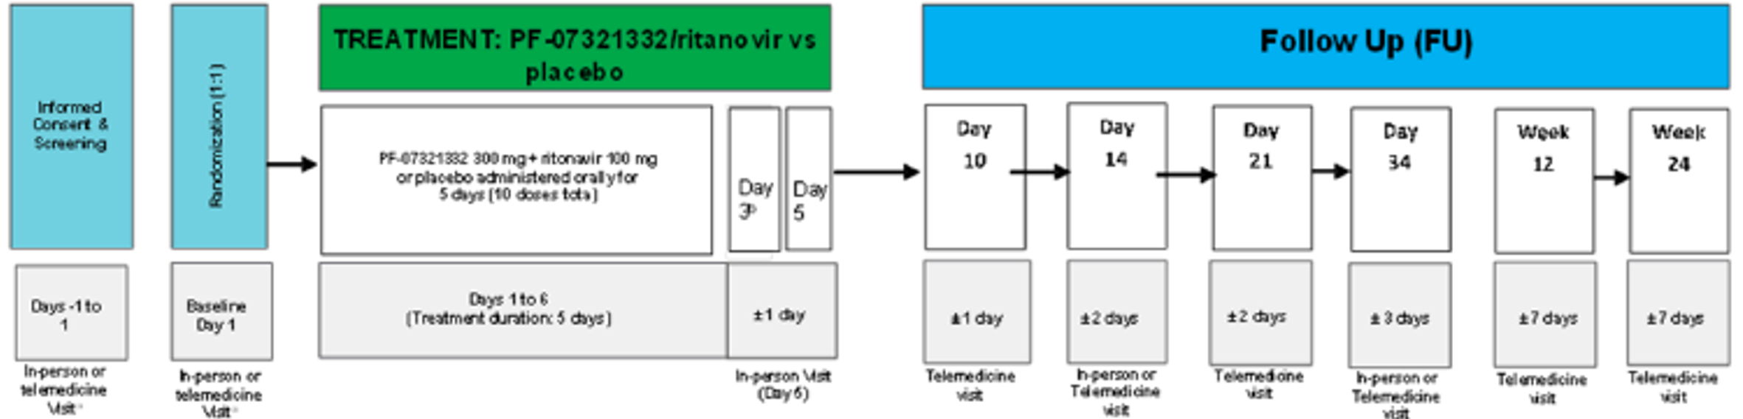
PF-07321332 = drug development code for nirmatrelvir; FU = follow-up.
a. the baseline and screening visits may be a combination of in person and telemedicine visits.
b. the Day 3 visit must be conducted in person for the first 60 participants (sentinel cohort) and thereafter only if a pharmacokinetic (PK) sample (not using Tasso) is collected by an healthcare professional or if electrocardiograph is required.
Enrolment of participants that had received or were expected to receive COVID-19 therapeutic monoclonal antibody (mAb) treatment was to be limited to approximately 25% of participants.
An independent Environmental Data Management Committee (E-DMC) reviewed unblinded safety data on an ongoing basis throughout the duration of the study, and for a sentinel cohort of the first 60 participants after completion through Day 10. In addition, the E-DMC conducted a proof of concept assessment using viral load data from approximately 200 participants from the modified intention-to-treat (mITT) analysis set through Day 5, and a formal interim analysis for efficacy and futility (with a sample size re-estimation) after approximately 45% of participants in the mITT analysis set completed the Day 28 assessments. This represented 774, 1219, and 1330 of participants in the mITT, mITT1 and mITT2 analysis sets, respectively.
On 3 November 2021, the external data monitoring committee reviewed data from the 45% interim analysis and determined that the pre-specified criteria for stopping the trial due to overwhelming efficacy had been achieved (nirmatrelvir/ritonavir is superior to placebo in the mITT analysis set for reduction in hospitalisation/death; p < 0.0001, the pre-specified p-value per protocol to stop the trial for efficacy was p < 0.002). Further enrolment in the study was stopped on 5 November 2021, and at the time of this decision, 2426 participants of the intended sample size (3100 participants) had been randomised.
A Preliminary Completion Date Summary Report full analysis, dated 13 December 2021, has been recently provided by the sponsor. This is a top line report summarising primary efficacy and key safety data from the primary completion date (PCD) analysis of Study C4671005 for all participants enrolled. The report includes efficacy assessments through Day 28 and follow-up safety assessments through Day 34.
The final (PCD) clinical study report has been provided on 11 January 2022 by the sponsor. This presents the results of the primary analysis of all enrolled participants who completed the Day 34 visit. A follow-up analysis will be performed after all participants have completed the Week 24 visit. The top line data from this final clinical study report was already incorporated in this Delegate overview under the preliminary (PCD) summary report full analysis. This updated Delegate overview includes additional and relevant information from the final clinical study report provided on 11 January 2022.
The study results/conclusions from the interim clinical study report dated 21 November 2021 remain unchanged.

Key inclusion criteria
Key inclusion criteria were:
- Participants ≥ 18 years of age (or the minimum country specific age of consent if >18) at the time of the screening visit.
  - Women of childbearing potential may be enrolled.
  - All fertile participants must agree to use a highly effective method of contraception.
- Confirmed SARS-CoV-2 infection as determined by reverse transcription polymerase chain reaction (RT-PCR) in any specimen collected within 5 days prior to randomisation.
- Note: RT-PCR is the preferred method; however, with evolving approaches to confirmation of SARS-CoV-2 infection, other molecular or antigen tests that detect viral RNA or protein are allowed.
- Initial onset of signs/symptoms attributable to COVID-19 within 5 days prior to the day of randomisation and at least one of the specified signs/symptoms attributable to COVID-19 present on the day of randomisation.
- Has at least one characteristic or underlying medical condition associated with an increased risk of developing severe illness from COVID-19 including:
  - ≥ 60 years of age;
  - Body mass index >25;
  - Current smoker (cigarette smoking within the past 30 days) and history of at least 100 lifetime cigarettes.
  - Immunosuppressive disease (for example, bone marrow or organ transplantation or primary immune deficiencies) or prolonged use of immune weakening medications:
    - Has received corticosteroids equivalent to prednisone ≥ 20 mg daily for at least 14 consecutive days within 30 days prior to study entry.
    - Has received treatment with biologics (for example, infliximab, ustekinumab), immunomodulators (for example, methotrexate, 6-mercaptopurine, azathioprine) or cancer chemotherapy within 90 days prior to study entry.
    - Human immunodeficiency virus infection with cluster of differentiation 4 (CD4) cell count < 200 mm³ and a viral load less than 400 copies/mL
  - Chronic lung disease (if asthmatic, requires daily prescribed therapy);
  - Known diagnosis of hypertension;
  - Cardiovascular disease, defined as history of any of the following: myocardial infarction, stroke, transient ischaemic attack, heart failure, angina with prescribed nitroglycerin, coronary artery bypass graft, percutaneous coronary intervention, carotid endarterectomy, and aortic bypass;
  - Type 1 or type 2 diabetes mellitus;
  - Chronic kidney disease provided the participant does not meet the relevant exclusion criterion (see following section);
  - Sickle cell disease;
  - Neurodevelopmental disorders (for example, cerebral palsy, Down’s syndrome) or other conditions that confer medical complexity (for example, genetic or metabolic syndromes and severe congenital anomalies);
  - Active cancer, other than localised skin cancer, including those requiring treatment as long as the treatment is not among the prohibited medications that must be administered/continued during the trial period;
  - Medical related technological dependence (for example, continuous positive airway pressure (not related to COVID-19)).

Key exclusion criteria

Medical conditions
History of hospitalisation for the medical treatment of COVID-19; Current need for hospitalisation or anticipated need for hospitalisation within 48 hours after randomisation in the clinical opinion of the site investigator; prior to current disease episode, any confirmed SARS-CoV-2 infection; known medical history of active liver disease; receiving dialysis or have known moderate to severe renal impairment; known HIV infection with a viral load greater than 400 copies/mL or taking prohibited medications for HIV treatment.

Prior/concomitant therapy
Current or expected use of any medications or substances that are highly dependent on CYP3A4 for clearance and for which elevated plasma concentrations may be associated with serious and/or life threatening events during treatment and for 4 days after the last dose of nirmatrelvir/ritonavir.
Concomitant use of any medications or substances that are strong inducers of CYP3A4 are prohibited within 28 days prior to first dose of nirmatrelvir/ritonavir and during study treatment; Has received or is expected to receive convalescent COVID-19 plasma; Has received or is expected to receive any dose of a SARS-CoV-2 vaccine before the Day 34 visit.

Study interventions
Participants were randomly assigned to one of two treatment groups in the study:
- Nirmatrelvir 300 mg (that is, 2 tablets of 150 mg, or 3 tablets of 100 mg for some participants in the sentinel cohort) and ritonavir 100 mg (that is, one capsule of 100 mg) every 12 hours by mouth for 5 days.
- Placebo for nirmatrelvir (2 tablets (3 tablets for the sentinel cohort)) and placebo for ritonavir (one capsule) every 12 hours by mouth for 5 days.

Statistical analysis
Table 23: Study C4671005 Summary of efficacy analyses for the 45% interim analysis
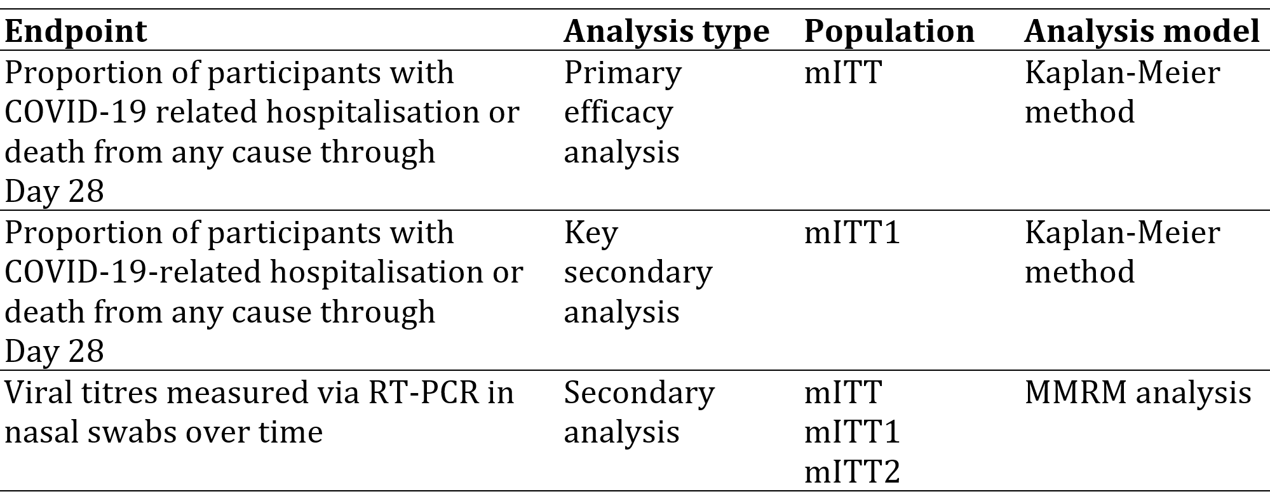
COVID-19 = coronavirus disease 2019; mITT = modified intention-to-treat; RT-PCR = reverse transcription polymerase chain reaction.

Changes in planned analyses prior to unblinding or database lock
- A sensitivity analysis that was pre-specified as a secondary analysis of the primary endpoint (Protocol Amendment 2, 2 August 2021) was planned to include participants regardless of COVID-19 therapeutic mAb treatment (that is, mITT2 analysis set). This sensitivity or supportive analysis was to assess if the treatment effect of nirmatrelvir/ritonavir would extend to participants who received the mAb treatment or had planned to receive mAb treatment.
- Sequential testing for the secondary efficacy endpoints was added in statistical analysis plan (SAP) version 1.2, 26 October 2021: following the positive test of the primary endpoint, sequential testing was to be performed for the following 2 secondary endpoints:
  - Proportion of participants with COVID-19 related hospitalisation or death from any cause through Day 28 who did not receive COVID-19 therapeutic mAb treatment, regardless of their onset of COVID-19 related signs and symptoms.
  - Time (days) to sustained alleviation of all targeted signs/symptoms through Day 28.

Proof of concept analysis for viral load
- A proof of concept analysis of viral titres measured via RT-PCR in nasopharyngeal samples collected on Day 1 and Day 5 was added in SAP version 1.1 (12 October 2021) to analyse the change from Baseline (Day 1) to Day 5.
- Participants were excluded from the analysis due to missing or baseline viral load below the limit of detection (< 550 log10 copies/mL), or collection with a unvalidated (local) swab.
- As per the US Food and Drug Administration (FDA)’s request sensitivity analysis of the primary endpoint was performed using the mITT analysis set whereby participants who did not have follow-up data through Day 21 were hypothetically assumed to have experienced both COVID-19 related hospitalisation and death in a worst case scenario.
Viral load over time: nasopharyngeal swabs were collected per the schedule of activities (SoA) and analysed to measure SARS-CoV-2 RNA by RT-PCR at Baseline (Day 1) and end of trial (Day 5). Nasal mid-turbinate swabs were collected by the participant as specified in the SoA on Day 3, Day 10 and Day 14 but were not used in the viral proof of concept analysis. The sponsor mentions that the residual viral load samples will be utilised for viral sequencing to assess prevalence of variant of concern (VOC)/variant of interest (VOI) in the study population and to determine the efficacy of study treatment against different VOC/VOI present at Baseline and the frequency of treatment emergent mutations (for example, 3C-like gene) compared to placebo.
The sponsor plans to submit further data when available. Subsequent infectivity and phenotypic assays will be conducted to characterise susceptibility and fitness of virus engineered to contain treatment emergent mutations to nirmatrelvir/ritonavir.

Study participants
As of the data cut-off (26 October 2021), all 1361 participants in this planned interim analysis had entered the treatment phase. The proportion of participants who discontinued the treatment phase was similar between treatment groups. The proportion of participants who completed the safety follow-up (Day 34) and who entered the long term follow-up phase were similar between treatment groups.
Table 24: Study C4671005 Disposition events summary (full analysis set; 45% interim analysis)
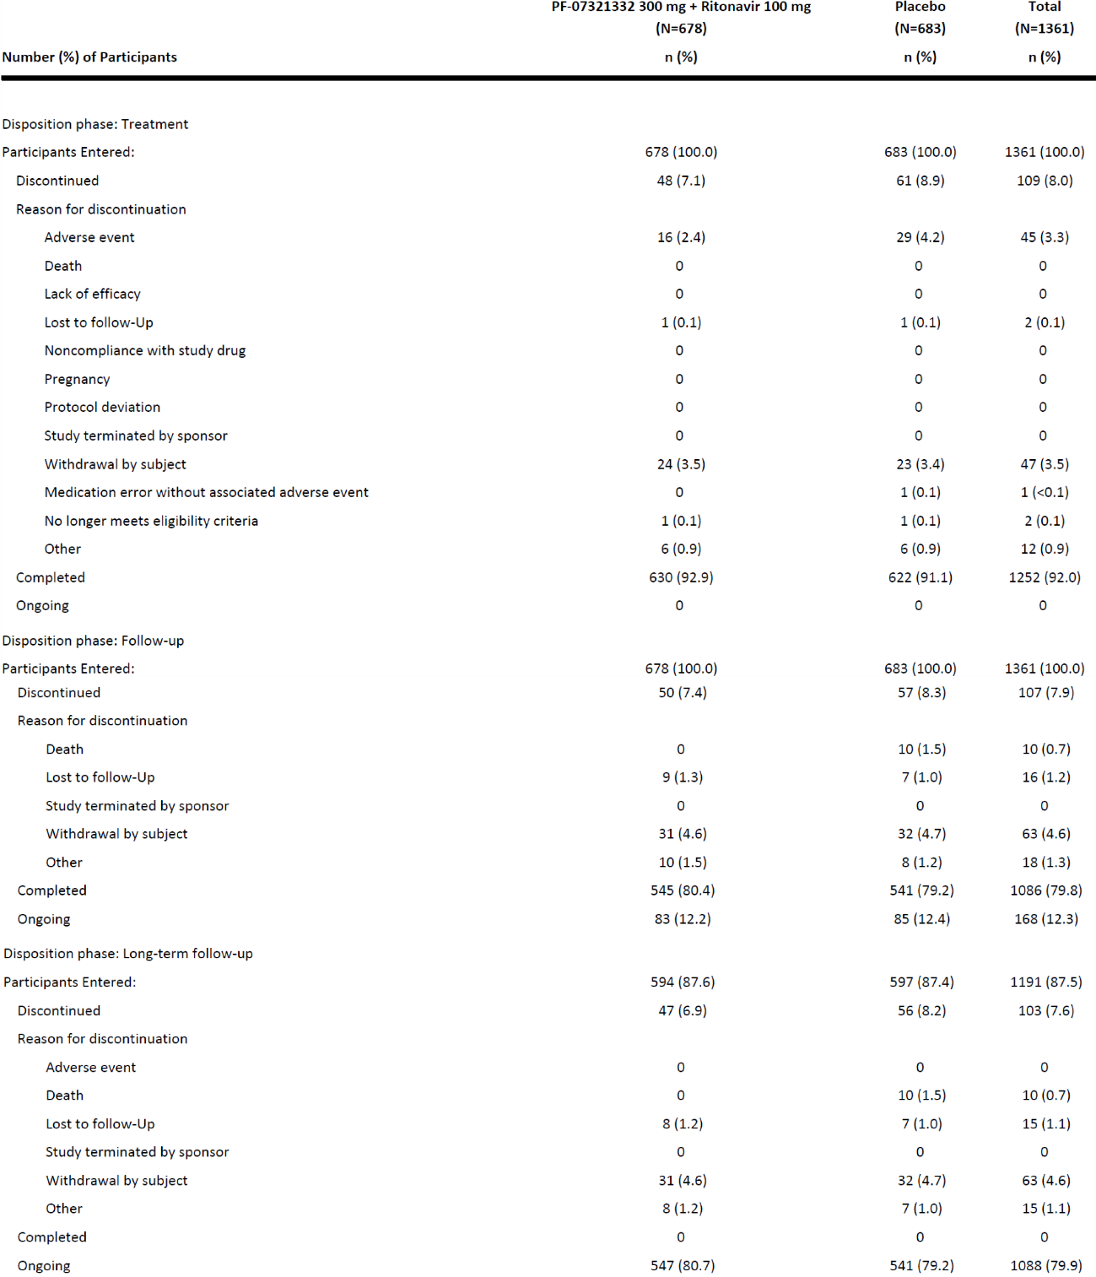
N = total number of participants in the treatment group in the indicated population; n = sample size.
Table 25: Study C4671005 Participant evaluation groups (all screened participants; 45% interim analysis)
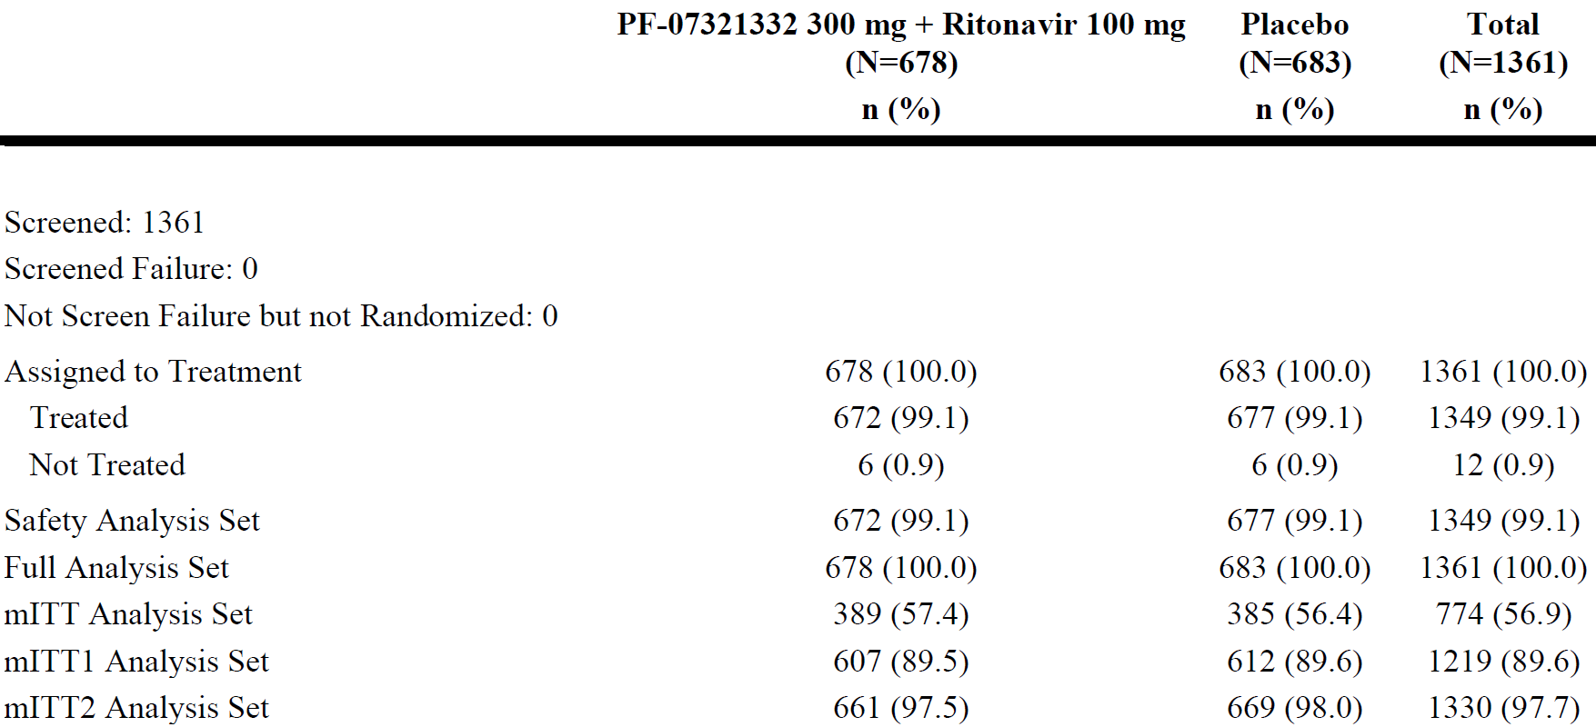
mITT = modified intention-to-treat; N = total number of participants in the treatment group in the indicated population; n = sample size.
Table 26: Study C4671005 Definition of analysis population sets
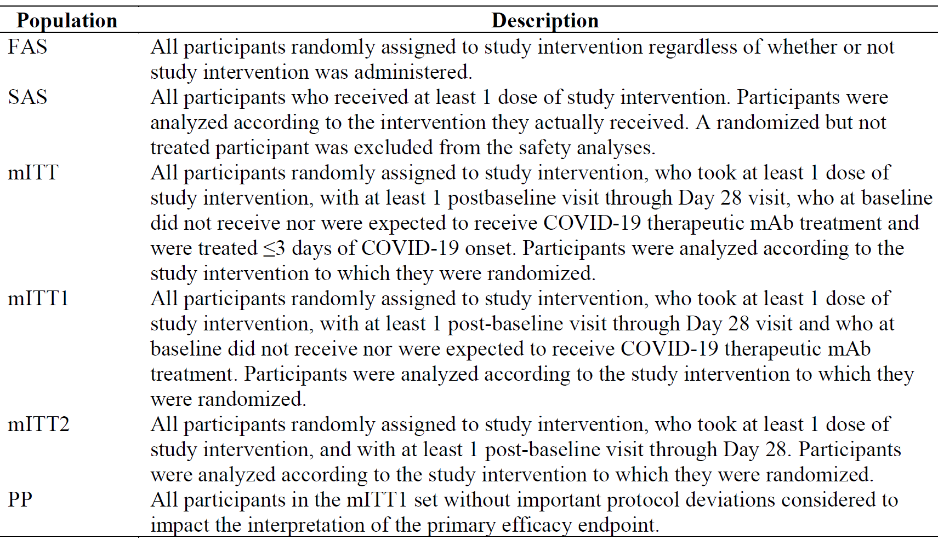
COVID-19 = coronavirus disease 2019; FAS =full analysis set; mITT = modified intention-to-treat; PP = per-protocol; SAS = statistical analysis system.
As of the data cut-off (11 December 2021) 2246 (100.0%) participants were randomised into Study 100, and 2102 (93.6%) participants had completed the safety follow-up (Day 34). (Table 27 below).
Table 27: Study C4671005 Participant evaluation groups (all screened participants; primary completion date full analysis)
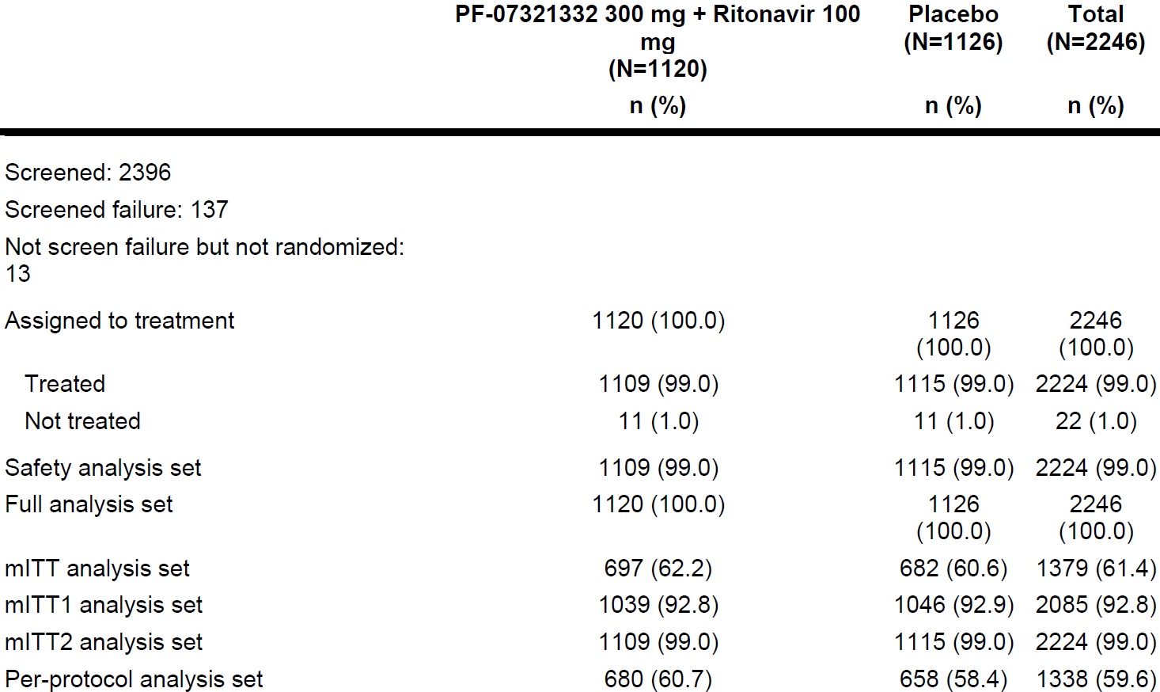
mITT = modified intention-to-treat; N = total number of participants in the treatment group in the indicated population; n = sample size.
Primary completion date full analysis: there was a minor change in the definitions below (from 45% interim analysis) before database lock using the agreed FDA Biometrics-suggested definitions.
Table 28: Study C4671005 Efficacy analysis sets defined
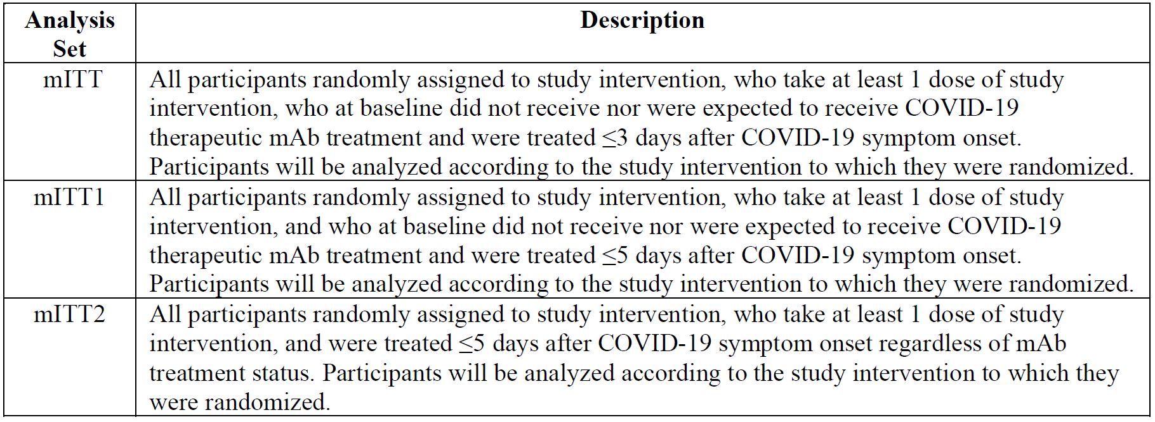
COVID-19 = coronavirus disease 2019; mAb = monoclonal antibody; mITT = modified intention-to-treat.
- The proportion of participants who discontinued the treatment phase was similar between treatment groups (6.0% versus 7.7% in the nirmatrelvir/ritonavir group and placebo group, respectively). The most common reasons for discontinuation during the treatment phase of the study in either treatment group were AEs (3.1%) followed by ‘withdrawal by subject’ (2.6%). Fewer participants in the nirmatrelvir/ritonavir group (2.1%) discontinued the treatment phase due to an AE compared with the placebo group (4.2%).
- The proportion of participants who completed the safety follow-up (Day 34) was similar between treatment groups.
Table 29: Study C4671005 Disposition events summary (full analysis set; primary completion date full analysis)
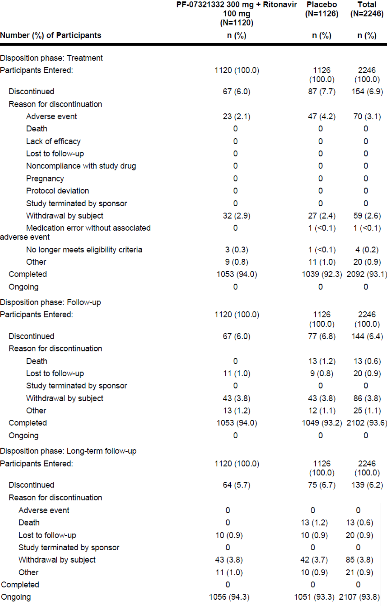
N = total number of participants in the treatment group in the indicated population; n = sample size; PF-07321332 = drug development code for nirmatrelvir.

Demography and baseline characteristics
As of the data cut-off date (26 October 2021), demographic characteristics for the full analysis set (FAS) (that is, participants randomised by 29 September 2021) were similar between the nirmatrelvir/ritonavir and placebo groups.
- Over half of the participants were male and were White. Approximately half of the participants in each treatment group were Hispanic and Latino.
- The median age was 44.00 (18.00, 86.00) years and 255 (18.7%) participants were 60 years of age or greater at the time of randomisation. The mean (SD) BMI was 29.14 (5.63) kg/m².
The participant population of this study reflect the patient population who are at high risk for progressing to severe disease:
- All participants had a laboratory confirmed SARS-CoV-2 diagnosis, with 92.9% of participants having a qualifying SARS CoV-2 positive test collected within 3 days of first dose of study intervention.
- Across treatment groups, 63.1% of participants received their first dose of study intervention within 3 days of symptom onset.
- The incidence of participants with at least one prior or ongoing disease/syndrome at screening in the safety analysis set was similar between both treatment groups (454 (67.6%) participants for nirmatrelvir/ritonavir versus 480 (70.9%) for placebo)
- Across treatment groups, 44.4% of participants were serological negative at Baseline.
- Across treatment groups, the median log10(viral load) in log10(copies/mL) was 5.26. Approximately 63% participants had a high baseline viral load (≥ 4.0 log10 copies/mL).
Demographic and baseline characteristics were similar for the mITT, mITT1, mITT2, and safety analysis sets.
As of the data cut-off (11 December 2021), demographic and baseline characteristics for the FAS were similar between the nirmatrelvir/ritonavir and placebo groups.
As of the data cut-off, 41.3%, 29.8%, 8.5%, and 20.4% of participants were from the USA, Europe, India and rest of the world, respectively. Over half of the participants (51.1%) were male and were White (71.5%). Just under half of the participants in each treatment group were Hispanic or Latino. The median age was 46.0 (18.0, 88.0) years and 288 (12.8%) patients were 65 years of age or greater at the time of randomisation. The mean (SD) BMI was 29.17 (5.62), and the majority of participants had a BMI of 25 or greater at the time of screening.
Across treatment groups, 47.0% of participants were serological negative at Baseline. Most participants (93.8% across treatment groups) did not receive or were not planning to receive monoclonal antibodies for the disease under study at the time of randomisation.
With the exception of 2 participants, all participants had at least one risk factor for severe COVID-19 with 38.9% of participants with one pre-specified risk factor and 35.7% participants with 2 pre-specified risk factors. A total of 375 (16.7%) and 152 (6.8%) participants presented at screening with 3 and 4 risk factors, respectively. The most common risk factor at Baseline was BMI ≥25 (80.5%).
Across treatment groups, the median baseline viral load (log10 copies/mL) was 5.35. Approximately 36.5% of participants had a low baseline viral load (< 4.0 log10 copies/mL), 60.2% of participants had a high baseline viral load (≥ 4.0 log10 copies/ L) and 25.6% of participants had a very high baseline viral load (≥ 7.0 log10 copies/mL).
The incidence of participants with at least one prior or ongoing disease/syndrome at screening was similar between both treatment groups.
- The most frequently reported conditions in at least 10% of participants in either treatment group present at the start of the study were tobacco user (865 (38.9%) participants), hypertension (733 (33.0%) participants), and diabetes mellitus (271 (12.2%)).

Exposure
Table 30: Study C4671005 Duration of treatment (actual dosing day; safety analysis set; 45% interim analysis)
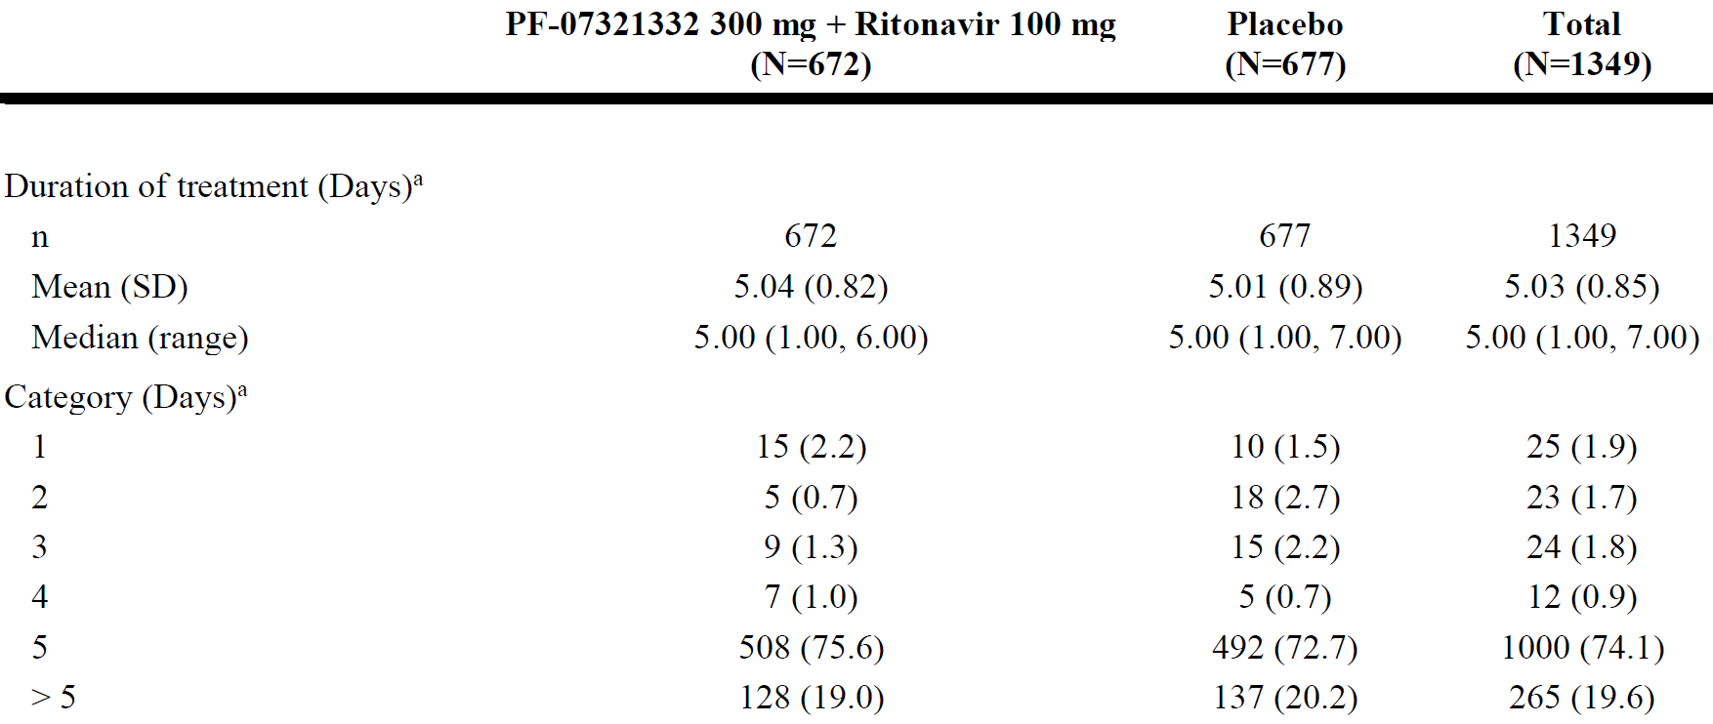
N = total number of participants in the treatment group in the indicated population; n = sample size; PF-07321332 = drug development code for nirmatrelvir; SD = standard deviation.
a. The total number of dosing days on which study drug was actually administered
Table 31: Study C4671005 Duration of treatment (actual dosing day; safety analysis set; final clinical study report)
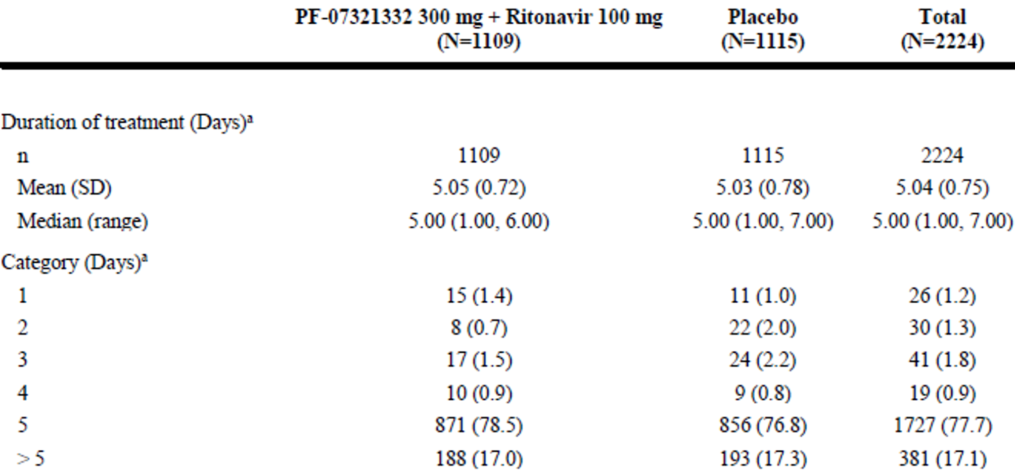
N = total number of participants in the treatment group in the indicated population; n = sample size; PF-07321332 = drug development code for nirmatrelvir; SD = standard deviation.
a. The total number of dosing days on which study drug was actually administered.

Primary efficacy endpoint results
For the 45% interim analysis, based on the sequential design and pre-specified interim analysis specifications, the primary analysis result was statistically significant, and the primary objective of the study was met.
Table 32: Study C4671005 Primary analysis of proportion of participants with COVID-19 related hospitalisation or death from any cause through Day 28 (modified intention-to-treat; Kaplan-Meier Method; 45% interim analysis)
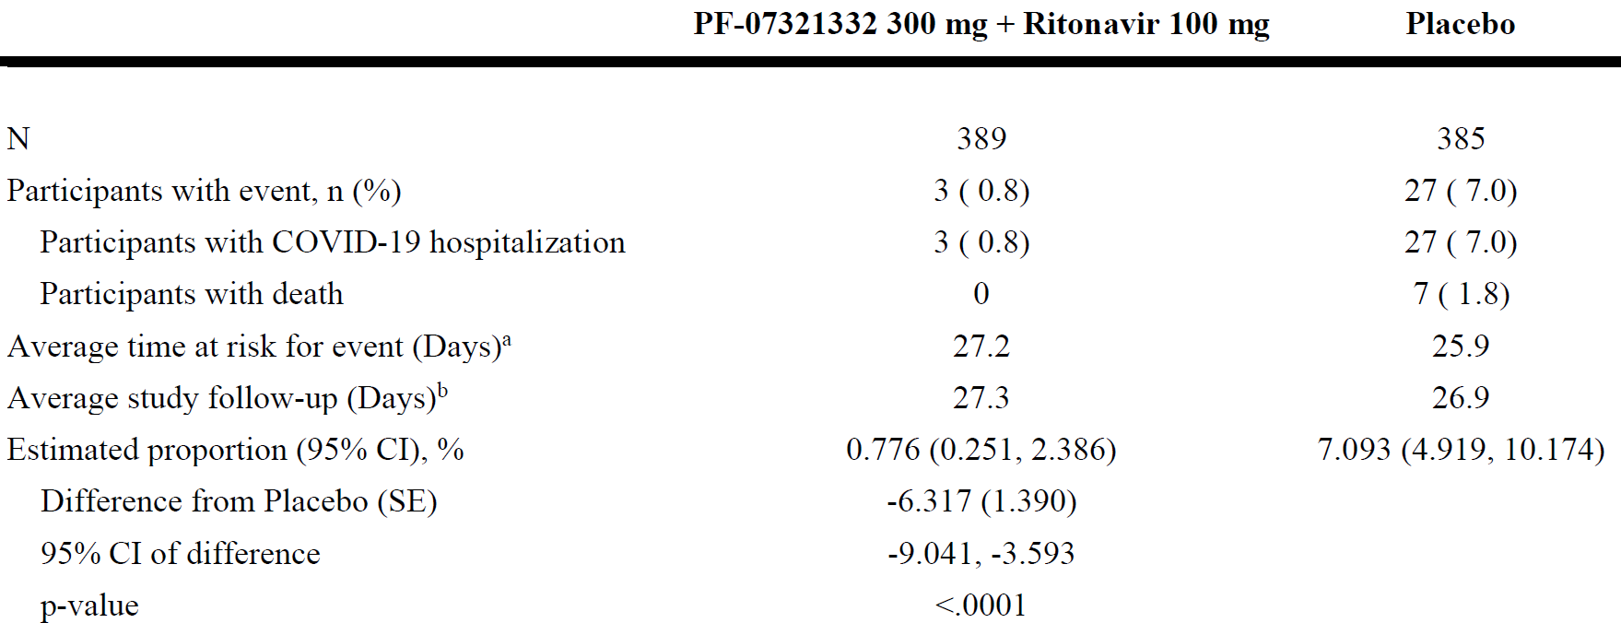
CI = confidence interval; COVID-19 = coronavirus disease 2019; N = number of participants in the analysis set; PF-07321332 = drug development code for nirmatrelvir; SE = standard error.
The cumulative proportion of participants hospitalized for the treatment of COVID-19 or death during the first 28 days of the study was estimated for each treatment group using the Kaplan-Meier method. The difference of the proportions in the 2 treatment groups and its 95% confidence interval, and p-value based on normal approximation of the data are presented.
a. Average time at risk for event is computed as time to first event, or time to last day of participation, or Day 28, whichever is earlier.
b. Average study follow-up is computed as time to last day of participation, or Day 28, whichever is earlier.
After accounting for premature study discontinuation (that is, participant discontinued study before Day 28 without having experienced a primary endpoint event) by using the follow-up time in the Kaplan-Meier calculation, treatment with nirmatrelvir/ritonavir showed a 6.32% (95% CI: -9.04% to -3.59%; p < 0.0001) absolute reduction, or 89.1% relative reduction in primary endpoint events compared to placebo. The reduction was statistically significant, at α-level of 0.002, which was pre-specified for the interim analysis.
At the PCD full analysis, the event rate of a COVID-19 related hospitalisation or death from any cause through Day 28 in the mITT analysis set in participants who received treatment within 3 days of symptom onset was 44/682 (6.45%) in the placebo group, and 5/697 (0.72%) in the nirmatrelvir/ritonavir group.
After accounting for premature study discontinuation (that is, participant discontinued study before Day 28 without having experienced a primary endpoint event) by using the follow-up time in the Kaplan-Meier calculation, treatment with nirmatrelvir/ritonavir showed a 5.81% (95% CI: -7.78% to -3.84; p<0.0001) absolute reduction, or 88.9% relative reduction in primary endpoint events compared to placebo.
There were zero and nine reported events of death from any cause through Day 28 in the nirmatrelvir/ritonavir and placebo groups, respectively.
Table 33: Study C4671005 Primary analysis of proportion of participants with COVID-19 related hospitalisation or death from any cause through Day 28 (modified intention-to-treat; Kaplan-Meier method; primary completion date full analysis)
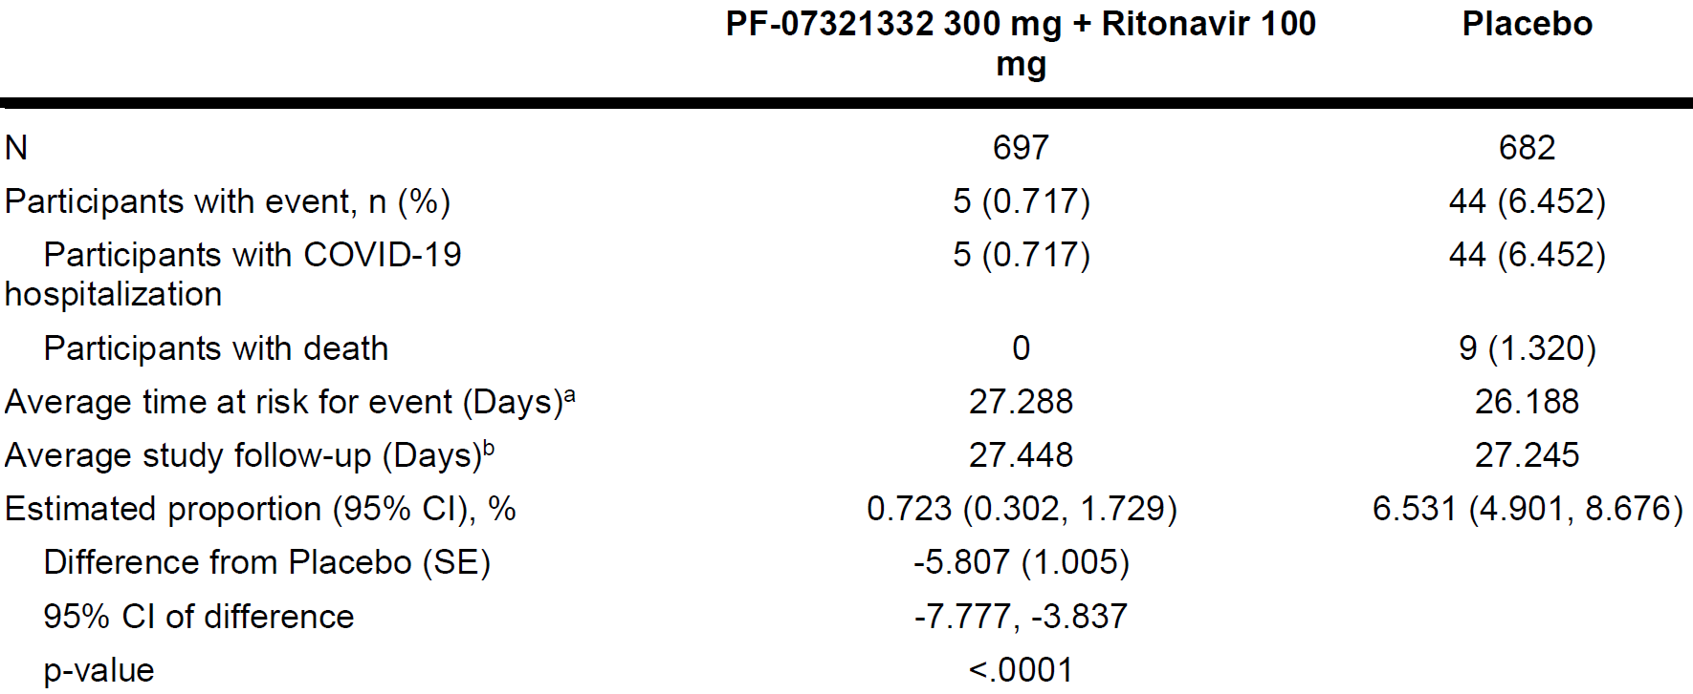
CI = confidence interval; COVID-19 = coronavirus disease 2019; N = number of participants in the analysis set; PF-07321332 = drug development code for nirmatrelvir; SE = standard error.
The cumulative proportion of participants hospitalized for the treatment of COVID-19 or death during the first 28 days of the study was estimated for each treatment group using the Kaplan-Meier method. The difference of the proportions in the 2 treatment groups and its 95% confidence interval, and p-value based on normal approximation of the data are presented.
a. Average time at risk for event is computed as time to first event, or time to last day of participation, or Day 28, whichever is earlier.
b. Average study follow-up is computed as time to last day of participation, or Day 28, whichever is earlier.

Sensitivity and supplemental analyses of the primary endpoint
A sensitivity analysis was planned as a secondary analysis of the primary endpoint to include participants regardless of COVID-19 therapeutic mAb treatment (mITT2 analysis set).
For the 45% interim analysis:
- At the 45% interim analysis, the event rate of a COVID-19 related hospitalisation or death from any cause through Day 28 in the mITT2 analysis set who received treatment within 5 days of symptom onset, regardless of mAb treatment was 6.4% (43 of 669) participants in the placebo group and 1.1% (7 of 661) in the nirmatrelvir/ritonavir group.
- Through Day 28, there were 10 deaths in the placebo group, none in the in the nirmatrelvir/ritonavir group.
For the final clinical study report:
- The observed event rate of a COVID-19 related hospitalisation or death from any cause through Day 28 in the mITT2 analysis set who received treatment within 5 days of symptom onset, regardless of mAb treatment was 68 of 1115 (6.099%) participants in the placebo group and 9 of 1109 (0.812%) in the nirmatrelvir/ritonavir group. After accounting for premature study discontinuation, treatment with nirmatrelvir/ritonavir showed a 5.363% (95% CI: -6.884% to -3.842%; p < 0.0001) absolute reduction, reducing the primary endpoint event rate from 6.185% to 0.822%.
- Through Day 28, there were 12 deaths from any cause in the placebo group and none in the nirmatrelvir/ritonavir group.
At the request of FDA, a sensitivity analysis of the mITT analysis set was performed whereby participants who did not have follow-up data through Day 21 were hypothetically assumed to have experience both COVID-19 related hospitalisation and death in a worst case scenario. Results from this analysis were consistent with what was observed in the primary analysis.
- Two participants in the nirmatrelvir/ritonavir group and one participant in the placebo group were assumed to have had a primary endpoint event.
- A statistically significant reduction (p < 0.0001) in COVID-19 related hospitalisation and death was shown in the nirmatrelvir/ritonavir group compared with placebo.
When participants who received a therapeutic COVID-19 mAb treatment post-Baseline that were considered to have experienced a primary endpoint event, treatment with nirmatrelvir/ritonavir reduced the primary event rate from 7.090% to 1.033%, showing a -6.057% absolute reduction (p < 0.0001). One participant in each treatment group had received mAb treatment.

Analyses of COVID-19 related hospitalisation or death from any cause by subgroup (modified intention-to-treat population)
For the 45% interim analysis, compared to results in the overall mITT population, similar findings were observed when the primary endpoint was analysed by age, gender, race, BMI, serology status, baseline viral load, baseline comorbidities and the number of baseline comorbidities except as noted below where either few events occurred or a statistical test could not be performed because no participants had the event. Significant or larger event reductions were observed in subgroups with a sufficiently large sample size and/or higher event rate.
- Few participants (zero for nirmatrelvir/ritonavir; 3 for placebo) in the subgroup of Asian (p = 0.0772) and Others (p = 0.0732) had events. No participants in the subgroup of Black or African American had an event; therefore, no statistical test could be performed.
- The treatment effect from nirmatrelvir/ritonavir versus placebo was significant among participants < 65 years of age (0.59% versus 5.47%, a 4.88% absolute reduction, p = 0.0002), but was larger in terms of absolute reduction among participants ≥ 65 years of age due to the expected higher event rate (2.27% versus 17.65%, a 15.37% absolute reduction, p = 0.0079).
- Few participants (zero for nirmatrelvir/ritonavir; 3 for placebo) in the subgroups of BMI < 25 kg/m² (p = 0.0778).
- The pre-specified subgroup analysis of the primary endpoint in the serology negative subgroup was consistent with the overall mITT population. The p-value for the serology positive subgroup was p = 0.0810. Few participants in the serology positive subgroup had events (zero for nirmatrelvir/ritonavir; 3 for placebo).
- Few participants in the subgroup of low baseline viral load (< log10⁴ copies/mL) had events (zero for nirmatrelvir/ritonavir; one for placebo; p = 0.3153).
- Few participants in the cigarette smoker subgroup had events (2 for nirmatrelvir/ritonavir; 5 for placebo; p = 0.2820). No participant had an event in the subgroups of immunosuppression, chronic lung disease, chronic kidney disease, device dependence, neurodevelopmental disorder or cancer, and a statistical test could not be performed. No participant in the mITT analysis set had HIV infection or sickle cell disease, and therefore these subgroup analyses could not be performed.
- No participant had an event in the subgroup of ≥ 4 baseline comorbidities and a statistical test could not be performed.

First key secondary efficacy endpoint (45% interim analysis)
The observed event rate of COVID-19 related hospitalisation or death from any cause
through Day 28 in the mITT1 analysis set who received treatment within 5 days of symptom onset was 41 of 612 (6.7%) participants in the placebo group, and 6 of 607 (1.0%) in the nirmatrelvir/ritonavir group.
Table 34: Study C4671005 Secondary analysis of proportion of participants with COVID-19 related hospitalisation or death from any cause through Day 28 (modified intention-to-treat 1; Kaplan-Meier method; 45% interim analysis)
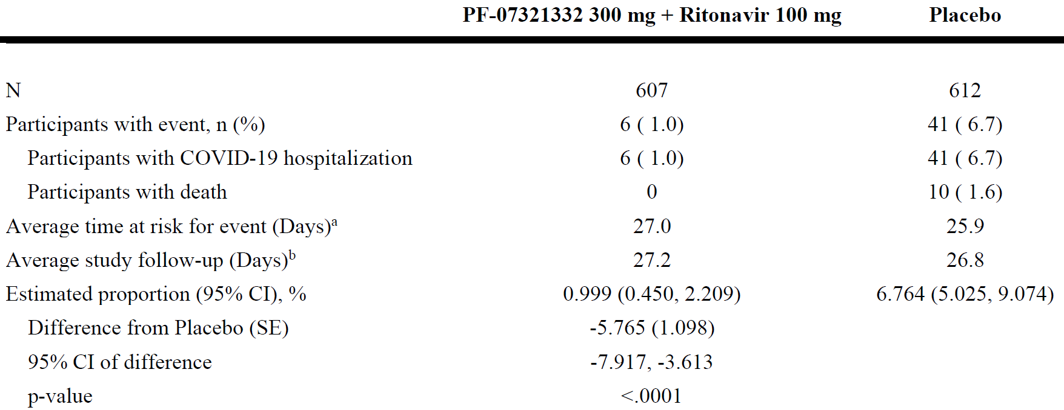
CI = confidence interval; COVID-19 = coronavirus disease 2019; N = number of participants in the analysis set; n = sample size; PF-07321332 = drug development code for nirmatrelvir; SE = standard error.
The cumulative proportion of participants hospitalized for the treatment of COVID-19 or death during the first 28 days of the study was estimated for each treatment group using the Kaplan-Meier method. The difference of the proportions in the 2 treatment groups and its 95% confidence interval, and p-value based on normal approximation of the data are presented.
a. Average time at risk for event is computed as time to first event, or time to last day of participation, or Day 28, whichever is earlier.
b. Average study follow-up is computed as time to last day of participation, or Day 28, whichever is earlier.

Primary completion date full analysis
The event rate of a COVID-19 related hospitalisation or death from any cause through Day 28 in the mITT1 analysis set in participants who received treatment within 5 days of symptom onset was 66/1046 (6.31%) in the placebo group, and 8/1039 (0.77%) in the nirmatrelvir/ritonavir group.
After accounting for premature study discontinuation (that is, participant discontinued study before Day 28 without having experienced a primary endpoint event) by using the follow-up time in the Kaplan-Meier calculation, treatment with nirmatrelvir/ritonavir showed a 5.62% (95% CI: -7.21% to -4.03%; p < 0.0001) absolute reduction, or 87.8% relative reduction in primary endpoint events compared to placebo.
There were zero and 12 reported events of death from any cause through Day 28 in the nirmatrelvir/ritonavir and placebo groups, respectively.
Table 35: Study C4671005 Secondary analysis of proportion of participants with COVID-19 related-hospitalisation or death from any cause through Day 28 (modified intention-to-treat 1; Kaplan-Meier method; primary completion date full analysis)
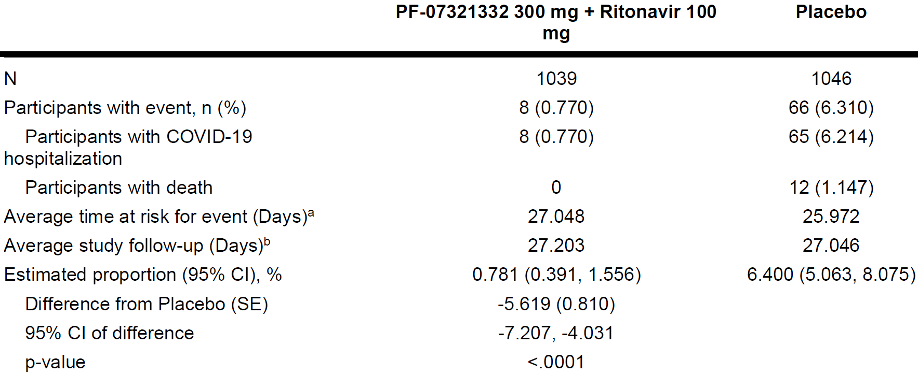
CI = confidence interval; COVID-19 = coronavirus disease 2019; N = number of participants in the analysis set; PF-07321332 = drug development code for nirmatrelvir; SE = standard error.
The cumulative proportion of participants hospitalized for the treatment of COVID-19 or death during the first 28 days of the study was estimated for each treatment group using the Kaplan-Meier method. The difference of the proportions in the 2 treatment groups and its 95% confidence interval, and p-value based on normal approximation of the data are presented.
a. Average time at risk for event is computed as time to first event, or time to last day of participation, or Day 28, whichever is earlier.
b. Average study follow-up is computed as time to last day of participation, or Day 28, whichever is earlier.
The event rate of a COVID-19 related hospitalisation or death from any cause through Day 28 in the mITT2 analysis set in participants who received treatment within 5 days of symptom onset regardless of mAb antibody treatment was 68/1115 (6.10%) in the placebo group, and 9/1109 (0.81%) in the nirmatrelvir/ritonavir group (Table 36 below).
After accounting for premature study discontinuation (that is, participant discontinued study before Day 28 without having experienced a primary endpoint event) by using the follow-up time in the Kaplan-Meier calculation, treatment with nirmatrelvir/ritonavir showed a 5.36% (95% CI: -6.88% to -3.84%; p < 0.0001) absolute reduction, or 86.7% relative reduction in primary endpoint events compared to placebo.
There were zero and 12 reported events of death from any cause through Day 28 in the nirmatrelvir/ritonavir and placebo groups, respectively.
Table 36: Study C4671005 Sensitivity analysis of proportion of participants with COVID-19 related hospitalisation or death from any cause through Day 28 (modified intention-to-treat 2; Kaplan-Meier method; primary completion date full analysis)
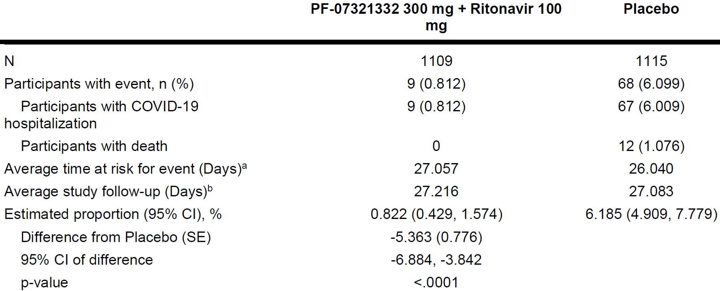
CI = confidence interval; COVID-19 = coronavirus disease 2019; N = number of participants in the analysis set; PF-07321332 = drug development code for nirmatrelvir; SE = standard error.
The cumulative proportion of participants hospitalized for the treatment of COVID-19 or death during the first 28 days of the study was estimated for each treatment group using the Kaplan-Meier method. The difference of the proportions in the 2 treatment groups and its 95% confidence interval, and p-value based on normal approximation of the data are presented.
a. Average time at risk for event is computed as time to first event, or time to last day of participation, or Day 28, whichever is earlier.
b. Average study follow-up is computed as time to last day of participation, or Day 28, whichever is earlier.

Subgroup analysis

Modified intention-to-treat by baseline viral load (primary completion date full analysis)
The pre-specified subgroup analysis of the primary endpoint by baseline viral load was consistent with the overall mITT population for the subgroups of high baseline viral load (≥ 4.0 log10 copies/mL), very high baseline viral load (≥ 7.0 log10 copies/mL) and baseline viral load < 7.0 log10 copies/mL. The p-value for the low baseline viral load subgroup (< 4.0 log10 copies/mL) was p = 0.3162. Few participants in the subgroup of low baseline viral load had events (zero for nirmatrelvir/ritonavir; one for placebo).
Table 37: Study C4671005 Analysis of proportion of participants with COVID-19 related hospitalisation or death any cause through Day 28, by subgroup of baseline viral load (modified intention-to-treat; Kaplan-Meier method)
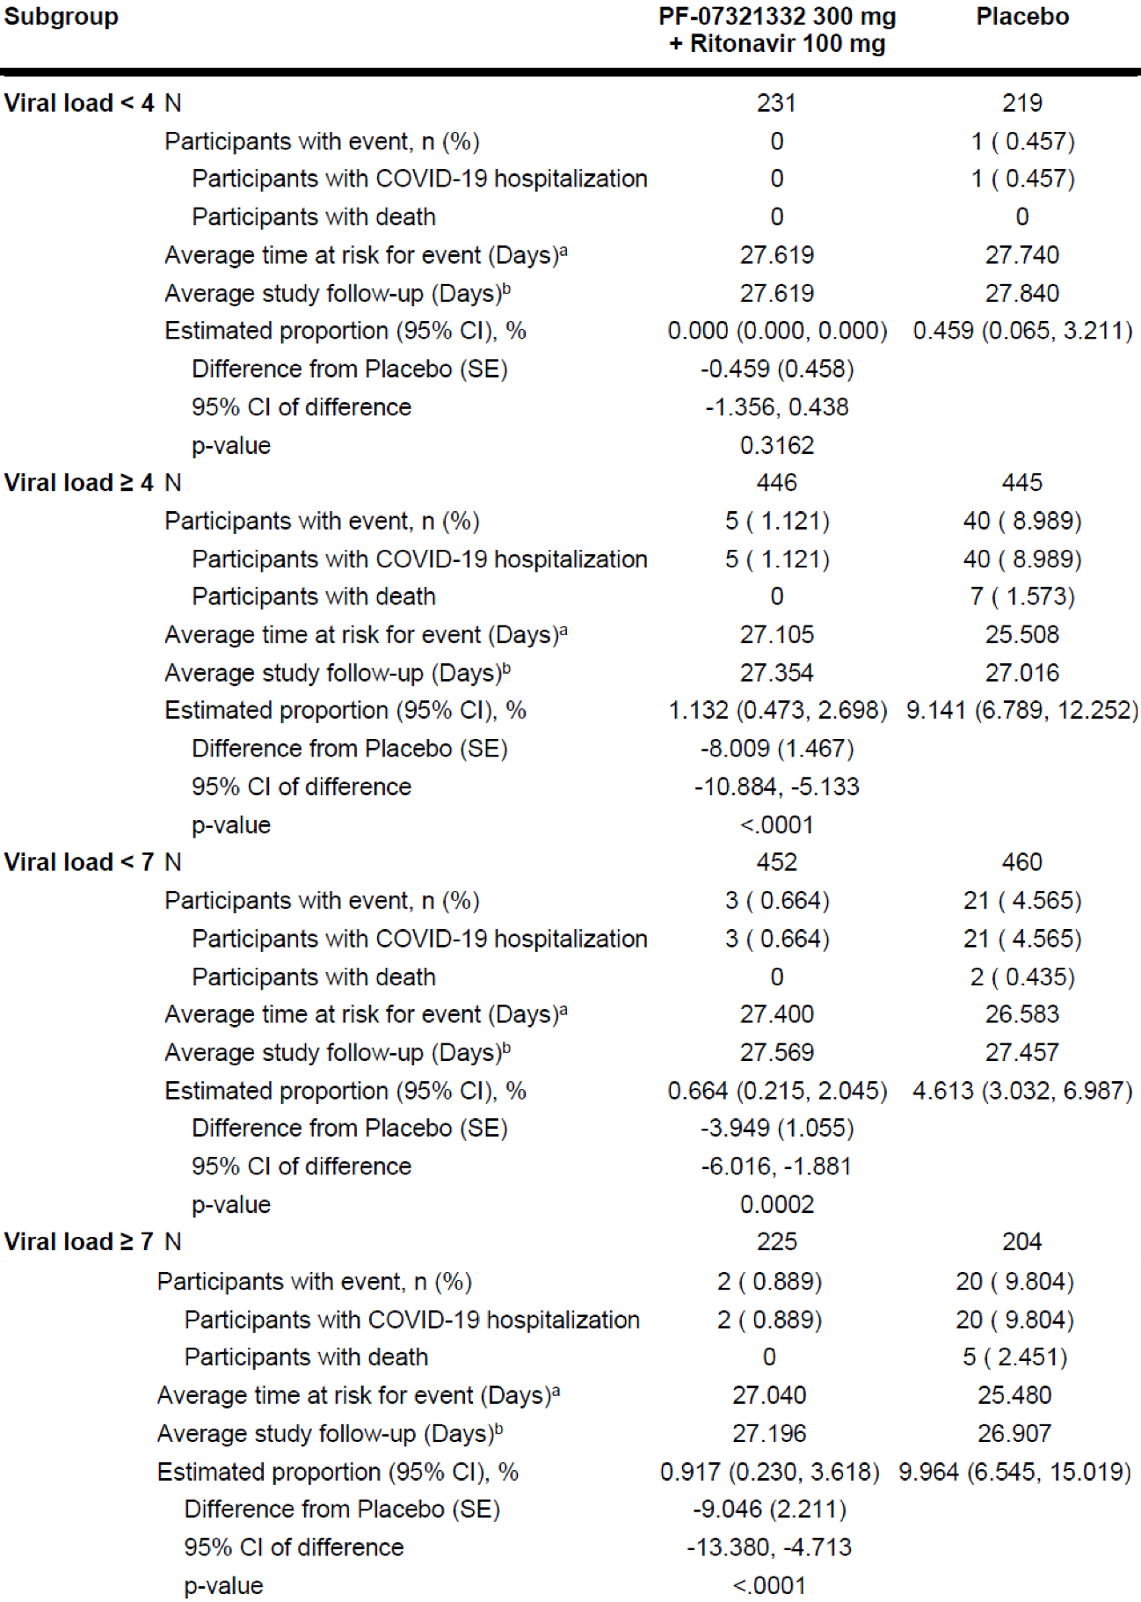
CI = confidence interval; COVID-19 = coronavirus disease 2019; N = total number of participants in the treatment group in the indicated population; PF-07321332 = drug development code for nirmatrelvir; SE = standard error.

Modified intention-to-treat by serology status (primary completion date full analysis)
The pre-specified subgroup analysis of the primary endpoint by serology negative subgroup was consistent with the overall mITT population (Table 38 below). The p-value for the serology positive subgroup was p = 0.0442. Few participants in the serology positive subgroup had events (zero for nirmatrelvir/ritonavir; 4 for placebo).
Table 38: Study C4671005 Analysis of proportion of participants with COVID-19 related hospitalisation or death from any cause through Day 28, by subgroup of baseline SARS-CoV-2 serology status (modified intention-to-treat; Kaplan-Meier method)
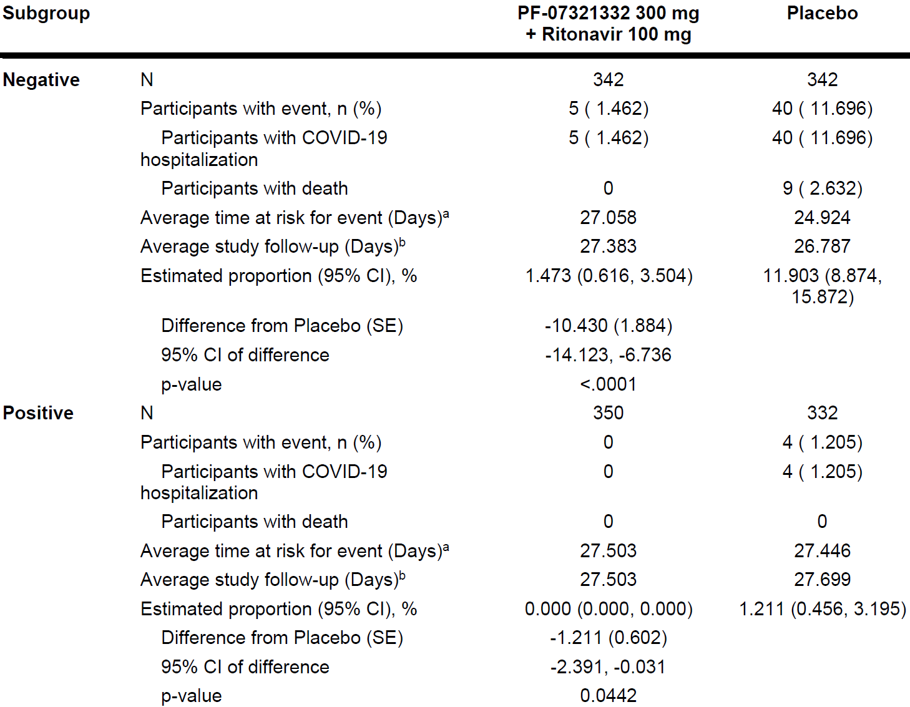
CI = confidence interval; COVID-19 = coronavirus disease 2019; N = number of participants in the subgroup of the analysis set; PF-07321332 = drug development code for nirmatrelvir; SE = standard error.
The cumulative proportion of participants hospitalized for the treatment of COVID-19 or death during the first 28 days of the study was estimated for each treatment group using the Kaplan-Meier method. The difference of the proportions in the 2 treatment groups and its 95% confidence interval, and p-value based on normal approximation of the data are presented.
a. Average time at risk for event is computed as time to first event, or time to last day of participation, or Day 28, whichever is earlier.
b. Average study follow-up is computed as time to last day of participation, or Day 28, whichever is earlier.

Modified intention-to-treat by age (primary completion date full analysis)
The pre-specified subgroup analysis of the primary endpoint by age was consistent with the overall mITT population. The treatment effect from nirmatrelvir/ritonavir versus placebo was significant among participants < 65 years of age (0.66% versus 4.80%, a 4.19% absolute reduction, p < 0.0001), but was larger in terms of absolute reduction among participants ≥ 65 years of age due to the expected higher event rate (1.06% versus 16.33%, a 15.26% absolute reduction, p < 0.0001).
Table 39: Study C4671005 Analysis of proportion of participants with COVID-19 related hospitalisation or death from any cause through Day 28, by subgroup of age (modified intention-to-treat; Kaplan-Meier method)
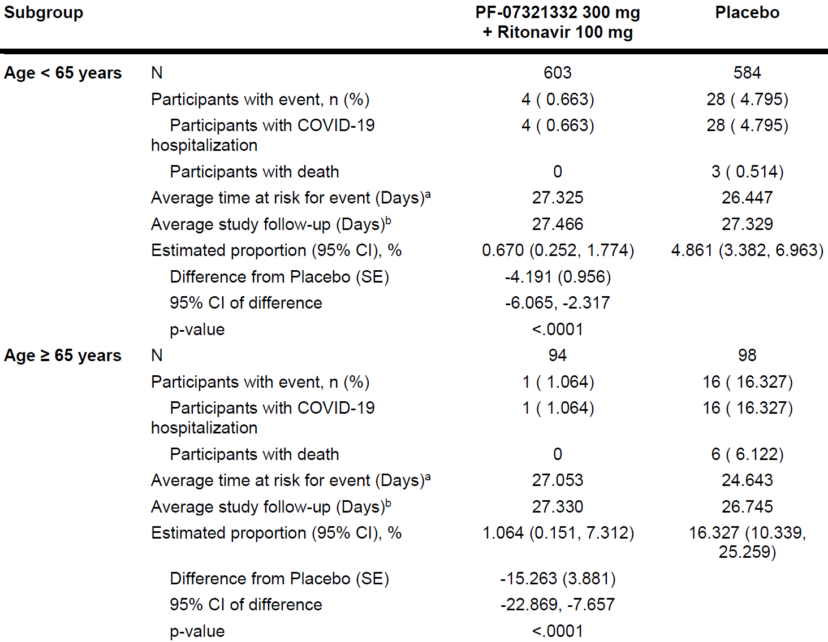
CI = confidence interval; COVID-19 = coronavirus disease 2019; N = number of participants in the subgroup of the analysis set; PF-07321332 = drug development code for nirmatrelvir; SE = standard error.
The cumulative proportion of participants hospitalized for the treatment of COVID-19 or death during the first 28 days of the study was estimated for each treatment group using the Kaplan-Meier method. The difference of the proportions in the 2 treatment groups and its 95% confidence interval, and p-value based on normal approximation of the data are presented.
a. Average time at risk for event is computed as time to first event, or time to last day of participation, or Day 28, whichever is earlier.
b. Average study follow-up is computed as time to last day of participation, or Day 28, whichever is earlier.

Cumulative proportions of primary events (modified intention-to-treat, primary completion date; full analysis)
As demonstrated in Figure 12 below, there is a strong separation of risk of primary events (COVID-19 related hospitalisation or death from any cause) for nirmatrelvir/ritonavir compared to placebo from Day 3 of study treatment.
Figure 12: Study C4671005 Time to COVID-19 related hospitalisation or death from any cause through Day 28 (modified intention-to-treat analysis set)
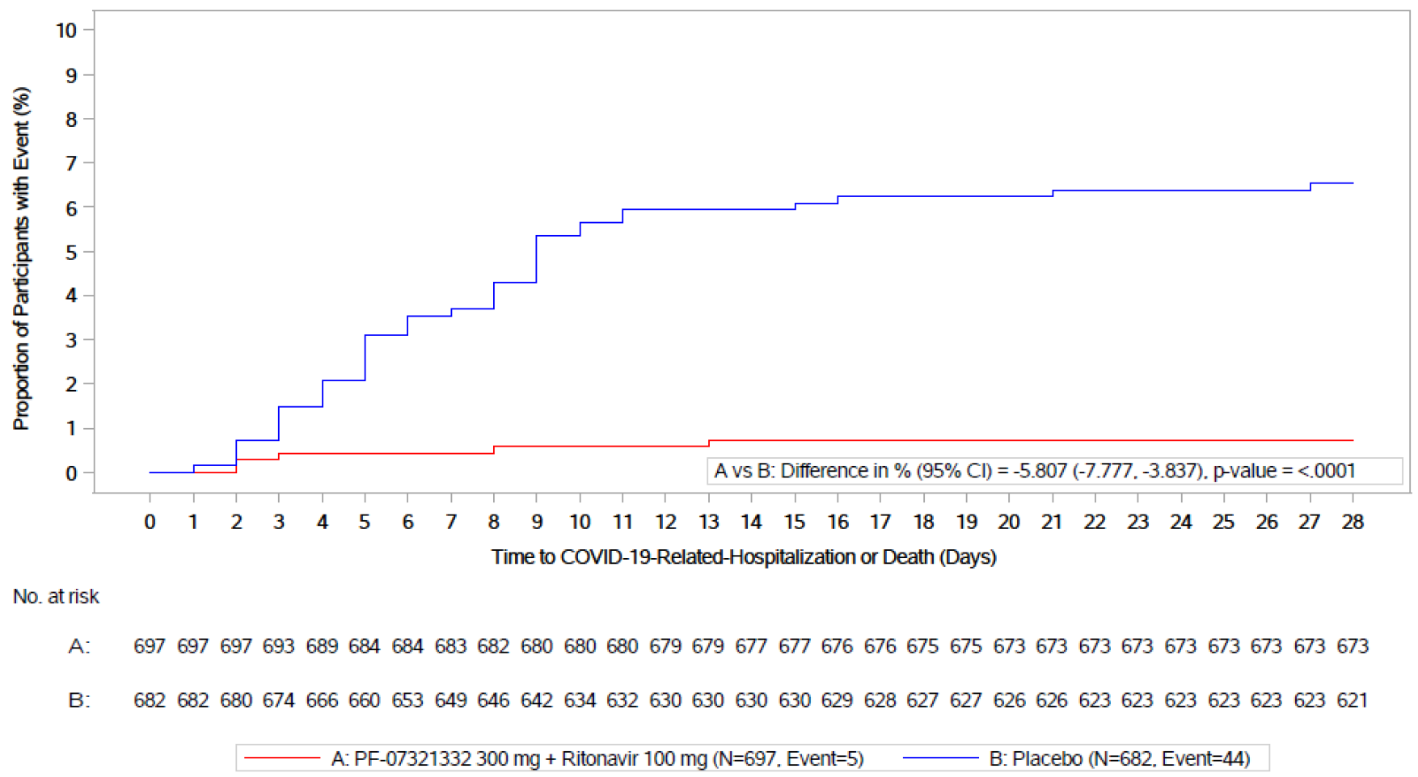
COVID-19 = coronavirus disease 2019; N = number of participants in the analysis set; PF-07321332 = drug development code for nirmatrelvir.
The cumulative proportion of participants hospitalised for the treatment of COVID-19 or death during the first 28 days of the study was estimated for each treatment group using the Kaplan-Meier method. The different of the proportions in the 2 treatment groups and its 95% confidence interval, and the p-value based on normal approximation of the data are presented.

Analyses of COVID-19 related hospitalisation or death from any cause by subgroup (modified intention-to-treat 1 population; 45% interim analysis)
Compared to results in the overall mITT1 population, similar findings were observed when the primary endpoint was analysed by age, gender, race, BMI, serology status, baseline viral load, baseline comorbidities, and the number of baseline comorbidities except as noted below where either few events occurred or a statistical test could not be performed because no participants had the event.
- Few participants in the subgroup of Black or African American race had events (0 of 28 for nirmatrelvir/ritonavir; 1 of 21 for placebo; p = 0.3055).
- Few participants in the serology positive subgroup (1 of 344 for nirmatrelvir/ritonavir; 5 of 332 for placebo; p = 0.0947) had events.
- Few participants in the subgroup with low baseline viral load (< 4 log10 copies/mL) (1 of 222 for nirmatrelvir/ritonavir; 3 of 217 for placebo; p = 0.3064) had events.
- Few participants in the subgroups of cigarette smoker (3 of 221 for nirmatrelvir/ritonavir; 8 of 239 for placebo; p = 0.1537), diabetes mellitus (2 of 77 for nirmatrelvir/ritonavir; 7 of 79 for placebo; p = 0.0867), and chronic lung disease (0 of 37 for nirmatrelvir/ritonavir; 1 of 23 for placebo; p = 0.3066) had events. One participant in the mITT1 analysis set had HIV infection and did not have an event, and no participant had sickle cell disease, and therefore these subgroup analyses could not be performed. No participant had an event in the subgroups of immunosuppression, chronic kidney disease, device dependence, HIV infection, neurodevelopmental disorder or cancer, and a statistical test could not be performed.
- No participant had an event in the subgroup of ≥ 4 baseline comorbidities and a statistical test could not be performed.

Secondary efficacy endpoints

Viral titres to assess proof of concept (45% interim analysis)
A validated quantitative SARS-CoV-2 RT-PCR assay was used to measure viral load (copies/mL).
In the mITT1 analysis set, baseline log10 (viral load) in log10 (copies/mL) averaged 5.11 among the 303 participants in the placebo group, and 5.41 among the 269 participants in the nirmatrelvir/ritonavir group.
Results in the mITT1 analysis set were also examined by serology status and baseline viral load. The additional viral load reduction from nirmatrelvir/ritonavir treatment relative to placebo were more apparent in participants who were seronegative than participants who were seropositive (-1.15 versus -0.77 log10 copies/mL on a log-10 scale), and more apparent in participants with higher versus lower (≥ 107 copies/mL versus < 107 copies/mL) viral load at Baseline (-1.40 versus -0.79 log10 copies/mL on a log-10 scale)
Table 40: Study C4671005 Statistical analysis of change from Baseline in log10 transformed viral load (copies/ml) data (modified intention-to-treat, modified intention-to-treat 1 and modified intention-to-treat 2)
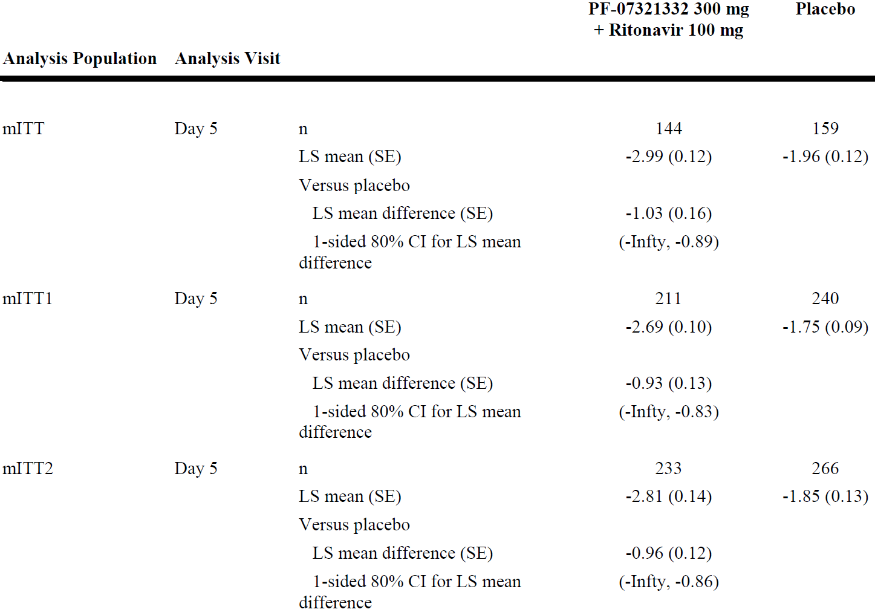
CI = confidence interval; Infty=Infinity. Only Upper Limit for 80% CI is presented; LS = least squares; mITT = modified intention-to-treat; n=Number of participants with non-missing data in the analysis population and the covariates in the statistical model; PF-07321332 = drug development code for nirmatrelvir; SE = standard error.
Participants are excluded from the analysis for reasons of not detected or missing baseline viral load result, and local swabs use. Results from samples collected at non-nasopharyngeal site are also excluded.
Change from baseline model using analysis of covariance (ANCOVA).
For mITT analysis set model = treatment + baseline viral load + geographic region + serology status.
For mITT1 analysis set model = treatment + baseline viral load + geographic region + serology status + symptom onset.
For mITT2 analysis set model = treatment + baseline viral load + coronavirus 2019 (COVID-19) monoclonal antibody treatment + geographic region +serology status + symptom onset.

Viral titres over time (modified intention-to-treat)
In the mITT population, on-treatment reduction in viral load was significantly (p < 0.0001) larger in the nirmatrelvir/ritonavir treatment group than in the placebo group.
- Baseline (Day 1) log10 (viral load) was 5.868 log10 copies/mL in the placebo group and 5.984 log10 copies/mL in the nirmatrelvir/ritonavir group.
- At Day 5, after accounting for treatment, geographic region, baseline SARS-CoV-2 serology status and baseline viral load, the adjusted mean (standard error (SE)) reduction in log10 (viral load) was -2.343 (0.083) log10 copies/mL in the placebo group, and -3.246 (0.084) log10 copies/mL in the nirmatrelvir/ritonavir group, reflecting an additional average reduction (95% CI) of -0.903 (-1.100 to -0.705, p < 0.0001) log10 copies/mL.
Compared to results in the overall mITT population, similar findings were observed when viral load at Day 1 and Day 5 was analysed by serology status and by baseline viral load.
In the mITT1 population, on-treatment reduction in viral load was significantly larger in the nirmatrelvir/ritonavir treatment group than in the placebo group

Time to sustained alleviation of all targeted signs/symptoms through Day 28 (modified intention-to-treat)
Because statistical significance was achieved in the analyses of both the primary and first secondary endpoints, the time to sustained alleviation in all targeted signs/symptoms through Day 28 was analysed with an alpha level of 5% in the sequential testing procedure as specified in the SAP.
Treatment with nirmatrelvir/ritonavir significantly reduced the time to sustained alleviation of all targeted signs and symptoms through Day 28 in the mITT analysis set who received treatment within 3 days of symptom onset.
- The proportion of participants who achieved sustained alleviation of all targeted signs and symptoms through Day 28 was 68.694% in the placebo group, and 76.676% in the nirmatrelvir/ritonavir group.
- The median time to sustained alleviation in the placebo group was 15 days and was reduced to 12 days in the nirmatrelvir/ritonavir group.
- The hazard ratio for treatment with nirmatrelvir/ritonavir versus placebo was 1.269 (95% CI: 1.117, 1.442 days, p = 0.0002), indicating participants in the nirmatrelvir/ritonavir group were 1.269 times more likely to achieve sustained alleviation of all targeted signs and symptoms.
Compared to results in the overall mITT population, similar findings were observed when the time to sustained alleviation was analysed by baseline serology status and by baseline viral load.

Time to sustained resolution of all targeted signs/symptoms through Day 28 (modified intention-to-treat)
This was analysed because statistical significance was achieved in the analyses of the primary endpoint, the first and second secondary endpoints.
Treatment with nirmatrelvir/ritonavir reduced the time to sustained resolution of all targeted signs and symptoms through Day 28 in the mITT analysis set who received treatment within 3 days of symptom onset:
- The proportion of participants who achieved sustained resolution of all targeted signs and symptoms through Day 28 was 61.424% in the placebo group and 67.638% in the nirmatrelvir/ritonavir group.
- The median time to sustained resolution in the placebo group was 18 days and was reduced to 16 days in the nirmatrelvir/ritonavir group.
- The hazard ratio for treatment with nirmatrelvir/ritonavir versus placebo was 1.201 (95% CI: 1.049, 1.375 days; p = 0.0080), indicating participants in the nirmatrelvir/ritonavir group were 1.2 times more likely to achieve sustained resolution of all targeted signs and symptoms.
Compared to results in the overall mITT population, similar findings were observed when the time to sustained resolution was analysed by baseline serology status and by baseline viral load.

Number of days in hospital and intensive care unit stay in participants with COVID-19 related hospitalisation (modified intention-to-treat)
Including participants with and without hospitalisations, the nirmatrelvir/ritonavir group reported fewer days in the hospital than in the placebo group (0.085 days per participant versus 0.748 days per participant on average). No participants in the nirmatrelvir/ritonavir group reported any intensive care unit (ICU) visits. The placebo group spent 0.122 days/participant on average in the ICU. No participant in the nirmatrelvir/ritonavir group received mechanical ventilation.
Compared with the nirmatrelvir/ritonavir group, there were approximately 5 times as many participants in the placebo group who had COVID-19 related medical visits (52 versus 10). The total number of visits was approximately 4 times as high in the placebo group (81 versus 22).

Safety

Adverse events

Study C4671005 (45% interim analysis)
The proportion of participants with all-causality treatment emergent adverse events (TEAE) that started on or prior to the Day 34 visits was comparable between treatment groups.
The most frequently reported TEAEs by Preferred Term (PT) in the nirmatrelvir/ritonavir group (that is, ≥ 1%) were dysgeusia (4.8% versus 0.1% for placebo), diarrhoea (3.9% versus 1.9% for placebo), nausea (1.9% versus 2.1% for placebo), headache (1.5% versus 1.6% for placebo), vomiting (1.3% versus 0.3% for placebo), and pyrexia (1.2% versus 1.0% for placebo). These adverse events (AE) were non-serious, mostly mild to moderate (Grade 1 or 2) in severity and resolved. In the nirmatrelvir/ritonavir group, dysgeusia, diarrhoea and vomiting led to few discontinuations in study intervention: one participant, one participant and 4 participants discontinuing due to each AE, respectively.
Hypertension occurred at a low frequency overall (0.9% and 0.1%, in the nirmatrelvir/ritonavir and placebo group, respectively), but was more frequent in the nirmatrelvir/ritonavir group.
- A total of 7 AEs of hypertension were reported (nirmatrelvir/ritonavir: 6 participants; placebo: one participant).
- The AEs of hypertension were nonserious, mostly transient in nature did not lead to treatment discontinuation and all were assessed as not related to study intervention by the investigator. The AEs were mild or moderate (Grade 1 to 2) in severity and were resolved/resolving, except for one participant in the nirmatrelvir/ritonavir group:
  - One participant had an event of severe (Grade 3) hypertension as well as 2 serious adverse events (SAE) (abscess and sepsis), which were not considered by the investigator to be related to study intervention and resolved. The event of severe hypertension was not resolved.
Most of the all-causality TEAEs experienced by participants in both treatment groups were mild (Grade 1) to moderate (Grade 2) in severity. Fewer participants in the nirmatrelvir/ritonavir group reported potentially life-threatening events (Grade 4) compared with the placebo group.
There were no events of death related to an AE (Grade 5) in the nirmatrelvir/ritonavir group compared with 10 events (1.5%) in the placebo group.
Table 41: Study C4671005 Treatment emergent adverse events (all causalities; division of acquired immunodeficiency syndrome grade; safety analysis set; 45% interim analysis)
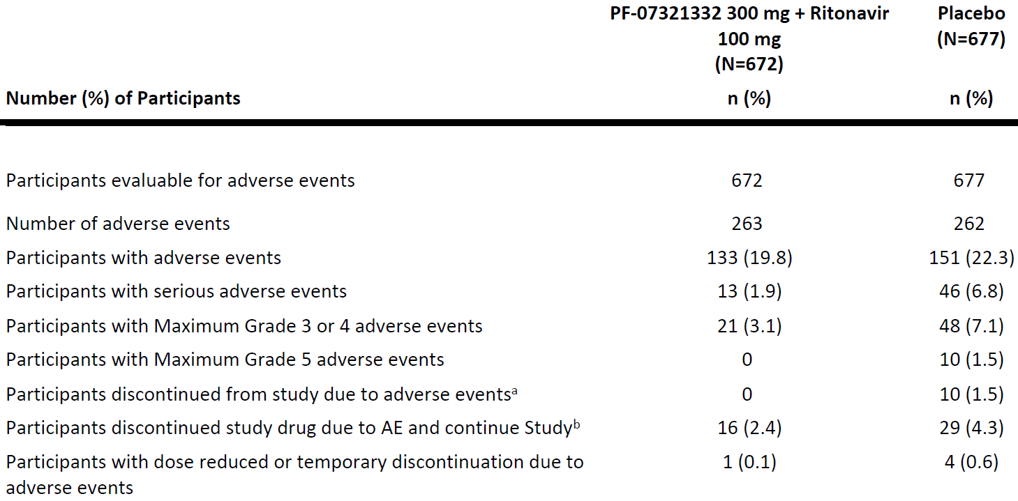
AE = adverse event; N = total number of participants in the treatment group in the indicated population; n = sample size; PF-07321332 = drug development code for nirmatrelvir.
Includes adverse events that started on or prior to Day 34 visit.
Medical Dictionary for Regulatory Activities (MedDRA) v24.0 coding dictionary applied.
Except for the number of AEs participants are counted only once per treatment in each row.
Serious adverse events: according to the investigator's assessment.
a. Participants who have an AE record that indicates that the AE caused the participant to be discontinued from the study
b. Participants who have an AE record that indicates that action taken with study treatment was drug withdrawn but AE did not cause the participant to be discontinued from study.
Table 42: Study C4671005 Treatment emergent adverse events (treatment related; division of acquired immunodeficiency syndrome grade; safety analysis set; 45% interim analysis)
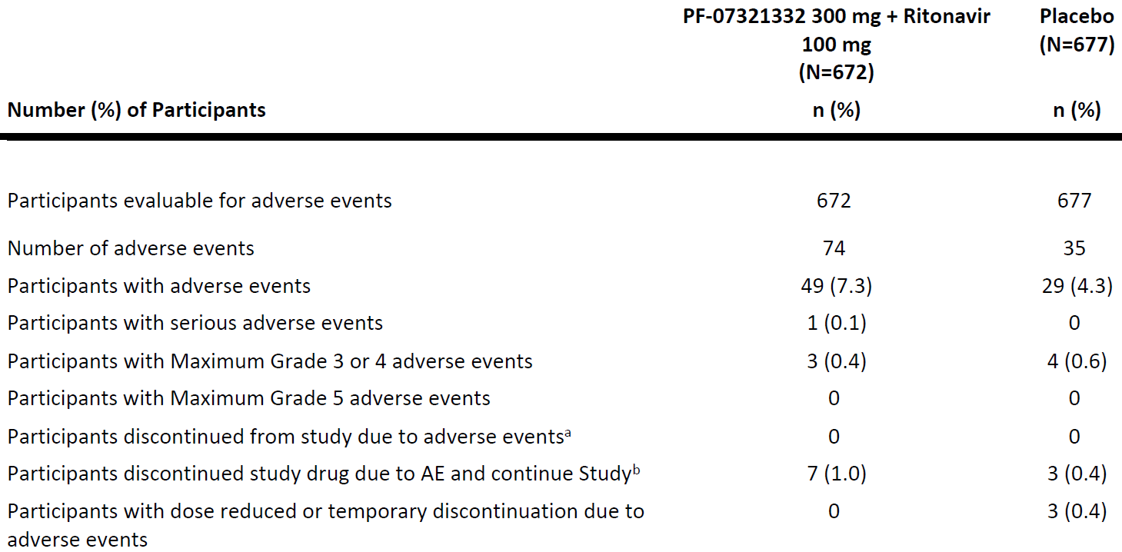
AE = adverse event; N = total number of participants in the treatment group in the indicated population; n = sample size; PF-07321332 = drug development code for nirmatrelvir.
Includes AEs that started on or prior to Day 34 visit.
Except for the number of adverse events participants are counted only once per treatment in each row.
Serious adverse events: according to the investigator's assessment.
a. Participants who have an AE record that indicates that the AE caused the participant to be discontinued from the study
b. Participants who have an AE record that indicates that action taken with study treatment was drug withdrawn but AE did not cause the participant to be discontinued from study
Medical Dictionary for Regulatory Activities (MedDRA) v24.0 coding dictionary applied.

Treatment-related treatment emergent adverse events (45% interim analysis)
The overall incidence of treatment-related TEAEs that started on or prior to the Day 34 visit was higher in the nirmatrelvir/ritonavir group (7.3%) compared with the placebo group (4.3%).
The most frequently reported treatment-related TEAEs (reported in ≥ 3% of participants in either treatment group) occurred in the System Organ Classes (SOC) of ‘nervous system disorders’ and ‘gastrointestinal disorders’.
The most frequently reported treatment-related TEAEs in the nirmatrelvir/ritonavir group (≥ 1%) were dysgeusia and diarrhoea. Both of these treatment related TEAEs were reported with a higher incidence in the nirmatrelvir/ritonavir group (3.7% and 1.9%, respectively) compared with the placebo group (0.1% and 0.3%, respectively).
- Treatment-related dysgeusia was experienced by 25 participants (3.7%) in the nirmatrelvir/ritonavir group. These AEs were Grade 1 (mild) with the exception of two Grade 2 (moderate) AEs, and one Grade 3 (severe) AE. All AEs were non-serious, and the event resolved by Day 7. One participant in the nirmatrelvir/ritonavir group discontinued treatment due to an AE of Grade 1 dysgeusia that resolved on Day 4.
- Treatment-related diarrhoea was experienced by 13 participants (1.9%) in the nirmatrelvir/ritonavir group. These AEs were non-serious and Grade 1 to 2 (mild to moderate) in severity and the event resolved. One participant, who also had treatment related AEs of dizziness, nausea, myalgia, and vomiting, discontinued study intervention due to these AEs, all of which resolved on Day 3.
Most of the treatment-related TEAEs experienced by participants in both treatment groups were mild (Grade 1) to moderate (Grade 2) in severity. One participant in the placebo group had a potentially life threatening (Grade 4) event (blood glucose increased). No participants in either treatment group had an event of death related to an AE (Grade 5).

Deaths (45% interim analysis)
There were 10 deaths among participants in this study.
All 10 deaths were in the placebo group and all were related to the disease under study (events reported as COVID-19 pneumonia (5 participants), COVID-19 (2 participants), hypoxia (one participant), acute respiratory distress syndrome (one participant), and acute respiratory failure (one participant)).
None of these deaths in the placebo group were considered by the investigator to be related to study intervention.

Serious adverse events (45% interim analysis)
The overall incidence of participants with all-causality treatment-emergent SAEs was lower in the nirmatrelvir/ritonavir treatment group (1.9%) compared with placebo (6.8%),
The most frequently reported SAEs in the nirmatrelvir/ritonavir group (≥ 2 participants) were COVID-19 and COVID-19 pneumonia. All of these SAEs were considered related to the disease under study. None of these SAEs were considered by the investigator to be related to study intervention.
One participant in the nirmatrelvir/ritonavir group had treatment-emergent SAEs of palpitations, chest discomfort and dyspnoea. In the opinion of the investigator, there was a reasonable possibility that the events of chest discomfort, dyspnoea, and palpitations were related to the study intervention (ritonavir); there was not a reasonable possibility that the events were related to the study intervention (nirmatrelvir), concomitant drugs, or clinical trial procedures. The participant discontinued study intervention due to these SAEs, but continued in the study; all of these events resolved.
Serious adverse events that resulted in death were reported for 10 participants (1.5%) in the placebo group, o participants in the nirmatrelvir/ritonavir group.

Discontinuations of study intervention due to adverse events (45% interim analysis)
Fewer participants in the nirmatrelvir/ritonavir group (2.4%) than in the placebo group (4.3%) discontinued study intervention due to an AE.
All-causality TEAEs that led to discontinuation of study intervention in more than one participant in either treatment group were nausea, vomiting, COVID-19 pneumonia, creatinine renal clearance decreased, glomerular filtration rate decreased, acute respiratory failure, COVID-19, and hypoxia. Of these, nausea and vomiting were considered COVID-19 related symptoms based on FDA Guidance for Industry.
Of the participants in the nirmatrelvir/ritonavir group who discontinued study intervention due to an AE, those participants reported most events as mild to moderate (Grade 1 to 2) or severe (Grade 3) and one participant had an AE that was life threatening (Grade 4):
- One participant had an AE of Haemoglobin decreased that was potentially life threatening (Grade 4); this Grade 4 AE was serious, was considered not related to study intervention, and the event resolved.
- In the placebo group, a greater proportion of participants who discontinued study intervention due to an AE had AEs that were reported as Grade 3 and Grade 4 compared with the nirmatrelvir/ritonavir group.
Few (≤ 1.0%) events leading to discontinuation of study intervention in either treatment group were considered by the investigator to be related to study intervention.
Of the participants with TEAEs that led to discontinuation of study intervention, only one participant in the nirmatrelvir/ritonavir group experienced SAEs (chest discomfort, dyspnoea, and palpitations) that were considered by the investigator to be related (related to ritonavir).

Discontinuation of study due to adverse event (45% interim analysis)
No participants in the nirmatrelvir/ritonavir group discontinued the study due to TEAEs (all causalities) compared with 10 participants (1.5%) in the placebo group. The 10 participants in the placebo group who discontinued the study were those who died.

Study C4671005 (safety analysis set; primary completion date full analysis)
No safety concerns for nirmatrelvir/ritonavir were identified during the review of safety data through the PCD of this study (data cut-off date: 11 December 2021).
There was one participant that had a hospitalisation on Day 3 with an outcome of death on Day 32. As the primary analysis evaluates hospitalisation and death through Day 28, this death was outside the event window but was within the ‘follow-up’ window through the Day 34 visit. Therefore, this participant was included as a death in the safety analysis set giving a total of 13 deaths in the placebo group.
Nirmatrelvir/ritonavir was well-tolerated. The proportion of participants with all-causality TEAEs was comparable between the nirmatrelvir/ritonavir group and the placebo group (22.6% and 23.9%, respectively).
Most of the all-causality TEAEs experienced by participants in both treatment groups were mild (Grade 1) to moderate (Grade 2) in severity The proportion of participants with all-causality SAEs was lower in the nirmatrelvir/ritonavir group (1.6%) compared with the placebo group (6.6%). Fewer participants discontinued study intervention due to an AE in the nirmatrelvir/ritonavir group compared with the placebo group (2.1% versus 4.2%), respectively.
Table 43: Study C4671005 Treatment emergent adverse events (all causalities; division of acquired immunodeficiency syndrome grade; safety analysis set)
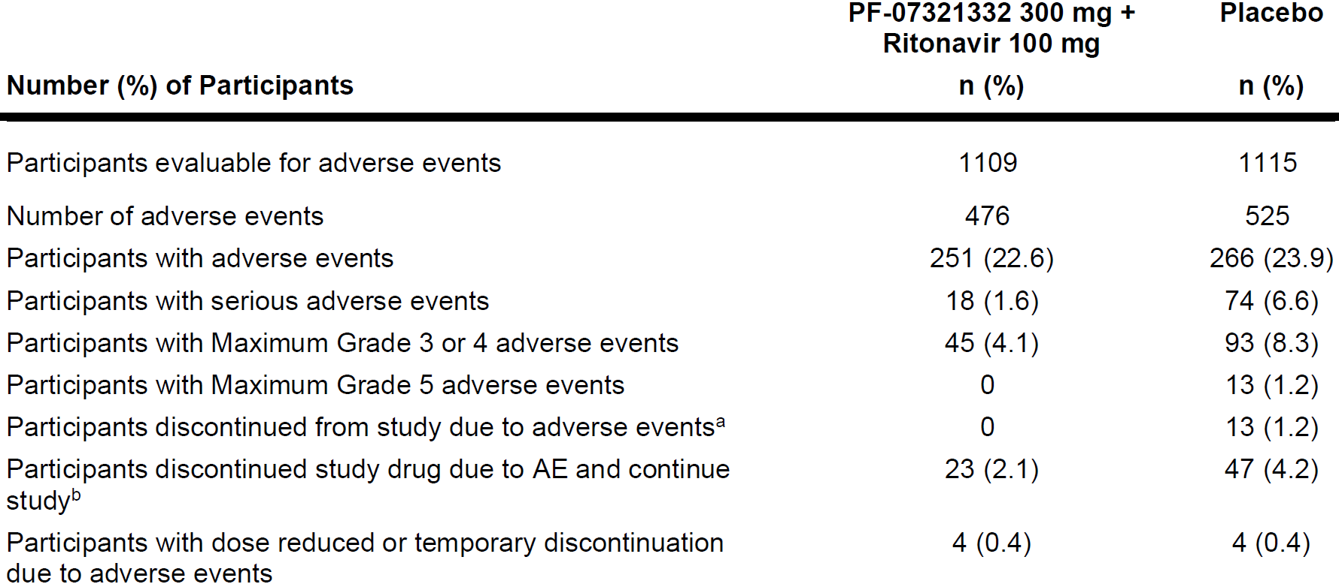
AE = adverse event; n = sample size; PF-07321332 = drug development code for nirmatrelvir.
Includes AEs that started on or prior to Day 34 visit.
Except for the number of AEs participants are counted only once per treatment in each row.
Serious adverse events: according to the investigator's assessment.
a. Participants who have an AE record that indicates that the AE caused the participant to be discontinued from the study.
b. Participants who have an AE record that indicates that action taken with study treatment was drug withdrawn but AE did not cause the participants to be discontinued from study.
Medical Dictionary for Regulatory Activities (MedDRA) v24.1 coding dictionary applied.
The most frequently reported TEAEs in the nirmatrelvir/ritonavir group (≥ 1%) were diarrhoea (3.1%), nausea (1.4%), vomiting (1.1%), alanine aminotransferase increased (1.5%), creatinine renal clearance decreased (1.4%), and fibrin D-dimer increased (1.9%), dysgeusia (5.6%), and headache (1.4%). Of these, diarrhoea, vomiting, dysgeusia, and headache were reported at a higher frequency in the nirmatrelvir/ritonavir group compared with the placebo group (1.6%, 0.8%, 0.3%, and 1.3% in the placebo group, respectively).

Treatment-related treatment emergent adverse events
Table 44: Study C4671005 Decreasing frequency of treatment emergent adverse events by System Organ Class and Preferred Term (treatment related) in 1% or greater (safety analysis set)
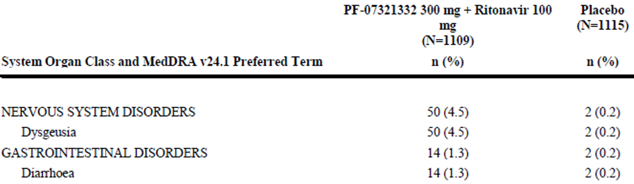
MedDRA = Medical Dictionary for Regulatory Activities; N = total number of participants in the treatment group in the indicated population; n = sample size; PF-07321332 = drug development code for nirmatrelvir.
Includes adverse events that stated on prior to Day 34 visit.

Serious adverse events (final clinical study report)
The overall incidence of participants with all-causality treatment emergent SAEs was lower in the nirmatrelvir/ritonavir treatment group (1.6%) compared with placebo (6.6%). The most frequently reported SAEs in the nirmatrelvir/ritonavir group (≥ 2 participants) were COVID-19 pneumonia, COVID-19, and Creatinine renal clearance decreased and were reported more frequently in the placebo group than in the nirmatrelvir/ritonavir group. Of these, COVID-19 pneumonia and COVID-19 were considered related to the disease under study; none of these SAEs were considered by the investigator to be related to study intervention.

Discontinuations of study intervention due to adverse events
Fewer participants in the nirmatrelvir/ritonavir group (2.1%) than in the placebo group (4.2%) discontinued study intervention due to an AE.
All-causality TEAEs that led to discontinuation of study intervention in more than one participant in either treatment group were COVID-19 pneumonia, nausea, creatinine renal clearance decreased, vomiting, COVID-19, glomerular filtration rate decreased, pneumonia, pneumonitis, white blood cell count decreased, and dysgeusia.
Few (≤ 0.8%) events leading to discontinuation of study intervention in either treatment group were considered by the investigator to be related to study intervention

Discontinuation of study due to adverse event
No participants in the nirmatrelvir/ritonavir group discontinued the study due to TEAEs (all causalities) compared with 13 participants (1.2%) in the placebo group. The 13 participants in the placebo group who discontinued from the study were those who died.
Hemodynamic events
Overall, there were no clinically meaningful differences in the changes in vital sign parameters over time between the nirmatrelvir/ritonavir group and the placebo group.
Thyroid related events
The incidence of participants with thyroid related all-causality TEAEs was comparable between treatment groups
The reported safety data indicates that nirmatrelvir/ritonavir has a favourable safety profile.

Study C4671001 (adverse events)

Part 1: single ascending dose
None of the TEAEs in Part 1 were treatment related. All were mild in severity. No participant had an SAE, severe AE, or dose reduced or temporary discontinuation due to AEs in Part 1. One participant discontinued from study due to a mild AE of COVID-19 positive test.

Part 2: multiple ascending dose
The numbers of treatment related TEAEs were also similar between the 6 treatment arms. All TEAEs were mild in severity. The System Organ Classes (SOC) for the treatment-related TEAEs reported in participants included Investigations (5 events) and Nervous systems disorders (3 events). Five treatment-related events of blood thyroid stimulating hormone (TSH) increased occurred in Part 2, and 2 of these events occurred in the placebo groups. Three treatment-related events of dysgeusia occurred, and all were in treated groups. No participant had an SAE, severe AE, discontinuation from study due to AEs, or dose reduced or temporary discontinuation due to AEs in Part 2.

Part 3: relative bioavailability/effect of food
The SOCs with participants reporting all-causality or treatment-related TEAEs were General disorders and administration site conditions (5 events, one treatment related), and nervous system disorders (3 events, all treatment related). All TEAEs were mild in severity No participant had an SAE, severe AE, discontinuation from study due to AEs, or dose reduced or temporary discontinuation due to AEs in Part 3.

Part 4: metabolism and excretion
Only one participant had TEAE (nasopharyngitis; moderate) in the nirmatrelvir 300 mg (suspension)/ritonavir 100 mg (fasted) group, the TEAE was not considered to be treatment related.
No participant had an SAE, severe AE, discontinuation from study due to AEs, or dose reduction or temporary discontinuation due to AEs in Part 4.

Part 5: Supratherapeutic exposure
The incidences of all-causality and treatment related TEAEs were the same between the 2 groups, treated and placebo. The most frequently reported SOC in which TEAEs were reported was gastrointestinal disorders (6 events, 2 treatment related). All TEAEs were mild in severity No participant had an SAE, severe AE, discontinuation from study due to AEs, or dose reduced or temporary discontinuation due to AEs in Part 5.

Analysis of adverse events
There were no deaths or SAEs reported in this study. All of the TEAEs in the 5 parts of the study were mild in severity, except for one moderate AE of nasopharyngitis in Part 4.
In Part 1, one participant from the nirmatrelvir 500 mg (suspension, fasted) group discontinued from study due to a mild AE (SARS-CoV-2 test positive), which was not considered to be treatment related. There were no discontinuations from study or from study drug due to AEs in Part 2, Part 3, Part 4, or Part 5.
There were no dose reductions or temporary discontinuations due to AEs reported in this study.

Clinical laboratory evaluation

Study C4671005 clinical laboratory evaluation-45% interim analysis
No clinically meaningful differences were observed between the nirmatrelvir/ritonavir and placebo groups with respect to haematology and clinical chemistry laboratory test results.
Baseline abnormalities (elevations) in laboratory parameters were comparable across treatment groups.
The overall incidence of laboratory test abnormalities occurring within 34 days of first dose was comparable between both treatment groups.
The most frequently occurring laboratory test abnormalities (occurring in ≥ 5% participants in any treatment group) were:
- fibrinogen (< 0.75 x Baseline; > 1.25 x Baseline),
- activated partial thromboplastin time (aPTT) (> 1.1 x ULN),
- D-Dimer (> 1.5 x ULN), neutrophils (> 1.2 x ULN),
- glucose (> 1.5 x ULN),
- thyroid stimulating hormone (TSH) (> 1.2 x ULN),
- creatine kinase (> 2 x ULN), and
- bicarbonate (< 0.9 x LLN).
The incidences of abnormalities in the following laboratory parameters were comparable across treatment groups:
- fibrinogen (< 0.75x Baseline),
- activated partial thromboplastin time (aPTT) (> 1.1 x ULN),
- neutrophils (> 1.2 x ULN),
- glucose (> 1.5 x ULN),
- thyrotropin (> 1.2 x ULN),
- creatine kinase (> 2 x ULN), and
- bicarbonate (< 0.9 x LLN).
Abnormalities in laboratory tests for fibrinogen (> 1.25 x Baseline) and D-dimer (> 1.5 x ULN) both occurred more frequently in the placebo group compared with the nirmatrelvir/ritonavir group.

Study C4671001 (evaluation of laboratory parameters)

Part 1: single ascending dose
The numbers of participants with laboratory abnormalities (without regard to Baseline) were similar among the 9 treatment groups (1 to 2 participants in each group)

Part 2: multiple ascending dose
The most frequently reported laboratory test abnormality (without regard to baseline abnormality) was monocytes/leukocytes (%) > 1.2 x ULN. One participant each in the placebo/ritonavir, 75 mg, 250 mg nirmatrelvir/ritonavir treatment group had abnormal monocyte/leukocytes (%) whereas 3 participants in the 500 mg nirmatrelvir/ritonavir group had abnormal values. No dose related increase in incidence of abnormal monocyte/leukocytes (%) were observed in participants with normal baseline values. The absolute and mean change from Baseline in monocyte and leukocytes did not show any dose or time related trends.
Clinically meaningful changes in thyroid stimulating hormone (TSH) were observed in a few participants without abnormal free thyroxine (T₄) or any associated clinical symptoms. One participant each in the placebo/ritonavir and 250 mg nirmatrelvir/ritonavir groups had abnormal (> 1.2 x ULN) thyrotropin without any change in free T₄. Similarly, one participant each in the placebo/ritonavir and 250 mg nirmatrelvir/ritonavir groups in Japanese participants had abnormal TSH without any change in free T₄ or clinical symptoms.
However, change from Baseline in TSH and free T₄ in Japanese and and non-Japanese participants on treatment appears to be similar to those in placebo, with 90% CI overlapping between the treatment groups. One participant in the 250 mg nirmatrelvir/ritonavir had persistent mild increase in TSH starting on Day 10 (last day of treatment) with no increase in free T₄ or any clinical symptoms and the TSH returned within normal limit without intervention by Day 23.
No clinically meaningful trends were observed in fibrinogen with the treatment of nirmatrelvir/ritonavir. One participant in the 75 mg nirmatrelvir/ritonavir and 3 participants in the 250 mg nirmatrelvir/ritonavir had fibrinogen increase (> 1.25 x of Baseline); however, fibrinogen values remained within reference range for 2 of these participants, and increased slightly above ULN for a third participant. No participant had similar increase in fibrinogen from baseline value at 500 mg nirmatrelvir/ritonavir group.

Part 3: relative bioavailability/effect of food
For the urine haemoglobin ≥ one instance, no haematuria was observed. None of the laboratory test abnormalities were considered to be clinically significant.
Table 45: Study C4671001 Part 3 (relative bioavailability/effect of food) Incidence of laboratory test abnormalities (without regard to baseline abnormality; safety analysis set)
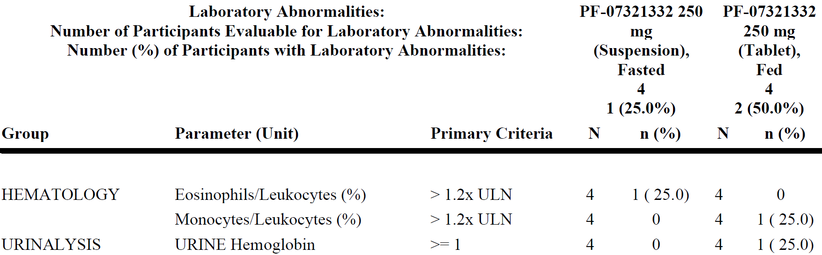
N = total number of participants with at least one observation of the given laboratory test while on study treatment or during lag time; n = number of participants with a laboratory abnormality meeting specified criteria while on study treatment or during lag time; PF-07321332 = drug development code for nirmatrelvir; ULN = upper limit of normal.
Percentages were displayed for the laboratory tests having a category with ≥ one evaluable participants.
Baseline was defined as the last measurement prior to first dosing (Day 1).
Lab abnormalities are not linked to a specific treatment.

Part 4: metabolism and excretion
For the urine haemoglobin ≥ 1 instances, there was no haematuria observed. None of the laboratory test abnormalities were considered to be clinically significant.
Table 46: Study C4671001 Part 4 (Metabolism and excretion) Incidence of laboratory test abnormalities (without regard to baseline abnormality; safety analysis set)
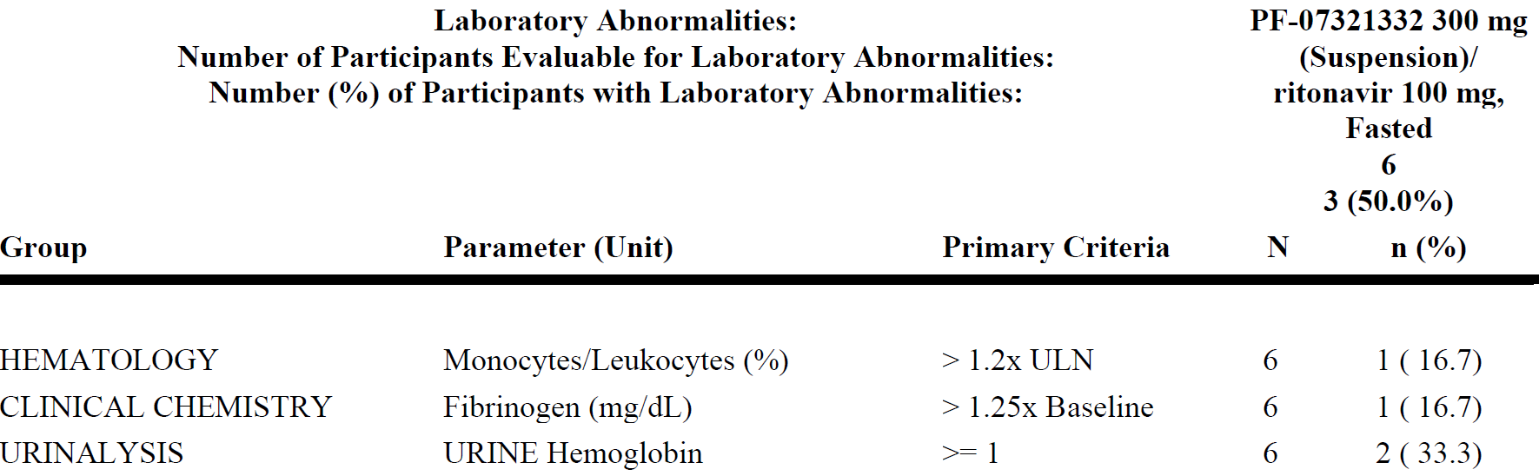
N = total number of participants with at least one observation of the given laboratory test while on study treatment or during lag time; n = number of participants with a laboratory abnormality meeting specified criteria while on study treatment or during lag time; PF-07321332 = drug development code for nirmatrelvir; ULN = upper limit of normal.
Ritonavir dosed at -12, 0, 12 and 24 hour post-dose.
Percentages were displayed for the laboratory tests having a category with ≥ one evaluable participants.
Baseline was defined as the last measurement prior to first dosing (Day 1).

Part 5: supratherapeutic exposure
There were 2 events ≥ 1 urine haemoglobin and > 1 hyaline casts that occurred equally across placebo/ritonavir and nirmatrelvir/ritonavir treatment groups (one in each group), and one event of ≥ 1 leukocyte esterase and ≥ 20 urine leukocytes occurred in the nirmatrelvir/ritonavir treatment group. These urinalysis abnormalities were not considered clinically significant and had no correlating AEs noted.

Other safety evaluations

Study C4671005 (vital signs and electrocardiogram findings)
No clinically meaningful findings in vital sign measurements were observed in this study (from the 45% interim analysis). The assessments and observations were comparable across treatment groups.
Baseline values for systolic and diastolic blood pressure, pulse rate, oxygen saturation (%), temperature, and respiratory rate, were similar across both treatment groups, and there were no clinically meaningful differences between treatment groups in the mean changes from Baseline in vital signs assessments.
The mean maximum change from Baseline in vital signs were comparable for participants in the nirmatrelvir/ritonavir treatment group compared with the placebo group,
The incidence of participants with diastolic blood >90 mmHg or systolic blood pressure > 140 mmHg was comparable across treatment groups.
Mean baseline values and mean changes from Baseline were similar between treatment groups for all electrocardiogram parameters.

Study C4671001 (vital signs and electrocardiogram findings)

Part 1: single ascending dose
Three instances of a systolic blood pressure (SBP) absolute value < 90 mmHg were reported (2 in the placebo (suspension, fasted) group and one in the nirmatrelvir 150 mg (suspension, fasted) group).
Two instances of a SBP value decrease ≥ 30 mmHg were reported (one in the placebo (suspension, fasted) group and one in the nirmatrelvir 150 mg (suspension, fasted) group).
Two instances of a diastolic blood pressure (DBP) decrease ≥ 20 mmHg were reported (one in the placebo (suspension, fasted) group and one in the nirmatrelvir 150 mg (suspension, fasted) group).
No participants in any part of the study had electrocardiogram abnormalities.

Part 2: multiple ascending dose
There was one event of vital signs abnormality reported in each dose groups except none in the nirmatrelvir (suspension)/ritonavir (75/100 mg) twice daily (fasted) group and 2 events reported in the nirmatrelvir (suspension)/ritonavir 250/100 mg twice daily (fasted, Japanese) group.

Part 3 and 4: relative bioavailability/effect of food and metabolism and excretion
No participants in Part 4 had post-Baseline vital signs data meeting the reporting criteria.

Part 5: supratherapeutic exposure
There were 2 events of vital signs abnormality reported in the placebo (suspension)/ritonavir 100 mg group and one vital signs abnormality reported in the nirmatrelvir 2250 mg (suspension)/ritonavir 100 mg group.

Risk management plan
The sponsor has submitted EU-risk management plan (RMP) version 0.1 (dated 30 November 2021; data lock point (DLP) 26 October 2021) and Australian specific annex (ASA) version 0.1 (dated 17 December 2021) in support of this application. With responses to RMP recommendations, the sponsor provided an updated ASA (version 0.2; dated 23 December 2021).
The summary of safety concerns and their associated risk monitoring and mitigation strategies are summarised in Table 47.
Table 47: Summary of safety concerns
Summary of safety concerns |  | Pharmacovigilance |  | Risk Minimisation
 |  | Routine | Additional | Routine | Additional
Important identified risks | None | – | – | – | –
Important potential risks | None | – | – | – | –
Missing information | Use in in patients with active hepatic impairment |  |  | * | –
 | Use in pregnancy† |  | ‡ |  | –
*Clinical trial
†added as Australia specific safety concern at the second round of evaluation at the request of the RMP evaluator
‡ Post-authorisation safety study (EU only)
- The sponsor agreed to include ‘use in pregnancy’ as missing information as an Australia specific safety concern. Summary of safety concerns is acceptable. TGA’s nonclinical and clinical evaluation reports, the delegate’s overview and ACM advice has been considered when making this decision.
- The sponsor has proposed a secondary database collection study as a post-authorisation safety study to be conducted in Europe to characterise the use safety in pregnancy. The pharmacovigilance plan is acceptable.
- The sponsor was requested to provide a Dear Healthcare Professional Letter (DHCPL) to address ‘use in renal impairment’ and ‘drug-drug interactions’. The ACM was of the view that an educational campaign would be valuable to prescribers and consumers to address the risk of drug interactions. The sponsor agreed to provide a DHCPL and to develop an educational campaign for the prescribers. The TGA informed the sponsor to emphasise to the prescribers the importance of providing a copy of the Consumer Medicines Information (CMI) to every patient.

Risk-benefit analysis

Delegate’s considerations

Quality
There are outstanding quality and nonclinical issues, but they have been resolved prior to registration.

Efficacy

Pharmacology
The pharmacokinetics of nirmatrelvir/ritonavir has been studied in 3 clinical pharmacology studies (Studies C4671001, C4671014 and C4671015) all in healthy adult participants and one study (Study C4671011) in participants with renal impairment.
Nirmatrelvir is a peptidomimetic inhibitor of the SARS-CoV-2 Mpro; rendering the protein incapable of processing polyprotein precursors which leads to the prevention of viral replication. Ritonavir is an HIV-1 protease inhibitor but is not active against the SARS-CoV-2 Mpro. Ritonavir inhibits the CYP3A-mediated metabolism of nirmatrelvir, resulting in increased plasma concentrations of nirmatrelvir.
Upon oral administration of nirmatrelvir/ritonavir, the increase in systemic exposure appears to be less than dose proportional up to 750 mg as a single dose, and up to 500 mg twice daily as multiple doses.
The sponsor claims that the recommendations for drug interactions and contraindications in the PI are based on the above conducted studies (with itraconazole and carbamazepine), and as already known with ritonavir. This is considered acceptable.
The primary route of elimination of nirmatrelvir when administered with ritonavir was renal excretion of intact drug. A total of 49.6% and 35.3% of the administered dose of nirmatrelvir 300 mg was recovered in urine and faeces, respectively.
The pharmacokinetic analysis and statistical methods used are considered adequate. The pharmacokinetics of nirmatrelvir was very similar to that observed in healthy volunteers. With the limited and sparse samples from Study C4671005, a predictive check (simulation) approach was used. The concentration time data of nirmatrelvir for healthy adults were adequately described by a two-compartment disposition model with first order absorption, and dose dependent absorption described by separate power functions for K_{a} and F1. The observed plasma nirmatrelvir concentrations from participants with COVID-19 (in Study C4671005) are consistent with concentrations (dose normalised to 300 mg) observed in the healthy participants in the FIH Study C4671001.
The sponsor plans to update the population pharmacokinetic model for nirmatrelvir with finalised data in healthy adult participants upon study completion in the first quarter in 2022. Data will be derived from the Phase I Study C4671001 (first-in-human study); Study C4671010 (in participants with hepatic impairment); Study C4671011 (in participants with renal impairment); the following studies evaluating drug-drug interactions: Study C4671012 (dabigatran), Study C4671013 (midazolam); Study C4671014 (carbamazepine); and Study C4671015 (itraconazole); and from the Phase IIb/ Phase III studies in adults with COVID-19: Study C4671002 (low risk) and Study C4671005 (high risk). The structural PK model will include the effect of creatinine clearance on clearance and an allometric model of body weight on clearance and volume of distribution with exponents fixed to 0.75 and 1, respectively. Other covariates including, but not limited to, formulation, age, race, hepatic impairment, and disease (or patient factors) will be evaluated. Simulations will be performed to support dose recommendations in special populations (for example, in patients with renal impairment, hepatic impairment, and the elderly). This is considered acceptable.
The sponsor has confirmed that the recommendations for moderate renal impairment (eGFR 30 to 60 mL/min) are based on the following:
- Maintaining nirmatrelvir C_{trough} levels at or above those in healthy participants with normal renal function receiving 300 mg/100 mg twice daily for 5 days, a dose that maintains concentration above EC₉₀ over the dosing interval and shown to be efficacious in Study C4671005.
- Safety data from Phase II/III Study C4671005 which enrolled participants with eGFR receiving 300 mg/100 mg nirmatrelvir/ritonavir twice daily for 5 days.
This is considered acceptable.
Exposure of nirmatrelvir in patients with renal impairment increased with the increase in severity of renal impairment. In Study C4671011, the exposure (mean AUC_{inf}) in patients with moderate and severe renal impairment was higher than those in healthy participants by 87% and 204%, respectively, that is an approximate 3-fold reduction in clearance in the severely impaired population. Additional safety analysis by renal impairment groups in Study C4671005 are planned. The sponsor mentions that it is anticipated that these additional analyses will be available soon to inform dose selection in the severe renal impairment group; considering this, RMP evaluator’s recommendation to include ‘Use in patients with renal impairment’ in the summary of safety concerns as missing information appears reasonable.
In this application, severe renal impairment is a contraindication. This is considered acceptable.

Antiviral activity
Nirmatrelvir exhibited antiviral activity against SARS-CoV-2 (USA-WA1/2020 isolate) infection of dNHBE cells with effective concentration (EC) values of 62 nM and 181 nM, for EC₅₀ and EC₉₀ respectively, after 3 days of drug exposure. Nirmatrelvir had similar cell culture antiviral activity (EC₅₀ values ≤ 3-fold relative to the USA-WA1/2020 isolate) against SARS-CoV-2 isolates belonging to the Alpha (B.1.1.7), Beta (B.1.351), Gamma (P.1), Delta (B.1.617.2), and Lambda (C.37) variants. The Beta (B.1.351) variant was the least susceptible tested variant with approximately 3-fold reduced susceptibility relative to the USA-WA1/2020 isolate.
The sponsor confirms that there is no data are available regarding the activity of nirmatrelvir against the SARS-CoV-2 Omicron (B.1.1.529) variant in cell culture. However, in a biochemical assay, the Mpro P132H substitution found in the Omicron variant (K_{i} fold change of < 1) compared to the USA-WA1/2020 enzyme. Preliminary results from an antiviral assay conducted with both VeroE6 TMPRSS cells; as well as HELA-ACE2 cells; also indicate that the omicron variant has susceptibility to nirmatrelvir comparable to USA-WA1/2020. The sponsor also states that thus far they have developed anti-viral assays for all the variants of concern and will continue to do so during the pandemic. This is considered acceptable.

Study C4671005
Efficacy of nirmatrelvir/ritonavir was demonstrated in this pivotal study with a formal interim analysis of 1361 participants and supported/confirmed by the PCD full analysis of 2246 participants.
The PCD full analysis, dated 13 December 2021, has been recently provided by the sponsor. This is a top line report summarising primary efficacy and key safety data from the PCD analysis of Study C4671005 for all enrolled participants. The report includes efficacy assessments through Day 28 and follow-up safety assessments through Day 34.
The final (PCD) clinical study report has been provided on 11 January 22 by the sponsor. This presents the results of the primary analysis of all enrolled participants who completed the Day 34 visit. A follow-up analysis will be performed after all participants have completed the Week 24 visit. This updated Delegate overview includes additional and relevant information from the final clinical study report provided on 11 January 2022.
The participant population of Study C4671005 appears to reflect the patient population in the proposed therapeutic indication. Demographic and baseline characteristics for the FAS were similar between the nirmatrelvir/ritonavir and placebo groups.
Study C4671005 met the primary endpoint, demonstrating efficacy at the pre-planned 45% interim analysis in the mITT population.
In summary:
- In the mITT analysis set, nirmatrelvir/ritonavir significantly (p < 0.0001) reduced the proportion of participants with COVID-19 related hospitalisation or death from any cause through Day 28 by 89.1% compared to placebo in non-hospitalised symptomatic adult participants who were at increased risk of progression to severe illness at Baseline.
- Generally, treatment with nirmatrelvir/ritonavir showed consistent effects in all subgroups of participants.
- A first key secondary analysis supports the findings for the primary endpoint:
  - In the mITT1 analysis set, nirmatrelvir/ritonavir significantly (p < 0.0001) reduced the proportion of participants with COVID-19 related hospitalisation or death from any cause through Day 28 by 85.2% compared to placebo.
- A sensitivity analysis supports the findings for the primary endpoint:
  - In the mITT2 analysis set, nirmatrelvir/ritonavir significantly reduced (p < 0.0001) the proportion of participants with COVID-19 related hospitalisation or death from any cause through Day 28 by 83.6% compared to placebo.
- Secondary analyses showed that the adjusted mean reduction in log10 (viral load) from Baseline to Day 5 for the mITT, mITT1 and mITT2 analysis sets was significantly greater for participants who received nirmatrelvir/ritonavir compared to those who received placebo, with adjusted mean difference (SE) of -1.03 (0.16), -0.93 (0.13) and -0.96 (0.12) log10,copies/mL, respectively.
- The relative risk reduction was similar for the PCD full analysis (data cut-off: 11 December 2021, of 2246 participants randomised through 6 November 2021) being 88.9%, 87.8% and 86.7% for the mITT, mITT1 and mITT2 analysis sets, respectively. Overall, the PCD full analysis is supportive and confirms the results from the 45% interim analysis. Furthermore, the overall treatment effect was similar for the participants included in the 45% interim analysis and participants included post-IA.
- The PCD full analysis showed an 88.9% relative reduction in risk of COVID-19 related hospitalisation or death from any cause compared to placebo in participants treated with nirmatrelvir/ritonavir within 3 days of symptom onset (primary endpoint); 0.72% (5/697) of participants who received nirmatrelvir/ritonavir were hospitalised or died through Day 28 following randomisation, compared to 6.45% (44/682) of participants who received placebo; p < 0.0001
- In the PCD full analysis similar reductions in COVID-19 related hospitalisation or death were observed in participants treated within 5 days of symptom onset; 0.77% (8/1039) of participants who received nirmatrelvir/ritonavir were hospitalised or died through Day 28 following randomisation, compared to 6.31% (66/1046) of participants who received placebo; p < 0.0001.
- For the secondary endpoints:
  - Treatment with nirmatrelvir/ritonavir significantly reduced the duration and severity of COVID-19 signs and symptoms compared with placebo.
  - COVID-19 related medical visits were significantly less frequent in the nirmatrelvir/ritonavir group occurring at 26.3% of the rate in the placebo group. The nirmatrelvir/ritonavir group on average spent 0.085 days/participant (no ICU stays) in the hospital, compared with the 0.748 days/participant (0.122 days/participant in ICU) in the placebo group.

Safety
Treatment with nirmatrelvir/ritonavir was well tolerated across the Phase I studies (Studies C4671001, C4671011, C4671014, and C4671015, respectively) and the pivotal Phase II/III study (Study C4671005).
In summary, the safety data, including adverse events (AE), laboratory abnormalities, vital signs, and electrocardiograms indicate that nirmatrelvir appears to have an acceptable safety and tolerability profile in healthy adult participants
In Study C4671005
- The incidence of all-causality treatment-emergent adverse events (TEAE) was comparable between the nirmatrelvir/ritonavir group and the placebo group (19.8% and 22.3% in the 45% interim analysis; and 22.6% and 23.9%, respectively for the PCD full analysis).
- Most of the all-causality TEAEs experienced by participants in both treatment groups were mild to moderate (Grade 1 or 2) in severity.
- The proportion of participants with all-causality serious adverse events (SAE) was lower in the nirmatrelvir/ritonavir group (1.9%) compared with the placebo group (6.8%) for the 45% interim analysis; and 1.6% and 6.6%, respectively, in the PCD full analysis).
- There were 10 events of deaths among participants in this study. All 10 death events in 45% interim analysis (13 death events in PCD analysis) were in the placebo group and were related to the disease under study.
- Fewer participants discontinued study intervention due to an AE in the nirmatrelvir/ritonavir group compared with the placebo group (2.4% and 4.3%, -45% interim analysis and 2.1% and 4.2%, respectively-PCD full analysis).
- nirmatrelvir/ritonavir was not associated with clinically meaningful changes in laboratory values, vital signs, or electrocardiograms (including corrected QT interval (QTc)).⁴⁰
- In the overall study population through Day 28, 0 deaths were reported in participants who received nirmatrelvir/ritonavir as compared to 13 deaths in participants who received placebo. No safety concerns for nirmatrelvir/ritonavir were identified during the review of safety data.
- The most frequently reported TEAEs were gastrointestinal-related and were mild to moderate in severity. The overall incidence of SAEs with nirmatrelvir/ritonavir was low (< 2%) with the most frequently reported treatment-emergent SAEs considered related to the disease under study. No deaths were reported in the nirmatrelvir/ritonavir group. In addition, few participants in the nirmatrelvir/ritonavir group discontinued study intervention due an AE and no participants discontinued the study due to an AE.
- No clinically meaningful changes in laboratory values, vital signs, or electrocardiograms (including QTc)⁴⁰ were observed with nirmatrelvir/ritonavir administration.

Proposed action
The pharmacokinetics of nirmatrelvir/ritonavir has been characterised in healthy volunteers and in the target population.
Efficacy of nirmatrelvir/ritonavir was demonstrated with a formal interim analysis of 1361 participants and supported/confirmed by the PCD full analysis of 2246 participants. Both the primary and the first key secondary analyses showed significant treatment benefit (p < 0.0001) in a sequential testing procedure pre-specified in the protocol. The results of the 45% interim analysis showed an 89.1%, 85.2%, and 83.6% relative reduction in primary endpoints events for the mITT (that is when treatment was initiated within 3 days of symptom onset), mITT1 (that is when treatment was initiated within 5 days of symptom onset) and mITT2 analysis sets, respectively. The relative risk reduction was similar for the PCD full analysis being 88.9%, 87.8% and 86.7%, respectively.
The reported safety data indicates that nirmatrelvir/ritonavir has a favourable safety profile.
Overall, based on the review of data on quality, safety and efficacy, the Delegate considers that the benefit-risk balance of Paxlovid is favourable in the following indication:
Paxlovid has provisional approval for the treatment of coronavirus disease 2019 (COVID-19) in adults 18 years of age and older, who do not require supplemental oxygen and are at increased risk of progressing to severe COVID-19 (see Section 5.1 Pharmacodynamic properties, Clinical trials).
The decision has been made on the basis of short term efficacy and safety data. Continued approval of this indication depends on the efficacy and safety data from ongoing clinical trials and post-market assessment.

Advisory Committee considerations
The Advisory Committee on Medicines (ACM), having considered the evaluations and the Delegate’s overview, as well as the sponsor’s response to these documents, advised the following.

Specific advice to the Delegate
- Please comment on the revised indication (proposed by TGA Delegate and accepted by the sponsor):
‘Paxlovid has provisional approval for the treatment of coronavirus disease 2019 (COVID-19) in adults 18 years of age and older, who do not require supplemental oxygen and are at increased risk of progressing to severe COVID-19 (see Section 5.1 Pharmacodynamic properties, Clinical trials).
The decision has been made on the basis of short term efficacy and safety data. Continued approval of this indication depends on the efficacy and safety data from ongoing clinical trials and post-market assessment.’
The ACM agreed that there is sufficient data for provisional approval of this indication.
The ACM discussed risk stratification and highlighted that the efficacy supports those at risk of progressing to severe COVID-19 which was defined in the clinical study as hospitalisation or death due to COVID-19. The ACM recommended the indication specify ‘risk of progression to hospitalisation or death’ to align with the primary endpoint in the pivotal clinical trial.
The ACM noted that the current proposed indication states ‘who do not require supplemental oxygen’, which would exclude patients who are stable on supplemental oxygen for other reasons (for example, lung disease). The ACM advised that the indication should more clearly specify patients ‘who do not require initiation of supplemental oxygen due to COVID-19’.
The ACM recommended the following wording for the indication:
Paxlovid has provisional approval for the treatment of coronavirus disease 2019 (COVID-19) in adults 18 years of age and older, who do not require initiation of supplemental oxygen due to COVID-19 and are at increased risk of progression to hospitalisation or death (see Section 5.1 Pharmacodynamic properties, Clinical trials).
The decision has been made on the basis of short term efficacy and safety data. Continued approval of this indication depends on the efficacy and safety data from ongoing clinical trials and post-market assessment.
- The sponsor claims that the Product Information (PI) recommendations for potentially significant drug-drug interactions with Paxlovid (listed in Table 2 [of the proposed PI]) and its contraindications (listed in Table 1) are based on the conducted studies (with itraconazole and carbamazepine), and information as already known with ritonavir (Norvir PI) and aligning with the US fact sheet, EU labelling and the UK summary of product characteristics (SmPC).
Please comment and advice on the presentation of the drug-drug interaction medicinal products listed in Table 1 and Table 2 of the PI.
The ACM commented that Paxlovid has significant drug-drug interactions, including with a wide range of commonly used medications.
The ACM noted there are differences in the presentation of information between the US PI and the Australian PI.
The ACM emphasised the importance of having clear information for the prescriber. The ACM advised that the presentation of the tables should be adjusted to enhance readability and clarity. The ACM was of the view that the table in the US PI is clearer and a similar table should be used in the Australian PI, adapted for the Australian context.
The ACM noted that some drugs listed in Table 1 and 2 of the PI are either not registered on the ARTG or are not in common use in Australia. Removing these drugs from the table would improve the readability and relevance.
On balance, the ACM recommended that the presentation of the drug interaction tables be reconsidered to make it easier for prescribers to identify and act on potential concerns.
The ACM was of the view that an educational campaign would be valuable to prescribers and consumers and proposed that ideally this should be included in the RMP, amongst other channels, but that this should not delay approval within Australia.
- The committee is also requested to provide advice on any other issues that it thinks may be relevant to a decision on whether or not to approve this application
The ACM advised that further in vitro data on the Omicron variant should be submitted to the TGA. The ACM also emphasised the lack of clinical data in variants of concern and expressed interest in the provision of this data.
The ACM noted that nasal swabs were collected on Days 3, 10 and 14 of Study C4671005 with future plan for sequencing of residual virus looking for variants of concern and variants of interest and advised this data should be provided to the TGA when available.
The ACM advised that the level of lactose within this preparation should not routinely preclude the use of this medication in those with galactosaemia.
The ACM advised that the following sentence on page 2 of the CMI should also have ‘miscarriage’ added and ‘abortion’ changed to ‘termination’:
‘methylergometrine, medicine to stop excessive bleeding that may occur following childbirth, miscarriage, or a termination.’
The ACM recommended that reference to dose modifications for those with severe liver disease should be removed from the CMI, as this therapy is contraindicated in those with severe liver disease.
The ACM emphasised that this therapy is not an alternative or substitute for vaccination. The ACM reiterated its view that vaccination is the preferred and primary option to prevent COVID-19.

Conclusion
The ACM considered this product to have an overall positive benefit-risk profile for the indication:
Paxlovid has provisional approval for the treatment of coronavirus disease 2019 (COVID-19) in adults 18 years of age and older, who do not require initiation of supplemental oxygen due to COVID-19 and are at increased risk of progression to hospitalisation or death (see Section 5.1 Pharmacodynamic properties, Clinical trials).
The decision has been made on the basis of short term efficacy and safety data. Continued approval of this indication depends on the efficacy and safety data from ongoing clinical trials and post-market assessment.

Outcome
Based on a review of quality, safety and efficacy, the TGA approved the registration of Paxlovid (nirmatrelvir/ritonavir) 150 mg nirmatrelvir film-coated tablets and 100 mg ritonavir film-coated tablets, blister card, indicated for:
Paxlovid has provisional approval for the treatment of coronavirus disease 2019 (COVID-19) in adults 18 years of age and older, who do not require initiation of supplemental oxygen due to COVID-19 and are at increased risk of progression to hospitalisation or death (see Section 5.1 Pharmacodynamic properties, Clinical trials).
The decision has been made on the basis of short term efficacy and safety data. Continued approval of this indication depends on the efficacy and safety data from ongoing clinical trials and post-market assessment.

Specific conditions of registration applying to these goods
- Risk management plan
Paxlovid (nirmatrelvir and ritonavir) is to be included in the Black Triangle Scheme. The PI and CMI for Paxlovid include the black triangle symbol and mandatory accompanying text for the product’s entire period of provisional registration.
Any changes to which the sponsor has agreed should be included in a revised RMP and ASA. However, irrespective of whether or not they are included in the currently available version of the RMP document, the agreed changes become part of the risk management system.
The Paxlovid EU-risk management plan (RMP) (version 0.1, dated 30 November 2021; DLP 26 October 2021), with Australian specific annex (version 0.2, dated 23 December 2021), included with Submission PM-2021-04880-1-2, and any subsequent revisions, as agreed with the TGA will be implemented in Australia.
An obligatory component of risk management plans is routine pharmacovigilance. Routine pharmacovigilance includes the submission of periodic safety update reports (PSURs). Unless agreed separately between the supplier who is the recipient of the approval and the TGA, the first report must be submitted to TGA no later than 15 calendar months after the date of the approval letter. The subsequent reports must be submitted no less frequently than annually from the date of the first submitted report until the period covered by such reports is not less than three years from the date of the approval letter, or the entire period of provisional registration, whichever is longer.
The reports are to at least meet the requirements for PSURs as described in the European Medicines Agency’s Guideline on Good Pharmacovigilance Practices (GVP) Module VII periodic safety update report (Rev 1), Part VII.B Structures and processes. Note that submission of a PSUR does not constitute an application to vary the registration. Each report must have been prepared within ninety calendar days of the data lock point for that report.
Additional to the routine submission of the routine PSURs, expedited monthly, Paxlovid safety summary reports (including safety data for patients in Australia) are to be provided for the first 6 months post registration, and thereafter at intervals specified by the TGA.
- Clinical
The following study reports/data will have to be submitted before a definitive authorisation can be considered:
  - Please provide updates to the TGA regarding the clinical activity, efficacy, and effectiveness of Paxlovid against the current and future variants of concern and variants of interest identified by the World Health Organization (WHO).
  - Please also provide updates to the TGA on timelines of the comparable overseas regulators for conditional and full marketing authorisation applications.
  - When available, further data relating to efficacy in immunocompromised subjects, pregnant women, lactating mother, paediatric subjects, pharmacology, long term safety, drug-drug interaction, and the information relating to post market safety and effectiveness studies should be provided to the TGA to update the Product Information.
- Confirmatory trial data (as identified in the sponsor’s plan to submit comprehensive clinical data on the safety and efficacy of the medicine before the end of the 6 years that would start on the day that registration would commence) must be provided. Specifically, the sponsor must conduct studies as described in the clinical study plan in version 0.2 (dated 23 December 2021) of the Australia specific annex.
  - Any further data/analysis from the pivotal Study C4671005 should be submitted to TGA
Further guidance for sponsors is available on the TGA website.

Attachment 1. Product Information
The PI for Paxlovid approved with the submission which is described in this AusPAR is at Attachment 1. For the most recent PI, please refer to the TGA website at <https://www.tga.gov.au/product-information-pi>.

Therapeutic Goods Administration
PO Box 100 Woden ACT 2606 Australia
Email: info@tga.gov.au Phone: 1800 020 653 Fax: 02 6232 8605
https://www.tga.gov.au

The Black Triangle Scheme provides a simple means for practitioners and patients to identify certain types of new prescription medicines, including those being used in new ways and to encourage the reporting of adverse events associated with their use. The Black Triangle does not denote that there are known safety problems, just that the TGA is encouraging adverse event reporting to help us build up the full picture of a medicine's safety profile.
Wu, F. et al. A New Coronavirus Associated with Human Respiratory Disease in China, Nature, 2020; 57: 265-269.
Centers for Disease Control and Prevention (CDC) Scientific Brief: SARS-CoV-2 Transmission, updated 7 May 2021. Available at: https://www.cdc.gov/coronavirus/2019-ncov/science/science-briefs/sars-cov-2-transmission.html (Accessed 8 November 2021).
Li, Q. et al. Early Transmission Dynamics in Wuhan, China, of Novel Coronavirus–Infected Pneumonia, N Engl J Med, 2020; 382: 1199-1207.
Huang, C. et al Clinical Features of Patients Infected with 2019 Novel Coronavirus in Wuhan, China, Lancet, 2020; 395: 497-506.
Yanez, N.D. et al. COVID-19 Mortality Risk for Older Men and Women, BMC Public Health, 2020; 20, 1742.
Fang, X. et al. Epidemiological, Comorbidity Factors with Severity and Prognosis of COVID-19: a Systematic Review and Meta-analysis, Aging (Albany NY), 2020;12(13): 12493-12503.
World Health Organization (WHO) Director-General's Opening Remarks at the Media Briefing on COVID-19, updated 11 March 2020. Available at: https://www.who.int/director-general/speeches/detail/who-director-general-s-opening-remarks-at-the-media-briefing-on-covid-19---11-march-2020 (accessed 13 January 2022)
World Health Organization (WHO) WHO Coronavirus (COVID-19) Dashboard, updated 21 January 2022. Available at: https://covid19.who.int/ (accessed 24 January 2022).
Australian Government Department of Health, Coronavirus (COVID-19) Case Numbers and Statistics, updated 24 January 2022. Available at: https://www.health.gov.au/news/health-alerts/novel-coronavirus-2019-ncov-health-alert/coronavirus-covid-19-case-numbers-and-statistics (accessed 24 January 2022).
Veklury was first registered on the ARTG on 10 July 2020 (ARTG number: 338419).
AusPAR for Veklury (remdesivir) new chemical entity, published on 21 July 2020. Available at: https://www.tga.gov.au/auspar/auspar-remdesivir
Xevudy was first registered on the ARTG on 20 August 2021 (ARTG number: 364110)
AusPAR for Xevudy (sotrovimab) new biological entity, published on 20 August 2021. Available at: https://www.tga.gov.au/auspar/auspar-sotrovimab
Ronapreve was first registered on the ARTG on 18 October 2021 (ARTG number: 373839 and 374310)
AusPAR for Ronapreve (casirivimab/imdevimab) new biological entity, published on 2 November 2021. Available at: https://www.tga.gov.au/auspar/auspar-casirivimabimdevimab
Actemra was first registered on the ARTG on 21 May 2009 (ARTG number: 149402).
AusPAR for Actemra (tocilizumab) extension of indications, published on 6 January 2022. Available at: https://www.tga.gov.au/auspar/auspar-tocilizumab-rch-3.
Regkirona was first registered on the ARTG on 6 December 2021 (ARTG number: 374190).
AusPAR for Regkirona (regdanvimab) new biological entity, published on 7 December 2021. Available at: https://www.tga.gov.au/auspar/auspar-regdanvimab.
Tozinameran, the active ingredient in the Comirnaty COVID-19 Vaccine was previously registered in Australia and overseas by the provisional drug name BNT162b2. Both the International non-proprietary name (INN) and the Australian Approved Name (AAN) is accepted as being tozinameran, and it is therefore referred to as Comirnaty (tozinameran) COVID-19 vaccine throughout this AusPAR. This is in contrast to the use of BNT162b2 as the name of the active ingredient in earlier AusPARs. The change is in name only; the composition of the active ingredient is unchanged in any way.
Comirnaty was first registered on the ARTG on 25 January 2021 (ARTG number: 346290).
AusPAR for Comirnaty (BNT162b2 (mRNA)) new biological entity, published on 25 January 2021. Available at: https://www.tga.gov.au/auspar/auspar-bnt162b2-mrna-comirnaty.
AusPAR for Comirnaty (BNT162b2 (mRNA)) extension of indications, published on 23 July 2021. Available at: https://www.tga.gov.au/auspar/auspar-bnt162b2-mrna.
AusPAR for Comirnaty (tozinameran) extension of indications; change to formulation (excipients), published on 13 December 2021. Available at: https://www.tga.gov.au/auspar/auspar-tozinameran-mrna-covid-19-vaccine.
COVID-19 Vaccine AstraZeneca was first registered on the ARTG on 16 February 2021 (ARTG number: 349072).
AusPAR for COVID-19 Vaccine AstraZeneca (ChAdOx1-S) new biological entity, published on 16 February 2021. Available at: https://www.tga.gov.au/auspar/auspar-chadox1-s.
COVID-19 Vaccine Janssen was first registered on the ARTG on 25 June 2021 (ARTG number: 350150).
AusPAR for COVID-19 Vaccine Janssen (Ad26.COV2.S) new biological entity, published on 25 June 2021. Available at: https://www.tga.gov.au/auspar/auspar-ad26cov2s.
Spikevax was first registered on the ARTG on 9 August 2021 (ARTG number: 370599).
AusPAR for Spikevax (elasomeran) new biological entity, adult indication, published on 9 August 2021. Available at: https://www.tga.gov.au/auspar/auspar-elasomeran.
AusPAR for Spikevax (elasomeran) new biological entity, paediatric indication, published on 4 September 2021. Available at: https://www.tga.gov.au/auspar/auspar-elasomeran-0.
Department of Health, Vaccination Numbers and Statistics, updated 14 January 2022. Available at: https://www.health.gov.au/initiatives-and-programs/covid-19-vaccines/numbers-statistics (accessed 14 January 2022).
Cytochrome P450 (CYP) enzymes: CYPs are the major enzymes involved in drug metabolism, accounting for large part of the total metabolism. Most drugs undergo deactivation by CYPs, either directly or by facilitated excretion from the body. Also, many substances are bioactivated by CYPs to form their active compounds. Many drugs may increase or decrease the activity of various CYP isozymes either by inducing the biosynthesis of an isozyme (enzyme induction) or by directly inhibiting the activity of the CYP (enzyme inhibition). This is a major source of adverse drug interactions, since changes in CYP enzyme activity may affect the metabolism and clearance of various drugs. Such drug interactions are especially important to take into account when using drugs of vital importance to the patient, drugs with important side-effects and drugs with small therapeutic windows, but any drug may be subject to an altered plasma concentration due to altered drug metabolism.
Under Article 5 (3) of the Regulation establishing the European Medicines Agency (EMA), the EMA’s Executive Director, the European Commission or a Member State can ask the Committee for Medicinal Products for Human Use (CHMP) to draw up an opinion on any scientific matter related to the evaluation of medicines for use in humans.
As part of the provisional approval pathway, the provisional registration process will allow certain medicines to be provisionally registered in the Australian Register of Therapeutic Goods (ARTG) for a limited duration. These medicines are registered on the basis of preliminary clinical data, where there is the potential for a substantial benefit to Australian patients. The TGA will re-assess risks related to the absence of evidence through data provided at a later stage, as part of the confirmatory data. Confirmatory data should confirm the relationship between outcomes predicted by the surrogate endpoint, or other preliminary data, and the clinical benefit as demonstrated by direct clinical outcomes. The sponsor may apply to transition to full registration at any time up until the provisional registration lapse date, once they have completed the obligations outlined for the provisional registration period and complete confirmatory data on safety and efficacy are available.
Polyamide/aluminium/polyvinyl chloride/aluminium.
Pregnancy category B3: Drugs which have been taken by only a limited number of pregnant women and women of childbearing age, without an increase in the frequency of malformation or other direct or indirect harmful effects on the human fetus having been observed. Studies in animals have shown evidence of an increased occurrence of fetal damage, the significance of which is considered uncertain in humans.
Therapeutic Goods Administration (TGA) Biopharmaceutic studies, Previously Guidance 15: Biopharmaceutic Studies, Version 1.2, December 2019.
The QT interval is the time from the start of the QRS wave complex to the end of the corresponding T wave. It approximates to the time taken for ventricular depolarisation and repolarisation, that is to say, the period of ventricular systole from ventricular isovolumetric contraction to isovolumetric relaxation. The corrected QT interval (QTc) estimates the QT interval at a standard heart rate. This allows comparison of QT values over time at different heart rates and improves detection of patients at increased risk of arrhythmias. The QTcF is the QT interval corrected for heart rate according to Fridericia’s formula.
The Medical Dictionary for Regulatory Activities (MedDRA) is a single standardised international medical terminology, developped as a project of the International Council for Harmonisation of Technical Requirements for Pharmaceuticals for Human Use (ICH) which can be used for regulatory communication and evaluation of data pertaining to medicinal products for human use. As a result, MedDRA is designed for use in the registration, documentation and safety monitoring of medicinal products through all phases of the development cycle (that is,, from clinical trials to post-marketing surveillance). Furthermore, MedDRA supports ICH electronic communication within the ICH’s Electronic Common Technical Document (eCTD) and the E2B Individual Case Safety Report.
The randomised clinical trials analysed by the intention-to-treat (ITT) approach provide unbiased comparisons among the treatment groups. In the ITT population, none of the subjects are excluded, regardless of treatment compliance or attrition due to dropout or crossover, and the subjects are analysed according to the randomisation scheme. A modified intention-to-treat analysis (mITT) may sometimes be conducted excluding subjects post-randomisation.
United States of America (USA) Food and Drug Administration (FDA), COVID-19: Developing Drugs and Biological Products for Treatment or Prevention, Guidance for Industry, updated 22 February 2021.
Routine risk minimisation activities may be limited to ensuring that suitable warnings are included in the product information or by careful use of labelling and packaging. Routine pharmacovigilance practices involve the following activities: - All suspected adverse reactions that are reported to the personnel of the company are collected and collated in an accessible manner; - Reporting to regulatory authorities; - Continuous monitoring of the safety profiles of approved products including signal detection and updating of labelling; - Submission of PSURs; - Meeting other local regulatory agency requirements.
Vero E6 TMPRSS2 refers to a recombinant clonal stable VERO E6 cell line constitutively expressing full length human TMPRSS2. TMPRSS2 is a gene coding for transmembrane protease serine 2.
HELA-ACE2 refers to a recombinant clonal stable HeLA cell line constitutively expressing full length ACE2. ACE2 is a gene coding for angiontensin converting enzyme 2.
The ACM provides independent medical and scientific advice to the Minister for Health and the Therapeutic Goods Administration (TGA) on issues relating to the safety, quality and efficacy of medicines supplied in Australia including issues relating to pre-market and post-market functions for medicines. Further information on TGA statutory advisory committees can be found here: https://www.tga.gov.au/tga-statutory-advisory-committees.

