November 2020

Australian Public Assessment Report for Niraparib tosilate monohydrate
  - Proprietary Product Name: Zejula
  - Sponsor: Takeda Pharmaceuticals Australia Pty Ltd (Current Sponsor: GlaxoSmithKline Australia Pty Ltd)

About the Therapeutic Goods Administration (TGA)
- The Therapeutic Goods Administration (TGA) is part of the Australian Government Department of Health and is responsible for regulating medicines and medical devices.
- The TGA administers the Therapeutic Goods Act 1989 (the Act), applying a risk management approach designed to ensure therapeutic goods supplied in Australia meet acceptable standards of quality, safety and efficacy (performance) when necessary.
- The work of the TGA is based on applying scientific and clinical expertise to decision-making, to ensure that the benefits to consumers outweigh any risks associated with the use of medicines and medical devices.
- The TGA relies on the public, healthcare professionals and industry to report problems with medicines or medical devices. TGA investigates reports received by it to determine any necessary regulatory action.
- To report a problem with a medicine or medical device, please see the information on the TGA website <https://www.tga.gov.au>.

About AusPARs
- An Australian Public Assessment Report (AusPAR) provides information about the evaluation of a prescription medicine and the considerations that led the TGA to approve or not approve a prescription medicine submission.
- AusPARs are prepared and published by the TGA.
- An AusPAR is prepared for submissions that relate to new chemical entities, generic medicines, major variations and extensions of indications.
- An AusPAR is a static document; it provides information that relates to a submission at a particular point in time.
- A new AusPAR will be developed to reflect changes to indications and/or major variations to a prescription medicine subject to evaluation by the TGA.

Copyright
© Commonwealth of Australia 2020
This work is copyright. You may reproduce the whole or part of this work in unaltered form for your own personal use or, if you are part of an organisation, for internal use within your organisation, but only if you or your organisation do not use the reproduction for any commercial purpose and retain this copyright notice and all disclaimer notices as part of that reproduction. Apart from rights to use as permitted by the Copyright Act 1968 or allowed by this copyright notice, all other rights are reserved and you are not allowed to reproduce the whole or any part of this work in any way (electronic or otherwise) without first being given specific written permission from the Commonwealth to do so. Requests and inquiries concerning reproduction and rights are to be sent to the TGA Copyright Officer, Therapeutic Goods Administration, PO Box 100, Woden ACT 2606 or emailed to <tga.copyright@tga.gov.au>.

Contents
Common abbreviations 4
I. Introduction to product submission 6
Submission details 6
Product background 7
Regulatory status 9
Product Information 9
II. Registration timeline 9
III. Submission overview and risk/benefit assessment 10
Quality 10
Nonclinical 11
Clinical 11
Risk management plan 18
Risk-benefit analysis 20
Outcome 22
Attachment 1. Product Information 23

Common abbreviations
Abbreviation | Meaning
ACM | Advisory Committee on Medicines
ACSS | Australia-Canada-Singapore-Switzerland Consortium
AE | Adverse event
AESI | Adverse event of special interest
AML | Acute myeloid leukaemia
ARTG | Australian Register of Therapeutic Goods
ASA | Australian specific Annex
AUC | Area under the concentration-time curve
BRCA | Breast cancer gene
CFI | Chemotherapy free interval
CI | Confidence interval
CL/F | Apparent total clearance
C_{max} | Maximum (serum) drug concentration
CMI | Consumer Medicines Information
CR | Complete response
CrCL | Creatinine clearance
DLP | Data lock point
ECOG | Eastern Cooperative Oncology Group (Performance Status)
EMA | European Medicines Agency (European Union)
EU | European Union
FDA | Food and Drug Administration (United States)
FTC | Fallopian tube cancer
gBRCA | Germline breast cancer gene
GMP | Good Manufacturing Practice
GVP | Good Pharmacovigilance Practices
HR | Hazard ratio
HRD | Homologous recombination deficiency
ITT | Intent-to-treat
MDS | Myelodysplastic syndromes
NGS | Next-generation sequencing (assay)
OS | Overall survival
PARP | Poly ADP (adenosine diphosphate ) ribose polymerase
PFS | Progression free survival
PFS2 | Progression free survival 2
PI | Product Information
PK | Pharmacokinetic(s)
PPC | Primary peritoneal cancer
PR | Partial response
PSUR | Periodic safety update report
RMP | Risk management plan
SAE | Serious adverse event
SD | Standard deviation
t_{1/2} | Half-life
TEAE | Treatment emergent adverse event
TFST | Time to first subsequent therapy
T_{max} | Time of maximum serum drug concentration
TSST | Time to second subsequent therapy
US(A) | United States (of America)
V_{d/F} | Apparent volume of distribution

I. Introduction to product submission

Submission details
Type of submission: | New chemical entity
Product name: | Zejula
Active ingredient: | Niraparib tosilate monohydrate
Decision: | Approved
Date of decision: | 28 June 2019
Date of entry onto ARTG: | 28 June 2019
ARTG numbers: | 305254; 305255
Black Triangle Scheme: | Yes  This product will remain in the scheme for 5 years, starting on the date the product is first supplied in Australia.
Sponsor’s name and address: | Takeda Pharmaceuticals Australia Pty Ltd;  Level 5, 2 Chifley Square  Sydney NSW 2000
Dose form: | Hard capsule
Strength: | 100 mg
Containers: | Blister pack, bottle
Pack sizes: | Blister pack: 28, 56 and 84 capsules  Bottle: 90 capsules
Approved therapeutic use: | Zejula is indicated as monotherapy for the maintenance treatment of adult patients with platinum-sensitive relapsed high grade serous epithelial ovarian, fallopian tube, or primary peritoneal cancer who are in response (complete or partial) to platinum-based chemotherapy
Route of administration: | Oral
Dosage: | Treatment with Zejula should be initiated and supervised by a physician experienced in the use of anticancer medicinal products.  The recommended starting dose is 300 mg (three 100 mg capsules) taken orally once daily.  Patients should be encouraged to take their dose at approximately the same time each day. Bedtime administration may be a potential method for managing nausea. The capsules should be swallowed whole with water. The capsules should not be chewed or crushed. Zejula can be taken without regard to meals.  It is recommended that treatment should be continued until disease progression or unacceptable toxicity.  For further information regarding dosage, refer to the Product Information.
Pregnancy category: | D  Drugs which have caused, are suspected to have caused or may be expected to cause, an increased incidence of human fetal malformations or irreversible damage. These drugs may also have adverse pharmacological effects. Accompanying texts should be consulted for further details.  The use of any medicine during pregnancy requires careful consideration of both risks and benefits by the treating health professional. This must not be used as the sole basis of decision making in the use of medicines during pregnancy. The TGA does not provide advice on the use of medicines in pregnancy for specific cases. More information is available from obstetric drug information services in your State or Territory.

Product background
This AusPAR describes the application by Takeda Pharmaceuticals Australia Pty Ltd (the sponsor); to register Zejula (niraparib tosilate monohydrate) 100 mg capsule blister pack and bottle for the following indication:
Zejula is indicated as monotherapy for the maintenance treatment of adult patients with platinum-sensitive relapsed high grade serous epithelial ovarian, fallopian tube, or primary peritoneal cancer who are in response (complete or partial) to platinum-based chemotherapy.
Ovarian cancer is the leading cause of death from gynaecologic cancers worldwide. The 5 year overall survival (OS) rate of ovarian cancer patients is 46% across all stages.
Epithelial ovarian carcinoma accounts for approximately 90% of ovarian malignancies. Primary peritoneal cancer (PPC) and fallopian tube cancer (FTC) resemble epithelial ovarian carcinoma morphologically and clinically, and are often included within the ovarian epithelial cancer designation.
Despite a high initial response rate to platinum and taxane based treatmentsin patients with advanced cancer, the effectiveness of the treatments diminishes over time, and most patients have a relapse. Platinum retreatment is used in patients in whom there is an assumed platinum sensitivity, with diminishing effectiveness and a cumulative increase in toxicity.
Niraparib is a highly selective inhibitor of poly ADP (adenosine diphosphate)-ribose polymerase (PARP) enzymes, PARP-1 and PARP-2, nuclear proteins that detect DNA damage and promote its repair.
The rationale for the anti-tumour activity of PARP inhibitors in tumours with defective homologous recombination, including those with breast cancer gene (BRCA) mutations, is based on the concept of synthetic lethality, whereby the combination of PARP inhibition in tissues with defective homologous recombination results in genomic instability, mitotic catastrophe and cell death. Homologous recombination deficient tumours tend to respond to platinum because they are less able to repair DNA damage induced by platinum treatment, so platinum sensitivity is a clinical indicator of responsiveness to PARP inhibition.
Another PARP inhibitor (olaparib, trade name Lynparza) is registered in Australia for the following ovarian cancer indication:
Lynparza is indicated as monotherapy for the maintenance treatment of adult patients with platinum-sensitive relapsed high grade epithelial ovarian, fallopian tube or primary peritoneal cancer who are in response (complete response or partial response) after platinum-based chemotherapy. Prior treatment must have included at least 2 courses of platinum-based regimens.
The proposed dosage of Zejula for patients who weigh less than 77 kg or have a baseline platelet count < 150 x 10⁹/L, is a recommended starting dose of Zejula is 200 mg (two 100 mg capsules) taken orally once daily. For all other patients, the recommended starting dose is 300 mg (three 100 mg capsules) taken orally once daily.
Note: The proposed dosage (above) differs from the recommended starting dose of 300 mg daily approved by the United States (US) Food and Drug Administration (FDA) and the European Medicines Agency (EMA) in the European Union (EU).
This application was evaluated as part of the Australia-Canada-Singapore-Switzerland (ACSS) Consortium; with work-sharing between the TGA and Health Canada (HC). Each regulator made independent decisions regarding approval (market authorisation) of the new medicine.

Regulatory status
This product is considered a new chemical entity for Australian regulatory purposes.
At the time the TGA considered this application, a similar application had been approved in the USA (approved on 27 March 2017), the EU (approved on November 2017), and under consideration in Switzerland (submitted on 22 May 2017) and Canada (submitted on 31 May 2018).
Table 1: International regulatory status of Zejula (as of May 2019)
Region | Submission date | Status | Approved indications
USA | 31 October 2016 | Approved on 27 March 2017 | Zejula is indicated for the maintenance treatment of adult patients with recurrent epithelial ovarian, fallopian tube, or primary peritoneal cancer who are in a complete or partial response to platinum-based chemotherapy
EU (centralised procedure) | 4 October 2016 | Approved on November 2017 | Zejula is indicated as monotherapy for the maintenance treatment of adult patients with platinum-sensitive relapsed high grade serous epithelial ovarian, fallopian tube, or primary peritoneal cancer who are in response (complete or partial) to platinum-based chemotherapy.
Switzerland | 22 May 2017 | Under consideration | Under consideration
Canada | 31 May 2018 | Under consideration | Under consideration

Product Information
The Product Information (PI) approved with the submission which is described in this AusPAR can be found as Attachment 1. For the most recent PI, please refer to the TGA website at <https://www.tga.gov.au/product-information-pi>.

II. Registration timeline
The following table captures the key steps and dates for this application and which are detailed and discussed in this AusPAR.
Table 2: Timeline for Submission PM-2018-02496-1-4
Description | Date
Submission dossier accepted and first round evaluation commenced | 30 August 2018
First round evaluation completed | 31 January 2019
Sponsor provides responses on questions raised in first round evaluation | 8 March 2019
Second round evaluation completed | 10 April 2019
Delegate’s Overall benefit-risk assessment and request for Advisory Committee advice | 24 May 2019
Sponsor’s pre-Advisory Committee response | Not applicable
Advisory Committee meeting | Not applicable
Registration decision (Outcome) | 28 June 2019
Completion of administrative activities and registration on the ARTG | 28 June 2019
Number of working days from submission dossier acceptance to registration decision* | 188 days
*Statutory timeframe for standard applications is 255 working days

III. Submission overview and risk/benefit assessment
This section is a TGA summary of wording used in the TGA’s evaluation report, which discussed numerous aspects of overseas evaluation reports and included some information that was commercial-in-confidence.

Quality
The structure of niraparib tosilate monohydrate is shown below.
Figure 1: Chemical structure of niraparib tosilate monohydrate
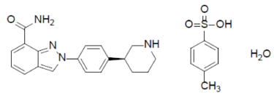
The dosage form is a 100 mg immediate release hard gelatin capsule, with ‘100 mg’ black text on the white body and ‘Niraparib’ white text on the purple cap and containing 100 mg of niraparib (as tosilate monohydrate). The capsules will be packaged in Australia in HPDE bottles in packs of 90 capsules and in blister packs of 28, 56 and 84 capsules.
The application and the supporting data relating to the composition, development, manufacture, quality control, stability and bioavailability of the product have been assessed and checked for compliance, as applicable, with Australian legislation and requirements for new medicines and in accordance with pharmacopoeial standards and the technical guidelines adopted by the TGA.
There are no quality objections to registration.
All outstanding quality issues have been addressed. The PI and labels are acceptable from a pharmaceutical chemistry perspective. Good Manufacturing Practice (GMP) manufacturing status is current for all proposed manufacturing sites, with the earliest date of expiry being 12 August 2019.

Nonclinical
There are no nonclinical objections to registration.
Primary pharmacology studies provided in vitro and in vivo demonstration of anti-tumour activity against ovarian tumour types. Off-target effects of niraparib on monoamine transporters for dopamine, norepinephrine (noradrenaline) and serotonin were seen at clinically relevant concentrations, raising the potential of clinical effects on blood pressure and heart rate.
Target organs of toxicity were the haematopoietic system, gastrointestinal tissue and male reproductive system. The proposed pregnancy category of D is considered appropriate.
The proposed PI is satisfactory from a nonclinical perspective.

Clinical

Pharmacology

Pharmacokinetics
The clinical pharmacology studies were conducted exclusively in oncology patients. The key pharmacokinetic (PK) findings from the clinical studies are described below.

Absorption
Niraparib was rapidly absorbed with the median time of maximum serum drug concentration (T_{max}) occurring at 2.5 to 4 hours post dose. The absolute bioavailability of niraparib was approximately 73%. Concomitant administration of a high fat meal did not significantly affect the PK of niraparib.
Systemic exposures (maximum (serum) drug concentration (C_{max})) and the area under the concentration-time curve (AUC)) to niraparib increased in a dose proportional manner with daily doses ranging 30 mg to 400 mg. The accumulation ratio of niraparib exposure following repeated daily doses was approximately 2 to 3 fold for doses ranging from 30 mg to 400 mg.

Distribution
Niraparib is 83.0% bound to human plasma proteins. The average (± standard deviation; SD) apparent volume of distribution (V_{d/F}) was 1220 (± 1114) L. In a population PK analysis, the V_{d/F} of niraparib was 1074 L in cancer patients.

Metabolism
Niraparib is metabolised primarily by carboxylesterases to form a major inactive metabolite, which subsequently undergoes glucuronidation.

Excretion
Niraparib is eliminated primarily through the hepatobiliary and renal routes. Following a single oral dose of 300 mg niraparib, the mean half-life (t_{1/2}) ranged from 48 to 51 hours. In a population PK analysis, the apparent total clearance (CL/F) of niraparib was 16.2 L/h in cancer patients.
Following administration of a single oral 300 mg dose of radio-labelled niraparib, the average percent recovery of the administered dose over 21 days was 47.5% (range 33.4% to 60.2%) in urine, and 38.8% (range 28.3% to 47.0%) in faeces.

Special populations
Age, weight and race had no significant impact on the PK of niraparib in population PK analyses. In population PK analyses, clearance of niraparib was not influenced by pre-existing creatinine clearance (CrCL) of ≥ 30 mL/min, or by mild or moderate hepatic impairment. The PK of niraparib have not been assessed in patients with CrCL < 30 mL/min or patients with severe hepatic impairment. A PK study in patients with moderate hepatic impairment is being conducted as a post-approval commitment to the FDA and is scheduled for completion in September 2020.

Dosage
No formal Phase II dose-ranging studies were conducted. The starting dose of 300 mg in the pivotal Phase III NOVA trial (Study PR-30-5011-C) was based on data from the Phase I dose-escalating study (Study PN001).

Efficacy

Study PR-30-5011-C (NOVA trial)
The evidence to support the proposed registration of niraparib is derived from the NOVA trial; a Phase III multi centre, randomised, double blind, placebo controlled trial to evaluate the efficacy and safety of niraparib compared to placebo as maintenance treatment in patients with platinum-sensitive recurrent ovarian cancer. Patients were recruited from August 2013 and the data cut-off date for the primary efficacy analysis was 30 May 2016. The estimated study completion date is June 2020.
Eligible patients were at least 18 years of age and had histologically diagnosed ovarian cancer, fallopian tube cancer or primary peritoneal cancer with predominantly high-grade serous histologic features. All the patients had shown sensitivity to platinum-based treatment and had received at least two such regimens. Patients were considered to be platinum sensitive if they had achieved a complete response (CR) or partial response (PR) for more than 6 months.
The NOVA trial enrolled patients into two independent cohorts based on the presence or absence of a germline BRCA (gBRCA) mutation (into a gBRCA cohort and a non-gBRCA cohort), as determined by Integrated BRACAnalysis testing (Myriad Genetics). In addition, tumour samples of patients in the non-gBRCA cohort were tested for homologous recombination deficiency (HRD), using the myChoice HRD test (Myriad Genetics).
This test is a next-generation sequencing (NGS)-based assay designed to assess genomic instability, including loss of heterozygosity, telomeric allelic imbalance and large scale transitions, and in parallel, to detect and classify large rearrangements and sequencing variants in the BRCA1 and BRCA2 genes (in a similar manner to gBRCA classification by Integrated BRACAnalysis). HRD-positive tumours were further categorised as HRD-positive with somatic BRCA mutations or HRD-positive without somatic BRCA mutations (HRD-positive/BRCA wildtype).
Within 8 weeks of completing their last dose of platinum-based chemotherapy, patients were randomly assigned in a 2:1 ratio to receive niraparib (300 mg) or placebo once daily. Randomisation within each cohort was stratified according to:
- time to progression after completion of the penultimate platinum regimen (6 to < 12 months versus ≥ 12 months); and
- the use of bevacizumab in conjunction with the penultimate or last platinum regimen; and the best response (complete response (CR) or partial response (PR)) during the last platinum regimen.
Treatment was continued until disease progression, unacceptable toxicity, withdrawal of consent, loss to follow up or death.
The primary endpoint was progression free survival (PFS) assessed by independent central review based on RECIST version 1.1. PFS was evaluated independently in the gBRCA mutation and non-gBRCA mutation cohorts. A hierarchical-testing procedure was predefined for the non-gBRCA cohort in which statistical analysis was first performed in patients with HRD-positive tumours, and if the results were significant, a test of the overall non-gBRCA cohort was performed. Secondary endpoints included the time to first subsequent therapy (TFST), chemotherapy free interval (CFI), progression-free survival 2 (PFS2); overall survival (OS), time to second subsequent therapy (TSST) and patient reported outcomes.
Key inclusion criteria included: female patients ≥ 18 years of age; histologically diagnosed ovarian, fallopian tube or primary peritoneal cancer; high grade serous histology or known gBRCA mutation; completed at least 2 courses of platinum-based chemotherapy; and an ECOG Performance Status of 0 or 1.
A total of 553 women were enrolled, 203 in the gBRCA mutation cohort and 350 in the non-gBRCA mutation cohort. Of the 350 women in the non-gBRCA mutation cohort, 162 had HRD positive tumours and 134 had HRD negative tumours. Another 54 had undefined HRD status for various reasons, but were included in the intent-to-treat (ITT) population for the non-gBRCA mutation cohort analysis (see Figure 1).
Approximately 40% of patients were from North America and 60% from Europe and Israel. The majority of patients were White and had baseline ECOG PS of 0. Median ages ranged from 57 to 63 years across treatments and cohorts. Demographic and baseline characteristics were generally well balanced across the cohorts.
Figure 2: Study PR-30-5011-C/NOVA trial Patient numbers for each biomarker population
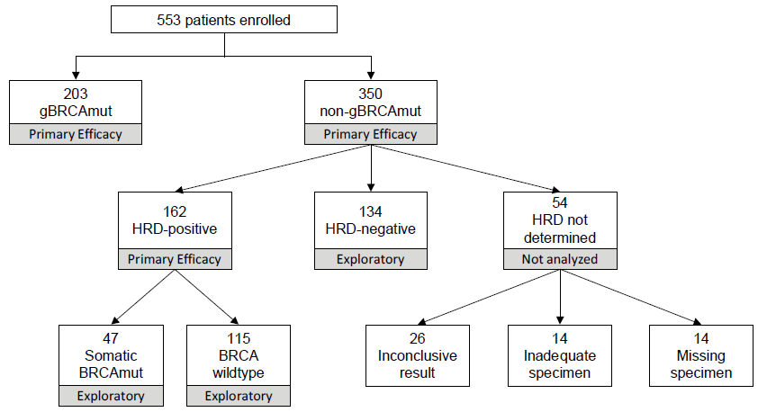

Results
There was a statistically significant improvement in PFS for patients in the niraparib arm compared to placebo in all three pre-specified patient groups: the gBRCA mutation cohort, the non-gBRCA mutation cohort and the HRD positive subgroup within the non-gBRCA mutation cohort (see Table 3). Sensitivity analyses for PFS were consistent with the primary outcome, as were subgroup analyses based on demographics and prior treatments.
Table 3: Study PR-30-5011-C/NOVA trial Progression free survival based on independent review committee assessment in the 3 primary efficacy populations
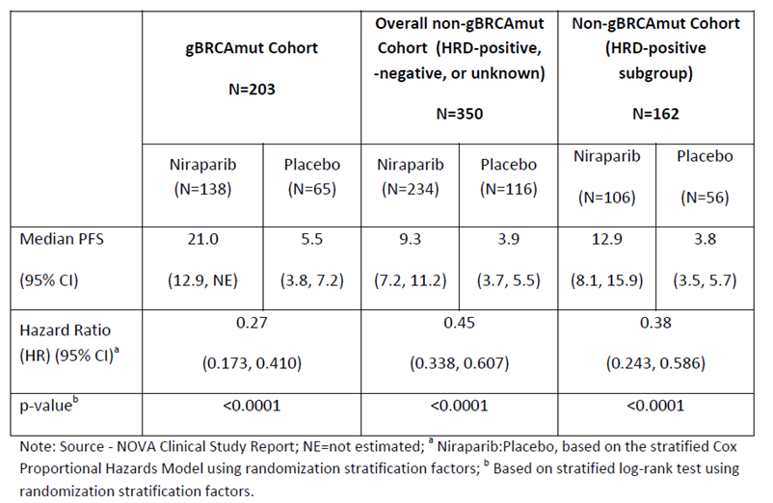
Figure 3: Study PR-30-5011-C/NOVA trial Kaplan-Meier plot for progression free survival in the germline BRCA mutation cohort (intent to treat population)
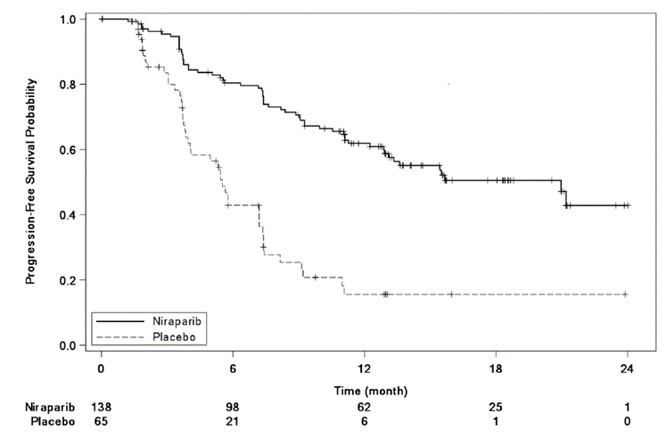
Figure 4: Study PR-30-5011-C/NOVA trial Kaplan-Meier plot for progression free survival in the non-germline BRCA mutation cohort overall (intent to treat population)
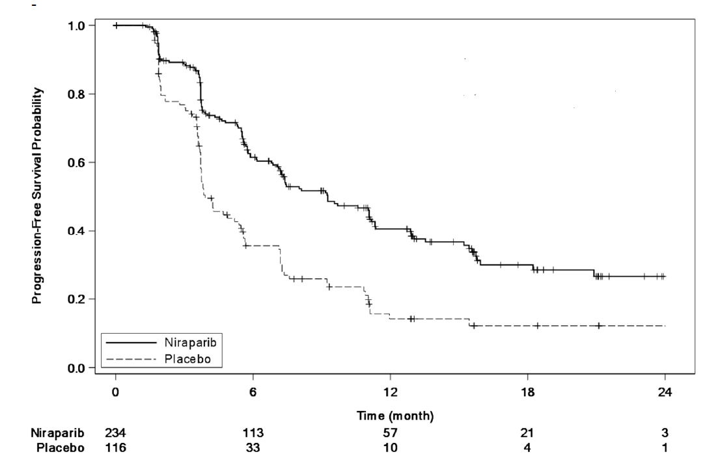
Outcomes for secondary endpoints TFST, CFI, and PFS2 showed a consistent treatment effect favouring niraparib in both the gBRCA muation cohort and the non-gBRCA mutation cohort.
Overall survival data were immature at the data cut-off for the primary analysis of PFS. As at the 30 May 2016 data cut-off, only 24 patients in the gBRCA mutation cohort had died, including 16 (12%) of the 138 patients randomised to niraparib and 8 (12%) of the 65 patients randomised to placebo (hazard ratio (HR) = 0.91; 95% confidence interval (CI) 0.36 to 2.28). In the non-gBRCA mutation cohort, 71 patients had died, including 44 (19%) of the 234 patients randomised to niraparib and 27 (23%) of the 116 patients randomised to placebo (HR = 0.74; 95% CI 0.45 to 1.20).
Patient-reported outcomes data were collected using validated surveys; generally similar results were seen for patients in the niraparib and placebo treatment arms.

Safety
The primary data supporting safety in the proposed indication are derived from the NOVA trial, in which 367 patients received niraparib and 179 received placebo. These data are supported by pooled safety data from 384 ovarian cancer patients in 4 open-label studies (the Phase I Study PN001, the Phase II Study PR-30-5020-C (QUADRA trial), and 2 sub-studies of the NOVA trial, Study PR-30-5011-C1-QTC and Study PR-30-5011-C2-FE). The majority of patients in the pooled dataset received the proposed dose of 300 mg daily.
In the NOVA trial, 367 patients were exposed to at least one dose of niraparib, 245 subjects (66.8%) for ≥ 6 to < 12 months and 163 subjects (44.4%) for ≥ 12 months at the data cut-off date. The mean duration of treatment was approximately 3 months longer in the niraparib arm (300 days) compared to placebo (213 days).
All 367 patients in the niraparib arm and 171 of 179 patients (96%) in the placebo arm experienced at least 1 treatment emergent adverse event (TEAE). The most common TEAEs are summarised in Table 4. Similar results were reported for TEAEs in the gBRCA mutation and non-gBRCA mutation cohorts. The incidence of treatment-related adverse events (AE) was 358 of 367 (98%) in the niraparib arm and 127 of 179 patients (71%) in the placebo arm.
Table 4: Study PR-30-5011-C/Nova trial Adverse events reported in ≥ 10% of patients (safety analysis population; N = 546)
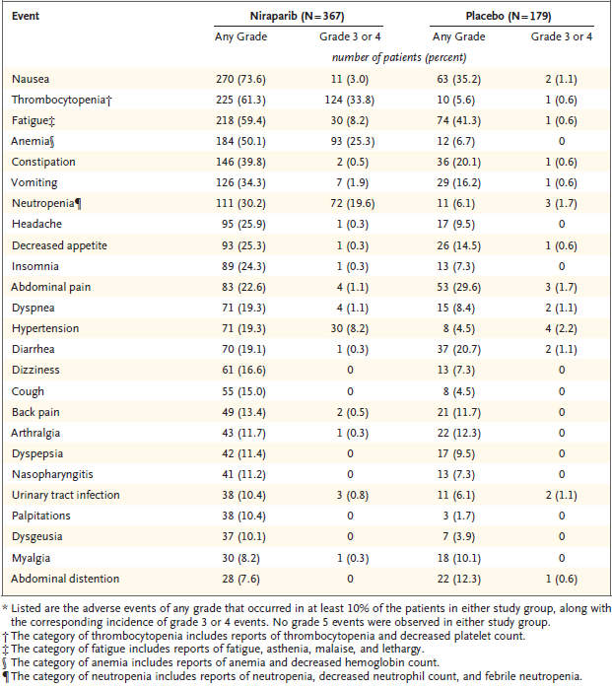
Extract from: Mirza M et al., Niraparib maintenance therapy in platinum sensitive, recurrent ovarian cancer. N Engl J Med 2016; 375:2154-2164
The incidence of CTCAE; Grade 3 or 4 adverse events (AE) (74% versus 23%), serious adverse events (SAE) (30% versus 15%), treatment interruption (67% versus 15%), dose reduction (69% versus 5%), and discontinuation (15% versus 2%) due to AEs were all higher in the niraparib arm compared to the placebo arm.
237of 367 (65%) of the patients treated with niraparib experienced Grade 3/4 treatment-related AEs, most commonly thrombocytopenia (34%), anaemia (25%), neutropaenia (20%) and hypertension (8%). No Grade 5 AEs were reported in either group. Grade 3 or 4 haematological AEs were more common at the beginning of treatment and generally responded to dose reductions. Hypertension events were manageable with dose modifications and concomitant medications.
The study protocol mandated that all women enrolled in the study and randomised to the study drug arm start with 300 mg niraparib. Based on a post-hoc analysis of AEs, the sponsor is proposing to reduce the recommended starting dose of niraparib for patients who weigh less than 77 kg or have baseline platelet count < 150,000/µL because of an increased risk of grade 3 or 4 thrombocytopenia events. 35% of patients with a baseline bodyweight less than 77 kg or baseline platelet count <150 x 10⁹/L experienced a Grade 3/4 thrombocytopenia event within the first 30 days, compared 12% of patients with a bodyweight above 77 kg and baseline platelet count >150 x 10⁹/L. The proposed change to the starting dose is discussed below.
95 patients died during the follow-up period, including 60 of 372 (16%) randomised to niraparib and 35 of 181 (19%) of the patients randomised to placebo. Three deaths due to myelodysplastic syndromes (MDS)/acute myeloid leukaemia (AML) occurred in the post-treatment period; 1 in the niraparib arm and 2 in the placebo arm.
The protocol identified adverse events of special interest (AESI) based on the anticipated effect of niraparib and experience with previous PARP inhibitors. AESIs included thrombocytopenia, anaemia, leukopaenia, neutropaenia, pancytopenia, MDS/AML, fatigue, pneumonitis and overdose.
MDS/AML events were reported in 1.4% of patients who received niraparib (5 of 367), while the incidence rate in the placebo group was 1.1% (2 of 179). MDS/AML has been observed with the use of other PARP inhibitors. The PI contains a specific precaution regarding MDS/AML.

Risk management plan
The sponsor has submitted EU-risk management plan (RMP) version 0.4 (dated 11 September 2017; data lock point (DLP) 20 June 2016) and Australian-specific Annex (ASA) version 1.0 (dated June 2018) in support of this application.
The summary of safety concerns and their associated risk monitoring and mitigation strategies are summarised in Table 5.
Table 5: Sponsors summary of safety concerns
Summary of safety concerns |  | Pharmacovigilance |  | Risk minimisation
 |  | Routine | Additional | Routine | Additional
Important identified risks | Haematological toxicity (thrombocytopenia, anaemia, neutropenia) |  | – |  | –
Important identified risks | Hypertension |  | – |  | –
Important potential risks | Myelodysplastic syndrome (MDS) and acute myeloid leukaemia (AML) | ≠ | * |  | –
Important potential risks | Second primary malignancies other than MDS and AML | ≠ | * |  | –
Important potential risks | Embryo-foetal toxicity | # | – |  | –
Important potential risks | Pneumonitis |  | – |  | –
Missing information | Exposure in patients with severe renal impairment and end stage renal disease (ESRD) |  | – |  | –
Missing information | Exposure in patients with severe hepatic impairment |  | – |  | –
The proposed summary of safety concerns and their associated risk monitoring and mitigation strategies are considered acceptable. There are no outstanding issues from a RMP perspective.
Recommended conditions of registration:
- The Zejula EU-Risk Management Plan (RMP) (version 0.4, dated 11 September 2017; DLP 20 June 2016), with Australian Specific Annex (version 1.0, dated June 2018), included with submission PM-2018-02496-1-4, and any subsequent revisions, as agreed with the TGA will be implemented in Australia.
- An obligatory component of risk management plans is routine pharmacovigilance. Routine pharmacovigilance includes the submission of periodic safety update reports (PSURs).
Reports are to be provided in line with the current published list of EU reference dates and frequency of submission of PSURs until the period covered by such reports is not less than three years from the date of the approval letter.
The reports are to at least meet the requirements for PSURs as described in the European Medicines Agency’s Guideline on Good Pharmacovigilance Practices (GVP) Module VII-periodic safety update report (Rev 1), Part VII.B Structures and processes. Note that submission of a PSUR does not constitute an application to vary the registration.
- Zejula (Niraparib) is to be included in the Black Triangle Scheme. The PI and Consumer Medicines Information (CMI) for Zejula must include the black triangle symbol and mandatory accompanying text for five years, which starts from the date that the sponsor notifies the TGA of supply of the product.

Risk-benefit analysis

Delegate’s considerations

Efficacy
The evidence for efficacy of narapamib maintenance therapy is derived from the pivotal Phase III study, the NOVA trial. Eligible patients were at least 18 years of age and had histologically diagnosed ovarian cancer, fallopian tube cancer, or primary peritoneal cancer with predominantly high-grade serous histologic features. All patients had shown sensitivity to platinum-based treatment and had received at least two such regimens.
At the time of initiation of the NOVA trial, there was no approved maintenance treatment for patients with platinum-sensitive, recurrent ovarian cancer so the comparison with placebo is acceptable. Olaparib and bevacizumab were not appropriate comparators at the time of initiation of the NOVA trial.
The primary efficacy endpoint was PFS, assessed independently in three pre-specified cohorts (gBRCA mutation, non-gBRCA mutation HRD positive, and non-gBRCA mutation). PFS is an appropriate primary endpoint in this clinical setting.
The NOVA trial demonstrated a statistically significant improvement in PFS for niraparib maintenance therapy compared to placebo in all three cohorts. Median PFS in the gBRCA mutation cohort was 21.0 months for niraparib versus 5.5 months for placebo (HR 0.27; 95% CI, 0.173 to 0.410; p < 0.0001), in the non-gBRCA mutation HRD positive cohort median PFS was 12.9 months for niraparib versus 3.8 months for placebo (HR 0.38; 95% CI, 0.243 to 0.586; p < 0.001) and in the overall non-gBRCA mutation cohort median PFS was 9.3 months for niraparib versus 3.9 months for placebo (HR 0.45; 95% CI, 0.338 to 0.607; p < 0.0001).
The primary efficacy outcomes were supported by consistent outcomes in multiple sensitivity analyses for PFS as well as secondary endpoints for TFST, CFI and PFS2. OS data were immature at the data cut-off for the primary analysis of PFS.

Proposed indication
The Australian indication should be gender neutral, so ‘female’ should be removed.
PFS was significantly improved for patients who received niraparib compared to placebo regardless of gBRCA mutation status, so the proposed indication in the overall population without regard to gBRCA mutation is acceptable.
There are some minor differences in the wording of the FDA- and EMA-approved indications (for example ‘relapsed’ versus ‘recurrent’), with the proposed Australian indication being aligned with the EU indication. The same differences in wording are evident in the FDA- and EMA-approved indications for olaparib maintenance treatment in recurrent/relapsed ovarian cancer, with the Australian indication again being aligned with the EU indication.
The following indication would be acceptable:
Zejula is indicated as monotherapy for the maintenance treatment of adult patients with platinum-sensitive relapsed high grade serous epithelial ovarian, fallopian tube, or primary peritoneal cancer who are in response (complete or partial) to platinum-based chemotherapy.

Safety
The primary data supporting safety in the proposed indication are derived from the NOVA trial, supported by pooled safety data from 384 ovarian cancer patients in 4 open label studies.
Common AEs include nausea, thrombocytopenia, fatigue and anaemia. The most common Grade 3 or 4 AEs were thrombocytopenia, anaemia and neutropaenia. The majority of haematological AEs occurred early in treatment and were generally manageable with dose interruptions and/or reductions. Close monitoring of haematological parameters is required, particularly in the first month of treatment. As seen with other PARP inhibitors, cases of MDS/AML were reported in niraparib clinical trials.
The safety profile of niraparib in the proposed indication has been adequately characterised. Dose reductions to manage AEs were common overall, but the majority of patients were able to remain on treatment. In the context of maintenance treatment of platinum-sensitive relapsed high grade serous epithelial ovarian, fallopian tube, or primary peritoneal cancer, the safety profile of niraparib is acceptable.

Proposed starting dose
In contrast to the 300 mg starting dose for all patients treated with niraparib in the pivotal study, the sponsor has proposed that for patients who weigh less than 77 kg or have baseline platelet count < 150 x 10⁹/L, the recommended starting dose is 200 mg/day. For all others, the recommended starting dose is 300 mg/day.
The primary justification for the proposed dosing came from retrospective analysis of data from the Phase III NOVA trial (Study PR-30-5011-C), as well as supportive safety data from the QUADRA trial (Study PR-30-5020-C) and the Phase I/II TOPACIO trial (Study 3000-PN-162-01-001. The QUADRA trial is an ongoing Phase II niraparib monotherapy study in patients with advanced, relapsed ovarian cancer (starting dose of 300 mg). The TOPACIO trial is an ongoing Phase I/II study evaluating the safety and efficacy of combination treatment with niraparib (starting dose 200 mg) and pembrolizumab in patients with advanced triple negative breast cancer or platinum-resistant ovarian cancer.
The proposed dosing regimen was prompted by the higher incidence in the NOVA trial of Grade 3/4 thrombocytopenia within the first 30 days of treatment (35% versus 12%) in patients with a baseline bodyweight < 77 kg or platelet count < 150 x 10⁹/L compared to those with a baseline bodyweight ≥ 77 kg and platelet count ≥ 150 x 10⁹/L.
The impact of the proposed dose reduction on efficacy in the NOVA trial was considered by the sponsor. The sponsor calculated that the median daily dose taken within the first 2 months was 207 mg for patients with a baseline body weight < 77 kg or baseline platelet count < 150 x 10⁹/L compared with a median of 295 mg for patients with baseline body weight ≥ 77 kg and baseline platelet count ≥ 150 x 109/L. The sponsor concluded from post hoc analyses of PFS that there was no loss of efficacy in patients who had dose reductions to 200 mg or 100 mg. However, these patients all started on the 300 mg dosage. No patients in the pivotal study started on a 200 mg dosage. No prospective studies were provided to support the 200 mg starting dose in the proposed indication.
The higher incidence of Grade 3/4 thrombocytopenia events in patients with low baseline bodyweight or platelet levels is acknowledged, but these AEs were generally manageable with dose interruptions and/or reductions. Discontinuation due to thrombocytopenia occurred in only 3% of patients in the NOVA trial.
There is a lack of clinical data supporting the efficacy of a 200 mg starting dose. The sponsor performed post-hoc analyses of efficacy in patients who had undergone dose reduction, but all patients treated with niraparib in the NOVA trial started on 300 mg. The majority of patients in the NOVA trial weighed less than 77 kg, so there is uncertainty whether the demonstrated efficacy would have been achieved if a 200 mg starting dose had been specified in the trial protocol. Whilst there may be a valid safety rationale for a lower starting dose in patients with low baseline bodyweight or platelet count, the lack of clinical efficacy data means that there is uncertainty regarding the benefit-risk for the proposed 200 mg starting dose in patients with baseline body weight < 77 kg or baseline platelet count < 150 x 10⁹/L. The approved dose in USA and EU is 300 mg daily.
The recommended dose in Australia should be 300 mg daily, consistent with the starting dosage in the pivotal study. Close monitoring of haematological parameters is advised, particularly in the first month of treatment, and dose modifications are recommended to manage haematological toxicity.

Deficiencies of the data
There is a lack of clinical trial data supporting the efficacy of a 200 mg starting dose.
The NOVA trial was limited to patients with ECOG Performance Status 0 or 1, so outcomes for patients with ECOG Performance Status > 1 are not known.

Proposed action
In the NOVA trial, niraparib maintenance treatment significantly prolonged PFS compared to placebo in patients with platinum-sensitive relapsed high grade serous epithelial ovarian, fallopian tube or primary peritoneal cancer who were in response (CR or PR) to platinum-based chemotherapy, regardless of germline BRCA mutation status. The safety profile of niraparib in the proposed indication is acceptable.
There are no outstanding issues requiring expert advice from the Advisory Committee on Medicines (ACM).
There are no outstanding issues from the evaluations of quality and nonclinical data. The RMP is acceptable.

Advisory Committee considerations
The Delegate did not refer this application to the Advisory Committee on Medicines (ACM) for advice.

Outcome
Based on a review of quality, safety and efficacy, the TGA approved the registration of Zejula (niraparib) for 100 mg oral hard capsule, indicated for:
Zejula is indicated as monotherapy for the maintenance treatment of adult patients with platinum-sensitive relapsed high grade serous epithelial ovarian, fallopian tube, or primary peritoneal cancer who are in response (complete or partial) to platinum-based chemotherapy

Specific conditions of registration applying to these goods
- Zejula (niraparib) is to be included in the Black Triangle Scheme. The PI and CMI for Zejula must include the black triangle symbol and mandatory accompanying text for five years, which starts from the date that the sponsor notifies the TGA of supply of the product.
- The clinical study report for the PK study in patients with moderate hepatic impairment is to be submitted to the TGA for evaluation when available.
- The Zejula EU-Risk Management Plan (RMP) (version 0.4, dated 11 September 2017; DLP 20 June 2016), with Australian Specific Annex (version 1.0, dated June 2018), included with submission PM-2018-02496-1-4, and any subsequent revisions, as agreed with the TGA will be implemented in Australia.
An obligatory component of risk management plans is routine pharmacovigilance.
Routine pharmacovigilance includes the submission of periodic safety update reports (PSURs).
Reports are to be provided in line with the current published list of EU reference dates and frequency of submission of PSURs until the period covered by such reports is not less than three years from the date of the approval letter.
The reports are to at least meet the requirements for PSURs as described in the European Medicines Agency’s Guideline on Good Pharmacovigilance Practices (GVP) Module VII-periodic safety update report (Rev 1), Part VII.B Structures and processes. Note that submission of a PSUR does not constitute an application to vary the registration.

Attachment 1. Product Information
The PI for Zejula approved with the submission which is described in this AusPAR is at Attachment 1. For the most recent PI, please refer to the TGA website at <https://www.tga.gov.au/product-information-pi>.

Therapeutic Goods Administration
PO Box 100 Woden ACT 2606 Australia
Email: info@tga.gov.au Phone: 1800 020 653 Fax: 02 6232 8605
https://www.tga.gov.au

The Black Triangle Scheme provides a simple means for practitioners and patients to identify certain types of new prescription medicines, including those being used in new ways and to encourage the reporting of adverse events associated with their use. The Black Triangle does not denote that there are known safety problems, just that the TGA is encouraging adverse event reporting to help us build up the full picture of a medicine's safety profile.
Note: This submission was originally submitted to the TGA by Takeda Pharmaceuticals Australia Pty Ltd, with sponsorship later being transferred to GlaxoSmithKline Australia Pty Ltd following registration of the product.
Note: This submission was originally submitted to the TGA by Takeda Pharmaceuticals Australia Pty Ltd, with sponsorship later being transferred to GlaxoSmithKline Australia Pty Ltd following registration of the product.
The Australia-Canada-Singapore-Switzerland (ACSS) Consortium is a medium-sized coalition, which was formed in 2007 by 'like-minded' regulatory authorities to promote greater regulatory collaboration and alignment of regulatory requirements. Its goal is to maximise international cooperation, reduce duplication, and increase each agency's capacity to ensure consumers have timely access to high quality, safe and effective therapeutic products. For further information visit: https://www.tga.gov.au/australia-canada-singapore-switzerland-acss-consortium.
Pregnancy Category D: Drugs which have caused, are suspected to have caused or may be expected to cause, an increased incidence of human fetal malformations or irreversible damage. These drugs may also have adverse pharmacological effects. Accompanying texts should be consulted for further details.
The Response Evaluation Criteria in Solid Tumours (RECIST) is a voluntary, international standard using unified, easily applicable criteria for measuring tumour response using X-ray, CT and MRI.
Time frame: From treatment randomisation to the earlier of the date of disease progression on the next anti-cancer therapy following study treatment or death due to any cause.
ECOG Performance Status: The Eastern Cooperative Oncology Group (ECOG) has developed criteria used by doctors and researchers to assess how a patient's disease is progressing, assess how the disease affects the daily living abilities of the patient, and determine appropriate treatment and prognosis. The following are used: 0) Fully active, able to carry on all pre-disease performance without restriction; 1) Restricted in physically strenuous activity but ambulatory and able to carry out work of a light or sedentary nature, e.g., light house work, office work; 2) Ambulatory and capable of all selfcare but unable to carry out any work activities. Up and about more than 50% of waking hours; 3) Capable of only limited selfcare, confined to bed or chair more than 50% of waking hours; 4) Completely disabled. Cannot carry on any selfcare. Totally confined to bed or chair; 5) Dead.
The Common Terminology Criteria for Adverse Events (CTCAE) are a set of criteria for the standardised classification of adverse effects of drugs used in cancer therapy. The CTCAE system is a product of the United States National Cancer Institute (NCI). Many clinical trials, now extending beyond oncology, encode their observations based on the CTCAE system. It uses a range of grades from 1 to 5. Specific conditions and symptoms may have values or descriptive comment for each level, but the general guideline is: 1) Mild; 2) Moderate 3) Severe; 4) Life-threatening; 5) Death.
Routine risk minimisation activities may be limited to ensuring that suitable warnings are included in the product information or by careful use of labelling and packaging. Routine pharmacovigilance practices involve the following activities: - All suspected adverse reactions that are reported to the personnel of the company are collected and collated in an accessible manner; - Reporting to regulatory authorities; - Continuous monitoring of the safety profiles of approved products including signal detection and updating of labelling; - Submission of PSURs; - Meeting other local regulatory agency requirements.
The ACM provides independent medical and scientific advice to the Minister for Health and the Therapeutic Goods Administration (TGA) on issues relating to the safety, quality and efficacy of medicines supplied in Australia including issues relating to pre-market and post-market functions for medicines. The Committee is established under Regulation 35 of the Therapeutic Goods Regulations 1990. Members are appointed by the Minister. The ACM was established in January 2017 replacing Advisory Committee on Prescription Medicines (ACPM) which was formed in January 2010. ACM encompass pre and post-market advice for medicines, following the consolidation of the previous functions of the Advisory Committee on Prescription Medicines (ACPM), the Advisory Committee on the Safety of Medicines (ACSOM) and the Advisory Committee on Non-Prescription Medicines (ACNM). Membership comprises of professionals with specific scientific, medical or clinical expertise, as well as appropriate consumer health issues relating to medicines.

